|  |
| --- |
| **February 2019** |

|  |
| --- |
| Australian Public Assessment Report for dexamethasone (intravitreal implant) |
| Proprietary Product Name: Ozurdex |
| Sponsor: Allergan Australia Pty Ltd |

About the Therapeutic Goods Administration (TGA)

* The Therapeutic Goods Administration (TGA) is part of the Australian Government Department of Health and is responsible for regulating medicines and medical devices.
* The TGA administers the *Therapeutic Goods Act 1989* (the Act), applying a risk management approach designed to ensure therapeutic goods supplied in Australia meet acceptable standards of quality, safety and efficacy (performance) when necessary.
* The work of the TGA is based on applying scientific and clinical expertise to decision-making, to ensure that the benefits to consumers outweigh any risks associated with the use of medicines and medical devices.
* The TGA relies on the public, healthcare professionals and industry to report problems with medicines or medical devices. TGA investigates reports received by it to determine any necessary regulatory action.
* To report a problem with a medicine or medical device, please see the information on the TGA website <<https://www.tga.gov.au>>.

About AusPARs

* An Australian Public Assessment Report (AusPAR) provides information about the evaluation of a prescription medicine and the considerations that led the TGA to approve or not approve a prescription medicine submission.
* AusPARs are prepared and published by the TGA.
* An AusPAR is prepared for submissions that relate to new chemical entities, generic medicines, major variations and extensions of indications.
* An AusPAR is a static document; it provides information that relates to a submission at a particular point in time.
* A new AusPAR will be developed to reflect changes to indications and/or major variations to a prescription medicine subject to evaluation by the TGA.

Copyright

© Commonwealth of Australia 2019  
This work is copyright. You may reproduce the whole or part of this work in unaltered form for your own personal use or, if you are part of an organisation, for internal use within your organisation, but only if you or your organisation do not use the reproduction for any commercial purpose and retain this copyright notice and all disclaimer notices as part of that reproduction. Apart from rights to use as permitted by the *Copyright Act 1968* or allowed by this copyright notice, all other rights are reserved and you are not allowed to reproduce the whole or any part of this work in any way (electronic or otherwise) without first being given specific written permission from the Commonwealth to do so. Requests and inquiries concerning reproduction and rights are to be sent to the TGA Copyright Officer, Therapeutic Goods Administration, PO Box 100, Woden ACT 2606 or emailed to <[tga.copyright@tga.gov.au](mailto:tga.copyright@tga.gov.au)>.

Contents

Common abbreviations 4

I. Introduction to product submission 6

Submission details 6

Product background 6

Regulatory status 8

Product Information 9

II. Registration time line 9

IV. Nonclinical findings 9

V. Clinical findings 10

Introduction 10

Pharmacokinetics 14

Pharmacodynamics 15

Dosage selection for the pivotal studies 15

Efficacy 16

Studies providing evaluable efficacy data (uveitis) 66

Clinical Safety 80

Studies providing safety data 80

Patient exposure 82

Safety issues with the potential for major regulatory impact 82

Second round evaluation 103

Second round benefit-risk assessment 103

VI. Pharmacovigilance findings 104

Risk management plan 104

VII. Overall conclusion and risk/benefit assessment 106

Quality 106

Nonclinical 106

Clinical 106

Risk management plan 119

Risk-benefit analysis 120

Outcome 127

Attachment 1. Product Information 128

Attachment 2. Extract from the Clinical Evaluation Report 128

## Common abbreviations

|  |  |
| --- | --- |
| Abbreviation | Meaning |
| ACM | Advisory Committee on Medicines |
| BLQ | Below the level of quantification |
| BRVO | Branch retinal vein occlusion |
| BVCA | Best-corrected visual acuity |
| BVOS | Branch vein occlusion study |
| CI | Confidence interval |
| CMH test | Cochran-Mantel-Haenszel (test) |
| CMI | Consumer Medical Information |
| CMV | Cytomegalovirus |
| CRT | Central retinal thickness |
| CRVO | Central retinal vein occlusion |
| CVOS | Central vein occlusion study |
| DDS | Drug delivery system |
| DEX 350 | Dexamethasone 350 μg |
| DEX 700 | Dexamethasone 700 μg |
| DEX PS DDS | Dexamethasone posterior segment drug delivery system |
| DME | Diabetic macular oedema |
| eCRF | Electronic clinical record file |
| EMEA | European Medicines Evaluation Agency |
| ETDRS | Early treatment of diabetic retinopathy study |
| FA | Fluorescein angiography |
| HRVO | Hemi-retinal vein occlusion |
| ICH GCP | International Conference on Harmonisation Good Clinical Practice |
| IOP | Intraocular pressure |
| ISE | Integrated summary of efficacy |
| ISS | Integrated summary of safety |
| IT | Initial treatment (period) |
| ITT | Intention-to-treat |
| IVRS | Interactive voice response system |
| IWRS | Interactive web response system |
| LLOQ | Lower limit of quantification |
| LLOQ | Lower limit of quantification |
| LS | Least square (of the mean) |
| mITT | Modified intention-to-treat |
| OCT | Optical coherence tomography |
| OL | Open-label (extension) |
| PD | Pharmacodynamic(s) |
| PI | Product Iinformation |
| PK | Pharmacokinetic(s) |
| PLGA | Polyglactin D ,L lactide coglycolide |
| PP | Per protocol |
| PSUR | Post-marketing safety update report |
| RVO | Retinal vein occlusion |
| SD | Standard deviation |
| SLE | Systemic lupus erythematosus |
| VEGF | Vascular endothelial growth factor |

## I. Introduction to product submission

### Submission details

|  |  |
| --- | --- |
| *Type of submission:* | Extension of indications |
| *Decision*: | Approved |
| *Date of decision:* | 6 June 2017 |
| *Date of entry onto ARTG* | 16 June 2017 |
| *Active ingredient:* | Dexamethasone |
| *Product name:* | Ozurdex |
| *Sponsor’s name and address:* | Allergan Australia Pty Ltd  Locked Bag 1514  Pymble NSW 2073 |
| *Dose form:* | Implant (ocular) |
| *Strength:* | 700 microgram |
| *Container:* | Dispenser pack |
| *Pack size:* | 700 microgram |
| *Approved therapeutic use:* | *Ozurdex is indicated for the treatment of:*   * *Macular oedema due to Branch Retinal Vein Occlusion (BRVO) or Central Retinal Vein Occlusion (CRVO).* * *Non-infectious uveitis affecting the posterior segment of the eye.* |
| *Route(s) of administration:* | Intravitreal |
| *Dosage:* | 700 microgram per eye (entire contents of a single-use Ozurdex device). |
| *ARTG numbers:* | 222392 |

### Product background

This AusPAR describes the application by Allergan Australia Pty Ltd to register Ozurdex (active ingredient: dexamethasone (intravitreal implant)). Dexamethasone is a synthetic corticosteroid with potent glucocorticoid and minimal mineralocorticoid activity. It has robust immunomodulatory and anti-inflammatory properties in most tissues including the retinal vascular endothelium via the inhibition of inflammatory mediators and subsequent inhibition of oedema, fibrin deposition, capillary leakage and phagocytosis.

The currently approved indication for Ozurdex is as follows:

*Ozurdex is indicated for the treatment of diabetic macular oedema (DME)*

With this submission, two additional new indications are proposed by the sponsor:

*Ozurdex is indicated for the treatment of:*

*Macular oedema due to branch retinal vein occlusion (BRVO) or central retinal vein occlusion (CRVO)*

*Non-infectious uveitis affecting the posterior segment of the eye*

#### Dosage forms and strengths

Ozurdex is a biodegradable, sustained release implant containing 700 µg dexamethasone in a solid polymer drug delivery system (DDS).

No new dosage forms or strengths are proposed.

#### Dosage and administration

There are no proposed changes to the dosage form and delivery system for the proposed indications compared with that for the current approved indication.

Ozurdex is a biodegradable intravitreal implant containing 700 µg dexamethasone in a solid polymer drug delivery system (DDS). The Ozurdex implant is preloaded into a single-use, specifically designed DDS applicator to facilitate injection of the rod-shaped implant directly into the vitreous. The polymer DDS contains polyglactin D,L‑lactide‑coglycolide (PLGA) biodegradable polymer matrix. The implant itself is preservative free.

Ozurdex is only to be administered by a qualified ophthalmologist experienced in intravitreal insertions. Patients treated with Ozurdex who have experienced an initial response and in the physician’s opinion may benefit from retreatment without being exposed to significant risk should be considered for retreatment.

In clinical trials for the currently approved indication (DME) the majority of retreatments were administered at 6 monthly intervals.

Regarding dosage frequency for the two proposed indications, the sponsor proposes the following changes to the PI:

* Retinal vein occlusion:

There is only very limited information on repeat dosing intervals less than 6 months. There is currently no experience beyond 2 implants in RVO.

* Uveitis:

There is no experience of repeat administration in posterior segment non-infectious uveitis.

#### Retinal vein occlusion

Retinal vein occlusion (RVO) affects approximately 1.6% of adults over 49 years, the prevalence increases with increasing age. It is one of the most common causes of vascular blindness. The usual presentation is one of painless loss of vision. Branch retinal vein occlusion has a better visual prognosis than central retinal vein occlusion. Patients with macular oedema from BRVO may experience spontaneous visual improvement in the first 3 months after onset of symptoms, after this the likelihood of improvement diminishes. In those with BRVO and visual acuity (VA) of 20/40 or worse at 3 months, 34% will achieve VA of 20/40 or better, and 23% have VA 20/200 or worse at 3 years. In CRVO, the visual prognosis depends upon VA at Baseline. In patients who present with VA better than 20/40, two thirds maintain vision and 10% deteriorate to worse than 20/200. In patients who had VA worse than 20/200 at Baseline, only 20% improved. A better visual prognosis is observed in younger patients and those with non-ischaemic RVO.

The main causes of visual impairment in RVO include macular oedema, retinal neovascularisation with secondary neovascular glaucoma and secondary vitreous haemorrhage, and retinal tissue destruction due to retinal ischaemia.

##### Current treatment options

There are no treatments to reopen the retinal veins. Treatment is aimed at secondary complications such as macular oedema, retinal neovascularisation, and anterior segment neovascularisation. Pharmacological treatment with an anti-vascular endothelial growth factor (VEGF) agent is now considered first line treatment (Uptodate). The current anti-VEGF agents registered for this indication include: ranibizumab, bevacizumab and afibercept. Laser therapy is used in BRVO. Surgical options include pars plana vitrectomy, surgically induced retinochoroidal anastamoses, direct venous cannulation, and radial optic neurometry.

#### Intermediate and posterior non-infectious uveitis

Uveitis involves inflammation of the uvea. Posterior uveitis involves inflammation of the choroidal component of the uvea in the posterior segment of the eye. Due to close proximity to the retina and optic nerve, posterior uveitis has the propensity to result in severe complications including permanent loss of vision.

Non-infectious causes of uveitis include systemic disease (such as sarcoidosis, multiple sclerosis, SLE, rheumatoid arthritis, ankylosing spondylitis, Behects disease, Vogt Koyanagi harada syndrome, and Kawasaki disease) , as well as local causes (pars planitis and birdshot choroidopathy). Around 30% of cases have no identifiable cause.

##### Current treatment options

Treatment involves use of intraocular steroids or other immunosuppressant medication. Most of these are used off label. Adalimumab was registered for this indication in 2015. Uveitis can be a chronic or a recurrent disease.

In the US and EU, Ozurdex is indicated for the treatment of non-infectious uveitis involving the posterior segment.

### Regulatory status

An application to use the same 700 µg dexamethasone dose delivery system to treat adults with RVO was received by the TGA in 2009, and withdrawn by the sponsor in 2010. Both the clinical evaluator and delegate recommended rejection. The application was discussed at the July 2011 Advisory Committee On Prescription Medicines (ACPM) meeting. There were concerns regarding the optimum dose, lack of long term safety and efficacy data, use of a different formulation in the Phase I and II clinical trials, lack of definition of who is best to benefit from retreatment, and lack of data from subsets.

Ozurdex was approved in the United States (US) for the treatment of macular oedema following BRVO or CRVO in June 2009, and in the European Union (EU) in July 2010. It is currently approved for these indications in over 60 countries.

The TGA receives a number of applications for Ozurdex and other intraocular corticosteroids for BRVO and CRVO through the special access scheme each week.

In the US and EU, Ozurdex is indicated for the treatment of non-infectious uveitis involving the posterior segment.

### Product Information

The Product Information (PI) approved with the submission which is described in this AusPAR can be found as Attachment 1. For the most recent PI, please refer to the TGA website at <<https://www.tga.gov.au/product-information-pi>>.

## II. Registration time line

The following table captures the key steps and dates for this application and which are detailed and discussed in this AusPAR and Attachment 2.

|  |  |
| --- | --- |
| Description | Date |
| Submission dossier accepted and first round evaluation commenced | 29 April 2016 |
| First round evaluation completed | 30 September 2016 |
| Sponsor provides responses on questions raised in first round evaluation | 29 November 2016 |
| Second round evaluation completed | 9 January 2017 |
| Delegate’s Overall benefit-risk assessment and request for Advisory Committee advice | 6 March 2017 |
| Sponsor’s pre-Advisory Committee response | 21 March 2017 |
| Advisory Committee meeting | 6-7 April 2017 |
| Registration decision (Outcome) | 6 June 2017 |
| Completion of administrative activities and registration on ARTG | 16 June 2017 |
| Number of working days from submission dossier acceptance to registration decision* | 235 |

*Target timeframe for standard applications is 220 working days

III. Quality findings

There was no requirement for a quality evaluation in a submission of this type.

## IV. Nonclinical findings

There was no requirement for a nonclinical evaluation in a submission of this type.

## V. Clinical findings

A summary of the clinical findings is presented in this section. Further details of these clinical findings can be found in Attachment 2.

### Introduction

#### Information on the conditions being treated

##### Macular oedema due to branch retinal vein occlusion (BRVO) or central retinal vein occlusion (CRVO)

Retinal vein occlusion (RVO) is a common retinal vascular disorder and the second most common vascular cause of blindness after diabetic retinopathy. In Australia the prevalence of RVO was found to be 1.6% amongst Australians aged 49 years or older, rising with age from 0.7% in those younger than 60 to 4.6% in those aged 80 or older.[1]

RVO is classified depending on the location of the occlusion. In central retinal vein occlusion (CRVO), occlusion of the central retinal vein near the lamina cribrosa results in restriction to the outflow of the entire retinal venous system. Hemi-retinal vein occlusion (HRVO) describes an obstruction at either the primary superior or inferior hemi-retinal veins that drain approximately half of the retina each. Branch retinal vein occlusion (BRVO) can involve obstruction of any of the more distal branches that provide outflow to the retinal capillaries. Beyond these three anatomical classifications, each of which produces a different clinical picture, RVO can be further categorised as ischaemic or non-ischaemic, with ischaemic type RVO having the worse clinical picture.

By far the most common cause of RVO is intraluminal venous thrombosis promoted by disarrangement of the elements of the Virchow triad. In BRVO atherosclerosis of the retinal arteries and subsequent compression of the adjacent retinal vein (both of which share a common adventitial sheath) at arteriovenous crossing sites is thought to result in turbulent flow and venous stasis, with fibrin-platelet thrombus formation and possible endothelial injury implicated in CRVO.

Normally the non-fenestrated retinal epithelium with tight gap junctions, prevent any leakage into the retinal space. In RVO, obstruction of the venous circulation leads to increased retinal capillary pressure, leading to the loss of integrity of the blood-retinal barrier and subsequent leakage of capillary fluid and haemorrhage of blood leading to retinal and macular oedema. Macular ischaemia results from non-perfusion of the retinal capillaries and decreased oxygen delivery to the retina, stimulating the release of inflammatory cytokines and vascular endothelial growth factor (VEGF) in turn resulting in increased capillary permeability and macular oedema. As a later complication, ischaemia driven VEGF release stimulates abnormal patterns of neovascularisation potentially leading to neovascular glaucoma.

RVO is characterised by painless unilateral vision loss, although BRVO may be asymptomatic in that changes may involve slow and subtle reductions in visual acuity that not be immediately noticeable to the patient and may discovery may be found on fundoscopy. In BRVO blurred vision or scotoma in one visual quadrant developing over a few days is common, whereas in CRVO the loss in visual acuity develops globally across all four visual quadrants and can either present as a sudden and severe unilateral vision loss or as intermittent but worsening episodes of blurred vision.

Risk factors are similar to those for coronary artery disease/atherosclerotic cardiovascular disease, with hypertension, diabetes, smoking, lack of exercise/obesity and deranged blood-cholesterol profile all implicated. Hypercoagulability or other disorders with increased clotting propensity are also implicated. Finally pre-existing glaucoma and causes of increased ocular pressure are implicated through reduced venous flow, with neovascular glaucoma development implicated in worsening prognosis.

##### Non-infectious uveitis affecting the posterior segment of the eye

Uveitis involves inflammation of the uvea; inflammation of all or any combination of the iris, ciliary body and choroid. Posterior uveitis is also known as choroiditis as only the choroid component of the uvea is found in the posterior segment of the eye. Due to the close proximity of the retina and optic nerve, posterior uveitis has the propensity to result in severe complications including permanent loss of vision.

Presentation of posterior uveitis is often subtle and most commonly associated with a painless decrease in visual acuity, in contrast with anterior uveitis which frequently presents with painful blurring of vision, hyperaemia and sensitivity to light. Patients with posterior uveitis may also complain of phenomenon such as ‘snowflakes’ or ‘floaters’ migrating or across their visual field.

Posterior uveitis may arise secondary to infectious or non-infectious causes. Non-infectious causes are most commonly immunologic in origin such as secondary to SLE (7.9% of cases) or sarcoidosis (3.3%) but may be allergic, neoplastic or idiopathic (13.3%).[2]

#### Current treatment options

##### RVO

Current treatment options for RVO include laser photocoagulation (for BRVO only), intravitreal corticosteroids and newer drug options such as intravitreal anti-VEGF therapies.

###### Laser photocoagulation

Classical management of RVO has involved laser photocoagulation, first demonstrated to achieve a small but significant improvement in visual acuity in patients with macular oedema secondary to BRVO through the Branch Vein Occlusion Study (BVOS) in 1984 and has remained a common treatment for BRVO since.[3] Unlike in BRVO the Central Vein Occlusion Study (CVOS) found laser photocoagulation was not able to produce the same improvements in loss of visual acuity due to CRVO related macular oedema.[4]

###### Intravitreal corticosteroids

The SCORE‑BRVO study evaluated the safety and efficacy of intravitreal triamcinolone versus grid laser photocoagulation, concluding that at 12 months both treatments were effective and there was no significant difference in improvement in visual acuity between the two treatment groups.[5] The intravitreal triamcinolone group however had a significantly greater rate of cataract formation and an increase in intraocular pressure, and at 3 years a significant improvement in visual acuity was greater in the laser photocoagulation treatment group versus those treated with triamcinolone.

Intravitreal corticosteroids may be used to treat of macular oedema due to CRVO and not effectively treated with laser photocoagulation (as per findings from the SCORE‑CRVO trial comparing intravitreal triamcinolone to observation alone).[6]

###### Anti-VEGF therapies

Retinal ischaemia resulting in the up regulation of VEGF secondary to the increased venous resistance is postulated to play a key role in the pathogenesis of RVO and subsequent macular oedema as VEGF is a potent stimulator of vascular permeability.[7]

Two anti‑VEGF ranibizumab and aflibercept, are approved for treatment of visual impairment due to macular oedema secondary to RVO, are available in Australia. Both are administered via intraocular injection and have been demonstrate a consistent, rapid and robust response both in morphology and improvement in visual acuity.[8],[9] Frequent intravitreal injections (typically once a month, for 6 months according to studies) have been reported to have an increased rate of ocular adverse events such endophthalmitis, conjunctival hyperaemia and subconjunctival haemorrhage.[10]

##### Posterior uveitis

###### Corticosteroids

Corticosteroid therapy is the most common treatment of non‑infectious uveitis due to their potent immunomodulatory and anti‑inflammatory response. Corticosteroids for this indication are available for peri ocular, systemic and intravitreal routes of administration.

Corticosteroid eye drops, although available in Australia, are limited in use for posterior uveitis due to low bioavailability of topical corticosteroids posterior to the cornea.[11] Oral corticosteroids can achieve high plasma concentrations and achieve good drug delivery to the posterior tissues of the eye however oral corticosteroid therapy, particularly at high doses or for extended durations can produce hypertension, hyperglycaemia, immunosuppression and adrenal suppression.

###### Cryotherapy and lasercoagulation

Cryotherapy and laser photocoagulation of the peripheral retina are both less common treatments particularly in patients with peripheral retinal neovascularisation or history of vitreous haemorrhage.[12]

##### Clinical rationale

Dexamethasone Posterior Segment Drug Delivery System (DEX PS DDS) Applicator System, an intraocular drug delivery system was developed for the treatment of uveitis, RVO, and DME. The active ingredient, dexamethasone, is a potent corticosteroid with marked anti-inflammatory activity. Other formulations of dexamethasone have been marketed worldwide for over 50 years for the treatment of both ocular and systemic diseases. In the DEX PS DDS, dexamethasone is combined with biodegradable polymers, and extruded into a small implant for delivery into the posterior segment of the eye through a specifically designed applicator. The polymers are well known, and have been marketed for other clinical uses (for example in biodegradable sutures).

The DEX PS DDS Applicator System was developed to address many of the problems associated with conventional corticosteroid therapies. DEX PS DDS injected into the posterior segment of the eye releases a total dose of approximately 0.7 mg dexamethasone (trade name Ozurdex). Other routes of administration (topical, periocular, systemic and standard intravitreal injection of corticosteroid suspensions) require much higher daily doses to deliver equivalent levels of corticosteroid to the posterior segment while also exposing non-target organs to corticosteroids. With Ozurdex, substantially lower daily doses of dexamethasone are released directly to the posterior segment, thereby minimising potential side effects. While releasing dexamethasone, the implant gradually degrades completely over time so there is no need to remove the Ozurdex implant. By delivering a drug directly into the vitreous, the blood-eye barriers are circumvented, and intraocular therapeutic levels can be achieved with minimal risk of systemic toxicity.

#### Guidance

There are no relevant TGA or EU adopted guidance documents for ophthalmology.

#### Contents of the clinical dossier

The submission contained the following clinical information:

* Three pivotal Phase III safety and efficacy studies (RVO indication):
  + Study 206207-008
  + Study 206207-009
  + Study 206207-020
* One pivotal Phase III safety and efficacy study (uveitis indication):
  + Study 206207-014
* One discontinued Phase III safety and efficacy study (uveitis indication):
  + Study 206207-015
* Four Population‑PK study reports:
  + PK12158-PK (DME)
  + PK12159-PK (DME)
  + CPK-08-028 (CRVO/BRVO)
  + CPK-08-042 (CRVO/BRVO)
* Study reports of controlled clinical studies other than for the indications proposed:
  + Study 206207-010 (DME)
  + Study 206207-011 (DME)
  + Study DC103-06 (DME)
  + Study 206207-012 (DME and laser photocoagulation)
  + Study 206207-018 (DME in vitrectomised subjects)
* An Integrated Summary of Safety (ISS), Integrated Summary of Efficacy (ISE) and four PSUR for the period 28 January 2012 to 28 January 2016
* A Clinical Overview, Summary of Clinical Efficacy, Summary of Safety, literature references and study synopses
* An Application letter, application form, and draft changes to the current Australian PI and CMI.

#### Paediatric data

No paediatric data was supplied. No paediatric development plan has been submitted in the EU or the US. This is appropriate as this condition is rare in children.

#### Good clinical practice

The sponsor stated in the Clinical Overview that all studies were conducted in accordance with International Conference on Harmonisation Good Clinical Practice (ICH GCP) guidelines and the Declaration of Helsinki.

### Pharmacokinetics

As this submission involves an extension of indications for a product currently registered for the indication of the treatment of DME and the drug product and dosage remains the same, most of the pharmacokinetic (PK) data related to this submission was essentially the same and previous conclusions remain valid. No new studies solely for PK or pharmacodynamics (PD) evaluation were submitted, therefore only a brief overview and PK data directly related to the proposed indications is included.

#### Studies providing pharmacokinetic data

* RVO Study 206207-008 (Report CPK-08-028)
* RVO Study 206207-009 (Report CPK-08-042)
* DME Studies 206207-010/011 (Report PK12158; Report PK12159)

#### Summary of pharmacokinetics

There were no PK/PD studies with DEX PS DDS in healthy subjects. The implant has to be inserted into the posterior segment of the eye. As such, this is an invasive administration procedure with no tangible benefit to healthy subjects. This is acceptable

No specific ocular PK/PD studies were performed in patients. While human ocular tissue concentrations could be clinically relevant, obtaining this data in humans is not feasible.

Some PK/PD was obtained in the context of clinical trials. In Study 008 samples were obtained from 16 patients (6 Sham, 6 DEX 700 and 4 DEX 350 treated patients). In Study 009, samples were obtained from 17 patients (6 Sham, 7 DEX 700 and 4 DEX 350 treated patients). Only samples from patients receiving active treatment were included in the PK analysis. In both studies, the majority of plasma dexamethasone concentrations were below the level of quantitation (BLQ). In the pooled studies, plasma dexamethasone concentrations from 10 of 73 samples in the DEX 700 group and from 2 of 42 samples in the DEX 350 group were above the lower limit of quantification (LLOQ) and ranged from 0.0521 ng/mL to 0.0940 ng/mL. There were no apparent correlations between plasma dexamethasone concentration and age, body weight, or sex.

The single highest plasma dexamethasone concentration observed in the Phase III RVO studies was lower that was reported in a study where multiple ocular applications of 1 drop of dexamethasone disodium phosphate (0.1%) were administered into one eye were every 1.5 hours. The PK results of Studies 008 and 009 show that systemic exposure of dexamethasone was minimal but dose dependent in RVO patients who received DEX 700 or DEX 350.

In the Phase III DME studies, blood samples were collected in a subgroup of patients at the Pre‑dose visit, Qualification/Baseline visit (4 to 14 days prior to the Randomisation (Day 0) visit), post-dose at Days 1, 7, and 21, and at Months 1.5 and 3 after the initial treatment to determine plasma dexamethasone concentrations. The majority of concentrations were below the LLOQ of 0.05 ng/mL. Dexamethasone concentrations in 5 of the 52 samples in the DEX 700 group and 0 of the 60 samples in the DEX 350 group were above the LLOQ, ranging from 0.0599 to 0.102 ng/mL. The single highest plasma dexamethasone concentration observed in either of the phase 3 studies was 0.102 ng/mL at Day 7, which again is only 14.6% of the serum concentration value observed following multiple ocular applications of 1 drop of 0.1% dexamethasone disodium phosphate every 1.5 hours. All PK samples were below the LLOQ by Month 3. There were no apparent correlations between plasma dexamethasone concentration and age, body weight, or sex.

#### Evaluator’s conclusions on pharmacokinetics

Systemic absorption and exposure (both predicted and as measure above) after intravitreal injection of dexamethasone is very low. There is no data on the local concentration of dexamethasone in the posterior chamber, nor how this correlates with efficacy. Data specific to the RVO indication is confirmatory of the PK findings related the already approved indication of DME. In conclusion, the evidence submitted by the sponsor is acceptable.

### Pharmacodynamics

No new data was submitted.

### Dosage selection for the pivotal studies

The dose and dosage form used in the pivotal studies was the same as that currently commercially available and currently used in clinical practice for the approved indication of treatment of diabetic macular oedema: DEX 700 (700 µg dexamethasone in a solid polymer drug delivery system (DDS)) delivered by intravitreal injection).

In addition some studies used a DEX 350 dose. This is not a commercially available dose, but was used as a comparator in the evaluation of the safety and efficacy of dexamethasone in a vitreous implant.

Due to the intimate and delicate nature of eyes direct experimentation using volunteers was considered unethical and potentially dangerous. In place of preclinical human-eye experimentation, preclinical studies were largely based around a rabbit model of VEGF-induced vascular retinopathy. The final dose selection evaluated tableted and extruded dose forms of dexamethasone at both 350 µg and 700 µg in two rabbit studies. Analyses were performed at 72 hours or 84 days post‑implantation. Dexamethasone release profiles were demonstrated to be similar with mean intraocular dexamethasone concentrations consistent with the administered dose level. Complete degradation of the biodegradable polymer-matrix was confirmed via necropsy. Ocular toxicity, including evidence of cataract formation was observable at both doses.

Based on the above, 700 µg and 350 µg dexamethasone doses were used for the first dose ranging study in humans (Study 06) involving patients with macular oedema of any cause. Analyses of the treatment-response favoured the higher dose.

#### Evaluator’s conclusions on dose finding for the pivotal studies

The rationale for the doses selected is reasonable. However, consideration of different doses and dose frequencies would have strengthened the drug investigation program.

### Efficacy

#### Studies providing efficacy data

For the indication of macular oedema secondary to RVO, 3 pivotal Phase III randomised sham‑control trials were submitted:

* Study 206207-008
* Study 206207-009
* Study 206207-020

#### Macular oedema due to branch retinal vein occlusion (BRVO) or central retinal vein occlusion (CRVO)

##### Study 206207-009

###### Study design, objectives, locations and dates

Study 206207-009 (along with Study 206207-008) were Phase III multicentre, masked, sham-controlled trials of the Ozurdex (Dexamethasone) Posterior Segment Drug Delivery System (DEX PS DDS) in patients with macula oedema secondary to BRVO or CRVO. The trials were run in parallel with a 6 month initial treatment (IT) period with an additional six-month open-label (OL) extension. The aims of the study were to assess the safety and efficacy of 700 µg DEX PS DDS (DEX 700) and 350 µg DEX PS DDS (DEX 350) implants compared with Sham DEX PS DDS with patients randomised in a 1:1:1 ratio between treatment groups.

In the OL extension, all eligible patients (regardless of IT randomised treatment group) were treated with DEX 700 and followed up for an addition 6-month period with the primary objective of the OL extension being collection of longer term safety data.

###### Study objectives

* To evaluate the safety and efficacy of 700 DEX and 350 DEX compared with Sham-control in the treatment of patients with macular oedema due to BRVO or CRVO.
* To evaluate the safety and efficacy of the DEX PS DDS applicator system in patients with macular oedema due to BRVO or CRVO.
* To assess the safety of 700 DEX via the DEX PS DDS applicator system for an additional 6 months in patients who qualify for treatment in the OL extension.

###### Locations

82 study centres in a total of 13 countries each randomised at least one patient. Countries included UK, New Zealand, Spain, Brazil, USA, South Korea and Hong Kong.

###### Dates

The study initiation date (date first patient enrolled) was 18 November 2004 with completion (date the last patient completed the 12-month visit) was 5 September 2008.

##### Inclusion and exclusion criteria

###### Inclusion criteria

* ≥ 18 years of age
* Macular oedema in study-eye involving the centre of the macula due to BRVO (6 weeks to 12 months duration) or CRVO (6 weeks to 9 months duration).
* Visual acuity decrease attributable to oedema, with best-corrected visual acuity (BCVA) score between 34 and 68 letters by Early Treatment of Diabetic Retinopathy Study (ETDRS) method.
* Retinal thickness of ≥ 300 µm by optical coherence tomography (OCT).
* Negative urine pregnancy test for females of child-bearing potential.

###### Exclusion criteria

* Uncontrolled systemic disease
* Any ocular condition that would prevent a 15-letter improvement in visual acuity.
* Presence of epiretinal membrane, ocular hypertension, aphakia or anterior chamber intraocular lens, diabetic retinopathy, presence of retinal, disc or choroidal neovascularization or rubeosis iridis.
* Active ocular infection or toxoplasmosis.
* Visible scleral thinning or ectasia.
* Media opacity.
* Past intraocular surgery or need for ocular surgery or laser.
* Haemodilution.
* Use of specific medicines: Periocular depot or systemic steroids, carbonic anhydrase inhibitors, immunosuppressants/modulators, antimetabolites, alkylating agents, topical ophthalmic steroids or topical non-steroidal anti-inflammatory drugs, warfarin, heparin and enoxaparin.
* BCVA < 34 letters in non-study eye.
* History of intraocular pressure (IOP) elevation in response to steroids.
* Glaucoma or optic nerve head change.
* Herpetic infection or adnexa.
* Central serous chorioretinopathy.
* Pars plana vitrectomy.
* Use of other intravitreal steroids.

###### Eligibility criteria (Open label extension)

Patients were eligible for the 6-month OL extension provided BCVA was < 84 letters (approximately 20/20 Snellen equivalent) or retinal thickness by OCT was > 250 µm in the central 1 mm macular subfield and in the investigator’s opinion, the procedure would not put the patient at significant risk.

Patients were not informed of their IT randomised when recruited at IT visit Day 180.

##### Study treatments

The three study treatment groups in the IT period were: DEX 700 (700 µg dexamethasone), DEX 350 (350 µg dexamethasone) and Sham-treatment (control). All treatments were given following randomisation on Day 0 via the DEX PS DDS applicator system.

###### Treatment procedure

Study treatment was inserted into the vitreous through the pars plana into the study eye using the DEX PS DDS applicator system. In the case of sham-treatment, a needleless DDS applicator pushed against the conjunctiva. This was conducted by the treating investigator (either an ophthalmic surgeon or suitably trained doctor qualified to give ophthalmic injections) in a surgical suite or office using a standard sterile technique. All patients, including the needleless Sham-control group, received a combination of subconjunctival and topical local anaesthesia.

###### Pre- and post-treatment care

At the visit preceding the study treatment procedure, the patient was given a bottle of gatifloxacin or ofloxacin as an ophthalmic solution (where available) or otherwise an ophthalmic fluoroquinolone (such as ciprofloxacin) or an ophthalmic aminoglycoside (such as gentamicin or tobramycin). Patients were directed to instil one drop four times daily (QDS) for the period of 3 days pre-procedure until 3 days post-procedure (to include the day of study procedure itself).

###### Open label extension

Beyond the 6-month IT period, all patients qualifying and entering into the OL extension received DEX 700 at visit IT Day 180, and were followed up for a further 6 months.

###### Prior and concomitant therapy

Therapy necessary for the patient's welfare could be given at the discretion of the investigator. Dosages were to remain constant throughout the course of the trial for those concurrent medications that may have affected the study outcomes. The decision to administer a prohibited medication/treatment was done with the safety of the patient as the primary consideration. When possible, the sponsor was to be notified before the prohibited medication/treatment was administered.

1. Approved concomitant medication and surgical interventions (Study 009)

|  |  |
| --- | --- |
| Indication or treatment | Use in study |
| Treatment of elevated lOP | For elevated IOP ≤ 30 mm Hg, treatment was at the investigator’s discretion based on risk factors for optic nerve damage. If IOP > 30 mm Hg consultation with a glaucoma specialist was recommended. |
| Cataract surgery | The decision to perform cataract surgery was left to the discretion of the investigator and the patient. Efforts were to be made to avoid cataract surgery within 30 days prior to the IT Day 180 visit (open-label treatment study medication procedure). Topical steroids or NSAIDs were allowed up to 6 weeks following cataract surgeries. |
| Non-study eye inflammation | Topical steroids and periocular or intravitreal steroid injections could be used for an inflammatory condition in the non-study eye. |
| NSAIDs (systemic) | If systemic NSAIDs were regularly used prior to enrolment, these medications may have continued during the study. |
| Carbonic anhydrase inhibitors | CA inhibitors were permitted if needed to treat elevated lOP that developed during the course of the study. |
| Prohibited medications | Intravitreal (other than study medication), periocular or topical steroids or ophthalmic NSAIDs in the study eye (topical ophthalmic NSAIDS or steroids were only permitted post-cataract surgery)  Systemic steroids  Dexamethasone during the first 90 days of study for any patients participating in therapeutic drug monitoring  Immunosuppressants (such as cyclosporine) or immunomodulators (such as γ-interferon)  Anti-metabolites and alkylating agents (such as 5-FU or cyclophosphamide)  Warfarin, heparin, enoxaparin or similar anticoagulants |
| Prohibited procedures | Laser or surgical treatment for macular oedema in the study-eye Any additional non-study procedure or surgery in the study-eye |

##### Efficacy variables and outcomes

The efficacy variables were the same for both the IT period and the OL extension.

###### Primary efficacy variable and outcome

The primary efficacy variable was BCVA measured using the ETDRS in the study-eye.

The primary efficacy outcome was the proportion of patients from the ITT population with a ≥ 15 letter improvement from Baseline BCVA at the primary efficacy time point of IT Day 180.

###### Other outcomes for the primary efficacy variable

Additional efficacy analyses for the primary efficacy variable included:

* Proportion of patients from the ITT population with a ≥ 15 letter improvement from Baseline BCVA of IT Day 180 according to diagnostic subgroups (BRVO or CVRO)
* Proportion of patients from the ITT population with a ≥ 15 letter improvement from Baseline BCVA of IT Day 180 with macular oedema ≥ 3 months (ad hoc analysis)
* Time to a treatment response of ≥ 15 letters improvement from Baseline BCVA
* Categorical change from Baseline BCVA
* Raw BCVA scores
* Mean change in letters correctly read from Baseline BCVA

###### Secondary efficacy variables

The secondary efficacy variables were:

* Contrast sensitivity using the Pelli-Robson chart
* Optical coherence tomography (OCT) capturing the mean retinal thickness in the 1 mm central subfield and central retinal thickening
* Fundus photography
* Fluorescein angiography.

###### Secondary efficacy outcomes

Secondary efficacy outcomes included:

* Change from Baseline in numbers of letters read (contrast sensitivity)
* Change from Baseline in central retinal thickness and retinal volume assessed by OCT
* Change from Baseline in central retinal thickening assessed by fundus photography.

In addition, the primary efficacy outcome and other analyses of the primary efficacy variable were performed for the Per Protocol population.

##### Randomisation and blinding methods

###### Randomisation methods

On the Randomisation visit (Day 0) prior to the study treatment procedure, each patient who qualified for entry was assigned a patient number also used as a randomisation number for study treatment assignment and on all study-related documentation for that patient. A series of patient numbers were provided to the site.

Numbers were to be assigned in ascending order and numbers should not have been omitted. On Day 0, patients were randomised in a 1:1:1 ratio to DEX 700, DEX 350 or Sham.

Once the patient was randomised, assigned personnel accessed a validated remote automated system either by phone (IVRS) or a website through the internet (IWRS) to obtain the study medication kit numbers that corresponded to the patient's treatment assignment.

The DEX PS DDS placement (DEX 700 or DEX 350) or Sham procedure was performed on randomisation Day 0 and again at IT visit Day 180 if patients qualified to receive open-label DEX 700 whilst remaining unaware of their IT period randomisation allocation (see the ‘inclusion and exclusion criteria: eligibility criteria (open-label extension)’ above).

###### Patients

Patients were masked as to their initial randomised treatment assignment for the trial duration.

###### Treating investigator

The treating investigator evaluated the quality of OCT, fundus and fluorescein angiogram imaging taken at qualification/Baseline. The treating investigator was responsible for overall patient safety and was excluded from efficacy procedures. Details of study medication assignment were to be kept confidential unless for pressing safety concerns.

###### Follow-up investigator

The follow-up investigator did not participate in study treatment procedures with treating investigators and follow-up investigators required to strictly maintain their separate roles throughout the study. Only at necessary unscheduled visits in the first 30 days (IT period) and at point of re-treatment (OL extension) did the treating investigator have any contact with patients with all other unscheduled necessary visits being conducted by the follow-up investigator.

###### Collection of efficacy data

Individuals responsible for collection of BCVA data, contrast sensitivity, OCT, fundus photography and fluorescein angiography were masked to study treatment assignment and not present during the treatment procedure. BCVA technicians were only to collect BCVA, manifest refraction and contrast sensitivity data and had no access to other study data.

###### Central reading facility

Evaluator’s responsibilities were to process and analyse fundus photography and OCT imaging and had no knowledge of study treatment assignment.

###### DDS applicator

The DEX PS DDS applicator system and the needleless DDS applicator without DEX were individually and identically foil packaged. Each had a 2 part peel-off label and unique identifier. Only if needed, such as in circumstances for patient safety, could the medication be unmasked by comparing the unique identifier with information on the Investigator Emergency Treatment Disclosure Sheet. This information in turn protected by a scrape-off silver coating, and the individual who broke the code was required to document (sign and date) that they broke the code.

##### Analysis populations

Analysis populations for Study 206207-009 are summarised below.

1. Summary of analysis populations (Study 009)

|  |  |
| --- | --- |
| Analysis population | Definition and use in analyses |
| Intent-to-treat (ITT) | All randomised patients in the IT period, with a separate ITT population (Re-treatment population) comprised of patients from the IT period ITT that went on to receive OL extension treatment.  Used for all analyses except safety |
| Per protocol (PP) | All randomised patients who received study treatment and had no major protocol violations |
| Safety | All randomised patients who received study treatment based on the actual treatment received  Used in all safety analyses |

##### Sample size

For this 3-arm study with a 1:1:1 ratio for treatment allocation, a total of 495 patients (165 per group) were needed based on calculations assuming a 9% improvement rate for Sham (according to the primary efficacy variable) and an α-value = 0.05 giving an 81% power to detect an 11 percentage point absolute difference in the improvement rate between groups. The power calculation, using the nQuery Advisor 6.0, was based on a 2-sided chi-square test comparing 2 proportions. The 9% improvement rate for the Sham was estimated from the Phase II Study DC103-06 and literature on vein occlusion studies.[13],[14] Accounting for approximately 10% dropout rate, approximately 550 patients were to be enrolled.

##### Statistical methods

###### Primary efficacy analyses

The primary efficacy analyses included a comparison between DEX 700 and Sham and a comparison between DEX 350 and Sham at IT Day 180 in the ITT population.

For the primary efficacy analysis, a Pearson’s chi-square test was performed for each pairwise comparison. A gate-keeping procedure was used to control the overall type I error at 5% for the multiple between-treatment comparisons (that is, DEX 700 versus Sham and DEX 350 versus Sham). The comparison of DEX 700 versus Sham was considered significant if the p-value was ≤ 0.05.

Only if the comparison of DEX 700 versus Sham was significant at the 0.05 level was the comparison of DEX 350 versus Sham to be performed at the significance level of 0.05. If the comparison of DEX 700 versus Sham was not statistically significant, the comparison of DEX 350 versus Sham was not to be considered statistically significant regardless of its p-value. In addition, a 2-sided 95% confidence interval (CI) for the treatment difference in the proportion of patients with BCVA improvement of 15 or more letters from Baseline was constructed using the normal approximation for a binary variable.

###### Other analyses for the primary efficacy variable

For the analysis of the primary efficacy outcome in diagnostic subgroups a Pearson’s chi-square test was used for between-group comparisons. The same gate-keeping procedure as specified for the primary efficacy analysis was applied with the comparison of DEX 700 versus Sham as the gate-keeper using 0.05 as the significance level.

Unless otherwise stated, all other efficacy analyses were performed using the ITT population based on the 2-sided hypothesis test with an unadjusted significance level of 0.05. Analyses for BCVA (and retinal thickness – see below) for the ITT population used the LOCF method for missing data. The PP analyses of BCVA and retinal thickness, and the ITT analyses of other efficacy variables, were done on observed data without missing data imputation. BCVA scores at each scheduled visit were analysed using a 1-way ANOVA model with treatment as the fixed effect. Between-group comparisons were performed in a pairwise fashion using contrasts from the ANOVA model. In addition, a 2-sided 95% CI was constructed for the difference in least-square means of BCVA for each of the 3 between-group comparisons. For BCVA categorical change, the distribution of the 5 categories was summarised by frequency tabulations for each treatment group and pairwise between-group comparisons were performed using the Wilcoxon rank-sum test.

###### Secondary efficacy analyses

Contrast sensitivity and central retinal volume were analysed using pairwise between-group comparisons performed using contrasts from the 1-way ANOVA model with treatment as the fixed effect. Least square means and the corresponding 95% CIs for the between-group differences were calculated and reported. Central retinal thickening was analysed with the Wilcoxon rank-sum test with Pearson’s chi-square test was used to compare the proportion of patients with at least 1-grade improvement from Baseline between groups for each scheduled follow-up visit.

All BCVA analyses using the PP population, any ITT analyses not involving the primary efficacy outcome (that is, other analyses of the primary efficacy variable) were performed on observed data and didn’t use LOCF or missing data imputation methods.

##### Participant flow

Participant flow is summarised below. 996 patients were initially screened with 33% (328/996) failing to meet the entry criteria with a total of 668 patients were randomised and enrolled in the study (ITT population). Seven patients (7/668) of the ITT population did not receive treatment, 1 patient was in the DEX 700 group with 3 patients in the DEX 350 and 3 in the Sham group. In total, 99.0% (661/668) received at least one dose of study medication (safety population).

For the ITT population, 94.2% (629/668) completed IT Day 180 with completion rates similar across the three treatment groups. For the safety population, 95.2% (629/668) completed IT Day 180, with completion rates similar across the three groups at 95.1% (214/225), 95.8% (206/215) and 94.6% (209/221) for DEX 700, DEX 350 and Sham respectively.

The PP population comprised all enrolled patients with no major protocol violations or 93.3% (629/668) of the starting ITT population. 95.2% (593/623) of the PP population completed IT Day 180 with comparable rates across the three groups at 95.8% (204/213), 95.5% (192/201) and 94.3% (197/209) for DEX 700, DEX 350 and Sham respectively.

1. Disposition of patients (ITT and Re-treatment populations; Study 009)

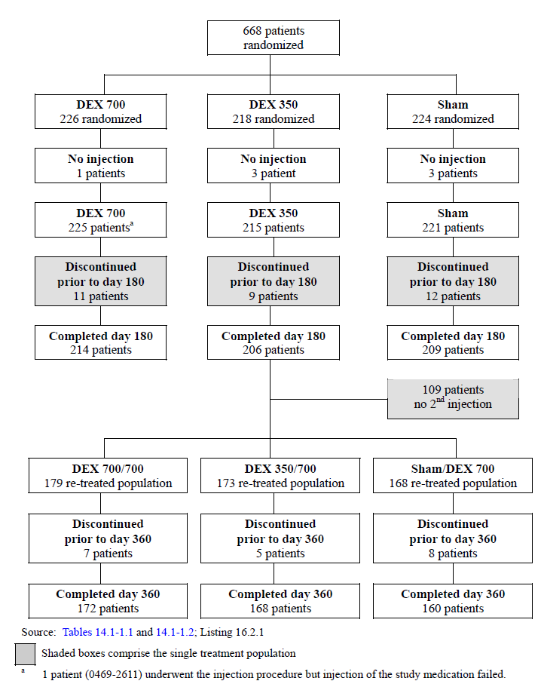

1. Summary of study populations (Study 009)

|  |  |  |  |
| --- | --- | --- | --- |
| Study population | DEX 700 | DEX 350 | Sham |
| ITT population | 226 | 218 | 224 |
| Safety population (as % of ITT population) | 225 (99.6%) | 215 (98.6%) | 221 (98.7%) |
| Per protocol population (as % of ITT pop.) | 213 (94.2%) | 201 (92.2%) | 209 (93.3%) |
| ITT population completing IT period | 214 (94.7%) | 206 (94.5%) | 209 (93.3%) |
| Re-treated population | 179 | 173 | 168 |
| Re-treated population completing OL extension | 172 (96.1%) | 168 (97.1%) | 168 (100%) |

For the re-treatment population, 96.2% (500/520) completed OL Day 180 with completion rates similar across the three groups at 96.1% (172/179), 97.1% (168/173) and 95.2% (160/168) in the DEX 700/700, DEX 350/700 and Sham/DEX 700 groups respectively. 16.3% (109/668) of the ITT population didn’t receive the second injection with rates and reasons for not receiving the second injection were comparable between treatment arms as summarised in the table below.

1. Exit status (Study 009)

|  | DEX 700/700 (N = 179) | DEX 350/700 (N = 173) | Sham/DEX 700 (N = 168) | Total  (N = 520) |
| --- | --- | --- | --- | --- |
| ITT population | 226 (100%) | 218 (100%) | 224 (100%) | 668 |
| Did not receive 2nd injection | 35 (15.5%) | 33 (15.1%) | 41 (18.3%) | 109 (16.3%) |
| Discontinued during IT period | 3 (1.3%) | 3 (1.4%) | 4 (1.8%) | 10 (1.5%) |
| Ineligible (BCVA/OCT criteria) | 18 (8.0%) | 19 (8.7%) | 23 (10.3%) | 60 (9.0%) |
| Safety concerns | 7 (3.1%) | 7 (3.2%) | 8 (3.6%) | 22 (3.3%) |

Reasons given for randomised patients not receiving treatment included concurrent vitreous haemorrhage and retinal tear, concurrent ocular infection, severe hypertension, panic attack at time of procedure, use of prohibited medications at IT Day 0 and new disclosure of ineligible medical history.

For the IT period, the attrition rate was small at 5.8% (39/668) of the ITT population discontinuing before completion of IT Day 180, with rates and reasons for discontinuation across treatment groups being similar. Discontinuation rates and reasons for the other analysis populations were also similar both between groups and between populations. For the re-treatment population, the attrition rate was even smaller at 3.8% (20/520) of patients discontinued prior to OL day 360, again a high completion rate with little variation in distribution between the three treatment groups.

##### Baseline data

###### Demographic characteristics

For the ITT population, overall, the mean (range) age was 63.6 years (31 to 96), 52.4% (350/668) were male and 67.2% (449/668) were Caucasian. 34.7% (232/668) were diagnosed with CRVO and 65.3% (436/668) with BRVO. There were no statistically significant differences among the treatment groups in the demographic and Baseline characteristics in the ITT population, as summarised in the table below.

1. Baseline demographic characteristics (ITT population; Study 009)

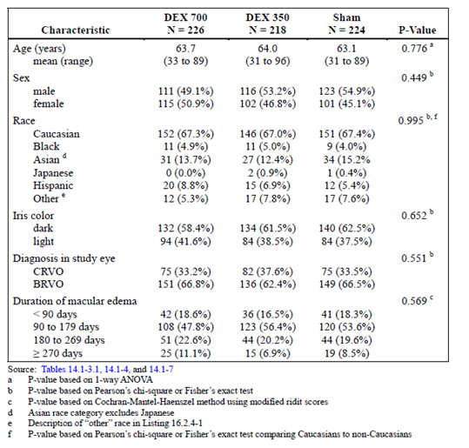

The Baseline demographic characteristics were well balanced and similar across the treatment groups. The mean age and age range reflects the rise in incidence of RVO with increasing age, as does the roughly equal proportions of male and female patients in the study, with the prevalence of RVO being approximately equal between genders. The ratio of BRVO to CRVO was roughly 2:1 and adequate enough to assess the efficacy and safety in (and any difference between) the diagnostic subgroups.

###### Medical and ophthalmic history

Overall, treatment groups were comparable in terms of history. Other than macular oedema (in the study eye), findings in the ophthalmic history as reported under SOC: ‘Eye disorders’ was positive for 99.9% (667/668) of patients. The most common findings were RVO 99.1% (662/668), cataract 57.2% (382/668), retinal haemorrhage 17.5% (117/668), refraction disorder 12.0% (80/668), and vitreous detachment 10.5% (70/668).

In the general medical history the most common findings were vascular disorders at 65.4% (437/668), musculoskeletal/connective tissue disorders 35.6% (238/668), metabolism/nutrition disorders 33.8% (226/668), social circumstances 28.0% (187/668), gastrointestinal disorders 25.1% (168/668), and infections/infestations 22.2% (148/668). There were statistically significant among-group differences for hepatobiliary disorders (12.8%, 3.7%, and 9.4% in the DEX 700, DEX 350, and Sham groups, respectively); and endocrine disorders (6.2%, 9.6%, and 13.8% in the DEX 700, DEX 350, and Sham groups, respectively).

###### Prior medications and procedures

Use of prior medication for macular oedema was similar among diagnostic subgroups at 5.5% (24/436) of the BRVO subgroup and 6.5% (15/232) of the CRVO subgroup. 8.5% (57/668) of patients reported prior procedures for the treatment of macular oedema in the study eye. All these patients had retinal laser coagulation, except one patient, who had intra-ocular injection.

17.5% (117/668) of patients reported medications for ophthalmological conditions other than the treatment of macular oedema prior to study entry. The most common prior medications (reported by greater than 2% of patients) were other ophthalmologicals (5.4%), other ophthalmological anti-infectives (4.2%), and ophthalmic beta blocking agents (2.4%).

The proportion of patients having received prior medication for macular oedema was low and comparable across the three groups as were the proportions having received laser coagulation.

###### Concurrent medications and procedures

Concurrent use of ocular medications in the study eye were reported for 46.5% (105/226) of patients in the DEX 700 group, 44.0% (96/218) in the DEX 350 group, and 22.3% (50/224) in the Sham group. The most frequently reported drug classes (more than 10% in any treatment group) were: ophthalmic beta blocking agents (25.7% in the DEX 700 group, 21.6% in the DEX 350 group, and 2.7% in the Sham group), sympathomimetics in glaucoma therapy (12.8% in the DEX 700 group, 12.8% in the DEX 350 group, and 1.3% in the Sham group), ophthalmic prostaglandin analogues (9.7% in the DEX 700 group, 11.5% in the DEX 350 group, and 1.3% in the Sham group), and other ophthalmologicals (9.7% in the DEX 700 group, 11.0% in the DEX 350 group, and 9.8% in the Sham group). The higher incidence of IOP-lowering medications is to be expected in the patients receiving intravitreal steroid injections. The proportion of patients requiring concurrent procedures was low overall and comparable at 3.5% (8 patients) in the DEX 700 group versus 2.65% (6 patients) in the Sham group.

Concurrent ophthalmological medication use was approximately double that in the DEX 700 group compared with the Sham group. As reported, the majority of this difference is made up from the much higher rates of IOP lower medication use in the DEX 700 group.

###### Re-treatment population

For the 520 patients in the re-treated population, overall, the mean (range) age was 64.4 (31 to 96) years, 51.5% were male, and 68.7% were Caucasian. The diagnosis was CRVO for 35.0% and BRVO for 65.0% of patients. Demographics and Baseline characteristics were similar among the 3 treatment groups in the re-treated population as summarised in the table below.

The Baseline demographics of the ITT population and re-treatment population were very similar possibly in part due to the overall low attrition rate that was comparable across all 3 IT groups.

1. Baseline demographic characteristics (Re-treatment population)

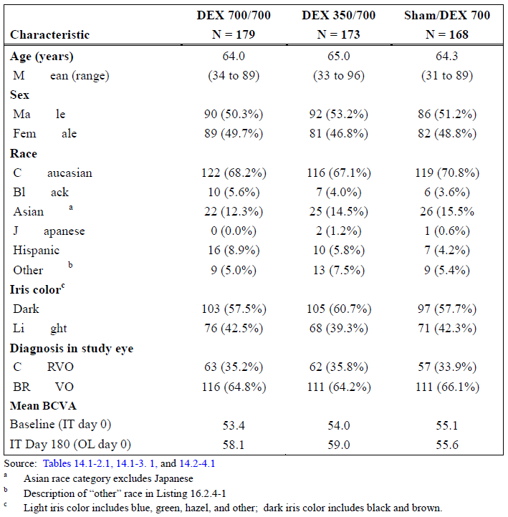

During the OL extension, ocular concomitant medications in the study eye of the re-treated population were reported for 48.0% in the DEX 700/700 group, 50.9% in the DEX 350/700 group, and 48.2% in the Sham/DEX 700 group. Use of ocular concomitant medications doubled in the OL extension for patients who had received Sham in the IT period. The most frequently reported drug classes (more than 10% in any treatment group) during the OL extension were: ophthalmic beta blocking agents (29.1% in the DEX 700/700 group, 29.5% in the DEX 350/700 group, and 28.0% in the Sham/DEX 700 group), sympathomimetics in glaucoma therapy (14.5% in the DEX 700/700 group, 15.6% in the DEX 350/700 group, and 11.9% in the Sham/DEX 700 group), ophthalmic prostaglandin analogues (15.1% (27/179) in the DEX 700/700 group, 12.7% in the DEX 350/700 group, and 8.3% in the Sham/DEX 700 group), and other ophthalmologicals (11.2% in the DEX 700/700 group, 12.1% in the DEX 350/700 group, and 14.3% in the Sham/DEX 700 group).

The number of concurrent ocular procedures in the retreatment population were 4 and 8; 4 and 8; 1 and 8 in the IT and OL period for the DEX 700/700, DEX 350/700 and Sham/DEX 700 groups respectively. Retinal laser coagulation was the most common with 4, 3 and 4 procedures carried out across the three groups (12-month cumulative period) followed by eye laser surgery (0, 4 and 2 procedures) and intraocular injection (2, 0 and 1 procedures).

IOP lowering ophthalmic medications were there most commonly used class and the doubling in use is unsurprising considering elevated IOP was the most common AE across all studies. Numerically, concurrent ocular were higher in the DEX groups and following re-treatment, there were no significant differences.

##### Major protocol violations/deviations

Using pre-specified guidelines, each deviation in the master list was classified as ‘unimportant’ or ‘important’. Unimportant deviations were related to use of selected concomitant medications or therapies (for example warfarin or heparin, immunosuppressants, topical ophthalmic steroids or NSAIDs, procedures for reasons other than macular oedema), timing/roles for study procedures related to secondary endpoints, out-of-visit windows, and documentation of serious adverse event reporting discrepancies.

Important deviations were related to patient eligibility, amended informed consent/privacy documents or ethics committee approval, any study drug issues, use of prohibited concomitant medications or therapies (such as intravitreal, periocular or systemic steroids, laser/surgical treatment for macular edema in the study eye), or missing/incomplete BCVA at key visits.

###### IT period (ITT population)

A total of 49 patients were excluded from the PP population: 14 patients in the DEX 700 group, 18 patients in the DEX 350 group, and 17 patients in the Sham group.

Patients and visits/measurements were excluded from analyses of the PP population due to the following reasons: Duration of macular oedema in the study eye at enrolment was outside of the window: 4 weeks to 9 months for CRVO patients and 4 weeks to 12 months for BRVO patients prior to the qualification/Baseline visit; Baseline retinal thickness of the study eye was less than 275 μm; reported history or existing condition of neovascularization or diabetic retinopathy in the study eye; Baseline BCVA in the study eye was outside the range of 32-70 letters; history of anterior chamber intra-ocular lens in the study eye; missing partial or full information for Baseline BCVA calculation; received a study treatment other than that being assigned by randomisation; did not receive any treatment following enrolment and randomisation; injection of the study medication failed; Received intravitreal injection drugs (such as triamcinolone, ranibizumab, bevacizumab, dexamethasone) in the study eye within 3 months prior to Qualification/Baseline visit or intraocular laser surgery of the study eye within 80 days prior to Qualification/Baseline visit.

###### 12-month study (Re-treatment population)

There were 186 patients with 238 important protocol deviations during the 12 month study. These included: 7 patients were randomised but not treated; 6 patients were treated with expired open label study medication; 1 patient was treated with a Posurdex injection from another ongoing Allergan trial instead of the RVO open label study medication at the re-treatment visit; 56 protocol inclusion/exclusion violations occurred; 53 patients were noted to have informed consent issues (majority not signing updated version of informed consent form); 52 patients received prohibited medications.

***Results for the primary efficacy outcome***

###### BCVA improvement of 15 or more letters from Baseline

1. Proportion of patients with ≥ 15 letters improvement from Baseline BCVA (Study 009)

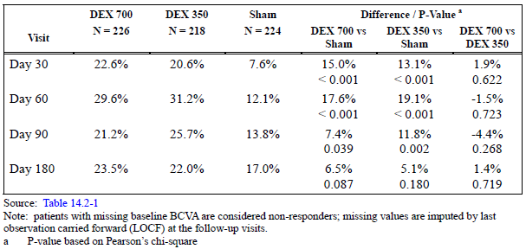

The proportion of patients from the ITT population with ≥ 15 letters BCVA improvement from Baseline was significantly higher with DEX 700 compared to Sham at IT visit Days 30, 60 (both p < 0.001) and day 90 (p = 0.039) as summarised in the table above. At IT Day 180 (primary time point) the comparison of response rates between DEX 700 versus Sham was 23.5% versus 17.0%, a difference of 6.5% and not significant (p > 0.087). The greatest differences between DEX 700 and Sham were seen at day 30 (15.0%) and day 60 (17.6%). There were no differences between the 2 doses of DEX and results for the PP population were similar to those for the ITT population.

Note that the primary efficacy outcome at IT Day 180 was not met. The difference between DEX 700 and Sham was 6.5% (CI 95%: -0.9% to 13.9%) and wasn’t statistically significant (p = 0.087).

##### Results of other analyses of the primary efficacy outcome

###### Proportion of patients with BCVA improvement ≥ 15 letters from Baseline in diagnostic subgroups

1. Proportion with BCVA improvement ≥ 15 letters from Baseline by diagnosis (Study 009)

|  |  |  |  |  |  |  |
| --- | --- | --- | --- | --- | --- | --- |
| Visit | Diagnosis: BRVO | | | Diagnosis: CRVO | | |
|  | DEX 700 | Sham | Difference; P‑value | DEX 700 | Sham | Difference; P‑value |
| IT day 30 | 32/151 (21.2%) | 13/149 (8.7%) | 12.5%; 0.002 | 19/75 (25.3%) | 4/75 (5.3%) | 20.0%; < 0.001 |
| IT day 60 | 42/151 (27.8%) | 23/149 (15.4%) | 12.4%; 0.009 | 25/75 (33.3%) | 4/75 (5.3%) | 28.0%; < 0.001 |
| IT day 90 | 34/151 (22.5%) | 23/149 (15.4%) | 7.1%; 0.118 | 14/75 (18.7%) | 8/75 (10.7%) | 8.0%  0.166 |
| IT Day 180 | 35/151 (23.2%) | 30/149 (20.1% | 3.0%; 0.522 | 18/75 (24.0%) | 8/75 (10.7%) | 13.3%  0.031 |

As summarised in the table for the BRVO subgroup, the difference between DEX 700 and Sham was 12.5% at day 30 (p = 0.002) and 12.4% at day 60 (p = 0.009). Comparisons at day 90 and 180 were non-significant. In comparison the CRVO subgroup showed a better treatment response with a difference between DEX 700 and Sham of 20.0% at day 30 and 28.0% at day 60 (both p < 0.001) due to less spontaneous improvement in the sham group. Comparisons at day 90 were non-significant, but response improved at Day 180, with a difference of 13.3% (p = 0.031).

The primary efficacy outcome in diagnostic subgroups was only met in those with CRVO. Differences between DEX 700 and Sham were non-significant in the BRVO subgroup beyond IT day 60.

###### Proportion of patients with BCVA improvement ≥ 15 letters (macular oedema ≥ 90 days duration)

1. Proportions with > 15 letter BCVA improvement (macular oedema ≥ 90 days duration)

|  |  |  |  |
| --- | --- | --- | --- |
| Visit | DEX 700 | Sham | Difference; p value |
| IT day 30 | 42/184 (22.8%) | 11/183 (6.0%) | 16.8%; <0.001 |
| IT day 60 | 51/184 (27.7%) | 21/183 (11.5%) | 16.2%; <0.001 |
| IT day 90 | 40/184 (21.7%) | 24/183 (13.1%) | 8.6%; 0.029 |
| IT Day 180 | 45/184 (24.5%) | 26/183 (14.2%) | 10.2%; 0.013 |

Excluding patients with < 90 days, the proportion of patients with BCVA improvement of ≥ 15 letters from Baseline was significantly higher with DEX 700 compared to Sham at IT Days 30 and 60 (p < 0.001), day 90 (p = 0.029) and Day 180 (p = 0.013).

Note this analysis was defined a posteriori. This is reasonable as it recognises the high rates of spontaneous improvement in BCVA found in this and later studies. In contrast to findings in the ITT population, this analysis of the primary efficacy outcome demonstrated that at the primary time point (IT Day 180) the difference (10.2%) between DEX 700 and Sham was significant (CI 95%: 2.2% to 18.3%; p = 0.013).

##### Results of other analyses of the primary efficacy variable

###### Proportion of patients with BCVA improvement ≥ 10 letters from Baseline

1. Improvement of ≥ 10 letters from Baseline BCVA

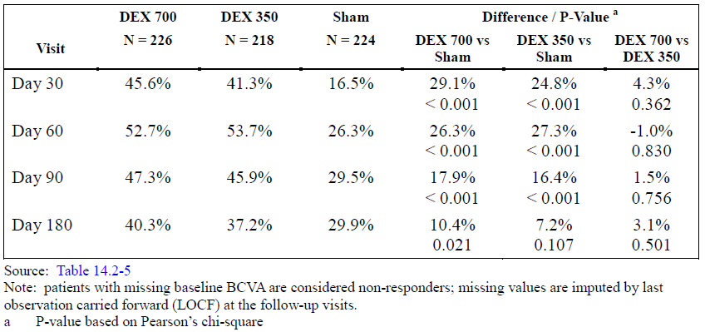

The proportion of patients with a BCVA improvement ≥ 10 letters from Baseline is summarised in the table. The comparison between DEX 700 versus Sham showed significantly higher response rates favouring DEX 700 at all study visits (p ≤ 0.021). As with the primary efficacy outcome, differences in response rates were highest at early visits (day 30; day 60: 29.1% and 26.3% respectively) compared to later visits (day 90; Day 180: 17.9% and 10.4%).

1. BVCA > 10 letter improvement over Baseline (BRVO subgroup)

|  |  |  |  |
| --- | --- | --- | --- |
|  | DEX 700 | Sham | Difference; p-value |
| IT day 30 | 64/151 (42.4%) | 30/149 (20.1%) | 22.2%; < 0.001 |
| IT day 60 | 79/151 (52.3%) | 45/149 (30.2%) | 22.1%; < 0.001 |
| IT day 90 | 77/151 (51.0%) | 50/149 (33.6%) | 17.4%; 0.002 |
| IT Day 180 | 67/151 (44.4%) | 49/149 (32.9%) | 11.5%; 0.041 |

The proportion of BRVO patients with a BCVA improvement of 10 or more letters from Baseline was significantly higher with DEX 700 and DEX 350 compared to Sham at the early visits, and with DEX 700 compared to Sham at IT Day 180. As with the ITT, the difference was greatest at the early visits (day 30 and 60). At Day 180 the difference (95% CI) between DEX 700 compared with Sham was 11.5% (0.5% to 22.4%); p = 0.041.

An improvement of ≥ 10 letters BCVA represents the minimally clinical relevant outcome in terms of visual gain. At the primary time point (Day 180) for an improvement of ≥ 15 letters, applying this lower criterion for VA response demonstrated a difference in the ITT between DEX 700 versus Sham of 10.4%. Note that the BRVO subgroup responded poorly compared to CRVO, with differences between DEX 700 and Sham non-significant at the day 90 and 180 visits. No analysis for the CRVO subgroup was given, with the analysis in the BRVO subgroup included in the study prior to database lock. Also of note, in the PP analysis, the comparison of DEX 700 versus Sham at Day 180 was 9.8% and non-significant (p = 0.100).

###### ≥ 3-line vision loss from baseline

At day 90 and 180 (but not earlier visits) the comparison of DEX 700 and Sham was 3.5% versus 8.0% (difference 4.5%; p = 0.041) and 6.6% versus 12.1% (difference 5.5%; p = 0.048).

###### Time to a treatment response

The cumulative response rates are depicted in the figure below. The cumulative response rates were consistently higher throughout the 180 day IT period for DEX 700 and DEX 350 compared to Sham (p < 0.001). Patients receiving DEX achieved the treatment response much earlier than Sham patients. Overall, the cumulative response rate curves were significantly different for the DEX 700 and DEX 350 groups compared to the Sham group (p < 0.001). Cumulative response rates were consistently higher with DEX 700 and DEX 350 than with Sham from IT visit day 30 to the end of the IT period. There was a separation of curves as early as day 30 which was consistent over time without any crossover at any visit. There were no differences between the 2 doses of DEX.

1. Time to ≥ 15 letters improvement from Baseline BCVA (Study 009)

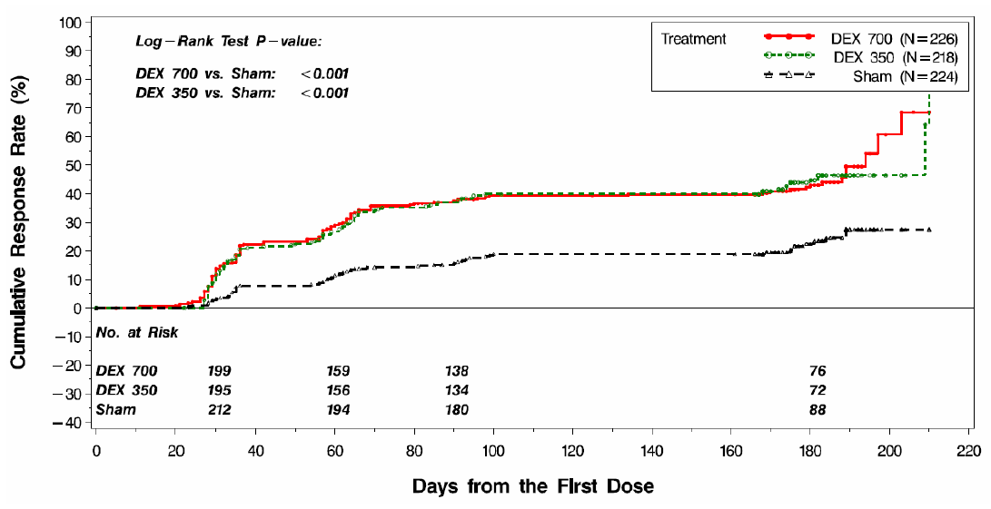

Note this analysis was included after database lock and included as the primary efficacy endpoint in later studies. Although a significant difference is seen, it fails to reflect the lack of efficacy later in the study period at day 90 and 180 as seen in other analyses of efficacy.

###### Mean change from Baseline BVCA

1. Mean change in letters from Baseline BCVA (Study 009)

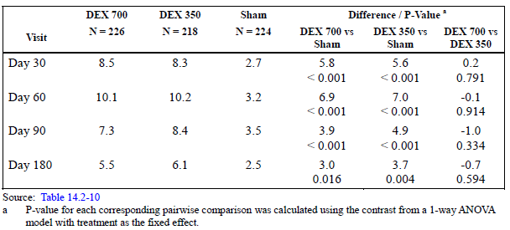

In the ITT population, the mean change from Baseline BCVA in number of letters read correctly is summarised in the table above. Mean change peaked at IT day 60, and were significantly greater with DEX 700 compared to Sham at all study visits (p ≤ 0.016). At the primary time point for the primary efficacy analysis (Day 180) the difference between DEX 700 versus sham was 3.0 (p = 0.016).

For BRVO patients, differences between DEX 700 and Sham in mean change in letters read correctly were significant at IT Days 30, 60, 90, and 180 (p ≤ 0.018). For CRVO patients, differences were significant at IT Days 30, 60, and 90 (p ≤ 0.044).

1. Mean change from Baseline BCVA according to diagnostic subgroups

|  |  |  |  |  |  |  |
| --- | --- | --- | --- | --- | --- | --- |
| Visit | BRVO (N = 151) | | | CRVO | | |
|  | DEX 700 | Sham | Difference; p‑value | DEX 700 | Sham | Difference; p‑value |
| Baseline | 55.4 | 56.3 | -1.0; 0.360 | 51.6 | 52.4 | -0.9; 0.630 |
| IT day 30 | 8.6 | 4.2 | 4.5; < 0.001 | 8.3 | -0.1 | 8.5; < 0.001 |
| IT day 60 | 10.6 | 5.6 | 5.0; < 0.001 | 9.2 | -1.6 | 10.8; < 0.001 |
| IT day 90 | 9.2 | 5.8 | 3.4; 0.001 | 3.5 | -1.2 | 4.7; 0.044 |
| IT Day 180 | 8.0 | 5.0 | 2.9; 0.018 | 0.4 | -2.7 | 3.1; 0.242 |
| P-values for difference in mean change compared to Baseline between DEX 700/700 versus Sham/DEX 700 were: IT Days 30, 60 and 90 (p < 0.001); IT Day 180 (p = 0.002); OL extension Days 30 and 60 (p = 0.003); OL extension day 90 (p = 0.211); OL extension Day 180 (p = 0.632). | | | | | | |

##### Results for secondary efficacy outcomes

###### Retinal thickness measured by OCT

At Baseline in the ITT population the mean central retinal thickness in the 1 mm subfield of the study eye measured by OCT was comparable and not significantly different between DEX 700 and Sham. At IT day 90 the mean decrease in retinal thickness was significantly greater with DEX 700 (-215.6 microns) compared to Sham (-91.1 microns), p < 0.001. At Day 180 there were no significant differences between DEX 700 and Sham. Results for the PP population were similar to those of the ITT population.

For BRVO patients, mean decrease in retinal thickness was significantly greater at day 90 with DEX 700 (-206.2 microns) and DEX 350 (-190.3 microns) compared to Sham (-93.4 microns) (p < 0.001). For CRVO patients, mean central retinal thickness in the 1 mm subfield in the study eye measured by OCT was significantly less with DEX 700 (-234.9 microns) compared to Sham (‑86.5 microns) (p < 0.001) At Day 180 there were no significant differences between DEX 700 and Sham for either diagnostic subgroup.

###### Other outcomes

At Baseline, central retinal thickening in the study eye on fundus photography was graded as definite for > 90% of patients in each treatment group. There were no statistically significant pairwise differences between DEX 700 and Sham.

For contrast sensitivity, there were no statistically significant differences between treatment groups at Baseline or IT Day 180 in mean number of letters read correctly.

Change from Baseline in fluorescein leakage at the macula was improved from Baseline for approximately 50% across all 3 treatment groups. There were no statistically significant differences between the treatment groups in the distribution of change from Baseline fluorescein leakage.

##### Efficacy for the re-treated population

###### BCVA improvement of 15 or more letters from Baseline

The table below summarises the proportions of the patients in the re-treatment population according to initial treatment randomisation with a BCVA improvement of 15 or more letters from Baseline. At the end of the IT period (IT Day 180) 17.9% (32/179) of the DEX 700/700 group and 11.3% (19/168) of the Sham group achieved an improvement of ≥ 15 letters from Baseline BCVA. The difference in response rates (6.6%) was not statistically significant. Following retreatment with DEX 700 response rates increased by 2 to 2.5 fold at the visit with peak response in each of the 3 treatment groups compared to the second Baseline at IT Day 180. No statistically significant differences between DEX 700/700 and Sham/DEX 700 except at OL day 30 (p = 0.035). At the end of the OL extension, a non-significant difference of 0.9% was seen in response rates favouring the Sham/DEX 700 group. Compared the IT Day 180 the difference in response rates at the end of the OL extension was 4.4% for DEX700/700 and 11.9% for Sham/DEX 700.

1. Proportions with ≥ 15 letters improvement from Baseline BCVA (Study 009)

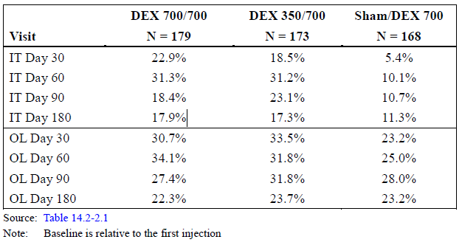

Patients in all three groups responded to treatment with maximal gain in VA greatest in the DEX 700/700 group, but at OL Day 180 there was no evidence of a sustained accumulative gain in VA twice two consecutive implants compared to one. It seems that a comparison in proportions with a ≥ 10 letter improvement in BCVA wasn’t available.

###### Mean change in letters read correctly from Baseline BCVA

In the re-treatment population, the mean change from Baseline BCVA are summarised in the table below. Mean gain was greater in the DEX 700/700 compared to Sham/DEX 700 at every time point during the 12-month study and differences were significant at the IT visits (p ≤ 0.002) and at OL Days 30 and 60 (p = 0.003) but not Days 90 and 180. For the DEX 700/700 group maximal mean gain in letters read correctly in the OL extension (10.5 at OL day 60) was essentially the same but not greater than the maximal mean gain in letters in the IT period (10.6 letters at IT day 60).

1. Mean change from first Baseline BCVA (Study 009)

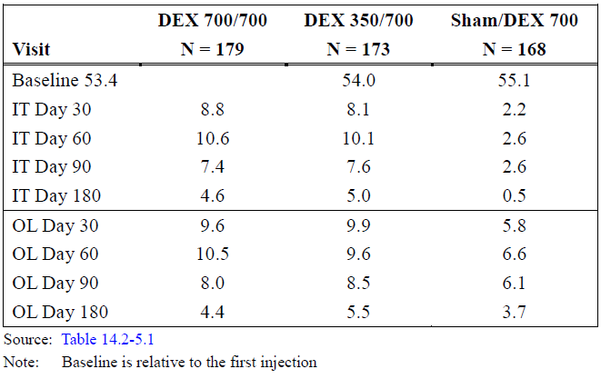

All treatment groups experience an improvement in the OL extension. Compared to the mean gain in letters read correctly at IT Day 180, at the end of the OL extension, a -0.2 letter decrease was seen in the DEX 700/700 group contrasted with a 3.2 letter gain for Sham/DEX 700 group. Although the DEX 700/700 group outperformed the Sham/DEX 700 group, with no improvement in letters gained in the maximal number of letters gained and no improvement at OL Day 180 compared with IT Day 180 there was no evidence of an accumulative effect in efficacy in the DEX 700/700 group.

###### Retinal thickness measured by optical coherence tomography

As with the ITT population, the DEX 700/700 group had a significantly greater mean decrease in retinal thickness at IT day 90 but not IT Day 180 compared with Sham/DEX 700. Following re-treatment the mean decrease at OL day 90 was -267.8 microns and -262.2 microns for DEX 700/700 and Sham/DEX 700 respectively and -170.4 and -179.2 microns at OL Day 180. Neither comparison was significant.

###### Single treatment population (12-month data)

The single treatment population was comprised of patients randomised in the IT period and followed up in the OL extension, but who didn’t receive treatment for the OL extension. During the OL extension however when neither group was receiving treatment, differences between DEX 700 and Sham in the proportions with a BCVA improvement of ≥ 15 letters all favoured the Sham group at every visit, and at OL Day 180, 8.3% more Sham patients counted as responders. Likewise, in terms of mean number of letters read correctly compared to BCVA Baseline, response rates were greater in the DEX 700 group in the IT period, and static in the OL extension whereas letters gained in the Sham group steadily increased over the 12-month period and were numerically greater than DEX 700 at OL Days 30, 60 and 180.

1. ≥ 15 letter BCVA from Baseline (left) and mean change in BCVA (letters) from Baseline (right)

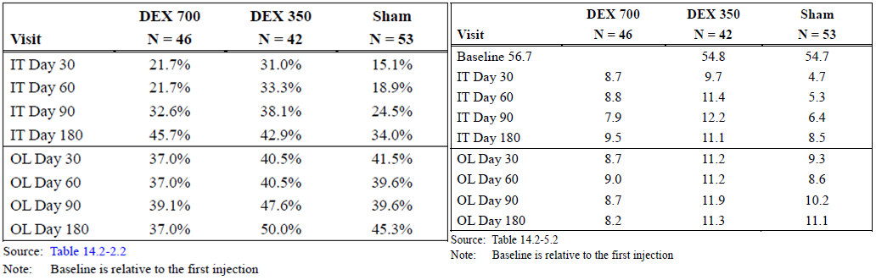

Mean change in retinal thickness from Baseline between DEX 700 and Sham progressively shrank up to OL Day 180. At this time point, comparison was -260.6 versus -215.4 (p = 0.345).

##### Evaluator’s commentary

The primary efficacy analysis demonstrated a non-significant difference (6.5%; p = 0.087) between proportions in the DEX 700 and Sham treatment groups with an improvement of ≥ 15 letters BCVA from Baseline at the primary time point of IT Day 180.

On analysis of the secondary endpoints, DEX 700 treatment was associated with an early benefit when between-group comparisons between DEX 700 and Sham demonstrated a difference of 15.0% at IT day 30 and 17.6% difference at IT day 60 (both p < 0.001). The between-group DEX 700 versus Sham differences in the individual diagnostic subgroups were both insignificant at IT day 90 (BRVO: 7.1%; p = 0.118; CRVO: 8.0%; p = 0.166). Overall the CRVO subgroup had a better treatment response with a significant difference at IT Day 180 compared with no clinical benefit in the BRVO subgroup (CRVO: 13.3%; p = 0.031; BRVO: 3.0%; p = 0.522). When a post hoc analysis of patients with macula oedema of < 90 days history were excluded to theoretically eliminate the effect of spontaneous improvement in patients, a significant difference in response rates between DEX 700 and Sham was seen at every study visit and at IT Day 180 the difference was 10.2% (p = 0.013). Applying a lower criterion to qualify as a responder, at a BCVA improvement of ≥ 10 letters, the DEX 700 versus Sham difference at IT Day 180 was 9.7% (p =  0.044). Categorical change from Baseline BCVA demonstrated a significant difference in distribution between DEX 700 versus Sham at IT Day 180 but the importance of this is unclear – a small difference between groups (-5.5%) was seen in the number of patients with ≥ 15 letter deterioration in BCVA compared with Baseline (p = 0.016), although the implant was still associated with 8.0% having a ≥ 5 and < 15 letter deterioration and 6.6% having a ≥ 15-letter deterioration at IT Day 180. Difference in mean change in BCVA from Baseline peaked at IT day 60 at 6.9 letters (p < 0.001) falling to 3.0 letters (p = 0.016) at Day 180. Whilst significant, the clinical meaningfulness of a 3.0 letter gain is questionable. In keeping with the results for the primary efficacy variable, retinal thickness and mean change was significantly different at IT day 90 but numerically and significantly, differences were non-existent at Day 180.

Following re-treatment, response rates (≥ 15 letter improvement in BCVA from the first Baseline) increased for all treatment groups but with no significant differences between DEX 700/700 and Sham/DEX 700 with a numerically better response rate in the Sham/DEX 700 group than the DEX 700/700 group at the end of the OL extension. Compared to the second Baseline (IT Day 180), the change in proportion of responders at OL Day 180 was 4.4% with the DEX 700/700 treated group and 11.9% with Sham/DEX 700, and the change from second Baseline to peak response rates was 16.2% in the DEX 700/700 group and 16.7% in the Sham/DEX 700 group. Overall, there was no evidence of accumulative efficacy in the DEX 700/700 group compared with the Sham/DEX 700 treated group when injections were performed after 6 months.

#### Study 206207-008

Evaluator’s comment: Studies 206207-008 and 009 were run with the same protocol and methodology with Study 009 completing first in September 2008 and Study 008 completing in October 2008. Due to these similarities, where the study design and methodology is identical please refer to the relevant sections for Study 009 above. Despite the identical nature of protocols and methodology, following completion of Study 009 and approximately one month before completion and Database lock of Study 008 major amendments to the statistical analysis plans including changes to the primary efficacy endpoint and time points of Study 008 were made. According to the CSR, these changes were made in consultation with the following regulatory agencies:  
FDA: The ‘proportion of patients with a ≥ 15 letter improvement in BCVA from Baseline at IT visit Day 180 in the ITT population’ was amended to the ‘time to achieve a treatment response of ≥ 15 letter improvement in BCVA from Baseline.’  
EMEA: the ‘proportion of patients with a ≥ 15 letter improvement in BCVA from Baseline at IT visit Day 180 in the ITT population’ was amended so that the new primary time point was at IT visit day 90 opposed to Day 180.  
For the purposes of this efficacy evaluation, the primary efficacy endpoint has remained at the proportion of patients with a BCVA improvement of ≥ 15 letters from Baseline in the ITT population IT Day 180.

##### Study design, objectives, locations and dates

###### Primary objectives

As for Study 206207-009

###### Locations

85 study centres randomised at least one patient across 13 countries. These included Australia, USA, France, Germany, South Africa and Canada.

###### Dates

Study initiation date (first patient enrolled): 22 October 2004

Study completion date (last patient completed OL extension visit Day 180): 09 October 2008.

###### Inclusion and exclusion criteria

As for Study 206207-008

###### Study treatments

As for Study 206207-009 (see above).

###### Efficacy variable and outcomes

The efficacy variables and outcomes measured were the same for both the initial 6-month trial and the 6-month open-label extension.

###### Primary efficacy variable and outcomes

###### Other outcomes for the primary efficacy variable

Additional efficacy analyses for the primary efficacy variable included:

* Time to a treatment response of ≥ 15 letters improvement from Baseline BCVA
* Proportion of patients from the ITT population with a ≥ 15 letter improvement from Baseline BCVA of IT Day 180 according to diagnostic subgroups (BRVO or CVRO)
* Proportion of patients from the ITT population with a ≥ 15 letter improvement from Baseline BCVA of IT Day 180 with macular oedema ≥ 3 months (ad hoc analysis)
* Categorical change from Baseline BCVA
* Raw BCVA scores
* Mean change in letters correctly read from Baseline BCVA
* Other exploratory analyses for the primary efficacy variable in BRVO and CRVO subpopulations

###### Secondary efficacy variables

The secondary efficacy variables were:

* Contrast sensitivity using the Pelli-Robson chart
* Optical coherence tomography (OCT) capturing the mean retinal thickness in the 1 mm central subfield
* Fundus photography
* Fluorescein angiography.

###### Secondary efficacy outcomes

Secondary efficacy outcomes included:

* Change from Baseline in numbers of letters read (contrast sensitivity)
* Change from Baseline in central retinal thickness and retinal volume assessed by OCT
* Change from Baseline in central retinal thickening assessed by fundus photography

In addition, the primary efficacy outcome and other analyses of the primary efficacy variable were performed for the PP population.

###### Randomisation and blinding methods

These were as for Study 009 above.

###### Analysis populations

These were as for Study 009 above.

###### Sample size

This was calculated as for Study 009 above.

###### Statistical methods

*Primary efficacy analyses:* The primary efficacy analysis was the comparison between DEX 700 and Sham in the ITT population. A Kaplan-Meier survival analysis using a 2-sided log-rank test at the 0.05 significance level was performed. The cumulative response rates were calculated using the Kaplan-Meier method for each treatment group. For the EMA submission a Pearson’s chi‑square test at the 0.05 significance level was performed, and a 2-sided 95% CI for the treatment difference in the proportion of patients with a BCVA improvement of 15 or more letters from Baseline was constructed using the normal approximation for a binary variable.

*Other analyses for the primary efficacy variable*: Secondary analyses include comparisons of DEX 700 versus Sham or DEX 350 versus Sham for specific variables. A gate-keeping procedure with a pre-specified sequence for controlling the overall experiment-wise type I error at 5% level was used with between-group comparisons performed and the statistical significance was assessed sequentially. A serial gate-keeping procedure was applied for statistical inferences. In the event that a non-significant result (p-value > 0.05) was obtained from any of the above comparisons, none of the subsequent tests were considered as significant at the 0.05 significance level. For the EMA submission all secondary efficacy analyses were done with a nominal significance level of 0.05 and no gate-keeping procedure was applied.

Unless otherwise stated, all other efficacy analyses were performed using the ITT population based on the 2-sided hypothesis test with an unadjusted significance level of 0.05. Analyses for BCVA and retinal thickness in the ITT population used the last observation carried forward (LOCF) method for missing data. The PP analyses of BCVA and retinal thickness and the ITT analyses of other efficacy variables were done on observed data without missing data imputation.

For BCVA improvement from Baseline, analyses used the Pearson’s chi-square test for between group comparisons. BCVA scores at each scheduled visit and change from Baseline was analysed using a 1-way ANOVA model with treatment as the fixed effect. Between-group comparisons were performed in a pairwise fashion using contrasts from the ANOVA model.

*Secondary efficacy analyses:* Contrast sensitivity and central retinal thickness (OCT) was analysed using pairwise between-group comparisons performed using contrasts from the 1-way ANOVA model with treatment as the fixed effect. Least square means and the corresponding 95% CIs for the between-group differences were calculated and reported. Central retinal thickening was analysed with the Wilcoxon rank-sum test with Pearson’s chi-square test was used to compare the proportion of patients with at least 1-grade improvement from Baseline between groups for each scheduled follow-up visit.

###### Participant flow

Participant flow is summarised. 872 patients were screened with 32% (275/872) failing to meet the entry criteria. A total of 599 patients were randomised and enrolled (defining the ITT population) as shown in Figure 3, below. 201 patients were randomised to the DEX 700 group, 196 to the DEX 350 group, and 202 to the Sham group. 94.7% (567/599) of participants completed the 180 day IT period (similar across the three randomised groups).

4 patients (0.7%, 4/599) were randomised but did not receive treatment, 3 patients in the DEX 700 group and 1 patient in the Sham group. Reasons given were active uveitis, severe influenza, withdrawal of consent and not meeting inclusion criteria on day of treatment. 1 patient randomised to the DEX 700 group was treated with DEX 350, and 1 patient randomised to DEX 700 received Sham.

1. Summary of study populations (Study 008)

|  |  |  |  |  |
| --- | --- | --- | --- | --- |
| Study population | DEX 700 | DEX 350 | Sham | Total |
| ITT population | 201 | 196 | 202 | 599 |
| ITT population completing IT Day 180 | 189 (94.0%) | 189 (96.4%) | 189 (93.6%) | 567 (94.7%) |
| Safety population | 196 (97.5%) | 197 (100.5%) | 202 (100%) | 595 (99.3%) |
| PP population | 189 (94.0%) | 181 (92.3%) | 185 (91.6%) | 555 (92.7%) |
| Re-treatment population | 162 | 156 | 159 | 477 |
| Re-treatment population completing OL Day 180 | 158 (97.5%) | 148 (94.9%) | 153 (96.2%) | 459 (96.2%) |

1. Disposition of patients (Study 008: ITT and re-treatment population)

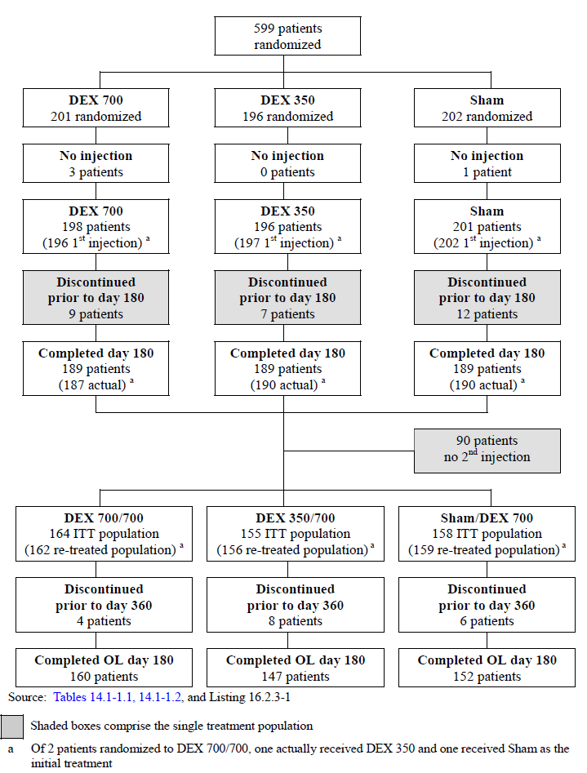

Of the 599 patients (ITT population) 477 (79.6%) were retreated at IT Day 180. 96.2% (459/477) of the re-treatment population completed OL Day 180. Of the 18 patients (3.8%, 18/477) discontinued after IT Day 180 but prior to OL Day 180, 6 were due to adverse events, 6 due to administrative reasons, and 6 due to protocol violations.

##### Major protocol violations/deviations

###### IT period

The PP population includes patients who had no major protocol violations determined prior to database lock. The PP population included 92.7% (555/599) of enrolled patients. Forty-four patients (12 patients in the DEX 700 group, 15 patients in the DEX 350 group, and 17 patients in the Sham group) were excluded from the PP population and all by-visit analyses.

Patients and visits/measurements were excluded from analyses of the PP population due to the following reasons: Duration of macular oedema was outside the following window period at enrolment: 4 weeks to 9 months for CRVO patients and 4 weeks to 12 months for BRVO patients prior to the qualification/Baseline visit; Baseline BCVA in the study eye was outside the range of 32-70 letters; Baseline retinal thickness of the study eye was below 275 μm; reported history or existing condition of retinal neovascularisation or diabetic retinopathy (DME) in the study eye; intraocular laser surgery of the study eye within 80 days prior to qualification/Baseline visit; use of intravitreal injectable drug (such as triamcinolone, ranibizumab, bevacizumab, or dexamethasone) in the study eye within 3 months prior to Qualification/Baseline visit; history of anterior chamber intra-ocular lens in the study eye; missing partial or full information for Baseline BCVA calculation; received a study treatment other than that being assigned by randomisation; did not receive any treatment following enrolment and randomisation; the treatment procedure was performed but the injection of the study medication failed.

Three patients were excluded from the IT Day 180 PP analyses due to on-study violations during follow-up as they received protocol-prohibited procedures during the study.

###### Retreatment population

There were 138 patients with 168 important protocol deviations during the 12-month study: 4 patients were randomised but not treated; 2 patients were treated with a different study medication kit number to the one assigned by the IVRS system; 2 patients were treated with expired open-label study medication; 4 patients were treated with an injection from the masked portion of the study at the re-treatment visit; although the treatment was masked, all patients received DEX 700 as verified from the study drug kit numbers; 52 protocol inclusion/exclusion violations occurred; 32 patients were noted to have informed consent issues (majority: not signing updated version of informed consent form); 47 patients received prohibited medications.

##### Baseline data

###### Demographic characteristics

There were no statistically significant differences among the treatment groups in the demographic and Baseline characteristics in the ITT population. The mean age was 65.5 years (range: 32 to 91) with > 95% aged ≥ 45 years. 54.6% were male and 83.8% Caucasian. 34.2% had been diagnosed with CRVO and 65.8% with BRVO.

1. Demographic and Baseline characteristics (ITT population)

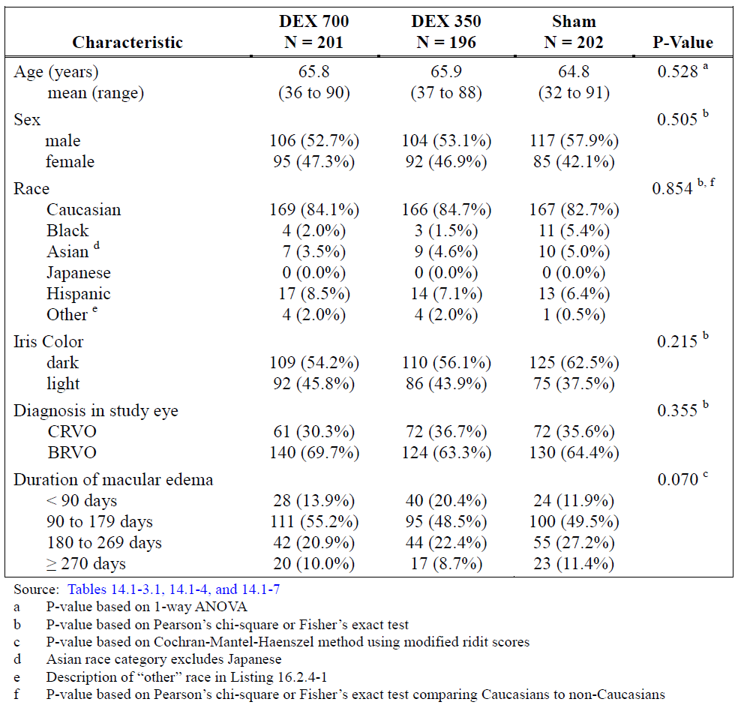

###### Medical and ophthalmic history

Ophthalmic history, other than macular oedema in the study eye, was reported by 99.2% (594/599) of patients under the SOC: ‘Eye disorders’. The most common findings were RVO at 98.5% (590/599), cataract 54.1% (324/599), retinal haemorrhage 12.7% (76/599), and cataract nuclear 10.5% (63/599). Other than ophthalmic history, the most common findings on medical history were vascular disorders 64.8% (388/599), metabolism/nutrition disorders 47.2% (283/599), musculoskeletal/connective tissue disorders 29.7% (178/599), social circumstances 25.2% (151/599), and gastrointestinal disorders 22.4% (134/599). There were no statistically significant among-group differences for any of the findings.

###### Prior medications and procedures

In BRVO patients, 5.6% (22/394) used medications prior to study entry for the treatment of macular oedema in the study eye whilst in CRVO patients, 8.8% (18/205) used medications prior to study entry for the treatment of macular oedema in the study eye.

Overall, 12.5% (75/599) of patients reported prior procedures for the treatment of macular edema in the study eye. 11.5% (69/599) reported retinal laser coagulation, 5.4% (4/599) haemodilution, and 1 patient had intra-ocular injections. 18.2% (109/599) of patient reported medications for other than the treatment of macular oedema prior to study entry. The most common prior medications (reported by greater than 2% of patients) were other ophthalmologicals 5.0% (30/599), other anti-infectives 3.3% (20/599), platelet aggregation inhibitors excluding heparin 2.7% (16/599), and beta blocking agents 2.7% (16/599).

###### Concurrent medications and procedures

Ocular concomitant medications in the study eye were reported for 40.8% (82/201) of patients in the DEX 700 group, 39.8% (78/196) in the DEX 350 group, and 19.8% (40/202) in the Sham group.

1. Concurrent ophthalmic medication use (Study 008)

|  |  |  |  |  |
| --- | --- | --- | --- | --- |
| Drug class | DEX 700 N = 201 | DEX 350 N = 196 | Sham N = 202 | Total N = 599 |
| Beta-blocking agents | 39 (19.4%) | 50 (25.5%) | 7 (3.5%) | 96 (16.0%) |
| Sympathomimetics | 21 (10.4%) | 22 (11.2%) | 1 (0.5%) | 44 (7.3%) |
| Other ophthalmologicals | 16 (8.0%) | 11 (5.6%) | 15 (7.4%) | 42 (7.0%) |
| Prostaglandin analogues | 15 (7.5%) | 22 (11.2%) | 3 (1.5%) | 40 (6.7%) |
| Other anti-infectives | 8 (4.0%) | 11 (5.6%) | 12 (5.9%) | 31 (5.2%) |
| Carbonic anhydrase inhibitors | 13 (6.5%) | 11 (5.6%) | 0 (0.0%) | 24 (4.0%) |

A total of 6, 8 and 7 concurrent procedures were carried out in the study-eye for the DEX 700, DEX 350 and Sham groups respectively. The most common procedure was retinal laser coagulation at 2, 3 and 5 procedures and laser eye surgery at 2, 0 and 1 procedures across groups.

Concomitant medications during the initial treatment period were reported for 95.5% (192/201) of patients in the DEX 700 group, 95.4% (187/196) of patients in the DEX 350 group, and 87.1% (176/202) of patients in the Sham group. There were no notable differences among the treatment groups in the types or frequencies of medication use with the exception of ophthalmic beta blocking agents, sympathomimetics in glaucoma therapy, and ophthalmic prostaglandin analogues as discussed above. The most common medications (reported by greater than 10% of patients in any treatment group) were proton pump inhibitors, biguanides, platelet aggregation inhibitors excluding heparin, plain thiazides, selective beta blocking agents, dihydropyridine derivatives, plain ACE inhibitors, plain angiotensin II antagonists, HMG CoA reductase inhibitors, thyroid hormones, ophthalmic beta blocking agents, sympathomimetics in glaucoma therapy, and ophthalmic prostaglandin analogues.

###### Re-treatment population

For the 477 patients in the re-treated population, overall, the mean (range) age was 66.0 (32 to 91) years, 54.7% (261/477) were male, and 85.5% (408/477) were Caucasian. The diagnosis was CRVO for 35.6% (170/477) and BRVO for 64.4% (307/477) of patients. There were no significant differences between re-treatment population groups.

In the retreatment population, cataracts (comprising the MedDRA terms cataract, cataract nuclear, cataract cortical and cataracts subcapsular) in the study eye, were noted at Baseline for 68.8% (328/477) of patients overall. Cataracts in the non-study eye were noted at Baseline for 48.4% (231/477) of patients, and cataracts in both eyes were noted at Baseline for 20.3% (97/477) of patients overall. There were no differences in proportion of patients with a cataract history between treatment groups.

1. Demographic and Baseline characteristics (Study 008: Re-treatment population)

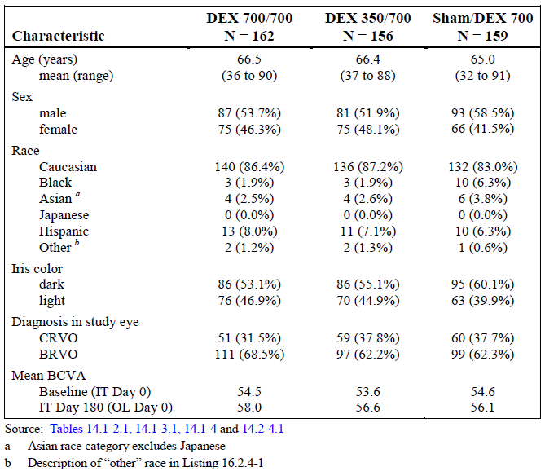

###### Ocular concomitant medications and procedures (Re-treatment population)

For the re-treated population, ocular concomitant medications in the study eye were reported for 40.9% (67/164) of patients in the DEX 700/700 group, 38.1% (59/155) in the DEX 350/700 group, and 20.3% (32/158) in the Sham/DEX 700 group during the IT period. Similarly during the OL extension, ocular concomitant medications in the study eye were reported for 46.3% (76/164) of patients in the DEX 700/700 group, and 38.1% (59/155) in the DEX 350/700 group. Use of ocular concomitant medications in the study eye in the Sham/DEX 700 group increased to 39.9% (63/158) during the OL extension compared to the IT period.

The most frequent drug classes (more than 10% in any treatment group) during the OL extension were:

* Ophthalmic beta blocking agents (28.0% (46/164) in the DEX 700/700 group, 23.9% (37/155) in the DEX 350/700 group, and 20.3% (32/158) in the Sham/DEX 700 group)
* Sympathomimetics in glaucoma therapy (10.4% (17/164) in the DEX 700/700 group, 9.7% (15/155) in the DEX 350/700 group, and 9.5% (15/158) in the Sham/DEX 700 group)
* Ophthalmic prostaglandin analogues (8.5% (14/164) in the DEX 700/700 group, 11.0% (17/155) in the DEX 350/700 group, and 13.9% (22/158) in the Sham/DEX 700 group).

There was a high incidence of IOP-lowering medications in all 3 treatment groups following the administration of DEX 700, which is to be expected in patients receiving intravitreal steroid injections.

There were 3 (9), 4 (5) and 5 (5) procedures in the IT (OL) periods for the DEX 700/700, DEX 350/700 and Sham/DEX 700 groups respectively. For the cumulative 12-month period, the most common procedures were retinal laser coagulation at 6, 3 and 5 procedures and cataract surgery at 2, 3 and 0 procedures in the DEX 700/700, DEX 350/700 and Sham/DEX 700 group respectively.

***Results for the primary efficacy outcome***

###### BCVA improvement of 15 or more letters from Baseline

In the ITT population the proportion of patients with 15 or more letters improvement from Baseline was significantly higher with DEX 700 compared to Sham at IT Days 30, 60, and 90 (p ≤ 0.008). At the unamended primary time point (IT Day 180) the comparison between DEX 700 and Sham was 19.4% versus 18.3%, a difference of 1.1% and non-significant (p = 0.780). The greatest difference in response rates between DEX 700 versus Sham was 18.5% at day 90 (p < 0.001). For the PP population, the comparison was similar: at IT Day 180 proportions were 19.4% versus 17.8% (a difference of 1.7% (p = 0.685).

1. Proportion of patients with ≥ 15 letter improvement from Baseline BCVA (Study 008)

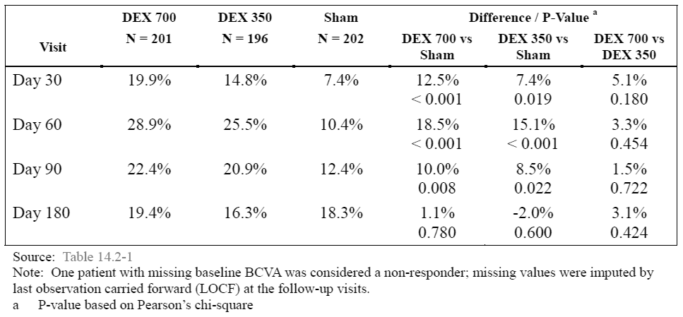

##### Results of other analyses of the primary efficacy outcome

###### Proportion of patients with BCVA improvement ≥ 15 letters from Baseline in diagnostic subgroups

The proportion of BRVO diagnosed patients with BCVA improvement of 15 or more letters from Baseline was significantly higher with DEX 700 compared to Sham at IT visit Days 30, 60, and 90 (p ≤ 0.021) but with no statistically significant difference at IT Day 180 (2.1%; p = 0.678). Results were similar for the PP population.

Other patient comparisons between DEX 700 and Sham were non-significant at every IT visit. Results for the PP population were worse than the ITT population.

1. Proportion ≥ 15 letters improvement from Baseline BCVA (CRVO subgroup) (Study 008)

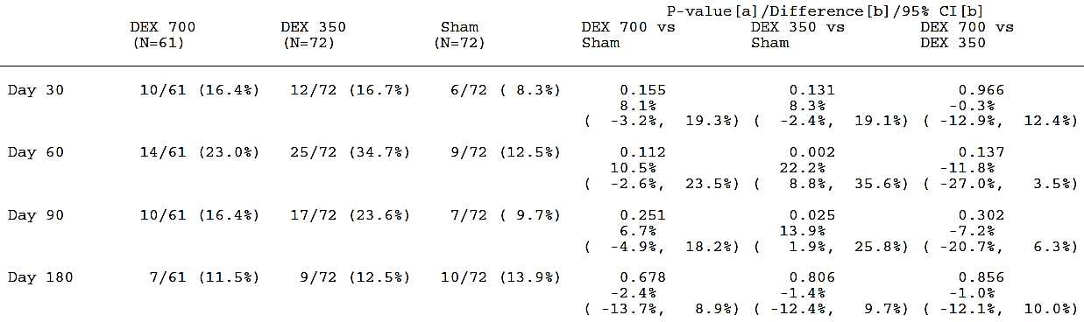

The BRVO diagnostic subgroup showed a similar albeit slightly better response to the results of the overall ITT population. For the CRVO diagnostic subgroup there was no significant difference in response rate between DEX 700 and Sham at any IT visit although the comparison of DEX 350 and Sham was significant at IT day 60 and 90.These results are the inverse of those found in Study 206207-009 where the CRVO subgroup responded better and the BRVO subgroup responded worse than the overall DEX 700 treatment group.

###### Proportion of patients with BCVA improvement ≥ 15 letters (macular oedema ≥ 90 days duration)

Excluding patients with < 90 days history of macular oedema, differences between DEX 700 and Sham were significant at Days 30, 60 and 90 (p ≤ 0.013) with maximal difference at day 60 (18.7%; p < 0.001). At IT Day 180 there was effectively no numerical difference between DEX 700 and Sham (p = 0.985).

1. Proportions with > 15 letter BCVA improvement (macular oedema ≥ 90 days duration) (Study 008)

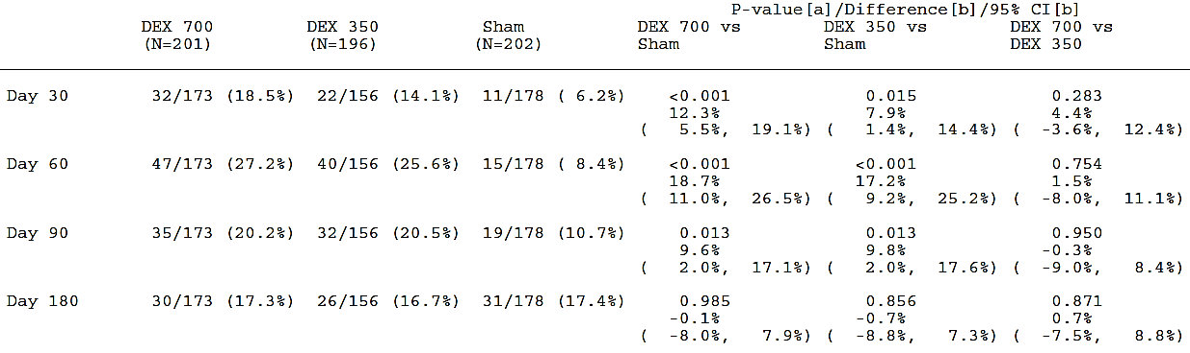

##### Results of other analyses of the primary efficacy variable

###### Proportion of patients with BCVA improvement of ≥ 10 letters from Baseline

The proportion of patients with ≥ 10 letters improvement from Baseline was significantly higher with DEX 700 to Sham at IT Days 30, 60, and 90 (p ≤ 0.010) as summarised below but not at IT Day 180 where a 2.6% difference between DEX 700 and Sham (p = 0.567). Results were similar for the PP population.

1. Proportions with BCVA improvement > 10 letters from Baseline (Study 008)

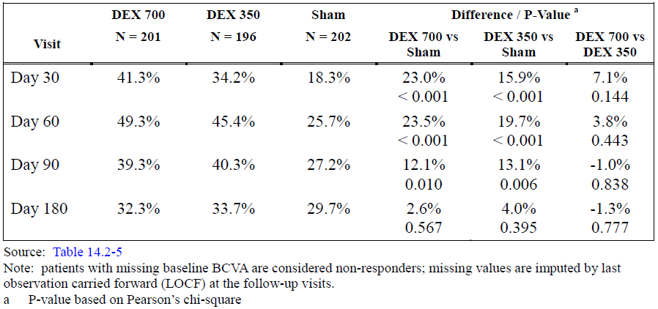

In the BRVO subgroup differences between DEX 700 and Sham were significant at Days 30, 60 and 90 (p ≤ 0.014) but not at Day 180 where the comparison in response rates was 37.9% versus 33.1% (difference 4.8%; p = 0.412). Rates in the DEX 700 group and differences versus Sham were maximal at IT day 60 (51.4% versus 28.5%, difference 23.0%; p < 0.001). Findings were similar in the PP population to the ITT population.

Note: as with Study 009 separate data was not given for the CRVO subgroup.

###### Mean change from baseline BCVA

Changes were significantly greater with DEX compared to Sham at IT Days 30, 60, and 90 (p ≤ 0.003), and peaked at day 60 with a difference of 6.4 letters between DEX 700 and Sham (p < 0.001). At IT Day 180 there was 1.9 letters difference between groups (p = 0.154)

1. Mean change in letters from Baseline BCVA (Study 008)

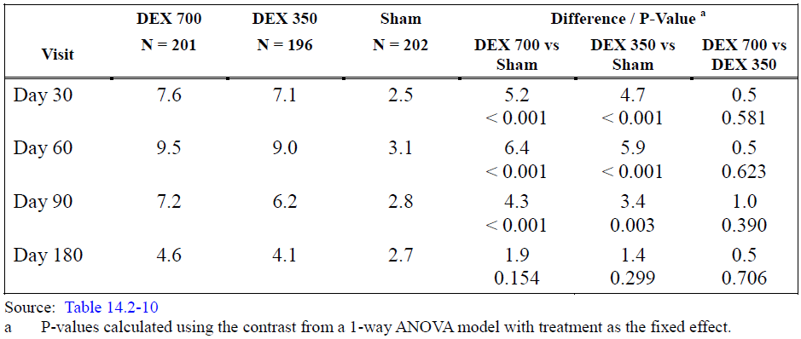

In the BRVO subgroup, mean change from Baseline BCVA in the number of letters read correctly in the study eye were significantly greater with DEX 700 compared to Sham at IT visit Days 30, 60, and 90 (p ≤ 0.018). Results were similar for the CRVO subgroup with comparisons between DEX 700 and Sham significant at IT visit Days 30, 60, and 90 (p ≤ 0.046) as summarised.

1. Mean change in letters from Baseline BCVA according to diagnostic subgroup (Study 008)

|  |  |  |  |  |  |  |
| --- | --- | --- | --- | --- | --- | --- |
| Visit | BRVO DEX 700 | BRVO Sham | P-value | CRVO DEX 700 | CVRO  Sham | P-value |
| Baseline | 54.9 | 54.6 | 0.826 | 53.6 | 54.2 | 0.765 |
| day 30 | 8.4 | 3.4 | < 0.001 | 5.9 | 0.9 | 0.006 |
| day 60 | 10.0 | 4.4 | < 0.001 | 8.2 | 0.7 | < 0.001 |
| day 90 | 8.0 | 4.1 | < 0.001 | 5.2 | 4.9 | 0.046 |
| Day 180 | 6.8 | 4.8 | 0.157 | -0.3 | -0.9 | 0.807 |

###### Time to treatment response analysis

The cumulative response rates are depicted in Figure 4 below. Overall, cumulative response rate curves were significantly different in the DEX 700 group compared to the Sham group (p = 0.001). Cumulative response rates were consistently higher with DEX 700 compared with Sham, with separation of curves as early as IT day 30 and no crossover during the initial treatment period. Similar results were also found in the PP population (DEX 700 and DEX 350 groups compared to the Sham group (p ≤ 0.007)).

1. Time to ≥ 15 letters improvement in BCVA (Study 008)

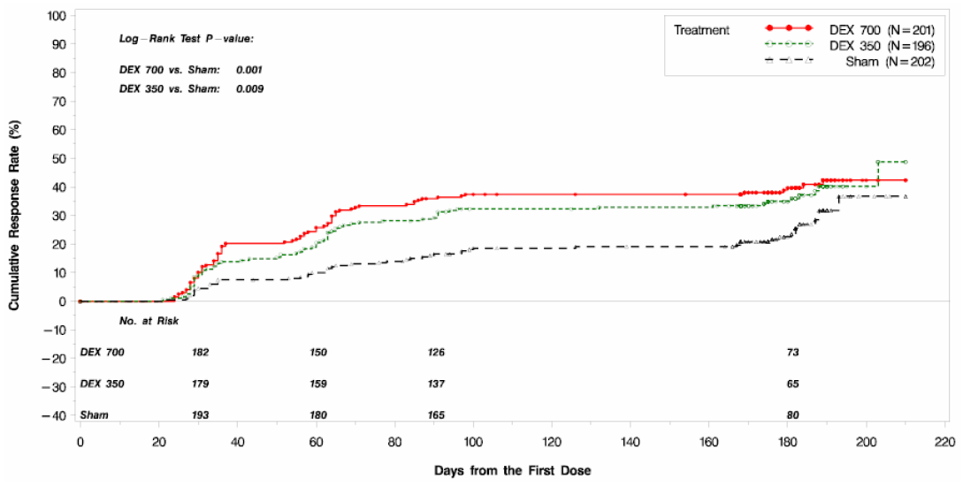

The time to 15 or more letters improvement in BCVA from Baseline was one of two major protocol amendments and replaced the original (as per protocol) primary efficacy endpoint reportedly in agreement with the FDA. For the EMEA submission it served as a secondary efficacy analysis. In this evaluation, it is considered a poor primary efficacy endpoint and is misleading; although it captures the early differences in treatment-response that occurred at the day 30 and 60 visits, it fails to describe changes in efficacy from day 90 to Day 180 nor the long term placebo response.

Results for other efficacy outcomes

###### Retinal thickness measured by OCT

In ITT population, mean central retinal thickness at Baseline was comparable between DEX 700 and Sham at 548.9 microns and 534.4 microns respectively. At IT visit day 90 the mean decrease in retinal thickness was significantly greater with DEX 700 (-199.3 microns) compared to Sham (-78.2 microns), a difference of -121.1 microns (p < 0.001). At IT Day 180, mean decrease was -105.0 versus -110.3 microns in the DEX 700 and Sham groups respectively with effectively no difference between groups (5.4 microns; p = 0.779). Results were similar for the PP population.

For BRVO patients, mean central retinal thickness was significantly less at day 90 in the DEX 700 group (-160.5 microns) compared to Sham (-71.4 microns) (p ≤ 0.003). At IT visit Day 180 there effectively no difference between groups with a -6.6 micron difference between DEX 700 and Sham favouring Sham (p = 0.731). For CRVO patients, mean central retinal thickness was significantly less with DEX 700 compared to Sham (p < 0.001) at IT visit day 90 with mean decrease of -288.5 microns versus 90.8 microns in the DEX 700 versus Sham groups (p ≤ 0.001). At IT Day 180 there was only a -1.3 difference between groups favouring Sham (p = 0.977)

###### Other outcomes

At Baseline, central retinal thickening in the study eye assessed by fundus photography was graded as definite for approximately 90% of patients in each treatment group. At IT day 90 proportions of patients with central retinal thinking graded as ‘present’ was significantly different for the DEX 700 group (71.6%) compared to Sham (82.1%) (p = 0.004). At Day 180 there were no significant differences between DEX 700 and Sham with central retinal thickening was graded ‘present’ for 77.6% of Sham versus 74.1% of DEX 700 (p = 0.934).

Fluorescein leakage at the macula was graded as improved, unchanged, or worsening from Baseline. At IT Day 180, change from Baseline in fluorescein leakage at the macula was improved from Baseline for 50.8% (91/179) of patients in the DEX 700 group, 46.4% (85/183) in the DEX 350 group, and 40.2% (74/184) in the Sham group. The difference between the DEX 700 group and the Sham group was statistically significant (p = 0.023).

There were no statistically significant differences between treatment groups at Baseline or IT Day 180 in either the mean number of letters read correctly or mean change from Baseline in the number of letters read correctly in the study eye using contrast sensitivity.

##### Efficacy in the re-treatment population

###### BCVA improvement of 15 or more letters from baseline

Proportions with a BCVA improvement of ≥ 15 letters from Baseline in the re-treatment population are summarised. In the IT period, findings for the ITT population and the re-treatment population were generally similar. For the re-treatment population during the IT period differences were 10.4% at day 30 (p = 0.005), 19.0% at day 60 (p < 0.001), 8.5% at day 90 (p = 0.027) and -1.5% at Day 180 (p = 0.702).

Following re-treatment, rates achieving a ≥ 15 letter improvement in BCVA rose for all treatment groups with maximal rates in the DEX 700/700 group of 31.5% at OL day 90 and rates of 26.4% at OL Days 60 and 90 for Sham/DEX 700. At the end of the OL extension at Day 180, 11.4% more DEX 700/700 and 3.2 % more Sham/DEX 700 patients were responders compared to IT Day 180. At OL Day 180 there was a 6.4% difference between response rates in the DEX 700/700 and Sham/DEX 700 group, but comparisons at this and all other OL study visits were non-significant.

1. Proportion with ≥ 15 letters improvement in BCVA from Baseline (Study 008: Re-treatment population)

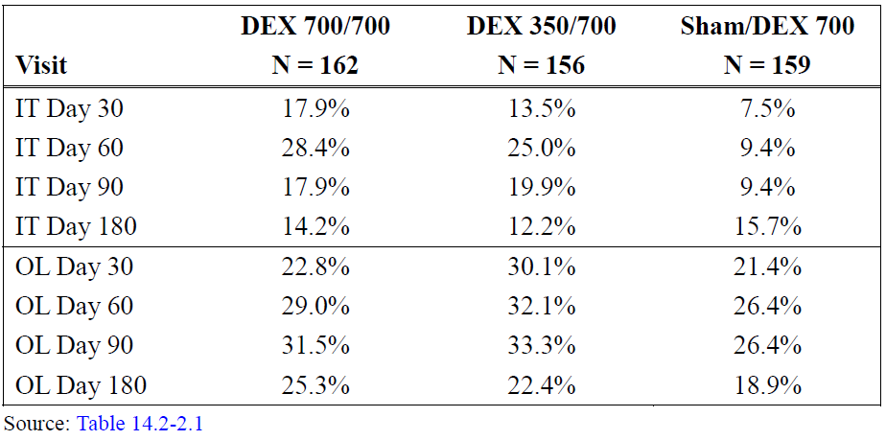

Overall, the results for the mean change in letters read correctly from BCVA Baseline during IT period was comparable between the ITT population and retreatment population. Differences between of the DEX 700/700 and Sham/DEX 700 groups were 4.9, 6.5, 4.3 and 2.1 letters at the same IT visits. Differences at IT Days 30 to 90 were significant (p < 0.001) whereas the difference at IT Day 180 wasn’t (p = 0.124).

Following retreatment, all groups saw an improvement in mean number of letters read correctly compared to Baseline. Comparing DEX 700/700 and Sham/DEX 700, none of the differences were significant at any OL visit. The improvement in mean number of letters read correctly peaked on OL day 60 at 8.7 and 7.3 letters for the DEX 700/700 and Sham/DEX 700 groups respectively. At the end of the OL extension, the change from IT Day 180 to OL Day 180 was 2.2  letters for DEX 700/700 and 1.8 letters for Sham/DEX 700.

1. Mean change from Baseline (Re-treatment population)

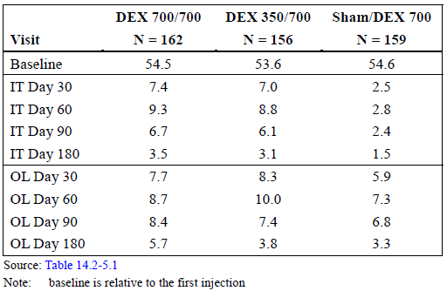

Mean central retinal thickness at Baseline was comparable between the ITT and re-treatment populations. At IT visit day 90 the mean decrease in retinal thickness in the for the ITT population was significantly greater with DEX 700 (-199.3 microns) compared to Sham (‑78.2 microns), a difference of -121.1 microns (p < 0.001). At IT Day 180, mean decrease was -105.0 versus -110.3 microns in the DEX 700 and Sham groups respectively with effectively no difference between groups (5.4 microns; p = 0.779). In the re-treatment population, mean decrease in central retinal thickness at IT day 90 was -205.3 and -71.6 microns for DEX 700/700 and Sham/DEX respectively, with a difference of -133.7 microns (p < 0.001). At IT Day 180, mean decrease was -99.1 versus -98.9 microns, a -0.2 micron difference (p = 0.994). Following re-treatment mean changes from Baseline were similar for both DEX 700/700 and Sham/DEX 700 at -258.5 and -271.3 microns on OL day 90 (p = 0.575) and -160.3 and ‑166.2 microns on OL Day 180 (p = 0.971).

###### Single-treatment population

Results for the single-treatment population are summarised in the table. During the OL extension, the response rates in the DEX 700 treated group remained static at 41.2% to 44.2% finishing 0.1% higher at the end of the OL extension compared to IT Day 180. In comparison, the Sham group continued to spontaneously improve throughout the OL extension finishing 7.0% higher at OL Day 180 compared to IT Day 180. Similar findings were also seen in terms of mean change in letters read correctly from BCVA at Baseline. The DEX 700 treated group showed a greater improvement at the early visits with comparisons between DEX 700 and Sham significant at IT Days 30 and 60 (p ≤ 0.022) with the mean change plateauing from IT day 90 until the end of the OL extension. The Sham group continued to improve up until OL day 30 and remaining comparable to the DEX 700 group except at OL Day 180.

1. ≥ 15 letter BCVA from Baseline (left) and mean change in BCVA (letters) from Baseline (right)

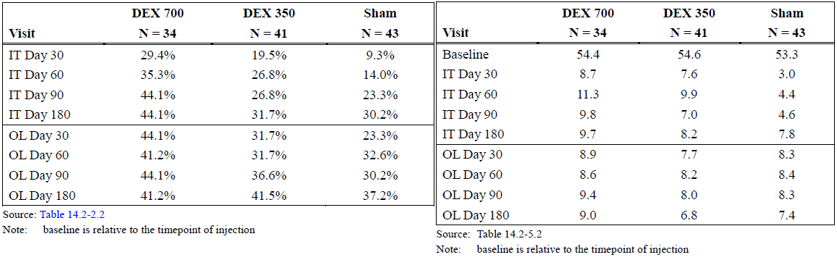

The mean change in retinal thickness at IT day 90 was -179.2 microns versus -105.9 microns in the DEX 700 and Sham groups respectively, with the difference between groups -73.3 microns (p = 0.050). At IT Day 180 and OL Days 90 and 180, the difference between DEX 700 versus Sham remained between 17.3 and 18.7 microns at all 3 visits, favouring Sham but otherwise non-significant. At OL Day 180, the difference from Baseline was -126.5 and -145.2 microns for the DEX 700 and Sham groups respectively (p = 0.669).

##### Evaluator’s commentary

At the original and unamended time point (IT Day 180) the primary efficacy analysis revealed a difference of 1.1% between proportions of DEX 700 and Sham treated patients with a ≥ 15-letter improvement from Baseline BCVA which is non-significant (p = 0.780) and represents no clinical benefit. This difference is even smaller than the 6.5% found in Study 009.

Using the EMA-agreed amended primary efficacy endpoint (the comparison at IT day 90 as opposed to IT Day 180) the primary efficacy analysis gives difference of 10.0% (p = 0.008) with an NTT of 10 patients (in comparison, the same comparison at day 90 was 7.4% in Study 009). As with that Study 009, DEX 700 treatment was associated with a clearly higher response rate than Sham treatment at earlier visits (day 30 difference: 12.5%; day 60: 18.5%; both p < 0.001). In Study 009, DEX 700 versus Sham differences for diagnostic subgroups were insignificant at IT day 90 but results were generally more favourable for CRVO. In contrast, in Study 008 between-group results were better for the BRVO group (BRVO: 11.2%; p = 0.021; CRVO: 6.7%; p = 0.251). At Day 180 differences in the BRVO subgroup were small and non-significant (2.1%; p = 0.678) and response rates were numerically worse for CRVO patients in the DEX 700 group (difference: -2.4%; p = 0.678). Excluding patients with duration of macular oedema of < 90 days in order to reduce the interference of spontaneous improvement, compared with results the overall Study 008 ITT population, the difference between DEX 700 at Sham at IT day 90 and 180 was worse (9.6% and -0.1%) than in the overall ITT population (10.0% and 1.1%). This is the reverse to the Study 009 where the DEX 700 and Sham comparison in (ITT population) at IT day 90 and 180 was 7.4% and 6.5% improving to 8.6% and 10.2% after excluding such patients.

At a response criterion of ≥ 10 letters, the difference in response rates was 23.5% (p < 0.001) at day 60, 12.1% (p = 0.010) at day 90 but non-significant at 2.6% (p = 0.567) at Day 180. In the BRVO subgroup, differences were 14.4% (p = 0.014) at day 90 but unlike Study 009, the difference between results at Day 180 were non-significant at 4.8% (p = 0.412). Comparing categorical distributions, differences between DEX 700 and Sham were also non-significant at Day 180. At this time point, the proportions with ≥ 5 and < 15 letter deterioration were 10.9% and 14.9% (DEX 700 and Sham respectively; difference: -4.0%) and at ≥ 15-letter deterioration at IT Day 180, proportions were 5.5% and 8.9% (difference: -3.4%). Differences in mean change in letters read correctly from Baseline BCVA was significant (p < 0.001) at Days 30, 60 and 90 (-5.2, -6.4 and -4.3 respectively) but not at Day 180 (-1.9 letters; p = 0.154) all favouring DEX 700. In diagnostic subgroups, at IT Day 180 in the BRVO subgroup the difference (DEX 700 versus Sham) was -2.0 letters (p = 0.157), and for CRVO the difference was -0.6 letters (p = 0.807). At IT Day 180, the mean change from Baseline in letters read correctly was negative at -0.3 letters. Comparison in retinal thickness (specifically mean change from Baseline) between DEX 700 and Sham was significant for the overall ITT population and BRVO and CRVO subpopulations at IT day 90, but at IT Day 180 there were no significant differences of any kind between DEX 700 and Sham.

Following re-treatment, the twice DEX 700 treated group demonstrated a much stronger improvement compared with Study 009 – peak improvement in the OL extension was 31.5% and the response rate at OL Day 180 was 11.1% higher than the response rate at IT Day 180. In comparison, the peak response rate for Sham/DEX 700 was 26.4% and final response rate at OL extension Day 180 was 3.2% higher than that seen at IT Day 180.

##### Supportive Study 206207-020

###### Study design, objectives, locations and dates

Study 206207-020 was a six-month, Phase III, masked and randomised sham-controlled trial with a two-month OL extension to assess the safety and efficacy of DEX 700 via the DEX PS DDS in the treatment of patients with macular oedema following CRVO or BRVO. All patients were to be followed up for 8 months after the initial study treatment with a 6-month masked IT period for safety and efficacy analysis and a 2-month OL extension when all qualifying patients from both arms received DEX 700 at the IT Month 6/OL day 1 visit.

Study 020 was submitted as a pivotal study and has been reviewed as such, however in comparison with Studies 008/009 where a combined 997 patients received DEX 700 in a 6-month OL extension, in this study 203 patients received DEX 700 for a 2 month OL extension and as such evaluation of efficacy relies more heavily on the other pivotal studies both in terms of numbers but also in terms of the duration of the OL extension. Although the 2 month OL extension revealed short term gain in efficacy, considering Ozurdex is a product intended to give around 6-months of therapeutic coverage, the duration of the OL extension only covers a third of the expected or intended duration of clinical benefit.

###### Objectives

Evaluation of the safety and efficacy of DEX 700 via PS DDS applicator system compared with Sham treatment via the needleless DEX PS DDS applicator system in patients with macular oedema secondary to BRVO or CRVO.

###### Locations and dates

All enrolled patients were Chinese and all investigating centres were based in China. The protocol was submitted and reviewed by Chinese Food and Drug Administration (CFDA) under a Clinical Trial Application (CTA). The CTA was approved 23 May 2012. The study initiation date (first patient enrolled) on 06 September 2012 completing on 20 May 2014.

###### Inclusion and exclusion criteria

*Inclusion criteria*: Male or female; at least 18 years of age; presence of macular oedema defined as macular thickening by optical coherence tomography (OCT) in the study eye of 6 weeks to 9 months duration prior to screening for CRVO patients and 6 weeks to 12 months for BRVO patients; best-corrected visual acuity (BCVA) score ≥ 34 and ≤ 68 letters; retinal thickness ≥ 320 μm (Spectralis OCT) or ≥ 300 μm (Cirrus OCT); negative pregnancy test for females of childbearing potential

###### Exclusion criteria

Uncontrolled systemic disease; ocular condition that would prevent a 15-letter improvement in visual acuity; epiretinal membrane in the study eye; history of glaucoma or intraocular pressure (IOP) elevation; ocular hypertension (IOP > 21 mg Hg); active retinal, choroidal, or disc neovascularization; diabetic retinopathy; active ocular infection; visible scleral thinning or ectasia; media opacity; intraocular surgery within 3 months prior to IT day 1; history of chorioretinopathy or pars plana vitrectomy; use of systemic carbonic anhydrase inhibitors, use of intravitreal steroids, systemic steroids, or prescribed Chinese herbal medicines; use of immunosuppressants, immunomodulators, antimetabolites, alkylating agents, or topical ophthalmic corticosteroids; BCVA score < 34 letters in non-study eye.

###### Open label extension

While remaining unaware of the initial randomised treatment, patients were eligible to receive an OL extension treatment with DEX 700 at IT Month 6 if the following criteria were met: BCVA was < 84 letters (approximately 20/20 or worse Snellen equivalent; retinal thickness in the 1 mm central macula subfield by OCT was > 250 μm (determined by the site, not the central reading centre) OR evidence, upon investigator interpretation of the OCT, of residual retinal oedema consisting of intraretinal cysts or any regions of increased retinal thickening (within or outside of the centre subfield); the procedure would not put the patient at significant risk.

###### Study treatments

The two study treatment groups in the IT period were DEX 700 and Sham-treatment (control). All treatments were given following randomisation at the IT period day 1 visit via the DEX PS DDS applicator system. Patients randomised to active (DEX 700) treatment had the study drug inserted into the vitreous through the pars plana using the DEX PS DDS Applicator System. Patients randomized to Sham treatment had the needleless applicator pressed against the conjunctiva. Patients were treated with topical ophthalmic antibiotics 3 days pre and post-procedure. Prior to study treatment, the study eye of each patient was anesthetised with a topical or subconjunctival anaesthetic (or both) and prepared according to a standard protocol.

Therapy considered necessary for the patient’s welfare was given at the discretion of the investigator. Concurrent medications were recorded in the eCRF. If the permissibility of a specific medication/treatment was in question, Allergan was to be contacted. Specifically, elevated IOP eye up to 30 mm Hg, the need for treatment was at the discretion of the investigator, based on the patient’s risk factors for optic nerve damage. For IOP > 30 mm Hg, consultation with a glaucoma specialist was to be considered. Inflammatory conditions in the non-study eye was treatable with topical steroids, periocular or intravitreal steroid injections. NSAIDs were permitted if regularly used at stable doses prior to study enrolment.

Specific prohibited medications included intravitreal injections of any sort other than the study medication (study eye), Sub-Tenon or subconjunctival corticosteroids (study eye); systemic corticosteroids (such as oral, intravenous, intramuscular, epidural, rectal, or extensive dermal); additional invasive ocular procedures or intraocular surgery; systemic immunosuppressants or immunomodulators (note topical cyclosporine was permitted); systemic medication known to be toxic to the lens, including psoralen, risedronic acid, and tamoxifen; prescribed Chinese herbal medicines that in the opinion of the investigator could influence the interpretation of the study results, for example ones with blood thinning effect. Over-the-counter herbal medications were allowed but the dose regimen was to remain the same during the study period.

###### Primary efficacy variable and outcomes

The primary efficacy variable was BCVA measured using the ETDRS in the study-eye.

The primary efficacy endpoint was the time to achieve a treatment response of ≥ 15 letters improvement from Baseline BCVA from the date of treatment (IT day 1) to the Month 6 visit.

*Other outcomes for the primary efficacy variable:*

Additional efficacy analyses for the primary efficacy variable included:

* BCVA improvement of ≥ 15 letters from Baseline
* BCVA improvement of ≥ 10 letters from Baseline
* BCVA average change from Baseline
* BCVA change from Baseline by visit
* BCVA categorical change from Baseline by visit
* Subgroup analyses for the primary efficacy variable

###### Secondary efficacy variables and outcomes

The secondary efficacy variables were central retinal thickness and retinal volume assessed by OCT and fluorescein leakage assessed by fluorescein angiography. The secondary efficacy outcomes were:

* Change from Baseline in central retinal thickness (OCT)
* Change from Baseline in retinal volume (OCT)
* Change from Baseline in fluorescein leakage
* Subgroup analyses for secondary efficacy variables

###### Randomisation and blinding methods

An IVRS/IWRS allocated study treatment kit numbers that corresponded to the patient’s treatment assignment. The assigned staff member accessed the IVRS/IWRS after patient randomisation had been completed. At the Month 6 visit, after a patient qualified to receive open-label treatment, an authorised assigned staff member accessed the IVRS/IWRS system to receive a kit number for the OL treatment. This kit was then dispensed from the open-label supply. When necessary for the safety and proper treatment of the patient, the investigator could unmask the patient’s treatment assignment to determine which treatment had been assigned, and institute appropriate follow-up care. The investigator was to inform the sponsor of the unmasking if there had been no notification prior to the unmasking. The treating investigators were responsible for performing the implant insertion treatment or Sham-treatment procedure and IT day 2 visit procedures except BCVA measurement. If any unscheduled visit was required between IT day 1 and the Month 1 visit, the visit was to be performed by the treating investigator. Follow-up investigators did not participate in study-injection (or sham) procedures or any scheduled or unscheduled visits until the Month 1 visit. Individuals collecting efficacy data (BCVA, OCT, and FA) were not to assist or be present during the treatment procedure as they needed to remain unaware of patient treatment assignments.

All patients were to remain unaware of treatment randomisation. Patients entering the OL extension were to remain unaware of the IT randomisation at the Month 6 visit.

###### Analysis populations

Four populations were used for statistical analyses: modified intent-to-treat (mITT), per-protocol (PP), safety, and retreated. The mITT population included all randomised and treated patients. The PP population included patients who had no major protocol deviations. The safety population included all treated patients. The retreated population included all patients who entered the open-label extension and received the second treatment. The mITT analysis was based on the treatment as randomised; analyses for PP and safety populations were based on the treatment that the patient actually received.

###### Sample size

Approximately 130 patients for each treatment group (260 patients for the study) were to be enrolled in the study. This sample size would provide 85% power for a 2-sided log-rank test to detect a treatment difference in the time to achieve a ≥ 15 letters improvement from Baseline in BCVA. This calculation was based on a 6-month analysis, assuming a cumulative response rate of 22.5% for the Sham group and a constant hazard ratio of 2 for DEX 700 versus Sham.

###### Statistical methods

*Primary efficacy analysis*: The primary efficacy analysis was a time-to-event analysis using the Kaplan-Meier method and log-rank test in the mITT population. Patients who did not achieve the 15-letter improvement in BCVA prior to receiving the first rescue treatment were censored at the time of the first rescue treatment.

*Other analyses for the primary efficacy variable:* The average BCVA was calculated as the area under the curve (AUC approach) divided by the study days at the last BCVA measurement. AUC was estimated using the trapezoidal method based on observed data. Between-group comparisons were done using a 2-way analysis of variance (ANOVA) with treatment group and RVO diagnosis as fixed effects. Change from Baseline in BCVA scores (number of letters read correctly) was analysed using a 2-way ANOVA with treatment group and RVO diagnosis as fixed effects. BCVA improvement of ≥ 15 letters from Baseline at each post-Baseline visit was calculated for each treatment group. Between-group comparisons were done using a Cochran-Mantel-Haenszel test stratified by the RVO diagnosis. Raw data of BCVA by visit were analysed using the same 2-way ANOVA as used for the change from Baseline. The proportion of patients with a BCVA improvement of 10 or more letters from Baseline in the study eye at each post-Baseline visit was calculated for each treatment group using the mITT population. Group comparisons was done using a Cochran-Mantel-Haenszel test stratified by the RVO diagnosis.

###### Secondary efficacy analysis

CRT raw data and change from Baseline in the study eye were analysed using a 2-way ANOVA, with treatment group and RVO diagnosis as fixed effects. In addition, within-group changes from Baseline in CRT were analysed using a paired t-test at each scheduled follow-up visit. Retinal volume raw data and change from Baseline in the study eye based on the central reading centre’s evaluations of OCT images were analyzed at each scheduled visit using the same methods as for the CRT.

###### Participant flow

328 patients were screened for the study, of which 262 were randomised, 129 to the DEX 700 group and 130 to the Sham group. Three patients were enrolled and randomised but not treated. Two patients were enrolled and randomized, but had been incorrectly classified as ‘screen failure’. Approximately 96% of patients in the mITT population completed the initial 6-month treatment period. Patient disposition and exit status at Month 6 for the PP and safety populations (initial treatment) were similar to the mITT population, and no differences were noted between the 2 treatment groups.

The re-treatment population consisted of 107/126 of the DEX 700 group and 96/123 of the Sham group completing IT Month 6. 17.8% (46/259) of patients did not receive open-label treatment. The reasons were as follows: BCVA ≥ 84 letters (3.5%); retinal thickness by OCT ≤ 250 microns (9.7%) investigator OCT interpretation of no residual retinal edema (7.7%); in the investigator’s opinion, procedure would place patient at significant risk (10.8%); other (0.8%).

1. Patient disposition and exit status at Month 6 (Study 020: mITT population; IT period)

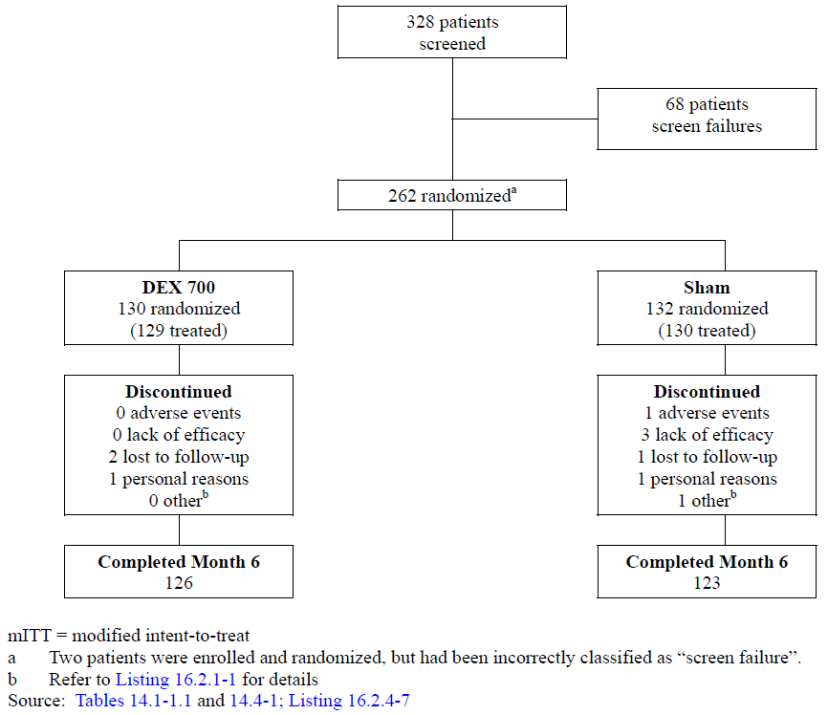

###### Major protocol violations/deviations

Overall, 3.9% (5/129) of patients in the DEX 700 group and 0.0% (0/130) in the Sham group had protocol deviations leading to data exclusion from the PP analysis. The reasons were patient had an exclusionary intraocular surgical history (n = 1), patient had a history of use of intravitreal steroid or any intravitreal injectable drug in the study eye within 3 months prior to day 1 (n = 3), or patients’ BCVA score was not between 34 and 68 letters in the study eye at the screening visit (n = 1).

Overall, 8.5% (11/129) patients in the DEX 700 group and 3.8% (5/130) in the Sham group had significant protocol deviations. The most frequently reported deviations were data related: 6.2% (8/129) of patients in the DEX 700 group and 1.5% (2/130) in the Sham group. Informed consent/patient privacy deviations were reported for 2.3% (3/129) of patients in the DEX 700 group and 1.5% (2/130) in the Sham group. Subject safety deviations were reported for 1 patient (0.8%) in each treatment group.

###### Baseline data

Demographic characteristics

For the mITT population, overall, the mean (range) age was 54.7 (19 to 78) years, 47.5% (123/259) were male, and all patients were Asian. The diagnosis was CRVO for 50.6% (131/259) and BRVO for 49.4% (128/259). There were no statistically significant differences between the treatment groups in the demographic and Baseline characteristics in the mITT population aside from younger patients in the Sham group (3.4 years average difference), as summarised below. Demographics were similar in the PP and retreated populations.

1. Demographic and Baseline characteristics (Study 020: mITT population; IT period)

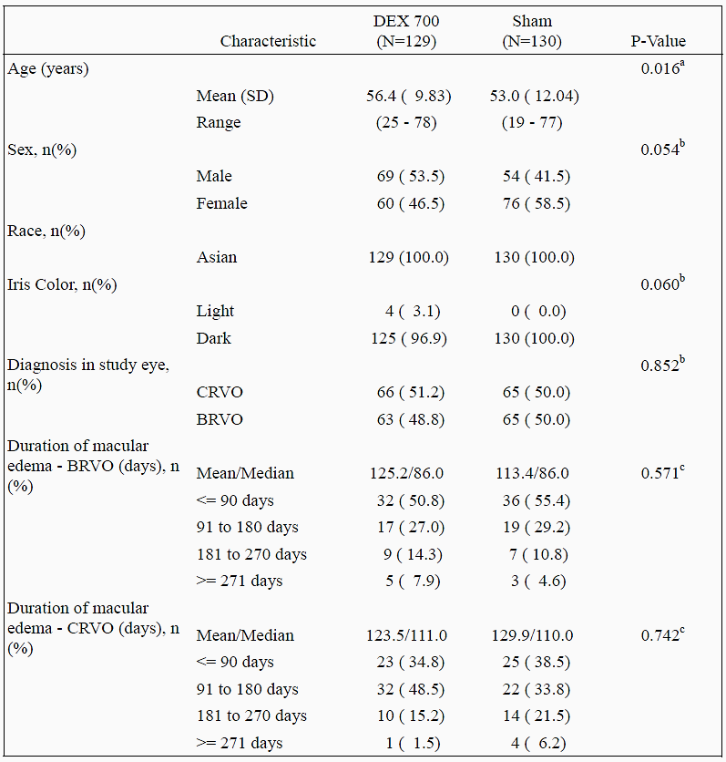

a. P-value based on 2-sample t-test. b. P-value based on Pearson's chi square or Fisher's exact test. c. P-value based on Wilcoxon rank sum test.

###### Medical and ophthalmic history

According to the medical history of patients, vascular disorders (36.3%), social circumstances (33.2%), metabolic disorders (11.2%) infections and infestations (6.2%), surgical (5.8%) and neoplastic disorders (5.4%) were most commonly reported classes by SOC. There were no significant differences between the treatment arms. RVO (77.2%), macular oedema (38.2%) and cystoid macular oedema (6.9%) were the most commonly reported ocular conditions in medical history. In general, patients were comparable between the treatment groups. Regarding lens status, the lens of the study eye was classified as phakic for 98.5% (225/259) of patients, and pseudophakic for 1.5% (4/259).

###### Prior medications and procedures

99.6% (258/259) of patients received medications prior to the first day of study treatment. The most common prior medications were for conditions in the following SOCs: Surgical and Medical Procedures (98.8%), Vascular Disorders (30.1%), Cardiac Disorders (24.3%), Investigations (17.8%), and Eye Disorders (17.0%).

98.8% (256/259) of patients received ophthalmic medications in the study eye prior to first day of study treatment. The most common prior ophthalmic medications were for conditions in the following SOCs: Surgical and Medical Procedures (98.5%), Investigations (15.8%) and Eye Disorders (13.5%). Within SOC: Eye Disorders, more of the DEX 700 group (17.1%) than Sham group (10.0%) were likely to have received medications prior to the study. The use of ranibizumab was 1.9% overall, 3.1% (DEX) and 0.8% (Sham)) for HLT retinal, choroid and vitreous infections and inflammations were the most common prior medications. Approximately 10.8% overall (28/259) had had prior surgery or ocular procedures (including laser) for the treatment of RVO, similar in both the DEX 700 group (11.6% or 15/129) and Sham group (10.0% or 13/130). Other ocular procedures had been for cataracts (2.3% versus 0.8%), cystoid macular oedema (2.3% versus 0.8%), macular oedema (1.6% versus 3.8%) and borderline glaucoma (0.8% versus 0.0%) in the DEX 700 versus Sham groups respectively.

###### Concomitant medications and procedures

100% (129/129) of DEX 700 patients and 99.2% (129/130) of Sham patients and received concomitant medications during the study with SOCs Surgical and Medical Procedures (99.6%), Investigations (34.7%), Vascular Disorders (30.9%), and Eye Disorders (13.1%) .

100.0% (129/129) of DEX 700 patients and 99.2% (129/130) of Sham patients received concomitant ophthalmic medications during the study eye. Of note, medications required for study procedure are collected as concomitant medications. The most common concomitant ophthalmic medications were for conditions in the following SOCs: Surgical and Medical Procedures, including oxybuprocaine, proxymetacaine, ofloxacin, and levofloxacin (99.6%); Investigations, including phenylephrine with tropicamide, carteolol, and timolol (33.2%); and Eye Disorders, including calcium dobesilate, brinzolamide, and timolol (11.2%). Concomitant ophthalmic medications used for managing IOP elevations (used for treatment of IOP as an AE) were reported for 34.9% (45/129) of patients in the DEX 700 group, and 13.8% (18/130) in the Sham group.

11.6% (15/129) of patients in the DEX 700 group and 11.5% (15/130) in the Sham group had concurrent procedures (ocular or non-ocular) during the study. The most common procedure was retinal laser coagulation: 10.9% (14/129) in the DEX 700 group and 8.5% (11/130) in the Sham group. Other procedures were reported for at most 1 patient in either treatment group.

##### Results for the primary efficacy outcome

###### Time-to-treatment response

For the primary efficacy endpoint (time to achieve a treatment response of 15 or more letters improvement from Baseline BCVA in the mITT population), the cumulative response rates were consistently higher with DEX 700 than with Sham (p < 0.001) from the Month 1 visit until the end of the IT period. The cumulative response curves are depicted in Figure 5 below. The results of for the PP population were similar to those for the mITT population

The significant treatment difference was confirmed after adjusting for the Baseline factors/covariates of RVO diagnosis, age, and sex using the Cox regression model. The estimated hazard ratio (95% confidence interval) for time to 15 or more letters improvement was 2.4 (1.6 to 3.7) for DEX 700 versus Sham.

As previously discussed, time-to-treatment response is deceptive for use as the primary efficacy endpoint as the results of all other analyses show a transient increase in response rates associated with DEX 700 treatment. In this scenario, time-to-treatment response will detect and consider a patient who responded once at an early study visit as being a responder throughout the study and not capture loss of efficacy as time progresses.

1. Time to achieve ≥ 15 letter improvement in BCVA from Baseline (Study 020)

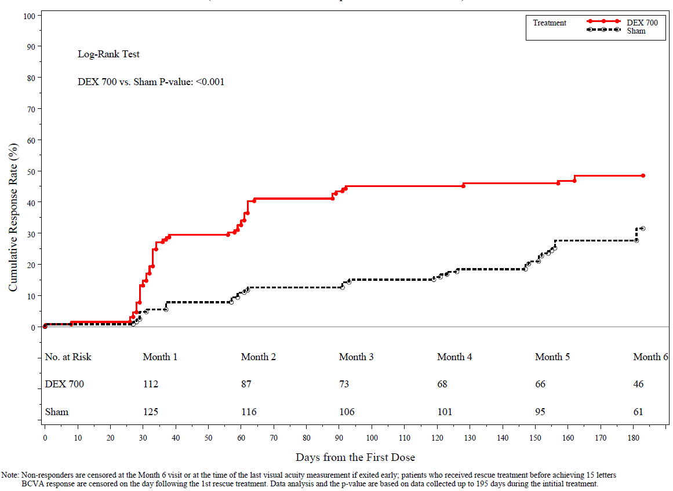.

##### Secondary efficacy analyses

###### Proportion of patients with BCVA improvement of 15 or more letters from Baseline

As summarised below, the proportion of patients with 15 or more letters improvement from Baseline was significantly higher in the early visits the comparison between DEX 700 and Sham significant at IT Months 1, 2, and 3 (p < 0.001). Maximal response rates were seen at Month 2 in the DEX 700 group, with a comparison versus Sham of 34.9% versus 11.5%. The maximal difference of 23.3% in responder rates between DEX 700 and Sham was recorded at the Month 1 and 2 visits (p < 0.001). Results were similar for the PP population.

1. Patients with ≥ 15 letters improvement from Baseline BCVA (Study 020)

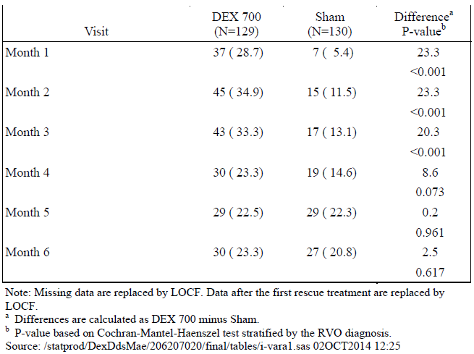

###### BCVA improvement of 10 or more letters from baseline

The proportion of patients with a BCVA improvement of 10 or more letters from Baseline for the mITT population is presented in the table. The proportion of patients with 10 or more letters improvement from Baseline was significantly higher with DEX 700 compared to Sham early in the study at Months of 1, 2, and 3, p ≤ 0.024. The maximal response rate in the DEX 700 group was 48.8% at Month 2, with the greatest difference in response rates 31.9% at Month 1.

1. Patients with ≥ 10 letters improvement from Baseline BCVA (Study 020)

|  |  |  |  |  |
| --- | --- | --- | --- | --- |
| Visit | DEX 700 | Sham | Difference | P-value |
| Month 1 | 46.5% | 14.6% | 31.9% | <0.001 |
| Month 2 | 48.8% | 21.5% | 27.3% | <0.001 |
| Month 3 | 43.4% | 30.0% | 13.4% | 0.024 |
| Month 4 | 33.3% | 31.5% | 1.8% | 0.745 |
| Month 5 | 34.9% | 33.8% | 1.0% | 0.849 |
| Month 6 | 36.4% | 33.8% | 2.6% | 0.644 |

###### Mean change in letters from BCVA baseline

In the mITT population, the mean changes from Baseline BCVA in the number of letters read correctly in the study eye are summarised below. Changes from Baseline peaked at Month 2 in the DEX 700 group with a mean improvement of 10.6 letters versus 1.7 letters in the Sham group (difference 8.9 letters; p < 0.001). Differences between DEX 700 and Sham were significant at IT Months 1, 2, and 3 (p < 0.001).

1. Mean (SD) change from Baseline BCVA by visit (Study 020)

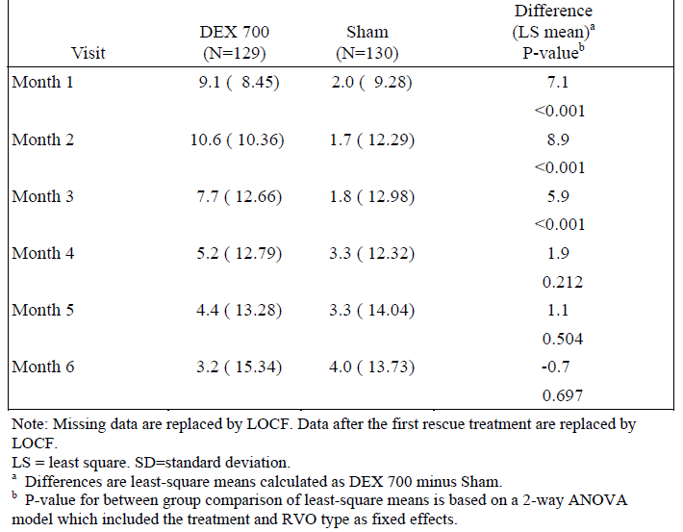

1. Mean change from Baseline BCVA by visit (Study 020)

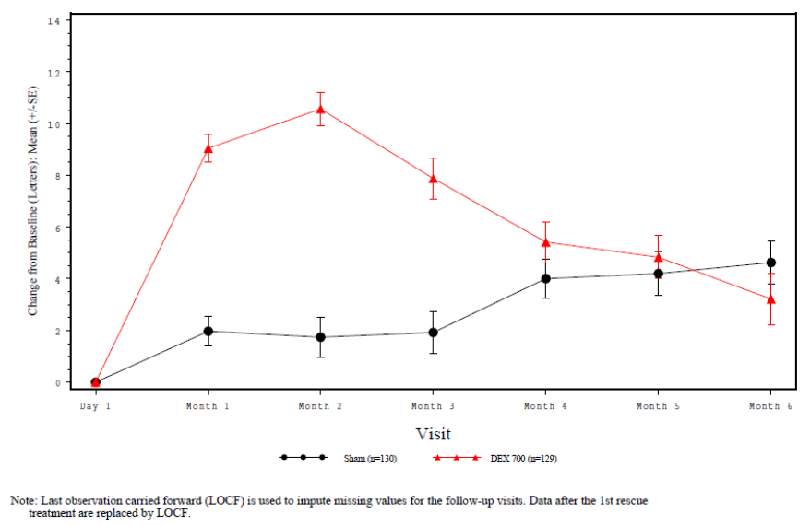

###### Change from baseline retinal thickness by OCT

In the mITT population, the mean changes from Baseline CRT in the 1 mm subfield of the study eye measured by OCT. Decreases were significant with DEX 700 compared to Sham at initial treatment Months 1, 2, and 3 (p < 0.001).

1. Mean (SD) change from Baseline central retinal thickness (microns) by OCT (Study 020)

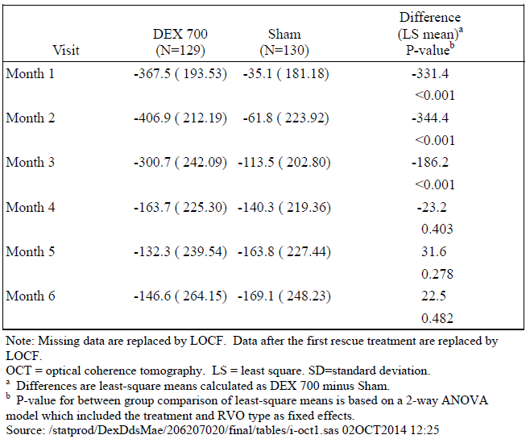

##### Results for other efficacy outcomes

###### BRVO and CRVO subgroup analyses

Results from the BRVO and CRVO subgroup analyses are summarised below.

The difference between mean change in letters read correctly from Baseline BCVA (DEX 700 versus Sham) was significant (p < 0.001) at Month 1 (5.5 letters) and Month 2 (7.3 letters) visits but not beyond. Numerically, from Month 4 to Month 6 the Sham group outperformed the DEX group. Similarly, comparison between DEX 700 and Sham treated BRVO patients revealed a statistical difference in early treatment (Month 1 and 2; p ≤ 0.007) in the proportion of patients with a ≥ 15 letter improvement from BCVA at Baseline but spontaneous improvement in the Sham group resulted in a numerically greater proportion of Sham patients with a ≥ 15 letter improvement from Month 4 to 6. Comparison of DEX 700 versus Sham demonstrated that differences between the mean change from Baseline in central retinal thickness measured by OCT were significant at Month 1 to 3 (p ≤ 0.025) favouring DEX 700, however the mean change in central retinal thickness decreased in the DEX 700 group over the 6-month period. In comparison, spontaneous improvement in the Sham group resulted in a statistically significant difference at Month 5 for the difference between DEX 700 versus Sham, favouring the Sham group (p = 0.028).

Comparison of the mean change in letters read correctly from Baseline BCVA for CRVO patients in the DEX 700 versus Sham groups demonstrated a significant difference at Month 1 to 3 (p < 0.001). In contrast to the BRVO patients, no pattern of spontaneous change in the number of letters read correctly compared to Baseline was seen in the CRVO cohort. Significant differences in the proportions of patients with a ≥ 15 letter improvement in BCVA from Baseline was also seen at the Month 1 to 4 visits (p < 0.001), with a pattern of improvement in the DEX 700 treated with response rising from Baseline to Month 3 (peak response rate of 34.8%) falling to 21.2% at Month 6. In comparison, no spontaneous improvement was seen in the Sham treated group from Month 1 until Month 5 with response rates static between 4.6 and 6.2%. Comparison of mean change from Baseline in central retinal thickness showed a significant difference in the DEX 700 group compared to Sham at Months 1 to 3. Mean decreases from Baseline in the DEX 700 group were over 10-fold the decreases seen in Months 1 and 2, however by Month 5 and 6 the differences between DEX 700 and Sham had reduced to approximately -20 microns.

1. Key efficacy parameters in BRVO left) and CVRO (right) subgroups (Study 020)

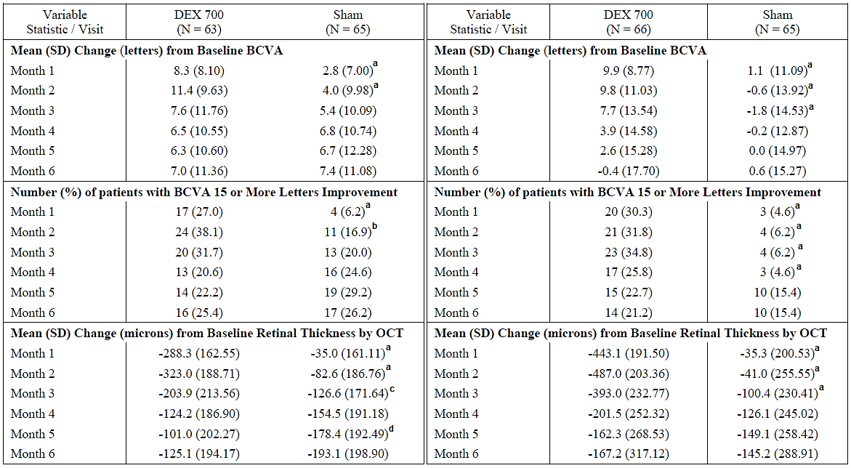

a. Difference (DEX 700 versus Sham) p-value < 0.001

b. p-value = 0.007

c. p-value = 0.025

d. p-value = 0.028

##### Evaluator commentary

The primary efficacy outcome (the time to a ≥ 15 letter improvement in Baseline BCVA) was met. At the Month 1, 2 and 3 visits the difference between proportions meeting the improvement criteria between DEX 700 and Sham were significant (p < 0.001). The peak improvement was seen at the Month 2 (or day 60) visit, when the improvement was seen in 34.9% for the DEX 700 group versus 13.1% of Sham-treated group. The biggest decrease from this peak was seen at the Month 4 visit, where the proportion of the DEX 700 with such an improvement fell from 33.3% at Month 3 to 23.3% at Month 4.

#### Analyses performed across trials: Integrated summary of efficacy (Studies 206207-008/009)

These 2 studies were identical in protocol, methodology and duration (except for changes to the primary efficacy time point) and are described in detail above with comparable numbers of participants with similar Baseline characteristics. Unless otherwise mentioned, the ITT population (IT period) and re-treatment populations (OL extension) were used for the ISE analysis.

##### Patient disposition and Baseline characteristics

For the IT period, 1267 patients were randomised (forming the ITT population) of which 1196 (94.4%) completed IT Day 180. The three pooled treatment groups were similar in size (n = 427, n = 414 and n = 426 (DEX 700, DEX 300 and Sham respectively)) as were the proportions of each pooled randomisation group completing the IT phase (94.4%, 95.4% and 93.4%). The PP population was similar to that of the ITT population. Baseline demographic characteristics were similar and balanced across the pooled treatment arms; for the pooled ITT population the mean age of the DEX 700, DEX 350 and Sham groups respectively was similar (p = 0.453) at 64.7, 64.9 and 63.9 years respectively; 50.8%, 53.1% and 56.3% were male (p = 0.268) and 75.2%, 75.4% and 74.6% were Caucasian (p = 0.970). The PP population was similar to the ITT population. 34.5% of the total (n = 1267) ITT population had CRVO, with 65.5% diagnosed with BRVO with no significant difference between pooled randomised treatment groups (p = 0.264).

##### Primary efficacy analysis

###### Proportion with ≥ 15 letters of improvement in BCVA from Baseline

Response rates with DEX 700 versus Sham were significantly higher at IT Days 30, 60 and 90 (p < 0.001), with peak response rates at IT day 60 of 29.3% versus 11.3% (DEX 700 versus Sham, difference 18.0%; p < 0.001). By IT Day 180, the difference between DEX 700 and Sham was 3.9% and not significant (p = 0.147).

1. Patients with ≥ 15 letters improvement from Baseline BCVA (ISE)

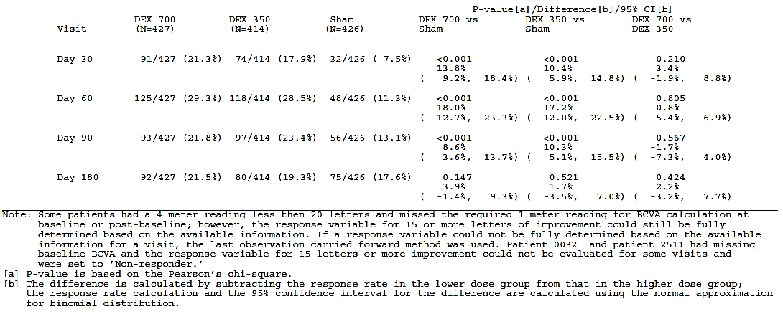

###### Proportion with ≥ 15 letters improvement in BCVA from Baseline by diagnostic subgroups

1. Proportions with ≥ 15 letter improvement in BCVA from Baseline by diagnosis (ISE)

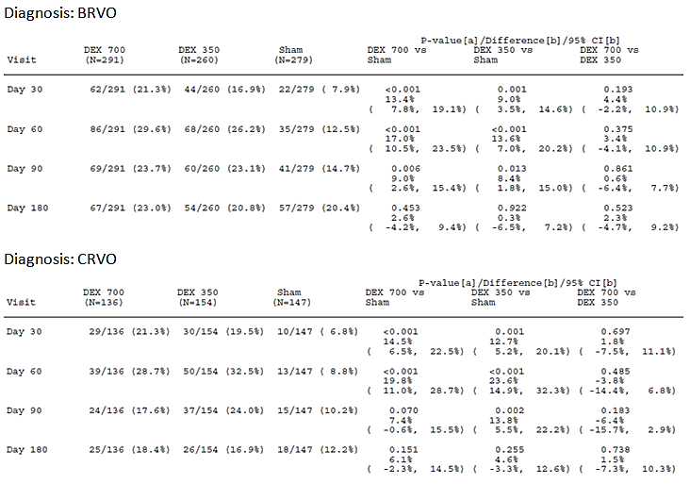

Response rates for both BRVO and CRVO are summarised in the table. Patients in the BRVO subgroup had better response rates than both the overall ITT population and the CRVO subgroup regardless of randomisation to DEX 700 or Sham treatment. Differences between the DEX 700 and Sham response rates were greatest in the early period of the studies, with a difference of 13.4% and 17.0% at day 30 and 60 (both p < 0.001) but falling at day 90 to 9.0% (p = 0.006). The DEX 700 treatment group was characterised by a maximal response rate of 29.6% at day 60, falling to 23.7% at day 90 and remaining static at 23.0% at Day 180. In contrast, the spontaneous improvement rate in the Sham group rose steadily from 7.9% at day 30 to 20.4% at Day 180 so that at the end of the IT period, the difference between responder rates in the DEX 700 and Sham groups was small at 2.6% (p = 0.453).

The response pattern in CRVO patients was similar, with a maximal response rate of 28.7% at day 60, falling to approximately 18.0% at day 90 and 180. Although response rates for the DEX 700 CRVO treated group were slightly lower, differences with Sham were greater at day 30 (14.5%) and day 60 (19.8%) (both p < 0.001) in part due to a slower rate of spontaneous improvement in the Sham CRVO group. At day 90, the difference between DEX 700 versus Sham was 7.4% (p = 0.070) and 6.1% at the end of the IT period (p = 0.151). In contrast to the BRVO subgroup, the difference at IT Day 180 was more than double (6.1% versus 2.6%) again related to lower rate of spontaneous improvement at 12.2% versus 20.4% in the Sham group of CRVO patients versus BRVO patients respectively.

###### Proportion of patients with ≥ 10 letters improvement in BCVA from baseline

With a response of ≥ 10 letters improvement, DEX 700 outperformed Sham with statistically significant between-pair differences at every study visit. Peak response in the DEX 700 group was seen at IT day 60 (as it was for ≥ 15 letters improvement) with roughly half of DEX 700 patients responding (51.1%; p < 0.001).At each consecutive study visit the difference in response rates between DEX 700 and Sham decreased due to falling efficacy and the effect of spontaneous response rates in the Sham group, with a response rate rising progressively to 29.8% at IT Day 180. At the end of the IT period, the comparison between DEX 700 and Sham was 36.5% and 29.8% (difference 6.7%; p < 0.037).

1. Patients with ≥ 10 letters improvement in BCVA from Baseline (ISE)

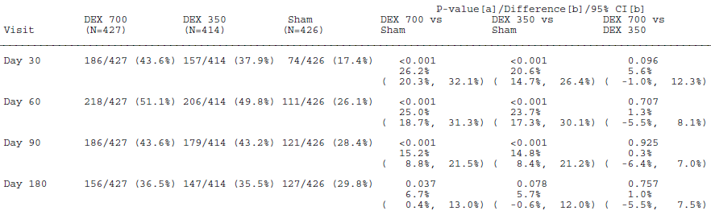

###### Mean change from baseline BCVA in number of letters read correctly

At Baseline, DEX 700 and Sham groups were comparable (mean BCVA in letters (min/max): 54.3 (34 to 68) and 54.8 (28 to 80) for DEX 700 and Sham respectively (p = 0.493). The highest mean change from BCVA Baseline in letters read correctly (min/max) was at IT day 60 at 9.8 (-39 to 41) versus 3.1 (-42 to 38) with a difference of 6.7 letters between DEX 700 versus Sham (CI95: 5.3 to 8.1; p < 0.001). At IT Day 180, the response rate was 5.1 (-56 to 41) versus 2.6 (-55 to 44); difference: 2.5 (CI95: 0.7 to 4.3; p < 0.006).

###### Vision loss of ≥ 15 letters from baseline BCVA

DEX 700 treatment was consistently associated with fewer patients reporting VA loss ≥ 15 letters than Sham with the difference statistically significant at all IT visits. The incidence of VA loss in the DEX 700 group was 1.2% (5/427), 1.4% (6/427), 3.5% (15/427) and 6.1% (26/427) at IT Days 30, 60, 90 and 180 respectively. Incidence for the Sham group was 3.3% (14/426), 4.9% (21/426), 6.8% (29/426) and 10.6% (45/426), with a greater difference in incidence (DEX 700 versus Sham) at IT Day 180 (-4.5%, CI95: -8.2% to -0.8%; p = 0.018) than at IT day 60 (-3.5%, CI95: -6.3% to -0.3%; p = 0.003) which was the study visit otherwise associated with greatest peak effect on BCVA improvement.

##### Secondary efficacy analysis

###### OCT retinal thickness

At Baseline, mean retinal thickness of the central 1 mm subfield in microns was 562.0 and 538.6 for DEX 700 and Sham respectively (difference: 23.3; CI95: -2.7 to 49.4). At IT day 90 the comparison was 355.8 and 455.5 microns (difference: -99.7; CI95: -124.1 to -75.2; p < 0.001). By IT Day 180 the comparison was 443.6 and 421.0 (difference: 22.6; -4.1 to 49.3; p = 0.097). DEX 700 treatment was associated with a mean (min/max) reduction in retinal thickness from Baseline of -207.9 (-1144 to 337) versus -85.0 microns (-931 to 569) for Sham at IT day 90 (difference: -122.9; CI95: -148.8 to -97.1; p < 0.001). At IT Day 180, there was no difference in mean change from Baseline between DEX 700 versus Sham (mean decrease from Baseline of -119.3 microns for both groups, p > 0.999).

##### Re-treatment population analysis

The table below summarises the response rate in terms of proportions with improvement of ≥ 15 letters in BCVA from Baseline. In the retreatment population, significant differences in the IT period between DEX 700 versus Sham were seen at IT Days 30, 60 and 90 (p ≤ 0.003), but not beyond. Following re-treatment, Sham/DEX 700 response was similar in magnitude to that seen for DEX 700 and DEX 350 treatment in the IT period, but the visit with peak response was delayed to 90 days post insertion opposed to 60 days in the IT period. Response rates for the DEX 700/700 group were numerically greater following re-treatment (that is, after 2 consecutive implants) than for the same group in the IT period, with peak response being 29.9% and 31.7% at IT day 60 and OL day 60 respectively. In the re-treatment population there were no significant differences in proportions with ≥ 15 letter BCVA improvement between the DEX 700/700 and Sham/DEX 700 groups at any OL visit. The peak response was 31.7% in the DEX 700/700 group (OL day 60) and 27.2% for Sham/DEX 700 (OL day 90). At OL Day 180 the difference in response rates between the two groups was 2.7% (p = 0.411). Compared with the 2nd Baseline (IT Day 180), essentially the same proportions for both groups demonstrated an improvement at ≥ 15 letters improvement in BCVA over Baseline (7.7% more DEX 700/700 and 7.6% more Sham/DEX patients).

1. Proportion ≥ 15 letter BCVA improvement from Baseline (Retreatment population)

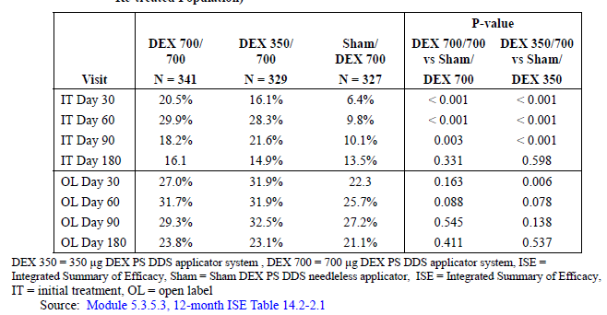

In the BRVO subgroup, maximal improvement rate in the IT period was 29.5% versus 11.9% at IT day 60 (difference 17.6%; p < 0.001) for DEX 700 versus Sham respectively. At IT Day 180 the comparison was 16.7% versus 16.2% (p = 0.877). Following re-treatment, response rates for the DEX 700/700 group were 31.7%, 33.9%, 32.2% and 27.8% at OL Days 30, 60, 90 and 180 respectively and 25.7%, 28.6%, 28.6% and 23.3% for the Sham/DEX 700 group.

In the CRVO subgroup, maximal improvement rate in the IT period was 30.7% versus 11.9 at IT day 60 (difference 24.7%; p < 0.001) for DEX 700 versus Sham respectively. At IT Day 180 the comparison was 14.9% versus 8.5% (p = 0.132). Following re-treatment, response rates for the DEX 700/700 group were 17.5%, 27.2%, 23.7% and 15.8% at OL Days 30, 60, 90 and 180 respectively and 16.2%, 20.5%, 24.8% and 17.1% for the Sham/DEX 700 group. Response rates with two consecutive implants were numerically greater but not statistically significant at any point.

For the re-treatment population, proportions with ≥ 10 letters improvement over Baseline at IT Day 180 were 30.8% for DEX 700/700 and 24.2% for Sham/DEX 700 (difference: 6.6%, p = 0.055). Following re-treatment this peaked at 54.5% in the DEX 700/700 group at OL day 60 and in Sham/DEX 700 group peaked at 46.2% on OL day 90. Two consecutive DEX 700 treatments were associated with statistically significant differences in the early visits of the OL extension to those only treated once, with a difference in response rates between DEX 700/700 and Sham/DEX 700 at OL day 30 of 9.8% (p = 0.011) and at OL day 60 of 8.7% (p = 0.025). At OL Day 180 both the DEX 700/700 and Sham/DEX 700 groups were the same with roughly 39% of both groups responding, an improvement of approximately 8% and 15% for the DEX 700/700 and Sham/DEX 700 group compared with IT Day 180 (2nd Baseline).

1. Proportions with ≥ 10 letter BCVA improvement from Baseline (OL extension)

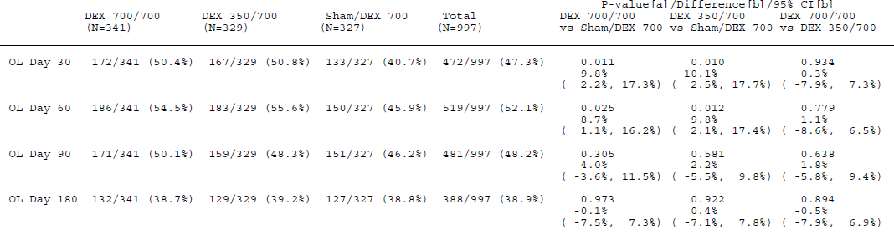

Patients treated with 2 doses of DEX showed significantly greater mean change from BCVA Baseline in both the IT period and OL extension than patients initially receiving Sham. The treatment group differences peaked at IT day 60, with a difference of approximately 7 letters. Differences between DEX 700/700 and Sham/DEX 700 were 2.8, 2.7, 1.8 and 1.5 letters at OL Days 30, 60, 90 and 180 respectively and significant at the first 2 OL visits (p ≤ 0.004).

Mean retinal thickness was significantly less with DEX 700/700 compared to Sham/DEX 700 at IT day 90 (p < 0.001). At IT Day 180, mean retinal thickness was 473.0 and 452.0 microns for DEX 700 and Sham respectively (difference: 21.0 microns; p = 0.158). During the OL extension mean thickness decreased to 308.2 and 287.8 microns at OL day 90 (difference: 20.4; p = 0.099) and 405.1 and 382.9 at OL Day 180 (difference: 22.2; p = 0.139. Considering the mean retinal thickness at IT Day 180 (second Baseline) decreases were uniform between the DEX 700/700 and Sham/DEX 700 groups.

##### Evaluator’s commentary

As per the individual studies, for the ITT population a statistically significant difference was seen at the early visits but not at IT Day 180. At this time point the difference in response rates (≥ 15 letters improvement in BCVA from Baseline) was 3.9% (p = 0.147). Peak response rate in the DEX 700 group was at day 60, with a difference versus Sham of 18.0% (p < 0.001), falling to 8.6% at IT day 90 (p < 0.001). Both the BRVO and CRVO subgroups had peak response at day 60. At this time point, the difference with DEX 700 versus Sham was 17.0% for BRVO and 19.8% for CRVO (both p < 0.001). Differences were significant at day 90 for BRVO (9.0%, p = 0.006) but not CRVO (7.4%, p = 0.070). At Day 180, differences (2.6% for BRVO and 6.1% for CRVO) were insignificant for both subgroups (p = 0.453 and p = 0.151 respectively). At a reduced threshold for response (≥ 10 letters BCVA improvement), comparisons with Sham were significant at all IT visits. The peak response for DEX 700 was at day 60 with a difference versus Sham of 25.0%, falling to 15.2% at day 90 (p < 0.001). At Day 180 the difference was 6.7% (p = 0.037). Similarly, the biggest difference in mean letters read correctly over Baseline (all favouring DEX 700) was 6.7 letters at day 60, falling to 2.6 letters at day 90 (p < 0.001). At Day 180, the difference was 2.5 letters (p = 0.006). Mean change in retinal thickness was significantly different and lower in the DEX 700 treatment group at day 90, but numerically both DEX 700 and Sham groups were identical at Day 180.

In the re-treatment population there were no significant differences in proportions with ≥ 15 letter BCVA improvement between the DEX 700/700 and Sham/DEX 700 groups at any OL visit. The peak response was 31.7% in the DEX 700/700 group (OL day 60) and 27.2% for Sham/DEX 700 (OL day 90). At OL Day 180, responder proportions in both the DEX 700/700 and Sham/DEX 700 were essentially the same with the difference in response rates between the two groups being 2.7% (p = 0.411). Compared with the 2nd Baseline (IT Day 180), essentially the same proportions for both groups demonstrated an improvement at ≥ 15 letters improvement in BCVA over Baseline (7.7% more DEX 700/700 and 7.6% more Sham/DEX patients). BRVO patients in both the DEX 700/700 and Sham/DEX 700 group demonstrate a greater rate of improvement compared with CRVO patients, however in the OL extension there were no significant differences between the two treatment arms for either diagnosis at any study visit.

With a lower threshold for response (≥ 10 letters improvement), a significant difference was seen in early visits between DEX 700/700 versus Sham/DEX 700 with 9.8% and 8.7% more DEX 700/700 counted as responders at OL day 30 and 60 (p ≤ 0.025), however by the end of the OL extension the difference was non-existent. Similarly, significant differences were seen between the DEX 700/700 and Sham/DEX 700 groups at the OL day 30 and 60 visits between groups in mean change (letters) from Baseline BCVA at 2.8 and 2.7 letters difference (favouring DEX 700/700). At OL Day 180 the comparison in mean change between groups was 1.5 letters and not significant.

#### Evaluator’s conclusions on clinical efficacy for RVO

Using the original primary efficacy endpoint/analysis (as per protocol) for Studies 008 and 009, the primary efficacy results failed to demonstrate a statistically significant difference between the proportion of DEX 700 and Sham-treated patients with a ≥ 15 letter improvement in BCVA from Baseline at IT Day 180. Between-group differences of 6.5% (p = 0.087) in Study 009 and 1.1% (p = 0.780) in Study 008 were neither statistically significant nor clinically meaningful. Results were no better in the pooled-analysis with a between-group difference of 3.9% (p = 0.147). In Study 020 (where this efficacy endpoint was considered secondary as per protocol) the between-group difference at the same time point was 2.5% (p = 0.617).

DEX 700 treatment was associated with an early gain in VA compared with Sham, with statistically significant between-group differences across all studies at the day 30 visit. BCVA improvement was well characterised and consistent across studies with maximal between-group differences at day 60. Considering the much smaller above-group differences at day 90 compared to day 60, it may be considered that any statistically significant difference was lost early in following 90 day study interval. As there were no visits for the second half of Studies 008 and 009, there is no evidence either way, but as demonstrated in Study 020 with visits on Days 120 and 150, between-group differences had fallen to 8.6% (p = 0.073) on day 120 and 0.2% (p = 0.921) on day 150. Also of note is that in Study 020, between-group differences at day 90 already higher at over double (20.3%) those seen in the other studies (approximately 8.6%).

Applying a lower criterion for improvement of ≥ 10 letters from BCVA at Baseline, at Day 180 between-group differences were statistically significant for 2 of the 3 studies at 10.4% (p = 0.021) in Study 009, 2.6% (p = 0.567) in Study 008, 2.6% (p = 0.644) in Study 020 and 6.7% (p = 0.037) in the pooled analysis. Maximal between-group differences at this level of improvement were 29.1% in Study 009, 23.5% in Study 008, 31.9% in Study 020 and 26.2% in the pooled analysis (all p < 0.001). Between-group differences across studies were all statistically significant at day 90, but as for with a ≥ 15 letter improvement, in Study 020, between-group differences had fallen from 13.4% at day 90 (p = 0.024) to 1.8% at day 120 (p= 0.745) suggesting loss of efficacy compared to Sham shortly after 3-months of treatment.

Data from the diagnostic subgroups was conflicting, particularly amongst those diagnosed with CRVO. In the BRVO cohort, statistically significant differences (≥ 15 letters) were demonstrated at Days 30 and 60 in Studies 009 and 020 and Days 30 to 90 in Study 008 and the pooled analysis. In the CRVO cohort, statistically significant between group differences were seen at Days 30, 60 and 180 (but not day 90) in Study 009; at Days 30 to 120 in Study 020; and no statistically significant differences were seen at any visit in Study 008 with the pooled analysis revealing significant differences at Days 30 to 60. Results for a ≥ 10 letter improvement were supplied but only for the BRVO subgroup.

Changes from mean retinal thickness at Baseline were more uniform, with statistically significant between-group differences at day 90 in all studies with strong loss of significance at Day 180. Studies 008 and 009 only performed OCT readings at Baseline, day 90 and Day 180 so Study 020 was useful in that OCT readings were conducted at all visits with loss of statistical significance for between group differences at day 120 and beyond.

One common finding throughout the studies was the rate of spontaneous improvement in the Sham treatment group which saw proportions of responders increase steadily from Baseline to Day 180. Between-group differences by day 90 were statistically significant but numerically (thus clinically) much reduced partly due to declining response rates in the DEX 700 treated groups after maximal response at day 60 but also due to a pattern of steady spontaneous improvement in the Sham group throughout the study period. Spontaneous improvement is relatively common in RVO and as can be seen from the data on single treatment patients receiving Sham in the IT period, spontaneous improvement continued throughout the OL extension, therefore treatment needs to be able to show efficacy exceeding spontaneous improvement rates to be regarded as clinically relevant with gains in VA for Sham replicated by findings for mean change in retinal thickness. Considering steady and sustained improvements in the Sham group (both in the 6 month IT period and in the 12 month period for the single-treatment group), an active comparator group could (and ethically perhaps should) have been included for BRVO patients. Grid laser photocoagulation had been considered standard care for some years prior to study initiation and remain the case today with studies for other treatments for macular oedema including laser as an active comparator. Inclusion could have extended the comparison with DEX 700 for 12-months opposed to six without ethical concerns for patient welfare. No explanation was given for non-inclusion of laser in the study.

Regarding amendments to the protocol for Study 008, changing the primary efficacy outcome analysis from between-group differences in proportions of patients with a BCVA gain of ≥ 15 letters from Baseline to a time-to-treatment response analysis was of concern. A time-to-treatment response does not capture efficacy and clinically relevant outcomes, particularly an early improvement but subsequent deterioration in vision. With this kind of outcome analysis, patients with a ≥ 15 letter visual gain at day 30 or day 60 (when response rates were highest) were counted as responders for duration of the study period despite the reduction in response rates at later visits. Secondly, no scientific or clinical explanation is given for changing the primary efficacy outcome analysis for Study 008. The major and critical protocol amendment occurred soon after completion of Study 009 and not long before the completion date of Study 008. This is of concern given that the results for the primary efficacy outcome analysis in Study 009 failed to demonstrate a significant difference between DEX 700 and Sham, and unamended, the outcome analysis for Study 008 would have also failed. As for the protocol amendment to change primary efficacy time point from Day 180 to day 90, this again is unexplained. Given that Ozurdex is given at 6 month intervals, the primary efficacy endpoint at day 90 would suggest re-treatment at 3 month intervals, however the safety data available for both RVO and DME relates to treatment at 6 monthly intervals

### Studies providing evaluable efficacy data (uveitis)

For the indication of non-infectious uveitis affecting the posterior segment of the eye, the sponsor submitted one pivotal study: Study 206207-014.

#### Pivotal or main efficacy Study 206207-014

Study 206207-014 assessed the efficacy and safety of DEX 700 via DEX PS DDS for the treatment of non-infectious ocular inflammation of the posterior segment in patients with intermediate or posterior uveitis. It was an 8 week, multicentre, masked and randomised Sham-controlled trial using a comparative DEX 350 dose. Following the 8-week IT period, qualifying patients could enter into an 18 week masked OL extension.

In comparison with the studies submitted for the RVO indication, the OL extension of Study 206207-014 did not involve retreatment of patients, but rather the study had two time points, the first and primary efficacy timepoint was the Week 8 visit when patients could exit (early exit) and the first database lock occurred. Those entering the masked OL extension were in fact consenting to extended follow-up until the OL extension time point of the Week 26 visit.

##### Study design, objectives, locations and dates

After screening, patients meeting study criteria were randomised in a 1:1:1 ratio to receive DEX 700, DEX 350 or Sham at Baseline. Patients were stratified at randomisation according to their Baseline scores for vitreous separated as those having Baseline scores of +1.5 or +2 and patients with Baseline scores of either +3 or +4. Treatment either occurred on the same day as the Baseline visit or a maximum of 4 days later, and this visit was designated as the IT Day 0 visit. Patients then had masked outcome visits at Weeks 3, 6, 8, 12, 16, 20 and 26. Study completion (or a patient considered exited from the study) was upon completion or IT visit Week 26, with an early exit date of IT visit Week 8.

###### Primary objectives

To evaluate the safety and efficacy of DEX 700 and DEX 350 compared with Sham in the treatment of non-infectious ocular inflammation of the posterior segment in patients with intermediate or posterior uveitis.

To evaluate the safety and efficacy of DEX 700 with DEX 350 in the treatment of non-infectious ocular inflammation of the posterior segment in patients with intermediate or posterior uveitis.

###### Locations

46 study centres randomised at least one patient, with 16 centres in North America, 15 in Europe, 6 in Israel/ and South Africa, 5 in Asia Pacific and 4 in Latin America.

###### Dates

Study initiation date (first patient enrolled): 10 May 2006

Study completion date (last patient completed open-label Day 180 visit): 28 April 2009.

##### Inclusion and exclusion criteria

###### Key inclusion criteria

* Male or female at least 18 years of age
* Diagnosis of intermediate or posterior uveitis in at least one eye based on the standardisation of uveitis nomenclature for reporting clinical data workshop (SUN Working Group 2005).
* Vitreous haze (VH) ≥ +1.5 at both the screening and Baseline visits in the study eye, otherwise media clarity
* BCVA in the study eye of 10 to 75 letters using the ETDRS method
* Allowable treatments at Screening, Baseline and treatment (Day 0) visit were:
  + topical corticosteroids, non-steroidal anti-inflammatory drugs (NSAIDs) if doses were stable for at least 2 weeks prior to screening and to remain stable through treatment (Day 0)
  + systemic immunosuppression (such as cyclosporine, methotrexate) if doses were stable for at least 3 months prior to screening and to remain stable through treatment (Day 0)
  + systemic corticosteroids if doses were ≤ 20 mg/day of prednisone (or its equivalent) and were stable for at least 1 month prior to screening and to remain stable through treatment (Day 0)
  + topical cycloplegia (such as homatropine, atropine) at the investigator’s discretion
* Female patients of childbearing potential must have had a negative pregnancy test at the treatment visit
* Written informed consent had been obtained, in the US written authorisation for use and release of health and research study information had been obtained and for the EU sites only, written data protection consent had been obtained
* All patients were required to have the ability to understand the informed consent and willingness to follow instructions and likely to complete all required visits and procedures.

###### Key exclusion criteria

* Female patients who were pregnant, nursing, or planning a pregnancy, or who were of childbearing potential and not using a reliable means of contraception
* Uncontrolled systemic disease or known human immunodeficiency virus (HIV) infection
* Participation in an investigational trial within 30 days of study entry
* Use of warfarin/heparin/enoxaparin or similar anticoagulant agent ≤ 2 weeks prior to the treatment (IT Day 0) visit
* Known allergy or sensitivity to the study medication(s), any component of the delivery vehicle, any corticosteroids or any diagnostic agents used during the study (such as fluorescein, dilation drops)
* Anticipated need to initiate or change doses of current systemic immunosuppression or systemic corticosteroids during the first 8 weeks of the study
* Any condition (including inability to read visual acuity charts or language barrier) that precluded the patient’s ability to comply with study requirements including completion of the study
* Patient had a condition or was in a situation that in the investigator's opinion may have put the patient at significant risk, may have confounded the study results, or may have interfered significantly with the patient's participation in the study
* Previous enrolment in a DEX PS DDS clinical trial
* IOP > 21 mm Hg at screening or Baseline
* History of clinically significant IOP elevation in response to corticosteroid treatment in either eye (defined as an increase of > 10 mm Hg and an absolute IOP of ≥ 25 mm Hg without the use of antiglaucoma medications) unless there was a functioning trabeculectomy or seton (with IOP < 18 mm Hg at screening and Baseline) and there was no significant visual field loss in the investigator’s opinion
* History, diagnosis, or clinical findings of ocular hypertension or glaucoma (such as elevated IOP, optic nerve head change consistent with glaucoma, glaucomatous visual field loss) in the study eye unless there was a functioning trabeculectomy or seton (with IOP < 18 mm Hg at screening and Baseline) and there was no significant visual field loss in the investigator’s opinion. Patients with a history of episodic increases in IOP due to inflammation and not due to corticosteroids may have been eligible if they met all other IOP and glaucoma medication exclusions.
* Use of antiglaucoma medications in the study eye within 4 weeks prior to the screening visit or any use between screening and treatment visits
* History of central serous chorioretinopathy in either eye
* Any active ocular infection (for example bacterial, viral, parasitic, or fungal) in either eye at screening, Baseline, or treatment visits
* Presence of active or inactive toxoplasmosis in either eye
* Contraindication to pupil dilation in either eye
* Any other ocular disease (such as choroidal neovascularization, media opacity) in the study eye that could have interfered with the diagnosis or the assessment of disease progression
* Periocular corticosteroid injections to the study eye ≤ 8 weeks prior to the treatment visit
* History of any intravitreal drug injection to the study eye ≤ 26 weeks prior to the treatment visit
* History of any intravitreal corticosteroid injection to the study eye unless all of the following criteria were met: The only corticosteroid injected intravitreally was triamcinolone acetonide; The most recent dose was > 26 weeks prior to the treatment visit; all doses were ≤ 4 mg
* Any previous use of fluocinolone acetonide intravitreal implant in the study eye
* Intraocular surgery, including cataract surgery, and/or laser of any type in the study eye ≤ 90 days prior to the treatment
* Aphakia or anterior chamber intraocular lens in the study eye (posterior chamber intraocular lens (IOL) was acceptable)
* History of pars plana vitrectomy in the study eye
* History of herpetic infection in the study eye or adnexa
* Presence of visible scleral thinning or ectasia in the study eye at screening, Baseline, or treatment visits
* Best-corrected ETDRS visual acuity score < 34 letters (approximately 20/200 on the Snellen scale) in the non-study eye using the ETDRS method at the screening or Baseline visit
* Uveitis expected to be unresponsive to corticosteroids or uveitis unresponsive to prior corticosteroids
* Hypotony (IOP < 5 mm Hg or clinical signs such as choroidals, choroidal or corneal folds) or prephthisis (such as scleral thickening on ultrasonography, decreasing globe size)

The SUN Working Group (2005) standard for diagnosis and methods of reporting clinical data for uveitis are well established and are in widespread current clinical and research use.[15] The criteria for diagnosis of intermediate or posterior uveitis were described in detail: For diagnosis of intermediate uveitis (such as pars planitis, posterior cyclitis or hyalitis), the vitreous must have been the primary site of inflammation. The presence of peripheral vascular sheathing and macular edema was acceptable as long as the vitreous remained the main site of inflammation. For diagnosis of posterior uveitis, the retina or choroid must have been the primary site of inflammation. Suspected masquerade syndromes should have been ruled out by the investigator prior to patient entry into the study. The use validated and peer-reviewed diagnostic criteria allow the applicability of potential research findings from this study population to other populations including those in clinical practice.

The original inclusion criteria required patients with a vitreous haze score of ≥ +2.0 at Screening and Baseline. This was amended to ≥ +1.5 in order to increased participant recruitment in the study, hence the reason that a modification was made to the vitreous haze grading scale (to include a +1.5 grade).

##### Study treatments

Only one eye was treated with the study drug as a single dose. Patients received DEX 700, DEX 350 or Sham on the randomisation Day 0 visit. Study treatment procedure was carried out by the treating investigator in a surgical suite or office using a standard sterile technique. A combination of topical and subconjunctival anaesthetics were used during the procedure with patients being prescribed ophthalmic antibiotics (such as floxacins, quinolones or aminoglycosides) to use prior and post-procedure. Patients randomised to active treatment underwent insertion of the study drug (DEX 700 or DEX 350) into the vitreous via the pars plana using the DEX PD DDS applicator system. Those randomised to Sham treatment had a needleless applicator pressed against the conjunctiva.

##### Efficacy variables and outcomes

###### Primary efficacy variable and outcome

The primary efficacy variable was vitreous haze score with the primary efficacy endpoint was the proportion of patients with a vitreous haze score of 0 at Week 8 (primary time point) in the ITT population.

The published photographic standardised scale used which was modified to include a +1.5 grade vitreous haze scoring system and is displayed in the table below.[16]

1. Vitreous haze grading

|  |  |
| --- | --- |
| Grading | Findings |
| 0 | No inflammation |
| +0.5 | Trace inflammation (slight blurring of the optic disc margins and/or loss of the nerve fibre layer (NFL) reflex) |
| +1.0 | Mild blurring of retinal vessels and the optic nerve |
| +1.5 | Optic nerve head and posterior retina view obscuration greater than +1, but less than +2 |
| +2.0 | Moderate blurring of optic nerve head |
| +3.0 | Marked blurring of optic nerve head |
| +4.0 | Optic nerve head not visible |

Vitreous haze is a suitable, standardised and well-accepted marker of ocular inflammation with a high rate of interobserver agreement.**[17]** Assessment is generally faster, more practical and may be considered non-inferior to alternatives such as vitreous cell count.**[18]** Note that +1.5 is not a grade on the accepted grading system. As noted under comments on inclusion and exclusion criteria above, inclusion criteria was widened to from a vitreous haze score of ≥ +2.0 to ≥ +1.5 to increase patient recruitment.

###### Other analyses for the primary efficacy variable

* Time to vitreous haze score of zero
* Vitreous haze score at least 1-unit improvement from Baseline
* Mean vitreous haze score
* Change from Baseline in vitreous haze score
* Proportion of patients with at least 2-unit improvement from Baseline vitreous haze score
* Proportion of patients with at least a 1 unit deterioration from Baseline vitreous haze score
* Proportion of patients with at least a 2 unit deterioration from Baseline vitreous haze score

###### Secondary efficacy variables

* BCVA as measured by the EDTRS method
* OCT of retina and retinal thickening

###### Secondary efficacy outcomes

* Proportion of patients with a ≥ 15 letter improvement from Baseline BCVA
* Proportion of patients with a ≥ 10 letter improvement from Baseline BCVA
* Average change in thickness in 1.0 mm central macula (OCT)

##### Randomisation and blinding methods

Patients were randomised in a 1:1:1 ratio to receive DEX 700, DEX 350 or Sham and stratified at randomisation according to Baseline scores for vitreous haze into 2 strata, the first containing patients with Baseline scores of +1.5 and +2.0 and the second containing patients with scores of +3.0 or +4.0.

At screening, patients qualifying were assigned unique patient numbers to be used on patient documentation. Patients were then randomised via IVRS within their stratum on IT Day 0 to one of the 3 treatment groups in a 1:1:1 ratio. The method of randomisation has been developed and validated by the MAH.

Throughout the duration of the trial (including the OL extension) patients were masked to the randomised study treatment. The treating investigator who carried out the insertion procedure was not permitted to participate in the measurement of any of the efficacy variables; all efficacy variables (including BCVA, which was considered both an efficacy and safety variable) were measured by an independent follow-up investigator.

##### Analysis populations

1. Analysis populations (Study 014)

|  |  |
| --- | --- |
| Analysis population | Definition and use in analyses |
| Intent-to-treat (mITT) | All randomised and treated patients regardless of the actual treatment received.  Used for all analyses except safety. |
| Per protocol (PP) | All randomised patients who received study treatment and had no major protocol violations at enrolment. |
| Safety | All randomised patients who received study treatment based on the actual treatment received.  Used in all safety analyses |

##### Sample size

Assuming 10% of patients in the Sham group had a vitreous haze score of zero, a sample size of 73 patients for each treatment group would have had a 93% power to detect a between-group difference of 23% (DEX PS DDS minus Sham) in the proportion of patients with a vitreous haze score of zero. The power calculation was based on a 2-sided Pearson's chi-square test as implemented using the PTTO procedure in the commercial software nQuery Advisor 6.0 (Elashoff, 2005) at a 2-sided significance level of 0.05.

The assumption that 10% of patients in the Sham group would have a vitreous haze score of zero was estimated based on the natural history of uveitis.

Based on an anticipated dropout rate of 5%, approximately 231 patients were to be randomised to the 3 treatment groups in a 1:1:1 ratio to have 219 patients complete the study at Week 8.

##### Statistical methods

###### Primary efficacy analysis

The primary efficacy analysis was performed using the ITT population based on scheduled visits with Week 8 being the primary timepoint. Missing data were imputed using the last observation (scheduled or unscheduled) carried forward (LOCF) method. All available data were used for imputation. The primary analysis was performed using Pearson’s chi-square test, and the primary comparisons of interest were DEX 700 versus Sham and DEX 350 versus Sham. A gate-keeping procedure was used to control the overall type I error rate at 5% for the 2 between-treatment comparisons with the comparison between DEX 700 and Sham performed first at the significance level of 0.05. If the comparison was statistically significant, the comparison between DEX 350 and Sham was performed at the same significance level. 2-sided 95% confidence intervals (CIs) were constructed for the between-group difference in the proportion of patients with a vitreous haze score of 0 using the normal approximation of binary variables.

###### Other efficacy analyses of the primary efficacy variable

Time to a vitreous haze score of zero was calculated from IT Day 0 to the Week 8 visit with the first occurrence of vitreous haze score 0. Patients not achieving a score 0 in the study eye at these visits, their time to vitreous haze score 0 was censored at the last vitreous haze examination performed amongst these visits. Treatment group comparisons were analysed by the log-rank test. In addition, the cumulative rates of achieving vitreous haze score 0 were calculated by the life-table method for Weeks 3, 6, and 8. A 2-sided Z-test and 95% CI were constructed to compare the cumulative rates at those scheduled visits using the normal approximation. 1-unit and 2-unit improvement from Baseline was analysed with between-group difference was compared with a Pearson’s chi-square test at the significance level of 0.05. Missing data were imputed using the LOCF (scheduled or unscheduled) method. Vitreous haze score at each scheduled visit and change from Baseline was analysed using a 1-way analysis of variance (ANOVA) model with fixed effect of treatment. Between-group comparisons were performed in a pairwise fashion using contrasts from the ANOVA model. In addition, a 2-sided 95% CI was constructed for the between-group difference in mean vitreous haze scores for each of the 3 comparisons.

###### Secondary efficacy analyses

BCVA change between-group comparisons were performed using Pearson’s chi-square or Fisher’s exact test in all responder analyses. Change from Baseline in retinal thickness on OCT was analysed using a 1-way ANOVA model with fixed effect of treatment. Between-group comparisons were performed in a pairwise fashion using contrasts from the ANOVA model. In addition, a 2-sided 95% CI was constructed for the between-group difference in mean vitreous haze scores for each of the 3 comparisons.

##### Participant flow

331 patients were screened, of which 102 (30.8%) failed to meet the entry criteria with 21.1% due to inclusion criteria, 6.6% due to exclusion criteria and 4.8% due to other reasons. A total of 229 patients were enrolled and randomised. > 97% in each randomised treatment arm completed the IT Week 8 visit and > 94% completed the entire 26-week study. Proportions completing the study were similar across the treatment groups. Participant flow for the ITT population is summarised in Figure 7 below.

1. Participant flow (Study 014)

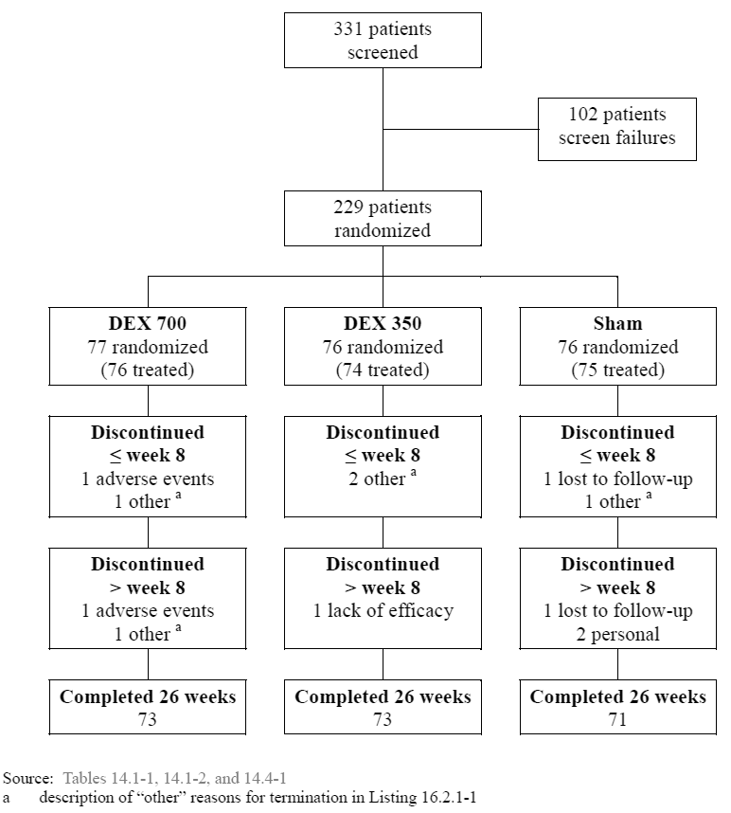

1. Summary of analysis population size (Study 014)

|  |  |  |  |  |
| --- | --- | --- | --- | --- |
| Population | DEX 700 | DEX 350 | Sham | Total |
| ITT population | 77 | 76 | 76 | 229 |
| PP population | 70 | 66 | 71 | 207 |
| Safety population | 76 | 74 | 75 | 225 |

##### Major protocol violations/deviations

Changes to the study methodology included widening the original population during recruitment to include patients with posterior uveitis (versus intermediate uveitis).

There were 68 important protocol deviations in patients, summarised as: use of prohibited medications (n = 52), vitrectomy (n = 5), randomisation but not receiving treatment (n =4), informed consent after screening but before study treatment date (n = 4), treating investigator performed screening, Baseline or outcome assessment (n = 2) and injection into the sclera (n = 1). Protocol deviations were documented and investigators were of the opinion few deviations/violations were major and did not affect patient safety, the study conduct or interpretation of the study results.

The PP population consisted of 90.4% (207/229) of the ITT population; that is patients in the ITT population with no major protocol variations. 22 patients were excluded, 7 in the DEX 700 group, 10 in the DEX 350 group and 5 in the Sham group. The major reason for exclusion was due to the use of medications prohibited according to study protocol (n = 18) with the remainder (n = 4) excluded as they didn’t received randomised treatment.

##### Baseline data

###### Demographic and Baseline characteristics

Demographic and Baseline characteristics data for the ITT population is summarised in the table below, with no statistical differences among the randomised treatment groups. The mean age was 44.8 years (range: 18 to 82 years), the majority were female (63.3%) and Caucasian (60.7%). 80.8% were diagnosed with intermediate uveitis and 19.2% with posterior uveitis.

1. Demographic and Baseline characteristics (014)

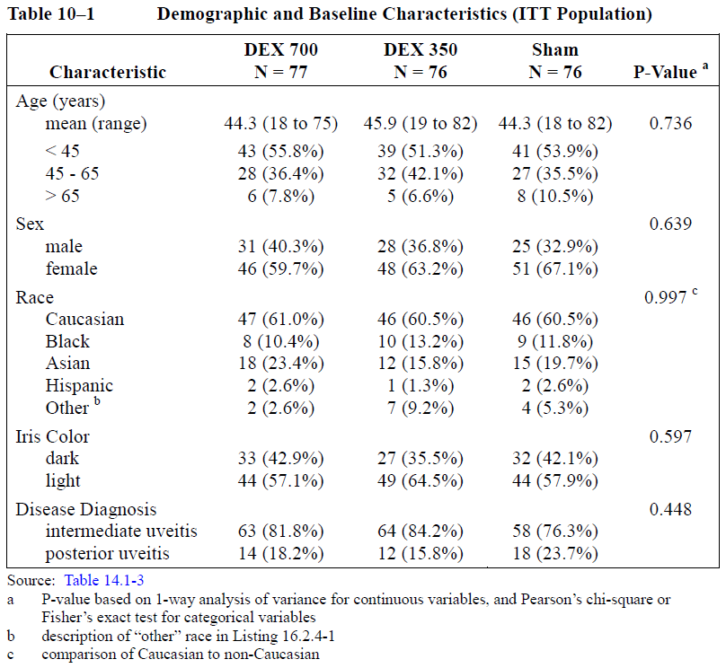

###### Medical and ophthalmic history

The most frequently reported conditions (> 10% in any treatment group) in the ophthalmic history (other than ocular inflammation in the study eye) were cataract (37.6%), uveitis (24.5%), macular oedema (17.5%), intermediate uveitis (10.5%), maculopathy (7.0%) and refraction disorder (9.6%). There were no statistically significant differences among the 3 treatment groups. Cataracts were most commonly reported and at reported at Baseline for 28.6% (22/77) of patients in the DEX 700 group, 43.4% (33/76) in the DEX 350 group, and 40.8% (31/76) in the Sham group (among-group p = 0.128). There were no statistically significant differences among the 3 treatment groups.

The most frequently reported conditions or states (> 10% in any treatment group) in the medical history (other than ophthalmic) were hypertension, contraception, depression, menopause, sarcoidosis, and post-menopause. Frequency of reported gastritis was statistically (but not meaningfully) greater at 6.6% (5/76) of patients in the DEX 350 group compared to 1.3% (1/77) in the DEX 700 group and 0.0% (0/76) in the Sham group (p = 0.034). There were no other statistically significant differences among the 3 treatment groups.

###### Prior medications and procedures

Over 40% of patients in each treatment group had received medications for the treatment of ocular inflammation in the study eye prior to the trial. The most frequently reported (> 10% in any treatment group) drug classes were ophthalmic anti-cholinergics (such as atropine), ophthalmic corticosteroids - plain (such as triamcinolone) and glucocorticoids for systemic use (such as prednisolone).

Prior triamcinolone in the study eye were reported for 15.6% (12/77) of patients in the DEX 700 group (5 intravitreal, 7 periocular), 18.4% (14/76) in the DEX 350 group (14 periocular), and 23.7% (18/76) in the Sham group (5 intravitreal, 12 periocular, 1 intracameral).

1. Prior ophthalmic and corticosteroid use (Study 014)

|  |  |  |  |  |
| --- | --- | --- | --- | --- |
| Drug Class | DEX 700 (N = 77) | DEX 350 (N = 76) | Sham (N = 76) | Total (N = 229) |
| Overall (ophthalmic) | 31 (40.3%) | 33 (43.4%) | 36 (47.4%) | 100 (43.7%) |
| Ophthalmic corticosteroids | 24 (31.2%) | 26 (34.2%) | 30 (39.5%) | 80 (34.9%) |
| Ophthalmic NSAIDs | 2 (2.6%) | 7 (9.2%) | 5 (6.6%) | 14 (6.1%) |
| Ophthalmic anti-cholinergics | 6 (7.8%) | 5 (6.6%) | 8 (10.5%) | 19 (8.3%) |
| Corticosteroids (systemic) | 12 (15.6%) | 12 (15.8%) | 10 (13.2%) | 34 (14.8%) |

###### Use of concomitant and escape medications

Over 90% of patients received concomitant medications during the trial. The most frequently reported (> 10% in any treatment group) of drug classes were PPIs, H2receptor antagonists, calcium and FDCs, statins, glucocorticoids for systemic use, immunosuppressants (such as methotrexate), NSAIDs, paracetamol, ophthalmic corticosteroids, ophthalmic anticholinergics, ophthalmic beta blocking agents, ophthalmic NSAIDs, other ophthalmologicals (such as ciclosporin), other ophthalmic anti-infectives and ophthalmic carbonic anhydrase inhibitors (namely, acetazolamide).

Rates of concomitant ocular medication use were similar among and between the 3 treatment groups at 81.8%, 77.6% and 82.9% for DEX 700, DEX 350 and Sham-treatment groups respectively. The most frequently reported (> 10% in any treatment group) drug classes were glucocorticoids for systemic use ophthalmic corticosteroids, ophthalmic anticholinergics ophthalmic beta blocking agents ophthalmic anti-inflammatory agents non-, other ophthalmologicals ophthalmic carbonic anhydrase inhibitors), and other ophthalmic anti-infectives

There were no notable differences among the treatment groups for the reported drug classes of the concomitant medications used to treat the study eye with the following exceptions (all rates for DEX 700, DEX 350 and Sham respectively): Systemic glucocorticoids, 31.2% (24/77), 22.4% (17/76), 31.6% (24/76); ophthalmic corticosteroids, plain: 50.6% (39/77), 50.0% (38/76), 65.8% (50/76); ophthalmic beta-blocking agents: 27.3% (21/77), 21.1% (16/76), 6.6% (5/76); ophthalmic anti-inflammatory agents, non-steroidal: 7.8% (6/77), 15.8% (12/76), 21.1% (16/76); other ophthalmic anti-infectives: 3.9% (3/77), 7.9% (6/76), 13.2% (10/76).

##### Results for the primary efficacy outcome

###### Vitreous haze score of zero

The results for the primary efficacy endpoint (proportion of patients with a vitreous haze score at the Week 8 visit) were 46.8%, 35.5% and 11.7% of DEX 700, DEX 350 and Sham groups respectively. The comparison of DEX 700 versus Sham found a difference of 34.9% (CI95% 21.6% to 48.2%; p < 0.001). The results for the primary efficacy outcome across study visits are summarised in the table below.

Response rates were consistently higher with DEX 700 compared to Sham, with the treatment effect apparent and significant from the Week 6 visit, peaking at Week 8, and persisting throughout the 26-week study. At the final visit, the response rate with DEX 700 remained twice as high as that with Sham. Similar results were observed in the per protocol population. The percent of patients with vitreous haze score of 0 was significantly higher with DEX 700 compared to Sham at Weeks 6, 8, and 12 (p < 0.001) and Weeks 20 (p = 0.036) but not Weeks 16 or 26. Note missing values (LOCF) were not imputed in this analysis.

1. Proportion of patients achieving a vitreous haze score of zero (Study 014)

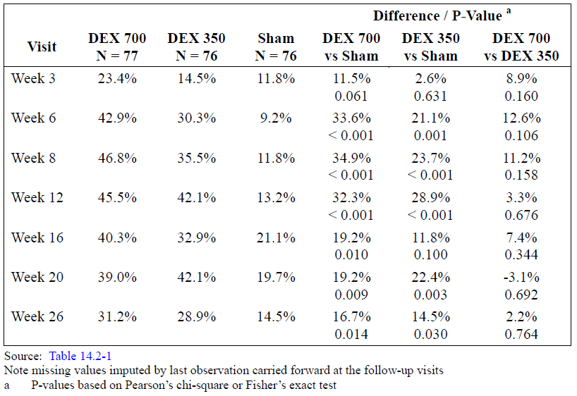

##### Results for other analyses of the primary efficacy outcome

###### Proportion of patients with a 1-unit or more improvement in vitreous haze score

At the primary time point (Week 8) 95% of DEX 700 compared with 46.1% with Sham had ≥ 1 unit improvement (difference: 50.1% (CI95% 37.8% to 62.3%; p < 0.001)) representing a > 2 fold higher response rate with DEX 700 compared to Sham. Results are summarised in the table below. At visits before and after Week 8, the proportion with ≥ 1-unit improvement was significantly higher (p < 0.001) with DEX 700 compared to Sham throughout the 26 week study period.

1. Proportion with ≥ 1-unit improvement in vitreous haze score (Study 014)

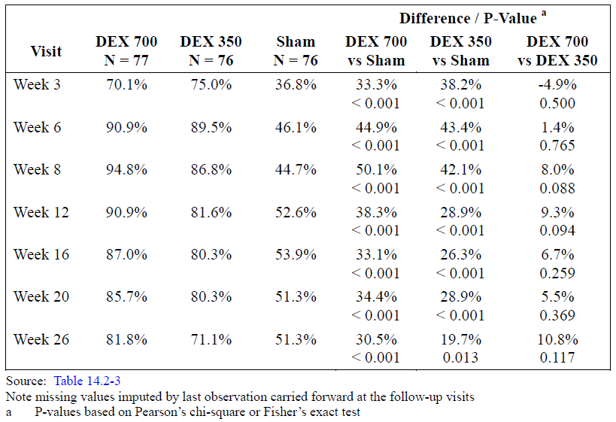

###### Proportion of patients with a 2-unit or more improvement in vitreous haze scores

Proportions with ≥ 2-unit improvement were significantly higher with DEX 700 versus Sham at every study visit and significant at Week 3 (p = 0.023) and at Weeks 6 to 26 (p ≤ 0.002). Response rates were between 2 and 4 times higher with DEX 700 versus Sham.

1. Proportions with ≥ 2-unit improvement in vitreous haze score (Study 014)

|  |  |  |  |  |
| --- | --- | --- | --- | --- |
| Visit | DEX 700 | Sham | Difference | P-value |
| Week 3 | 20.8% | 7.9% | 12.9% | 0.023 |
| Week 6 | 40.3% | 11.8% | 28.4% | < 0.001 |
| Week 8 | 44.2% | 11.8% | 32.3% | < 0.001 |
| Week 12 | 41.6% | 13.2% | 28.4% | < 0.001 |
| Week 16 | 40.3% | 17.1% | 23.2% | 0.002 |
| Week 20 | 41.6% | 14.5% | 27.1% | <0.001 |
| Week 26 | 33.8% | 11.8% | 21.9% | 0.001 |

As is summarized in the table above, treatment with DEX 700 demonstrated similar efficacy regardless of the Baseline vitreous haze severity although none of the comparisons for the Baseline score of +3/+4 were significant due to the small population size in the latter category. The overall trend and magnitude of response was similar with DEX 700 resulting in similar or greater improvement compared to the +1.5/+2.0 category at most study visits, except at Week 26.

###### Vitreous haze score of zero by baseline demographic subgroups

Overall, treatment with DEX demonstrated the same or similar efficacy for patients aged < 45 years and 45 to 65 years. Although the population size for the > 65 year subgroup was too small to record differences of any significance, patterns of change were generally comparable to the other age groups.

1. Vitreous haze score of zero by gender (Study 014)

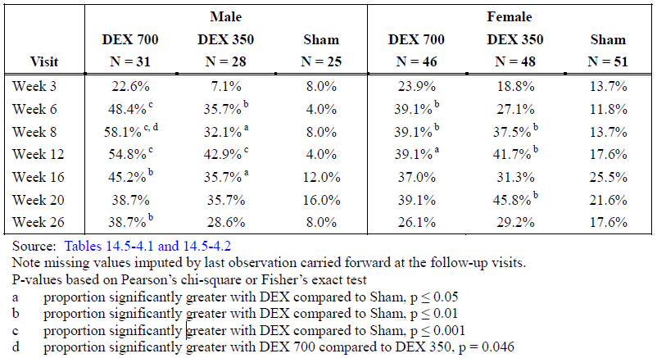

The proportion of patients whose Baseline vitreous haze score decreased to zero is summarised by sex in the table above. Comparing the difference between DEX 700 and Sham at Week 8, the difference in response rate was almost double in male patients (50.1% versus 25.4%) compared with female patients, with a 2.4 X difference at Week 12 (50.8% versus 21.5%) and 2.9 X difference at Week 16. This was in part due to lower response rates amongst female patients (DEX 700) but also due to higher rates of spontaneous improvement in the Sham group. The size of the female subgroup (145/229) was also larger than the male subgroup (84/228). Nevertheless, the results for both groups were significant and followed a similar pattern of response and a numerical benefit was clear for both male and female patients at every visit with comparison of response rates reaching significance at Weeks 6, 8, 12, 16 and 26 for males and Weeks 6, 8 and 12 for females.

Treatment with DEX demonstrated the same or similar efficacy regardless of race. The results from the analysis of the 2 subgroups (Caucasian, non-Caucasian) and the overall population were similar in that treatment with DEX compared to Sham resulted in the same or similar many-fold improvements at most study visits.

###### Deterioration from Baseline in vitreous haze scores

At each visit, the proportion of patients with ≥ 1-unit deterioration (increased severity score) from Baseline vitreous haze score was less in the DEX treatment groups than with Sham. This difference was statistically significant for DEX 700 compared to Sham at Weeks 3, 6, 8 and 26 (p ≤ 0.028). At any visit, 0 to 1 patient for DEX 700, 0 to 4 patients for DEX 350, and 5 to 6 patients for Sham had at least 1-unit deterioration from Baseline. There were no patients in any treatment group with a 2-unit deterioration from Baseline vitreous haze score at any visit aside from 1 patient who received DEX 700. The patient with 2-unit deterioration had a Baseline vitreous haze score of 2 that deteriorated to a score of 4 at Weeks 12 and 20.At Week 26, the patient’s vitreous haze score was 1.5.

###### Change from baseline vitreous haze score

1. Mean vitreous haze raw score (Study 014)

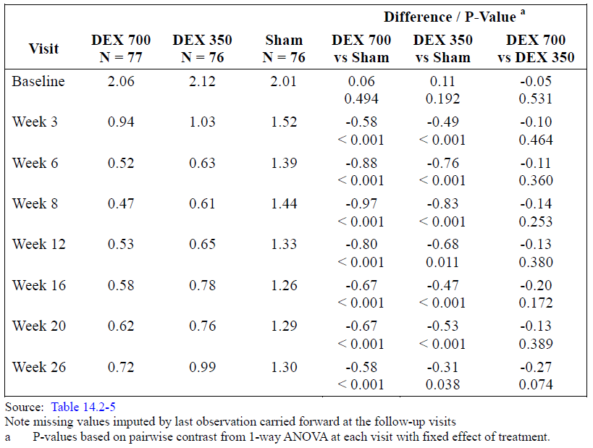

Patients treated with DEX 700 demonstrated a greater than 1-unit mean decrease from Baseline vitreous haze score throughout the study, from weeks 3 through 26. Mean decreases from Baseline score were numerically greater for DEX 700 (range 1.13 to 1.60) compared to DEX 350 (range 1.09 to 1.51) at each visit.

***Results for the secondary efficacy outcomes***

###### BCVA improvement of 15 or more letters from baseline

The proportion of patients able to read ≥ 15 letters compared to Baseline was significantly greater at every visit (p < 0.001) in the DEX 700 versus Sham group, with the treatment effect with DEX apparent at Week 3, and peaking at Week 8 with more than 6-fold the effect of Sham. Rates of improvement are summarised in the table below.

1. Proportion of patients with a BCVA improvement of ≥ 15 from Baseline

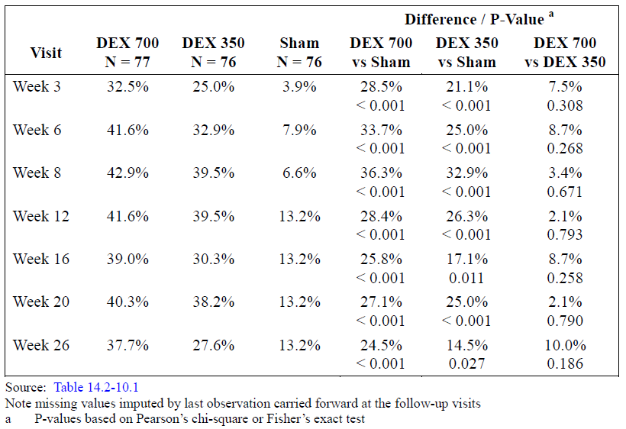

Improvements persisted throughout the 26-week study, and at the final visit, the response with DEX 700 remained nearly 3 times that of Sham. Response rates were numerically superior with DEX 700 compared with DEX 350 at each visit.

###### Central macular thickness using OCT

Central macular thickness using OCT was assessed at selected sites. At Baseline, the mean thickness was 344.0 microns in the DEX 700 group and 324.6 microns in the Sham group. At Week 8, there was a significantly greater mean decrease with DEX 700 (-99.4 microns) compared to Sham (-12.4 microns) (p = 0.004). At Week 26 however, there were no statistically significant differences (DEX 700: -50.2 microns; Sham: -35.5 microns (p = 0.605)).

###### Escape medication use

Escape medications were defined as intravitreal or periocular injections of corticosteroids in the study eye or systemic medications (such as via the oral or intravenous route) taken for uveitis or ocular inflammation which were newly started or increased in dose from treatment Day 0. Throughout the study, use of escape medications was higher for patients receiving Sham than for those treated with DEX. As shown in the table below,

1. Summary of escape medication use from Baseline to each visit (Study 014)

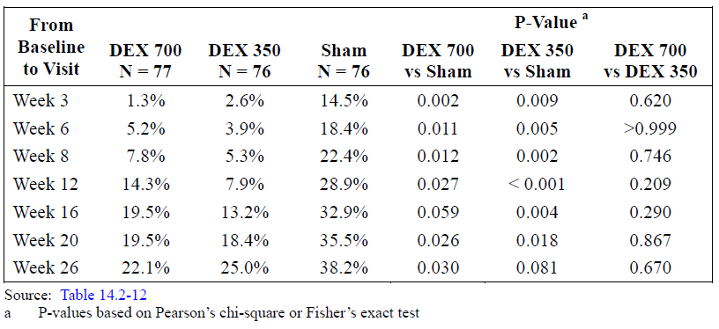

By the Week 3 visit, Sham patients were already 14 X more likely to require the use of escape medications than DEX 700 treated patients. At the primary efficacy variable timepoint (Week 8) Sham patients were 2.9 X more likely to have required escape medication than the DEX 700 treated group, with the comparison being 7.8% (DEX 700) versus 22.4% (Sham), a difference of 14.6%. Even at Week 26, the difference in escape medication use was 16.1% between the DEX 700 and Sham treatment groups. The results suggest not only was there a lower requirement for escape medication use in the DEX 700 treatment group, but also that the lower rates of escape medication use in the DEX treatment are less likely to confound the results of efficacy analysis at either the primary time point (Week 8) or at other visits throughout the study.

#### Evaluator commentary

##### Evaluator’s conclusions on clinical efficacy for uveitis

Only 1 pivotal study was submitted for evaluation of efficacy. Study 014 was a Sham-controlled trial with adequate methods of randomisation and masking of both patients and investigators and randomisation procedures. The choice of Sham-control was appropriate considering none of the included patients had received intravitreal implants previously and due to nature of a single treatment procedure, compliance was 100%. The length of the trial (26 weeks) was adequate for assessing efficacy as the primary time point was the Week 8 visit and efficacy was clear before this point and differences between DEX 700 and Sham statistically significant present up to and including the final study visit. The selection criteria were adequate and reflective of population for the proposed indication. The definition of study populations (ITT, PP and safety) were all acceptable as were methods of statistical analysis.

At Baseline, demographic characteristics were well-balanced across groups and again reflective of the target population. There were low a relatively low attrition rate. The primary efficacy outcome (the proportion of patients with a vitreous haze score of zero at Week 8) was 46.8% for the DEX 700 treated group versus 11.8% for Sham. DEX 700 treatment demonstrated a clear difference (DEX 700 versus Sham) of 35.0% (p < 0.001) with a NNT of 2.88. Differences in response rates between DEX 700 and Sham were evident at Week 3 and significant (p < 0.001) at Week 6, with persistence in difference at Week 26.

The most patient-relevant clinical outcome (a secondary outcome analysis) at Week 8 was the proportion of patients with 15 letters improvement from Baseline BCVA. This is considered a very important outcome and complements the primary efficacy outcome well. The results of 42.9% for DEX 700 compared to 6.6% for Sham (a difference of 36.3%; p < 0.001) were considered strongly clinically relevant with a NNT of 2.8. The difference between DEX 700 and Sham was statistically significantly (p < 0.001) at every study visit, evidence of strong clinical benefit in terms of visual acuity, that persisted throughout the study with the comparison at Week 26 being 37.7% versus 13.2% (difference 24.5%; NNT = 4.1). All other measures of efficacy outcomes were favourable for DEX 700 including use of escape medication which was significantly lower in the DEX 700 group at every visit except Week 16. In addition, amongst subgroups, either a clear statistically significant benefit was seen, or in the case of subgroup size that were too small for significance, trends in efficacy favoured DEX 700 over Sham.

Despite no data available beyond 6 month covering possible retreatment of patients, there was no evidence of loss of efficacy at the 6 month period (either due to sustained active drug effect or due to disease remission).

## Clinical Safety

### Studies providing safety data

#### Pivotal studies that assessed safety as the sole primary outcome

Not applicable.

#### Pivotal and/or main efficacy studies

The following pivotal efficacy and safety studies were submitted for evaluation:

* Study 206207-008 (RVO)
* Study 206207-009 (RVO)
* Study 206207-020 (RVO)
* Study 206207-014 (Uveitis)
* A pooled Integrated Summary of Safety (ISS) was presented for individual Studies 008/009. Due to the similarity of such studies, pooled data is considered appropriate for evaluation and useful as the safety/re-treatment population for analysis as approximately double. In this assessment differences between study safety outcomes of the individual studies are highlighted.

Safety data was collected as follows:

* AEs were recorded and summarised using preferred terms (PT) according to frequency, system organ class (SOC), severity and for events leading to discontinuation Adverse events (AEs), non-ocular AEs and ocular AEs were assessed using MedDRA coding.
* Ocular AEs were summarised as in the study eye or non-study eye. AEs reported in the non-study eye for all 3 treatment groups (or 2 treatment groups in Study 206207-020) were combined into a single group in each study.
* AE severity was investigator graded by clinical determination of the intensity of an AE (mild, moderate or severe. Not applicable was used for all or none type events).
* Treatment-related ocular AEs were further summarised according to relationship to applicator/insertion or to DEX PS DDS (study drug) itself.
* Ocular AEs and treatment-related ocular AEs of note included ‘IOP Increased’ coded under Investigations SOC or Eye Disorders SOC. ‘Cataract’ including subtypes such as ‘Cataract subscapular’ were coded under Eye Disorders SOC.
* IOP measurement was recorded for the study eye and non-study eye at Baseline and each follow-up visit into categories with target IOP of ≥ 10 mm Hg, ≥ 25 mm Hg and IOP≥ 35 mm Hg from Baseline IOP.
* Biomicroscopic and ophthalmoscopic findings were recorded and tabulated for any finding with at least 1 severity grade increase from Baseline or a status change from absent to present at any of the follow-up visits were generated for each MedDRA PT. Severity increase was graded as follows: 0 = none, 0.5 = trace, 1 = mild, 2 = moderate, and 3 = severe.
* Retinal tear, lattice degeneration and round (atrophic) retinal holes were evaluated during the fundus examination as present or absent. Lattice degeneration was evaluated during the fundus examination and assessed as present or absent.
* The presence and severity of nuclear, cortical, and posterior subcapsular lens opacities in phakic eyes only were graded using one standardised retroillumination photograph for each category of lens opacity and following a standardised clinical lens grading protocol.
* The number and percent of patients with reported iris neovascularization or retinal neovascularisation were tabulated for the study eye and non-study eye by treatment group at each visit.
* Vital signs including blood pressure, pulse rate and body temperature were collected at Baseline and follow-up
* Plasma concentrations of dexamethasone were measured using a validated liquid chromatography-tandem mass spectrometry method (LC-MS/MS) with a lower limit of quantitation (LLOQ) of 0.05 ng/mL for dexamethasone.
* Unless otherwise indicated all safety analyses in the IT period involve the safety population. In the OL extension, the re-treatment population was used.

#### Other studies

Studies 206207-010 and 011 for the indication of diabetic macular oedema (DME) were evaluable for safety outcomes.

##### Other efficacy studies

Studies 206207-010/011 (ISS)

These 3Year, masked and randomised Phase III studies were identical in protocol and methodology, with similar patient populations at Baseline. They were conducted to evaluate the efficacy and safety of DEX 700 and 350 versus Sham in the treatment of DME. They are included here only for analysis of safety, particularly long-term safety. As multiple cycles of treatment were conducted (approximately once every 6-months) it can contribute towards analysis of the safety of multiple rounds of DEX PS DDS therapy and contribute towards the evaluation of the exposure-adjusted safety of the study treatments, for instance, AE incidence by number of treatment cycles, by year of treatment course and by patient-years.

### Patient exposure

#### Pivotal studies

##### Study 206207-008/009- RVO

For the 6-month IT period, exposure for the safety population was similar between the 3 groups with approximately 95% of each study group completing at least 150 days. The mean (range) duration was 176.1 (7 to 215) days for patients in the DEX 700 group (n = 421), 177.2 (22 to 270) days in the DEX 350 group (n = 412) and 174.8 (0 to 259 days) in the Sham group (n = 423).

For the IT period plus the OL extension, overall exposure for the re-treatment population was similar, with approximately 96% of each study group completing 330 days or more. The mean (range) duration was 362.3 (258 to 473) for the DEX 700/700 group (n = 341), 361.3 (206 to 484) for the DEX 350/700 group (n = 329) and 361.4 (210 to 582) for the Sham/DEX 700 group (n = 327).

##### Study 206207-020-RVO

For the safety population, exposure was similar between the 2 treatment groups. Approximately 95% of patients in each treatment group remained in the study at least 150 days. The mean (range) duration was 239.5 (66 to 255) days for patients in the DEX 700 group, and 232.7 (2 to 288) days in the Sham group.

##### Study 206208-014-Uveitis

The 77 patients randomised to the DEX 700 group, of whom 1 patient was randomised but not treated. 76 patients randomised to the DEX 350 group; 2 patients were randomized but not treated. The 76 patients randomised to the Sham group were to receive no active treatment; 1 patient was randomised but not treated. The safety analyses are based on a total of 225 patients who received treatment of the 229 patients randomised. Exposure was similar across the 3 treatment groups. The mean (range) duration was 181.3 (49 to 225) days for patients in the DEX 700 group, 183.1 (140 to 216) days in the DEX 350 group, and 181.0 (22 to 262) days in the Sham group.

#### Other studies

##### Study 206207-010/011-DME

Overall 1040 with DME received at least 1 study treatment, and thus were included in the safety population: n = 347 in the DEX 700 subgroup, n = 343 in the DEX 350 subgroup and n = 350 in the Sham group. Cumulative exposure was 22% less in the Sham group due to more patient discontinuations, primarily driven by a reported lack of efficacy.

The pooled data from the Phase III studies represents a total of 853.9, 880.2 and 665.5 years of treatment exposure for the DEX 700, DEX 350 and Sham groups respectively with a total of 1427, 1501 and 1149 treatments for the three groups. The mean number of treatments given per patient was 4.1, 4.4 and 3.3 over 3 years (up to 7) across the DEX 700, DEX 350 and Sham groups.

### Safety issues with the potential for major regulatory impact

#### Liver function and liver toxicity

There were no issues identified.

#### Renal function and renal toxicity

There were no issues identified.

#### Other clinical chemistry

According to protocol, standard clinical laboratory data were not collected in the clinical safety and efficacy Studies 206207-008 and 009. In Study 206207-020, blood samples were collected at screening, Month 8, and the early exit visit for routine haematology and chemistry analysis. The results were reviewed by qualified site personnel, and kept in patients’ source documents at study site for reference. No issues were identified.

#### Haematology and haematological toxicity

There were no issues identified.

#### Other laboratory tests

There were no issues identified.

#### Electrocardiograph findings and cardiovascular safety

There were no issues identified. Vital signs from the RVO and uveitis studies demonstrated no difference to blood pressure or pulse rate between DEX treated groups and Sham. No ECG data was reported from the submitted studies.

#### Vital signs and clinical examination findings

Studies 206207-008, 009, 014 and 020 all assessed diastolic and systolic blood pressure and pulse rate. In addition Study 020 assessed body temperature.

There were no statistically significant between-group differences in any of the studies nor differences between Baseline and subsequent measurements throughout the trials.

#### Immunogenicity and immunological events

Retinitis secondary to reactivation of latent viral or other ophthalmic infection is an uncommon ADR, with one reported incident in Study 014 (uveitis) and one from the DME studies (010/011). Both incidents were reported as necrotising retinitis. The incident from the uveitis study was in a 40 year old male with previously undiagnosed HIV infection developed worsening panuveitis and retinal necrosis 86 days following treatment with study medication (DEX 350). An aetiologic agent was not identified. The outcome was reported as improved/ongoing. In the DME incident, the subject was a 58-year-old diabetic (type II) male developed acute retinal necrosis 98 days after treatment with dexamethasone 700 μg for DME. The subject had no known history of human immunodeficiency virus (HIV) or herpes virus infection. Polymerase chain reaction (PCR) assay was positive for cytomegalovirus infection. Outcome was reported as ongoing.

Considering the immunosuppressive mechanisms of action behind corticosteroids, reactivation of latent viral or ophthalmic infection remains a rare but serious possibility.

Of note, to minimise this risk, Section 6 (Contraindications) of the US CCDS includes the following information: DEX 700 is contraindicated in patients with active or suspected ocular or periocular infection, including most viral diseases of the cornea and conjunctiva, including active epithelial herpes simplex keratitis (dendritic keratitis), vaccinia, varicella, mycobacterial infections, and fungal diseases. Additionally, the Warnings and Precautions (Section 7) states ’Corticosteroids should be used cautiously in patients with a history of ocular herpes simplex. Corticosteroids should not be used in active ocular herpes simplex’.

Since the international birth date of ozurdex there have been 2 cases reporting the PT Retinitis and 3 cases reporting other adverse events (including hypotony, vitreous loss, complication of device insertion and necrotising retinitis) in patients with medical history of retinitis.

#### Serious skin reactions

Other than mild injection related reactions such as peri-orbital oedema and conjunctival erythema, no skin reactions were reported.

#### Increased intraocular pressure

##### Pivotal studies

###### RVO

Elevation in IOP compared with Baseline IOP (reported as ‘IOP increased’) was the most common finding across all pivotal studies with statistically significant differences between DEX treated groups and Sham across all studies. At Baseline, there were no differences in statistically significant among or between-group differences for mean IOP in the study-eye in any of the submitted studies.

In Study 008 and 009 (pooled safety population; IT period) DEX administration was consistently associated with elevations in IOP over Baseline. Maximal effect was seen at IT day 60: For DEX 700, DEX 350 and Sham respectively, 15.7%, 14.7% and 0.2% had an IOP ≥ 10 mm Hg another 15.7%, 15.9 and 0.2% had an IOP ≥ 25 mm Hg, and a further 3.2%, 3.8% and 0.0% had an IOP ≥ 35 mm Hg, with all comparisons between either DEX dose versus Sham significant (p < 0.001). From day 7 up to and including day 90, DEX 700 versus Sham was associated with elevated IOP at ≥ 10 and ≥25 mm Hg over Baseline that was statistically significant (p < 0.001). By Day 180 however, IOP had returned to normal or within 10 mm Hg of Baseline for > 97% and there were no statistically significant differences between either DEX dose group and Sham.

In the re-treatment population, the pattern of IOP response with DEX was similar to that in the overall safety population (IT period) as summarised below. Following re-treatment, the proportion of patients with IOP increase ≥ 10, ≥ 25 or ≥ 35 mm Hg from the first Baseline peaked at OL day 60 but declined to levels comparable to 1st and 2nd Baseline levels by the end of the 1-year study.

At IT day 60, peak increase in mean IOP (from Baseline) was IT day 60, at 4.3, 3.7 and -0.3 mm Hg for DEX 700/700, DEX 350/700 and Sham/DEX 700 respectively and OL day 60, the increase was 4.5, 4.0 and 4.4 mm Hg with IT and OL peak values comparable. Mean change from Baseline was also comparable at the end of each study period at 0.2, -0.5 and 0.2 mm Hg (IT Day 180) and 0.4, 0.1 and 0.3 (OL Day 180). Overall, there was no evidence of increased magnitude in mean IOP increase associated with re-treatment.

Overall, the incidence of IOP increased for each treatment group was similar across demographic sub-groups but was more commonly reported in CRVO than BRVO with the incidence in the IT period being 26.3% versus 1.7% of DEX 700/700 and Sham/DEX 700 CRVO patients and 21.1% and 1.0% of BRVO patients. In addition, despite the small size of the RVO population < 45 years of age (5% or 67/1256 of the pooled population of Studies 206207-008/009) in this age-group 60.9% (14/23), 45.5% (10/22) and 0.0% (0/22) of DEX 700, DEX 350 and Sham patients had IOP increased as an AE, with comparisons of DEX 700 and DEX 350 versus Sham both significant (p < 0.001). In contrast, the incidence of IOP increased as an AE in those aged between 45 and 65 was 24.9% (47/189) 26.7% (51/191) and 0.5% (1/199).

1. Proportion of patients with IOP ≥ 10 mm Hg (above) ≥ 25 or ≥ 35 mm Hg (below) (Studies 008/009, Re-treatment population)

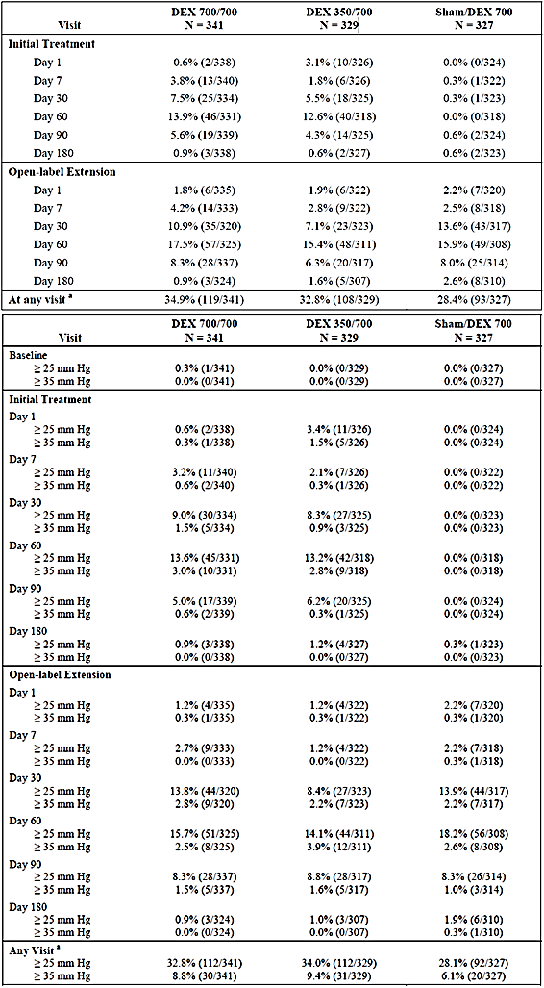

DEX 700 = 700 μg DEX PS DDS applicator system, DEX 350 = 350 μg DEX PS DDS applicator system a Patients with IOP ≥ 25 mm Hg or ≥ 35 mm Hg at any post-Baseline visit during the initial treatment period or open-label extension.

There were 6 procedures performed in the study eye for high ocular pressure during the IT period of Studies 008/009 as summarised below. In addition, one patient (Sham) underwent an iridotomy with laser for narrow angle anterior chamber and ocular hypertension. Two patients from the single treatment population also required procedures for managing IOP post-IT period exit. Patient [information redacted](DEX 700) required tube shunt insertion with scleral reinforcement and panretinal photocoagulation for elevated intraocular pressure (and also rubeosis) and patient [information redacted] (DEX 350) required laser photocoagulation, drainage tube implant OS and intravitreal triamcinolone for the treatment of neovascular glaucoma and increased intraocular pressure.

1. Concurrent Procedures in the for management of elevated IOP

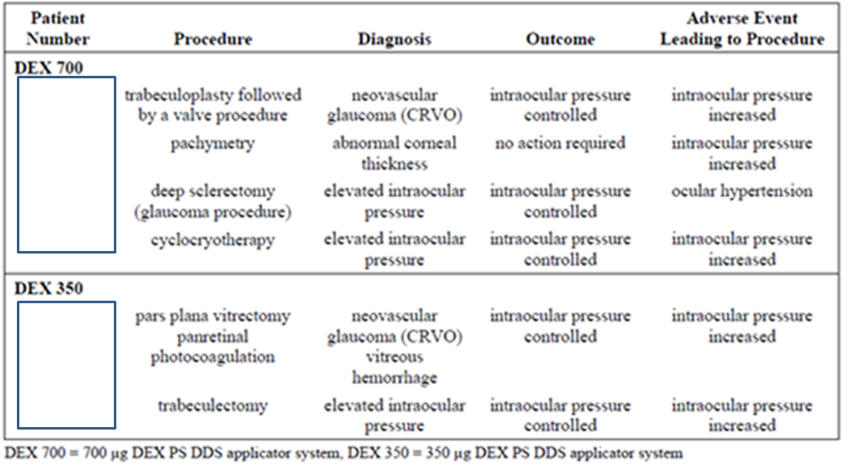

Overall, 7.5% of re-treated patients in Studies 008/009 underwent ocular concurrent procedures related to increased IOP as summarised in the table below.

1. Procedures for elevated IOP or neovascular glaucoma

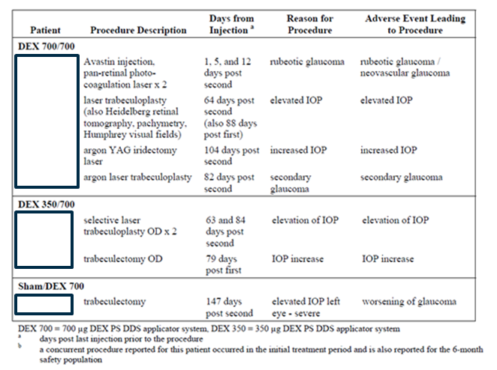

The concomitant use of IOP lowering medications was common and significantly higher in the DEX treated groups during the IT periods of both Study 008 and 009 as summarised in the table below. Following re-treatment, the use of such medications in the Sham/DEX 700 group rose to rates either similar or slightly lower but comparable to rates in the twice treated groups.

1. Concomitant use of IOP lowering medications (Study 008/009)

|  |  |  |  |  |  |  |  |
| --- | --- | --- | --- | --- | --- | --- | --- |
| Drug Class | | Study 206207-008 | | | Study 206207-009 | | |
|  | DEX 700 (700) | | DEX 350 (700) | Sham (DEX 700) | DEX 700 (700) | DEX 350 (700) | Sham (DEX 700) |
| Ophthalmic beta blocking agents | 19.4% (28.0%) | | 25.5% (23.9%) | 3.5% (20.3%) | 25.7% (29.1%) | 21.6% (29.5%) | 2.7% (28.0%) |
| Sympathomimetics for glaucoma | 10.4% (10.4%) | | 11.2% (9.7%) | 0.5% (9.5%) | 12.8% (14.5%) | 12.8% (15.6%) | 1.3% (11.9%) |
| Prostaglandin analogues | 7.5% (8.5%) | | 11.2% (11.0%) | 1.5% (13.9%) | 9.7% (15.1%) | 11.5% (12.7%) | 1.3% (8.3%) |

Note: numbers in brackets refer to OL extension rates of IOP lowering medication use

Changes in IOP were similar in Study 020 to those seen in Studies 008/009. Elevated intraocular pressure (IOP) adverse events were reported for 32.6% of patients in the DEX 700 group, and 2.3% in the Sham group. The mean change from Baseline IOP was significantly greater with DEX 700 compared to Sham at the Month 1, 2, and 3 visits, (p < 0.001). Values returned to levels comparable to Baseline and between groups by IT Day 180. The peak proportion of patients with elevated IOP in each of the 3 IOP categories was at the Month 2 visit, with 17.1%, 15.5% and 4.7% of the DEX 700 group having IOP elevations of ≥ 10, 25 and 35 mm Hg respectively. In comparison, none of the Sham group recorded elevation of IOP at this timepoint. The percent of patients with increases from Baseline IOP ≥ 10 mm Hg in the study eye was greater with DEX 700 (27.1% at any visit) compared to Sham (1.5% at any visit). At a target IOP ≥ 25 mm Hg 23.3% of the DEX 700 group compared to 0.8% of Sham had a positive finding at any visit and at ≥ 35 the proportion was 6.2% for DEX 700 and 0.0% for Sham.

In Study 206207-020, one patient (1/129) required a trabeculoplasty for increased IOP, with one Sham patient (1/130) requiring iridectomy for glaucoma. Concomitant ophthalmic medications used for managing IOP elevations were reported for 34.9% (45/129) of patients in the DEX 700 group, and 13.8% (18/130) in the Sham group.

The pivotal studies for the RVO indication demonstrated a very similar rise and fall in IOP compared with Baseline both in terms of timepoints and proportions of patients with elevated IOP at each measurement level.  
From Studies 008/009, the proportions in each IOP category were almost identical between DEX 350 and DEX 700 at each timepoint despite effectively doubling the dose of dexamethasone.

DEX treatment was unequivocally associated with higher incidence of elevated IOP compared with Sham with IOP increased responsible for the majority of the increased incidence of all ocular AEs and treatment-related AEs in the DEX groups versus Sham. Rates of IOP increased (DEX 700 versus Sham) were 36-fold in Studies 008/009 (IT period) and 19-fold in Study 020. Comparing DEX 700 with DEX 350, there was no significant difference in incidence of IOP increased despite an effective doubling of dose and following re-treatment (Studies 008/009) the incidence of IOP increased was comparable in the OL extension to the IT period.  
As may be expected, use of IOP lowering medications was high across all studies with over a third of DEX treated patients using such medications. Overall rates of use stayed relatively constant following the second consecutive injection, with rates of use in the Sham/DEX 700 group (OL extension) reaching levels similar to those treated twice. A relatively high proportion of treated patients required procedures for lowering IOP.

###### Uveitis

In Study 206207-014, day 7 visit (7 days post-plant) mean change from Baseline IOP was significantly higher compared with Sham for both DEX 700 and DEX 350 (p < 0.001). At Week 8 the greatest mean change over Baseline IOP was seen at 3.8 and 2.9 mm Hg for DEX 700 and DEX 350 respectively compared with -0.3 mm Hg for Sham, with the difference between both DEX groups versus Sham significant (p < 0.001). From the Week 12 visit, differences between DEX 350 versus Sham were non-significant (mean change in IOP compared with Baseline 1.0 versus -0.2 mm Hg, p = 0.166) and from Week 16 differences between DEX 700 versus Sham were non-significant (0.9 versus 0.3 mm Hg). At study conclusion (Week 26) mean change from Baseline IOP was 0.1, -0.6, and 0.5 mm Hg in DEX 700, DEX 350 and Sham respectively.

Overall, 43 patients experienced IOP ≥ 25 mm Hg in the study eye, the majority at a single visit only and which returned to Baseline by the end of the study. 10 patients experienced IOP ≥ 35 mm Hg in the study eye, 7 patients at a single visit only and all which returned to Baseline by the end of the study. At an IOP of ≥ 10 mm Hg the peak incidence at any one visit was 11.3% for DEX 700 (versus 1.5% (Sham) at Week 6) and 9.7% for DEX 350 (compared with 9.6% (DEX 700) and 0.0% (Sham) at Week 8). The amongst-group p-value for Week 6 was 0.053, and at Week 8 both DEX groups versus Sham were significant (p = 0.013). None of the amongst-group differences for IOP of ≥ 25 or ≥ 35 mm Hg were significant, but peak incidence at ≥ 25 mm Hg for both DEX 700 and DEX 350 versus Sham was 7.1% and 8.7% at Week 3, and at ≥ 35 mm Hg, peak incidence was 2.7% for DEX 700 (Week 8) and 2.9% for DEX 350 (Week 3). At Week 26 1.4% of DEX 700 and 2.8% of Sham had an IOP ≥ 10 mm Hg over Baseline and 4.2% of Sham and none of the DEX groups had an IOP ≥ 25 mm Hg.

In those < 45 years, 30.2% (13/43), 28.9% (11/38) and 7.5 (3/40) of DEX 700, DEX 350 and Sham respectively were reported as having IOP increased as an AE. The findings were significant for DEX 700 versus Sham (p = 0.009) and DEX 350 versus Sham (p = 0.007) and reported rates were higher than for those aged 45 to 65 at 21.4% (6/28), 19.5% (6/31) and 7.4% (2/27) for DEX 700, DEX 350 and Sham respectively. In this age group there were no significant differences between treatment groups. The incidence of ocular hypertension was also higher in those < 45 years at 9.3% (4/43), 13.2% (5/38) and 0.0% (0/40) (among-group p-value = 0.056).

Three patients required laser iridotomies in the study eye for the following reported reasons: pupillary block (Patient 8295-55608 (DEX 350)), iris bombe (Patient 5282-54311 (DEX 700)), and raised IOP (Patient 6409-56408 (DEX 700)). Ophthalmic beta-blocking agents were used by 27.3% (21/77) DEX 700, 21.1% (16/76) DEX 350 and 6.6% (5/76) of Sham patients, with sympathomimetics (for glaucoma therapy) used by 9.1%, 5.3% and 5.3%, carbonic anhydrase inhibitiors by 13.0%, 7.9% and 6.6% and prostaglandin analogues used by 5.2%, 3.9% and 3.9% of the DEX 700, DEX 350 and Sham group respectively.

Due to the population size none of the comparisons for ≥ 25 or ≥ 35 mm Hg Baseline IOP were significant. Approximately 8% to 10% of DEX treated patients experienced an IOP increase ≥ 10 mm Hg, 4% to 7% ≥ 25 mm Hg and 1.4% to 4% ≥ 35 mm Hg. Compared with the RVO trials, proportions with clinically significant elevations in IOP (≥ 25 or 35 mm Hg) were comparable. IOP increased reported as an AE was 22.4% (DEX 700) versus 4.0% (Sham) which is lower than that seen in RVO Studies 008/009 (IT period: 27.7% versus 0.6%) representing a 5.6 fold increase as an AE, compared to the 36 fold increase in the RVO studies. Perhaps due to the underlying pathologies involved in uveitis, 3 Sham patients (3/72, 4.2%) recorded an IOP ≥ 25 mm Hg and 1 Sham patient recorded an IOP ≥ 35 mm Hg (1/72, 1.4%). In contrast only 1 Sham patient (1/323, 0.3%) in Studies 008/009 recorded an IOP increase ≥ 25 mm Hg and none had an IOP increase ≥ 35 mm Hg. Regarding patient age, both RVO and uveitis studies showed that higher incidence of IOP increased as an AE was statistically significant for younger patients, however unlike RVO which is more common in older adults, non-infectious uveitis is more likely to occur in younger populations.

##### Other studies

In Study 010 (indication of DME) elevated IOP AEs during the whole study period were reported in 40.6%, 36.4% and 3.0% of the DEX 700, DEX 350 and Sham groups, respectively. Mean IOP in the study eye increased following each injection of DEX 700 by 3.0 to 4.5 mm Hg across all visits from Baseline. However, the magnitude of change in mean IOP did not increase with repeated injections. Similar changes in mean IOP were recorded in the DEX 350 group. Mean changes from Baseline ranged from -2.0 to 5.0 mm Hg across all visits. During the course of the study, 43.8%, 39.4% and 6.7% of patients required IOP lowering medications in the DEX 700, DEX 350 and Sham groups, respectively. In Study 011, elevated IOP AEs during the whole study period were reported in 32.1%, 32.0% and 7.0% of the DEX 700, DEX 350 and Sham groups, respectively. Mean IOP in the study eye increased following each injection of DEX 700 by -4.0 to 3.0 mm Hg across all visits from Baseline. However, the magnitude of change in mean IOP did not increase with repeated injections. Similar changes in mean IOP were recorded in the DEX 350 group. Mean changes from Baseline ranged from 3.0 to 6.0 mm Hg across all visits. During the course of the study, 39.6%, 36.0% and 11.3% of patients required IOP lowering medications in the DEX 700, DEX 350 and Sham groups, respectively.

#### Cataracts

##### Pivotal studies

###### RVO

The combined incidence of cataract AEs (including cortical, nuclear, subcapsular) in Studies 008/009 (IT period; Safety population) was 7.4% (31/421) of patients in the DEX 700 group, 4.1% (17/412) in the DEX 350 group, and 4.5% (19/423) in the Sham group. For the re-treatment population in the IT period, the combined cataract incidence was comparable to the overall safety population at 8.8%, 4.6% and 4.6% for the DEX 700/700, DEX 350/700 and Sham/DEX 700 groups respectively.

At the end of the OL extension, the overall rates of reported cataract AEs in the study eye was 26.4%, 17.0% and 9.5% for the DEX 700/700, DEX 350/700 and Sham/DEX 700 groups respectively. For comparison, cataract events in the non-study eye for the 12 Month period for the same population were 6.2%, 4.3% and 6.4% across the three groups.

1. Incidence of cataract in the study eye (Re-treated population 008/009)

|  |  |  |  |  |  |  |  |
| --- | --- | --- | --- | --- | --- | --- | --- |
| Study Period | DEX 700/700 (N = 341) | | DEX 350/700 (N = 329) | | Sham/DEX 700 (N = 327) | | P-value |
| **%** | **N =** | **%** | **N =** | **%** | **N =** |
| IT period | 8.8% | 30 | 4.6% | 15 | 4.6% | 15 | 0.029 |
| OL extension | 25.8% | 88 | 17.0% | 56 | 8.9% | 29 | <0.001 |
| IT plus OL | 26.4% | 90 | 17.0% | 56 | 9.5% | 31 | <0.001 |

(ISS Analysis Plan 008/009 12M) Note: Included all reported adverse events with a MedDRA term that contained cataract: cataract, cataract cortical, cataract subscapsular

On retro illumination photography cortical opacities and posterior subcapsular opacities in the study eye were absent at Baseline for approximately 55% and 92% of patients respectively in each treatment group. At IT Day 180 approximately 15% of patients in each treatment group had new or progressed cortical opacities at IT Day 180. There were no statistically significant among-group differences. Posterior subcapsular opacities were questionable or present for a higher percentage of DEX patients compared to Sham at IT Day 180 (among-group p = 0.006). There was a higher incidence of new or progressed posterior subcapsular opacities in the study eye at IT Day 180 with DEX 700 (11.5%) and DEX 350 (6.9%) compared to Sham (3.9%) (among-group p = 0.001).

1. Retroillumination photography in the study eye (Studies 008 and 009, IT Period)

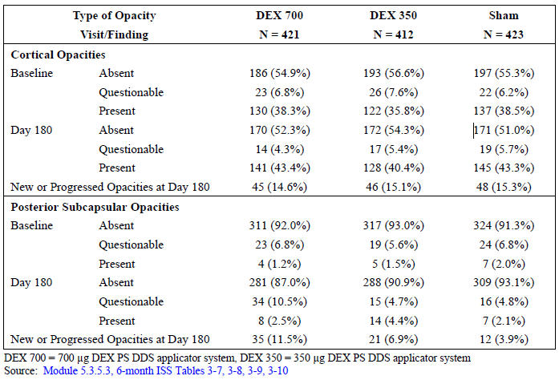

In the re-treated population (cumulative 12-Month period) there were no significant differences in the numbers of patients reported with cortical opacities between treatment groups and although rates were slightly higher than Baseline (IT period), these were no higher at the end of the OL extension compared with IT Day 180 with all 3 groups hovering around 50% at Baseline, IT Day 180 and OL Day 180. In contrast, the rates of posterior subcapsular opacities as found on retroillumination photography increased in the DEX 700/700 group from 1.4% (4/341) at Baseline to 2.9% (8/341) at IT Day 180 to 12.3% (33/341) at OL Day 180 following the second implant. A similar increased rate was seen in the DEX 350/700 group following the second DEX implant. In contrast reported the rates of posterior subcapsular opacities in the Sham treatment group remained the same from Baseline to IT Day 180 before doubling at OL Day 180 when re-treated with their 1st DEX 700 implant.

1. Posterior subcapsular opacities (Studies 206207-008/009; Re-treatment population)

|  |  |  |  |  |  |  |
| --- | --- | --- | --- | --- | --- | --- |
| Visit | Status | | DEX 700/700 (N = 341) | DEX 350/700 (N = 329) | Sham/DEX 700 (N = 327) | P-value |
| Posterior subcapsular opacities | | | | | | |
| Baseline | | Absent | 254 (90.7) | 249 (93.6%) | 248 (91.2%) | 0.430 |
|  | | Questionable | 22 (7.9%) | 13 (4.9%) | 19 (7.0%) |  |
|  | | Present | 4 (1.4%) | 4 (1.5%) | 5 (1.8%) |  |
| IT Day 180 | | Absent | 239 (87.2%) | 240 (91.6%) | 252 (93.0%) | 0.065 |
|  | | Questionable | 27 (9.9%) | 10 (3.8%) | 14 (5.2%) |  |
|  | | Present | 8 (2.9%) | 12 (4.6%) | 5 (1.8%) |  |
| OL Day 180 | | Absent | 195 (72.8%) | 187 (76.0%) | 234 (90.7%) | < 0.001 |
|  | | Questionable | 40 (14.9%) | 24 (9.8%) | 15 (5.8%) |  |
|  | | Present | 33 (12.3%) | 35 (14.2%) | 9 (3.5%) |  |

In the re-treated population of Studies 008/009, the rates overall rates of cataract surgery for the 12-month study period were 0.9% (3/341), 1.5% (5/329) and 0.0% (0/327) for the DEX 700/700, DEX 350/700 and Sham/DEX 700 groups respectively. In the single treatment population (one implant, IT period plus 6 month follow up) rates were 0.0% (0/80), 1.2% (1/83) and 1.0% (1/96) for the DEX 700, DEX 350 and Sham groups respectively.

In the 6 month IT period of Study 206207-020, the incidence of cataract AEs were was 1.6% (2/126) of patients in the DEX 700 group, and 0.0% (0/129) of patients in the Sham group with only ‘lenticular opacities’ reported. No patient had surgery for cataracts in the study eye. In the following 2 month OL extension ‘lenticular opacities’ were reported a further 2 DEX 700/700 patients (1.9% or 2/107) following the second implant.

Cataract is a well-known potential AE arising from use of corticosteroids in any dose from. From Studies 008/009 there is strong evidence that re-treatment (2 consecutive implants) is associated with an increased rate of cataract AE reporting. In the IT period, cataracts in the DEX 700/700 group were reported for 1.9 fold more than in the Sham/DEX 700 group. In the OL extension, the difference was 2.9 fold. This is supported by the changes in retroillumination findings over the IT period and OL extension. Considering that multiple implants may be required (as evidenced by BCVA efficacy results), the incidence of cataract in patients is also likely to increase with time as would the need for corrective surgery. From the 8 procedures to correct cataracts (re-treatment population) 3 were in DEX 700/700 patients and 5 were in DEX 350/700 patients.

###### Uveitis

In Study 014approximately 35% to 50% of patients across groups had some report of ‘cataract’ in the ophthalmic history. At the end of the study ‘cataract’ formation as an AE was reported for approximately double the DEX 700 group compared with the Sham group (11.8% (9/76) versus 5.3% (4/75) respectively). ‘Cataract subscapular’ was reported for 2.6% (2/76) and 5.3% (4/75) of the DEX 700 and Sham group respectively. There were no statistically significant among-group differences so pairwise comparison was not performed.

1. Cataract adverse events (Study eye; Safety population)

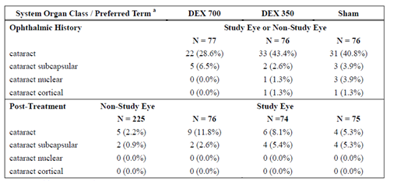

Cortical opacities were absent in phakic eyes for 90.2% (55/61), 76.5% (39/51) and 87.3% (48/55) of DEX 700, DEX 350 and Sham patients respectively. At study conclusion (Week 26), cortical opacities were absent for 81.4% (48/59) 69.4% (34/49) and 86.0% (43/50) respectively. The proportions of patients with a 1-grade increase in cortical opacity grade at any visit during the study were 17.7% (11/62), 15.7% (8/51), and 12.7% (7/55) in the DEX 700, DEX 350, and Sham groups respectively. There were no among-group differences at any visit that reached statistical significance.

At Baseline, nuclear opacities were absent in phakic eyes for 72.1% (44/61) 68.6% (35/51) and 83.6% (46/55) of the DEX 700, DEX 350 and Sham patients respectively. During follow-up, there were no statistically significant among-group differences in the distribution of nuclear opacities except at Week 20 (p = 0.047). At Week 26, nuclear opacities were absent for approximately 70% of patients.

There were no statistically significant among or between-group differences for the proportion of patients at least a 1-grade increase from Baseline to any follow-up visit for nuclear opacities in phakic eyes, except at weeks 3 and 12. At Week 3, the proportion of patients with ≥ 1-grade increase in nuclear opacities was significantly higher in the Sham group (12.0%) compared to DEX 350 (0.0%), p = 0.027. At Week 12, the proportion of patients with ≥ 1-grade increase in nuclear opacities was significantly higher in the Sham group (15.4%) compared to DEX 700 (3.4%), p = 0.043. The proportions of patients with a 1-grade increase in nuclear opacity grade at any visit during the study were 12.9% (8/62), 15.7% (8/51) and 23.6% (13/55) in the DEX 700, DEX 350, and Sham groups, respectively.

Five patients had surgical procedures during Study 206207-014for cataracts as follows, 3 in the study eye (1 DEX 700 patient and 2 Sham patients) and 2 in the non-study eye. Patient [ID redacted] (DEX 700) developed a cataract as sequelae of endophthalmitis in the study eye and had a phacoemulsification with an intraocular lens (IOL) procedure performed. Patient [ID redacted] (Sham) had cataract removal and an IOL placement in the study eye due to decreased vision. Patient [ID redacted ] (Sham) had cataract surgery in the study eye to remove a dense cataract. In addition 8 days post-study completion, Patient [ID redacted] (DEX 350) had cataract extraction and IOL implantation in the study eye due to decreased vision and Patient [ID redacted] (DEX 700) had small incision cataract surgery with an IOL placement in the study eye 1 day post-exit.

By the end of Study 014, cataract AEs (of any type) were reported for 3.8% more DEX 700 treated patients than Sham, with ‘cataract’ reported in 6.5% more DEX 700 treated patients than Sham. Of note, reports of cataract (of any type) at Baseline from the ophthalmic history were much lower (approximately 35%) in the DEX 700 group than the DEX 350 and Sham groups (approximately 48 to 50%). In contrast to the reported 14.4% incidence of cataracts in DEX 700 treated patients here, in Studies 008/009 the incidence of cataracts in the DEX 700/700 group during the IT period was 8.8%, increasing by much more in the OL extension.

##### Other studies

In Study 010, patients with a phakic study eye numbered 117, 118 and 115 in the DEX 700, DEX 350 and Sham groups, respectively. In this subgroup, the incidence of cataract AEs was 68.4%, 69.5% and 14.8% in the DEX 700, DEX 350 and Sham groups, respectively. Most cataracts became apparent during Years 2 and 3. In this subgroup of patients with phakic eyes at Baseline, 61.5%, 61.0% and 7.0% of patients had cataract surgery during the study period. In Study 011, patients with a phakic study eye numbered 145, 138 and 135 in the DEX 700, DEX 350 and Sham groups, respectively. In this subgroup, the incidence of cataract AEs was 67.6%, 59.4% and 25.2% in the DEX 700, DEX 350 and Sham groups, respectively. Most cataracts became apparent during Years 2 and 3. In this subgroup of patients with phakic eyes at Baseline, 57.2%, 44.9% and 7.4% of patients had cataract surgery during the study period.

#### Retinal detachments

##### RVO

In Studies 008/009 retinal detachments were reported by 2 patients (0.6%) in each of the treatment groups. The two occurring in the DEX700/700 groups were SAEs related to applicator insertion. Among the four others, two occurred during the OL extension, day 301 (DEX 350/700) and day 378 (Sham/DEX 700), and two during the IT phase, on day 156 (DEX350/700) and day 100 (Sham/DEX 700). In addition, there was one occurrence of detachment of retinal pigment epithelium (RPE) in the DEX700/700 group during the IT phase. 3 of 4 retinal detachments in the OL extension were found on slit lamp examination (otherwise asymptomatic) and all incidents of detachment in the studies resolved without sequelae except for one additional patient in the 12-month single-treatment population, one DEX 350 patient had a worsening of a retinal detachment.

There were no reports of retinal detachment in Study 020

In Studies 008/ 009 (IT period) retinal tears including retinal holes were reported for 19 patients in the study eye, 5 patients in the non-study eye, and 3 patients in both eyes. Eleven patients (3 in the DEX 700 group, 2 in the DEX 350 group and 6 in the Sham group) had retinal tears in the study eye at Baseline, which continued to be reported during the study. 0.7% (3/421) 1.0% (4/412) and 0.7% (3/423) of the DEX 700, DEX 350 and Sham groups respectively were reported as having at least one grade increase in severity from Baseline. Eight patients (2 DEX 700, 4 DEX 350, and 2 Sham group patients) had retinal tears in the study eye reported post-Baseline. None of the tears were considered serious or progressed to retinal detachments. In the OL extension, 2 patients from the DEX 350/700 group and 1 patient in the DEX 700/700 and Sham/DEX 700 group were reported as having retinal tears.

In Study 020 for the RVO indication only one patient [information redacted] was report as having a retinal tear or retinal hole at Baseline on ophthalmoscopy. No other retinal tears or holes, new or pre-existing were reported in either the DEX 700 or Sham group.

##### Uveitis

In Study 014 there were 4 retinal detachments, 2 each in the DEX 700 group (one severe, one moderate) and Sham group (both severe) and all were classed as SAEs. Both DEX 700 cases and one Sham case was classed as treatment related. All of the 4 patients required pars plana vitrectomy with laser air-gas fluid exchange. 2 patients (1 DEX 700, 1 Sham; both cases judged as treatment-related) had subsequent detachments requiring further surgery. On follow-up the outcomes for the patients with single detachment episodes was generally good and considered resolved, however in both cases that required repeat surgery for further detachments the outcome was poor with both patients reported with the sequelae of poor vision in the study eye of ≤ 20/200 (Snellen). With the exception of pre-existing retinal fibrosis and horseshoe tear seen in one patient (DEX 700, resolved with good outcome) none of the patients had a history or evidence of pre-existing retinal tears or holes.

2 patients (1 DEX 700, 1 Sham) had retinal tears in the study eye during found on biomicroscopy and/or ophthalmoscopy. The horseshoe tear in the DEX 700 patient [information redacted] was found at time of diagnosis of retinal detachment and is discussed above. For pre-existing retinal tears, 1.3% (1/76) of the DEX 700 group and 2.7% (2/75) of the Sham group experienced at least one grade increase in severity from Baseline on biomicroscopy and ophthalmoscopy and for retinal holes this finding was 3.9% (3/76) for the DEX 700 group and 1.4% (1/74) for the Sham group.

#### Neovascularisation

##### RVO

In Studies 008/009 (IT period; safety population) iris neovascularisation was observed in 0.5% (2/421), 1.0% (4/412) and 1.4% (6/423) of the DEX 700, DEX 350 and Sham group respectively and retinal neovascularisation was reported in 0.7% (3/421), 1.0% (4/412) and 2.6% (11/423). More concurrent procedures for the treatment of rubeosis or retinal neovascularisation were reported in the Sham group (n = 6) than DEX 700 (n = 1) or DEX 350 (n = 3). In patients with retinal neovascularisation at Baseline, 0.7% (3/421), 0.7 (3/412) and 1.7% (7/423) of DEX 700, DEX 350 and Sham patients respectively experienced at least one grade deterioration in severity. For iris neovascularisation existing at Baseline this was 0.2%, 0.7% and 1.2%.

Following re-treatment, 1.2% (4/341) 0.9% (3/329) and 1.5% (5/327) of DEX 700/700, DEX 350/700 and Sham/DEX 700 patients experienced retinal neovascularisation. Rates for iris neovascularisation were 0.6% (2/341), 0.6% (2/329) for DEX 700/700 and DEX 350/700 patients with no new reports in the Sham/DEX 700 group.

In Study 020 there was a single report of a patient from the Sham group in Study 020 with retinal neovascularisation of moderate severity and no reports of rubeosis iridis or iris neovascularisation.

##### Uveitis

There were no reports of neovascularisation.

Neovascularisation of the retina or iris (iris rubeosis) are consequences of venous occlusion and venous congestion leading to reduced arterial supply and tissue hypoxia. Subsequent ischaemia and release of VEGF and other cytokines leads to proliferative neovascularisation. Ischaemic-type RVO is more severe than the non-ischaemic counterpart that is characterised as RVO with macular oedema but without ischaemia. In reality, ischemia is not an all or none dichotomy, as those patients classified as non-ischemic will still have varying degrees of retinal ischemia and macular oedema is not distinct from development of ischaemia itself as tissue oedema itself will impede capillary perfusion itself leading to ischaemia, whilst VEGF release through ischaemia itself leads to increased capillary permeability and subsequent macular oedema.

Overall, DEX 700 treatment was not associated with worse outcomes than Sham and arguably was associated with a small but significant benefit (p = 0.044) in terms of retinal and a positive trend (p = 0.085) in lower rates of iris neovascularisation.

#### Endophthalmitis and retinitis

##### Pivotal studies

###### RVO

There were no reports of endophthalmitis from any of the RVO based studies.

###### Uveitis

In Study 014 there was 1 case of endophthalmitis in a DEX 700 treated patient classed as a SAE, judged to be severe and insertion/applicator related. The patient had a negative vitreous tap and developed a cataract requiring phacoemulsification with an IOL procedure as a consequence.

There was a further report of necrotising retinitis due to CMV, HSV or HZV in a DEX 350 treated patient with a background of undiagnosed HIV infection. This was not judged to be treatment related.

##### Other studies

In the Phase III DME-indication studies, there were no reports of endophthalmitis across the 1426 cumulative number of DEX injections administered throughout Study 206207-010 (664 DEX 700 injections and 762 DEX 350 injections) and 2 reports of endophthalmitis in Study 011 involving DEX treated patients. Both patients discontinued from the study and required vitrectomy but both cases resolved without sequelae. 1 case occurred 4 days post-insertion and was classed as applicator/insertion related, with the other case presenting 5 days post cataract surgery and therefore judged to be non-treatment related. In addition there was one report of necrotising retinitis from Study 011, judged to be applicator/insertion related, where a patient experienced acute necrotising retinitis due to suspected CMV reactivation.

Endophthalmitis and retinitis secondary to reactivation of latent viral or other ophthalmic infections are recognised as important identified risks and are listed in the PI. Overall in the submitted studies, cases of endophthalmitis were rare with no reports from RVO studies, one case in a uveitis patient and one (treatment/insertion-related) case from the DME studies. The onset of endophthalmitis eventranges from 2 days to 10 days post Ozurdex injection with the outcome in most cases reported as resolved after antibiotic treatment, but as in Study 011, vitrectomy has been indicated in worse case scenarios. The report of endophthalmitis following cataract surgery highlights the fact that any intraocular procedure harbours the risk of infection, but as found in the same study with an insertion related report of endophthalmitis in a patient with a negative vitreous tap, although most cases are infectious in aetiology, non-infectious causes such as allergy and trauma also exist. From the PSUR up to January 2016, the sponsor states that the educational materials for Ozurdex have been updated to provide greater detail of the recommended injection technique, in particular the use of antibiotic before and after the injection. In addition, the RMP educational materials also emphasize the use of povidone iodine to disinfect the ocular surface and surrounding tissues prior to injection to minimise injection-related infection.

Although not judged to be treatment-related, the case of necrotising retinitis is illustrative of the risks that use of corticosteroids may enhance the establishment of secondary ocular infections due to bacteria, fungi, or viruses. Since the IBD (up to January 2016) there have been 5 case reports of retinitis secondary to latent viral or other infective reactivation.

#### Ocular concurrent surgery

In the re-treated population of Studies 206207-008/009there was no statistical difference between the overall rates of rates of ocular surgical procedures. In the IT period, there were 38 procedures in total with treatment group rates being 3.2% (11/341), 4.9% (16/329) and 3.4% (11/327) for the DEX 700/700, DEX 350/700 and Sham/DEX 700 groups respectively (p = 0.475). Retinal laser coagulation was the most common procedure (8/38 procedures in the IT period, at rates of 0.6%, 0.6% and 1.2% across the three treatment groups) with the majority of the other procedures largely investigative such as OCT (5/38 procedures) or angiogram retina (4/38). The treatment-based procedures for more serious causes were iridotomy (1/38, Sham/DEX 700 patient), cataract operation (2/38, one DEX 700/700 and one DEX 350/700 patient), conjunctival repair (1/38, DEX 350/700 patient), trabeculectomy (1/38, DEX 350/700 patient), vitrectomy (1/38, DEX 350/700 patient) and retinopexy (1/38, DEX 700/700 patient).

In the OL extension (re-treatment population) the overall procedure rate was 5.6% (19/341), 4.3% (14/329) and 4.6% (15/327) for the DEX 700/700, DEX 350/700 and Sham/DEX 700 groups respectively (p = 0.709) with a total of 48 procedures performed. Again, retinal laser coagulation was the most common procedure (17/48 procedures) at 2.3%, 1.2% and 1.5% of the for the DEX 700/700, DEX 350/700 and Sham/DEX 700 groups respectively, followed by eye laser surgery (6/48 procedures) at 0.0%, 0.9% and 0.9% across groups. The more serious procedures included trabeculotomy (1/48, Sham/DEX 700 patient), trabeculoplasty (3/48, two DEX 700/700 patients, one DEX 350/700 patient), vitrectomy (1/48, DEX 350/700 patient), iridectomy (1/48, DEX 700/700 patient) and retinopexy (1/48, DEX 700/700 patient).

In Study 206207-020, ocular concurrent procedure rates across the IT period and OL extension (mITT population) were 11.6% (15/129) and 10.0% (13/130) for the DEX 700 and Sham groups respectively, with among-group difference non-significant (p = 0.673). In total there were 28 reports of procedures in patients. Retinal laser coagulation was the most common (25/28 procedures) at 10.9% (14/129) and 8.5% (11/130) of the DEX 700 and Sham group respectively. The other procedures were trabeculoplasty (1/28, DEX 700 patient), eye laser surgery (1/28, Sham patient) and iridectomy (1/28, Sham patient).

In Study 206207-014, one DEX 700, one DEX 350 and 2 Sham patients required ocular concurrent procedures, all related to cataract. In addition, a further DEX 700 patient required cataract surgery one day post-study exit.

#### Visual acuity loss

##### Pivotal studies

###### RVO

Severe vision loss was defined as ≥ 30 letters decrease from Baseline, moderate vision loss as ≥ 15 and < 30 letters decrease from Baseline and no or mild vision loss as < 15 letters decrease from Baseline.

At IT Day 180 (Studies 008/009; safety population) for the DEX 700 group 1.5%, 3.8% and 94.8% had severe, moderate and no/mild vision loss respectively. For the DEX 350 group, proportions were 2.0%, 4.9% and 93.1% and for Sham proportions were 2.0%, 7.8% and 90.1%. Comparison of DEX 700 and Sham was significant (p = 0.015), with no other pairwise comparisons significant. In the re-treatment population, at OL Day 180 for the DEX 700/700 group 2.5%, 3.7% and 93.8% had severe, moderate and no/mild vision loss respectively. For the DEX 350/700 group proportions were 2.3%, 9.2% and 88.6% and for Sham/DEX 700 proportions were 3.6%, 7.8% and 88.7%, with an amongst-group p-value of 0.044 (no pairwise comparison was given).

In the re-treatment population at IT Day 180 5.9%, 7.1% and 10.9% of DEX 700/700, DEX 350/700 and Sham/DEX 700 experienced a ≥ 3-line vision loss from BCVA Baseline. At OL Day 180, proportions were 6.2%, 11.4% and 11.3%. Comparison between DEX 700/700 versus Sham/DEX 700 was significant at both IT Day 180 and OL Day 180 (p ≤ 0.023) and between DEX 700/700 versus DEX 350/700 at OL Day 180 (p = 0.021).

In Study 020 2.5%, 7.4% and 90.2% of DEX 700 patients experienced severe, moderate and no/mild vision loss respectively. In the Sham group proportions were 0.8%, 4.2% and 95.0%. At the end of the OL extension 1.7%, 3.3% and 95.0% of DEX 700/700 and 0.0%, 3.5% and 96.5% of Sham/DEX 700 experienced severe, moderate and mild/no vision loss respectively.

Results from Studies 008/009 indicate 4.8% fewer patients treated with DEX 700 experienced a moderate or severe vision loss versus Sham, and re-treatment (two DEX 700 implants) was associated with a 5.1% few patients with moderate or severe vision loss compared to Sham/DEX 700. In terms of a ≥ 3 line BCVA loss, rates with DEX 700 (5.9%) at IT Day 180 were just over half of that seen with Sham (11.3%) with similar findings at OL Day 180 where rates of vision loss with DEX 700/700 (6.2%) were just over half of those seen with Sham/DEX treatment (11.3%). DEX 700 treatment also appeared better in preventing or at least less likely to be associated with vision loss than DEX 350 treatment. In comparison, in (the much smaller) Study 020 DEX 700 treated patients experienced more vision loss (both severe and moderate) than those treated with Sham.

###### Uveitis

In Study 014 at the Week 26 visit (final visit) for the DEX 700 group 1.7%, 0.0% and 98.3% experienced severe, moderate and no/mild vision loss. For DEX 350 the proportions were 1.7%, 5.1% and 93.2% and for Sham proportions were 0.0%, 2.2% and 97.8%

Proportions with vision loss are comparable between DEX 700 and Sham. DEX 700 neither appears to result in nor prevent vision loss.

#### Other safety issues

##### Safety in special populations

No specific issues were identified by gender or race, with Study 020 exclusively involving patients of Chinese origin having fewer AEs and treatment-related AEs than the ≥ 75% Caucasian population of Studies 008/009.

As discussed above treatment-related AEs were more common in younger patients (< 45 years age group) principally due to a higher incidence of elevated IOP, as found in Studies 008/009 (RVO) and 014 (uveitis). Studies 010/011 (DME) also found a higher AE rate in patients < 45 years again mainly due to increased incidence of elevated IOP. The size of the < 45 years subgroup in all studies was small however findings were consistent across studies.

For the RVO indication, patients with CRVO had a higher incidence of AEs, ocular AEs and treatment-related AEs compared with BRVO as discussed under clinical safety above. Overall despite the increased incidence of AEs, no distinct pattern was seen. The sponsor states that ‘due to the nature of the disease, patients with CRVO are more likely to develop ocular adverse events than patients with BRVO. Potential complications include neovascularisation in the retina or on the surface of iris (rubeosis), retinal or vitreous haemorrhages, etc. As a consequence of rubeosis, neovascular glaucoma also occurs more frequently in CRVO patients because new vessels on the iris can block the outflow channels of the trabecular meshwork in the eye. The findings from these 2 Phase III studies are consistent with the natural history of the retinal vein occlusion (RVO) disease.’

##### Paediatrics

Safety and efficacy for paediatric use has not been established. None of the submitted studies involved paediatric populations and to date no studies using Ozurdex in such populations have been conducted.

Specific reference to ‘adult’ is neither mentioned in the proposed Australian PI for the proposed indications related to RVO or uveitis, nor is mentioned in the current PI for the approved indication in the treatment of DME. Similar to the treatment of DME, the demographic profile of patients with the macular oedema related to RVO is typically one of middle aged or older adults with a history of CV disease or presence of CV risk factors (or in DME, long-standing diabetes with or without poor glycaemic control). This does not correspond with that of paediatrics. Non-infectious uveitis of the posterior segment however has a much broader and varied demographic make-up including younger populations but does not typically extend to the paediatric population.

##### Pregnancy and lactation

Safety for use in pregnancy and lactation has not been established. None of the submitted studies involved pregnant or lactating women, and pregnant women were specifically excluded from studies conducted. Although dexamethasone concentrations were generally very low, and may possibly be lower or comparable to those seen in inhaled corticosteroid therapy for asthma the sponsor also states that ‘corticosteroids are generally teratogenic in laboratory animals when administered systemically at relatively low dosage levels. Studies in animals have shown reproductive toxicity. The potential risk for humans is unknown.’

No nonclinical studies were performed by Allergan to investigate effects of DEX PS DDS on fertility and general reproduction due to the well-established use of dexamethasone, and the published literature and clinical experience with the drug.

##### Long term and repeated dosing safety

There were a maximum of 2 doses given in the submitted studies for the indications of RVO and uveitis. Patients who received Ozurdex (DEX 700) twice saw a benefit in all studies in terms of improved VA with the second administration, along with a decline in efficacy from OL extension visit Days 60 or 90, suggesting that further re-administration may be considered in clinical practice.

In the pivotal DME studies (Studies 010/011) patients received up to 7 treatments over 3 years with no evidence of incremental AEs associated with re-treatment. Ocular AEs were consistent with other ophthalmic steroid therapy.

There was no evidence of a cumulative effect of Ozurdex on increased IOP. IOP increased from the time of each retreatment (roughly every 6 months) before declining from day 60 post-retreatment and reaching Baseline IOP levels at the next retreatment visit.

At Baseline, 87% of patients with a phakic study eye treated with Ozurdex had some degree of lens opacification/early cataract. The incidence of all observed cataract types (cataract cortical, cataract diabetic, cataract nuclear, cataract subcapsular, cataract lenticular, cataract) was 68% over the 3 year period. It may be argued however that this population group is already at higher risk of cataract formation through diabetes itself, even if rates in the DEX 700 treatment group were substantially higher than the Sham treatment group. Although undesirable, surgery for cataracts is a well-established and relatively safe procedure.

#### Safety related to drug-drug interactions and other interactions

No drug-drug interaction studies have been performed, however due to the low systemic levels of dexamethasone following DEX 700 treatment; drug-drug interactions are not expected.

#### Postmarketing data

The DEX PS DDS 700 μg (as Ozurdex) was first approved on 17 June 2009 in the US, for the treatment of macular oedema following RVO) and is now approved in more than 60 countries for this indication and marketed in more than 50. Cumulatively, between product launch and the end of the most recent PSUR reporting period (27 January 2016) approximately 653,890 units of Ozurdex have been distributed worldwide, resulting in approximately 228,862 patient-years of exposure with approximately 225,227 Ozurdex units distributed in the 12-months prior to 27 January 2016 alone.

For the period of the latest PSUR, one new safety signal was evaluated, being implant dislocation to the macula of the eye.

From the IBD to January 2016 the following AEs have been reported:

* Retinal detachment/injury/tear – 60 reports
* Increased IOP or glaucoma – 540 reports, of which 261 (48.3%) were serious and 2 involving fatal outcomes (considered unrelated to treatment)
* Endophthalmitis (general, non-infectious, mycotic or pseudoendophthalmitis) – 161 reports, the majority serious, spontaneous and medically performed. Most cases were 2 to 5 days post procedure, range: day of procedure to 45 days post-procedure
* Device dislocation with associated corneal oedema – 175 reports, is an important identified risk. Patients with a posterior capsule tear such as those with a posterior lens (such as after cataract surgery) or those with an iris opening to the vitreous cavity (such as due to iridectomy) with or without a history of vitrectomy are at risk of implant migration into the anterior chamber. Implant migration into the anterior chamber may lead to corneal oedema, with severe and persistent cases able to progress to the need for corneal transplantation.
* Cataract – 227 reports, with 45 in last PSUR. Medical review of all cases reporting cataract, cataract subcapsular, cataract cortical or lenticular opacities have not detected any new safety concerns.

Since June 2009, a total of 101 case reports were received for Ozurdex (or dexamethasone with unspecified formulation) which included the 26 reports received during this reporting period. Of the 101 cases, 71 were serious medically confirmed reports, 24 were non-serious medically confirmed reports, 3 were serious consumer reports, and 3 were non-serious consumer reports. Many cases reported visual acuity reduced as a secondary event associated with a primary event, including corneal oedema, necrotising retinitis, diabetic retinal oedema, complications of device insertion, retinal detachment, vitreous haemorrhage, vitritis, retinal exudates, and cataract/lenticular opacities.

The 3-year duration Studies 010 and 011 (treating patients with DME), over the 3 year period 59.2% (155/262) of the DEX 700 treated group required cataract surgery at some point compared with 7.2% (18/250) in the Sham-treatment group, equating to a rate of 15.3 per 100 patient years (DEX 700) versus 5.1 (Sham). The highest incidence was seen between the 12-month and 18-month, 18-month and 24-month and 24-month and 30-month visits. Although patients with diabetes are at higher risk of cataract formation anyway, there was a still a significantly higher incidence in DEX treated patients, increasing with duration of treatment.

#### Evaluator’s conclusions on safety

##### RVO

64.1% of DEX 700 treated patients reported at least one ocular AE in following the first implant (IT period; Studies 008/009), significantly higher than Sham (57.0%), with comparison of treatment-related AEs being 47.3% for DEX 700 and 17.5% for Sham. The most frequently reported ocular AEs in the DEX 700 group were elevated IOP (25.2%), conjunctival haemorrhage (20.2%), eye pain (7.4%) conjunctival hyperaemia (6.7%) ocular hypertension (4%) and cataract (3.6%). The biggest difference in ocular AE rates (DEX 700 versus Sham) were due to elevated IOP (25.2% versus 1.2%), conjunctival haemorrhage (20.2% versus 14.9%), eye pain (7.4% versus 3.8%) and ocular hypertension (4.0% versus 0.7%). In general, most ocular AEs were reported as mild and either self-limiting, or in the case of elevated IOP, treatable with topical IOP lowering medications.

The incidence of ocular AEs in patients treated with consecutive DEX 700 implants (12-month cumulative rates) was 77.7% modestly higher (and significant statistically) than the rate of 71.9% for patients randomised to Sham for the first 6 months and then receiving DEX 700 in the OL extension. Overall, the pattern and magnitude of ocular AEs reported in the OL extension and 12-month cumulative period was similar to the IT period, with ocular AEs in the Sham/DEX 700 treated group similar to the IT period and the OL extension for the DEX 700/700 group. The change in IOP following re-treatment showed a similar response to the first implant with IOP rising rapidly following implantation, peaking at day 60 (in line with peak efficacy) and declining by day 90. At Month 180, IOP was similar to Baseline. Few SAEs linked with treatment were reported overall but of those that were ocular, elevated IOP (or related SAEs such as glaucoma or ocular hypertension) were the principal SAE reported. Retinal detachment was rare, but is a recognised SAE linked to the insertion procedure itself.

Cataract AEs were reported for 7.4% of DEX 700 patients in the IT period (compared with 4.6% of Sham) and 25.8% of twice-DEX 700 treated patients in the OL extension (compared with 8.9% of Sham/DEX 700 patients). In DME studies similar findings were reported with a greater incidence of cataracts in patients receiving multiple DEX 700 implants.

A greater incidence of ocular AEs was present in CRVO patients compared with BRVO patients although there was no general trend as to increases in specific AEs reported.

##### Uveitis

Non-infectious uveitis of the posterior segment is a heterogeneous condition with multiple causative pathologies, therefore AE rates, patterns and response to intravitreal corticosteroids is expected to show more variation than with other indications such as DME or macular oedema secondary to RVO.

Ocular AEs in the study eye were reported for 75.0% and 60.0% of DEX 700 and Sham patients respectively (p = 0.2) with the incidence of treatment-related AEs was significantly higher in DEX 700 patients (60.5%) versus Sham (28.0%) (p < 0.001).

The most common treatment-related AEs were IOP increased, conjunctival haemorrhage, ocular discomfort, cataract, ocular hypertension, eye pain, conjunctival hyperaemia, conjunctival oedema and cataract subcapsular with the AEs with greatest between-group differences reported for IOP increased (22.4% versus 4.0%), conjunctival haemorrhage (25.0% versus 13.3%), cataract (10.5% versus 2.7%), ocular discomfort (11.8% versus 4.0%) and ocular hypertension (6.6% versus 0.0%). All other treatment-related AEs were either the same between treatment arms, more common with Sham, or only occurring in 1 to 2 patients. There were 12 and 14 cases of AEs graded as severe in the DEX 700 and Sham groups respectively with 4 cases of IOP increased, and one case of ocular hypertension and one of endophthalmitis, with none of these AEs reported in the Sham group.

4 ocular SAEs occurred in the DEX 700 group with 2 cases of retinal detachment, 1 case of endophthalmitis and 1 case of worsening uveitis, with all but the cases of worsening uveitis being considered as treatment related. Retinal detachment is a recognised potential SAE from intravitreal implantation or injection and rates would appear to be higher for this smaller sized DEX 700 population compared with RVO or DME indications however there were also 2 cases of retinal detachment in the Sham group, with retinal detachment known potential complication of posterior segment uveitis. Of note, the case of endophthalmitis (which wasn’t confirmed as being infectious or not) wasn’t reported from any of the pivotal RVO or DME studies however it is a known potential complication of intravitreal injection and is recognised as such with Ozurdex. There were no deaths in this study in any group. The discontinuation rate was 2.6% (2 patients) for DEX 700 (1 case of severe retinal detachment and 1 case of moderate vitreous opacities approximately 4 months post-treatment) compared to no discontinuations with Sham.

All AE rates of IOP increased (25.0% and 7.0%) and ocular hypertension (8.0% and 0.0%) were statistically higher with DEX 700 compared with Sham (p ≤ 0.001 and p < 0.05 respectively). The temporal pattern of increased IOP up to about 2 to 3 months post-implant insertion followed swift decline at 4 months and return to Baseline by 6 months is similar to that seen in RVO and DME. Although there were no significant differences in proportions of patients with IOP ≥ 25 or ≥ 35 mm Hg over Baseline, the CSR states ‘43 patients experienced IOP ≥ 25 mm Hg in the study eye, the majority at a single visit only and which returned to Baseline by the end of the study. 10 patients experienced IOP ≥ 35 mm Hg in the study eye, 7 patients at a single visit only and all which returned to Baseline by the end of the study.’ Despite the pattern of IOP change being well characterised it remains an important concern particularly as IOP ≥ 25 or ≥ 35 mm Hg constitutes a clinically important finding. Of note despite the small population size, the incidence of IOP increased was higher in younger patients (and significant comparing DEX 700 versus Sham) but proportions with IOP ≥ 25 or 35 mm Hg were not given. The higher incidence of IOP increased was also in younger patients was also noted in the overall much larger population of pooled Studies 008/009 for the RVO indication, however the number of patients < 45 years in those studies was small and understandably due to the typically older demographic associated with RVO and consideration must be given that Ozurdex is far more likely to be used in younger patients for this indication due to the typical demographic age being 20 to 50 years as opposed to approximately 50 years or older.

As with other studies, a higher rate of IOP lowering medication was used in the DEX 700 group as might be expected. Exact proportions of DEX 700 and Sham using any IOP lowering medication (as opposed to rates for use of a specific agent) were not given but beta-blocking agents were used in 27.3% versus 6.6%, carbonic anhydrase inhibitors in 13.0% versus 6.6%, sympathomimetics in glaucoma therapy in 9.1% versus 5.3% and prostaglandin analogues in 5.2% versus 3.9%, again not dissimilar to other indications. Three patients required laser iridotomy to control high lOP due to pupillary block (1 patient), and iris bombe (2 patients) but no surgical procedures were required.

All cataracts AEs (that is, cataract AEs plus cataract subcapsular AEs combined) were reported for 11.8% of DEX 700 and 5.3% of Sham patients over the 6 month period (2.2 fold more in the DEX 700 group compared with Sham). In contrast, in Studies 008/009 (RVO) cataracts were reported for 7.4% versus 4.5% (1.6 times more for DEX 700 than Sham) in the first 6-month period. In those RVO studies rates of all cataract events increased to approximately 25% over the following 6 month period. Whilst cataract development from corticosteroid exposure is well characterised and recognised with Ozurdex, higher rates of cataract development for an indication associated with having a younger demographic that may potentially require re-treatment is a concern as these rates only reflect the first 6 months of exposure with evidence from other studies reporting that rates of new cataract reporting increased with extended exposure. This must be balanced with evidence that cataract formation is also a recognised complication of posterior segment uveitis without adequate treatment.

Biomicroscopy and ophthalmoscopy revealed similar rates (93% and 88% of DEX 700 and Sham) of new findings or pre-existing findings at Baseline worsening by ≥ 1 grade over the study. Reported deterioration of ≥ 2 grades was more common with Sham than DEX 700 (55% and 47% respectively). Only slightly increased incidences of vision reduced, cataracts and vitreous floaters were reported for DEX 700 with no significant between-group differences.

In conclusion the overall safety profile of Ozurdex for the indication of non-infectious uveitis of the posterior segment was comparable to that demonstrated for the indications of macular oedema secondary to RVO and DME.

#### First Round Benefit-Risk Assessment

##### First round assessment of benefits

1. Indication: RVO – Benefits and strengths - uncertainties

| **Indication: RVO** | |
| --- | --- |
| **Benefits and strengths** | **Uncertainties** |
| * more rapid improvement (at 30 days) in visual acuity than sham group * Low systemic exposure * There is no loss of efficacy with one re-treatment * low drop out rate in clinical trials- therefore procedure tolerated | * questionable generalizability- inclusion criteria based on VA and retinal thickness; excluded patients with other ophthalmological and systemic conditions * Concerns that meaningful clinical improvement in visual acuity is reduced by day 90 and lost by Day 180. * Decreased efficacy beyond 90 days questions surrounding re-treatment timing. * No measure of quality of life or what patients thought of benefits versus risks |

1. Indication: Non-in-infectious uveitis affecting the posterior segment of the eye ectious uveitis affecting the posterior segment of the eye

| **Indication: Non-infectious uveitis affecting the posterior segment of the eye** | |
| --- | --- |
| **Benefits and strengths** | **Uncertainties** |
| * Increase in proportions with a vitreous haze score of zero * Improved visual acuity * Rapid onset of action * Low systemic exposure * clinically improvement sustained | * No follow-up data beyond Week 26 is available (in comparison to RVO studies that had 12-month follow up data in patients that received a single implant and didn’t enter the OL extension). * No data submitted regarding re-treatment efficacy |

##### First round assessment of risks

1. Indication: Non-infectious uveitis affecting the posterior segment of the eye

| **Indication: Non-infectious uveitis affecting the posterior segment of the eye** | |
| --- | --- |
| **Risks** | **Strengths and Uncertainties** |
| * AE associated with the procedure, including pain * Increased IOP * Cataracts * Retinal detachment * Infection | * Limited duration of safety data (6-months) |
| **Indication: RVO** | |
| **Risks** | **Strengths and Uncertainties** |
| * Short term efficacy, therefore need for retreatment * Invasive procedure- AE related to this * Increased IOP * Cataract * infection | * Lack of data in patients with RVO requiring > 2 implants or injections more frequently than every 6 months |

##### First round assessment of benefit-risk balance

#### *Indication: Macular oedema due to branch retinal vein occlusion (BRVO) or central retinal vein occlusion (CRVO)*

At this time the benefit-risk balance is unfavourable.

#### *Indication: Non-infectious uveitis affecting the posterior segment of the eye*

Overall, the benefit-risk balance of Ozurdex for this indication is considered favourable.

### Second round evaluation

For details of the second round evaluation including the issues raised by the evaluator (Clinical questions), the sponsor’s responses and the evaluation of these responses please see Attachment 2.

### Second round benefit-risk assessment

#### Second round assessment of benefits

##### CRVO and BRVO indication

The benefits are as per the first round evaluation.

##### Non-infectious uveitis affecting the posterior segment of the eye indication

The benefits are as per the first round evaluation. The results of the Phase III study demonstrated that the 700 µg implant was efficacious in the treatment of uveitis of the posterior segment of the eye.

#### Second round assessment of risks

##### CRVO and BRVO indication

There is a concern regarding the change of the primary efficacy endpoint in Study 206207-008, from proportion of patients with at least 15 letters of improvement from Baseline in BCVA at Day 180, to time to respond (achieve at least 15 letters improvement from Baseline in BCVA). This concern was allayed as the change was undertaken before the data lock point. It is noted that the latter efficacy end point favoured dexamethasone over sham.

The studies did not provide adequate information on the onset and duration of treatment effect as there were only 4 post Baseline visits scheduled.

No data are provided in this submission for evaluation on more than 2 injections. However, this is addressed in the draft PI.

The adverse event profile is that which is expected with corticosteroids and is addressed in the draft PI and CMI documents.

##### Uveitis indication

There is lack of data of repeat injections; also on those requiring injections more frequently than 6 monthly dosing.

#### Second round assessment of benefit-risk balance

##### BRVO and CRVO

Benefit/risk balance is favourable.

###### Non-infectious uveitis affecting the posterior segment of the eye

Benefit/risk balance is favourable.

#### Second round recommendation regarding authorisation

The evaluator recommends the approval of Ozurdex 700 μg dexamethasone intravitreal implant; for the indications of:

* Treatment of macular oedema due to Branch Retinal Vein Occlusion (BRVO) or Central Retinal Vein Occlusion (CRVO).
* Treatment of non-infectious uveitis affecting the posterior segment of the eye.

## VI. Pharmacovigilance findings

### Risk management plan

#### Summary of RMP evaluation[19]

* The sponsor has submitted EU-RMP version 8.1 (date 4 August 2015; DLP 27 January 2015) and ASA version 5.0 (date 7 April 2016) in support of this application.
* During Round 2 RMP evaluation, the Sponsor submitted an updated ASA (version 5.0, dated 25 November 2016).
* With the post-second round response, the sponsor submitted ASA version 5.2, dated 18 January 2017.
* The proposed Summary of Safety Concerns and their associated risk monitoring and mitigation strategies are summarised below:

1. Summary of safety concerns

|  |  |  |  |  |  |
| --- | --- | --- | --- | --- | --- |
| Summary of safety concerns | | Pharmacovigilance | | Risk Minimisation | |
| Routine | Additional | Routine | Additional |
| **Important identified risks** | Increased intraocular pressure, Glaucoma, Ocular Hypertension | ✓ | – | ✓ | ✓ |
| Cataract formation and associated Visual acuity reduced | ✓ | – | ✓ | ✓ |
| Vitreous detachment, haemorrhage | ✓ | – | ✓ | ✓ |
| Endophthalmitis (infectious/ non-infectious) | ✓ | – | ✓ | ✓ |
| Retinal tear/detachment | ✓ | – | ✓ | ✓ |
| Significant vitreous leak or hypotony | ✓ | – | ✓ | ✓ |
| Device Dislocation | ✓ | – | ✓ | ✓ |
| Implant misplacement | ✓ | – | ✓ | ✓ |
| Retinitis secondary to reactivation of latent viral or other ophthalmic infections | ✓ | – | ✓ | ✓ |
| **Important potential risks** | Systemic corticosteroid effects (infections, impaired healing and hypertension) | ✓ | – | ✓ | – |
| **Missing information** | **Paediatric Use** | ✓ | – | ✓ | – |
| **Pregnancy and lactation** | ✓ | – | ✓ | – |
| **Long-term safety, Repeat dosing data** | ✓ | – | ✓ | – |
| **Concurrent use of anticoagulants** | ✓ | – | ✓ | – |
| **Patients with significant retinal ischaemia** | ✓ | – | ✓ | – |

Additional risk minimisation activities include education material for the health care professionals and the patients.

##### Reconcilliation of recommendations following post-round 2

The sponsor has stated that sponsor representative mediated education is not considered as an additional risk minimisation measure for Australia. This is acceptable as the additional risk minimisation activities proposed by the sponsor, which include educational material for the health care professionals and the patients are considered adequate.

The sponsor states that Information Packs which includes the Injector’s Guide will be mailed to all the physicians who are expected to prescribe Ozurdex. This is acceptable. However the sampling method for the physician survey is likely to result in sampling bias and overestimate the effectiveness of the educational material. It is recommended not to limit the sample to physicians who have had a visit by a sponsor representative in the few weeks preceding the survey. It is also recommended to include the physicians who only had access to the educational material but not had a visit by a sponsor representative.

##### Wording for conditions of registration

Any changes to which the Sponsor has agreed should be included in a revised RMP and ASA. However, irrespective of whether or not they are included in the currently available version of the RMP document, the agreed changes become part of the risk management system.

The suggested wording is: Implement EU-RMP (version 8.1; date 4 August 2015; DLP 27 January 2015) with Australian Specific Annex (version 5.2, date 18 January 2017) and any future updates as a condition of registration.

## VII. Overall conclusion and risk/benefit assessment

The submission was summarised in the following Delegate’s overview and recommendations:

### Quality

There was no pharmaceutical chemistry evaluation for this application.

### Nonclinical

There was no non-clinical evaluation of this application. In the previous application (Submission PM 2009-00795-3-5) there were no objections to registration for the use in RVO.

### Clinical

#### Pharmacology

There were no PK/PD studies performed in healthy individuals due to the invasive nature of the procedure.

Some PK/PD data was obtained in the context of clinical trials. Serum was obtained in 16 patients from study 008 and 17 patients from study 009 (for RVO). In both studies, the plasma level of dexamethasone was below the LLUQ. In 10 of 73 samples from the DEX 700 group and 2 of 42 samples from the DEX 350 group, dexamethasone levels were in the range of 0.0521 ng/mL to -0.940 ng/mL. This is less than the levels seen when 1 drop of 0.1% dexamethasone disodium phosphate eye drops were used every 1.5 hours.

#### Efficacy: Branch and central retinal vein occlusion

##### Studies 008 and 009

Studies 20627-009 and 206207-008 were Phase III multicentre, masked, sham controlled trials of Ozurdex in patients with BRVO or CRVO. They were run in parallel. The studies took place between November 2004 and September 2008.

*Aims*: To assess the safety and efficacy of 700 µg DEX compared with 350 µg DEX and sham.

###### Primary efficacy variable and outcome

The primary efficacy variable was BCVA measured using the ETDRS in the study-eye.

The primary efficacy outcome was the proportion of patients from the ITT population with a ≥ 15 letter improvement from Baseline BCVA at the primary efficacy time point of IT Day 180.

###### Secondary efficacy variables

The secondary efficacy variables were:

* Contrast sensitivity using the Pelli-Robson chart
* Optical coherence tomography (OCT) capturing the mean retinal thickness in the 1 mm central subfield and central retinal thickening
* Fundus photography
* Fluorescein angiography.

The primary efficacy analyses included a comparison between DEX 700 and Sham and a comparison between DEX 350 and Sham at IT Day 180 in the ITT population.

Studies 009 and 008 varied in primary efficacy endpoints. Following completion of Study 009 and approximately one month before completion and database lock of Study 008 major amendments to the statistical analysis plans were made. These including the following changes to the primary efficacy endpoints:

* FDA: The ‘proportion of patients with a ≥ 15 letter improvement in BCVA from Baseline at IT visit Day 180 in the ITT population’ was amended to the ‘time to achieve a treatment response of ≥ 15 letter improvement in BCVA from Baseline.’
* EMEA: the ‘proportion of patients with a ≥ 15 letter improvement in BCVA from Baseline at IT visit Day 180 in the ITT population’ was amended so that the new primary time point was at IT visit day 90 opposed to Day 180.

###### Patients:

There were 82 study centres in 13 countries including UK, USA, NZ, Spain, Brazil, South Korea and Hong Kong.

*Inclusion criteria:*

* ≥18 years old
* macular oedema in study eye involving the centre of the macular due to BRVO (6 weeks to 12 month duration) or CRVO (6 week to 9 month duration)
* decreased visual acuity due to oedema, with BCVA 34 to 68 by ETDRS
* retinal thickness ≥ 300 µm by OCT.

*Notable exclusion criteria:*

* uncontrolled systemic disease, infections
* any ocular condition that would prevent a 15 letter improvement in visual acuity, epiretinal membrane, ocular hypertension, aphakia, diabetic retinopathy, retinal, disc or choroidal neovascularisation, glaucoma

Patients were eligible for the 6 months open label extension aspect of the trial if the BCVA was < 84 letters or the retinal thickness by OCT was > 250µm in the central 1mm macular subfield.

###### Treatment arms

* 700 µg implant inserted intravitreally every 6 months (same dose at DMO). This dosing period was based on PK data
* 350 µg implant
* Sham: involved a needleless drug delivery system applicator pushed against the conjunctiva.

All patients received subconjunctival and topical local anaesthetic and topical antibiotic eye drops

###### Methods:

Randomised centrally, 1:1:1. The study was adequately powered.

##### Study 009

###### Baseline characteristics

The three treatment groups had similar Baseline characteristics. At Baseline, 57.2% of patients had cataracts, 17.5% had retinal haemorrhages, 10.5% had vitreous detachment. Fifty six patients had previous laser surgery.

Concurrent ophthalmological medication during the trial was almost double that in the DEX 700 group compared to placebo, primarily due to medications to treat raised intraocular pressure.

1. Baseline characteristics

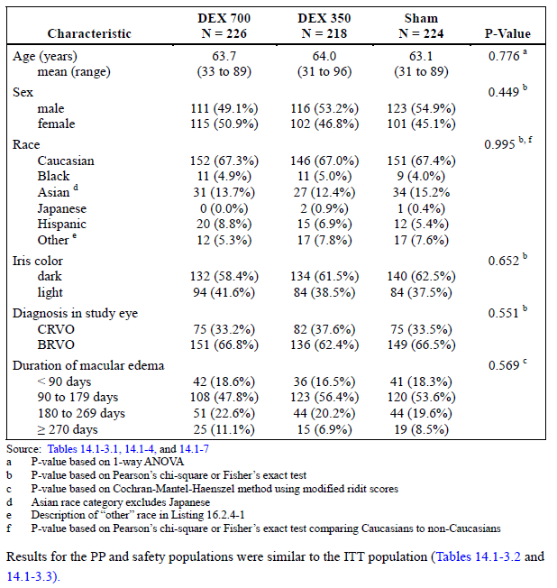

###### Primary efficacy outcome

Proportion of patients with > 15 letter improvement in BCVA peaked at day 60 in both DEX groups, but continued to improve until Day 180 in the placebo group so that at Day 180 there was no statistically significant difference between groups. There was little difference in efficacy in the two DEX groups.

1. Difference / P-Value between groups



The response at day 30 and 60 was seen both in patients with BRVO and CRVO.

1. Response at day 30 and 60 was seen both in patients with BRVO and CRVO

|  |  |  |  |  |  |  |
| --- | --- | --- | --- | --- | --- | --- |
| Visit | Diagnosis: BRVO | | | Diagnosis: CRVO | | |
|  | DEX 700 | Sham | Difference; P‑value | DEX 700 | Sham | Difference; P‑value |
| IT day 30 | 32/151 (21.2%) | 13/149 (8.7%) | 12.5%; 0.002 | 19/75 (25.3%) | 4/75 (5.3%) | 20.0%; < 0.001 |
| IT day 60 | 42/151 (27.8%) | 23/149 (15.4%) | 12.4%; 0.009 | 25/75 (33.3%) | 4/75 (5.3%) | 28.0%; < 0.001 |
| IT day 90 | 34/151 (22.5%) | 23/149 (15.4%) | 7.1%; 0.118 | 14/75 (18.7%) | 8/75 (10.7%) | 8.0%  0.166 |
| IT Day 180 | 35/151 (23.2%) | 30/149 (20.1% | 3.0%; 0.522 | 18/75 (24.0%) | 8/75 (10.7%) | 13.3%  0.031 |

There was also an improvement in BCVA > 10 letters for both DEX treatment groups that peaked at day 60.

1. Improvement in BCVA > 10 letters for both DEX treatment groups that peaked at day 60

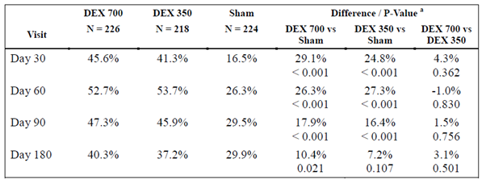



Patients treated with DEX had a more rapid improvement in vision than those in the SHAM treatment arm.

Results for the time to > 15 letter improvement from Baseline BCVA is shown in Figure 8, below.

1. Time to > 15 letter improvement from Baseline BCVA



###### Secondary efficacy outcomes

At IT day 90, the mean decrease in retinal thickness was greater in the DEX 700 group compared to Sham. However at Day 180, there was no significant difference between treatment groups.

For contrast sensitivity, there was no statistically significant difference between treatment groups at Baseline or IT Day 180. Change from Baseline in fluorescein leakage at the macula was improved from Baseline for approximately 50% across all 3 treatment groups. There were no statistically significant differences between the treatment groups in the distribution of change from Baseline fluorescein leakage.

###### Retreatment

After each dose, the mean change in BCVA peaked on day 60. The improvement in BCVA was slightly better in the DEX groups than the placebo group after the second 180 day treatment period, however a change in BCVA < 5 is not considered to be clinically significant.

1. Change in BCVA score < 5 letters



1. Mean change from Baseline in BCVA



###### Single treatment group

In the patients who had a single treatment, there was continued improvement in the sham group who received no treatment. The vision of patients in the DEX 350 group also improved. The BCVA in the group with a single DEX dose was maintained or decreased.

1. Patients with 15 or more letters improvement from Baseline BCVA in the study eye (Single Treatment Population)

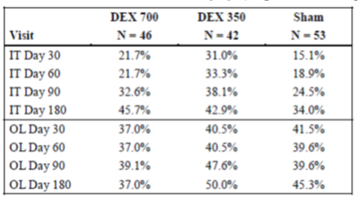

1. Mean change from Baseline best-corrected visual acuity in the study eye (single treatment population)

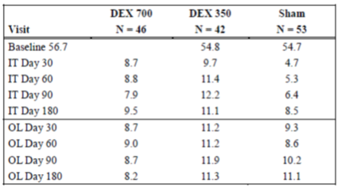

##### Study 008

###### Baseline criteria

As in Study 009, at Baseline the three treatment groups were well matched. The mean age was 65 years. At Baseline, 54.1% of participants had cataracts, and 10.5% had nuclear cataracts. Sixty five patients reported previous retinal laser coagulation.

1. Characteristic versus treatment group



###### Efficacy

As in Study 009, the peak response after treatement with DEX was at day 60. There was no significant difference in BCVA between the three groups at treatment Day 180.

1. Visit versus treatment groups at treatment Day 180



In this study, when the subgroups with BRVO and CRVO were evaluated, it was only those with BRVO who benefited from treatment.

In the entire cohort, the improvement of BCVA ≥ 10 letters from Baseline peaked at day 60 in the DEX groups.

1. BCVA ≥ 10 letters from Baseline peaked at day 60 in the DEX groups



There was a more rapid improvement in VA in those patients treated with DEX.

The following figure shows the time to > 15 letter improvement in BCVA.

1. Improvement in BCVA



###### Secondary efficacy outcomes

In ITT population, at day 90 the mean decrease in retinal thickness was significantly greater with DEX 700 compared to Sham. At IT Day 180 there was no difference between the two groups. There was no significant differences between the groupsd in terms of contrast sensitivity. Fluoresecin leakage at the macular improved in 10% more patients in the dexamethasone than the placebo group.

###### Retreated population

1. Mean change from Baseline BCVA during initial treatment and open-label extension(Studies 206207-008 and 206207, retreated population, 12 months pooled data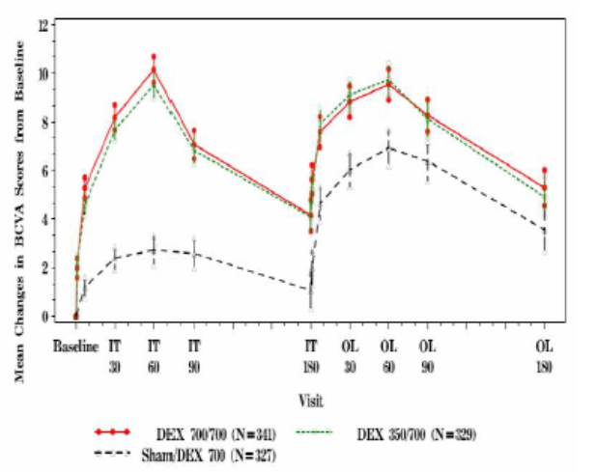

There was improvement in vision after the second 180 days observation in patients treated with a second dose of DEX. The difference was slightly greater in the DEX treated groups. However, at the end of the second 180 day treatment period the improvement in BCVA was small with an even smaller difference between the groups previously treated with DEX and those who were not.

###### Single treated group:

In this study, there was a different pattern of response in the single treated group than in the previous study. The DEX 700 and sham groups maintained VA in the second 180 day treatment period, whereas the VA in the DEX 350 group deteriorated.

1. Mean change from Baseline BCVA in the study eye (single treatment population)

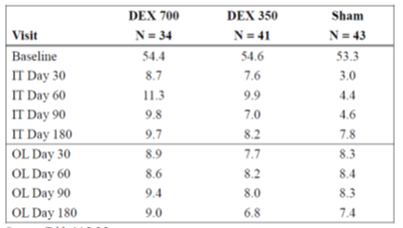

Note: Baseline is relative to the timepoint of injection

1. Patients with 15 or more letters improvement from Baseline BCVA in the study eye (single treatment population)

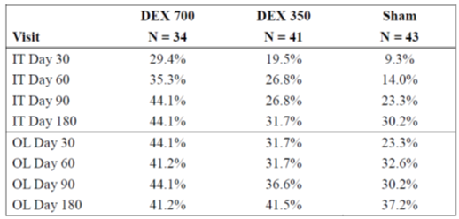

Note: Baseline is relative to the timepoint of injection

##### Study MAF-AGN-OPH-RET-004

This study was submitted as part of the sponsor’s post-first round response. It was a 12 month, multicentre, randomised, parallel group study to compare the efficacy and safety of Ozurdex versus ranibizumab in patients with BRVO. Patients were randomised 1:1 to receive Ozurdex or ranibizumab. Ozurdex was administered Month 1 and Month 5. Ranibizumab was administered on day 1 and monthly until month 5 then as needed. Additional treatment at month 10 or 11 was possible if the patient fulfilled predefined criteria. It was designed as a non-inferiority study with the margin for a difference in BCVA of 5 considered as being a clinically significant difference. Subjects were included if they had macular oedema secondary to BRVO in the study eye that involved the centre of the fovea, central retinal subthickness > 320 µm as assessed by OCT, duration of symptoms of BRVO of < 90 days to screening visit, decreased VA due to macular oedema, no severe macular ischemia, BCVA ≥ 20 to ≤ 70 (equivalent to 20/40 to 20/400 on a Snellen chart).

A total of 307 patients (154 Ozurdex patients, and 153 ranibizumab patients) were randomly assigned to receive study treatment (note, this meant the study was underpowered, it is unclear why the target of 400 was not reached).

Among the 154 subjects assigned to receive Ozurdex, 112 (72.7%) subjects completed the study. Reasons for early study exit were AE (18), no further treatment benefit expected (5), lost to follow-up (3), withdrawal of consent (2), protocol violation (6), death (2), and other (6).

For the 153 subjects in the ranibizumab group, 139 (90.8%) subjects completed the study. Reasons for early study exit were AE (2), no further treatment benefit expected (1), lost to follow-up (1), withdrawal of consent (2), protocol violation (4), and other (4).

The mean (standard deviation (SD)) number of treatments given to patients over 12 months was 2.5 for those receiving Ozurdex and 8.0 for those receiving ranibizumab. Ninety-three (60.4%) patients received the third treatment of Ozurdex, and 98 (64.1%) patients received 8 or more treatments of ranibizumab

###### Primary endpoint

* By ANCOVA analysis with an LOCF approach, the adjusted least squares (LS) mean change from Baseline in study eye BCVA at Month 12 for Ozurdex was 7.4 and 17.4 for ranibizumab. The LS mean difference of Ozurdex minus ranibizumab was −10.1, confidence interval (CI; −12.9, −7.2), showing the lower bound of the CI for the treatment difference change was < −5 letters. ie the null hypothesis than Ozurdex was non‑inferior to ranibizumab could not be rejected.

###### Secondary endpoints

* BCVA
  + these were generally supportive of the primary endpoints
* Central retinal subfield thickness
  + No statistically significant difference in mean change from Baseline to Month 12 in central retinal subfield thickness by OCT was observed.
* VFQ-25
  + A statistically significant (p = 0.0011) difference in favor of ranibizumab was observed for the overall change from Baseline in VFQ-25 composite score at Month 12. Similar results were observed for the far vision (p = 0.0198) subscale and the vision-related dependency subscale (p = 0.0244), but not for the near vision subscale (p = 0.1599).
* Proportion of subjects who failed treatment: there was no difference between the Ozurdex and ranibizumab groups in terms of number of patients who failed treatment.
* BCVA at Baseline and OCT retinal thickness were predictive of the response.

#### Clinical evaluator’s recommendation

The first round evaluator recommended rejection. The second round evaluator recommended approval based on the sponsor’s response to questions.

#### Efficacy: Uveitis

##### Study 206207-014

This was an 8 week, multicentre, randomised, sham controlled study. The treatment arms included DEX 700, DEX 350 and sham. There was an 8 week treatment period followed by a 16 week open label extension. The study took place between May 2006 and April 2009.The inclusion criteria were age > 18 years old; diagnosis of intermediate or posterior uveitis in at least one eye based on the standardisation of uveitis nomenclature for reporting clinical data workshop (SUN working group 2005), vitreous haze > 1.5, BCVA 10-75 using EDTRS.

The primary efficacy variable was the vitreous haze score at 8 weeks, secondary efficacy variables included BCVA and OCT.

###### Results

Approximately 80% of patients had intermediate uveitis, and 18% had posterior uveitis. Cataracts were reported in around 30% of patients at Baseline. Approximately 20% of patients had received prior triamcinolone in the study eye. Interestingly, the cause of uveitis was not specifically recorded, however on reviewing the medical histories the following were noted : sarcoidosis (8.7%), arthritis (6.1%), rheumatoid arthritis (2.6%), Behcet’s syndrome (3.5%), multiple sclerosis (2.2%), spondyloarthropathy (1.3%), juvenile arthritis (0.9%), polyarthritis (0.9%), systemic lupus erythematosus (0.9%), Crohn’s disease (0.4%), ankylosing spondylitis (0.4%), psoriasis (0.4%), and pulmonary sarcoidosis (0.4%).

There was a greater improvement in vitreous haze in both DEX groups, this was greater for the 700 dose initially however after week 12 the difference between the two DEX doses was minimal.

1. Difference divided by the P-value



More patients treated with dexamethasone had an improvement of > 15 in BCVA.

1. Difference divided by the P-value



There was an initial decrease in macular thickness using OCT in the DEX 700 group, however there was no significant difference between the DEX and sham group at week 26.

There was greater use of escape medications for uveitis or ocular inflammation in the Sham group.

#### Safety

The safety data submitted included data from:

* Studies 008 and 009 for RVO: duration 12 months
* Study 020 for RVO: duration 150 to 239 days
* Study 014 for uveitis: 24 weeks duration
* Studies 010 and 011 for DMO: 3 years duration.

In summary, the rate of non-ocular adverse events was similar in DEX and sham treatment groups.

DEX injections were associated with an increased risk of raised intraocular pressure, glaucoma, and ocular hypertension. The increased risk over sham was in the order for 20%. The risk did not appear to increase with the number of injections. Most cases were able to be managed with medication. A small proportion required surgery (7.5% in Studies 008 and 009, 1 patient in Study 020, 3 patients in Study 014). In the 3 year study in DME, 43.8% of those treated with DEX 700 required medication.

DEX injections were associated with an increased risk of cataracts. The risk increased with increasing dose of DEX and increased duration of treatment. The morbidity associated with cataracts is difficult to ascertain as around 50% of patients had cataracts at Baseline. In Studies 008 and 009, of those treated with DEX 700, 7.4% developed new or progressive cataracts in the first 6 month, and of those retreated a further 19% developed new of progressive cataracts. 3/341 patients in the DEX 700/DEX700 group required cataracts surgery. However cataracts were one of the causes of deterioration of vision in the treatment groups. It is noteworthy that in the studies of DME, the incidence of cataracts in the DEX 700 group over 3 years was 68.4%. Most of these became apparent during Years 2 to 3. Of those patients with cataracts, 61.5% required cataract surgery during the treatment period (compared to 7% of patients treated with Sham).

The procedure was associated with ocular pain, conjunctival haemorrhage, conjunctival hyperaemia. These problems were of short duration and occurred in both DEX and sham groups.

There were a small number of other adverse ocular events such as retinal detachment, migration of the implant (most commonly where there had been previous surgery on the eye), reactivation of infection. There were 2 patients with retinal detachment in the RVO study, neither required surgery and both had a good outcome. However in the uveitis study, 4 patients required surgery and had a poor visual outcome. Post market data to January 2016, there were 161 reports of endophthalmitis and 175 episodes of device dislocation (in this period an estimated 225,227 units were sold).

In the RVO studies, the rate of severe visual loss was around 5% higher in the sham than the DEX groups. However in the uveitis study, the rate of severe visual loss was similar between the DEX 700 and sham groups.

##### Study 206207-025

This was a multicentre, prospective, observational study to evaluate the long term safety profile of Ozurdex for macular oedema secondary to RVO or non-infectious posterior uveitis under conditions of routine medical practice. Patients were followed up for 2 years.

800 patients were enrolled, of these 80.9% had RVO and 19.1% had non-infectious uveitis.

Five hundred and twenty-six patients received 2 or fewer injections and 274 received more than 2 injections. The median number of injections in the patients who had > 2 injections was 4, with a range of 3 to 10.The incidence of ocular serious adverse events (OSAEs) was 3.4% (N = 28) of the 819 treated eyes. Twenty-one of the 28 ocular AE that occurred were suspected to be related to Ozurdex treatment. Cataract progression, vitreous haemorrhage and increased intraocular pressure were more commonly seen in those who received more than two injections. There were also more procedures among patients who had previous DEX injections or greater than 2 DEX injections, these procedures were primarily for cataracts. Approximately 20% of eyes underwent laser therapy, slightly more in those who received > 2 injections. This could be due to the severity of disease rather than an effect of DEX.

1. Notable increase in adverse events of special interest incidence (Study 206207-025)

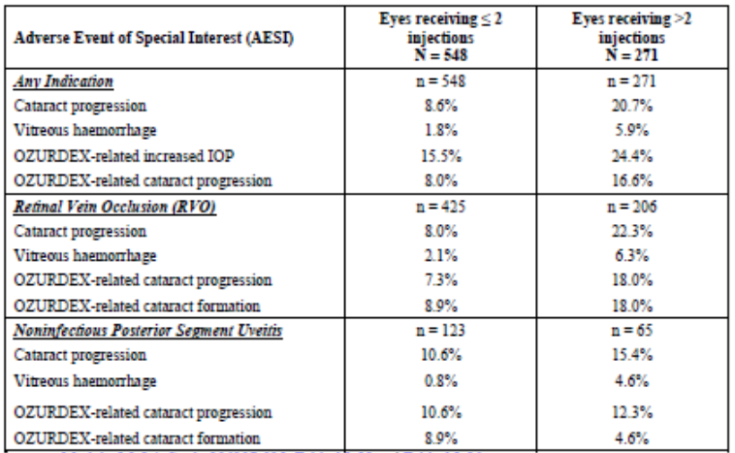

1. Concurrent ocular procedures; ATP cohourt

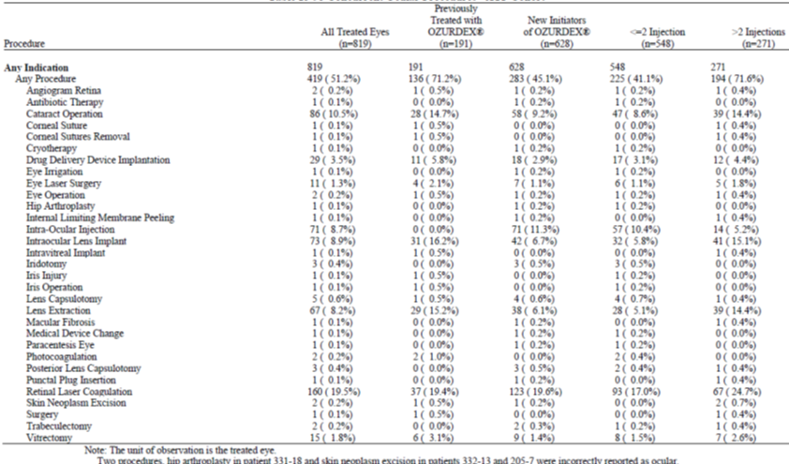

##### Study MAF-AGN-OPH-RET-004

This study is described under efficacy (above), and submitted with the sponsor’s response. There were more ocular AE with DEX than ranibizumab.

1. Incidence of ocular treatment-emergent adverse events greater than or equal to 6% in any treatment group (safety population, Study MAF‑AGN‑OPH‑RET‑004)

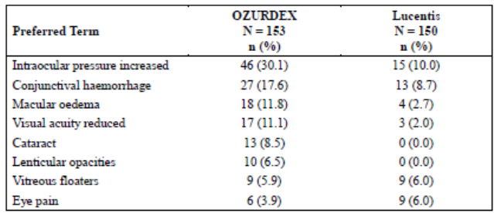

#### Clinical evaluator’s recommendation

For the indication of treatment of BRVO/CVRO:

* The first round evaluator recommended rejection. The second round evaluator recommended approval based on the sponsor’s response to questions.

For the indication of treatment of uveitis:

* The clinical evaluator recommended approval for the use of dexamethasone in uveitis.

### Risk management plan

The sponsor has proposed the following Summary of Safety Concerns:

1. Summary of safety concerns

|  |  |
| --- | --- |
| Summary of safety concerns | |
| Important identified risks | Increased intraocular pressure, Glaucoma, Ocular Hypertension |
| Cataract formation and associated Visual acuity reduced |
| Vitreous detachment, haemorrhage |
| Endophthalmitis (infectious/ non-infectious) |
| Retinal tear/detachment |
| Significant vitreous leak or hypotony |
| Device Dislocation |
| Implant misplacement |
| Retinitis secondary to reactivation of latent viral or other ophthalmic infections |
| Important potential risks | Systemic corticosteroid effects (infections, impaired healing and hypertension) |
| Missing information | Paediatric Use |
| Pregnancy and lactation |
| Long-term safety, Repeat dosing data |
| Concurrent use of anticoagulants |
| Patients with significant retinal ischaemia |

Overall, the Summary of Safety Concerns remains acceptable.

The sponsor has proposed routine pharmacovigilance. Routine and active risk mitigation were proposed. The active risk mitigation strategies include injectors guide and patient guide. It is unclear if the risk management team have assessed these documents. The delegate has not reviewed these documents but would be very interested in doing so to determine if they mitigate the risks identified.

### Risk-benefit analysis

#### Delegate’s considerations

##### Limitations of clinical trial data

Indication: RVO

* The clinical trials submitted demonstrate that in clinical trials comparing DEX to sham treatment, injections with DEX are associated with more rapid improvements in vision, less macular oedema. It is noted that in proportion of patients in the sham treatment group, spontaneous improvement did occur. The benefits of treatment were at the expense of an increased risk of cataracts and increased risk of raised intraocular pressure.
* The clinical trials involved patients with a duration of RVO greater than 6 weeks, however spontaneous resolution may occur in the first 6 months.
* There was minimal data on efficacy beyond 2 injections for RVO.
* In the clinical trials, treatment occurred every 6 months. However PK, PD and clinical data suggest peak efficacy may be at 3-4 months. Safety and efficacy of injections every 3-4 months have not been established.
* No data on whether treatment after laser or anti-VEGF is beneficial.
* There appears to have been similar efficacy and greater safety with lower dose, however that dose is not available for clinicians.

Indication: uveitis

* There was similar efficacy for both the 350 and 700 DEX doses, the rationale for larger dose is unclear
* poor description of Baseline characteristics and how that influenced outcome
* relatively short duration and use of only single dose.
* reliance on a single pivotal study.

The new data submitted does not answer all of the concerns raised in the evaluation of this indication in 2009.

* Safety: the concerns about lack of safety data have been somewhat addressed by the open label extension periods of the pivotal data, supportive data from the DME studies, and studies submitted with the sponsor’s post-first round response. However the rates of ocular events cannot be reliably extrapolated between indications due to the different background risk of AE with different indications. There is still a major deficiency in the lack of data with more than 2 injections for RVO and 1 for uveitis.
* The best dosing schedule has not been established. The DEX 350 dose is slightly less efficacy than the larger dose, but is associated with less risk of cataracts. The efficacy of DEX peaks at treatment Days 60 to 90 and wanes after this. The safety and efficacy of injections at 3 or 4 monthly intervals has not been established.
* The role of DEX in therapy: the study supported with the sponsor’s post first round response suggested that DEX 700 not non inferior and had more adverse effects than ranibizumab.
* The previous concerns about subgroups has not been addressed; this is a minor issue

##### Delegate review of literature

Anti-VEGF agents appear better (SUN, Regnier), or have similar efficacy to intravitreal steroids for RVO.

A Cochrane review (Gewaily, 2015) of intravitreal steroid for RVO concluded that there was insufficient evidence from clinical trials in demonstrating a benefit of intravitreal steroids in CRVO-ME.

A Cochrane review concluded that there were inconclusive results for the effects of grid laser in comparison to observation, anti-VEGF agents or intravitreal steroids at 12 months, possibly due to the study designs. The results of laser on visual acuity after 12 months were more positive.

In relation to the use of intravitreal dexamethasone for refractory macular edema due to RVO when anti-VEGF agents have failed, several studies have shown an improvement in macular oedema but no improvement in visual acuity. It is believed that in resistant cases there may be chronic structural alterations in the retina.

RANZCO Guidelines recommend intravitreal triamcinolone as second line treatment for RVO.

#### Proposed action

The benefits of intravitreal dexamethasone for RVO appear to be seen early, and may not be sustained. The clinical trials included patients relatively early after the diagnosis and excluded those with very poor VA, thus may represent a group who would have had a good prognosis regardless of treatment. Although early treatment of oedema is thought to be associated with better long term visual outcome, this has not been demonstrated in clinical trials with long term follow up. The small, short term improvement is in the context of adverse effects such as glaucoma and cataracts which increases with increasing dose and duration of therapy. The evidence for the use of anti-VEGF agents has expanded since these clinical trials were performed, and suggest similar of greater efficacy for these drugs with less adverse events.

It does not seem appropriate to give dexamethasone a first line therapy option for RVO when agents such as this have a better safety profile, nor does it seem appropriate to reject this application when there is some short term benefit over placebo in some patients, and ongoing use of these agents by ophthalmologists for this indication, particularly in patients where there has been poor response to VEGF agents. Yet the Delegate is unaware of any evidence that intravitreal steroids improve visual acuity for refractory macular oedema when anti-VEGF agents have failed.

If this medicine is registered, there must be adequate documentation of the efficacy, limitations of the clinical trial data and safety- in particular, the relative benefits and risks of repeated injections.

Alternative options to approving the current indication and variations to the PI may include:

* Amended indication such as:
  + Ozurdex is indicated for the treatment of macular oedema due to branch retinal vein occlusion or central retinal vein occlusion in patients with reduced visual acuity when other treatments are considered inappropriate or ineffective.
* Other amendments to the PI [beyond the scope of this document].

#### Request for ACM advice

##### For the RVO indication

1. Is the risk benefit balance for first line therapy favourable in the context of:
   1. a much better safety profile for use of anti-VEGF agents;
   2. limited data about the most efficacious dose and dosing interval and dosing duration; and
   3. heterogeneity among patients with RVO and their likely prognosis making interpretation of clinical trial data difficult?

##### For the uveitis indication:

1. Is there sufficient long term data for registration in view of the recurrent/chronic nature of this disease?

##### Questions to the sponsor

###### Question 1

*Please provide the Delegate with the instructions for use and patient information. How does the patient information differ from the CMI? Are two separate documents needed?*

#### Summary of issues

MACULAR OEDEMA SECONDARY TO RVO

* The clinical trials were performed in 2004-2008 using comparison between 700μg and 350 μg dexamethasone doses and sham. First line treatment for RVO is now an anti-VEGF agent.
* There was some early efficacy with DEX. However this waned after 4 months whereas there was continuing improvement in the sham group.
* The efficacy of repeated doses was marginal.
* Optimal dosing schedule unclear.
* Limited long term experience in clinical trials.
* High rate of cataracts and glaucoma with intraocular steroids which increase with increasing doses and duration of therapy.

UVEITIS

* Highly variable patient population, not well characterised in the study
* Study was for one dose only- many of the causes of uveitis are chronic diseases

#### Advice sought

##### For retinal vein occlusion

Is the risk benefit balance for first line therapy favourable in the context of:

* A much better safety profile for use of anti-VEGF agents.
* Limited data about the most efficacious dose and dosing interval and dosing duration.
* Heterogeneity among patients with RVO and their likely prognosis.

##### Uveitis

Is there sufficient long term data for registration in view of the recurrent/chronic nature of this disease?

The committee is also requested to provide advice on any other issues that it thinks may be relevant to a decision on whether or not to approve this application.

#### Response from sponsor

##### Sponsor’s comments on the evaluation

The sponsor refers to the Delegate’s Overview and Request for ACM’s advice (dated March 2017), and acknowledges concerns raised by the Delegate with regard to macular oedema secondary to retinal vein occlusion (RVO). These included choice of the control group in the clinical trials, the duration of efficacy, the optimal dosing schedule, limited long-term experience, and the common side effects.

###### Concerns related to uveitis were related to patient population and use of single dose.

We further acknowledge the concerns raised by the delegate with regards to the efficacy and safety of Ozurdex in the treatment of RVO within the context of other available therapies. The Delegate has questioned whether the benefit: risk ratio is favourable in a first line indication, and has recommended that the additional language ‘*when other treatments are considered inappropriate or ineffective*’ be part of the indication. The sponsor notes that there remain some patients where Ozurdex would be appropriately used as an initial treatment and that the treating physician is in the best position to identify these patients. The company therefore continues to believe that the product should be approved with the indications:

* *treatment of macular oedema due to branch retinal vein occlusion or central retinal vein occlusion*
* *non­infectious uveitis of the posterior segment of the eye*
* *macular oedema secondary to retinal vein occlusion*

###### Study design

The sponsor believes that Ozurdex has demonstrated robust efficacy in the 2 pivotal Studies 206207-008 and 206207-009. Based on the preponderance of evidence, Ozurdex was shown to be effective in the treatment of macular oedema due to branch retinal vein occlusion (BRVO) or central retinal vein occlusion (CRVO). The trials were performed in 2004 to 2008 using the comparison between 700 µg (DEX 700) and 350 µg (DEX 350) dexamethasone doses and Sham. At that time, there were no licensed pharmacologic therapies, and no agreed standard of care for macular oedema caused by BRVO and CRVO. The 3 most commonly used therapeutic interventions were off-label use of vascular endothelial growth factor (VEGF)-inhibitors and corticosteroids, as well as laser photocoagulation. Since the completion of the studies anti-VEGF agents have become the standard of care in treating the majority of patients with RVO.

###### Duration of efficacy

The unique drug delivery applicator system was designed to overcome ocular delivery barriers and prolong duration of the dexamethasone effect in the eye. The release profile, while maximal at 2 months, is sustained up to 6 months. In the phase 3 studies, the proportion of patients with 15 or more letters improvement from Baseline in best corrected visual acuity (BCVA) was significantly higher with DEX 700 compared to Sham at days 30, 60, and 90. The response with DEX 700 was similar at Day 180 (21.5%) to that seen at day 90 (21.8%), indicating that the treatment effect was maintained. Loss of statistical significance at Day 180 related more to a small, spontaneous improvement in patients who received Sham.

At initial treatment Day 180, patients were re-evaluated for a second injection according to retreatment criteria: BCVA < 84 letters or retinal thickness by optical coherence tomography (OCT) > 250 um in the central 1 mm macular subfield and in the investigator’s opinion, the procedure would not put the patient at significant risk. Patients who had initially received DEX 700 showed a similar response following the repeat injection. While patients initially receiving Sham did show a positive response following retreatment with DEX 700, the degree of improvement in visual acuity never achieved the same level of improvement as in patients who initially received DEX 700.

###### Selection of dose

In the 6 month pooled analysis of studies 008 and 009, both DEX doses were shown to be effective in treating macular oedema associated with RVO. The 700 µg however demonstrated greater efficacy and a longer duration of action. The percentage of patients with BCVA ≥ 14, 13, 12, and 10 letters improvement at Day 180 was significantly higher with DEX 700 compared to Sham, but this was not observed with DEX 350. The percentages (cumulative probabilities) of response in the time to ≥ 15 letters of improvement in BCVA based on the life-table method were consistently numerically superior with DEX 700 compared to DEX 350 at the end of each interval.

The percentage of patients with ≥ 15 letters of improvement was relatively stable with DEX 700 over time, decreasing by only 0.3% from day 90 to Day 180 in contrast to a 4.1% decline over the comparable interval with DEX 350. Thus the treatment effect to Day 180 was maintained better for DEX 700 than DEX 350.

The mean decrease in retinal thickness measured by OCT was significantly greater with DEX 700 and DEX 350 compared to Sham at day 90 (p < 0.001), with the 700 µg dose providing significantly more effect than the 350 µg dose.

Overall, a consistent numerical trend towards better efficacy with DEX 700 compared to DEX 350 was observed across the spectrum of efficacy endpoints, which in the absence of dose-dependent clinically relevant side effects suggests the use of DEX 700 in this population to maximise the treatment benefit. Based on the results above, the recommended dose for treatment of macular oedema due to RVO is DEX 700.

###### Optimal dosing schedule

According to protocol, patients were not allowed to receive retreatment earlier than 6 months after their last treatment (retreatment window ± 1 month). Thus, the optimal number of injections during 1 year may be underestimated, and cannot be extrapolated from the trials.

Recent publications however have reported the optimal posology in terms of frequency of retreatment.

A retrospective cohort study of 30 patients with macular oedema secondary to RVO at 10 Canadian retina practices reported data from medical charts with 3 to 6 months of follow-up after the initial DEX implant (Lam et al, 2015). The mean (± standard error (SE)) number of injections was 1.7 ± 0.1. The mean (± SE) time to the first and second DEX implant reinjection intervals (that is, second and third DEX implants) were 4.9 ± 0.3 months and 7.2 ± 2.3 months, respectively. A retrospective review of patient records from a real- life clinical practice included 67 patients with 75 injections (12 diabetic macular oedema (DME), 14 CRVO, 25 BRVO, and 24 uveitic macular oedema) during a 6-month follow-up period (Jiménez-Gómez et al, 2015). Six patients were retreated.

Further, a post-authorisation safety study (PASS) to evaluate long-term safety and treatment patterns in real-world clinical practice in patients receiving Ozurdex for macular oedema following RVO or non- infectious posterior segment uveitis (NIPSU) was completed in 2016 (Module 5.3.5.4, Report 206207- 025). The study enrolled a total of 800 patients of whom 753 received on study treatment with 73.0% completing 24 months of follow-up. In the 610 patients with RVO, the number of injections per person- year on-study was 1.4, and a median of 26.14 weeks passed between subsequent injections. A median of 2.0 (range 1 to 10) on-study injections per patient, and 2.0 (range 1 to 7) study injections per treated eye were administered.

###### Limited long term experience

Since its initial approval in June 2009, over 826,000 units of Ozurdex have been distributed worldwide, among which approximately 487,000 units were distributed in Europe and 238,000 were distributed in the US. Nine periodic safety update reports (PSURs) have been submitted to regulatory agencies. In the most recent PSUR version 9, Allergan concluded that based on these safety and efficacy reviews, the overall risk-benefit profile of Ozurdex remained unaltered and favourable. The safety review from completed and ongoing clinical studies during this PSUR review period, as well as cumulative clinical safety experience, suggest that the safety data remain in accord with the safety information presented in the company core datasheet which is reflected in the labelling. There were no changes to the risk management plan.

Whilst the Phase III studies in RVO were limited to 2 injections and 1-year follow-up, subsequent studies by Allergan followed DME patients for 3 years with up to 7 injections. In  Study PASS 206207-025 referenced above, RVO and NIPSU patients were followed for 2 years with up to 10 injections.

The most commonly observed (that is, > 5%) adverse events were increased intraocular pressure (IOP), cataract progression, and cataract formation. These however are expected and both are well managed with available therapies. Cataract extraction surgery is routine in Australia and is relatively very low risk. In the 008/009studies, only 3 patients in the DEX 700 retreated population underwent cataract surgery. Increases in IOP are readily managed with topical drops (as evident in the 008/009 studies) with very limited need for further intervention. Only 0.6% (5/833) DEX patients required laser or surgical procedures for management of elevated IOP.

The study results suggest that Ozurdex was well tolerated in patients with macular oedema due to RVO or NIPSU in the context of routine clinical practice and over a 2-year period. The safety profile observed in PASS is consistent with known safety profile of Ozurdex. No new safety concerns were identified in the long-term safety study with repeated treatment in the same eye.

###### Current treatment paradigm

Currently, anti-VEGF therapies ranibizumab (Lucentis) and aflibercept (Eylea) are approved for the treatment of visual impairment due to macular oedema secondary to CRVO or BRVO in Australia, as well as in the EU and US. The efficacy of anti-VEGFs in RVO, both alone and in combination with laser therapy, has been investigated in several key studies that demonstrated that anti-VEGFs lead to significant improvements in BCVA (Lucentis Australia package insert, 2014; Eylea Australia package insert, 2016). Allergan acknowledges that for most patients with RVO, anti-VEGFs are the preferred initial treatment due to their efficacy and safety profile.

Limitations of anti-VEGF therapies include the requirement of multiple injections and frequent monitoring, which increase the burden of treatment for the patient and the physician. The most common adverse reactions associated with anti-VEGFs include conjunctival haemorrhage, eye pain, vitreous floaters, and increased IOP. Endophthalmitis and retinal detachments may occur following intravitreal injections. Further, there is a potential risk of arterial thromboembolic events following intravitreal use of VEGF inhibitors, including nonfatal stroke, nonfatal myocardial infarction, and vascular death. Lastly, despite a clinical response in many patients (47.7% to 61.1% with a BCVA improvement of ≥15 letters at Month 6), a substantial proportion of patients have either an insufficient or incomplete response (Lucentis Australia package insert, 2014; Eylea Australia package insert, 2016). Ozurdex has a broader mechanism of action acting across multiple anti-inflammatory cascades where anti-VEGFs do not have activity. Another pharmacologic treatment option therefore is needed since anti-VEGFs may not be optimal, including the following reasons:

* Burden of treatment of monthly ocular injections/visits are not sustainable
* Insufficient response to anti-VEGF therapy
* Potential risk for arterio-thromboembolic events.

Ozurdex may also be used when laser is not appropriate as patients with central involvement of the retina cannot be treated with laser. The retinal specialist understands the current treatment paradigm for the treatment of RVO, and is in the best position to determine the population where Ozurdex use is appropriate.

##### Uveitis

###### Patient population

In the Phase III Study 206207-014 in the treatment of non-infectious ocular inflammation of the posterior segment in patients with intermediate or posterior uveitis, the mean (range) age was 44.8 (18 to 82) years, 63.3% of patients were female, and 60.7% were Caucasian. The disease diagnosis was intermediate uveitis for 80.8% of patients, and posterior uveitis for 19.2%. Nearly 95% of patients completed the 26-week study with the proportion of patients completing the study similar across the 3 treatment groups.

The most frequently reported (> 10% in any treatment group) in medical history (other than ophthalmic) were hypertension, contraception, depression, menopause, sarcoidosis, and postmenopause. The most frequently reported (> 10% in any treatment group) ophthalmic history (other than ocular inflammation in the study eye) were cataract, uveitis, macular oedema, intermediate uveitis, maculopathy, and refraction disorder. Cataracts were reported at Baseline for 28.6% of patients in the DEX 700 group, 43.4% in the DEX 350 group, and 40.8% in the Sham group. Over 40% of patients in each treatment group had received medications for the treatment of ocular inflammation in the study eye prior to the trial.

###### Repeat dosing

Patients in the Phase III Study 206207-014 received a single injection of DEX 700, DEX 350, or Sham after randomisation. At the end of the 26-week study, over 30% of DEX 700 patients had a vitreous haze score of 0 (primary endpoint). Therefore retreatment was unnecessary. However as uveitis is due to underlying diseases which are chronic, repeat dosing is likely.

Therefore Study PASS 206207-025 was designed to evaluate long-term safety in real-world clinical practice of repeat dosing with Ozurdex. In the 153 patients with NIPSU, the number of injections per person-year on-study was 1.7, and a median of 31.14 weeks passed between subsequent injections. A median of 2.0 (range 1 to 9) on-study injections per patient, and 2.0 (range 1 to 6) study injections per treated eye were administered.

Stratifications by injection frequency revealed increases in the incidence of cataract progression, vitreous haemorrhage, Ozurdex related increased IOP, and Ozurdex related cataract progression among treated eyes receiving more than 2 injections compared to patients receiving 2 or fewer injections. As with the RVO population, the overall safety profile in the study was consistent with the known profile of Ozurdex, and no new safety concerns were identified with repeat treatment.

##### Conclusion

The sponsor’s position is that Ozurdex is suitable for use as first line or second line treatment for RVO and Uveitis. The retinal specialist understands the current treatment paradigm for these diseases, and is in the best position to determine where Ozurdex is appropriately used. Therefore the broad indications of treatment of macular oedema due to branch retinal vein occlusion or central retinal vein occlusion and non­infectious uveitis of the posterior segment of the eye are the most appropriate.

#### Advisory Committee Considerations[20]

The Advisory Committee on Medicines (ACM), having considered the evaluations and the Delegate’s overview, as well as the sponsor’s response to these documents, advised the following:

The ACM advised the following in response to the delegate’s specific questions on the submission:

##### For RVO

Is the risk benefit balance for first line therapy favourable in the context of:

* 1. A much better safety profile for use of anti-VEGF agents.
  2. Limited data about the most efficacious dose and dosing interval and dosing duration.
  3. Heterogeneity among patients with RVO and their likely prognosis.

The ACM advised that evidence in the submission is minimal with respect to afety profile, dosing and patient group with RVO. ACM advised that the risk benefit balance for first line therapy is not favourable for treatment of retinal vein occlusion (branch and central) but can be used for second line therapy when other treatments are considered inappropriate or ineffective.

##### Uveitis

Is there sufficient long term data for registration in view of the recurrent/chronic nature of this disease.

ACM advised that the evidence is minimal but sufficient for nonBaselineinfective uveitis in view of the recurrent/chronic nature of this disease. ACM noted that safety in children has not been established.

The ACM advised that implementation by the sponsor of the recommendations outlined above to the satisfaction of the TGA, in addition to the evidence of efficacy and safety provided would support the safe and effective use of this product.

### Outcome

Based on a review of quality, safety and efficacy, the TGA approved the registration of Ozurdex dexamethasone 700 microgram intravitreal implant dispenser pack [AUST R 222392], indicated for the new indications:

*Ozurdex is indicated for the treatment of:*

* Macular oedema due to Branch Retinal Vein Occlusion (BRVO) or Central Retinal Vein Occlusion (CRVO).
* Non-infectious uveitis affecting the posterior segment of the eye.

The full indications are now:

*Ozurdex is indicated for the treatment of:*

* Diabetic macular oedema (DME).
* Macular oedema due to Branch Retinal Vein Occlusion (BRVO) or Central Retinal Vein Occlusion (CRVO).
* Non-infectious uveitis affecting the posterior segment of the eye.

#### Specific conditions of registration applying to these goods

* The Ozurdex dexamethasone EU Risk Management Plan (RMP), version 8.1, dated 4 August 2015 (DLP 27 January 2015) with Australian Specific Annex, version 5.2, dated 18 January 2017, and any subsequent revisions, as agreed with the TGA will be implemented in Australia.

## Attachment 1. Product Information

The PI for Ozdurdex approved with the submission which is described in this AusPAR is at Attachment 1. For the most recent PI, please refer to the TGA website at <<https://www.tga.gov.au/product-information-pi>>.

## Attachment 2. Extract from the Clinical Evaluation Report

|  |
| --- |
| Therapeutic Goods Administration |
| PO Box 100 Woden ACT 2606 Australia  Email: [info@tga.gov.au](mailto:info@tga.gov.au) Phone: 1800 020 653 Fax: 02 6232 8605  [**https://www.tga.gov.au**](https://www.tga.gov.au) |

1. Mitchell P, Smith W, Chang A. Prevalence and Associations of Retinal Vein Occlusion in Australia: The Blue Mountains Eye Study. Arch Ophthalmol. 1996;114(10):1243-1247. doi:10.1001/archopht.1996.01100140443012.
2. Rodriguez A et al. Referral patterns of uveitis in a tertiary eye care center. Arch Ophthalmol. 1996;114(5):593-9
3. Shilling J et al. Retinal branch vein occlusion: a study of argon laser photocoagulation in the treatment of macular oedema. Brit J Ophthalmol. 1984;68(3):196-198.
4. A randomized clinical trial of early panretinal photocoagulation for ischemic central vein occlusion. The Central Vein Occlusion Study Group N report. Ophthalmol.1995;102:1434-44.
5. McAllister I et al. Effect of triamcinolone acetonide on vascular endothelial growth factor and occludin levels in branch retinal vein occlusion. Am J Ophthalmol. 2009; 147:838–46.
6. Ip M et al. A randomized trial comparing the efficacy and safety of intravitreal triamcinolone with observation to treat vision loss associated with macular edema secondary to central retinal vein occlusion: the Standard Care vs Corticosteroid for Retinal Vein Occlusion (SCORE) study report 5. Arch Ophthalmol. 2009 Sep. 127(9):1101-14.
7. Noma H et al. Pathogenesis of macular edema with branch retinal vein occlusion and intraocular levels of vascular endothelial growth factor and interleukin-6. Am J Ophthalmol. 2005 Aug; 140(2):256-61.
8. Brown D et al. Ranibizumab for macular edema following central retinal vein occlusion. Ophthalmol. 2010; 117:1124-1133.
9. Campochiaro P et al. Ranibizumab for macular edema following branch retinal vein occlusion. Ophthalmol. 2010;117:1102-1112.
10. Rehak J et al. Branch retinal vein occlusion: pathogenesis, visual prognosis, and

    treatment modalities. Curr Eye Res 2008;33:111-131.
11. Kearns V et al. Drug delivery systems for the eye [review]. Expert Rev Med Dev.

    2009;6(3):277-290.
12. Lai W et al. Intermediate uveitis. Ophthalmol Clin North Am 2002;15:309-317.
13. Branch Vein Occlusion Study Group. Argon laser photocoagulation for macular edema in branch

    vein occlusion. Am J Ophthalmol 1984;98:271-282.
14. Central Vein Occlusion Study Group. Evaluation of grid pattern photocoagulation for macular

    edema in central vein occlusion; Group M Report. Ophthalmology 1995;102:1425-1433.
15. SUN Working Group. Standardization of Uveitis Nomenclature for Reporting Clinical Data. Results of the First International Workshop AJO 2005;140:509 516.
16. Nussenblatt et al. Standardization of vitreal inflammatory activity in intermediate and posterior uveitis. Ophthalmology 1985;92:467-471.
17. Interobserver Agreement in Clinical Grading of Vitreous Haze Using Alternative Grading Scales

    Hornbeak, Dana M. et al. Ophthalmology , Volume 121 , Issue 8 , 1643 - 1648
18. Nussenblatt RB, Palestine AG, Chan CC, Roberge F. Standardization of vitreal inflammatory

    activity in intermediate and posterior uveitis. Ophthalmology 1985;92:467-471.
19. *Routine risk minimisation* activities may be limited to ensuring that suitable warnings are included in the product information or by careful use of labelling and packaging.

    *Routine pharmacovigilance* practices involve the following activities:

    • All suspected adverse reactions that are reported to the personnel of the company are collected and collated in an accessible manner;

    • Reporting to regulatory authorities;

    • Continuous monitoring of the safety profiles of approved products including signal detection and updating of labeling;

    • Submission of PSURs;

    • Meeting other local regulatory agency requirements.
20. The ACM provides independent medical and scientific advice to the Minister for Health and the Therapeutic Goods Administration (TGA) on issues relating to the safety, quality and efficacy of medicines supplied in Australia including issues relating to pre-market and post-market functions for medicines.

    The Committee is established under Regulation 35 of the Therapeutic Goods Regulations 1990. Members are appointed by the Minister. The ACM was established in January 2017 replacing Advisory Committee on Prescription Medicines (ACPM) which was formed in January 2010. ACM encompass pre and post-market advice for medicines, following the consolidation of the previous functions of the Advisory Committee on Prescription Medicines (ACPM), the Advisory Committee on the Safety of Medicines (ACSOM) and the Advisory Committee on Non-Prescription Medicines (ACNM). Membership comprises of professionals with specific scientific, medical or clinical expertise, as well as appropriate consumer health issues relating to medicines.