First round evaluation: September 2012
Second round evaluation: February 2013

AusPAR Attachment 2

Extract from the Clinical Evaluation Report for Dimethyl Fumarate
  - Proprietary Product Name: Tecfidera
  - Sponsor: Biogen Idec Australia Pty Ltd

About the Therapeutic Goods Administration (TGA)
- The Therapeutic Goods Administration (TGA) is part of the Australian Government Department of Health, and is responsible for regulating medicines and medical devices.
- The TGA administers the Therapeutic Goods Act 1989 (the Act), applying a risk management approach designed to ensure therapeutic goods supplied in Australia meet acceptable standards of quality, safety and efficacy (performance), when necessary.
- The work of the TGA is based on applying scientific and clinical expertise to decision-making, to ensure that the benefits to consumers outweigh any risks associated with the use of medicines and medical devices.
- The TGA relies on the public, healthcare professionals and industry to report problems with medicines or medical devices. TGA investigates reports received by it to determine any necessary regulatory action.
- To report a problem with a medicine or medical device, please see the information on the TGA website <http://www.tga.gov.au>.
About the Extract from the Clinical Evaluation Report
- This document provides a more detailed evaluation of the clinical findings, extracted from the Clinical Evaluation Report (CER) prepared by the TGA. This extract does not include sections from the CER regarding product documentation or post market activities.
- The words [Information redacted], where they appear in this document, indicate that confidential information has been deleted.
- For the most recent Product Information (PI), please refer to the TGA website <http://www.tga.gov.au/hp/information-medicines-pi.htm>.
Copyright
© Commonwealth of Australia 2013
This work is copyright. You may reproduce the whole or part of this work in unaltered form for your own personal use or, if you are part of an organisation, for internal use within your organisation, but only if you or your organisation do not use the reproduction for any commercial purpose and retain this copyright notice and all disclaimer notices as part of that reproduction. Apart from rights to use as permitted by the Copyright Act 1968 or allowed by this copyright notice, all other rights are reserved and you are not allowed to reproduce the whole or any part of this work in any way (electronic or otherwise) without first being given specific written permission from the Commonwealth to do so. Requests and inquiries concerning reproduction and rights are to be sent to the TGA Copyright Officer, Therapeutic Goods Administration, PO Box 100, Woden ACT 2606 or emailed to <tga.copyright@tga.gov.au>.

Contents
List of abbreviations 4
1. Clinical rationale 6
2. Contents of the clinical dossier 7
2.1. Guidance 7
2.2. Scope of the clinical dossier 7
2.3. Paediatric data 8
2.4. Good clinical practice 8
3. Pharmacokinetics 8
3.1. Studies providing pharmacokinetic data 8
3.2. Summary of pharmacokinetics 9
3.3. Pharmacokinetics in the target population 18
3.4. Pharmacokinetics in other special populations 19
3.5. Pharmacokinetic interactions 21
3.6. Evaluator’s overall conclusions on pharmacokinetics 22
4. Pharmacodynamics 23
4.1. Studies providing pharmacodynamic data 23
4.2. Summary of pharmacodynamics 23
4.3. Evaluator’s overall conclusions on pharmacodynamics 27
5. Dosage selection for the pivotal studies 27
6. Clinical efficacy 27
6.1. Pivotal efficacy studies 30
6.2. Supportive efficacy studies 57
6.3. Evaluator’s conclusions on clinical efficacy 67
7. Clinical safety 68
7.1. Studies providing evaluable safety data 68
7.2. Patient exposure 69
7.3. Adverse events 72
7.4. Laboratory tests 83
7.5. Electrocardiograph 86
7.6. Vital signs 88
7.7. Postmarketing experience 89
7.8. Safety issues with the potential for major regulatory impact 89
7.9. Other safety issues 89
7.10. Evaluator’s overall conclusions on clinical safety 91
8. First round benefit-risk assessment 92
8.1. First round assessment of benefits 92
8.2. First round assessment of risks 93
8.3. First round assessment of benefit-risk balance 93
8.4. First round recommendation regarding authorisation 93
9. Clinical questions 93
9.1. Pharmacokinetics 93
9.2. Pharmacodynamics 93
9.3. Efficacy 93
9.4. Safety 94
10. Second round evaluation of clinical data submitted in response to questions 94
10.1. Hazard ratios versus cumulative risk reduction 94
10.2. Pregnancy category 103
10.3. Additional revision to the PI 104
10.4. Second round benefit-risk assessment 104
10.5. Second round recommendation regarding authorisation 104
11. References 104

List of abbreviations
Abbreviation | Meaning
9HPT | Nine-Hole Peg Test
AE | adverse event
ANCOVA | analysis of covariance
AUC | area under the curve
BG00012 | Tecfidera (dimethyl fumarate)
BID | twice daily
CI | confidence interval
C_{max} | maximum plasma concentration
CNS | central nervous system
CRF | case report form
CSR | clinical study report
DMF | dimethyl fumarate
DMT | disease modifying therapy
EDSS | Expanded Disability Status Scale
EQ-5D | European Quality of Life-5 Dimensions Health Survey
GA | glatiramer acetate
Gd | gadolinium
IFN β | interferon beta
IM | intramuscular
INEC | Independent Neurology Evaluation Committee
ITT | Intent-to-treat
IV | intravenous
IVMP | Intravenous methylprednisolone
MCS | Mental Component Summary
MMF | monomethyl fumarate
MRI | magnetic resonance imaging
MS | multiple sclerosis
MSFC | Multiple Sclerosis Functional Composite
MTR | magnetization transfer ratio
Nrf2 | nuclear factor (erythroid-derived 2) related factor 2
PASAT-3 | 3-Second Paced Auditory Serial Addition Test
PBVC | percent brain volume change
PCS | Physical Component Summary
PD | pharmacodynamics
PK | pharmacokinetics
PPMS | primary progressive multiple sclerosis
PRMS | progressive-relapsing multiple sclerosis
QD | once daily
RRMS | relapsing-remitting multiple sclerosis
SAE | serious adverse event
SF-36 | Short Form-36® Health Survey
SC | subcutaneous
SIENA | Structural Image Evaluation of Normalized Atrophy
SPMS | secondary progressive multiple sclerosis
T25FW | Timed 25-Foot Walk
TID | 3 times daily
VAS | Visual Analogue Scale

Clinical rationale
Multiple sclerosis (MS) is an inflammatory disease of the central nervous system (CNS) that predominantly affects young adults, causing plaques of demyelination. Plaques are most common in the white matter of the brain, spinal cord and optic nerves, but occasionally plaques affect the cerebral grey matter. The most common pattern of disease is that patients experience bouts of inflammation, or “relapses” in which plaques appear and cause symptoms, followed by periods of recovery, or “remissions”; this is known as relapsing and remitting MS. Eventually, due to a combination of incomplete recovery from attacks and some background progression of disease between attacks, patients develop a progressive form in which individual relapses are no longer a major feature; this is known as secondary progressive MS (SPMS). Some patients show progressive disease from the outset, without identifiable relapses, and this is known as primary progressive MS (PPMS).
The aetiology of MS is complex and not fully understood but most models propose an autoimmune process directed against myelin. Most available treatments for MS are either directed at symptom management (anti-spasm treatment, pain relief, bladder relaxants) or at modifying the inflammatory cascade that leads to demyelination. Anti-inflammatory treatments include corticosteroids, which may ameliorate relapses, or immunomodulatory agents that may reduce the frequency of relapses and delay progression of disease.
For many years, the most widely used immunomodulatory agents in MS have been beta-interferons, which require subcutaneous or intramuscular injections one or more times per week, and glatiramer acetate, which requires daily subcutaneous injection. Both groups of agents may cause injection-site reactions and the beta interferons have been associated with flu-like symptoms, mood changes and fatigue. The chemotherapy agent mitoxantrone has also been used but this agent causes cumulative cardiotoxicity. Monthly infusions of natalizumab have been shown to be effective but come with a risk of causing progressive multifocal leukoencephalopathy (PML), an opportunistic viral infection of the CNS. More recently, the oral agents cladribine and fingolimod have been approved for use in Australia but both have some safety concerns and cladribine is no longer marketed. Fingolimod, the most widely used of the new oral agents, has been associated with sudden death and may cause macular oedema. There is a clear need for additional oral agents to be developed as disease-modifying drugs in MS.
The precise mechanism of action of DMF in MS is unclear but it appears to have anti-inflammatory and neuroprotective properties. According to the sponsor, its pharmacodynamic effects “appear to be predominately mediated through activation of the nuclear factor (erythroid-derived 2)-related factor 2 (Nrf2) antioxidant response pathway, which is the primary cellular defence system for responding to a variety of potentially toxic stimuli.” It may also have an immunomodulatory or anti-inflammatory action. In a variety of animal models, including collagen-induced arthritis (CIA) and experimental autoimmune encephalitis (EAE), DMF was observed to reduce cytokine production and inflammation. EAE is an animal model of antigen-induced CNS inflammation that has many parallels with MS, and efficacy in this setting suggests that a similar benefit might be achieved in humans with MS.

Contents of the clinical dossier

Guidance
The sponsor designed the pivotal efficacy studies in accordance with recommendations from the US National MS Society’s International Advisory Committee on Clinical Trials of New Agents in MS [Polman 2008] and TGA adopted European Union “Guideline on Clinical Investigation of Medicinal Products for the Treatment of Multiple Sclerosis” (CPMP/EWP/561/98 Rev. 1).
The sponsor also sought guidance through from scientific-advice meetings in Europe and the US. The main issue addressed was the ethics of performing a placebo-controlled study in MS, when several active agents are known to be effective. [information redacted].
The main recommendations that were incorporated into the pivotal studies as a result of this guidance were (1) the inclusion of subjects who could not be controlled by established effective therapies; (2) subjects had to be aware of and decline locally approved MS therapies; (3) the consent forms stated that, by choosing to participate in a placebo-controlled study, the subject was potentially delaying treatment, which could negatively impact their disease course; (4) subjects had to be re-consented when they had experienced confirmed relapse or disability progression.

Scope of the clinical dossier
The submission contained the following clinical information:
- 10 clinical pharmacology studies, all of which provided pharmacokinetic data and 1 of which also provided pharmacodynamic data (a QT-prolongation study). A couple of additional PD studies were mentioned but not submitted for critical evaluation.
- 2 pivotal efficacy/safety studies.
- 1 dose-finding efficacy study.
- (sponsor’s) Summary of Clinical Pharmacology, Summary of Clinical Efficacy, Summary of Clinical Safety.

Paediatric data
The submission did not include paediatric data. MS is relatively rare in the paediatric age group, and it is unlikely that an adequately powered study of DMF in paediatric subjects could ever be performed.

Good clinical practice
The sponsor provided a statement that all studies were conducted in accordance with the principles of Good Clinical Practice.

Pharmacokinetics

Studies providing pharmacokinetic data
Table 1, below, shows the studies relating to each pharmacokinetic topic and the location of each study summary.
Table 1. Submitted pharmacokinetic studies.
PK topic | Subtopic | Study ID | *
PK in healthy adults | General PK - Single dose | IKP/ID33 | *
 |  | 109HV101
 |  | 109HV102 | *
 | -  Multi-dose | FG-PK-03/04 | *
 | Bioequivalence† | n/a
 | Food effect | FG-PK-02/02 | *
 |  | C-1903 | *
PK in special populations | Target population § -  Single dose | 109MS101 | *
 | - Multi-dose | n/a
 | Hepatic impairment | n/a
 | Renal impairment | n/a
 | Neonates/infants/children/adolescents | n/a
 | Elderly | n/a
Genetic/gender-related PK | Males vs. females | n/a
PK interactions | Aspirin (ASA) | 109HV106 | *
 | Avonex (Interferon β-1a) | 109HV103 | *
 | Copaxone (glatiramer acetate) | 109HV104 | *
Population PK analyses | Healthy subjects | n/a
 | Target population | n/a
 | Other | n/a
* Indicates the primary aim of the study. † Bioequivalence of different formulations. § Subjects who would be eligible to receive the drug if approved for the proposed indication.
None of the pharmacokinetic studies had deficiencies that excluded their results from consideration.

Summary of pharmacokinetics
The information in the following summary is derived from conventional pharmacokinetic studies unless otherwise stated.

Physicochemical characteristics of the active substance
From the sponsor’s proposed Product Information sheet:
“Dimethyl fumarate is a white to off-white powder that is highly soluble in water. It has a molecular formula of C6H8O4 and a molecular weight of 144.13. The chemical name for dimethyl fumarate is dimethyl (E) butenedioate.
Each TECFIDERA capsule contains 120 mg or 240 mg dimethyl fumarate. The inactive ingredients of TECFIDERA are: microcrystalline cellulose, croscarmellose sodium, purified talc, silica - colloidal anhydrous, magnesium stearate, triethyl citrate, methacrylic acid copolymer Type A, methacrylic acid copolymer dispersion, simethicone, sodium lauryl sulfate, polysorbate 80, gelatin, titanium dioxide, brilliant blue FCF (CI42090), iron oxide yellow (CI77492), iron oxide black (CI77499).”
Dimethyl fumarate (DMF, also referred to as BG00012) is [information redacted] rapidly and completely converted to monomethyl fumarate (MMF) by hydrolysis. According to the sponsor, “It is not known if this hydrolysis occurs predominantly in the gut, gut wall, or during first pass within the portal venous system.”
All PK studies primarily assessed the PK of MMF, as DMF is barely detectable in the serum.

Pharmacokinetics in healthy subjects

Absorption

Sites and mechanisms of absorption
Absorption of DMF from the gut is largely complete, as suggested by the small proportion of a radioactive dose that is recoverable from faeces (<1%). The precise sites and mechanisms of absorption were not addressed in the submitted studies.

Bioavailability

Absolute bioavailability
Intravenous administration of BG00012 has not been tested in humans, so the absolute bioavailability of DMF and MMF is unknown. In Study 109HV102, which used radiolabelled DMF, <1% of radioactivity was recoverable from faeces suggesting that orally administered DMF is well absorbed. According to studies in pigs (Werdenberg, 2003) bioavailability of MMF is considerably increased when it is administered as [information redacted] DMF, compared to when it is administered as MMF. This is likely to reflect the fact that DMF is more lipophilic than MMF.

Bioavailability relative to an oral solution or micronised suspension
No studies have specifically compared bioavailability of the proposed formulation of BG00012 to an oral solution of DMF. The proposed formulation contains enteric-coated microtablets, specifically aimed at delaying absorption of BG00012 to improve tolerability. For most drugs, enteric coating usually impairs absorption but as discussed above only a very small proportion of a radio-labelled dose of BG00012 appears in the faeces, so its bioavailability must be high, and comparable to an oral solution.

Bioequivalence of clinical trial and market formulations
All of the oral human PK studies were conducted with the standard clinical formulation: a gelatin capsule filled with enteric-coated microtablets containing 120 mg DMF (BG00012).
Although the PK parameters of BG00012 were assessed with the standard formulation (encapsulated enteric-coated microtablets), the sponsor also performed a bioequivalence study (109HV105) to compare the standard formulation and the active pharmaceutical ingredient (API) formulation (encapsulated non-coated API) to evaluate the effect of the enteric coating on MMF PK parameters. The 2 formulations yielded similar exposure (area under the concentration time curve (AUC)) and half-life (t_{1/2}), suggesting that the enteric coating merely delays absorption (prolongs the time to peak plasma concentration (T_{max})) but has no significant effect on overall exposure or elimination half-life.
Table 2. Summary of Pharmacokinetic parameters
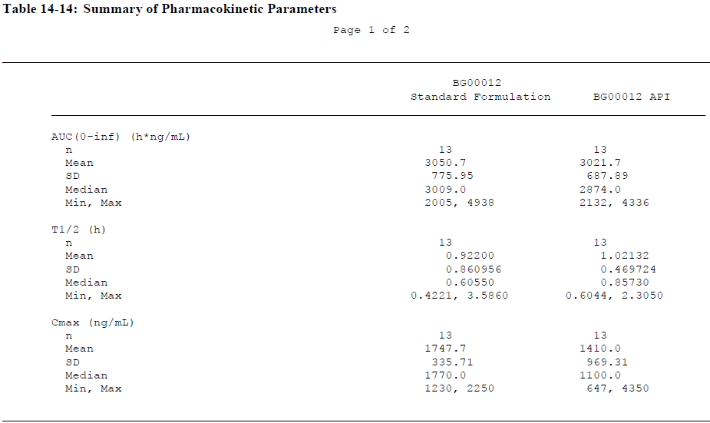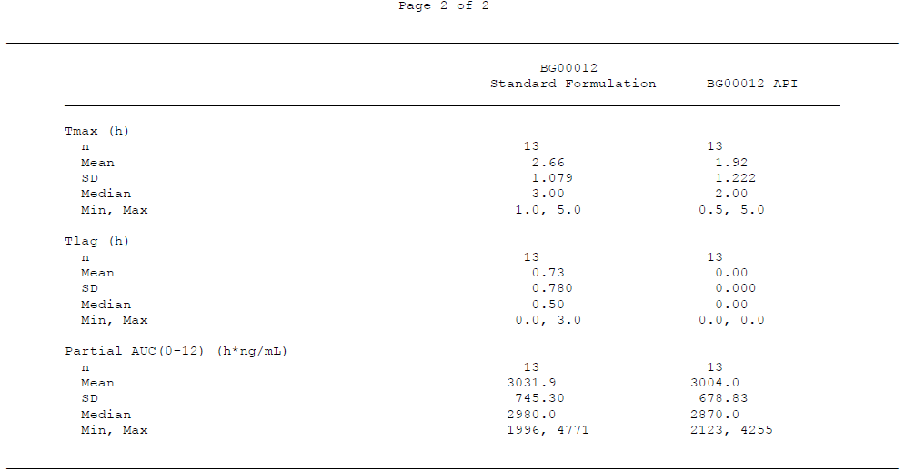

Bioequivalence of different dosage forms and strengths
The sponsor is seeking registration of 120 mg capsules that are identical to the trial tablets, as well as 240 mg capsules that have not been directly studied. According to the sponsor, the manufacturing process and specifications of the two capsule strengths (120 mg and 240 mg) are similar and the pharmaceutical characteristics are equivalent. Both consist of a gelatin capsule filled with enteric-coated microtablets, and the microtablets do not differ between tablet strengths. Bioavailability of the two strengths is not expected to be significantly different. To confirm this, the sponsor performed a healthy volunteer Phase I bioequivalence study (109HV107), which compared a single 240 mg capsule with two 120 mg capsules and demonstrated that the 90% confidence intervals (90%CIs) of the ratios of the geometric means for AUC and peak plasma concentration (C_{max}) were 0.99 to 1.07 (point estimate 1.03) and 0.96 to 1.16 (point estimate 1.06), respectively. Thus, the results of the pivotal studies can be applied to the proposed 240 mg capsule.

Bioequivalence to relevant registered products
Not applicable.

Influence of food
The effects of food were assessed in two single-dose studies, using a normal meal in Study FG-PK-02/02 and a fat-rich meal in Study C-1903. Both studies assessed a dose of 240 mg. A normal meal did not influence the AUC or C_{max} of MMF. A fat-rich meal did not influence the AUC but did affect the C_{max} and t_{½}: under fasting conditions, C_{max} was 50% to 60% higher and the t_{½} was approximately 2 fold shorter than after a fatty meal. With both meal types, the lag-time and T_{max} increased significantly. In Study FG-PK-02/02, T_{max} was 2.29 hrs in the fasted state, compared to 4.32 hrs in the fed state. In Study C-1903, T_{max} was delayed from 1.93 hrs in the fasted state, to 5.37 hrs in the fed state.

Dose proportionality
In general, as shown in the table below, the PK of DMF was dose proportional, with increasing C_{max} at progressively higher doses, in the range 120 mg to 360 mg. There was, however, high inter-individual variability.
Table 3. Summary of single dose pharmacokinetics healthy volunteers
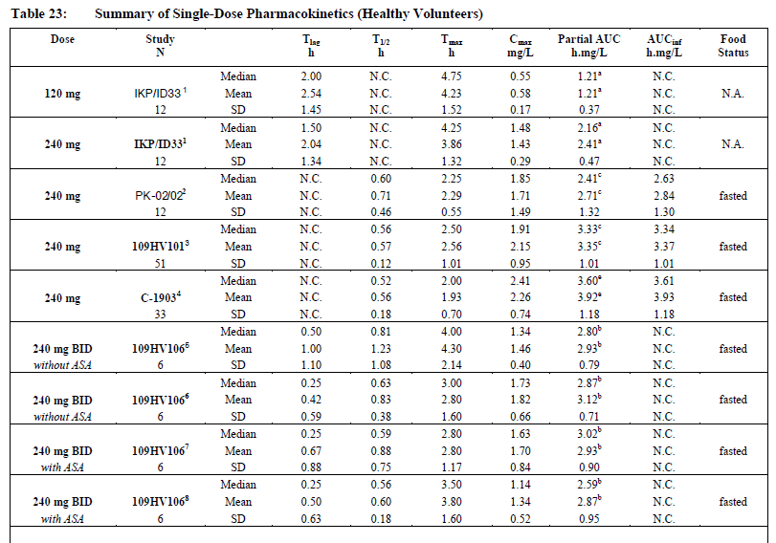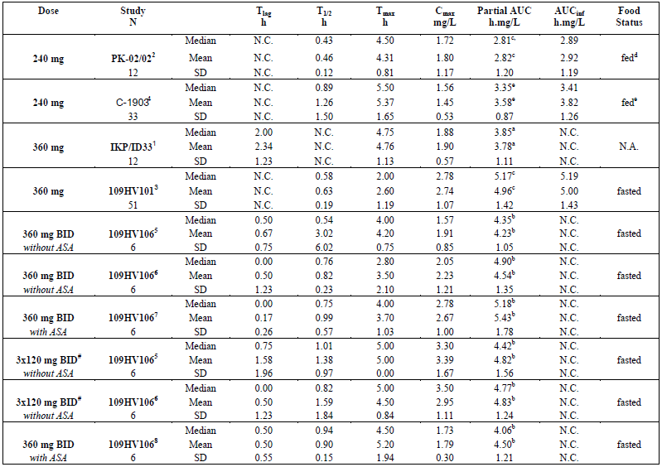
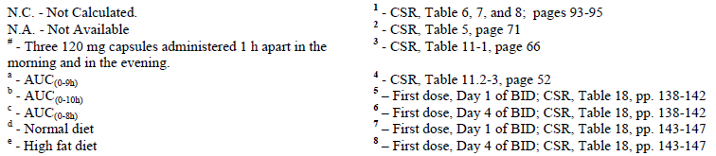

Bioavailability during multiple-dosing
Short multiple-dose studies were performed in healthy volunteers and MS patients, for up to 4 days. Both twice daily (BID) and three times daily (TID) oral dosing were assessed. The PK parameters derived from these studies are summarised in Table 4, below.
Bioavailability appeared to be similar in single-dose and multiple-dose PK studies and C_{max} values for MMF, as derived from multiple dose studies, seemed to be approximately dose-proportional. The elimination half-life (t_{½}) was consistent with rapid elimination of MMF and no accumulation of MMF over multiple doses was observed.
Table 4. Summary of multiple dose pharmacokinetics (healthy volunteers and MS patients)
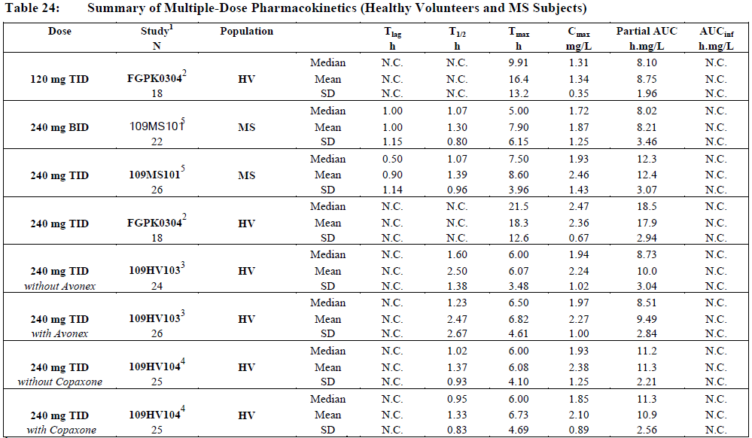
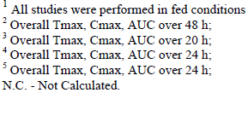

Effect of administration timing
Apart from the observed food effects, the timing of administration of BG00012 is not known to influence its pharmacokinetics.

Distribution

Volume of distribution
The apparent volume of distribution was assessed in Study 109HV101 and was approximately 60-70 L. For 240 mg, the mean (SD) was 64.07 L (23.870) and for 360 mg it was 72.69 L (43.521), with medians of 59.80 L and 58.90 L, respectively.

Plasma protein binding
Based on in vitro studies, the sponsor makes the following claim about protein binding: “Human plasma protein binding of DMF was shown to be in the range of 58.0% to 68.5%. However, DMF rapidly hydrolyzes to MMF, which has a lower range of binding in pooled human plasma (unbound fractions ranged from 55.1% to 66.1%).”
These values are derived from Study P00012-10-05, which used an equilibrium dialysis methodology.
Table 5. Unbound fraction (%) of MMF in human plasma. Study P00012-10-05
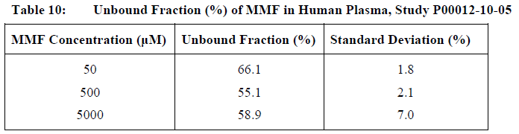
No clinical studies assessed protein binding. Because of the relatively low protein-binding, it is not anticipated that BG00012 will be involved in drug interactions due to displacement from plasma proteins.

Erythrocyte distribution
Red blood cell partitioning of MMF was assessed in the nonclinical study, Study P00012-10-07, and the results indicated that red blood cell to plasma partition coefficients and whole blood to plasma partition coefficients were both < 1, suggesting that MMF does not preferentially partition into the cellular components of blood.

Tissue distribution
The tissue distribution of MMF was not specifically addressed by the sponsor. The apparent volume of distribution (~60-70 L in Study 109HV101) is similar to total body water, suggesting that the drug does not partition into tissues.

Metabolism

Interconversion between enantiomers
Not applicable.

Sites of metabolism and mechanisms / enzyme systems involved
DMF is extensively metabolised by esterases in the gastrointestinal tract, blood and tissues, before it reaches the systemic circulation and DMF at normal doses is barely detectable in the blood. The PK studies assessed the primary active metabolite, MMF.
Figure 1. Proposed metabolic pathways for BG00012
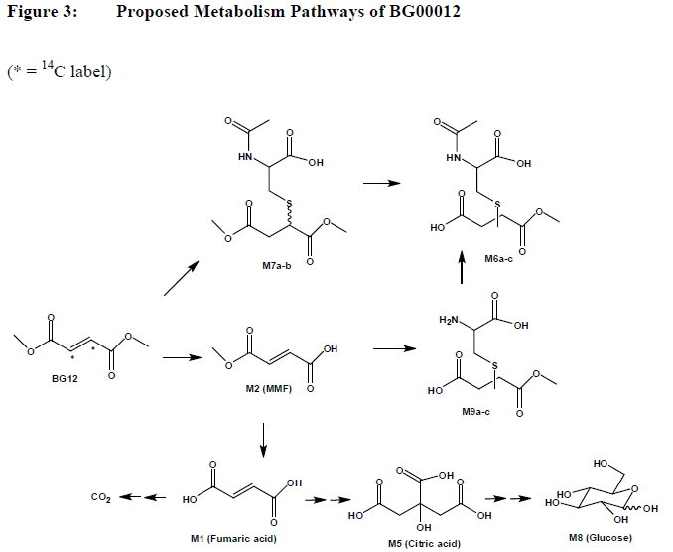
*=¹⁴C label
The metabolism of MMF was assessed in vivo in Study 109HV102, which employed radio-labelled BG00012. The proposed metabolic pathway is illustrated in Figure 1 and the relative abundance of different metabolites is shown in Table 6, below that.
The metabolism of MMF is pharmacologically unusual, in that it is metabolised through the natural tricarboxylic acid (TCA) cycle, also known as the Krebs cycle or citric acid cycle, which takes place in mitochondria throughout the body and which is used by all aerobic organisms to generate energy through the oxidization of acetate, derived from carbohydrates, fats and proteins, into carbon dioxide.
The metabolism of MMF produces citric acid and fumaric acid metabolites, along with carbon dioxide (CO₂). Recovery of radioactivity from the breath of healthy volunteers, after administration of a radio-labelled dose of BG00012, suggests that exhalation of CO₂ serves as the predominant pathway of elimination, accounting for 39.7% to 58.6% of the administered radioactivity.
Glucose has also been identified as an end metabolite, suggesting that some radio-labelled carbon from the BG00012 dose is processed via normal endogenous metabolic process and subsequently becomes incorporated into endogenous cellular components; this may be contribute to the apparent incomplete recovery of administered radioactivity.
Table 6. Summary of abundance of metabolites. Study 109HV102
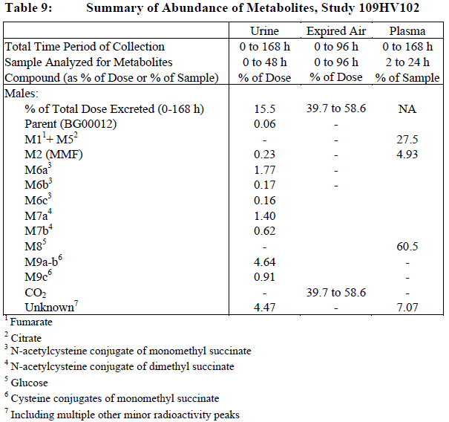

Non renal clearance
As discussed above, non renal clearance of MMF predominates, and most of the drug is excreted as CO₂. Only ~15% of a radio-labelled dose is recoverable from urine.

Metabolites identified in humans
MMF is the major active metabolite of DMF. The other metabolites, illustrated in Figure 1 above, have undefined activity but are not thought to make a major contribution to the pharmacological effects of DMF.

Pharmacokinetics of metabolites
DMF is [information redacted] barely detectable following administration. MMF is the main active metabolite and its PK has been well-characterised, as discussed in previous sections.
With the exception of MMF, the pharmacokinetics of the major DMF parameters have not been defined.

Consequences of genetic polymorphism
The metabolism of MMF uses the Krebs cycle, which plays such a fundamental role in the body’s energy metabolism that there is little scope for major genetic variation in the breakdown of MMF. There may be genetic variability in the absorption and hydrolysis of DMF but this has not been directly studied. No specific studies of genetic subgroups have been performed.

Excretion

Routes and mechanisms of excretion
MMF is predominantly excreted as CO₂, as discussed above.

Mass balance studies
The main mass balance study was Study 109HV102. The main results are described above.

Renal clearance
Renal clearance accounts for ~15% of a radio-labelled dose, as shown above.

Intra- and inter-individual variability of pharmacokinetics
There is high intra- and inter-individual variability in the PK of DMF/MMF. The sponsor writes: “The MMF exposure profiles displayed high IIV as demonstrated by the high coefficients of variation (CVs) and irregular shapes. In many cases secondary peaks were observed. The exact mechanistic cause of these is unclear, due to the complicated interplay between dissolution, absorption and pre-systemic conversion from DMF into MMF and the downstream metabolites, but some evidence suggests multiple absorption/pre-systemic sites of metabolism along the GI tract.”
An example of this variability can be seen in Study IKP/ID33 (see figure below), where different subjects showed peak MMF levels at widely different times over the first few hours after dosing, and some individuals showed multiple peaks in MMF concentration, the causes for which remain unclear.
In Tables 3 and 4 above, the single and multiple dose PK of MMF is shown for multiple studies. The variability between subjects is apparent in the relatively high standard deviation (SD) for each parameter, relative to the mean.
Figure 2. Plasma MMF concentration by subject and time following BG00012 240 mg administration in study IKP/ID33
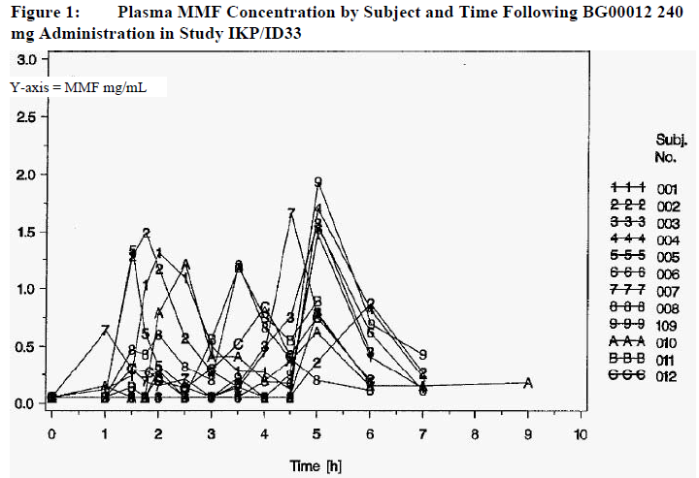

Pharmacokinetics in the target population
The multiple-dose pharmacokinetics of MMF in MS subjects was assessed in Study 109MS101, using the proposed dose of 240 mg BID, as well as a higher dose, 240 mg TID for 1 day.
BG00012 was administered with food to 48 study participants.
The concentration-time profiles in MS patients were broadly consistent with those seen in healthy volunteer studies but displayed high inter-individual variability and the individual concentration-time profiles had long lag times and multiple peaks.
For the proposed BID dose, the median T_{max} was 5 hours (BID) and median C_{max} was 1.72 mg/L (BID). The overall MMF exposure was dose proportional, with median AUC from time 0 to 24 h postdose (AUC₍₀₋₂₄₎) values of 8.02 h.mg/L for BID dosing and 12.3 h.mg/L for TID dosing.

Pharmacokinetics in other special populations

Pharmacokinetics according to gender
Study C-1903 and Study 109HV101 both suggested an effect of gender on the PK of MMF but these observations were not subjected to statistical analysis. The main PK parameters in each gender subgroup are shown in the tables below (Table 7 for C-1903 and Table 8 for Study 109HV101).
Table 7. Summary by gender of pharmacokinetic parameters
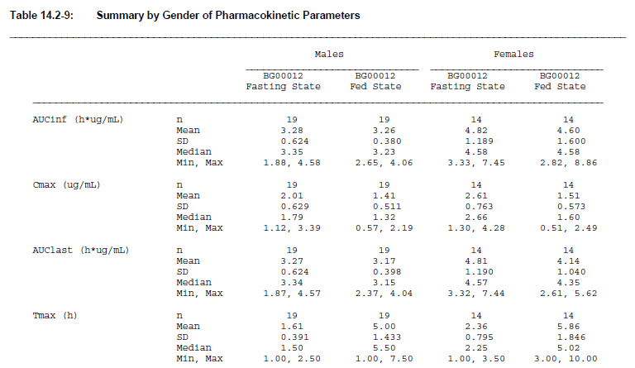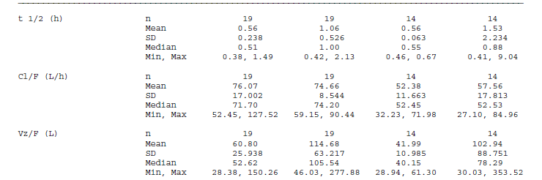
Table 8. Summary of pharmacokinetic parameters by gender
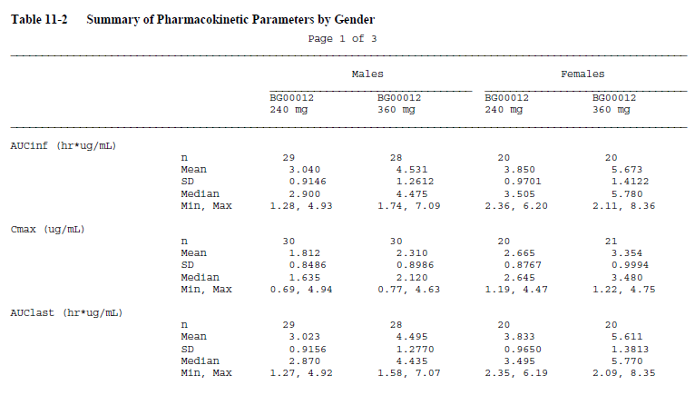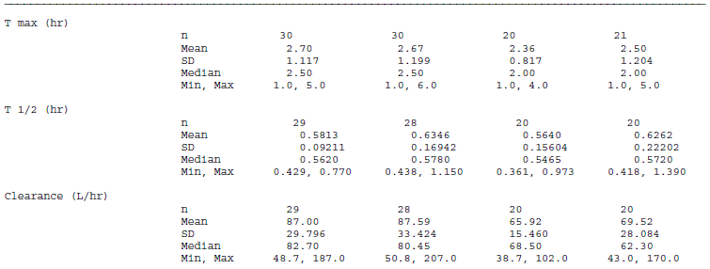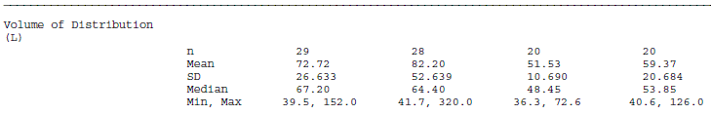
A formal statistical evaluation of the effects of both gender and weight effect was performed in Study 109MS101, in MS subjects. The results indicated that the effect of weight on AUC and C_{max} is statistically significant but once weight was accounted for, gender had only a marginal impact on C_{max} only (see the table below).
Table 9. Analysis of variance for MMF AUC and Cmax (weight as a continuous variable) study 109MS101.
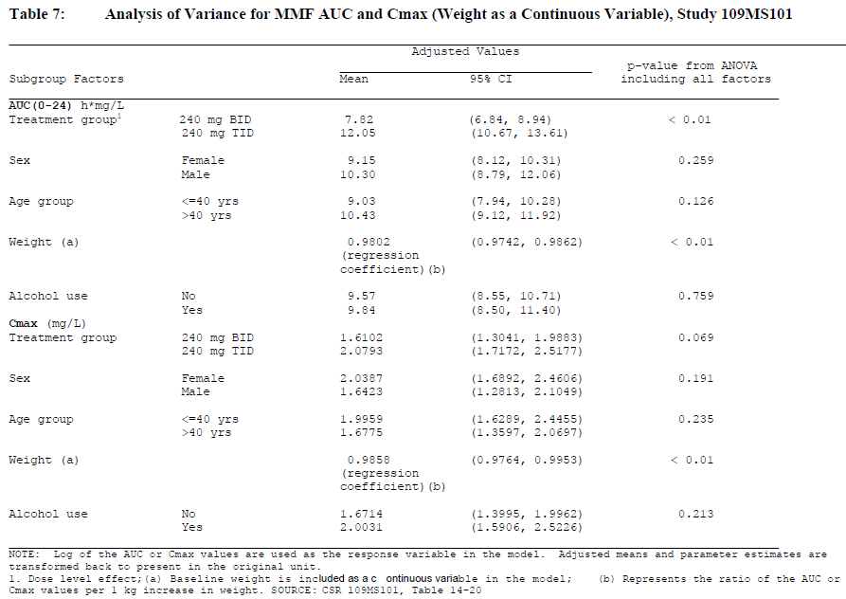

Pharmacokinetics in subjects with impaired hepatic and renal function
The sponsor did not perform specific studies assessing the PK of MMF in the setting of hepatic or renal impairment, arguing as follows: “Given the absorption/metabolism/elimination profile of BG00012, the evaluation of PK in individuals with renal and hepatic impairment is not considered necessary.”
This seems reasonable.

Pharmacokinetics related to genetic factors
There are no known genetic factors influencing the PK of MMF but the high variability of the PK may have a genetic component.

Pharmacokinetic interactions

Pharmacokinetic interactions demonstrated in human studies
No significant PK interactions of MMF have been demonstrated in humans but the sponsor only performed a small number of clinical drug-interaction studies, assessing potential interactions with beta-interferon 1a (Avonex), glatiramer acetate (GA, Copaxone), aspirin and alcohol.
When administered in combination with BG00012 240 mg BID or TID to healthy volunteers, Avonex (Study 109HV103) and GA (Study 109HV104) had no significant effects on the PK of BG00012.
When aspirin (Study 109HV106) was co-administered with BG00012 at doses ranging from 240 mg BID to 360 mg TID, it had no significant effect on the PK of BG00012.
When alcohol (Study 109MS101) was combined with BG00012, the PK profile of BG00012 was not significantly changed.

Clinical implications of in vitro findings
In vitro studies included Cytochrome P450 (CYP) induction and inhibition studies, conducted in human hepatocytes and with recombinant human CYP isozymes, a P-gp study and a study of the protein binding characteristics of DMF and MMF.
Neither DMF nor MMF inhibited CYP isozymes CYP2D6 or CYP3A4 at clinically relevant concentrations, and the induction potential of MMF appeared to be low. The 50% inhibitory concentration (IC₅₀) value for the inhibition of other CYP-isoforms (1A2, 2B6, 2C8, 2C9, 2C19, 2E1), was greater than 50 µM, suggesting the potential for CYP mediated inhibitory interactions is low. BG00012 was neither an inducer nor an inhibitor of P-gp. As previously discussed, the majority of BG00012 in blood is unbound, so the potential for interactions based on displacement of drug from plasma proteins is also low.

Evaluator’s overall conclusions on pharmacokinetics
Overall, the PK of BG00012 has been adequately studied, though some features of the PK profile remain unexplained. Dimethyl fumarate (DMF) is [information redacted] rapidly and completely converted to the active agent monomethyl fumarate (MMF) before reaching the systemic circulation. Bioavailability is high, as indicated by the very low proportion (<1%) recoverable from the faeces.
BG00012 microtablets are protected by an enteric coating, so absorption does not commence until the microtablets leave the stomach. The time of peak concentration of MMF is variable but usually occurs in 2-2.5 hours. MMF is distributed with an apparent volume of distribution of around 60-70 L. Following 240 mg administered twice a day with food, the median peak (C_{max}) in MS subjects was 1.72 mg/L and overall (AUC) exposure was 8.02 mg.h/L. Many individuals show multiple peaks in plasma concentration, for unknown reasons. Human plasma protein binding of MMF generally ranges between 27%-40%.
MMF is metabolised in the Krebs cycle in mitochondria and it is largely excreted as CO_{2,} with a terminal half-life of about one hour. Exhalation of CO₂ accounts for approximately 60% of a radioactive dose, whereas renal and faecal elimination account for 15.5% and 0.9% of the dose respectively.
Exposure to MMF (C_{max} and AUC) is dose proportional and there is no significant difference between single and multi-dose pharmacokinetics.
Body weight is the main covariate of exposure (C_{max} and AUC) in relapsing remitting multiple sclerosis (RRMS) subjects. Gender, age and race did not have a statistically significant impact on C_{max} or AUC. (The PK of MMF did show statistically significant gender differences but these are almost entirely accounted for on the basis of weight.) There is very limited information about the PK of MMF in the elderly and no information relating to the paediatric setting.
The pharmacokinetic profile of MMF does not indicate a high likelihood of interactions with other drugs and there was no evidence of interactions with beta interferon, glatiramer acetate, aspirin or alcohol. The dose is not likely to need adjustment in the setting of moderate renal or hepatic impairment, given that renal elimination accounts for only 15.5% of an administered dose and hepatic enzyme systems are not involved in its metabolism, though the PK of MMF has not been directly studied in the setting of renal or hepatic impairment. PK in the MS population is not different to that in healthy volunteers.

Pharmacodynamics

Studies providing pharmacodynamic data
No primary pharmacodynamic (PD) studies were submitted and the mechanism of action of BG00012 remains unclear. The PD studies that were performed were largely limited to exploring tolerability (in particular, potential mediators of flushing), cardiac safety (QT interval) and some aspects of the effect of BG00012 on the Nrf2 pathway (which relates to one theory of a potential mechanism of action). Not all PD studies were submitted for critical evaluation: Study PK01/02 and Study 09RA201 were merely described in the sponsor’s Summary of Clinical Pharmacology.
None of the pharmacodynamic studies had deficiencies that excluded their results from consideration but the studies contributed little to the understanding of how BG00012 exerts its effects.
Activation of the Nrf2 pathway was assessed in a sub-study of the pivotal Phase III Study, 109MS301; the design of this study is described in the Efficacy section but the PD sub-study is described under Primary Pharmacodynamics below.

Summary of pharmacodynamics
The information in the following summary is derived from conventional pharmacodynamic studies in humans unless otherwise stated.

Mechanism of action
The nuclear-related factor 2 (Nrf2) pathway is known to defend cells against oxidative stress, and the sponsor has hypothesised that this reduces neuronal death and maintains integrity of the blood brain barrier and myelin in the central nervous system. DMF was developed as a potential agent for use in MS with this in mind but the precise mechanism of action remains unknown.
Effects on the Nrf2 pathway may play a partial role. There is, at least, in vitro and nonclinical evidence that BG00012 activates the Nrf2 pathway, as assessed by markers of NRf2 activity including NADH- quinone 1 (nicotinamide adenine dinucleotide phosphate dehydrogenase quinone 1, NQO-1) and haeme oxidase-1 (HO-1). In 2 clinical studies, discussed below, there was evidence of increased expression of NQO-1 messenger ribonucleic acid (mRNA) but increases of HO-1 mRNA expression were not statistically significant.
There is also nonclinical evidence that BG00012 may protect cells from oxidative stress. The proposed PI states: “In preclinical studies MMF is able to penetrate into the central nervous system where it promotes cyto- and neuro-protective responses. DMF and MMF significantly improve cell viability after oxidative challenge in primary cultures of astrocytes and neurons, suggesting MMF and DMF directly prevent neurodegeneration in response to toxic stress. Acute neurotoxic injury models and genetic models of neurodegenerative disease confirm that DMF provides therapeutic benefit in reducing neuronal and functional damage resulting from various types of toxic stimuli and other forms of cellular stress inherent in neurodegenerative disease states.”
An assessment of these claims is beyond the scope of this clinical evaluation.
It remains unclear if other, anti-inflammatory effects or immunomodulatory effects of BG00012 might play a more important role. For instance, BG00012 is known to affect prostaglandin metabolism, as demonstrated in the sponsor’s own investigations into the potential mediators of flushing as a side effect of BG00012 treatment. Also, as discussed in the Safety section, BG00012 treatment is associated with lymphopaenia in some subjects, which might reflect immune effects, though the mechanisms of lymphopaenia are not known.
A literature search also reveals that independent investigators have found evidence of an immunomodulatory or anti-inflammatory action with BG00012 or MMF. These are just two citations:
- Ockenfels HM, Schultewolter T, Ockenfels G, et al. The antipsoriatic agent dimethyl fumarate immunomodulates T-cell cytokine secretion and inhibits cytokines of the psoriatic cytokine network. Br J Dermatol 1998;139(3): 390−5.
- de Jong R, Bezemer AC, Zomerdijk TP, et al. Selective stimulation of T helper 2 cytokine responses by the antipsoriasis agent monomethyl fumarate. Eur J Immunol 1996;26(9): 2067−74.
These alternative (or additional) mechanisms of action are acknowledged in the proposed Product Information sheet, as follows: “In preclinical and clinical studies, dimethyl fumarate demonstrates anti-inflammatory and immunomodulatory properties. Dimethyl fumarate (DMF) and monomethyl fumarate (MMF), the primary metabolite of DMF, significantly reduce immune cell activation and subsequent release of pro-inflammatory cytokines in response to inflammatory stimuli, and moreover affects lymphocyte phenotypes through a down-regulation of pro-inflammatory cytokine profiles (TH1, TH17), and biases towards anti-inflammatory production (TH2). DMF demonstrates therapeutic activity in multiple models of inflammatory and neuroinflammatory injury, and also appears to promote improvement in blood brain barrier integrity.”
The sponsor’s Summary of Clinical Pharmacology had a completely different emphasis, however, and seemed to imply that Nrf2 modulation was the only likely mechanism of action. This residual uncertainty about the mechanism of action is worthy of future research but should not be a barrier to registration.

Pharmacodynamic effects

Primary pharmacodynamic effects
Activation of the Nrf2 pathway was assessed in a sub-study of the pivotal Phase III Study, 109MS301, by measuring NQO-1 and HO-1 mRNA expression in a subset of whole blood RNA samples, relative to a housekeeping gene (beta-2 microglobulin, B2M) with presumed stable expression. The samples were obtained from 300 subjects who were randomised into 1 of 3 treatment groups: placebo TID, BG00012 480 mg/day (240 mg BID), or BG00012 720 mg/day (240 mg TID). The expression of mRNA in each active group was compared to the placebo group at Week 12 and Week 48, using a non-parametric multiple comparison test.
There was significant upregulation of NQO-1 mRNA in both the BG00012 BID and TID groups at both Week 12 and Week 48 compared to the placebo group and both increases were statistically significant (15.6% and 14.0% change from baseline in the BG00012 BID group versus 4.5% and 0.0% in the placebo group at Weeks 12 and 48 respectively; 29.0% and 13.1% change from baseline in BG00012 TID group, respectively).
A similar analysis was performed for the HO-1 marker but no significant differences were observed between treatment groups. A modest increase was observed in the HO-1 marker from baseline (adjusted for B2M) in both BG00012 groups, with the greatest increase in the BG00012 BID group at Week 48 (22.6% change from baseline versus 11.6% in the placebo group). This increase was not statistically significant.
Similar results were obtained in Study 109RA201, which was a randomised, double-blind, placebo-controlled, multicentre study of BG00012 administered for 12 weeks in subjects with rheumatoid arthritis (RA). Subjects were also treated with methotrexate for at least 3 months prior to beginning the study. Approximately 150 subjects were randomized into 3 treatment groups: placebo, BG00012 240 mg BID and 240 mg TID.
Nrf2 pathway activation markers, HO-1 and NQO-1, were examined at Weeks 2 and 12 (adjusted for housekeeping gene B2M). A rank-transformed analysis of variance (ANOVA) model was used to compare each BG00012 group with placebo. In the BG00012 TID group, the median NQO-1 levels were increased at both Weeks 2 and 12, relative to the placebo group and the increases at Week 12 were statistically significant. There was a 36.4% change from baseline in the BG00012 TID group versus 1.6% with placebo. In the BG00012 BID group, there was a statistically significant increase in the level of NQO-1 at Week 12 (18.3% change from baseline versus 1.6% with placebo).
A similar analysis was performed for the HO-1 marker, but as in the MS study, no significant changes were observed between treatment groups for HO-1. The sponsor proposes that HO-1 in blood may be a poor marker of NRf2 activity.
It remains somewhat unclear if the so-called “housekeeping” gene B2M might itself have been modified by treatment, and whether adjustments for B2M could have confounded the results. As noted in the previous section, it also remains unclear to what extent NRf2 effects play a major role in the therapeutic mechanism of action of BG00012.

Secondary pharmacodynamic effects
Flushing is a common side effect of BG00012 treatment and two studies sought to explore the potential mediators of this side effect, including prostaglandin D2 (PGD2), prostaglandin E2 (PGE2), prostaglandin F2 (PGF2α), serotonin, histamine and tumour necrosis factor alpha (TNFα)
Study BG-PK-01/02 was an open-label, 2-treatment, parallel-group study in which 2 groups of 12 psoriasis patients were randomised to a single dose of 240 mg BG00012 or to one capsule of 120 mg BG00012 at breakfast, lunch and dinner. Blood samples for determination of flushing mediators were collected for 24 hours after dosing. If a flush occurred, additional blood samples were taken every 15 minutes for the duration of the flushing.
The subjects and the study Investigator rated the severity of flushing using a visual analogue scale and the sponsor assessed correlations between flushing scores and blood concentration time-profiles of potential mediators. There was an increase of PGD2, PGF2α and serotonin during the flush for both treatment groups. Histamine and TNFα levels were temporally correlated with the occurrence of flushing.
Study 109HV106 examined potential mediators of flushing and the potential effect of aspirin (ASA) on these mediators, in healthy volunteers. It also attempted to assess gastrointestinal (GI) symptoms but GI scores were too low and inconsistent to allow a meaningful interpretation. Subjects were randomised into 9 treatment groups and given different regimens of BG00012 alone or after pre-treatment with 325 mg ASA administered 30 minutes prior to BG00012.
Plasma and urine samples were analysed for metabolites of PGD2 and plasma samples were assessed for serotonin and histamine. In some subjects who received BG00012 alone, plasma levels of 9α, 11β-PGF2 (the main metabolite of PGD2) increased on the first day but returned to near baseline on Day 4. Concentrations of 9α, 11β-PGF2 in individual subjects remained low when subjects were pre-treated with ASA. No elevation of 9α, 11β-PGF2 was observed in any of the placebo groups.
In general, subjects with normal or only mildly elevated 9α, 11β-PGF2 levels had milder flushing scores. Elevated serotonin levels were seen in BG00012-treated subjects as well as placebo subjects but there was no clear association between serotonin elevation and flushing or GI events, in contrast to the psoriasis study described above. Histamine levels were not elevated in BG00012-treated subjects, suggesting that the BG00012 flushing response is a non-allergic response not associated with mast cell degranulation.
The sponsor also performed a QT study discussed under Electrocardiography, Pivotal studies below. Single doses of BG00012 at 240 mg or 360 mg did not have any effect on the QTc interval when compared to placebo.

Time course of pharmacodynamic effects
The primary mechanism of action of BG00012 remains unclear. There is no good data on the time-course of the Nrf2 effects but effects have been detected at Weeks 2, 12 and 48 of treatment, combining observations from the two studies described above.
The acute time-course of flushing side effects has been characterised in the PD studies described above, and is illustrated in the figure in the next section. The chronic response to flushing is less clear: the prevalence of flushing seemed to decline after the first month of treatment in the pivotal studies, based on the number of reported adverse events but it is unclear whether this represents a true decline in the prevalence of flushing or under-reporting of a problem that patients and their clinicians may have felt had already been dealt with via their earlier reports.

Relationship between drug concentration and PD effects
There is no direct PK/PD data relating the concentration of MMF to the therapeutic effects of BG00012 in MS. There have been adequate dose-ranging studies, however, which suggest that the proposed dose achieves an effective concentration within the limits imposed by tolerability issues (see Dosage Selection below).
There is better evidence characterising the PK/PD relationships between plasma MMF concentration and secondary pharmacodynamic effects, such as flushing intensity and GI symptoms; these were evaluated in Study 109HV106. The key results for flushing (as measured with subjective “Flushing Severity Scores”, or FSS) are shown below. In Figure 3, the values at the apex of the peaks represent the overall FSS score. For GI symptoms, the symptom scores were too low and inconsistent to allow a meaningful analysis.
Figure 3. Relationship between plasma MMF concentrations and overall FSS scores by treatment time and subject: BG00012 240 mg BIF without ASA (n=6). Study 109HV106.
Day 1 Day 4
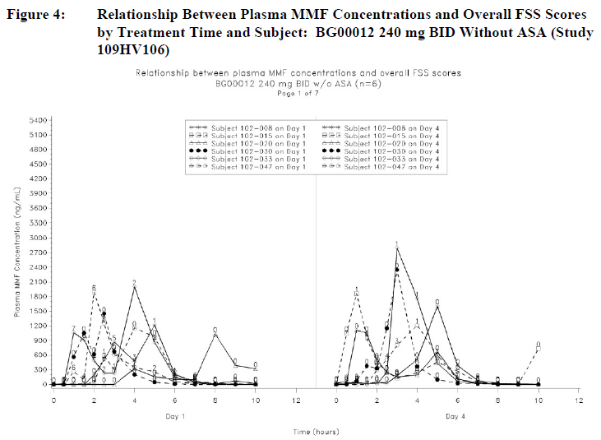

Genetic-, gender- and age-related differences in PD response
The PD response in different demographic groups has not been characterised but subgroup analyses in the pivotal studies suggested efficacy across all major demographic groups. There have been no adequate PD or efficacy studies in the paediatric setting or the elderly.

Pharmacodynamic interactions
PD interactions were only studied in the context of the secondary pharmacodynamics of flushing, where aspirin reduced the rise in prostaglandin metabolites that was seen with BG00012 treatment.

Evaluator’s overall conclusions on pharmacodynamics
The precise mechanism of action of BG00012 in MS remains unclear but there is some evidence that it modifies activation of the NRf2 pathway which plays a role in defending cells from oxidative stress. It remains unclear whether other potential mechanisms, such as immune modulation, might play a more important role.

Dosage selection for the pivotal studies
In both of the pivotal studies (Studies 109MS301 and 109MS302), the sponsor assessed two dose regimens of BG00012: 240 mg twice daily (BID), which is the proposed dose and 240 mg three times daily (TID).
According to the sponsor, these doses were selected on the basis of Study C-1900, a randomised, double-blind, placebo-controlled, dose-ranging study in which 257 subjects received either BG00012 (120 mg daily, 120 mg TID, or 240 mg TID) or placebo for 24 weeks. Subjects receiving BG00012, 240 mg TID, had significant reductions in brain lesions and annualised relapse rate compared with subjects who received placebo. The lower BG00012 dose regimens (120 mg TID and 120 mg daily) did not have a significant effect on any of the efficacy endpoints, but note that BID dosing was not evaluated and the middle dose group had a total daily dose (360 mg) less than the standard proposed dose. All 3 dose regimens in Study C-1900 were generally well tolerated.
Study C-1900 thus showed that 240 mg TID was effective and had acceptable tolerability, so it was chosen for the Phase III studies. An intermediate dose regimen, 240 mg BID, was also chosen for evaluation in the Phase III studies [information reacted].
This rationale seems reasonable and means that the Phase III studies assessed the doses [information redacted] to provide a balance between efficacy and tolerability.

Clinical efficacy
The sponsor’s submission rests on two pivotal efficacy studies, Study 109MS301 and Study 109MS302 (hereafter, Study 301 and 302). Supportive efficacy data comes from a Phase II dose-ranging study, C-1900 and an extension study, Study 109MS303 (hereafter, Study 303).
Table 10. List of BG00012 efficacy studies
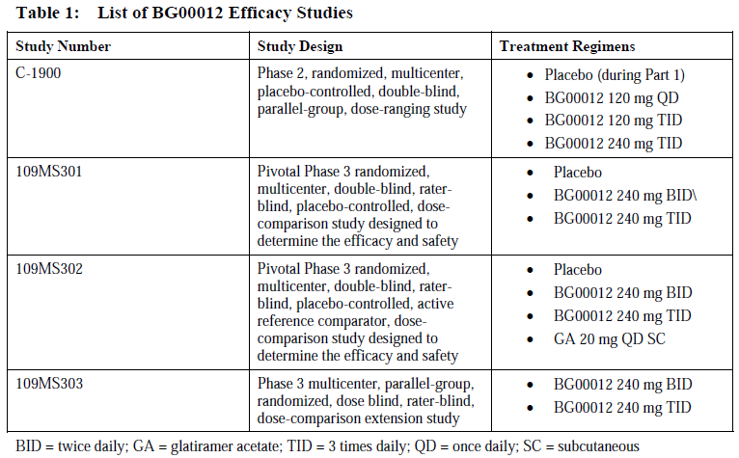
Table 11. Tabular summary of individual efficacy studies
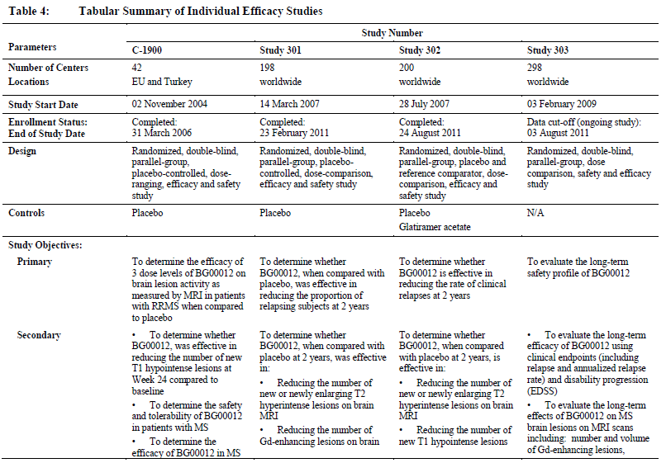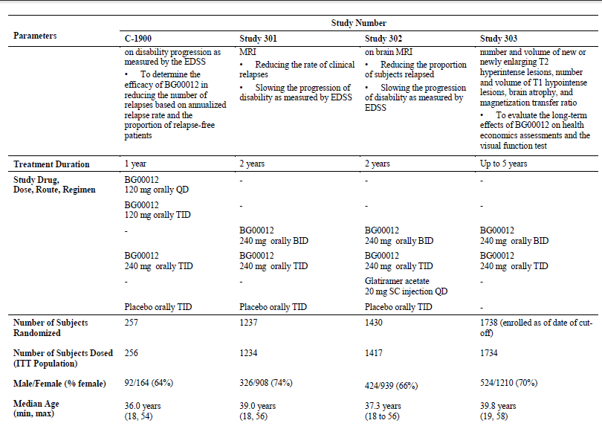
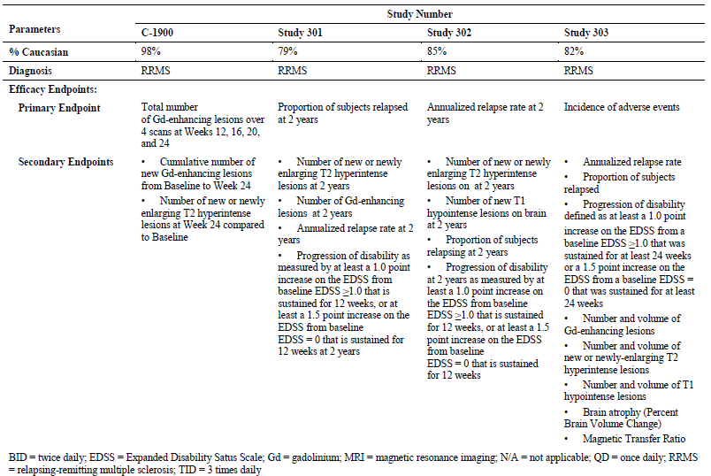

Pivotal efficacy studies
The sponsor submitted two pivotal efficacy studies, which had very similar designs: both were randomised, double-blind, and placebo-controlled studies in which subjects with RRMS were treated for 2 years. Both were designed to have sufficient statistical power to detect a reduction in relapses, which was the primary efficacy focus in each study but relapses were analysed differently in the two studies. Study 301 assessed the proportion of patients relapsed, whereas Study 302 assessed annualised relapse rate. Both methods are acceptable but the annualised relapse rate is a more conventional efficacy endpoint, used in many other MS studies; it is potentially more sensitive than the proportion of subjects relapsed because it incorporates data about second and subsequent relapses in the same subject. On the other hand, the mean annualised relapse rate could be dominated by a small number of subjects with frequent relapses (who would only be counted once with a “proportion relapsed” approach).
Secondary endpoints in the two studies were similar, as shown in the table below.
Apart from using slightly different primary endpoints, another key difference between the pivotal studies was that Study 302 employed an active control, glatiramer acetate, as well as placebo.
Table 12. Efficacy endpoints in pivotal studies. Primary, secondary and selected tertiary efficacy endpoints in studies 301 and 302 and for the integrated analysis of pooled data.
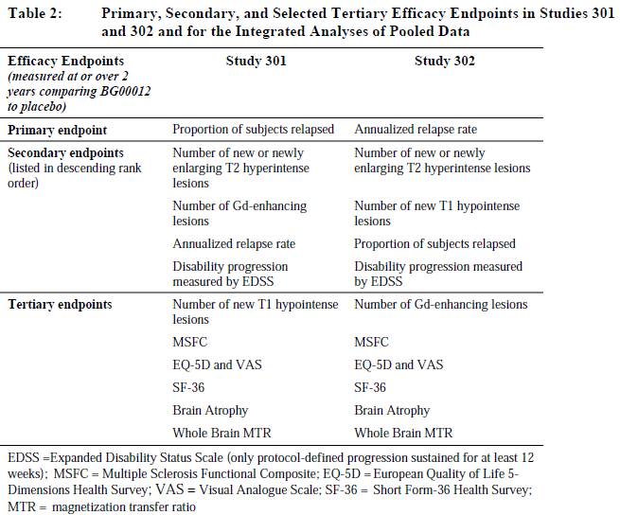

Study 109MS301

Study design, objectives, locations and dates
Study 109MS301 (Study 301) was a multi-centre, randomised, placebo-controlled, double-blind study designed to determine whether BG00012 (DMF), administered to subjects with RRMS, was effective in reducing the proportion of relapsing subjects at 2 years.

Inclusion and exclusion criteria
The inclusion and exclusion criteria were fairly standard for a study of RRMS. They were aimed at recruiting subjects who had RRMS rather than one of the other MS variants, and excluding those who had other significant illnesses that might have confounded assessment of efficacy or safety. To be eligible, subjects had to have active disease (either a relapse within the prior 12 months, or an active MRI) but they could not be clinically involved in a relapse close to baseline (relapse within 6 weeks, or still recovering from the last relapse).
The key inclusion criteria were as follows:
- Written informed consent.
- Aged 18 to 55 years old, inclusive.
- A confirmed diagnosis of RRMS according to McDonald criteria 1 to 4 [Polman 2005].
- Baseline EDSS between 0.0 and 5.0, inclusive.
- At least 1 relapse within the 12 months prior to randomisation, with a prior brain MRI demonstrating lesion(s) consistent with MS, or evidence of Gd-enhancing lesion(s) of the brain on an MRI within the 6 weeks prior to randomisation.
- Male subjects and female subjects of child bearing potential had to be willing to practice effective contraception.
Key exclusion criteria were:
- Primary progressive, secondary progressive or progressive relapsing MS (as defined by Lublin and Reingold, 1996). Subjects with these conditions were distinguished from relapsing-remitting subjects by the lack of clinically stable periods or periods of clinical improvement.
- Inability to perform the Timed 25-Foot Walk (T25FW), Nine-Hole Peg Test (9HPT) with both upper extremities, PASAT 3, and visual function tests (VFTs).
- History of major illnesses other than MS.
- History of severe allergic or anaphylactic reactions or known drug hypersensitivity.
- History of drug or alcohol abuse within the 2 years prior to randomisation.
- An MS relapse within the 50 days prior to randomisation and/or the subject had not stabilised from a previous relapse prior to randomisation.
- Positive for hepatitis C antibody and/or positive for hepatitis B surface antigen (HBsAg) at screening.
- Significant abnormal blood or urine tests at screening.
- Previous treatment with Fumaderm or BG00012.
- Previous treatment with total lymphoid irradiation, cladribine, T-cell or T-cell receptor vaccination, monoclonal antibodies (apart from natalizumab).
- Previous treatment with either of the following within 1 year prior to randomisation: mitoxantrone, cyclophosphamide.
- Prior treatment with any of the following medications or procedures within the 6 months prior to randomisation: cyclosporine, azathioprine, methotrexate, natalizumab, mycophenolate mofetil, IV immunoglobulin, plasmapheresis or cytapheresis.
- Prior treatment with any of the following within the 3 months prior to randomisation: subcutaneous or oral GA, interferon-alpha, interferon-beta.
- Treatment with any of the following medications within the 50 days prior to randomisation: steroids (IV or oral), 4-aminopyridine or related products.
- Treatment with another investigational drug within the 6 months prior to randomisation.

Study treatments
Subjects were randomly assigned to 1 of 3 treatment groups in a 1:1:1 ratio:
- Group 1: BG00012 240 mg BID
- Group 2: BG00012 240 mg TID
- Group 3: Placebo
The duration of blinded study treatment administration was to be 96 weeks.

Efficacy variables and outcomes
The main efficacy variables are listed in Table 12, in comparison to the other pivotal study (Study 302).
The primary efficacy endpoint was the proportion of subjects relapsed at “2 years” (96 weeks of treatment). Relapses were defined as “new or recurrent neurologic symptoms not associated with fever or infection, lasting at least 24 hours, and accompanied by new objective neurological findings upon examination by the examining neurologist.” Neurologic symptoms that evolved gradually over months were not counted as relapses. All relapses had to be confirmed by an Independent Neurology Evaluation Committee (INEC).
The main secondary endpoints were ranked as follows:
- Total number of new or newly enlarging T2 hyperintense lesions on brain MRI scans at 2 years.
- Total number of Gd-enhancing lesions on brain MRI scans at 2 years.
- Annualised relapse rate at 2 years.
- Progression of disability at 2 years (defined as ≥ 1.0-point increase on the EDSS from a baseline EDSS ≥1.0, sustained for 12 weeks, or ≥ 1.5-point increase from a baseline EDSS of 0, sustained for 12 weeks.)
The MRI endpoints were only evaluable in the subset of patients who consented to MRIs (n=540). MRI evaluations were performed at baseline, Month 6, Year 1 and Year 2.

Randomisation and blinding methods
Randomisation was achieved with a centralised Interactive Voice Response System (IVRS), and subjects were randomised equally to the three treatment groups. All patients received two tablets TDS: patients receiving placebo or BID active treatment received sufficient placebo tablets to maintain the blind. Some degree of unblinding may have occurred because of the flushing side effects of DMF, seen in ~30% of subjects. Neurological assessments contributing to efficacy endpoints were performed by an examining neurologist, however, who was not involved in the patients’ care and who was not informed of flushing and other side effects, an approach which should have limited bias due to unblinding. MRI assessments were performed by a centralised radiological facility blinded to the details of the patients’ clinical course.

Analysis populations
The primary analysis was performed on the intent-to-treat (ITT) population (n=1234), which consisted of all subjects who were randomised and received at least one blinded treatment (BG00012 or placebo). Additional analyses were performed on the per-protocol (PP) population (n=1090), consisting of subjects in the ITT population who did not have a major protocol violation. MRI endpoints were only considered for ITT subjects who underwent MRI scanning (n=540).

Sample size
The sponsor estimated sample size based on the Chi-squared test, assuming that the proportions of subjects who relapsed by 2 years would be 48% in the placebo group and 33.6% in each of the BG00012 groups. A sample size of 337 subjects per group provides 90% power to detect a 30% reduction in the proportion of subjects who relapsed at 2 years in each of the BG00012 groups, at a significance level of p<0.05. A dropout rate of 23% over the 2-year study period was also assumed.
This recruitment target was exceeded, and the study was adequately powered for all of its major endpoints.

Statistical methods
The statistical methods employed in the two pivotal studies were very similar and seemed appropriate overall. They are listed for each endpoint in the table below.
For Study 301, the primary efficacy endpoint was analysed using the Cox proportional hazards model for the time to first relapse. A number of sensitivity analyses were also performed, using broader definitions of relapse (for example, suspected by treating physician rather than confirmed by the INEC).
Appropriate measures were taken to correct for the fact that multiple dose groups were studied. For the primary endpoint, statistical testing was based on a sequential (closed) testing procedure: if the primary endpoint for the high dose group (BG00012 TID versus placebo) was statistically significant (p ≤0.05), then the low-dose comparison (BG00012 BID versus placebo) would be performed and considered statistically significant if p ≤0.05. Secondary endpoints were also examined sequentially (for the high-dose group first and then the low-dose group for each endpoint, followed by the next endpoint in the hierarchy, and so on), with the sequence to be abandoned if any higher-ranked comparison was not statistically significant.

Statistical methods, pivotal studies
Table 13. Summary of statistical methods
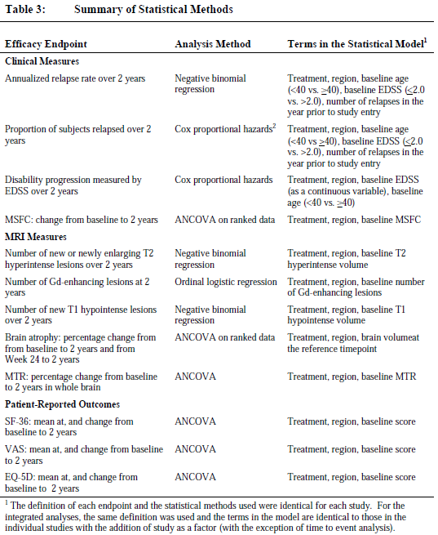

Participant flow
Nearly all randomised subjects were dosed and therefore entered the ITT population but a relatively high number discontinued study drug for various reasons, as shown in the table below. Discontinuation rates were slightly higher in the placebo group (35%) than either of the active groups (31% in both). The reasons for discontinuation were different in the placebo group where MS relapses (8% of subjects) and “consent withdrawn” (8%) were the leading causes of discontinuation as compared to the active groups where adverse events were the leading cause of withdrawal (15% in the BID group, 13% in the TID group). This is not likely to have produced a substantial withdrawal bias, given that more placebo recipients withdrew because of relapses than did recipients of active treatment. Subjects who discontinued treatment sometimes remained in the study, and the overall completion rates were acceptable, and fairly typical for studies of this nature (78% placebo, 77% for both active groups).
Table 14. Accounting subjects. Study 301 and 302. ITT population.
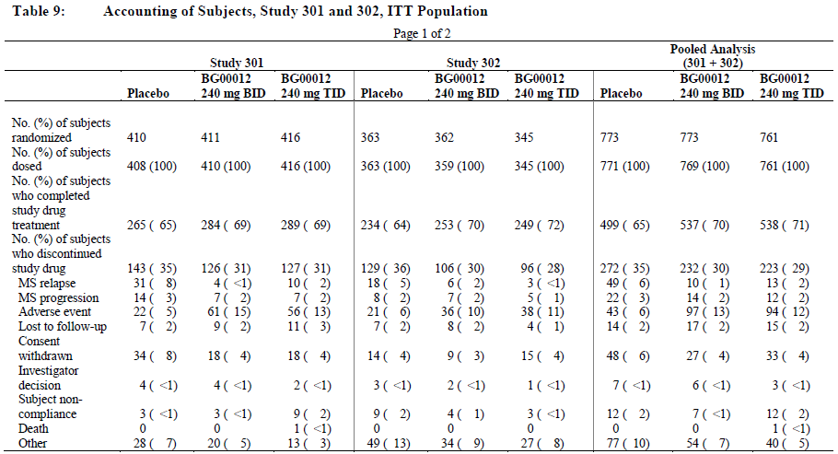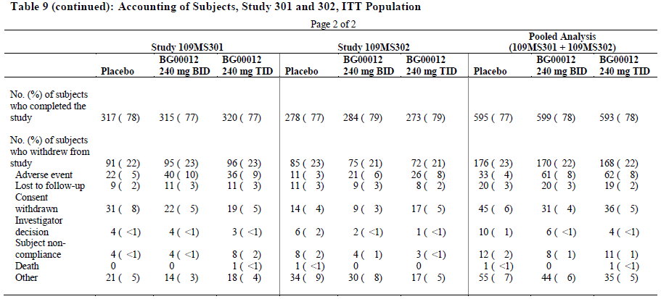

Major protocol violations/deviations
Protocol deviations were generally minor and largely consisted of missed doses, mistimed visits or failure to perform or act upon urinalysis.
Major protocol deviations were reported for 27/408 subjects in the placebo group, 60/410 subjects in the BG00012 BID group, and 57/416 subjects in the BG00012 TID group. Poor treatment compliance (<70% of doses taken) was the most common major violation in all 3 groups.
More seriously, six subjects (2 placebo, 4 active) received the wrong type of drug kit on at least one visit (active treatment in place of placebo, or the wrong dose).
Dosing errors and poor compliance are likely to have diluted the observed treatment effect sightly but do not invalidate the overall conclusions of the study.

Baseline data
The baseline demographic characteristics of the study population are shown in Table 15 below, and baseline disease characteristics are shown in Table 16. The three treatment groups were well matched in terms of age, gender distribution, body weight and disease activity. They were fairly typical of the population likely to receive BG00012 in the post-marketing setting: median age was 39 years, median years since diagnosis was 4.0 years and median EDSS score at baseline was 2.0.
The TID group had a slight excess of patients with only one relapse in the previous 12 months (71% versus 67% in the other two groups). This might be expected to bias the study in favour of this group in terms of the raw percentage of relapsing subjects but the number of relapses in the prior 12 months was one of the factors used in the proportional hazards model, so this bias would be expected to have been eliminated in the sponsor’s analysis. Also, this minor inequality at baseline was not present in the group receiving the proposed BID dose who were very well matched to the placebo group.
Table 15. Demography for studies 301 and 302. IT population.
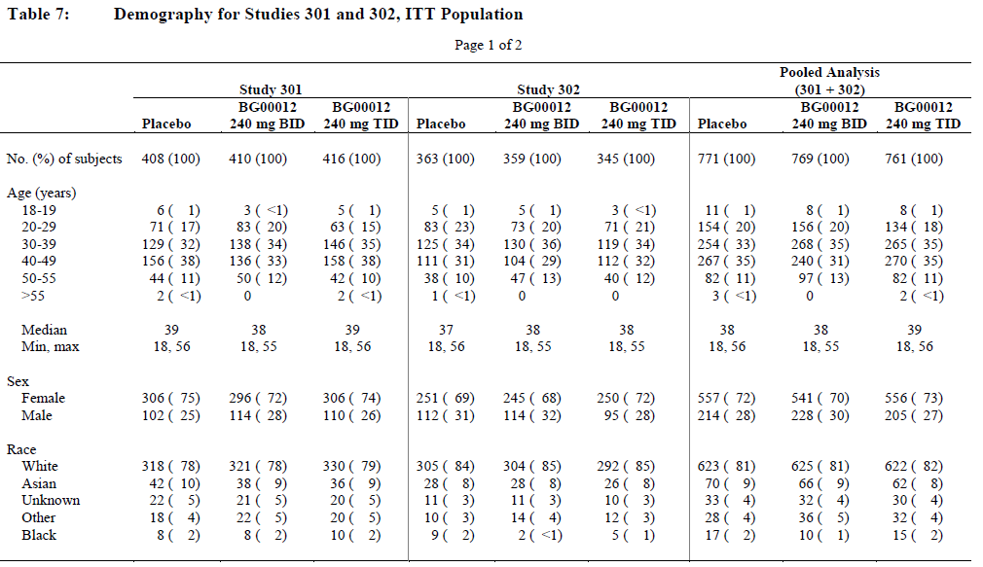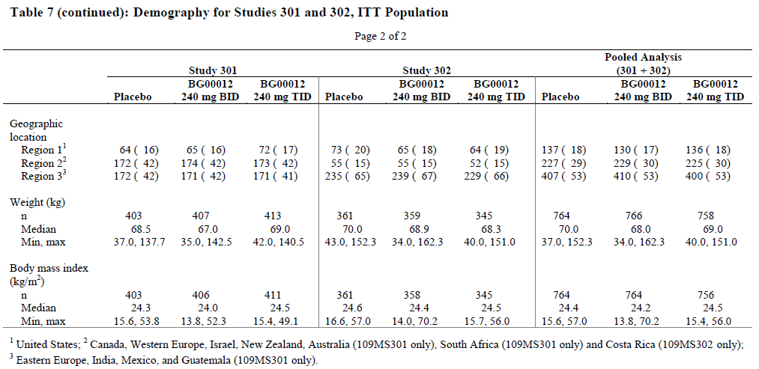
Table 16. Baseline MS disease characteristics in studies 3013 and 302. ITT population. EDSS scores at baseline.
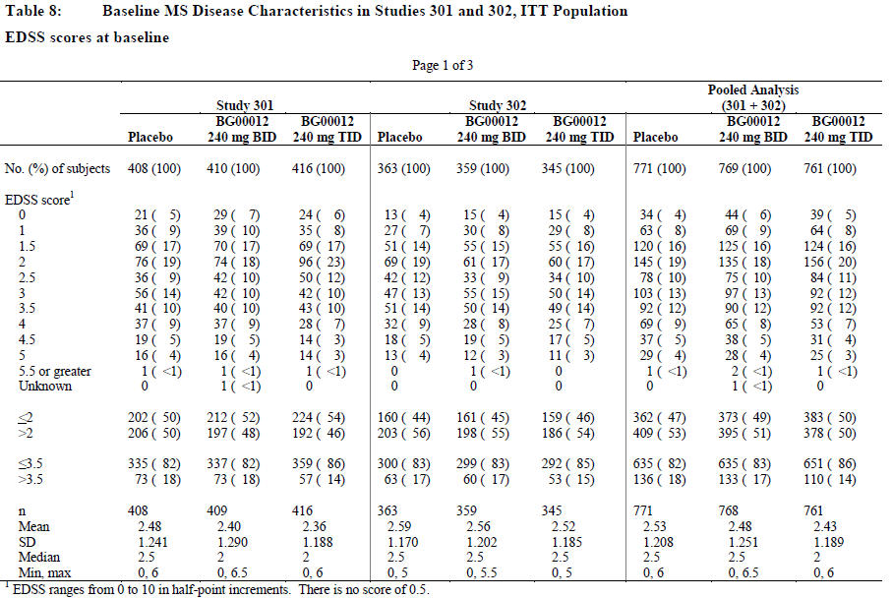
Relapse history
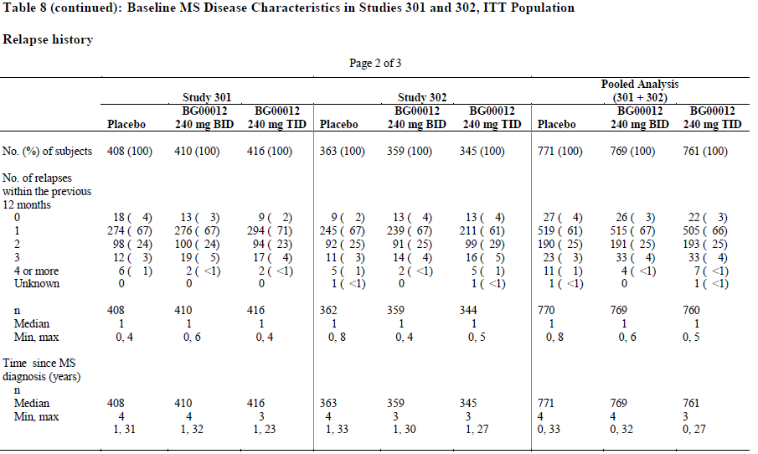
McDonald criteria at baseline
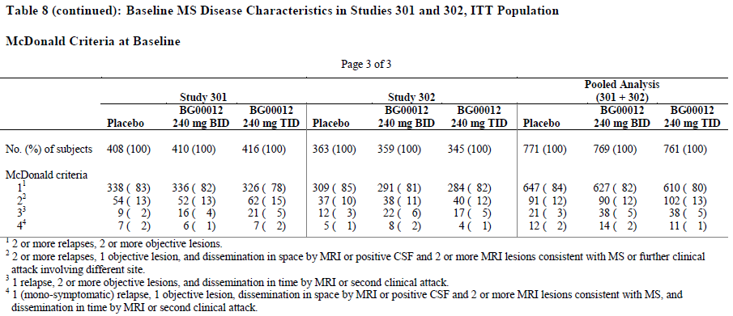

Results

Results for the primary efficacy outcome
Results for the primary endpoint are shown in the Table 17 below. The Kaplan-Meier estimate of the proportion of subjects relapsed at “2 years” (96 weeks) was 27.0% in the BG00012 BID group and 26.0% in the TID group, compared to 46.1% in the placebo group, a relative reduction of 41% and 44% respectively. The unadjusted raw figures were similar, with 42% of placebo recipients relapsing versus 24% and 23% with BG00012 BID and TID, respectively.
Relative to placebo, the hazard ratios obtained from the model were 0.51 (95% CI, 0.40, 0.66) for BG00012 BID and 0.50 (95% CI, 0.39, 0.65) for BG00012 TID. This indicated the instantaneous risk of relapse was reduced by 49% (p <0.0001) and 50% (p <0.0001) during treatment with BG00012 BID and TID, respectively.
Table 17. Summary of proportion of subjects relapsed (INEC-confirmed relapses) at 2 years. ITT population.
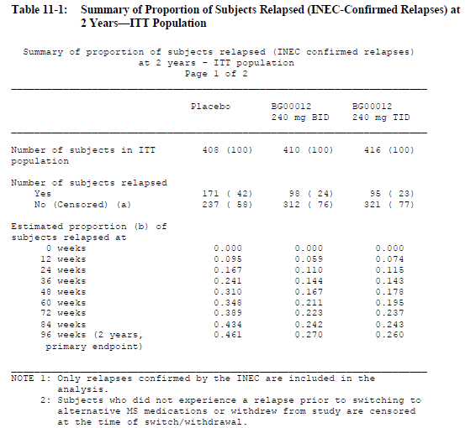
In reporting this result, the sponsor states: “This indicated the risk of relapse at 2 years was reduced by 49% (p <0.0001) and 50% (p <0.0001) following treatment with BG00012 BID and TID, respectively, compared with placebo” (p141/3378, report-body.pdf). In fact, from the table above, the two-year risk estimated by the KM method was only reduced by 41% and 44%, suggesting that the sponsor is in error, misreporting the reduction in instantaneous hazard risk as a reduction in cumulative two-year risk.
This is a common source of confusion. Reductions in hazard and in cumulative risk are not the same because hazard ratios generally refer to the instantaneous hazard rate of still-at-risk subjects; subjects who have already experienced a relapse prior to the end of the two-year period are no longer at risk of a first relapse for the remainder of the two-year period, and therefore necessarily dilute the benefit exhibited in the pooled treatment group for any analysis based on a first relapse (such as conversion from relapse-free to relapsed). Clinicians and patients are more likely to think in terms of cumulative risk over a time period, rather than instantaneous hazard ratios, so it is usually more useful to express the results in those terms. More importantly, it is misleading to equate cumulative risk reductions and instantaneous hazard reductions, an error that exaggerates the apparent benefit of active treatment. The sponsor should be asked to clarify whether they have made such an error in reporting this outcome, and, if so, correct all references to this result including the draft Product Information (PI) sheet.
The proposed PI displays the result as follows (only the clinical section of the table is shown):
Table 18. Clinical and MRI results of study 1
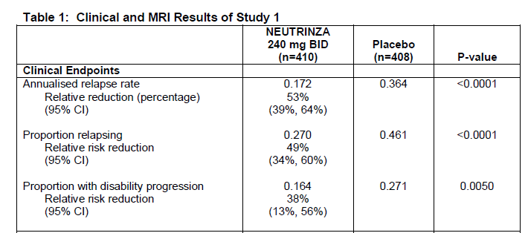
A simple calculation shows that the proportion relapsing was reduced by ~41% with active treatment (proportion relapsing with treatment was 0.270/0.461 = 0.586, or 58.6% of the placebo proportion; 100%-58.6% = 41.4%). The table claims a relative risk reduction of 49%, which is not plausible and probably refers instead to the reduction in instantaneous hazard.
Despite the sponsor’s apparent errors in reporting this outcome, it is generally a favourable and clinically meaningful result. A relative reduction in proportion relapsing of 41% is a worthwhile outcome. In absolute terms, the reduction was less impressive: 19.1% (0.461-0.27 = 0.191). This implies that five patients would need to be treated for two years to keep one extra patient relapse-free.

Results for other efficacy outcomes
Results for secondary endpoints were generally favourable. The annualised relapse rate with active treatment was about half that with placebo (placebo group 0.364 relapses/year; BID group, 0.172 relapses/year, or 47% of placebo; TID group 0.189 relapses/year, or 52% of placebo), and the differences were highly significant (p<0.001 for comparisons of either dose group with placebo).
Table 19. Summary of annualised relapse rate (INEC-Confirmed) at 2 years.
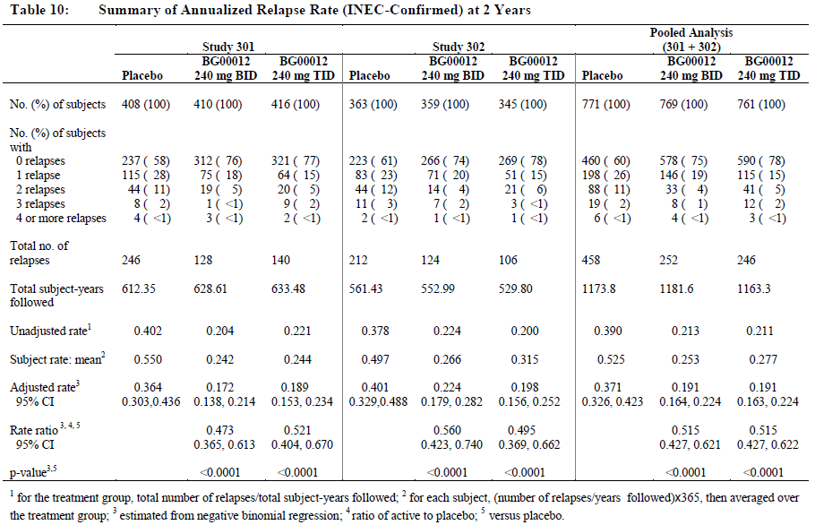
The proportion of patients showing sustained progression (for ≥ 12 weeks) was also significantly reduced by active treatment: 0.164 and 0.177 for the BID and TID groups, respectively, compared to 0.271 with placebo, relative reductions of 39% and 35% respectively. (For this parameter, there does not seem to be a difference between the two-year cumulative risk reduction and the hazard reduction, possibly because progression was not assessed throughout the two years as relapses were; the scope for misreporting this endpoint was therefore minimal).
This is an important and reassuring result, especially considering that the early studies of older MS treatments struggled to demonstrate improvements in progression.
Table 20. Time to sustained progression of disability at 2 years as measured by an increase in EDSS.
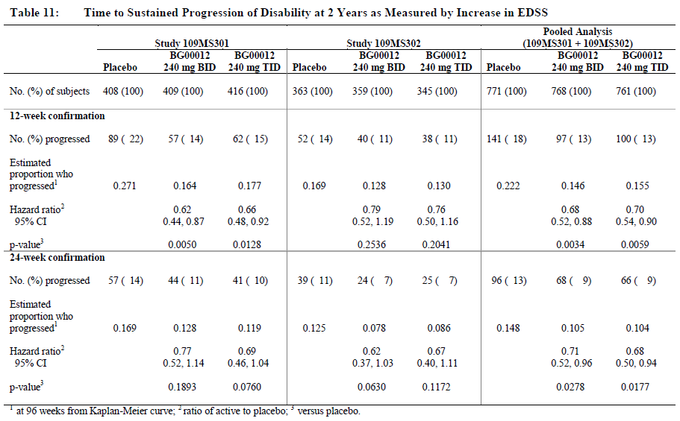
The sponsor also assessed progression via the MS Functional Composite (MSFC), which scores patients on their ability to perform 3 specific tasks. The timed walk component of this score appears to have had poor sensitivity and did not show a significant benefit but the upper limb motor assessment (9-Hole Peg Test) and the cognitive assessment (Paired Serial Addition) did show a highly significant benefit, as did the overall combined MSFC. The validity of these results is somewhat questionable as they were not replicated in the other pivotal study; on the other hand, a pooled analysis of both studies showed a significant overall treatment effect for MSFC).
Table 21.MSFC: Change in Z-scores from baseline to 2 years. ITT population.
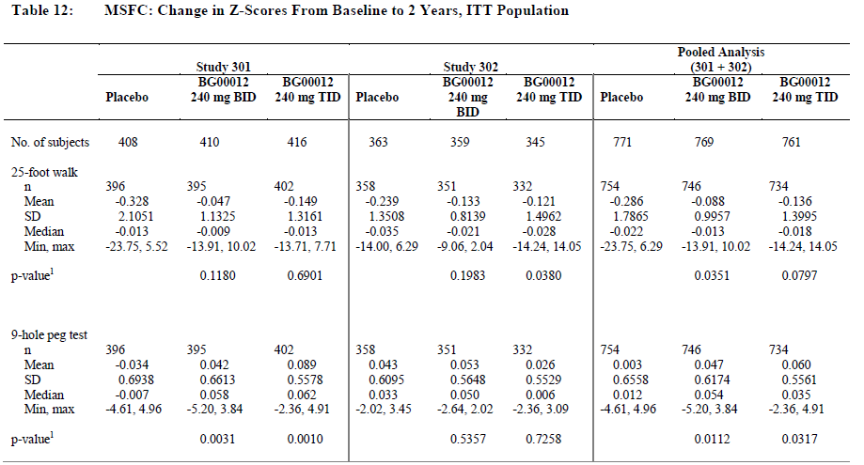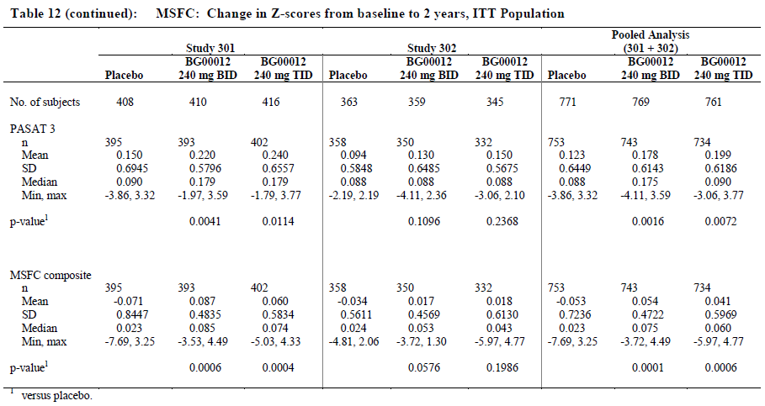
MRI endpoints also favoured active treatment, in the cohort of patients where this endpoint was available. MRI results for this study, the other pivotal study and for the pooled analysis of both pivotal studies are shown below. For this study, the mean number of new or newly enlarging lesions was 2.6 for recipients of BG00012 240mg BID, 4.4 for recipients of BG00012 240mg TID, compared to 17.0 for placebo recipients, percentage reductions of 85% and 74% respectively. The statistical comparisons with placebo were highly significant (p<0.0001 for either dose group versus placebo).
Table 22. Number of newly enlarging T2 hyperintense lesions at 2 years compared to baseline. Studies 301 and 302 (pooled), MRI cohort.
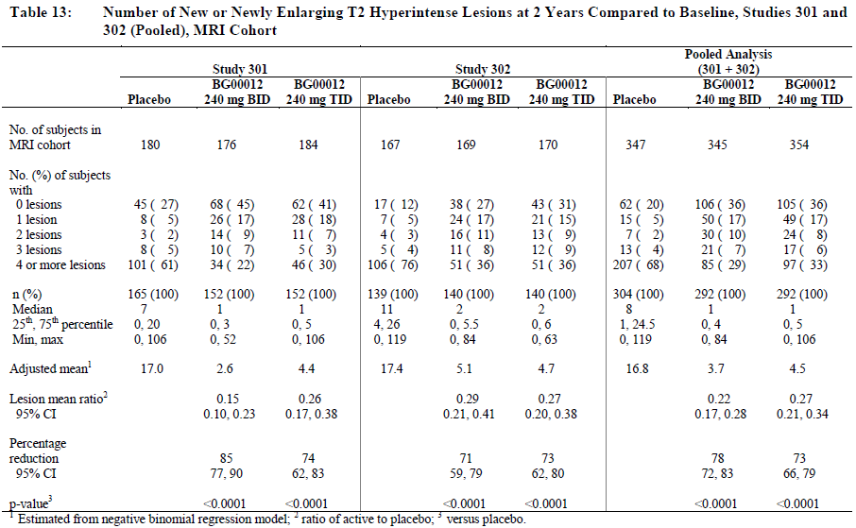
Similarly favourable results were obtained for Gd-enhancing lesions, as shown in the table below, with a mean of 0.1 and 0.5 Gd+ lesions in the BID and TID groups, respectively, compared to 1.8 in the placebo group (p<0.0001 for either active group versus placebo).
Table 23. Number of Gd-enhancing lesions at 2 years.
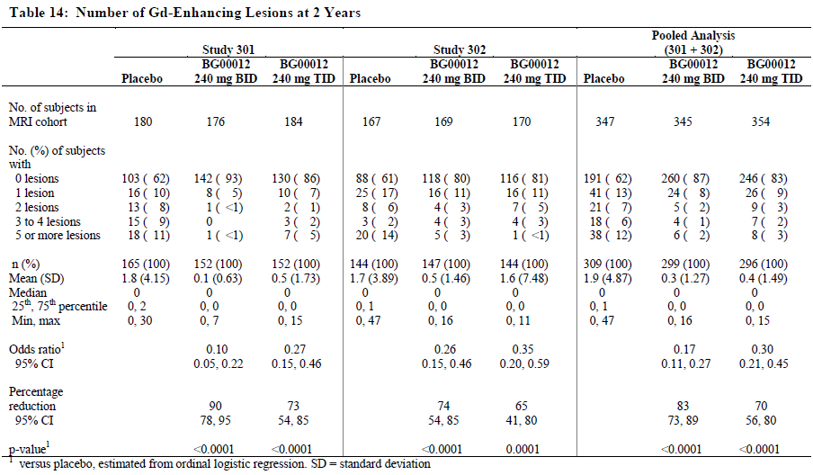
Whereas T2 hyperintensity reflects water content in cerebral tissue and hence a combination of oedema and scarring (gliosis), Gd-enhancement reflects acute compromise of the blood-brain barrier, and hence correlates with active inflammation. Both reflect disease activity but could in theory be dissociated from the accumulation of significant neurological damage. T1 hypointense lesions, on the other hand, known as “back holes”, are thought to correlate with loss of axons in a plaque, and hence with permanent loss of functional white matter and ultimately with cumulative disability. It is therefore very encouraging that T1 hypointense lesions were also reduced with active treatment, from an adjusted mean of 5.6 in the placebo group to 1.5 and 2.1 in the 240mg BID and 240mg TID groups, respectively (p<0.0001 for either dose group versus placebo).
Table 24. Number of New T1 hypointense lesions over 2 years. Studies 301 and 302 (pooled). MRI cohort.
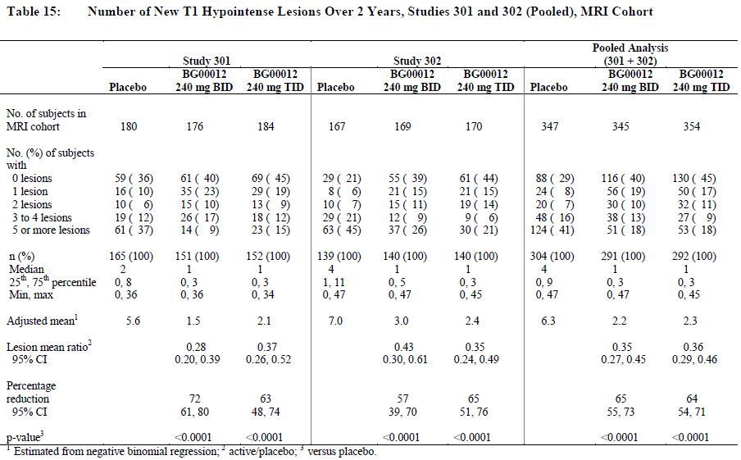
The sponsor also studied brain atrophy on MRI. This is a measure with poor sensitivity, in part because successful reduction in brain oedema can cause a reduction in brain volume (pseudoatrophy) that offsets any amelioration of true brain atrophy. The sponsor therefore assessed atrophy from Week 24 onwards, to minimise the confounding effect of pseudoatrophy, which usually occurs early. Despite this, comparisons between active and placebo groups were inconsistent. Only one comparison, the percentage change from Week 24 to 96 for 240mg BID group versus placebo, achieved statistical significance. The failure to replicate this benefit in the higher dose group, or in the other pivotal study, implies that there is no consistent benefit on brain atrophy over two years of treatment with BG00012.
Table 25. Brain atrophy: percent brain volume change (PBVC) from week 24. Studies 301 and 302 (pooled). MRI cohort.
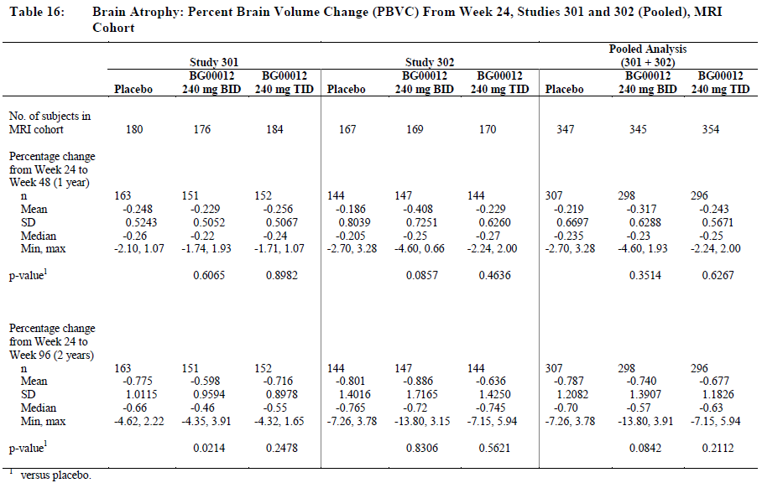
Overall, the results in secondary endpoints in Study 301 were favourable and strongly support the results for the primary endpoint. They suggest that BG00012 has a beneficial effect on both relapse rate, disability progression and MRI markers of disease activity.

Study 302

Study design, objectives, locations and dates
Study 302 was a randomised study of BG00012 in patients with RRMS. It shared a broadly similar design to Study 301 but it had a slightly different primary endpoint (relapse rate rather than proportion relapsed) and it used an active control (glatiramer acetate, GA) as well as a placebo group. It was double-blind with respect to the BG00012 versus placebo comparison, but it was only rater-blinded for the glatiramer group.

Inclusion and exclusion criteria
Inclusion criteria were essentially the same as those outlined above, for Study 301. Subjects had RRMS according to the revised McDonald Criteria [Polman 2005], with a baseline EDSS between 0.0 and 5.0, inclusive. They had to have active disease, as indicated by at least 1 relapse within the 12 months prior to randomisation or evidence of Gd-enhancing lesion(s) of the brain on an MRI performed within the 6 weeks prior to randomisation. Subjects had to be willing to practise effective contraception.
Exclusion criteria included other forms of MS, other illnesses likely to confound the assessment, or inability to perform the required assessments. Patients could not have received any previous treatment with BG00012, or GA.
Previous treatments likely to have a residual effect were also grounds for exclusion, including:
- Total lymphoid irradiation
- Cladribine
- T-cell or T-cell receptor vaccination
- Any therapeutic monoclonal antibody, with the exception of natalizumab.
- Prior treatment with any of the following within 1 year prior to randomisation:
  - Mitoxantrone
  - Cyclophosphamide
- Prior treatment with any of the following medications or procedures within the 6 months prior to randomisation:
  - Cyclosporine
  - Azathioprine
  - Methotrexate
  - Natalizumab
  - IV immunoglobulin
  - Plasmapheresis or cytapheresis
- Prior treatment within the 3 months prior to randomisation:
  - Interferon-alpha (IFN-α)
  - IFN-β
- Treatment with any of the following medications within the 50 days prior to randomisation:
  - Steroids (including agents that may act through the corticosteroid pathway)
  - 4-aminopyridine or related products

Study treatments
Subjects were randomly assigned to one of four treatment groups:
- BG00012, 240 mg BID (Group 1)
- BG00012, 240 mg TID (Group 2)
- placebo (Group 3)
- GA 20 mg QD (Group 4).
Treatment was continued for a total of 96 weeks, and was administered orally in a double-blind double-dummy fashion (except for those receiving GA, which was injected subcutaneously in an open-label fashion).
Subjects in Groups 1, 2, and 3 took two capsules of blinded study treatment orally TID, except during the first week, when they took one capsule orally TID to minimise side effects.

Efficacy variables and outcomes
The primary efficacy variable was the annualised relapse rate. Secondary endpoints were almost identical to those in the previous pivotal study, and included MRI endpoints, EDSS progression, and MSFC, as previously listed.

Randomisation and blinding methods
Patients were randomised equally to the four treatment groups, stratified by site. Blinding was achieved across Groups 1-3 by using matching placebo and active tablets but blinding was not achieved for the active comparator group, which received subcutaneous injections.
Blinding was enhanced by using a blinded examining neurologist for clinical efficacy assessments, and blinded radiologists for MRI assessments. Injection sites were supposed to be covered for neurological examinations.

Analysis populations
The analysis populations included the ITT population, who were randomised and received at least one treatment, the PP population, who completed the study without major protocol violations, the MRI cohort, who consented to frequent MRI scans, and the safety population, who received any treatment.

Sample size
The sponsor estimated sample size on the assumption that the annualized relapse rate in the placebo group would be ~0.61 relapses/year, and the rate on active treatment would be ~0.456. Given this background risk, a sample size of 308 subjects per group would provide 84% power to detect a 25% reduction in the annualized relapse rate at 2 years in the BG00012 group. A dropout rate of ~23% over 2 years was assumed, so the total planned sample size for the study was 1232, a target that was exceeded.

Statistical methods
Statistical methods are listed alongside those for Study 301, in Table 11 above.
The primary endpoint, relapse rate, was analysed with a negative binomial regression model, appropriately adjusted for baseline EDSS score (≤2.0 versus >2.0), baseline age (<40 versus ≥40 years), region and the number of relapses in the year prior to study entry.
As already described for Study 301, statistical testing for the primary and secondary efficacy endpoints was based on a sequential (closed) testing procedure to control for the overall type I error.

Participant flow
Patient disposition is shown in the table below. The proportion of subjects completing treatment was low (71% overall), but it was better with active treatment (BG00012 or GA) than with placebo. The proportion completing the study was somewhat better (80%) and is reasonably typical of studies of this nature.
Table 26. Accounting of subjects.
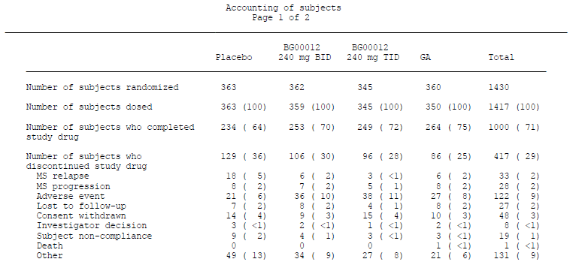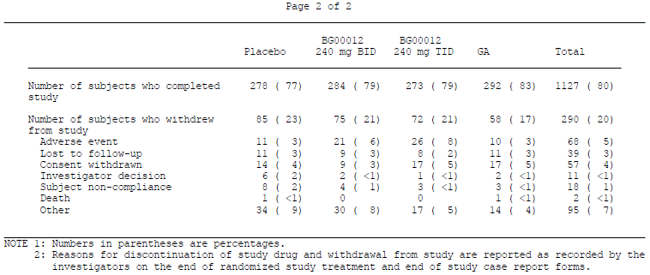

Major protocol violations/deviations
Major protocol violations are tabulated below. The most common cause for exclusion from the PP population was low study drug compliance (85% of exclusions). This is likely to have diluted the observed benefit. A few patients violated inclusion/exclusion criteria. Ten subjects received incorrect treatment, including one who was randomised to BG00012 but received GA for the entire study and 9 others who received the wrong treatment kit for a 4 week period.
Table 27. Summary of number of subjects and reasons for exclusion from the per-protocol population.
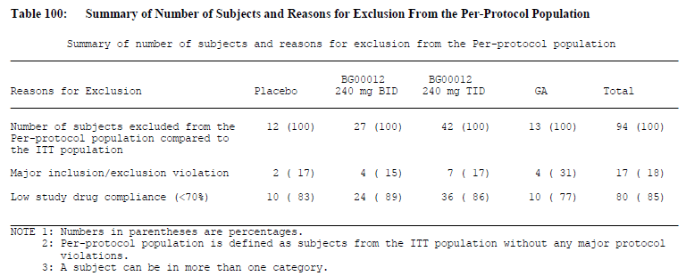

Baseline data
Demographic data and disease characteristics at baseline were shown for both pivotal studies in Baseline data, with the relevant figures for Study 302 in the second column. There was no substantial mismatch at baseline. (The TID group had a slightly lower proportion of patients with only one relapse in the last 12 months, and a slightly higher proportion with two relapses, compared to the other two groups, which could have weakly biased the study against the TID group, but this is not likely to have had any significant impact).

Results

Results for the primary efficacy outcome
The annualised relapse rate was significantly reduced in the BG00012 groups, relative to placebo.
Over two years, the adjusted annualised relapse rate was 0.401 (95% CI, 0.329, 0.488) in the placebo group, compared with 0.224 in the BG00012 BID group and 0.198 in the BG00012 TID group, a relative reduction of 44.0% and 50.5%, respectively (p < 0.0001 for both comparisons versus placebo). The 95% CIs for the relapse rate on BG00012 did not overlap those seen in the placebo group, as shown in the table and figure below.
Table 28. Summary of annualised relapse rate (INEC-confirmed relapses) at 2 years. ITT population.
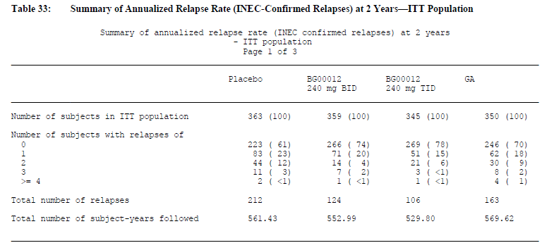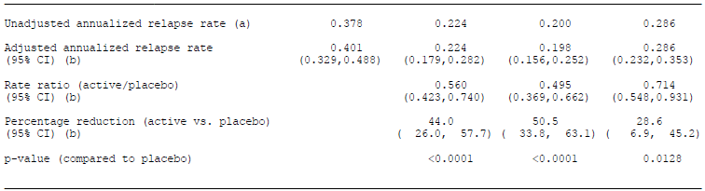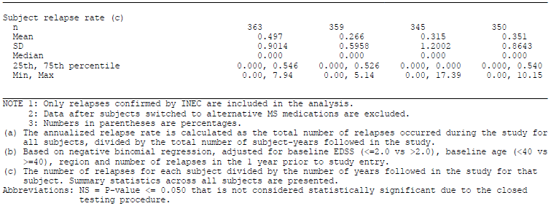
Figure 4. Summary of annualised relapse rate (INEC-confirmed relapses) at 2 years. ITT population.
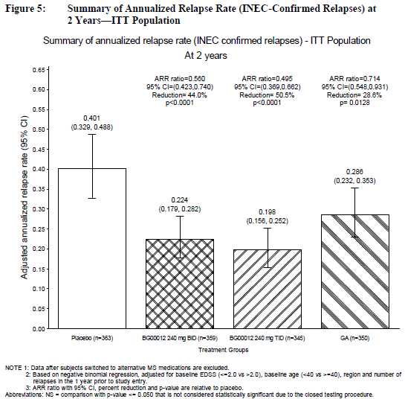
The magnitude of this clinical benefit is modest but it compares favourably to the initial studies that led to registration of the beta-interferons and GA, where reductions in relapse rate of ~30% were noted. It also compares favourably to the 28.6% reduction in annualised relapse rate observed in the active comparator (GA) group, compared to placebo. There was a trend suggesting improved efficacy of BG00012 versus GA but the 95%CIs showed partial overlap, as shown in the table and figure above.
More recent studies in RRMS have shown that reductions in relapse rate of ~50% can be achieved with a range of disease modifying drugs. (For instance, in the FREEDOMS study, fingolimod reduced the relapse rate by 54% for the lower dose, 0.5mg, and by 60% for the higher dose, 1.25 mg, compared to placebo; see <http://clinicaltrials.gov/show/NCT00662649>. Comparisons from one study to the other are inherently unreliable but at least this suggests that BG00012 is broadly comparable in efficacy to its competitors.
The sponsor also performed a number of sensitivity analyses for the primary endpoint, including analyses based on unconfirmed relapses and on relapses including those that occurred before and after switching to alternative therapies. These additional analyses showed that the treatment effect was robust and remained statistically significant under a range of different assumptions (see Figure 5, below).
Figure 5. Summary of annualised relapse rate. Summary of primary and sensitivity analysis results.
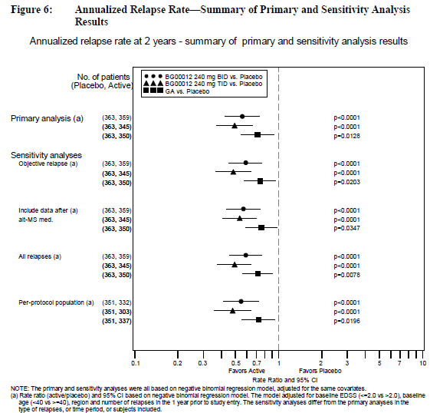

Results for other efficacy outcomes
The proportion of subjects relapsed, which was the primary endpoint of Study 301, was treated as a secondary endpoint in Study 302. The magnitude of the benefit was similar in both studies. The estimated proportion relapsed at 96 weeks was 0.410 in the placebo group, compared to 0.291, 0.241 and 0.321 in the BG00012 BID group, BG00012 TID group and GA group, respectively. This is equivalent to a relative reduction in 2 year risk of 29% ([1-0.291/0.41]x100%), 41% ([1-0.241/0.41]x100%) and 22% ([1-0.321/0.41]x100%) for the three treatments, respectively. The hazard reductions were consistent with this, but showed numerically greater percentage reductions (34%, 45% and 29%).
Table 29. Summary of proportion of subjects relapsed (INEC-confirmed relapses) at 2 years. ITT population.
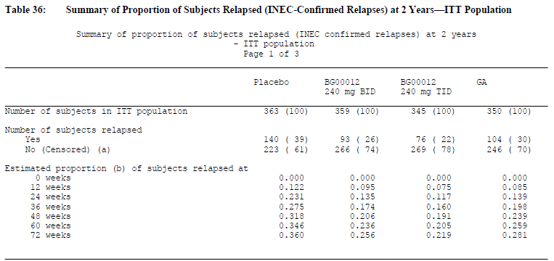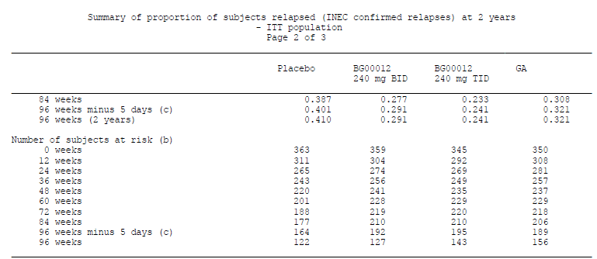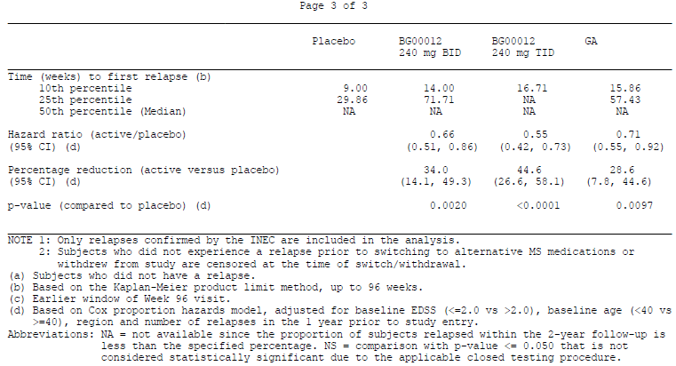
Figure 6. Time to first relapse (INEC-confirmed). ITT population.
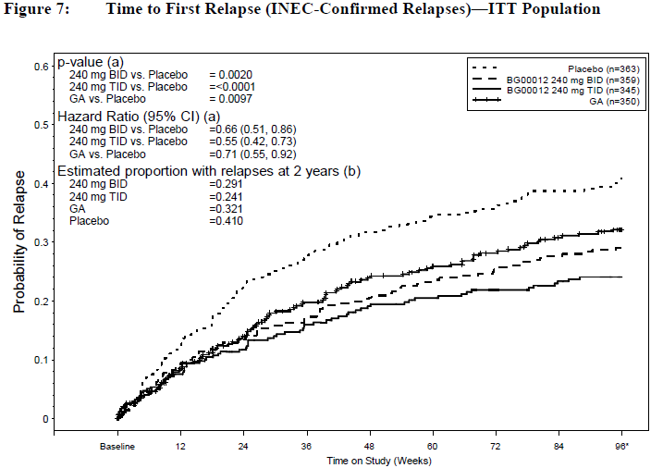
The sponsor described this result as follows: “The hazard ratios (95% CI) obtained from the model were 0.66 (0.51, 0.86) for BG00012 BID and 0.55 (0.42, 0.73) for BG00012 TID, corresponding to reductions of 34% (p=0.0020) and 45% (p <0.0001), respectively, in the risk of relapse following treatment with BG00012 BID and TID compared with placebo.” This statement is somewhat ambiguous but refers to hazard ratios (instantaneous risk), rather than the cumulative 2 year risk.
In the proposed PI, the description slips from being ambiguous to misleading, in that the hazard reduction is described as a “relative risk reduction”; the placement in the sponsor’s table (excerpt below) falsely implies that the 34% reduction was in the proportion relapsing. This needs to be corrected.
Table 30. Clinical and MRI results of study 2.
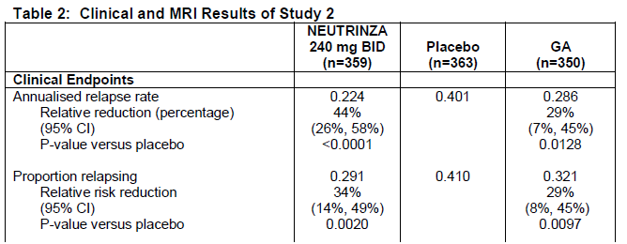
MRI endpoints for Study 302, relative to placebo, have already been shown in the tables under Results for Study 301, which included results for both pivotal studies. The tables below show similar information but also include the GA group.
The number of new or newly enlarging T2 hyperintensities was significantly reduced by BG00012 at either dose, relative to placebo. The mean number of lesions was 19.9 in the placebo group (adjusted 17.4), compared to 5.7 and 5.1 in the BID and TID groups, respectively (adjusted 5.1 and 4.7), an adjusted reduction of 71% and 73% respectively. The GA group showed an intermediate benefit, with a mean of 9.6 lesions (adjusted 8.0, a 54% reduction relative to placebo). All three active treatments were statistically superior to placebo (p<0.0001). The higher TID dose of BG00012 was narrowly superior to GA according to the 95% CIs of the adjusted means, but the proposed BID dose showed overlapping results with GA.
Table 31. MRI: number of new and newly enlarging T2 lesions at 2 years compared to baseline. MRI cohort. Primary analysis.
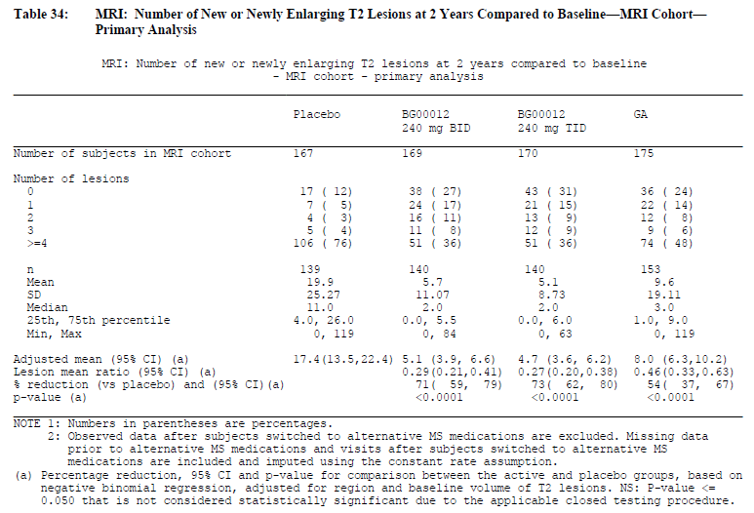
The results for T1 hypointense lesions (“black holes”) were also highly favourable, with both BG00012 dose groups showing clear superiority over placebo, and GA showing a significant but intermediate result.
Table 32. MRI: number of new T1 hyperintense lesions at 2 years compared to baseline. MRI cohort. Primary analysis.
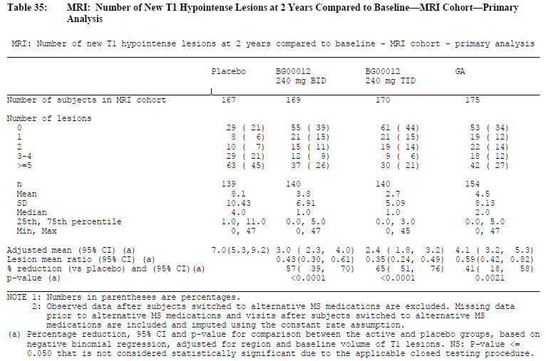
The proportion of patients showing EDSS progression was not significantly altered by active treatment, as shown in the figure below.
Figure 7. Time to confirmed progression of disability (12 weeks confirmation) as measured by EDSS. ITT population.
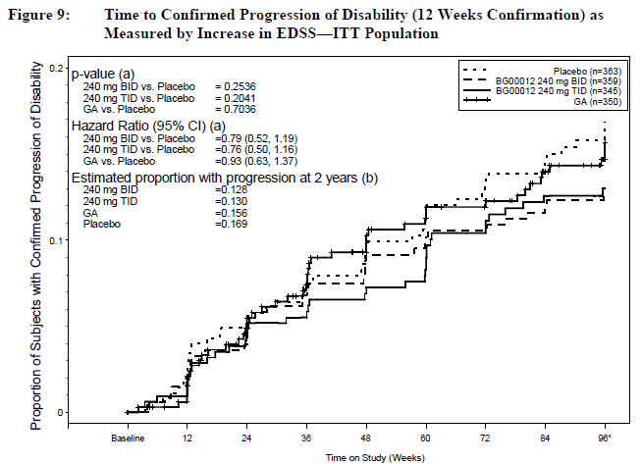
The MSFC was considered a tertiary endpoint in this study. As shown in the figure below, there was a trend in favour of active treatment. All three active dose groups had improved scores at 96 weeks, but were not significantly different from placebo.
Figure 8. MSFC: change of Z-scores from baseline over time. ITT population. Primary analysis.
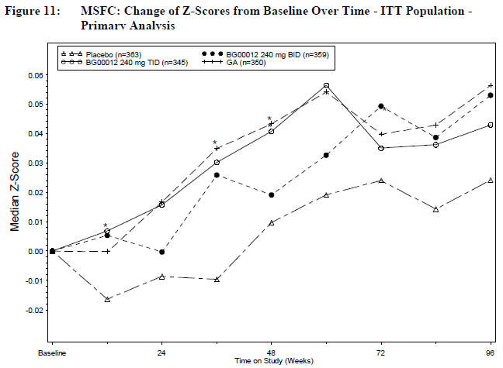

Summary of efficacy comparisons between BG00012 and GA
The sponsor also performed a direct comparison of BG00012 versus GA for the primary endpoint and key secondary endpoints. The results are shown in the figure below. For most measures, the 95% CIs between the proposed BID dosing overlapped with the 95% CIs for GA. The exception was the number of new or newly enlarging T2 lesions, where BG00012 was superior at both doses. For the primary endpoint, annualised relapse rate, the higher BG00012 TID dose was significantly superior to GA but the proposed BID dose was merely numerically superior.
Figure 9. Summary of key efficacy endpoints (ration and 95% CI). BG00012 versus GA comparisons. ITT population.
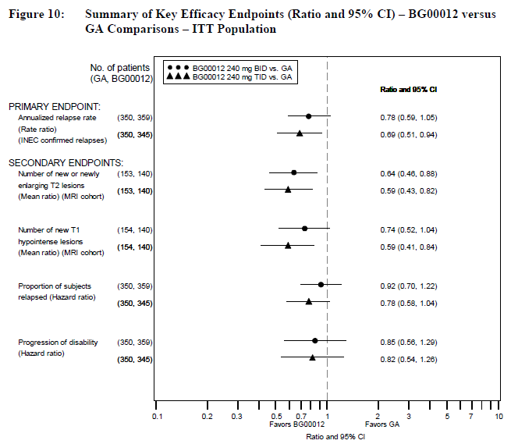

Supportive efficacy studies

Study C-1900

Design
Study C-1900 (n=256) was a Phase II, randomised, multicentre, placebo-controlled, double-blind, parallel-group, dose-ranging study. It consisted of two parts: a 24-week double-blind, placebo-controlled safety and efficacy phase (Part 1) followed by a 24-week dose-blinded, safety-extension phase (Part 2). As a supportive study, it must be considered quite weak because it had a non-clinical, surrogate primary endpoint (the combined number of new Gd-enhancing lesions at Weeks 12, 16, 20, and 24, calculated as the sum of the 4 MRI scans) and it only had a short placebo-controlled phase (the 24 weeks of Part 1) and it did not assess the proposed dose of 240 mg BID. Also, according to the sponsor “No adjustment was made to the Type I error rate for multiple comparisons; all statistical tests were 2-sided with a Type I error of 0.05.” This deficiency is serious because multiple doses were assessed, as well as multiple timeframes in which MRI parameters were compared.
Subjects were initially randomised in a 1:1:1:1 ratio to receive 1 of 3 doses of BG00012 (120 mg QD, 120 mg TID, or 240 mg TID) or matching placebo for 24 weeks. The two lowest dose groups received a lower daily dose than that proposed for treatment, whereas the highest dose group exceeded the proposed dose.
In the extension phase, subjects who received placebo in Part 1 switched to the highest dose of BG00012 (240 mg TID) while the other dose groups continued on their original BG00012 dosing regimen.
Inclusion criteria were similar to the subsequent Phase III studies. Patients were eligible if they:
- Were 18 to 55 years old, inclusive, at the time of informed consent.
- Had a confirmed diagnosis of RRMS according to McDonald criteria (McDonald et al, 2001).
- Had a baseline EDSS between 0.0 and 5.0, inclusive.
- Had active disease, as evidenced by at least 1 relapse within the previous 12 months, or Gd-enhancing lesions on MRI.
- Agreed to use effective contraception during the study
Exclusion criteria consisted of other significant comorbidities, recent use of other MS treatments or experimental agents.
A total of 257 subjects were randomised at 42 sites in the European Union. Of these, 256 subjects received at least 1 dose and 235 subjects completed Part 1 of the study; 225 subjects entered Part 2 and 219 of these completed Part 2.
MRI endpoints were analysed using the “efficacy evaluable” population, defined as those subjects without any missing MRI data from Weeks 12 to 24, whose scans were performed per protocol, and who did not take prohibited alternative MS medications. This population included 223 patients (54, 59, 56, and 54 from the placebo, BG00012 120 mg QD, 120 mg TID, and 240 mg TID groups, respectively).

Baseline data
Baseline demographics for the ITT population are shown below; the results were similar in the “efficacy evaluable” population. There were no significant mismatches across the treatment groups.
Table 33. Demography. ITT population. BG 00012
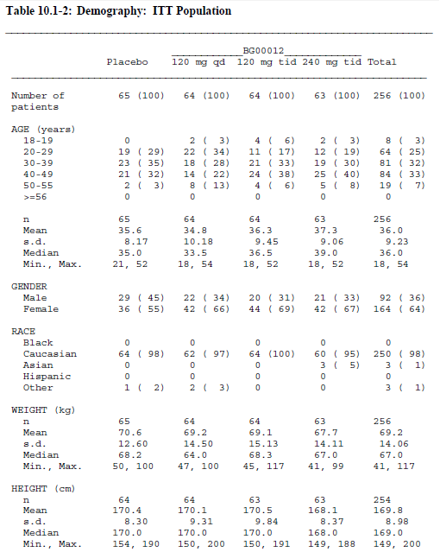
Baseline disease characteristics were also reasonably matched, in terms of years since symptom onset and number of relapses in the previous 12 months.
Table 34. History of MS. ITT population.BG00012
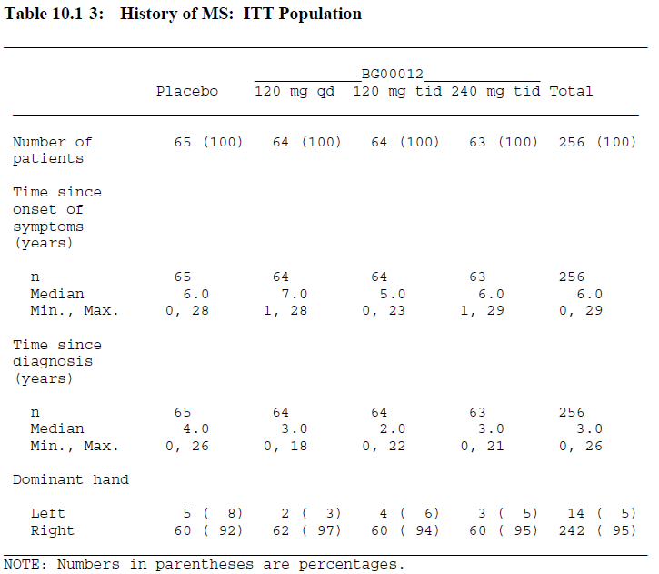
Table 35. History of relapses.
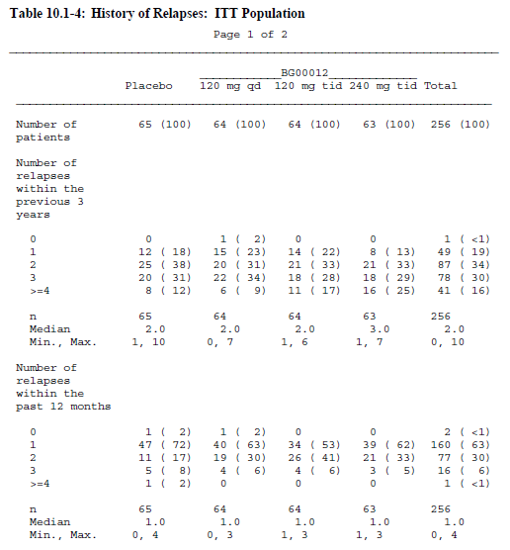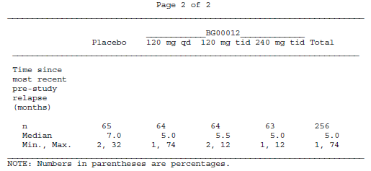
Table 36. Baseline MRI evaluation. ITT population.
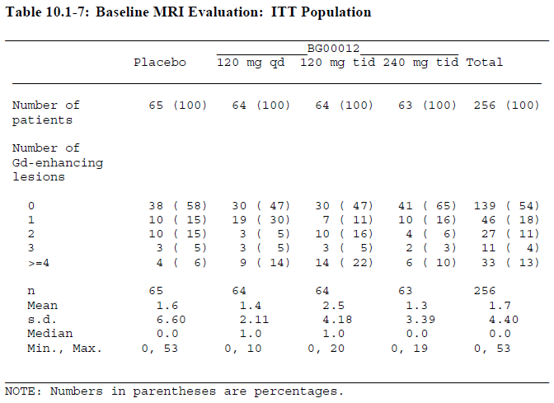

Efficacy results
The primary endpoint in this study was the number of Gd-enhancing lesions (which would not be considered an adequate endpoint in a Phase III study). The sponsor considered the combined number of lesions between Weeks 12 to 24 and between Weeks 4 to 24. Only the highest dose-group (BG00012 240mg TID) showed a significant benefit versus placebo, with a mean of 1.4 combined lesions from Week 12 to 24, compared to 4.5 with placebo (p=0.002). The lower doses produced an intermediate number of lesions, as shown in the table below. The results from Week 4 onwards were also significantly in favour of the high-dose group but the magnitude of the benefit appeared smaller, probably reflecting a delay in the onset of radiologically apparent benefit.
Table 37. Study C-1900 summary of key efficacy results.
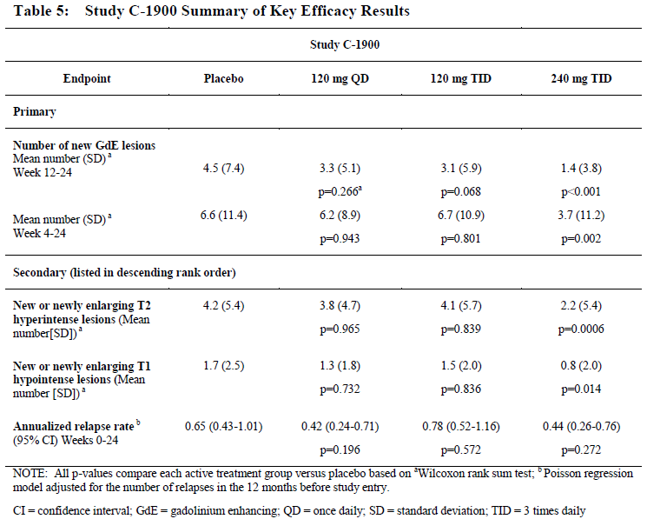
Secondary MRI endpoints including the number of new or enlarging T2 lesions and T1 hypointense lesions also showed a significant treatment benefit at the highest dose but merely weak trends in favour of active treatment at lower doses, as shown above.
Only one secondary endpoint was clinical, and that was the annualised relapse rate. Considering that patients were only treated for 24 weeks in Part 1, this is an insensitive measure and it did not show a significant benefit with active treatment. The mean annualised number of relapses was 0.44 in the highest dose group, compared to 0.65 with placebo (p=0.272). This trend is broadly consistent with that demonstrated in the later Phase III studies. Lower doses showed an inconsistent effect, with the relapse rate at 120 mg TID showing inferiority relative to placebo.
Overall, this weak supportive study indicates that some efficacy of BG00012 is probable at doses of around 240 mg TID and unlikely at doses of 120 mg TID or less. The proposed dose is between these two extremes. Efficacy was much more thoroughly assessed in the later Phase III studies and this study does little to support or undermine conclusions based on those later studies.

Analyses performed across trials
Both pivotal studies assessed a similar population of subjects with MS and used the same doses of BG00012 for a similar duration. Efficacy assessments were performed with the same methodology and the primary endpoints of both studies were based on relapses, though the actual endpoints differed (Study 301 was based on proportion relapsed, and Study 302 on relapse rate). It was therefore appropriate to pool the data from both studies in a supportive analysis that had improved statistical power compared to either of the individual studies. The figures derived from the pooled analysis are reproduced below. Overall, the pooled analysis was consistent with the individual studies, showing a clear treatment effect for either of the active doses tested (240 mg BID or TID), relative to placebo. This included a reduction in annualised relapse rate, improved MRI parameters and a significant reduction in the proportion of patients relapsed.
Because the individual studies were already strongly positive for their primary endpoints and most of their secondary endpoints, the submission does not particularly rest on this pooled analysis. The pooled subgroup analysis (Figure 11 and Figure 12) was useful, however, in that it showed a consistent therapeutic effect across a range of subgroups based on baseline demographics and disease characteristics. The pooled analysis of proportion with progression of disability was also useful, because this endpoint had been positive in Study 301, but negative in Study 302 (Figure 13). When the studies were combined (Figure 14), the difference between active treatment and placebo was statistically significant for either active dose.
Figure 10. Summary of annualised relapse rate (INEC-Confirmed relapses) by 6 month interval. ITT population, studies 301 and 302 (pooled data).
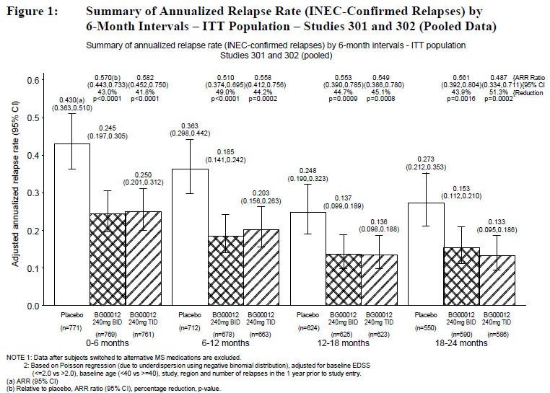
Figure 11. Summary of annualised relapse rate (INEC-Confirmed relapses) at 2 years-rate ratio and 95% CI. ITT population, by baseline demographic subgroups. Studies 301 and 302 (pooled data).
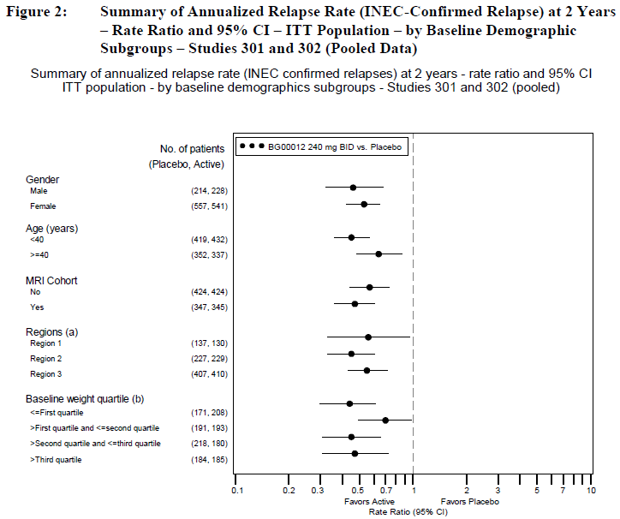
Figure 12. Summary of annualised relapse rate (INEC-Confirmed relapses) at 2 years-rate ratio and 95% CI. ITT population, by baseline disease characteristics subgroups. Studies 301 and 302 (pooled data).
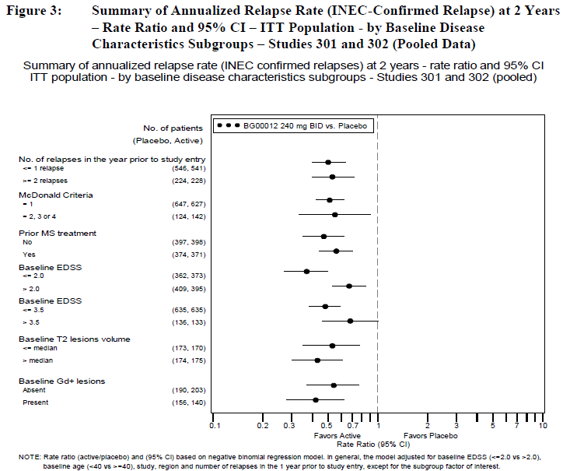
Figure 13. Summary of time of confirmed progression of disability at 2 years (12 weeks confirmation and 24 weeks confirmation). Hazard ratio and 95% CI. Studies 301 and 302 (pooled data).
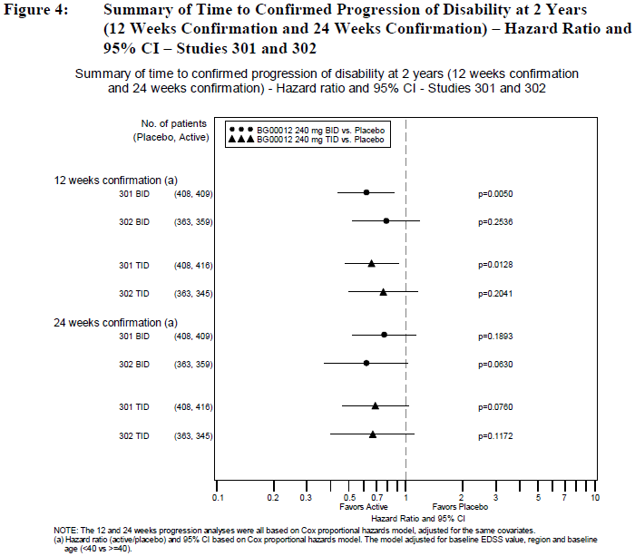
Figure 14.Time to confirmed progression of disability at 2 years (12 weeks confirmation. Studies 301 and 302.
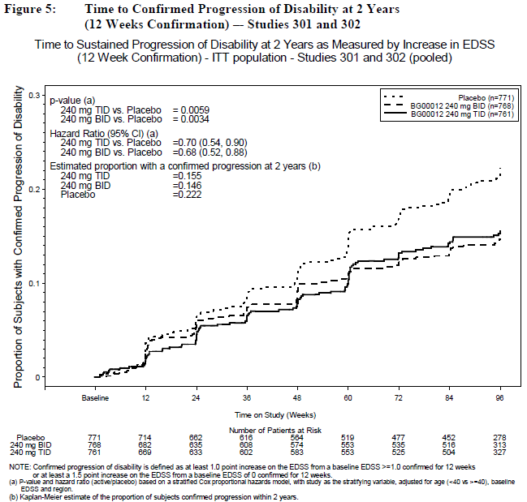
Table 38. BG00012 dose comparison of primary and secondary efficacy endpoints relative to placebo. Studies 301 and 302 (pooled).
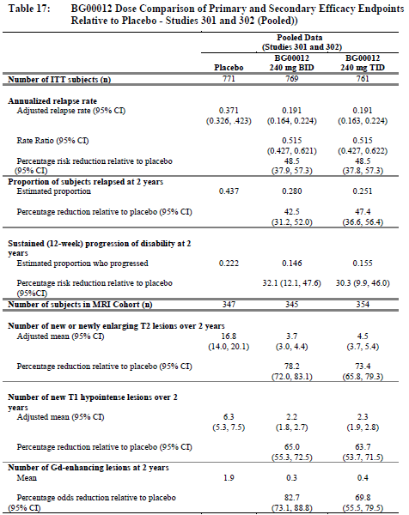
Table 39. Summary of annualised relapse rate (INEC-confirmed relapses) post last dose of study treatment. Studies 301 and 302 (pooled).
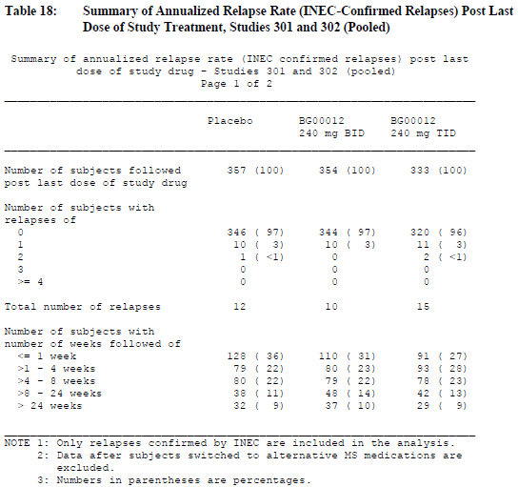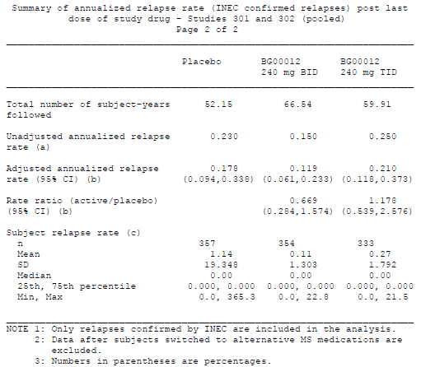

Evaluator’s conclusions on clinical efficacy
The important endpoints from both pivotal studies are tabulated below. Active treatment with BG00012 for “2 years” (96 weeks) at the proposed dose of 240 mg BID reduced the proportion of subjects relapsing from 0.461 to 0.270, in Study 301 (where this parameter was the primary endpoint) and from 0.410 to 0.291 in Study 302. Both reductions were statistically significant. This endpoint was reported in a potentially misleading manner in the sponsor’s Summary of Clinical Efficacy and the proposed PI, and the sponsor should clarify the cumulative relative risk reduction for this endpoint prior to final approval of the PI.
Most pivotal MS studies for other agents have used the annualised relapse rate as their primary endpoint. Active treatment with BG00012 reduced the annualised relapse rate from 0.364 to 0.172, in Study 301 and from 0.401 to 0.224, in Study 302 (where this parameter was the primary endpoint). This corresponds to relative reductions of 53% and 44%, respectively. These reductions were highly statistically significant, and they were of a magnitude likely to be of clinical value. The reductions in relapse rate with BG00012 were broadly comparable to reductions seen with other disease-modifying treatments in MS, although direct comparisons across different studies are inappropriate
Treatment with BG00012 240 mg BID was also associated with highly significant reductions in disease activity as assessed by MRI, in both clinical studies, for a range of individual MRI parameters including the major MRI parameter, new or newly enlarging T2 lesions.
Results for disability progression were less consistent. In Study 301, BG00012 240 mg BID reduced the proportion of patients progressing from 0.271 to 0.164 and this was highly significant (p=0.005). In Study 302, the proportion progressing was reduced from 0.169 to 0.128, which was favourable but not significant (p=0.25). In a pooled analysis, the overall effect on disease progression was significant (32% risk reduction, 95%CI 12.1 to 47.6%).
Efficacy results for the 240 mg TID regimen were generally similar to the 240 mg BID regimen, which supports the validity of the results.
Table 40. Pivotal phase III studies 301 and 302 individual efficacy results at 2 years.
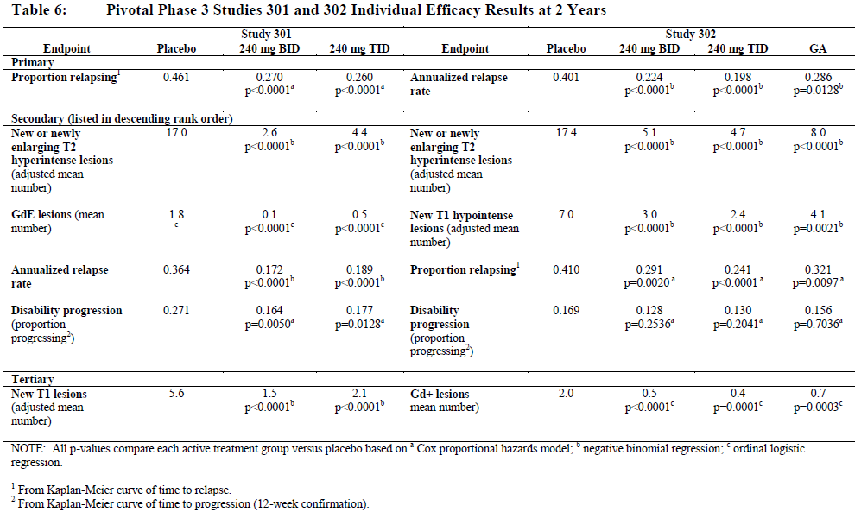

Clinical safety

Studies providing evaluable safety data
The sponsor performed an integrated safety analysis based on 3 placebo-controlled studies in MS (Study C1900, Study 301 and Study 302), which were combined into Pool A. The sponsor also considered the broader population of patients from extension studies, including the second part of C1900 and Study 303, which was the open-label extension of the pivotal studies. These were combined into Pool B. The Pool A data is more meaningful, because active treatment can be compared with placebo but the Pool B data covers a longer period of treatment, up to 5 years, and a greater number of patients, because previous placebo recipients switched to active treatment.
Table 41. Pools for integrated safety analysis in MS.
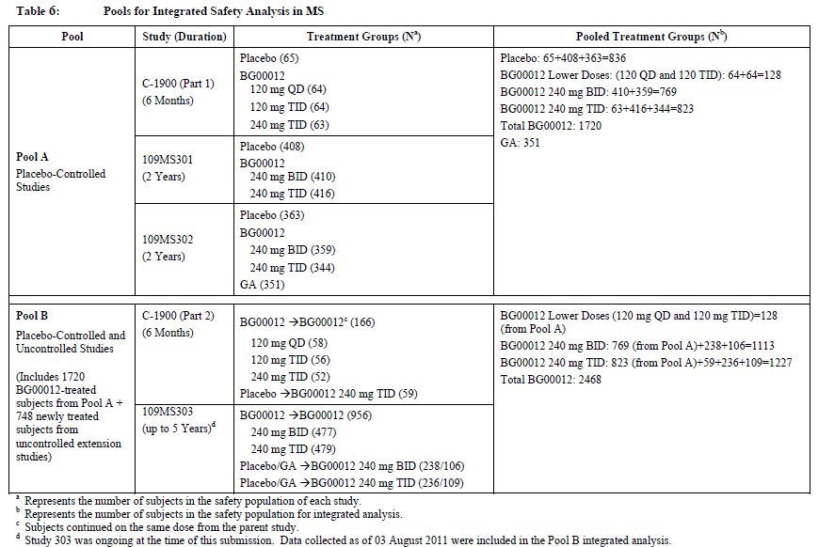
A small number of subjects were also assessed in the Clinical Pharmacology program, and in studies of psoriasis and rheumatoid arthritis (see below).
In all of the studies contributing to Pool A, a standard approach was taken to collect safety data. Adverse events were detected during routine scheduled consultations and when patients had unscheduled presentations to their doctor or Emergency Department. Standard monitoring for abnormalities in laboratory tests was performed at regular intervals.

Patient exposure
Patient exposure to BG00012 in MS studies is summarised in Table 42 below. Exposure in psoriasis studies is shown in Table 43 and in the Clinical Pharmacology program in Table 44. Exposure in patients with rheumatoid arthritis was limited: 101 subjects were exposed to BG00012 and 51 subjects were exposed to placebo in Study 109RA201. These treatments were administered with methotrexate, which potentially confounds the assessment of safety because of its own adverse event profile.
Table 42.MS Studies included in the summary of safety.
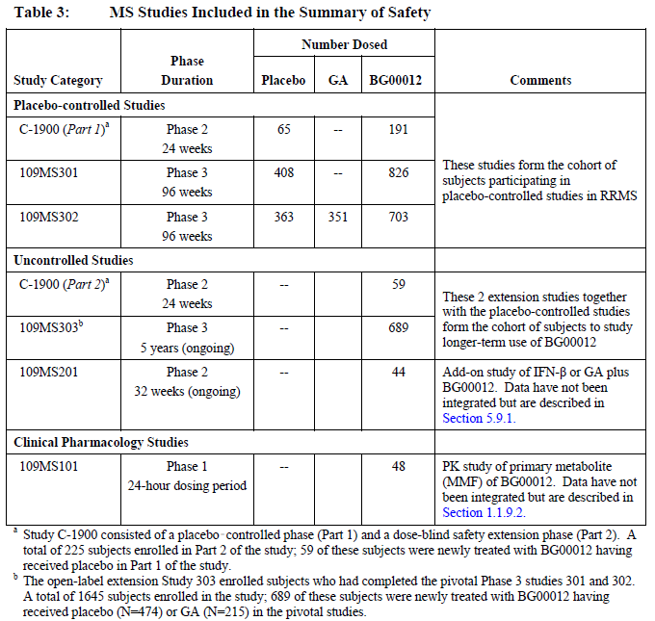
Table 43. Supportive psoriasis studies included in the summary of safety.
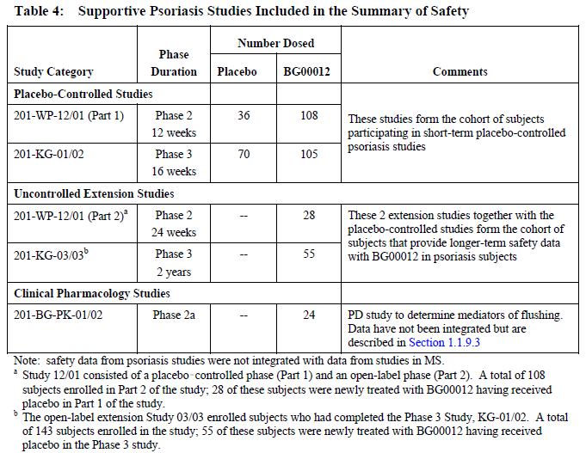
Table 44.Studies in healthy volunteers included in the summary of safety.
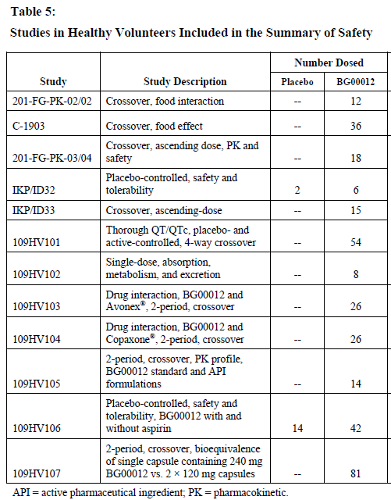
For placebo-controlled safety data, the duration of exposure is summarised below. Most subjects were followed for ≥ 84 weeks, and about half for ≥ 96 weeks. A total of 769 subjects received the proposed dose (240 mg BID), and 823 received a higher dose (240 mg TID). This represents an adequate exposure for the detection of common adverse events but does not allow assessment of rare side effects, which will require on-going postmarketing surveillance.
Table 45. Overall extent of exposure: Controlled MS studies (Pool A).
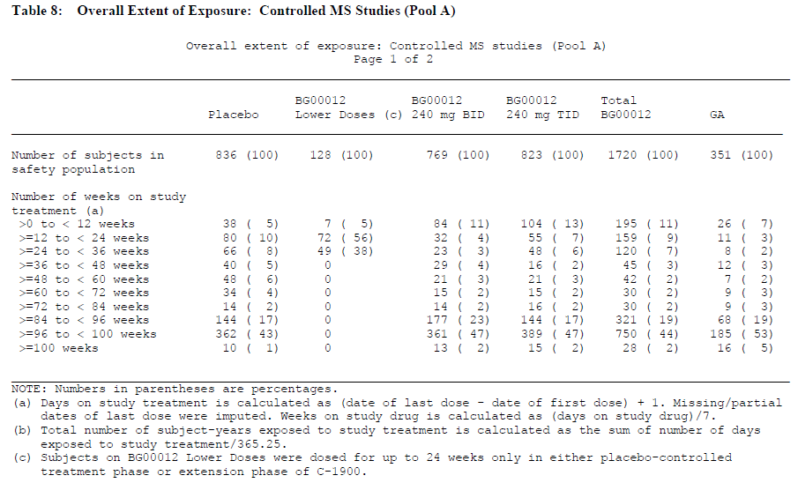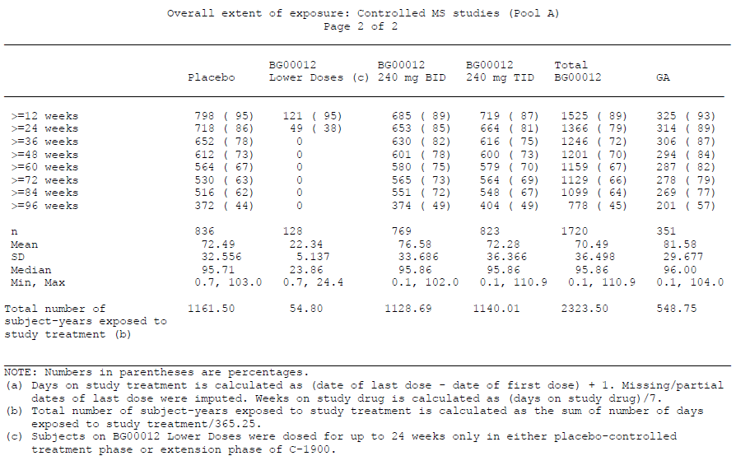

Adverse events

All adverse events (irrespective of relationship to study treatment)
Adverse events (AEs) were extremely common with active treatment and with placebo, as expected for any study of two years duration. The overall proportion of subjects with at least one AE was so high (87-94%) that a comparison across groups is barely meaningful. Considering just those with a severe event, the incidence was similar with the proposed dose (15%) and with placebo (14%).
Table 46. High level summary analysis of AEs: controlled MS studies (pool A).
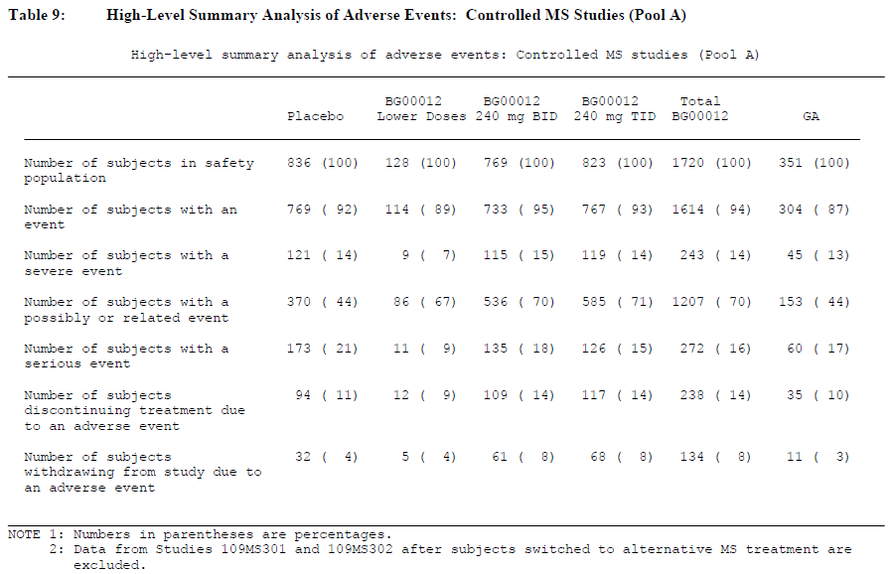
Table 47. Incidence of AEs experienced by 5% or more of subjects in any treatment group-by preferred term. Controlled MS studies (pool A).
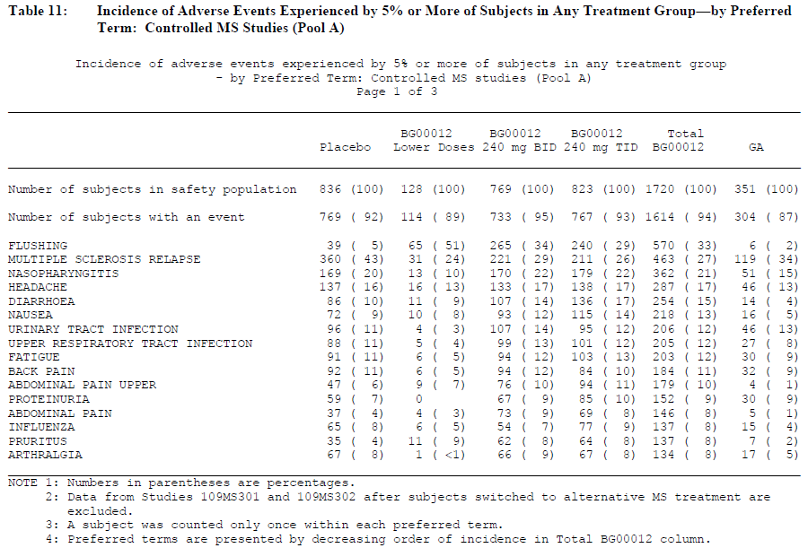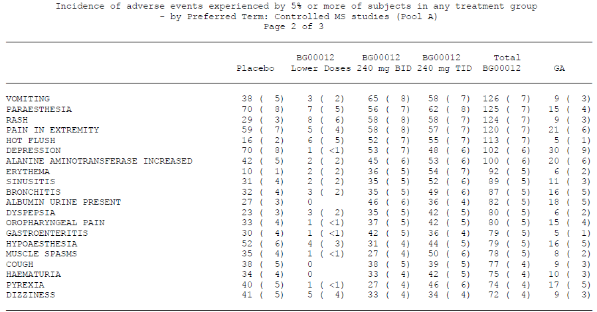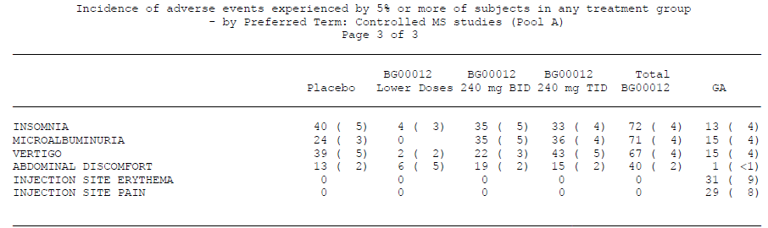
In Pool B, which includes non-placebo-controlled data, the percentages of subjects in the BID and TID groups with any AE (91% and 90%, respectively), severe AEs (15% and 13%), treatment-related AEs (68% and 69%), AEs leading to treatment discontinuation (14% and 16%) and AEs leading to study withdrawal (10% and 12%) were similar to those observed in the corresponding groups in Pool A. Without a placebo control group, this is difficult to interpret but there is no strong evidence of worsening tolerability with continued use.
Some individual types of AE were seen more commonly with active treatment than with placebo, as shown below (for the proposed dose only). Flushing, in particular, was very common with BG00012 at the proposed dose, occurring in 35% of subjects, compared to 4% of placebo recipients. Gastrointestinal disorders were also more common, with an excess of diarrhoea, nausea, abdominal pain, vomiting and dyspepsia. Skin reactions were also more common, with pruritus occurring in 8% of BG00012 recipients but only 4% of placebo recipients, rash occurring in 8% versus 3% and erythema in 5% versus 1%.
Some laboratory-based AEs were also more common with BG00012, including lymphopenia (~2% versus <1%), albuminuria (6% versus 4%) and elevated aspartate aminotransferase (6% versus 4%).

Adverse events. BG00012 versus placebo
Table 48. AEs in placebo controlled MS experience for studies 301 and 302 reported for BG000012 240 mg BID at ≥2% higher incidence than placebo.
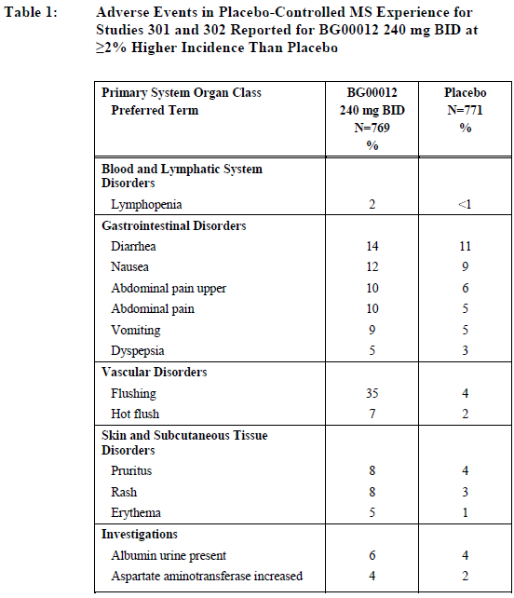
Considering other doses of BG00012, as shown in the table below, a similar side effect profile is seen with the proposed dose of 240 mg BID and the higher dose of 240 mg TID, and a lower incidence of side effects seems to occur with lower doses. Flushing did not show a clear dose-response curve and was actually seen more commonly at lower doses (51%, versus 34% at the proposed dose).
The tolerability of GA appears superior in the table below, with less flushing and less gastrointestinal intolerance than was observed with BG00012 but GA can produce injection-site reactions and may be less attractive to many patients simply because it is injected.
Table 49. Incidence of AEs at least 2% higher for any BG00012 group or GA relative to placebo by preferred term. Controlled MS studies (pool A).
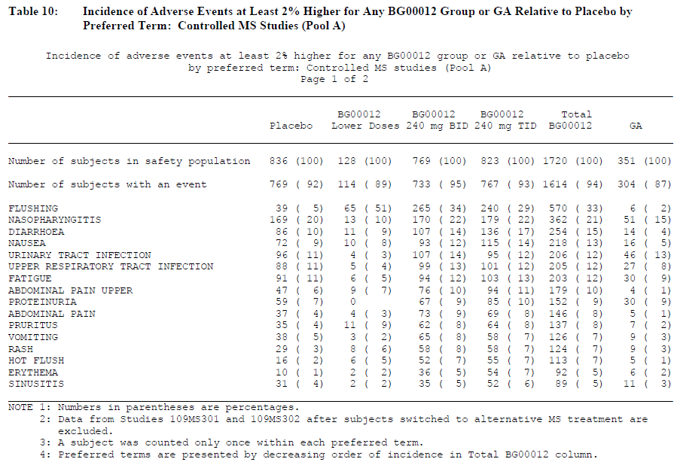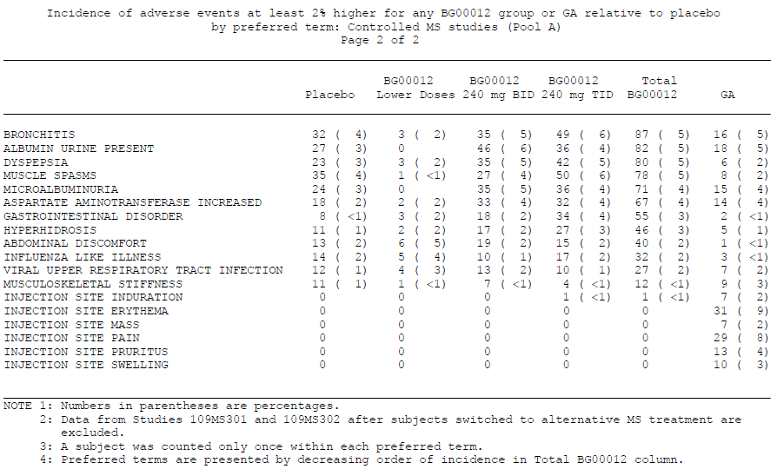

Treatment-related adverse events (adverse drug reactions)
Investigators were asked to indicate whether they thought AEs had a causal relationship to study drug, as is standard practice in studies of this nature. Such causal attribution is inherently unreliable but most of the AEs that were more common in the BG00012 group were also more commonly attributed to BG00012 by the study investigators. The table below lists AEs thought to be related to treatment (“Adverse Drug Reactions”), broadly grouped according to incidence. Flushing and gastrointestinal symptoms were “very common”, whereas skin reactions, lymphopaenia, leukopenia, elevated AST and ALT and albuminuria were “common”.
Table 50. Adverse drug reactions for BG00012
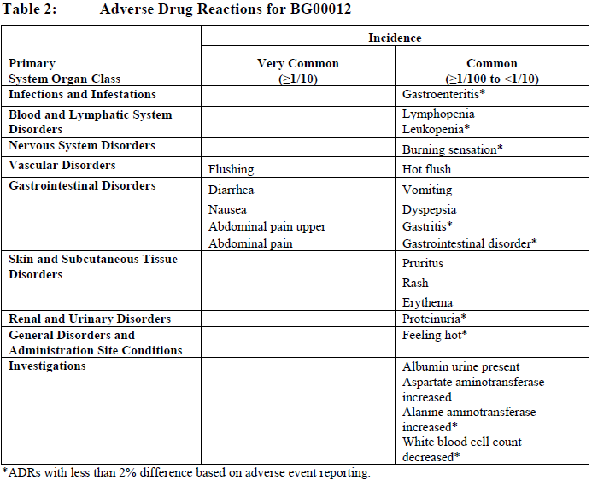

Severe adverse events
In the placebo-controlled studies (Pool A), severe adverse events occurred with a similar incidence in the active and placebo groups, as shown below.
Table 51. Incidence of severe AEs experienced by at least 3 subjects in any group by system organ class and preferred term. Controlled MS studies (pool A).
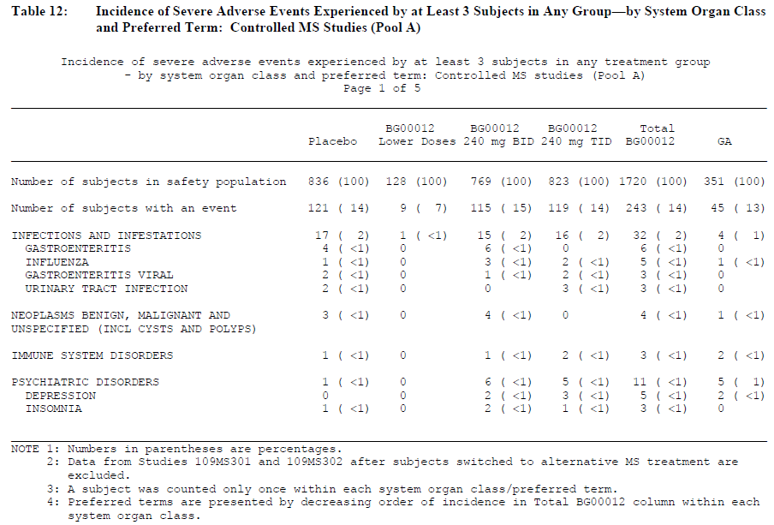
Table 51 continued. Incidence of severe AEs experienced by at least 3 subjects in any group by system organ class and preferred term. Controlled MS studies (pool A).
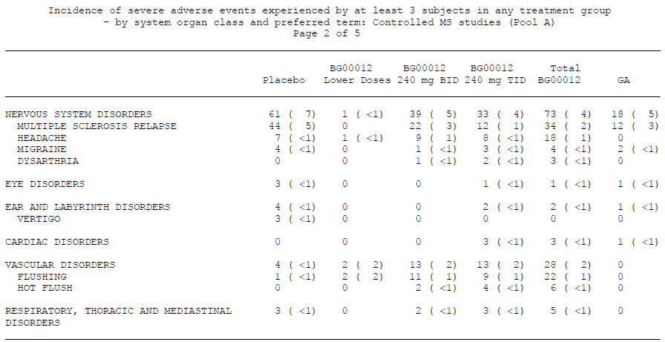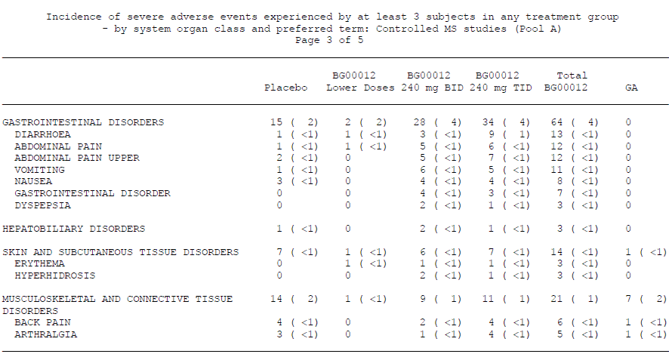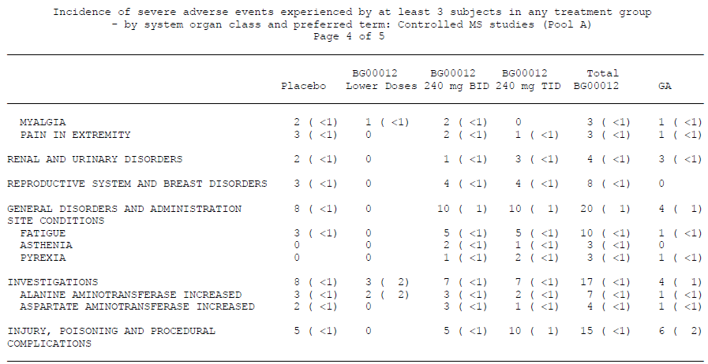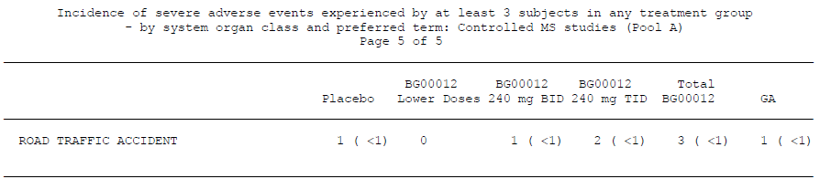

Deaths and other serious adverse events

Deaths
Seven deaths were reported in MS studies, including placebo-controlled as well as uncontrolled studies. Five of these deaths were reported in pivotal Studies 301 and 302: ischemic stroke in a placebo-treated subject, traumatic brain injury from a bicycle accident in a subject receiving BG00012 BID group, a motor vehicle accident in a subject receiving BG00012 TID, complications of an MS relapse in another subject receiving BG00012 TID and suicide in a GA-treated subject.
The other two deaths were reported for BG00012-treated subjects in the uncontrolled Study 303. One was attributed to MS relapse and cardiopulmonary arrest, related to paraplegia and respiratory muscle weakness, in the BG00012 BID group. The other was a suicide by paracetamol overdose in a subject receiving BG00012 TID.
None of the causes of death was assessed by the Investigators as treatment-related and reviews of the narrative summaries did not raise any particular safety concerns.

Serious adverse events
Serious adverse events (SAEs) in the controlled MS studies are tabulated below. Overall, SAEs were slightly more common with placebo than with the proposed dose of BG00012 and the incidence of SAEs with the TID dose was slightly lower again. The incidence of SAEs with GA was similar to that seen with the proposed dose of BG00012.
Considering SAEs by System Organ Class, there was little difference between placebo and the proposed dose of BG00012. For most organ classes, there was a slight excess of events in the placebo group or no real difference between groups when the percentage incidence was rounded to the nearest percent. For the category of “Infections and infestations”, there was a minor excess in the BG00012 group (2% for the proposed dose, 1% for placebo). Gastroenteritis was the most common infection; it is possible that this was diagnosed more commonly because of gastrointestinal intolerance related to BG00012.
Overall, the SAE profile does not raise any major concerns.
Table 52. Incidence of severe AEs experienced by at least 2 subjects in any treatment group by system organ class and preferred term. Controlled MS studies (pool A).
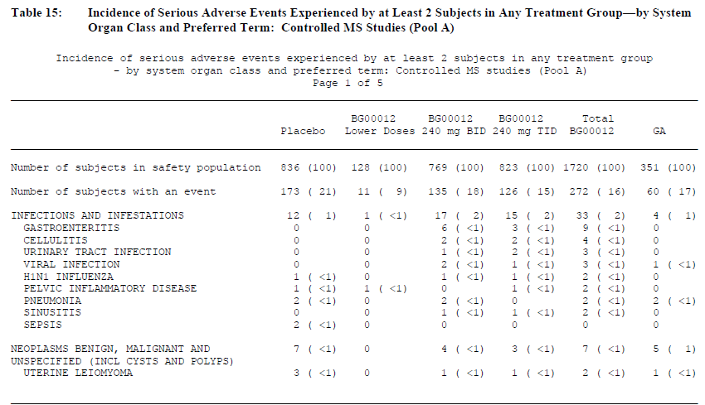
Table 52 continued. Incidence of severe AEs experienced by at least 2 subjects in any treatment group by SOC and PT. Controlled MS studies (pool A).
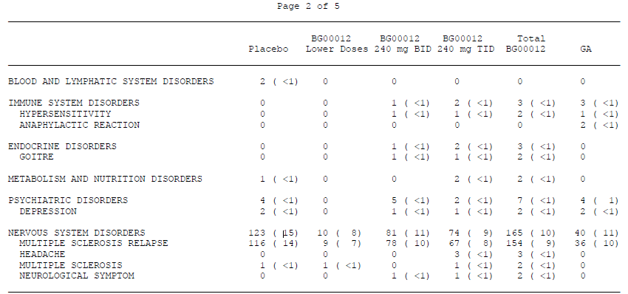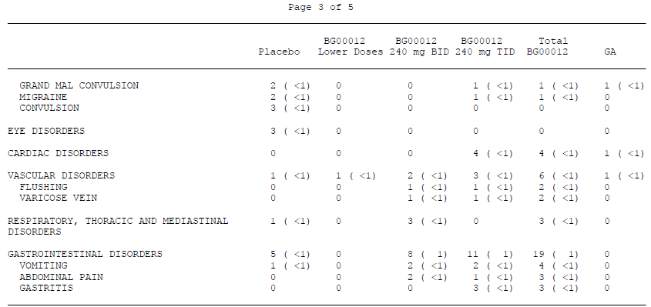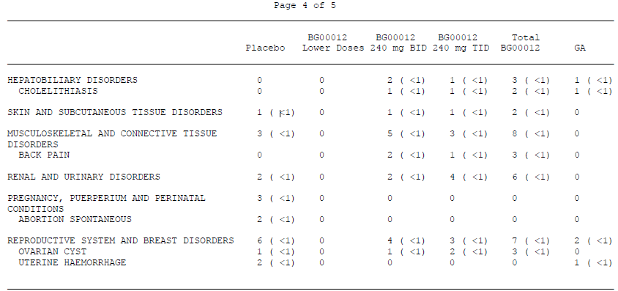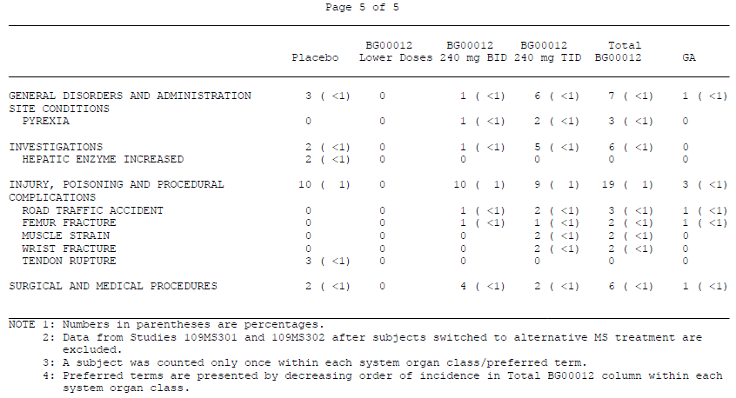

Discontinuation due to adverse events
Discontinuations due to adverse events (DAEs) reflected the overall AE profile. In Pool A, DAEs were slightly more common with BG00012 than placebo (11% placebo versus 14% BG00012 BID, 14% BG00012 TID, 10% GA). The most common DAE was MS relapse, which was reported more frequently with placebo than with BG00012 (placebo 6% versus 1% BG00012 BID, 2% BG00012 TID, 2% GA).
In the BG00012 groups, there was an increased incidence of DAEs in the Gastrointestinal organ class, (<1% placebo versus 4% BG00012 BID, 6% BG00012 TID, <1% GA). This difference was largely accounted for by an increased incidence in diarrhoea, nausea, vomiting and abdominal pain.
The incidence of treatment discontinuations due to flushing was also higher in the BG00012 groups than in the placebo group (<1% placebo versus 3% BG00012 BID, 2% BG00012 TID, 0% GA).
DAEs due to skin disorders were more common with BG00012 (<1% placebo versus 2% BG00012 BID, 2% BG00012 TID, <1% GA).
The incidence of treatment discontinuations due to elevations in liver transaminases was low and balanced across groups (<1% for each of ALT increased, AST increased, hepatic enzyme increased).

Flushing
Flushing was a noted feature during the Clinical Pharmacology program and an expected side effect when the pivotal studies were performed. About 30% of patients reported flushing as an AE. The sponsor notes that the incidence of flushing showed a decrease during continued treatment, as reflected in the figure below but it is unclear whether this represents a true reduction in flushing or a failure of patients and clinicians to re-report a persistent side effect.
The best indicator of whether flushing is a significant problem with BG00012 is the discontinuation rate attributed to flushing in the controlled studies: <1% placebo versus 3% BG00012 BID, 2% BG00012 TID and 0% GA. Given that the flushing is primarily a tolerability issue, rather than a safety concern, this was considered acceptable. The draft PI carries appropriate warnings and clinicians will have to warn subjects about the likely occurrence of flushing.
Figure 15. Incidence of flushing and other relates symptoms by 1 month intervals. placebo, BG00012 240 mg BID and TID in controlled MS studies (pool A).
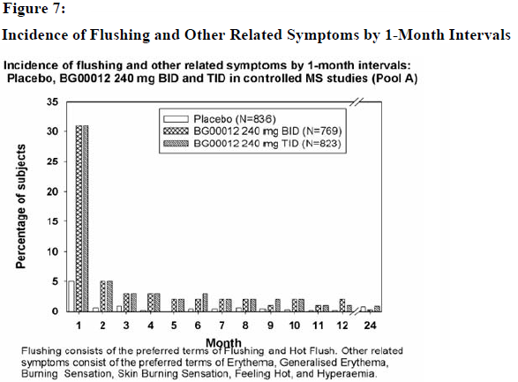

Gastrointestinal intolerance
Gastrointestinal intolerance is the other main tolerability issue raised by the submitted studies, and may make BG00012 an unsatisfactory option for some patients. As with flushing, the sponsor points out that GI intolerance was reported with declining frequency as the study progressed. It is unclear whether this represents a true decline in GI symptoms or a failure to re-report the same persistent symptoms. At the proposed dose, discontinuations due to GI symptoms affected about 1 in 25 patients (<1% placebo versus 4% BG00012 BID, 6% BG00012 TID, <1% GA), which is acceptable overall.
Figure 16. Incidence of gastrointestinal tolerability by 1 month intervals. Placebo, BG00012 240 mg BID and TID in controlled MS studies (pool A).
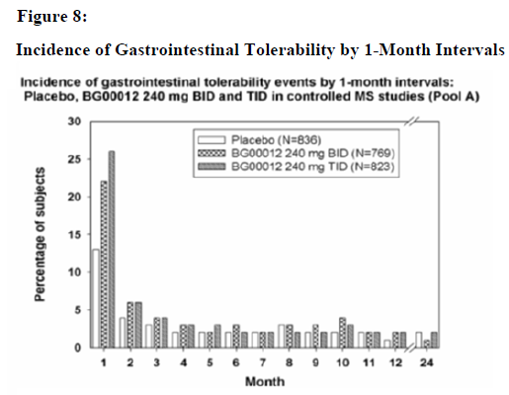

Laboratory tests

Liver function
In the Pool A (placebo-controlled) analysis, subjects receiving BG00012 showed an increased incidence of abnormal liver function tests, though this was more marked in the first few weeks of treatment and settled with continued treatment (see figure below). Only a small proportion of patients had aspartate transaminase (AST) or alanine transaminase (ALT) values ≥ 3 times the upper limit of normal (ULN), and the proportion of such patients was similar across groups, as shown in the tables below. Elevated bilirubin was slightly more common with placebo or GA than with BG00012 (see table).
Reassuringly, there were no cases of BG00012-treated subjects who had concurrent elevations of hepatic transaminases ≥3 times ULN and an elevated total bilirubin >2 × ULN. Discontinuations due to elevated hepatic transaminases were infrequent (<1%) and were similar in subjects treated with BG00012 or placebo.
SAEs involving hepatic enzymes were rare. In Pool A, 2 placebo recipients reported SAEs of “hepatic enzymes increased” and 1 subject in the BG00012 BID group had an SAE of cholestatic hepatitis.
Results were broadly similar in Pool B, following longer-term treatment with BG00012. The incidence of values ≥3 × ULN for ALT or AST were not elevated compared with Pool A. (not shown)
Figure 17. ALT-mean values (±SE) over time. Controlled MS studies (pool A).
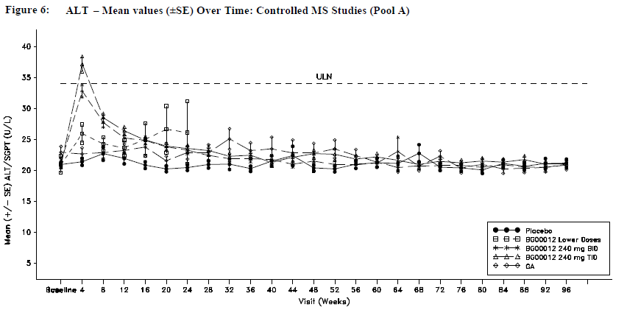
Table 53. Summary of maximum post-baseline values. Liver enzymes (ALT, AST, gamma glutamyltransferase (GGT) and bilirubin). Controlled MS studies (pool A).
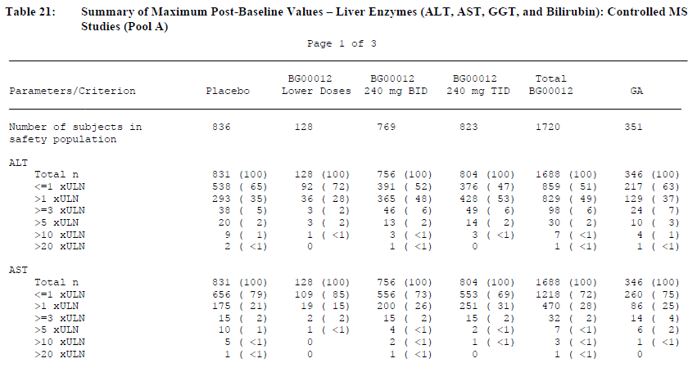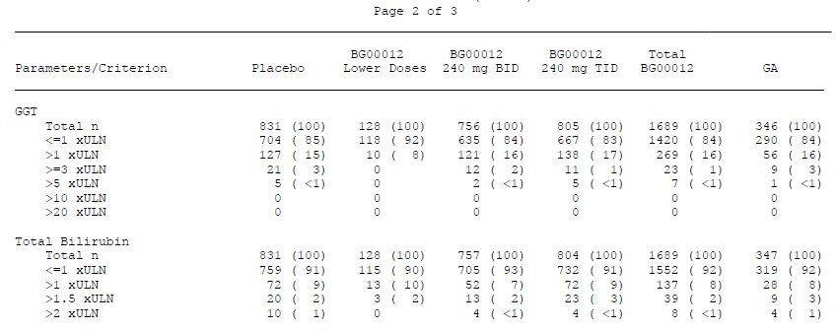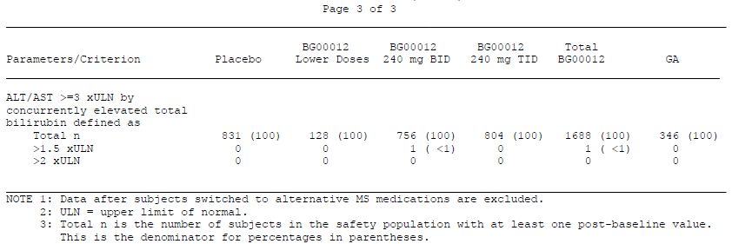

Kidney function
There was no substantial difference across groups in the incidence of abnormal urea, creatinine or electrolytes. There was a slightly increased incidence of shifts to high bicarbonate with BG00012 treatment: BG00012 BID (16%), BG00012 TID (15%), placebo (9%) and GA (10%). This is unlikely to be clinically significant.
Urinalysis did not show any notable differences between groups. Albumin in the urine was reported as an AE in 6% of subjects who received BG00012 240 mg BID and 4% of placebo recipients.

Other clinical chemistry
Lipids seemed to show minor changes in response to BG00012 but these were favourable: small increases in mean High density lipoprotein (HDL) and decreases in mean triglycerides were observed in BG00012 recipients and there was an increased incidence of favourable shifts in these parameters.

Haematology
BG00012 treatment was associated with a reduction in mean white blood cell (WBC) and lymphocyte counts during the first year by approximately 10% and 30%, respectively, followed by a plateau. Mean and median WBC and lymphocyte counts remained within normal limits.
WBC counts <3.0 × 109/L and lymphocyte counts <0.5 × 10⁹/L were rare in placebo-treated subjects (1% and <1%, respectively) but were much more common in BG00012 recipients (7% and 6%, respectively). These low counts were not associated with serious infections.
No cases of leukopenia were rated as Grade 4 but one case of lymphopaenia reached values in the Grade 4 range: a 39 year-old female who received BG00012 240 mg BID had normal lymphocyte counts at baseline (1.41 × 10⁹/L) but steadily declined following Week 24. At Week 72, her lymphocyte counts decreased to 0.14 × 10⁹/L (CTC Grade 4). She subsequently completed the study without incident and entered the extension study. By Week 12 of the extension study, the subject’s lymphocyte count was 0.41 × 10⁹/L.
Prolonged treatment did not appear to worsen mean WBC and lymphocyte counts, which remained stable in subjects who received BG00012 for more than 2 years.
A transient increase in mean eosinophil counts was also observed during the first 2 months of treatment.
Red blood cells and haemoglobin were not affected by treatment, in terms of mean values and in shifts from normal (see table below).
Figure 18. Haematology parameters (WBC and lymphocytes). Mean values (±SE) over time. Controlled MS studies (pool A).
- Lab test WBC (x10-9/L).
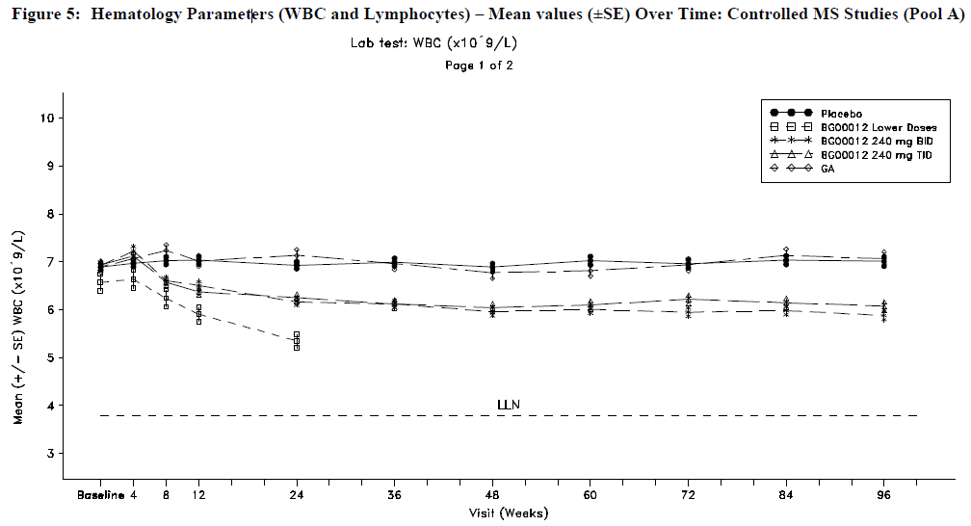
- Lab test Lymphocytes (x10⁻⁹/L).
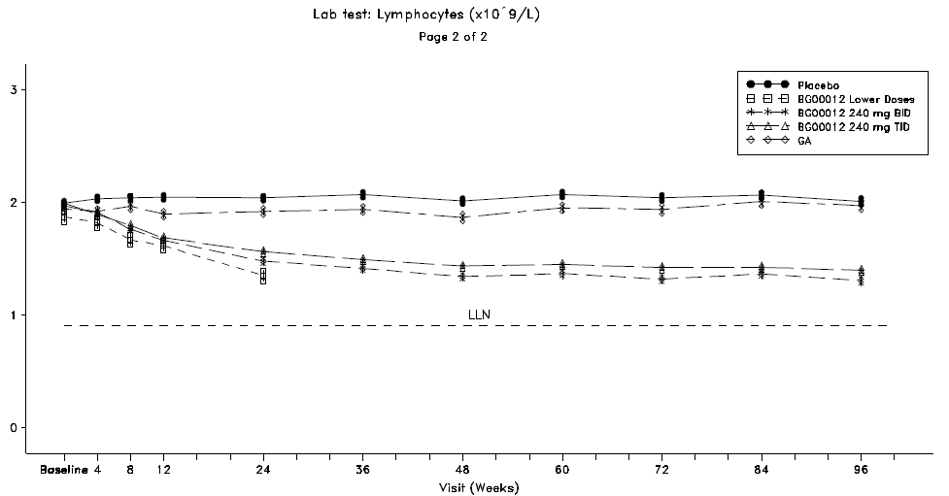
Table 54. Potentially clinically significant haematology laboratory abnormalities. Controlled MS studies (pool A).
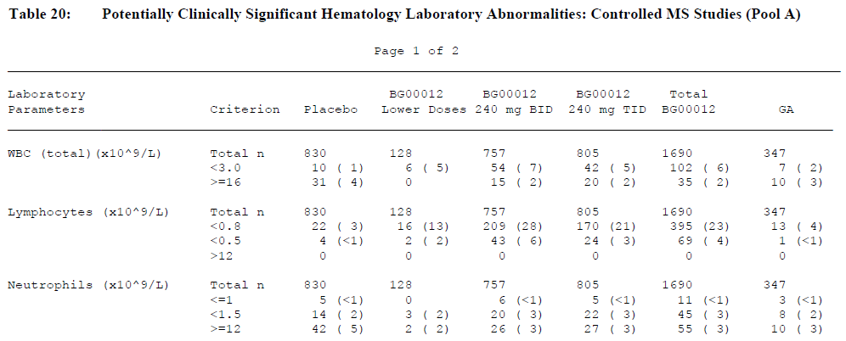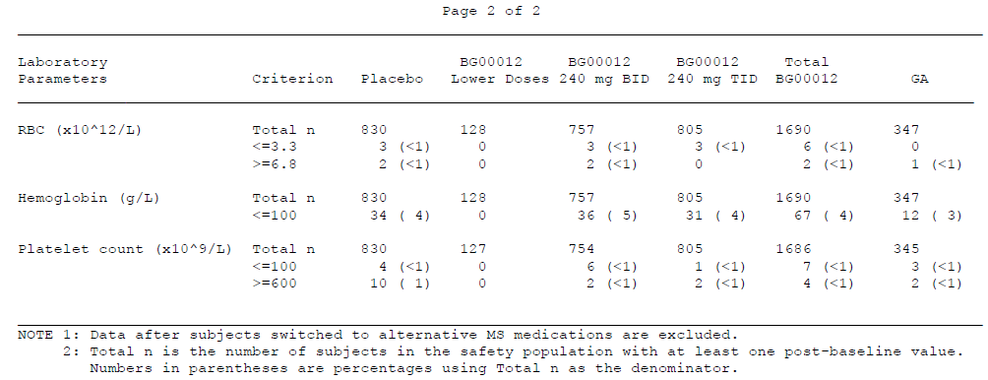

Electrocardiograph

Pivotal studies
In the placebo-controlled pivotal studies, no clinically relevant changes occurred in any electrocardiogram (ECG) parameter, including the QTc interval (using both Fridericia’s and Bazett’s correction formulae), heart rate, PR interval, QRS interval, QRS axis, and RR interval, and there were no meaningful differences from placebo or subjects treated with GA at any timepoint during the observation period.

Other studies
The potential effects of BG00012 on the QT interval of the ECG were studied in detail in a prolonged-QT study performed as part of the Clinical Pharmacology program.
The QTc was not affected by BG00012, as shown in the table below. Both BG00012 and placebo were associated with a minor shortening of the QTc interval, whereas the active control, moxifloxacin, showed the expected increase in QTc.
Table 55. Time averaged ECG results
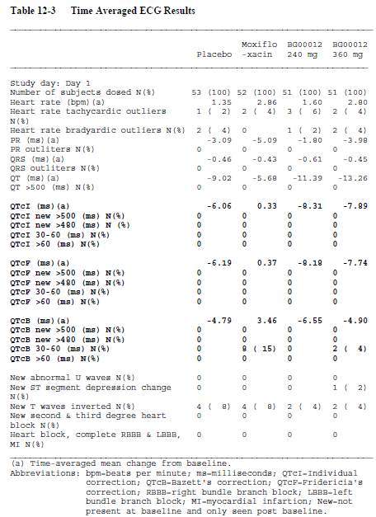

Vital signs
There were no clinically relevant differences in mean values between placebo-treated and BG00012-treated subjects for body temperature, pulse and systolic or diastolic blood pressure. Vital sign abnormalities were similar across groups, and included the following minor abnormalities:
- An increase of >20 beats per minute (bpm) from baseline pulse rate (20% to 26% across treatment groups)
- A decrease of >20 bpm from baseline pulse rate (8% to 13%)
- A decrease of >30 mmHg from baseline systolic blood pressure (6% to 9%)
- A decrease of >20 mmHg from baseline diastolic blood pressure (11% to 13%)
Results in Pool B were similar. Overall, there were no concerning trends noted in vital signs.

Postmarketing experience
There is no postmarketing data available at present. Under “Post-Marketing Data”, the sponsor states “BG00012 is an investigational product and has not been approved or marketed in any countries.”

Safety issues with the potential for major regulatory impact

Liver toxicity
Abnormal liver function tests (LFTs) are occasionally observed with BG00012 treatment but serious liver toxicity was not observed in the study program. The draft PI does not explicitly recommend monitoring of LFTs in BG00012 recipients but reports that LFTs were occasionally abnormal. This seems appropriate. The potential for rarer, more severe reactions will need to be the subject of specific postmarketing surveillance strategies.

Haematological toxicity
BG00012 treatment is associated with a reduction in total white cell counts and lymphocyte counts. One case of Grade 4 lymphopaenia was observed in the pivotal studies, in a recipient of BG00012 at the proposed dose but this was not associated with any clinical sequelae. Haematological monitoring should be recommended in the PI and the potential for more serious toxicity should be the subject of specific postmarketing surveillance.

Serious skin reactions
BG00012 treatment is associated with an increased incidence of skin reactions, including rash, but only one recipient of BG00012 had a SAE related to skin, comparable to the one skin-related SAE reported in a placebo recipient.

Cardiovascular safety
BG00012 does not appear to pose a significant risk of cardiovascular events. It is associated with marked flushing, however, indicating vasodilation that might be symptomatic in at risk individuals.

Unwanted immunological events
BG00012 does not appear to be associated with a substantial risk of unwanted immunological events.

Other safety issues

Safety in special populations
Most of the safety evidence related to BG00012 comes from MS patients in pivotal studies. It is expected that, if registered, this drug would be used in a very similar population.
There is a lack of safety data in the elderly and in paediatric subjects, because entry criteria for the pivotal studies specified an age range of 18-55 years. MS is relatively rare in children, and the sponsor is not seeking registration in the paediatric age group, so this lack of data is acceptable. It is unlikely that major studies will ever be undertaken in the paediatric age group because of the rarity of MS in children.
MS is also relatively unlikely to begin in older patients but many patients diagnosed with MS during middle age are expected to survive into older age groups, where they might be treated with disease-modifying agents including BG00012. The safety and tolerability of BG00012 in older subjects remains unclear and the draft PI appropriately mentions this.
The sponsor performed a subgroup analysis of the safety of BG00012 in those <40 years compared to those ≥ 40 years and claimed that no substantial differences were found. The data was not presented in a convenient summary table but the overall incidence of AEs and SAEs by age are shown in the excerpts below.
Table 56. Incidence of adverse events by system organ class and preferred term-by age group. Controlled MS studies (pool A).
<40 years
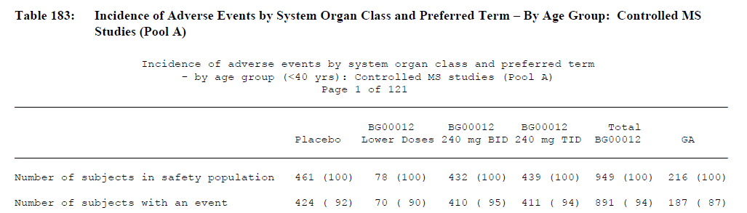
≥40 years
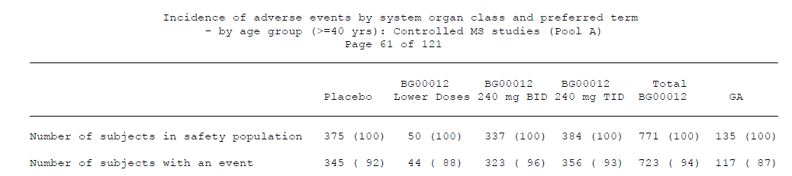
Table 57. Incidence of serious adverse events by system organ class and preferred term-by age group. Controlled MS studies (pool A).
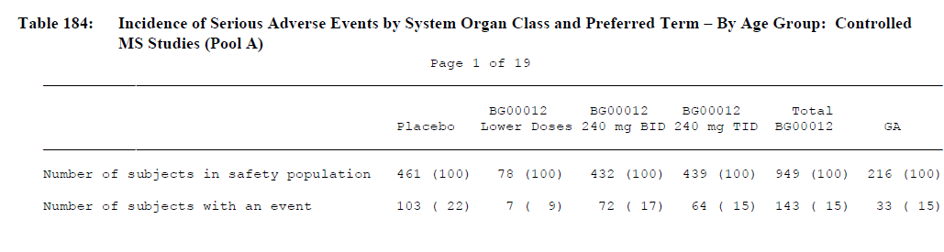
≥40 years
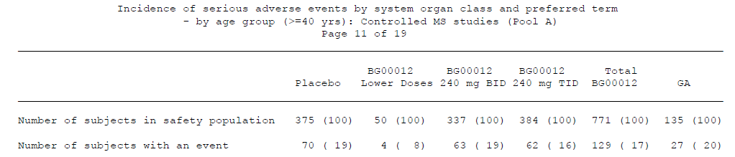
BG00012 does not appear to pose particular risks in subjects with reduced hepatic or renal function but it should be used with caution in subjects whose baseline liver function is abnormal, because it can worsen LFTs. It should be avoided in subjects with severe baseline leukopenia or lymphopaenia, as it causes a reduction in total white cell and lymphocyte counts. The safety of treatment in the setting of mild baseline leukopenia is unclear.
Racial differences in safety were generally not observed but flushing showed an increase incidence in White subjects treated with BG00012 (32% to 38%), compared to placebo-treated White subjects (5%) or BG00012-treated subjects of other races (7% to 9%). The lowest incidence of flushing was in placebo-treated subjects of other races (2%). This may in part reflect the ease of seeing flushing in white-skinned subjects and is not likely to be clinically relevant.

Safety related to drug-drug interactions and other interactions
The sponsor assessed safety in a variety of subgroups based on extrinsic factors. They wrote: “Within each of the extrinsic factor subgroups in Pool A, BG00012- and placebo-treated subjects had similar proportions of subjects experiencing at least 1 AE (Appendix Table 193 [prior MS treatment], Appendix Table 195 [region], Appendix Table 197 [alcohol use], and Appendix Table 199 [smoking status]) and of subjects experiencing at least 1 SAE (Appendix Table 194 [prior MS treatment], Appendix Table 196 [region], Appendix Table 198 [alcohol use], and Appendix Table 200 [smoking status]).”
Unfortunately, the sponsor did not initially present this data in a convenient summary table, and the tables referenced run to hundreds of pages. The sponsor provided an Integrated Summary of Safety upon request, which included the following table:
Table 58. Incidence of adverse events and serious adverse events by extrinsic factors. Controlled MS studies (pool A).
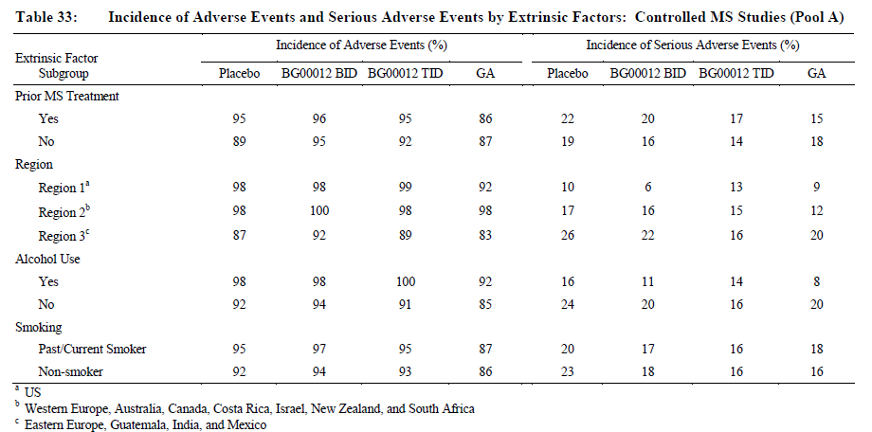
BG00012 was combined with corticosteroid treatment in many subjects in the pivotal trials, particularly in the treatment of relapses. In subjects treated with corticosteroids, the distribution of AEs was similar amongst recipients of BG00012 and placebo, except that there was a decreased incidence of flushing among BG00012 BID treated subjects who received steroids. Among subjects treated with IV corticosteroids, flushing was reported by 27% of BG00012 BID-treated subjects versus 8% of placebo-treated subjects, while among subjects not treated with IV corticosteroids flushing was reported by 37% of BG00012 BID-treated subjects versus 3% of placebo-treated subjects. Given that steroid use was intermittent, this is difficult to interpret.
In the Clinical Pharmacology program, BG00012 was also combined with Avonex (Study HV103), GA (Study HV104), aspirin (Study HV106) and food (Studies 201-FG-PK-02/02 and C-1903). No particular safety concerns were raised, although the number of subjects and duration of treatment was low.

Evaluator’s overall conclusions on clinical safety
The overall safety profile of BG00012 is acceptable. Its use is associated with mild to moderate changes in LFTs, and reductions in total white cell count and lymphocyte count but these changes were not of major clinical significance in the pivotal studies. It remains unclear whether some subjects will be at risk of more substantial hepatic or haematological toxicity and this will need to be monitored in the postmarketing context.
Severe adverse events were relatively rare with BG00012 and the spectrum of events was not qualitatively different to those seen with placebo.
BG00012 is also associated with a range of tolerability issues, particularly flushing, which was seen in ~30% of subjects, and gastrointestinal intolerance, which was seen in more than 25% of subjects in the first month. Both of these problems were reported less commonly with continued follow-up but it is unclear if the symptoms actually improved. Discontinuations due to flushing were seen in ~3% of subjects and due to GI intolerance in ~4% of subjects.

First round benefit-risk assessment

First round assessment of benefits
The efficacy of BG00012 in the RRMS population, as demonstrated in the two pivotal studies (Study 301 and Study 302), is summarised in the table below.
Table 59. Pivotal phase III studies 301 and 302 individual efficacy results at 2 years.
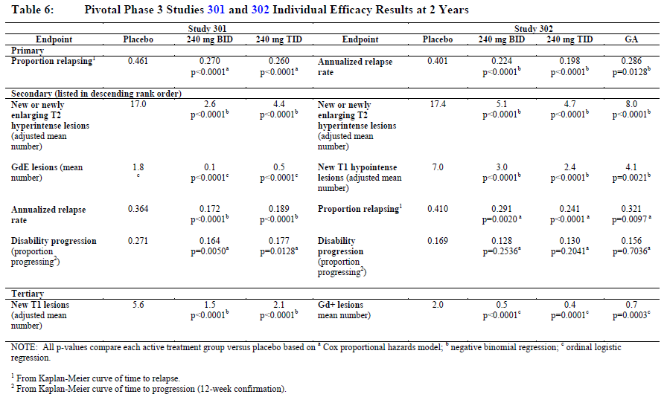
The benefits of BG00012 in the proposed usage are:
- A reduction in relapses, manifested as a reduction in the proportion relapsed after two years of treatment and a reduction in annualised relapse rate.
- For Study 301, the Kaplan-Meier estimate of the proportion of subjects relapsed at 2 years was 27.0% in the BG00012 BID group, compared to 46.1% in the placebo group, a relative reduction of 41%.
- For Study 302, the proportion of subjects who relapsed at 96 weeks was 0.410 in the placebo group compared to 0.291 in the BG00012 BID group. This is equivalent to a relative reduction in two-year risk of 29%.
- Annualised relapse rate was reduced by about half. In Study 301, the annualised relapse rate in the placebo group was 0.364 relapses/year and in the BG00012 240 mg BID group it was 0.172 relapses/year, a 53% reduction. In Study 302, the adjusted annualised relapse rate was 0.401 in the placebo group, compared with 0.224 in the BG00012 BID group, a relative reduction of 44.0%. The differences with placebo were highly significant.
- A substantial decrease in MRI activity for a number of MRI measures, as summarised in the table above.
- Reduced progression, as measured in terms of the EDSS and the MSFC.
- An efficacy that appears to be at least as good as an existing agent, glatiramer acetate.
- An oral route of administration.
- Apparent cardiovascular safety, which may provide an alternative for subjects in whom fingolimod is contraindicated because of cardiac risk.

First round assessment of risks
The risks of BG00012 in the proposed usage are:
- Leukopenia and lymphopaenia
- Abnormal liver function tests
- Tolerability issues in many patients, particularly related to flushing and gastrointestinal symptoms

First round assessment of benefit-risk balance
The benefit-risk balance of BG00012, given the proposed usage, is favourable.

First round recommendation regarding authorisation
Tecfidera (BG00012) should be approved for marketing once mistakes in the submission have been corrected. In particular, the sponsor should provide:
- A clarification of the relative risk of relapsing with two years of active treatment compared to placebo, as demonstrated in both pivotal studies, with clear differentiation between hazard ratios and cumulative risk reduction.
- A correction of the description of both pivotal studies in the PI, with regards to the relative risk of relapsing during two years of treatment.

Clinical questions

Pharmacokinetics
None.

Pharmacodynamics
None.

Efficacy
The sponsor should clarify the source of the cited “relative risk reductions” in the proposed PI and the Summary of Clinical Efficacy, as discussed previously.
In particular, the sponsor should answer the following questions:
- In Study 301, what was the cumulative relative risk reduction for the primary endpoint of “proportion of subjects relapsed”?
- Do the percentages cited in the following statement actually refer to instantaneous hazard reduction? “This indicated the risk of relapse at 2 years was reduced by 49% (p <0.0001) and 50% (p <0.0001) following treatment with BG00012 BID and TID, respectively, compared with placebo”.

Safety
The sponsor should clarify the category of risk for use in pregnancy.

Second round evaluation of clinical data submitted in response to questions
The sponsor has responded to two clinical issues raised in the first-round clinical evaluation: the conflation of hazard ratios and cumulative risk reduction, which is discussed below in Section 10.1, and pregnancy risk, discussed in Section 10.2. The sponsor has also responded to a first-round criticism of one sentence in the proposed PI; this issue was not submitted as a clinical question but is discussed in Section 10.3.

Hazard ratios versus cumulative risk reduction

The nature of the problem and the sponsor’s response
The sponsor was asked to respond to the multi-part question posed above and was given copies of the relevant sections of the first-round evaluation report to provide context for the question. The main issue of concern was that several quantitative treatment effects cited by the sponsor as “relative risk reductions” had values that appeared to be based on hazard ratios but were presented in the sponsor’s primary study reports and proposed PI without any direct reference to hazard ratios. Instead, the sponsor’s wording was ambiguous or misleading, with the results described in a way that appeared to refer to cumulative risk reduction or the overall proportion of patients relapsed. This had the effect of inflating the apparent magnitude of the treatment benefit.
The sponsor’s response, which will be discussed in detail below, confirms that hazard reductions were indeed used as the basis for “relative risk reductions” throughout the submission, though the sponsor disputes that this method of reporting is erroneous or misleading.
The sponsor states: “These results are based on the reduction in hazards (i.e. “1” minus the hazard ratio) and are extracted directly from the pre-specified analysis in the statistical analysis plan…”
After an explanation of how the hazard ratios were derived, the sponsor goes on to say:
“In relation to this, we also note that the evaluator states on page 20 of the consolidated set of questions: “…from the table above, the two-year risk estimated by the Kaplan-Meier method was only reduced by 41% and 44%, suggesting that the sponsor is in error, misreporting the reduction in instantaneous hazard risk as a reduction in cumulative two-year risk.” Given the explanation above, we advise that there was no error but concede the needs [sic] to have clearer label [sic] of the expression of risk reduction, based on the pre-specified statistical analysis plan for Study 301.”
From the evaluator’s perspective, this remains an important issue, and conflating hazard reductions with risk reductions is a serious error.
The sponsor’s submission included the following statement:
“This indicated the risk of relapse at 2 years was reduced by 49% (p <0.0001) and 50% (p <0.0001) following treatment with BG00012 BID and TID, respectively, compared with placebo”.
This wording strongly implies that the cited values refer to the risk of a patient relapsing over the course of two years; that is, the risk of finishing the two-year period in the relapsed sub-group, as compared to the non-relapsed subgroup. This risk can be referred to more clearly as the cumulative two-year risk of relapsing; it has a natural, intuitive, common-sense meaning that is transparent to patients and clinicians. A patient would like to know “If I do not take treatment for the next two years, what is the probability (risk) I will have a relapse, and what is the probability I will remain relapse-free? Conversely, if I take the drug, how much will those probabilities change?” The underlined statement from the sponsor’s study report implies that the probability of being in the relapsed group, at the two year time point, was halved by active treatment; reduced by 50% with one dose and by 49% with another. This interpretation is also favoured by the sponsor’s description of the primary endpoint as “the proportion of subjects relapsed”, which refers to an overall proportion of subjects after two years of treatment, not to a rate. Without additional context or mention of hazard ratios, very few readers would guess that the risk of being in the relapsed group at two years was reduced by substantially less than 50%.
Hazards and hazard ratios are abstract concepts, and the associated terminology is unfamiliar to most patients and clinicians outside academic settings. Hazard refers to the instantaneous risk of a bad event, which can have a straightforward interpretation in some contexts but tends to be confusing in other contexts, particularly when the “bad event” can only occur once to each subject (as in the case of a first MS relapse on treatment), so that the number of subjects at risk does not equal the number of subjects on treatment.
There is nothing intrinsically wrong with estimating treatment benefit in terms of instantaneous hazard reductions or hazard ratios. Hazard reductions can be derived directly from the Cox proportional hazard model and have a clear mathematical meaning. Care must be taken in reporting hazards, though, and in distinguishing them from the common-sense notion of overall (cumulative) risk reduction over a specified time period. Although the sponsor has now clarified the matter, the sponsor’s original submission did not take the necessary care to report these results clearly and instead used wording that was misleading.
The sponsor has since confirmed that the cumulative two-year risk reductions were substantially less than the values originally cited for “risk of relapse at 2 years”.
“In Study 301, the “relative reduction” for the primary endpoint of "proportion of subjects relapsed", based on the Kaplan-Meier estimate at 2 years, are 41% and 44% for the BG00012 240 mg BID and TID groups respectively. In Study 302, the relative reductions are 29%, and 41% for the BG00012 240 mg BID, and TID groups respectively.”
These percentages are substantially less impressive than the apparent 49-50% benefit originally cited by the sponsor.
To see why the sponsor’s claims are misleading, it is helpful to review the main reason why the hazard reductions and the cumulative risk reductions are numerically different.
The sponsor explains the hazard analysis as follows:
“This statistical analysis used the Cox “proportional hazards” model, which adjusted for covariates of age (<40 vs. >=40 yrs), region, baseline EDSS score (<=2.0 versus >2.0), and number of relapses in the year prior to study entry. The Cox model takes into account the data from all subjects who experienced relapses, as well as those who were relapse-free (censored due to the fact that the patients were relapse-free at two years), and the timing of the relapse and censoring over the course of the study.”
Although the Cox proportional hazards model introduces some adjustments according to the baseline stratification factors listed, these adjustments could also be applied to cumulative two-year risk, and minor statistical adjustments are not the chief source of the large numerical difference between hazard reductions and cumulative risk reductions. Instead, the difference arises from the nature of instantaneous risk versus cumulative risk, and most importantly from the number of subjects at risk. Hazard reductions can diverge markedly from cumulative risk reductions when the hazardous events being counted can only occur once, as in the current submission. The primary endpoint in Study MS301 was “the proportion of subjects relapsed at 2 years” (actually, 96 weeks). This endpoint necessarily splits subjects into two mutually exclusively categories: those who have relapsed and those who have not. Once a subject has entered the “relapsed” group, they cannot leave that group and are not at risk of entering it again, and thus they face no further hazard for this endpoint. The hazard ratio only applies to subjects remaining at risk, and so relapsed subjects are, in effect, censored from the remainder of the analysis. Such subjects, which can be considered treatment failures for the primary endpoint, stay in the treated cohort and dilute the overall cumulative benefit of a two-year course of treatment, but they are removed from further hazard analysis. (Such subjects can experience a potential treatment benefit for other endpoints, such as the overall annualised relapse rate, but they cannot experience further benefit or harm for the primary endpoint.)
The sponsor’s response explains the discrepancy somewhat differently, by referring to the risk faced by non-relapsed subjects.
“Since the Cox model assumes a constant hazard ratio over time, the risk reduction relative to placebo will not change over time. In other words, if a subject did not experience a relapse over the course of the 2 year period, the risk of relapse was reduced by 49% and 50% for BG00012 240 mg BID and TID group, respectively (based on Study 301 data) and 34% and 45% for the BG00012 240 mg BID and TID groups, respectively (based on Study 302 data).”
This statement is confusing, though it probably alludes to the fact that the subjects at risk are a progressively shrinking cohort, and it is this cohort that enjoyed the ~50% hazard reduction in Study 301. The comment “if a subject did not experience a relapse over the course of the 2 year period, the risk of relapse was reduced by X” is almost meaningless, because such subjects by definition have avoided a relapse entirely; if they could be identified prospectively at baseline, their risk would be zero and if they have only been identified in retrospect, the notion of risk for the two-year period barely applies. They cannot be at risk of an event in the past, much less an event which is known not to have happened. What the sponsor is probably trying to say is that a non-relapsed subject’s instantaneous risk of a relapse, at any time moving forward, was 49% and 50% of the placebo risk in Study MS301, for the two doses respectively. This estimate of instantaneous risk applies to the progressively shrinking non-relapsed subgroup at any stage of the study but is increasingly at odds with the cumulative benefit displayed by the larger, overall study population (which includes rather than censors the treatment failures).
The group of treatment failures necessarily enlarges with longer periods of follow up, even when relative hazard reductions remain constant, so cumulative relative risk reductions will tend to deteriorate with longer periods of follow-up and progressively more conversions to the studied endpoint, leading to progressively greater divergence from instantaneous hazard reductions. Over the course of the two-year study MS301, the divergence was ~8% for the proposed dose (49% versus 41%). Eventually, if the study cohort were followed until 90% of actively treated subjects had relapsed the cumulative relative risk reduction would necessarily be ≤ 10%, even if the hazard ratio had remained at 50% throughout the period of risk. This dependency on length of follow up is not an ideal property for a measure of treatment benefit, and is one reason why hazard ratios may be favoured in academic settings but it is a property that is intuitively known to clinicians and factored in when assessing claims of relative benefit for a given time period.
The problem, then, is not the sponsor’s use of hazard ratios, but the manner in which they have been reported, using wording that could apply to cumulative risk reduction. If a clinician reads that the risk of relapsing after two years is halved by active treatment, the clinician will think, quite reasonably, that an untreated cohort will have twice as many relapsed subjects after two years as a treated one, and communicate this erroneous interpretation to the patient. The sponsor has a responsibility to prevent such errors.
Note that, even for clinicians who are familiar with hazard ratios and the way that they differ from cumulative risk reduction, there is a risk of conflating the two measures unless the sponsor is clear in reporting the results. Just as a hazard reduction of ~49% can be associated with a cumulative two-year risk reduction of only ~41% (as demonstrated in Study MS301), the hazard reduction required to produce a true 49% reduction in cumulative risk over two years would be expected to be greater than 49%, given similar baseline placebo risk. This means that even a clinician aware of hazard ratios could be misled by the sponsor’s claims, inferring that active treatment confers a hazard reduction substantially better than 49%.
The safest approach in reporting such results is to report both measures (hazard reduction and cumulative risk reduction) and to label each measure clearly. If only one measure of risk reduction is to be reported, then the commonsensical and clinically transparent measure of cumulative risk reduction is less misleading than the superficially more impressive hazard reduction, particularly when the stated endpoint refers to “proportion relapsed” rather than to a rate.

Conventions in reporting hazard ratios
In a couple of sections of their response to the first-round questions, the sponsor argues that hazard ratios are a standard way of reporting MS endpoints.
“Although the concept of “instantaneous hazard reduction” is mathematically correct, it is not usually interpreted as such in MS clinical trials, for ease of understanding to the general readers.”
“The Cox model is a conventional method utilized to analyze time to disability progression and reduction in proportion of subjects progressed in Phase III MS trials such as those for natalizumab (Tysabri), fingolimod (Gilenya), laquinimod, teriflunomide (Aubagio). The reductions in hazard, are commonly referred to as the reductions in risk of progression relative to placebo in official publications of the study results (References: Polman et al 2006, Kappos et al 2010, Giovannoni et al 2010 and Comi et al 2012). In addition, relative reductions are presented in the TGA approved Product Information (summary of clinical efficacy) for Tysabri and Gilenya for the disability progression or Annualised Relapse Rate (ARR) endpoint.”
Even if it is accepted that hazard ratios are a standard method of reporting MS studies, it does not follow that hazard ratios should be reported without explicitly labelling them. The majority of the references mentioned by the sponsor above make frequent use of hazard ratios but these are reported clearly as such. An example is shown below, from a reference supplied by the sponsor (Comi et al 2012).
Table 60. From Comi et al 2012. Clinical and MRI end points.
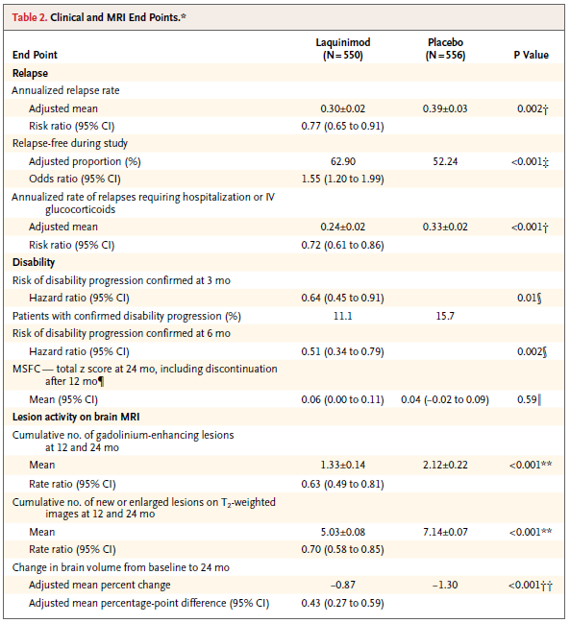
On the other hand, the sponsor is correct in pointing out that the approved PI for Tysabri appears to set a precedent for using the term ‘Relative Risk Reduction’ to present hazard reductions. The tables below are copied from the online digital PI for Tysabri; only the clinical section of each table is shown. (<http://www.biogenidec.com.au/Admin/Public/DWSDownload.aspx?File=%2fFiles%2fFiler%2fAustralia%2fTysabri-PI-19-NOV-2012.doc>).
In the monotherapy Tysabri study (Table 61 below), the reported relative risk reduction in sustained disability is 42%, which is within 1% of the relative reduction (41.4%) that would be calculated from direct inspection of percentage of patients with sustained increase in disability at two years (17/29 = 0.586, that is,17 is 58.6% of 29, so 17% is 41.4% less than 29%). The minor discrepancy could be due to rounding. In the add-on study (Table 62), however, the reported relative risk reduction is 24%, which is greater than the relative reduction (20.7%) deduced from direct inspection (23/29 = 0.793, that is, 23 is 79.3% of 29, so 23% is 20.7% less than 29%). This discrepancy suggests that the Tysabri PI should be modified to improve clarity along the same lines as suggested for Tecfidera.
Table 61. Clinical and MRI endpoints in study 1 (monotherapy study) at 2 years.
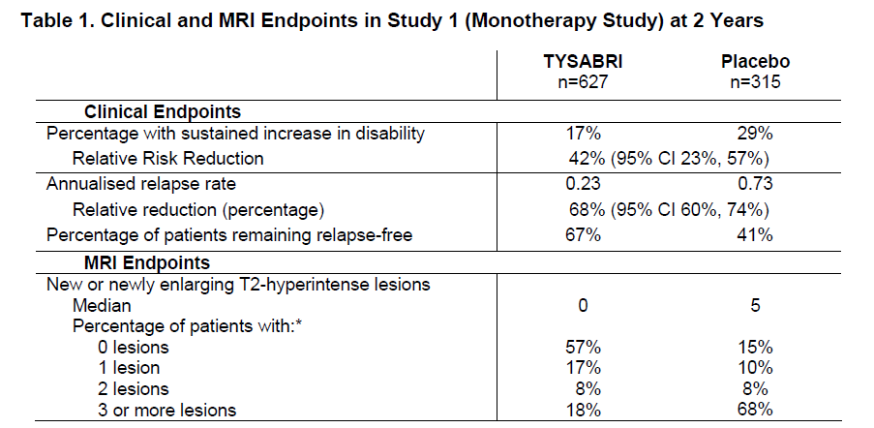
Table 62. Clinical and MRI endpoints in study 2 (add-on study) at 2 years.
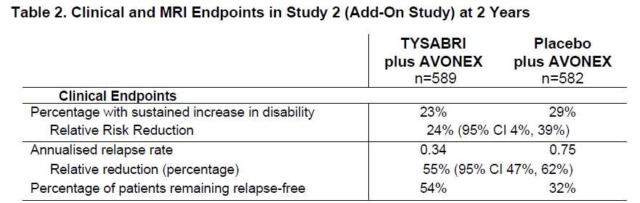
The PI for Gilenya, on the other hand, sets a precedent for explicit acknowledgement of hazard ratios when these are used, as shown in the table below. Note that the percentage of patients remaining relapse-free was a major endpoint in the Gilenya study (as in the Tecfidera study), but this percentage is reported in the Gilenya PI directly, rather than as a hazard ratio.
Table 63. Clinical and MRI results of study D2301.
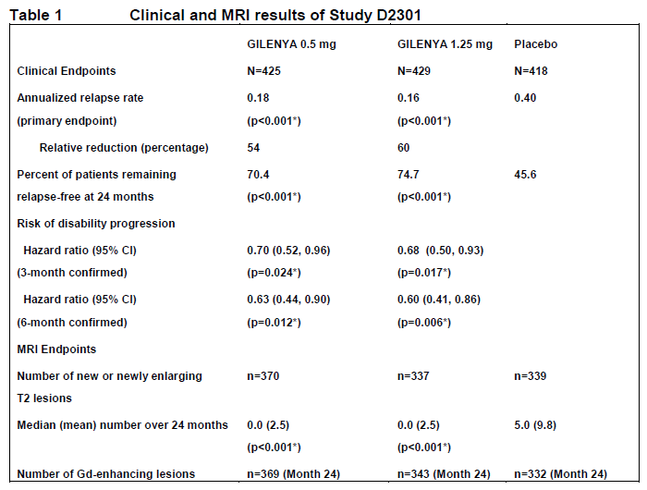
Overall, the majority of MS studies using hazard ratios have been explicit when reporting their results. The Tysabri PI is an exception, in that it does not clearly indicate that the relative risk reduction in disease progression has been expressed in terms of hazard ratios but this is an argument in favour of fixing the Tysabri PI rather than repeating the error with Tecfidera.
The most common endpoint for disease modifying agents in MS is annualised relapse rate, rather than proportion relapsed. Relapse rates are appropriately expressed as hazard ratios. Given that relapse rates are necessarily expressed as events per time, and relapses contributing to these rate estimates do not have the property of removing subjects from the cohort at risk, there is relatively little chance of confusing the reader with hazard ratios when the primary endpoint is relapse rate. The problem arises from the sponsor’s description of the primary endpoint as “proportion relapsed” at the end of two years, followed by numerical data based on instantaneous hazard rates. Referring to the proportion of subjects relapsed at two years creates the expectation that what is being reported as “relative risk” is the relative proportions of patients reaching the relapsed subgroup at two years, which is the same as the cumulative relative risk over two years. Inserting an unexpected hazard ratio as the means of reporting this change in proportions is misleading, and inflates the apparent benefit of the treatment.

The sponsor’s proposed changes to the PI to address the issue
The sponsor indicates that the relative reductions in proportions relapsed were as follows:
“In Study 301, the “relative reduction” for the primary endpoint of "proportion of subjects relapsed", based on the Kaplan-Meier estimate at 2 years, are 41% and 44% for the BG00012 240 mg BID and TID groups respectively. In Study 302, the relative reductions are 29%, and 41% for the BG00012 240 mg BID, and TID groups respectively.”
Unfortunately, the sponsor has not indicated a readiness to include these new estimates of risk reduction within the revised PI. Instead, they propose use of the following revised table (truncated copy):
Table 64. Clinical and MRI results of study 1.
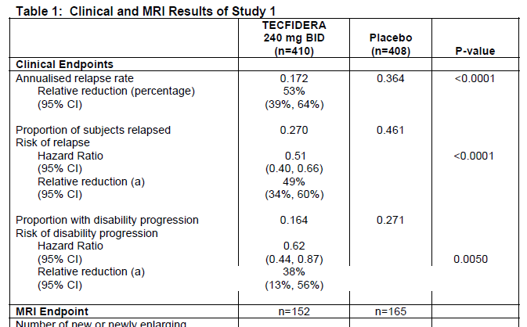
Compare the revised table, above, to the version that was discussed in the first-round evaluation, reproduced below:
Table 65. Clinical and MRI results of study 1.
The revised version is an improvement, because the term “Relative risk reduction” no longer appears immediately under the heading “Proportion relapsing”, an arrangement that strongly implied that the cited reduction was a relative reduction in the proportion relapsing. The term “Relative reduction (a)” now appears under the ambiguous heading “Risk of relapse”, which refers to the hazard rate but could easily be assumed to refer to the risk of (at least one) relapse over the course of the study. The bracketed footnote marker “(a)” refers the reader to a footnote at the end of the table, which in turn explains that the figure cited is based on the hazard ratio, but the footnote is found on the next page. Furthermore, the cited risk reduction adds no new or useful information, because it is simply the complement of the hazard ratio (it is 1-hazard ratio, expressed as a percentage); the same relation holds for the 95%CIs (34% is the complement of 0.66, 60% the complement of 0.40, 13% the complement of 0.87, and so on). That is, those who know what the “risk reduction” means in this context could derive it easily for themselves, by subtracting from 100%; those who do not know what it means might assume it refers directly to the primary endpoint of the study, the proportion relapsing.
A potentially clearer version of the table, produced by the evaluator, is shown below. The lines that appear in red, italics and underlined correspond to the “relative reduction (a)” in the sponsor’s proposed table. They add no new information and would be better omitted but at least the version below clearly distinguishes the reduction in proportion of relapsed patients (41%) from the relative reduction in hazard (49%). The 41% figure in the table was derived directly from the cited proportions (0.270 is ~59% of 0.461, implying it has been reduced by ~41%) but this is similar to the risk estimated by the Kaplan-Meier approach, provided by the sponsor above. (“In Study 301, the “relative reduction” for the primary endpoint of "proportion of subjects relapsed", based on the Kaplan-Meier estimate at 2 years, are 41% and 44% for the BG00012 240 mg BID and TID groups respectively. In Study 302, the relative reductions are 29%, and 41% for the BG00012 240 mg BID, and TID groups respectively.”) If the sponsor preferred to use a Kaplan-Meier estimate of the cumulative two-year risk in the PI, instead of directly comparing the proportions relapsed, that approach would also be reasonable; in that case, a footnote of explanation below the table would be appropriate.
Table 66. Clinical and MRI results of study 1.
Clinical Endpoints | Tecfidera  240 mg BID  (n=410) | Placebo  (n=408) | P-value
Annualised relapse rate | 0.172 | 0.364 | <0.0001
Relative reduction (percentage) | 53% (95% CI) (39%, 64%)
Proportion of subjects relapsed | 0.270 | 0.461
Relative reduction in proportion relapsed | 41%
Hazard Ratio for first relapse (95%CI) | 0.51 (0.40, 0.66) |  | <0.0001
Relative hazard reduction (95%CI) | 49% (34%, 60%)
Proportion with disability progression | 0.164 | 0.271
Relative reduction in proportion progressing | 39%
Hazard Ratio for progression (95% CI) | 0.62 (0.44, 0.87) |  | 0.0050
Relative hazard reduction (95%CI) | 38% (13%, 56%)
Throughout their submission, the sponsor has taken a similar approach to the risk of disability progression as they took with proportion relapsed, referring in some places of the study reports and PI to the proportion progressing over two years, then slipping into a comparison of hazard ratios, usually without explicitly noting that the cited figures have been derived from hazard ratios. In principle, all the same arguments apply to this endpoint, and the need for clarity remains important, but for this endpoint the actual numerical difference between the two methods of reporting is relatively minor.

Overall conclusion about the sponsor’s response to hazard ratios
The sponsor has confirmed the evaluator’s suspicions that values cited in the study reports and proposed PI as “relative risk reductions” actually refer to (instantaneous) hazard reductions. The proposed changes in the PI are improvements over the original version but do not go far enough in clarifying the true nature of the data. The sponsor should change all references to “relative reduction” or “relative risk reduction” throughout the PI to more explicit terminology that directly refers to hazard ratios. This includes the text of the PI and tables including the results for Study 302.
The sponsor should also explicitly report the relative reduction in the proportion of patients relapsed and the relative reduction in the proportion of patients progressed, so that clinicians can predict the likely effects of treating subjects for two years. The study design and the endpoints as described lend themselves naturally to such a description of cumulative risk. A statement such as the following should appear in the PI:
“In Study 301, the relative reductions for the primary endpoint of proportion of subjects relapsed, based on the Kaplan-Meier estimate at 2 years, were 41% and 44% for the Neutrinza [Tecfidera] 240 mg BID and TID groups respectively. In Study 302, the relative reductions were 29% and 41% for the Neutrinza [Tecfidera] 240 mg BID, and TID groups respectively.”
Similar statements should be added referring to the proportion of patients progressing.

Pregnancy category
At the time of the first-round submission, the sponsor had not decided upon a pregnancy risk category in the proposed PI, and the sponsor was asked to clarify this. The sponsor’s response is as follows:
“No formal studies of BG-12 in pregnant women have been performed.
“As of 02 January 2013, there have been 56 pregnancies in the BG00012 clinical development program, of which 38 pregnancies (68%) were reported in subjects exposed to BG00012 (37 subjects with MS and 1 healthy volunteer). Pregnancy outcomes were known for 34 of the 38 BG00012-exposed subjects (89%) and included 22 live births, 3 spontaneous abortions, and 9 elective terminations; information was pending on 3 pregnancies and 1 subject was lost to follow-up.
“No fetal abnormalities (i.e., congenital defects) have been reported for any of the pregnancies in the BG00012 clinical development program. The incidence of spontaneous abortion among pregnancies with known outcome was: 3 out of 34 subjects with known outcomes (9%) in the BG-12 treated subjects and 3 out of 14 subjects (21%) in the placebo treated subjects indicating a slightly higher incidence of spontaneous abortion in the placebo arm.
“The rates of spontaneous abortion in the BG00012 and placebo-treated subjects are consistent with the expected rate of early pregnancy loss in the general population. Based on the current data, there is no evidence of increased risk of foetal abnormalities or adverse pregnancy outcomes associated with gestational exposure to BG00012 during the first trimester. Reproductive studies in rodents and rabbits showed no evidence of teratogenic effects of BG00012.
“In light of these results, the Applicant proposes a pregnancy category B1.”
This is appropriate. Category B1 applies to drugs that have been taken by only a limited number of pregnant women and women of childbearing age, without an increase in the frequency of malformation or other direct or indirect harmful effects on the human foetus having been observed, and where studies in animals have not shown evidence of an increased occurrence of foetal damage.

Additional revision to the PI
As discussed in the first-round evaluation, one sentence of the proposed PI implied that Studies 301 and 302 were more similar than they actually were.
The criticism was expressed as follows:
The description of Study 302 is broadly accurate, but the following sentence from page 6 of 14 falsely implies that the primary endpoint was the same as Study 301:
“The efficacy and safety evaluations were identical to Study 1 and the endpoints were consistent between the studies.”
The two studies were consistent in the sense that both had primary endpoints based on relapses, but they were inconsistent in how the relapses were treated: Study 301 assessed the proportion of patients relapsed, whereas Study 302 assessed the annualised relapse rate. This should be clarified, as follows:
“The efficacy and safety evaluations were similar to Study 1 and the endpoints were broadly consistent between the studies, but the primary endpoint of Study 2 was annualised relapse rate, whereas the primary endpoint of Study 1 was the proportion of patients relapsed.”
The sponsor has suggested the following change.
The original sentence, “The efficacy and safety evaluations were identical to Study 1 and the endpoints were consistent” will be revised to: “The efficacy and safety evaluations were similar to Study 1 and the endpoints were broadly consistent, but the primary endpoint of Study 2 was the annualized relapse rate, whereas the primary endpoint of Study 1 was the proportion of subjects relapsed”.
This proposed change was considered acceptable.

Second round benefit-risk assessment
The overall risk-benefit was not altered by the new information.

Second round recommendation regarding authorisation
Tecfidera (BG00012,) should be approved for marketing once the PI has been modified along the lines discussed above.

References
The sponsor provided the following list of references with their Summary of Clinical Efficacy, many of which were consulted during preparation of this report.
Agarwal R, Panesar A, Lewis RR. Dipstick proteinuria: can it guide hypertension management? Am J Kidney Dis. 2002;39(6):1190-5.
Barkhof F, Filippi M, Miller DH, et al. Comparison of MRI criteria at first presentation to predict conversion to clinically definite multiple sclerosis. Brain. 1997;120 ( Pt 11):2059-69.
Boffetta P, Gridley G, Lindelöf B. Cancer risk in a population-based cohort of patients hospitalized for psoriasis in Sweden. J Invest Dermatol. 2001;117(6):1531-7.
Brauchli YB, Jick SS, Miret M, et al. Psoriasis and risk of incident cancer: an inception cohort study with a nested case-control analysis. J Invest Dermatol. 2009;129(11):2604-12.
Brønnum-Hansen H, Koch-Henriksen N, Stenager E. Trends in survival and cause of death in Danish patients with multiple sclerosis. Brain. 2004;127(Pt 4):844-50.
Cotton F, Weiner HL, Jolesz FA, et al. MRI contrast uptake in new lesions in relapsing-remitting MS followed at weekly intervals. Neurology. 2003;60(4):640-6.
Ellrichmann G, Petrasch-Parwez E, Lee DH, et al. Efficacy of fumaric acid esters in the R6/2 and YAC128 models of Huntington's disease. PLoS One. 2011;6(1):e16172.
Garcia-Enguidanos A, Calle ME, Valero J, et al. Risk factors in miscarriage: a review. European Journal of Obstetrics & Gynecology and Reproductive Biology. 2002;102(2):111-9.
Gelfand JM, Neimann AL, Shin DB, et al. Risk of myocardial infarction in patients with psoriasis. Jama. 2006;296(14):1735-41.
Ghoreschi K, Brück J, Kellerer C, et al. Fumarates improve psoriasis and multiple sclerosis by inducing type II dendritic cells. J Exp Med. 2011;208(11):2291-303.
Giovannoni G, Comi G, Cook S, et al. A placebo-controlled trial of oral cladribine for relapsing multiple sclerosis. N Engl J Med. 2010;362(5):416-26.
Jacobs L, Cookfair D, Rudick R, et al. Intramuscular interferon beta-1a for disease progression in relapsing multiple sclerosis. The Multiple Sclerosis Collaborative Research Group (MSCRG). Ann Neurol. 1996;39(3):285-94.
Ji J, Shu X, Sundquist K, et al. Cancer risk in hospitalised psoriasis patients: a follow-up study in Sweden. Br J Cancer. 2009;100(9):1499-502.
Johnson KP, Brooks BR, Cohen JA, et al. Copolymer 1 reduces relapse rate and improves disability in relapsing-remitting multiple sclerosis: results of a phase III multicenter, double blind placebo-controlled trial. The Copolymer 1 Multiple Sclerosis Study Group. Neurology. 1995;45(7):1268-76.
Kappos L, Radue EW, O'Connor P, et al. A placebo-controlled trial of oral fingolimod in relapsing multiple sclerosis. New England Journal of Medicine. 2010;362(5):387-401.
Levitan B. A concise display of multiple end points for benefit-risk assessment. Clin Pharmacol Ther. 2011;89(1):56-9.
Linker RA, Lee DH, Ryan S, et al. Fumaric acid esters exert neuroprotective effects in neuroinflammation via activation of the Nrf2 antioxidant pathway. Brain. 2011;134(Pt 3):678- 92.
Lublin FD, Baier M, Cutter G. Effect of relapses on development of residual deficit in multiple sclerosis. Neurology. 2003;61(11):1528-32.
Margolis D, Bilker W, Hennessy S, et al. The risk of malignancy associated with psoriasis. Arch Dermatol. 2001;137(6):778-83.
McDonald CJ, Calabresi P. Psoriasis and occlusive vascular disease. Br J Dermatol. 1978;99(5):469-75.
Mikol DD, Barkhof F, Chang P, et al. Comparison of subcutaneous interferon beta-1a with glatiramer acetate in patients with relapsing multiple sclerosis (the REbif versus Glatiramer Acetate in Relapsing MS Disease [REGARD] study): a multicentre, randomised, parallel, open-label trial. Lancet Neurol. 2008;7(10):903-14.
Noseworthy JH, Lucchinetti C, Rodriguez M, et al. Multiple sclerosis. N Engl J Med. 2000;343(13):938-52.
O'Connor P, Filippi M, Arnason B, et al. 250 microg or 500 microg interferon beta-1b versus 20 mg glatiramer acetate in relapsing-remitting multiple sclerosis: a prospective, randomised, multicentre study. Lancet Neurol. 2009;8(10):889-97.
O'Connor P, Wolinsky JS, Confavreux C, et al. Randomized trial of oral teriflunomide for relapsing multiple sclerosis. N Engl J Med. 2011;365(14):1293-303.
O’Neill G, Polman C, Kappos L, et al. Relapse efficacy endpoints for the evaluation of disease modifying therapies in clinical studies of multiple sclerosis [poster]. Presented at: 59th Annual Meeting of the American Academy of Neurology; 2007 April 28-May 5; Boston, MA.
Polman CH, Wolinsky JS, Reingold SC. Multiple sclerosis diagnostic criteria: three years later. Mult Scler. 2005;11(1):5-12.
Polman CH, O'Connor PW, Havrdova E, et al. A randomized, placebo-controlled trial of natalizumab for relapsing multiple sclerosis. N Engl J Med. 2006;354(9):899-910.
Polman CH, Reingold SC, Barkhof F, et al. Ethics of placebo-controlled clinical trials in multiple sclerosis: a reassessment. Neurology. 2008;70(13 Pt 2):1134-40.
PRISMS Study Group. Randomised double-blind placebo-controlled study of interferon beta-1a in relapsing/remitting multiple sclerosis. Lancet. 1998;352(9139):1498-504.
Rosati G. The prevalence of multiple sclerosis in the world: an update. Neurol Sci. 2001;22(2):117-39.
Rudick RA, Lee JC, Simon J, et al. Significance of T2 lesions in multiple sclerosis: A 13-year longitudinal study. Ann Neurol. 2006;60(2):236-42.
Runmarker B, Andersen O. Prognostic factors in a multiple sclerosis incidence cohort with twenty-five years of follow-up. Brain. 1993;116 ( Pt 1):117-34.
The IFNB Multiple Sclerosis Study Group. Interferon beta-1b is effective in relapsing-remitting multiple sclerosis. I. Clinical results of a multicenter, randomized, double-blind, placebo controlled trial. Neurology. 1993;43(4):655-61.
Weinshenker BG, Bass B, Rice GP, et al. The natural history of multiple sclerosis: a geographically based study. 2. Predictive value of the early clinical course. Brain. 1989;112 ( Pt 6):1419-28.
Werdenberg D. Stability, permeability and pharmacokinetics of perorally administered fumarates [dissertation]. [Zürich (Switzerland)]: Swiss Federal Institute of Technology; 2003.

The second-round evaluation also consulted the following references:
Comi G et al. Placebo-controlled trial of oral laquinimod for multiple sclerosis. N Engl J Med. 2012 Mar 15; 366(11):1000-9
O’Connor P et al. Randomized trial of oral teriflunomide for relapsing multiple sclerosis. N Engl J Med. 2011 Oct 6; 365(14):1293-303.
Kappos L et al. A placebo-controlled trial of oral fingolimod in relapsing multiple sclerosis. N Engl J Med. 2010 Feb 4; 362(5):387-401.
Giovannoni G et al. A placebo-controlled trial of oral cladribine for relapsing multiple sclerosis. N Engl J Med 2010; 362:416-426
Polman CH et al. A randomized, placebo-controlled trial of natalizumab for relapsing multiple sclerosis. N Engl J Med. 2006 Mar 2; 354(9):899-910.

http://www.tga.gov.au/pdf/euguide/ewp056198en.pdf
Common Terminology Criteria (CTC) is a standardised classification of side effects used in assessing drugs for cancer therapy, in particular. Specific conditions and symptoms may have values or descriptive comment for each level, but the general guideline is 1 – Mild, 2 – Moderate, 3 – Severe, 4 - Life threatening, 5 - Death.
QT interval: a measure of the time between the start of the Q wave and the end of the T wave in the heart's electrical cycle. A prolonged QT interval is a risk factor for ventricular tachyarrhythmias and sudden death. QT_{c}: The QT interval is dependent on the heart rate (the faster the heart rate, the shorter the QT interval). To correct for changes in heart rate and thereby improve the detection of patients at increased risk of ventricular arrhythmia, a heart rate-corrected QT interval QTc is often calculated using a correction based on either Bazett's or Fridericia’s formulae.
A schematic diagram of the cardiac action potential showing the various intervals discussed in the text.
A 10% relative risk reduction would apply to the situation where 100% of placebo recipients and 90% of active recipients had relapsed; if less than 100% of placebo recipients had relapsed, the relative benefit would be less than 10%.

