First round evaluation: 27 June 2014
Second round evaluation: 18 November 2014

AusPAR Attachment 2

Extract from the Clinical Evaluation Report for Dolutegravir 50 mg, Abacavir 600 mg, Lamivudine 300 mg tablets
  - Proprietary Product Name: Triumeq
  - Sponsor: ViiV Healthcare

About the Therapeutic Goods Administration (TGA)
- The Therapeutic Goods Administration (TGA) is part of the Australian Government Department of Health, and is responsible for regulating medicines and medical devices.
- The TGA administers the Therapeutic Goods Act 1989 (the Act), applying a risk management approach designed to ensure therapeutic goods supplied in Australia meet acceptable standards of quality, safety and efficacy (performance), when necessary.
- The work of the TGA is based on applying scientific and clinical expertise to decision-making, to ensure that the benefits to consumers outweigh any risks associated with the use of medicines and medical devices.
- The TGA relies on the public, healthcare professionals and industry to report problems with medicines or medical devices. TGA investigates reports received by it to determine any necessary regulatory action.
- To report a problem with a medicine or medical device, please see the information on the TGA website <https://www.tga.gov.au>.
About the Extract from the Clinical Evaluation Report
- This document provides a more detailed evaluation of the clinical findings, extracted from the Clinical Evaluation Report (CER) prepared by the TGA. This extract does not include sections from the CER regarding product documentation or post market activities.
- The words [Information redacted], where they appear in this document, indicate that confidential information has been deleted.
- For the most recent Product Information (PI), please refer to the TGA website <https://www.tga.gov.au/product-information-pi>.
Copyright
© Commonwealth of Australia 2015
This work is copyright. You may reproduce the whole or part of this work in unaltered form for your own personal use or, if you are part of an organisation, for internal use within your organisation, but only if you or your organisation do not use the reproduction for any commercial purpose and retain this copyright notice and all disclaimer notices as part of that reproduction. Apart from rights to use as permitted by the Copyright Act 1968 or allowed by this copyright notice, all other rights are reserved and you are not allowed to reproduce the whole or any part of this work in any way (electronic or otherwise) without first being given specific written permission from the Commonwealth to do so. Requests and inquiries concerning reproduction and rights are to be sent to the TGA Copyright Officer, Therapeutic Goods Administration, PO Box 100, Woden ACT 2606 or emailed to <tga.copyright@tga.gov.au>.

Contents
1. List of the most common abbreviations 5
2. Clinical rationale 9
3. Contents of the clinical dossier 10
3.1. Scope of the clinical dossier 10
3.2. Paediatric data 10
3.3. Good clinical practice 10
4. Pharmacokinetics/pharmacodynamics 10
4.1. Study ING114580 pivotal pharmacokinetics 10
4.2. Study ING116898 drug interaction – Dolutegravir, calcium and iron 16
4.3. Study ING116070 pharmacodynamics – cerebrospinal fluid 20
5. Dosage selection for the pivotal studies 25
6. Clinical efficacy/virology 25
6.1. Study ING114467 (single) pivotal study – Treatment naïve 25
6.2. Study ING113086 (spring-2) supportive – Treatment-naive 32
6.3. Study ING114915 (flamingo) supportive – Treatment-naïve 38
6.4. Study ING111762 (sailing) – Treatment-experienced 46
7. Virology 51
7.1. Study ING116070 pharmacodynamic – Treatment-naive 51
7.2. Study ING114467 (single) pivotal – Treatment-naïve 52
7.3. Study ING113086 (spring-2) Treatment-naïve 54
7.4. Study ING114915 (flamingo) Treatment-naïve 55
7.5. Study ING111762 (sailing) – Treatment experienced 56
8. Clinical safety 62
8.1. Study ING114580 – Pivotal Pharmacokinetic 62
8.2. Study ING116898 – Drug interaction 63
8.3. Study ING116070 pharmacodynamic – CSF 64
8.4. Study ING114467 (single) pivotal – Treatment-naïve 64
8.5. Study ING113086 (spring-2) – Treatment-naïve 71
8.6. Study ING114915 (flamingo) – Treatment-naïve 81
8.7. Integrated safety for DTG + ABC/3TC – Treatment-naïve 84
9. First round benefit-risk assessment 88
10. First round recommendation regarding authorisation 88
11. Clinical questions and Second round evaluation of clinical data submitted in response to questions 88
11.1. Question 1 88
11.2. Question 2 89
11.3. Question 3 89
11.4. Question 4 89
11.5. Question 5 90
11.6. Question 6 91
11.7. Question 7 94
11.8. Question 8 94
11.9. Question 9 95
11.10. Question 10 96
11.11. Question 11 97
11.12. Question 12 99
11.13. Question 13 99
11.14. Question 14 100
11.15. Question 15 100
11.16. Question 16 101
11.17. Question 17 102
11.18. Question 18 102
11.19. Question 19 103
11.20. Question 20 103
11.21. Question 21 104
11.22. Question 22 105
11.23. Question 23 105
11.24. Question 24 106
11.25. Second round discussion 107
11.26. Discussion 115
12. Second round benefit-risk assessment 116
12.1. Benefit 116
12.2. Risk 116
12.3. Balance 116
13. Second round recommendation regarding authorisation 116
14. References 116

List of the most common abbreviations
Abbreviation | Meaning
λx | Terminal phase elimination rate constant
3TC | Lamivudine
ABC | Abacavir
AE | Adverse event
ALT | Alanine aminotransferase
AIDS | Acquired immunodeficiency syndrome
ALP | Alkaline aminotransferase
ART | Antiretroviral therapy
AST | Aspartate aminotransferase
AUC (0 - ∞) | Area under the concentration-time curve from time zero to infinity
AUC (0 – 24) | Area under the concentration-time curve from time zero to 24 hours
AUC (0 – τ) | Area under the concentration-time curve over the dosing interval
%AUCex | Percentage of AUC(0 - ∞) obtained by extrapolation
BD | Twice daily
BID | Twice daily
BCRP | Breast cancer resistance protein
BilT | Total bilirubin
BMI | Body mass index
BP | Blood pressure
C24 | Concentration at 24 hours
CDC | Centres for Disease Control
CER | Clinical evaluation report
CI | Confidence interval
CK | Creatine kinase
CL/F | Apparent clearance after oral administration
Cmax | Maximum observed concentration
c/mL | Copies per millilitre
CPK | Creatine phosphokinase
CSF | Cerebrospinal fluid
CSR | Clinical study report
C | Concentration
CV | Coefficient of variation
CVw | Within subject coefficient of variation
DHHS | Department of Health and Human Services
dL | Decilitre
DNA | Deoxyribonucleic acid
DRV | Darunavir
DRVr | Darunavir plus ritonavir
DRV + RTV | Darunavir plus ritonavir
DTG | Dolutegravir
ECG | Electrocardiogram
EFV | Emtricitabine
ABC/3TC | Epzicom
ERDF | Efficacy related discontinuation = failure
ETR | Etravirine
EU | European Union
FC | Fold change
FDA | Food and Drug administration
FDC | Fixed dose combination
FTC | Emtricitabine
GCP | Good clinical practice
GI | Gastrointestinal
GSK | GlaxoSmithKline
HBV | Hepatitis B virus
HCV | Hepatitis C virus
HDL | High density lipoprotein
HIV | Human immunodeficiency Virus
HLA | Human leukocyte antigen
HLQ | Highest limit of quantitation
Hr | Hour
HR | Heart rate
HSR | Hypersensitivity reaction
ICH | International Conference on Harmonisation
IDMC | Independent data monitoring committee
IN | Integrase
INI | Integrase inhibitor
IP | Investigational product
IRIS | Immune reconstitution inflammatory syndrome
ITT | Intent to treat
ITT-E | Intent to treat exposed
kg | Kilogram
LDL | Low density lipoprotein
LFT | Liver function test
LLOD | Lower limit of detection
LLQ | Lower limit of quantitation
LOCF | Last observation carried forward
μg | Microgram
mITT | Modified intent to treat
mITT-E | Modified intent to treat exposed
mL | Millilitre
mm | Millimetre
MSDF | Missing , switch discontinuation = failure (Snapshot algorithm)
N | Number of participants planned
n | Number of individuals participating
ng | Nanogram
NNRTI | Non-nucleoside reverse transcriptase inhibitors
NRTI | Nucleoside reverse transcriptase inhibitor
PDVF | Protocol defined virologic failure
P-gp | P glycoprotein
PK | Pharmacokinetic
PP | Per protocol
PRO | Protease
PR/RT | Protease/reverse transpriptase
QTcB | Heart rate corrected QT interval using Bazett’s formula
QTcF | Heart rate corrected QT interval using Fridericia’s method
RAL | Raltegravir
RAP | Reporting analysis plan
RNA | Ribonucleic acid
RR | Relative risk
RT | Reverse transcriptase
RTV | Ritonavir
SAE | Serious adverse event
SOC | System organ class
τ | Dosing interval, time between consecutive doses
TDF | Tenofovir
TdP | Torsade de pointes
tlag | Lag time before observation of drug concentrations in sampled matrix
tmax | Time of occurrence of Cmax
t½ | Terminal half life
TRDF | Treatment related discontinuation = failure
TGA | Therapeutic Goods Administration
UGT | Uridine 5’-diphospho-glucuronosyltransferase
ULN | Upper limit of normal
US, USA | United States of America
VF | Virologic failure
ViiV | ViiV Healthcare Pty Ltd
Vz/F | Apparent volume of distribution after oral administration

Clinical rationale
The strategy for the development of Triumeq takes into account data available from clinical studies conducted under different development programs for dolutegravir, abacavir, lamivudine, and the ABC/3TC fixed-dose combination.
The Sponsor has cited the following potential clinical benefits for the DTG/ABC/3TC FDC.
- Activity against drug resistant HIV; less toxicity and greater tolerability; durability and higher barrier to developing resistance; fewer drug interactions; a convenient dosing schedule.
- Regimens that include integrase inhibitors (INIs) can provide most, if not all such improvements over existing regimens, particularly when combined with other antiretrovirals in a single tablet regimen.
- There is substantial evidence in the literature (references included) that supports the benefit of streamlined treatment regimens (STR), including those with once-daily administration and a minimized pill burden. Due to a reduction in the number of individual dose units to be taken by patients, this single tablet regimen is expected to improve patient compliance and therefore maximize antiviral efficacy and reduce the incidence of resistance.
- Another potential treatment advantage for the DTG/ABC/3TC FDC versus most other available STRs include a lack of significant cytochrome P450 (CYP) 3A enzyme interactions, and the ability to dose without regard to food.

Contents of the clinical dossier

Scope of the clinical dossier
For the Triumeq development program, one pivotal study and five supportive studies provide safety and efficacy data in support of this combination product. These studies were conducted in the populations intended for registration, and provide data from participants taking all three FDC components concomitantly and/or DTG + 2 nucleoside reverse transcriptase inhibitors (NRTIs), or at least 1 fully active agent in the case of the antiretroviral therapy (ART)-experienced, integrase inhibitor (INI)-naive study ING111762. These studies are:
- ING114467 (SINGLE), which is also part of the DTG single entity development program is considered the pivotal DTG/ABC/3TC FDC study as a regimen once-daily DTG 50 mg + ABC/3TC 600/300 mg FDC was evaluated as one of two randomized study treatments.
- ING113086 (SPRING-2), ING114915 (FLAMINGO), ING112276 (SPRING-1) clinical studies within the DTG single entity development program include participants administered once-daily ABC/3TC 600/300 mg FDC as a background treatment option in combination with DTG 50 mg once daily.
- ING116070 (CSF Study) and ING111762 (SAILING), also clinical studies within the DTG single entity development program, were considered supportive in demonstrating the safety and efficacy of the DTG 50 mg tablet in combination with ABC/3TC or other active antiretroviral drugs.

Paediatric data
No paediatric data were submitted.

Good clinical practice
ViiV Healthcare has given the assurance that all studies were undertaken in accordance with standard operating procedures of the GlaxoSmithKline Group of Companies, which comply with the principles of Good Clinical Practice. The assurance was given that all studies were conducted with the approval of Ethics Committees or Institutional Review Boards, that informed consent was obtained for all participants, and that the studies were performed in accordance with the version of the Declaration of Helsinki that applied at the time the studies were conducted and that where required, regulatory approval was obtained from the relevant health authority.

Pharmacokinetics/pharmacodynamics

Study ING114580 pivotal pharmacokinetics
ING114580 was a single-centre, randomized, two-part, open-label, crossover study to evaluate the single-dose pharmacokinetics of an oral DTG 50 mg/ABC 600 mg/3TC 300 mg combination tablet formulation proposed for commercial use, compared to co-administration of the separate tablet formulations of DTG 50 mg and Epzicom, the US registered fixed dose combination of ABC/3TC. The study was undertaken at one centre in the United States in 2012.
The primary objective was to evaluate bioequivalence in the fasted state between a single FDC tablet formulation of DTG 50mg, ABC 600 mg and 3TC 300 mg versus co-administration of the separate tablet formulations of DTG 50 mg plus FDC ABC/3TC (600/300 mg). The primary outcomes were plasma DTG, ABC and 3TC AUC_{(0-∞)}, AUC_{(0-t)}, and Cmax.
The null hypothesis was that the true ratio of the geometric mean of the test treatment to the reference treatment, test/reference, for each primary PK endpoint was ≤ to 80% or ≥ to 125%. For each PK parameter, a two one-sided t-test procedure with α = 0.05 for each one-sided test was used. For bioequivalence of FDC formulation to co-administered DTG plus ABC/3TC, all three analytes were required to demonstrate bioequivalence.
Secondary Objectives were:
- To evaluate the effect of food on the bioavailability of the FDC tablet formulation
- To assess the safety and tolerability of the combination of DTG, ABC and 3TC.
Secondary endpoints were:
- Change from baseline in 12-lead ECG and vital signs (BP and HR), number of participants with adverse events and toxicity grading of clinical laboratory tests
- Plasma DTG, ABC and 3TC tlag, tmax, t½, λz, (%AUCex) percent of AUC_{(0-t)} relative to AUC_{(0-∞)}, CL/F, and Vz/F, and DTG C24.
The treatment phase was divided into Parts A and B.
Part A included two single dose treatment sequences (AB, BA) followed by 48 hours of serial PK collection, with at least a 7 day washout between treatments. Planned enrolment was 66 participants assigned treatment sequence using validated internal software in accordance with the randomization schedule generated prior to the start of the study.
Part B included the first 12 individuals completing the first two dosing periods in Part A. After a washout period of at least 7 days, participants received a single dose of the FDC tablet administered with a high fat meal (Treatment C) followed by 48 hour PK sampling.
Treatment A = DTG 50 mg/ABC 600 mg/3TC 300 mg FDC tablet fasted
Treatment B = DTG 50 mg tablet plus a single ABC/3TC tablet fasted
Treatment C = DTG 50 mg/ABC 600 mg/3TC 300 mg tablets 30 minutes (± 5) after the start of a high fat meal containing 53% fat and 869 calories.
Figure 1: Study ING114580 Study Schematic
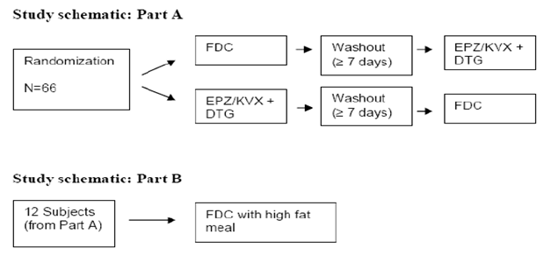
Key inclusion criteria were: healthy males and non-pregnant females with capacity to consent and cooperate, aged between 18 and 55 years, with BMI between 18.5 kg/m2 to 31.0 kg/m2, with negative HLA_B*5701 allele screening assessment. Permitted and excluded medications were summarised.

Analysis populations
Safety Population: All participants who received at least one dose of study drug.
Pharmacokinetic Concentration Populations: All participants with evaluable pharmacokinetic (PK) DTG, ABC, or 3TC assay results. This was the population for the concentration listing and plotting of the concentration-time data for each analyte.
Pharmacokinetic bioequivalence Summary Population: All participants with valid DTG, ABC or 3TC PK parameter estimates in both period 1 and period 2 and with no missing PK sample from 0-6 hour post dose. Data from this population was used for analysis of PK parameter data for Part A.
PK Food Effect Summary Population: Participants in Part B with valid DTG, ABC or 3TC PK data. This population was used for summary and analysis of PK parameter data for Part B.
There was one protocol amendment which predated the commencement of the trial. There were no changes in the conduct of the study or planned analyses.

Results
Sixty-six participants enrolled in Part A. The mean age was 29.3 years, the majority were male (66%) and White (52%) or African/American (38%). Twelve participants were included in Part B, the mean age was 33.8 years, he majority were male (67%) and White (58%) or Africa/American (42%). Mean weight in Part B was greater than Part A.
Sixty-five participants were included in the PK Concentration Population. One participant vomited after dosing and was withdrawn from the study. All 12 participants enrolled in Part B were included in the PK food effect summary population.
Sixty-two participants in Part A had data included in the bioequivalence analysis. One individual who vomited after dosing in Period 1 and one was unable to swallow the ABC/3TC tablet in Period 2 were excluded, one failed to return for Period 2 and one had the 2-hour PK sample inadvertently not collected.
Six participants had protocol deviations. With the exception of the missed 2-hour PK sample; protocol deviations were not considered to affect the validity of the study.
Five participants received 1 or more concomitant medications during the study: paracetamol (2) and Neosporin ointment, tetryzoline eye drops, cough drops, ibuprofen, and diphenhydramine (1 each).

Pharmacokinetic results – Part A
For each of DTG, ABC, and 3TC, the 90% CIs for the geometric least-squares mean ratios for each of the bioequivalence parameters were within the bioequivalence criteria range of 0.8 to 1.25. (Table 1 and Figure 2)

Table 1: ING114580 Part A: Bioequivalence Assessment
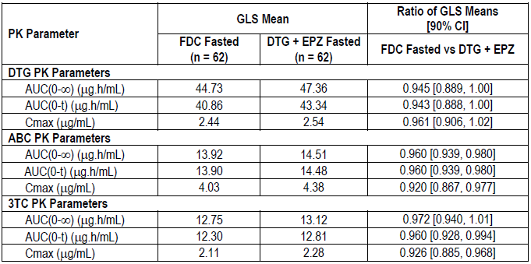
GLS=geometric least squares
Figure 2: ING114580 Geometric Mean Ratios and 90% CIs - Bioequivalence Assessment (Study Part A)
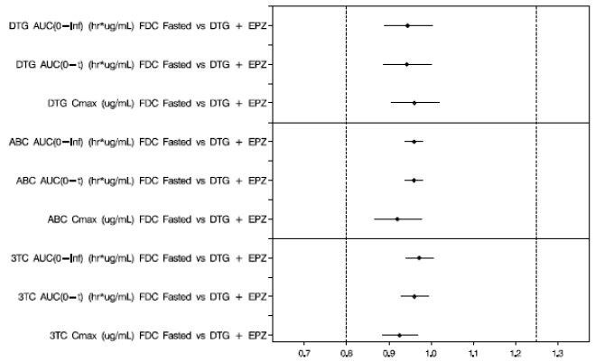
Individual fasted PK parameters are summarised: for DTG Table 2; ABC Table 3 and 3TC Table 4. Each component was rapidly absorbed with median values indicating no lag time for absorption.
DTG tmax was 3.0 hours for both FDC and DTG + ABC/3TC. Geometric mean Cmax, AUC and t1/2 were similar for both treatments.
ABC median tmax was 2 hours for the FDC and DTG + ABC/3TC. ABC Cmax and AUC values were slightly higher for DTG + ABC/3TC treatment. Geometric mean t1/2 values were similar.
3TC median tmax values were 3 hours for the FDC tablet and 2 hours following DTG + ABC/3TC. 3TC Cmax and AUC were slightly higher and t1/2 slightly shorter for the DTG + ABC/3TC treatment relative to the FDC treatment.

Table 2: Study ING114580 Summary of Plasma Dolutegravir Pharmacokinetic Parameters
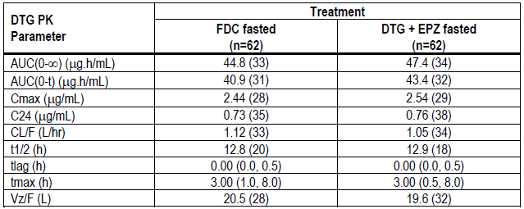
Values denoted geometric mean (CV%) except for tmax and tlag which are presented as median (range).

Table 3: Study ING114580 Summary of Plasma Abacavir Pharmacokinetic Parameters
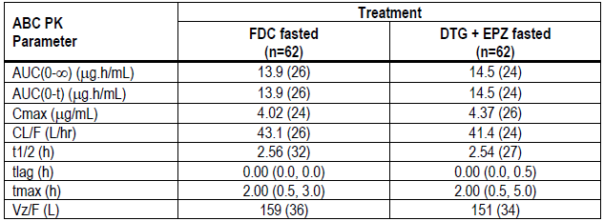
Values denoted geometric mean (CV%) except for tmax and tlag which are presented as median (range).

Table 4: Study ING114580 Summary of Plasma Lamivudine Pharmacokinetic Parameters
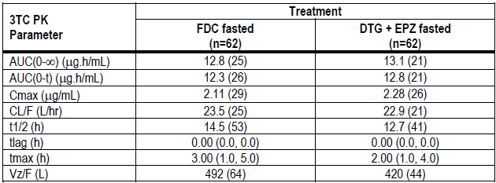
Values denoted geometric mean (CV%) except for tmax and tlag which are presented as median (range).

Pharmacokinetic results - Part B
The PK parameters, fed and fasted for 12 participants in Part B are summarised Table 5. DTG Cmax and AUC were higher when the FDC tablet was administered with high fat meal than in the fasted state. ABC Cmax and AUC were slightly reduced and 3TC AUC were slightly increased when the FDC tablet was administered with a high fat meal.
As summarised in Table 6 the results for DTG for the FDC tablet following the high fat meal that were approximately 48% higher for AUC and 37% higher for Cmax than in the fasted condition.
For both ABC and 3TC, the results indicate that plasma exposures from the FDC tablet administered with a high fat meal were similar to those in the fasted state, although the Cmax for ABC was approximately 23% lower when the FDC tablet was taken with food.

Table 5: ING114580 Plasma DTG, ABC, and 3TC Pharmacokinetic Parameters for Food Effect
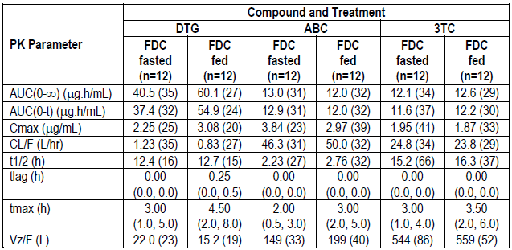
Values denoted geometric mean (CV%) except for tmax and tlag which are presented as median (range).

Table 6: Study ING114580 Part B: Statistical Comparison for Food Effect Assessment
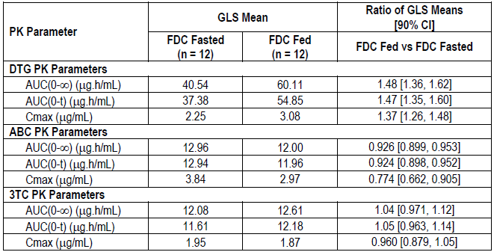

Applicant’s discussion
Bioequivalence was demonstrated between the FDC tablet formulation and the separate co-administered tablet formulations of DTG plus Epzicom.
Administration of the FDC tablet with a high fat meal resulted in increases in plasma DTG Cmax and AUC, but these are not considered clinically significant. The effects of food on ABC and 3TC exposures were very similar to prior effects seen with Epzicom, which may be taken with or without food supporting the recommendation that the FDC can be given without regard to meals.
The design of this study did not include administration of ABC and 3TC alone. The data do not address whether DTG impacts ABC and 3TC exposure. Due to different routes of metabolism and elimination, no clinically significant drug interaction is expected between DTG and ABC/3TC.
ABC is metabolized by glucuronidation and by alcohol dehydrogenase with less than 2% excreted in the urine as unchanged parent. ABC does not have inhibitory activity on uridine 5’-diphospho-glucuronosyltransferase (UGT) pathways and is metabolized primarily through UGT2B7. Only 25-36% of ABC is glucuronidated, indicating it is not a substrate-sensitive route. As DTG is metabolized through UGT1A1, a drug interaction with ABC is unlikely. Furthermore, UGT is a high capacity enzyme system and the fraction metabolized by UGT pathways for both of these compounds is likely less than 50%, making drug interactions between these agents both unlikely and not clinically significant.
As 3TC is primarily eliminated by renal clearance with the majority of drug eliminated unchanged in the urine, a clinically meaningful drug interaction with DTG is not anticipated.
Lack of significant interaction is supported by Table 7 below demonstrating that the PK of ABC and 3TC when given as an FDC tablet with DTG in ING114580 are similar to that when given alone in the ABC/3TC bioequivalence study CAL10001. These data suggest that DTG does not have an effect on ABC or 3TC exposure.

Table 7: Study ING114580 Comparison of ABC and 3TC PK Parameters across Studies
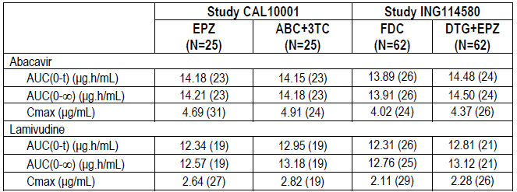
All data are from doses administered in fasted state. Values denote geometric mean (CV%)
The following was included in Module 2.7: In vitro, dolutegravir inhibited the basolateral renal transporters: organic anion transporter (OAT) 1 (IC50 = 2.12 μM) and OAT3 (IC50 = 1.97 μM). Based upon the dolutegravir unbound plasma concentration, in silico modeling, and no notable effect on the pharmacokinetics in vivo of the OAT substrates tenofovir and para aminohippurate, dolutegravir has low propensity to cause drug interactions via inhibition of OAT transporters.
In vitro, DTG was an inhibitor of the basolateral renal organic cation transporter 2 (OCT2) and the renal apical transporters: multidrug and toxin extrusion transporter (MATE) 1 (IC50 = 6.34 μM) and MATE2-K (IC50 = 24.8 μM). Dolutegravir has a low potential to affect the transport of MATE2-K substrates. In vitro incubation with DTG concentrations that were observed in vivo after a 50 mg oral dose produced a 90% inhibition of OCT2. These in vitro results indicate the potential for a drug interaction in vivo with cationic compounds that are renally cleared by these transporters, mainly for drugs with narrow therapeutic indices.

Evaluator comment
The finding of bioequivalence in the protocol defined terms is accepted. No data for Cmin were presented. Cmin is considered a potentially clinically relevant parameter.
With respect to Table 7, on the assumption that the values in the column headed ABC/3TC are for single entity administration, and considering problems inherent in use of historical comparisons, ABC and 3TC AUC values appear similar; however, it is likely that Cmax for both ABC and 3TC would not meet bioequivalence limits. As DTG has the theoretical capacity to increase 3TC levels based on in vitro inhibition of OCT2, it is surprising that the FDC 3TC Cmax point estimate shown in Table 7 is approximately 75% of the single active point estimate. While lamivudine may not have a narrow therapeutic index, it is less than optimal that an interaction study has not been provided when two of the actives in the FDC have the potential to interact.

Study ING116898 drug interaction – Dolutegravir, calcium and iron
DTG is a 2-metal-binding INI. The mechanism of action involves binding to magnesium in the active site of the integrase enzyme, preventing insertion of HIV viral DNA into the host cell DNA. Drugs in this class are susceptible to chelation type drug interactions with divalent and trivalent metal cations. In this study, Calcium carbonate was selected over calcium citrate due to its higher elemental calcium. Ferrous fumarate contains a higher elemental iron than ferrous sulfate and ferrous gluconate.
ING116898 was a Phase I, single centre (US) open-label, randomized, four-period crossover study evaluating the effects of calcium carbonate 1200 mg and ferrous fumarate 324 mg on pharmacokinetics of dolutegravir 50 mg in healthy adults. Participants were randomized into one of two cohorts and received each of four treatments in a randomized fashion.
- A single dose of DTG 50 mg administered under fasted conditions
- A single dose of DTG 50 mg co-administered with a single dose of calcium carbonate or ferrous fumarate under fasted conditions
- A single dose of DTG 50 mg co-administered with a single dose of calcium carbonate or ferrous fumarate with a moderate-fat meal (approximately 30% fat)
- A single dose of DTG 50 mg administered under fasted conditions 2 hours prior to administration of a single dose of calcium carbonate or ferrous fumarate.
Participants in each cohort were assigned to one of four treatment sequences: ABCD, BDAC, CADB, DCBA for Cohort1 (Table 8) or AEFG, EGAF, FAGE, GFEA for Cohort 2 (Table 9) in accordance with the randomization schedule generated prior to the start of the study, using validated internal software.
Each dosing session was separated by wash-out of at least 7 days. During each treatment period, the participants were admitted to the unit on Day -1 and were housed in the unit until after the Day 3 post-dose assessments were completed. Permitted and prohibited medications were the same as for Study ING114580.

Table 8: Study ING116898 Cohort 1 Treatment Assignment
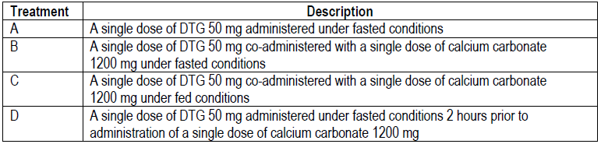

Table 9: Study ING116898 Cohort 2 Treatment Assignment
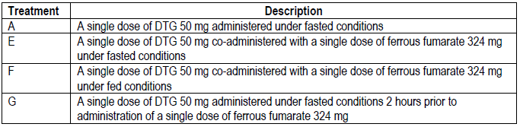
The primary objectives were:
Cohort 1
- To compare single dose plasma DTG PK following co-administration of DTG 50 mg and calcium carbonate 1200 mg in the fasted state, to DTG 50 mg alone in the fasting state
- To compare single dose plasma DTG PK following co-administration of DTG 50 mg and calcium carbonate 1200 mg with a moderate-fat meal, to DTG 50 mg alone in the fasting state
- To compare single dose plasma DTG PK following administration of DTG 50 mg in the fasted state 2 hour prior to administration of calcium carbonate 1200 mg to DTG 50 mg alone in the fasting state
- To compare single dose plasma DTG PK following co-administration of DTG 50 mg and calcium carbonate 1200 mg in a fed state to DTG 50 mg and calcium carbonate 1200 mg in a fasted state.
Cohort 2
- To compare single dose plasma DTG PK following co-administration of DTG 50 mg and ferrous fumarate 324 mg in the fasted state to DTG 50 mg alone in the fasting state
- To compare single dose plasma DTG PK following co-administration of DTG 50 mg and ferrous fumarate 324 mg with a moderate-fat meal to DTG 50 mg alone in the fasting state
- To compare single dose plasma DTG PK following administration of DTG 50 mg in the fasted state 2 hour prior to administration of ferrous fumarate 324 mg to DTG 50 mg alone in the fasting state
- To compare single dose plasma DTG PK following co-administration of DTG 50 mg and ferrous fumarate 324 mg in a fed state to DTG 50 mg and ferrous fumarate 324 mg in a fasted state.
Primary endpoints were the DTG PK parameters: AUC_{(0-t)}, AUC_{(0-∞)}, Cmax and C24. Interactions of DTG with calcium carbonate or ferrous fumarate were considered not clinically significant according to the protocol, if the observed decrease in dolutegravir AUC or Cmax was less than 70%.
The study included healthy individuals aged between 18 and 65 years with body weight more than 50 kg for males and 45 kg for females, having BMI between 18.5 and 31.0 kg/m2, ALT, alkaline phosphatase and bilirubin ≤ 1.5x upper limit of normal (ULN), single QTcF < 450 msec and capable of giving written informed consent.

Results
One individual in Cohort 1 was prematurely discontinued due to a protocol deviation (positive drug screen). Two in Cohort 2 were discontinued; one lost to follow-up and one with a protocol deviation (positive drug screen). Demographic characteristics are summarised in Table 10. The mean age was 33.2 years; the majority were White (71%) and male (58%).

Table 10: Study ING116898 Demographic Characteristics
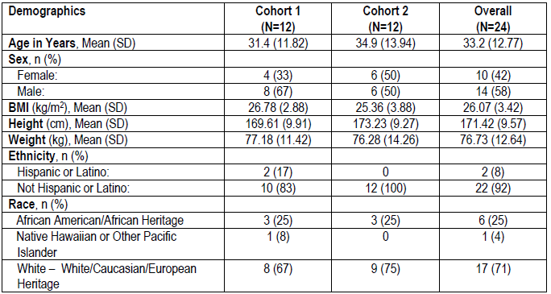

Pharmacokinetic results
Co-administration of DTG with either calcium carbonate or ferrous fumarate under fasted condition resulted in reduced plasma DTG exposures; plasma DTG AUC_{(0-t)}, AUC_{(0-∞)}, Cmax, and C24 by approximately 37 - 39% with calcium carbonate and 54 - 57% with ferrous fumerate (Table 11 and Table 12).
Co-administration of DTG with calcium carbonate or ferrous fumarate under fed condition counteracted the interaction and provided plasma exposures comparable to DTG alone under fasted conditions. Similarly, DTG administered under fasted conditions 2 hours prior to administration of a single dose of calcium carbonate or ferrous fumarate resulted in plasma exposures comparable to DTG alone (Table 12).

Table 11: Study ING116898 Summary of Plasma DTG Pharmacokinetic Parametersª
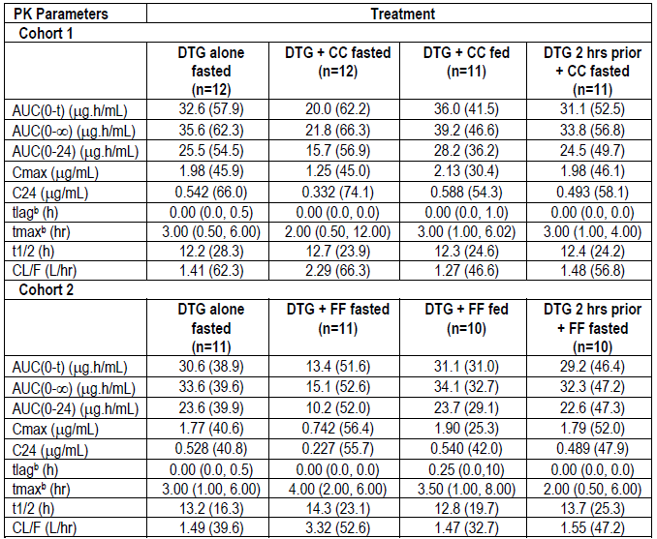
ªGeometric mean; ^{b} Presented as median (range); Tlag=lag time before observation of drug concentrations in sampled matrix

Table 12: Study ING116898 Statistical Comparison of Plasma DTG Pharmacokinetic Parameters
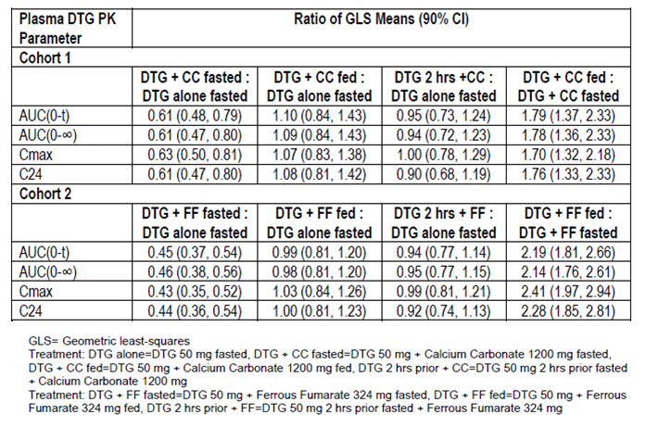

Applicant’s conclusion
- Co-administration of DTG with calcium carbonate under fasted condition resulted in reduction in plasma DTG AUC_{(0-∞)}, Cmax, and C24 by 39%, 37%, and 39%, respectively
- Co-administration of DTG with ferrous fumarate under fasted condition resulted in reduction in plasma DTG AUC_{(0-∞)}, Cmax, and C24 by 54%, 57%, and 56%, respectively
- Co-administration of DTG with calcium carbonate or ferrous fumarate under fed condition or dosing DTG 2 hours prior to these supplements showed DTG exposure similar to those when DTG was given alone under fasted conditions
- DTG and calcium or iron supplements can be co-administered if taken with a meal. Under fasted conditions, DTG should be given 2 hours prior or 6 hours after calcium or iron supplements.

Evaluator comment
The strategy for minimising effect of these cation supplements is accepted in principle; in practice it may be difficult to ensure compliance. Vigilance will be required by the treating practitioners.

Study ING116070 pharmacodynamics – cerebrospinal fluid
ING116070 is an ongoing Phase IIIb single-arm, open-label, multicentre study of HIV-1 infected ART-naïve patients to determine the potential for dolutegravir to enter the cerebrospinal fluid (CSF) compartment and to assess the effect of DTG plus fixed-dose ABC/3TC (Epzicom) on CSF and plasma HIV-1 RNA viral load. The study started in January 2012 at three sites in the US. The Week 2 results were evaluated for registration of DTG. The Week 16 results are the subject of this report.
Dolutegravir is approximately 99% bound to plasma proteins and is a substrate of P-gp and breast cancer resistance protein (BCRP), limiting access to the CSF.
The primary objective was to determine total and unbound plasma DTG concentration and evaluate the relationship between DTG concentration in plasma and CSF.
Primary outcomes assessed at Week 16 were CSF DTG concentration and total and unbound plasma DTG PK concentration of samples drawn within 2 to 6 hours post-dose and within 1 hour of CSF sample collection. No formal hypothesis was tested. The relationship between DTG concentration in plasma (total and unbound) and CSF at Week 2 and Week 16 was estimated.
Secondary Objectives were to assess:
- The effect of DTG + ABC/3TC on CSF and plasma HIV-1 viral load
- The tolerability, long-term safety, incidence of HIV-associated conditions, antiviral and immunologic activity of DTG in combination with ABC/3TC over time
- The relationship between CSF DTG concentration and HIV-1RNA in CSF at Weeks 2 and 16
- The relationship between HIV-1 RNA suppression in plasma and CSF at Weeks 2 and 16
- The development of viral resistance in participants experiencing virologic failure.
The ITT-E Population was the primary population for all efficacy analysis. The plasma efficacy endpoint was the proportion of participants with plasma HIV-1 RNA < 50 c/mL at Week 16 using the Snapshot, missing, switch, or discontinuation = failure (MSDF) algorithm. The CSF efficacy endpoint was the proportion of participants in the CSF Pharmacodynamic Population with CSF HIV-1 RNA < 50 c/mL at Week 16.
Key inclusion criteria were: HIV-1 infected ARV- naive adults ≥ 18 years of age with screening plasma HIV-1 RNA ≥ 5000 copies/mL(c/mL); CD4+ cell count ≥ 200 cells/mm³, negative for the HLA-B*5701 allele and willing to undergo serial lumbar punctures.
All participants received DTG 50 mg with background FDC ABC/3TC 600/300 mg once daily, with or without food. Only DTG was considered the investigational product (IP). Switch of background to an alternative NRTI therapy for toxicity or tolerability management was allowed once. Permitted and prohibited medications were specified in the protocol.
One pair of PK samples in plasma and time matched CSF were collected for determination of DTG concentration at Week 2 and Week 16. Samples for plasma HIV-1 RNA were collected at Baseline and various time points throughout the study and samples for HIV-1 RNA levels in the CSF were collected at Baseline, Week 2 and Week 16. (Figure 3).
Figure 3: Study ING116070 Study schematic
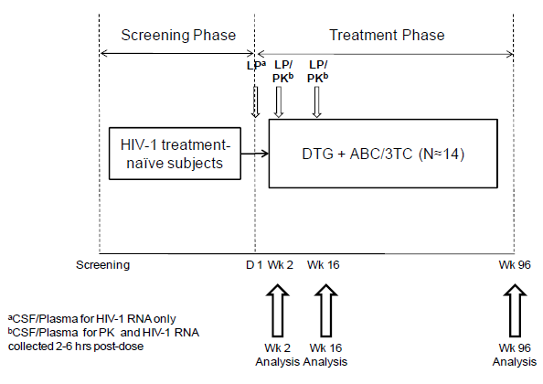
Virologic failure was defined as confirmed plasma HIV-1 RNA > 200 c/mL on or after Week 16. For participants with virologic failure, blood samples were tested for viral resistance patterns.

Results
The original protocol was amended once and included 3 changes unlikely to impact the results. All thirteen enrolled participants received study medication; two prematurely withdrew, one for a non-drug-related serious adverse event (SAE) and the other for virologic failure. No participant had a deviation from inclusion/exclusion criteria. Ten (77%) had one or more protocol deviations: administer/dispense study medication 7 (54%) and ‘other’ 8 (62%).

Table 13: Study ING116070 Disposition of Participants at Week 16 (ITT-E Population)
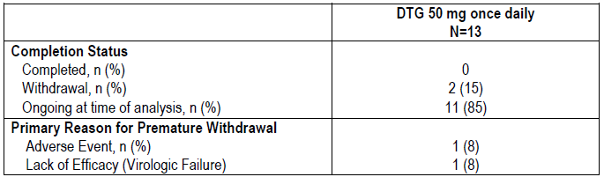
All participants were white, and male. Mean age was 40.2 years, range 28 to 52 years. The number entering the study with plasma HIV-1 RNA >100,000 c/mL was 5/13, (38%) and CD4+ cell count < 350 cells/mm3 was 6/13 (46%). All participants received ABC/3TC as their background NRTI therapy. No concomitant medication was considered likely to impact results. (Table 14)

Table 14: Study ING116070 Demographic and Baseline Characteristics
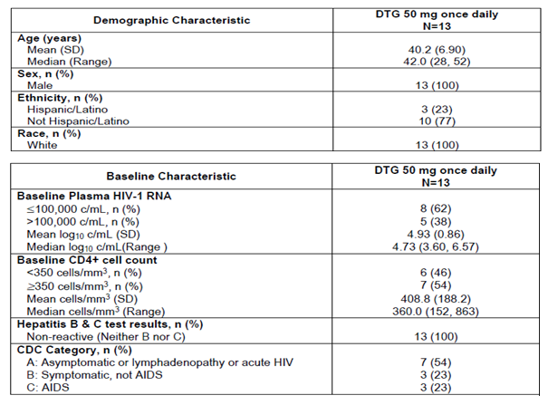
The median time of exposure to DTG was 168 days; 92% (12/13) of participants received therapy for at least 16 weeks. Half of the participants (7/13, 54%) had received at least 24 weeks of therapy as of the data cut-off. Participants providing evaluable plasma PK and CSF PK data on DTG at Weeks 2 and 16 are summarised in table 15.

Table 15: Study ING116070 Summary of Participants Providing PK Data at Week 2 and Week 16
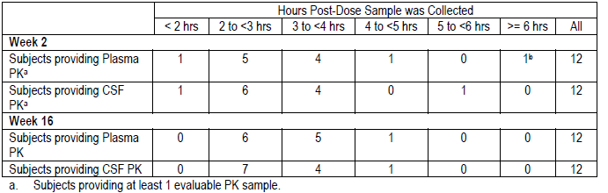

Pharmacokinetic results
The results are summarised in table 16. At Week 2, there was no significant correlation between CSF and total plasma DTG concentrations (Pearson Correlation Coefficient [P-value] = 0.267 [0.427]. There was no significant correlation between CSF and unbound plasma DTG concentrations (Pearson Correlation Coefficient [P-value] = 0.434 [0.183].
At Week 16, there was a significant correlation between CSF and total plasma DTG concentrations (Pearson Correlation Coefficient [P-value] = 0.647 [0.023]. There was also a significant correlation between CSF and unbound plasma DTG concentrations (Pearson Correlation Coefficient [P-value] = 0.728 [0.007].
When combining Week 2 and Week 16 data, there was a significant correlation between CSF and total plasma DTG concentrations (Pearson Correlation Coefficient [P-value] = 0.464 [0.026], but no correlation between CSF and unbound plasma DTG concentrations (Pearson Correlation Coefficient [P-value] = 0.279 [0.197].

Table 16: Study ING116070 Summary of DTG Concentration in Plasma and CSF
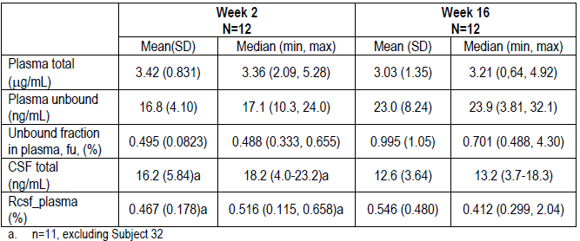

Pharmacodynamic results
Total and unbound plasma DTG concentrations overlapped between virologic responders and non-responders at Week 2 and Week 16. There was no correlation between CSF DTG concentrations and changes from Baseline in CSF HIV-1 RNA at Week 2 and Week 16. Although there appeared to be a correlation between CSF DTG concentration and absolute CSF HIV-1 RNA levels, the direction of correlations at Week 2 and Week 16 were opposite. There was a significant overlap in CSF DTG concentrations between participants with CSF HIV-1 RNA <50 c/mL and ≥ 50 c/mL at Week 2.

Efficacy result
One participant was a non-responder due to lack of virologic data; this participant prematurely discontinued due to non-drug-related SAE of pharyngitis. Using the key cut-off of 50 c/mL, two individuals experienced virologic failure with plasma HIV-1 RNA of 236 and 77 c/mL respectively.

Table 17: Study ING116070 Proportion with Plasma HIV-1 RNA < 50 c/mL over Time (ITT-E Population) SNAPSHOT Analysis
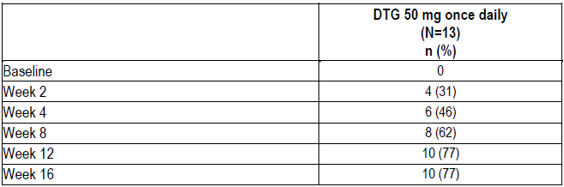

Table 18: Study ING116070 Summary of Study Outcomes – HIV RNA < 50 c/mL
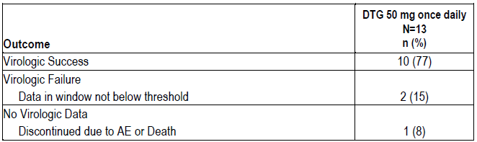
At Week 16
- 11/11 participants had CSF HIV-1 RNA < 50 c/mL using an Observed Dataset. The median change from Baseline to Week 16 in CSF HIV-1 RNA was -3.42 log10 c/mL and was similar to that observed in plasma (-3.04 log10 c/mL)
- 11 participants had both plasma and CSF HIV-1 RNA data available and nine (82%) had both plasma and CSF HIV-1 RNA < 50 c/mL
- there was a median increase in CD4+ cell count of 225.5 cells/mm3 (IQR: 136 to 336.5 cells/mm³).

Applicant’s conclusions
- DTG concentrations observed in CSF at both Week 2 and Week 16 exceed the in vitro IC50 against wild-type viruses (0.2 ng/mL) for all subjects suggesting that DTG is able to achieve therapeutic concentrations in the CSF
- DTG concentrations were detected in the CSF at Week 16 and were similar to the unbound DTG concentrations in plasma, with statistically significant correlations between DTG CSF and plasma, (both total and unbound) concentrations
- A regimen of DTG + ABC/3TC was effective in decreasing CSF HIV-1 RNA levels
- No direct correlation of DTG CSF concentrations and change from Baseline in CSF HIV-1 RNA levels was observed likely due to combination therapy and the potent antiviral activity across subjects at Week 16
- Median decreases in CSF HIV-1 RNA levels at Week 16 were similar to those observed in plasma
- A regimen of DTG 50 mg once daily with ABC/3TC demonstrated good short-term tolerability in this study, with a safety profile comparable to that observed in other studies with DTG + ABC/3TC
- No integrase or NRTI resistance was detected in 1 subject with PDVF, which confirms previous findings of a higher barrier to resistance with dolutegravir.
Given the PK and efficacy data in this study, the combination of DTG/ABC/3TC forms the basis of a potentially effective regimen in subjects with neurologic manifestation of HIV infection.

Evaluator comment
The sponsor’s leading conclusion, that DTG concentrations observed in CSF at both Week 2 and Week 16 exceed the in vitro IC50 against wild-type viruses (0.2 ng/mL) for all participants, is accepted.
This was a small observational study in which no hypothesis was tested, with very limited power to detect significance. Multiplicity was not accounted for in the Reporting Analysis Plan (RAP Section 8.4 page 17). While the RAP stated that the Pearson Correlation Coefficient and 90% confidence intervals would be calculated, p-values, and not Confidence Intervals were provided in the CSR. The reporting of significance or otherwise based on p-values is questioned. The investigators made somewhat contradictory conclusions with regard to significance, i.e: at Week 2 there was no significant correlation between CSF and unbound plasma DTG concentrations; at Week 16 there was a significant correlation; for the combined Week2 and 16 data, there was no significant correlation. There was no correlation between CSF DTG concentrations and changes from baseline in CSF HIV-1 RNA at Week 2 and 16 and although there appeared to be a correlation between CSF DTG and absolute CSF HIV-1 RNA levels, the direction of the correlation at Weeks 2 and 16 was opposite.
While the study has been undertaken to assess dolutegravir, the background therapy of ABC/3TC is relevant to the FDC proposed for registration and also relevant to the efficacy findings of the study. The unquantified contribution to efficacy of abacavir and lamivudine, both of which penetrated CSF is a confounder.

Dosage selection for the pivotal studies
No studies submitted.

Clinical efficacy/virology

Study ING114467 (single) pivotal study – Treatment naïve
ING114467 is an ongoing, Phase III, parallel group, randomised, double-blind, active-controlled multinational study of HIV-1 infected ART naïve adult patients comparing DTG + ABC/3TC (Epzicom) with emtricitabine/tenofovir/efavirenz (EFV/TDF/FTC) This study commenced in 2011and is being conducted at 136 sites in Europe (71), USA (51), Canada (10) and Australia (4).
Treatments were blinded until Week 96. For this Week 96 week analysis report, the last observation was dated 04 May 2013. The Week 48 results were previously evaluated by the Therapeutic Goods Administration (TGA) for registration of DTG.
Participants were randomised 1:1 to receive DTG + ABC/3TC or EFV/TDF/FTC. Randomisation was stratified by screening HIV-1 RNA status (≤ 100,000 or >100,000 c/mL) and CD4+ count (≤ 200 or > 200 cells/mm³). After enrolment, patients attended the clinic at Day 1, Weeks, 2, 4, 8, 12, 16, 24, 32, 40 and 48 and the every 12 weeks thereafter. Randomisation was via a validated central randomisation procedure (RANDALL, GSK).
The primary objective was to demonstrate the antiviral activity of DTG + ABC/3TC FDC compared to EFV/TDF/FTC. The primary endpoint was the proportion of participants with plasma HIV-1 RNA < 50 copies/mL at Week 48 using the Snapshot algorithm.
The primary efficacy analyses were performed on the ITT-E population (all randomised patients who received at least one dose of study drug) at Week 48. The per-protocol (PP) population was used for sensitivity analyses. Non-inferiority was concluded if the lower bound of a two-sided 95% confidence interval for the difference in response rates between the two treatment arms was greater than - 10%.

Secondary objectives
- To demonstration of the antiviral activity of the DTG + ABC/3TC once daily therapy compared to EFV/TDF/FTC over 96 weeks
- To explore the impact of gender, race and/or HIV-1 subtype on response to DTG + ABC/3TC once daily therapy and EFV/TDF/FTC
- To assess the development of viral resistance in participants experiencing virological failure.
Secondary endpoints included
- The proportion of participants with plasma HIV-1 RNA < 50 copies/mL at Week 96
- Time to viral suppression (< 50 copies/mL)
- Proportion of participants with plasma HIV-1 RNA <50 copies/mL at Week 96.
Key inclusion criteria were: HIV-1 infected, treatment- naïve males and non-pregnant females aged ≥ 18 years; plasma HIV-1 RNA ≥ 1000 c/mL; and negative HLA-B*5701 allele. Key exclusion criteria were: Category C disease; hepatic impairment; history of malignancy; recent treatment with HIV-1 vaccines, immunomodulators, cytotoxic agents or radiation; evidence of viral resistance; any Grade 4 laboratory abnormality; significant renal impairment; and recent GI bleeding.
Withdrawal from the study was required for confirmed virologic failure, treatment substitution, pregnancy, QTC interval > 550 msec, liver or renal toxicity, grade 4 adverse event considered related to investigational product. Withdrawal criteria also included non-compliance, participant, investigator or sponsor request, use of prohibited medication as specified in the protocol.
The randomised treatments including matched placebo tablets are summarised in Table 19.

Table 19: Study ING114467 Study treatments

Results
Disposition is summarised in Figure 4. A total of 1,090 patients were screened and 844 randomised. (Table 20) Participant withdrawals were 17% vs. 26% for DTG+ABC/3TC and for EFV/TDF/FTC respectively. Adverse events were the most common reason for withdrawal. Withdrawals due to AEs for the DTG + ABC/3TC and EFV/TDF/FTC groups were 3% and 11% respectively. Withdrawals due to lack efficacy were reported for 18 (4%) of the DTG+ABC/3TC group and 14 (3%) of the EFV/TDF/FTC arm. Seventeen (4%) in the DTG+ABC/3TC arm and 18 (4%) in the EFV/TDF/FTC arm were lost to follow up (Table 21).
A total of 35 participants had protocol deviations leading to exclusion from the PP population (DTG + ABC/3TC 18, EFV/TDF/FTC 17). One participant from each group had deviations specific to the Inclusion or Exclusion Criteria. The participant receiving DTG+ABC/3TC had a positive HLA-B*5701 allele assessment. The participant receiving EFV/TDF/FTC was positive for Hepatitis B (+HbsAg) at Screening. Three participants were excluded from the PP population, because of interrupted investigational product treatment for > 10% of the total time they were on treatment (DTG+ABC/3TC 2, EFV/TDF/FTC 1). Ten participants (DTG+ABC/3TC 4, EFV/TDF/FTC 6) used prohibited medication. Twenty-six (3%) participants (DTG+ABC/3TC 14, EFV/TDF/FTC 12) permanently discontinued due to protocol deviations including pregnancy (n=9), use of prohibited meds (n=3), non-compliance with investigational product (n=9), and non-compliance with protocol procedure (n=7).
Figure 4: ING447767 Disposition
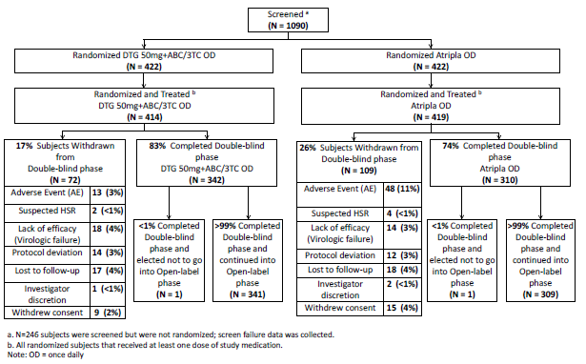

Table 20: Study ING114467 Study Populations
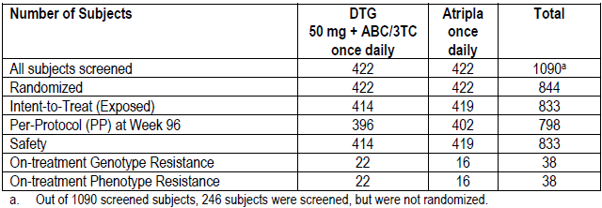

Table 21: Study ING114467 Summary of Participant Accountability: Double Blind Phase Conclusion Record
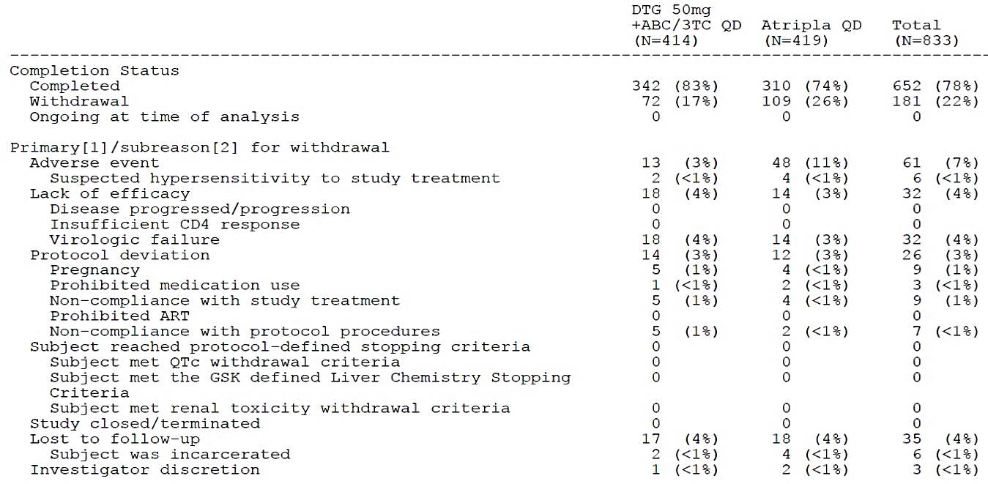
Demographic and baseline characteristics are summarised in Table 22 and Table 23. Characteristics were fairly evenly spread between groups.

Table 22: ING114467 Summary of Demographic Characteristics (ITT-E population)
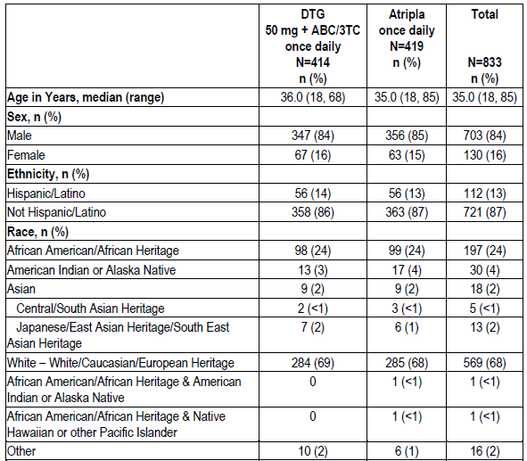

Table 23: ING114467 Summary of Baseline Characteristics (ITT-E population)
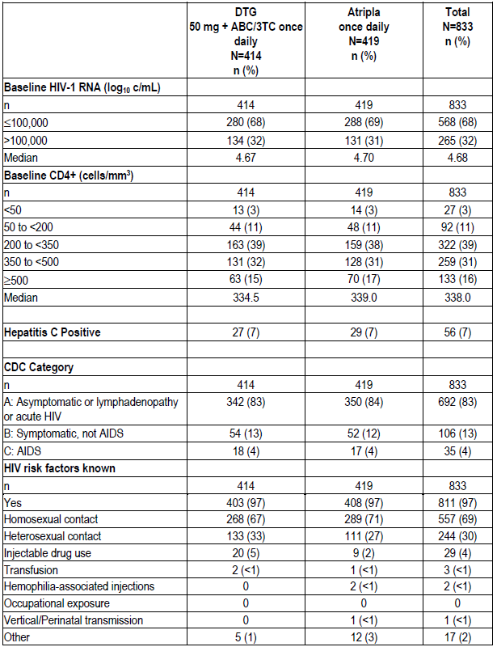

Efficacy results
At Week 48 (previously evaluated), the adjusted difference (DTG- EFV/TDF/FTC) was 7.4 (95% CI: 2.5-12.3) (p=0.003) consistent with conclusion of superiority of DTG + ABC/3TC. The primary efficacy endpoint was reassessed as a secondary objective at Week 96. The adjusted difference, DTG minus EFV/TDF/FTC was 8.0% (95% CI: +2.3%, +13.8%). The result supported the Week 48 finding. (Table 24 and Figure 5).
Virologic response rate differences between DTG+ABC/3TC and EFV/TDF/FTC were due to a lower rate of discontinuations due to AEs on the DTG+ABC/3TC arm (13/414, 3% on DTG+ABC/3TC versus 48/419, 11% on EFV/TDF/FTC). Eight percent (8%) of EFV/TDF/FTC participants were virologic non responders compared with 7% in the DTG+ABC/3TC group. Twenty percent (20%) of participants in the EFV/TDF/FTC group and 12% in the DTG + ABC/3TC group were considered non responders because of lack of virologic data at Week 96. The ‘Other’ reasons for discontinuation among the subjects with no virologic data at Week 96 included protocol deviations, lost to follow up, investigator discretion, and withdrawal of consent. (Table 25).
Sensitivity analyses were conducted: Kaplan-Meier estimates of the proportion of participants without treatment related failure (TRDF) by Week 96 were numerically greater with the DTG + ABC/3TC compared to the EFV/TDF/FTC treatment group and supportive of the primary results, while the proportion of subjects without efficacy related failure (ERDF) was essentially the same for both treatment groups. (Table 26).

Table 25: Study ING114467 Proportion with Plasma HIV-1 RNA <50 c/mL at Week 96 (ITT-E Population)
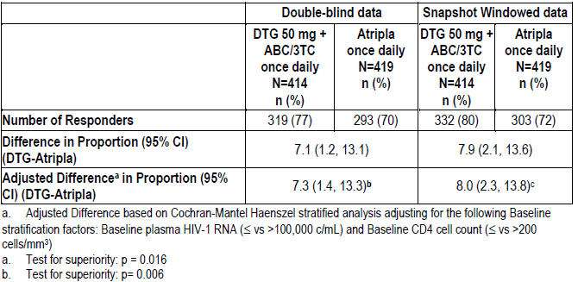
Figure 5: Study ING114467 Proportions with Plasma HIV-1 RNA < 50 c/mL Snapshot Analysis by Visit
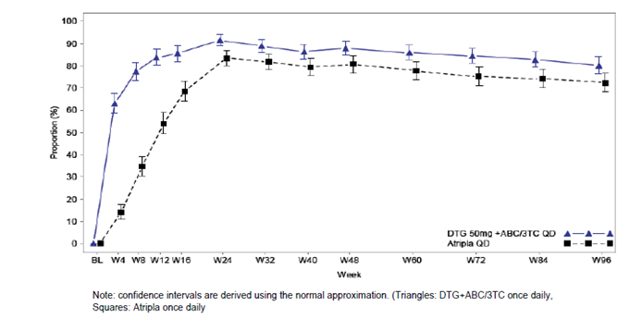

Table 25: ING114467 HIV-1 RNA < 50 c/mL) at Week 48 and Week 96 Snapshot Analysis (ITT-E Population)
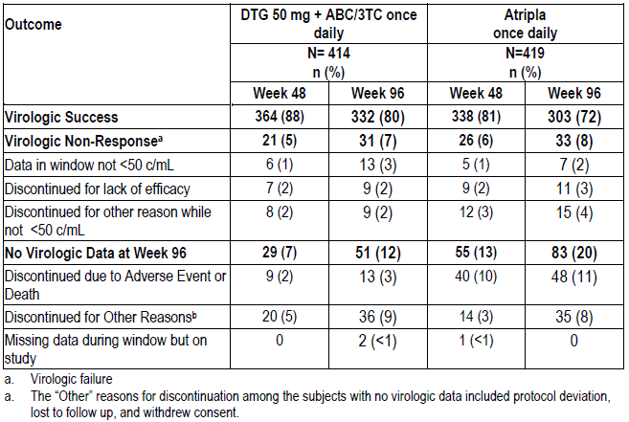

Table 26: ING114467 Kaplan-Meier Estimates of the Proportion of Subjects without Treatment/Efficacy Related Failure by Week 96
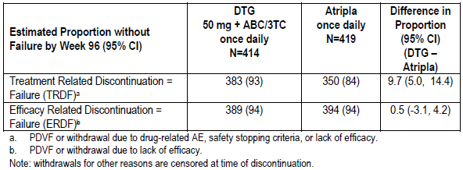
In the high viral load DTG + ABC/3TC subgroup, there were more ‘discontinuations due to other reasons’ 14 (10%) than in the EFV/TDF/FTC group 8 (6%). There was also a slightly higher rate of ‘virologic nonresponse’ for DTG + ABC/3TC than EFV/TDF/FTC, driven by data in window not < 50 c/mL. The difference between treatment arms in withdrawals due to AE, driving the overall statistical difference, was consistent in the high and low viral load subgroups.
For treatment related non-responders analysis, in which participants with protocol defined virologic failure (PDVF) or withdrawal due to adverse events, are counted as non-responders, while participants discontinued for other reasons [e.g. lost to follow-up] were censored, the treatment difference was consistently in favour of DTG+ABC/3TC in both the high and the low viral load subgroups. Further, the treatment difference was consistent between the high and low viral load subgroups in PDVFs, as shown by the overlapping confidence intervals.

Applicant’s conclusions
- The SINGLE study was designed to demonstrate non-inferiority of a dolutegravir - based regimen versus EFV/TDF/FTC, and the primary analysis met this criterion. Statistical superiority at Week 96 was concluded as part of a subsequent, pre-specified testing procedure.
- At 96 weeks, 80% of study participants on the DTG + ABC/3TC regimen were virologically suppressed vs. 72% of participants on the single tablet regimen EFV/TDF/FTC [difference and 95% CI; 8.0% (+2.3% to +13.8%); difference in the primary endpoint was statistically significant, [p=0.006].
- Differences in efficacy were primarily driven by a lower rate of discontinuation due to AEs on the DTG+ABC/3TC arm.
- The treatment difference was more pronounced in the low viral load subgroup. Overall, the statistically higher responses on DTG+ABC/3TC were driven by withdrawals due to AEs, irrespective of viral load strata. For treatment related non-responders, the treatment difference was consistently in favour of DTG+ABC/3TC between the high and low viral load subgroups. Further, the treatment difference was consistent between the high and low viral load subgroups in protocol-defined virologic failures. Thus, the overall treatment differences are applicable to the population studied in SINGLE, which included participants with both high and low Baseline viral loads.
- Response rates on DTG+ ABC/3TC and EFV/TDF/FTC were generally consistent across demographic subgroups, including race, gender, age, HIV risk factors, and Baseline CDC category.
- Several pre-specified secondary analyses which controlled for the risk of false positive results were also supportive, including that participants treated with DTG + ABC/3TC achieved viral suppression significantly faster compared to EFV/TDF/FTC.

Evaluator comment
The Week 96 analysis was secondary and the protocol stated that no adjustment would be made for multiplicity caused by repeated evaluation of the primary endpoint as the Week 96 analysis will be secondary. It is accepted that the result of analysis of this secondary objective supported the primary analysis result; however, lack of adjustment of the CI for multiplicity is questioned.
Although the study was double blind for investigators and participants until the Week 96 visit, GSK unblinded the study at the time of the Week 48 analysis. Unblinding has the potential to add risk of bias in interpreting borderline results. Furthermore it is possible that the differing side effect profiles alerted investigators and participants to the likely treatments, a matter which is considered virtually impossible to completely avert, especially when every one of the comparator drugs differed from the IP regimen. The Snapshot analysis used in the primary and supportive secondary analyses is considered to have potential to be influenced by lack of, or imperfect blinding, due to decisions relating to change of, or discontinuation of treatment due to adverse events.
The primary efficacy endpoint, also used for the Week 96 analysis, was the proportion of participants with HIV-1 RNA <50 c/mL at Week 48 using a Missing, Switch or Discontinuation equals Failure algorithm as codified by the FDA’s ‘snapshot’ algorithm (RAP). This suggests that failures are considered to have HIV-1 RNA ≥ 50 c/mL for the purpose of the analysis, although they may not have at the time of missing the relevant test result, switching or discontinuing treatment. The latter in particular could be due to multiple reasons and switching may also be based on a subjective decision. It is considered inaccurate that results using this algorithm are stated in terms of HIV-RNA < 50 c/mL in the Product Information. It is argued that the difference strictly in terms of HIV RNA < 50 copies/mL was not statistically different as shown Table 26.

Study ING113086 (spring-2) supportive – Treatment-naive
ING113086 is an ongoing Phase III randomized, double-blind, active-controlled, multicentre, non-inferiority study of treatment-naïve adults, designed to assess safety and efficacy of dolutegravir 50 mg once daily versus raltegravir (RAL) 400 mg twice daily, each administered with either ABC/3TC or tenofovir/emtricitabine (TDF/FTC). The study commenced in October 2010. A total of 100 investigational sites enrolled participants in 59 centres in Europe (France, Germany, Italy, Spain, and the United Kingdom), 19 in the US, 11 in Russia, 7 in Canada, and 4 in Australia. Ninety-six week results were presented with this submission.
Key inclusion criteria were, HIV-1 infected, ART-naive adults ≥18 years of age with plasma HIV-1 RNA ≥1000 c/mL at Screening; Study treatments were as shown in Table 27.

Table 27: Study ING113086 Treatments
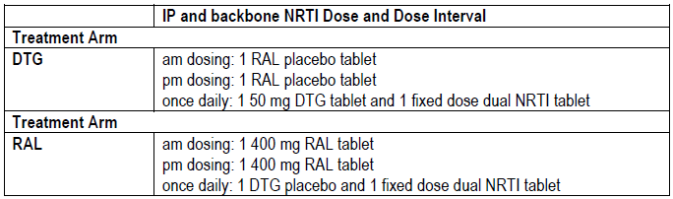
The primary objective was to demonstrate the antiviral activity of DTG 50 mg administered once daily compared to RAL 400 mg twice daily over 48 weeks. Antiviral activity was assessed as the proportion of participants with plasma HIV-1 RNA < 50 c/mL determined by the Snapshot algorithm. Non-inferiority of DTG 50 mg was concluded if the lower bound of a two-sided 95% confidence interval for the difference in proportions (DTG minus RAL) was greater than - 10%. The adjusted difference in the proportions was based on a stratified analysis using Cochran-Mantel-Haenszel weights.
The key secondary objective was to demonstrate the antiviral activity of DTG vs. RAL over 96 weeks. With respect to this objective according to the RAP, as there is only one key secondary analysis comparison, no adjustment for multiplicity was required. As the secondary analysis comparison was tested only in the case of a finding of non-inferiority for the primary comparison, this pre-specified sequence of testing controlled the overall type I error among the tests of the primary comparison of interest and the key secondary analysis comparison.
Other secondary objectives included: comparisons of tolerability, safety and antiviral; assessment of development of viral resistance in subjects experiencing virological failure and exploration of the impact of gender, race and HIV-1 subtype on response DTG and RAL. Assessment of results for those treated with DTG + ABC/3TC was not a study objective.
Efficacy analyses were conducted using the ITT-E population and assessed according to their randomized treatment. The analysis was repeated using the PP population. If both analyses showed non-inferiority and the lower end of the 95% CI was above 0%, superiority was concluded.
After completion of the Week 48 statistical analysis, the sponsor became aware of good clinical practice (GCP) noncompliance issues at a ViiV sponsored study at one site in Russia where 14 subjects (DTG 8, RAL 6) were enrolled in ING113086. GlaxoSmithKline (GSK) in conjunction with ViiV, closed this site. Sensitivity analyses were conducted to assess the impact to removing these subjects from the Weeks 48 and 96 analyses.
Plasma for quantitative HIV-1 RNA was collected according to the Time and Events schedule. Methods used could include but were not limited to the Abbott RealTime HIV-1 Assay lower limit of detection (LLOD) 40 c/mL.
Participants were randomized 1:1 via a central procedure using GSK validated software RANDALL, to receive DTG 50 mg once daily or RAL 400 mg twice daily, each in combination with fixed-dose dual NRTI therapy for 96 weeks. Backbone therapies were selected by the investigator. Randomization was stratified by screening HIV-1 RNA (≤ 100,000 c/mL or > 100,000 c/mL) and by backbone NRTI. Treatment was unblinded at Week 96. (Figure 6).
Figure 6: ING113086 (spring-2) design
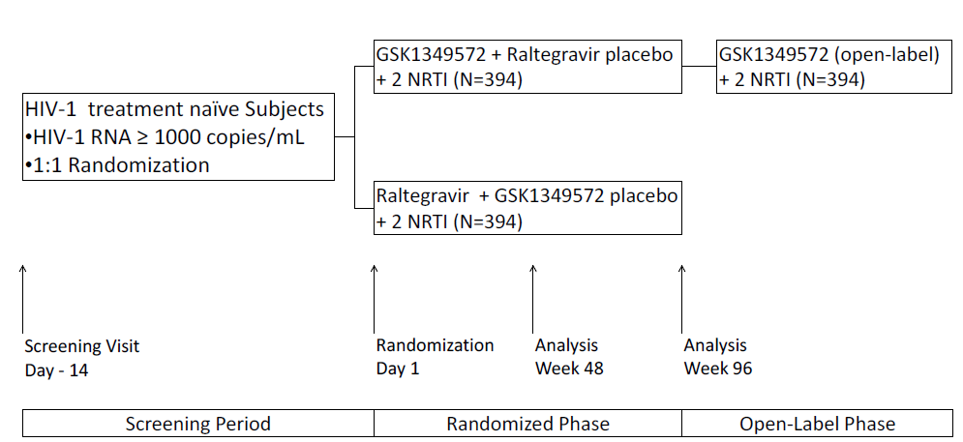
The original protocol was amended three times, each occurring after enrolment had commenced. These amendments should not have impacted results of the primary or key secondary analyses.

Results
A total of 827 subjects were randomized. Of these, 822 received at least one dose of study medication. (Table 28) In total, 681 patients completed Week 96: DTG 349 (85%); RAL 332 (81%)]. Fifteen patients (DTG 8, RAL 7) discontinued due to an AE; twenty-nine withdrew due to protocol deviations (DTG 13, RAL 16); five discontinued upon reaching protocol-defined liver stopping criteria (DTG 2, RAL 3). (See also Table 29 and Table 30).
The majority of participants were White (85%) and male (86%); the median age of the ITT-E population was 36 years. (Table 31) Twenty-eight percent of each group had baseline HIV-1 RNA > 100,000 log₁₀ copies/mL. Baseline CD4+ levels were evenly spread between groups. Approximately 12% of subjects had hepatitis B and/or hepatitis C (HCV) infection; 86% were in Centres of Disease Control (CDC) Class A, and 65% identified homosexual activity as an HIV risk factor. (Table 32).

Table 28: Study ING116086 Participant Accountability
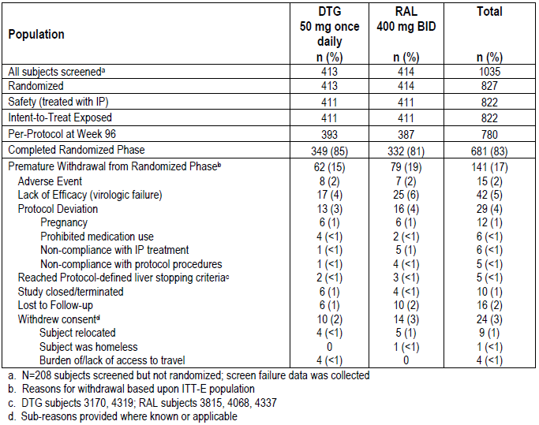

Table 29: ING113086 Protocol Deviations Leading to Exclusion from the PP Population to Week 96
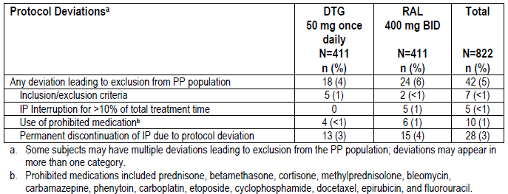

Table 30: Study ING113086 Analysis Populations (All Subjects Screened)
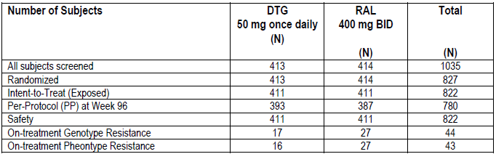

Table 31: Study ING113086 Summary of Demographic Characteristics (ITT-E population)
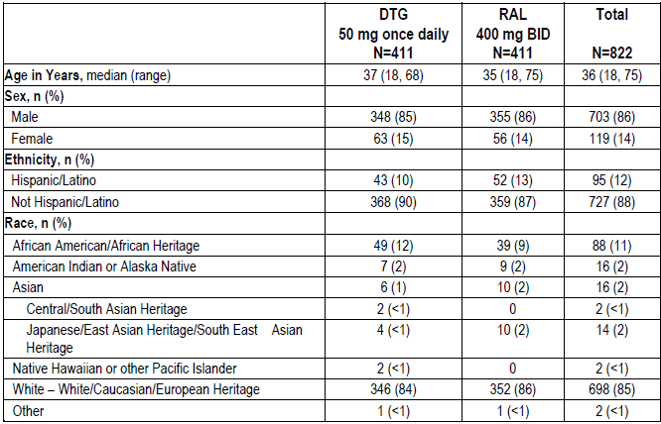

Table 32: Study ING113086 Summary of Baseline Characteristics (ITT-E population)
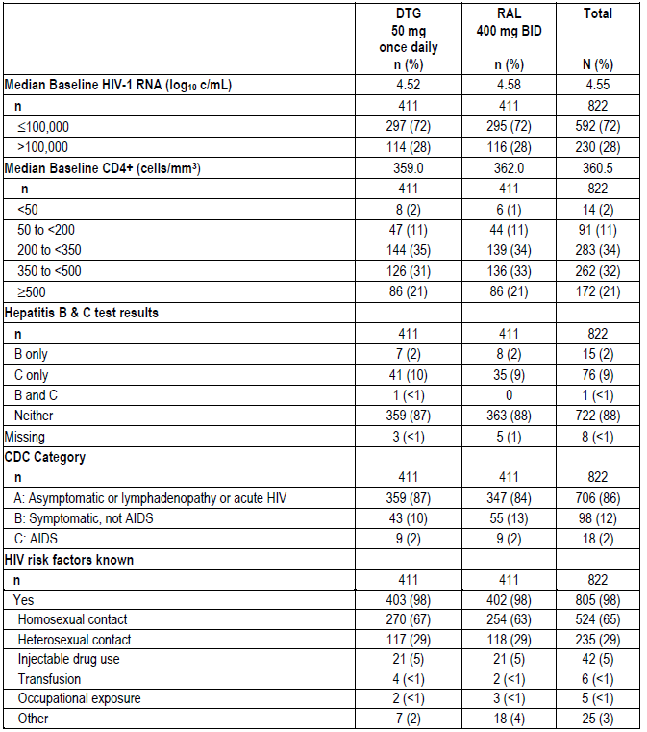

Efficacy results
Approximately 40% of participants were prescribed ABC/3TC as backbone NRTI. Ten individuals permanently switched therapy: 5 switched from ABC/3TC to TDF/FTC (DTG 4, RAL 1), and 4 switched from TDF/FTC to ABC/3TC (DTG 2, RAL 2). One HLA-B*5701 positive, Russian participant randomized to DTG switched from ABC/3TC to lamivudine + zidovudine when the error was discovered; TDF/FTC is not registered in Russia. Exposure to study drugs was similar between groups. (Table 33).
At week 96, 81% of the DTG group and 76% of the RAL group achieved < 50 c/mL plasma HIV-1 RNA. The per-protocol results were 83% and 80% respectively. The difference in proportions (95% CI) for the ITT-E population was 4.4% (-1.2, 10.0). (Table 34 and Figure 7).
Kaplan-Meier estimates of the proportion of subjects without treatment/efficacy related failure by Week 96 were similar for DTG and RAL. (Table 35 overall results; Table 36 for those with ABC/3TC backbone) In the Efficacy related discontinuation = failure analysis, the proportions overall without failure were 94.1% for DTG and 92.3% for RAL and for the ABC/3TC treated participants: 92.5% vs. 91.7% for DTG and RAL respectively.

Table 33: Study ING113086 Summary of Extent of Exposure (Safety Population)
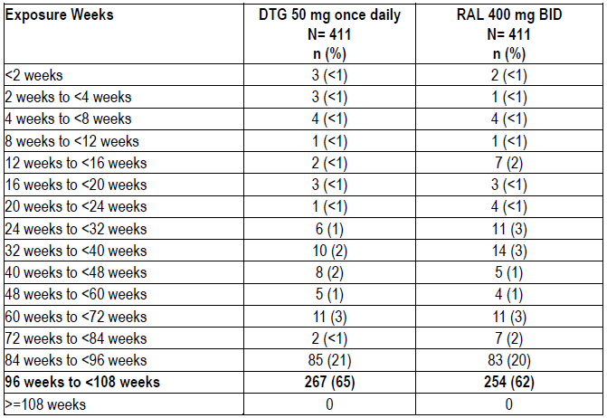

Table 34: SING113086 Response based on Plasma HIV-1 RNA < 50 c/mL at Week 96 (ITT-E Population)
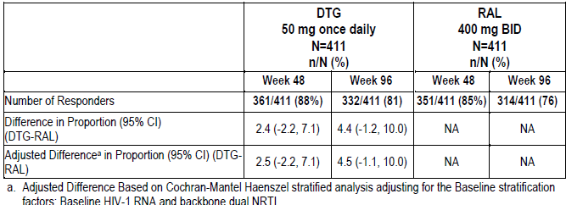
Figure 7: Study ING113086 Proportion (95% CI) of Subjects with HIV-1 RNA <50 c/mL by Visit
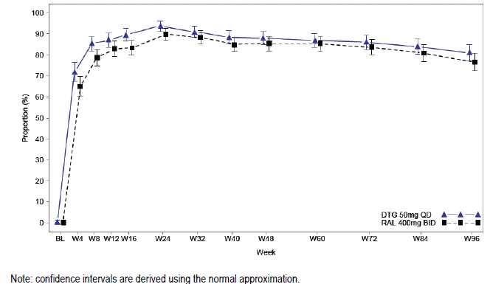

Table 35: ING113086 Kaplan-Meier estimates of the proportion of subjects without treatment/efficacy related failure by Week 96
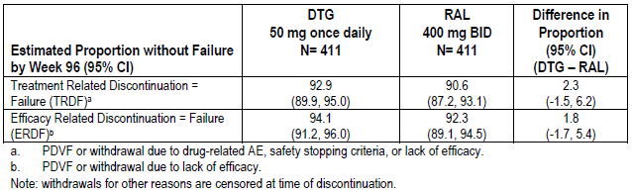

Table 36: ING1130886 Kaplan-Meier estimates of the proportion of subjects without PDVF and not discontinued due to Treatment related reasons at Week 96, by Background Dual NRTI
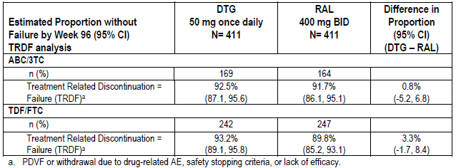

Applicant’s conclusion
- DTG administered once daily with two NRTIs demonstrated non-inferiority to RAL at Week 96 and was associated with good treatment response
- The proportion of subjects with HIV RNA <50 c/mL (81%) compares favourably with RAL (76%) through 96 weeks
- DTG performed as well as RAL regardless of baseline viral load or background dual NRTI
- DTG performed as well as RAL across demographic subgroups, including race, gender, age, HIV risk factors, Baseline CD4+ cell count and Baseline CDC category.

Evaluator comment
Non-inferiority at Week 96 was not the primary objective. Planned analysis according to the criteria for the primary analysis could not be located in the protocol which stated only that secondary efficacy endpoints would be summarised by treatment arm and by visit. However, it is accepted that the Week 48 non-inferiority criterion was met at Week 96. Sub-analysis for those treated with background ABC/3TC was not a study objective.

Study ING114915 (flamingo) supportive – Treatment-naïve
Study ING114915 is an ongoing Phase IIIb randomized, open-label, active-controlled, multicentre, parallel group, non-inferiority study of HIV-1 infected ART-naïve adults which commenced in October 2011. Participants were randomly assigned 1:1 to receive DTG 50 mg once daily or darunavir + ritonavir (DRV+RTV or DRVr) 800/100 mg once daily, each in combination with fixed dose dual NRTI therapy (ABC/3TC or TDF/FTC).
Randomization via a central randomization procedure using validated software was stratified by screening plasma HIV-1 RNA ≤ 100,000 c/mL or >1 00,000 c/mL and by background NRTI. The date of the last observation completed for this Week 48 analysis was 22 Apr 2013. A total 488 participants were enrolled in 64 investigational centres in Europe (France, Germany, Italy, Romania, Spain, and Switzerland), the United States, Russia, and Puerto Rico.
The primary objective was to demonstrate the non-inferior antiviral activity of DTG compared to DRV/RTV over 48 weeks of treatment. Antiviral activity was assessed as the proportion of participants with plasma HIV-1 RNA < 50 c/mL determined by the FDA Snapshot algorithm. The primary comparison was made at a one-sided 2.5% level of significance. Treatment with DTG was declared non-inferior to treatment with DRV/r if the lower end of a two-sided 95% confidence interval for the difference between the two groups in response rates at Week 48 was above - 12%. The adjusted difference in the proportions was based on a stratified analysis using Cochran-Mantel-Haenszel weights. Superiority was declared if the lower end of the 95% confidence interval calculated in the mITT-E analysis was above 0%.
Assuming an 80% response rate at Week 48 for both DTG and DRV+RTV arms, the study required 234 evaluable subjects per arm to have 90% power with a 12% non-inferiority margin and a 1-sided 2.5% significance level. This sample size also had 85% power under the assumption of a 75% response rate at Week 96.
The primary population used in analysis was the mITT-E population, defined as all randomized subjects who received at least 1 dose of IP. One patient at a Russian site closed early because of GCP non-compliance was excluded from this population.
As for ING113086, quantitative HIV-1 RNA assessment methods to be used could include but were not limited to the Abbott RealTime HIV-1 Assay lower limit of detection 40 c/mL.
Secondary Objectives included:
- Comparison of the effects of DTG and DRV+RTV on fasting glucose and lipids over time
- Comparison of the tolerability, safety and HIV-associated conditions
- Assessment of viral resistance in subjects with virologic failure
- Evaluation of the effect of patient characteristics on response to treatment.
Secondary endpoints included the following:
- Time to viral suppression (<50 c/mL) through Week 48
- Proportion of subjects with plasma HIV-1 RNA < 400 c/mL
- Absolute values and change from Baseline in plasma HIV-1 RNA
- Absolute values and changes from Baseline in CD4+ and CD8+ T cell counts.
If the primary comparison of interest demonstrated noninferiority for the mITT-E population of DTG compared to DRV/r, then the following comparisons were tested according to the gatekeeping procedure described below:
- Superiority of DTG to DRV/r with respect to change from baseline in LDL cholesterol at Week 48 on the modified safety population
- Superiority of DTG to DRV/r with respect to the incidence of Grade 2 or higher in LDL cholesterol lab abnormalities at Week 48 on the modified safety population
- Superiority of DTG to DRV/r with respect to time to viral suppression (< 50 copies/mL) to 48 Weeks on the mITT-E population.
Time to viral suppression was summarised graphically by treatment group using Kaplan-Meier plots. Participants who withdraw for any reason without having suppressed prior to the analysis were censored. Superiority of DTG vs. DRV/r was tested using a generalised Wilcoxon test based on the mITT-E population.
Treatments are summarised in Table 37. Background treatment was chosen by the investigators. DTG and background NRTIs could be administered with or without food. Darunavir + ritonavir were to be administered with food. The FDC dual NRTI tablets were to be taken once daily.

Table 37: Study ING113086 treatments
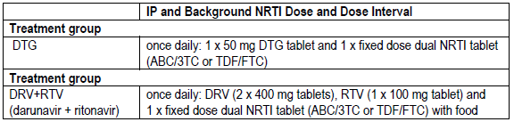
With respect to the open-label design it was stated that blinding of the protease PI component, particularly RTV with its trademark embossed on the marketed tablet, was a substantial logistical hurdle. In a double-dummy design, 5 pills per day would be administered, a large pill burden.’
Key inclusion criteria were as for Study ING113086: HIV-1 infected, ART-naive adults ≥18 years of age with plasma HIV-1 RNA ≥1000 c/mL at Screening. Exclusion criteria differed from those of ING113086 on with respect to toxicity specified only in the ING114915 protocol.

Results
Of 488 patents randomly assigned, 484 received at least 1 dose of study medication. The rates of premature withdrawals were: DTG 7%; DRV+RTV 12%. The proportions withdrawing due to AEs were: DTG 1%, DRV+RTV 4%, and lost to follow-up: DTG 2%, DRV+RTV 4%. (Table 40) Analysis populations are summarised in Table 38. The mITT-E population included 242 participants in each treatment group. Twelve participants had protocol deviations leading to exclusion from the PP Population (DTG 5, DRV+RTV 7). (Table 39).

Table 38: Study ING114915 Analysis Population (All Subjects Screened)
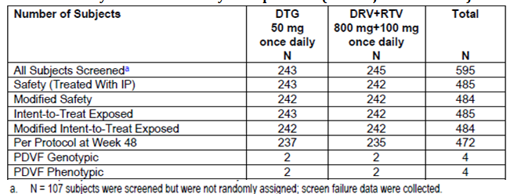
[information redacted]

Table 39: ING114915 Deviations Leading to Exclusion from PP Population Week 48 mITT-E Population
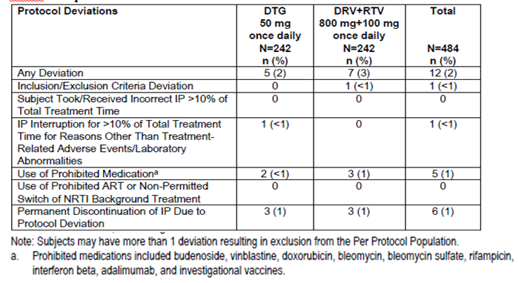

Table 40: Study ING114915 Subject Accountability (mITT-E Population)
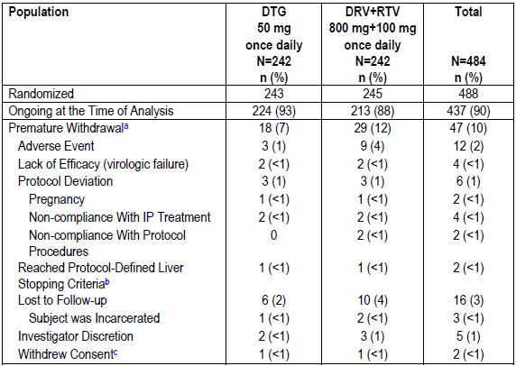
a Reasons for withdrawal based upon the mITT-E population. Subjects may have only 1 primary reason for withdrawal. b [information redacted] c subreasosn were not provided.
Most participants were White (72%) and male (85%) with median age of 34 years. Most had negative screening test for hepatitis B and HCV (90%), were in CDC Class A (84%), and identified homosexual activity as an HIV risk factor (70%). (Tables 41 and 42)

Table 41: Study ING114915 Summary of Demographic Characteristics (mITT-E Population)
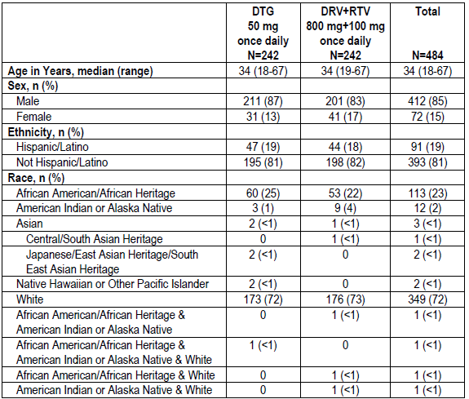
Note: One subject had a missing race. [information redacted] did not fit any of the provided options. The subject was Hispanic originating from Central America (Mexico).

Table 42: Study ING114915 Summary of Baseline Characteristics (mITT-E Population)
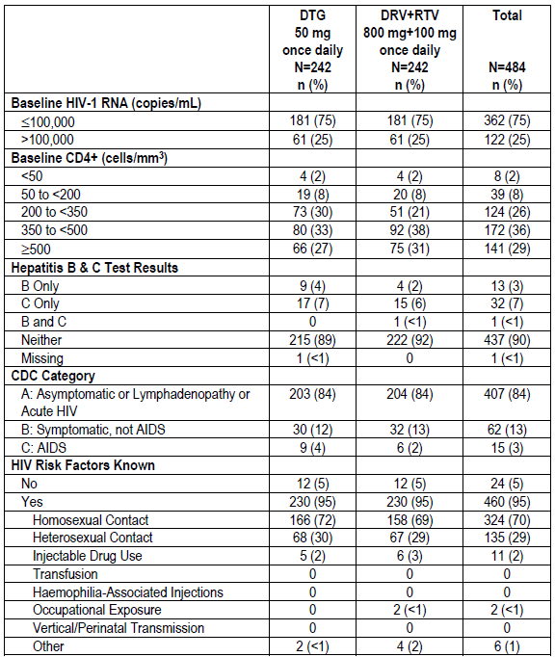
CDC= Centres for Disease Control. Note: Subjects could have more than 1 risk factor
Initially 33% of subjects were prescribed ABC/3TC as background NRTI, the remainder receiving TDF/FTC. At the time of this analysis, 8 subjects had permanently switched therapy: 2 (DTG 1, DRV+RTV 1) switched from ABC/3TC to TDF/FTC, and 6 (DTG 4, DRV+RTV 2) switched from TDF/FTC to ABC/3TC.

Efficacy results
The primary analysis demonstrated non-inferiority of DTG compared to DRV+RTV; superiority was also concluded. At Week 48, 90% of the DTG group vs. 83% of the DRV+RTV group achieved the primary endpoint. The difference (95% CI) = 7.1% (0.9, 13.2). (Table 43).

Table 43: ING114915 Proportion with HIV RNA <50 c/mL Week 48 Snapshot Analysis (mITT-E Population)
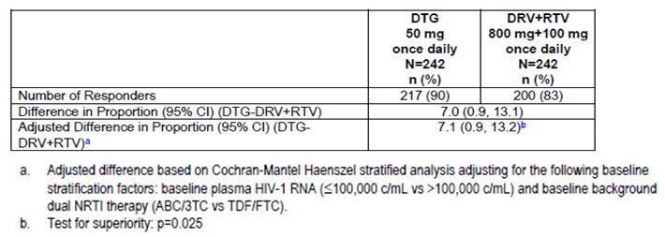
Figure 8: ING114915 Proportion (95% CI) with Plasma HIV-1 RNA <50 c/mL Snapshot Analysis (mITT-E)
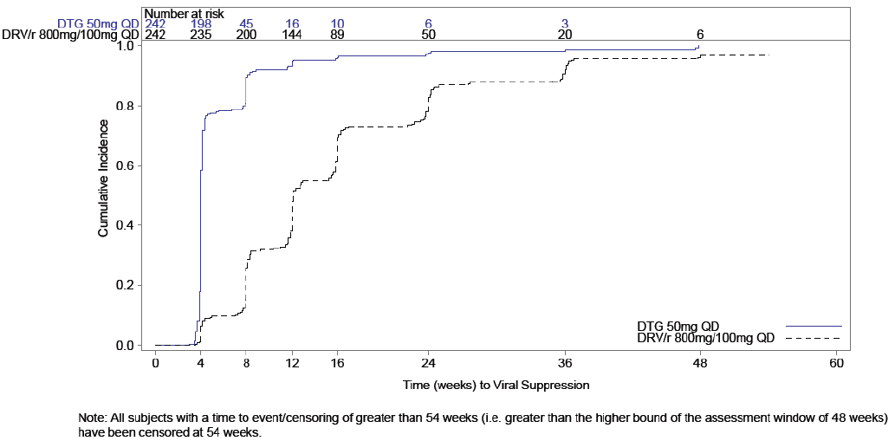
The results for the PP analysis supported the mITT-E analysis: 91% and 84% of DTG and DRV+RTV subjects, respectively, achieved <50 c/mL plasma HIV-1 RNA at Week 48 and the lower end of the 95% CI for the adjusted treatment difference was 1.4%
The proportion of virologic non-responders by the FDA ‘Snapshot’ algorithm to Week 48 was 6% in the DTG group and 7% in the DRV+RTV group, while 4% of subjects in the DTG treatment group and 10% in the DRV+RTV treatment group were considered virologic non-responders due to lack of virologic data at Week 48.
Differences in virologic response rate were primarily driven by discontinuations due to AEs (DTG 1%, DRV+RTV 4%) and other reasons (DTG 2%, DRV+RTV 5%). The ‘Other’ reasons for discontinuation among the subjects with no virologic data at Week 48 included protocol deviation, lost to follow-up, and withdrew consent. (Table 44).
Five participants (DTG 1, DRV+RTV 4) had no virologic data at Week 48 due to ‘missing data during window. For 2 of these, the Week 48 viral load data (HIV-1 RNA < 40 c/mL [sic] in both cases) was obtained after the data cut-off date for the Week 48 analysis. As these data points fall within the Week 48 window for the ‘Snapshot’ algorithm, these 2 participants will be included as virologic successes in the 96-week report. Therefore, the results of the Week 48 analysis will change when the data is reported again at Week 96. In addition, in the DRV+RTV group, one participant was lost to follow-up after Week 24 and the sample of one who completed Week 48 was received unfrozen. One in the DTG group missed the Week 48 visit and was withdrawn, due to lost to follow.
The median time to suppression was 28 days for subjects in the DTG treatment group compared to 85 days in the DRV+RTV treatment group. The difference in time to viral suppression was statistically significant against the pre-specified threshold of 0.05 (2-sided) (p < 0.001). This was the third step in the pre-specified multiple-testing strategy (Figure 9).
Kaplan-Meier estimates of the proportion of subjects without treatment- and efficacy related failure at Week 48 were similar for DTG and DRV+RTV are summarised in Table 45. The proportions without efficacy related failures for DTG vs. DRV + RTV were 99.1% vs. 98.9% with 95% CI for the difference of (-1.7, 2.1).

Table 44: ING114915Plasma HIV-1 RNA <50 c/mL)at Week 48, Snapshot Analysis (mITT-E Population)
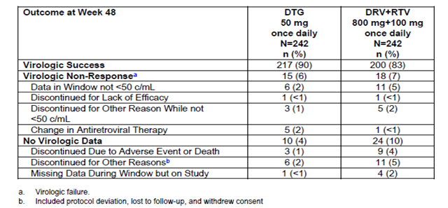
Figure 9: ING114915 Time to Viral Load <50 c/mL to Week 48 (Kaplan-Meier, mITT-E Population)
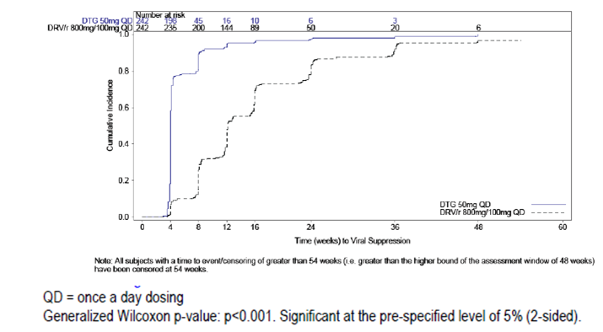
NB: The indistinct text below the figure says: Note: All subjects with a time to event/censoring of greater than 54 weeks (i.e. greater than the higher bound of the assessment window of 48 weeks) have been censored at 54 weeks.

Table 45: Kaplan-Meier Estimates of the Proportion of Subjects Without Treatment/Efficacy-Related Failure at Week 48 (mITT-E Population)
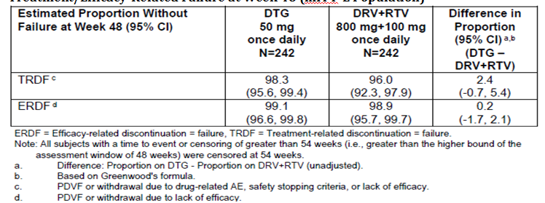
In the DTG group, response rate for patients with baseline high viral load vs. low viral load was 93% vs. 88% respectively. In the DRV+RTV group the response rate for baseline high viral load vs. low viral load was 70% vs. 87%.
Response rates for background ABC/3TC were: DTG 71/79 (90%); DRV+RTV 68/80 (85%). For TDF/FTC the response rates were: DTG 146/163 (90%) and DRV+RTV 132/162 (81%) (Table 46).
The results showing difference in proportions with HIV-1RNA < 50% by demographic characteristics were shown in a figure. The results are considered hypothesis generating.

Table 46: ING114915 Proportions with HIV RNA <50 c/mL by Background NRTI , Snapshot mITT-E
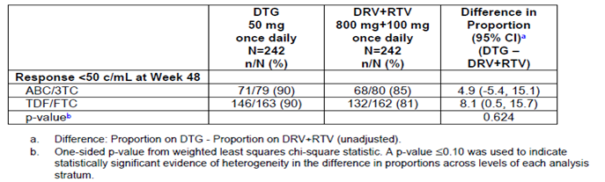

Applicant’s conclusions
- Non-inferiority of DTG versus DRV+RTV was shown as per the study primary analysis. Statistical superiority was concluded as part of a subsequent, pre-specified testing procedure
- At Week 48, 90% of study participants on the DTG regimen were virologically suppressed (<50 c/mL) compared to 83% of participants on the DRV+RTV regimen (difference and 95% CI; 7.1% [0.9, 13.2]; difference in the primary endpoint was statistically significant p=0.025)
- Treatment differences for DTG compared to DRV+RTV across the baseline stratification factors were supportive of the primary analysis. The treatment difference for the high viral load stratum was larger than that for the low viral load stratum (p=0.005, test for evidence against homogeneity). Because the number of subjects in the high viral load stratum is much smaller than the number in the low viral load stratum, the results by strata should be interpreted with caution
- Treatment differences for DTG compared to DRV+RTV across demographic subgroups, including race, sex, age, HIV risk factors, baseline CDC category, and country were generally supportive of the primary analysis.
- Several pre-specified secondary analyses, with pre-specified testing procedures that controlled for the risk of false positive results, were also supportive, including:
- Subjects treated with DTG had statistically significantly lower change from baseline values in LDL cholesterol at Week 48 than those on DRV+RTV (p<0.001 compared against pre-specified p-value threshold of 0.025, 2-sided)
- Subjects treated with DTG had statistically significantly fewer Grade 2 or higher LDL cholesterol lab abnormalities through Week 48 than those on DRV+RTV (p<0.001 compared against pre-specified p-value threshold of 0.045, 2-sided)
- The median time to viral suppression (< 50 c/mL) on the DTG-containing regimen was statistically significantly shorter than on the DRV+RTV-containing regimen (p < 0.001 compared against pre-specified p-value threshold of 0.05, 2-sided)
- CD4+ recovery at Week 48 was similar in subjects in the DTG and DRV+RTV treatment groups.

Evaluator’s comment
The practical difficulty with blinding is accepted; however, the open-label nature of the study introduces the potential for bias. Regarding the primary analysis, it appears that treatment was failed for reasons other than HIV RNA > 50 c/mL or lack of efficacy for 18 (7.4%) participants in the DTG group and for 30 (12.4%) of the DRV+RTV. This difference influenced the result of the Snapshot analysis and could potentially have been impacted by the lack of blinding. It is considered unsafe to determine superiority in this unblinded study without sensitivity analysis which excludes this potential for bias. The Kaplan-Meyer analysis results (Table 45), do not support superiority.
The relevance of this study to Triumeq is limited as the numbers treated with DTG/ABC/3TC were relatively small. Mention of superiority of response in the context of the FDC DTG/ABC/3TC Product Information has the potential to be misleading. Analysis of results of the subgroup treated with DTG + ABC/3TC was not an objective of the study.
Regarding proportions with HIV-1 RNA <50 c/mL at Week 48 by Baseline HIV-1 RNA >100,000 c/mL, the findings for DTG are counter intuitive and appear to be driven by low numbers (zero) of participants in the DTG group with reasons for failure other than HIV-1 RNA > 50 c/mL or lack of efficacy, while other reasons for failure accounted for 9/61 in the DRV+RTV group. The high proportion of responders according to the Snapshot analysis, in those with > 100,000 c/mL is considered likely to be a statistical aberration with potential to skew the overall results for DGT and possibly the overall results of the study.
Regarding time to viral suppression, although the analysis was specified in the RAP it is unclear why an efficacy outcome should be contingent on the finding of superiority of cholesterol results assessed in two different ways. And for the 2 steps relating to cholesterol, it is unclear how many participants provided fasting blood samples. However, it is accepted that a sizeable difference has been reported, and that use of the Bonferoni adjustment would likely have confirmed significance.
The contribution of the TDF/FTC backbone in this result is a confounding factor which would not have been so problematic in reporting in the DTG Product Information but which is considered problematic when reporting the results in the Product Information for this FDC.

Study ING111762 (sailing) – Treatment-experienced
ING11762 is an ongoing a Phase III randomized 1:1, double-blind study of the safety and efficacy of DTG 50 mg once daily versus RAL 400 mg twice daily, both administered with an investigator selected background regimen to HIV-1 infected, integrase inhibitor-naïve, antiretroviral therapy- experienced adults. The study commenced in Oct 2010. It included 156 investigational sites in 19 countries. The Week 48 results were reported in this submission, the Week 24 week results having been previously evaluated for registration of dolutegravir.
The primary objective was to demonstrate the antiviral efficacy of DTG 50 mg once daily compared to RAL 400 mg twice daily each with a background regimen consisting of one to two fully active single agents. The primary endpoint was the proportion of participants with HIV-1 RNA < 50 c/mL to Week 48 using the Snapshot algorithm.
Non-inferiority of DTG 50 mg and RAL was concluded if the lower bound of a two-sided 95% CI for the difference in proportions (DTG - RAL) was greater than -12%. Superiority was declared if the lower bound of the 95% confidence interval calculated in the mITT-E analysis was above 0%.
Secondary objectives included the following:
- To compare the tolerability, long-term safety, antiviral efficacy, and immunologic activity
- To assess the development of viral resistance in subjects experiencing virological failure
- To explore the impact of gender-, race-, and/or HIV-1 subtype on response.
Secondary endpoints included the following:
- The proportion of subjects with detectable virus with genotypic or phenotypic evidence of INI resistance by Week 24 and Week 48 (The Week 48 outcome was designated a key secondary endpoint within the RAP with Type I alpha error protection provided using a fixed-sequence testing approach
- The proportions with detectable virus with genotypic or phenotypic INI resistance
- Absolute values and changes from Baseline in CD4+ and CD8+ cell counts over time
- The proportion developing genotypic or phenotypic resistance to the background regimen.
Key inclusion criteria were: ART-experienced, HIV-1 infected adults ≥18 years of age with HIV-1 RNA > 400 c/mL; documented resistance to two or more different classes of antiretroviral agents but no prior exposure to any integrase inhibitor.
Randomization, via a central randomization procedure using validated randomization software, was stratified by screening plasma HIV-1 RNA: ≤ 50,000 c/mL vs >50,000 c/mL, by DRV/r use without primary PI resistance and by number of fully active drugs in investigator selected background regimen, 2 versus < 2.
Participants receive double-blinded DTG or RAL plus matching placebo tablets until Week 48. (Table 47:) While GSK staff was unblinded for the Week 24 interim analysis, participants and investigators remained blinded until Week 48. The background regimen was guided by Screening resistance test results and prior ART, and was limited to two agents, one of which was required to be fully active.

Table 47: Study ING111762 Investigational treatments
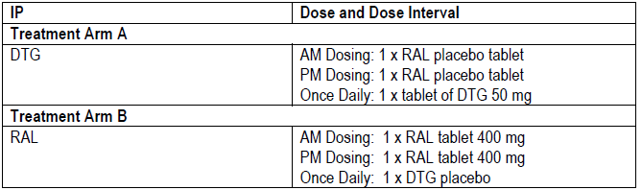

Results
A total of 360 patients were randomised to the DTG group, 354 were included in the mITT-E and 364 to the control group, 361 were included in the mITT-E population. Fifteen participants (DTG: 4, <1%; RAL: 11, 3%) prematurely withdrew from the study because of an AE. Four patients were removed from the study and from the ITT-E population due to study site GCP non-compliance forming the mITT-E population. A total of 50 (7%) subjects had protocol deviations prior to Week 48 leading to exclusion from the PP analysis (DTG: 29; RAL: 21) Summary of the populations analysed is included in Table 48.
Demographic characteristics were well matched. Fifty percent of the overall population were White, 42% were of African Heritage, 36% were of Hispanic/Latino ethnicity 68% were male. Median age was 43 years, with range 18 – 73 years. (Table 49) Baseline characteristics were well balanced as summarised in Table 50.
The median overall prior exposure to any ART was greater than 6 years, with a median of 281.4 weeks for patients with 2-class resistance and 387.7 weeks for those with 3-class or more resistance. Most (54%) had received five or more prior ART, with > 99% receiving one or more NRTI, 84% receiving one or more non-nucleoside reverse transcriptase inhibitor (NNRTI) and 60% receiving one or more PI. Only 2% of subjects had previously received a CCR5 antagonist (maraviroc). In total, 47% of subjects had previously been exposed to drugs in three or more ART classes. The most common background antiretrovirals taken by at least 5% of participants are summarised in Table 51. Abacavir/lamivudine was not listed amongst the most common.
One switch in background therapy occurred in 9 (3%) of the DTG arm and 5 (1%) in the RAL arm. Seven patients (DTG: 1; RAL: 6) received one or more of concomitant medications considered to possibly impact safety, efficacy or the PK of DTG and were excluded from the PP population.
Overall, similar proportions of participants had Baseline 2-class resistance (364/715; 51%) versus 3-class resistance or more (351/715; 49%). (Table 52) Three patients in the DTG group and two in the RAL group had evidence of INI resistance at Baseline.

Table 48: Study ING111762 Analysis Populations
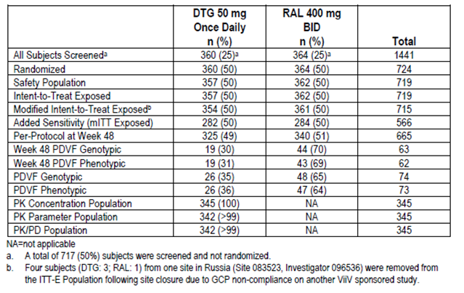

Table 49: Study ING111762 Summary of Demographic Characteristics (mITT-E population)
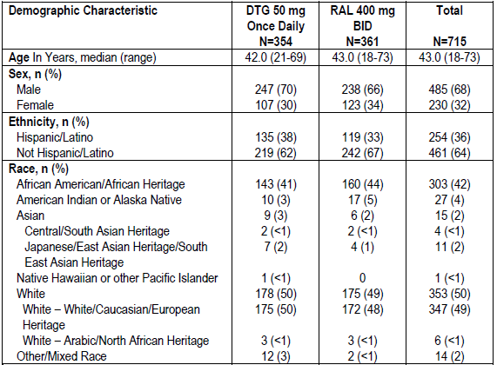

Table 50: Study ING111762 Summary of Baseline Characteristics (mITT-E Population)
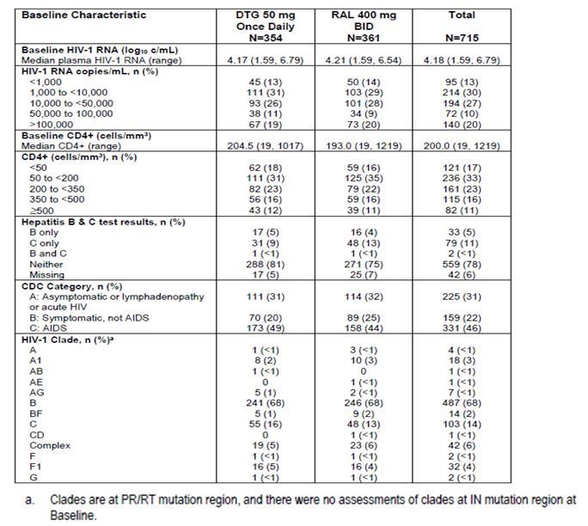

Table 51: Study ING111762 Summary of Background Antiretroviral Regimen (>=5% in any treatment arm) – mITT-E Population
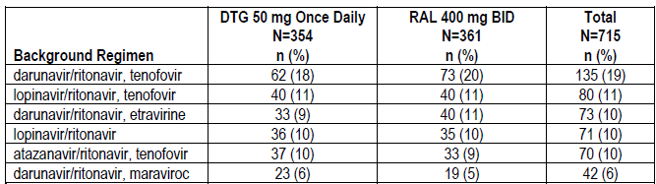

Table 52: ING111762 S Baseline Resistance (mITT-E Population)
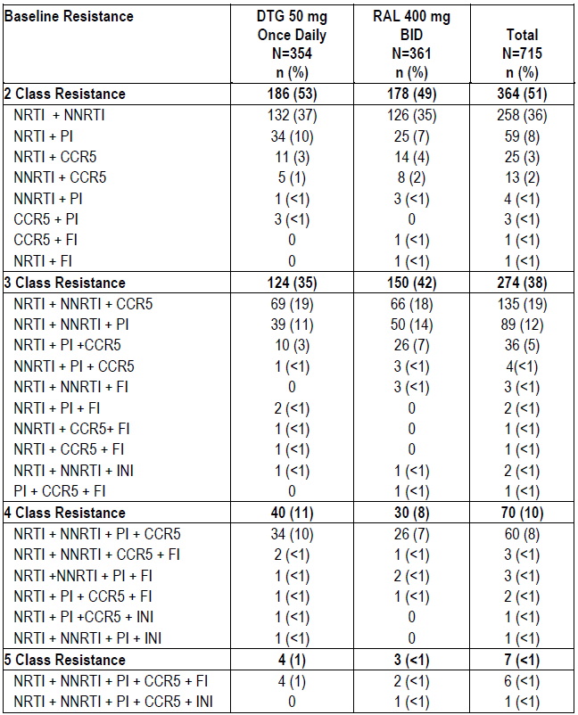
FI=Fusion inhibitor (Enfuvirtide)

Efficacy results
At Week 48, 71% of patients receiving DTG and 64% receiving RAL achieved HIV-1 RNA < 50 c/mL at Week 48. The difference, DTG - RAL, (95% CI) was 7.2 (0.3, 14.0). The pre-specified basis for concluding non-inferiority and superiority were met. (Table 53)

Table 53: Study ING111762 Proportion of Subjects with Plasma HIV-1 RNA <50 c/mL at Week 48
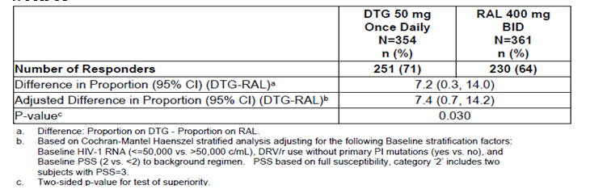
Differences in favour of DTG, not adjusted for multiple testing, were reported in subgroups: non-white race, African heritage race, female, and age < 50 years. The lower response rate on DTG compared to RAL observed in subjects older than 50 years of age was the result of more subjects on DTG being classified as non-responders due to having no virologic data at Week 48 (DTG: 13% vs. RAL: 5%) and not for reasons related to virologic failure (DTG: 22% vs. RAL: 26%). The lower response rate on DTG compared to RAL observed in patients with CDC category B was the result of more patients on DTG being classified as non-responders due to having no virologic data at Week 48 (DTG: 16% vs. RAL: 8%) and for having background regimen changes [DTG: 6 (9%) vs. RAL: 2 (2%)]. All six background regimen changes on DTG occurred while participants were virologically suppressed.

Applicant’s conclusion
- The study population in ING111762 was more demographically diverse than prior DTG Phase III clinical studies
- A notable HBV / HCV co-infected population was included in the study, representing the overall global HIV patient population
- The majority of subjects had 2 fully active background drugs in their background regimen; a variety of background regimens were used
- The study population bridges the gap between highly treatment experienced and treatment naive subjects
- These results demonstrate that a DTG 50 mg once daily containing regimen is more efficacious than a standard of care regimen for treatment-experienced subjects and therefore is an appropriate dose for the treatment-experienced but integrase naïve population.

Evaluator comment
Non-inferiority and superiority were demonstrated in protocol defined the terms. However, as superiority was assessed at Week 24 there may be a multiplicity issue with respect to CIs chosen.
The study included very few participants with background therapy of ABC/3TC. The background therapy in general was also a factor in viral response and its contribution is hard to assess. Although it was deemed necessary to evaluate the study for this application, as it has been proposed to include the study in the Product Information, the relevance of this study to FDC DTG/ABC/3TC is questioned. The study is relevant to the DTG Product Information but no more relevant to the Triumeq Product Information than studies done for registration of ABC and 3TC.
A table summarised the subgroups with confidence intervals excluding zero and in favour of DTG. The confidence intervals are wide suggesting insufficient numbers. For those less than 50 years, and CDC Category A, more subjects classified non-responders due to lack of virologic data at Week 48 rather than for proven HIV RNA < 50 c/mL. Adjustment for multiple testing was not factored in. Subgroup results are considered hypothesis generating and not appropriate for inclusion in any Product Information.

Virology

Study ING116070 pharmacodynamic – Treatment-naive
ING116070 is a Phase IIIb single-arm, open-label, multicentre study of HIV-1 infected ART-naïve patients to determine the potential for dolutegravir to enter the CSF compartment. Participants were 13 HIV-1 infected treatment naïve adults ≥ 18 years of age, with screening plasma HIV-1 RNA ≥5000 copies/mL(c/mL); CD4+ cell count ≥ 200 cells/mm3 and negative for HLA-B*5701. Treatment was DTG 50 + ABC/3TC 600/300 mg. The Week 16 results were presented.
No major NRTI, non-nucleoside reverse transcriptase inhibitor (NNRTI) or protease inhibitor (PI) mutations were detected in the 1 participant with protocol defined virologic failure (PDVF). At PDVF, the participant was phenotypically susceptible to all tested NRTIs, NNRTIs and PIs. No IN genotypic or phenotypic results were obtained at Week 16.

Study ING114467 (single) pivotal – Treatment-naïve
ING114467 is a Phase III, parallel group, randomised, double-blind, active-controlled multinational study of DTG + ABC/3TC compared with EFV/TDF/FTC in treatment of HIV-1 infected ART naïve adult patients. Week 96 results were presented.
Genotypic and phenotypic analyses were carried out by Monogram Biosciences using, their Standard Phenosense and GenoSure testing methods for reverse transcriptase (RT), or with their GeneSeq Integrase and PhenoSense Integrase assays. For screening virologic evaluations, only viral genotype was analysed and this was done through Quest Diagnostics.
Protocol define virologic failure (PDVF) was two consecutive HIV-1 RNA values ≥ 50 c/mL on or after Week 24. PDVF mandated testing for resistance and withdrawal from the trial. Virologic failure occurred in 25/414 (6%) in the DTG + ABC/3TC group and 25/419 (6%) in the EFV/TDF/FTC group. The majority with confirmed PDVF had low-level viraemia: 20/25 (80%) on DTG + ABC/3TC and 17/25 (68%) on EFV/TDF/FTC had < 200 c/mL HIV-1 RNA. (Table 54)

Table 54: Study ING114467 Distribution of HIV-1 RNA Results at Suspected and Confirmation of PDVF
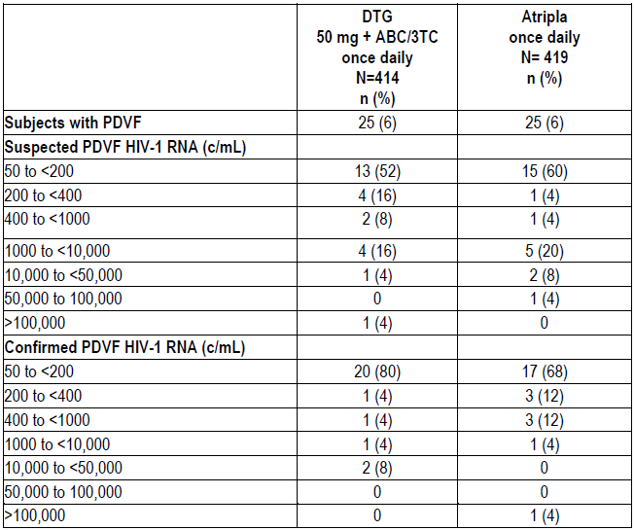
Thirteen participants in the DTG + ABC/3TC group and 10 in the EFV/TDF/FTC arm had IN genotype and phenotype at both Baseline and PDVF. No INI resistance mutations were found. One participant in the DTG + ABC/3TC group had a treatment emergent substitution E157Q/P at Week 24, without accompanying DTG phenotypic resistance and replicative capacity could not be determined. The Week 24 virus had a 1.13 fold change (FC) to DTG and 1.26 FC to RAL, compared to 1.02 FC to DTG and 1.22 FC to RAL at Baseline and the HIV-1 RNA at Baseline was 330,641 c/mL, reached a nadir of 79 c/mL at Week 12, and increased to 275 c/mL at Week 24.
Seventeen participants in the DTG/ABC/3TC group and 12 in the EFV/TDF/FTC group had NNRTI genotypic and phenotypic data at both Baseline and time of PDVF. There were no treatment emergent NNRTI resistance mutations or treatment emergent NNRTI phenotypic changes in any participant in the DTG + ABC/3TC group. Six participants in the EFV/TDF/FTC treatment group had treatment emergent NNRTI resistance mutations. Phenotypic changes to EFV were observed in five of these participants. (Table 55).

Table 55: Study ING114467 Treatment Emergent Genotypic or Phenotypic Evidence of NNRTI Resistance
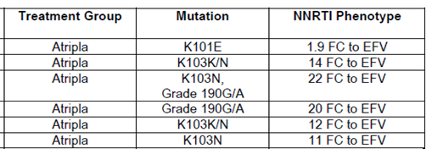
Subject numbers have been redacted from this table.

Applicant’s conclusions
DTG +ABC/3TC given to ART naive participants demonstrated long term durability without the selection of treatment emergent resistance mutations. The results of this study support those obtained in ING112276 and ING113086 indicating that DTG protects the nucleoside backbone better than EFV and RAL and support the belief that DTG has a higher barrier to resistance than EFV.
With respect to the E157P observed in one case, this substitution has not been described, but the E157Q substitution has been observed in 5/112 (4.5%) participants with acute HIV-1 infection [Low, 2009]. This substitution has been selected along with H51Y, E92Q, and E147G during in vitro passage with elvitegravir [Shimura, 2008]. Shimura, et al., demonstrated that the enzyme carrying the E157Q substitution had reduced strand transfer activity relative to wild type levels, but they were able to determine that it remained susceptible to elvitegravir. The virus containing this substitution had only minimally decreased susceptibility to elvitegravir.
In an analysis of clinical isolates obtained during raltegravir treatment, including a patient with IN substitution E157Q, it was shown that the E157Q enzyme was almost completely inactive in both 3’ processing and strand transfer. In addition, the in vitro activity of this virus was too low for antiviral activity to be tested [Malet, 2008].
The sponsor’s conclusions were:
- DTG + ABC/3TC demonstrated long term durability with a low rate of discontinuation due to virologic failure through 96 weeks
- No treatment emergent primary INI or NRTI resistance mutations were observed through 96 weeks for those participants on DTG plus ABC/3TC FDC with PDVF. Both EFV and NRTI primary resistance mutations were observed in participants on EFV/TDF/FTC with PDVF.

Evaluator comment
Genotypic and phenotypic IN resistance results were available for 13/25 (52%) of the DTG group vs. 10/25 (40%) of the EFV/TDF/FTC group. Genotypic and phenotypic NNRTI resistance results were available for 17/25 (68%) in the DTG vs. 12/25 (48%) of the EFV/TDF/FTC group. While these may have been largely due to the stringent criteria for viral resistance, the high drop-out rate complicates evaluation.
In the absence of hypothesis driven testing of the difference in results and in the presence of missing data, the sponsor’s conclusion that ‘The results of this study support those obtained in ING112276 and ING113086 indicating that DTG protects the nucleoside backbone better than EFV and RAL and support the belief that DTG has a higher barrier to resistance than EFV’; cannot be fully endorsed; however, use of the word ‘belief’ is noted. In addition, the efficacy of differing background therapies in preventing viral failure is considered potentially confounding.

Study ING113086 (spring-2) Treatment-naïve
ING113086 is a Phase III randomized, double-blind, active-controlled, multicentre study or treatment-naïve adult patients, to assess safety and efficacy of DTG versus RAL 400 mg each administered with either ABC/3TC or TDF/FTC. Ninety-six week results were presented.
Genotypic and phenotypic analyses were done by Monogram Biosciences using Standard Phenosense and GenoSure methods for reverse transcriptase (RT), or with their GeneSeq Integrase and PhenoSense Integrase assays. For screening virologic evaluations, viral genotype and subtype was analysed, undertaken by Quest Diagnostics. No subtype was available when eligibility was determined using a historic genotype.
PDVF was two consecutive HIV-1 RNA values ≥ 50 c/mL HIV-1 RNA from Week 24. PDVF was observed in 5% of the DTG group and 7% of RAL group. PDVF was met by 22 (5%) in the DTG group vs. 29 (7%) in the RAL group. Three participants had PDVF after Week 48 (DTG 2; RAL 1). No treatment emergent IN or NRTI resistance mutations were detected.

Table 56: Study ING113086 Distribution of HIV-1 RNA at Time of PDVF
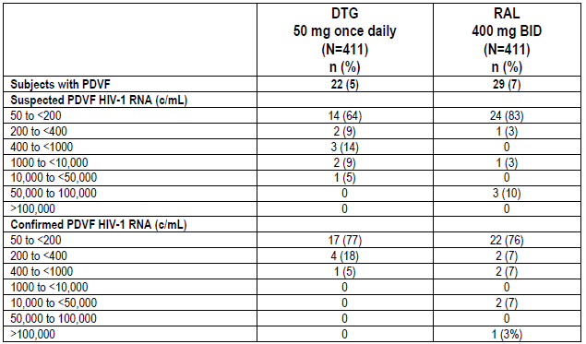
Ten of the 22 participants with PDVF in the DTG arm had IN genotype at both baseline and at the time of PDVF vs. 20 of 29 in the RAL arm. In the DTG arm 0/10 had emergent INI resistance mutations vs. 1/20 (5%) in the RAL group.
Three patients had genotypic or phenotypic indication of treatment emergent IN resistance.
Participant [information redacted] was randomized to RAL with TDF/FTC as the nucleoside backbone.
- Treatment emergent INI resistance mutations at Week 24 were T97T/A, E138E/D, V151V/I, and N155H
- Week 24 virus had a 34 fold change (FC) to RAL and 2.02 FC to DTG, as compared to 1.15 FC to RAL and 1.48 FC to DTG at Baseline
- Week 24 virus also had treatment emergent NRTI mutations A62A/V, K65K/R, K70K/E, and M184V with accompanying 1.44 FC to TDF and MAX FC to FTC.
Participant [information redacted], in the DTG group with TDF/FTC backbone, had 2.01 FC to RAL (0.96 FC to DTG) at PDVF at Week 32. IN substitutions at Baseline and Week 32 were compared:
- Baseline virus had IN substitutions K14R, V32I, E48E/K, V72I, Y99F, L101I, V113I, S119P, T122I, T124A, T125A, G134N, K136T, K188R, V201I, T206S, Y227F, S255N, D256E, and S283G
- IN substitutions at Week 32 were identical to those observed at Baseline except that E48K was a full substitution at Week 32
Participant [information redacted] treated with RAL and TDF/FTC, had 1.62 FC to RAL (1.40 FC to DTG) at PDVR (Week 24). All IN substitutions at Baseline and Week 24 were compared
- Baseline virus had IN substitutions E11E/D, V31I, V72I, L101I, V113I, V201I, T206S, K215T, Q216Q/K, T218I, I220L, V234L, and D256E
- IN substitutions at Week 24 were identical to those observed at Baseline with the exceptions that E11D was a full substitution at Week 24 and Q216 was fully Q at Week 24.
Fourteen of the 22 individuals with PDVF in the DTG treatment group had PR/RT genotype at both Baseline and time of PDVF, while 20 of the 29 with PDVF in the RAL treatment group had PR/RT genotype at both Baseline and time of PDVF. None of the 14 subjects with Baseline and PDVF RT and PR genotypic data in the DTG treatment arm had treatment emergent NRTI resistance mutations while 4/20 (20%) of the subjects on the RAL treatment arm had treatment emergent NRTI resistance mutations.
- Participant [information redacted] (see also integrase testing) (RAL + TDF/FTC) had NRTI treatment emergent mutations A62A/V, K65K/R, K70K/E, and M184V
- Participant [information redacted] (RAL + TDF/FTC) had treatment emergent mutation M184M/I at PDVF (Week 24) with no accompanying phenotypic change to TDF or FTC
- Participant [information redacted] (RAL + TDF/FTC), had treatment emergent mutation A62A/V at PDVF (Week 24) with no phenotypic change to TDF or FTC
- Participant [information redacted] (RAL + ABC/3TC) had treatment emergent mutation M184M/V with 2.56 FC to ABC and MAX FC to 3TC

Applicant’s conclusions
- Overall, there was a low rate of discontinuation due to virologic failure in both treatment arms, with only three additional subjects with PDVF identified after Week 48. The durability of the virologic response on DTG and RAL was maintained through Week 96
- Both INI (RAL) and NRTI primary resistance mutations were observed in subjects on RAL with PDVF up to Week 48. No treatment emergent primary INI or NRTI resistance mutations were observed for those subjects on DTG with PDVF throughout the study.

Study ING114915 (flamingo) Treatment-naïve
Study ING114915 is a Phase IIIb randomized, open-label, active-controlled, multicentre, parallel group, study including 488 treatment-naïve adults treated with DTG 50 mg or DRV+RTV 800/100 mg with either ABC/3TC or TDF/FTC background. Week 48 results were presented.
Genotypic and phenotypic analyses were carried out by Monogram Biosciences using their standard PhenoSense and GenoSure testing methods for protease (PRO) and reverse transcriptase (RT), or with their GeneSeq Integrase and PhenoSense Integrase assays. For screening virologic evaluations, only viral genotype was analysed and this was performed through Quest Diagnostics.
PDVF was 2 consecutive HIV-1 RNA values > 200 c/mL from Week 24. Two participants (<1%) in each treatment group met PDVF. Each had genotype and phenotype results at baseline and at PDVF. Neither had treatment-emergent resistance mutations in integrase or phenotypic resistance to DTG. No individual had treatment-emergent resistance mutations in reverse transcriptase or protease. One participant (DTG + TDF/FTC), had phenotypic resistance to nelfinavir (4.12 FC), despite having no treatment emergent PRO resistance mutations. This individual had secondary PI resistance mutations L10V, I13V, K20R, E35D, M36I, I62I/V, L63T, and L89M at baseline and at PDVF (Week 24); no phenotypic resistance to PIs was observed at baseline.

Applicant’s conclusions
- Overall, there was a low rate (<1%) of discontinuation due to virologic failure in both treatment groups
- No treatment-emergent primary INI or NRTI resistance mutations were observed for participants in the DTG or DRV+RTV treatment groups
- One subject (in the DTG group) had resistance to nelfinavir at PDVF, despite having no treatment emergent PI resistance mutations. Several reasons for this finding were considered. Variability of the protease (PR) phenotypic assay seems unlikely to fully explain this difference from Baseline. Mixtures in the PR substitutions might account for the differences in phenotype between Baseline and Week 24 (without PI drug pressure), but only one of the PI secondary mutations for this subject was a mixture (I62I/V). Substitutions at this location are unlikely to result in phenotypic changes for nelfinavir susceptibility. Finally, re-infection with HIV containing nelfinavir resistance seems unlikely as well with no evidence of primary PI mutations at Week 24. The emergence of PI mutation in a subject receiving DTG is likely related to the presence of secondary PI mutations at Baseline and Week 24 for this individual.’

Evaluator comment
It is noted that PDVF is differently defined in this study.

Study ING111762 (sailing) – Treatment experienced
ING11762 was a Phase III randomized, double-blind study of the safety and efficacy of DTG 50 vs. RAL, each with an investigator selected background regimen in HIV-1 infected, integrase inhibitor-naïve, antiretroviral therapy- experienced adults. The Week 48 results were reported. In total, 354 were included in the DTG group and 364 in the active control group.
All genotypic and phenotypic testing was conducted at Monogram BioSciences. Integrase PhenoSense, Integrase Geneseq, PhenoSense GT, PhenoSense Entry and Trofile assays were performed. PhenoSense GT, PhenoSense Entry and Trofile were used to assess resistance to other ARTs for eligibility purposes and to aid in the selection of the background regimen; PhenoSense Entry and Trofile tests were performed for Baseline samples only when requested by investigator. Integrase PhenoSense, Integrase Geneseq, and PhenoSense GT assays were required at PDVF for both the Day 1 and PDVF time points.
According to the protocol, virological failure was defined as follows.
- Virologic Non-response
  - A decrease in plasma HIV-1 RNA of less than 1 log10 c/mL by Week 16, with subsequent confirmation, unless plasma HIV-1 RNA is <400 c/mL
  - Confirmed plasma HIV-1 RNA levels ≥ 400 c/mL on or after Week 24.
- Virologic Rebound
  - Confirmed rebound in plasma HIV-1 RNA levels to ≥ 400 c/mL after prior confirmed suppression to < 400 c/mL
  - Confirmed plasma HIV-1 RNA levels >1 log10 c/mL above the nadir value where nadir is the lowest HIV-1 RNA value ≥ 400 c/mL.
At Week 48 in 21 (6%) and 45 (12%) PDVFs were reported for DTG and RAL respectively. Due to integrase assay failure, paired data for IN resistance was not available for 4/21 DTG PDVF samples and 7/45 RAL PDVF samples. The potential reasons were: viral load < 500 c/mL or reduced viral fitness or compromised sample collection/handling. The virologic failure Week 16 sample for one subject in the DTG arm was inadvertently tested instead of the confirmed Week 24 sample, which was thus not available at database freeze. IN resistance testing at PDVF for one subject in the RAL arm was not available prior to database release. Genotype and Phenotype available for PDVF assessment are summarised in Table 57 and Table 58.

Table 57: Study ING111762 Genotypes Available in PDVF Genotypic Population through Week 48
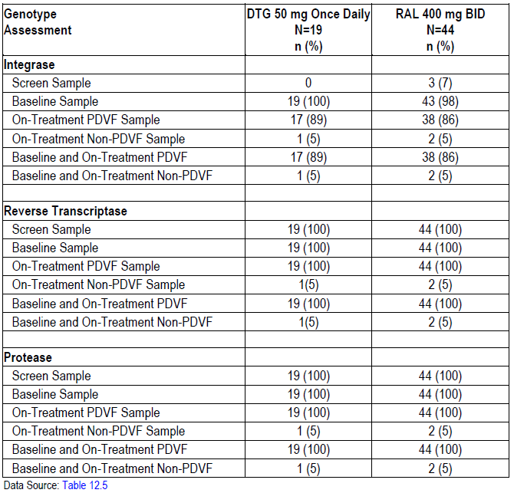

Table 58: Study ING111762 Phenotypes Available in PDVF Phenotypic Population through Week 48
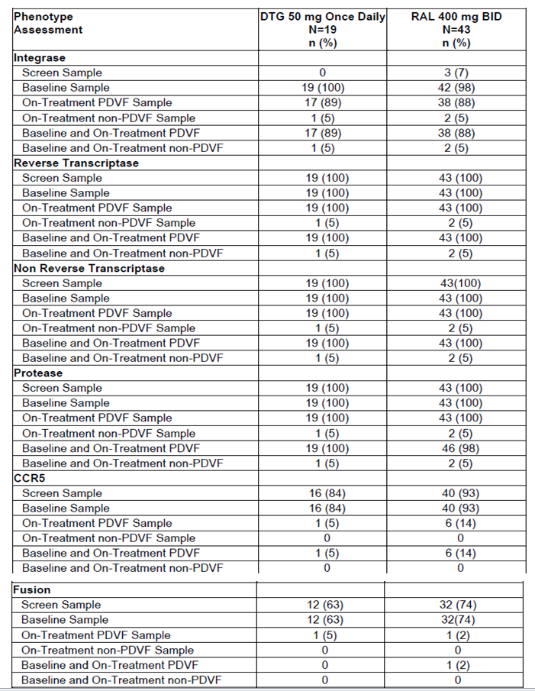
At Week 48, 17 participants with PDVF in the DTG arm had matched Baseline and PDVF IN genotypic resistance testing results available. Integrase substitutions emerged at the RAL associated T97, E138, and polymorphic V151 positions, and at R263.
At Week 48, 38 participants with PDVF in the RAL arm had matched Baseline and PDVF IN genotypic resistance testing results available. Integrase substitutions emerged at positions commonly observed during RAL therapy including primary resistance mutations at Y134, Q148, and N155 as well as associated secondary mutations. (Table 59).

Table 59: Study ING111762 Treatment Emergent Integrase Substitutions Week 48 PDVF Genotypic Population
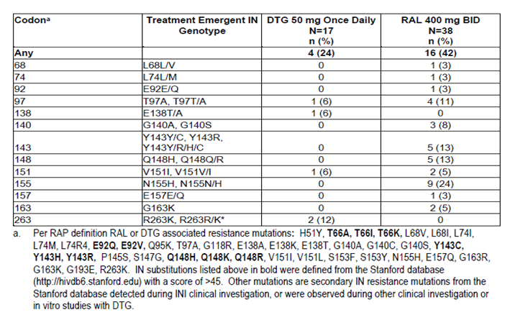
In the DTG arm, 16/17 patients with IN phenotypic resistance testing results available had a DTG fold change of < 2.5 (Monogram Biosciences DTG [standard] cut-off) and 16/17 RAL fold change of < 1.5 (Monogram Biosciences RAL biological cut-off). The patient receiving DTG with elevated DTG and RAL fold changes at PDVF enrolled with pre-existing RAL resistance mutations and with Baseline fold changes above cut-off for both DTG and RAL. Thus, no DTG subjects had treatment-emergent INI phenotypic resistance at PDVF.
In the RAL arm, 4 patients had a DTG FC ≥ 2.5, and 14 had RAL FC ≥ 1.5. One of these enrolled with pre-existing RAL resistance mutations. Therefore, 13 subjects receiving RAL had evidence of treatment-emergent INI phenotypic resistance to RAL at PDVF. (Table 60)

Table 60: Study ING111762 Summary of Fold Change to DTG and RAL at Time of PDVF (Week 48)
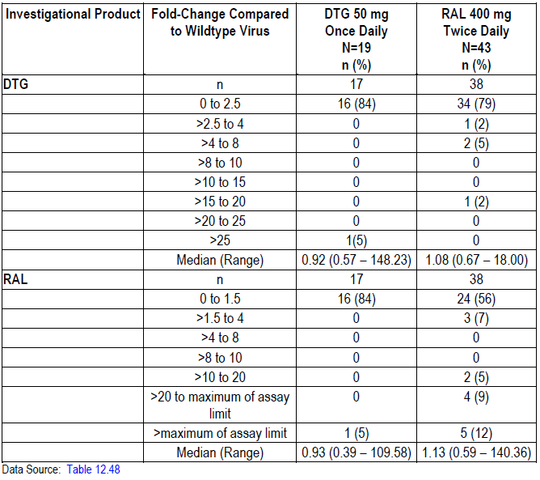
Four patients in the DTG arm had emergent integrase-defined substitutions: 3/4 experienced virologic rebound; 1 experienced non-response. Three had no defined integrase resistance substitutions at Baseline; two of these three acquired a substitution at R263 and on, a polymorphic V151V/I substitution. In all three cases the DTG fold change was < 2, as was the RAL fold change. None of the three participants with emergent substitutions at R263 or V151V/I had RAL-associated secondary mutations at Baseline.
At Baseline, one patient in the DTG arm harboured virus with RAL associated resistance mutations at Q148H, E138A, G140S, and elevated DTG FC of 12 at Baseline and RAL FC > Max measureable. At PDVF integrase substitutions E138T/A and T97A emerged and DTG and RAL FCs both increased to > Max measureable.
Two patients in the DTG arm experienced suspected PDVF at Week 48 confirmed during the open label phase of the study. An additional 6 subjects experienced virologic rebound on DTG during the Open Label Phase: 3 at Week 60, 2 at Week 72, and 1 at Week 84. (Table 61).

Table 61: ING111762 Integrase Genotypes and Phenotypes for PDVF Confirmed During Open-Label Phase
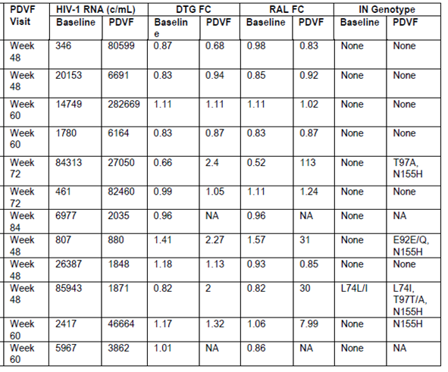
Note: Patient numbers have been redacted from this table. The subjects in first 7 rows were in the DTG arm and subjects in the last 5 rows were in the RAL arm.
To further monitor the development of resistance to INIs, the genotypic and phenotypic susceptibilities were determined at the last time point on study meeting the criteria of unconfirmed PDVF HIV-1 RNA ≥ 400 c/mL. At Week 48, 6 participants in the DTG arm and 8 in the RAL arm had resistance results based on meeting these testing criteria (Table 62).

Table 62: Study ING111762 Participants with Elevated HIV-1 RNA who Discontinued Without Confirmation
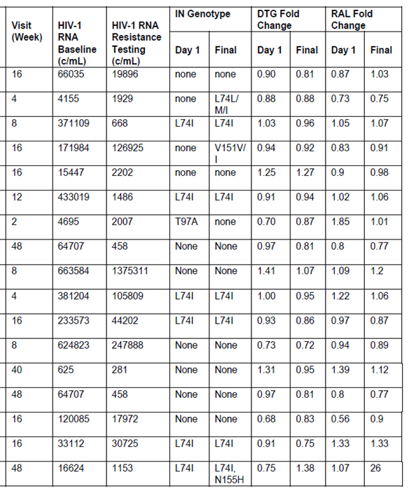
Note: Patient numbers have been redacted from this table. The subjects in first 7 rows were in the DTG arm and subjects in the last 10 rows were in the RAL arm.

Applicant’s conclusion
Results from this Week 48 analysis show DTG has a higher barrier to resistance in this patient population and a distinct resistance profile from RAL.
Key secondary endpoint: For the mITT-E population, 1% of subjects receiving DTG and 5% of subjects receiving RAL had evidence of treatment emergent genotypic or phenotypic INI resistance at the time of protocol defined virologic failure by Week 48. The treatment difference was less than the pre-specified two-sided 5% type I error cut-off based on a pre-specified analysis of this key secondary endpoint as summarised in Table 63.

Table 63: ING III762 Proportions with Detectable Virus that has Treatment Emergent Genotypic or Phenotypic Evidence of INI Resistance by Week 48 (mITT-E Population)
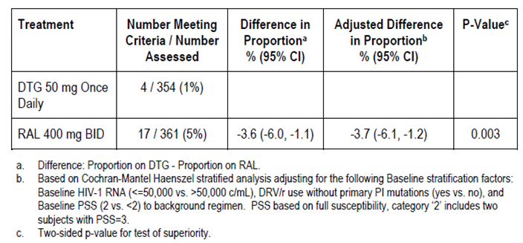

Evaluator comment
The definition of PDVF differed from that in other studies, e.g., Study ING113086 in which PDVF was defined as two consecutive HIV-1 RNA values ≥ 50 c/mL HIV-1 RNA and ING114915, 2 consecutive HIV-1 RNA values > 200 c/mL HIV-1 RNA on or after Week 24.
Small numbers were included in the analyses and there were instances of missing data. The baseline resistance and chosen background therapy would have impacted virologic non-response.

Clinical safety

Study ING114580 – Pivotal Pharmacokinetic
ING114580 was the pivotal study in healthy adults evaluating the single-dose pharmacokinetics of an oral DTG ABC/3TC combination tablet formulation proposed for commercial use, compared to co-administration of the separate tablet formulations of DTG 50 + ABC/3TC.
Sixty-six participants received at least one dose of study medication and were included in the Safety Population; all received individual doses as planned, with the exception of 1 unable to swallow the Epzicom tablet. There were no SAEs, fatal or non-fatal and no pregnancies reported. Adverse events were reported by 38 - 40% of participants (Table 64). Treatment related adverse events occurring in Study Part A (fasted state) are summarised in Table 65. The most frequent were nausea and headache. There was no Grade 3 or 4 adverse event reported. No adverse events were reported in Part B in which 12 participants received a second single dose with food. No treatment related, clinically significant changes in haematology, clinical chemistry values, blood pressure, heart rate or in ECG values were observed.

Table 64: ING114580 Summary of AEs Occurring in 2 or More Subjects in Any Treatment Group
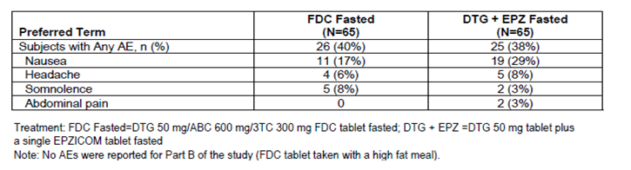

Table 65: Study ING114580 Summary of All Drug-Related Adverse Events
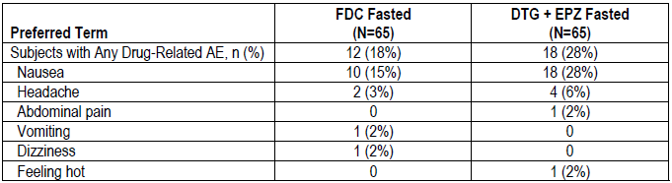

Applicant’s conclusion
Administration of ABC/3TC +DTG fasted and FDC fasted was generally well tolerated and demonstrated similar tolerability during Part A. Administration of the FDC tablet with a high fat meal was well tolerated. Of the seven subjects with somnolence, five reported this event within the same dosing cohort approximately one hour after dosing, suggesting a group effect of this AE.

Evaluator comment
Adverse events were common, in particular drug related nausea and headache. It is hypothetically possible that nausea may be mitigated by administration with food.

Study ING116898 – Drug interaction
ING116898 was a Phase I, open-label, randomized, crossover study to separately evaluate the effects of calcium carbonate (Cohort 1) and ferrous fumarate (Cohort 2) on pharmacokinetics of DTG in 12 healthy adults. One participant was lost to follow-up. There were no deaths, SAEs, grade 3 or 4 AEs, or AEs leading to discontinuation. Six participants in Cohort 1 experienced AEs. No individual AE was reported by > 1 person. One participant reported 7 of these individual events. Six participants in Cohort 2 experienced AEs. Contact dermatitis and headache were reported by 3 subjects each, but were considered unrelated to study drug. All reported AEs were Grade 1. (Table 66) One participant administered DTG 50 mg 2 hours prior fasted + calcium carbonate 1200 mg experienced a Grade 1 AE of nasal congestion on Day 1 considered drug related.

Table 66: Study ING116898 Summary of All Adverse Events by Treatment – Cohort 1
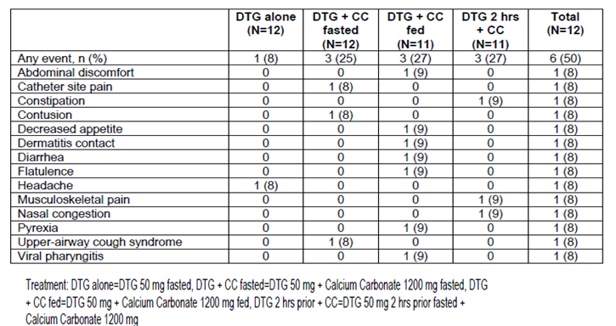

Table 67: Study ING116898 Summary of All Adverse Events by Treatment – Cohort 2
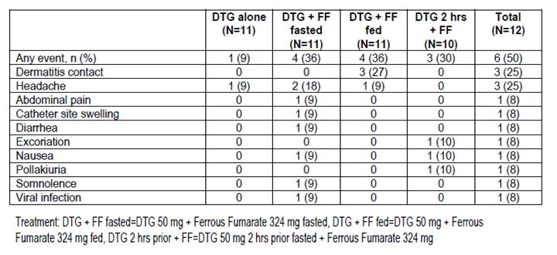
No clinically significant changes in ECG values were observed. A [information redacted] White female, had a QTcB value of 458 msec and QTcF value 437 msec on Day 3 of Period 4 (DTG alone). The finding was considered not clinically significant. No individual had QTc values > 480 msec.

Study ING116070 pharmacodynamic – CSF
ING116070 is a Phase IIIb single-arm, open-label, study including 13 male HIV-1 infected ART-naïve adult patients determining the potential for DTG to enter the CSF compartment. Participants were ≥ 18 years of age and negative for HLA-B*5701 and were treated with DTG + ABC/3TC.
The most commonly reported AE was headache 7/13. The most common drug related adverse events were fatigue, headache and nausea, each reported by 2 participants. The majority of adverse events were Grade 1 or 2 (85% and 8%, respectively). One participant reported Grade 2 worsening depression, potentially related to study drug. Two participants reported SAEs considered unrelated to study treatment: cholecyctitis, and syphilis with grade 4 pharyngitis. There were no deaths.
Small median increases in serum creatinine and small decreases in the calculated creatinine clearance were noted beginning at Week 2 and remaining stable to Week 16. (Table 68) There were no graded creatinine toxicities or drug-related AE reported up until the data-cut-off.

Table 68: ING116070 Median Change from Baseline in Creatinine & Creatinine Clearance – Week 16
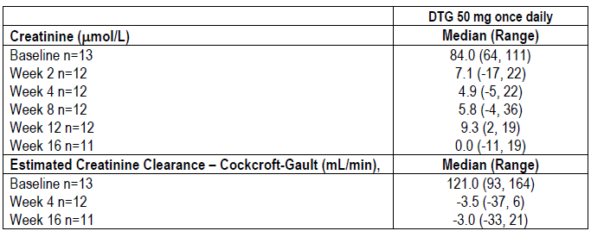

Study ING114467 (single) pivotal – Treatment-naïve
ING114467 is an ongoing, Phase III, parallel group, randomised, double-blind, active-controlled, multinational study of DTG + ABC/3TC compared with EFV/TDF/FTC in treatment of HIV-1 infected ART naïve adult patients. Treatments were blinded until Week 96. A total of 844 were randomised. Week 96 results were reported.
Dizziness, diarrhoea, nasopharyngitis, headache, nausea and fatigue were most commonly reported AEs and occurred at similar rates across both treatment groups with the exception of dizziness which was reported more frequently in the EFV/TDF/FTC group. (Table 69).
Treatment related events were more common in the EFV/TDF/FTC group. The most common drug related adverse events were dizziness and abnormal dreams, both of which were reported more commonly in the EFV/TDF/FTC group, nausea, insomnia, diarrhoea, fatigue, headache and rash which were reported at similar rates between groups as summarised in Table 70.
Most events in both groups were Grade 1 or 2. The incidence of Grade 3 and 4 events combined was DTG+ABC/3TC 57/414 (14%) vs. EFV/TDF/FTC 83/419 (20%). In the DTG/ABC/3TC group, Grade 4 events (also reported as SAEs and considered unrelated) were subdural haematoma, priapism, homicidal and suicidal ideation and intentional overdose/ suicide attempt. Five participants reported non-serious grade 4 events in the EFV/TDF/FTC group: muscle injury, creatinine phosphokinase (CPK) increase (2 participants) and hyperglyceridaemia (considered IP related). NB page 78 of the CSR only lists AEs for four participants.

Table 69: Study ING114467 Common Adverse Events (≥ 5% Incidence in Either Treatment Group)
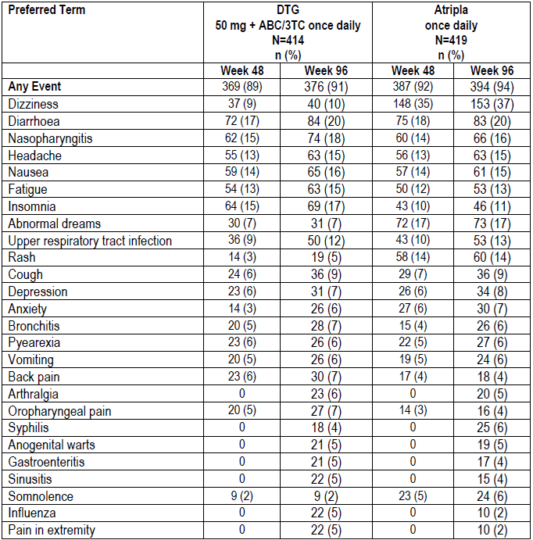

Table 70: Study ING114467 Drug Related Events Reported for ≥ 5% Incidence in Either Treatment Group)
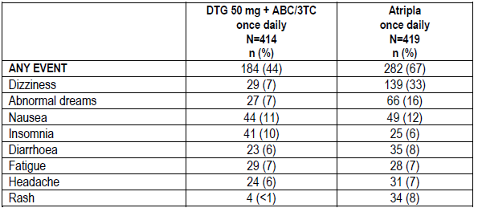
Two participants treated with EFV/TDF/FTC reported at least one drug related Grade 4 event, also reported as an SAE: one with cerebrovascular accident, one with paranoia and suicidal ideation. Events for 3 individuals were considered unrelated to IP: pneumonia and sepsis; aspergillosis, renal failure, septic shock, systemic candidiasis, respiratory failure and vascular pseudo aneurism; alcohol abuse, and suicidal behaviour.
In the DTG + ABC/3TC group, one SAE was considered related to IP (drug hypersensitivity). Nine in the EFV/TDF/FTC group had SAEs considered related to study treatment: syncope (2); depression, homicidal ideation and suicidal ideation; paranoia and suicidal ideation; drug hypersensitivity; cerebrovascular accident; hallucination, visual; and bipolar (1 each).There were two deaths to Week 96, both in the EFV/TDF/FTC treatment group and included in the Week 48 analysis. One event, renal failure, was considered possibly related to study drug.
There was a higher incidence of AEs leading to withdrawal in the EFV/TDF/FTC treatment group, and higher rate of AEs considered related to IP in this treatment group. (Table 71).

Table 71: Study ING114467 Adverse Events Leading to Permanent Discontinuation of Investigational Product and Withdrawal Summarised by SOC (Safety Population)
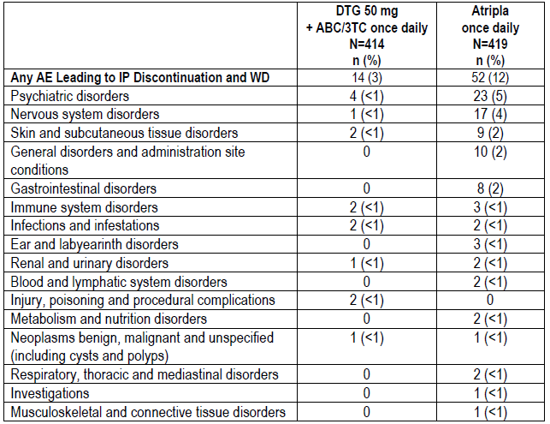

Events of special interest
Four participants in the DTG group and 6 in the EFV/TDF/FTC group reported hypersensitivity as summarised in Table 72.

Table 72: ING114467 Hypersensitivity events
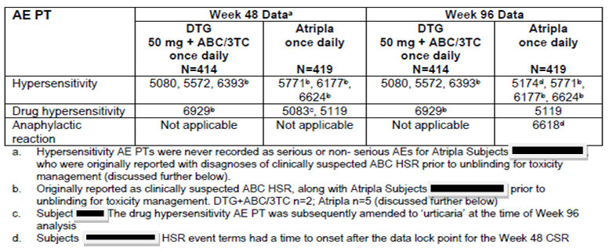
Rash events were reported by 60/419 (14%) of the EFV/TDF/FTC group and 19/414 (5%) of the DTG/ABC/3TC group, relative risk (RR) 0.32, (95% CI 0.19, 0.53). (Table 73) Rash considered study treatment related 34/419 (8%) vs. 4/414 (<1%) and rash leading to permanent discontinuation 9/419 (2%) vs. 2.414 (<1%) for EFV/TDF/FTC vs. DRT/ABC/3TC respectively. One episode was considered Grade 3, all others were Grade 1 or 2.
Relative risk and 95% Confidence Intervals < 1 favouring DTB/ABC/3TC were noted for dizziness, abnormal dreams, rash and somnolence; favouring EFV/TDF/FTC insomnia, influenza and pain in extremity. (Table 73).

Table 73: Study ING114467 Summary of Relative Risks for Common Adverse Events
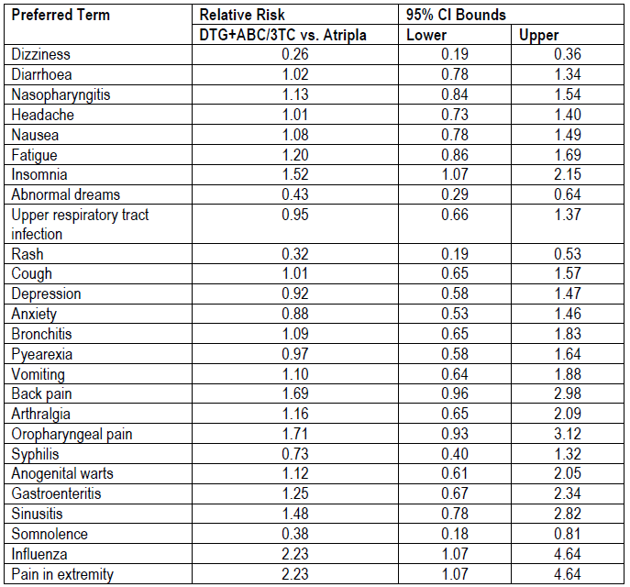
There were no events of completed suicide in either group. AEs indicative of suicidal ideation and behaviours were reported by 2 in the DTG + ABC/3TC group and 7 in the EFV/TDF/FTC group. No episode in the DTG + ABC/3TC group was considered IP related. Four events in the EFV/TDF/FTC group were considered related and one led to withdrawal from the study.
Immune reconstitution inflammatory syndrome (IRIS) events were reported by 3 participants in the DTG group and 4 in the EFV/TDF/FTC group.
Diarrhoea and nausea were two of the most commonly reported AEs occurring at similar frequencies across both treatment groups. No participants in the DTG + ABC/3TC group had GI AEs leading to withdrawal from the study vs. to 8 (2%) in the EFV/TDF/FTC group.
The higher number of discontinuations for GI events in the EFV/TDF/FTC treatment group did not appear to be related to higher event toxicity/intensity grades. The number of participants with severe or Grade 3/4 AEs in the GI disorders system organ class (SOC) was low in both groups. The majority of GI events leading to discontinuation in the EFV/TDF/FTC group, i.e., four participants with nausea and one participant each with dyspepsia, gastrointestinal pain, lip swelling or vomiting were Grade 1 to 2 in intensity, with the exception of gastrointestinal pain, which was Grade 3.
More DTG/ABC/3TC participants reported events considered indicative of GI ulceration compared with EFV/TDF/FTC. The majority were mild to moderate intensity. (Table 74).

Table 74: Study ING114467 Summary of Events Suggestive of GI ulcerative lesion
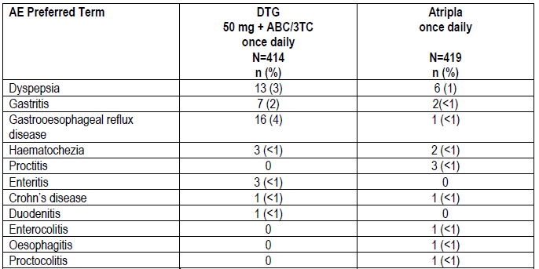
Cardiac disorders were reported in the DTG+ABC/3TC group by 11(3%) vs. EFV/TDF/FTC 8 (2%). No case of myocardial infarction or other ischaemic coronary event was reported for DTG + ABC/3TC. There was a single case of coronary artery disease in the EFV/TDF/FTC group. There was no evidence of increased risk of Torsades de Pointes.
Events in the Metabolic and Nutrition disorders SOC were reported for 42 in the EFV/TDF/FTC and 40 in the DTG/ABC/3TC group (10% each). The most common in the EFV/TDF/FTC group was decreased appetite, and in the DTG + ABC/3TC group, vitamin D deficiency.

Clinical laboratory evaluations
The distribution and number of graded treatment emergent clinical chemistry toxicities was similar between the DTG + ABC/3TC and EFV/TDF/FTC treatment groups. (Table 75).
There was a low rate of elevated liver chemistries in both arms. For ALT > 3xULN reported numbers were DTG+ABC/3TC7 (2%) and EFV/TDF/FTC 17 (4%). Reports for elevated alkaline phosphatase (ALP) were DTG/ABC/3TC 14 (3%); EFV/TDF/FTC 47, (11%). No one in either group reported combined ALT >3xULN, total bilirubin >2xULN and ALP <2xULN.
Rhabdomyolysis and myositis were not reported for DTG/ABC/3TC. One case of myositis was reported for EFV/TDF/FTC. The incidence of musculoskeletal and connective tissue disorders was comparable between treatment groups (DTG/ABC/3TC 109/414 (26%), vs. EFV/TDF/FTC 93/419 (22%). The incidence of arthragia was, DTG+ABC/3TC 23/414 (6%), vs. EFV/TDF/FTC 20/419 (5%). Myalgia was reported by 16/419 (4%) EFV/TDF/FTC vs. DTG/ABC/3TC 7/414 (2%).
The most commonly reported treatment emergent hematology abnormality was decreased absolute neutrophil. No clinically significant differences were reported between the two treatment arms with respect to haematology abnormalities. (Table 76).
The mean changes in LDL and total cholesterol were small. Overall both groups showed a small increase in the total cholesterol/HDL ratio. Both groups showed a comparable modest rise in mean total triglycerides at Week 96. (Table 77).

Table 75: ING114467 Clinical Chemistry Toxicities for Selected Parameters – Week 96 (Safety Population)
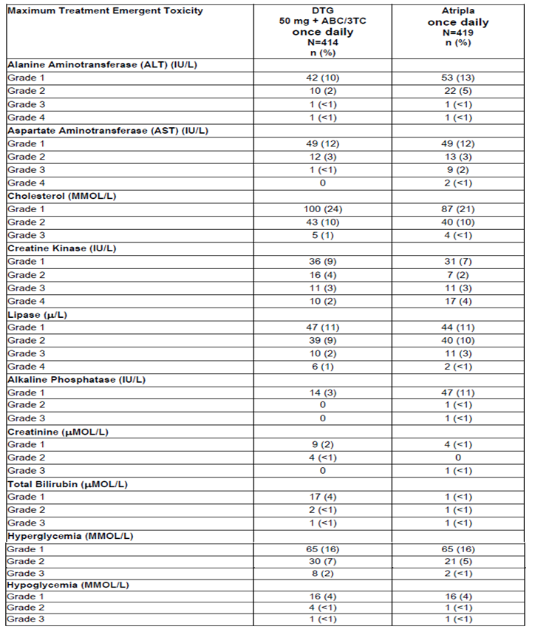

Table 76: ING114467 Summary of Treatment Emergent Hematology Toxicities (Safety Population)
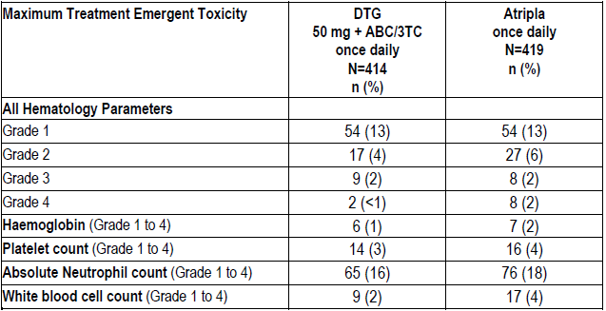

Table 77: ING114467 Mean (SD) Change from Baseline for Select Lipid Parameters (Safety Population)
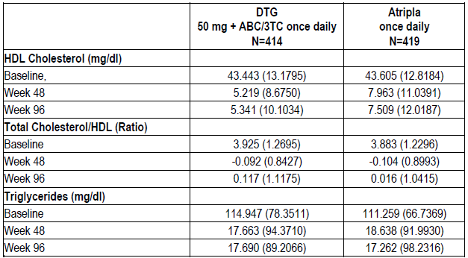
Exploratory bone biomarkers were identified apriori in the study protocol. Increases from Baseline in the four bone biomarkers were seen in both treatment groups, with differences statistically significant in favour of DTG/ABC/3TC. Both treatment arms experienced a decrease in Vitamin D, but the treatment difference in Vitamin D was not significant at Week 96. (Table 78)

Table 78: Study ING114467 Percentage Change from Baseline in Select Bone Biomarkers at Week 96
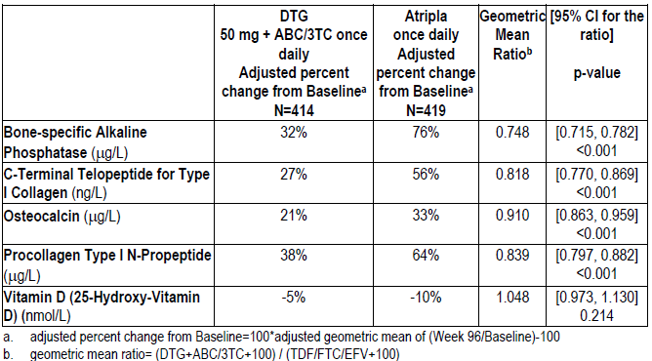
Pregnancies were reported by 12 participants: (DTG+ABC/3TC 5; EFV/TDF/FTC 7). Two in each group delived normal infants. There were 3 elective terminations in the DTG/ABC/3TC group and 1 in the EFV/TDF/FTC group. A further elective termination was doen for ectopic pregnancy (EFV/TDF/FTC). Three spontaneous abortions were reported: DTG/ABC/3TC group 1; EFV/TDF/FTC group 2; none were considered related to IP. No congenital anomalies were reported. One pregnancy in the EFV/TDF/FTC group was ongoing at data cut off. One female partner of a male participant in the DTG/ABC/3TC group delivered a normal infant.

Applicant’s conclusions
- DTG/ABC/3TC demonstrated a safety and tolerability profile that was generally favourable to that of EFV/TDF/FTC over the period of the study
- Based on Week 96 data, there appears to be no increased risk of either hepatic or renal toxicity for DTG/ABC/3TC compared to EFV/TDF/FTC
- Nervous system and psychiatric disorders were more frequent with EFV/TDF/FTC, with the exception of insomnia, which was more frequent with DTG/ABC/3TC
- The superiority of the DTG/ABC/3TC efficacy response rate was due to a higher rate of participants on EFV/TDF/FTC reporting events leading to withdrawal from the study; specifically from the psychiatric disorders, nervous system disorders, gastrointestinal disorders and general disorders and administration site conditions events SOCs
- There is no evidence from this study for increased risk of rash with or without systemic symptoms with DTG/ABC/3TC. There was no increase in suspected abacavir HSR for DTG/ABC/3TC in this HLA-B*5701 pre-screened population in a double-blind trial
- Non-clinical evidence for GI toxicity (ulceration events) with DTG use did not translate into significant clinical findings for DTG in this trial, with a similar rate and nature of events reported for DTG+ABC/3TC compared to EFV/TDF/FTC
- There is no evidence from this study for increased risk of torsades de pointes with DTG
- There was no untoward effect on the overall lipid profile in either treatment group.

Evaluator comment
There was a higher discontinuation rate in the EFV/TDF/FTC group due to gastrointestinal AEs even though most events were Grade 1 – 2. This had the potential to impact the result of the primary efficacy objective. Although the study was blinded, the differing AE profile may have resulted in identification of the comparator by investigators and participants.

Study ING113086 (spring-2) – Treatment-naïve
ING113086 is a Phase III randomized, double-blind, active-controlled, multicentre, study of treatment-naïve adults, to assess safety and efficacy of DTG vs. RAL 400, each administered with either ABC/3TC (40% of participants) or TDF/FTC (60% of participants). Ninety-six week results were presented. A total of 822 patients received at least one dose of study medication.
The most commonly reported clinical AEs among subjects receiving DTG and RAL were nausea, nasopharyngitis, diarrhoea and headache, with no appreciable difference between treatment groups. (Figure 10, Table 79; Table 81).
Most events in both treatment groups were considered grade 1 or 2 (Table 80). There were 18 grade 4 events reported in the DTG group, 2 of which were reported as SAEs and considered IP related: drug hypersensitivity and hepatitis. Seven participants randomized to RAL reported Grade 4 AEs, all reported as serious and none related to IP.
Reporting rates for IP related AEs were: DTG 124/411 (30%); RAL 121/411 (29%). The only drug-related AE reported in ≥ 5% of participants in each treatment group was nausea: DTG 40/411 (10%); RAL 45/411 (11%). Grade 3/4 events considered possibly or probably related to IP in each group were reported for 5 in each group. For DTG, the events were: Grade 3: headache, dizziness, feeling abnormal, arrhythmia; Grade 4: Drug hypersensitivity with associated ALT, AST/ALP, BilT, LFT and, hepatitis (one participant each). For RAL, the events reported for the five patients with Grade 3 events assessed as possibly/probably related were: Grade 3: nausea, abdominal pain, aphasia, drug eruption, fatigue, ALT increased, CPK increased, lipase increased, decreased appetite.
Figure 10: Study ING113086 Most Common Clinical Adverse Events (>=5% Incidence) and Relative Risks
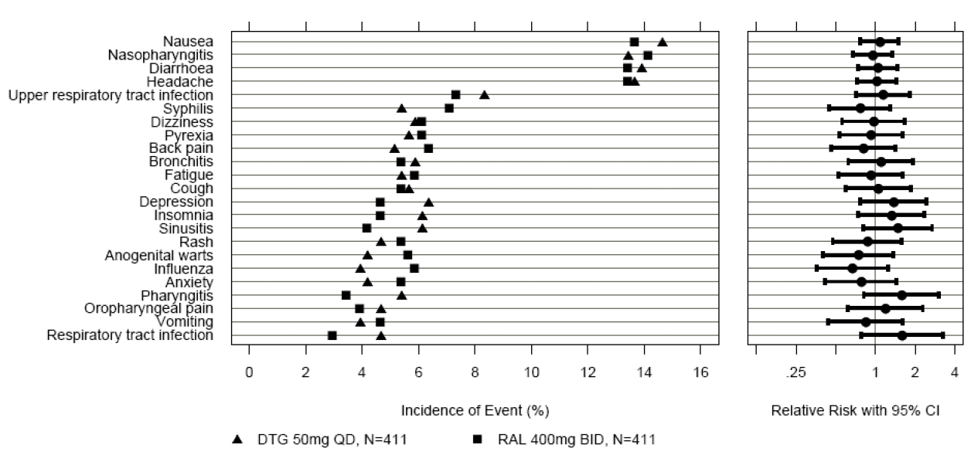

Table 79: ING113086 Most Common Clinical Adverse Events (≥=5% Incidence in Either Treatment Group)
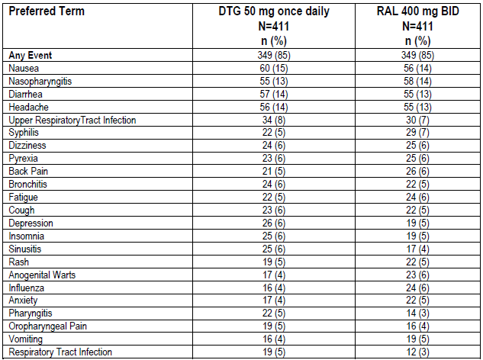

Table 80: ING113086 Adverse Event Incidence by Maximum Toxicity
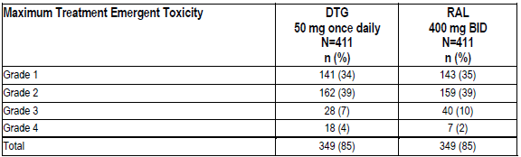

Table 81: ING113086 Adverse Events by System Organ Class
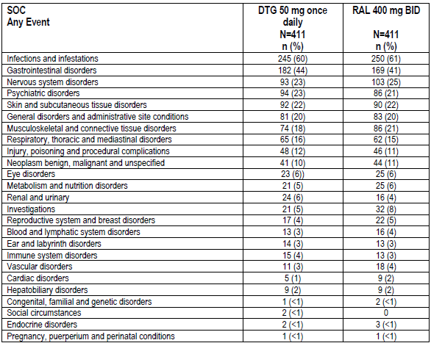
Few participants had AEs leading to discontinuation of IP in either group and there were no discernible patterns of events. Hepatitis C and ALT elevation were the only events that occurred in more than 1 patient. Three additional patients receiving RAL had AEs leading to withdrawal since Week 48: hepatitis C, suicide attempt/intentional overdose, and hepatotoxicity. (Table 82).
At least one SAE was reported by 10% for DTG and 12% for RAL. Drug related events were reported by < 1% of those taking DTG and 1% for RAL. All individually reported SAE preferred terms had an incidence of ≤ 1% in either treatment group. The SAEs considered to be related to DTG (N = 3) were: arrhythmia leading to withdrawal; hypersensitivity considered by the investigator to be related to DTG, the Sponsor also implicated co-suspect ABC/3TC, and hepatitis. SAEs considered related to RAL (N = 5) were CPK increased and convulsion, convulsion, aphasia, diarrhoea, and for one cytolytic hepatitis, hypersensitivity, influenza and lymphadenitis viral. Two fatalities were reported, one in each group neither considered related to study treatment.

Table 82: ING113086 AEs Leading to Withdrawal/ Discontinuation of IP (Safety Population)
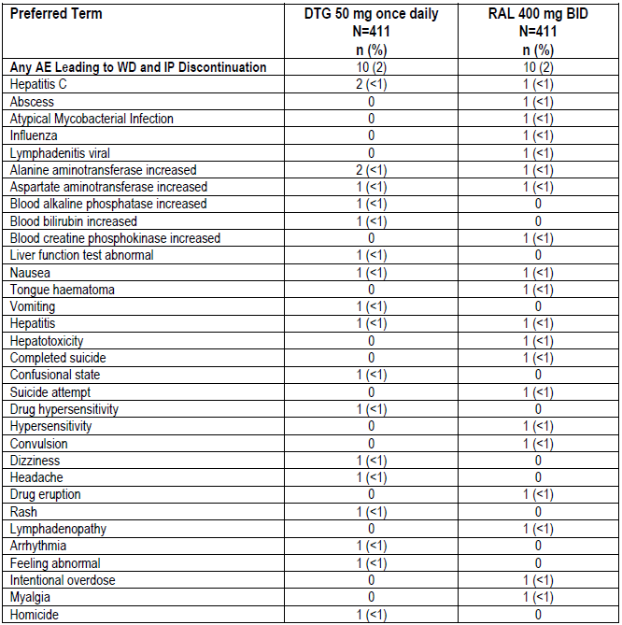

Events of special interest
There were 4 reports of hypersensitivity in the DTG group, none in the RAL group. The hypersensitivity AEs were considered reasonably attributable to abacavir. Other than the rash associated with hypersensitivity reaction, there were no reports of serious rash.
The incidences of Skin and subcutaneous tissue disorders by SOC were DTG 22%, RAL 22 %. The majority of episodes were considered mild to moderate. Events attributable to IP were reported for: DTG 5%, RAL 5%. No events from this SOC were reported as SAEs and few resulted in the permanent discontinuation of IP and withdrawal from the study (<1% in both groups).
Four patients, two from each group, had AEs classified as IRIS events: 2 reports of HBV infection and one each with tuberculosis and CMV pneumonia.
Diarrhoea and nausea were two of the most commonly reported gastrointestinal AEs. For those considered IP related the incidences were DTG 18% and RAL 17%. Less than 1% of each group reported GI events in either treatment group resulting in the permanent discontinuation of IP and withdrawal. GI events considered SAES were reported by: DTG <1%, RAL 2). Severe or grade 3 or 4 events in the GI system are summarised in Table 83. Events considered potentially indicative of GI ulceration are listed in Table 84.
Two cases of pancreatitis were reported, one non-serious event in the DTG group and one serious event in the RAL group (pancreatic pseudocyst).

Table 83: Study ING113086 Severe or Grade 3/4 Adverse Events in GI System
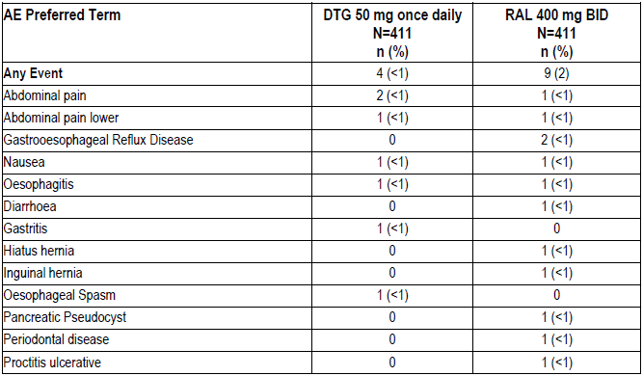

Table 84: Study ING113086 Summary of Events Suggestive of GI ulcerative lesion
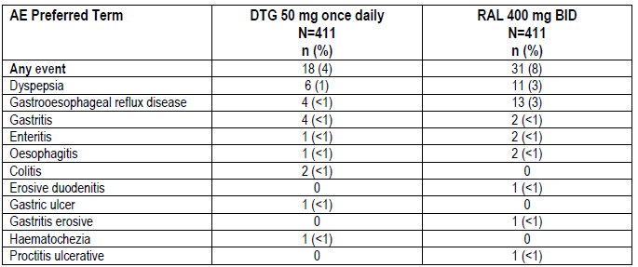
The most common psychiatric disorders were depression, insomnia and anxiety, each reported by < 6% per arm. Suicide ideation or behaviours were reported for DTG 4/411 [<1%] and RAL 6/411 [1%] One RAL treated individual completing suicide. No case was considered IP related.

Clinical laboratory evaluations
There was a similar overall pattern in Graded treatment emergent clinical chemistry toxicities for DTG and RAL. Since the Week 48 analysis, additional Grade 4 labs include: Grade 4 lipase (DTG), Grade 4 creatinine (RAL) and Grade 4 CPK (n=5 DTG; n=1 RAL). (Table 85).
The numbers of participants in each treatment group with ALT ≥3xULN were: DTG 21 (5%); RAL 19 (5%). (Table 86) Two patients on DTG had a combination ALT >3xULN with total bilirubin ≥ 2xULN and ALP <2xULN.
Seven participants (DTG 5, RAL 2) had maximum treatment emergent ALT values ≥ 10xULN (table 87) Patients with treatment emergent ALT elevations ≥5xULN but < 10xULN are shown in Table 88. Of the 5 patients in each group, four met liver criteria for stopping IP, yielding a total of 11 [DTG 7, 2%; RAL 4, <1%] who met at least one of the criteria. Eleven in each group recorded ALT ≥ to 3xULN but <5xULN; one in the RAL group met liver stopping criteria.
There was no change from baseline bilirubin in either group. Hepatobiliary disorder SOC AEs were reported for DTG 9/411 (2%) and RAL 9/411 (2%). Two participants in each group reported hepatic steatosis (<1%); 1 in the RAL group developed hepatomegaly. (Table 81).

Table 85: Study ING113086 Selected Clinical Chemistry Toxicities – Week 96 (Safety Population)
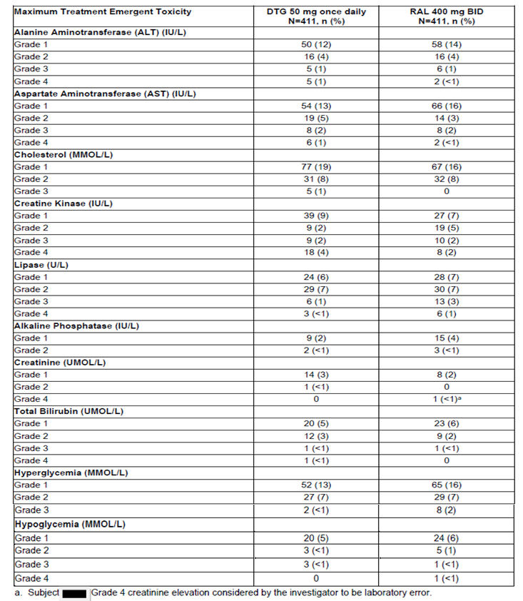

Table 86: Study ING113086 Summary of Subjects with ALT >=3xULN

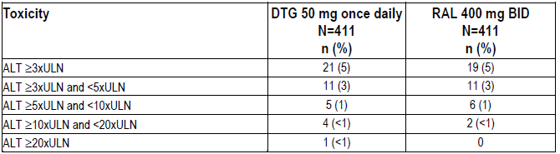

Table 87: Study ING113086 Maximum treatment emergent ALT greater than or equal to 10xULN
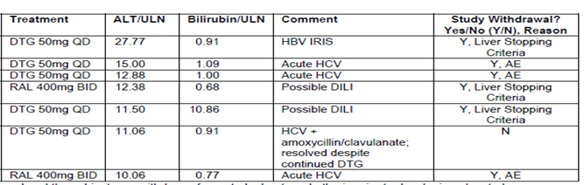
Subject numbers have been redacted from this table. Subject referred to in row two from top: IP stopped and the subject was withdrawn from study due to arrhythmia prior to developing elevated transaminases.

Table 88: Study ING113086 Participants with Maximum treatment emergent ALT ≥ 5xULN but <10xULN
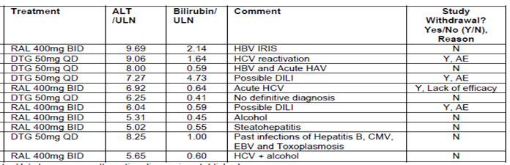
Subject numbers have been redacted from this table. Subject in first row from top: Not a Hy’s law case as alternative diagnosis established. Subject in fourth row from top: Additional diagnosis established. Subject in second last row: Repeat ALT 4 days later was 48 IU/L.

Table 89: Study ING113086 Participants with Maximum treatment emergent ALT ≥3xULN but <5xULN
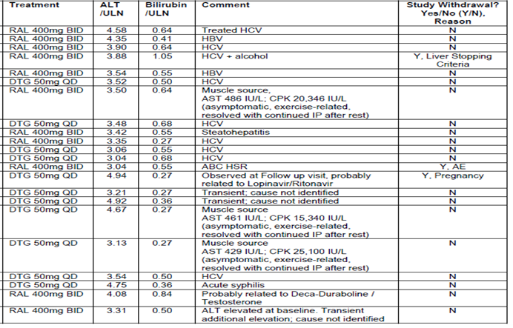
Subject numbers have been redacted from this table.
Treatment emergent Grade 1 creatinine toxicities were reported for DTG 14, RAL 8. There was only one (DTG) who had Grade 2 toxicity. For AEs related to the Renal and Urinary disorders SOC, the incidence was: DTG 24/411 (6%); RAL 16/411 (4%). (Table 81).
The median urine albumin/creatinine ratios were similar in both groups at baseline and remained stable up to Week 96. Although there were some changes in the mean values with a fall in the DTG group and small rise in the RAL group, the mean values were affected by outliers.
Grade 4 elevations of CK were recorded by 18 (4%) in the DTG group and 8 (2%) in the RAL group. For all those in the DTG group and for 7 in the RAL group, the changes were transient without associated AEs, clinically significant symptoms or changes in renal function. High degrees of physical activity preceded the CPK elevations for 13/18 in the DTG group and 4/8 in the RAL group and by a seizure in 1 in the RAL arm.
The incidence of AEs related to the musculoskeletal and connective tissue disorders SOC was: DTG 74/411 (18%); RAL 86/411 (21%). Arthralgia was reported by: (DTG 10/411 (2%); RAL 14/411 (3%); myalgia by: DTG 11/411 (3%); RAL 8/411 (2%); there were no AEs of rhabdomyolysis.
There were no clinically significant trends in treatment emergent haematology abnormalities. The incidence of Grade 2 to Grade 4 haematology toxicities (all parameters) was 7% in the DTG arm and 6% in the RAL arm. No clinically significant differences were noted between groups.
The most commonly reported Grade 3 to 4 treatment emergent haematology abnormality was decreased absolute neutrophil count reported in 2% of individuals in each treatment group. The majority were either isolated events or occurred in those with an underlying neutropenia.
Regarding lipid parameters, there was no clinically significant change in Total/HDL cholesterol or triglycerides. The higher LDL Grade 1 incidence in the DTG group was not reflected in change from Baseline values or in higher toxicities. (Table 90 and Table 91).

Table 90: ING113086 Week 96 Mean (SD) Change from Baseline in Lipid Parameters (Safety Population)
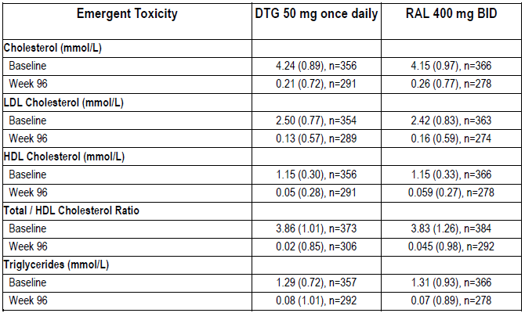

Table 91: ING113086 Maximum Treatment Emergent Toxicities for Lipid Parameters (Safety Population)
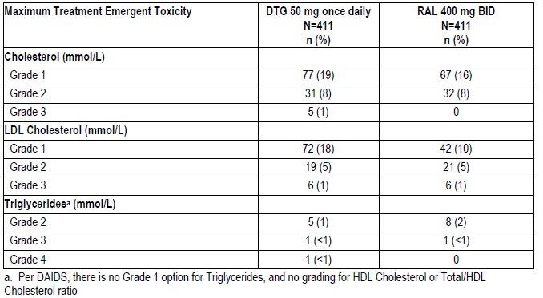
Twenty DTG treated patients had clinically significant abnormal ECG findings reported during the study. With the exception of sinus bradycardia (n=5) and ST-T wave changes (n=6), no other abnormalities occurred in more than 1 person. Eleven participants (3%) randomized to RAL had clinically significant abnormal ECG findings at Baseline or post-baseline (low QRS voltage, left atrial abnormality, and sinus arrhythmia/ectopic ventricular beats). (Table 92).
Most patients had a change from Baseline in QTcB or QTcF ≤ 30 msec. For DTG, the mean changes from baseline (SD) for QTcB and QTcF at Week 96 were 3.5 msec (28.37) and 6.9 msec (24.55), respectively, and for RAL, 0.5 msec (26.14) and 3.6 msec (23.18). AEs potentially related to torsades de pointes were considered to be unrelated to torsades de pointes.

Table 92: Study ING113086 Summary of ECG Findings (Safety Population)
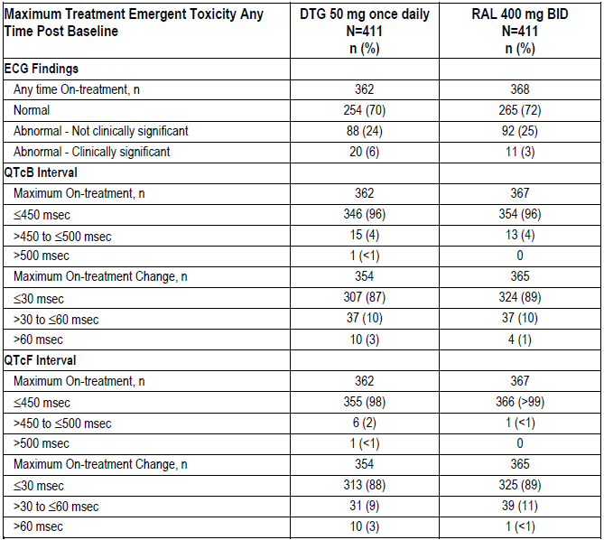
Thirteen patients reported pregnancies: DTG 7/411 (2%); RAL 6/411 (<1%). Three were enrolled at the same site in Russia. In 5/13 cases (DTG 3, RAL 2), the pregnancy resulted in delivery of a normal infant. One delivery of a normal infant at 32 weeks gestation was preceded by a threatened miscarriage at 8 weeks, which resolved following treatment with drotaverine, ethamsylate and dydrogesterone. The reporting investigator did not consider the threatened abortion reasonably attributable to IP (DTG).
In six of the 13 cases, elective terminations were performed (DTG 3, RAL 3). One RAL treated patient had a spontaneous abortion and a past history of two prior spontaneous abortions and two prior elective terminations. The spontaneous abortion was considered unrelated to IP (RAL). One pregnancy was ongoing (DTG.

Applicant’s conclusion
- DTG demonstrated a safety and tolerability profile that was similar to that of RAL over the period of the study
- Based on Week 48 data, there is no increased risk of renal toxicity for DTG compared to RAL
- Based on Week 48 data, there is no increased risk for hepatic toxicity for DTG compared to RAL
- Mild to moderate general GI intolerance (mainly diarrhoea and nausea) is associated with DTG treatment in a small proportion of subjects; however nonclinical findings for GI erosions did not translate into significant clinical findings
- There is no evidence from this study for increased risk of TdP with DTG
- Other serious conditions that are labelled for RAL, such as serious rash (e.g., Stevens Johnson syndrome, toxic epidermal necrolysis or erythema multiforme) and rhabdomyolysis have not been observed in this study, and there was no increased risk for psychiatric disorders for DTG over RAL
- Serious hypersensitivity events were rare and there was no increased risk for DTG compared to RAL.

Evaluator comment
It is accepted that no new DTG safety concern was uncovered between Weeks 48 and 96. The conditions labelled for RAL including serious rash and myopathy and rhabdomyolysis were not reported for DTG. Numbers studied may preclude identification of rare events.
The very large SDs for mean changes for baseline of QT intervals signifies that there was considerable variation and the mean may not represent the total treated population.
The treatment of the one patient with threatened miscarriage was unusual by Australian standards. The occurrence of 3 pregnancies at one site in Russia may have been a reflection of general oversight of patients in that site.

Study ING114915 (flamingo) – Treatment-naïve
ING114915 is a Phase IIIb randomized, open-label, controlled, multicentre study of ART-naïve adults comparing safety and efficacy of DTG v. DRV+RTV each with either ABC/3TC (33%) or TDF/FTC (67%). Week 48 results were presented.
The most common AEs in both treatment groups were diarrhoea, nausea, headache, and nasopharyngitis. Reports of diarrhoea and upper respiratory tract infection were more frequent in the DRV+RTV group; headache was more frequent in the DTG group. The majority of events overall were Grade 1 or 2.
Five events were reported as both AEs and SAEs: congestive cardiomyopathy (DTG), suicide attempt (DTG), myocardial infarction (DRV+RTV), pulmonary tuberculosis (DRV+RTV), and acute hepatitis C (DRV+RTV). These events will be reported as SAEs in the 96-week report.
In the DTG group, Grade 4 events were reported for 7 patients: blood CPK increased (n = 2); neutropenia, overdose, and the following, reported as SAEs: small intestinal obstruction, recurrent small bowel adhesions, syncope, postoperative ileus, overdose, drug abuse, and epilepsy: ‘any of these Grade 4 events were assessed as related to DTG by the investigator’ (sic). (See questions). For DRV+RTV, Grade 4 treatment related AE were type V hyperlipidaemia and ALT increased.
The incidences of drug-related events were similar except for diarrhoea which was reported more frequently in the DRV+RTV group. The discrepancy in incidence was largely due to higher numbers in the DRV+RTV group with Grade 1 events.
In the DTG treatment group, the Grade 3 events assessed as at least possibly drug related were reported for 2 patients: cardiac failure and diarrhoea. In the DRV+RTV treatment group, the Grade 3 events included: ALT increased, AST increased (n = 2), dissociation, disturbance in attention, feeling abnormal, nervousness, and psychomotor retardation.
Adverse events leading to study withdrawal were summarised. With the exception of increases in ALT and AST levels in 2 subjects who were receiving DRV+RTV, no other individual AE was reported in more than 1 subject.
No deaths were reported. Only 1 participant in the DTG treatment group reported an SAE considered by the investigator to be related to IP, a suicide attempt. SAEs were individually reported by less than one percent of participants.

Events of special interest
One SAE report of hypersensitivity reaction grade 2, disseminated maculopapular rash and erythema without associated symptoms, was suspected by the investigator to be due to ABC but the Sponsor considered DRV+RTV to be the likely cause.
Four non-serious cases of hypersensitivity were reported (DTG 3, DRV+RTV 1). The NRTI backbone treatments were ABC/3TC in 1/3 DTG subjects and TDF/FTC in 2/3 DTG subjects and the DRV+RTV subject. None of these reactions were considered IP related.
There were no serious rash events reported. The incidences of all preferred terms: rash, rash macular, rash generalized, rash morbilliform were: DTG 12 (5%) and DRV+RTV, 17 (7%).
The incidence of skin and subcutaneous tissue disorders by SOC was 16% for the DTG group and 20% for the DRV+RTV group. Of these, 3% in the DTG group and 9% in the DRV+RTV group were considered IP-related. All were Grade 1 or 2, none were reported as SAEs; 2 in the DRV+RTV group resulted in the permanent discontinuation of IP and withdrawal from the study.
Two patients in the DTG treatment group had events classified as possible IRIS. In the DRV+RTV group, two patients had events classified as IRIS and 2 as possible IRIS.
The incidence of GI disorders by SOC was 48% for the DTG group and 52% for the DRV+RTV group. The number of patients with severe or Grade 3 and Grade 4 AEs in the GI system was 8 in the DTG treatment group and 2 in the DRV+RTV treatment group. Drug related GI events were reported for 23% of the DTG group and 38% of the DRV+RTV group. Eight subjects reported GI SAEs (DTG 6, 2%; DRV+RTV 2, <1%), and 4 GI events resulted in the permanent discontinuation of IP and withdrawal from the study (DTG 2, <1%, DRV+RTV 2, <1%).
Ninety-two diarrhoea-related AEs were reported by 71 patients in the DRV+RTV group, compared to 46 in 43 patients in the DTG group. Most were considered drug related (DTG 51%, DRV+RTV 79%). One event in the DRV+RTV group and 2 events in the DTG group were Grade 3 or 4.
There were 42 reports of nausea for 39 patients in the DTG group vs. 51 reports for 43 in the DRV/RTV group, mostly considered IP related: DTG 74%, DRV+RTV 79%; all were ≤ Grade 2.
AEs potentially indicative of GI ulcerative lesion considered likely to be drug related were reported by 2 individuals in the DTG group and 6 in the DRV+RTV group. All were graded mild.
The incidence of psychiatric disorders reported was 19% for the DGT group and 14% for the DRV+RTV group. Insomnia, depression, and anxiety were the most commonly reported: Insomnia DTG 18 (7%); DRV+RTV 15 (6%); anxiety: DTG 10 (4%); DRV+RTV 7 (3%); depression DTG 11 (5%); DRV+RTV 6 (2%). All other events in this SOC were reported in ≤ 1%. Insomnia was considered IP related for 2% of the DTG group and 1% of the DRV+RTV group. Overall, the majority of events were considered of Grade 1 intensity and/or not reasonably drug-related.
Three patients in the DTG treatment group recorded AEs indicative of suicide ideation, for one, relatedness could not be ruled out.

Clinical laboratory evaluations
The proportions meeting at least 1 FDA hepatobiliary laboratory abnormality were: DTG 23 (10%); DRV+RTV 12 (5%). The numbers meeting the protocol liver stopping criteria were: DTG 1 (<1%); DRV+RTV 4 (2%).
No trend for increase in mean ALT, AST, or total bilirubin was observed in either group. There were more participants in the DTG treatment group with ALT ≥3 × ULN.
No subjects had a combination of ALT > 3 × ULN with total bilirubin ≥ 2 × ULN and ALP < 2 × ULN.
Four patients (DTG 1, DRV+RTV 3) had maximum post-baseline emergent ALT values ≥ 10 × ULN. Each was withdrawn from the study; events for 2 were considered unrelated to study drug (both DRV+RTV), related for one (DRV+RTV) and unrelated for one (DTG ABC/3TC).
Participants on DTG had mean increases in serum creatinine and decreased calculated creatinine clearance evident by Week 2 that remained stable through Week 48. The mean serum creatinine in participants receiving DRV+RTV was steady over time, and lower than in the DTG group. Two participants in the DTG treatment group had Grade 2 creatinine toxicity; none had Grade 3 or 4 toxicity. Twenty-six patients recorded with AEs related to the renal and urinary disorders SOC: DTG 15 (6%); DRV+RTV 11 (5%).
The median urine albumin/creatinine ratios were similar in both groups at Baseline and remained stable up to Week 48. In the DTG group, the mean values increased at Week 24 driven by outliers. At Week 48 in the DTG group, and at Weeks 24 and 48 in the DRV+RTV group, the mean urine albumin/creatinine ratio slightly decreased. Only 8 (5%) of patients in either group who had albumin/creatinine ratios less than or equal to the ULN at Baseline had increases to above the ULN.
Grade 4 elevations of CK were reported for 3% in the DTG group and 2% in the DRV+RTV group. CK increases were reported as an AE for three individuals in the DTG group and 1 in the DRV+RTV group. In all cases, CK levels oscillated with time and elevations were transient changes from baseline with no clear temporal relationship with the introduction of the IP. In addition to the Grade 4 CK elevations, there were 83 subjects with AEs related to the musculoskeletal and connective tissue disorders SOC: DTG 39, 16%; DRV+RTV 44, 18%. One subject in DTG treatment group experienced rhabdomyolysis together with an SAE of acute renal failure. The event was considered related to volume depletion and alcohol consumption.
The most commonly reported Grade 3 - 4 treatment-emergent haematology abnormalities were decreased absolute neutrophil count: DTG 8 (3%); DRV+RTV 1 (<1%).
Lipid parameters were only summarized on fasting data and did not include all participants. The mean increase in fasting LDL cholesterol at Week 48 was higher in the DRV+RTV group than the DTG group (adjusted mean difference [95% CI] -0.30 [-0.42, -0.19], p<0.001). This was the second step in the pre-specified multiple-testing strategy. The incidence of ≥ Grade 2 fasting LDL abnormalities was higher in the DRV+RTV group than the DTG group (p<0.001). This was the third step in the pre-specified multiple testing strategy.
Cholesterol, LDL cholesterol, and triglycerides showed little mean change from Baseline in the DTG group but were increased in the DRV+RTV group. There was little change in high-density lipoprotein (HDL) cholesterol in either group. The total cholesterol/HDL cholesterol ratio showed no change in the DTG group but increased in the DRV+RTV group.
Similar proportions in each group had a low HDL cholesterol level at Baseline: DTG 39%, DRV+RTV 42%. A similar proportion improved to more favourable higher levels of ‘Normal’ or ‘High’ (47% each treatment group). Few subjects in either group had a fall in HDL cholesterol from ‘High’ or ‘Normal’ to the less favourable ‘Low’ level (DTG ≤1%, DRV+RTV 5%).
The majority of participants in both groups had ‘Normal’ fasting triglyceride values at Baseline. However, the proportion with ‘Normal’ values that increased to less favourable categories was higher in the DRV+RTV group than in the DTG group.
Clinically significant abnormal ECG findings were reported in 2 subjects in the DTG treatment group: myocardial infarction inferior; and left atrial abnormality. The proportion with QTcB and QTcF values ≤450 msec was similar in both treatment groups throughout the study. Most subjects had a change from Baseline in QTcB or QTcF ≤ 30 msec.
There were 8 (3%) in the DTG group with events potentially related to TdP, and 1 (< 1%) in the DRV+RTV group. Three events in the DTG group were reported as SAEs in the nervous system disorders SOC, but were not IP related. The remaining 6 TdP related events were reported as AEs, and were: 1 non-serious case of arrhythmia in the DTG treatment group; 3 non-serious cases of syncope (DTG 2, DRV+RTV 1), and 2 non serious cases of cardiac failure in the DTG treatment group. One participant in the DTG group developed a serious episode of congestive cardiomyopathy considered related to IP.
Four participants reported pregnancies. There were no elective terminations. One DTG participant delivered a normal female neonate: on DRV+RTV and 1 on DTG had unknown outcomes.

Applicant’s conclusions
- DTG demonstrated a safety and tolerability profile that was comparable to that of DRV+RTV over 48 weeks
- Based on Week 48 data, there is no increased risk of renal toxicity or hepatic toxicity for DTG compared to DRV+RTV
- There is no evidence from this study for increased risk of rash with or without systemic symptoms with DTG compared to DRV+RTV. Serious rash (e.g., Stevens Johnson syndrome, toxic epidermal necrolysis or erythema multiforme) was not observed in this study. Only 1 case suggestive of ABC HSR in the DRV+RTV treatment group was reported in this HLA-B*5701 pre-screened population
- Mild to moderate general GI intolerance (mainly diarrhoea and nausea) is associated with DTG treatment in a small proportion of subjects; however, non-clinical findings for GI erosions did not translate into significant clinical findings
- The psychiatric AE profile for DTG was comparable to prior studies
- There is no evidence from this study for increased risk of TdP with DTG
- The changes in lipid profile through Week 48 were favourable for DTG compared to DRV+RTV
- Although there are limitations to the assessment of safety due to the open label design, the results support the use of DTG in a treatment-naïve patient population.

Evaluator comment
It is agreed that the open-label design has the potential to bias the results. For laboratory determined safety, the results depended on those who were tested and it was not possible to determine from the tables, how many participants contributed to the reported results.
The study is only partially relevant to Triumeq, as only 79 participants of the 242 in the DTG group were treated with ABC/3TC.
The primary efficacy analysis using the Snapshot algorithm included discontinuation or switching of treatment as failures, and the result was influenced by the higher numbers in the DTG/RTV group who discontinued due to adverse events that appear to have been considered generally mild. This is seen as potential problem in an open-label study.

Integrated safety for DTG + ABC/3TC – Treatment-naïve
Integrated comparisons of IP related AEs across studies of treatment-naïve patients treated with DTG + ABC/3TC vs. comparators were summarised. The comparison is hampered by small numbers in comparator groups other than in ING114467.

Study ING111762 (sailing) – Treatment-experienced
ING11762 was a Phase III randomized, double-blind study of the safety and efficacy of DTF vs. RAL, each with an investigator selected background regimen, in adult HIV-1 infected, integrase inhibitor-naïve, ARV-experienced adults. The Week 48 results were reported. The numbers included in the safety populations were DTG 357 and RAL 362. As far as could be ascertained only 7 (or possibly 9) participants were treated with DTG + ABC/3TC.
The most commonly reported clinical AEs among participants receiving DTG were diarrhoea, upper respiratory tract infection, headache, nausea, cough, and influenza. The majority of events in both treatment groups were considered Grade 1 or Grade 2. Diarrhoea, headache and nausea were the most commonly reported Grade 2 to 4 AEs.
Similar proportions in each treatment group (DTG: 20%, RAL: 23%) developed one or more IP related AE. The only IP-related AE reported in ≥ 5% of subjects in either treatment group was diarrhoea: DTG 8%: RAL 6%. Six patients receiving DTG had drug-related upper abdominal pain vs. RAL 0. Six patients receiving RAL had drug-related insomnia vs. DTG 0.
Participants in this study were most frequently withdrawn due to hepatobiliary disorders, infections and infestations, gastrointestinal disorders, benign, malignant and unspecified neoplasms, and renal and urinary disorders. Of the 7 subjects with AEs leading to withdrawal in the DTG group, 4 events in 3 patients were considered IP-related: increased liver enzymes and bilirubin; hepatotoxicity: myositis and acute renal failure.
Three deaths in the RAL group were reported; none considered IP related by investigators; 1 report of liver failure considered possibly related by the Sponsor. SAEs considered IP related were reported by 2 in the DTG group and 4 in the RAL group.

Adverse events of special interest
Five cases of pancreatitis were reported, DGT 3 (<1%) and RAL 2 (< 1%). One case in the RAL group was considered possibly due to study treatment.
Two participants in each group reported hypersensitivity; 1 in the DTG group developed Grade 2 drug hypersensitivity considered possibly related background therapy etravirine and DRV/RTV, and leading to study discontinuation.
No episodes of severe/life threatening rash were reported. Reporting rates for rash were: DTG 53 (15%) all grade 1 - 2 and RAL 68 (19%) three of which were Grade 3. One of the Grade 3 events in the RAL group, associated with oral mucosal blistering, was reported as an SAE.
The most commonly reported psychiatric AE was insomnia which occurred at 3% and 4% in the DTG and RAL treatment groups, respectively; all grade 1 or 2; events considered drug related were reported for 6 (2%) of the DTG group and none of the RAL group.
Six patients in the DTG treatment group and 2 in the RAL group reported with AEs indicative of suicide ideation and behaviours. There were no events of completed suicide. In the DTG group, 2 patients attempted suicide. Six events in the DTG group and both cases for RAL were reported as SAEs. One event in the RAL group was considered IP related and led to withdrawal from the study.
Six participants in the DTG group were identified as having IRIS or possible IRIS. Five of these six were considered to have hepatitis B and/or hepatitis C IRIS.

Clinical laboratory evaluations
Emergent clinical chemistry toxicities showed an overall similar pattern for DTG and RAL: The most commonly reported were cholesterol abnormalities, 28% for both groups, hyperglycaemia 20% for DTG and 22% for RAL and lipase abnormalities 18% for DTG and 19% for RAL.
Increases in total bilirubin were seen across both treatment arms, did not correlate with changes in other liver chemistries and were typically associated with atazanavir use.
Grade 3 or Grade 4 increases in CPK occurred 7/357 (2%) of the DTG group and 4/362; (1%) of the RAL group. Most of these increases were transient and all resolved within about 2 weeks.
Musculoskeletal/connective tissue disorders were reported by: RAL (72/362, 20%) and DTG (51/357, 14%). Grade 3 or 4 events were reported by 8 in the RAL group and 5 in the in the DTG group. One DTG treated patient had myositis with a mild increase in creatinine and two had rhabdomyolysis. The rhabdomyolysis cases were both considered secondary to pneumonia and not related to DTG and the patients continued in the study.
The proportions with emergent ALT ≥ 3xULN were: DTG: 5%; RAL: 3%, and with ALT ≥ 5xULN: DTG: 3%; RAL: 2%. The numbers meeting hepatobiliary laboratory abnormality criteria were 34 in the DTG group and 19 in the RAL group. Seven patients on DTG and 4 on RAL met protocol-defined liver chemistry criteria for stopping IP. Of those subjects, 6 in the DTG group and 3 in the RAL group were also withdrawn from the study.
Three patients on DTG vs. none on RAL had a combination of ALT > 3xULN with total bilirubin ≥ 2xULN and ALP < 2xULN. All 3 met the protocol-defined liver stopping criteria. One was considered due to hepatitis C, two were considered hepatitis B flares, One patient on RAL had a combination of AST > 3xULN with total bilirubin ≥ 2xULN and ALP < 2xULN possibly due to ethanol and hepatitis C.
The 5 participants with maximum emergent ALT values ≥10xULN (DGT 4 and RAL 1), all met protocol-defined liver chemistry criteria for stopping IP. For DTG, three were considered possibly related to DTG (2 Hepatitis C flares with possible involvement of DTG; 1 hepatitis B flare and possible IRIS reasonably related to DTG. One hepatitis B flare did not have DTG implicated. For RAL, the investigator implicated the IP but the sponsor considered it to be consistent with possible retained gallstone. A total of twelve patients had ALT elevations >5xULN but < 10xULN [DTG: 5 (1%); RAL: 7 (2%)]. A total of seventeen patients had with ALT elevations > 3xULN but < 5xULN at any time from Baseline onward [DTG: 11 (3%); RAL: 6 (2%)].
Discordant numbers of participants on DTG and RAL, co-infected with hepatitis B, were noted for liver stopping criteria and other significant liver enzyme elevations. Use of antiretroviral background therapy containing hepatitis B active agents (i.e., tenofovir, lamivudine, emtricitabine) and use of other hepatitis B therapy (e.g., entecavir, telbivudine) varied widely across the study with 11 patients (6 on DTG, 5 on RAL) on no active hepatitis B therapy at Day 1 despite being hepatitis B surface antigen positive at Screening or Day 1. For the RAL group with chronic hepatitis B, 3/17 (18%) patients experienced PDVF versus 1/18 (6%) subjects on DTG experienced PDVF.
Four patients (DTG: 2, RAL: 2) with acute (n=1) or chronic (n=3) hepatitis C met liver stopping criteria and were withdrawn for liver chemistry elevations. One additional patient on DTG with hepatitis C co-infection was withdrawn, although liver stopping criteria were not met. Other HCV co-infected subjects in both treatment arms were also noted to have Grade 1 and 2 elevations in liver transaminases at Baseline and during the course of treatment, which were not treatment-limiting or progressive and in some cases were sporadic or self-limiting.
There were a small number of post-Baseline emergent Grade 1 creatinine toxicities in both groups (DTG: 12/357; 3%; RAL: 6/362; 2%). Five patients in the DTG arm and 6 in the RAL arm had emergent Grade 2 increases in creatinine and 1 subject in each group had Grade 3 increased creatinine. There were no other graded creatinine abnormalities overall. In both groups, small increases in mean creatinine (DTG: +11.1 μmol/L; RAL: +5.1 μmol/L) were noted.
The median urine albumin/creatinine ratios were similar in the two treatment groups at Baseline and remained stable up to Week 48. There were some changes in the mean values with a similar decrease in both arms. Most patients in both treatment groups experienced a decrease in albumin/creatinine ratio at Week 48 (DTG: 58%; RAL: 57%).
Four participants, (DTG: 3; RAL: 1) had acute renal failure. Of these, 3 had Grade 2 (DTG: 1; RAL: 2) and 1 had Grade 3 (DTG: 1) acute renal failure. For DTG, two were considered unrelated to IP, for one relationship was unclear, and for one the investigator and the Sponsor appeared to disagree. For RAL, the events were considered unrelated.
The overall frequency of decreased absolute neutrophil counts was 14% in each group. Grade 3 or Grade 4 decreases were reported for DTG: 12/357; 3% and RAL: 10/362; 3%.
There were similar changes in mean values for fasting lipid parameters across both across groups and similar grades and distribution of emergent toxicities. There were increases in mean total cholesterol, LDL cholesterol and HDL cholesterol in both groups, but little change in the HDL/cholesterol ratio.
Most participants in the both arms had corrected QT interval using Bazett's formula (QTcB) and corrected QT interval Fridericia's formula (QTcF) values ≤450 msec throughout the study. QTcB or QTcF values >500 msec were rare for either DTG or RAL subjects. Most participants in both arms had a change from Baseline in QTcB or QTcF ≤ 30 msec. Two percentage of each group had a change from baseline QTcB or QTcF of > 60 msec. No events were considered related to torsades de pointes.
Two pregnancies (DTG: 1; RAL: 1) were reported. The outcome for the DTG patient was unknown. The patient in the RAL treatment group underwent an elective termination.

Applicant’s conclusions
- The safety profile for DTG was similar to RAL, with similar rates of occurrence in both arms for the most common AEs and low rates of discontinuation due to AEs for both DTG and RAL
- No serious hypersensitivity events were observed, and there was no increased risk for DTG compared to RAL for hypersensitivity events
- Other serious conditions that are labelled for RAL, such as serious rash (e.g., Stevens Johnson syndrome, toxic epidermal necrolysis, or erythema multiforme) were not observed in this study
- Across the entire study population, a similar hepatic profile was observed for DTG and RAL
- Subjects with hepatitis B co-infection receiving DTG were noted to have significant liver chemistry elevations in the setting of HIV virologic and immunologic responses to DTG and withdrawal or lack of HBV active therapy. The pattern of injury is likely consistent with IRIS and/or HBV flare in the setting of inadequate HBV therapy rather than direct liver injury due to DTG
- Subjects with hepatitis C co-infection may be at greater risk of HCV IRIS with DTG due to improved HIV virologic responses versus RAL
- Based on Week 48 data, there appears to be no increased risk of renal toxicity for DTG compared to RAL
- Mild to moderate general GI intolerance (mainly diarrhoea and nausea) is associated with DTG treatment in a small proportion of subjects; however nonclinical findings for GI erosions did not translate into significant clinical findings
- There was no increased risk for psychiatric disorders for DTG over RAL
- Based on Week 48 data, there appears to be no increased risk of musculoskeletal disorders with DTG compared to RAL
- There is no evidence from this study for increased risk of TdP with DTG
- There was no untoward effect on the overall lipid profile in either treatment group.

Evaluator comment
The number of participants in the DTG group with background of ABC/3TC was small; only 7 that the evaluator could find. The safety results of the study would have been directly influenced by differing background therapies and disease related events. While these elements of the study were unavoidable, it is considered nigh impossible to make generalisation regarding the similarity of safety compared to studies enrolling treatment-naïve patients.
In the study synopsis, the Sponsor has stated that there may be a greater risk of HCV IRIS with DTG due to improved HIV virologic responses versus RAL. The numbers in the study are relatively small, and the events may be a chance aberration; however, vigilance will be required. The possibility of IRIS is included in the Precaution section of the draft Product Information.

First round benefit-risk assessment
The Benefit risk assessment will be completed in the second round evaluation (see below).

First round recommendation regarding authorisation
The recommendation will be given following the second round evaluation.

Clinical questions and Second round evaluation of clinical data submitted in response to questions

Question 1
The FDC is a large, 22 mm x 11 mm, film coated tablet. The depth and circumference have not been stated in the clinical component of the dossier. The Sponsor is requested to supply the depth and circumference measurements.

ViiV Healthcare response
For Triumeq Tablets, the typical thickness is 7.6 mm and the approximate maximum circumference is 54.6 mm.
For Kivexa Tablets, the typical thickness is 8.3 mm (as stated in our response to Question #2) and the approximate maximum circumference is 51 mm.
In addition, Atripla, another fixed-dose combination HIV product marketed in Australia has similar dimensions: Atripla (EFV/TDF/FTC FDC): 20 mm x 10.4 mm.

Evaluator comment
Response accepted. Triumeq is a relatively large tablet which may cause some patients difficulty.

Question 2
What are the dimensions of Kivexa tablets and Tivicay tablets?

ViiV Healthcare response
The dimensions of Kivexa and Tivicay tablets are provided below:
- Kivexa: 20.3 mm by 8.9 mm; typical thickness is 8.3 mm
- Tivicay: 9 mm round tablet; typical thickness is 4.7 mm.

Evaluator comment
Response accepted.

Question 3
Does the Triumeq tablet swell in the presence of water?

ViiV Healthcare response
Triumeq Tablets do not swell in water. An experiment was performed where tablets from three batches were placed in water at room temperature and the dimensions were compared after 1, 3 and 10 minutes. No increases in dimensions (length, width and thickness) were observed. The tablets disintegrate by erosion in water, which would not be expected to cause difficulties in swallowing the tablets.

Evaluator comment
Response accepted. The information is reassuring.

Question 4
The only submitted study in which the FDC was administered was ING114580, in which 54 healthy adults were administered 1 tablets and 12 were administered 2 tablets.
In general, many people find it hard to swallow big pills1, and as HIV infected patients are prone to dysphagia which may be due to a number of factors such as candida, HSV and CMV infections, aphthous ulceration, gastroesophageal reflux, HIV associated altered oesophageal motility and function, it is possible that the benefits of once daily dosing may be countered by lack of compliance due to difficulty in swallowing the large tablets. Acknowledging the literature references on the benefits of reduced tablet loads included in the dossier, is there direct evidence to support the contention that the FDC DTG/ABC/3TC tablet is readily swallowed by patients with HIV-1 infection, with resultant increase in compliance?

ViiV Healthcare response
We would first like to note that HIV-infected patients are starting care earlier in their disease process based on current treatment guidelines. Therefore, we are less likely to see complications related to OIs as those highlighted by the reviewer (e.g., esophageal issues like candidal and HSV esophagitis).
From the dimensions provided in response to Question #1 and #2, one can see that the DTG/ABC/3TC (Trii) tablet is very close in size to the other single table regimens, especially Atripla, as well as the KIVEXA formulation. Although there is not a formal clinical study evaluating adherence impact of the Trii tablet size, its very similar size to these already marketed formulations predict that adherence should not be negatively affected. This is especially true when taking into account the KIVEXA formulation, since that product has been in use in Australia since its listing on the Pharmaceutical Benefits Scheme in 2005.
Two clinical trials provide insight on this question: the pivotal Bioequivalence trial, ING 114580, which was conducted in adult subjects, and an large, ongoing multi-center, international Phase IIIB-study, ING117172, which has randomized over 300 women to date to either the DTG/ABC/3TC FDC (Trii) tablet or tenofovir/emtricitabine plus atazanavir/ritonavir. The sponsor is aware of only two cases regarding issue with the formulation from subjects in the development studies: in one case the subject had some difficulty swallowing the Kivexa tablet (commercial) in the bioequivalence trial, and one subject in the ongoing ING117172 study has mentioned difficulty in swallowing the Trii tablet, but has remained in the trial for over 6 months and is still participating.
Therefore, in light of the acceptability of Kivexa in children greater than 12 years of age and the data from ING114580 and ING117172, the Applicant feels that the tablet size for DTG/ABC/3TC will not adversely affect medication adherence. In either situation, this same clinical consideration would be necessary for any solid tablet or pill form of ART, including those noted above to be of similar size.
Regarding evidence to support the view that the use of fixed dose combinations by patients with HIV-1 infection results in an increase in compliance, we refer to the Triumeq: s31 Response Document D2014-5614 - 5 - literature summarized in this submission, as there are no new data with FDC DTG/ABC/3TC.

Evaluator comment
This argument is accepted.

Question 5
With respect to Table 7, please confirm that the values in the column headed ABC/3TC are for either ABC or 3TC administered as single entities.
Assuming this is so, and taking into consideration problems inherent in use of historical comparisons, ABC and 3TC AUC values appear similar but it is likely that Cmax for both ABC and 3TC would not meet bioequivalence limits had the comparison been done contemporaneously.
As DTG has the theoretical capacity to increase 3TC levels based on in vitro inhibition of OCT2, it is surprising that the FDC Cmax level of 3TC shown in Table 7 is approximately 75% of the single active point estimate. Please comment.
No Cmin data has been supplied. Please submit Cmin data for Study InG114580 if available.

ViiV Healthcare response
We confirm that the values in the column headed ‘ABC/3TC’ in Table 7 (copied here) denotes abacavir and 3TC administered as single entities given simultaneously.

Table 7: Study ING4580 comparison of ABC and 3TC PK parameters across studies
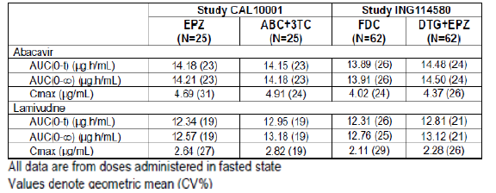
In this table, both ABC and 3TC showed similar AUC values between Study CAL10001 and ING114580, however Cmax values in study CAL10001 were consistently higher than those in ING114580 for both ABC and 3TC. The reason for different Cmax between these two study is likely due to different PK sampling scheme. In Study CAL1001, plasma PK samples were collected at 0, 0.25, 0.5, 0.75, 1, 1.5, 2, 2.5, 3, 4, 5, 6, 8, 10, 12, 16, and 24 hours post dose. In Study ING114580, plasma PK samples were collected at 0, 0.5, 1, 2, 3, 4, 5, 6, 8, 12, 16, 24, 36, and 48 hours post dose. Study CAL10001 collected more sample around tmax for ABC and 3TC. ABC tmax observed ranged from 0.25 to 3 hours post dose and 3TC tmax ranged from 0.75-4 hours post dose in Study CAL10001 (RM2002/00116/00 in eCTD). Therefore it is possible Cmax estimated in Study CAL10001 was higher than Study ING114580 due to more intensive PK sampling around tmax. However such difference in PK sample scheme would have less impact on the estimation of AUC. The between-study variation in Cmax could also be due to difference in sample size and subjects enrolled.
Cmin data could not be obtained from Study ING114580 as it is a single dose study. However C24, concentration at 24 hours post dose were reported in the study report for DTG, ABC, and 3TC and summarized here. C24 values for DTG were also summarized in the study report for the 62 subjects who completed both treatments in Study Part A (FDC fasted and DTG+EPZ fasted). These results indicated that the C24 values for each compound were very similar between the two treatments: Trii FDC vs DTG +EPZ.

Table 89: ING114580 Summary of C24 hour concentrations
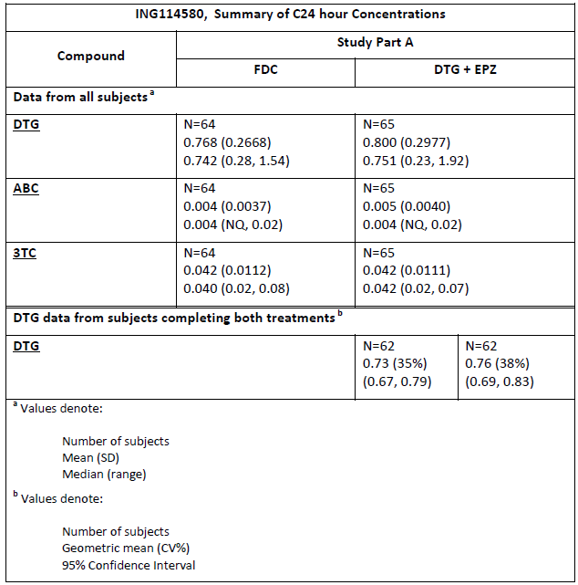

Evaluator comment
This response is accepted.

Question 6
It appears possible that a clinically relevant drug-drug interaction between DTG and 3TC may exist based on renal transporter OCT2 and possibly other renal transporters such as OAT1, MATE1 and MATE2-K based on in vitro studies. It is considered unproven that such an interaction is unlikely. A formal interaction study between DTG and 3TC, including assessment of intracellular levels of lamivudine is recommended.

ViiV Healthcare response
mediated via OCT-2, and that dolutegravir (DTG) has been shown to inhibit the activity of OCT2 as well as MATE1 and MATE2-K (weak inhibition) . However, based on the clinical data and predicted effect of DTG on 3TC exposure (e.g. AUC) using various static models and in vitro IC50 values [Ito 2005; Zamek-Gliszczynski 2009], no interaction between DTG and 3TC is observed or expected. Therefore, a formal interaction study between DTG and 3TC is not needed.
Cross-study analyses of PK data observed in ING114580 and CAL10001 demonstrate that 3TC PK parameters were similar with or without co-administration of DTG. Table 89 below shows that 3TC AUC when given as a Epzicom (EPZ) tablet with DTG in ING114580 are similar to that when given as EPZ in Study CAL10001, a bioequivalence study for Epzicom/KIVEXA. These data suggest that DTG does not have an effect on 3TC exposure. The higher 3TC Cmax observed in CAL10001 is likely due to more intensive PK sampling scheme than that used in ING114580.

Table 89: Comparison of ABC and 3TC PK parameters across studies
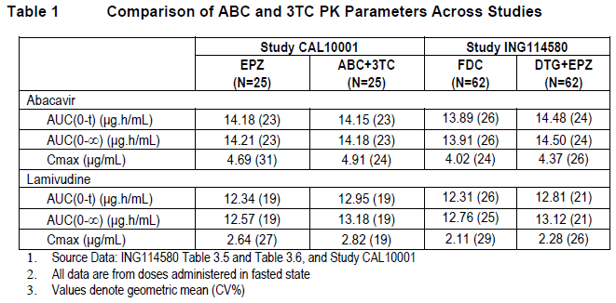
The lack of any meaningful PK interaction between DTG and 3TC is further supported by the favourable safety profile observed across the treatment-naive studies, where subjects have received DTG in combination with 3TC and ABC for up to 96 weeks and/or beyond (ING112276, ING113086, and ING114467).
3TC is predominantly cleared by the kidney via both glomerular filtration (GFR)and active tubular secretion (CLATS) of unchanged drug. The renal clearance (CLR) of 3TC is 280 ml/min, which is approximately 70% of 3TC’s total plasma clearance (399 mL/min). The renal clearance due to active tubular secretion is estimated to be 190 mL/min, based on CLATS = CLR – fu*GFR, where 3TC fu = 0.9, estimated average GFR = 100 mL/min/1.73 m2 (source: NKEDP). Thus the fraction of 3TC cleared by active tubular secretion is approximately 47.5% of the total plasma clearance. The potential effect of complete inhibition of active renal secretion on 3TC exposure by co-administration of drugs that inhibit active renal secretion can be estimated using the equation by (Ito et al. 2005):
Maximum AUC ratio= {1/ (1-fraction CL by active secretion}
Thus, the maximum increase in 3TC exposure due to complete inhibition of active renal secretion is predicted to be 1.9-fold.
Active tubular secretion of 3TC is primarily mediated by uptake into the proximal tubule cells via organic cation transporter 2 (OCT2) and efflux out of the kidney into the urine by multidrug and toxin extrusion transporters (MATE1 and MATE2-K) (Jung et al., 2008; Muller et al., 2013).
Trimethoprim reduces the renal clearance of 3TC by 35% and increases 3TC plasma concentrations by 43% in HIV patients (Moore et al., 1996). However, this drug interaction is not considered clinically significant, as a dose adjustment of lamivudine is not required. Importantly, MATE-mediated active renal secretion appears to be the main mechanism for this interaction rather than inhibition of OCT2, as trimethoprim is a potent inhibitor of MATE2-K (IC50=0.66 uM) and weaker inhibitor of MATE1 (IC50=6.2 uM) and OCT2 (IC50 =13 uM) (Muller et al., 2013). Based on unbound trimethoprim plasma concentrations (4.66 uM), the maximum systemic trimethoprim concentration (I) = 50*fu*Cmax, as defined by the EMA, is 233 uM. The I/IC50 ratios are estimated therefore to be 17.7 (OCT2), 37.6 (MATE1) and 353 (MATE2-K).
A DTG-mediated drug interaction with 3TC through inhibition of MATE1 and MATE-2K is not expected. Based on DTG’s maximum systemic concentration (I) or 50*fu*Cmax and weak MATE inhibitory potency, where fu = 0.01, Cmax = 8.8uM, MATE1 IC50 =6.3uM, and MATE2-K IC50 = 25uM, the calculated 50*fu*Cmax/ IC50 ratios are 0.7 (MATE1), and 0.18 (MATE2-K). As these ratios are 53-fold and 2000-fold lower, respectively, than the ratios for trimethoprim, no drug interaction with 3TC is expected.
The effect of dolutegravir on lamivudine exposure due to inhibition of lamivudine’s active tubular secretion through inhibition of OCT2 can be estimated using the mechanistic static equation described by Zamek-Gliszcynski et al (2009):
Fold Δ=1/((f_{e}/1+(I)/K_{i})+(1-f_{e}))
where:
f_{e} = the fraction of total clearance of lamivudine mediated by active tubular secretion (0.475)
K_{i} = IC50 for dolutegravir inhibition of OCT2 (1.93 μM)
[I] = unbound dolutegravir plasma concentration (0.088 μM); fu * Cmax, where Cmax after 50mg oral QD dose = 8.8μM and fu = 0.01.
Based on the above parameters lamivudine exposure is only predicted to increase 2% due to dolutegravir inhibition of lamivudine renal secretion by OCT2. As a worst case assessment, drug interaction prediction calculations were performed using a 20-fold more potent OCT2 inhibition by dolutegravir (IC50 = 0.1 μM). Using this more conservative estimate lamivudine exposure is only predicted to increase by 28%.
In summary, PK data from ING114580 and comparisons to historical data suggest that there is no significant drug interaction between DTG and 3TC. Additionally, based on in vitro transporter data, it is not predicted that DTG would have a significant impact on 3TC plasma concentrations. Finally, DTG has been co-administered with 3TC in multiple clinical studies, and no significant safety issues have been identified due to co-administration with DTG and 3TC.

References:
Ito K, Hallifax D, Obach RS, and Houston JB. Impact of Parallel Pathways of Drug Elimination and Multiple Cytochrome P450 Involvement on Drug-Drug Interactions: CYP2D6 Paradigm. Drug Metabolism and Disposition 2005 33:837-844.
Jung N, Lehmann C, Rubbert A, Knispel M, Hartmann P, van Lunzen J, Stellbrink H-J, Faetkenheuer G, Taubert D. Relevance of the Organic Cation Transporters 1 and 2 for Antiretroviral Drug Therapy in Human Immunodeficiency Virus Infection. Drug Met Disp 2008 36:1616–1623.
Moore K, Yuen G, Raasch R, Eron J, Martin D, Mydlow P, Hussey E. Pharmacokinetics of lamivudine administered alone and with trimethoprim-sulfamethoxazole. Clin Pharmacol Ther 1996; 59:550-558.
Muller F, Konig J, Hoier E, Mandery K, Fromm MF. Role of organic cation transporter OCT2 and multidrug and toxin extrusion proteins MATE1 and MATE2-K for transport and drug interactions of the antiviral lamivudine. Biochem Pharmacol 2013;86(6):808-15.
NKDEP (National Kidney Disease Education Program). (http://nkdep.nih.gov/lab-evaluation/gfr-calculators.shtml)

Evaluator comment
This response is accepted.

Question 7
Regarding ING116070 the Sponsor is requested to supply details of the protocol deviations which the evaluator could not locate in the CSR.

ViiV Healthcare response
Please refer to (Week 16) Clinical Study Report [2012N150605_00] dated 25 Mar 2013. Due to the small sample size for this study, no per protocol analysis excluding subjects with deviations considered to have a significant impact on efficacy analyses was conducted. No subject had a deviation from inclusion/exclusion criteria. Ten subjects (77%) had one or more protocol deviation (Administer/dispense study medication: 7 [54%] and other: 8 [62%]) recorded on the protocol deviations log within the eCRF. The deviations were reviewed by the study team on an ongoing basis and sites were retrained as deemed necessary.

Evaluator comment
The information provided above was noted by the Round 1 evaluator and reported in the CER. Reporting protocol deviations as ‘other’ is uninformative, especially in such a small sample population, when protocol deviations may have much greater impact than in a very large study.

Question 8
Justification is required for the 95% confidence interval and p-value used in assessment of virologic suppression at Week 96. The proposed text includes the statement that the difference between treatment groups was significant; however, multiplicity was not accounted for after Week 48.

ViiV Healthcare response
The Week 48 was the primary endpoint of this study. At that timepoint, we found that the DTG+ABC/3TC arm was statistically superior to the Atripla arm. If the results on the primary endpoint had been negative (i.e., not non-inferior) at week 48, the results of the week 96 would have likely become irrelevant and we agree that the ‘superior’ and ‘non-inferior’ statement should have been taken out. However, we believe that we can refer to week 96 this way because week 48 is significant. In effect, it’s a stepwise fixed sequence procedure where endpoints are ordered and tested if and only if the null hypothesis is rejected at the previous test (Dmitrienko 2013). In HIV studies, the different timepoints are often naturally ordered chronologically. In SINGLE and SPRING2, Week 48 is primary; Week 96 is secondary and only assessed if Week 48 is non-inferior in support of the Week 48 results and to confirm long term effect. This method controls the family wise error rate for both hypotheses (ie the probability of at least one false positive at either week 48 or week 96) in the strong sense. If we had to apply other multiplicity adjustment methods (e.g., the conservative Bonferroni method); the results would be confirmed and remain statistically significant.
Hence, we believe the use of ‘superiority’ and ‘non-inferiority’ is justified in the label at Week 96.

References
Dmitrienko A, D’Agostino R, Traditional multiplicity adjustment methods in clinical trials Statist. Med. 2013

Evaluator comment
Response accepted

Question 9
The applicant is requested to comment on the notion that the Snapshot analysis includes a composite endpoint. The surrogate endpoint of HIV-1 RNA < 50 c/mL is accepted as an important efficacy endpoint. The decision to discontinue treatment due to adverse event may be subjective and open to bias, particularly when the study is unblinded (e.g. ING114915), or when the nature of the adverse events lead to identification of the treatment in a blinded study. Discontinuation criterion such as a missing values at a specified time point is clinically relevant. The inclusion of results of the Snapshot analysis in the Product Information, qualified as HIV-1 RNA < 50 c/mL, is not considered accurate. The result based in < 50 c/mL is considered more appropriately that of the Kaplan Meier ERDF analysis.

ViiV Healthcare response
The Snapshot endpoint was the primary endpoint in the treatment naive studies. It is a widely used and well accepted endpoint. Snapshot or similar endpoints are reported in the Australian labels for other HIV treatments such as Stribild, Eviplera and Tivicay. The ability to successfully maintain a suppressed viral load in the long term is a combination of efficacy and safety. We agree that the decision to discontinue treatment due to adverse event may be subjective and open to bias in open label studies. However, if a treatment causes adverse events to the point where a large proportion of patients have to interrupt taking it, this cannot be ignored as it means that their viral load cannot stay suppressed and patients have to find an alternative treatment. Additionally, both arms were measured using the same snapshot algorithm rules. An ‘observed analysis’ where the proportion of responders is only calculated based on the number of subjects remaining on the study at the later time point and ignoring the subjects who do not manage to stay on treatment up to the timepoint of analysis is misleading. In the Kaplan Meier (KM) analysis of the ERDF and TRDF endpoints, the discontinuations are not completely ignored and are censored instead. These KM results are important for sensitivity analyses ie to understand and support the main snapshot analysis. However, KM estimates of success at the time point of interest are closer to an observed analysis than the Snapshot analysis and should not be used for the analysis presented in the PI.
For instance in the SINGLE Week 96 analysis, the results are as follows:

Table 90: SINGLE Week 96 analysis
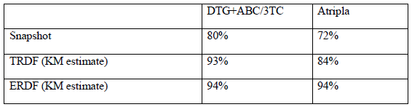
There is a difference between the Snapshot responses in the two arms, which remains in the TRDF analysis. In a TRDF analysis, withdrawals due to reasons unrelated to treatment are censored, this implies that the difference is not affected by these type of withdrawals. However, when looking at ERDF, ie only failures relating to efficacy are counted and all other withdrawals (safety related withdrawals as well as treatment unrelated withdrawals) are censored, the difference disappears. This shows that the treatment response difference in SINGLE is driven by withdrawals due to AE. This is an important result and is not to be ignored; however it is already contained and well described in the outcome Table 2 in the Product Information where the reasons for failure are split between virologic failures and failure due to early withdrawal (e.g., adverse events).
If we were to present the ERDF successes only, we would not be able to see that in one arm, a higher proportion of subject did not manage to maintain virologic suppression because of a higher rate of AEs that were such that patients could not stay on treatment. The response rate in the ERDF analysis is much higher and closer to an analysis where missing data is ignored ie where the denominator contains only subjects still on the study at the time of the analysis. This would be 332/345 (96%) in DTG and 303/310 in Atripla (98%). Such an analysis ie ‘responder only’ is misleading.
However, to address the concerns of the reviewer, the sponsor agrees to qualify snapshot and virologic suppression by ‘missing, switch, discontinue=failure’ in the PI. The virologic outcome table has been updated to clearly label treatment successes as those subjects whose viral load is below 50c/mL (this still needs to be specified to clarify that this isn’t based on a different cut off for instance 200 or 400 c/mL) at the time of the analysis, and treatment failures subjects with a viral load above 50c/mL at that time as well as those subjects with missing data. It would be incorrect to call non-responder the number of subjects with VL >50c/mL as it would not include the subjects who withdrew early and are also non-responders, however it is correct to call responders the number of subjects with VL <50c/mL at the time of analysis.

Evaluator comment
It is agreed that the Snapshot endpoint is widely used and reported. Viv Healthcare has not commented on the possibility that an investigator may discern the treatment in a blinded study due to the characteristics of adverse events, leading for the potential for introduction of bias.

Question 10
Figure 3 Study Accountability in ING114467 Report is illegible. Please provide a legible copy.

ViiV Healthcare response
Please see below.
Figure 10: Study Accountability in ING114467 Report
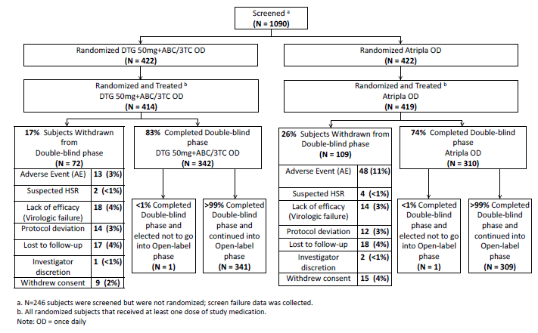

Evaluator comment
Response accepted.

Question 11
With regard to Figure 5 of the CSR (Figure 11 below) the y-axis labelling is partially illegible. The figure purports to show that results favour DTG + ABC/3TC, however these results are considered exploratory. Overlapping of confidence intervals is not accepted as proof of similarity, especially in the presence of very wide confidence intervals. Sub-analyses are considered the basis for further specific investigation.

ViiV Healthcare response
Figure 11: Difference in proportion of responders and 95% CI by baseline Viral Load Strata (DTG+ABC/3TC-EFV/TDF/FTC)
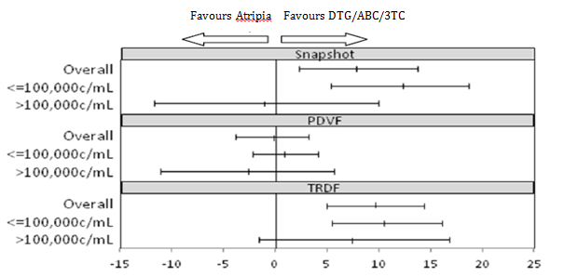
The purpose of Figure 11 in the Clinical Evaluation Report is to explore the finding of a statistical interaction between treatment and baseline viral load rather than to show that results favour DTG+ABC/3TC. We agree that sub-group analyses are exploratory only. The graph represents the response rate of DTG+ABC/3TC minus the response rate of Atripla; a value on the right hand side of the graph represent a positive value of this difference, ie a response rate numerically higher for DTG than Atripla. The word ‘favors Atripla’ and ‘favors DTG+ABC/3TC’ at the top of the graph are just to indicate which side of 0 is numerically better for DTG+ABC/3TC vs Atripla to orient the reader but from which not to make any claims.
Abundant literature exists on the use and misuse of subgroup analysis, in particular over-emphasis on subgroup analyses that commonly lack statistical power. Almost inevitably some subgroups will and others will not show significant differences depending on chance and the ‘smallness’ of subgroups. The testing for a statistically significant treatment effect in a subgroup is testing the wrong hypothesis and is hindered by a small sample size. The ING114467 trial was powered for statistical testing on the primary analysis based on the full ITT exposed population and is underpowered for subgroup analysis. It is therefore inaccurate to make a definitive statement about non-inferiority in the subgroup of patients with high baseline viral load. As per ICH E9, the hypothesis that should be tested is whether the treatment effect in a subgroup is significantly different from that in the overall population which is the interaction test we carried out in the Clinical Study Report.
One key consideration to ascertain whether this interaction finding is real is to check for consistency across secondary endpoints that are most closely related to the snapshot analysis (as discussed in the next two bullets):
- Importantly, for treatment related non-responders (TRDF) analysis, in which subjects with protocol defined virological failure (PDVF) or withdrawal due to adverse events are counted as non-responders, while subjects discontinued for other reasons [e.g. Lost To Follow-Up] are censored, the treatment difference was consistently in favour of DTG+ABC/3TC in both the high and the low viral load subgroups similar to the overall snapshot results. The conclusion from this graph is that the statistical interaction does not seem to be repeated for this endpoint (Figure 11)
- Further, the treatment difference in PDVF was consistently around 0 for both the high and low viral load subgroups. Again, the conclusion from this graph is that the statistical interaction does not seem to be repeated for this endpoint either (Figure 11).
In the Snapshot analysis, the non-responder category includes subjects who are virologic failures, subjects who withdrew due to adverse events, and subjects who withdrew due to reasons unrelated to treatment. We concluded in the Week 48 report and re-confirmed in the Week 96 report that the difference between the DTG+ABC/3TC and Atripla groups in the analysis of the Snapshot endpoint is driven by withdrawals due to AE, and that it is consistent in both the high and low viral load subgroups. This statistical interaction was not driven by lower efficacy. However, in the high viral load subgroup, there are more ‘discontinuations due to other reasons’ unrelated to treatment (eg, lost to follow-up, withdrawn consent, protocol deviation) in the DTG + ABC/3TC group 14 (10%) vs. 8 (6%) in the Atripla group.
In summary, although we have found a statistical interaction in the treatment difference by baseline viral load for the snapshot endpoint, we are showing, that this result is not replicated on endpoints where subjects who withdrew due to reasons unrelated to treatment are censored (ie endpoints looking at efficacy only or efficacy and safety failure). This is confirmed when looking at the subcategories for non-response in the snapshot analysis by viral load. In other words, the interaction seems to be explained mainly by the fact that the snapshot categorises discontinuation due to reasons unrelated to treatment as ‘failure’ and there are more of these in the DTG+ABC/3TC high baseline viral load subgroup at Week 96. Thus, the overall treatment differences are applicable to the population studied in SINGLE, which included subjects with both high and low Baseline viral loads.

Evaluator comment
Response accepted.

Question 12
How many patients were enrolled in the Russian site at which 3 participants became pregnant? Were there concerns about investigator oversight at this site?

ViiV Healthcare response
The rate of pregnancies at Russian sites totalled 6 compared with 8 at non-Russian sites (all other study sites) in SPRING-2. A contributing factor to the higher number of pregnancies in Russia was most likely the fact that Russian sites as a group randomized the most women (n=45) in SPRING-2 from a total of 90 Russian subjects enrolled. Ten subjects were randomized at the site in question and four were women. All SPRING-2 study sites received retraining of study protocol requirements regarding this point along with reminders to discuss contraception with subjects on an ongoing basis. The central study team reviewed eCRF data/queries and protocol deviations and had conversations with the local study manager. In addition, the central study team reviewed the overall quality of study conduct at this site via team reviews and decided that overall there was not a pattern of poor adherence to the protocol, nor poor selection of subjects (e.g., no unusually high rate of early withdrawals for other reasons).

Evaluator comment
Response accepted.

Question 13
How many participants were enrolled in each treatment group in Russia? What proportion of participants in Russia was treated with ABC/3TC? What proportion of the overall study numbers treated with ABC/3TC were enrolled in Russian sites? If TDF/FTC cannot be used in Russia, it seems likely that ABC/3TC was used exclusively and this may have had the potential to bias the results due to differing treatment protocols.

ViiV Healthcare response
All subjects at Russian sites were treated with ABC/3TC since TDF/FTC is not available. This can also be confirmed in the Clinical Study Report.
- How many participants were enrolled in each treatment group in Russia?
  - 45 subjects in each treatment arm.
- What proportion of participants in Russia was treated with ABC/3TC?
  - 100% in Russia treated with ABC/3TC.
- What proportion of the overall study numbers treated with ABC/3TC were enrolled in Russian sites?
  - 90/333 = 27% of ABC/3TC subjects come from Russian sites.
All Russian subjects had ABC/3TC as NRTI, however, the primary comparison was DTG vs RAL when paired with a 2 drug NRTI backbone. DTG has been shown to be effective with both ABC/3TC and TDF/FTC in a pooled analysis in treatment naive subjects (Eron 2012). Other analyses have shown that clinical efficacy/outcome is not different between the 2 backbones (Smith 2009). For this reason we do not believe that the use of ABC/3TC in Russia biased the results.

References
Eron J, Rockstroh JK.,et al. Dolutegravir Treatment Response by Baseline Viral Load and NRTI Backbone in Treatment-Naive, HIV-Infected Individuals11th International Congress on Drug Therapy in HIV Infection; November 11-15, 2012; Glasgow, UK http://hivarchive.com/hiv11/uploads/New%20Treatments%20and%20Targets%20and%20Non-AIDS%20Morbidities%20and%20Mortality%20and%20Ageing%20-%20Part%20One.pdf
Smith K., Patel P., et al., Randomized, double-blind, placebo-matched, multicenter trial of abacavir/lamivudine or tenofovir/emtricitabine with lopinavir/ritonavir for initial HIV treatment, AIDS 2009, Vol 23 No 12:1547–1556

Evaluator comment
Response accepted.

Question 14
Please provide a legible copy of the study schematic.

ViiV Healthcare response
Please see below.
Figure 12: Study schematic
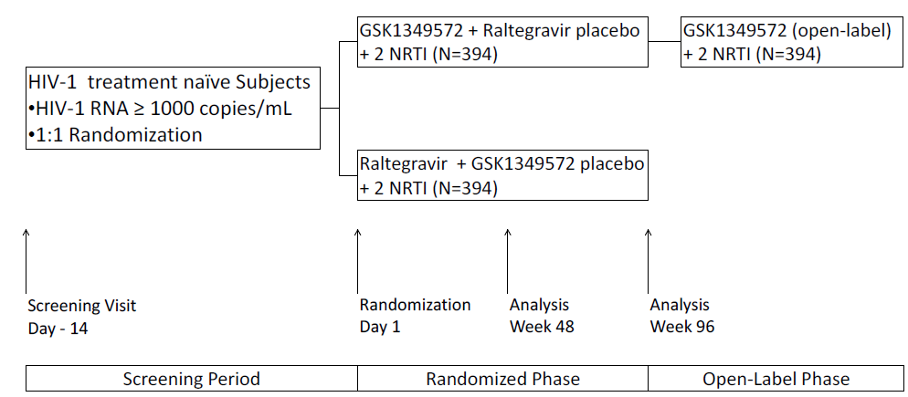

Evaluator comment
Response accepted.

Question 15
Please provide a legible copy of the study schematic.

ViiV Healthcare response
Please see below.
Figure 13: Study schematic

Evaluator comment
Response accepted.

Question 16
Regarding ING111762, (Sailing), he Sponsor is requested to justify inclusion of this study in the Triumeq Product Information when so few participants were treated with the active components.

ViiV Healthcare response
The Company/Applicant believes that some presentation of the clinical data from ING111762 (SAILING), to support use of this combination in the appropriate treatment experienced, INI naive subjects, is warranted.
Triumeq is a FDC of three drugs, and the relevant safety and efficacy data of the components, at the doses included in the FDC - is applicable to the evaluation of this drug. The currently approved labelling for treatment experienced patients for each of the individual components also substantiates the utility of the dolutegravir/abacavir/lamivudine fixed dose combination in such patients.
ABC and 3TC provide a NRTI backbone in this FDC. Efficacy in treatment experienced populations was demonstrated in studies CAL30001 and ESS30008 where ABC/3TC and ABC+3TC were effectively used in combination therapy to maintain viral suppression in the treatment of experienced subjects, with low rates of treatment emergent viral resistance mutations. These studies provide long-standing clinical experience in this population, and are included in the supporting studies for this submission.
DTG 50 mg once daily has been recently approved for use in ART-experienced, INI-naive patients in several markets including Australia based on the data provided in ING111762. This study demonstrated that DTG, when combined with various other drugs as backbone (selected based on resistance considerations and current activity), was effective and well tolerated in this population. Per the indications in the TIVICAY Product Information, which reflects the full body of DTG subjects in ING111762, DTG at 50 mg QD in combination with other drugs, is considered effective therapy for patients who are treatment experienced, INI-naïve.
A brief summary of efficacy results of the ART-experienced population from ING111762 was included in the Triumeq submission to support the indication in ART-experienced subjects. Such data will also provide prescribers evidence that a combination of DTG plus two additional ART drugs (to which the HIV-1 is susceptible) is effective in patients who are treatment experienced, yet INI-naive.
Based on the statement above, the Company requests retaining the wording as originally proposed.

Evaluator comment
The argument is not accepted. Too few participants in Sailing have been treated with ABC/3TC to make the study directly relevant to Triumeq.

Question 17
The Product Information states that there were no INI-resistant mutations reported in ING114467. However, the treatment emergent substitution E157Q/P was noted Week 24 albeit without accompanying DTG phenotypic resistance and with replicative capacity which could not be determined. The University of California HIV InSite 8 includes this substitution amongst the list of resistance mutations in patients with no previous exposure to integrase inhibitors, again with the qualification that no phenotypic decrease in susceptivity to dolutegravir or raltegravir was reported.

ViiV Healthcare response
As noted, one subject in ING114467 had the treatment emergent substitution E157Q/P at Week 24 without DTG phenotypic resistance. Thank you for the additional information on this substitution which the University of California HIV InSite 8 describes as pre-existing to exposure to integrase inhibitors. Their conclusion that E157Q does not cause phenotypic decrease in susceptibility to DTG or RAL is consistent with our investigation and with this substitution being non-impactful on response. Additional data supporting the lack of association with resistance includes no additional occurrences for INI naives subjects during the dolutegravir Phase III program, and as annotated by Stanford database there is a resistance score of full susceptibility (zero) for DTG for E157Q (http://hivdb.stanford.edu/DR/cgi-bin/rules_scores_hivdb.cgi?class=INI).
For further confirmation E157Q and E157P were generated using Site Directed Mutagenesis. The replication capacity of the E157P mutant was too low to evaluate. The E157Q substitution did not alter susceptibility to integrase inhibitors, giving a FC of 0.85, 0.92 and 1.1 for DTG, RAL and EVG, respectively. The overall data is why we believe E157Q/P in integrase is not a DTG resistance mutation.

Evaluator comment
Response accepted.

Question 18
Does the Sponsor consider that different definitions of viral failure and different methods of assessment of mutations impact the resistance findings of the studies? Justification is requested for not including definitions of PDVF in in the Product Information.

ViiV Healthcare response
Virologic failure definitions are based on elements such as patient population and associated treatment guidelines. When Spring-2 and Single were designed, the definition of PDVF (≥50 c/mLHIV-1 RNA) reflected the treatment guidelines for ART-naive patients at the time. When Flamingo was designed, treatment guidelines had just increased the desired threshold for virologic response to ≥200 c/mL and the definition of PDVF in Flamingo reflects this change. Even with the increased level of HIV-1 RNA required for PDVF in Flamingo (and, presumably, the increased opportunity to detect resistance) there were no treatment emergent resistance mutations in the DTG treatment arm, consistent with what was observed in Spring-2 and Single. Since PDVF is not associated with emergent resistance on the DTG arm under both definitions the sponsor does not view virologic failure definitions as useful to clinicians when selecting HIV treatment regimen.
In addition, as genotypic assessments of emergent resistance for all Phase III studies were performed at Monogram Biosciences using the same methodologies, assessment methods would not be expected to generate differences in resistance findings between studies nor across arms.
Definitions of viral failure have not traditionally been noted as key information in labelling to ensure effective and safe use of medicines. The Sponsor does note that the criteria for efficacy measurement are included in the clinical studies section of the proposed label. Concerning the use of different viral loads as PDVF, both arms in each study were evaluated using the same PDVF criteria within that study, as such, the conclusion of non-inferiority, or superiority, would still have been based on equal means of measuring effectiveness of each arm within that study. The presentation of results is transparent, and equal.

Evaluator comment
Response accepted.

Question 19
The report states that the cumulative numbers with PDVF in ING111762 at Week 48 were 21 in the DTG group and 45 in the RAL group. Table 57 reports the numbers for DTG and RAL as 19 and 44 respectively. Which is correct? Has the evaluator not understood correctly?

ViiV Healthcare response
The cumulative numbers with PDVF is indeed 21 in the DTG arm and 45 in the RAL group as stated in the Clinical Study Report. However, both values are correct: the 19 and 44 included in Table 57 of the Clinical Evaluation Report represent the numbers of subjects included in the ‘PDVF Genotypic Population’ ie subjects who are PDVF and have on-treatment genotypic resistance data available for resistance analysis.
Reasons resistance data may not be generated for all samples sent for testing (eg, at Monogram Biosciences) include low viral loads, reduced viral fitness (for phenotypic resistance testing), and compromised sample collection/handling. Therefore, for 2 subjects on DTG and 1 subject on RAL with PDVF, no genotypes could be generated, and thus these subjects were not included in Table 57 of the ING111762 study report.’

Evaluator comment
Response accepted.

Question 20
As there were 4 participants in the DTG group without paired samples for the integrase assessments and 7 in the RAL group, the percent in the DTG group with paired samples, it could be argued, should have been (17/21) 81% rather than the 89% shown in Table 58. Similarly for RAL, using 45 as denominator 84% of participants had paired samples rather than 88%. The number of drop-outs from analysis is considered to have the potential to alter the results of subsequent analyses. Comment is requested.

ViiV Healthcare response
Paired resistance testing samples are needed for resistance analyses. It is important to only include those subjects with baseline resistance genotype if that same subject provided a ‘failure’ profile from which to compare genotypes, in order to be able to clearly identify which are newly emergent after the initiation of treatment. As specific example for importance of using matched sample evaluations with integrase inhibitors (INI), there are a number of secondary mutations which are polymorphic and thus may be present at baseline and have no known effect on their own on INI susceptibilities or emergence of INI resistance. For example, when L74I or L74M are present in integrase they modulate INI resistance only when present with certain other primary and secondary INI mutations. Of note L74I and/or L74M are together present in 11.5% of sequences from a set of ~3000 INI-naive HIV isolate integrase sequences (ref Vavro, 2013). This means that if baseline comparator data is used to assess emergence a random substitution of L74I or L74M may be present at both timepoints, and an incorrect assessment of emergent resistance could be assumed if the unpaired data is not excluded. The Sponsor thereby considers the 89% and 88% denominator values valid as originally stated.
Resistance testing for baseline and samples at protocol defined virologic failure (PDVF) is done at Monogram Biosciences which is CLIA (Clinical Laboratory Improvement Amendments) validated laboratory for resistance testing for the integrase class of HIV drugs. Reasons resistance data may not be generated for all samples sent for testing (eg, at Monogram Biosciences) include low viral loads, reduced viral fitness (for phenotypic resistance testing), and compromised sample collection/handling. This generally accounts for why unpaired sample data is observed for Monogram Laboratories resistance testing data across HIV clinical studies.
Finally, the key analysis of interest based on integrase resistance (genotype or phenotype) results is provided via Table 74 Summary of Analysis for Proportion of Subjects with Detectable Virus that has Treatment Emergent Genotypic or Phenotypic Evidence of INI Resistance by Week 48 (mITT-E Population). For this analysis, an inclusive approach was used to incorporate either genotypic or phenotypic treatment-emergent resistance, to allow for the greatest opportunity to identify integrase resistance in either treatment arm. Based on the differences in PDVF across the 2 treatment arms (21 for DTG and 45 for RAL), it is highly unlikely that the differences in treatment-emergent resistance are based solely on lack of paired resistance samples or inability to generate resistance testing (genotype or phenotype). Additionally, as noted above, similar percentages of subjects with PDVF in each treatment arm had paired samples for resistance testing.
Therefore, the analysis of treatment emergent resistance is appropriate and shows significant differences between the 2 treatment arms.

References
Vavro C, Hasan S, Madsen H, et al. Prevalent Polymorphisms in Wild-Type HIV-1 Integrase Are Unlikely To Engender Drug Resistance to Dolutegravir (S/GSK1349572). Antimicrob. Agents Chemother. March 2013 vol. 57 no. 3 1379-1384.

Evaluator comment
It is understood that paired samples are required for demonstration of treatment emergent resistance. The problem, perhaps not well stated initially, is that removing participants from the denominator, just because they lack paired sample results, could be interpreted as selective reporting although this would not be so if, in tables of results, the participants without paired samples were accounted for. In general, particularly in a small sample, lack of results, which may by chance affect one group more than another, has the potential to bias the results.

Question 21
The Product Information mentions R263K (2 patients) and V151V/I. The applicant is requested to discuss the reason for not including more detailed information on participant 9402 in the Product Information. Table 59 also includes R236R/K, E138T/A, T97A and T79T/A in the patient with baseline RAL associated resistance associated mutations. The Product Information only mentions that this patient existed and the possible reason why this patient had pre-existing integrase mutations but leaves out the what is considered the most important information, i.e. the emergence of further mutations with increasing fold changes to > maximum.

ViiV Healthcare response
The Table 59 described in Question 21 is a summary table for study ING111762 (SAILING) showing emergent integrase resistance associated substitutions at given positions across all subject protocol defined virologic failure (PDVF) timepoints with matched baseline and PDVF resistance data at Week 48, for both the DTG and RAL arms. There is no one subject in which R236R/K, E138T/A, T97A and T79T/A are emergent together. Virologic characteristics including emergent IN substitutions for specific subjects on the DTG and RAL arms are shown in Table 78.
Subject [information redacted] randomized to DTG in ING111762 and had the emergent R263R/K mixture and is one of the two subjects with the substitution K at R263 as described in Product Information, and is described in Table 78. Both Subject [information redacted] with R623R/K mixture and Subject [information redacted] with R263K had maximum DTG fold changes of <2 at PDVF.
Subject [information redacted] randomized to DTG in ING111762 and received atazanavir/ritonavir and tenofovir as the background regimen experienced virologic rebound at Week 16 and had treatment emergent E138T/A and T97A added onto Baseline Q148H, E138A, G140S, with change in DTG susceptibility fold change from Baseline 12 to PDVF >Max. The RAL susceptibility fold change was >Max at Baseline and also PDVF. Subject [information redacted] had 6.9 years ART experience but no reported RAL experience. Therefore, it is unclear if the subject had prior exposure to raltegravir or had transmitted integrase resistance. The response and emergent resistance outcome for Subject [information redacted] is consistent with observations for subjects enrolled in ING112574 (VIKING-3 study) for ART resistant subjects with history of RAL or elvitegravir treatment failure and pre-existing INI-resistance. Overall then, Subject [information redacted] is a subject with a resistance pattern similar to subjects in the VIKING 3 study, with typical resistance mutations emerging on DTG therapy in the setting of pre-existing INI-resistance. Therefore, detailed resistance information on subject [information redacted], as agreed with the TGA, was not included in the Tivicay Product Information for the SAILING study, as subject [information redacted] was more consistent with subjects from the VIKING-3 study.

Evaluator comment
Response accepted.

Question 22
The statement ‘any of these grade 4 events were assessed as related to DTG by the investigator’ requires clarification. Were these events IP related?

ViiV Healthcare response
None of these events were assessed as related to DTG by the investigator. The number of subjects with any grade 4 drug-related AE in the DTG arm is zero.

Evaluator comment
Response accepted.

Question 23
With respect to triglyceride levels in ING114915 (Flamingo), please provide the denominators for each result. Is the bracketed number a percent?

ViiV Healthcare response
Table 124 in the Clinical Evaluation Report corresponds to Table 55 in the ING114915 Week 48 Clinical Study Report below.

Table 91: Summary of changes in NCEP lipid baseline category to maximum post-baseline category-triglycerides (mSafety population)
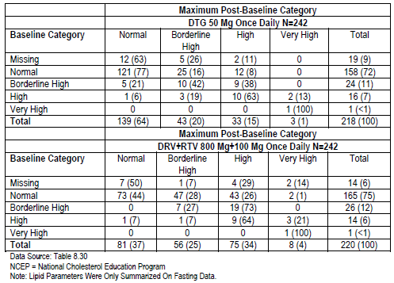
The bracketed numbers are percentages. The denominators used to derive these percentages are the numbers in the Total column on the right hand side of the table. For instance, a total of 158 subjects have a normal baseline category in the DTG arm. There are 121 subjects with a normal baseline category whose maximum post-baseline category remained normal. So, one can say that 77% (121/158) of subjects remained normal out of the subjects with a normal baseline category. Similarly, 16% (25/158) of subjects with a normal baseline category had a shift to a borderline high maximum post-baseline category.
In the total column, the percentages in brackets are calculated out of the total number of subjects with non-missing post-baseline values in that group. For instance, there are 242 subjects in the DTG arm and 218 subjects with post-baseline fasted lipids values available. At baseline, 24 subjects had a borderline high lipid value, which represents 11% (24/218) of the total number of subjects with non-missing post-baseline values in DTG arm.

Evaluator comment
Tables are generally used to make things clearer. Instead of text, a table including the denominators would have been appreciated.

Question 24
It appears that not all participants provided fasting blood samples. The Sponsor is requested to supply the numbers of individuals with fasting LDL results and the drop-out percentages for the step-wise pre-specified multiple testing strategy.

ViiV Healthcare response
The statistical analysis of the LDL data included in the step-wise pre-specified multiple testing strategy
- include all subjects with a fasted on treatment value at any time up to the Week 48 visit window, not just Week 48 itself.
- exclude subjects who took lipid lowering agents at baseline (‘lipid LOCF’ dataset).
The denominator is 218 for subjects in the DTG arm and 219 for the DRV/r arm and represents the number of subject who were not taking lipid lowering agents at baseline and who had a fasted on treatment value by Week 48. The numerator represents the number of subjects with a maximum grade 2 or higher fasted value by Week 48 out of these subjects. They are presented below with the correct percentages (it seems that there was a mistake in the percentage in the week 48 report). The p-value has not changed.

Table 92: Summary of analysis of incidence of Grade 2 or higher laboratory abnormalities in fasting LDL cholesterol by Week 48-Lipid LOCF
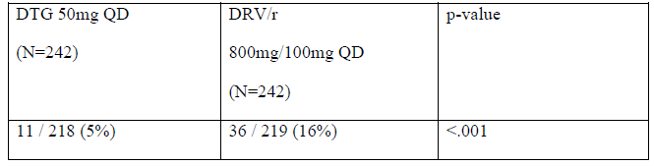
The drop-out percentages ie the percentage of missing data is therefore 24/242=10% for the DTG arm and 23/242=10% for the DRV/r arm.

Evaluator comment
Response accepted.

Second round discussion

Summary
In support of their application to register the new fixed dose product including dolutegravir, abacavir and lamivudine, ViiV Healthcare has provided a pivotal bioequivalence study ING114580 and a pivotal safety and efficacy study ING114467. Also included in the data package are supportive safety and efficacy studies ING113086, ING114915 and ING111762, and drug interaction study ING116898 and pharmacodynamic study ING116070. The studies are summarised below. The discussion is included in proximity to each evaluation.

Pharmacology

ING114580 Bioequivalence pivotal
ING114580 was a crossover study of 66 healthy adults evaluating the single-dose pharmacokinetics of an oral DTG/ABC/3TC50/600/300 mg combination tablet formulation proposed for commercial use, compared to co-administration of the separate tablet formulations of DTG 50 mg and Epzicom (ABC/3TC 600/300 mg).
The primary objective was to evaluate bioequivalence in the fasted state between a single FDC tablet formulation of DTG/ABC/3TC 50/600/300 mg versus co-administration of the separate tablet formulations of DTG plus FDC ABC/3TC. The primary outcome was plasma DTG, ABC and 3TC AUC_{(0-∞)}, AUC_{(0-t)}, and Cmax. Bioequivalence was determined if the 90% CI of the ratio of geometric least squares means FDC/DTG + ABC/3TC was within the range 0.8 to 1.25.
Secondary Objectives were to evaluate the effect of food on the bioavailability of the FDC tablet formulation and to assess the safety and tolerability of the combination of DTG, ABC and 3TC.
For each of DTG, ABC, and 3TC, the 90% CIs for the geometric least-squares mean ratios for each of the bioequivalence parameters are within the bioequivalence criteria range of 0.8 to 1.25.
Plasma DTG exposures following administration of the FDC tablet formulation administered with a high fat meal were approximately 48% higher for AUC and 37% higher for Cmax than following administration of the FDC tablet formulation in the fasted condition.
For both ABC and 3TC, plasma exposures from the FDC tablet formulation administered with a high fat meal were similar to those from administration in the fasted condition, although the ABC Cmax was approximately 23% lower when the FDC tablet was taken with food.

ING116898 Interaction – Calcium carbonate and ferrous fumarate
ING116898 was a Phase I, open-label, randomized, four-period crossover study to evaluate the effects of calcium carbonate 1200 mg and ferrous fumarate 324 mg on pharmacokinetics of DTG 50 mg in 12 healthy adults.
Participants were randomized to receive DTG co-administered with calcium carbonate in Cohort 1 and with ferrous fumarate in Cohort 2, and received each of four treatments as follows. Each dosing session was separated by wash-out of at least 7 days.
- A single dose of DTG 50 mg administered under fasted conditions
- A single dose of DTG 50 mg co-administered with a single dose of calcium carbonate or ferrous fumarate under fasted conditions
- A single dose of DTG 50 mg co-administered with a single dose of calcium carbonate or ferrous fumarate with a moderate-fat meal (approximately 30% fat)
- A single dose of DTG 50 mg administered under fasted conditions 2 hours prior to administration of a single dose of calcium carbonate or ferrous fumarate.
The primary objectives were to compare:
- Single dose plasma DTG PK following co-administration of DTG and calcium carbonate or ferrous fumarate in the fasted state, to DTG alone in the fasting state.
- Single dose plasma DTG PK following co-administration of DTG 50 and calcium carbonate or ferrous fumarate with a moderate-fat meal, to DTG alone in the fasting state
- Single dose plasma DTG PK following administration of DTG in the fasted state 2 hour prior to administration of calcium carbonate or ferrous fumarate to DTG alone in the fasting state
- Single dose plasma DTG PK following co-administration of DTG and calcium carbonate or ferrous fumarate in a fed state to DTG and calcium carbonate or ferrous fumarate in a fasted state.
Primary endpoints were the DTG PK parameters: AUC_{(0-t)}, AUC_{(0-∞)}, Cmax and C24. Interactions of DTG with calcium carbonate or ferrous fumarate were considered not clinically significant if the observed decrease in dolutegravir AUC or Cmax was less than 70%.
Co-administration of DTG with either calcium carbonate or ferrous fumarate under fasted condition resulted in reduction in plasma DTG exposures; plasma DTG AUC_{(0-t)}, AUC_{(0-∞)}, Cmax, and C24 by approximately 37 - 39% with calcium carbonate and 54 - 57% with ferrous fumerate.
Co-administration of DTG with calcium carbonate or ferrous fumarate under fed condition counteracted the interaction and provided plasma exposures comparable to DTG alone under fasted conditions. Similarly, DTG administered under fasted conditions 2 hours prior to administration of a single dose of calcium carbonate or ferrous fumarate resulted in plasma exposures comparable to DTG alone.

ING116070 Pharmacodynamic CSF
ING116070 is an ongoing Phase IIIb single-arm, open-label, multicentre study of HIV-1 infected ART-naïve patients to determine the potential for dolutegravir to enter the cerebrospinal fluid compartment. Participants were HIV-1 infected treatment naïve adults ≥ 18 years of age, with screening plasma HIV-1 RNA ≥ 5000 copies/mL(c/mL); CD4+ cell count ≥ 200 cells/mm³ and negative for HLA-B*5701. All 13 enrolled subjects were White and male. Study medication was DTG 50 mg with background FDC ABC/3TC 600/300 mg taken once daily with or without food. The Week 16 results were presented.
The primary objective was to determine total and unbound plasma DTG concentration and evaluate the relationship between DTG concentration in plasma and CSF at Week 16. Primary outcomes were CSF DTG concentration and total and unbound plasma DTG PK concentration of samples drawn within 2 to 6 hours post-dose and within 1 hour of CSF sample collection at Week 16; the relationship between DTG concentration in plasma and CSF was evaluated using an estimation approach.
Secondary Objectives were to assess:
- The effect of DTG + ABC/3TC on CSF and plasma HIV-1 viral load; tolerability and safety
- The relationship between CSF DTG concentration and HIV-1RNA in CSF at Weeks 2 and 16
- The relationship between HIV-1 RNA suppression in plasma and CSF at Weeks 2 and 16
- The development of viral resistance in participants experiencing virologic failure.
At Week 16, the correlation between CSF and total plasma DTG concentrations was: (Pearson Correlation Coefficient [P-value] = 0.647 [0.023]. There was also a correlation between CSF and unbound plasma DTG concentrations (Pearson Correlation Coefficient [P-value] = 0.728 [0.007]. However, this finding contradicted findings at Week 2 and for the combined results.
Although there appeared to be a correlation between CSF DTG concentration and absolute CSF HIV-1 RNA levels, the direction of correlations at Week 2 and Week 16 were opposite. There was a significant overlap in CSF DTG concentrations between participants with CSF HIV-1 RNA < 50 c/mL and ≥ 50 c/mL at Week 2.
At Week 16, two participants had withdrawn prematurely, 11 had CSF HIV-1 RNA < 50 c/mL using an Observed Dataset. The median change from Baseline to Week 16 in CSF HIV-1 RNA was -3.42 log10 c/mL and was similar to that observed in plasma (-3.04 log10 c/mL). Eleven participants had both plasma and CSF HIV-1 RNA data available and nine (82%) of these had both plasma and CSF HIV-1 RNA < 50 c/mL.
The most common drug related adverse events were fatigue, headache and nausea, each reported by 2/13 participants. The majority of adverse events were Grade 1 or Grade 2. There were no IP related SAEs reported and no deaths. Small median increases in serum creatinine and small decreases in the calculated creatinine clearance were noted beginning at Week 2 and remaining stable to Week 16.

Efficacy, safety and virology

ING114467 (single) treatment-Naive pivotal efficacy and safety
ING114467 is an ongoing, Phase III, parallel group, randomised, double-blind, active-controlled multinational study of DTG plus fixed dose ABC/3TC compared with EFV/TDF/FTC in treatment of HIV-1 infected ART naïve adult patients with plasma HIV-1 RNA ≥1000 c/mL; and negative HLA-B*5701 allele. Week 96 results were presented.
The primary objective was to demonstrate the antiviral activity of DTG + ABC/3TC FDC once daily therapy compared to EFV/TDF/FTC. The primary endpoint was the proportion of participants with plasma HIV-1 RNA < 50 copies/mL up until Week 48 using the Snapshot algorithm, Missing, Switch, or Discontinuation = Failure (MSDF). The primary efficacy analyses were performed on the ITT-E population (all randomised patients who received at least one dose of study drug) at Week 48. Non-inferiority was concluded if the lower bound of a two-sided 95% confidence interval for the difference in response rates between the two treatment arms was greater than - 10%. A similar assessment at Week 96 was a secondary objective. The Week 96 results were presented.
Participant withdrawals by Week 96 were 17% vs. 26% for DTG+ABC/3TC and for EFV/TDF/FTC respectively. Adverse events were the most common reason for withdrawal. Withdrawals due to AEs for the DTG + ABC/3TC and EFV/TDF/FTC groups were 3% and 11% respectively. Withdrawals due to lack efficacy were reported for 18 (4%) of the DTG+ABC/3TC group and 14 (3%) of the EFV/TDF/FTC arm. Seventeen (4%) in the DTG+ABC/3TC arm and 18 (4%) in the EFV/TDF/FTC arm were lost to follow up.
At Week 96, the adjusted difference, DTG minus EFV/TDF/FTC was 8.0% (+2.3%, +13.8%).
PDVF was two consecutive HIV-1 RNA values ≥ 50 c/mL HIV-1 RNA from Week 24 onwards. Genotypic and phenotypic IN resistance results were available for 13/25 (52%) of the DTG group vs. 10/25 (40%) of the EFV/TDF/FTC group. Genotypic and phenotypic NNRTI resistance results were available for 17/25 (68%) in the DTG vs. 12/25 (48%) of the EFV/TDF/FTC group. No treatment emergent primary INI or NRTI resistance mutations were observed through 96 weeks for those participants on DTG plus ABC/3TC FDC with PDVF. Six participants in the EFV/TDF/FTC treatment group had treatment emergent NNRTI resistance mutations. Phenotypic changes to EFV were observed in five of these participants.
Regarding safety, dizziness, diarrhoea, nasopharyngitis, headache, nausea and fatigue were most commonly reported AEs and occurred at similar rates across both treatment groups. Treatment related events were more common in the EFV/TDF/FTC group. The most common drug related adverse events were dizziness, abnormal dreams, nausea, insomnia, diarrhoea, fatigue, headache and rash. Most events in both groups were considered Grade 1 or 2. The incidence of Grade 3 and 4 events combined was DTG+ABC/3TC 57/414 [14%] vs. EFV/TDF/FTC 83/419 [20%].
One individual in the DTG/ABC/3TC group reported an SAE considered related to IP (drug hypersensitivity). Nine in the EFV/TDF/FTC group had SAEs considered related to study treatment: syncope, reported by two individuals; depression, homicidal ideation and suicidal ideation; paranoia and suicidal ideation; drug hypersensitivity; cerebrovascular accident; hallucination, visual; and bipolar 1 disorder each reported by one individual. One death in the EFV/TDF/FTC group was considered possibly related (renal failure).
For EFV/TDF/FTC vs. DTG/ABC/3TC respectively, rash was considered study treatment related for 34/419 (8%) vs. 4/414 (<1%), and rash leading to permanent discontinuation for 9/419 (2%) vs. 2/414 (<1%). All but one episode of rash were graded 1 or 2; one was considered Grade 3.
Relative risk and 95% Confidence Intervals < 1 favouring DTG/ABC/3TC were noted for dizziness, abnormal dreams, rash and somnolence; favouring EFV/TDF/FTC insomnia, influenza and pain in extremity.
Comparable rates for participants with any gastrointestinal event were reported in both treatment groups. The higher number of discontinuations for GI events in the EFV/TDF/FTC treatment group did not appear to be related to higher event toxicity/intensity grades.
There was a low rate of elevated liver chemistries in both arms. The mean changes in LDL and total cholesterol were small and not considered statistically significant.
Twelve participants became pregnant (DTG+ABC/3TC 5/414, EFV/TDF/FTC 7/419). Four normal neonates have been delivered (2 in each group). Three participants in the DTG/ABC/3TC group and 1 in the EFV/TDF/FTC group had elective terminations. A further elective termination was carried out due to an ectopic pregnancy (EFV/TDF/FTC). Three spontaneous abortions were reported; 1 in the DTG/ABC/3TC group 2 in the EFV/TDF/FTC group; none were considered related to IP. No congenital anomalies were reported. One pregnancy in the EFV/TDF/FTC group was ongoing at data cut off. The partner of a male participant in the DTG/ABC/3TC group delivered a normal infant.

ING113086 (spring-2) treatment-naïve supportive efficacy and safety
ING113086 is an ongoing Phase III randomized, double-blind, active-controlled, multicentre, non-inferiority study including treatment-naïve adult patients. The study was designed to assess safety and efficacy of DTG 50 mg once daily versus RAL 400 mg twice daily, each administered with either ABC/3TC or TDF/FTC. Approximately 40% of each group were treated with ABC/3TC background. Week 96 results were presented.
The primary objective was to demonstrate the antiviral activity of DTG 50 mg administered once daily compared to RAL 400 mg twice daily over 48 weeks in HIV-1 infected therapy-naive subjects. Antiviral activity was assessed as the proportion of participants with plasma HIV-1 RNA < 50 c/mL determined by the Snapshot algorithm. Non-inferiority of DTG 50 mg was concluded if the lower bound of a two-sided 95% confidence interval for the difference in proportions (DTG minus RAL) was greater than - 10%. The adjusted difference in the proportions was based on a stratified analysis using Cochran-Mantel-Haenszel weights. A key secondary objective was to demonstrate the antiviral activity of DTG vs. RAL over 96 weeks.
In total, 681 patients completed Week 96: DTG 349 (85%); RAL 332 (81%). Fifteen patients (DTG 8, RAL 7) discontinued due to an AE; twenty-nine withdrew due to protocol deviations (DTG 13, RAL 16); five discontinued upon reaching protocol-defined liver stopping criteria (DTG 2, RAL 3).
At week 96, the efficacy outcome was achieved by 81% of the DTG group and 76% of RAL group. The difference in proportions (95% CI) was 4.4% (-1.2, 10.0).
For the Kaplan-Meier sub analysis of proportions treated with ABC/3TC background, without treatment failure using the treatment related discontinuation = failure approach, the point estimates (95% CI) for DTG was 92.5% (87.1, 95.6) and for RAL 91.7% (89.1, 93.1).
As for ING114467, PDVF was two consecutive HIV-1 RNA values ≥ 50 c/mL HIV-1 RNA from Week 24 onwards. Ten of the 22 participants with PDVF in the DTG arm had IN genotype assessed at both baseline and at PDVF vs. 20 of 29 in the RAL arm. In the DTG arm 0/10 had emergent INI resistance mutations vs. 1/20 in the RAL group.
Fourteen of the 22 individuals with PDVF in the DTG treatment group had PR/RT genotype assessment at both Baseline and at PDVF, while 20 of the 29 with PDVF in the RAL treatment group had PR/RT genotype at both Baseline and PDVF. NRTI primary resistance mutations (4/20) were observed in subjects on RAL. No treatment emergent NRTI resistance mutations were observed for those subjects on DTG with PDVF throughout the study.
With respect to safety, the most commonly reported clinical AEs among participants receiving DTG and RAL were nausea, nasopharyngitis, diarrhoea and headache, with no appreciable difference between treatment groups. Most events in both treatment groups were considered grade 1 or 2. There were 18 grade 4 events reported in the DTG group, 2 of which were reported as SAEs and considered IP related: drug hypersensitivity and hepatitis. Seven participants randomized to RAL reported Grade 4 AEs, all reported as serious and none related to IP.
Reporting rates for IP related AEs were: DTG 124/411 (30%); RAL 121/411 (29%). The only drug-related AE reported in ≥ 5% of subjects in each treatment group was nausea: DTG 40/411 (10%); RAL 45/411 (11%). Grade 3/4 events considered possibly or probably related to IP in each group were reported for 4 in the DTG 4 group, 5 in the RAL group. For DTG, the events were: Grade 3: headache, dizziness, feeling abnormal, arrhythmia; Grade 4: Drug hypersensitivity with associated ALT/AST/ALP/total bilirubin/LFT and, hepatitis (one participant each). For RAL, the events reported for the five participants with Grade 3 events assessed as possibly/probably related were: Grade 3: nausea, abdominal pain, aphasia, drug eruption, fatigue, ALT increased, CPK increased, lipase increased, decreased appetite.
There were no deaths related to IP. At least one SAE was reported by 10% for DTG and 12% for RAL. Drug related events were reported by < 1% of those taking DTG and 1% for RAL. All individually reported SAE preferred terms had an incidence of ≤ 1% in either treatment group. The SAEs considered to be related to DTG (N = 3) were: Arrhythmia leading to withdrawal; hypersensitivity considered by the investigator to be related to DTG (the Sponsor also implicated co-suspect ABC/3TC), and hepatitis considered possibly drug induced.
There were 4 reports of hypersensitivity in the DTG group, none in the RAL group. The hypersensitivity AEs were considered reasonably attributable to abacavir.
Diarrhoea and nausea were two of the most commonly reported gastrointestinal AEs. For those considered IP related the incidences were DTG 18% and RAL 17%. Less than 1% of each group reported GI events in either treatment group resulting in the permanent discontinuation of IP and withdrawal. GI events considered SAEs were reported by: DTG <1%, RAL 2%).
There was a similar overall pattern in graded treatment emergent clinical chemistry toxicities for DTG and RAL. The numbers in each treatment group with ALT ≥ 3xULN were: DTG 21 (5%); RAL 19 (5%). Two patients on DTG had a combination ALT > 3xULN with total bilirubin ≥ 2xULN and ALP < 2xULN. A total of 11 patients [DTG 7, 2%; RAL 4, < 1%] met at least one of the criteria for stopping. Seven participants (DTG 5, RAL 2) had maximum treatment emergent ALT values ≥ 10xULN: all met criteria for stopping IP. Of the five participants in each group with ALT elevations ≥5xULN but <10xULN, four met liver criteria for stopping IP. Eleven in each group recorded ALT ≥ 3xULN but <5xULN; one in the RAL group met liver stopping criteria.
Treatment emergent Grade 1 creatinine toxicities were reported for DTG 14, RAL 8; one (DTG) had Grade 2 toxicity. The incidence of AEs related to the Renal and Urinary disorders SOC was (DTG 24/411 (6%); RAL 16/411 (4%).
Grade 4 elevations of CK were recorded by 18 (4%) in the DTG group and 8 (2%) in the RAL group. For all those in the DTG group and seven in the RAL group, the changes were transient without associated AEs. High degrees of physical activity preceded the CPK elevations in the majority of cases (13/18 for DTG and 4/8 for RAL) and by a seizure in 1 participant in the RAL arm.
The incidence of AEs related to the Musculoskeletal and Connective Tissue Disorders SOC was: DTG 74/411 (18%); RAL 86/411 (21%). Arthralgia was reported by: (DTG 10/411 (2%); RAL 14/411 (3%); myalgia by: DTG 11/411 (3%); RAL 8/411 (2%).
There was no clinically significant change in Total/HDL cholesterol or triglycerides.

ING114915 (flamingo) treatment-naive supportive efficacy and safety
Study ING114915 is an ongoing Phase IIIb randomized, open-label, active-controlled, multicentre, parallel group, non-inferiority study of treatment-naïve adults. Participants were randomly assigned 1:1 to receive DTG 50 mg once daily or DRV+RTV 800 mg+100 mg once daily, each in combination with fixed dose combination ABC/3TC or TDF/FTC. Approximately one third of each group were treated with ABC/3TC backbone. Week 48 results were presented.
The primary objective was to demonstrate non-inferiority of antiviral activity of DTG compared to DRV/RTV over 48 weeks, assessed as the proportion of participants with plasma HIV-1 RNA < 50 c/mL determined by the FDA ‘Snapshot’ algorithm. The primary comparison was made at a one-sided 2.5% level of significance. Treatment with DTG was declared non-inferior to treatment with DRV/r if the lower end of a two-sided 95% confidence interval for the difference between the two groups in response rates at Week 48 was above - 12%. The adjusted difference in the proportions was based on a stratified analysis using Cochran-Mantel-Haenszel weights. Superiority was declared if the lower limit of the 95% CI calculated in the mITT-E analysis was above 0%.
If the primary comparison of interest demonstrated non-inferiority for the mITT-E population of DTG compared to DRV/r, then the following comparisons were tested according to the gatekeeping procedure described below:
- Superiority of DTG to DRV/r with respect to change from baseline in LDL cholesterol at Week 48 on the modified safety population
- Superiority of DTG to DRV/r with respect to the incidence of Grade 2 or higher in LDL cholesterol lab abnormalities at Week 48 on the modified safety population
- Superiority of DTG to DRV/r with respect to time to viral suppression (< 50 copies/mL) to 48 Weeks on the mITT-E population.
Of 488 patents randomly assigned, 484 received at least 1 dose of study medication. The rates of premature withdrawals were: DTG 7%; DRV+RTV 12%. The proportions withdrawing due to AEs were: DTG 1%, DRV+RTV 4%, and lost to follow-up: DTG 2%, DRV+RTV 4%.
At Week 48, 90% of the DTG group vs. 83% of the DRV+RTV group achieved the primary endpoint. The difference (95% CI) = 7.1% (0.9, 13.2). Superiority of DTG was concluded.
Differences in virologic response rate were primarily driven by discontinuations due to AEs (DTG 1%, DRV+RTV 4%) and other reasons (DTG 2%, DRV+RTV 5%). The ‘Other’ reasons for discontinuation among the subjects with no virologic data at Week 48 included protocol deviation, lost to follow-up, and withdrawal of consent.
The median time to suppression was 28 days for subjects in the DTG treatment group compared to 85 days in the DRV+RTV treatment group. The difference was statistically significant against the pre-specified threshold of 0.05 (2-sided) (p < 0.001). This was the third step in the pre-specified multiple-testing strategy.
PDVF definition was 2 consecutive HIV-1 RNA values > 200 c/mL HIV-1 RNA on or after Week 24. Two participants (<1%) in each treatment group met PDVF. Each had genotype and phenotype results at baseline and time of PDVF. Neither had treatment-emergent resistance INI mutations or phenotypic resistance to DTG or treatment-emergent resistance mutations in reverse transcriptase or protease. One patient in the DTG treatment arm with TDF/FTC as the NRTI backbone, had phenotypic resistance to nelfinavir (4.12 FC), in spite of having no treatment emergent protease resistance mutations.
With respect to safety the most commonly reported AEs in both treatment groups were diarrhoea, nausea, headache, and nasopharyngitis. Diarrhoea and upper respiratory tract infection were more frequently reported among those in the DRV+RTV group, and headache was more frequently reported in the DTG group. The majority of events reported in both groups were considered to be of Grade 1 or Grade 2.
The incidences of drug-related events were similar except for diarrhoea which was reported more frequently in the DRV+RTV group. The discrepancy in incidence was largely due to higher numbers in the DRV+RTV group with Grade 1 events.
No deaths were reported. One patient in the DTG treatment group reported an SAE considered by the investigator to be related to IP, a suicide attempt. SAEs were individually reported by < 1% of participants. One SAE report of hypersensitivity reaction grade 2, disseminated maculopapular rash and erythema without associated symptoms, was suspected by the investigator to be due to ABC; however, the sponsor did not consider the event to be a convincing case of ABC hypersensitivity reaction due to lack of multisystem involvement and considered DRV+RTV to be the likely cause.
The incidence of psychiatric disorders was 19% for the DGT group and 14% for the DRV+RTV group. Insomnia, depression, and anxiety were the most commonly reported. The frequencies were: insomnia DTG 18 (7%); DRV+RTV 15 (6%); anxiety: DTG 10 (4%); DRV+RTV 7 (3%) and depression DTG 11 (5%); DRV+RTV 6 (2%). All other events in this SOC were reported in ≤ 1%. Insomnia was considered drug related for 2% of the DTG group and 1% of the DRV+RTV group. The majority of events in either treatment group were considered of Grade 1 intensity and/or not reasonably drug-related.

ING111762 (sailing) treatment-experienced
ING11762 was a Phase III randomized 1:1, double-blind study of the safety and efficacy of DTG 50 mg once daily versus RAL 400 mg twice daily, both administered with an investigator selected background regimen over 48 weeks in HIV-1 infected, integrase inhibitor-naïve, antiretroviral therapy- experienced adults with HIV-1 RNA > 400 c/mL and documented resistance to two or more different classes of antiretroviral agents but no prior exposure to any integrase inhibitor. In total, 354 were included in the DTG group and 364 in the active control group. As far as could be ascertained, 7 DTG treated patients took ABC/3TC as background. The Week 48 results were reported. The Week 24 results were evaluated for registration of DTG. Week 48 results were presented.
The primary objective was to demonstrate the antiviral efficacy of DTG 50 mg once daily compared to RAL 400 mg twice daily each with a background regimen consisting of one to two fully active single agents The primary endpoint was the proportion of subjects with HIV-1 RNA < 50 c/mL to Week 48 using a Missing, Switch, or Discontinuation = Failure (MSDF) Snapshot’ algorithm. Non-inferiority of DTG 50 mg and RAL was concluded if the lower bound of a two-sided 95% CI for the difference in proportions (DTG - RAL) was greater than -12%. Superiority was declared if the lower bound of the 95% confidence interval calculated in the mITT-E analysis was above 0%.
At Week 48, 71% of subjects receiving DTG and 64% of subjects receiving RAL achieved the primary endpoint at Week 48. The difference, DTG – RAL, (95% CI) was 7.2 (0.3, 14.0). The pre-specified basis for concluding non-inferiority and superiority were met.
PDVF was defined as follows.
- Virologic non-response
  - A decrease in plasma HIV-1 RNA of less than 1 log10 c/mL by Week 16, with subsequent confirmation, unless plasma HIV-1 RNA is <400 c/mL.
  - Confirmed plasma HIV-1 RNA levels ≥ 400 c/mL on or after Week 24.
- Virologic Rebound
  - Confirmed rebound in plasma HIV-1 RNA levels to ≥ 400 c/mL after prior confirmed suppression to < 400 c/mL.
  - Confirmed plasma HIV-1 RNA levels >1 log10 c/mL above the nadir value where nadir is the lowest HIV-1 RNA value ≥ 400 c/mL.
Cumulative PDVF at Week 48 was reported for 21 (6%) of the DTG group and 45 (12%) of the RAL group: 1% receiving DTG and 5% receiving RAL had evidence of treatment emergent genotypic or phenotypic INI resistance at the time of PDVF by Week 48 p = 0.003, based on a pre-specified analysis of this secondary endpoint.
At Week 48, 17 participants experiencing PDVF in the DTG arm had matched Baseline and PDVF IN genotypic resistance testing results available. Integrase substitutions emerged at the RAL associated T97, E138, and polymorphic V151 positions, and at R263. In the RAL arm 38 patients who experienced PDVF had matched Baseline and PDVF IN genotypic resistance testing results available. Integrase substitutions emerged at positions commonly observed during RAL therapy including primary resistance mutations at Y134, Q148, and N155 as well as associated secondary mutations.
A unique IN substitution (R263K or R263R/K mixture) conferring little change in susceptibility to DTG and RAL was observed in 2 patients with treatment emergent resistance on DTG. No DTG subjects had treatment-emergent INI phenotypic resistance at PDVF. Thirteen patients receiving RAL had evidence of treatment-emergent INI phenotypic resistance to RAL at PDVF.
With respect to safety, the most common AEs were diarrhoea, upper respiratory tract infection, headache, nausea, cough, vomiting, rash. The most common grade 2 – 4 drug related AEs were diarrhoea, nausea, headache, and abdominal pain. AEs leading to discontinuation of treatment occurred in less than one percent of patients in each group.
Six participants in the DTG group were identified as having IRIS or possible IRIS. Five of these six were considered to have hepatitis B and/or hepatitis C IRIS.

Discussion
Round 1 discussion of studies is included in proximity to each study: ING114580 Pivotal bioequivalence; ING114467 Pivotal efficacy and Safety; ING116896 drug interaction DTG, calcium and iron; ING116070 PK/PD study CSF.
The indication is a well-recognised disease state. The proposed combination is based on valid therapeutic principles. Each component has a documented therapeutic contribution. The choice of each substance is considered justified based on modes of action, the dosage frequencies. Each of the individual components can be taken with and without food. The doses used in the fixed combination are identical to the doses used in the broad clinical setting and there is safety data generated with these doses are available.
The choice of each substance is considered justified based on treatment recommendations include in ASHM and the US DHHS guidelines in which it is stated that the optimal antiretroviral regimen for a treatment-naive patient consists of two NRTIs in combination with a third active ARV drug from one of three drug classes: an NNRTI, a PI boosted with ritonavir, or an integrase inhibitor.
It is noted that DTG + ABC/3TC has recently been added to the AIDSinfo Guidelines for the use of Antiretroviral Agents in HIV-Infected Adults and Adolescent section: Regimens for ART-naïve patients regardless of baseline viral load or CD4 cell count.
Bioequivalence was shown for each component of the FDC compared to DTG and the FDC ABC/3TC. The FDC was not tested against each component separately. However it is most likely that patients in clinical practice who are treated with ABC and 3TC would take the fixed dose product ABC/3TC.
The pivotal efficacy study documented superior efficacy of DTG + ABC/3TC vs. EFV/TDF/FTC, the difference being largely driven by a larger proportion in the comparator arm discontinuing due to AES. No treatment emergent primary INI or NRTI resistance mutations were observed through 96 weeks for those subjects on DTG plus ABC/3TC FDC with PDVF. The study did not use the FDC proposed for registration.
There may be an improvement in risk benefit balance due to possible increased treatment compliance due to decreased number of tablets required. Increased compliance in turn may reduce the risk of development of resistance mutations. However, it remains to be determined whether the relatively large tablet (22 x 11x7.6 mm with maximum circumference 54.6 mm) will be a problem for some patients.

Second round benefit-risk assessment

Benefit
The DTG/ABC/3TC fixed dose combination has been shown to be bioequivalent to DTG + ABC/3TC. The latter combination has been shown to be effective in maintaining viral suppression as shown in ING114467. There were no unexpected safety concerns detected in ING114467. There was a high barrier to resistance reported in the study. The FDC may increase treatment compliance although this remains hypothetical.

Risk
The safety profiles of lamivudine and abacavir have been established since first registration in the US of lamivudine in 1995 and abacavir in 1998. The safety profile of the recently registered dolutegravir is not so well established. For individual patients, there is the potential for development of significant adverse events consistent with the known safety profiles.
The large dimensions of the tablet (22 x 11x7.6 mm with circumference 54.6 mm) may preclude use, or result in misuse of the product for some patients.

Balance
The balance is considered to lie on the side of benefit.

Second round recommendation regarding authorisation
Registration of the fixed dose combination, dolutegravir/abacavir/lamivudine is recommended.
The recommended condition of registration is that product information is presented to the Therapeutic Goods Administration, to the Australian medical fraternity and the general public as clearly as is possible, in accordance with the requirements included in the Round 1 and Round 2 comments on the product documentation.

References
Nil listed.
Therapeutic Goods Administration
PO Box 100 Woden ACT 2606 Australia
Email: info@tga.gov.au Phone: 1800 020 653 Fax: 02 6232 8605
https://www.tga.gov.au

Registered in Australia as Kivexa
Screening: Day 1, Weeks 4, 8, 12, 24, 32, 48 and every 12 weeks after Week 48 until Week 96.
Drotaverine said to have ability to accelerate labour by speeding up cervical dilatation (sold in Hungary and former Soviet Union - Wikipedia)
Ethamsylate is indicated for control of haemorrhages from small blood vessels and may be used in neonatal intaventicular haemorrhage – Wikipedia. And according to Russian studies may arrest haemorrhage and prolong pregnancy
Dydroogesterone is a potent orally active progestogen may be useful in threatened miscarriage
May be recorded differently on subject disposition table and study conclusion page – e.g. may be withdrawn due to AE. One patient was excluded from the ITT-E analyses and is therefore not reported in the Table of Subject accountability (Table 3).
Not included in this Attachment 2.
Not included here as they are beyond the scope of an AusPAR.

