|  |
| --- |
| **April 2022** |

|  |
| --- |
| Australian Public Assessment Report for Dupilumab |
| Proprietary Product Name: Dupixent |
| Sponsor: Sanofi-Aventis Australia Pty Ltd |

About the Therapeutic Goods Administration (TGA)

* The Therapeutic Goods Administration (TGA) is part of the Australian Government Department of Health and is responsible for regulating medicines and medical devices.
* The TGA administers the *Therapeutic Goods Act 1989* (the Act), applying a risk management approach designed to ensure therapeutic goods supplied in Australia meet acceptable standards of quality, safety and efficacy (performance) when necessary.
* The work of the TGA is based on applying scientific and clinical expertise to decision-making, to ensure that the benefits to consumers outweigh any risks associated with the use of medicines and medical devices.
* The TGA relies on the public, healthcare professionals and industry to report problems with medicines or medical devices. TGA investigates reports received by it to determine any necessary regulatory action.
* To report a problem with a medicine or medical device, please see the information on the TGA website <<https://www.tga.gov.au>>.

About AusPARs

* An Australian Public Assessment Report (AusPAR) provides information about the evaluation of a prescription medicine and the considerations that led the TGA to approve or not approve a prescription medicine submission.
* AusPARs are prepared and published by the TGA.
* An AusPAR is prepared for submissions that relate to new chemical entities, generic medicines, major variations and extensions of indications.
* An AusPAR is a static document; it provides information that relates to a submission at a particular point in time.
* A new AusPAR will be developed to reflect changes to indications and/or major variations to a prescription medicine subject to evaluation by the TGA.

Copyright

© Commonwealth of Australia 2022  
This work is copyright. You may reproduce the whole or part of this work in unaltered form for your own personal use or, if you are part of an organisation, for internal use within your organisation, but only if you or your organisation do not use the reproduction for any commercial purpose and retain this copyright notice and all disclaimer notices as part of that reproduction. Apart from rights to use as permitted by the *Copyright Act 1968* or allowed by this copyright notice, all other rights are reserved and you are not allowed to reproduce the whole or any part of this work in any way (electronic or otherwise) without first being given specific written permission from the Commonwealth to do so. Requests and inquiries concerning reproduction and rights are to be sent to the TGA Copyright Officer, Therapeutic Goods Administration, PO Box 100, Woden ACT 2606 or emailed to <[tga.copyright@tga.gov.au](mailto:tga.copyright@tga.gov.au)>.

Contents

List of abbreviations 4

I. Introduction to product submission 6

Submission details 6

Product background 7

Regulatory status 10

Product Information 10

II. Registration timeline 10

III. Submission overview and risk/benefit assessment 11

Quality 12

Nonclinical 12

Clinical 12

Risk management plan 22

Risk-benefit analysis 24

Outcome 30

Attachment 1. Product Information 31

## List of abbreviations

|  |  |
| --- | --- |
| Abbreviation | Meaning |
| ACM | Advisory Committee on Medicines |
| ADA | Anti-drug antibodies |
| ARTG | Australian Register of Therapeutic Goods |
| ASA | Australia specific annex |
| AUC | Area under the plasma concentration time curve |
| CHMP | Committee for Medicinal Products Human Use (European Union) |
| Cmax | Maximum plasma concentration |
| CMI | Consumer Medicines Information |
| CPMP | Committee for Proprietary Medicinal Products (European Union) |
| CRSsNP | Chronic rhinosinusitis without nasal polyps |
| CRSwNP | Chronic rhinosinusitis with nasal polyps |
| CT | Computerised tomography |
| Ctrough | Trough concentration |
| DLP | Data lock point |
| EASI | Eczema Area and Severity Index |
| EASI-75 | 75% improvement from Baseline in Eczema Area and Severity Index |
| EC50 | Half (50%) maximal effective concentration |
| EC90 | 90% maximal effective concentration |
| EM(E)A | European Medicines (Evaluation) Agency (European Union) |
| EU | European Union |
| FDA | Food and Drug Administration (United States of America) |
| GINA | Global Initiative for Asthma |
| GVP | Good Pharmacovigilance Practice(s) |
| IGA | Investigator’s Global Assessment |
| IL | Interleukin |
| LS | Least squares |
| mFAS | Modified full analysis set |
| NPS | Nasal polyps score |
| NSAID-ERD | Nonsteroidal anti-inflammatory drug exacerbated-respiratory disease |
| PI | Product Information |
| PK | Pharmacokinetic(s) |
| popPK | Population pharmacokinetic(s) |
| PSUR | Periodic safety update report |
| RMP | Risk management plan |
| SmPC | Summary of Product Characteristics (European Union) |
| SNOT-22 | Sino-Nasal Outcome Test (22 items) |
| TEAE | Treatment‑emergent adverse event |
| US(A) | United States of (America) |

## I. Introduction to product submission

### Submission details

|  |  |
| --- | --- |
| *Type of submission:* | Extension of indications (new indication for a previously approved medication; and expansion of target population for an existing indication); and major variation (update to clinical trials section of the Product Information) |
| *Product name:* | Dupixent |
| *Active ingredient:* | Dupilumab |
| *Decision*: | Approved |
| *Date of decision:* | 13 August 2021 |
| *Date of entry onto ARTG:* | 17 August 2021 |
| *ARTG numbers:* | 283127 and 302463 |
| *Black Triangle Scheme:[1]* | Yes.  This product will remain in the scheme for 5 years, starting on the date the new indication was approved. |
| *Sponsor’s name and address:* | Sanofi-Aventis Australia Pty Ltd  12-24 Talavera Road  Macquarie Park NSW 2113 |
| *Dose form:* | Solution for injection |
| *Strengths:* | 150 mg/mL and 175 mg/mL |
| *Container:* | Pre-filled syringe with needle shield;[2] |
| *Pack sizes:* | One (starter pack and trade pack), 2 (starter pack and trade pack), 3 (trade pack) and 6 (trade pack) syringe(s) |
| *Approved therapeutic use:* | ***Atopic dermatitis - children 6 to 11 years of age***  *Dupixent is indicated for the treatment of severe atopic dermatitis in patients aged 6 to 11 years old who are candidates for chronic systemic therapy. Dupixent is not intended for episodic use.*  ***Chronic rhinosinusitis with nasal polyposis (CRSwNP)***  *Dupixent is indicated as an add-on maintenance treatment in adult patients with inadequately controlled chronic rhinosinusitis with nasal polyposis (CRSwNP).* |
| *Route of administration:* | Subcutaneous |
| *Dosage:* | Dosage is based on multiple factors, including the condition being treated, the age and weight of the patient.  For further information regarding dosage, refer to the Product Information. |
| *Pregnancy category:* | B1  Drugs which have been taken by only a limited number of pregnant women and women of childbearing age, without an increase in the frequency of malformation or other direct or indirect harmful effects on the human fetus having been observed.  Studies in animals have not shown evidence of an increased occurrence of fetal damage.  The use of any medicine during pregnancy requires careful consideration of both risks and benefits by the treating health professional. This must not be used as the sole basis of decision making in the use of medicines during pregnancy. The TGA does not provide advice on the use of medicines in pregnancy for specific cases. More information is available from obstetric drug information services in your State or Territory. |

### Product background

This AusPAR describes the application by Sanofi-Aventis Australia Pty Ltd (the sponsor) to register Dupixent (dupilumab) 150 mg/mL and 175 mg/mL, solution for injection, prefilled syringes for the following proposed extension of indications:

*Dupixent is indicated for the treatment of moderate to severe atopic dermatitis in patients aged 6 years and older who are candidates for chronic systemic therapy. Dupixent is not intended for episodic use.*

*Dupixent is indicated as an add-on maintenance treatment in adult patients with inadequately controlled chronic rhinosinusitis with nasal polyposis (CRSwNP).*

#### Controlled chronic rhinosinusitis with nasal polyposis

The diagnosis of chronic rhinosinusitis encompasses a heterogeneous group of conditions. Two main subgroups have been described, which are chronic rhinosinusitis with nasal polyps (CRSwNP) and chronic rhinosinusitis without nasal polyps (CRSsNP).[3] Chronic rhinosinusitis with nasal polyps is a complex chronic inflammatory condition, the pathogenesis of which involves multiple factors.[4]

Chronic rhinosinusitis with nasal polyposis is characterised by symptoms of nasal obstruction, anterior or posterior nasal discharge, loss of sense of smell, facial pain or pressure and sleep disturbance. A diagnosis requires the presence of symptoms for at least 3 months and the visualisation of polyps in the nose and/or the middle nasal meati (nasal passage).3,8 Symptoms may result in substantial impairment of quality of life, comparable to that observed with in other chronic illnesses such as chronic obstructive pulmonary disease or congestive heart failure.[5] A high proportion of CRSwNP subjects have coexisting asthma.8,[6] CRSwNP is a very common condition, with estimates of prevalence usually > 2% of the population.6 Nasal polyps are uncommon before adulthood and peak incidence occurs in the sixth decade of life. The condition is more common in men.8

The current consensus clinical practice guidelines;3,6,[7] recommend the use of topical intranasal corticosteroids together with nasal irrigation with normal saline as first line treatment of CRSwNP. Short courses of systemic corticosteroids once or twice per year (in combination with topical corticosteroids) are recommended in subjects with uncontrolled disease. In unresponsive patients, endoscopic sinus surgery is undertaken, primarily to create improved conditions for continued medical therapy (topical steroids, saline and so on). There is conflicting evidence to support the use of other agents such as antibiotics or montelukast.

Chronic rhinosinusitis with nasal polyps is often characterised by type 2 inflammation, with T-helper cell associated eosinophilia, increased levels of interleukins (IL) -4, IL-5, and IL-13, and high local production of immunoglobulin E.[8] The rationale for use of dupilumab is that it prevents receptor binding of IL-4 and IL-13.

#### Atopic dermatitis

Atopic dermatitis is an inflammatory skin disease characterised by eczematous lesions, intense pruritus and a chronic or chronic relapsing course.[9],[10] It is a common condition affecting 20% of children and up to 10% of adults.9,10 It typically commences in early childhood, although one third of cases present in adults.10 Type 2 inflammation, mediated through T-helper cell secretion of cytokines IL-4, IL-5 and IL-13 and associated with eosinophilia, is thought to play a role in the pathogenesis of the condition. Other contributing factors include deficiencies in in skin barrier function and abnormal microbial colonisation.10 Atopic dermatitis is commonly associated with other atopic conditions such as allergic rhino-conjunctivitis, asthma and food allergy.

Current consensus clinical practice guidelines;10,[11],[12],[13] recommend the following:

* general non-pharmacological therapies such as the avoidance of any trigger factors, enhancement of the skin barrier through the use of moisturisers, use of non-soap cleaners and the use of wet dressings during flares;
* topical corticosteroids as first line therapy;
* topical calcineurin inhibitors (pimecrolimus/tacrolimus);
* topical phosphodiesterase-4 inhibitors (crisaborole ointment);
* phototherapy (narrow band ultraviolet B or ultraviolet A1) in subjects unable to be controlled on topical therapies;
* systemic immunosuppressive treatment, in subjects unable to be controlled with other treatments. Recommended agents include oral corticosteroids, cyclosporin A, azathioprine, mycophenolate and methotrexate.

Patients with atopic dermatitis are predisposed to secondary bacterial and viral infections of the skin, due to an impaired skin barrier. Systemic antibacterial agents are used for subjects with evidence of clinical infection. Systemic antiviral agents are used for the treatment of atopic dermatitis complicated by herpes simplex infection (eczema herpeticum).

Dupilumab is already approved for the treatment of atopic dermatitis in adults and adolescents and the disease is more common in children than in adults. The current submission seeks to lower the age limit for use of the product from 12 years to 6 years.

The sponsor’s rationale for the current submission is due to the limitations in currently available treatments for atopic dermatitis in children including unsatisfactory effectiveness, limited data from randomised, controlled clinical trials to guide their use in clinical practice, and important risks and side effects. The sponsor suggested that these limitations result in a large number of children with severe atopic dermatitis whose disease cannot be safely controlled by available therapies. Therefore, there exists a significant unmet medical need for an effective treatment that has a favourable safety profile for long term use for children with severe forms of the disease not adequately controlled by topical prescription therapies.

#### Asthma

Asthma is a common disease characterised by chronic airway inflammation which results in wheeze, dyspnoea, chest tightness and cough, with variable degrees of expiratory airflow limitation.[14] A large proportion of subjects have a form of asthma characterised by type 2 inflammation.[15]

Current treatment guidelines;14,[16] recommend a stepwise approach to management with level of treatment depending on severity of disease, with the following agents being introduced in a sequential manner:

* short acting beta‑agonists (for example, salbutamol, terbutaline);
* inhaled corticosteroids;
* long acting beta-agonists (for example, formoterol, salmeterol).

Other agents used in some patients as add-on therapy include tiotropium, montelukast and monoclonal antibodies such as dupilumab, omalizumab, mepolizumab and benralizumab).

Dupilumab is currently registered for the treatment of asthma as described above. The rationale for the current submission is to provide information on the long term efficacy and safety of the drug. It is proposed to include such information in the Product Information (PI).

### Regulatory status

The product received initial registration on the Australian Register of Therapeutic Goods (ARTG) on 24 January 2018. The following indications have been approved previously:

*Dupixent is indicated for the following type 2 inflammatory diseases:*

***Atopic dermatitis***

*Adults and adolescents*

*Dupixent is indicated for the treatment of moderate to severe atopic dermatitis in patients aged 12 years and older who are candidates for chronic systemic therapy. Dupixent is not intended for episodic use.*

***Asthma***

*Dupixent is indicated as add on maintenance treatment in patients aged 12 years and older with moderate to severe asthma with type 2 inflammation (elevated eosinophils or elevated FeNO).*

*Dupixent is indicated as maintenance therapy for oral corticosteroid dependent asthma.*

#### Atopic dermatitis indication in patients 6 to 11 years of age

At the time the TGA considered this application, similar application had been approved in the United States of America (USA) on 26 May 2020, European Union (EU) on 25 November 2020, Canada on 22 February 2021, Brazil on 31 August 2020, Russia on 12 August 2020, South Korea on 9 March 2021, and the United Arab Emirates on 9 November 2020.

#### Asthma adults and adolescents > 12 years

At the time the TGA considered this application, a similar application had been approved in the EU on 17 September 2020. Similar applications were under consideration in the USA (submitted on 14 December 2020), Canada (submitted on 15 April 2020) and Switzerland (submitted on 25 January 2021).

### Product Information

The Product Information (PI) approved with the submission which is described in this AusPAR can be found as Attachment 1. For the most recent PI, please refer to the TGA website at <<https://www.tga.gov.au/product-information-pi>>.

## II. Registration timeline

The following table captures the key steps and dates for this application, and which are detailed and discussed in this AusPAR.

Table : Timeline for Submission PM-2020-03043-1-5

|  |  |
| --- | --- |
| Description | Date |
| Submission dossier accepted and first round evaluation commenced | 31 July 2020 |
| First round evaluation completed | 5 January 2021 |
| Sponsor provides responses on questions raised in first round evaluation | 9 March 2021 |
| Second round evaluation completed | 8 April 2021 |
| Delegate’s Overall benefit-risk assessment and request for Advisory Committee advice | 6 May 2021 |
| Sponsor’s pre-Advisory Committee response | 20 May 2021 |
| Advisory Committee meeting | 3 and 4 June 20 21 |
| Registration decision (Outcome) | 13 August 2021 |
| Completion of administrative activities and registration on the ARTG | 17 August 2021 |
| Number of working days from submission dossier acceptance to registration decision* | 213 |

*Statutory timeframe for standard applications is 255 working days

## III. Submission overview and risk/benefit assessment

The submission was summarised in the following Delegate’s overview and recommendations.

Relevant guidelines or guidance documents referred to by the Delegate are listed below:

* European Medicines Agency (EMA), Committee for Medicinal Products Human Use (CHMP), Guideline on the Clinical Investigation of Medicinal Products for the Treatment of Asthma, CHMP/EWP/2922/01 Rev.1, 22 October 2015.
* European Medicines Evaluation Agency (EMEA), Committee for Proprietary Medicinal Products (CPMP), ICH Topic E 11 Clinical Investigation of Medicinal Products in the Paediatric Population, CPMP/ICH/2711/99, January 2001.
* Global Initiative for Asthma (GINA). Global Strategy for Asthma Management and Prevention, 2020.
* National Asthma Council Australia. Australian Asthma Handbook Version 2.1. 2020.

### Quality

There was no requirement for a quality evaluation in a submission of this type.

Dupixent (dupilumab) underwent a full quality evaluation at the time of initial registration to the satisfaction of the TGA.

### Nonclinical

There was no requirement for a nonclinical evaluation in a submission of this type.

Dupixent (dupilumab) underwent a full nonclinical evaluation at the time of initial registration to the satisfaction of the TGA.

### Clinical

#### Pharmacology

##### Pharmacokinetics (chronic rhinosinusitis with nasal polyposis)

In the three CRSwNP studies sparse pharmacokinetic (PK) sampling (trough concentration (Ctrough) only) was performed and two population pharmacokinetic (popPK) analyses were performed. The first used data from previous studies in healthy adults, atopic dermatitis patients and asthma patients to establish a ‘global’ popPK model. In the second, the global model was used to analyse the PK data collected in CRSwNP subjects.

The global base model was fitted to the PK data obtained in CRSwNP subjects. The model adequately described the observed data in CRSwNP subjects. No covariates other than weight were found to have a significant effect on dupilumab PK.

The model predicted that switching from a once every 2 weeks to a once every 4 weeks dosing regimen at Week 24 would result in substantial reductions in systemic exposure at Week 52 (area under the plasma concentration time curve (AUC) decreased by approximately 29%, maximum plasma concentration (Cmax) by approximately 54% and Ctrough by approximately 75%). Note that a once every 4 weeks dose regimen has not been proposed for this condition.

##### Pharmacodynamics (chronic rhinosinusitis with nasal polyposis)

Biomarkers and an exposure response analysis were performed for this indication. Reduced efficacy was associated with the once every 4 weeks regimen for this indication.

##### Pharmacokinetics (paediatric atopic dermatitis)

In the atopic dermatitis studies, PK sampling and a popPK model was produced for children aged 6 to < 12 years with severe atopic dermatitis. Two dose regimens were assessed, a once every 2 weeks and a once every 4 weeks.

Pharmacokinetic parameters were generally consistent with those previously estimated for adult and adolescent populations. Target mediated clearance was moderately higher in children and central volume was lower.

Simulations conducted with the model predicted that the two maintenance dosage regimens proposed for registration for children aged ≥ 6 to < 12 years would result in similar mean AUC values at steady state. Using the proposed and approved dosage regimens, mean steady state AUC was predicted to be higher in children than in adolescents and adults weighing greater than 75 kg, but similar to adults weighing less than 75 kg.

##### Pharmacodynamics (paediatric atopic dermatitis)

Biomarkers and an exposure response analysis were performed for the paediatric atopic dermatitis indication.

Exposure response analyses suggested a relationship between increasing Ctrough and increased efficacy. No relationship could be demonstrated between increasing Ctrough and the probability of developing conjunctivitis.

#### Efficacy

##### Chronic rhinosinusitis with nasal polyposis (new indication)

Proposed new indication:

*Dupixent is indicated as an add-on maintenance treatment in adult patients with inadequately controlled chronic rhinosinusitis with nasal polyposis (CRSwNP).*

The clinical dossier consisted of:

* two pivotal Phase III randomised, double blind placebo controlled trials in subjects with CRSwNP: Studies EFC14146 (the SINUS-24 trial) and EFC14280 (the SINUS-52 trial) were submitted.
* one Phase II, randomised, double blind, placebo controlled, proof-of-concept study (Study ACT 12340) in subjects with CRSwNP was also included. This study has previously been submitted to the TGA.

All three clinical trials provided pharmacokinetic, pharmacodynamic, efficacy and safety data.

The clinical module also included the following:

* two population pharmacokinetic analyses;
* one exposure response (efficacy) analysis;
* integrated analyses of efficacy and safety;
* literature references.

The clinical evaluator noted that there are no specific European Medicines Agency (EMA) guidelines relating to clinical trials in chronic rhinosinusitis with nasal polyposis.

##### Studies EFC14146 and EFC14280

Studies EFC14146 and EFC14280 (also known as the SINUS-24 and SINUS-52 trials, respectively) were designed to demonstrate the efficacy of dupilumab as add-on to standard of care (background of intranasal corticosteroid) versus standard of care alone in CRSwNP. Both studies assessed all components that characterise CRSwNP, that is, nasal polyps, underlying sinusitis, and overall symptoms of rhinosinusitis. The study design allowed the use of systemic corticosteroid and surgery as rescue at the discretion of the investigators to evaluate the effects of dupilumab for CRSwNP, a disease characterised by frequent recurrence of polyps and repeated cycles of systemic corticosteroids and surgeries in clinical practice.

These studies were conducted globally with regional representation including Japan (only in Study EFC14280), Latin America, Eastern Europe, and Western Countries; race representation included Caucasian (White), African descent (Black), Asian, and other races.

In Study EFC14146, a total of 276 subjects were randomised to receive either 300 mg Dupixent (n = 143) or placebo (n = 133) every other week for 24 weeks. This study included a post-treatment period of 24 weeks, during which subjects were followed for disease recurrence.

In Study EFC14280, 448 subjects were randomised to receive either 300 mg Dupixent (n = 150) every other week for 52 weeks, 300 mg Dupixent (n = 145) every other week until Week 24 followed by 300 mg Dupixent every 4 weeks until Week 52, or placebo (n = 153). All subjects had evidence of sinus opacification on the Lund Mackay sinus computerised tomography (CT) scan and 73% to 90% of subjects had opacification of all sinuses.[17]

Subjects were stratified based on their histories of prior surgery and co-morbid asthma/nonsteroidal anti-inflammatory drug exacerbated-respiratory disease (NSAID‑ERD). A total of 63% of subjects reported previous sinus surgery, with a mean number of 2.0 prior surgeries, 74% used systemic corticosteroids in the previous two years with a mean number of 1.6 systemic corticosteroid courses in the previous two years, 59% had co-morbid asthma, and 28% had NSAID-ERD.

The co-primary efficacy endpoints were change from Baseline to Week 24 in bilateral endoscopic nasal polyps score (NPS; 0 to 8 scale) as graded by central blinded readers, and change from Baseline to Week 24 in nasal congestion/obstruction score averaged over 28 days (0 to 3 scale), as determined by subjects using a daily diary. For NPS, polyps on each side of the nose were graded on a categorical scale (0 = no polyps; 1 = small polyps in the middle meatus not reaching below the inferior border of the middle turbinate; 2 = polyps reaching below the lower border of the middle turbinate; 3 = large polyps reaching the lower border of the inferior turbinate or polyps medial to the middle turbinate; 4 = large polyps causing complete obstruction of the inferior nasal cavity). The total score was the sum of the right and left scores. Nasal congestion was rated daily by the subjects on a 0 to 3 categorical severity scale (0 = no symptoms; 1 = mild symptoms; 2 = moderate symptoms; 3 = severe symptoms).

In both studies, key secondary endpoints at Week 24 included change from Baseline in: Lund Mackay sinus CT scan score, daily loss of smell, and 22-item Sino-Nasal Outcome Test (SNOT-22).[18] The Lund Mackay sinus CT scan score evaluated the opacification of each sinus using a 0 to 2 scale (0 = normal; 1 = partial opacification; 2 = total opacification) deriving a maximum score of 12 per side and a total maximum score of 24 (higher scores indicate more opacification). Loss of smell was scored reflectively by the patient every morning on a 0 to 3 scale (0 = no symptoms; 1 = mild symptoms; 2 = moderate symptoms; 3 = severe symptoms). The SNOT-22 includes 22 items assessing symptoms and symptom impact associated with CRSwNP with each item scored from zero (no problem) to 5 (problem as bad as it can be) with a global score ranging from zero to 110. SNOT-22 had a 2 week recall period. In the pooled efficacy results, the reduction in the proportion of subjects rescued with systemic corticosteroids and/or sino-nasal surgery (up to Week 52) were evaluated.

Both studies enrolled adults with a mean age of around 50 years and a mean duration of CRSwNP of 11 years. Most had atopic medical history and 58% to 60% across the 2 studies had asthma. Results for the co-primary endpoints in these studies are shown below in Table 2: Studies EFC14146 and EFC14280 Results for co-primary endpoints

Table : Studies EFC14146 and EFC14280 Results for co-primary endpoints

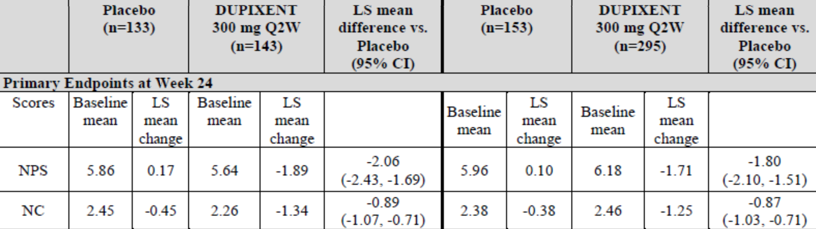

CI = confidence interval; LS = least squares; n = sample size; NC = nasal congestion/obstruction; NPS = nasal polyps score; q2w = once every 2 weeks; vs. = versus.

A reduction in score indicates improvement.

At Week 52 in the Study EFC14280 study, improvement from Baseline was numerically greater in the once every 2 weeks arm (least squares (LS) mean = -2.24 points) than in the once every 2 weeks/once every 4 weeks arm (LS mean = -2.06 points). The Kaplan-Meier curve for the NPS extracted from the study report is shown in Figure 1 below.

Figure : Study EFC14280 Least squares mean change from Baseline in bilateral nasal polyps score by visit up to Week 52 (intention-to-treat population)

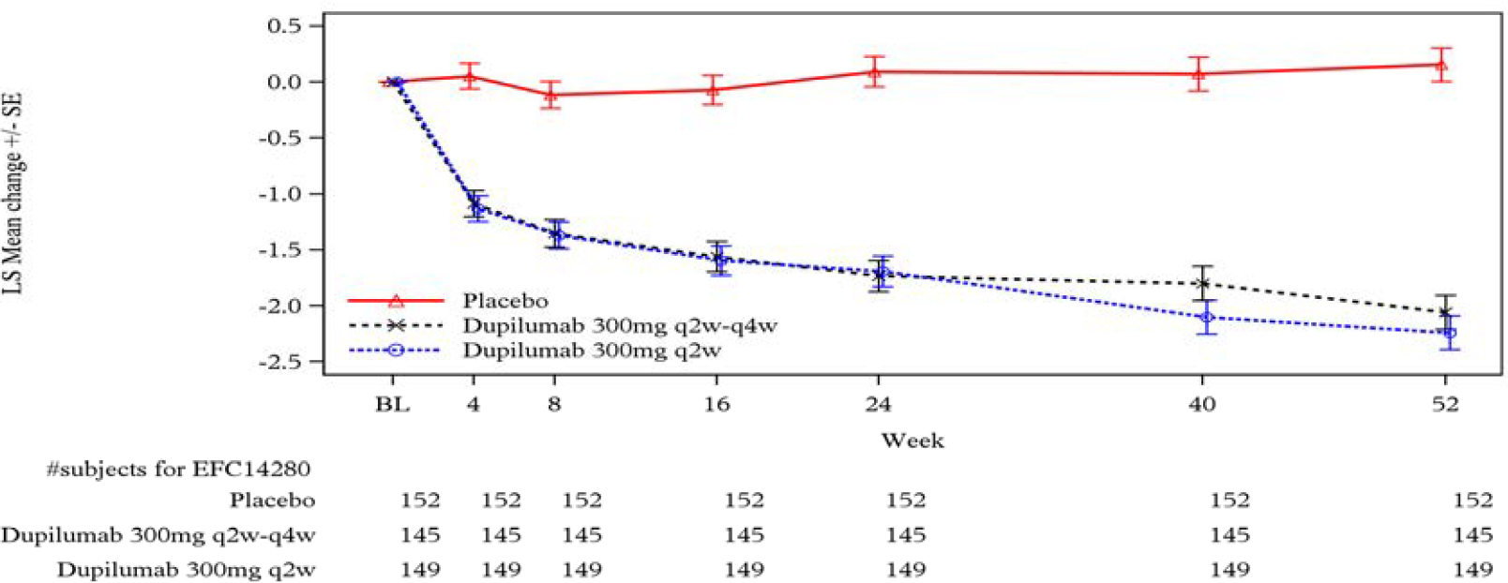

LS = least squares; q2w = once every 2 weeks; q4w = once every 4 weeks; SE = standard error.

Similarly, the nasal congestion scores were reduced over the 52 weeks of the Study EFC14280 with somewhat lower scores with the once every 2 to 4 weeks dose regimen compared with the once every 4 weeks regimen as shown in Figure 2 below.

Figure : Study EFC14280 Least squares mean change from Baseline in nasal congestion/obstruction by month up to Week 52 (intention-to-treat population)

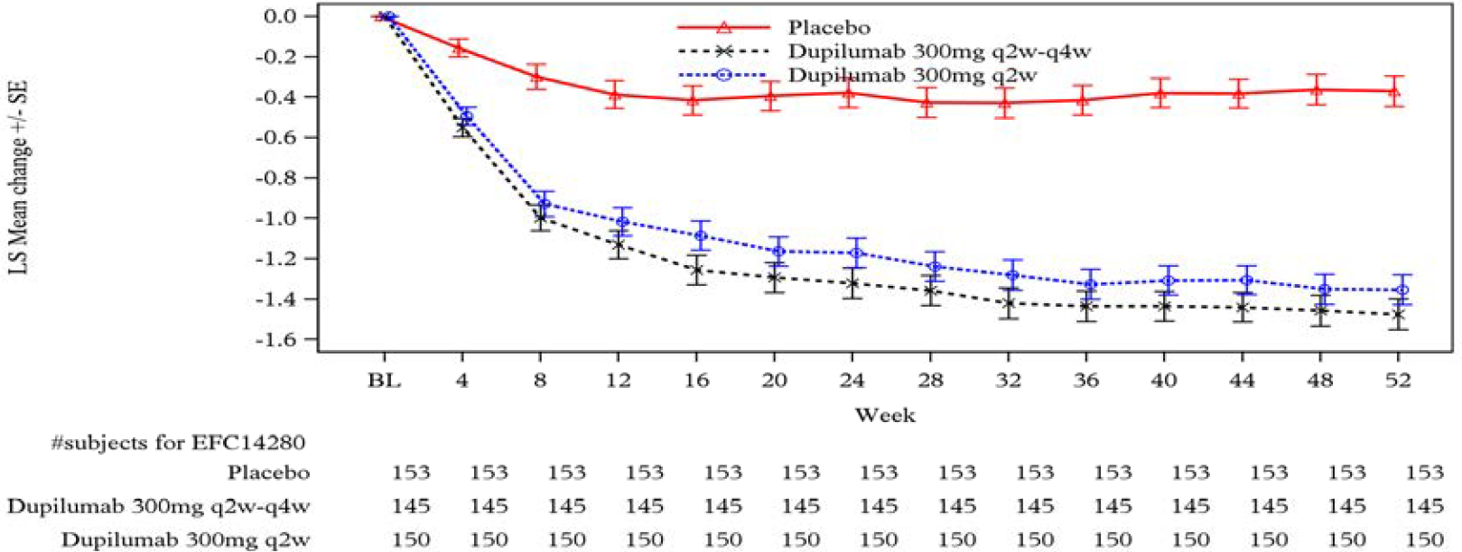

LS = least squares; q2w = once every 2 weeks; q4w = once every 4 weeks; SE = standard error.

Clear clinically significant efficacy was demonstrated in both these studies. After 24 weeks of treatment the nasal polyposis score increased markedly during the post treatment period in Study EFC14146 but not in Study EFC14280 in which patients continued treatment.

##### Atopic dermatitis (extension of existing indication to include children aged 6 to 11 years)

Proposed modification (extension to expand target population to include children aged 6 to 11 years of age):

*Dupixent is indicated for the treatment of moderate to severe atopic dermatitis in patients aged 6 years and older who are candidates for chronic systemic therapy. Dupixent is not intended for episodic use.*

The clinical dossier consisted of:

* one pivotal Phase III randomised, double blind placebo controlled trial in subjects aged ≥ 6 to < 12 years with atopic dermatitis (Study R668-AD-1652).
* one Phase II, open label, dose escalation study (Study R668-AD-1412) in paediatric subjects with atopic dermatitis. This study has previously been submitted to the TGA.
* one Phase III, ongoing open label extension study (Study R668-AD-1434) for subjects previously enrolled in the other two studies.

All three clinical trials provided pharmacokinetic, efficacy and safety data. The pivotal Phase III study also provided some pharmacodynamic data.

The clinical module also included one popPK analysis and literature references.

The evaluator noted that there are no specific EMA guidelines relating to clinical trials in atopic dermatitis.

##### Study R668-AD-1652

Study R668-AD-1652 was the pivotal study describing the main evidence for efficacy. The study has also been published.[19]

It was a randomised, double blind, placebo controlled trial with three parallel groups. It included four study periods:

* a screening period of up to 9 weeks;
* a topical corticosteroid standardisation period of 2 weeks;
* a treatment period of 16 weeks; and
* a follow-up period of 12 weeks (for subjects who did not enroll in an open label extension study).

###### Study objectives

The primary objective was to demonstrate the efficacy of dupilumab administered concomitantly with topical corticosteroids in patients ≥ 6 years to < 12 years of age with severe atopic dermatitis.

The secondary objective was to assess the safety of dupilumab administered concomitantly with topical corticosteroid in patients ≥ 6 years to < 12 years of age with severe atopic dermatitis.

###### Inclusion and exclusion criteria

The clinical evaluator highlighted that the main inclusion criteria were a diagnosis of severe atopic dermatitis with an inadequate response to topical therapy, and subjects aged between 6 and 11 years inclusive.

There were a number of exclusion criteria. Subjects with a bodyweight < 15 kg at Baseline were excluded. Recent treatment with topical crisabarole, topical calcineurin inhibitors or systemic therapy were also reasons for exclusion.

###### Participant flow

A total of 474 subjects were screened for enrolment, 367 were randomised and 362 received study treatment.

###### Study treatments

At Baseline, subjects were randomised to one of the following three treatment arms:

Dupilumab once every 2 weeks group (Arm A):

* Subjects with a baseline weight of < 30 kg received a loading dose of dupilumab 200 mg subcutaneously at Week 0 (day 1) and then 100 mg once every 2 weeks subcutaneously from weeks 2 to 14;
* Subjects with a baseline weight of ≥ 30 kg received a loading dose of dupilumab 400 mg subcutaneously at week 0 (day 1) and then 200 mg once every 2 weeks subcutaneously from weeks 2 to 14;

Dupilumab once every 4 weeks group (Arm B):

* All subjects received a loading dose of dupilumab 600 mg subcutaneously at Week 0 (Day 1) and then 300 mg once every 4 weeks subcutaneously from Weeks 4 to 12;

Placebo group (Arm C)

* All subjects received placebo injections corresponding to one of the above dupilumab regimens.

###### Primary endpoints

A number of validated scoring systems and questionnaires were used, including the Investigator’s Global Assessment (IGA) and the Eczema Area and Severity Index (EASI).[20]

Investigator’s Global Assessment

The IGA is an assessment instrument used in clinical studies to rate the severity of atopic dermatitis globally, based on a 5-point scale ranging from 0 (clear) to 4 (severe), as assessed by the investigator.

Eczema Area and Severity Index

The EASI is a validated scoring system that grades the physical signs of atopic dermatitis. The scoring system assesses extent of skin involvement (in terms of body surface area) and the severity of disease in terms of four signs (erythema, oedema/papulation, excoriation and lichenification). Scoring is performed by the investigator. Separate instruments are available for subjects aged ≥ 8 years and those aged < 8 years. The potential range for the score is 0 to 72, with higher scores indicating more extensive/severe disease. Severity of atopic dermatitis based on EASI score can be categorised as follows: 0 = clear; 0.1 to 1.0 = almost clear; 1.1 to 7.0 = mild; 7.1 to 21.0 = moderate; 21.1 to 50.0 = severe; 50.1 to 72.0 = very severe

In this study the primary endpoint for the USA (and USA reference markets) was the proportion of patients with an IGA score of 0 (clear) or 1 (almost clear) at Week 16.

For the EU (and EU reference markets) the co-primary endpoints were:

* the proportion of patients with a ≥ 75% improvement from Baseline in EASI (EASI-75) at week 16; and
* the proportion of patients with an of IGA score of 0 or 1 at Week 16.

The IGA and EASI scores were measured during initial screening and during the topical corticosteroid standardisation period, at Baseline (Week 0), at Weeks 1, 2, 3, 4, 8, 12 and 16 during the treatment period and at Weeks 20, 24 and 28 during the follow-up period.

###### Results for the primary efficacy outcomes

Proportion of subjects with an investigator’s global assessment score of zero or one at Week 16

The proportion in full analysis set was significantly greater in both the once every 2 weeks arm (29.5%) and the once every 4 weeks arm (32.8%), compared to the placebo arm (11.4%).

Analyses conducted in the modified full analysis set (mFAS) and per-protocol;[21] sets gave similar results. Two sensitivity analyses using alternative methods of accounting for missing data also gave similar results.

Figure : Study R668-AD-1652 Proportion of subjects with Investigator’s Global Assessment scale score of zero or one

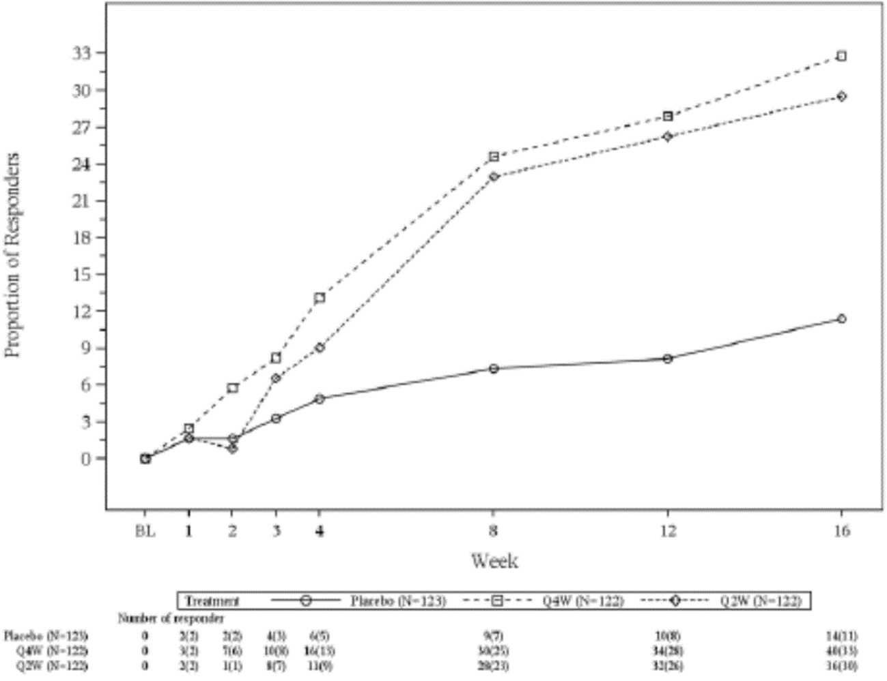

N = population size; Q2W = once every 2 weeks; Q4W = once every 4 weeks.

Values after first rescue treatment used were set to missing. Patients with missing score at each visit were considered as a non-responder.

Proportion of patients with 75% improvement from Baseline in Eczema Area and Severity Index at Week 16

The proportion was significantly greater in both the once every 2 weeks arm (67.2%) and the once every 4 weeks arm (69.7%), compared to the placebo arm (26.8%).

Analyses conducted in the mFAS and per-protocol sets gave similar results. The two sensitivity analyses using alternative methods of accounting for missing data also gave similar results.

Figure : Study R668-AD-1652 Proportion of patients with 75% improvement from Baseline in Eczema Area and Severity Index score

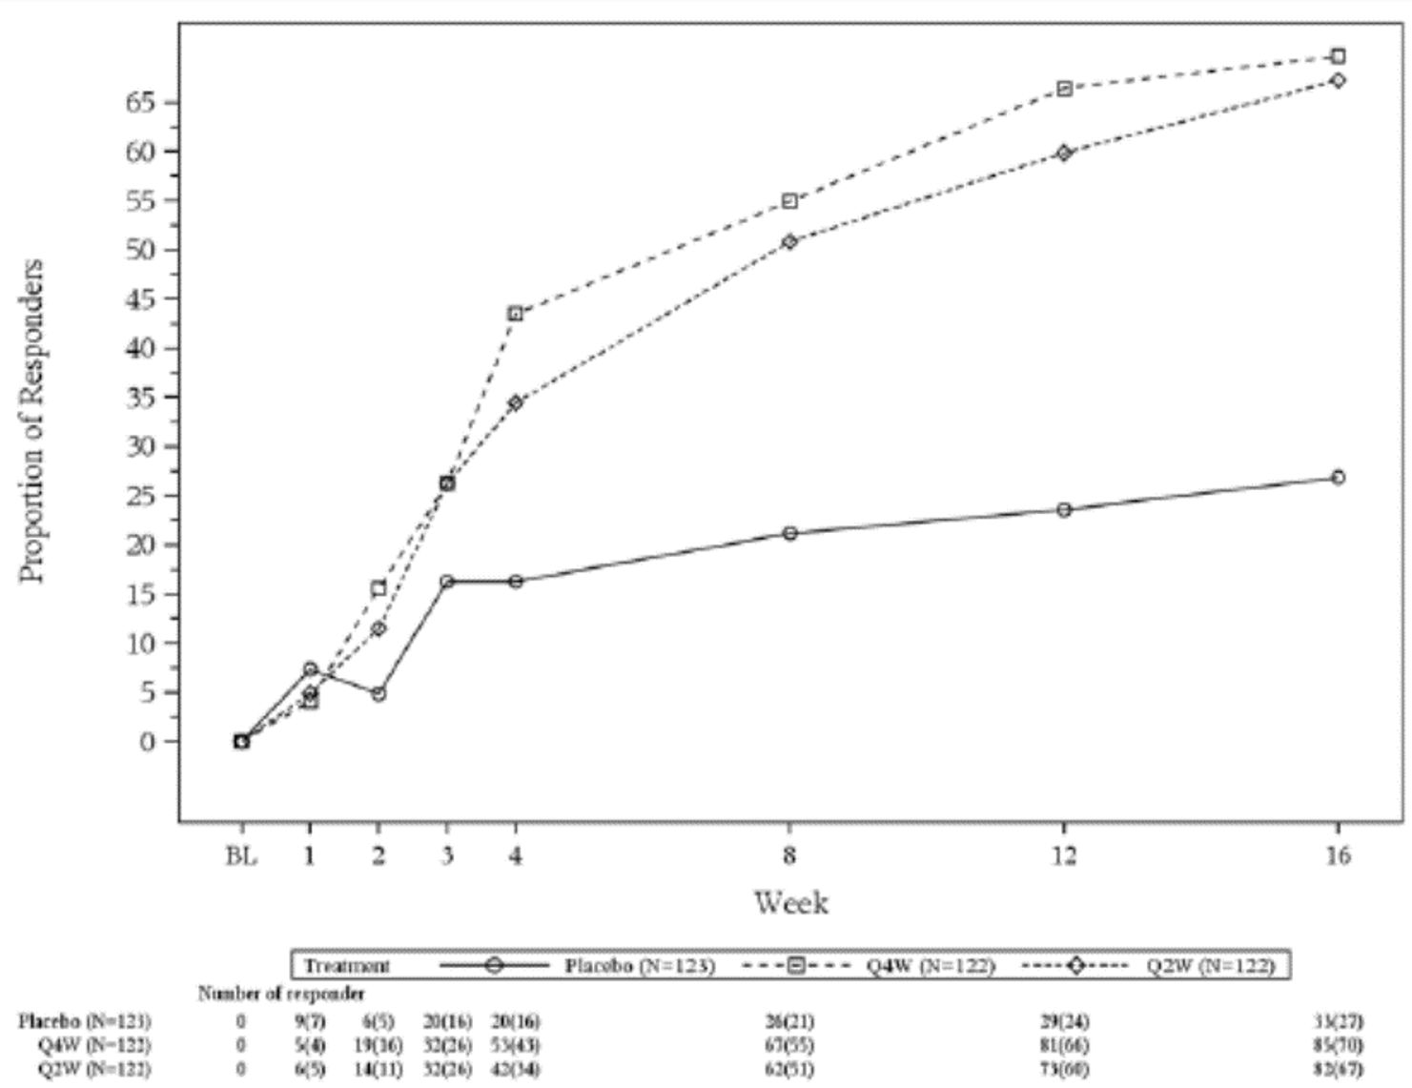

N = population size; Q2W = once every 2 weeks; Q4W = once every 4 weeks.

Values after first rescue treatment used were set to missing. Patients with missing score at each visit were considered as a non-responder.

###### Clinical evaluator’s conclusions

The pivotal study (Study R668-AD-1652) demonstrated statistically and clinically significant improvements in most efficacy outcomes, including the two co-primary endpoints (proportion of subjects with an IGA score of 0 or 1, proportion of subjects with a 75% improvement in EASI score) and the key secondary endpoints (percentage change in EASI score, percentage change in worst itch score).

Three different dosage regimens were explored in the pivotal study. The evaluator concluded that the two proposed for registration have been adequately justified on efficacy grounds.

##### Study R668-AD-1412

This study has previously been evaluated by the TGA and does not require further assessment.

##### Study R668-AD-1434

This trial is an ongoing Phase III, open label extension study for subjects previously enrolled in the two studies described above (the pivotal Study R668-AD-1652 and the Phase II Study R668-AD-1412). It enrolled both adolescent subjects (12 to < 18 years) (first step analysis) and children (≥ 6 to < 12 years) (second step analysis). However, the submitted report only presented data for the latter. It is an interim report covering the time period of 15 October 2015 to 22 July 2019.

The primary objective was to assess long term safety of dupilumab in paediatric subjects with atopic dermatitis. Secondary objectives were to assess long term efficacy and to assess trough concentrations and immunogenicity.

###### Study treatments

All subjects were treated with dupilumab. There was no control arm.

Under the original protocol, the only subjects eligible for enrolment were those completing the Phase II Study R668-AD-1412. These subjects were to be continued on their prior dose of either 2 mg/kg or 4 mg/kg subcutaneously every week.

Under a protocol amendment these subjects were switched to a regimen of 300 mg once every 4 weeks. Any new subjects were also treated with 300 mg once every 4 weeks.

###### Participant flow

A total of 368 subjects aged ≥ 6 to < 12 years were enrolled and treated in the study.

The adolescent cohort in Study R668-AD-1434 was evaluated as part of previous submission to the TGA. At the time, the evaluator expressed concerns regarding the lack of long term safety data and small numbers of patients, given atopic dermatitis is a chronic disease and long term treatment is expected.

For this cohort (that is, children (≥ 6 to < 12 years)), only 39 subjects (10.6%) had completed 52 weeks of treatment. 31 subjects (8.4%) had completed 3 years of treatment.

###### Clinical evaluator’s conclusions

In general, efficacy measures improved compared to Baseline (of the parent study or of the open label extension study) and this improvement was maintained over time.

The clinical evaluator commented that in the draft PI the proposed long term maintenance dose in children weighing < 30 kg is 300 mg once every 4 weeks. For children weighing 30 to 60 kg the proposed long term maintenance dose of 200 mg once every 2 weeks.

The data suggest that 60% of subjects weighing 30 to 60 kg did not require up titration from the 300 mg once every 4 weeks regimen. Retention of the 300 mg once every 4 weeks regimen as an option for the treatment of subjects weighing 30 to 60 kg may be desirable, as frequency of injections may be an issue for some children.

The clinical evaluator noted that available systemic therapies such as immunosuppressant agents are associated with significant toxicities, that the submitted data demonstrated clinically significant efficacy with limited toxicity. The major adverse effects were conjunctivitis and injection site adverse events (AEs) which were not generally severe. The evaluator considered that the overall benefit-risk balance for dupilumab in children aged 6 to < 12 years with atopic dermatitis was favourable.

#### Safety

##### Chronic rhinosinusitis with nasal polyposis (new indication)

The three submitted studies in CRSwNP included a total of 470 subjects treated with dupilumab and 312 subjects treated with placebo. Of the 470 dupilumab treated subjects, 440 were randomised to treatment with the proposed regimen of 300 mg once every 2 weeks for periods of up to 24 weeks. A total of 149 subjects were randomised to treatment with this regimen for periods up to 52 weeks.

Generally, dupilumab treatment was associated with a slightly lower incidence of AEs, serious AEs and discontinuations due to AEs than placebo treatment. This finding was attributable to a lower incidence of disease related AEs (for example, nasal polyps, acute sinusitis, upper-respiratory tract infection, nasal congestion) and AEs related to concomitant type 2 inflammatory disorders (asthma).

Eosinophilia related events, particularly in association with cessation of oral steroids were observed and have been identified previously with dupilumab. Arthralgias and hypertension were AE terms reported more frequently with dupilumab treatment in the pivotal studies. Other AEs were not consistently more frequent in the dupilumab arms of the submitted studies.

##### Atopic dermatitis (extension of existing indication to include children aged 6 to 11 years)

The safety of dupilumab with concomitant topical corticosteroid was assessed in 367 subjects aged 6 to 11 years with severe atopic dermatitis. The safety was similar to the safety profile seen in adults and adolescents with atopic dermatitis.

No new safety signals were apparent from the submitted studies.

##### Safety conclusions (Study LTS12551)

Study LTS12551 (the TRAVERSE trial) provided long term safety data on a total of 2,282 subjects with asthma who had previously been enrolled in other dupilumab trials. The dose used in the study (300 mg once every 2 weeks) was higher than that approved for most asthma subjects in Australia.

The majority of the subjects (2,062 of 2,282, that is 90%) were previously enrolled in Studies DRI12544 and EFC13579. In this subgroup, mean duration of treatment was 73.8 weeks. Mean duration of treatment was somewhat less in subjects enrolled from the other studies.

In total, 1,906 subjects were treated for at least 48 weeks and 923 subjects were treated for at least 96 weeks. There was no control group in the study.

The pattern of AEs and laboratory abnormalities observed during the study was generally consistent with that previously described for dupilumab. No new safety issues were identified.

Serious AEs were observed in approximately 10% to 12% of subjects. Discontinuation of treatment due to AEs was uncommon, with an incidence of approximately 3.4% overall.

Dupilumab treatment has previously been associated with conjunctivitis, hypersensitivity events including anaphylaxis, injection site AEs, eosinophilia and possibly with eosinophilic conditions such as eosinophilic granulomatosis with polyangiitis. These AEs were observed during the open label extension study.

Approximately 3% to 8% of subjects developed anti-drug antibodies (ADA). The development of high titre ADA, which occurred in up to 1.6% of subjects, was associated with reduced dupilumab concentrations and decreased efficacy in some subjects. ADA were not associated with any apparent safety concerns.

The clinical evaluator was of the opinion that the study provided adequate evidence that long term administration of dupilumab had an acceptable safety profile. The revised PI was deemed acceptable.

### Risk management plan

The most recently evaluated EU-risk management plan (RMP) was version 3.0 (28 September 2018; data lock point (DLP) 21 April 2018) and Australia specific annex (ASA) version 3.0 (November 2018). The sponsor has submitted ASA version 5.0 (30 April 2021) and unapproved EU-RMP version 6.0 (15 February 2021; DLP 28 September 2020) as part of another submission to the TGA. As no RMP evaluation is required for this other submission these latest EU-RMP and ASA versions will be evaluated in this submission.

The summary of safety concerns and their associated risk monitoring and mitigation strategies are summarised in Table 3.[22]

Table : Summary of safety concerns

|  |  |  |  |  |  |
| --- | --- | --- | --- | --- | --- |
| Summary of safety concerns | | Pharmacovigilance | | Risk minimisation | |
| **Routine** | **Additional** | **Routine** | **Additional** |
| **Important identified risks** | Systemic hypersensitivity (including events associated with immunogenicity) | ✓ | – | ✓ | – |
|  | Conjunctivitis and keratitis related events in atopic dermatitis patients | – | ✓† | ✓ | – |
| **Important potential risks** | None | – | – | – | – |
| **Missing Information** | Use in pregnant and lactating women | ✓ | ✓‡ | ✓ | – |
| Long term safety | – | ✓§ | ✓ | – |

† Ophthalmology sub-study

‡ Pregnancy registry study and outcomes database study

§ Open label extension study (upgraded to important identified risk)

* As the sponsor has not identified any new safety concerns due to the proposed new indications, the summary of safety concerns is considered acceptable from an RMP perspective. In ASA version 5.0, the sponsor upgraded ‘conjunctivitis related events in atopic dermatitis patients’ to an important identified risk and added keratitis.
* The sponsor has proposed routine pharmacovigilance for safety concerns. The proposed pharmacovigilance plan is acceptable in managing the safety concerns.
* As no new safety concerns have been identified through the extension of indications, routine risk minimisation activities continue to be acceptable from an RMP perspective.

### Risk-benefit analysis

#### Delegate’s considerations

The dosing regimen proposed for long term use of dupilumab in patients with chronic rhinosinusitis with nasal polyps (CRSwNP) is 300 mg once every 2 weeks. This dose was not associated with markedly increased efficacy, as measured by the nasal polyp score and the nasal congestion scores. It may be that for many patients the more frequent dose is not necessary for adequate control of symptoms. Some consideration should be given to recommending the less frequent dose regimen (300 mg once every 4 weeks) as an alternative to the currently proposed dose regimen of 300 mg once every 2 weeks.

Dosing for children with atopic dermatitis: It is not clear whether the dose regimen adopted by the US Food and Drug Administration (FDA) or that adopted by the EMA would be preferred for children aged from 6 to < 12 years with atopic dermatitis. The once every 4 weeks regimen would most likely be more convenient and not require regular body weight assessment however it would also result in higher than needed exposure to dupilumab. Additionally, the evidence for longer term maintenance is quite limited and was assessed primarily on the once every 4 weeks dose regimen which was irrespective of body weight.

The clinical evaluator commented:

In the draft PI the proposed long term maintenance dose in children weighing < 30 kg is 300 mg once every 4 weeks. For children weighing 30 to 60 kg the proposed long term maintenance dose 200 mg once every 2 weeks. The data for atopic dermatitis suggest that 60% of subjects weighing 30 to 60 kg did not require up titration from the 300 mg once every 4 weeks regimen. Retention of the 300 mg once every 4 weeks regimen as an option for the treatment of subjects weighing 30 to 60 kg may be desirable, as frequency of injections may be an issue for some children.

The clinical evaluator noted that the two dose regimens were associated with similar efficacy.

The current proposed dose regimens for atopic dermatitis in children is shown in Table 4 below.

Table : Current proposed dose regimens for children with atopic dermatitis (Australia)

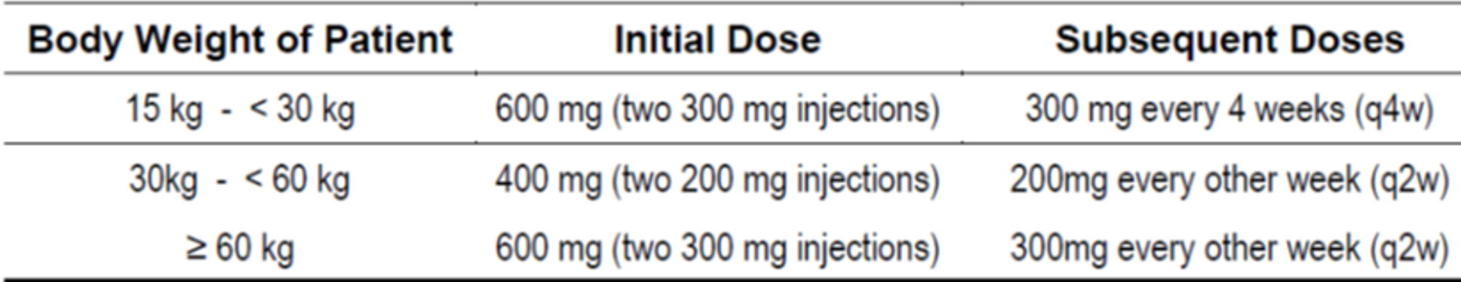

q2w = once every 2 weeks; q4w = once every 4 weeks.

The US regimen for children with atopic dermatitis is shown in Table 5. The EU regimens for adolescents (12 to 17 years of age) and children (6 to 11 years of age) with atopic dermatitis are shown in Table 6 and Table 7, respectively.

Table : Dose regimens for children with atopic dermatitis (United States of America)

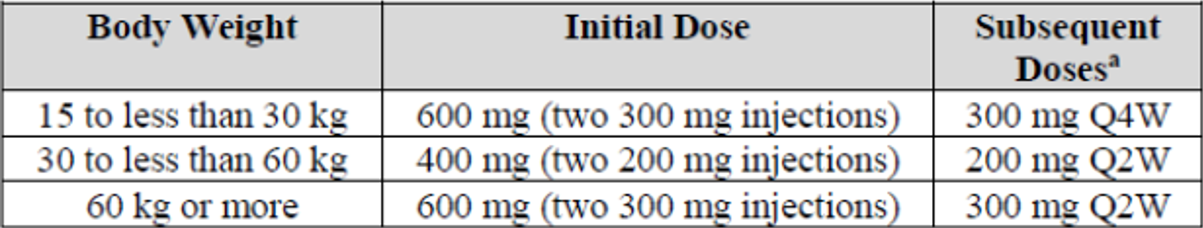

a. Q2W = once every 2 weeks; Q4W = once every 4 weeks.

Table : Dose of dupilumab for subcutaneous administration in adolescent patients 12 to 17 years of age with atopic dermatitis (European Union)

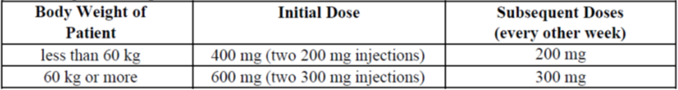

Table : Dose of dupilumab for subcutaneous administration in children patients 6 to 11 years of age with atopic dermatitis (European Union)

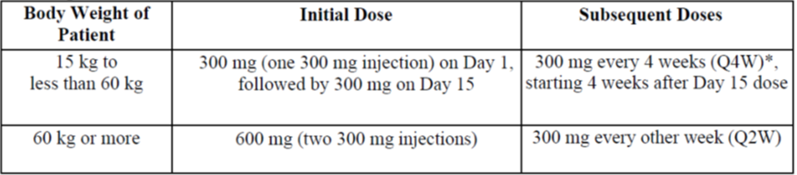

Q2W = once every 2 weeks; Q4W = once every 4 weeks.

* The dose may be increased to 200 mg once every 2 weeks in patients with body weight of 15 kg to less than 60 kg based on physician’s assessment.

The data suggest that dupilumab is associated with substantial efficacy benefits and only limited toxicity when used for the treatment of atopic dermatitis in children aged 6 to 11 years. The overall benefit-risk balance was therefore considered favourable.

#### Proposed action

The Delegate proposes to accept both of the proposed major variations to the conditions of approval for Dupixent. Approval is subject to satisfactory resolution of the PI.

#### Questions for the sponsor

The sponsor provided the following response to questions from the Delegate.

1. ***Please comment on the clinical significance of the differences in primary efficacy measures of the once every 2 weeks and once every 4 weeks dupilumab regimens for chronic rhinosinusitis with nasal polyps.***

As discussed in the sponsor‘s submitted dossier, the data generated in the Phase III program indicates that the 300 mg every 4 weeks is suboptimal dosing for at least a subset of patients based on efficacy, PK, and safety events indicative of lack of efficacy. Further details are provided below.

In relation to Study EFC14280 efficacy, continued treatment with 300 mg every 2 weeks between Weeks 24 and 52 was associated with further increase in the proportion of patients with at least 1 point reduction in nasal polyp score (NPS) up to 67.3% (+11%) without reaching the maximum effect while no increase in responder rate was observed for patients who switched to once every 4 weeks after Week 24, indicating that continued treatment with dupilumab 300 mg once every 2 weeks after 24 weeks will result in additional benefit for a substantial amount of the patients.

Review of the dupilumab drug concentration data showed that more patients in the 300 mg once every 2 weeks once every 4 weeks regimen (8.7%) had steady-state concentrations that were below the limit of quantitation (0.078 mg/L) than those in the 300 mg once every 2 weeks regimen (1.8%) at Week 52. A lower proportion of patients at the 300 mg once every 2 weeks to once every 4 weeks regimen (86%) maintained steady state trough concentrations above the half maximal effective concentration (EC50) (1.75 mg/L) of NPS response compared to 300 mg once every 2 weeks (97%) (Figure 5). The proportion of patients who maintained Week 52 steady-state trough concentrations above the 90% maximal effective concentration (EC90) (15.8 mg/L) of NPS response was 97%, and 41% at 300 mg once every 2 weeks and 300 mg once every 2 weeks to once every 4 weeks regimens, respectively.

Figure : Study EFC14280 Box plot of dupilumab trough concentrations at Week 52 in individual patients with chronic rhinosinusitis with nasal polyps at 300 mg once every 2 weeks and 300 mg once every 2 weeks to once every 4 weeks

Figure 5: Study EFC14280 Box plot of dupilumab trough concentrations at Week 52 in individual patients with chronic rhinosinusitis with nasal polyps at 300 mg once every 2 weeks and 300 mg once every 2 weeks to once every 4 weeks

q2w = once every 2 weeks; q4w = once every 4 weeks

The boxplot has individual observed data (as open circles). Lower and upper end of whisker indicate fifth and ninety fifth percentile of trough concentration (Ctrough); lower and upper boundary of the box and the median line represent the 25%, 75% and 50% percentiles of Ctrough.

Based on these observations, complete saturation of target mediated elimination may not have been maintained in all patients in the 300 mg once every 2 weeks to once every 4 weeks regimen after switching to a 300 mg once every 4 weeks schedule and we cannot exclude disease control erosion with 300 mg once every 4 weeks regimen upon longer term dosing, for example, after 52-week treatment period.

In addition, treatment emergent adverse events (TEAEs) of sinusitis, nasal polyps, and asthma which are generally associated with worsening of CRSwNP or asthma, were numerically higher in patients who switched at Week 24 from dupilumab 300 mg once every 2 weeks to once every 4 weeks dosing compared with those who remained on once every 2 weeks (Table 8). This suggests that the once every 4 weeks arm may have suboptimal disease control in a subset of patients and the imbalance noted in TEAEs was indicative of gradual loss of clinical symptom control for both CRSwNP and comorbid asthma. This is consistent with dupilumab drug concentration data which similarly suggests a subset of patients with suboptimal exposure.

Table : Study EFC14280 Number (%) of patients with acute sinusitis, sinusitis, nasal polyps, and asthma treatment emergent adverse events up to Week 24 and up to Week 52 (safety population)

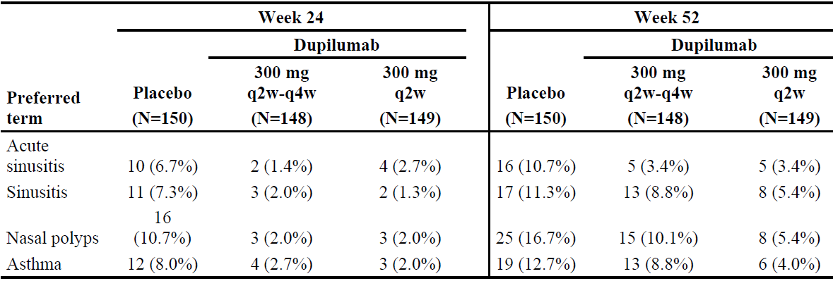

N = population size; q2w = once every 2 weeks; q4w = once every 4 weeks.

To determine a maintenance dosing regimen for a drug, it is critical to understand when the maximal treatment effect of a regimen is achieved and the evidence from the current Phase III program does not allow for drawing a definitive conclusion about the optimal timing for a regimen change, though the data does indicate that is not likely to be at 24 weeks.

While the sponsor acknowledges that a less frequent dosing regimen could be more convenient for patients, during the Phase III mean compliance with administration of the investigational medicinal product was high (> 99%) for both once every 2 weeks and once every 4 weeks treatment regimens (only one patient, in the dupilumab 300 mg once every 2 weeks to once every 4 weeks group, had a compliance rate < 80%).

Taken altogether, since a less frequent dosing regimen leaves a portion of with suboptimal dupilumab exposure and response, there is suggestion of loss of efficacy in the safety data and no dose related trends for safety to favour the less frequent regimen, the sponsor considers that 300 mg once every 2 weeks is the optimal dose for CRSwNP, a disease characterised by a chronic, indolent clinical course with high rate of polyp recurrence after surgery and high incidence of asthma and other type 2 comorbidities.

1. ***The sponsor is requested to submit the completed study report for Study R668‑AD-1434 second step analysis to the TGA when it is available.***

The sponsor commits to submit the completed study report for Study R668-AD-1434 to the TGA when it becomes available.

1. ***The sponsor is requested to provide an update of the overseas regulatory status for each of the three components for this submission.***

An update of the overseas regulatory status for atopic dermatitis (aged 6 to 11 years), chronic rhinosinusitis with nasal polyposis and long term asthma study (the TRAVERSE trial) is provided to the TGA.

#### Advisory Committee considerations[23]

The Advisory Committee on Medicines (ACM), having considered the evaluations and the Delegate’s overview, as well as the sponsor’s response to these documents, advised the following.

##### Specific advice to the Delegate

The ACM advised the following in response to the Delegate’s specific request for advice:

1. ***Efficacy of the proposed dose regimen for Dupixent was demonstrated in adult patients with inadequately controlled CRSwNP over 52 weeks. Two dose regimens were assessed in the second half of the long term study (the SINUS-52 trial)[24] - 300 mg given either once every 2 weeks or once every 4 weeks. While there was a formal comparison of efficacy between these two treatment groups the difference appears to be clinically quite minor.***

***Does the committee consider that a once every 4 weeks dose regimen could also be recommended for those patients who are adequately controlled? The once every 2 weeks dose regimen could also be recommended for patients requiring the higher exposure to dupilumab. The Delegate note that the US Prescribing Information and EU Summary of Product Characteristics (SmPC) have included only the once every 2 weeks regimen for long term use in this population and that the sponsor has also proposed only the once every 2 weeks regimen to the TGA.***

The ACM notes that in the SINUS-52 trial, there was lowering of dupilumab dosing frequency after 24 weeks of treatment from once every two weeks to once every four weeks. For all clinically relevant outcomes (that is, SNOT-22 score, nasal polyp score, and smell test), the results were comparable to those using dupilumab once every two weeks. The ACM recommends a flexible dosing frequency anywhere between once every two weeks to once every four weeks for patients who are adequately controlled. This would allow individualisation of the dose based on the condition of each patient.

1. ***The current dose regimen for Dupixent in adults with atopic dermatitis is an initial dose of 600 mg then 300 mg once every 2 weeks. The same dose regimen has been proposed for children aged 6 to 12 years with body weight ≥ 60 kg. For children with body weight 30 to < 60 kg a loading dose of 400 mg then 200 mg once every 2 weeks has been proposed. For children with body weight 15 to < 30 kg a loading dose of 600 mg then 300 mg once every 4 weeks has been proposed. In the pivotal study, efficacy of the above regimen and of 600 mg subcutaneously at Week 0 (Day 1) and then 300 mg once every 4 weeks subcutaneously for all body weights was similar.***

***Please comment on the proposed dosage regimen for atopic dermatitis for Australia, specifically whether it would be appropriate to allow a once every 4 weeks regimen for children up to 60 kg. The Delegate notes that such a regimen has not been adopted in the USA and that the EU has adopted the once every 4 weeks regimen for all children aged 6 to < 12 years without regard to body weight.***

The ACM recommended variation in dosing intervals for treatment individualisation. The ACM recommended to specify both the loading dose (400 or 600 mg) and maintenance dose (200 or 300 or 400 mg) in the Product Information.

1. ***The pivotal study supporting use in children aged 6 to 12 years with atopic dermatitis included only children with severe disease however the sponsor proposes use in children with both moderate and severe atopic dermatitis. There were no data in the submission to support efficacy in children with moderate atopic dermatitis.***

***Noting that the TGA has adopted an EMA guideline on clinical trials in paediatric populations.[25] The guideline states the following:***

***‘When a medicinal product is to be used in the paediatric population for the same indication(s) as those studied and approved in adults, the disease process is similar in adults and paediatric patients, and the outcome of therapy is likely to be comparable, extrapolation from adult efficacy data may be appropriate.’***

***Dupilumab is currently approved for the treatment moderate to severe atopic dermatitis in both adults and adolescents. It would therefore seem reasonable to extrapolate efficacy data from adults with moderate atopic dermatitis to the paediatric population.***

***In addition, at Baseline of the open label extension study, only 19.6% of subjects had severe disease and efficacy was maintained in the study population as a whole.***

***Given the above, does the committee consider it is appropriate to extend the use of Dupixent to children aged 6 to 11 years with both moderate and severe atopic dermatitis?***

The prevalence of atopic dermatitis in Australia is about 10 to 15% of the general population: 15 to 20% of children, 38.5% of infants, and 1 to 2% of adults. The ACM considered that extension of use is appropriate as the current approved use excludes the largest age segment of the Australian population with atopic dermatitis. The ACM was of view to extend the use of dupilumab to children aged 6 to 11 years with both moderate and severe atopic dermatitis.

##### Conclusion

The ACM considered this product to have an overall positive benefit-risk profile for the indication:

*Chronic rhinosinusitis with nasal polyposis (CRSwNP)*

*Dupixent is indicated as an add-on maintenance treatment in adult patients with inadequately controlled chronic rhinosinusitis with nasal polyposis (CRSwNP).*

*Extension of the approved patient population for atopic dermatitis indication*

*Dupixent is indicated for the treatment of moderate to severe atopic dermatitis in patients aged 6 years and older who are candidates for chronic systemic therapy. Dupixent is not intended for episodic use.*

### Outcome

Based on a review of quality, safety and efficacy, the TGA approved the registration of Dupixent (dupilumab) 150 mg/mL and 175 mg/mL, solution for injection, pre-filled syringe, for the following extension of indications:

***Atopic dermatitis - children 6 to 11 years of age***

*Dupixent is indicated for the treatment of severe atopic dermatitis in patients aged 6 to 11 years old who are candidates for chronic systemic therapy. Dupixent is not intended for episodic use.*

***Chronic rhinosinusitis with nasal polyposis (CRSwNP)***

*Dupixent is indicated as an add-on maintenance treatment in adult patients with inadequately controlled chronic rhinosinusitis with nasal polyposis (CRSwNP).*

As such, the full indications at this time were:

*Dupixent is indicated for the following type 2 inflammatory diseases:*

***Atopic dermatitis***

*Adults and adolescents*

*Dupixent is indicated for the treatment of moderate to severe atopic dermatitis in patients aged 12 years and older who are candidates for chronic systemic therapy. Dupixent is not intended for episodic use.*

*Children 6 to 11 years of age*

*Dupixent is indicated for the treatment of severe atopic dermatitis in patients aged 6 to 11 years old who are candidates for chronic systemic therapy. Dupixent is not intended for episodic use.*

***Asthma***

*Dupixent is indicated as add on maintenance treatment in patients aged 12 years and older with moderate to severe asthma with type 2 inflammation (elevated eosinophils or elevated FeNO).*

*Dupixent is indicated as maintenance therapy for oral corticosteroid dependent asthma.*

***Chronic rhinosinusitis with nasal polyposis (CRSwNP)***

*Dupixent is indicated as an add-on maintenance treatment in adult patients with inadequately controlled chronic rhinosinusitis with nasal polyposis (CRSwNP).*

#### Specific conditions of registration applying to these goods

* Dupixent (dupilumab) is to be included in the Black Triangle Scheme. The PI and CMI [Consumer Medicines Information] for Dupixent must include the black triangle symbol and mandatory accompanying text for five years, which starts from the date the new indication is registered.
* The Dupixent EU-risk management plan (RMP) (version 6.0, dated 15 February 2021, data lock point 28 September 2020), with Australian specific annex (version 5.0, dated 30 April 2021), included with Submission PM-2020-03043-1-5, and any subsequent revisions, as agreed with the TGA will be implemented in Australia.

An obligatory component of risk management plans is routine pharmacovigilance. Routine pharmacovigilance includes the submission of periodic safety update reports (PSURs).

Reports are to be provided in line with the current published list of EU reference dates and frequency of submission of PSURs until the period covered by such reports is not less than three years from the date of the approval letter.

The reports are to at least meet the requirements for PSURs as described in the European Medicines Agency’s Guideline on Good Pharmacovigilance Practices (GVP) Module VII-periodic safety update report (Rev 1), Part VII.B Structures and processes. Note that submission of a PSUR does not constitute an application to vary the registration.

* For all injectable products the Product Information must be included with the product as a package insert.

## Attachment 1. Product Information

The PI for Dupixent approved with the submission which is described in this AusPAR is at Attachment 1. For the most recent PI, please refer to the TGA website at <<https://www.tga.gov.au/product-information-pi>>.

|  |
| --- |
| Therapeutic Goods Administration |
| PO Box 100 Woden ACT 2606 Australia  Email: [info@tga.gov.au](mailto:info@tga.gov.au) Phone: 1800 020 653 Fax: 02 6232 8605  [**https://www.tga.gov.au**](https://www.tga.gov.au) |

1. The **Black Triangle Scheme** provides a simple means for practitioners and patients to identify certain types of new prescription medicines, including those being used in new ways and to encourage the reporting of adverse events associated with their use. The Black Triangle does not denote that there are known safety problems, just that the TGA is encouraging adverse event reporting to help us build up the full picture of a medicine's safety profile.
2. Dupixent (dupilumab) 300 mg/2 mL solution for injection prefilled syringe has been approved by the TGA on 13 August 2021, but it is not listed on the Australian Register of Therapeutic Goods (ARTG).
3. Orlandi, R.R. et al. International Consensus Statement on Allergy and Rhinology: Rhinosinusitis*, Int Forum Allergy Rhinol*, 2016; Suppl 1: S22-S209.
4. Hulse, K.E. et al Pathogenesis of Nasal Polyposis, *Clin Exp Allergy*, 2015; 45 (2): 328-346.
5. Zoler, Z.M. et al. Health State Utility Values in Patients Undergoing Endoscopic Sinus Surgery, *Laryngoscope*, 2011; 121 (12): 2672-2678.
6. Fokkens, W.J.et al. European Position Paper on Rhinosinusitis and Nasal Polyps, *Rhinology*, 2020; Suppl 29: 1‑464.
7. Kaplan, A. Canadian Guidelines for Chronic Rhinosinusitis, *Can Fam Physician*, 2013; 59: 1275-81.
8. Hopkins, C. Chronic Rhinosinusitis with Nasal Polyps, *N Engl J Med*, 2019; 381: 55-63.
9. Langan, S.M. et al. Atopic dermatitis, *Lancet*. 2020; 396 (10247): 345-360.
10. Wollenberg, A. et al. Consensus-Based European Guidelines for Treatment Of Atopic Eczema (Atopic Dermatitis) in Adults and Children: Part I, *J Eur Acad Dermatol Venereol*, 2018; 32 (5): 657-682.
11. Wollenberg A et al. Consensus-Based European Guidelines for Treatment of Atopic Eczema (Atopic Dermatitis) in Adults and Children: Part II, *J Eur Acad Dermatol Venereol*, 2018; 32 (6): 850-878.
12. Eichenfield, L.F. et al. Guidelines of Care for the Management of Atopic Dermatitis: Section 2. Management and Treatment of Atopic Dermatitis with Topical Therapies, *J Am Acad Dermatol*, 2014; 71 (1): 116-132.
13. Sidbury, R. et al. Guidelines of Care for the Management of Atopic Dermatitis: Section 3. Management and Treatment with Phototherapy and Systemic Agents, *J Am Acad Dermatol*, 2014; 71 (2): 327-349.
14. Global Initiative for Asthma (GINA). Global Strategy for Asthma Management and Prevention, 2020. Available from: [www.ginasthma.org](http://www.ginasthma.org).
15. Fahy, J.V. Type 2 Inflammation in Asthma - Present in Most, Absent in Many, *Nat Rev Immunol*, 2015; 15 (1): 57-65.
16. National Asthma Council Australia. Australian Asthma Handbook Version 2.1, 2020. Available from: <http://www.asthmahandbook.org.au>.
17. Food and Drug Administration (FDA) (United States of America), Dupixent (dupilumab) injection, for subcutaneous use, Prescribing Information -Clinical Trials Section. Available from the FDA website at:at: https://www.accessdata.fda.gov/drugsatfda_docs/label/2021/761055s031lbl.pdf
18. The **22-item Sino-nasal outcome test (SNOT-22)** is a validated patient-reported chronic rhinosinusitis health-related quality-of-life outcome measure.
19. Paller, A.S. et al. Efficacy and Safety of Dupilumab with Concomitant Topical Corticosteroids in Children 6 to 11 Years Old with Severe Atopic Dermatitis: a Randomized, Double-Blinded, Placebo-Controlled Phase 3 Trial, *J Am Acad Dermatol*, 2020; 83 (5): 1282-1293
20. **Eczema area and severity index (EASI)** is a scoring system that grades the extent and severity of atopic eczema.
21. The **per-protocol (PP)** analysis is restricted to the participants who strictly adhered to the protocol. Also known as ‘on-treatment’ analysis.
22. *Routine risk minimisation* activities may be limited to ensuring that suitable warnings are included in the product information or by careful use of labelling and packaging.

    *Routine pharmacovigilance* practices involve the following activities:

    All suspected adverse reactions that are reported to the personnel of the company are collected and collated in an accessible manner;

    Reporting to regulatory authorities;

    Continuous monitoring of the safety profiles of approved products including signal detection and updating of labelling;

    Submission of PSURs;

    Meeting other local regulatory agency requirements.
23. The ACM provides independent medical and scientific advice to the Minister for Health and the TGA on issues relating to the safety, quality and efficacy of medicines supplied in Australia including issues relating to pre market and post-market functions for medicines. Further information can be found here: <https://www.tga.gov.au/committee/advisory-committee-medicines-acm>.
24. Referred to as Study EFC14280 elsewhere in this document.
25. European Medicines Evaluation Agency (EMEA), Committee for Proprietary Medicinal Products (CPMP), ICH Topic E 11 Clinical Investigation of Medicinal Products in the Paediatric Population, CPMP/ICH/2711/99, January 2001.