|  |
| --- |
| AusPAR Attachment 2 |
| Extract from the Clinical Evaluation Report for elotuzumab |
| Proprietary Product Name: Empliciti |
| Sponsor: Bristol-Myers Squibb Australia Pty Ltd |

|  |
| --- |
| **First round report: 12 January 2016**  **Second round report: 7 June 2016** |

About the Therapeutic Goods Administration (TGA)

* The Therapeutic Goods Administration (TGA) is part of the Australian Government Department of Health, and is responsible for regulating medicines and medical devices.
* The TGA administers the *Therapeutic Goods Act 1989* (the Act), applying a risk management approach designed to ensure therapeutic goods supplied in Australia meet acceptable standards of quality, safety and efficacy (performance), when necessary.
* The work of the TGA is based on applying scientific and clinical expertise to decision-making, to ensure that the benefits to consumers outweigh any risks associated with the use of medicines and medical devices.
* The TGA relies on the public, healthcare professionals and industry to report problems with medicines or medical devices. TGA investigates reports received by it to determine any necessary regulatory action.
* To report a problem with a medicine or medical device, please see the information on the TGA website <<https://www.tga.gov.au>>.

About the Extract from the Clinical Evaluation Report

* This document provides a more detailed evaluation of the clinical findings, extracted from the Clinical Evaluation Report (CER) prepared by the TGA. This extract does not include sections from the CER regarding product documentation or post market activities.
* The words [Information redacted], where they appear in this document, indicate that confidential information has been deleted.
* For the most recent Product Information (PI), please refer to the TGA website <<https://www.tga.gov.au/product-information-pi>>.

Copyright

© Commonwealth of Australia 2017  
This work is copyright. You may reproduce the whole or part of this work in unaltered form for your own personal use or, if you are part of an organisation, for internal use within your organisation, but only if you or your organisation do not use the reproduction for any commercial purpose and retain this copyright notice and all disclaimer notices as part of that reproduction. Apart from rights to use as permitted by the *Copyright Act 1968* or allowed by this copyright notice, all other rights are reserved and you are not allowed to reproduce the whole or any part of this work in any way (electronic or otherwise) without first being given specific written permission from the Commonwealth to do so. Requests and inquiries concerning reproduction and rights are to be sent to the TGA Copyright Officer, Therapeutic Goods Administration, PO Box 100, Woden ACT 2606 or emailed to <[tga.copyright@tga.gov.au](mailto:tga.copyright@tga.gov.au)>.

Contents

List of abbreviations 5

1. Introduction 9

1.1. Drug class and therapeutic indication 9

1.2. Dosage forms and strengths 9

1.3. Dosage and administration 9

1.4. Special populations 9

1.5. Premedication and additional medication recommendations 10

1.6. Dose delay, interruption, or discontinuation 10

1.7. Preparation and administration 10

2. Clinical rationale 12

3. Contents of the clinical dossier 12

3.1. Scope of the clinical dossier 12

3.2. Good clinical practice 13

4. Pharmacokinetics 13

4.1. Studies providing pharmacokinetic data 13

4.2. Summary of pharmacokinetics 14

4.3. Evaluator’s overall conclusions on pharmacokinetics 28

5. Pharmacodynamics 30

5.1. Studies providing pharmacodynamic data 30

5.2. Summary of results of individual studies 30

5.3. Summary of pharmacodynamics 32

5.4. Evaluator’s overall conclusions on pharmacodynamics 33

6. Dosage selection for the pivotal studies 34

6.1. Pivotal study CA204004 34

7. Clinical efficacy 34

7.1. Combination therapy studies for the treatment of multiple myeloma 34

8. Clinical safety 82

8.1. Studies providing evaluable safety data 83

8.2. Studies that assessed safety as a primary outcome 84

8.3. Patient exposure 90

8.4. Adverse events 92

8.5. Laboratory tests 95

8.6. Post-marketing experience 97

8.7. Other safety issues 97

8.8. Evaluators overall comments on safety 98

9. First round benefit-risk assessment 98

9.1. First round assessment of benefits 98

9.2. First round assessment of risks 99

9.3. First round assessment of benefit-risk balance 99

10. First round recommendation regarding authorisation 99

11. Clinical questions 99

12. Second round evaluation of clinical data 99

13. Second round benefit-risk assessment 104

13.1. Second round assessment of benefits 104

13.2. Second round assessment of risks 104

13.3. Second round assessment of benefit-risk balance 104

14. Second round recommendation regarding authorisation 104

15. References 105

## List of abbreviations

| Abbreviation | Meaning |
| --- | --- |
| ADA | anti-drug antibody |
| ADCC | antibody-dependent cellular cytotoxicity |
| AE | adverse event |
| AST | aspartate aminotransferase |
| AUC | area under the serum concentration-time curve |
| BA | bioavailability |
| Bd | bortezomib+dexamethasone |
| BE | bioequivalence |
| BLA | biologic license application |
| BMS | Bristol-Myers Squibb |
| CHMP | The Committee for Medicinal Products for Human Use |
| CI | confidence interval |
| Cmax | maximum concentration |
| CrCl | creatinine clearance |
| CSR | clinical study report |
| CYP | cytochrome P450 |
| DDI | drug–drug interactions |
| DOR | duration of response |
| DS | drug substance |
| EBMT | European Group for Blood and Bone Marrow Transplant |
| ECG | electrocardiogram |
| ECOG | Eastern Cooperative Oncology Group |
| E-Bd | elotuzumab+bortezomib+dexamethasone |
| ECL | electrochemiluminescence |
| E-CTd | elotuzumab + cyclophosphamide + thalidomide + dexamethasone |
| E-Ld | elotuzumab+lenalidomide+dexamethasone |
| EMA | European Medicines Agency |
| E-R | exposure-response |
| E-Td | elotuzumab+thalidomide +dexamethasone |
| FDA | US Food and Drug Administration |
| EBMT | European Group for Blood and Bone Marrow Transplant |
| ESRD | end-stage renal disease |
| GFR | glomerular filtration rate |
| GM-CSF | granulocyte-macrophage colony-stimulating factor |
| HR | hazard ratio |
| HSCT | hemopoietic stem cell transplant |
| IA | interim analysis |
| ICH | International Conference on Harmonization |
| IMiD | immunomodulatory drugs |
| IMWG | International Myeloma Working Group |
| Ig | immunoglobulin |
| IR | infusion reaction |
| IRC | independent review committee |
| ISS | International Staging System |
| IV | intravenous |
| Ld | lenalidomide+dexamethasone |
| K-M | Kaplan-Meier |
| LDH | lactate dehydrogenase |
| mAb | monoclonal antibody |
| MCP-1 | monocyte chemotactic protein |
| MedDRA | Medical Dictionary for Regulatory Activities |
| MM | multiple myeloma |
| MTD | maximum tolerated dose |
| Nab | neutralizing antibodies |
| NCI CTCAE | National Cancer Institute Common Terminology Criteria for Adverse Events |
| NK | natural killer (cells) |
| NRF | Normal renal function |
| ORR | objective response rate |
| OS | overall survival |
| PBMC | peripheral blood mononuclear cells |
| PD | pharmacodynamics |
| PFS | progression free survival |
| PGX | pharmacogenomix |
| PK | pharmacokinetics |
| PLD | pegylated liposomal doxorubicin |
| PPK | population PK |
| PMDA | Pharmaceuticals and Medical Devices Agency |
| PO | per os (orally) |
| P-Y | patient-years |
| Q2W | every 2 weeks |
| QD | Once daily |
| SAE | serious adverse event |
| RI | renal impairment |
| RO | receptor occupancy |
| RR | relapsed/refractory |
| SAP | Statistical Analysis Plan |
| SCT | stem cell transplant |
| SCS | Summary of Clinical Safety |
| SI | International Standard |
| SLAMF7 | Signaling Lymphocyte Activation Molecule Family 7 |
| SMQ | standardized MedDRA query |
| SOC | system organ class |
| SPM | second primary malignancy |
| SQ | subcutaneous |
| STD | standard deviation |
| TBILI | total bilirubin |
| TNF-α | tumor necrosis factor-alpha |
| TTP | time to progression |
| TTR | time to objective response |
| ULN | upper limit of normal |
| WBC | white blood cell |
| WHO | World Health Organization |

## Introduction

This is a full submission to register a new biological entity, elotuzumab

### Drug class and therapeutic indication

Elotuzumab is a humanized, IgG1 monoclonal antibody (mAb) that specifically binds the Signaling Lymphocyte Activation Molecule Family member 7 (SLAMF7) protein. SLAMF7 is highly expressed on multiple myeloma (MM) cells independent of disease stage or known cytogenetic abnormalities. SLAMF7 is also expressed on natural killer (NK) cells, plasma cells and at significantly lower levels on specific immune cell subsets, but is not detected on hematopoietic stem cells or on most normal tissues.

The proposed indication is

*EMPLICITI (elotuzumab) is indicated as combination therapy for the treatment of multiple myeloma in adult patients who have received one or more prior therapies.*

### Dosage forms and strengths

The submission proposes registration of the following dosage forms and strengths:

* One single use 300 mg vial which contains 340 mg Elotuzumab, 16.6 mg Sodium citrate, 2.44 mg of citric acid monohydrate, 510 mg sucrose, 3.40 mg Polysorbate 80.
* One single use 400 mg vial which contains 440mg of Elotuzumab, 21.5 mg Sodium citrate, 3.17 mg of citric acid monohydrate, 660 mg sucrose, 4.40 mg Polysorbate 80.

### Dosage and administration

The dosage and administration as set out in the proposed PI are:

* Administration with lenalidomide and dexamethasone:

The recommended dose of elotuzumab is 10 mg/kg administered intravenously every week (28-day cycle), on days 1, 8, 15, and 22 for the first two cycles and every 2 weeks thereafter on days 1 and 15 when administered with lenalidomide and dexamethasone. Treatment should continue until disease progression or unacceptable toxicity.

* Administration with bortezomib and dexamethasone:

The recommended dosage of elotuzumab is 10 mg/kg administered intravenously weekly for the first 2 cycles (21-day cycles) on Days 1, 8, and 15, on Days 1 and 11 for cycles 3 to 8 (21-day cycles), and every 2 weeks on days 1 and 15 for cycles 9 and up (28-day cycles) when administered with bortezomib and dexamethasone. Treatment should continue until disease progression or unacceptable toxicity.

### Special populations

#### Use in elderly

No dose adjustment is necessary in elderly patients (≥ 65 years of age).

#### Use in paediatrics

There is no relevant use of elotuzumab in the paediatric population in the indication of multiple myeloma.

#### Renal impairment

No dose adjustment of elotuzumab is required for patients with mild, moderate, severe renal impairment or end stage renal disease requiring dialysis.

#### Hepatic impairment

Elotuzumab is an IgG1 monoclonal antibody, which is likely eliminated via several pathways similar to that of other antibodies. Hepatic excretion is not expected to play a dominant role in the excretion of elotuzumab. Based on a population pharmacokinetic analysis, no dose adjustment for elotuzumab is recommended for patients with mild hepatic impairment. elotuzumab has not been studied in patients with moderate or severe hepatic impairment.

### Premedication and additional medication recommendations

Premedication consisting of dexamethasone, H1 blocker, H2 blocker, and paracetamol should be administered prior to elotuzumab infusion. When elotuzumab is used in combination with lenalidomide, dexamethasone 40 mg should be divided into oral and intravenous doses. On days that elotuzumab is administered, dexamethasone should be given as 28 mg orally once daily between 3 and 24 hours before elotuzumab plus 8 mg intravenously between 45 and 90 minutes before elotuzumab; On days that elotuzumab is not administered, it should be given as 40 mg orally once daily.

When elotuzumab is used in combination with bortezomib, dexamethasone 20 mg should be divided into an oral and intravenous dose. On days that elotuzumab is administered, dexamethasone should be given as 8 mg orally once daily between 3 and 24 hours before elotuzumab plus 8 mg intravenously between 45 and 90 minutes before elotuzumab. On days that elotuzumab is not administered, it should be given as 20 mg orally once daily.

In addition, the following premedication must be administered 45-90 minutes prior to elotuzumab infusion:

* H1 blocker: diphenhydramine (25-50 mg orally once daily or intravenous) or equivalent H1 blocker.
* H2 blocker: ranitidine (50 mg intravenous or 150 mg orally) or equivalent H2 blocker.
* Paracetamol (650-1000 mg orally).

### Dose delay, interruption, or discontinuation

If the dose of one medicine in the regimen is delayed, interrupted, or discontinued, the treatment with the other medicines may continue as scheduled. However, if dexamethasone is delayed or discontinued, the administration of elotuzumab should be based on clinical judgment (based on risk of hypersensitivity).

Infusion rate should be modified following a ≥ Grade 2 infusion reaction

### Preparation and administration

#### Aseptic preparation

Aseptically reconstitute each EMPLICITI vial with a syringe of adequate size and an 18 gauge or smaller needle as shown in Table 1.

Table 1: Table of volumes of reconstituted Elotuzumab

| Strength | Amount of Sterile Water for Injections BP, required for reconstitution | Final volume of reconstituted EMPLICITI in the vial (including volume displaced by the solid cake) | Post reconstitution concentration |
| --- | --- | --- | --- |
| 300 mg vial | 13.0 ml | 13.6 ml | 25 mg/ml |
| 400 mg vial | 17.0 ml | 17.6 ml | 25 mg/ml |

Dilute the reconstituted EMPLICITI solution as described below:

* Once the reconstitution is completed, 16 mL from 400 mg vial and 12 mL from 300 mg vial can be withdrawn for further dilution with 0.9% sodium chloride injection BP or 5% glucose injection BP prior to administration to the patient.
* Dilute the reconstituted solution with 100-400 mL of either 0.9% sodium chloride injection BP or 5% glucose injection BP, depending on patient weight and dose, into an infusion bag made of polyvinyl chloride or polyolefin.
* The volume of 0.9% sodium chloride injection BP or 5% glucose injection BP should be adjusted so as not to exceed 5 mL/kg of patient weight at any given dose of EMPLICITI. The resulting EMPLICITI concentration must be from 1.0 mg/mL to 6.0 mg/mL. Concentrations of EMPLICITI infusion solutions at the upper limit result in lower infusion fluid volumes and facilitate shorter infusion time.

#### Administration

The entire EMPLICITI infusion should be administered with an infusion set and a sterile, non-pyrogenic, low-protein-binding filter (with a pore size of 0.2-1.2 μm) using an automated infusion pump. EMPLICITI should be initiated at an infusion rate of 0.5 mL per minute. If well tolerated, the infusion rate may be increased in a stepwise fashion as described in Table 2. The maximum infusion rate should not exceed 5 mL per minute.

The EMPLICITI infusion must be completed within 24 hours of preparation of the infusion solution. If not used immediately, the infusion solution may be stored under refrigeration conditions: 2°C-8°C and protected from light for up to 24 hours (a maximum of 8 hours of the total 24 hours can be at room temperature: 20°C-25°C and room light).

Table 2: Infusion Rates for EMPLICITI

| Cycle 1, Dose 1 | | Cycle 1, Dose 2 | | Cycle 1, Dose 3 and 4 and all subsequent Cycles |
| --- | --- | --- | --- | --- |
| Time Interval | Rate | Time Interval | Rate | Rate |
| 0-30 min | 0.5 mL/min | 0-30 min | 3 mL/min | 5 mL/min* |
| 30-60 min | 1 mL/min | ≥ 30 min | 4 mL/min* |
| ≥ 60 min | 2 mL/min* | - | - |

* Continue this rate until infusion is completed, approximately 1 hour based on patient weight.

## Clinical rationale

Multiple myeloma is a malignant disease of plasma cells, and currently has a median overall survival of approximately 5 years. Despite improvements in treatment outcomes with proteasome inhibitors and immunomodulatory drugs, most patients will relapse, and new treatment approaches are needed. Combination therapy may overcome drug resistance and improve long-term treatment outcomes. Lenalidomide, an immunomodulatory drug, in combination with dexamethasone; and bortezomib, a proteasome inhibitor, in combination with dexamethasone, are standard regimens in patients with relapsed or refractory disease. Three-drug combinations (immunomodulatory agent, proteasome inhibitor and dexamethasone) are emerging for patients with previously treated multiple myeloma but may be limited by toxic effects. Consequently, agents with new mechanisms of action that can be combined with existing therapies without an increase in serious toxicity are needed.

Elotuzumab is a first-in-class humanized immunoglobulin G1 immunostimulatory monoclonal antibody targeted against SLAMF7, a glycoprotein expressed on myeloma and natural killer cells but not on normal tissues that enables selective killing of myeloma cells with minimal effects on healthy tissue. Over 95% of bone marrow myeloma cells express SLAMF7 independently of cytogenetic abnormalities. Elotuzumab exerts a dual effect by directly activating natural killer cells and mediating antibody-dependent cell-mediated cytotoxicity. SLAMF7 mediates activating signals in NK cells by coupling with its adapter protein EAT-2. In myeloma cells, SLAMF7 signaling is compromised owing in part to lack of EAT-2 expression and therefore, elotuzumab does not induce proliferation of myeloma cells.

## Contents of the clinical dossier

### Scope of the clinical dossier

The clinical dossier documented a full clinical development program of pharmacology, efficacy and safety. The submission contained the following clinical information:

* 1 Phase 3 clinical efficacy/safety study in adults of elotuzumab in combination with lenalidomide and dexamethasone versus lenalidomide and dexamethasone (Study CA204004) in which pharmacokinetic and pharmacodynamic properties of elotuzumab were also assessed.
* 1 Phase 2 clinical efficacy/safety study in adults of elotuzumab in combination with bortezomib and dexamethasone versus bortezomib and dexamethasone (Study CA204009) in which pharmacokinetic and pharmacodynamic properties of elotuzumab were also assessed.
* 2 Phase 1 efficacy/safety studies (Studies HuLuc63-1702 and HuLuc63-1703), which also provided pharmacodynamic and pharmacokinetic data.
* 1 Phase 2a efficacy/safety study of elotuzumab combined with thalidomide and dexamethasone (Study CA204010), which also provided pharmacodynamic and pharmacokinetic data.
* 3 Phase 1 safety/PK studies (Studies CA204007, CA204005, and HuLuc63-1701)
* 1 Phase 2 efficacy/safety/PK biomarker study (study CA204011)

### Good clinical practice

All of the studies at US sites were conducted under a United States Investigational New Drug Application (IND). All non-US sites complied with local regulations. All of the sites (US and non-US) were conducted in accordance with recognised international scientific and ethical standards, including but not limited to the International Conference on Harmonisation guideline for Good Clinical Practice (ICH GCP) and the original principles embodied in the Declaration of Helsinki. These standards are consistent with the requirements of the US Code of Federal Regulations (CFR) Title 21, Part 312 (21CFR312), and the European Community Directive 2001/20/EC.

The protocol, consent form, study subject information sheets, and advertisement were submitted by each investigator to a duly constituted Institutional Review Board for review and approval before study initiation. All patients provided written informed consent after adequate explanation of the aims, methods, objectives, and potential hazards of the study and before undertaking any study-related procedures.

## Pharmacokinetics

### Studies providing pharmacokinetic data

The PK of elotuzumab was studied in 619 patients with MM who received doses of 0.5 (N = 3), 1.0 (N = 4), 2.5 (N = 9), 5.0 (N = 10), 10 (N = 483), or 20 (N = 110) mg/kg IV either as monotherapy, in combination with lenalidomide/dexamethasone, in combination with bortezomib (and dexamethasone if added at the end of Cycle 2 or 3), or in combination with bortezomib/dexamethasone.

It should be noted that Abbott Biotherapeutics validated an inhouse ELISA method to quantitate elotuzumab from patient samples in support of Phase 1 and 2 clinical trials. Because the initial Phase 1 study was a dose-escalation study, an assay with a low sensitivity was desired. The resulting assay had a minimum required dilution (MRD) of 1:10 for serum samples and incorporated background subtraction whereby the signal obtained with a patient’s baseline sample was subtracted from the same patient’s post-dose sample signals prior to determining the elotuzumab concentration in the post-dose samples. Elotuzumab is being jointly developed by ABR and Bristol Meyers Squib (BMS), with BMS having primary responsibility for running Phase 3 studies. For PK assay support, the ELISA was transferred to Tandem Labs and the assay was updated to have a higher MRD and remove the background subtraction since it was not necessary to have very low assay sensitivity for Phase 3. Thus, an ELISA was validated at Tandem using a 1:200 MRD. Since the PK data obtained from Abbott for Phase 1/2 will be used for regulatory filing(s), and the Phase 3 study has a sparse PK sampling design, it was determined that a cross validation of the assay was necessary to assess comparability of the two methods. However, the AbbVie PK assay SOP 30-0592_00 and the BMS PK assay TLIAM-0180 did not meet the pre-established cross-validation criteria. This prompted a sensitivity analysis using a PPK approach which demonstrated that inclusion of PK data from 2 of the AbbVie studies (HuLuc63-1701 and HuLuc63-1703) had minimal impact on the PPK model parameters of elotuzumab. Nevertheless, only PK data from BMS clinical studies (CA204004, CA204005, CA204007, and CA204011) were used for PPK analysis and results from this analysis were used to provide PK information to the labelling.

Single dose PK of elotuzumab was investigated in 4 studies (HuLuc63-1701, HuLuc63-1702, CA204005, and CA204007), after the administration of the first IV dose. The PPK analyses for elotuzumab and lenalidomide/dexamethasone combination were based on data from a Phase 1 study (CA204005), a Phase 1b study (CA204007), a Phase 2 study (CA204011), and a Phase 3 study (CA204004). Data from these studies comprised the PPK analysis dataset (375 subjects; 6958 samples). The PPK model for elotuzumab/bortezomib/dexamethasone that was developed with data from the above 4 studies was evaluated and refined with additional PK data from the randomized Phase 2 Study CA204009 (74 subjects; 476 samples).

### Summary of pharmacokinetics

#### Single dose PK

Maximum concentrations increased dose proportionally over the dose range of 0.1 to 20 mg/kg; however, AUC increased greater than proportionally within the dose range examined. Total body clearance (CLT) decreased from 17.5 to 5.8 mL/day/kg (0.73 to 0.24 ml/h/kg) and terminal elimination half-life (T-HALF) appeared to increase with an increase in dose from 0.5 to 20 mg/kg.

At the recommended dose of 10 mg/kg, the single dose PK parameters of elotuzumab are compared in Table 5. Elotuzumab exhibits nonlinear pharmacokinetics with clearance of elotuzumab decreasing with an increase in dose, suggesting a target-mediated clearance, resulting in greater than proportional increases in exposure compared to dose.

Table 3: PK parameters of elotuzumab.

| PK Parametera | Statistic | Clinical Studyb | | | |
| --- | --- | --- | --- | --- | --- |
|  |  | HuLuc63-1701 | HuLuc63-1702 | CA204005 | CA204007 |
| Cmax  (µg/mL) | GeoMean  (%CV)  N | 334  (20)  2 | 266  (4.6)  3 | 173  (9.0)  3 | 217  (24)  8 |
| AUC(INF)  (µg•h/mL) | GeoMean  (%CV)  N | 27196  (43)  2 | 49346  (8.9)  3 | NA | 46401  (39)  8 |
| T-HALF  (h) | Mean  (SD)  N | 110  (2.4)  2 | 140  (11.4)  3 | NA | 204  (134.11)  8 |
| CLT  (mL/h/kg) | GeoMean  (%CV)  N | 0.37  (43)  2 | 0.20c  (0.02)  3 | NA | 0.22  (46)  8 |
| Vz  (mL/kg) | GeoMean  (%CV)  N | 58.5  (44.2)  2 | 41.2c  (4.1)  3 | NA | 59.4  (30)  8 |

Parameter values were rounded up or down.

HuLuc63-1701 Phase 1 monotherapy study, HuLuc63-1702 Phase1/2 combination study with bortezomib, CA204005 Phase 1 combination study with lenalidomide/dexamethasone, CA204007 Phase 1b combination study with lenalidomide/dexamethasone; Arithmetic mean (SD) reported Abbreviations: PK = pharmacokinetic; Cmax = maximum serum concentration; AUC(INF) = area under the serum concentration-time curve from time 0 to infinite time; T-HALF = terminal elimination half life; CLT = total body clearance; Vz = volume of distribution in the terminal elimination phase; GeoMean = geometric mean; SD = standard deviation; CV = coefficient of variation; NA = not available; N = number of subjects

In humans, the volume of distribution of elotuzumab at the 10 mg/kg dose (59.4 mL/kg [approximately 4 L for a subject weighing 70 kg]) was almost equal to the plasma volume. The large size and hydrophilic nature of the elotuzumab molecule decreased its distribution to tissue and led to low volumes of distribution.

The multiple-dose PK of elotuzumab, given every week to every 4 weeks, was also determined following IV administration of various doses. Comparison of multiple-dose PK of elotuzumab across studies was difficult because of different dosing regimens, sparse PK sampling in some of the studies, co-administered medications, and potential changes in infusion rates. Increase in exposure was more than dose proportional from 0.5 to 20 mg/kg. Following weekly or every 2 weeks administration of 10 mg/kg of elotuzumab in combination with lenalidomide/dexamethasone or bortezomib/dexamethasone, mean trough concentrations (Cmin) were above the target concentration (70 µg/mL), the threshold concentration for maximal efficacy observed in the preclinical xenograft human MM mouse model.

A PPK analysis was conducted to characterize the PK of elotuzumab. The PK of elotuzumab in MM patients was nonlinear. Population PK based simulations indicated that following administration of elotuzumab at 10 mg/kg in combination with lenalidomide/ dexamethasone or bortezomib/dexamethasone, mean effective half-life is 33.5 and 43.1 days, respectively, and AUC accumulation ratio of 7.42 and 9.41, respectively.

After discontinuation of elotuzumab, concentrations decreased to approximately 3% (approximately 97% washout) of the population predicted steady-state maximal serum concentration by 3 months. The PPK analysis suggested no difference in clearance of elotuzumab based on age, sex, race, baseline lactate dehydrogenase (LDH), albumin, β2-microglobulin, mild hepatic dysfunction, renal function (as measured by estimated glomerular filtration rate), and Eastern Cooperative Oncology Group (ECOG) performance status. The PPK analysis established that the clearance of elotuzumab increases with increasing body weight; model-based simulations of elotuzumab exposure following 10 mg/kg dosage in Study CA204004 showed that BW-based dosing provided uniform exposures across the range of body weights.

#### Pharmacokinetics in the target population

##### Immunogenicity Assessments

A comprehensive assessment of immunogenicity was performed in the elotuzumab program and the results were integrated across studies CA204004, CA204005, CA204007, and CA204009 that investigated elotuzumab in combination with lenalidomide/dexamethasone or bortezomib/dexamethasone and that used the same sensitive electrochemiluminescence (ECL) assay that was used in the pivotal Phase 3 trial CA204004. Out of 390 elotuzumab-treated subjects, 18.5% of subjects were anti-drug antibodies (ADA) positive on-study and 81.5% of subjects were ADA-negative. Based on immunogenicity data from CA2040041, only two subjects developed persistent ADA responses (both of them also had neutralizing antibodies [NAbs]) and 19 subjects had NAbs. Overall, in the majority of ADA-positive subjects, immunogenicity was transient, started early, and was usually resolved by 2 to 4 months. No causal relationship can be established between positive ADA response and elotuzumab exposure. In addition, there was no clear causal evidence of the altered efficacy, or toxicity profiles with ADA development.

#### Summary of Results of Individual Studies

##### Study CA204005: Phase 1 Multiple Ascending Dose Study of Elotuzumab (BMS-901608) in combination with Lenalidomide/Low-Dose Dexamethasone in Patients with Relapsed or Refractory Multiple Myeloma in Japan

###### Study Objectives and Design

The primary objective was to assess the safety and tolerability of elotuzumab when given in combination with lenalidomide and low-dose dexamethasone (E-Ld) in subjects with relapsed or refractory multiple myeloma (MM) in Japan. Secondary objectives were:

* To assess the clinical activity of E-Ld, according to the European Group for Blood and Marrow Transplantation (EBMT) criteria
* To assess the pharmacokinetics (PK) of elotuzumab when administered in combination with lenalidomide/dexamethasone.
* To evaluate the immunogenicity of elotuzumab.

This was a phase 1, open-label, standard 3+3 dose escalation study of E-Ld in up to 12 evaluable patients with relapsed or refractory MM who had 1 to 4 prior treatment regimens. This study evaluated the safety and tolerability of E-Ld based on the assessment of dose-limiting toxicity (DLT) and other toxicities. The DLT assessment period was from the initial dose through observation on Day 29 (a total of 4 doses of elotuzumab on Cycle 1). Any drug-related toxicities observed within this period, which met pre-defined criteria, were counted as a DLT. Elotuzumab was first given to 3 subjects at the initial dose level (10 mg/kg: Cohort 1). If all subjects completed the first cycle (DLT evaluable) and none of these 3 subjects experienced a DLT, the elotuzumab dose was escalated to 20 mg/kg (Cohort 2). If 1 out of the 3 subjects experienced a DLT in cohort 1 then 3 additional subjects were assigned to the same dose level. If no additional subjects experienced a DLT at the 10 mg/kg dose level, the elotuzumab dose was escalated to 20 mg/kg (Cohort 2). If 2 or more out of the 3-6 subjects experienced a DLT, the Sponsor was to discuss study termination or de-escalation to 7.5 mg/kg with the Investigator, and consult with the Efficacy Safety Review Committee (ESRC). Elotuzumab was first given to 3 subjects in Cohort 2. If none of the 3 subjects experienced a DLT, Cohort 2 was to be determined as the maximum tolerated dose (MTD). If 1 out of the 3 subjects experienced a DLT, then 3 additional subjects were to be assigned to the same dose level. If no additional subjects experienced a DLT at the 20 mg/kg dose level, Cohort 2 was to be determined as the highest tolerated dose. If 2 or more out of the 3-6 subjects experienced DLT in Cohort 2 and none of the 3 subjects experienced DLT or 1 of the 6 subjects experienced DLT in cohort 1, cohort 1 was to be determined as the MTD. However, at the recommendation of the ESRC, the sponsor would be able to enroll 6 additional subjects at an intermediate dose level. No additional subjects were treated at an intermediate dose level. All subjects were to be followed up at the study site 30 and 60 days after the last day of treatment.

###### Pharmacokinetic Results

The mean plasma concentration-time profiles for elotuzumab are shown in Figure 1.

Figure 1: Plot of Mean Elotuzumab Serum Concentration Profile vs. Time (Top - Linear plot over first 250 day period covering 9 cycles, Bottom - Semi-log plot over entire on-treatment period of up to 39 cycles).

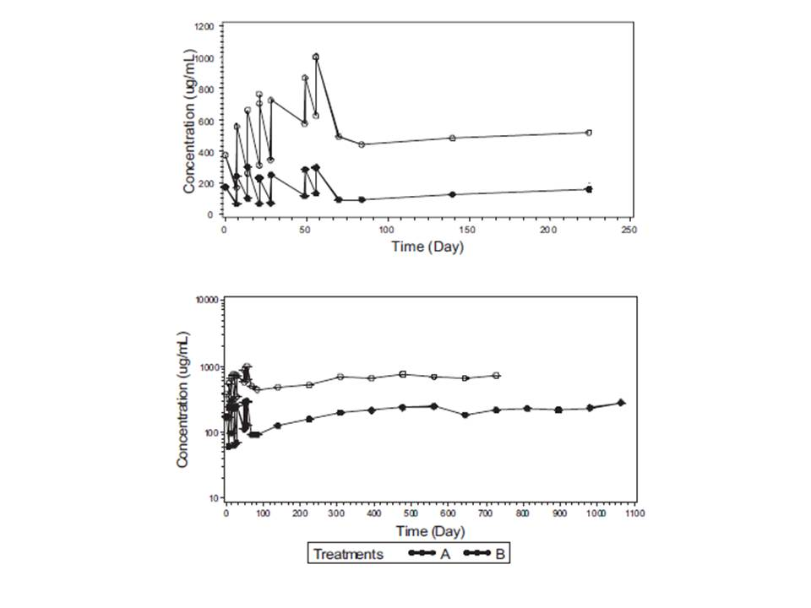

TREATMENT CODES: A: Elotuzumab 10 mg/kg + Lenalidomide + Dexamethasone; B: Elotuzumab 20 mg/kg + Lenalidomide + Dexamethasone

The geometric mean (%CV) Cmax after the first dose (Cycle 1 Day 1) was 173 (9) and 376 (14) μg/mL following administration of 10 mg/kg and 20 mg/kg E-Ld, respectively. Following multiple dose administration (ie, dose administered on Cycle 3 Day 1), the geometric mean (%CV) Cmax was 286 (32) and 972 (32) μg/mL following administration of 10 mg/kg and 20 mg/kg E-Ld, respectively. Thus, the Cmax increased by greater than 3-fold as the dose increased by 2-fold, indicating a greater than dose-proportional increase in exposure to elotuzumab following multiple dose administration. The geometric mean (%CV) Cmin on Cycle 3 Day 15 was 59.4 (78) and 466 (38) μg/mL following administration of 10 mg/kg and 20 mg/kg E-Ld, respectively. The 8-fold increase in the Cmin values relative to a 2-fold increase in the corresponding dose was indicative of a greater than dose-proportional increase in exposure to elotuzumab.

No definite conclusions could be drawn regarding the time to reach steady state in this study, as PK samples available in later cycles were limited.

###### Conclusions

Inter-individual variability in Cmax and Cmin showed a wide range of 9-95%, and was probably reflective of the small sample size. Following multiple dose administration of elotuzumab, the Cmax and Cmin demonstrated a trend of increasing in a greater than doseproportional manner.

Although elotuzumab PK exposure showed a non-linear increase between 10 mg/kg and 20 mg/kg treatment group, the efficacy and safety were not meaningfully different.

##### Study CA204007: A Phase 1b Study of Elotuzumab in Combination with Lenalidomide and Dexamethasone in Subjects with Multiple Myeloma and Normal Renal Function, Severe Renal Impairment, or End Stage Renal Disease Requiring Dialysis

###### Study Objectives and Design

Primary Objective:

* To assess the effect of severe renal impairment (SRI) and end stage renal disease (ESRD) on the single-dose PK of elotuzumab.

Secondary Objectives:

* To evaluate the safety of elotuzumab in combination with orally administered lenalidomide and low dose dexamethasone (E-Ld) in MM subjects with and without SRI and ESRD.
* To evaluate the immunogenicity of elotuzumab in subjects with and without SRI and ESRD.

Exploratory Objectives:

* To assess the degree and rapidity of renal function improvement with E-Ld in subjects with SRI and ESRD.
* To assess anti-myeloma activity of E-Ld in MM subjects with SRI and ESRD.
* To assess PK results in relation to estimated glomerular filtration rate (eGFR) as determined by the Modification of Diet in Renal Disease formula.

This was a Phase 1b, open-label, multicenter trial investigating elotuzumab PK in adult (age 18 years and older) male and female subjects with MM and SRI or ESRD. The study was designed as an open-label trial of E-Ld treatment, with a group of MM subjects with normal renal function (NRF) (creatinine clearance [CrCl] >/= 90 mL/min) included as an internal control. Eight subjects were assigned to each of the 3 renal function groups (referred to as treatment groups in the protocol): 8 subjects with NRF, 8 subjects with SRI (CrCl < 30 mL/min not requiring dialysis), and 8 subjects with ESRD (requiring hemodialysis).

###### Pharmacokinetic Results

The mean serum elotuzumab concentrations in Figure 2and Figure 3(C-G CrCl method) were lower for the NRF group compared to the SRI and ESRD groups. However, the differences in the mean profiles were small. Similar trends were observed with the mean serum concentration vs. time profiles for the renal function groups using MDRD eGFR method.

Figure 2: Mean (+SD) Elotuzumab Serum Concentration vs. Time Profile Following Cycle 1, Day 1 Dose - Grouping by Cockcroft-Gault Creatinine Clearance Method - Linear Scale.

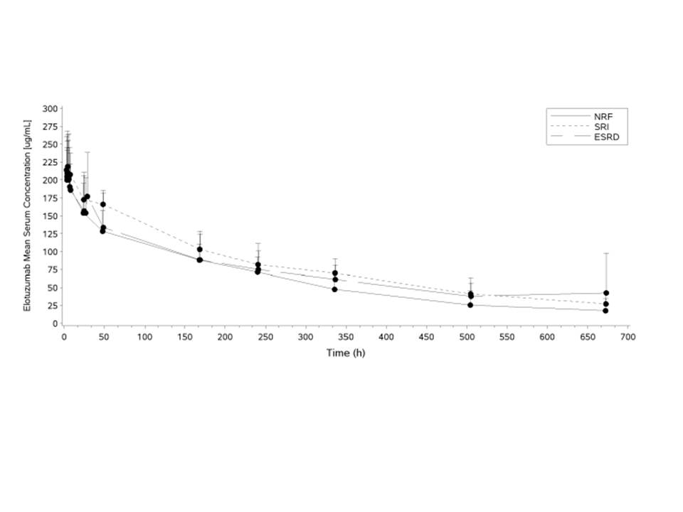

N=8, 7, and 8 for the NRF, SRI, and ESRD groups, respectively Mean post-dialysis concentrations at 48 h were excluded from the ESRD group due to N=1 Subjects CA204007-1705-1, CA204007-1714-177, and CA204007-1714-175 were excluded from mean summaries

Figure 3: Mean (+SD) Elotuzumab Serum Concentration vs. Time Profile Following Cycle 1, Day 1 Dose - Grouping by Cockcroft-Gault Creatinine Clearance Method - Semi-log Scale).

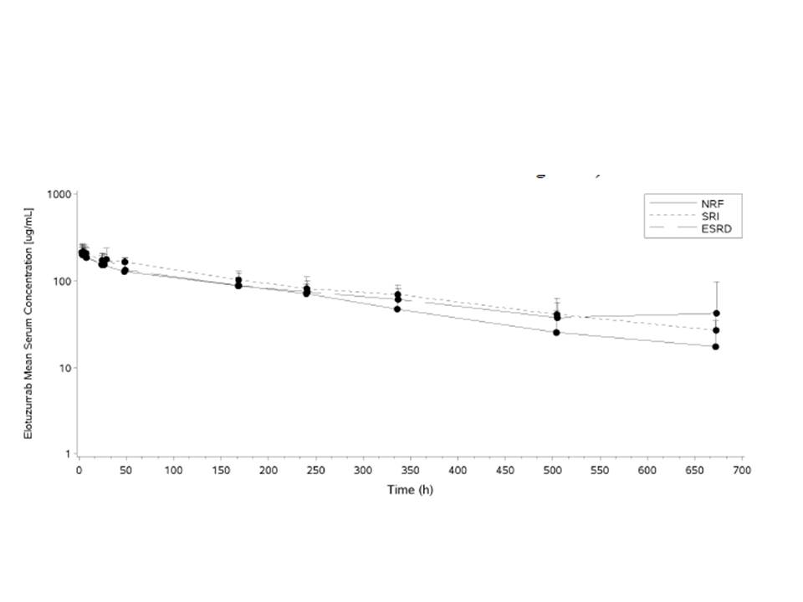

Mean post-dialysis concentrations at 48 h were excluded from the ESRD group due to N=1 Subjects CA204007-1705-1, CA204007-1714-177, and CA204007-1714-175 were excluded from mean summaries.

There were no statistically significant differences in PK parameters (Cmax, AUC(0-T), and AUC(INF)) for the NRF group compared to the SRI and ESRD groups, using CrCl method. There was a trend towards higher adjusted geometric mean of AUC(INF) for SRI and ESRD groups (by 29.9% and 10.4%, respectively), compared to NRF group. However, 90% CI included unity for these comparisons.

All 3 groups had comparable AUC(INF) values when two ADA positive subjects at Cycle 2 pre-dose in NRF group and one ADA positive subject at Cycle 2 pre-dose in ESRD group were excluded from the statistical summary.

Regression analysis of key PK parameters (Cmax, AUC(0-T), and AUC(INF)), using C-G CrCl method indicated no relationship between elotuzumab PK and renal function (based on the data from NRF and SRI groups).

There were 3 subjects excluded from PK parameter summary statistics and statistical analysis:

* Subject CA204007-1714-177, an 81 year-old White female in the SRI group, was excluded due to the sparse PK profile containing only 4 quantifiable concentration time points and a biologically implausible Cmax at 672 hours post-dose.
* Subject CA204007-1714-175, an 83 year-old White male in the SRI group, was excluded due to the pretreatment CrCl value outside the criterion of CrCl </= 30 mL/min (actual values were 36 mL/min and 33 mL/min).
* Subject CA204007-1705-1, a 48 year-old White female, in the ESRD group was excluded due to a high elotuzumab administered dose in Cycle 1, Day 1. Since a replacement subject was enrolled, this action did not affect the targeted sample size.

###### Conclusions

There were no statistically significant differences in PK parameters (Cmax, AUC(0-T), and AUC(INF)) between severe RI and end-stage renal disease groups compared to normal renal function group. Therefore, MM patients with impaired renal function can be dosed without any dose adjustment.

Higher adjusted geometric means for AUC(INF) was observed for the SRI (29.9%) and ESRD (10.4%) groups compared to the NRF group, which can potentially be attributed to high inter-individual variability in PK; 90% CI include 1 for these comparisons.

Slight differences in PK parameters between SRI and ESRD groups compared to NRF group were unlikely to be of clinical significance.

##### Study CA204011: A Phase 2 Biomarker Study of Elotuzumab (Humanized anti-CS1 Monoclonal IgG1 Antibody) Monotherapy to Assess the Association Between NK Cell Status and Efficacy in High Risk Smoldering Myeloma

###### Study Objectives and Design

Primary objective:

* To explore the association between baseline percent CD56dim/CD16+/ CD3-/CD45+ (CD56dim) Natural Killer (NK) cells in bone marrow and the maximal change in serum monoclonal protein in subjects with high-risk smoldering myeloma treated with elotuzumab (10 mg/kg or 20 mg/kg) monotherapy.

Secondary objectives:

* To estimate the objective response rate (ORR) by modified International Myeloma Working Group (IMWG) criteria;
* To evaluate the effects of elotuzumab on electrocardiogram (ECG) intervals, including corrected QT (QTc) intervals;
* To estimate the 2-year PFS rate.

Exploratory objectives:

* To assess the safety of elotuzumab (10 mg/kg and 20 mg/kg);
* To assess the PK and explore exposure-response relationships with respect to safety, efficacy, and biomarkers;
* To assess the immunogenicity of elotuzumab;
* To estimate PFS distribution, in the 2 dose cohorts
* To estimate time to response and duration of response, in the 2 dose cohorts;
* To identify and evaluate other potential baseline predictive biomarkers including sSLAMF7 and soluble major histocompatibility complex class I-related chain A (sMICA);
* To identify potential pharmacodynamic and predictive markers of response/resistance to elotuzumab using gene expression profiling.

This was a Phase 2, open-label, multicenter trial exploring the association between baseline percent CD56dim NK cells in bone marrow and the maximal change in serum monoclonal protein in subjects with high risk SMM treated with elotuzumab monotherapy. Enrolment in the 2 cohorts occurred in a sequential manner: the 20 mg/kg cohort followed by the 10 mg/kg cohort.

The study required 30 treated subjects. A total of 41 subjects were enrolled in this study. Thirty-one subjects received elotuzumab at 20 mg/kg (N=15) or 10 mg/kg (N=16).

###### Pharmacokinetic Results

The mean concentrations at 30 minutes following the end-of-infustion after the first dose (Cycle 1, day 1 were 78.0 (n=16) and 155 (n=15) μg/mL for the 10 and 20 mg/kg dose groups, respectively, suggesting a dose-related increase in elotuzumab concentrations. The mean predose concentrations at Cycle 6 Day 1 were 173 (n=14) and 84.3 (n=13) μg/mL for the 10 and 20 mg/kg dose groups, respectively. The predose sample at Cycle 6 Day 1 was representative of the steady state trough concentration since each cohort had completed at least 3 maintenance cycles (12 weeks) by this timepoint; which was adequate to reach steady state. Also, since the 20 mg/kg dose was administered every 4 weeks, contrasted with the 10 mg/kg dose which was administered every 2 weeks during each maintenance cycle, the steady state trough concentrations for the 20 mg/kg dose group were expected to be lower than the 10 mg/kg dose group, as confirmed from the observed trough concentrations.

Pharmacokinetic data collected in this study was used for population PK modeling and exposure-response analyses.

##### Study HuLuc63-1701: Phase 1, Multi-Center, Open-Label, Dose Escalation Study of Elotuzumab (Humanized anti-CS1 Monoclonal IgG1 antibody) in Subjects with Advanced Multiple Myeloma

###### Study Design and Objectives

Primary objectives:

* To identify the maximum tolerated dose (MTD) of elotuzumab administered intravenously
* To evaluate the safety of elotuzumab intravenously given every other week.

Secondary objectives:

* To evaluate the pharmacokinetics (PK) of elotuzumab
* To evaluate the immunogenicity of elotuzumab
* To evaluate the potential clinical activity of elotuzumab in relapsed/refractory MM, as defined by the European Group for Blood and Marrow Transplantation (EBMT) response criteria
* To evaluate the long-term safety of elotuzumab given intravenously every other week.
* To evaluate the pharmacodynamics (PD) of elotuzumab.

###### Pharmacokinetic Results

Following administration of the first dose, Cmax increased in a dose proportional manner across the dose range of 0.5 to 20 mg/kg with the slope (β) of 1.026 and 95% confidence interval of 0.9423 to 1.109 estimated by the power model. Mean estimates of AUCτ and AUCinf increased greater than proportionally with dose over the dose range of 0.5 to 20 mg/kg with estimated slopes of 1.219 (95% confidence interval of 1.074 to 1.365) and 1.315 (95% confidence interval of 1.11 to 1.524), respectively. A value of β = 1.026 represented that the PK parameters of interest changed proportionally with dose. Elotuzumab clearance decreased and terminal phase half-life appeared to increase with an increase in dose from 0.5 to 20 mg/kg suggesting a saturation of target-mediated clearance, resulting in greater than proportional increases in exposure compared to dose.

Elotuzumab volume of distribution (approximately 3 to 6 L) approximated the serum volume.

The elotuzumab serum concentration appeared to reach the steady state after administration of the second dose when elotuzumab was administered IV every 2 weeks at doses of 0.5 to 2.5 mg/kg, at approximately 0.3 µg/mL, 4 µg/mL and 7 µg/mL for doses 0.5, 1.0 and 2.5 mg/kg, respectively. However, the trough serum concentration of elotuzumab continuously increased through administration of the fourth dose for the doses of 5 to 20 mg/kg. Following administration of the fourth dose, the geometric mean accumulation ratio varied with dose and ranged from 0.7 to 1.8.

##### Study CA204004: Population Pharmacokinetic and Exposure-response Analysis in Relapsed or Refractory Multiple Myeloma Patients Treated With Elotuzumab With or Without Combination Lenalinomide and Dexamethasone

###### Study Design and Objectives

Objectives were to:

* To characterize elotuzumab PK in patients with relapsed or refractory multiple myeloma and to determine exposure in these patients
* To characterize the relationship between elotuzumab exposure and progression-free survival (PFS) in relapsed or refractory multiple myeloma patients
* To characterize the relationship between elotuzumab exposure and time to first occurrence of Grade 3+ AEs and time to AEs leading to discontinuation or death (excluding death due to disease progression).

Elotuzumab PK was characterized by population pharmacokinetic (PPK) analysis with 6958 elotuzumab serum concentration values from 375 subjects with multiple myeloma, who were enrolled in the following 4 clinical studies: 2 Phase 1 studies (CA204005 and CA204007), 1 Phase 2 study (CA204011), and 1 Phase 3 study (CA204004).

The exposure-response (E-R) analysis of PFS and time to first occurrence of Grade 3+ AEs and time to AEs leading to discontinuation or death was conducted using data from multiple myeloma patients from study CA204004 who received lenalidomide/dexamethasone with or without elotuzumab and for whom estimates of elotuzumab exposure were available from the PPK analysis (N = 629). The elotuzumab exposure in patients in the control arm (lenalidomide/dexamethasone with placebo) of CA204004 was assumed to be zero.

The elotuzumab PPK model was developed in 3 steps, namely base, full and final model. The base model was a two compartment model with zero order IV infusion, parallel linear and Michaelis-Menten elimination from the central compartment, and additional target-mediated elimination from the peripheral compartment. The model was parameterized in terms of the following PK parameters: clearance (nonspecific linear clearance denoted as CL), volume of distribution of the central compartment (VC), intercompartmental clearance (Q), volume of distribution of the peripheral compartment (VP), the maximum rate of Michaelis-Menten elimination (VMAX), Michaelis-Menten constant (KM), initial target SLAMF7 concentration in the peripheral compartment (RMAX), and second-order elimination rate constant of the drug-target complex from the peripheral compartment (kint).

Second, a full model was developed to determine the magnitude of covariate effects on the base model PK parameters. The following parameter-covariate relationships were included in the full model:

* CL ~ body weight (BW), age, sex, estimated glomerular filtration rate (eGFR), lactate dehydrogenase (LDH), Eastern Oncology Group (ECOG) performance status, serum M-protein, serum β2-microglobulin (B2MICG), race, hepatic impairment, albumin, and concomitant lenalidomide/dexamethasone
* VC ~ BW, sex, B2MICG, race
* VMAX ~ serum M-protein;
* VC and Q ~ Body weight.

Lastly, the final model was developed by backward elimination of these based upon improvement in Bayesian Information Criterion (BIC). The performance of the final model was assessed by standard diagnostic plots.

###### Population Pharmacokinetics Analysis

###### Time Dependence of Pharmacokinetics and Time To Steady-State Exposure

Concentration-time curves (Figure 4) and distributions of Cmin values over time simulated from the final model for 10 mg/kg regimen as in the protocol of Study CA204004 (QW for two 28-day cycles followed by Q2W administration) show that the more intensive initial dosing allowed attainment of exposures above steady-state level approximately 6 weeks after the start of elotuzumab dosing. While concentrations continue to rise for another 3 weeks of QW dosing, they decrease back to values attained at 5 to 6 weeks after switching to Q2W dosing. The fraction of patients with Cmin above 70 μg/mL, which is considered to be the target concentration threshold associated with maximum efficacy in the preclinical mouse xenograft model, was approximately ≥ 90% after the first cycle.

Figure 4: Predicted Elotuzumab Concentration-Time Course Following 10 mg/kg Elotuzumab Administered QW for Two 28-day Cycles Followed by Q2W for Subsequent Cycles

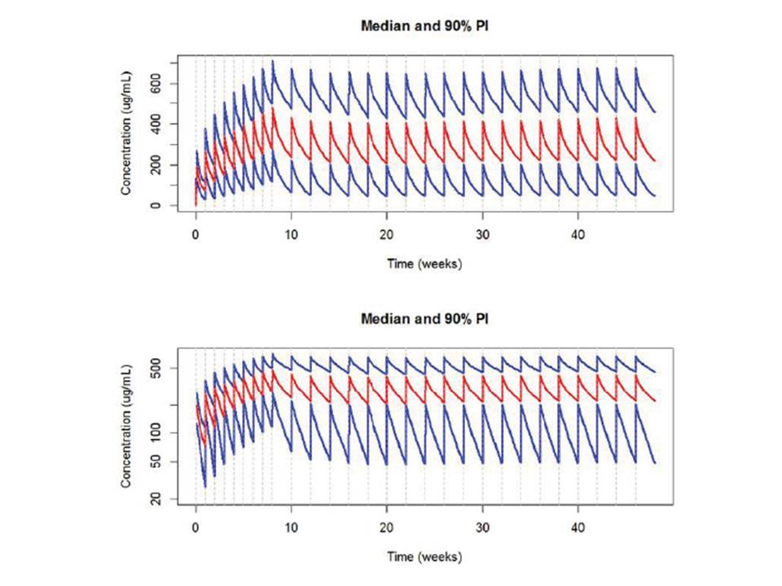

Note: The red (blue) lines represent median (5th and 95th percentiles) of elotuzumab concentration distribution (top: arithmetic scale, bottom: semi-log scale). Conditional predictions for all patients with concomitant dexamethasone/lenalidomide administration were used to compute these percentiles

To compute the effective half-life and accumulation ratio, elotuzumab concentration-time curve was simulated for a typical patient with or without lenalidomide/dexamethasone administration for 10 mg/kg QW dosing regimen. For patients with lenalidomide/dexamethasone AUC accumulation ratio was estimated to be 7.42, with the corresponding effective half-life of 33.5 days. Without lenalidomide/dexamethasone, the corresponding values were 5.32 and 23.3 days, respectively.

###### Influence of Body Weight on Model Parameters and Exposure

The PPK analysis indicated that elotuzumab CL and VC increase with body weight. Inter-compartmental clearance (Q) and VP also increase with body weight. Patients weighing 51 kg had 34.4% lower clearance compared to patients weighing 75 kg, and patients with weight of 106 kg had 46% higher CL, respectively. Weight-based dosing generated uniform exposures across a range of body weights and minimized the IIV of elotuzumab exposure.

###### Influence of Serum M-Protein on Model Parameters and Exposure

The PPK analysis showed that there was no relationship between baseline serum M-protein and nonspecific (linear) clearance.

###### Influence of Concomitant Lenalidomide/Dexamethasone on Elotuzumab Exposure

The PPK analysis showed that coadministration of lenalidomide/dexamethasone decreases nonspecific CL (Figure 5) thus increasing the steady-state exposure. In patients without coadministration of lenalidomide/dexamethasone, CavgSS, CmaxSS, CminSS, and AUCSS were 29%, 12%, 44%, and 28% lower, respectively, than the corresponding values of patients coadministered these medications.

Figure 5: Dependence of Elotuzumab Nonspecific (Linear) Clearance on Lenalidomide/Dexamethasone Administration.

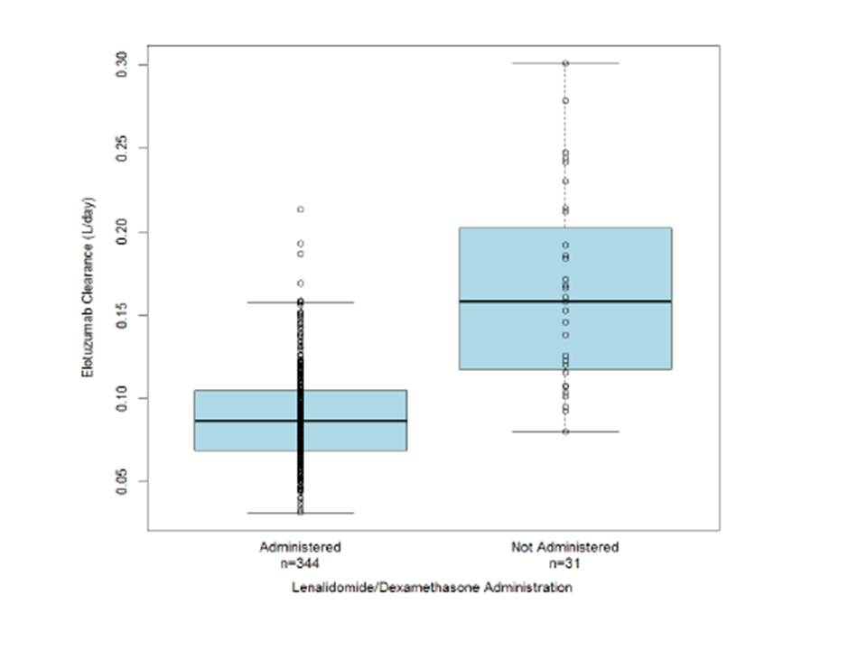

Note: Conditional predictions (circles) for all patients. Boxes represent 25th and 75th percentiles of the distributions, the bold line in the middle of the boxes represents median. Whiskers represent 1.5 inter-quartile range.

###### Influence of β2-microglobulin on Elotuzumab Exposure

The PPK analysis showed that baseline B2MICG has no influence on PK parameters except for central volume of distribution, which is increased by 13% in patients with B2MICG > 3.5 mg/L (cutoff based on the stratification factor in study CA204004). The decrease of steady-state exposures for patients with baseline B2MICG > 3.5 mg/L did not exceeded 17.5%.

###### Influence of Asian Race and Japanese Country of Origin on Elotuzumab Exposure

The PPK analysis showed that Asian race has no influence on PK parameters except for central volume of distribution, which is only 14% lower in Asian patients. Most Asian patients were from Japan (37 out of 40), and models with Japan covariate were equivalent to models with Asian race. The simulations showed that differences in exposure between Asian and non-Asian patients did not exceed 15% for all exposure measures.

###### Influence of Sex on Model Parameters and Elotuzumab Exposure

The PPK analysis showed that sex has no influence on PK parameters except for central volume of distribution, which is only 20% lower in female patients. However, the simulations showed that differences in exposure between male and female patients did not exceed 10% for all exposure measures.

###### Influence of Age, ECOG Score, Hepatic and Renal Impairment, and Baseline Albumin, LDH, eGFR, and Modified Diet in Renal Disease on Model Parameters

None of the model parameters were influenced by the following covariates: age, ECOG score, hepatic and renal impairment, and baseline values of albumin, LDH, or eGFR (computed both ways, according to CKD-EPI and MDRD equations.

###### Relationships Between Immunogenicity, Exposure, and Pharmacokinetic Parameters

Among 344 patients with concomitant lenalidomide/dexamethasone administration, 61 (17.7%) had observed ADAs. The individual estimates of elotuzumab clearance and central volume of distribution were independent of ADA status, while target-mediated elimination was higher (ie, VMAX was higher and KM was lower) in patients with detected ADAs. Model-based simulations of elotuzumab exposure showed lower exposure in patients with ADAs. For these patients, CavgSS, CmaxSS, CminSS, and Cmin1 were, respectively, 29%, 22%, 36%, and 48% lower than the corresponding values for patients without ADAs. Note that the largest difference was observed for the minimum concentration after the first dose (Cmin1), before the ADAs could potentially develop and therefore it is unlikely that a decrease in elotuzumab exposure was due to an ADA mediated effect. Thus, lower elotuzumab exposure seen in patients that had ADAs detected may not be due to a direct causal relationship, but could be a result of other factors associated with these patients. Baseline serum M-protein concentrations were higher in patients with detected ADAs, and according to the model target-mediated elimination (VMAX) strongly increases with increasing serum M-protein. However, since the ADAs of the majority of the subjects were transient, resulting in corresponding transient increase in nonspecific clearance at these time points, PK exposures were considered to return to baseline at later time points when ADAs were no longer detected.

##### Study CA204009: Population Pharmacokinetic and Exposure-response Analysis of Efficacy in Patients with Relapsed or Refractory Multiple Myeloma who were Coadministered Bortezomib/Dexamethasone With or Without Elotuzumab

###### Study Design and Objectives

Objectives were to perform an external evaluation of the previously developed elotuzumab PPK model using data from relapsed or refractory multiple myeloma (MM) patients from study CA204009 and to assess the effect of coadministration of bortezomib/dexamethasone with elotuzumab on elotuzumab PK parameters; and to characterize the relationship between elotuzumab exposure and progression free survival (PFS) in relapsed or refractory MM patients who were coadministered bortezomib/dexamethasone with elotuzumab.

The external evaluation of the PPK model of elotuzumab in patients with relapsed or refractory MM was performed by combining the initial PPK dataset with data from the Phase 2 study (CA204009) using 476 elotuzumab serum concentration values from 74 subjects, resulting in a final PPK dataset with 449 subjects with MM with or without concomitant lenalidomide/dexamethasone or bortezomib/dexamethasone administration. 3 different models were fitted to the combined data set. First, the final model of the earlier PPK analysis with fixed population parameters was applied. Then, the same model was applied but the parameters of the model were re-estimated. Finally, additional effects were introduced that accounted for differences in elotuzumab clearance when elotuzumab is coadministered with lenalidomide/dexamethasone and bortezomib/dexamethasone and the model parameters were re-estimated

###### Population Pharmacokinetic Analysis

Based on the earlier PPK model, elotuzumab PK was adequately described with a two compartment model with zero order IV infusion, parallel linear and Michaelis-Menten elimination from the central compartment, and additional target-mediated elimination from the peripheral compartment. The parameters of the refined model that included study CA204009 were compared with the parameters (and their 95% confidence intervals [CI]) of the final PPK model developed earlier. Coadministration of lenalidomide/dexamethasone or bortezomib/dexamethasone resulted in a 35% (95% C.I.: 24% - 44.4%) or 50.1% (95% CI: 39.8% - 58.7%) decrease in elotuzumab clearance, respectively. All the other parameters of the updated model were inside the 95% CIs of the final model parameter estimates. Specifically, the estimates of the main structural parameters (CL, VC, Q, and VP) were very similar, with differences not exceeding 3.9%. Differences between the models in the parameters of the nonlinear elimination pathways were up to 11.7%. Differences in the covariate effect parameters were below 4.4% except for the effects of body weight on VC and VP (differences of 11.3% and 16.1%, respectively). Differences in the estimates of the variances of inter-individual random effects were below 4.9% except for the variance on RMAX parameter estimated to be 19.7% lower in the model with the combined data set. The residual error was estimated to be slightly lower in the model with the combined data set.

###### Conclusions

* Coadministration of bortezomib/dexamethasone background therapy resulted in a 50% reduction of elotuzumab nonspecific clearance.
* In the majority of ADA-positive patients, immunogenicity started early, was transient, and was resolved by 2 to 4 months. However, lower steady-state exposure was observed for ADA positive subjects. This was most likely confounded by baseline M-protein levels, and therefore no causal relationship can be established between positive ADA response and elotuzumab steady state exposure.

###### Rationale for Dose Selection

The recommended elotuzumab dosage was selected based upon an integrated assessment of data from in vitro, preclinical, and clinical studies and is as follows:

* 10 mg/kg administered intravenously (IV) every week for the first two cycles and every 2 weeks thereafter when administered with lenalidomide and dexamethasone
* 10 mg/kg administered IV weekly for the first 2 cycles, on Days 1 and 11 for the next 6 cycles and every 2 weeks thereafter when administered with bortezomib and dexamethasone

The early Phase 1/2 clinical studies examined the clinical pharmacology, immunogenicity, efficacy, and safety of elotuzumab given over a range of doses in relapsed/refractory MM subjects (monotherapy Phase 1 Study HuLuc63-1701, Phase 2 Study HuLuc63-17033 in combination with lenalidomide/dexamethasone and Phase 1 Study HuLuc63-17024 in combination with bortezomib [and dexamethasone if added at the end of Cycle 2 or 3]). The administration schedule of elotuzumab was refined with the PK, PD, efficacy, and safety results and further investigated in a pivotal randomized Phase 3 study in relapsed/refractory MM subjects (CA204004) who received lenalidomide/dexamethasone with or without elotuzumab, and a randomized Phase 2 study in relapsed/refractory MM subjects (CA204009)2 who received bortezomib/dexamethasone with or without elotuzumab. The treatment cycle for lenalidomide/dexamethasone was a 28-day cycle; whereas, for bortezomib/dexamethasone was a 21-day cycle in Cycles 1-8 and became a 28-day cycle after Cycle 9. Since the elotuzumab dosing regimen was added onto these backbone schedules, this strategy lead to the differences in elotuzumab schedules in Study CA204004 versus Study CA204009. These data are presented in Section 3.4 Rationale for Dose Selection, Module 2.7.2, Summary of Clinical Pharmacology Studies.88

Specific clinical findings that contributed to the selection of the Phase 2/3 dose and regimen were as follows:

* The 10 mg/kg dose and the frequency of administration in combination with lenalidomide/dexamethasone or in combination with bortezomib/dexamethasone provided target exposure at steady-state in the proximity of 70 µg/mL or greater, the target threshold concentration for maximal efficacy observed in the preclinical xenograft human MM mouse model.
* SLAMF7 RO was maintained at high levels (> 80%) at the 10 mg/kg dose and over multiple cycles of drug administration.
* In the Phase 2 dose ranging studies, the nature, frequency, and severity of AEs and clinical efficacy at the 10 mg/kg dose were similar to the 20 mg/kg dose in relapsed or refractory MM subjects. In addition, based on exposure-response analysis from Phase 2 Study HuLuc63-1703, no definite conclusions can be drawn that higher steady-state exposure leads to a reduction in hazard for disease progression, indicating that both 10 and 20 mg/kg doses achieved maximum possible efficacy.

The results of the randomized, controlled, Phase 2 and Phase 3 studies demonstrated statistically significant and clinically meaningful improvement in efficacy and an acceptable safety profile, even though the backbones differed between the two studies. In summary, both the 10 mg/kg and 20 mg/kg dose levels of elotuzumab demonstrated clinically meaningful ORR and PFS in the HuLuc63-1703 Phase 2 study. A significant difference between the two dose cohorts was not observed, with respect to ORR and PFS. The safety profile of elotuzumab is consistent across doses and does not appear to be dose dependent. Pharmacokinetic analysis suggests that the 10 and 20 mg/kg dose levels lead to a trough serum elotuzumab concentration above the target levels of 70 μg/mL determined to be effective in preclinical models. In addition, saturation of the target, SLAMF7 is above 80% at 10 and 20 mg/kg. Based on these key data points during the 10-July-2010 End of Phase 1 meeting, FDA advised that the lower dose level should be utilized for further clinical development. Therefore, based upon saturation of SLAMF7, PK of elotuzumab, the safety/efficacy profile, and FDA feedback, the 10 mg/kg dose was selected for the Phase 3 clinical development.

### Evaluator’s overall conclusions on pharmacokinetics

The application included detailed characterizations of the clinical pharmacology of elotuzumab, which were based on preclinical studies and clinical development in Phase 1, 2 and 3 studies. Pharmacokinetic assessments included single- and multiple-dose PK, dose proportionality, accumulation ratio, and impact of renal dysfunction.

Pharmacokinetic assessments were performed for elotuzumab monotherapy in a Phase 1 study (HuLuc63-1701) and a Phase 2 study (CA204011); in combination with bortezomib and dexamethasone in a Phase 1 study (HuLuc63-1702), and a Phase 2 study (CA204009); in combination with lenalidomide and low-dose dexamethasone in a Phase 1 study (CA204005), a Phase 1b study (CA204007), a Phase 1b/2 study (HuLuc63-1703), and a Phase 3 study (CA204004).

Single dose PK of elotuzumab was investigated in 4 studies (HuLuc63-1701, HuLuc63-1702, CA204005, and CA204007), after the administration of the first IV dose.

The PPK analyses for elotuzumab/lenalidomide/dexamethasone were based on data from a Phase 1 study (CA204005), a Phase 1b study (CA204007), a Phase 2 study (CA204011), and a Phase 3 study (CA204004). Data from these studies comprised the PPK analysis dataset (375 subjects; 6958 samples). The PPK model for elotuzumab/bortezomib/dexamethasone that was developed with data from the above 4 studies was evaluated and refined with additional PK data from the randomized Phase 2 Study CA204009 (74 subjects; 476 samples).

All studies were conducted as planned and protocol deviations and violations were provided. Collection and storage of samples were described and adequate. The assays used to determine plasma concentrations were adequately described and validated (Section 4.1). In support of Phase 1 and 2 clinical trials, an Abbott Biotherapeutics inhouse ELISA method with a low sensitivity was used. For PK assay support in Phase 3 studies, the ELISA was transferred to Tandem Labs and the assay was updated to have a higher MRD and remove the background subtraction, since it was not necessary to have very low assay sensitivity. A cross validation of the assays was performed to compare the two methods. However, the AbbVie PK assay SOP 30-0592_00 and the BMS PK assay TLIAM-0180 did not meet the pre-established cross-validation criteria. A sensitivity analysis using a PPK approach demonstrated that inclusion of PK data from 2 of the AbbVie studies (HuLuc63-1701 and HuLuc63-1703) had minimal impact on the PPK model parameters of elotuzumab. However, only PK data from BMS clinical studies (CA204004, CA204005, CA204007, and CA204011) were used for PPK analysis and results from this analysis were used to provide PK information for the labelling.

The PK of elotuzumab in MM patients was nonlinear. Following administration of a single dose, elotuzumab clearance decreased from 17.5 to 5.8 mL/day/kg, and the area under the serum concentration-time curve increased in a greater than dose proportional manner over the dose range of 0.5 to 20 mg/kg. The nonlinearity of elotuzumab PK was consistent with target-mediated drug disposition and was described by a two compartment model with zero order IV infusion, parallel linear and Michaelis-Menten elimination from the central compartment and time dependent, target mediated elimination from the peripheral compartment.

For all provided studies inclusion/exclusion criteria were appropriate and compliance with treatment was acceptable.

Population PK based simulations indicated that following administration of elotuzumab at 10 mg/kg in combination with lenalidomide/dexamethasone or bortezomib/dexamethasone, values for the mean effective half-life of elotuzumab were 33.5 and 43.1 days, respectively, and an AUC accumulation ratio of 7.42 and 9.40, respectively. The prolonged half-lives were in part attributable to concomitant dexamethasone administration. After discontinuation of treatment, serum elotuzumab concentrations decreased to approximately 3% (approximately 97% washout) of the population predicted steady-state maximal concentration by 3 months. Nonspecific (linear) clearance of elotuzumab increased with increasing body weight and the nonlinear clearance increased with baseline M-protein.

Renal function did not significantly affect elotuzumab PK, indicating that no dose adjustment is required in patients with renal dysfunction, which includes ESRD undergoing dialysis. No clinically important differences in the clearance of elotuzumab were found between patients with mild hepatic impairment and patients with normal hepatic function. Population PK analysis suggested no differences in clearance of elotuzumab based on age, sex, race, baseline LDH, albumin, β2-microglobulin, mild hepatic function, renal function, and ECOG performance status.

Monoclonal antibodies are not direct inhibitors/inducers of metabolizing enzymes and are eliminated by metabolic pathways that are divergent from small molecules; consequently direct drug–drug interactions (DDIs) between mAb and small molecules are thought to be unlikely. This was considered an acceptable explanation for not performing formal PK DDI studies. Elotuzumab treatment resulted in transient changes in circulating cytokines across the dose range 0.1 to 20 mg/kg that were not time- or dose dependent and, therefore, are not considered to be clinically meaningful. This finding suggested elotuzumab has a low potential for modulating CYP enzymes and is a low risk to impact the PK of other drugs and for therapeutic protein-drug interactions.

The 10 mg/kg dose of intravenous elotuzumab on days 1, 8, 15, and 22 during the first two cycles and then on days 1 and 15 starting with the third cycle, given in 28-day cycles until disease progression, in combination with lenalidomide/dexamethasone or in combination with bortezomib/dexamethasone provided steady-state target exposure in the proximity of 70 μg/mL or greater, the target threshold concentration associated with maximal efficacy observed in the preclinical xenograft multiple myeloma mouse model.

## Pharmacodynamics

### Studies providing pharmacodynamic data

Patient PD and PK/PD data were included in the following study reports: HuLuc63-1701, HuLuc63-1702, CA204011, and CA204009.

### Summary of results of individual studies

#### Study HuLuc63-1701: Dose Escalation Study of Elotuzumab in Subjects with Advanced Multiple Myeloma

##### Pharmacodynamics

Fluorescent activated cell sorting (FACS) analysis was performed on subjects who were exposed to elotuzumab antibody during this study. Peripheral blood specimens were collected at screening and on Day 0 visits prior to dosing, as well as post-dosing at pre-specified visits throughout the study. Bone marrow samples were also collected and analysed for CS1 expression on antigen rich NK, as well as CD38+ and CD138+ putative myeloma cells. Substantial reductions in peripheral blood T, B and NK cell counts were consistently observed following first infusions with elotuzumab. These reductions in major lymphocyte subsets were transient, as cell counts returned to approximate baseline levels prior to subsequent elotuzumab doses and there were no instances of lymphocyte depletion caused by repeated elotuzumab dosing. Figure 6 depicts the changes in NK cells.

Figure 6: Changes in NK cells.

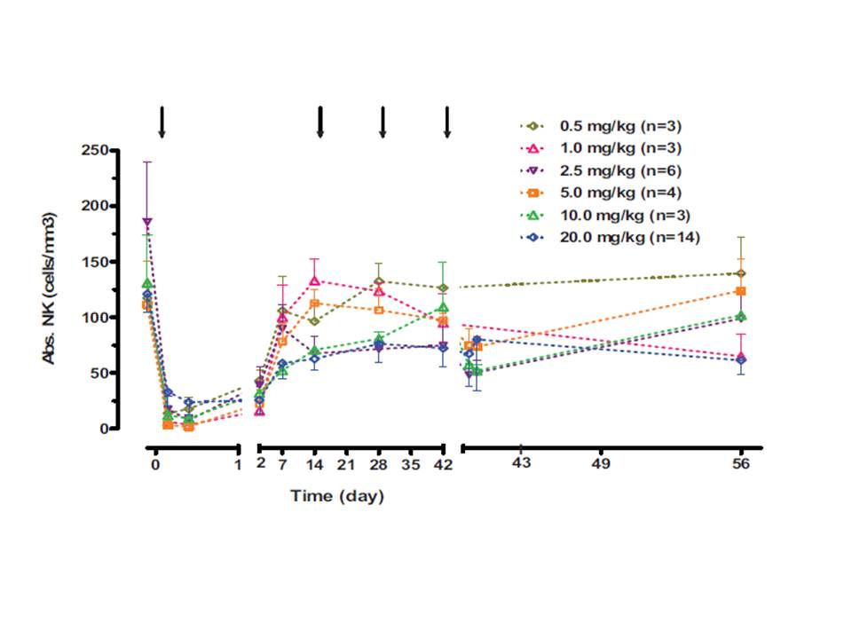

Mean and standard error for each dosing group are shown for nominal visits during Course 1 Numbers of subjects per dosing group are indicated (n=x). Dosing days are indicated with downward arrows. Post dosing collections were taken on Day 0 and Day 42, at 2 and 4 hours.

##### Evaluation of Pharmacokinetic/Pharmacodynamic Relationships

More than 80% of the antigen-rich peripheral blood NK cells appeared to have fully occupied (i.e., saturated) CS1 receptors when serum concentrations of elotuzumab reached between 10 to 100 μg/mL (Figure 7). Similar trends of CS1 saturation by elotuzumab antibody were also observed on bone marrow NK cells, as well as antigen rich CD38+ and CD138+ putative myeloma cells at Study Day 56 (14 days after the last dose of elotuzumab), when serum concentrations of elotuzumab were approximately 10 or greater μg/mL.

Figure 7: CS1 Saturation on Peripheral blood NK Cells at Day 56

Figure 7: CS1 Saturation on Peripheral blood NK Cells at Day 56

Symbols: observed data from individual subject at each dose level Dashed curve: CS1 occupancy curve of peripheral blood NK cells. Dashed line at 80%: empirically selected occupancy value representing fully saturated CS1 sites.

#### Study CA204011: Phase 2 Biomarker Study of Elotuzumab (Humanized anti-CS1 Monoclonal IgG1 Antibody) Monotherapy to Assess the Association Between NK Cell Status and Efficacy in High Risk Smoldering Myeloma

##### Pharmacodynamics

The majority of NK cells in both the tumor microenvironment and in the periphery were of the CD56dim subset. The NK cell subset associated with enhanced potential for cytotoxic activity and highest percentage of SLAMF7 expression. Following treatment, both CD56dim and CD56brt (CD45+/CD3-/CD56brt/CD16-) NK cells were reduced at C2D1 with the 10 mg/kg cohort showing the greatest effect. Levels of sSLAMF7 prior to treatment were above the LLOQ (lower limit of quantitation) of 0.051 ng/mL and showed 1.7 ng/mL for the 20 mg/kg cohort and 2.6 ng/mL for the 10 mg/kg cohort. Both cohorts demonstrated similar and significant fold increased in total sSLAMF7 at C2D1 while the 10 mg/kg cohort showed a greater absolute increase in absolute sSLAMF7.

##### Soluble Serum Protein Assessments

Serum samples were collected prior to therapy (C1D1) and at C2D1 to assess levels of soluble SLAMF7 (sSLAMF7) and sMICA. In the case of sSLAMF7, the levels recorded represent total amount of protein - free (unbound by elotuzumab) and elotuzumab-bound sSLAMF. Levels of sSLAMF7 prior to treatment were above the LLOQ of 0.051 ng/mL and showed 1.7 ng/mL in the 20 mg/kg cohort and 2.6 ng/mL in the 10 mg/kg cohort. Both cohorts demonstrated similar and significant fold increased in total sSLAMF7 at C2D1 while the 10 mg/kg cohort showed a greater absolute increase in absolute sSLAMF7. Measurements for sMICA yielded only 8 samples (6 for C1D1 and 2 for C2D1) with values >LLOQ of the assay (80 ng/mL) thereby limiting interpretation of sMICA changes.

#### Study CA204009: Population Pharmacokinetic and Exposure-response Analysis of Efficacy in Patients with Relapsed or Refractory Multiple Myeloma who were Coadministered Bortezomib/Dexamethasone With or Without Elotuzumab

##### Pharmacodynamics

To address PD changes in peripheral blood NK cells following E-Bd versus Bd, samples were collected at Cycle 1 Day (C1D1) and Cycle 2 Day 1 (C2D1) and at end of treatment. There was a general decline in total NK cells after initial doses of therapy observed at C2D1 for both groups. However, the decline appeared to be more pronounced in the E-Bd group compared to the control Bd group, suggesting that elotuzumab may contribute to declining peripheral blood NK numbers during initial doses (Figure 8). This effect was somewhat transient, as NK cell numbers recovered to near-baseline levels by end of therapy.

Figure 8: Peripheral Blood Natural Killer Cell Counts/Percentage, All Treated Subjects

Figure 8: Peripheral Blood Natural Killer Cell Counts/Percentage, All Treated Subjects

Baseline natural-killer cell values are reported at C1D1.

### Summary of pharmacodynamics

Pharmacodynamic assessments included percent saturation (receptor occupancy of SLAMF7, temporal changes in T, B, and NK cells during the first course of treatment, temporal changes in SLAMF7 expression in peripheral blood and bone marrow, temporal changes in cytokines/chemokines/growth factors, baseline soluble SLAMF7 (sSLAMF7), and association of cell counts for major immune subsets in relation to clinical response as defined by EBMT criteria. PD and PK/PD data were included in 3 of the Module 5 clinical study reports: CA204011, HuLuc63-1701 and CA204009.

In humans, > 80% saturation of SLAMF7 receptors by elotuzumab on antigen-rich peripheral blood NK cells, bone marrow NK cells, as well as bone marrow plasma cells was observed when serum concentrations of elotuzumab were between 10 and 100 µg/mL. Elotuzumab concentrations exceeding 10 µg/mL were achieved at predose on Day 8 following the first infusion and higher concentrations are sustained after multiple dosing with the recommended 10 mg/kg dosage of elotuzumab to relapsed/refractory MM patients. At these concentrations, in vitro data suggested near complete saturation of SLAMF7 receptors by elotuzumab. The target threshold concentration of elotuzumab associated with maximal efficacy in the preclinical xenograft mouse model was identified as 70 µg/mL, with an upper limit of 430 µg/mL.

Transient decreases in all lymphocytes, including NK cells, were observed post dose with the first infusion of elotuzumab which was attenuated after repeated administration. This transient decrease occurred in all lymphocyte subsets examined regardless of their SLAMF7 expression (resting B cells, CD8+ T cells, and CD4+ T cells have minimal to no detectable surface expression of SLAMF7). Lymphocyte cell trafficking out of the periphery may be one possible explanation to account for the reduction in cell counts due to the transient increase in interferon gamma-induced protein 10 (IP-10), a chemokine that stimulates migration of activated T cells and NK cells.

Elotuzumab can cause the release of cytokines, chemokines, and growth factors in vitro as well as in vivo. Most individuals showed a transient increase in three chemokines or cytokines, tumor necrosis factor α (TNF-α), IP-10, and monocyte chemoattractant protein 1 (MCP-1), with a trend for levels to return to baseline. Other chemokines or cytokines, including IL-6, also showed a similar pattern. Reactions due to cytokine release can be minimized by appropriate hydration and diuresis, premedications, and incremental increases in the rate of infusion of elotuzumab. There was no relationship between SLAMF7 expression on plasma cells in bone marrow aspirates at baseline and best confirmed clinical response as determined by International Myeloma Working Group (IMWG) criteria or PFS in subjects treated with elotuzumab in combination with lenalidomide/dexamethasone. Therefore, the data suggested that pretreatment testing of SLAMF7 on bone marrow plasma cells was not warranted prior to administering elotuzumab in combination with lenalidomide/dexamethasone or bortezomib/dexamethasone to relapsed/refractory MM patients. Also, SLAMF7 is expressed on nearly all myeloma cells (> 97%) and thus pretreatment testing would not distinguish many patients since they would all have SLAMF7 expression. In addition to being a cell surface receptor, SLAMF7 also exists as at least one soluble or shed form (sSLAMF7) that can be readily detected at low but significantly higher concentrations in the serum of patients with MM compared to healthy individuals. There was no relationship in serum sSLAMF7 concentrations at baseline and best confirmed response or PFS in subjects treated with elotuzumab in combination with lenalidomide/dexamethasone. Due to the lack of species-specific cross-reactivity, there were no relevant animal species in which to conduct safety pharmacology studies.

#### Mechanism of action

Elotuzumab is a first-in-class, immunostimulatory, humanized immunoglobulin G1 monoclonal antibody targeted against Signaling Lymphocyte Activation Molecule Family 7 (SLAMF7, also called CS1), a glycoprotein highly expressed on myeloma cells independent of cytogenetic abnormalities. SLAMF7 is selectively expressed on natural killer cells and some immune cell subsets, however, not on hematopoietic stem cells or other normal solid organ tissues. Elotuzumab exerts a dual effect by directly activating natural killer cells and mediating antibody dependent cell-mediated cytotoxicity via the CD16 pathway.

### Evaluator’s overall conclusions on pharmacodynamics

Serum concentrations of elotuzumab between 10 and 100 µg/mL resulted in > 80% saturation of SLAMF7 receptors on antigen-rich peripheral blood NK cells, bone marrow NK cells, and bone marrow plasma cells. Elotuzumab concentrations greater than 10 µg/mL are achieved at predose on Day 8 following the first infusion; and higher concentrations are sustained after multiple dosing with the recommended 10 mg/kg dosage of elotuzumab to relapsed/refractory MM patients. At these concentrations, *in vitro* data suggested near complete saturation of SLAMF7 receptors by elotuzumab. The target threshold concentration of elotuzumab associated with maximal efficacy in the preclinical xenograft mouse model was identified as 70 µg/mL, with an upper limit of 430 µg/mL. These data indicated that administration of the recommended 10 mg/kg elotuzumab dose resulted in serum concentrations that were at or higher than those expected to result in antitumor activity in a clinical setting.

Transient decreases in all lymphocytes, including NK cells, were observed post dose with the first infusion of elotuzumab which was attenuated after repeated administration. This transient decrease occurred in all lymphocyte subsets examined regardless of their SLAMF7 expression. Lymphocyte cell trafficking out of the periphery may be one possible explanation to account for the reduction in cell counts due to the transient increase in interferon gamma-induced protein 10 (IP-10), a chemokine that stimulates migration of activated T cells and NK cells.

Elotuzumab has the propensity to cause the release of cytokines, chemokines, and growth factor *in vitro* as well as *in vivo*. A transient increase in three chemokines or cytokines was observed: tumor necrosis factor α (TNF-α), IP-10, and monocyte chemoattractant protein 1 (MCP-1), with a trend for levels to return to baseline. Other chemokines or cytokines, including IL-6, showed a similar pattern. Reactions due to cytokine release were minimized by hydration and diuresis, premedications, and incremental increases in the rate of infusion of elotuzumab. There was no relationship between SLAMF7 expression on plasma cells in bone marrow aspirates at baseline and best confirmed clinical response as determined by International Myeloma Working Group (IMWG) criteria or PFS in subjects treated with elotuzumab in combination with lenalidomide/dexamethasone.

## Dosage selection for the pivotal studies

### Pivotal study CA204004

Based on the assessments of clinical PK, PD, efficacy, and safety, the elotuzumab was administered weekly at a dose of 10 mg/kg IV (Days 1, 8, 15, and 22, -1 to + 3 days) for the first 2 cycles and every 2 weeks (Day 1 and 15) thereafter. Dose reductions were not permitted and doses that fell outside of the pre-specified window for Cycles 1 and 2 were to be skipped. In Cycle 3 and beyond, elotuzumab dosing could be delayed by up to 1 week as clinically indicated. If the dose was not able to be administered within 1 week, then the dose was to be skipped and the remaining doses of elotuzumab were to continue according the protocol-defined schedule. The 10-mg/kg dose of elotuzumab was chosen since it was the dose selected for Phase 3 MM studies in the clinical development program. This dose showed similar safety, efficacy, and toxicity as the highest elotuzumab dose tested in clinical studies (20 mg/kg), and was sufficient to saturate the CS1 target on MM cells in bone marrow. Further, the trough PK levels at 10 mg/kg were above those needed for activity against myeloma in preclinical models.

## Clinical efficacy

### Combination therapy studies for the treatment of multiple myeloma

#### Pivotal efficacy study

##### Study CA204004

* A Phase 3, Randomized, Open Label Trial of Lenalidomide/Dexamethasone With or Without Elotuzumab in Relapsed or Refractory Multiple Myeloma

###### Study design, objectives, locations and dates

The research hypothesis was that the addition of elotuzumab to lenalidomide/low-dose dexamethasone will increase the objective response rate (ORR) and/or progression free survival (PFS).

Patients were enrolled between June 2011 and November 2012 at 168 sites globally. In total, 646 patients underwent randomization. Baseline characteristics were balanced between the two study groups. Approximately one third of patients (35%) had resistance to their most recent line of therapy, including bortezomib (in 22% of patients) and thalidomide (10%). A total of 32% of patients had the del(17p) variant (17p deletion), which is associated with a poor outcome.

Primary Objectives:

* To compare PFS of lenalidomide/low-dose dexamethasone + elotuzumab (LdE) versus lenalidomide/low-dose dexamethasone (Ld) in subjects with relapsed or refractory multiple myeloma (MM).
* To compare the ORR of LdE versus Ld.

Secondary objectives:

* To compare overall survival of LdE versus Ld
* To compare the change from baseline of the mean score of pain severity and the change from baseline of the mean score of pain interference using the Brief Pain Inventory- Short Form (BPI-SF) of LdE versus Ld

Exploratory Objectives:

* To assess safety in each arm;
* To assess the time to tumor response and duration of response among subjects who had an objective response and to assess time in response among all randomized subjects;
* To assess the PFS rates at 1, 2 and 3 years
* To assess the OS rates at 3, 4, 5 and 6 years.
* To assess the Health related Quality of Life (HRQOL) outcomes (EORTC QLQ-C30 and QLQ-MY20).
* To measure the serum concentrations of elotuzumab in the presence of lenalidomide and dexamethasone;
* To evaluate the immunogenicity of elotuzumab.

This was a Phase 3, open-label, multi-centre trial investigating lenalidomide/low-dose dexamethasone with and without elotuzumab in subjects with previously treated, relapsed or refractory multiple myeloma. Eligible subjects were randomized in a 1:1 ratio to receive either lenalidomide/low-dose dexamethasone (Ld) or lenalidomide/low-dose dexamethasone/elotuzumab (LdE). The randomization will be stratified by:

* β2 microglobulin (< 3.5 mg/L vs >/= 3.5 mg/L)
* Number of prior lines of therapy (1 versus 2 or 3)
* Prior IMiD (no vs prior thalidomide only vs other)

Subjects were to receive Ld with or without elotuzumab in 28-day cycles until disease progression, unacceptable toxicity, or subject meets other criteria for discontinuation of study, whichever occurred earlier, per the schema below (Figure 9).

Figure 9: Study Schema for Study CA204004.

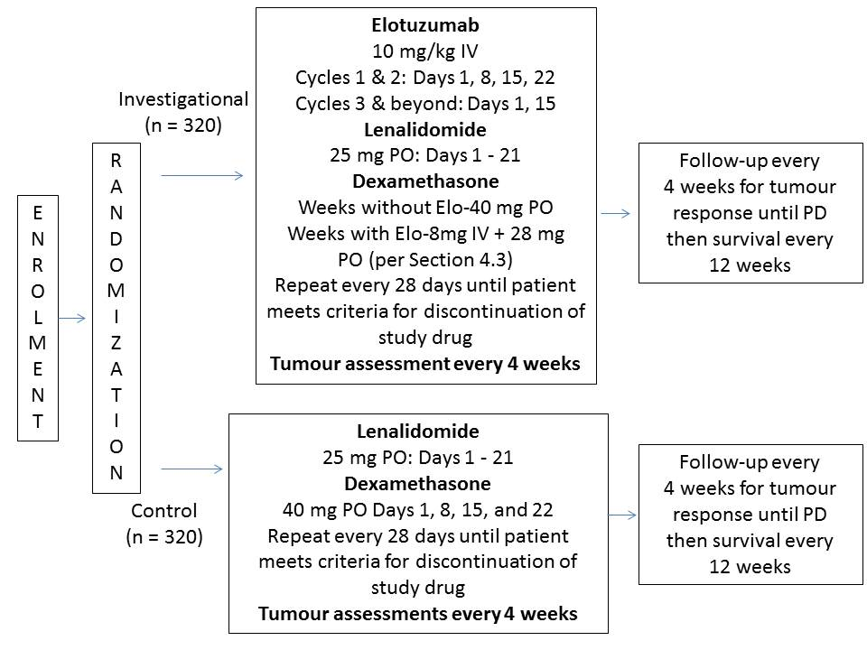

Tumor assessments were conducted every 4 weeks (+/- 1 week) relative to the first dose of each cycle until disease progression, death or withdrawal of consent. Subjects were followed at least every 12 weeks after disease progression for survival and subsequent myeloma therapy. The efficacy endpoints were based on a blinded review of tumor assessments by an independent review committee (IRC), in addition to investigator assessments.

###### Inclusion and exclusion criteria

**Inclusion:**

Adult subjects (>/=18 years of age) with multiple myeloma who met the following criteria were eligible to participate in the study:

* Eastern Cooperative Oncology Group (ECOG) performance status </=2
* Documented evidence of multiple myeloma and had received 1 to 3 prior lines of therapy with documented progression by the European Group for Blood and Bone Marrow Transplant (EBMT) criteria after the most recent therapy, and
* Measurable disease as defined by at least one of the following: a) serum IgG, IgA, IgM M-protein >/=0.5 g/dL or IgD M-protein >/=0.05 g/dL; b) Urine M-protein >/=200 mg/24-hour.
* Prior lenalidomide exposure was permitted only if all the following criteria were met: a) best response achieved was >/=PR, b) were not refractory to prior lenalidomide, defined as no progression while receiving lenalidomide or within 9 months of last dose of lenalidomide, c) did not discontinue lenalidomide due to a Grade >/= 3 related AE, and d) did not receive more than 9 cycles of lenalidomide and had at least 9 months between the last dose of lenalidomide and progression.

**Exclusion:**

A patient was not eligible for participation in this study if any of the following criteria applied:

###### Target Disease Exceptions

* Subjects with non-secretory or oligo-secretory of serum free light-chain only myeloma (subjects with measurable M protein only in the urine as defined under inclusion criteria would be eligible) Active plasma cell leukemia (defined as either 20% of peripheral white blood cell (WBC) composed of plasma/CD138+ cells or an absolute plasma cell count of 2 x 109/L).

###### Medical History and Concurrent Diseases

* All AEs of any prior chemotherapy, surgery, or radiotherapy not resolved to National Cancer Institute Common Terminology Criteria for Adverse Events (NCI CTCAE, v 3.0) Grade ≤ 2
* POEMS syndrome (plasma cell dyscrasia with polyneuropathy, organomegaly, endocrinopathy, monoclonal protein, and skin changes)
* Significant cardiac disease as determined by the investigator including:
* Known or suspected cardiac amyloidosis
* Congestive heart failure of Class III or IV of the NYHA classification;
* Uncontrolled angina, hypertension or arryhythmia
* Myocardial infarction in the past 6 months o Any uncontrolled or severe cardiovascular disease
* Prior cerebrovascular event with persistent neurologic deficit
* Known HIV infection or active hepatitis A, B, or C
* Any medical conditions that, in the investigator’s opinion, would impose excessive risk to the subject. Examples included:
* Any uncontrolled disease, such as pulmonary disease, infection, seizure disorder
* Active infection that requires parenteral anti-infective treatment
* Any altered mental status or and psychiatric condition that would interfere with the understanding of the informed consent
* Prior or concurrent malignancy, except any malignancy from which the subject the subject has been disease-free for > 5 years or adequately treated basal cell or squamous cell skin cancer
* Unable to tolerate thromboembolic prophylaxis

###### Study treatment

The first phase comprised Cycles 1 & 2 (weekly elotuzumab administration), while phase 2 comprised Cycles 3 and beyond (elotuzumab administration every 2 weeks). Treatment was administered in 28-day cycles until disease progression, unacceptable toxicity, or the subject met other criteria for discontinuation of study drug.

**Control arm**:

Lenalidomide was administered daily at a dose of 25 mg per os (PO) (Days 1-21) and dexamethasone was administered weekly at a dose of 40 mg PO on Days 1, 8, 15, and 22.

**Investigational arm**:

* Elotuzumab was intravenously (IV) administered weekly at a dose of 10 mg/kg for Cycles 1 & 2 on Days 1, 8, 15, and 22; and for Cycle 3 and beyond was administered biweekly on Days 1 and 15
* Lenalidomide was administered daily at a dose of 25 mg PO on Days 1-21 at least 2 hours after completion of elotuzumab dosing.
* Dexamethasone was administered weekly at a dose of 40 mg PO on weeks without elotuzumab and during weeks of elotuzumab dosing, dexamethasone was administered as a split dose of 28 mg PO + 8 mg IV, 3 to 24 hours and at least 45 minutes, respectively, both prior to elotuzumab infusion

###### Efficacy variables and outcomes

**Assessment of Efficacy**

Efficacy end points were centrally assessed on the basis of the criteria of the European Group for Blood and Marrow Transplantation and on a blinded review of tumor assessments by an independent review committee. Tumor assessments were performed every 4 weeks after the first dose of study medication until disease progression, death, or withdrawal of consent. The uniform response criteria of the International Myeloma Working Group were incorporated into the assessment of the independent review committee for the evaluation of stringent complete response and very good partial response. Pain and health-related quality of life were assessed with the use of the Brief Pain Inventory– Short Form and the European Organisation for Research and Treatment of Cancer Quality-of-Life Questionnaire–Core 30 module (EORTC QLQ-C30) and myeloma-specific module (EORTC QLQ-MY20).

**Definitions of Treatment Response**

* Complete Response /stringent complete response
* A complete response required that all of the following criteria be achieved:
* Negative immunofixation on both serum and urine, maintained for a minimum of 6 weeks and
* A bone marrow aspirate or biopsy containing < 5% plasma cells. It was not essential to perform a trephine biopsy, but if a biopsy is performed this must also contain < 5% plasma cells (although not required for documentation of complete response using the EBMT criteria, light chain restriction (flow or immunohistochemistry for kappa and lambda light chain in the bone marrow should also be assessed to assist in classification of stringent complete response using the IMWG criteria) and
* If skeletal survey showed osteolytic bone lesions, there should be no increase in the size or number (development of a compression fracture does not exclude response) and
* If screening scans showed extramedullary plasmacytomas, complete disappearance of any must have been noted.
* For assessment of stringent complete response, per IMWG criteria, all criteria for complete response must be upheld. In addition, bone marrow sample must be assessed for light chain restriction (as mentioned in bullet 2 above) and serum free light chains must be normalized at two time points at least 6 weeks apart, at the time of complete response assessment.

**Partial Response**

Patients in whom some, but not all, the criteria for complete response were fulfilled were classified as having a partial response, providing the remaining criteria satisfied the requirements for partial response. This included patients in whom routine electrophoresis was negative but in whom immunofixation had not been performed.

* Greater than or equal to 50% reduction in serum M-protein, maintained for a minimum of 6 weeks.
* Reduction of ≥ 90% in urinary light chain excretion or a decrease to < 200 mg/ 24 hours, maintained for a minimum of 6 weeks.
* Greater than or equal to 50% reduction in the size of extramedullary plasmacytomas present at baseline (by radiography or clinical examination using bidimensional measurements).
* If a skeletal survey is performed, no increase in the size or number of lytic lesions (development of a compression fracture did not exclude response).

**Very Good Partial Response**

Very good partial response, a subset of partial response, is not formally included in the EBMT criteria but is derived from the IMWG criteria. Because very good partial response is commonly used to measure depth of response in multiple myeloma, this response must have been reported by the investigator and IRC and was defined by:

* Serum and Urine M-protein detectable by immunofixation but not on electrophoresis and that was confirmed in a subsequent assessment OR
* 90% or greater reduction in serum M-protein plus urine M-protein level < 100 mg per 24 h and that was confirmed in a subsequent assessment.

**Minor (Minimal) Response**

Patients who had reduction in M-protein or plasmacytoma but did not meet the criteria for partial response were classified as having a minor response if they met all of the following definitions:

* Between 25% and 49% reduction in serum M-protein, maintained for a minimum of 6 weeks.
* Between 50% and 89% reduction in urinary light chain excretion which still exceeded200 mg/24 hours, maintained for a minimum of 6 weeks.
* Between 25% and 49% reduction in the size of extramedullary plasmacytomas.
* If a skeletal survey was performed, no increase in the size or number of lytic lesions (development of a compression fracture does not exclude response).

**Progression of disease**

Progression described a definite increase in disease activity relative to the nadir in 2 consecutive assessments in patients not in complete response, whereas the term ‘relapse from complete response’ applied to a recurrence of evident disease in subjects previously in complete response. The date of EBMT-based disease progression was the first date of two consecutive values fulfilling the criteria for disease progression. Any of the following list was sufficient for progression of disease:

* Increase of > 25% in serum M-protein (also an absolute increase of at least 5 g/L) and confirmed by at least 1 investigation.
* Increase of > 25% urinary light chain excretion (which must also be an absolute increase of at least 200 mg/24-hours and confirmed by at least 1 investigation.
* Increase of > 25% plasma cell percentage in the marrow (which must also have been an absolute increase of at least 10%).
* Definite increase in the size or number of lytic bone lesions or extramedullary plasmacytomas (development of a compression fracture did not exclude continued response and may not have indicated progression).
* Development of hypercalcemia (corrected serum calcium greater than 11.5 mg/dL; 2.8 mmol/L) not attributable to any other cause.

Relapse from complete response (for patients in complete response)

Patients who had documented complete response and then achieved at least one of the following criteria were classified as relapse from complete response. According to the EBMT criteria, relapse from complete response was considered to be progression of disease. The date of EBMT based relapse from complete resposne was the first date of two consecutive values fulfilling the criteria for relapse.

* Reappearance of serum or urinary M-protein on immunofixation or routine electrophoresis, confirmed by at least one further investigation and excluding oligoclonal reconstitution.
* Greater than or equal to 5% plasma cells in a bone marrow aspirate or on trephine bone biopsy.
* Any of the definitions met for progression of disease
* Stable Disease/No Change
* Patient did not meet the criteria for any of the categories above.

Tumor assessments were performed every 4 weeks following the first dose of study medication until disease progression, death, or withdrawal of consent. Confirmation of a tumor response was required after at least 6 weeks. Patients who discontinued study medication for reasons other than disease progression continued tumor assessments until disease progression for the intent-to-treat analyses. Patients were followed every 12 weeks after disease progression for survival and subsequent myeloma treatment. Follow-up for survival was continued every 12 weeks until study end, the patient died, or withdrawal of consent. Patients who were lost to follow-up had shorter follow-up for this reason.

All laboratory assessments were performed at a central laboratory (ICON Central laboratories, Dublin, Ireland), except corrected calcium and bone marrow assessments for plasma cell percentage and light chain restriction, which were assessed locally.

Pain severity and pain interference was assessed at baseline, on day 1 of each cycle, and at the end of treatment or withdrawal from the study using the Brief Pain Inventory–Short Form (BPI-SF). The BPISF is a 15-item instrument that measures pain (five-item sensory dimension) and the impact of pain on daily life, including general activity, mood, ability to walk, normal work both outside the home and housework, relationships, sleep, and enjoyment of life (seven-item reactive dimension). Health-related quality of life was assessed at baseline, on day 1 of each cycle, and at the end of treatment or withdrawal from the study using the European Organisation for Research and Treatment of Cancer Quality-of-Life Questionnaire–Core 30 module (EORTC QLQ-C30) and myeloma-specific module (EORTC QLQ-MY20). The EORTC QLQC30 questionnaire comprises five functional scales, three symptom scales, and a global health/quality-of-life scale. Scale scores range from 0 to 100, with higher scores representing a better health state for the functional scores and lower scores representing a better health state for the symptom scores. The EORTC QLQ-MY20 consists of a 20-item questionnaire grouped into four scales: disease symptoms, treatment adverse effects, social support, and future perspective. Scale scores range from 0 to 100, with higher scores representing poorer health.

###### Analysis populations

The following subject populations were used for the statistical analyses:

* All enrolled subjects: all subjects who gave signed informed consent and who were entered in the Interactive Voice Response System (IVRS)
* Randomized subjects: all enrolled subjects who were randomized
* Treated subjects: all randomized subjects who received at least one dose of study medication (lenalidomide, dexamethasone, or elotuzumab)
* ECG evaluable subjects: all elotuzumab-treated subjects who consented to participate in the ECG substudy with the baseline ECG measurement and at least one on-study ECG measurement
* PK evaluable subjects: all treated subjects who received elotuzumab and had at least one PK sample available

The analysis of demographics, baseline characteristics, and efficacy were carried out on the ‘Randomized’ subject population with subjects grouped according to the treatment arm to which they were randomized. The analysis of extent of exposure and safety was based on the ‘Treated’ subject population, with subjects grouped according to the treatment received (i.e. the same as the randomized treatment arm unless the wrong treatment was administered throughout the study or the subject was randomized but did not receive treatment).

###### Sample size

The PFS (per IRC) and ORR (per IRC) were co-primary endpoints in this study. If the analyses for either of these two endpoints achieved significance (2-sided 0.5% for ORR or 2-sided 4.5% for PFS to preserve the overall type-I error for the study at the 5% level) the corresponding primary objective was declared statistically significant.

The interim analysis (IA) of PFS was to be conducted when at least 70% of the events had been observed (i.e. 326 events of the planned 466) and after a minimum follow-up of 2 years from LPFV.

The final analysis of PFS was planned for 466 events (documented progression or deaths), to ensure that a 2-sided test procedure with one IA had 88.7% power if the median PFS times in the control and experimental arms were 11.1 and 15 months, respectively, i.e. if the hazard ratio (HR) of the experimental to control arm was 0.74. The number of events and power for PFS were calculated assuming an exponential distribution for each arm. The final analysis of ORR was planned for a minimum follow-up of 16 months from LPFV. With 640 subjects the test for the ORR had 88.5% power at the 2-sided alpha level of 0.5% when the true odds ratio of the experimental to the control arm was 2 (i.e. when the response rate in the control arm was 60% and was 75% in the experimental arm).

###### Statistical methods

Continuous variables were summarized using descriptive statistics; i.e. number of non-missing observations (n), mean, standard deviation (STD), median, minimum, maximum, first quartile and third quartile. Categorical variables were summarized by frequencies and percentages.

Time to event distributions (e.g., PFS, duration of response) were estimated using Kaplan-Meier (K-M) techniques. When appropriate, comparison between treatment groups were performed using a stratified log-rank test. The median along with confidence intervals (CIs) were estimated based on Brookmeyer and Crowley methodology (using log-log transformation for constructing the CIs). A stratified Cox proportional hazards model was used to compute an estimate and CI for the HR of E-Ld to Ld. Rates at fixed timepoints (e.g., PFS at 1 year) were derived from the K-M estimate along with their corresponding log-log transformed 95% CIs

Objective response rate was compared between the two treatment groups using a stratified Cochran Maentel Haenszel (CMH) test. Confidence intervals for binomial proportions were derived using the Clopper-Pearson method. Confidence interval for the difference in ORR was computed using the method of DerSimonian and Laird, using a fixed-effects model (setting Δ2 equal to zero), and adjusting for the stratification factors.

For stratified analyses, stratification factors were obtained from IVRS randomization data set.

All p-values reported were 2-sided. For primary (ORR and PFS) and secondary endpoints (OS) included in hierarchy, the alpha (α) level used for the two-sided CI was the same as nominal significance level for hypothesis testing adjusting for the primary and hierarchical testing. In addition two-sided 95% CI for these endpoints were also provided. Confidence intervals for other endpoints were at the two-sided 95% level and used for estimation purpose.

Laboratory results, AEs, and other symptoms were graded using the NCI CTCAE, Version 3.0, except where CTCAE grades were not available. Individual laboratory values were presented in the Systeme Internationale (SI) and US units. Adverse events were categorized using the Medical Dictionary for Regulatory Activities (MedDRA) version 17, by system organ class and preferred term. Prior therapies were summarized using the current version of the World Health Organization (WHO) drug dictionary.

###### Participant flow

The database cutoff date for this study was 29-Oct-2014. The clinical database lock occurred on 04-Nov-2014 and the IRC database was locked on 11-Dec-2014.

The enrolment period lasted from June 2011 to November 2012 and included 230 sites in 21 countries. Subjects were accrued from Europe (60%), North America (21%), Japan (9%) and the rest of the world (10%; Australia, Israel).

A total of 168 sites enrolled subjects and 161 sites treated at least 1 subject.

* A total of 761 subjects were enrolled. Of these, 646 subjects were randomized into the study (321 subjects in the E-Ld group and 325 subjects in the Ld group).
* As of the clinical database lock, 179 (28.2%) subjects were still on treatment and 456 subjects (71.8%) were off treatment. Of the 179 subjects on treatment, 113 subjects (35.4%) were still being treated with E-Ld and 66 subjects (20.9%) were still being treated with Ld.
* The most common reasons for discontinuation of all study therapy were:
* Disease progression (135 [42.3%] E-Ld subjects and 149 [47.2%] Ld subjects),
* Study drug toxicity (28 [8.8%] E-Ld subjects and 42 [13.3%] Ld subjects), and
* AEs unrelated to study drug (15 [4.7%] E-Ld subjects and 26 [8.2%] Ld subjects).

Table 4: End of Treatment Summary - All Randomized Subjects.

|  | E-Ld | Ld | Total |
| --- | --- | --- | --- |
| **Subjects randomized (a)** | 321 | 325 | 646 |
| **Subjects never treated** | 2 ( 0.6) | 9 ( 2.8) | 11 ( 1.7) |
| **Subjects treated** | 319 ( 99.4) | 316 ( 97.2) | 635 ( 98.3) |
| **Subjects still on treatment (b)** | 113 ( 35.4) | 66 ( 20.9) | 179 ( 28.2) |
| **Subjects off treatment** | 206 ( 64.6) | 250 ( 79.1) | 456 ( 71.8) |
| **Reason off treatment (b)** | |  |  |
| **Disease progression** | 135 ( 42.3) | 149 ( 47.2) | 284 ( 44.7) |
| **Study drug toxicity** | 28 ( 8.8) | 42 ( 13.3) | 70 ( 11.0) |
| **Adverse event unrelated to study drug** | 15 ( 4.7) | 26 ( 8.2) | 41 ( 6.5) |
| **Subject request to discontinue study treatment** | 20 ( 6.3) | 13 ( 4.1) | 33 ( 5.2) |
| **Subject withdrew consent** | 4 ( 1.3) | 8 ( 2.5) | 12 ( 1.9) |
| **Other** | 1 ( 0.3) | 10 ( 3.2) | 11 ( 1.7) |
| **Death** | 1 ( 0.3) | 1 ( 0.3) | 2 ( 0.3) |
| **Subject no longer meets study criteria** | 2 ( 0.6) | 0 | 2 ( 0.3) |
| **Poor/non-compliance** | 0 | 1 ( 0.3) | 1 ( 0.2) |

All randomized subjects, by treatment arm as randomized. Percentages based on treated subjects. There was 1 subject randomized to treatment E-Ld but who received treatment Ld. Subject [information redacted] was enrolled twice. This subject was first enrolled as [information redacted] and reported as a screen failure, then was enrolled as [information redacted] and was randomized.

###### Major protocol violations/deviations

Relevant protocol deviations: Relevant protocol deviations, i.e., significant protocol deviations that were programmable and could potentially affect the interpretability of study results, included:

At study entry:

* No prior systemic anti-myeloma therapy
* Non measureable disease. This occurred when none of the following three conditions were met:
* Serum IgG, IgA, or IgM M-protein ≥ 0.5 g/dL
* Serum IgD M-protein ≥ 0.05 g/dL
* M-protein ≥ 200 mg in 24-hour urine
* Ineligible for this study due to failure to meet criteria for re-treatment with lenalidomide.

This occurred when:

* the best response on prior lenalidomide-containing regimen was not ≥ PR
* or the subject progressed within nine months of the last dose of prior lenalidomide,
* or the subject received prior lenalidomide for more than nine months.

On study:

* Non-protocol specified systemic anti-myeloma therapy prior to discontinuation of study therapy
* Received non-assigned treatment regimen throughout the study
* No baseline efficacy assessment. This occurred when there were no tumor assessments at all (laboratory assessments) on or prior to first day of dosing
* Subjects continuing to receive study therapy after 10 weeks of documented progression per investigator

The majority of subjects (98%) had no relevant protocol deviations. Two subjects with > 3 prior lines of therapy were enrolled in error and represented relevant protocol deviations. After review of the reported protocol deviations, it was determined that there was no impact on the interpretability of study results.

###### Baseline data

Baseline demographics were balanced between the E-Ld and Ld treatment groups. Across the combined treatment groups:

* The median age was 66 years.
* 20% of subjects were >/= 75 years of age.
* The majority were white (84.2%) males (59.6%).
* β2-microglobulin, number of prior lines of therapy, and prior IMiD were used as stratification factors for randomization in this study. Stratification factors were balanced between the E-Ld and Ld group

Baseline disease characteristics were as expected for this relapsed or refractory MM population. Specific disease characteristics for subjects in the E-Ld and Ld treated groups were balanced and were as follows:

* The median duration of MM was 3.5 years prior to entering the trial.
* A total of 53% of subjects were ISS stage II or III.
* Most subjects had > 3 lytic bone lesions (53%).
* 9.0% of subjects had known plasmacytomas at baseline.
* The most common myeloma type in subjects was IgG (70.0%).
* The high risk cytogenetic markers of del17p and t(4;14) were present in 32% and 9% of subjects, respectively

###### Results for primary efficacy outcomes

A total of 113 of 321 patients in the elotuzumab group (35%) and 66 of 325 patients in the control group (20%) were still receiving study treatment at the time of the cutoff date for the interim analysis on November 4, 2014. Median follow-up was 24.5 months. The study met the prespecified statistical cutoff for the coprimary end point of progression-free survival. At 1 year, the rate of progression-free survival in the elotuzumab group was 68% (95% confidence interval [CI], 63 to 73) versus 57% (95% CI, 51 to 62) in the control group; the 2-year rates were 41% (95% CI, 35 to 47) and 27% (95% CI, 22 to 33), respectively. Median progression-free survival in the elotuzumab group was 19.4 months (95% CI, 16.6 to 22.2) versus 14.9 months (95% CI, 12.1 to 17.2) in the control group, for a hazard ratio of 0.70 (95% CI, 0.57 to 0.85; P<0.001), indicating a relative reduction of 30% in the risk of disease progression or death (Figure 10).

Figure 10: Kaplan-Meier Plot of PFS (IRC, Primary Definition) Randomized Subjects

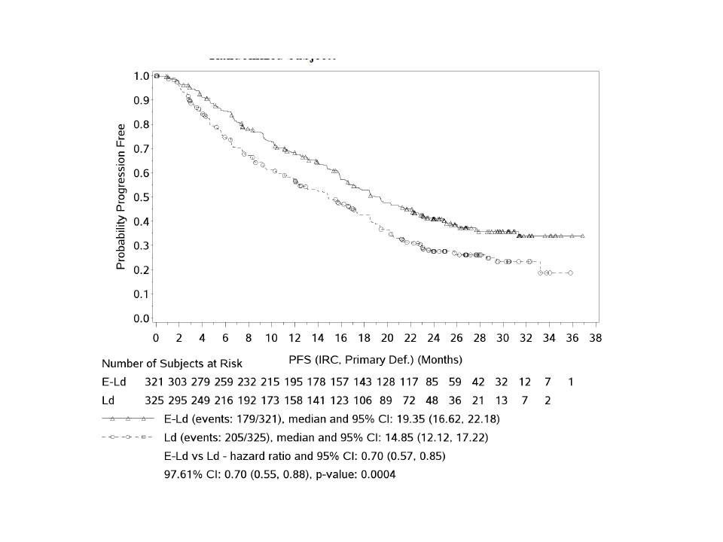

Symbols represent censored observations. Adjusted alpha level = 0.0239. Stratified by β2 microglobulin (<3.5 mg/L vs >=3.5 mg/L), number of prior lines of therapy (1 vs 2 or 3) and prior IMiD (no vs prior thalidomide only vs other) at randomization.

In the elotuzumab group, 179 events were observed (165 progressions and 14 deaths), and in the control group, 205 events were observed (183 progressions and 22 deaths). The benefit for progression-free survival in the elotuzumab group was consistent across key subgroups, including patients 65 years of age or older and those with resistance to the most recent line of therapy, with International Staging System stage III disease, with previous exposure to bortezomib or immunomodulatory drugs, with previous stemcell transplantation, with the del(17p) variant, or with a creatinine clearance of less than 60 ml per minute (Figure 11).

Figure 11: PFS (IRC, Primary All Randomized Subjects Definition) Hazard Ratio and 95% CI in Subsets.

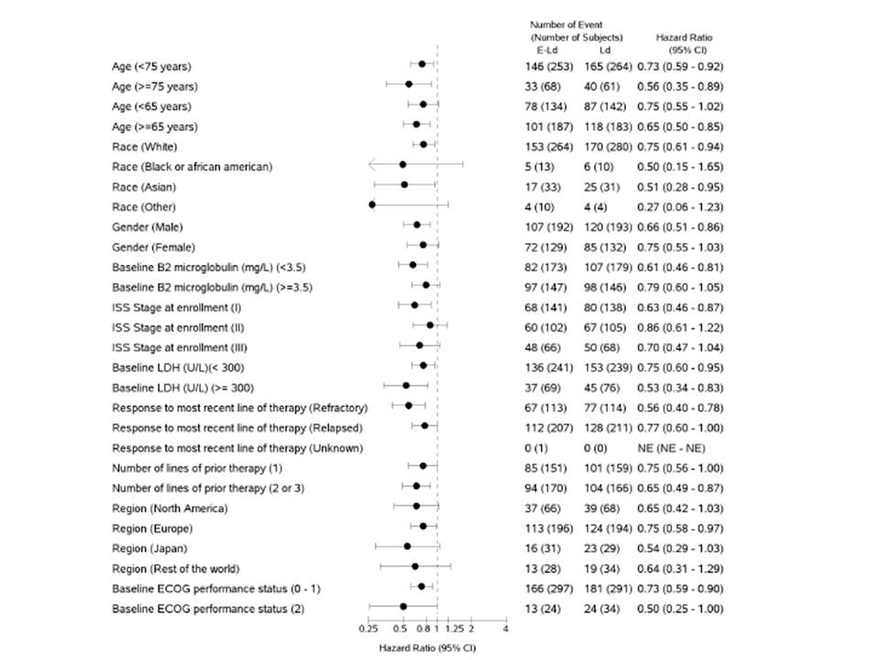

Figure 11 (continued): PFS (IRC, Primary All Randomized Subjects Definition) Hazard Ratio and 95% CI in Subsets.

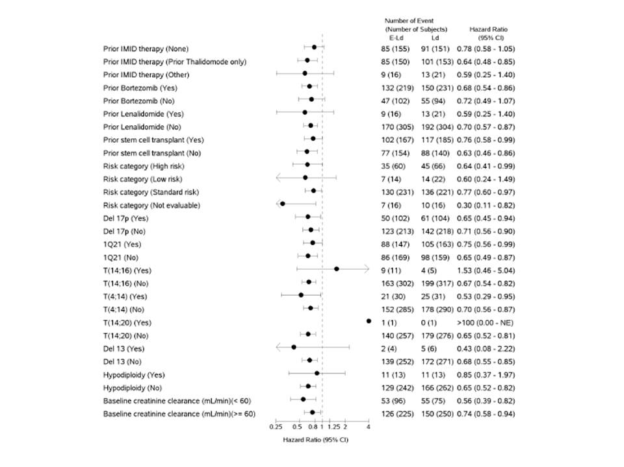

The benefit was also consistent across supportive analyses of progression-free survival. In the intention-to-treat population, there was a relative reduction of 32% in the risk of progression free survival in the elotuzumab group (hazard ratio, 0.68; 95% CI, 0.56 to 0.83) (Table 5).

Table 5: PFS (IRC, ITT) Analysis All Randomized Subjects

|  | E-Ld  N = 321 | Ld  N = 325 |
| --- | --- | --- |
| #Events/#subjects (%) | 192/321 ( 59.8) | 231/325 ( 71.1) |
| Median (95% CI), months | 18.50 (16.46, 21.42) | 14.32 (11.99, 15.97) |
| 1-year PFS rate (95% CI) | 0.68 (0.63, 0.73) | 0.56 (0.50, 0.61) |
| 2-year PFS rate (95% CI) | 0.39 (0.34, 0.45) | 0.26 (0.21, 0.31) |
| Hazard ratio (95% CI) (1) (2) | 0.68 (0.56, 0.83) | |
| Hazard ratio (97.61% CI) (1) (2) | 0.68 (0.55, 0.85) | |
| P-value (3) | 0.0001 | |

1. Stratified by B2 microglobulin (<3.5 mg/L vs >=3.5 mg/L), number of prior lines of therapy (1 vs 2 or 3) and prior IMiD (no vs prior thalidomide only vs other) at randomization. 2. Hazard Ratio of E-Ld to Ld. 3. 2-sided p-value for stratified log rank test.

The study also met the prespecified statistical cutoff for the co-primary end point of overall response rate. Overall response rates were 78.5% (95% CI, 73.6 to 82.9) in the elotuzumab group and 65.5% (95% CI, 60.1 to 70.7) in the control group (odds ratio for the elotuzumab group versus the control group, 1.9; 95% CI, 1.4 to 2.8; P = 0.0002) (Table 6).

Table 6: Best Overall Response (IRC) - All Randomized Subjects.

|  | E-Ld  N = 321 | Ld  N = 325 |
| --- | --- | --- |
| Best overall response |  |  |
| Stringent complete response (SCR) | 9 ( 2.8) | 5 ( 1.5) |
| Complete response (CR) | 5 ( 1.6) | 19 ( 5.8) |
| Very good partial response (VGPR) | 91 ( 28.3) | 67 ( 20.6) |
| Partial response (PR) | 147 ( 45.8) | 122 ( 37.5) |
| Minimal response (MR) | 22 ( 6.9) | 33 ( 10.2) |
| Stable disease (SD) | 30 ( 9.3) | 54 ( 16.6) |
| Progressive disease (PD) | 8 ( 2.5) | 8 ( 2.5) |
| Not evaluable (NE) | 9 ( 2.8) | 17 ( 5.2) |
| Objective response rate (1) | 252 /321 ( 78.5%) | 213 /325 ( 65.5%) |
| 95% ci for objective response rate | ( 73.6, 82.9) | ( 60.1, 70.7) |
| CMH estimate of common odds ratio (2)(3) | 1.94 | |
| 95% CI for common odds ratio | ( 1.36, 2.77) | |
| 99.5% CI for common odds ratio | ( 1.17, 3.23) | |
| P-value | 0.0002 | |
| Difference in objective response rate (4) | 12.6% | |
| 95% CI for difference in objective response rate | ( 6.1, 19.2) | |

1. SCR+CR+VGPR+PR, confidence interval is based on the Clopper and Pearson method. 2. Stratified by B2 microglobulin (<3.5 mg/L vs >=3.5 mg/L), number of prior lines of therapy (1 vs 2 or 3) and prior IMiD (no vs prior thalidomide only vs other) at randomization. 3. Ratio of E-Ld to Ld. 4. Difference of E-Ld minus Ld. Computed using the method of DerSimonian and Laird (weighted average over the strata).

In the analysis by the independent review committee, there were less CRs in the elotuzumab group than in the control group. In the two study groups, the median time to best response was 2.8 months according to IRC and 3.8 months according to investigator assessment. In supportive analyses that used investigator-assessed tumor responses, the rates of complete responses were similar (11% in each group) (Table 9). Furthermore, 105 of 321 patients (33%) in the elotuzumab group had a very good partial response or better, versus 91 of 325 patients (28%) in the control group. Patients in the elotuzumab group who had a partial response or better had better progression- free survival outcomes than did those with a minor response or stable disease (Fig. S1 in Appendix). Responses were durable, particularly in the elotuzumab group (21 months; 95% CI, 18 to 27) versus the control group (17 months; 95% CI, 15 to 19) (Fig. S2 in Appendix).

Table 7: Treatment Responses According to Investigator Assessment of Tumor Response (All Randomized Patients).

|  | E-Ld  N = 321 | Ld  N = 325 |
| --- | --- | --- |
| Best overall response |  |  |
| Complete response (CR) | 34 (11) | 37 (11) |
| Very good partial response (VGPR) | 96 (30) | 66 (20) |
| Partial response (PR) | 142 (44) | 136 (42) |
| Minimal response (MR) | 19 (6) | 24 (7) |
| Stable disease (SD) | 17 (5) | 35 (11) |
| Progressive disease (PD) | 6 (2) | 8 (3) |
| Not evaluable (NE) | 7 (2) | 19 (6) |
| Objective response rate | 272 (85) | 239 (74) |
| 95% CI for objective response rate | 80.3–88.5 | 68.4–78.3 |
| P-value | 0.0004 | |

P-value based on the Cochran-Mantel-Haenszel chi-square test stratified by randomization factors

###### Results for other efficacy outcomes

**Overall Survival**

Follow-up data regarding overall survival were not yet mature enough to represent in graphical form. There were 210 deaths (94 of 318 [30%] in the elotuzumab group vs. 116 of 317 [37%] in the control group), which represented 49% of the 427 deaths that were prespecified for the final analysis.

**Pain Severity**

The scoring pain severity and the scoring pain inference were secondary endpoints of the study.

* Overall, change from baseline in pain severity and pain interference did not significantly differ between the treatment groups (P = 0.871 and P = 0.813, respectively), suggesting that the addition of elotuzumab to Ld does not lead to deterioration of HRQL.
* Questionnaire completion rate at baseline and end of treatment was similar between the E-Ld and Ld treatment groups (90% and 92%; 61% and 62%), respectively; and remained > 65% until Cycle 40, where owing to a limited number of eligible subjects the completion rate decreased.
* Baseline scores for pain severity were generally similar between treatment groups (2.6 for E-Ld and 2.9 for Ld) with no decline in pain severity in both overall treatment groups.
* The treatment estimate for pain severity was -0.02 in favour of elotuzumab, indicating a slight improvement in pain severity. However, this treatment effect was not statistically significant.

Baseline scores for pain interference were also generally similar between groups (2.5 for E-Ld and 2.8 for Ld) with no decline in pain interference in activities of daily living in both overall groups. The treatment estimate for pain interference was 0.03 indicating there was no effect of elotuzumab.

**Cancer Quality of Life**

EORTC QLQ-C30 findings showed that pain and fatigue were the symptoms with the highest baseline values reported by patients. There was no significant detriment to overall health-related quality of life with the addition of elotuzumab to lenalidomide and dexamethasone; similar mean changes from baseline were observed in the two groups, and patients receiving elotuzumab were able to maintain their overall health-related quality of life.

###### Conclusions

* In patients with relapsed or refractory multiple myeloma, the addition of elotuzumab to lenalidomide and dexamethasone, as compared with lenalidomide and dexamethasone as control therapy, improved progression-free survival and the overall response rate.
* Kaplan–Meier curves for progressionfree survival showed early and increasing separation between the two groups over time.
* Patients receiving elotuzumab had a relative reduction of 30% in the risk of disease progression or death as compared with the control group.
* The benefit of adding elotuzumab to lenalidomide and dexamethasone was observed across most prespecified subgroups, including patients with resistance to the most recent line of therapy and those who had previous exposure to IMiDs or bortezomib, were 65 years of age or older, had received a diagnosis of multiple myeloma at least 3.5 years before study entry, or had a high-risk cytogenetic profile, particularly the presence of the del(17p) variant.
* Follow-up for survival outcomes is ongoing.

#### Other clinical studies in relapsed/refractory multiple myeloma

##### Study CA204009

This was a phase 2, randomized study of bortezomib/dexamethasone with or without elotuzumab in subjects with relapsed/refractory multiple myeloma.

###### Study design, objectives, locations and dates

This Phase 2, multicenter, open-label, randomized study evaluated the effect of elotuzumab in combination with bortezomib and dexamethasone, (E-Bd; investigational arm) compared with bortezomib and dexamethasone alone (Bd; control group) in subjects with relapsed/refractory MM. Subjects were randomized in a 1:1 ratio to receive either E-Bd or Bd and were stratified based on prior proteasome inhibitor use (yes vs no), presence of at least one FcγRIIIa V allele (yes vs no) and number of prior lines of therapy (1 vs 2 or 3).

The enrolment period lasted from 31-Jan-2012 through 15-Apr-2013 and the results presented in this application were based on the clinical database lock (DBL) of 12-Sep-2014, which occurred after at least 103 PFS events had occurred, as per protocol. The study is ongoing; subjects are being followed for OS and safety.

Patients were given EBd or Bd in 21-day (Cycles 1–8) or 28-day (Cycle 9+) cycles until disease progression or unacceptable toxicity. Elotuzumab (10 mg/kg IV) was administered weekly for Cycles 1–2, on Days 1 and 11 for Cycles 3–8, then on Days 1 and 15. Bortezomib (1.3 mg/m2 IV/SC) was administered on Days 1, 4, 8, and 11 for Cycles 1–8, then on Days 1, 8, and 15. Dexamethasone 20 mg was administered on non-elotuzumab days, and at 8 mg PO + 8 mg IV on elotuzumab days. The primary endpoint was PFS (ITT population) according to International Myeloma Working Group criteria. The study had 80% power to detect a HR of 0.69 with 103 events. In this proof-of-concept study, a 2-sided 0.30 significance level was specified to test for PFS difference between arms; p≤0.3 was considered significant.

Primary objective was to compare progression free survival (PFS) between treatment arms in the overall population.

Secondary objectives:

* To estimate the PFS hazard ratio in the subgroup of subjects with at least one FcγRIIIa V allele.
* To estimate the difference in response rates between arms in the overall population.
* To estimate the difference in response rates between arms in the subgroup of subjects with at least one FcγRIIIa V allele.

Exploratory Objectives:

* To characterize the safety of elotuzumab in combination with bortezomib and dexamethasone.
* To estimate the PFS hazard ratio and the difference in response rates between arms in the subgroup of subjects with no FcγRIIIa V alleles.
* To estimate overall survival (OS), time to response and duration of response, by treatment arm, in the overall population and the FcγRIIIa V allele subgroups.
* To estimate the interaction between treatment and the presence of at least one FcγRIIIa V allele on PFS.
* To characterize the pharmacokinetics of elotuzumab and explore exposure-response relationships with respect to safety, efficacy, and biomarkers.
* To identify and evaluate potential pharmacodynamic and/or predictive biomarkers of activity of elotuzumab in combination with bortezomib and dexamethasone.
* To evaluate the immunogenicity of elotuzumab.

###### Inclusion and exclusion criteria

**Inclusion**

A subject was eligible for study participation only if all of the following criteria applied:

* Adults subjects (age >/= 18 years or legal age of consent per local regulations) that signed the Informed Consent Form (ICF) and who met the following main disease criteria at screening were eligible to enrol in the study:
  + ECOG performance status </= 2
  + Confirmed diagnosis of MM with documented progression by modified IMWG criteria after or during the most recent therapy; AND
  + Measurable disease by modified IMWG criteria as defined by at least 1 of the following:
  + Serum IgG, IgA or IgM M-protein >/= 0.5 g/dL or serum IgD M-protein >/= 0.05 g/dL or
  + Urine M-protein >/= 200 mg excreted in a 24-hour collection sample; or
  + Involved serum free light chain level >/= 10 mg/dL, provided the free light chain ratio is abnormal
  + Proteasome inhibitor naive or prior proteasome inhibitor exposure was permitted provided all of the following criteria were met:
  + Best achieved response was >/= PR to previous proteasome inhibitor
  + Subject did not discontinue any proteasome inhibitor due to intolerance or grade >/= 3 toxicity
  + Subject was not refractory to any proteasome inhibitor (defined as progression during treatment or within 60 days after the last dose)

**Exclusion**

A subject was not eligible to participate in this study, if any of the following criteria applied.

* Target Disease Exceptions:
  + Solitary bone or solitary extramedullary plasmacytoma as the only evidence of plasma cell dyscrasia
  + MGUS, smoldering myeloma or Waldenström’s macroglobulinemia.
  + Active plasma cell leukemia (defined as either 20% of peripheral WBC comprised of plasma/CD138+ cells or an absolute plasma cell count of 2 x 109/L).
  + Medical History and Concurrent Diseases
  + Any medical conditions that, in the investigator’s opinion, would impose excessive risk to the subject. Examples of such conditions include:
  + Any uncontrolled disease, such as pulmonary disease, infection, or seizure disorder;
  + Any altered mental status or any psychiatric condition that would interfere with the understanding of the informed consent.
  + Significant cardiac disease as determined by the investigator, including:
  + Known or suspected cardiac amyloidosis;
  + Congestive heart failure of Class III or IV of the NYHA classification;
  + Uncontrolled angina, hypertension, or arrhythmia;
  + Myocardial infarction in past 6 months;
  + Any uncontrolled or severe cardiovascular disease.
  + Prior or concurrent malignancy, except for the following:
  + Adequately treated basal cell or squamous cell skin cancer;
  + Any other cancer from which the subject has been disease-free for > 3 years.
  + Known HIV infection or active hepatitis A, B, or C.
  + Grade 1 neuropathy with pain or any >/= Grade 2 neuropathy (per NCI CTCAE v3.0).
  + Any residual AEs from prior chemotherapy, surgery, or radiotherapy that have not resolved to < Grade 2 (per NCI CTCAE v3.0).
* Physical and Laboratory Test Findings:
  + Corrected serum calcium >= 11.5 mg/dL within 2 weeks of enrolment (despite appropriate measures such as hydration, a short course of steroids, bisphosphonates, or calcitonin).
  + Absolute neutrophil count < 1000 cells/mm3. No granulocyte colony stimulating factors (G-CSF or GM-CSF) allowed within 1 week of randomization. No pegylated G-CSFs allowed within 3 weeks of randomization.
  + Platelets < 75,000 cell/mm3 (75 x 109/L). Qualifying laboratory value must occur at most recent measurement before enrolment and must be no more than 14 days before enrollment. No transfusions are allowed within 72 hours before qualifying laboratory value.
  + Hemoglobin < 8 g/dL. Qualifying laboratory value must occur at most recent measurement before enrolment and must be no more than 14 days before enrolment. No transfusions are allowed within 72 hours before qualifying laboratory value.
  + Creatinine clearance < 30 mL/minute measured by 24-hour urine collection or estimated by the Cockcroft-Gault formula. Qualifying laboratory value must have occurred at most recent measurement before enrolment and must be no more than 14 days before enrolment.
  + Total bilirubin > 1.5 x upper limit of normal (ULN).
  + Aspartate aminotransferase (AST) or alanine aminotransferase (ALT) >/= 3x ULN.
  + Prior Therapy or Surgery
  + Major surgery within 4 weeks prior to randomization
  + Thalidomide, lenalidomide, or cytotoxic chemotherapy within 2 weeks of first dose of study drugs.
  + Steroid use within 3 weeks of randomization, except for </= 10 mg prednisone (or equivalent) per day or steroids with little to no systemic absorption (ie, topical or inhaled steroids).
  + Treatment with any investigational drug within 3 weeks of randomization.
  + Prior autologous stem cell transplant within 12 weeks or allogeneic stem cell transplant within 16 weeks of the first dose of study drug.
  + Treatment with nitrogen mustard agents, melphalan, or monoclonal antibodies within 6 weeks of the first dose of study drug.
  + Primary refractory disease (defined as best response of no better than SD with all prior therapies).
  + Prior exposure to elotuzumab.

###### Study treatments

In both arms, during Cycles 1 through 8, bortezomib was administered on Days 1, 4, 8, and 11 followed by a 10-day rest period. At least 72 hours was to elapse between consecutive doses of bortezomib. During Cycles 1 and 2, dexamethasone was administered on Days 1, 2, 4, 5, 8, 9, 11, and 12 (control arm only) or Day 15 (in the investigational arm only). During Cycles 3 through 8, dexamethasone was administered on Days 1, 2, 4, 5, 8, 9, 11, and 12.

Beginning with Cycle 9, bortezomib was administered on Days 1, 8, and 15 followed by a 13- day rest. Dexamethasone was administered on Days 1, 2, 8, 9, 15, and 16 during these 28-day cycles. For those subjects in the investigational arm, elotuzumab was administered weekly for the first 2 cycles (Days 1, 8, and 15) of the 21 day cycles. For Cycles 3 through 8, elotuzumab was administered on Days 1 and 11 of the 21 day cycles. Beginning with Cycle 9, elotuzumab was administered on Days 1 and 15 of the 28 day cycles. Elotuzumab was administered 30 to 90 minutes following bortezomib when they were administered on the same day. The dose of dexamethasone was 20 mg po except in the investigational arm on the days when elotuzumab was given. On those days, the dexamethasone dose was to be split: 8 mg (po) 3 to 24 hours prior to each elotuzumab infusion followed by dexamethasone premedication, 8 mg IV (on the day of elotuzumab infusion, at least 45 minutes prior to the start of infusion). In the investigational arm, on the days when elotuzumab was not given, the dexamethasone dose was to be the same 20 mg po dose as administered in the control arm.

Figure 12: Study schema.

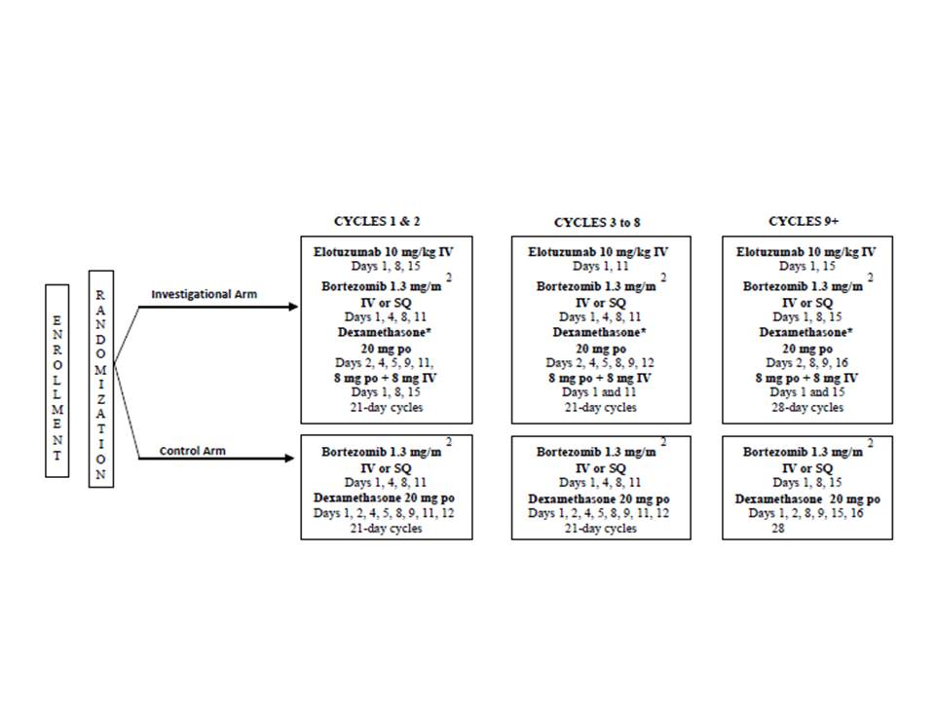

IV = intravenous; po = per os; SQ = subcutaneous

###### Efficacy variables and outcomes

The primary efficacy endpoint was PFS of E-Bd versus Bd, based on investigator assessment.

* Primary Definition of PFS (based on intent to treat [ITT]) was defined as the time, in months, from randomization to the date of the first documented tumor progression or death due to any cause. A subject who neither progressed nor died was censored on the date of the last adequate tumor assessment (ATA), requiring both SPEP and UPEP. A subject who did not have any post-baseline tumor assessments and who did not die was censored on the date of randomization.
* A Secondary Definition of PFS was defined as the time from randomization to the date of the first documented tumor progression or death due to any cause, provided, progression or death did not occur after start of subsequent systemic therapy, or more than 10 weeks (two or more assessment visits) after the last ATA.

Secondary efficacy endpoints included:

* Objective response rate (ORR) was defined as the proportion of randomized subjects who achieve a best response of complete response (CR), stringent complete response (sCR), very good partial response (VGPR), or partial response (PR) using the modified IMWG criteria as per investigator’s assessment.

Exploratory:

* Time to response (TTR) was defined as the time, in months, from randomization to the first objective documentation of PR or better.
* Duration of response (DOR) was measured from the time, in months, that the criteria for ORR are first met until the date of a progression event. A subject with objective response who did not have a progression event was censored at the same time they were censored under the PFS analysis.
* Overall survival (OS) is defined as the time, in months, from randomization to the date of death from any cause. Subjects who had not died were censored at the date of last contact (‘last known date alive”).

###### Sample size

The primary endpoint in this study was PFS. The study required at least 103 progression events (documented progressions or deaths) for the analysis of PFS. This number of events ensured that a one-sided, 0.15 (equivalent to a two-sided 0.30) significance level log-rank test would have 80% power if the median PFS times in the control and investigational arms were 10 months and 14.5 months, respectively, ie, if the hazard ratio of the investigational arm to the control arm was 0.69. The treatment group comparison at the final analysis was based on a two-sided 0.3 alpha level.

###### Statistical methods

Continuous variables were summarized using descriptive statistics; i.e. number of non-missing observations (n), mean, standard deviation (STD), median, minimum, maximum, first quartile and third quartile. Categorical variables were summarized by frequencies and percentages. The Kaplan-Meier (KM) product limit method was used to estimate the distribution and median of each time-to-event endpoint. The Breslow method was used for handling ties. The Brookmeyer and Crowley method was used to compute the 95% confidence interval (CI) for the median of each time-to-event endpoint. Cox proportional hazards model was used to compute an estimate of the hazard ratio of the investigational to the control arm, for time to event endpoints. Hazard ratios for time-to-event variables were rounded to two decimal places.

Laboratory results, adverse events, and other symptoms were graded using the National Cancer Institute (NCI) Common Terminology Criteria for Adverse Events (CTCAE), Version 3.0, except where CTCAE grades were not available. Individual laboratory values were presented in the International System of Units (SI). Adverse events were categorized using the most current version of Medical Dictionary for Regulatory Activities (MedDRA), by system organ class and preferred term. Prior therapies were summarized using the most current version of the World Health Organization (WHO) drug dictionary.

The following subject populations were used for the statistical analysis:

* All enrolled subjects: all subjects who gave signed informed consent and who were entered in the IVRS
* Randomized subjects: all enrolled subjects who were randomized
* Treated subjects: all randomized subjects who received at least one dose of study medication (bortezomib, dexamethasone or elotuzumab).
* Elotuzumab-treated subjects: all subjects whose treated treatment arm is E-Bd and who received at least one infusion of Elotuzumab.

Analyses of demography, baseline characteristics and efficacy were performed on the data set of all randomized subjects, unless otherwise indicated, grouped according to the arm to which they were assigned at randomization. The analyses of safety and dosing were performed on the data set of all treated subjects, unless otherwise indicated, grouped by treatment received. Analyses specific to elotuzumab infusion reactions and pre-medications for elotuzumab were based on the population of elotuzumab-treated subjects.

###### Enrolment of Subjects

The clinical database lock occurred on 12-Sep-2014. The enrollment period lasted from 31-Jan-2012 through 15-Apr-2013. Subjects were enrolled at 53 sites in 4 countries. Subjects were accrued from France (13.8%), Italy (43.4%), Spain (11.2%) and the United Sates (31.6%). A total of 46 sites randomized and treated at least 1 subject.

A total of 185 subjects were enrolled. Of these, 152 subjects were randomized into the study; 77 were randomized to E-Bd and 75 were randomized to Bd. The majority of randomized subjects were treated (150 subjects [98.7%], 75 subjects in E-Bd arm and 75 subjects on Bd arm, the latter including Subject [information redacted]).

Table 8: End of Treatment Summary - All Randomized Subjects

|  | E-Bd | Bd | Total |
| --- | --- | --- | --- |
| Subjects randomized (a) | 77 | 75 | 152 |
| Subjects never treated | 1 ( 1.3) | 1 ( 1.3) | 2 ( 1.3) |
| Subjects treated | 76 ( 98.7) | 74 ( 98.7) | 150 ( 98.7) |
| Subjects still on treatment (b) | 14 ( 18.4) | 7 ( 9.5) | 21 ( 14.0) |
| Subjects off treatment | 62 ( 81.6) | 67 ( 90.5) | 129 ( 86.0) |
| Reason off treatment (b) |  |  |  |
| Disease progression | 46 ( 60.5) | 32 ( 43.2) | 78 ( 52.0) |
| Study drug toxicity | 8 ( 10.5) | 13 ( 17.6) | 21 ( 14.0) |
| Adverse event unrelated to study drug | 1 ( 1.3) | 9 ( 12.2) | 10 ( 6.7) |
| Subject request to discontinue study treatment | 1 ( 1.3) | 5 ( 6.8) | 6 ( 4.0) |
| Subject withdrew consent | 2 ( 2.6) | 4 ( 5.4) | 6 ( 4.0) |
| Other | 1 ( 1.3) | 3 ( 4.1) | 4 ( 2.7) |
| Poor/non-compliance | 1 ( 1.3) | 1 ( 1.4) | 2 ( 1.3) |
| Subject no longer meets study criteria | 1 ( 1.3) | 0 | 2 ( 0.3) |
| Not reported | 1 ( 1.3) | 0 | 1 ( 0.7) |

a. All randomized subjects, by treatment arm as randomized. b. Percentages based on treated subjects.

###### Major protocol violations/deviations

Relevant protocol deviations are summarized in Table 9.

Table 9: Relevant Protocol Deviation Summary

|  | E-Bd  N=76 | Bd  N=74 | Total  N=150 |
| --- | --- | --- | --- |
| Subjects with at least 1 deviation | 4 (5.3) | 8 (10.8) | 12 (8.0) |
| Eligibility Deviations |  |  |  |
| No prior systemic anti-myeloma therapy | 0 | 0 | 0 |
| Non-measurable disease | 2 (2.6) | 4 (5.4) | 6 (4.0) |
| On-treatment deviations |  |  |  |
| Non-protocol specified systemic anti-myeloma therapy prior to discontinuation of study therapy | 0 | 0 | 0 |
| Subjects continuing to receive study therapy 4 weeks after confirmed progression per investigator (ie, 8 weeks after first date of documented progression) | 2 (2.6) | 4 (5.4) | 6 (4.0) |

###### Baseline data

Demographic and general baseline characteristics are shown in Table 10.

Table 10: Subject Characteristics at Baseline

| Characteristic | Elotuzumab Group  (N = 77) | Control Group  (N = 75) | All Patients  (N = 152) |
| --- | --- | --- | --- |
| Median age (range) — yr | 66 (25-82) | 66 (30-85) | 66 (25-85) |
| Cytogenetic profile — no. (%) |  |  |  |
| del(17p) |  |  |  |
| Yes | 3 ( 3.9) | 6 ( 8.0) | 9 ( 5.9) |
| No | 29 ( 37.7) | 33 ( 44.0) | 62 ( 40.8) |
| Not reported | 45 ( 58.4) | 36 ( 48.0) | 81 ( 53.3) |
| t(4;14) |  |  |  |
| Yes | 2 ( 2.6) | 6 ( 8.0) | 8 ( 5.3) |
| No | 31 ( 40.3) | 32 ( 42.7) | 63 ( 41.4) |
| Not reported | 44 ( 57.1) | 37 ( 49.3) | 81 ( 53.3) |
| Disease stage International Staging System — no. (%) |  |  |  |
| I | 26 ( 33.8) | 19 ( 25.3) | 45 ( 29.6) |
| II | 23 ( 29.9) | 20 ( 26.7) | 43 ( 28.3) |
| III | 11 ( 14.3) | 16 ( 21.3) | 27 ( 17.8) |
| Not reported | 17 ( 22.1) | 20 ( 26.7) | 37 ( 24.3) |
| Previous therapy regimens |  |  |  |
| Median no. (range) | 1 (1-3) | 1 (1-3) | 1 (1-3) |
| Regimens — no. (%) |  |  |  |
| 1 | 50 ( 64.9) | 51 ( 68.0) | 101 ( 66.4) |
| 2 | 25 ( 32.5) | 18 ( 24.0) | 43 ( 28.3) |
| 3 or more | 2 ( 2.6) | 6 ( 8.0) | 8 ( 5.3) |
| Previous stem-cell transplantation — no. (%) | 39 ( 50.6) | 41 ( 54.7) | 80 ( 52.6) |

###### Results for the primary efficacy outcome

**Progression-Free Survival (Primary Analysis based on the Primary Definition - ITT)**

Progression-free survival was assessed using the primary definition of Adequate Tumor Assessment (ATA) per IMWG criteria, which included a serum M-protein test and a urine M protein test that were performed within 14 days of each other. In addition, if the subject had extramedullary plasmacytoma at baseline and if imaging was indicated for that assessment visit then a CT or MRI scan for the plasmacytoma must also have been available.

As of the database lock, 41 subjects did not have a progression event; 25 subjects (32.5%) in the E-Bd arm and 16 subjects (21.3%) in the Bd arm. A total of 52 subjects (67.5%) in the EBd arm and 59 subjects (78.7%) in the Bd arm had a progression event.

* For the 41 subjects without a progression event, the elapsed median time between data cutoff (12-Sep-2014) and adequate tumor assessment was 3.71 months for the E-Bd arm and 10.61 months for the Bd arm, mostly driven by the higher percentage of subject in the Bd group that were censored due to early withdrawal of informed consent.
* The median follow-up time was 15.93 months for the E-Bd group and 11.70 months for the Bd group. The trial met the primary endpoint of PFS with a hazard ratio (HR) of 0.72 (70% CI: 0.59, 0.88; p-value= 0.0923). The median PFS for subjects treated with E-Bd was 9.72 months (95% CI: 7.43, 12.16) compared to 6.90 months (95% CI: 5.09, 10.15) for subjects treated with Bd.

The improvement in PFS by the addition of elotuzumab to Bd was statistically significant at the pre-specified two-sided alpha level of 0.3 (2-sided, log-rank test p-value= 0.0923) (Figure 13).

Figure 13: Kaplan-Meier Plot of Progression-Free Survival (Primary ATA) – All Randomized Subjects

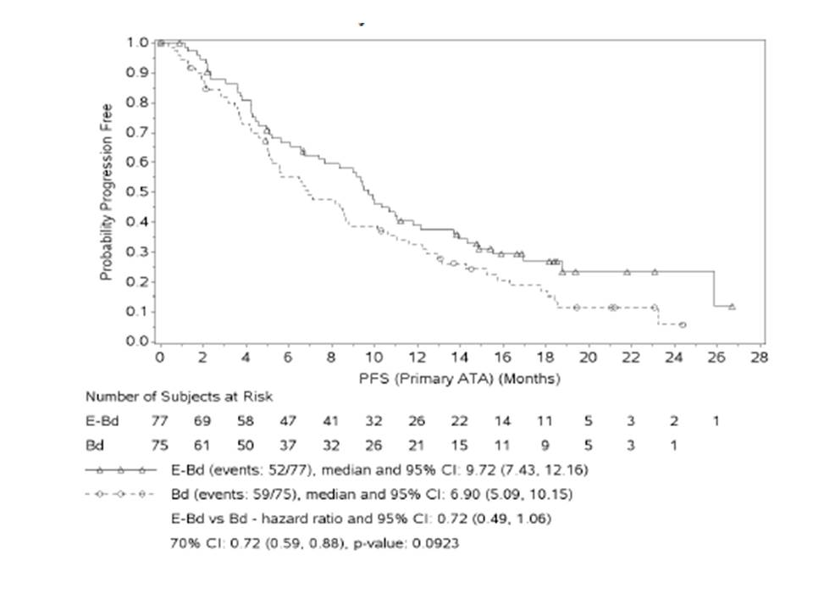

Symbols represent censored observations. Adjusted alpha level = 0.3. Stratified by prior proteasome inhibitor use (Yes vs No), presence of at least one FcγRIIIa V allele (Yes vs No) and number of prior lines of therapy (1 vs 2 or 3) at randomization.

**Analyses using the secondary definition of PFS and primary ATA that included censoring for subsequent therapy**

PFS, under a secondary definition, was the time from randomization to the date of the first documented tumor progression or death due to any cause, provided progression or death did not occur after start of subsequent systemic therapy, or more than 10 weeks (two or more assessment visits) after the last adequate tumor assessment. Clinical deterioration was not considered progression. Given the secondary definition of PFS and primary ATA, the following were observed: As of the database lock, 70 subjects did not have a PFS event; 37 subjects (48.1%) in the E-Bd arm and 33 subjects (44.0%) in the Bd arm. A total of 82 subjects had a PFS event; 40 subjects (51.9%) in the E-Bd arm and 42 subjects (56.0%) in the Bd arm.

* Compared with the primary definition of PFS, the secondary definition of PFS increased the number of censored cases (i.e. decreased the number of PFS events) by 12 subjects in the EBd arm and 17 subjects in the Bd arm, respectively.
* For the 70 subjects without a progression event, the elapsed median time between data cutoff (12-Sep-2014) and adequate tumor assessment was 12.71 months for the E-Bd arm and 17.54 months for the Bd arm. The median follow-up time was 10.94 months for the E-Bd group and 2.14 months for the Bd group.

A hazard ratio (HR) of 0.66 (70% CI: 0.52, 0.83) was estimated with a stratified log-rank test pvalue of 0.0645, consistent with the results from the primary analysis. The median PFS for subjects treated with E-Bd was 9.72 months (95% CI: 6.57, 15.51) compared to 6.64 months (95% CI: 5.03, 8.84) for subjects treated with Bd. The Kaplan-Meier (K-M) estimation of probability of PFS is shown in Figure 14. To assess the difference in censoring between the two treatment groups, an analysis of the censoring distribution was performed via “reverse” Kaplan-Meier curves, similar to the primary PFS analysis. The censoring distributions, in the secondary PFS analysis (primary ATA, censoring for subsequent therapy), was similar between the 2 treatment groups.

Figure 14: Kaplan-Meier Plot of PFS (Primary ATA, Including Censoring for Subsequent Therapy), All Randomized Subjects

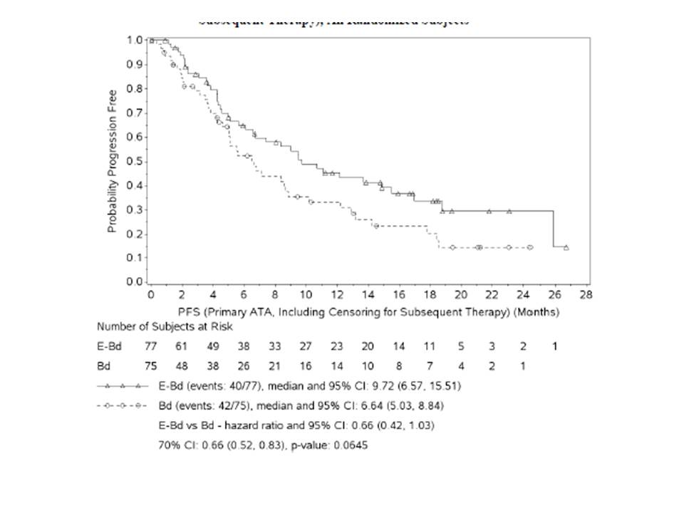

###### Results for other efficacy outcomes

**Progression-Free Survival in FcγRIIIa V Allele Sub-Groups (Secondary Analyses)**

The magnitude of the interaction between treatment arm and FcγRIIIa V allele status on PFS was estimated from a Cox proportional hazards model, stratified by prior proteasome inhibitor use and the number of prior lines of therapy. The estimate of the coefficient (95% CI) of the interaction effect between treatment arm and FcγRIIIa V allele status was -0.015 (-0.853, 0.822), which includes zero. Thus, the treatment benefit (E-Bd/Bd hazard ratio) is similar between the two subgroups (with versus without at least one V allele).

**Subset Analyses of Progression-Free Survival**

For all but one of the subsets analyzed, the unstratified HR favored E-Bd over Bd (HR < 1.0), demonstrating a PFS benefit of E-Bd over Bd (Figure 15). For 4 of the subsets, gender (female), baseline LDH (>/= 300 U/L), no prior stem cell transplant, and no prior IMID therapy, the upper 95% CI did not cross one in favor of the E-Bd arm. Results from analysis of PFS by response suggest that subjects who achieved a response (PR or better) obtained a differential long-term benefit with the addition of elotuzumab.

Figure 15: PFS (Primary ATA) Hazard Ratio and 95% CI in Subsets, All Randomized Subjects.

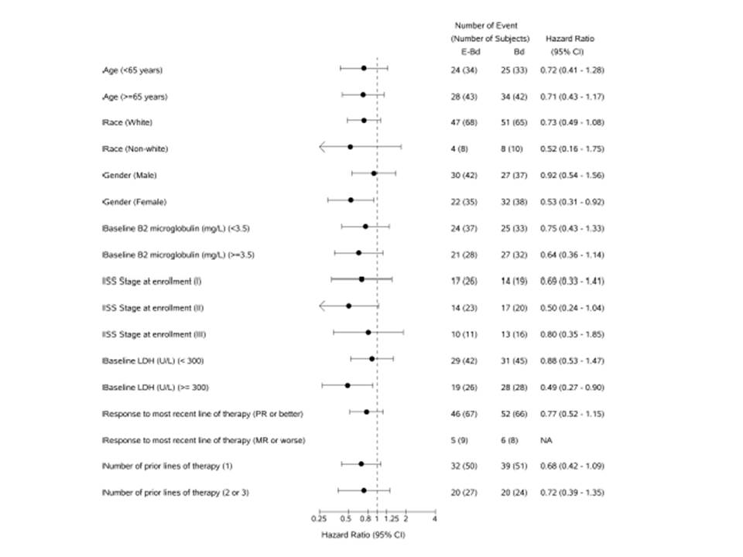

Figure 15 (continued): PFS (Primary ATA) Hazard Ratio and 95% CI in Subsets, All Randomized Subjects.

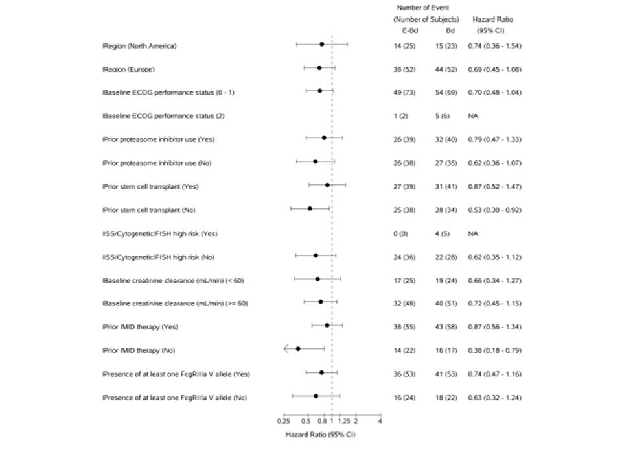

NA = Not available as the number of events in the subset is less than 10% of all PFS events

**Objective Response Rate**

For E-Bd and Bd, respectively, 31.2% and 36.0% of subjects achieved a PR, 29.9% and 22.7% of subjects achieved a VGPR, 3.9% and 2.7% of subjects achieved a CR, and 0 and 1.3% of subjects achieved a sCR. Best overall response in the E-Bd arm was 64.9% (95% CI: 53.2, 75.5) compared to 62.7% (95% CI: 50.7, 73.6) in the Bd arm. The 95% CI for the difference in ORR (-13.2, 17.8) included 0, indicating there was no significant difference between the two arms.

**Subset Analyses of Best Overall Response**

There were no significant differences in subsets between treatment groups for BOR. There was no difference between treatment groups in BOR for subsets of subjects with either the presence or absence of at least 1 FcγRIIIa V allele.

* For the subset of subjects with the presence of at least 1 FcγRIIIa V allele, best overall response in the E-Bd arm was 60.0% (95% CI: 45.9, 73.0) compared to 61.1% (95% CI: 46.9, 74.1) in the Bd arm. The 95% CI for the difference in ORR (-19.6, 17.4) included 0, indicating there was no significant difference between the two arms.
* For the subset of subjects with absence of at least 1 FcγRIIIa V allele, best overall response in the E-Bd arm was 77.3% (95% CI: 54.6, 92.2) compared to 66.7% (95% CI: 43.0, 85.4) in the Bd arm. The 95% CI for the difference in ORR (-17.2, 37.7) included 0, indicating there was no significant difference between the two arms.

**Duration of Response**

The median duration of response was 10.35 months (95% CI: 8.54, 14.75) in the E-Bd arm compared to 9.26 months in the Bd arm (95% CI: 5.59, 11.73). For subjects with the presence of at least one FcγRIIIa V allele the median duration of response was 11.37 months (95% CI: 8.54, 16.62) in the E-Bd arm compared to 10.35 months in the Bd arm (95% CI: 5.55, 14.42). For subjects with the absence of at least one FcγRIIIa V allele, the median duration of response was 9.41 months (95% CI: 6.64, not estimable) in the E-BD arm compared to 6.21 months (95% CI: 2.33, 15.67) in the Bd arm.

**Time to Response**

The median time to response was 1.43 months for the 50 responder subjects in the E-Bd arm compared to 1.51 months for the 47 responder subjects in the Bd arm. For subjects with the presence of at least one FcγRIIIa V allele, the median time to response was 1.35 months for the 33 responder subjects in the E-Bd arm compared to 1.45 months for the 33 responder subjects in the Bd arm. For subjects without the presence of at least one FcγRIIIa V allele, the median time to response was 1.45 months for the 17 responder subjects in the E-BD arm compared to 2.18 months for the 14 responder subjects in the Bd arm.

**Overall Survival**

The analysis of overall survival (OS) is planned after 85 subjects have died. Subjects who have not died will be censored at the last known date alive. While the OS data is immature at this time with 40 subjects with a reported death (17 on E-Bd, 23 on Bd), a preliminary OS analysis was performed based on the current data. These analyses included estimates and CI of median OS and hazard ratio, without any formal statistical consideration.

* As of the database lock, 60 subjects (77.9%) in the E-Bd arm and 52 subjects (69.3%) in the Bd arm did not have a reported death. Seventeen subjects (22.1%) in the E-Bd arm and 23 subjects (30.7%) in the Bd arm had died.
* The median time between data cutoff (12-Sep-2014) and the last known alive date for subjects without an event was 2.99 months for the E-Bd arm and 3.33 months for the Bd arm.
* Of the subjects still alive, most had 2 to <3 months elapse between the data cutoff date and the last known alive date (18.2% for the E-Bd group and 24.0% for the Bd group).
* The median follow-up for subjects without an event was 18.69 months for the E-Bd group and 18.51 months for the Bd group.
* The 1-year OS rate (95% CI) was 0.85 (0.75, 0.92) for the E-Bd group and 0.74 (0.62, 0.83) for the Bd group.
* Overall survival data is plotted in a Kaplan-Meier plot.

Figure 16: Kaplan-Meier Plot of Overall Survival, All Randomized Subjects

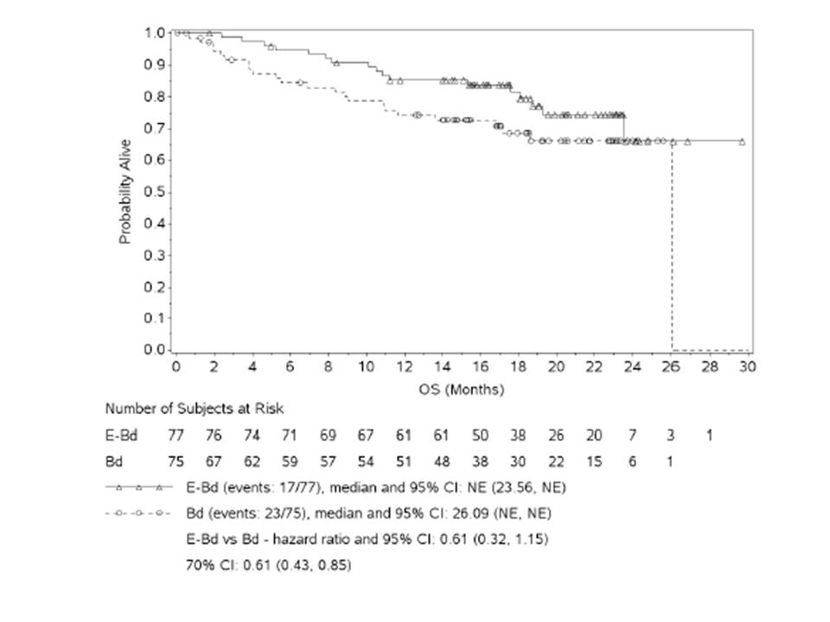

Symbols represent censored observations. Adjusted alpha level = 0.3. Stratified by prior proteasome inhibitor use (Yes vs No), presence of at least one FcγRIIIa V allele (Yes vs No) and number of prior lines of therapy (1 vs 2 or 3) at randomization. NE = Non-estimable.

##### Study HuLuc63-1702

###### Study design, objectives, locations and dates

This was a phase 1/2, multicenter, open-label, dose-escalation study of elotuzumab and bortezomib in subjects with multiple myeloma following one to three prior therapies.

Primary Objectives:

For Phase 1:

* To identify the maximum tolerated dose (MTD) of elotuzumab in combination with bortezomib in subjects with multiple myeloma (MM) after 1 to 3 prior therapies. The MTD was defined as the highest dose level of elotuzumab at which ≤ 1dose-limiting toxicity (DLT) occurred in 6 subjects.

For Phase 2 (which was not conducted):

* To evaluate the efficacy of elotuzumab in combination with bortezomib in subjects with MM after 1 to 3 prior therapies.

Secondary Objectives: For Phase 1 only:

* To evaluate the efficacy of elotuzumab in combination with bortezomib in subjects with MM after 1 to 3 prior therapies
* To evaluate the safety of elotuzumab in combination with bortezomib.
* To evaluate the pharmacokinetic parameters of elotuzumab in combination with bortezomib.
* To evaluate the immunogenicity of elotuzumab in combination with bortezomib.
* To evaluate the pharmacodynamics of elotuzumab in combination with bortezomib.

###### Inclusion and exclusion criteria

Subjects were eligible for inclusion in this study if they met all of the following criteria:

* Male or female, 18 years of age or older.
* Diagnosis of MM and documentation of 1 to 3 prior therapies.
* M-protein spike (complete immunoglobulin molecule) of ≥ 1 g/dL in serum and/or ≥ 0.5 g excreted in a 24-hour urine collection sample.
* Eastern Cooperative Oncology Group (ECOG) performance status 0 – 2.
* No prior bortezomib treatment OR responsive (partial response or better) to prior bortezomib treatment for a minimum of 3 months OR responsive to prior bortezomib treatment at the time of going to another treatment or ceasing treatment.
* Alanine aminotransferase (ALT) or aspartate aminotransferase (AST) ≤ 3 × the upper limit of normal (ULN).
* Total bilirubin ≤ 2 × ULN.
* Serum creatinine ≤ 2.0 mg/dL (unless related to MM, then ≤ 3.0 mg/dL).
* Adequate bone marrow function defined as: a. Absolute neutrophil count > 1,000 cells/mm3 (1.0 × 109 cells/L) without growth factor support for 7 days; b. Platelets ≥ 75,000 cells/mm3 (75 × 109 cells/L) without transfusion within 72 hours of screening; c. Hemoglobin ≥ 8 g/dL without red blood cell transfusion within 2 weeks of screening.
* Serum calcium (corrected for albumin) level at or below the ULN range (treatment of hypercalcemia was allowed and subject may have enrolled if hypercalcemia returned to normal with standard treatment; additional screening time for confirmation was permitted).
* Use of appropriate contraception where applicable.
* Negative urine pregnancy test where applicable.
* Two-dimensional echocardiogram indicating left ventricular ejection fraction ≥ 45% within 30 days prior to the first dose of elotuzumab.
* Ability to understand the purpose and risks of the study and provide signed and dated informed consent and authorization to use protected health information (in accordance with national and local subject privacy regulations).

Subjects were ineligible for this study if they met any one of the following criteria:

* Life expectancy < 3 months.
* Prior malignancy, except for adequately treated basal cell or squamous cell skin cancer, in situ cervical cancer, or other cancer from which the subject was disease-free for at least 2 years.
* Uncontrolled medical problems such as diabetes mellitus, coronary artery disease, hypertension, unstable angina, arrhythmias, pulmonary (including acute diffuse infiltrative pulmonary and pericardial disease), hepatic, and renal diseases unless renal insufficiency was felt to be secondary to MM.
* Solitary bone or solitary extramedullary plasmacytoma as the only evidence of plasma cell dyscrasia.
* Prior treatment with bortezomib within 3 months of first dose of study drug.
* Thalidomide, lenalidomide, cytotoxic chemotherapy, or corticosteroids (except prior to infusion of first dose of study drug as prophylaxis for infusion reactions) within 2 weeks of the first dose of elotuzumab.
* Prior therapy with anti-CD56+ therapeutics.
* Radiotherapy within 2 weeks prior to the first dose of elotuzumab.

###### Study treatments

Table 11: HuLuc63-1702 Study Treatments

| Cohort Numbera | Elotuzumab Dose Level and Frequency | Bortezomib Dose Level and Frequencyb | Dexamethasone Dose Level and Frequencyc |
| --- | --- | --- | --- |
| 1 | 2.5 mg/kg twice per cycle (IV, Days 1 and 11) | 1.3 mg/m2 four times per cycle (IV, Days 1, 4, 8, and 11) | 20 mg eight times per cycle (PO, Days 1, 2, 4, 5, 8, 9, 11, and 12) |
| 2 | 5.0 mg/kg twice per cycle (IV, Days 1 and 11) | 1.3 mg/m2 four times per cycle (IV, Days 1, 4, 8, and 11) | 20 mg eight times per cycle (PO, Days 1, 2, 4, 5, 8, 9, 11, and 12) |
| 3 | 10.0 mg/kg twice per cycle (IV, Days 1 and 11) | 1.3 mg/m2 four times per cycle (IV, Days 1, 4, 8, and 11) | 20 mg eight times per cycle (PO, Days 1, 2, 4, 5, 8, 9, 11, and 12) |
| 4 | 20.0 mg/kg twice per cycle (IV, Days 1 and 11) | 1.3 mg/m2 four times per cycle (IV, Days 1, 4, 8, and 11) | 20 mg eight times per cycle (PO, Days 1, 2, 4, 5, 8, 9, 11, and 12) |

a. Cohort numbers were based on DLT outcomes. Actual cohort dose assignments were carried out on the basis of dose escalation outcomes in the study. If 2 DLTs occurred at the 20 mg/kg dose, a fifth cohort at 15 mg/kg elotuzumab would have been added. b. From Cycle 11 onwards, bortezomib dosing on Days 4 and 8 could be omitted at the investigator's discretion. c. If added at the end of Cycle 2 or 3.

###### Efficacy variables and outcomes

The primary endpoint was the incidence of DLTs in the first treatment cycle for each cohort. Secondary endpoints were as follows:

* Objective response rate according to EBMT criteria.
* Frequency, severity, and relationship of AEs and SAEs with the combination of elotuzumab and bortezomib.
* Duration of response, time to progression, and progression-free survival.
* Objective response rate according to International Myeloma Working Group (IMWG) criteria (programatically derived).
* Pharmacokinetic profile, including Cmax, AUC0-inf, systemic clearance, volume of distribution, and half-life.
* Incidence of elotuzumab-specific antidrug antibodies.

###### Sample size

Approximately 15 to 42 subjects in up to 5 cohorts were to be enrolled in the trial.

Cohorts 1 to 3 for dose escalation were to begin with 3 subjects. If no DLT occurred within the first cycle of treatment in any subject, enrolment was to begin in the next higher cohort. If one subject had a DLT, 3 additional subjects were to be enrolled in the cohort. If no other subject in the cohort had a DLT, escalation to the next cohort may have proceeded. In the case of the 20.0 mg/kg group, 3 additional subjects were to be enrolled into the cohort for a total of 6 subjects. If a second subject in a cohort had a DLT, determination of the MTD was then to continue at an intermediate dose of 15 mg/kg elotuzumab dose at which 6 subjects were to be treated or the next lower dose cohort at which an additional 3 subjects were to be added, for a total of 6 (unless that cohort already had 6 subjects). The MTD was defined as the highest dose level at which ≤ 1 of 6 subjects experienced a DLT.

Once the MTD was established, an additional 12 to 18 subjects could have been treated at the MTD to further characterize the safety profile. To comply with the Simon's 2-stage design used for this study (Phase 2 portion),[1] the number of subjects treated under MTD who were efficacy evaluable was not to exceed 17. Subjects who completed at least 2 cycles of treatment, or progressed before completing 2 cycles of treatment, were to be considered as efficacy evaluable.

###### Statistical methods

The Intent-to-Treat (ITT) population was defined as subjects who were enrolled in the study. The Safety population was defined as subjects who received at least 1 dose of study drug.

The DLT Evaluable population included subjects who completed the first treatment cycle or experienced a DLT during the first treatment cycle.

The Efficacy Evaluable population included subjects who completed 2 cycles of treatment or progressed before completing 2 cycles of treatment.

Safety endpoints were summarized for the Safety population. Efficacy endpoints were summarized for the Efficacy Evaluable and ITT populations. The occurrence of DLTs was summarized for the DLT Evaluable population.

###### Enrolment of Subjects

A total of 28 subjects were enrolled at 7 sites in the United States.

###### Major protocol violations/deviations

Eight subjects had protocol deviations, none of which resulted in premature discontinuation of study drug. No protocol violation was considered to have affected the outcome of the study.

###### Baseline data

The ITT population had a mean age of 61 years, was approximately two-thirds male, and was predominantly white and non-Hispanic. Demographic characteristics were generally consistent across treatment cohorts. At the time of enrolment, the mean time since diagnosis of MM was 4.2 years). The majority of subjects (21/28, 75%) had 1 or 2 relapses since their initial diagnosis. Approximately half of all subjects (46.4%) were refractory to their last anticancer treatment. Most subjects (25/28, 89.3%) had an ECOG performance status of 0 or 1 at Baseline.

The median number of previous MM therapies was 2. Previous therapies included transplant (67.9% of subjects), radiotherapy (21.4% of subjects), and systemic therapies (100% of subjects). Per the protocol-specified entry criteria, subjects were required to be either bortezomib naïve or responsive to prior bortezomib therapy for a minimum of 3 months; bortezomib therapy within 3 months of baseline was prohibited. These requirements regarding prior bortezomib treatment were introduced with Amendment C of the protocol. Of the 11 subjects previously treated with bortezomib, 1 (Subject [information redacted]) was enrolled prior to Amendment C; this subject received and was refractory to bortezomib within 3 months of study entry. The remaining 10 subjects had at least a partial response.

###### Results for efficacy outcomes

Objective response rate (complete and partial response) according to EBMT criteria, duration of response, time to progression, and progression-free survival were secondary endpoints in this study.

The ORR in the total subjects group was 48.1% by the EBMT criteria, with 2 subjects achieving a complete response and 11 achieving a partial response to study treatment.

Table 12: Objective Response Rate (Efficacy Evaluable Population).

|  | Number (%) of Subjects | | | | |
| --- | --- | --- | --- | --- | --- |
| Response | Cohort 1  2.5 mg/kg  N = 3 | Cohort 2  5 mg/kg  N = 3 | Cohort 3  10 mg/kg  N = 3 | Cohort 4  20 mg/kg  N = 18 | Total  N = 27 |
| Best confirmed response |  |  |  |  |  |
| Complete response (CR) | 0 | 0 | 1 (33.3) | 1 (5.6) | 2 (7.4) |
| Partial response (PR) | 2 (66.7) | 0 | 2 (66.7) | 7 (38.9) | 11 (40.7) |
| No confirmed response | 1 (33.3) | 3 (100.0) | 0 | 10 (55.6) | 14 (51.9) |
| Objective response |  |  |  |  |  |
| Response (CR or PR) | 2 (66.7) | 0 | 3 (100.0) | 8 (44.4) | 13 (48.1) |
| 95% CI | 9.4 – 99.2 | 0.0 – 70.8 | 29.2 – 100.0 | 21.5 – 69.2 | 28.7 – 68.1 |

###### Time to Response and Duration of Response

Among the 13 subjects who had an objective response (complete or partial), the median time to objective response was 2.1 months. Duration of response ranged from 1.4 to 33.9 months, with a median duration of 6.6 months.

Table 13: Time to Response and Duration of Response (Efficacy Evaluable Population)

|  | Cohort 1  (2.5 mg/kg)  N = 3 | Cohort 2 (5 mg/kg)  N = 3 | Cohort 3  (10 mg/kg)  N = 3 | Cohort 4  (20 mg/kg)  N = 18 | Total  N = 27 |
| --- | --- | --- | --- | --- | --- |
| **Time to objective response (months)a** |  |  |  |  |  |
| **N** | 2 | 0 | 3 | 8 | 13 |
| **Mean ± SD** | 1.1 ± 0.02 | 0 | 2.7 ± 0.51 | 2.5 ± 1.89 | 2.3 ± 1.56 |
| **Median** | 1.1 | 0 | 3.0 | 1.9 | 2.1 |
| **(Min, max)** | (1.1, 1.1) | 0 | (2.1, 3.0) | (1.1, 6.5) | (1.1, 6.5) |
| **Duration of objective response (months)b** |  |  |  |  |  |
| **N** | 2 | 0 | 3 | 8 | 13 |
| **Mean ± SD** | 5.9 ± 1.65 | 0 | 16.5 ± 15.12 | 7.3 ± 7.57 | 9.2 ± 9.47 |
| **Median** | 5.9 | 0 | 9.1 | 4.2 | 6.6 |
| **(Min, max)** | (4.7, 7.0) | 0 | (6.6, 33.9) | (1.4, 24.7) | (1.4, 33.9) |

a. Only subjects who had an objective response (CR or PR) are included. Time to objective response is calculated as (date of onset of CR or PR response – date of first dose + 1)/30.4375. b. Only subjects who had an objective response (CR or PR) are included. Duration of objective response is calculated as (date of PD – date of initial objective response)/30.4375. For censored subjects, duration of objectiveresponse = (censored date – initial objective response date + 1)/30.4375.

###### Time to Progression and Progression-Free Survival

Fourteen of the 27 subjects (51.9%) in the Efficacy Evaluable population had disease progression while receiving study treatment (Table 16). The median time to disease progression overall was 9.5 months. Median time to disease progression in the 10 mg/kg cohort (N = 3) was 24.5 months compared to 7.8 months in the 20 mg/kg cohort (N = 18). Among subjects previously treated with bortezomib, the median time to disease progression was 5.8 months

Table 14: Time to Disease Progression (Efficacy Evaluable Population)

|  | Cohort 1  (2.5 mg/kg)  N = 3 | Cohort 2  (5 mg/kg)  N = 3 | Cohort 3  (10 mg/kg)  N = 3 | Cohort 4  (20 mg/kg)  N = 18 | Total  N = 27 |
| --- | --- | --- | --- | --- | --- |
| **Subjects who had disease progression** | | | | | |
| **N (%)** | 2 (66.67) | 1 (33.33) | 2 (66.67) | 9 (50.00) | 14 (51.85) |
| **95% CIa** | 0.84 – 90.57 | 9.43 – 99.16 | 0.84 – 90.57 | 26.02 – 73.98 | 28.67 – 68.05 |
| **Time to disease progression (months)b** | | | | | |
| **N** | 3 | 3 | 3 | 18 | 27 |
| **25th percentile** | 5.78 | 2.76 | 12.09 | 2.76 | 2.76 |
| **Median** | 9.46 | - | 24.51 | 7.75 | 9.46 |
| **95% CI for median** | (5.78 – 9.46) | - | (12.09 – 36.93) | (2.53 – 27.17) | (5.78 – 27.17) |
| **75th percentile** | 9.46 | - | 36.93 | 27.17 | 27.17 |

a. 95% CI is based on exact binomial probability. b. Time to disease progression was calculated from the date of the first elotuzumab dose. Subjects who withdrew from the study without disease progression were censored at the last evaluation for EBMT response. Subjects who did not receive study drug were censored at Day 1. Kaplan-Meier product limit was used.

##### Study HuLuc63-1703

###### Study design, objectives, locations and dates

A phase 1b/2, multicenter, open-label, dose-escalation study of elotuzumab in combination with lenalidomide and dexamethasone in subjects with relapsed multiple myeloma.

**Phase 1**

Primary objective:

* To identify the maximum tolerated dose (MTD) of elotuzumab given in combination with lenalidomide and dexamethasone in subjects with relapsed multiple myeloma (MM).

Secondary objectives:

* To evaluate the safety of elotuzumab when given in combination with lenalidomide and dexamethasone.
* To evaluate the pharmacokinetics of elotuzumab when given in combination with lenalidomide and dexamethasone.
* To evaluate the immunogenicity of elotuzumab when given in combination with lenalidomide and dexamethasone.
* To explore pharmacodynamic markers of elotuzumab when given in combination with lenalidomide and dexamethasone.
* To evaluate the effectiveness of the revised premedication regimen.

**Phase 2**

Primary objective:

* To evaluate the efficacy of elotuzumab given in combination with lenalidomide and dexamethasone in subjects with multiple myeloma after 1 to 3 prior therapies.

Secondary objectives:

* Phase 2 secondary objectives were identical to the Phase 1b secondary objectives

###### Inclusion and exclusion criteria

Eligible subjects were considered for inclusion in this study if they met all of the following criteria:

* Age 18 years or older, with a confirmed diagnosis of MM and documentation of 1 to 3 prior therapies
* Confirmed evidence of disease progression from immediately prior MM therapy or refractory to the immediately prior treatment.
* Measurable disease monoclonal protein (M-protein) component in serum (at least 0.5 g/dL) and/or urine (if present, ≥ 0.2 g excreted in a 24-hour collection sample). Subjects with free light chain only disease were excluded.
* Eastern Cooperative Oncology Group (ECOG) Performance Status of 0 to 2. 5. Creatinine clearance ≥ 50 mL/min measured by the Cockcroft-Gault method.
* Alanine aminotransferase (ALT) AND aspartate aminotransferase (AST) < 3 × upper limit of normal (ULN).
* Total bilirubin < 2 × upper limit of normal (ULN), and direct bilirubin < 2.0 mg/dL.
* Negative urine pregnancy test in women of childbearing potential at screening and prior to prescribing lenalidomide.
* Able to understand the purpose and risks of the study and provide signed and dated informed consent and authorization to use protected health information (in accordance with national and local subject's privacy regulations).
* Able to take aspirin daily as prophylactic anticoagulation therapy (subjects intolerant to aspirin may use warfarin or low-molecular-weight heparin).

Subjects were not eligible for this study if they met any of the following criteria:

* Prior malignancy, except for adequately treated basal cell or squamous cell skin cancer, in situ cervical cancer, or other cancer from which the subject has been disease-free for at least 2 years.
* Active or prior plasma cell leukemia (defined as either 20% of peripheral white blood cell [WBC] comprised of plasma/CD138+ cells or an absolute count of 2 × 109/L).
* Uncontrolled medical problems such as diabetes mellitus, coronary artery disease, hypertension, unstable angina, arrhythmias, pulmonary disease, and symptomatic heart failure.
* Prior lenalidomide therapy. Note: The earlier protocols under which 25 subjects in Phase 1b were enrolled (original protocol up through Amendment B) allowed lenalidomide if it had been administered more than 6 weeks prior to the first dose of study drug.
* Neuropathy ≥ grade 3 or painful neuropathy ≥ grade 2 (National Cancer Institute [NCI] Common Terminology Criteria for Adverse Events [CTCAE] v. 3.0).
* Known active infections requiring IV antibiotic, antiviral, or antifungal therapy.
* Female subjects who were pregnant or breastfeeding.

###### Study treatments

The treatment regimens for Cycles 1 and 2, and for Cycles 3 through study completion.

Table 15: Cycles 1 and 2 Dosing Regimen: Days 1 Through 28

| Cohort | Elotuzumab IV Dose Level and Frequency | Lenalidomide PO Dosage and Frequencya | Dexamethasone Dosage and Frequencyb |
| --- | --- | --- | --- |
| Phase 1b |  |  |  |
| 1 | 5 mg/kg once on  Days 1, 8, 15, 22 | 25 mg once daily on  Days 1 – 21 | 40 mg once weekly on  Days 1, 8, 15, 22 |
| 2 | 10 mg/kg once on  Days 1, 8, 15, 22 | 25 mg once daily on  Days 1 – 21 | 40 mg once weekly on  Days 1, 8, 15, 22 |
| 3c | 20 mg/kg once on  Days 1, 8, 15, 22 | 25 mg once daily on  Days 1 – 21 | 40 mg once weekly on  Days 1, 8, 15, 22 |
| Phase 2 |  |  |  |
| 10 mg/kg Dose  Group | 10 mg/kg once on  Days 1, 8, 15, 22 | 25 mg once daily on  Days 1 – 21 | 40 mg once weekly on  Days 1, 8, 15, 22 |
| 20 mg/kg Dose  Group | 20 mg/kg once on  Days 1, 8, 15, 22 | 25 mg once daily on  Days 1 – 21 | 40 mg once weekly on  Days 1, 8, 15, 22 |

a. Lenalidomide was administered 2 to 4 hours after the end of the elotuzumab infusion. b. Prior to Amendment E, dexamethasone 40 mg PO was administered 1 – 3 hours prior to the first elotuzumab infusion. For subsequent doses, dexamethasone could be given either as a single 40 mg PO dose up to 24 hours prior OR a split dose of 20 mg PO 12 – 24 hours and another 20 mg PO 1 – 3 hours prior to the infusion. Starting with Amendment E, dexamethasone was administered as follows: Weeks with elotuzumab, a split dose of 28 mg PO (between 3 – 24 hours prior to elotuzumab infusion) AND 8 mg IV (at least 45 minutes prior to infusion); weeks without elotuzumab, 40 mg PO. c. The subjects enrolled in the Expansion Phase of Phase 1b were also treated at this elotuzumab dose, which was defined as the maximum tolerated dose.

IV = intravenous; PO = oral; Note: The dosing regimen for Cycles 1 and 2 on Days 1 – 22 is shown in this table; Days 23 – 28 are rest days.

Table 16: Cycle 3 Through Study Completion Dosing Regimen: Days 1 Through 28

| Cohort | Elotuzumab IV Dose Level and Frequency | Lenalidomide PO Dosage and Frequencya | Dexamethasone Dosage and Frequencyb |
| --- | --- | --- | --- |
| Phase 1b |  |  |  |
| 1 | 5 mg/kg once on  Days 1 and 15 | 25 mg once daily on  Days 1 – 21 | 40 mg once weekly on  Days 1, 8, 15, 22 |
| 2 | 10 mg/kg once on  Days 1 and 15 | 25 mg once daily on  Days 1 – 21 | 40 mg once weekly on  Days 1, 8, 15, 22 |
| 3c | 20 mg/kg once on  Days 1 and 15 | 25 mg once daily on  Days 1 – 21 | 40 mg once weekly on  Days 1, 8, 15, 22 |
| Phase 2 |  |  |  |
| 10 mg/kg Dose  Group | 10 mg/kg once on  Days 1 and 15 | 25 mg once daily on  Days 1 – 21 | 40 mg once weekly on  Days 1, 8, 15, 22 |
| 20 mg/kg Dose  Group | 20 mg/kg once on  Days 1 and 15 | 25 mg once daily on  Days 1 – 21 | 40 mg once weekly on  Days 1, 8, 15, 22 |

a. Lenalidomide was administered 2 to 4 hours after the end of the elotuzumab infusion. b. Prior to Amendment E, dexamethasone 40 mg PO was administered 1 – 3 hours prior to the first elotuzumab infusion. For subsequent doses, dexamethasone could be given either as a single 40 mg PO dose up to 24 hours prior OR a split dose of 20 mg PO 12 – 24 hours and another 20 mg PO 1 – 3 hours prior to the infusion. Starting with Amendment E, dexamethasone was administered as follows: Weeks with elotuzumab, a split dose of 28 mg PO (between 3 – 24 hours prior to elotuzumab infusion) AND 8 mg IV (at least 45 minutes prior to infusion); weeks without elotuzumab, 40 mg PO. c. The subjects enrolled in the Expansion Phase of Phase 1b were also treated at this elotuzumab dose, which was defined as the maximum tolerated dose.

IV = intravenous; PO = oral; Note: The dosing regimen for Cycle 3 on Days 1 – 22 is shown in this table; Days 23 – 28 are rest days.

###### Efficacy variables and outcomes

The secondary efficacy endpoint for the Phase 1b portion of the study was as follows:

* Objective response according to the IMWG.

The secondary efficacy endpoints for both the Phase 1b and Phase 2 portions of the study were as follows:

* Duration of response, TTP, and PFS.

###### Objective Response and Duration of Response

Objective response was defined as confirmed sCR (stringent complete response), CR (complete response), VGPR (very good partial response), or PR (partial response) using the IMWG response criteria. Stable disease (SD) was not considered as an objective response. The response was collected on CRFs. The number and percent of subjects with each type of response and the objective response were summarized by dose cohort for the Phase 1b portion of the study or by dose group for the Phase 2 portion and presented in data listings. The objective response rate (ORR) difference and 95% confidence interval (CI) was calculated based on methods described by Agresti and Min 20 for the Phase 1b and Phase 2 results.

Time to onset of the response was summarized using descriptive statistics unless otherwise specified and duration of response, defined as time from the initial objective response to progression for responders, was summarized using Kaplan-Meier estimates.

###### Time to Progression (TTP)

Time to progression was summarized using Kaplan-Meier estimates. Time to progression was calculated from the first elotuzumab dosing date for Phase 1b and the randomization date for Phase 2. Subjects who did not have disease progression were censored at the date of the last IMWG assessment or at the time of initiation of new therapy, whichever was earlier. In addition, as noted in the SAP, if a subject died before progression, the subject was censored on the date of the last IMWG assessment prior to death. Subjects who did not have any IMWG assessment post baseline were censored on the first elotuzumab dosing date for Phase 1b and on the randomization date for Phase 2. Progression-Free Survival (PFS) Progression-free survival was plotted and summarized using the Kaplan-Meier product-limit method. Death due to any cause was counted as an event. Time to progression or death was calculated from the first elotuzumab infusion for Phase 1b and from the randomization date for Phase 2. Subjects who were alive and did not have disease progression were censored at the date of the last IMWG evaluation or at the time of initiation of new therapy, whichever was earlier. Subjects who were alive and did not have any IMWG assessment post baseline were censored on the first elotuzumab dosing date for Phase 1b and on the randomization date for Phase 2.

###### Sample size

The planned sample size during the Phase 1b portion was up to 33 subjects, following a 3 + 3 dose escalation design. It was planned to treat an additional 12 – 15 evaluable subjects with the MTD during the Expansion Phase of Phase 1b. This sample size was considered sufficient to support pharmacologic and safety assessments.

For the Phase 2 portion of the protocol, a sample size of 30 subjects was planned for each of the 10 mg/kg and 20 mg/kg elotuzumab dose groups. The sample size of 30 subjects per arm would provide a two-sided 95% CI with width less than 40% between the lower limit and the upper limit for each dose group using the Clopper-Pearson (exact) method (see examples listed below). The study was not powered for a direct comparison between the 10 mg/kg and 20 mg/kg dose groups in the Phase 2 portion. After 60 subjects were randomized in the Phase 2 portion of the study, an additional 10 subjects were enrolled to evaluate the revised premedication regimen. The sample size for these additional 10 subjects was deemed appropriate for exploratory analysis.

###### Statistical methods

The number and percent of subjects with each type of objective response (sCR, CR, VGPR, PR, and SD) were summarized by dose cohort for the Phase 1b portion of the study or by treatment group for the Phase 2 portion and presented in data listings. The objective response rate (ORR) difference between the 10 and 20 mg/kg Dose Groups and 95% confidence interval (CI) was calculated based on methods described by Agresti and Min for Phase 2 results. Time to onset of the response was summarized using descriptive statistics unless otherwise specified and duration of response was summarized using Kaplan-Meier estimates.

Progression-free survival and TTP were estimated using Kaplan-Meier estimates and the Kaplan-Meier product-limit method, respectively. For PFS, death due to any cause was counted as an event; PFS was calculated from the first elotuzumab infusion for the Phase 1b portion and from the date of randomization for the Phase 2 portion. Subjects who were alive and did not have disease progression were censored at the date of the last IMWG evaluation or at the time of initiation of the new therapy, whichever was earlier. Subjects who were alive and did not have any IMWG assessment after the first elotuzumab infusion in Phase 1b and after randomization in Phase 2 were censored on the day of the first infusion and the day of randomization, respectively. The duration of response was summarized using Kaplan-Meier estimates.

###### Enrolment of Subjects

A total of 102 subjects (29 in Phase 1, 73 in Phase 2) were enrolled. Of the enrolled subjects, 101 subjects received at least 1 dose of study drug (1 subject in Phase 1b did not receive study drug) at 17 study sites in North America (US and Canada) and the EU (France and Germany). Five sites enrolled subjects in the Phase 1b portion of the study and all 17 sites enrolled subjects into the Phase 2 portion of the study. A total of 73 subjects were enrolled, randomized, and treated in the Phase 2 portion of the study at 17 study sites. Thirteen subjects were still on treatment in the study, and 60 subjects had discontinued treatment as of the data cutoff date for this interim report. The primary reasons for discontinuation were disease progression (34 subjects), AEs (12 subjects), the subject's decision (8 subjects), and the investigator's decision (6 subjects). Subject disposition for the Phase 2 portion of the study is summarized.

Table 17: Disposition of Subjects – Phase 2

|  | Elotuzumab Dose Group | | |
| --- | --- | --- | --- |
|  | 10 mg/kg | 20 mg/kg | Total |
| Subject enrolled, n (%) | 36 (100) | 37 (100) | 73 (100) |
| ITT population, n (%) | 36 (100) | 37 (100) | 73 (100) |
| Safety population, n (%) | 36 (100) | 37 (100) | 73 (100) |
| Completed 30-day follow-up, n (%) | 26 (72.2) | 21 (56.8) | 47 (64.4) |
| Completed 60-day follow-up, n (%) | 28 (77.8) | 21 (56.8) | 49 (67.1) |
| Discontinued treatment, n (%) | 30 (83.3) | 30 (81.1) | 60 (82.2) |
| Primary reason for treatment cessation, n |  |  |  |
| Adverse event | 4 | 8 | 12 |
| Disease progression | 17 | 17 | 34 |
| Investigator's decision | 4 | 2 | 6 |
| Subject's decision | 5 | 3 | 8 |

ITT = intent-to-treat

###### Major protocol violations/deviations

Deviations included, but were not limited to, inclusion/exclusion criteria violation, receipt of incorrect treatment or incorrect dose of study drug, subject development of withdrawal criteria without being withdrawn, and use of prohibited concomitant medications. None of the protocol deviations were considered to have affected the study outcome or interpretation of the study results or conclusions.

###### Baseline data

The 73 subjects enrolled in the Phase 2 portion of the study included 43 males (58.9%) and 30 females (41.1%) who ranged from 39 to 82 years of age, with a median of 63.1 years. The majority of subjects were white (83.6%) and non-Hispanic (95.8%).

Of the 73 subjects in the Phase 2 ITT population, 25 subjects (34.7%) had stage I MM, 20 subjects (27.8%) had stage II MM, and 27 subjects (37.5%) had stage III MM at study entry. The MM stage for 1 subject at enrollment was not captured in the database. Thirty-nine subjects (53.4%) had 1 relapse since their initial diagnosis, 30 subjects (41.1%) had 2 relapses, and 4 subjects (5.5%) had 3 relapses since initial diagnosis. The 73 subjects had a median of 2 lines of prior therapy: 33 subjects (45.2%) had 1 line, 32 subjects (43.8%) had 2 lines, and 8 subjects (11.0%) had 3 lines of prior therapy. The baseline disease characteristics for the Phase 2 portion of the study are summarized by dose group and previous MM therapies.

Table 18: Baseline Disease Characteristics – Phase 2 (ITT Population)

|  |  | Elotuzumab Dose Group |  |
| --- | --- | --- | --- |
|  | 10 mg/kg  N = 36 | 20 mg/kg  N = 37 | Total  N = 73 |
| Sex, n (%) |  |  |  |
| Male | 19 (52.8) | 24 (64.9) | 43 (58.9) |
| Female | 17 (47.2) | 13 (35.1) | 30 (41.1) |
| Age |  |  |  |
| Median | 62.9 | 63.4 | 63.1 |
| Min – max | 39 – 77 | 41 – 82 | 39 – 82 |
| MM stage at initial diagnosis, n (%) | | | |
| Stage I | 13 (41.9) | 11 (32.4) | 24 (36.9) |
| Stage II | 7 (22.6) | 7 (20.6) | 14 (21.5) |
| Stage III | 11 (35.5) | 16 (47.1) | 27 (41.5) |
| Number of relapses since initial diagnosis, n (%) | | | |
| 1 | 18 (50.0) | 21 (56.8) | 39 (53.4) |
| 2 | 16 (44.4) | 14 (37.8) | 30 (41.1) |
| 3 | 2 (5.6) | 2 (5.4) | 4 (5.5) |
| Cytogenetic risk category,n (%) | | | |
| High risk | 1 (2.8) | 3 (8.1) | 4 (5.5) |
| Standard risk | 30 (83.3) | 24 (64.9) | 54 (74.0) |
| Low risk | 2 (5.6) | 3 (8.1) | 5 (6.8) |
| Not reported | 3 (8.3) | 7 (18.9) | 10 (13.7) |

High risk = ISS stage II or III and t(4;14) or del(17p) abnormality; standard risk: not high or low risk; low risk: ISS stage I or II and absence of t(4;14), del(17p) and 1q21 abnormalities AND age < 55.

###### Results for efficacy outcomes

The primary efficacy endpoint for the Phase 2 portion of the study was the objective response according to the IMWG. The analysis population was the ITT population. Sixty-one of the 73 subjects (83.6%) had an objective response (95% CI: 73.0% – 91.2%), consistent with the objective response rate in the Phase 1b portion of the trial. The best objective response was stringent complete response (sCR) for 3 subjects (4.1%), complete response (CR) for 7 subjects (9.6%), very good partial response (VGPR) for 31 subjects (42.5%), and partial response (PR) for 20 subjects (27.4%). The combined ORR of the 10 and 20 mg/kg Dose Groups was 83.6%. Similar to the results observed in Phase 1b, median time to reach objective response was 1.0 month for subjects in the 10 mg/kg Dose Group, 1.7 months for subjects in the 20 mg/kg Dose Group, and 1.0 month overall. The median time to reach best objective response was 2.6 months overall; 2.8 months in the 10 mg/kg Dose Group and 2.4 months in the 20 mg/kg Dose Group.

Table 19: IMWG Response – Phase 2 (ITT Population)

|  | Elotuzumab Dose Group | | |
| --- | --- | --- | --- |
| Assessment | 10 mg/kg  N = 36 | 20 mg/kg  N = 37 | Total  N = 73 |
| Objective response |  |  |  |
| Response (sCR, CR, VGPR, or PR), n (%) | 33 (91.7) | 28 (75.7) | 61 (83.6) |
| 95% CIa | 77.5 – 98.2 | 58.8 – 88.2 | 73.0 – 91.2 |
| Best confirmed response,b n (%) | | | |
| Stringent complete response (sCR) | 2 (5.6) | 1 (2.7) | 3 (4.1) |
| Complete response (CR) | 4 (11.1) | 3 (8.1) | 7 (9.6) |
| Very good partial response (VGPR) | 17 (47.2) | 14 (37.8) | 31 (42.5) |
| Partial response (PR) | 10 (27.8) | 10 (27.0) | 20 (27.4) |
| No confirmed response,b n (%) | 3 (8.3) | 9 (24.3) | 12 (16.4) |

CR = complete response; IMWG = International Myeloma Working Group Uniform Response Criteria; max = maximum; min = minimum; PR = partial response; sCR = stringent complete response; STD = standard deviation; VGPR = very good partial response

a. Clopper-Pearson (exact) method was used to calculate 95% CI. b. Confirmed response required 2 consecutive assessments at the same response or better.

Secondary efficacy endpoints for the Phase 2 portion of the study were duration of response, TTP, and PFS. The analysis population was the ITT population.

###### Duration of Response – Phase 2

The median duration of response using Kaplan-Meier estimates was 34.8 months for the 10 mg/kg Dose Group, 29 months for the 20 mg/kg Dose Group, and 29.2 months overall. Overall, the lower 95% CI limit was 18.2 months and upper limit could not be estimated.

###### Progression-Free Survival (PFS) – Phase 2

The median PFS (using confirmed time-to-first disease progression) was 28.62 months (95% CI: 16.6 – 43.1) overall in Phase 2. The median PFS in the 10 mg/kg Dose Group was 32.5 months (95% CI: 14.9, upper limit not estimable) and for the 20 mg/kg Dose Group it was 25 months (95% CI: 14.0 – 35.7).

###### Time to Progression (TTP) – Phase 2

The median TTP was 28.2 months (95% CI: 15.4 – 35.8) overall in Phase 2. The median TTP in the 10 mg/kg Dose Group was 32.5 months (95% CI: 14.9, upper limit not estimable) and for the 20 mg/kg Dose Group it was 20 months (95% CI: 12.9 – 35.7).

###### Efficacy Conclusions

Elotuzumab, in combination with lenalidomide and dexamethasone demonstrated clinically meaningful antitumor activity as measured by ORR and PFS in subjects with relapsed MM.

* In Phase 2, the overall ORR was 84% and the overall median PFS was 29 months (32 months for 10 mg/kg and 25 months for 20 mg/kg). The overall median duration of response was 29 months.
* In Phase 1b, the overall ORR was 82% and the overall median PFS was 33 months. The median duration of response was not estimable.

##### Study CA204010

###### Study design, objectives, locations and dates

This was a phase 2a single-arm study of elotuzumab in combination with thalidomide and dexamethasone in subjects with relapsed and/or refractory multiple myeloma.

Primary Objective:

* To determine the safety and tolerability of elotuzumab in combination with thalidomide and dexamethasone (E-Td) in subjects with relapsed and/or refractory multiple myeloma (MM) as assessed by the incidence of severe (Grade 3 or higher) non-hematologic adverse events (AEs).

Secondary Objective:

* To determine the frequency of dose modifications due to AEs in subjects with relapsed/refractory MM treated with E-Td.

Exploratory Objectives:

* To evaluate the general safety of the E-Td regimen
* To evaluate the clinical activity of E-Td as defined by the modified International Myeloma Working Group (IMWG) response criteria
* To assess safety and clinical activity of thalidomide, dexamethasone, elotuzumab, and cyclophosphamide (E-CTd) in those subjects who have a suboptimal response to E-Td

###### Inclusion and exclusion criteria

Male and female subjects >/=18 years of age who were candidates for treatment with thalidomide and dexamethasone based on prior therapies and toxicities and met the following criteria:

* Eastern Cooperative Oncology Group (ECOG) performance status of 0-1 for the E-Td lead-in cohort and 0-2 for all other subjects
* Confirmed diagnosis of previously treated MM with documented progression by IMWG criteria after or during the most recent therapy
* 1-5 prior lines of therapy
* Measurable disease as defined by at least one of the following: a) serum IgG, IgA or IgM M-protein >/= 0.5 g/dL, or serum IgD M-protein >/=0.05 g/dL; b) Urine M-protein >/=200 mg excreted in a 24-hour collection sample; or c) Involved serum free light chain level >/=10 mg/dL provided the free light chain ratio was abnormal.

Key exclusion criteria for this study were:

* Target Disease Exceptions
  + Solitary bone or solitary extramedullary plasmacytoma as the only evidence of plasma cell dyscrasia
  + Monoclonal gammopathy of undetermined significance (MGUS), smoldering myeloma or Waldenstrom’s magroglobulinemia
  + Active plasma cell leukemia (defined as either 20% of peripheral white blood cells comprised of plasma/CD138+ cells or an absolute plasma cell count of 2 x 109/L)
  + Non-secretory myeloma
  + Medical History and Concurrent Diseases
  + Any residual AEs from prior chemotherapy, surgery, or radiotherapy that had not resolved to < Grade 2 (per NCI CTCAE v3.0)
  + Any medical conditions that, in the investigator’s opinion, would impose excessive risk to the subject
  + Any uncontrolled disease, such as pulmonary disease, infection, or seizure disorder
  + Any altered mental status or any psychiatric condition that would interfere with the understanding of the informed consent
  + Significant cardiac disease as determined by the investigator, including:
  + Known or suspected cardiac amyloidosis
  + Congestive heart failure of Class III or IV of the New York Heart Association (NYHA) classification
  + Uncontrolled angina, hypertension, or arrhythmia
  + Myocardial infarction in past 6 months
  + Any uncontrolled or severe cardiovascular disease
  + Prior cerebrovascular event with persistent neurologic deficit
  + Prior or concurrent malignancy, except any malignancy from which the subject has been disease-free for ≥ 5 years
  + Known HIV infection
  + Active hepatitis A, B, or C
  + Grade >/= 2 neuropathy (per NCI CTCAE v 3.0)
  + Physical and Laboratory Test Findings
  + Corrected serum calcium >/= 11.5 mg/dL
  + Absolute neutrophil count < 1000 cells/mm3. No growth factors allowed within 1 week of enrollment
  + Platelets < 75,000 cell/mm3 (75 x 109/L)
  + Hemoglobin < 8 g/dL
  + Creatinine clearance < 30 mL/minute measured by 24-hour urine collection or estimated by the Cockcroft-Gault formula
  + Total bilirubin > 1.5 x upper limit of normal (ULN)
  + Aspartate aminotransferase (AST) or alanine aminotransferase (ALT) >/=3 x ULN

###### Prior Therapy or Surgery

* Administration of chemotherapy, biological, immunotherapy, or investigational agent (therapeutic or diagnostic) within 3 weeks prior to Cycle 1 Day 1 (14 days for non-myelosuppressive therapy). Subjects should be 6 weeks from last dose of nitrosourea, nitrogen mustards or monoclonal antibody, 12 weeks from autologous stem cell transplant (SCT), and 16 weeks from allogeneic SCT.
* Discontinued any immunomodulatory drugs (IMiDs [such as lenalidomide and pomalidomide]) due to a Grade ≥ 3 toxicity (unless the toxicity was neutropenia).
* Prior exposure to elotuzumab or prior participation in an elotuzumab clinical trial.

###### Study treatments

Elotuzumab was supplied to the sites as a lyophilized powder (400 mg/vial), which was reconstituted as a solution for IV infusion. Elotuzumab was administered as a 10 mg/kg (based on the subject’s body weight assessed at each visit) IV infusion weekly on Day 1 during Cycles 1 and 2, and every 2 weeks during Cycle 3 and beyond.

* Elotuzumab dose reductions were not permitted.
* Premedication with dexamethasone, an H1 blocker (diphenhydramine, 25-50 mg po or IV, or equivalent), H2 blocker (ranitidine, 50 mg IV), and acetaminophen (650-1000 mg po) was required 30-90 minutes prior to the elotuzumab infusion.

Thalidomide po QD: started at 50 mg (Cycle 1 Days 1-14); if tolerated, escalated to 100 mg (Cycle 1 Days 15-28), and then to 200 mg (Cycle 2 and beyond).

* Thalidomide dose reductions, delay, interruptions, or discontinuation were permitted in the event of toxicity. Dexamethasone: 40 mg po weekly on weeks without elotuzumab; and as premedication for elotuzumab at 28 mg po 3-24 h before the elotuzumab infusion and 8 mg IV at least 45 min before the elotuzumab infusion on weeks with elotuzumab.
* Dexamethasone dose reduction was permitted in the event of toxicity and in the setting of infusion reactions; dose delays were allowed as clinically indicated at the discretion of the investigator. Cyclophosphamide: 50 mg po QD (if response to E-Td was suboptimal)
* Cyclophosphamide dose reduction, delay, interruption, or discontinuation were permitted in the event of toxicity.

###### Efficacy variables and outcomes

Subjects were evaluated for tumor response, the primary efficacy assessment, by the investigator every 4 weeks from study start until disease progression using modified IMWG criteria that included Minor (Minimal Response) per European Group for Blood and Marrow Transplant (EBMT). All efficacy endpoints in this study were exploratory and included response rate (objective response rate [ORR], best overall response [BOR]), duration of response (DOR) and time to response (TTR), and progression-free survival (PFS).

* ORR was defined as the proportion of treated subjects who achieved a best response of stringent complete response (sCR), complete response (CR), very good partial response (VGPR), or PR using the modified IMWG criteria.
* TTR was defined as time from first dose of study drug to the first objective documentation of PR or better and was restricted to subjects with a best response of PR or better.
* DOR was defined as time from first response until a progression event (documented progression or death) and was restricted to subjects with a best response of PR or better. Subjects who neither progressed nor died were censored on the date of their last adequate tumor assessment.
* PFS was defined as time, in months, from the first dose of study drug to the date of documented disease progression (based on investigator assessment) or death due to any cause. For subjects who were administered cyclophosphamide, disease progression before start of cyclophosphamide was not considered an event. Subjects who neither progressed nor died were censored on the date of the last adequate tumor assessment. Subjects who did not have any postbaseline tumor assessments and who had not died were censored on the first date of study drug dosing.

###### Sample size

A sample size of 40 subjects was selected, but was not based on hypothesis testing or power consideration. The primary objective of this study was to determine the safety and tolerability of elotuzumab in combination with thalidomide and dexamethasone in subjects with relapsed and/or refractory multiple myeloma as assessed by the incidence of severe (Grade 3 or higher) non-hematologic AEs. In a pivotal Phase 3 study of Td in subjects with newly diagnosed MM, Grade 3 or higher non-hematologic AEs were reported in 67% of subjects within four cycles. This figure included deep vein thromboses (DVTs), which were not expected to be as common in the current study given the requirement for prophylaxis for thromboembolic events. The rate of Grade 3 or higher non-hematologic AEs excluding DVT was 62%. If the observed Grade 3 or higher non-hematologic AE rate in this study was 65% (between 62% and 67% as mentioned above), then with 40 subjects, the upper bound of a one-sided 90% confidence interval (CI; Clopper-Pearson11) for this rate was expected to be approximately 75%, and a rate of 75% or higher would be of concern.

###### Statistical methods

An estimate of ORR along with 95% CI was computed for treated subjects. Duration of response and PFS were estimated using the Kaplan-Meier (K-M) product limit method for treated subjects. Descriptive summaries were provided for time to response for treated subjects with response of PR or better.

###### Enrolment of Subjects

The plan was to enrol a sufficient number of subjects to ensure that 40 subjects were treated to evaluate the primary safety endpoint. Of 51 enrolled subjects, a total of 40 subjects were treated with E-Td/E-CTd (of these 40 subjects, 11 subjects had cyclophosphamide added to their treatment).

###### Major protocol violations/deviations

In this study, no relevant protocol deviations were reported.

###### Baseline data

A total of 51 subjects were enrolled. Of these, 40 subjects were treated with E-Td/E-CTd (of these 40 subjects, 11 subjects had cyclophosphamide added to their treatment). The enrolment period lasted from Jul-2012 to Apr-2013 and included 10 sites in Spain. Eight sites treated at least 1 subject. The majority of enrolled subjects were treated (40/51 [78.4%]); 11 of 51 subjects were not treated because they no longer met study criteria.

As of the database lock date (19-Feb-2014), 13 (32.5%) subjects were still on treatment and 27 (67.5%) subjects had discontinued treatment.

The most common reason for treatment discontinuation was disease progression (17 [42.5%]). Seven (17.5%) subjects discontinued due to AEs including study drug toxicity (1 subject) and AEs deemed by the investigator as unrelated to study treatment (6 subjects).

Table 20: Subject Disposition - Enrolled Subjects

|  | All treated subjects |
| --- | --- |
| Subjects enrolled | 51 |
| Subjects treated (a) | 40 |
| Subjects still on treatment (%) (b) | 13 (32.5) |
| Subjects off treatment | 27 ( 67.5) |
| Reason for treatment discontinuation (%) (b) |  |
| Disease progression | 17 ( 42.5) |
| Study drug toxicity | 1 ( 2.5) |
| Adverse event unrelated to study drug | 6 (15.0) |
| Subject request to discontinue study treatment | 2 (5.0) |
| Other | 1 (2.5) |

a. All treated subjects. b. Percentages based on treated subjects.

###### Results for the primary efficacy outcome

Objective Response, Duration of Response, and Time to Response

* Treatment with E-Td/E-CTd led to an ORR of 40.0% (16 of 40 treated subjects, 95% CI: 24.9, 56.7).
* One subject who had not achieved a response on E-Td had a best response of PR after addition of cyclophosphamide.
* Objective responses in treated subjects with a BOR of PR or better were durable, with 10 of 16 (62%) responders maintaining their response at 7 months.
* The median DOR was not reached.
* Of 13 subjects who were on study (all on E-Td) at the time of the analysis, 11 subjects had ongoing response (PR or better) and 2 subjects had MR.
* The median TTR was 1.9 months (range: 1 month to 6 months).
* Progression-Free Survival
* The median PFS was 3.9 months (95% CI: 2.8, 9.4).

Table 21: Summary of Efficacy Results - All Treated Subjects

|  | Elotuzumab 10 mg/kg |
| --- | --- |
| Efficacy Endpoints (Exploratory) | All Treateda  N=40 |
| ORR |  |
| Number (%) of respondersb | 16/40 (40) |
| 2-sided 95% CI | 24.9, 56.7 |
| TTR (n=16 With Best Response of PR or Better) |  |
| Median, months | 1.9 |
| Range, months | 1 - 6 |
| DOR (n=16 With Best Response of PR or Better)c |  |
| Median (95% CI), months | NE (7.6, NE) |
| PFSc |  |
| Median (2-sided 95% CI), months | 3.9 (2.8, 9.4) |

a. All Treated includes subjects treated with E-Td/E-CTd (of these 40 subjects, 11 subjects had cyclophosphamide added to their treatment). b. ORR defined as the proportion of treated subjects with a BOR of PR or better (sCR, CR, VGPR, or PR) per modified IMWG criteria. Two-sided CI computed using the Clopper and Pearson method. Subjects that responded to either E-Td or E-CTd treatment were considered responders for calculation of ORR for All Treated subjects. c. DOR and PFS based on K-M estimations.

###### Conclusions

* The ORR with E-Td/E-CTd was 40% and median PFS was 3.9 months.
* The efficacy results observed in this study indicate that E-Td is a potentially active combination treatment in this heavily pretreated population of MM subjects.

#### Evaluator’s conclusions on clinical efficacy

For the treatment of relapsed/refractory multiple myeloma with elotuzumab in combination with lenalidomide/dexamethasone, the sponsors have provided one pivotal phase 3 study (CA204004), supported by one phase 2 study (HuLuc63-1703).

Study CA204004 was a randomized, open-label, multicentre phase 3 trial, which evaluated the efficacy and safety of elotuzumab in combination with lenalidomide and dexamethasone, as compared with lenalidomide and dexamethasone alone, in patients with relapsed or refractory multiple myeloma. Eligible patients were randomly assigned in a 1:1 ratio and stratified according to the baseline β2-microglobulin level (<3.5 mg per litre vs. ≥3.5 mg per litre), the number of previous therapies (one vs. two or three), and previous immunomodulatory drug therapy (none vs. thalidomide only or other). The co-primary end points were progression-free survival and the overall response rate (partial response or better). Efficacy end-points were centrally assessed on the basis of standard criteria of the European Group for Blood and Marrow Transplantation and International Myeloma Working Group.

At 1 year, the rate of progression-free survival in the elotuzumab group was 68% (95% confidence interval [CI], 63 to 73) versus 57% (95% CI, 51 to 62) in the control group; the 2-year rates were 41% (95% CI, 35 to 47) and 27% (95% CI, 22 to 33), respectively. Median progression-free survival in the elotuzumab group was 19.4 months (95% CI, 16.6 to 22.2) versus 14.9 months (95% CI, 12.1 to 17.2) in the control group, for a hazard ratio of 0.70 (95% CI, 0.57 to 0.85; P<0.001), indicating a relative reduction of 30% in the risk of disease progression or death. In relapsed/refractory multiple myeloma, these data show that the combination of elotuzumab with lenalidomide and dexamethasone provide clinically meaningful and statistically significant improvements in treatment outcomes. Specifically, Kaplan–Meier curves for progression free survival showed early and increasing separation between the two groups over time. The benefit with respect to progression-free survival was further confirmed by means of multiple sensitivity analyses. Follow-up for survival outcomes is ongoing.

The external validity of this study was high and the results are generalizable to relapsed/refractory multiple myeloma patients that would be encountered in typical clinical haematology settings. The benefit of adding elotuzumab to lenalidomide and dexamethasone was observed across most pre-specified subgroups, including patients resistant to the most recent line of therapy, those with previous exposure to immunomodulatory drugs or bortezomib, and patients 65 years of age or older. Furthermore, this study had a high proportion of patients (30%) with a high-risk cytogenetic profile, when defined as positive results on testing for t(4;14) or t(14;16) or >/= 60% cells with del(17p).

There was an absolute difference of 13 percentage points in the overall response rate in favour of the elotuzumab group. It was noted that there were a lower number of complete responses in the elotuzumab group compared to the control group. However, it is possible that the measurement of the M-protein was affected by the presence of therapeutic antibody on serum EPG and IFE, which has been observed in trials of other mAbs, and that the number of CRs was under-estimated.

In Study HuLuc63-1703, a single-group, phase 1b/2 trial of elotuzumab in combination with lenalidomide and dexamethasone, the primary efficacy endpoint for the Phase 2 portion of the study was the objective response according to the IMWG. The analysis population was the ITT population. Sixty-one of the 73 subjects (83.6%) had an objective response (95% CI: 73.0% – 91.2%), consistent with the objective response rate in the Phase 1b portion of the trial.

In the Phase 2 portion of HuLuc63-1703, progression-free survival in the elotuzumab plus lenalidomide and dexamethasone group was 28.62 months (95% CI: 16.6 – 43.1) overall, which was longer than 21 months for investigator determined-progression-free survival in CA204004. However, patients in HuLuc63-1703 were younger (median age, 63 years) and fewer had a high-risk cytogenetic profile, whereas there were more patients with co-existing illnesses in CA204004.

For the treatment of relapsed/refractory multiple myeloma with elotuzumab in combination with bortezomib/dexamethasone, the sponsors have provided one Phase 2, multicentre, open-label, randomized study (CA204009), and one phase 1/2, multicentre, open-label, dose-escalation study (HuLuc63-1702), although the Phase 2 part of this trial was not conducted. The phase 2 study design of CA204009 presents moderate quality evidence of efficacy, which would have been better provided by a phase 3 study, however protection from bias in selecting patients has to some extent been provided by the inclusion of multiple study sites.

Study CA204009 randomized subjects in a 1:1 ratio to receive either elotuzumab in combination with bortezomib and dexamethasone or bortezomib and dexamethasone alone, and were stratified based on prior proteasome inhibitor use, presence of at least one FcγRIIIa V allele, and number of prior lines of therapy. The primary endpoint was PFS, and for analysis, required at least 103 progression events. This number of events was to ensure that a one-sided, 0.15 (equivalent to a two-sided 0.30) significance level log-rank test would have 80% power if the median PFS times in the control and investigational arms were 10 months and 14.5 months, respectively, that is, if the hazard ratio of the investigational arm to the control arm was 0.69. The treatment group comparison at the final analysis was based on a two-sided 0.3 alpha level.

As of the database lock, 41 subjects did not have a progression event; 25 subjects (32.5%) in the E-Bd arm and 16 subjects (21.3%) in the Bd arm. A total of 52 subjects (67.5%) in the EBd arm and 59 subjects (78.7%) in the Bd arm had a progression event. The median follow-up time was 15.93 months for the E-Bd group and 11.70 months for the Bd group. The trial met the primary endpoint of PFS with a hazard ratio of 0.72 (70% CI: 0.59, 0.88; p-value= 0.0923). The median PFS for subjects treated with E-Bd was 9.72 months (95% CI: 7.43, 12.16) compared to 6.90 months (95% CI: 5.09, 10.15) for subjects treated with Bd.

HuLuc63-1702 was a phase 1/2 dose-escalation study of elotuzumab and bortezomib in subjects with multiple myeloma following one to three prior therapies, however the Phase 2 stage was not performed and efficacy was a secondary objective of the Phase 1 stage. Subjects who completed at least 2 cycles of treatment, or progressed before completing 2 cycles of treatment, were to be considered as efficacy evaluable. Fourteen of 27 subjects (51.9%) in the Efficacy Evaluable population had disease progression while receiving study treatment. The median time to disease progression overall was 9.5 months.

In Module 5 efficacy and safety studies, the sponsors included Study CA204010, which was a phase 2a single-arm study of elotuzumab in combination with thalidomide and dexamethasone in subjects with relapsed and/or refractory multiple myeloma. Clinical activity was an exploratory objective in this study, the primary aim of which was to determine safety and tolerability. Objective response in this study was 40% (16 of 40 treated subjects, 95% CI: 24.9, 56.7) and the median PFS was 3.9 months.

The Phase 3 and Phase 2 efficacy studies provided by the sponsor show that elotuzumab can be successfully combined with lenalidomide, and have demonstrated synergy in relapsed/refractory multiple myeloma patients, with enhanced response rate and improvemed in progression-free survival compared to a combination of lenalidomide and dexamethasone. The results for a Phase 2 study of the combination of elotuzumab, bortezomib and dexamethasone are promising and demonstrate clinical efficacy, however further validation in a Phase 3 study in a larger patient population is warranted. Similarly, validation of efficacy is required for the combination of elotuzumab, thalidomide and dexamethasone.

## Clinical safety

The biological expression of SLAMF7 on malignant plasma cells and NK cells, minimal expression in a subset of normal immune cells, and absent expression on normal tissue and haematopoietic stem gives elotuzumab a favourable safety. profile.

Elotuzumab in combination with Ld or Bd was well tolerated in relapsed/refractory MM patients with 1 or more prior therapies. With the exception of infusion reactions (which could be mitigated with a pre-medication regimen), the safety profile of the elotuzumab combination therapy was similar to that of Ld or Bd alone.

### Studies providing evaluable safety data

Across 3 separate phase 1 trials, dose escalation up to 20 mg/kg (range: 5-20 mg/kg) was achieved without reaching a maximum tolerated dose. The safety population is summarized in Table 22.

Table 22: Overview of Subjects Treated with Elotuzumab in Completed and Ongoing Studies

| Population | Elotuzumab  Dose (mg/kg) | Enrolled/Randomized a  N | Elotuzumab  treated  N | Safety Data Provided for Submission |
| --- | --- | --- | --- | --- |
| **Elotuzumab in Combination with Lenalidomide/Dexamethasone** | | | | |
| CA204004, RR MM | 10 | 646 | 318 | - Pooled E-Ld  population;  - Completed CSR |
| HuLuc63-1703, RR MM | 5, 10, 20 | 102 | 101 |
| CA204005, RR MM | 10, 20 | 7 | 6 |
| CA204007, RI MM | 10 | 35 | 26 |
| **Elotuzumab in Combination with Bortezomib/Dexamethasone** | | | | |
| CA204009, RR MM | 10 | 152 | 75 | Completed CSR |
| HuLuc63-1702, RR MM | 2.5, 5, 10, 20 | 28 | 28 | Completed CSR |
| **Other Studies - Elotuzumab Monotherapy** | | | | |
| CA204011, SM | 10, 20 | 41 | 31 | Completed CSR |
| HuLuc63-1701, RR MM | 0.5, 1.0, 2.5, 5.0, 10, or 20 | 35 | 34 | Completed CSR |
| **Ongoing E-Ld Studies** | | | | |
| CA204006, ND MM | 10 | ~750b | ~371c | Select AE summaries |
| CA204112, RR MM/  ND MM | 10 | ~84b | 69c | Select AE summaries |

a. N’s reflect number randomized for CA204004, CA204009 and number enrolled for all other studies. b. N reflects approximate number to be randomized (for CA204006) or enrolled (for CA204112). c. For ongoing study CA204112, number treated as of 15-May-2015. For CA204006, number of elotuzumab treated is approximate based on 742 treated subjects as of 14-Nov-2014.

IMiD = immunomodulatory drug; MM = multiple myeloma; ND = newly diagnosed; PI = proteasome inhibitor; RI = renally impaired; RR = Relapsed/Refractory; SM = smoldering myeloma

#### Pivotal efficacy study

In the pivotal study, safety was an exploratory endpoint. The safety assessments included the following and were reported for drug-related AEs and regardless of causality:

* Frequency of on-study AEs and on-study serious AEs [SAE]
* Frequency of on-study AEs and on-study SAEs leading to discontinuation
* Frequency of AEs of special interest
* Frequency of deaths
* Laboratory assessments for safety, including hematology, liver parameters, renal/electrolyte parameters
* Electrocardiograms (ECG)
* Vital signs and physical measurements

##### Adverse Events of Special Interest

###### Infusion Reactions

Infusion reaction is a known elotuzumab toxicity and was defined as any investigator-reported non-serious or serious IRs on the day of or the day after elotuzumab infusion.

###### Secondary Malignancies

Secondary malignancies were assessed continuously on-treatment and during follow-up.

###### Adverse Events of Infection

Adverse events of infection were characterized in detail since elotuzumab may affect some cellular components of the immune system. To further identify the types and severity of infections, summaries of all relevant AEs, AEs leading to discontinuation, SAEs (any grade, Grade 3-4), and deaths within 60 days of the last dose were analyzed for all PTs under the SOC of “infections and infestations”. Additional analyses were also included in order to:

* characterize the time and duration of infections
* determine the frequency of opportunistic infections
* determine the frequency of infections by prior stem cell transplant
* summarize the worst CTC grade for ALCs by prior stem cell transplant

###### ECG Variables

Electrocardiogram assessment for subjects treated with elotuzumab was added through amendments at selected sites. Electrocardiograms were collected in triplicate and assessed at 13 time points over the course of Cycles 1 through 3 by an independent ECG core laboratory (Biomedical Systems, St. Louis, Missouri) blinded to treatment, subject and study day. The time points covered baseline, maximum concentration, and periodic on-therapy assessments.

### Studies that assessed safety as a primary outcome

Studies that assessed safety as a primary outcome were studies CA204005, CA204010, and HuLuc63-1701. PK studies in renal failure were included in Study CA204007 and ECG changes were a primary outcome in the biomarker study, HuLuc63-1701.

#### Study CA204005

* Phase 1 Multiple Ascending Dose Study of Elotuzumab (BMS-901608) in combination with Lenalidomide/Low-Dose Dexamethasone in Patients with Relapsed or Refractory Multiple Myeloma in Japan

The primary objective was to assess the safety and tolerability of elotuzumab when given in combination with lenalidomide and low-dose dexamethasone (E-Ld) in subjects with relapsed or refractory multiple myeloma (MM) in Japan.

Secondary objectives were:

* To assess the clinical activity of E-Ld, according to the European Group for Blood and Marrow Transplantation(EBMT) criteria
* To assess the pharmacokinetics (PK) of elotuzumab when administered in combination with lenalidomide/dexamethasone.
* To evaluate the immunogenicity of elotuzumab.

Safety analyses were conducted using the all-treated subject population. Worst toxicity grades per subject were tabulated for AEs and laboratory measurements. All recorded AEs, SAEs, and AEs leading to study therapy discontinuation were listed and tabulated by system organ class, and preferred term. Vital signs and clinical laboratory test results were listed and summarized.

Seven subjects were enrolled and 6 were treated with elotuzumab (N=3 subjects receiving 10 mg/kg E-Ld and N=3 subjects receiving 20 mg/kg E-Ld). One subject was not treated due to no longer meeting study criteria. Three subjects are currently enrolled in the follow-up period.

##### Overall Safety Summary

* Types and frequencies of AEs reported were as expected given the mechanism of action of elotuzumab and were consistent with the prior Phase 1 experience.
* There were no deaths or AEs leading to discontinuation.
* Two subjects experienced related SAEs. One subject had Grade 2 hepatitis in the 10 mg/kg E-Ld treatment group. One subject had Grade 3 cataract in the 20 mg/kg E-Ld treatment group.
* Four (66.7%) subjects had at least 1 Grade 3 event (including lymphopenia [N=4; 66.7%], neutropenia [N=2; 33.3%], and leukopenia, bronchopneumonia, increased AST, increased ALT, increased amylase, increased GGT, and cataract, which were all reported in 1 [16.7%] subject each), and 2 (33.3%) subjects had at least 1 Grade 4 event (including lymphopenia and decreased hemoglobin (N=1 each).
* The most frequently reported AE was leukopenia, which was reported in 6 (100%) subjects, followed by lymphopenia and dysgeusia in 5 (83.3%) subjects each, and constipation, pyrexia, nasopharyngitis, and rash in 4 (66.7%) subjects each.
* No subjects had a secondary malignancy.
* No subject had elotuzumab administration interrupted or discontinued due to an infusion reaction.
* Grade 3-4 hematologic clinical laboratory abnormalities (worst grade on study) of anemia, lymphopenia, neutropenia, thrombocytopenia, and leukopenia were reported in 1 (16.7%), 6 (100.0%), 5 (83.3%), 1 (16.7%), and 2 (33.3%) of subjects respectively.
* No instances of possible drug-induced liver injury (ie, AST or ALT > 3 upper limit of normal range (ULN) and total bilirubin > 2 ULN and ALP < 2ULN) were reported. No Grade 3-4 on-study increases of elevated albumin, ALP, creatinine and total bilirubin were reported.
* Grade 3-4 increases in ALT and AST were reported in 2 (33.3%) subjects for each parameter.

#### Study CA204010

* Phase 2a single-arm study of elotuzumab in combination with thalidomide and dexamethasone in relapsed and/or refractory multiple myeloma

Primary Objective: To determine the safety and tolerability of elotuzumab in combination with thalidomide anddexamethasone in subjects with relapsed and/or refractory multiple myeloma) as assessed by the incidence of severe (Grade 3 or higher) non-hematologic adverse events (AEs).

Secondary Objectives: To determine the frequency of dose modifications due to AEs in subjects with relapsed/refractory MM treated with E-Td. Exploratory Objectives:

* To evaluate the general safety of the E-Td regimen
* To evaluate the clinical activity of E-Td as defined by the modified International Myeloma Working Group (IMWG) response criteria
* To assess safety and clinical activity of thalidomide, dexamethasone, elotuzumab, and cyclophosphamide in those subjects who have a suboptimal response to E-Td

The primary safety endpoint was the proportion of subjects receiving E-Td (excluding cyclophosphamide) and E-Td/E-CTd who experienced at least 1 severe (Grade 3 or higher) non-hematologic AE. The secondary safety endpoint was the proportion of subjects receiving E-Td (excluding cyclophosphamide) and E-Td/E-CTd who experienced at least 1 dose reduction or discontinuation of study treatment due to an AE. An exploratory safety endpoint was the frequency of serious and non-serious AEs, AEs leading to discontinuation, and overall AEs (drug-related and regardless of causality); and clinical laboratory tests in subjects receiving E-Td/E-CTd.

Adverse events were coded using the Medical Dictionary for Regulatory Activities (MedDRA) Version 16.1. Adverse events and laboratory values were graded for severity using the NCI CTCAE Version 3.0.

The enrolment period lasted from Jul-2012 to Apr-2013 and included 10 sites in Spain. Of 51 enrolled subjects, 40 (78.4%) were treated across 8 of these sites. Of 40 subjects, 11 were not treated because they no longer met study criteria (screen failures).

##### Overall Safety Summary

Primary and Secondary Endpoints:

* The proportion of subjects who experienced >/= 1 severe (Grade 3 or higher) non-hematologic AEs was 55.0% in subjects receiving E-Td and 62.5% in treated subjects (E-Td/E-CTd), and no unexpected toxicity was observed with the addition of cyclophosphamide.
* The upper bound of the 1-sided 90% CI (66% and 73% for E-Td and treated subjects, respectively) was acceptable compared to the historically reported frequency of 67% observed with thalidomide + dexamethasone (Td) in subjects with myeloma.

#### Study CA204007

* A Phase 1b study of elotuzumab in combination with lenalidomide and dexamethasone in subjects with multiple myeloma and normal renal function, severe renal impairment, or end stage renal disease requiring dialysis.

Primary Objective:

* To assess the effect of severe renal impairment (SRI) and end stage renal disease (ESRD) on the single-dose pharmacokinetics (PK) of elotuzumab.

Secondary Objectives:

* To evaluate the safety of elotuzumab in combination with orally administered lenalidomide and low dose dexamethasone (E-Ld) in multiple myeloma (MM) subjects with and without SRI and ESRD.
* To evaluate the immunogenicity of elotuzumab in subjects with and without SRI and ESRD.

Exploratory Objectives:

* To assess the degree and rapidity of renal function improvement with E-Ld in subjects with SRI and ESRD.
* To assess anti-myeloma activity of E-Ld in MM subjects with SRI and ESRD.
* To assess PK results in relation to estimated glomerular filtration rate (eGFR) as determined by the Modification of Diet in Renal Disease (MDRD) formula.

This was a Phase 1b, open-label, multicentre trial investigating elotuzumab PK in adult (age >/= 18 years) male and female subjects with MM and SRI or ESRD. The study was designed as an open-label trial of E-Ld treatment, with a group of MM subjects with normal renal function (NRF) (creatinine clearance [CrCl] >/= 90 mL/min) included as an internal control. The study design was to assign 8 subjects to each of the 3 renal function groups (referred to as treatment groups in the protocol): 8 subjects with NRF, 8 subjects with SRI (CrCl < 30 mL/min not requiring dialysis), and 8 subjects with ESRD (requiring hemodialysis).

Safety assessments included the following:

* Deaths
* Nonserious AEs
* SAEs
* AEs leading to discontinuation
* Vital signs, physical measurements, and physical examinations
* ECOG performance status
* Laboratory assessments for safety, including hematology, chemistry, urinalysis, coagulation tests (all subjects were treated with thromboembolic prophylaxis), and pregnancy test.
* Monitoring of renal function by calculation of CrCl (not required for subjects in the ESRD group).
* Echocardiogram and electrocardiogram (ECG) (both at screening only)

##### Adverse Events of Special Interest

###### Infusion Reactions

Infusion reactions are a known elotuzumab toxicity and were defined using 2 different approaches:

* Based on Investigator assessment. Included any Investigator-reported non-serious or serious infusion-related AEs that start on the day or the day after the elotuzumab infusion, judged by the Investigator to be infusion related.
* Based on a composite group termed “peri-infusional AE” created by BMS. Included a predefined list of specific MedDRA Preferred Terms (PTs) (regardless of relationship to study drug) which started on the day or the day after the elotuzumab infusion.

##### Overall Safety Summary

The safety profile of elotuzumab treatment in subjects with MM was acceptable, demonstrating that elotuzumab can be safely administered in combination with lenalidomide and dexamethasone in subjects with newly diagnosed and relapsed or refractory MM, and NRF, SRI, or ESRD, and appeared to be comparable to the results of other studies with E-Ld.

* Deaths: No deaths were reported during the study and no deaths were reported after 60 days of the last dose.
* Serious adverse events (SAEs): SAEs were reported for 15 subjects: 3 (37.5%) subjects, 5 (55.6%) subjects, and 7 (77.8%) subjects in the NRF, SRI, and ESRD renal function groups, respectively. Most SAEs were Grade 3.
* Adverse events (AEs): AEs were reported for all subjects in each of the renal function groups, and most Grade 3 - 4. Four subjects had AEs reported that led to discontinuation of treatment.
* Infusion Reactions (IR): 1 subject in the NRF group and 2 subjects in the ESRD group had Grade 2 IRs; no IRs were reported for any subjects in the SRI group.
* No second primary malignancies were reported during the study.

There were no deaths reported during the study, and no deaths reported within 60 days of the last dose.

##### Serious Adverse Events

Serious adverse events (SAEs) were reported for 15 subjects, 3 (37.5%) subjects with NRF, and for more than half of the subjects with SRI or ESRD (5 [55.6%] and 7 [77.8%], respectively). Grade 3 to 4 SAE events were reported less in subjects in the NRF and SRI renal function groups vs. the ESRD renal function group (3 [37.5%], 3 [33.3%], and 6 [66.7%], respectively). The system organ class (SOC) with the most Grade 3-4 SAE events, with 6 subjects across renal function groups, was Infections and Infestations: 2 (25.0%) in the NRF group, 1 (11.1%) in the SRI group, and 3 (33.3%) in the ESRD group. In addition, there were 2 (22.2%) subjects in the SRI and ESRD groups (none in the NRF group) with Grade 3-4 SAEs reported in the SOC Metabolism and Nutrition Diseases.

##### Overall conclusions

* There were no statistically significant differences in PK parameters (Cmax, AUC(0-T), and AUC(INF)) between severe RI and end-stage renal disease groups compared to normal renal function group. Therefore, MM patients with impaired renal function can be dosed without any dose adjustment.
* E-Ld was well tolerated by patients with MM regardless of renal function.

#### Study HuLuc63-1701

* Phase 1, Multi-Center, Open-Label, Dose Escalation Study of Elotuzumab (Humanized anti-CS1 Monoclonal IgG1 antibody) in Subjects with Advanced Multiple Myeloma.

Primary objectives:

* To identify the maximum tolerated dose (MTD) of elotuzumab administered intravenously
* To evaluate the safety of elotuzumab intravenously given every other week

Secondary objectives:

* To evaluate the pharmacokinetics (PK) of elotuzumab
* To evaluate the immunogenicity of elotuzumab
* To evaluate the potential clinical activity of elotuzumab in relapsed/refractory MM, as defined by the European Group for Blood and Marrow Transplantation (EBMT) response criteria.
* To evaluate the long-term safety of elotuzumab given intravenously every other week
* To evaluate the pharmacodynamics (PD) of elotuzumab

A total of 35 subjects in 6 cohorts were enrolled. Subjects received 4 doses of elotuzumab (1 dose every other week) in 1 of the following 6 dose cohorts: 0.5, 1.0, 2.5, 5.0, 10.0, or 20.0 mg/kg. If >/= 2 dose-limiting toxicities (DLTs) per 6 subjects occurred at 20 mg/kg during the first 4 doses, a 7th dose cohort was to be added at 15 mg/kg. Treatment period: 42 days, with an option for continued treatment if there was no evidence of disease progression at Day 56 (for subjects enrolled prior to initiation of Amendment D) or Day 52 (for subjects enrolled under Amendment D). Follow-up period: up to 12 months

##### Criteria for safety evaluation

* DLTs defined as any adverse event (AE) of greater than or equal to Grade 3 in severity (according to National Cancer Institute Common Terminology Criteria for Adverse Events [NCI CTCAE] v3.0 criteria scale) that was considered to be related to elotuzumab during the first 2 doses
* All systemic or laboratory AEs that occur from time of first dose of elotuzumab to 30 days post the last dose of elotuzumab
* Monitoring numbers of circulating NK-, T-, and B-cells and normal immunoglobulin levels
* Monitoring cytokine levels for cytokine release syndrome

A total of 35 subjects were enrolled in this study across 6 cohorts: 3 in the 0.5-mg/kg cohort, 4 in the 1.0-mg/kg cohort, 6 in the 2.5-mg/kg cohort, 4 in the 5.0-mg/kg cohort, 4 in the 10.0-mg/kg cohort, and 14 in the 20.0-mg/kg cohort. There were 34 subjects who received treatment (modified intent-to-treat [MITT] population). Of the 34 subjects in the MITT population, 26 (76.5%) received 1 treatment cycle, 6 (17.6%) received 2 treatment cycles, and 2 (5.9%) received 3 treatment cycles. Mean age was 65.6 years (range: 46 to 87 years). Most subjects were white. The median time since diagnosis was 4.4 years. The mean number of previous MM treatments was 4.5. Seventeen (50.0%) subjects had previously received a bone marrow transplant, and 10 (29.4%) subjects had previously received radiotherapy.

##### Overall Safety Summary

The primary objective of this study was to determine the MTD of elotuzumab. In the 2.5-mg/kg cohort, 1 out of the first 3 subjects dosed experienced a DLT. Subsequently, the cohort was expanded to include another 3 subjects. No further DLTs occurred in the 2.5-mg/kg cohort and dosing continued up to the 20-mg/kg cohort. In the 20-mg/kg cohort, 1 subject experienced a DLT; therefore, an MTD was not reached as the highest planned dose of 20 mg/kg was tolerated in this study. The most common treatment-emergent AEs (TEAEs), regardless of causality reported, were chills (13 [38.2%]), fatigue (13 [38.2%]), pyrexia (13 [38.2%]), cough (10 [29.4%]), headache (10 [29.4%]), and anaemia (9 [26.5%]). The most common treatment-related TEAEs were the infusion-related reactions of chills (11 [32.4%]), pyrexia (6 [17.6%]), and flushing (4 [11.8%]). There was no apparent dose-response relationship with respect to the incidence or severity of TEAEs.

##### Conclusion

In this dose-escalating study, elotuzumab was administered to a population of subjects with advanced MM at doses ranging from 0.5 to 20 mg/kg. All doses had a manageable safety profile and a MTD was not identified. The most common treatment-related AEs were infusion-related, ie, chills, pyrexia, and flushing.

### Patient exposure

The clinical development program for elotuzumab included data in subjects with MM from Phase 1, 2, and 3 studies. Subjects received the proposed dose of 10 mg/kg elotuzumab in the E-Ld, E-Bd, and E-Td regimens and as elotuzumab monotherapy. Dose ranging Phase 1/2 studies, with monotherapy or in combination with Ld or Bd, identified 10 mg/kg as a potential efficacious dose for elotuzumab. The recommended elotuzumab dosage was selected based upon an integrated assessment of data from in vitro, preclinical, and clinical studies.

The majority of the safety results are derived from the 10 mg/kg elotuzumab dose, based on the percentage of subjects treated at that dose.

This submission includes safety data from the following clinical studies:

* E-Ld Regimen
  + CA204004 (ELOQUENT-2)
  + HuLuc63-1703
  + CA204005.
  + CA204007
* E-Bd Regimen
  + CA204009
  + HuLuc63-1702
* Other Supportive Completed Studies
  + CA204010
  + 2 elotuzumab monotherapy studies
    - HuLuc63-1701
    - CA204011

Overall, the E-Ld and E-Bd regimens with 10 mg/kg of elotuzumab were well tolerated, based on a high percentage of subjects able to tolerate ≥ 90% of the planned doses (81.6% and 73.3%, respectively).

#### E-Ld (CA204004 and Pooled E-Ld Population)

In CA204004, most subjects in the E-Ld group received ≥90% of the planned dose of elotuzumab (Table 25). In the pooled E-Ld population, more subjects received ≥ 90% of the planned dose of elotuzumab (81.6%) than lenalidomide (49.2%) or dexamethasone (43%).

Table 23: Relative Dose Intensity by Drug Summary - All Treated Subjects with 10mg/kg Elotuzumab (CA204004 and Pooled E-Ld Population)

|  |  | CA204004  E-Ld  N=318 | |  |  | Pooled  E-Lda  N= 386 |  |
| --- | --- | --- | --- | --- | --- | --- | --- |
|  | E  N (%) | Ld  N (%) | | D  N (%) | E  N (%) | Ld  N (%) | D  N (%) |
| Relative dose intensity | | | | |  | | |
| ≥ 90% | 264 (83.0) | 163 (51.3) | 146 (45.9) | | 315 (81.6) | 190 (49.2) | 166 (43.0) |
| 80% to < 90% | 35 (11.0) | 41 (12.9) | 61 (19.2) | | 47 (12.2) | 50 (13.0) | 74 (19.2) |
| 70% to < 80% | 12 (3.8) | 27 (8.5) | 25 (7.9) | | 14 (3.6) | 33 (8.5) | 34 (8.8) |
| 60% to <70% | 2 (0.6) | 30 (9.4) | 26 (8.2) | | 3 (0.8) | 45 (11.7) | 32 (8.3) |
| <60% | 5 (1.6) | 56 (17.6) | 60 (18.9) | | 7 (1.8) | 66 (17.1) | 80 (20.7) |

E = Elotuzumab; Ld = Lenalidomide; D= Dexamethasone; Pooled E-Ld: CA204004 (E-Ld), CA204005, CA204007, and HuLuc63-1703

#### E-Bd (CA204009 and HuLuc63-1702)

In CA204009, a majority of subjects (73.3%) achieved a relative dose intensity of ≥90% of the planned doses of 10 mg/kg of elotuzumab in the E-Bd group (Table 26). Only 36% and 38.7% of subjects in the E-Bd and Bd groups, respectively, received the full planned dose of bortezomib. The median number of treatment cycles was 12 in the E-Bd group. In those subjects that were still on study treatment, the median duration of treatment in the E-Bd group was 18.2 months for elotuzumab, 17.8 months for bortezomib, and 18.2 months for dexamethasone, with a maximum duration of therapy of 27.2 months for elotuzumab and 27.3 months for bortezomib and 27.3 months for dexamethasone.

In HuLuc63-1702, the median number of treatment cycles was 6 (range: 1-53), and the median number of elotuzumab infusions was 11 (range: 1-104). The median total duration of elotuzumab treatment was 114.5 days (range, 1-1124), which was approximately 3.8 months (range: ∼ 0.3 to 37 months) (calculated by dividing days/30.25).

Table 24: Relative Dose Intensity Summary - All Subjects Treated (CA204009).

|  | E-Bd  (N=75) | | | Bd  (N=75) | |
| --- | --- | --- | --- | --- | --- |
| Relative dose intensity | E  N (%) | Bd  N (%) | D  N (%) | Bd  N (%) | D  N (%) |
| ≥90% | 55 (73.3) | 27 ( 36.0) | 31 ( 41.3) | 29 ( 38.7) | 39 ( 52.0) |
| 80% to <90% | 12 (16.0) | 18 ( 24.0) | 10 ( 13.3) | 21 ( 28.0) | 11 ( 14.7) |
| 70% to <80% | 5 (6.7) | 16 ( 21.3) | 13 ( 17.3) | 8 ( 10.7) | 12 ( 16.0) |
| 60% to <70% | 1 (1.3) | 10 ( 13.3) | 6 ( 8.0) | 10 ( 13.3) | 3 ( 4.0) |
| <60% | 2 (2.7) | 4 ( 5.3) | 15 ( 20.0) | 6 ( 8.0) | 10 ( 13.3) |

E = Elotuzumab; Bd = Bortezomib; D = Dexamethasone

### Adverse events

Elotuzumab in combination with Ld or Bd was well tolerated in relapsed/refractory MM subjects with 1 or more prior therapies and demonstrated acceptable clinical efficacy (refer to Module 2.7.3 Elotuzumab SCE12). In addition, safety data from the larger pooled E-Ld population from Studies CA204004, CA204005, CA204007, and HuLuc63-1703 indicated a safety profile that was well tolerated and manageable. In the pooled E-Ld population, no new signals in the frequency, types, and severity of AEs were seen compared to the E-Ld-treated subjects in CA204004. Infusion reactions (IRs) are an AE of special interest that was identified in all elotuzumab clinical studies. When the recommended guidelines for premedication were followed, IRs were uncommon and were generally mild to moderate in intensity. The frequencies of SPMs were not increased with the addition of elotuzumab to Ld or Bd therapy. The frequency and severity of infections appeared similar among the treatment groups in Studies CA204004 (E-Ld vs. Ld) and CA204009 (E-Bd vs. Bd), particularly when adjusted for the different study drug exposure durations. The infections reported with elotuzumab in combination with Ld or Bd therapy were those expected for this patient population. The addition of elotuzumab did not appear to increase the rates or duration of infection nor alter the course of the myeloma therapy.

Table 25: Summary of Treatment-Emergent Adverse Events - All Treated Subjects (CA204004 and Pooled E-Ld Population

|  | Number of subjects (%) | | | | | | | | | |
| --- | --- | --- | --- | --- | --- | --- | --- | --- | --- | --- |
|  | CA204004 | | | | | Pooled E-Ld | | | | |
|  | E-Ld  N = 318 | | | Ld  N = 317 | | | | E-Lda  N=451 | | |
| Deaths | 94 (29.6) | | | 116 (36.6) | | | | 99 (22.0) | | |
| Deaths within 60 days of last dose | 31 (9.7) | | | 39 (12.3) | | | | 35 (7.8) | | |
|  | Worst Grade | | | Worst Grade | | | | Worst Grade | | |
|  | Any Gd | Gd 3-4 | Gd 5 | Any Gd | Gd 3-4 | | Gd 5 | Any Gd | Gd 3-4 | Gd 5 |
| All SAEs | 208  (65.4) | 153  (48.1) | 31  (9.7) | 179  (56.5) | 116  (36.6) | | 39  (12.3) | 284  (63.0) | 213  (47.2) | 35  (7.8) |
| All AEs leading to DC | 83  (26.1) | 51  (16.0) | 17  (5.3) | 85  (26.8) | 50  (15.8) | | 20  (6.3) | 110  (24.4) | 70  (15.5) | 19  (4.2) |
| All AEs | 316  (99.4) | 247  (77.7) | 31  (9.7) | 314  (99.1) | 208  (65.6) | | 39  (12.3) | 449  (99.6) | 82  (18.2) | 35  (7.8) |
| Infusion reactions | 33 (10.4) | 4  (1.3) | 0 | NA | NA | | NA | 44  (9.8) | 5  (1.1) | 0 |
| Secondary primary malignancies | 22  (6.9) | NA | NA | 13  (4.1) | NA | | NA | 35  (7.8) | NA | NA |
| Infections and infestations | 259  (81.4) | 89  (28.0) | 8  (2.5) | 236  (74.4) | 77  (24.3) | | 7  (2.2) | 368  (81.6) | 121  (26.8) | 10  (2.2) |

a. Pooled E-Ld: CA204004 (E-Ld), CA204005, CA204007 and HuLuc63-1703

#### Common Adverse Events

##### E-Ld (CA204004 and Pooled E-Ld Population)

In the pivotal efficacy study CA204004, a total of 635 patients were treated. The median duration of treatment was 17 months in the elotuzumab group and 12 months in the control group; 65% and 79% of patients, respectively, discontinued treatment, most commonly owing to disease progression. Adverse events that were reported in 25% or more of patients in either study group are shown. Serious adverse events were reported in 65% and 57% of patients in the elotuzumab group and the control group, respectively. In the elotuzumab group, 34% of patients had grade 3 or 4 neutropenia, as compared with 44% in the control group; grade 3 or 4 lymphocytopenia was reported in 77% and 49% of patients, respectively. Rates were similar between groups for grade 3 or 4 cardiac disorders, with 4% in the elotuzumab group and 6% in the control group, and for renal disorders, with 4% in each group

Table 26: Adverse events Study CA204004.

| Event | Elotuzumab Group  (N = 318) | | Control Group  (N = 317) | |
| --- | --- | --- | --- | --- |
|  | Any Grade | Grade 3 to 4 | Any Grade | Grade 3 to 4 |
| Common hematologic toxic effect — no. (%) |  |  |  |  |
| Lymphopenia | 316 (99) | 244 (77) | 311 (98) | 154 (49) |
| Anaemia | 306 (96) | 60 (19) | 301 (95) | 67 (21) |
| Thrombocytopenia | 266 (84) | 61 (19) | 246 (78) | 64 (20) |
| Neutropenia | 260 (82) | 107 (34) | 281 (89) | 138 (44) |
| Common non-haematologic adverse event — no. (%) |  |  |  |  |
| General disorder |  |  |  |  |
| Fatigue | 149 (47) | 27 (8) | 123 (39) | 26 (8) |
| Pyrexia | 119 (37) | 8 (3) | 78 (25) | 9 (3) |
| Peripheral oedema | 82 (26) | 4 (1) | 70 (22) | 1 (<1) |
| Nasopharyngitis | 78 (25) | 0 | 61 (19) | 0 |
| Gastrointestinaldisorder |  |  |  |  |
| Diarrhoea | 149 (47) | 16 (5) | 114 (36) | 13 (4) |
| Constipation | 113 (36) | 4 (1) | 86 (27) | 1 (<1) |
| Musculoskeletal or connective-tissue disorder |  |  |  |  |
| Muscle spasms | 95 (30) | 1 (<1) | 84 (26) | 3 (1) |
| Back pain | 90 (28) | 16 (5) | 89 (28) | 14 (4) |
| Other disorder |  |  |  |  |
| Cough | 100 (31) | 1 (<1) | 57 (18) | 0 |
| Insomnia | 73 (23) | 6 (2) | 82 (26) | 8 (3) |

In the elotuzumab group, infections were reported in 81% of patients versus 74% in the control group. After adjustment for drug exposure, rates of infection were equal in the two groups (197 events per 100 patient-years). The rate of herpes zoster infection was greater in the elotuzumab group than in the control group (incidence per 100 patient-years, 4.1 vs. 2.2); 1 patient in the control group discontinued treatment because of herpes zoster infection. Other than herpes zoster, there was no increase in the incidence of opportunistic infections.

A similar proportion of patients in each study group (2%) died from an adverse event. In the elotuzumab group, 2 patients died from infections and 1 each from pulmonary embolism, gastrointestinal cancer, and myelodysplastic syndrome. In the control group, 5 patients died from infections and 1 from pulmonary embolism.

Infusion reactions, including pyrexia, chills, and hypertension, were reported in 33 patients (10%) receiving elotuzumab; such reactions were grade 1 or 2 in 29 patients, and no patient had a grade 4 or 5 reaction. Most infusion reactions (70%) occurred with the first dose of study therapy. Elotuzumab infusion was interrupted in 15 patients (5%) for a median of 25 minutes (range, 5 to 70, with 18 interruptions). Infusion reactions resolved in all, except 2 patients (1%) who discontinued treatment because of an infusion reaction.

Of the 299 patients in the elotuzumab group who had been tested for the presence of antidrug antibodies, 6 patients (2%) had positive results before starting therapy. During elotuzumab treatment, 254 patients (85%) had negative results on testing for antidrug antibodies throughout treatment, 45 patients (15%) had positive results on at least one occasion, and 2 patients (1%) had positive results on more than two consecutive occasions.

In the pooled E-Ld population, no new signals in the frequency, types, and severity of AEs were seen.

* At least 1 AE of any causality was reported in the majority of subjects (99.6%).
* The most common non-hematological AEs of any grade reported in at least 30% of subjects were fatigue (50.1%), diarrhea (50.3%), constipation (39.5%), pyrexia (38.4%), muscle spasms (34.8%), cough (30.6%), and back pain (30.4%).
* Grade 3-4 AEs were reported for 78% of the subjects.
* The most frequently reported Grade 3-4 non-hematologic AEs in at least 5% of subjects were pneumonia (9.5%), fatigue (8.4%), hyperglycemia (8%), diarrhea (6.4%), cataract (5.3%), and deep vein thrombosis (5.1%),
* Grade 3-4 hematologic abnormalities reported in the pooled E-Ld population were lymphopenia (78.2%), neutropenia (32.4%), leukopenia (32%), anemia (18.2%), thrombocytopenia (17.6%).
* Grade 3-4 AEs of infection were reported for 26.8% of subjects in the pooled E-Ld population. The most common Grade 3-4 AE of infection was pneumonia (9.5%).

No relevant differences in the overall AE profile were observed in the analysis of AEs adjusted for exposure. Similar to the E-Ld group in CA204004, the exposure adjusted rates for the most commonly reported AEs of fatigue, diarrhea, pyrexia, constipation and cough were higher in the pooled E-Ld group vs. Ld alone. The rates of infection for the pooled E-Ld population (199.4/100 P-Y) were consistent with that reported E-Ld and Ld groups (197/100 P-Y) in CA204004.

##### E-Bd (CA204009 and HuLuc63-1702)

In CA204009, AEs were reported in the majority of subjects in both treated groups (100% treated with E-Bd and 96% treated with Bd).

* Grade 3-4 events were reported in 68% treated with E-Bd and 60% subjects treated with Bd.
* The most frequently reported non-hematology Grade 3-4 events (≥ 5%) in the E-Bd group were diarrhea (8%), pneumonia (6.7%), hyperglycemia (12%), hypokalemia (5.3%), and peripheral neuropathy (8%).
* In the Bd group, the most frequently reported non-hematology Grade 3-4 events (≥ 5%) were pneumonia (6.7%), hyperglycemia (5.3%), peripheral neuropathy (9.3%), and paraesthesia (5.3%).
* Grade 3-4 AEs of infection were reported in 17.3% of the E-Bd and 13.3% of the Bd subjects. The most common Grade 3-4 AE of infection was pneumonia, (6.7% for both the E-Bd and Bd groups).

The analysis of AEs adjusted for exposure was provided for the randomized trial (CA204009). No analyses were performed in Study HuLuc63-1702.

In CA204009, the AEs adjusted for exposure in the E-Bd and Bd groups were (72.4 P-Y and 53.3 P-Y, respectively).

* Exposure adjusted incidence rates (E-Bd and Bd /100 P Y) for the most common AEs were: Diarrhea (74.6 and 75.1), Constipation (45.6 and 63.8), peripheral neuropathy (49.8 and 54.4), cough (49.8 and 35.7), pyrexia (48.4 and 45), nausea (40.1 and 31.9), asthenia (34.6 and 43.2), peripheral edema (33.2 and 39.4), insomnia (34.6 and 30), parasthesia (34.6 and 31.9), pain in extremity (34.6 and 28.2) and fatigue (33.2 and 35.7).
* Exposure adjusted incidence rates of infection were lower in the E-Bd group (146.5/100 P-Y) than the Bd group (168.9/100 P-Y)
* Differences between treatment groups for infection AEs included (E-Bd and Ld/100 P-Y): upper respiratory tract infection (22.1 and 7.5), bronchitis (11.1 and 20.6), pneumonia (9.7 and 20.6), conjunctivitis (13.8 and 9.4), nasopharyngitis (8.3 and 15), urinary tract infection (4.1 and 15.0), influenza (4.1 and 13.1), herpes zoster (6.9 and 5.6), respiratory tract infection (1.4 and 11.3), and cellulitis (5.5 for the E-Bd group, no data for the Bd group).

### Laboratory tests

#### Chemistry

No clinically meaningful changes were seen in the clinical chemistry results with the addition of elotuzumab to Ld or Bd. The most common Grade 3-4 chemistry laboratory abnormality observed with the addition of elotuzumab to Ld or Bd was hyperglycemia, which was expected with dexamethasone administration.

In CA204004, chemistry laboratory test results of any grade were similar between the E-Ld and Ld treatment groups. Grade 3-4 chemistry laboratory test results were reported (> 5% of subjects) for hyperkalemia, hypokalemia, hypocalcemia, and hyperglycemia (Table 29).

Table 27: Grade 3-4 Chemistry Laboratory Tests - All Treated Subjects (Study CA204004)

| Chemistry laboratory tests  N (%) | E-Ld  N=318 | Ld  N=317 |
| --- | --- | --- |
| Hypernatremia | 1 (0.3) | 1 (0.3) |
| Hyponatremia | 34 (10.7) | 32 (10.1) |
| Hyperkalemia | 21 (6.6) | 5 (1.6) |
| Hypokalemia | 37 (11.6) | 29 (9.2) |
| Hypercalcemia | 7 (2.2) | 9 (2.8) |
| Hypocalcemia | 36 (11.3) | 16 (5.0) |
| Hyperglycemia | 54 (17.0) | 32 (10.2) |

In CA204009, chemistry laboratory test results of any grade were similar between the E-Bd and Bd treatment groups. Grade 3-4 chemistry laboratory test results were reported (> 5% of subjects) for hyponatremia, hyperkalemia, hypokalemia, and hyperglycemia. A review of the exposure adjusted rates for hypokalemia, hypocalcemia, and hyperglycemia reported as AEs revealed that all 3 events occurred with greater adjusted rates in the E-Bd group.

Table 28: Grade 3-4 Chemistry Laboratory Tests - All Treated Subjects (Study CA204009)

| Chemistry laboratory tests  N (%) | E-Bd  N=75 | Bd  N=75 |
| --- | --- | --- |
| Hypernatremia | 0 | 1 (1.4) |
| Hyponatremia | 7 (9.6) | 8 (10.8) |
| Hyperkalemia | 4 (5.5) | 1 (1.4) |
| Hypokalemia | 6 (8.2) | 3 (4.1) |
| Hypercalcemia | 0 | 1 (1.4) |
| Hypocalcemia | 2 (2.7) | 3 (4.1) |
| Hyperglycemia | 13 (17.8) | 6 (8.1) |

#### Liver and Renal Function

In CA204004 and CA204009, the addition of elotuzumab to Ld or Bd therapy did not increase the overall incidence or severity of liver function abnormalities. No untoward safety signals were observed in hepatic function in the pooled E-Ld population.

In CA204004 and CA204009, the addition of elotuzumab to Ld or Bd did not increase the overall incidence of creatinine toxicity, and no meaningful differences in the results were seen in baseline creatinine or creatinine clearance (CrCl). In the pooled E-Ld population, no new safety signals were observed with RFTs with E-Ld treatment.

#### Electrocardiograms

The effects of elotuzumab treatment on the QT/QTc interval, as well as AEs potentially related to ECG intervals, was assessed in elotuzumab-treated subjects from Studies CA204004 and CA204011 who consented to participate in the ECG sub-studies. Overall, elotuzumab treatment was not associated with meaningful prolongation of the QTc interval and no safety concerns were evident based on ECG results for subjects treated with elotuzumab across the clinical development program.

#### Immunogenicity

Integrated analyses of the elotuzumab assessments for immunogenicity were performed for studies CA204004, CA204005, CA204007, and CA204009. Out of 390 elotuzumab-treated subjects across these studies that investigated elotuzumab in combination with lenalidomide/dexamethasone or bortezomib/dexamethasone, 18.5% of subjects were ADA positive on-study and 81.5% of subjects were ADA-negative. Based on immunogenicity data from CA204004, two subjects developed persistent ADA response (both of them also had neutralizing antibodies [NAbs]) and 19 subjects had NAbs. The safety profiles of the 19 NAb-positive subjects from CA204004 were no different than those seen in other subjects.

Overall, in the majority of ADA-positive subjects, immunogenicity was transient, started early, and usually resolved by 2 to 4 months. In addition, there were relatively low titres in positive subjects, and low incidences of persistent-positive subjects and neutralizing-positive samples. There were no clinically meaningful effects of the presence of ADAs/NAbs, nor loss of efficacy or safety events typically attributed to immunogenicity.

### Post-marketing experience

At time of TGA evaluation, there are no post-marketing data as elotuzumab is not marketed in any country.

### Other safety issues

#### Safety in Special Populations

##### Use in Pregnancy and Lactation

No pregnancies or positive pregnancy test results were reported among subjects or subject partners while on treatment with elotuzumab or within 60 days of last dose within the clinical development program.

It is not known whether elotuzumab can cause fetal harm when administered to a pregnant woman or whether elotuzumab can affect reproductive capacity. Animal reproduction studies have not been conducted with elotuzumab. There are no clinical studies of elotuzumab in pregnant women. Lenalidomide is an analogue of thalidomide and should not be administered during pregnancy.

It is not known whether elotuzumab is secreted into human milk. However, because many drugs are secreted in human milk and because of the potential for serious adverse reactions in nursing infants from elotuzumab, a decision should be made whether to discontinue nursing or to discontinue elotuzumab, taking into account the importance of elotuzumab to the mother.

##### Drug Interactions

Since mAb are not direct inhibitors/inducers of metabolizing enzymes and are eliminated by metabolic pathways that are divergent from small molecules, direct drug–drug interactions (DDIs) between mAb and small molecules are thought to be unlikely. Therefore, no formal PK DDI studies were conducted with elotuzumab.

Therapeutic proteins that are modulators of cytokines may indirectly affect expression of cytochrome P450 enzymes. Elotuzumab treatment resulted in transient changes in circulating cytokines across the dose range 0.1 to 20 mg/kg that were not time- or dose dependent and, therefore, considered not to be clinically meaningful.

Elotuzumab is likely eliminated via several pathways similar to that of other antibodies, ie degradation by catabolism/proteolysis, Fcγ receptor-mediated clearance, target-mediated clearance, nonspecific endocytosis, and formation of immune-complexes followed by complement- or Fc receptor-mediated clearance mechanisms. These enzymes or pathways are not known to be inhibited or induced by drugs; therefore, it is unlikely that other drugs will have an impact on the PK of elotuzumab. However, PPK analysis showed that combination of lenalidomide/ dexamethasone or bortezomib/dexamethasone with elotuzumab decreased non-specific (linear) clearance by 35% and 50%, respectively, thus increasing steady-state exposure of elotuzumab compared to subjects receiving elotuzumab monotherapy. However, the PK exposures of elotuzumab were similar when combined with Ld or Bd regimens. The effect was attributed to dexamethasone coadministration, as dexamethasone is an immunosuppressant and this class of drugs is known to affect antibody clearance.

### Evaluators overall comments on safety

The biological expression of SLAMF7 on malignant plasma cells and NK cells, minimal expression in a subset of normal immune cells, and absent expression on normal tissue and haematopoietic stem gives elotuzumab a favourable safety. profile. Elotuzumab, in combination with lenalidomide, thalidomide or bortezomib was well tolerated in relapsed/refractory MM patients with 1 or more prior therapies, and with the exception of infusion reactions the safety profile of the elotuzumab combination therapy was similar to that of lenalidomide, thalidomide or bortezomib alone. The size of the safety database was considered adequate to define the safety profile of elotuzumab at the intended registrational dose.

In combination with lenalidomide, lymphopenia was observed in elotuzumab-treated patients, which may reflect alterations in lymphocyte trafficking. However, there was no evidence of increased autoimmunity. The rate of herpes zoster infection was greater in the elotuzumab group than in the control group (incidence per 100 patient-years, 4.1 vs. 2.2); 1 patient in the control group discontinued treatment because of herpes zoster infection. Other than herpes zoster, there was no increase in the incidence of opportunistic infections. In Study CA204004, a similar proportion of patients in each study group (2%) died from an adverse event. In the elotuzumab group, 2 patients died from infections and 1 each from pulmonary embolism, gastrointestinal cancer, and the myelodysplastic syndrome. In the control group, 5 patients died from infections and 1 from pulmonary embolism.

Infusion reactions are an AE of special interest that was identified in all elotuzumab clinical studies. When the recommended guidelines for premedication were followed, infusion reactions were uncommon and were generally mild to moderate in intensity. The frequencies of secondary primary malignancies were not increased with the addition of elotuzumab to lenalidomide or bortezomib therapies. The frequency and severity of infections appeared similar among the treatment groups in Studies CA204004 (E-Ld vs. Ld) and CA204009 (E-Bd vs. Bd), particularly when adjusted for the different study drug exposure durations. The infections reported with elotuzumab in combination with lenalidomide or bortezomib were those expected for this patient population. The addition of elotuzumab did not appear to increase the rates or duration of infection.

Based on the safety data from 2 controlled, randomized, trials (CA204004 and CA204009), and other completed and ongoing studies, elotuzumab has demonstrated a favorable safety profile as demonstrated by the frequency and severity of AEs, SAEs, AEs leading discontinuation, and select AEs and in the context of the observed clinical efficacy in subjects who have received 1 or more prior therapies. The consistency of the elotuzumab safety results across trials underlines the reliability of the risk assessment provided by the sponsor.

## First round benefit-risk assessment

### First round assessment of benefits

The benefits of elotuzumab in the proposed usage are:

* In patients with relapsed or refractory multiple myeloma who receive a combination of elotuzumab, lenalidomide, and dexamethasone, a significant relative reduction of 30% in the risk of disease progression or death.
* In patients with relapsed or refractory multiple myeloma who receive a combination of elotuzumab, lenalidomide, and dexamethasone, overall response rate of 79%, compared to 66% with lenalidomide and dexamethasone.

### First round assessment of risks

The risks of elotuzumab in the proposed usage are:

* Infusion reactions, including pyrexia, chills, and hypertension
* Lymphopenia

The safety profile of the elotuzumab combination therapy was similar to that of lenalidomide, thalidomide or bortezomib alone.

### First round assessment of benefit-risk balance

The benefit-risk balance of Empliciti, in combination with lenalidomide and dexamethasone for the treatment of patients with multiple myeloma who have received one to three prior therapies, is favourable.

There are insufficient data provided with regard to the clinical efficacy of the combination of Empliciti with bortezomib and dexamethasone, or the combination of Empliciti with thalidomide and dexamethasone to provide an assessment of benefit-risk. However, the safety profile of Empliciti combination therapy is similar to that of thalidomide or bortezomib alone.

## First round recommendation regarding authorisation

Based on the clinical data submitted it is not recommended that the application for EMPLICITI (elotuzumab) as combination therapy for the treatment of multiple myeloma in adult patients who have received one or more prior therapies be approved.

However, it is recommended that the EMPLICITI (elotuzumab) be authorised to be used in combination with lenalidomide and dexamethasone for the treatment of patients with multiple myeloma who have received one to three prior therapies.

## Clinical questions

None

## Second round evaluation of clinical data

The sponsor acknowledges the Round 1 clinical evaluation report. While no specific questions were issued by the clinical evaluator the sponsor wishes to make the following comment:

The sponsor accepts the recommendation made by the clinical evaluator in relation to their assessment of benefit-risk and their recommendation for authorisation for the proposed indication which were as follows:

* The benefit-risk balance of Empliciti, in combination with lenalidomide and dexamethasone for the treatment of patients with multiple myeloma who have received one to three prior therapies, is favourable.
* There are insufficient data provided with regard to the clinical efficacy of the combination of Empliciti with bortezomib and dexamethasone, or the combination of Empliciti with thalidomide and dexamethasone to provide an assessment of benefit-risk. However, the safety profile of Empliciti combination therapy is similar to that of thalidomide or bortezomib alone.
* Based on the clinical data submitted it is not recommended that the application for

EMPLICITI (elotuzumab) as combination therapy for the treatment of multiple myeloma in adult patients who have received one or more prior therapies be approved. However, it is recommended that the EMPLICITI (elotuzumab) be authorised to be used in combination with lenalidomide and dexamethasone for the treatment of patients with multiple myeloma who have received one to three prior therapies.

Therefore, the sponsor proposes a revised indication, taking into account the recommendation by the clinical evaluator:

*Empliciti (elotuzumab) is indicated in combination with lenalidomide and dexamethasone for the treatment of multiple myeloma in adult patients who have received one to three prior therapies.*

Based on the clinical evaluator’s recommendations from the assessment of clinical data submitted with this application, the Sponsor has also made consequential amendments to the product information and consumer medicines information leaflet.

To further support the amendment to the indication requested by the clinical evaluator, the Sponsor has provided further information relevant to the assessment of efficacy for the specific indication in the form of an interim overall survival (OS) analysis from study CA204004. elotuzumab in combination with lenalidomide and dexamethasone when compared to lenalidomide and dexamethasone in subjects with multiple myeloma.

A formal interim analysis (IA) of OS has been conducted in the CA204004 study with a database cut-off date of 29-Oct-2015; details are provided in the CA204004 CSR addendum,1 which is attached to this response and summarized below. Overall survival was a secondary endpoint in study CA204004.

A total of 295 subjects have died as of the cutoff date, representing 69% of the 427 deaths required for the mature survival analysis. As both co-primary endpoints, PFS and ORR, were significant at the time of the formal IA for PFS, the overall alpha that could be carried forward to test for OS was 0.05. The adjusted significance level used for the IA of OS, i.e., 2-sided 0.014, was obtained using the Lan-DeMets α spending function with the O’Brien-Fleming type of boundary and was calculated based on 295 deaths (69%) out of 427 required for final analysis.

The minimum follow up was 35.4 months. Similarly, the median time between randomization date and last known alive date for subjects without a death was 38.7 months for E-Ld and 38.6 months for Ld subjects (Table 29).

Table 29: Currentness and extent of follow-up for OS summary: all randomized subjects (CA204004)

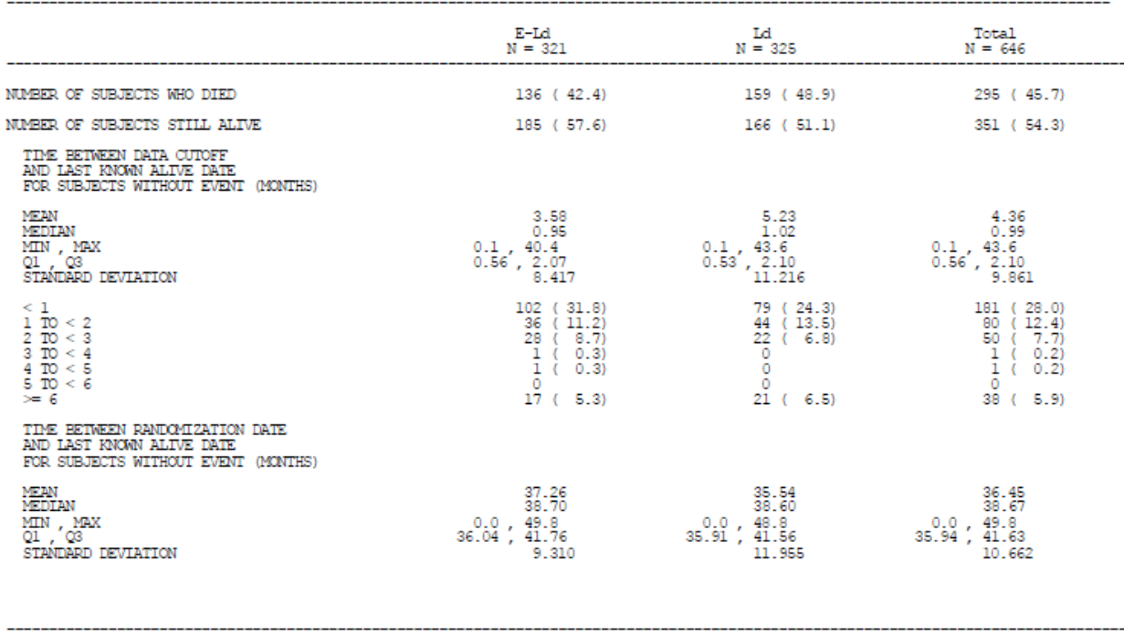

The results are summarized below.

A 23% reduction in the risk of death (HR E-Ld/Ld: 0.77: 95% CI: 0.61 0.97; P-value 0.0257) was observed (Figure 17):

* The 1 year OS rate was 91% in the E-Ld group compared to 83% in the Ld group;
* The 2 year OS rate was 73% in the E-Ld group and 69% in the Ld group;

Although the IA did not meet the pre-specified criteria, the addition of elotuzumab to Ld demonstrated a strong trend toward improved OS compared with Ld (p=0.0257).

The CA204004 CSR addendum also presents the updated PFS data with a cutoff date of 10-Aug-2015: The minimum follow-up (from last patient randomized and the data cut) was 33 months. Similarly, the median time between randomization date and last adequate assessment for subjects without an event was 32.4 months (33.2 months for E-Ld and 31.4 months for Ld subjects), demonstrating long-term follow-up in these subjects.

With a minimum follow-up time of 33 months, the 3-year PFS rate was 26% and 18% for the E-Ld and Ld group, respectively (Table 31 and Figure 18).

Figure 17: KM plot of OS: all randomized subjects (CA204004).

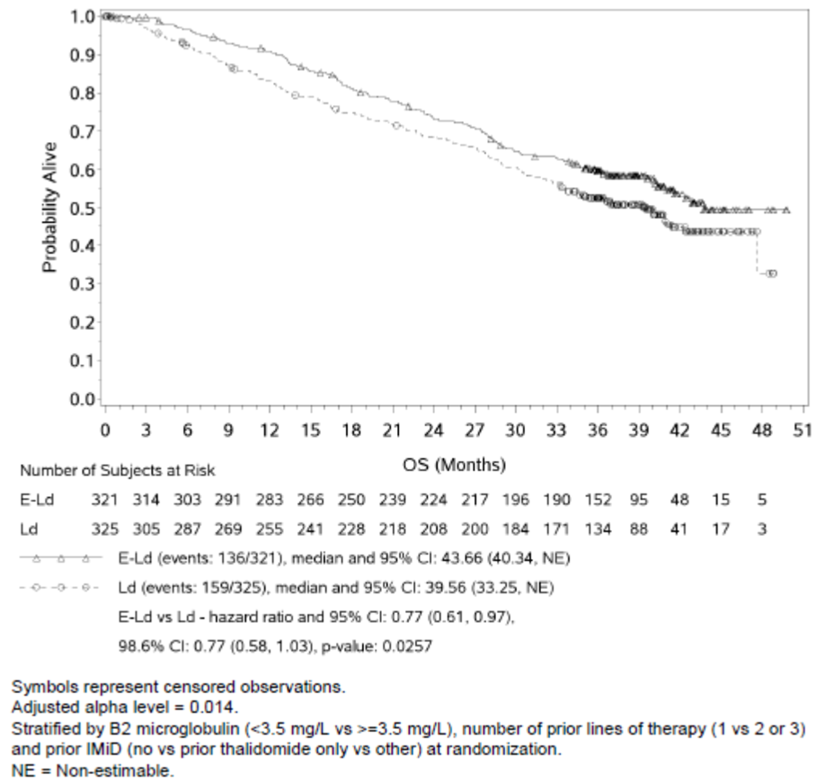

The 3-year OS rate was 60% in the E-Ld group compared to 53% in the Ld group (Table 30).

* Median OS was 43.7 months (95% CI: 40.3, NE) for E-Ld versus 39.6 months (95% CI: 33.3, NE) for Ld.

Table 30: OS analysis: all randomized subjects (CA204004).

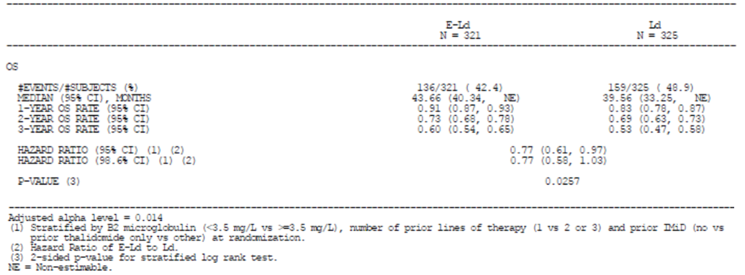

Although the IA did not meet the pre-specified criteria, the addition of elotuzumab to Ld demonstrated a strong trend toward improved OS compared with Ld (p=0.0257).

The CA204004 CSR addendum also presents the updated PFS data with a cutoff date of 10-Aug-2015: The mimimum follow-up (from last patient randomized and the data cut) was 33 months. Similarly, the median time between randomization date and last adequate assessment for subjects without an event was 32.4 months (33.2 months for E-Ld and 31.4 months for Ld subjects), demonstrating long-term follow-up in these subjects.

With a minimum follow-up time of 33 months, the 3-year PFS rate was 26% and 18% for the E-Ld and Ld group, respectively (Table 31 and Figure 18).

Table 31: Updated PFS (IRC, primary definition) analysis: all randomized subjects (CA204004).

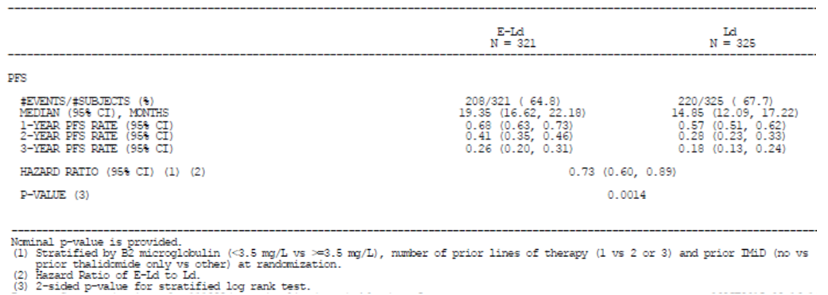

Figure 18: KM plot of PFS (IRC, primary definition) analysis: all randomized subjects (CA204004).

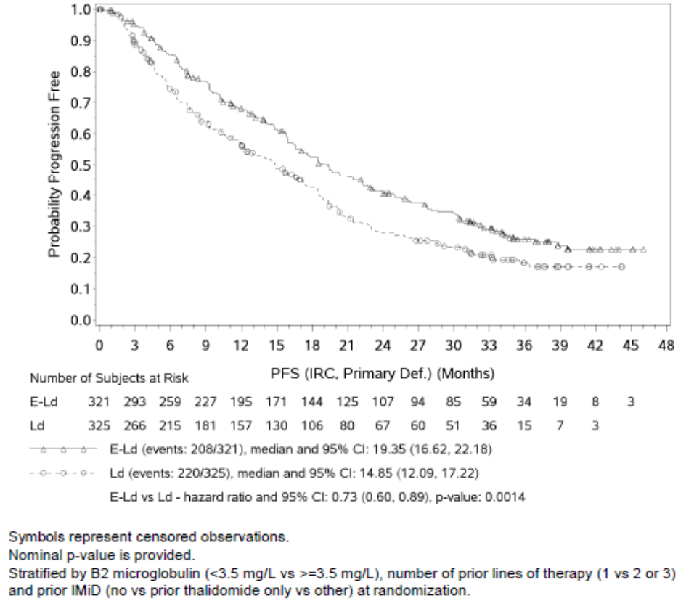

In addition, since the results of CA204009 show notable consistency with the larger Phase 3 trial, CA204004 and, within the constraints of a Phase 2 design, the treatment effect is as clinically meaningful as other standard treatments for myeloma with minimal increment combination treatment, the sponsor Australian PI in the Clinical Trials section

The results from the main study immunotherapeutic strategy of targeting SLAMF7 in this lethal hematologic malignancy and support this novel approach in the treatment of MM.

Regarding an update on international regulatory status, Elotuzumab received marketing authorization approval from the US FDA on 30-Nov-2015 for the following indication:

*EMPLICITI is indicated in combination with lenalidomide and dexamethasone for the treatment of patients with multiple myeloma who have received one to three prior therapies.*

The CHMP adopted a positive opinion for approval of elotuzumab on the 29-Jan-2016 for the following indication:

*Empliciti is indicated in combination with lenalidomide and dexamethasone for the treatment of multiple myeloma in adult patients who have received one to three prior therapies (see sections 4.2 and 5.1).*

Elotuzumab is not currently approved in any other country.

## Second round benefit-risk assessment

### Second round assessment of benefits

The evaluator notes the sponsor has provided an unsolicited update of efficacy (alone) in their S31 response. The TGA does not accept efficacy data for evaluation unless specifically requested by the evaluator.

This additional data represents 18 months additional follow-up, pertaining to a later database lock (29 October 2015) as compared to that of the study in the dossier when originally submitted (19 February 2014).

### Second round assessment of risks

The risks of elotuzumab for the proposed usage are unchanged, based upon the safety data presented with the dossier. No additional safety data for the additional 18 month follow-up period was presented in the S31 response. Therefore the evaluator cannot form a new opinion regarding risks of elotuzumab at this later database cut-off.

### Second round assessment of benefit-risk balance

The risk-benefit balance cannot be established for the later database cut-off of 29 October 2015 since no additional safety data was presented. The efficacy *and* safety data pertaining to the database cut-off of 29 October 2015 will need to be presented to the TGA for full evaluation as a separate submission in the event that elotuzumab is registered on the ARTG.

## Second round recommendation regarding authorisation

The following proposed indication remains suitable for registration:

*Empliciti (elotuzumab) is indicated in combination with lenalidomide and dexamethasone for the treatment of multiple myeloma in adult patients who have received one to three prior therapies.*

## References

1. Genzen JR, Kawaguchi KR, Furman RR. Detection of a monoclonal antibody therapy (ofatumumab) by serum protein and immunofixation electrophoresis. Br J Haematol 2011; 155: 123-5.

2. McCudden CR, Voorhees PM, Hainsworth SA, et al. Interference of monoclonal antibody therapies with serum protein electrophoresis tests. Clin Chem 2010; 56: 1897-9.

3. Axel AE, McCudden CR, Xie H, Hall BM, Sasser AK. Development of clinical assay to mitigate daratumumab, an IgG1K monoclonal antibody, interference with serum immunofixation (IFE) and clinical assessment of M-protein response in multiple myeloma. Cancer Res 2014; 74: 2563. abstract.

|  |
| --- |
| Therapeutic Goods Administration |
| PO Box 100 Woden ACT 2606 Australia  Email: [info@tga.gov.au](mailto:info@tga.gov.au) Phone: 1800 020 653 Fax: 02 6232 8605  <https://www.tga.gov.au> |

1. The Phase 2 portion of this study was not conducted.