|  |
| --- |
| **Date of 1st round CER: 28 February 2013**  **Date of 2nd round CER: 16 April 2013** |

|  |
| --- |
| AusPAR Attachment 2 |
| Extract from the Clinical Evaluation Report for elvitegravir |
| Proprietary Product Name: Vitekta |
| Sponsor: Gilead Sciences Pty Ltd |

About the Therapeutic Goods Administration (TGA)

* The Therapeutic Goods Administration (TGA) is part of the Australian Government Department of Health, and is responsible for regulating medicines and medical devices.
* The TGA administers the *Therapeutic Goods Act 1989* (the Act), applying a risk management approach designed to ensure therapeutic goods supplied in Australia meet acceptable standards of quality, safety and efficacy (performance), when necessary.
* The work of the TGA is based on applying scientific and clinical expertise to decision-making, to ensure that the benefits to consumers outweigh any risks associated with the use of medicines and medical devices.
* The TGA relies on the public, healthcare professionals and industry to report problems with medicines or medical devices. TGA investigates reports received by it to determine any necessary regulatory action.
* To report a problem with a medicine or medical device, please see the information on the TGA website <<http://www.tga.gov.au>>.

About the Extract from the Clinical Evaluation Report

* This document provides a more detailed evaluation of the clinical findings, extracted from the Clinical Evaluation Report (CER) prepared by the TGA. This extract does not include sections from the CER regarding product documentation or post market activities.
* The words [Information redacted] indicate confidential information has been deleted.
* For the most recent Product Information (PI), please refer to the TGA website <<http://www.tga.gov.au/hp/information-medicines-pi.htm>>.

Copyright

© Commonwealth of Australia 2013  
This work is copyright. You may reproduce the whole or part of this work in unaltered form for your own personal use or, if you are part of an organisation, for internal use within your organisation, but only if you or your organisation do not use the reproduction for any commercial purpose and retain this copyright notice and all disclaimer notices as part of that reproduction. Apart from rights to use as permitted by the *Copyright Act 1968* or allowed by this copyright notice, all other rights are reserved and you are not allowed to reproduce the whole or any part of this work in any way (electronic or otherwise) without first being given specific written permission from the Commonwealth to do so. Requests and inquiries concerning reproduction and rights are to be sent to the TGA Copyright Officer, Therapeutic Goods Administration, PO Box 100, Woden ACT 2606 or emailed to <[tga.copyright@tga.gov.au](mailto:tga.copyright@tga.gov.au)>.

Contents

List of abbreviations 4

1. Clinical rationale 9

2. Contents of the clinical dossier 10

2.1. Scope of the clinical dossier 10

2.2. Paediatric data 10

2.3. Good clinical practice 11

3. Pharmacokinetics 11

3.1. Studies providing pharmacokinetic data 11

3.2. Summary of pharmacokinetics 12

3.3. Evaluator’s overall conclusions on pharmacokinetics 20

3.4. Evaluator’s overall conclusions on pharmacokinetics 21

4. Pharmacodynamics 22

4.1. Studies providing pharmacodynamic data 22

4.2. Summary of pharmacodynamics 22

4.3. Evaluator’s overall conclusions on pharmacodynamics 25

5. Dosage selection for the pivotal studies 25

6. Clinical efficacy 26

6.1. Indication: Use as part of combination therapy in HIV-1 infection 26

7. Clinical safety 49

7.1. Studies providing evaluable safety data 49

7.2. Pivotal studies that assessed safety as a primary outcome 49

7.3. Patient exposure 49

7.4. Adverse events 51

7.5. Laboratory tests 59

7.6. Post-marketing experience 62

7.7. Safety issues with the potential for major regulatory impact 62

7.8. Other safety issues 63

7.9. Evaluator’s overall conclusions on clinical safety 64

8. First round benefit-risk assessment 64

8.1. First round assessment of benefits 64

8.2. First round assessment of risks 64

8.3. First round assessment of benefit-risk balance 65

9. First round recommendation regarding authorisation 65

10. Clinical questions 65

11. Second round evaluation of clinical data submitted in response to questions 65

12. Second round benefit-risk assessment 66

12.1. Second round assessment of benefits 66

12.2. Second round assessment of risks 66

12.3. Second round assessment of benefit-risk balance 66

13. Second round recommendation regarding authorisation 66

14. References 66

## List of abbreviations

| Abbreviation | Meaning |
| --- | --- |
| λz | terminal elimination rate constant, estimated by linear regression of the terminal elimination phase of the log plasma/serum/PBMC concentration versus time curve of the drug |
| AAG | α1 acid glycoprotein |
| ABC | abacavir |
| AE | adverse event |
| aGFR | actual glomerular filtration rate |
| AIDS | acquired immune deficiency syndrome |
| ALT | alanine aminotransferase |
| ANOVA | analysis of variance |
| ARV | antiretroviral |
| AST | aspartate aminotransferase |
| ATR | efavirenz/emtricitabine/tenofovir disoproxil fumarate, coformulated (Atripla) |
| ATV | atazanavir |
| ATV/r | ritonavir-boosted atazanavir |
| AUC | area under the plasma concentration-time curve |
| AUC0-last | area under the plasma/serum/PBMC concentration versus time curve from time zero to the last quantifiable concentration |
| AUCinf | area under the plasma/serum/PBMC concentration versus time curve extrapolated to infinite time, calculated as AUC0-last + (Clast/λz) |
| AUCtau | area under the plasma/serum/PBMC concentration versus time curve over the dosing interval |
| CD4 | cluster determinant 4 |
| CI | confidence interval |
| Clast | last observed quantifiable plasma/serum/PBMC concentration of the drug |
| Cmax | maximum observed plasma/serum/PBMC concentration of drug |
| Ctau | observed drug concentration at the end of the dosing interval |
| Ctrough | plasma concentration at the end of the dosing interval |
| CL/F | apparent oral clearance after administration of the drug: CL/F = Dose/AUCinf, where “Dose” is the dose of the drug |
| CMH | Cochran-Mantel-Haenszel |
| /co | boosted with cobicistat |
| CPI/r | ritonavir-boosted comparative protease inhibitor |
| CPT | Child-Pugh-Turcotte |
| CSR | clinical study report |
| CV | coefficient of variation |
| CYP | cytochrome P450 enzyme(s) |
| d4T | stavudine |
| DAVG | difference between time-weighted average post baseline and baseline |
| ddI | didanosine |
| DNA | deoxyribonucleic acid |
| DRV | darunavir |
| DRV/r | ritonavir-boosted darunavir |
| ECxx | concentration of a compound inhibiting virus replication by xx% |
| EFV | efavirenz |
| eGFR | estimated glomerular filtration rate |
| eGFRCG | estimated glomerular filtration rate calculated using the Cockcroft-Gault equation |
| Emax | maximum (pharmacodynamic) effect |
| EVG | elvitegravir |
| EVG/co | cobicistat-boosted elvitegravir |
| EVG/COBI/FTC/TDF | elvitegravir/cobicistat/emtricitabine/tenofovir disoproxil fumarate (STRIBILD), coformulated |
| EVG/r | ritonavir-boosted elvitegravir |
| FDA | (US) Food and Drug Administration |
| FPV | fosamprenavir |
| FPV/r | ritonavir-boosted fosamprenavir |
| FTC | emtricitabine (Emtriva) |
| GCP | Good Clinical Practice |
| GGT | gamma-glutamyltransferase |
| GS-9200 | metabolite of elvitegravir, produced by glucuronic acid conjugation; also named M4 |
| GS-9202 | (see M1) |
| GSS | genotypic sensitivity score |
| HAART | highly active antiretroviral therapy |
| HBV | hepatitis B virus |
| HCV | hepatitis C virus |
| HIV, HIV-1, HIV-2 | human immunodeficiency virus, type 1, type 2 |
| HMG CoA | 3-hydroxy-3-methyl-glutaryl-CoA |
| HSA | human serum albumin |
| IAS-USA | International Antiviral Society |
| ICH | International Conference on Harmonization (of Technical Requirements for Registration of Pharmaceuticals for Human Use) |
| ICxx | concentration that results in xx% inhibition |
| IN | integrase |
| INR | international normalised ratio |
| INSTI | integrase strand-transfer inhibitor |
| INSTI-R | integrase strand-transfer inhibitor resistance |
| IQ | inhibitory quotient |
| ITT | intent-to-treat |
| KM | Kaplan-Meier |
| KS | Kaposi Sarcoma |
| KTZ | ketoconazole |
| LLOQ | lower limit of quantification |
| LPV | lopinavir |
| LPV/r | lopinavir/ritonavir, coformulated |
| LSM | least-squares mean |
| M1 | elvitegravir metabolite (hydroxylation of the chlorofluorophenyl group); also named GS-9202 and JTP-71081 |
| M4 | elvitegravir metabolite (glucuronide conjugate of the carboxylic acid); also named GS-9200, JTP-655386, and JTP-71051 |
| M = E | missing = excluded |
| MedDRA | Medical Dictionary for Regulatory Activities |
| M = F | missing = failure |
| MH | Mantel-Haenszel |
| mtDNA | mitochondrial deoxyribonucleic acid |
| NDA | New Drug Application |
| NNRTI | nonnucleoside reverse transcriptase inhibitor |
| NRTI | nucleoside reverse transcriptase inhibitor |
| NtRTI | nucleotide reverse transcriptase inhibitor |
| NVP | nevirapine |
| OATP | organic anion transporting polypeptide |
| PBMC | peripheral blood mononuclear cell |
| PD | pharmacodynamic(s) |
| Pgp or MDR1 | P glycoprotein |
| PI | protease inhibitor |
| PI | Product Information |
| PI/r | ritonavir-boosted protease inhibitor |
| PK | pharmacokinetic(s) |
| PP | per protocol |
| PR | protease |
| PT | preferred term |
| PVF | pure virologic failure |
| PVR | pure virologic response |
| QD | once daily |
| QT | electrocardiographic interval between the beginning of the Q wave and termination of the T wave, representing the time for both ventricular depolarisation and repolarisation to occur |
| QTc | QT interval corrected for heart rate |
| /r | boosted with ritonavir |
| RAL | Raltegravir (Isentress) |
| RAP | resistance analysis population |
| RMP | risk management plan |
| RNA | ribonucleic acid |
| RT | reverse transcriptase |
| RTV | ritonavir |
| SAE | serious adverse event |
| SD | standard deviation |
| SOC | system organ class |
| STRIBILD | elvitegravir/cobicistat/emtricitabine/tenofovir disoproxil fumarate, coformulated |
| t½ | estimate of the terminal elimination half-life of the drug in serum/plasma/PBMC, calculated by dividing the natural log of 2 by the terminal elimination rate constant (λz) |
| T-20 | enfuvirtide |
| TDF/FTC | tenofovir disoproxil fumarate / emtricitabine, co-formulated as Truvada |
| TFV | tenofovir |
| TLOVR | time to loss of virologic response |
| TPV | tipranavir |
| TPV/r | ritonavir-boosted tipranavir |
| TVD | emtricitabine/tenofovir disoproxil fumarate, coformulated (Truvada) |
| UGT | uridine glucuronosyltransferase |
| ULN | upper limit of the normal range |
| VcF | volume of the central compartment |
| VpF | volume of the peripheral compartment |
| VF | virologic failure |
| ZDV | zidovudine |

## Clinical rationale

According to the WHO, approximately 34 million people are infected with HIV worldwide. Standard-of-care for the treatment of HIV infection generally involves the use of three active antiretroviral (ARV) drugs to suppress viral replication to below detectable limits, increase CD4 cell counts, and delay disease progression. While combination ARV therapy has been largely successful in reducing the morbidity and mortality associated with HIV disease, a significant proportion of subjects eventually experience loss of virologic, immunologic, or clinical benefit from their current regimens.

Poor tolerability, toxicity, or the development of resistance can limit options for treatment. Developing safe and effective therapies for HIV infection to expand the range of treatment options remains a priority. Current treatment guidelines suggest several approaches to the management of HIV-infected subjects. However, newer treatments targeting alternative steps in the viral replication cycle are needed to expand the treatment options for patients, particularly for treatment-experienced patients who develop side effects or drug resistance.

HIV-1 integrase strand-transfer inhibitors (INSTIs) are a new class of ARV drug for the treatment of HIV infection, and prevent integration of the HIV-1 genetic material into the host-cell genome. The first drug in this class is raltegravir (RAL) which was approved in Australia in February 2013. RAL requires twice-daily dosing to achieve its therapeutic effect. Therefore, new additions to the INSTI class are much needed, particularly those that offer convenient, once-daily dosing while maintaining optimal safety and efficacy.

Elvitegravir (EVG) is a new chemical entity that belongs to the new class of HIV-1 INSTIs.

## Contents of the clinical dossier

### Scope of the clinical dossier

The clinical dossier documented a full clinical development program of pharmacology, efficacy and safety studies.

The submission contained the following clinical information:

* 16 clinical pharmacokinetic studies
* 1 population pharmacokinetic analyses
* 1 pivotal efficacy/safety study: Study GS-US-183-0145
* 1 other efficacy/safety study: Study GS-US-183-0130

*Comment: The summaries are dated between June and July 2012 and, by agreement with TGA, are the summaries submitted in the US. They include many more studies (37) than have been submitted in Australia; for example, summaries of studies of both EVG single tablet and as component of the Stribild combination tablet. Many studies referenced in the summaries as being of EVG single tablets have not been included in this submission, but were submitted in the submission. All studies have been evaluated. Reference is made to the Stribild submission evaluator’s report where relevant.*

### Paediatric data

The submission did not include paediatric data. The sponsor stated that the product was not intended for children under 18 years of age. No further details are provided in the submission. The EU Guideline specifically states: “The development of acceptable and palatable pharmaceutical formulations with suitable strengths for children is normally expected to take place early.”

It was noted on the EMA website[1] that a Paediatric Investigation Plan (PIP) had been submitted in Europe and was granted a deferral by the EMA. In the EMA decision granting the deferral, the sponsor stated they are planning to develop an age appropriate tablet and an age appropriate powder for oral suspension. To support this development, four clinical studies are proposed.

### Good clinical practice

All but two studies were conducted under a US Investigational New Drug Application (IND) and in accordance with recognised international scientific and ethical standards, including but not limited to the International Conference on Harmonisation guideline for Good Clinical Practice (ICH GCP) and the Declaration of Helsinki. These standards are consistent with the requirements of the US Code of Federal Regulations (CFR) Title 21, Part 312 (21CFR312), and the European Community Directive 2001/20/EC.

In the pivotal clinical trial (Study GS-US-183-0145), one site was excluded from the efficacy analysis due to failure to comply with the signed investigator agreement. The sponsor complied with GCP in investigating the site and documenting the failure to comply with the protocol and other GCP requirements. Under these circumstances it is acceptable to exclude the patients recruited from this site from the efficacy analysis. Patients were appropriately included in the safety analysis.

The two studies in Japan were conducted in compliance with the ethical principles of the Declaration of Helsinki and the following:

* The Clinical Study Protocol;
* GCP Ordinance specifying standards for sponsoring, management and implementation of clinical studies (MHW Ordinance No. 28, dated 27-Mar-1997, revised by the MHLW Ordinance No. 106, dated 12-Jun-2003) (hereafter referred to as “GCP Ordinance”);
* On Enforcement of GCP Ordinance specifying standards for sponsoring, management and implementation of clinical studies (Pharmaceutical Affairs Bureau Notification No. 430 dated 27-Mar-1997). On Enforcement of the law for partial revision of GCP Ordinance (Pharmaceutical Affairs Bureau Notification No. 0612001 dated 12-Jun-2003);
* Application of standards for the Implementation of Clinical Trials on Pharmaceutical Products (Notification No. 445 of Pharmaceuticals and Cosmetics division/Notification No. 68 of the Safety Division, Pharmaceutical Affairs Bureau dated 29-May-1997).

## Pharmacokinetics

### Studies providing pharmacokinetic data

Table 1 shows the studies relating to each pharmacokinetic topic and the location of each study summary.

Table 1: Submitted pharmacokinetic studies.

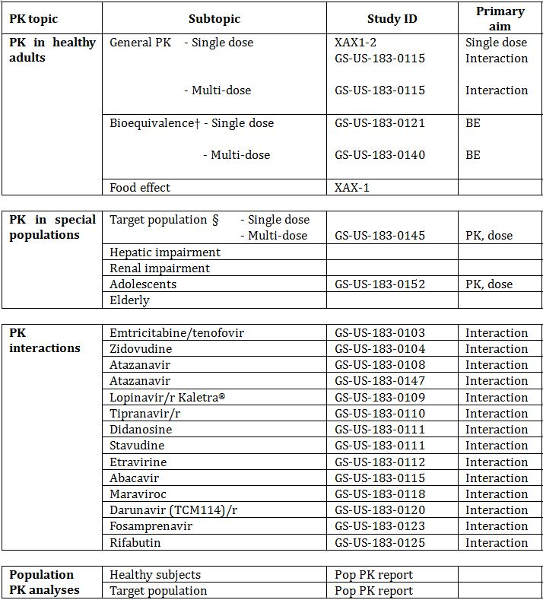

† Bioequivalence of different formulations.

§ Subjects who would be eligible to receive the drug if approved for the proposed indication.

Table 2 lists pharmacokinetic results that were excluded from consideration due to study deficiencies.

Table 2: Pharmacokinetic results excluded from consideration.

Table 2: Pharmacokinetic results excluded from consideration.

### Summary of pharmacokinetics

The information in the following summary is derived from conventional pharmacokinetic studies unless otherwise stated. Those studies included and evaluated in the Stribild submission are referenced but not summarised in this report.

#### Physicochemical characteristics of the active substance

Empirical formula: C23H23ClFNO5; Formula weight: 447.9. Elvitegravir contains a single asymmetric centre at C-11. The absolute configuration was established by single crystal X-ray crystallography and has been determined to be of “S” configuration. Dissociation Constant pKa = 6.6 (carboxylic acid). Three polymorphs (Form-α, Form-β and Form-γ) have been observed. Form-γ has been determined to be the most thermodynamically stable polymorphic form. The crystallisation process is designed to consistently deliver Form-γ. The compound is practically insoluble in water but is freely soluble in organic solvents such as dimethyl sulphoxide, dimethylformamide and tetrahydrofuran.

#### Pharmacokinetics in healthy subjects

##### Absorption

Following oral administration of boosted EVG, peak EVG concentrations are observed ~3 to 4 hours post dose, regardless of the dose level in HIV-1 infected patients and healthy subjects. Its absorption is unaffected by local gastrointestinal pH, however EVG is subject to chelating in the gastrointestinal tract by high concentrations of di and tri valent cations present in high strength antacids (Study GS-US-183-0119)[2]. In this drug interaction study the PK of boosted EVG in the presence of acid reducing agents were evaluated using simultaneous or staggered (±2 hrs or ±4 hrs) administration of antacid (20mL of magnesium hydroxide/aluminium hydroxide; 2000 mg each total dose). Other studies submitted in the Stribild submission or the cobicistat submission also investigated the interaction with a representative proton pump inhibitor, omeprazole (40mg once daily), using different boosters for EVG (RTV or cobicistat) and staggered (12 hours) or co-administered with a representative H2 receptor antagonist famotidine (40 mg once daily).

Elvitegravir absorption and resulting systemic exposures were lower (40-50%) upon simultaneous co-administration with antacids containing high concentrations of divalent and trivalent cations, presumably due to local complexation in the gastrointestinal tract, consistent with the pharmacophore-Mg2+ interaction at the integrase enzyme active site. Staggering EVG and antacid administration by ± 2 hours or ± 4 hours offsets this interaction, and accordingly, these agents need to be administered ≥ 2 hours apart.

Elvitegravir absorption was unaffected upon staggered or co-administration of boosted EVG with omeprazole, with EVG exposure parameters being within classical bioequivalence boundaries (i.e. 90% CI within 80-125%). Similarly, EVG exposures were unaffected (within bioequivalence bounds) following staggered or co-administration of boosted EVG with famotidine, indicating that changes in gastric pH do not affect EVG PK. Boosted EVG may be simultaneously co-administered with proton pump inhibitors (e.g. omeprazole) or H2-receptor antagonists (e.g. famotidine).

##### Bioavailability

###### Absolute bioavailability

Absolute bioavailability has not been investigated. Elvitegravir is formulated as a tablet.

###### Bioequivalence of clinical trial and market formulations

The formulation changes were appropriately documented and bioequivalence studies performed at each stage of the development of the final product intended for marketing. A number of formulations were used during the clinical development program. Two of the three relevant bioequivalence studies were submitted in this dossier and the other was submitted in the Stribild submission.

Study XAX1-2 compared two early formulations and while the solid dispersion formulation was found to have higher bioavailability the conventional tablet was determined to be sufficient to achieve efficacy when administered with food and with ritonavir as the pharmacoenhancing agent.

In Study GS-US-183-0121 two test formulations of EVG were compared to the reference formulation conventional tablet. The test products were a single 125 mg tablet. Neither of the test formulations met the criteria for bioequivalence when compared to the reference formulation as both test formulations were found to have the lower bound of the 90% CI for the geometric mean ratios of EVG Cmax, AUC0-last and AUCinf below the bioequivalence range of 80% to 125%. Test Formulation 2 was closest to the reference formulation for systemic exposure (in terms of Cmax and AUC) being only 8.1%, 12.8% and 9.9% lower for Cmax, AUC0-last and AUCinf, respectively.

Study GS-US-183-140[3] was a multiple dose bioequivalence study that was submitted in the Stribild submission. This found that Test Formulation 2, dosed at 150 mg tablet was bioequivalent to the reference formulation (125 mg tablet) used in the earlier studies. This was the tablet and dose used in the pivotal clinical trial and intended for marketing.

###### Influence of food

Absorption of EVG is greater following administration with food. Study XAX-1 conducted in Japan was a single dose study of the unboosted EVG single agent. There was an approximately 3 fold higher EVG exposure with food compared to the fasted state: 3.30 fold increase in Cmax (90% CI 2.27 to 4.80) and 2.69 fold increase in AUCinf (90%CI 2.16 to 3.36).

The effect of a representative light meal and a high calorie, high fat meal on the absorption/bioavailability of boosted EVG as part of the combination product was evaluated in Study GS-US-236-0105.[4] Elvitegravir mean (%CV) Cmax and AUCinf were 22% and 34% higher with a light meal (~373 kcal, 20% fat) and 56% and 87% higher with a high-calorie/high-fat meal (~800 kcal, 50% fat), each compared to fasted dosing. This result is likely due to improved solubility under fed conditions. The increase in EVG exposures between a light meal and a high-calorie/high-fat meal is not considered to be clinically relevant. This was considered acceptable in the Stribild evaluation. Boosted EVG was administered with food throughout the clinical development program.

###### Dose proportionality

Clinical data from Studies GS-US-183-0119,[5] GS-US-183-0125,[6] GS-US-183-0128,[7] and GS-US-183-0147[8] support the likelihood of solubility-limited absorption of EVG due to the less than proportional increases in exposures over a wide dose range of 50 mg to 300 mg equivalent across studies (3- to 4-fold increase EVG AUC over a 6-fold dose range). Also relative to the therapeutic dose (doubling the 150 mg-equivalent therapeutic dose resulted in only ~48% increase in EVG AUC). Doubling the dose from the EVG 150-mg Phase 3 formulation in Study GS-US-183-0140[9] to 300 mg in Studies GS-US-183-0125[10] and GS-US-183-0147[11] resulted in ~1.1- to 1.4-fold increases in mean EVG trough concentrations in healthy subjects (Ctau of 440 ng/mL vs. 485 and 614 ng/mL, respectively).

##### Distribution

Based on equilibrium dialysis studies (in vitro and plasma samples from HIV-1 infected patients and healthy subjects from clinical studies, including subjects with renal or hepatic impairment) EVG was on average 98% to 99% bound to human plasma proteins regardless of concentration or subject status (i.e. healthy, HIV-1 infected, or hepatically impaired) with preferential binding to albumin over AAG (Studies GS-US-183-0126[12] and GS-US-183-0133[13]).

The distribution of EVG into compartments other than plasma (e.g. cerebrospinal fluid or genital tract secretions) has not been clinically evaluated.

##### Metabolism

The metabolism of EVG was primarily via CYP-mediated aromatic and aliphatic hydroxylation and/or primary or secondary glucuronidation.

The mass-balance, PK, and metabolite profile of EVG following administration of an oral dose of boosted [14C]EVG in healthy subjects were evaluated in Study GS-US-183-0126.[14] Serial blood (whole blood and plasma), urine, and stool samples were obtained for analysis while subjects were confined to the clinic during sample collection, with the exact interval based on the measured recovery of radioactivity. Quantifiable levels of 14C-radioactivity in whole blood and plasma were observed for up to 36 and 48 hours, respectively, following a single dose of boosted [14C]EVG.

###### Metabolites identified in humans

With unboosted administration there are 2 primary metabolites:

* M1 (GS-9202), produced by CYP3A4, and whose formation is almost completely inhibited when administered with ritonavir or cobicistat (typically plasma M1 concentrations are below the lower limit of quantification in clinical studies); and
* M4 (GS-9200), produced by uridine glucuronosyltransferases 1A1 and 1A3 and which becomes the predominant route of metabolism in the boosted state.

Plasma exposure (AUCtau) of M4 is very low and unaffected by boosting.

##### Excretion

Following administration of boosted [14C]EVG, 94.8% of the radioactive dose was recovered in faeces, consistent with hepatobiliary excretion. 6.7% of the administered dose was recovered in urine, primarily as glucuronide metabolites, with no unchanged EVG observed (Study GS-US-183-0126).[15]

In plasma, EVG was the predominant species, representing ~94% of circulating radioactivity. All observed metabolites, including several minor metabolites, constituted <10% relative systemic exposure (AUCtau) to parent drug in humans.

##### Inter-individual variability of pharmacokinetics

Using the population PK data set covariate analyses indicated no clinically relevant effects/differences in EVG exposures based on age, gender, race (Asian, Black, or White), estimated glomerular filtration rate (eGFR), HBV and/or HCV co-infection, or HIV-1 positive or negative disease status.

A modest, statistically significant relationship was observed between RTV AUC and EVG bioavailability; however, relative to the median RTV AUC value of 5,595 ng•h/mL in the entirety of the dataset, the range of observed RTV AUC of 1,729 to 12,672 ng•h/mL (5th to 95th percentile) corresponded to differences of only -15% and 12% in EVG bioavailability, respectively, which are not deemed to be clinically significant (consistent overall with the results from the RTV dose-finding Study GS-US-183-0113).[16] Similarly, a modest, statistically significant relationship was observed between body surface area and EVG clearance; however, EVG AUC, Cmax, and Ctrough were generally comparable across the range of body surface area values (e.g. quartiles), with EVG Ctrough consistently several fold above the protein binding-adjusted IC95 (45 ng/mL), and as such, the observed relationship is not considered to be clinically relevant in the adult population.

The intersubject variability in EVG exposure (AUC) was relatively low for both doses in the efficacy Study GS-US-183-0145 CV: 36% for EVG 150 mg and 40% for EVG 85 mg.

#### Pharmacokinetics in the target population

Pharmacokinetic data in the target population: HIV-1 infected patients was investigated in studies submitted in the Stribild submission and in the efficacy studies and a population PK analysis submitted in this submission.

In Study GS-US-183-0101,[17] single- and multiple-dose PK of unboosted EVG at doses of 200, 400, and 800 mg twice daily, 800 mg once daily; and of once-daily EVG/r 50/100 mg demonstrated that unboosted EVG T½ was ~3 hours, versus ~9 hours when EVG was administered with ritonavir. Elvitegravir 200, 400, and 800 mg twice daily and 800 mg once daily resulted in 31%, 23%, 52%, and 15% lower exposure, respectively, at steady state compared with single dose, consistent with autoinduction of CYP3A by unboosted EVG. In contrast, exposure of boosted EVG was 35% higher at steady state compared with single dose.

In Study GS-US-183-0105,[18] multiple-dose PK of EVG/r were evaluated at doses of 20/100 mg, 50/100 mg, and 125/100 mg. Elvitegravir exposures increased in a roughly dose-proportional manner between doses of 20 and 50 mg EVG, but were less than dose proportional between 50 and 125 mg (~2-fold higher AUCtau over a 2.5-fold dose increase). The variability at 20 mg was higher relative to that at 50 or 125 mg for AUC, Cmax, and, in particular, Ctau (percent coefficient of variation [%CV] ~176% vs. 52%–78% at higher doses).

Study GS-US-183-0130 was an extension study for patients who had previously completed other EVG studies primarily aimed at evaluating long term safety. During the study a sub study was conducted in a subset of patients (planned n = 40) at selected sites. All patients had confirmed HIV-1 RNA <50 copies/mL and were initially receiving EVG 150 mg in the study. In the sub study the EVG/r dose was increased 300/100 mg to evaluate the safety and pharmacokinetics of a higher dose of EVG once daily, co-administered with RTV. Subjects began dosing with EVG 300 mg + RTV, in combination with their antiretroviral regimen, as previously prescribed. The multiple-dose PK of EVG were evaluated using intensive sampling performed 2 weeks after entry into the sub study. Sub study safety evaluations were to continue at Weeks 2, 4, 8, 12, 16, 20, 24, once every 8 weeks until Week 48, and then once every 12 weeks thereafter.

Elvitegravir mean Ctau was ~17% greater following EVG/r 300/100 mg (446 ng/mL) versus EVG/r 150/100 mg (382 ng/mL) based on within-subject assessments in this cohort. The EVG/r 150/100-mg trough levels observed are consistent with historical data on EVG/r 150/100 mg from Study GS-US-183-0145 (Ctau 378 ng/mL). In further comparison of EVG PK parameters following EVG/r 300/100 mg dosing, the Cmax (2296 ng/mL) and AUCtau (26,619 ng•h/mL) were modestly higher (i.e. 33% and 31%, respectively), as compared to Study GS-US-183-0145, where EVG/r 150/100 mg dosing resulted in a Cmax of 1,721 ng/mL and an AUCtau of 20,298 ng•h/mL. Following availability of data demonstrating the lack of utility for the 300 mg dose of EVG, sub study subjects discontinued dosing with EVG 300 mg at their next scheduled clinic visit and went back to receiving EVG 150 mg.

Study GS-US-183-0145 was a randomised, multicentre, efficacy study in HIV-1 infected, antiretroviral treatment experienced adults. At selected sites, subjects (planned number: up to 45) participated in a PK sub study to evaluate the PK of study drugs. The sub study included an intensive PK profile during Week 2: samples were taken predose, and 1, 2, 3, 4, 4.5, 5, 6, 8, 10, 12, and 24 hours post dose. Concentrations of EVG and its metabolites GS-9200 (M4), GS-9202 (M1), and RTV in plasma samples were determined using validated high-performance liquid chromatography-tandem mass spectroscopy (LC/MS/MS) bioanalytical methods with the parameters shown in Table 3.

Table 3: Parameters to determine concentrations of EVG and its metabolites GS-9200 (M4), GS-9202 (M1), and RTV in plasma samples.

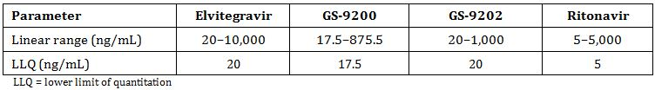

The pharmacokinetic analysis included all subjects who received at least 1 dose of RTV-boosted EVG and for whom PK parameters at Week 2 were evaluable = 31 patients

The steady state mean EVG AUCtau and Cmax were comparable following administration of 85 mg EVG, as compared with 150 mg EVG, and Ctau (Ctrough) was higher with the 85-mg dose versus the 150-mg dose. These results are comparable with the data from previous results in studies that evaluated EVG 85 mg in HIV-1 infected adolescent subjects (Study GS-US-183-0152) and healthy subjects. These results are consistent with the known interactions between EVG and ATV/r or LPV/r (Table 4).

Table 4: Study GS-US-183-0145: EVG Summary Statistics of PK Parameters at Week 2 by EVG Dose (PK Substudy Analysis Set).

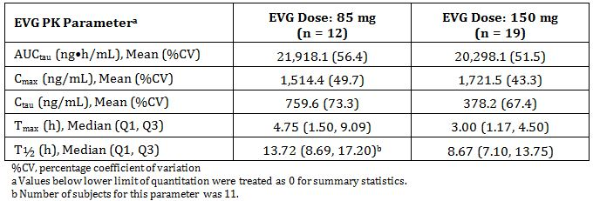

Following the administration of EVG (85 or 150 mg), the mean EVG trough level (Ctau, Ctrough) was ~8.5- to 17.1-fold above the protein-binding IC95 (concentration that results in 95% inhibition) (~44.5 ng/mL), indicating exposures corresponding to near maximal antiviral activity with either dose. Median EVG (85 mg or 150 mg) plasma half-life was supportive of once-daily dosing.

Mean (%CV) GS-9200 (M4) AUCtau was comparable with that observed previously in HIV-1 infected subjects. Consistent with data from previous EVG studies, the plasma exposures of GS-9200 (M1), the glucuronidated metabolite of EVG, were low relative to EVG, and GS-9202 concentrations, the RTV-inhibited p-hydroxylated metabolite of EVG, were below the limit of quantitation (assessed in subjects within the PK sub study).

The observed ritonavir PK were consistent with historical data.

A pure virologic failure (PVF) based efficacy analysis showed virologic response was ~65% in both treatment groups at Week 48. Exploratory PK/PD analyses indicated that across the various quantiles of EVG exposure, virologic response spanned the observed PVF-based efficacy for all 3 quantile based analyses (i.e. for quartiles, quintiles, or octiles of EVG Ctrough for both the 85 mg and 150 mg doses). Overall, EVG 85-mg and 150-mg doses provided exposures corresponding to the plateau of the dose-response relationship and were associated with antiviral efficacy.

##### Comparison of exposure to EVG between healthy subjects and HIV-1 infected subjects

Elvitegravir exposures in HIV-1 infected subjects (Study GS-US-183-0145 population PK analysis-derived) were compared against those in healthy subjects (Study GS-US-183-0140[19]) following multiple-dose administration of RTV-boosted EVG 85 mg or 150 mg and are shown in Table 5. Elvitegravir exposures, in particular Ctau, were comparable between these populations. These results are consistent with covariate assessments during the population PK analysis, which indicated no relevant effects of HIV-1 disease state on EVG PK.

Table 5: Steady-State EVG PK Parameters after Once-Daily Administration of EVG in HIV-1 Infected Subjects (Study GS-US-183-0145 Population PK Analysis) or in Healthy Subjects (Study GS-US-183-0140).

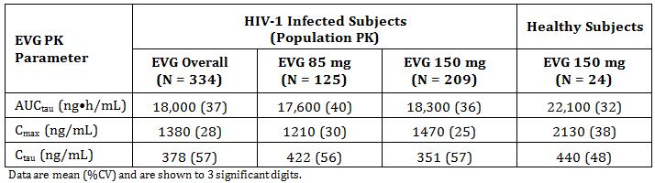

#### Pharmacokinetics in other special populations

##### Pharmacokinetics in subjects with impaired hepatic function

The PK of boosted EVG in non-HIV-1 infected subjects with moderate hepatic impairment (Child-Pugh-Turcotte [CPT] Classification B) were compared with data for subjects with normal hepatic function (matched for age, gender, and body mass index) in Study GS-US-183-0133.[20]

The steady-state plasma exposure of EVG was modestly higher (AUCtau, Ctau, and Cmax were 35%, 80%, and 41% higher, respectively) in the subjects with moderate hepatic impairment relative to matched control subjects with normal hepatic function, but well below the protocol-defined clinically relevant increase in AUCtau or Cmax of 100%. Therefore, steady-state plasma exposure of EVG is not considered clinically relevant. Accordingly, no dose adjustment of EVG is required in patients with mild (CPT Classification A) or moderate (CPT Classification B) hepatic impairment. Elvitegravir has not been studied in patients with severe hepatic impairment (CPT Classification C).

This was considered acceptable in the Stribild evaluation.

##### Pharmacokinetics in subjects with impaired renal function

In a population PK analysis of EVG, baseline eGFR was not a significant covariate, indicating no affect of eGFR on EVG PK. This was expected in view of the minimal renal excretion of EVG (~6 to 7%).

The PK of boosted EVG were evaluated in non-HIV-1 infected subjects with severe renal impairment (eGFR using the Cockcroft-Gault equation [eGFRCG] <30 mL/min) and a matching cohort of subjects with normal renal function (eGFR ≥90 mL/min) in Study GS-US-216-0124h Elvitegravir AUCtau, Cmax, and Ctau following once-daily administration of boosted EVG for 7 days were approximately 25%, 33%, and 31% lower in subjects with severe renal impairment than in matched controls. Notably, EVG exposure on Day 7 among subjects with normal renal function was substantially higher than that observed in previous clinical studies with EVG (Studies GS-US-216-0116,[21] GS-US-216-0123 and GS-US-183-0133[22]). No differences in EVG plasma protein binding were observed between the 2 groups. The differences in exposures between subjects with severe renal impairment and those with normal renal function are not considered clinically relevant. Accordingly, no dose adjustment of EVG is required for patients with renal impairment.

#### Pharmacokinetic interactions

##### Potential for other drugs to affect elvitegravir

The metabolism of EVG is mediated predominantly by CYP3A and secondarily by UGT1A1/3.

The pharmacokinetics of EVG are likely to be affected by potent inhibitors of UGT1A1/3 (EVG exposure increase) and inducers of CYP3A enzymes (EVG exposure decrease). The pharmacokinetics of EVG do not change with acid-reducing agents, with the exception of antacids, as noted below.

Upon co-administration with RTV, a potent CYP3A inhibitor, the bioavailability of EVG increases as a result of increased absorption/reduced first-pass and the systemic clearance of EVG substantially decreases such that the apparent EVG clearance is ~1/20th of hepatic blood flow (Study GS-US-183-0102[23]).

The EVG systemic exposures are bioequivalent upon co-administration with cobicistat 150 mg or RTV 100 mg once daily (Study GS-US-216-0116[24]). Based on these data and an RTV dose-ranging study (Study GS-US-183-0113[25]) indicating no additional increases in EVG plasma exposures at RTV doses ≥100 mg, co-administration of EVG and RTV with other potent CYP3A inhibitors is not expected to increase EVG exposures, even if RTV exposures are higher.

The observed drug interactions between cobicistat-boosted EVG plus ATV (Study GS-US-216-0123) and EVG/r plus ATV or ketoconazole (Studies GS-US-183-0106,[26] and GS-US-183-0146[27]) support the hypothesis that incremental decreases in the systemic clearance of boosted EVG are only evident with agents known to potently inhibit UGT1A1. These clinical pharmacology studies have determined that potent UGT1A1 inhibition can result in increased EVG exposure. Due to increases with ATV/r or LPV/r, a dose adjustment of EVG (85 mg) upon co-administration with these agents is recommended.

Administration of RTV-boosted EVG with CYP3A inducers may result in lower EVG exposures and the potential for loss of therapeutic activity; therefore, co-administration of EVG with CYP3A inducers is not recommended.

Co-administration of EVG/r and dose-reduced rifabutin resulted in equivalent exposures of EVG and rifabutin as assessed by AUCtau, Cmax, and Ctau relative to their administration individually (Study GS-US-183-0125). It is recommended that rifabutin be co-administered with EVG/r at a reduced dose of 150 mg every other day or 3 times a week.

*In vitro*, EVG showed no detectable inhibition of human hepatic microsomal CYP1A2, Elvitegravir absorption and resulting systemic exposures were lower (40-50%) upon simultaneous co-administration with antacids containing high concentrations of divalent and trivalent cations, presumably due to local complexation in the gastrointestinal tract (Studies GS-US-183-0103, and GS-US-183-0119[28]). This observation is consistent with the pharmacophore of HIV IN inhibitors such as EVG forming a complex with divalent cations (Mg2+) at the active site of the IN enzyme. Staggering EVG and antacid administration by ± 2 hours or ± 4 hours offsets this interaction, and accordingly, these agents need to be administered ≥ 2 hours apart.

##### Potential for elvitegravir to affect other drugs

*In vitro*, EVG showed no detectable inhibition of human hepatic microsomal CYP1A2, CYP2A6, CYP2C9, CYP2C19, CYP2D6, or CYP2E1 activity, and weak inhibition of CYP3A. Elvitegravir is a weak inhibitor of human MDR1 and OATP1B1, but it is a more potent inhibitor of human OATP1B3 (IC50 0.44 μM). From these data, EVG is predicted to have very low liability to cause drug interactions through inhibition of human CYP or MDR1. Inhibition of OATP transporters is consistent with a clinical drug interaction study (Study GS-US-216-0123[29]) in which, after dosing with 150 mg cobicistat and 150 mg EVG, there was a transient effect resulting in a modest increase in exposure of co-administered rosuvastatin (AUCinf increased ~38% compared to the reference treatment).

Co-administration of the Stribild combination product with a representative oral contraceptive resulted in decreases in ethinyl oestradiol AUCtau and Ctau (Study GS-US-236-0106[30]). Administration of EVG in combination with an RTV-boosted PI may decrease plasma concentrations of ethinyl oestradiol. Therefore, alternative non hormonal contraception methods are recommended.

Because EVG is used in combination with an RTV-boosted PI, the PI for Vitekta contains an appropriate precautions warning about the need to consult the Product Information for the co-administered PI for dosing recommendations. The effect of EVG as a perpetrator drug is expected to be driven based on the guidance for the co-administered RTV-boosted PI.

### Evaluator’s overall conclusions on pharmacokinetics

Extensive pharmacokinetic studies have been conducted. Most of the studies were submitted in the Stribild submission with mainly interaction studies submitted in this submission. The PK profile has been well established in both normal and certain special subjects and HIV-1 infected patients. No clinically relevant differences in the PK or EVG were observed with respect to demographic variables.

Results of drug interaction studies between ATV/r (300/100mg QD) and LPV/r (400/100 mg BID) and once-daily EVG showed increases in EVG exposure beyond intended plasma levels. Therefore, co-administration with ATV/r or LPV/r requires a reduction of the EVG dose to 85 mg.

Co-administration of EVG with DRV/r (600/100 mg BID), FPV/r (700/100 mg BID), and TPV/r (500/200 mg BID) indicate no clinically relevant PK drug interactions necessitating dose modifications.

The sponsor is not seeking approval for the use of cobicistat as the boosting agent. EVG is not recommended for use with other PIs or with any cobicistat-boosted PI, as there are no data available to make dosing recommendations.

As a perpetrator, EVG dosing guidance is expected to be driven by that of the co-administered PI/r. As a victim, co-administration of EVG with CYP3A inducers is not recommended due to the potential for lower EVG and/or PI/r exposures, which may result in lower efficacy and/or development of resistance.

Dose adjustment of EVG is not warranted in subjects with renal impairment or mild to moderate hepatic impairment. Elvitegravir has not been studied in patients with severe hepatic impairment. Co-administration with antacids should be staggered from EVG dosing by at least 2 hours due to a chelating (not pH) effect of antacids with EVG.

The proposed PI section for the pharmacokinetics contains summary data but the source texts given in the annotations are not correct for all details and some of the annotations could not be located in the submission. It is noted that the information is consistent with the US Package Insert and the EU SmPC. The following sections should be noted:

* Absorption: the Tmax should be changed to 3-4 h;
* Absorption: The Cmax, AUCtau, and Ctrough – while the range is correct the exact numbers could not be verified;
* Distribution: the mean plasma to blood drug concentration could not be verified;
* Effect of food: the last sentence should be corrected to “...22% to 34% with a light meal, while increasing to 56% to 91% with a high fat meal, respectively”.

The remaining sections are correct.

### Evaluator’s overall conclusions on pharmacokinetics

Extensive pharmacokinetic studies have been conducted. Most of the studies were submitted in the Stribild submission with mainly interaction studies submitted in this submission. The pharmacokinetic profile has been well established in both normal and certain special subjects and HIV-1 infected patients. No clinically relevant differences in the pharmacokinetics or EVG were observed with respect to demographic variables.

Results of drug interaction studies between RTV boosted atazanavir (ATV/r) (300/100mg QD) and lopinavir/RTV, coformulated (LPV/r) (400/100 mg BID [twice daily]) and once daily EVG showed increases in EVG exposure beyond intended plasma levels. Therefore, co-administration with ATV/r or LPV/r requires a reduction of the EVG dose to 85 mg.

Co-administration of EVG with RTV boosted darunavir (DRV/r) (600/100 mg BID), RTV boosted fosamprenavir (FPV/r) (700/100 mg BID), and ritonavir boosted tipranavir (TPV/r) (500/200 mg BID) indicate no clinically relevant pharmacokinetic drug interactions necessitating dose modifications.

The sponsor is not seeking approval for the use of COBI as the boosting agent. EVG is not recommended for use with other PIs or with any COBI boosted PI, as there are no data available to make dosing recommendations.

As a perpetrator, EVG dosing guidance is expected to be driven by that of the co-administered RTV boosted protease inhibitor (PI/r). As a victim, co-administration of EVG with CYP3A inducers is not recommended due to the potential for lower EVG and/or PI/r exposures, which may result in lower efficacy and/or development of resistance.

Dose adjustment of EVG is not warranted in subjects with renal impairment or mild to moderate hepatic impairment. EVG has not been studied in patients with severe hepatic impairment. Co-administration with antacids should be staggered from EVG dosing by at least 2 hours due to a chelating (not pH) effect of antacids with EVG.

The proposed PI section for the pharmacokinetics contains summary data but the source texts given in the annotations are not correct for all details and some of the annotations could not be located in the submission. It is noted that the information is consistent with the US Package Insert and the EU SmPC (Summary of Product Characteristics). The following sections should be noted:

* Absorption: the Tmax (time to reach maximum plasma concentration following drug administration) should be changed to 3-4 h;
* Absorption: The Cmax, AUCtau, and Ctrough (plasma concentration at the end of the dosing interval) – while the range is correct, the exact numbers could not be verified;
* Distribution: the mean plasma to blood drug concentration could not be verified; and
* Effect of food: the last sentence should be corrected to “...22% to 34% with a light meal, while increasing to 56% to 91% with a high fat meal, respectively”.

The remaining sections are correct.

## Pharmacodynamics

### Studies providing pharmacodynamic data

The summaries do not include a section on pharmacodynamics. Only one study was included as a pharmacodynamic study: Study GS-US-183-0152 but this is more correctly a PK study as the primary aim was to collect PK data in HIV-1 infected adolescents and to confirm the dose in this population. Most of the pharmacodynamic data was established in *in vitro* studies. Table 6 shows the studies relating to each pharmacodynamic topic and the location of each study summary.

Table 6: Submitted pharmacodynamic studies.

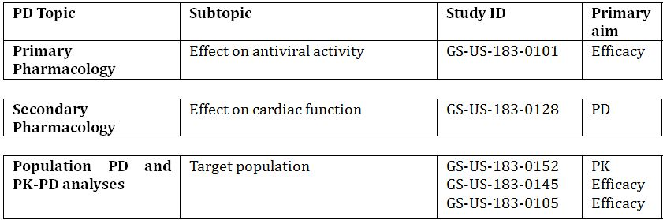

§ Subjects who would be eligible to receive the drug if approved for the proposed indication.

‡ And adolescents if applicable.

None of the pharmacodynamic studies had deficiencies that excluded their results from consideration.

### Summary of pharmacodynamics

#### Mechanism of action

Elvitegravir is a low molecular weight HIV-1 INSTI that prevents integration of the HIV-1 genetic material into the host-cell genome. Elvitegravir specifically inhibits HIV-1 integrase strand-transfer activity and the integration of HIV-1 deoxyribonucleic acid (DNA) into the host chromosomal DNA in cell culture.

##### In vitro activity

*Comment: The in vitro activity will be evaluated in Module 4. This summary information is taken from the clinical summaries in Module 2, Sections 2.5 and 2.7.*

*In vitro* studies have demonstrated potent antiviral activity of EVG against laboratory and clinical strains of HIV-1, including virus with reduced sensitivity to other NRTIs, NNRTIs, and PIs.

The median EVG EC50 (concentration of a compound inhibiting virus replication by 50%) for HIV-1NL4-3 was 0.38 nM and ranged from 0.02 to 1.7 nM in human peripheral blood mononuclear cells (PBMCs), T-lymphoblastoid cells, and monocytes/macrophages *in vitro*.

Elvitegravir showed activity against multiple subtypes of HIV-1 and against HIV type 2 (HIV-2). Elvitegravir showed broad anti-HIV-1 activity (8 subtypes: Group M: A, B, C, D, E, F, G, and Group O), with average EC50 values ranging from 0.1 to 1.3 nM in PBMCs and 0.53 nM against an HIV-2 isolate.

Elvitegravir showed potent activity against HIV-1 in monocyte/macrophage cells with EC50 values that ranged from 0.07 to 0.67 nM. The calculated EC95 value for EVG was 1.25 nM (0.61 ng/mL) in the absence of human serum components, and 100 nM (45 ng/mL) in the presence of the human serum components, human serum albumin (HSA) and α1-acid glycoprotein (AAG), in HIV-1 infected human PBMC cultures.

Elvitegravir lacks antiviral activity against hepatitis B virus (HBV) and hepatitis C virus (HCV) *in vitro*.

The two most abundant metabolites of EVG in clinical studies are M4 (acyl glucuronide, GS-9200 [the predominant metabolite in the boosted state]) and M1 (p-hydroxylated, GS-9202 [the predominant metabolite in the unboosted state]). GS-9202 and GS-9200 retained antiviral activity against wild-type HIV-1IIIB in MT-2 cells but with ≥6-fold less activity than the parent drug EVG. The resistance profiles of EVG and its metabolites GS-9202 and GS-9200 were overlapping. The M1 and M4 metabolites constitute <10% relative systemic exposure than EVG and are not considered to contribute to the antiviral activity of EVG.

The anti-HIV-1 activity of EVG in combination with a broad panel of representatives from all classes of approved anti-HIV agents (NRTIs, NNRTIs, PIs, fusion inhibitors, entry inhibitors, and INSTIs) was found to be additive to synergistic in multiple in vitro assay systems, supporting the use of these agents in combination in HIV-1 infected patients.

In addition, the HIV-1 antiviral activity of EVG with anti-HBV drugs in two-drug combination studies was not antagonistic when combined with adefovir, clevudine, entecavir, or telbivudine. For all these combinations, additive to synergistic anti-HIV activity was observed

#### Clinical resistance

HIV-1 isolates with reduced susceptibility to EVG were selected in vitro and identified in clinical isolates from subjects with virologic failure. In an analysis of treatment-failure subjects from Phase 2 and Phase 3 studies of EVG in treatment-experienced subjects, multiple patterns of primary INSTI-R mutations associated with EVG treatment were identified, namely T66I/A/K, E92Q/G/A, T97A, S147G, Q148R/H/K, and N155H. Phase 2 and Phase 3 studies of EVG in the Stribild development program revealed a subset of these patterns, namely T66I, E92Q, Q148R, and N155H.

No subjects had developed phenotypic resistance to EVG in the absence of these primary INSTI-R mutations, suggesting that the group of primary INSTI-R mutations described is sufficient to identify subjects who have developed resistance to EVG.

Elvitegravir-resistant viruses show varying degrees of cross-resistance to the INSTI RAL depending on the type and number of mutations. Viruses expressing the T66I/A mutations maintain susceptibility to RAL, while most other patterns showed reduced susceptibility to RAL. With the exception of substitutions at integrase position Y143, most primary RAL-associated substitutions show cross-resistance to EVG.

##### Study GS-US-183-0105[31]

Study GS-US-183-0105 was a multicentre, randomised, partially blinded, multiple dose, active controlled, dose finding study to assess the non inferiority of EVG/r relative to a comparator PI/r, both with a background ARV regimen. Subjects in the EVG/r arms of the study who had protocol-defined virologic failure or failed to achieve <400 copies/mL of HIV-1 RNA by Week 48 or the last time point on study had analyses of protease (PR), RT, and IN genotypes and phenotypes performed. Subjects in the (comparator) CPI/r arm who subsequently switched to open-label EVG/r (125 mg once daily) and had virologic failure on EVG/r also had analysis of IN genotype and phenotype performed.

In total, 164 subjects were analysed for IN resistance development as a result of virologic failure on EVG/r with 57, 44, and 43 subjects from the EVG/r 20 mg, 50 mg, and 125 mg arms, respectively, and 20 subjects from the CPI/r arm who began open label EVG/r. In subjects randomised to EVG/r 20, 50, or 125 mg, INSTI resistance (INSTI-R) mutations, including T66I/A/K, E92Q, Q148R/H/K, and N155H developed in 56/57 (98%), 42/44 (95%), and 38/43 (88%) of virologic failure subjects, respectively; 15/20 (75%) of virologic failure subjects who switched to open label EVG/r developed INSTI-R mutations.

All subjects in the study who experienced virologic failure were fully susceptible to EVG at baseline. At VF, the mean fold change in susceptibility to EVG was >88-fold; susceptibility to RAL also declined indicative of the development of cross resistance to RAL. Reduced replication capacity of viral mutants containing INSTI-R mutations was observed.

##### Study GS-US-183-0130

Study GS-US-183-0130 was an extension study for patients who had completed previous EVG studies and primarily assessed long term safety. A resistance analysis was performed at Week 192. The majority of resistance development was characterised as an evolution of reverse transcriptase (RT), protease, and IN resistance that had existed prior to study entry in subjects who were not fully suppressed on their regimen. With regards to IN resistance, mutation patterns were observed to evolve resulting in a general increase in the level of phenotypic resistance. In subjects who entered the study with fully suppressed HIV-1 RNA, IN resistance development was infrequent (3 of 84 subjects) and was observed along with evolution of RT and/or protease resistance that was present prior to EVG therapy.

##### Study GS-US-183-0145

Study GS-US-183-0145 is the pivotal efficacy study for EVG and compared efficacy between EVG and raltegravir (RAL). Among 702 randomised subjects, screening resistance analysis demonstrated baseline NRTI, NNRTI, and PI resistance mutations in 70%, 61%, and 32% of subjects, respectively; 17% had no known resistance mutations.

The resistance analysis population (RAP) at Week 96 consisted of 180 subjects (EVG, n = 87/351; RAL, n = 93/351) who had >400 copies/mL of HIV-1 RNA at Week 96 or at early study drug discontinuation. Among the 43 subjects infected with non-B HIV-1 subtypes (6% of study) there was no evidence of reduced treatment response as compared to those infected with subtype B.

Overall, resistance development to EVG or RAL occurred infrequently (6.6% of subjects in the EVG group, and 7.4% of subjects in the RAL group). Elvitegravir subjects developed T66I/A (n = 8) and E92Q (n = 7) predominantly, whereas RAL subjects developed N155H (n = 16) and Q148R/H (n = 7) predominantly. The mutations T66I/A, S147G, and Q148R were found exclusively in the EVG group, while the mutations Y143R/H/C and Q148H were found only in the RAL treatment group. The other mutations (E92Q, T97A, and N155H) were observed in both treatment groups, confirming the cross-resistant nature of those mutations. Analysed subjects who did not develop integrase resistance showed less RT and protease resistance at baseline suggesting that their lack of virologic suppression was due to poor adherence. Subjects who developed INSTI-R mutations showed phenotypic resistance to both EVG and RAL in the majority of cases. Reduced replication capacity of viral mutants containing INSTI-R was also noted. Subjects within the RAL group showed a higher frequency of phenotypic resistance to both RAL and EVG than subjects who developed INSTI-R while receiving EVG. Resistance to RT inhibitors or PIs in the background regimen occurred infrequently in this study and often in a background of pre-existing protease and RT resistance.

### Evaluator’s overall conclusions on pharmacodynamics

The pharmacodynamics of EVG were largely demonstrated in *in vitro* and the efficacy studies.

The pharmacokinetic/pharmacodynamic analyses for efficacy demonstrate comparable rates of virologic response across the range of clinically achieved EVG trough concentrations following administration with a PI/r. These results are consistent with the selection of the 150 mg EVG dose that provides exposures corresponding to Emax across subjects via provision of potent INSTI antiviral activity with both mean and overall Ctrough values that exceed the protein binding adjusted IC95 (95% inhibitory concentration).

Overall analysis of resistance across a number of studies (including those presented in the Stribild submission) lead to the following conclusions for EVG resistance:

* Resistance development to EVG was infrequent:
  + EVG resistance mutation development occurred more often in treatment experienced subjects (16.8%) than in treatment naive subjects (<2%)
  + EVG resistance mutation development was more frequent and extensive in subjects experiencing virologic failure for a longer period of time
* Primary (major) EVG resistance mutations observed were T66I/A/K, E92Q/G/A, T97A, S147G, Q148R/H/K, and N155H, alone and in combination with other IN mutations;
* Phenotypic analyses at virologic failure demonstrated high levels of resistance to EVG in most subjects analysed and evidence of cross resistance to RAL in most cases.

## Dosage selection for the pivotal studies

The dose of elvitegravir (EVG) 150 mg was selected based on the results from Study GS-US-183-0101[32] as well as a Phase 2 study in heavily treatment experienced HIV-1 infected subjects (Study GS-US-183-0105[33]) A series of drug-drug interaction studies containing EVG with ritonavir (RTV) boosted protease inhibitors were conducted to determine whether dose adjustment of EVG was required to achieve target exposure levels. Results of drug interaction studies between atazanavir (ATV) boosted with ritonavir (ATV/r) and EVG (Study GS-US-183-0108[34]), and ritonavir boosted lopinavir (LPV/r) and EVG (Study GS-US-183-0116[35]), indicated higher systemic EVG exposures with co-administration with those protease inhibitors than with EVG/r alone. Through pharmacokinetic modelling and bioequivalence simulations, an EVG dose of 85 mg was expected to provide similar exposures (AUC) and maintenance of high trough concentrations when administered with ATV/r or LPV/r, relative to EVG/r 150/100 mg. This was subsequently demonstrated in Study GS-US-183-0106l using ATV/r where EVG 85 mg plus ATV/r provided bioequivalent AUC and Cmax as EVG/r 150/100 mg. The reduced dose of 85 mg EVG co-administered with ATV/r or LPV/r was further confirmed in the additional studies (GS-US-183-0145 and GS-US-183-0152).

## Clinical efficacy

### Indication: Use as part of combination therapy in HIV-1 infection

#### Pivotal efficacy studies: Study GS-US-183-0145

The was a multi-centre, randomised, double blind, double dummy, Phase 3 study of the safety and efficacy of ritonavir Boosted elvitegravir (EVG/r) versus raltegravir (RAL) each administered with a background regimen in HIV-1 infected, antiretroviral treatment experienced adults.

##### Study design, objectives, locations and dates

Randomised, double blind, double dummy, active controlled study conducted at 161 centres worldwide (USA 86, Spain 13, Canada 9, Australia 8, France 8, Germany 8, Italy 6, Portugal 6, Puerto Rico 6, Belgium 4, Mexico 4, UK 4 and the Netherlands 1) from June 2008 to November 2011 (96 weeks).

*Comment: Two reports are included in the submission – 48 week analysis and 96 week analysis. This report presents the 96 week analysis unless otherwise stated. The primary efficacy parameter was at 48 weeks.*

###### Primary objective

To assess non-inferiority of a regimen containing RTV-boosted EVG versus RAL, each administered with a background regimen in HIV-1 infected, antiretroviral treatment-experienced adult subjects as determined by the percentage of subjects achieving and maintaining confirmed HIV-1 RNA < 50 copies/mL through Week 48.

###### Secondary objectives

* To evaluate the efficacy, safety, and tolerability of the 2 treatment regimens through 96 weeks of treatment
* To evaluate the long-term safety, tolerability, and efficacy of EVG administered with a background regimen

The study is an ongoing 96-week double-blind phase that will be followed by an optional 144-week open-label extension phase (Figure 1).

Figure 1: Study GS-US-183-0145: Study Schema.

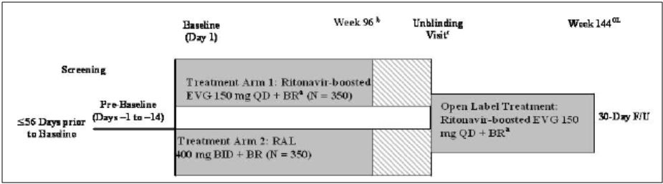

BR = background regimen; EVG = elvitegravir

a. EVG 85 mg if subject was taking atazanavir (ATV)/r or lopinavir (LPV)/r as part of BR; all other subjects received EVG 150 mg

b. Subjects will continue to attend visits every 8 weeks following Week 96 until Week 144, and every 12 weeks thereafter until treatment assignments have been unblinded.

c. Subjects will continue to attend visits every 12 weeks following the Unblinding Visit throughout the open-label extension phase of the study until Week 144 or until EVG becomes commercially available (whichever occurs first).

##### Inclusion and exclusion criteria

###### Inclusion

* Plasma HIV-1 RNA levels ≥ 1000 copies/mL at screening
* Subjects must have had documented resistance, as defined by current IAS-USA definitions, or at least 6 months experience prior to screening with 2 or more different classes of antiretroviral agents. Thus, subjects may have had resistance to 1 class and at least 6 months experience prior to screening with a second class of antiretroviral agents, or resistance to 2 classes of antiretroviral agents, or at least 6 months experience with the 2 classes of antiretroviral agents. Subjects may also have had resistance or at least 6 months experience prior to screening with 3 or more classes of antiretroviral agents
* Subjects must have been on a stable antiretroviral regimen for at least 30 days prior to screening and up until the baseline visit
* Subjects must have been eligible to receive one of the fully active RTV-boosted-PIs, based on the results of screening phenotype analysis. Fully active PIs were defined as those with fold changes below the lower clinical or biological cutoff for each drug
* Normal electrocardiogram (ECG)
* Adequate renal function: based on estimated glomerular filtration rate according to the Cockcroft-Gault formula (eGFRCG) ≥60 mL/min
* Hepatic transaminases (AST and ALT) ≤5 x ULN
* Total bilirubin ≤1.5 mg/dL, or normal direct bilirubin (subjects with documented Gilbert’s Syndrome or hyperbilirubinaemia due to indinavir or atazanavir (ATV) therapy may have had total bilirubin up to 5 x ULN)
* Adequate haematologic function (absolute neutrophil count ≥1,000/mm3; platelets ≥50,000/mm3; haemoglobin ≥8.5 g/dL)
* Serum amylase <1.5 x ULN (subjects with serum amylase ≥1.5 x ULN remained eligible if serum lipase was ≤1.5 x ULN)
* Negative serum pregnancy test
* Males and females of childbearing potential agreed to utilise highly effective contraception methods
* Age ≥18 years
* Life expectancy ≥1 year

###### Exclusion

* A new AIDS-defining condition diagnosed within the 30 days prior to screening
* Prior treatment with any HIV-1 integrase inhibitor
* Subjects who were experiencing ascites
* Subjects who were experiencing encephalopathy
* Subjects who were receiving ongoing therapy with any medication listed in protocol that was not to be taken with a component of the background regimen, including drugs not to be used with RTV
* Current alcohol or substance use judged by the investigator to potentially interfere with subject study compliance
* A history of or ongoing malignancy other than cutaneous Kaposi Sarcoma (KS), basal cell carcinoma, or resected, non-invasive cutaneous squamous cell carcinoma. Subjects with biopsy-confirmed cutaneous KS were eligible, but must not have received any systemic therapy for KS within 30 days of baseline and were not anticipated to require systemic therapy during the study.
* Active, serious infections (other than HIV-1 infection) requiring parenteral antibiotic or antifungal therapy within 30 days prior to baseline

##### Study treatments

Subjects were randomised into one of two treatment groups (Table 7), to receive oral EVG once daily or oral RAL twice daily plus placebo tablets once or twice daily, as appropriate to maintain the blind. The EVG dose (85 or 150 mg) received by subjects randomised to Treatment Group 1 was based on the protease inhibitor/r (PI/r) in the background regimen (BR). All subjects received 3 tablets of study drug per day (active drug and placebo), in addition to the components of the background regimen. Due to known PK interactions, subjects who were taking ATV/r or lopinavir (LPV)/r as part of their background regimen received EVG 85 mg if randomised to Treatment Group 1.

Table 7: Submitted pharmacodynamic studies.

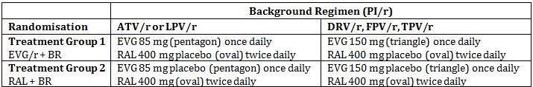

BR = background regimen; ATV = atazanavir; DRV = darunavir; FPV = fosamprenavir; LPV = lopinavir; /r, boosted with ritonavir; TPV = tipranavir; PI = protease inhibitor

The following ritonavir boosted protease inhibitors were allowed as background regimen: ATV/r, DRV/r, FPV/r, LPV/r or TPV/r. Protease inhibitors had to be fully active based on phenotypic susceptibility. The second agent may or may not have been fully active and could have been one nucleoside or nucleotide RT inhibitor, etravirine, maraviroc or enfuvirtide. However, the second agent could not have been the following: an integrase inhibitor; the NNRTIs efavirenz, nevirapine, or delavirdine (due to unknown PK interactions); or the fixed-dose combination therapies Atripla (efavirenz/emtricitabine/tenofovir disoproxil fumarate) or Trizivir (Abacavir/lamivudine/ zidovudine).

##### Efficacy variables and outcomes

The **primary efficacy outcome** was the percentage of subjects who achieved and maintained confirmed HIV-1 RNA <50 copies/mL through Week 48.

This outcome parameter was derived based on the US FDA defined time to loss of virologic response (TLOVR) algorithm.

Other efficacy outcomes included:

* Virologic response at Weeks 48 and 96 (HIV-1 RNA <50 copies/mL and <400 copies/mL)
* Percentage of patients who achieved and maintained confirmed HIV-1 RNA <50 copies/mL through Week 96
* Percentage of patients who achieved and maintained confirmed HIV-1 RNA <400 copies/mL through Week 48 and 96
* Time to pure virologic failure (PVF) with HIV-1 RNA cutoff at 50 copies/mL up to Weeks 48 and 96
* Time to PVF with HIV-1 cutoff at 400 copies/mL up to Weeks 48 and 96
* Percentage of subjects with HIV-1 RNA <50 copies/mL at Weeks 48 and 96
* Percentage of subjects with HIV-1 RNA <400 copies/mL at Weeks 48 and 96
* Change from baseline in log10 HIV-1 RNA (copies/mL) at Weeks 48 and 96
* Change from baseline in CD4 cell count at Weeks 48 and 96
* Analysis of resistance

##### Randomisation and blinding methods

The study treatments were randomised 1:1 into the treatment groups using an Interactive Voice/Web Response System (IVRS/IWRS). Randomisation was stratified by the following three factors: geographic area (US and Puerto Rico vs. Europe, Australia, Canada, and Mexico); screening HIV 1 RNA level (≤100,000 copies/mL vs. >100,000 copies/mL); and class of the second agent (NRTI vs. other classes) in the background regimen.

This was a double-blind and double-dummy study. Elvitegravir tablets (85 mg or 150 mg) and matching placebo tablets were packaged in identical white bottles. Commercial RAL was purchased and repackaged in bottles containing a sponsor label and were not distinguishable from the placebo tablets to match RAL.

The components of the background regimen were dispensed in an open-label fashion in the container in which they were supplied as prescribed by the investigator and were administered according to the approved product labelling for that particular compound.

##### Analysis populations

###### Intent-to-treat (ITT)

ITT included all subjects who were randomised into the study, received at least 1 dose of study medication, and were not enrolled at one site in USA = 702 (EVG = 351; RAL = 351).

###### Per Protocol (PP)

Included all subjects who were randomised into the study, received at least one dose of study drug, were not enrolled at one site in USA, and did not commit any major protocol violation. The PP analysis set was used for the virologic outcome at Week 48 for HIV-1 RNA cutoff at 50 or 400 copies/mL per the FDA-defined time to loss of virologic response (TLOVR) algorithm and snapshot algorithm = 538 (EVG = 270; RAL = 268).

###### Safety

Included subjects who were randomised into the study and received at least one dose of study medication. For safety analysis, all safety data collected up to 30 days after subjects permanently discontinued their study medication were included = 712 (EVG = 354; RAL = 358).

##### Sample size

The planned sample size of 700 subjects, 350 in each treatment group, was estimated to provide approximately 85% power to establish non-inferiority in the percentage of subjects achieving and maintaining confirmed HIV-1 RNA <50 copies/mL through Week 48. It was to be concluded that EVG is not inferior to RAL if the lower bound of the 2-sided 95% confidence interval (CI) of the difference (EVG treatment group - RAL treatment group) in the response rate is greater than -10%. For sample size and power computation, it was assumed that both RAL and EVG groups have a response rate of 0.74 and that the significance level of the test was 2-sided 0.05 level.

*Comment: The clinical study report (CSR) does not provide a justification for the delta of -10% but the Clinical Overview states that the non-inferiority margin was based on results observed in the “BENCHMRK” trials, in which (among subgroups of subjects having active T-20 (enfuvirtide) and DRV as background regimen) the treatment difference (RAL - placebo) was at least 20% at Week 48. Based on the BENCHMRK results, and assuming EVG would preserve at least half of the effect of RAL observed in those trials, a delta of 10% was chosen in Study GS-US-183-0145 to evaluate non-inferiority.*

##### Statistical methods

For the primary efficacy endpoint, non-inferiority of EVG treatment relative to RAL treatment (in addition to the BR) was assessed using a conventional 95% CI approach, with a delta of 0.10, based on the ITT analysis set. If the lower bound of the 2-sided 95% CI of the difference (EVG treatment group - RAL treatment group) in the response rate was greater than -10%, then it was to be concluded that EVG was non-inferior to RAL. The baseline strata (baseline HIV-1 RNA level ≤100,000 copies/mL or >100,000 copies/mL) and the class of the second agent (NRTI vs. other classes) weighted difference in 2 proportions (P1 - P2) and its 95% CI were calculated based on stratum-adjusted Mantel-Haenszel proportions. The primary efficacy endpoint was also evaluated using the PP analysis set. If the lower bound of the 95% CI was >0, then superiority was established. Superiority between treatment groups was also assessed using a 2-sided Cochran-Mantel-Haenszel test adjusted for baseline HIV-1 RNA (≤100,000 copies/mL vs. >100,000 copies/mL) and the class of the second agent (NRTI vs. other classes).

The percentages of subjects who achieved and maintained confirmed HIV-1 RNA <50 copies/mL through Week 96 and <400 copies/mL through Weeks 48 and 96 were summarised in the same manner as described for the primary efficacy endpoint. Time to loss of virologic response and time to PVF with HIV-1 RNA cutoff at 50 or 400 copies/mL were analysed using the Kaplan-Meier (KM) method, stratified by baseline HIV-1 RNA level (≤100,000 copies/mL vs. >100,000 copies/mL) and the class of the second agent (NRTI vs. other classes).

The percentages of subjects with HIV-1 RNA <50 or <400 copies/mL at Weeks 48 and 96 were also assessed using a snapshot analysis. A 2-sided 95% CI for the difference in proportions of virologic success between treatment groups was constructed in the same manner as described for the primary efficacy endpoint. The percentages of subjects with HIV-1 RNA <50 or <400 copies/mL at Weeks 48 and 96 were also summarised using missing = failure (M = F) and missing = excluded (M = E) data imputation methods.

The changes from baseline in log10 HIV-1 RNA and CD4 cell count were summarised using descriptive statistics. The differences between treatment groups and the associated 95% CIs were constructed using the analysis of variance model, including baseline HIV-1 RNA level (≤100,000 copies/mL or >100,000 copies/mL) and the class of the second agent (NRTI vs. other classes) as the fixed effect in the model.

##### Participant flow

Participant flow is shown in Figure 2.

Figure 2: Participant flow for Study GS-US-183-0145.

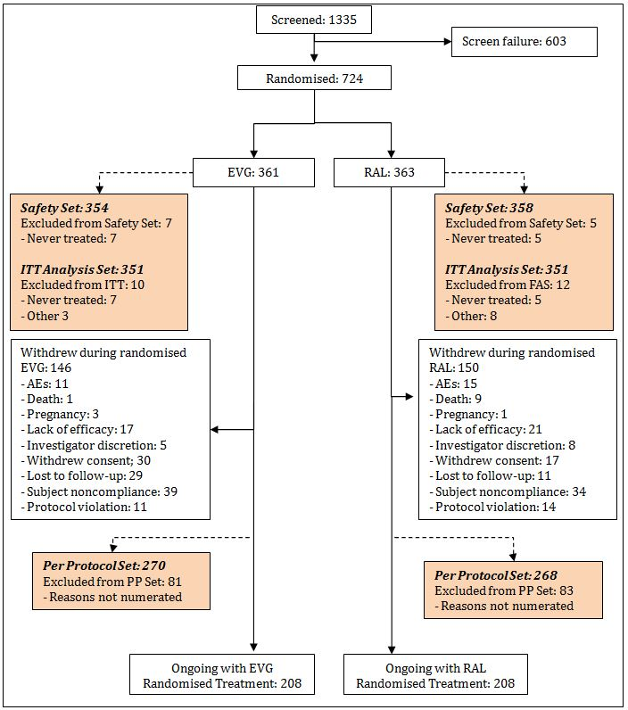

##### Major protocol violations/deviations

A total of 533 important protocol deviations were reported for 320 subjects during the study. Of the 320 subjects with important protocol deviations, the majority (n = 203) had a single important deviation, and 47 had 3 or more deviations.

Subjects enrolled at one site in the USA (3 EVG and 7 RAL subjects) were excluded from the ITT and the PP analysis sets (but included in the safety analysis set) due to failure to comply with the signed investigator agreement. Important protocol deviations at this site included the following: (1) subjects were given the study drug without other active antiretroviral drugs; and (2) subjects who met protocol-defined inclusion and exclusion criteria could not be verified by the source documentation. All 10 subjects at this site prematurely discontinued study drug; 9 subjects because of protocol deviations and 1 subject (in the EVG group) withdrew consent.

For the remaining sites the reasons for protocol deviations were as follows:

* Departure from required dosing requirements (250)
* Incorrect dispensing of study drug (38)
* Informed consent not obtained appropriately (8)
* Not managed according to protocol: assessments or procedures (39)
* Not managed according to protocol: background regimen (74)
* Received prohibited concomitant medications (90)
* Violation of inclusion/exclusion criteria (34)

The sponsor states that none of these important deviations affected the overall interpretability of the study findings.

##### Baseline data

Demographic and baseline characteristics were similar between the 2 treatment groups for the ITT analysis set and safety analysis set (Table 8). Subjects ranged in age from 19 to 78 years, with a median of 45 years. In total, 82.1% of subjects were male, 62.3% were white, and 33.9% were black or African American. The mean (SD) BMI at baseline was 25.8 (5.30) kg/m2. In total, 25.6% of subjects had HIV-1 RNA >100,000 copies/mL, and 44.6% of subjects had CD4 cell counts ≤200 cells/mm3. Co-infection with HBV was reported for 4.2% of subjects and co-infection with HCV was reported for 14.1% of subjects. The percentages of subjects with resistance mutations to NNRTIs, NRTIs, or PIs were similar in the two treatment groups.

Table 8: Study GS-US-183-0145: Baseline Demographics Including Disease Characteristics (ITT Analysis Set, Week 96 Dataset).

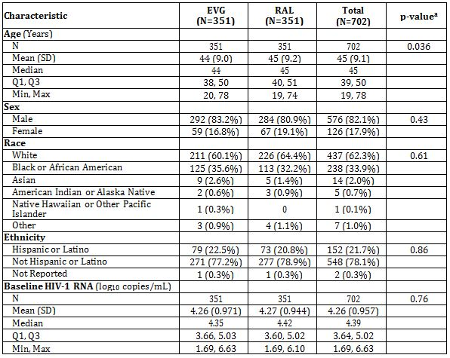

Table 8 (continued): Study GS-US-183-0145: Baseline Demographics Including Disease Characteristics (ITT Analysis Set, Week 96 Dataset).

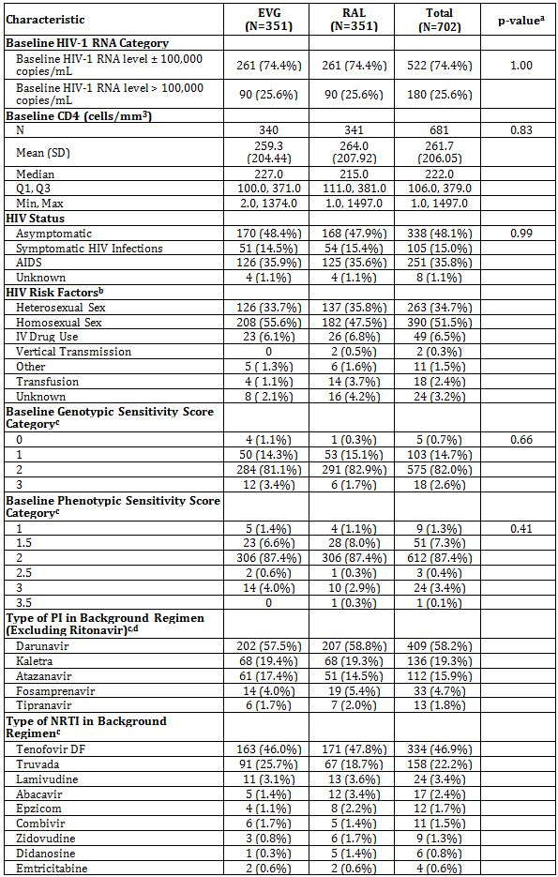

a P-values are estimated using a two-sided Cochran-Mantel-Haenszel test (categorical data) and the Wilcoxon rank sum test (continuous data).

b Subject may select more than one HIV-1 risk factors; therefore, percentages may add to more than 100.

c Baseline (BL) background regimen (BR) is defined as antiretrovirals (other than study drug) taken on or before Study Day 28 from BL for a minimum of 4 wks on/after BL. The GSS and PSS are calculated by summing up drug susceptibility values (1=sensitive; 0.5=partially sensitive; 0=resistance or reduced susceptibility) on all drugs in the BL BR. For subjects naive to T-20 (or maraviroc), a score of 1 is assigned for T-20 (or maraviroc).

d All subjects have one PI identified in the BR except one subject who took darunavir on Days 1-4 and fosamprenavir on Days 6-11.

##### Results for the primary efficacy outcome

###### Subjects achieving and maintaining confirmed HIV-1 RNA <50 copies/mL at week 48 (TLOVR Analysis)

The analysis of the primary efficacy endpoint was evaluated in the Week 48 CSR (using the Week 48 dataset) and was evaluated again using the Week 96 dataset. The results were identical.

The percentage of subjects achieving and maintaining confirmed HIV-1 RNA < 50 copies/mL at Week 48 (TLOVR analysis, ITT) was similar in the EVG and RAL treatment groups: 59.0% of subjects (207 of 351 subjects) in the EVG group and 57.8% of subjects (203 of 351 subjects) in the RAL group were classified as responders

The stratum-adjusted difference between treatment groups (EVG - RAL) was 1.1%, and the 95% CI was -6.0% to 8.2%. The lower bound of the 2-sided 95% CI of the stratum-weighted difference (EVG - RAL) in the response rate was -6%, which is greater than the prespecified non-inferiority margin of -10%, indicating that EVG is non-inferior to RAL.

Table 9: Study GS-US-183-0145: Treatment Outcomes at Week 48 for HIV-1 RNA Cutoff at 50 copies/mL, TLOVR Analysis (ITT Analysis Set, Week 96 Dataset).

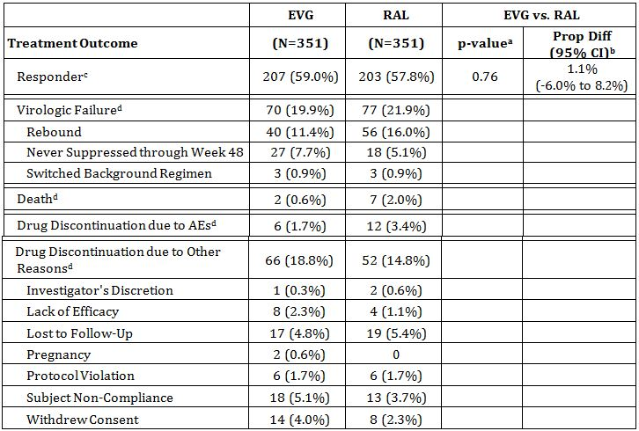

a. The p-value is estimated from a 2-sided Cochran-Mantel-Haenszel test adjusted by baseline HIV-1 RNA level and the class of second agent. This is the superiority p-value.

b. The difference in proportions and its 95% CIs between randomized treatment groups are based on stratum-adjusted [by baseline HIV-1 RNA level (≤100,000 or >100,000 copies/mL) and the class of second agent (NRTI or other classes)] Mantel-Haenszel (MH) proportions and normal approximation.

c. Responders include subjects who achieved and maintained confirmed HIV-1 RNA <50 copies/mL through Week 48.

d. If there is more than one event at the earliest time of failure, the order for classification is death, virologic failure, discontinuation due to adverse event, and discontinuation due to other reasons.

###### Subgroup analysis

Using the Week 96 dataset, results of the subgroup analyses (TLOVR, ITT analysis set) of the primary efficacy endpoint were identical to those using the Week 48 dataset. The 95% CIs for treatment differences in the percentage of subjects achieving and maintaining confirmed HIV-1 RNA <50 copies/mL included zero for all subgroups, suggesting no treatment differences across subgroups (Figure 3).

Figure 3: Study GS-US-183-0145: Forest Plot of Treatment Difference and 95% CI by Subgroup for Percent of Subjects with HIV-1 RNA < 50 copies/mL at Week 48, TLOVR Outcome (ITT Analysis Set, Week 96 Dataset).

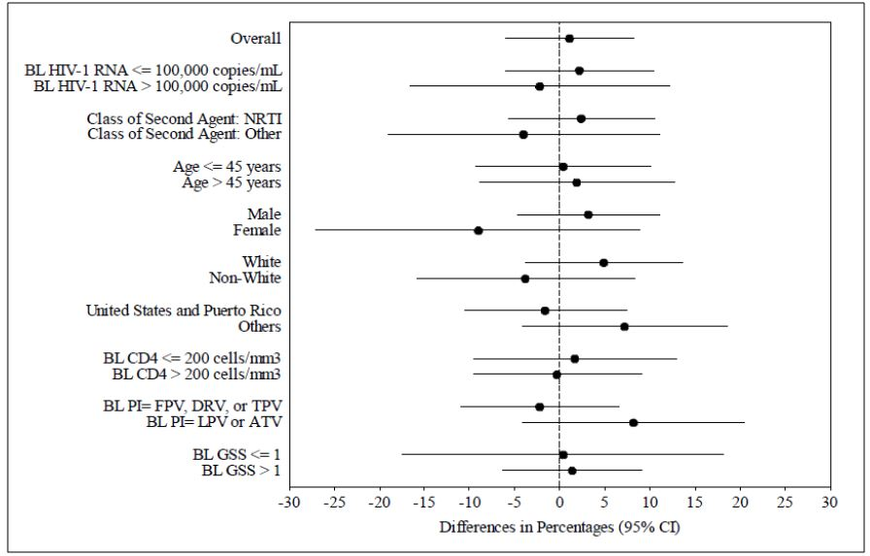

Relative to the vertical line at 0, differences on the right favour the EVG group and differences on the left favour the RAL group.

##### Results for other efficacy outcomes

###### The percentage of subjects who achieved and maintained confirmed HIV-1 RNA <50 copies/mL through week 96 (TLOVR algorithm)

Outcomes for the percentage of subjects achieving and maintaining confirmed HIV-1 RNA < 50 copies/mL at Week 96 (TLOVR analysis, ITT) were similar in the EVG and RAL groups: 47.6% of subjects (167 of 351 subjects) in the EVG group and 45.0% of subjects (158 of 351 subjects) in the RAL group were classified as responders. The stratum-adjusted difference between groups (EVG - RAL) was 2.6%, and the 95% CI was -4.6% to 9.9%.

Virologic failure was reported less frequently in the EVG group than in the RAL group (EVG 22.8%, 80 subjects; RAL 27.4%, 96 subjects), because fewer subjects experienced virologic rebound in the EVG group (19.7%, 69 subjects) than in the RAL group (24.5%, 86 subjects). The percentages of subjects who were never suppressed or who switched background regimen were similar in the two groups (Table 10).

Table 10: Study GS-US-183-0145: Treatment Outcomes at Week 96 for HIV-1 RNA Cutoff at 50 copies/mL, TLOVR Analysis (ITT Analysis Set, Week 96 Dataset).

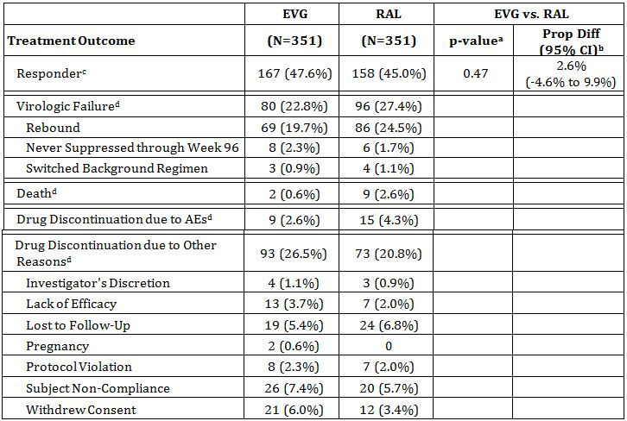

a. The p-value is estimated from a 2-sided Cochran-Mantel-Haenszel test adjusted by baseline HIV-1 RNA level and the class of second agent. This is the superiority p-value.

b. The difference in proportions and its 95% CIs between randomized treatment groups are based on stratum-adjusted [by baseline HIV-1 RNA level (≤100,000 or >100,000 copies/mL) and the class of second agent (NRTI or other classes)] Mantel-Haenszel proportions and normal approximation.

c. Responders include subjects who achieved and maintained confirmed HIV-1 RNA <50 copies/mL through Week 96.

d. If there is more than one event at the earliest time of failure, the order for classification is death, virologic failure, discontinuation due to adverse event, and discontinuation due to other reasons.

###### The percentage of subjects who achieved and maintained confirmed HIV-1 RNA < 400 copies/mL through weeks 48 and 96 (TLOVR algorithm)

The percentage of subjects achieving and maintaining confirmed HIV-1 RNA <400 copies/mL at Week 48 (TLOVR analysis, ITT) was similar in the EVG and RAL treatment groups: 68.1% of subjects (239 of 351 subjects) in the EVG group and 67.2% of subjects (236 of 351 subjects) in the RAL group were classified as responders. The stratum-adjusted difference between treatment groups (EVG - RAL) was 0.9%, and the 95% CI was -6.0% to 7.7%. The difference between treatment groups was consistent with that observed for the primary endpoint (TLOVR analysis with HIV-1 RNA <50 copies/mL).

The percentage of subjects achieving and maintaining confirmed HIV-1 RNA <400 copies/mL at Week 96 (TLOVR analysis, ITT) was similar in the EVG and RAL groups: 57.0% of subjects (200 of 351 subjects) in the EVG group and 56.1% of subjects (197 of 351 subjects) in the RAL group were classified as responders. The stratum-adjusted difference between groups (EVG - RAL) was 0.9%, and the 95% CI was -6.4% to 8.2%.

###### Virologic response at weeks 48 and 96 (HIV-1 RNA < 50 or < 400 copies/mL) per snapshot algorithm

The percentage of subjects with HIV-1 RNA <50 copies/mL at Week 48 (snapshot analysis, ITT) was similar in the EVG and RAL treatment groups: 59.8% of subjects (210 of 351 subjects) in the EVG group and 57.5% of subjects (202 of 351 subjects) in the RAL group were classified as a virologic success. The stratum-adjusted difference between treatment groups (EVG - RAL) was 2.2%, and the 95% CI was -5.0% to 9.3%. Similar percentages of subjects in the two groups were classified as virologic failures. The response rates observed in the snapshot analysis were consistent with those observed in the primary TLOVR analysis.

###### Subjects with HIV-1 RNA <50 copies/mL at week 96 (snapshot analysis)

The percentage of subjects with HIV-1 RNA <50 copies/mL at Week 96 (snapshot analysis, ITT) was similar in the EVG and RAL treatment groups: 52.4% of subjects (184 of 351 subjects) in the EVG group and 53.0% of subjects (186 of 351 subjects) in the RAL group were classified as a virologic success. The stratum-adjusted difference between the two treatment groups (EVG - RAL) was -0.5%, and the 95% CI was -7.9% to 6.8%. The response rates observed in the snapshot analysis were slightly higher than those observed in the TLOVR analysis.

###### Subjects with HIV-1 RNA <400 copies/mL at week 48 (snapshot analysis)

Using the Week 96 dataset, the percentage of subjects with HIV-1 RNA <400 copies/mL at Week 48 (snapshot analysis, ITT) was similar in the EVG and RAL treatment groups: 68.4% of subjects (240 of 351 subjects) in the EVG group and 68.7% of subjects (241 of 351 subjects) in the RAL group were classified as a virologic success. The stratum-adjusted difference between treatment groups (EVG - RAL) was -0.3%, and the 95% CI was -7.1% to 6.5%. These results were consistent with those observed in the TLOVR analysis with HIV-1 RNA <400 copies/mL.

###### Subjects with HIV-1 RNA <400 copies/mL at week 96 (snapshot analysis)

The percentage of subjects with HIV-1 RNA <400 copies/mL at Week 96 (snapshot analysis, ITT) was similar in the EVG and RAL groups: 59.0% of subjects (207 of 351 subjects) in the EVG group and 59.3% of subjects (208 of 351 subjects) in the RAL group were classified as a virologic success. The stratum-adjusted difference between groups (EVG - RAL) was -0.2%, and the 95% CI was -7.5% to 7.0%. These results were slightly higher than those observed in the TLOVR analysis with HIV-1 RNA <400 copies/mL.

###### Time to loss of virologic response with HIV-1 RNA cutoff at 50 copies/mL up to week 96

Time to loss of virologic response with HIV-1 RNA cutoff at 50 copies/mL is shown in Figure 4. The KM curves separated early, as a higher percentage of subjects in the EVG group compared with the RAL group had loss of virologic response due to never being suppressed and were, therefore, assumed to have failed at Day 1. In contrast, a higher percentage of subjects in the RAL group compared with the EVG group experienced virologic rebound; these subjects failed at the time when the rebound occurred. Taken together, the percentages of subjects with loss of virologic response (due to never being suppressed or rebound) were similar between the EVG and RAL treatment groups. At Week 96, the KM estimates for the percentages of subjects with loss of virologic response were 52% for the EVG group and 55% for the RAL group. The median time to loss of virologic response was 617 days in the EVG group and 562 days in the RAL group (p = 0.86).

Figure 4: Study GS-US-183-0145: Time to Loss of Virologic Response with HIV-1 RNA Cutoff at 50 copies/mL (ITT Analysis Set, Week 96 Dataset).

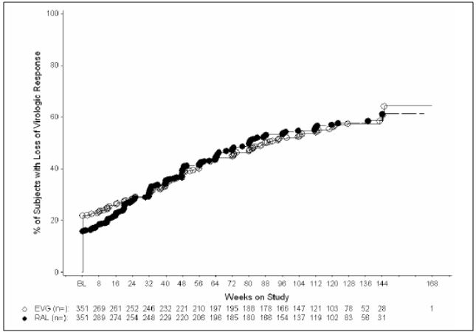

Event time for TLOVR responders was censored at the last HIV-1 RNA collection date. Event time for subjects who never achieved a confirmed response was 1 (i.e. assumed to have failed on Day 1). Event time for the remaining subjects was the earliest time to death, discontinuation of study drug, first switch of background regimen, first occurrence of confirmed rebound (HIV-1 RNA ≥50 copies/mL), or non confirmed rebound followed by premature discontinuation of study drug.

The number of subjects listed below the x-axis is the number of subjects at risk per specified time point.

###### The time to PVF with HIV-1 RNA cutoff at 50 or 400 copies/mL up to weeks 48 and 96

Time to PVF with HIV-1 RNA cutoff at 50 copies/mL is depicted in Figure 5. The KM curves separated early, as a higher percentage of subjects in the EVG group compared with the RAL group had PVF due to never being suppressed and were, therefore, defined as failures at Day 1. In contrast, a higher percentage of subjects in the RAL group compared with the EVG group experienced virologic rebound; these subjects failed at the time when the rebound occurred. Taken together, the percentages of subjects with PVF were similar in the EVG and RAL treatment groups. At Week 96, the KM estimates for the percentages of subjects with PVF were 45% for the EVG group and 46% for the RAL group. The median time to PVF was 1014 days in the EVG group and 961 days in the RAL group (p = 0.99).

Figure 5: Study GS-US-183-0145: Time to Pure Virologic Failure with HIV-1 RNA Cutoff at 50 copies/mL (ITT Analysis Set, Week 96 Dataset).

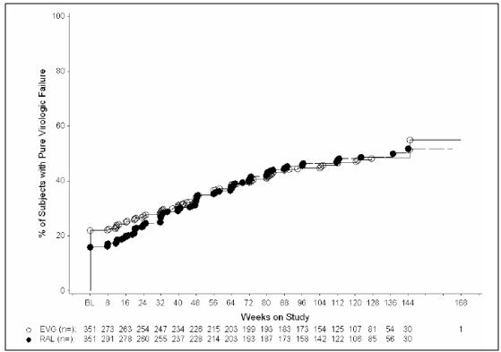

The time to pure virologic failure for subjects who had not achieved a confirmed HIV-1 RNA <50 copies/mL was assumed to have failed on Day 1. Subjects who achieved confirmed HIV-1 RNA <50 copies/mL but had not experienced a confirmed rebound were censored at the last HIV-1 RNA collection date. For subjects who achieved a confirmed HIV-1 RNA <50 copies/mL and then experienced a confirmed rebound, the time to pure virologic failure was the earliest time of 2 consecutive HIV-1 RNA ≥ 50 copies/mL or the last available HIV-1 RNA ≥50 copies/mL followed by premature discontinuation of study. All HIV-1 RNA data collected by the data cutoff date were used for this summary.

###### The change from baseline in log10 HIV-1 RNA (copies/mL) at weeks 48 and 96

HIV-1 RNA levels decreased following administration of study drug, and the mean decreases were similar between the EVG and RAL treatment groups at all time points (Figure 6). Mean (SD) baseline HIV-1 RNA levels were 4.26 (0.971) log10 copies/mL in the EVG group and 4.27 (0.944) log10 copies/mL in the RAL group. At Week 96, the mean (SD) decreases from baseline in HIV-1 RNA were -2.26 (1.078) log10 copies/mL in the EVG group and -2.31 (1.068) log10 copies/mL in the RAL group. The difference in least-squares means (LSM) was 0.05, and the 95% CI was -0.12 to 0.22.

Figure 6: Study GS-US-183-0145: Mean (95% CI) Change from Baseline in HIV-1 RNA (log10 copies/mL) by Study Visit (ITT Analysis Set, Week 96 Dataset).

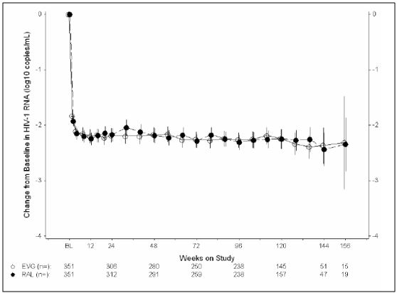

Results from Week 168 were removed due to small sample size with wild confidence intervals

###### The change from baseline in CD4 cell count at weeks 48 and 96

CD4 cell counts increased following administration of study drug, and the mean increases were similar between the EVG and RAL treatment groups at all time points (Figure 7). Mean (SD) baseline CD4 cell counts were 259 (204.4) cells/mm3 in the EVG group and 264 (207.9) cells/mm3 in the RAL group. At Week 96, the mean (SD) increases from baseline in CD4 cell count were 205 (191.5) cells/mm3 in the EVG group and 198 (162.2) cells/mm3 in the RAL group. The difference in LSM was 7, and the 95% CI was -25 to 39.

Figure 7: Study GS-US-183-0145: Mean (95% CI) Change from Baseline in CD4 Cell Count (cells/mm3) by Study Visit (ITT Analysis Set, Week 96 Dataset).

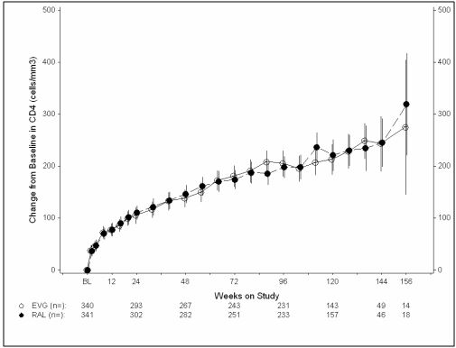

Results from Week 168 were removed due to small sample size with wild confidence intervals.

###### Resistance

Resistance development to EVG or RAL occurred infrequently through Week 96 in this study (6.6% of subjects in the EVG group, and 7.4% of subjects in the RAL group). Analysed subjects who did not develop integrase resistance also showed less reverse transcriptase and protease resistance at baseline suggesting that their lack of virologic suppression was due to poor adherence. Subjects who developed INSTI-R while receiving RAL showed a higher level of phenotypic cross-resistance to both RAL and EVG than subjects who developed INSTI-R while receiving EVG. Finally, resistance to reverse transcriptase inhibitors or protease inhibitors also occurred infrequently and often in a background of pre-existing protease and reverse transcriptase resistance.

##### Conclusions

* Elvitegravir once daily is non-inferior to RAL twice daily when administered to HIV-1 infected, antiretroviral treatment experienced adults in combination with a fully active RTV boosted protease inhibitor and an active second agent;
* Resistance development to EVG, RAL or the background regimen occurred infrequently and with similar incidence in the two treatment groups.

#### Other efficacy studies: Study GS-US-183-0130

##### Summary

A Phase 2, Open Label, Multicentre Study of the Safety of Ritonavir Boosted Elvitegravir (EVG/r) Administered in Combination with Other Antiretroviral Agents for the Treatment of HIV-1 Infected Subjects.

##### Objectives

Study was initiated to provide continued access to ritonavir boosted elvitegravir (EVG/r) for those subjects who had completed a prior EVG/r study without experiencing any treatment limiting toxicities.

The **primary objective** was to observe the long term safety of EVG/r in combination with other antiretroviral agents in subjects who have completed a prior EVG/r treatment study.

##### Methodology

###### Design

Open label, multicentre, multiple dose, single arm extension study conducted in 59 centres in the USA and Puerto Rico from February 2007 to March 2011.

###### Entry criteria

Subjects were eligible for this study if they had completed a prior EVG/r treatment study without experiencing any dose-limiting toxicity; eligible subjects may or may not have received EVG in their prior study. Subjects were enrolled regardless of their baseline HIV-1 RNA level (i.e. subjects with baseline HIV-1 RNA levels of either <50 or ≥50 copies/mL were enrolled). Non-virologically suppressed subjects entering this study had, for the most part, failed prior antiretroviral regimens and had limited treatment options available; these subjects were allowed in the current extension study even if they had been exposed to EVG in their prior study. Genotyping was not performed at baseline.

It was planned to enrol subjects from multiple prior studies; however, subjects from only two prior studies (GS-US-183-0105 and GS-US-183-0152) rolled over into this study.

###### Treatments

The components of each subject’s background antiretroviral regimen were selected by the investigator without input from the sponsor. The background antiretroviral regimen consisted of at least 2 agents, but was not to include the NNRTIs efavirenz, nevirapine, or delavirdine; the PIs saquinavir, nelfinavir, or indinavir; or other investigational agents (without sponsor approval) due to known or unknown drug-drug interactions with EVG/r.

Elvitegravir was administered orally with RTV, once daily with food, in combination with other antiretroviral agents. Subjects in the main study who were taking LPV/r or ATV/r as part of their antiretroviral regimen received EVG 85 mg due to an established drug-drug interaction with these agents; all other subjects in the main study received EVG 150 mg.

The regimens shown in Table 11 were included.

Table 11: Regimens for Study GS-US-183-0130.

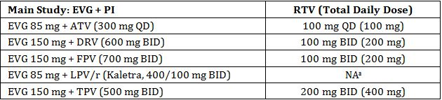

a. Kaletra consisted of LPV coformulated with RTV; therefore, no additional RTV doses were required.

###### Efficacy outcomes

* Percentage of subjects with HIV-1 RNA <50 copies/mL
* Percentage of subjects with HIV-1 RNA <400 copies/mL
* Change in baseline in HIV-1 RNA (log10 copies/mL)
* Change in baseline in CD4 cell count (cells/mm3)
* Resistance analysis on retained samples

##### Study participants

Enrolled: 192

Completed: 113

Analysed: 191 – one subject excluded because he had no post baseline HIV-1 RNA or CD4 cell count data.

Figure 8: Study GS-US-183-0130 participants.

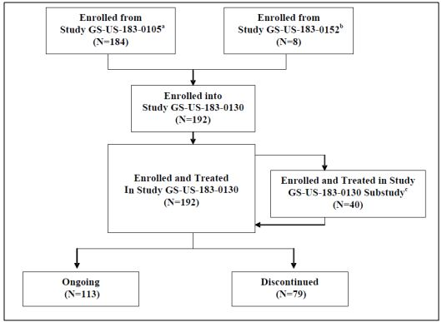

a. Study GS-US-183-0105 was a Phase 2, randomised study in HIV-1 infected, antiretroviral treatment-experienced subjects comparing RTV-boosted EVG versus a comparator RTV-boosted protease inhibitor in combination with a background antiretroviral therapy.

b. Study GS-US-183-0152 was a Phase 1B study of the safety and pharmacokinetics of RTV-boosted EVG plus a background regimen in HIV-1 infected, antiretroviral treatment-experienced adolescents.

c. Forty subjects receiving EVG 150 mg participated in the sub study, in which they received a higher dose of EVG 300 mg. All sub study subjects came from Study GS-US-183-0105, completed the sub study, and switched back to EVG 150 mg.

###### Baseline characteristics

Subjects were predominantly male (90.1%) and White (72.4%), with a mean age of 45 years (ranging from 15 to 65 years). At baseline, the mean weight was 81.6 kg, mean height was 175.4 cm, and mean body mass index (BMI) was 26.4 kg/m2.

Categorically, baseline HIV-1 RNA level was <50 copies/mL in 85 subjects (44.5%), 50 to <400 copies/mL in 40 subjects (20.9%), and ≥400 copies/mL in 66 subjects (34.6%). At baseline, the mean CD4 cell count was 282 cells/mm3; categorically, 119 subjects (62.6%) had a baseline CD4 cell count >200 cells/mm3. Mean estimated glomerular filtration rate (GFR) was 107.0 mL/min (using the Cockcroft-Gault formula) and 89.3 mL/min/1.73 m2 (using the Modification of Diet in Renal Disease [MDRD] formula). Five subjects had baseline estimated GFRs <50 mL/min using the Cockcroft-Gault formula.

##### Results

###### The percentages of subjects with HIV-1 RNA < 50 copies/mL

These are outlined in Figure 9 and Table 12.

Figure 9: Study GS-US-183-0130: Percentage of Subjects with HIV-1 RNA < 50 copies/mL by Visit (Missing = Failure) (Efficacy Analysis Set).

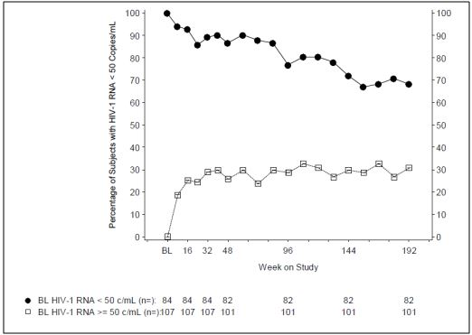

Table 12: Study GS-US-183-0130: Subjects with HIV-1 RNA <50 copies/mL at Weeks 48, 96, 144, and 192 (Missing = Failure) (Efficacy Analysis Set).

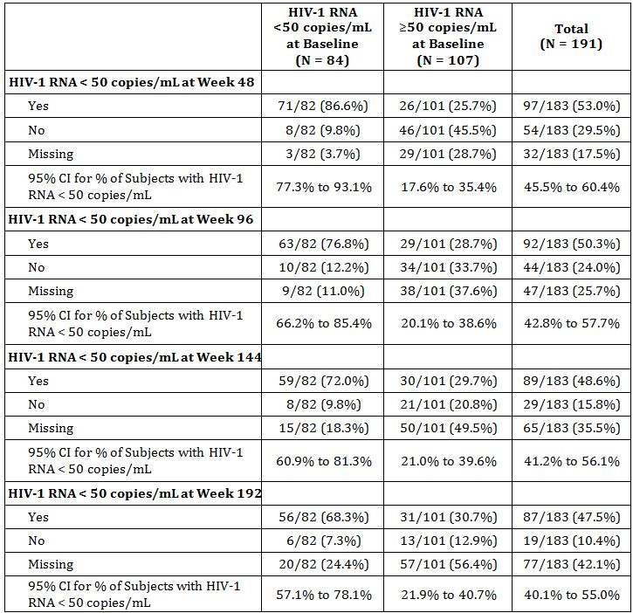

###### The percentages of subjects with HIV-1 RNA <400 copies/mL

This is shown in Table 13.

Table 13: Study GS-US-183-0130: Subjects with HIV-1 RNA < 400 copies/mL at Weeks 48, 96, 144, and 192 (Missing = Failure) (Efficacy Analysis Set).

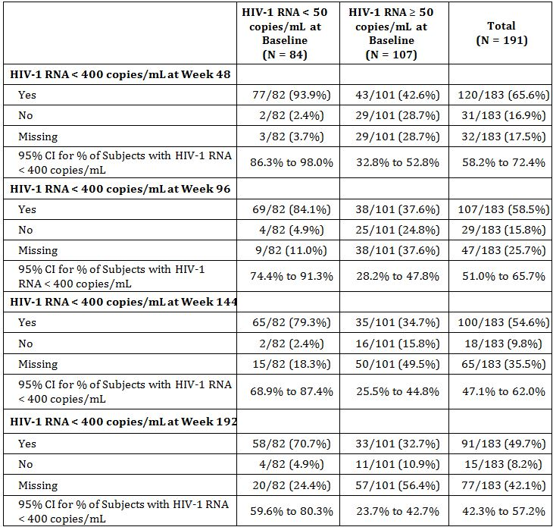

All data collected up to the data cut-off date are included in the summary statistics.

Denominator for percentage is the number of Efficacy Subjects, excluding ongoing subjects who have both missing HIV-1 RNA at a visit and have not reached the upper limit of the analysis window for the corresponding visit.

The 95% confidence interval for the proportion estimate for a treatment group is based on the Exact method.

###### The change from baseline in HIV-1 RNA (log10 copies/mL)

For the baseline HIV-1 RNA < 50 copies/mL subject group (N = 84), HIV-1 RNA (log10 copies/mL) levels were maintained over 192 weeks.

For the baseline HIV-1 RNA ≥ 50 copies/mL subject group (N = 107), HIV-1 RNA levels decreased over 192 weeks (Figure 10).

Figure 10: Study GS-US-183-0130: Mean and 95% CI in Change from Baseline in HIV-1 RNA (log10 copies/mL) by Study Visit (Efficacy Analysis Set).

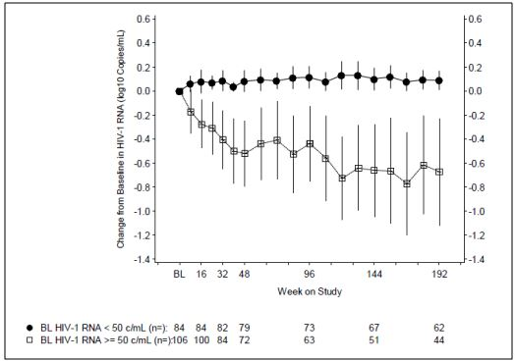

###### The change from baseline in CD4 cell count (cells/mm3)

For the baseline HIV-1 RNA < 50 copies/mL subject group (N = 84), CD4 cell counts increased over 192 weeks (Figure 11). For the baseline HIV-1 RNA ≥ 50 copies/mL subject group (N = 107), CD4 cell counts also increased over 192 weeks.

Figure 11: Study GS-US-183-0130: Mean and 95% CI in Change from Baseline in CD4 Cell Counts (cells/mm3) by Study Visit (Efficacy Analysis Set).

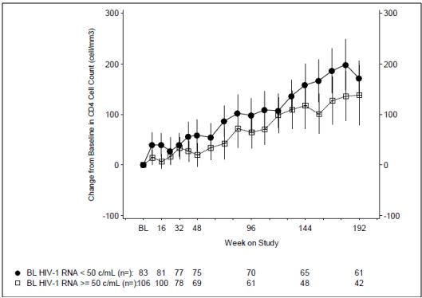

###### Resistance

The majority of resistance development was characterised as an evolution of RT, protease, and integrase resistance that had existed prior to study entry in subjects who were not fully suppressed on their regimen. With regards to integrase resistance, mutation patterns were observed to evolve resulting in a general increase in the level of phenotypic resistance. In subjects who entered the study with fully suppressed HIV-1 RNA, integrase resistance development was infrequent (3/84 subjects) and was observed along with evolution of RT and/or protease resistance that was present prior to EVG therapy.

##### Conclusion

The interpretation of efficacy data in this study is difficult for the following reasons:

* inclusion of both subjects who did (n = 162) and did not (n = 30) receive EVG in their prior study;
* inclusion of both subjects with baseline HIV-1 RNA <50 copies/mL (n=84) and ≥50 copies/mL (n=107);
* high attrition rate (79 of 192 subjects) during the study for reasons other than lack of efficacy or death (50 of 79 subjects);
* the open-label, single-arm study design, lacking a comparator arm.

Despite the above concerns the following conclusions can be made:

* in subjects with baseline HIV-1 RNA <50 copies/mL, EVG in combination with the background regimen showed durable efficacy;
* Approximately one third of subjects with baseline HIV-1 RNA ≥50 copies/mL, most of whom received uninterrupted EVG from prior studies, achieved long term virologic suppression;
* Integrase resistance developed infrequently in subjects with baseline HIV-1RNA <50 copies/mL. In contrast, pre-existing integrase resistance was common in subjects entering the study with baseline HIV-1 RNA ≥50 copies/mL. There was an evolution of integrase, reverse transcriptase resistance in subjects with ongoing unsuppressed HIV-1 RNA.

#### Other efficacy studies: Study GS-US-183-0152

*Comment: This study is primarily a PK study and is summarised in the PK section. While not stated as an objective of the study, efficacy data was collected in an optional treatment extension of the trial. The efficacy results are presented here.*

Study GS-US-183-0152 was a non randomised, open label multicentre, multiple dose study conducted at 10 sites in the USA, UK and Canada. Twenty-five HIV-1 infected ARV treatment experienced adolescents aged 12 to <18 years old with plasma HIV-1 RNA levels >1,000 copies/mL or <400 copies/mL and weight >40kg were enrolled.

Eleven of the 23 subjects, who completed the 10-day PK evaluation phase of the study, met the eligibility criterion (screening plasma HIV-1 RNA level >1000 copies/mL) for enrolment in the optional treatment phase of the study. Nine of 11 eligible subjects enrolled in the optional treatment phase, and each of these 9 subjects completed the optional treatment phase through 48 weeks.

##### Efficacy results

Efficacy criteria were change in baseline in log10 HIV-1 RNA (copies/mL) and in CD4 cell count (cells/μL) at the end of the study and the proportions of subject with HIV-1 RNA <50 copies/mL and <400 copies/mL at the end of the study.

All 9 subjects had reductions in HIV-1 RNA from baseline to Week 48 (the median change from baseline was -1.74 log10 copies/mL, range -2.69, -0.40), and 2 subjects had HIV-1 RNA <50 copies/mL at Week 48. Increases were observed in CD4 cell counts and percentages; 6/9 subjects had a CD4 cell count within or near the normal reference range at Week 48, and 6/9 subjects had CD4 cell percentage values within or near the normal reference range at Week 48.

Four of 9 subjects enrolled in the optional treatment phase through 48 weeks were included in the resistance analysis population. Three subjects had pre-existing secondary integrase mutations at baseline, and 1 subject developed a secondary integrase resistance mutation at or before Week 48; however, all 4 subjects lacked primary integrase resistance mutations and remained phenotypically susceptible to EVG.

#### Evaluator’s conclusions on clinical efficacy for use as part of combination therapy in HIV-1 infection

The efficacy of EVG is reliant on one pivotal clinical Study GS-US-183-0145.

EVG once daily was non inferior to RAL twice daily when administered for 48 weeks to HIV-1 infected, antiretroviral treatment experienced adults in combination with a fully active PI/r and an active second agent. The response rates observed in the study (EVG 59%, RAL 58%) are similar to the historical response rates reported in previous BENCHMRK studies with RAL,[36] despite differences in the patient populations and permitted background regimens between studies.

The choice of RAL as comparator is acceptable as this is approved in Australia for use in this patient population. The sponsor has adequately justified the delta of -10% for the non inferiority margin.

Study GS-US-183-0130 submitted as an uncontrolled study is primarily a safety study as it included patients who had participated in previous efficacy and pharmacokinetic studies.

The EU Guideline requirement for acceptance of one pivotal study is: “one controlled study with statistically compelling and clinically relevant results”.[37] In addition, one study should meet the following criteria:

* Internal validity: there should be no indications of a potential bias
  + No potential bias was detected
* External validity: the study population should be suitable for extrapolation to the population to be treated
  + Study population is suitable for extrapolation to the population to be treated
* Clinical relevance: the estimated size of the treatment benefit must be large enough to be clinically relevant
  + The estimated size of the treatment benefit is consistent with the published literature
* The degree of statistical significance: when the aim is to demonstrate non inferiority, the lower 95% confidence bound is well away from the non inferiority margin
  + The lower 95% confidence bound was set at -10% and the lower 95% confidence bounds using different algorithms as shown in Table 14.

Table 14: 95% confidence bounds for analyses of clinical efficacy.

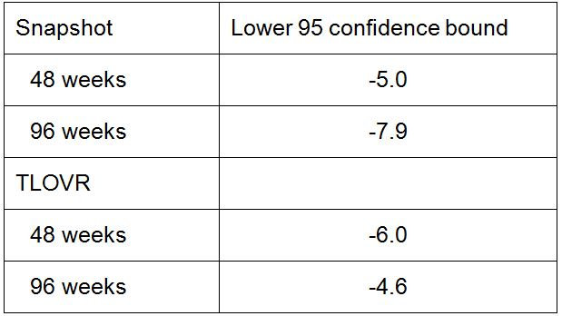

* + Results are consistently above the preset non inferiority margin.
* Data quality
  + Data quality is acceptable
* Internal consistency – all important endpoints showing similar findings
  + All secondary efficacy outcomes were consistent with the primary outcome parameter and were consistent for 48 weeks and 96 weeks of treatment
* Centre effects are not seen
  + While a centre effect was not specifically tested the analysis of primary endpoint by subgroups included an analysis by geographic region (US and Puerto Rico versus others). No subgroup effect was seen, suggesting no centre effect was present.
* Plausibility of the hypothesis tested
  + Hypothesis tested was plausible

Study GS-US-183-0145 meets the criteria for acceptance of one pivotal trial.

The majority of subjects in both groups who had samples sent for resistance testing had wild type virus without any new HIV-1 mutations, suggesting that poor adherence to the study regimens might be the principle reason for virologic failure. Resistance development to EVG and RAL occurred infrequently in both groups.

The sponsor also presents Study GS-US-183-0105 in the summary as supporting the efficacy of EVG. This study was not submitted in this dossier but was submitted and evaluated in the Stribild submission. The study is said to have shown that EVG/r 50/100 mg and 125/100 mg met the criteria for non inferiority relative to the comparator protease inhibitor/r (CPI/r) for the pre specified primary analysis endpoint of time weighted average change from baseline through Week 24 in HIV-1 RNA. However, the sponsor states that changes in the study drug treatment regimens recommended by the Independent Data Monitoring Committee confound the interpretation of the results of non inferiority after Week 16. Additional post hoc analysis confirmed the results.

The sponsor has supplied supporting data in Study GS-US-183-0130 but this is primarily for the long term safety up to 192 weeks.

The data in efficacy in adolescents is slim: based on very small number (n = 9) of patients treated for 48 weeks. No data is provided for children less than 12 years. The sponsor is not seeking approval for use in children <18 years and the PI states that safety and efficacy has not been established in children <18 years.

The sponsor is not seeking approval for use of EVG boosted by COBI despite this being part of the component of the Stribild product. The sponsor does not really explain why this has not been more extensively investigated. They cite the studies conducted with COBI which showed that when 150 mg EVG was administered with COBI (150 mg) and DRV, plasma exposures of all three agents were insufficient for optimal therapeutic activity. In addition, when COBI is co-administered with EVG it is not expected to adequately boost tipranavir (TPV) versus TPV/r. The sponsor states that EVG is not recommended for use with a COBI boosted protease inhibitor, as dosing recommendations for such combinations have not been established and may result in suboptimal plasma concentrations of EVG and/or the protease inhibitor leading to loss of therapeutic effect and possible development of resistance.

There is no clinical data available with boosted EVG in the treatment naive population other than with the Stribild combination product. Consequently, the EVG tablet is only recommended for use when co administered with a RTV boosted PI and other antiretrovirals for use in treatment experienced adults with HIV-1 infection.

## Clinical safety

### Studies providing evaluable safety data

#### Pivotal efficacy studies

In the pivotal efficacy study (GS-US-183-0145), the following safety data were collected:

* General AEs: the study report does not indicate how they were collected
* No AEs of particular interest were pre specified in the pivotal study
* Laboratory tests, including serum chemistry, haematology, metabolic assessments, pregnancy tests (for females of childbearing potential), and urinalysis, were performed at Baseline/Day 1, 2, 4, 8, 12, 16, 20, 24, 32, 40, 48, 56, 64, 80, 88, 72, 96 and then every 8-12 weeks
* Other safety related assessments which included complete/symptom directed physical examinations and vital signs.

#### Pivotal studies that assessed safety as a primary outcome

Not applicable.

#### Dose response and non pivotal efficacy studies

The dose response and non pivotal efficacy studies provided safety data, as follows:

* Study GS-US-183-0130 provided data on adverse events, laboratory tests and vital signs;
* Study GS-US-183-0152 provided data on adverse events in adolescents, laboratory tests and vital signs.

#### Other studies evaluable for safety only

Not applicable.

#### Clinical pharmacology studies

AEs, vital signs, haematology, clinical chemistry and in some cases electrocardiograms (ECGs) were recorded in the clinical pharmacology studies. Most of these studies enrolled healthy volunteers. One study, GS-US-183-0152, enrolled HIV-1 infected adolescent patients.

### Pivotal studies that assessed safety as a primary outcome

Not applicable.

### Patient exposure

These are listed in Tables 15 and 16.

*Comment: The Summary of Clinical Safety does not provide a full integrated summary of all clinical studies with EVG. It provides a summary of the safety results from Studies GS-US-183-0145 and GS-US-183-0130 but also includes Study GS-US-183-0105 which was included and evaluated in the Stribild Submission. The following presents the data from the individual study reports included in this submission with reference to the summary where relevant.*

Table 15: Exposure to EVG and comparators in clinical studies.

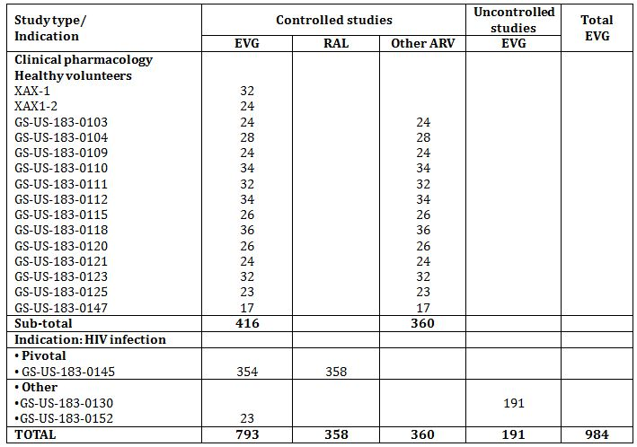

Table 16: Exposure to elvitegravir and comparator (raltegravir) in pivotal study (Safety Analysis Set, Week 96 Dataset).

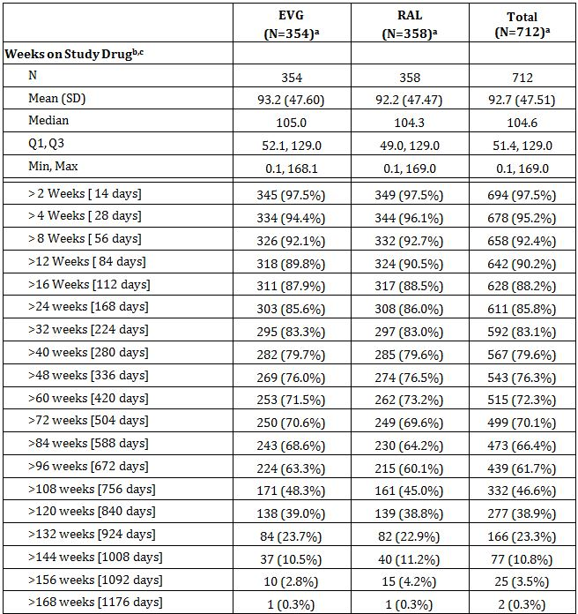

a. Denominator for percentages is the number of subjects in the safety analysis set within the treatment group.

b. Duration of exposure in weeks = (Last Dose Date - First Dose Date + 1)/7.

c. Last dose date was estimated as the maximum of last clinical (excluding the 30-Day follow-up visit) and laboratory visit dates up to the data cutoff dates if subjects were still on study drug. For subjects who have discontinued from study drug, the last dose date was the last non missing end date of study drug reported on the study drug administration CRF.

#### Other studies

In Study GS-US-183-0130 the median duration of exposure to EVG (85, 150, or 300 mg; combined) for all subjects through the Week 192 data cutoff date was 191.2 weeks. The 8 adolescent subjects who rolled-over from Study GS-US-183-0152 had a median duration of exposure to EVG of 32.3 weeks (Table 17).

Table 17: Study GS-US-183-0130: Duration of Exposure to EVG through the Week 192 Data Cutoff Date (Safety Analysis Set).

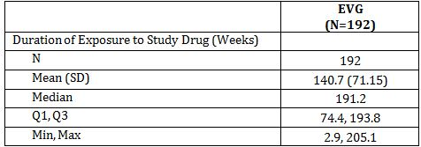

Duration of exposure (weeks) is defined as (last dose date − first dose date of EVG in the Study + 1)/7, regardless of temporary interruptions in study drug.

The median duration of exposure to EVG 300 mg (40 patients) was 39.9 weeks in the sub study.

In Study GS-US-183-0152 23 adolescent patients age range 12-17 completed the 10 treatment period. 8 patients rolled over into Study GS-US-183-0130.

### Adverse events

#### All adverse events (irrespective of relationship to study treatment)

##### Pivotal study

AEs were reported for a similar percentage of subjects in the 2 groups (EVG 90.1%, 319 subjects; RAL 88.8%, 318 subjects) (Table 18). The most frequently reported AEs in each group were as follows:

* EVG: diarrhoea (33.6%, 119 subjects), upper respiratory tract infection (18.9%, 67 subjects), and headache (13.3%, 47 subjects)
* RAL: diarrhoea (21.8%, 78 subjects), upper respiratory tract infection (15.6%, 56 subjects), and cough (13.1%, 47 subjects).

Table 18: Study GS-US-183-0145: Treatment-Emergent Adverse Events Reported for ≥ 5% of Subjects in Either Treatment Group (Safety Analysis Set, Week 96 Dataset).

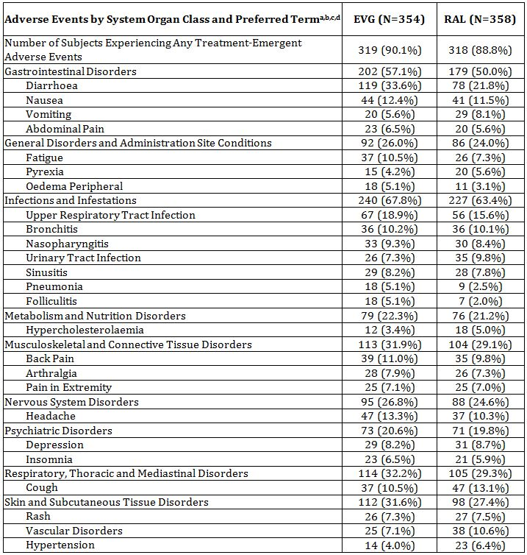

a. Denominator for percentages is the number of subjects in the safety analysis set within the treatment group.

b. Adverse events are mapped according to the MedDRA dictionary, Version 14.0.

c. System organ classes are sorted alphabetically. Within each SOC, PTs are sorted in decreasing order of frequency.

d. Adverse events with onset after the last dose date plus 30 days are excluded from analysis.

##### Other studies

###### Study GS-US-183-130

A total of 177 subjects (92.2%) experienced a treatment-emergent AE while receiving EVG (85, 150, or 300 mg) (Table 19). Most treatment-emergent AEs were considered by the investigator to be not related to study drug. Most treatment-emergent AEs were considered by the investigator to be mild (Grade 1) or moderate (Grade 2) in severity. Severe (Grade 3) and life-threatening (Grade 4) treatment-emergent AEs were experienced by 73 subjects (38.0%).

Table 19: Study GS-US-183-0130: Treatment-Emergent Adverse Events Reported for at Least 5% of Subjects through the Week 192 Data Cutoff Date (Safety Analysis Set).

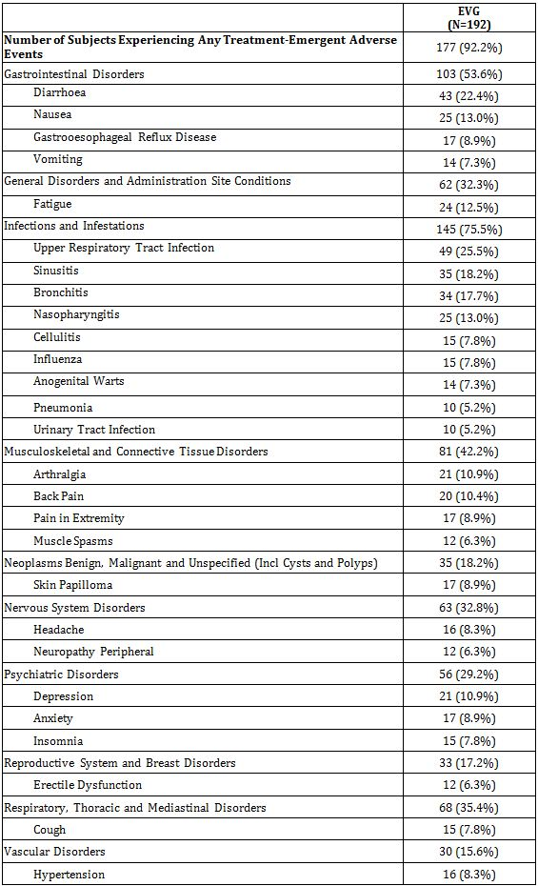

Data collected after last dose date + 30 days are excluded from analysis.

Denominator for percentages is the number of subjects in Safety analysis set.

Adverse events were mapped according to MedDRA 13.1.

Multiple adverse events were counted once only per subject for each system organ class and preferred term.

System organ class (SOC) was sorted alphabetically. Within each SOC, preferred terms were sorted in decreasing order of the total frequencies.

All 40 subjects (100.0%) experienced a treatment-emergent AE in the sub study while receiving EVG 300 mg. Most treatment-emergent AEs were in the system organ classes of infections and infestations (67.5%) and gastrointestinal disorders (42.5%).

The most frequently reported treatment-emergent AEs (≥10% of subjects by preferred term) were upper respiratory tract infection (25.0%), diarrhoea (25.0%), bronchitis (17.5%), vomiting (10.0%), and headache (10.0%), similar to what was observed in the entire study.

###### Study GS-US-183-0152

During the 10-day PK evaluation phase of the study, treatment-emergent AEs were reported in 10/14 subjects (71.4%) in the EVG 85-mg treatment group and in 8/11 subjects (72.7%) in the EVG 150-mg treatment group (Table 20). The most frequently reported AEs were nausea (6/25, 24%) and dizziness (3/25, 12.0%).

Table 20: Study GS-US-183-0152: Treatment-Emergent Adverse Events Reported in More than 1 Subject in Either Treatment Group during the 10-Day Pharmacokinetic Evaluation Phase (10-Day PK Analysis Set).

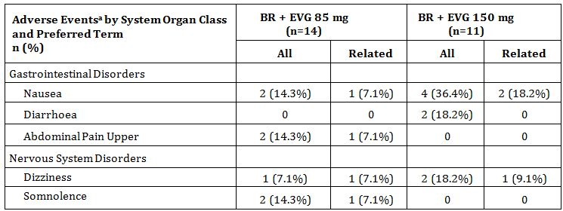

a. AEs were coded according to MedDRA version 13

BR = background regimen

#### Treatment-related adverse events (adverse drug reactions)

##### Pivotal studies

AEs considered related to study drug by the investigator were reported for similar percentages of subjects in the 2 groups (EVG 23.7%, 84 subjects; RAL 20.4%, 73 subjects) (Table 21). In both treatment groups, the most frequently reported AEs considered related to study drug by the investigator were diarrhoea (EVG 7.1%, 25 subjects; RAL 5.3%, 19 subjects), nausea (EVG 4.0%, 14 subjects; RAL 2.5%, 9 subjects), and headache (EVG 2.8%, 10 subjects; RAL 2.5%, 9 subjects).

Table 21: Study GS-US-183-0145: Treatment-Emergent Adverse Events Related to Study Drug Reported in > 1% of Subjects in Either Treatment Group (Safety Analysis Set, Week 96 Dataset).

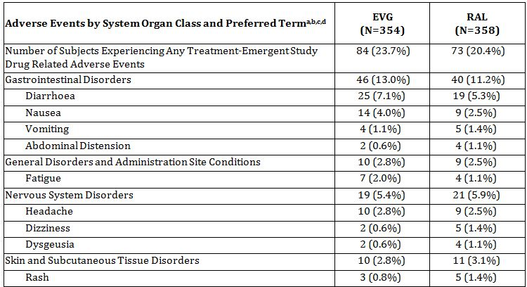

a. Denominator for percentages is the number of subjects in the safety analysis set within the treatment group.

b. Adverse events are mapped according to the MedDRA dictionary, Version 14.0.

c. System organ class is sorted alphabetically. Within each SOC, PTs are sorted in decreasing order of frequency.

d. Adverse events with onset after the last dose date plus 30 days are excluded from analysis.

##### Other studies

###### Study GS-US-183-0130

AEs considered related to study drug were experienced by 24 patients (12.5%). Treatment emergent study drug related AEs reported for more than 1 subject included pain in extremity, peripheral neuropathy, and alopecia; each reported by 2 subjects.

###### Study GS-US-183-0152

AEs considered related to study drug were reported by 1/14 subjects (7.1%) in the EVG 85-mg treatment group and in 4/11 subjects (36.4%) in the EVG 150-mg treatment group. In the EVG 85-mg group, one subject reported nausea, vomiting, upper abdominal pain, chills, pyrexia, dizziness, headache, and somnolence. In the EVG 150-mg group, study treatment related AEs included (nausea, n = 2; vomiting, n = 1; chills, n = 1; pyrexia, n = 1; dizziness, n = 1; and rash, n = 1).

#### Deaths and other serious adverse events

##### Pivotal study

###### Deaths

Twelve subjects died during the study, and death was treatment-emergent for 9 subjects (EVG 2, subjects 0.6%,; RAL 7 subjects, 2.0%); AEs that were the cause of death were considered related to study drug for 3 subjects in the RAL group (Coombs positive haemolytic anaemia, acute coronary syndrome, and cardiac arrest); deaths in EVG group (acute myocardial infarction and rectal haemorrhage) were not considered related to study drug. Review of the narratives provided for the deaths confirms the lack of relatedness.

###### SAEs

Similar percentages of subjects in the 2 groups reported SAEs (EVG 20.1%, 71 subjects; RAL 23.5%, 84 subjects) or SAEs considered related to study drug by the investigator (EVG 1.1%, 4 subjects; RAL 2.0%, 7 subjects).

The SAEs reported for more than 1% of subjects in either group were as follows: EVG - pneumonia (3.4%, 12 subjects) and cellulitis (1.4%, 5 subjects); RAL - pneumonia (2.0%, 7 subjects), and chest pain, cellulitis, bronchitis, and suicidal ideation (each reported for 1.1%, 4 subjects).

Convulsion was the only SAE considered related to study drug by the investigator that was reported for more than 1 subject in a treatment group (2 subjects in the RAL group); all other SAEs considered related to study drug by the investigator were reported for 1 subject each (Table 22).

Table 22: Study GS-US-183-0145: Treatment-Emergent Serious Adverse Events Reported in >1% of Subjects in Either Treatment Group (Safety Analysis Set, Week 96 Dataset).

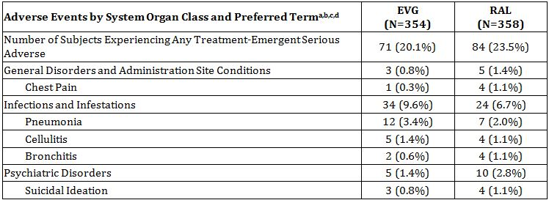

a. Denominator for percentages is the number of subjects in the safety analysis set within the treatment group.

b. Adverse events are mapped according to the MedDRA dictionary, Version 14.0.

c. System organ class is sorted alphabetically. Within each SOC, PTs are sorted in descending order of frequency.

d. Adverse events with onset after the last dose date plus 30 days are excluded from analysis.

##### Other studies

###### Study GS-US-183-0130

Deaths

Eleven subjects died during this study. None of the deaths were considered by the investigator to be related to study drug. Causes of death were: subdural hematoma; complications from *Pneumocystis carinii* pneumonia secondary to HIV infection resulting in respiratory failure; presumptive autoerotic self-asphyxiation; perforated ulcer; colorectal carcinoma; sepsis; occlusive coronary arterial sclerosis and dilated cardiomyopathy; advanced HIV disease; strangulation; progressive multifocal leukoencephalopathy, and Hodgkin’s lymphoma.

SAEs

In this population of HIV-1 infected, treatment-experienced subjects, 72 subjects (37.5%) experienced a treatment-emergent SAE.

Treatment-emergent SAEs reported for more than 1 subject are shown in Table 23.

Table 23: Study GS-US-183-0130: Treatment-Emergent Serious Adverse Events Reported for at Least 2 Subjects through the Week 192 Data Cutoff Date (Safety Analysis Set).

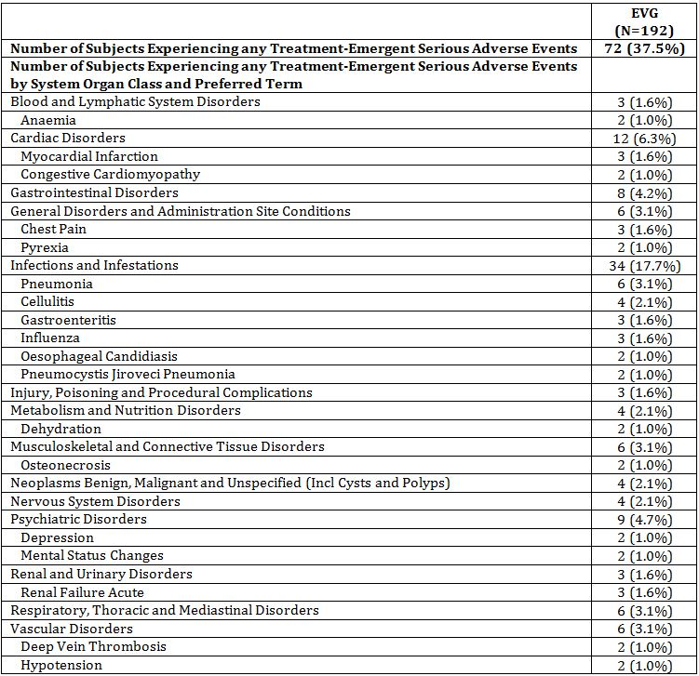

Data collected after last dose date + 30 days are excluded from analysis.

Denominator for percentages is the number of subjects in Safety analysis set.

Adverse events were mapped according to MedDRA 13.1.

Multiple adverse events were counted once only per subject for each system organ class and preferred term.

System organ class was presented alphabetically and preferred terms were presented by decreasing order based on the total frequencies.

Serious adverse events are those marked “yes” to the question “Event Serious?” on the adverse event CRF.

Only 2 subjects (1.0%) had a treatment-emergent SAE that was considered by the investigator to be related to study drug:

* A 38-year-old Hispanic male with HIV-1 infection, experienced acute pancreatitis while receiving EVG 150 mg on Day 496. Other antiretroviral medications at the time of the event included RTV, DRV, and FTC/TDF. Relevant laboratory test results were: lipase 516 U/L (reference range 23-300 U/L), AST 283 U/L (reference range 14-50 U/L), ALT 157 U/L (reference range 21-72 U/L), and triglycerides 274 mg/dL (reference range < 150 mg/dL). Abdominal ultrasound revealed no gallstones but only fatty liver. The event of acute pancreatitis was considered severe in severity, resulted in the temporary interruption of study drug and all antiretroviral medications, and resolved on Day 499. After restarting study drug and all antiretroviral medications, the patient did not have any recurrence of acute pancreatitis; lipase, a laboratory test specific to acute pancreatitis, continued to improve. The investigator considered the acute pancreatitis to be related to study drug, including EVG and FTC/TDF, as acute pancreatitis is a known complication of NRTIs.
* A 22-year-old African-American male with HIV-1 infection (diagnosed at birth), experienced necrotising retinitis (verbatim term: acute retinal necrosis) while receiving EVG 150 mg on Day 1220. The subject had a medical history of eye disorders (peripheral retinal degeneration, atrophic retinal holes, and vitreous floaters), diagnosed at a pre-baseline eye examination prior to receiving EVG in Study GS-US-183-0105. Throughout most of the GS-US-183-0130 study, the subject’s HIV-1 RNA was suppressed (<50 copies/mL) and CD4 cell count was >200 cells/mm3. Acute retinal necrosis (one of several types of necrotising retinitis) is a known ophthalmologic complication of HIV infection, which can occur with any CD4 cell count. This event was considered moderate in severity and resolved on Day 1226. The investigator considered the necrotising retinitis to be related to EVG, and not related to RTV or study procedures.

###### Study GS-US-183-0152

No deaths occurred.

One SAE occurred in a patient who discontinued EVG 150 mg after receiving 1 dose. The patient initially reported vomiting, chills, pyrexia and dizziness and was subsequently found to have Pneumocystis pneumonia. The SAE was not considered to be drug related.

#### Discontinuation due to adverse events

##### Pivotal study

Similar percentages of subjects in the 2 groups discontinued study drug due to an AE (EVG 3.1%, 11 subjects; RAL 4.2%, 15 subjects).

Adverse events that led to study drug discontinuation reported for more than 1 subject in either treatment group were hepatitis/acute hepatitis (RAL 3 subjects), nausea (EVG 2 subjects), and vomiting (EVG 2 subjects).

Adverse events leading to study drug discontinuation and considered related to study drug by the investigator were reported for 6 subjects in the EVG group and for 9 subjects in the RAL group. Vomiting (EVG 2 subjects) and hepatitis/acute hepatitis (RAL 2 subjects) were AEs considered related to study drug that were reported for more than 1 subject in a treatment group and that resulted in study drug discontinuation. All AEs in the Skin and Subcutaneous Tissue Disorders SOC that led to discontinuation of RAL (3 subjects) were considered related to study drug.

##### Other studies

###### Study GS-US-183-0130

A total of 10 subjects (5.2%) experienced a treatment-emergent AE that led to the premature discontinuation of study drug during the study. No treatment emergent AE leading to discontinuation of study drug was reported for more than 1 subject. None of the AEs leading to discontinuation of study drug were considered by the investigator to be related to study drug, and all but 1 (verbatim term: renal insufficiency) were considered SAEs

###### Study GS-US-183-0152

Two subjects discontinued EVG as the result of AEs, one from each treatment group:

* A 17-year-old White male in the EVG 150-mg treatment group had Grade 3 vomiting and chills and Grade 2 pyrexia and dizziness on Day 1 and discontinued study treatment and the study. Each of the AEs was deemed by the investigator to be study treatment related. The subject’s background regimen consisted of maraviroc, FTC + TDF, and DRV/r.
* A 16-year-old White female in the EVG 85-mg treatment group had Grade 3 nausea, vomiting, dizziness, and chills and Grade 2 abdominal pain upper, pyrexia, headache, and somnolence on Day 1 and discontinued study treatment and the study. Each of the AEs was deemed by the investigator to be study treatment related. The subject’s background regimen consisted of abacavir, TDF, and ATV/r.

### Laboratory tests

#### Liver function

##### Pivotal study

There were 13 subjects (EVG 6 subjects, RAL 7 subjects) who had ALT or AST values greater than 3 x ULN and total bilirubin values greater than 2 x ULN occurring at the same study visit. Two subjects (EVG 1; RAL 1) had changes in liver laboratory values potentially associated with drug-induced chemical hepatitis. The enzymatic elevations were transient in both cases, recovered after study drug discontinuation, and had no sequelae. No subject in the study met the definition of Hy’s law.

##### Other studies

There were no clinically significant changes in liver function during the studies.

#### Kidney function

##### Pivotal study

###### Serum creatinine

There was an increase in median values for serum creatinine in both treatment groups (EVG baseline median 0.88 mg/dL, RAL baseline median 0.89 mg/dL; the median change from baseline at Week 96 was 0.10 mg/dL in both groups).

Treatment-emergent serum creatinine abnormalities were reported for 32 subjects in the EVG group and for 36 subjects in the RAL group. Grade 3 or 4 serum creatinine abnormalities were reported for 2 subjects in each group (all were marked laboratory abnormalities).

Blood creatinine increased was reported as an AE for 2 subjects in the EVG group and for 3 subjects in the RAL group; the event was considered related to study drug for 1 subject in the EVG group

###### Estimated glomerular filtration rate

There was a decrease in median values for eGFRCG in both treatment groups (EVG baseline median 113.0 mL/min, median change from baseline at Week 96 of -10.8 mL/min; RAL baseline median 110.6 mL/min, median change from baseline at Week 96 of -11.7 mL/min).

Glomerular filtration rate decreased was reported as an AE for 1 subject in the RAL group. The subject also had blood creatinine increased reported as an AE; the events were considered related to study procedures but not related to study drug by the investigator, and required interruption of study drug; study drug was not restarted as it was permanently discontinued due to an AE of blood triglycerides increased.

###### Serum phosphorus

No clinically relevant changes were seen in median values for serum phosphorus. Treatment-emergent hypophosphataemia was reported for slightly more subjects in the EVG group than in the RAL group (EVG 41 subjects, RAL 31 subjects). The majority of the reported abnormalities were Grade 1 or Grade 2 in severity. Grade 3 hypophosphataemia was reported for 2 subjects in the EVG group.

Blood phosphorus decreased or hypophosphataemia was reported as an AE for 2 subjects in each group. None of the AEs was considered related to study drug by the investigator, and no action was taken with study drug in relation to these events.

###### Glycosuria

Treatment-emergent glycosuria was reported for similar numbers of subjects in the 2 groups (EVG 31 subjects; RAL 26 subjects). Grade 3 glycosuria was reported for 13 subjects (3.7%) in the EVG group and for 11 subjects (3.1%) in the RAL group. Glycosuria was reported as an AE for 2 subjects in the RAL group). The AEs were considered not related to study drug by the investigator, and no action was taken with study drug in relation to these events).

###### Proteinuria

Treatment-emergent proteinuria was reported for similar numbers of subjects in the 2 groups (EVG 170 subjects; RAL 176 subjects). Grade 3 proteinuria was reported for 1 subject in the EVG group.

Proteinuria or urine protein present was reported as an AE for 1 subject in the EVG group and for 4 subjects in the RAL group. The event was considered related to study drug by the investigator for 1 subject in the RAL group.

##### Other studies

No clinically significant findings were reported.

#### Other clinical chemistry

##### Pivotal study

There were no clinically relevant changes from baseline in median values for clinical chemistry parameters (except for renal and fasting lipid parameters, which are summarised separately) in either group. Median values were within normal ranges throughout the study.

##### Other studies

No clinically significant findings were reported.

#### Haematology

##### Pivotal study

There were no clinically relevant changes from baseline in median values for haematology parameters in either group. Median values were within normal ranges throughout the study.

##### Other studies

No clinically significant findings were reported.

#### Lipid parameters

##### Pivotal study

In both treatment groups, there were small increases from baseline in median values for fasting total cholesterol, direct LDL, HDL, and triglycerides through Week 96; however, median values remained in the reference range for each analyte.

Similar numbers of subjects in each treatment group had treatment-emergent abnormalities reported for fasting total cholesterol or fasting triglycerides. Adverse events of blood triglycerides increased or hypertriglyceridaemia were reported for similar percentages of subjects in the two groups. Two subjects in the RAL group discontinued study drug due to lipid AEs. The event of lipids increased in one subject was considered not related to study drug by the investigator. The event of blood triglycerides increased in the other subject was considered related to study drug by the investigator.

##### Other studies

No clinically significant findings were reported.

#### Electrocardiograph

##### Pivotal study

No clinically significant findings were reported.

##### Other studies

No clinically significant findings were reported.

#### Vital signs

##### Pivotal study

No clinically relevant changes from baseline in systolic or diastolic blood pressure, heart rate, respiratory rate, or body temperature were seen in the either treatment group.

##### Other studies

There were no clinically relevant changes from baseline in mean values for systolic blood pressure, diastolic blood pressure, temperature, heart rate, or respiration rate in Studies GS-US-183-0130 or GS-US-183-0152.

#### Weight

##### Pivotal study

Similar increases in body weight were seen in the two groups (median increases at Week 96: EVG 2.0 kg, RAL 1.8 kg).

##### Other studies

There were no clinically relevant changes from baseline in body weight for Study GS-US-183-0130 and the increases in body weight in Study GS-US-183-152 were as expected in this age group.

#### Overdose

##### Pivotal study

Overdose was reported to sponsor for 31 subjects (EVG 13 subjects, RAL 18 subjects). The majority of the overdoses reported were accidental instances of overdose with study drug or sponsor-supplied medication, and were not associated with any unusual signs or symptoms.

Many of the overdose reports in the RAL group were of twice-daily dosing of the EVG placebo tablet, rather than once-daily dosing per protocol. Most of the overdose reports ranged from taking an extra dose of blinded study drug for 1 day to up to 2 weeks.

Overdose was reported as an AE for 4 subjects (2 per treatment group). In addition, toxicity to various agents was reported for 1 subject in the EVG group who took a heroin overdose. Overdoses which were reported as SAEs: EVG 2 – one with oxycodone and one with heroin; RAL 2 – one with an unknown illicit drug and one with clonazepam and Celexa.

Overdose with study drug and TDF was reported as an AE for one subject in the EVG group. The subject took 255 mg EVG instead of 85 mg EVG on 1 day or took 170 mg additional drug instead of 85 mg for 2 days. The subject took 600 mg TDF instead of 300 mg TDF on 1 day.

##### Other studies

No overdoses were reported during the Studies GS-US-183-0130 or GS-US-183-0152

#### Pregnancy

##### Pivotal study

Seven pregnancies were reported during the study. Four of the subjects were randomised into the EVG group and 3 were randomised into the RAL group.

Two subjects, one from each treatment group, were determined to be pregnant before study drug administration was initiated; 1 of these subjects had a spontaneous abortion and the other had an induced abortion. Of the 5 subjects exposed to study drug during their pregnancy, 2 subjects in the EVG group delivered healthy babies with no complications. One subject in the RAL group had a spontaneous abortion, which the investigator assessed as serious and not related to study drug. For 1 subject in each group, the pregnancy was ongoing at the time of the report.

##### Study GS-US-183-0130

One pregnancy occurred during this study, which resulted in premature discontinuation from the study. The subject had a spontaneous abortion, which was reported as an SAE and was considered by the investigator to be not related to study drug, concomitant antiretroviral medications, or study procedures.

##### Study GS-US-183-0152

No pregnancy was reported during the study.

### Post-marketing experience

There is no post-marketing experience as the product is not yet approved in any market.

### Safety issues with the potential for major regulatory impact

#### Liver toxicity

The PK of boosted EVG in non-HIV-1 infected subjects were evaluated in subjects with moderate hepatic impairment (CPT Classification B), with an additional cohort of matched subjects (age, gender, and BMI) with normal hepatic function) in Study GS-US-183-0133.[38]

The steady-state plasma exposure parameters of EVG were modestly higher (AUCtau, Ctau, and Cmax were 34.99%, 79.63%, and 41.28% higher, respectively) in subjects with moderate hepatic impairment relative to matched control subjects with normal hepatic function. The observed increases, however, were well below the protocol-defined clinically significant increase of 100% in EVG AUCtau or Cmax for subjects with moderate hepatic impairment compared with normal matched control subjects, and were not considered to be clinically relevant.

Exploratory analyses indicated no clinically relevant correlations between EVG exposures versus CPT scores or individual liver function laboratory parameters (i.e. albumin, total bilirubin, prothrombin time, and international normalised ratio [INR]) for subjects with moderate hepatic impairment. The mean (SD) percentage free fraction (unbound concentration) for EVG in the normal matched control subjects and moderate hepatic impairment subjects was 1.15 (0.14) and 1.22 (0.23), respectively, indicating lack of effect of hepatic impairment on EVG protein binding.

No dose adjustment of EVG is required in patients with mild (CPT Class A) or moderate (CPT Class B) hepatic impairment. Elvitegravir has not been studied in patients with severe hepatic impairment (CPT Class C).

#### Renal toxicity

Baseline eGFR did not have an effect on EVG exposures in HIV-1 infected subjects and was not a clinically relevant covariate based on population PK analyses. This was expected in view of the minimal renal excretion of EVG (~6 to 7%).

Small increases in median values for serum creatinine (0.10 mg/dL at Week 96) and small decreases in median values for eGFR were observed in both treatment groups in Study GS-US-183-0145. Similar increases in serum creatinine were observed in Study GS-US-183-0105n but were not observed in Study GS-US-183-0130. The findings in Studies GS-US-183-0145 and GS-US-183-0105 are likely due to the underlying characteristic of the study population (i.e. ARV treatment experienced subjects), concurrent use of ritonavir (which inhibits secretion of creatinine) by all subjects and concurrent use of TDF by the majority of subjects.

Since clinically meaningful differences in PK of EVG or cobicistat were not observed in subjects at the extremes of renal function (eGFRCG < 30 mL/min and eGFRCG ≥ 90 mL/min) in Study GS-US-216-0124,[39] dose adjustment of EVG is not considered warranted in subjects with renal impairment. In addition, EVG/co was well tolerated in the study. All AEs were Grade 1 in severity and none of the subjects in either renal function group prematurely discontinued study drug treatment because of an AE.

### Other safety issues

#### Safety in special populations

##### Safety in elderly patients

Pharmacokinetic studies have not been performed with EVG in the elderly (i.e. those aged >65 years). Insufficient numbers of elderly subjects have been evaluated in clinical studies to determine whether they respond differently than younger subjects.

In the pivotal study (GS-US-183-0145) the age range was 19 to 78 years. Similar percentages of subjects in the EVG and RAL groups had AEs reported when assessed in subgroups according to age subgroups ≤45 years and >45 years. Upper respiratory tract infection was reported for a higher percentage of subjects in the EVG group ≤45 years (23.3%, 48/206) compared to >45 years (12.8%, 19/148). No further details are provided on the AEs reported in relation to age.

##### Safety in children

The proposed PI for elvitegravir is seeking approval for use in adults and not children less than 18 years old. As the study in adolescents (GS-US-183-0152) only had 11 patients who completed the study, this is appropriate. The study did show that in this small patient sample EVG was well tolerated and provided comparable plasma exposures as in HIV-1 infected adults when added to a PI/r background regimen.

#### Safety in patients with HIV-1 and HBV and/or HCV co-infection

Elvitegravir is not proposed for the treatment of chronic HBV or HCV infection; EVG does not have activity against HBV or HCV.

Hepatitis B virus or HCV co-infection status did not have an effect on EVG exposures in HIV-1 infected subjects and was not a clinically relevant covariate based on population PK analyses.

In Study GS-US-183-0145, a number of HIV-1 infected subjects were co-infected with HBV (4.2%, 30 subjects) or HCV (14.0%, 99 subjects). The hepatic adverse reaction profile in subjects co-infected with HIV-1 and HBV or HIV-1 and HCV who received EVG was consistent with underlying hepatitis infection. As expected in this subject population, elevations in AST and ALT occurred more frequently than in the general HIV-1 infected population. Grade 3 or 4 elevations in ALT and/or AST were observed in 8.5% of subjects (n = 5) co-infected with HBV or HCV and 2.4% of subjects (n = 7) without co-infection in subjects who received EVG. For Grade 3 or 4 elevations in bilirubin, these values were 13.6%, 8 subjects co-infected and 4.5%, 13 subjects without co-infection in the EVG group.

### Evaluator’s overall conclusions on clinical safety

Overall, the safety database for EVG is not large as the efficacy is based primarily on one pivotal study that enrolled only 354 patients into the EVG group. However, the safety of EVG is also supported by the studies of EVG in the combination product Stribild in which no safety major safety concerns were identified.

Overall, there were no significant safety concerns identified for EVG. EVG was well tolerated, as demonstrated by the low overall rate of study drug discontinuation due to AEs, and the mild or moderate severity of most AEs. The most frequently reported AEs for subjects administered the EVG containing regimen were diarrhoea, upper respiratory tract infection, and headache.

Subgroup analyses of AEs by sex, age, race, HIV-1 stratum at baseline, and CD4 cell count at baseline showed no differences between subgroups.

EVG may be used without dose adjustment in patients with renal impairment or mild or moderate hepatic impairment. EVG has not been studied in patients with severe hepatic impairment.

In the proposed PI, the section on drug interactions instructs prescribers to refer to the RTV and co-administered protease inhibitor PI for the list of contraindicated drugs. It should be considered to also include the list in the EVG PI for assistance to prescribing doctors. The list should include, but are not limited to, efavirenz, nevirapine, carbamazepine, oxcarbazepine, phenobarbital, phenytoin, modafinil, rifampin, rifapentine, dexamethasone, bosentan, and St. John’s wort. Co-administration with these agents is not recommended.

## First round benefit-risk assessment

### First round assessment of benefits

The benefits of Vitekta in the proposed usage are:

* EVG was shown to be non inferior to RAL twice daily when co-administered with a PI/r and one or more other antiretroviral agents for 48 weeks;
* Efficacy of the above regimen was durable through 96 weeks;
* Efficacy is also supported by the efficacy seen when EVG is boosted by COBI in the combination product Stribild;
* No major safety issues have been identified.

### First round assessment of risks

The risks of Vitekta in the proposed usage are:

* AEs identified during the clinical development program;
* In the pivotal study, diarrhoea was more frequently reported in the EVG group;
* While no dose adjustment is required for patients with renal impairment or mild to moderate hepatic impairment, EVG has not been studies in patients with severe hepatic impairment;
* EVG is primarily metabolised by CYP3A. Drugs that induce CYP3A activity are expected to decrease the plasma concentrations of EVG, which may lead to loss of therapeutic effect of EVG and possible development of resistance;
* For RTV boosted protease inhibitor containing regimens that are co-administered with EVG, RTV may increase the plasma concentrations of concomitant drugs that are primarily metabolized by CYP3A, as RTV is a strong CYP3A inhibitor. Higher plasma concentrations of concomitant drugs can result in increased or prolonged therapeutic or adverse effects, potentially leading to severe, life threatening events.

### First round assessment of benefit-risk balance

The benefit-risk balance of Vitekta, given the proposed usage, is favourable.

While the efficacy data is primarily based on a single pivotal trial, it does meet the regulatory requirements and demonstrates non inferiority to the currently approved comparator product. The efficacy is durable over two years. No significant safety issues have been identified.

## First round recommendation regarding authorisation

Based on the clinical data submitted, it is recommended that application be approved.

## Clinical questions

The sponsor should be asked to address the following question:

Q. The proposed PI section for the pharmacokinetics contains summary data but the source texts given in the annotations are not correct for all details and some of the annotations could not be located in the submission. It is noted that the information is consistent with the US Package Insert and the EU SmPC. The following sections should be noted:

* Absorption: the Tmax should be changed to 3-4 hours
* Absorption: The Cmax, AUCtau, and Ctrough – while the range is correct the exact numbers could not be verified
* Distribution: the mean plasma to blood drug concentration could not be verified
* Effect of food: the last sentence should be corrected to “...22% to 34% with a light meal, while increasing to 56% to 91% with a high fat meal, respectively”.

Please provide an updated annotated PI addressing the issues itemised above and providing accurate cross reference to the electronic submission provided in the dossier.

## Second round evaluation of clinical data submitted in response to questions

The sponsor addressed each of the issues raised as follows:

* Absorption: the Tmax should be changed to 3-4 hours
  + Response: this was accepted by the sponsor.
* Absorption: The Cmax, AUCtau, and Ctrough – while the range is correct, the exact numbers could not be verified
  + Response: the sponsor recognised it had inadvertently cross referenced an incorrect section for the pharmacokinetic/pharmacodynamic analysis to the application to register Stribild and did not provide the correct EVG pharmacokinetic/pharmacodynamic analysis in this section. Sections of the relevant report were provided to the TGA such that the source and actual values cited in the PI were confirmed.
* Distribution: the mean plasma to blood drug concentration could not be verified
  + Response: the derivation (source data and calculations) of the ratio was explained satisfactorily.
* Effect of food: the last sentence should be corrected to “...22% to 34% with a light meal, while increasing to 56% to 91% with a high fat meal, respectively”.
  + Response: The sponsor accepted the change from 22% to 34%, however as this value is based on AUCinf, it also suggested altering the high fat meal to 87% instead of 91% as the 87% value is also based on AUCinf. This is acceptable.

## Second round benefit-risk assessment

### Second round assessment of benefits

No new clinical information was submitted in response to questions. Accordingly, the risks of Vitekta are unchanged from those identified in the first round assessment.

### Second round assessment of risks

No new clinical information was submitted in response to questions. Accordingly, the risks of Vitekta are unchanged from those identified in the first round assessment.

### Second round assessment of benefit-risk balance

The benefit-risk balance of Vitekta is unchanged from that identified in the first round assessment.

## Second round recommendation regarding authorisation

The recommendation is unchanged from that given in the first round.

## References

Guideline on the Clinical Development of Medicinal Products for the Treatment of HIV Infection EMEA/CPMP/EWP/633/02 Revision 2, which came into effect in June 2009 and was adopted by TGA in July 2009.

Points to consider on Application with 1. Meta-analysis; 2. One pivotal study. CPMP/EWP/2330/99 which was adopted by CPMP in May 2001 and adopted by TGA in March 2002.

Steigbigel RT, et al. Raltegravir with Optimized Background Therapy for Resistant HIV-1 Infection. *N Engl J Med* 2008; 359:339-53.

1. <http://www.ema.europa.eu/docs/en_GB/document_library/PIP_decision/WC500123254.pdf>
2. Evaluated in Stribild submission.
3. Evaluated in Stribild submission.
4. Evaluated in Stribild submission.
5. Evaluated in Stribild submission.
6. Evaluated in Stribild submission.
7. Evaluated in Stribild submission.
8. Evaluated in Stribild submission.
9. Evaluated in Stribild submission.
10. Evaluated in Stribild submission.
11. Evaluated in Stribild submission.
12. Evaluated in Stribild submission.
13. Evaluated in Stribild submission.
14. Evaluated in Stribild submission.
15. Evaluated in Stribild submission.
16. Evaluated in Stribild submission.
17. Evaluated in Stribild submission.
18. Evaluated in Stribild submission.
19. Evaluated in Stribild submission.
20. Evaluated in Stribild submission.
21. Evaluated in Stribild submission.
22. Evaluated in Stribild submission.
23. Evaluated in Stribild submission.
24. Evaluated in Stribild submission.
25. Evaluated in Stribild submission.
26. Evaluated in Stribild submission.
27. Evaluated in Stribild submission.
28. Evaluated in Stribild submission.
29. Evaluated in Stribild submission.
30. Evaluated in Stribild submission.
31. Evaluated in Stribild submission.
32. Evaluated in Stribild submission.
33. Evaluated in Stribild submission.
34. Evaluated in Stribild submission.
35. Evaluated in Stribild submission.
36. Steigbigel RT, et al. (2008) Raltegravir with optimized background therapy for resistant HIV-1 infection. *N Engl J Med.* 359: 339-354.
37. European Medicines Agency, “Committee for Proprietary Medicinal Products (CPMP): Points to Consider on Application with 1. Meta-Analyses; 2. One Pivotal Study (CPMP/EWP/2330/99)”, 31 May 2001, Web, accessed 14 November 2013 <www.ema.europa.eu/docs/en_GB/document_library/Scientific_guideline/ 2009/09/WC500003657.pdf>.
38. Evaluated in Stribild submission.
39. Evaluated in Stribild submission.