|  |
| --- |
| **December 2013** |

|  |
| --- |
| Australian Public Assessment Report for elvitegravir |
| Proprietary Product Name: Vitekta |
| Sponsor: Gilead Sciences Pty Ltd |

About the Therapeutic Goods Administration (TGA)

* The Therapeutic Goods Administration (TGA) is part of the Australian Government Department of Health, and is responsible for regulating medicines and medical devices.
* The TGA administers the *Therapeutic Goods Act 1989* (the Act), applying a risk management approach designed to ensure therapeutic goods supplied in Australia meet acceptable standards of quality, safety and efficacy (performance), when necessary.
* The work of the TGA is based on applying scientific and clinical expertise to decision-making, to ensure that the benefits to consumers outweigh any risks associated with the use of medicines and medical devices.
* The TGA relies on the public, healthcare professionals and industry to report problems with medicines or medical devices. TGA investigates reports received by it to determine any necessary regulatory action.
* To report a problem with a medicine or medical device, please see the information on the TGA website <<http://www.tga.gov.au>>.

About AusPARs

* An Australian Public Assessment Record (AusPAR) provides information about the evaluation of a prescription medicine and the considerations that led the TGA to approve or not approve a prescription medicine submission.
* AusPARs are prepared and published by the TGA.
* An AusPAR is prepared for submissions that relate to new chemical entities, generic medicines, major variations, and extensions of indications.
* An AusPAR is a static document, in that it will provide information that relates to a submission at a particular point in time.
* A new AusPAR will be developed to reflect changes to indications and/or major variations to a prescription medicine subject to evaluation by the TGA.

Copyright

© Commonwealth of Australia 2013  
This work is copyright. You may reproduce the whole or part of this work in unaltered form for your own personal use or, if you are part of an organisation, for internal use within your organisation, but only if you or your organisation do not use the reproduction for any commercial purpose and retain this copyright notice and all disclaimer notices as part of that reproduction. Apart from rights to use as permitted by the *Copyright Act 1968* or allowed by this copyright notice, all other rights are reserved and you are not allowed to reproduce the whole or any part of this work in any way (electronic or otherwise) without first being given specific written permission from the Commonwealth to do so. Requests and inquiries concerning reproduction and rights are to be sent to the TGA Copyright Officer, Therapeutic Goods Administration, PO Box 100, Woden ACT 2606 or emailed to <[tga.copyright@tga.gov.au](mailto:tga.copyright@tga.gov.au)>.

Contents

I. Introduction to product submission 4

Submission details 4

Product background 5

Regulatory status 5

Product Information 5

II. Quality findings 5

Drug substance (active ingredient) 5

Drug product 6

Biopharmaceutics 6

Quality summary and conclusions 7

III. Nonclinical findings 7

Introduction 7

Pharmacology 8

Pharmacokinetics 8

Toxicology 9

Nonclinical summary and conclusions 10

IV. Clinical findings 10

Introduction 10

Pharmacokinetics 10

Pharmacodynamics 12

Efficacy 13

Safety 15

First round benefit-risk assessment 16

First round recommendation regarding authorisation 17

Clinical questions 17

Second round evaluation in response to questions 18

Second round benefit-risk assessment 18

Second round recommendation regarding authorisation 18

V. Pharmacovigilance findings 19

Risk management plan 19

VI. Overall conclusion and risk/benefit assessment 23

Quality 23

Nonclinical 24

Clinical 24

Risk management plan 30

Discussion 30

Outcome 35

Attachment 1. Product Information 36

Attachment 2. Extract from the Clinical Evaluation Report 36

## I. Introduction to product submission

### Submission details

|  |  |  |
| --- | --- | --- |
| *Type of submission:* | New Chemical Entity | |
| *Decision*: | Approved | |
| *Date of decision:* | 15 October 2013 | |
| *Active ingredient:* | Elvitegravir |
| *Product name:* | Vitekta |
| *Sponsor’s name and address:* | Gilead Sciences Pty Ltd  Level 6, 417 St Kilda Road  Melbourne VIC 3004 |
| *Dose form:* | Immediate release film coated tablets |
| *Strengths:* | 85 mg and 150 mg |
| *Container:* | High density polyethylene (HDPE) bottles |
| *Pack size:* | 30 tablets |
| *Approved therapeutic use:* | Vitekta is indicated for the treatment of HIV-1 infection in antiretroviral treatment-experienced adults and adolescents when co-administered with a ritonavir-boosted protease inhibitor and other antiretroviral therapy. |
| *Route of administration:* | Oral |
| *Dosage:* | 150 mg once daily taken orally with food. If Vitekta is used in combination with atazanavir/ritonavir or lopinavir/ritonavir, the dose of Vitekta should be decreased to 85 mg once daily taken orally with food. |
| *ARTG numbers:* | 200435 (85 mg)  201510 (150 mg) |

### Product background

This AusPAR describes a submission by the sponsor, Gilead Sciences Pty Ltd, to register a new chemical entity, elvitegravir (trade name: Vitekta), for the following indication:

*Vitekta, co-administered with a ritonavir-boosted protease inhibitor and with other antiretroviral agents, is indicated for the treatment of HIV-1 infection in antiretroviral treatment experienced adults.*

Elvitegravir (EVG) is a new chemical entity that belongs to the class of HIV-1 integrase strand transfer inhibitors (INSTIs). INSTIs prevent the integration of HIV-1 DNA into host genomic DNA, blocking the formation of the HIV-1 provirus and propagation of the viral infection. EVG has shown activity against laboratory viral strains and clinical isolates of HIV-1 and against virus with resistance to nucleoside/nucleotide reverse transcriptase inhibitors (NRTI/NtRTI), non nucleoside reverse transcriptase inhibitors, and protease inhibitors.

The first drug in the new class of HIV-1 INSTIs is raltegravir (RAL), which was approved in Australia in February 2013. RAL requires twice daily dosing to achieve its therapeutic effect. Therefore, new additions to the INSTI class are much needed, particularly those that offer convenient, once daily dosing while maintaining optimal safety and efficacy.

EVG is also a component of the fixed dose combination tablet Stribild (also previously referred to as QUAD [elvitegravir/cobicistat/emtricitabine/tenofovir disoproxil fumarate, coformulated]). Stribild contains tenofovir disoproxil fumarate (TDF) 300mg + emtricitabine (FTC) 200mg + EVG 150mg + cobicistat (COBI) 150 mg and was approved for the treatment of HIV infection in adults who have no known resistance mutations to the individual drugs by the TGA in February 2013.

### Regulatory status

At the time of lodgement of the submission in Australia, marketing applications with essentially the same datasets had been made by the sponsor in the EU (22 May 2012) and US (28 June 2012). An application was planned for Canada in September 2012.[1]

### Product Information

The approved Product Information (PI) current at the time this AusPAR was prepared can be found as Attachment 1.

## II. Quality findings

### Drug substance (active ingredient)

The sponsor has submitted an application to register Vitekta tablets, containing 85 mg and 150 mg EVG. EVG is also a component of the fixed dose combination tablet Stribild, comprising 300 mg of TDF, 200 mg of FTC, 150 mg of EVG and 150 mg of COBI. Stribild tablets were registered in Australia on 7 February 2013.

The EVG drug substance used in Vitekta tablets is identical to that used in Stribild tablets. The structure of EVG is shown in Figure 1.

Figure 1: Chemical structure of elvitegravir (EVG).

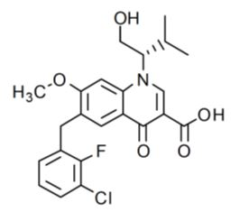

### Drug product

The immediate release, film coated tablets are proposed in two strengths, 85 mg and 150 mg, which have directly scaled formulations. EVG 85 mg tablets are green, pentagon shaped, film coated and debossed with “GSI” on one side and “85” on the other side. EVG 150 mg tablets are green, triangle shaped, film coated and debossed with “GSI” on one side and “150” on the other side. The tablets are packaged in 60 mL, white, high density polyethylene (HDPE) bottles. Each bottle contains 30 tablets and is capped with a white, child resistant, polypropylene screw cap.

The proposed shelf life of 4 years below 25°C is supported by the stability data submitted.

### Biopharmaceutics

Four biopharmaceutic studies were referenced. Two of those studies (GS-US-183-0121 and GS‑US-183-0140) showed that the formulation proposed for registration has suboptimal oral bioavailability. The greatest oral bioavailability was obtained when EVG was incorporated into a tablet as an amorphous solid dispersion on povidone. In the fasted state, in dogs this tablet had a 2.6 fold higher area under the plasma concentration-time curve (AUC) than a conventional tablet, although its AUC was only 30% higher (1.3 fold) when the tablets were taken after food. For ease of manufacture, it was decided to pursue the conventional tablet formulation, but when it was reformulated for large scale production its bioavailability appeared to decrease further, by about 8%. Hence, the dose strength of this tablet was increased from 125 mg to 150 mg, giving a tablet that, at 150 mg, was bioequivalent to the originally developed 125 mg conventional tablet. The 150 mg tablet proposed for registration has been used in all Phase III clinical studies without any further modification.

Two food effect studies were referenced. Study GS-US-236-0105 assessed the effects of a high fat meal and a light meal on the bioavailability of Stribild tablets. Study XAX1-1 assessed the effects of a light meal on the bioavailability of an early Japanese conventional tablet, administered without ritonavir (RTV) boosting. The results with respect to EVG bioavailability are summarised in Table 1.

Table 1: Effects of food on the bioavailability of Stribild and Japanese conventional tablet.

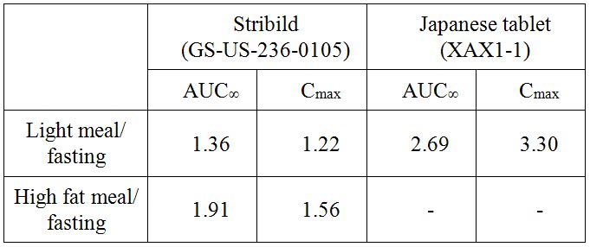

It is apparent that the effect of food on EVG bioavailability differs markedly depending on the tablet formulation, type of meal, and whether RTV is taken concomitantly. However, a food study was not performed on the EVG single agent tablet proposed for registration. The rationale provided by the sponsor is that the tablet was always administered with food in the clinical safety and efficacy studies. The type of food was not controlled in those studies.

The sponsor did not provide a justification for not submitting a bioequivalence study of the 85 mg tablets versus the 150 mg tablet. This is accepted given that the cores of the two strengths are direct scales and the tablets show similar dissolution rates.

The following justification was provided for not conducting an absolute bioavailability study on EVG tablets. This justification was referred to the clinical evaluator:

*The absorption, distribution, metabolism, and elimination (ADME) properties, and the clinical pharmacology of EVG have been extensively characterised using in vitro/nonclinical studies and clinically, through pharmacokinetic and drug interaction studies. EVG is expected to have very high/near complete bioavailability when administered as the TDF/FTC/EVG/COBI tablet. An early pharmacokinetic boosting study (GS-US-183-0102) demonstrated a 20 fold increase in EVG AUCtau (the AUC [area under the plasma concentration time curve] over the dosing interval) (from ~719 ng.h/ml to ~14,300 ng.h/ml) following multiple co-administration with RTV 100 mg versus EVG dosing alone. This increase was mediated by a ~6-7 fold increase in bioavailability and a 3 fold reduction in EVG systemic clearance (based on EVG elimination half life increase from ~3.5 to ~9.5 hours). The resulting estimate of EVG apparent clearance (CL/F) IS ~5-6 L/hour, which is ~5% of the hepatic blood flow, indicating F is very high and approaches complete absorption. Study GS-US-183-0102 is being submitted as part of this Category 1 Application.*

### Quality summary and conclusions

A number of issues were raised following the initial evaluation of this application, but all issues have since been satisfactorily resolved. There are now no objections to registration of this product in respect of Chemistry, Manufacturing and Controls.

## III. Nonclinical findings

### Introduction

The sponsor has applied to register the HIV integrase strand transfer inhibitor EVG (Vitekta) 85 and 150 mg tablets. Similar applications have been made in the EU (26 May 2012), US (28 June 2012), and Canada (14 September 2012). The proposed indication for EVG is co-administration with a RTV boosted protease inhibitor and other antiretroviral drugs, for treatment of HIV-1 infection in antiretroviral treatment experienced adults 18 years and older. The proposed regimen is 150 mg once daily with food. EVG is metabolised via CYP3A, and co-administration with a CYP3A inhibitor such as RTV enables once daily dosing. If EVG is used in combination with atazanavir/RTV or lopinavir/RTV, the dose should be decreased to 85 mg once daily with food. RAL, another integrase inhibitor, requires twice daily dosing.

An application to register the fixed dose combination of EVG/COBI/FTC/TDF (Stribild) 150/150/200/300 mg for HIV treatment in adults with no known resistance mutations to the individual drugs was approved on 7 February 2013 (Advisory Committee on Prescription Medicines [ACPM] 287th meeting resolution no. 2705, December 2012). The EVG dose in the combination is the same as the proposed individual tablet. The four drug combination was approved in the US in August 2012, and an application to approve Stribild was also made in the EU.[2] The Stribild application contained an adequate nonclinical dossier for EVG. A 13 week rat toxicity study with the COBI/RTV combination was previously evaluated in the Stribild application.

### Pharmacology

#### Tablet excipients

EVG tablets have the same excipients as the Stribild tablet. The film coating is indigo carmine (FD&C blue #2), aluminium lake, macrogol 3350, polyvinyl alcohol, talc (E553B), titanium dioxide (E171), and yellow iron oxide (E172).

#### Primary pharmacology

Previous *in vitro* studies demonstrated the anti HIV-1 activity of EVG, with IC50 (half maximal inhibitory concentration) values of ~0.1-1.3 nM. The IC50 values were well below the respective human plasma EVG Cmax (maximum plasma drug concentration) and Cmin (minimum plasma drug concentration) values of ~3.9 and 1 µM. Development of resistance mutations was observed *in vitro*, and there was some cross resistance to RAL selected mutations.

#### Safety and secondary pharmacology

Previous secondary and safety pharmacology studies were adequate. A small but significant inhibition of hERG currents was observed in stably transfected HEK293 cells at the highest test concentration of 10 µM, but was considered unlikely to be of clinical significance.

### Pharmacokinetics

Previous toxicokinetic studies showed that co-administration of EVG and RTV generally resulted in moderate increases in EVG exposures in animals.

EVG and RTV are metabolised by CYP3A and RTV is a CYP3A inhibitor. The proposed PI states that RTV may increase plasma concentrations of drugs metabolised by CYP3A, and drugs that inhibit or induce CYP3A may affect the clearance of EVG.

A previous *in vitro* study reported high plasma binding for EVG (99.3%) in human plasma. EVG protein binding in mouse, rat and dog plasma was likewise high.

A new assay validation report for quantitative determination of GS-9137 (EVG) and GS-9350 (COBI) in rat plasma by liquid chromatography tandem mass spectrometry (LC/MS/MS) was submitted.

#### Relative systemic exposures

Exposure ratios (animal:human) relevant to the proposed EVG PI are shown in Table 2. The steady state plasma AUC0-τ of EVG 150 mg in combination with RTV 100 mg was 18.29 µg.h/mL in HIV-1-infected subjects (Study GS-US-183-0140). EVG exposure ratios in the Stribild application were based on a slightly higher human AUC0-τ of 23 µg.h/mL.

Table 2: Exposure ratios (animal:human) relevant to the proposed EVG PI.

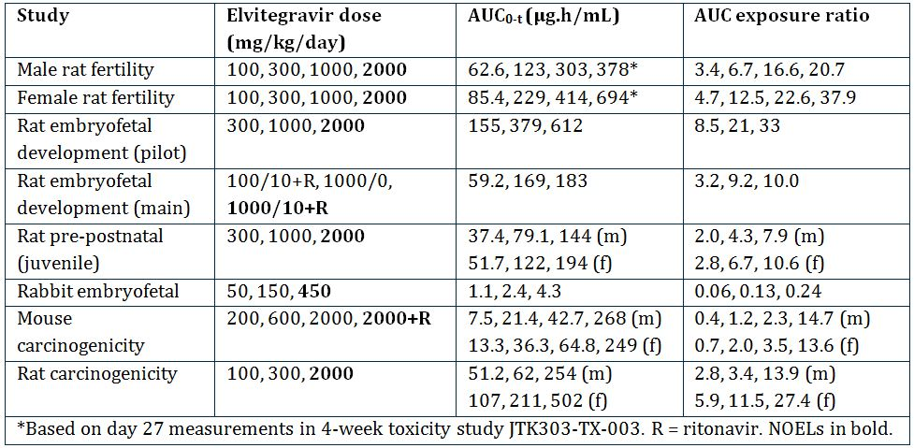

### Toxicology

Previous adequate EVG toxicity studies in mice and dogs showed little toxicity, with findings of lipid droplets in the lamina propria of the duodenum/jejunum of rats and dogs, and increased caecal weights in rats, possibly due to anti bacterial activity (see ‘Genotoxicity’ below).

A previous 13 week rat toxicity study (TX-183-2007) with EVG or RTV alone, and EVG/RTV (High Dose = 1000/10 mg/kg/day), showed no additive or new toxicities with the combination.

#### Genotoxicity

Both new genotoxicity studies for three impurities were negative. The three impurities were adequately qualified in previous toxicity studies. Previous adequate EVG genotoxicity studies showed an equivocal positive response in an *in vitro* test for clastogenicity in Chinese hamster lung cells, and negative results in *in vitro* bacterial reverse mutation and *in vivo* rat micronucleus tests.

#### Carcinogenicity

EVG was negative in previous adequate carcinogenicity studies in mice and rats. The mouse study included groups treated with RTV alone and the combination EVG/RTV 2000/25 mg/kg/day.

#### Reproductive toxicity

EVG had no effects on rat fertility and early embryonic development or on embryofoetal and peri postnatal development in previous adequate studies. A rat embryofoetal development study (TX-183-2008) incorporated a group treated with EVG/RTV 1000/10 mg/kg/day.

EVG exposure in the rabbit embryofoetal development study was considered inadequate (0.2x human exposure at the High Dose). The sponsor has proposed an Australian pregnancy category of B1; however B2 is recommended on the basis of inadequate drug exposure in rabbits. There was no clear evidence of maternal or reproductive toxicity in a previous adequate rat pre postnatal study.

#### Immunotoxicity

Previous adequate studies showed no potential of EVG for sensitisation or immunotoxicity.

### Nonclinical summary and conclusions

There are no nonclinical objections to the registration of EVG (Vitekta) 85 and 150 mg oral tablets, for co administration with a RTV boosted protease inhibitor and other antiretroviral drugs, for treatment of HIV-1 infection in antiretroviral treatment experienced adults. A nonclinical toxicity study was conducted with the EVG/RTV combination, but combination studies were not conducted with additional retroviral drugs. Hence, safety assessment will rely on clinical data.

## IV. Clinical findings

*A summary of the clinical findings is presented in this section. Further details of these clinical findings can be found in Attachment 2.*

### Introduction

The clinical dossier documented a full clinical development program of pharmacology, efficacy and safety studies.

The submission contained the following clinical information:

* 16 clinical pharmacokinetic studies
* 1 population pharmacokinetic analyses
* 1 pivotal efficacy/safety study: Study GS-US-183-0145
* 1 other efficacy/safety study: Study GS-US-183-0130

*Comment: The summaries are dated between June and July 2012 and, by agreement with TGA, are the summaries submitted in the US. They include many more studies (37) than have been submitted in Australia; for example, summaries of studies of both EVG single tablet and as component of the Stribild combination tablet. Many studies referenced in the summaries as being of EVG single tablets have not been included in this submission, but were submitted in the Stribild submission. All studies have been evaluated. Reference is made to the Stribild submission evaluator’s report where relevant.*

### Pharmacokinetics

#### Studies providing pharmacokinetic data

Table 3 shows the studies relating to each pharmacokinetic topic and the location of each study summary.

Table 3: Submitted pharmacokinetic studies.

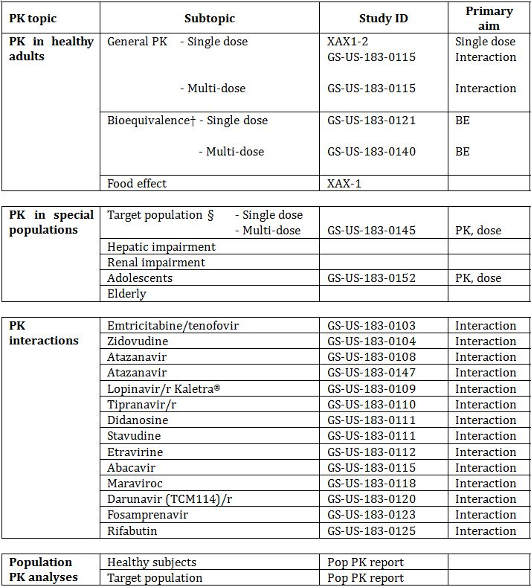

† Bioequivalence of different formulations.

§ Subjects who would be eligible to receive the drug if approved for the proposed indication.

Table 4 lists pharmacokinetic results that were excluded from consideration due to study deficiencies.

Table 4: Pharmacokinetic results excluded from consideration.

Table 4: Pharmacokinetic results excluded from consideration.

#### Evaluator’s overall conclusions on pharmacokinetics

Extensive pharmacokinetic studies have been conducted. Most of the studies were submitted in the Stribild submission with mainly interaction studies submitted in this submission. The pharmacokinetic profile has been well established in both normal and certain special subjects and HIV-1 infected patients. No clinically relevant differences in the pharmacokinetics or EVG were observed with respect to demographic variables.

Results of drug interaction studies between RTV boosted atazanavir (ATV/r) (300/100mg QD) and lopinavir/RTV, coformulated (LPV/r) (400/100 mg BID [twice daily]) and once daily EVG showed increases in EVG exposure beyond intended plasma levels. Therefore, co-administration with ATV/r or LPV/r requires a reduction of the EVG dose to 85 mg.

Co-administration of EVG with RTV boosted darunavir (DRV/r) (600/100 mg BID), RTV boosted fosamprenavir (FPV/r) (700/100 mg BID), and ritonavir boosted tipranavir (TPV/r) (500/200 mg BID) indicate no clinically relevant pharmacokinetic drug interactions necessitating dose modifications.

The sponsor is not seeking approval for the use of COBI as the boosting agent. EVG is not recommended for use with other PIs or with any COBI boosted PI, as there are no data available to make dosing recommendations.

As a perpetrator, EVG dosing guidance is expected to be driven by that of the co-administered RTV boosted protease inhibitor (PI/r). As a victim, co-administration of EVG with CYP3A inducers is not recommended due to the potential for lower EVG and/or PI/r exposures, which may result in lower efficacy and/or development of resistance.

Dose adjustment of EVG is not warranted in subjects with renal impairment or mild to moderate hepatic impairment. EVG has not been studied in patients with severe hepatic impairment. Co-administration with antacids should be staggered from EVG dosing by at least 2 h due to a chelating (not pH) effect of antacids with EVG.

The proposed PI section for the pharmacokinetics contains summary data but the source texts given in the annotations are not correct for all details and some of the annotations could not be located in the submission. It is noted that the information is consistent with the US Package Insert and the EU SmPC (Summary of Product Characteristics). The following sections should be noted:

* Absorption: the Tmax (time to reach maximum plasma concentration following drug administration) should be changed to 3-4 h;
* Absorption: The Cmax, AUCtau, and Ctrough (plasma concentration at the end of the dosing interval) – while the range is correct, the exact numbers could not be verified;
* Distribution: the mean plasma to blood drug concentration could not be verified; and
* Effect of food: the last sentence should be corrected to “...22% to 34% with a light meal, while increasing to 56% to 91% with a high fat meal, respectively”.

The remaining sections are correct.

### Pharmacodynamics

#### Studies providing pharmacodynamic data

The summaries do not include a section on pharmacodynamics. Only one study was included as a pharmacodynamic study: Study GS-US-183-0152, but this is more correctly a pharmacokinetic study as the primary aim was to collect pharmacokinetic data in HIV-1 infected adolescents and to confirm the dose in this population. Most of the pharmacodynamic data was established in *in vitro* studies. Table 5 shows the studies relating to each pharmacodynamic topic and the location of each study summary.

Table 5: Submitted pharmacodynamic studies.

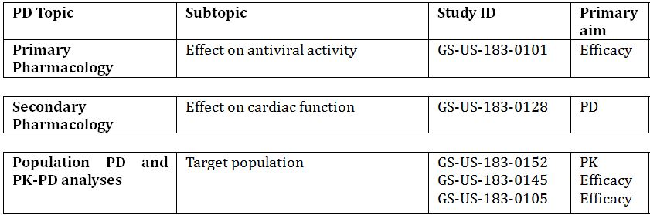

§ Subjects who would be eligible to receive the drug if approved for the proposed indication.

‡ And adolescents if applicable.

None of the pharmacodynamic studies had deficiencies that excluded their results from consideration.

#### Evaluator’s overall conclusions on pharmacodynamics

The pharmacodynamics of EVG were largely demonstrated in *in vitro* and the efficacy studies.

The pharmacokinetic/pharmacodynamic analyses for efficacy demonstrate comparable rates of virologic response across the range of clinically achieved EVG trough concentrations following administration with a PI/r. These results are consistent with the selection of the 150 mg EVG dose that provides exposures corresponding to Emax across subjects via provision of potent INSTI antiviral activity with both mean and overall Ctrough values that exceed the protein binding adjusted IC95 (95% inhibitory concentration).

Overall analysis of resistance across a number of studies (including those presented in the Stribild submission) lead to the following conclusions for EVG resistance:

* Resistance development to EVG was infrequent:
  + EVG resistance mutation development occurred more often in treatment experienced subjects (16.8%) than in treatment naive subjects (<2%)
  + EVG resistance mutation development was more frequent and extensive in subjects experiencing virologic failure for a longer period of time
* Primary (major) EVG resistance mutations observed were T66I/A/K, E92Q/G/A, T97A, S147G, Q148R/H/K, and N155H, alone and in combination with other IN mutations;
* Phenotypic analyses at virologic failure demonstrated high levels of resistance to EVG in most subjects analysed and evidence of cross resistance to RAL in most cases.

### Efficacy

#### Evaluator’s conclusions on clinical efficacy for use as part of combination therapy in HIV-1 infection

The efficacy of EVG is reliant on one pivotal clinical Study GS-US-183-0145.

EVG once daily was non inferior to RAL twice daily when administered for 48 weeks to HIV-1 infected, antiretroviral treatment experienced adults in combination with a fully active PI/r and an active second agent. The response rates observed in the study (EVG 59%, RAL 58%) are similar to the historical response rates reported in previous BENCHMRK studies with RAL,[3] despite differences in the patient populations and permitted background regimens between studies.

The choice of RAL as comparator is acceptable as this is approved in Australia for use in this patient population. The sponsor has adequately justified the delta of -10% for the non inferiority margin.

Study GS-US-183-0130 submitted as an uncontrolled study is primarily a safety study as it included patients who had participated in previous efficacy and pharmacokinetic studies.

The EU Guideline requirement for acceptance of one pivotal study is: “one controlled study with statistically compelling and clinically relevant results”.[4] In addition, one study should meet the following criteria:

* Internal validity: there should be no indications of a potential bias
  + No potential bias was detected
* External validity: the study population should be suitable for extrapolation to the population to be treated
  + Study population is suitable for extrapolation to the population to be treated
* Clinical relevance: the estimated size of the treatment benefit must be large enough to be clinically relevant
  + The estimated size of the treatment benefit is consistent with the published literature
* The degree of statistical significance: when the aim is to demonstrate non inferiority, the lower 95% confidence bound is well away from the non inferiority margin
  + The lower 95% confidence bound was set at -10% and the lower 95% confidence bounds using different algorithms as shown in Table 6.

Table 6: 95% confidence bounds for analyses of clinical efficacy.

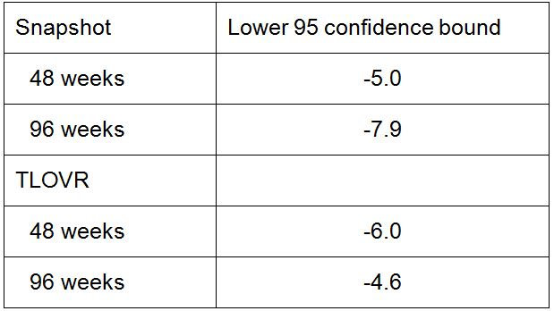

* + Results are consistently above the preset non inferiority margin.
* Data quality
  + Data quality is acceptable
* Internal consistency – all important endpoints showing similar findings
  + All secondary efficacy outcomes were consistent with the primary outcome parameter and were consistent for 48 weeks and 96 weeks of treatment
* Centre effects are not seen
  + While a centre effect was not specifically tested the analysis of primary endpoint by subgroups included an analysis by geographic region (US and Puerto Rico versus others). No subgroup effect was seen, suggesting no centre effect was present.
* Plausibility of the hypothesis tested
  + Hypothesis tested was plausible

Study GS-US-183-0145 meets the criteria for acceptance of one pivotal trial.

The majority of subjects in both groups who had samples sent for resistance testing had wild type virus without any new HIV-1 mutations, suggesting that poor adherence to the study regimens might be the principle reason for virologic failure. Resistance development to EVG and RAL occurred infrequently in both groups.

The sponsor also presents Study GS-US-183-0105 in the summary as supporting the efficacy of EVG. This study was not submitted in this dossier but was submitted and evaluated in the Stribild submission. The study is said to have shown that EVG/r 50/100 mg and 125/100 mg met the criteria for non inferiority relative to the comparator protease inhibitor/r (CPI/r) for the pre specified primary analysis endpoint of time weighted average change from baseline through Week 24 in HIV-1 RNA. However, the sponsor states that changes in the study drug treatment regimens recommended by the Independent Data Monitoring Committee confound the interpretation of the results of non inferiority after Week 16. Additional post hoc analysis confirmed the results.

The sponsor has supplied supporting data in Study GS-US-183-0130 but this is primarily for the long term safety up to 192 weeks.

The data in efficacy in adolescents is slim: based on very small number (n = 9) of patients treated for 48 weeks. No data is provided for children less than 12 years. The sponsor is not seeking approval for use in children <18 years and the PI states that safety and efficacy has not been established in children <18 years.

The sponsor is not seeking approval for use of EVG boosted by COBI despite this being part of the component of Stribild. The sponsor does not really explain why this has not been more extensively investigated. They cite the studies conducted with COBI which showed that when 150 mg EVG was administered with COBI (150 mg) and DRV, plasma exposures of all three agents were insufficient for optimal therapeutic activity. In addition, when COBI is co-administered with EVG it is not expected to adequately boost tipranavir (TPV) versus TPV/r. The sponsor states that EVG is not recommended for use with a COBI boosted protease inhibitor, as dosing recommendations for such combinations have not been established and may result in suboptimal plasma concentrations of EVG and/or the protease inhibitor leading to loss of therapeutic effect and possible development of resistance.

There is no clinical data available with boosted EVG in the treatment naive population other than with Stribild (the combination product). Consequently, the EVG tablet is only recommended for use when co administered with a RTV boosted PI and other antiretrovirals for use in treatment experienced adults with HIV-1 infection.

### Safety

#### Studies providing evaluable safety data

The following studies provided evaluable safety data:

##### Pivotal efficacy studies

In the pivotal efficacy study (GS-US-183-0145), the following safety data were collected:

* General adverse events (AEs): the study report does not indicate how they were collected
* No AEs of particular interest were pre specified in the pivotal study
* Laboratory tests, including serum chemistry, haematology, metabolic assessments, pregnancy tests (for females of childbearing potential), and urinalysis, were performed at Baseline/Day 1, 2, 4, 8, 12, 16, 20, 24, 32, 40, 48, 56, 64, 80, 88, 72, 96 and then every 8-12 weeks
* Other safety related assessments which included complete/symptom directed physical examinations and vital signs.

##### Pivotal studies that assessed safety as a primary outcome

Not applicable.

##### Dose response and non pivotal efficacy studies

The dose response and non pivotal efficacy studies provided safety data, as follows:

* Study GS-US-183-0130 provided data on adverse events, laboratory tests and vital signs;
* Study GS-US-183-0152 provided data on adverse events in adolescents, laboratory tests and vital signs.

##### Other studies evaluable for safety only

Not applicable.

##### Clinical pharmacology studies

AEs, vital signs, haematology, clinical chemistry and in some cases electrocardiograms (ECGs) were recorded in the clinical pharmacology studies. Most of these studies enrolled healthy volunteers. One study, GS-US-183-0152, enrolled HIV-1 infected adolescent patients.

#### Evaluator’s overall conclusions on clinical safety

Overall, the safety database for EVG is not large as the efficacy is based primarily on one pivotal study that enrolled only 354 patients into the EVG group. However, the safety of EVG is also supported by the studies of EVG in Stribild in which no safety major safety concerns were identified.

Overall, there were no significant safety concerns identified for EVG. EVG was well tolerated, as demonstrated by the low overall rate of study drug discontinuation due to AEs, and the mild or moderate severity of most AEs. The most frequently reported AEs for subjects administered the EVG containing regimen were diarrhoea, upper respiratory tract infection, and headache.

Subgroup analyses of AEs by sex, age, race, HIV-1 stratum at baseline, and CD4 cell count at baseline showed no differences between subgroups.

EVG may be used without dose adjustment in patients with renal impairment or mild or moderate hepatic impairment. EVG has not been studied in patients with severe hepatic impairment.

In the proposed PI, the section on drug interactions instructs prescribers to refer to the RTV and co-administered protease inhibitor PI for the list of contraindicated drugs. It should be considered to also include the list in the EVG PI for assistance to prescribing doctors. The list should include, but are not limited to, efavirenz, nevirapine, carbamazepine, oxcarbazepine, phenobarbital, phenytoin, modafinil, rifampin, rifapentine, dexamethasone, bosentan, and St. John’s wort. Co-administration with these agents is not recommended.

### First round benefit-risk assessment

#### First round assessment of benefits

The benefits of Vitekta in the proposed usage are:

* EVG was shown to be non inferior to RAL twice daily when co-administered with a PI/r and one or more other antiretroviral agents for 48 weeks;
* Efficacy of the above regimen was durable through 96 weeks;
* Efficacy is also supported by the efficacy seen when EVG is boosted by COBI in the combination product Stribild;
* No major safety issues have been identified.

#### First round assessment of risks

The risks of Vitekta in the proposed usage are:

* AEs identified during the clinical development program;
* In the pivotal study, diarrhoea was more frequently reported in the EVG group;
* While no dose adjustment is required for patients with renal impairment or mild to moderate hepatic impairment, EVG has not been studies in patients with severe hepatic impairment;
* EVG is primarily metabolised by CYP3A. Drugs that induce CYP3A activity are expected to decrease the plasma concentrations of EVG, which may lead to loss of therapeutic effect of EVG and possible development of resistance;
* For RTV boosted protease inhibitor containing regimens that are co-administered with EVG, RTV may increase the plasma concentrations of concomitant drugs that are primarily metabolized by CYP3A, as RTV is a strong CYP3A inhibitor. Higher plasma concentrations of concomitant drugs can result in increased or prolonged therapeutic or adverse effects, potentially leading to severe, life threatening events.

#### First round assessment of benefit-risk balance

The benefit-risk balance of Vitekta, given the proposed usage, is favourable.

While the efficacy data is primarily based on a single pivotal trial, it does meet the regulatory requirements and demonstrates non inferiority to the currently approved comparator product. The efficacy is durable over two years. No significant safety issues have been identified.

### First round recommendation regarding authorisation

Based on the clinical data submitted, it is recommended that application be approved.

### Clinical questions

The sponsor should be asked to address the following question:

Q. The proposed PI section for the pharmacokinetics contains summary data but the source texts given in the annotations are not correct for all details and some of the annotations could not be located in the submission. It is noted that the information is consistent with the US Package Insert and the EU SmPC. The following sections should be noted:

* Absorption: the Tmax should be changed to 3-4 h
* Absorption: The Cmax, AUCtau, and Ctrough – while the range is correct the exact numbers could not be verified
* Distribution: the mean plasma to blood drug concentration could not be verified
* Effect of food: the last sentence should be corrected to “...22% to 34% with a light meal, while increasing to 56% to 91% with a high fat meal, respectively”.

Please provide an updated annotated PI addressing the issues itemised above and providing accurate cross reference to the electronic submission provided in the dossier.

### Second round evaluation in response to questions

The sponsor addressed each of the issues raised as follows:

* Absorption: the Tmax should be changed to 3-4 h
  + Response: this was accepted by the sponsor.
* Absorption: The Cmax, AUCtau, and Ctrough – while the range is correct, the exact numbers could not be verified
  + Response: the sponsor recognised it had inadvertently cross referenced an incorrect section for the pharmacokinetic/pharmacodynamic analysis to the application to register Stribild and did not provide the correct EVG pharmacokinetic/pharmacodynamic analysis in this section. Sections of the relevant report were provided to the TGA such that the source and actual values cited in the PI were confirmed.
* Distribution: the mean plasma to blood drug concentration could not be verified
  + Response: the derivation (source data and calculations) of the ratio was explained satisfactorily.
* Effect of food: the last sentence should be corrected to “...22% to 34% with a light meal, while increasing to 56% to 91% with a high fat meal, respectively”.
  + Response: The sponsor accepted the change from 22% to 34%, however as this value is based on AUCinf, it also suggested altering the high fat meal to 87% instead of 91% as the 87% value is also based on AUCinf. This is acceptable.

### Second round benefit-risk assessment

#### Second round assessment of benefits

No new clinical information was submitted in response to questions. Accordingly, the risks of Vitekta are unchanged from those identified in the first round assessment.

#### Second round assessment of risks

No new clinical information was submitted in response to questions. Accordingly, the risks of Vitekta are unchanged from those identified in the first round assessment.

#### Second round assessment of benefit-risk balance

The benefit-risk balance of Vitekta is unchanged from that identified in the first round assessment.

### Second round recommendation regarding authorisation

The recommendation is unchanged from that given in the first round.

## V. Pharmacovigilance findings

### Risk management plan

The sponsor submitted a Risk Management Plan which was reviewed by the TGA’s Office of Product Review (OPR).

#### Safety specification

The sponsor provided a summary of Ongoing Safety Concerns which are shown at Table 7.

Table 7: Ongoing safety concerns as identified by the sponsor.

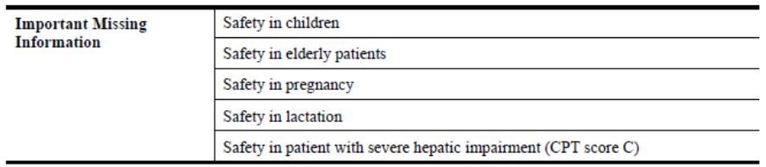

##### OPR reviewer comment

In comparison to the AU-RMP previously reviewed for Stribild, the EVG element of this product included the important potential risk: ‘Concurrent use of drugs whose co-administration with EVG is contraindicated’ and the important missing information: ‘Long-term safety information’. Notwithstanding the evaluation of the nonclinical and clinical aspects of the Safety Specification, it is recommended that the sponsor include these ongoing safety concerns in the AU-RMP for Vitekta or provide compelling justification as to why such amendment should not be required. If the sponsor decides to include these ongoing safety concerns in the AU-RMP for Vitekta then consideration must be given as to what routine and additional pharmacovigilance and risk minimisation activities will be proposed for them.

#### Pharmacovigilance plan

The sponsor states that routine pharmacovigilance activities, consistent with published guidelines,[5] are proposed to monitor all the specified Ongoing Safety Concerns.

In addition, the following planned clinical studies are proposed to further monitor the important missing information: ‘Safety in children’:

* GS-US-183-0160: A Phase II/III multicentre, open label, multi cohort, two part study evaluating the pharmacokinetics, safety, and antiviral activity of EVG administered with a background regimen containing a RTV boosted protease inhibitor in HIV-1 infected, antiretroviral treatment experienced paediatric subjects aged <18 years, with follow up of 5 years on study treatment.
* GS-US-183-0155: A Phase II/III multicentre, open label, randomised (1:1), multi cohort study evaluating safety and antiviral activity of current therapy versus EVG administered with a background regimen containing a RTV boosted protease inhibitor in HIV-1 infected, antiretroviral treatment experienced, virologically suppressed paediatric subjects aged <18 years.
* GS-US-183-0154: A Phase II/III multicentre, open label, non randomised, multi cohort, two part study evaluating the pharmacokinetics, safety, and antiviral activity of EVG co-administered with COBI and two first line NRTIs in HIV-1 infected, antiretroviral treatment naive subjects aged <18 years.

Protocols for the planned clinical studies were not provided as they are not yet available.

The Antiretroviral Pregnancy Registry is an ongoing epidemiology study proposed to further monitor the important missing information: ‘Safety in pregnancy’. A protocol for this registry dated May 2005 was provided in Annex 4 of the AU-RMP, although no reporting milestones for planned data availability have been proposed.

##### OPR reviewer’s comments in regard to the pharmacovigilance plan (PP) and the appropriateness of milestones

The sponsor should provide an assurance that the draft protocols for the planned clinical studies proposed to further monitor the important missing information: ‘Safety in children’ will be provided to the TGA for review when they become available.

During the evaluation of the AU-RMP for Stribild, the sponsor’s correspondence of 23 July 2012 stated that reports were produced 6 monthly (June and December each year) for the Antiretroviral Pregnancy Registry. Consequently this information should be included in the table ‘Summary Table of Study Protocols’ of the AU-RMP for Vitekta when this document is next updated.

The ongoing epidemiology study is not considered to be part of the planned clinical studies in the pharmacovigilance plan. Therefore, the related study protocol has not been reviewed. Nevertheless, an update on the progress/results/analysis of this study, as outlined in the sponsor’s correspondence of 23 July 2012, will be expected in future Periodic Safety Update Reports (PSURs).

#### Risk minimisation activities

The sponsor has concluded that routine risk minimisation activities are sufficient for all the specified Ongoing Safety Concerns. Consequently, no risk minimisation measures additional to the provision of safety information in the product labelling are considered by the sponsor to be warranted for the use of EVG.

##### OPR reviewer comment

The above conclusion was previously accepted for the EVG element of Stribild. Consequently, this is acceptable.

#### First round summary of recommendations

The OPR provides these recommendations in the context that the submitted RMP is supportive to the application; the implementation of a RMP satisfactory to the TGA is imposed as a condition of registration; and the draft PI and Consumer Medicine Information (CMI) documents should *not* be revised until the Delegate’s Overview has been received:

* Safety considerations may be raised by the nonclinical and clinical evaluators through the consolidated Section 31 request and/or the Nonclinical and Clinical Evaluation Reports, respectively. It is important to ensure that the information provided in response to these include a consideration of the relevance for the RMP, and any specific information needed to address this issue in the RMP. For any safety considerations so raised, the sponsor should provide information that is relevant and necessary to address the issue in the RMP.
* In comparison to the AU-RMP previously reviewed for Stribild, the EVG element of this product included the important potential risk: ‘Concurrent use of drugs whose co-administration with EVG is contraindicated’ and the important missing information: ‘Long-term safety information’. Notwithstanding the evaluation of the nonclinical and clinical aspects of the Safety Specification, it is recommended that the sponsor include these Ongoing Safety Concerns in the AU-RMP for Vitekta or provide compelling justification as to why such amendment should not be required. If the sponsor decides to include these Ongoing Safety Concerns in the AU-RMP for Vitekta, then consideration must be given as to what routine and additional pharmacovigilance and risk minimisation activities will be proposed for them.
* The sponsor should provide an assurance that the draft protocols for the planned clinical studies proposed to further monitor the important missing information: ‘Safety in children’ will be provided to the TGA for review when they become available.
* During the evaluation of the AU-RMP for Stribild, the sponsor’s correspondence of 23 July 2012 stated that reports were produced 6 monthly (June and December each year) for the Antiretroviral Pregnancy Registry. Consequently, this information should be included in the table ‘Summary Table of Study Protocols’ of the AU-RMP for Vitekta when this document is next updated.
* The ongoing epidemiology study is not considered to be part of the planned clinical studies in the pharmacovigilance plan. Therefore, the related study protocol for the Antiretroviral Pregnancy Registry has not been reviewed. Nevertheless, an update on the progress/results/analysis of this study, as outlined in the sponsor’s correspondence of 23 July 2012, will be expected in future PSURs.
* The sponsor’s conclusion that routine risk minimisation activities are sufficient for all the specified ongoing safety concerns was previously accepted for the EVG element of Stribild. It is agreed that no risk minimisation measures additional to the provision of safety information in the product labelling is currently warranted for the use of EVG.
* The sponsor’s proposed application of routine risk minimisation activities would appear to be reasonable and therefore acceptable. It is acknowledged that routine risk minimisation is already applied in regard to the important potential risk: ‘Concurrent use of drugs whose co-administration with EVG is contraindicated’.

#### Second round evaluation of the sponsor’s response to the RMP evaluation

Reconciliation of issues outlined in the RMP report is shown in Table 8.

Table 8: Reconciliation of issues outlined in the RMP report.

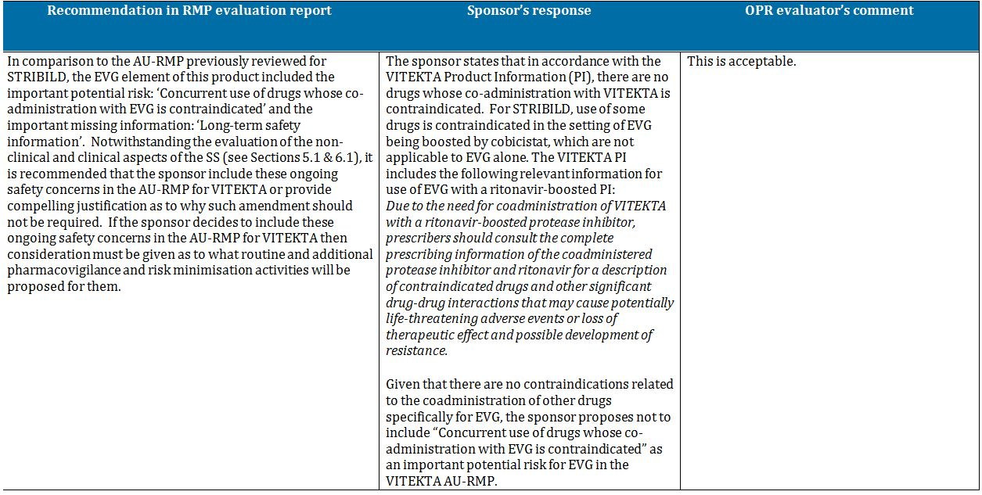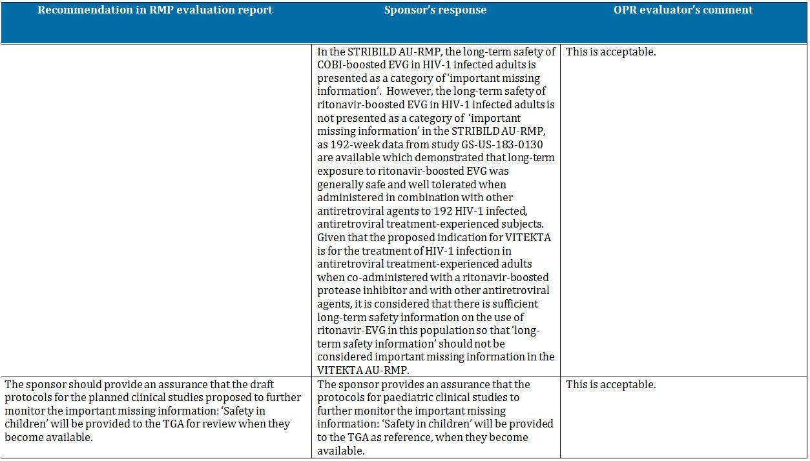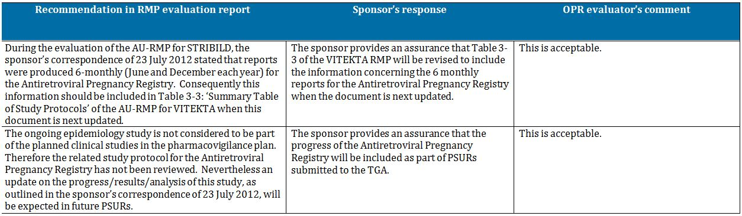

##### Outstanding issues

###### Issues in relation to the RMP

There are no outstanding issues in relation to the RMP for this submission.

###### Advice from the Advisory Committee on the Safety of Medicines (ACSOM)

ACSOM advice was not sought for this submission.

##### Comments on the safety specification of the RMP

###### Clinical evaluation report

The Safety Specification in the draft RMP is satisfactory.

The sponsor did not provide new clinical information after the first round and has not changed the Safety Specification in the draft RMP. There are no changes to the comments on the Safety Specification.

###### Nonclinical evaluation report

The nonclinical evaluator made no specific comments on the safety specification in the nonclinical evaluation report.

## VI. Overall conclusion and risk/benefit assessment

The submission was summarised in the following Delegate’s overview and recommendations:

### Quality

The EVG drug substance and excipients used in Vitekta tablets are identical those used in Stribild tablets.

The oral bioavailability of EVG is limited by solubility and dissolution. The sponsor described various formulation and process development strategies that were implemented to improve the biopharmaceutical performance of EVG. Two formulations developed by Japan Tobacco were used in early studies: a solid dispersion formulation for EVG with povidone, and a conventional tablet formulation incorporating micronised EVG. The highest oral bioavailability was obtained with the solid dispersion formulation. In the fasted state, in dogs, this tablet had a 2.6 fold higher AUC than a conventional tablet, although the AUC was only 30% higher (1.3 fold) when the tablets were taken after food. However, for ease of manufacture it was decided to pursue the conventional tablet formulation, but when it was reformulated for large scale production its bioavailability appeared to decrease further, by about 8%. Hence, the strength of the tablet was increased from 125 mg to 150 mg, giving a dose that was bioequivalent to the originally developed 125 mg conventional tablet. The 150 mg tablet proposed for registration was used in all Phase III clinical studies without any further modification. The sponsor did not provide a justification for the absence of a bioequivalence study of the 85 mg tablets versus the 150 mg tablet. However, this was accepted by the evaluator because the cores of the two strengths are direct scales and the tablets show similar dissolution rates.

A food study was not performed on the EVG single agent tablet proposed for registration. The rationale provided by the sponsor is that the tablet was always administered with food in the clinical safety and efficacy studies (as is intended for the proposed registration of Vitekta) and the type of food was not controlled in those studies.

No objections were raised to registration of Vitekta with regard to Chemistry, Manufacturing and Controls at the time of completion of the evaluation rounds. However, the TGA recently became aware that the United States Food and Drug Administration (FDA) has issued Complete Response Letters advising that it cannot approve the US New Drug Application for EVG in its current form as a result of recent Good Manufacturing Practices (GMP) inspections in which deficiencies were observed. At the time of completion of this Request for Advice, the TGA was working through additional information provided by the sponsor to determine the nature and scope of the deficiencies, and the sponsor’s proposed actions to address those deficiencies.

### Nonclinical

The majority of the nonclinical data for EVG were included in the Stribild submission. Only two new, GLP compliant genotoxicity studies for three impurities were added for the Vitekta submission. Previous adequate EVG genotoxicity studies showed an equivocal positive response in an *in vitro* test for clastogenicity in Chinese hamster lung cells, and negative results in *in vitro* bacterial reverse mutation and *in vivo* rat micronucleus tests. The two new genotoxicity studies for the three impurities were negative.

Key nonclinical findings for EVG previously identified in the Stribild submission were:

* *in vitro* studies demonstrated the anti HIV-1 activity of EVG, with IC50 values of ~0.1-1.3 nM. The IC50 values were well below the respective human plasma EVG Cmax and Cmin values of ~3.9 and 1 µM. Development of resistance mutations was observed *in vitro*, and there was some cross resistance to RAL selected mutations.
* A small but significant inhibition of hERG currents was observed in stably transfected HEK293 cells at the highest test concentration of 10 µM, but was considered unlikely to be of clinical significance.
* Toxicokinetic studies showed that co-administration of EVG and RTV generally resulted in moderate increases in EVG exposures in animals.
* An *in vitro* study reported 99.3% plasma binding of EVG in human plasma. EVG protein binding in mouse, rat and dog plasma was also high.
* EVG toxicity studies in mice and dogs showed little toxicity, with findings of lipid droplets in the lamina propria of the duodenum/jejunum of rats and dogs, and increased caecal weights in rats, possibly due to anti bacterial activity.
* A 13 week rat toxicity study with EVG or RTV alone, and EVG/RTV (High Dose = 1000/10 mg/kg/day), showed no additive or new toxicities with the combination.
* EVG was negative in adequate carcinogenicity studies in mice and rats. The mouse study included groups treated with RTV alone and the combination EVG/RTV 2000/25 mg/kg/day.
* EVG had no effects on rat fertility and early embryonic development or on embryofoetal and peri postnatal development. A rat embryofoetal development study incorporated a group treated with EVG/RTV 1000/10 mg/kg/day.

There were no nonclinical objections to registration of the Vitekta. However, the evaluator noted:

* The sponsor had proposed an Australian pregnancy category of B1. A B2 category was recommended by the evaluator on the basis of inadequate drug exposure in rabbits. (EVG exposure in a rabbit embryofetal development study included with the Stribild submission was considered inadequate ]0.2x human exposure at the High Dose]); and
* A nonclinical toxicity study was conducted with the EVG/RTV combination, but not for the combination with additional antiretroviral drugs. Consequently, it was recommended that the safety assessment should rely on clinical data.

### Clinical

#### Safety pharmacology

In the Stribild submission, a well designed and conducted dedicated QT study (183-0128) in 122 healthy adult volunteers using moxifloxacin as positive control showed that an EVG/RTV daily dose of 125/100 mg and the supra therapeutic dose of 250/100 mg had no significant effect on QTc intervals in healthy adult volunteers. EVG/RTV dosing at 250/100 mg resulted in supra therapeutic plasma exposures of EVG relative to the 125/100 mg dose. Pharmacodynamic/pharmacokinetic analysis showed no relationship between EVG concentrations and QTc intervals.

#### Drug resistance

Reduced susceptibility to EVG was associated with the primary integrase substitutions T66A/I, E92G/Q, S147G, and Q148R. Additional integrase substitutions observed in cell culture selection included D10E, S17N, H51Y, F121Y, S153F/Y, E157Q, D232N, R263K, and V281M.

The clinical evaluator noted that EVG resistant viruses showed varying degrees of cross resistance in cell culture to RAL depending on the type and number of substitutions in HIV-1 integrase. Among the four primary EVG resistance associated substitutions detected in Stribild treatment virologic failure isolates, E92Q, Q148R, and N155H individually conferred reduced susceptibility both to EVG (greater than 32 fold) and RAL (greater than 5 fold) when introduced into a wild type virus by site directed mutagenesis. The T66I substitution conferred greater than 14 fold reduced susceptibility to EVG but less than 3 fold to RAL. Among the three primary RAL resistance associated substitutions (Y143H/R, Q148H/K/R, and N155H), all but one (Y143H) conferred significant reductions in susceptibility to EVG (greater than 5 fold).

#### Pharmacokinetics and dose selection

Key pharmacokinetics of EVG, established in the Stribild submission are:

* EVG exposures are nonlinear and less than dose proportional. This is most likely due to solubility limited absorption;
* Absolute bioavailability of EVG has not been assessed. However, the solubility profile of EVG precludes the development of a parenteral formulation;
* The AUC for EVG following multiple doses is about 20% lower compared to the AUC after single dose (Study 183-0102). Addition of RTV 100mg to a single dose of EVG increases exposure to EVG by nearly 7 fold. After multiple dosing the exposure is higher by >20 times. The continuous accumulation over 10 day treatment period (half life 18 hours after single dose, 9.5 hours at 10 days) indicates nonlinear clearance. The exposure difference with EVG compared to EVG/RTV in the study is the claimed basis for including a pharmacokinetic booster with EVG;
* EVG is highly protein bound;
* In a mass balance study of EVG (Study 183-0126), 95% radioactivity was recovered in faeces after oral administration. The combined faecal and urinary recovery accounted for 100% of the drug and indicated hepatobiliary excretion. EVG biotransformation was found to be primarily via aromatic and aliphatic hydroxylation and/or primary or secondary glucuronidation. In plasma, nearly 94% activity is from the intact drug with the remaining radioactivity made up of low levels of metabolites from hydroxylation and/or glucuronidation including GS-9200 (M4) and GS-9202 (M1). In faeces, the radioactivity was accounted for mainly by intact EVG and GS-9202 (M1). In urine, the radioactivity was mainly accounted for by GS-9200 (M4) or other glucuronides of EVG hydroxylation (M7, M19 and M20). Intact EVG radioactivity was not recovered from any urine sample;
* EVG bioavailability is increased substantially with food compared to fasting, particularly with a high fat meal (Study 236-0105). The company considers the differences between a light meal and a high fat meal in respect of EVG bioavailability to be clinically insignificant;
* No dose adjustment of EVG is required in patients with mild to moderate hepatic impairment. Patients with severe hepatic impairment have not been studied; and
* No dose adjustment of EVG is required in patients with renal impairment.

The data from the Stribild submission that supports the 150 mg dose of EVG (and 85 mg when combined with ATV/RTV or LPV/RTV) is described in the Clinical Evaluation Report. The reduced dose of 85 mg EVG co-administered with ATV/RTV or LPV/RTV is further confirmed in the Vitekta submission through additional data from studies GS-US-183-0145 and GS-US-183-0152. EVG is metabolised via CYP3A, and co-administration with a CYP3A inhibitor such as RTV enables once daily dosing.

In the current submission, additional data are provided mainly in the form of pharmacokinetic interaction studies that form the basis of information included in the Interactions section of the PI. Of particular relevance to the protease inhibitors boosted by RTV that are intended to be used with EVG (that is, darunavir (DRV), fosamprenavir (FPV) and tipranavir (TPV)), co-administration of EVG with these combinations at the doses proposed for labelling (and used in the pivotal efficacy study) shows no clinically relevant pharmacokinetic drug interactions necessitating dose modifications: for DRV/RTV (600/100 mg BID) see Study GS-US-183-0120; FPV/RTV (700/100 mg BID) see Study GS-US-183-0123; and for TPV/RTV (500/200 mg BID) see Study GS-US-183-0110.

#### Efficacy

##### Pivotal efficacy study: Study GS-US-183-0145

Study GS-US-183-0145 was a randomised, double blind, double dummy, non inferiority study in which HIV-1 infected, antiretroviral treatment experienced adults with plasma HIV-1 RNA levels ≥1000 copies/mL at screening received a regimen containing EVG/RTV or RAL, each administered with a background regimen. The background regimen comprised fully active protease inhibitor/RTV and an active second agent but not the non nucleoside reverse transcriptase inhibitors (NNRTIs) efavirenz, nevirapine, or delavirdine (due to unknown pharmacokinetic interactions); or the fixed dose combination therapies Atripla (TDF/FTC/efavirenz) or Trizivir (Abacavir/ lamivudine/ zidovudine). The background regimen was selected by the investigator based on genotypic/phenotypic resistance and prior antiretroviral treatment history. Subjects taking lopinavir (LPV)/RTV or ATV/RTV as part of their antiretroviral regimen received EVG 85 mg active or placebo tablets. All other subjects (that is, those taking DRV/RTV, FPV/RTV or TPV/RTV) received EVG 150 mg active or placebo tablets.

Non inferiority of the treatment regimens was assessed using the proportion of subjects achieving and maintaining confirmed HIV-1 RNA <50 copies/mL through Week 48 as a primary objective and through 96 weeks as a secondary objective, with a non inferiority margin (delta) of -10%. The primary efficacy outcome parameter was derived using the US FDA defined time to loss of virologic response (TLVOR) algorithm.

A total of 702 patients (median age 45 years; 82% male; 62% Caucasian; median HIV-1 RNA 4.35 log10 copies/mL; 25% with HIV-1RNA >100,000 copies/mL; and median CD4+ T cell count 222 cells/mm3) were enrolled. Hepatitis B co-infection was reported in 4.2% subjects and hepatitis C co-infection was reported for 14.1% subjects. Randomisation was stratified according to geographic area, screening HIV-1 RNA level and class of second agent in the background regimen prior to randomisation. A total of 351 patients comprised the Intent To Treat (ITT) analysis set for each treatment group, which were well matched with respect to age, gender, HIV clinical status and background regimen. DRV was the most commonly prescribed protease inhibitor, followed by LPV and ATV. More than 80% of all subjects received an NRTI as the second background agent, with more than 48% of subjects in each group prescribed TDF and more than 20% in each group prescribed Truvada. Approximately 15% of subjects were prescribed an NNRTI (14% of subjects received etravirine) and 6% of subjects received maraviroc, a CCR5 entry inhibitor.

At 48 weeks, the proportion of subjects achieving and maintaining HIV-1 RNA <50 copies/mL were similar for the two groups (59% EVG versus 57.8% RAL). The stratum adjusted between group difference was 1.1% (95% CI [Confidence Interval]: -6.0% to 8.2%). The 95% CI sat wholly to the right of -10%, indicating EVG was non inferior to RAL. At 96 weeks the stratum adjusted between group difference for the percentage of subjects achieving and maintaining HIV-1 RNA <50 copies/mL was 2.6% (95% CI: -4.6% to 9.9%).

The results of numerous other secondary endpoints, including virologic response at 48 and 96 weeks per snapshot algorithm, time to loss of virologic response (cut off HIV-1 RNA <50 copies/mL) at 96 weeks, change from baseline in HIV-1 RNA, and change from baseline in CD4 count were all consistent with the findings for the primary endpoint. Specifically with regard to time to loss of virologic response and time to pure virologic failure (cut of HIV-1 RNA <50 copies/mL) at 96 weeks, the Kaplan-Meier curves separated early, higher percentages of subjects in the EVG group compared with the RAL group had loss of virologic response and pure virologic failure, respectively, due to never being suppressed and were, therefore, assumed to have failed at Day 1. In contrast, higher percentages of subjects in the RAL group compared with the EVG group experienced virologic rebound; these subjects failed at the time when the rebound occurred. However, taken together, the percentages of subjects with either loss of virologic response or pure virologic failure (due to never being suppressed or rebound) were similar between the EVG and RAL treatment groups.

The majority of subjects in both groups who had samples sent for resistance testing had wild type virus without any new HIV-1 mutations, suggesting that poor adherence to the study regimens might be the principal reason for virologic failure. Resistance development to EVG, RAL, or the background regimen occurred infrequently with similar incidence in the two treatment groups.

The evaluator considered the choice of RAL as comparator to be appropriate and the choice of delta of -10% for the non inferiority margin to be justified. The evaluator also assessed Study GS-US-183-0145 against the EU Guideline requirement for acceptance of one pivotal study vis a vis “one controlled study with statistically compelling and clinically relevant results” and found it met the criteria.

##### Supporting efficacy studies: Study GS-US-183-0130

Study GS-US-183-0130 was an open label, single arm, multicentre Phase II study in which HIV-1 infected adults who had completed prior EVG/RTV studies (GS-US-183-0105 and GS-US-183-0152) without experiencing any treatment limiting toxicities were able to continue to access EVG/RTV in combination with other anti retroviral treatment. The background antiretroviral regimen consisted of at least two agents, but not the NNRTIs efavirenz, nevirapine, or delavirdine; the protease inhibitors saquinavir, nelfinavir, or indinavir; or other investigational agents due to known or unknown drug-drug interactions with EVG/RTV. Subjects who were taking LPV/RTV or ATV/RTV as part of their antiretroviral regimen received EVG 85 mg. All other subjects received EVG 150 mg. Although this study was conducted primarily to obtain long term safety data for EVG/RTV, efficacy data from up to 192 weeks follow up were also obtained.

A total of 192 patients were enrolled, of whom 85 (44.5%) subjects had plasma HIV-1 RNA levels <50 copies/mL at baseline; 40 (20.9%) had plasma HIV-1 RNA levels 50 to <400 copies/mL; and 66 (34.6%) had plasma HIV-1 RNA levels ≥400 copies/mL. Also, 119 (62.6%) subjects had a baseline CD4 cell count >200 cells/mm3. Most subjects received an NRTI (189 subjects; 98.4%) as part of the background regimen, the most common being Truvada (145 subjects; 75.5%). Most subjects (131 subjects; 68.2%) also received a protease inhibitor (in addition to RTV, which was used as a pharmacoenhancer), the most common being DRV (120 subjects; 62.5%).

Despite limitations of the study design and execution (which included the lack of a comparator arm, high attrition rate (79/192 patients) and inclusion of 30 patients who did not receive EVG in prior studies), from an efficacy point of view it was concluded:

* for subjects with baseline HIV-1 RNA <50 copies/mL, EVG in combination with the background regimen showed durable efficacy - 86.6% (95% CI: 77.3 to 93.1%) subjects maintained HIV-1 RNA <50 copies/mL through week 48 and 68.3% subjects (95%CI: 57.1% to 78.1%) were able to maintain HIV-1 RNA <50 copies/mL through Week 192;
* approximately one third of subjects with baseline HIV-1 RNA ≥50 copies/mL, most of whom received uninterrupted EVG from prior studies, achieved long term virologic suppression; and
* integrase resistance developed infrequently in subjects with baseline HIV-1RNA <50 copies/mL. In contrast, pre-existing integrase resistance was common in subjects entering the study with baseline HIV-1 RNA ≥50 copies/mL.

The low efficacy by the missing failure analysis (25-30%) in subjects with baseline HIV-1 RNA ≥ 50 copies/mL was attributed by the sponsor to a high attrition rate (~54%) and the fact that the subjects who received EVG in prior studies had virologic failure at the end of those studies, which suggests that many subjects did not have an effective background regimen. Also, baseline genotype was not performed and, therefore, the background antiretroviral regimen was not reconfigured or optimised.

##### Supporting efficacy studies: Study GS-US-183-0152

Study GS-US-183-0152 was a pharmacokinetic study in adolescents with an optional treatment extension phase for subjects with plasma HIV-1 RNA levels >1000 copies/mL. A total of 9 subjects received ongoing treatment with either EVG 150 mg daily (plus background regimen (BR) including RTV-boosted DRV, FPV, or TPV) or EVG 85 mg daily (plus BR including RTV boosted LPV or ATV) through 48 weeks. All 9 subjects had reductions in HIV-1 RNA from baseline to Week 48 (the median change from baseline −1.74 log10 copies/mL; range -2.69, –0.40), and 2 subjects had HIV-1 RNA <50 copies/mL at Week 48. Increases were observed in CD4 cell counts and percentages; 6/9 subjects had a CD4 cell count within or near the normal reference range at Week 48, and 6/9 subjects had CD4 cell percentage values within or near the normal reference range at Week 48.

##### Supporting efficacy studies: Study GS-US-183-0105

Study GS-US-183-0105 was also presented as supporting the efficacy of EVG. A study report was not included in the Vitekta submission but was included and evaluated for the Stribild submission. It was noted that EVG/RTV 50/100 mg and 125/100 mg met the criteria for non inferiority relative to the comparator protease inhibitor/RTV for the pre specified primary analysis endpoint of time weighted average change from baseline through Week 24 in HIV-1 RNA. However, the sponsor noted that changes in the study drug treatment regimens recommended by the Independent Data Monitoring Committee confounded the interpretation of the results of non inferiority after week 16.

#### Safety

Safety data were available for a total of 984 subjects who had been exposed to EVG, including 416 healthy volunteers who participated in clinical pharmacology studies and 354 HIV-1 infected adults in the pivotal study. The median duration of exposure to EVG in the pivotal study was 105 weeks (range 0.1 to 168 weeks); 76% (n=269) patients were exposed for >48 weeks.

Overall, EVG was well tolerated and no major safety concerns were identified. In the pivotal study, the key findings were:

* AEs were reported for a similar percentage of subjects in the two groups (EVG 90.1% versus RAL 88.8%), with the most frequently reported AEs for EVG being diarrhoea (33.6%), URTI (18.9%), and headache (13.3%), and for RAL were diarrhoea (21.8%), URTI (15.6%), and cough (13.1%);
* Treatment related AEs were also comparable for the two groups (EVG 23.7% versus 20.4%), with the most events for EVG being diarrhoea (7.1%), nausea (4.0%), headache (2.8%), and fatigue (2.0%). The corresponding figures for the RAL group were 5.3%, 2.5%, 2.5%, and 1.1%;
* Similar percentages of subjects in the two groups reported serious AEs (SAEs) (EVG 20.1% versus RAL 23.5%) or SAEs considered related to study drug by the investigator (EVG 1.1% versus RAL 2.0%). The SAEs reported for more than 1% of subjects in either group were pneumonia (3.4%) and cellulitis (1.4%) for EVG and pneumonia (2.0%), and chest pain, cellulitis, bronchitis, and suicidal ideation (each reported for 1.1%) for RAL. Convulsion was the only SAE considered related to study drug by the investigator that was reported for more than 1 subject in a treatment group (2 subjects in the RAL group); all other SAEs considered related to study drug by the investigator were reported for 1 subject each;
* 12 subjects died during the study, with 9 considered to be treatment emergent (EVG 2 subjects 0.6% versus RAL 7 subjects, 2.0%). Three subjects in the RAL group died due to treatment-related AEs (Coombs +ve haemolytic anaemia, acute coronary syndrome, and cardiac arrest) versus none in the EVG group. The deaths in EVG subjects were end stage liver disease due to hepatitis C, and peritonitis due to intestinal perforation;
* Similar proportions of subjects in the 2 groups discontinued study drug due to an AE (EVG 3.1% versus RAL 4.2%). AEs that led to study drug discontinuation reported for more than 1 subject in either treatment group were hepatitis/acute hepatitis (RAL 3 subjects), nausea (EVG 2 subjects), and vomiting (EVG 2 subjects);
* Laboratory test abnormalities were similar between the 2 groups (EVG 26.6% versus RAL 22.9%). There were small increases from baseline in median values for fasting total cholesterol, direct LDL, and triglycerides for both treatment groups through Week 96. However, median values remained in the reference range for each analyte. Median values for serum creatinine increased by 0.10 mg/dL from baseline to Week 96 in both treatment groups. There was a corresponding decrease in median values for eGFRCG in both treatment groups from baseline to Week 96 of -10.8 mL/min for EVG and -11.7 mL/min for RAL; and
* The hepatic adverse reaction profile in subjects co-infected with HIV-1 and HBV or HIV-1 and HCV who received EVG was consistent with underlying hepatitis infection. Elevations in AST and ALT occurred more frequently than in the general HIV-1 infected population. Grade 3 or 4 elevations in ALT and/or AST were observed in 8.5% of subjects (n = 5) co-infected with HBV or HCV and 2.4% of subjects (n = 7) without co-infection in subjects who received EVG. For Grade 3 or 4 elevations in bilirubin, these values were 13.6%, 8 subjects co-infected and 4.5%, 13 subjects without co-infection in the EVG group.

The safety profile observed for EVG across the supporting studies was consistent with that observed in the pivotal study.

#### Clinical evaluator’s benefit-risk assessment

The evaluator considered that although the efficacy data were primarily based on one pivotal study, the study convincingly demonstrated non inferiority of EVG to the currently approved comparator RAL, with efficacy that was durable over two years. Consequently, it was concluded that the regulatory requirements for a single pivotal study had been met. The safety database was noted to be relatively small. However, the evaluator also concluded that EVG was well tolerated, with mostly mild to moderate AEs and a low rate of discontinuation due to AEs. No major safety signals had been generated in the pivotal and supporting studies in the Vitekta submission, or from the studies of EVG in the Stribild submission. On this basis the evaluator found that Vitekta had a favourable benefit-risk balance and recommended approval of the application.

### Risk management plan

There are no outstanding issues in relation to the proposed RMP for Vitekta. ACSOM advice was not sought by the OPR on this or the Stribild submission. The RMP evaluator recommended that a condition of registration be that the Australian RMP Version: 0.1 dated 6 August 2012 (revised as specified in the sponsor’s correspondence dated 27 March 2013) is implemented.

### Discussion

Much of the nonclinical and clinical pharmacology of EVG have been established previously in the Stribild submission. The efficacy of Vitekta in relation to its proposed use in combination with a RTV-boosted protease inhibitor and with other antiretroviral agents for the treatment of HIV-1 infection in antiretroviral treatment experienced adults effectively rests on one pivotal randomised controlled Phase III clinical study: GS-US-183-0145. Efficacy data from clinical studies with Stribild are not relevant to the proposed indications for Vitekta as those studies evaluated the efficacy of EVG boosted by COBI in treatment naive, HIV-1 infected subjects.

Study GS-US-183-0145 demonstrated the non inferiority of EVG versus RAL, each administered with a background regimen. RAL is the only currently approved INSTI. This well designed and conducted pivotal study provides robust and clinically relevant data for Vitekta in relation to its proposed use and the criteria for acceptance of one pivotal study can be considered to have been met. The response rates observed in the study (EVG 59%, RAL 58%) were reported to be similar to the historical response rates reported in previous BENCHMRK studies with RAL, despite differences in the patient populations (in the BENCHMRK studies patients had lower CD4+ counts, higher viral loads and few remaining treatment options). At the time Study GS-US-183-0145 commenced recruitment there were newer antiretroviral agents available which gave rise to a study population that had failed a first line and even a second line regimen with more remaining treatment options available to them. The sponsor considered that such circumstances may have contributed to the high rates of non compliance (11% (n = 39) in the EVG group; 9.5% (n = 34) in the RAL group). The majority of subjects in both groups who had samples sent for resistance testing had wild type virus without any new HIV-1 mutations, suggesting poor adherence to the study regimen might be the principal reason for virologic failures in both groups.

Limitations of the efficacy data that impact on the general application of results include:

* Women were in the minority of subjects enrolled in the studies presented (10-20% only). Although subgroup analysis in the pivotal study did not indicate any statistically significant treatment differences across any of the subgroups analysed, the point estimate of the between group difference for viral response in women (~ -10%) favoured RAL. The very wide 95% CI is a consequence of the small numbers of female subjects;
* Few subjects were co-infected with hep B and/or C; and
* Efficacy data in adolescents is minimal – 9 patients treated for 48 weeks – and no data is provided for children less than 12 years, although future studies are planned by the sponsor. This limitation is reflected in the restriction of the proposed indication to adults with HIV-1.

The numbers of patients treated with Vitekta is relatively small, with a relatively short duration of treatment. Furthermore, surrogate measures of efficacy have been used. However, this is in keeping with development programs for other HIV-1 drug treatments. This Delegate considers there is sufficient evidence to demonstrate that EVG has a level of antiviral activity that is able to render viral load undetectable (that is, <50 copies/mL) through 96 weeks when combined with a background regimen comprising an RTV boosted fully active protease inhibitor and an active second agent (selected on the basis of genotypic/phenotypic resistance and prior antiretroviral treatment history). The sponsor has also undertaken extensive investigation of potentially clinically relevant drug-drug interactions for EVG. The agents studied include other antiretroviral agents and treatments of invasive fungal or mycobacterial infection, antacids and proton pump inhibitors, HMG-CoA reductase inhibitors and oral contraceptives. This information is presented appropriately in the proposed PI. Furthermore, the totality of the safety data for EVG from the Vitekta submission and Stribild submission indicates that EVG is well tolerated, with no major safety signals having been identified.

Overall, and pending further advice from within the TGA about GMP deficiencies identified recently by the FDA, this Delegate agrees with the clinical evaluator that Vitekta has a positive benefit-risk balance for the treatment of HIV-1 infection in antiretroviral treatment-experienced adults when co‑administered with a RTV boosted protease inhibitor and with other antiretroviral agents.

#### Summary of Issue/s

Efficacy data for Vitekta in relation to its proposed indication are limited to a single pivotal study and two supporting studies. The pivotal study convincingly demonstrates non inferiority of EVG to the currently approved comparator RAL.

The safety database for Vitekta is also relatively small, supplemented by data for EVG from the Stribild submission.

Limitations of the data include:

* women were in the minority of subjects enrolled in the studies presented (10-20% only);
* few subjects were co-infected with hep B and/or C; and

efficacy data in adolescents is minimal – 9 patients treated for 48 weeks – and no data is provided for children less than 12 years.

#### Request to ACPM

The Delegate thanks the ACPM for discussing and providing advice on the following issues:

* Whether the data from the studies submitted are sufficient to adequately characterise the efficacy and safety profiles of EVG in relation to its use in the treatment of HIV-1 infection in antiretroviral treatment-experienced adults when co‑administered with a RTV-boosted protease inhibitor and with other antiretroviral agents.
* Notwithstanding the advice pending on GMP deficiencies identified recently by the FDA, whether the submitted data demonstrate a positive benefit-risk balance for Vitekta.

The committee is also requested to provide advice on any other issues that it thinks may be relevant to a decision on whether or not to approve this application.

#### Pre ACPM preliminary assessment

Pending further advice from within the TGA about GMP deficiencies identified recently by the FDA, the Delegate has no reason to say, at this time, that Vitekta should not be approved for registration.

#### Response from sponsor

##### Summary

The Delegate requests guidance as to whether the data submitted are sufficient to demonstrate the safety and efficacy of EVG. Gilead concurs with the clinical evaluator that “Study GS-US-183-0145 meets the criteria for acceptance of one pivotal trial”. Prior to arriving at this conclusion, the evaluator methodically establishes compliance with all the criteria stipulated in EU Guidance for the acceptance of one pivotal study. The clinical development plan for EVG was established based on compliance with this EU Guidance and should therefore be considered acceptable for registration in Australia.

Further supporting evidence came from data from the Phase II EVG Studies GS-US-183-0105 and GS-US-183-0130 in treatment experienced patients, as well as cross referenced data from the pivotal studies with Stribild single tablet regimen (EVG, COBI, FTC, TDF) recently reviewed by the ACPM and subsequently approved by TGA. Cross reference between different submissions is allowed within the TGA regulatory process, and these supporting data provide additional evidence of the validity of the safety and efficacy seen in the pivotal study.

The sponsor considers that the safety and efficacy of EVG is suitably characterised according to accepted regulatory guidance and should therefore be approved for the proposed indication:

*Vitekta, co-administered with a RTV-boosted protease inhibitor and with other antiretroviral agents, is indicated for the treatment of HIV-1 infection in antiretroviral treatment-experienced adults.*

Poor tolerability, toxicity, or the development of resistance can limit options for HIV treatment. Developing safe and effective therapies for HIV infection to expand the range of treatment options remains a priority. Current treatment guidelines suggest several approaches to the management of HIV infected subjects.[6] However, newer treatments targeting alternative steps in the viral replication cycle are needed to expand the treatment options for patients, particularly for treatment experienced patients who develop side effects or drug resistance.

INSTIs are a new class of antiretroviral agents for the treatment of HIV infection, and prevent integration of the HIV-1 genetic material into the host cell genome. At this time, RAL is the only INSTI approved for use in the Australia and requires twice daily dosing to achieve its therapeutic effect. Therefore, new additions to the INSTI class are much needed, particularly those that offer convenient, once daily dosing while maintaining optimal safety and efficacy.

EVG is a new INSTI and its efficacy, safety, and tolerability were shown to be comparable to the only currently approved INSTI in Australia, RAL, but were achieved through once-daily dosing (compared to twice daily dosing required for RAL). EVG therefore represents a clear alternative to RAL in enabling construction of an INSTI based regimen. This, in turn, broadens the therapeutic options available to Australian physicians in devising optimal antiretroviral regimens for use in treatment experienced patients.

The Category 1 application to register Vitekta was supported by data from the pivotal Phase III Study GSUS-183-0145, which evaluated the non inferiority of a regimen of elvitegraivr co-administered with RTV boosted protease inhibitor versus RAL, each administered with a background regimen in HIV-1 infected antiretroviral treatment experienced adult subjects. The application was further supported by the Phase II Studies GS-US-183-0105 and GS-US-183-0130, all of which demonstrate the safety and efficacy of EVG tablets co-administered with an RTV boosted protease inhibitor in treatment experienced adults and by cross reference to the comprehensive clinical programme of Phase I, I and III clinical studies provided to the TGA as part of the Category 1 application for Stribild which was approved in Australia on 8 February 2013.

Across the various efficacy and safety studies, EVG demonstrated durable antiviral efficacy and an acceptable safety and tolerability profile in the treatment of HIV infected patients.

##### Discussion of Delegate’s comments

*(1) Whether the data from studies submitted are sufficient to adequately characterise the efficacy and safety profiles of EVG in relation to its use in the treatment of HIV-1 infection in antiretroviral treatment experienced adults when co-administered with a RTV boosted protease inhibitor and other antiretroviral agents.*

The data provided in the application adequately demonstrates efficiacy and safety of EVG in compliance with established EU Guidance. In terms of efficacy, EVG once daily was shown to be non inferior to RAL twice daily when co-administered with a PI/r and one or more other antiretroviral agents at 48 week (primary endpoint) in a Phase III study of treatment experienced patients with HIV-1 infection (Study GS-US-183-0145). The durable antiviral efficacy of EVG when coadministered with a PI/r and other antiretrovirals was also shown by secondary analyses of the 96 week data from Study GS-US-183-0145, 48 week data from a Phase II Study GS-US-183-0105, and 192 week data from Phase II study GS-US-183-0130, all in treatment experienced patients with HIV-1 infection.

Overall, there were no significant safety concerns identified for EVG, it was well tolerated as demonstrated by the low overall rate of study drug discontinuration due to AEs, and the mild to moderate severity of most AEs. The most frequently reported AEs for subjects administered the EVG containing regimen were diarrhoea, upper respiratory tract infection, and headache.

The Delegate also raised the following limitations (see dot points below) of the data provided to support the registration of Vitekta, which Gilead has also addressed as part of this response.

* Women were in the minority of subject enrolled in the studies presented

In the Phase III study population and for population pharmacokinetic analyses ~17% of subjects were female. While the pivotal study was comprised of over 80% male, this does not impact the safety and efficacy of EVG in women as gender did not have an effect on EVG exposure in HIV-1 infected subjects and was not a clinically relevant covariate based on population pharmacokinetic analyses.

* Few subjects were co-infected with hep B and/or C; and

EVG does not have activity against HBV or HCV and is not anticipated to have reduced anti-HIV activity in these subpopulations. In Study GS-US-183-0145, at screening 60 subjects (16.9%) were co-infected with HBV (4.8%, 17 subjects) and/or HCV (12.5%, 44 subjects) in the EVG group and 67 subjects (18.7%) were coinfected with HBV (3.6%, 13 subjects) and/or HCV (15.4%, 55 subjects) in the RAL group. The hepatic adverse reaction profile in subjects co-infected with HIV-1 and HBV and HIV-1 and HCV who received EVG was consistent with underlying hepatitis infection.

* Efficacy data in adolescents is minimal 9 patients

The sponsor is seeking approval for EVG for use in adults and not in children less than 18 years of age. Study GSUS-183-0152 which was provided in the application looked specifically at the adolescent population whereby 25 subjects aged 12 to < 18 years received EVG therapy. At the end of the 10 day pharmacokinetic evaluation phase, all evaluable subjects who had a baseline HIV-1 RNA level > 1000 copies/mL had reductions from baseline in HIV-1 RNA.

As outlined in the EVG RMP, the safety of EVG in children is presented as a category of ‘Important missing information’, as the safety and efficacy of EVG has not been established in paediatric patients. However, the sponsor has initiated a paediatric program to establish the safety, tolerability, efficacy and pharmacokinetics of EVG in the treatment of HIV-1 infected children.

*(2) Notwithstanding the advice pending on GMP deficiencies identified recently by the FDA, whether the submitted data demonstrate a positive benefit-risk balance for Vitekta.*

The sponsor believes that Vitekta as part of a regiment containing a RTV boosted PI and other antiretroviral agents represents a positive benefit-risk balance for treatment-experienced HIV-1 infected patients as demonstrated by non inferiority to currently approved integrase inhibitor RAL, and an acceptable safety and tolerability profile.

The sponsor appreciates that TGA are working further through additional information provided by the sponsor in response to the issuing of FDA Complete Response Letters. The sponsor understands and appreciates the importance of strict adherence to cGMP requirements. Such adherence ensures the continued high quality of our products and, ultimately, the safety of the patients who take those products. We, therefore, take the inspectional observations of the FDA investigators seriously.

Specifically with regards to the EVG application, method qualification data has been reviewed and additional method validation data were provided to demonstrate that all test methods used during clinical development are valid and the data generated for the release and stability testing of EVG drug product and EVG drug substance were reliable. Bridging studies comparing test results generated by using the different versions of the test methods confirmed the comparability of test results. Therefore, Gilead strongly believes there is no impact identified on the validity of the data to support the Category 1 application to register Vitekta tablets. The deficiencies noted during the FDA inspection have been addressed and supplemental data presented confirms the veracity of the data provided in the Category 1 application.

##### Conclusion

EVG has demonstrated durable antiviral efficacy and an acceptable safety and tolerability profile in the treatment of HIV-1 infected, treatment experienced patients. Efficacy, safety, and tolerability of EVG were comparable to the only currently approved INSTI in Australia – RAL – but was achieved through once daily dosing (compared to twice daily dosing required for RAL). EVG therefore represents a clear alternative to RAL in enabling construction of integrase inhibitor based regimen. This, in turn, broadens the therapeutic options available to physicians in devising optimal antiretroviral regimens for use in treatment-experienced patients.

#### Advisory committee considerations

The ACPM, taking into account the submitted evidence of efficacy, safety and quality, agreed with the delegate and considered Vitekta film-coated tablets containing 85 mg and 150 mg of EVG to have an overall positive benefit-risk profile for the indication:

*Vitekta is indicated for the treatment of HIV-1 infection in antiretroviral treatment-experienced adults and adolescents when co administered with a RTV-boosted protease inhibitor and in combination with antiretroviral therapy.*

##### Proposed conditions of registration

The ACPM agreed with the delegate on the proposed conditions of registration and specifically advised on the inclusion of the following:

* Negotiation of the GMP conditions to the satisfaction of the TGA.

##### Proposed Product Information (PI)/Consumer Medicine Information (CMI) amendments

The ACPM agreed with the Delegate to the proposed amendments to the PI and CMI and specifically advised on the inclusion of the following:

* Suitable statements acknowledging the essentially low resistance barrier of these products.
* Suitable statements acknowledging the low level of efficacy in patients with viral major mutations associated with RAL treatment.
* Statements in the ‘Precautions’ section of the PI and relevant sections of the CMI to clarify the specifics of drug interactions.
* A suitable statement acknowledging the indications dosing and drug-drug interactions differ in directing co-administration of protease inhibitor/RTV.

The ACPM advised that the implementation by the sponsor of the recommendations outlined above to the satisfaction of the TGA, in addition to the evidence of efficacy and safety provided would support the safe and effective use of these products.

### Outcome

Based on a review of quality, safety and efficacy, TGA approved the registration of Vitekta tablets containing 85 mg and 150 mg of elvitegravir, indicated for:

*Vitekta is indicated for the treatment of HIV-1 infection in antiretroviral treatment-experienced adults and adolescents when co-administered with a ritonavir-boosted protease inhibitor and other antiretroviral therapy.*

#### Specific conditions of registration applying to these therapeutic goods

1. For the Vitekta (EVG) tablets submission number PM-2012-02159-3-2, the Australian RMP Version: 0.1 dated 6 August 2012, to be revised as specified in the sponsor’s correspondence dated 27 March 2013, must be implemented in Australia.

An obligatory component of RMP is Routine Pharmacovigilance. Routine Pharmacovigilance includes the submission of PSURs. Reports are to be provided annually until the period covered by such reports is not less than three years from the date of this approval letter. No fewer than three annual reports are required. The reports are to at least meet the requirements for PSURs as described in the European Medicines Agency’s Guideline on Good Pharmacovigilance Practices (GVP) Module VII-Periodic Safety Update Report, Part VII.B. "Structures and processes". Note that submission of a PSUR does not constitute an application to vary the registration. Each report must have been prepared within ninety calendar days of the data lock point for that report.

Unless agreed separately between the supplier who is the recipient of the approval and the TGA, the first report must be submitted to TGA no later than 15 calendar months after the date of this approval letter. The subsequent reports must be submitted no less frequently than annually from the date of the first submitted report until the period covered by such reports is not less than three years from the date of this approval letter.

The annual submission may be made up of two PSURs each covering six months. If the sponsor wishes, the six monthly reports may be submitted separately as they become available.

Sections 29A and 29AA of the *Therapeutic Goods Act 1989* provide for penalties where there has been failure to inform the Secretary in writing, as soon as a person has become aware, of:

* 1. information that contradicts information already given by the person under this Act;
  2. information that indicates that the use of the goods in accordance with the recommendations for their use may have an unintended harmful effect;
  3. information that indicates that the goods, when used in accordance with the recommendations for their use, may not be as effective as the application for registration or listing of the goods or information already given by the person under this Act suggests;
  4. information that indicates that the quality, safety or efficacy of the goods is unacceptable.

## Attachment 1. Product Information

The Product Information approved at the time this AusPAR was published is at Attachment 1. For the most recent Product Information please refer to the TGA website at <<http://www.tga.gov.au/hp/information-medicines-pi.htm>>.

## Attachment 2. Extract from the Clinical Evaluation Report

1. Sponsor comment: “This application has since been approved in Canada (27 August 2013) and EU (13 November 2013).”
2. Sponsor comment: “Stribild was approved in the EU in March 2013.”
3. Steigbigel RT, et al. (2008) Raltegravir with optimized background therapy for resistant HIV-1 infection. *N Engl J Med.* 359: 339-354.
4. European Medicines Agency, “Committee for Proprietary Medicinal Products (CPMP): Points to Consider on Application with 1. Meta-Analyses; 2. One Pivotal Study (CPMP/EWP/2330/99)”, 31 May 2001, Web, accessed 14 November 2013 <www.ema.europa.eu/docs/en_GB/ document_library/Scientific_guideline/2009/09/WC500003657.pdf>.
5. European Medicines Agency, “ICH Topic E 2 E Pharmacovigilance Planning (Pvp) Step 5: Note for Guidance on Planning Pharmacovigilance Activities (CPMP/ICH/5716/03)”, June 2005, Web, accessed 14 November 2013 <www.ema.europa.eu/docs/en_GB/document_library/ Scientific_guideline/2009/09/WC500002818.pdf >.
6. Thompson MA, et al. (2010) Antiretroviral treatment of adult HIV infection: 2010 recommendations of the International AIDS Society-USA panel. *JAMA* 304: 321-333.