|  |
| --- |
| 28 June 2015 |

|  |
| --- |
| AusPAR Attachment 2 |
| Extract from the Clinical Evaluation Report for Elvitegravir/ Cobicistat/ Emtricitabine/ Tenofovir alafenamide |
| Proprietary Product Name: Genvoya |
| Sponsor: Gilead Sciences Pty Ltd |

About the Therapeutic Goods Administration (TGA)

* The Therapeutic Goods Administration (TGA) is part of the Australian Government Department of Health, and is responsible for regulating medicines and medical devices.
* The TGA administers the *Therapeutic Goods Act 1989* (the Act), applying a risk management approach designed to ensure therapeutic goods supplied in Australia meet acceptable standards of quality, safety and efficacy (performance), when necessary.
* The work of the TGA is based on applying scientific and clinical expertise to decision-making, to ensure that the benefits to consumers outweigh any risks associated with the use of medicines and medical devices.
* The TGA relies on the public, healthcare professionals and industry to report problems with medicines or medical devices. TGA investigates reports received by it to determine any necessary regulatory action.
* To report a problem with a medicine or medical device, please see the information on the TGA website <<https://www.tga.gov.au>>.

About the Extract from the Clinical Evaluation Report

* This document provides a more detailed evaluation of the clinical findings, extracted from the Clinical Evaluation Report (CER) prepared by the TGA. This extract does not include sections from the CER regarding product documentation or post market activities.
* The words [Information redacted], where they appear in this document, indicate that confidential information has been deleted.
* For the most recent Product Information (PI), please refer to the TGA website <<https://www.tga.gov.au/product-information-pi>>.

Copyright

© Commonwealth of Australia 2016  
This work is copyright. You may reproduce the whole or part of this work in unaltered form for your own personal use or, if you are part of an organisation, for internal use within your organisation, but only if you or your organisation do not use the reproduction for any commercial purpose and retain this copyright notice and all disclaimer notices as part of that reproduction. Apart from rights to use as permitted by the *Copyright Act 1968* or allowed by this copyright notice, all other rights are reserved and you are not allowed to reproduce the whole or any part of this work in any way (electronic or otherwise) without first being given specific written permission from the Commonwealth to do so. Requests and inquiries concerning reproduction and rights are to be sent to the TGA Copyright Officer, Therapeutic Goods Administration, PO Box 100, Woden ACT 2606 or emailed to <[tga.copyright@tga.gov.au](mailto:tga.copyright@tga.gov.au)>.

Contents

List of abbreviations 5

1. Introduction 10

2. Clinical rationale 10

3. Contents of the clinical dossier 11

3.1. Scope of the clinical dossier 11

3.2. Paediatric data 11

3.3. Good clinical practice 11

4. Pharmacokinetics 11

4.1. Studies providing pharmacokinetic data 11

4.2. Summary of pharmacokinetics 12

4.3. Evaluator’s overall conclusions on pharmacokinetics 25

5. Pharmacodynamics 26

5.1. Studies providing pharmacodynamic data 26

5.2. Summary of pharmacodynamics 27

5.3. Evaluator’s overall conclusions on pharmacodynamics 30

6. Dosage selection for the pivotal studies 30

7. Clinical efficacy 30

7.1. Pivotal efficacy studies 31

7.2. Other efficacy studies 57

7.3. Analyses performed across trials (pooled analyses and meta-analyses) 59

7.4. Evaluator’s conclusions on clinical efficacy 60

8. Clinical safety 60

8.1. Studies providing evaluable safety data 60

8.2. Pivotal studies that assessed safety as a primary outcome 61

8.3. Patient exposure 80

8.4. Adverse events 82

8.5. Laboratory tests 88

8.6. Post-marketing experience 90

8.7. Other safety issues 90

8.8. Evaluator’s overall conclusions on clinical safety 91

9. First round benefit-risk assessment 91

9.1. First round assessment of benefits 91

9.2. First round assessment of risks 92

9.3. First round assessment of benefit-risk balance 93

10. First round recommendation regarding authorisation 93

11. Clinical questions 93

## List of abbreviations

| Abbreviation | Meaning |
| --- | --- |
| 3TC | lamivudine |
| ABC | abacavir |
| ADME | absorption, distribution, metabolism, and elimination |
| ADR | adverse drug reaction |
| AE | adverse event |
| aGFR | actual glomerular filtration rate |
| AIDS | acquired immunodeficiency syndrome |
| ANCOVA | analysis of covariance |
| ANOVA | analysis of variance |
| ART | antiretroviral therapy |
| ARV | antiretroviral |
| ATR | efavirenz/emtricitabine/tenofovir disoproxil fumarate (coformulated; Atripla) |
| ATV/co | cobicistat-boosted atazanavir |
| ATV/r | ritonavir-boosted atazanavir |
| BHIVA | British HIV Association |
| BLQ | below the limit of quantitation |
| BMD | bone mineral density |
| BMI | body mass index |
| Cat A | cathepsin A |
| CD4 | cluster determinant 4 |
| CFR | Code of Federal Regulations |
| CHMP | Committee for Medicinal Products for Human Use |
| CI | confidence interval |
| COBI, C | cobicistat (Tybost) |
| ddI | didanosine |
| DHHS | Department of Health and Human Services |
| DNA | deoxyribonucleic acid |
| dNTP | 2' deoxynucleoside triphosphate |
| DRV, D | darunavir |
| DTG | dolutegravir |
| DXA | dual-energy x-ray absorptiometry |
| EASC | European AIDS Clinical Society |
| EC50 | concentration of a compound inhibiting virus replication by 50% |
| EOP2 | End of Phase 2 |
| EVG, E | elvitegravir (Vitekta) |
| E/C/F/TAF | elvitegravir/cobicistat/emtricitabine/tenofovir alafenamide (coformulated) |
| EFV | efavirenz |
| eGFR | estimated glomerular filtration rate |
| eGFRCG | estimated glomerular filtration rate calculated using the Cockcroft-Gault equation |
| ESRD | end-stage renal disease |
| EU | European Union |
| EVG, E | elvitegravir (Vitekta) |
| FAS | Full Analysis Set |
| FDA | Food and Drug Administration |
| FDC | fixed-dose combination |
| FTC, F | emtricitabine (Emtriva) |
| FTC-DP | emtricitabine diphosphate |
| GCP | Good Clinical Practice |
| Gilead | Gilead Sciences |
| GLSM | geometric least-squares mean |
| GS-7340 | tenofovir alafenamide fumarate |
| HBV | hepatitis B virus |
| HCV | hepatitis C virus |
| HDL | high-density lipoprotein |
| HIV, HIV-1, HIV-2 | human immunodeficiency virus, type 1, type 2 |
| IC95 | concentration that results in xx% inhibition |
| ICH | International Conference on Harmonization (of Technical Requirements for Registration of Pharmaceuticals for Human Use) |
| IN | integrase |
| IND | Investigational New Drug |
| INSTI | integrase strand-transfer inhibitor |
| ISE | Integrated Summary of Efficacy |
| ISS | Integrated Summary of Safety |
| LDL | low-density lipoprotein |
| LOCF | last observation carried forward |
| LSM | least-squares mean |
| mtDNA | mitochondrial DNA |
| N or n | number of subjects in a population (N) or subset (n) |
| NCEP | National Cholesterol Education Program |
| NNRTI | nonnucleoside reverse transcriptase inhibitor |
| NRTI | nucleoside reverse transcriptase inhibitor |
| NtRTI | nucleotide reverse transcriptase inhibitor |
| OATP | organic anion transporting polypeptide |
| P1NP | procollagen type 1 N-terminal propeptide |
| PBMC | peripheral blood mononuclear cell |
| PD | pharmacodynamic(s) |
| P-gp | P-glycoprotein |
| PI | protease inhibitor |
| PIP | Paediatric Investigational Plan |
| PK | pharmacokinetic(s) |
| PP | Per Protocol |
| PRT | proximal renal tubulopathy |
| PSP | Pediatric Study Plan |
| PTH | parathyroid hormone |
| PVF | Pure virologic failure |
| Q1, Q3 | first quartile, third quartile |
| -R | resistant |
| RBP | retinol binding protein |
| RNA | ribonucleic acid |
| rNTP | ribonucleoside triphosphate |
| RPV | rilpivirine |
| RT | reverse transcriptase |
| RTV | ritonavir |
| SAE | serious adverse event |
| SAP | statistical analysis plan |
| SD | standard deviation |
| SI | selectivity index (ratio of CC50 to IC50 ) |
| SOC | system organ class |
| STB | elvitegravir/cobicistat/emtricitabine/ tenofovir disoproxil fumarate (coformulated; Stribild) |
| STR | singletablet regimen (also referred to as FDC for E/C/F/TAF) |
| TAF | tenofovir alafenamide |
| TAM | thymidine analog mutation |
| TBLH | total body less head |
| TDF | tenofovir disoproxil fumarate (Viread) |
| TFV | tenofovir |
| TFV-DP | tenofovir diphosphate |
| TFV-MP | tenofovir monophosphate (previously referred to as PMPAp) |
| TVD | emtricitabine/tenofovir disoproxil fumarate (coformulated; Truvada) |
| UACR | urine albumin to creatinine ratio |
| UGT | uridine diphosphate glucuronosyltransferase |
| ULN | upper limit of normal |
| UPCR | urine protein to creatinine ratio |
| US | United States |
| vs | versus |

## Introduction

This application was to register a fixed dose combination (FDC) tablet comprising of 150 mg of elvitegravir (EVG), 150 mg of cobicistat (COBI), 200 mg of emtricitabine (FTC) and 10 mg of tenofovir alafenamide (TAF) (as fumarate).

Genvoya is indicated for the treatment of HIV-1 infection in adults and paediatric patients 12 years of age and older without any known mutations associated with resistance to the individual components of Genvoya.

The following dosage forms and strengths are currently registered: Individual components of this FDC have been previously approved by the TGA and an FDC that contains three components has also been approved (EVG/COBI/FTC with TDF). The following is a summary of the individual component approvals and the fixed dose combination (FDC) approval. The only new chemical entity is tenofovir alafenamide, which replaces 300 mg of tenofovir disoproxil fumarate (TDF) in the proposed new FDC.

The proposed commercial E/C/F/TAF FDC tablet contains EVG 150 mg, COBI 150 mg, FTC 200 mg, and TAF 10 mg. The proposed FDC will be called Genvoya as the tradename.

The dosage is one tablet daily given orally with food. The advice regarding food is to increase the bioavailability of the EVG component of the FDC. There is no particular time of day recommended for dosing.

## Clinical rationale

Standard of care for the treatment of HIV-1 infection uses combination antiretroviral therapy (ART) to suppress viral replication to below detectable limits, increase CD4 cell counts, and stop disease progression. For ART naive HIV infected patients, current treatment guidelines suggest that initial therapy consist of 2 nucleos(t)ide reverse transcriptase inhibitors (N(t)RTI) and either a nonnucleoside reverse transcriptase inhibitor (NNRTI), a boosted protease inhibitor (PI), or an integrase strand transfer inhibitor (INSTI).

The success of potent and well tolerated antiretroviral therapy (ART) means that morbidity and mortality in the HIV infected population is increasingly driven by non AIDS associated comorbidities. Clinical attention has become more focused on the optimization of tolerability, long-term safety, and adherence to potent ART regimens. There remains a significant medical need for new, effective therapies that take into consideration the non HIV co-morbidities, demographics of the aging HIV infected population, antiretroviral (ARV) resistance, and regimen simplification. Chronic kidney disease is important, since observational studies have demonstrated a relationship between kidney disease and progression to AIDS and death. Moreover, HIV associated nephropathy present in up to 30% of patients is a common cause of end stage renal disease (ESRD) requiring dialysis. ART with proven efficacy and safety in the both elderly and young patients is important; limited data and treatment options are available in both populations. The elderly have increased risks for comorbidities, including those related to renal and bone. There are specific and complex challenges for the treatment of adolescents, who also represent the population that will require ART for the longest time.

Given the duration for which a newly diagnosed person with HIV may take an ART regimen throughout his or her lifetime, the E/C/F/TAF FDC tablet may provide the longevity of a single treatment that optimises tolerability, long-term safety, and durable efficacy. For HIV infected, ART-naive patients, E/C/F/TAF may have advantages over the existing marketed product of Stribild, specifically less proteinuria, less need for renal monitoring, and less impact on bone mineralization relative to TDF treatment. The relatively low dose of TAF (10 mg versus TDF 300 mg) that is used in the E/C/F/TAF FDC also allows for co-formulation with multiple other third ARV agents. This will allow HIV infected, virologically suppressed patients to convert from a TDF based regimen to receive a TFV prodrug co-formulated with 2 active agents without any diminution of efficacy, but with renal and bone safety advantages. E/C/F/TAF can potentially provide a lifelong treatment option that can minimise impact on non-AIDS comorbidities that may be more important than AIDS related opportunistic infections.

## Contents of the clinical dossier

### Scope of the clinical dossier

The submission contained the following clinical information:

In total, the sponsor has submitted clinical trial data, in addition to clinical discussion papers. Many of these studies overlap in terms of their objectives and therefore cannot be clearly categorised as, efficacy, safety or pharmacokinetics/pharmacodynamics. The evaluator has focussed on the most relevant and pivotal studies for review as many of the studies submitted have identical designs, methodologies and analytical frameworks and geographic locations.

* 15 Phase I and Phase II studies of clinical pharmacology, including 10 that provided pharmacokinetic data and 5 that provided pharmacodynamic data.
* 2 pivotal efficacy/safety studies GS-US-292-0104 and GS-US-292-0111. Both studies are randomised; double blind trials conducted in HIV-1 infected adults and provide a direct comparison of E/C/F/TAF (Genvoya) with E/C/F/TDF (Stribild), the currently approved and marketed FDC.
* Additional studies include GS-US-292-0109; a Phase III, open-label study to evaluate the potential renal and/or bone benefits of switching from a TDF based regimen to the Genvoya in virologically-suppressed HIV-1 positive subjects; GS-US-292-0112; an open-label study of Genvoya in patients with mild to moderate renal impairment and GS-US-292-0106; an open-label study of Genvoya in HIV infected TN adolescents.
* Clinical overview, summary of clinical efficacy, summary of clinical safety and literature references.

### Paediatric data

The submission included paediatric pharmacokinetic / pharmacodynamic / efficacy / safety data for HIV infected treatment naive adolescents 12 years old or greater (GS-US-292-0106).

### Good clinical practice

The clinical studies reviewed in this evaluation were in compliance with CPMP/ICH/135/95 Note for Guidance on Good Clinical Practice.

## Pharmacokinetics

### Studies providing pharmacokinetic data

Table 1 shows the studies relating to each pharmacokinetic topic.

Table 1. Submitted pharmacokinetic studies

| PK topic | Subtopic | Study ID | Primary Drug |
| --- | --- | --- | --- |
| PK in healthy adults | General PK Single dose | GS-US-292-0108 | E/C/F/TAF |
| General PK Multi-dose | GS-US-292-0103 | E/C/F/TAF |
| GS-US-292-0101 | TAF |
| Food effect | GS-US-292-0110 | E/C/F/TAF |
| PK in special populations | Target HIV infected Multi-dose | GS-US-292-0112 | TAF |
| Hepatic impairment | GS-US-120-0114 | TAF |
| Renal impairment | GS-US-120-0108 | E/C/F/TAF |
| Adolescents (12-18 years of age) § | GS-US-292-0106 | E/C/F/TAF |
| Japanese Healthy subjects | GS-US-292-0108 | E/C/F/TAF |
| PK interactions | Sertraline | GS-US-292-1316 | E/C/F/TAF |
| Sofosbuvir | GS-US-342-1167 | E/C/F/TAF |
| Efavirenz and Darunavir | GS-US-311-0101 | TAF+COBI |
| Rilpivarine | GS-US-120-0117 | TAF |
| ATV+RTV/DRV+RTV/LPR/r | GS-US-120-0118 | TAF |
| Methadone and Buprenorphine/Naloxone | GS-US-216-0125 | EVG/COBI |

† Bioequivalence of different formulations. § Subjects who would be eligible to receive the drug if approved for the proposed indication.

None of the pharmacokinetic studies had deficiencies that excluded their results from consideration.

### Summary of pharmacokinetics

The information in the following summary is derived from conventional PK studies unless otherwise stated.

#### Physicochemical characteristics of the active substance

The following information is derived from the sponsor’s summaries. The application provided by the sponsor states that this dossier assumes the information previously provided for approval of the three components of Genvoya, namely elvitegravir (EVG, Vitekta), cobicistat (COBI, Tybost), emtricitabine (FTC, Emtriva) remain valid and therefore the main data provided for PK analysis focussed on the replacement of tenofovir disoproxil fumarate (TDF, Viread) by tenofovir alafenamide (TAF, formerly GS-7340) in the FDC combination that was previously assessed and approved as the QUAD combination in PM-2011-3533-3-2 and marketed as Stribild. This summary is based on the above assessment and submitted for completeness.

##### Elvitegravir (EVG)

Elvitegravir contains a single asymmetric centre at C-11. The absolute configuration was established by single crystal X-ray crystallography and has been determined to be of S configuration. The pKa of elvitegravir is 6.6. Three polymorphs have been observed. The crystallization process is designed to consistently deliver the most thermodynamically stable polymorphic form. The compound is practically insoluble in water.

##### Cobicistat on silicon dioxide (COBIC)

Cobicistat has three chiral centres and is produced as a single isomer. The stereo-chemical configuration is controlled through the synthetic process and use of starting materials having suitably high chiral purities. The pKa1 = 1.8 (thiazole group); pKa2 = 2.5 (alkylthiazole group); pKa3 = 6.4 (morpholino group).

##### Emtricitabine (GS-9019, GS-9036 FTC)

Emtricitabine contains two chiral centres at the C-2 and the C-5 positions of the 1,3-oxathiolane ring. Emtricitabine is produced as the 2R, 5S-enantiomer, designated as the cis-(-)-enantiomer. The pKa of emtricitabine is 2.65. Three polymorphs of emtricitabine have been observed. Emtricitabine is produced in the thermodynamically most stable form at room temperature, The compound is freely soluble in water and methanol.

##### Tenofovir alafenamide (TAF)

Figure 1. Tenofovir alafenamide chemical compound

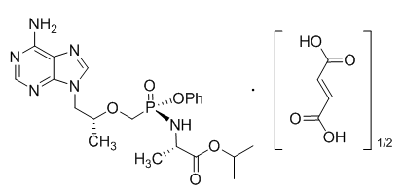

Tenofovir alafenamide is a prodrug of TFV. Tenofovir alafenamide fumarate is a white to off-white or tan powder with a solubility of 4.7 mg per mL in water at 20 °C. After absorption, TAF is converted to TFV intracellularly, which is phosphorylated to the active metabolite, tenofovir diphosphate (TFV-DP), which competes with natural 2’-deoxyadenosine triphosphate (dATP) for incorporation by the HIV-1 or HBV reverse transcriptase (RT) and, once incorporated, results in chain-termination.

TAF fumarate consists of tenofovir alafenamide free base and a half-molar equivalent of fumaric acid. Tenofovir alafenamide is metabolised by hydrolases including carboxyl esterase 1 and cathepsin A (CatA).Unlike tenofovir disoproxil fumarate (TDF, Viread), TAF is relatively stable in human plasma (t½ approximately 75 minutes), but rapidly converts to TFV inside cells.

#### Pharmacokinetics in healthy subjects

This section will provide data on the Pharmacokinetics of TAF. Previous assessments have provided details of the other components of the Genvoya FDC.

Following the dose selection of TAF 10 mg for the E/C/F/TAF FDC, a relative bioavailability study evaluating PK of TAF and TFV after single and multiple oral dosing of FTC+TAF 25 mg or E/C/F/TAF (Day 1 and Day 12) in healthy subjects (Table 2 and Table 3) was conducted (GS-US-292-0103). The mean TAF exposure following single and multiple dosing was comparable (Day 1 versus Day 12), and the mean TFV exposure following single dosing (AUCinf) was predictive of TFV multiple dose exposure (AUCtau). Additionally, statistical comparisons of TAF and TFV exposures following multiple-dose administration of E/C/F/TAF (test) and FTC+TAF 25 mg (reference) were conducted in Study GS-US-292-0103, demonstrating that the 90% CIs of the GLSM ratios for TAF and TFV exposure were within the predefined lack of effect boundary (Table 2 and Table 3) indicating comparability of TAF and TFV exposures following unboosted TAF 25 mg or boosted TAF 10 mg administration.

These data confirmed the dose selection of TAF 10 mg in the context of the E/C/F/TAF FDC, allowing for TAF and TFV exposures that are comparable with the exposures observed with the TAF 25 mg single agent.

Table 2. Single and multiple dose PK of TAF following administration of TAF as a single agent or as E/C/F/TAF in healthy subjects

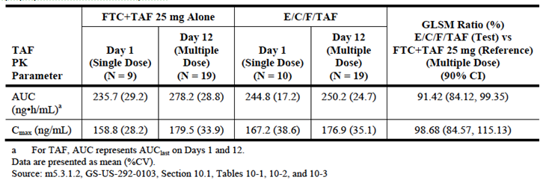

Table 3. Single and multiple dose PK of TAF following administration of TAF as a single agent or as E/C/F/TAF in health subjects

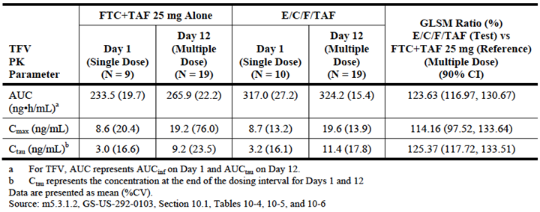

##### Absorption

###### Sites and mechanisms of absorption

TAF is transported by P-glycoprotein (P-gp) and subject to metabolism by esterases expressed in the intestine. Inhibition of P-gp by COBI reduces P-gp mediated TAF cycling across the brush border membrane of the intestine, thereby increasing the fraction of the TAF dose absorbed. Cumulative results from Studies GS-US-292-0103, GS-US-292-0101 and GS-US-311-0101 indicate that TAF exposure following a 10 mg dose (either as a single agent co administered with COBI 150 mg or as a component of E/C/F/TAF) was comparable with the exposure achieved following administration of TAF 25 mg alone.

##### Bioavailability

###### Absolute bioavailability

The bioavailability of TAF when administered alone is estimated to be ≤ 40%. TAF is transported by P-gp and metabolised by esterases expressed in the intestine. Intestinal P-gp cycles TAF, mediating metabolism of the prodrug by esterases. As such, drugs that strongly inhibit P-gp activity increase TAF availability.

Study GS-US-292-0103 was conducted to evaluate the pharmacokinetics and relative bioavailability of elvitegravir (EVG), cobicistat (COBI), emtricitabine (FTC), GS-7340 (TAF), and tenofovir (TFV) following the administration of a single tablet regimen (STR) containing a fixed-dose combination of EVG/COBI/FTC/GS-7340, and following administration of the STR components separately, in healthy subjects. The study was also conducted to evaluate the safety and tolerability of the EVG/COBI/FTC/GS-7340 STR compared with that of its individual components. The study produced results to indicate the relative bioavailability of the 10 mg dose of TAF with COBI 150 mg was equivalent to the 25 mg dose of TAF when administered without COBI 150 mg. For the E/C/F/TAF FDC tablet that contains TAF 10 mg, TAF bioavailability is increased approximately 2.3 fold, consistent with the exposure that occurs with the TAF 25 mg single agent (Table 4).

Table 4. Primary PK parameters of TAF, TFV, EVG, COBI and FTC following administration of E/C/F/TAF 10 mg, EVG+COBI, and EVG+TAF 25 mg. Statistical comparison between treatments

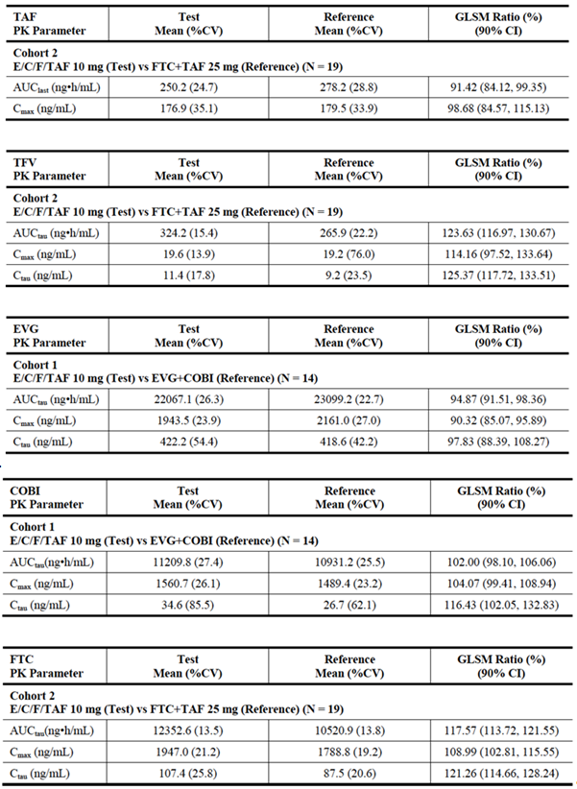

###### Bioequivalence of different dosage forms and strengths

TAF administered as a 10 mg dose with COBI 150 mg is equivalent to TAF administered as a 25 mg dose alone. In the Genvoya FDC, TAF is administered as a 10 mg dose in combination with COBI 150 mg.

###### Influence of food

The effect of food on the absorption/bioavailability of boosted TAF was evaluated when given as part of E/C/F/TAF (GS-US-292-0110) and the changes in TAF exposure upon E/C/F/TAF administration with food (versus fasted) are unlikely to be clinically relevant (approximately 15% and 18% higher AUC with light or high fat meal, respectively, versus fasted). It is recommended that Genvoya is administered with food once daily.

Following oral administration with food in HIV-1 infected patients, peak plasma concentrations were observed approximately 4 hours post-dose for elvitegravir; 3 hours post-dose for cobicistat, 3 hours post-dose for emtricitabine, and 1 hour post-dose for tenofovir alafenamide (see Table 5).

Table 5. Pharmacokinetic parameters of elvitegravir, cobicistat, emtricitabine, and tenofovir alafenamide exposure following oral administration in HIV infected adults

|  |  |  |  |  |
| --- | --- | --- | --- | --- |
| Parameter  Mean ± SD  (range: min:max) | Elvitegravira | Cobicistatb | Emtricitabineb | Tenofovir Alafenamidec |
| Cmax (mg/mL) | 1.7 ± 0.4 (0.4:3.7) | 1.1 ± 0.4 (0.1:2.1) | 1.9 ± 0.5 0.6:3.6) | 0.16 ± 0.08 (0.02:0.97) |
| AUCtau (mg/h/ mL) | 23.0 ± 7 (4.4:69.8) | 8.3 ± 3 (0.5:18.3) | 12.7 ± 4 (5.2:34.1) | 0.21 ± 0.15 (0.05:1.9) |
| Ctrough (mg/ mL) | 0.45 ± 0.26 (0.05:2.34) | 0.05 ± 0.13 (0.01:0.92) | 0.14 ± 0.25 (0.04:1.94) | NA |

SD = Standard Deviation; NA = Not Applicable a. From Population Pharmacokinetic analysis, N=419. b. From Intensive Pharmacokinetic analysis, N=61 to 62, except cobicistat Ctrough N=53. c. From Population Pharmacokinetic analysis, N=539

###### Dose proportionality

The main dose proportionality study conducted with TAF was in relation to a QT/QTc study in 48 healthy subjects, tenofovir alafenamide at the therapeutic dose or at a supratherapeutic dose approximately 5 times the recommended therapeutic dose did not affect the QT/QTc interval and did not prolong the PR interval.

###### Bioavailability during multiple dosing

Study GS-US-120-0104 evaluated the PK of TAF and TFV after single and multiple oral dosing of TAF 8, 25, or 40 mg monotherapy (Day 1 and Day 10) in HIV infected subjects. TAF exhibited linear PK and was rapidly absorbed in a dose proportional manner with a median t½ of approximately 0.40 hours. The PK exposure parameters of TAF were similar within each dose group following single and multiple dose administration, as expected given the short plasma half-life of TAF. Consistent with linear PK, TFV single dose exposures (AUCinf) were comparable with steady state exposures (AUCtau).

In healthy subjects, the mean TAF exposure following single and multiple dosing of FTC+TAF 25 mg or E/C/F/TAF (GS-US-292-0103) was comparable (Day 1 versus Day 12), while the mean TFV exposure following single dosing (AUCinf) was predictive of TFV multiple dose exposure (AUCtau). The metabolism of TAF provides > 4 fold higher intracellular levels of the active phosphorylated metabolite TFV-DP relative to TDF.

###### Effect of administration timing

There appears to be no specific effect of timing on administration of TAF. When taken in the FDC with food, timing of dosing does not have any clinical recommendation.

##### Distribution

###### Volume of distribution

The distribution of TAF into compartments other than plasma (eg, cerebrospinal fluid or genital tract secretions) has not been clinically evaluated.

###### Plasma protein binding

The protein binding of TAF in human plasma averaged 20% (range 14 to 23%) as determined in GS-US-120-0108 and GS-US-120-0114. In a human ADME study, following administration of an oral 25 mg dose of (14C) TAF in healthy subjects, the whole blood to plasma concentration ratio of 14C-radioactivity increased from 0.6 at 0.25 hours post dose to 2.4 at 216 hours post dose, suggesting a relatively slower clearance of 14C-radioactivity from blood cells relative to the plasma 14C-radioactivity time-course (GS-US-120-0109).

###### Tissue distribution

The distribution of TAF into compartments, other than plasma, has not been clinically evaluated. TAF is rapidly incorporated into PBMCs, spending very little time in plasma. As TAF is metabolised to tenofovir by Cat A, the level in plasma is very low, compared with TDF.

##### Metabolism

###### Interconversion between enantiomers

Not Applicable

###### Sites of metabolism and mechanisms / enzyme systems involved

Tenofovir alafenamide fumarate is subject to intracellular metabolism to TFV, which is further phosphorylated to the anabolites, TFV-MP and TFV-DP with TFV-DP being the pharmacologically active form. Intracellular metabolic activation of TAF in PBMCs or other lymphatic tissues involves conversion to TFV by cathepsin A (Cat A). In contrast to PBMCs, TAF is primarily hydrolysed by carboxylesterase 1 in primary hepatocytes. As lymphocytes are rich in CatA, most of the TAF will be converted in cells where its antiviral activity is required.

Of the HIV Protease Inhibitors (DRV, ATV, LPV and RTV), the boosting agent COBI, and HCV PIs (telaprevir, boceprevir, TMC-435, BI-201355, MK-5172, GS-9256, and GS-9451), the HCV PIs telaprevir and boceprevir, which are known to inhibit Cat A, were the only ones that changed the antiretroviral effect of TAF in primary CD4+ T lymphocytes (reduced 23 fold and 3 fold, respectively). These data support the co-administration of the tested therapeutic PIs, with the exception of telaprevir or boceprevir, in combination with TAF, without negatively affecting its clinical pharmacology and intracellular conversion to TFV. This will be relevant for treatment of HIV/HCV co-infected patients.

In vitro, TAF is not metabolised by CYP1A2, CYP2C8, CYP2C9, CYP2C19, CYP2D6, or uridine diphosphate glucuronosyl transferase (UGT) 1A1. TAF is minimally metabolised by CYP3A4. Upon co-administration with the moderate CYP3A inducer probe efavirenz (EFV), TAF exposure was unaffected. TAF is not an inhibitor of CYP1A2, CYP2B6, CYP2C8, CYP2C9, CYP2C19, CYP2D6, or UGT1A1. TAF is a weak inhibitor of CYP3A in vitro. TAF is eliminated following metabolism to its major metabolite TFV. TAF and TFV have a median plasma t½ of 0.51 and 32.37 hours, respectively. TFV is eliminated from the body by the kidneys by both glomerular filtration and active tubular secretion. Renal excretion of intact TAF is a minor pathway with less than 1% of the dose eliminated in urine. The pharmacologically active metabolite, TFV-DP, has a t½ of 150 to 180 hours within PBMCs.

###### Non-renal clearance

As above, less than 1% of TAF is excreted via renal clearance. The majority is metabolised to TFV where it is excreted via the kidneys.

###### Metabolites identified in humans

Active metabolites

TAF is eliminated following metabolism to its major metabolite TFV. TAF and TFV have a median plasma t½ of 0.51 and 32.37 hours, respectively. TFV is eliminated from the body by the kidneys by both glomerular filtration and active tubular secretion.

###### Pharmacokinetics of metabolites

The pharmacologically active metabolite, TFV-DP, has a t½ of 150 to 180 hours within PBMCs.

##### Excretion

###### Routes and mechanisms of excretion

Metabolism is a major elimination pathway for TAF in humans, accounting for > 80% of an oral dose. In vitro studies have shown that TAF is metabolised to TFV (major metabolite) by Cat A in PBMCs (including lymphocytes and other HIV target cells) and macrophages; and by carboxylesterase-1 in hepatocytes. In vivo, TAF is hydrolysed within PBMCs and macrophages to form TFV (major metabolite), which is phosphorylated to the active metabolite, TFV-DP. In human clinical studies, a 10 mg oral dose of TAF in E/C/F/TAF (Genvoya) resulted in TFV-DP concentrations > 4 fold higher in PBMCs and > 90% lower concentrations of TFV in plasma as compared to a 300 mg oral dose of TDF in STB.

TAF and TFV have a median plasma t½ of 0.51 and 32.37 hours, respectively. TFV is eliminated from the body by the kidneys by both glomerular filtration and active tubular secretion.

#### Pharmacokinetics in the target population

HIV disease status did not have an effect on TAF exposure in healthy and HIV infected subjects, and was not a statistically or clinically relevant covariate based on population PK analyses. A statistically significant effect of HIV disease status on TFV PK parameters was observed; however, the range of TFV exposures across healthy and HIV infected was comparable and the observed relationship between disease status and TFV exposure is therefore unlikely to be clinically relevant. One of the pivotal PK studies to determine the pharmacokinetics in the target population is GS-US-120-0104. This is a Phase I, randomised, partially-blinded, active and placebo controlled study of the safety, pharmacokinetics, and antiviral activity of GS-7340 (TAF) monotherapy in subjects with HIV-1.

Subjects were randomised in a 2:2:2:1:2 ratio to one of the following 5 treatment groups:

* Treatment Group 1: TAF 8 mg tablet
* Treatment Group 2: TAF 25 mg tablet
* Treatment Group 3: TAF 40 mg tablet
* Treatment Group 4: TDF 300 mg tablet
* Treatment Group 5: Placebo to match TAF tablet

Treatments 1, 2, 3 and 5 (TAF and matched placebo) were blinded, while Treatment 4 (TDF) was open label.

##### Study population

A total of 36 subjects were planned to be enrolled in this study. A total of 40 eligible subjects were randomised into the study. Two subjects were randomised and never dosed (1 subject each in the TAF 40 mg treatment group and placebo to match TAF treatment group). Nine subjects received TAF 8 mg, 8 subjects received TAF 25 mg, 8 subjects received TAF 40 mg, 6 subjects received open label TDF 300 mg, and 7 subjects received placebo to match TAF. A total of 37 subjects completed the study; 1 subject was lost to follow-up.

Of the 38 randomised and treated subjects, 37 (97.4%) were male, 20 (52.6%) were White, and 14 (36.8%) were Black. The mean age was 38 years (range: 20 to 57 years), the mean BMI was 26.8 kg/ m2 (range: 19.9 to 37.3 kg/ m2), and the mean eGFRCG was 118.2 mL/min (range: 64.2 to 173.9 mL/min).

##### Results

Following administration of TAF 8 mg, 25 mg, or 40 mg, TAF was rapidly absorbed with detectable levels at the first sampling time point (0.25 hours) and a median Tmax of approximately 0.50 hours. TAF t½ was approximately 0.40 hours and plasma concentrations were below the limit of quantitation (BLQ) by approximately 5 hours post dose. Pharmacokinetic exposure parameters of TAF were similar within each dose group following single and multiple-dose administration, as expected given the short plasma t½ of TAF. Following administration of TAF 8 mg, 25 mg, 40 mg, or TDF 300 mg (TFV equivalent dose of 4.8 mg, 15.1 mg, 24.1 mg, and 135.6 mg, respectively), the highest TFV plasma concentrations were observed when given as TDF. TFV plasma levels were greater within each dose group following multiple dosing, relative to single dose administration, indicating accumulation, and in general, single dose exposure (AUCinf) was comparable with steady state exposure (AUCtau).

Table6. Pharmacokinetic parameters of TAF (GS-US_120-0104)

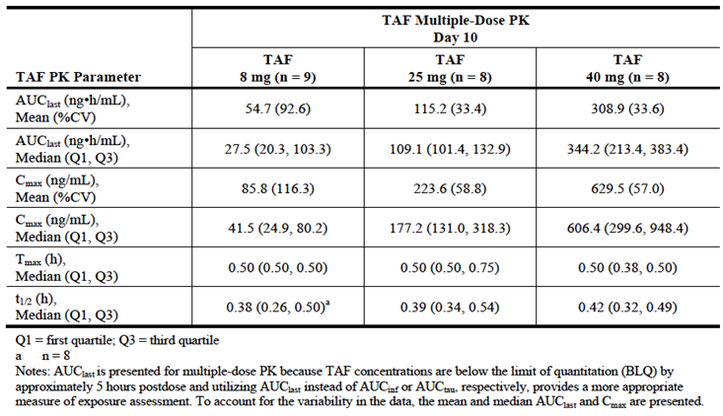

TFV exposure following administration of TDF 300 mg was consistent with historical data and substantially higher than when given as TAF. At steady state, following multiple dose administration of TAF 8 mg, 25 mg, or 40 mg, the mean TFV AUCtau values were 97%, 86%, and 79% lower respectively, while mean TFV Cmax values were 98%, 94%, and 89% lower, respectively, as compared with the mean TFV AUCtau and Cmax observed when dosed as TDF 300 mg. Peripheral blood mononuclear cell TFV-DP AUCtau was similar when given as TAF 8 mg or TDF 300 mg. Following multiple dose administration of TAF 25 mg and 40 mg, mean TFV-DP AUCtau values were approximately 7 fold and approximately 25 fold higher, relative to TDF 300 mg.

Peripheral blood mononuclear cell TFV-DP AUCtau was similar when given as TAF 8 mg or TDF 300 mg. Following multiple-dose administration of TAF 25 mg and 40 mg, mean TFV-DP AUCtau values were approximately 7 fold and approximately 25 fold higher, relative to TDF 300 mg.

Table 7. Pharmacokinetic parameters of TFV-DP (GS-US_120-0104)

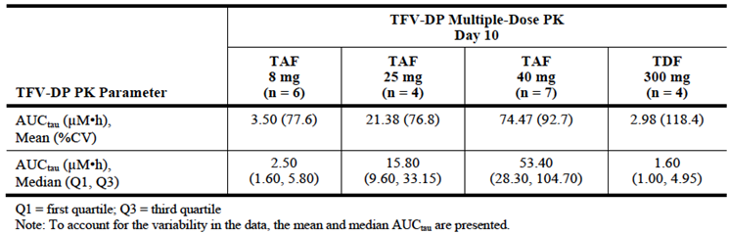

#### Pharmacokinetics in other special populations

##### Pharmacokinetics in subjects with impaired hepatic function

In subjects with mild hepatic impairment, the plasma exposure parameters of TAF were comparable (AUCinf, AUClast and Cmax were 7.52%, 8.17%, and 10.99% lower, respectively) relative to matched control subjects with normal hepatic function (GS-US-120-0114). The upper bounds of the 90% CIs were below the protocol defined clinically significant increase of 100% in TAF AUCinf, AUClast or Cmax for subjects with mild hepatic impairment compared with normal matched control subjects, and the observed decreases are not considered to be clinically relevant.

In subjects with moderate hepatic impairment, the plasma exposure parameters of TAF were comparable (AUCinf, AUClast, and Cmax were 12.69%, 15.06%, and 18.70% higher, respectively) relative to matched control subjects with normal hepatic function. The upper bounds of the 90% CIs were below the protocol defined clinically significant increase of 100% in TAF AUCinf, AUClast, or Cmax for subjects with moderate hepatic impairment compared with normal matched control subjects, and the observed increases are not considered to be clinically relevant. No clinically relevant differences in TAF or TFV PK were observed in subjects with mild to moderate hepatic impairment; therefore, no TAF dose adjustment is required in patients with mild to moderate hepatic impairment.

The effect of severe hepatic impairment on the PK of TAF has not been studied.

##### Pharmacokinetics in subjects with impaired renal function

No clinically relevant differences in TAF exposure was observed between healthy subjects and subjects with severe renal impairment, defined as having a calculated creatinine clearance (CLcr) of 15 ≤ CLcr ≤ 29 mL/min at screening (severe renal impairment group) (GS-US-120-0108). Calculated CLcr was determined using the Cockcroft-Gault formula (eGFRCG). Following screening procedures and baseline assessments (Day 0), eligible subjects in each of the 2 groups (severe renal impairment and control) received a single dose of TAF 25 mg (1 x 25 mg tablet) administered orally on Day 1. Enrolment of subjects in the control group began after the corresponding matched subject in the severe renal impairment group had completed PK assessments.

Subjects with severe renal impairment had a 1.9 fold higher TAF systemic exposure as assessed by AUCinf relative to subjects with normal renal function. This difference was not considered clinically relevant, as it is less than a 2 fold difference. Subjects with severe renal impairment had a 6.05 fold mean increase in systemic TFV exposure as assessed by AUCinf relative to subjects with normal renal function. The TFV exposure encountered in subjects with severe renal impairment in this study after a single dose of TAF 25 mg was within or below the range of TFV plasma exposures measured in other studies after administration of TDF 300 mg in subjects and patients with normal renal function.

**Comment**: The increase does not seem to be clinically relevant and may not need to be highlighted in the PI as this level is the same as that currently seen with the approved dose of TDF. The last sentence indicates that 25 mg of TAF is equivalent to 300 mg of TDF in relation to studies of TDF in subjects with renal impairment.

TAF plasma protein binding measured at 1 and 4 hours was similar between subjects with severe renal impairment and subjects with normal renal function (mean percent unbound was approximately 20% at 1 hour and approximately 14% at 4 hours in both groups). TFV plasma protein binding measured at 2 and 24 Hours was also similar between subjects with severe renal Plasma TFV exposure in subjects with mild-to-moderate renal impairment were within or below the range of TFV plasma exposure after administration of TDF 300 mg in both healthy, HIV-uninfected subjects and in HIV infected patients with normal renal function. Additionally, population PK analyses of TAF and TFV from pooled Phase I, II, and III study populations showed that baseline eGFR was not a statistically or clinically relevant covariate influencing TAF PK.

Table 8. Pharmacokinetic parameters for TAF and TFV after a single dose of TAF 25 mg on subjects with severe renal impairment or normal renal function

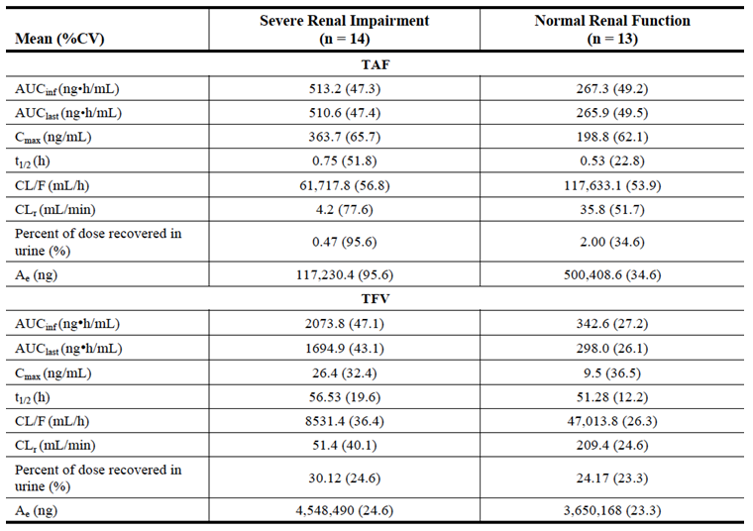

Table 9. Statistical comparison of TAF and TFV PK parameters in subjects with severe renal impairment or normal renal function

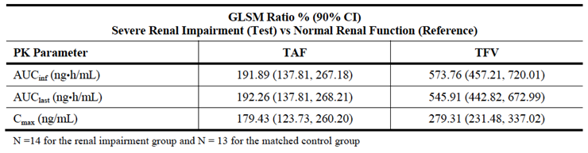

##### Pharmacokinetics according to age

The effect of age of paediatric subjects on the PK of TAF and TFV was assessed based on data from Study GS-US-292-0106, where E/C/F/TAF was administered to HIV infected, ART naive adolescents. TAF and TFV exposures were in the range of values observed in HIV infected, ART-naive adults following E/C/F/TAF administration, indicating no relevant effects of paediatrics (age > 12 years) on the exposure of TAF. Additionally, in the pooled Phase II and Phase III study populations used for TAF population PK analyses, HIV infected adolescent subjects had comparable TAF and TFV exposures versus HIV infected adult subjects, respectively, again confirming that age was not a clinically relevant covariate, at least in adolescents above 12 years of age.

##### Pharmacokinetics in other special population / according to other population characteristic

Population PK analyses indicated no statistically significant or clinically relevant influence on TAF exposure based on body size measures (body weight, body surface area, or body mass index (BMI), age (range 12 to 82 years), sex, race, eGFRCG, and population (healthy subjects versus treatment naive HIV subjects versus treatment experienced HIV subjects). A modest, statistically significant effect of race (Black versus non-Black) and sex on TFV PK parameters was observed. However, the range of TFV exposure across race and across males and females was comparable and, as such, these observed relationships are not considered to be clinically relevant.

#### Pharmacokinetic interactions

##### Pharmacokinetic interactions demonstrated in human studies

The potential for TAF and TFV to affect human CYP mediated drug metabolism was examined in vitro using hepatic microsomal fractions and enzyme-selective activities. The inhibitory activity of TAF with human liver microsomal CYP isozymes, CYP1A2, CYP2B6, CYP2C8, CYP2C9, CYP2C19, CYP2D6, and CYP3A were assessed at concentrations up to 25 µM. The inhibition constant (IC50) values calculated for CYP1A2, CYP2B6, CYP2C8, CYP2C9, CYP2C19, and CYP2D6 were greater than 25 µM. TAF weakly inhibited CYP3A-mediated oxidation of midazolam or testosterone with IC50 values of 7.6 and 7.4 µM, respectively. TFV at 100 µM did not inhibit CYP1A2, CYP2C9, CYP2D6, CYP2E1, and CYP3A.

The potential for TAF to be a mechanism-based inhibitor of the human CYP enzymes, CYP1A2, CYP2B6, CYP2C8, CYP2C9, CYP2C19 and CYP2D6 was assessed at TAF concentration at 50 µM (AD-120-2040). There was no evidence for time or cofactor dependent inhibition of any enzyme by TAF, with the maximum change in activity of 17.4% with CYP2C8 relative to control. Although TAF is a weak inhibitor of CYP3A, at clinically relevant concentrations, TAF is unlikely to affect hepatic CYP3A activity. While CYP3A activity may be affected in the intestine, where high levels of TAF can be achieved, the exposure to TAF in intestine should be transient and the potential for significant drug interaction is unlikely. In addition, since E/C/F/TAF contains COBI, a potent and specific CYP3A inhibitor, the effect caused by TAF, if any, is expected to be minimal. Moreover, any induction potential by TAF is countered by co administration with COBI.

TAF is transported by P-gp and metabolised by esterases expressed in the intestine. Intestinal P-gp cycles TAF, mediating metabolism of the prodrug by esterases. As such, drugs that strongly affect P-gp activity may lead to changes in TAF availability. However, upon co administration with COBI in E/C/F/TAF, near maximal inhibition of P-gp by COBI is achieved, leading to increased availability of TAF with resulting exposure comparable with TAF 25 mg single agent. As such, TAF exposure following administration of E/C/F/TAF is not expected to be further increased when used in combination with another P-gp inhibitor. This is supported by a clinical study with E/C/F/TAF and investigation agent GS-5816, a P-gp inhibitor, which showed no clinical relevant changes in TAF or TFV upon co administration of E/C/F/TAF with GS-5816, relative to E/C/F/TAF alone (GS-US-342-1167). Because TAF was found to be a substrate for hepatic transporters organic anion transporting polypeptide (OATP) B1 and OATP1B3, exposure to TAF may be affected by inhibitors of OATP1B1 and OATP1B3 or by genetic polymorphisms affecting their transport activities. The effects of differences in OATP1B1 and OATP1B3 activity are, however, not expected to be clinically relevant given the high passive permeability of TAF.

Co administration of TAF single agent with a modest CYP inducer, such as EFV, resulted in slightly lower TAF exposure (14% to 22%) and a commensurate lowering of TFV exposure (GS-US-311-0101). As such, administration of E/C/F/TAF with a modest CYP3A inducer may result in lower TAF exposure. However, the magnitude of change in TAF and TFV would be expected to be less following E/C/F/TAF due to the presence of the potent CYP3A inhibitor COBI.

###### Sertraline

Study GS-US-292-1316. Interaction between E/C/F/TAF and sertraline 50 mg. This study was conducted with 20 healthy adults. E/C/F/TAF was administered for 12 days and sertraline was administered as a single dose. Intensive plasma PK samples for PK analysis of EVG, COBI, FTC, TAF, TFV, and SER were collected prior to and following dosing on Days 1, 13, and 14 at the following time points: 0 (pre dose), 5 minutes, 15 minutes, and 0.5, 0.75, 1, 1.5, 2, 3, 3.5, 4, 5, 6, 8, 12, 16, and 24 hours post dose. Following the co administration of E/C/F/TAF and SER, no clinically relevant alterations in the PK of EVG, COBI, FTC, TAF, TFV, or SER were observed relative to the administration of E/C/F/TAF or SER alone. The 90% CIs for the relevant PK parameters of EVG, COBI, FTC, TAF, TFV, and SER were within the protocol-specified no PK alteration boundary of 70% to 143%, indicating the lack of a cytochrome P450-mediated drug interaction upon co administration of E/C/F/TAF and SER. Overall, the exposures of all analytes following E/C/F/TAF and/or SER were consistent with historical data. Based on these study results, no dose adjustment is needed when co administrating E/C/F/TAF and SER.

###### Sofosbuvir

Study GS-US-342-116. A Phase I study to determine the pharmacokinetic interactions between the sofosbuvir FDC. To evaluate the pharmacokinetics (PK) of sofosbuvir (SOF) with Atripla (ATR; efavirenz/emtricitabine/tenofovir disoproxil fumarate (EFV/FTC/TDF)), (emtricitabine/rilpivirine/tenofovir disoproxil fumarate (FTC/RPV/TDF)), (dolutegravir (DTG)), or elvitegravir/cobicistat/emtricitabine/tenofovir alafenamide fumarate EVG/COBI/FTC/TAF. For this assessment only the group administered the FDC containing TAF will be described. This cohort of healthy adults received SOF/GS-5816 (1 x 400 mg/100 mg tablet, once daily) plus EVG/COBI/FTC/TAF (1 x EVG 150 mg/COBI 150 mg/FTC 200 mg/TAF 10 mg tablet, once daily) administered in the morning with a moderate fat meal. Individual subject concentration data and individual subject PK parameters for each analyte were listed and summarised using descriptive statistics. To evaluate the PK impact of antiretroviral medications on SOF/GS-5816 and vice versa, natural log-transformed AUCtau, Cmax, and Ctau of each analyte was compared when co administered (that is, test treatments) versus when dosed alone (that is, reference treatments). A parametric (normal theory) analysis of variance (ANOVA) using a mixed effects model appropriate was fitted to the natural logarithmic transformation of PK parameters for each analyte of interest. Ninety percent confidence intervals (CIs) were constructed for the ratio of geometric means of PK parameters for each analyte of interest and treatment pair of interest. The majority of subjects were White (83.3%, 85 subjects) and Hispanic or Latino (88.2%, 90 subjects), with more males than females (59.8% male, 61 subjects), which was reflected in each cohort. Subjects had a mean (standard deviation (SD)) age of 35 (7.4) years (range: 19 to 45 years) and a mean (SD) BMI of 26.3 (2.49) kg/ m2. An increase in SOF AUC (37%) and GS-331007 AUC (48%) and Ctau (58%) were observed when administered with EVG/COBI/FTC/TAF. A small decrease in TAF Cmax (20%) was observed with no decrease in AUCtau following co administration of EVG/COBI/FTC/TAF with SOF/GS-5816. Based on the safety and PK data, SOF/GS-5816 may be co administered with EVG/COBI/FTC/TAF without dose adjustment to any of the agents.

### Evaluator’s overall conclusions on pharmacokinetics

The drug for which the sponsor seeks approval is tenofovir alafenamide fumarate (TAF). This compound is intended as a replacement component for tenofovir disoproxil fumarate (TDF) in the STR which is currently approved as the QUAD or Stribild. The other three components of this STR (EVG/COBI/FTC) have been extensively assessed and approved, both individually and in combination. Their formulations and dosages in the applicant STR will remain the same as in Stribild. TAF is a prodrug of tenofovir which is metabolised intracellularly by Cathepsin A (Cat A) to tenofovir diphosphate, the form that has anti-viral activity. The reason the sponsor is applying to replace TDF with TAF is that TDF has higher and more prolonged plasma circulating levels of tenofovir which is associated with an increased risk of renal and bone toxicity. The PK studies submitted by the sponsor indicate that TAF at a dose of 10 mg in the STR (boosted by COBI) or 25 mg (un boosted) have a circulating level of tenofovir that is 90% less than the current dose of TDF 300 mg, which is the approved dose component of Stribild. The sponsor has submitted an extensive number of studies to support this application which indicate that the pharmacokinetics of TAF are not affected by race, mild to moderate hepatic failure, renal failure or age (for teenagers more than 12 years of age). Specifically the clinical trial with Japanese subjects GS-US-292-0108 demonstrated no PK effect of Japanese origins. PK studies conducted as a part of the pivotal efficacy/safety clinical trial, GS-US-292-0104 and GS-US-0111 show that the AUCtau of E/C/F/TAF was 91% lower than tenofovir exposure compared with E/C/F/TDF and the PBMC AUC tau was 4.1 times higher with administration of E/C/F/TAF compared with E/C/F/TDF.

Figure 2. Plasma TVF and Intracellular TFV-DP

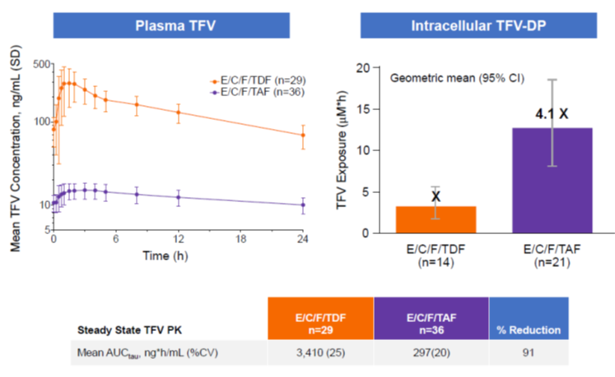

There are limited data on subjects of advanced ages. All studies in healthy subjects and in the target populations have been designed and analysed according to standardised procedures and all data are available for assessment. There are no specific interactions between TAF and other drugs commonly used by patients with HIV, although there are many drug interactions associated with the Genvoya FDC. These are primarily due to the COBI component and have been described in detail in previous assessments of the QUAD (Stribild) (PM-2011-03533-3-2) and of COBI. As TAF is not available as a single agent and the sponsor has applied for TAF to be included only as a component of the FDC, the evaluator did not consider the interaction of TAF, as a single agent, with other HIV antiretroviral agents. It is the opinion of the evaluator that the sponsor has adequately covered issues of the PK of TAF in the dossier.

## Pharmacodynamics

### Studies providing pharmacodynamic data

Summaries of the pharmacodynamic studies were provided. Table 10 shows the studies relating to each pharmacodynamic topic.

Table 10. Submitted pharmacodynamic studies

| PD Topic | Subtopic | Study ID | Primary Drug |
| --- | --- | --- | --- |
| Primary Pharmacology | Effect on antiviral activity | GS-US-120-1101 | TAF |
| Effect on Antiviral activity of escalating doses | GS-US-120-0104 | TAF |
| Secondary Pharmacology | Effect on QTcF | GS-US-120-0107 | TAF |
| Population PD and PK-PD analyses | Healthy subjects | GS-US-292-0103  GS-US-292-0108  GS-US-292-0110 |  |
| Target population‡§ | GS-US-292-0102  GS-US-292-0106  GS-US-292-0104  GS-US-292-0109  GS-US-292-0111  GS-US_292-0112 |  |

§ Subjects who would be eligible to receive the drug if approved for the proposed indication. ‡ And adolescents if applicable.

None of the pharmacodynamic studies had deficiencies that excluded their results from consideration.

### Summary of pharmacodynamics

The information in the following summary is derived from conventional pharmacodynamic studies in humans unless otherwise stated.

#### Mechanism of action

Tenofovir alafenamide fumarate (TAF) is a second generation oral prodrug of tenofovir that compared to TDF, delivers increased intracellular levels of tenofovir diphosphate (TFV-DP) allowing for a reduction in circulating tenofovir exposure. TAF is expected to provide enhanced delivery of tenofovir to peripheral blood mononuclear cells (PBMCs), resulting in higher intracellular levels of the active phosphorylated moiety tenofovir diphosphate, more effective suppression of residual viral replication in a wider range of reservoir and anatomic sanctuaries of HIV, and lower systemic circulating levels of tenofovir, resulting in a better overall profile. TAF displayed mean anti-HIV activity (EC50) of 0.008 µM, 0.0031 µM, and 0.014 µM in MT-2 cells, PBMCs and macrophages, respectively. In contrast, tenofovir DF displayed corresponding values of 0.050 µM, 0.015 µM, and 0.055 µM, and tenofovir 4.8 µM, 1.9 µM, and 1.4 µM, respectively. The CC50 for GS-7340 (83 µM) and TDF (95 µM) were comparable. These indicate that the in vitro activity of TAF against HIV-1 in MT-2 cells is 600 fold greater than tenofovir and 6 fold greater than TDF. Unlike TDF, TAF is stable in plasma, but is rapidly converted to tenofovir inside peripheral blood mononuclear cells (PBMCs) and MT-2 cells. TAF is metabolised to TFV, a nucleotide analogue (that is, a nucleoside monophosphate analogue) which is not dependent on an intracellular nucleoside kinase activity for the first step in the conversion to the active metabolite, TFV diphosphate (TFV-DP). The cellular enzymes responsible for TFV metabolism to the active di phosphorylated form are adenylate kinase (AK) and nucleotide diphosphate kinase, which are highly active and ubiquitous. AK exists as multiple isozymes (AK1 to AK4), with the phosphorylation of TFV mediated most efficiently by AK2. The intracellular metabolism of TAF and TFV (each 10 µM) in intact MT-2 cells indicated that after a two hour incubation, only 2% of TAF remained intact and the formation of TFV-DP continued to increase for up to 24 hours. At 24 hours, the intracellular concentration of TFV-DP was approximately 2.6 mM after incubation with 10 µM TAF, as compared to approximately 1.2 µM after incubation with 10 µM TFV {2944}. The intracellular levels of TFV-DP are consistent with the 600 fold enhancement in anti-HIV activity in cell culture of TAF over TFV. Metabolism of TAF was studied in different human blood lymphocyte subpopulations, CD4+ and CD8+ T-cells, NK cells, B-cells and macrophages/monocytes. Following incubation with GS-7340, all lymphocyte subpopulations demonstrate significant uptake of radioactivity ranging from 3.0 nmol/mln for monocytes to 1.7 nmol/mln for B-cells. Concentration of the active metabolite TFV-DP was substantial in all cell populations, ranging from 0.29 nmol/mln for NK-cells to 0.81 nmol/mln for CD8+-lymphocytes.

GS-7340 is metabolised inside host cells to the active metabolite TFV-DP. The Ki of TFV-DP for reverse transcription (RNA directed DNA synthesis) is 0.02 µM, more than 200 fold lower than its Ki for human DNA polymerase α, and more than 3,000 fold lower than its Ki values for human DNA polymerases β and γ.

#### Pharmacodynamic effects

##### Primary pharmacodynamic effects

TAF is a phosphonoamidate prodrug of TFV (2’-deoxyadenosine monophosphate analogue). TAF is permeable into cells and due to increased plasma stability and intracellular activation by Cat A, TAF is more efficient than TDF in loading TFV into peripheral blood mononuclear cells (PBMCs) (including lymphocytes, macrophages, and other HIV target cells). Intracellular TFV is subsequently phosphorylated to the pharmacologically active metabolite TFV-DP. TFV-DP inhibits HIV replication through incorporation into viral DNA by the HIV reverse transcriptase, which results in DNA chain termination.

TFV has activity that is specific to HIV-1 and HIV-2 and hepatitis B virus (HBV). In vitro studies have shown that both FTC and TFV can be fully phosphorylated when combined in cells. TFV-DP is a weak inhibitor of mammalian DNA polymerases that include mitochondrial DNA polymerase γ and there is no evidence of toxicity to mitochondria in vitro.

The bioavailability of TAF when administered alone is estimated to be ≤ 40%, based on dog and human hepatic extraction data. TAF is transported by P-glycoprotein (P-gp) and metabolised by esterases expressed in the intestine. Intestinal P-gp cycles TAF, mediating metabolism of the prodrug by esterases, so drugs that strongly inhibit P-gp activity increase TAF availability. Upon co administration of TAF with COBI single agent, near maximal inhibition of P-gp by COBI is achieved, leading to increased availability of TAF (Study GS-US-311-0101). For the E/C/F/TAF FDC tablet that contains TAF 10 mg, TAF bioavailability is increased approximately 2.3 fold, consistent with the exposure that occurs with the TAF 25 mg single agent (Study GS-US-292-0103). Following the administration of the E/C/F/TAF FDC tablet, the exposures of EVG, COBI, and FTC were equivalent to those observed following administration of EVG, COBI, or FTC single agents at the same dosages and consistent with those observed historically following administration of STB (Study GS-US-292-0103).

##### Secondary pharmacodynamic effects

HIV disease status did not have an effect on TAF exposure in healthy and HIV infected subjects, and was not a statistically or clinically relevant covariate based on population PK analyses. A statistically significant effect of HIV disease status on TFV PK parameters was observed; however, the range of TFV exposures across healthy and HIV infected was comparable and the observed relationship between disease status and TFV exposure is therefore unlikely to be clinically relevant.

#### Relationship between drug concentration and pharmacodynamic effects

Based on PK/PD analysis for efficacy parameters TAF 25 mg is expected to provide near-maximal activity (HIV-1 RNA decreases of approximately 1.7 to 1.8 log10 copies/mL). Phase II data in Study GS-US-292-0102 with TAF 10 mg in the E/C/F/TAF FDC demonstrated efficacy, based on high proportions of subjects with plasma HIV-1 RNA < 50 copies/mL. The E/C/F/TAF FDC was shown to be effective with a favourable safety and tolerability profile in Phase III studies (GS-US-292-0104, GS-US-292-0111, GS-US-292-0109, GS-US-292-0112, and GS-US-292-0106).

Study GS-US-120-0104, following monotherapy treatment of once daily administration of TAF 8, 25, 40 mg, or TDF 300 mg, the mean (± SD) DAVG11 was -0.67 ± 0.265, -0.94 ± 0.254, -1.14 ± 0.226, and -0.45 ± 0.340 log10 copies/mL, respectively. Mean (± SD) changes from baseline at Day 11 in HIV-1 RNA of -0.98 ± 0.464, -1.50 ± 0.412, and -1.74 ± 0.190 log10 copies/mL were observed following TAF 8, 25, or 40 mg treatment, respectively, as compared with a change of -0.81 ± 0.580 log10 copies/mL with TDF 300 mg (Figure 3). Mean viral load declines for both the TAF 25 mg and 40 mg doses were statistically greater than for the 8 mg dose.

Figure 3. GS-US-120-0104: Median (Q1, Q3) of changes from baseline in HIV-1 RNA (log10 copies/mL) by visit (full analysis set)

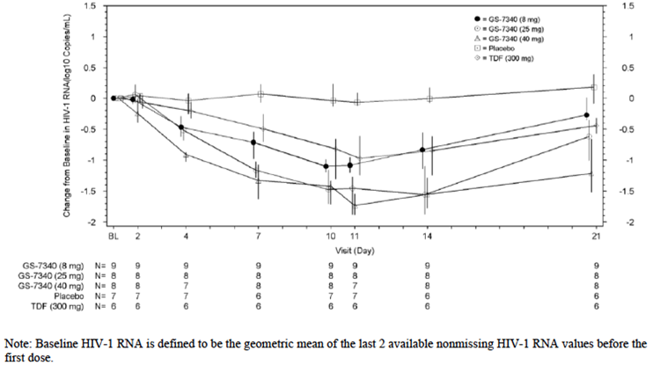

Moreover, TAF PK/PD analyses evaluating TAF exposure versus response in the 2 pivotal Phase III studies (GS-US-292-0104, GS-US-292-0111) using results from the FDA snapshot algorithm showed uniformly high virologic success across the quartile categories of TAF AUCtau with no trends in exposure response relationship observed, confirming the dose selection of TAF 10 mg for the E/C/F/TAF FDC that provides equivalent exposure as TAF 25 mg single agent.

#### Genetic, gender and age related differences in pharmacodynamic response

There appears to be no specific genetic, gender and age related differences in pharmacodynamic effects.

#### Pharmacodynamic interactions

The potential for TAF and TFV to affect human CYP-mediated drug metabolism was examined in vitro using hepatic microsomal fractions and enzyme-selective activities. The inhibitory activity of TAF with human liver microsomal CYP isozymes, CYP1A2, CYP2B6, CYP2C8, CYP2C9, CYP2C19, CYP2D6, and CYP3A were assessed at concentrations up to 25 µM. The inhibition constant (IC50) values calculated for CYP1A2, CYP2B6, CYP2C8, CYP2C9, CYP2C19, and CYP2D6 were greater than 25 µM. TAF weakly inhibited CYP3A-mediated oxidation of midazolam or testosterone with IC50 values of 7.6 and 7.4 µM, respectively. TFV at 100 µM did not inhibit CYP1A2, CYP2C9, CYP2D6, CYP2E1, and CYP3A. The potential for TAF to be a mechanism-based inhibitor of the human CYP enzymes, CYP1A2, CYP2B6, CYP2C8, CYP2C9, CYP2C19 and CYP2D6 was assessed at TAF concentration at 50 µM (AD-120-2040). There was no evidence for time- or cofactor-dependent inhibition of any enzyme by TAF, with the maximum change in activity of 17.4% with CYP2C8 relative to control. Although TAF is a weak inhibitor of CYP3A, at clinically relevant concentrations, TAF is unlikely to affect hepatic CYP3A activity. While CYP3A activity may be affected in the intestine, where high levels of TAF can be achieved, the exposure to TAF in intestine should be transient and the potential for significant drug interaction is unlikely. In addition, since E/C/F/TAF contains COBI, a potent and specific CYP3A inhibitor, the effect caused by TAF, if any, is expected to be minimal. Moreover, any induction potential by TAF is countered by co administration with COBI.

### Evaluator’s overall conclusions on pharmacodynamics

TAF showed broad anti HIV activity in human PBMCs against all HIV-1 groups and potent antiviral activity against HIV-2. TAF also has shown potent antiviral activity against HIV-1 isolates resistant to other ARV drug classes (that is, NNRTI-R, PI-R and INSTI-R mutants and combination NRTI-R + NNRTI-R or NRTI-R + NNRTI-R + PI-R mutants).

The PK/PD profiles of E/C/F/TAF and its components have been well established in HIV-1 infected subjects and certain special populations. No clinically relevant differences in the PK/PD of the E/C/F/TAF FDC were observed with respect to demographic variables. The PK/PD of the individual components of E/C/F/TAF in adolescents were consistent with the range of exposures associated with antiviral activity of E/C/F/TAF in adults, which supports the extrapolation of efficacy data from paediatrics to adult subjects and the use of E/C/F/TAF in patients > 12 years.

Based on PK/PD analysis for efficacy parameters, the exposure associated with TAF 25 mg (or ECFTAF 10 mg) is expected to provide near maximal activity.

## Dosage selection for the pivotal studies

The dose for the pivotal studies was the approved FDC Stribild as the comparator with the same components as the approved FDC, with TAF 10 mg substituted for TDF 300 mg in Stribild.

The proposed commercial E/C/F/TAF FDC tablet contains EVG 150 mg, COBI 150 mg, FTC 200 mg, and TAF 10 mg. The 150 mg dose of EVG is 1 of the 2 marketed doses of the product as a single agent (85 mg is the other dose). The 150 mg boosting dose of COBI is the marketed dose of COBI as a single agent, and the dose associated with boosting of the 150 mg dose of EVG. The 200 mg dose of FTC represents the marketed dose.

Cumulative assessment of exposure: response data from proof of concept Study GS-US-120-0104 indicated that TAF 25 mg exposure provided potent and near maximal antiviral activity. Relative to TDF 300 mg, TAF 25 mg demonstrated no loss in efficacy, but 90% reduction in TFV plasma levels that potentially translates into an improvement in off-target side effects. Pharmacokinetic data from Studies GS-US-292-0101 and GS-US-311-0101 indicated that TAF exposure from an 8 to 10 mg dose in combination with COBI (single agent or as E/C/F/TAF) were comparable with that from TAF 25 mg administered alone. Cumulative results from Studies GS-US-120-0104, GS-US-292-0101, and GS-US-311-0101 were used in selecting a 10 mg TAF dose for clinical development within the E/C/F/TAF FDC.

## Clinical efficacy

Studies for the treatment of HIV-1 infection in adults and paediatric patients 12 years of age and older.

Primary efficacy endpoints:

The primary efficacy endpoint for the pivotal Phase III studies in ART naive (Studies GS-US-292-0104 and GS-US-292-0111) and virologically suppressed subjects (Study GS-US-292-0109) was the proportion of subjects who achieved HIV-1 RNA < 50 copies/mL at Week 48; this endpoint is also presented for the Phase II study in ART-naive subjects (Study GS-US-292-0102), and for subjects with mild to moderate renal impairment (Study GS-US-292-0112). For adolescents (Study GS-US-292-0106), for subjects with mild to moderate renal impairment (Study GS-US-292-0112), and for the switch subjects in Study GS-US-292-0102, the proportion of subjects who achieved HIV-1 RNA < 50 copies/mL at Week 24 was the primary efficacy endpoint.

Additional endpoints presented in this summary are outlined in Table 11.

Table 11. Efficacy endpoints included in this summary by study

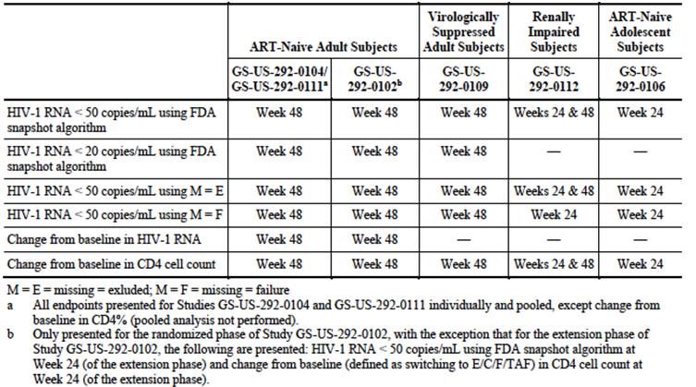

### Pivotal efficacy studies

Studies GS-US-292-0104 and GS-US-292-0111.

These studies have been pooled as the design, study population and analysis framework are the same. The aim of these studies is to demonstrate that the FDC with TAF is equivalent to the FDC with TDF.

#### Study design, objectives, locations and dates

##### Study GS-US-292-0104

###### Design

A Phase III, randomised, double blind study to evaluate the safety and efficacy of elvitegravir/cobicistat/emtricitabine/tenofovir alafenamide versus elvitegravir/cobicistat/ emtricitabine/tenofovir disoproxil fumarate in HIV-1 positive, antiretroviral treatment naive adults.

###### Objectives

Study GS-US-292-0104 was conducted to evaluate the efficacy and safety of a fixed dose combination (FDC) tablet containing elvitegravir (EVG; E)/cobicistat (COBI; C)/emtricitabine (FTC; F)/tenofovir alafenamide (TAF) (E/C/F/TAF) versus an FDC tablet containing EVG/COBI/FTC/tenofovir disoproxil fumarate (TDF) (Stribild; STB) in HIV infected, antiretroviral treatment (ART) naive adult subjects.

The primary objective of this study was as follows:

* To evaluate the efficacy of an FDC tablet containing E/C/F/TAF versus STB in HIV infected, ART naive adult subjects as determined by the achievement of HIV-1 RNA < 50 copies/mL at Week 48.

The secondary objectives of this study were as follows:

* To determine the safety of the 2 treatment regimens as determined by the percentage change from baseline in hip and spine bone mineral density (BMD) at Week 48
* To determine the safety of the 2 treatment regimens as determined by the change from baseline in serum creatinine at Week 48
* To evaluate the safety and tolerability of the 2 treatment regimens through Week 48
* To evaluate the efficacy, durability, safety and tolerability of the 2 treatment regimens through Week 96.

###### Study sites and study period

Subjects were enrolled in a total of 120 study sites: 82 in the United States (US), 9 in Spain, 8 in Canada, 6 in Thailand, 5 in Australia, 3 in Switzerland, 2 in Austria, 2 in Belgium, 1 in Italy, 1 in Japan, and 1 in the United Kingdom.

Study period: First subject screened 26 December 2012, last subject observation 26 August 2014.

##### Study GS-US-292-0111

###### Design

A Phase III, randomised, double blind study to evaluate the safety and efficacy of elvitegravir/cobicistat/emtricitabine/tenofovir alafenamide versus elvitegravir/cobicistat/emtricitabine/tenofovir disoproxil fumarate in HIV-1 positive, antiretroviral treatment-naive adults.

###### Objectives

Study GS-US-292-0111 was conducted to evaluate the efficacy and safety of a fixed dose combination (FDC) tablet containing elvitegravir (EVG; E)/cobicistat (COBI;C)/emtricitabine (FTC; F)/tenofovir alafenamide (TAF) (E/C/F/TAF) versus an FDC tablet containing EVG/COBI/FTC/tenofovir disoproxil fumarate (TDF) (Stribild; STB) in HIV infected, antiretroviral treatment (ART) naive adult subjects.

The primary objective of this study was as follows:

* To evaluate the efficacy of an FDC tablet containing E/C/F/TAF versus STB in HIV infected, ART naive adult subjects as determined by the achievement of HIV-1 RNA < 50 copies/mL at Week 48.

The secondary objectives of this study were as follows:

* To determine the safety of the 2 treatment regimens as determined by the percentage change from baseline in hip and spine BMD at Week 48
* To determine the safety of the 2 treatment regimens as determined by the change from baseline in serum creatinine at Week 48
* To evaluate the safety and tolerability of the 2 treatment regimens through Week 48
* To evaluate the efficacy, durability, safety and tolerability of the 2 treatment regimens through Week 96.

###### Study sites and study period

Study centres: Subjects were enrolled in a total of 121 study sites: 82 in the United States (US), 10 in the United Kingdom, 9 in France, 5 in Canada, 4 in Italy, 4 in Portugal, 2 in Mexico, 2 in Netherlands, 2 in Sweden, and 1 in Dominican Republic.

Study Period: First subject screened 12 March 2013. Last subject observation 19 September 2014.

#### Inclusion and exclusion criteria

GS-US-292-0104 and GS-US-292-0111 inclusion criteria:

##### Inclusion criteria

Subjects who met all of the following criteria were eligible for participation in the study:

* The ability to understand and sign a written informed consent form, which was obtained prior to initiation of study procedures
* Plasma HIV-1 RNA levels ≥ 1000 copies/mL at screening
* No prior use of any approved or investigational antiretroviral (ARV) drug for any length of time, except the use for PrEP (pre exposure prophylaxis) or PEP (post exposure prophylaxis), up to 6 months prior to screening
* Screening genotype report must have shown sensitivity to EVG, FTC, and TDF
* Normal electrocardiogram (ECG; or if abnormal, determined by the investigator to be not clinically significant)
* eGFRCG ≥ 50 mL/min
* Hepatic transaminases (aspartate aminotransferase (AST) and alanine aminotransferase (ALT)) ≤ 5 x upper limit of normal (ULN)
* Total bilirubin ≤ 1.5 mg/dL or normal direct bilirubin
* Adequate hematologic function (absolute neutrophil count ≥ 1000/mm3; platelets ≥ 50,000/mm3; haemoglobin ≥ 8.5 g/dL)
* Serum amylase ≤ 5 x ULN (subjects with serum amylase > 5 x ULN were eligible if serum lipase was ≤ 5 x ULN).

Females of childbearing potential agreed to utilise highly effective contraception methods or be non-heterosexually active or practice sexual abstinence from screening throughout the duration of study drugs and for 30 days following the last dose of study drug.

* Female subjects who utilised hormonal contraceptive as one of their birth control methods must have used the same method for at least 3 months prior to study dosing
* Female subjects who had stopped menstruating for ≥ 12 months but did not have documentation of ovarian hormonal failure must have had a serum follicle stimulating hormone (FSH) level at screening within the postmenopausal range based on the central laboratory reference range
* Male subjects agreed to utilise a highly effective method of contraception during heterosexual intercourse or be non-heterosexually active, or practiced sexual abstinence from screening throughout the study period and for 30 days following discontinuation of investigational medicinal product
* Age ≥ 18 years.

##### Exclusion criteria

Exclusion criteria for Studies GS-US-292-0104 and GS-US-292-0111: Subjects with any of the following were not eligible for participation in the study:

* A new AIDS-defining condition diagnosed within the 30 days prior to screening
* Hepatitis B surface antigen positive
* Hepatitis C antibody positive
* Subjects experiencing decompensated cirrhosis (eg, ascites, encephalopathy)
* Females who were breastfeeding
* Positive serum pregnancy test
* Had an implanted defibrillator or pacemaker
* Current alcohol or substance use judged by the investigator to potentially interfere with subject study compliance
* A history of malignancy within the past 5 years (prior to screening) or ongoing malignancy other than cutaneous Kaposi sarcoma (KS), basal cell carcinoma, or resected, non-invasive cutaneous squamous carcinoma. Subjects with cutaneous KS were eligible, but must not have received any systemic therapy for KS within 30 days of baseline and must not have been anticipated to require systemic therapy during the study
* Active, serious infections (other than HIV-1 infection) requiring parenteral antibiotic or antifungal therapy within 30 days prior to baseline
* Any other clinical condition or prior therapy that, in the opinion of the investigator, would have made the subject unsuitable for the study or unable to comply with dosing requirements
* Participation in any other clinical trial (including observational trials) without prior approval from the sponsor was prohibited while participating in this trial
* Subjects receiving ongoing therapy with any medications in the table below, including drugs not to be used with EVG, COBI, FTC, TDF (refer to the individual agents prescribing information), and TAF (refer to the investigator’s brochure); or subjects with any known allergies to the excipients of STB or E/C/F/TAF.

#### Study treatments

Studies GS-US-292-0104 and GS-US-292-0111.

Treatment groups and subject numbers were identical for both studies:

Treatment Group 1: FDC tablet of EVG 150 mg/COBI 150 mg/FTC 200 mg/TAF 10 mg + placebo to match STB once daily.

Treatment Group 2: FDC tablet of EVG 150 mg/COBI 150 mg/FTC 200 mg/TDF 300 mg + placebo to match E/C/F/TAF once daily.

#### Efficacy variables and outcomes

The main efficacy variables were:

* The proportion of patients who had ˂ 50 copies per mL of HIV-1 RNA at the 48 week window (anytime between days 294 and 377). The analysis was based on a non-inferiority between the study therapy and the comparator at a level of ˂ 12%
* Secondary efficacy endpoints evaluated for the Week 48 analysis included the proportion of subjects with HIV-1 RNA < 20 copies/mL, change from baseline in CD4 count, pure virologic response with HIV-1 RNA cut-off at 50 copies/mL, change from baseline in log10 HIV-1 RNA, and change from baseline in CD4%.

#### Randomisation and blinding methods

GS-US-292-0104 and GS-US-292-0111.

Subjects were randomised in a 1:1 ratio. Randomization was stratified by HIV-1 RNA level (˂ 100,000 copies/mL, ≥ 100,000 to ≤ 400,000 copies/mL, or ≥ 400,000 copies/mL); CD4 count (< 50 cells/µL, 50 to 199 cells/µL, or ≥ 200 cells/µL), and region (US versus ex-US) at screening.

#### Analysis populations

##### GS-US-292-0104

Subject Disposition: In this study, 1,105 subjects were screened, 872 subjects were randomised, and 867 subjects received at least 1 dose of study drug (E/C/F/TAF 435 subjects; STB 432 subjects); 3 subjects randomised to E/C/F/TAF and 2 subjects randomised to STB did not receive study drug.

A total of 813 subjects (E/C/F/TAF 94.9%, 413 subjects; STB 92.6%, 400 subjects) were continuing study drugs as of the Week 48 data cut date. Of the 867 subjects randomised and treated, 54 subjects (6.2%) discontinued study drugs (E/C/F/TAF 5.1%, 22 subjects; STB 7.4%, 32 subjects) and 48 subjects (5.5%) discontinued from the study prior to the Week 48 data cut date (E/C/F/TAF 4.8%, 21 subjects; STB 6.3%, 27 subjects). The reasons for premature discontinuation of study drugs were generally comparable between study groups. The most common reasons for discontinuation of study drugs were withdrawal of consent (E/C/F/TAF 1.8%, 8 subjects; STB 1.6%, 7 subjects), lost to follow-up (E/C/F/TAF 1.1%, 5 subjects; STB 2.1%, 9 subjects), and AE (E/C/F/TAF 0.9%, 4 subjects; STB 1.4%, 6 subjects).

Demographic and general baseline characteristics were similar between the 2 treatment groups. The majority of subjects were male (85.4% overall). The median age was 33 years (range: 18 to 74) in the E/C/F/TAF group and 35 years (range: 18 to 76) in the STB group (p = 0.014). The most common races were White (58.2%), Black (20.2%), and Asian (17.6%), and most subjects were not Hispanic or Latino (85.0%). The median (first quartile (Q1), third quartile (Q3)) value for BMI at baseline was 24.3 (21.7, 27.7) kg/ m2 (Table 12).

Table 12. GS-US-292-0104: Demographic and baseline characteristics (Safety Analysis Set)

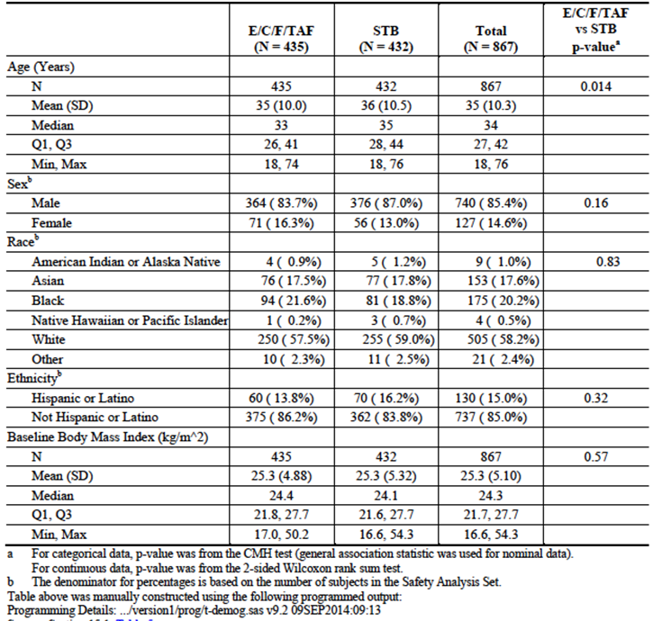

Baseline disease characteristics were generally similar between the 2 treatment groups. Overall, the median (Q1, Q3) baseline HIV-1 RNA value was 4.61 (4.16, 4.97) log10 copies/mL. At baseline, 76.9% of subjects had HIV-1 RNA ≤ 100,000 copies/mL, 17.4% had > 100,000 to ≤ 400,000 copies/mL, and 5.7% had > 400,000 copies/mL. Overall, median (Q1, Q3) baseline CD4 count was 404 (289, 554) cells/µL. At baseline, 2.5% (22 subjects) had a CD4 cell count < 50 cells/µL and 10.3% (89 subjects) had 50 to < 200 cells/µL. The most common HIV risk factor category was homosexual sex (74.7% of subjects); 23.9% of subjects reported heterosexual sex as the mode of infection. The majority of subjects (93.4%) had asymptomatic HIV-1 infection; 4.4% had symptomatic HIV-1 infection, and 2.2% were diagnosed with AIDS. At baseline, the median (Q1, Q3) eGFRCG value was slightly higher in the E/C/F/TAF group (118.5 (101.6, 135.7) mL/min) compared with the STB group (112.8 (97.8, 134.2) mL/min) (p = 0.031). Similar results were obtained using the eGFR CKD-EPI, creatinine formula. Values for eGFR CKD-EPI, cysC were similar between the 2 treatment groups. Seventy nine subjects (9.1%) had proteinuria (Grade 1, 2, or 3 by dipstick) on urinalysis. Overall, 14.6% of subjects had a medical history of hypertension, 10.6% had a medical history of hyperlipidaemia, 3.2% had a medical history of diabetes, and 2.0% had a medical history of cardiovascular disease (Table 13).

Table13. GS-US-292-0104: Baseline disease characteristics (safety analysis set)

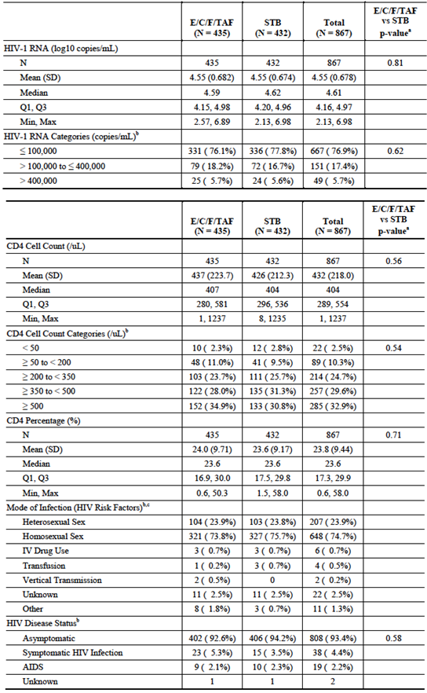

Table 13 (continued). GS-US-292-0104: Baseline disease characteristics (safety analysis set)

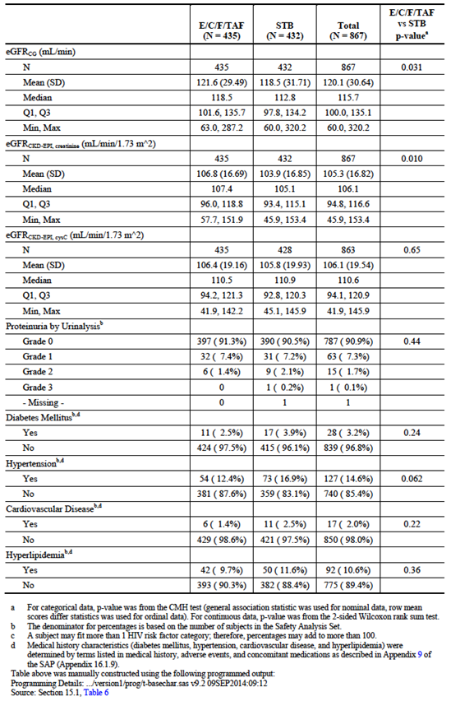

##### GS-US-292-0111

Subject Disposition: In this study 1,070 subjects were screened, 872 subjects were randomised, and 866 subjects received at least 1 dose of study drug (E/C/F/TAF 431 subjects; STB 435 subjects); 4 subjects randomised to E/C/F/TAF and 2 subjects randomised to STB did not receive study drug. A total of 804 subjects (E/C/F/TAF 94.7%, 408 subjects; STB 91.0%, 396 subjects) were continuing study drugs as of the Week 48 data cut date. Of the 866 subjects randomised and treated, 62 subjects (7.2%) discontinued study drugs (E/C/F/TAF 5.3%, 23 subjects; STB 9.0%, 39 subjects) and 46 subjects (5.3%) discontinued from the study prior to the Week 48 data cut-off date (E/C/F/TAF 4.2%, 18 subjects; STB 6.4%, 28 subjects). The reasons for premature discontinuation of study drugs were generally balanced between study groups. The most common reasons for discontinuation of study drugs were lost to follow-up (E/C/F/TAF 2.3%, 10 subjects; STB 2.1%, 9 subjects), withdrawal of consent (E/C/F/TAF 0.9%, 4 subjects; STB 2.1%, 9 subjects), and AE (E/C/F/TAF 0.9%, 4 subjects; STB 1.4%, 6 subjects).

#### Subject demographics and baseline disease characteristics

Demographic and general baseline characteristics were similar between the 2 treatment groups. The majority of subjects were male (84.6% overall) (Table 14). The median age was 33 years (range: 18 to 66) in the E/C/F/TAF group and 34 years (range: 18 to 71) in the STB group (p = 0.049). The most common races were White (55.2%), black (30.1%), and other (10.5%), and most subjects were not Hispanic or Latino (76.2%). The median (first quartile (Q1), third quartile (Q3)) value for body mass index at baseline was 24.7 (22.1, 28.2) kg/ m2. Baseline disease characteristics were generally similar between the 2 treatment groups. Overall, the median (Q1, Q3) baseline HIV-1 RNA value was 4.55 (4.12, 4.94) log10 copies/mL. At baseline, 77.9% of subjects had baseline HIV-1 RNA ≤ 100,000 copies/mL, 17.3% had > 100,000 to ≤ 400,000 copies/mL and 4.7% had > 400,000 copies/mL. Overall, the median (Q1, Q3) CD4 count was 406 (284, 536) cells/mL. Overall, 3.4% (29 subjects) had a baseline CD4 cell count < 50 cells/µL and 10.3% (89 subjects) had 50 to < 200 cells/µL. The most common HIV risk factor category was homosexual sex (74.9% of subjects); 25.6% of subjects reported heterosexual sex as the mode of infection. The majority of subjects (89.9%) had asymptomatic HIV-1 infection; 5.8% had symptomatic HIV-1 infection, and 4.3% were diagnosed with AIDS. At baseline, the median (Q1, Q3) eGFRCG value was similar in the E/C/F/TAF group (115.9 (98.4, 135.6) mL/min) compared with the STB group (114.7 (99.6, 133.4) mL/min).

Similar results were obtained using the eGFR CKD-EPI, creatinine and eGFR CKD-EPI, cysC formulas. Ninety five subjects (11.0%) had proteinuria (Grade 1 or 2 by dipstick) on urinalysis. Overall, 15.8% of subjects had a medical history of hypertension, 11.5% had a medical history of hyperlipidaemia, 4.3% had a medical history of diabetes, and 0.9% had a medical history of cardiovascular disease (Table 15).

Table14. GS-US-292-0111: Demographic and baseline characteristics (safety analysis set)

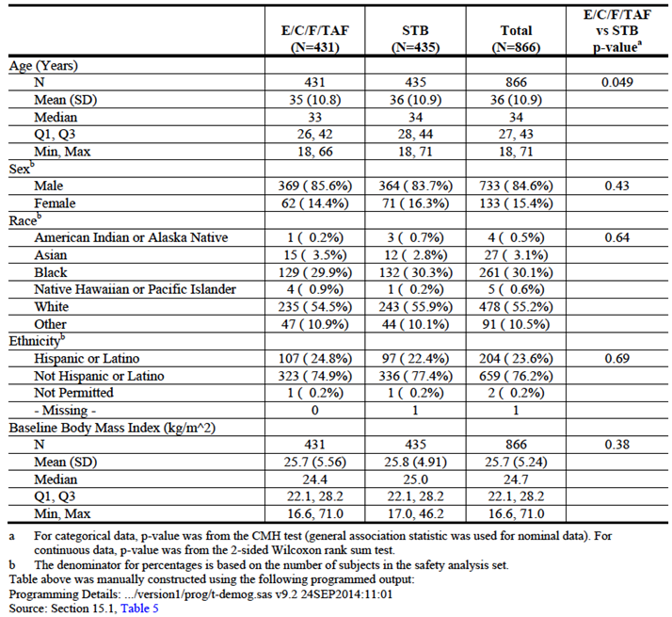

Table15. GS-US-292-0111: Baseline disease characteristics (safety analysis set)

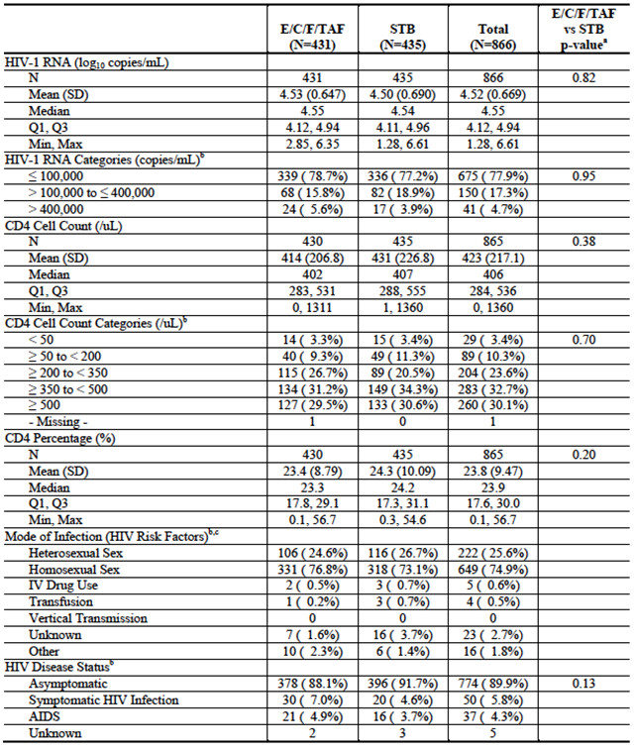

Table 15 (continued). GS-US-292-0111: Baseline disease characteristics (safety analysis set)

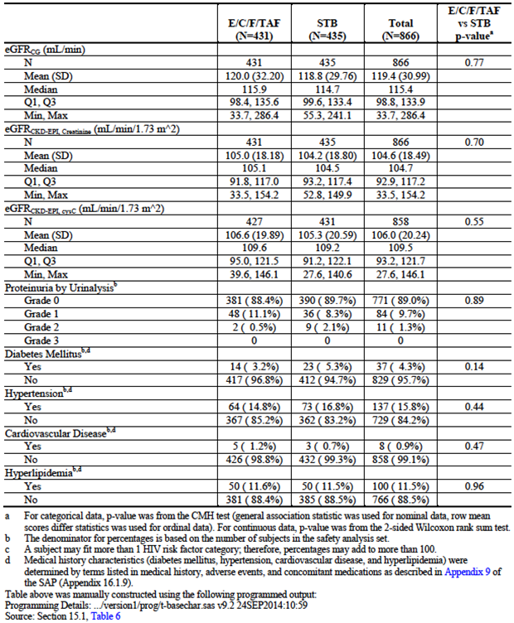

#### Sample size

##### GS-US-292-0104

A total sample size of 840 subjects randomised in a 1:1 ratio to 2 groups (420 subjects per group) was planned to achieve at least 95% power to assess a non-inferiority margin of 12% in Week 48 response rate (HIV-1 RNA < 50 copies/mL as defined by the FDA snapshot algorithm) difference between the 2 groups. For sample size and power computation, it was assumed that both treatment groups had a response rate of 0.85 (based on Study GS-US-292-0102), that the non-inferiority margin was 0.12, and that the significance level of the test was at a 1-sided alpha level of 0.025.

The sample size of 420 subjects in each group provided 98% power to demonstrate that E/C/F/TAF had a 1% less decrease at Week 48 in hip and spine BMD than STB. In this power assessment, it was assumed that the standard deviation (SD) for percentage BMD change was 3.5% (based on Study GS-99-903) and that a 2 sided t test would be conducted at an alpha level of 0.05.

The sample size of 420 subjects in each group provided 93% power to demonstrate that E/C/F/TAF had 0.03 mg/dL less increase at Week 48 in serum creatinine than STB. In this power assessment, it was assumed that the common SD for change from baseline in serum creatinine was 0.12 mg/dL (based on Study GS-US-292-0102) and that a 2 sided t test would be conducted at an alpha level of 0.05.

##### GS-US-292-0111

A total sample size of 840 subjects randomised in a 1:1 ratio to 2 groups (420 subjects per group) was planned to achieve at least 95% power to assess a non-inferiority margin of 12% in Week 48 response rate (HIV-1 RNA < 50 copies/mL as defined by the FDA snapshot algorithm) difference between the 2 groups. For sample size and power computation, it was assumed that both treatment groups had a response rate of 0.85 (based on Study GS-US-292-0102), that the non-inferiority margin was 0.12, and that the significance level of the test was at a 1 sided alpha level of 0.025.

The sample size of 420 subjects in each group provided 98% power to demonstrate that E/C/F/TAF had a 1% less decrease at Week 48 in hip and spine BMD than STB. In this power assessment, it was assumed that the standard deviation (SD) for percentage BMD change was 3.5% (based on Study GS-99-903) and that a 2 sided t test would be conducted at an alpha level of 0.05.

The sample size of 420 subjects in each group provided 93% power to demonstrate that E/C/F/TAF had 0.03 mg/dL less increase at Week 48 in serum creatinine than STB. In this power assessment, it was assumed that the common SD for change from baseline in serum creatinine was 0.12 mg/dL (based on Study GS-US-292-0102) and that a 2 sided t test would be conducted at an alpha level of 0.05.

**Comment:** Inferiority margin calculations: If the confidence interval for the difference between the test and control treatments can exclude that the degree of inferiority of the test treatment is not greater than the non-inferiority margin, then the test treatment can be declared non-inferior. ICH E10 guideline states that the margin chosen for a non-inferiority trial cannot be greater than the smallest effect size that the active drug would be reliably expected to have compared with placebo in the setting of the planned trial. ICH E10 further states that the determination of the margin in a non-inferiority trial should be based on both statistical reasoning and clinical judgement, and should reflect uncertainties in the evidence on which the choice is based, and should be suitably conservative.

Ref: Guideline on the choice of the non-inferiority margin (CHMP); London, 27 July 2005. EMEA/CPMP/EWP/2158/99.

As can be seen from the above sample size descriptions they are the same, which supports the sponsor’s analysis that combines these studies into a single clinical trial efficacy report. These sample size descriptions were extracted directly from the sponsor submitted clinical trial reports.

#### Statistical methods

Efficacy: The primary efficacy analysis used the full analysis set (FAS), which included all subjects who (1) were randomised into the study and (2) received at least 1 dose of study medication. The primary efficacy analysis was the assessment of non-inferiority of E/C/F/TAF compared with STB with respect to the proportion of subjects with HIV-1 RNA < 50 copies/mL at Week 48 as defined by the FDA snapshot algorithm. Non inferiority was assessed using a conventional 95% confidence interval (CI) approach, with a non-inferiority margin of 12%. For each interim analysis performed by the independent data monitoring committee (IDMC) at Weeks 12 and 24, an alpha of 0.00001 was spent. Therefore, the significance level for the 2 sided test in the primary analysis at Week 48 was 0.04998 (corresponding to 95.002% CI). The 95% CI was constructed using Mantel-Haenszel (MH) proportion stratified by baseline HIV‑1 RNA level (≤ 100,000 or > 100,000 copies/mL) and region (US versus ex-US) and normal approximation.

If non inferiority of E/C/F/TAF was established, superiority testing was conducted between treatments using the same 95.002% CI. If the lower bound of the 95.002% CI was greater than 0, superiority of E/C/F/TAF over STB was established. Supporting analyses of the primary endpoint included a Week 48 per protocol (PP) analysis to evaluate the robustness of the primary analysis, and subgroup analyses to assess treatment differences between pre specified subgroups (that is, age, sex, race, baseline HIV-1 RNA level, baseline CD4 cell count, region and study drug adherence). The secondary efficacy endpoint of proportion of subjects with HIV-1 RNA < 20 copies/mL at Week 48 was analysed in the same manner using the FDA snapshot algorithm, except that CIs were constructed at the 95% level.

The changes from baseline in CD4 cell count at Week 48 were summarised by treatment group using descriptive statistics based on both observed data and imputed data using last observation carried forward (LOCF). The differences in changes from baseline in CD4 cell count between treatment groups and the associated 95% CI were constructed using analysis of variance (ANOVA) model, including baseline HIV-1 RNA level (≤ 100,000 or > 100,000 copies/mL) and region (US versus ex-US) as fixed effects. Time to PVF at Week 48 was analysed using the Kaplan-Meier method by treatment group. The log rank test was performed to compare the difference between the 2 treatment groups stratified by baseline HIV-1 RNA level (≤ 100,000 or > 100,000 copies/mL) and region (US versus ex-US).

The HIV-1 RNA strata were reclassified by baseline HIV-1 RNA level (≤ 100,000 or > 100,000 copies/mL) for stratified statistical analysis. To avoid small or missing cells in analysis strata, CD4 cell count was not stratified in analysis because HIV-1 RNA and CD4 cell count was highly correlated, and balanced distribution between treatment groups was expected following CD4 cell count stratified randomization. Similarly, the number of subjects in the HIV-1 RNA > 400,000 copies/mL stratum was very small; therefore, this stratum was combined with HIV-1 RNA > 100,000 to 400,000 copies/mL stratum to form a 2 level HIV-1 RNA stratification in the analysis.

#### Participant flow

Figure 4 summarises patient flow across all centres in GS-US-292-0104 and 0111.

Figure 4. Patient flow – studies GS-US-292-0104 and GS-US-292-0111

Figure 4. Patient flow – studies GS-US-292-0104 and GS-US-292-0111
2175 patients screened 1105 instudy 104 and 1070 in study 111
866 randomly assigned to recieve E/C/F/TAF (435 in study 104 and 431 in study 111) of these 45 discontinued (8 adverse event, 1 died, 2 lack of efficicy, 12 withdrew consent, 15 lost to follow up, 2 non-compliance, 5 protocol violation) and 821 continued through to at least week 48
867 randomly assigned to recieve E/C/F/TDF (432 in study 104, 435 in study 111) of these 71 discontinued (13 adverse event, 2 died, 7 investigator discretion, 3 lack of efficacy, 16 withdrew consent, 18 lost to follow up, 5 pregnancy, 1 non-compliance, 6 protocol violation) and 796 continued through to at least week 48.

Patient flow is the same for GS-US-292-0104 and 0111.

Figure 5. Patient Schema – studies GS-US-292-0104 and GS-US-292-0111

Figure 5. Patient Schema – studies GS-US-292-0104 and GS-US-292-0111
Sreening less than or equal to 30 days prior to Baseline.
 Baseline Day1 Week 48 Primary Endpoint. Week 96 Unblinding at end of 30 day follow up after week 96
Treatment  Arm 1. E/C/F/TAF QD + E/C/F/TDF placebo QD (N = 420)
Treatment Arm 2. E/C/F/TDF QD + E/C/F/TAF placebo QD (N = 420)

a Following the Baseline visit, subjects will return for study visits at Weeks 2, 4, 8, 12, 16, 24: and then every 12 weeks through to Week 96. b Subjects will continue to attend visits every 12 weeks following Week 96 until treatment assignment is unblinded. c Once Gilead Sciences provides unblinded treatment assignments to the Investigators, all subjects will return to the clinic (preferably within 30 days) for an Unblinding Visit. At the Unblinding Visit all subjects will discontinue their blinded study drug and will be given an option to participate in an open-label rollover study. Subjects who do not wish to participate in the open-label rollover study will discontinue their blinded study drug and will return for a 30 Day Follow-up visit following the Unblinding Visit. d Subjects who have discontinued study drug prior to the Unblinding Visit will not be eligible for the open-label rollover study; these subjects will be asked to continue attending the scheduled study visits through the Unblinding Visit and discontinue the study after the Unblinding Visit. e The E/C/F/TAF STR tablet and matching placebo will be administered orally, one tablet, once daily with food at approximately the same time each day. E/C/F/TDF STR tablets and matching placebo will be administered orally, one tablet, once daily, with food at approximately the same time each day.

#### Major protocol violations/deviations

For GS-US-292-0104 there were a total of 299 important protocol deviations (IPDs) reported for 228 individual subjects during the study. Of the 228 subjects, 175 had 1 important deviation, 37 subjects had 2 important deviations, 15 subjects had 3 important deviations, and 1 subject [Information redacted] had 4 important deviations. Relevant protocol deviations were proportionally distributed between treatment groups and study centres. The majority of the IPDs (182 of 299) were for subjects who were not managed according to protocol specified assessments or procedures related to repeat testing of laboratory abnormalities. The majority of laboratory issues considered IPDs were due to failure to reassess an abnormality in dipstick proteinuria within 14 days of the original result. In addition, IPDs were also issued for violations of inclusion/exclusion criteria. Many of these were due to lack of documented INSTI resistance testing in subjects from Thailand, a laboratory issue that arose due to non-amplification of HIV-1 viruses of the A/E subtype commonly seen in Thailand.

For GS-US-292-0111 total of 320 IPDs were reported for 246 individual subjects during the study. Of the 246 subjects, 186 subjects had 1 important deviation, 47 subjects had 2 important deviations, 12 subjects had 3 important deviations, and 1 subject [Information redacted] had 4 important deviations. Relevant protocol deviations were proportionally distributed between treatment groups and study centres. The majority of the IPDs (221 of 320) were for subjects who were not managed according to protocol specified assessments or procedures related to repeat testing of laboratory abnormalities. The majority of laboratory issues considered IPDs were due to failure to reassess an abnormality in dipstick proteinuria within 14 days of the original result. After blinded review by the Gilead medical monitor, it was concluded that none of these IPDs affected the overall quality or interpretation of the interim Week 48 study data.

#### Baseline data

Table 16. Baseline characteristics for studies GS-US-292-0104 and GS-US-292-0111

|  | Elvitegravir, cobicistat, emtricitabine, tenofovir alafenamide (n=866) (GS-US-292-0111) | Elvitegravir, cobicistat, emtricitabine, tenofovir disoproxil fumarate (n=867) (GS-US-292-0104) |
| --- | --- | --- |
| Age (years) | 33 (26 to 42) | 35 (28 to 44) |
| Women | 133 (15%) | 127 (15%) |
| **Ethnic origin** | | |
| White | 485 (56%) | 498 (57%) |
| Black or African heritage | 223 (26%) | 213 (25%) |
| Hispanic or Latino | 167 (19%) | 167 (19%) |
| Asian | 91 (11%) | 89 (10%) |
| **HIV disease status** | | |
| Asymptomatic | 780 (90%) | 802 (93%) |
| Symptomatic | 53 (6%) | 35 (4%) |
| AIDS | 30 (4%) | 26 (3%) |
| **HIV risk factor** | | |
| Heterosexual sex | 210 (24%) | 219 (25%) |
| Homosexual sex§ | 652 (75%) | 645 (74%) |
| Intravenous drug use | 5 (1%) | 6 (1%) |
| Median HIV-1 RNA (log10c/mL) | 4·58 (4·04–4·95) | 4·58 (4·15–4·96) |
| HIV-1 RNA concentration >100 000 copies per mL | 196 (23%) | 195 (22%) |
| Median CD4 count (cells per µL) | 404 (283–550) | 406 (291–542) |
| **Number with CD4 cell count (cells per µL)** | | |
| < 50 | 24 (3%) | 27 (3%) |
| ≥ 50 to < 200 | 88 (10%) | 90 (10%) |
| ≥ 200 | 753 (87%) | 750 (87%) |
| Median estimated glomerular filtration rate (Cockcroft-Gault; mL/min) | 117 (100–136) | 114 (99–134) |
| Median BMI (kg/ m2) | 24·4 (22·0–28·0) | 24·5 (21·7–28·0) |

Data are median (IQR) or n (%).

#### Results for the primary efficacy outcome

The primary efficacy outcome is the proportion of patients with a plasma HIV-1RNA ˂ 50 copies per ml at the 48 week interim analysis time period. The sponsor has determined that the two pivotal efficacy studies should be combined as the design, conduct and sample population are comparable. The design is a non-inferiority statistical comparison set at a non-inferiority margin of 12%. Subjects who had ˂ 50 copies per mL of HIV-1 RNA between Days 294 and 377 (Week 48 window) were classified as successes. At 48 weeks E/C/F/TAF was non inferior to E/C/F/TDF at 800 out of 866 (92%) versus. 784 out of 867 (90%). The results were almost the same for GS-US-292-0104 with 93% E/C/F/TAF versus 92% E/C/F/TDF, difference (95% CI) 1% (‑2.6 to 4.5) and GS-US-292-0111 with 92% E/C/F/TAF versus 89% E/C/F/TDF, difference (95% CI) 3.1% (‑1.0 to 7.1). The failure rate in both groups was 4% with failure defined as patients missing HIV-1 RNA data for the week 48 analysis; those who discontinued study drug or those who changed treatment before the week 48 analysis. This proportion of viral suppression is amongst the highest for an HIV cohort.

This overall result in selected subgroups was comparable for patients:

* with a baseline HIV-1 RNA viral load of ≤ 100,000 copies per mL (E/C/F/TAF 94% versus E/C/F/TAD 91%; 0.2 to 6.0) versus. ≥ 100,000 copies per mL (E/C/F/TAF 87% versus. E/C/F/TDF 89%; 8.3 to 4.8). There appears to be a significant difference between groups depending on baseline HIV-1 RNA viral load with the E/C/F/TAF treated cohort having a higher proportion of patients with < 50 copies per mL if the baseline HIV-1 RNA viral load was < 100,000 copies per mL
* with a baseline CD4 count of ˂ 200 cells per µL (E/C/F/TAF 86% versus. E/C/F/TDF 89%; ‑13.8 to 5.3) versus. ≥ 200 cells per µL (E/C/F/TAF 93% versus. E/C/F/TDF 91%; -0.0 to 5.6). It was also noted that the mean increase in CD4 count in the E/C/F/TAF group of 230 cells per mL (SD 177.3) versus. E/C/F/TDF group of 211 cells per mL. This is a difference of 19 cells per mL, 95% CI; 3 to 36 cells; p = 0.024
* with a baseline ˂ 50 years of age (92% versus. 90%; -1.0 to 4.8) versus. ≥ 50 years of age (94% versus. 91%; -5.2 to 12.2)
* male (92% versus 91%; -1.8 to 4.0) versus female (95% versus. 87%; 0.2 to 15.6)
* non Black (94% versus. 93%; -1.5 to 4.1) versus Black (88% versus. 83%; -1.8 to 83%).

While these results were not the primary outcomes, they add to the validity of the overall result and support the conclusion that E/C/F/TAF is equivalent to E/C/F/TDF.

Figure 6. Comparison of primary efficacy outcomes; studies GS-US-292-0104 and GS-US-292-0111

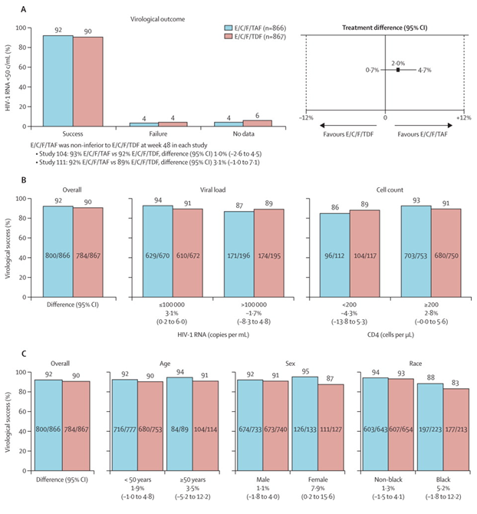

#### Results for other efficacy outcomes

Studies GS-US-292-0104 and GS-US-292-0111:

Secondary efficacy endpoints included the proportion of subjects with HIV-1 RNA < 20 copies/mL, change from baseline in CD4 count, pure virologic response with HIV-1 RNA cut off at 50 copies/mL, change from baseline in log10 HIV-1 RNA, and change from baseline in CD4%.

Further results relating to the secondary outcomes of virological failure is development of resistance indicate equivalence between E/C/F/TAF and E/C/F/TDF as follows:

* Of the 866 patients in the E/C/F/TAF group 7 (0.8%) were classified as virological failures compared with the E/C/F/TDF group where of the 867 patients; 5 (0.6%) were classified as virological failures.

##### Study GS-US-292-0104

In Study GS-US-292-0104, virologic outcomes at Week 48 were similar between the 2 treatment groups when assessed using the FDA defined snapshot algorithm (HIV-1 RNA < 20 copies/mL) based on the FAS. Virologic success rates were high in both groups, as follows: E/C/F/TAF 86.4%; STB 87.3%; difference in percentages: -0.6%, 95% CI: -5.1% to 3.8%. Percentages of subjects with virologic failure (and reasons for failure) were similar for the 2 treatment groups (E/C/F/TAF 9.9%; STB 7.9%).

Virologic success rates at Week 48 were similar using the PP Analysis Set, as follows: E/C/F/TAF 91.1 %, 368 of 404 subjects; STB 92.4%, 367 of 397 subjects; difference in percentages: -1.4%, 95% CI: -5.2% to 2.4%.

In Study GS–US-292-0104 CD4 cell counts increased for each treatment group in the FAS, based on observed data (that is, M = E). Mean (SD) baseline CD4 cell counts were as follows: E/C/F/TAF 437 (223.7) cells/µL; STB 426 (212.3) cells/µL. The mean (SD) increases were similar for each treatment group through Week 48 (observed data) based on the FAS, as follows: E/C/F/TAF 235 (183.1) cells/µL; STB 222 (178.0) cells/µL; difference in LSM: 12 cells/µL, 95% CI: -13 to 37 cells/µL. Results at Week 48 for the PP Analysis Set were consistent with the results for the FAS. The change from baseline in CD4 cell counts using LOCF to impute missing values showed similar trends compared with the observed data. Mean (SD) increases from baseline at Week 48 were as follows: E/C/F/TAF 231 (183.1) cells/µL; STB 220 (177.0) cells/µL; difference in LSM: 11 cells/µL, 95% CI: -13 to 35 cells/µL.

##### Study GS-US-292-0111

In Study GS-US-292-0111, virologic outcomes at Week 48 were similar between the 2 treatment groups when assessed using the FDA defined snapshot algorithm (HIV-1 RNA < 20 copies/mL) based on the FAS. Virologic success rates were high in both groups, as follows: E/C/F/TAF 82.4%; STB 80.7%; difference in percentages: 1.4%, 95% CI: -3.7% to 6.5%.

Percentages of subjects with virologic failure (and reasons for failure) were similar for the 2 treatment groups (E/C/F/TAF 13.9%; STB 13.8%).

Virologic success rates at Week 48 were similar using the PP Analysis Set, as follows: E/C/F/TAF 87.7 %, 348 of 397 subjects; STB 87.2%, 342 of 392 subjects; difference in percentages: -0.2%, 95% CI: -4.7% to 4.3%.

In Study GS-US-292-0111 CD4 cell counts increased for each treatment group in the FAS, based on observed data (that is, M = E) (Figure 4). Mean (SD) baseline CD4 cell counts were as follows: E/C/F/TAF 414 (206.8) cells/µL; STB 431 (226.8) cells/µL. The mean (SD) increases from baseline at Week 48 (observed data) based on the FAS were greater for the E/C/F/TAF group compared with the STB group, as follows: E/C/F/TAF 225 (171.2) cells/µL; STB 200 (162.5) cells/µL; difference in LSM 27 cells/µL, 95% CI: 4 to 50 cells/µL; p = 0.019. Results at Week 48 for the PP Analysis Set were consistent with the results for the FAS.

The change from baseline in CD4 cell counts using LOCF to impute missing values showed similar trends compared with the observed data. Mean (SD) increase from baseline at Week 48 (LOCF) was greater for the E/C/F/TAF group compared with the STB group, as follows: E/C/F/TAF 224 (174.7) cells/µL; STB 195 (165.0) cells/µL; difference in LSM 30 cells/µL, 95% CI: 7 to 53 cells/µL; p = 0.009.

#### Study GS-US-292-0109

##### Study design, objectives, locations and dates

Study GS-US-292-0109 was conducted to evaluate the efficacy, safety, and tolerability of switching to a fixed dose combination (FDC) tablet of elvitegravir (EVG;E)/cobicistat (COBI; C)/emtricitabine (FTC; F)/tenofovir alafenamide (TAF) (E/C/F/TAF) from regimens containing tenofovir disoproxil fumarate (TDF) in virologically suppressed human immunodeficiency virus type 1 (HIV-1) infected subjects.

###### The primary objective of this study is as follows:

* To evaluate the non-inferiority of switching to a TAF containing FDC relative to maintaining TDF containing regimens in virologically suppressed, HIV infected subjects as determined by having HIV-1 RNA ˂ 50 copies/mL at Week 48 (US Food and Drug Administration (FDA) defined snapshot algorithm).

###### The secondary objectives of this study are as follows:

* To determine the safety of the 2 treatment groups as determined by the percentage change from baseline in hip and spine bone mineral density (BMD) at Week 48
* To determine the safety of the 2 treatment groups as determined by the change from baseline in serum creatinine at Week 48
* To evaluate the safety and tolerability of the 2 treatment groups through Week 48
* To evaluate the durability of the efficacy, safety, and tolerability of the 2 treatment groups through Week 96.

###### Study locations and dates

Subjects were enrolled in a total of 168 study sites: 9 in Australia, 3 in Austria, 2 in Belgium, 4 in Brazil, 10 in Canada, 1 in Denmark, 1 in Dominican Republic, 8 in France, 10 in Germany, 4 in Italy, 1 in Mexico, 2 in Netherlands, 2 in Portugal, 3 in Spain, 1 in Sweden, 3 in Switzerland, 5 in Thailand, 5 in the United Kingdom, 3 in Puerto Rico, and 91 in the United States (US).

First Subject Screened; 27 March 2013, Last Subject Observation; 28 Aug 2014.

##### Inclusion and exclusion criteria

###### Inclusion criteria

Subjects who met all of the following criteria were eligible for participation in the study:

* Able to understand and sign a written informed consent form, which had to be obtained prior to initiation of study procedures
* On an ARV regimen consisting of STB, ATR, ATV/r + Truvada (TVD is FTC+TDF), or ATV/co + TVD for 6 consecutive months preceding the final visit in their earlier study
* Completed the Week 144 visit in Studies GS-US-236-0102, GS-US-236-0103, or GS-US-216-0114, or completed the Week 96 visit in Study GS-US-264-0110 (only subjects on an EFV-based regimen), or completed the primary endpoint assessment visit for the respective study in Study GS-US-236-0104 or GS-US-216-0105
* Plasma HIV-1 RNA concentrations at undetectable levels for at least 6 consecutive months prior to the screening visit and HIV RNA < 50 copies/mL at the screening visit. Unconfirmed virologic elevation of ≥ 50 copies/mL after previously reaching viral suppression (transient detectable viremia, or ‘blip’) and prior to screening was acceptable
* Normal electrocardiogram (ECG); or if abnormal, determined by the investigator to be not clinically significant
* Estimated GFR ≥ 50 mL/min according to the Cockcroft-Gault formula for creatinine clearance
* Hepatic transaminases (aspartate aminotransferase (AST) and alanine aminotransferase (ALT)) ≤ 5 × upper limit of normal (ULN)
* Direct bilirubin ≤ 1.5 × ULN
* Adequate hematologic function (absolute neutrophil count ≥ 1000/mm3; platelets ≥ 50,000/mm3; haemoglobin ≥ 8.5 g/dL)
* Serum amylase ≤ 5 × ULN (subjects with serum amylase > 5 × ULN remained eligible if serum lipase was ≤ 5 × ULN)
* Females of childbearing potential agreed to utilise highly effective contraception methods or be non-heterosexually active or practice sexual abstinence from screening throughout the duration of study treatment and for 12 weeks following the last dose of study drug if receiving an EFV/FTC/TDF regimen, and 30 days for those assigned to all other regimens. Female subjects who utilised hormonal contraceptive as 1 of their birth control methods must have used the same method for at least 3 months prior to study dosing
* Female subjects who had stopped menstruating for ≥ 12 months but did not have documentation of ovarian hormonal failure must have had a serum follicle stimulating hormone (FSH) level at screening within the postmenopausal range based on the central laboratory reference range
* Male subjects agreed to utilise a highly effective method of contraception during heterosexual intercourse or be non-heterosexually active, or practice sexual abstinence from screening throughout the study period and for 12 weeks following discontinuation of investigational medicinal product if receiving an EFV/FTC/TDF regimen, and 30 days for those assigned to all other regimens
* Age ≥ 18 years.

###### Exclusion criteria

Subjects who met any of the following criteria were not eligible to be enrolled in the study:

* A new AIDS defining condition diagnosed within the 30 days prior to screening
* HBsAg positive
* Hepatitis C antibody positive
* Subjects experiencing decompensated cirrhosis (for example, ascites, encephalopathy)
* Females who were breastfeeding
* Positive serum pregnancy test (females of childbearing potential)
* Had an implanted defibrillator or pacemaker
* Current alcohol or substance use judged by the investigator to potentially interfere with subject study compliance
* A history of malignancy within the past 5 years (prior to screening) or ongoing malignancy other than cutaneous Kaposi sarcoma (KS), basal cell carcinoma, or resected, non-invasive cutaneous squamous carcinoma. Subjects with cutaneous KS were eligible, but must not have received any systemic therapy for KS within 30 days of baseline and were not anticipated to require systemic therapy during the study
* Active, serious infections (other than HIV-1 infection) requiring parenteral antibiotic or antifungal therapy within 30 days prior to baseline
* Any other clinical condition or prior therapy that, in the opinion of the investigator, would make the subject unsuitable for the study or unable to comply with the dosing requirements
* Participation in any other clinical trial (including observational trials) without prior approval from the sponsor was prohibited while participating in this trial
* Subjects receiving ongoing therapy with any of the following medications in the table below, including drugs not to be used with EVG, COBI, FTC, TDF, ATV, RTV, EFV, and TAF or subjects with any known allergies.

##### Study treatments

The E/C/F/TAF tablet, STB, ATV/r + Truvada (FTC/TDF), and ATV/co + Truvada were administered orally, once daily with food, at approximately the same time each day. The ATR tablet was administered orally on an empty stomach, preferably at bedtime. The treatment regimen for Group 2 was administered in the same manner as prior to study entry. All study drugs (E/C/F/TAF tablets, STB tablets, ATR tablets, ATV capsules, COBI tablets, RTV tablets, and FTC/TDF tablets) were provided by Gilead.

##### Efficacy variables and outcomes

The main efficacy variables were:

* The primary efficacy endpoint was the percentage of subjects with HIV-1 RNA < 50 copies/mL at Week 48 using the FDA defined snapshot algorithm.

Other efficacy outcomes included:

* The proportion of subjects with HIV-1 RNA < 20 copies/mL at Week 48 (snapshot algorithm)
* Changes from baseline in cluster determinant 4 (CD4) cell count at Week 48 (observed data and missing = last observation carried forward (M = LOCF) analysis)
* Pure virologic failure (PVF) with HIV-1 RNA cut-off at 50 copies/mL by Week 48
* Percentage of subjects who have HIV-1 RNA < 50 copies/mL at Week 48 (Missing = Failure (M = F) and Missing = Excluded (M = E))
* Change from baseline in CD4% at Week 48.

##### Randomisation and blinding methods

This is a randomised, open-label, multicentre, active-controlled study to evaluate the efficacy, safety, and tolerability of switching to E/C/F/TAF from regimens containing TDF in virologically suppressed, HIV infected subjects. All subjects were HIV infected adults drawn from a predefined set of Gilead Sciences (Gilead) clinical studies and were virologically suppressed on 1 of the following FTC/TDF regimens:

* EVG/COBI/FTC/TDF (Stribild; STB)
* Efavirenz (EFV)/FTC/TDF (Atripla; ATR)
* COBI-boosted atazanavir (ATV/co) + FTC/TDF (Truvada; TVD)
* Ritonavir (RTV)-boosted atazanavir (ATV/r) + TVD

Subjects were randomised in a 2:1 ratio to 1 of the following 2 treatment groups:

* Treatment Group 1: Switch to E/C/F/TAF (n = 1000).
* Treatment Group 2: Stay on pre-existing Truvada (FTC/TDF)+3rd Agent regimen (STB, ATR, ATV/co+TVD, or ATV/r+TVD (n = 500).

Randomization was stratified by prior treatment regimen (that is, STB, ATR, ATV/boosted with RTV+TVD) at screening.

##### Analysis populations

One thousand five hundred and fifty nine subjects were screened in this study, of whom 1,443 subjects were randomised, and 1,436 subjects received at least 1 dose of study drug (E/C/F/TAF 959 subjects; FTC/TDF + 3rd Agent 477 subjects). Seven randomised subjects did not receive study drug (E/C/F/TAF 4 subjects; FTC/TDF + 3rd Agent 3 subjects). Subjects were randomised at 168 sites in 20 countries.

Study enrolment was stratified by the prior treatment regimen present at study screening (that is, STB, ATR, ATV/boosted + TVD). The distributions of prior treatment regimens were comparable between the two treatment groups (STB: E/C/F/TAF 31.9%, 306 subjects; FTC/TDF + 3rd Agent 32.1%, 153 subjects; ATR: E/C/F/TAF 26.2%, 251 subjects; FTC/TDF + 3rd Agent 26.2%, 125 subjects; ATV/boosted + TVD: E/C/F/TAF 41.9%, 402 subjects; FTC/TDF + 3rd Agent 41.7%, 199 subjects).

Of the 1,436 subjects treated with study drug, 3.5% (50 subjects) discontinued study drug treatment (E/C/F/TAF 2.1%, 20 subjects; FTC/TDF + 3rd Agent 6.3%, 30 subjects), and 2.7% (39 subjects) prematurely discontinued from the study (E/C/F/TAF 1.8%, 17 subjects; FTC/TDF + 3rd Agent 4.6%, 22 subjects) prior to the data cut-off date. The reasons for premature discontinuation of study drug were generally balanced between treatment groups, although a lower percentage of subjects discontinued E/C/F/TAF (0.4%, 4 subjects) compared with FTC/TDF + 3rd Agent (2.5%, 12 subjects) due to withdrawal of consent, possibly a reflection of the open-label study design. Two subjects (0.2%) in the E/C/F/TAF group discontinued study drug due to death; both deaths were considered by the investigator unrelated to study drug. Adverse event led to discontinuation of study drug in 0.9% (9 subjects) of the E/C/F/TAF group and 1.5% (7 subjects) of the FTC/TDF + 3rd Agent group.

Through the data cut-off date, 1,386 subjects are continuing study drug treatment (E/C/F/TAF 97.9%, 939 subjects; FTC/TDF + 3rd Agent 93.7%, 447 subjects), and 1,397 subjects are remaining on the study (E/C/F/TAF 98.2%, 942 subjects; FTC/TDF + 3rd Agent 95.4%,455 subjects).

##### Sample size

One thousand five hundred and fifty nine subjects were screened in this study, of whom 1,443 subjects were randomised, and 1,436 subjects received at least 1 dose of study drug (E/C/F/TAF 959 subjects; FTC/TDF + 3rd Agent 477 subjects). Seven randomised subjects did not receive study drug (E/C/F/TAF 4 subjects; FTC/TDF + 3rd Agent 3 subjects). Subjects were randomised at 168 sites in 20 countries.

##### Statistical methods

The power of the study to establish non inferiority was dependent on the total enrolment and could range from 90% (200 subjects in E/C/F/TAF and 100 subjects in FTC/TDF + 3rd Agent) to 99% (1,000 subjects in E/C/F/TAF and 500 subjects in FTC/TDF + 3rd Agent). It was assumed that both treatment groups would have a response rate of 90% (HIV-1 RNA < 50 copies/mL at Week 48 as defined by the Food and Drug Administration (FDA) snapshot algorithm), that the non-inferiority margin was 12%, and that the significance level of the test was at a 1 sided, 0.025 level.

**Comment:** Inferiority margin calculations. If the confidence interval for the difference between the test and control treatments can exclude that the degree of inferiority of the test treatment is not greater than the non-inferiority margin, then the test treatment can be declared non-inferior. ICH E10 guideline states that the margin chosen for a non-inferiority trial cannot be greater than the smallest effect size that the active drug would be reliably expected to have compared with placebo in the setting of the planned trial. ICH E10 further states that the determination of the margin in a non-inferiority trial should be based on both statistical reasoning and clinical judgement, and should reflect uncertainties in the evidence on which the choice is based, and should be suitably conservative.

Ref: Guideline on the choice of the non-inferiority margin committee for medicinal products for human use (CHMP); 27 July 2005. EMEA/CPMP/EWP/2158/99.

##### Participant flow

Figure 7. Participant flow Study GS-US-292-0109

Figure 7. Participant flow Study GS-US-292-0109
1559 participants were screened. 91 failed screening
25 were not randomised, 1443 were randomised.
Of those randomised 963 went to E/C/T/F/TAF and 480 into FTC/TDF + 3rd agent
Of the 963 4 were randomised and not treated and 959 were randomised and treated. Of these 939 were ongoing with E/C/F/TAF and 20 discontinued (9 due to adverse events, 2 to death, 1 lack of efficacy, 1 investigator discrimination, 4 withdrew consent and 3 lost to folllow up)
Of the 480 3 were randomised and not treated and 477 were treated with FTC/TDF + 3rd agent.Of these 447 contined with the treatment and 30 discontinued (7 for adverse events, 4 for investigator discretion, 2 for non compliance, 12 withdrew consent, 5 lost to folowup)

##### Major protocol violations/deviations

A total of 463 important protocol deviations occurred in 364 subjects during the study. Of the 364 subjects, 283 subjects had a single important deviation, 67 subjects had 2 important deviations, 12 subjects had 3 important deviations, 1 subject had 5 important deviations, and 1 subject had 6 important deviations. The majority of important protocol deviations (360 of 463) were for subjects who were not managed according to protocol specified assessments or procedures. Relevant protocol deviations were proportionally distributed between treatment groups and study centres.

None of these important protocol deviations affected the overall quality or interpretation of the study data.

##### Baseline data

Table17. Study GS-US-292-0109: demographic and baseline characteristics (safety analysis set)

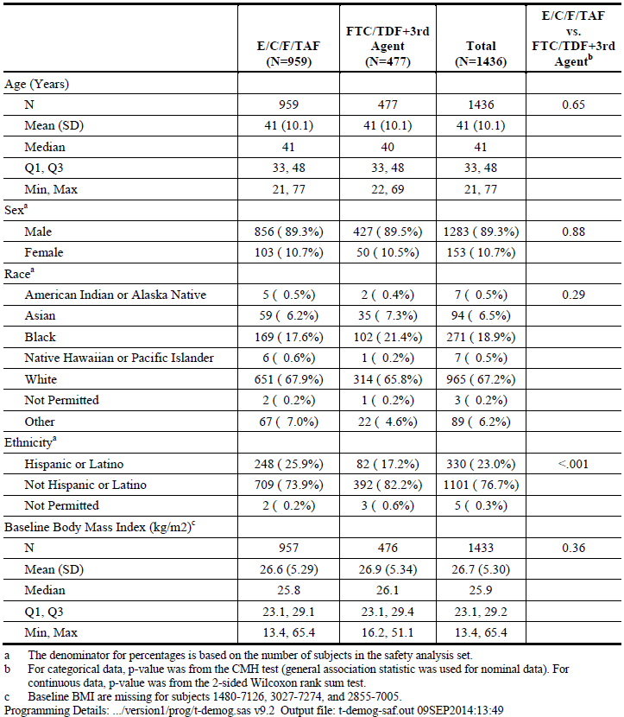

Demographic and general baseline characteristics were similar between the 2 treatment groups with the exception of ethnicity; a higher proportion of subjects in the E/C/F/TAF group (25.9%, 248 subjects) compared with the FTC/TDF + 3rd Agent group (17.2%, 82 subjects) were of Hispanic or Latino ethnicity (p < 0.001). Most subjects in the Safety Analysis Set were male (89.3%), with a median age of 41 years (range: 21 to 77 years); most were either White (67.2%) or Black (18.9%), and most were not Hispanic/Latino (76.7%). The median (Q1, Q3) value for body mass index at baseline was 25.9 (23.1, 29.2) kg/ m2 (Table 17).

##### Results for the primary efficacy outcome

The primary efficacy endpoint was the percentage of subjects with HIV-1 RNA < 50 copies/mL at Week 48 using the FDA defined snapshot algorithm.

Virologic outcomes at Week 48 were similar between the 2 treatment groups for the primary endpoint analysis using the Week 48 FAS. Virologic success rates at Week 48 were high in both groups (E/C/F/TAF 95.6%; FTC/TDF + 3rd Agent 92.9%; difference in percentages: 2.7%, 95.01% CI: -0.3% to 5.6%), indicating that E/C/F/TAF was non inferior to FTC/TDF + 3rd Agent. Because the lower bound of the 2-sided 95.01% CI of the difference in response rate was greater than the pre specified -12% margin, switching to E/C/F/TAF was non inferior to maintaining FTC/TDF + 3rd Agent at Week 48.

##### Results for other efficacy outcomes

The percentages of subjects with virologic failure at Week 48 were balanced between the treatment groups using the Week 48 FAS (E/C/F/TAF 1.1%, FTC/TDF + 3rd Agent 1.3%). The reasons for the virologic failure also were balanced between treatment groups. In the E/C/F/TAF group, 3.3% of subjects had no virologic data at Week 48 compared with 5.8% of subjects in the FTC/TDF + 3rd Agent group. The difference between treatment groups in the proportion of subjects who had no virologic data at Week 48 was primarily driven by a lower rate of study drug discontinuation for ‘other’ reasons (that is, not AE or death) in the E/C/F/TAF group (0.6%, 5 subjects) compared with the FTC/TDF + 3rd Agent group (3.8%, 15 subjects).

Virologic success rates also were high and similar between treatment groups at Week 48 using the Week 48 PP Analysis Set (E/C/F/TAF 99.1%, 748 of 755 subjects; FTC/TDF + 3rd Agent 98.9%, 363 of 367 subjects; difference in percentages: 0.2%, 95.01% CI: -1.3% to 1.6%) (Section 15.1, Table 10.2). The lower bound of the 2-sided 95% CI of the difference in response rate was greater than the pre specified -12% margin, confirming that switching to E/C/F/TAF was non inferior to maintaining FTC/TDF + 3rd Agent at Week 48.

### Other efficacy studies

#### Study GS-US-292-0102

##### Study design, objectives, locations and dates

Study GS-US-292-0102. This study was conducted to assess the safety and efficacy of a regimen containing elvitegravir/cobicistat/emtricitabine/tenofovir alafenamide (EVG/COBI/FTC/TAF (E/C/F/TAF)) administered as a single fixed dose combination (FDC) tablet versus elvitegravir/cobicistat/emtricitabine/tenofovir disoproxil fumarate (EVG/COBI/FTC/TDF (Stribild, STB)) administered as a FDC tablet in HIV infected, antiretroviral treatment (ART) naive adult subjects. The study also includes an open label (OL) extension of E/C/F/TAF in ART naive subjects and virologically suppressed subjects switching treatment to E/C/F/TAF from STB or from a cobicistat boosted darunavir (DRV) containing regimen (DRV+COBI). It was a Phase II randomised double blinded design.

It was conducted in 37 sites (36 in the U.S. and one in Puerto Rico). The study started in December 2011 and last patient observation was in March 2014 at the 96 week point.

The primary objective of the study was to evaluate the efficacy of a regimen containing E/C/F/TAF versus STB in HIV-1 infected, ART-naive adult subjects as determined by the achievement of HIV-1 RNA < 50 copies/mL at Week 24.

Secondary objectives were to:

* To evaluate the efficacy of a regimen containing E/C/F/TAF versus STB in HIV-1 infected, ART-naive adult subjects as determined by the achievement of HIV-1 RNA < 50 copies/mL at Week 48
* To evaluate the safety and tolerability of the 2 treatment regimens through 48 weeks of treatment
* To evaluate the safety and efficacy of switching subjects suppressed on a regimen containing DRV+COBI to E/C/F/TAF.

This was a multicentre study conducted in 2 phases: a randomised, double blind, active controlled phase and an OL extension phase. Subjects were randomised in a 2:1 ratio to 1 of the following 2 treatment groups:

* Treatment Group 1: FDC tablet of EVG 150 mg/COBI 150 mg/FTC 200 mg/TAF 10 mg + placebo to match STB once daily (n = 100)
* Treatment Group 2: FDC tablet of EVG 150 mg/COBI 150 mg/FTC 200 mg/TDF 300 mg + placebo to match E/C/F/TAF once daily (n = 50).

Randomization was stratified by HIV-1 RNA level (≤ 100,000 copies/mL or > 100,000 copies/mL) at screening.

A total of 171 subjects were randomised and 170 randomised subjects received at least 1 dose of study drug (E/C/F/TAF 112 subjects; STB 58 subjects); 1 subject randomised to E/C/F/TAF did not receive study drug. After Week 48, subjects continued to take their blinded study drug and attend visits every 12 weeks until treatment assignments were un-blinded, at which point all subjects returned for an un-blinding visit. At the un-blinding visit, subjects were given the option to receive E/C/F/TAF in an OL extension.

A total of 266 subjects entered the extension phase and received E/C/F/TAF, including 158 subjects from this study who completed the 48-week randomised phase and 108 subjects who rolled over from Study GS-US-299-0102. Of the 266 subjects who entered the extension phase, 264 are continuing treatment; 2 subjects (1 each in the E/C/F/TAF group and D/C/F/TAF to E/C/F/TAF group) discontinued treatment with study drug and discontinued from the study (lost to follow up) during the extension phase.

Subjects enrolled in the randomised phase of the study were HIV infected adults with plasma HIV-1 RNA levels ≥ 5000 copies/mL, no prior use of any approved or experimental anti-HIV drug for any length of time, and had an estimated glomerular filtration rate (eGFR) 70 mL/min at screening according to the Cockcroft-Gault (CG) formula (eGFRCG).

The full analysis set (FAS) was the primary efficacy analysis set and included all subjects who were randomised into the double blind phase of the study and received at least 1 dose of blinded study drug. Subjects were analysed according to randomised treatment group (E/C/F/TAF or STB). The all E/C/F/TAF analysis set included all subjects who received at least 1 dose of double blinded E/C/F/TAF during the randomised phase and those subjects who received OL E/C/F/TAF during the OL extension phase and was the primary analysis set for all E/C/F/TAF efficacy.

For the primary efficacy endpoint, the baseline HIV-1 RNA stratum (< 100,000 copies/mL or ≥ 100,000 copies/mL) weighted difference in the response rate and its 95% confidence interval (CI) were calculated based on stratum adjusted Mantel-Haenszel proportion. The same statistical method applied for the analysis of the primary efficacy endpoint was used for the analysis of secondary endpoints involving the percentage of subjects with HIV-1 RNA < 50 copies/mL, for the randomised phase analysis only.

The differences in changes from baseline in log10 HIV-1 RNA and CD4 cell count between treatment groups and the associated 95% CI were calculated using analysis of variance models, including baseline HIV-1 RNA level (< 100,000 copies/mL or ≥ 100,000 copies/mL) for the randomised phase analysis only. The virologic outcome at Week 24 and Week 48 of the randomised phase determined by the FDA defined snapshot algorithm was also analysed for subgroups by demographic and disease characteristics, and adherence.

The number and percentage of subjects with HIV-1 RNA < 50 copies/mL and changes in CD4 cell count were summarised by visit using descriptive statistics for the all E/C/F/TAF analysis set.

##### Subject demographics and baseline disease characteristics

###### ART naive subjects

Demographic and general baseline characteristics were similar between the 2 treatment groups in the randomised phase (safety analysis set). The majority of subjects were male (97.1%), with a mean age of 36 years (range, 18 to 71 years); most were either White (67.1%) or Black (30.0%) and not Hispanic/Latino (78.8%). The mean (SD) value for body mass index at baseline was 25.8 (4.34) kg/ m2.

Baseline disease characteristics were similar between the 2 treatment groups in the randomised phase. The mean (SD) baseline HIV-1 RNA value was 4.65 (0.572) log10 copies/mL, and CD4 count was 401 (191.1) cells/µL. Overall, 79.4% of subjects had baseline HIV-1 RNA ≤ 100,000 copies/mL, 15.9% had > 100,000 to ≤ 400,000 copies/mL, and 4.7% had > 400,000 copies/mL. The most common HIV risk factor category was homosexual sex (88.8% of subjects). The majority of subjects (88.8%) had asymptomatic HIV infection; 8.2% of subjects had symptomatic HIV infection, and 2.9% of subjects were diagnosed with AIDS. Most subjects (91.8%) had no proteinuria (Grade 0 by dipstick) on urinalysis. The mean eGFRCG values were similar in the 2 treatment groups: E/C/F/TAF 120.4 mL/min, STB 114.8 mL/min. Less than 5% of subjects had medical histories of diabetes (3.5%) or cardiovascular disease (2.9%); 11.8% of subjects had a medical history of hypertension and 12.4% of subjects had a medical history of hyperlipidaemia.

###### Virologically suppressed subjects who switched treatment

Most subjects in the switch groups had baseline HIV-1 RNA values < 50 copies/mL (all TDF to TAF: 93.4%; D/C/F/TAF to E/C/F/TAF: 97.1%).

###### Results

ART naive subjects

The primary efficacy endpoint was the percentage of subjects with HIV-1 RNA < 50 copies/mL at Week 24 of the randomised phase using the FDA defined snapshot algorithm. Virologic outcomes at Week 24 were similar between the 2 treatment groups for the primary endpoint analysis using the FAS. Virologic success rates were as follows: E/C/F/TAF 88.4%, STB 89.7%; difference in percentages: -2.9%, 95% CI -13.5% to 7.7% p = 0.58. This indicates that both treatments were equivalent.

Similar rates of virologic success in the 2 treatment groups were achieved through Week 48 when assessed using the FDA defined snapshot algorithm using the FAS, as follows: E/C/F/TAF 88.4%, STB 87.9%; difference in percentages: -1.0%, 95% CI: -12.1% to 10.0% p=0.84. This indicates that at 48 weeks, in HIV-1 infected treatment naive patients the comparator treatments are equivalent. These results are similar to the pivotal efficacy studies GS-US-292-0104 and GS-US-92-0111.

Virologically suppressed patients who switched treatment

Virologic suppression was maintained and CD4 cell count increased in subjects who switched treatment to E/C/F/TAF in the extension phase. At Week 24 of the extension phase, 98.9% of subjects in the all TDF to TAF group had HIV-1 RNA levels < 50 copies/mL (Missed = Excluded), and mean (SD) change from OL baseline in CD4 cell count was 61 (159.1) cells/µL. These are, again, similar results to those seen in the two pivotal efficacy studies.

### Analyses performed across trials (pooled analyses and meta-analyses)

The main pooled analysis was conducted across GS-US-292-0104 and GS-US-292-0111. These were conducted at the same time in the same general countries. The design of both studies was the same in all respects and they enrolled almost the same number of patients. The sponsor considered it appropriate to pool the analysis of these studies and this approach was supported by all experts in the HIV field. The results of this pooled analysis have been considered in the assessment of the pivotal studies.

### Evaluator’s conclusions on clinical efficacy

Evaluator’s conclusions on clinical efficacy for the treatment of HIV-1 infection in adults and paediatric patients 12 years of age and older.

The sponsor has submitted at least ten separate clinical trials, involving more than 2,500 patients in more than 40 countries. The clinical efficacy objective of these studies was to confirm that tenofovir alafenamide fumarate (TAF) is equivalent to tenofovir disoproxil fumarate (TDF) when combined in an FDC tablet with Elvitegravir (EVG) and Cobicistat (COBI) and Emtricitabine (FTC). The single parameter of efficacy has been defined as achieving an HIV-1 RNA viral load of less than 50 copies per mL. These studies universally confirm that TAF, as a component of Genvoya, is clinically equivalent to TDF as a component of Stribild or QUAD, which has been approved. The equivalence of TAF with TDF is supported by the comprehensive pharmacokinetics data submitted by the sponsor. The PK studies provide data to demonstrate that TAF at a dose of 10 mg, boosted by COBI 150 mg, results in the equivalent intracellular levels of the active substance Tenofovir, as a dose of 300 mg of TDF. The sponsor provides further data to conclude that, in the short to medium term this lower dose requirement of TAF will result in a lower rate of adverse renal and bone density effects. This observation will be detailed in the section on clinical safety.

The pivotal efficacy studies in this submission are GS-US-292-0104 and GS-US-292-0111. These are the studies that have been pooled for analysis. The data shows that the FDC containing TAF (Genvoya) resulted in equivalent viral suppression when compared with the FDC containing TDF (Stribild), both achieving > 90% of patients with an HIV-1 RNA viral load of < 50 copies per mL. Virological failure was infrequent in both groups (3.6% and 4.0% respectively). It was observed that the TAF combination appeared to be significantly better for women and for those with a baseline viral load of < 100,000 copies per mL. The TAF group also appeared to have a significantly higher CD4 increase when compared with the TDF group. Other parameters such as age, ethnicity, area of residence and mild to moderate renal and hepatic abnormality did not have an effect on the efficacy outcomes. Study GS-US-292-0109 provided data on both HIV-1 treatment naive patients and patient who switched from a regimen containing TDF to one containing TAF. This study with more than 1,400 patients also showed that suppression of HIV‑1 RNA viral load was maintained when patients switched to the TAF containing regimen.

It is the opinion of the evaluator that the Genvoya FDC provides a non-inferior viral suppression STR to an already approved FDC.

## Clinical safety

### Studies providing evaluable safety data

The sponsor has submitted 20 separate clinical studies that, in some aspects address the safety of TAF, either as a separate tablet or in combination with E/C/F as the compound Genvoya, which is submitted for assessment. As the current application for TAF is not as a separate tablet, the assessor has considered the safety of TAF in combination with E/C/F. The pivotal safety data provided by the sponsor are GS-US-292-0104 and GS-US-292-0111 which were the pivotal efficacy studies. The key safety data for this submission is the documented renal and bone mineral density toxicity reported for the Stribild and due to the TDF component. The sponsor’s submission states that this toxicity is due to the TDF component because it is in plasma for an extended period before being incorporated into PBMCs. The sponsor’s submission is intended to show that, because TAF is incorporated into PBMCs at a much more rapid rate than TDF the effects on renal and bone mineral function will be much ameliorated.

#### Pivotal efficacy studies

In the pivotal efficacy studies, the following safety data were collected:

* General adverse events (AEs) were assessed by clinical history, physical examination, blood analysis, urinalysis, bone mineral density scanning
* AEs of particular interest, including diarrhoea, nausea, headache, respiratory infections, fatigue, cough, vomiting, rash, dizziness, proteinuria, bone mineral density, bone fractures, were assessed by patient history, physical examination, bone mineral density scanning, x-ray and/or MRI as indicated
* Laboratory tests, including serum creatinine, changes in glomerular filtration rate, proximal renal tubulopathy (Fanconi Syndrome).

#### Pivotal studies that assessed safety as a secondary outcome

Studies GS-US-292-0104, GS-US-292-0111, GS-US-292-0106, GS-US-292-0109, GS-US-292-0102 were pivotal studies that assessed safety as a secondary outcome in parallel with their primary outcome of efficacy (equivalence between E/C/F/TAF and E/C/F/TDF). These studies are described below. Study GS-US-292-0112 is relevant, although not a pivotal safety study as it is a Phase III open label study of patients treated with E/C/F/TAF who have mild to moderate renal impairment. This study is important in consideration of the impact of TAF on renal function.

### Pivotal studies that assessed safety as a primary outcome

The three studies regarded as the most important in relation to safety are GS-US-292-0104, GS-US-292-0111 and GS-US-292-0109. These studies have been described in detail in Section 7. The relevant sections will be incorporated into this section for ease of assessment and consistency. The first two studies have been pooled as their design, implementation and analysis frameworks are identical.

#### Studies GS-US-292-0104 and GS-US-292-0111

##### Study design, objectives, locations and dates

Described above in the efficacy section.

##### Inclusion and exclusion criteria

Described above in the efficacy section.

##### Study treatments

Described above in the efficacy section.

##### Safety variables and outcomes

The main safety variables were:

* Bone mineral Density as measured by Hip BMD and Spine BMD
* Renal function as measured by serum creatinine and proteinuria.

The primary safety outcome was renal function and bone mineral density.

Other safety outcomes included:

* tubular proteins (urine retinol binding protein (RBP) to creatinine ratio and beta‑2‑microglobulin to creatinine ratio).

*GS-US-292-0104 and GS-US-292-0111*

Baseline and post baseline safety assessments included adverse events (AEs), BMD using dual energy x-ray absorptiometry (DXA), and clinical laboratory tests (chemistry, haematology, urinalysis, and pregnancy testing) including bone laboratory parameters (type I collagen C telopeptide (C telopeptide), procollagen type I N-terminal propeptide (PINP), and parathyroid hormone (PTH)), serum creatinine, eGFR by 3 formulas (eGFRCG, Chronic Kidney Disease Epidemiology Collaboration (CKD-EPI) creatinine (eGFR CKD-EPI, creatinine), and CKD-EPI cystatin E/C/F/TAF C (eGFR CKD-EPI, cysC)), proteinuria by urinalysis and quantitative assessment (protein to creatinine ratio (UPCR), urine albumin to creatinine ratio (UACR)), and renal biomarkers (retinol binding protein (RBP) to creatinine ratio, beta-2-microglobulin to creatinine ratio, renal tubular maximum reabsorption rate of phosphate to the glomerular filtration rate (TmP/GFR), fractional excretion of phosphate (FEPO4), and fractional excretion of uric acid (FEUA)). Change from baseline fracture probabilities were assessed using the FRAX algorithm.

Four key safety endpoints were defined as follows:

* Percentage change from baseline in hip BMD at Week 48
* Percentage change from baseline in spine BMD at Week 48
* Change from baseline in serum creatinine at Week 48
* Treatment-emergent proteinuria by urinalysis (dipstick) through Week 48.

Statistical procedures to control for multiplicity are described in the statistical methods below.

Other endpoints:

The EQ-5D-3L health-outcomes questionnaire was performed at baseline and every 24 weeks for all subjects, and also at the early study drug discontinuation (ESDD) visit, if applicable.

##### Randomisation and blinding methods

Described above in the efficacy section.

##### Analysis populations

Described above in the efficacy section.

##### Sample size

Described above in the efficacy section.

##### Statistical methods

Described above in the efficacy section.

##### Participant flow

Described above in the efficacy section.

##### Major protocol violations/deviations

Described above in the efficacy section.

##### Baseline data

Described above in the efficacy section.

Baseline data are summarised across the pivotal studies (GS-US-292-0104, GS-US-292-0111 and GS-US-292-0109) where safety was a parallel outcome parameter to efficacy. In these trials, once equivalence had been shown, the issue of effect of TAF on renal and bone mineral density was considered the most important parameters as TDF is known to adversely affect renal and bone mineral density.

Demographic and general baseline characteristics were generally similar between treatment groups within each study. The median ages of adult subjects with normal renal function who were ART naive or virologically suppressed were generally similar (range: 33 to 41 years). Subjects with mild to moderate renal impairment were older, with a median age of 58 years in Cohort 1 (ART experienced subjects who switched to E/C/F/TAF; range: 24 to 82). Across studies, a total of 97 subjects were ≥ 65 years of age. The median age of adolescent subjects in Study GS-US-292-0106 was 15 years (range: 12 to 17).

Approximately 15% of subjects in the pivotal ART naive studies (GS-US-292-0104 and GS-US-292-0111) were women. With the exception of Study GS-US-292-0106, the most subjects across studies were White or Black. Subjects in GS-US-292-0106 were Black (87.5%) or Asian (12.5%). The median BMI was generally similar across all studies (approximately 25 kg/ m2), except for adolescent subjects in Study GS-US-292-0106 (median (Q1, Q3) body mass index (BMI) 20.0 kg/ m2 (18.1, 23.2)). Baseline disease characteristics were generally similar between treatment groups within each study. The median baseline estimated glomerular filtration rate (eGFR) calculated using the Cockcroft-Gault equation (eGFRCG) value was generally similar across ART naive and virologically suppressed adult subjects (range: 105.7 to 117.0 mL/min). In subjects with mild to moderate renal impairment, the median (Q1, Q3) eGFRCG value was 55.6 mL/min (45.7, 62.4) among subjects who were virologically suppressed at baseline. In ART naive adolescent subjects, the median (Q1, Q3) eGFR calculated using the modified Schwartz formula was 110.9 mL/min/1.73 m2.

Across the Phase III (GS-US-292-0104, GS-US-292-0111 and GS-US-292-0109) studies in adults with normal renal function, 10% or less of subjects had any Grade 1, 2, or 3 proteinuria at baseline. In subjects with mild to moderate renal impairment, 9.5% of virologically suppressed subjects had Grade 2 proteinuria by urinalysis (dipstick), and 23.1% of subjects had Grade 1 proteinuria at baseline. Among adolescent subjects, < 5% had proteinuria at baseline. In the Phase III study GS-US-292-0112, of the 380 subjects screened, 252 were enrolled in the study (246 Cohort 1 switch subjects and 6 Cohort 2 ART naive subjects). Subjects were enrolled at 70 sites in 9 countries. A total of 248 subjects received at least 1 dose of study drug (242 Cohort 1, switch subjects and 6 Cohort 2 ART naive subjects). Of the 248 treated subjects, 6.5% (16 subjects) discontinued study drug treatment, all of whom were Cohort 1 switch subjects. The reasons for discontinuation of study drug in the Cohort 1 switch subjects (n = 242) were AE (3.3%, 8 subjects), withdrew consent (1.2%, 3 subjects), lost to follow up (0.8%, 2 subjects), lack of efficacy (0.4%, 1 subject), protocol violation (0.4%, 1 subject) and investigator’s discretion (0.4%, 1 subject).

The study was designed to determine if switching subjects from either a TDF containing regimen (65%) or a non TDF containing regimen (35%) to a TAF containing regimen altered renal safety in patients who had mild to moderate renal impairment (Cohort 1). Second, would starting a TAF containing regimen in HIV-1 treatment naive patients, who had mild to moderate renal impairment (Cohort 2), impact on efficacy in suppressing HIV-1 RNA viral load and also have any safety implications for an already impaired renal function.

##### Results for the primary safety outcome

The primary safety analyses for these studies focussed on renal and bone mineral toxicity. The primary safety outcomes were specified as hip BMD; spine BMD, serum creatinine and treatment emergent proteinuria.

###### Percentage change from baseline in hip and spine BMD

GS-US-292-0104

The percentage changes from baseline in BMD at the hip or at the spine at Week 48 were the first and second key alpha protected safety endpoints for this study, respectively. Statistical analysis using the fall back procedure, confirmed significance using adjusted alphas, which were dependent on the results from preceding tests. Mean percentage decreases from baseline in BMD at the hip or spine were smaller in the E/C/F/TAF group compared with the STB group (p < 0.001 for the differences between the 2 groups at Weeks 24 and 48. Mean (SD) baseline hip BMD values were similar for each treatment group (E/C/F/TAF 1.033 (0.1571) g/cm2; STB 1.023 (0.1503) g/cm2); mean (SD) percentage decreases from baseline at Week 48 were as follows: E/C/F/TAF 0.883% (3.2882%); STB 3.288% (3.6213%). Mean (SD) baseline spine BMD was higher in the E/C/F/TAF group compared with the STB group (E/C/F/TAF 1.139 (0.1786) g/cm2; STB 1.106 (0.1607) g/cm2; p = 0.005); mean (SD) percentage decreases from baseline at Week 48 were as follows: E/C/F/TAF 1.322% (3.1546%); STB 2.964% (3.4717%).

**Comment**: The alpha level is specified at the beginning of the study and is retained regardless of the number of interim analyses conducted. Reference: *European Journal of Heart Failure* 2000; 2: 315-324.

Similar percentages of subjects in both treatment groups were taking osteoporosis medications at study entry (E/C/F/TAF 7.1%, 31 subjects; STB 8.6%, 37 subjects. Fewer subjects in the E/C/F/TAF group initiated osteoporosis medications during the study compared with the STB group (E/C/F/TAF 6.7%, 29 subjects; STB 13.0%, 56 subjects; p = 0.002. Sensitivity analyses of percentage changes from baseline in BMD at the hip or at the spine were performed to exclude subjects who took osteoporosis medications during the study. Results were similar to those observed for all subjects in the hip and spine DXA analysis sets.

Decreased bone density was reported as a non-serious AE for 1 subject (0.2%) in the E/C/F/TAF group and for 3 subjects (0.7%) in the STB group. Decreased bone density was considered related to study drugs for 1 subject (0.2%) in the E/C/F/TAF group and for 2 subjects (0.5%) in the STB group. No AEs of decreased bone density resulted in discontinuation of study drugs.

Figure 8. Study GS-US-292-0104: Mean (95% CI) of percentage changes from baseline hip BMD by visit (observed data; hip DXA analysis sets)

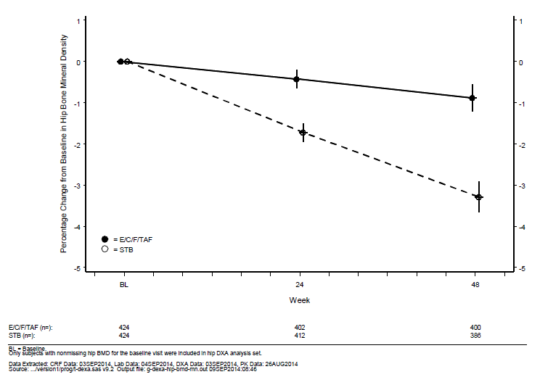

Figure 9. Study GS-US-292-0104: Mean (95% CI) of percentage changes from baseline in spine BMD by visit (observed data; spine DXA analysis sets)

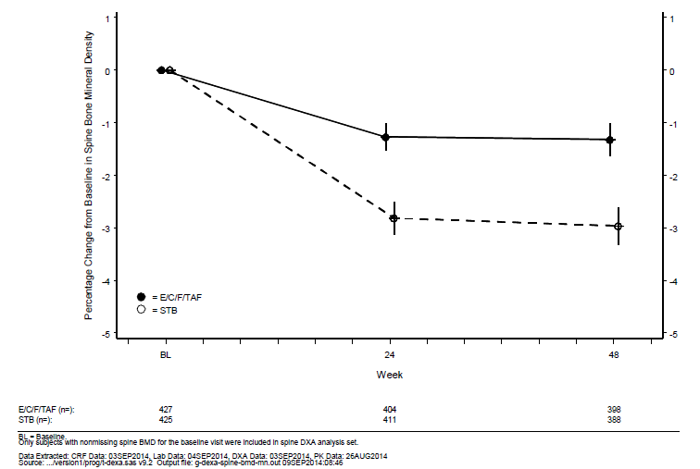

Differences between groups in the categorical distribution of percentage change from baseline in hip or spine BMD were statistically significant (p < 0.001 at Weeks 24 and 48). At Week 48, fewer subjects in the E/C/F/TAF group compared with the STB group had a > 3% decrease from baseline in hip (E/C/F/TAF 19.0%; STB 54.7%) or spine BMD (E/C/F/TAF 25.1%; STB 45.4%).

Clinical BMD status was assessed using BMD T scores; normal bone status was defined by a BMD T-score ≥ -1, osteopenia by a T score from < -1 to ≥ -2.5, and osteoporosis by a T-score < ‑2.5. The distribution of the clinical BMD status adjusted for baseline status was significantly different between treatment groups at Weeks 24 and 48 at the hip (p = 0.036 at Week 24; p = 0.035 at Week 48) or at the spine (p < 0.001 at Week 24; p = 0.009 at Week 48). Based on the number of subjects with available data at Week 48, fewer subjects in the E/C/F/TAF group had worsening hip BMD clinical status from baseline (normal to osteopenia, normal to osteoporosis, or osteopenia to osteoporosis) compared with the STB group (E/C/F/TAF 4.8%, 19 of 397 subjects; STB 8.1%, 31 of 384 subjects). Similarly, fewer subjects in the E/C/F/TAF group had worsening spine BMD clinical status at Week 48 compared with the STB group (E/C/F/TAF 7.8%, 31 of 395 subjects; STB 11.7%, 45 of 386 subjects).

The incidences of osteopenia and osteoporosis reported as an AE were as follows: osteopenia: E/C/F/TAF 2.5 %, 11 subjects; STB 5.3%, 23 subjects; osteoporosis: E/C/F/TAF 1.4%, 6 subjects; STB 1.9%, 8 subjects. Osteopenia was considered related to study drugs for 13 subjects: E/C/F/TAF 3 subjects (0.7%); STB 10 subjects (2.3%). Osteoporosis was considered related to study drugs for 4 subjects: E/C/F/TAF 1 subject (0.2%); STB 3 subjects (0.7%). Five of the 11 subjects in the E/C/F/TAF group and 9 of the 23 subjects in the STB group who had AEs of osteopenia were reported prior to Day 30. All of the 6 subjects in the E/C/F/TAF group and 5 of the 8 subjects in the STB group who had AEs of osteoporosis were reported prior to Day 30.

The reporting of these events was probably in response to baseline DXA scan. All AEs of osteopenia or osteoporosis were non serious, and none resulted in discontinuation of study drugs.

GS-US-292-0111

The percentage changes from baseline in BMD at the hip or at the spine at Week 48 were the first and second key alpha protected safety endpoints for this study, respectively. Statistical analysis using the fall back procedure, confirmed significance using adjusted alphas, which were dependent on the results from preceding tests. Mean percentage decreases from baseline in BMD at the hip or spine were smaller in the E/C/F/TAF group compared with the STB group (p < 0.001 for the differences between the 2 groups at Weeks 24 and 48). Mean (SD) baseline hip BMD values were similar for both treatment groups (E/C/F/TAF 1.049 (0.1539) g/cm2; STB 1.034 (0.1456) g/cm2); mean (SD) percentage decreases from baseline at Week 48 were as follows: E/C/F/TAF 0.420% (3.2268%); STB 2.603% (3.1482%). Mean (SD) baseline spine BMD values were similar for both treatment groups (E/C/F/TAF 1.132 (0.1732) g/cm2; STB 1.123 (0.1640) g/cm2); mean (SD) percentage decreases from baseline at Week 48 were as follows: E/C/F/TAF 1.278% (3.0098%); STB 2.759% (3.0024%).

Similar percentages of subjects in both treatment groups were taking osteoporosis medications at study entry (E/C/F/TAF 4.9%, 21 subjects; STB 6.2%, 27 subjects). Similar percentages of subjects in both treatment groups initiated osteoporosis medications during the study (E/C/F/TAF 10.9%, 47 subjects; STB 10.8%, 47 subjects). Sensitivity analyses of percentage changes from baseline in BMD at the hip or at the spine were performed to exclude subjects who took osteoporosis medications during the study. Results were similar to those observed for all subjects in the hip and spine DXA analysis sets.

Decreased bone density was reported as a non-serious AE for 2 subjects (0.5%) in the E/C/F/TAF group and for 1 subject (0.2%) in the STB group. Decreased bone density was considered related to study drugs for 1 subject (0.2%) in the E/C/F/TAF group. No AEs of decreased bone density resulted in discontinuation of study drugs.

Differences between groups in the categorical distribution of percentage change from baseline in hip or spine BMD were statistically significant (p < 0.001 at Weeks 24 and 48). At Week 48, fewer subjects in the E/C/F/TAF group compared with the STB group had a > 3% decrease from baseline in hip (E/C/F/TAF 14.5%; STB 45.4%) or spine BMD (E/C/F/TAF 28.0%; STB 46.2%).

Clinical BMD status was assessed using BMD T-scores; normal bone status was defined by a BMD T-score ≥ ‑1, osteopenia by a T-score from < ‑1 to ≥ ‑2.5, and osteoporosis by a T-score < ‑2.5. The distribution of the clinical BMD status adjusted for baseline status was significantly different between treatment groups at Weeks 24 and 48 at the hip (p < 0.001 at Weeks 24 and 48) or at the spine (p = 0.008 at Week 24; p = 0.012 at Week 48).

Based on the number of subjects with available data at Week 48, fewer subjects in the E/C/F/TAF group had worsening hip BMD clinical status from baseline (normal to osteopenia, normal to osteoporosis, or osteopenia to osteoporosis) compared with the STB group (E/C/F/TAF 2.4%, 9 of 376 subjects; STB 6.9%, 26 of 377 subjects). Similarly, fewer subjects in the E/C/F/TAF group had worsening spine BMD clinical status at Week 48 compared with the STB group (E/C/F/TAF 7.6%, 29 of 382 subjects; STB 12.6%, 48 of 381 subjects).

Figure10. Study GS-US-292-0111: Mean (95% CI) of percentage changes from baseline hip BMD by visit (observed data; hip DXA analysis sets)

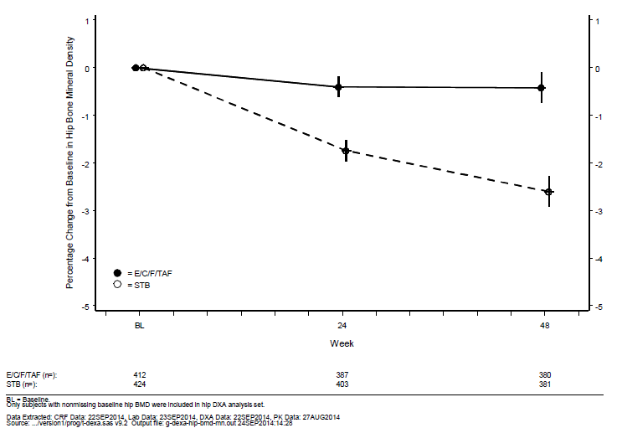

Figure11. Study GS-US-292-0111: Mean (95% CI) of percentage changes from baseline in spine BMD by visit (observed data; spine DXA analysis sets)

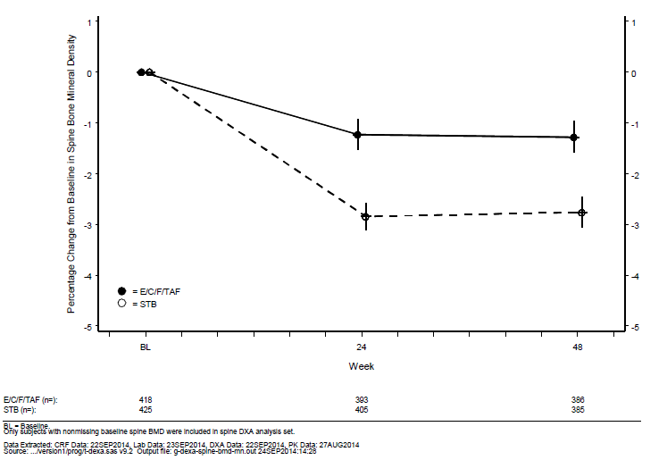

The incidences of osteopenia and osteoporosis reported as an AE were as follows: osteopenia: E/C/F/TAF 4.9%, 21 subjects; STB 4.8%, 21 subjects; osteoporosis: E/C/F/TAF 1.2%, 5 subjects; STB 1.1%, 5 subjects. Osteopenia was considered related to study drugs for 12 subjects: E/C/F/TAF 1.2%, 5 subjects; STB 1.6%, 7 subjects. Osteoporosis was considered related to study drugs for 3 subjects: E/C/F/TAF 0.5%, 2 subjects; STB 0.2%, 1 subject. Fourteen of the 21 subjects in the E/C/F/TAF group and 9 of the 21 subjects in the STB group who had AEs of osteopenia were reported prior to Day 30. Three of the 5 subjects in the E/C/F/TAF group and 3 of the 5 subjects in the STB group who had AEs of osteoporosis were reported prior to Day 30.

The reporting of these events was probably in response to baseline DXA scan. All AEs of osteopenia or osteoporosis were non serious, and none resulted in discontinuation of study drugs.

##### Renal function

Outcomes focussing on serum creatinine and treatment emergent proteinuria

###### Serum creatinine

GS-US-292-0104

Change from baseline in serum creatinine at Week 48 was the third key alpha protected safety endpoint for this study. Statistical analysis using the fall back procedure, confirmed significance using adjusted alphas, which were dependent on the results from preceding tests. Overall, increases from baseline in mean values for serum creatinine were smaller in the E/C/F/TAF group compared with the STB group. Mean (SD) baseline serum creatinine values were as follows: E/C/F/TAF 0.91 (0.171) mg/dL; STB 0.93 (0.174) mg/dL. Increases were observed by Week 2 for each treatment group, and remained stable through Week 48. Mean (SD) changes from baseline were as follows:

* Week 2: E/C/F/TAF 0.07 (0.094) mg/dL, STB 0.10 (0.127) mg/dL (p < 0.001)
* Week 48: E/C/F/TAF 0.08 (0.110) mg/dL, STB 0.11 (0.117) mg/dL (p < 0.001).

The difference between the treatment groups was statistically significant at all time points from Weeks 2 to 48.

Figure12. Study GS-US-292-0104: Mean (95% CI) change from baseline in serum creatinine (mg/dL) by visit (observed data; safety analysis sets)

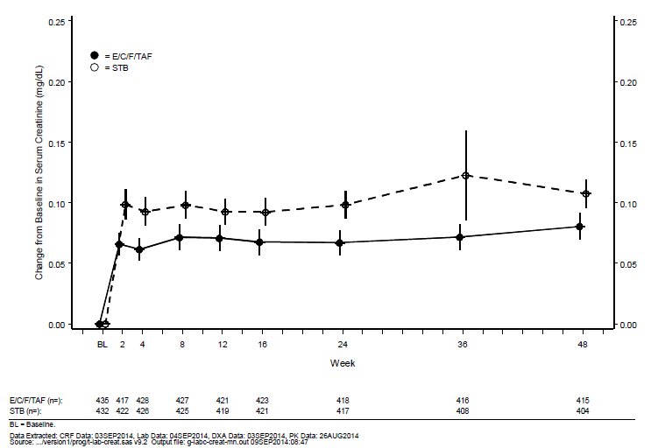

Graded laboratory abnormalities for serum creatinine were reported for 3.5% of subjects (n = 15) in the E/C/F/TAF group and 4.9% of subjects (n = 21) in the STB group. Most of these abnormalities were Grade 1. Grade 2 serum creatinine abnormalities were reported for 3 subjects, all in the STB group. One subject [information redacted] in the STB group, had a Grade 4 serum creatinine abnormality that was also reported as an AE.

Adverse events of elevated serum creatinine (PT = blood creatinine increased) were reported for 3 subjects (E/C/F/TAF 1 subject; STB 2 subjects ) these AE were considered related to study drugs by the investigator for the 1 subject in the E/C/F/TAF group, and 1 subject in the STB group.

GS-US-292-0111

Change from baseline in serum creatinine at Week 48 was the third key alpha protected safety endpoint for this study. Statistical analysis using the fall back procedure, confirmed significance using adjusted alphas, which were dependent on the results from preceding tests. Overall, increases from baseline in mean values for serum creatinine were smaller in the E/C/F/TAF group compared with the STB group. Mean (SD) baseline serum creatinine values were as follows: E/C/F/TAF 0.95 (0.171) mg/dL; STB 0.94 (0.164) mg/dL. Increases were observed by Week 2 for each treatment group and remained stable through Week 48. Mean (SD) changes from baseline were as follows:

* Week 2: E/C/F/TAF 0.06 (0.115) mg/dL, STB 0.10 (0.116) mg/dL;(p < 0.001)
* Week 48: E/C/F/TAF 0.08 (0.136) mg/dL, STB 0.12 (0.283) mg/dL;(p = 0.008).

The difference between the treatment groups was statistically significant at all time points from Weeks 2 to 48.

Figure 13. Study GS-US-292-0111: Mean (95% CI) change from baseline in serum creatinine (mg/dL) by visit (observed data; safety analysis sets)

Figure 13. Study GS-US-292-0111: Mean (95% CI) change from baseline in serum creatinine (mg/dL) by visit (observed data; safety analysis sets)


###### Treatment emergent proteinuria by urinalysis (dipstick)

GS-US-292-0104

Proteinuria by urinalysis (dipstick) through Week 48 data cut was the fourth key alpha protected safety endpoint for this study. Statistical analysis using the fall back procedure, confirmed significance using adjusted alphas, which were dependent on the results from preceding tests). Fewer subjects in the E/C/F/TAF group than in the STB group had at least 1 recorded, graded proteinuria by dipstick during the study (E/C/F/TAF 30.4% (132 of 434 subjects); STB 37.4% (161 of 431 subjects); p = 0.034).

Of the subjects who had proteinuria by urinalysis, most were Grade 1. Four subjects (0.9%) in the E/C/F/TAF group and 5 subjects (1.2%) in the STB group had AEs of proteinuria. One subject in the STB group had an AE of protein urine present. All AEs of proteinuria were assessed by the investigator as Grade 1 in severity. The AEs of proteinuria were considered related to study to drugs by the investigator for 3 subjects in each treatment group. One subject had Grade 3 proteinuria that was not reported as an AE (the subject had an AE of nephropathy that resulted in discontinuation of study drugs).

GS-US-292-0111

Proteinuria by urinalysis (dipstick) through Week 48 data cut was the fourth key alpha protected safety endpoint for this study. Fewer subjects in the E/C/F/TAF group than in the STB group had at least 1 recorded, graded proteinuria by dipstick during the study, although the difference between groups was not statistically significant (E/C/F/TAF 32.0% (137 of 428 subjects); STB 36.2% (157 of 434 subjects); p = 0.25). Of the subjects who had proteinuria by urinalysis, most were Grade 1.

A total of 13 subjects, 4 (0.9%) in the E/C/F/TAF and 9 (2.1%) in the STB group, had AEs of proteinuria. Most AEs of proteinuria were assessed by the investigator as Grade 1 in severity. The proteinuria AEs were considered related to study drugs by the investigator in 11 of the 13 subjects (E/C/F/TAF 4 subjects; STB 7 subjects). Two subjects, 1 in each treatment group, also had an AE of protein urine present; the AE for the subject in the STB group was also considered related to study drugs by the investigator. One subject in the STB group, had AEs of proteinuria and creatinine renal clearance decreased, both of which were considered related to study drugs by the investigator.

###### Estimated glomerular filtration rate

GS-US-292-0104

Overall, decreases from baseline in median eGFRCG values were smaller in the E/C/F/TAF group compared with the STB group. Median (Q1, Q3) baseline eGFRCG values were as follows: E/C/F/TAF 118.5 (101.6, 135.7) mL/min; STB 112.8 (97.8, 134.2) mL/min. Decreases were observed by Week 2 for each treatment group that remained stable through Week 48. Median (Q1, Q3) changes from baseline were as follows:

* Week 2: E/C/F/TAF −7.2 (−15.9, 0.0) mL/min, STB −10.2 (−17.8, −3.0) mL/min (p < 0.001)
* Week 48: E/C/F/TAF −6.8 (−16.6, 1.2) mL/min, STB −10.4 (−21.0, −2.4) mL/min (p < 0.001).

The difference between the treatment groups was statistically significant at all time points from Weeks 2 to 48.

The number and percentage of subjects with change from baseline of ≥ 25% and ≥ 50% in eGFRCG were summarised. A smaller percentage of subjects reported a decrease from baseline in eGFRCG of ≥ 25% in the E/C/F/TAF group than the STB group (E/C/F/TAF 12.4%, 54 of 434 subjects; STB 26.9%, 116 of 431 subjects; p < 0.001). A decrease from baseline in eGFRCG of ≥ 50% was reported for 0.5% of subjects (2 of 434) in the E/C/F/TAF group and 0.7% of subjects (3 of 431) in the STB group.

Figure 14. GS-US-292-0104: Median (Q1, Q3) Change from baseline in eGFRCG (mL/min) by visit (safety analysis set)

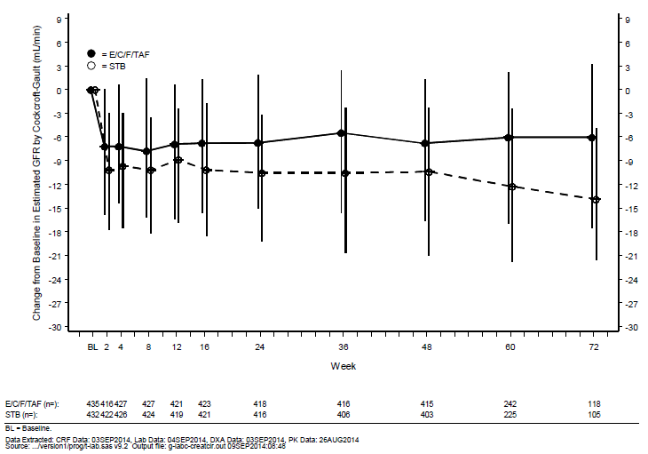

GS-US-292-0111

Overall, decreases from baseline in median eGFRCG values were smaller in the E/C/F/TAF group compared with the STB group. Median (Q1, Q3) baseline eGFRCG values were as follows: E/C/F/TAF 115.9 (98.4, 135.6) mL/min; STB 114.7 (99.6, 133.4) mL/min. Decreases were observed by Week 2 for each treatment group that remained stable through Week 48. Median (Q1, Q3) changes from baseline were as follows:

* Week 2: E/C/F/TAF −6.7 (−14.2, 1.0) mL/min, STB −10.3 (−17.9, −3.2) mL/min; p < 0.001
* Week 48: E/C/F/TAF −5.7 (−14.3, 3.0) mL/min, STB −11.9 (−19.8, −2.1) mL/min; p < 0.001.

The difference between the treatment groups was statistically significant at all time points from Weeks 2 to 48.

The number and percentage of subjects with change from baseline of ≥ 25% and ≥ 50% in eGFRCG were summarised. A smaller percentage of subjects reported a decrease from baseline in eGFRCG of ≥ 25% in the E/C/F/TAF group than the STB group (E/C/F/TAF 12.4%, 53 of 428 subjects; STB 24.4%, 106 of 434 subjects; p < 0.001). A decrease from baseline in eGFRCG of ≥ 50% was reported for 0.5% of subjects (2 of 428) in the E/C/F/TAF group and 0.5% of subjects (2 of 434) in the STB group. Observations for changes from baseline in eGFRCKD-EPI, creatinine, support those seen for eGFRCG.

Figure 15. GS-US-292-0111: Median (Q1, Q3) change from baseline in eGFRCG (mL/min) by visit (safety analysis set)

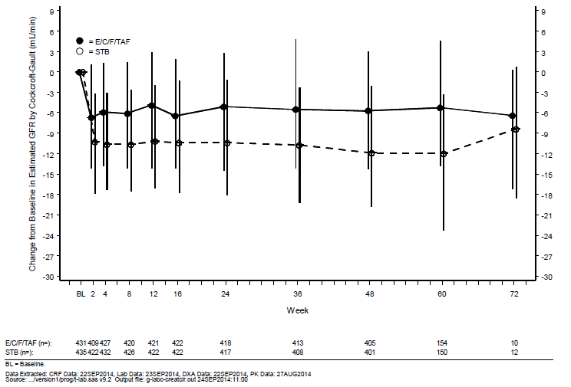

#### GS-US-292-0109

##### Study design, objectives, locations and dates

Described above in the efficacy section.

##### Inclusion and exclusion criteria

Described above in the efficacy section.

##### Study treatments

Described above in the efficacy section.

##### Safety variables and outcomes

The main safety variables were:

* Bone mineral Density as measured by Hip BMD and Spine BMD
* Renal function as measured by serum creatinine and proteinuria

The primary safety outcome was renal function and bone mineral density.

Other safety outcomes included:

* tubular proteins (urine retinol binding protein (RBP) to creatinine ratio and beta-2-microglobulin to creatinine ratio).

Baseline and post baseline safety assessments included adverse events (AEs), BMD using dual energy x-ray absorptiometry (DXA), vital signs, weight, and clinical laboratory tests (chemistry, haematology, urinalysis, and pregnancy testing) including bone biomarkers (type I collagen C‑telopeptide (C-telopeptide) and procollagen type 1 N-terminal propeptide (P1NP)), parathyroid hormone (PTH), serum creatinine, eGFRCG and eGFR by chronic kidney disease epidemiology collaboration (CKD-EPI) creatinine method (eGFRCKD-EPI, creatinine), proteinuria by urinalysis and quantitative assessment (protein to creatinine ratio (UPCR), urine albumin to creatinine ratio (UACR)), and renal biomarkers (retinol binding protein (RBP) to creatinine ratio, beta-2-microglobulin to creatinine ratio, renal tubular maximum reabsorption rate of phosphate to the glomerular filtration rate (TmP/GFR), fractional excretion of phosphate (FEPO4), and fractional excretion of uric acid (FEUA)). Fracture probabilities were assessed using an E/C/F/TAF computer-based algorithm (FRAX). Neuropsychiatric symptoms related to EFV were evaluated in subjects who took ATR as their prior regimen. Additionally, subjects who participated in the ophthalmologic sub study underwent fundoscopic and slit-lamp examinations, and had retinal photographs taken of both eyes.

Four key safety endpoints were defined as follows:

* Percentage change from baseline in hip BMD at Week 48
* Percentage change from baseline in spine BMD at Week 48
* Change from baseline in serum creatinine at Week 48
* Change from baseline in EFV-related symptom assessment score at Week 48.

##### Randomisation and blinding methods

Described above in the efficacy section.

##### Analysis populations

Described above in the efficacy section.

##### Sample size

Described above in the efficacy section.

##### Statistical methods

Described above in the efficacy section.

##### Participant flow

Described above in the efficacy section.

##### Major protocol violations/deviations

Described above in the efficacy section.

##### Baseline data

Described above in the efficacy section.

**Comment:** Study GS-US-292-0109 is a Phase III, Open-Label Study to Evaluate Switching from a TDF-Containing Combination Regimen to a TAF-Containing Combination Single Tablet Regimen (STR) in virologically suppressed, HIV-1 positive subjects, in contrast to GS-US-292-0104 and 0111, which are studies in HIV-1 naive patients comparing E/C/F/TDF with E/C/F/TAF.

##### Percentage change from baseline in hip and spine BMD

The percentage changes from baseline in BMD at the hip or at the spine at Week 48 were the first and second key alpha protected safety endpoints for this study, respectively. Statistical analysis using the fall back procedure, confirmed significance using adjusted alphas, which were dependent on the results from preceding tests. There were increases from baseline in mean (SD) BMD at the hip or at the spine in the E/C/F/TAF group as compared with minimal changes from baseline in both parameters in the FTC/TDF + 3rd Agent group at both Weeks 24 and 48 (p < 0.001 for the differences between groups). Mean (SD) percentage changes from baseline in BMD at Week 48 were as follows:

* Hip: E/C/F/TAF 1.949% (2.9956); FTC/TDF + 3rd Agent -0.136% (2.9890)
* Spine: E/C/F/TAF 1.861% (3.0889); FTC/TDF + 3rd Agent -0.110% (3.7415).

Similar results were obtained when the data were analysed using the LOCF approach for the Week 48 hip and spine DXA analysis sets.

An increase from baseline in BMD was consistently observed for subjects in the E/C/F/TAF group at the hip or at the spine at Weeks 24 and 48, regardless of prior treatment regimen. In contrast, there were minimal changes from baseline in both parameters for subjects who continued on their baseline regimen. Significant differences between the E/C/F/TAF and FTC/TDF + 3rd Agent groups were observed at Weeks 24 and 48 for the percentage changes from baseline in hip and spine BMD in each subgroup by prior treatment (p < 0.001).

Mean (SD) percentage changes from baseline in hip BMD at Week 48 by prior treatment group were as follows:

* STB: E/C/F/TAF 1.622% (3.0016); FTC/TDF + 3rd Agent 0.014% (3.1113); difference in LSM: 1.609%, 95% CI: 0.949% to 2.268%
* ATR: E/C/F/TAF 2.398% (3.3332); FTC/TDF + 3rd Agent 0.035% (2.8713); difference in LSM: 2.363%, 95% CI: 1.607% to 3.118%
* ATV/boosted + TVD: E/C/F/TAF 1.883% (2.6358); FTC/TDF + 3rd Agent -0.415% (2.9637); difference in LSM: 2.298%, 95% CI: 1.715% to 2.882%.

Mean (SD) percentage changes from baseline in spine BMD at Week 48 by prior treatment group were as follows:

* STB: E/C/F/TAF 1.735% (2.9805); FTC/TDF + 3rd Agent -0.276% (3.1363); difference in LSM 2.011%, 95% CI: 1.353% to 2.669%
* ATR: E/C/F/TAF 1.686% (3.3176); FTC/TDF + 3rd Agent 0.059% (3.3071); difference in LSM 1.626%, 95% CI: 0.858% to 2.395%
* ATV/boosted + TVD: E/C/F/TAF 2.127% (2.9818); FTC/TDF + 3rd Agent -0.091% (4.5460); difference: in LSM 2.218%, 95% CI: 1.465% to 2.971%.

Similar results were obtained when the data in each subgroup by prior treatment were analysed using the LOCF approach for the Week 48 Hip and Spine DXA Analysis.

Differences between the 2 treatment groups in the categorical distribution of percentage change from baseline in hip or spine BMD were statistically significant (p < 0.001 for both parameters at Weeks 24 and 48). Higher percentages of subjects in the E/C/F/TAF group had increases from baseline in BMD of > 3% relative to the FTC/TDF + 3rd Agent group at Week 24 (hip: E/C/F/TAF 12.0%; FTC/TDF + 3rd Agent 2.8%; spine: E/C/F/TAF 28.2%, FTC/TDF + 3rd Agent 11.1%) and at Week 48 (hip: E/C/F/TAF 25.2%; FTC/TDF + 3rd Agent 8.6%; spine: E/C/F/TAF 33.5%, FTC/TDF + 3rd Agent 13.8%). Smaller percentages of subjects in the E/C/F/TAF group had decreases from baseline in BMD of > 3% relative to the FTC/TDF + 3rd Agent group at Week 24 (hip: E/C/F/TAF 1.3%, FTC/TDF + 3rd Agent 6.5%; spine: E/C/F/TAF 4.6%, FTC/TDF + 3rd Agent 14.3%) and at Week 48 (hip: E/C/F/TAF 1.9%; FTC/TDF + 3rd Agent 11.1%; spine: E/C/F/TAF 5.8%, FTC/TDF + 3rd Agent 17.4%).

Figure 16. Study GS-US-292-0109: Mean (95% CI) of percentage changes from baseline hip BMD by visit (observed data; hip DXA analysis sets)

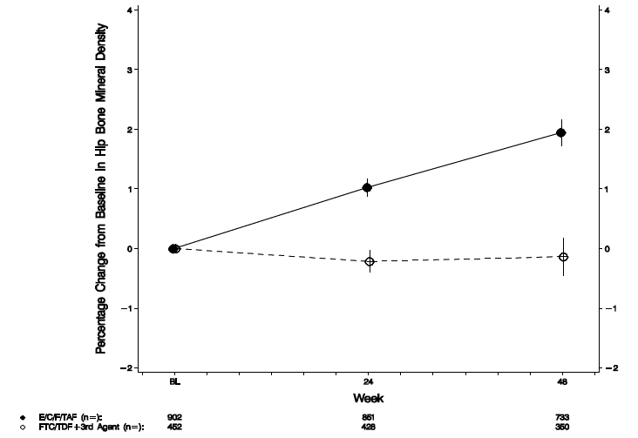

Figure 17. Study GS-US-292-0104: Mean (95% CI) of percentage changes from baseline in spine BMD by visit (observed data; spine DXA analysis sets)

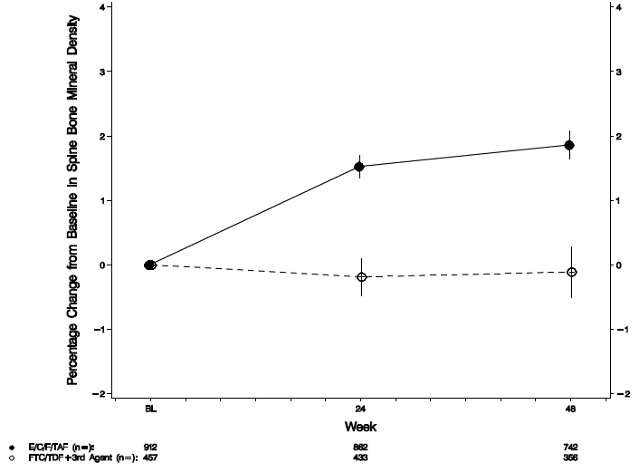

An increase from baseline in BMD was consistently observed for subjects in the E/C/F/TAF group at the hip or at the spine at Weeks 24 and 48, regardless of prior treatment regimen. In contrast, there were minimal changes from baseline in both parameters for subjects who continued on their baseline regimen. Significant differences between the E/C/F/TAF and FTC/TDF + 3rd Agent groups were observed at Weeks 24 and 48 for the percentage changes from baseline in hip and spine BMD in each subgroup by prior treatment (p < 0.001).

Clinical BMD status was assessed using BMD T scores; normal bone status was defined as a BMD T score ≥ ‑1, osteopenia by a T score from ≥‑2.5 to < ‑1, and osteoporosis by a T score < ‑2.5. The majority of subjects in both treatment groups had normal hip and spine BMD clinical status at baseline, and retained that status at Week 24 and Week 48.

The distribution of the clinical BMD status adjusted for baseline status was significantly different between treatment groups at Weeks 24 and 48 at the hip (p ≤ 0.002) or at the spine (p ≤ 0.002). Based on results for subjects with available data at Week 48, a higher percentage in the E/C/F/TAF group than the FTC/TDF + 3rd Agent group had an improvement in hip BMD clinical status (E/C/F/TAF 5.6%, 41 of 733 subjects; FTC/TDF + 3rd Agent 2.0%, 7 of 350 subjects) and a lower percentage of subjects in the E/C/F/TAF group than the FTC/TDF + 3rd Agent group had worsening hip BMD clinical status (E/C/F/TAF 0.7%, 5 subjects; FTC/TDF + 3rd Agent 4.3%, 15 subjects).

Similarly, based on results for subjects with available data at Week 48, a higher percentage in the E/C/F/TAF group than the FTC/TDF + 3rd Agent group had an improvement in spine BMD clinical status (E/C/F/TAF 7.5%, 56 of 742 subjects; FTC/TDF + 3rd Agent 3.7%, 13 of 356 subjects) and a lower percentage of subjects in the E/C/F/TAF group than the FTC/TDF + 3rd Agent group had worsening spine BMD clinical status (E/C/F/TAF 0.9%, 7 subjects; FTC/TDF + 3rd Agent 5.1%, 18 subjects).

##### Renal function outcomes focussing on serum creatinine and treatment emergent proteinuria

###### Serum creatinine

Note this is the switch study from a TDF containing regimen to a TAF containing regimen.

The change from baseline in serum creatinine at Week 48 was the third alpha protected key safety endpoint for this study. Statistical analysis using the fall back procedure, confirmed significance using an adjusted alpha, which was dependent on the results from preceding tests. The analysis excluded subjects in the safety analysis set with ATR as their prior treatment regimen since these subjects had not previously received COBI, a known inhibitor of creatinine secretion.

There were decreases or no changes from baseline in mean serum creatinine values in the E/C/F/TAF group as compared with increases or no changes from baseline in the FTC/TDF + 3rd Agent group after excluding subjects switching from ATR (p ≤ 0.014 for the differences between treatment groups at Weeks 2 through 48). At Week 48, the mean changes from baseline in serum creatinine were: E/C/F/TAF -0.01 (0.117) mg/dL; FTC/TDF + 3rd Agent 0.04 (0.123) mg/dL (p < 0.001 for the difference between groups).

For subjects who switched to E/C/F/TAF from STB, there were decreases from baseline in serum creatinine as compared with increases from baseline observed among subjects who remained on STB (p ≤ 0.017 for the differences between groups at Weeks 2 through 48). For subjects who switched to E/C/F/TAF from ATV/boosted + TVD regimens (including ATV boosted with COBI or RTV), there were increases or no changes from baseline in serum creatinine at most time points as compared with increases from baseline observed among subjects who remained on ATV/boosted + TVD regimens ). There were no significant differences between treatment groups in the changes from baseline in serum creatinine, except at Week 48 (p < 0.001 for the difference between groups).

In contrast, for subjects who switched to E/C/F/TAF from ATR, there were increases from baseline in mean values for serum creatinine as compared with either no changes or smaller increases from baseline observed among subjects who remained on ATR. Increases were observed at Week 2 for the E/C/F/TAF group (consistent with the established COBI effect on serum creatinine) and through Week 48 (p < 0.001 for the differences between groups at Weeks 2 through 48).

Mean (SD) changes from baseline in serum creatinine at Week 48 by prior treatment group were as follows:

* STB: E/C/F/TAF ‑0.02 (0.111) mg/dL; FTC/TDF + 3rd Agent 0.03 (0.110) mg/dL; difference in LSM: ‑0.05 mg/dL, 95% CI: ‑0.07 to ‑0.03 mg/dL
* ATV/boosted + TVD: 0.00 (0.121) mg/dL; FTC/TDF + 3rd Agent 0.05 (0.134) mg/dL; difference in LSM: ‑0.05 mg/dL, 95% CI: ‑0.07 to ‑0.02 mg/dL
* ATR: E/C/F/TAF 0.11 (0.124) mg/dL; FTC/TDF + 3rd Agent 0.02 (0.088) mg/dL; difference in LSM: 0.08 mg/dL, 95% CI: 0.06 to 0.11 mg/dL.

Figure 18. Study GS-US-292-0109: Mean (95% CI) change from baseline in serum creatinine (mg/dL) by visit (observed data; safety analysis set, prior treatment regimen = STB)

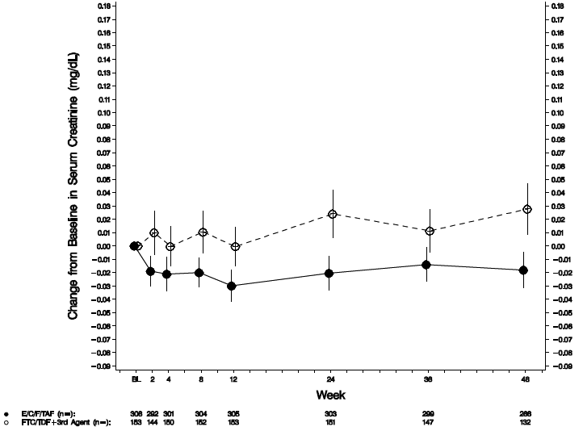

Note: this graph illustrates the reserve situation to the previous studies as it is switching from a TDF regimen to a TAF regimen in treatment experienced patients.

##### Treatment emergent proteinuria by urinalysis (dipstick)

The distribution of proteinuria adjusted for baseline status was significantly different between treatment groups at Week 24 (p = 0.026) and Week 48 (p = 0.004). The majority of subjects in both treatment groups had no proteinuria (Grade 0 by dipstick) at baseline and through Week 48.

Based on results for subjects with available data at Week 48, a higher percentage in the E/C/F/TAF group than the FTC/TDF + 3rd Agent group had improvements from baseline in proteinuria (E/C/F/TAF 7.1%, 55 of 772 subjects; FTC/TDF + 3rd Agent 5.6%, 21 of 374 subjects) and a lower percentage in the E/C/F/TAF group than the FTC/TDF + 3rd Agent group had worsening proteinuria (E/C/F/TAF 4.3%, 33 of 772 subjects; FTC/TDF + 3rd Agent 7.0%, 26 of 374 subjects).

Of the subjects with available data at Week 48 and with Grade 1 proteinuria at baseline, a higher percentage of subjects in the E/C/F/TAF group than the FTC/TDF + 3rd Agent group had improvement to no proteinuria (Grade 0) (E/C/F/TAF 82.5%, 52 of 63 subjects; FTC/TDF + 3rd Agent 60.0%, 18 of 30 subjects).

Based on results for all subjects, treatment-emergent graded proteinuria by urinalysis (dipstick) was reported for the following percentages of subjects during the study: E/C/F/TAF 25.2%, 242 of 959 subjects; FTC/TDF + 3rd Agent 28.4%, 135 of 476 subjects. Most proteinuria was Grade 1 (E/C/F/TAF 220 subjects; FTC/TDF + 3rd Agent 120 subjects).

##### Estimated glomerular filtration rate

There were increases from baseline in eGFRCG values in the E/C/F/TAF group compared with decreases from baseline in the FTC/TDF + 3rd Agent group at Weeks 2 through 48 after excluding subjects switching from ATR. Median changes from baseline at Week 48 were: E/C/F/TAF 1.8 mL/min, FTC/TDF + 3rd Agent -3.7 mL/min (p < 0.001 for the difference between groups) (Table 18).

The changes from baseline in eGFRCG corresponded with those observed for serum creatinine at most time points in both treatment groups among subjects with STB or ATR as their prior regimen and among subjects who remained on ATV/boosted + TVD regimens. Among subjects who switched to E/C/F/TAF from ATV/boosted + TVD regimens, increases from baseline in eGFRCG were observed at most time points, and there was generally no correspondence between eGFRCG and serum creatinine values.

Table 18. GS-US-292-0109: changes from baseline in estimated GFR at Week 48 (safety analysis set, excluding subjects with prior treatment regimen – ATR)

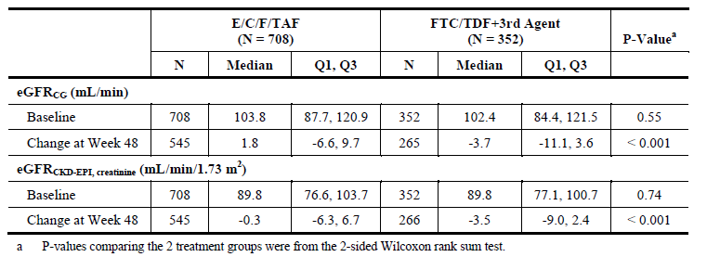

##### Results for other safety outcomes

###### Fracture probability

GS-US-292-0104

FRAX scores were calculated for all subjects. As this tool is validated only for subjects ≥ 40 years of age, in the analysis for all subjects, the FRAX score for subjects < 40 years old was calculated based upon a default age of 40 years. Given this and the lack of validation in the age < 40 group, only the FRAX analysis for subjects ≥ 40 years old are presented below.

For subjects aged ≥ 40 years, the mean (SD) baseline 10 year probability of a hip fracture by FRAX analysis was low for both treatment groups based on the Hip DXA analysis set (E/C/F/TAF 0.33% (0.678%); STB 0.50% (0.871%)). Mean (SD) increase from baseline at Week 48 in hip fracture risk was smaller for the E/C/F/TAF group compared with the STB group (E/C/F/TAF 0.09% (0.291%); STB 0.16% (0.325%); difference in LSM: ‑0.07%, 95% CI: ‑0.15% to 0%; p = 0.057).

For subjects aged ≥ 40 years, the baseline 10 year probability of a major osteoporotic fracture by FRAX analysis was low for both treatment groups based on the hip DXA analysis set; with a lower mean fracture risk observed for the E/C/F/TAF group compared with the STB group (mean (SD): E/C/F/TAF 2.51% (1.757%), STB 3.07% (2.348%); p = 0.025). Mean (SD) increase from baseline at Week 48 in major osteoporotic fracture risk was smaller for the E/C/F/TAF group compared with the STB group (E/C/F/TAF 0.23% (0.454%); STB 0.35% (0.476%); difference in LSM ‑0.12%, 95% CI: ‑0.23% to ‑0.01%; p = 0.038).

GS-US-292-0111

FRAX scores were calculated for all subjects. As this tool is validated only for subjects ≥ 40 years of age, in the analysis for all subjects, the FRAX score for subjects < 40 years old was calculated based upon a default age of 40 years. Given this and the lack of validation in the age < 40 group, only the FRAX analysis for subjects ≥ 40 years old are presented below.

For subjects aged ≥ 40 years, the mean (SD) baseline 10 year probability of a hip fracture by FRAX analysis was low for both treatment groups based on the hip DXA analysis set (E/C/F/TAF 0.36% (0.548%); STB 0.44% (0.628%). Mean (SD) increase from baseline at Week 48 in hip fracture risk was smaller for the E/C/F/TAF group compared with the STB group (E/C/F/TAF 0.09% (0.331%); STB 0.18% (0.476%); difference in LSM: ‑0.09%, 95% CI: ‑0.19% to 0.00%; p = 0.062).

For subjects aged ≥ 40 years, the mean (SD) baseline 10 year probability of a major osteoporotic fracture by FRAX analysis was low for both treatment groups based on the hip DXA analysis set (E/C/F/TAF 3.11% (2.223%); STB 3.36% (2.339%)). Mean (SD) increase from baseline at Week 48 in major osteoporotic fracture risk was smaller for the E/C/F/TAF group compared with the STB group (E/C/F/TAF 0.28% (0.599%); STB 0.41% (0.741%); difference in LSM: ‑0.13%, 95% CI: ‑0.29% to 0.03%; p = 0.12).

GS-US-292-0109

For subjects aged 40 years or older and for all subjects regardless of age (where subjects with an age below 40 years were treated as having an age of 40 years), the baseline 10 year probability of a hip fracture or of a major osteoporotic fracture was similar between treatment groups.

Among subjects aged 40 years or older, the changes from baseline in the 10 year probability of hip fracture and of major osteoporotic fracture, by FRAX analysis, were lower in the E/C/F/TAF group than in the FTC/TDF + 3rd Agent group. The mean (SD) change from baseline in fracture risk at Week 48 was 0.00% (0.242) in the E/C/F/TAF group and 0.10% (0.438) in the FTC/TDF + 3rd Agent group (p < 0.001 for the difference between groups). The change from baseline in the 10 year probability of major osteoporotic fracture at Week 48 was 0.10% (0.386) in the E/C/F/TAF group and 0.23% (0.549) in the FTC/TDF + 3rd Agent group (p = 0.002 for the difference between groups).

Similar results in fracture risk were observed in both treatment groups among all subjects.

### Patient exposure

#### GS-US-292-0104

The duration of exposure to study drugs was similar between the 2 treatment groups. Median (Q1, Q3) exposure was as follows: E/C/F/TAF 60.0 weeks (48.0, 71.3); STB 59.4 weeks (48.0, 65.1). The majority of subjects in each treatment group had received study drugs for ≥ 48 weeks at the time of the Week 48 data cut date (E/C/F/TAF 78.9%, 343 subjects; STB 76.6%, 331 subjects). There was no statistically significant difference between groups in the overall KM estimate of time to premature discontinuation.

Table 19. GS-US-292-0104: Duration of exposure to study drug (safety analysis set)

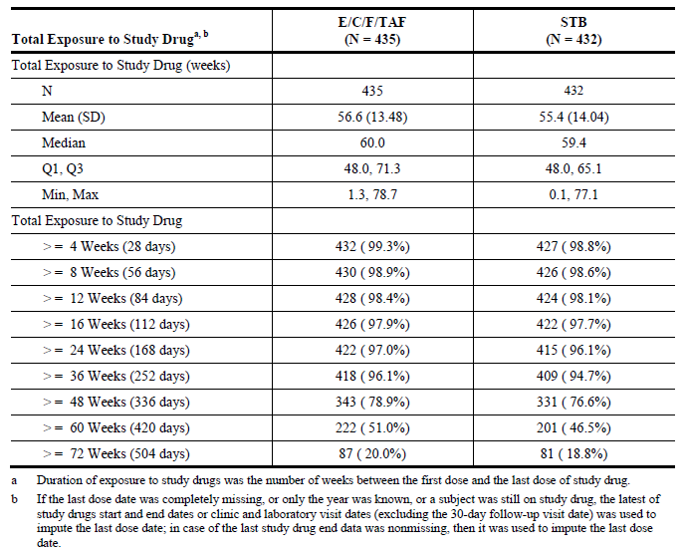

#### GS-US-292-0111

The duration of exposure to study drug was similar between the 2 treatment groups (Table 20). Median (Q1, Q3) exposure was as follows: E/C/F/TAF 48.1 weeks (45.4, 60.1); STB 48.3 weeks (44.4, 60.1). However, the distributions of time to premature discontinuation of study drug between the treatment groups as measured by the KM estimates were different, mainly due to more subjects discontinuing study drug in the STB group (p = 0.04).

Table 20. GS-US-292-0111: Duration of exposure to study drug (safety analysis set)

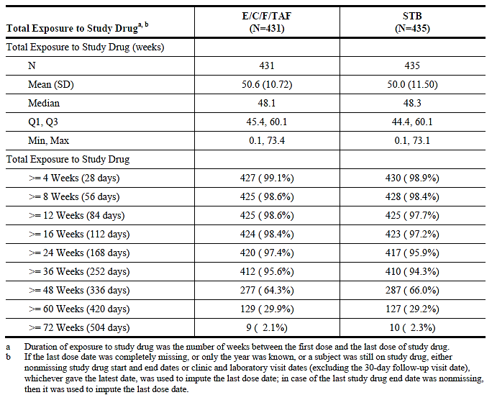

### Adverse events

#### All adverse events (irrespective of relationship to study treatment)

##### Pivotal studies

The key data source supporting the adverse reactions section of the E/C/F/TAF prescribing information is the Week 48 pooled data from the pivotal Phase III studies in ART naive subjects, Studies GS-US-292-0104 and GS-US-292-0111. Supporting data are also provided from studies of virologically suppressed adults switching treatment to E/C/F/TAF (GS-US-292-0109), adults with mild to moderate renal impairment (GS-US-292-0112), and ART naive adolescents (GS-US-292-0106).

###### Adverse drug reactions

In Studies GS-US-292-0104 and GS-US-292-0111, the proportion of subjects who discontinued study drug due to AEs, regardless of severity, was 0.9% (8 subjects) in the E/C/F/TAF group and 1.5% (13 subjects) in the STB group. The only AE (all grades) considered related to study drug by the investigator that was reported in ≥ 10% of subjects in the E/C/F/TAF group was nausea (10.4%, 90 subjects).

Table 2 of the proposed E/C/F/TAF Prescribing Information, entitled adverse reactions (Grades 2 to 4) reported in ≥ 1% of HIV-1 infected treatment naive adults in any treatment arm in studies 104 and 111 (Week 48 analysis), is based on all Grade 2 through 4 AEs considered related to study drug by the investigator and reported in ≥ 1% of subjects in either treatment group in the pooled dataset from Studies GS-US-292-0104 and GS-US-292-0111.

Five AEs considered related to study drug by the investigator that occurred less frequently than 1% (for Grades 2 to 4) in either treatment group in Studies GS-US-292-0104 and GS-US-292-0111 are also included as ADRs for E/C/F/TAF under Table 2 of the proposed Prescribing Information based on an assessment for a potential causal relationship: vomiting, abdominal pain, dyspepsia, flatulence, and rash.

Table 21. GS-US-292-0104 and GS-US-292-0111: Adverse events related to study drug (grades 2 to 4) reported in ≥ 1% of subjects in either treatment group (Week 48 analysis)

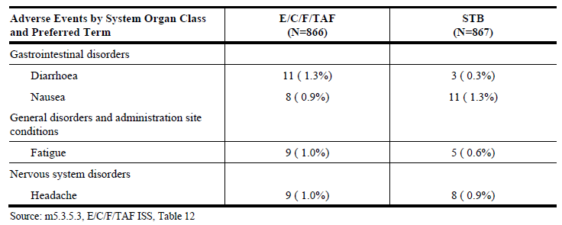

No additional ADRs to E/C/F/TAF were identified through Week 48 in virologically suppressed subjects (Study GS-US-292-0109) who switched from a TDF containing regimen to E/C/F/TAF. In Study GS-US-292-0109, there were no AEs (Grades 2 to 4) considered related to study drug by the investigator that were reported in ≥ 1% of subjects in the E/C/F/TAF group. Based on the data presented, the safety profile of E/C/F/TAF in subjects with mild to moderate renal impairment from Study GS-US-292-0112 is similar to that in subjects with normal renal function, and the safety profile of E/C/F/TAF in ART-naive adolescent subjects aged 12 to < 18 years from Study GS-US-292-0106 is similar to that in adults.

More specifically, the distribution of adverse reactions in the pivotal clinical studies GS-US-292-0104 and GS-US-292-0111 are shown below (Table 22).

Table 22. GS-US-292-0104 and GS-US-292-0111; common adverse events (all grades) in ≥ 5% of patients

|  | Elvitegravir, cobicistat, emtricitabine, tenofovir alafenamide (n=866) | Elvitegravir, cobicistat, emtricitabine, tenofovir disoproxil fumarate (n=867) |
| --- | --- | --- |
| Diarrhoea | 147 (17%) | 164 (19%) |
| Nausea | 132 (15%) | 151 (17%) |
| Headache | 124 (14%) | 108 (13%) |
| Upper respiratory tract infection | 99 (11%) | 109 (13%) |
| Nasopharyngitis | 78 (9%) | 80 (9%) |
| Fatigue | 71 (8%) | 71 (8%) |
| Cough | 67 (8%) | 60 (7%) |
| Vomiting | 62 (7%) | 54 (6%) |
| Arthralgia | 61 (7%) | 39 (5%) |
| Back pain | 60 (7%) | 57 (7%) |
| Insomnia | 57 (7%) | 48 (6%) |
| Rash | 55 (6%) | 46 (5%) |
| Pyrexia | 45 (5%) | 41 (5%) |
| Dizziness | 44 (5%) | 37 (4%) |

Data are n (%).

##### Other studies

###### GS-US-292-0112

Cohort 1: Switch Subjects

Grade 3 and 4 AEs were reported for 7.4% of subjects (n = 18): 6.6% of subjects (n = 16) had Grade 3 AEs and 0.8% of subjects (n = 2) had Grade 4 AEs. Myocardial infarction (3 subjects) was the only Grade 3 or 4 AE reported in > 1 subject; each event was considered serious and unrelated to study drug by the investigator.

Cohort 2: ART naive subjects

No Grade 3 or 4 AEs were reported for Cohort 2 ART naive subjects.

###### GS-US-292-0109

Common AEs were consistent with those expected in the subject population, the known safety profiles of the study drugs, and with previous clinical study experience with E/C/F/TAF. The most common AEs (that is, occurred in ≥ 5% of subjects) by treatment group were as follows:

* E/C/F/TAF: upper respiratory tract infection (12.1%, 116 of 959 subjects), diarrhoea (8.0%, 77 subjects), nasopharyngitis (6.7%, 64 subjects), headache (6.0%, 58 subjects), and cough (5.1%, 49 subjects)
* FTC/TDF + 3rd Agent: upper respiratory tract infection (7.5%, 36 of 477 subjects), diarrhoea (7.5%, 36 subjects), and nasopharyngitis (5.5%, 26 subjects) No AE by PT was reported with a difference in percentages of ≥ 5% between groups.

#### Treatment related adverse events (adverse drug reactions)

##### Pivotal studies

###### GS-US-292-0104

Similar percentages of subjects in both treatment groups had any AE considered related to study drugs by the investigator (E/C/F/TAF 41.8%, 182 subjects; STB 45.4%, 196 subjects). The AEs considered related to study drugs by the investigator reported for ≥ 5% of subjects in either treatment group were as follows:

* E/C/F/TAF group; nausea (11.3%, 49 subjects), diarrhoea (8.5%, 37 subjects), headache (6.4%, 28 subjects), and fatigue (5.5%, 24 subjects)
* STB group; nausea (12.7%, 55 subjects), diarrhoea (9.5%, 41 subjects), fatigue (4.4%, 19 subjects), and headache (6.5%, 28 subjects).

The majority of AEs considered related to study drugs by the investigator were Grade 1. Few subjects had Grade 3 or 4 AEs considered related to study drugs (E/C/F/TAF 2.1%, 9 subjects; STB 0.5%, 2 subjects).

###### GS-US-292-0111

Similar percentages of subjects in both treatment groups had any AE considered related to study drugs by the investigator (E/C/F/TAF 37.1%, 160 subjects; STB 38.6%, 168 subjects). The AEs considered related to study drugs by the investigator reported for ≥ 5% of subjects in either treatment group were as follows:

* E/C/F/TAF group; nausea (9.5%, 41 subjects), diarrhoea (5.8%, 25 subjects), and headache (5.6%, 24 subjects)
* STB group; nausea (13.3%, 58 subjects) and diarrhoea (7.6%, 33 subjects).

The majority of AEs considered related to study drugs by the investigator were Grade 1. Few subjects had Grade 3 AEs considered related to study drugs (E/C/F/TAF 0.7%, 3 subjects; STB 1.6%, 7 subjects). There were no Grade 4 AEs related to study drugs.

##### Other studies

###### GS-US-292-0109

A higher percentage of subjects in the switch group (that is, E/C/F/TAF treatment group) had any AE considered by the investigator as related to study drug (E/C/F/TAF 19.3%, 185 subjects; FTC/TDF + 3rd Agent 12.8%, 61 subjects).

The most common AEs by PT considered by the investigator as related to study drug, reported for > 1% of subjects in either group were as follows:

* E/C/F/TAF: diarrhoea (2.5%, 24 of 959 subjects), nausea (2.2%, 21 subjects), flatulence (1.9%, 18 subjects), headache (1.8%, 17 subjects), abnormal dreams (1.3%, 12 subjects), dizziness (1.1%, 11 subjects), and insomnia (1.0%, 10 subjects)
* FTC/TDF + 3rd Agent: jaundice (1.9%, 9 of 477 subjects), osteopenia (1.3%, 6 subjects), dizziness (1.3%, 6 subjects), abnormal dreams (1.3%, 6 subjects), diarrhoea (1.3%, 6 subjects), insomnia (1.3%, 6 subjects), and ocular icterus (1.0%, 5 subjects).

Among the common study drug related AEs, there were no notable differences between treatment groups. All reports of study drug related jaundice and ocular icterus were for subjects taking ATV/boosted + TVD regimens.

###### GS-US-292-0112

Cohort 1: Switch Subjects

Adverse events considered related to the study drug by the investigator that occurred in ≥ 1% of Cohort 1 switch subjects were provided. The most commonly reported AEs considered related to the study drug by the investigator in Cohort 1 switch subjects were dizziness (2.9%, 7 subjects), diarrhoea (2.5%, 6 subjects), and headache (2.1%, 5 subjects). The majority of AEs considered related to study drugs by the investigator were Grade 1. Three subjects had a single non serious Grade 3 AE considered related to study drug: blood creatine kinase increased (baseline eGFRCG < 50 mL/min group), gastroesophageal reflux disease (baseline eGFRCG ≥ 50 mL/min group), and hypercholesterolemia (baseline eGFRCG ≥ 50 mL/min group).

Cohort 2: ART naive subjects:

One AE considered related to the study drug by the investigator was reported in a Cohort 2 ART naive subject was hyperlipidaemia, but it was reported in < 1% of Cohort 1 switch subjects.

#### Deaths and other serious adverse events

##### Pivotal studies

###### Study GS-US-292-0104

Deaths

One subject in each treatment group died during the study; neither death was considered related to study drugs by the investigator. Subject [information redacted] in the E/C/F/TAF group died as a result of embolic stroke in the setting of atrial fibrillation that transformed into haemorrhagic stroke. Subject [information redacted] in the STB group died as a result of cardiac arrest which occurred following cholesteatoma removal (reported as vagally mediated bradycardic/asystole).

Serious adverse events

Serious AEs were reported for a similar percentage of subjects in both treatment groups (E/C/F/TAF 8.5%, 37 subjects; STB 6.7%, 29 subjects). Overall, the incidence of SAEs considered related to study drugs by the investigator were low and similar in both treatment groups (E/C/F/TAF 0.7%, 3 subjects; STB 0.2%, 1 subject).

No individual SAE occurred in > 1% of subjects in either treatment group. The following SAEs were reported for > 1 subject in either treatment group: acute myocardial infarction (E/C/F/TAF 0.5%, 2 subjects; STB 0 subjects), appendicitis (E/C/F/TAF 0.9%, 4 subjects; STB 0.2%, 1 subject), cellulitis (E/C/F/TAF 0 subjects; STB 0.5%, 2 subjects), staphylococcal skin infection (E/C/F/TAF 0.5%, 2 subjects; STB 0 subjects), accidental overdose (E/C/F/TAF 0.5%, 2 subjects; STB 0 subjects), and suicidal ideation (E/C/F/TAF 0.5%, 2 subjects; STB 0.5%, 2 subjects).

Serious AEs that were considered related to study drugs by the investigator were reported for a similar percentage of subjects in both treatment groups: (E/C/F/TAF 0.7%, 3 subjects (staphylococcal skin infection, erythematous rash, and hypovolemic shock); STB 0.2%, 1 subject (immune reconstitution inflammatory syndrome)).

###### Study GS-US-292-0111

Deaths

Three subjects died during the study; 1 in the E/C/F/TAF group and 2 in the STB group. None of the SAEs that resulted in the deaths were considered related to study drugs by the investigator. Subject [information redacted] in the E/C/F/TAF group died on Day 90 of alcohol intoxication (reported as an SAE of alcohol poisoning on Day 62).

Subject [information redacted] in the STB group died on Day 62 died of acute ethanol and multiple drug toxicity (reported as an SAE of recreational drug and alcohol overdose on Day 62). Subject [information redacted] in the STB group died on Day 110 of myocardial infarction (reported as an SAE of acute myocardial infarction on Day 110, 2 weeks after the onset of an SAE of meningococcal meningitis). The SAEs with fatal outcomes were considered not related to study drugs by the investigator.

Serious adverse events

The SAEs were reported for similar percentages of subjects in both treatment groups (E/C/F/TAF 7.7%, 33 subjects; STB 6.9%, 30 subjects). Overall, the incidences of SAEs considered related to study drugs by the investigator were low in both treatment groups (E/C/F/TAF 0 subjects; STB 0.2%, 1 subject). No individual SAE occurred in ≥ 1% of subjects in either treatment group.

The following SAEs were reported for > 1 subject in either treatment group:

* vomiting (E/C/F/TAF 0.5%, 2 subjects; STB 0 subjects)
* appendicitis (E/C/F/TAF 0 subjects; STB 0.5%, 2 subjects)
* gastroenteritis (E/C/F/TAF 0.5%, 2 subjects; STB 0 subjects)
* overdose (E/C/F/TAF 0 subjects; STB 0.5%, 2 subjects)
* depression suicidal (E/C/F/TAF 0 subjects; STB 0.5%, 2 subjects)
* psychotic disorder (E/C/F/TAF 0.5%, 2 subjects; STB 0 subjects), and
* suicide attempt (E/C/F/TAF 0 subjects; STB 0.5%, 2 subjects).

There was 1 SAE considered related to study drugs by the investigator, reported for 1 subject (0.2%) in the STB group (cholelithiasis). None of the subjects in the E/C/F/TAF group had an SAE that was considered related to study drugs.

##### Other studies

###### Study GS-US-292-0109

Deaths

Two subjects in the E/C/F/TAF group died during the study. Subject [information redacted] died on Day 148 of septic shock and Subject [information redacted] died on Day 391 as a result of stage 4 adenocarcinoma. Both events were considered by the investigator as not related to study drug.

Serious adverse events

Serious AEs were reported for similar percentages of subjects in the 2 groups (E E/C/F/TAF 4.4%, 42 subjects; FTC/TDF + 3rd Agent 4.4%, 21 subjects). The following SAEs were reported for > 1 subject in either treatment group:

* aseptic meningitis (E/C/F/TAF 0.3%, 3 subjects; FTC/TDF + 3rd Agent 0%)
* pneumonia (E/C/F/TAF 0.3%, 3 subjects; FTC/TDF + 3rd Agent 0%)
* sepsis (E/C/F/TAF 0.2%, 2 subjects; FTC/TDF + 3rd Agent 0%)
* sinusitis (E/C/F/TAF 0.2%, 2 subjects; FTC/TDF + 3rd Agent 0%)
* chest pain (E/C/F/TAF 0.2%, 2 subjects; FTC/TDF + 3rd Agent 0.2%, 1 subject)
* diarrhoea (E/C/F/TAF 0.1%; 1 subject; FTC/TDF + 3rd Agent 0.4%, 2 subjects); and
* abdominal pain (E/C/F/TAF 0.2%, 2 subjects; FTC/TDF + 3rd Agent 0%).

One subject in the FTC/TDF + 3rd Agent group had an SAE of acute renal failure that was considered by the investigator as related to study drugs.

#### Discontinuation due to adverse events

##### Pivotal studies

GS-US-292-0104 and GS-US-292-0111: In the pivotal studies around 1% of subjects had SAEs that lead to their discontinuation, but these were not considered to be related to study medication. The contribution of TAF to these observations is not known as there appears to be no statistical difference between the TAF containing regimen and the TDF regimen in terms of SAE related discontinuations.

##### Other studies

GS-US-292-0109 and GS-US-292-0112: There were no SAE related discontinuations directly associated with study medication, although the switch study indicated a higher number of patients who switched to the TAF regimen had AEs than those who stayed on their established regimen. This would be expected from a clinical perspective.

### Laboratory tests

#### Liver function

##### Pivotal studies

###### GS-US-292-0104

In the assessment of liver enzyme elevations in relation to normal ranges, 1 subject in the STB group, had elevations > 3 × ULN in AST or ALT, in addition to total bilirubin > 2 × ULN, and ALP < 1.5 × ULN. Subject [information redacted], who had high AST and ALT at baseline (79 U/L Grade 1 and 152 U/L Grade 2, respectively), had the following values on Day 43: AST = 2360 U/L (Grade 4), ALT = 3244 U/L (Grade 4), total bilirubin = 9.1 mg/dL (Grade 4), and ALP = 143 U/L. This subject tested positive for hepatitis B virus (HBV) surface antigen at screening, and discontinued study drugs on Day 32 due an SAE of Grade 3 immune inflammatory syndrome due to HBV, which resulted in unblinding of study drug.

###### GS-US-292-0111

In the assessment of liver enzyme elevations in relation to normal ranges, no subjects had elevations > 3 × ULN in AST or ALT, plus > 2 × ULN in total bilirubin, plus < 2 × ULN in alkaline phosphatase.

##### Other studies

###### GS-US-292-0109

In the assessment of liver enzyme elevations in relation to normal ranges, no subjects in the E/C/F/TAF group and 5 subjects in the FTC/TDF + 3rd Agent group had AST or ALT > 3 x ULN in addition to total bilirubin > 2 x ULN and ALP < 2 x ULN. Of the 5 subjects in the FTC/TDF + 3rd Agent group who met these combined criteria, 1 had syphilitic hepatitis and 4 had asymptomatic elevations of liver enzymes consistent with ATV treatment. Among virologically suppressed subjects in Study GS-US-292-0109, a lower percentage of subjects in the E/C/F/TAF group compared with the FTC/TDF + 3rd Agent group had Grade 3 or 4 abnormalities (E/C/F/TAF 19.8%, FTC/TDF + 3rd Agent 25.4%), predominantly driven by the higher incidence of Grade 3 or Grade 4 hyperbilirubinemia in the FTC/TDF + 3rd Agent group (E/C/F/TAF 0.1%, 1 of 959 subjects; FTC/TDF + 3rd Agent 14.3%, 68 of 477 subjects). Almost all cases (66 of 68) of Grade 3 or 4 hyperbilirubinemia in the FTC/TDF + 3rd Agent group occurred in subjects taking ATV.

#### Kidney function

##### Pivotal studies

Renal function has been discussed under the safety headings as it is one of the pivotal outcome safety parameters.

#### Other clinical chemistry

##### Pivotal studies

###### Bone laboratory parameters

GS-US-292-0104

Mean percentage increases from baseline in the bone turnover biomarkers C-telopeptide (bone resorption) and PINP (bone formation), as well as PTH, a hormone involved in bone metabolism, were smaller in the E/C/F/TAF group compared with the STB group (p < 0.001 for the differences between the 2 groups at Weeks 24 and 48. Median baseline values for all 3 parameters were similar for both treatment groups. Median (Q1, Q3) percentage changes from baseline at Week 48 were as follows: C-telopeptide: E/C/F/TAF 10.7% (‑6.9%, 33.3%), STB 23.3% (3.9%, 47.8%); PINP: E/C/F/TAF 27.46% (3.72%, 66.99%), STB 75.20% (42.84%, 118.60%); PTH: E/C/F/TAF 17.3% (‑9.9%, 50.9%), STB 33.6% (3.7%, 75.8%).

GS-US-292-0111

Mean percentage increases from baseline in the bone turnover biomarkers C-telopeptide (bone resorption) and PINP (bone formation), as well as PTH, a hormone involved in bone metabolism, were smaller in the E/C/F/TAF group compared with the STB group (p < 0.001 for the differences between the 2 groups at both Weeks 24 and 48 for all parameters except PTH at Week 24 (p = 0.003)). Median (Q1, Q3) baseline values for all 3 parameters were similar for both treatment groups, with the exception of PINP which was higher in the E/C/F/TAF group compared with the STB group (E/C/F/TAF 43.25 (34.44, 55.31) ng/mL; STB 41.23 (32.91, 52.66) ng/mL; p = 0.039). Median (Q1, Q3) percentage changes from baseline at Week 48 were as follows: C-telopeptide: E/C/F/TAF 7.9% (‑10.8%, 30.8%), STB 18.6% (0.0%, 42.3%); PINP: E/C/F/TAF 25.51% (2.45%, 55.46%), STB 69.48% (39.65%, 122.90%); PTH: E/C/F/TAF 27.8% (0.3%, 69.0%), STB 50.5% (14.4%, 94.1%).

##### Other studies

Across comparative studies, as in the pivotal studies above, reduced bone turnover was observed with E/C/F/TAF compared with STB or TDF regimens, as shown by less change in parathyroid hormone (PTH), type I collagen C telopeptide (C-telopeptide), and procollagen type 1 N-terminal propeptide (P1NP). Subjects who switched to E/C/F/TAF from a TDF based regimen experienced a decrease from baseline in serum levels of the P1NP and PTH.

#### Haematology

##### Pivotal studies

There were no haematological abnormalities of note reported in either the pivotal or comparative studies.

#### Blood lipids

##### Pivotal studies

Mean changes from baseline in serum lipids from Studies GS-US-292-0104 and GS-US-292-0111 are presented in Table 3 of the proposed Prescribing Information, entitled ‘*Lipid Values, Mean Change from Baseline, Reported in Subjects Receiving Genvoya or Stribild in Studies 104 and 111*’. In the E/C/F/TAF group, 4.4% of subjects (n = 32) were taking lipid modifying medications at study entry, and 3.6% of subjects (n = 31) initiated treatment during the study. In the STB group, 5.0% of subjects (n = 43) were taking lipid modifying medications at study entry, and 2.9% of subjects (n = 25) initiated treatment during the study.

#### Electrocardiograph

##### Pivotal studies

Abnormal ECGs were reported in patients of both cohorts across the study period. These resolved with a day or two and were not assessed as related to study medication.

In Study GS-US-292-0104, clinically significant ECG abnormalities were reported for 2 subjects in the E/C/F/TAF group and 1 subject in the STB group. Clinically significant ECG abnormalities were reported as an AE for 1 subject in the E/C/F/TAF group. Subject [information redacted], who had a normal ECG at baseline, had clinically significant abnormal sinus rhythm with sinus arrhythmia and first degree atrioventricular (AV) block at Week 48, which was also reported as a non-serious AE of ECG abnormal considered. The event was ongoing at the time of the data cut off, considered unrelated to study drugs by the investigator, and did not result in discontinuation of study drugs.

In Study GS-US-292-0111, clinically significant ECG abnormalities were reported as an AE for 1 subject in the E/C/F/TAF group. Subject [information redacted], who had an abnormal ECG at baseline (premature supraventricular complexes with aberrant ventricular conduction), had clinically significant atrial fibrillation on Day 305, which was reported as a non-serious AE of ECG abnormal. The event resolved the same day, was considered unrelated to study drugs by the investigator, and did not result in discontinuation of study drugs.

##### Other studies

In Study GS-US-292-0109, clinically significant ECG findings were reported for 6 subjects in the E/C/F/TAF group and 1 subject in the FTC/TDF + 3rd Agent group. These ECG findings were reported as AEs for 2 subjects in the E/C/F/TAF group. Subject [information redacted] in the E/C/F/TAF group, with normal ECG at baseline, had clinically significant abnormal nonspecific ST and T wave abnormality, with normal sinus rhythm on Day 331. The wave abnormality was reported as a non-serious; Grade 1 AE of ECG abnormal. The event was ongoing at the time of the data cut off, considered by the investigator as unrelated to study drug, and did not result in discontinuation of study drug. Subject [information redacted] in the E/C/F/TAF group, with normal ECG at baseline, had clinically significant abnormal sinus rhythm with possible premature atrial complexes, aberrant conduction, possible left atrial enlargement, and incomplete right bundle branch block on Day 333. The bundle branch block right and arrhythmia were reported as non-serious, Grade 1 AEs. The events were ongoing at the time of the data cut off, were considered by the investigator as unrelated to study drug, and did not result in discontinuation of study drug.

#### Vital signs

##### Pivotal studies

There were no vital sign abnormalities reported across studies.

### Post-marketing experience

There is no post-marketing experience as this FDC is not available in any market globally.

### Other safety issues

There appear to be no additional safety issues specifically related to TAF as a component of Genvoya compared with the currently approved Stribild.

### Evaluator’s overall conclusions on clinical safety

Statistically significant differences favouring E/C/F/TAF over STB or TDF containing regimens were observed at Week 48 for all key secondary safety endpoints in both ART naive and virologically suppressed subjects: mean percentage changes from baseline in hip BMD (p < 0.001 for both ART naive and virologically suppressed subjects) and spine BMD (p < 0.001 for both ART naive and virologically suppressed subjects), mean change from baseline in serum creatinine (p < 0.001 for both ART naive and virologically suppressed subjects), change from baseline in treatment emergent proteinuria (ART naive subjects, p = 0.022), and change from baseline in EFV related symptom assessment composite score (virologically suppressed subjects; p < 0.001).

The clinical relevance of improving BMD is unquestionable in terms of potentially reducing fractures. It is not possible to determine if the 48 week follow-up period is long enough. However statistically significant differences between Genvoya and Stribild were observed by 48 weeks. There is no reason to assume these differences will be reduced following longer term observation as the pharmacokinetics of TDF and TAF should remain consistent.

There appears to be a positive benefit of Genvoya in terms of renal toxicity, compared with Stribild and also when patients were switch to Genvoya from a TDF containing regimen. There were no untoward adverse reactions to Genvoya, in cohorts of either naive or treatment experienced patients. There were no untoward AEs or SAEs in adolescents or patients who had baseline mild to moderate renal impairment.

The overall safety profile of Genvoya is a significant improvement over the safety profile of Stribild.

## First round benefit-risk assessment

### First round assessment of benefits

The benefits of Genvoya in the proposed usage are:

* Higher treatment response rate with Genvoya (92.4%) compared with the currently approved Stribild (90.4%). This confirmed equivalence
* Significant reduction in loss of bone density in Genvoya cohort compared with the Stribild cohort

Figure 19. Comparison bone density loss; Genvoya compared with Stribild

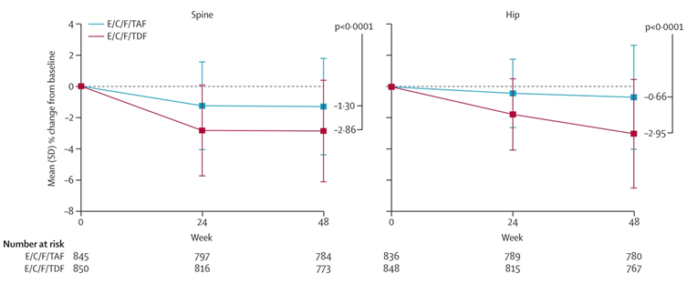

* This reduction in bone loss was apparent in both hip and spine DEXA scans
* Improvement and reversal in bone loss and reduction of laboratory markers of bone resorption in patients switched from E/C/F/TDF to E/C/F/TAF
* Bone density loss was reduced in E/C/F/TAF cohorts of patients who had baseline mild to moderate renal impairment
* No additional adverse reactions for Genvoya compared with the approved Stribild. Low level of drug discontinuation due the study medication and equal between Genvoya and Stribild (8:0.9% versus. 13: 1.5%). No SAEs resulting in death were related to study medications
* Renal toxicity observed with Stribild, not found with Genvoya as shown by significantly reduced parameters of renal toxicity in the E/C/F/TAF group compared with the E/C/F/TDF group

Figure 20. Parameters of renal toxicity; Genvoya compared with Stribild

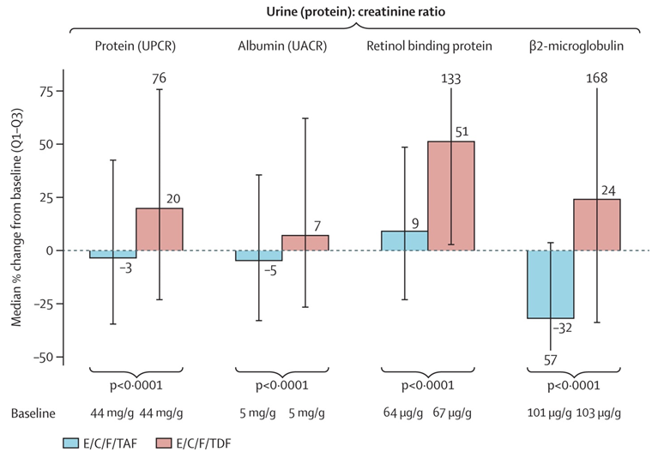

* Improvement in parameters of renal function in cohort of E/C/F/TDF group when switched to E/C/F/TAF
* Fractures were not common in either comparative groups and not related to study medication as almost all were due to trauma
* Non-significant increases in blood lipids noted in the E/C/F/TAF group compared with the E/C/F/TDF group.

### First round assessment of risks

The risks of Genvoya in the proposed usage are:

* That the apparent improvement in bone density observed in this submission did not include a substantial number of elderly men and post-menopausal women. This is understandable, given the epidemiology and demography of the HIV-1 infected populations in the study countries. It is these populations who are at most risk of have bone density problems when taking life-long HIV-1 therapies. The sponsor may be requested to maintain a post-marketing strategy to determine if the bone density advantages of Genvoya are sustained over the long term
* The proportion of patients with advanced HIV-1 disease was small in all studies, although because the overall cohort numbers were large, the actual number of patients appears reasonable. The sponsor will need to investigate the efficacy and safety of E/C/F/TAF in patients with advanced disease to determine if Genvoya is effective and safe for this cohort, as it appears to be from sub analysis of the submitted studies.

### First round assessment of benefit-risk balance

The benefit-risk balance of Genvoya, given the proposed usage, is favourable.

## First round recommendation regarding authorisation

Genvoya is indicated for the treatment of HIV-1 infection in adults and paediatric patients 12 years of age and older without any known mutations associated with resistance to the individual components of Genvoya.

It is recommended that authorisation is approved for Genvoya.

## Clinical questions

No clinical questions were raised.

|  |
| --- |
| Therapeutic Goods Administration |
| PO Box 100 Woden ACT 2606 Australia  Email: [info@tga.gov.au](mailto:info@tga.gov.au) Phone: 1800 020 653 Fax: 02 6232 8605  [**https://www.tga.gov.au**](https://www.tga.gov.au) |