|  |
| --- |
| **Date of CER: October 2012** |

|  |
| --- |
| AusPAR Attachment 2 |
| Extract from the Clinical Evaluation Report for Emtricitabine |
| Proprietary Product Name: Emtriva |
| Sponsor: Gilead Sciences Pty Ltd |

About the Therapeutic Goods Administration (TGA)

* The Therapeutic Goods Administration (TGA) is part of the Australian Government Department of Health, and is responsible for regulating medicines and medical devices.
* The TGA administers the *Therapeutic Goods Act 1989* (the Act), applying a risk management approach designed to ensure therapeutic goods supplied in Australia meet acceptable standards of quality, safety and efficacy (performance), when necessary.
* The work of the TGA is based on applying scientific and clinical expertise to decision-making, to ensure that the benefits to consumers outweigh any risks associated with the use of medicines and medical devices.
* The TGA relies on the public, healthcare professionals and industry to report problems with medicines or medical devices. TGA investigates reports received by it to determine any necessary regulatory action.
* To report a problem with a medicine or medical device, please see the information on the TGA website <<http://www.tga.gov.au>>.

About the Extract from the Clinical Evaluation Report

* This document provides a more detailed evaluation of the clinical findings, extracted from the Clinical Evaluation Report (CER) prepared by the TGA. This extract does not include sections from the CER regarding product documentation or post market activities.
* The words [Information redacted] indicate confidential information has been deleted.
* For the most recent Product Information (PI), please refer to the TGA website <<http://www.tga.gov.au/hp/information-medicines-pi.htm>>.

Copyright

© Commonwealth of Australia 2014  
This work is copyright. You may reproduce the whole or part of this work in unaltered form for your own personal use or, if you are part of an organisation, for internal use within your organisation, but only if you or your organisation do not use the reproduction for any commercial purpose and retain this copyright notice and all disclaimer notices as part of that reproduction. Apart from rights to use as permitted by the *Copyright Act 1968* or allowed by this copyright notice, all other rights are reserved and you are not allowed to reproduce the whole or any part of this work in any way (electronic or otherwise) without first being given specific written permission from the Commonwealth to do so. Requests and inquiries concerning reproduction and rights are to be sent to the TGA Copyright Officer, Therapeutic Goods Administration, PO Box 100, Woden ACT 2606 or emailed to <[tga.copyright@tga.gov.au](mailto:tga.copyright@tga.gov.au)>.

Contents

List of abbreviations 5

1. Clinical rationale 6

2. Contents of the clinical dossier 7

2.1. Scope of the clinical dossier 7

2.2. Paediatric data 7

2.3. Good clinical practice 7

3. Pharmacokinetics 7

3.1. Studies providing pharmacokinetic data 7

3.2. Summary of pharmacokinetics 7

3.3. Evaluator’s overall conclusions on pharmacokinetics 11

4. Pharmacodynamics 11

4.1. Studies providing pharmacodynamic data 11

4.2. Evaluator’s overall conclusions on pharmacodynamics 11

5. Dosage selection for the pivotal studies 11

6. Clinical efficacy 12

6.1. Extension of age 12

6.2. Analyses performed across trials (pooled & meta analyses) 24

6.3. Evaluator’s conclusions on extension of age indication 25

7. Clinical safety 25

7.1. Studies providing evaluable safety data 25

7.2. Studies that assessed safety as an outcome 26

7.3. Patient exposure 28

7.4. Adverse events 29

7.5. Laboratory tests 33

7.6. Post-marketing experience 34

7.7. Safety issues with the potential for major regulatory impact 34

7.8. Other safety issues 34

7.9. Evaluator’s overall conclusions on clinical safety 35

8. First round benefit-risk assessment 35

8.1. First round assessment of benefits 35

8.2. First round assessment of risks 36

8.3. First round assessment of benefit-risk balance 36

9. First round recommendation regarding authorisation 36

10. Clinical questions 36

11. References 36

## List of abbreviations

| **Abbreviation** | **Meaning** |
| --- | --- |
| 3TC | lamivudine |
| AE | adverse event |
| ABC | abacavir (Ziagen) |
| AIDS | acquired immunodeficiency syndrome |
| ART | antiretroviral therapy |
| AUC | area under the plasma concentration versus time curve |
| AUCtau | area under the (plasma concentration versus time) curve over the dosing interval at steady state |
| CL/F | apparent total body clearance following oral administration |
| Cmax | maximum plasma concentration |
| CV | coefficicent of variation |
| d4T | stavudine (Zerit) |
| ddI | didanosine (Videx) |
| DHHS | (US) Department of Health and Human Services |
| EFV | efavirenz (Sustiva) |
| FDA | (US) Food and Drug Administration |
| FTC | emtricitabine |
| HAART | highly active antiretroviral therapy |
| HIV-1 | human immunodeficiency virus type 1 |
| ITT | intent-to-treat |
| LOCF | last observation carried forward |
| LLOQ | lower limit of quantitation |
| LPV/r | lopinavir/ritonavir (Katetra) |
| MAA | Market Authorisation Application |
| M = F | missing = failure |
| NC = F | noncompeter = failure |
| NNRTI | non-nucleoside reverse transcriptase inhibitor |
| NRTI | nucleoside reverse transcriptase inhibitor |
| NFV | nelfinavir (Viracept) |
| PACTG | Paediatric AIDS Clinical Trials Group |
| PI | protease inhibitor |
| RNA | ribonucleic acid |
| RTV | ritonavir (Norvir) |
| SAE | serious adverse event |
| SDMC | Statistical and Data Management Centre |
| T1/2 | elimination half-life |
| TLOVR | time to loss of virologic response |
| Tmax | time to maximum plasma concentration |
| ZDV | zidovudine |

## Clinical rationale

Emtricitabine (Emtriva, FTC) is an approved nucleoside transciptase inhibitor (NRTI) administrated once daily in combination with other antiretroviral agents for the treatment of human immunodeficiency virus type 1 (HIV-1) infection. The 200 mg hard capsule formulation is approved in Australia for use in adult populations.

The objective of this application is to provide data to support the extension of age indication to paediatric populations aged 12-17 years and weighting >33kg. Data to support the application is from three 48-week pharmacokinetic, efficacy and safety studies in paediatric patients (studies FTC-203, FTC-202 and FTC-211). These studies involve 164 paediatric patients less than 18 years of age, with a median duration of exposure of 96.1 weeks.

Paediatric HIV infection remains a major therapeutic challenge both in under-privileged settings and high-income countries. Although treatment of HIV in paediatric patients shares common characteristics with the adult population, there are considerations of particular importance to the paediatric population. Maximal suppression of viral replication and reduction and delay in the emergence of drug resistant viral variants is as important for children as it is for adults. Poor adherence is a major determinant of failure of highly active antiretroviral therapy (HAART) and suboptimal adherence is a common problem among children. Thus, any measures that may enhance adherence, such as ease of administration, palatability, and once-daily dosing, have the potential to make a substantial impact on therapeutic response in this population. In addition, a low risk of drug-drug interactions and the ability to administer medication with or without regard to food increase the versatility of antiretroviral regimen.

*Comment: The above summary is taken from the sponsor’s clinical summary. The need for simple dosing regimens to improve patient compliance is an important consideration in adolescent medicine where the treatment of chronic disease and treatment compliance is a recognised challenge.*

## Contents of the clinical dossier

### Scope of the clinical dossier

The submission contained the following clinical information:

* 3 pivotal efficacy/safety studies;
* Most recent Periodic Safety Update Report (PSUR) for Emtriva, covering the period 3 April 2011 through to 2 April 2012.

### Paediatric data

The submission included paediatric efficacy and safety data.

### Good clinical practice

The applicant stated that all trials were conducted following contemporary Good Clinical Practice guidelines and considerations for the ethical treatment of human subjects.

## Pharmacokinetics

### Studies providing pharmacokinetic data

Table 1 shows the studies relating to each pharmacokinetic topic and the location of each study summary.

Table 1: Submitted pharmacokinetic studies.

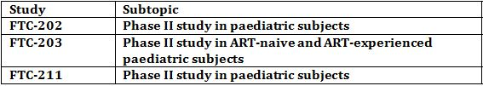

None of the pharmacokinetic studies had deficiencies that excluded their results from consideration.

### Summary of pharmacokinetics

The information in the following summary is derived from conventional pharmacokinetic studies unless otherwise stated.

Studies FTC-202, FTC-203 and FTC-211 provided information on pharmacokinetics. The pharmacokinetic endpoints were:

* Steady-state daily (0-24 h) plasma area under the concentration-time curve (AUC) of emtricitabine performed at Week 2, and between Weeks 8 to 24 if dose adjustments were required;
* Emtricitabine plasma trough concentration at steady state.

#### Pharmacokinetics in the target population

##### Study FTC-202

All subjects underwent an intensive (0-24 h) pharmacokinetic study after 2 weeks on the recommended dose regimen in study FTC-202. Plasma samples were assayed for emtricitabine, efavirenz and ddI. For Age Groups 2 and 3, the need for dose adjustments was determined after the Week 2 pharmacokinetic data for the initial 8 subjects enrolled into these two age groups were analysed. No adjustment for emtricitabine was required.

###### Data analysis

The initial pharmacokinetic emtricitabine analysis was a non-compartmental evaluation to provide preliminary estimates of AUC, Cmax, Tmax, apparent half-life, and end of dosing interval concentrations. A two-compartment model with first-order absorption was selected for the best fit based on a predetermined set of criteria. Parameters calculated from the compartment analysis include an estimate of AUC0-24 and estimated oral clearance (CL/F). Summary statistics for all parameters include median, range, mean, and standard deviation.

###### Data set

Pharmacokinetic evaluations were available for 31 children (17/21 subjects in Group 2 and 14/16 in Group 3 (Table 2).

Table 2: Summary Demographic and Dosing Information FTC-202.

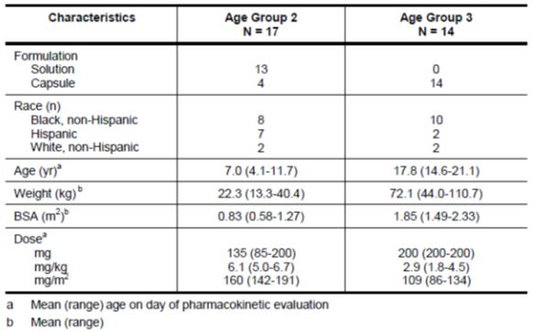

###### Results

In paediatric subjects, the emtricitabine dosage regimen of 6 mg/kg once daily, with a maximum of 200 mg once daily was expected to achieve a target daily AUC of at least 6 h*µg/mL (the 10th percentile of the adult AUC given 200 mg once daily). Mean values for emtricitabine pharmacokinectic parameters at steady-state by age group are provided in Table 3.

Table 3: Pharmacokinetic Parameters at Stead-State by Age Group.

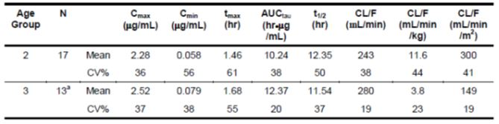

The variability of AUCtau in the younger children (Age Group 2) is approximately 2-fold higher than in the older children, as reflected in the CV% for this parameter estimate. Some variability may be due to dosing of a liquid formulation, and part may be due to greater variability in emtricitabine clearance in younger children dosed on a mg/kg basis, rather than body surface area.

The mean plasma emtricitabine concentrations, by age group, are in Figure 1.

Figure 1: Mean Plasma Emtricitabine Concentration Profiles.

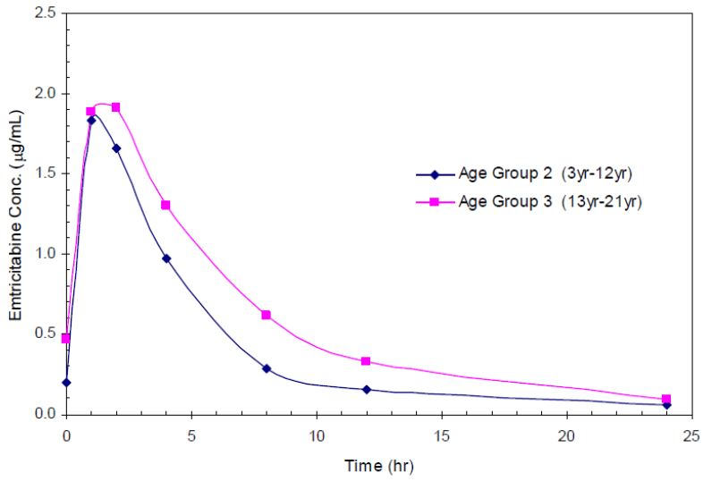

*Comment: Variability in dosing for the younger age group does not affect this evaluation (extension of age indication is for children >12 years and capsule dosing (Age Group 3 only, 200mg daily). The AUCtau for the older age group was 12.37 h*µg/mL which is higher than the minimum acceptable level of 6.00 h*µg/mL.*

##### Study FTC-203

A full-profile pharmacokinetic evaluation (24 h collection) was obtained at Week 2 from the first 6 to 8 subjects enrolled in each age group.

Pharmacokinetic data was evaluable in 34/36 subjects who provided 24 h profiles: 13/16 subjects in Age Group 1, 9/68 in Age Group 2, 9/29 in Age Group 3 and 3/3 subjects in Age Group 4. All subjects in Age Groups 1 and 2 and 4 subjects in Age Group 3 received emtricitabine solution. Five subjects in Age Group 3 and 3 subjects in Age Group 4 received emtricitabine capsules.

###### Plasma emtricitabine concentrations

The principal pharmacokinetic parameters by age group for subjects receiving oral solution and capsules combined are presented in Table 4.

Table 4: Pharmacokinetic Parameters at Stead-State by Age Group (FTC-203).

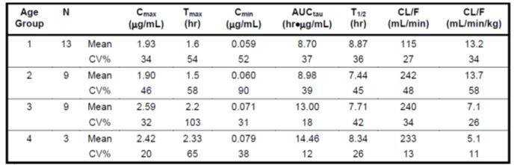

The study concluded that the emtricitabine exposure, expressed as AUCtau achieved in children receiving 6 mg/kg daily or oral solution up to 200 mg daily or in children >33 kg receiving a 200mg capsule daily is similar to exposure achieved in adults receiving a dose of 200 mg daily.

*Comment: The AUCtau for Group 4 (aged > 12 years) is within the normal range of variation to that seen in FTC-202.*

##### FTC-211

Week 2 pharmacokinetic evaluations are available for 15 of the 16 children entered in the study (1/1 subjects in Age Group 2, and 14/15 subjects in Age Group 3). The subject in Age Group 2 was 12.8 years at study entry, just below the 13 year age limit for Age Group 3. All subjects received the 200mg capsule formulation with the exception of one subject in Age Group 3. The principal pharmacokinetic parameters for the subjects receiving the capsule formation (n=14) are summarised in Table 5.

Table 5: Pharmacokinetic Parameters at Steady State by Age Group (FTC-211).

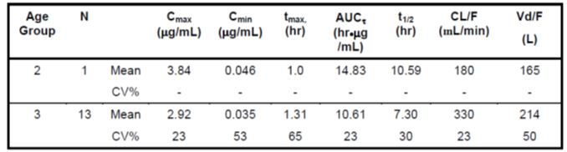

The emtricitabine dosage regimen for paediatric subjects in this study was expected to achieve a target daily AUC of at least 6 h*µg/mL (the 10th percentile of the adult AUC given 200 mg once daily). All subjects in this study achieved this minimum target exposure level (range 7.16 to 16.246 h*µg/mL).

*Comment: Despite the smaller study numbers, Study FTC-211, has a study population that come the closest to approximating the target population in Australia. All subjects were 12 years and older and with the exception of one subject, all took the 200 mg capsule as a daily dose. The PK data reflects the data seen in FTC-202, FTC-203 and adult populations.*

#### Pharmacokinetics in other special populations

##### Pharmacokinetics in subjects with impaired renal function

###### Study FTC-202

Subject # [Information redacted] in Age Group 3 (age = 14.6 years) who received 200 mg capsules (4.5 mg/kg) had the highest AUC in the study at 36.30 h*µg/mL. At baseline, nephropathy was noted for this subject with a Grade 1 serum creatinine (1.3mg/dL) and a Grade 1 uric acid (8.6 mg/dL). This subject had reached Week 48 on study with a Grade 1 serum creatinine (1.0 mg/dL) and Grade 1 triglycerides (314 mg/dL). At Week 48, the HIV-RNA viral load for this subject was <50 copies/mL. The high emtricitabine concentrations were likely attributable to decreased renal function caused by nephropathy.

*Comment: Increased levels of emtricitabine are known to occur in subjects with renal impairment. The current PI provides dosing adjustments for people with altered creatinine clearance.*

##### Pharmacokinetics according to age

A higher variability in pharmacokinetics in young children compared to adults is hypothesised to be due in part to greater variability in drug clearance and in part due to difficulties in administering a solution formation to young children.

*Comment: This variability is not as pronounced in the older age groups (>12 years). Based on the arguments laid out by the sponsor, this may be due to the use of the capsule formulation, in addition to a reduced variability in drug clearance in adolescents.*

*The increased variability seen in younger children does not affect this evaluation.*

### Evaluator’s overall conclusions on pharmacokinetics

Studies FTC-202, FTC-203 and FTC-211 provide pharmacokinetic data to support the application. All studies assessed the pharmacokinectics of emtricitabine in paediatric populations, with FTC-211 having the greatest proportion of subjects in the target age range (>12-18 years of age). The area under the plasma concentration-time curve (AUC) data was consistent across studies, with all studies achieving the minimum target exposure level of > 6 h*µg/mL). This level is considered to be the minimum acceptable level when compared against adult pharmacokinetic data.

The data did suggest some increased variability in the AUC data in FTC-202 and FTC-203, particularly in the younger age groups. It was suggested by the sponsor that this may have been due to differences in administration of a liquid formulation to a young population and/or altered pharmacokinetics in young children. This variability did not seem to be present amongst children > 12 years, taking the capsule formulation.

## Pharmacodynamics

### Studies providing pharmacodynamic data

There was no pharmacodynamic data presented in the submission.

### Evaluator’s overall conclusions on pharmacodynamics

Not applicable.

## Dosage selection for the pivotal studies

The 200mg hard capsule, taken once daily, has been selected as the dosage for paediatric patients >33kg.

## Clinical efficacy

### Extension of age

Emtricitabine is indicated for the treatment of HIV-1 infected adults and children in combination with other antiretroviral agents. The paediatric indication in the European Union was based on the results of an interim 24-week analysis of two ongoing studies:

* FTC-203, which was sponsored by the manufacturer, and
* a study conducted by the Paediatrics AIDS Clinical Trials Group (PACTG) and sponsored by the National Institute of Allergy and Infectious Disease (NIAID), referred to hereafter as study FTC-202.

This submission, 48-week data are presented from three multiple-dose, pharmacokinetic (PK) efficacy and safety studies in paediatric HIV infected patients (FTC-203, FTC-202 and FTC-211).

#### Pivotal efficacy studies

##### Study (or studies) FTC-202

###### Study design, objectives, locations and dates

FTC-202 is an ongoing, multi-centre, open-label, nonrandomised study that was designed to evaluate the efficacy, safety and PK of emtricitabine in male and female patients in the following age groups: 3 months to <36 months, 3 to 12 years and 13 to 21 years.

FTC-202 was undertaken by the Paediatric AIDS Clinical Trials Group in multiple centres in the United States. Data analysis was performed by the Statistical and Data Management Centre at Harvard School of Public Health.

The main objectives were:

* To determine the long-term safety and tolerance of a regimen of emtricitabine + efavirenz + didanosine (FTV.EFV/ddI) administered once daily in HIV infected paediatric patients who are naive, or have very limited exposure, to ART
* To determine the antiviral activity of a regimen of FTC/EFV/ddI administered once daily in treatment of naive or very limited antiretroviral-exposed paediatric patients

Secondary objectives were:

To examine in an exploratory analysis the relationship between antiretroviral systemic exposure for each of the three drugs (FTC/EFV/ddI) and the anti-retroviral outcomes as determined by the extent and duration of suppression of plasma HIV-RNA.

To determine the role of antiretroviral resistance in virologic failure of a once-daily treatment regimen of FTC/EFV/ddI, and to evaluate the use of ultrasensitive HIV-RNA determination as an early indicator of virologic failure in treatment naive paediatric patients.

*Comment: This study was designed as a Phase II efficacy and safety study. The objectives and endpoints are appropriate.*

###### Inclusion and exclusion criteria

Eligible patients had documented HIV-1 infection, were ART-naive (no or very limited prior exposure to ART) and had a plasma HIV-1 RNA level of at least 5,000 copies/mL at screening.

Medically participants were required to have had no hypersensitivity to any component of the formulation of FTC, EFV or ddI, no renal impairment, no presence of acute opportunistic or bacterial infection requiring systemic therapy at the time of enrolment, no chemotherapy for active malignancy within one year of screening and no pregnancy or breastfeeding, no Grade 3 or above haemoglobin level, Grade 2 or above absolute neutrophil count or Grade 2 or above platelet count at screening.

*Comment: “very little or no exposure to ART” was defined as no exposure to ART except for in vitro exposure to maternal ART and/or post-natal prophylaxis for prevention of mother to child transmission of HIV.*

###### Study treatments

All patients received a triple-drug regimen comprising emtricitabine (6mg/kg once daily in capsule or oral-solution formation, up to a maximum of 200 mg once daily), didanosine (240mg/m2 once daily, up to a maximum of 400 mg once daily) and efavirenz (dosage based on body weight, up to a maximum of 600 mg once daily as a capsule or up to 720 mg once daily as an oral solution in age groups 2 and 3). All but three of the children who weighed less than 33 kg received the emtriciabine oral solution formation and all others received the capsule formulation.

Treatment was administered on an outpatient basis, with patients returning to clinic for follow-up visits at Week 2, 4, 7 and every 4 weeks thereafter.

###### Efficacy variables and outcomes

The main efficacy variables were:

* Plasma HIV-1 RNA levels assessed at baseline and at every clinic visit using RT-PCR assay with standard and ultrasensitive specimen preparation providing lowest limit of quantitation (LLOQ) values of 400 and 50 copies/mL, respectively
* Absolute and percent CD4 counts were measured at baseline, weeks 4, 16, 24 and every 12 weeks thereafter
* Special immunology studies were performed at baseline, weeks 16, 24 and 48
* In case of virologic failure, descriptive analysis of genotypic mutations of HIV-1 with correlation with virologic, pharmacologic and immunologic response markers
* Serial blood samples were obtained 0-24 hours postdose at Week 2 for determination of study drug concentrations; these data were used to calculate the PK parameters
* Cytochrome P450 3A (CYP3A) genotyping was collected at Week 4.

The primary efficacy endpoint was the proportion of patients at Week 48 and all other time points with plasma HIV-1 RNA levels <400 copies/mL and <50 copies/mL, evaluated using missing=failure (M=F) analysis. This method classified a patient with missing data (for any reason) as a “failure” for the cross-sectional Week 48 analysis.

Other efficacy outcomes included:

* Change from baseline in HIV-1 RNA levels at measured time points, tabulated using descriptive statistics
* Change from baseline in CD4 count (absolute and precent) at measured time points, tabulated using descriptive statistics
* The incidence or virologic failure; probability of virologic failure estimated using the Kaplan-Meier method

*Comment: Small sample size limits the ability to interpret the secondary efficacy outcomes however, HIV-1 RNA levels and CD4 counts follow similar patterns and should provide sufficient evidence to show the efficacy of the study drug.*

###### Randomisation and blinding methods

This was an open-label, non-randomised study. There was no blinding.

###### Analysis populations

Participants were grouped into three age groups; Group 1 (3 months to <36 months), Group 2 (3 years to 12 years) and Group 3 (13 years to 21 years).

*Comment: Only Group 3 analysis is relevant to this application.*

###### Sample size

A total of 42 enrolled patients comprised the ITT population; 6 in Group 1, 21 in Group 2 and 16 in Group 3.

*Comment: Only Group 3 analysis is relevant for this application*

###### Statistical methods

* Clopper-Pearson exact confidence intervals were used for proportion estimates.
* Kaplan-Meier method was used to plot over time the proportion of subjects with viral failure or a permanent discontinuation of study treatment other than completion of the protocol specified duration of treatment.
* Wilcoxon signed rank test is used to compare the values of CD4 cell count or percentage at two different time points.
* Confidence interval for the estimated median increase of CD4 cell count or percentage from study entry to any later time point is calculated by inverting the sign test using the binomial distribution.

*Comment: Statistical methods seem appropriate.*

###### Participant flow

A total of 37 subjects from 16 sites were enrolled into Groups 2 and 3 of this study. The first was registered to this study on 18 September 2001, and the last was registered on 23 October 2002. The starting date of the study treatment was used as time 0 in all analyses. Of the 37 subjects, 21 were in Age Group 2 (3 to 12 years of age, inclusive), and 16 were in Age Group 3 (13 to 21 years of age, inclusive).

Two subjects (with patient numbers [information redacted]) discontinued study treatment permanently before the week 2 intensive PK study. The team decided to enrol one more subject than the sample size specified by the protocol (36 for Groups 2 and 3 combined) to replace them for PK reasons. The other 35 subjects are evaluable for the PK analysis. For all analyses other than PK, all 37 subjects are included.

All 37 subjects who were enrolled on study started study treatment; 14 subjects discontinued study medication permanently prior to week 178. Of these 14 subjects, 5 had not reached the minimum treatment duration of 48 weeks, including 2 who discontinued the study treatment before the week 2 intensive PK study.

The first interim analysis was carried out after the first 13 subjects had completed the week 2 intensive pharmacokinetic study.

Chemistry and liver function tests were scheduled at screening, study entry, weeks 2 and 4, every 4 weeks up to week 144 and every 12 weeks thereafter. Haematology tests were scheduled at screening, study entry, every four weeks from week 4 to week 24, every 8 weeks up to week 144 and every 12 weeks thereafter.

###### Major protocol violations/deviations

There were 28 of the 37 subjects who had treatment modifications during the study (up to week 178); reasons for treatment modification included an increase in EFV dose following the first interim analysis pharmacokinetic results and temporary discontinuation due to adverse events. The majority of treatment modifications appear to have been due to behavioural/lifestyle factors such as the subject not wanting to take medication, forgetting to take medication, being incarcerated and not having access to medication, etc.

*Comment: Compliance with treatment for chronic illness is a recognised challenge of managing adolescent health issues and the problems with drug non-compliance and protocol violations should be viewed through this lens. The majority of treatment modifications (protocol violations) occurred after week 24 and would not have affected the PK analysis. A change in treatment regimen for any reason (adverse event, failure, patient compliance) was classified as ‘treatment failure’ in the ITT analysis. Medication non-compliance in all cases seemed to be associated with social factors and not adverse events (side effects) precipitating poor drug-taking behaviour.*

###### Baseline data

Seventeen of the 37 subjects (46%) were female. The median CD4 count was 310 cells/µL (range 2 to 1,893 cells/µL), the median CD4 percentage was 17.0% (range 1.0% to 40.0%) and the median HIV-1 RNA level was 47,775 copies/mL (range 3,655 to 2,370,844 copies/mL) (Table 6).

Table 6: Study FTC-202 Baseline Subject Data.

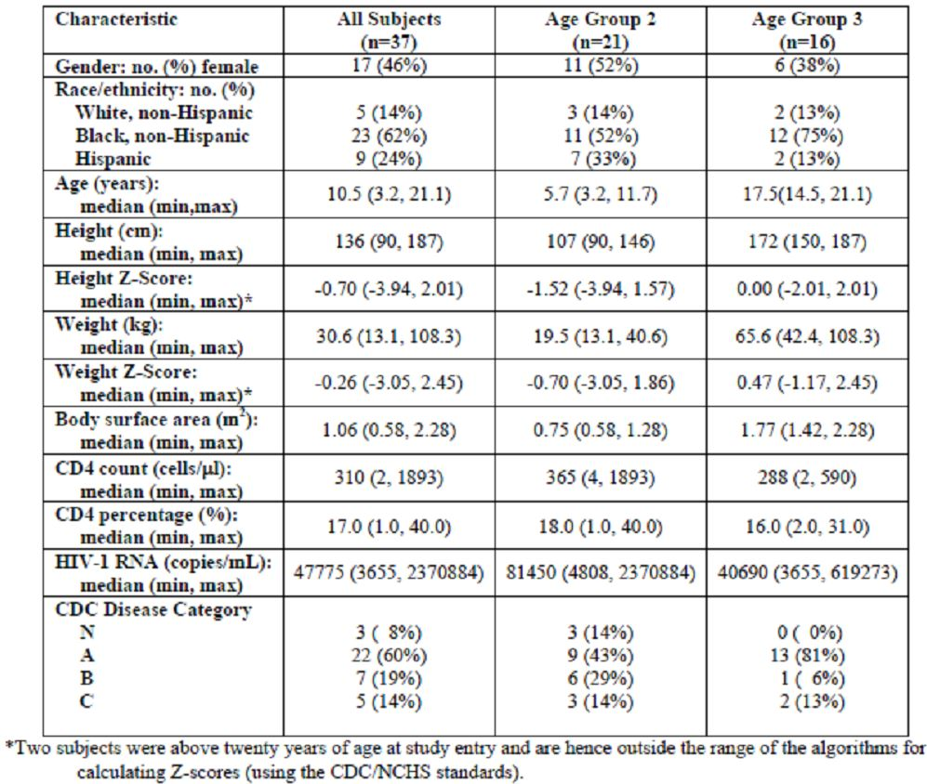

*Comment: Only 3 subjects were recruited in Age Group 3 (> 12 years), this may be due to most children in this age group having already started treatment and therefore being excluded as they were classified as ART-experienced. Median age for Age Group 2 was 5.7 years and the median weight was 19.5 kg, this is significantly lower that the target age and weight range for this evaluation (> 12 years and > 33 kg). Results from this study should be viewed as contributing to the overall assessment of the safety of emtricitabine in paediatric populations, however, individual patient data is not relevant to this specific evaluation.*

###### Results for the primary efficacy outcome

At Week 48, of the 37 subjects enrolled in Age Groups 2 and 3, 31 (proportion 0.81, 95%CI: 0.68 – 0.94) had viral load suppressed below 400 copies/mL at Week 48 and 27 (proportion 0.73, 95%CI: 0.56 – 0.86) had viral load suppressed below 50 copies/mL at the same time.

For Group 3, 13 out of 16 (proportion: 0.81, 95%CI: 0.54 – 0.96) had viral load suppressed below 400 copies/mL at Week 48, and all 13 subjects had viral loads suppressed below 50 copies/mL (Figure 2).

Figure 2: Proportion of subjects with plasma HIV-1 RNA below Limit of Detection by Study Week.

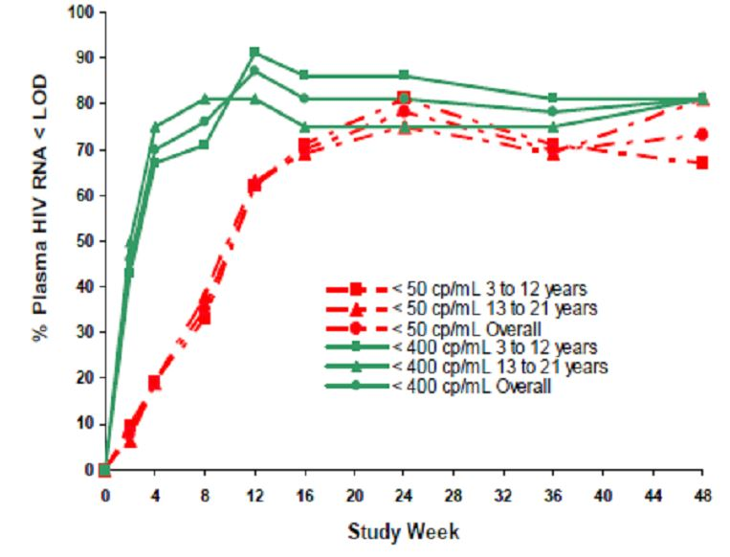

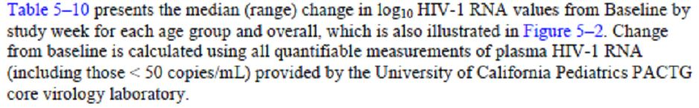

*Comment: The proportion of subjects with HIV-1 suppression at Week 48 is good and consistent across Age Groups suggesting good efficacy at the suggested drug dosing. HIV-1 levels below the level of detection appear relatively stable at Week 48.*

###### Results for other efficacy outcomes

Figure 3 below shows the Kaplan-Meier estimates for the proportion of subjects who either had a confirmed HIV-1 RNA above 400 copies/mL or had permanently discontinued study treatment for any reason other than completion of the protocol specified duration of treatment. Subjects who completed the protocol specified period of follow-up on treatment with HIV-1 RNA < 400 copies/mL were censored at their last available HIV-1 RNA measurement.

Figure 3: Time to loss of virologic response (Study FTC-202).

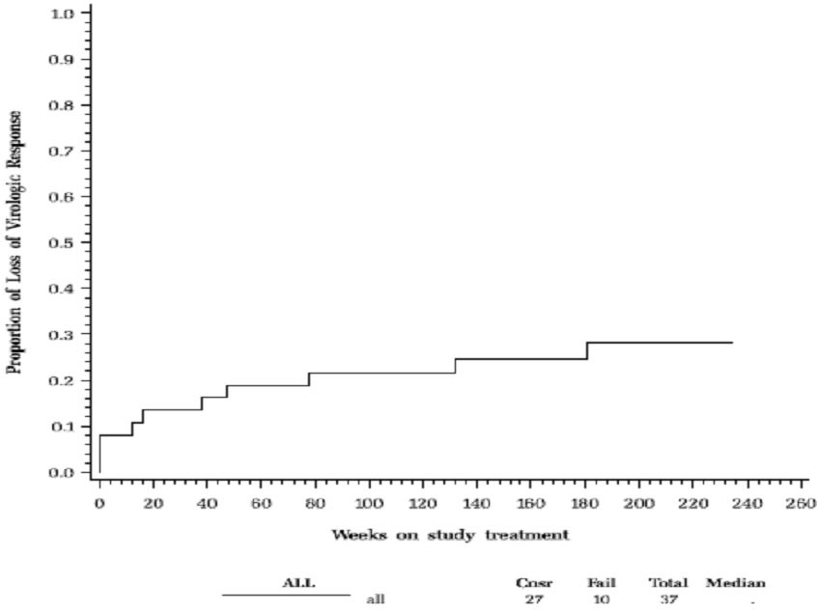

Six subjects permanently discontinued the study treated on or before Week 48. All the other 31 subjects showed a decrease of at least 2 log10 copies/mL in the viral load from baseline to week 48. The median decrease in the logarithmic viral load at week 48 was estimated to be 3.28 log10 copies/mL (95%CI 2.89-3.51 log10 copies/mL).

###### CD4 cell count and CD4 percentage

For the 31 subjects who had a CD4 cell count available at week 48, 29 had higher CD4 count at that time point than at baseline, with a median increase of 248 cells per µL (95% CI: 210 – 348). For the 31 subjects who had a CD4 percentage available at week 48, 30 had higher CD4 percentage at that time point compared with baseline, with a median increase of 13% (95%CO: 10%-18%).

The Wilcoxon signed rank test shows that the CD4 count was significantly higher at Week 48 than at baseline (m<0.0001) and that the CD4 percentage was also significantly higher at week 48 than at baseline (p<0.0001).

*Comment: In an ART-naive population CD4 cell counts should increase if treatment is efficacious. A median increase in baseline CD4 cell count of 248 cells per µL is a good surrogate for drug efficacy and supports the primary endpoint results.*

##### Study (or studies) FTC-203

###### Study design, objectives, locations and dates

Ongoing, multicentre, open-label, non-randomised Phase II study of emtricitabine in ART-naive and ART-experienced patients aged 3 months to 17 years. Patients were treated for at least 48 weeks.

Three main objectives were:

* To obtain long-term safety experience for antiretroviral regimens containing emtricitabine in HIV-1 infected paediatric patients
* To obtain antiviral activity data for antiretroviral regimens containing emtricitabine in HIV-1 infected paediatric patients
* To determine the steady-state emtricitabine concentrations in HIV-1 infected paediatric patients and, if necessary, to refine the dose of emtricitabine to achieve plasma concentrations comparable to those in adults given 200 mg emtricitabine once daily.

###### Inclusion and exclusion criteria

All participants had documented HIV-1 infection and an absolute CD4 cell count of more than 200cells/mm3 at screening. ART-naive patients had no or very limited prior exposure to ART (peri-natal prophylaxis only) and a plasma HIV-1 RNA level of 5,000 to 600,000 copies/mL at screening. ART-experienced patients were stable on a lamivudine-containing ART regimen for at least 3 months and had a plasma HIV-1 RNA level of ≤ 400 copies/mL at screening.

###### Study treatments

ART-naive patients received emtricitabine (oral solution or capsule formulation), stavudine and lopinavir/ritonavir. ART-experienced patients had the lamivudine in their existing ART regimen replaced with emtricitabine. For the older age groups, emtricitabine was supplied as a 200mg capsule administered, once daily.

All subjects were treated for an initial period of 48 weeks, provided they did not meet the study drug discontinuation criteria. After completing the Week 48 study evaluations, individual subjects could continue to receive emtricitabine until the drug was available via market distribution.

###### Efficacy variables and outcomes

The main efficacy variables were:

* HIV-1 RNA measured at screening, baseline and at every clinic visit (monthly) thereafter until 48 weeks
* CD4 cell count measured at screening, baseline and every 12 weeks throughout the study (absolute and percent)
* Clinical Disease monitored at every clinic visit

The primary efficacy outcome was the proportion of patients with suppression of plasma HIV-1 RNA to below the LLOQ for the assay i.e. ≤ 400 and ≤ 50 copies/mL for the standard and ultrasensitive tests, respectively, at Week 48, evaluated using noncompleter=failure (NC=F) analysis.

Other efficacy outcomes included:

* The change from baseline in HIV-1 RNA levels at the measured time points (in ART-naive patients only)
* The change in baseline in CD4 cell counts (absolute and precent) at the measured time points. In addition, an age-adjusted analysis of change in CD4 was performed.
* The proportion of virologic failure by Week 48
* The proportion of patients experiencing clinical disease progression by Week 48.

*Comment: Efficacy variables are similar to FTC-202, FTC-211 allowing easy comparison across studies. Efficacy variables are appropriate for HIV-1 drug efficacy trial.*

###### Randomisation and blinding methods

There was no randomisation or blinding.

###### Analysis populations

Participants were grouped into four groups according to age; groups 1-3 were children aged 3 months – 12 years and are not relevant for this application. Group 4 included children aged 13 to 17 years.

###### Sample size

A total of 117 patients were enrolled and data from 116 patients were analysed (71 ART-naive and 45 ART-experienced).

###### Statistical methods

Statistical analyses for safety and anti-HIV activity are presented by subject population (ART-naive and ART-experienced subjects). In addition, for each ART population, analyses are presented by age group (see below) and emtricitabine dosage form (liquid/capsule).

* Age Group 1: from 3 to 24 months of age, inclusive
* Age Group 2: from 25 months to 6 years of age, inclusive
* Age Group 3: from 7 to 12 years of age, inclusive
* Age Group 4: from 13 to 17 years of age, inclusive.

Analyses was conducted according to the intent-to-treat (ITT) principle using all data collected; the ITT population of defined as all patients who received at least one (1) dose of the study drug, emtricitabine, regardless of whether or not the patient completed the planned duration of the study.

Virologic response parameters that were continuous data (e.g. HIV-1 RNA) are summarised by the mean, standard error, median, minimum and maximum. Categorical data (e.g. proportion of subjects with plasma HIV-1 RNA below the LLOQ at Week 48) are summarised by the number and percent of subjects belonging to a specific classification. Time-to-event methods (e.g. Kaplan-Meier estimates) were used to summarise time-to-event data.

*Comment: Statistical considerations are appropriate. The Group 4 subject population is most relevant for this evaluation.*

###### Participant flow

A total of 117 subjects were enrolled into the study and received at least one dose of the study drug, emtricitabine. One subject was found to be HIV negative on repeat testing and their data were censored from the analysis. Thus, the ITT Population comprised data from 116 subjects, 71 ART-naive and 45 ART-experienced.

Table 7: Schedule of study assessments (FTC-203).

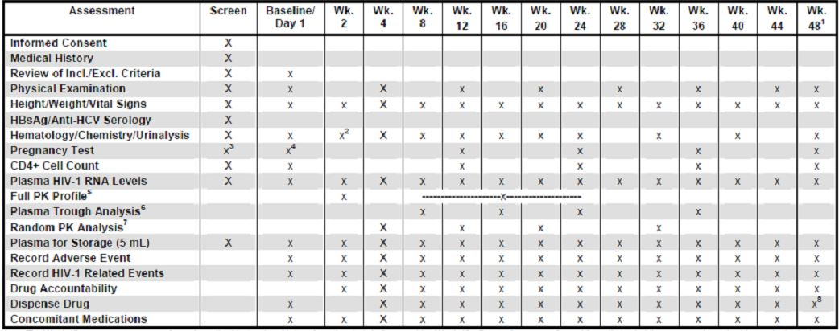

###### Major protocol violations/deviations

Of the 116 subjects in the ITT population, 99 (85.3%) subjects were still on study at the data cut-off date when the last subject completed through Week 48. Of the 17 (14.6%) subjects who had discontinued the study, 8 (11.3%) subjects were ART-naive and 9 (20.0%) were ART-experienced. The CRF-recorded reasons for premature discontinuation of ART-naive subjects were virologic failure (3), investigator and/or subject decision (2), adverse event (1), loss to follow up (1) and “other” (1). The CRF-recorded reasons for premature discontinuation of ART-experienced subjects were virologic failure (2), investigator and/or subject decision to withdraw (2), loss to follow up (2), “other” (2) and adverse event (1).

*Comment: There were no significant protocol violations/deviations*

###### Baseline data

A total of 117 subjects were enrolled in this study between 12 study centres located in the USA (8 centres), South Africa (2 centres), Mexico (1 centre) and Panama (1 centre). There were 71 ART-naive subjects (number of subjects in Age Groups 1 to 4 were 13, 45, 13 and 0, respectively) and a total of 45 ART-experienced subjects (number of subjects in Age Groups 1 to 4 were 3, 23, 16 and 3, respectively).

The majority (n=80, 69.0%) of subjects were black with an even number of female and male participants (number of female participants is 61 (52.6%). The mean age was 5.8 years with a range of 0.3 – 15.9 years. Median baseline CD4+ cell count was 817cells/mm3 and median HIV-1 RNA was 4.53 log10 copies/mL. Twenty-two (22/116, 19.0%) subjects had a history of a CDC Class C cent, with Mycobacterium tuberculosis the most common Class C event reported in 9 (7.8%) subjects.

The majority of subjects received the oral solution formation of emtricitabine.

*Comment: Subjects in study FTC-203 are younger and more likely to have taken the oral solution formation compared to the target population for emtricitabine in Australia.*

###### Results for the primary efficacy outcome

Using the ITT analysis, at Week 48, overall 90.3% (92.6% naive stratum, 86.7% experienced stratum) of subjects achieved and/or maintained suppression of plasma HIV-1 RNA to ≤400 copies/mL through Week 48.

Based on the time to loss of virologic response (TLOVR) algorithm, overall 89.7% (104/116) subjects achieved and/or maintained suppression of plasma HIV-1 RNA to ≤ 400 copies/mL at Week 48.

The proportion of patients also achieving and maintaining suppression of plasma HIV-1 RNA to ≤ 50 copies/mL at Week 48 was 75.9% (88/116) overall.

*Comment: Reference ranges for the proportion of subjects achieving and maintaining suppression are not provided and would provide more meaningful data than a single point estimate.*

###### Results for other efficacy outcomes

HIV-1 RNA stratified analysis

The proportion of subjects in the naive stratum achieving HIV-1 RNA to ≤400 copies/mL at Week 48 was 93.0% (66/71) and in the experienced stratum is was 84.4% (38/45). The proportion of subjects with HIV-1 RNA suppression to ≤50 copies/mL at Week 48 was 78.9% (56/71) in the naive stratum and 71.1% (32/45) in the experienced stratum.

The incidence of TLOVR-defined virologic failure at Week 48 was 6.9% (8/116) overall, and 4.2% (3/71) in the naive stratum and 11.1% (5/45) in the experienced stratum.

Within the naive stratum, the proportion of subjects achieving and maintain a plasma HIV-1 RNA viral load of ≤400 copies/mL at Week 48 was generally consistent across the three applicable age groups, with values of 92.3% (12/13), 95.6% (43/45) and 84.6% (11/13) in Age Groups 1 to 3, respectively. Within the experienced stratum, the numbers of subjects in Age Groups 1 and 4 were too small (n=3 each) to be meaningful. However the majority of ART-experienced subjects in Age Groups 2 and 3 maintained suppression of plasma HIV-1 RNA viral load at ≤400 copies/mL through Week 48 as defined by the TLOVR algorithm, with values of 91.3% (21/23) and 81.3% (13/16), respectively.

Change in HIV-1 RNA Viral Load from Baseline:

Within the naive stratum, significant decreased in HIV-1 RNA viral load were achieved through Week 48 across all three applicable age groups. Using a last observation carried forward (LOCF) analysis, median changes of -3.72, -3.24 and -2.82 log10 copies/mL from baseline were recorded for Age Groups 1 to 3, respectively, with an overall median change from -3.22 log10 copies/mL.

Change in CD4+ cell counts from baseline:

Using LOCF analysis, the overall (all age groups) median (range) change in absolute and percent CD4+ cell counts were +313 (-512 to +1,5121) cells/mm3 and +10.8 (-4.6 to +33.8)% for ART-naive subjects. For ART experienced subjects the results were -59.5 (-945 to +712) cells/mm3 and +2.7 (-10.8 to +12.6)%. The same general trend was seen for CD4+ cell counts within each population with looking at different age groups.

*Comment: No stratification of analysis was undertaken by Age Group alone (stratification occurred for treatment stratum (naive versus experienced* ***and*** *Age Group). This made the groups analysed small leading to non-meaningful results, particularly as they relate to the > 12 years age group (Age Group 4). The small numbers of subjects recruited into Group 4 makes interpreting results for this group, in general, problematic.*

CD4+ percent change is not reported for the individual age groups despite CD4+ count being reported. It is possible that these results were not reported due to unfavourable data.

#### Other efficacy studies

##### FTC-211

###### Study design, objectives, locations and dates

This was a multicentre, open-label, non-randomised study that evaluated the safety, pharmacokinetics and efficacy of emtricitabine in ART-naive and ART-experienced male or female patients from 3 months – 17 years of age. The study ran from November 2002 to July 2004 in two study centres in Romania and followed subjects for a minimum of 48 weeks.

The main objectives were:

* To obtain safety experience for antiretroviral regiments containing emtricitabine in HIV-1 infected paediatric subjects
* To determine the stead-state emtricitabine concentrations in HIV-1 infected paediatric subjects and, if necessary, to refine the dose of emtricitabine to achieve plasma concentrations comparable to those in adults given 2100 mg emtricitabine once daily
* To obtain antiretroviral activity data for antiretroviral regimens containing emtricitabine in HIV-1 infected paediatric subjects.

###### Inclusion and exclusion criteria

Patients were enrolled in the following age groups; Group 1 (3 months to 24 months), Group 2 (7-12 years) and Group 3 (13-17 years). Eligible patients had documented HIV-1 infection and an absolute CD4 cell count of at least 200 cells/mm3 at screening.

ART-naive patients were to have no or very limited prior exposure to ART (peri-natal prophylaxis ≤56 days and/or postnatal zidovudine treatment ≤6 weeks) and a plasma HIV-1 RNA level of at least 5,000 copies/mL at screening (and ≤600,000 copies/mL in patients at least 7 years of age).

ART-experienced patients were to have no previous treatment with an ART regimen that included lamivudine or an NNRTI; they were also required to have a screening plasma HIV-1 RNA level of ≤ 600,000 copies/mL.

###### Study treatments

Subjects received a combination of emtricitabine, didanosine and efavirenz based on body weight up to a maximum of 200mg QD emtricitabine, 400mg QD didanosine and 600mg QD efavirenz.

###### Efficacy variables and outcomes

The main efficacy variables were:

* Plasma HIV-1 RNA levels were obtained at screening, baseline and at every scheduled clinic visits thereafter (every 4 weeks)
* CD4 cell count measured at screening, baseline and every 12 weeks thereafter
* Full-profile blood sampling for plasma concentrations of emtricitabine was performed at Week 2 for up to 10 subjects per age group.
* Trough blood samples for plasma concentrations of emtricitabine were collected from all subjects at Weeks 8, 16, 24 and 36.

The primary efficacy outcome was the proportion of patients with suppression of plasma HIV-1 RNA to below the LLOQ for the assay i.e. ≤ 400 and ≤ 50 copies/mL for the standard and ultrasensitive tests, respectively, at Week 48, evaluated using non-completer=failure (NC=F) analysis.

Other efficacy outcomes included:

* The change from baseline in HIV-1 RNA levels at the measured time points
* The change in baseline in CD4 cell counts (absolute and percent) at the measured time points.
* The incidence of virologic failure by Week 48
* The incidence of patients experiencing clinical disease progression by Week 48.

*Comment: Efficacy outcomes are similar to FTC-202 and FTC-203 allowing comparison across studies.*

###### Randomisation and blinding methods

There was no blinding or randomisation.

###### Analysis populations

Subjects were analysed based on an ITT population.

###### Sample size

There were no formal sample size calculations; based on experience with other paediatrics studies, it was anticipated that a sample size of 30 to 50 subjects would provide sufficient data to characterise the safety, pharmacokinetic profile and antiviral activity of emtricitabine in a paediatric population.

A total of 16 enrolled patients at two centres comprised the ITT population. Once patient was enrolled in Group 2 and 15 were enrolled in Group 3.

*Comment: It is not clear from the study report why enrolment was stopped at 16 subjects despite an initial anticipated sample size of 30 to 50 people. Given that no formal sample size calculations were undertaken the significance of the reduction in subjects numbers is unclear although the robustness of results is likely to have been affected.*

###### Statistical methods

Safety and efficacy analyses were conducted according to the ITT population. The ITT population was defined as all subjects who received at least 1 dose of the study drug, emtricitabine.

Primary efficacy parameters

The number and percentage of subjects not meeting the defined efficacy endpoints are summarised, along with 95% confidence intervals for the percentage. Any subject that was missing an HIV-1 RNA value at Week 48 was considered a failure, unless the missing data point was preceded (at Week 44) and followed (at Week 52) by a value that was less than 50 copies/mL. In this case, the missing data point was censored.

Secondary efficacy parameters

Summary statistics (n, mean, median, minimum, maximum and inter-quartile range) were displayed with proportions provided in percentage with 95% confidence intervals.

The proportion of virologic failures that occurred during the study was summarised. Virologic failure was defined as not having at least one plasma HIV-1 RNA ≤400 copies/mL by Week 24. A loss of virologic response was defined as having > 1 log10 increase from nadir on 2 consecutive HIV-1 RNA measurements, preferably within 1 month of each other or < 400 copies/Ml plasma HIV-1 RNA measured on 3 consecutive visits over approximately 2 months while on study drugs(s) after having had at least 2 consecutive plasma HIV-1 RNA measurements at ≤ 400 copies/mL.

Safety parameters

Safety data were analysed by incidences (frequencies) of events/abnormalities or descriptive statistical summaries (n, mean, SD, median, min, max). These data were compiled for all ITT subjects. Descriptive statistics are provided for selected laboratory evaluations.

###### Participant flow

Of the 16 subjects in the ITT population, 16 (93.8%) subjects completed the study through Week 48. One subject decided to withdraw from the study on the first day of dosing.

###### Major protocol violations/deviations

None.

###### Baseline data

All subjects were caucasian and half (50%) were female. Mean age was 14.1 years (range 12.8 to 15.2 years). Median baseline plasma HIV-1 precent CD4+ cell counts were 373 cells/mm3 (range: 200.0 to 1100 cells/mm3) and 23% (range 16 to 38%), respectively. All but one subject was ART-naive.

*Comment: This data set provides the most number of subjects aged > 12 years who were ART-naive.*

###### Results for the primary efficacy outcome

At Week 48, 75% of patients (12/16) had plasma HIV-1 RNA levels ≤ 50 copies/mL (ITT, NC=F analysis). All but one patients achieved suppression of plasma HIV-1 RNA to ≤ 400 copies/mL, approximately 94% overall.

Based on the TLOVR algorithm, 69% (11/16) and 56% (9/16) of the patients achieved suppression of plasma HIV-1 RNA to ≤ 400 copies/mL and ≤ 50 copies/mL, respectively.

*Comment: HIV-1 RNA level results for FTC-211 are similar to results reported in FTC-202 and FTC-203.*

###### Results for other efficacy outcomes

A decrease in HIV-1 RNA levels was achieved through Week 48 with a median value of -3.03 log10 copies/mL (range -4.05 to -2.30). The median (range) changes in absolute and precent CD4 cell counts were 201 (-107 to 366) cells/mm3 and 8% (3% to 29%), respectively.

Virologic failure

One subject met the protocol defined virologic failure but did not discontinue the study. Per the TLOVR algorithm, 5 subjects were defined as virologic failure using the 400 copies/mL, threshold, including 4 subjects due to HIV-1 RNA rebound and 1 subject who withdrew consent.

CD4+ cell counts

The overall median (range) change in absolute and percent CD4+ cell count was +201 (-107 to +366) cells/mm3 and +8 (+3 to +29)%, respectively.

### Analyses performed across trials (pooled & meta analyses)

A comparison and analyses of the results across the three trials (202, 203 and 211) is provided in the ‘Clinical Summary’ component of the submission (Table 8).

Table 8: Summary of patient disposition by Study at Week 48.

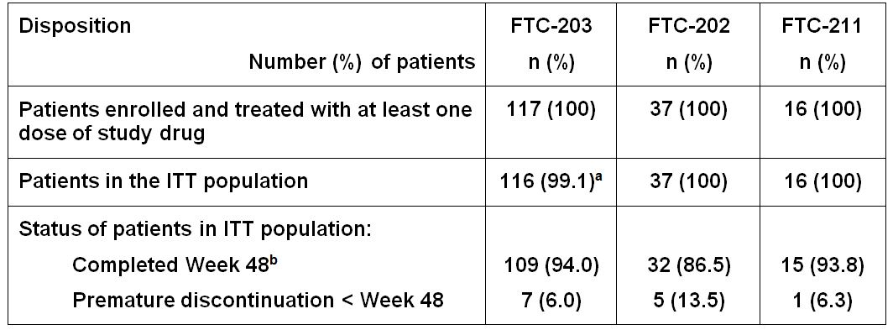

a One patient was not HIV infected and was therefore censored from all analyses

b Precent of ITT population

#### Demographics

In FTC-202 and FTC-203, the majority of patients were black, whereas all patients enrolled in FTC-211 were white. In FTC-203, approximately half of the patients were enrolled at two study sties in South Africa, whereas in FTC-202, all patients were enrolled at 16 study sties in the USA and in FRC-211, all patients were enrolled at two study sites in Romania.

Approximately half of the patients were male in each study; patient age ranged from 3 months to 21.1 years. In study FTC-203, 61.2% of patients were ART-naive. In FTC-202, all patients were ART-naive (36/37 had had no previous ART exposure at all) and in FTC-211 all but one was ART-naive.

#### Primary efficacy outcomes

These are shown in Table 9.

Table 9: Primary efficacy outcomes.

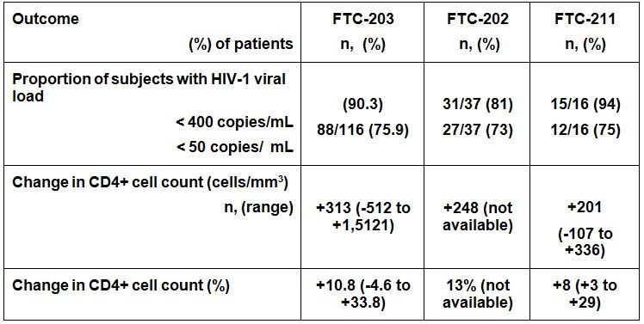

*Comment: Results of the primary efficacy outcomes are comparable across studies with minor variation within the bounds of expected variability.*

### Evaluator’s conclusions on extension of age indication

The three studies present efficacy data on the use of emtricitabine for the treatment of HIV-1 infection in paediatric populations. All studies present data to 48 weeks, with the proportion of subjects with HIV-1 viral loads < 400 copies/mL above 80 and < 50 copies/mL above 70. All studies used a conservative missing equals failure (M = F), intention to treat analysis and the true suppression rate may be higher. Consistent with other anti viral medications, there appears to be a small percentage of children who did not respond to emtricitabine and required their anti retroviral medication to be changed (emtricitabine stopped) within the first two months of commencing treatment; there did not appear to be any difference in the number of responders between the anti retroviral therapy (ART) naive and ART experienced groups. In addition to the non responders, a small percentage of children withdrew from the trial prior to Week 48 due to non compliance with the medication. For the majority of cases this appears to have been due to an overall lack of motivation/interest in treatment rather than being secondary to adverse effects/symptoms. Poor treatment compliance is a common problem in the management of adolescent chronic disease and the rates of non compliance may reflect this challenge.

From the data presented, no efficacy issue has been identified preventing an extension of age indication to children aged > 12 years and weighing > 33 kg. The small study numbers prevent a more rigorous and robust analysis of efficacy results; however, the results of Studies FTC-202, FTC-203 and FTC-211 broadly align with those seen in the pre market clinical studies undertaken for emtricitabine in adult populations.

## Clinical safety

### Studies providing evaluable safety data

The following studies provided evaluable safety data: FTC-202, FTC-203 and FTC-211.

#### Pivotal efficacy studies

In the pivotal efficacy studies, the following safety data were collected:

* General adverse events (AEs) were assessed during every clinical visit
* Laboratory markers were monitored during every clinical visit

#### Pivotal studies that assessed safety as a primary outcome

No studies assessed safety as a primary outcome.

### Studies that assessed safety as an outcome

#### Study FTC-203

##### Study design, objectives, locations and dates

These were described in the ‘Clinical efficacy’ section. Safety outcomes were monitored at each clinic visit (every 4 weeks to Week 48, and every 12 weeks thereafter).

##### Safety variables and outcomes

The main efficacy variables were:

* Tolerability Failure (cessation of study treatment due to safety related concerns).
* Serious adverse events
* Grade 3-4 laboratory abnormality

The primary efficacy outcome was tolerability failure, defined as withdrawal from study medication due to safety related concerns (e.g. severe and/or life-threatening adverse events requiring removal from study treatment).

Other efficacy outcomes included:

* Serious adverse events
* Grade 3-4 laboratory abnormalities

##### Summary of safety results

Overall, 3 of the 116 (2.6%) study subjects ceased treatment with the study drug due to tolerability failure through data cut-off. Data cut-off extended beyond the Week 48 efficacy end-point (through to Week 96). At data cut-off there had been 19 (26.8%) serious adverse events in the ART-naive population and 5 (11.1%) in the ART-experienced population. There were 5 (7.0%) and 5 (11.1%) grade 3-4 laboratory abnormalities over the same period in the ART-naive and ART-experienced populations, respectively (Table 10).

Table 10: Summary of safety result at Week 96 (FTC-203).

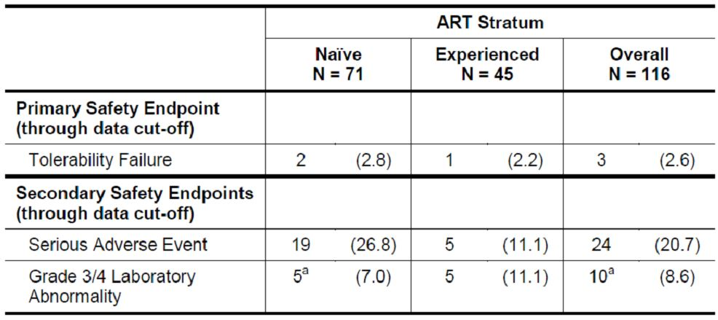

##### Results for the primary safety outcome (tolerability failure)

The overall incidence of tolerability failure through Week 48 and through data cut-off (Week 96) were 2 out of 166 (1.7%) and 3 out of 166 (2.6%), respectively. The two subjects (1 ART-naive, 1 ART-experienced) who discontinued treatment with the study drug due to an adverse event prior to Week 48 stopped due to anaemia (Grade 3 low haemoglobin) and pancreatitis. The third subject classified as tolerability failure died shortly after being diagnosed with acute myeloid leukaemia.

#### FTC-202

##### Study design, objectives, locations and dates

These were described in the ‘Clinical efficacy’ section. Safety outcomes were monitored at each clinic visit (every 4 weeks to Week 48, and every 12 weeks thereafter).

##### Safety variables and outcomes

The main efficacy variables were:

* Laboratory abnormalities measured at study entry, Weeks 2 and 4 and every 4 weeks thereafter up to Week 144.
* Subject clinical signs and symptoms

Other efficacy outcomes included:

* Death
* Serious adverse events
* Grade 3-4 laboratory abnormalities

##### Summary of safety results

The study treatment appeared to be well tolerated; of the 37 subjects enrolled in Age Groups 2 and 3, five (14%; 95% CI: 5% ~ 29%) experienced one or more Grade 3 or 4 laboratory abnormalities or signs and symptoms that were judged by the study team to be possibly or probably related to the study treatment.

##### Results for the primary safety outcome

See above for a summary of the primary safety outcome.

* Subject # [information redacted] had a Grade 3 gamma glutamyl transferase (GGT) value at week 3, which was followed by two Grade 4 GGT tests at weeks 4 and 5. This subject had a Grade 2 GGT at study entry. The GGT abnormality resolved to Grade 1 at week 9 and to a normal value at week 12. These abnormal GGT values were attributed to the study treatment by the SAE office, but were judged to be not related to the study treatment by the team.
* Subject # [information redacted] had a Grade 4 low glucose at week 11, which resolved to normal four days later. This abnormality was judged to be possibly or probably related to the study treatment by both the site and the team. The same patient had a Grade 4 low fasting blood sugar (with the value 0 mg/dL) at week 24, but the same sample processed at the local lab of the site showed a normal value. This Grade 4 abnormality was judged to be not related to the study treatment by both the site and the team. This test was repeated at week 36 and a normal value was obtained.
* Subject # [information redacted] had a Grade 3 low glucose at week 60, which resolved at the next visit to a normal value.
* Subject # [information redacted] had two Grade 3 elevated CPK values on two consecutive days at week 4, which caused temporary discontinuation of all study drugs. The elevated CPK resolved to a normal value at week 9. These CPK abnormalities were judged to be possibly or probably related.

##### Results for other safety outcomes

The study required that signs and symptoms of Grade 2 or higher, all central nervous system (CNS) symptoms, and any grade nausea, vomiting or abdominal pain when associated with any elevation of serum fractionated pancreatic amylase or lipase be reported. Eight subjects (21.6%) had signs or symptoms of Grade 3 or Grade 4. The signs and symptoms of three subjects were judged to be probably or possibly related to study treatment. The Grade 3 dizziness of subject # [information redacted] was judged to be possibly or probably related to the study treatment by both the team and the site. The Grade 3 abnormal dreams and mental status bizarre thinking experienced by subject # [information redacted] was judged possible related by both the team and the site. The grade 3 rash of subject # [information redacted] was judged to be possibly or probably related to the study treatment by both the team and the site. This event led to permanent discontinuation of the study treatment. All the other grade 3 or 4 abnormalities were judged by the team to be not related to the study treatment.

#### FTC-211

##### Study design, objectives, locations and dates

The safety analysis was based on data collected from all 16 subjects in the ITT population through Week 48. Overall the median time on study treatment was 337 days (range: 1 to 337); one subject being on the study for one day.

Further details on the study design can be found in the ‘Clinical efficacy’ section.

##### Safety variables and outcomes

The main efficacy variables were:

* Tolerability failure
* Serious adverse events (Grade 3 or 4 severity)

##### Summary of safety variables

Overall, there were no study deaths or tolerability failures and one serious adverse event during the trial period. 10 (62.5%) subjects experienced at least one adverse event during the study. The most frequently reported adverse events were: pharyngitis (n=4, 25%), rash (n=3, 18.8%), conjunctivitis (n=2, 12.5%), interstitial pneumonia (n=2, 12.5%), accidental injury (n=2, 12.5%), pain (n=2, 12.5%) and hypertension (n=2, 12.5).

Two subjects had an adverse event assessed by the Investigator as possibly or probably drug related. The drug-related adverse events were leukopaenia (n=1) and rash (n=1).

##### Results for the primary safety outcome (tolerability failure)

No subjects discontinued the study for adverse events

##### Results of other safety outcomes

No subjects died during the study. Overall, one (6.3%) subject (a [information redacted] ART naive subjects) experienced a SAE through Week 48. The subjects experienced an episode of mumps/orchitis that was assessed as not related to study drug by the Investigator.

### Patient exposure

Patient exposure was identical for all three studies; subjects received emtricitabine in combination with other retroviral medications daily for 48 weeks for the treatment of HIV-1 infection.

### Adverse events

#### All adverse events (irrespective of relationship to study treatment)

##### FTC-202

Thirty-three subjects (89.2%) experienced a new diagnosis during the study. The majority were judged to be not related to the study drug. Two cases (erythema multiforme and mild peripheral neuropathy) were judged as being possibly or probably related to the study drugs.

##### FTC-203

The most frequent (≥ 10% incidence in either ART stratum) adverse events by body system and ART stratum are listed in Table 11.

Table 11: Frequent adverse events by body system.

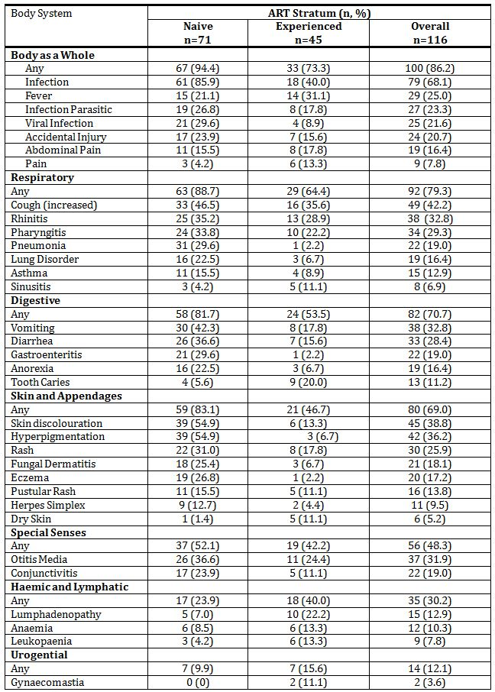

Nearly all (97.0%) subjects experienced at least one adverse event through the data cut-off, including in all 71 (100%) ART-naive subjects and 42/45 (93.3%) ART-experienced subjects. Overall, the most frequent adverse events reported were infection (68.1%), cough increased (42.2%), skin discoloration (38.8%), rhinitis (32.8%), vomiting (32.8%) and otitis media (31.9%).

##### FTC-211

A total of 10 (62.5%) subjects experienced at least one adverse event during the study. The most frequently reported adverse events were: pharyngitis (n=4, 25%), rash (n=3, 18.8%), conjunctivitis (n=2, 12.5%), interstitial pneumonia (n=2, 12.5%), accidental injury (n=2, 12.5%), pain (n=2, 12.5%) and hypertension (n=2, 12.5).

#### Treatment-related adverse events (adverse drug reactions)

##### FTC-202

Of the 37 subjects enrolled in Age Groups 2 and 3, give (14%, 95%CI 3-25%) experienced one or more Grade 3 or 4 laboratory abnormality, sign or symptoms that was judged by the study team to be possibly or probably related to the study treatment (Table 12).

Table 12: Treatment-related adverse events (FTC-202).

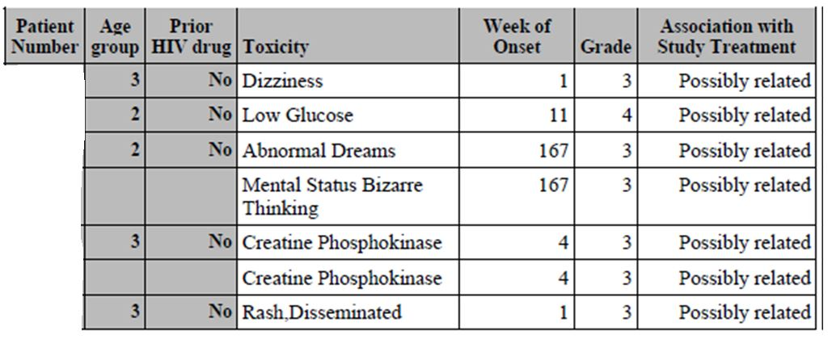

##### FTC-203

Overall, 58 (50.0%) subjects had at least one adverse events assessed by the Investigator as possibly or probably drug related; the incidence of drug-related adverse events was about three-fold higher in the ART-naive subjects (67.6%), as compared to ART-experienced subjects (22.2%). In ART-naive subjects, drug-related adverse events occurring at ≥5% frequency were skin discolouration (53.5%) and vomiting (18.3%). In ART-experienced subjects, drug-related adverse events occurring ≥5% frequency was leukopaenia, which was reported in 3 (6.7%) subjects.

Table 13 summarises the most frequent (≥5%) possibly or probably drug-related adverse events by body system and ART stratum.

Table 13: Possibly or probably drug-related adverse events by ART stratum.

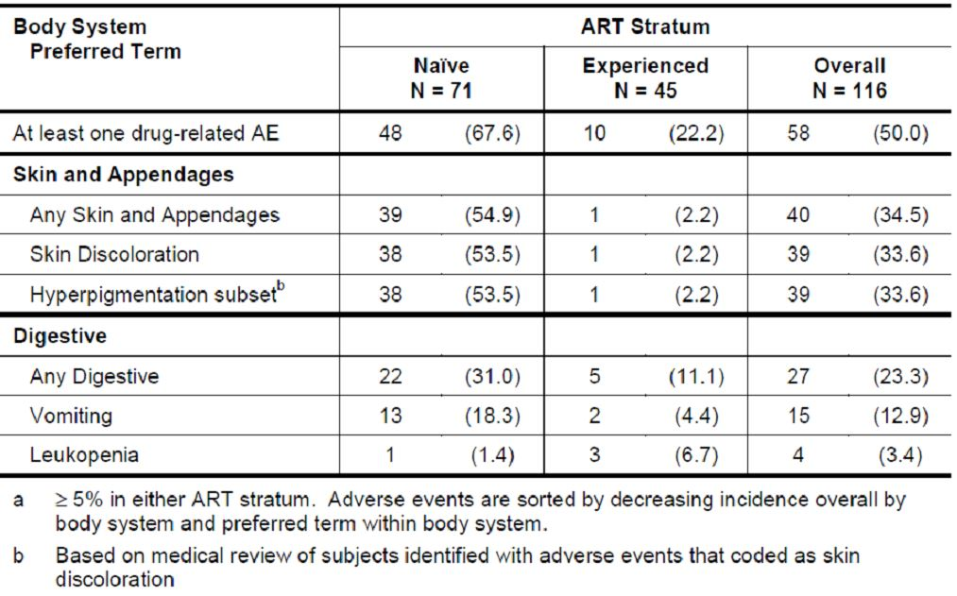

##### FTC-211

Two subjects had an adverse event assessed by the Investigator as possibly or probably drug related. The drug-related adverse events were leukopaenia (n=1) and rash (n=1). Both events were respectively Grade 3 and Grade 2 and both events resolved during the study drug treatment period.

#### Deaths and other serious adverse events

##### FTC-202

There were no deaths during the study period.

##### FTC-203

###### Deaths

One subject died during the study; subject # [information redacted] was a [information redacted] who was enrolled in the naive stratum and died approximately 1 year after study enrolment after initiating treatment with emtricitabine, lopinavir/ritonavir and stavudine. Shortly prior to death the subject was diagnosed with acute myeloid leukemia, which the Investigatory had assessed as remotely related to her study medications. The subject died prior to the commencement of chemotherapy.

###### Severe adverse events

Overall, 24 (20.7%) subjects had experienced at least one SAE through the data cut-off for this report (4 May 2004), including 19 (26.8%) ART-naïve subjects and 5 (11.1%) ART-experienced subjects.

The only specific SAEs that occurred in more than 1 subject were pneumonia, which occurred in 7 (6.0%) subjects, hepatitis A, which occurred in 4 (3.4%) subjects, accidental injury and pharyngitis, each of which occurred in 3 (2.6%) subjects, and pancreatitis, which occurred in 2 (1.7%) subjects.

Three (2.6%) subjects, 2 ART-naïve and 1 ART-experienced, had an SAE that was assessed by the reporting Investigator as possibly or probably related to study drug:

* Subject # [information redacted], an ART-experienced, [information redacted] receiving emtricitabine oral solution, had an anaemia (Grade 3 low haemoglobin) that the Investigator assessed as probably related to the use of emtricitabine and unrelated to the use of either of her background antiretroviral medications, nelfinavir and zidovudine.
* Subject # [information redacted], an ART-naïve, [information redacted] receiving emtricitabine capsules, experienced pancreatitis that the reporting Investigator assessed as possibly related to the use of emtricitabine and stavudine and remotely related to the use of lopinavir/ritonavir.
  + Both of these events led to the premature discontinuation of the study drug, emtricitabine, and the removal of the subjects from the study.
* Subject # [information redacted], an ART-naïve, [information redacted] receiving emtricitabine oral solution, experienced pancreatitis that the reporting Investigator assessed as possibly related to the use of emtricitabine, probably related to the use of stavudine and remotely related to the use of lopinavir/ritonavir. The subject permanently discontinued treatment with the study medications.

##### FTC-211

There were no study deaths and one (1) serious adverse event. The subject developed mumps/orchitis that was assessed as not being related to the study medication.

#### Discontinuation due to adverse events

##### FTC-202

Details are not specified in the study report.

##### FTC-203

Two subjects discontinued due to adverse events and there was one death which was assessed as being possibly or probably related to the use of emtricitabine; 2 cases of pancreatitis and 1 acute myeloid leukaemia resulted in permanent discontinuation of the study drug. Details are available in an earlier paragraph of the ‘Clinical safety’ section.

##### FTC-211

There were no study discontinuations due to adverse events.

### Laboratory tests

Almost all (15/16, 93.8%) subjects in Study FTC-211 had at least one treatment-emergent laboratory abnormality (Grade 1 to 4). Treatment emergent Grade 3 or 4 laboratory abnormalities were reported in 6 subjects (neutropaenia (2), serum amylase increase (4)).

#### Liver function

##### FTC-203

There were no reports of Grade 3 or 4 changes in liver function.

A total of 7 subjects had Grade 3 or 4 laboratory abnormalities during the study period.

##### FTC-2011

Grade 3 serum amylase increase was reported in three (n=3) subjects.

Grade 4 serum amylase increase was reported in one (n=1) subject.

#### Haematology

##### FTC-211

Grade 3 neutropaenia was reported in one subject and a Grade 4 neutropaenia was reported in one subject.

#### Hyperpigmentation

During the clinical development program for emtricitabine, hyperpigmentation events, usually affecting the hands and/or the feet, in particular the palms and soles, and more rarely the nails and tongue, were observed more frequently in adult patients treated with emtricitabine, as compared to patients treated in the comparator arms. The frequency of these hyperpigmentation events in HIV-infected adult patients treated with emtricitabine was low overall, at 29 of 814 patients (3.6%), and occurred predominantly in patients of black racial origin (25/29 cases). The incidence of skin discoloration in black HIV-infected adult patients across the three studies was 7.8% (25/319).

##### FTC-202

Not details provided.

##### FTC-203

In this study (FTC-203) skin discolouration was reported in 39 (54.9%) subjects in the naive stratum, all located in South Africa, and 6 (13.3%) subjects in the experienced stratum, all located in the USA. The events were similar to those reported in adult patients treated with emtricitabine. All skin discolouration events were non-serious, asymptomatic and, with one exception, mild in severity. All subjects were of black African descent (African-American or South African). In 38/39 (97.4%) of naive stratum cases and 3/6 (50%) of experienced stratum cases the events were assessed as being possibly or probably related to the study drug. In the three non-drug related cases in the experience stratum, the hyperpigmentation was assessed as being (1) hyperpigmented burn scars, (2) cafe-au-lait spot and (3) ancanthosis nigracans in a subjects with a significant family history of diabetes.

At the time of data cut-off 16/42 (38.1%) subjects had reported resolution of the hyper-pigmentation while they continued treatment with emtricitabine. 4 subjects with hyper-pigmentation prematurely discontinued the study (for other reasons); the hyper-pigmentation in these subjects resolved following the cessation of treatment.

##### FTC-211

There were no reports of emtricitabine-related skin discolouration in this population of Caucasian paediatric subjects.

### Post-marketing experience

A PSUR for Emtriva was submitted for the period 3 April 2011 to 2 April 2012.

Emtriva was first approved in the US on 2 July 2003; since first approval, cululative exposure is estimated to be 116,638 patient-years of treatment, including 12,024 patient-years during the period of this safety update. A total of 25 medically confirmed case reports were received during the safety period including 20 serious and 5 non-serious events.

### Safety issues with the potential for major regulatory impact

#### Liver toxicity

A cumulative review of cases involving the event term ‘cyolytic hepatitis’ was prompted following a request from a regulatory agency; six cases were identified, all originating in France. In four cases, the patient received other medications that have been associated with hepatitis. In one case there was a negative dechallenge to emtricitabine suggesting an alternative etiology. In the final case, the onset of cytolytic hepatitis was prior to the patient commencing emtricitabine.

Based on the findings and a literature search no changes to Emtriva listings were considered necessary.

#### Haematological toxicity (lactic acidosis)

A cumulative review of cases of lactic acidosis was promoted following a request from a regulatory agency; 15 relevant cases were identified. In eleven cases, either the use of concomitant medications (metformin and/or stavudine) or the patient’s underlying/intercurrent illness provided a possible alternative cause for the event. In two reports, the data did not support NRTI associated lactic acidosis. The remaining two reports contained insufficient information to assess causality.

Based on the findings no update was considered necessary.

### Other safety issues

#### Safety in special populations (paediatrics)

Study GS-US-162-0112 is a rollover study to provide subjects completing the FTC-203 study in South Africa with continued access to Emtriva. The median follow-up for FTC-203 is 164 weeks. The objectives of Study-0112 are to provide FTC-203 participants with continued access to Emtriva and to collect long-term safety information on Emtriva use in paediatric populations. Data collection is limited to the reporting of AEs that (1) meet the criteria for an SAE, (2) result in permanent discontinuation of the study drug, emtricitabine and/or (3) are associated with skin discolouration (hyperpigmentation).

There were no reports of SAEs during the presented PSUR time period.

#### Safety related to drug-drug interactions and other interactions

There was one report of a possible drug-drug interaction. One [information redacted] female was using etonogestrel implants for contraception. Two-and-a-half years after starting etonogestrel, the patient underwent a right salpingectomy for an ectopic pregnancy. Nine months later, the patient underwent left salpingectomy for a second ectopic pregnancy. Etopic pregnancies have been associated with the use of etonogestrel. A drug-drug interaction between the concomitant medication efavirenz (CYP3A4 inducer) and etonogestrel (CYP3A4 substrate) has not been demonstrated but it also, theoretically, possible.

### Evaluator’s overall conclusions on clinical safety

All three studies presented data on the clinical safety of emtricitabine when use in paediatric patients. Over the 48 week study period, the majority of patients experienced at least one adverse event (AE). Most AEs were classified as Class 1 or 2 events; the majority of AEs were also consistent with the burden of disease in paediatric populations (respiratory illness, skin complaints, gastrointestinal illness) and were classified by the study investigators as being probably not related to the study medication. Approximately 10% of subjects experienced an AE that was deemed to be probably or possibly related to the study medication. Again, the vast majority of these were Class 1 or 2 events that resolved without a change in the study medication.

There were several Class 3 and 4 AEs that were considered to be possibly or probably related to the study medication. In one case, the subject required permanent discontinuation from the study drug in order for the laboratory findings (elevated GGT) reverted to normal levels. Skin hyperpigmentation was seen in several dark skinned patients receiving emtricitabine. In approximately half the cases, the skin condition resolved without change to the study medication; in the other cases, the hyperpigmentation resolved following cessation of the drug at study end.

There was one study death (acute myeloid leukaemia) this case was not thought to be related to the study medication.

Overall, the safety profile of the drug was consistent with the know side-effect profile in adult populations. Adverse events with antiretroviral medications include elevated liver toxicity, hypoglycaemia and skin hyperpigmentation. These conditions require careful monitoring by the prescribing physician.

Given the small number of paediatric patients studied, it is possible that safety issues with emtricitabine when used in paediatric populations were not been identified in the pre market assessment undertaken by the sponsor; however, the safety requirements for an extension of indication of this nature (that is, extension of age indication from a drug found to be safe and efficacious in an adult population) have been met.

## First round benefit-risk assessment

### First round assessment of benefits

The benefits of emtricitabine in the proposed usage are:

* Provide additional choice of antiretroviral medications for use in the adolescent population;
* Daily dosing regimen;
* Pharmacokinetics reflect adult dosing and pharmacokinetic parameters; and
* Efficacious in majority of paediatric patients to Week 48 (relatively low numbers of non responders).

### First round assessment of risks

The risks of emtricitabine in the proposed usage are:

* Dosing window is narrow; virological failure can occur with inconsistent pill taking or treatment non compliance;
* Skin hyperpigmentation a well recognised adverse event, particularly in dark skinned subjects;
* Elevated LFTs a common side effect; and
* Renal impairment increases half life, requires modified dosing regimen.

### First round assessment of benefit-risk balance

The benefit-risk balance of emtricitabine, given the proposed usage, is favourable.

## First round recommendation regarding authorisation

The studies presented in this application provide evidence of the safety, tolerability and efficacy of emtricitabine when used for the treatment of HIV-1 infection in paediatric patients. Although the paediatric dataset is small, it has not identified any new AEs to those detected in the pre market clinical trials undertaken in adult subjects. However, given the low paediatric study numbers, it is possible that Studies FTC-202, FTC-203 and FTC-211 failed to detect AEs and efficacy issues due to inadequate power.

Emtricitabine has been available on the European and US markets since 2003 for paediatric use. Since 2003, there has been no major safety alert requiring regulatory action.

The evaluator recommends that emtricitabine be approved for use in children aged > 12 years and weighing more than 33 kg for use in HIV-1 infection in combination with other antiretroviral agents provided that the grammatical error in the Consumer Medicine Information (CMI) is corrected.

## Clinical questions

The evaluator has no clinical questions.

## References

None.