|  |
| --- |
| **June 2014** |

|  |
| --- |
| Australian Public Assessment Report for Emtricitabine |
| Proprietary Product Name: Emtriva |
| Sponsor: Gilead Sciences Pty Ltd |

About the Therapeutic Goods Administration (TGA)

* The Therapeutic Goods Administration (TGA) is part of the Australian Government Department of Health, and is responsible for regulating medicines and medical devices.
* The TGA administers the *Therapeutic Goods Act 1989* (the Act), applying a risk management approach designed to ensure therapeutic goods supplied in Australia meet acceptable standards of quality, safety and efficacy (performance), when necessary.
* The work of the TGA is based on applying scientific and clinical expertise to decision-making, to ensure that the benefits to consumers outweigh any risks associated with the use of medicines and medical devices.
* The TGA relies on the public, healthcare professionals and industry to report problems with medicines or medical devices. TGA investigates reports received by it to determine any necessary regulatory action.
* To report a problem with a medicine or medical device, please see the information on the TGA website <<http://www.tga.gov.au>>.

About AusPARs

* An Australian Public Assessment Record (AusPAR) provides information about the evaluation of a prescription medicine and the considerations that led the TGA to approve or not approve a prescription medicine submission.
* AusPARs are prepared and published by the TGA.
* An AusPAR is prepared for submissions that relate to new chemical entities, generic medicines, major variations, and extensions of indications.
* An AusPAR is a static document, in that it will provide information that relates to a submission at a particular point in time.
* A new AusPAR will be developed to reflect changes to indications and/or major variations to a prescription medicine subject to evaluation by the TGA.

Copyright

© Commonwealth of Australia 2014  
This work is copyright. You may reproduce the whole or part of this work in unaltered form for your own personal use or, if you are part of an organisation, for internal use within your organisation, but only if you or your organisation do not use the reproduction for any commercial purpose and retain this copyright notice and all disclaimer notices as part of that reproduction. Apart from rights to use as permitted by the *Copyright Act 1968* or allowed by this copyright notice, all other rights are reserved and you are not allowed to reproduce the whole or any part of this work in any way (electronic or otherwise) without first being given specific written permission from the Commonwealth to do so. Requests and inquiries concerning reproduction and rights are to be sent to the TGA Copyright Officer, Therapeutic Goods Administration, PO Box 100, Woden ACT 2606 or emailed to <[tga.copyright@tga.gov.au](mailto:tga.copyright@tga.gov.au)>.

Contents

I. Introduction to product submission 4

Submission details 4

Product background 4

Regulatory status 5

Product Information 6

II. Quality findings 6

III. Nonclinical findings 6

IV. Clinical findings 7

Introduction 7

Pharmacokinetics 7

Pharmacodynamics 7

Efficacy 7

Safety 8

Clinical summary and conclusions 8

List of questions 9

V. Pharmacovigilance findings 9

Risk management plan 9

VI. Overall conclusion and risk/benefit assessment 12

Quality 12

Nonclinical 12

Clinical 13

Risk management plan 18

Discussion 18

Outcome 25

Attachment 1. Product Information 25

Attachment 2. Extract from the Clinical Evaluation Report 25

## I. Introduction to product submission

### Submission details

|  |  |  |
| --- | --- | --- |
| *Type of submission:* | Major Variation (Extension of indications) | |
| *Decision*: | Approved | |
| *Date of decision:* | 9 April 2014 | |
| *Active ingredient:* | Emtricitabine |
| *Product name:* | Emtriva |
| *Sponsor’s name and address:* | Gilead Sciences Pty Ltd Level 6, 417 St Kilda Road Melbourne VIC 3004 |
| *Dose form:* | Capsules |
| *Strength:* | 200 mg |
| *Containers:* | Bottle or blister pack |
| *Pack size:* | 30 capsules |
| *Approved therapeutic use:* | Emtriva is indicated for the treatment of HIV in combination with other antiretroviral agents in infected adults and paediatric patients 12 years of age and older, weighing more than 33 kg.  Evidence to support this claim is based on surrogate markers (plasma HIV RNA and CD4 count) in antiretroviral naïve individuals and in antiretroviral experienced individuals with virological suppression (see Clinical Trials). |
| *Route of administration:* | Oral |
| *Dosage:* | *Adults:* The recommended dose of Emtriva is one 200 mg hard capsule, taken once daily.  *Paediatric patients (12 to 17 years inclusive):* The recommended dose of Emtriva for paediatrics weighing more than 33 kg is one 200 mg hard capsule, taken once daily. |
| *ARTG numbers:* | 96426 (capsule bottle), 96427 (capsule blister pack) |

### Product background

This AusPAR describes a submission by the sponsor, Gilead Sciences Pty Ltd, to extend the indications for Emtriva capsules containing emtricitabine. Emtricitabine is a synthetic nucleoside analogue reverse transcriptase inhibitor (NRTI). It is administered once daily in combination with other antiretroviral agents for the treatment of human immunodeficiency virus type 1 (HIV-1) infection.

The current approved indication is:

*Emtriva is indicated for the treatment of HIV infected adults in combination with other antiretroviral agents.*

The proposed additional indication is to include paediatric patients 12 years of age and older:

*Emtriva is indicated for the treatment of HIV infected adults and paediatric patients 12 years of age and older in combination with other antiretroviral agents.*

*Evidence to support this claim is based on surrogate endpoints (plasma HIV RNA and CD4 count) in naïve populations and in antiretroviral experienced individuals with virological suppression (see Clinical Trials).*

The proposed dose regimen is 200 mg daily for paediatric patients 12 to 17 years inclusive and weighing more than 33 kg.

### Regulatory status

In Australia, Emtriva was designated as an orphan drug for the treatment of HIV-1 infection in paediatric patients aged 12 to 17 years inclusive in March 2012.

Emtricitabine has been approved by a number of other regulatory agencies for both adult and paediatric use including the US Food and Drug Administration (FDA), European Medicines Agency (EMA), and Swiss Medic since 2003 (capsule) and 2005 (oral solution) (Tables 1-2).

Table 1: International regulatory status: Emtriva capsules.

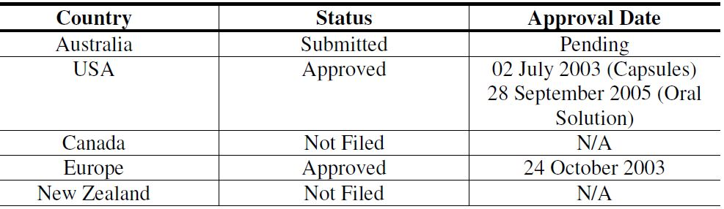

Table 2: Approved indications for Emtriva capsules.

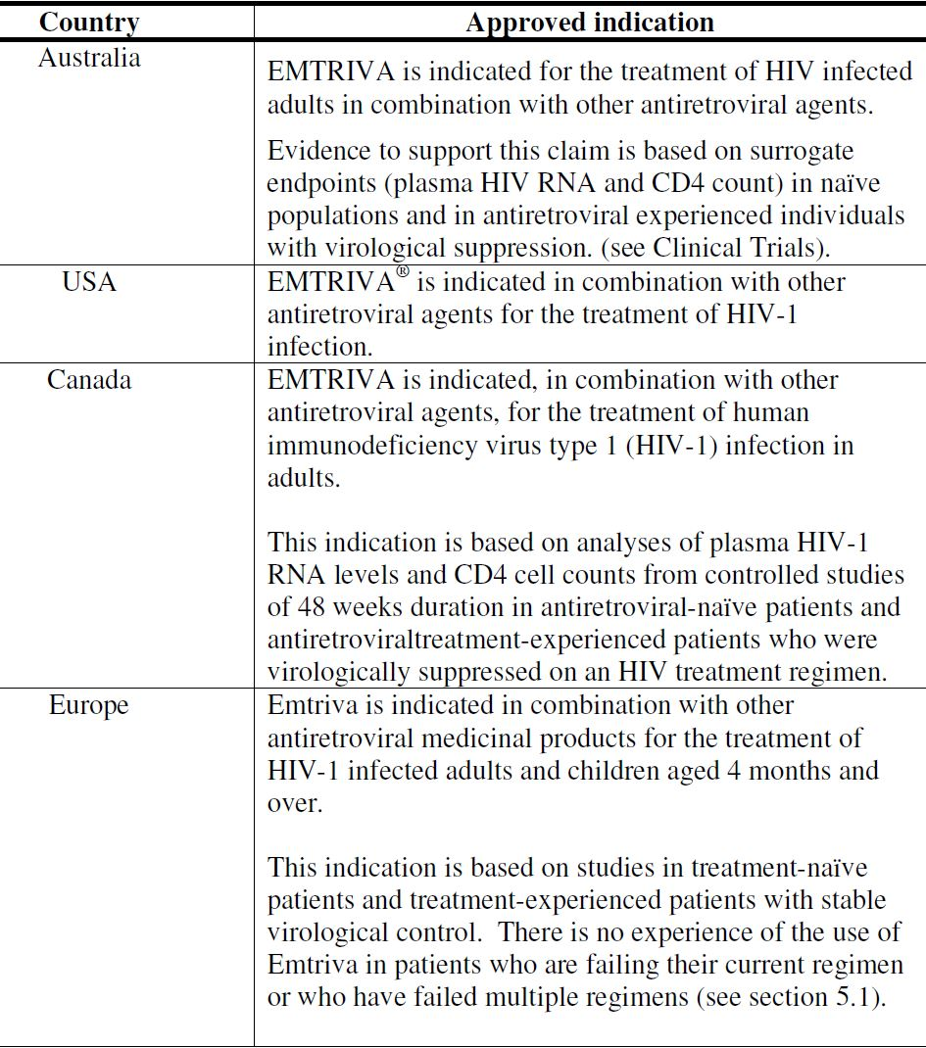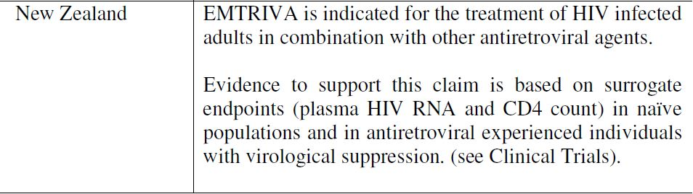

### Product Information

The approved Product Information (PI) current at the time this AusPAR was prepared can be found as Attachment 1.

## II. Quality findings

There was no requirement for a quality evaluation in a submission of this type.

## III. Nonclinical findings

There was no requirement for a nonclinical evaluation in a submission of this type.

## IV. Clinical findings

A summary of the clinical findings is presented in this section. Further details of these clinical findings can be found in Attachment 2.

### Introduction

The submission contained the following clinical information:

* 3 pivotal efficacy/safety studies;
* Most recent Periodic Safety Update Report (PSUR) for Emtriva, covering the period 3 April 2011 through to 2 April 2012.

### Pharmacokinetics

Studies FTC-202, FTC-203 and FTC-211 provide pharmacokinetic data to support the application. All studies assessed the pharmacokinectics of emtricitabine in paediatric populations, with FTC-211 having the greatest proportion of subjects in the target age range (>12-18 years of age). The area under the plasma concentration-time curve (AUC) data was consistent across studies, with all studies achieving the minimum target exposure level of > 6.0 h*µg/mL). This level is considered to be the minimum acceptable level when compared against adult pharmacokinetic data.

The data did suggest some increased variability in the AUC data in FTC-202 and FTC-203, particularly in the younger age groups. It was suggested by the sponsor that this may have been due to differences in administration of a liquid formulation to a young population and/or altered pharmacokinetics in young children. This variability did not seem to be present amongst children > 12 years, taking the capsule formulation.

### Pharmacodynamics

Not applicable.

### Efficacy

The three studies present efficacy data on the use of emtricitabine for the treatment of HIV-1 infection in paediatric populations. All studies present data to 48 weeks, with the proportion of subjects with HIV-1 viral loads < 400 copies/mL above 80 and < 50 copies/mL above 70. All studies used a conservative missing equals failure (M = F), intention to treat analysis and the true suppression rate may be higher. Consistent with other anti viral medications, there appears to be a small percentage of children who did not respond to emtricitabine and required their anti retroviral medication to be changed (emtricitabine stopped) within the first two months of commencing treatment; there did not appear to be any difference in the number of responders between the anti retroviral therapy (ART) naive and ART experienced groups. In addition to the non responders, a small percentage of children withdrew from the trial prior to Week 48 due to non compliance with the medication. For the majority of cases this appears to have been due to an overall lack of motivation/interest in treatment rather than being secondary to adverse effects/symptoms. Poor treatment compliance is a common problem in the management of adolescent chronic disease and the rates of non compliance may reflect this challenge.

From the data presented, no efficacy issue has been identified preventing an extension of age indication to children aged > 12 years and weighing > 33 kg. The small study numbers prevent a more rigorous and robust analysis of efficacy results; however, the results of Studies FTC-202, FTC-203 and FTC-211 broadly align with those seen in the pre market clinical studies undertaken for emtricitabine in adult populations.

### Safety

All three studies presented data on the clinical safety of emtricitabine when use in paediatric patients. Over the 48 week study period, the majority of patients experienced at least one adverse event (AE). Most AEs were classified as Class 1 or 2 events; the majority of AEs were also consistent with the burden of disease in paediatric populations (respiratory illness, skin complaints, gastrointestinal illness) and were classified by the study investigators as being probably not related to the study medication. Approximately 10% of subjects experienced an AE that was deemed to be probably or possibly related to the study medication. Again, the vast majority of these were Class 1 or 2 events that resolved without a change in the study medication.

There were several Class 3 and 4 AEs that were considered to be possibly or probably related to the study medication. In one case, the subject required permanent discontinuation from the study drug in order for the laboratory findings (elevated Gamma Glutamyl Transpeptidase [GGT]) reverted to normal levels. Skin hyperpigmentation was seen in several dark skinned patients receiving emtricitabine. In approximately half the cases, the skin condition resolved without change to the study medication; in the other cases, the hyperpigmentation resolved following cessation of the drug at study end.

There was one study death (acute myeloid leukaemia) this case was not thought to be related to the study medication.

Overall, the safety profile of the drug was consistent with the know side-effect profile in adult populations. Adverse events with antiretroviral medications include elevated liver toxicity, hypoglycaemia and skin hyperpigmentation. These conditions require careful monitoring by the prescribing physician.

Given the small number of paediatric patients studied, it is possible that safety issues with emtricitabine when used in paediatric populations were not been identified in the pre market assessment undertaken by the sponsor; however, the safety requirements for an extension of indication of this nature (that is, extension of age indication from a drug found to be safe and efficacious in an adult population) have been met.

### Clinical summary and conclusions

#### First round benefit-risk assessment

##### First round assessment of benefits

The benefits of emtricitabine in the proposed usage are:

* Provide additional choice of antiretroviral medications for use in the adolescent population;
* Daily dosing regimen;
* Pharmacokinetics reflect adult dosing and pharmacokinetic parameters; and
* Efficacious in majority of paediatric patients to Week 48 (relatively low numbers of non responders).

##### First round assessment of risks

The risks of emtricitabine in the proposed usage are:

* Dosing window is narrow; virological failure can occur with inconsistent pill taking or treatment non compliance;
* Skin hyperpigmentation a well recognised adverse event, particularly in dark skinned subjects;
* Elevated LFTs a common side effect; and
* Renal impairment increases half life, requires modified dosing regimen.

##### First round assessment of benefit-risk balance

The benefit-risk balance of emtricitabine, given the proposed usage, is favourable.

#### First round recommendation regarding authorisation

The studies presented in this application provide evidence of the safety, tolerability and efficacy of emtricitabine when used for the treatment of HIV-1 infection in paediatric patients. Although the paediatric dataset is small, it has not identified any new AEs to those detected in the pre market clinical trials undertaken in adult subjects. However, given the low paediatric study numbers, it is possible that Studies FTC-202, FTC-203 and FTC-211 failed to detect AEs and efficacy issues due to inadequate power.

Emtricitabine has been available on the European and US markets since 2003 for paediatric use. Since 2003, there has been no major safety alert requiring regulatory action.

The evaluator recommends that emtricitabine be approved for use in children aged > 12 years and weighing more than 33 kg for use in HIV-1 infection in combination with other antiretroviral agents provided that the grammatical error in the Consumer Medicine Information (CMI) is corrected.

### List of questions

The evaluator has no clinical questions.

## V. Pharmacovigilance findings

### Risk management plan

The sponsor submitted a Risk Management Plan which was reviewed by the TGA’s Office of Product Review (OPR).

#### Safety specification

The sponsor provided a summary of ongoing safety concerns which are shown at Table 3.

Table 3: Ongoing safety concerns for Emtriva.

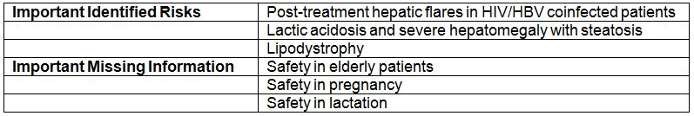

##### OPR reviewer comment

Notwithstanding the evaluation of the nonclinical and clinical aspects of the Safety Specification, it is recommended that the above summary of ongoing safety concerns is acceptable.

#### Pharmacovigilance plan

##### Proposed pharmacovigilance activities

Routine pharmacovigilance activities are proposed for all ongoing safety concerns, which the sponsor states includes targeted follow up questionnaires where applicable. For the area of important missing information ‘Safety in Pregnancy’, the sponsor proposes two ongoing additional pharmacovigilance activities:

* Antiretroviral Pregnancy Registry (information on the risk of birth defects in patients exposed to emtricitabine during pregnancy)
* Cross sectional study ‘MITOC’ (information on the risk of mitochondrial disease in children exposed to NRTIs in utero)

##### OPR reviewer’s comments in regard to the pharmacovigilance plan (PP) and the appropriateness of milestones

All additional pharmacovigilance activities are ongoing for Emtriva. It is expected that results of these studies will be communicated to the TGA via PSURs and updates to the RMP at the same time as other regulatory agencies.

The sponsor does not provide any study milestones for reporting. It is recommended the sponsor provide milestones for the planned submission of interim or final reports for the ongoing studies Antiretroviral Pregnancy Registry and cross sectional study ‘MITOC’ to the TGA.

#### Risk minimisation activities

##### Sponsor’s conclusion in regard to the need for risk minimisation activities

The sponsor concludes the following in regard to the need for risk minimisation activities:

Information regarding the safety concerns associated with emtricitabine is communicated to prescribers and patients in the PIs and CMIs for emtricitabine containing products.

Guidance in the PIs on safety concerns associated with emtricitabine includes the following:

* Warning on the risk of exacerbation of hepatitis in HIV/HBV (hepatitis B virus) co-infected patients following discontinuation of treatment and guidance that these patients should be closely monitored with both clinical and laboratory follow up for at least several months after stopping treatment.
* Warning that lactic acidosis, usually associated with hepatic steatosis, has been reported with the use of nucleoside analogues and guidance that patients at risk should be followed closely.
* Warning that lipodystrophy has been associated with combination antiretroviral therapy in HIV patients and guidance on clinical examination and measurement of fasting serum lipids and blood glucose.

The PI and CMIs for emtricitabine containing products will be updated as new safety information concerning emtricitabine becomes available.

##### OPR reviewer comment

Routine risk minimisation activities (that is, PI and CMI labelling) are considered acceptable to mitigate the ongoing safety concerns associated with Emtriva.

#### Summary of recommendations

The OPR provides these recommendations in the context that the submitted RMP is supportive to the application; the implementation of a RMP satisfactory to the TGA is imposed as a condition of registration; the submitted EU-RMP is applicable without modification in Australia unless so qualified; and the draft PI and CMI should *not* be revised until the Delegate’s Overview has been received:

Safety considerations may be raised by the nonclinical and clinical evaluators through the consolidated section 31 request and/or the Nonclinical and Clinical Evaluation Reports respectively. It is important to ensure that the information provided in response to these will include a consideration of the relevance for the RMP, and any specific information needed to address this issue in the RMP. For any safety considerations so raised, the sponsor should provide information that is relevant and necessary to address the issue in the RMP.

1. It is recommended that the Delegate implement AU RMP Version 0.1 dated August 2012 (Data Lock Point 2 April 2012) and any future updates as a condition of registration.
2. The sponsor does not provide any study milestones for reporting of ongoing pharmacovigilance studies. It is recommended the sponsor provide milestones for the planned submission of interim or final reports for the ongoing studies Antiretroviral Pregnancy Registry and cross sectional study ‘MITOC’ to the TGA.
3. In regards to routine risk minimisation activities, it is recommended to the Delegate that additions are made to the proposed Australian PI to inform Healthcare professionals of important precautions and also recommendations for dosage and administration.

#### Second round evaluation of the sponsor’s response to the RMP evaluation

Reconciliation of issues outlined in the RMP report is outlined below.

##### Recommendation in RMP evaluation report

Safety considerations may be raised by the nonclinical and clinical evaluators through the consolidated section 31 request and/or the nonclinical and clinical evaluation reports, respectively. It is important to ensure that the information provided in response to these includes a consideration of the relevance for the RMP, and any specific information needed to address this issue in the RMP. For any safety considerations so raised, please provide information that is relevant and necessary to address the issue in the RMP.

The sponsor does not provide any study milestones for reporting of ongoing pharmacovigilance studies. It is recommended the sponsor provide milestones for the planned submission of interim or final reports for the ongoing studies Antiretroviral Pregnancy Registry and cross sectional study ‘MITOC’ to the TGA.

##### Sponsor’s response

Given the nature of the MITOC investigation, it is inherently difficult to provide definitive milestones for submission of interim or final reports, however it is anticipated that the final study report will be available by the end of 2014.

Currently, Gilead reports updates to the status of the APR and MITOC to regulators in PSURs and will continue to do so via evolving RMP/PSUR reporting processes.

##### OPR evaluator’s comment

This is considered acceptable.

##### Outstanding issues

###### Issues in relation to the RMP

Statement in the PI with regard to mitochondrial toxicty

In the ‘Precautions’ section, the following statement should be added: Mitochondrial toxicity is associated with exposure to HIV nucleoside reverse transcriptase inhibitors *in utero*, but there is insufficient data to provide a causal link between emtricitabine and mitochondrial disease (or a statement to that effect).

###### Advice from the Advisory Committee on the Safety of Medicines (ACSOM)

ACSOM advice was not sought for this submission.

##### Comments on the safety specification of the RMP

###### OMA clinical evaluation report

Note: The first round clinical report is the final report.

The clinical evaluator made the following summary first round comment in regard to safety specifications in the draft RMP:

*The Safety Specification in the draft Risk Management Plan is satisfactory.*

###### OSE nonclinical evaluation report

Not applicable.

##### Key changes to the updated RMP

Not applicable.

##### Suggested wording for conditions of registration

###### RMP

Implement Risk Management Plan (AU-RMP Version 0.1 [dated August 2012, Data Lock Point 2 April 2012]), and any future updates as a condition of registration.

###### PSUR

The Offices of Medicines Authorisation (OMA) is to provide new wording when finalised.

## VI. Overall conclusion and risk/benefit assessment

The submission was summarised in the following Delegate’s overview and recommendations.

### Quality

There was no requirement for a quality evaluation in a submission of this type.

### Nonclinical

There was no requirement for a nonclinical evaluation in a submission of this type.

### Clinical

#### Efficacy

The clinical data is comprised of three pivotal studies (FTC-202, FTC-203, and FTC-211) and the most recent PSUR for Emtriva covering the period 3 April 2011 through to 2 April 2012.

##### Study FTC 202

This was an ongoing, multi centre, open label, non randomised designed to evaluate the efficacy, safety and the pharmacokinetics of emtricitabine in male and female patients in the following age groups: 3 to <36 months, 3 to 12 years, and 13 to 21 years. Patients received a triple drug regimen comprising emtricitabine (oral solution or capsule formulation), didanosine and efavirenz. All but 3 of the subjects who weighed < 33 kg received the emtriciabine oral solution formation with all others receiving the capsule formulation. A total of 37 subjects were enrolled into groups 2 and 3, with 21 in group 2 and 16 in group 3. The primary efficacy endpoint was the proportion of patients at Week 48 and all other time points with plasma HIV-1 RNA levels <400 copies/mL and <50 copies/mL, evaluated using missing equals failure (M = F) analysis.

At Week 48, of the 37 subjects enrolled in groups 2 and 3, 31 (81%, 95%CI [Confidence Interval]: 0.68-0.94) had viral load suppressed below 400 copies/mL (73%, 95%CI: 0.56-0.86) and 27 had viral load suppressed below 50 copies/mL at the same time. For Group 3, 13 out of 16 (81%, 95%CI: 0.54-0.96) had viral load suppressed below 400 copies/mL at Week 48, and all 13 subjects had viral loads suppressed below 50 copies/mL.

##### Study FTC 203

This was an ongoing, multicentre, open label, non randomised Phase II study, and the study evaluated the efficacy, safety, and pharmacokinetics of emtricitabine in ART naive and ART experienced patients aged 3 months to 17 years. Participants were assessed in 4 groups. Groups 1-3 were children aged 3 months to 12 years and were not relevant for this application. Group 4 included children aged 13 to 17 years. ART naive patients received emtricitabine (oral solution or capsule formulation), stavudine and lopinavir/ritonavir. ART experienced patients had the lamivudine in their existing ART regimen replaced with emtricitabine. For the older age groups, emtricitabine was supplied as a 200 mg capsule administered once daily. All subjects were treated for an initial period of 48 weeks, provided they did not meet the study drug discontinuation criteria. The primary efficacy outcome was the proportion of patients with plasma HIV-1 RNA below the Lower Limit of Quantification (LLOQ) for the assay, that is, ≤ 400 and ≤ 50 copies/mL for the standard and ultrasensitive tests, respectively, at Week 48, evaluated using non completer equals failure (NC = F) analysis.

The Intention To Treat (ITT) population comprised data from 116 subjects: 71 ART naive and 45 ART experienced. Of note, there were only 3 patients in group 4 aged 13 to 17 years as shown in Table 4.

Table 4: Subjects in ITT population (Study FTC 203).

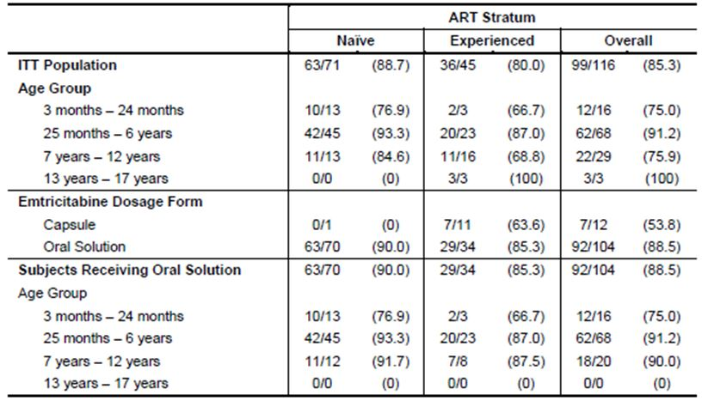

Using the ITT analysis, at Week 48, overall 90.3% (92.6% naive, 86.7% experienced) of patients achieved and/or maintained suppression of plasma HIV-1 RNA to ≤400 copies/mL. Based on the time to loss of virologic response (TLOVR) algorithm, overall 89.7% (104/116) subjects achieved and/or maintained suppression of plasma HIV-1 RNA to ≤ 400 copies/mL at Week 48. The proportion of patients achieving and maintaining suppression of plasma HIV-1 RNA to ≤ 50 copies/mL at Week 48 was 75.9% (88/116) overall.

##### Study FTC 211

This was a multicentre, open label, non randomised study to evaluate the safety, pharmacokinetics and efficacy of emtricitabine in ART naive and ART experienced HIV infected patients from 3 months to 17 years in 3 age groups: Group 1: 3-24 months; Group 2: 7-12 years; Group 3: 13-17 years. Subjects received a combination of emtricitabine (oral solution or capsule), didanosine and efavirenz. A sample size of 30-50 patients was planned. Only 16 (group 1: 1; group 3: 15) were enrolled and 15 (93.8%) subjects completed the study through Week 48. The mean age was 14.1 years (range: 12.8 to 15.2). All but one subject was ART naïve.

The primary efficacy outcome was the proportion of patients with suppression of plasma HIV-1 RNA to below the LLOQ for the assay, that is, ≤ 400 and ≤ 50 copies/mL for the standard and ultrasensitive tests, respectively, at Week 48, evaluated using NC = F analysis. At Week 48, 75% of patients (12/16) had plasma HIV-1 RNA levels ≤ 50 copies/mL (ITT, NC = F analysis). All but 1 patient achieved suppression of plasma HIV-1 RNA to ≤ 400 copies/mL, approximately 94% overall. Based on the TLOVR algorithm, 69% (11/16) and 56% (9/16) of the patients achieved suppression of plasma HIV-1 RNA to ≤ 400 copies/mL and ≤ 50 copies/mL, respectively.

##### Pooled analysis performed across the trials

A comparison of the results across the three trials was provided in ‘Clinical Summary’ (Table 5).

Table 5: Summary of Patient Disposition by Study at Week 48.

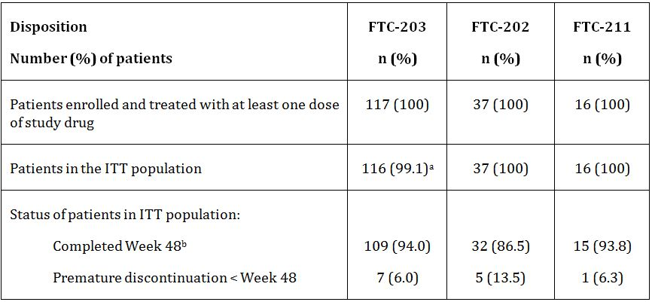

The patient age ranged from 3 months to 21.1 years. In Study FTC-203, 61.2% of patients were ART naive. In FTC-202, all patients were ART naive (36/37 had had no previous ART exposure at all), and in FTC-211 all but one was ART naive (Table 6).

Table 6: Results for the Primary Efficacy Outcome.

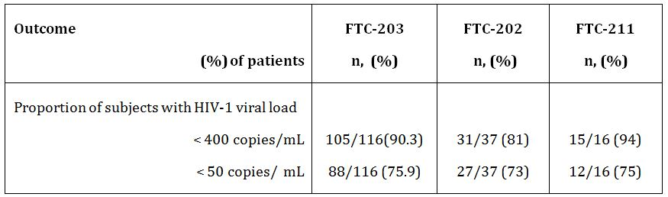

#### Pharmacokinetics

The pharmacokinetics data was also obtained from Studies FTC-203, FTC-202 and FTC-211. The study subjects underwent an intensive (0-24 h) pharmacokinetic study after 2 weeks on the recommended dose regimen. In total, data from 77 HIV infection children contributed to the integrated pharmacokinetic analysis representing an adequate number of patients to characterise emtricitabine pharmacokinetics. The key pharmacokinetic endpoint was steady state (0-24 h) plasma AUC of emtricitabine performed at Week 2, and between Weeks 8 to 24 if dose adjustments were required.

In paediatric subjects, the emtricitabine dosage regimen of 6 mg/kg once daily, with a maximum of 200 mg once daily was expected to achieve a target daily AUC of at least 6 h*µg/mL (the 10th percentile of the adult AUC given 200 mg once daily).

##### Pharmacokinetic data from Study FTC-202

Pharmacokinetic evaluations were available for 31 children (17/21 subjects in group 2 [3-12 years] and 14/16 in group 3 [13-21 years]). In group 2, 13/17 received the emtricitabine solution. All subjects in group 3 received the 200 mg emtricitabine capsule. All subjects > 33 kg received capsules and all but 2 weighing ≤ 33 kg (27 and 30 kg) received solution. All children > 10.5 years received capsules, and all subjects ≤ 10.5 years old received the solution except two who were 8.7 and 9.9 years old. Mean values for emtricitabine pharmacokinetic parameters at steady state by age group are provided in Table 7.

Table 7: Mean (CV%) Values for Emtricitabine PK Parameters at Steady-State by Age Group (Study FTC-202).

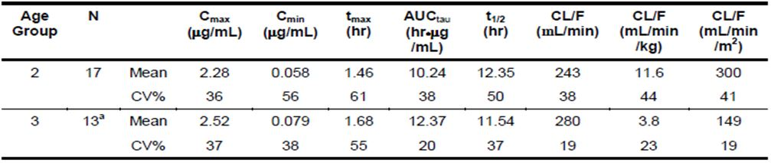

Subjects in both groups achieved the minimum target exposure level of at least 6 h*µg/mL.

The variability of AUC between doses at steady state (AUCtau) in the younger children (group 2) is ~2 fold higher than in the older children, as reflected in the CV% for this parameter estimate. Some variability may be due to dosing of a liquid formulation, and part may be due to greater variability in emtricitabine clearance in younger children dosed on a mg/kg basis, rather than body surface area. Variability in dosing for the younger age group does not affect the proposed extension of age indication. The AUCtau for the older age group was 12.37 h*µg/mL which is higher than the minimum acceptable level of 6 h*µg/mL.

##### PK data from study FTC-203

Participants were grouped into 4 groups. Groups 1-3 were children aged 3 months to 12 years. Group 4 included children aged 13 to 17 years. Pharmacokinetic data was evaluable in 34/36 subjects who provided 24 h profiles: 13/16 subjects in group 1, 9/68 in group 2, 9/29 in group 3 and 3/3 in group 4. All subjects in groups 1 and 2 and 4 subjects in group 3 received emtricitabine solution. Five subjects in group 3 and 3 in group 4 received emtricitabine capsules.

The principal pharmacokinetic parameters by age group for subjects receiving oral solution and capsules combined are presented in Table 8.

Table 8: Mean (CV%) Values for Emtricitabine PK Parameters at Steady-State by Age Group (Study FTC-203).

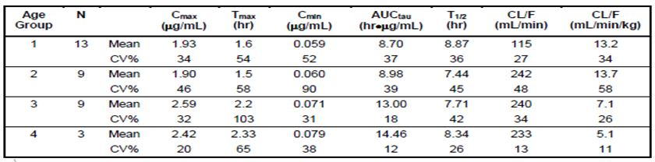

The results showed that subjects in both groups achieved the minimum target exposure level of at least 6 h*µg/mL.

##### Pharmacokinetic data from study FTC-211

Pharmacokinetic evaluations were available for 15 of the 16 children in the study (1/1 subjects in group 2 [7-12 years], and 14/15 in group 3 [13-17 years]). The subject in age Group 2 was 12.8 years at study entry, just below the 13 year age limit for age Group 3. All subjects received the 200 mg capsule formulation with the exception of 1 subject in Age Group 3. The principal PK parameters for the subjects receiving the capsule formation (n=14) are summarised in Table 9.

Table 9: Pharmacokinetic Parameters at Steady-State by Age Group.

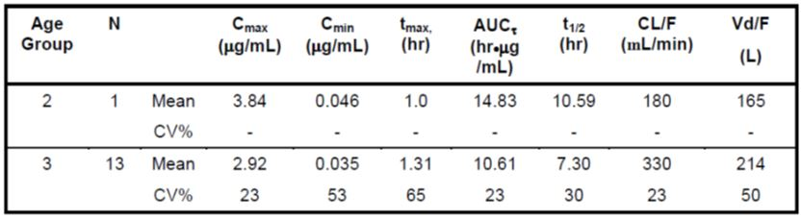

Subjects in both groups achieved the minimum target exposure level of at least 6 h*µg/mL.

Despite the smaller numbers in Study FTC-211, its population was closest to that applicable for the proposed extension of indication. All subjects were ≥ 12 years and except for 1 subject, all took the 200 mg capsule as a daily dose. The pharmacokinetic data reflects the data seen in FTC-202, FTC-203 and adult populations.

##### Pharmacokinetics in subjects with impaired renal function

There has been no formal pharmacokinetic study in subjects with impaired renal function. In Study FTC-202, 1 subject in group 3 (age = 14.6 years) who received 200 mg capsules had the highest AUC in the study at 36.30 h*µg/mL. At baseline, nephropathy was noted for this subject with a grade 1 serum creatinine (1.3 mg/dL) and a grade 1 uric acid (8.6 mg/dL). The subject reached Week 48 on study with a grade 1 serum creatinine (1.0 mg/dL) and grade 1 triglycerides (314 mg/dL). At Week 48, their HIV-RNA viral load was <50 copies/mL. It was considered that the high emtricitabine concentrations were likely to be attributable to decreased renal function caused by nephropathy.

##### Evaluator’s overall conclusion on pharmacokinetics

FTC-202, FTC-203 and FTC-211 assessed the pharmacokinetics of emtricitabine in paediatric populations, with FTC-211 having the greatest proportion of subjects in the target age range (>12 to 18 years of age). The AUC data was consistent across studies. In all studies the minimum target exposure level of >6.0 h*µg/mL was achieved. This level is considered to be the minimum acceptable level when compared against adult pharmacokinetic data.

#### Safety

The safety evaluation comprised analysis of AEs, tolerability failure, and clinical laboratory results. Key points noted by the evaluator are presented below.

The 3 studies presented data on the clinical safety of emtricitabine when use in paediatric patients. Over the 48 week study period the majority of patients experienced at least 1 AE. Most were classified as Class 1 or 2 events, were consistent with the burden of disease in paediatric populations (respiratory illness, skin complaints, gastrointestinal illness) and were assessed by the study investigators as probably not related to the study medication. Approximately 10% of subjects experienced an AE assessed as probably or possibly related to the study medication. The majority were Class 1 or 2 events which resolved without a change in the study medication.

There were several Class 3 and 4 AEs assessed as possibly or probably related to the study medication. In 1 case, the subject required permanent discontinuation from the study drug for the laboratory finding (elevated GGT) to revert to normal levels. Skin hyperpigmentation was seen in several dark skinned patients receiving emtricitabine. In approximately half the cases, the skin condition resolved without change to the study medication, in the other cases the hyperpigmentation resolved following cessation of the drug at study end.

There was one death in a patient with acute myeloid leukaemia. This was not considered to be related to the study medication.

Ongoing post market research on emtricitabine use in paediatric patients in the US and EU provided additional safety related data. There is no new information from the post market studies providing a safety signal for the drug.

#### Clinical evaluator’s recommendation

The clinical evaluator recommends that Emtriva (emtricitabine) be approved for use in children aged >12 years and weighing more than 33 kg for use in HIV-1 infection in combination with other antiretroviral agents provided that the grammatical error in the CMI is corrected.

### Risk management plan

The submitted RMP has been evaluated by the OPR evaluator and the evaluation report is provided for the Advisory Committee on Prescription Medicines (ACPM) meeting. At the first round evaluation, the evaluator recommends the sponsor providing milestones for the planned submission of interim or final reports for the ongoing studies Antiretroviral Pregnancy Registry and Cross sectional study ‘MITOC’ (*information on the risk of mitochondrial disease in children exposed to NRTIs in utero*) to the TGA, and also recommends a number of changes to the PI, including a request to include in ‘Precautions’ section the statements relating to mitochondrial toxicity (see the first round RMP evaluation report). The second round RMP evaluation further explained that the statement requested refers to the fact that HIV NRTIs are associated with mitochondrial toxicity, not emtricitabine specifically, and making this statement available to clinicians would allow them to look for signs and symptoms of mitochondrial toxicity. The statement proposed by RMP evaluator is:

*Mitochondrial toxicity is associated with exposure to HIV nucleoside reverse transcriptase inhibitors in utero, but there is insufficient data to provide a causal link between emtricitabine and mitochondrial disease (or a statement to that effect).*

### Discussion

Three small studies were provided to support the use of emtricitabine for the treatment of HIV-1 infection in paediatric populations. All 3 studies the present data to 48 weeks, and the results showed that the proportion of subjects with HIV-1 viral loads < 400 copies/mL were above 80% and the proportion of subjects with HIV-1 viral loads < 50 copies/mL were above 70%. All studies used a conservative missing equals failure (M = F), intention to treat analysis and the true suppression rate may be higher. In addition, the pharmacokinetics analysis demonstrated that the minimum target exposure level of > 6 h*µg/mL was achieved in all studies. This level is considered to be the minimum acceptable level when compared against adult PK data.

The small numbers of subjects (only 34 patients in the target age) prevent a more rigorous and robust analysis of efficacy, however, taking into account the pharmacokinetics results, and the previous efficacy experience in HIV infected adults patients, the results of these 3 studies support the use of emtricitabine in HIV infected children aged > 12 years and weighing > 33 kg.

The safety profile of the drug was consistent with known side effects in adult populations. AEs with antiretroviral medications include elevated liver toxicity, hypoglycaemia and skin hyperpigmentation. These conditions require careful monitoring by the prescribing physician.

Given the small number of paediatric patients studied, it is possible that safety issues with emtricitabine when used in paediatric populations were not been identified in the pre market assessment undertaken by the sponsor. However, the safety requirements for an extension of indication of this nature (that is, extension of age indication from a drug found to be safe and efficacious in an adult population) have been met.

In the submitted RMP, there is information relating to the evidence of mitochondrial disease in children exposed to emtricitabine *in utero*. Mitochondrial toxicity in children associated with in utero/perinatal exposure to NRTIs was first raised as a specific concern in 1999 following the identification of 8 cases of mitochondrial dysfunction in HIV-1 negative children from a French clinical study and paediatric cohort. Gilead states that it has regularly reviewed all data relevant to this safety concern and there is currently no specific evidence of a causal link between emtricitabine and mitochondrial disease in children who have been exposed *in utero*. The ongoing MITOC study will provide information on the risk of mitochondrial disease in children exposed to NRTIs *in utero*.

The RMP evaluator recommends that the sponsor should include a precautionary statement to inform healthcare professionals that mitochondrial damage has been reported with nucleoside and nucleotide analogue use, and these who have been exposed *in utero* or post natally, including those who are HIV negative, should have clinical and laboratory follow up. Gilead considers the addition of a *Precaution* regarding mitochondrial damage to be excessive given the current approved PI text “There was no evidence of toxicity to mitochondria *in vitro*.”

It is noted that the following comprehensive statements have been included in the EU Summary of Product Characteristics under the heading mitochondrial dysfunction:

*Nucleoside and nucleotide analogues have been demonstrated in vitro and in vivo to cause a variable degree of mitochondrial damage. There have been reports of mitochondrial dysfunction in HIV negative infants exposed in utero and/or postnatally to nucleoside analogues. The main adverse events reported are haematological disorders (anaemia, neutropenia), metabolic disorders (hyperlactataemia, hyperlipasaemia). These events are often transitory. Some late onset neurological disorders have been reported (hypertonia, convulsion, and abnormal-behaviour). Whether the neurological disorders are transient or permanent is currently unknown. Any child exposed in utero to nucleoside and nucleotide analogues, even HIV negative children, should have clinical and laboratory follow-up and should be fully investigated for possible mitochondrial dysfunction in case of relevant signs or symptoms. These findings do not affect current national recommendations to use antiretroviral therapy in pregnant women to prevent vertical transmission of HIV.*

The sponsor should consider strengthening the statements in the PI regarding mitochondrial dysfunction.

#### Summary of issues

Three small open label, non randomised studies were submitted. These studies evaluated the pharmacokinetics, efficacy, and safety of Emtriva in HIV infected paediatric patients aged from 3 months to 17 years. In all three studies, the minimum target exposure level of > 6.0 h*µg/mL was achieved. The anti viral efficacy was assessed at Week 48 in all 3 studies, and the Week 48 results showed that the proportion of subjects achieving HIV-1 viral loads < 400 copies/mL and < 50 copies/mL was above 80% and 70%, respectively. It is noted that only 34 patients were in the target age group (> 12 years).

The submitted RMP indicates there is information in relation to mitochondrial disease in children who were exposed to nucleoside and nucleotide analogue *in utero*. The RMP evaluator requests that this information be included in the *Precautions* section of the PI.

#### Issues requesting ACPM advice

The committee is requested to provide advice on the following specific issues:

* Whether the committee consider that the submitted data support the use of Emtriva in HIV infected paediatric patients 12 years and older.
* Whether the committee considers that the sponsor should be requested to strengthen the statements in the PI regarding mitochondrial dysfunction which has been reported with the use of nucleoside and nucleotide analogue.
* The committee is also requested to provide advice on any other issues that it thinks may be relevant to a decision on whether or not to approve this application.

#### Pre ACPM preliminary assessment

The Delegate has no reason to say, at this time, that the application for the extension of indication to include the treatment of HIV infected children 12 years and older and the proposed updates to the PI should not be approved.

The Delegate proposes to approve the extension of indication to include the treatment of HIV infected paediatric patents aged > 12 years and weighing > 33 kg:

*Emtriva is indicated for the treatment of HIV infected adults and children aged > 12 years and weighing > 33 kg in combination with other antiretroviral agents.*

*Evidence to support this claim is based on surrogate endpoints (plasma HIV RNA and CD4 count) in naïve populations and in antiretroviral experienced individuals with virological suppression (see Clinical Trials).*

The condition of registration includes the implementation of the RMP (AU-RMP Version 0.1 [dated August 2012, Data Lock Point 2 April 2012]), and any future updates to the RMP.

#### Response from sponsor

Thank you for providing an opportunity to comment upon the Delegate’s Overview concerning the Category 1 Application seeking to extend the indication of Emtriva capsules to include paediatric patients 12 years of age and older.

##### Summary

Emtriva (emtricitabine) 200 mg capsules have been registered in Australia for the treatment of HIV infected adults since 2005. Emtriva was designated as an orphan drug for the treatment of HIV infection in paediatric patients aged 12 to 17 years in March 2012.

HIV infection in children is markedly more aggressive than that in adults. One quarter of children who acquire HIV infection by vertical transmission progress to acquired immunodeficiency syndrome (AIDS) within the first year of infection, while the others progress to AIDS over five years.[1]

New therapies are needed for treatment of children to maintain chronic suppression of viral replication and while at the same time having a high genetic barrier to the development of viral resistance. Emtriva is recommended by the US Department of Health and Human Services (DHHS) as an initial therapy as part of a dual NRTI backbone.

The Delegate requests guidance as to whether the submitted data support the use of Emtriva in HIV infected patients 12 years and older. It was concluded by the clinical evaluator, and the Delegate is in agreement, that Emtriva should be approved for use in children aged > 12 years and weighing more than 33 kg with the following indication:

*Emtriva is indicated for the treatment of HIV infected adults and paediatric patients >12 years of age and older and weighing > 33 kg in combination with other antiretroviral agents.*

*Evidence to support this claim is based on surrogate endpoints (plasma HIV RNA and CD4 count) in naïve populations and in antiretroviral experienced individuals with virological suppression (see Clinical Trials).*

Emtricitabine administered once daily in combination with other ARTs showed potent efficacy in HIV-1 infected children, as measured by significant and sustained decreases in HIV-1 RNA viral load. Further to the efficacy demonstrated in the original Emtriva CAT 1, the results presented in the submission show the durability of efficacy through 48 weeks of treatment. The response rates in ART naive paediatric patients in Studies FTC-203, FTC-202 and FTC-211 through 48 weeks of treatment are at least as good as those for other studies that have demonstrated good response rates in this population using an ITT (NC = F) analysis.[2]

Based on the data provided within the Category 1 Application from 3 pivotal studies (FTC-202, FTC-203 and FTC-211), emtricitabine was shown to be safe and effective for the treatment of HIV-1 infection in an adolescent population (12 to 17 years old). Gilead supports the above revised indication as proposed by both the clinical evaluator and Delegate.

The remainder of this response is separated into three sections to address the Delegate’s comments in their Overview.

##### Discussion of delegate’s comments

###### (1) Whether the committee consider that the submitted data support the use of EMTRIVA in HIV infected paediatric patients 12 years and older.

Data from the 3 pivotal studies submitted within the Category 1 Application provide evidence (FTC-202, FTC-203 and FTC-211), that emtricitabine was shown to be safe and effective for the treatment of HIV-1 infection in an adolescent population (12 to 17 years old).

Efficacy, as measured by the percentage of patients achieving and maintaining a plasma HIV-1 RNA viral load of ≤ 400 copies/mL at Week 48, was consistent across all three studies, with values of 90.3%, 81.1%, and 93.8% in Studies FTC-203, FTC-202, and FTC-211, respectively, and 88.6% overall. The percentage of patients achieving and maintaining complete suppression of HIV-1 RNA viral load to ≤ 50 copies/mL was also similar across the three studies, and was 76.5% overall.

In terms of safety, emtricitabine was well tolerated in the paediatric population, with children aged from 3 months up to 21 years. The incidence of discontinuation due to AEs was consistently low across studies with no specific treatment limiting adverse effects or laboratory abnormalities identified and few specific AEs were consistently considered related to FTC.

It was concluded by the clinical evaluator that the benefit-risk balance is favourable, and Emtriva is efficacious in the majority of paediatric patients to Week 48 with a relatively low number of non responders.

There remains a need for new therapies for the treatment of children to maintain chronic suppression of viral replication. Granting approval of Emtriva for the treatment of HIV infection in children aged >12 would provide an additional choice of antiretroviral medication in a simple once daily dosing regimen.

###### (2) Whether the committee considers that the sponsor should be requested to strengthen the statements in the PI regarding mitochondrial dysfunction which has been reported with the use of nucleoside and nucleotide analogue.

Gilead does not believe there is a need to update the *Precautions* section of the current Emtriva PI regarding mitochondrial dysfunction. The approved Emtriva PI currently states the following within the *Precautions* section: ‘There was no evidence of toxicity to mitochondria *in vitro*.’ Gilead continues to monitor this safety concern as outlined below and will revise the PI text should there be any relevant findings.

Emtricitabine was first approved on 2 July 2003. In the 10 years since approval, there has been estimated excess of 143,000 patient-years exposure to emtricitabine as Emtriva, and over 4,300,000 patient-years exposure to emtricitabine containing products (Emtriva, Truvada, Atripla, Complera/Eviplera and Stribild). Routine pharmacovigilance activities have not identified mitochondrial toxicity as an adverse reaction to emtricitabine.

The signal for mitochondrial toxicity originated from the published article in 1999. Since that time, there has been no further indication of mitochondrial toxicity from both the MITOC study and routine pharmacovigilance activities. Therefore, Gilead considers the suggestion for addition of a *Precaution* regarding mitochondrial damage to be unwarranted. Gilead will continue to monitor this safety concern as outlined in the RMP and will revise PI text should there be any relevant findings.

Mitochondrial toxicity in children associated with *in utero*/perinatal exposure to NRTIs was first raised as a specific concern in 1999 following the identification of 8 cases of mitochondrial dysfunction in HIV-1 infected children and the publication of A French journal article.[3] This journal article led to an EU SmPC class labelling update. The same class labeling update request was not initiated by any other regulatory agency and as such, the statement within the EU SmPC is not present in any other major territory NRTI labels.

A cross sectional assessment of HIV negative children with *in utero* exposure to NRTIs is being conducted by the Collaborative Committee for Mitochondrial Toxicity in Children (MITOC). This committee was established by Bristol Myers Squibb, Gilead Sciences, and GlaxoSmithKline following discussion with the European Medicines Agency (EMA) and the Committee for Medicinal Products for Human Use (CHMP) after there were reports of mitochondrial toxicity in children with *in utero* exposure to nucleoside and/or nucleotide reverse transcriptase inhibitors. Academic experts are also participating in this project, as well as representatives from European cohorts of children born to HIV infected mothers.

Existing European cohorts of children born to HIV infected mothers will be used in the study and it is anticipated that 2500 to 3000 children will be recruited. The final version of the MITOC protocol was submitted to CHMP on 17 July 2007.

The objectives of the study are as follows:

* to determine the prevalence of neurological clinical symptoms of cognitive or motor delay (with or without seizures) in HIV negative children between the ages of 18-24 months born to HIV-1 infected mothers and followed since birth, without attribution of cause
* to categorise these cases into explained and unexplained cognitive or motor delay and to estimate prevalence accordingly
* to estimate the proportion of the unexplained cases whose symptoms are suggestive (that is, “definite”, “probable” or “possible” by consensus review) of mitochondrial disorder (or clinically manifested mitochondrial disorder)
* to assess the association between type and duration of ART exposure in utero and unexplained and mitochondrial disorder related cognitive or motor delay.

As of May 2013, 1761 patients have been officially enrolled in the study. In addition to the 1761 patients, 704 screening questionnaires have been received from the French Cohort.

To date, there have been no confirmed cases of mitochondrial toxicity.

Currently Gilead reports updates to the status of the MITOC to regulators in PSURs and RMPs, and will continue to do so until study completion.

###### (3) The committee is also requested to provide advice on any other issues that it thinks may be relevant to a decision on whether or not to approve this application.

There remains a need for new therapies for the treatment of children to maintain chronic suppression of viral replication. Granting approval of Emtriva for the treatment of HIV infection in children aged >12 would provide an additional choice of antiretroviral medication in a simple once daily dosing regimen.

Emticitabine has been available on the EU and US markets since 2003 for paediatric use. Since 2003 there has been no major safety alert requiring regulatory action.

The data set provided with this Category 1 Application was assessed to have a favourable benefit-risk balance is to be efficacious in the majority of paediatric patients to Week 48.

##### Conclusion

Emtriva has been available since 2005 for use in HIV infected adults in Australia. The pivotal studies provided in this Category 1 Application demonstrated efficacy and safety in adolescent patients (aged 12 to 17), while the ongoing widespread use of emticitabine in adults provides supportive safety and virological evidence. There is a clear need for alternative therapies for paediatric patients with HIV infection.

#### Advisory committee considerations

The submission seeks to register an extension of indications for a currently registered product.

The ACPM, taking into account the submitted evidence of efficacy, safety and quality, agreed with the delegate and considered Emtriva hard capsule containing 200 mg of Emtricitabine to have an overall positive benefit-risk profile for the amended indication:

*Emtricitabine is indicated for the treatment of HIV in combination with other antiretroviral agents in adults and paediatric patients 12 years of age and older, weighing more than 33 kg.*

*Evidence is based on surrogate markers (HIV RNA and CD4) in antiretroviral naive individuals and in antiretroviral experienced individuals with virological suppression [see Clinical Trials].*

*There is no evidence in patients who have experienced treatment failure [see Clinical Trials].*

The committee is requested to provide advice on the following specific issues:

* Whether the committee consider that the submitted data support the use of Emtriva in HIV infected paediatric patients 12 years and older.

The ACPM noted:

* + The data provided are very limited in terms of numbers of subjects in the target age group and in study quality and that this should be communicated to the sponsor
  + Adult data and the pharmacokinetic findings provide a better basis for the extension of indication to the 12-17 year age group
  + There are no concerns regarding safety
* Whether the committee considers that the sponsor should be requested to strengthen the statements in the PI regarding mitochondrial dysfunction which has been reported with the use of nucleoside and nucleotide analogue.
  + The ACPM advised the data suggesting mitochondrial dysfunction are extremely limited and the statement should be moderated to include “...rare and inconsistently reported” with *in utero* exposure.

##### Proposed conditions of registration

The ACPM agreed with the Delegate on the proposed conditions of registration.

##### Proposed Product Information (PI)/Consumer Medicine Information (CMI) amendments:

The ACPM agreed with the delegate to the proposed amendments to the PI and CMI and specifically advised on the inclusion of the following:

* A statement in the *Precautions* section of the PI to reference the potential for renal impairment, including proximal tubulopathy and acute or chronic renal insufficiency.
* A statement in the *Precautions* section of the PI and relevant sections of the CMI to ensure caution with withdrawal or interruption of treatment in HBV co-infected patients due to the potential for hepatocellular damage,
* The proposed statement in the *Precautions* section of the PI on *In utero* mitochondrial toxicity should be modified with terms such as “...rare and inconsistently reported”
* Suitable statements on renal and bone toxicity of the tenofovir/emtricitabine (TDF/FTC) combination treatment.
* A strengthening of the statement in regards to pre-treatment resistance in the *Precautions* section of the PI and relevant sections of the CMI and to ensure the statement refers to all patients.
* The statement in the *Precautions* section of this PI and relevant sections of this CMI and of the other products in this class to more accurately reflect current evidence that ARV treatment ‘substantially reduces transmission but does not completely prevent.’

The ACPM advised that the implementation by the sponsor of the recommendations outlined above to the satisfaction of the TGA, in addition to the evidence of efficacy and safety provided would support the safe and effective use of these products.

### Outcome

Based on a review of quality, safety and efficacy, TGA approved the registration of Emtriva containing emtricitabine for the **new indication**:

*Emtriva is indicated for the treatment of HIV in combination with other antiretroviral agents in adults and paediatric patients 12 years of age and older, weighing more than 33 kg.*

*Evidence to support this claim is based on surrogate markers (plasma HIV RNA and CD4 count) in antiretroviral naïve individuals and in antiretroviral experienced individuals with virological suppression (see Clinical Trials).*

#### Specific conditions of registration applying to these therapeutic goods

* The Emtriva Risk Management Plan (AU-RMP), version 1.0, dated August 2012, Data Lock Point 2 April 2012, and any subsequent revisions, as agreed with the TGA will be implemented in Australia.

## Attachment 1. Product Information

The Product Information approved at the time this AusPAR was published is at Attachment 1. For the most recent Product Information please refer to the TGA website at <<http://www.tga.gov.au/hp/information-medicines-pi.htm>>.

## Attachment 2. Extract from the Clinical Evaluation Report

1. Hoy J, Lewin S. (2008) HIV Management in Australasia - a guide for clinical care. Australasian Society for HIV Medicine, Inc., Sydney.
2. Sáez-Llorens X, et al. (2003) Forty-eight-week evaluation of lopinavir/ritonavir, a new protease inhibitor, in human immunodeficiency virus-infected children. Pediatr Infect Dis J. 22: 216-224; Luzuriaga K, et al. (2004) A trial of three antiretroviral regimens in HIV-1-infected children. N Engl J Med. 350: 2471-2480; Starr SE, et al. (1999) Combination therapy with efavirenz, nelfinavir, and nucleoside reverse-transcriptase inhibitors in children infected with human immunodeficiency virus type 1. Pediatric AIDS Clinical Trials Group 382 Team. N Engl J Med. 341: 1874-1881; Paediatric European Network for Treatment of AIDS (PENTA). (2002) Comparison of dual nucleoside-analogue reverse-transcriptase inhibitor regimens with and without nelfinavir in children with HIV-1 who have not previously been treated: the PENTA 5 randomised trial. Lancet 359: 733-740; Nachman SA, et al. (2000) Nucleoside analogs plus ritonavir in stable antiretroviral therapy-experienced HIV-infected children: a randomized controlled trial. JAMA 283: 492-498.
3. Blanche S, et al. (1999) Persistent mitochondrial dysfunction and perinatal exposure to antiretroviral nucleoside analogues. Lancet 354: 1084-1089.