First round CER: April 2015
Second round CER: July 2015

AusPAR Attachment 2

Extract from the Clinical Evaluation Report for enzalutamide

  - Proprietary Product Name: Xtandi
  - Sponsor: Astellas Pharma Australia Pty Ltd

About the Therapeutic Goods Administration (TGA)
- The Therapeutic Goods Administration (TGA) is part of the Australian Government Department of Health, and is responsible for regulating medicines and medical devices.
- The TGA administers the Therapeutic Goods Act 1989 (the Act), applying a risk management approach designed to ensure therapeutic goods supplied in Australia meet acceptable standards of quality, safety and efficacy (performance), when necessary.
- The work of the TGA is based on applying scientific and clinical expertise to decision-making, to ensure that the benefits to consumers outweigh any risks associated with the use of medicines and medical devices.
- The TGA relies on the public, healthcare professionals and industry to report problems with medicines or medical devices. TGA investigates reports received by it to determine any necessary regulatory action.
- To report a problem with a medicine or medical device, please see the information on the TGA website <https://www.tga.gov.au>.
About the Extract from the Clinical Evaluation Report
- This document provides a more detailed evaluation of the clinical findings, extracted from the Clinical Evaluation Report (CER) prepared by the TGA. This extract does not include sections from the CER regarding product documentation or post market activities.
- The words [Information redacted], where they appear in this document, indicate that confidential information has been deleted.
- For the most recent Product Information (PI), please refer to the TGA website <https://www.tga.gov.au/product-information-pi>.
Copyright
© Commonwealth of Australia 2016
This work is copyright. You may reproduce the whole or part of this work in unaltered form for your own personal use or, if you are part of an organisation, for internal use within your organisation, but only if you or your organisation do not use the reproduction for any commercial purpose and retain this copyright notice and all disclaimer notices as part of that reproduction. Apart from rights to use as permitted by the Copyright Act 1968 or allowed by this copyright notice, all other rights are reserved and you are not allowed to reproduce the whole or any part of this work in any way (electronic or otherwise) without first being given specific written permission from the Commonwealth to do so. Requests and inquiries concerning reproduction and rights are to be sent to the TGA Copyright Officer, Therapeutic Goods Administration, PO Box 100, Woden ACT 2606 or emailed to <tga.copyright@tga.gov.au>.

Contents
List of abbreviations 5
1. Introduction 7
2. Clinical rationale 7
3. Contents of the clinical dossier 7
3.1. Scope of the clinical dossier 7
3.2. Paediatric data 7
3.3. Good clinical practice 8
4. Pharmacokinetics 8
4.1. Studies providing pharmacokinetic data 8
4.2. Summary of pharmacokinetics 8
4.3. Evaluator’s overall conclusions on pharmacokinetics 10
5. Pharmacodynamics 11
5.1. Studies providing pharmacodynamic data 11
6. Summary of pharmacodynamics 11
6.1. Pharmacodynamic effects 11
6.2. Evaluator’s overall conclusions on pharmacodynamics 13
7. Clinical efficacy 13
7.1. Studies providing efficacy data 13
7.2. Proposed indication 13
7.3. Evaluator’s conclusions on efficacy 31
8. Clinical safety 34
8.1. Studies providing safety data 34
8.2. Patient exposure 35
8.3. Adverse events 37
8.4. Safety issues with the potential for major regulatory impact 50
8.5. Evaluator’s conclusions on safety 57
9. First round benefit-risk assessment 58
9.1. First round assessment of benefits 58
9.2. First round assessment of risks 58
9.3. First round assessment of benefit-risk balance 59
10. First round recommendation regarding authorisation 59
11. Clinical questions 59
11.1. Pharmacokinetics 59
11.2. Pharmacodynamics 60
11.3. Efficacy 60
11.4. Safety 61
12. Second round evaluation 62
13. Second round benefit-risk assessment 83
13.1. Second round assessment of benefits 83
13.2. Second round assessment of risks 83
13.3. Second round assessment of benefit-risk balance 83
14. Second round recommendation regarding authorisation 83

List of abbreviations
Abbreviation | Meaning
% CV | Percent coefficient of variation
ALT | Alanine aminotransferase
AST | Aspartate aminotransferase
AUC | Area under the concentration-time curve
AUCinf | Area under the plasma concentration-time curve extrapolated to infinite time
AUClast | Area under the plasma concentration-time curve to last measurable concentration
BMD | Bone mineral density
CFR | Code of Federal Regulations
Cmax | Maximum (observed) plasma concentration
Cmin | Minimum (predose) plasma concentration
CRPC | Castrate-resistant prostate cancer
CTCAE | Common Terminology Criteria for Adverse Events
CYP | Cytochrome P450
ECG | Electrocardiogram
ECOG | Eastern Cooperative Oncology Group
FACT-P | Functional assessment of cancer therapy-prostate
FDA | Food and Drug Administration
GCP | Good Clinical Practice
GMR | Geometric mean ratio
GnRH | Gonadotropin-releasing hormone
ICH | International Conference on Harmonisation
IRB | Institutional Review Board
ITT | Intent-to-treat
LVEF | Left ventricular ejection fraction
M1 | Carboxylic acid metabolite of enzalutamide (inactive metabolite)
M2 | N-desmethyl-enzalutamide (active metabolite)
MedDRA | Medical Dictionary for Regulatory Activities
mITT | Modified intent-to-treat
NCI | National Cancer Institute
NYHA | New York Heart Association
NYR | Not yet reached
OS | Overall survival
PD | Pharmacodynamic
PI | Product Information
PK | Pharmacokinetic
PSA | Prostate-specific antigen
QT | QT interval
QTcB | QT interval assessed by Bazett formula
QTcF | QT interval assessed by Fredericia formula
rPFS | Radiographic progression-free survival
SD | Standard deviation
SJS/TEN | Stevens’ Johnson syndrome/Toxic epidermal necrolysis
Tmax | Time to maximal plasma concentration
ULN | Upper limit of normal
WBC | White blood cell (count)

Introduction
This application describes the application by Astellas Pharma Australia Pty Ltd to extend the indications for Xtandi (enzalutamide). The currently approved indication is:
Xtandi is for the treatment of patients with metastatic castration-resistant prostate cancer who have previously received docetaxel.
The proposed additional indication is:
Xtandi is indicated for:
  - the treatment of patients with metastatic castration-resistant prostate cancer who are asymptomatic or mildly symptomatic after failure of androgen deprivation therapy in whom chemotherapy is not yet clinically indicated.
  - the treatment of patients with metastatic castration-resistant prostate cancer who have previously received docetaxel.

Clinical rationale
As per the currently approved PI for enzalutamide:
Enzalutamide is an androgen receptor signalling inhibitor that blocks the androgen receptor signalling pathway. Enzalutamide competitively inhibits binding of androgens to androgen receptors, and consequently inhibits the nuclear translocation of these receptors and inhibits the binding of androgen receptor to DNA. In vitro, enzalutamide treatment decreased proliferation and induced prostate cancer cell death. Decreased tumour growth was seen in a mouse prostate cancer xenograft model. In preclinical studies enzalutamide lacked androgen receptor agonist activity against several prostate cancer cell lines. The active metabolite, N-desmethyl enzalutamide, exhibited similar in vitro activity to enzalutamide in the inhibition of testosterone binding to the androgen receptor.
The rationale for the proposed new indication is that in patients with castration-resistant prostate cancer (CRPC) who fail androgen deprivation therapy, disease progression may present as either a continuous rise in prostate-specific antigen (PSA), the progression of pre-existing malignant disease, and/or the appearance of new metastases.

Contents of the clinical dossier

Scope of the clinical dossier
The submission contained the following clinical information:
- Three clinical pharmacology studies
- Two population pharmacokinetic analyses.
- One pivotal efficacy/safety study, two non-pivotal studies of efficacy and safety
- Line listing of adverse events (AEs)

Paediatric data
The submission did not include paediatric data.

Good clinical practice
The clinical studies reviewed in this evaluation were in compliance with published guidelines.

Pharmacokinetics

Studies providing pharmacokinetic data
Table 1 shows the studies relating to each pharmacokinetic topic and the location of each study summary.
Table 1: Submitted pharmacokinetic studies.
Study ID | Study type | Phase, design | Study population | Assessment | Number of subjects
MDV3100-06 | PK, safety, tolerability | Phase Ib, open-label | Patients with metastatic CRPC | Primary analysis | 22
9785-CL-0321 | Efficacy, safety, tolerability, PD, PK | Phase II, open-label, single arm | Patients with hormone-naïve prostate cancer | 1-year analysis | 67
9785-CL-0111 | Efficacy, safety, tolerability, PK | Phase I-II open label, uncontrolled, dose-escalation | Japanese patients with metastatic CRPC, with or without prior docetaxel | Primary analysis | 47
None of the pharmacokinetic studies had deficiencies that excluded their results from consideration.

Summary of pharmacokinetics
The information in the following summary is derived from conventional pharmacokinetic studies unless otherwise stated.

Pharmacokinetics in the target population
The effect of co-administration of docetaxel and enzalutamide on docetaxel PK was assessed in study MDV3100-06.
Concomitant administration was observed to not significantly affect the Cmax, AUClast or AUCmin of docetaxel (Table 2).
Table 2: Comparison of plasma docetaxel pharmacokinetic parameters in treatment period 1 (pre-enzalutamide) and 2 (during enzalutamide).
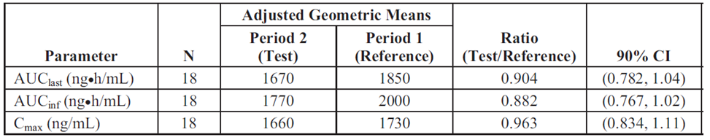
Comment: the GMR (and 95% confidence interval) for the three docetaxel PK parameters each fall within the accepted boundary for bioequivalence indicating no difference with concomitant administration of docetaxel and enzalutamide. The sponsor is proposing to include a statement in the PI pertaining to these findings.
In study 9785-CL-0321, patients with prostate cancer were administered 160mg enzalutamide for at least 25 weeks on study. Measured trough concentrations of enzalutamide were similar beyond 4 weeks of treatment, reflecting that steady-state was reached. Steady-state of the active metabolite M2 was reached by week 9.
Figure 1: Mean trough plasma enzalutamide & metabolite concentration, by study visit.
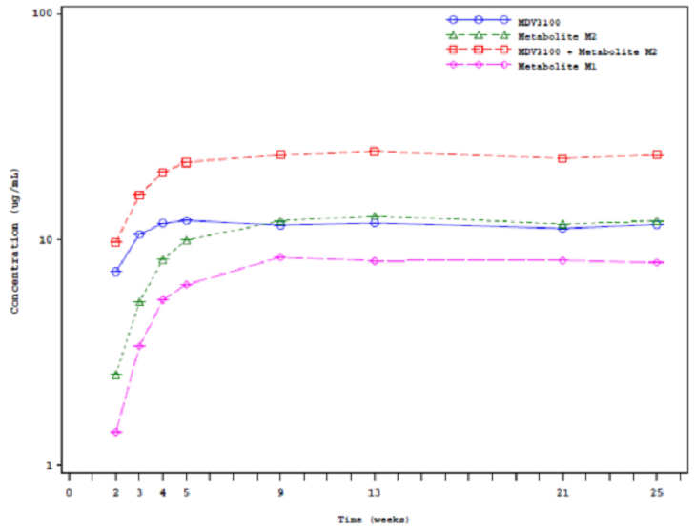

Pharmacokinetics in Japanese patients
Study 9875-CL-0111 studies the effect of 80mg, 160mg or 240mg daily enzalutamide in Japanese patients with CRPC previously treated with chemotherapy (including docetaxel).
The results of this study are shown in Table 3 comparing the data in the currently approved PI for non-Japanese subjects.
Table 3: Pharmacokinetic values in non-Japanese and Japanese subjects.
 | data obtained from PI | Japanese subjects, single dose administration
 |  | 80mg, n=3 | 160mg, n=3 | 240mg, n=3
Tmax, h | 1 to 2 | 2.100 | 2.000 | 1.083
Mean plasma terminal half-life, days | 5.8 (range 2.8 -10.2) | 4.719 | 8.436 | 6.299
AUC7d μg·h/mL | Not reported | 82.291 | 165.147 | 315.645
Cmax, μg/mL | 16.6 | 1.421 | 2.169 | 5.717
Cmax, μg/mL | 16.6 | 8.006* | 16.072*
Mean apparent clearance L/h | 0.520-0.564 | 0.5796 | 0.3777 | 4.293
Apparent volume of distribution, L | 110 (CV 29%) | 94.39 | 109.8675 | 88.7829
*Plasma pharmacokinetic parameter after multiple dosing on day 85 of study
Dose-proportionality was only demonstrated for enzalutamide for the parameters Cmax, AUC7d and AUCinf for the initial single-dose period of the study, as was previously observed in non-Japanese subjects for dosing up to 160mg. For the two-fold increase in dose between 80mg and 160mg, Cmax increased by
For the 1.5-fold increase in single dosing from 160mg to 240mg, the AUC has increased 1.9-fold, and Cmax increased 2.6-fold.
Following single dosing of enzalutamide, the metabolites MDPC0001 and MDPC0002 demonstrated dose proportionality for Cmax and AUC7d. In the multiple dose study period the mean trough concentration peaked between days 29 & 57, thereafter achieved steady-state.
Comment: Between the three doses tested, for the 240mg single-dose there is a non-linear increase in AUC and Cmax as compared to lower doses. There is a significant potential that patients will be at risk of adverse events related to increased exposure if they are receiving additional therapy which inhibits the metabolism of enzalutamide during initial dosing.

Evaluator’s overall conclusions on pharmacokinetics
The results of study MDV-3100-06 demonstrated that the pharmacokinetic profile of docetaxel was not significantly altered by the co-administration of enzalutamide. The sponsor has proposed to include the results of this study in the PI, reporting the observed change in AUClast and Cmax. Although a reduction in the AUClast of docetaxel of 12% was observed, the effect of this reduction on the efficacy of docetaxel has not been correlated with clinical outcomes. Safety during co-administration of docetaxel and enzalutamide is discussed in section 7.
The results of study 9875-CL-0111 in a very small number of Japanese patients demonstrates that there was no significant difference between the three patients who received the recommended dose of 160mg when compared with the data in the currently approved PI, as assessed in non-Japanese subjects.
The participants in PREVAIL were permitted to be concomitantly administered enzalutamide and abiraterone. Abiraterone is metabolised by CYP3A4 and enzalutamide induces this enzyme. No pharmacokinetic analysis has been presented to justify the use of this experimental combination of therapies.

Pharmacodynamics

Studies providing pharmacodynamic data
Table 4 shows the studies relating to each pharmacodynamic topic and the location of each study summary.
Table 4: Submitted pharmacodynamic studies.
Study ID | Study type | Phase, design | Study population | Assessment | Number of subjects
9785-CL-0321 | Efficacy, safety, tolerability, PD, PK | Phase II, open-label, single arm | Patients with hormone-naïve prostate cancer | 1-year analysis | 67
None of the pharmacodynamic studies had deficiencies that excluded their results from consideration.

Summary of pharmacodynamics
The information in the following summary is derived from conventional pharmacodynamic studies in humans unless otherwise stated.

Pharmacodynamic effects

Primary pharmacodynamic effects

Effect of enzalutamide on PSA concentration
In study 9785-CL-0321, the pharmacodynamic effect of enzalutamide on PSA concentration was assessed after 25 weeks, and 1 year, of exposure.
PSA response, defined as a reduction by ≥80% from baseline concentration, was evaluable in 63 of the 67 patients initially enrolled who completed at least 25 weeks of therapy. Four patients initially enrolled did not complete 25 weeks of treatment. A PSA response was observed in 62/63 patients (98.4%) after 25 weeks of therapy, the patient not reaching this threshold has a PSA reduction of 57% from baseline at week 25.
At the 1-year evaluation time point, 54 of the 67 patients (80.6%) had received enzalutamide. The reasons for the remainder having not completed 1 year of therapy is not presented in the dossier.
Of those patients completing 1 year of therapy, all had a PSA response.
The effect of enzalutamide on testosterone concentration in patients with hormone-naïve prostate cancer was assessed in 9785-CL-0321. Patients were eligible for trial entry if their baseline concentration of testosterone was ≥8 nmol/L (230 ng/gL). Among the 63 patients that had received at least 25 weeks enzalutamide, the median testosterone concentration was 30.1 nmol/L (range 12.1 to 68.1), representing a reduction from baseline of 114.3% (SD 73.7).
At one year of treatment, 51 of the 54 patients eligible were evaluated for change in testosterone concentration. The median testosterone concentration at 1 year was 26.5 nmol/L (range 9.2 to 64.8), representing a change from baseline of 101.7% (SD 76.1).
Effect of enzalutamide on bone mineral density (BMD)
In study 9785-CL-0321, the pharmacodynamic effect of enzalutamide on BMD was assessed after 25 weeks, and 1 year, of exposure.
At week 25, total body BMD was reduced by 0.24% (SD 1.66) from baseline, whereas at 1 year, BMD was reduced by 0.3% (SD 1.62) from baseline.
When assessed by anatomical location, the femoral neck, trochanter and L1-L4 spine all showed a reduction in BMD at 1 year of treatment of 0.42%, 0.96% and 0.59% respectively.
Comment: The percentage BMD changes observed in the study population have not been compared with the expected background age-adjusted reduction in BMD for the whole population, therefore neither any diagnostic nor prognostic assessments can be made from these findings.
The appropriate measure to report for BMD in these patients is the baseline t-score, and change over the treatment period.

Time course of pharmacodynamic effects
Time to PSA concentration reduction was assessed in 9785-CL-0321 according to either the degree of reduction in comparison to baseline or by the absolute concentration as the assessment time-point (Table 5).
Table 5: Time to PSA concentration decline – safety analysis set.
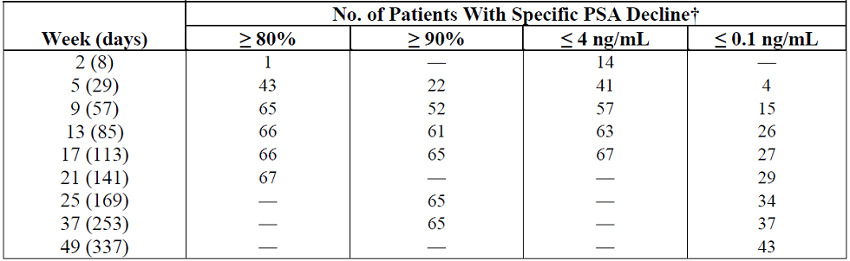
† Using the Kaplan-Meier method, the analysis was based on the actual day events and censoring occurred.
Comment: In comparison with the proportion of patients achieving a reduction of ≥80% from baseline at week 25 of 98.4%, the proportion achieving a reduction to ≤0.1 ng/mL was slower, and not achieved in 33/67 (49.3%) of enrolled patients. Furthermore, only 43/57 (75.4%) of patients continuing therapy until 1 year achieved a PSA concentration of ≤0.1 ng/mL.

Evaluator’s overall conclusions on pharmacodynamics
Change in PSA concentration was observed as a marker of enzalutamide exposure and efficacy. There was no data presented to enable clinicians to use change in PSA concentration over time as a prognostic or diagnostic measure.
The sponsor is proposing to include a statement in the PI regarding the proportion of patients that achieved a reduction in PSA of 50%. This exploratory outcome has not been correlated with disease progression, and should therefore be removed from the PI.

Clinical efficacy

Studies providing efficacy data
Table 6 shows efficacy studies.
Table 6: Submitted efficacy studies.
Study ID | Study type | Phase, design | Study population | Results | Number of subjects
MDV3100-03 PREVAIL | Efficacy & safety | Phase III, randomised, double-blind, placebo controlled, multicentre | Chemotherapy naïve patients with metastatic CRPC | Primary analysis | 871 enzalutamide, 844 placebo
MDV3100-06 | PK, safety, tolerability | Phase Ib, open-label | Patients with metastatic CRPC | Primary analysis | 22
9785-CL-0321 | Efficacy, safety, tolerability, PD, PK | Phase II, open-label, single arm | Patients with hormone-naïve prostate cancer | 1-year analysis | 67

Proposed indication

Pivotal efficacy studies

Study MDV3100-03 (PREVAIL)

Study design, objectives, locations and dates
This was a phase 3, randomised, double-blind, placebo-controlled multicentre trial performed in North America, Europe, Australia and Asia to assess the efficacy and safety of enzalutamide in patients with metastatic prostate cancer that progressed on androgen deprivation therapy. Patients must have been asymptomatic or mildly symptomatic due to prostate cancer at study entry and must not have previously received cytotoxic chemotherapy.

Inclusion and exclusion criteria
Table 7 shows inclusion and exclusion criteria.
Table 7: Inclusion and exclusion criteria.
Inclusion criteria | Exclusion criteria
1. Age 18 or older and willing and able to provide informed consent  2. Histologically or cytologically confirmed adenocarcinoma of the prostate without neuroendocrine differentiation or small cell features  3. Ongoing androgen deprivation therapy with a GnRH analogue or bilateral orchiectomy (ie, surgical or medical castration)  4. Patients who had not had a bilateral orchiectomy, must have had a plan to maintain effective GnRH analogue therapy for the duration of the trial  5. Serum testosterone level ≤1.73 nmol/L (50 ng/dL) at the screening visit  6. Patients receiving bisphosphonate therapy must have been on stable doses for at least 4 weeks  7. Progressive disease at study entry defined as one or more of the following 3 criteria that occurred while the patient was on androgen deprivation therapy as defined in inclusion criterion 3:  PSA progression defined by a minimum of 2 rising PSA levels with an interval of ≥ 1 week between each determination. Patients who received an antiandrogen must have had progression after withdrawal (≥ 4 weeks since last flutamide or > 6 weeks since last bicalutamide or nilutamide). The PSA value at the screening visit was to be ≥ 2 μg/L (2 ng/mL)  Soft tissue disease progression defined by RECIST 1.1  Bone disease progression defined by PCWG2 with 2 or more new lesions on bone scan  8. Metastatic disease documented by bone lesions on bone scan or by measurable soft tissue disease by CT/MRI. Patients whose disease spread was limited to regional pelvic lymph nodes were not eligible  9. No prior cytotoxic chemotherapy for prostate cancer  10. Asymptomatic or mildly symptomatic from prostate cancer (i.e. < 4 on BPI question 3)  11. ECOG performance status 0–1  12. Estimated life expectancy ≥ 6 months  13. Able to swallow the study drug and comply with study requirements | 1. Severe, concurrent disease, infection, or comorbidity that, in the judgment of the investigator, would make the patient inappropriate for enrolment  2. Known or suspected brain metastasis or active leptomeningeal disease  3. History of another malignancy within the previous 5 years other than curatively treated non-melanoma skin cancer  4. Absolute neutrophil count < 1500/μL, or platelet count < 100,000/μL, or haemoglobin < 5.6 mmol/L (9 g/dL) at the screening visit. (NOTE: patients may not have received any growth factors within 7 days or blood transfusions within 28 days of the hematologic  laboratory values obtained at the screening visit)  5. Total bilirubin, alanine aminotransferase (ALT) or aspartate aminotransferase (AST) > 2.5-times the upper limit of normal at the screening visit  6. Creatinine > 177 μmol/L (2 mg/dL) at the screening visit  7. Albumin < 30 g/L (3.0 g/dL) at the screening visit  8. History of seizure or any condition that may predispose to seizure. Also, history of loss  of consciousness or transient ischemic attack within 12 months of enrollment (day 1 visit)  9. Clinically significant cardiovascular disease including:  Myocardial infarction within 6 months  Uncontrolled angina within 3 months  Congestive heart failure New York Heart Association class III or IV, or patients with history of congestive heart failure New York Heart Association class III or IV in the past, unless a screening echocardiogram or multi-gated acquisition scan performed within 3 months results in a left ventricular ejection fraction that is ≥45%  History of clinically significant ventricular arrhythmias (e.g. ventricular tachycardia, ventricular fibrillation, torsades de pointes)  History of Mobitz II second degree or third degree heart block without a permanent pacemaker in place  Hypotension as indicated by systolic blood pressure < 86 millimetres of mercury (mm Hg) at the screening visit  Bradycardia as indicated by a heart rate of < 50 beats per minute on the screening ECG  Uncontrolled hypertension as indicated by systolic blood pressure > 170 mm Hg or diastolic blood pressure > 105 mm Hg at the screening visit  10. Gastrointestinal disorder affecting absorption (e.g. gastrectomy, active peptic ulcer disease within last 3 months)  11. Major surgery within 4 weeks of enrolment (day 1 visit)  12. Use of opiate analgesics for pain from prostate cancer within 4 weeks of enrolment (day 1 visit)  13. Radiation therapy for treatment of the primary tumour within 3 weeks of enrolment (day 1 visit)  14. Radiation or radionuclide therapy for treatment of metastasis  15. Treatment with flutamide within 4 weeks of enrolment (day 1 visit)  16. Treatment with bicalutamide or nilutamide within 6 weeks of enrollment (day 1 visit)  17. Treatment with 5-α reductase inhibitors (finasteride, dutasteride), estrogens, cyproterone within 4 weeks of enrolment (day 1 visit)  18. Treatment with systemic biologic therapy for prostate cancer (other than approved bone  targeted agents and GnRH analogue therapy) or other agents with antitumor activity within 4 weeks of enrolment (day 1 visit)  19. History of prostate cancer progression on ketoconazole  20. Prior use, or participation in a clinical trial, of an investigational agent that blocks  androgen synthesis (e.g. abiraterone, TAK-700, TAK-683, TAK-448) or blocks the androgen receptor (eg, BMS 641988)  21. Participation in a previous clinical trial of enzalutamide  22. Use of an investigational agent within 4 weeks of enrolment (day 1 visit)  23. Use of herbal products that may have hormonal anti-prostate cancer activity and/or are known to decrease PSA levels (eg, saw palmetto) or systemic corticosteroids greater than the equivalent of 10 mg of prednisone per day within 4 weeks of enrolment (day 1 visit)  24. Any condition or reason that, in the opinion of the investigator, interfered with the ability of the patient to participate in the trial, which placed the patient at undue risk, or complicates the interpretation of safety data

Study treatments
Subjects were randomised to receive either enzalutamide 160mg or placebo, administered as four capsules once daily by mouth, whilst also continuing testosterone suppression (GnRH agonist/antagonist or following orchidectomy).
The study drug was to continue until confirmed radiographic disease progression or a skeletal-related event and the initiation of cytotoxic chemotherapy, or an investigational agent, for treatment of prostate cancer.
However, abiraterone and other biological anti-tumour treatments were permitted to be concomitantly administered with study drug following confirmed radiographic progression, prior to cessation of study drug.
Comment: Patients who had previously received abiraterone were excluded from the trial.
The currently approved PI for abiraterone states that it is indicated ‘with prednisone or predinsolone for the treatment of patients with metastatic prostate cancer. The sponsor should confirm whether patients in PREVAIL that received concomitant study drug and abiraterone also received appropriate steroid.
By nesting the patients receiving concomitant use of additional therapies and study drug, this trial actually has multiple potential arms of treatment before the study drug would be ceased.
The potential for differential concomitant use of study treatment plus additional therapy between treatment arms is thus a source of bias. The efficacy outcomes should be reported for those that received concomitant study treatment plus additional therapies separate from those who only received study drug as monotherapy.
Safety data representing the absolute difference between enzalutamide and placebo can only be ascertained for the period during which patients only received study drug as monotherapy.
The sponsor states that “PSA rise without evidence of confirmed radiographic progression or a skeletal-related event was strongly discouraged as a criterion to start a new systemic antineoplastic therapy during the first 12 weeks of therapy and was discouraged as a criterion to start a new systemic antineoplastic therapy throughout the study per Prostate Cancer Clinical Trials Working Group 2 (PCWG2) guidelines. After randomization, radiation therapy and initiation of bisphosphonates or other approved bone targeting agents were allowed.”
Dose modifications, defined as either temporary interruption or dose reduction, were allowed if a patient experienced an adverse event that was intolerable or could not be ameliorated by other means, or if necessary for other logistical reasons. The study drug could be taken with or without food

Efficacy variables and outcomes
The co-primary efficacy variables were to determine:
- the benefit of enzalutamide as compared to placebo as assessed by overall survival
- the benefit of enzalutamide as compared to placebo as assessed by radiographic progression-free survival (rPFS)
The secondary efficacy outcomes were to determine:
- the benefit of enzalutamide as compared to placebo as assessed by time to first skeletal-related event
- the benefit of enzalutamide as compared to placebo as assessed by time to initiation of cytotoxic chemotherapy
- the benefit of enzalutamide as compared to placebo as assessed by time to PSA progression
- the benefit of enzalutamide as compared to placebo as assessed by PSA response ≥ 50%
- the benefit of enzalutamide as compared to placebo as assessed by best overall soft tissue response
- the safety of treatment with enzalutamide as compared to placebo
The exploratory outcomes were:
- To evaluate quality of life using the Functional Assessment of Cancer
- Therapy-Prostate (FACT-P) and the European Quality of Life 5-Domain Scale (EQ-5D) instruments
- To evaluate emergence of pain relative to baseline at 6 months using the Brief Pain Inventory (BPI) Short Form for enzalutamide as compared to placebo
- To determine the benefit of enzalutamide as compared to placebo as assessed by time to first subsequent antineoplastic therapy (cytotoxic or hormonal)
- To determine the benefit of enzalutamide as compared to placebo as assessed by PSA response ≥90%
- To characterize enzalutamide exposure (e.g. minimum plasma concentration [Cmin])
- To collect PK data to be combined with data from other studies in a population PK model

Randomisation and blinding methods
Following successful screening, subjects were assigned 1:1 to enzalutamide or placebo using a centrally administered, randomized, permuted-block method and stratified by study site. An IVRS/IWRS assigned the patient a study drug bottle number according to the randomization code on day 1.
All patients, investigators, site personnel, and sponsor personnel involved in the conduct of the study were blinded to treatment assignment. Some patients who had disease progression and previously discontinued study drug were unblinded in order to determine eligibility for a subsequent clinical study when this study was determined by the investigator to be the best (or only) available treatment option.

Analysis populations
The intention to treat (ITT) population was used to assess the co-primary end point of OS and the secondary endpoints of time to first skeletal-related event (SRE), time to initiation of cytotoxic chemotherapy, and time to PSA progression; and exploratory endpoints of time to first post-baseline antineoplastic therapy and time to degradation of FACT-P.
The secondary end-point of proportion with a PSA response (of either ≥50% or ≥90% change) was assessed from those patients in the ITT population who had evaluable data at baseline and post-baseline.
The analysis of the co-primary end-point of rPFS excluded 84 patients due to them not having been randomised before the cut-off date of 6 May 2012.
Comment: The effect of this missing data on the integrity of the co-primary outcome has not been discussed in the dossier. However, the proportion of missing data was similar in each treatment arm and would not, therefore, be expected to bias the result in favour of one arm.
The secondary endpoint of best overall soft tissue response was analysed using all patients with evaluable measurements at baseline.
The exploratory endpoint of pain emergence as measured by the BPI was analysed using the ITT population with non-missing data for questions 3 to 6 at baseline (or screening) and at week 25. The EQ-5D data were summarized descriptively by visit and treatment group.

Sample size
The sample size was calculated in order for the ITT population to demonstrate the significance of the two co-primary end-points. The overall type I error was 0.05 split as 0.049 for OS and 0.001 for rPFS.
Interim analyses were to be assessed after the following events (Table 8).
Table 8: Summary of planned interim analyses for the two co-primary end-points.
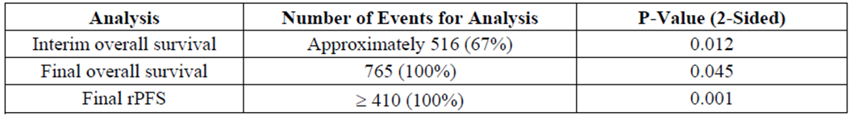

Major protocol violations/deviations
Of the 201 patients with a protocol deviation (table 7), 186 were for deviations from the eligibility criteria. The sponsor states that the majority of the eligibility criteria deviations “did not affect patient safety or data integrity”.
Comment: Overall, the major protocol deviations, and those of the inclusion/exclusion criteria were balanced across the treatment arms and would not, therefore, be expected to be a source of bias.
The deviations from the inclusion/exclusion criteria are shown (Table 9).
Table 9: Major protocol deviations – intention to treat population.
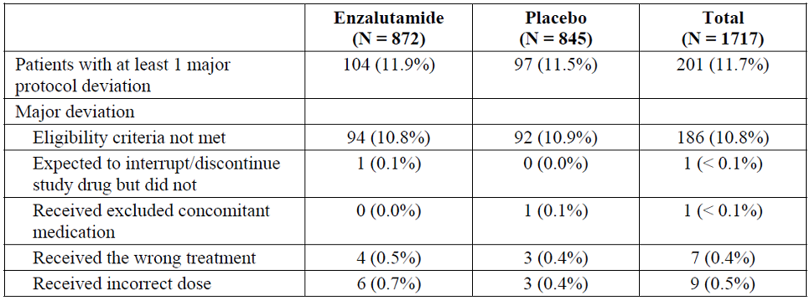

Baseline data
The demographic and baseline disease characteristics were similar in each treatment arm, and are consistent with the general population of males with metastatic prostate cancer.
Comment: The reported mean age of prostate cancer diagnosis in PREVAIL of 71 years was higher than that reported for the Australian population mean of 67.4 years.
The baseline prostate cancer characteristics were similar between the treatment arms.
Consistent with the age of the study population, concomitant medical conditions were common, and were generally balanced between the treatment arms.
Comment: The randomisation method employed in PREVAIL yielded balance between the treatment arms for baseline disease characteristics and demographic variables.
The efficacy analysis populations are shown in Table 10.
Table 10: Efficacy analysis populations.
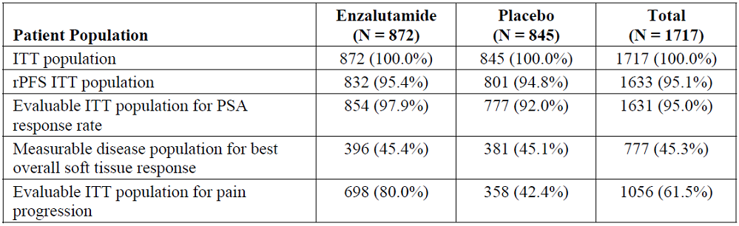
Comment: The proportion of missing data for the assessment of rPFS and PSA response is acceptably small.
The denominator of patients for the evaluation of best overall soft tissue response is those with soft tissue disease at baseline, not the whole ITT population, thus, the study is not powered to evaluate the difference in this outcome. The proposed PI statement regarding soft tissue response appropriately does not include a p-value.
The exploratory assessment of pain progression has a substantial, and differential, amount of missing data between the treatment arms, which is a source of bias and precludes the generalisability of this outcome.
The sponsor is not proposing to include a statement in the PI regarding pain progression alone, but is including a statement regarding the FACT-P assessment, of which pain assessment is a component.

Results for the co-primary efficacy outcomes
The sponsor states that the co-primary outcomes of overall survival and radiographic progression-free survival were both met.
There were 241 deaths in the enzalutamide arm (27.6%) as compared to 299 in the placebo arm (35.4%) after a median duration of follow-up time of 22.2 months and 22.4 months respectively. The median duration of overall survival was 32.4 months (IQR 22.0, not reached) in the enzalutamide arm as compared to 30.2 months (IQR 17.2, not reached).
The un-stratified Cox regression hazard ratio for death, with treatment as the only covariate, was 0.706 (95% CI 0.596, 0.837), p<0.0001, in favour of enzalutamide treatment.

Post-baseline antineoplastic therapy
Additional antineoplastic therapy was permitted following cessation of study drug, with the exception of abiraterone which was permitted to be concomitantly administered following confirmed rPFS or a skeletal-related event.
The distribution of post-baseline therapies is shown in Table 11.
Table 11: Post baseline antineoplastic therapy use.
 | Enzalutamide | Placebo
Patients taking antineoplastic therapy | 382/872 (43.8%) | 642/845 (76.0%)
Docetaxel | 286/382 (74.9%) | 479/642 (74.6%)
Abiraterone | 179/382 (46.8%) | 385/642 (60.0%)
Caazitaxel | 51/382 (13.3%) | 110/642 (17.1%)
Sipuleucel-T | 12/382 (3.1%) | 10/642 (1.6%)
Enzalutamide | 9/382 (2.3%) | 37/642 (5.8%)
Comment: From the data presented, the sponsor has not satisfactorily demonstrated an improvement in overall survival solely due to enzalutamide during monotherapy study drug administration.
The addition of treatment prior to cessation of study drug and post-progression cross-over precludes the study from demonstrating the absolute difference in OS between enzalutamide and placebo.
The sponsor has not separately reported the multiple experimental regimens are being tested in this study, particularly the enzalutamide ± abiraterone versus placebo ± abiraterone, from study drug as monotherapy.
The sponsor states that abiraterone was registered during the course of the pivotal study, making it unethical to withhold this therapy from patients who had confirmed radiographic progression. The evaluator agrees with this concept, but not with the ability for patients to receive an experimental combination enzalutamide & abiraterone within an experimental trial. The sponsor has not presented a pharmacokinetic analysis to support this experimental combination regimen.
It is not specifically descried in the dossier if OS was assessed for the placebo-controlled period only, or if the open label uncontrolled period following initiation of additional therapy was included. However, the ‘documentation of statistical methods’ states that: “OS will be evaluated for the ITT population. OS is defined as the time from randomisation to death from any cause”. Given that 308 (35.3%) of patients in the enzalutamide arm and 515 (60.9%) of the patients in the placebo arm initiated cytotoxic chemotherapy while on-study, the assessment of OS is substantially contaminated by the large proportion of patients receiving these other therapies.
The small difference in estimated median duration of OS needs to be considered in the context of substantially different duration of treatment exposure between treatment arms and the median duration of follow-up, which is shorter than the OS estimates.
The median duration of study treatment was 16.6 months for enzalutamide and 4.6 months for placebo, yet after approximately 30 months OS only a difference in median duration of 2.2 months was observed.
Abiraterone was permitted to be co-administered with study drug after confirmed rPFS or a skeletal-related event. Co-administration with abiraterone is a potential source of bias & the proportion of each study arm that received concomitant abiraterone and enzalutamide/placebo is not reported.
Given the issue of contamination of both treatment arms, the OS data presented above is not suitable for inclusion in the PI. Should the sponsor wish to include OS outcomes in the PI, the OS data up to the point of initiation of any subsequent therapy (including abiraterone), for each treatment arm should be presented for evaluation.
In a post-hoc sub-group analysis of overall survival, there appears to be a consistent benefit from enzalutamide, but this analysis also includes data from the un-randomised and concomitant-use periods.
Comment: Separate Forest plots should be presented for (i) those receiving only study drug and (ii) those that received concomitant study drug plus any additional therapy.

Radiographic progression-free survival
The co-primary end point of radiographic progression-free survival was assessed at the primary analysis point after 439 events (centrally determined), which exceeded the number specified in the statistical analysis plan of 410 events. Eighty-four patients were not included in the analysis, due to having been randomised after the data cut-off data.
Independently-assessed events of rPFS occurred less frequently in the enzalutamide arm as compared to placebo: 118 (14.2) versus 321 (40.1%) respectively. The Kaplan-Meier estimate of median duration of rPFS was not met in the enzalutamide arm (IQR 9.5, not reached), as compared to 3.9 months (IQR 1.9, 8.3).
The estimated hazard ratio of rPFS, with treatment as the only covariate, was 0.186 (95% CI 0.149, 0.231), p<0.0001, in favour of enzalutamide.
In a sub-group analysis of rPFS, there was a consistent benefit from enzalutamide.

Results for other efficacy outcomes

Time to first skeletal-related event
The composite outcome of “skeletal related event status” was comprised of new events requiring either: radiation to bone, bone surgery, pathological fracture, spinal cord compression or initiation/change in antineoplastic therapy to treat bone pain from prostate cancer.
For all ‘skeletal related events’, there was a smaller proportion in the enzalutamide arm as compared to placebo – 278 (31.9%) versus 309 (36.6%), hazard ratio 0.72 (95% CI 0.61, 0.84), p<0.0001. Among the individual components of this composite outcome, the need for radiation to bone and initiation/change in antineoplastic therapy for bone pain were significantly reduced in the enzalutamide arm, the risk ratio was not different for the others.
The median time to first skeletal-related event was not different between the two arms – 31.1 months for enzalutamide versus 31.3 months for placebo.
The incidence of skeletal-related events in each treatment arm is shown in Table 12.
Table 12: Incidence of skeletal-related event (ITT population).
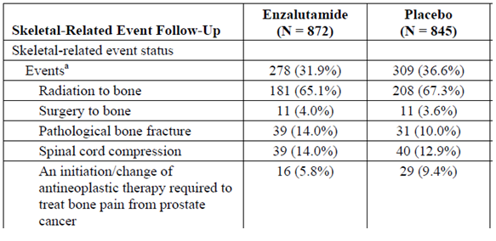
Comment: For the composite outcome ‘skeletal-related events’ there was a difference in incidence between the treatment arms of 4.7%. However the study was not powered to assess the relative effect of enzalutamide/placebo on this outcome. The PI should include the absolute difference in incidence between treatment arms, as the hazard ratio does not sufficiently represent this difference.
It is unclear from the dossier whether the time to first skeletal event is only reported for the placebo-controlled treatment period. Given that the median time to commence chemotherapy in the placebo arm is 10.9 months (below) and the median time to first skeletal event is 31.3 months, it appears that this outcome is contaminated by the effects of additional therapies.
It is not clear from the data presented what proportion of the patients requiring a change/initiation in antineoplastic therapy for bone pain was due to a change in therapy or was due to initiation of therapy.
Despite a shorter median duration of placebo therapy, the median time to first skeletal event was not clinically meaningful between the enzalutamide and placebo arms, with a difference in median time to first event of 0.2 months

Time to initiation of cytotoxic therapy
As of the data cut off, a greater proportion of patients in the placebo arm required subsequent cytotoxic chemotherapy – 515/845 (60.9%) placebo versus 308/872 (35.3%) enzalutamide.
Furthermore, the time to commencement of additional cytotoxic chemotherapy was longer in the enzalutamide arm (median 28.0 months (IQR 15.3, not reached)) as compared to placebo (10.8 months (IQR 4.9, 28.8)). Based on a median follow-up time of 19.6 months for the enzalutamide arm and 19.4 months for the placebo arm, the Cox regression hazard ratio, based on a single covariate of treatment arm, was 0.35 (95% CI 0.30, 0.40) in favour of enzalutamide.
Comment: Although exposure to enzalutamide was associated with a longer median pre-chemotherapy duration (28.0 months versus 10.8 months for placebo) this magnitude of difference was not observed in the median duration of OS – 32.4 months for enzalutamide versus 30.2 months for placebo.

Time to PSA progression
As of the data cut off, in the enzalutamide arm 532/872 (61.0%) patients experienced PSA progression as compared to 548/845 (64.9%) in the placebo arm. The median time to PSA progression was longer in the enzalutamide arm (11.2 months (95% CI 11.1, 13.7) as compared to placebo (2.8 months (95% CI 2.8, 2.9).
Comment: The data on PSA progression reported above uses the incorrect denominator – the whole ITT population has been used, not the ITT population for ‘PSA response rate’. Only patients with at least one post-baseline assessment can be truly identified as having PSA progression since a change in PSA concentration is being assessed. Subjects with missing post-baseline PSA assessments represent 18/872 (2.1%) of the enzalutamide arm and 67/845 (7.9%) of the placebo arm.
Given the discrepant proportion of missing data between study arms, the Sponsor should re-calculate the data for time to PSA progression, seen in table 11-20 of the CSR using the ITT population for ‘PSA response rate’, as per the PSA response >50% below.

PSA response ≥50%
Among the 854 patients in the enzalutamide arm and 777 patients in the placebo arm with baseline and post-baseline PSA assessments, 666 (78.0%) and 27 (3.5%) had reductions of PSA by ≥50% from baseline respectively. The difference in proportion achieving a response was 74.5% (95% CI 71.5, 77.6%).
Comment: As per the PCWG2 recommendations, “PCWG2 advises against reporting PSA response rates because these are of little value given the uncertain significance of a defined degree of decline from baseline, be it 50% or 30%, and no criterion has been shown prospectively to be a surrogate of clinical benefit”.
The sponsor has not provided any information in the dossier to contradict the above recommendation. The reference to this outcome in the PI should be removed.

Best overall soft tissue response
As shown above, best soft tissue response was only assessed in the patients with measurable disease at baseline, of each treatment arm - 396/872 (45.4%) enzalutamide and 381/845 (45.0%) placebo.
Best soft tissue response, was defined as the presence of at least one target lesion according to RECIST and was only evaluated by the investigator. Post-baseline assessments were available for 382 (96.5%) evaluable subjects in the enzalutamide arm and 353 (92.7%) for the placebo arm.
The outcomes for each treatment arm are shown in Table 13.
Table 13: Best overall soft tissue response in the population with measurable disease.
 | Enzalutamide N=396 | Placebo N=381
Patients with evaluable post-baseline assessment | 382 (96.5%) | 353 (92.7%)
Complete response (CR) | 78/382 (20.4%) | 4/353 (1.1%)
Partial response (PR) | 155/382 (40.5%) | 15/353 (4.2%)
CR or PR | 233/382 (61.0)%) | 19/353 (5.4%)

Additional anti-neoplastic therapy
Post-baseline use of anti-neoplastic therapy was assessed, demonstrating that use was less common in the enzalutamide arm than with placebo (43.8% versus 76.0% respectively).
The sponsor reports that additional therapies were initiated later following enzalutamide than with placebo – median 22.8 months versus 7.4 months with placebo.

Time to degradation of functional assessment of cancer therapy-prostate (FACT-P) score
The time to degradation of the FACT-P total score was defined as time from randomization to first assessment with at least a 10-point decrease from baseline in the total FACT-P score for each patient. FACT-P was only collected during the treatment period, equating to a median follow-up time of 16.6 months in the enzalutamide arm and 5.6 months in the placebo arm.
A total of 456 patients (52.3%) in the enzalutamide group and 409 patients (48.4%) in the placebo group had at least a 10-point decrease from baseline in FACT-P total score as of the data cut-off date of 16 Sep 2013. Treatment with enzalutamide was associated with a statistically significant decrease in the risk of FACT-P degradation (hazard ratio 0.625 [95% CI: 0.542, 0.720], p < 0.0001). The median time to degradation of FACT-P was 11.3 months in the enzalutamide group versus 5.6 months in the placebo group.
The degradation of the individual components of the FACT-P score (physical well-being, social/family well-being, emotional well-being, functional well-being and prostate cancer) demonstrated a consistent difference, of similar magnitude to the overall result, in favour of enzalutamide.
Comment: The sponsor should confirm that only the quality of life outcomes for the placebo-controlled period of the study have been reported.
Compliance with quality of life assessments was consistently high in the first two years of study, with less than 10% of eligible patients not completing the assessment at each assessment time-point. This level of compliance is in contrast to the evaluable population for the outcome of ‘pain progression’ where 80% of the enzalutamide arm and 42.4% of the placebo arm comprised the ITT population.

Study 9785-CL-0321

Study design, objectives, locations and dates
This phase 2 open-label, single-arm, multinational study in patients with prostate cancer with non-castrate level of testosterone at study entry was designed to assess:
The primary objective was to assess the effect of enzalutamide on PSA concentration. This outcome was dichotomised as a ≥80% reduction from baseline at week 25 on study.
Comment: This trial enrolled patients who had non-castrate testosterone concentration as compared to PREVAIL in which patients had castrate concentration of testosterone and are not directly comparable.
The secondary objectives of:
- the safety and tolerability of enzalutamide in patients who have not previously received hormone treatment for prostate cancer
- reporting the proportion having, and time to, PSA progression (≥25% increase and an absolute increase of ≥2 ng/mL from the nadir)
- the pharmacodynamic effects of enzalutamide on circulating testosterone, DHT, sex hormone-binding globulin (SHBG), androstenedione, dehydroepiandrosterone (DHEA), luteinizing hormone (LH), follicle-stimulating hormone (FSH), estradiol and prolactin.
- the pharmacokinetics of enzalutamide and its active metabolite M2.
The exploratory objectives were:
- The potential metabolic effects of enzalutamide, including changes in lipids and insulin sensitivity.
- The changes in bone mineral density (BMD), lean and fat body mass as assessed by DXA scan and biomarkers of bone turnover N-telopeptide (NTx) and bone alkaline phosphatase (bALP).
- aspects of QoL using the European Organization for Research and Treatment of Cancer (EORTC) quality of life questionnaires (QLQs) QLQ-C30 and QLQ-PR25.
- objective tumour response in patients with metastatic disease.

Inclusion and exclusion criteria
The inclusion and exclusion criteria are shown in Table 14.
Table 14: Inclusion and exclusion criteria.
Inclusion criteria | Exclusion criteria
An IEC-approved written informed consent and privacy language as per national regulations had to be obtained from the patient or legally authorized representative prior to any study-related procedures.  Male aged 18 years or older.  Histologically confirmed prostate cancer (all stages) for whom androgen deprivation therapy was indicated (except when indicated in a neoadjuvant/adjuvant setting).  Asymptomatic from prostate cancer.  Noncastrate level of testosterone (≥ 8 nmol/L [230 ng/dL]) at screening.  PSA ≥ 2 ng/mL at screening.  ECOG score of 0.  A life expectancy of at least 12 months.  Was able to swallow the study drug and comply with the study requirements. | Has had previous or was currently receiving hormonal therapy with intent to treat prostate cancer (surgical castration or other hormonal manipulation, e.g., GnRH agonists, GnRH antagonists, anti-androgens, estrogens or 5-α reductase inhibitors).  Had received systemic glucocorticoids within 6 months prior to enrollment or was expected to require systemic glucocorticoids during the study period.  Prior chemotherapy with the intent to treat prostate cancer.  Known or suspected brain or skull metastasis or leptomeningeal disease.  Use of opiate analgesics for pain from prostate cancer.  Had a known or suspected hypersensitivity to enzalutamide or any components of the formulation used.  Had concurrent disease or any clinically significant abnormality following the investigator’s review of the prestudy physical examination, ECG and clinical laboratory tests, which in the judgment of the investigator would have interfered with the patient's participation in this study or evaluation of study results.  History of hypogonadism.  History of another malignancy within the previous 5 years other than curatively treated nonmelanoma skin cancer.  10. Radiation therapy for treatment of the primary tumor within 3 months prior to enrollment.  Radiation therapy for the treatment of metastases.  Major surgery within 2 months prior to enrollment.  History of seizure, including febrile seizure or any condition that may predispose to seizure (e.g., prior stroke, brain arteriovenous malformation, head trauma with loss of consciousness requiring hospitalization). Also, current or prior treatment with antiepileptic medications for the treatment of seizures or history of loss of consciousness or transient ischemic attack within 12 months prior to treatment (day 1 visit).  Use of herbal products that may have had hormonal antiprostate cancer activity or were known to decrease PSA levels (e.g., saw palmetto) within 4 weeks of enrollment.  Gastrointestinal disorder affecting absorption (e.g., gastrectomy, active peptic ulcer disease).  Clinically significant cardiovascular disease including:  Myocardial infarction within 6 months prior to screening  Uncontrolled angina within 3 months prior to screening  Congestive heart failure, New York Heart Association (NYHA) class 3 or 4 or patients with a history of congestive heart failure, NYHA class 3 or 4 in the past, unless a screening echocardiogram or multi-gated acquisition scan (MUGA) performed within 3 months resulted in a left ventricular ejection fraction that was ≥ 45%  History of clinically significant ventricular arrhythmias (e.g., ventricular tachycardia, ventricular fibrillation or torsades de pointes)  History of Mobitz II second degree or third degree heart block without a permanent pacemaker in place  Uncontrolled hypertension as indicated by a resting systolic blood pressure > 170 mmHg or diastolic blood pressure >105 mmHg at the screening visit.  Absolute neutrophil count < 1,500/μL, platelet count < 100,000/μL and haemoglobin < 5.6 mmol/L (9 g/dL) at screening (NOTE: patients must not have received any growth factors or blood transfusions within 7 days of the hematologic laboratory values obtained at screening).  Total bilirubin > 1.5 times the upper limit of normal (ULN) at screening. This did not apply to patients with Gilbert’s syndrome (persistent or recurrent hyperbilirubinemia that was predominantly unconjugated in the absence of evidence of hemolysis or hepatic pathology), who were allowed after consultation with the sponsor.  Alanine aminotransferase (ALT) or aspartate aminotransferase (AST) > 2.5 times ULN at screening.  Creatinine > 177 μmol/L (2 mg/dL) at screening.  Albumin ≤ 30 g/L (3.0 g/dL) at screening.  Use of an investigational agent within 4 weeks prior to treatment allocation or local regulation required period, whichever was longer.

Study treatments
Patients were treated with 160mg enzalutamide daily for 24 weeks. At the end of this period, patients experiencing a clinical benefit were permitted to continue treatment until disease progression or unacceptable toxicity at the discretion of the investigator. Patients experiencing an adverse event of grade 3 or more that was unmanageable by medical intervention had their treatment interrupted until resolution of the event to grade 2 or lower.

Randomisation and blinding methods
This was an un-randomised, un-blinded study.

Analysis populations
The safety analysis set comprised all patients who received at least one dose of enzalutamide.
The pharmacokinetic analysis set comprised those patients in the safety analysis population who had at least one pharmacokinetic concentration value.

Sample size
The sample size calculation was based on the “PSA response rate” (sic). With a sample size of 47 patients, the study had 80% power to reject the unwanted PSA response rate (sic) of ≤ 50% at a 5% significance level, if the expected PSA response rate (sic) for enzalutamide was approximately 70%. Allowing a 20% drop out rate, a total of 60 patients was planned.
Comment: “PSA response rate” here refers to the proportion of patients with the response, not the number of patients with the response per unit of time.

Statistical methods
Analyses were planned at week 25, 1 year, 2 years and a final update.

Participant flow
Of the 67 patients enrolled in the study, all received at least one dose of enzalutamide and were included in the safety analysis and pharmacokinetic analysis populations. A total of 49 were continuing treatment, 15 were excluded, and 18 discontinued treatment.

Major protocol violations/deviations
There were 42 (62.7%) patients who had 1 or more protocol deviations. Three patients entered the study even though they satisfied an exclusion criterion: Patients [information redacted] (patient had a history of another malignancy within the previous 5 years [colon carcinoma in 2007]), [information redacted] (patient had radiation therapy for treatment of the primary tumour within 3 months prior to enrolment) and [information redacted] (patient had radiation therapy for the treatment of metastases). Seven (10.4%) patients received an excluded concomitant medication: 6 patients received a potent CYP inhibitor or inducer as concomitant medication, which was initially prohibited, but the protocol was amended to not prohibit their use but to advise they be used with caution and 1 patient received dutasteride as concomitant medication.
Patient [information redacted] started another hormone antagonist after treatment ended and progression was confirmed. Other protocol deviations were:
- Low study drug compliance
- Incorrect dosage
- Visits outside the protocol-specified window
- Time points excluded from pharmacokinetic analyses
- CT/MRI or bone scan not done at week 25 or week 49 despite presence of metastasis at
- screening
- Chest x-ray not done at screening
- PET/CT scan done at screening, instead of bone scan

Baseline data
The summary baseline demographic data are shown in Table 15. Baseline disease characteristics are shown in Table 16.
Table 15: Baseline demographic data, safety analysis set.
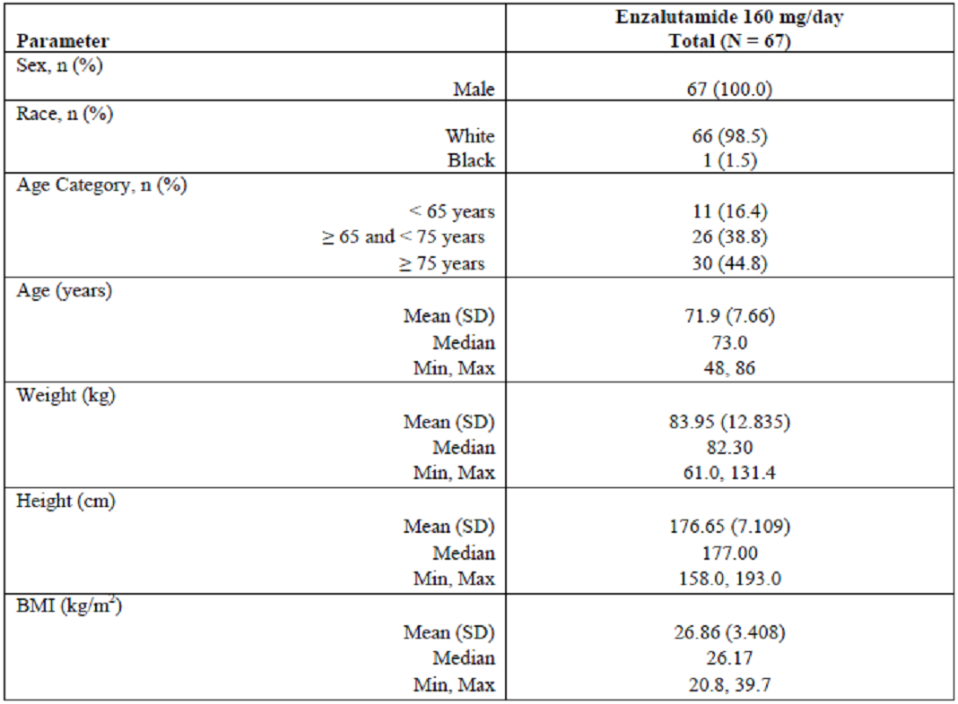
Table 16: Baseline disease characteristics, safety analysis set.
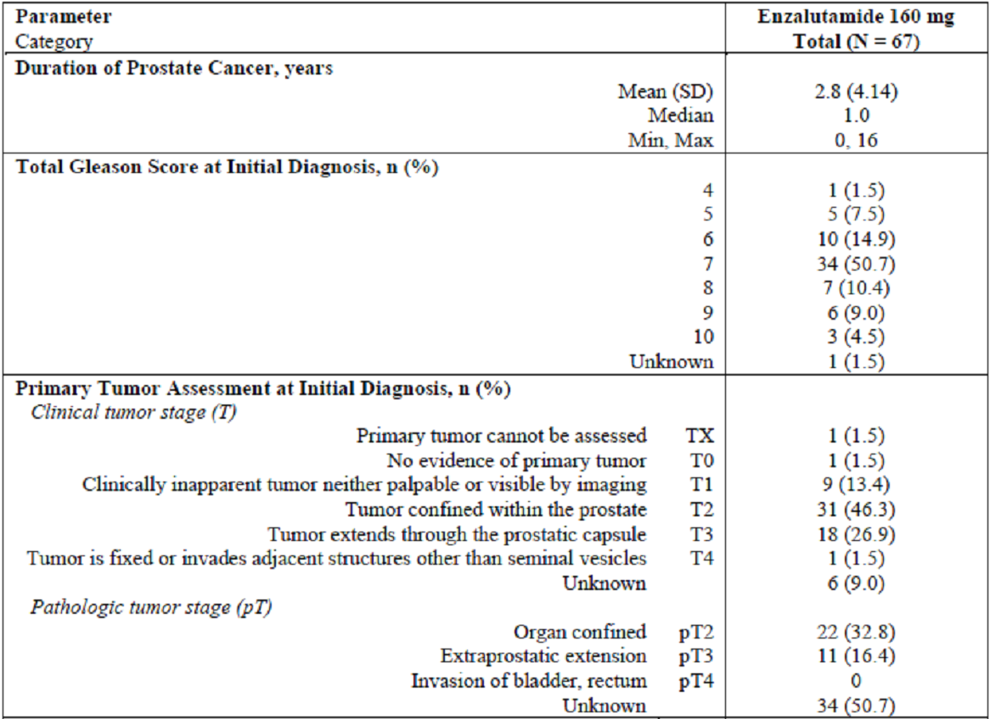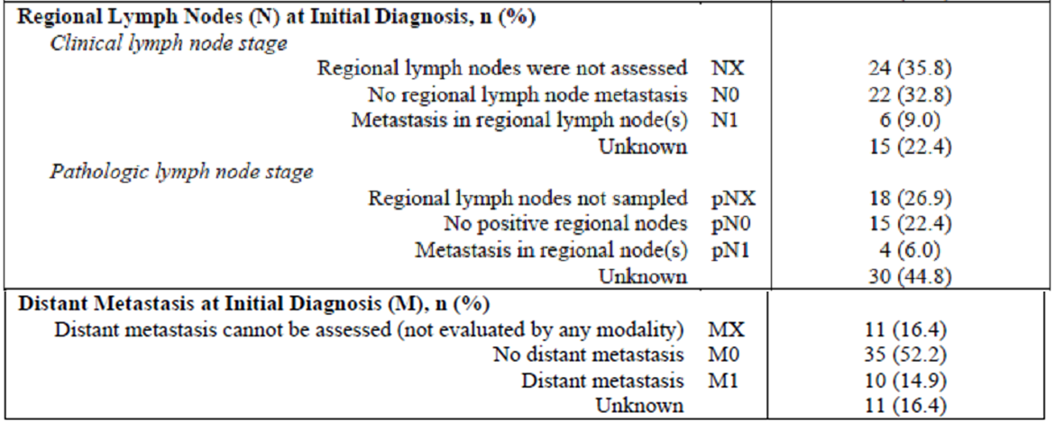
Comment: The baseline disease characteristics above show that in 1 case the primary tumour could not be assessed, 24 patients (35.8%) did not have regional lymph node assessment and 11 patients (16.4%) could not have assessment of metastases.
The inadequate assessment of baseline disease status precludes this study from satisfactorily informing the evaluator of the efficacy of enzalutamide.

Results for the primary efficacy outcome
The primary outcome of reduction in PSA by ≥80% baseline values was achieved in 62/67 (92.5%) patients.
Of the patients not fulfilling the outcome criteria, four had not completed 25 weeks of treatment and one had had an earlier nadir of PSA reduction of 98.4% at week 9, with subsequent deterioration to a level of 57% from baseline at week 25.
At the 1 year (week 49) assessment point, 54 patients had completed treatment and all had a PSA reduction of ≥80% from baseline value. The remaining patients were non-responders, but had not completed 49 weeks of treatment.
The proportion of patients who had a decline in PSA of ≥80% was similar for patients with baseline metastases (24/26 (92.3%)) and those without (38/41 (92.7%)).
The median time to achieve a PSA reduction of ≥80% was similar between patients with baseline metastases and those without – 29 days.

Results for other efficacy outcomes
The description of changes in hormone status is shown in Table 17.
Table 17: Changes in measurements of endocrine function.
 | Percentage increase from baseline
 | Week 25 | Week 49
SHBG | 100.6% | 88.5%
Androstenedione | 51.1% | 49.9%
DHEA | 9.6% | 10.5%
DHT | 51.7% | 74.4%
Estradiol | 71.7% | 81.0%
FSH | 47.0% | 62.2%
LH | 184.7% | 215.2%
Prolactin | 16.8% | 9.6%
Testosterone | 114.3% | 101.7%
Free testosterone | 46.4% | 43.7%

Changes in PSA
One patient fulfilled the criterion of a 25% increase in PSA following the nadir by week 25.
The median time to achieve a ≥90% decrease in PSA from baseline was 56 days for patients without baseline metastases as compared to 29 days for those with baseline metastases. At week 49, 53 patients (98.1%) had achieved a ≥90% decrease in PSA from baseline.

Exploratory variables
Given the un-randomised nature of this study, the exploratory variables reported will not be discussed further in this evaluation, since causality cannot be established.

Other efficacy studies

9785-CL-0111
The efficacy of enzalutamide was assessed in Japanese patients in the expansion cohort of this study, following the initial single-dose PK evaluation. Patients were administered enzalutamide 160mg per day.
At the day 85 assessment point, the best overall tumour response was evaluated (Table 18).
Table 18: Best overall response at day 85, full analysis set.
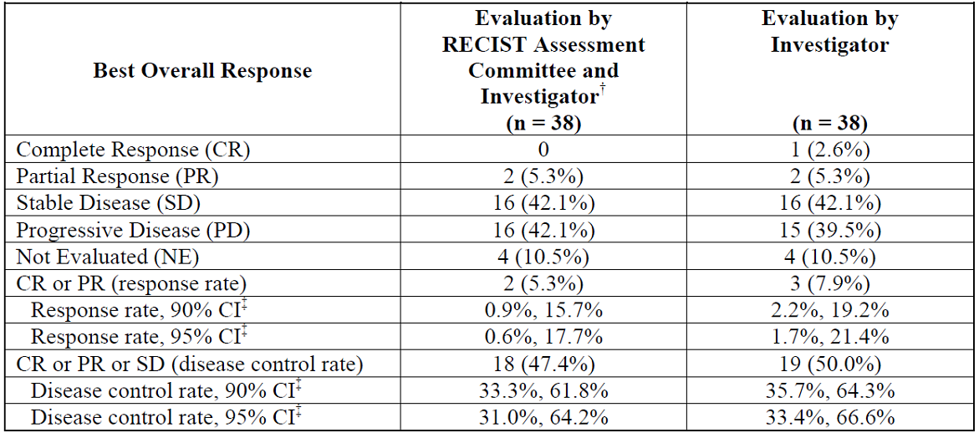
Number (%) of patients
Tumour response (overall response) for each patient was assessed by the investigator, subsequently evaluated by an independent RECIST assessment committee when the investigator assessed that a patient had been accomplished CR or PR.
† When there were evaluation data from both the RECIST committee and investigator, RECIST assessment committee data were adopted.
‡ Based on exact binomial confidence interval (Clopper-Pearson)
Overall survival was assessed in this study. Nine of the 38 patients (23.7%) among the expansion cohort died. The median time to death was 319 days (95% CI 207, not estimated). Radiographic disease progression occurred at a median of 163 days (95% CI 85, 339).
Comment: In this small sample of Japanese patients with post-chemotherapy CRPC , the time to death (median of approximately 11 months) was shorter than that seen in the AFFIRM study (median 18.4 months (95% CI 17.3, not reached)). Similarly, the median time to rPFS was shorted for the Japanese patients – median approximately 5.8 months as compared to those in AFFIRM of 8.3 months.
The sponsor is asked to comment on the substantial differences in outcome for Japanese patients in the clinical questions.

Evaluator’s conclusions on efficacy
Given the approved indication of abiraterone, the best contemporary practice of the treatment of patients fulfilling the proposed indication is no longer placebo. A direct comparison of monotherapy enzalutamide and monotherapy abiraterone is the critical comparison to sufficiently inform prescribers and patients.
The general scheme of PREVAIL is represented in Figure 2 below. Following either first confirmed radiographic progression or a skeletal related event (whichever came first) and commencement of cytotoxic chemotherapy was the trigger to cease enzalutamide/placebo. However, patients in either treatment arm were permitted to be co-administered other active agents prior to the administration of cytotoxic chemotherapy, including abiraterone. Thus, the reported time to commence cytotoxic chemotherapy is not solely representative of the difference between enzalutamide and placebo.
Figure 2: General scheme of PREVAIL until commencement of cytotoxic chemotherapy.
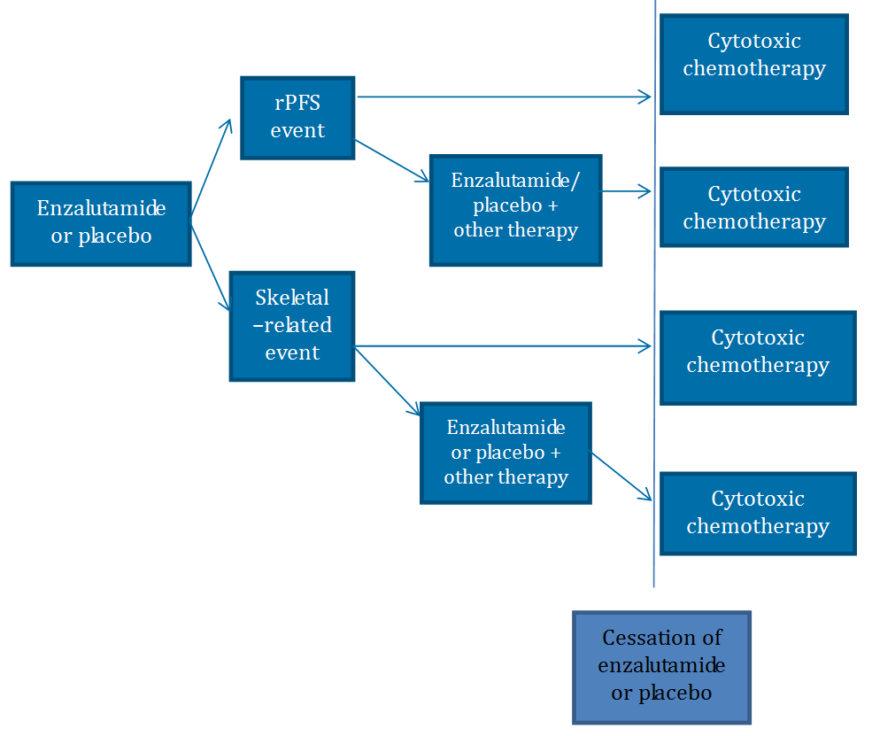
1. Enzalutamide or placebo
2. rPFS event
a. Enzalutamide or placebo + other therapy
i. Cytotoxic chemotherapy
b. Cytotoxic chemotherapy
3. Skeletal related event
a. Enzalutamide or placebo + other therapy
i. Cytotoxic chemotherapy
b. Cytotoxic chemotherapy
4. Cessation of enzalutamide or placebo
The impact of crossover has not been addressed by the sponsor. Once patients have commenced an agent other than that allocated by the randomisation procedure, this randomisation scheme is broken; a substantial (and discrepant) proportion of each study arm discontinued study treatment. The use of the intention to treat analysis may be an appropriate method in some circumstances, such as where only crossover from placebo to active treatment occurs, however there are limitations to this approach. The intention to treat analysis in PREVAIL includes not only crossover from placebo to an alternative therapy, but also from enzalutamide to an alternative therapy and the nesting of patients who could be concomitantly administered abiraterone with study drug: an experimental regimen on its own. Thus, contamination of both treatment arms has occurred, with the multiple treatment options employed. It is impossible for the evaluator to tell whether the difference in co-primary outcomes is due to the study treatment, post randomisation therapy, or concomitant therapy or a combination of each.
The co-primary endpoint of PREVAIL was “to determine the benefit of enzalutamide as compared to placebo as assessed by overall survival”. Due to the inclusion of patients who discontinued the study therapy in both treatment arms, and commencement of non-study agents, the sponsor has not demonstrated what the magnitude of median overall survival (OS) difference of 2.2 months between study arms which is due to enzalutamide/placebo separate from that of the effect of the agglomeration of additional therapies which patients received prior to, and following cessation of enzalutamide/placebo. The proportion of patients in each study arm receiving concomitant abiraterone has not been reported: it is plausible that discrepant exposure between treatment arms biases the OS outcome in favour of enzalutamide.
The co-primary end point of radiographic progression free survival (rPFS) was met, demonstrating a benefit from enzalutamide, as compared to placebo. The difference in time to rPFS was longer in the enzalutamide arm: median not reached for enzalutamide, median 3.9 months for placebo. However, the magnitude of benefit in delay of rPFS was not translated into a substantial difference in OS, with only a 2.2 month difference, in favour of enzalutamide (plus all other subsequent therapies). Furthermore, this outcome may also be confounded: patients may have had a skeletal related event and commenced cytotoxic chemotherapy and ceased study drug before a rPFS event.
The pivotal study efficacy outcomes have to be interpreted according to the median duration of follow-up (22.2 months for the enzalutamide arm and 22.4 months for placebo arm). Not only is OS potentially affected by concomitant disproportionate abiraterone administration, the sponsor states that “the median overall survival estimates are considered unstable because of the small number of patients at risk at the estimated medians (4 patients in the enzalutamide group and 24 patients in the placebo group) and the lower median time of follow-up for overall survival (22.2 months in the enzalutamide group and 22.4 months in the placebo group) relative to the estimated median survival”.
The median time to initiation of chemotherapy in the placebo arm was 10.8 months (interquartile range [IQR] 9.7, 12.2) whereas that for the enzalutamide arm was 28.8 months (IQR 25.8, NYR). It is not clear from the reporting methods used in the dossier whether additional therapies, in particular concomitant abiraterone administration, influenced this outcome.
For the secondary efficacy outcomes of PREVAIL:
- The time to first skeletal related event was not different between the study arms for patients who fulfilled this composite outcome of diagnoses and does not represent a clinical benefit to patients. The median time to initiation of chemotherapy for the placebo arm was 10.8 months with a median time to first skeletal related event of 31.3 months. This data would imply that most skeletal related events in the placebo arm occurred after chemotherapy was commenced. The sponsor should confirm that this outcome has been reported for the placebo controlled period only. The proportion of each treatment arm which had a skeletal related event following cessation of enzalutamide or placebo has not been reported.
- The median time to commencement of additional cytotoxic chemotherapy was longer following enzalutamide as compared to placebo (28.0 months versus 10.8 months respectively) , but was only associated with a difference in 2.2 months median overall survival, in favour of enzalutamide.
- Time to PSA progression has been presented using the incorrect denominator of patients, and requires re-calculation.
- The proportion of patients achieving a reduction in PSA concentration of >50% from baseline was presented and included in the proposed PI. However, the PCWG2 recommendations state that this outcome should not be reported.
- In patients with baseline soft- tissue disease, who comprised less than half of each treatment arm, the proportion of patients achieving a complete or partial soft tissue response was higher following enzalutamide treatment than with placebo. This finding is descriptive only; the trial was not powered to formally assess a difference in this outcome.
- Important missing information is the number of PFS events in each treatment arm following cessation of enzalutamide/placebo and commencement of cytotoxic chemotherapy.
- The proposed indication is for patients who are ‘mildly symptomatic’. There is no suitable definition of this term provided for this term. Indeed, the word mildly may be considered superfluous, the descriptor is symptom status – ‘mildly symptomatic’ patients are nonetheless symptomatic.
- Study 9875-CL-0321 has a substantial proportion of patients with an inadequate assessment of baseline disease status and therefore results from this study are non-informative.

Clinical safety

Studies providing safety data
Table 19 shows safety studies.
Table 19: Submitted safety studies.
Study ID | Study type | Phase, design | Study population | Results | Number of subjects
9785-CL-0007 | DDI | Phase I, nonrandomized, open-label, single sequence crossover. Effect of repeat doses of enzalutamide on single dose PK of pioglitazone, warfarin, omeprazole, and midazolam | Patients with CRPC | Primary analysis | 14
MDV3100-03 PREVAIL | Efficacy and safety | Phase III, randomized, double-blind, placebo controlled, multicentre | Chemotherapy naïve patients with metastatic CRPC | Primary analysis | 1717
S-3100-1-01 | Safety, tolerability, MTD, PK, efficacy | Phase I, open-label, uncontrolled, dose-escalation and dose-expansion cohorts | Patients with metastatic CRPC | Primary analysis | 140
MDV3100-06 | PK, safety, tolerability | Phase Ib, open-label | Patients with metastatic CRPC | Primary analysis | 22
9785-CL-0321 | Efficacy, safety, tolerability, PD, PK | Phase II, open-label, single arm | Patients with hormone-naïve prostate cancer | 1-year analysis | 67

Pivotal efficacy study – MDV3100-03 (PREVAIL)
The safety population was defined as:
All patients randomly assigned to treatment who received at least 1 dose or partial dose of study drug (enzalutamide or placebo).
In PREVAIL, the sponsor reports the following safety data were collected:
“General adverse events (AEs) were assessed by the frequency of adverse events, grade 3 or higher adverse events, serious adverse events, adverse events that were the primary reason for discontinuation of study drug, adverse events associated with discontinuation of study drug, adverse events leading to dose modification, and deaths, as well as the frequency of new clinically significant changes in physical examination findings, vital signs, laboratory values, and ECGs.”

Non-pivotal efficacy studies
Studies 9785-CL-0111 and 9785-CL-0321 provided data on safety.

Patient exposure
In PREVAIL, treatment duration for the interim analysis was calculated up to the data analysis cut-off date for patients receiving ongoing therapy. Patients were required to return any unused medicines; it was assumed that non-returned medicine was taken. The exposure of patients in PREVAIL is shown in Table 20.
Table 20: Exposure to enzalutamide & placebo, PREVAIL.
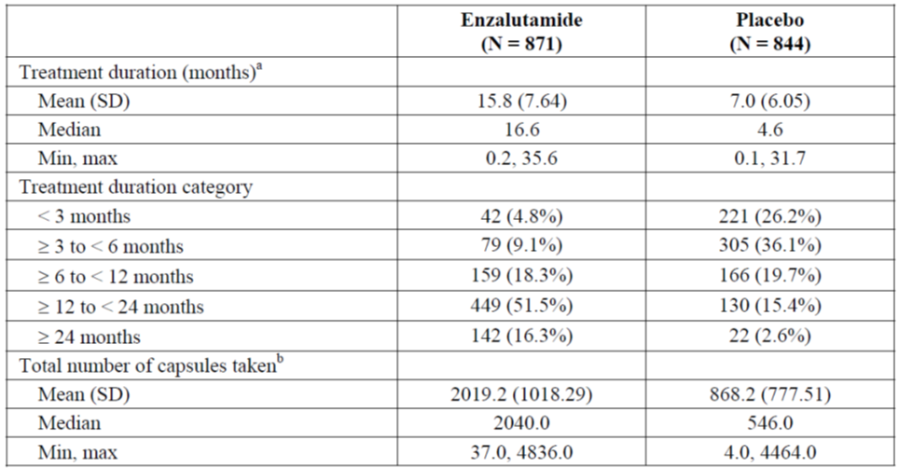
Dose modifications were permitted in the study, with 11.8% and 10.0% of the enzalutamide and placebo arms having at least one dose modification, respectively.
Comment: As noted in the efficacy evaluation above, patients enrolled in this study could receive concomitant study treatment, including abiraterone (plus steroid), prior to cessation of study drug. The safety analysis does not state that the safety outcomes were reported only for the enzalutamide/placebo monotherapy period for each patient, which is consistent with the proposed indication. The evaluator has to assume, therefore, that the safety data also includes periods of concomitant administration, which is unrepresentative of the difference between enzalutamide and placebo. The sponsor should clarify the reporting method.
The evaluator cannot therefore satisfactorily ascertain the relative difference in safety between enzalutamide exposure and placebo exposure, as required by the relevant legislation, owing to the unclear reporting methods in the dossier. The evaluation of all of the safety analyses below are predicated upon this concept.
Furthermore, the incidence of adverse events will be influenced by the highly discrepant duration of study drug exposure between the treatment arms. The total exposure period was 1180 patient-years for enzalutamide and 541 patient-years for placebo (see footnote of Table 10). These total exposure durations will also include concomitant abiraterone use. The incidence of adverse events in each study arm should also be reported standardised for the duration of exposure during the placebo controlled period only.
Reasons for dose modification are shown in Table 21.
Table 21: Dose modifications, PREVAIL safety population.
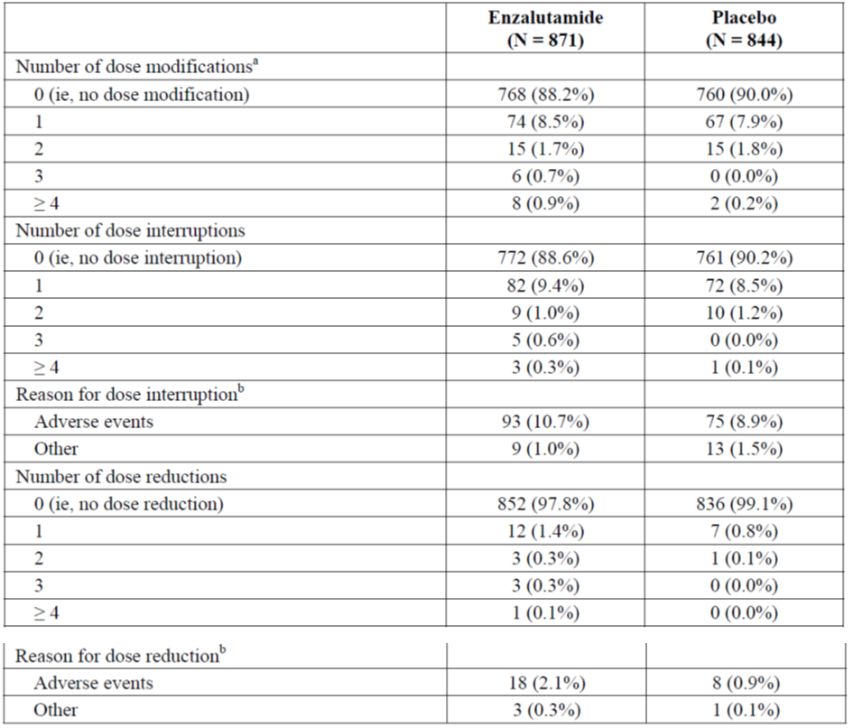
a Includes dose interruptions and dose reductions.
b Patients can be summarized for both reasons but counted only once for each reason.
The median duration of the reporting period for TEAEs was 17.1 months and 5.4 months for the enzalutamide and placebo groups respectively. The total exposure period was 1180 patient-years for enzalutamide and 541 patient-years for placebo.
AEs were assessed according to MedDRA version 16.1 and laboratory parameters were graded according to CTCAE version 4.0.

Adverse events

All adverse events (irrespective of relationship to study treatment)

PREVAIL study
The summary of common adverse events is shown in Table 22, with the events occurring more commonly in the enzalutamide arm in darker font.
Table 22: Common Adverse Events Reported in at Least 5% of Patients in Either Treatment Group by System Organ Class (Safety Population).
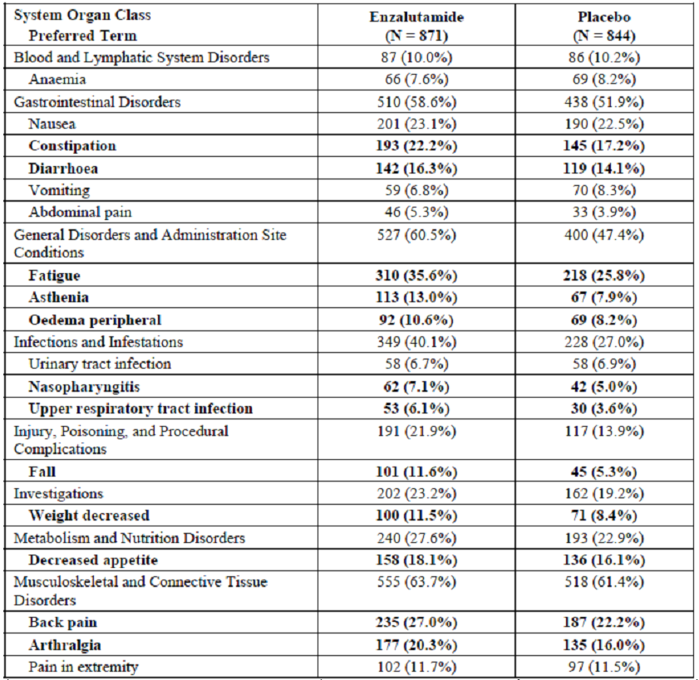
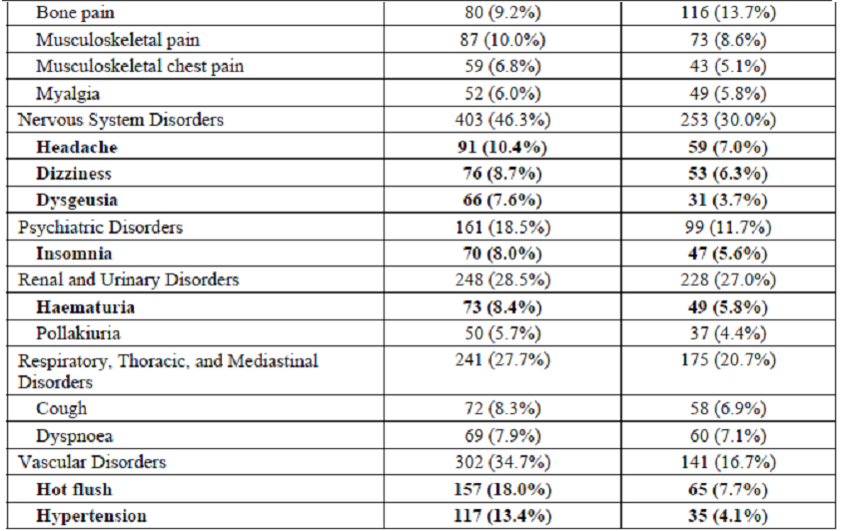
Comment: The reporting method for describing these common AEs does not clearly relate multiple events. For example, patients with ‘fall’ as a recorded adverse event may have experienced pain or fracture, it is not clear whether associated pain (using any of the multiple possible descriptors) has been reported concomitantly, or if these events occurred separately.
Similarly, the cause of the ‘fall’ may have had an identifiable preceding cause which could be directly attributable to study drug, but this cannot be identified.

Treatment emergent adverse events

PREVAIL study
The treatment-emergent safety reporting period began at the time of first dose of study drug and continued until 28 days after the last dose of study drug or the initiation of cytotoxic chemotherapy or an investigational agent.
The summary statistics for the incidence of TEAEs in PREVAIL are shown in Table 23.
Table 23: Treatment emergent adverse events, PREVAIL safety population.
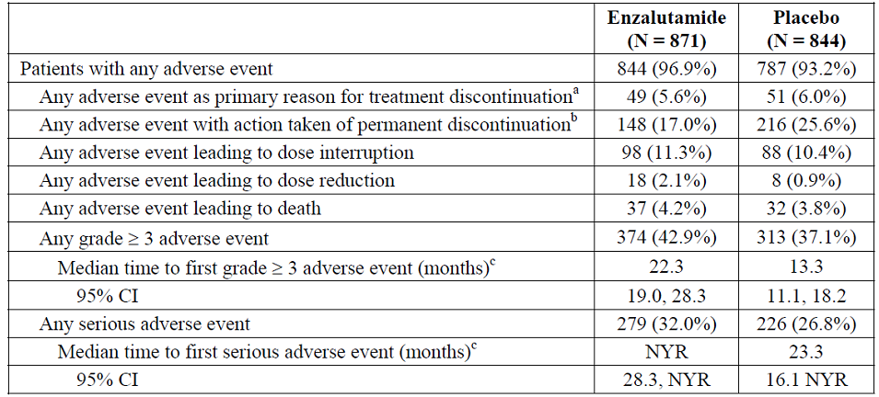
a From treatment discontinuation case report form.
b From the adverse event case report form.
c Based on Kaplan-Meier estimates.
NYR, not yet reached.
Comment: The incidence of events in the treatment-emergent period is not solely representative of the difference between enzalutamide and placebo as it is confounded by the (undisclosed) proportion of patients that received concomitant administration of therapies, in particular abiraterone.
The smaller incidence of TEAEs leading to discontinuation in the enzalutamide arm is noted, however the exposure period is different between the two arms.
Despite a similar incidence of all TEAEs, TEAEs leading to death and grade ≥3 TEAEs, the median time to grade ≥3 event or first serious event was longer in the enzalutamide arm than with placebo.
In the enzalutamide arm of AFFIRM trial, AEs leading to death occurred in 2.9%. The incidence of AEs leading to death in the enzalutamide arm of PREVAIL is 4.2%. The sponsor is asked to comment on this observation, given the later stage of disease for patients in AFFIRM.
The more specific descriptor of treatment-related adverse events has not been reported.
A summary of the adverse events which were considered by the investigator as possibly, probably or definitely related to study drug is seen in Table 24.
Table 24: Study Drug-Related Adverse Events in at Least 1% of Patients in Either Treatment Group by System Organ Class (Safety Population).
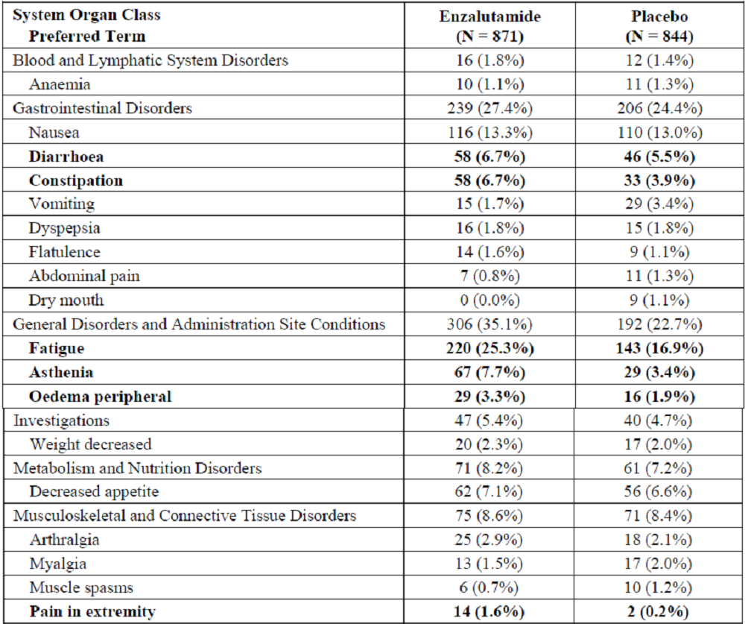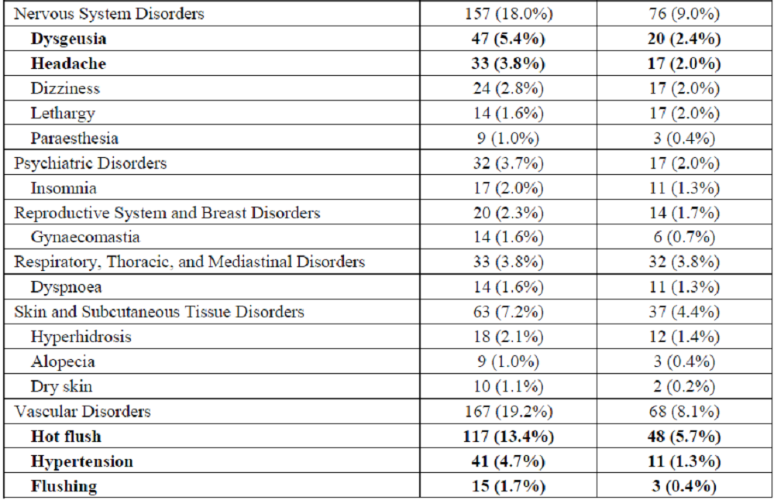
Comment: The term ‘hot flush and ‘flushing’ are likely to represent the same event.

Other studies

9785-CL-0321
The causes of TEAEs in this study were generally in keeping with those observed in PREVAIL. The incidence of TEAE was 91%, with grade 3, or higher, events of atrial fibrillation, angina pectoris, pneumonia, urosepsis, hypercalcaemia bladder transitional cell carcinoma, anoxic seizure, syncope and hypertension being the notable causes.
Following one year of therapy the incidence of TEAE was 95.5%. The incidence of gynaecomastia was 47.8%, with 35.9% reporting symptoms associated with breast or nipple pain or tenderness. Fatigue was reported in 38.8%, hypertension was reported in 11.9%. Nausea and diarrhoea were reported in 10.4% and 11.9% of patients respectively.
The incidence of adverse events adjusted for duration of exposure is seen in Table 25.
Table 25: Adverse Events Reported in at Least 5% of Patients and at Least 2% Absolute Higher Incidence in the Enzalutamide Group With Corresponding Event Rate Analysis (Safety Population).
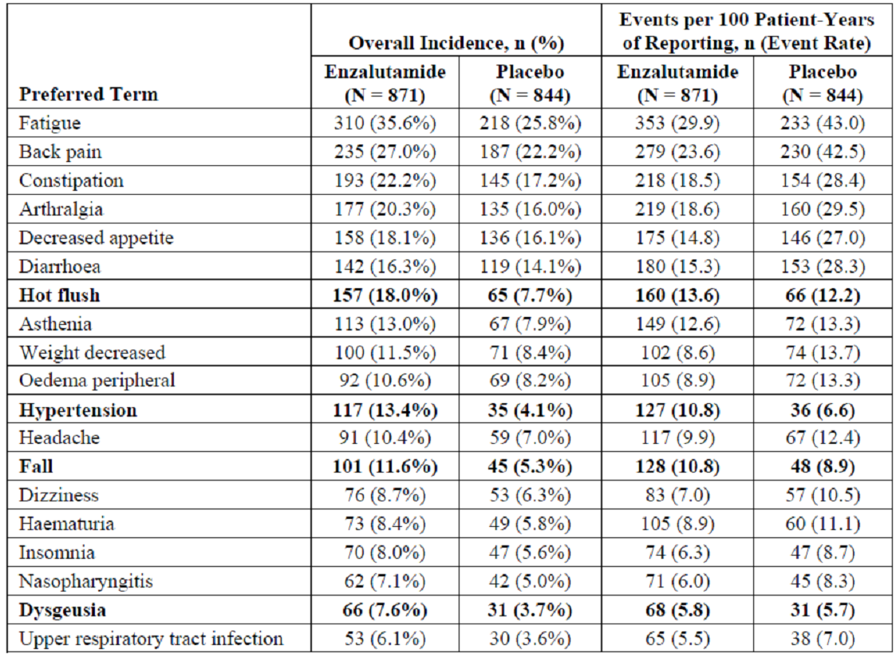
Comment: It is unclear from these results whether patients that received concomitant abiraterone have been included in incidence and event rate reporting. The sponsor should confirm the reporting method and re-analyse the data for the study drug monotherapy period only if the above analysis does include those with concomitant abiraterone use.

9785-CL-0111
Across the three dosage levels in the nine patients studied in the dose-escalation cohort, all patients experienced a TEAE. Among the 38 patients in the expansion cohort receiving 160mg BD enzalutamide, 94.7% experienced a TEAE.

Deaths and other serious adverse events

PREVAIL study
A total of 241 enzalutamide-treated patients (27.6%) and 299 placebo-treated patients (35.4%) died as of the data cut-off date (Table 26). Disease progression was the most common cause of death reported on the end of study case report form (21.0% of enzalutamide-treated patients and 26.9% of placebo-treated patients), followed by death due to other causes (4.0%, 4.9%), and deaths due to unknown causes (2.6%, 3.7%).
Table 26: Summary of deaths, PREVAIL - ITT population.
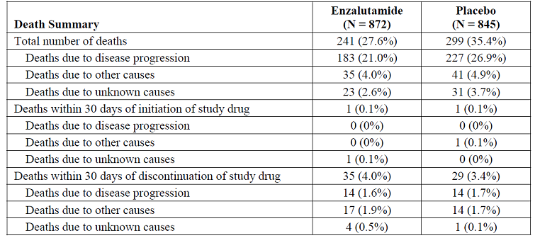
Two patients (1 enzalutamide and 1 placebo) died within 30 days after the first dose of study drug – the patient receiving enzalutamide died of an unknown cause at home and the patient receiving placebo died as a result of a subdural haemorrhage following a fall.
A similar proportion of patients died within 30 days after discontinuation of study drug - 35 enzalutamide-treated patients (4.0%) and 29 placebo-treated patients (3.4%).
Among all causes of death, the commonest was due to “general health deterioration” (9 enzalutamide-treated patients, 1.0% and 4 placebo-treated patients, 0.5%). The sponsor states that “death was considered an adverse event for 4 enzalutamide-treated patients (0.5%) and 1 placebo-treated patient (0.1%)”.
Comment: the longest mean terminal half-life of enzalutamide following single-dosing reported in the PI is 10.2 days. The follow-up period of 30 days following cessation of enzalutamide is too short to capture the period where all patients remain at risk.
There were a similar proportion of deaths due to disease progression in each treatment arm, with 2.6% and 3.7% of deaths due to unknown causes in the enzalutamide and placebo arms respectively. It is plausible that all 2.6% of the deaths with unknown cause in the enzalutamide arm were due to disease progression – i.e. 206 deaths in 872 patients (23.6%). This represents a minimum difference in incidence of death due to disease progression of 3.3%, and a number needed to treat of 30.
Although there was a reported reduction in the hazard of death for all-cause mortality in the enzalutamide arm, among the patients who died in the two treatment arms, the cause of death was disease progression for 75.9% in both. It is plausible that the proportion of deaths due to disease progression will not change over time, such that by the time the same number of deaths have occurred in the enzalutamide arm as placebo, there will be no observable benefit in preventing prostate cancer deaths in the proposed usage.
The use of the term “general health deterioration” would not be an acceptable term to document the cause of death on an Australian death certificate.
As per the Delegate’s Overview for the submission for initial registration, the use of the term ‘death’ as a cause of death is not appropriate. The sponsor is requested to explain the cause of death in the five patients assigned as ‘death’ more thoroughly.
Adverse events leading to death occurred in a similar proportion of each arm – 4.2% enzalutamide as compared to 3.8% placebo. There was no preponderant cause of death in either arm, with causes of death attributed to co-morbid conditions that might be expected to occur in a population of the age studied.
Serious adverse events occurred more frequently in the enzalutamide arm – 279/871 (32.0%) versus 226/844 (26.8%). The listed serious adverse events reported in at least 0.5% patients, by system organ class, are shown in Table 27.
Table 27: SAEs reported in at least 0.5% of patients, safety population.
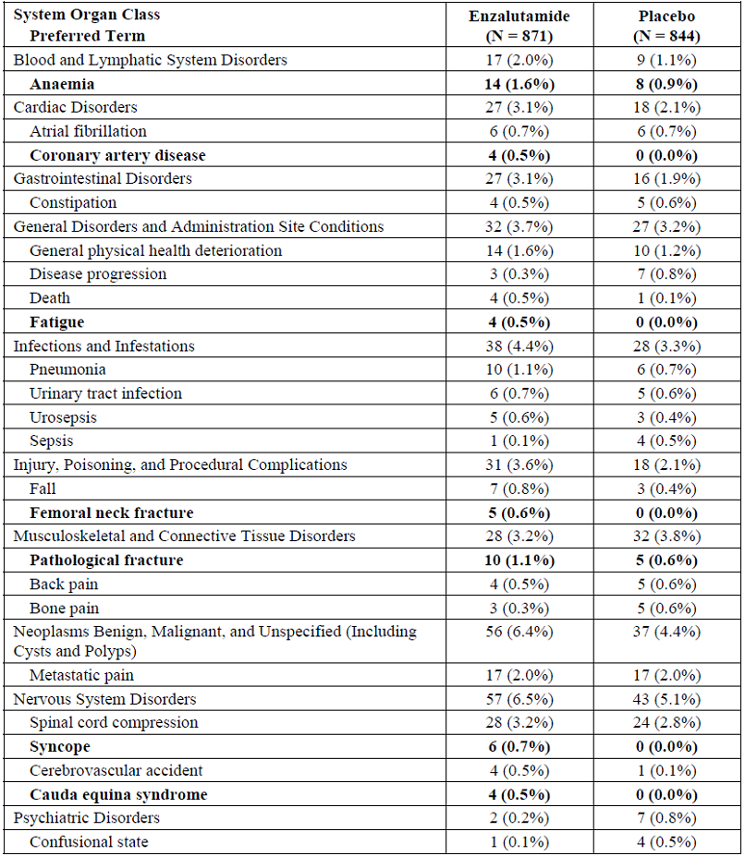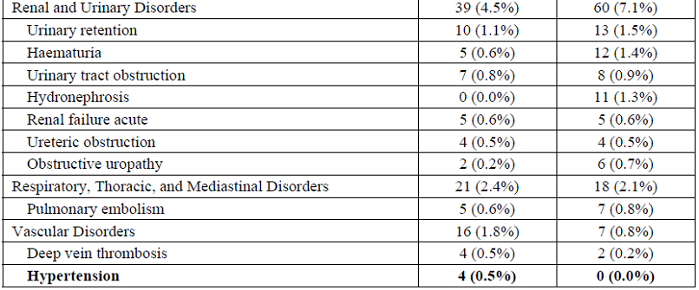
Serious adverse events of spinal cord compression occurred more commonly in the enzalutamide arm – 3.8% versus 2.8% for placebo. Similarly, serious events of cauda equina syndrome occurred in 4 patients (0.5) enzalutamide arm, whereas none occurred in the placebo arm. None of the events of cauda equine syndrome occurred within 180 days of commencing enzalutamide.
Serious events of hypertension occurred in four patients in the enzalutamide arm only. The narratives for these patients document pre-existing hypertension, with or without additional cardiovascular disease events. In each case, the hypertension was satisfactorily managed using anti-hypertensive medication.
Comment: From the table above, the combined events of serious events of fractured neck of femur and pathological fracture occurred more commonly in the enzalutamide arm. The longer duration of androgen suppression associated with longer duration of study drug is expected to confer a greater risk of osteoporosis on enzalutamide-exposed patients as compared to placebo.
Similarly, combined serious events of syncope and falls occurred more commonly in the enzalutamide arm.

Other studies

9785-CL-0321
One patient died on day 67 within 24 hours of resection of invasive transitional cell carcinoma of the bladder. This event was not considered related to enzalutamide, or disease progression.
One patient with a previous history of syncope and atrial flutter experienced events of syncope, pneumonia, atrial fibrillation, acute respiratory distress syndrome and acute myocardial infarction which led to his death. The events were considered unrelated to either enzalutamide or disease progression by the investigator and sponsor.
Another patient had an event of acute cardiorespiratory arrest following an event of pneumonia. The investigator and sponsor considered these events to be unrelated to enzalutamide or disease progression.

9785-CL-0111
No deaths were reported in the study period.

Discontinuation due to adverse events & dose interruptions

PREVAIL study
Adverse events leading to treatment discontinuation occurred in a similar proportion of each treatment arm (Table 28). No serious adverse events were reported as the reason for treatment discontinuation in more than 2 patients in either treatment arm.
Table 28: Adverse events as the primary reason for treatment discontinuation, safety population.
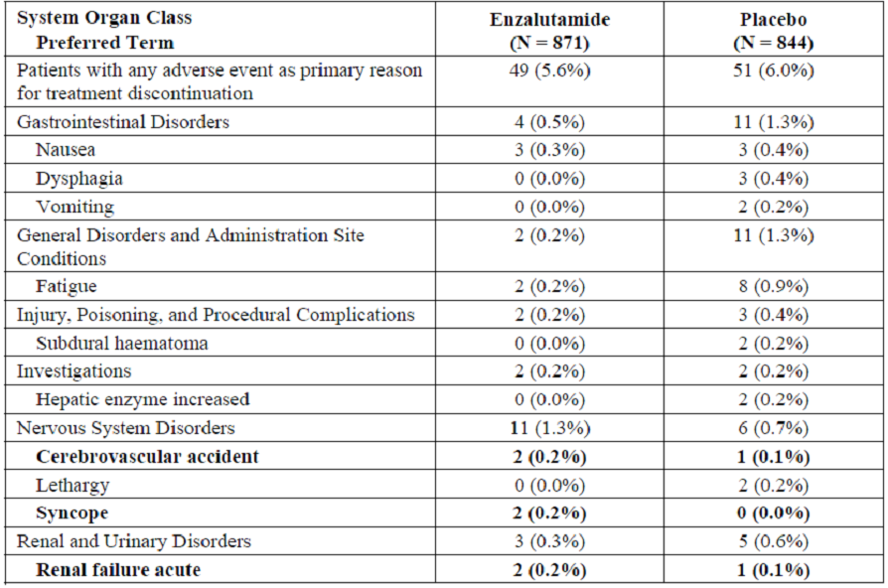
The proportion of patients with adverse events that led to dose interruptions was higher in the enzalutamide arm – 11.3% versus 10.4% placebo (Table 29).
Table 29: Adverse events leading to dose interruption (in at least 0.5% of patients).
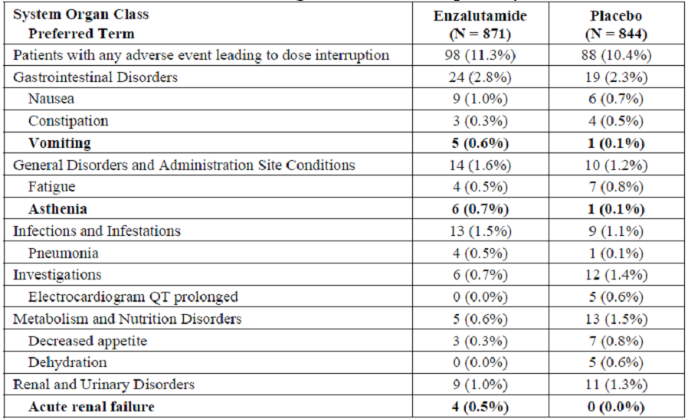
There were four cases of acute renal failure in the enzalutamide arm as compared to none with placebo. The specific causes of acute renal failure are not described. Of note, there were no cases of dehydration reported in the enzalutamide arm, which may indicate renal, or post-renal, causes of acute renal failure.

Clinical chemistry

PREVAIL study
Overall, there were no toxicities (grade 3 or 4 clinical chemistry abnormalities) that occurred more commonly in the enzalutamide arm.

Haematology

PREVAIL study
Events of CTCAE grade 3 or 4 toxicities for haematology values are presented in Table 30. The incidence of adverse events of neutropenia adjusted for exposure duration was higher in the enzalutamide arm – 1.7 events per 100 patient-years as compared to placebo 1.1 events per 100 patient-years.
Table 30: Summary of grade 3 or 4 haematology toxicities, safety population.
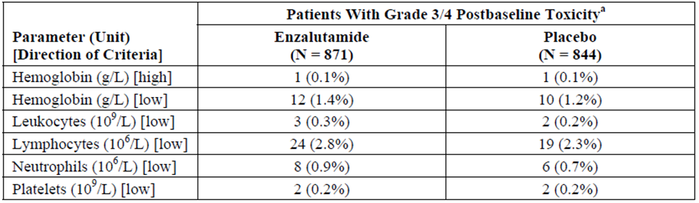
Comment: There is a discrepancy between the incidence of SAEs of anaemia in table 27 above and the incidence of grade 3 or 4 anaemia in table 23 due to the definitions used in MedDRA and CTCAE.
By using the CTCAE grading system, the difference in incidence of anaemia between the treatment arms as shown in table 24 is minimised in comparison to that reported in table 21.
The incidence of grade 3 or 4: leukopenia, lymphocytopenia, neutropenia and thrombocytopenia were similar between the treatment arms.
Table 4, in the proposed PI, documents events occurring in >2% of subjects in PREVAIL. A separate description of reported adverse events is listed below this table. The ‘Blood and lymphatic system disorders’ entry does not include the uncommon risk of grade 3 or 4 anaemia, which occurred in 1.4% enzalutamide patients, but should.
The sponsor is requested to reconcile the different incidence of anaemia reported in the clinical study report for PREVAIL and the lower incidence in the summary of clinical safety using CTCAE grading.
Table 31: Grade 3 or Higher Adverse Events Reported in at Least 1% of Patients in Either Treatment Group by System Organ Class (Safety Population).
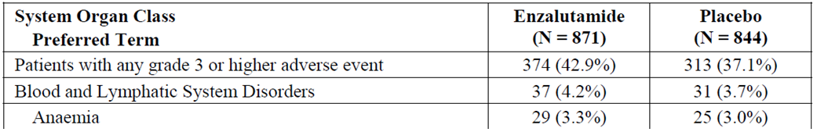
Table 32: Summary of Grade 3 or 4 Postbaseline Laboratory Abnormalities in MDV3100-03 and CRPC2.
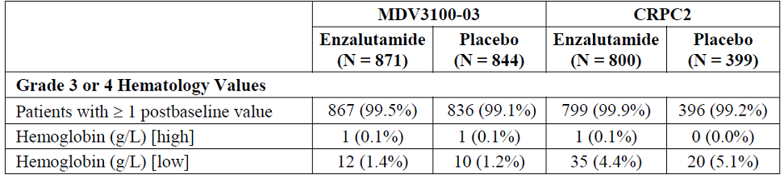

Other studies
In the PK study MDV3100-06, the incidence of neutropaenia in patients co-administered docetaxel and enzalutamide was 19/22 (86.4%). In the post-combination phase of this study, the incidence of neutropaenia in patients receiving enzalutamide alone was 4.8%. The currently approved PI for enzalutamide reports the incidence of grade 1-4 neutropenia from the AFFIRM trial to be 15% in patients exposed to enzalutamide and grade 1&2 neutropenia (there were no grades 3 or 4 events) in 6% of patients.
The patients in MDV3100-06 are neither representative of the current indication nor those in which the new indication is sought – i.e. for monotherapy enzalutamide use. The efficacy of the combination of enzalutamide and docetaxel has not been established. In the absence of confirmed benefit of this combination, the proposed statement in the PI regarding the incidence of neutropenia during co-administration with docetaxel should be removed – see section 12.2.5.

Electrocardiograph

PREVAIL study
Baseline ECG abnormalities were present in a similar proportion of each treatment arm – 49.7% enzalutamide versus 48.8% placebo. Treatment-emergent ECG abnormalities which were deemed ‘significant’ by the investigators were seen in 3.9% enzalutamide arm and 2.7% placebo.
The sponsor reports the incidence of at least 1 new post-baseline QTcF prolongation >480 msec as 4.5% in the enzalutamide arm versus 1.2% in the placebo arm; the incidence of new QTcF prolongation >500 msec was reported as 0.5% and 0.2%.
From the table above, the combined incidence of: intraventricular conduction defect, right bundle branch block (complete or incomplete) and left anterior hemi-block was 9.7% in the enzalutamide arm versus 5.0% with placebo.

Other studies
In study 9785-CL-0321, the sponsor reports than no patients had a significant ECG abnormality at baseline and that the mean change in QTcB were <22 msec at any time point and the mean change in QTcF were <19 msec at any time point.
In study 9785-CL-0111, ECG assessments were made by investigators and central analysis of was performed. Among the 38 patients in the expansion cohort, variation in various ECG measures was observed for a number of patients (Table 33).
Table 33: Summary of ECG analysis, safety analysis population.
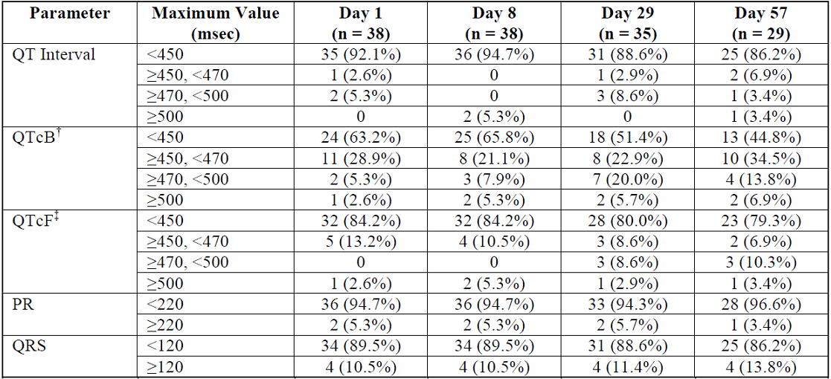
Number (%) of patients
The results were based on triplicate ECGs.
† QT corrected for heart rate, by Bazett’s correction
‡ QT corrected for heart rate, by Fridericia’s correction
The sponsor reports that no serious adverse events, or adverse events leading to discontinuation, occurred in this study population.
Comment: It is uncertain to the evaluator if the patients in 9785-CL-0321 with new QTcF prolongation >500 msec are a sub-group of those with new prolongation >480 msec – the sponsor is requested to confirm this.
The patients studied in PREVAIL were receiving continuing GnRH analogue therapy. The currently approved PI for the GnRH agonists Lucrin (leuprolin) and the EU SmPC for Zoladex (goserelin) each contain a warning for QT prolongation. The currently approved PI for the GnRH antagonist Firmagon (degarelix) reports an incidence of prolonged QT/QTc interval of 20% of patients. These observed adverse effects may sufficiently explain the incidence of pre-existing QT prolongation in the current study population. It is not clear form the data provided in the dossier what proportion of study patients were receiving continued therapy GnRH antagonists or agonists, which are reported to be associated with a an increased risk of adverse cardiac events themselves, with higher incidence in patients receiving GnRH agonists. Whether this difference in adverse cardiac events is maintained during concomitant enzalutamide therapy cannot be determined form the dossier.
In contrast to the safety data presented in the current dossier, the currently approved PI for Zytiga (abiraterone) states “there were no significant effects of abiraterone acetate on the cardiac QT/QTc interval”.
Given the observed incidence of pre-existing and new ECG abnormalities in the population studied in PREVAIL there is a dual risk of ECG abnormalities from existing GnRH therapy and enzalutamide which should be reflected in the PI.
The currently approved, and proposed, PI for enzalutamide do not contain warnings for any ECG abnormalities. The increased incidence of new QT prolongation and the combined incidence of events of intraventricular or branch conduction block observed in the enzalutamide-treatment arm should be separately included in the PI as a precaution.
The evaluator recommends that a baseline ECG should be performed in all patients commencing enzalutamide to enable the identification, and treatment where necessary, of treatment-emergent ECG abnormities – which should be reflected in the enzalutamide PI.
A major deficiency in the presentation of the safety data is that the incidence of new ECG abnormalities has not been correlated with events of: acute cardiac failure, dizziness, lethargy, syncope or falls.

Vital signs

PREVAIL study
Events of hypertension (MedDRA term) occurred more commonly in the enzalutamide arm (13.9%) compared to placebo (4.7%), despite a similar incidence at baseline. Hypertension was the most common grade 3 adverse event reported in the enzalutamide group (6.8% vs 2.3% with placebo).
The incidence of hypertension adjusted for study drug exposure was reported as 10.8 events per 100 patient years for enzalutamide and 6.6 events per 100 patient years for placebo.
Other vital signs, including change in weight, did not show a substantial difference between the treatment arms.

Cognitive impairment

PREVAIL study
The crude incidence of events of ‘cognitive impairment’, and also when adjusted for exposure, occurred more commonly in the enzalutamide arm (Table 34). Among the events reported, those of amnesia, memory impairment and disturbance in attention were commoner in the enzalutamide arm.
Table 34: Summary of events of cognitive impairment, safety population.
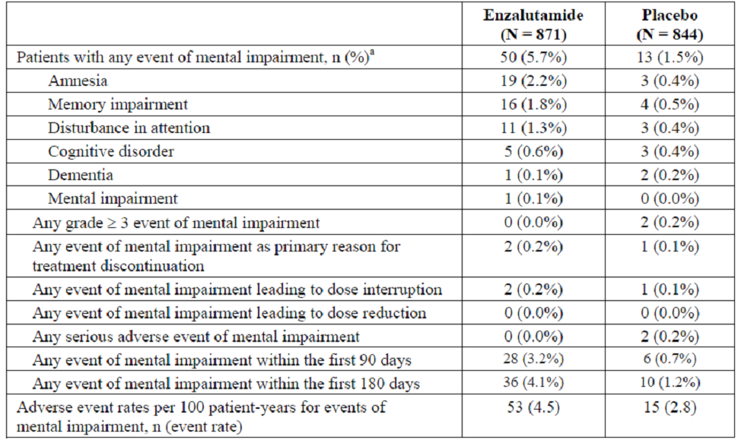
Comment: The general terms ‘cognitive disorder’ and ‘mental impairment’ are not sufficiently descriptive to allow further discussion for the nine patients assigned these diagnoses.
The sponsor has included the umbrella term ‘Mental impairment disorders’ in the table of adverse reactions in PREVAIL in the PI, reporting the crude incidence of ‘mental impairment’.

Seizures

PREVAIL study
Two events of seizures, one in each treatment arm, were reported. In both patients there was a history of predisposing neurological disorders.

Safety issues with the potential for major regulatory impact

Second malignancies (including post marketing experience)
Events of non-melanoma, second malignancy were observed to occur more commonly in the enzalutamide arm (3.1%) as compared to placebo (0.7%). The incidence of grade 3 or higher non-melanoma, second malignancy was 2.4% and 0.5% in the enzalutamide and placebo arms respectively. When adjusted for exposure to study treatment, the difference in incidence remained present: 1.9 versus 0.7 events per 100 patient-years with enzalutamide and placebo, respectively.
As presented in the dossier, among the reported specific diagnoses of grade 3, or higher, second malignancies, there was no preponderant disease type occurring in the enzalutamide arm (Table 35).
Table 35: Summary of grade 3 or higher second malignancies.
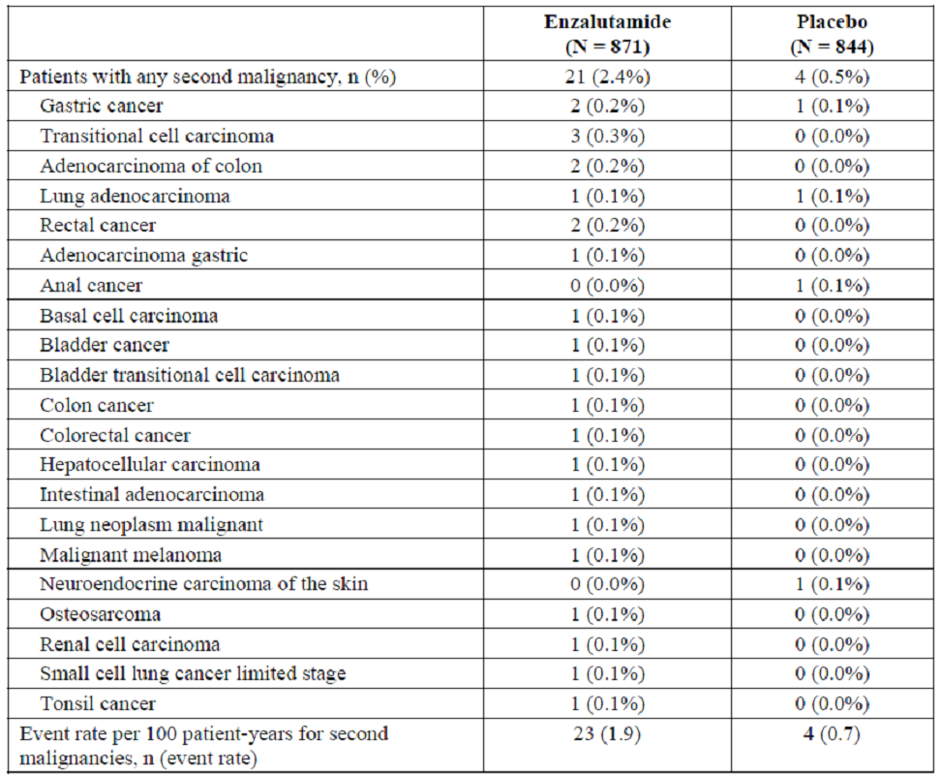
In the unrandomised trial 9785-CL-0321, there was one reported case (1.5% of all patients) of treatment emergent transitional cell carcinoma of the bladder. This was diagnosed at day 66 on-study, after approximately nine weeks of enzalutamide exposure. This patient died in the immediate post-operative period, with the event of bladder cancer being ascribed ‘not related’ to study drug or disease progression.
No second malignancies were reported within trial 9785-CL-0111, but the median duration of exposure in the expansion cohort was only 121 days.
In the post marketing safety report of April 2014, there was one case of colon adenoma and one of colon cancer, five assigned “neoplasm” or “neoplasm malignant”, and one case of “bladder cancer”.
Comment: The previous submission leading to the current registration of enzalutamide did not contain any preclinical carcinogenicity studies and did not specifically report the incidence of second malignancies in patients recruited into AFFIRM.
The randomisation method used in PREVAIL yielded two comparable treatment arms in regard to their demographic variables and disease characteristics. Of note however, is the lack of reporting of prior or current tobacco usage, but given the exchangeability of the groups in other respects, this factor is unlikely to be unbalanced on its own. Evidence from a randomised controlled trial with a placebo comparator yields the best evidence of a difference in incidence between patients with pre-chemotherapy CRPC. Cross study comparisons between AFFIRM and PREVAIL for this outcome are not valid since there are substantial differences In baseline disease state, exposure to additional therapies, duration of exposure and population composition resulting in a difference in incidence. Reports of second malignancies from non randomised studies do not inform the relative incidence between patients receiving enzalutamide and placebo.
The method of reporting the second malignancies in the PREVAIL study report leads the reader to believe that there is no overall cancer types more commonly associated with enzalutamide exposure. However, using the information from Table 36 and the associated patient narratives, it can be seen that a number of the reported malignancies are of the same histological type and may be amalgamated:
    - Of the four patients with ‘gastric cancer’ all had adenocarcinoma of the stomach.
    - Of the six patients with ‘colorectal cancer’, five had a histological diagnosis of adenocarcinoma. The remaining subject had a clinical diagnosis of ‘rectal carcinoma’ but no histological diagnosis was made.
    - Of the four patients with lung cancer, the patient in the placebo arm had a histological diagnosis of adenocarcinoma whereas among the three patients in the enzalutamide arm two had a diagnosis of adenocarcinoma and one of small cell lung cancer of the lung.
    - Of the five patients with cancer of the kidney or urinary tract, all had a histological diagnosis of transitional cell carcinoma.
Table 36: Reported malignancies.
 |  | Enzalutamide (N=871) | Placebo (N=844)
Gastric carcinoma | Number of patients, n (% of total) | 3 (0.34%) | 1 (0.12%)
 | 95% CI for incidence | 0.1, 1.0 | 0.02, 0.6
 | Age, years. Median (IQR) | 73 (69, 80) | 77
 | Time on study at diagnosis, days. Median (IQR) | 341 (212, 523) | 120
Colorectal carcinoma | Number of patients | 6 (0.69%) | 0 (0%)
 |  | 0.32, 1.5 | 0, 0.4
 | Age, years. Median (IQR) | 67 (64,72)
 | Time on study at diagnosis, days. Median (IQR) | 202 (130, 251) | -
Lung | Number of patients | 3 (0.34%) | 1 (0.12%)
 |  | 0.1, 1.0 | 0.02, 0.6
 | Age, years. Median (IQR) | 69 (66, 74) | 77
 | Time on study at diagnosis, days. Median (IQR) | 361 (338, 469) | 58
Transitional cell cancer of the kidney or urinary tract | Number of patients | 5 (0.57%) | 0 (0%)
 |  | 0.2, 1.3 | 0, 0.4
 | Age, years. Median (IQR) | 68 (62, 79) | -
 | Time on study at diagnosis, days. Median (IQR) | 426 (148, 443) | -
Among the patients with second malignancies, two died during the study: one patient in the enzalutamide arm died of rectal carcinoma, having been diagnosed eight days after randomisation and another in the placebo arm died of lung adenocarcinoma 58 days after randomisation. These two deaths cannot be considered attributable to the study treatment, but it is of concern that these two patients were recruited and randomised in to the study since they fulfil an exclusion criterion.
Thus, given the randomisation method and if the two early on-study deaths are excluded, there appears a plausibly greater risk of gastric and colorectal adenocarcinoma and transitional cell carcinoma of the urinary tract, shown above, associated with enzalutamide exposure. These findings should be specifically included in the PI.
In the Summary of Clinical Safety, the sponsor has provided a comparison of the expected incidence of categorised types of malignancy and compared the expected incidence as observed form the SEER database. This analysis includes all patients that received enzalutamide in the clinical development program, and not those in PREVAIL separately. This information does not allow a potential prescriber to inform the patient with pre-chemotherapy CRPC of their potential risk of second malignancy. The SEER database is only representative of patients in the USA, whereas PREVAIL patients are from numerous other countries which may have a different background risk of malignancy. This notwithstanding, the observed incidence of bladder and colorectal and gastric second malignancies are higher than that expected from the age adjusted SEER incidence.
Furthermore, there may be patients that withdrew from the Phase III study enzalutamide arm that are still at risk, but beyond the follow-up period determined by the sponsor, who may yield additional information on the risk of second malignancy.
In the submitted post marketing safety report, there are additional events of ‘colon adenoma’, ‘colon cancer’ and ‘bladder cancer’ occurring each in one patient. In addition six patients were reported to have ‘neoplasm’ or ‘neoplasm malignant’ or ‘lymphangiosis carcinomatosa’, but there is no description of the tumour type for these patients.
The findings have potential implications for the use of enzalutamide in patients either in the setting of pre-chemotherapy CRPC outside PREVAIL in the wider community, or in the adjuvant setting where exposure may be longer than that in PREVAIL, in a population with a different risk profile.

Liver toxicity
Overall, there was no preponderance of adverse hepatobiliary event in either treatment arm, with a similar AE rate adjusted for exposure duration (Grade 3, Table 37), or higher, hepatobiliary disorder events occurred in a similar proportion of each treatment arm.
Table 37: Summary of events of hepatic impairment, safety population.
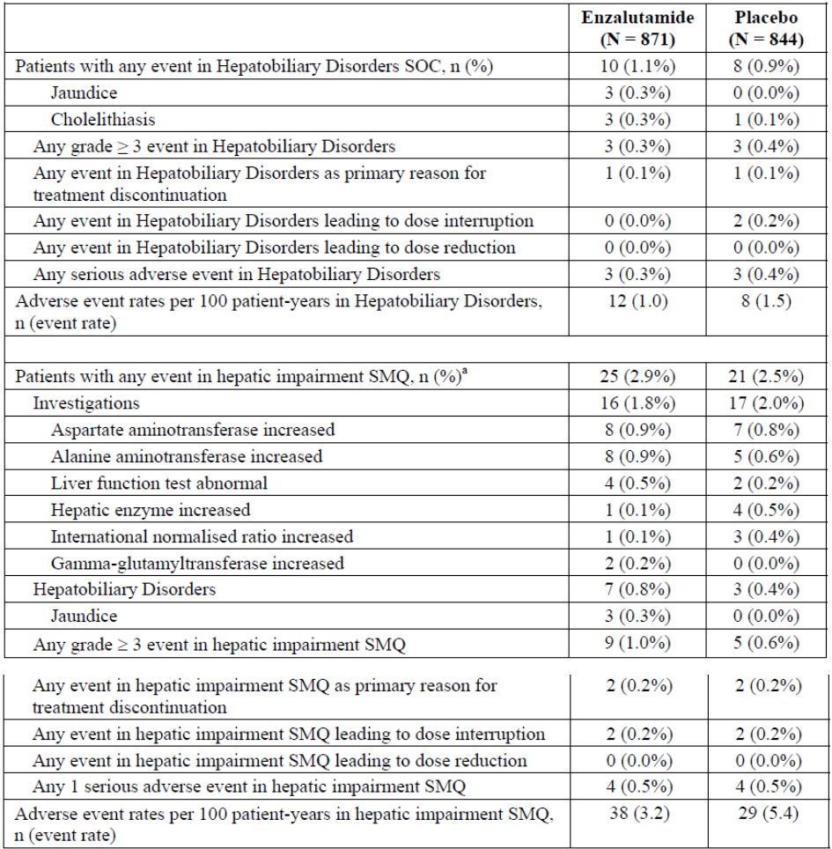

Safety of co-administration of enzalutamide and docetaxel
Study MDV 3100-06 assessed the safety of co-administration of docetaxel and enzalutamide (160 mg/day) in 22 patients with CRPC eligible to receive docetaxel (75 mg/m²) as their first systemic chemotherapy regimen. Patients not tolerating the combination of docetaxel and enzalutamide were permitted to continue enzalutamide alone.
The median duration of enzalutamide therapy was 12 months (range 0.2, 17.2 months). The median duration of docetaxel therapy was 3.8 months (range 0.7, 14.9 months), representing a median number of 5.5 21-day cycles.
The majority of patients required no enzalutamide dose reductions or interruptions. Of the 19% of patients requiring enzalutamide dose interruptions, all were due to AEs. One patient (4.5%) required a dose reduction of docetaxel, which was due to an AE.
TEAEs occurred in all 22 patients during co-administration, whereas in the post docetaxel enzalutamide only phase, 17/21 (81%) had a TEAE. The reported incidence of TEAE due to docetaxel is shown in Table 38.
Table 38: TEAEs in MDV 3100-06 safety population.
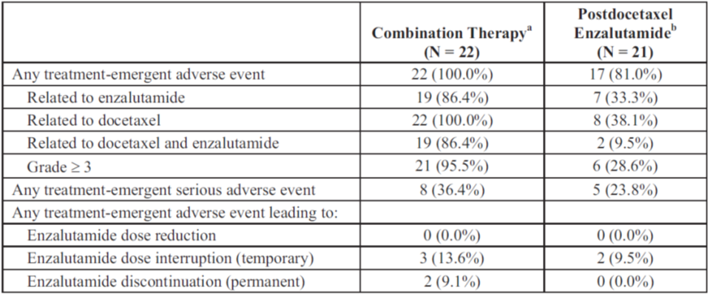
The listing of TEAEs occurring in >5% of patients is reported for the combination and monotherapy study periods in Table 39.
Table 39: TEAEs reported in ≥5% of patients during either therapy window (Safety Population).
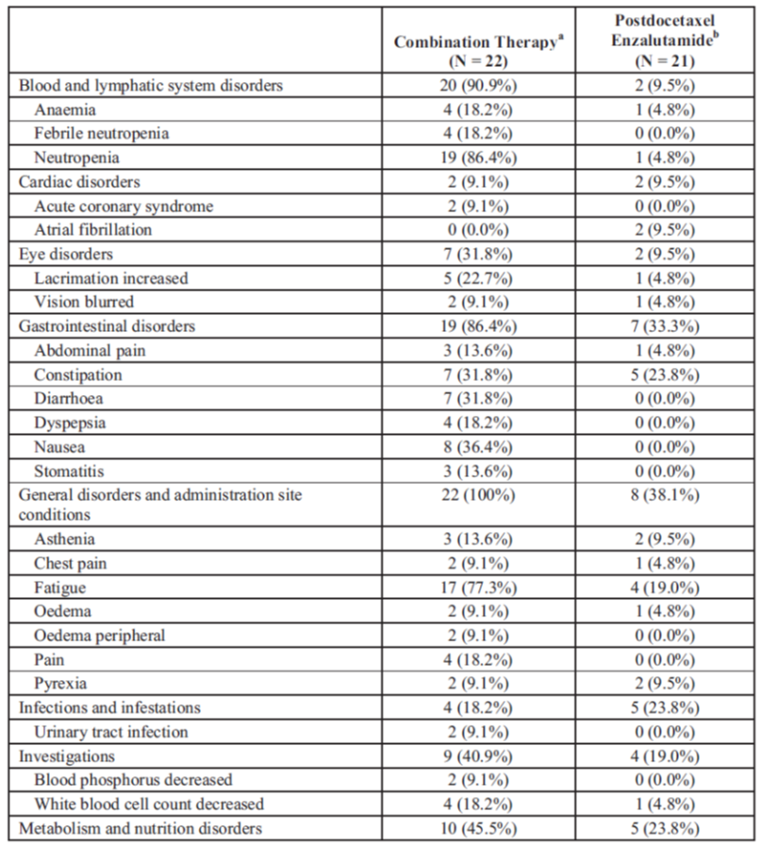
Table 39 (continued): TEAEs reported in ≥5% of patients during either therapy window (Safety Population).
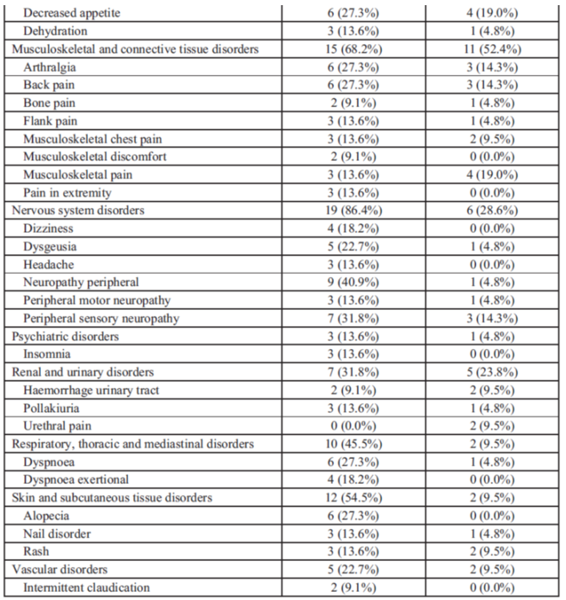
Grade 3 or higher TEAEs were reported in 21/22 (95.5%) of patients receiving combination therapy as opposed to 6/21 (28.6%) receiving enzalutamide alone. Among the reported severe TEAEs, neutropenia occurred in 19/22 (86.4%) with combination compared to 1/21 (4.8%) with monotherapy, and febrile neutropenia was reported in 4/22 (18.2%) and 0/21 for each phase respectively. Leukopenia was reported in 4 patients (18.2%) and a reduction in blood phosphorous was reported in two patients receiving combination therapy.
Other reported events occurred in one patient per event in either treatment phase.
Comment: The incidence of any grade TEAE was higher during combination therapy than with enzalutamide monotherapy. The small number of patients studied in this trial therapy have not been randomised and compared against patients receiving docetaxel alone, and therefore firm conclusions cannot be drawn. The incidence of TEAEs during combination therapy occurred more frequently for events in multiple system organ classes including neutropenia, gastrointestinal disorders, nervous system disorders and dyspnoea.

Serious skin reactions
The incidence of skin common adverse events when adjusted for duration of exposure was similar between the two treatment arms (Table 40).
Table 40: Summary of incidence of common events of the SOC skin & subcutaneous tissue disorders, safety population.
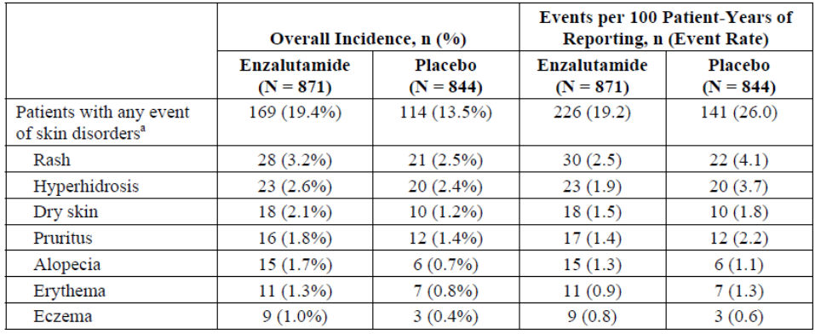
The incidence of grade 3, or higher, adverse events was 0.5% in the enzalutamide arm and 0.1% in the placebo arm. Two events in patients receiving enzalutamide were described as having a toxic skin eruption, with “toxidermia”; in one patient the skin eruption was associated with eosinophilia.
Comment: The narrative for one patient describes the onset of a maculopapular rash occurring on over 50% of the skin surface, with a biopsy showing grade 3 ‘toxidermia’ and inflammatory exudate. This patient did not have lymphocytosis or eosinophilia.
The narrative for another patient describes the presence of an erythematous maculopapular rash, with two small pustules and skin peeling of <20% total body surface area, but Nikolsky sign negative. The skin biopsy was reported to be “not inconsistent with a diagnosis of toxidermia”.
In both patients, their symptoms abated following temporary discontinuation of enzalutamide.
The term “toxidermia” is used in French medical literature, but given it is written in the dossier inverted commas, is not sufficiently explained in these patients to derive a specific diagnosis. The sponsor is requested to provide a sufficient explanation of the term ‘toxidermia’ – see safety questions.
The first patient has no obvious features of SJS/TEN, whereas for the second patient, the description is concerning for SJS/TEN.
Given the description of the second patient, it is recommended that events of desquamating skin rash be included in the RMP, since this may have been an event of SJS/TEN.

Evaluator’s conclusions on safety
The assessment of the comparative safety of enzalutamide versus placebo can only be made during study drug monotherapy. A meaningful analysis is rendered impossible by the potential for inclusion of an unspecified number of patients who received concomitant abiraterone while receiving study drug.

First round benefit-risk assessment

First round assessment of benefits
The benefits of enzalutamide in the proposed usage are:
- In androgen deprived males with metastatic CRPC yet to receive chemotherapy, enzalutamide significantly reduces the time to radiographic progression as compared to placebo.
- The observed increased risk of seizures seen in patients in AFFIRM was not replicated in PREVAIL. However, the advice contained in the PI regarding cessation of therapy in individuals in whom seizures occur while on-therapy should remain.
- Co-administration of enzalutamide and docetaxel was shown to not affect the pharmacokinetics of docetaxel. This finding relates to the initial registration submission rather than the current one, in which monotherapy enzalutamide was administered.

First round assessment of risks
The risks of enzalutamide in the proposed usage are:
- Enzalutamide has not been satisfactorily shown to increase the duration of overall survival (all-cause mortality) as compared to placebo due to the effects of concomitant (especially abiraterone) use and treatment switching and crossover.
- The data for PREVAIL is immature, rendering the OS estimate unstable: in the submission, less than 50% of each treatment arm has died.
- Among the patients in PREVAIL who died, the cause of death was progression of prostate cancer in 75% of each treatment arm.
- Despite a longer time to rPFS with enzalutamide in PREVAIL, the difference in median duration of overall survival differed by 2.2 months. This outcome is potentially confounded by the permitted concomitant use of abiraterone prior to study drug cessation.
- The unclear method of reporting safety data precludes the evaluator from forming any firm conclusions as to the safety of enzalutamide in the proposed indication
- The incidence, and severity, of adverse events in pre chemotherapy PREVAIL patients with CRPC appears, notwithstanding the unclear reporting method, non-identical to those who are post chemotherapy reported in AFFIRM. This difference in risk needs to be clearly stated in the PI to satisfactorily inform prescribers and patients.
- The proposed indication includes patients who are ‘mildly symptomatic’. There is no definition of this term provided.
- The pivotal study compared enzalutamide against placebo. In contemporary practice, the more appropriate comparator would be abiraterone rather than placebo.
- Concomitant use of enzalutamide and abiraterone was permitted in PREVAIL yet the efficacy and safety of this experimental combination has not been separately reported and therefore cannot be endorsed.
- One in 25 patients receiving enzalutamide in PREVAIL had a TEAE leading to death.
- The incidence of treatment related deaths in PREVAIL has not been reported.
- Approximately 30 patients need to be treated with enzalutamide to prevent one death from prostate cancer disease progression.
- Falls occurred twice as commonly in enzalutamide treated patients as compared to placebo in the randomised controlled trial. This finding is consistent with the safety profile described in AFFIRM.
- The data regarding the magnitude of change in PSA concentration, or time to PSA concentration change, in pre chemotherapy CRPC patients has not been confirmed to be a suitable predictive test of duration of survival, time to radiographic progression or time to first skeletal related event.
- A formal QT study has not been performed.
- The incidence of pre-existing electrocardiogram (ECG) abnormalities, including prolonged QT interval, reflects the known adverse event profile of androgen deprivation therapies.
- Treatment emergent ECG abnormalities, including bundle branch block and prolonged QTc, were reported in PREVAIL. These new ECG changes can only be identified if patients have had a baseline ECG.
- The risk of adverse cardiac events during enzalutamide therapy has not been reported separately for patients concomitantly receiving GnRH agonists and antagonists, which confer different baseline risks.
- There is an increased risk of amalgamated ventricular conduction adverse events with enzalutamide exposure as compared to placebo
- The incidence of adverse events was shown in a post hoc analysis of the combined PREVAIL and AFFIRM populations to be directly related to increasing age.
- The adverse event profile of docetaxel may be adversely affected by co-administration with enzalutamide (this potential risk is included in the proposed PI, but only for events of neutropenia)
- A case of potential Stevens Johnson syndrome/toxic epidermal necrolysis (SJS/TEN) has been reported, and requires further clarification from the sponsor.

First round assessment of benefit-risk balance
From the data presented in the dossier, the benefit-risk balance of enzalutamide in the proposed usage is unfavourable.

First round recommendation regarding authorisation
There are substantial methodological discrepancies in the data presented to yield a satisfactory demonstration of efficacy and safety of enzalutamide in the proposed indication. Registration is not yet recommended, pending the sponsors’ response to the clinical questions.

Clinical questions

Pharmacokinetics
None

Pharmacodynamics
None

Efficacy
- The sponsor should provide OS data (hazard ratio [HR], median duration, mean duration) for the enzalutamide and placebo arms of PREVAIL for the randomised controlled period alone, and excluding the period of concomitant abiraterone use where this occurred.
- In PREVAIL, prior to cessation of study drug, what were the additional therapies used in each treatment arm, and what were the number of patients that received each of them?
- In PREVAIL, what were the criteria for commencing abiraterone as a concomitant therapy?
- In PREVAIL, what were the criteria for commencing abiraterone as concomitant therapy as opposed to commencing chemotherapy?
- The sponsor should report the median and IQR of time to commencement of cytotoxic chemotherapy therapy (and therefore cessation of enzalutamide/placebo) for the four treatment arms: (i) enzalutamide only, (ii) concomitant enzalutamide and additional therapy, (iii) placebo alone, (iv) concomitant placebo plus additional therapy.
- The sponsor should report the median and IQR of time to PSA progression for the four treatment arms: (i) enzalutamide only, (ii) concomitant enzalutamide & abiraterone, (iii) placebo alone, (iv) concomitant placebo plus abiraterone, using the appropriate denominator.
- The sponsor should report the proportion receiving, and median and IQR of time to antineoplastic use for the four treatment arms: (i) enzalutamide monotherapy, (ii) concomitant enzalutamide and additional therapy, (iii) placebo monotherapy, (iv) concomitant placebo plus additional therapy.
- The sponsor should report the median and IQR of time to PSA progression for the four treatment arms: (i) enzalutamide monotherapy, (ii) concomitant enzalutamide & additional therapy, (iii) placebo monotherapy, (iv) concomitant placebo plus additional therapy, using the appropriate denominator.
- The sponsor should report the number of patients and their median time (plus interquartile range) to rPFS event or first skeletal related event, which ever came sooner, for the four treatment groups receiving (i) enzalutamide monotherapy, (ii) concomitant enzalutamide & additional, (iii) placebo monotherapy and (iv) concomitant placebo & additional therapy, according to the table below:
 | Enzalutamide only | Enzalutamide + abiraterone / biological therapy | Placebo only | Placebo + abiraterone / biological therapy
rPFS1
rPFS2
rPFS3
rPFS4
- What number of patients in each PREVAIL treatment arm were receiving study drug alone at the efficacy analysis point?
- The sponsor is requested to provide an explanation for the substantially lower time to both rPFS and death for the post-chemotherapy CRPC Japanese patients in Study 9785-CL-0111 as compared to the non-Japanese patients in the AFFIRM study.
- The reported data on time to PSA progression in PREVAIL included patients with only one PSA measurement. The sponsor is requested to re-calculate the data in the CSR to reflect the correct denominator of only those patients with >1 PSA measurement.
- In PREVAIL, was Radium 223 permitted as an additional agent prior to cessation of enzalutamide/placebo, and if so, how many patients in each arm received this therapy?
- The sponsor should confirm whether the reported data pertaining to first skeletal event is for the randomised controlled period only, or also includes the period following initiation of additional therapies. If the latter applies, the sponsor should report the outcome for the monotherapy period of study treatment, including standardisation for the duration of study treatment.
- What proportion of the skeletal related events occurred after commencement of cytotoxic chemotherapy in each PREVAIL treatment arm?
- The sponsor should confirm that patients who received abiraterone also received prednisone/prednisolone at all stages of the PREVAIL study, as per the currently approved PI for abiraterone.
- What pharmacokinetic analysis was performed on patients receiving concomitant abiraterone and enzalutamide to ensure the safety of this combination?
- The sponsor should present the quality of life data for each treatment arm of PREVAIL for the study drug monotherapy period alone.
- The sponsor should present the efficacy outcomes of OS and time to first skeletal-related event for each treatment arm of PREVAIL, stratified for concomitant additional therapy use.
- The sponsor should present the PREVAIL sub-group analyses of OS for (i) those patients that only received study drug as monotherapy and (ii) those that received concomitant study drug plus additional therapy, prior to cessation of study drug.
- What is the prognostic value of achieving a PSA concentration reduction of >50% from baseline for patients fulfilling the criteria to enter PREVAIL?
- Were patients in PREVAIL who had clinical progression prior to a skeletal-related event or radiographic progression permitted to received concomitant therapy prior to cessation of enzalutamide/placebo?
- In study 9785-CL-0321, what were (i) the median (IQR) baseline bone mineral bone density t-score, and (ii) the median (IQR) change in bone mineral density t-score over time?

Safety
- The sponsor should confirm the reporting methods of the safety analysis. A safety analysis reporting only the period during which patients only received the study drug as monotherapy is requested, that is, excluding the period when concomitant use of additional therapies occurred, and excluding the period post-cessation of study drug. Outcomes should be reported including standardisation according to duration of study drug treatment.
- Can the sponsor explain the difference in incidence of TEAEs leading to death in enzalutamide-treated patients in PREVAIL (37/871 = 4.2%) as compared to the incidence of any TEAE leading to death in AFFIRM of 2.9%.
- What was the incidence of treatment related death (as opposed to treatment emergent) for patients in PREVAIL while receiving monotherapy study drug?
- The cause of death for 9 enzalutamide treated patients and 4 placebo treated patients in PREVAIL was described as ‘general health deterioration’. The sponsor is requested to provide a more thorough explanation for the actual cause of death for these thirteen patients.
- The cause of AEs leading to death in 4 enzalutamide treated patients and 1 placebo treated patient in PREVAIL is listed as ‘death’. The sponsor is requested to provide a more thorough explanation for the actual cause of death for these five patients.
- The sponsor is requested to provide a sufficient explanation of the non-specific term ‘toxidermia’ for the two patients in whom it occurred.
- The incidence of second malignancies observed in PREVAIL should be included in the PI.
- In the post marketing safety report, six patients were reported to have either ‘neoplasm’ or ‘neoplasm malignant’ or ‘lymphangiosis carcinomatosa’. What is the histological diagnosis of the cancer for these six patients, and what was their duration of enzalutamide exposure?
- In Study 9785-CL-0321 were patients with reported new QTcF prolongation >500 msec a sub-group of those with new prolongation >480 msec?
- In Study 9785-CL-0321, were the two deaths reported in the safety analysis set treatment related?
- What proportion of patients in PREVAIL were continuing to receive (i) a GnRH agonist and (ii) a GnRH antagonist, in each treatment arm? What was the incidence of cardiac and ECG TEAEs due to enzalutamide for patients receiving each GnRH treatment modality?

Second round evaluation
- The sponsor should provide OS data (hazard ratio [HR], median duration, mean duration) for the enzalutamide and placebo arms of PREVAIL for the randomised controlled period alone, and excluding the period of concomitant abiraterone use where this occurred.
Sponsor response
The sponsor would like to clarify a potential misunderstanding about the PREVAIL study design. Patients were to remain on study drug until confirmed radiographic disease progression or a skeletal-related event (SRE) and the initiation of cytotoxic chemotherapy or an investigational agent for the treatment of prostate cancer. After discontinuation of study drug, patients could receive any approved or investigational antineoplastic therapy.
During the course of the study, abiraterone was approved in this patient population, and concomitant treatment with abiraterone was allowed once patients had either confirmed radiographic progression or an SRE. Only 12 of the 1717 randomized patients received abiraterone concomitantly with the study treatment (Table 41). For 6 patients (5 enzalutamide and 1 placebo) the overlap was only 1 day, i.e., the last day of study treatment was the same day as the start of abiraterone treatment. Given the low percentage of patients (0.7%) who used abiraterone concomitantly and the short duration of overlap, the impact on the overall survival (OS) analysis is considered negligible. PREVAIL was designed as a standard randomized, double-blind, phase 3 oncology study, and the sponsor is of the opinion that the study was adequately designed and that the results can be well interpreted.
Table 41: Concomitant use of abiraterone in PREVAIL.
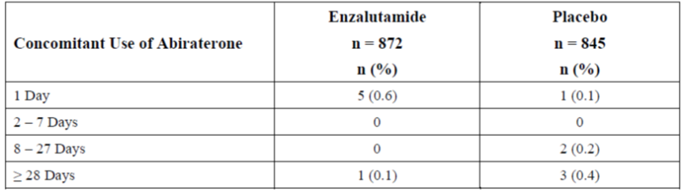
Evaluator response
The response above states that:
Patients were to remain on study drug until confirmed radiographic disease progression or a skeletal-related event (SRE) and the initiation of cytotoxic chemotherapy or an investigational agent for the treatment of prostate cancer. After discontinuation of study drug, patients could receive any approved or investigational antineoplastic therapy.
This implies that no patients were permitted to receive any approved or investigational antineoplastic therapy until cessation of study drug. However, the response to question 2 contradicts this statement – Table 42 below documents patients who received concomitant therapy in each treatment arm.
- In PREVAIL, prior to cessation of study drug, what were the additional therapies used in each treatment arm, and what were the number of patients that received each of them?
Sponsor response
Table 42 shows the number of patients who received antineoplastic treatment concomitantly with study treatment in the PREVAIL study. For 6 out of the 7 patients that received concomitant docetaxel, docetaxel treatment started on the last day of study treatment.
Sipuleucel-T treatment was allowed in this study.
Table 42: Concomitant use of antineoplastic treatment by ATC-level 2 (ITT Population) in PREVAIL.
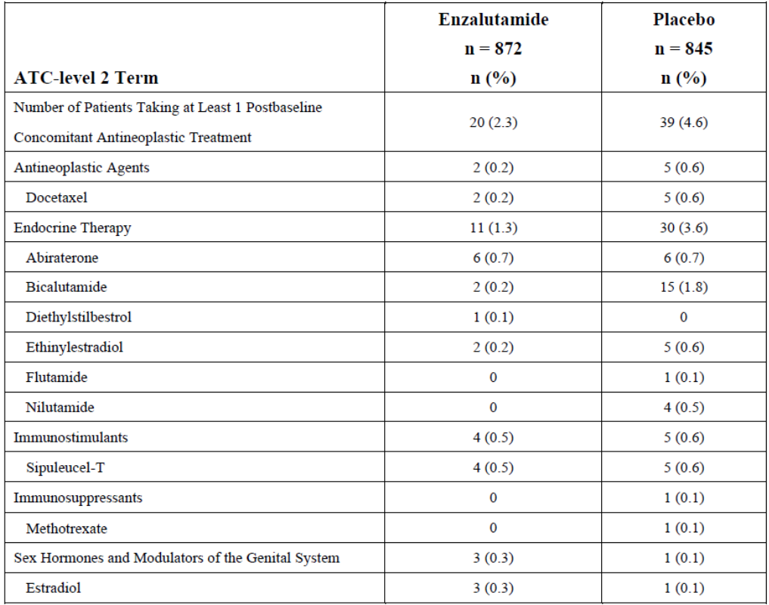
Evaluator response
Contrary to the response to question 1, the use of concomitant therapy appears to have been permitted. The proportion of patients receiving concomitant therapy was different between the two treatment arms.
The majority of the difference is accounted for in the use of the endocrine therapies bicalutamide, ethinylestradiol and nilutamide.
Table 42 is incomplete - it excludes the 5 patients in the enzalutamide arm and 9 in the placebo arm who received Radium 223 prior to cessation of enzalutamide or placebo, as documented in the response to Question 13 below.
Therefore, overall, it appears that 73/1717 (4.3%) received concomitant therapy prior to cessation of study agent - 25 patients in the enzalutamide arm (2.9%) and 48 patients (5.7%) of the placebo arm.
- In PREVAIL, what were the criteria for commencing abiraterone as a concomitant therapy?
Sponsor response
Abiraterone is indicated for treatment of metastatic castration-resistant prostate cancer (CRPC) in patients who are chemotherapy-naïve or who progressed after a docetaxel-based chemotherapy regimen.
In the PREVAIL study, initiating abiraterone treatment for prostate cancer was at the discretion of the investigator for those patients who met the protocol-specific criteria of having a confirmed radiographic progression or an SRE. Very few patients actually used abiraterone concomitantly with study treatment (see the response to Efficacy: Question 1).
Evaluator response
The investigator-led discretionary use of abiraterone is noted.
- In PREVAIL, what were the criteria for commencing abiraterone as concomitant therapy as opposed to commencing chemotherapy?
Sponsor response
There were no specific criteria in the PREVAIL protocol to define which medication was to be used as a subsequent treatment for each patient. The investigator was to make a decision after consultation with the patient and the decision may have depended on the standard of care in that particular site or country.
Table 43 summarizes the number of patients who were treated with chemotherapy and/or abiraterone and the sequence of these treatments. Treatment with abiraterone most frequently occurred after treatment with chemotherapy (n = 108 in the enzalutamide group and n = 279 in the placebo group).
Table 43: Overview of use of abiraterone and/or chemotherapy (ITT Population) in PREVAIL.
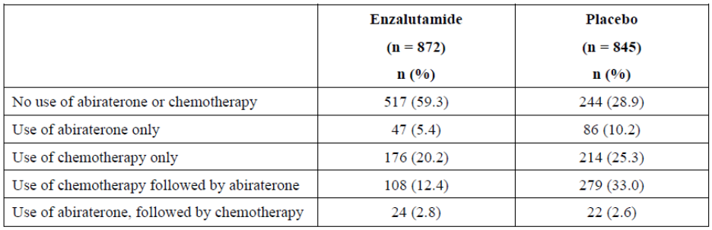
Evaluator response
The investigator-led discretionary use of abiraterone or chemotherapy is noted. Concomitant use of enzalutamide and abiraterone occurred in a similar proportion of patients prior to cessation of study drug (0.7% of each arm in PREVAIL).
There is a substantial imbalance in the proportion of patients that received each category of therapy listed in Table 43. The independent effects of each treatment regimen will confound the outcomes of the trial following commencement of these therapies, and the assessment of the absolute difference in efficacy between enzalutamide and placebo is impaired by their use.
The direction of any independent effect upon the primary outcome these other therapies might have had cannot be satisfactorily determined from the data provided.
- The sponsor should report the median and IQR of time to commencement of cytotoxic chemotherapy therapy (and therefore cessation of enzalutamide/placebo) for the four treatment arms: (i) enzalutamide only, (ii) concomitant enzalutamide and additional therapy, (iii) placebo alone, (iv) concomitant placebo plus additional therapy.
Sponsor response
Please see the responses to Efficacy: Questions 1 and 2. The concomitant use of additional therapies in the PREVAIL study was limited to a small number of patients (20 [2.3%] patients and 39 [4.6%] patients in the enzalutamide and placebo arms, respectively) with a 1-day overlap in most cases. Due to the small population size and limited treatment overlap, the results from a separate analysis would not be meaningful.
Evaluator response
As per the evaluator comments to questions 1 & 2, the sponsor has provided contradictory statements regarding the use of concomitant medication. Furthermore, the proportions described in the response do not include those patients that received Radium223.
The sponsor has only presented the period of overlap for patients that received abiraterone (in Question 1 response) and not the nine other therapies documented in the response to question 2, nor the overlap for patients that received Radium 233. The effect of these concomitant medications on the trial outcomes cannot be assessed given the limited data presented.
- The sponsor should report the median and IQR of time to PSA progression for the four treatment arms: (i) enzalutamide only, (ii) concomitant enzalutamide & abiraterone, (iii) placebo alone, (iv) concomitant placebo plus abiraterone, using the appropriate denominator.
Sponsor response
The response to Efficacy: Question 1 presents the small number of patients with concomitant abiraterone use in PREVAIL. Subgroups (ii) and (iv), described in this question, would consist of 6 patients each. Due to the small population size, the results from this subgroup analysis would not be meaningful.
Evaluator response
The small number of patients that received concomitant abiraterone is noted and is balanced between treatment arms. The evaluator agrees that this subgroup, alone, would be unlikely to materially affect the trial outcomes.
- The sponsor should report the proportion receiving, and median and IQR of time to antineoplastic use for the four treatment arms: (i) enzalutamide monotherapy, (ii) concomitant enzalutamide and additional therapy, (iii) placebo monotherapy, (iv) concomitant placebo plus additional therapy.
Sponsor response
Please see the response to Efficacy: Question 5.
Evaluator response
This question has not been answered.
From the response to question 2, there was a disproportionate use of concomitant therapy prior to cessation of enzalutamide/placebo. These patients are not representative of the indication sought and their outcomes should be reported separately.
- The sponsor should report the median and IQR of time to PSA progression for the four treatment arms: (i) enzalutamide monotherapy, (ii) concomitant enzalutamide & additional therapy, (iii) placebo monotherapy, (iv) concomitant placebo plus additional therapy, using the appropriate denominator.
Sponsor response
Please see the response to Efficacy: Question 5.
Evaluator response
This question has not been answered.
From the response to question 2, there was a disproportionate use of concomitant therapy prior to cessation of enzalutamide/placebo. These patients are not representative of the indication sought and their outcomes should be reported separately.
- The sponsor should report the number of patients and their median time (plus interquartile range) to rPFS event or first skeletal related event, which ever came sooner, for the four treatment groups receiving (i) enzalutamide monotherapy, (ii) concomitant enzalutamide & additional, (iii) placebo monotherapy and (iv) concomitant placebo & additional therapy, according to the table below:
 | Enzalutamide only | Enzalutamide + abiraterone / biological therapy | Placebo only | Placebo + abiraterone / biological therapy
rPFS1
rPFS2
rPFS3
rPFS4
Sponsor response
Please see the response to Efficacy: Question 5.
Evaluator response
The sponsor has not answered this question.
The sponsor stated as a justification for not providing an answer was that the proportion of patients that were receiving therapies other than enzalutamide, or placebo, alone was small. This does not explain why the table of number of rPFS events was not completed for patients solely receiving enzalutamide or placebo – the groups which the sponsor considers representative of the whole study population.
- What number of patients in each PREVAIL treatment arm were receiving study drug alone at the efficacy analysis point?
Sponsor response
As Table 44 shows, only a small number of patients had an efficacy assessment subsequent to the start of concomitant antineoplastic therapy in PREVAIL; therefore, the results provided can be considered representative of study treatment alone.
Table 44: Number of patients with an efficacy assessment subsequent to the start of concomitant antineoplastic therapy in PREVAIL.
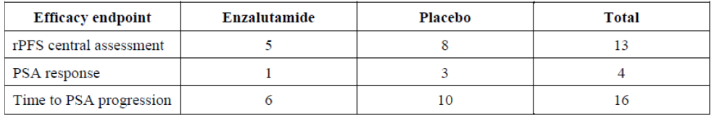
Evaluator response
Overall, 32/1717 (1.9%) patients were in receipt of concomitant therapy at an efficacy assessment point. A larger proportion of these were in the placebo arm (2.5% vs. 1.4%). This table does not reflect the duration of concomitant use.
- The sponsor is requested to provide an explanation for the substantially lower time to both rPFS and death for the post-chemotherapy CRPC Japanese patients in Study 9785-CL-0111 as compared to the non-Japanese patients in the AFFIRM study.
Sponsor response
The lower time to rPFS and death in the post-chemotherapy CRPC Japanese patients in Study 9785-CL-0111 as compared to the non-Japanese patients in the AFFIRM study, is mainly due to differences in eligibility and prior treatment history. Study 9785-CL-0111, required measurable metastatic lesions, as determined by Response Evaluation Criteria in Solid Tumors, version 1.1 (RECIST 1.1) for the primary efficacy analysis of best overall response. Therefore, patients in Study 9785-CL-0111 had more bulky disease as compared to patients in AFFIRM in which measurable lesions were not an eligibility requirement. An additional reason for the difference was prior hormone therapy and estramustine use. While over 90% of the 446 patients with measurable disease by RECIST 1.1 at baseline in the enzalutamide group in AFFIRM received ≤ 3 lines of hormone therapy, about 20% of the patients in Study 9785-CL-0111 received ≤ 3 lines of hormone therapy. Moreover, while 97.5% (435/446) of patients in AFFIRM had not received pretreatment with estramustine, 21.1% (8/38) of patients in Study 9785-CL-0111 had not received pretreatment with estramustine.
In summary, Study 9785-CL-0111 was not designed to collect OS data, i.e., following patients until a prespecified number of progression events or deaths occurred. Progression events and deaths captured in the study were likely from patients with poorer prognoses and may not be representative of the population in that study.
Evaluator response
The differences in trial design are noted, which may plausibly explain differences in outcome.
- The reported data on time to PSA progression in PREVAIL included patients with only one PSA measurement. The sponsor is requested to re-calculate the data in the CSR to reflect the correct denominator of only those patients with >1 PSA measurement.
Sponsor response
In PREVAIL, the time to event analysis censored patients with only a baseline prostate-specific antigen (PSA) measurement on day 1; therefore, those patients do not provide information for the time to PSA progression analysis at time-points after day 1. The Kaplan-Meier estimate and the statistical analysis (log-rank test and Cox regression) use the correct denominator at the timepoints when progression events occurred.
Evaluator response
The question was asked as table 11-20 of the CSR erroneously documents the denominators of: N= 872 for the enzalutamide arm and N=845 for the placebo arm, whereas table E12 documents the correct values of N=854 and N=777 respectively, for this outcome.
The estimated median time to PSA progression was 11.2 months (95% CI 11.1, 13.7) and 2.8 months (95% CI 2.8, 2.9) for the enzalutamide and placebo arms respectively. The associated hazard ratio was 0.17 (95% CI 0.14, 0.20), p<0.0001.
- In PREVAIL, was Radium 223 permitted as an additional agent prior to cessation of enzalutamide/placebo, and if so, how many patients in each arm received this therapy?
Sponsor response
In PREVAIL, Radium 223 was permitted as an additional agent prior to the cessation of enzalutamide or placebo. Radium 223 was used by 5 (0.6%) patients in the enzalutamide group and 9 (1.1%) patients in the placebo group.
Evaluator response
These patients should be included in the response to question 2 – “In PREVAIL, prior to cessation of study drug, what were the additional therapies used in each treatment arm, and what were the number of patients that received each of them?”
The proportion of patients that received Radium 223 is noted.
- The sponsor should confirm whether the reported data pertaining to first skeletal event is for the randomised controlled period only, or also includes the period following initiation of additional therapies. If the latter applies, the sponsor should report the outcome for the monotherapy period of study treatment, including standardisation for the duration of study treatment.
Sponsor response
In PREVAIL, the results reported for the time to first SRE are based on the intent-to-treat principle and include all SRE events recorded during the treatment phase as well as during the follow-up phase. The follow-up phase maintained study blinding and was therefore still considered randomized.
An analysis of time to first SRE, limited to the treatment-emergent period is provided (Table 45). A total of 188 patients (21.6%) in the enzalutamide group and 156 patients (18.5%) in the placebo group experienced an SRE event during the treatment-emergent period. The results from this analysis show a similar effect of enzalutamide on time to first SRE as compared to placebo, with a 47% reduction in risk (HR: 0.526 [95% CI: 0.421, 0.656], P < 0.0001).
Table 45: Time to first skeletal related event during the treatment emergent period (ITT population) in PREVAIL.
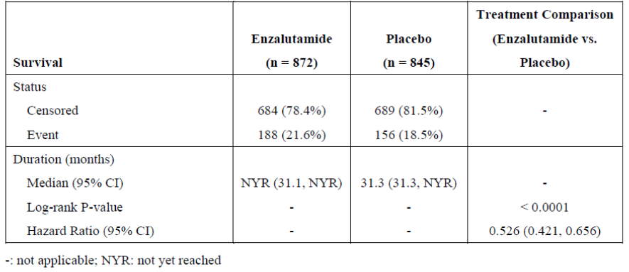
Evaluator response
The hazard of first skeletal-related event for the treatment-emergent period (HR: 0.526 [95% CI: 0.421, 0.656], P < 0.0001) should be that reported in the PI.
The results show a 3.1% difference in skeletal-related events between the study arms, in favour of enzalutamide. For the study-treatment period, this represents a number needed to treat of 33.
There was a similar proportion of each treatment arm that experienced first skeletal-related event in the treatment-emergent phase.
- What proportion of the skeletal related events occurred after commencement of cytotoxic chemotherapy in each PREVAIL treatment arm?
Sponsor response
In PREVAIL, in the enzalutamide arm, 14.4% of the SRE events were reported after the start of cytotoxic chemotherapy. In the placebo arm, with an earlier and higher use of chemotherapy during the same follow-up period, 26.2% of the initial SRE events were reported after the start of chemotherapy (Table 46).
Table 46: Overview of type of skeletal related events in relation to the use of cytotoxic treatment (ITT population).
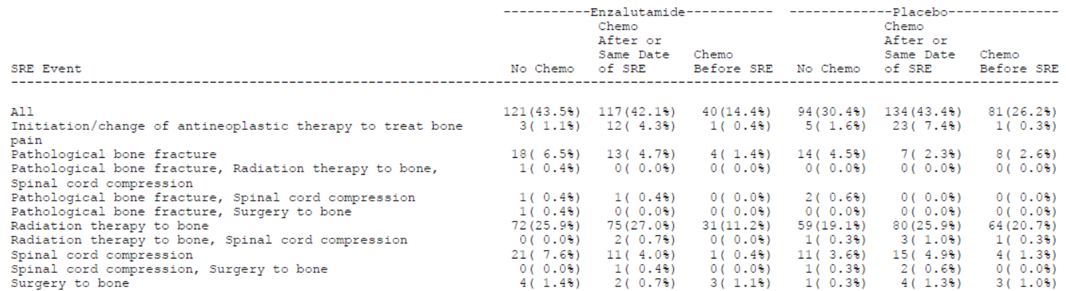
Evaluator response
From Table 46, the proportion of all skeletal-related events that occurred prior to chemotherapy was higher in the enzalutamide arm as compared to the placebo arm (121/278, 43.5% vs. 94/309, 30.4% respectively):
- The sponsor should confirm that patients who received abiraterone also received prednisone/prednisolone at all stages of the PREVAIL, as per the currently approved PI for abiraterone.
Sponsor response
Only a small number of patients received abiraterone concomitantly with enzalutamide in PREVAIL (Table 41). Patients who did receive abiraterone were to be treated per standard of care. Prednisone use was not required to be recorded in the follow-up period on the case report form (CRF) unless it was used during the safety reporting period.
Evaluator response
The response is satisfactory.
- What pharmacokinetic analysis was performed on patients receiving concomitant abiraterone and enzalutamide to ensure the safety of this combination?
Sponsor response
In PREVAIL, pharmacokinetic assessments of trough levels were performed at weeks 5, 13 and 26. No pharmacokinetic data were collected for concomitant use of abiraterone and enzalutamide as only 1 patient used this combination for > 1 day (Table 43). A separate study evaluating the combination of abiraterone and enzalutamide is currently being conducted.
Evaluator response
The safety of the regimen of concomitant administration of enzalutamide and abiraterone has not been satisfactorily established in the current submission.
- The sponsor should present the quality of life data for each treatment arm of PREVAIL for the study drug monotherapy period alone.
Sponsor response
In PREVAIL, quality of life (QoL) assessments were only conducted during the study treatment period. The small number of patients who received antineoplastic treatment concomitantly with enzalutamide for a short period of time does not have an impact on the reported QoL results.
Evaluator response
No data has been presented for evaluation to justify the sponsors’ assertion that no impact on QoL was observed.
- The sponsor should present the efficacy outcomes of OS and time to first skeletal-related event for each treatment arm of PREVAIL, stratified for concomitant additional therapy use.
Sponsor response
Please see the response to Efficacy: Question 5.
Evaluator response
No data has been presented for evaluation.
As per the response to question 15, 85.6% of patients in the enzalutamide arm experienced a SRE before the commencement of cytotoxic chemotherapy.
- The sponsor should present the PREVAIL sub-group analyses of OS for (i) those patients that only received study drug as monotherapy and (ii) those that received concomitant study drug plus additional therapy, prior to cessation of study drug.
Sponsor response
Please see the response to Efficacy: Question 5.
Evaluator response
No data has been presented for evaluation.
- What is the prognostic value of achieving a PSA concentration reduction of >50% from baseline for patients fulfilling the criteria to enter PREVAIL?
Sponsor response
Kaplan-Meier curves for the primary efficacy endpoints, duration of OS and rPFS, separated by PSA response (a decrease > 50% from baseline) versus no PSA response for PREVAIL are provided. Patients without a postbaseline assessment were excluded.
In the placebo-treated group nearly all patients were non-responders. In the enzalutamide-treated group, PSA responders showed a higher duration of OS and rPFS as compared to non-responders, demonstrating the potential predictive value of PSA response.
Evaluator response
This question has not been answered.
The sponsor was specifically asked to comment on the prognostic value of achieving a PSA concentration reduction of >50% from baseline. The results of a prognostic test have not been presented.
The sponsor describes a PSA reduction of >50% to have ‘potential predictive value’ - this does not relate to a recognised epidemiological term. The sponsor appears to be erroneously interchanging the proper term ‘positive predictive value’, which derives from a 2x2 analysis of a diagnostic test.
- Were patients in PREVAIL who had clinical progression prior to a skeletal-related event or radiographic progression permitted to received concomitant therapy prior to cessation of enzalutamide/placebo?
Sponsor response
No, per the PREVAIL protocol; patients who had clinical progression prior to radiographic progression or an SRE were not permitted to receive concomitant therapy prior to cessation of enzalutamide or placebo.
Evaluator response
This response is noted.
- In study 9785-0321, what were (i) the median (IQR) baseline bone mineral bone density t-score, and (ii) the median (IQR) change in bone mineral density t-score over time?
Sponsor response
In Study 9785-CL-0321, bone mineral density (BMD) scores were not recorded as t-scores.
Changes over time were presented by percent change from baseline as is commonly done to illustrate the potential effect of drug treatments. Table 47 shows there were minimal changes over time in BMD percent change from baseline.
Table 47: Median change and percentage change from baseline in bone mineral density as assessed by DXA scan.
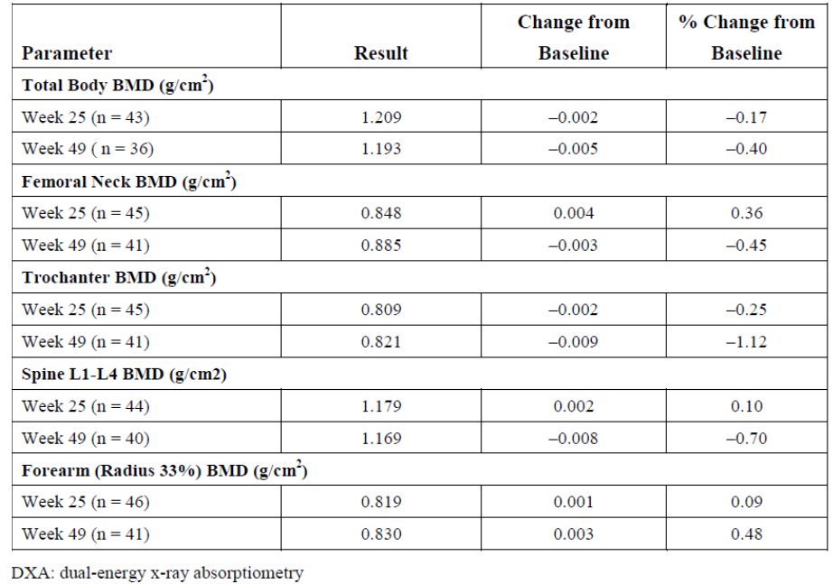
Evaluator response
This data is not included in the proposed PI.
The standard method of reporting bone density measurement is as a standardised t-score or z-score value. The effect of a certain percentage change from baseline is dependent upon where the baseline is situated.
The sponsor has only presented the median change from baseline. The interquartile range is not shown, which is more indicative of the effect observed in the study population.
In the absence of a placebo comparator arm, no meaningful assessment can be made of this limited, non-standardised, data to confirm the sponsors’ assertion that “minimal changes over time” in BMD occurred.
- The sponsor should confirm the reporting methods of the safety analysis. A safety analysis reporting only the period during which patients only received the study drug as monotherapy is requested, that is, excluding the period when concomitant use of additional therapies occurred, and excluding the period post-cessation of study drug. Outcomes should be reported including standardisation according to duration of study drug treatment.
Sponsor response
The sponsor would like to clarify that monotherapy is not an accurate term as all patients in PREVAIL were required to have continued androgen deprivation therapy with a GnRH analogue for the duration of the study or to have undergone bilateral orchiectomy (i.e., surgical or medical castration).
The safety analyses were based on the treatment-emergent period, which was defined as the date of the first dose of study drug to 28 days after the last dose of study drug or 1 day before the date of initiation of cytotoxic chemotherapy or an investigational agent for prostate cancer, whichever was first.
This means that the safety analysis was not truncated for patients who used abiraterone at the same time as the study drug (6 patients in each group, see response Efficacy: Question 1).
However, the safety analysis was truncated if the patient started with docetaxel (7 patients in total, see response to Efficacy: Question 2). Given the small number of patients and the short period of overlap, there is no impact on the results from the safety analysis.
Evaluator response
The use of ‘monotherapy’ in this instance was to refer to the period during which patients were receiving enzalutamide or placebo, in association with GnRH analogue, rather than ‘combination therapy’ as described in the responses to efficacy questions 1 & 2.
A small number of patients received concomitant abiraterone and enzalutamide; the sponsor confirms a study of this combination is being conducted currently.
However, the total proportion of patients in the enzalutamide and placebo arms which received concomitant therapies is shown from the responses to Efficacy questions 2 & 13 – 2.9% and 5.7%, respectively.
The method of reporting includes a 28-day period following cessation of enzalutamide or placebo when additional therapies were received, which were imbalanced between study arms. The effect would plausibly increase the number of observed AEs in the ‘placebo’ arm compared to the ‘enzalutamide’ arm, minimising the apparent adverse safety profile of enzalutamide.
- Can the sponsor explain the difference in incidence of TEAEs leading to death in enzalutamide-treated patients in PREVAIL (37/871 = 4.2%) as compared to the incidence of any TEAE leading to death in AFFIRM of 2.9%.
Sponsor response
The difference in the incidence of TEAEs leading to death is a result of the median treatment duration in the enzalutamide arm in PREVAIL (16.6 months) versus AFFIRM (8.3 months), which resulted in nearly twice the treatment period length in the PREVAIL study.
Evaluator response
The relationship between duration of exposure and incidence of TEAE leading to death is noted. The sponsor has not provided a standardised measure of exposure (i.e. events per 100 patient-years) to satisfactorily explain this finding. The difference in TEAE incidence should be in the PI.
- What was the incidence of treatment related death (as opposed to treatment emergent) for patients in PREVAIL while receiving monotherapy study drug?
Sponsor response
In the PREVAIL study, the incidence of TEAEs leading to death in enzalutamide-treated patients was 4.2%. None of the fatal events in the enzalutamide arm were assessed by the investigator as related to the study drug.
Evaluator response
The evaluator notes that none of the TEAEs leading to death were considered treatment-related in PREVAIL.
- The cause of death for 9 enzalutamide treated patients and 4 placebo treated patients in PREVAIL was described as ‘general health deterioration’. The sponsor is requested to provide a more thorough explanation for the actual cause of death for these thirteen patients.
Sponsor response
Deaths occurring during the treatment-emergent period of PREVAIL were reported on both the adverse event (AE) CRF and the end of study CRF. Deaths occurring in the long-term follow-up period were reported only on the end of study CRF. The AE CRF reported the specific grade 5 clinical event whereas the end of study CRF classified all deaths as due to prostate cancer “disease progression,” due to “other causes” unrelated to prostate cancer, or due to “unknown causes.” On the end of study CRF the category of “disease progression” includes patients who had AEs leading to death reported as specific clinical sequelae, but for whom the investigator attributed the overall cause of death as disease progression. For deaths reported as due to “other causes,” investigators were to enter the specific cause of death, which was then coded in MedDRA version 16.1.
In PREVAIL, “general physical health deterioration” was the preferred term for TEAEs leading to death on the AE CRF for 9 (1.0%) enzalutamide-treated patients and 4 (0.5%) placebo-treated patients. In each case, the primary cause of death was determined from the end of study CRF as disease progression. The primary cause of death for each of these 13 patients was assessed as unrelated or unlikely to be related to the study drug.
Evaluator response
The evaluator notes the relationship between exposure to enzalutamide and death among these 13 patients was assigned ‘unrelated’ or ‘unlikely’.
- The cause of AEs leading to death in 4 enzalutamide treated patients and 1 placebo treated patient in PREVAIL is listed as ‘death’. The sponsor is requested to provide a more thorough explanation for the actual cause of death for these five patients.
Sponsor response
Deaths occurring during the treatment-emergent period of PREVAIL were reported on both the AE CRF and the end of study CRF. Deaths occurring in the long-term follow-up period were reported only on the end of study CRF. The AE CRF reported the specific grade 5 clinical event whereas the end of study CRF classified all deaths as due to prostate cancer “disease progression,” due to “other causes” unrelated to prostate cancer, or due to “unknown causes.” In PREVAIL, “Death” was the preferred term for the TEAE leading to death on the AE CRF for 4 (0.5%) enzalutamide-treated patients and 1 (0.1%) placebo-treated patient.
In each case, the primary cause of death from the end of study CRF was listed as unknown.
The category of “unknown” includes patients whose deaths were from unknown causes (i.e., without autopsy or other information available) as well as patients whose cause of death was not obtained by investigators.
Of note, a review of all treatment emergent events resulting in death showed no clinically meaningful difference between treatment groups (4.2% enzalutamide-treated patients, and 3.8% in the placebo-treated patients). The imbalance between treatment groups in the number of fatal events may be attributed to the longer time on study for enzalutamide-treated patients compared with placebo-treated patients, as the median time on enzalutamide treatment was 3.6-fold longer than median time on placebo treatment. The following information is available regarding the above mentioned patients:
- Patient [information redacted] (placebo)
An [information redacted] patient with progressive metastatic prostate cancer entered the study with more than 20 bone lesions and rising PSA. Non-serious events reported before the death included arthralgia, musculoskeletal chest pain, dyspnea, and bilateral pleural effusions.
Concomitant medications at the time of death were prednisone, atorvastatin, ramipril, oxybutynin transdermal patch, sodium bicarbonate, allopurinol, ciclopirox, acetaminophen, insulin glulisine, insulin glargine, salbutamol, and Fluticasone/salmeterol.
Ten days before patients’ death, he was noted to have grade 1 pleural effusion. Three days later the study drug was permanently discontinued due to disease progression. No abnormalities in vital signs or physical examination were noted at last visit, and an ECG showed right bundle branch block (RBBB) (present at baseline). One week after study drug discontinuation, the patient experienced “death unexplained” when he died at home. It is unknown whether he had any symptoms before his death. The cause of death was unknown; a death certificate could not be obtained, and no autopsy was performed.
- Patient [information redacted] (enzalutamide)
A [information redacted] patient entered the study with more than 20 lesions on bone scan, multiple liver lesions, and rising PSA.
Medical history included high blood pressure, dyslipidemia, and a recent diagnosis of aortic arteriosclerosis. No AEs were reported before his death. Concomitant medications at the time of death included goserelin, methotrexate, vitamin D, folic acid, and prednisone.
Twenty-one days after initiating the study drug, the patient died at home and was found by police. At the baseline visit, serum glucose was 121 mg/dL (range, 70 – 100 mg/dL), with a plan for evaluation by the patient’s family physician. Blood pressure was 116/68 mm Hg and pulse 114 beats per minute (bpm). ECG showed normal sinus rhythm at a rate of 111 – 112 bpm without other abnormalities. Hemoglobin was 9.0 g/dL (range, 12.5 – 17 g/dL), a decrease from 10.0 g/dL 3 weeks earlier during the screening visit. No further information and no autopsy report were available for this patient.
The investigator considered the relationship between the serious AE of “death” and enzalutamide to be unrelated.
- Patient [information redacted] (enzalutamide)
A [information redacted] patient entered the study with a nontarget latero-aortic lymph node lesion and rising PSA. A screening computerized tomography (CT) scan of the chest showed a noncompressive pericardial effusion but no pleural fluid, 1.5-cm lymph nodes in the anterior mediastinum and near the left renal pedicle, and heterogeneous liver consistent with known liver steatosis. A screening ECG showed sinus tachycardia and RBBB, and baseline serial ECGs showed RBBB, left atrial abnormality, and minimally prolonged QTcB (488 – 502 ms), but not QTcF (453 – 465 ms). An ECG four days after initiation of study drug was unchanged, with RBBB, left atrial abnormality, and prolonged QTc.
The patient experienced serious AEs of grade 3 “gastroenteritis” 13 days after initiation the study drug and a grade 4 “hypokaliemia” 23 days after initiating the study drug. Ten days later, 33 days after initiation of study drug, the event “unknown cause of death” was reported.
Concomitant medication at time of death included leuprorelin, bromocriptine, Fluticasone/salmeterol, beclomethasone, salbutamol, cytelium lotion, and dorzolamide.
Approximately 2 weeks after initiating study drug, the patient was hospitalized for “gastroenteritis” with persistent nonserious grade 2 nausea and vomiting, musculoskeletal chest pain, and hematoma of the left lumbar fossa. A stool culture was negative for Clostridium difficile. Treatment included diosmectite, racecadotril, nifuroxazide, and intravenous fluids. Study drug was temporarily interrupted due to nausea and vomiting, and the patient was discharged later in the day. Three weeks after initiating study drug, study drug was resumed and the patient was hospitalized for “hypokaliemia” with deteriorating general state. Potassium was 2.4 mmol/L and improved after treatment to 3.4 - 4.3 mmol/L on various dates. Non-serious grade 2 “hypokaliemia” remained ongoing and was attributed to recent diarrhea. The patient was discharged.
Approximately 1 month after initiating study drug, and 2 weeks after resuming study drug following a temporary interruption, the patient was found dead at home and an event of “unknown cause of death” was reported. A visiting nurse reported that the patient had no concerns or changes in medications. A death certificate was not available and an autopsy was not performed. Study drug was continued up until the day of death. The investigator considered the relationship between “unknown cause of death” and enzalutamide to be unrelated.
- Patient [information redacted] (enzalutamide)
An [information redacted] patient with progressive metastatic prostate cancer entered the study with 5 to 9 lesions on bone scan and rising PSA.
Concomitant medications ongoing at the time of death included leuprorelin, amlodipine, pantoprazole, enalapril, and bromazepam.
At the week 61 visit, approximately 9 weeks before death, the patient’s vital signs and weight were stable, and ECOG performance status improved from a baseline status of 1 to 0.
An ECG was reported as “abnormal” with ST depression, but the site reported the findings as not clinically significant. There were no significant changes in laboratory studies and no evidence of radiographic disease progression. Approximately 15 months after initiating the study drug, the patient died in his sleep. The patient was in his usual health and had no complaints during that day or before going to bed. An autopsy was not performed. No other clinical information was available.
The investigator considered the relationship between event of “death” and enzalutamide to be unlikely.
- Patient [information redacted] (enzalutamide)
A [information redacted] patient with progressive metastatic prostate cancer entered the study with a single lesion on bone scan and rising PSA.
Concomitant medications ongoing at time of death included leuprorelin, metoprolol, allopurinol, ramipril, hydrochlorothiazide, ibuprofen, Silybum marianum, tramadol, and phytomenadione.
The patient had a known history of alcohol liver disease.
The patient’s baseline alanine aminotransferase (ALT) was 74 U/L (range, 6 – 43 U/L), aspartate aminotransferase (AST) 102 U/L (range, 11 – 36 U/L), alkaline phosphatase 122 U/L (range, 35 – 131 U/L), LDH 259 U/L (range, 53 – 234 U/L), and total bilirubin 0.9 mg/dL (range, 0.2 - 1.2 mg/dL).
On week 13, the patients’ ALT was 164 U/L, AST 301 U/L (grade 3), alkaline phosphatase (ALP) 191 U/L, LDH 280 U/L, and total bilirubin 1.1 mg/dL.
On week 25, ALT was 58 U/L, AST 128 U/L, ALP 188 U/L, LDH 233 U/L, and total bilirubin 1.0 mg/dL; a CT scan of the abdomen and pelvis showed 2 new visceral liver lesions in the right lobe measuring 57 × 58 mm and 46 × 37 mm, in an area of hepatic steatosis.
Approximately 7 months after initiating study drug, the patient was diagnosed with a grade 3 “hepatocellular carcinoma.” Histology showed parenchyma with nodular tumor proliferation, a basophilic cytoplasm, and nuclear pleomorphism. There was no evidence of biliary obstruction. Following the biopsy, the patient developed nonserious grade 2 hypocoagulation treated with plasma, coagulation factors, and phytomenadione. There was no known hepatitis B or C infection, and alpha-fetoprotein level was not known.
At the week 37 visit, 8 days before the patient’s death, the ECOG performance status decreased to 1 from 0 at baseline, and weight decreased to 91.4 kg from 98.1 kg at baseline. White blood cell (WBC) count was 11.14 × 109/L (range, 3.80 - 10.70 × 109/L), BUN 12.7 mmol/L (range, 1.4 - 8.6 mmol/L), creatinine 212 μmol/L (range, 40 – 110 μmol/L), ALP 172 mg/dL, AST 158 U/L, ALT 53 U/L, and total bilirubin 1.9 mg/dL.
Approximately 8 months after initiating study drug, the patient experienced “death due to unknown reason.” Information regarding the death was found on a public website and no other information was available. It is unknown if an autopsy was performed, and other records could not be obtained. The investigator considered the relationship between “death due to unknown reason” and enzalutamide to be unlikely.
Evaluator response
The lack of meaningful safety information from these patient narratives is noted.
- The sponsor is requested to provide a sufficient explanation of the non-specific term ‘toxidermia’ for the two patients in whom it occurred.
Sponsor response
Two patients (300-300021 and 300-300024) in the enzalutamide arm of PREVAIL experienced a serious adverse event (SAE) involving rash and were diagnosed with toxidermia by skin biopsy. The details of the events of toxidermia are provided below:
- Patient [information redacted]
A [information redacted] patient without history of allergies experienced an SAE of grade 3 “cutaneous toxicity (rash)” 8 days after initiating study drug. Ongoing medications at the time of event included leuprorelin and vitamin B.
The patient presented with pruriginous maculopapular rash with confluent lesions which started on the back of the thighs and spread to the trunk, covering more than 50% of the body surface area. Study drug was temporarily interrupted. Cutaneous biopsy showed grade 3 toxidermia with hypervascularization of inflammatory infiltrate gradually eroding the surface epidermis without signs of malignancy. The patient was treated with levocetirizine, hydroxyzine and topical steroids. The patient was afebrile without hyperleukocytosis or hypereosophilia. Study drug was restarted at a reduced dose of 40 mg/day and gradually escalated to full dose (160 mg/day) without recurrence of rash.
The investigator considered the relationship between the SAE of “cutaneous toxicity (rash)” and enzalutamide to be possible.
- Patient [information redacted]
A [information redacted] patient with medical history of drug hypersensitivity experienced an SAE of grade 2 “toxidermia” 30 days after initiating study drug. Ongoing medications at the time of the event included goserelin, irbesartan/hydrochlorothiazide, nebivolol, zolpidem, alprazolam, and paracetamol.
The patient developed a cutaneous rash on the lower limb, arm, pelvic, and inguinal areas.
A dermatology evaluation noted an erythematous maculopapular rash in the axillary folds, groin, umbilical folds, and face with hand edema, 2 small pustules in the groin area without lymph node involvement, negative Nickolsky’s sign, and skin peeling involving less than 20% of total body surface area. Hypereosinophilia was present with an eosinophil count of 600/mm2 (range not provided). A skin biopsy revealed some interstitial and pericapillary mononucleated inflammatory cells and rare eosinophils; histological appearance was subnormal, but not inconsistent with a diagnosis of toxidermia. Study drug was temporarily interrupted, and treatment with topical betamethasone and desloratadine was initiated.
Enzalutamide was restarted at a reduced dose of 40 mg/day and gradually escalated to full dose (160 mg/day) without recurrence of toxidermia.
The investigator considered the relationship between the event of toxidermia and enzalutamide to be possible.
The temporal relationship of the events of cutaneous toxicity (rash) and toxidermia with enzalutamide was present in both patients. However, the events did not recur on rechallenge with the study drug in either patient. Therefore, it seems more likely that the toxidermia was due to an environmental factor or another concomitant medication the patients were taking.
Evaluator response
The evaluator notes the sponsors’ determination of a temporal relationship between enzalutamide exposure and occurrence of rash in both patients. The first patient received anti-histamine and topical steroids prior to rechallenge, which may have minimised the risk of recurrence.
The maculopapular rash in the second patient is consistent with a diagnosis of toxic epidermal necrolysis (TEN), due to the presence of erythematous rash, blistering and eosinophilia. This patient subsequently received topical corticosteroid and anti-histamine. The absence of recurrence on re-challenge does not exclude the diagnosis of TEN. The currently approved PIs for the concomitant medications taken by this patient do not report a risk of TEN. The risk of TEN should be included in the PI.
- The incidence of second malignancies observed in PREVAIL should be included in the PI.
Sponsor response
Literature suggests that patients with prostate cancer, in general, have an increased risk of developing a second malignancy compared with the general population.
A population-based study in Germany identified that the overall risk of a second malignancy among patients with prostate cancer was significantly increased by 14% compared with the general male population, more specifically, an increased risk for the cell types of urinary bladder, kidney, pancreas, melanoma of skin, leukemia, myeloma, brain/nervous system, renal pelvis/ureter, thyroid, and the small intestine [Braisch et al, 2012]. Prior radiotherapy appears to be a major factor associated with the increased risk of second malignancies such as bladder, gastrointestinal tract (including rectum), lung, and hematologic malignancies, and this risk may increase with time [Michaelson et al, 2008; Nieder et al, 2008; Nam et al, 2014].
At the 2014 American Society of Clinical Oncology meeting, 2 review studies were presented regarding the risk of second malignancy after a prostate cancer diagnosis. The first study evaluated new primary cancers arising 10 years or more after prostate cancer treatment and showed that men who receive external beam radiation therapy have a significantly increased risk of bladder and rectal cancer, with standardized incidence ratios (SIR) for bladder cancer of 1.42 vs. 0.76 (p < 0.0001) for prior radiation versus no radiation and SIR for rectal cancer of 1.70 vs. 0.74 (p < 0.0001) for prior radiation versus no radiation [Davis et al, 2014]. The second study evaluated 548 United States veterans with prior prostate cancer diagnosed between 1999 and 2011 and showed that 28% of the patients developed a second primary malignancy. Among the 95 patients with prior radiotherapy who later developed a second malignancy, 29% developed the second malignancy in the radiotherapy field (bladder, colon, and rectal cancer) and 11% developed a hematologic malignancy [Perez-Florez et al, 2014]. A number of other studies have reported a high frequency of double primary cancers of the bladder and prostate, suggesting that these 2 cancers may share a common carcinogenic process or that these patients are particularly susceptible to both cancers [Kinoshita et al, 2004]. Lastly, an increased risk of incident melanoma has been reported in the United States among patients with a history of prostate cancer and this increase is postulated to be associated with androgen imbalance [Li et al, 2013]. Based on these data the patients with prostate cancer are at increased risk of developing a second malignancy compared with men without prostate cancer, and that the increased risk is mainly due to genetic predisposition or treatment modalities such as radiotherapy.
The pattern of second malignancy observed in the PREVAIL study is generally consistent with these data, with the most common events being malignant melanoma, bladder cancers, and cancers of the gastrointestinal tract. The length of the follow-up of patients has to be considered in the occurrence of any secondary malignancy event.
Enzalutamide-treated patients in this study were followed for a median of 17.1 months vs. 5.4 months with placebo-treated patients, about of 12 months longer. Time to onset of second malignancy is another important factor. In the PREVAIL study, excluding nonmelanoma skin cancer, the time to onset ranged from 8 to 856 days (median of 267 days) in the enzalutamide group and from 15 to 454 days (median of 229 days) in the placebo group.
Additionally, assessment of the onset of second malignancy by anatomic type in the context of current knowledge of the long latency period for the observed nonprostate malignancies, independent of any additional potential risk associated with prior prostate cancer, the relatively short and similar time to onset in enzalutamide and placebo groups does not suggest either has contributory role in the development of second malignancy.
Cancers take many years and up to several decades after exposure to a causative agent to manifest clinically. The pattern and onset latency of second malignancies in the PREVAIL study does not appear to be clinically or substantially different between treatment groups.
There is no clear association between exposure to enzalutamide and the development of secondary malignancies; therefore, the sponsor does not believe the incidence of second malignancies should be included in the PI.
Table 48: Summary of grade 3 or higher second malignancies (safety population).
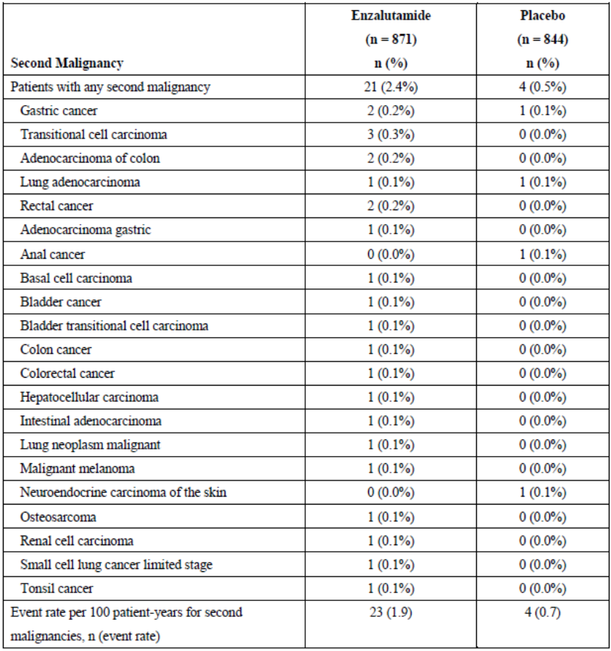
Evaluator response
The sponsor has re-presented the same table as in the dossier, without commenting on the finding in the evaluation that multiple terms have been used to describe the same kind of malignancy, thus giving the appearance of a lower risk.
The evaluator notes the absence of pre-clinical carcinogenicity studies of enzalutamide to date.
The sponsor has stated in their response to question 14 that the ‘follow-up phase maintained study blinding and was therefore still considered randomised’.
The event rate presented is from a randomised controlled trial where patients were blalnced in terms of age and disease state at baseline. Thus the results can be considered to reflect the difference between the exposure to enzalutamide and placebo. As per table 8, above, the event rate of second malignancy was higher in the enzalutamide arm than the placebo arm (1.9 & 0.7 events per 100 patient-years respectively). This information should be included in the PI.
- In the post marketing safety report, six patients were reported to have either ‘neoplasm’ or ‘neoplasm malignant’ or ‘lymphangiosis carcinomatosa’. What is the histological diagnosis of the cancer for these six patients, and what was their duration of enzalutamide exposure?
Sponsor response
No histological diagnosis of the cancer for these 6 patients is available. The cases originated from spontaneous reporting and contain very limited information. In cases where onset latency information is available, the treatment duration with enzalutamide varied between 4 days and 3 months. The details of the reported cases are provided below:
One case of PT Lymphangiosis carcinomatosa:
- [Information redacted]
The event of lymphangiosis carcinomatosa was reported in a patient with prostate cancer, liver and lymph node metastases. No second malignances have been reported for this patient. The event of lymphangiosis carcinomatosa was reported 9 months after starting enzalutamide, however, the reporter did not specify the date of event of onset.
Four cases of PT Neoplasm malignant:
- [Information redacted]
A [information redacted] prostate cancer patient was reported to have died “from multiple cancers”.
The patient was treated with enzalutamide for 3 months and died 9 months after enzalutamide discontinuation. The reporter assessed the event as unrelated to enzalutamide.
- [Information redacted]
A [information redacted] patient with prostate cancer and colon cancer died due to colon and prostate cancer progression. Colon cancer was diagnosed prior to enzalutamide treatment. The patient received enzalutamide for only 7 days and died 3 days after enzalutamide was discontinued.
- [Information redacted]
This is a consumer case of an [information redacted] prostate cancer patient who “died due to cancer”.
The patient received enzalutamide for 2 months and died 1 month after enzalutamide was discontinued.
- [Information redacted]
A [information redacted] patient experienced a “new cancer” during enzalutamide treatment. The patient received enzalutamide for 5 days. Enzalutamide was discontinued due to fatigue and anorexia.
One case of PT Neoplasm:
- [Information redacted]
This consumer report referred to a metastatic prostate cancer patient who had back surgery with a tumor removed during enzalutamide treatment.
Evaluator response
The evaluator notes the ‘very limited information’ provided in these patient narratives, which do not yield any useful information.
- In Study 9785-CL-0321 were patients with reported new QTcF prolongation >500 msec a sub-group of those with new prolongation >480 msec?
Sponsor response
In PREVAIL, patients with a QTcF prolongation > 500 msec are included in the total of patients with a prolongation > 480 msec (PREVAIL CSR). A table of QTcF values by treatment group was not provided for Study 9785-CL-0321.
Evaluator response
This response is noted.
- In Study 9785-CL-0321, were the two deaths reported in the safety analysis set treatment related?
Sponsor response
As of the cut-off date, a total of 3 deaths were reported: 1 death was reported by the week 25 visit and 2 additional deaths were reported by the 1 year visit. All 3 deaths were assessed by the investigator as unrelated to study drug regimen.
Evaluator response
The evaluator notes the ‘unrelated’ categorisation of these deaths.
- What proportion of patients in PREVAIL were continuing to receive (i) a GnRH agonist and (ii) a GnRH antagonist, in each treatment arm? What was the incidence of cardiac and ECG TEAEs due to enzalutamide for patients receiving each GnRH treatment modality?
Sponsor response
All patients in PREVAIL were required to have continued androgen deprivation therapy with a GnRH analogue for the duration of the study or to have undergone bilateral orchiectomy (i.e., surgical or medical castration). Most patients were continuing to receive a GnRH agonist; 31 (3.6%) enzalutamide-treated and 22 (2.6%) placebo-treated patients were treated with a GnRH antagonist (i.e., degarelix). Safety results for such a small subgroup of patients are not meaningful).
The PREVAIL study included 82 patients who had undergone orchiectomy prior to enrollment in the study: 40 (4.6%) enzalutamide-treated and 42 (5.0%) placebo-treated patients. As a consequence of their surgery, these patients were not receiving LHRH agonist therapy prior to or in combination with their study treatment during the PREVAIL study, regardless of the method of deprivation (LHRH agonist or surgical castration) no differences in outcome were observed.
Evaluator response
The proportion of patients continuing to receive each treatment modality is noted.
The sponsor has not answered the second part of the question.
In regard to the 6.1% of patients who were continuing to receive Degarelix in addition to either enzalutamide or placebo, no data has been presented to substantiate the sponsors’ assertion that ‘safety results for such a small subgroup of patients are not meaningful’. Nor has the sponsor presented the data to support the statement “...regardless of the method of deprivation (LHRH agonist or surgical castration) no differences in outcome were observed”.
Any potential adverse effect of enzalutamide on the development of cardiac/ECG abnormalities may be confounded by the concomitant therapy received by the patient. The evaluator considers it very clinically relevant as to whether an increased risk of cardiac/ECG TEAEs were observed in particular groups of patients in order to manage & inform them satisfactorily.

Second round benefit-risk assessment

Second round assessment of benefits
After consideration of the responses to clinical questions, the benefits of enzalutamide, in addition to those in the first round evaluation, in the proposed usage are:
- A similarity of efficacy in patients dichotomised at age 75 years.

Second round assessment of risks
After consideration of the responses to clinical questions, the risks of enzalutamide in the proposed usage are:
- The sponsor has not provided a satisfactory response to establish if a difference in risk of adverse cardiac/ECG events according to type of GnRH agonist/antagonist use exists.
- A positive relationship between duration of enzalutamide exposure and fatal TEAE has been reported by the sponsor, but this has not been quantified further.
- Data from the randomised controlled trial PREVAIL demonstrates a higher incidence of second malignancy for patients exposed to enzalutamide than those exposed to placebo.
- In PREVAIL, the safety profile for patients exposed to enzalutamide aged ≥75 years was worse than for those aged <75 years.
- The occurrence of rash consistent with a diagnosis if toxic epidermal necrolysis has been reported.

Second round assessment of benefit-risk balance
The benefit-risk balance of enzalutamide is unfavourable given the proposed usage, but would become favourable if the changes recommended are adopted.

Second round recommendation regarding authorisation
The proposed indication could be supported if the sponsor satisfactorily responds to the relevant PI comments.

Therapeutic Goods Administration
PO Box 100 Woden ACT 2606 Australia
Email: info@tga.gov.au Phone: 1800 020 653 Fax: 02 6232 8605
https://www.tga.gov.au

Therapeutic Goods Administration, “Note for Guidance on Good Clinical Practice (CPMP/ICH/135/95)”, July 2000.
Concomitant treatment with abiraterone was allowed once patients had either confirmed radiographic progression or a skeletal-related event.
Ishak K, et al. (2014) Methods for adjusting of bias due to cross-over in oncology trials. Pharmacoeconomics 32: 533-546.
Hernán MA, Hernández-Díaz S. (2012) Beyond the intention to treat in comparative effectiveness research. Clin Trials 9: 48-55.
Concomitant treatment with abiraterone was only allowed once patients had either confirmed radiographic progression or a skeletal-related event.

