PRODUCT INFORMATION
XTANDI® 40 mg SOFT CAPSULES

NAME OF THE MEDICINE

Active ingredient: enzalutamide

Chemical structure:

Chemical name: 4-{3-[4-cyano-3-(trifluoromethyl)phenyl]-5,5-dimethyl-4-oxo-2-thioxoimidazolidin-1-yl}-2-fluoro-N-methylbenzamide

Molecular formula: C₂₁H₁₆F₄N₄O₂S

CAS registry number: 915087-33-1

DESCRIPTION

Enzalutamide is a white crystalline non-hygroscopic solid. It is practically insoluble in water.

XTANDI is provided as liquid-filled soft gelatin capsules for oral administration. Each capsule contains 40 mg of enzalutamide as a solution in caprylocaproyl macrogolglycerides.

XTANDI contains the following inactive ingredients: caprylocaproyl macrogolglycerides, butylated hydroxyanisole, butylated hydroxytoluene, gelatin, sorbitol sorbitan solution, glycerol, purified water, titanium dioxide. The soft capsules also contain OPACODE WB monogramming ink NSP-78-17827 BLACK.

PHARMACOLOGY

Pharmacology

Enzalutamide is an androgen receptor signalling inhibitor that blocks the androgen receptor signalling pathway. Enzalutamide competitively inhibits binding of androgens to androgen receptors, and consequently inhibits the nuclear translocation of these receptors and inhibits the binding of androgen receptor to DNA. In vitro, enzalutamide treatment decreased proliferation and induced prostate cancer cell death. Decreased tumour growth was seen in a mouse prostate cancer xenograft model. In preclinical studies enzalutamide lacked androgen receptor agonist activity against several prostate cancer cell lines. The active metabolite, N-desmethyl enzalutamide, exhibited similar in vitro activity to enzalutamide in the inhibition of testosterone binding to the androgen receptor.

Pharmacokinetics

The pharmacokinetics of enzalutamide have been evaluated in prostate cancer patients and in healthy male subjects. The mean terminal half-life (t_{1/2}) for enzalutamide in patients after a single oral dose is 5.8 days (range 2.8 to 10.2 days), and steady state is achieved in approximately one month. With daily oral administration, enzalutamide accumulates approximately 8.3-fold relative to a single dose. Daily fluctuations in plasma concentrations are low (peak-to-trough ratio of 1.25). Clearance of enzalutamide is primarily via hepatic metabolism, producing an active metabolite that circulates at approximately the same plasma concentration as enzalutamide.

Absorption

Maximum plasma concentrations (C_{max}) of enzalutamide in patients are observed 1 to 2 hours after administration. Based on a mass balance study in humans, oral absorption of enzalutamide is estimated to be at least 84.2%. Enzalutamide is not a substrate of the efflux transporters P-gp or BCRP. At steady state, the mean C_{max} values for enzalutamide and its active metabolite are 16.6 µg/mL (23% coefficient of variation [CV]) and 12.7 µg/mL (30% CV), respectively.

Food has no clinically significant effect on the extent of absorption. In clinical trials, XTANDI was administered without regard to food.

Distribution

The mean apparent volume of distribution (V/F) of enzalutamide in patients after a single oral dose is 110 L (29% CV). The volume of distribution of enzalutamide is greater than the volume of total body water, indicative of extensive extravascular distribution. Studies in rodents indicate that enzalutamide and its active metabolite can cross the blood brain barrier.

Enzalutamide is 97% to 98% bound to plasma proteins, primarily albumin. The active metabolite is 95% bound to plasma proteins. There was no protein binding displacement between enzalutamide and other highly bound drugs (warfarin, ibuprofen and salicylic acid) in vitro.

Metabolism

Enzalutamide is extensively metabolized. There are two major metabolites in human plasma: N-desmethyl enzalutamide (active) and a carboxylic acid derivative (inactive). Enzalutamide is metabolized by CYP2C8 and to a lesser extent by CYP3A4/5 (see INTERACTIONS WITH OTHER MEDICINES), both of which play a role in the formation of the active metabolite. N-desmethyl enzalutamide was not metabolized by CYPs in vitro.

Under conditions of clinical use, enzalutamide is a strong inducer of CYP3A4, a moderate inducer of CYP2C9 and CYP2C19, and has no clinically relevant effect on CYP2C8 (see INTERACTIONS WITH OTHER MEDICINES).

Excretion

The mean apparent clearance (CL/F) of enzalutamide in patients ranges from 0.520 and 0.564 L/h.

Following oral administration of ¹⁴C-enzalutamide, 84.6% of the radioactivity is recovered by 77 days post dose: 71.0% is recovered in urine (primarily as the inactive metabolite, with trace amounts of enzalutamide and the active metabolite), and 13.6% is recovered in faeces (0.39% of dose as unchanged enzalutamide).

Linearity

No major deviations from dose proportionality are observed over the dose range 40 to 160 mg. The steady-state C_{min} values of enzalutamide and the active metabolite in individual patients remained constant during more than one year of chronic therapy, demonstrating time-linear pharmacokinetics once steady-state is achieved.

Pharmacokinetic characteristics in special populations

Patients with hepatic impairment: The pharmacokinetics of enzalutamide were examined in subjects with baseline mild (N = 6) or moderate (N = 8) hepatic impairment (Child-Pugh Class A and B, respectively) and in 14 matched control subjects with normal hepatic function. Following a single oral 160 mg dose of enzalutamide, the AUC and C_{max} for enzalutamide in subjects with mild impairment increased by 5% and 24%, respectively, and the AUC and C_{max} of enzalutamide in subjects with moderate impairment increased by 29% and decreased by 11%, respectively, compared to healthy control subjects. For the sum of unbound enzalutamide plus the unbound active metabolite, the AUC and C_{max} in subjects with mild impairment increased by 14% and 19%, respectively, and the AUC and C_{max} in subjects with moderate impairment increased by 14% and decreased by 17%, respectively, compared to healthy control subjects. The patients in the moderate hepatic impairment group however had only modest impairment in parameters indicative of metabolic function (albumin, prothrombin time), and thus a larger effect in other patients with moderate hepatic impairment cannot be excluded.

Patients with baseline severe hepatic impairment (Child-Pugh C) were excluded from clinical trials.

Patients with renal impairment: No formal renal impairment study for enzalutamide has been completed. Patients with serum creatinine > 177 µmol/L (2 mg/dL) were excluded from clinical trials. Based on a population pharmacokinetic analysis, no dose adjustment is necessary for patients with calculated creatinine clearance (CrCL) values ≥ 30 mL/min (estimated by the Cockcroft and Gault formula). Enzalutamide has not been evaluated in patients with severe renal impairment (CrCL < 30 mL/min) or end-stage renal disease, and caution is advised when treating these patients. It is unlikely that enzalutamide will be significantly removed by intermittent haemodialysis or continuous ambulatory peritoneal dialysis.

Elderly: No clinically relevant effect of age on enzalutamide pharmacokinetics was seen in the population pharmacokinetic analysis.

Paediatric use: Safety and efficacy of enzalutamide in paediatric patients have not been established.

Gender and race: Most patients in the randomised clinical trials (>84.6%) were Caucasian. There are insufficient data to evaluate potential differences in the pharmacokinetics of enzalutamide in other races.

CLINICAL TRIALS

Efficacy of enzalutamide was established in two randomized placebo-controlled multicentre phase 3 clinical studies [CRPC2 (AFFIRM), MDV3100-03 (PREVAIL)] of patients with progressive metastatic prostate cancer who had failed androgen deprivation therapy [luteinising hormone-releasing hormone (LHRH) analogue or after bilateral orchiectomy]. The PREVAIL study enrolled chemotherapy-naive patients; whereas the AFFIRM study enrolled patients who had received prior docetaxel. All patients continued on a LHRH analogue or had prior bilateral orchiectomy. In the active treatment arm, XTANDI was administered orally at a dose of 160 mg daily. In both clinical trials, patients received placebo in the control arm and patients were allowed, but not required, to take prednisone (maximum daily dose allowed was 10 mg prednisone or equivalent).

Changes in PSA serum concentration independently do not always predict clinical benefit. Therefore, in both studies it was recommended that patients be maintained on their study treatments until discontinuation criteria were met as specified below for each study.

MDV3100-03 (PREVAIL) study (chemotherapy-naive patients)
A total of 1717 asymptomatic or mildly symptomatic chemotherapy-naive patients were randomized 1:1 to receive either enzalutamide orally at a dose of 160 mg once daily (N = 872) or placebo orally once daily (N = 845). Patients with visceral disease, patients with a history of mild to moderate heart failure (NYHA Class 1 or 2), and patients taking medications associated with lowering the seizure threshold were allowed. Patients with a previous history of seizure or a condition that might predispose to seizure and patients with moderate or severe pain from prostate cancer were excluded. Study treatment continued until disease progression (evidence of radiographic progression, a skeletal related event, or clinical progression) and the initiation of either a cytotoxic chemotherapy or an investigational agent, or until unacceptable toxicity.

Patient demographics and baseline disease characteristics were balanced between the treatment arms. The median age was 71 years (range 42-93) and the racial distribution was 77% Caucasian, 10% Asian, 2% Black and 11% other or unknown races. Sixty-eight percent (68%) of patients had an ECOG performance status score of 0 and 32% of patients had ECOG performance status 1. Baseline pain assessment was 0-1 (asymptomatic) in 67% of patients and 2-3 (mildly symptomatic) in 32% of patients as defined by the Brief Pain Inventory Short Form (worst pain over past 24 hours on a scale of 0 to 10). Approximately 45% of patients had measurable soft tissue disease at study entry, and 12% of patients had visceral (lung and/or liver) metastases.

Co-primary efficacy endpoints were overall survival and radiographic progression-free survival (rPFS). In addition to the co-primary endpoints, benefit was also assessed using time to initiation of cytotoxic chemotherapy, best overall soft tissue response, time to first skeletal-related event, PSA response (≥50% decrease from baseline), time to PSA progression, and time to FACT-P total score degradation.

Radiographic progression was assessed with the use of sequential imaging studies as defined by Prostate Cancer Clinical Trials Working Group 2 (PCWG2) criteria (for bone lesions) and/or Response Evaluation Criteria in Solid Tumors (RECIST v 1.1) criteria (for soft tissue lesions). Analysis of rPFS utilized centrally-reviewed radiographic assessment of progression.

At the pre-specified interim analysis for overall survival, although the overall survival data may be immature, treatment with enzalutamide demonstrated a statistically significant improvement in overall survival compared to treatment with placebo with a 29% reduction in risk of death [HR=0.706, (95% CI: 0.596; 0.837), p < 0.0001] (Table 1). Of note, 40.4% of enzalutamide-treated patients and 70.5% of placebo-treated patients received subsequent therapies with a demonstrated survival benefit.

Table 1: Overall Survival of Patients Treated with Either Enzalutamide or Placebo in the PREVAIL Study (Intent-to-Treat Analysis)

 | Enzalutamide  (N = 872) | Placebo  (N = 845)
Pre-specified interim analysis
Number of deaths (%) | 241 (27.6%) | 299 (35.4%)
Estimated median, months (95% CI) | 32.4 (30.1, NR) | 30.2 (28.0, NR)
P-value ª | < 0.0001
Hazard ratio (95% CI) ^{b} | 0.71 (0.60, 0.84)
^{a)} P-value is derived from an unstratified log-rank test
^{b)} Hazard Ratio is derived from an unstratified proportional hazards model. Hazard ratio <1 favours enzalutamide
NR, not reached.

Figure 1: Kaplan-Meier Overall Survival Curves Based on Pre-specified Interim Survival Analysis in the PREVAIL Study (Intent-to-Treat Analysis)
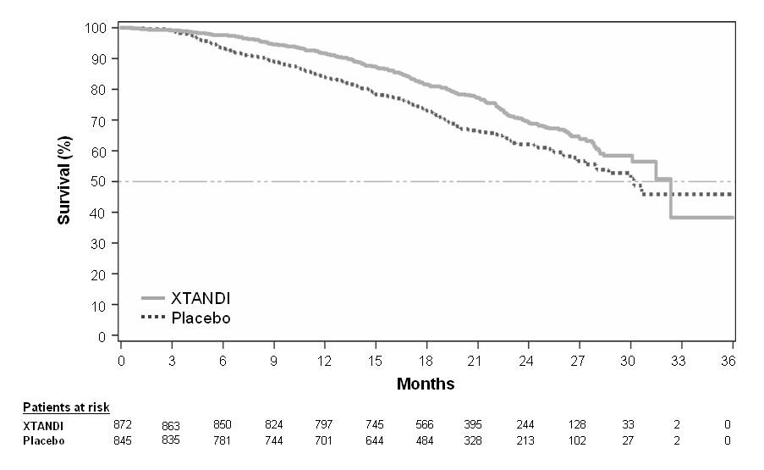

Figure 2: Overall Survival by Subgroup: Hazard Ratio and 95% Confidence Interval in the PREVAIL Study (Intent-to-Treat Analysis)
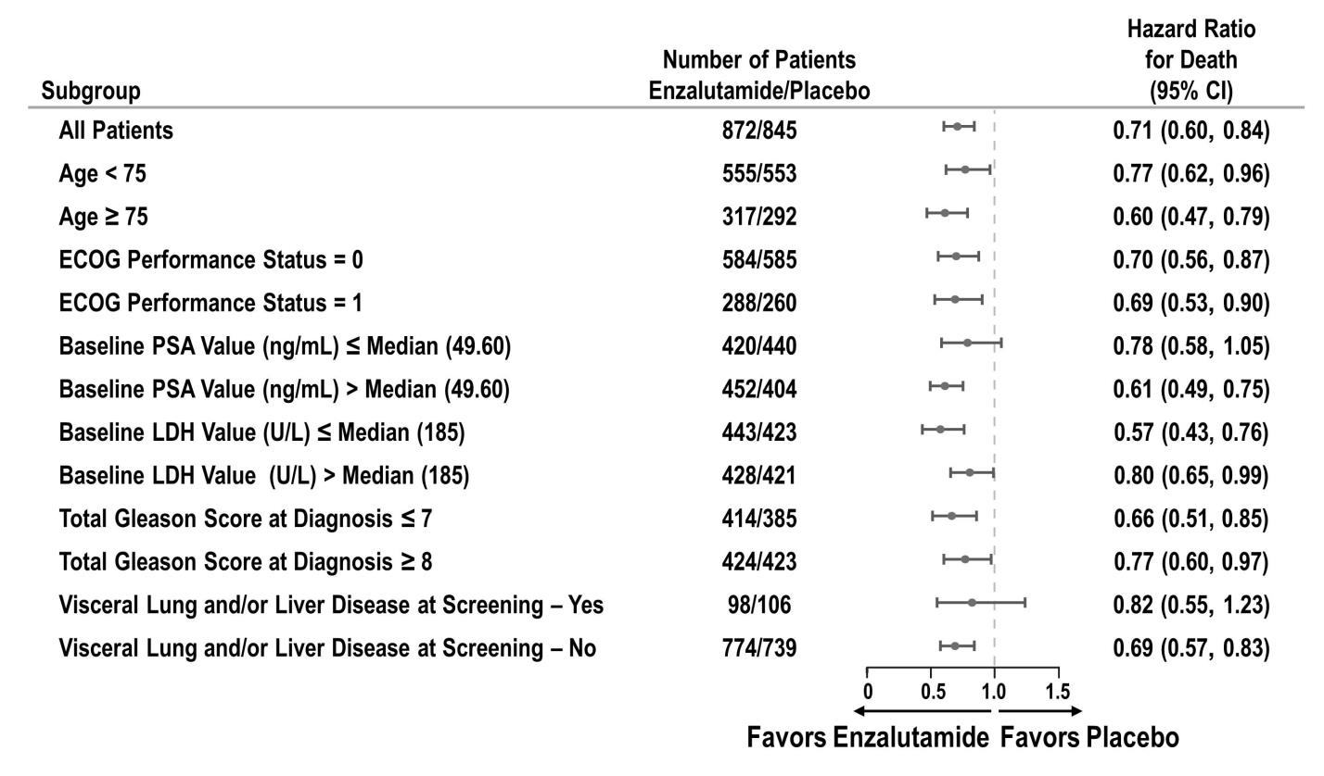

At the pre-specified rPFS analysis, a statistically significant improvement was demonstrated between the treatment groups with an 81.4% reduction in risk of radiographic progression or death [HR = 0.186 (95% CI: 0.149, 0.231), p < 0.0001]. One hundred and eighteen (14%) enzalutamide-treated patients and 321 (40%) of placebo-treated patients had an event. The median rPFS was not reached (95% CI: 13.8, not reached) in the enzalutamide-treated group and was 3.9 months (95% CI: 3.7, 5.4) in the placebo-treated group (Figure 3). Consistent rPFS benefit was observed across all pre-specified patient subgroups (e.g., age, baseline ECOG performance, baseline PSA and LDH, Gleason score at diagnosis, and visceral disease at screening). A pre-specified follow-up rPFS analysis based on the investigator assessment of radiographic progression demonstrated a statistically significant improvement between the treatment groups with a 69.3% reduction in risk of radiographic progression or death [HR = 0.307 (95% CI: 0.267, 0.353), p < 0.0001]. The median rPFS was 19.7 months in the enzalutamide group and 5.4 months in the placebo group.

Figure 3: Kaplan-Meier Curves of Radiographic Progression-Free Survival in the PREVAIL Study (Intent-to-Treat Analysis)
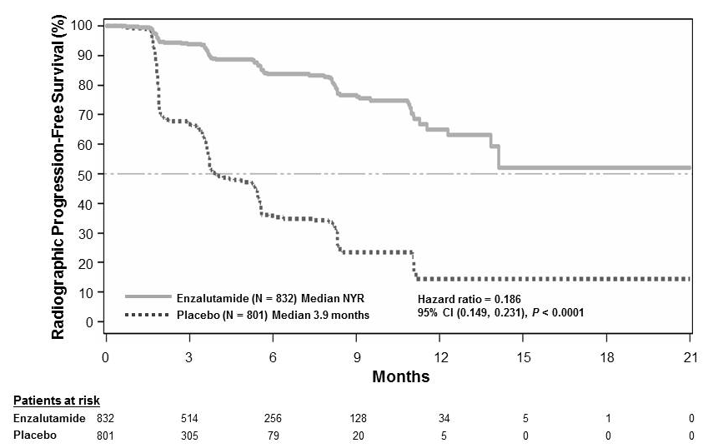

At the time of the primary analysis there were 1633 patients randomized.

In addition to the co-primary efficacy endpoints, statistically significant improvements were also demonstrated in the following prospectively defined endpoints.

The median time to initiation of cytotoxic chemotherapy was 28.0 months for patients receiving enzalutamide and 10.8 months for patients receiving placebo (HR=0.350, 95% CI: [0.303, 0.403], p<0.0001). The proportion of enzalutamide-treated patients with measurable disease at baseline who had an objective soft tissue response was 58.8% (95% CI: 53.8, 63.7) compared with 5.0% (95% CI: 3.0, 7.7) of patients receiving placebo. The absolute difference in objective soft tissue response between enzalutamide and placebo arms was 53.9% (95% CI: 48.5%, 59.1%, p<0.0001). Complete responses were reported in 19.7% of enzalutamide-treated patients compared with 1.0% of placebo-treated patients, and partial responses were reported in 39.1% of enzalutamide-treated patients versus 3.9% of placebo-treated patients.

Enzalutamide significantly decreased the risk of the first skeletal-related event by 27% [HR=0.526, (95% CI: 0.421, 0.656), p<0.0001], 21.6% of enzalutamide-treated patients reported a skeletal-related event versus 18.5% of placebo-treated patients, an absolute difference of 3.1% events.A skeletal-related event was defined as radiation therapy or surgery to bone for prostate cancer, pathologic bone fracture, spinal cord compression, or change of antineoplastic therapy to treat bone pain.

The median time to PSA progression per PCWG2 criteria was 11.2 months for patients treated with enzalutamide and 2.8 months for patients who received placebo [HR=0.169, (95% CI: 0.147, 0.195), p<0.0001].

Treatment with enzalutamide decreased the risk of FACT-P degradation by 37.5% compared with placebo (p<0.001). The median time to degradation in FACT-P was 11.3 months in the enzalutamide group and 5.6 months in the placebo group.

CRPC2 (AFFIRM) study (patients who previously received chemotherapy)
The efficacy and safety of XTANDI in patients with metastatic castration-resistant prostate cancer who had received docetaxel and were using a LHRH analogue or had undergone orchiectomy were assessed in a randomised, placebo-controlled, multicentre phase 3 clinical trial (AFFIRM). A total of 1199 patients were randomised 2:1 to receive either XTANDI orally at a dose of 160 mg once daily (N = 800) or placebo once daily (N = 399). Patients were allowed but not required to take prednisone (maximum daily dose allowed was 10 mg prednisone or equivalent). Patients randomised to either arm were to continue treatment until disease progression (defined as confirmed radiographic progression or the occurrence of a skeletal-related event) and initiation of new systemic antineoplastic treatment, unacceptable toxicity, or withdrawal. Following progression, 41% of study drug arm and 61.7% of placebo arm received ≥1 further systemic treatments therefore the observed survival data and Kaplan-Meier curve reflect a median duration of treatment of 8 months of enzalutamide vs 3 months of placebo followed by additional treatments.

The following patient demographics and baseline disease characteristics were balanced between the treatment arms. The median age was 69 years (range 41-92) and the racial distribution was 92.7% Caucasian, 3.9% Black, 1.1% Asian, and 2.1% Other. The ECOG performance score was 0-1 in 91.5% of patients and 2 in 8.5% of patients; 28.4% had a mean Brief Pain Inventory score of ≥4 (mean of patient’s reported worst pain over the previous 24 hours calculated for seven days prior to randomization). Most (91.2%) patients had metastases in bone and 23.2% had visceral lung and/or liver involvement. At study entry, 41% of randomized patients had PSA progression only, whereas 59% of patients had radiographic progression. Fifty-one percent (51%) of patients were on bisphosphonates at baseline.

The AFFIRM study excluded patients with medical conditions that may predispose them to seizures (see ADVERSE EFFECTS) and medications known to decrease the seizure threshold, as well as clinically significant cardiovascular disease such as uncontrolled hypertension, recent history of myocardial infarction or unstable angina, New York Heart Association class III or IV heart failure (unless ejection fraction was ≥ 45%), clinically significant ventricular arrhythmias or AV block (without permanent pacemaker).

The protocol pre-specified interim analysis after 520 deaths showed a statistically significant
superiority in overall survival in patients treated with XTANDI compared to placebo (Table 2 and Figure 4).

Table 2: Overall Survival of Patients treated with Either XTANDI or Placebo in the AFFIRM Study (intent-to-treat analysis)ª

 | XTANDI (N = 800) | Placebo (N = 399)
Deaths (%) | 308 (38.5%) | 212 (53.1%)
Median survival (months) (95% CI) | 18.4 (17.3, NR) | 13.6 (11.3, 15.8)
P-valueb | < 0.0001
Hazard ratio (95% CI)c | 0.631 (0.529, 0.752)
ª Median duration of treatment of 8 months of enzalutamide vs 3 months of placebo followed by additional treatments.
^{b} P-value is derived from a log-rank test stratified by ECOG performance status score (0-1 vs. 2) and mean pain score (< 4 vs. ≥ 4)
^{c} Hazard ratio is derived from a stratified proportional hazards model. Hazard ratio < 1 favours XTANDI

Figure 4: Kaplan-Meier Overall Survival Curves in the AFFIRM Study (Intent-to-Treat Analysis)

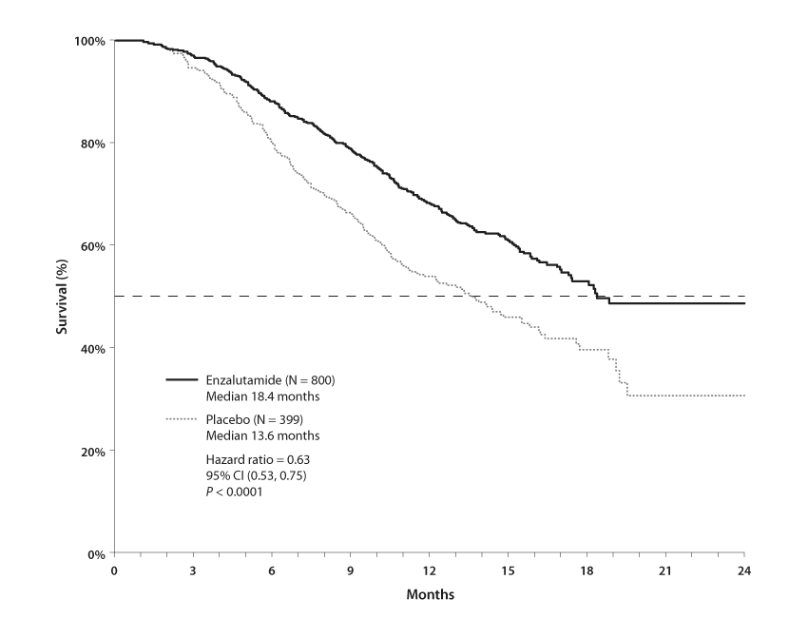Figure 5: Overall Survival by Subgroup in the AFFIRM Study – Hazard Ratio and 95% Confidence Interval
XTANDI (n=800)
Median 18.4 months
Placebo (N=399)
Median 13.6 months
Hazard ratio = 0.63
95% CI (0.53, 0.75)
P < 0.0001
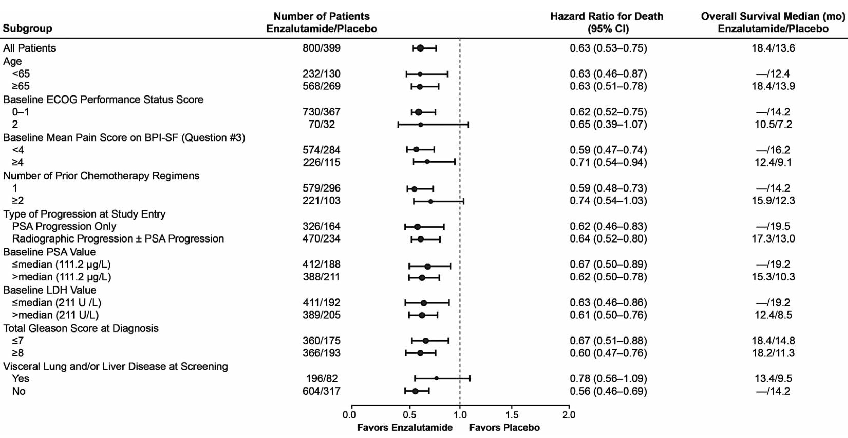
ECOG: Eastern Cooperative Oncology Group; BPI-SF: Brief Pain Inventory-Short Form; PSA: Prostate Specific Antigen

In addition to the observed improvement in overall survival, key secondary endpoints (radiographic progression-free survival, and time to first skeletal-related event) favoured XTANDI and were statistically significant after adjusting for multiple testing.

Radiographic progression-free survival as assessed by the investigator using RECIST v1.1 for soft tissue and appearance of 2 or more bone lesions in bone scan was 8.3 months for patients treated with XTANDI and 2.9 months for patients who received placebo (HR = 0.404, 95% CI: [0.350, 0.466]); p < 0.0001). The analysis involved 216 deaths without documented progression and 645 documented progression events, of which 303 (47%) were due to soft tissue progression, 268 (42%) were due to bone lesion progression and 74 (11%) were due to both soft tissue and bone lesions.

The median time to first skeletal-related event was 16.7 months for patients treated with XTANDI and 13.3 months for patients who received placebo (HR = 0.688, 95% CI: [0.566, 0.835]; p < 0.0001). A skeletal-related event was defined as radiation therapy or surgery to bone, pathologic bone fracture, spinal cord compression, or change of antineoplastic therapy to treat bone pain.

The efficacy of enzalutamide in patients who have previously received abiraterone acetate has not been studied.

Older people
Of the 1671 patients in the phase 3 trials who received enzalutamide, 1261 patients (75.5%) were 65 years and over and 516 patients (30.9%) were 75 years and over. No overall differences in safety or effectiveness were observed between these older patients and younger patients. The incidence of serious adverse events, fatal adverse events and adverse events leading to discontinuation was higher in older patients (≥75 years). For patients ≥ 75 years, one of these adverse events was reported in 50.5% of patients in the enzalutamide arm and 50.0% in the placebo arm. For patients < 75 years, one of these adverse events was reported in 37.0% of patients in the enzalutamide arm and 29.5% of patients in the placebo arm.

INDICATIONS

XTANDI is indicated for:

- the treatment of patients with metastatic castration resistant prostate cancer following failure of androgen deprivation therapy in whom chemotherapy is not yet indicated.

- the treatment of patients with metastatic castration-resistant prostate cancer who have previously received docetaxel.

CONTRAINDICATIONS

XTANDI is contraindicated in patients with known hypersensitivity to enzalutamide or to any of the excipients in the formulation.

XTANDI is not indicated for use in women. XTANDI is contraindicated in women who are, or may become, pregnant (see PRECAUTIONS – Contraception in males and females, and Use in pregnancy).

PRECAUTIONS

XTANDI capsules should only be prescribed by a medical practitioner who is experienced with the treatment of prostate cancer and the use of antineoplastic endocrine therapies.

The following are clinically significant: seizures (see Risk of seizure below), PRES (see Posterior reversible encephalopathy syndrome below) and drug interactions (see INTERACTIONS WITH OTHER MEDICINES).

Risk of seizure

The risk to patients, especially those with predisposing factors for seizures has not been studied and is unknown. In the AFFIRM clinical trial, which enrolled patients who previously received docetaxel, 7 of 800 (0.9%) patients treated with XTANDI 160 mg once daily experienced a seizure. No seizures occurred in patients treated with placebo. In the PREVAIL clinical trial, 1 of 871 (0.1%) chemotherapy-naïve patients treated with XTANDI and 1 of 844 (0.1%) patients treated with placebo experienced a seizure. Patients experiencing a seizure were permanently discontinued from therapy and all seizure events resolved. There is no clinical trial experience re-administering XTANDI to patients who experienced seizure.

Because of the risk of seizure associated with XTANDI use, patients should be advised of the risk of engaging in any activity where sudden loss of consciousness could cause serious harm to themselves or others.

Caution should be used in administering XTANDI to patients with a history of seizures or other predisposing factors including, but not limited to, underlying brain injury, stroke, primary brain tumours or brain metastases, or alcoholism. In addition, the risk of seizure may be increased in patients receiving concomitant medicines that lower the seizure threshold.

Posterior reversible encephalopathy syndrome

There have been rare reports of posterior reversible encephalopathy syndrome (PRES) in patients receiving XTANDI. PRES is a rare, reversible, neurological disorder which can present with rapidly evolving symptoms including seizure, headache, confusion, blindness, and other visual and neurological disturbances, with or without associated hypertension. A diagnosis of PRES requires confirmation by brain imaging, preferably magnetic resonance imaging. Discontinuation of XTANDI in patients who develop PRES is recommended.

Falls and fall-related injuries

In the two randomised clinical trials (AFFRIM and PREVAIL), falls or injuries related to falls occurred in 9% of patients treated with XTANDI compared to 4% of patients treated with placebo. Falls were not associated with loss of consciousness or seizure. Fall-related injuries were more severe in patients treated with XTANDI and included non-pathologic fractures, joint injuries, and hematomas. Androgen deprivation therapy has been known to cause bone loss. For patients who fall or have a concomitant recognised risk of falling, it is recommended that the physicians consider additional supportive therapy when appropriate.

Hypersensitivity reactions

Hypersensitivity reactions manifested by symptoms including, but not limited to, tongue oedema, lip oedema and pharyngeal oedema have been observed with enzalutamide (see Contraindications).

Androgen deprivation therapy may prolong the QT interval

In patients with a history of or risk factors for QT prolongation and in patients receiving concomitant medicinal products that might prolong the QT interval, physicians should assess the benefit risk ratio including the potential for Torsade de pointes prior to initiating XTANDI.

Recent cardiovascular disease

The phase 3 studies excluded patients with recent myocardial infarction (in the past 6 months) or unstable angina (in the past 3 months), New York Heart Association (NYHA) Class III or IV heart failure except if Left Ventricular Ejection Fraction (LVEF) ≥ 45%, bradycardia or uncontrolled hypertension. This should be taken into account if XTANDI is prescribed in these patients.

Hypertension

In the two randomized trials, hypertension was reported in 11% of patients receiving XTANDI and 4% of patients receiving placebo. The difference in frequency of hypertensive events between the enzalutamide and placebo-treated groups was larger in the PREVAIL trial (13.9% enzalutamide; 4.7% placebo) than in the AFFIRM trial (7% enzalutamide; 3.2% placebo). No patients experienced hypertensive crisis. Medical history of hypertension was balanced between arms. Hypertension led to study discontinuation in <1% of patients in each arm.

Risk of second malignancy

In the PREVAIL study, the event rate of second malignancy was higher in the enzalutamide arm (1.9 events per 100 patient-years; median follow-up time was 17.1 months) than the placebo arm (0.7 events per 100 patient-years; median follow-up time was 5.4 months). Median time to onset of second malignancy, excluding nonmelanoma skin cancer, was 267 days (range 8 to 856 days) in the enzalutamide group and 229 days (range 15 to 454 days) in the placebo group.

Use with chemotherapy

The safety and efficacy of concomitant use of XTANDI with cytotoxic chemotherapy has not been established.

Renal impairment

Caution is required in patients with severe renal impairment as XTANDI has not been studied in this patient population.

Hepatic impairment

No dose adjustment is required for mild hepatic impairment (Child-Pugh Class A). Caution is advised in patients with moderate hepatic impairment (Child-Pugh Class B; see PHARMACOLOGY – Pharmacokinetic characteristics in special populations) and XTANDI is not recommended in patients with severe hepatic impairment (Child-Pugh Class C).

Contraception in males and females

As it is not known whether XTANDI or its metabolites are present in semen, and there were severe teratogenic effects observed in the animal studies, a condom is required during and for 3 months after treatment with XTANDI if the patient is engaged in sexual activity with a pregnant woman. If the patient engages in sexual intercourse with a woman of childbearing potential, a condom and another form of birth control must be used during and for 3 months after treatment. Studies in animals have shown reproductive toxicity (see PRECAUTIONS – Effects on fertility and Use in pregnancy).

Effects on fertility

Based on its pharmacology and findings in animal studies, male fertility may be impaired by treatment with enzalutamide. Findings in the male reproductive tract of rats and/or dogs treated with enzalutamide included atrophy of the prostate gland and seminal vesicles, testicular hypospermia and seminiferous tubule degeneration. These effects were observed at all dose levels (below the clinical exposure based on AUC) and reversed or partially resolved after an 8-week recovery period.

Use in pregnancy (Category X)

Category X - Drugs which have such a high risk of causing permanent damage to the foetus that they should not be used in pregnancy or when there is a possibility of pregnancy.

XTANDI is not indicated for use in women. XTANDI has not been shown to be safe for use in women. XTANDI is contraindicated in women who are or may become pregnant (see CONTRAINDICATIONS). There are no human data on the use of XTANDI in pregnancy. Teratogenicity (cleft palate, cervical rib and decreased anogenital distance) and embryofetal lethality were seen in mouse embryofetal development studies at greater than or equal to 10 mg/kg/day (below the clinical exposure based on AUC).

Use in lactation

XTANDI is not indicated for use in women and has not been shown to be safe in children. It is not known whether XTANDI is secreted in human milk.

Paediatric use

The safety of XTANDI has not been studied in children, and therefore it is not recommended for use in those <18 years of age.

Use in the elderly

No clinically relevant effect of age on XTANDI pharmacokinetics was seen in the population pharmacokinetic analysis. No dose adjustment is required for the elderly.

Genotoxicity

Enzalutamide did not induce mutations in the microbial mutagenesis (Ames) assay and was not clastogenic in either the in vitro cytogenetic assay with mouse lymphoma cells or the in vivo mouse micronucleus assay.

Carcinogenicity

Long-term animal studies to evaluate the carcinogenic potential of enzalutamide have not been conducted.

Effect on laboratory tests

There is no information on the effect of enzalutamide on laboratory tests.

Effects on ability to drive and use machines

Neurological and psychiatric events have occurred in patients taking XTANDI (see ADVERSE EFFECTS). No formal studies of the effects of XTANDI on the ability to drive or use machines have been conducted. Patients with a history of seizures or other predisposing factors (see PRECAUTIONS – Risk of seizure, and INTERACTIONS WITH OTHER MEDICINES) should be advised of the risk of driving or operating machines.

INTERACTIONS WITH OTHER MEDICINES

Effects of other medicines on XTANDI

CYP2C8 inhibitors and inducers
CYP2C8 plays an important role in the elimination of enzalutamide and in the formation of its active metabolite. Following oral administration of the strong CYP2C8 inhibitor gemfibrozil (600 mg twice daily) to healthy male subjects, the AUC of the sum of enzalutamide plus the active metabolite increased by 2.17-fold while C_{max} decreased by 16% Strong inhibitors (e.g. gemfibrozil) or inducers (e.g. rifampicin) of CYP2C8 are to be avoided or used with caution during enzalutamide treatment. If patients must be co-administered a strong CYP2C8 inhibitor, the dose of enzalutamide should be reduced to 80 mg once daily (see DOSAGE AND ADMINISTRATION).

CYP3A4 inhibitors and inducers
CYP3A4 plays a minor role in the metabolism of enzalutamide. Following oral administration of the strong CYP3A4 inhibitor itraconazole (200 mg once daily) to healthy male subjects, the AUC of enzalutamide increased by 41% while C_{max} was unchanged. For the sum of unbound enzalutamide plus the unbound active metabolite, the AUC increased by 27% while C_{max} was again unchanged. No dose adjustment is necessary when enzalutamide is co-administered with inhibitors or inducers of CYP3A4.

Effects of XTANDI on other medicines

Enzyme induction
Enzalutamide is a potent enzyme inducer and increases the synthesis of many enzymes and transporters; therefore, interaction with many common medicinal products that are substrates of enzymes or transporters is expected. The reduction in plasma concentrations can be substantial, and lead to lost or reduced clinical effect. There is also a risk of increased formation of active metabolites. Enzymes that may be induced include CYP3A in the liver and gut, CYP2B6, CYP2C9, CYP2C19 and uridine 5'-diphospho-glucuronosyltransferase (UGTs - glucuronide conjugating enzymes). The transport protein P-gp may also be induced, and probably other transporters as well, e.g. multidrug resistance-associated protein 2 (MRP2), breast cancer resistance protein (BCRP) and the organic anion transporting polypeptide 1B1 (OATP1B1).

In vivo studies have shown that enzalutamide is a strong inducer of CYP3A4 and a moderate inducer of CYP2C9 and CYP2C19. Co-administration of enzalutamide (160 mg once daily) with single oral doses of sensitive CYP substrates in prostate cancer patients resulted in an 86% decrease in the AUC of midazolam (CYP3A4 substrate), a 56% decrease in the AUC of S-warfarin (CYP2C9 substrate), and a 70% decrease in the AUC of omeprazole (CYP2C19 substrate). UGT1A1 may have been induced as well.

Interactions with certain medicinal products that are eliminated through metabolism or active transport are expected. If their therapeutic effect is of large importance to the patient, and dose adjustments are not easily performed based on monitoring of efficacy or plasma concentrations, these medicinal products are to be avoided or used with caution.

The risk for liver injury after paracetamol administration is suspected to be higher in patients concomitantly treated with enzyme inducers.

Groups of medicinal products that can be affected include, but are not limited to:

- Analgesics (e.g. fentanyl, tramadol)
- Antibiotics (e.g. clarithromycin, doxycycline)
- Anticancer agents (e.g. cabazitaxel)
- Anticoagulants (e.g. warfarin)
- Antiepileptics (e.g. carbamazepine, clonazepam, phenytoin, primidone, valproic acid)
- Antipsychotics (e.g. haloperidol)
- Betablockers (e.g. bisoprolol, propranolol)
- Calcium channel blockers (e.g. diltiazem, felodipine, nicardipine, nifedipine, verapamil)
- Cardiac glycosides (e.g. digoxin)
- Corticosteroids (e.g. dexamethasone, prednisolone)
- HIV antivirals (e.g. indinavir, ritonavir)
- Hypnotics (e.g. diazepam, midazolam, zolpidem)
- Statins metabolized by CYP3A4 (e.g. atorvastatin, simvastatin)
- Thyroid agents (e.g. levothyroxine)

The full induction potential of enzalutamide may not occur until approximately 1 month after the start of treatment, when steady-state plasma concentrations of enzalutamide are reached, although some induction effects may be apparent earlier. Patients taking drugs that are substrates of CYP2B6, CYP3A4, CYP2C9, CYP2C19 or UGT1A1 should be evaluated for possible loss of pharmacological effects (or increase in effects in cases where active metabolites are formed) during the first month of XTANDI treatment, and dose adjustment should be considered as appropriate. In consideration of the long half-life of enzalutamide (5.8 days, see PHARMACOLOGY – Pharmacokinetics), effects on enzymes may persist for one month or longer after stopping XTANDI. A gradual dose reduction of the concomitant medicinal product may be necessary when stopping XTANDI treatment.

Warfarin and coumarin-like anticoagulants
Co-administration with warfarin and coumarin-like anticoagulants should be avoided. If XTANDI is coadministered with an anticoagulant metabolized by CYP2C9 (such as warfarin), additional INR monitoring should be conducted.

CYP2C8 substrates
Enzalutamide (160 mg once daily) did not cause a clinically relevant change in the AUC or C_{max} of pioglitazone (CYP2C8 substrate). The AUC of pioglitazone increased by 20% while C_{max} decreased by 18%. No dose adjustment is indicated when a CYP2C8 substrate is co-administered with XTANDI.

P-gp substrates
In vitro data indicate that enzalutamide is not a substrate for, but may be an inhibitor of the efflux transporter P-gp. The effect of enzalutamide on P-gp substrates has not been evaluated in vivo; however, under conditions of clinical use, enzalutamide may be an inducer of P-gp via activation of the nuclear pregnane receptor (PXR). Medicinal products with a narrow therapeutic range that are substrates for P-gp (e.g. colchicine, dabigatran etexilate, digoxin) should be used with caution when administered concomitantly with XTANDI and may require dose adjustment to maintain optimal plasma concentrations.

BCRP, MRP2, OAT1, OAT3, OATP1B1, OATP1B3, OCT1 and OCT2 substrates
Based on in vitro data, inhibition of BCRP and MRP2 (in the intestine), as well as organic anion transporter 3 (OAT3), OATP1B1, and OCT1 (systemically) cannot be excluded. Theoretically, induction of OAT3, OATP1B1, OCT1, BCRP and MRP2 is also possible, and the net effect is presently unknown. The effects of enzalutamide on these transporters have not been evaluated in vivo. In vitro data indicate that enzalutamide and its major metabolites do not inhibit the following transporters at clinically relevant concentrations: OAT1, OATP1B3, or OCT2.

Effect of food on XTANDI exposures
Food has no clinically significant effect on the extent of exposure to XTANDI. In clinical trials, XTANDI was administered without regard to food.

ADVERSE EFFECTS

Clinical trial experience

The most common adverse reactions (≥ 10%) that occurred more commonly (≥ 2% over placebo) in the XTANDI-treated patients reported in the two randomized clinical trials were asthenia/fatigue, back pain, decreased appetite, constipation, arthralgia, diarrhoea, hot flush, and upper respiratory tract infection, peripheral edema, dyspnea, musculoskeletal pain, weight decreased, headache, hypertension, and dizziness/vertigo. All adverse events and laboratory abnormalities were graded using NCI CTCAE version 4.

Study 1: Metastatic Castration-Resistant Prostate Cancer Following Chemotherapy (AFFIRM)

Study 1 (AFFIRM) enrolled 1199 patients with metastatic castration-resistant prostate cancer (CRPC) who had previously received docetaxel. The median duration of treatment was 8.3 months with XTANDI and 3.0 months with placebo. During the trial, 48% of patients on the XTANDI arm and 46% of patients on the placebo arm received glucocorticoids.

Grade 3 and higher adverse reactions were reported among 47% of XTANDI-treated patients and 53% of placebo-treated patients. Discontinuations due to adverse events were reported for 16% of XTANDI-treated patients and 18% of placebo-treated patients. The most common adverse reaction leading to treatment discontinuation was seizure, which occurred in 0.9% of the XTANDI-treated patients compared to none (0%) of the placebo-treated patients. Table 3 shows adverse reactions reported in AFFIRM that occurred at a ≥ 2% absolute increase in frequency in the XTANDI arm compared to the placebo arm.

Table 3. Adverse Reactions in Study 1 (AFFIRM)

 | XTANDI  N = 800 |  | Placebo  N = 399
 | Grade 1-4  (%) | Grade 3-4  (%) | Grade 1-4  (%) | Grade 3-4  (%)

General Disorders
Asthenic Conditionsª | 50.6 | 9.0 | 44.4 | 9.3
Peripheral Edema | 15.4 | 1.0 | 13.3 | 0.8

Musculoskeletal And Connective Tissue Disorders
Back Pain | 26.4 | 5.3 | 24.3 | 4.0
Arthralgia | 20.5 | 2.5 | 17.3 | 1.8
Musculoskeletal Pain | 15.0 | 1.3 | 11.5 | 0.3
Muscular Weakness | 9.8 | 1.5 | 6.8 | 1.8
Musculoskeletal Stiffness | 2.6 | 0.3 | 0.3 | 0.0

Gastrointestinal Disorders
Diarrhea | 21.8 | 1.1 | 17.5 | 0.3

Vascular Disorders
Hot Flush | 20.3 | 0.0 | 10.3 | 0.0
Hypertension | 6.4 | 2.1 | 2.8 | 1.3

Nervous System Disorders
Headache | 12.1 | 0.9 | 5.5 | 0.0
Dizziness^{b} | 9.5 | 0.5 | 7.5 | 0.5
Spinal Cord Compression and Cauda Equina Syndrome | 7.4 | 6.6 | 4.5 | 3.8
Paresthesia | 6.6 | 0.0 | 4.5 | 0.0
Mental Impairment Disorders^{c} | 4.3 | 0.3 | 1.8 | 0.0
Hypoesthesia | 4.0 | 0.3 | 1.8 | 0.0

Infections And Infestations
Upper Respiratory Tract Infection^{d} | 10.9 | 0.0 | 6.5 | 0.3
Lower Respiratory Tract And Lung Infection^{e} | 8.5 | 2.4 | 4.8 | 1.3

Psychiatric Disorders
Insomnia | 8.8 | 0.0 | 6.0 | 0.5
Anxiety | 6.5 | 0.3 | 4.0 | 0.0

Renal And Urinary Disorders
Hematuria | 6.9 | 1.8 | 4.5 | 1.0
Pollakiuria | 4.8 | 0.0 | 2.5 | 0.0

Injury, Poisoning And Procedural Complications
Fall | 4.6 | 0.3 | 1.3 | 0.0
Non-pathologic Fractures | 4.0 | 1.4 | 0.8 | 0.3

Skin And Subcutaneous Tissue Disorders
Pruritus | 3.8 | 0.0 | 1.3 | 0.0
Dry Skin | 3.5 | 0.0 | 1.3 | 0.0

Respiratory Disorders
Epistaxis | 3.3 | 0.1 | 1.3 | 0.3

a Includes asthenia and fatigue.

b Includes dizziness and vertigo.

c Includes amnesia, memory impairment, cognitive disorder, and disturbance in attention.

d Includes nasopharyngitis, upper respiratory tract infection, sinusitis, rhinitis, pharyngitis, and laryngitis.

e Includes pneumonia, lower respiratory tract infection, bronchitis, and lung infection.

Study 2: Chemotherapy-naive Metastatic Prostate Cancer that Progressed on Androgen Deprivation Therapy (PREVAIL)

Study 2 (PREVAIL) enrolled 1717 patients with metastatic prostate cancer that progressed on an LHRH analogue or after bilateral orchiectomy and had not received prior cytotoxic chemotherapy, of whom 1715 received at least one dose of study drug. The median duration of treatment was 16.6 months with XTANDI and 4.6 months with placebo. The most common adverse reaction leading to treatment discontinuation was fatigue, which occurred in 0.2% of the XTANDI-treated patients compared to 0.9% of placebo-treated patients.

Table 4 includes adverse reactions reported in Study 2 that occurred at a ≥ 2% absolute increase in frequency in the XTANDI arm compared to the placebo arm.

Table 4. Adverse Reactions in Study 2 (PREVAIL)

 |  | XTANDI  N = 871 |  | Placebo  N = 844
 |  | Grade 1-4ª  (%) | Grade 3-4  (%) | Grade 1-4  (%) | Grade 3-4  (%)
General Disorders
Asthenic Conditionsª | 46.9 |  | 3.4 | 33.0 | 2.8
Peripheral Edema | 11.5 |  | 0.2 | 8.2 | 0.4
Musculoskeletal And Connective Tissue Disorders
Back Pain | 28.6 |  | 2.5 | 22.4 | 3.0
Arthralgia | 21.4 |  | 1.6 | 16.1 | 1.1
Gastrointestinal Disorders
Constipation | 23.2 |  | 0.7 | 17.3 | 0.4
Diarrhea | 16.8 |  | 0.3 | 14.3 | 0.4
Vascular Disorders
Hot Flush | 18.0 |  | 0.1 | 7.8 | 0.0
Hypertension | 14.2 |  | 7.2 | 4.1 | 2.3
Nervous System Disorders
Dizziness^{b} | 11.3 |  | 0.3 | 7.1 | 0.0
Headache | 11.0 |  | 0.2 | 7.0 | 0.4
Dysgeusia | 7.6 |  | 0.1 | 3.7 | 0.0
Mental Impairment Disorders^{c} | 5.7 |  | 0.0 | 1.3 | 0.1
Restless Legs Syndrome | 2.1 |  | 0.1 | 0.4 | 0.0
Respiratory Disorders
Dyspnea^{d} | 11.0 |  | 0.6 | 8.5 | 0.6
Infections And Infestations
Upper Respiratory Tract Infection^{e} | 16.4 |  | 0.0 | 10.5 | 0.0
Lower Respiratory Tract And Lung Infection^{f} | 7.9 |  | 1.5 | 4.7 | 1.1
Psychiatric Disorders
Insomnia | 8.2 |  | 0.1 | 5.7 | 0.0
Renal And Urinary Disorders
Hematuria | 8.8 |  | 1.3 | 5.8 | 1.3
Injury, Poisoning And Procedural Complications
Fall | 12.7 |  | 1.6 | 5.3 | 0.7
Non-Pathological Fracture | 8.8 |  | 2.1 | 3.0 | 1.1
Metabolism and Nutrition Disorders
Decreased Appetite | 18.9 |  | 0.3 | 16.4 | 0.7
Investigations
Weight Decreased | 12.4 |  | 0.8 | 8.5 | 0.2
Reproductive System and Breast disorders
Gynecomastia | 3.4 |  | 0.0 | 1.4 | 0.0
a Includes asthenia and fatigue.
b Includes dizziness and vertigo.
c Includes amnesia, memory impairment, cognitive disorder, and disturbance in attention.
d Includes dyspnea, exertional dyspnea, and dyspnea at rest.
e Includes nasopharyngitis, upper respiratory tract infection, sinusitis, rhinitis, pharyngitis, and laryngitis.
f Includes pneumonia, lower respiratory tract infection, bronchitis, and lung infection.

The following additional adverse reactions were reported during the two randomised clinical trials and are listed by frequency category. Frequency categories are defined as follows: very common reactions are defined as those occurring in ≥10% of patients, common reactions are defined as those occurring in ≥1% and <10% of patients, uncommon reactions are defined as those occurring in ≥0.1% and <1% of patients, and rare reactions are defined as those occurring in <0.1% of patients.

Blood and lymphatic system disorders

Uncommon: leukopenia, neutropenia

General disorders

Very common: asthenia/fatigue

Psychiatric disorders

Common: anxiety

Uncommon: visual hallucinations

Nervous system disorders

Uncommon: seizure

Common: restless legs syndrome, amnesia

Reproductive system and breast disorder

Common: gynaecomastia

Post Marketing Experience:
The following adverse events, which are not listed above, have been reported in association with enzalutamide use during worldwide post-marketing experience:
Musculoskeletal and connective tissue disorders: myalgia, muscle spasms, muscular weakness, back pain
Nervous system disorders: Posterior Reversible Encephalopathy Syndrome (see PRECAUTIONS)

Description of selected adverse reactions

Seizures
In the phase 3 clinical studies, 8 patients (0.5%) experienced a seizure out of 1671 patients treated with a daily dose of 160 mg enzalutamide, whereas one patient (<0.1%) receiving placebo experienced a seizure. Patients who are taking concomitant medicines (strong CYP2C8 inhibitors) that increase the blood levels of enzalutamide may be at increased risk of seizure (See PRECAUTIONS & INTERACTIONS WITH OTHER MEDICINES and DOSAGE AND ADMINISTRATION).
In the AFFIRM trial, 7 of 800 (0.9%) post-chemotherapy patients treated with XTANDI 160 mg once daily experienced a seizure. Seizures occurred from 31 to 603 days after initiation of XTANDI. No seizures occurred in patients treated with placebo. In the PREVAIL trial, 1 of 871 (0.1%) chemotherapy naive patients treated with XTANDI 160 mg once daily, and 1 of 844 (0.1%) patients treated with placebo experienced a seizure. Patients experiencing seizure were permanently discontinued from therapy and all seizure events resolved. There is no clinical trial experience re-administering XTANDI to patients who experienced seizure. Seizure reactions identified during the post-marketing experience based on spontaneous reports with XTANDI demonstrate a frequency of ≥0.1% and <1% (Uncommon).

Laboratory abnormalities

In the two randomised clinical trials (AFFIRM and PREVAIL), Grade 1-4 neutropenia occurred in 14% of patients treated with XTANDI (1% Grade 3-4) and in 6% of patients treated with placebo (0.5% Grade 3-4). The incidence of Grade 1-4 thrombocytopenia was 6% of patients treated with XTANDI (0.3% Grade 3-4) and 5% of patients on placebo (0.5% Grade 3-4). Grade 1-4 elevations in ALT occurred in 10% of patients treated with XTANDI (0.2% Grade 3-4) and 16% of patients treated with placebo (0.2% Grade 3-4). Grade 1-4 elevations in bilirubin occurred in 3% of patients treated with XTANDI (0.1% Grade 3-4) and 2% of patients treated with placebo.

Infections

In the AFFIRM trial, 1% of patients treated with XTANDI compared to 0.3% of patients on placebo died from infections or sepsis. In the PREVAIL trial, 1 patient in each treatment group (0.1%) had an infection resulting in death.

Hallucinations

In the AFFIRM trial, 1.6% of patients treated with XTANDI were reported to have Grade 1 or 2 hallucinations compared to 0.3% of patients on placebo. In the PREVAIL trial, 1 patient in each treatment group (0.1%) reported an event of Grade 1 hallucination. Of the patients with hallucinations, the majority were on opioid-containing medications at the time of the event. Hallucinations were visual, tactile, or undefined.

DOSAGE AND ADMINISTRATION

The recommended dose of XTANDI is 160 mg (four 40 mg capsules) as a single oral daily dose. Swallow capsules whole with water. Do not chew, dissolve, or open the capsules.

XTANDI can be taken with or without food.

If a patient experiences a ≥ Grade 3 toxicity or an intolerable adverse reaction, withhold dosing for one week or until symptoms improve to ≤ Grade 2, then resume at the same or a reduced dose (120 mg or 80 mg) if warranted.

Concomitant use with strong CYP2C8 inhibitors
The concomitant use of strong CYP2C8 inhibitors should be avoided if possible. If patients must be co-administered a strong CYP2C8 inhibitor, reduce the dose of XTANDI to 80 mg once daily. If co-administration of the strong CYP2C8 inhibitor is discontinued, the XTANDI dose should be returned to the dose used prior to initiation of the strong CYP2C8 inhibitor (see INTERACTIONS WITH OTHER MEDICINES).

Patients with hepatic impairment

No dose adjustment is required for mild hepatic impairment (Child-Pugh Class A). Caution is advised in patients with moderate hepatic impairment (Child-Pugh Class B; see PHARMACOLOGY – Pharmacokinetic characteristics in special populations) and XTANDI is not recommended in patients with severe hepatic impairment (Child-Pugh Class C).

Patients with renal impairment
No dose adjustment is necessary for patients with mild or moderate renal impairment (see PHARMACOLOGY - Pharmacokinetic characteristics in special populations). Caution is advised in patients with severe renal impairment or end-stage renal disease (see PRECAUTIONS – Renal impairment).

OVERDOSAGE

For information on the management of overdose, contact the Poisons Information Centre on 13 11 26 (Australia).

There is no antidote for XTANDI. In the event of an overdose, treatment with XTANDI should be stopped and general supportive measures initiated taking into consideration the half-life of 5.8 days. Patients may be at increased risk of seizures following an overdose.

PRESENTATION AND STORAGE CONDITIONS

XTANDI 40 mg capsules are supplied as white to off-white oblong soft gelatin capsules imprinted with “ENZ” in black ink on one side.

XTANDI 40 mg capsules are supplied in a cardboard wallet incorporating a PVC/PCTFE/aluminium blister of 28 soft capsules. Each carton contains 4 wallets (112 soft capsules).

Storage conditions

Store below 25ºC.

NAME AND ADDRESS OF THE SPONSOR

Astellas Pharma Australia Pty Ltd
Level 4, 6 Eden Park Drive
Macquarie Park
NSW 2113
Australia

POISON SCHEDULE OF THE MEDICINE

Schedule 4 – Prescription Only Medicine

DATE OF FIRST INCLUSION IN THE AUSTRALIAN REGISTER OF THERAPEUTIC GOODS (THE ARTG)

1 July 2014

DATE OF LAST AMMENDMENT

7 January 2016

