|  |
| --- |
| **First round July 2015**  **Second round February 2016** |

|  |
| --- |
| AusPAR Attachment 2 |
| Extract from the Clinical Evaluation Report for Ephedrine hydrochloride |
| Proprietary Product Name: Ephedrine hydrochloride MYX |
| Sponsor: Mayne Pharma International Pty Ltd |

About the Therapeutic Goods Administration (TGA)

* The Therapeutic Goods Administration (TGA) is part of the Australian Government Department of Health, and is responsible for regulating medicines and medical devices.
* The TGA administers the *Therapeutic Goods Act 1989* (the Act), applying a risk management approach designed to ensure therapeutic goods supplied in Australia meet acceptable standards of quality, safety and efficacy (performance), when necessary.
* The work of the TGA is based on applying scientific and clinical expertise to decision-making, to ensure that the benefits to consumers outweigh any risks associated with the use of medicines and medical devices.
* The TGA relies on the public, healthcare professionals and industry to report problems with medicines or medical devices. TGA investigates reports received by it to determine any necessary regulatory action.
* To report a problem with a medicine or medical device, please see the information on the TGA website <<https://www.tga.gov.au>>.

About the Extract from the Clinical Evaluation Report

* This document provides a more detailed evaluation of the clinical findings, extracted from the Clinical Evaluation Report (CER) prepared by the TGA. This extract does not include sections from the CER regarding product documentation or post market activities.
* The words [Information redacted], where they appear in this document, indicate that confidential information has been deleted.
* For the most recent Product Information (PI), please refer to the TGA website <<https://www.tga.gov.au/product-information-pi>>.

Copyright

© Commonwealth of Australia 2017  
This work is copyright. You may reproduce the whole or part of this work in unaltered form for your own personal use or, if you are part of an organisation, for internal use within your organisation, but only if you or your organisation do not use the reproduction for any commercial purpose and retain this copyright notice and all disclaimer notices as part of that reproduction. Apart from rights to use as permitted by the *Copyright Act 1968* or allowed by this copyright notice, all other rights are reserved and you are not allowed to reproduce the whole or any part of this work in any way (electronic or otherwise) without first being given specific written permission from the Commonwealth to do so. Requests and inquiries concerning reproduction and rights are to be sent to the TGA Copyright Officer, Therapeutic Goods Administration, PO Box 100, Woden ACT 2606 or emailed to <[tga.copyright@tga.gov.au](mailto:tga.copyright@tga.gov.au)>.

Contents

List of abbreviations 5

1. Introduction 6

1.1. Drug class and therapeutic indication 6

1.2. Dosage forms and strengths 6

1.3. Dosage and administration 7

2. Clinical rationale 9

3. Contents of the clinical dossier 9

3.1. Scope of the clinical dossier 9

3.2. Paediatric data 9

3.3. Good clinical practice 9

4. Pharmacokinetics 10

4.1. Summary of pharmacokinetics 10

4.2. Justification for not submitting biopharmaceutical studies 10

4.3. Evaluator’s overall conclusions on pharmacokinetics 11

5. Pharmacodynamics 12

5.1. Summary of pharmacodynamics 12

5.2. Evaluator’s overall conclusions on pharmacodynamics 18

6. Dosage selection for the pivotal studies 18

7. Clinical efficacy 18

7.1. Shock unresponsive to fluid replacement 18

7.2. Prevention of hypotension associated with spinal anaesthetic 18

7.3. Bronchial asthma and reversible bronchospasm 26

8. Clinical safety 26

8.1. Studies providing evaluable safety data 26

8.2. Post Market Data 29

8.3. Evaluator’s overall conclusions on clinical safety 29

9. First round benefit-risk assessment 30

9.1. First round assessment of pharmaceutical equivalence and benefits 30

9.2. First round assessment of risks 31

9.3. First round assessment of benefit-risk balance 31

10. First round recommendation regarding authorisation 31

11. Clinical questions 32

11.1. Pharmacokinetics 32

11.2. Pharmacodynamics 32

11.3. Efficacy 32

11.4. Safety 32

12. Second round evaluation of clinical data submitted in response to questions 33

12.1. Question 1 33

12.2. Question 2 33

12.3. Question 3 33

12.4. Question 4 35

12.5. Question 5 37

12.6. Question 6 39

12.7. Question 7 39

12.8. Question 8 40

12.9. Question 9 40

13. Second round benefit-risk assessment 41

13.1. Second round assessment of benefits 41

13.2. Second round assessment of risks 41

13.3. Second round assessment of benefit-risk balance 41

14. Second round recommendation regarding authorisation 41

15. References 41

## List of abbreviations

| Abbreviation | Meaning |
| --- | --- |
| AR | Adrenergic receptor |
| ASA | American Society of Anaesthetists |
| BP | Blood pressure |
| FDA | Food and drug administration |
| HR | Heart rate |
| IM | intramuscular |
| IVI | Intravenous injection |
| MAP | mean arterial pressure |
| MBP | Mean blood pressure |
| PI | Product information |
| SC | subcutaneous |
| TMP | trimethaphan |
| TNG | nitroglycerin |
| UK | United kingdom |
| USA | United states of America |
| MBP | Mean blood pressure |

## Introduction

This is a type F (major variation) submission to register Ephedrine hydrochloride MYX 25 mg/mL injection ampoule as a pharmaceutical alternative to Ephedrine sulfate 30 mg/mL ampoule.

A ‘pharmaceutical alternative’ is not a term found in the Australian Therapeutic Goods Act 1989.

The FDA define a pharmaceutical alternative as a drug product that contains the same therapeutic moiety, but are different salts, esters, or complexes of that moiety, or are different forms or strengths.

**Comment:** This submission relates to a different salt and strength of ephedrine.

### Drug class and therapeutic indication

Ephedrine is a sympathomimetic which stimulates both alpha and beta adrenergic receptors and also releases noradrenaline from storage sites.

The approved indications of ephedrine sulfate are:

* + *The treatment of shock unresponsive to fluid replacement*
  + *Hypotension secondary to spinal anaesthesia*
  + *Bronchial asthma and reversible bronchospasm, although more selective agents (beta agonists) are now available.*

The proposed indications for ephedrine hydrochloride are identical to that of Ephedrine sulfate.

**Comment:** The sponsor has not specified if ephedrine is to be used for the prophylaxis or treatment of hypotension due to spinal anaesthesia. These indications do not reflect current clinical practice.

### Dosage forms and strengths

The currently registered Ephedrine sulfate is available as an ampoule containing 30 mg/mL. The free base concentration is 23.12 mg/mL. There is 0.77 mg of free ephedrine per 1 mg of Ephedrine sulfate.

The proposed ephedrine hydrochloride solution will be available as a 25 mg/mL solution. The free base concentration is 20.5 mg/mL. This represents an 11% decrease in the concentration of free base in solution. But more ephedrine free base per milligram of salt (0.82 mg of free ephedrine per 1 mg of ephedrine hydrochloride).

Ephedrine hydrochloride will be supplied as packs of 5 x 1 mL sterile ampoules.

**Comment:** The main determinant of the clinical effect of ephedrine is the amount of free base. However, in clinical practice the dose administered is determined by the weight of the salt.

A change in the amount of ephedrine salt per vial has the potential to create drug errors as nurses and doctors are familiar with a 1 mL vial containing 30 mg of ephedrine sulfate. The recommended concentration of the solution for injection intravenously is 3 mg/mL. Thus, instead of making a 30 mg ampoule of ephedrine sulfate into 10 mL of saline, an anaesthetist will need to make up a 25 mg vial of ephedrine hydrochloride in 8.3 mL of saline to make a 3 mg/mL solution, or will need to open two vials of ephedrine hydrochloride and dilute 1 mL of one vial and 0.2 mL of the other into 10 mL of saline.

If the dose of ephedrine hydrochloride is administered by weight of salt, there will be a 6% increase in the amount of free base administered. It is unknown whether this will have a significant impact on the efficacy or safety of ephedrine. Possibilities would include no change in effect, increased efficacy, increased risk of rebound hypertension, and fetal tachycardia.

If a health care professional does not carefully check the concentration of ephedrine in the vial, and dilutes the 25 mg of ephedrine hydrochloride in 10 mL of saline and administers this as if it were the sulfate salt, the dose of free base delivered would be 11% less. The effect that this will have is unknown. Possibilities include lack of efficacy resulting in a prolonged period of hypotension that may have detrimental effects on cardiac or cerebral blood flow, with the need for repeated dosing, and with that the risk of tachyphylaxis.

### Dosage and administration

The following section is taken from the draft Ephedrine hydrochloride MYX PI and based upon the DBL Ephedrine Sulfate PI:

Ephedrine hydrochloride MYX injection is administered by the intramuscular, subcutaneous or intravenous route. Patients in shock may require intravenous administration to ensure appropriate absorption of the drug.

When administered intravenously, the injection should be given slowly. Care should be taken to avoid extravasation, since this may result in tissue necrosis and sloughing. Ephedrine hydrochloride should be administered in the lowest effective dose. The parenteral adult dose should not exceed 150 mg in 24 hours.

As a pressor:

Adult Dose: the usual adult dose is 25 to 50 mg (range 10 to 50 mg) administered intramuscularly or subcutaneously. Additional doses should be based on the patient response. The intravenous route may be used if an immediate response is required. The dosage for the intravenous route is 10 to 25 mg which may be repeated every 5 to 10 minutes until the desired response is obtained.

Paediatric Dose: the recommended paediatric dose is 3 mg/kg/day or 100 mg/m2/day via the intravenous or subcutaneous route, given in 4 to 6 divided doses.

Bronchospasm:

Adult dose: The usual adult dose is 12.5 to 25 mg given intramuscularly, subcutaneously or intravenously. Further dosage should be determined by the patient’s response.

Paediatric Dose: The usual paediatric dose is 3 mg/kg or 100 mg/m2 intravenously or subcutaneously given in 4 to 6 doses.

**Comment:** The sponsor needs to clarify if this is the dose of salt or free base. The sponsor needs to provide further evidence to support this dosing regimen, particularly as there is a difference between the proportion of free base and salt in ephedrine hydrochloride versus ephedrine sulfate.

It would be preferable to quote the dose per dose rather than per day for paediatric patients.

The evaluator has consulted multiple pharmacopoeias in relation to the dosing of ephedrine. Most references quote the same dose for use with both ephedrine sulfate and ephedrine hydrochloride. There is also a wide range of recommended doses, see Table 1.

In a patient with hypotension, a rapid effect is desired. The use of intramuscular or subcutaneous injections for this indication is questionable.

Table 1: Summary of entry in selected pharmacopoeia

|  | Martindales | Injectable Drug Guide | Drugs |
| --- | --- | --- | --- |
| Salt | Ephedrine sulfate,  Ephedrine hydrochloride, racephedrine hydrochloride | Ephedrine hydrochloride 3 mg per mL in 10 mL ampoule or 30 mg/mL in 1mL ampoule | Available as ephedrine hydrochloride, ephedrine sulfate or ephedrine tannate; dosage expressed in terms of the salt |
| Adult Dose for hypotension | A solution of 3 mg/mL is given by slow intravenous injection in doses of 3 to 6 mg (or at most 9 mg) repeated every 3 to 4 minutes. Ephedrine salts have also been given by intramuscular or subcutaneous injection | 3-6 mg (max 9 mg) given by slow IV injection of a solution of 3 mg/mL. | IV 5-25 mg, repeat in 5 to 10 minutes  IM or SC 25 to 50 mg (range 10 to 50 mg) |
| Adult Dose for bronchospasm |  | - | IV, IM or SC 12.5 to 25 mg |
| Paediatric dose for hypotension | Ephedrine is rarely needed in children for reversal of hypotension induced by spinal or epidural anaesthesia, but if it is used the BNFC[1] suggests the following doses of a solution containing ephedrine hydrochloride 3 mg/mL, given by slow intravenous injection via a central line:  -1 to 12 years: 500 to 750 µg/kg or 17 to 25 mg/m2 every 3 to 4 minutes according to response up to a maximum total dose of 30 mg  -12 to 18 years: 3 to 7.5 mg (maximum 9 mg) repeated every 3 to 4 minutes  according to response up to a maximum total dose of 30 mg | - | IV 0.75 mg/kg 4 times daily  IM or SC 0.5 mg/kg every 4 to 6 hours |
| Paediatric dose for bronchospasm |  | - | IV 0.75 mg/kg 4 times daily  IM or SC 0.5 mg/kg every 4 to 6 hours |
| Preparation of intravenous injection |  | Withdraw the required dose. If using the 30 mg/mL product, dilute to 3 mg per mL using 0.9% NaCl. Give by IV injection over 3 to 4 minutes in increments of 3-6 mg. |  |

## Clinical rationale

In clinical practice, ephedrine is most commonly used as a pressor agent in obstetric anaesthetics. There are now a number of more selective and efficacious agents for use in asthma. Ephedrine is rarely used in Australia for the management of shock, as there is greater emphasis on initial resuscitation with adequate oxygenation, fluid replacement, and targeted therapy for the cause of shock.

## Contents of the clinical dossier

### Scope of the clinical dossier

The submission contained the following clinical information:

* Introduction
* Clinical overview of clinical efficacy and a summary of clinical safety.
* Literature references

### Paediatric data

The submission did not include paediatric data. However, paediatric use may occur as there are no specific indications or contraindications that would limit its use to adults. The sponsor plans to keep the same dosage and administration information that pertains to children as is in the currently approved DBL Ephedrine sulfate PI.

### Good clinical practice

No sponsor initiated clinical trials were submitted as part of this evaluation.

## Pharmacokinetics

### Summary of pharmacokinetics

Ephedrine is rapidly absorbed after intramuscular or subcutaneous administration. The onset of action after intravenous administration is immediate; the onset of action after intramuscular administration is 10 to 20 minutes. The duration of pressor and cardiac responses to ephedrine is 1 hour. Small quantities of ephedrine are metabolised in the liver, but the majority of ephedrine is excreted unchanged in the urine. The plasma half-life of ephedrine is 3 to 6 hours. Elimination of ephedrine is increased (and hence half-life decreased) with decreasing pH of the urine. Ephedrine is presumed to cross the placenta and to be excreted in breast milk.

**Comment:** It is not clear from the submitted data how the pharmacokinetics relates to dose, speed at which the intravenous bolus dose was given, or how the solutions for injection were prepared.

### Justification for not submitting biopharmaceutical studies

The sponsor has provided a written statement of justification and included references to journal articles and pharmacopoeia.

The sponsor states ephedrine sulfate and ephedrine hydrochloride are not equipotent. However it believes there will be minimal clinical impact of this as the PI “*recommends to start with the lowest effective dose and then give increments until the desired clinical outcome is achieved*”. It considers that changes in dosing due to the different potency will be well within the therapeutic window and that the risk of dosing error is negligible. A difference of 0.3% sodium chloride between small volume parenteral products is not considered significant.

The sponsor states that ephedrine hydrochloride is interchangeable with other ephedrine salt forms. The sponsor could not find any information in the scientific literature about differences in toxicity of a hydrochloride salt as compared to a sulfate salt. The hydrochloride and sulfate salts have same the solubility in water (Chou 1926),[2] therefore the sponsor does not expect any pharmacokinetic differences.

The sponsor states that ephedrine hydrochloride meets the requirements for a parenteral solution biowaiver. The bioequivalence guidelines state that “bioequivalence studies are generally not required if the test product is to be administered as an aqueous intravenous solution containing the same active substance as the currently approved product”

**Comment:** The bioequivalence guidelines state that “different salt, esters, ethers, isomers, mixtures of isomers, complexes or derivatives of an active substance are considered to be the same active substance, unless they differ significantly in properties with regard to safety and/or efficacy”. The sponsor has not provided any evidence to support whether there is or there is not a difference in safety or efficacy between ephedrine hydrochloride or ephedrine sulfate.

There is a difference between these formulations is not just in the type of salt, but also in the concentration or amount of that salt. Ephedrine sulfate is a heavier molecule, thus the ratio of free base to salt is greater. There is more ephedrine per mL of ephedrine sulfate than there is per mL of ephedrine hydrochloride. In clinical practice, dosing is by milligrams of salt. Ten mg of ephedrine sulfate contains 7.71 mg of free base. Ten mg of ephedrine hydrochloride contains 8.19 mg of free base, this represents 6% more free base and potentially 6% greater potency. The effects of this on efficacy and dosing errors was discussed above and further discussed in below.

It is unclear what the sponsor means by ‘therapeutic window’. It is also unclear what the lowest effective dose is.

A bio waiver for parenteral products may be considered if the products have the same amount of active substance, and there is no difference in excipients. Ephedrine sulfate 30 mg/mL and ephedrine hydrochloride 25 mg/mL differ by 11% in the amount of salt per mL, 6% in the amount of free base per milligram of salt, and also in their molecular weight and tonicity. The clinical evaluator is not satisfied that the two different salts are similar enough for a bio waiver to be applied. There needs to be further evidence to support this.

Table 2: Comparison of current and new ephedrine formulations

|  |  |  |  |
| --- | --- | --- | --- |
|  | Current formulation | Proposed formulation | difference |
| Company | [information redacted] | [information redacted] |  |
| Ingredients | 30 mg Ephedrine sulfate  3 mg sodium chloride  In a 1 mL glass ampoule | 25 mg ephedrine hydrochloride  Water for injection  Volume 1 mL | 16.7% salt dose per mL |
| Concentration of free base | 23.1 mg | 20.5 mg | 11.2% base dose |

### Evaluator’s overall conclusions on pharmacokinetics

The sponsor has submitted information from pharmacology texts in relation to the pharmacological profile of ephedrine. It is reasonable to expect the efficacy and safety of the ephedrine salt that dissipates from either ephedrine hydrochloride or ephedrine sulfate to have the same pharmacological action.

It is reasonable to assume bioequivalence of two different salts of the same molar concentration if administered intravenously. However, in this case where there is a 6% difference in the amount of base per milligram of salt, a 6% difference in bioavailability and potency would be expected.

It would be expected that the pharmacokinetics of a drug administered intravenously would be affected by the rate at which the dose is administered. There is no information available as to how ephedrine is to be drawn up and administered.

The bioequivalence of the intramuscular or subcutaneous route of the two dose forms is unknown. The chemistry evaluator has described both solutions of ephedrine as isotonic, however the sulfate salt has a tonicity at the upper end of the normal range (338.8 mOsm/kg), and the hydrochloride salt has a tonicity at the lower end of the normal range (256.7 mOsm/kg). The tonicity of a solution correlates with the viscosity of this solution and can affect the rate at which it is absorbed from the muscle or subcutaneous tissue.

## Pharmacodynamics

The sponsor provided information in the form of a clinical and nonclinical overview, and a number of literature references.

### Summary of pharmacodynamics

The information in the following summary is derived from the product information, the nonclinical overviews, and the literature review provided by the sponsor.

#### Mechanism of action

Ephedrine stimulates both alpha and beta adrenergic receptors, and also releases noradrenaline from storage sites. The main effects of therapeutic doses of ephedrine are relaxation of bronchial smooth muscle, cardiac stimulation, and increased blood pressure (via an increase in cardiac output and peripheral vasoconstriction). Ephedrine also decreases intestinal tone and motility, relaxes the bladder wall, contracts the sphincter muscle, relaxes the detrusor muscle, and decreases uterine activity. Ephedrine has a stimulatory effect on the central nervous system. Tachyphylaxis to the effects of ephedrine may occur after use for a short while due to the depletion of noradrenaline stores.

The relative potency of ephedrine for β receptors is β1 > β2 > > > β3. This suggests that at clinically relevant plasma concentrations, the cardiovascular effects (β1 and β2) predominate over the lipid mobilization and thermogenic effects.

Ephedrine possesses two chiral centres and can exist as four stereoisomers. Of these, only (-) ephedrine and (+) pseudoephedrine are in current therapeutic use. (-) ephedrine is four times as potent as (+) pseudoephedrine in producing tachycardia, increasing blood pressure and stimulating the central nervous system.

##### Animal studies

Changes in the pressor effects of ephedrine have been studied in dogs. Administration of 0.1 to 0.2 mg/kg of ephedrine led to an increase in blood pressure of 12 to 16 mmHg. With increasing doses of ephedrine, there was a decrease in BP effect with repeat dosing (Takasaki)[3].

The mechanism by which ephedrine elicits a pressor response has been studied in rats. In anesthetised rats, l-ephedrine causes a dose dependent increase in arterial blood pressure and heart rate, and these effects disappear after destruction of the sympathetic nerve terminals with 6-hydroxydopamine (6-OHDA) pre-treatment. L-ephedrine also produced a concentration dependent increase in tension of anococcygeal muscle and sinus rate of the right atrium, however 50% of these responses were 6-OHDA resistant suggesting another mechanism is also involved. The same concentration of l-ephedrine did not have any effect in the human umbilical artery and vein. Direct adrenoreceptor activation was identified at tissue levels (Kobayashi).[4]

The direct effect of ephedrine on human β1, β2, and β3 adrenergic receptors has been studied in transfected Chinese hamster ovary cells. The 1R, 2S-(-)-ephedrine isomer was the most potent of four isomers on all three human BAR subtypes (Vansal and Feller).[5]

In another study, ephedrine alkaloids were assessed for their binding affinities on human α1B, α1D, α2A, α2B, α2c AR expressed in HEK and Chinese hamster ovary cells. The results showed that ephedrine alkaloids did not activate α1 or α2 AR and that they antagonised the agonist mediated effects of phenylephrine and medetomidine on α1 and α2 AR (Ma).[6] These results were consistent with functional studies of intracellular calcium changes where ephedrine isomers at 10 µM lacked agonist activity in cells expressing human α1A and α2A AR (Rothman).[7]

In contrast the rat, systemic and pulmonary pressor responses and hindlimb vasoconstrictor responses are mediated by direct activation of alpha receptors (Liles).[8] There was an increasing response in BP with increasing dose, and a decreasing effect of BP with subsequent doses (tachyphylaxis).

#### Relationship between drug concentration and pharmacodynamic effects

##### Modelling the cardiovascular effects of ephedrine; Persky et al. 2004[9]

###### Introduction

The aim of this study was to examine the cardiovascular effects of orally administered ephedrine. This study was performed due to the increasing use of ephedrine in the community in dietary supplements for weight loss.

###### Methods

Eight healthy, overweight, non-smoking volunteers (age 21 to 44 years) participated in a 5 way, randomised, double blind, placebo controlled trial of three doses of ephedrine sulfate (0.25, 0.5 and 1 mg/kg) dissolved in 240 mL of cranberry juice, followed by open label sibutramine (10 mg) with a 7 day washout. After an overnight fast, subjects received the standardised treatment and pharmacokinetic/pharmacodynamic measurements for 6 hours post dose. Blood samples (5 mL) for determining plasma drug concentrations were drawn pre dose and at 0.25, 0.75, 1.25, 1.75, 2.25, 3,4,5,6 and 8 hours post dose during the ephedrine and placebo treatments. The ephedrine concentration time data from individual subjects for all three doses were fit simultaneously with a one compartment model assuming first order absorption with a lag time and first order elimination.

Blood pressure and heart rate were recorded in duplicate in the semi recumbent position. All pharmacodynamic data were derived as percentage change from the time respective placebo controlled condition.

###### Results

For the pharmacokinetic modelling, linear pharmacokinetics were assumed. Oral clearance correlated with creatinine clearance. There was an increased plasma ephedrine concentration with increased oral doses (Figure 1).

Figure1: Concentration time curve after oral dosing from Persky et al

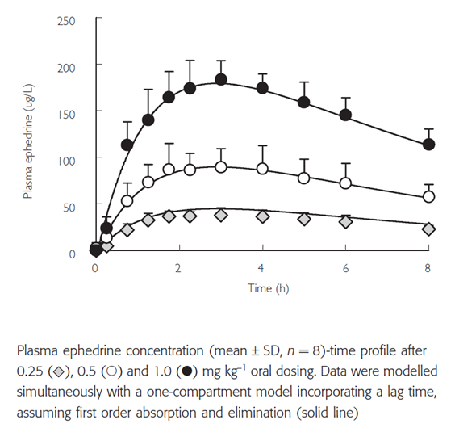

The relationship between ephedrine concentration and heart rate did not show any significant hysteresis on an individual or pooled basis. The data were best described using a linear model (Figure 2). The percentage change in systolic blood pressure was best described by a tolerance model as suggested by a clockwise hysteresis in the plasma concentration effect profile (Figure 3).

Figure 2: Change in heart rate with ephedrine concentration from Persky et al

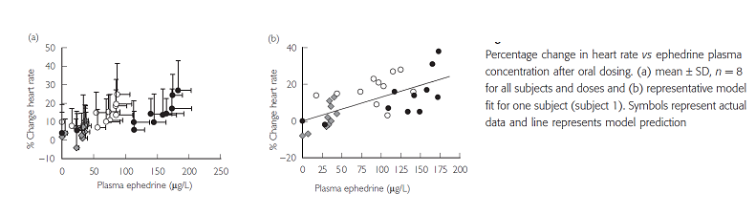

Figure 3: Change in systolic blood pressure with ephedrine concentration from Persky et al

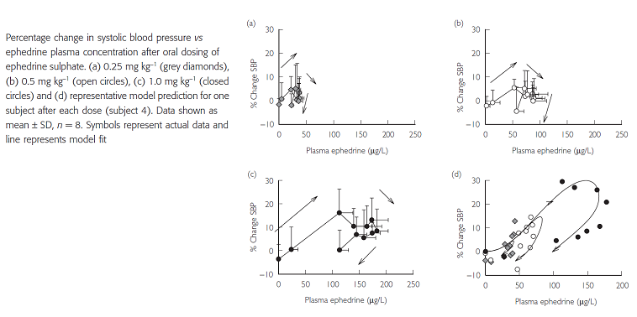

**Comment:** This paper used oral rather than IV dosing, thus cannot be used as direct evidence for the pharmacokinetic or pharmacodynamic effect or parenteral ephedrine. However it did demonstrate a linear relationship between plasma ephedrine and heart rate, and a more complex relationship between ephedrine concentrations and blood pressure with tolerance developing after repeated doses.

##### Differential pressor response to intravenous ephedrine during recovery from deliberate hypotension. Kanaya et al. 2004[10]

###### Introduction

Ephedrine is commonly used to treat intraoperative hypotension because of its mild and controllable pressor response. It acts indirectly, by releasing endogenous catecholamines from the adrenergic nerve terminals and the adrenal medulla.

The aims of this study were

1. To assess the pressor response to IV ephedrine during deliberate hypotension
2. To compare the effect of ephedrine when used with nitroglycerin (a vasodilator) with trimethaphan (a ganglion blocker).

###### Methods

The subjects were 60 women, American Society of Anaesthetists (ASA) grade I scheduled for mastectomy. They were randomised into 6 groups, to receive either nitroglycerin or trimethaphan and 0.1 or 0.15 mg/kg of ephedrine (Table 2). Pre-operatively, the patients received 2 mg midazolam. They were monitored with continuous ECG monitoring and a radial arterial catheter. Patients were pre-oxygenated with 100% oxygen. General anaesthesia was induced using propofol and maintained with 2% sevoflurane in 33% oxygen. Tracheal intubation was facilitated with vecuronium. Hypotension was induced and maintained to a MAP of 55 to 65mmHg using nitroglycerin or trimethaphan. Before suturing the skin, nitroglycerin or trimethaphan infusions were ceased. Patients received normal saline, 0.1 or 0.15 mg/kg of ephedrine IV.

Table 2: Demographic characteristics and randomised groups of the study by Kanya

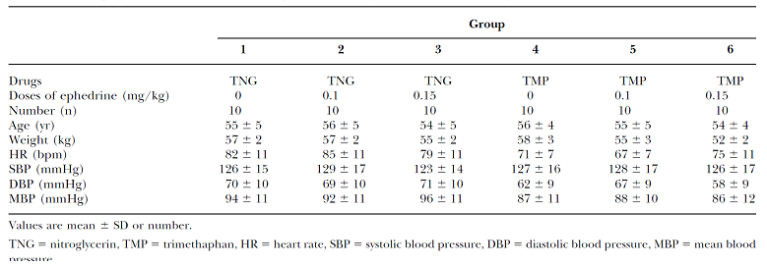

###### Results

After a dose of 0.1 mg/kg of ephedrine, the maximum pressor response in the trimethaphan group was twofold greater than that of the nitroglycerin group. In contrast, the maximum increase in MAP after 0.15 mg/kg of ephedrine were almost identical between those who received trimethaphan and nitroglycerin (Figure 4 and 5).

Figure 4: Changes in mean blood pressure (MBP) after normal saline, ephedrine 0.1 mg/kg or 0.15 mg/kg IV in patients receiving nitroglycerin (TNG) for deliberate hypotension

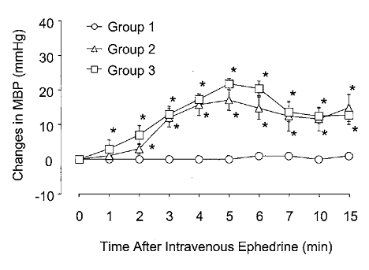

Figure 5: Change in mean blood pressure (MBP) after normal saline, ephedrine 0.1 mg/kg or 0.15 mg/kg IV in patients receiving trimethaphan (TMP) for deliberate hypotension

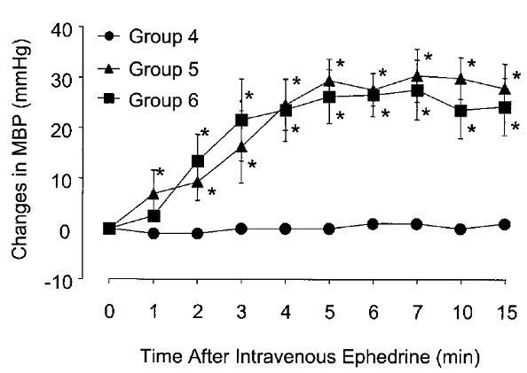

**Comment:** For a 70 kg person, the different doses would correspond to 7 mg versus 10.5 mg, or a 50% increase. Higher doses of ephedrine were required to overcome the hypotensive effects of nitroglycerin than trimethaphan. The dose response curve for ephedrine is likely to be different when co administered with nitroglycerin and trimethaphan.

##### Comparison of potency of ephedrine and metaphedtermine for prevention of post-spinal hypotension in caesarean section Mohta et al. 2008[11]

###### Methods

This was a randomised, double blind study of 46 ASA I and II females undergoing elective caesarean section under spinal anaesthesia. Patients received IV ranitidine the night before, and IV ranitidine and metoclopramide 1 hour prior to surgery. Patients received 10 mL/kg of ringers lactate prior to surgery. Spinal anaesthesia was at L2-3 or L3-4 with 2.2mL of 0.5% bupivacaine. Continuous ECG and non-invasive BP measurements were used for monitoring.

Patients were randomised to receive ephedrine or mephentermine. The first patient in each group received a dose 50 mg of vasopressor. The dose of vasopressor was diluted to 20 mL with normal saline and the infusion started at a rate of 40 mL/hr. Hypotension was defined as a reduction in systolic BP of > 20% or an absolute value < 100 mmHg. If hypotension occurred during the study period, the dose of vasopressor was increased and the subsequent patient received 5 mg more. If hypotension was prevented, the subsequent patient received 5 mg less. Hypotension was treated with a bolus of ephedrine (5 mg IVI). The sample size was based on the previous literature of the up-down method of Dixon, according to which at least 6 independent pairs of patients with no hypotension should provide reliable estimates of the minimum effective dose (ED50) of vasopressor.

Figure 6: Up-down sequences for ephedrine representing effective and ineffective outcomes

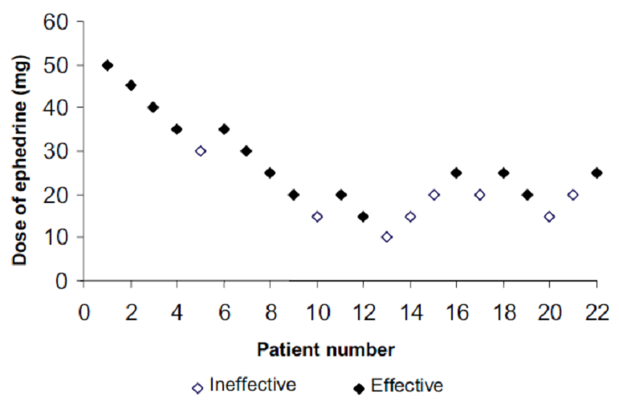

The ED 50 of ephedrine was 25 mg (95% CI 15.5 to 40.4 mg).

#### Pharmacodynamic interactions

There are a number of pharmacodynamic interactions listed in the interactions with other medications sections of the PI.

### Evaluator’s overall conclusions on pharmacodynamics

The mechanism of action of ephedrine has been reasonable well established. However there is limited information on the dose response relationship of either Ephedrine sulfate or ephedrine hydrochloride. It is very difficult to accurately predict the effect of a 6% difference in free base in the proposed formulation without such data. Ephedrine is most commonly used in the context of spinal anaesthesia, particularly in obstetrics. A 6% difference in the free base may have no impact if the dose given is below the therapeutic dose. However, a 6% difference in the amount of active base would have potentially more impact when other drugs that potentiate the effects of ephedrine on α and β receptors for example oxytocin, atropine, cardiac glycosides, hydrocarbon inhalation anaesthetics, antidepressants (monoamine oxidase inhibitors, tricyclic antidepressants noradrenaline reuptake inhibitors), clonidine, and sodium citrate; or if given at a steep part of the slope of a dose response curve.

## Dosage selection for the pivotal studies

No information was presented in this section.

## Clinical efficacy

The clinical efficacy for ephedrine hydrochloride is presumed to be the same as that for ephedrine sulfate as both formulations contain the same ephedrine base. The sponsor has submitted a number of journal articles and pharmacology reviews. In addition, the clinical evaluator has performed a literature review and evaluated pharmacopoeia, searched for clinical guidelines, and spoken with anaesthetists in relation to current practice.

### Shock unresponsive to fluid replacement

There were no articles submitted to support this indication. The use of ephedrine is this indication is based upon its physiological mechanism of action. In the extract from Martindale’s submitted by the sponsor, under the section dosage and administration, it states “ephedrine is of little value in hypotensive crises produced by shock, circulatory collapse or haemorrhage. It is no longer advocated in orthostatic hypotension.”

### Prevention of hypotension associated with spinal anaesthetic

#### Ayatollahi etal 2012[12]

Comparison of effects of ephedrine, lidocaine and ketamine with placebo on injection pain, hypotension and bradycardia due to propofol injection: A randomised placebo controlled clinical trial.

##### Introduction

Propofol is a commonly used anaesthetic drug. Common side effects include pain during the infusion, and hypotension (particularly in the elderly).

##### Method

This was a double blind, randomised, placebo controlled trial implemented in 140 patients. The patients were randomised into 4 groups; the first received 0.1 mg/kg of ephedrine, the second 2% lidocaine, the third 0.1 mg/kg ketamine, the fourth 2 mL normal saline IV. All drugs were given 30 seconds before propofol. Pain was measured by an observer. BP and HR were measured before the study drug, 1 minute after injection with propofol, just before intubation, 1 minute after intubation and 2 minutes after intubation.

##### Results

The mean age of the patients was 28.22 ± 7.32 years. There was less pain with injection with all study drugs compared to placebo. The mean drop in systolic and diastolic BP was lower 1 minute after intubation with ephedrine than with the other drugs and placebo. However, hypotension and bradycardia were infrequent in this group of young patients.

#### Ayorinde et al. 2001[13]

Evaluation of pre-emptive intramuscular phenylephrine and ephedrine for reduction of spinal anaesthesia induced hypotension during Caesarean section.

The incidence of hypotension during spinal anaesthesia for Caesarean section is reported to be as high as 80% despite fluid pre load, lateral uterine displacement and the use of vasopressors. Ephedrine is the vasopressor of choice in obstetric anaesthesia. Phenylephrine is an α1 adreno‑receptor agonist which counteracts the decrease in systemic vascular resistance induced by spinal anaesthesia.

##### Methods

This was a randomised controlled trial of 108 women, ASA I or II, undergoing elective Caesarean section under spinal anaesthesia. Group 1 received phenylephrine 4 mg IMI, Group 2 received phenylephrine 2 mg IMI, Group 3 received ephedrine 45 mg IMI, Group 4 received 0.9% saline. Non-invasive arterial BP and heart rate were recorded at 1 minute intervals by an automated oscillometer. A 16 gauge cannula was inserted into the right hand and 500 mL ringers lactate given. The spinal injection was achieved in a sitting position at L2-3 or L3-4. Spinal medications included 2.2 mL of 0.5% hyperbaric bupivacaine and 20 µg fentanyl. Rescue doses of IV ephedrine 6 mg were given for hypotension, nausea or vomiting. Hypotension was defined as a 25% decrease in MAP from baseline.

##### Results

The incidence of hypotension was 33% in the phenylephrine 4 mg group, 48% in the ephedrine 45 mg group and 70% in the phenylephrine 2 mg and control groups. No patient developed hypertension after the study medication. There was a non-significant increase in heart rate with ephedrine. There was no effect on infant Apgar scores or cord pH.

#### Cleary-Goldman et al, 2005[14]

Prophylactic ephedrine and combined spinal epidural.

##### Methods

This study evaluated the effects of prophylactic ephedrine before spinal anaesthesia on women in labour. One hundred healthy, normotensive, pregnant women were enrolled in a prospective randomised, double blind, study. Patients were randomised into receiving an IM dose of 25 mg ephedrine or sterile saline into the deltoid before the back was prepared for the spinal anaesthetic. Maternal hypotension was defined as a 25% fall in blood pressure or systolic blood pressure < 90 mmHg. Rescue IV ephedrine was given for symptomatic hypotension. Maternal BP was measured every 5 minutes, and heart rate continuously. The spinal anaesthetic was given at T10 using fentanyl 20 µg and bupivacaine 2.5 mg.

##### Results

The nadir in systolic blood pressure occurred 10 minutes after the dose of spinal anaesthesia. Patients who received ephedrine had less fall in BP as a group and less women needing rescue ephedrine. There was no difference in heart rate or diastolic blood pressure between the groups. Ephedrine prevented a decrease in uterine contractions, and late fetal heart rate decelerations. However there was more fetal tachycardia in the group treated with ephedrine. The tachycardia was reactive and there were no adverse effects on fetal wellbeing. There was no difference in the neonatal outcomes between the two groups.

#### Hemmingsen et al 1989[15]

Prophylactic Ephedrine during spinal anaesthesia: double-blind study in patients in ASA groups I to III.

##### Methods

This study involved 48 patients scheduled to undergo surgical procedures on the lower extremity or lower abdomen. Patients were randomised by ASA category to receive either ephedrine 12.5 mg IVI and 37.5 mg IMI or placebo. Premedication was with diazepam 5 to 15 mg given orally 60 minutes before the scheduled procedure. Immediately before the procedure, patients received 7 mL/kg of isotonic sodium glucose solution intravenously. Spinal anaesthesia was at level L2-3 or L3-4, with 3 mL of bupivacaine. BP and heart rate were measured at 1 minute intervals then every 5 minutes for 40 minutes. Hypotension was treated with fluids, head down, oxygen, IV ephedrine, and if needed albumin or blood.

##### Results

There was less reduction in MAP in the patients who received ephedrine than those who received placebo. This effect was most significant in the ASA group III (see Figure7).

Figure 7: Changes in blood pressure with ephedrine (circle) or placebo (square) by ASA criteria

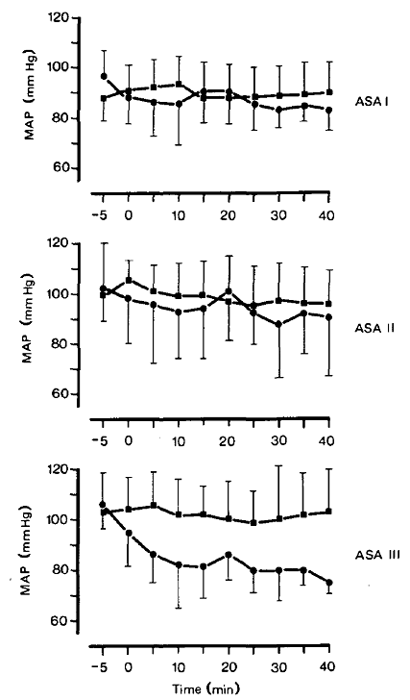

There was no significant difference in heart rate between the groups. There was no rebound hypertension, angina, cardiac arrhythmia, or signs of cardiac decompensation.

#### Kol et al. 2008[16]

The effects of intravenous ephedrine during spinal anaesthesia for caesarean delivery: a randomised controlled trial.

This was a randomised controlled trial of the efficacy and safety of 0.5 mg/kg ephedrine given IV for the prevention of hypotension during spinal anaesthesia for caesarean delivery in 42 women.

The mean highest and lowest heart rate in the ephedrine group was higher than those of the control group (p < 0.05). Fewer women developed hypotension (38.1% versus 85.7%) and nausea and vomiting (19% versus 57%) in the ephedrine group compared to the control group. The time to the first rescue dose of ephedrine was longer (14.9 minute versus 7.9 minutes) in the ephedrine compared to the control groups. There was no significant difference in neonatal outcomes.

#### Ngan kee et al 200025

A dose response study of prophylactic intravenous ephedrine for the prevention of hypotension during spinal anaesthesia for caesarean delivery.

##### Introduction

Ephedrine has been used to prevent hypotension after spinal anaesthesia, but IM doses do not provide a consistent effect. IV ephedrine after induction of anaesthesia has been described; however doses of 10 to 20 mg and 0.25 mg/kg have been ineffective.

##### Methods

80 ASA I and II Asian women having elective caesarean sections for singleton pregnancies were recruited. Patients were pre-medicated with ranitidine 150 mg orally the night before, and 0.3M sodium citrate 30 mL on arrival to the operating theatre. Monitoring included HR, BP and fetal heart rate. Spinal anaesthesia was achieved at L2-3 or L3-4 using 0.5% bupivacaine 2.0 mL and fentanyl 15 µg. Patients were randomised to receive 10, 20 or 30 mg of ephedrine IV diluted in 30 mL of normal saline. Hypotension was defined as a 20% drop in systolic BP or a systolic BP less than 100 mmHg.

##### Results

Systolic BP was significantly greater with the 30 mg ephedrine compared with the lower doses of ephedrine and placebo (Figure 8). There was no significant effect of ephedrine on heart rate (Figure 9). There was less nausea in the 30 mg ephedrine group. There was no significant difference in fetal outcome between groups. Approximately 45% of patients who received a 30 mg dose of ephedrine developed reactive hypertension.

Figure 8: Changes in systolic BP during the first 12 minutes after the induction of spinal anaesthesia

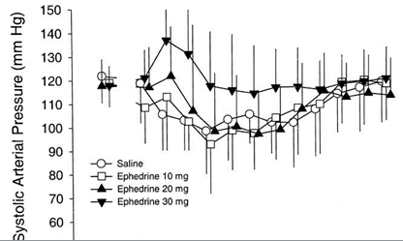

Figure 9: Change in heart rate in the first 12 minutes after spinal anaesthesia

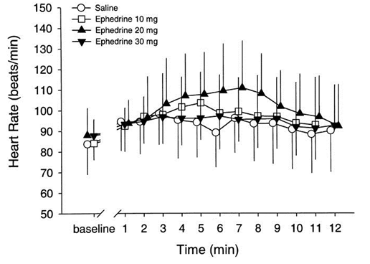

Figure 10: Cumulative survival curves showing percentage of patients remaining not hypotensive until delivery

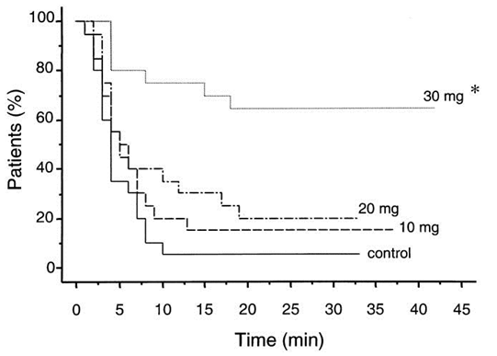

#### Simon et al. 2001[17]

Dose of prophylactic intravenous ephedrine during spinal anaesthesia for caesarean section.

In this study, 108 ASA I-II women were randomised to receive 10, 15 and 20 mg of ephedrine IV, 2 minutes after the injection of the spinal anaesthetic. Patients received 20 mL/kg of Ringers lactate prior to the spinal anaesthesia. Spinal anaesthesia occurred at L3-4 or L4-5 using 10 µg bupivacaine, 2 µg sufentanil, 0.2 mg morphine. Hypotension was defined as a 30% decrease in systolic BP from baseline, or systolic blood pressure < 100 mmHg.

There was significantly less hypotension in the groups that received 15 and 20 mg of ephedrine. The rate of rebound hypertension was similar in the three groups. There were no adverse fetal outcomes (Table 3).

Table 3: Haemodynamic variations associated with spinal anaesthesia from Simon 2001

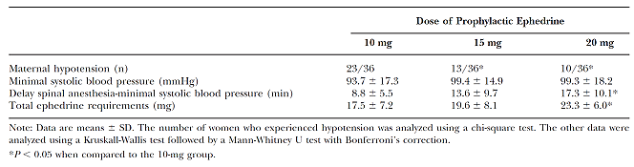

#### Sterno et al 1995[18]

Prophylactic IM ephedrine in bupivacaine spinal anaesthesia.

This was a double blind, placebo controlled, randomised study of ephedrine, 0.6 mg/kg, IM in 98 elderly patients undergoing hip arthroplasty. The patients received a pre medication 1 hour before anaesthesia with ketobemidone (an opiod) and dixtrazine (a phenothiazine with sedative and antiemetic properties). Patients who usually received a β blocker or calcium channel blocker received their usual morning dose. Spinal anaesthesia was achieved at L2-3 or L3-4 using 0.5% plain bupivacaine 20 mg and morphine 0.3 mg. Patients received intravenous fluids, blood and midazolam as needed during the anaesthetic. A fall in systolic BP of more than 30% was considered a negative efficacy outcome, where as a rise in systolic BP of 20% or > 160 mmHg was considered a negative safety outcome. The average age of patients was 70 years, and weight 74.5 kg. Systolic BP during the first 60 minutes after anaesthetic was more stable in the ephedrine treated patients than the control group. An increased in heart rate or systolic BP of more than 20% from baseline occurred in 2 patients in the ephedrine and 1 patient in the control group (Figure 11).

Figure11: Systolic arterial pressure (mean SEM) during the first 60 minutes after anaesthesia in the placebo (open circle) and ephedrine (closed circle) groups

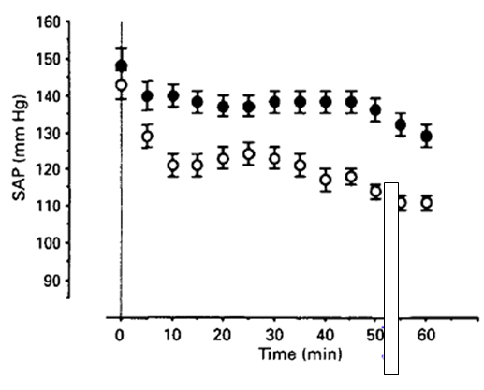

#### Tsen et al. 2000[19]

Hemodynamic effects of simultaneous administration of intravenous ephedrine and spinal anaesthesia for caesarean delivery.

This was a randomised, prospective, double blind study of 10 mg of ephedrine given intravenously at the time of spinal anaesthesia in 40 ASA I and II non labouring women undergoing elective caesarean section. Significant changes from baseline in MAP, systemic vascular resistance index, heart rate, and cardiac index before and after spinal anaesthesia. There was no difference in parameters between the ephedrine and placebo groups.

#### Iqbal et al 2010[20]

Optimal dose of prophylactic intravenous ephedrine for spinal-induced hypotension during caesarean section.

##### Objectives

The objective of this study was to compare the efficacy of 10, 15, and 20 mg bolus doses of prophylactic IV ephedrine for prevention of maternal hypotension associated with spinal anaesthesia for caesarean section.

##### Study Design

A prospective, quasi experimental study. Ninety women of ASA grade I and II, receiving spinal anaesthesia for elective C-section were included in this study. They were randomly divided into three groups. Group I received 10 mg, Group II 15 mg, and Group III 20 mg prophylactic IV ephedrine immediately after administration of spinal anaesthesia. Intra operative hemodynamic changes were recorded and the data were analysed.

##### Results

Incidence of hypotension was significantly higher in Group I women receiving a 10 mg prophylactic dose of ephedrine than in Group II and Group III women receiving 15 mg or 20 mg of ephedrine respectively (53.3% versus 13.3% and 3.3% respectively). There was however, a significantly higher incidence of reactive hypertension in Group II women (46.7%).

##### Conclusions

15 mg bolus dose of prophylactic IV ephedrine can effectively prevent spinal induced maternal hypotension during caesarean section without adverse effects like reactive hypertension.

#### Cochrane review 2006

Techniques for preventing hypotension during spinal anaesthesia for caesarean section 2006

Search methods: Cochrane Pregnancy and Childbirth Group's Trials Register (November 2005), updated on 30 June 2010.

Selection criteria: Randomised controlled trials comparing interventions to prevent hypotension with placebo or alternative treatment in women having spinal anaesthesia for caesarean section. Data collection and analysis: Three review authors independently assessed eligibility and methodological quality of studies, and extracted data.

Main results: 75 trials (a total of 4624 women). Crystalloids were more effective than no fluids (relative risk (RR) 0.78, 95% confidence interval (CI) 0.60 to 1.00; one trial, 140 women, sequential analysis) and colloids were more effective than crystalloids (RR 0.68, 95% CI 0.52 to 0.89; 11 trials, 698 women) in preventing hypotension following spinal anaesthesia at caesarean section. No differences were detected for different doses, rates or methods of administering colloids or crystalloids. Ephedrine was significantly more effective than control (RR 0.51, 95% CI 0.33 to 0.78; seven trials, 470 women) or crystalloid (RR 0.70, 95% CI 0.50 to 0.96; four trials, 293 women) in preventing hypotension. No significant differences in hypotension were seen between ephedrine and phenylephrine (RR 0.95, 95% CI 0.37 to 2.44; three trials, 97 women) and phenylephrine was more effective than controls (RR 0.27, 95% CI 0.16 to 0.45; two trials, 110 women). High rates or doses of ephedrine increase the rate of hypertension and tachycardia incidence.

#### Evaluator’s conclusions on clinical efficacy for hypotension with spinal anaesthesia

Most of the studies do not specify whether ephedrine hydrochloride or sulfate is used, nor do they specify if the dose is for the free base or salt.

All of the studies were examining using ephedrine for the prophylaxis of hypotension with spinal anaesthesia. There was a wide range in reported doses and route of ephedrine used for prophylaxis. The larger doses had greater efficacy. Efficacy varied between studies, however there were a number of confounding factors that had the potential to affect the efficacy including other drugs being administered, whether a fluid bolus was given prior to the spinal needle, the level of the spinal block, the timing of the injection, the route and dose of ephedrine used, and the definition of hypotension. All of the studies reported using rescue IV ephedrine at a dose of around 7 to 10 mg for hypotension, which is lower than recommended in the PI.

The clinical evaluator is satisfied that ephedrine is efficacious for the prophylaxis and management of hypotension in the context of spinal anaesthesia. However the most efficacious dose for prophylaxis and rescue treatment remains uncertain based on the ranges used in the published studies. In particular, the rescue dose used in the clinical studies appears to be much lower than described in the PI.

### Bronchial asthma and reversible bronchospasm

The sponsor’s literature review included studies using oral rather than parenteral ephedrine. There is insufficient evidence to support the use of ephedrine for this indication.

In the excerpt from Martindale’s[21] included in the dossier, under usage and administration, it states “ephedrine salts have been used as bronchodilators, but the more beta 2 selective sympathomimetics such as salbutamol are now preferred”.

The sponsor will be asked to submit evidence in support of the use of ephedrine hydrochloride for asthma and reversible bronchospasm, in comparison with both placebo and current standard therapy.

## Clinical safety

### Studies providing evaluable safety data

The sponsor submitted a number of journal articles that documented safety profile of adrenaline. Many of these related to effects after oral administration.

#### Dingemanse 1996[22]

Modification of the cardiovascular effects of ephedrine by the reversible monoamine oxidase inhibitor moclobemide.

This was a two day randomised cross over trial in 12 healthy subjects to examine the safety and tolerability of concomitant administration of moclobemide (300 mg bd) and ephedrine (two doses of 50 mg 4 hours apart). Co-administration of these two drugs increased in incidence of adverse effects (headache and palpitations), and also increased the effect of ephedrine of systolic blood pressure (potentiation factor 3.2), and diastolic blood pressure (potentiation factor 3.8), however it decreased heart rate by a factor of 0.6.

#### Khavandi 2009[23]

Myocardial infarction associated with the administration of intravenous ephedrine and metaraminol for spinal induced hypotension.

This was a case report of a 31 year old with no pre-existing risk factors for cardiac disease, who suffered a peri-operative myocardial infarction during an elective gynaecological procedure under spinal anaesthesia. 5 mg of ephedrine was given intravenously because of hypotension and bradycardia. This was followed by rebound hypertension, tachycardia and chest tightness. Her symptoms resolved, but post operatively there was ECG, troponin and echocardiographic evidence of discrete myocardial ischemia. Coronary artery vasospasm has been attributed to the effects of ephedrine on alpha adrenergic receptor on large epicardial arteries.

#### Mourand et al 1998[24]

Acute reversible cerebral arteritis associated with parenteral ephedrine use.

This was a case report of a 44 year old woman who developed headache, nausea, vomiting and progressive drowsiness immediately after spinal anaesthesia for varicose vein surgery. She was given ephedrine (the exact dose was not stated). This was followed by a period of hypertension lasting 3 minutes. Her past medical history included migraine, mitral valve prolapse and atrial tachycardia, treated with propranolol hydrochloride. A CT scan showed a deep right frontal lobe haemorrhagic infarction involving the internal capsule, caudate nucleus, ventricles and left parietal lobe. Seven days after the procedure, headache and drowsiness persisted. Neurological examination showed temporal and topographic disorientation, aphasia, and nuchal rigidity. Angiography showed features typical of a vasculitis. The patient was treated with an anticoagulant and oral methylprednisolone for 2 months. She deteriorated 2 days later with increasing clouding of consciousness, incomplete cortical blindness, dysarthric speech and impaired memory. A second CT showed a recent infarct in the right occipital and parietal lobes. Her clinical state subsequently improved. Six months later, CT was normal.

Cerebral vasculitis has previously been reported in association with chronic or single use of amphetamine, phenylpropanolamine, pseudo-ephedrine, chronic abuse of nasal decongestion spray, and oral use and abuse of ephedrine. It was hypothesised that the patients previous sue of phenoxazoline may have sensitized her to ephedrine, and that the chronic use of propranolol favoured the effects of ephedrine on cerebral vasoconstriction.

#### Ngan Kee. 2009[25]

Placental transfer and fetal metabolic effects of phenylephrine and ephedrine during spinal anaesthesia for caesarean delivery.

This was a randomised trial of phenylephrine (100 µg/mL) or ephedrine (8 mg/mL) titrated to maintain systolic blood pressure near baseline in 104 women having elective caesarean section. In the ephedrine group, umbilical arterial and umbilical venous pH and base excess were lower, and umbilical arterial and venous concentrations of lactate, glucose, epinephrine and nor-epinephrine were higher. There was more transfer of ephedrine than phenylephrine (Table 4 and 5).

Table 4: Table of blood gas results from mother and neonate comparing the effects of phenylephrine and ephedrine administered IV during caesarean section from Ngan Keeet et al, 2009

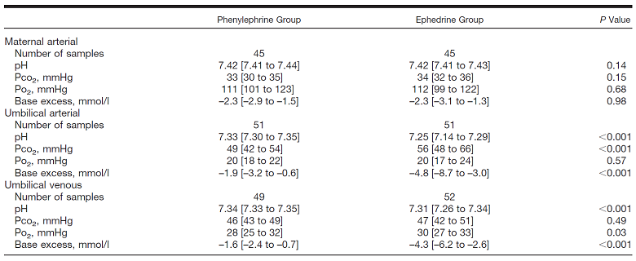

Table 5: Table of concentrations of lactate, glucose, norepinephrine, phenylephrine and ephedrine in mother and neonate comparing the effects of phenylephrine and ephedrine administered during caesarean section from Ngan Kee et al, 2009

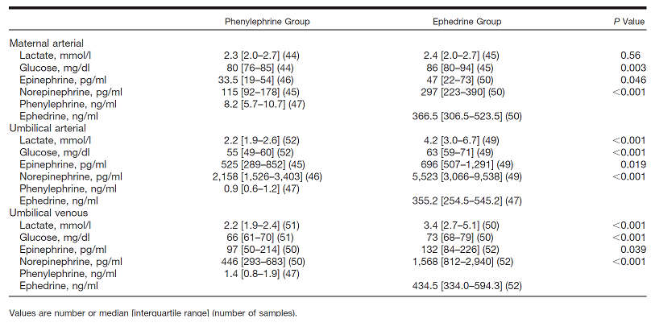

Ephedrine has been favoured in obstetrics as animal and in vitro studies have shown that ephedrine has lesser propensity to cause vasoconstriction of the uteroplacental circulation compared to α adrenergic agonists. The authors attribute these results to transfer of the drug across the placenta and stimulation of metabolic processes in the fetus. The maternal concentrations of epinephrine and norepinephrine were also greater in the ephedrine group, and may have led to transplacental transfer of these hormones.

#### Exert from Martindale20

Ephedrine has both alpha and beta agonist effects and its commonest adverse effects are tachycardia, anxiety, restlessness and insomnia. Tremor, dry mouth, impaired circulation to the extremities, hypertension and cardiac arrhythmias may also occur. Ephedrine may be used in labour to maintain blood pressure during spinal anaesthesia but may cause fetal tachycardia. Paranoid psychosis, delusions, and hallucinations may also follow ephedrine overdosage. Prolonged usage has no cumulative effect, but tolerance with dependence has been reported.

### Post market data

The sponsor did not submit any post market data to support the use of ephedrine hydrochloride as a 25 mg/mL strength vial.

The only post market safety data that the Signal Investigation Unit of the Pharmacovigilance and Special Product Access Branch of the TGA was aware of, related to the use of ephedrine and pseudoephedrine in complementary medicines.

### Evaluator’s overall conclusions on clinical safety

There is very little evidence to base an assessment on safety on. The risks of ephedrine need to be balanced against the risks of untreated hypotension for which the ephedrine is being given.

The sponsor has submitted journal articles illustrating drug interactions and rare complications of ephedrine such as myocardial infarction and cerebral vasculitis. The PI contains a statement about the use of ephedrine with MAOI, and the risk of myocardial ischemia and cerebral vasculitis.

Ephedrine has pregnancy category A [26] in Australia. The results of the study by Ngan kee24 on the transplacental passage of ephedrine and effects on the cord blood pH are notable; however there is no corresponding clinical evidence to document its effect on the neonate. Other studies have not demonstrated significant effects on neonatal outcomes. The clinical evaluator would suggest an extra statement in the pregnancy section to describe this finding, however there is insufficient evidence to justify a change in pregnancy category.

Other safety questions posed by this submission include:

* Safety of ephedrine hydrochloride versus Ephedrine sulfate as the active ingredient

It would be assumed that both salts have the same safety profile.

* Safety of the dose formulation.

In clinical practice, ephedrine is dosed based on the salt. Thus, the proposed formulation contains 6% more free base than the currently marketed Ephedrine sulfate. Although such a small difference is unlikely to have a clinically significant effect, there is no evidence to base this assessment on. As ephedrine is used to treat an abnormal and potentially dangerous physiological state, it is preferable to use 6% more rather than 6% less of the active substance. The physiological effects of ephedrine are relatively immediate and short acting. Doses can be repeated every 5 to 10 minutes if a single does is not efficacious, however this is not ideal due to the potential for tachyphylaxis with repeated dosing.

* Safety in the proposed doses.

There is a large dose range proposed. The level of evidence to support these doses is low.

* Safety in the proposed indication.

Ephedrine appears to be relatively safe for the prevention and treatment of hypotension in the context of spinal anaesthesia. There is insufficient data to assess its safety when used for asthma and shock.

The most common adverse effects from the mechanism of action of the drug (rebound hypertension or tachycardia) are transient and dose dependent.

## First round benefit-risk assessment

### First round assessment of pharmaceutical equivalence and benefits

For this application the clinical evaluator will consider if there is sufficient evidence to support the sponsor’s claim that ephedrine hydrochloride is a pharmaceutical alternative to ephedrine sulfate, and the benefits of ephedrine for the proposed indications.

The two ephedrine salts would be considered as pharmaceutical alternatives under the CHMP guideline definition as they are different salts of an active moiety which differ in dose form. In an intravenous form, it would be expected they are bioequivalent in the same molar dose; however there is a 6 percent difference in the amount of free base if dosed according to milligram of salt (as is done in clinical practice). The clinical impact of this is unknown as there is no information provided about the dose response relationship of ephedrine hydrochloride. A 6% difference is unlikely to be clinically significant at a low dose of ephedrine or when administered to otherwise healthy individuals on no other medications, but may be significantly different to an older individual with significant cardiovascular or cerebrovascular disease who is on other medications which would prolong or potentiate the effects. Furthermore the effect of a 6% increase in free base will depend upon where this dose lies on the dose-response curve, and this information is not available. The sponsor has not submitted sufficient information about the pharmacokinetics or pharmacodynamics of ephedrine at different doses and administered via different routes (IV or IM) to provide an evidence based decision.

The two ephedrine salts are both isotonic; however differ considerably in their tonicity. This may have implications in how well they are systemically absorbed after intramuscular or subcutaneous administration.

The sponsor proposes the use of ephedrine hydrochloride in the treatment of shock unresponsive to volume replacement, hypotension due to spinal anaesthesia, and bronchospasm; all based on an extrapolation of indications for ephedrine sulfate. The stated rationale being that the ephedrine base in each salt is the same active substance and is expected to have the same therapeutic effect.

Ephedrine is widely used in anaesthesia, particularly obstetric anaesthesia. The sponsor has submitted a number of journal articles to support the use of ephedrine in hypotension after spinal anaesthesia. In relation to the route of administration, there is reasonable evidence for the efficacy of the intravenous route, less robust evidence for the intramuscular route and no evidence for the subcutaneous route. The sponsor has not justified the proposed doses.

In relation to the proposed indication of hypotension, the sponsor has not submitted sufficient evidence to determine if ephedrine hydrochloride is an appropriate pharmaceutical alternative to Ephedrine sulfate, is efficacious for this indication, nor the most appropriate dose.

In relation to the proposed indication of asthma and reversible bronchospasm, the sponsor has not submitted sufficient evidence to determine if ephedrine hydrochloride is an appropriate pharmaceutical alternative to Ephedrine sulfate, is efficacious for this indication, nor the most appropriate dose.

### First round assessment of risks

There are risks in accepting ephedrine hydrochloride as a pharmaceutical alternative to ephedrine sulfate for the proposed indications. These include

1. Unknown pharmacokinetics and pharmacodynamics of the proposed doses and routes.
2. Assumptions that a 6% difference in molar concentration will equate with a 6% difference in efficacy and safety outcomes without sufficient information about the pharmacokinetics, pharmacodynamics, efficacy or safety.
3. The use of information from product information for ephedrine sulfate which has been outdated by new research and changes in clinical practice.
4. Dosing errors due to changes in the strength of the ephedrine solution.
5. Insufficient information about how to prepare ephedrine for administration, including what diluents to use and the rate at which it should be administered (as this would have considerable impact on the pharmacokinetics and dynamics and therefore efficacy and safety).

The main risks associated with the use of ephedrine sulfate are rebound hypertension and tachycardia, particularly with higher doses or higher infusion rates. It could be assumed that the proposed risks of ephedrine hydrochloride are the same.

### First round assessment of benefit-risk balance

At this stage, the benefit risk balance of ephedrine hydrochloride given intravenously for hypotension in the context of spinal anaesthesia is favourable if questions about dosing are addressed and changes to the PI are made. The benefits of the intramuscular and subcutaneous routes have not been demonstrated and therefore the risk-benefit balance is unfavourable for these routes.

The risk-benefit balance for the use of ephedrine for shock unresponsive to fluid replacement and asthma and reversible bronchospasm is unfavourable due to the lack of current evidence to support its use.

## First round recommendation regarding authorisation

Under the section 16 of Therapeutic Goods Act 1989 (The Act), therapeutic goods that are of different formulation or dosage form are to be taken as a separate and distinct good, and therefore need to be evaluated under section 25 of The Act.

At this stage, the clinical evaluator would consider authorising the use of ephedrine hydrochloride as a pharmaceutical alternative to ephedrine sulfate, given intravenously, for use in hypotension secondary to spinal anaesthesia, provided the sponsor is able to address the questions in relation to the pharmacokinetics, pharmacodynamics, dosage, safety, efficacy, changes to the product information and development of a risk management plan.

At this stage, there is insufficient data to support the use of an intramuscular or subcutaneous dose used for hypotension in the context of spinal anaesthesia. There is insufficient data to support the use of ephedrine hydrochloride for indications of shock and asthma.

## Clinical questions

1. Please explain the rationale for the development and marketing of ephedrine hydrochloride to replace Ephedrine sulfate?
2. Is ephedrine hydrochloride for parenteral use currently registered in Europe or the United States of America? If not, what are the barriers?

### Pharmacokinetics

1. Please provide further information about the pharmacokinetics.

* For the intravenous route, please provide information comparing the pharmacokinetics of Ephedrine sulfate to ephedrine hydrochloride.
* Please describe how the ephedrine was administered in the pharmacokinetic studies described in the PI (that is, what the strength of the solution was, and the volume of fluid this was administered with).
* For the intramuscular route, please provide information about the pharmacokinetics of Ephedrine sulfate compared to ephedrine hydrochloride.

### Pharmacodynamics

1. Please provide evidence of the dose-response of ephedrine when given in the recommended dose range after intravenous, intramuscular or subcutaneous injections.

### Efficacy

1. Please provide evidence of the efficacy and safety to support the use of ephedrine hydrochloride given intravenously, intramuscularly and subcutaneously for indication hypotension.
2. Please provide evidence of the efficacy and safety of ephedrine hydrochloride given intravenously, intramuscularly or subcutaneously for the indication bronchospasm.

### Safety

1. Please provide an update of the safety profile of parentally administered ephedrine hydrochloride using post marketing data.

## Second round evaluation of clinical data submitted in response to questions

### Question 1

*Please explain the rationale for the development and marketing of ephedrine hydrochloride to replace Ephedrine sulfate?*

*Sponsor response*

Both Australian directors of pharmacies and anaesthetists canvassed by Mayne Pharma have expressed an interest in having an alternative supply of ephedrine injection to alleviate a reliance on a single source of this critical product in Australia and to alleviate pharmacy budget pressures. The feedback to the potential introduction of Ephedrine hydrochloride -MYX 25 mg/1 mL ampoule as an alternative to the current DBL Ephedrine sulfate 30 mg/1 mL ampoule for the treatment of hypotension secondary to spinal anaesthesia given the difference in potency is not clinically relevant as the drug is titrated to effect [Information redacted] has been very favourable.

Mayne Pharma’s approach of introducing a different ephedrine injection salt into a market exclusively supplied by ephedrine sulfate injection has been preceded successfully in New Zealand where the both an ephedrine hydrochloride and ephedrine sulfate injection product are supplied and discussed further within the risk management plan.

*Evaluation of response:*

This is acceptable. It is agreed that an alternative source for a drug used in an emergency setting is an advantage.

### Question 2

*Is ephedrine hydrochloride for parenteral use currently registered in Europe or the United States of America? If not, what are the barriers?*

*Sponsor response:*

Ephedrine sulfate USP 50 mg/mL for IM, IV or SC use dominates the ephedrine injection market in the United States based upon a review of IMS[27] data for annual turnover. The main suppliers are Sandoz Inc, Akorn Inc, and Nexus. However all product labels include the disclaimer “This drug has not been found by the FDA to be effective and this labelling has not been approved by the FDA”.

Europe is dominated by the ephedrine hydrochloride salt in solutions for injection such as SALF in Italy, Aguettant in the UK and other EU member states. Europe has seen several relatively recent approvals of ephedrine hydrochloride injection products.

*Evaluation of response:*

This is acceptable

### Question 3

*Please provide further information about the pharmacokinetics.*

* *For the intravenous route, please provide information comparing the pharmacokinetics of* Ephedrine sulfate *to ephedrine hydrochloride.*
* *Please describe how the ephedrine was administered in the pharmacokinetic studies described in the PI (ie what the strength of the solution was, and the volume of fluid this was administered with).*
* *For the intramuscular route, please provide information about the pharmacokinetics of* Ephedrine sulfate *compared to ephedrine hydrochloride.*

*Sponsor response:*

The sponsor has included data on the PK of the intravenous route only as the use subcutaneously and intramuscularly has been withdrawn.

Both the hydrochloride and sulfate products are highly soluble and supplied as aqueous solutions containing 25 mg/1 mL and 30 mg/1 mL of each salt respectively. The solution may be used as is without dilution. However, in clinical practice it is more commonly further diluted to give a 3 to 6 mg/mL solution ready for intravenous use.

Once a salt (such as ephedrine sulfate or hydrochloride) is dissolved in water, the salt dissociates into the cation and anion, and the two moieties that made up the drug substance (that is, protonated ephedrine and either chloride or sulfate anion) are no longer closely associated with each other as they were in the solid phase. The DBL product is supplied as an approximately isotonic solution in 0.3% sodium chloride. This solution contains around 50 mM chloride ion and 71 mM of sulfate ion. Therefore, as supplied, ephedrine sulfate injection is likely to have at least partially converted to the hydrochloride. In addition, once the product is further diluted in normal saline, the concentration of chloride ion would be somewhat higher, leading to further conversion from sulfate to hydrochloride salt even before the product is administered to the patient. Once the product has been administered intravenously, the small amount injected (typically < 10 mL) would be rapidly diluted in the bloodstream and the identity of the original salt injected would become irrelevant as equilibrium is reached. The counter-ions associated with the active substance would be determined by those present in blood plasma, mainly chloride and bicarbonate ions, and not those present in the dose form as marketed. Ionic reactions such as these are instantaneous.

In New Zealand, both the DBL ephedrine sulfate 30 mg/mL and ephedrine hydrochloride 30 mg/mL are available with identical indications. The pharmacokinetic section, dosing and administration instructions are also essentially identical.

The sponsor has proposed the following new wording for the pharmacokinetic section:

Pharmacokinetic data for ephedrine following intravenous or other parenteral administration is limited. After intravenous administration, ephedrine is completely bioavailable and clinical effects occur within 3-5 minutes; these persist for 10-15 minutes before heart rate begins to decrease [Kol et al, 2009]16. Approximately 90% of an intravenous dose is excreted in the urine in 24 hours although, as an alkaloid, its excretion rate is reduced in alkaline urine. [Wilkinson and Beckett, 1968[28]; Sever et al, 1975][29]

The following data have been obtained for other dosage forms (oral or nasal). However, given ephedrine’s high aqueous solubility and bioavailability, this information can be reasonable extrapolated to an intravenous product. The absolute bioavailability of ephedrine is approximately 90%, and the drug is rapidly and extensively distributed throughout body tissues with a mean volume of distribution of 216 L, well in excess of total body water volume [Pickup et al, 1976].[30]

Kinetics have been shown to be linear after both oral and nasal administration [Berlin et al, 2001; Persky et al, 2004][31], 9

After both oral and intravenous administration, the majority of ephedrine is excreted unchanged in the urine, although this varies depending on urine pH. The major metabolite is the N-demethylated and biologically active norephedrine (up to 20%) with smaller amounts of other deaminated metabolites also reported [Wilkinson and Beckett, 1968; Sever et al, 1975].

The elimination half-lie of ephedrine has been reported to be from 3 to 7 hours, with faster excretion expected in acidic urine [Csajka et al, 2004].[32]

*Evaluation of response:*

The sponsor has not addressed all aspects of the question; however the evaluator is satisfied with the response.

### Question 4

*Please provide evidence of the dose response of ephedrine when given in the recommended dose range after intravenous, intramuscular or subcutaneous injections.*

*Sponsor response:*

A meta-analysis by Lee reviewed the literature to determine the dose response characteristics of intravenous ephedrine for the prevention of hypotension.[33] The doses in the studies ranged from 0 to 30 mg. The study found significant and robust dose response relationships for risk of maternal hypotension, hypertension and umbilical pH. No significant dose response was seen for fetal acidosis, risk of nausea or vomiting, or Apgar score at 1 or 5 minutes. The sponsor has stated that although significant dose response relationships were seen for hypotension and hypertension, the slopes of the regression lines are such that the 10% change in potency would be unlikely to result in a clinically significant change in the risk of hypotension or hypertension.

A Cochrane review by Cyna in 2006[34] used the same studies as Lee but looked at different outcomes. The results suggested a lower risk of hypotension with doses above 10 mg, and an increased risk of rebound hypertension at doses over 15 mg. Differences in infusion rates from 0.5 mg/minute to 4 mg/minute did not show any significant difference in rates of hypotension, despite the higher systemic levels likely to result from faster infusion rates. However a comparison of a bolus dose and infusion alone did show a significant effect (RR 3.5, 1.26 to 9.72). Higher rates of infusion (4 mg/minute) were associated with higher rates of rebound hypertension.

Simon et al (2001) reviewed the effectiveness of 10 mg, 15 mg and 20 mg prophylactic doses for hypotension in 108 women admitted for elective caesarean section.16 While the 10 mg dose appeared insufficient to prevent hypotension during spinal anaesthesia, both 15 mg and 20 mg doses appear to the safe and efficacious treatments. The effects on blood pressure and heart rate appears similar for both the higher doses, although 3 cases of hypertension were observed in the 20 mg dose group compared to two in each of the lower dose groups.

Kang et al (1982) compared a 5 mg/min infusion with a 20 mg intravenous bolus (with 10 mg increments as clinically required) in patients undergoing spinal anaesthesia for caesarean section.[35] A similar increase in heart rate was seen in both groups, although blood pressure control and levels of nausea/vomiting were improved in the infusion group compared to the bolus dose.

Current Australian clinical practice is that the supplied 30 mg/mL solution is diluted with normal saline into either a 10 mL syringe (to give 3 mg/mL) or into a 5 mL syringe (6 mg/mL). Doses of 3 to 6 mg are then given every 2 to 3 minutes until an adequate increase in blood pressure is achieved.

However, treatment with ephedrine is limited by heart rate and total dose and it is rare that a dose of more than 30 mg would be administered. In the opinion of the expert, the 10% difference in potency is unlikely to be clinically relevant as, firstly, the drug is titrated either until an adequate response is achieved or the patient does not respond, in which case they are moved on to an alternative therapeutic intervention. Second, a historical ceiling of 30 mg (23.1 mg drug) has been used. In the expert’s opinion, a 10% change in this ceiling is of little clinical relevance, as the patient again would be transferred to an alternative treatment once the ceiling has been reached. Finally, in clinical practice, widely varying dose increments used by anaesthetists (for example, 3 mg, 5 mg, 6 mg, 10 mg) are considered to vary to a far greater extent than the potency difference between the products.

Both parenteral ephedrine sulfate and ephedrine hydrochloride are used around the world for the treatment of hypotension in anaesthesia. A review of the literature demonstrates that a wide variety of drug concentrations, routes of administration, doses and infusion times have been used. The drug has also been used either prophylactically shortly after induction of anaesthesia, as a treatment with bolus doses being given immediately hypotension develops, or as a combination of both prophylaxis and treatment. Each of these is likely to result in significant variation in plasma drug levels and concentration-time profiles, but each has been used effectively in patient treatment. There is considerable variation in clinical practice, but in all cases it is clear that patients are closely monitored and doses are titrated to effect, balancing control of hypotension with development of reactive hypotension, tachycardia and potential effects on the fetus. .[36],16,15

While there appears to be a clear dose response for intravenous ephedrine over the range of clinical doses, the available data indicates that any changes in both efficacy and adverse events are gradual over the typical dose range (5 mg to 20 mg), indicating a shallow dose response curve. Given the way that the drug is used, the close monitoring of patients while it is being administered and the dose response relationships shown in the published literature, the small 10% difference in drug content between the current ephedrine sulfate injection and the proposed ephedrine hydrochloride injection is considered unlikely to be of any clinical significance.

*Evaluation of response:*

The sponsor has brought together a range of pharmacokinetic and clinical studies and clinical expert opinion to answer this question. There appears to be some dose response between 5 and 30 mg, with doses over 10 mg more efficacious and those > 15 mg more likely to cause adverse effect. There was no information about whether there is a ceiling dose below which a pharmacodynamic effect or efficacy is not seen. There were no relevant studies to determine if a 10% difference in potency would have a clinical effect.

The response is acceptable. The evaluator agrees that the 11% difference in salt per mL of solution is within the normal variation of doses given by different practitioners. There are also a number of other clinical factors which will affect the patient’s response. The effects are immediate and transient and patients will be closely monitored.

### Question 5

*Please provide evidence of the efficacy and safety to support the use of ephedrine hydrochloride given intravenously, intramuscularly and subcutaneously for indication hypotension.*

*Sponsor response:*

The sponsor submitted an addendum of the clinical overview. This is titled ‘efficacy and safety to support the use of ephedrine for hypotension’. This is briefly summarised below.

***Background***

Spinal blocks are major regional techniques with a long history of effective use for a variety of surgical procedures and pain relief. It produces sympathetic block, sensory analgesia and motor block, depending on dose, concentration, or volumes of local anaesthetics, after insertion of a needle in plane of the neuraxis. Nevertheless, precipitous hypotension and difficulty in controlling the level of analgesia are major disadvantages of spinal block. The most common serious side effects of spinal anaesthesia are hypotension (33%) and bradycardia (13%). Systemic vasodilation induced by sympathetic blockade after spinal anaesthesia (SA), resulting in venous pooling of blood and reduction in systemic vascular resistance, has been regarded as the predominant mechanism for hypotension. In addition, absence of significant reflex tachycardia after spinal anaesthesia despite the presence of hypotension also play important role in development of hypotension.[37]

Several interventions could be planned for prevention of hypotension after spinal anaesthesia. A good option could be the use of prophylactic vasoconstrictors, such as ephedrine, in reducing the hemodynamic side effects of spinal anaesthesia.[38]

According to Kee, the primary use of intravenous ephedrine is to treat anaesthesia-induced hypotension. It may also be used to treat hypotension resulting from sympathectomy or overdose of antihypertensive drugs. Ephedrine causes an increase in systolic and diastolic blood pressures, cardiac contractility, and cardiac output. Heart rate can be increased, but generally, it is not.[39]

* Efficacy of ephedrine to contrast anaesthesia induced hypotension

The studies described in the following sections are presented to support the proposed indication of ephedrine in the treatment of hypotension secondary from spinal anaesthesia by slow intravenous injection. Furthermore, several studies, related to the use of ephedrine in the prophylaxis of anaesthesia-induced hypotension and in hypotension secondary to various types of anaesthesia, are mentioned to support the proposed indication since they provided relevant information to clarify the effects of ephedrine on blood pressure during anaesthesia.

* Efficacy in the treatment of hypotension secondary to anaesthesia

Ephedrine and norepinephrine are the most commonly used drugs to treat hypotension due to neuraxial anaesthesia. Ephedrine has advantageous being short acting. It has a greater effect on heart rate than other agents. It has also been shown to improve cerebral perfusion more than phenylephrine and noradrenaline.

* Efficacy in the prophylaxis of hypotension due to anaesthesia

Ephedrine has been shown to be more efficacious than fluid loading in the prevention of hypotension from spinal anaesthesia in 60 patients aged 20 to 65 years ASA 1-2.

Ephedrine has also been shown to be efficacious in preventing pain, hypotension and bradycardia after injection with propofol.

* Subgroups

Efficacy has been demonstrated in the elderly and in pregnant women.

***Safety***

Reported side effects of ephedrine include hypertension, palpitations, dry exfoliating skin, dizziness, insomnia, anxiety and urine retention. Some of these effects (for example, dry skin, urinary retention, insomnia) may not be relevant after a single dose. “Toxicity” includes arrhythmias, myocardial infarction, stroke, cardiac arrest, death and psychosis- however it is unclear if these toxicities are dose related or idiopathic.

A study aimed to investigate the effect of three escalating doses of ephedrine, namely 0.07, 0.1 and 0.15 mg/kg on mean arterial blood pressure, systemic vascular resistance, cardiac stroke volume and left ventricular stroke work indices, heart rate, ST segment and cardiac troponin I changes was performed. It was made a comparison of ephedrine with placebo and phenylephrine, when used before propofol-fentanyl anaesthesia in patients undergoing elective valve surgery. Intraoperative ischemic episodes were higher with higher doses, but they were transient and not associated with an increased length of ICU stay or troponin. Higher doses were associated with hypertension and the need for rescue nitroglycerin and lower doses with more rescue ephedrine.

Table 6: Clinical data in the placebo (group 1), ephedrine 0.07 (group 2), 0.1 (group 3) and 0.15 mg/kg (group 4), and phenylephrine 1.5 µg/kg (group 5) [reproduced from El-Tahan 2011[40]]

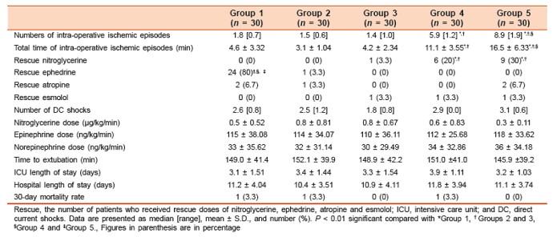

Table 7: Perioperative cardiac troponin I (cTnI) [µg/L] changes in the placebo (group 1), ephedrine 0.07 (group 2), 0.1 (group 3) and 0.15 mg/kg (group 4), and phenylephrine 1.5 µg/kg (group 5) (reproduced from El-Tahan 2011)

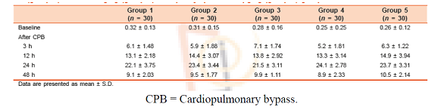

There have been case reports of cardiac ischemia and arrhythmia from ephedrine.

### Question 6

*Please provide evidence of the efficacy and safety of ephedrine hydrochloride given intravenously, intramuscularly or subcutaneously for the indication bronchospasm.*

The indication of bronchospasm has been withdrawn.

### Question 7

*Please provide an update of the safety profile of parentally administered ephedrine hydrochloride using post marketing data.*

*Sponsor response:*

The proposed product has been supplied in Italy since 1993. The sponsor prepared an overview of the product and adverse event profile within Italy and it is provided.

The report summarises the data from the PSURs covering the period 17 December 1998 to 17 September 2003; Sept 2003 to May 2008, May 2008 to April 2011. During this time there were no adverse events reported. This is despite a large number of product sales.

Table 8: reported sales data of the medicinal product for the reference period September 2003 to May 2008

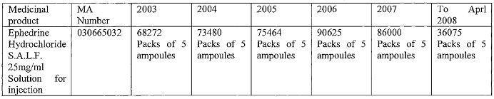

Table 9: reported sales data of the medicinal product for the reference period June 2008 to April 2011

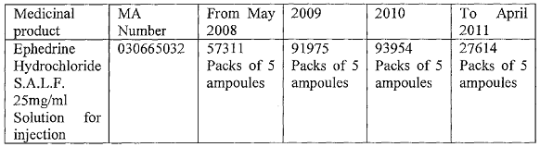

A search of the National network of pharmacovigilance for the medicinal product Ephedrine Hydrochloride SALF 25 mg/mL between November 2001 and 14 December 2015 did not identify any results.

A screen of the national (Italian) and international literature for adverse reactions due to the medicinal product ephedrine hydrochloride 25 mg/mL did not show any results.

### Question 8

*Please justify why the interactions listed in the UK PI should not be included in the Australian PI.*

These have been updated

### Question 9

*Please explain the reason for the discrepant advice in relation to overdose in the PI of Australia compared to Italy and the UK. Please update the overdose section with evidence based statements that consistent with current clinical practice.*

The sponsor was unable to access the relevant information.

The evaluator cannot find this on the internet either, it is probably a typographical error.

On review of the EMC website (www.medicines.org.uk/emc/search), the following ephedrine hydrochloride salts are listed:

* Ephedrine Hydrochloride 3 mg/mL – Aguettant Ltd, Martindale Pharmaceuticals Ltd
* Ephedrine Hydrochloride 30 mg in 1 mL- Auden McKenzie Ltd, Martindale Pharmaceuticals Ltd

## Second round benefit-risk assessment

### Second round assessment of benefits

The sponsor has included further justification for the use of ephedrine in spinal and other anaesthesia. In addition, further chemistry, pharmacokinetic, pharmacodynamic and clinical data was submitted in relation to the concerns about the 11% change in potency due to different strength.

The evaluator agrees that for a drug such as ephedrine which is used to treat a medical emergency, a market alternative is an advantage; particularly for situations where there are problems with supply of a drug.

### Second round assessment of risks

The post market data submitted indicated that the use of ephedrine in Italy was not associated with any reported adverse events. The safety profile of ephedrine is well known, and largely due to its pharmacodynamic effect. It is likely to be used only be anaesthetists in a controlled setting, thus adverse events will be closely monitored and treated.

There appears to be little evidence of a clinical risk for the small difference in the amount of free base or salt in the ephedrine hydrochloride versus ephedrine sulfate. The evaluator will defer any comments in relation to how these risks will be mitigated, assuming that this will be assessed by the pharmacovigilance team and delegate. Appropriate labelling and education would be important.

### Second round assessment of benefit-risk balance

Having revised the indications and PI, the risk benefit balance for the use of ephedrine hydrochloride for the treatment of hypotension due to spinal anaesthesia is favourable.

## Second round recommendation regarding authorisation

The clinical evaluator recommends approval of the registration of ephedrine hydrochloride for the indication of ‘treatment of hypotension secondary to spinal anaesthesia’ and other changes to the PI (version 2).

## References

1. Ngan Kee WD, Khaw KS, Lee BB, Gin TT. A dose response study of prophylactic intravenous ephedrine for the prevention of hypotension during spinal anaesthesia for caesarean delivery. *Anesth Analg*. 2000; 90: 1390-1395
2. Biddle, C To press or not to press, and if so with what? A single question-focused meta-analysis of vasopressor choice during regional anaesthesia. *Obstetrics. AANA Journal*. 2013; 81: 261
3. Mohta, M; Agaral, D; Gupta, LK; Tyagi, A; Gupta, A; Sethi, AK. Comparison of potency of ephedrine and mephentermine for prevention of post-spinal hypotension in caesarean section. *Anaesthesia and Intensive Care*. 2008; 36: 360-364.
4. Cyna et al. Techniques for preventing hypotension during spinal anaesthesia for caesarean section. *Cochrane Database of Systematic Reviews. 2006*. http://onlinelibrary.wiley.com/doi/10.1002/14651858.CD002251.pub2/abstract
5. Iqbal M.S. Ishaq M. Masood A. Khan M.Z. Optimal dose of prophylactic intravenous ephedrine for spinal-induced hypotension during cesarean section. *Anaesthesia, Pain and Intensive Care.* 2010; 14: 71-75
6. Drug Monograph: Ephedrine hydrochloride. In: Injectable Drug Guide® System (electronic version). Truven Health Analytics, Greenwood Village, Colorado, USA. Available from: http://www.micromedexsolutions.com/ (cited: 23 July 2015). Subscription required to view.

|  |
| --- |
| Therapeutic Goods Administration |
| PO Box 100 Woden ACT 2606 Australia  Email: [info@tga.gov.au](mailto:info@tga.gov.au) Phone: 1800 020 653 Fax: 02 6232 8605  [**https://www.tga.gov.au**](https://www.tga.gov.au) |

1. BNFC = British national formulary for children
2. Chou TQ. The preparation and properties of ephedrine and its salts. *J. Biol. Chem*. 1926 70: 109-114.
3. Takasaki K et al. Tachyphylaxis of indirectly acting sympathomimetic amines. I. Difference of pressor effect produced by repeated administration of ephedrine, methamphetamine and pheniprazine in dogs. *Kurume Med J.* 1972; 19: 1-10.
4. Kobayashi S, et al The sympathomimetic actions of l-ephedrine and d-pseudoephedrine: direct *Anesth Analg*. 2003; 97:1239-1245.
5. Vansal SS, Feller DR. Direct effects of ephedrine isomers on human beta-adrenergic receptor subtypes. *Biochem Pharmacol*. 1999; 58:807-810.
6. Ma G, et al. Pharmacological effects of ephedrine alkaloids on human alpha(1)- and alpha(2)-adrenergic receptor subtypes. *J Pharmacol Exp Ther*. 2007; 322: 214-221.
7. Rothman RB, et al. In vitro characterization of ephedrine-related stereoisomers at biogenic amine transporters and the receptorome reveals selective actions as norepinephrine transporter substrates. *J Pharmacol Exp Ther.* 2003 ;307:138-145.
8. Liles JT et al Pressor responses to ephedrine are mediated by a direct mechanism in the rat. *J Pharmacol Exp Ther*. 2006; 316: 95-105.
9. Persky AM, et al. Modelling the cardiovascular effects of ephedrine*. Br J Clin Pharmacol*. 2004; 57: 552-562.
10. Kanaya N, et al Differential pressor response to intravenous ephedrine during recovery from deliberate hypotension*. J Clin Anesth*. 2004; 16: 266-270.
11. Mohta, M et al. Comparison of potency of ephedrine and mephentermine for prevention of post-spinal hypotension in caesarean section. *Anaesthesia and Intensive Care*. 2008; 36: 360-364
12. Ayatollahi V et al. Comparison of effects of ephedrine, lidocaine and ketamine with placebo on injection pain, hypotension and bradycardia due to propofol injection: a randomized placebo controlled clinical trial. *Acta Med Iran.* 2012; 50: 609-614.
13. Ayorinde BT et al. Evaluation of pre-emptive intramuscular phenylephrine and ephedrine for reduction of spinal anaesthesia-induced hypotension during Caesarean section*. Br J Anaesth*. 2001; 86: 372-376.
14. Cleary-Goldman J,et al. Prophylactic ephedrine and combined spinal epidural: maternal blood pressure and fetal heart rate patterns. *Obstet Gynecol*. 2005; 106: 466-472.
15. Hemmingsen C, et al. Prophylactic ephedrine during spinal anaesthesia: double-blind study in patients in ASA groups I-III. *Br J Anaesth*. 1989; 63: 340-342.
16. Kol IO et al The effects of intravenous ephedrine during spinal anesthesia for cesarean delivery: a randomized controlled trial*. J Korean Med Sci.* 2009; 24: 883-888.
17. Simon L, et al Dose of prophylactic intravenous ephedrine during spinal anesthesia for cesarean section. *J Clin Anesth.* 2001; 13: 366-369.
18. Sternlo JE, et al. Prophylactic i.m. ephedrine in bupivacaine spinal anaesthesia. *Br J Anaesth.* 1995; 74: 517-520.
19. Tsen LC, et al Hemodynamic effects of simultaneous administration of intravenous ephedrine and spinal anesthesia for cesarean delivery. *J Clin Anesth*. 2000; 12: 378-382.
20. Iqbal M.S. et al. Optimal dose of prophylactic intravenous ephedrine for spinal-induced hypotension during cesarean section*. Anaesthesia, Pain and Intensive Care*. 2010; 14: 71-75
21. Martindale: The Complete Drug Reference; drug monographs: Ephedrine
22. Dingemanse J, et al Modification of the cardiovascular effects of ephedrine by the reversible monoamine oxidase A-inhibitor moclobemide. *J Cardiovasc Pharmacol*. 1996; 28: 856-861.
23. Khavandi A et al Myocardial infarction associated with the administration of intravenous ephedrine and metaraminol for spinal-induced hypotension. *Anaesthesia.* 2009; 64: 563-536.
24. Mourand I, Ducrocq X, Lacour JC, Taillandier L, Anxionnat R, Weber M. Acute reversible cerebral arteritis associated with parenteral ephedrine use. *Cerebrovasc Dis*. 1999; 9: 355-357.
25. Ngan Kee WD, et al. Placental transfer and fetal metabolic effects of phenylephrine and ephedrine during spinal anesthesia for cesarean delivery. *Anesthesiology.* 2009; 111:506-512.
26. Category A: *Drugs which have been taken by a large number of pregnant women and women of childbearing age without any proven increase in the frequency of malformations or other direct or indirect harmful effects on the fetus having been observed*.
27. IMS Health is an American company that provides information, services and technology for the [healthcare industry](https://en.wikipedia.org/wiki/Healthcare_industry). It is the largest vendor of U.S. physician prescribing data.
28. Wilkinson GR and Becket AH. Absorption, metabolism and excretion of the ephedrines in Man. I. The influence of urinary pH and urine volume output The Journal of Pharmacology and Experimental Therapeutics 1968; 182: 139-147
29. Sever PS et al. The metabolism of (-)-Ephedrine in Man. *Europ. J Clin Pharmacol* 1975; 9: 193-198
30. Pickup ME et al. The pharmacokinetics of ephedrine after oral dosage in asthmatics receiving acute and chronic treatment. *Br. J. clin. Pharmac* 1976; 3: 123-134
31. Berlin I et al Pharmacodynamics and pharmacokinetics of single nasal (5 mg and 10 mg) and oral (50 mg) doses of ephedrine in healthy subjects. *Eur J Clin Pharmacol* 2001; 57: 447-455
32. Csajka C et al. Mechanistic pharmacokinetic modelling of ephedrine, norephedrine and caffeine in healthy subjects *British Journal of Clinical Pharmacology* 2004; 59: 335-345
33. Lee, A et al A Quantitative, Systematic Review of Randomized Controlled Trials of Ephedrine Versus Phenylephrine for the Management of Hypotension During Spinal Anesthesia for Cesarean Delivery *Anesth Analg* 2002; 94: 920–926
34. Cyna AM,et al Techniques for preventing hypotension during spinal anaesthesia for caesarean section (Review) 2006 published in The Cochrane Library2006, Issue 4
35. Kang, Y. G et al. Prophylactic Intravenous Ephedrine Infusion during Spinal Anesthesia for Cesarean Section*. Anesth Analg* 1982; 61: 839-842.
36. Turkoz A et al Effectiveness of Intravenous Ephedrine Infusion During Spinal Anaesthesia for Caesarean Section Based on Maternal Hypotension, Neonatal Acid-base Status and Lactate Levels. *Anaesth Intensive Care* 2002; 30: 316-320
37. Sigdel et al., Prevention of Spinal Anesthesia Induced Hypotension in Elderly: Comparison of Prophylactic Atropine with Ephedrine *J Anesth Clin Res* 2015; 6 (8): 1000557
38. Goel M et al Hemodynamic Effects during Combined Spinal and Epidural Anesthesia: Role of Fluid Preloading and Prophylactic Vasoconstrictors. *The Internet Journal of* Anesthesiology 2008; 22 (1): 1-6
39. Kee, V R Hemodynamic Pharmacology of Intravenous Vasopressors. Critical Care Nurse 2003; 23: 79-82.
40. El-Tahan, M. Preoperative ephedrine counters hypotension with propofol aneshtesia during valve surgery: A dose dependent study. *Annals of Cardiac Anaesthesia* 2011; 14: 30-40