|  |
| --- |
| **February 2022** |

|  |
| --- |
| Australian Public Assessment Report for Eptinezumab |
| Proprietary Product Name: Vyepti |
| Sponsor: Lundbeck Australia Pty Ltd |

About the Therapeutic Goods Administration (TGA)

* The Therapeutic Goods Administration (TGA) is part of the Australian Government Department of Health and is responsible for regulating medicines and medical devices.
* The TGA administers the *Therapeutic Goods Act 1989* (the Act), applying a risk management approach designed to ensure therapeutic goods supplied in Australia meet acceptable standards of quality, safety and efficacy (performance) when necessary.
* The work of the TGA is based on applying scientific and clinical expertise to decision-making, to ensure that the benefits to consumers outweigh any risks associated with the use of medicines and medical devices.
* The TGA relies on the public, healthcare professionals and industry to report problems with medicines or medical devices. TGA investigates reports received by it to determine any necessary regulatory action.
* To report a problem with a medicine or medical device, please see the information on the TGA website <<https://www.tga.gov.au>>.

About AusPARs

* An Australian Public Assessment Report (AusPAR) provides information about the evaluation of a prescription medicine and the considerations that led the TGA to approve or not approve a prescription medicine submission.
* AusPARs are prepared and published by the TGA.
* An AusPAR is prepared for submissions that relate to new chemical entities, generic medicines, major variations and extensions of indications.
* An AusPAR is a static document; it provides information that relates to a submission at a particular point in time.
* A new AusPAR will be developed to reflect changes to indications and/or major variations to a prescription medicine subject to evaluation by the TGA.

Copyright

© Commonwealth of Australia 2022  
This work is copyright. You may reproduce the whole or part of this work in unaltered form for your own personal use or, if you are part of an organisation, for internal use within your organisation, but only if you or your organisation do not use the reproduction for any commercial purpose and retain this copyright notice and all disclaimer notices as part of that reproduction. Apart from rights to use as permitted by the *Copyright Act 1968* or allowed by this copyright notice, all other rights are reserved and you are not allowed to reproduce the whole or any part of this work in any way (electronic or otherwise) without first being given specific written permission from the Commonwealth to do so. Requests and inquiries concerning reproduction and rights are to be sent to the TGA Copyright Officer, Therapeutic Goods Administration, PO Box 100, Woden ACT 2606 or emailed to <[tga.copyright@tga.gov.au](mailto:tga.copyright@tga.gov.au)>.

Contents

List of abbreviations 4

I. Introduction to product submission 6

Submission details 6

Product background 7

Regulatory status 8

Product Information 9

II. Registration timeline 9

III. Submission overview and risk/benefit assessment 10

Quality 10

Nonclinical 10

Clinical 11

Risk management plan 25

Risk-benefit analysis 27

Outcome 33

Attachment 1. Product Information 34

## List of abbreviations

| Abbreviation | Meaning |
| --- | --- |
| ACM | Advisory Committee on Medicines |
| ADA | Antidrug antibodies |
| ARTG | Australian Register of Therapeutic Goods |
| ASA | Australian Specific Annex |
| AUC | Area under the plasma concentration time curve |
| AUC0-2016h | Area under concentration time curve from time 0 to 2016 hours |
| AUC0-τ | Area under concentration time curve in a steady state dosing interval (τ) |
| AUC0-last | Area under the plasma concentration time curve from time zero to the last measurable time point |
| BLA | Biologics License Application (Food and Drug Administration, United States of America) |
| CGRP | Calcitonin gene related peptide |
| Cmax | Maximum plasma concentration |
| CMI | Consumer Medical Information |
| CPD | Certified Product Details |
| Ctrough | Trough plasma concentration |
| CYP450 | Cytochrome P450 |
| DLP | Data lock point |
| EMEA | European Medicines Evaluation Agency (European Union) |
| EU | European Union |
| FDA | Food and Drug Administration (United States of America) |
| GMP | Good Manufacturing Practice |
| GP | General practitioner |
| GVP | Good Pharmacovigilance Practices |
| HIT-6 | Headache impact test-6 |
| ICHD-II | International Classification of Headache Disorders, second edition |
| IgG | Immunoglobulin G |
| IHS | International Headache Society |
| IMP | Investigational medicinal product |
| MAA | Marketing authorisation application |
| MDD | Major depressive disorder |
| MOH | Medication overuse headache |
| NAb | Neutralising antibody |
| PBRER | Periodic benefit-risk evaluation report |
| PE | Polyethylene |
| PI | Product Information |
| PK | Pharmacokinetic(s) |
| PopPK | Population pharmacokinetic(s) |
| PSUR | Periodic safety update report |
| PTSD | Post-traumatic stress disorder |
| PVC | Polyvinyl chloride |
| REDCap | Research Electronic Data Capture |
| RMP | Risk management plan |
| SAE | Serious adverse event |
| SMQ | Standardised Medical Dictionary for Regulatory Activities (MedDRA) Query |
| T½ | Terminal drug half-life |
| TEAE | Treatment emergent adverse event |
| Tmax | Time of maximum concentration |
| US(A) | United States (of America) |

## I. Introduction to product submission

### Submission details

|  |  |
| --- | --- |
| *Type of submission:* | New biological entity |
| *Product name:* | Vyepti |
| *Active ingredient:* | Eptinezumab |
| *Decision*: | Approved |
| *Date of decision:* | 9 June 2021 |
| *Date of entry onto ARTG:* | 16 June 2021 |
| *ARTG number:* | 335256 |
| *Black Triangle Scheme:[1]* | Yes  This product will remain in the scheme for 5 years, starting on the date the product is first supplied in Australia. |
| *Sponsor’s name and address:* | Lundbeck Australia Pty Ltd  1 Innovation Road  North Ryde NSW 2113 |
| *Dose form:* | Concentrated injection |
| *Strength:* | 100 mg/mL |
| *Container:* | Vial |
| *Pack size:* | One |
| *Approved therapeutic use:* | *Vyepti is indicated for the preventive treatment of migraine in adults.* |
| *Route of administration:* | Intravenous infusion |
| *Dosage:* | The recommended dosage is 100 mg administered by intravenous infusion every 12 weeks. Some patients may benefit from a dosage of 300 mg administered by intravenous infusion every 12 weeks.  The treatment benefit should be assessed 3 to 6 months after initiation of the treatment. The need for dose escalation should be assessed within 12 weeks after initiation of the treatment. The decision to continue with treatment should be made on an individual patient basis, determined prior to each dose.  For further information regarding dosage, refer to the Product Information. |
| *Pregnancy category:* | B1  Drugs which have been taken by only a limited number of pregnant women and women of childbearing age, without an increase in the frequency of malformation or other direct or indirect harmful effects on the human fetus having been observed.  Studies in animals have not shown evidence of an increased occurrence of fetal damage. The use of any medicine during pregnancy requires careful consideration of both risks and benefits by the treating health professional. This must not be used as the sole basis of decision making in the use of medicines during pregnancy. The TGA does not provide advice on the use of medicines in pregnancy for specific cases. More information is available from obstetric drug information services in your State or Territory. |

### Product background

This AusPAR describes the application by Lundbeck Australia Pty Ltd (the sponsor) to register Vyepti (eptinezumab) 100 mg/mL, concentrated injection for the following proposed indication:

*Vyepti is indicated for the preventive treatment of migraine in adults.*

Migraine is an episodic disorder, characterised by a severe headache generally associated with nausea and/or light and sound sensitivity.[2] In Australia, 4.9 million people suffer from migraine.[3] The one year prevalence of migraine is 16%, with females at three times elevated risk of migraine.3,[4] Women make up 71% of migraine sufferers and 86% are people of working age. Chronic migraine (that is, 15 migraine days per month or more) is experienced by 7.6% of migraine sufferers.

The exact pathophysiological mechanisms underlying the onset of a migraine attack remain unknown.[5] Vasodilatation that occurs during spontaneous migraine attacks is probably an epiphenomenon resulting from instability in the central neurovascular control mechanism. There is evidence to suggest that calcitonin gene‑related peptide (CGRP) plays an important role in the pathogenesis of migraine via the activation of the trigeminovascular system.[6] Stimulation of the trigeminal ganglion results in the release of vasoactive neuropeptides, including substance P, CGRP, and neurokinin-A. Release of these neuropeptides is associated with the process of neurogenic inflammation. The two main components of this sterile inflammatory response are vasodilation (CGRP is a potent vasodilator) and plasma protein extravasation.6,[7]

In humans, CGRP is present in two isoforms, α-CGRP and β-CGRP. Since α-CGRP is the principal isoform localised in the peripheral and central sensory nervous system, its biological activity seems more important in the pathophysiology of migraine. However, in terms of side effects, the β-CGRP isoform cannot be excluded (which plays a role in the enteric transmission) since some CGRP blocking drugs (monoclonal antibodies such as eptinezumab, fremanezumab, and galcanezumab) are not selective and can block both the α-CGRP and β-CGRP isoforms.7,[8]

Vyepti is approved for preventive (prophylactic) treatment of migraine in adults to be administrated intravenously as an infusion once every three months. Current pharmacological migraine preventive options available in Australia may be administered orally or by subcutaneous injection. Common oral prophylactic options in current use in Australia include pizotifen (Sandomigran),[9] propranolol,[10],[11] and topiramate;[12] amongst others. Subcutaneously injected drugs include botulinum toxin; the CGRP antagonists, erenumab (Aimovig),[13] fremanezumab (Ajovy);[14] and galcanezumab (Emgality),[15] that have become available via patient familiarisation programmes or private prescription.

The TGA has approved three CGRP antagonists for the preventive treatment of migraine: erenumab, fremanezumab, and galcanezumab. All these medicines are administered subcutaneously. Eptinezumab is the first CGRP antagonist and a treatment agent for the prophylaxis of migraine that is administered intravenously. Erenumab binds to the CGRP receptor, and fremanezumab and galcanezumab bind to the CGRP ligand. Erenumab was the first CGRP antagonist that was approved by the TGA in 2018. The CGRP antagonists are each administered monthly via subcutaneous injection, with a loading dose recommended for galcanezumab. Fremanezumab also has an alternate dosing regimen of three injections (doses) given together once every three months.

There are a number of limitations with the currently available preventive agents. Many patients do not respond to the currently available agents. In addition, they may experience idiosyncratic or dose related intolerable side effects, or find adhering to a daily medication regime challenging.

Therefore, there is a clinical need for effective novel migraine prophylactic agents.

### Regulatory status

This product is considered a new biological entity for Australian regulatory purposes.

At the time the TGA considered this application, similar applications had been approved in the United States of America (USA) (on 21 February 2020) and Canada (on 11 January 2021). Similar applications were under consideration in Switzerland (submitted on 30 April 2020), Singapore (submitted on 15 June 2020) and the European Union (EU) (submitted on 16 November 2020).

Table 1, shown below, summarised the approved indications for eptinezumab in other countries and territories.

Table 1: International regulatory status

|  |  |  |  |
| --- | --- | --- | --- |
| Region | Submission date | Status | Approved indications |
| United States of America | 21 February 2019 | Approved on 21 February 2020 | *Vyepti is indicated for the preventive treatment of migraine in adults.* |
| Canada | 3 February 2020 | Approved on 11 January 2021 | *Vyepti (eptinezumab for injection) is indicated for the prevention of migraine in adults who have at least 4 migraine days per month.* |
| Switzerland | 30 April 2020 | Under consideration | Under consideration |
| Singapore | 15 June 2020 | Under consideration | Under consideration |
| European Union | 16 November 2020 | Under consideration | Under consideration |

### Product Information

The Product Information (PI) approved with the submission which is described in this AusPAR can be found as Attachment 1. For the most recent PI, please refer to the TGA website at <<https://www.tga.gov.au/product-information-pi>>.

## II. Registration timeline

The following table captures the key steps and dates for this application and which are detailed and discussed in this AusPAR.

Table 2: Timeline for Submission PM-2020-01823-1-1

| Description | Date |
| --- | --- |
| Submission dossier accepted and first round evaluation commenced | 2 June 2020 |
| First round evaluation completed | 17 November 2020 |
| Sponsor provides responses on questions raised in first round evaluation | 21 December 2020 |
| Second round evaluation completed | 10 February 2021 |
| Delegate’s Overall benefit-risk assessment and request for Advisory Committee advice | 18 February 2021 |
| Sponsor’s pre-Advisory Committee response | 15 March 2021 |
| Advisory Committee meeting | 8 and 9 April 2021 |
| Registration decision (Outcome) | 9 June 2021 |
| Completion of administrative activities and registration on the ARTG | 16 June 2021 |
| Number of working days from submission dossier acceptance to registration decision* | 213 |

*Statutory timeframe for standard applications is 255 working days

## III. Submission overview and risk/benefit assessment

The submission was summarised in the following Delegate’s overview and recommendations.

Relevant guidelines or guidance documents referred to by the Delegate are listed below:

* European Medicines Evaluation Agency (EMEA), Committee for Medicinal Products for Human Use (CHMP), 24 January 2007. Guideline on Clinical Investigation of Medicinal Products for the Treatment of Migraine (CPMP/EWP/788/01 Rev. 1).

### Quality

Eptinezumab is a humanised monoclonal immunoglobulin G1 (IgG1) antibody. Each single-dose vial contains 100 mg/mL eptinezumab.

Eptinezumab binds to the α- and β-isoforms of the CGRP ligand. This, in combination with the 100% bioavailability following intravenous administration, translates into fast blockage of pharmacological effects of circulating CGRP in humans. As a result, eptinezumab prevents the activation of CGRP receptors and hence blockade of the downstream cascade of physiological events linked to initiation, frequency and severity of migraine attacks.

Good Manufacturing Practice (GMP) clearances for the drug substance and drug product manufacturing sites are considered acceptable.

The quality evaluator has recommended approval.

### Nonclinical

Eptinezumab has high affinity for human CGRP and inhibits CGRP-driven signalling *in vitro*. Eptinezumab inhibited capsaicin induced increase in dermal blood flow in Sprague Dawley rats and cynomolgus monkeys, and β-CGRP induced increase in dermal blood flow in rabbits.

Eptinezumab is functionally inactive at the adrenomedulin, and intermedin/adrenomedulin-2, calcitonin, and amylin receptors, all members of the calcitonin receptor family.

Examination of safety pharmacology (incorporated into general repeat-dose toxicity studies) revealed no effects of eptinezumab on neurological, cardiovascular, and respiratory function when given up to 100 mg/kg intravenously in monkeys.

The pharmacokinetics (PK) of eptinezumab in monkeys and human subjects was generally consistent with the protein nature of the drug: long half-lives and limited distribution.

Eptinezumab had a low order of acute intravenous toxicity in rats and monkeys.

Repeat-dose toxicity studies by the intravenous route were conducted in rats (28 days) and cynomolgus monkeys (28 days and 6 months). The studies were adequately conducted, achieving high relative exposures. No target organs for toxicity were identified. An antidrug antibody (ADA)-mediated anaphylactoid response on a single animal indicates a potential risk of hypersensitivity reactions in patients.

No genotoxicity studies were conducted. Given the protein nature of the drug, this is considered acceptable. No carcinogenicity studies were conducted. No proliferative lesions were seen in the repeat-dose toxicity study.

Reproductive and developmental studies performed with eptinezumab revealed no treatment related effects on male or female fertility in rats, no adverse effects on embryofetal development in rats and rabbits, and no effects on postnatal development of offspring from treated rats.

The nonclinical evaluator has recommended approval.

### Clinical

The clinical dossier consisted of the following studies:

* Phase I Studies ALD403-CLIN-001 (also known as Study 001), ALD403-CLIN-002 (also known as Study 002), ALD403-CLIN-003 (also known as Study 003), ALD403‑CLIN‑007 (also known as Study 007), ALD403-CLIN-009 (also known as Study 009), ALD403-CLIN-010 (also known as Study 010), ALD403-CLIN-012 and ALD403-CLIN-014 (also known as Study 014)
* Phase II Study ALD403-CLIN-005 (also known as Study 005)
* Phase III pivotal Studies ALD403-CLIN-006 (also known as Study 006), ALD403‑CLIN‑011(also known as Study 011)
* Long term safety Study ALD403-CLIN-013 (also known as Study 013)

#### Pharmacology

###### Absorption

Eptinezumab, when administered intravenously has a bioavailability of 100%.

###### Distribution

The volume of distribution is approximately 3.7 L.

###### Metabolism

Eptinezumab, as with all other endogenous immunoglobulin G (IgG), is expected to be degraded into small peptides and amino acids via catabolic pathways.

###### Excretion

The mean clearance of eptinezumab is 0.15 L/day and the mean terminal half-life was approximately 27 days.

##### Pharmacokinetics

###### Pharmacokinetic properties of 30 mg, 100 mg and 300 mg eptinezumab (Study 006)

It appears that a dose proportional increase in PK parameters was observed across the eptinezumab doses. A steady state of plasma concentration was noted at around 12 weeks (2016 hours) time period. Inter-subject variability of area under concentration time curve from time 0 to 2016 hours (AUC0-2016h), area under the plasma concentration time curve from time zero to the last measurable time point (AUC0-last), and maximum plasma concentration (Cmax) ranged from 36.1% to 83.4%.

Figure 1: Study 006 Plasma trough concentrations of eptinezumab 30, 100 and 300 mg doses in subjects with episodic migraine

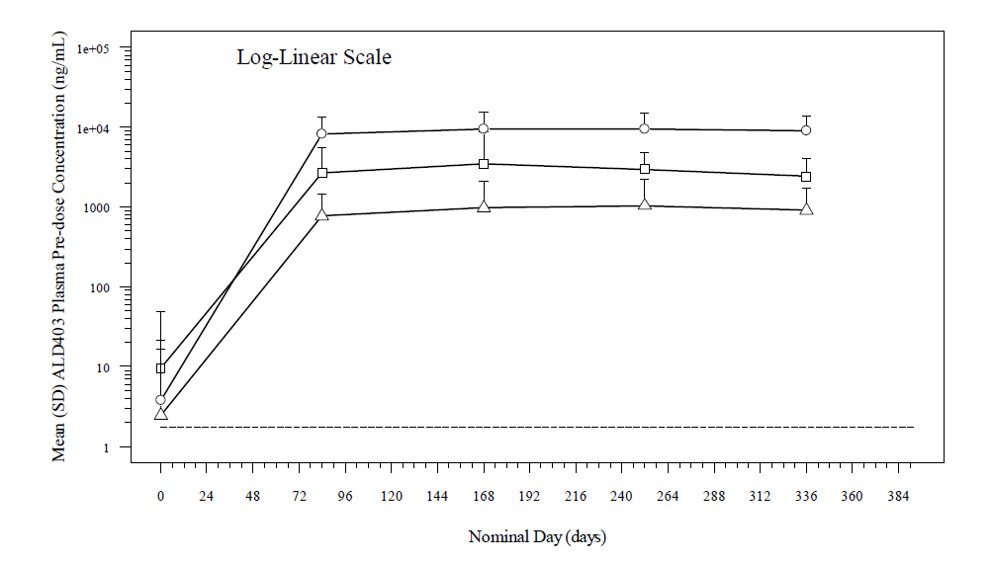

SD = standard deviation.

Table 3: Study 006 Pharmacokinetics parameters after a single administration of eptinezumab in subjects with episodic migraine

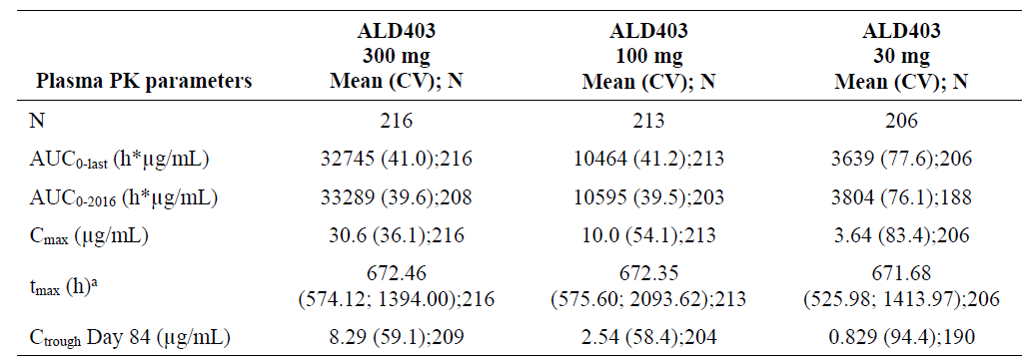

AUC0‑2016 = area under concentration time curve from time 0 to 2016 hours; AUC0-last = area under the plasma concentration time curve from time zero to the last measurable time point; Cmax =maximum plasma concentration; Ctrough = trough plasma concentration; CV = coefficient of variation; N = total number of subjects in a group; PK = pharmacokinetics; tmax = time of maximum concentration.

After multiple dose administrations, mean plasma eptinezumab area under the plasma concentration time curve (AUC), Cmax and trough plasma concentration (Ctrough) increased proportionally with dose. Median time of maximum concentration (Tmax) ranged from 671.28 to 672.60 hours after multiple dose administrations in subjects with episodic migraine, and was independent of dose. Inter-subject variability of AUC0-last (area under concentration time curve in a steady state dosing interval (τ)), (AUC0-τ), and Cmax was 42.8% to 66.9%.

##### Population pharmacokinetics data

A population pharmacokinetics (PopPK) model was utilised to describe the PK properties of eptinezumab. Dose and exposure-response relationships of selected endpoints were performed to support dosing of eptinezumab.

The PopPK model consisted of healthy subjects and subjects with chronic and episodic migraine who were participants in 8 clinical studies with eptinezumab. The model also included subjects with mild (41.9%) and moderate renal impairment (2.7%).

No major variations of PK parameters for eptinezumab, associated with age, gender and mild and moderate renal impairment were reported.

##### Pharmacodynamics

In subjects with migraine, mean neurogenic vasodilation was reduced by 41% following intravenous administration of eptinezumab compared to an increase of 12% for placebo on the day following treatment. The reduction persisted ranging from 20% to 50% for 100 mg eptinezumab for up to 12 weeks, whilst placebo ranged from a 20% increase to a 0.20% reduction during the same period.

##### Immunogenicity

In Studies 005, 006, 011 and 013, a total of 1993 patients were tested for ADA. Among those, 316 patients (15.9%) were identified to have treatment emergent anti-eptinezumab antibody ADA responses. 124 (6.2%) patients developed neutralising antibodies (NAb) against eptinezumab.

In Study 006, a dose-response trend in the number of subjects with ADA positive results was observed after Week 8. The incidence of ADA was 21.0% (47/224), 20.2% (45/223) and 12.3% (27/219) for the 300 mg, 100 mg and 30 mg dose groups, respectively.

The number of subjects with positive NAb generally increased over time from Week 8 to Week 24 (except at Week 16), and then decreased at time points after Week 24. At Week 8, around 46% of 28 ADA positive subjects were NAb positive. At Week 24, around 44% of the 87 ADA positive subjects were NAb positive.

There was no dose-response trend related to NAb positive observations.

##### Drug-drug interactions

Eptinezumab is not metabolised by cytochrome P450 (CYP450) enzymes.[16] Therefore, interactions by eptinezumab with concomitant medications that are substrates, inducers, or inhibitors of CYP450 enzymes are considered unlikely. Co-administration of eptinezumab in combination with sumatriptan was investigated in Study 001 Part B. No major impacts on PK of eptinezumab was noted, when co-administered with sumatriptan.

#### Efficacy

##### Dose selection for pivotal studies

The inhibition of α-CGRP mediated neurogenic vasodilation induced by topical capsaicin application following single or multiple administrations of eptinezumab in human subjects was used as a biomarker to help inform early dose selection.

At the higher doses tested (30 to 1000 mg intravenously), eptinezumab had a generally dose-dependent effect upon reducing the dermal vasodilation induced by topical treatment with capsaicin relative to placebo (Study 001). Subjects receiving 100 mg intravenous eptinezumab experienced marked reductions in capsaicin induced vasodilation relative to the placebo treated subjects within 24 hours following the first treatment. The treatment effect persisted for at least 12 weeks following each dose (Study 007).

Study 005 was included in the dossier as a phase II dose finding study. Subjects were randomised in a 1:1:1:1:1 ratio to either eptinezumab 10, 30, 100, 300 mg or placebo. Overall exposure appeared dose proportional. Terminal elimination half-life was dose independent and consistent between the active treatment groups (10, 30, 100, and 300 mg), with mean values in the range 27 to 30 days. Median terminal drug half-life (T½) values were similar. It was concluded that dose had no effect on the T½ of eptinezumab.

Exposure-response analyses were also done in Phase III Studies 006 and 011 and a flat exposure response was reported at 100 to 300 mg of eptinezumab.

##### Clinical studies with efficacy and safety data

Table 4: Clinical studies with efficacy and safety data

|  |  |  |  |  |  |  |
| --- | --- | --- | --- | --- | --- | --- |
| Study | Diagnosis | Objectives of study | Study design and type of control | Number of subjects treated  (full analysis population) | Treatment schedule | Study durationa |
| Pivotal Studies | | | | | | |
| 006 | Episodic migraine | Efficacy; safety; PK;  immunogenicity | Parallel group; double blind; placebo controlled | 4 treatment groups:  222 placebo  223 active (30 mg)  221 active (100 mg)  222 active (300 mg) | 4 total infusions: day 0  week 12  week 24  week 36 | 56 weeks |
| 011 | Chronic migraine | Efficacy; safety; PK;  immunogenicity | Parallel group; double blind; placebo controlled | 3 treatment groups:  366 placebo  356 active (100 mg)  350 active (300 mg) | 2 total infusions: day 0  week 12 | 32 weeks |
| Supportive Studies | | | | | | |
| 002 | Episodic migraine | Safety; efficacy; PK;  immunogenicity | Parallel group; double blind; placebo controlled | 2 treatment groups:  82 placebo  81 active (1000 mg) | Single infusion | 24 weeks |
| 005 | Chronic migraine | Dose response; safety; duration of effect;  PK;  immunogenicity | Parallel group; double blind; placebo controlled; dose ranging | 5 treatment groups:  116 placebo  123 active (10 mg)  active (30 mg)  active (100 mg)  114 active (300 mg) | Single infusion | 49 weeks |

PK = pharmacokinetic(s).

a Duration of the study following the first treatment.

##### Study 006

###### Study design

Study 006 is a Phase III double blind, parallel group randomised controlled trial.

Efficacy of eptinezumab was assessed as the primary objective. Safety, PK and immunogenicity of eptinezumab were assessed as secondary objectives.

Eligible subjects were randomly assigned into one of three eptinezumab doses (30 mg, 100 mg, and 300 mg) or placebo in a 1:1:1:1 ratio. Randomisation was stratified by migraine days during screening (≤ 9 days versus >9 days). The total duration of the study was 60 weeks, with 12 scheduled visits. There was a screening period of 4 weeks to determine eligibility, followed by treatment on Day 0, Week 12, Week 24, and Week 36, and a follow-up period of 20 weeks following the final dose.

Four infusions of either eptinezumab or placebo were given 12 weeks apart. The study period consisted of a blinded analyses period of 24-week safety and efficacy period (Weeks 1 to 24) and a long-term safety period (Weeks 25 to 56).

###### Key inclusion criteria

* Episodic migraine: during the 28-day screening period, eligible subjects had to have a minimum of 4 and a maximum of 14 headache days (of which at least 4 had to be migraine days). A migraine day was defined as any day with a migraine or probable migraine as outlined in the International Headache Society (IHS) the International Classification of Headache Disorders, second edition (ICHD-II) (2004).18
* Diagnosis of migraine at ≤ 50 years of age.
* Acute migraine medications ≤ 14 days per 28-day period in the 3 months before screening and the 28 day period prior to randomisation.
* Used triptans for ≤ 10 days per 28-day period in the 3 months prior to screening and the 28 day period prior to randomisation.
* Did not regularly use (> 7 days) prophylactic headache medication.

###### Key exclusion criteria

* Confounding pain syndromes, (for example, fibromyalgia, complex regional pain syndrome) or any pain syndrome that required regular analgesia.
* Known or suspected temporo-mandibular disorders.

###### Study treatment

Four infusions of eptinezumab 100 mg/mL were administered intravenously at 12 weeks interval.

###### Primary endpoint

The primary endpoint was the change in frequency of migraine days from Baseline to Week 12.

This primary efficacy endpoint was calculated as the number of migraine days within 4 week intervals that were then averaged up to Week 12. The difference of this estimate from Baseline was calculated as the change from Baseline in the frequency of migraine days over Weeks 1 to 12.

###### Key secondary efficacy endpoints

* 75% migraine responder rate (Weeks 1 to 4).
* 75% migraine responder rate (Weeks 1 to 12).
* 50% migraine responder rate (Weeks 1 to 12).
* Percentage of subjects with a migraine on the day after dosing.

A responder was defined as a subject who achieved a ≥ 50% reduction, ≥ 75% reduction, or 100% reduction in migraine days, respectively. These reductions were evaluated by comparing the baseline frequency of migraine days to the migraine frequency in 4 week intervals. The same analyses were conducted for headache days.

###### Immunogenicity endpoints

* Development of anti-eptinezumab antibodies.
* Characterisation of anti-eptinezumab antibodies for neutralising activity and epitope specificity of the ADA response.

###### Study population

Eight hundred ninety-eight (898) subjects were randomised to three eptinezumab (30, 100 and 300 mg) and placebo arms. Around 21% of subjects discontinued treatment during study period, with the commonest reason being withdrawal of informed consent.

###### Baseline demographics

The mean age was around 40 years and around 61% of subjects were > 35 years of age. Around 85% of subjects were females and the mean body mass index was 29.45.

###### Migraine history

The mean number of headache days per 28 day period was 10.1 days and migraine days was 7.7 days.

Overall, the mean baseline percent of days that subjects used any headache medication was 25.12%. At Baseline, the mean percent of days with ergotamine, triptan and opioid usage was 0.12%, 5.44% and 0.43%, respectively. The most frequently reported concomitant medications were ibuprofen (41.6%), thomapyrin N (37.7%), sumatriptan (28.2%) and paracetamol (17.7%).

###### Results

Eptinezumab 100 and 300 mg doses are the proposed doses for marketing and hence discussed in detail, compared to the 30 mg dose.

###### Primary endpoint

The primary endpoint was the change in frequency of monthly migraine days from Baseline to Week 12.

At Week 12 of treatment period, subjects in the eptinezumab 30, 100 and 300 mg arms experienced a mean of 4.6, 4.7 and 4.3 migraine days respectively, compared to 5.4 migraine days in the placebo arm. The treatment difference of -0.82, -0.69 and ‑1.11 migraine days for eptinezumab 30, 100 and 300 mg arms respectively were statistically significant, compared to placebo.

Table 5: Study 006 Primary endpoint: the change in frequency of monthly migraine days (Weeks 1 to 12)

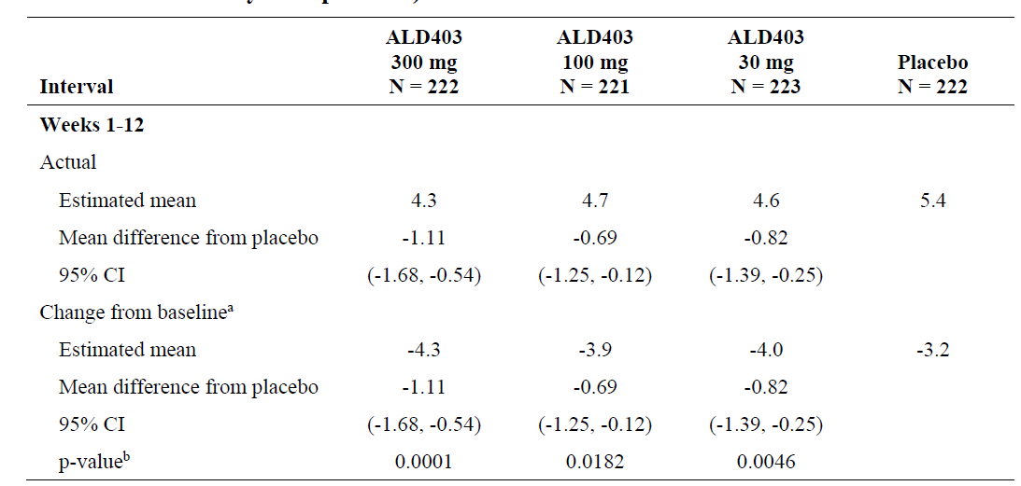

CI = confidence interval; N = total number of subjects in a group.

a Change from Baseline was the difference in migraine days between Baseline and the selected interval.

b Significant P-values for the primary endpoint change from Baseline migraine days from Weeks 1 to 12 were determined by the decision rule outlined in the statistical analysis plan.

###### Key secondary efficacy endpoints

For the key secondary efficacy endpoint of 75% migraine responder rate (Weeks 1 to 4), a greater percentage of subjects in the eptinezumab arms achieved a ≥ 75% reduction in migraine days at Week 4, compared to placebo. The treatment difference was statistically significant.

The wide confidence interval was noted and reflects the inherent variability in the occurrence of episodic migraine.

Table 6: Study 006 Summary of 75% migraine responder rate (Weeks 1 to 4)

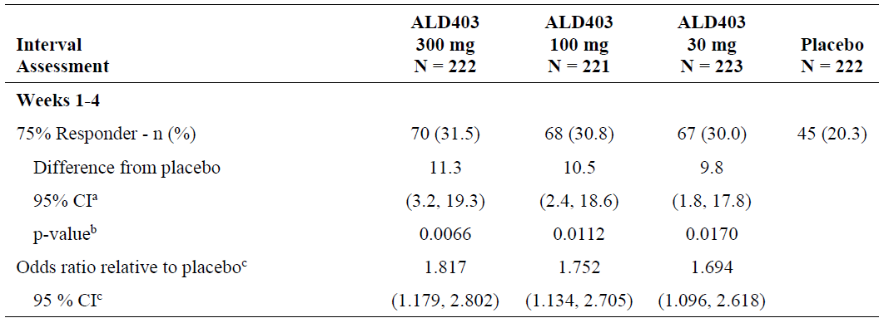

CI = confidence interval; N = total number of subjects in a group.

a 95% confidence intervals were calculated based upon normal approximation for two independent proportions. Stratification was not used.

b P-values for the key secondary endpoint 75% migraine responder rate for Weeks 1 to 4 were obtained from the Cochran-Mantel-Haenszel test stratified by randomised baseline migraine days (≤ 9 days, > 9 days). Significant P-values were determined by the decision rule outlined by the statistical analysis plan.

c The common odds ratio and 95% confidence intervals were obtained from the Mantel-Haenszel test stratified by randomised baseline migraine days (≤ 9 days, > 9 days).

For the key secondary efficacy endpoint of 75% migraine responder rate (Weeks 1 to 12), at Week 12, a greater percentage of subjects in the eptinezumab arms achieved this endpoint, compared to placebo. The odds ratio of achieving 75% reduction in migraine days was slightly higher for eptinezumab 300 mg arm at Week 12, compared to Week 4. A reduction in the odds ratio was at Week 12 for the eptinezumab 100 mg arm, compared to Week 4. The treatment difference was statistically significant for 30 and 300 mg eptinezumab groups.

Table 7: Study 006 Summary of 75% migraine responder rate (Weeks 1 to 12)

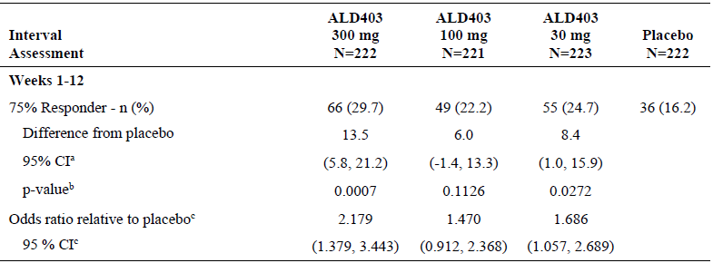

CI = confidence interval; N = total number of subjects in a group.

a 95% confidence intervals were calculated based upon normal approximation for two independent proportions. Stratification was not used.

b P-values for the key secondary endpoint 75% migraine responder rate for Weeks 1 to 12 were obtained from the Cochran-Mantel-Haenszel test stratified by randomised baseline migraine days (≤ 9 days, > 9 days). Significant P-values were determined by the decision rule outlined by the statistical analysis plan.

c The common odds ratio and 95% confidence intervals were obtained from the Mantel-Haenszel test stratified by randomised baseline migraine days (≤ 9 days, > 9 days).

For the secondary endpoint of 50% migraine responder rate, a greater percentage of subjects in eptinezumab 300 mg (around 18%) and eptinezumab 100 mg (around 12%) achieved a 50% reduction in migraine days, compared to placebo. The treatment difference was statistically significant.

Table 8: Study 006 Summary of 50% migraine responder rate by 12 week interval and treatment

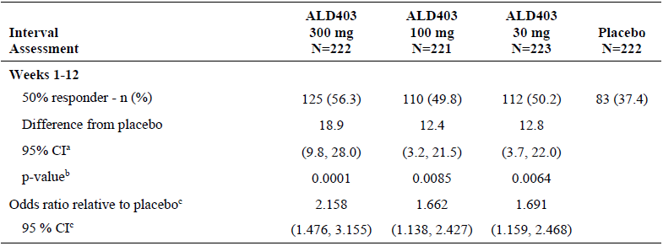

CI = confidence interval; N = total number of subjects in a group.

a 95% confidence intervals were calculated based upon normal approximation for two independent proportions. Stratification was not used.

b P-values for the key secondary endpoint 50% migraine responder rate for Weeks 1 to 12 were obtained from the Cochran-Mantel-Haenszel test stratified by randomized baseline migraine days (≤ 9 days, > 9 days). Significant P-values were determined by the decision rule outlined by the statistical analysis plan.

c The common odds ratio and 95% confidence intervals were obtained from the Mantel-Haenszel test stratified by randomised baseline migraine days (≤ 9 days, > 9 days).

Overall, outcomes of other secondary endpoints were supportive of the key primary and secondary endpoints.

The efficacy outcomes with headache-endpoints were overall similar to the migraine endpoints.

###### Health related quality of life

At Baseline, approximately 52% to 61% of subjects did not report ‘problems with pain/discomfort’ across all treatment groups by using EQ-5D-5L health questionare.

By Week 12, a decrease in pain or discomfort was noted in 48 subjects (23.1%), 52 subjects (25.2%), and 43 subjects (21.4%) in the eptinezumab 300 mg, 100 mg, and 30 mg groups, respectively, compared with 39 subjects (19.7%) in the placebo group.

##### Study 011

Overall, the study design was identical to Study 006, except for the duration (32 weeks), patient population (chronic migraine), number of infusions (n = 2) and the number of treatment groups (3 groups: eptinezumab 100, 300 mg and placebo).

Subjects were randomly assigned to one of the two eptinezumab dose levels (100 mg or 300 mg) or placebo in a 1:1:1 ratio. Treatment included 2 infusions of eptinezumab or placebo administered on Day 0 and at the Week 12 visit. Subjects were followed for 20 weeks after the final dose for a total study duration of 36 weeks.

The primary efficacy endpoint was the change from Baseline in the frequency of monthly migraine days over the Weeks 1 to 12 interval following the first dose.

The key secondary efficacy endpoints were 75% migraine responder rate over Weeks 1 to 4 and from 1 to 12, 50% migraine responder rate over 1 to 12 weeks.

###### Key inclusion criteria

* Diagnosis of migraine at ≤ 50 years of age with a history of chronic migraine.
* During the 28 day screening period, the subject had ≥ 15 to ≤ 26 headache days, of which ≥ 8 days were assessed as migraine days.

Other inclusion criteria were largely identical to Study 006 with one of the the exceptions that Study 006 was conducted in patients with episodic migraine, in contrast to Study 011, which was conducted in patients with chronic migraine.

###### Exclusion criteria

The exclusion criteria in Study 011 were largely identical to Study 006.

###### Study population

1121 subjects were randomised to eptinezumab 100, 300 mg and placebo. Around 4% of subjects discontinued treatment, with withdrawal of consent being the commonest reason.

###### Baseline demographics

The mean age was around 40 years. Around 88% of subjects were females. Around 55% of subjects had < 17 migraine days at Baseline. Majority of the subjects (85.2%) did not use prophylactic medication prior to randomisation. The mean number of headache days per 28 day period in the 3 months prior to screening was 20.1 days. The mean number of migraine days per 28 day period in the 3 months prior to screening was 14.8 days.

Overall, the mean baseline percent of days that subjects used any headache medication was 51.12%. At Baseline, the mean percent of days with ergotamine, triptan, simple analgesic, opioid, and combination analgesic usage was 0.63%, 23.93%, 22.17%, 0.63%, and 13.54%, respectively.

###### Results

###### Primary endpoint

For the primary efficacy endpoint of change from Baseline in the frequency of monthly migraine days over the Weeks 1 to 12, at Week 12, subjects in eptinezumab 300 mg and 100 mg arms achieved a greater reduction of 2.6 and 2.03 migraine days, compared to placebo. The treatment difference was statistically significant.

Table 9: Study 011 Primary endpoint: analysis of migraine days by 12 week interval and treatment

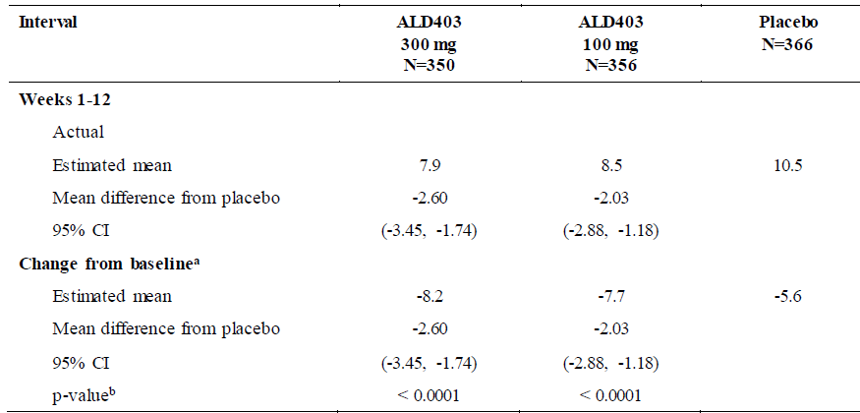

CI = confidence interval; N = total number of subjects in a group.

a Change from Baseline was the difference in migraine days between Baseline and the selected interval.

b Significant P-values for the primary endpoint change from Baseline migraine days from Weeks 1 to 12 were determined by the decision rule outlined in the statistical analysis plan.

###### Key secondary endpoints

For the key secondary efficacy endpoint of 75% migraine responder rate (Weeks 1 to 4), at Week 4, around 21% and 15% greater number of subjects in eptinezumab 300 and 100 mg groups achieved a ≥ 75% reduction in migraine days. The treatment difference was statistically significant.

Table 10: Study 011 Summary of 75% migraine responder rate (Weeks 1 to 4)

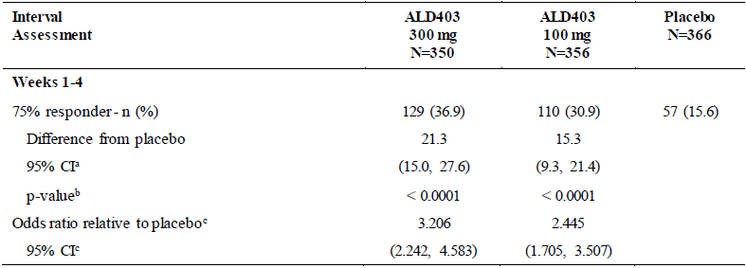

CI = confidence interval; N = total number of subjects in the group; n = number of subjects with the event.

a The 95% confidence intervals were calculated based upon normal approximation for two independent proportions. Stratification was not used.

b The P-values for the key secondary endpoint 75% migraine responder rate for Weeks 1 to 4 were obtained from the Cochran-Mantel-Haenszel test stratified by randomised baseline migraine days (< 17 days, ≥ 17 days) and prophylactic medication use (yes versus no). Significant P-values were determined by the decision rule outlined by the statistical analysis plan.

c The common odds ratio and 95% confidence intervals were obtained from the Cochran-Mantel-Haenszel test stratified by randomised baseline migraine days (< 17 days, ≥ 17 days) and prophylactic medication use (yes versus no).

A similar result was reported for both 75% and 50% migraine responder rates at Week 1 to 12.

Table 11: Study 011 Summary of 75% responder rate (Weeks 1 to 12)

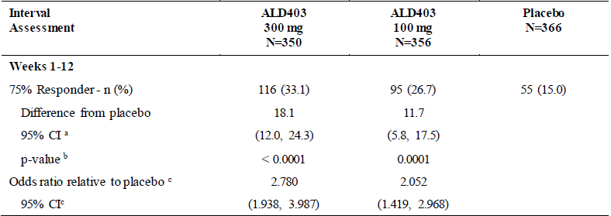

CI = confidence interval; N = total number of subjects in the group; n = number of subjects with the event.

a The 95% confidence intervals were calculated based upon normal approximation for two independent proportions. Stratification was not used.

b The P-values for the key secondary endpoint 75% migraine responder rate for Weeks 1 to 12 were obtained from the Cochran-Mantel-Haenszel test stratified by randomised baseline migraine days (< 17 days, ≥ 17 days) and prophylactic medication use (use versus no use). Significant P-values were determined by the decision rule outlined by the statistical analysis plan.

c The common odds ratio and 95% confidence intervals were obtained from the Cochran-Mantel-Haenszel test stratified by randomised baseline migraine days (< 17 days, ≥ 17 days) and prophylactic medication use (use versus no use).

Table 12: Study 011 Summary of 50% migraine responder rate (Weeks 1 to 12)

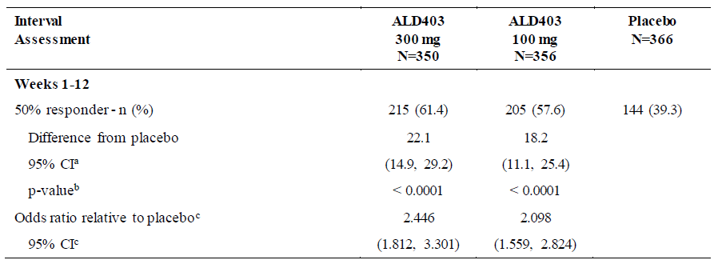

CI = confidence interval; N = total number of subjects in the group; n = number of subjects with the event.

a The 95% confidence intervals were calculated based upon normal approximation for two independent proportions. Stratification was not used.

b The P-values for the key secondary endpoint 50% migraine responder rate for Weeks 1 to 12 were obtained from the Cochran-Mantel-Haenszel test stratified by randomised baseline migraine days (< 17 days, ≥ 17 days) and prophylactic medication use (use versus no use). Significant P-values were determined by the decision rule outlined by the statistical analysis plan.

c The common odds ratio and 95% confidence intervals were obtained from the Cochran-Mantel-Haenszel test stratified by randomised baseline migraine days (< 17 days, ≥ 17 days) and prophylactic medication use (use versus no use).

For the efficacy endpoint of the percentage of subjects with migraine on the day after dosing (Day 1), at Baseline, around 58% of subjects had a migraine on any given day during the 28 day screening period. The percentages of subjects with a migraine on the day after dosing (Day 1) were 27.8% and 28.6% in the eptinezumab 300 mg and 100 mg groups, respectively, compared with 42.3% in the placebo group. The between group treatment difference was statistically significant.

Treatment outcomes for other secondary endpoints were overall supportive of the outcomes for the key primary and secondary endpoints.

###### Headache impact test-6

As a measure of impact of headache on daily life activities, there was a greater reduction in headache impact test-6 (HIT-6) scores from Baseline for subjects in both eptinezumab 300 and 100 mg groups. The treatment difference was statistically significant.

Table 13: Study 011 Analysis of headache impact test-6 by visit and treatment (Week 1 to 12)

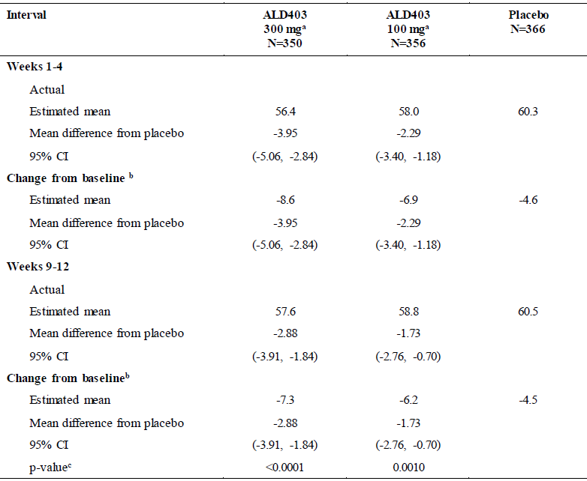

CI = confidence interval; HIT-6 = headache impact test-6; N = total number of subjects in the group.

a The HIT-6 at the 300 mg dose was a key secondary endpoint; the HIT-6 at the 100 mg dose was a secondary endpoint.

b Change from Baseline was the difference in HIT-6 score between Baseline and the selected interval.

c Significant P-values for the change from baseline of HIT-6 score at Weeks 9 to 12 were determined by the decision rule outlined in the statistical analysis plan.

There was also a statistically significant reduction in the usage of acute migraine medications at Week 12 for subjects in both eptinezumab 300 and 100 mg groups, compared to placebo.

###### Health related quality of life

By Week 12, a reduction in the incidence of pain was noted in 39.3% and 34% of subjects in the eptinezumab 300 and100 mg group respectively, as compared with 33.2% in the placebo group by using EQ-5D-5L health questionare.

Clinical Studies 002 and 005 were included as supportive studies. Overall, the findings of these studies support the findings of the pivotal studies.

#### Safety

##### Study 013

Study 013 was an open label Phase III study that evaluated safety as a sole primary outcome.

This study was conducted in subjects between 18 and 65 years of age with chronic migraine. Subjects with history of cardiovascular disease and/or with hypertension were excluded. Eptinezumab 300 mg was administered as a single intravenous infusion on Day 0, Weeks 12, 24, 36, 48, 60, 72, and 84. 128 subjects participated in this study. Treatment period was for 84 weeks, followed by a 20 week follow up period.

The mean age of the safety population was 41.5 years, and most subjects (64.8%) were in the > 35 year age group. Majority of the subjects were female (85.2%).

###### Results

No deaths were reported in this study.

Five subjects (3.9%) had a serious treatment emergent adverse event (TEAE). Overall, 91 subjects (71.1%) had at least one TEAE and 18 subjects (14.1%) had a TEAE that was considered related to study drug. Most TEAEs associated with eptinezumab treatment were mild or moderate in severity. There were 13 subjects (10.2%) who had a severe TEAE. There were 8 subjects (6.3%) with a TEAE that led to study drug withdrawal and 10 subjects (7.8%) with a TEAE leading to study drug interruption.

In Study 006, suicidal ideation (n = 1) and suicidal attempt (n = 1) were reported as serious adverse events (SAEs) in subjects in eptinezumab 100 mg group. In Study 011, one subject in eptinezumab 300 mg was reported with a suicidal attempt. No similar SAE was reported in placebo group.

The most frequently reported TEAEs were nasopharyngitis (18 subjects (14.1%)), upper respiratory tract infection (10 subjects (7.8%)), sinusitis (10 subjects (7.8%)), and influenza (8 subjects (6.3%)).

The most frequently reported TEAE leading to study drug interruption was infusion site extravasation (6 subjects (4.7%)). All incidences of infusion site extravasation leading to study drug interruption were mild in severity, considered not related to study drug, and resolved on the same day without concomitant treatment.

The most frequently reported TEAE leading to study drug withdrawal was hypersensitivity (3 subjects (2.3%)).

##### Adverse events

###### Treatment emergent adverse events

The sponsor performed pooled analyses to assess safety in pivotal study pool (Studies 006 and 011) and overall eptinezumab pool (Studies 002, 005, 006, 011 and 013).

In the pivotal study pool, TEAEs tended to occur after or during the first infusion, with decreasing incidence after subsequent infusions. The majority of all TEAEs were mild to moderate in severity.

Nasopharyngitis was the only TEAE that occurred in ≥ 2% of subjects in any eptinezumab group and with an incidence that was 2% greater in the eptinezumab 300 mg or 100 mg groups than in the placebo group.

There were no Grade 4 (life-threatening) or Grade 5 (fatal) TEAEs in any eptinezumab subject. Grade 3 (severe) TEAEs occurred infrequently and in similar proportions of all pivotal study eptinezumab subjects (2.2%), eptinezumab 300 mg subjects (2.6%), eptinezumab 100 mg subjects (1.7%), and placebo subjects (3.1%). Similar results were seen in the overall eptinezumab pool.

Nasopharyngitis occurred in ≥ 2% of subjects across eptinezumab group and with an incidence that was 2% greater in the eptinezumab 300 mg or 100 mg groups than in the placebo group. Similar results were seen in the overall eptinezumab pool.

In Study 011, constipation was reported with a higher prevalence (twice) in the eptinezumab group, compared to placebo. In Study 006, 7 subjects across eptinezumab groups experienced constipation as a TEAE, compared to one subject in placebo.

###### Discontinuations due to adverse events

The incidence of TEAEs that led to study drug discontinuation among eptinezumab subjects was 2.5%, compared to 1.4% in placebo group. Majority of TEAEs were related to hypersensitivity that led to study drug discontinuation in 13 (0.9%) eptinezumab subjects and no placebo subjects.

There were no major safety events that were related to liver, renal toxicity or cardiovascular safety.

No deaths were reported in any of the clinical studies with eptinezumab.

It should be noted that subjects with history of cardiovascular disease were excluded from the study.

### Risk management plan

The sponsor has submitted core risk management plan (RMP) version 1.0 (dated 27 March 2020; data lock point (DLP) 1 February 2019) and Australian Specific Annex (ASA) version 1.0 (dated 21 April 2020) in support of this application. In the response to a TGA request for information, EU-RMP version 1.0 (dated 2 November 2020; DLP 20 August 2020) and ASA version 2.0 (dated 7 December 2020) has been submitted to replace the core RMP. In the response to TGA RMP report, EU-RMP version 1.1 (dated 9 February 2021; DLP 30 November 2020) and ASA version 3.0 (dated 12 February 2021) has been submitted.

The summary of safety concerns and their associated risk monitoring and mitigation strategies, which have been agreed during the third round of evaluation, are summarised in Table 14.[17]

Table 14: Summary of safety concerns

|  |  |  |  |  |  |
| --- | --- | --- | --- | --- | --- |
| Summary of safety concerns | | Pharmacovigilance | | Risk Minimisation | |
| **Routine** | **Additional** | **Routine** | **Additional** |
| **Important identified risks** | Severe hypersensitivity, including anaphylactic reactions1 | ✓ | – | ✓ | – |
| **Important potential risks** | None | – | – | – | – |
| **Missing information** | Use in pregnant women (including those at risk of pre-eclampsia) | ✓ | ✓† | ✓ | – |
| Cardiovascular outcomes in patients with pre-existing myocardial infarction, cerebrovascular accident, transient ischemic attack, angina unstable and poorly controlled hypertension | ✓ | ✓* | ✓ | – |
| Long-term safety | ✓ | ✓* | ✓ | – |

1 Australia-specific safety concern in Australian Specific Annex

* Eptinezumab real world use and long term cardiovascular safety study

† Post-market pregnancy program

* The safety specification including the summary of safety concerns is considered acceptable from an RMP perspective. The sponsor agreed to include severe hypersensitivity, including anaphylactic reactions as an important identified risk in the ASA’s summary of safety concerns.
* Routine and additional pharmacovigilance activities have been proposed for all of the safety concerns. There are two planned studies conducted overseas: (1) a pregnancy program that consists of prospective pregnancy exposure registry and retrospective pregnancy exposure outcome studies; and, (2) a drug utilisation and long term cardiovascular safety study. There is no Australian patient involvement in these, but the study outcomes are considered relevant to Australian patients. The sponsor is required to notify the TGA if these studies will not proceed as planned.
* As this product will be administered by health care professionals in health care settings and, in consideration of the current summary of safety concerns, the associated risks can be expected to be addressed with routine risk minimisation measures. Risks associated with other CGRP inhibitors are also managed in the same way.

### Risk-benefit analysis

#### Delegate’s considerations

Two randomised controlled trials in subjects with episodic and chronic migraine provided evidence to support the efficacy of eptinezumab for the preventive treatment of migraine. These two studies demonstrated a greater reduction from Baseline in migraine days over a range from 0.69 to1.11 days with 100 mg and 300 mg eptinezumab in subjects with episodic migraine and 2.03 to 2.6 days with 100 mg and 300 mg eptinezumab in subjects with chronic migraine, compared to placebo. The magnitude of treatment benefit are comparable to previously approved CGRP antagonists and slightly higher than the one day difference specified in the sample calculation.

Around 50% to 60% of subjects in eptinezumab achieved a 50% reduction in migraine days from Baseline, which is the clinical trial end point recommended by the Clinical Trials Subcommittee of the IHS.[18]

The studies were not designed to examine the efficacy of eptinezumab, when administered as a third/fourth line of treatment for episodic and chronic migraine.[19] In Study 011, around 85% of patients were not using prophylactic medication prior to screening. A similar data for Study 006 was not available in the dossier. However, the subjects were experiencing migraine at a frequency that fulfilled the inclusion criteria for episodic and chronic migraine. Taken together, it seems like, at Baseline, the patient population was largely under-treated.2

Across Studies 006 and 011, the overall adverse events were balanced between the eptinezumab and placebo groups. Three subjects in the eptinezumab group in these studies experienced suicide-related SAEs (two subjects in eptinezumab 100 mg and one subject in eptinezumab 300 mg group). No subjects in placebo arm experienced a similar SAE. The investigators did not consider these events as related to the treatment agent. There was previous history of depression in all these cases. A higher incidence of depression among individuals with migraine has been previously reported.2,[20] It was noted that the subjects with history of suicidal behaviour and/or ideation were excluded from the studies with eptinezumab (pivotal Studies 006 and 011 and long term open label safety Study 013). The Delegate considers that the role of eptinezumab in these events and the long term safety of eptinezumab in this patient group are unclear.

Mechanistically, patients on CGRP antagonist may be at increased risk of cerebrovascular or cardiovascular events.[21] This is attributed to the proposed mechanism of action of CGRP in maintaining cardiovascular homeostasis and its role in initiating the compensatory vasodilation in the event of ischemia.6 Patients with migraine are also known to have an elevated risk of cardiovascular events.2 Although a signal related to cardiovascular safety was not identified in the studies included in this submission, the data are limited in that patients with a history of cardiovascular or cerebrovascular disease were not included in any of these studies. It was noted that three patients discontinued due to hypertension. The proposed RMP has the following as missing information: ‘cardiovascular outcomes in patients with pre-existing myocardial infarction, cerebrovascular accident, transient ischemic attack, angina unstable and poorly controlled hypertension’, mostly due to patients with cardio risk being excluded from trials and real-world use to include this cohort. The sponsor has also informed the TGA regarding a post-market study: Eptinezumab real-world use and long term cardiovascular safety study. This study will include patients treated with eptinezumab in routine clinical practice and followed up for a duration of 5 years. Precautionary statements are included in the proposed PI and are considered as acceptable.

It was noted that patients over the age of 65 years were not well represented in studies with eptinezumab. Considering the higher incidence of migraine in individuals up to 40 years of age, this issue was not considered as critical. The information about insufficient data in this age group has been included in the PI.

Hypersensitivity was observed with other CGRP antagonist monoclonal antibodies recently approved. Hence, it was identified as a safety signal of interest for this application. In the controlled trials, there were 13 reported TEAEs of hypersensitivity in the active treatment arm (13 leading to discontinuations) and none reported in the placebo arm. In addition, 12 patients reported pruritus in the active treatment arm, with none reported in the placebo arm. Four of these patients reported this event on the day of dosing, which makes them likely to be due to hypersensitivity. Hypersensitivity has been mentioned as a precaution in the proposed PI. However, the Delegate considers that the post-infusion observation period is required to confirm patient safety. The ACM's advice will be considered prior to making further recommendations.

In the pivotal studies, the incidence of constipation in the eptinezumab groups was more than around twice the incidence in the placebo arm. However, the overall incidence was considered as low throughout the studies. None of the events led to discontinuation of treatment. Constipation has also been reported in studies with erenumab.

Limitations of data:

* Lack of clinical data when eptinezumab is administered as a third/fourth line of treatment for episodic and chronic migraine.
* Clinical studies were not designed to examine an effective approach to cessation of treatment and to examine any withdrawal symptoms, once treatment has been stopped.
* Lack of safety data in patients with cardiovascular and cerebrovascular risk factors.

#### Proposed action

Overall, the evidence suggests comparable efficacy of eptinezumab to other TGA approved CGRP antagonists.

Hypersensitivity was the commonest cause of treatment discontinuations.

Suicide-related SAEs and constipation had incidence that was numerically greater in eptinezumab group, compared to placebo. These adverse events did not occur with sufficient frequency to be reported in the PI. The Delegate will consider the ACM's advice on including these events in the RMP for enhanced pharmacovigilance.

#### Questions for the sponsor

The sponsor provided the following response to questions from the Delegate.

1. ***In both Studies 006 and 011, eptinezumab infusion was administered over 1 hour ± 15 mins. After the infusion, subjects were observed for a period of one hour. The proposed PI does not reflect this method of administration (infusion time period of 30 mins and no recommendation for observation post infusion). Please clarify the reason for not having a method of administration in the PI that is comparable to the pivotal studies, particularly considering the report of events of anaphylaxis and hypersensitivity following eptinezumab infusions.***

In the first pivotal Study 006, the intravenous administration time was 1 hour ± 15 min. As more patient data became available and no safety concerns were identified, both the recommended infusion and observation times were shortened. In Studies 011 and 013, the administration time was 30 (+ 15) min, however, infusions could have been administered for up to one hour, if needed, at the judgement of the investigator.

The clinical study report[22] shows that most patients were administered both infusions of eptinezumab in Study 011 over 30 (+ 15) min. Data from the clinical studies to date confirm that the infusion time of 30 (+ 15) min has not led to safety concerns. Thus far, 3 SAEs of anaphylactic reactions have been reported in the clinical studies. The events occurred within 10 minutes of the initiation of the infusion. All 3 patients recovered on the same day following discontinuation of the investigational medicinal product (IMP) infusion and treatment according to standard practice, and they did not require in-patient hospitalisation. Other events related to hypersensitivity in the clinical studies were reported as non-serious. In most of these cases, the hypersensitivity reactions occurred during the infusion.

As most allergic reactions, including anaphylactic reactions, occurred during the infusion, a recommendation for a specific observation period post-infusion in the label is not considered warranted. It can be expected that health care providers will observe or monitor patients, as necessary, and in accordance with normal clinical practice.

Post-marketing data from the US confirms the administration instructions including a 30 minutes infusion time. Up to 31 January 2021, with an estimated post-marketing exposure of 30,078 infusions, the reporting of one case of anaphylactic reaction and 3 cases of other serious systemic hypersensitivity reactions, is considered low. The patients recovered from the event and none of the patients were reported to require in-patient hospitalisation. Overall, currently available post-marketing data do not indicate safety concerns with regards to the administration instructions.

1. ***Please submit any post-marketing safety data from US for eptinezumab (periodic benefit-risk evaluation report (PBRER)), if available.***

The PBRER with the cut-off date 20 August 2020 is provided with this response.22 The next PBRER with the cut-off date 20 February 2021 will be available on 1 May 2021.

1. ***In Study 006, what proportion of subjects were on prophylactic medication for migraine?***

The regular use (> 7 days per month) of prophylactic medications for migraine (that is, any preventive medication or supplement with evidence of efficacy from at least one placebo-controlled study) was restricted from 2 months prior to the screening visit through Week 24 in Study 006. Due to the restrictions the overall use of migraine preventive treatment in Study 006 was low. Overall, 41 patients (4.6%) reported at least one prophylactic headache medication, and the use was well balanced across the treatment groups, with no differences at the drug preferred term level considered clinically relevant. The most frequently reported prophylactic headache medication, in > 1% of patients, was magnesium (1.4%).

1. ***Constipation and suicide-related SAEs were reported at a higher incidence in eptinezumab group, compared to placebo. Are there any additional pharmacovigilance activities planned to monitor the incidence of these events in clinical practice?***

*Constipation:* Constipation is common in the general population. Depending on the definition used, chronic constipation can affect from 2% to 27% of the population.[23] In a Canadian study of health issues in the general population, 27.2% of the participants self-reported constipation within the past 3 months, and 16.7% and 14.9% had functional constipation according to the Rome I and II criteria, respectively.[24]

In the placebo controlled Studies 002, 005, 006 and 011, constipation was reported at frequencies of 0.9% for patients receiving eptinezumab and 0.5% for patients receiving placebo. Although the incidences were higher in the eptinezumab group, the incidences of constipation in the clinical studies are considered low, and the difference between the eptinezumab and placebo group is considered small and not clinically significant, when put in perspective to the high prevalence of constipation in the general population. Of the 19 TEAEs of constipation reported in patients treated with eptinezumab, the majority of TEAEs (13 out of 19) were considered not related to study treatment by the investigators. Other than one single serious and severe event of constipation, all events of constipation in patients receiving eptinezumab were non-serious and mild or moderate. The single serious and severe event concerns an event of post-operative worsening of constipation in a patient with a pre-existing history of constipation requiring medication and digital disimpaction. The event was considered not related by the investigator.

Currently available post-marketing data are in line with the clinical study data and indicate that the frequency of constipation in patients treated with eptinezumab is low and the events are mainly non-serious. Up to 31 January 2021, with an estimated post-marketing exposure of 30,087 infusions, a total of 2 events of constipation were reported. Both events were non-serious.

Given the low frequency, the mainly non-serious nature of the reported events and the fact that most events were considered not related to eptinezumab treatment, the sponsor does not consider additional pharmacovigilance activities to be warranted for constipation. However, the sponsor will continue to monitor constipation via routine pharmacovigilance and commits to present and discuss this event in future PBRERs.

*Suicide-related SAEs*: Psychiatric disorders such as depression are common in patients with migraine. This is also reflected in the high proportion, approximately 30%, of patients in the eptinezumab clinical studies with a psychiatric disorder as medical history.

Data from the clinical studies do not indicate an increased risk of suicide-related events for eptinezumab. In the placebo-controlled Studies 002, 005, 006 and 011, TEAEs captured in the suicide/self-injury (Standardised Medical Dictionary for Regulatory Activities (MedDRA)[25] Queries (SMQ))[26] have been reported at similar frequencies in the eptinezumab (0.6%) and placebo (0.4%) groups. Most TEAEs were considered not related. One patient in the eptinezumab group (< 0.1%) had related events of suicidal ideation and intentional self-injury. The patient’s medical history included non-suicidal self-injurious behaviour.

Suicide-related SAEs were reported in the overall eptinezumab pool (including Studies 002, 005, 006, 011 and 013) in 4 (0.2%) of 2076 eptinezumab-treated patients and in 1 (0.1%) of 791 patients receiving placebo. All suicide-related SAEs in eptinezumab-treated patients were assessed as not related by the investigators. The events were confounded by medical history and/or triggering stressors:

[Subjects ID redacted] in Study 006 experienced two episodes of suicidal ideation and subsequently had a suicide attempt. The events were confounded by the patient’s medical history of post-traumatic stress disorder (PTSD), major depressive disorder (MDD), psychosis, poly-substance abuse, and sexual abuse. In addition, it was reported that the patient tried to overdose on medications due to stressors with the roommate.

[Subjects ID redacted] in Study 011experienced a suicide attempt. The event was confounded by the patient’s medical history of MDD, anxiety, insomnia, and attention deficit hyperactivity disorder. In addition, it was reported that the patient was upset about a family relationship.

[Subjects ID redacted] in Study 011 experienced depression suicidal. The event was confounded by the patient’s medical history of depression, suicidal ideation, previous suicide attempts, PTSD, anxiety, insomnia and alcohol abuse.

[Subjects ID redacted] in Study 005 experienced suicidal ideation. The event was confounded by the patient’s medical history of depression.

Currently available post-marketing data are in line with the clinical study data. Up to 31 January 2021, with an estimated post-marketing exposure of 30,078 infusions, one case containing the events suicide attempt and suicidal ideation was reported. The patient had a medical history of depression.

Overall, currently available data do not suggest an increased risk of suicide-related events with eptinezumab treatment. The reported suicide-related SAEs are not related and confounded by patients’ pre-existing underlying psychiatric disorders, which can be expected given that psychiatric disorders are common in patients with migraine. Hence, the sponsor does not consider additional pharmacovigilance activities to be warranted for suicide-related events. However, the sponsor will continue to monitor suicide-related events via routine pharmacovigilance and commits to present and discuss suicide-related events in future PBRERs.

1. ***In the proposed PI, the following statements were noted: After dilution, Vyepti solution for infusion may be stored at room temperature or refrigerated at 2 to 8°C. This instruction is in contrast to the corresponding instruction in Food and Drug Administration (FDA) PI, which recommends that the Vyepti solution should be stored in room temperature. Please clarify this disparity.***

Current data supports an 8 hour expiry for both temperature storage conditions (refrigerated and room temperature) for either eptinezumab dose level, 100 and 300 mg, in polyvinyl chloride (PVC) and polyethylene (PE) saline bags for intravenous administration.

A flexible in-use storage condition, where either room temperature or refrigerated conditions can be used, is desirable in certain clinical settings in the different jurisdictions where the Vyepti marketing authorisation application (MAA) is currently being submitted. During the Biologics License Application (BLA) label negotiations, it was decided to include a labelling restriction, as data in all the commonly used intravenous bags were not available at that point in time. In addition, the in-use storage temperature was not considered critical as room temperature in-use storage is used in the US clinics rather than storage at 2 to 8°C.

In order to have the most flexible in-use storage conditions in Australia, the sponsor consider in-use storage at both room temperature and 2 to 8°C to be appropriate.

#### Advisory Committee considerations[27]

The Advisory Committee on Medicines (ACM), having considered the evaluations and the Delegate’s overview, as well as the sponsor’s response to these documents, advised the following.

##### Specific advice to the Delegate

1. ***Hypersensitivity-related events were the commonest cause for treatment discontinuations in pivotal studies and severe hypersensitivity, including anaphylactic reactions are included as important identified risks in the summary of safety concerns. In view of these facts, from a safety perspective, what is the committee's opinion regarding the adequacy of the instructions for infusion in the method of administration section of the proposed PI?***

The ACM noted that hypersensitivity occurred within 1.1% of study participants and suggested that if additional terms such as urticaria, rash and pruritus were included the incidence could be greater than 2%. However, they noted that most instances of these events were not serious and resolved within a day.

ACM noted that an ‘anaphylactic’ reaction occurred in 1 of 2076 patients within the study, on the 300 mg dose. On further testing it was deemed to be an allergic and infusion reaction in the broader sense without respiratory or cardiovascular compromise to indicate anaphylaxis.

The ACM also noted that the infusion times within the studies; infusion was over 60 minutes and had a 4 hour observation window for PROMISE-1;[28] and infusion was over 30 minutes and had a 2 hour observation window for PROMISE-2.[29] Even with these measures, hypersensitivity reactions were the commonest cause for withdrawals in these studies.

Considering this information ACM was of the view that it is reasonable to have an observation period of an hour following infusion, particularly considering the longer infusion time within PROMISE-1 study and that most immediate hypersensitivity reactions occur in the first 30 to 120 minutes.

The ACM advised that if a patient were to develop significant/serious hypersensitivity during/after the first dose then treatment discontinuation should be considered. The rationale for this is primarily due to the significance of the reaction and potential for high rates of antibody development. The ACM suggested the PI should be updated to include a statement such as ‘consideration of discontinuation if significant hypersensitivity reaction is observed, if the reactions are minor, the continuation of treatment should be at clinician's discretion’.

1. ***The incidence of suicide-related SAEs and constipation were numerically greater in the eptinezumab group, compared to placebo. What are the committee's views on including these events in the RMP for enhanced pharmacovigilance?***

The ACM identified that in the active treatment arm of the pivotal studies two suicide attempts and one instance of suicidal ideation were documented. They acknowledged that the study investigators did not consider these events to be treatment related, rather indicating that the individual patient narratives suggested other factors contributed to these events. The ACM agreed that there is a well-recognised bidirectional association between migraine and depression.

Based on this information the ACM felt it reasonable for suicide-related SAEs to be monitored via routine post-market surveillance mechanisms.

In regards to constipation, the ACM noted that within clinical practice CGRP mAbs have been associated with cases of constipation and that this occurrence can be a prohibitive factor for some patients. Taking this into consideration, the ACM were of the opinion that it would be worthwhile including a statement about constipation within the PI.

The ACM also acknowledged the Research Electronic Data Capture (REDCap) database, based at The Alfred Hospital, Melbourne, to independently report adverse events and pregnancies within 6 months or during CGRP mAb treatment and would encourage a more formal data registry with access and awareness to all CGRP mAb prescribers.

1. ***The committee is also requested to provide advice on any other issues that it thinks may be relevant to a decision on whether or not to approve this application.***

The ACM emphasised the importance of having the infusion protocol outlined extremely clearly in the PI to assist prescribers, particularly general practitioners (GPs) in rural areas.

The ACM noted that a dose response curve does not appear to be present for eptinezumab. However, they acknowledge there is a patient subgroup that responds better to the higher dose (300 mg).

While ACM are of the view that clinical practice would benefit from having both the 100 mg and 300 mg doses available, they advised that treatment should begin at the lower dose (100 mg), and this should be specified in the PI.

The ACM discussed that there is a potential place in therapy for eptinezumab as rescue for patients hospitalised with status migrainosus, due to the more rapid onset of action in responders. The ACM were also of the view that eptinezumab could potentially be a useful option in the medication overuse headache (MOH) subgroup, who are generally very refractory to all other migraine therapies.

##### Conclusion

The ACM considered this product to have an overall positive benefit-risk profile for the indication:

*Vyepti is indicated for the preventive treatment of migraine in adults.*

### Outcome

Based on a review of quality, safety and efficacy, the TGA approved the registration of Vyepti (eptinezumab) 100 mg/mL, concentrated injection, vial, indicated:

*Vyepti is indicated for the preventive treatment of migraine in adults.*

#### Specific conditions of registration applying to these goods

* Vyepti (eptinezumab) is to be included in the Black Triangle Scheme. The PI and Consumer Medical Information (CMI) for Vyepti must include the Black Triangle symbol and mandatory accompanying text for five years, which starts from the date that the sponsor notifies the TGA of supply of the product.
* The Vyepti EU-RMP (version 1.1, dated 9 February 2021; DLP 30 November 2020), with ASA (version 3.0, dated 12 February 2021), included with submission PM‑2020‑01823‑1‑1, and any subsequent revisions, as agreed with the TGA will be implemented in Australia.

An obligatory component of RMP is routine pharmacovigilance. Routine pharmacovigilance includes the submission of periodic safety update reports (PSURs).

Unless agreed separately between the supplier who is the recipient of the approval and the TGA, the first report must be submitted to TGA no later than 15 calendar months after the date of this approval letter. The subsequent reports must be submitted no less frequently than annually from the date of the first submitted report until the period covered by such reports is not less than three years from the date of this approval letter. The annual submission may be made up of two PSURs each covering six months. If the sponsor wishes, the six monthly reports may be submitted separately as they become available.

If the product is approved in the EU during the three years period, reports can be provided in line with the published list of EU reference dates no less frequently than annually from the date of the first submitted report until the period covered by such reports is not less than three years from the date of the approval letter.

The reports are to at least meet the requirements for PSURs as described in the European Medicines Agency’s Guideline on Good Pharmacovigilance Practices (GVP) Module VII-periodic safety update report (Rev 1), Part VII.B Structures and processes.

Note that submission of a PSUR does not constitute an application to vary the registration. Each report must have been prepared within ninety calendar days of the data lock point for that report.

* **Laboratory testing and compliance with Certified Product Details**
  + All batches of Vyepti supplied in Australia must comply with the product details and specifications approved during evaluation and detailed in the Certified Product Details (CPD).
  + When requested by the TGA, the sponsor should be prepared to provide product samples, specified reference materials and documentary evidence to enable the TGA to conduct laboratory testing on the product. Outcomes of laboratory testing are published biannually in the TGA Database of Laboratory Testing Results http://www.tga.gov.au/ws-labs-index and periodically in testing reports on the TGA website.
* For all injectable products the PI must be included with the product as a package insert.

## Attachment 1. Product Information

The PI for Vyepti approved with the submission which is described in this AusPAR is at Attachment 1. For the most recent PI, please refer to the TGA website at <<https://www.tga.gov.au/product-information-pi>>.

|  |
| --- |
| Therapeutic Goods Administration |
| PO Box 100 Woden ACT 2606 Australia  Email: [info@tga.gov.au](mailto:info@tga.gov.au) Phone: 1800 020 653 Fax: 02 6232 8605  [**https://www.tga.gov.au**](https://www.tga.gov.au) |

1. The **Black Triangle Scheme** provides a simple means for practitioners and patients to identify certain types of new prescription medicines, including those being used in new ways and to encourage the reporting of adverse events associated with their use. The Black Triangle does not denote that there are known safety problems, just that the TGA is encouraging adverse event reporting to help us build up the full picture of a medicine's safety profile.
2. Ashina, M. Migraine, *N Engl J Med*, 2020; 383(19): 1866-1876.
3. Migraine Headache Australia, Prevalence and Cost of Headache, Available from Migraine Headache Australia website.
4. European Medicines Evaluation Agency (EMEA), Committee for Medicinal Products for Human Use (CHMP), 24 January 2007. Guideline on Clinical Investigation of Medicinal Products for the Treatment of Migraine (CPMP/EWP/788/01 Rev. 1).
5. Silberstein, S.D. Migraine, *Lancet*, 2004; 363(9406): 381-391.
6. Iyengar, S. et al. CGRP and the Trigeminal System in Migraine, *Headache*, 2019; 59(5): 659-681.
7. Drellia, K. et al. Anti-CGRP Monoclonal Antibodies for Migraine Prevention: a Systematic Review and Likelihood to Help or Harm Analysis, *Cephalalgia*, 2021; 41(7): 851-864.
8. Deen, M. et al. Blocking CGRP in Migraine Patients - a Review of pros and cons, *J Headache Pain*. 2017; 25;18(1): 96.
9. Sandomigran was first registered on the ARTG on 24 June 1999 (ARTG number: 69608).
10. Deralin was first registered on the ARTG on 20 September 1991 (ARTG number: 17612, 17613 and 17614).
11. Inderal was first registered on the ARTG on 11 July 1991 (ARTG number: 11228 and 11230).
12. Topamax was first registered on the ARTG on 30 January 1998 (ARTG number: 62709, 62710, 62711 and 62712).
13. Aimovig was first registered on the ARTG on 2 July 2018 (ARTG number: 289959 and 289960).
14. Ajovy was first registered on the ARTG on 20 September 2019 (ARTG number: 308630).
15. Emgality first registered on the ARTG on 28 May 2019 (ARTG number: 302145 and 302146).
16. **Cytochrome P450 (CYP) enzymes**: CYPs are the major enzymes involved in drug metabolism, accounting for large part of the total metabolism. Most drugs undergo deactivation by CYPs, either directly or by facilitated excretion from the body. Also, many substances are bioactivated by CYPs to form their active compounds.

    Many drugs may increase or decrease the activity of various CYP isozymes either by inducing the biosynthesis of an isozyme (enzyme induction) or by directly inhibiting the activity of the CYP (enzyme inhibition). This is a major source of adverse drug interactions, since changes in CYP enzyme activity may affect the metabolism and clearance of various drugs. Such drug interactions are especially important to take into account when using drugs of vital importance to the patient, drugs with important side-effects and drugs with small therapeutic windows, but any drug may be subject to an altered plasma concentration due to altered drug metabolism.
17. *Routine risk minimisation* activities may be limited to ensuring that suitable warnings are included in the product information or by careful use of labelling and packaging.

    *Routine pharmacovigilance* practices involve the following activities:

    All suspected adverse reactions that are reported to the personnel of the company are collected and collated in an accessible manner;

    Reporting to regulatory authorities;

    Continuous monitoring of the safety profiles of approved products including signal detection and updating of labelling;

    Submission of PSURs;

    Meeting other local regulatory agency requirements.
18. Headache Classification Committee of the International Headache Society (IHS) The International Classification of Headache Disorders, 3rd edition (beta version). *Cephalalgia*, 2013; 33(9): 629-808.
19. Raffaelli, B. et al. Monoclonal Antibodies for the Prevention of Migraine, *Expert Opin Biol Ther*. 2019; 19(12): 1307-1317.
20. Silberstein, S.D. Migraine, *Lancet*, 2004; 363(9406): 381-391.
21. Pellesi, L. et al. Spotlight on Anti-CGRP Monoclonal Antibodies in Migraine: The Clinical Evidence to Date, Clin Pharmacol Drug Dev, 2017; 6(6): 534-547.
22. Inclusion of these information is beyond the scope of the AusPAR.
23. Sanchez, M.I.P and Bercik, P. Epidemiology and Burden of Chronic Constipation*, Can J Gastroenterol*,

    2011; 25(Suppl B): 11B-15B.
24. Pare, P. et al. An Epidemiological Survey of Constipation in Canada: Definitions, Rates, Demographics, and Predictors of Health Care Seeking, *Am J Gastroenterol*, 2001; 96(11): 3130-3137.
25. The **Medical Dictionary for Regulatory Activities (MedDRA)** is a single standardised international medical terminology, developped as a project of the International Council for Harmonisation of Technical Requirements for Pharmaceuticals for Human Use (ICH) which can be used for regulatory communication and evaluation of data pertaining to medicinal products for human use. As a result, MedDRA is designed for use in the registration, documentation and safety monitoring of medicinal products through all phases of the development cycle (that is,, from clinical trials to post-marketing surveillance). Furthermore, MedDRA supports ICH electronic communication within the ICH’s Electronic Common Technical Document (eCTD) and the E2B Individual Case Safety Report.
26. **Standardised MedDRA Queries (SMQs)** are groupings of terms from one or more MedDRA System Organ Classes (SOCs) that relate to a defined medical condition or area of interest. They are intended to aid in case identification.
27. The ACM provides independent medical and scientific advice to the Minister for Health and the Therapeutic Goods Administration (TGA) on issues relating to the safety, quality and efficacy of medicines supplied in Australia including issues relating to pre-market and post-market functions for medicines.

    The Committee is established under Regulation 35 of the Therapeutic Goods Regulations 1990. Members are appointed by the Minister. The ACM was established in January 2017 replacing Advisory Committee on Prescription Medicines (ACPM) which was formed in January 2010. ACM encompass pre and post-market advice for medicines, following the consolidation of the previous functions of the Advisory Committee on Prescription Medicines (ACPM), the Advisory Committee on the Safety of Medicines (ACSOM) and the Advisory Committee on Non-Prescription Medicines (ACNM). Membership comprises of professionals with specific scientific, medical or clinical expertise, as well as appropriate consumer health issues relating to medicines.
28. Also known as the PROMISE-1 trial.
29. Also known as the PROMISE-2 trial.