▼This medicinal product is subject to additional monitoring in Australia. This will allow quick identification of new safety information. Healthcare professionals are asked to report any suspected adverse events at [https://www.tga.gov.au/reporting-problems.](https://www.tga.gov.au/reporting-problems)

AUSTRALIAN PRODUCT INFORMATION - STEGLATRO®

(Ertugliflozin)

# 1 NAME OF THE MEDICINE

Ertugliflozin

# 2 QUALITATIVE AND QUANTITATIVE COMPOSITION

Ertugliflozin tablets contain ertugliflozin pyroglutamic acid, the isolated form of the active ingredient ertugliflozin. Ertugliflozin tablets contain 6.48 or 19.43 mg of ertugliflozin pyroglutamic acid, which is equivalent to 5 and 15 mg of the active ingredient ertugliflozin.

### Excipients with known effect

Lactose monohydrate.

For the full list of excipients see Section 6.1 LIST OF EXCIPIENTS

# 3 PHARMACEUTICAL FORM

STEGLATRO 5 mg tablets are pink, triangular-shaped, film-coated tablets debossed with “701” on one side and plain on the other side.

STEGLATRO 15 mg tablets are red, triangular-shaped, film-coated tablets debossed with “702” on one side and plain on the other side.

# 4 CLINICAL PARTICULARS

## 4.1 THERAPEUTIC INDICATIONS

STEGLATRO (ertugliflozin) is indicated as an adjunct to diet and exercise to improve glycaemic control in adults with type 2 diabetes mellitus as:

* monotherapy when metformin is considered inappropriate due to intolerance; or
* in combination with other anti-hyperglycaemic agents

[see 5.1 PHARMACODYNAMIC PROPERTIES, Clinical trials and 4.4 SPECIAL WARNINGS AND PRECAUTIONS FOR USE for available data on different add-on combination therapies].

## 4.2 DOSE AND METHOD OF ADMINISTRATION

### General

The recommended starting dose of STEGLATRO is 5 mg once daily, taken in the morning, with or without food. In patients tolerating STEGLATRO 5 mg once daily the dose may be increased to 15 mg once daily if additional glycaemic control is needed.

### Renal impairment

Assessment of renal function is recommended prior to initiation of STEGLATRO and periodically thereafter [see 4.4 SPECIAL WARNINGS AND PRECAUTIONS FOR USE].

Initiation of STEGLATRO is not recommended in patients with an eGFR less than 45 mL/min/1.73 m2 [see 4.4 SPECIAL WARNINGS AND PRECAUTIONS FOR USE].

In patients with an eGFR of 45 to less than 60 mL/min/1.73 m2, individually assess the risk benefit as HbA1c reduction was only demonstrated in a post hoc analysis for ertugliflozin 15 mg.

Discontinue STEGLATRO if the patient’s eGFR falls persistently below 45 mL/min/1.73 m2.

### Hepatic impairment

No dose adjustment of STEGLATRO is necessary in patients with mild or moderate hepatic impairment. STEGLATRO has not been studied in patients with severe hepatic impairment and is not recommended for use in these patients.

### Paediatric population

Safety and effectiveness of STEGLATRO in paediatric patients under 18 years of age have not been established.

### Elderly

No dose adjustment of STEGLATRO is recommended based on age.

## 4.3 CONTRAINDICATIONS

History of a serious hypersensitivity reaction to STEGLATRO or to any of the excipients.

Patients with chronic kidney disease (CKD)receiving dialysis; eGFR < 30 mL/min/1.73 m2 or eGFR persistently < 45 mL/min/1.73m2 (CKD stage 3B, 4 and 5). The efficacy of STEGLATRO is dependent on renal function [see 4.4 SPECIAL WARNINGS AND PRECAUTIONS FOR USE].

## 4.4 SPECIAL WARNINGS AND PRECAUTIONS FOR USE

### General

STEGLATRO should not be used in patients with type 1 diabetes mellitus or for the treatment of diabetic ketoacidosis.

### Hypotension

STEGLATRO causes an osmotic diuresis, which may lead to intravascular volume contraction. Therefore, symptomatic hypotension may occur after initiating STEGLATRO [see 4.8 ADVERSE EFFECTS (UNDESIRABLE EFFECTS)] particularly in patients with impaired renal function (eGFR less than 60 mL/min/1.73 m2), elderly patients (≥ 65 years), or patients on diuretics. Before initiating STEGLATRO, intravascular volume status should be assessed and patients advised on the importance of adequate hydration. Monitor intravascular volume status in addition to blood pressure and renal function after initiating therapy.

In case of conditions that may lead to fluid loss (e.g. gastrointestinal illness, heat stress or severe infections), careful monitoring of volume status (e.g. physical examination, blood pressure measurements, laboratory tests including haematocrit) and electrolytes is recommended for patients receiving STEGLATRO. Temporary interruption of STEGLATRO should be considered until the fluid loss is corrected.

### Ketoacidosis

Reports of ketoacidosis, including life-threatening cases, have been identified in clinical trials and postmarketing surveillance in patients with type 1 and type 2 diabetes mellitus receiving sodium glucose co-transporter-2 (SGLT2) inhibitors. STEGLATRO is not indicated for the treatment of patients with type 1 diabetes mellitus.

Patients treated with STEGLATRO who present with signs and symptoms consistent with severe metabolic acidosis should be promptly assessed for ketoacidosis regardless of presenting blood glucose levels, as ketoacidosis associated with SGLT2 inhibitors may be present even if blood glucose levels are less than 14 mmol/L. If ketoacidosis is suspected, STEGLATRO should be discontinued, patient should be evaluated, and prompt treatment should be instituted. Signs and symptoms consistent with severe metabolic acidosis include nausea, vomiting, abdominal pain, generalised malaise, and shortness of breath.

Factors predisposing to ketoacidosis such as insulin dose reduction, acute febrile illness, reduced caloric intake due to illness or surgery, pancreatic disorders suggesting insulin deficiency (e.g., type 1 diabetes, history of pancreatitis or pancreatic surgery), and alcohol abuse were identified in some but not all cases.

Before initiating STEGLATRO, consider factors in the patient history that may predispose to ketoacidosis. In patients treated with STEGLATRO consider monitoring for ketoacidosis and temporarily discontinuing STEGLATRO in clinical situations known to predispose to ketoacidosis (e.g., prolonged fasting due to acute illness or surgery).

### Hypoglycaemia with concomitant use with insulin and insulin secretagogues

Insulin and insulin secretagogues are known to cause hypoglycaemia. STEGLATRO may increase the risk of hypoglycaemia when used in combination with insulin and/or an insulin secretagogue [see 4.8 ADVERSE EFFECTS (UNDESIRABLE EFFECTS)]. Therefore, a lower dose of insulin or insulin secretagogue may be required to minimize the risk of hypoglycaemia when used in combination with STEGLATRO.

### Genital mycotic infections

STEGLATRO increases the risk of genital mycotic infections. In trials with SGLT2 inhibitors, patients with a history of genital mycotic infections and uncircumcised males were more likely to develop genital mycotic infections [see 4.8 ADVERSE EFFECTS (UNDESIRABLE EFFECTS)]. Monitor and treat appropriately.

### Use in patients with renal impairment

The efficacy of STEGLATRO is dependent on renal function. STEGLATRO should not be used in patients with CKD stage 4 or 5 (severely impaired renal function including patients receiving dialysis; eGFR < 30 mL/min/1.73 m2) or eGFR persistently < 45 mL/min/1.73m2 (CKD stage 3B, 4 and 5) [see 4.3 CONTRAINDICATIONS].

STEGLATRO increases serum creatinine and decreases eGFR; patients with moderate renal impairment at baseline have larger mean changes [see 4.8 ADVERSE EFFECTS (UNDESIRABLE EFFECTS) and 4.4 SPECIAL WARNINGS AND PRECAUTIONS FOR USE].

Monitoring of renal function is recommended:

* prior to initiating STEGLATRO and periodically thereafter, i.e. at least yearly;
* prior to initiation of concomitant medicines that may reduce renal function and periodically thereafter;
* more frequently in patients with an eGFR below 60 mL/min/1.73 m2.

STEGLATRO should be discontinued when eGFR is persistently below 45 mL/min/1.73m2 [see 4.3 CONTRAINDICATIONS].

The efficacy and safety of STEGLATRO have not been established in patients with severe renal impairment, with end-stage renal disease (ESRD), or receiving dialysis. STEGLATRO is not expected to be effective in these patient populations.

### Urosepsis and pyelonephritis

There have been postmarketing reports of serious urinary tract infections including urosepsis and pyelonephritis requiring hospitalisation in patients receiving SGLT2 inhibitors. Evaluate patients for signs and symptoms of urinary tract infections and treat promptly, if indicated [see 4.8 ADVERSE EFFECTS (UNDESIRABLE EFFECTS)]. Discontinuation of STEGLATRO may be considered in cases of recurrent urinary tract infections.

### Use with other antidiabetic agents

The use of ertugliflozin in combination with insulin and/or sulphonylureas was assessed in one study of patients with moderate renal impairment. Furthermore, efficacy and safety of ertugliflozin in combination with GLP-1 analogues, acarbose and thiazolidinediones has not been evaluated.

### Use in the elderly

Elderly patients may be at an increased risk of volume depletion. Patients 65 years and older treated with ertugliflozin had a higher incidence of adverse reactions related to volume depletion compared to younger patients. Ertugliflozin is expected to have diminished efficacy in elderly patients with renal impairment.

### Paediatric use

Safety and effectiveness of STEGLATRO in paediatric patients under 18 years of age have not been established.

### Lower limb amputations

An increase in cases of lower limb amputation (primarily of the toe) has been observed in clinical trials with another SGLT2 inhibitor. A numerical imbalance in non-traumatic lower limb amputations was reported in trials with STEGLATRO, however a causal association between STEGLATRO and lower limb amputation has not been definitively established. It is important to counsel patients on routine preventative foot-care.

### Effects on laboratory tests

#### Positive urine glucose test

Monitoring glycaemic control with urine glucose tests is not recommended in patients taking SGLT2 inhibitors as SGLT2 inhibitors increase urinary glucose excretion and will lead to positive urine glucose tests. Use alternative methods to monitor glycaemic control.

#### Interference with 1,5-anhydroglucitol (1,5-AG) assay

Monitoring glycaemic control with 1,5-AG assay is not recommended as measurements of 1,5-AG are unreliable in assessing glycaemic control in patients taking SGLT2 inhibitors. Use alternative methods to monitor glycaemic control.

## 4.5 INTERACTIONS WITH OTHER MEDICINES AND OTHER FORMS OF INTERACTIONS

No clinically significant pharmacokinetic interaction was seen when STEGLATRO was coadministered with metformin, sitagliptin, simvastatin, or glimepiride. Rifampicin had no clinically meaningful effects on the pharmacokinetics of STEGLATRO.

### *In vitro* assessment of drug interactions

In *in vitro* studies, ertugliflozin and its two major glucuronide metabolites did not inhibit CYP450 isoenzymes (CYPs) 1A2, 2C9, 2C19, 2C8, 2B6, 2D6, or 3A4, at clinically relevant concentrations and did not induce CYPs 1A2, 2B6, or 3A4. Ertugliflozin was not a time-dependent inhibitor of CYP3A *in vitro*. As well, ertugliflozin and its two major glucuronide metabolites did not inhibit UGT1A1, 1A4, 1A6, 1A9, or 2B7 *in vitro* at clinically relevant concentrations. Only weak inhibitory activity was observed, with the IC50 at the most sensitive target (39 μM for ertugliflozin against UGT1A4) almost 1000 times higher than the peak plasma concentration of unbound drug in patients at the MRHD of 15 mg/day. Overall, ertugliflozin is unlikely to affect the pharmacokinetics of drugs eliminated by these enzymes. Ertugliflozin is a substrate of P‑glycoprotein (P‑gp) and breast cancer resistance protein (BCRP) transporters and is not a substrate of organic anion transporters (OAT1, OAT3), organic cation transporters (OCT1, OCT2), or organic anion transporting polypeptides (OATP1B1, OATP1B3, OATP2B1). Ertugliflozin or its two major glucuronide metabolites do not meaningfully inhibit P‑gp, BCRP, OCT1, OCT2, OAT1, OAT3 transporters, or transporting polypeptides OATP1B1 or OATPB3 *in vitro* at clinically relevant concentrations. Overall, ertugliflozin is unlikely to affect the pharmacokinetics of concurrently administered medications that are substrates of these transporters.

### *In vivo* assessment of drug interactions

No dose adjustment of STEGLATRO is recommended when coadministered with commonly prescribed medicinal products. Ertugliflozin pharmacokinetics were similar with and without coadministration of metformin, glimepiride, sitagliptin, and simvastatin in healthy subjects (see Figure 1). Coadministration of ertugliflozin with multiple doses of 600 mg once daily rifampicin (an inducer of UGT and CYP enzymes) resulted in approximately 39% and 15% mean reductions in ertugliflozin AUC and Cmax, respectively, relative to ertugliflozin administered alone. These changes in exposure are not considered clinically relevant. Ertugliflozin had no clinically relevant effect on the pharmacokinetics of metformin, glimepiride, sitagliptin, and simvastatin when coadministered in healthy subjects (see Figure 2). Physiologically-based PK (PBPK) modelling suggests that coadministration of mefenamic acid (UGT inhibitor) may increase the AUC and Cmax of ertugliflozin by 1.51- and 1.19-fold, respectively. These predicted changes in exposure are not considered clinically relevant.

### Clinical studies of the effects of other drugs on the pharmacokinetics of ertugliflozin (see Figure 1)

The effects of coadministered drugs on the pharmacokinetics of ertugliflozin have been assessed in drug-drug interaction studies. There were no clinically significant drug interactions identified.

##### Sitagliptin

Single-dose administration of sitagliptin 100 mg had no clinically meaningful effect on the exposure of ertugliflozin 15 mg. The geometric mean ratios (GMR) and 90% CI (expressed as percentages) for ertugliflozin AUCinf and Cmax for coadministration with sitagliptin vs. ertugliflozin alone were 102.27% (99.72%, 104.89%) and 98.18% (91.20%, 105.70%), respectively.

##### Metformin

Single-dose administration of metformin 1,000 mg had no clinically meaningful effect on the exposure of ertugliflozin 15 mg. The GMR and 90% CI (expressed as percentages) for ertugliflozin AUCinf and Cmax for coadministration with metformin vs. ertugliflozin alone were 100.34% (97.43%, 103.34%) and 97.14 % (88.77%, 106.30%), respectively.

##### Glimepiride

Single-dose administration of glimepiride 1 mg had no clinically meaningful effect on the exposure of ertugliflozin 15 mg. The GMR and 90% CI (expressed as percentages) for ertugliflozin AUCinf and Cmax for coadministration with glimepiride vs. ertugliflozin alone were 102.11% (97.19%, 107.27%) and 98.20% (92.17%, 104.63%), respectively.

##### Simvastatin

Single-dose administration of simvastatin 40 mg had no clinically meaningful effect on the exposure of ertugliflozin 15 mg. The GMR and 90% CI (expressed as percentages) for ertugliflozin AUCinf and Cmax for coadministration with simvastatin vs. ertugliflozin alone were 102.40% (99.57%, 105.31%) and 105.16% (98.26%, 112.54%), respectively.

##### Rifampicin

Multiple-dose administration of rifampicin 600 mg q.d. x 10 days was associated with a decrease in exposure of ertugliflozin 15 mg. The GMR and 90% CI (expressed as percentages) for ertugliflozin AUCinf and Cmax for coadministration with rifampicin vs. ertugliflozin alone were 61.16% (57.22%, 65.37%) and 84.62% (74.17%, 96.53%), respectively.

1. Effects of Other Drugs on the Pharmacokinetics of Ertugliflozin

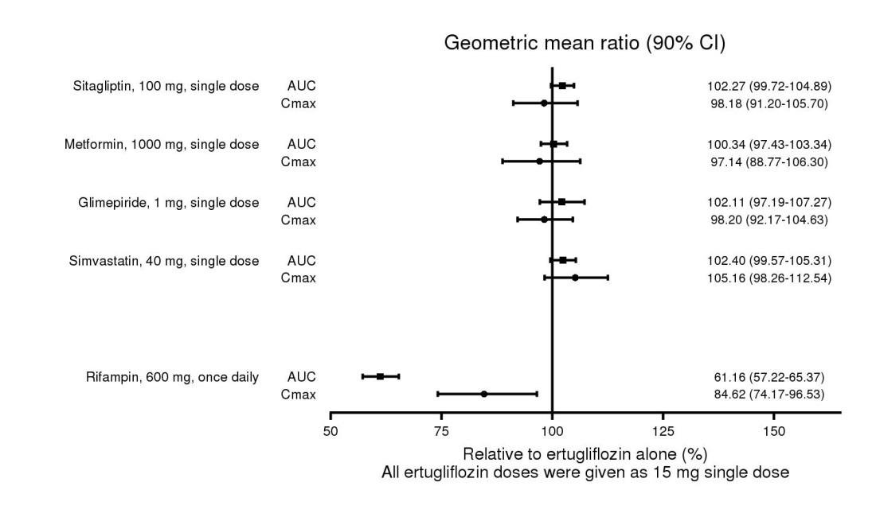

### Clinical studies of effects of ertugliflozin on the pharmacokinetics of other drugs (see Figure 2)

The effects of ertugliflozin on the pharmacokinetics of coadministered drugs have been assessed in drug-drug interaction studies. There were no clinically significant drug interactions identified.

##### Sitagliptin

No clinically meaningful change in sitagliptin exposure was observed following concomitant administration of a single 100 mg sitagliptin dose with 15 mg ertugliflozin compared to sitagliptin alone. The GMR and 90% CI (expressed as percentages) for sitagliptin AUCinf and Cmax for coadministration with ertugliflozin vs. sitagliptin alone were 101.67% (98.40%, 105.04%) and 101.68% (91.65%, 112.80%), respectively.

##### Metformin

No clinically meaningful change in metformin exposure was observed following concomitant administration of a single 1,000 mg metformin dose with 15 mg ertugliflozin compared to metformin alone. The GMR and 90% CI (expressed as percentages) for metformin AUCinf and Cmax for coadministration with ertugliflozin vs. metformin alone were 100.94% (90.62%, 112.44%) and 94.00% (82.94%, 106.55%), respectively.

##### Glimepiride

No clinically meaningful change in glimepiride exposure was observed following concomitant administration of a single 1 mg glimepiride dose with 15 mg ertugliflozin compared to glimepiride alone. The GMR and 90% CI (expressed as percentages) for glimepiride AUCinf and Cmax for coadministration with ertugliflozin vs. glimepiride alone were 109.80% (98.14%, 122.86%) and 97.39% (71.07%, 133.46%), respectively.

##### Simvastatin

Coadministration of a single 40 mg simvastatin dose with a single dose of ertugliflozin 15 mg resulted in a small, non-clinically meaningful increase in AUCinf and Cmax of simvastatin and simvastatin acid. The GMR and 90% CI (expressed as percentages) for simvastatin AUCinf and Cmax for coadministration with ertugliflozin vs. simvastatin alone were 123.83% (90.92%, 168.66%) and 119.05% (97.22%, 145.77%), respectively. The GMR and 90% CI for simvastatin acid AUCinf and Cmax for coadministration with ertugliflozin vs. simvastatin alone were 130.46% (108.32%, 157.13%) and 115.66% (95.74%, 139.71%), respectively.

1. Effects of Ertugliflozin on the Pharmacokinetics of Other Drugs

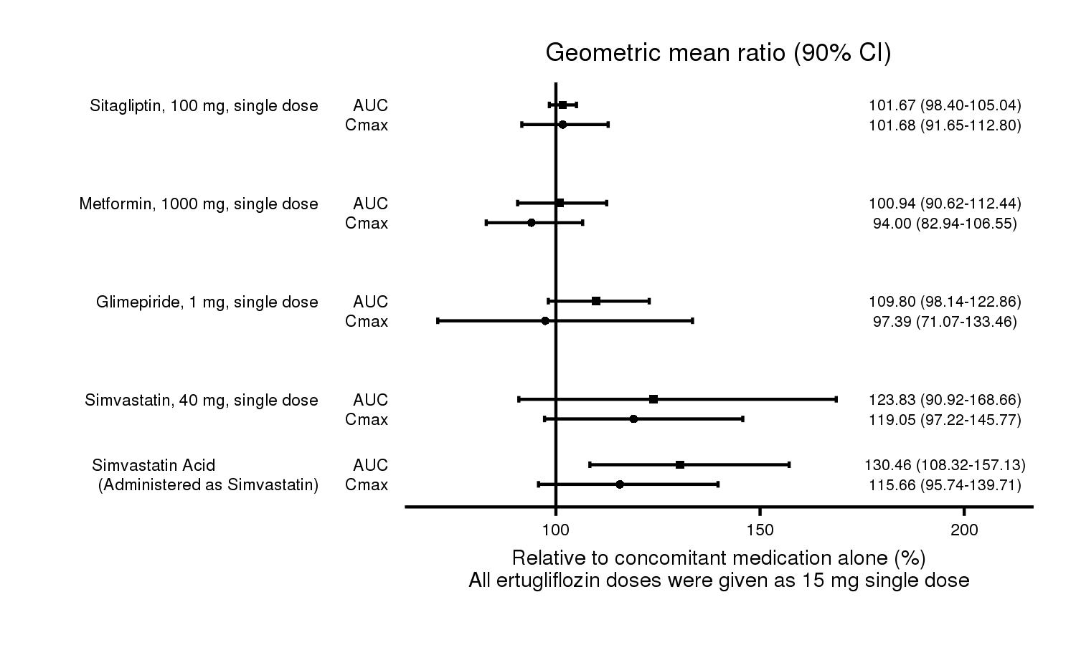

## 4.6 FERTILITY, PREGNANCY AND LACTATION

### Effects on fertility

The effect of ertugliflozin on fertility in humans has not been studied. In rats, no effects on male or female fertility were observed with oral administration of ertugliflozin up to the highest dose of 250 mg/kg/day (yielding approximately 280 and 380 times the clinical plasma AUC for unbound ertugliflozin at the maximum recommended human dose (MRHD) of 15 mg/day in the respective sexes).

### Use in pregnancy (Category D)

There are no adequate and well-controlled studies of STEGLATRO in pregnant women. Based on results from animal studies, ertugliflozin may affect renal development and maturation. Use of STEGLATRO during pregnancy is not recommended.

Ertugliflozin and/or its metabolites were shown to cross the placenta in rats.

In animal studies, ertugliflozin did not adversely affect developmental outcomes in rats and rabbits at oral doses up to 100 mg/kg/day and 250 mg/kg/day in the respective species (yielding approximately 240 and >1000 times the clinical AUC for unbound ertugliflozin at the MRHD of 15 mg/day). At a maternally toxic dose in rats (250 mg/kg/day), lower fetal viability and a higher incidence of cardiac malformation were observed (510 times the clinical exposure at the MRHD, based on AUC). The developing kidney is seen to be more sensitive to ertugliflozin than the mature organ. When ertugliflozin was administered to juvenile rats from post-natal day (PND) 21 to PND 90, increased kidney weights, dilatation of the renal pelvis and tubules, and renal mineralization were seen at all dose levels tested (≥ 5 mg/kg/day, yielding 13 times the clinical exposure at the MRHD), with effects more prominent than observed in adult animals.

### Use in lactation

There is no information regarding the presence of ertugliflozin in human milk, the effects on the breastfed infant, or the effects on milk production. Ertugliflozin was shown to be excreted in the milk of lactating rats. Since human kidney maturation occurs in utero and during the first 2 years of life when lactational exposure may occur, there may be risk to the developing human kidney [see Use in Pregnancy].

Because many drugs are excreted in human milk and because of the potential for adverse reactions in nursing infants STEGLATRO is not recommended during breast feeding.

## 4.7 EFFECTS ON THE ABILITY TO DRIVE AND USE MACHINES

Ertugliflozin has no or negligible influence on the ability to drive or use machines. Patients should be alerted to the risk of hypoglycaemia when STEGLATRO is used in combination with insulin or an insulin secretagogue and to the elevated risk of adverse reactions related to volume depletion, such as postural dizziness [see 4.4 SPECIAL WARNINGS AND PRECAUTIONS FOR USE and 4.8 ADVERSE EFFECTS (UNDESIRABLE EFFECTS)].

## 4.8 ADVERSE EFFECTS (UNDESIRABLE EFFECTS)

### Clinical trials

The safety and tolerability of STEGLATRO were evaluated in seven Phase 3 studies which included 4,859 subjects who were randomised and received at least 1 dose of study medication (3,409 of whom were exposed to STEGLATRO with a mean exposure duration of approximately 51 weeks). The overall incidence of patients with 1 or more adverse events was not notably different across the STEGLATRO 5 mg (62.6%), STEGLATRO 15 mg (62.0%), and placebo (64.8%) groups.

#### Pool of placebo-controlled trials evaluating STEGLATRO 5 and 15 mg

The primary assessment of safety and tolerability was conducted in a pooled analysis of three 26-week placebo-controlled trials with similar study design, duration of treatment, and baseline characteristics. STEGLATRO was used as monotherapy in one trial and as add-on therapy in two trials [see 5.1 PHARMACODYNAMIC PROPERTIES, Clinical trials]. These data reflect exposure of 1,029 patients to STEGLATRO with a mean exposure duration of approximately 25 weeks. Patients received STEGLATRO 5 mg (N=519), STEGLATRO 15 mg (N=510), or placebo (N=515) once daily. The data in Table 1 are derived from this pooled analysis.

The overall incidence of subjects with 1 or more adverse events was not notably different across the STEGLATRO 5 mg (45.5%), STEGLATRO 15 mg (50.4%), and placebo (51.1%) groups. The incidence of non-fatal serious adverse events was low and similar in the STEGLATRO 5 mg and 15 mg groups relative to the placebo group (3.3%, 2.4%, and 2.9% for the STEGLATRO 5 mg, STEGLATRO 15 mg, and placebo groups, respectively). The incidence of adverse events resulting in discontinuation from study medication was low overall and not notably different in the STEGLATRO 5 mg and 15 mg groups (2.3% and 1.4%, respectively) relative to the placebo groups (1.7%).

The adverse drug reactions (ADRs) listed in Table 1 are presented by System Organ Class (SOC).

###### Adverse Drug Reactions Reported in Patients Receiving STEGLATRO

|  |  |  |  |
| --- | --- | --- | --- |
| **Body System/Organ Class**  **Adverse Reaction** | **STEGLATRO 5 mg**  **%** | **STEGLATRO 15 mg**  **%** | **Placebo**  **%** |
|  | N = 519 | N = 510 | N = 515 |
| Infections and infestations |  |  |  |
| Female genital mycotic infections* | 9.1 | 12.2 | 3.0 |
| Male genital mycotic infections† | 3.7 | 4.2 | 0.4 |
| Renal and urinary disorders |  |  |  |
| Increased urination‡ | 2.7 | 2.4 | 1.0 |
| Reproductive system and breast disorders |  |  |  |
| Vulvovaginal pruritus | 1.0 | 1.2 | 0.2 |
| General disorders and administration site conditions |  |  |  |
| Thirst§ | 1.3 | 1.0 | 0.2 |

* Includes: genital candidiasis, genital infection fungal, vaginal infection, vulvitis, vulvovaginal candidiasis, vulvovaginal mycotic infection, and vulvovaginitis. Percentages calculated with the number of female patients in each group as denominator: placebo (N=235), STEGLATRO 5 mg (N=252), STEGLATRO 15 mg (N=245).

†  Includes: balanitis candida, balanoposthitis, genital infection, and genital infection fungal. Percentages calculated with the number of male patients in each group as denominator: placebo (N=280), STEGLATRO 5 mg (N=267), STEGLATRO 15 mg (N=265).

‡ Includes: pollakiuria, micturition urgency, polyuria, urine output increased, and nocturia.

§ Includes: thirst and polydipsia.

### Description of selected adverse reactions

#### Volume depletion

STEGLATRO causes an osmotic diuresis, which may lead to intravascular volume contraction and adverse reactions related to volume depletion, particularly in patients with impaired renal function (eGFR less than 60 mL/min/1.73 m2). In the pool of three placebo-controlled clinical trials, adverse reactions related to volume depletion (e.g., dehydration, dizziness postural, presyncope, syncope, hypotension, and orthostatic hypotension) were not more frequent in patients treated with STEGLATRO compared to those treated with placebo; events were reported by 0.8%, 1.0%, and 1.7% of patients treated with STEGLATRO 5 mg, STEGLATRO 15 mg, and placebo, respectively. A higher incidence was seen in a study of patients with moderate renal impairment; events were reported by 4.4%, 1.9%, and 0% of patients treated with STEGLATRO 5 mg, STEGLATRO 15 mg, and placebo, respectively. STEGLATRO may also increase the risk of hypotension in other patients at risk for volume contraction [see 4.4 SPECIAL WARNINGS AND PRECAUTIONS FOR USE].

#### Ketoacidosis

Across the clinical program, ketoacidosis was identified in 3 of 3,409 (0.1%) STEGLATRO-treated patients and 0.0% of comparator-treated patients [see 4.4 SPECIAL WARNINGS AND PRECAUTIONS FOR USE].

#### Impairment in renal function

Use of ertugliflozin was associated with increases in serum creatinine and decreases in eGFR [see 4.4 SPECIAL WARNINGS AND PRECAUTIONS FOR USE, Effects on laboratory tests]. Patients with moderate renal impairment at baseline had larger mean changes; these changes were observed to reverse after treatment discontinuation, suggesting acute haemodynamic changes play a role in the renal function abnormalities observed with STEGLATRO [see 4.4 SPECIAL WARNINGS AND PRECAUTIONS FOR USE, Use in patients with renal impairment].

Renal-related adverse reactions (e.g., acute kidney injury, renal impairment, acute prerenal failure) may occur in patients treated with ertugliflozin, particularly in patients with moderate renal impairment where the incidence of renal-related adverse reactions was 2.5%, 1.3%, and 0.6% in patients treated with ertugliflozin 5 mg, ertugliflozin 15 mg, and placebo, respectively.

#### Hypoglycaemia

In all clinical trials, hypoglycaemia was defined as any event regardless of symptoms, where biochemical hypoglycaemia was documented (any glucose value below or equal to 3.9 mmol/L). Severe hypoglycaemia was defined as an event consistent with hypoglycaemia where the patient required the assistance of another person to recover, lost consciousness, or experienced a seizure (regardless of whether biochemical documentation of a low glucose value was obtained).

The incidence of hypoglycaemia by study is shown in Table 2. The incidence in clinical trials was low; hypoglycaemia may be higher when STEGLATRO is administered with insulin and/or an insulin secretagogue [see 4.4 SPECIAL WARNINGS AND PRECAUTIONS FOR USE].

###### Incidence of Overall* and Severe† Hypoglycaemia in Placebo- or Comparator-Controlled Clinical Studies

|  |  |  |  |  |  |
| --- | --- | --- | --- | --- | --- |
| **Monotherapy (26 weeks)** | **STEGLATRO 5 mg**  **(N =156)** | **STEGLATRO 15 mg**  **(N = 152)** | **Placebo**  **(N = 153)** |  |  |
| Overall [N (%)] | 4 (2.6) | 4 (2.6) | 1 (0.7) |  |  |
| Severe [N (%)] | 0 (0.0) | 2 (1.3) | 0 (0.0) |  |  |
| **Add-on Combination Therapy with Metformin (26 weeks)** | **STEGLATRO 5 mg**  **(N = 207)** | **STEGLATRO 15 mg**  **(N = 205)** | **Placebo**  **(N = 209)** |  |  |
| Overall [N (%)] | 15 (7.2) | 16 (7.8) | 9 (4.3) |  |  |
| Severe [N (%)] | 1 (0.5) | 0 (0.0) | 1 (0.5) |  |  |
| **Active -Controlled Study with Glimepiride as Add-on Combination Therapy with Metformin (52 weeks)** | **STEGLATRO 5 mg**  **(N = 448)** | **STEGLATRO 15 mg**  **(N = 440)** | **Glimepiride (N = 437)** |  |  |
| Overall [N (%)] | 25 (5.6) | 36 (8.2) | 119 (27.2) |  |  |
| Severe [N (%)] | 1 (0.2) | 1 (0.2) | 10 (2.3) |  |  |
| **Factorial Study with Sitagliptin as Add-on Combination Therapy with Metformin (26 weeks)** | **STEGLATRO 5 mg**  **(N = 250)** | **STEGLATRO 15 mg**  **(N = 248)** | **Sitagliptin**  **(N = 247)** | **STEGLATRO 5 mg + Sitagliptin**  **(N = 243)** | **STEGLATRO 15 mg + Sitagliptin**  **(N = 244)** |
| Overall [N (%)] | 14 (5.6) | 13 (5.2) | 9 (3.6) | 13 (5.3) | 22 (9.0) |
| Severe [N (%)] | 0 (0.0) | 1 (0.4) | 0 (0.0) | 0 (0.0) | 1 (0.4) |
| **Add-on Combination Therapy with Metformin and Sitagliptin (26 weeks)** | **STEGLATRO 5 mg**  **(N = 156)** | **STEGLATRO 15 mg**  **(N = 153)** | **Placebo**  **(N = 153)** |  |  |
| Overall [N (%)] | 7 (4.5) | 3 (2.0) | 5 (3.3) |  |  |
| Severe [N (%)] | 1 (0.6) | 0 (0.0) | 1 (0.7) |  |  |
| **Initial Combination Therapy with Sitagliptin (26 weeks)** |  |  | **Placebo**  **(N = 97)** | **STEGLATRO 5 mg + Sitagliptin**  **(N = 98)** | **STEGLATRO 15 mg + Sitagliptin**  **(N = 96)** |
| Overall [N (%)] |  |  | 1 (1.0) | 6 (6.1) | 3 (3.1) |
| Severe [N (%)] |  |  | 0 (0.0) | 0 (0.0) | 2 (2.1) |
| **In Combination with Insulin and/or an Insulin Secretagogue in Patients with Moderate Renal Impairment (26 weeks)** | **STEGLATRO 5 mg**  **(N = 148)** | **STEGLATRO 15 mg**  **(N = 143)** | **Placebo**  **(N = 133)** |  |  |
| Overall [N (%)] | 53 (35.8) | 39 (27.3) | 48 (36.1) |  |  |
| Severe [N (%)] | 5 (3.4) | 3 (2.1) | 3 (2.3) |  |  |

* Overall hypoglycaemic events: plasma or capillary glucose of less than or equal to 3.9 mmol/L.

† Severe hypoglycaemic events: required assistance, lost consciousness, or experienced a seizure regardless of blood glucose.

#### Genital mycotic infections

In the pool of three placebo-controlled clinical trials, female genital mycotic infections (e.g., genital candidiasis, genital infection fungal, vaginal infection, vulvitis, vulvovaginal candidiasis, vulvovaginal mycotic infection, vulvovaginitis) occurred in 9.1%, 12.2%, and 3.0% of females treated with STEGLATRO 5 mg, STEGLATRO 15 mg, and placebo, respectively. In females, discontinuation due to genital mycotic infections occurred in 0.6% and 0% of patients treated with STEGLATRO and placebo, respectively [See 4.4 SPECIAL WARNINGS AND PRECAUTIONS FOR USE].

In the same pool, male genital mycotic infections (e.g., balanitis candida, balanoposthitis, genital infection, genital infection fungal) occurred in 3.7%, 4.2%, and 0.4% of males treated with STEGLATRO 5 mg, STEGLATRO 15 mg, and placebo, respectively. Male genital mycotic infections occurred more commonly in uncircumcised males. In males, discontinuations due to genital mycotic infections occurred in 0.2% and 0% of patients treated with STEGLATRO and placebo, respectively. In rare instances, phimosis was reported and sometimes circumcision was performed [See 4.4 SPECIAL WARNINGS AND PRECAUTIONS FOR USE].

### Laboratory tests

#### Increases in serum creatinine and decreases in eGFR

Initial increases in mean creatinine and decreases in mean eGFR in patients treated with ertugliflozin were generally transient during continuous treatment. In the pool of three placebo-controlled clinical trials, mean changes from baseline in creatinine at 6 weeks were 2.41 and 2.76 µmol/L for ertugliflozin 5 mg and 15 mg, respectively, compared to 0.24 µmol/L for placebo. Mean changes from baseline in eGFR were ‑2.7 and ‑3.1 mL/min/1.73 m2 for ertugliflozin 5 mg and 15 mg, respectively, compared to ‑0.3 mL/min/1.73 m2 for placebo. At 26 weeks, mean changes from baseline in creatinine were ‑0.08 and 0.80 µmol/L for ertugliflozin 5 mg and 15 mg, respectively, compared to ‑0.57 µmol/L for placebo. Mean changes from baseline in eGFR at 26 weeks were 0.5 and ‑0.6 mL/min/1.73 m2 for ertugliflozin 5 mg and 15 mg, respectively, compared to 0.7 mL/min/1.73 m2 for placebo. Patients with moderate renal impairment at baseline had larger mean changes at 6 weeks (approximately 1 mL/min/1.73 m2) with some attenuation but not a complete return to baseline by 26 weeks. These changes were observed to reverse after treatment discontinuation.

#### Increases in low-density lipoprotein cholesterol (LDL-C)

In the pool of three placebo-controlled trials, dose-related increases in LDL-C were observed in patients treated with STEGLATRO. Mean percent changes from baseline in LDL-C relative to placebo were 2.6% and 5.4% with STEGLATRO 5 mg and STEGLATRO 15 mg, respectively. The range of mean baseline LDL-C was 2.50 to 2.53 mmol/L across treatment groups.

#### Increases in haemoglobin

In the pool of three placebo-controlled trials, mean changes (percent changes) from baseline in haemoglobin were 4.6 g/L (3.5%) with STEGLATRO 5 mg, 4.8 g/L (3.5%) with STEGLATRO 15 mg, and ‑2.1 g/L (-1.4%) with placebo. The range of mean baseline haemoglobin was 139.0 to 140.0 g/L across treatment groups. At the end of treatment, 0.2%, 0.4%, and 0.0% of patients treated with STEGLATRO 5 mg, STEGLATRO 15 mg, and placebo, respectively, had a haemoglobin increase greater than 20 g/L and above the upper limit of normal. This change in laboratory parameter is of unknown clinical significance.

#### Increases in serum phosphate

In the pool of three placebo-controlled trials, mean changes (percent changes) from baseline in serum phosphate were 0.07 mmol/L (6.8%) with STEGLATRO 5 mg, 0.08 mmol/L (8.5%) with STEGLATRO 15 mg, and 0.01 mmol/L (1.9%) with placebo. The range of mean baseline serum phosphate was 1.14 to 1.14 mmol/L across treatment groups. In a clinical trial of patients with moderate renal impairment, mean changes (percent changes) from baseline at Week 26 in serum phosphate were 0.09 mmol/L (9.7%) with STEGLATRO 5 mg, 0.08 mmol/L (7.8%) with STEGLATRO 15 mg, and ‑0.00 mmol/L (0.8%) with placebo. This change in laboratory parameter is of unknown clinical significance.

### Adverse reactions in specific populations

#### Elderly patients

Across the clinical program, a total of 876 (25.7%) patients treated with STEGLATRO were 65 years and older, and 152 (4.5%) patients treated with STEGLATRO were 75 years and older. Patients 65 years and older had a higher incidence of adverse reactions related to volume depletion compared to younger patients; events were reported in 2.2%, 2.6%, and 1.1% of patients treated with STEGLATRO 5 mg, STEGLATRO 15 mg, and comparator, respectively [see 4.2 DOSE AND METHOD OF ADMINISTRATION and 4.8 ADVERSE EFFECTS (UNDESIRABLE EFFECTS)].

#### Renal impairment

The efficacy and safety of STEGLATRO were evaluated in a study of patients with moderate renal impairment. In this study, 202 patients exposed to STEGLATRO had an eGFR between 45 and 60 mL/min/1.73 m2 and 111 patients exposed to STEGLATRO had an eGFR between 30 and 45 mL/min/1.73 m2. The glucose‑lowering efficacy of STEGLATRO decreased in patients with worsening renal function. Compared to placebo-treated patients, patients with moderate renal impairment treated with STEGLATRO had increases in serum creatinine and decreases in eGFR, and increased risks for renal-related volume depletion adverse reactions [see 4.2 DOSE AND METHOD OF ADMINISTRATION, 4.4 SPECIAL WARNINGS AND PRECAUTIONS FOR USE, and 4.8 ADVERSE EFFECTS (UNDESIRABLE EFFECTS)].

#### Reporting suspected adverse reactions

Reporting suspected adverse reactions after registration of the medicinal product is important. It allows continued monitoring of the benefit-risk balance of the medicinal product. Healthcare professionals are asked to report any suspected adverse reactions at [www.tga.gov.au/reporting-problems](http://spapp.merck.com/sites/ANZMarket/REGAFF/PRODPROJ/Ertuglif/PROJECTS/001/Other/00-az-PI-CMI-forreview-postACM/www.tga.gov.au/reporting-problems).

# 4.9 OVERDOSE

For information on the management of overdose, contact the Poison Information Centre on 131126 (Australia).

Ertugliflozin did not show any toxicity in healthy subjects at single oral doses up to 300 mg and multiple doses up to 100 mg daily for 2 weeks. No potential acute symptoms and signs of overdose were identified.

In the event of an overdose, employ the usual supportive measures (e.g., remove unabsorbed material from the gastrointestinal tract, employ clinical monitoring, and institute supportive treatment) as dictated by the patient’s clinical status. Removal of ertugliflozin by haemodialysis has not been studied.

# 5 PHARMACOLOGICAL PROPERTIES

## 5.1 PHARMACODYNAMIC PROPERTIES

### Mechanism of action

STEGLATRO tablets contain ertugliflozin, a sodium-glucose co-transporter 2 (SGLT2) inhibitor.

SGLT2 is the predominant transporter responsible for reabsorption of glucose from the glomerular filtrate back into the circulation. Patients with diabetes have been shown to have elevated reabsorption of glucose which may result in persistence of hyperglycaemia. Ertugliflozin is an inhibitor of SGLT2 with an IC50 of 0.88 nM. It displays >2,200-fold selectivity for SGLT2 over SGLT1 (responsible for glucose absorption in the gut). By inhibiting SGLT2, ertugliflozin reduces renal reabsorption of filtered glucose and lowers the renal threshold for glucose, and thereby increases urinary glucose excretion (UGE), which lowers fasting plasma glucose (FPG) and haemoglobin A1C levels in an insulin-independent manner. Additionally, UGE results in caloric loss and with ensuing weight loss. Ertugliflozin also causes an osmotic diuresis, which may result in reduction of blood pressure. UGE is observed after the first dose. UGE with ertugliflozin depends on plasma glucose levels and glomerular filtration rate. Consequently, UGE is reduced as plasma glucose levels fall, which reduces the risk of hypoglycaemia.

#### Urinary glucose excretion and urinary volume

Dose-dependent increases in the amount of glucose excreted in urine were observed in healthy subjects and in patients with type 2 diabetes mellitus following single‑ and multiple‑dose administration of ertugliflozin. Dose-response modelling indicates that ertugliflozin 5 mg and 15 mg result in near maximal urinary glucose excretion (UGE), with the 15 mg dose providing incrementally greater UGE relative to the 5 mg dose. Enhanced UGE is maintained after multiple-dose administration. UGE with ertugliflozin also results in increases in urinary volume. Ertugliflozin acts independently of insulin secretion and insulin action. Over time, significant improvement in beta cell function (HOMA-beta) has been observed in clinical studies with ertugliflozin.

#### Cardiac Electrophysiology

In a randomised, placebo-controlled, active-comparator, crossover study, 42 healthy subjects were administered a single oral supratherapeutic dose of STEGLATRO 100 mg (6.7 times the maximum recommended dose), moxifloxacin, and placebo. No increase in QTc was observed with 100 mg ertugliflozin.

### CLINICAL TRIALS

The efficacy and safety of STEGLATRO have been studied in 7 multi-centre, randomised, double-blind, placebo- or active comparator-controlled, Phase 3 clinical studies involving 4,863 patients with type 2 diabetes. These studies included White, Hispanic, Black, Asian, and other racial and ethnic groups, and patients with an average age of approximately 57.8 years.

STEGLATRO has been studied as monotherapy and in combination with metformin and/or a dipeptidyl peptidase 4 (DPP-4) inhibitor. In a study in patients with type 2 diabetes with moderate renal impairment, STEGLATRO has also been studied in combination with current diabetes treatments, including insulin and a sulfonylurea.

In patients with type 2 diabetes as monotherapy or in combination with metformin and/or a DPP-4 inhibitor, treatment with STEGLATRO produced clinically and statistically significant improvements in HbA1c and FPG compared to placebo after 26 weeks of treatment. In a 52‑week study, glycaemic control (HbA1c) was maintained with ertugliflozin treatment.

In patients with type 2 diabetes treated with STEGLATRO, the improvement in HbA1c was generally similar across subgroups defined by age, sex, race, geographic region, baseline BMI, and duration of type 2 diabetes mellitus.

#### Monotherapy

A total of 461 patients with type 2 diabetes inadequately controlled on diet and exercise participated in a randomised, double-blind, multi-centre, 26‑week, placebo-controlled study to evaluate the efficacy and safety of STEGLATRO monotherapy. These patients, who were not receiving any background antihyperglycaemic treatment, were randomised to STEGLATRO 5 mg, STEGLATRO 15 mg, or placebo administered once daily.

At Week 26, treatment with STEGLATRO at 5 mg or 15 mg daily provided statistically significant improvements in HbA1c, FPG, body weight, and 2-hour post-prandial glucose (PPG) compared to placebo. STEGLATRO also resulted in a greater proportion of patients achieving an HbA1c <7% compared with placebo (see Table 3 and Figure 3).

###### Results at Week 26 from a Placebo-Controlled Monotherapy Study of STEGLATRO*

|  |  |  |  |
| --- | --- | --- | --- |
|  | **STEGLATRO 5 mg** | **STEGLATRO 15 mg** | **Placebo** |
| **HbA1c (%)** | **N = 156** | **N = 151** | **N = 153** |
| Baseline (mean) | 8.16 | 8.35 | 8.11 |
| Change from baseline (LS mean†) | -0.79 | -0.96 | 0.20 |
| Difference from placebo (LS mean†, 95% CI) | -0.99‡ (-1.22, -0.76) | -1.16‡ (-1.39, -0.93) |  |
| **Patients [N (%)] with HbA1c <7%** | 44 (28.2)§ | 54 (35.8)§ | 20 (13.1) |
| **FPG (mmol/L)** | **N = 155** | **N = 152** | **N = 153** |
| Baseline (mean) | 10.04 | 9.94 | 10.00 |
| Change from baseline (LS mean†) | -1.88 | -2.41 | 0.03 |
| Difference from placebo (LS mean†, 95% CI) | -1.92‡ (-2.37, -1.46) | -2.44‡ (-2.90, -1.98) |  |
| **2-hour PPG (mmol/L)** | **N = 153** | **N = 148** | **N = 151** |
| Baseline (mean) | 14.45 | 14.59 | 14.22 |
| Change from baseline (LS mean†) | -3.56 | -3.47 | 0.27 |
| Difference from placebo (LS mean†, 95% CI) | -3.83‡ (-4.62, -3.04) | -3.74‡ (-4.54, -2.94) |  |
| **Body Weight (kg)** | **N = 156** | **N = 152** | **N = 153** |
| Baseline (mean) | 94.0 | 90.6 | 94.2 |
| Change from baseline (LS mean†) | -3.2 | -3.6 | -1.4 |
| Difference from placebo (LS mean†, 95% CI) | -1.8‡ (-2.6, -0.9) | -2.2‡ (-3.0, -1.3) |  |
| **Efficacy in patients with high baseline HbA1c (≥8%)** | | | |
| **HbA1c (%)** | **N = 74** | **N = 78** | **N = 61** |
| Baseline (mean) | 8.85 | 9.17 | 8.74 |
| Change from baseline (LS mean¶) | -1.02 | -1.43 | 0.09 |
| Difference from placebo (LS mean¶, 95% CI) | -1.11 (-1.46, -0.77) | -1.52 (-1.86, -1.17) |  |

* N includes all randomised, treated patients who had at least one measurement of the outcome variable.

† Least squares means adjusted for treatment, time, prior antihyperglycaemic medication, baseline eGFR and the interaction of time by treatment.

‡ p<0.001 compared to placebo.

§ p<0.001 compared to placebo (based on adjusted odds ratio comparisons from a logistic regression model using multiple imputation for missing data values).

¶ Obtained from a repeated measures ANCOVA model adjusted for baseline eGFR and baseline HbA1c, prior antihyperglycaemic medication, treatment, subgroup, treatment-by-subgroup, and treatment-by-time-by-subgroup interactions.

1. HbA1c (%) Change Over Time in a 26‑Week Placebo‑Controlled Monotherapy Study of STEGLATRO*

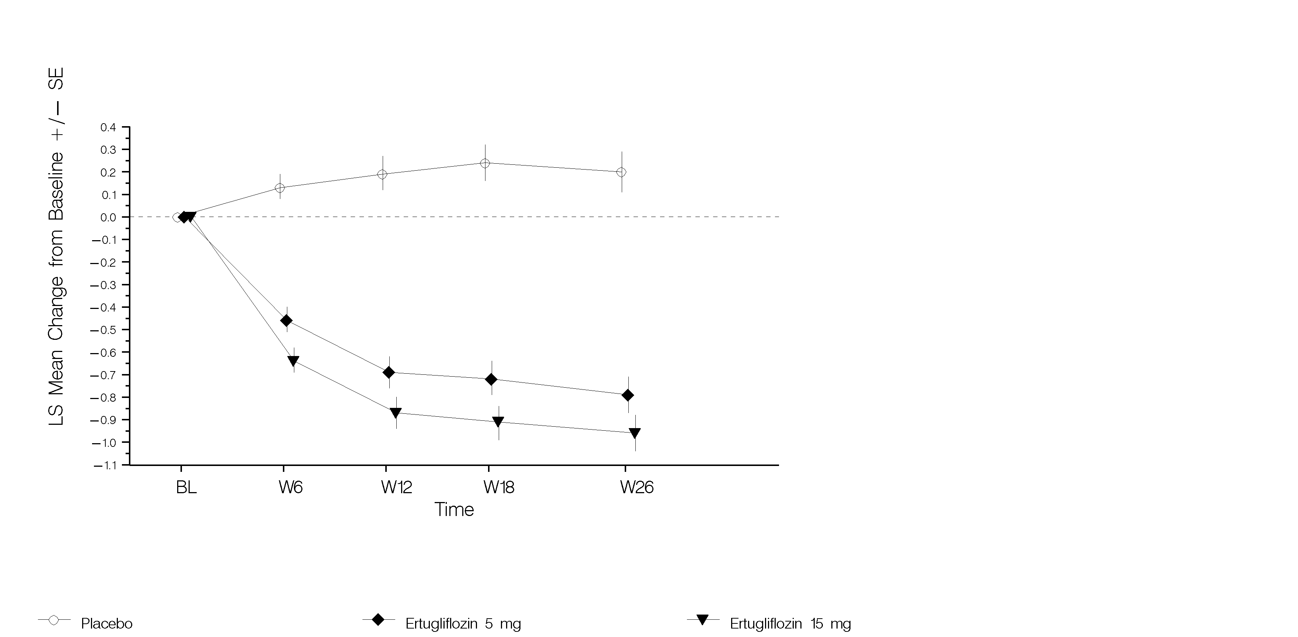

* Based on the full analysis set population, which included all randomised, treated patients with at least one HbA1c measurement.

#### STEGLATRO as add-on combination therapy with metformin

A total of 621 patients with type 2 diabetes inadequately controlled on metformin monotherapy (≥1,500 mg/day) participated in a randomised, double-blind, multi-centre, 26‑week, placebo-controlled study to evaluate the efficacy and safety of STEGLATRO in combination with metformin. Patients were randomised to STEGLATRO 5 mg, STEGLATRO 15 mg, or placebo administered once daily in addition to continuation of background metformin therapy.

At Week 26, treatment with STEGLATRO at 5 mg or 15 mg daily provided statistically significant improvements in HbA1c, FPG, and body weight compared to placebo. Treatment with STEGLATRO at 5 mg or 15 mg daily provided a statistically significant improvement in systolic and diastolic blood pressure compared to placebo. STEGLATRO also resulted in a greater proportion of patients achieving an HbA1c <7% compared to placebo (see Table 4 and Figure 4).

###### Results at Week 26 from a Placebo‑Controlled Study for STEGLATRO Used in Combination with Metformin*

|  |  |  |  |
| --- | --- | --- | --- |
|  | **STEGLATRO 5 mg** | **STEGLATRO 15 mg** | **Placebo** |
| **HbA1c (%)** | **N = 207** | **N = 205** | **N = 209** |
| Baseline (mean) | 8.06 | 8.13 | 8.17 |
| Change from baseline (LS mean†) | -0.73 | -0.91 | -0.03 |
| Difference from placebo (LS mean†, 95% CI) | -0.70‡ (-0.87, -0.53) | -0.88‡ (-1.05, -0.71) |  |
| **Patients [N (%)] with HbA1c <7%** | 73 (35.3)§ | 82 (40.0)§ | 33 (15.8) |
| **FPG (mmol/L)** | **N = 207** | **N = 205** | **N = 209** |
| Baseline (mean) | 9.33 | 9.32 | 9.39 |
| Change from baseline (LS mean†) | -1.53 | -2.17 | -0.05 |
| Difference from placebo (LS mean†, 95% CI) | -1.48† (-1.83, -1.14) | -2.12† (-2.47, -1.78) |  |
| **Body Weight (kg)** | **N = 207** | **N = 205** | **N = 209** |
| Baseline (mean) | 84.9 | 85.3 | 84.5 |
| Change from baseline (LS mean†) | -3.0 | -2.9 | -1.3 |
| Difference from placebo (LS mean†, 95% CI) | -1.7‡ (-2.2, -1.1) | -1.6‡ (-2.2, -1.0) |  |
| **Systolic Blood Pressure** | **N = 207** | **N = 204** | **N = 209** |
| Baseline (mean) | 130.5 | 130.2 | 129.3 |
| Change from baseline (LS mean†) | -4.4 | -5.2 | -0.7 |
| Difference from placebo (LS mean†, 95% CI) | -3.7¶ (-6.0, -1.4) | -4.5‡ (-6.8, -2.2) |  |
| **Diastolic Blood Pressure** | **N = 207** | **N = 204** | **N = 209** |
| Baseline (mean) | 78.4 | 78.1 | 77.4 |
| Change from baseline (LS mean†) | -1.6 | -2.2 | 0.2 |
| Difference from placebo (LS mean†, 95% CI) | -1.8¶ (-3.2, -0.4) | -2.4‡ (-3.9, -1.0) |  |
| **Efficacy in patients with high baseline HbA1c (≥9%)** | | | |
| **HbA1c (%)** | **N = 34** | **N = 38** | **N = 40** |
| Baseline (mean) | 9.47 | 9.62 | 9.49 |
| Change from baseline (LS mean#) | -1.61 | -1.73 | -0.30 |
| Difference from placebo (LS mean#, 95% CI) | -1.31 (-1.73, -0.90) | -1.43 (-1.83, -1.03) |  |

* N includes all randomised, treated patients who had at least one measurement of the outcome variable.

† Least squares means adjusted for treatment, time, prior antihyperglycaemic medication (metformin monotherapy or metformin + another AHA), baseline eGFR (continuous), menopausal status randomization stratum (men, premenopausal women, women who are perimenopausal or <3 years postmenopausal, women who are ≥3 years postmenopausal) and the interaction of time by treatment.

‡ p≤0.001 compared to placebo.

§ p<0.001 compared to placebo (based on adjusted odds ratio comparisons from a logistic regression model using multiple imputation for missing data values).

¶ p<0.05 compared to placebo.

# Obtained from a repeated measures ANCOVA model with terms for prior antihyperglycaemic medication, menopausal status stratum, baseline eGFR, baseline HbA1c, treatment, subgroup, treatment-by-subgroup, and treatment-by-time-by-subgroup interactions.

1. HbA1c (%) Change Over Time in a 26‑Week Placebo‑Controlled Study for STEGLATRO Used in Combination with Metformin*

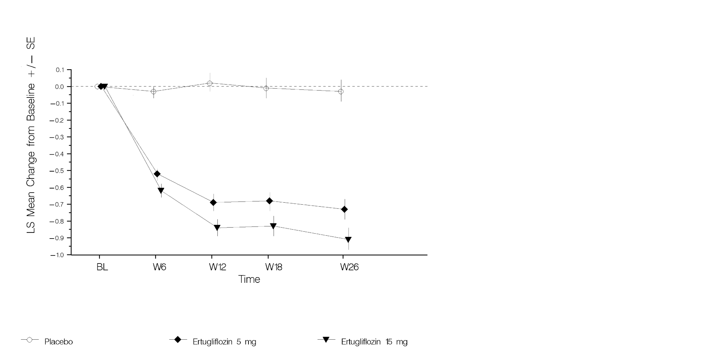

* Based on the full analysis set population, which included all randomised, treated patients with at least one HbA1c measurement.

#### Active‑controlled study of STEGLATRO versus glimepiride as add-on combination therapy with metformin

A total of 1,326 patients with type 2 diabetes inadequately controlled on metformin monotherapy participated in a randomised, double-blind, multi-centre, 52‑week, active comparator‑controlled study to evaluate the efficacy and safety of STEGLATRO in combination with metformin. These patients, who were receiving metformin monotherapy (≥1,500 mg/day), were randomised to STEGLATRO 5 mg, STEGLATRO 15 mg, or glimepiride administered once daily in addition to continuation of background metformin therapy. Glimepiride was initiated at 1 mg/day and titrated up to a maximum dose of 6 or 8 mg/day (depending on maximum approved dose in each country) or a maximum tolerated dose or down-titrated to avoid or manage hypoglycaemia. The mean daily dose of glimepiride was 3.0 mg.

At Week 52, STEGLATRO 5 mg and 15 mg provided similar reductions in HbA1c from baseline compared to glimepiride when added to metformin therapy. STEGLATRO 15 mg was non-inferior to glimepiride after 52 weeks of treatment. At Week 52, STEGLATRO 15 mg resulted in a statistically significant difference in change from baseline for body weight compared to glimepiride (-3.4 kg for STEGLATRO 15 mg vs. +0.9 kg for glimepiride; treatment difference -4.3 kg; p<0.001) (See Table 5 and Figure 5).

###### Results at Week 52 from an Active-Controlled Study Comparing STEGLATRO to Glimepiride as Add-on Therapy in Patients Inadequately Controlled on Metformin*

|  |  |  |  |
| --- | --- | --- | --- |
|  | **STEGLATRO 5 mg** | **STEGLATRO 15 mg** | **Glimepiride** |
| **HbA1c (%)** | **N = 448** | **N = 440** | **N = 437** |
| Baseline (mean) | 7.81 | 7.80 | 7.76 |
| Change from baseline (LS mean†) | -0.56 | -0.64 | -0.74 |
| Difference from glimepiride (LS mean†, 95% CI) | 0.18‡ (0.06, 0.30) | 0.10§ (-0.02, 0.22) |  |
| **Patients [N (%)] with HbA1c <7%** | 154 (34.4) | 167 (38.0) | 190 (43.5) |
| **Body Weight (kg)** | **N = 448** | **N = 440** | **N = 437** |
| Baseline (mean) | 87.9 | 85.6 | 86.8 |
| Change from baseline (LS mean†) | -3.0 | -3.4 | 0.9 |
| Difference from glimepiride (LS mean†, 95% CI) | -3.9 (-4.4, -3.4) | -4.3§ (-4.8, -3.8) |  |

* N includes all randomised, treated patients who had at least one measurement of the outcome variable.

† Least squares means adjusted for treatment, time, prior antihyperglycaemic medication (monotherapy or dual therapy), baseline eGFR (continuous) and the interaction of time by treatment. Time was treated as a categorical variable.

‡ Non-inferiority between ertugliflozin 5 mg and glimepiride was not established.

§ Non-inferiority is declared when the upper bound of the two-sided 95% confidence interval (CI) for the mean difference is less than 0.3%.

¶ p<0.001 compared to glimepiride.

1. HbA1c (%) Change Over Time in an Active-Controlled Study Comparing STEGLATRO to Glimepiride as Add-on Therapy in Patients Inadequately Controlled on Metformin*

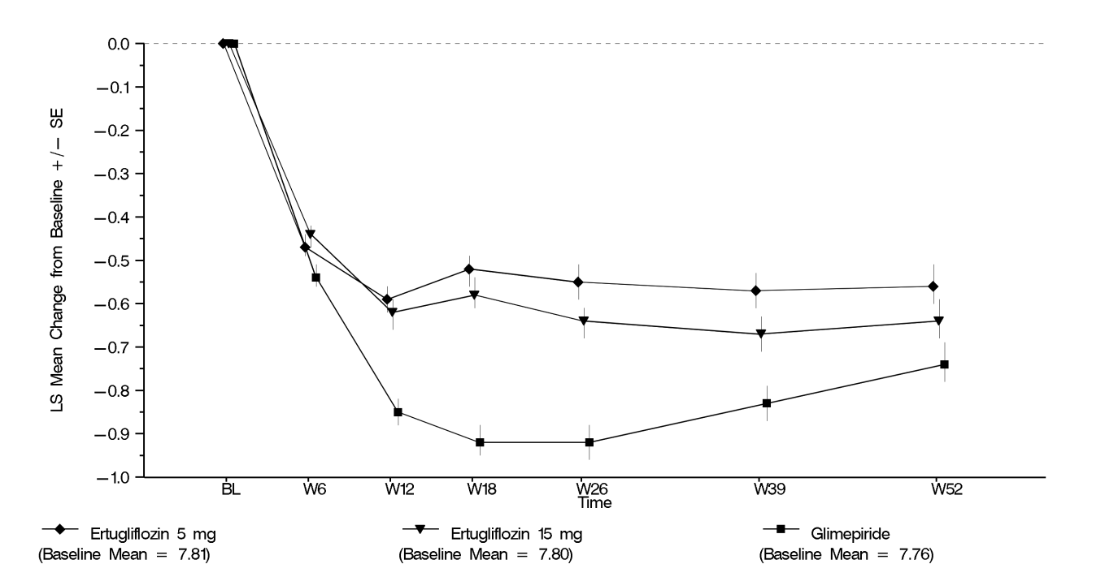

* Based on the full analysis set population, which included all randomised, treated patients with at least one HbA1c measurement.

#### Factorial study with STEGLATRO and sitagliptin as add-on combination therapy with metformin

A total of 1,233 patients with type 2 diabetes participated in a randomised, double-blind, multi-centre, 26‑week, active-controlled study to evaluate the efficacy and safety of STEGLATRO 5 mg or 15 mg in combination with sitagliptin 100 mg compared to the individual components. Patients with type 2 diabetes inadequately controlled on metformin monotherapy (≥1,500 mg/day) were randomised to one of five active-treatment arms: STEGLATRO 5 mg or 15 mg, sitagliptin 100 mg, or sitagliptin 100 mg in combination with 5 mg or 15 mg STEGLATRO administered once daily in addition to continuation of background metformin therapy.

At Week 26, STEGLATRO 5 mg or 15 mg used in combination with sitagliptin 100 mg provided statistically significant improvement in HbA1c and FPG compared to the individual components (see Table 6). More patients receiving STEGLATRO 5 mg or 15 mg in combination with sitagliptin 100 mg achieved an HbA1c <7% compared to the individual components. Treatment with STEGLATRO 5 mg or 15 mg in combination with sitagliptin 100 mg also resulted in a statistically significant reduction in body weight and systolic blood pressure compared to sitagliptin 100 mg.

###### Results at Week 26 from a Factorial Study with STEGLATRO and Sitagliptin as Add-on Combination Therapy with Metformin Compared to Individual Components Alone*

|  |  |  |  |  |  |
| --- | --- | --- | --- | --- | --- |
|  | **STEGLATRO 5 mg** | **STEGLATRO 15 mg** | **Sitagliptin 100 mg** | **STEGLATRO 5 mg + Sitagliptin 100 mg** | **STEGLATRO 15 mg + Sitagliptin 100 mg** |
| **HbA1c (%)** | **N = 250** | **N = 248** | **N = 247** | **N = 243** | **N = 244** |
| Baseline (mean) | 8.57 | 8.57 | 8.50 | 8.56 | 8.56 |
| Change from baseline  (LS mean†) | -1.02 | -1.08 | -1.05 | -1.49 | -1.52 |
| Difference from Sitagliptin  STEGLATRO 5 mg  STEGLATRO 15 mg  (LS mean†, 95% CI) |  |  |  | -0.43‡ (-0.60, -0.27)  -0.46‡ (-0.63, -0.30) | -0.47‡ (-0.63, -0.30)  -0.44‡ (-0.61, -0.27) |
| **Patients [N (%)] with HbA1c <7%** | 66 (26.4) | 79 (31.9) | 81 (32.8) | 127§ (52.3) | 120§ (49.2) |
| **FPG (mmol/L)** | **N = 250** | **N = 248** | **N = 247** | **N = 243** | **N = 244** |
| Baseline (mean) | 10.22 | 9.96 | 9.85 | 10.20 | 9.83 |
| Change from baseline  (LS mean†) | -1.98 | -2.05 | -1.42 | -2.44 | -2.70 |
| Difference from Sitagliptin  STEGLATRO 5 mg  STEGLATRO 15 mg  (LS mean†, 95% CI) |  |  |  | -1.02‡ (-1.33, -0.71)  -0.46 (-0.77, -0.15) | -1.28‡ (-1.60, -0.97)  -0.65‡ (-0.96, -0.35) |
| **Body Weight (kg)** | **N = 250** | **N = 248** | **N = 247** | **N = 243** | **N = 244** |
| Baseline (mean) | 88.6 | 88.0 | 89.8 | 89.5 | 87.5 |
| Change from baseline  (LS mean†) | -2.7 | -3.7 | -0.7 | -2.5 | -2.9 |
| Difference from Sitagliptin  (LS mean†, 95% CI) |  |  |  | -1.8‡ (-2.5, -1.2) | -2.3‡ (-2.9, -1.6) |
| **Systolic Blood Pressure** | **N = 250** | **N = 248** | **N = 247** | **N = 243** | **N = 244** |
| Baseline (mean) | 129.7 | 128.9 | 128.3 | 130.2 | 129.1 |
| Change from baseline  (LS mean†) | -3.9 | -3.7 | -0.7 | -3.4 | -3.7 |
| Difference from Sitagliptin  (LS mean†, 95% CI) |  |  |  | -2.8¶ (-4.7, -0.8) | -3.0¶ (-4.9, -1.1) |
| **Efficacy in patients with high baseline HbA1c (≥10%)** | | | | | |
| **HbA1c (%)** | **N = 25** | **N = 21** | **N = 26** | **N = 20** | **N = 22** |
| Baseline (mean) | 10.66 | 10.51 | 10.46 | 10.46 | 10.39 |
| Change from baseline (LS mean#) | -2.10 | -1.30 | -1.82 | -2.35 | -2.66 |
| Difference from Sitagliptin  STEGLATRO 5 mg  STEGLATRO 15 mg  (LS mean#, 95% CI) |  |  |  | -0.53 (-1.08, -0.03)  -0.24 (-0.80, -0.32) | -0.84 (-1.38, -0.30)  -1.36 (-1.91, -0.81) |

* N includes all randomised, treated patients who had at least one measurement of the outcome variable.

† Least squares means adjusted for treatment, time, baseline eGFR and the interaction of time by treatment.

‡ p<0.001 compared to control group.

§ p<0.001 compared to corresponding dose of ertugliflozin or sitagliptin (based on adjusted odds ratio comparisons from a logistic regression model using multiple imputation for missing data values).

¶ p≤0.005 compared to control group.

# Obtained from a repeated measures ANCOVA model adjusted for baseline eGFR, baseline HbA1c, treatment, subgroup, treatment-by-subgroup, and treatment-by-time-by-subgroup interactions.

#### STEGLATRO as add-on combination therapy with metformin and sitagliptin

A total of 463 patients with type 2 diabetes inadequately controlled on metformin (≥1,500 mg/day) and sitagliptin 100 mg once daily participated in a randomised, double-blind, multi-centre, 26‑week, placebo-controlled study to evaluate the efficacy and safety of STEGLATRO. Patients were randomised to STEGLATRO 5 mg, STEGLATRO 15 mg, or placebo administered once daily in addition to continuation of background metformin and sitagliptin therapy.

At Week 26, treatment with STEGLATRO at 5 mg or 15 mg daily provided statistically significant improvements in HbA1c, FPG, body weight, and systolic blood pressure compared to placebo. STEGLATRO also resulted in a greater proportion of patients achieving an HbA1c <7% compared to placebo (see Table 7).

###### Results at Week 26 from an Add-on Study of STEGLATRO in Combination with Metformin and Sitagliptin*

|  |  |  |  |
| --- | --- | --- | --- |
|  | **STEGLATRO 5 mg** | **STEGLATRO 15 mg** | **Placebo** |
| **HbA1c (%)** | N = 156 | N = 153 | N = 153 |
| Baseline (mean) | 8.05 | 8.00 | 8.03 |
| Change from baseline (LS mean†) | -0.78 | -0.86 | -0.09 |
| Difference from placebo (LS mean†, 95% CI) | -0.69‡ (-0.87, -0.50) | -0.76‡ (-0.95, -0.58) |  |
| **Patients [N (%)] with HbA1c <7%** | 50 (32.1)‡ | 61 (39.9)‡ | 26 (17.0) |
| **FPG (mmol/L)** | **N = 156** | **N = 153** | **N = 153** |
| Baseline (mean) | 9.31 | 9.53 | 9.41 |
| Change from baseline (LS mean†) | -1.49 | -1.83 | -0.10 |
| Difference from placebo (LS mean†, 95% CI) | -1.40‡ (-1.82, -0.97) | -1.74‡ -2.16, -1.31) |  |
| **Body Weight (kg)** | **N = 156** | **N = 153** | **N = 153** |
| Baseline (mean) | 87.6 | 86.6 | 86.5 |
| Change from baseline (LS mean†) | -3.3 | -3.0 | -1.3 |
| Difference from placebo (LS mean†, 95% CI) | -2.0‡ (-2.6, -1.4) | -1.7‡ (-2.3, -1.1) |  |
| **Systolic Blood Pressure** | **N = 156** | **N = 153** | **N = 153** |
| Baseline (mean) | 132.1 | 131.6 | 130.2 |
| Change from baseline (LS mean†) | -3.8 | -4.8 | -0.9 |
| Difference from placebo (LS mean†, 95% CI) | -2.9§ (-5.4, -0.5) | -3.9§ (-6.4, -1.5) |  |

* N includes all randomised, treated patients who had at least one measurement of the outcome variable.

† Least squares means adjusted for treatment, time, prior antihyperglycaemic medication.

‡ p<0.001 compared to placebo.

§ p<0.05 compared to placebo.

#### Initial combination therapy of STEGLATRO and sitagliptin

A total of 291 patients with type 2 diabetes inadequately controlled on diet and exercise participated in a randomised, double-blind, multi-centre, placebo-controlled 26‑week study to evaluate the efficacy and safety of STEGLATRO in combination with sitagliptin. These patients, who were not receiving any background antihyperglycaemic treatment, were randomised to STEGLATRO 5 mg or STEGLATRO 15 mg in combination with sitagliptin (100 mg) or to placebo once daily.

At Week 26, treatment with STEGLATRO 5 mg and 15 mg in combination with sitagliptin at 100 mg daily provided significant improvements in HbA1c, FPG, body weight, 2-hour PPG, and systolic blood pressure compared to placebo. STEGLATRO 5 mg and 15 mg in combination with sitagliptin at 100 mg daily also resulted in a significantly higher proportion of patients achieving an HbA1c <7% compared with placebo (see Table 8).

###### Results at Week 26 from an Initial combination Therapy Study of Ertugliflozin and Sitagliptin*

|  |  |  |  |
| --- | --- | --- | --- |
|  | **STEGLATRO 5 mg + Sitagliptin 100 mg** | **STEGLATRO 15 mg + Sitagliptin 100 mg** | **Placebo** |
| **HbA1c (%)** | **N = 98** | **N = 96** | **N = 96** |
| Baseline (mean) | 8.90 | 8.98 | 8.95 |
| Change from baseline (LS mean†) | -1.60 | -1.68 | -0.44 |
| Difference from placebo (LS mean†, 95% CI) | -1.16‡ (-1.49, -0.84) | -1.24‡ (-1.57, -0.91) |  |
| **Patients [N (%)] with HbA1c <7%** | 35 (35.7)§ | 30 (31.3)§ | 8 (8.3) |
| **FPG (mmol/L)** | **N = 98** | **N = 96** | **N = 96** |
| Baseline (mean) | 10.99 | 10.42 | 11.52 |
| Change from baseline (LS mean†) | -2.68 | -3.07 | -0.52 |
| Difference from placebo (LS mean†, 95% CI) | -2.16‡ (-2.77, -1.55) | -2.56‡ (-3.17, -1.94) |  |
| **2-hour PPG (mmol/L)** | **N = 97** | **N = 95** | **N = 91** |
| Baseline (mean) | 15.61 | 15.63 | 15.95 |
| Change from baseline (LS mean†) | -4.60 | -5.00 | -1.13 |
| Difference from placebo (LS mean†, 95% CI) | -3.46‡ (-4.47, -2.46) | -3.87‡ (-4.87, -2.86) |  |
| **Body Weight (kg)** | **N = 98** | **N = 96** | **N = 97** |
| Baseline (mean) | 90.8 | 91.3 | 95.0 |
| Change from baseline (LS mean†) | -2.9 | -3.0 | -0.9 |
| Difference from placebo (LS mean†, 95% CI) | -2.0‡ (-3.0, -1.0) | -2.1‡ (-3.1, -1.1) |  |
| **Systolic Blood Pressure (mmHg)** | **N = 98** | **N = 96** | **N = 97** |
| Baseline (mean) | 130.7 | 129.2 | 127.4 |
| Change from baseline (LS mean†) | -2.0 | -4.0 | 2.4 |
| Difference from placebo (LS mean†, 95% CI) | -4.4¶ (-7.9, -1.0) | -6.4‡ (-9.8, -3.0) |  |

* N includes all patients who received at least one dose of study medication and had at least one measurement of the outcome variable.

† Least squares means adjusted for treatment, time, antihyperglycaemic medication wash-off status, baseline eGFR, and the interaction of time by treatment.

‡ p<0.001 compared to placebo.

§ p<0.001 compared to placebo (based on adjusted odds ratio comparisons from a logistic regression model using multiple imputation for missing data values).

¶ p=0.011 compared to placebo.

#### Moderate renal impairment

The efficacy of STEGLATRO was also assessed separately in a dedicated study of diabetic patients with moderate renal impairment (468 patients with eGFR ≥ 30 to < 60 mL/min/1.73 m2). The pre-specified primary efficacy hypothesis was not met. However, the glycaemic efficacy analysis may have been confounded by use of metformin. A post-hoc analysis which excluded data from metformin users showed some evidence of greater reduction in A1C with ertugliflozin, with the higher 15 mg dose. In patients with Stage 3A CKD (eGFR > 45 and < 60mL/min/1.73m2), LS mean (95% CI) placebo-corrected reductions in HbA1c of -0.20% (-0.48%, 0.08%) and -0.35% (-0.64%, -0.05%) were observed for ertugliflozin 5 mg and ertugliflozin 15 mg, respectively.

## 5.2 PHARMACOKINETIC PROPERTIES

The pharmacokinetics of ertugliflozin are similar in healthy subjects and patients with type 2 diabetes. The steady state mean plasma area under the curve (AUC) and peak concentration (Cmax) were 398 ng∙hr/mL and 81.3 ng/mL, respectively, with 5 mg ertugliflozin once daily treatment and 1,193 ng∙hr/mL and 268 ng/mL, respectively, with 15 mg ertugliflozin once daily treatment. Steady-state is reached after 4 to 6 days of once-daily dosing with ertugliflozin. Ertugliflozin does not exhibit time-dependent pharmacokinetics and accumulates in plasma up to 10-40% following multiple dosing.

### Absorption

Following single-dose oral administration of 5 mg and 15 mg of ertugliflozin, peak plasma concentrations (median Tmax) of ertugliflozin occur at 1 hour postdose under fasted conditions. Plasma Cmax and AUC of ertugliflozin increase in a dose-proportional manner following single doses from 0.5 mg to 300 mg and following multiple doses from 1 mg to 100 mg. The absolute oral bioavailability of ertugliflozin following administration of a 15‑mg dose is approximately 100%.

Administration of ertugliflozin with a high-fat and high-calorie meal decreases ertugliflozin Cmax by 29% and prolongs Tmax by 1 hour, but does not alter AUC as compared with the fasted state. The observed effect of food on ertugliflozin pharmacokinetics is not considered clinically relevant, and ertugliflozin may be administered with or without food. In Phase 3 clinical trials, STEGLATRO was administered without regard to meals.

### Distribution

The mean steady-state volume of distribution of ertugliflozin following an intravenous dose is 85.5 L. Plasma protein binding of ertugliflozin is 93.6% and is independent of ertugliflozin plasma concentrations. Plasma protein binding is not meaningfully altered in patients with renal or hepatic impairment. The blood-to-plasma concentration ratio of ertugliflozin is 0.66.

### Metabolism

Metabolism is the primary clearance mechanism for ertugliflozin. The major metabolic pathway for ertugliflozin is UGT1A9 and UGT2B7-mediated O-glucuronidation to two glucuronides. These are present in plasma at levels 2- and 4-times lower than ertugliflozin and are pharmacologically inactive at clinically relevant concentrations. CYP-mediated (oxidative) metabolism of ertugliflozin is minimal (12%).

### Excretion

The mean systemic plasma clearance following an intravenous 100 µg dose was 11.2 L/hr. The mean elimination half-life in type 2 diabetic patients with normal renal function was estimated to be 16.6 hours based on the population pharmacokinetic analysis. Following administration of an oral [14C]-ertugliflozin solution to healthy subjects, approximately 40.9% and 50.2% of the drug-related radioactivity was eliminated in faeces and urine, respectively. Only 1.5% of the administered dose was excreted as unchanged ertugliflozin in urine and 33.8% as unchanged ertugliflozin in faeces, which is likely due to biliary excretion of glucuronide metabolites and subsequent hydrolysis to parent.

#### Special populations

#### Renal impairment

In a Phase 1 clinical pharmacology study in patients with type 2 diabetes and mild, moderate, or severe renal impairment (as determined by estimated glomerular filtration rate (eGFR)), following a single-dose administration of 15 mg STEGLATRO, the mean increases in AUC of ertugliflozin were ≤1.7‑fold, compared to subjects with normal renal function. These increases in ertugliflozin AUC are not considered clinically relevant. There were no clinically meaningful differences in the ertugliflozin Cmax values among the different renal function groups. The 24-hour urinary glucose excretion declined with increasing severity of renal impairment [see 4.4 SPECIAL WARNINGS AND PRECAUTIONS FOR USE]. The plasma protein binding of ertugliflozin was unaffected in patients with renal impairment.

#### Hepatic impairment

Moderate hepatic impairment (based on the Child-Pugh classification) did not result in an increase in exposure of ertugliflozin. The AUC of ertugliflozin decreased by approximately 13%, and Cmax decreased by approximately 21% compared to subjects with normal hepatic function. This decrease in ertugliflozin exposure is not considered clinically meaningful. There is no clinical experience in patients with Child-Pugh class C (severe) hepatic impairment. The plasma protein binding of ertugliflozin was unaffected in patients with moderate hepatic impairment.

#### Paediatric

No studies with STEGLATRO have been performed in paediatric patients.

#### Effects of age, body weight, gender, and race

Based on a population pharmacokinetic analysis, age, body weight, gender, and race do not have a clinically meaningful effect on the pharmacokinetics of ertugliflozin.

## 5.3 PRECLINICAL SAFETY DATA

### Genotoxicity

Ertugliflozin was not mutagenic in the bacterial reverse mutation assay, and was not clastogenic *in vitro* (cytogenic assay in human lymphocytes), or *in vivo* (rat bone marrow micronucleus test).

### Carcinogenicity

The carcinogenic potential of ertugliflozin was examined in 2-year studies in mice and rats. Administration was by oral gavage. There were no ertugliflozin-related neoplastic findings in mice at doses up to 40 mg/kg/day (approximately 41 times human exposure at the MRHD of 15 mg/day based on plasma AUC for unbound ertugliflozin) or in female rats at doses up to 15 mg/kg/day (approximately 50 times human exposure), the highest dose levels tested. In male rats, treatment with ertugliflozin at 15 mg/kg/day increased the incidence of benign adrenal medullary phaeochromocytoma. This finding was attributed to carbohydrate malabsorption leading to altered calcium homeostasis and is not considered relevant to human risk. The no-observed-effect level (NOEL) for neoplasia in male rats was 5 mg/kg/day (approximately 13 times human exposure at the MRHD of 15 mg/day) and no neoplasia was observed in female rats.

# 6 PHARMACEUTICAL PARTICULARS

## 6.1 LIST OF EXCIPIENTS

Ertugliflozin tablets contain the inactive ingredients: microcrystalline cellulose, lactose monohydrate, sodium starch glycollate Type A, and magnesium stearate. The film coating contains hypromellose, lactose monohydrate, macrogol 3350, triacetin, titanium dioxide and iron oxide red.

## 6.2 INCOMPATIBILITIES

Incompatibilities were either not assessed or not identified as part of the registration of this medicine

## 6.3 SHELF LIFE

In Australia, information on the shelf life can be found on the public summary of the Australian Register of Therapeutic Goods (ARTG). The expiry date can be found on the packaging.

## 6.4 SPECIAL PRECAUTIONS FOR STORAGE

Store below 30ºC. Store in original packaging.

## 6.5 NATURE AND CONTENTS OF CONTAINER

Available in aluminium/aluminium blister packs of 7 tablets (starter packs) and 28 tablets.

Not all packs may be supplied.

## 6.6 SPECIAL PRECAUTIONS FOR DISPOSAL

In Australia, any unused medicine or waste material should be disposed of by taking to your local pharmacy.

## 6.7 PHYSICOCHEMICAL PROPERTIES

### Chemical structure

The chemical name of ertugliflozin pyroglutamic acid is (1*S*,2*S*,3*S*,4*R*,5*S*)-5-(4-chloro-3-(4-ethoxybenzyl)phenyl)-1-(hydroxymethyl)-6,8-dioxabicyclo[3.2.1]octane-2,3,4-triol, compound with (2*S*)-5-oxopyrrolidine-2-carboxylic acid. The molecular formula is C27H32ClNO10 and the molecular weight is 566.00.

The chemical structure is:



Ertugliflozin pyroglutamic acid is a white to off-white powder that is soluble in ethyl alcohol and acetone, slightly soluble in ethyl acetate and acetonitrile and very slightly soluble in water.

### CAS number

The CAS Registry Number is 1210344-83-4

# 7 MEDICINE SCHEDULE (POISONS STANDARD)

Prescription only medicine (S4)

# 8 SPONSOR

Merck Sharp & Dohme (Australia) Pty Limited

Level 1, Building A, 26 Talavera Rd

Macquarie Park NSW 2113

[www.msd-australia.com.au](http://www.msd-australia.com.au)

# 9 DATE OF FIRST APPROVAL

14-May-2018

# 10 DATE OF REVISION

**Summary table of changes**

|  |  |
| --- | --- |
| **Section changed** | **Summary of new information** |
| Not applicable | New PI |
|  |  |
|  |  |