|  |
| --- |
| First round evaluation: 10 December 2015  Second evaluation: 14 April 2016 |

|  |
| --- |
| AusPAR Attachment 2 |
| Extract from the Clinical Evaluation Report for Etanercept (rch) |
| Proprietary Product Name: Brenzys |
| Sponsor: Samsung Bioepis AU Pty Ltd[1] |

About the Therapeutic Goods Administration (TGA)

* The Therapeutic Goods Administration (TGA) is part of the Australian Government Department of Health, and is responsible for regulating medicines and medical devices.
* The TGA administers the *Therapeutic Goods Act 1989* (the Act), applying a risk management approach designed to ensure therapeutic goods supplied in Australia meet acceptable standards of quality, safety and efficacy (performance), when necessary.
* The work of the TGA is based on applying scientific and clinical expertise to decision-making, to ensure that the benefits to consumers outweigh any risks associated with the use of medicines and medical devices.
* The TGA relies on the public, healthcare professionals and industry to report problems with medicines or medical devices. TGA investigates reports received by it to determine any necessary regulatory action.
* To report a problem with a medicine or medical device, please see the information on the TGA website <<https://www.tga.gov.au>>.

About the Extract from the Clinical Evaluation Report

* This document provides a more detailed evaluation of the clinical findings, extracted from the Clinical Evaluation Report (CER) prepared by the TGA. This extract does not include sections from the CER regarding product documentation or post market activities.
* The words [Information redacted], where they appear in this document, indicate that confidential information has been deleted.
* For the most recent Product Information (PI), please refer to the TGA website <<https://www.tga.gov.au/product-information-pi>>.

Copyright

© Commonwealth of Australia 2016  
This work is copyright. You may reproduce the whole or part of this work in unaltered form for your own personal use or, if you are part of an organisation, for internal use within your organisation, but only if you or your organisation do not use the reproduction for any commercial purpose and retain this copyright notice and all disclaimer notices as part of that reproduction. Apart from rights to use as permitted by the *Copyright Act 1968* or allowed by this copyright notice, all other rights are reserved and you are not allowed to reproduce the whole or any part of this work in any way (electronic or otherwise) without first being given specific written permission from the Commonwealth to do so. Requests and inquiries concerning reproduction and rights are to be sent to the TGA Copyright Officer, Therapeutic Goods Administration, PO Box 100, Woden ACT 2606 or emailed to <[tga.copyright@tga.gov.au](mailto:tga.copyright@tga.gov.au)>.

Contents

List of abbreviations 5

1. Introduction 8

1.1. Drug class and therapeutic indication 9

1.2. Dosage forms and strengths 9

1.3. Dosage and administration 9

1.4. Other proposed changes to the PI 9

2. Clinical rationale 9

3. Contents of the clinical dossier 10

3.1. Scope of the clinical dossier 10

3.2. Paediatric data 10

3.3. Good clinical practice 10

3.4. Guidance 10

4. Pharmacokinetics 12

4.1. Studies providing pharmacokinetic data 12

4.2. Summary of pharmacokinetics 12

4.3. Evaluator’s overall conclusions on pharmacokinetics 20

5. Pharmacodynamics 21

5.1. Studies providing pharmacodynamic data 21

5.2. Summary of pharmacodynamics 22

5.3. Evaluator’s overall conclusions on pharmacodynamics 22

6. Dosage selection for the pivotal studies 22

7. Clinical efficacy 23

7.1. Rheumatoid arthritis 23

7.2. Analyses performed across trials (pooled analyses and meta-analyses) 37

7.3. Evaluator’s conclusions on clinical efficacy for rheumatoid arthritis 37

7.4. Justification for extension to all adult approved indications for Enbrel 38

7.5. Evaluator’s conclusion on extrapolation of treatment indications 39

8. Clinical safety 40

8.1. Studies providing evaluable safety data 40

8.2. Patient exposure 41

8.3. Adverse events 41

8.4. Laboratory tests 49

8.5. Post-marketing experience 52

8.6. Safety issues with the potential for major regulatory impact 52

8.7. Other safety issues 53

8.8. Evaluator’s overall conclusions on clinical safety 53

9. First round benefit-risk assessment 55

9.1. First round assessment of benefits 55

9.2. First round assessment of risks 56

9.3. First round assessment of benefit-risk balance 56

9.4. First round recommendation regarding authorisation 57

10. Clinical questions 58

10.1. Pharmacokinetics 58

10.2. Pharmacodynamics 58

10.3. Efficacy 58

10.4. Safety 59

11. Second round evaluation of clinical data submitted in response to questions 60

11.1. Question 1 60

11.2. Question 2 61

11.3. Question 3 62

*11.4.* Question 4 63

11.5. Question 5 64

11.6. Question 6 64

11.7. Question 7 65

11.8. Question 8 66

11.9. Question 9 67

11.10. Question 10 68

11.11. Question 11 69

11.12. Question 12 70

11.13. Question 13 70

12. Second round benefit-risk assessment 71

12.1. Second round assessment of benefits 71

12.2. Second round assessment of risks 71

12.3. Second round assessment of benefit-risk balance 71

12.4. Second round recommendation regarding authorisation 72

13. References 73

## List of abbreviations

| Abbreviation | Meaning |
| --- | --- |
| ACR | American College of Rheumatology |
| ADA | Anti-Drug Antibody |
| AE | Adverse Event |
| ANOVA | Analysis of Variance |
| AS | Ankylosing Spondylitis |
| AUCinf | Area Under Concentration-Time curve from time zero to infinity |
| AUClast | AUC-Time curve from time zero to last detectable drug concentration |
| BASDAI | Bath Ankylosing Spondylitis Disease Activity Index |
| BMI | Body Mass Index |
| CHO | Chinese Hamster Ovary |
| CI | Confidence interval |
| CL/F | Apparent Drug Clearance |
| Cmax | Maximum serum concentration |
| CRP | C-Reactive Protein |
| CS | Corticosteroids |
| CTCAE | Common Terminology Criteria for Adverse Events |
| CV | Coefficient of Variation |
| DAS | Disease Activity Score |
| DMARD | Disease Modifying Anti-Rheumatic Drug |
| ESR | Erythrocyte Sedimentation Ratio |
| ETN | Etanercept |
| EU | European Union |
| EULAR | European League Against Rheumatism |
| FAS | Full Analysis Set |
| GCP | Good Clinical Practice |
| HAQ-DI | Health Assessment Questionnaire – Disability Index |
| ITT | Intention-to-Treat |
| JSN | Joint Space Narrowing |
| LEF | Leflunomide |
| mTSS | modified Total Sharp Score |
| MTX | Methotrexate |
| NAb | Neutralising Antibodies |
| NSAID | Non-Steroidal Anti-Inflammatory Drug |
| NRI | Non-Responder Imputation |
| PD | Pharmacodynamic |
| PK | Pharmacokinetic |
| PPS | Per Protocol Set |
| PsA | Psoriatic Arthritis |
| PSOR | Plaque Psoriasis |
| RA | Rheumatoid Arthritis |
| RF | Rheumatoid Factor |
| SAE | Serious Adverse Event |
| SD | Standard Deviation |
| SOC | System Organ Class |
| SSZ | Sulfasalazine |
| TB | Tuberculosis |
| TEAE | Treatment Emergent Adverse Event |
| Tmax | Time to Cmax |
| TNF | Tumour Necrosis Factor |
| TNFR | Tumour Necrosis Factor Receptor |
| ULN | Upper Limit of Normal |
| US | United States (of America) |
| VAS | Visual Analogue Scale |

## Introduction

This application is a full submission requesting the registration of a new biological entity in Australia, SB4, which is a biosimilar medicine of etanercept (ETN). In this submission, similarity to Enbrel® (that is, the reference medicinal product) is claimed. The application for SB4 is requesting approval of the same 5 treatment indications currently approved for Enbrel in Australia, which include active rheumatoid arthritis (RA), psoriatic arthritis (PsA), chronic plaque psoriasis (PSOR), ankylosing spondylitis (AS) and non-radiographic axial spondyloarthritis.

***Rheumatoid arthritis***

*Active, adult rheumatoid arthritis (RA) in patients who have had an inadequate response to one or more disease-modifying antirheumatic drugs (DMARDs). SB4 can be used in combination with methotrexate.*

*Severe active rheumatoid arthritis in adults to slow progression of disease associated structural damage in patients at high risk of erosive disease.*

***Psoriatic arthritis***

*The signs and symptoms of active and progressive psoriatic arthritis in adults, when the response to previous disease-modifying antirheumatic drug therapy has been inadequate. SB4 has been shown to reduce the rate of progression of joint damage as measured by X-ray and to improve physical function.*

***Psoriasis***

*Adult patients with moderate to severe plaque psoriasis, who are candidates for phototherapy or systemic therapy.*

***Ankylosing spondylitis***

*The signs and symptoms of active ankylosing spondylitis in adult patients.*

***Non-radiographic axial spondyloarthritis***

*Treatment of adults with active* non-radiographic axial spondyloarthritis with objective signs of inflammation as indicated by elevated C-reactive protein (CRP) and/or MRI change who have had an inadequate response to NSAIDs .*

*\*Active disease is defined as a Bath Ankylosing Spondylitis Disease Activity Index (BASDAI) score of >4*

Enbrel also has 2 approved paediatric treatment indications in Australia (juvenile idiopathic arthritis and PSOR in children and adolescents aged between 4 and 17 years); however, the sponsor is not requesting either of the 2 approved paediatric treatment indications for SB4. The sponsor application letter is dated 1 July 2015.

The submission contains a single pivotal Phase III trial (Study SB4-G31-RA) conducted over 56 weeks, which evaluated the comparative efficacy and safety of SB4 versus Enbrel for the treatment of 596 adult subjects with active RA. Supporting pharmacokinetic and safety data is provided by a single Phase I trial (Study SB4-G11-NHV) which investigated 138 healthy male volunteers aged between 18 and 55 years.

The development program for SB4 has been guided by the European Medicines Agency (EMA) and US FDA requirements for biosimilar medicines. The sponsor is of the opinion that the comparability of SB4 to Enbrel® is representative of the best standards of reference product use, and the label claim for Australia will not depart from that of the Australian Product Information for the reference product, Enbrel®.

### Drug class and therapeutic indication

ETN is a soluble TNF receptor (TNFR) p75 fragment, crystallisable fusion protein that competitively inhibits human tumour necrosis (TNF) by binding to it, and thereby preventing the interaction between TNF and TNFR. As a consequence, TNF is rendered biologically inactive because TNF mediated signal transduction requires cell surface receptors to be cross-linked. ETN is classified as an immunosuppressant with the ATC code of L04AB01. SB4 is a monoclonal biosimilar antibody to Enbrel®, which consists of a genetically produced dimer of a chimeric protein engineered by fusing the extracellular ligand binding domain of human TNFR-2 to the fragment crystallisable region domain of human IgG1. SB4 is produced by DNA technology in a Chinese hamster ovary (CHO) mammalian expression system.

The proposed treatment indications for SB4 in Australia are identical to the registered treatment indications in adult patients (>18 years of age) for the reference product (Enbrel®).

### Dosage forms and strengths

The submission proposes registration of the following dosage forms and strengths of SB4:

* 50 mg of ETN in 1mL solution, presented in single use, pre-filled syringe and as an auto-injector device.

The reference product (Enbrel) is presented in Australia as 25 mg and 50 mg vials (powder or solution for injection).

The reference drug (Enbrel) used in the pivotal Phase III trial (Study SB4-G31-RA) was sourced from within the European Union (EU). In the pre-submission meeting between the TGA and sponsor, it was recommended that a bridging comparability study with the EU reference formulation of Enbrel and the actual Australian registered product be conducted.

### Dosage and administration

ETN is administered by subcutaneous (SC) injection. Because the sponsor has only proposed to register a 50 mg strength injection of SB4, the proposed posology is 50 mg given once weekly by SC injection. The Enbrel PI also states the alternative dosing option of 25 mg SC injections twice weekly in all of the treatment indications approved in adult patients. The sponsor of this submission has removed all reference to a 25 mg dose option in the proposed PI for SB4.

### Other proposed changes to the PI

For SB4, the sponsor proposes additions to the currently approved Enbrel PI that include short paragraphs in the Pharmacology, Clinical Trials, Precautions, Adverse Effects and Presentation sections of the PI. The additional detail contains information about the comparability of SB4 with Enbrel based on the data obtained in the 2 clinical studies included in this submission.

## Clinical rationale

TNF plays a central role in the molecular and cellular events occurring in the pathogenesis of several autoimmune inflammatory conditions. Elevated concentrations of TNF have been found in the synovium of those with active RA, PsA and AS, as well as in the skin lesions of PSOR. Anti-TNF medicines work by neutralising the activity of soluble TNF and preventing its binding to the 2 main TNF receptors. These receptors are expressed on the membrane of monocytes and T-lymphocytes and also circulate in the blood in soluble forms. ETN is a recombinant human TNFR p75 fusion protein, which inhibits the binding of TNF to the surface of cells expressing TNFR such as T-lymphocytes in the synovium of patients with active RA. Enbrel is currently approved in Australia for use in 5 treatment indications. The central therapeutic effect of Enbrel in all these indications is mediated by TNF blockade. Reducing disease activity and slowing the progression of inflammatory disease are the key therapeutic goals in autoimmune disease with significant inflammatory characteristics. ETN is well established and widely used in adult rheumatology clinical practice for 15 years, with a well characterised benefit: risk profile.

## Contents of the clinical dossier

### Scope of the clinical dossier

The clinical dossier contains a single Phase I trial (Study SB4-G11-NHV) that aimed to compare the pharmacology, safety and tolerability of 3 different formulations of ETN (SB4, EU sourced Enbrel and US sourced Enbrel) and a single pivotal Phase III trial (Study SB4-G31-RA) in adult patients with active RA. The clinical program had the objective of achieving regulatory guidelines for the demonstration of biosimilarity between SB4 and the approved reference product, Enbrel.

The submission contained the following clinical information:

* 1 clinical pharmacology study (Study SB4-G11-NHV) in healthy male volunteers that provided pharmacokinetic (PK) data and supporting safety information.
* 1 pivotal efficacy/safety study (SB4-G31-RA) in adult patients with active RA, which included a PK sub-study reporting exploratory steady-state PK data.

There were no PK analyses, no dose-finding studies and no other efficacy/safety studies in the proposed treatment indication populations.

### Paediatric data

The submission did not include paediatric data.

### Good clinical practice

Both of the studies provided in this submission for SB4 were conducted in accordance with the principles of Good Clinical Practice (GCP) and compliance with ethical requirements was met.

### Guidance

The sponsor states that this submission is consistent with the TGA pre-submission planning form. A pre-submission meeting between drug developer and the TGA was held on 6 November 2014, with discussion of the development program and planned registration package for SB4 in Australia. The objectives of the meeting were:

* 1. to clarify the appropriate reference product for SB4 in the supporting clinical trials (that is, Australian or European sourced Enbrel),
  2. to discuss with the sponsor about the proposed treatment indications and the rationale/requirements for extrapolation of treatment indications, and
  3. to comment on the format of the Australian Risk Management Plan (RMP).

The following guidance documents are relevant to this submission:

* [CPMP/EWP/556/95 Rev 1 (pdf,176kb)](http://www.tga.gov.au/pdf/euguide/ewp055695enrev1.pdf)  
  Points to Consider on Clinical Investigation of Medicinal Products other than NSAIDS for Treatment of Rheumatoid Arthritis  
  Replaces: CPMP/EWP/556/95 (Adopted by TGA February 2001)  
  Published: TGA Internet site  
  Effective: 29 January 2007
* [EMEA/CHMP/EWP/438/04 (pdf,125kb)](http://www.tga.gov.au/pdf/euguide/chmp43804final.pdf)  
  Guideline on Clinical Investigation of Medicinal Products for the Treatment of Psoriatic Arthritis  
  Published: TGA Internet site  
  Effective: 5 February 2008
* [CPMP/EWP/4891/03 (pdf,78kb)](http://www.tga.gov.au/pdf/euguide/ewp489103en.pdf)  
  Guideline on Clinical Investigation of Medicinal Products for the Treatment of Ankylosing Spondylitis  
  Published: TGA Internet site  
  Effective: 23 February 2010
* [CHMP/EWP/2454/02 (pdf,276kb)](http://www.tga.gov.au/pdf/euguide/ewp245402en.pdf)  
  Guideline on clinical investigation of medicinal products indicated for the treatment of Psoriasis  
  Published: TGA Internet site  
  Effective: 28 July 2005
* [CHMP/437/04/Rev 1 (pdf,120kb)](http://www.tga.gov.au/pdf/euguide/chmp043704final.pdf)  
  Guideline on Similar Biological Medicinal Products  
  Published: TGA Internet site  
  Effective: 25 May 2015
* [EMEA/CHMP/BMWP/14327/2006 (pdf,160kb)](http://www.tga.gov.au/pdf/euguide/bmwp1432706en.pdf)  
  Guideline on Immunogenicity Assessment of Biotechnology-Derived Therapeutic Proteins  
  Published: TGA Internet site  
  Effective: 22 June 2009
* [EMEA/CHMP/BMWP/42832/2005/Rev 1 (pdf,165kb)](http://www.tga.gov.au/pdf/euguide/bmwp4283205en.pdf)

Guideline on Similar Biological Medicinal Products Containing Biotechnology-Derived Proteins as Active Substances: Non-Clinical and Clinical Issues  
Published: TGA Internet site  
Effective: 1 July 2015

* [EMEA/CHMP/BMWP/403543/2010 (pdf,212kb)](http://www.tga.gov.au/pdf/euguide/bmwp63261309en.pdf)  
  Guideline on similar biological medicinal products containing monoclonal antibodies – non-clinical and clinical issues  
  Published: TGA Internet site (effective: 17 August 2015)
* [CPMP/EWP/QWP/1401/98 Rev 1 (pdf,237kb)](http://www.tga.gov.au/pdf/euguide/ewp140198rev1.pdf)  
  Guideline on the Investigation of Bioequivalence  
  Published: TGA Internet site  
  Effective: 16 June 2011

## Pharmacokinetics

### Studies providing pharmacokinetic data

In accordance with the relevant TGA adopted EU guidelines (EMA/CHMP/42832/2005 Rev 1 and EMA/CHMP/BMWP/403543/2010), the clinical dossier presented 2 studies for demonstrating similarity in PK characteristics between SB4 and Enbrel. The clinical Phase I trial (Study SB4-G11-NHV) in young-middle aged, healthy male volunteers was considered the primary PK study for demonstrating similarity, and the steady-state PK sub-study of the pivotal Phase III clinical trial (Study SB4-G31-RA) provides supporting evidence for PK similarity in a patient population. Neither of the studies had significant deficiencies that excluded their results from consideration.

### Summary of pharmacokinetics

The information in the following summary is derived from conventional PK studies in humans with supporting information derived from the sponsor’s summaries.

#### Physicochemical characteristics of the active substance

SB4 is a human TNFR p75 Fc fusion protein comprised of 934 amino acids. ETN has an approximate molecular weight of 130 kDa. It is produced by recombinant DNA technology in a CHO mammalian expression system. The sponsor states that it has undertaken comparability studies between different scales of production and manufacturing sites to maintain the physiochemical structure of SB4.

SB4 solution for injection is a clear, colourless or pale yellow solution with a pH of 6.2 +/-0.3. During the development of SB4, EU sourced Enbrel was used as the main reference product to evaluate biosimilarity in terms of the quality, non-clinical, and Phase I and III clinical studies. To demonstrate that EU sourced Enbrel is representative of the Australian registered product (AU Enbrel); a bridging comparability study was performed using EU and AU Enbrel. In this study, head-to-head comparisons between 3 batches of AU Enbrel and 1 batch of EU Enbrel were performed in terms of their structural, physicochemical and biological properties. This approach was recommended during the SB4 pre-submission meeting with the TGA. The results of the bridging comparability study were presented and are part of the non-clinical evaluation. The sponsor states in the clinical submission that the analytical results showed that EU Enbrel is representative of AU Enbrel (within the pre-defined similarity ranges established for EU Enbrel) for quality similarity characteristics.

#### Pharmacokinetics in healthy subjects

##### Study design, objectives, locations and dates

Study SB4-G11-NHV was a Phase I randomised, 3-Part (2-Period), single dose, crossover trial that aimed to compare the PK and safety of 3 formulations of ETN (SB4, EU sourced Enbrel and US sourced Enbrel) in healthy male subjects aged between 18 and 55 years. The ETN formulation comparisons were recommended by the European Medicines Agency (EMA) and the US Food and Drug Administration, as part of their guidelines for the development of biosimilar products. The study was conducted at a single centre in Berlin between May 2013 and July 2013.

The study was conducted in 3 Parts, each with 2 Periods as summarised in Figure 1. There was a screening phase of up to 21 days. In each Part (A-C), 46 subjects were randomly assigned 1:1 to one of two treatment sequences. In Part A (Period 1) of the study, 46 subjects were randomised to receive a single dose of SB4 or EU sourced Enbrel, followed by a cross-over of treatment in Period 2. In Part B (Period 1), 46 subjects were randomised to receive a single dose of SB4 or US sourced Enbrel followed by treatment crossover in Period 2. In Part C (Period 1), 46 subjects were randomised to receive a single dose of EU sourced Enbrel or US sourced Enbrel, followed by cross-over of treatment in Period 2. Treatment periods were separated by 7 days, resulting in a 28-day washout between drug administrations. Subjects were admitted to the study facility on Day -1 (Period 1)/Day 28 (Period 2) and remained in-house until the morning of Day 6 (Period 1)/Day 34 (Period 2). In each study period, subjects received a single dose of ETN and were then followed for 21 days during which PK and safety and tolerability measurements were taken. Subjects were enrolled in the study for approximately 10 weeks in total.

Figure 1: Schematic Diagram of Design for Study SB4-G11-NHV

Figure 1: Schematic Diagram of Design for Study SB4-G11-NHV
In Part A of the study, 46 subjects were randomised to receive a single dose of SB4 or EU sourced Enbrel in Period 1, followed by a cross-over of treatment in Period 2. In Part B, 46 subjects were randomised to receive a single dose of SB4 or US sourced Enbrel in Period 1 followed by treatment crossover in Period 2. In Part C, 46 subjects were randomised to receive a single dose of EU sourced Enbrel or US sourced Enbrel in Period 1, followed by cross-over of treatment in Period 2. Treatment periods were separated by 7 days, resulting in a 28-day washout between drug administrations. Subjects were admitted to the study facility on Day -1 (Period 1)/Day 28 (Period 2) and remained in-house until the morning of Day 6 (Period 1)/Day 34 (Period 2). In each study period, subjects received a single dose of ETN and were then followed for 21 days during which PK and safety and tolerability measurements were taken. Subjects were enrolled in the study for approximately 10 weeks in total.

On the first day of Period 1 in Part A, 4 subjects received either SB4 (n = 1) or EU sourced Enbrel (n = 3) in a sequential manner with a 1 hour or longer dosing interval between dosing of subjects. If there were no serious or unexplained safety issues (as determined by the investigator and sponsor) based on the 24-hour safety data, then on day 2, 12 subjects in Part C received either EU or US sourced Enbrel. On Day 3, an additional 4 subjects in the next cohort of Part A received either SB4 (n = 3) or EU sourced Enbrel (n = 1) in a sequential manner with a 1-hour or longer dosing interval between dosing of subjects. If there were no serious or unexplained safety issues, then on day 4, 12 subjects in Part C received either EU or US sourced Enbrel. From study Day 5, the remainder of the subjects received SB4, EU sourced Enbrel or US sourced Enbrel in a non-sequential manner.

The original study protocol had 3 amendments, all of which were implemented before patient enrolment. The amendments contained clarifications about the treatments, reporting of safety measures and additional planned statistical analyses in relation to anti-drug antibody development. None of the amendments had the potential to have significantly impacted the integrity of the results.

##### Inclusion and exclusion criteria

To be eligible for inclusion, subjects had to be healthy males between the ages of 18 and 55 years (inclusive) with a body weight between 60-94.9 kg and a body mass index (BMI) of between 20.0 and 29.9 kg/m2. They had to be non-smokers or consume a maximum of 10 cigarettes per day (or equivalent) and refrain from smoking during their confinement. They were also required to have baseline vital sign readings between 90 and 145 mmHg for systolic blood pressure, between 50 and 95 mmHg for diastolic blood pressure and between 45 and 95 beats per minute for heart rate.

The exclusion criteria were extensive (n=22) and included:

* Co-morbid conditions: history or presence of significant allergy or atopy (including asthma, eczema and urticaria), history of significant infection (including invasive fungal infection and herpes zoster), infection requiring hospitalisation within preceding 6 months, cardiac disease (such as a personal or family history of long QT syndrome, Torsades and heart failure), history of malignancy (including any skin cancer), mental health disorder and substance abuse (including alcohol consumption >28 standard drinks per week),
* Blood donation or loss >1 00 mL within 4 weeks of screening,
* CRP reading within normal limits (that is, no evidence of systemic inflammation) and
* Live vaccine within 30 days of enrolment.

Subjects were screened for Hepatitis B and C, HIV as well as latent Tuberculosis (TB) at baseline. Subjects with significant laboratory abnormalities at screening and baseline were excluded. Notably, this included serum transaminases ≥ 1.5 x Upper Limit Normal (ULN).

##### Study treatments

Each enrolled subject received 2 different formulations of ETN as 50 mg single dose subcutaneous (SC) injections (presented in pre-filled syringes of 50 mg/mL). The total administered dose for each study subject was 100 mg of ETN with a 28-day separation period between injections.

ETN was administered by deep SC injection into the peri-umbilical region while subjects were supine. Patients were to remain supine or semi-supine for at least 2 hours post-administration. All injections were given in the morning by trained site staff. The anatomical location of the injection was to be the left or right upper quadrant and a different side was used for each injection administration.

##### Pharmacokinetic variables

The 2 primary PK endpoints for all Parts of the study were area under the concentration-time curve from time zero to infinity (AUCinf) and maximum serum concentration (Cmax) of ETN.

The secondary PK endpoints were:

* Area under the concentration-time curve from time zero to the last quantifiable concentration (AUClast),
* Time to Cmax (Tmax), and
* Terminal half-life (T1/2).

Serum samples for the determining the PK characteristics of ETN after administration of SB4 or Enbrel (EU or US sourced) were collected at baseline (pre-dose) and the following time points (in hours) post-injection: 0, 6, 12, 24, 36, 48, 60, 72, 84, 96, 120, 144, 168, 216, 312 and 480. Serum samples were evaluated using a validated enzyme-linked immunosorbent assay (ELISA) with a lower limit of quantification of 20.0 ng/mL and an upper limit of quantification of 1000.0 ng/mL in Study SB4-G11-NHV.

##### Randomisation and blinding

Randomisation was performed independently using a computer-generated code with an equal allocation of subjects to each treatment sequence within each study Part. Randomisation for each study Part was undertaken independently.

The trial was performed in a single-blind manner. Subjects were unaware of their treatment allocation. Subjects were blindfolded during administration of their injections and all study medication was supplied with a similar (but not identical) appearance. Investigator staff were made aware of which ETN formulation a subject received.

##### Sample size and statistical methods

A sample size of at least 32 subjects in each Part of the study provides 90% power to detect a 20% difference in PK between the test and reference formulations of ETN. This assumes no difference in the true geometric means between the test and reference formulations and an intra-subject variability (CV %) of 25% based upon previously generated PK data (Sullivan *et al*., , 2006). However, the true geometric mean ratio between 2 ETN formulations may be slightly different from unity due to differences between the content of the batches used as test ETN and the content of the batches used as reference ETN. Study SB4-G11-NHV examined SB4, EU sourced Enbrel and US sourced Enbrel. According to the guidelines on bioequivalence (CPMP/EWP/QWP/1401/98 Rev 1) assayed contents of batches between test and reference study medication should not differ by >5%. Thus, if a 5% difference in the true geometric means was assumed between test and reference ETN, 38 subjects would be required to complete Study SB4-G11-NHV. A 15% dropout rate was anticipated, so 46 subjects were needed to be enrolled in each Part of Study SB4-G11-NHV.

The statistical analysis of the log-transformed primary PK endpoints was based on an analysis of variance (ANOVA) model. The difference in least squares means (LS Mean) of log (AUCinf) and log (Cmax) between the SB4 and EU sourced Enbrel, SB4 and US sourced Enbrel and EU sourced Enbrel versus US sourced Enbrel was determined. Back-transformation provided the ratio of geometric LS Means and 90% confidence intervals (CI) for these ratios. For the EMA, equivalence for the primary endpoints was to be concluded if the 90% CIs for the ratio of geometric LS Mean of SB4 to EU sourced Enbrel was completely contained within the acceptance interval of 0.8 to 1.25. For US FDA review, equivalence for the primary endpoints was to be concluded if the 90% CI for the ratio of geometric LS Mean of SB4 to US sourced Enbrel, SB4 to EU sourced Enbrel and EU sourced Enbrel to US sourced Enbrel was completely contained within the acceptance interval of 0.8 to 1.25. The comparison of equivalence between EU and US sourced Enbrel was supportive in nature.

##### Participant flow and major protocol deviations

A total of 138 subjects were randomised into Study SB4-G11-NHV and 132 (95.7%) completed the trial. For the 6 subjects who discontinued, 4 did so because of adverse events (1 subject in Part A after receiving SB4, 1 subject in Part B after administration of US sourced Enbrel and 2 subjects in Part C, 1 each from the US and EU sourced Enbrel groups), 1 subject ceased because of abnormal laboratory results (in Part C after receiving EU sourced Enbrel) and 1 volunteer discontinued due to raised serum ethanol levels on study day 28 (in Part C after receiving EU sourced Enbrel).

The dataset for PK analysis included all randomised subjects who received at least 1 dose of ETN in Study SB4-G11-NHV and who had no major protocol deviations. Six subjects recorded major protocol deviations in Study SB4-G11-NHV: 1 subject each in Parts A and B (2.32% of 46), and 4 volunteers in Part C (8.7% of 46).

##### Baseline subject data

The mean and median age, height, weight and BMI of the PK cohort were comparable across the 3 Parts (and each Period) of the study. All subjects in the trial were male and all but 3 subjects were Caucasian. Enrolled subjects had mean age of 40 years, median age of 42.6 years and an age range of 19-55 years. The mean subject weight was 78.7 kg and the mean BMI was 24.6 kg/m2. Most subjects (59.4%; 82/138) did not consume alcohol at baseline and almost one third (29.7%; 41/138) were current smokers. QuantiFERON-TB Gold testing was negative in all subjects at baseline.

##### Results for primary PK variables

###### Part A

Table 1 provides a complete summary of the PK data observed for all 3 Parts of Study SB4-G11-NHV. In Part A, the mean AUCinf values of SB4 and EU sourced Enbrel were comparable at 769.07 μg·h/mL and 771.68 μg·h/mL, respectively. The mean Cmax values were also comparable between the 2 formulations of ETN being 3.607 μg/mL in the SB4 treatment group and 3.435 μg/mL in the EU sourced Enbrel arm.

Table 1: Summary of Key Pharmacokinetic Data in all 3 Parts of Study SB4-G11-NHV

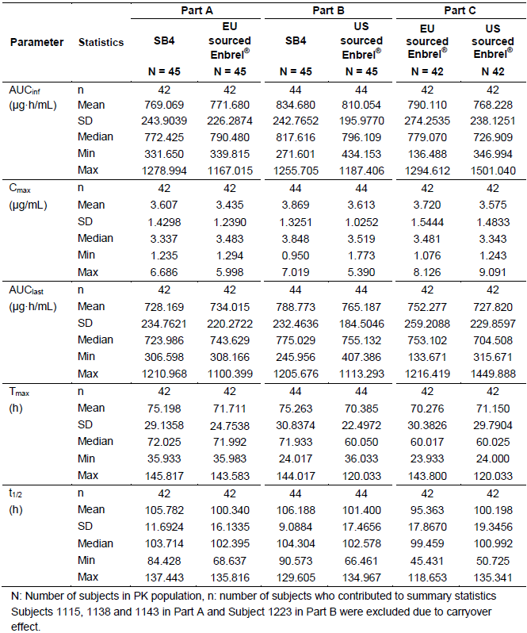

As summarised in Table 2, the 90% CIs for the geometric LS Means ratio of SB4 to EU sourced Enbrel in AUCinf was 0.947 to 1.036 and for the Cmax ratio was 0.985 to 1.092. Both of these results lie within the pre-defined equivalence margin of 0.8-1.25.

Table 2: ANOVA for Primary PK Parameters of AUCinf and Cmax in Part A of Study SB4-G11-NHV

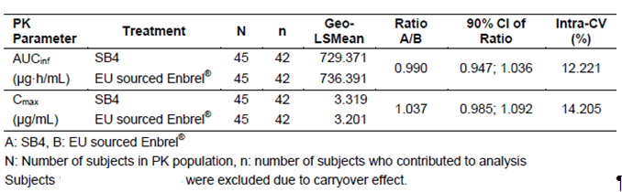

###### Part B

In Part B, the mean AUCinf values of SB4 and US sourced Enbrel were comparable at 834.680 μg·h/mL and 810.054 μg·h/mL, respectively. The mean Cmax values were also similar at 3.87 μg/mL for SB4 therapy and 3.613 μg/mL in the US sourced Enbrel arm.

As summarised in Table 3, the 90% CIs for the geometric LS Mean ratio of SB4 to US sourced Enbrel in AUCinf and Cmax were 0.958 to 1.067 and 0.977 to 1.114, respectively, which were within the pre-defined equivalence margin of 0.8-1.25.

Table 3: ANOVA for Primary PK Parameters of AUCinf and Cmax in Part B of Study SB4-G11-NHV

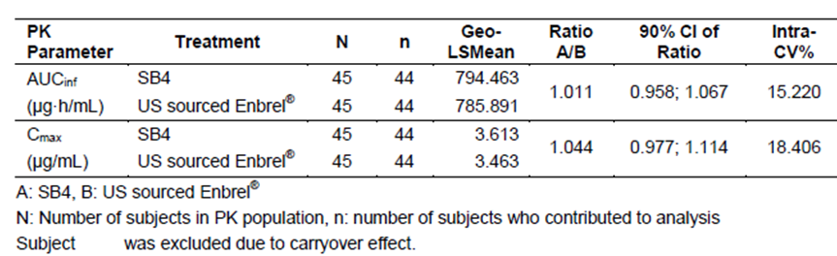

###### Part C

In Part C, the mean AUCinf values of EU and US sourced Enbrel were 790.110 μg·h/mL and 768.228 μg·h/mL, respectively. The mean Cmax values were also comparable between the 2 Enbrel formulations (3.720 μg/mL for EU sourced Enbrel and 3.575 μg/mL for US sourced Enbrel).

As summarised in Table 4, the 90% CIs for the geometric LS Mean ratio of EU sourced Enbrel to US sourced Enbrel in AUCinf and Cmax were 0.915 to 1.104 and 0.947 to 1.127, respectively, which were within the pre-defined equivalence margin of 0.8-1.25.

Table 4: ANOVA for Primary PK Parameters of AUCinf and Cmax in Part C of Study SB4-G11-NHV

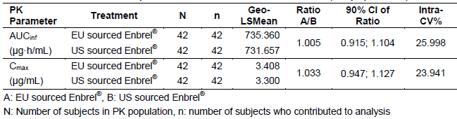

##### Results for other PK variables

###### Part A

The median Tmax values for SB4 and EU sourced Enbrel were 72.025 hours and 71.992 hours, respectively. The mean T1/2 of SB4 (105.782 hours) was also similar to that of EU sourced Enbrel (100.340 hours). The mean AUClast values for SB4 and EU sourced Enbrel were comparable at 728.169 μg·h/mL and 734.015 μg·h/mL, respectively.

###### Part B

The median Tmax values of SB4 and US sourced Enbrel were 71.933 hours and 60.05 hours, respectively. The mean T1/2 of SB4 was similar (106.2 hours) to that of US sourced Enbrel (101.4 hours). The mean AUClast values for SB4 and US sourced Enbrel were comparable at 788.773 μg·h/mL and 765.187 μg·h/mL, respectively.

###### Part C

The median Tmax values of EU sourced Enbrel and US sourced Enbrel were 60.017 hours and 60.025 hours, respectively. The mean T1/2 of EU sourced Enbrel (95.363 hours) was similar to that of US sourced Enbrel (100.198 hours). The mean AUClast values for EU and US sourced Enbrel were also comparable at 752.277 μg·h/mL and 727.820 μg·h/mL, respectively.

##### Pharmacokinetic conclusions for Study SB4-G11-NHV

The mean serum concentration-time profiles recorded in Study SB4-G11-NHV demonstrated that ETN is slowly absorbed from the site of SC injection (mean Tmax was 70-75 hours) and slowly cleared with the mean T1/2 ranging from 96-106 hours. These observations are consistent with the known PK characteristics of ETN. Comparisons between SB4 and EU sourced Enbrel in Part A, SB4 and US sourced Enbrel in Part B as well as EU and US sourced Enbrel in Part C show the 3 ETN formulations are highly similar in their mean serum concentration-time profiles in healthy male volunteers aged between 18 and 55 years.

#### Pharmacokinetics in the target population

Study SB4-G31-RA was a Phase III clinical study that aimed to demonstrate that SB4 was equivalent in terms of efficacy and safety to EU sourced Enbrel (50 mg dose given once weekly by SC injection). The trial enrolled a total of 596 adult subjects with active RA (299 were randomised to SB4 treatment and 297 patients were allocated to Enbrel therapy). A total of 85 enrolled subjects (43 in the SB4 group and 42 in the Enbrel arm) provided at least 1 post-dose serum sample in the PK sub-study. However, the PK results for 6 subjects from a single study site (2 in the SB4 group and 4 in the Enbrel arm) were excluded from the PK analysis because of data quality issues at the site. Hence, the final PK population in Study SB4-G31-RA consisted of 41 subjects in the SB4 treatment group and 38 patients in the Enbrel arm.

Serum samples for the determining the PK characteristics of ETN after administration of SB4 or EU sourced Enbrel were collected at baseline (prior to any therapy) and the following time points pre-dose (trough levels) during the study: 2, 4, 8, 12, 16 and 24 weeks. Serum samples were evaluated using a validated ELISA technique with a lower limit of quantification of 160.0 ng/mL and an upper limit of quantification of 4000.0 ng/mL in Study SB4-G31-RA.

Table 5 provides a summary of the serum trough (pre-dose) ETN concentrations by week of therapy (0-24 weeks) in the PK population of Study SB4-G31-RA. At each time point of evaluation, the mean serum trough concentrations of ETN between the SB4 treatment group (ranging from 2.419 μg/mL at Week 2 to 2.886 μg/mL at Week 24) and the Enbrel arm (ranging from 2.066 μg/mL at Week2 to 2.635 μg/mL at Week24) were similar but slightly higher following SB4 injections at all the time points apart from Week 2. Overall, steady state concentrations for SB4 and Enbrel were achieved by Weeks 2-4 of therapy. Both formulations of ETN exhibited moderately high inter-patient variability with the CV% ranging from 36.6-53.9% for SB4 and 48.1-65.7% for EU sourced Enbrel.

Table 5: Serum Trough Etanercept Concentrations in the PK Subset of Study SB4-G31-RA

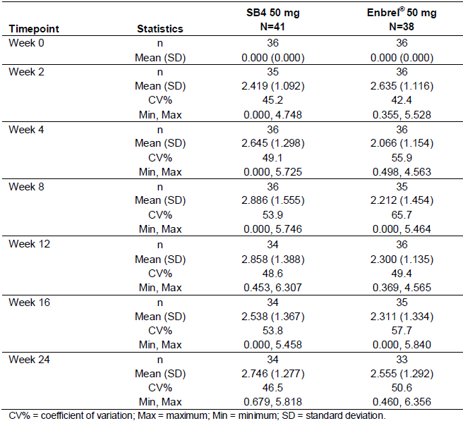

In Study SB4-G31-RA, an array of key PK variables was specifically evaluated at Week 8 of therapy (refer to Table 6). The data demonstrated that mean drug exposure parameters (AUC, Cmax and Cmin) were moderately higher (30% for AUC, 26% for Cmax and 42% for Cmin) following SB4 therapy versus Enbrel injections. Apparent drug clearance (CL/F) was 26% lower in the SB4 arm versus the Enbrel group. The median Tmax was comparable between the 2 formulations at just under 48 hours. Fluctuation was also similar between the 2 treatment groups with <7% difference. However, both ETN formulations again demonstrated considerable inter-subject variability with the CV% ranging from 35.1-71.5% in the SB4 group and 31.0-67.0% in the Enbrel treatment arm.

Table 6: Summary of Key Pharmacokinetic Parameters at Week 8 in Study SB4-G31-RA

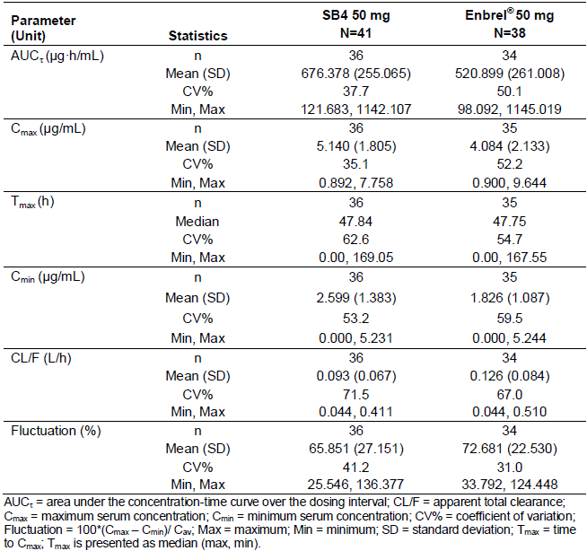

The sponsor also tried to examine the PK data at Weeks 8 and 24 according to those subjects who developed persistently positive anti-drug antibody test results. However, only 1 subject in the SB4 group and 3 patients in the Enbrel arm of the PK population tested positive for anti-drug antibodies at both Weeks 8 and 24. Due to the low number of relevant results, it is difficult to draw any meaningful conclusions about the potential impact of anti-drug antibody formation upon the PK characteristics of SB4. The individual trough ETN concentrations and PK parameters from subjects with positive anti-drug antibody results fell within the broad data range for subjects with negative anti-drug antibody results.

### Evaluator’s overall conclusions on pharmacokinetics

The PK characteristics of SB4 and the approved reference product Enbrel (EU and US sourced) were investigated in 2 clinical trials. Study SB4-G11-NHV was specifically designed to evaluate the PK of SB4 in healthy male volunteers aged between 18 and 55 years, and to demonstrate the PK equivalence of SB4 with Enbrel (EU and US sourced) for the co-primary endpoints of AUCinf and Cmax. These co-primary PK endpoints are appropriate for demonstrating PK similarity. It was agreed with the EMA and US FDA to determine PK equivalence using a single dose, crossover trial for which AUCinf and Cmax would lie within the pre-determined equivalence margin of 0.8 to 1.25. This was observed to be correct for Study SB4-G11–NHV, in which SB4 was demonstrated to have geometric LS means ratios compared to both EU and US sourced Enbrel close to 1 (and always within the 0.8-1.25 equivalence margin) for both primary PK endpoints. Study SB4-G11-NHV also demonstrated that SB4 was bioequivalent with the appropriate reference products of Enbrel in terms of the key secondary PK parameters including AUClast, Tmax and T1/2.

Study SB4-G31-RA demonstrated that SB4 and EU sourced Enbrel achieve similar levels of drug exposure (AUC, Cmax and Cmin) between Weeks 2 and 24. However, both formulations of ETN exhibited high inter-patient variability in drug exposure with the CV% (for various key PK parameters) ranging from 36.6-53.9% for SB4 and 48.1-65.7% for EU sourced Enbrel.

Both studies showed mean serum concentration-time profile data consistent with the known PK characteristics of ETN. In particular, ETN is slowly absorbed from the site of SC injection (mean Tmax was 70-75 hours in Study SB4-G11-NHV and 48 hours in Study SB4-G31-RA) and slowly cleared with the mean T1/2 ranging from 96-106 hours. Both studies had a low incidence of subjects developing anti-drug antibodies so it is difficult to make any meaningful interpretation about the potential impact of immunogenicity on the PK characteristics of SB4.

The clinical dossier for SB4 contained PK assessments collected in healthy male volunteers and a subset of 79 adult patients with active RA (that is, 1 approved treatment indication of the use of Enbrel). Hence, it is unknown whether or not there any significant PK differences between Enbrel and SB4 exist for the other claimed treatment indications in adults (such as AS, PsA and PSOR), although it would seem unlikely. The sponsor has not provided evidence from a literature review that there is no clear difference in the PK of ETN across its various treatment indications. Furthermore, no data has been obtained in children, but the sponsor is not requesting consideration of the approved paediatric treatment indications for ETN.

All enrolled patients in Study SB4-G31-RA were taking concomitant weekly low oral MTX with ETN, while none of the subjects in Study SB4-G11-NHV were taking concomitant immunosuppression. However, there has been no clinical study with SB4 in diseased individuals (for example, adult subjects with PSOR or AS) where the concurrent use of MTX is typically not part of the treatment strategy with ETN. It is unknown whether the PK and immunogenicity profile (anti-drug antibody status) of SB4 in those other adult treatment patients may be significantly altered without the concurrent use of MTX.

Overall, the PK assessments provided in this submission for the registration of SB4 as a biosimilar product of Enbrel are appropriate and the data largely meets the minimum criteria of supporting evidence for PK bioequivalence.

## Pharmacodynamics

### Studies providing pharmacodynamic data

This submission did not contain any specific pharmacodynamic (PD) data for SB4 collected in the 2 clinical studies. The sponsor states that the PD effects of ETN have been well characterised in the published Enbrel trials and registration process. Furthermore, the sponsor asserts that in vitro and in vivo non-clinical studies provided in this submission demonstrate similarity between SB4 and Enbrel in anti-TNF mediated PD effects. As a proposed biosimilar of Enbrel, the sponsor states that no further PD studies of SB4 are required by the relevant guidelines (EMEA/CHMP/BMWP/ 42832/2005 and EMA/CHMP/BMWP/403543/2010) and that clinical evidence for comparability can be demonstrated by PD surrogate endpoints or clinical evidence. In the case of SB4, clinical evidence for similarity was aimed to be demonstrated by clinical rather than PD endpoints. In patients with active RA, acute phase reactants of inflammation such as C-reactive protein (CRP) and erythrocyte sedimentation rate (ESR) can be useful PD markers. Both CRP and ESR are sensitive indicators of the inflammatory activity of RA, and their measurement is included among the ACR and EULAR criteria for improvement in RA.

### Summary of pharmacodynamics

The information in the following summary is derived from conventional PD studies in humans with the use of Enbrel, unless otherwise stated.

#### Mechanism of action

ETN binds specifically to TNF and blocks its interaction with cell surface TNF receptors (TNFR). ETN does not induce complement-mediated cytolysis of murine T cells that express TNF on the cell surface. TNF is a naturally occurring cytokine that is involved in normal inflammatory and immune responses. TNF is a dominant cytokine in the inflammatory process of RA. Elevated levels of TNF are also found in the synovium and PSOR plaques of patients with PsA, and in serum and synovial tissue of patients with AS. In PSOR, infiltration by inflammatory cells including T-cells leads to increased TNF levels in PSOR skin lesions, compared with levels in uninvolved skin.

Two distinct TNFRs, a 55 kDa protein (p55) and a 75 kDa protein (p75) exist naturally as monomeric molecules on cell surfaces and in soluble forms. The biological activity of TNF is dependent upon binding to either cell surface TNFR. ETN is a dimeric soluble form of the p75 TNFR that can bind to 2 TNF molecules. It inhibits the activity of TNFin vitro and has been shown to affect several animal models of inflammation, including murine collagen-induced arthritis.

#### Pharmacodynamic effects

In patients with active RA, acute phase reactants of inflammation such as CRP and ESR can be useful PD markers. Both CRP and ESR are sensitive indicators of the inflammatory activity of RA, and their measurement is included in the ACR and EULAR criteria for improvement in RA. Rheumatoid factor (RF) and anti-CCP antibody titres are tools that assist with the diagnosis of RA but their utility in assessing disease activity is not established. Serum and synovial concentrations of various interleukins, matrix metalloproteinase and adhesion molecules are alternative PD markers in RA.

### Evaluator’s overall conclusions on pharmacodynamics

In summary, the sponsor has not submitted any clinically derived PD data in this submission apart from the change in serum inflammatory markers (ESR and CRP) over time in the pivotal clinical Phase III study (SB4-G31-RA). This data will be presented in the clinical efficacy section of this report and in general shows there were similarity of PD effect (for serum inflammatory markers) between the 2 formulations of ETN in an adult RA treatment population. The sponsor has also provided in vitro studies examining binding and cell based assays, as well as an in vivo efficacy study in mouse model of collagen antibody-induced arthritis to support similarity in the PD activity of SB4 compared to Enbrel.

## Dosage selection for the pivotal studies

The dose and regimen of ETN selected for the pivotal and supporting study was based on the doses used in the Enbrel registration trials. This is an appropriate rationale for a biosimilarity submission.

In the pivotal study involving adult patients with active RA (Study SB4-G31-RA), ETN 50 mg injections were given once weekly by SC injection. ETN therapy was co-administered with oral MTX 10-25 mg/week and folic acid (at least 5 mg/week). In addition, more than half of the enrolled subjects were taking concurrent NSAID and/or low dose oral corticosteroid therapy during the study. The dose of ETN examined in the single pivotal clinical trial, as well as the background doses and rates of therapy are consistent with clinical practice in Australia. In Study SB4-G31-RA, no loading dose of ETN was utilised, which is consistent with clinical practice and the current approved posology for Enbrel.

In the supporting Phase I clinical study (SB4-G11-NHV) which evaluated healthy male volunteers aged between 18 and 55 years, the investigated dose of ETN was 50 mg by SC injection on 2 occasions, separated by at least 28 days. No concomitant background therapy was allowed, which is appropriate for this type of study.

## Clinical efficacy

### Rheumatoid arthritis

#### Pivotal efficacy study

##### Study SB4-G31-RA

###### Study design, objectives, locations and dates

Study SB4-G31-RA was a randomised, double-blind, parallel-group, comparative equivalence trial.

The study design, as shown in Figure 2, consisted of a screening phase of up to 6 weeks followed by an active treatment period of 52 weeks and 4 weeks of safety follow-up. At baseline (Week 0), eligible subjects were randomised 1:1 to receive 50 mg of either SB4 or Enbrel therapy. Subjects self-administered SB4 or Enbrel once weekly via SC injection while continuing to take a stable weekly dose of MTX 10-25 mg. Efficacy evaluations were performed at Weeks 2, 4, 8, 12, 16, 24, 32, 40 and 52. The study visit window was +/-1 day at Week 2, +/- 3 days at Week 4, +/- 5 days at Weeks 8, 12, 16 and 24; and +/- 7 days for the remainder of scheduled efficacy visit assessments.

Figure 2: Design Schema for Study SB4-G31-RA

Figure 2: Design Schema for Study SB4-G31-RA
screening phase of up to 6 weeks followed by an active treatment period of 52 weeks and 4 weeks of safety follow-up. At baseline (Week 0), eligible subjects were randomised 1:1 to receive 50 mg of either SB4 or Enbrel therapy. Subjects self-administered SB4 or Enbrel once weekly via SC injection while continuing to take a stable weekly dose of MTX 10-25 mg. Efficacy evaluations were performed at Weeks 2, 4, 8, 12, 16, 24, 32, 40 and 52. The study visit window was +/-1 day at Week 2, +/- 3 days at Week 4, +/- 5 days at Weeks 8, 12, 16 and 24; and +/- 7 days for the remainder of scheduled efficacy visit assessments.

The primary objective of Study SB4-G31-RA wasto demonstrate that SB4 was equivalent in terms of efficacy to EU sourced Enbrel at Week24 of treatment as determined by clinical response according to the American College of Rheumatology (ACR) definition of a 20% improvement (ACR20 response). The secondary efficacy objective of the trial was to evaluate the comparative efficacy of SB4 and Enbrel® at Week 24 using relevant efficacy endpoints other than the rate of ACR20 response.

Study SB4-G31-RA was conducted at 73 sites in 10 countries; Poland (18 centres), Ukraine (12 centres), Czech Republic (10 centres), Bulgaria (8 centres), Hungary, Lithuania and Korea (6 centres each), Mexico (3 centres) and Columbia and the United Kingdom (2 centres each). The majority of enrolled subjects came from centres in Eastern Europe. The first subject was enrolled into Study SB4-G31-RA on 11 June 2013 and the last patient visit (Week 56 assessment) occurred on 28 November 2014. There were 3 global and 3 country specific amendments to the original protocol (dated 8 November 2012). All of the amendments were instituted after the commencement of patient recruitment. The amendments contained clarifications about the enrolment criteria, explanations about the efficacy and safety measures, and increased the screening phase to 6 weeks (1st amendment). No changes to the statistical analysis plan were undertaken. None of the protocol amendments resulted in major changes to the study design, which may have adversely affected the integrity of the study’s outcomes or statistical analysis.

It is stated in the submission that Study SB4-G31-RA also has a planned open-label, single-arm (all to receive SB4 therapy 50 mg/week), extension phase of up to 52 weeks following the primary 52 week treatment period. Up to 245 patients participating in Study SB4-G31-RA at sites in Poland and the Czech Republic will continue to be followed up in the extension phase for longer-term efficacy and safety data. However, the current submission did not contain any of the extension phase data.

###### Inclusion and exclusion criteria

To be eligible for inclusion in Study SB4-G31-RA patients were required to be between 18 and 75 years of age with active RA despite MTX therapy. The diagnosis of RA was based on the revised 1987 ACR classification criteria. Patients were required to have been diagnosed with RA at least 6 months, but not exceeding 15 years, prior to screening. Active disease was defined by the presence of 6 or more swollen joints, 6 or more tender joints, and either an Erythrocyte Sedimentation Rate (ESR) ≥ 2 8 mm/h or serum CRP concentration ≥ 1.0 mg/dL at screening. Prior MTX treatment at a dose between 10 to 25 mg/week (oral or parenteral dosing) for at least 6 months prior to randomisation was a pre-requisite for inclusion, and the dose of MTX had to be stable for at least 4 weeks prior to screening. Patients were allowed to receive oral corticosteroids (CS) equivalent to prednisolone ≤ 10 mg/day, as well as NSAIDs, as long as these therapies were stable for at least 4 weeks prior to screening. Subjects (female and male) also had to agree to use at least 2 forms of appropriate contraception from screening until 2 months after their last dose of study medication.

The main exclusion criteria included:

* Previous administration of any biological agent (including anti-TNF therapy);
* History of hepatitis B, hepatitis C, or infection with human immunodeficiency virus-1 or -2 or positive result to the screening test for those infections;
* Current diagnosis of Tuberculosis (TB) or those who had a positive screening result for latent TB defined as a positive test result for the interferon-gamma release assay;
* Serious infection within the preceding 8 weeks, an infection requiring oral antibiotics in the 2 weeks prior to screening, history of infected prosthesis or chronic or recurrent infection (including recurrent herpes zoster);
* Medical history of any one of the following; bone marrow hypoplasia, significant systemic RA involvement (for example, vasculitis and pulmonary fibrosis), malignancy within the previous 5 years (except completely excised and cured squamous cell carcinoma of the cervix or non-melanoma skin cancer), lymphoproliferative disease, NYHA Class III/IV congestive heart failure or unstable angina, organ transplantation, demyelinating disorders, alcohol or drug abuse within the last 3 years or uncontrolled hypertension or diabetes mellitus at screening; and
* Abnormal baseline laboratory results – serum transaminases >2 x ULN, serum creatinine >2 x ULN, haemoglobin <8.0 g/dL, total white blood cell count <3.5 x 109/L, neutrophil count <1.5 x 109/L, lymphocyte count <0.8 x 109/L or platelet count <100 x 109/L.

In addition to the above exclusion criteria, prohibited medication use prior to randomisation included:

* Oral CS at a daily dose >10 mg of prednisolone, or any injectable CS, within 4 weeks;
* DMARDs other than MTX including antimalarials, sulfasalazine (SSZ), azathioprine, cyclosporine or mycophenolate mofetil within 4 weeks;
* Leflunomide (LEF) within 12 weeks or within 4 weeks if the subject had received cholestyramine wash-out;
* Alkylating agents within 12 months; and
* Live or live-attenuated vaccine within 8 weeks.

###### Study treatments

In both treatment groups, subjects self-administered ETN (SB4 or Enbrel EU sourced) 50 mg once weekly by SC injection, up to week 51 (that is, a total of 52 administrations of ETN). The first 3 SC injections (Weeks 0, 1 and 2) were done under supervision by site staff to ensure the correct procedure for SC injection was followed.

The trial required the continued co-administration of MTX at a dose of 10 to 25 mg/week (oral or parenteral; dose and route were to be maintained from the beginning of the trial), as well as folic acid (5-10 mg/week, oral).

###### Efficacy variables and outcomes

The main efficacy variables were:

* American College of Rheumatology (ACR) clinical response criteria,
* European League Against Rheumatism (EULAR) clinical response criteria, and
* Assessment of structural joint damage using the modified Total Sharp Score (mTSS).

There are 2 validated, internationally accepted sets of instruments used in RA trials to determine change with treatment. The ACR clinical response criteria is a composite endpoint using up to 7 core set variables to determine an improvement of 20%, 50%, or 70% in clinical manifestations. A patient with an ACR20 response to an intervention has demonstrated a 20% decrease in the combined number of swollen and tender joint counts, and a 20% improvement in any 3 of the 5 core-set measures which include Patient’s Global Assessment, Physician’s Global Assessment of disease activity (on 100 mm VAS), Patient’s Assessment of Pain score (on 100mm VAS), HAQ-DI, and acute phase reactants (ESR or CRP). The achievement of an ACR20 response by an individual subject is considered to be the minimally achieved level of response that is of clinical relevance. The ACR50 and ACR70 levels of response are calculated using the same criteria as the ACR20, but with a higher percentage improvement (50% and 70%, respectively) instead of 20%.

The ACR-N was defined as the minimum of the following 3 items: (i) the percentage change from baseline in the number of tender joints, (ii) the percentage change from baseline in the number of swollen joints, and (iii) the median of the percentage change from baseline for the other 5 ACR response criteria: - patient’s global assessment of disease activity, physician’s global assessment of disease activity, patient’s assessment of pain, HAQ-DI and CRP. The ACR-N is a continuous outcome measure that is quite different from the ACR20/50/70 response criteria, which are categorical endpoints. By measuring the mean (or median) change in ACR-N, this measure provides an assessment of the magnitude of benefit for a typical patient, which is complementary information to the categorical ACR response criteria. For example, a population with an ACR-N value of 38 means that the typical patient in that cohort has achieved a 38% improvement in RA by clinical measures.

The 28 joint Disease Activity Score (DAS28) is a widely used and validated method used in research trials and clinical practice for measuring outcome in patients with RA. DAS28 is a composite disease activity index of 4 clinical variables involving the tender joint count (up to 28 joints), swollen joint count (up to 28 joints), CRP (preferentially used in this study) or ESR, and the patient’s assessment of general health using a 100 mm visual analogue scale. The final score is derived by a complex mathematical calculation of the individual elements. DAS28 has a scale from 0 to 10, and most scores range from 2 to a maximum of 10. According to EULAR guidelines, a DAS28 of >5.1 indicates high disease activity, DAS28 of >3.2 and up to 5.1 indicates moderate disease activity, DAS28 of 3.2 or less indicates low disease activity, and ‘clinical remission’ is indicated by a DAS 28 score of <2.6. There are 3 categories of EULAR response (good, moderate and non-responders) that include not only the individual’s amount of change in the DAS but also the attainment of a particular DAS value (low, moderate or high) at the endpoint. A change from baseline of at least -1.2 (that is, 2 times the potential measurement error) in a patient’s DAS is considered indicative of a significant change in disease activity (compared with >-0.6 to -1.2 as moderate change in disease activity, and -0.6 or less as no change in disease activity). Hence, to be classified as a good EULAR response, the patient must demonstrate a significant change from baseline (that is, >-1.2) as well as reach low disease activity (that is, DAS 28 <3.2). A moderate EULAR response is a minimum change from baseline in the DAS 28 of >-0.6 to -1.2, as well as the endpoint achievement of a DAS28 equal to or less than 5.1.

The measures that are most valuable in assessing major clinical response are the proportion of subjects who achieved DAS28 responses to a score of <2.6 and/or the proportion of subjects achieving an ACR70 response for a continuous period of 6 months. Study SB4-G31-RA pre-specified the latter variable as its secondary endpoint for determining major clinical response.

The HAQ-DI is a patient reported questionnaire used to provide an assessment of the impact of the disease and its treatment on physical function. The tool assesses the degree of difficulty experienced by the individual in 8 domains of daily living activities using 20 questions. The domains include dressing and grooming, arising, eating, walking, hygiene, reach, grip and common daily activities, with each domain (activity) consisting of 2 or 3 items. For each question the level of difficulty is scored from 0 to 3 with 0 = ‘without any difficulty’, 1 = ‘with some difficulty’, 2 = ‘with much difficulty’ and 3 = ‘unable to do’. If the maximum score equals 0 or 1, but a device related to that activity was used or help from another person was provided for the activity, then the activity score is increased to 2. However, if the activity score was already 2 and a device related to that activity was used or help from another person was provided, the score for that activity remains 2. A total score of between 0 and 3 is obtained from the mean of each activity. A change from baseline in the HAQ-DI of at least -0.22 units has been specifically defined for RA in peer-reviewed literature to be the smallest measurable reduction that is clinically significant.

The mTSS (assessed using the van der Heijde 1999 modification of the Total Sharp Scoring system) is the sum of the joint space narrowing (JSN) score plus the erosion score (ES) and has a range of 0-448. A higher score represents greater structural damage. The JSN score has a range of 0-168 and is derived from evaluating 40 joints in the hands and feet, which are scored from 0 (no damage) to 4. The ES has a range of 0-280 and is derived from assessing 44 hand and foot joints. Each joint is scored 0 (no damage) to 5, except the metatarsophalangeal joints of the feet, which are scored 0-10.

All enrolled subjects in Study SB4-G31-RA were required to have X-rays taken of both hands and both feet (a single postero-anterior view of each hand, and a single dorso-plantar view of each foot) at baseline, week 52, or upon early withdrawal. X-ray images of both hands and feet were obtained using a slotting approach, digitized and assessed by 2 central readers, who were blinded to the treatment group, X-ray sequence and clinical status of the subject. The statistical analysis used the mean score from the 2 readers for all analyses. Although the mTSS is the appropriate radiological scoring method, the minimum time point in which it is assessed is crucial to deciding the validity of a drug’s claim to inhibition of the rate of structural progression of RA. The pertinent EMEA document states that for agents claiming to prevent structural joint damage, it is recommended to demonstrate radiological differences of the hands and forefeet on the basis of before and after treatment comparisons taken not less than 1 year apart, but ideally 2 years, using full randomization and pre-agreed criteria.

The primary efficacy outcome in Study SB4-G31-RA was the rate of ACR20 response at Week 24. The primary endpoint is a direct measure of efficacy in RA and is accordance with the relevant TGA adopted guideline.

The secondary efficacy outcomes in Study SB4-G31-RA were supportive of the primary efficacy outcome and included:

* ACR20 response rate at Week 52,
* ACR50 and ACR70 response rates at Weeks 24 and 52,
* Numeric index of the ACR response (ACR-N) at Weeks 24 and 52,
* AUC of ACR-N up to Week 24,
* DAS28 score at Weeks 24 and 52,
* EULAR response at Weeks 24 and 52,
* AUC of the change from baseline up to Week 24 in DAS28 score,
* Rate of Major Clinical Response (ACR70 response for 6 consecutive months) at Week 52, and
* Change from baseline in the mTSS at Week 52.

Overall, the selected efficacy endpoints in Study SB4-G31-RA use well-accepted validated metrics that has served as the basis of previous published studies, prior regulatory approvals and is consistent with published guidelines.

###### Randomisation and blinding methods

At baseline, all eligible patients were randomised 1:1 via interactive response technology (phone or web based) to treatment with either SB4 or Enbrel. This randomisation occurred according to a computer generated randomisation scheme, which allocated patients at centre level.

Patients, investigator staff and joint assessors remained blinded to the identity of study treatment from the time of subject randomisation up until Week 52. After the last subject completed their Week 24 visit, the study was only unblinded to data analysts for reporting purposes.

The radiographic data obtained in Study SB4-G31-RA was centrally read by 2 expert personnel blinded to study treatment, X-ray sequence and clinical status.

###### Analysis populations

The primary efficacy analysis for the rate of ACR20 response at 24 weeks (primary efficacy endpoint) was performed using the Per Protocol Set 1 (PPS1) cohort. The Full Analysis Set (FAS) was used as a sensitivity analysis of the primary efficacy outcome in Study SB4-G31-RA.

The FAS consisted of all subjects who were randomised into the trial and following the intention-to-treat principal were analysed according to the treatment they were assigned at randomisation. The FAS by definition excluded any subjects who did not meet the study entry criteria but who were inadvertently randomised. This did not affect any subject in the Study SB4-G31-RA, hence the FAS was equal to the randomised set (n=596 subjects in total). The PPS1 cohort was defined as all FAS subjects who completed the Week 24 visit with an adherence to study medications (ETN injections plus MTX therapy) from baseline to Week 24 within the range of 80-120% and who had no recorded major protocol deviations.

The Per Protocol Set 2 (PPS2) cohort was used as the primary analysis population for all efficacy endpoints evaluated at Week 52. The PPS2 consisted of all FAS subjects who completed the Week 52 visit with an adherence to study medications (ETN injections plus MTX therapy) from baseline to Week 52 within the range of 80-120% and who had no recorded major protocol deviations.

###### Sample size and equivalence margin

As recommended in the regulatory guideline ‘The choice of the non-inferiority margin’ (EMEA/CHMP/EWP/2158/99), the sponsor has identified the trials relevant to the comparison of the reference treatment with placebo in the target indication and study population for the equivalence margin and sample size calculation. The ACR20 response rates in the identified studies are outlined in Table 7.

Table 7: ACR20 Response Rates in Pivotal Studies with Enbrel

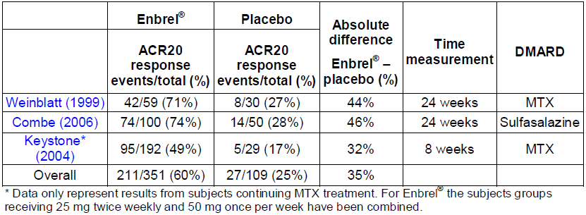

A random-effects meta-analysis of the above studies estimated a risk difference of 0.4049 (with 95% CI of 0.3103, 0.4996). To preserve 50% of the effect of Enbrel over and above control treatment (that is, placebo study injections plus continued low dose MTX in adult patients with active RA), an equivalence limit of 0.155 was used. With 219 subjects in each group of Study SB4-G31-RA, the observed 2-sided 95% CI will be expected to lie between -15% and 15%, with 80% power when the rate of ACR20 response at Week24 was assumed to be 60% in both treatment groups. Assuming a 12% dropout rate by Week 24, a sample size of 249 subjects per treatment group (overall study sample size of 498) was expected to give 219 completers per treatment group in Study SB4-G31-RA.

It is important to note that there are no established criteria for what is an appropriate equivalence margin and it needs to be individualised, dependent on the nature of the condition being treated and the therapy being investigated. This is outlined in the EMEA ‘Guideline on the Choice of Non-Inferiority Margin’. The equivalence margin in Study SB4-G31-RA was defined as 50% of the observed difference in the response rate (35%); that is, 17.5%. There are a couple of important considerations for determining the appropriateness of this margin. Firstly, the choice of equivalence margin should be sufficient to ensure that the new product is superior to usual care (that is, that SB4 is superior to MTX alone). Therefore, the equivalence margin should produce a lower limit of the confidence interval (CI) of the difference between SB4 and Enbrel such that the lower limit, if compared with the MTX only group in a meta-analysis, would be bounded by zero (thereby indirectly demonstrating the superiority of SB4 to MTX alone). The second aspect of the appropriateness of an equivalence margin is whether the maximum difference would be considered clinically relevant (that is, is a difference in the ACR20 response rate at 24 weeks of up to 15% clinically relevant?). There is no clear guidance in this regard and it is based on what is considered to be a clinically relevant difference. Consistent with the design of previous biosimilar anti-TNF medications, the ± 15% equivalence margin was considered to be the maximum acceptable margin, but nonetheless reasonable. I agree that the choice of equivalence margin is the maximum that would be accepted.

Overall, the sponsor has outlined a sample size calculation that is statistically robust and the rationale for the choice of equivalence margin is appropriate in establishing whether SB4 is superior to appropriate control therapy (low dose MTX alone). However, there is a significant discrepancy between the enrolled population of Study SB4-G31-RA (predominately MTX naïve) and the above historical control trials (MTX experienced subjects) used to develop the equivalence margin and estimate statistical power, which makes the above assumptions of questionable validity with respect to observing a clinically robust outcome.

###### Statistical methods

The primary efficacy analysis aimed to demonstrate equivalence in the ACR20 response between SB4 and Enbrel at Week24. To declare equivalence between the 2 treatment groups, the 2-sided 95% CI of the difference of the 2 populations should be contained within the pre-specified equivalence margin of -15% and 15%. The 2-sided 95% CI of the difference between the 2 treatment groups for the rate of ACR20 response at 24 weeks was estimated for the PPS1 cohort, stratified by pooled study centres (or region) using the Mantel-Haenszel weights for the strata, while adjusting for baseline CRP non-parametrically. As sensitivity analyses of the primary efficacy analysis, the same analysis was repeated for the FAS cohort using non-responder imputation (NRI) for missing data as well as available data for analysis.

The ACR50 and ACR70 response rates at Weeks 24 and 52 were analysed using the PPS1 and PPS2 cohorts, respectively, in a similar manner for the primary analysis of ACR20 response. Continuous ACR-N at Week24 and 52, as well as the AUC of AUC-N at Week24 were analysed using an analysis of variance model (ANOVA) with treatment group and region as factors. The change from baseline in DAS28 score at Week24 and 52, and the AUC of change from baseline to Week 24 in DAS28 score were analysed using an analysis of covariance model (ANCOVA) with treatment group and region as factors and DAS28 score as a covariate. The change in mTSS was analysed using ANCOVA with treatment group and region as factors and baseline score as a covariate for the subjects who completed their Week 52 assessments.

For statistical analysis purposes, centres were pooled into 7 regions for analysis (mainly to keep a balanced number of subjects between regions) as described:

* Region 1 – Korea (6 centres),
* Region 2 – Columbia and Mexico (5 centres),
* Region 3 – Ukraine (12 centres),
* Region 4 – Bulgaria, Hungary, United Kingdom and Lithuania (22 centres),
* Region 5 – Czech Republic (10 centres),
* Region 6 – Poland 1 (7 centres), and
* Region 7 – Poland 2 (11 centres).

###### Participant flow

Patient disposition for the enrolled set of subjects in Study SB4-G31-RA is shown in Table 8.

A total of 777 subjects were screened for the trial, and 596 patients were randomly assigned to study treatment (299 in the SB4 group and 297 in the Enbrel treatment arm). The most common reasons for screen failure were meeting the exclusion criteria (62.4% of screen failures; 113/181) and not meeting the inclusion criteria (22.1% of screen failures; 40/181).

Table 8: Disposition of Subjects (Enrolled Set) in Study SB4-G31-RA

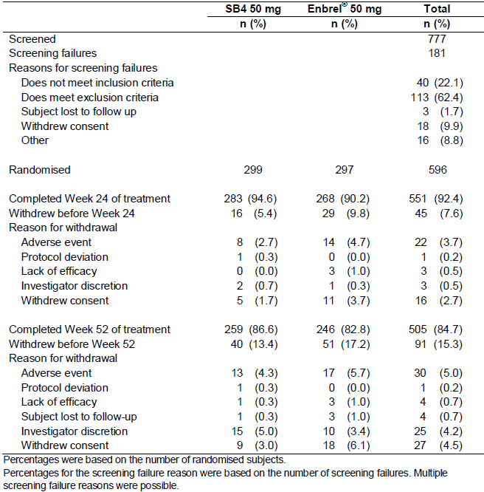

The majority of subjects in each group completed 24 weeks of treatment: 94.6% (283/299) in the SB4 arm and 90.2% (268/297) in the Enbrel group. The 2 most common reasons for study discontinuation prior to week 24 were Adverse Events (AEs; 3.7% [22/596]) and withdrawal of consent (2.7%; 16/596).

In the enrolled set of patients, the majority completed 52 weeks of Study SB4-G31-RA: 86.6% (259/299) in the SB4 arm and 82.8% (246/297) in the Enbrel group. The 3 most common reasons for study discontinuation prior to week 52 were AEs (5.0%; 30/596), withdrawal of consent (4.5%; 27/596) and investigator discretion (4.2%; 25/596).

###### Major protocol deviations and treatment compliance

Up to Week 52, a total of 157 subjects (26.3% of 596) recorded at least 1 major protocol deviation: 26.8% (80/299) in the SB4 arm and 25.9% (77/297) in the Enbrel group – refer to Table 9. Due to significant protocol deviations, 12.2% (73/596) of subjects were excluded from PPS1 and 13.1% (78/596) were excluded from PPS2. The 2 most frequently reported major protocol deviations that resulted in the exclusion of data from the PP analyses were failure to adhere to study procedure criteria (15 subjects in each treatment group for both the PPS1 and PPS2 cohorts) and failure to adhere to concomitant treatment requirements (10 patients in the SB4 arm and 15 subjects in the Enbrel treatment group of PPS1; and 11 patients in the SB4 arm versus 16 patients in the Enbrel group of PPS2).

Table 9: Summary of Major Protocol Deviations by Treatment Group in Study SB4-G31-RA

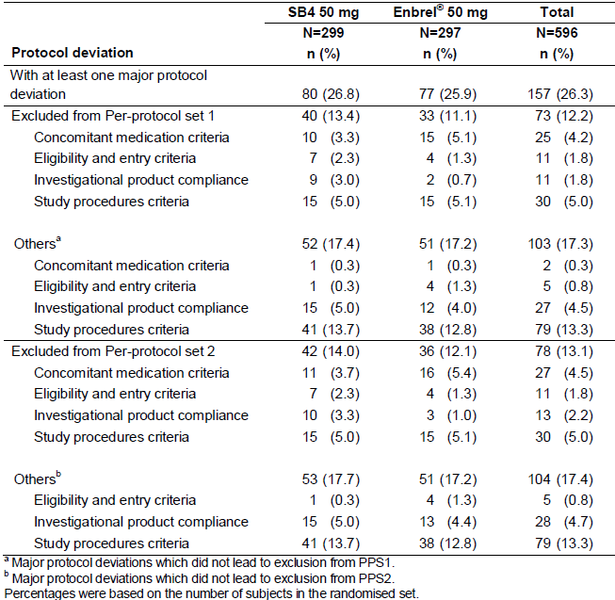

Non-compliance (that is, outside the range of 80-120%) with study medication also led to exclusion from the PPS1 and PPS2 cohorts. Up to week 24, non-compliance with MTX was recorded in 2.0% (6/299) of subjects in the SB4 group and another 3 subjects in the same treatment group (1.0% of 299) had errors of ETN dispensing (2 received Enbrel instead of SB4). Two subjects (0.7% of 297) in the Enbrel arm received only 15-17 administrations of ETN up to week 24 and were excluded from the PPS1 cohort. By Week 52, 1 additional subject (10 in total; 3.3% of 299) in the SB4 group after Week 24 was recorded as non-compliance with study treatment. This subject only received 41 weekly doses of SB4 up to Week 52 and was excluded from the PPS2 dataset. One additional subject (3 in total; 1.0% of 297) in the Enbrel arm had a violation of MTX dosing between Weeks 24 and 52.

###### Baseline data

The 2 treatment groups were well matched at baseline for demographic characteristics with no statistically significant differences between them. The majority of subjects enrolled in this trial were <65 years of age (84.6% [253/299] in the SB4 treatment group and 88.2% [262/297] in the Enbrel arm) with a mean age of 51.8 years. The majority of subjects were female (84.2%; 502/596) and Caucasian (92.6%; 552/596). The mean BMI of the randomised set was 26.57 kg/m2.

Both treatment groups were similar with respect to baseline RA features. The mean duration of RA was 6.03 years (range: 0.5-15.3 years) for subjects in the SB4 group and 6.16 years (range: 0.5-15.7 years) for patients in the Enbrel arm. The majority of subjects in both treatment groups had a positive rheumatoid factor blood test at randomisation (79.3% [237/299] in the SB4 arm and 77.8% [231/297] in the Enbrel group).

Prior to involvement in Study SB4-G31-RA, the majority of subjects (70.8%; 422/596) were DMARD naïve[2] (69.9% [209/299] in the SB4 group and 71.7% [213/297] in the Enbrel arm). However, in the minority of subjects with a history of DMARD therapy, the rate and pattern of prior DMARD use was similar in each of the treatment groups. One sixth of all subjects (16.3%; 97/596) had prior use of 1 DMARD, 8.7% (52/596) had experienced 2 previous DMARDs, and only 4.2% (25/596) had experienced 3 or more previous DMARDs. Overall, this data reflects a surprisingly treatment naïve RA population. Excluding MTX, the 3 most commonly used prior DMARDs were SSZ (17.1%; 102/596), anti-malarial drugs (14.3%; 85/596) and LEF (9.2%; 55/596). Almost one third of patients (30.2%; 180/596) had a past history of taking NSAID and nearly one quarter (22.8%; 136/596) of subjects had previously taken low dose oral CS. No patient had a prior history of receiving anti-TNF drugs or other biologic therapy.

All enrolled subjects were taking MTX (commenced at least 4 weeks prior) at baseline at a mean weekly dose of 15.59 mg (range: 10.0-25.0 mg) in the SB4 group and a mean weekly dose of 15.46 mg (range: 10.0-25.0 mg) in the Enbrel arm. Subjects in the SB4 group had been taking MTX for a mean of 48.19 months (range: 6.0-212.9 months) prior to randomisation and patients in the Enbrel arm had been taking MTX for a mean of 47.10 months (range: 6.2-173.9 months) before Study SB4-G31-RA. In addition, the majority of patients (52.9%; 315/596) in both treatment groups took concomitant NSAID during the trial, and more than half (56.7%; 338/596) of subjects took low dose oral CS. The median dose of CS taken during Study SB4-G31-RA was not reported. It is unclear why the incidence of concomitant NSAID and CS use during the trial was significantly higher (approximately double) than the recorded prior use of these medicines.

In terms of RA disease activity at baseline, the mean numbers of tender and swollen joints were similar for both treatment groups at 23.5-23.6 (maximum of 68) and 15.0-15.4 (maximum of 66), respectively, refer to Table 10. The mean baseline HAQ-DI scores were also similar between the 2 treatment groups at 1.49-1.51. The mean subject global and pain assessments were similar in the 2 treatment groups at 61.7-63.0 mm and 61.8-62.3 mm, respectively. The mean baseline CRP readings were similar in the SB4 and Enbrel treatment groups at 14.6 mg/L and 12.7 mg/L, respectively. The proportion of subjects in each group with baseline CRP values ≥ 10 mg/L was 40.5% (121/299) in the SB4 group and 38.4% (114/297) in the Enbrel arm.

Table 10: Baseline Disease Activity of Patients in Study SB4-G31-RA

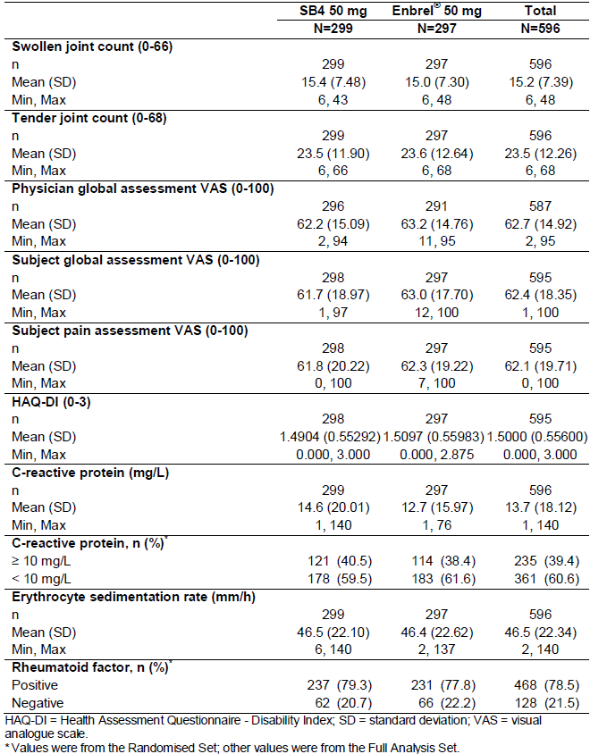

A medical history of hypertension was recorded at a slightly higher incidence in SB4 treatment groups (35.1%; 105/299) than in the Enbrel arm (31.0%; 92/297). A history of hyperlipidaemia was recorded in 9.6% (57/596) of all subjects and 5.6% (33/596) had a history of diabetes mellitus. More than one third of all subjects (35.9%; 214/596) were taking medicines for gastro-oesophageal reflux and/or peptic ulcer prevention.

###### Results for the primary efficacy outcome

Using the PPS1 cohort data, the rate of ACR20 response at Week24 was equivalent in the SB4 (78.1%; 193/247) and Enbrel treatment groups (80.5%; 190/236), refer to Table 11. The adjusted treatment difference in ACR20 response rate at Week24 was –2.37% and the 95% CI of the adjusted treatment difference was –9.54% to 4.80%, which was contained within the pre-defined equivalence margin of –15% to 15%.

Table 11: Primary Analysis of ACR20 Response Rate at Week 24 in Study SB4-G31-RA

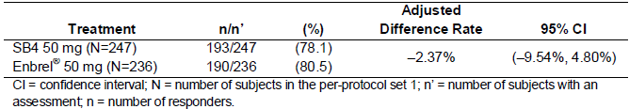

Sensitivity analyses of the primary efficacy outcome supported the robustness of the primary efficacy analysis observation. Using the FAS cohort and NRI, the rate of ACR20 response at Week24 was 73.6% (220/299) for SB4 and 71.7% (213/297) for Enbrel therapy. The adjusted treatment difference in ACR20 response rate at Week24 using this method of analysis was 1.66% (95% CI –5.50%, 8.82%). Using the FAS cohort and available data, the rate of ACR20 response at Week24 was 76.7% (220/287) for SB4 and 78.3% (213/272) for Enbrel therapy. The adjusted treatment difference in ACR20 response rate at Week24 using this method of analysis was -1.52% (95% CI –8.40%, 5.36%).

Various subgroup analyses of the primary efficacy endpoint by patient factors of interest were also performed. The rate of ACR20 responses at Week24 (using the PPS1 cohort) was equivalent between the 2 treatment groups for the following variables: baseline CRP reading (>10 mg/L versus <10 mg/L), region (EU versus non-EU), age (<65 years versus ≥ 65 years), gender, race/ethnicity and presence of anti-drug antibodies (yes/no).

###### Results for other efficacy outcomes

ACR20 response rate at Week 52

Using the PPS2 cohort, the rate of ACR20 response at Week 52 was statistically equivalent in the SB4 (80.8%; 181/224) and Enbrel treatment groups (81.5%; 176/216). The adjusted treatment difference in ACR20 response rate at Week 52 was –0.74% (95% CI –8.03%, 6.56%). Using the FAS cohort and NRI, the rate of ACR20 response at Week 52 was 70.2% (210/299) for SB4 and 65.7% (195/297) for Enbrel therapy. The adjusted treatment difference in ACR20 response rate at Week 52 using this method of analysis was 4.48% (95% CI –2.90%, 11.87%). Both analyses of the comparative rate of ACR20 response at 52 weeks were contained within the pre-defined equivalence margin of –15% to 15%.

ACR50 and ACR70 response rates at Weeks 24 and 52

At Week 24, the ACR50 response rate for the PPS1 cohort was 46.2% (114/247) in the SB4 group and 42.4% (100/236) in the Enbrel arm; refer to Table 12. The adjusted treatment difference was 4.36% (95% CI –4.33%, 13.05%). The ACR70 response rate at Week24 for the PPS1 was 25.5% (63/247) in the SB4 group and 22.5% (53/236) in the Enbrel arm. The adjusted treatment difference was 3.29% (95% CI –4.18%, 10.76%). The 24-week ACR50 and ACR 70 response rates demonstrate that SB4 was similar to Enbrel at Week24 for clinically relevant response.

Table 12: ACR50 and ACR70 Response Rates at Week 24 (PPS1 Cohort) in Study SB4-G31-RA

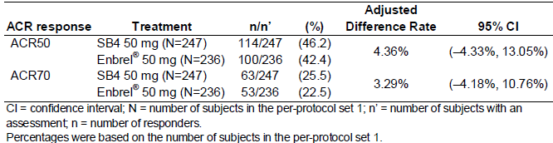

At Week 52, the ACR50 response rate for the PPS2 cohort was 58.5% (131/224) in the SB4 group and 53.2% (115/216) in the Enbrel arm; refer to Table 13. The adjusted treatment difference was 4.50% (95% CI –4.67%, 13.67%). The ACR70 response rate at Week 52 was 37.5% (84/224) in the SB4 group and 31.0% (67/216) in the Enbrel arm. The adjusted treatment difference in ACR70 response rate at Week 52 for the PPS2 was 7.02% (95% CI –1.69%, 15.74%). The week 52 data for rate of ACR70 response was slightly outside the pre-defined equivalence margin of –15% and 15% but overall suggests that SB4 was comparable to Enbrel for major clinical outcomes at Week 52.

Table 13: ACR50 and ACR70 Response Rates at Week 52 (PPS2 Cohort) in Study SB4-G31-RA

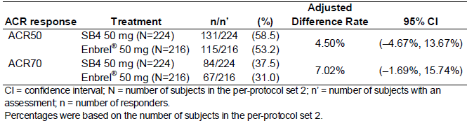

As summarised in Table 14, when analysis of the comparative rates of ACR50 and ACR70 response at Weeks 24 and 52 were assessed using the FAS cohort with NRI, the same outcome in terms of clinical equivalence were observed for SB4 therapy and Enbrel.

Table 14: ACR50 and ACR70 Response Rates at Weeks 24 and 52 in Study SB4-G31-RA using the Full Analysis Set and Non-Responder Imputation

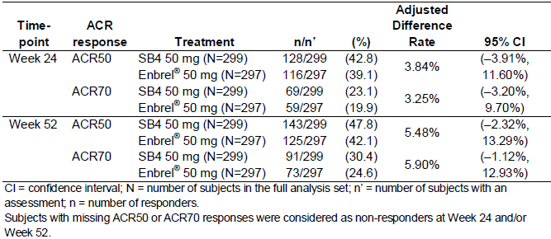

ACR-N at Weeks 24 and 52

The mean ACR-N at Week24 was 45.03% in the SB4 group and 43.72% in the Enbrel arm. The treatment difference in the LS means was 1.8% (95% CI -2.8%, 6.4%). The mean ACR-N at Week 52 was 52.08% for the SB4 group and 49.17% for the Enbrel arm. The treatment difference in the LS means was 3.2% (95% CI -2.0%, 8.4%). The ACR-N results for the SB4 arm were equivalent to that observed in the Enbrel treatment group.

AUC of ACR-N up to Week 24

The mean AUC of ACR-N up to Week 24 was 5822.252 in the SB4 treatment group and 5525.212 in the Enbrel arm. The treatment difference in the LS means was 368.2 (95% CI -243.4, 979.8), which shows that the AUC of ACR-N up to Week 24 was comparable between the 2 treatment groups.

DAS28 score at Weeks 24 and 52

The mean change from baseline to Week 24 in DAS28 score was -2.57 in the SB4 treatment group (baseline mean DAS28 score=6.47) and -2.50 in the Enbrel arm (baseline mean DAS28 score=6.46). The treatment related difference in the LS means of the DAS28 score at Week24 was 0.072 (95% CI -0.135, 0.279).

The mean change from baseline to Week 52 in DAS28 score was -2.91 in the SB4 treatment group and -2.80 in the Enbrel arm. The treatment related difference in the LS means of the DAS28 score at Week 52 was 0.118 (95% CI -0.092, 0.328). Both the Week 24 and 52 analyses of treatment related difference were contained within the pre-specified equivalence margin of -0.6 and 0.6 for this endpoint.

EULAR response at Weeks 24 and 52

At Week 24, the proportion of subjects in the FAS who had good EULAR response was 32.1% (92/287) in the SB4 group and 29.8% (81/272) in the Enbrel arm, and moderate EULAR response was 55.1% (158/287) and 58.5% (159/272), respectively. The proportion of subjects who had no EULAR response was 12.9% (37/287) and 11.8% (32/272) in the SB4 and Enbrel treatment groups, respectively.

The proportion of subjects who had good EULAR response, moderate EULAR response and no EULAR response at Week 52 was 41.7% (108/259), 51.0% (132/259) and 7.3% (19/259), respectively, in the SB4 treatment group and 34.6% (85/246), 56.5% (139/246) and 8.9% (22/246), respectively, in the Enbrel arm.

The proportion of subjects who had good, moderate and no EULAR response was comparable between the SB4 and Enbrel treatment groups at Weeks 24 and 52.

AUC of the Change in DAS28 score from Baseline up to Week 24

The mean AUC of the change in DAS28 score from baseline to week 24 was 358.2569 in the SB4 group and 343.5417 in the Enbrel treatment arm. The treatment difference in the LS means for the AUC of change in DAS28 score from baseline to Week 24 was 16.2 (95% CI –10.8, 43.3), which suggests that the AUC of DAS28 up to Week 24 was comparable between the 2 treatment groups.

Rate of Major Clinical Response at Week 52

Using the FAS cohort, the proportion of subjects achieving major clinical response (that is, ACR70 response for 6 consecutive months) at Week 52 was comparable between the SB4 (20.8%; 54/259) and Enbrel (18.3%; 45/246) treatment groups.

Change from Baseline in mTSS at Week 52

The mean change in structural joint damage at Week 52 for the FAS cohort is summarised in Table 15. At Week 52, the mean change from baseline in mTSS was comparable between the SB4 group (0.45 sharp units) and the Enbrel treatment groups (0.74 sharp units). The adjusted treatment related difference in mean mTSS at 52 weeks was -0.27 (95% CI -0.80, 0.26). The change from baseline in each component of the mTSS was also similar in the 2 ETN treatment groups. The mean change from baseline to Week 52 in erosion score was 0.26 in the SB4 group and 0.31 in the Enbrel arm. The mean change from baseline to Week 52 in JSN score was 0.18 in the SB4 group and 0.43 in the Enbrel arm.

Table 15: Summary of Structural Joint Damage at Week 52 in Study SB4-G31-RA (FAS Cohort)

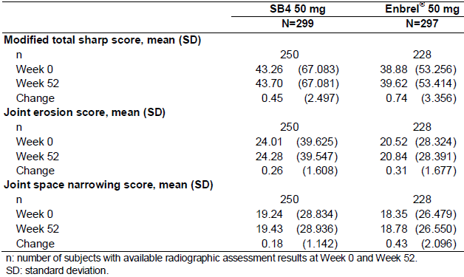

#### Other efficacy studies

Not applicable.

### Analyses performed across trials (pooled analyses and meta-analyses)

Not applicable.

### Evaluator’s conclusions on clinical efficacy for rheumatoid arthritis

This submission contained a single pivotal Phase III trial (Study SB4-G31-RA) in adult patients with active RA that recruited a total of 596 patients (299 received SB4 therapy and 297 received Enbrel treatment) and provided efficacy data for up to 52 weeks of therapy. The pivotal study was well designed, had an appropriate primary efficacy endpoint (ACR20 response rate at Week 24), was appropriately powered for the stated equivalence margin and used appropriate statistical analyses (both FAS and PP analyses). Although the pre-defined equivalence margin of ±15% is at the upper limit of acceptability, the sponsor has adequately justified that range. Furthermore, the equivalence margin was discussed prior to submission with the TGA and EMEA.

Although Study SB4-G31-RA recruited patients with RA of appropriate demographic and disease activity characteristics at baseline, the majority of subjects (70.8%; 422/596) were DMARD naïve[3] prior to involvement in the trial. The current approved treatment indication for Enbrel in patients with RA states ‘Active, adult rheumatoid arthritis (RA) in patients who have had an inadequate response to one or more disease-modifying anti-rheumatic drugs (DMARDs).’ The prior RA therapy features of the cohort recruited into Study SB4-G31-RA does not adequately reflect the patient characteristics of the current approved treatment indication for the reference product, which is a major deficiency of the current supporting dataset for SB4.

In Study SB4-G31-RA, SB4 and Enbrel demonstrated similar outcomes for the primary efficacy endpoint of the rate of ACR20 response at 24 weeks. This outcome was shown in both the PPS1 (78.1% [193/247] for SB4 versus 80.5% [190/236] for Enbrel) as well as in the FAS population (73.6% [220/299] for SB4 versus 71.7% [213/297] for Enbrel). The 95% CI for the treatment difference was within the predefined equivalence margin of -15% to +15, thereby supporting the therapeutic equivalence of SB4 to the reference product, Enbrel.

Various sub-group analyses of the primary efficacy endpoint by patient factors of interest were also performed. The rate of ACR20 responses at Week24 (using the PPS1 cohort) was equivalent between the 2 treatment groups for the following variables: baseline CRP reading (≥10 mg/L versus <10 mg/L), region (EU versus non-EU), age (<65 years versus ≥ 65 years), gender, race/ethnicity and presence of anti-drug antibodies (yes/no).

Similar efficacy between the 2 treatment groups in Study SB4-G31-RA could also be shown for all secondary efficacy endpoints including the ACR20 response rate at Week 52, rate of ACR50 and ACR70 response at Weeks 24 and 52, as well as the DAS28 and EULAR response criteria. Study SB4-G31-RA also assessed structural X-ray outcomes at Week 52. The mean changes from baseline to Week 52 in the mTSS and its component scores demonstrate that SB4 and Enbrel are equivalent for radiographic outcomes (that is, retarding the structural progression of joint damage) in adult patients with active RA.

The comparison of the primary endpoint result (that is, ACR20 response rate at Week24) of Study SB4-G31-RA with the published data for ETN (60% overall; Table 10) shows a moderately higher proportion of patients in the SB4 (73.6%) and Enbrel groups (71.7%) achieving clinical response in Study SB4-G31-RA. Likewise, when comparing the results of Study SB4-G31-RA with the results of other prospective trials in adult patients with active RA, the rates of ACR20 response are somewhat higher than the range (60-65% typically) reported with other anti-TNF medicines. The higher response rates observed in Study SB4-G31-RA probably reflect a relatively under-treated cohort of patients prior to inclusion as 70.8% of subjects were DMARD naïve at screening.

Overall, the efficacy data from a single pivotal trial (Study SB4-G31-RA) is sufficient to establish therapeutic equivalence between SB4 and Enbrel for the treatment indication of adult patients with active RA. The trial complied with most aspects of the TGA adopted guideline (CPMP/EWP/556/95 Rev 1) for the assessment of RA. In particular, the study design, efficacy outcomes (clinical and radiological), overall number of evaluated subjects and the duration of drug exposure meet the minimum standards outlined in the guidance document. However, the prior RA treatment characteristics of the cohort enrolled into the single pivotal study is not sufficiently reflective of the approved treatment indication for the reference product (Enbrel) which states that patients must have an inadequate response to at least 1 DMARD prior to the initiation of ETN.[4]

### Justification for extension to all adult approved indications for Enbrel

The sponsor has provided several references relating to the efficacy and safety of Enbrel in various other treatment indications in adult patients. However, the submission did not include any specific evaluation of that material with respect to justifying the attainment of all 5 approved Enbrel treatment indications by extrapolation. This is a major deficiency of the current submission. Regarding an application for a biosimilar medicine that includes extrapolation of indications, the relevant regulatory guideline (EMA/CHMP/BMWP/403543/2010) states ‘Applicants should support such extrapolations with a comprehensive discussion of available literature including the involved antigen receptor(s) and mechanism of action(s).’ Furthermore, the sponsor has not included any report justifying that a single clinical study in patients with RA is a sensitive clinical test model for the other requested treatment indications.

#### Psoriatic arthritis

There is no efficacy study for SB4 in PsA. The sponsor’s justification for approval is extrapolated from the collected PK data, mechanism of action and a single non-inferiority study performed in patients with RA.

#### Plaque psoriasis

There is no efficacy study for SB4 in PSOR. The sponsor’s justification for approval is extrapolated from the collected PK data, mechanism of action and a single non-inferiority study performed in patients with RA.

#### Ankylosing spondylitis

There is no efficacy study for SB4 in AS. The sponsor’s justification for approval is extrapolated from the collected PK data, mechanism of action and a single non-inferiority study performed in patients with RA.

#### Non-radiographic axial spondyloarthritis

There is no efficacy study for SB4 in non-radiographic axial spondyloarthritis. The sponsor’s justification for approval is extrapolated from the collected PK data, mechanism of action and a single non-inferiority study performed in patients with RA.

### Evaluator’s conclusion on extrapolation of treatment indications

The sponsor has provided evidence from non-clinical studies (not assessed as part of this report) that show similarity in structure for SB4 and Enbrel, as well as comparable inhibition of TNF activity in vitro and reduction in several animal models of inflammation, including murine collagen-induced arthritis. ETN is a dimeric soluble form of the p75 TNF receptor that can bind to 2 TNF molecules.

The efficacy data obtained in adult patients with active RA (Study SB4-G31-RA) provides evidence to suggest similar responses for SB4 and Enbrel in that patient cohort (powered as an equivalence trial). The sponsor has not provided sufficient justification, based on the non-clinical findings of SB4 structure and function, in conjunction with bioequivalence data from PK studies and a single Phase III efficacy study in RA (Study SB4-G31-RA) that SB4 and Enbrel are therapeutically equivalent across the treatment indications. Extrapolation of the PK and efficacy data generated in the 2 trials in this submission which examined adult patients with RA and healthy male volunteers aged 18-55 years to other approved indications for Enbrel such as active PsA, PSOR and inflammatory spondylitis is not justifiable on the basis of the results of the pre-clinical studies supported by the current limited evidence in RA. Although many of these conditions share similar and overlapping pathophysiological immunological mechanisms, their clinical features are varied and RA may not be a clinical test model of sufficient sensitivity to extrapolate efficacy and safety data. The extent and type of information provided in this submission does not justify the approval of SB4 in accordance with the guideline on similar biological medicinal products containing monoclonal antibodies (EMA/CHMP/BMWP/403543/2010). Therefore, the evaluator does not recommend approval of the sponsor’s request to register SB4 for all adult treatment indications that Enbrel is currently approved for in Australia.

## Clinical safety

### Studies providing evaluable safety data

The following studies provided evaluable safety data:

#### Pivotal efficacy studies

In this submission, there was only 1 pivotal efficacy trial (Study SB4-G31-RA), which collected the following safety data:

* Adverse events (AEs) in general were assessed by completion of the AE Case Report Form (CRF) and physical examination performed at Weeks 2 and 4, every 4 weeks between Weeks 4 and 16, and every 8 weeks between Weeks 24 and 52, with an additional post-treatment follow-up visit at Week 56.
* AEs of particular interest, including serious infection, tuberculosis (TB) and injection site reactions were assessed by CRF and physical examination as per the schedule for general AE evaluation.
* Laboratory tests, including haematology, clinical chemistry and urinalysis, were performed at baseline, Weeks 2 and 4 weeks, every 4 weeks between Weeks 4 and 16 and then every 8 weeks up until Week 52.
* Screening tests for tuberculosis (Chest X-ray and QuantiFERON Gold® testing) were taken at baseline, but not routinely collected thereafter.
* Vital signs such as blood pressure, heart rate and temperature were performed at each scheduled study visit. Subject weight was recorded at baseline and thereafter at the discretion of the site investigator.
* ECG for central reading was taken at baseline and thereafter as required by clinical indication up to Week 52.
* Urine pregnancy testing was performed at baseline and every 4 weeks thereafter in women of reproductive age.
* Serum for Anti-drug antibodies (ADA) to ETN, anti-nuclear antibodies and anti-dsDNA antibodies was collected at baseline, as well as Weeks 8, 24 and 52.[5]

#### Pivotal studies that assessed safety as a primary outcome

The clinical development program for SB4 does not contain any pivotal studies that assessed safety as a primary outcome.

#### Dose-response and non-pivotal efficacy studies

There were no dose-response and non-pivotal efficacy studies provided in this submission.

#### Other studies evaluable for safety only

The submission also contained a single clinical pharmacology study (Study SB4-G11-NHV), which enrolled a total of 138 healthy male subjects aged 18-55 years in 3 study parts (46 subjects per study part).

Vital signs, blood for haematology, clinical chemistry and serology (hepatitis B surface antigen, hepatitis C virus antibody and HIV antibody) and a 12 lead ECG were performed at baseline. Assessment for AEs (including injection site reactions in particular) was conducted daily for 8 days following each injection of ETN, and thereafter on Days 10, 14 and 21 post-injection. Clinical laboratory tests (haematology and clinical chemistry) were repeated on Days 3, 6, 14 and 21 post-injection. ECG was taken on Days 1, 2, 4, 8 and 21 post-injection. Serum for ADA was collected at baseline and study Day 29 in each treatment period.

#### Pivotal studies that assessed safety as a primary outcome

Not applicable.

### Patient exposure

#### Study SB4-G31-RA

In this trial, all 596 subjects were randomised and received at least one 50 mg weekly dose of ETN (either SB4 or Enbrel). As summarised in Table 16, the duration of exposure to ETN in Study SB4-G31-RA was comparable for the 2 treatment groups. The mean duration of exposure was 338.9 days (range: 34-371 days) in the SB4 group and 323.5 days (range: 14-371 days) in the Enbrel arm. The majority of continuing subjects (85-90%) in both treatment groups received all doses of study treatment up to day 281 (that is, >9 months in Study SB4-G31-RA) resulting in a similar cumulative exposure to ETN for both treatment arms.

Table 16: Duration of Exposure to Etanercept in Study SB4-G31-RA

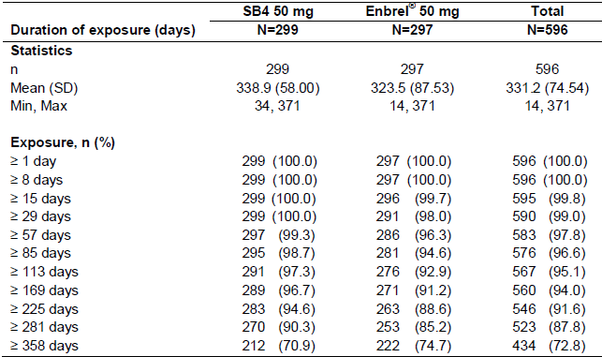

#### Study SB4-G11-NHV

Among the 138 subjects who enrolled in Study SB4-G11-NHV, 132 subjects completed both Period 1 and Period 2 of the trial and received at least 2 x 50 mg doses of ETN via different formulations (SB4, EU sourced Enbrel or US sourced Enbrel).

In Part A, 46 subjects received 1 dose of SB4 therapy and 45 subjects received 1 dose of EU sourced Enbrel*.* In Part B of the study, 45 subjects received 1 dose of SB4 and 46 subjects received 1 dose of US sourced Enbrel. In Part C, 45 subjects received 1 dose of EU sourced Enbrel and 43 subjects received 1 dose of US sourced Enbrel.

### Adverse events

#### All adverse events (irrespective of relationship to study treatment)

##### Study SB4-G31-RA

Table 17 provides a summary of all AEs reported in the safety dataset population of Study SB4-G31-RA. The overall incidence and number of treatment emergent AEs was comparable between the SB4 (58.5% [175/299] of subjects reported a total of 533 AEs) and Enbrel groups (60.3% [179/297] of subjects reported a total of 646 AEs). A small proportion of patients recorded AEs prior to receiving study medication, which explains why the number of overall AEs is slightly higher in each treatment group (as seen in Table 17). The majority of treatment emergent AEs in both groups were assessed as being of either mild or moderate severity with no discernible differences between the 2 treatment arms.

Table 17: Summary of All Adverse Events Recorded in the Safety Population of Study SB4-G31-RA

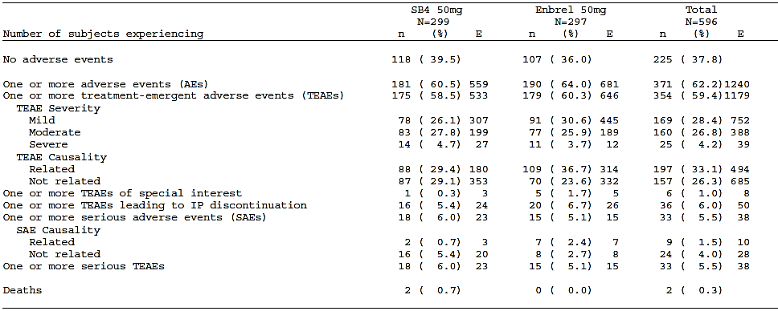



In both treatment groups, the most frequently recorded types of AEs by SOC (occurring in ≥ 10% of subjects in either treatment group) were similar in frequency and type:

* Infections and infestations: 28.4% (85/299) of subjects in the SB4 group reported 125 infection related AEs and 25.6% (76/297) of patients in the Enbrel arm reported 115 infectious AEs,
* General disorders and administration site conditions: 9.4% (28/299) of subjects in the SB4 group reported 46 AEs versus 20.5% (61/297) of patients in the Enbrel arm reporting 185 AEs,
* (Abnormal) Investigations: 13.7% (41/299) of patients in the SB4 group recording 86 AEs and 12.8% (38/297) of subjects in the Enbrel arm reporting 72 AEs,
* Musculoskeletal and connective tissue disorders: 10.0% (30/299) of subjects in the SB4 group recording 41 AEs and 9.8% (29/297) of patients in the Enbrel arm reporting 48 AEs, and
* Gastrointestinal disorders: 7.4% (22/299) of patients in the SB4 group recording 29 AEs and 10.1% (30/297) of subjects in the Enbrel arm reporting 46 AEs.

There was 1 SOC category of notable difference between the SB4 and Enbrel treatment groups. A total of 17 treatment emergent hepatobiliary AEs were reported in 11 subjects from the SB4 treatment group only. This included 4 AEs of cholelithiasis in 4 subjects, 3 AEs of liver disorder in 3 subjects, 3 AEs of chronic cholecystitis in 2 subjects, 2 AEs of bile duct stone in 1 subject and 1 AE each of biliary colic, cholangitis, cholecystitis and gall bladder perforation.[6] Most of the hepatobiliary AEs were rated as mild or moderate in severity, but 1 event was regarded as severe. No patient who recorded a hepatobiliary AE tested positive for anti-drug antibodies.

Table 18 provides a summary of the most common types of treatment emergent AEs (incidence of ≥ 2% in either treatment group) by Preferred Term (PT). The most frequently occurring treatment emergent AEs (occurring in ≥2% of subjects in either treatment group) at the PT level were.

Upper respiratory tract infection (24 [8.0%] subjects in the SB4 treatment group and 16 [5.4%] patients in the Enbrel arm), injection site erythema (6 [2.0%] subjects in the SB4 group and 33 [11.1%] patients in the Enbrel arm), raised serum ALT (18 [6.0%] subjects in the SB4 group and 17 [5.7%] subjects in the Enbrel arm), nasopharyngitis (15 [5.0%] patients in the SB4 group and 16 [5.4%] subjects in the Enbrel arm), hypertension (11 [3.7%] patients in the SB4 arm and 11 [3.7%] subjects in the Enbrel group), headache (13 [4.3%] subjects in the SB4 group and 8 [2.7%] patients in the Enbrel arm), exacerbation of RA (9 [3.0%] patients in the SB4 group and 10 [3.4%] subjects in the Enbrel arm), increased AST (8 [2.7%] patients in the SB4 group and 9 [3.0%] subjects in the Enbrel arm), cough (4 [1.3%] subjects in the SB4 arm and 10 [3.4%] subjects in the Enbrel group), and generalised erythema (2 [0.7%] subjects in the SB4 group and 10 [3.4%] patients in the Enbrel arm). The 2 most common types of AEs by PT occurred at a different frequency when comparing the 2 treatment groups, but all other common AE types occurred at a similar incidence. Only 1 subject in each treatment group (0.3% incidence) developed treatment emergent PSOR.

Table 18: Most Common Adverse Events (>2% incidence) by Preferred Term in Study SB4-G31-RA

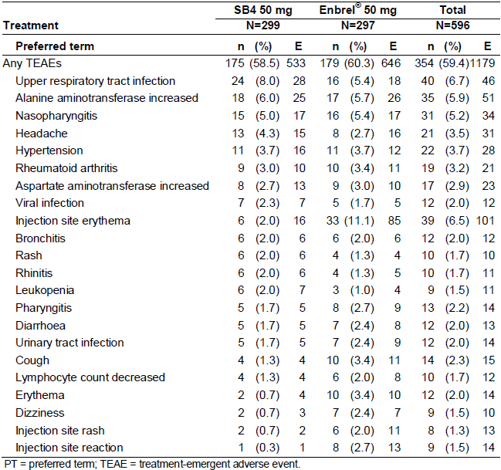

Treatment emergent AEs (SOC and PT) were assessed by various subgroup factors of potential interest, including anti-drug antibody status (positive/negative), age (<65 years/≥ 65 years) as well as race/ethnicity. None of the above factors were associated with an increased risk of AEs (including anti-drug antibody status and the risk of injection site reactions or infection). However, the sponsor has not provided an analysis of AEs by subject weight or opioid use, both of which are factors associated with an increased risk of AEs, particularly, infectious related events.

Injection site reactions (overall) were an AE of special interest in Study SB4-G31-RA. The proportion of subjects who experienced injection site reactions was lower in the SB4 group compared to Enbrel arm. In Study SB4-G31-RA, a total of 179 injection site reactions were reported in 63 (10.6% of 596) subjects: 22 reactions in 11 (3.7% of 299) subjects in the SB4 treatment group and 157 reactions in 52 (17.5% of 297) subjects in the Enbrel arm. The most commonly reported injection site reactions at the PT level were injection site erythema: 16 events in 6 (2.0% of 299) subjects in the SB4 group and 85 events in 33 (11.1% of 297) subjects in the Enbrel arm. It remains unclear as to whether or not the increased incidence of injection site reactions with Enbrel versus SB4 reflects a true and significant safety difference, and if so, what is the potential explanation. For Enbrel treated subjects, the incidence of overall injection site reactions and injection site erythema were near identical between the anti-drug antibody (ADA) positive and negative cohorts. For SB4 treated subjects, 1 of 3 ADA positive subjects versus 9.1% (27/296) of ADA negative patients reported an injection site reaction. However, the number of ADA positive subjects treated with SB4 is too low to interpret a significant increased risk of developing an injection site reaction related to positive ADA testing.

##### Study SB4-G11-NHV

###### Part A

The overall incidence of treatment emergent AEs was 39.1% (18/46) after administration of SB4 and 34.8% (16/46) after injection of EU sourced Enbrel. The most common treatment emergent AEs with both ETN therapies were nasopharyngitis, headache and injection site reaction – refer to Table 19. Nasopharyngitis was reported more frequently in subjects given SB4 (10.9%; 5/46) than in those who received EU sourced Enbrel (4.3%; 2/46). Headache was reported in 8.7% (4/46) of subjects given SB4 and 4.3% (2/46) of those who received EU sourced Enbrel. Injection site reactions affected 4.3% (2/46) of subjects in the SB4 group and 6.5% (3/46) of subjects after administration of EU sourced Enbrel. Back pain was reported in 1 subject following SB4.

In Part A of Study SB4-G11-NHV, the majority of reported AEs were of mild severity (43 AEs), 3 were rated as moderate (headache and neck pain after SB4; and headache following EU sourced Enbrel) and one AE was regarded as severe (diarrhoea after EU sourced Enbrel). The severe AE of diarrhoea started 18 days after the dosing of EU sourced Enbrel in Period 2 and lasted for 6 days. It was considered by the investigator to not be related to ETN.

Table 19: Most Common Adverse Events (≥ 5% incidence) by Preferred Term in Study SB4-G11-NHV

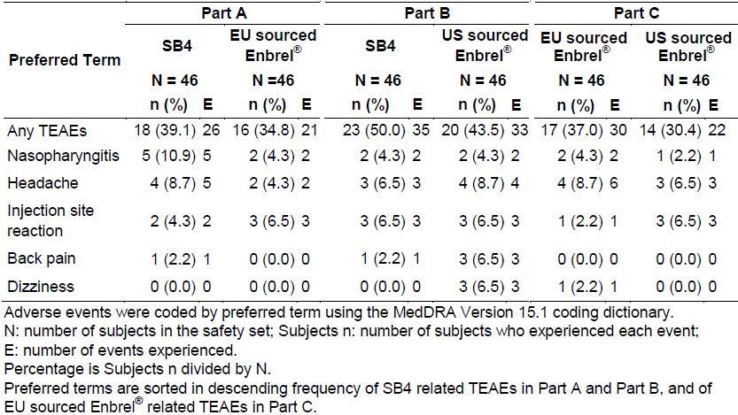

###### Part B

The overall incidence of treatment emergent AEs was 50.0% (23/46) after administration of SB4 and 43.5% (20/46) after injection of US sourced Enbrel. The most frequent AEs recorded in Part B were headache (6.5% [3/46] after SB4 and 8.7% [4/46] with US sourced Enbrel), injection site reaction (6.5% [3/46] in both treatment groups) and nasopharyngitis (4.3% [2/46] in both treatment groups). Back pain and dizziness were reported in 6.5% of subjects (3/46) following US sourced Enbrel, which was higher than that observed in subjects following SB4 therapy (back pain in 1 subject and no reports of dizziness).

In Part B of Study SB4-G11-NHV, the majority of AEs were of mild severity (60 AEs) and 8 were of moderate intensity (dyspepsia, chest discomfort, gastroenteritis, tooth abscess, increased ALT reading and headache after SB4 therapy; and influenza-like illness and postural dizziness after US sourced Enbrel). None of the AEs in Part B were judged to be of severe intensity.

###### Part C

The overall incidence of treatment emergent AEs was 37.0% (17/46) following administration of EU sourced Enbrel and 30.4% (14/46) with US sourced Enbrel. The common AEs reported in Part C were headache (8.7% [4/46] after EU sourced Enbrel and 6.5% [3/46] after US sourced Enbrel), nasopharyngitis (4.3% [2/46] after EU sourced Enbrel and 2.2% [1/46] after US sourced Enbrel) and injection site reaction (2.2% [1/46] after EU sourced Enbrel and 6.5% [3/46] after US sourced Enbrel). Dizziness was reported in 1 subject following administration of both ETN formulations.

The majority of AEs recorded in Part C of the trial were of mild severity (43 AEs) and 8 were judged to be of moderate intensity (injection site reaction, fatigue, dizziness, oral herpes, somnolence and increased ALT after EU sourced Enbrel; and folliculitis and eczema after US sourced Enbrel). One AE was judged as severe (ligament rupture after US sourced Enbrel in Period 1). The ligament rupture was considered to be unrelated to ETN.

#### Treatment-related adverse events (adverse drug reactions)

##### Study SB4-G31-RA

In Study SB4-G31-RA, treatment related AEs affected a greater number of subjects and were observed at a higher occurrence in the Enbrel group (36.7% [109/297] of subjects reported a total of 314 AEs) than the SB4 treatment arm (29.4% [88/299] of subjects reported a total of 180 AEs).

At the SOC level, the most commonly reported treatment related AEs considered to be related to study medication were:

* General disorders and administration site conditions (mainly, consisting of various types of injection site reactions): 23 AEs were reported in 12 (4.0%) subjects in the SB4 group and 165 AEs were reported in 55 (18.5%) subjects in the Enbrel arm,
* Infections and infestations: 43 AEs were reported in 31 (10.4%) subjects in the SB4 group and 39 AEs were recorded in 28 (9.4%) subjects in the Enbrel arm, and
* (Abnormal) investigations: 35 AEs were recorded in 23 (7.7%) subjects in the SB4 group and 32 AEs were reported in 17 (5.7%) subjects in the Enbrel arm.

Injection site reactions were an AE of special interest in Study SB4-G31-RA. The proportion of subjects who experienced treatment related[7] injection site reactions was lower in the SB4 group compared to Enbrel arm. In Study SB4-G31-RA, 22 reactions in 11 (3.7% of 299) subjects in the SB4 treatment group and 157 reactions in 52 (17.5% of 297) subjects in the Enbrel arm. The most commonly reported treatment related injection site reactions at the PT level were injection site erythema: 16 events in 6 (2.0% of 299) subjects in the SB4 group and 85 events in 33 (11.1% of 297) subjects in the Enbrel arm. It remains unclear as to whether or not the increased incidence of injection site reactions with Enbrel versus SB4 reflects a true and significant safety difference, and if so, what is the potential explanation.

Of the 17 hepatobiliary AEs recorded in 11 SB4 treated subjects, 2 events (1 case each of chronic cholecystitis and liver disorder) in 2 subjects were considered to be treatment related. As the majority of hepatobiliary AEs were appropriately classified as not being related to SB4 treatment, it would appear that the imbalance between the 2 ETN treatment groups for the incidence of this AE by SOC is best explained as a spurious finding, which does not reflect a significant safety difference between SB4 and Enbrel.

##### Study SB4-G11-NHV

###### Part A

The proportion of subjects who experienced a treatment related AE in Part A was 26.1% (17/46) in the SB4 group and 21.7% (10/46) in the EU sourced Enbrel arm. The 2 most frequently reported treatment related AEs were headache (6 subjects in total: 4 in the SB4 group and 2 in the EU sourced Enbrel arm) and injection site reactions (5 subjects in total: 2 in the SB4 group and 3 in the EU sourced Enbrel arm).

###### Part B

The proportion of subjects who experienced a treatment related AE in Part B was 37.0% (12/46) in the SB4 group and 32.6% (15/46) in the US sourced Enbrel arm. The 2 most frequently reported treatment related AEs were headache (5 subjects in total: 3 in the SB4 group and 2 in the US sourced Enbrel arm) and injection site reactions (5 subjects in total: 3 in the SB4 group and 3 in the EU sourced Enbrel arm, which includes 1 subject after both treatments).

###### Part C

The proportion of subjects who experienced a treatment related AE in Part C was 32.6% (15/46) after EU sourced Enbrel and 26.1% (12/46) in the US sourced Enbrel arm. The 3 most frequently reported treatment related AEs were headache (6 subjects in total: 4 in the EU Enbrel group and 3 in the US sourced Enbrel arm, including 1 subject after both treatments), injection site reactions (4 subjects in total: 1 in the EU Enbrel group and 3 in the US sourced Enbrel arm) and fatigue (3 subjects in total: 2 after EU sourced Enbrel and 3 with US sourced Enbrel, which includes 1 subject after both treatments).

#### Deaths and other serious adverse events

##### Study SB4-G31-RA

Two deaths in Czech treated patients in the SB4 group were reported during the trial. Both deaths were rated as being unrelated to study medication. A [information redacted] old male died suddenly overnight while asleep of cardiopulmonary failure on study [information redacted]. The subject underwent autopsy, which confirmed the diagnosis and identified associated cardiac hypertrophy and atherosclerosis. This subject received their last dose of SB4 on study [information redacted]. The other fatality occurred in a [information redacted] female who died of gastric adenocarcinoma on study [information redacted]. This subject was hospitalised on study [information redacted] with a pelvic mass and ascites, and underwent surgical excision of the mass and the surrounding tissues. The subject also underwent upper gastrointestinal endoscopy, which revealed a tumour infiltrating the stomach. Tissue histopathology from both regions was consistent with a ring cell adenocarcinoma. The subject had their last dose of SB4 on study [information redacted] and received 2 cycles of chemotherapy.

A total of 38 SAEs were reported in 33 subjects (5.5% of 596) in Study SB4-G31-RA. The proportion of subjects recording SAEs was comparable between the 2 treatment groups, but the number of SAEs was slightly higher in the SB4 group: 23 SAEs in 18 subjects (6.0% of 299) in the SB4 group and 15 SAEs in 15 subjects (5.1% of 297) in the Enbrel arm. The most common type of SAE by SOC was infection[8], which affected 1 SB4 treated subject (0.3% of 299; gall bladder perforation with liver abscess complicated by peritonitis in a 62 year old female) and 5 Enbrel treated subjects (1.7% of 297). The 5 infection related SAEs in Enbrel treated subjects were 3 cases of skin or soft tissue infections (2 cases of cellulitis and 1 report of erysipelas), 1 case of appendicitis and 1 report of pneumonia. Four subjects in the SB4 group developed 6 hepatobiliary SAEs, which consisted of various events related to gallstones (including 1 case of cholangitis). None of the hepatobiliary SAEs was considered to be related to SB4 (as judged by the site investigator). No patients in the Enbrel arm experienced hepatobiliary SAEs. Three gastrointestinal SAEs were recorded in Enbrel treated subjects including 1 case each of enterocolitis, gastritis and gastro-oesphageal reflux disease. There was also 1 report of significant neutropenia in an Enbrel treated individual. Another subject treated with Enbrel developed severe chorioretinopathy on study Day 64, which required withdrawal from therapy. Four patients developed cardiac SAEs (3 treated with SB4 and 1 in the Enbrel arm), 2 of which were related to coronary artery disease (1 in each treatment group) and there was a single report of atrial fibrillation. One patient treated with SB4 developed severe skin psoriasis.

Malignancies were reported in 4 (1.3% of 299) subjects in the SB4 treatment group and 1 (0.3% of 297) patient in the Enbrel arm. In the SB4 treatment group, the 4 malignant events involved single case reports of gastric adenocarcinoma (resulting in death), basal cell carcinoma of the skin ([information redacted]), breast cancer ([information redacted]) and lung cancer with cerebral metastases ([information redacted]). In the Enbrel treatment group, there was 1 case report of invasive ductal breast cancer affecting a [information redacted] female. Two of the malignancies (breast cancer cases) were attributed to study medication. All of the events resulted in discontinuation from ETN and 3 of the 5 patients (excluding subjects with gastric and metastatic lung cancer) had cancers that were considered to be resolved by successful treatment.

Only 3 of the 23 SAEs reported in SB4 treated subjects were considered to be related to treatment – 1 case of breast cancer and 2 reports of exacerbation of RA. This appears to reflect an under-reporting of possible SB4 related SAEs, as the evaluator would suggest the 2 reports of liver abscess complicated by peritonitis and new onset psoriasis to be possibly related to ETN. In the Enbrel treatment group, 7 of the 15 SAEs were considered to be treatment related; 4 cases of severe infection (3 cases of soft tissue infection and 1 report of pneumonia) as well individual case reports of breast cancer, neutropenia and chorioretinopathy.

To assist with the early detection of tuberculosis (TB) infection (new or reactivated), subjects were screened at baseline for TB by chest X-ray and QuantiFERON Gold test as well as at various time points during the study if clinically indicated. This is appropriate clinical practice given the mechanism of action of ETN and that the majority of subjects in Study SB4-G31-RA were recruited in countries with a moderately high background rate of TB exposure. A total of 12 subjects (4.0% of 299) in the SB4 group and 15 subjects (5.1% of 297) in the Enbrel arm had a positive QuantiFERON Gold test at baseline or during the trial up to Week 52. However, no patients developed active TB during Study SB4-G31-RA.

##### Study SB4-G11-NHV

There were no reported SAEs or deaths during this study.

#### Discontinuation due to adverse events

##### Study SB4-G31-RA

In Study SB4-G31-RA, AEs leading to discontinuation of study treatment were reported in 16 patients (5.4% of 299) in the SB4 group and 20 subjects (6.7% of 297) in the Enbrel arm. Injection site related AEs (erythema, dermatitis and reaction) were the most recorded type of AE resulting in discontinuation from ETN and affected 2 subjects (0.7%) in the SB4 treatment group and 7 patients (2.4%) in the Enbrel arm. The next most common type of AE leading to cessation of study treatment was exacerbation of RA (3 subjects in the SB4 arm and 5 patients in the Enbrel group), which reflects treatment failure rather than drug toxicity.

Other noteworthy types of AEs affecting at least 2 subjects and leading to discontinuation of study treatment included:

* Malignancy: 4 cases in the SB4 group and 1 subject in the Enbrel arm,
* Haematological abnormalities: 1 patient in each treatment group,
* Hepatobiliary disorders (gallstone related): 2 patients in the SB4 group,
* Infections: 2 patients in the SB4 group (including 1 case of pneumonia) and 1 subject in the Enbrel arm (pneumonia), and
* Skin complaints (rash, pruritus and erythema): 1 patient in the SB4 group and 2 subjects in the Enbrel arm.

##### Study SB4-G11-NHV

One subject (treated with SB4) discontinued in Part A of the trial because of nasopharyngitis. One subject (treated with US sourced Enbrel) withdrew from Part B of Study SB4-G11-NHV because of tooth abscess. Neither of the infections resulting in study discontinuation was considered to be treatment related, which is a determination of questionable adjudication. A total of 3 subjects (2 treated with EU sourced Enbrel and 1 received US sourced Enbrel) discontinued from Part C of the study. The discontinuations in the US sourced Enbrel group related to oral herpes infection (study day [information redacted] male) and increased serum ALT (3 x ULN on day [information redacted] male). Both of these AEs were considered to be related to ETN. One subject in the US sourced Enbrel arm ceased due to ligament rupture (judged as not related to ETN).

### Laboratory tests

#### Liver function

##### Study SB4-G31-RA

Over the course of the study, there were small changes in the mean and median values for liver function tests (serum transaminases, albumin, total bilirubin, GGT and lactate dehydrogenase) in both treatment groups that were clinically insignificant.

Up to Week 52, the most commonly reported abnormality of liver function tests was an elevated ALT value (that is, ≥ 2-fold ULN increase), which was recorded in 5.4% (16/299) of subjects in the SB4 group and 3.4% (10/297) of patients in the Enbrel arm. Increased AST readings ≥ 2-fold ULN increase were observed in 2.7% (8/299) of subjects in the SB4 group and 1.4% (4/297) of patients in the Enbrel arm. Only 2 subjects (both in the SB4 treatment group) reported increases in serum total bilirubin >34 μmol/L. In addition, high GGT readings were reported in 7 subjects (2.3% of 299) in the SB4 group and 2 patients (0.7% of 297) in the Enbrel arm. There were no possible Hy’s law cases observed in Study SB4-G31-RA.

##### Study SB4-G11-NHV

Two subjects in this trial developed significant abnormalities of liver function tests. A [information redacted] old male treated with SB4 in Part B developed a 3-fold increase above ULN in serum ALT on study days [information redacted], which partially resolved (approximately 2-fold increase above ULN) at last testing 19 days later. Another [information redacted] old male treated with EU sourced Enbrel in Part C developed a 3-fold increase above ULN in serum ALT on study [information redacted], which resulted in the subject withdrawing from the study. The abnormal result had nearly resolved by study day 28.

#### Kidney function

##### Study SB4-G31-RA

Over the 52 week treatment follow-up period of Study SB4-G31-RA, 3.1% (8/299) of subjects in the SB4 group and 4.1% (10/297) of patients in the Enbrel arm were recorded as having minor transient increases from a normal baseline value in serum creatinine levels at least on 1 occasion.

##### Study SB4-G11-NHV

No significant abnormalities of kidney function were observed in Study SB4-G11-NHV.

#### Other clinical chemistry

##### Study SB4-G31-RA

Up to week 52, high serum glucose readings > 13.9 mmol/L were reported in 4 subjects (1.3% of 299) in the SB4 group and 1 patient (0.3% of 297) in the Enbrel arm. In addition, 1 subject in the SB4 group developed a transient increase in serum potassium (>6.5 mmol/L) during the trial.

##### Study SB4-G11-NHV

No significant abnormalities of clinical chemistry were recorded in Study SB4-G11-NHV.

#### Haematology

##### Study SB4-G31-RA

In Study SB4-G31-RA, there were no notable differences between the 2 treatment groups for mean and median changes in haematology parameters. A total of 4 patients (all in the Enbrel treatment group) developed grade 2 decreases in serum haemoglobin levels (<80 g/L for females and <90 g/L for males) during the trial. One subject in each treatment group (0.3% incidence) developed significant thrombocytopenia (platelet count <50 x 109/L) during Study SB4-G31-RA. Grade 2 neutropenia (<1.2 x 109/L) was observed in 3 patients (1.0% of 299) in the SB4 group and 4 subjects (1.4% of 297) in the Enbrel arm. In addition, the same of number of subjects in each treatment group developed significant lymphopenia (<0.5 x 109/L) during the study.

##### Study SB4-G11-NHV

No subjects in this trial were recorded as having abnormalities in haematology parameters.

#### Immunogenicity

##### Study SB4-G31-RA

The development of ETN specific anti-drug antibodies (ADA) and neutralising antibodies (NAb) were assessed using validated assays in Study SB4-G31-RA. Immunogenicity samples for the analysis of ADA and NAb were collected before study treatment at baseline and immediately before dosing at Weeks 8, 24 and 52. Samples were analysed using a 96-well, plate based, bridging, and double antigen format assay specific for ADA to ETN. Testing was undertaken in a stepwise manner: screening, followed by confirmation and finally, titration. Confirmed positive samples were then assessed for neutralising antibodies. The ADA assay sensitivity was [information redacted].The determination of NAb was conducted using a validated MesoScale Delivery platform, which had an intra-assay and inter-assay precision of <25%. The NAb assay had a relative sensitivity of [information redacted] for detecting of anti-Enbrel NAb.

By Week 52, there was a statistically higher rate of positive ADA results in the Enbrel group (13.2%; 39/297) compared to SB4 therapy (1.0%; 3/299; p<0.001); refer to Table 20. Only 1 subject in the Enbrel treatment group tested positive for neutralising antibodies to ETN during the entire study. The majority of patients (in both treatment groups) who tested positive for ADA did so at Week 8 and ADA positivity persisted throughout the trial.

Table 20: Incidence of Anti-Drug Antibodies and Neutralising Drug Antibodies in Study SB4-G31-RA

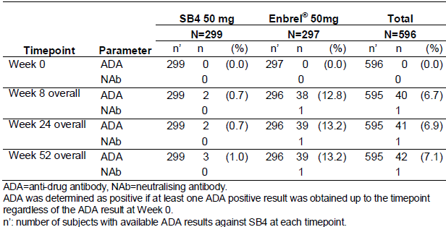

At week 52 in Study SB4-G31-RA, 7 (2.7% of 257) subjects in the SB4 group and 6 patients (2.4% of 245) in the Enbrel arm had a shift from negative ANA at baseline to a positive result. Two subjects in the SB4 treatment group tested positive for anti-dsDNA antibodies, 1 at baseline and 1 at Week24. In the Enbrel arm, 1 subject tested positive for anti-dsDNA antibodies at Week24. No patients in Study SB4-G31-RA developed clinical manifestations of SLE or any other autoimmune connective tissue disease.

##### Study SB4-G11-NHV

A single, bridging, ligand-binding assay was used for the detection of ADA in this Phase I study and a cell-based assay was used for the detection of NAb. The ADA assay sensitivity in Study SB4-G11-NHV was [information redacted] with a confirmation cut point of [information redacted]. The ADA assay had an intra-assay and inter-assay precision of <20%. The determination of neutralising antibody activity was conducted using a L929 cell-based cytotoxicity assay, which had an intra-assay precision of 29.5% and an inter-assay precision of 25.5%. The NAb assay was capable of detecting [information redacted] of goat polyclonal positive control antibody.

At Day 29 post-injection, no subject treated with SB4 tested positive for ADA, 7 subjects after receiving EU sourced Enbrel were positive for ADA and 10 subjects after receiving US sourced Enbrel tested positive for ADA. Among the ADA positive subjects, only 1 subject treated with EU sourced Enbrel had a positive result for neutralising antibodies and 2 subjects after receiving US sourced Enbrel tested non-specific positive for neutralising antibodies.

Table 21 provides a summary of ADA testing results on study Day 29 by each part in Study SB4-G11-NHV. In Part A, no subject treated with SB4 (n=22 subjects) was confirmed positive for ADA versus 3 subjects (13.0% of 23) who received EU sourced Enbrel who tested positive for ADA (p=0.233).

In Part B of Study SB4-G11-NHV, no subject given SB4 (n=23 subjects) tested positive for ADA compared with 4 subjects (18.2% of 22) given US sourced Enbrel who tested positive for ADA (p=0.049). In Part C, 4 of 22 subjects (18.2%) given EU sourced Enbrel tested positive for ADA and 6 of 22 subjects (27.3%) who received US sourced Enbrel tested positive for ADA (p=0.721).

Table 21: Incidence of Anti-Drug Antibodies and Neutralising Drug Antibodies in Study SB4-G11-NHV

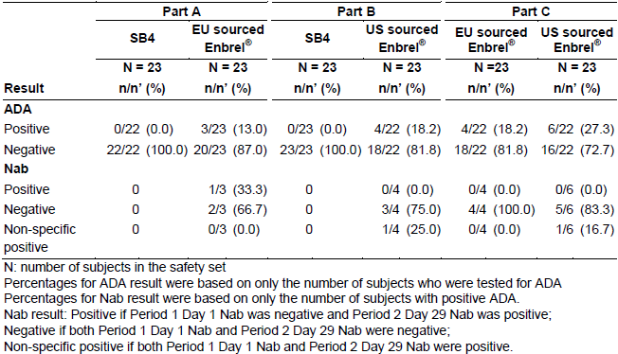

#### Electrocardiograph

##### Study SB4-G31-RA

A total of 50 patient (16.7% of 299) in the SB4 group and 54 patients (18.2% of 297) in the Enbrel arm were recorded as having abnormalities in their 12-lead ECG at screening in Study SB4-G31-RA, but none were considered to be clinically significant. During the 52-week trial, 1 patient in each treatment group developed acute coronary ischaemia and another patient in the SB4 arm experienced atrial fibrillation. All of these events were recorded as SAEs. No other subjects developed clinically relevant ECG abnormalities during the trial.

###### Study SB4-G11-NHV

In each part of Study SB4-G11-NHV, no significant changes (mean, median or individual) in ECG parameters such as QT interval were observed.

#### Vital signs

##### Study SB4-G31-RA

At Week 52, there were small differences between the SB4 and Enbrel treatment groups in mean systolic blood pressure (–1.3 mmHg versus +1.3 mmHg, respectively), mean diastolic blood pressure (–0.4 mmHg versus –0.4 mmHg, respectively) and heart rate (–1.1 bpm versus –2.4 bpm, respectively). Six (2.0% of 299; 4 of whom did so at Week2) subjects in the SB4 group recorded clinically significant, low systolic blood pressure (≤90 mmHg and a change from baseline ≤ –20 mmHg) at Week 52, while 1 (0.3%) subject in each of the treatment groups was reported with clinically significant high systolic blood pressure (≥ 180 mmHg and a change from baseline ≥ 20 mmHg) at Week 52.

##### Study SB4-G11-NHV

A total of 10 subjects (3 in Part A, 3 in Part B and 4 in Part C) developed minor changes in vital signs during the study, which are similar to that observed in healthy volunteers.

### Post-marketing experience

To date, SB4 has not yet been approved or marketed in any country.[9] However, there is a large volume of long-term clinical experience with Enbrel in the requested treatment indications to indicate that if SB4 meets the criteria for biosimilarity with Enbrel (reference product), then a predictable positive benefit: risk assessment can be concluded.

### Safety issues with the potential for major regulatory impact

#### Serious and/or opportunistic infection

In Study SB4-G31-RA, a higher number of infection related SAEs were recorded with EU sourced Enbrel (5 events in 5 subjects; 1.7% of 297) compared with those who received SB4 (2 events in 1 subject; 0.3% of 299). In this trial, the types of serious infection observed were similar to that reported with the known safety profile of ETN. There were no reports of active TB or serious opportunistic infection in Study SB4-G31-RA, but subjects were carefully screened at baseline for reactivation of TB.

#### Malignancy potential

Malignancy is an important potential safety concern with ETN therapy in all treatment indications. Study SB4-G31-RA reported 4 cases of malignancy in SB4 treated patients (breast cancer, lung cancer with cerebral metastases, basal cell skin carcinoma and gastric adenocarcinoma). One subject who received Enbrel in the same trial developed invasive ductal breast cancer. The relative imbalance of identified malignancy cases between the 2 treatment groups is probably within the expectations given the small overall patient numbers involved and relatively short duration of treatment follow-up (56 weeks). No lymphoproliferative disorders were reported in the SB4 study program, but this remains an important risk with long-term ETN therapy in all treatment indications.

#### Neurological events

No reports of demyelinating disorders such as multiple sclerosis or Guillain-Barré Syndrome were recorded in either of the 2 studies in this submission, but this remains an important identified risk with ETN therapy that requires ongoing surveillance.

#### Unwanted immunological events

Injection site reactions were an AE of special interest in the SB4 clinical development program and were reported in both clinical studies (all treatment groups). In Study SB4-G31-RA, a higher number of [10]injection site reactions (almost all were considered to be treatment related) were reported in Enbrel versus SB4 treated subjects (22 injection site reactions were recorded in 11 (3.7% of 299) subjects in the SB4 treatment group and 157 reactions were observed in 52 (17.5% of 297) subjects in the Enbrel arm). The most commonly reported type of injection site reaction was injection site erythema. No patient discontinued ETN in Study SB4-G31-RA because of injection site reaction. It remains unclear as to whether or not the increased incidence of injection site reactions with Enbrel versus SB4 reflects a true and significant safety difference, and what is the potential mechanism. In all 3 Parts of Study SB4-G11-NHV, injection site reactions were reported at a similar frequency (4.3-6.5%) in subjects receiving the 3 different formulations of ETN (SB4, EU and US sourced Enbrel). No severe immediate or delayed type hypersensitivity reactions were observed in either trial. No lupus-like or allergic reactions were observed in either clinical trial in this submission.

Both studies revealed a comparatively low rate of testing positive for ADA with SB4 therapy with no clear clinical significance to their development determined thus far. However, all enrolled patients in Study SB4-G31-RA were taking concomitant weekly low oral MTX with ETN, while none of the subjects in Study SB4-G11-NHV were taking concomitant immunosuppression. The submission does not include any clinical study with SB4 in diseased individuals (for example, adult subjects with PSOR or AS) where the concurrent use of MTX is typically not part of the treatment strategy with ETN. As such, the immunogenicity profile (ADA status) of SB4 in those other adult treatment patients may be significantly different without the concurrent use of MTX.

### Other safety issues

No reports of Hepatitis B virus reactivation or pregnancy were received in either of the studies in this submission.

### Evaluator’s overall conclusions on clinical safety

The safety profile of anti-TNF drugs, including ETN, is well characterised in the published literature. In this submission for the registration of SB4 (biosimilar medicine of ETN), the safety population consisted of 596 adult patients with active RA who were treated with at least 1 dose of either SB4 or Enbrel during the Phase III clinical trial (SB4-G31-RA). Of these patients, 299 received treatment with SB4 for a mean duration of 338.9 days (11 months) and 297 subjects were given Enbrel for a mean duration of 323.5 days (10.5 months). In addition, 138 healthy male subjects aged between 18 and 55 years were evaluated in the Phase I Study SB4-G11-NHV (46 subjects received cross-over therapy with either SB4 or EU or US sourced Enbrel). The size of the safety population and the duration of exposure to SB4 are consistent with the regulatory guidelines (CPMP/EWP/556/95rev1/FINAL) for presenting a safety population of sufficient size and follow-up duration to assess for possible registration. However, there are other issues identified in this evaluation which indicate that further safety data or clarification by the sponsor is required before meeting the minimum safety requirements of the biosimilar regulatory guideline.

The most frequently reported drug-related AEs (experienced by ≥ 4% of patients) in Study SB4-G31-RA were in the SOCs of general disorders and administration site conditions (mainly, injection site reactions), infection related AEs and (abnormal) investigations (for example, raised liver enzymes and various haematological abnormalities). The frequency and severity of drug-related AEs in Study SB4-G31-RA was comparable between the SB4 and Enbrel treatment groups apart from a higher incidence of injection site reactions with EU sourced Enbrel (18.5%) versus SB4 (4.0%). In Study SB4-G11-NHV, a similar pattern of the most commonly reported treatment emergent AEs was observed in all treatment groups (SB4 therapy, EU sourced Enbrel and US sourced Enbrel). The 2 most common drug-related AEs in healthy male volunteers were headache and injection site reactions.

Given the mechanism of action of ETN, infection is an AE of special interest. The overall number of subjects experiencing infection related AEs (25.6-28.4%) was comparable between the 2 treatment groups in Study SB4-G31-RA. However, there was higher number of infection related SAEs with EU sourced Enbrel (5 events in 5 subjects; 1.7% of 297) compared with those who received SB4 (1 event in 1 subject; 0.3% of 299) in Study SB4-G31-RA. There were no reports of active TB in Study SB4-G31-RA, but subjects were carefully screened at baseline for reactivation of TB. In Study SB4-G11-NHV, infection related AEs affected <10% of all subjects with no clear discernible differences in the pattern and type of infection observed in healthy volunteers treated with either formulation of ETN. The most common type of infectious AE by PT in both adults with active RA and healthy male volunteers was nasopharyngitis.

Two patients died in Study SB4-G31-RA (cardiopulmonary failure and gastric adenocarcinoma), but neither fatality was considered by the site investigators to be related to SB4 (both subjects received SB4 therapy). The evaluator opined that both deaths may have possibly been related to SB4; ETN has a potential association with malignancy, and worsening of cardiac failure is a potential risk in those at risk of major adverse cardiovascular events. Malignancies were reported in 4 patients (1.3%) treated with SB4 therapy and 1 subject (0.3%) who received Enbrel in Study SB4-G31-RA. The observed rate of drug-related, treatment-emergent SAEs was similar for both treatment groups (5.1-6.0%) in Study SB4-G31-RA. However, the pattern of drug-related SAEs in Study SB4-G31-RA was somewhat different for patients treated with SB4 versus Enbrel. In particular, 4 subjects treated with SB4 recorded 6 hepatobiliary SAEs versus no such events in the Enbrel group. However, in the Enbrel arm there were 2 individual reports of chorioretinopathy and significant neutropenia.

In both clinical studies, the frequency of patients who were discontinued due to drug-related AEs was low and similar between treatment groups (5.4-6.7% in Study SB4-G31-RA). The 2 most frequent AEs leading to permanent study treatment discontinuation in Study SB4-G31-RA were injection site reactions and exacerbation of RA. However, other reasons for discontinuation from ETN in Study SB4-G31-RA included infection (2 patients in the SB4 group and 1 in the Enbrel arm); skin complaints (1 patient in the SB4 group and 2 subjects in the Enbrel arm), haematological abnormalities (1 patient in each group) and 2 gallstone related AEs in SB4 treated individuals.

Injection site reactions were reported in both clinical studies (all treatment groups). In Study SB4-G31-RA, 22 injection site reactions were recorded in 11 (3.7% of 299) subjects in the SB4 treatment group and 157 reactions were observed in 52 (17.5% of 297) subjects in the Enbrel arm. The most commonly reported injection site reactions at the PT level were injection site erythema. It remains unclear as to whether or not the increased incidence of injection site reactions with Enbrel versus SB4 reflects a true and significant safety difference, and if so, what is the potential explanation. In all 3 Parts of Study SB4-G11-NHV, injection site reactions were reported at a similar frequency (4.3-6.5%) in subjects receiving 3 different formulations of ETN (SB4, EU and US sourced Enbrel). No severe immediate or delayed type hypersensitivity reactions were observed in either trial.

In Study SB4-G31-RA, 3.4-5.4% of subjects developed ≥ 2-fold increases in serum transaminases and there were a few cases of serious hepatobiliary AEs reported in SB4 treated subjects. Even though there was a slightly higher incidence of raised serum transaminases and hepatobiliary AEs with SB4 therapy versus Enbrel, the majority of these AEs were not treatment related and probably do not reflect a true safety difference between the 2 formulations of ETN. In addition, there were a few significant cases of neutropenia and thrombocytopenia recorded in both ETN treatment groups of Study SB4-G31-RA. These cases are consistent with the Australian PI for Enbrel and published literature.

The incidence of subjects developing anti-ADA antibodies was relatively low with SB4 and their clinical relevance is yet to be defined with no discernible link to the risk of infection, injection site related reactions or any other significant safety concern (such as hepatobiliary AEs). By Week 52 in Study SB4-G31-RA, there was a statistically higher rate of positive ADA results in the Enbrel group (13.2%; 39/297) compared to SB4 therapy (1.0%; 3/299; p<0.001). Only 1 subject in the Enbrel treatment group tested positive for neutralising antibodies to ETN during the entire study. The majority of patients (in both treatment groups) who tested positive for ADA did so at Week8 of therapy, and ADA positivity persisted throughout the trial. By Day 29 in Study SB4-G11-NHV, no subject treated with SB4 tested positive for ADA, 7 subjects after receiving EU sourced Enbrel were positive for ADA (including 1 subject with NAb) and 10 subjects after receiving US sourced Enbrel tested positive for ADA. It is unclear why there is a clear imbalance between SB4 and Enbrel therapy for the detection of ADA to ETN in both submitted studies and the sponsor has made no comment about this observation.

In Study SB4-G31-RA, 4 cases of malignancy were reported in SB4 treated patients (breast cancer, lung cancer with cerebral metastases, basal cell skin carcinoma and gastric adenocarcinoma) and 1 subject who received Enbrel developed invasive ductal breast cancer. No lymphoproliferative disorders were reported in either clinical study in this submission although this is a potential identified risk for anti-TNF therapy that is outlined in the RMP and the proposed Australian PI. Other previously identified safety concerns with ETN such as systemic lupus erythematosus or lupus-like syndromes and demyelinating disorders were not reported in any of the studies in the SB4 trial program.

The analysis of AEs reported during treatment with SB4 and the reference product Enbrel in Studies SB4-G31-RA and SB4-G11-NHV have not revealed any significant differences in the incidence and type of AEs. Moreover, no new safety signals have emerged from the submitted dataset to indicate the known risk profile of ETN has altered. The current safety dataset for SB4 is limited to 56 weeks of treatment follow-up and it would be important to continue collecting data beyond this time frame as part of post-marketing pharmacovigilance if approval was granted. Nonetheless, the safety data for Enbrel exceeds 15 years of treatment follow-up and it is likely that SB4 will demonstrate a similar safety profile over longer term follow-up based on the similar short term safety experience between the 2 formulations of ETN. However, as Study SB4-G31-RA recruited subjects who were predominately naïve to conventional DMARD therapy[11], it is unclear if both formulations of ETN will demonstrate a similar safety profile in all of the patient populations for which Enbrel is currently approved.

## First round benefit-risk assessment

### First round assessment of benefits

The benefits of SB4 in the proposed usage are:

* Comparable efficacy response rates to Enbrel in improving the symptoms and signs of active RA in adult patients who were predominantly treatment naïve10, including equivalent rates of ACR20 response at Week 24 (78.1-80.5% in the PPS1 cohort) as well as many secondary clinical efficacy variables (such as other levels of clinical response at 24 and 52 weeks) reporting similar rates of treatment response.
* Comparable efficacy response rates to Enbrel in slowing progression of disease associated structural progression (similar mean changes in mTSS and its component scores at Week 52).
* Demonstration of similar pharmacokinetic properties to Enbrel in healthy male volunteers (single dose, crossover design) and adult subjects with active RA (multiple dose therapy at steady state).
* Provision of an alternative formulation of ETN to treat various autoimmune inflammatory conditions in adults such as inflammatory spondylitis, psoriatic arthritis and skin psoriasis.
* Lower observed incidence of injection site reactions and development of anti-drug antibodies (of unclear clinical significance) with SB4 therapy compared to EU sourced Enbrel.

### First round assessment of risks

The risks of SB4 in the proposed usage are:

* Increased risk of infection (overall and serious) which is comparable to alternative ETN therapy (EU sourced Enbrel).
* Increased risk of injection site reactions, which occurred at a lower frequency in those who received SB4 versus Enbrel in the 2 clinical trials.
* Safety not established in those with a high risk of infection as these patients were excluded from the trial populations (that is, some limitations to external validity).
* Rare reports of significant adverse events such as neutropenia, hepatobiliary disorders and malignancy of unclear relationship to SB4 or Enbrel therapy.
* Safety data in patients with inflammatory arthritis (RA) limited to < 54 weeks of treatment follow-up at present.
* No information regarding the safety of switching therapy (single 1–way changes or multiple switching) between the 2 formulations of ETN.
* Risk of off label use in children and adolescents where Enbrel has an approved treatment indication (paediatric PSOR and Juvenile Idiopathic Arthritis).
* Risk of potential for prescribing and dispensing errors given that the sponsor is specifically not requesting registration of the 2 approved paediatric treatment indications for Enbrel, and not providing a 25 mg vial presentation with an alternative posology (25 mg twice weekly) as per Enbrel.

### First round assessment of benefit-risk balance

The submission indicates that the benefit-risk balance of SB4 is favourable for the treatment of active RA in adult patients, who are predominately treatment naïve to conventional DMARDs10 (Study SB4-G31-RA). However, the sponsor has not produced any clinical data with SB4 therapy which matches the approved target population of the reference product (Enbrel). This is a major deficiency of the current submission.[12] It is unclear if the inclusion of predominately DMARD naïve subjects with active RA makes the detection of potential efficacy differences between the 2 formulations of ETN more or less sensitive. Treatment naïve subjects with active RA will demonstrate higher placebo adjusted clinical response rates than DMARD experienced patients. In developing and justifying the equivalence margin and sample size calculations for the single pivotal study (SB4-G31-RA) in this submission, the sponsor has used data from 3 trials which enrolled DMARD experienced subjects with active RA (Table 7).

Furthermore, the currently available dataset on the benefit-risk balance of SB4 in adult patients with RA is limited to 52 weeks of treatment follow-up. This submission also contains a sufficient volume of data to support the claim that SB4 is pharmacokinetically equivalent to the reference product, Enbrel, in adult patients with active RA (Study SB4-G31-RA) and healthy young-middle aged males (Study SB4-G11-NHV).

The sponsor has not provided a review of the literature on the role of TNF in the disorders covered by the therapeutic indications of Enbrel and the potential mechanisms of action of the various anti-TNF medications. The mechanism of action of ETN is complex but the primary mode of action results from direct blocking of TNF receptor-mediated biological activities. ETN is a soluble TNFR fusion protein that competitively inhibits TNF by binding to it, thereby blocking the interaction between TNF and TNF receptors. This is thought to prevent various pro-inflammatory cellular responses that are recognised to occur in autoimmune conditions ranging from RA to AS and PSOR. However, the sponsor has not provided any justification for the extrapolation of indications for SB4 to include that which are approved for Enbrel on the basis of biosimilarity. Extrapolation of the PK, efficacy and safety data generated in the 2 trials in this submission which examined adult patients with RA and normal healthy volunteers is not justifiable on the basis of the results of the pre-clinical studies (that is, in vitro and ex vivo comparability data on the functionalities of the ETN molecule). Despite sharing similar and overlapping pathophysiological immunological mechanisms, RA is considered a clinical disease model of limited sensitivity for assessing the efficacy and safety of SB4 in inflammatory spondylitis, PsA and PSOR (Lee H, 2014).

On the safety aspect, there is an increased risk of infection (overall and serious) with SB4 which appears to be comparable to Enbrel. The 2 submitted studies show a risk of injection site reactions with SB4, which is numerically lower than that observed with Enbrel therapy. There are limitations to the current dataset which will require ongoing pharmacovigilance. The efficacy and safety of SB4 in patients at a high risk of infection is not established. In addition, there is no information about the safety and efficacy of switching to SB4 from Enbrel, or vice versa. Furthermore, the current dataset has evaluated SB4 use in healthy volunteers and adult subjects with active RA (of limited characteristics to the approved patient population for Enbrel) and the submission did not include any information (clinical or pharmacokinetic) on the use of SB4 in other adult treatment indications or in children and adolescents with inflammatory conditions where Enbrel is also approved for use.

### First round recommendation regarding authorisation

The evaluator does not recommend acceptance of the sponsor’s proposed registration of SB4 to include RA or any of the current approved treatment indications for Enbrel in adult patients. The current submission provides evidence that SB4 is therapeutically equivalent to Enbrel in improving the signs and symptoms, as well radiographic outcomes in adult patients with active RA that are predominately treatment naive. However, this target treatment population is not consistent with the approved RA treatment population for Enbrel (that is, for use in patients who have an inadequate response to 1 or more DMARD drugs prior to anti-TNF therapy[13]). In addition, the sponsor has not provided any clinical data or literature review assessment in any of the other requested treatment indications to justify that SB4 can obtain any of the other approved treatment indications for Enbrel in adults by extrapolation of information. Moreover, the sponsor is specifically not requesting registration of the 2 approved paediatric treatment indications for Enbrel and not providing a 25 mg vial presentation, which raises concern for potential prescribing and dispensing errors occurring with the registration of 2 ETN formulations in Australia.

The following are recommended conditions prior to further consideration of the proposed registration of SB4:

* Satisfactory response to the questions outlined in section 12 of this report,
* Provision of study report for the open-label, extension phase of Study SB4-G31-RA, and
* Literature review of the non-RA proposed treatment indications in adult subjects with satisfactory justification as to why SB4 should be able to claim those same indications by extrapolation of Enbrel data.

The evaluator would recommend that a registry study be a condition of registration if the application for SB4 is approved.

## Clinical questions

### Pharmacokinetics

1. The current submission contains 2 clinical studies with SB4: 1 in healthy male volunteers and the other in adult subjects with active RA. Could the sponsor provide evidence via literature review to support the hypothesis that there are no significant differences in the pharmacokinetic characteristics of etanercept across its various approved treatment indications in adult patients?
2. In Study SB4-G31-RA, the majority of subjects in both treatment arms received concomitant methotrexate with etanercept. There is published data indicating that concomitant methotrexate alters the immunogenicity, and potentially the pharmacokinetic profile, of anti-TNF therapy. In the requested treatment indications by extrapolation (inflammatory spondylitis, skin psoriasis and psoriatic arthritis) there are significantly lower rates of concurrent methotrexate use with anti-TNF therapy, including Enbrel. Could the sponsor comment on the potential impact upon the immunogenicity and pharmacokinetic characteristics of reduced concurrent immunosuppressant drug therapy (mainly, methotrexate use) with SB4 in the requested treatment indications by data extrapolation?

### Pharmacodynamics

Nil

### Efficacy

1. The current approved treatment indication for Enbrel therapy in patients with RA states ‘Active, adult rheumatoid arthritis (RA) in patients who have had an inadequate response to one or more disease-modifying anti-rheumatic drugs (DMARDs).’ Prior to involvement in Study SB4-G31-RA, the majority of subjects (70.8%; 422/596) were DMARD naïve. Could the sponsor justify how the population randomised into Study SB4-G31-RA accurately reflects the current approved treatment indication for Enbrel in RA (that is, for those who have failed to respond to 1 or more DMARDs)?
2. In Study SB4-G31-RA, the rates of concomitant NSAID and low dose systemic corticosteroid use were approximately 2-fold the recorded prior rates of such medicines. Could the sponsor explain why this changing pattern of medication use occurred and whether this influenced the rates of clinical response observed in the trial?
3. Could the sponsor report the median (and inter-quartile) doses of oral corticosteroid therapy used in Study SB4-G31-RA?
4. Could the sponsor provided a detailed, evidence-based report providing justification for SB4 being granted all the treatment indications in adult patients of Enbrel by extrapolation?
5. Could the sponsor comment on whether it considers rheumatoid arthritis to be a sensitive clinical model for extrapolation of treatment indication to inflammatory spondylitis, psoriatic arthritis and skin psoriasis? In addition, does the predominantly prior treatment naïve population enrolled into Study SB4-G31-RA (approximately 70%) significantly alter the sensitivity of the study to detect a potential efficacy difference between SB4 and Enbrel in adult patients with active rheumatoid arthritis?

### Safety

1. For Study SB4-G31-RA, could the sponsor provide an analysis of treatment emergent adverse events by subject weight at baseline and concurrent opioid therapy, as both of these patient factors are known to be associated with an increased risk of adverse events, particularly, infection related adverse events?
2. This submission contains data for Study SB4-G31-RA up to 52 weeks of treatment. However, the submission advises that the trial has an open-label, single-arm (all subjects to receive SB4 therapy), extension period of 52 weeks duration in subjects enrolled in Poland and the Czech Republic. Can the sponsor provide a study report for the open-label extension period of Study SB4-31-RA?
3. Could the sponsor provide data on whether any safety related concerns were identified if and when patients were switched from Enbrel to SB4 (or vice versa) in the open label phase of Study SB4-G31-RA?
4. In Study SB4-G31-RA, there was higher overall incidence of injection site reactions and injection site erythema with EU sourced Enbrel therapy versus SB4. Could the sponsor comment on whether or not the observed difference is a true and/or clinically significant finding? If the sponsor believes the observation to indicate a true potential difference between the formulations, what is/are the potential explanations and was there a signal of such in the non-clinical studies?
5. In both studies included in this submission, the incidence of testing positive to etanercept anti-drug antibodies was higher in subjects who received Enbrel (EU or US sourced) compared to those administered SB4 therapy. Could the sponsor comment on why there is a distinctly observed difference in rates of immunogenicity between SB4 and reference therapy?
6. If granted registration in Australia, is the sponsor planning on conducting any post-market surveillance studies in Australia or proposing to establish a patient registry in Australia?

## Second round evaluation of clinical data submitted in response to questions

The sponsor’s response dated February 29, 2016 addresses 13 questions that were raised in the first round clinical assessment.

### Question 1

*The current submission contains 2 clinical studies with SB4: 1 in healthy male volunteers and the other in adult subjects with active RA. Could the sponsor provide evidence via literature review to support the hypothesis that there are no significant differences in the pharmacokinetic characteristics of etanercept across its various approved treatment indications in adult patients?*

#### Sponsor response

In the response, the sponsor has provided a summary of a reasonably comprehensive literature review of the pertinent pharmacologic studies, which indicate that the PK characteristics of Enbrel shows no significant differences between healthy adult volunteers (single dose trials only; refer to Table 22) and adult subjects with 3 of the 5 Enbrel approved treatment indications (including the steady state PK parameters of trough serum ETN concentration, AUC, Cmax, Tmax and drug clearance in patients with RA, PSOR and AS; refer to Tables 23 and 24). In addition, the sponsor has included an integrated analysis of the PK profiles of Enbrel (derived from population PK modelling) which indicates that health status (health versus disease) or inflammatory joint disease type (RA or AS) does not significantly impact upon the PK of Enbrel.

Table 22: Single Dose Pharmacokinetic Characteristics of Enbrel in Healthy Volunteers and Adult Subjects with Rheumatoid Arthritis (Mean +/- SD)

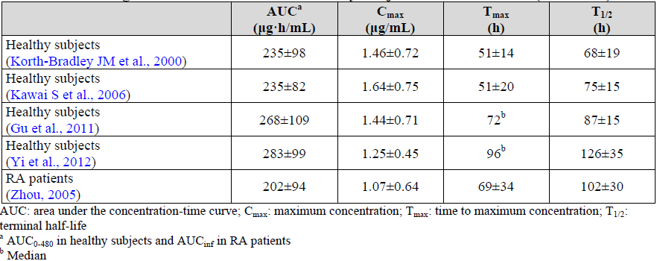

Table 23: Steady State Pharmacokinetic Characteristics of Enbrel in Adult Subjects with Rheumatoid Arthritis and Skin Psoriasis (PsO) – (Mean +/- SD)

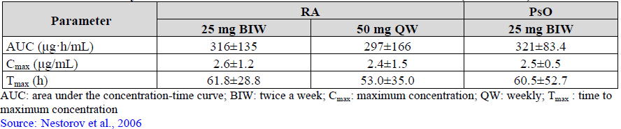

Table 24: Steady State Pharmacokinetic Characteristics of Enbrel in Adult Subjects with Rheumatoid Arthritis and Ankylosing Spondylitis (Mean +/- SD)

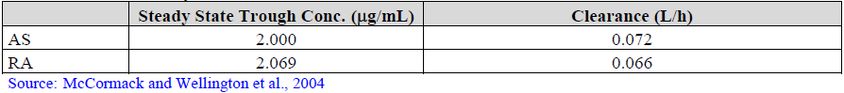

#### Evaluator comment

Based on the presented findings of the literature review by the sponsor, it can be concluded that the PK characteristics of Enbrel are similar across the approved adult treatment indications (RA, PSOR and AS) as well as between healthy and diseased adult subjects. Although the literature review did not include PK data from all treatment indications (in particular, PsA and non-radiographic axial spondyloarthritis), there is a high likelihood of similar patient and disease characteristics between adult subjects with PSOR and/or PsA; and those with AS or non-radiographic axial spondyloarthritis. The data in this submission shows that SB4 is similar for PK characteristics to Enbrel (EU and US sourced) in 46 healthy adult subjects (Study SB4-G11-NHV) and in 85 patients with active RA (subset of patients enrolled in Study SB4-G31-RA). Given the PK similarity between SB4 and Enbrel (EU sourced) in the 2 studies included in this submission, it can be reasonably expected by extrapolation of data that SB4 will display similar PK characteristics to Enbrel across the other approved adult treatment indications of PsA, PSOR, AS and non-radiographic axial spondyloarthritis.

### Question 2

*In Study SB4-G31-RA, the majority of subjects in both treatment arms received concomitant methotrexate with etanercept. There is published data indicating that concomitant methotrexate alters the immunogenicity, and potentially the pharmacokinetic profile, of anti-TNF therapy. In the requested treatment indications by extrapolation (inflammatory spondylitis, skin psoriasis and psoriatic arthritis) there are significantly lower rates of concurrent methotrexate use with anti-TNF therapy, including Enbrel. Could the sponsor comment on the potential impact upon the immunogenicity and pharmacokinetic characteristics of reduced concurrent immunosuppressant drug therapy (mainly, methotrexate use) with SB4 in the requested treatment indications by data extrapolation?*

#### Sponsor response

According to data included in the EPAR and European SmPC for Enbrel, the sponsor states that the incidence of testing positive to ADA in the first 12 months of ETN treatment is relatively low compared to at least 2 other anti-TNF therapies (infliximab and adalimumab), and similar across the approved adult treatment indications (6% in RA, 2% in AS and 7.0-7.5% for PSOR and PsA, respectively). Furthermore, the EPAR and European SmPC for Enbrel indicate that the reported incidences of ADA positive testing in the pivotal trials was comparable regardless of concomitant MTX use (refer to Table 25).

Table 25: Incidence of Positive Anti-Drug Antibody Testing in Approved Indications for Enbrel

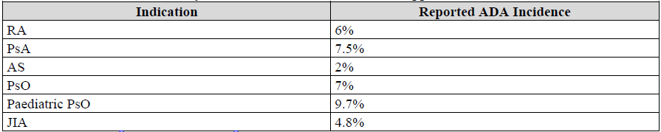

In the response, the sponsor has also provided an additional subgroup analysis of Study SB4-G31-RA examining the potential impact of concomitant MTX dose (stratified into 3 dose tertiles: 10-15 mg/week, 15-20 mg/week and 20-25 mg/week) upon the rates of ADA development. Although the number of patients with positive ADA results in Study SB4-G31-RA is limited in number (3 in the SB4 treatment group [1 in each MTX dose stratum] versus 39 in the Enbrel arm [proportionally spread across each MTX dose stratum), the sponsor did not identify any correlation between concurrent MTX dose and the incidence of testing positive for ADA up to 52 weeks with either SB4 therapy or EU sourced Enbrel (refer to Table 26).

Table 26: Immunogenicity Results According to Baseline MTX Use in Study SB4-G31-RA

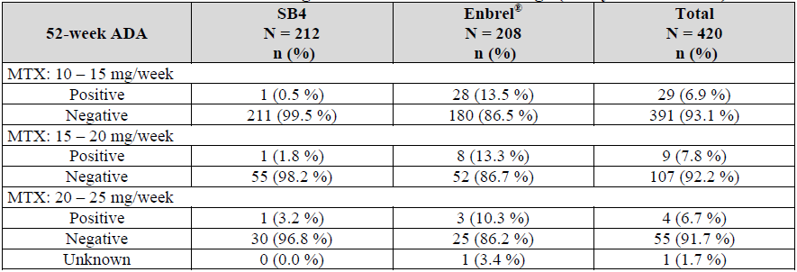

*Evaluator Comment*: Based on the approved European SmPC and published EPAR for Enbrel as well as the 52-week ADA subgroup analysis (positive/negative status) of treated RA patients in Study SB4-G31-RA, it can be concluded that the immunogenicity profile (and subsequent potential PK implications of developing ADA) for patients treated with SB4 therapy can be extrapolated with reasonable exactitude to the other approved adult treatment indications for Enbrel use.

### Question 3

*The current approved treatment indication for Enbrel therapy in patients with RA states ‘Active, adult rheumatoid arthritis (RA) in patients who have had an inadequate response to one or more disease-modifying anti-rheumatic drugs (DMARDs).’ Prior to involvement in Study SB4-G31-RA, the majority of subjects (70.8%; 422/596) were DMARD naïve. Could the sponsor justify how the population randomised into Study SB4-G31-RA accurately reflects the current approved treatment indication for Enbrel in RA (that is, for those who have failed to respond to 1 or more DMARDs)?*

#### Sponsor response

In the response, the sponsor has clarified that all 596 patients recruited into the pivotal Study SB4-G31-RA had received at least 6 months of MTX (10-25 mg/week; oral or parenteral) prior to randomisation. As such, the sponsor asserts that the population randomised into Study SB4-G31-RA accurately reflects the approved RA treatment indication for Enbrel in Australia with respect to prior DMARD therapy.

#### Evaluator comment

In the original submission, the 52-week clinical study report for Study SB4-G31-RA contained no text about the prior treatment characteristics of the randomised population and the table containing such data was after the end of the report. This crucial piece of data was not well presented in any of the modules and slowed the evaluation of the clinical dossier.All 596 patients enrolled in Study SB4-G31-RA had received at least 6 months of prior MTX treatment at median weekly dose of 15 mg (mean weekly dose of 15.5 mg). Patients randomised to the SB4 group had received MTX for a median of 36 months (mean of 48.2 months) prior to involvement in Study SB4-G31-RA, and those in the Enbrel arm had received MTX for a median of 33 months (mean of 47.1 months) prior to the trial. In addition to prior MTX use in all subjects, 16.3% (97/596) of subjects in Study SB4-G31-RA had prior use of 1 additional DMARD, 8.7% (52/596) had experienced 2 additional previous DMARDs and 4.2% (25/596) had experienced 3 or more previous DMARDs beyond MTX. Excluding MTX, the 3 most commonly used prior DMARDs were SSZ (17.1%; 102/596), anti-malarial drugs (14.3%; 85/596) and LEF (9.2%; 55/596).

The additional information included in the response regarding prior MTX treatment (incidence and dose) for patients recruited into Study SB4-G31-RA reflects an appropriate level of prior MTX treatment before being considered candidates for anti-TNF therapy. This observation supports the external validity of the single pivotal disease trial for SB4. Furthermore, the pattern of prior MTX and other DMARD use in Study SB4-G31-RA, as well as the measures of disease activity at baseline in this trial (for example, mean swollen joint count of 15; refer to Table 10), are consistent with the approved RA treatment indication for Enbrel which states ‘*patients who have had an inadequate response to one or more DMARD*.’

### Question 4

*In Study SB4-G31-RA, the rates of concomitant NSAID and low dose systemic corticosteroid use were approximately 2-fold the recorded prior rates of such medicines. Could the sponsor explain why this changing pattern of medication use occurred and whether this influenced the rates of clinical response observed in the trial?*

#### Sponsor response

The sponsor concurs that the incidence of concomitant medication use with NSAID and low dose oral corticosteroids in Study SB4-G31-RA appears to be 2-fold higher than their prior rates of use in the submitted study report. In the response, the sponsor provides an explanation that such an observation relates to how prior and concomitant medication use are defined and calculated in the study protocol. Among the 338 patients (56.7% of 596) who received concomitant corticosteroids in Study SB4-G31-RA, almost all patients (165 out of 169 for both treatment groups) started to receive corticosteroid therapy before the first injection of ETN in the trial. Similarly, almost all of the 424 patients (71.1% of 596) who received concomitant NSAID during Study SB4-G31-RA did so before the first injection of ETN (211 out of 218 subjects in the SB4 group and 196 out of 206 patients in the Enbrel arm). The sponsor asserts that since most concomitant medications were started prior to the first injection of ETN (that is, only 4-10 patients [1.3-3.4% of each treatment group] started to use corticosteroids or NSAID after the first injection of ETN), the incremental rate of concomitant corticosteroid or NSAID use did not have any significant impact on the clinical outcomes of Study SB4-G31-RA. Furthermore, the sponsor reports comparable rates of concomitant medication use (76-88% for concurrent NSAID and 39-64% for concomitant corticosteroid use) in the pivotal registration trials for Enbrel in RA.

#### Evaluator comment

In the response, the sponsor has provided an appropriate and adequate explanation of the apparent difference in prior versus concomitant NSAID and corticosteroid use in Study SB4-G31-RA. The explanation provided by the sponsor for the apparent changing rates of prior versus concomitant medication use indicates that there is limited likelihood that concomitant medication use with NSAID and corticosteroid has had a significant impact on the efficacy results observed in Study SB4-G31-RA. Moreover, the rates of concomitant NSAID and low dose oral corticosteroid use are within expectations for the treatment cohort, which supports the external validity of the study findings.

### Question 5

*Could the sponsor report the median (and inter-quartile) doses of oral corticosteroid therapy used in Study SB4-G31-RA?*

#### Sponsor response

Among the 596 patients randomised into Study SB4-G31-RA, a total of 324 subjects received oral corticosteroid therapy at baseline: 161 patients (53.8% of 299) in the SB4 treatment group and 163 patients (54.9% of 297) in the Enbrel arm. The distribution of weekly corticosteroid dosage at baseline was similar between the 2 treatment groups with the median weekly dosage being 35 mg of prednisone equivalent (approximate median daily dose of 5 mg; and approximate mean daily dose of 6 mg).

#### Evaluator comment

The usage rates and doses of oral corticosteroid therapy at baseline in both treatment groups in Study SB4-G31-RA are within the expectations for subjects with active RA, who are candidates for receiving anti-TNF therapy. The additional information supports the external validity of the studied cohort in Study SB4-G31-RA.

### Question 6

*Could the sponsor provided a detailed, evidence-based report providing justification for SB4 being granted all the treatment indications in adult patients of Enbrel by extrapolation?*

#### Sponsor response

In the response, the sponsor has provided a detailed report justifying the extrapolation of treatment indications for SB4 to include all 5 approved adult treatment indications for Enbrel. In particular, the sponsor has provided scientific evidence of a common mechanism of action in each condition, similarity in PK characteristics between SB4 and Enbrel (refer to Tables 22-24), similarity of clinical safety profiles with ETN use across the treatment indications (refer to Table 27 regarding rate of serious infection) and similarity in the rates of immunogenicity across the proposed treatment indications (refer to Tables 25 and 26).

Table 27: Exposure Adjusted Rate of Serious Infection in Enbrel Treated Patients in Clinical Trials

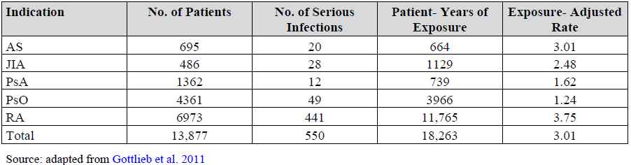

ETN is a TNF antagonist that differs from the other anti-TNF therapies in that it is not a monoclonal antibody, but rather an Fc-TNF receptor fusion protein. Unlike the other TNF antagonists, ETN also binds lymphotoxin, which has an important role in the inflammatory response. While, ETN represents a very different class of molecule, it still shows the same spectrum of activity as the monoclonal anti-TNF antibodies in RA, PsA, AS and PSOR. The efficacy of ETN is mainly dependent on inhibiting soluble TNF and the comparability of SB4 and Enbrel has been extensively delineated in pre-clinical testing such as structure activity relationship.

The efficacy data obtained in patients with RA (Study SB4-G31-RA) provides evidence of similar responses to SB4 and EU sourced Enbrel. From a safety viewpoint, similar AE and immunogenicity profiles are observed in adult patients across the approved treatment indications in clinical studies, regardless of concomitant MTX use.

#### Evaluator comment

The sponsor submission provides a credible argument, based on the non-clinical findings of SB4 structure and function, in conjunction with bioequivalence data from PK studies and a single Phase III efficacy study in RA (Study SB4-G31-RA) that SB4 and Enbrel are therapeutically equivalent. Extrapolation of the PK, efficacy and safety data generated in the 2 trials in this submission which examined adult patients with RA and healthy adult volunteers to other approved indications for Enbrel such as active PSOR, PsA and inflammatory spondylitis is justifiable on the basis of the results of the extensive pre-clinical studies (that is, *in vitro* and *ex vivo* comparability data on the functionalities of the ETN molecule) supported by the evidence that PSOR, PsA and AS share similar and overlapping pathophysiological immunological mechanisms and clinical features.

### Question 7

*Could the sponsor comment on whether it considers rheumatoid arthritis to be a sensitive clinical model for extrapolation of treatment indication to inflammatory spondylitis, psoriatic arthritis and skin psoriasis? In addition, does the predominantly prior treatment naïve population enrolled into Study SB4-G31-RA (approximately 70%) significantly alter the sensitivity of the study to detect a potential efficacy difference between SB4 and Enbrel in adult patients with active rheumatoid arthritis?*

#### Sponsor response

In Question 3 of the second round evaluation, the sponsor clarified that the enrolled population of Study SB4-G31-RA had been treated with MTX for at least 6 months, and as such the studied cohort in the pivotal trial of this submission is consistent with the Australian approved RA treatment indication for Enbrel.

In the response, the sponsor reiterates the similarity of SB4 and Enbrel with respect to PK parameters (Study SB4-G11-NHV) and clinical safety data (Study SB4-G31-RA). The sponsor asserts that the PK of ETN is comparable in healthy adult subjects and patients with RA, AS and PSOR (refer to Tables 22-24). With respect to safety, the sponsor states that the safety profile of Enbrel is comparable between those receiving ETN treatment for RA or AS (refer to Table 27 regarding rate of serious infection). In addition, the rates of immunogenicity (incidence of positive ADA testing) is low with ETN, similar between the treatment indications (RA, PSOR and AS) and not significantly affected by the use of concomitant MTX use (refer to Tables 25 and 26).

In the response, the sponsor asserts that RA is the most sensitive and clinically appropriate model for extrapolation of data across the broad range of adult treatment indications (AS, PsA and PSOR). The relative efficacy benefit of ETN versus PBO in RA and PsA is reported to be 44% (treatment related difference in ACR20 response at 12-24 weeks), which is higher than that observed for PSOR (31% treatment related difference in PASI 75 response at 12 weeks) and AS (35% treatment related difference in ASAS 20 response at 12 weeks). As such, the sponsor believes that RA is the most sensitive population to identify potential differences in efficacy between SB4 and Enbrel.

#### Evaluator comment

There is some controversy in the literature (Lee, 2013) about whether or not RA is a sensitive clinical model for extrapolation of efficacy and safety data to other treatment indications, however, the evaluator considers this to be less relevant with ETN and the proposed treatment indications requested in this submission. Although RA is associated with the smallest PBO adjusted response to ETN (compared to the 4 other requested adult treatment indications) and the diseases have several pathophysiological mechanisms, antagonism of endogenous TNF by ETN is a common pathway of producing response in a significant number of affected individuals. Furthermore, the posology and PK characteristics of ETN are highly similar across all 5 of the approved adult treatment indications for Enbrel. In addition, the safety and immunogenicity profile of SB4 has been sufficiently characterised in this submission.

Overall, the data observed in Study SB4-G31-RA represents a sufficiently sensitive clinical model to allow the extrapolation of SB4 clinical efficacy and safety data to other adult treatment indications of PsA, PSOR and inflammatory spondylitis, which have similar, clinically relevant pathophysiology and a common mechanism of response to ETN.

### Question 8

*For Study SB4-G31-RA, could the sponsor provide an analysis of treatment emergent adverse events by subject weight at baseline and concurrent opioid therapy, as both of these patient factors are known to be associated with an increased risk of adverse events, particularly, infection related adverse events?*

#### Sponsor response

In the response, the sponsor has provided additional safety analyses to explore the potential association between AEs and subject weight at baseline or concurrent opioid therapy. For the subject weight analysis, the sponsor has arbitrarily categorised patients into 4 groups: < 61 kg (n=145 subjects), 61 to < 70 kg (n=145 subjects), 70 to <8 1 kg (n=156 subjects) and ≥ 81 kg (n=150 subjects). The SB4 treatment group had a slightly higher proportion in the 2 heaviest subject weight categories compared to the Enbrel arm. The incidence of overall (refer to Table 28) and infection related AEs was comparable between the 4 subject weight categories for both ETN therapies and appropriate statistical testing did not identify any association between AEs and subject weight at baseline.

Table 28: Incidence of Treatment Emergent Adverse Events by Subject Weight in Study SB4-G31-RA

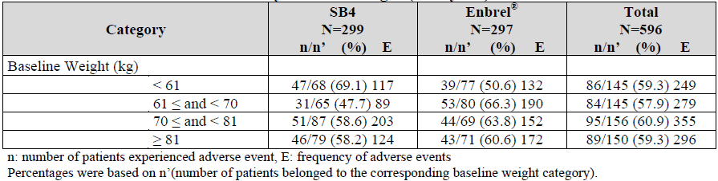

Regarding concurrent opioid therapy, very low numbers of patients (18 in total [3% of 596]; 11 subjects in the SB4 group and 7 patients in the Enbrel arm) recruited into Study SB4-G31-RA were taking such therapy, which is in contrast to the data concerning patients receiving biological therapies for severe RA in Australia. It is estimated that one quarter of adult patients receiving biologic therapy for RA in Australia are taking concurrent opioid therapy (according to the ARAD database). Although patients taking concurrent opioid therapy had a numerically higher incidence of overall and infection related AEs, this association was not statistically significant and the small overall patient numbers taking concurrent opioid therapy substantially limited the analysis.

#### Evaluator comment

The additional safety analyses provided by the sponsor in the response examining the potential relationship between ETN treatment (SB4, Enbrel and combined results) and subject weight at baseline or concurrent opioid therapy was not associated with a statistically increased incidence of overall or infection related AEs in Study SB4-G31-RA. The additional analyses are reassuring, but limited by small patient numbers in some of the interaction examinations.

### Question 9

*This submission contains data for Study SB4-G31-RA up to 52 weeks of treatment. However, the submission advises that the trial has an open-label, single-arm (all subjects to receive SB4 therapy), extension period of 52 weeks duration in subjects enrolled in Poland and the Czech Republic. Can the sponsor provide a study report for the open-label extension period of Study SB4-31-RA?*

#### Sponsor response

In the response, the sponsor has provided an interim report on data reported in the single-arm, open-label, extension phase of Study SB4-G31-RA, and the final clinical study report should be available upon request in late April 2016.

##### Subject disposition

Of the 596 patients (299 in the SB4 group and 297 in the Enbrel treatment arm), 505 subjects (259 in the SB4 group and 246 in the Enbrel treatment arm) completed 52 weeks of treatment. Among those completing subjects, 245 patients from Poland and the Czech Republic were enrolled in the open-label-extension phase. After unblinding, 126 patients were maintained on SB4 treatment and 119 subjects who had received Enbrel were switched to SB4 therapy in the extension phase. The majority of patients in each extension treatment group completed 100 weeks of therapy in total: 94.4% (119/126) in the continuing SB4 treatment group and 95.0% (113/119) in the Enbrel therapy arm. The 2 most common reasons for study discontinuation in the extension phase were withdrawal of consent (3 subjects in the continuing SB4 group and 4 patients in the treatment switch arm) and AEs (4 subjects in the continuing SB4 group and 1 patient in the treatment switch arm). Another patient in the treatment switch group was lost to follow-up.

##### Study treatment

Both treatment groups in the open-label extension phase (weeks 52-100) had a near identical exposure to SB4 therapy with subjects receiving a mean of 46 (median of 48) of weekly ETN injections (range: 3-48 injections). Similarly, the cumulative exposure to MTX was identical in both treatment groups in the extension phase with the median weekly dose being 15 mg (mean MTX dose of 15.7 mg/week).

##### Efficacy results

The preliminary open-label, extension phase efficacy data appears to show maintenance of treatment response up to 100 weeks of therapy with SB4 in adult patients with RA. At Week 100, the rate of ACR20 response was 77.9% (95/122) in the continuing SB4 group (versus 79.2% [99/125] at Week 52 in this group) and 79.1% (91/115) in the treatment switch arm (compared with 82.4% [98/119] in this cohort). At Week 100, the rate of ACR50 response was 59.8% (73/122) in the continuing SB4 group (versus 52.0% [65/125] at Week 52 in this group) and 60.9% (70/115) in the treatment switch arm (compared with 53.8% [64/119] in this cohort). At Week 100, the rate of ACR70 response was 42.6% (52/122) in the continuing SB4 group (versus 38.4% [48/125] at Week 52 in this group) and 41.7% (48/115) in the treatment switch arm (compared with 32.8% [39/119] in this cohort).

##### Safety results

In the open-label, extension phase of Study SB4-G31-RA, 173 AEs were reported in 60 subjects (47.6% of 126) treated with continuing SB4 injections and 123 AEs were recorded in 58 patients (48.7% of 119) who switched from Enbrel to SB4 therapy. After switching from Enbrel to SB4 at Week 52, the incidence and type of overall AEs, treatment related AEs, SAEs (including serious infection) and AEs leading to discontinuation were similar to those in the continuing SB4 treatment group and less than that observed in the first 52 weeks of treatment follow-up. Although the safety results in the open-label, extension phase dataset are preliminary, there were some noteworthy reports of significant AE types such as 1 case of thrombocytopenia in each of the extension treatment groups, 2 cases of cardiac failure in the treatment switch arm (versus zero in the continuing SB4 group), 3 cases of herpes viral infections (2 of which were herpes zoster) in the treatment switch group (versus 1 case of herpes simplex infection in the continuing SB4 arm) and 2 reports of oral candidiasis in the treatment switch group (versus zero in the continuing SB4 group). Furthermore, both extension treatment groups had 3 patients recording abnormalities of liver function tests.

#### Evaluator comment

The preliminary data up to week 100 of SB4 therapy obtained from the open-label, extension phase of Study SB4-G31-RA suggests maintenance of treatment response in those continuing SB4 treatment beyond 52 weeks, and for subjects switching from EU sourced Enbrel to SB4 at Week 52 there is also maintenance of treatment response. Moreover, the interim safety results do not appear to reveal any new safety concerns with continuing SB4 treatment up to 100 weeks or in those switched from EU sourced Enbrel to SB4 at Week 52. However, the data included in the response should be considered preliminary in nature and provision/evaluation of the final clinical study report for the open-label, extension phase of Study SB4-G31-RA should be a condition of registration.

### Question 10

*Could the sponsor provide data on whether any safety related concerns were identified if and when patients were switched from Enbrel to SB4 (or vice versa) in the open label phase of Study SB4-G31-RA?*

#### Sponsor response

In the preceding question of this response, the sponsor has provided an interim report including subject disposition, cumulative study drug exposure (SB4 and MTX), and efficacy and safety data for the open-label, extension phase of Study SB4-G31-RA. The new information included by the sponsor in response to this question concerns immunogenicity results. Overall, there was a low incidence of testing positive to ADA up to week 100. Only 1 patient (0.9% of 117) in the treatment switch group tested positive to non-neutralising ADA between weeks 52 and 100 (recorded at Week 76). One patient (0.8% of 123) in the continuing SB4 treatment group tested positive to non-neutralising ADA between Weeks 52 and 100 (recorded at Week100).

*Evaluator Comment:* The preliminary safety data up to Week 100 of SB4 therapy obtained from the open-label, extension phase of Study SB4-G31-RA does not reveal any new safety concerns with continuing SB4 treatment up to 100 weeks, or in those switched from EU sourced Enbrel to SB4 at Week 52. In particular, the rates of immunogenicity with SB4 remains very low in patients continuing to receive SB4 for up to 100 weeks, and also in those switched from Enbrel to SB4 at 52 weeks and followed for 48 weeks of switch therapy. However, the data included in the response should be considered preliminary in nature and provision/evaluation of the final clinical study report for the open-label, extension phase of Study SB4-G31-RA should be a condition of registration.

### Question 11

*In Study SB4-G31-RA, there was higher overall incidence of injection site reactions and injection site erythema with EU sourced Enbrel therapy versus SB4. Could the sponsor comment on whether or not the observed difference is a true and/or clinically significant finding? If the sponsor believes the observation to indicate a true potential difference between the formulations, what is/are the potential explanations and was there a signal of such in the non-clinical studies?*

#### Sponsor response

The sponsor concurs that the data reported in Study SB4-G31-RA shows a lower incidence of local, but not general or overall, injection site reactions with SB4 therapy (22 events in 11 [3.7%] subjects) compared with EU sourced Enbrel (157 events in 52 [17.5%] subjects), but the incidence of injection site reactions with both types of ETN in this trial are within the range of the published literature. In the response, the sponsor has provided a summary of 7 Enbrel treatment studies, which report the incidence of injection site reactions to vary between 10% and 49% over a broad range of treatment follow-up time intervals (12-104 weeks). In 6 of the 7 studies, Enbrel was administered at a dose of 25 mg twice weekly and in 1 trial the posology of Enbrel was 50 mg once weekly. The incidence of injection site reactions (19% at 16 weeks) was identical with either once or twice weekly ETN administration. In the 4 earlier published studies (published between 1999 and 2002), the incidence of injection site reactions was higher (37%-49% at 6 months) compared with the 3 later published studies (published between 2004 and 2006; injection site reaction incidence of 10-19% at 16-52 weeks). This observed difference for the frequency of injection site reactions according to date of publication (that is, higher rate in the 4 earlier conducted trials) may be confounded by the use of the concurrent DMARD use. In 3 of the 4 studies published between 1999 and 2002, no concurrent DMARD use was reported versus the 3 later published trials whereby concomitant DMARD (usually MTX) was required. The sponsor asserts that Study SB4-G31-RA is comparable with the 3 later published Enbrel studies, where the incidence of injection site reactions was 10-19% at 16-52 weeks (versus 3.7% for SB4 and 17.5% for EU sourced Enbrel at 12 months in Study SB4-G31-RA).

In the response, the sponsor hypothesised that SB4 may have certain quality attributes (for example, absence of latex in the needle shield and lack of L-arginine in the formulation), which may result in a lower incidence of local injection site reactions compared with EU sourced Enbrel. Nonetheless, the sponsor asserts that the observed difference in the incidence of injection site reactions is comparable between SB4 and EU sourced Enbrel in Study SB4-G31-RA, and that there is no clinically meaningful difference in the frequency of injection site reactions between the ETN therapies.

#### Evaluator comment

The reported incidence of local injection site reactions in Study SB4-G31-RA is numerically lower with SB4 therapy versus EU sourced Enbrel, and for the SB4 treatment group appears to be lower than expectations (≥ 10% incidence) from the relevant published data. The mechanism underlying this observation remains unclear, but the sponsor has proposed some potential hypotheses. In the supportive study included in this submission (Study SB4-G11-NHV), the incidence of injection site reactions in this single dose, crossover design trial involving healthy adult subjects was similar (4.3-6.5%) between the 3 different formulations of ETN (SB4, EU and US sourced Enbrel). Overall, the totality of the safety dataset does not indicate a robust and clinically significant safety difference between SB4 and Enbrel formulations with respect to injection site reactions (overall, generalised and local).

### Question 12

*In both studies included in this submission, the incidence of testing positive to etanercept anti-drug antibodies was higher in subjects who received Enbrel (EU or US sourced) compared to those administered SB4 therapy. Could the sponsor comment on why there is a distinctly observed difference in rates of immunogenicity between SB4 and reference therapy?*

#### Sponsor response

In the response, the sponsor does not refute the observation of a lower incidence of ADA being seen with SB4 therapy versus Enbrel (EU and US sourced) in both of the submitted studies. The sponsor has identified 3 potential quality attributes of SB4 compared with EU sourced Enbrel (lower content of high molecular weight product aggregates, lower content of host cell protein impurities and differences in glycosylation with SB4), which have the potential to affect (that is, lower) the rates of immunogenicity according to published indirect evidence.

#### Evaluator comment

The incidence of testing positive to ADA in Study SB4-G31-RA is numerically lower with SB4 therapy (1.0% by Week 52) versus EU sourced Enbrel (13.2%), and for the SB4 treatment group appears to be lower than expectations (≥ 6% incidence) from the relevant published data. The mechanism underlying this observation remains unclear, but the sponsor has proposed 3 potential hypotheses, which are indirectly supported by published data. In the supportive study included in this submission (Study SB4-G11-NHV), the incidence of ADA at Day 29 in this single dose, crossover design trial involving healthy adult subjects was zero for SB4 compared with 13-27% for Enbrel (EU and US sourced). In conclusion, the immunogenicity data included in this submission shows a lower rate of testing positive for ADA to ETN with SB4 therapy versus Enbrel, but the clinical implications of this observation is unclear as the development of ADA to any formulation of ETN has not been shown to significantly influence clinical outcomes (safety and efficacy), which is in contrast to other anti-TNF therapies such as infliximab and adalimumab where the development of ADA is clearly associated with loss of efficacy and possibly, some safety concerns.

### Question 13

*If granted registration in Australia, is the sponsor planning on conducting any post-market surveillance studies in Australia or proposing to establish a patient registry in Australia?*

#### Sponsor response

In the EU-RMP, the sponsor has provided plans for several European and 2 UK based registry studies, each of up to 10 years duration, across the range of proposed adult treatment indications for SB4 including RA, PsA, PSOR and AS. The sponsor is planning to provide annual reports for the registry studies to the EMA. The sponsor has no plans to conduct any specific Australian post-marketing studies as it asserts that the recruited populations and treatment standards in the European and British registry studies are similarly to the Australian practice setting, and any observed results can be extrapolated and applied to Australia from that dataset. The sponsor proposes to monitor for any safety signals in Australia through routine pharmacovigilance and has committed to submitting the annual European registry reports to the TGA.

#### Evaluator comment

Although there are some important demographic differences (for example, higher proportion of patients of Asian ethnicity in Australia versus Europe, and indigenous populations), the European and British registry experience is likely to reflect patient outcomes (safety and efficacy) in Australia, as there is significant overlap between the regions with respect to contemporary practice standards and patient/disease characteristics. The evaluator would not recommend an Australian specific post-marketing registry study as a condition of registration. The sponsor proposal to conduct routine post-marketing pharmacovigilance within Australia, and regular updates to the TGA of the European and British registry experience is appropriate if registration of SB4 is granted.

## Second round benefit-risk assessment

### Second round assessment of benefits

After consideration of the responses to the clinical questions, the potential benefits of SB4 in the proposed usage are better than expected after the first round evaluation. In particular, the sponsor has clarified details about the population recruited into the single pivotal clinical efficacy trial (Study SB4-G31-RA) to indicate that adult patients with active RA who were MTX inadequate responders for at least 6 months prior to involvement in this trial were studied. This is representative of the RA population approved to receive treatment with Enbrel. Study SB4-G31-RA demonstrated that SB4 exhibited comparable efficacy response rates to Enbrel in improving the symptoms and signs of active RA in adult patients (for example, ACR20 response rates of 78-80.5%[14] at 24 and 52 weeks) as well as for many secondary clinical efficacy variables and slowing the structural disease progression. In addition, the preliminary data available in the open-label, extension phase of Study SB4-G31-RA indicates that there is maintenance of treatment effect with SB4 for up to 100 weeks of continuous therapy, and that for patients who switch from Enbrel to SB4 at Week 52 there is a high rate of clinical response at Week100 (that is, 48 weeks after treatment switch).

### Second round assessment of risks

After consideration of the responses to the clinical questions, the risks of SB4 in the proposed usage are unchanged from those identified the first round. The sponsor has provided preliminary data with a longer duration of treatment follow-up (up to 100 weeks) in a subset of patients involved in the single pivotal trial (Study SB4-G31-RA), which does not appear to indicate any new safety concerns (incidence or type) with SB4. Furthermore, a limited number of patients (n=119) who have switched from EU sourced Enbrel to SB4 after 1 year of therapy appear to have no additional safety concerns for up to 48 weeks after switching ETN formulations.

### Second round assessment of benefit-risk balance

The updated submission indicates that the benefit-risk balance of SB4 is favourable for the treatment of active RA in adult patients, who are inadequate responders to MTX (Study SB4-G31-RA). In the response, the sponsor has provided data with SB4 therapy which matches the approved target population of the reference product, Enbrel.

Furthermore, the preliminary data from the open-label, extension phase of Study SB4-G31-RA supports the favourable benefit-risk balance of SB4 in adult patients with RA to 100 weeks of treatment follow-up. This submission also contains a sufficient volume of data to support the claim that SB4 is pharmacokinetically equivalent to the reference product, Enbrel, in adult patients with active RA (Study SB4-G31-RA) and healthy, young-middle aged males (Study SB4-G11-NHV).

In the response, the sponsor has provided a review of the literature on the role of TNF in the disorders covered by the therapeutic indications of Enbrel and its potential mechanism of action. The mechanism of action of ETN is complex but the primary mode of action results from direct blocking of TNF receptor-mediated biological activities. ETN is a soluble TNFR fusion protein that competitively inhibits TNF by binding to it, thereby blocking the interaction between TNF and TNF receptors. This is thought to prevent various pro-inflammatory cellular responses that are recognised to occur in autoimmune conditions ranging from RA to AS and PSOR. Moreover, the sponsor has provided sufficient justification for the extrapolation of indications for SB4 to include that which are approved for Enbrel on the basis of biosimilarity. Extrapolation of the PK, efficacy and safety data generated in the 2 trials in this submission which examined adult patients with RA and normal healthy volunteers is adequate on the basis of the results of the pre-clinical studies (that is, in vitro and ex vivo comparability data on the functionalities of the ETN molecule).

On the safety aspect, there is an increased risk of infection (overall and serious) with SB4 which appears to be comparable to Enbrel. The 2 submitted studies show a risk of injection site reactions with SB4, which is numerically lower (for local events) than that observed with Enbrel therapy. There are limitations to the current dataset which will require ongoing pharmacovigilance. The efficacy and safety of SB4 in patients at a high risk of infection is not established. The updated submission contains limited information about the safety and efficacy of switching to SB4 from Enbrel, or vice versa.

### Second round recommendation regarding authorisation

The evaluator recommends acceptance of the sponsor’s proposed registration of SB4 to include all of the 5 approved adult treatment indications for Enbrel. The submission provides robust evidence that SB4 is therapeutically equivalent to Enbrel in improving the signs and symptoms of active RA in adult patients. In terms of safety, the 2 formulations of ETN appear to be clinically equivalent for the incidence and type of clinically significant safety concerns. The SB4 clinical study program appears to show a lower incidence of local injection site reactions and immunogenicity in RA patients treated with SB4 compared to Enbrel, which remains of unclear explanation. Moreover, the safety profile (incidence and type) of SB4 is within historical expectations for ETN in the target population.

In the response, the sponsor has provided a review of the literature on the role of TNF in the disorders covered by the therapeutic indications of Enbrel and the potential mechanisms of action. The mechanism of action of ETN is complex but the primary mode of action results from direct blocking of TNF receptor-mediated biological activities. ETN is a soluble TNFR fusion protein that competitively inhibits TNF by binding to it, thereby blocking the interaction between TNF and TNF receptors. This is thought to prevent various pro-inflammatory cellular responses that are recognised to occur in autoimmune conditions ranging from RA to AS and PSOR. The sponsor has now provided sufficient justification for the extrapolation of indications for SB4 to include that which are approved for Enbrel on the basis of biosimilarity. Extrapolation of the PK, efficacy and safety data generated in the 2 trials in this submission which examined adult patients with RA and normal healthy volunteers is justifiable on the basis of the results of the pre-clinical studies (that is, in vitro and ex vivo comparability data on the functionalities of the ETN molecule). Overall, the results observed in Study SB4-G31-RA can be considered a clinical disease model of adequate sensitivity for assessing the efficacy and safety of SB4 in inflammatory spondylitis, PsA and PSOR.

After the sponsor’s response, there is residual concern that the sponsor is specifically not requesting registration of the 2 approved paediatric treatment indications for Enbrel and not providing a 25 mg vial presentation, which has the potential for prescribing and dispensing errors occurring with the registration of 2 ETN formulations in Australia.

The evaluator would recommend that approval of the sponsor’s proposed registration be subject to regular periodic safety update reports and the provision by the sponsor to the TGA of the final clinical study report for the open-label, extension phase of Study SB4-G31-RA.

## References

Combe B, Codreanu C, Fiocco U, Gaubitz M, Geusens PP, Kvien TK, Pavelka K, Sambrook PN, Smolen JS, Wajdula J and Fatenejad S for the Etanercept European Investigators Network (The Etanercept Study 309 Investigators). Etanercept and sulfasalazine, alone and combined, in patients with active rheumatoid arthritis despite receiving sulfasalazine: a double-blind comparison. Ann Rheum Dis 2006; 65:1357–62.

Feagan BG, Choquette D, Ghosh S, Gladman DD, Ho V, Meibohm B, Zou G, Xu Z, Shankar G, Sealey DC, Russell AS. The challenge of indication extrapolation for infliximab biosmilars. Biologicals 2014; 42: 177-83.

Kay J and Smolen JS. Biosimilars to treat inflammatory arthritis: the challenge of proving identity. Ann Rheum Dis 2013; 72: 1589-93.

Keystone EC, Schiff MH, Kremer JM, Kafka S, Lovy M, DeVries T, Burge DJ. Once-weekly administration of 50 mg etanercept in patients with active rheumatoid arthritis – Results of a multicenter, randomized, double-blind, placebo-controlled trial. Arthritis Rheum 2004; 50: 353-63.

Lee H. Is Extrapolation of the Safety and Efficacy Data in One Indication to Another Appropriate for Biosimilars? Amer Ass Pharm Sci 2014; 16: 22-6.

Sullivan J, Ni L, Sheelo C et al. Bioequivalence of liquid and reconstituted lyophilized etanercept subcutaneous injections. J Clin Pharmacol. 2006; 46: 654–661.

Weinblatt ME, Kremer JM, Bankhurst AD, Bulpitt KJ, Fleischmann RM, Fox RI, Jackson CG, Lange M, Burge DJ. A trial of etanercept, a recombinant tumor necrosis factor receptor:Fc fusion protein, in patients with rheumatoid arthritis receiving methotrexate. N Engl J Med 1999; 340:253-9.

Zhou H. Clinical pharmacokinetics of etanercept: A fully humanized soluble recombinant tumor necrosis factor receptor fusion protein. J Clin Pharmacol 2005; 45:490-7.

Zhou SY, Shu C, Korth-Bradley J, Raible D, Palmisano M, Wadjula J, Fatenejad S, Bjornsson T. Integrated population pharmacokinetics of etanercept in healthy subjects and in patients with rheumatoid arthritis and ankylosing spondylitis. J Clin Pharmacol 2011; 51:864-75.

|  |
| --- |
| Therapeutic Goods Administration |
| PO Box 100 Woden ACT 2606 Australia  Email: [info@tga.gov.au](mailto:info@tga.gov.au) Phone: 1800 020 653 Fax: 02 6232 8605  [**https://www.tga.gov.au**](https://www.tga.gov.au) |

1. ERA Consulting Pty Ltd was the sponsor of this submission but after the inclusion of the product on the ARTG the sponsor was changed to Samsung Bioepis AU Pty Ltd.
2. Excluding MTX
3. excluding MTX. The evaluator was initially concerned at the high proportion of patients who were DMARD naïve however this was subsequently clarified in the round two assessment that all patients had received at least 6 months of methotrexate prior to randomisation at a mean weekly dose of 15.5 mg and that this was an appropriate level of prior MTX use before considering anti-TNF treatment.
4. The evaluator was initially concerned at the high proportion of patients who were DMARD naïve however this was subsequently clarified in the round two assessment that all patients had received at least 6 months of methotrexate prior to randomisation at a mean weekly dose of 15.5 mg and that this was an appropriate level of prior MTX use before considering anti-TNF treatment.
5. Immunogenicity samples were collected at Week 0, 2, 4, 8, 12, 16, 24 and 52.
6. This is further discussed in section 8.3.2.1 below.
7. administration site reactions regarded as
8. and infestation
9. After the finalisation of this report, approval was given in the EU and Korea.
10. administration site reactions regarded as
11. excluding MTX
12. The evaluator was initially concerned at the high proportion of patients who were DMARD naïve however this was subsequently clarified in the round two assessment that all patients had received at least 6 months of methotrexate prior to randomisation at a mean weekly dose of 15.5 mg and that this was an appropriate level of prior MTX use before considering anti-TNF treatment.
13. Target treatment population was adult patients with active RA who were MTX inadequate responders for at least 6 months prior to involvement in this trial were studied (see AusPAR p53 for discussion).
14. 78.1-80.8% for SB4 and 80.5-81.5% for Enbrel at 24 and 52 weeks.