August 2013

Australian Public Assessment Report for everolimus
  - Proprietary Product Name: Afinitor
  - Sponsor: Novartis Pharmaceuticals Australia Pty Ltd
About the Therapeutic Goods Administration (TGA)
- The Therapeutic Goods Administration (TGA) is part of the Australian Government Department of Health and Ageing, and is responsible for regulating medicines and medical devices.
- The TGA administers the Therapeutic Goods Act 1989 (the Act), applying a risk management approach designed to ensure therapeutic goods supplied in Australia meet acceptable standards of quality, safety and efficacy (performance), when necessary.
- The work of the TGA is based on applying scientific and clinical expertise to decision-making, to ensure that the benefits to consumers outweigh any risks associated with the use of medicines and medical devices.
- The TGA relies on the public, healthcare professionals and industry to report problems with medicines or medical devices. TGA investigates reports received by it to determine any necessary regulatory action.
- To report a problem with a medicine or medical device, please see the information on the TGA website <http://www.tga.gov.au>.
About AusPARs
- An Australian Public Assessment Record (AusPAR) provides information about the evaluation of a prescription medicine and the considerations that led the TGA to approve or not approve a prescription medicine submission.
- AusPARs are prepared and published by the TGA.
- An AusPAR is prepared for submissions that relate to new chemical entities, generic medicines, major variations, and extensions of indications.
- An AusPAR is a static document, in that it will provide information that relates to a submission at a particular point in time.
- A new AusPAR will be developed to reflect changes to indications and/or major variations to a prescription medicine subject to evaluation by the TGA.
Copyright
© Commonwealth of Australia 2013
This work is copyright. You may reproduce the whole or part of this work in unaltered form for your own personal use or, if you are part of an organisation, for internal use within your organisation, but only if you or your organisation do not use the reproduction for any commercial purpose and retain this copyright notice and all disclaimer notices as part of that reproduction. Apart from rights to use as permitted by the Copyright Act 1968 or allowed by this copyright notice, all other rights are reserved and you are not allowed to reproduce the whole or any part of this work in any way (electronic or otherwise) without first being given specific written permission from the Commonwealth to do so. Requests and inquiries concerning reproduction and rights are to be sent to the TGA Copyright Officer, Therapeutic Goods Administration, PO Box 100, Woden ACT 2606 or emailed to <tga.copyright@tga.gov.au>.

Contents
I. Introduction to product submission 4
Submission details 4
Product background 4
Regulatory status 5
Product Information 5
II. Quality findings 5
III. Nonclinical findings 5
Introduction 5
Pharmacology 6
Nonclinical summary and conclusions 8
IV. Clinical findings 9
Introduction 9
Pharmacokinetics 9
Dose selection for the pivotal study 14
Efficacy 15
Safety 20
List of questions 30
Clinical summary and conclusions 30
V. Pharmacovigilance findings 35
Risk management plan 35
VI. Overall conclusion and risk/benefit assessment 40
Quality 40
Nonclinical 40
Clinical 40
Risk management plan 42
Risk-benefit analysis 42
Outcome 50
Attachment 1. Product Information 50

I. Introduction to product submission

Submission details
Type of Submission | Extension of indications
Decision: | Approved
Date of Decision: | 21 February 2013

Active ingredient(s): | Everolimus
Product Name(s): | Afinitor
Sponsor’s Name and Address: | Novartis Pharmaceuticals Australia Pty Ltd  54 Waterloo Road  North Ryde NSW 2113
Dose form(s): | Tablet
Strength(s): | 2.5 mg, 5 mg and 10 mg
Container(s): | Blister pack
Pack sizes: | 2.5 mg: 10, 30, 90  5 and 10 mg: 30, 50, 60, 100, 120
Approved Therapeutic use: | For the treatment of postmenopausal women with hormone receptor-positive, HER2-negative advanced breast cancer in combination with exemestane after failure of treatment with letrozole or anastrozole.
Route(s) of administration: | Oral
Dosage: | 10 mg once daily
ARTG Number (s) | 177648; 154661; 154663

Product background
This AusPAR describes an application by the sponsor, Novartis Pharmaceuticals Australia Pty Ltd, to extend the indications for everolimus (Afinitor), to the treatment of breast cancer. The new proposed indication is:
For the treatment of postmenopausal women with hormone receptor-positive advanced breast cancer in combination with an aromatase inhibitor, after prior endocrine therapy.
Everolimus inhibits the protein kinase mTOR (mammalian target of rapamycin). Rapamycin is also known as sirolimus. mTOR is a key serine threonine kinase playing a central role in the regulation of cell growth proliferation and survival. Activation of the mTOR pathway is a key adaptive change driving endocrine resistance in breast cancer. Various signal transduction pathways are activated to escape the effect of endocrine therapy.
The drug is well absorbed after oral administration, cleared mainly by cytochrome P450 isoenzyme 3A4 (CYP3A4) metabolism and has a mean plasma elimination half life of 30 h. Serious adverse reactions include pneumonitis, opportunistic infection, hypersensitivity, oral ulceration and renal failure.

Regulatory status
Everolimus (Certican) was first registered in Australia in March 2005 for the prophylaxis of organ rejection in adult patients at mild to moderate immunological risk receiving an allogeneic renal or cardiac transplant. A new trade name (Afinitor) and the following additional indications have since been approved:
- Progressive, unresectable or metastatic, well or moderately differentiated neuroendocrine tumours (NETs) of pancreatic origin
- Advanced renal cell carcinoma after failure or treatment with sorafenib or sunitinib
- Subependymal giant cell astrocytoma (SEGA) associated with tuberous sclerosis (TS) who require therapeutic intervention but are not candidates for curative surgical resection.
The same application has been submitted in the US, EU, Canada and Switzerland.

Product Information
The approved Product Information (PI) current at the time this AusPAR was prepared can be found as Attachment 1.

II. Quality findings
There was no requirement for a quality evaluation in a submission of this type.

III. Nonclinical findings

Introduction
The sponsor has submitted an application to extend the indications of Afinitor (everolimus) for the treatment of hormone receptor-positive advanced breast cancer in combination with an aromatase inhibitor (AI). For the proposed new indication the dose and the daily dose (10 mg) is the same as the maximum daily dose for the currently approved anti neoplastic indications (2.5-10 mg/day). The nonclinical component of the submission consisted of 28 pharmacodynamic (PD) studies (most well designed, conducted and written) in support of this extension of indication. Submitted studies were principally designed to support the new indication and proposed mechanism of action on mTOR signalling pathways.

Pharmacology

Primary pharmacology
Nonclinical studies demonstrated that everolimus inhibits breast tumour growth with modest effects in some slow growing tumour animal xenograft models. However, everolimus does not generally result in tumour regression and it is not effective against all human breast carcinomas tested in vitro. In vitro studies in aromatase expressing breast cancer cell lines (MCF7/Aro) showed increased anti proliferation activity for the everolimus/letrozole combination compared to each agent alone. The tumour inhibitory dose in mice with human tumour xenografts was 5-20 mg/kg, with plasma Cmax (maximum plasma drug concentration) more than 200 times the clinical Cmax. Treatment was well tolerated with usually no remarkable body weight loss.

In vitro activity/anti proliferative effects
It has been previously shown that everolimus inhibits the mTORC1 pathway by binding to the FKBP-12 protein with high affinity. In studies provided in this submission, everolimus inhibited the proliferation of human and rodent cancer cell lines of various origins in vitro, with inactivation of p70s6k (40D ribosomal S6 protein kinase) and dephosphorylation of 4EBP1 (eukaryotic initiation factor 4E binding protein), both downstream signalling components of the mTOR pathway (Figure 1) in both everolimus sensitive and resistant tumour cell lines; however, the effects on these molecular targets were not always correlated with the anti proliferative response, possibly related to the anti angiogenic activity of everolimus in vivo (see ‘Anti angiogenic activity of everolimus’ below). The everolimus and letrozole combination on proliferation in aromatase expressing MCF7/Aro cells in vitro showed synergistic effects since more potent inhibition was observed compared to either alone.
Figure 1: The mTOR signalling pathway (RAD001 = everolimus).
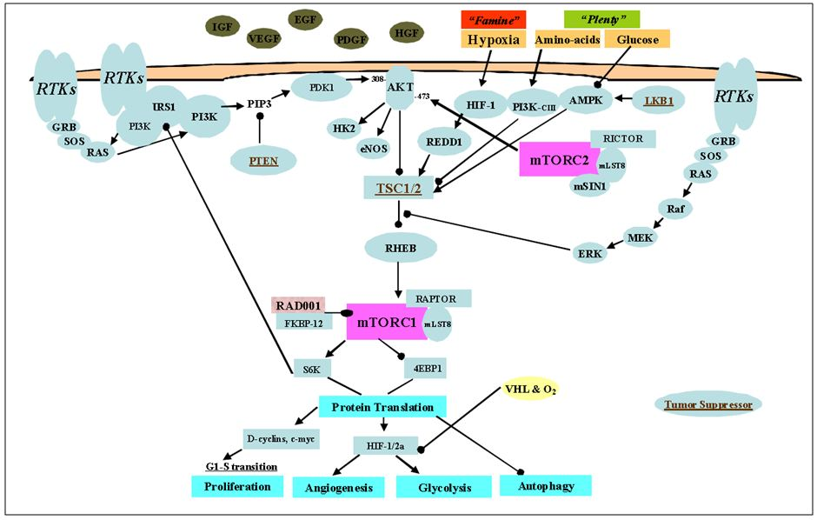
The sensitivity to everolimus of the breast tumour cell lines tested in vitro including the oestrogen receptor-positive cell lines varied. While some cell lines were found to be sensitive, other cell cells were resistant to everolimus treatment. The most sensitive cell lines were the enriched oestrogen receptor-positive and HER2 amplified subtypes. Comparison of in vitro IC50s (concentration at which 50% of the activity is inhibited) and anti tumour activity in mouse xenograft models showed some correlation of in vitro antiproliferative activity with the inhibition of tumour growth in vivo, but the prediction of in vivo activity by in vitro IC50s is not very reliable. Tumour growth of breast cancer cells that were found to be tolerant to everolimus in vitro were inhibited in the nude mouse model implanted with the cancer cells (see ‘Correlation of in vitro and in vivo sensitivity to everolimus’ below).

Biomarkers of tumour sensitivity and resistance
To identify molecular and cellular markers of resistance and sensitivity to everolimus, the effect of everolimus treatment on AKT S473 phosphorylation levels were studied. The results indicated that everolimus increased S473 phosphorylation. However, differences in the kinetics of induction and a lack of robust changes suggested that this potential marker of response may be difficult to monitor. Other ex vivo studies showed that everolimus effects on skin derived p70s6k activity closely mirrored those in tumour tissue (from the same mouse), indicating skin samples may be suitable for biomarker/surrogate marker evaluation. Similarly, the S6K1 activity was significantly inhibited in peripheral blood mononuclear cells (PBMCs), suggesting blood sampling could also provide source material for biomarker determination.

In vivo effects of everolimus
In vivo studies using human primary tumour derived breast cancer xenograft models in immunosuppressed (athymic/nude) mice showed that everolimus suppressed tumour growth for most tumours tested, including some tumours that were resistant to everolimus in vitro. However, everolimus displayed only moderate effects in slow growing tumour animal xenograft models. Where direct comparisons were made the anti tumour activity of everolimus was similar to standard cytotoxic agents such as capecitabine, docetaxel, doxorubicine and cyclophosphamide. There are no in vivo animal studies investigating the anti tumour effects of everolimus in combination with an AI.
The effective doses reported in the mouse studies were 5-20 mg/kg. From data derived from a previous submission, the plasma and tumour tissue Cmax values in tumour bearing Balb/c nu/nu female mice with epidermoid tumour xenografts given 5 mg/kg everolimus PO (per os; orally) were 2513 ng/mL and 102 ng/mL, respectively. The plasma Cmax in mice at the lowest PO dose of 5 mg/kg is higher than the human plasma Cmax at the proposed clinical dose of 10 mg per day.
The mTOR pathway is central to many signal transduction pathways and metabolic processes in the cell and is known to be upregulated in some tumours. Everolimus can potentially be combined with a variety of anti cancer agents. This was tested by the sponsor in vitro and in vivo (with trastuzumab only) and in almost all cases, everolimus combined with other agents led to increased efficacy.

Correlation of in vitro and in vivo sensitivity to everolimus
Nonclinical studies did not show a clear correlation of in vitro activity and the anti tumour effect in animal models of implanted tumours. In one study, breast cancer cells classified as resistant by in vitro assays, were found to be sensitive to everolimus treatment in the nude mouse model at PO doses of 10 mg/kg. This suggests that other factors (for example, anti angiogenic activity) may be important for activity in vivo.

Anti angiogenic activity of everolimus
An important aspect of the antitumor effect of everolimus is its potential to act on both tumour cells directly (by inhibition of mTOR leading to inhibition of cell cycle progression to inhibit growth) and indirectly (by inhibiting angiogenesis following mTOR inhibition). The observation of the in vivo sensitivity of some xenografts (which were comprised of cells with resistance to everolimus in vitro) is proposed to be attributed to everolimus’s potential to act on the vascular component of the supporting peritumoral stroma. Discussed in a previous submission by the same sponsor, an indirect antitumor effect could result from everolimus inhibiting tumour neovascularisation. The anti angiogenic properties of everolimus has been confirmed through experiments demonstrating the effect of everolimus in countering VEGF induced proliferation of human umbilical endothelial cells (HUVECs) in vitro and VEGF driven angiogenesis in a ‘chamber implant murine model’.

Everolimus metabolite
ATG181 is a major metabolite in humans. In a previously evaluated study, it was shown to have high affinity binding for the molecular target of everolimus (a 2 fold higher affinity than everolimus for the cytoplasmic protein/intracellular molecular target FKBP-12), but low activity in the mouse mixed lymphocyte reaction (MLR) T cell immune response assay [100 fold less active]. In an in vitro study provided with this submission, ATG181 was over 300 fold less active than everolimus in cultured human lung cancer A549 cells. This suggests the metabolite is unlikely to contribute significantly to the anti tumour activity of everolimus in vivo.

Nonclinical summary and conclusions
- An application has been submitted by Novartis Pharmaceuticals Australia Pty Ltd to extend the indications of Afinitor (everolimus; tablets, 2.5, 5 and 10 mg) to include the treatment of postmenopausal women with hormone receptor-positive advanced breast cancer in combination with an AI, after prior endocrine therapy.
- The proposed dose and dosage regimen for the new indication (10 mg/day) is the same as the maximum daily dose for the currently approved anti neoplastic indications of Afinitor (2.5-10 mg/day).
- The new nonclinical data comprises 28 pharmacology studies, the majority of which were conducted by the sponsor.
- The molecular target for everolimus is mTOR (mammalian target of rapamycin), a key serine threonine kinase with known roles in regulating protein synthesis and ultimately cell growth, cell proliferation, angiogenesis and survival. Downstream of PI3/AKT, mTOR has been considered as a component in the PI3K/AKT/mTOR pathway now known to be dysregulated in numerous human cancers and tumours.
- Tumour growth was inhibited by everolimus in the majority of the human tumours tested in vitro and in vivo in athymic mice (including tumours of breast origin) although some tumour cell lines (including breast cancer cell lines) were resistant to everolimus. Everolimus inhibited the activity of S6K1 kinase (40D ribosomal S6 protein kinase) and reduced phosphorylation of 4E-BP1 (eukaryotic initiation factor-4E binding protein), both downstream signalling components of the mTOR pathway, in both everolimus sensitive and resistant tumour cell lines. However, the effects on these molecular targets were not always correlated with anti proliferative activity in vitro. Nor did the sensitivity of tumour cells in vitro reliably predict the in vivo anti tumour response.
- Submitted pharmacology studies support the proposed mechanism of action of everolimus by demonstrating effects on mTOR signalling pathways and anti tumour activity.
- Overall, in experimental tumour models everolimus showed anti tumour activity in vitro and in vivo. Although not all tumour cell lines (including breast cancer cell lines) were sensitive to everolimus in vitro, the lack of anti proliferative effect in vitro did not always correlate with subsequent in vivo anti tumour activity effects seen in animal (xenograft) models of implanted human tumours. Analysis of various biomarkers showed that anti tumour activity was consistent with the mechanism of action (that is, inhibition of the mTOR pathway). Moreover, studies in a previous submission, the anti tumour activity also attributes to an anti angiogenic component. An in vitro assay with aromatase expressing cancer cells demonstrated synergistic activity of everolimus and letrozole, but there is no in vivo study on the anticancer efficacy of the combination of everolimus and an AI.
- There are no nonclinical objections to the proposed extension of indications.

IV. Clinical findings

Introduction
Three studies are provided in this submission for evaluation. The pivotal clinical study Y2301 (BOLERO-2) is a randomised double blind multicentre Phase III trial of everolimus plus the AI exemestane versus placebo plus exemestane in post menopausal women with oestrogen receptor positive, HER2 negative advanced breast cancer with recurrence or progression following prior therapy with letrozole or anastrozole. Patients were randomised in a 2:1 ratio to receive either everolimus in a dose of 10 mg per day or placebo in addition to open label exemestane 25mg per day. Primary endpoint for the study was progression free survival (PFS) with secondary endpoints included overall survival (OS), overall response rate (ORR), clinical benefit rate (CBR), safety, and change in quality of life. A total of 724 patients were randomised in the 2:1 ratio with a combination of everolimus plus exemestane involving 485 patients or placebo plus exemestane involving 239 patients.
To support changes in the PI, two pharmacokinetic (PK) studies are submitted:
- Study X2103: an open label two period fixed sequence study to investigate the effects of everolimus on the PK of midazolam in healthy volunteers;
- Study C2101-2102: a Phase I study investigating everolimus as monotherapy in patients with advanced solid cancers. This study was previously evaluated for relevant PK data but update is provided in relation to changes in the PK parameter AUC (area under the plasma concentration-time curve) in humans.
Relevant study reports together with summaries are provided for these two studies.
All aspects of Good Clinical Practice (GCP) were observed in the studies submitted.

Pharmacokinetics

Studies providing PK data
Three studies providing PK data are presented in this submission. The pivotal study Y2301 (BOLERO-2) involves PK evaluation of up to 88 patients in whom pre dose and 2 h post dose blood samples for concentrations and determination of everolimus in blood and exemestane in plasma were collected.
A second Study X2103 compared the effects of everolimus on the PK of midazolam with the primary objective to confirm that everolimus has no inhibitory effect on the PK of CYPA4-5 product substrate midazolam.
The third PK study involved an update of Study C2101-2102, a Phase I study investigating everolimus as monotherapy in patients with advanced solid cancers. The PK objective was to characterise the PK of everolimus at 5 mg, 10 mg, 20 mg, 30 mg, 50 mg, 70 mg given weekly and 5 mg and 10 mg given daily. This study has been previously submitted for evaluation but an update has revealed that the PK parameter AUC in humans has been revised from 514 ngm.h/ml to 560 ngm.h/ml, resulting in an update of the exposure ratio of animal/human based on the amended human systemic exposure at 10 mg per day.

Study Y2301 (BOLERO-2)
This is the pivotal study of the submission being a multicentre double blind randomised placebo controlled international Phase III study evaluating the treatment with everolimus in a dose of 10 mg per day versus placebo in combination with exemestane in a dose of 25 mg per day in post menopausal women with locally advanced or metastatic oestrogen receptor-positive breast cancer refractory to non steroidal AI.
Pre dose (Cmin) and 2 h post dose (C2h) blood samples for concentration determination of everolimus in blood in exemestane in plasma was collected in up to 88 patients at steady state at Visit 4. Blood samples for concentration determination of oestradiol were also collected in these patients at baseline on Visit 4 to evaluate the indirect effect of co administration of everolimus on the oestradiol level.
Everolimus is rapidly absorbed after oral administration with a median Tmax (time to reach maximum plasma concentration following drug administration) of 1-2 h post dose. Exemestane appears to be more rapidly absorbed in women with breast cancer with a Tmax of 1.2 h than in healthy women with a Tmax of 2.9 h.
All PK analyses were based on the safety population in patients with evaluable samples. However, only confirmed Cmin and C2h of everolimus and exemestane PK samples were included in the analysis.
In relation to everolimus exposure assessed as either Cmin or C2h, this was consistent with corresponding values observed in previous trials of everolimus in the 10 mg daily dose. Exposure of everolimus was similar in Japanese and non Japanese patients.
In relation to exemestane exposure average exemestane Cmin, C2h were 45% and 71% higher respectively when co administered with everolimus. This was similar in Japanese and non Japanese patients.
Everolimus is mainly metabolised by the CYP3A4 isoenzyme in the liver and to some extent in the intestinal wall by CYP3A4 aldoketoreductases. A slight increase in exemestane when co administered with everolimus could be due to competitive inhibition of the CYP3A4 metabolism. It appeared that exemestane had no significant effects on exposure of everolimus as the mean everolimus Cmin or C2h observed in this study was consistent with corresponding values observed in previous trials of everolimus 10 mg daily dose.
In relation to oestradiol exposure, oestradiol concentrations were measured in the study as a biomarker for the activity of exemestane. Oestradiol concentrations were comparable between the two treatment arms at baseline as well as Week 4 for the overall population and by region (Japanese versus non Japanese). The patient population in the Japanese patients on the placebo plus exemestane arm were small, making these results unreliable. It is noted the median changes from baseline in oestradiol level at Week 4 were similar between the two treatment arms in non Japanese patients. This suggests the increase in exemestane exposure had no clinically significant effect on endogenous oestradiol levels.
To determine whether any changes in oestradiol levels were related to everolimus exposure, a correlation between everolimus Cmin and oestradiol at Week 4 revealed that 18 patients had both valid samples and there is no statistically significant correlation between everolimus Cmin and oestradiol concentration in Week 4. Correlation between everolimus Cmin and change from baseline in oestradiol at Week 4 was also assessed in 11 patients with valid samples which show no statistically significant correlation between everolimus Cmin and change from baseline in oestradiol concentration at Week 4. Any change in the oestradiol from baseline at Week 4 was not likely related to everolimus exposure.
In an effort to assess the relationship between efficacy and time average dose in the absence of sufficient concentration data to perform exposure response analyses, the effect of everolimus exposure on tumour regression could not be directly ascertained. An analysis was performed to assess the potential impact of dose reductions and interruptions by exploring the anti tumour activity of patients who received time average doses of <7.5 mg and those who received ≥7.5 mg. It is worth noting that the numbers involved are relatively small making results liable to unreliability. The results did show that patients in the everolimus plus exemestane arm with time average dose to event of ≥7.5 mg for the 24.9% best percentage reduction in target lesion in comparison to a 17.4% reduction for patients with time average dose of <7.5 mg. Results of the Cox proportional hazard model showed the comparison for placebo plus the exemestane arm patients on everolimus plus exemestane arm with a time average everolimus dose of <7.5 mg had a PFS hazard ratio (HR) of 0.37 compared to those patients who had time average everolimus dose of ≥ 7.5mg per day with a PFS HR of 0.46. These observed differences in tumour regression data are small and not considered to be of clinical significance. This suggests that an effective dose modification guideline implemented in the protocol could be used to manage treatment toxicity without compromising efficacy.
Comment: This data would indicate that when everolimus is administered in combination with exemestane, while there is an increase in average exemestane concentrations compared to exemestane alone, this increase in exemestane level is not likely to have any major impact on the efficacy and safety of exemestane. Similarly changes in oestradiol levels from baseline to Week 4 were not likely related to everolimus exposure. Accordingly, it would seem appropriate to indicate that the combination of everolimus and exemestane do not compromise potential efficacy and safety as indicated by PK assessment.
In an update to the clinical pharmacology analyses for Study Y2301, PK samples were ultimately collected from a total of 131 patients the additional concentration data did not change the PK and exposure response conclusions of the study.

Study X2103
This was an open label two period, fixed sequence study to investigate the effect of everolimus on the PK of midazolam in healthy volunteers. It was a single centre open label non randomised two period study in healthy male volunteers to evaluate the effects of everolimus on the PK of midazolam. A total of 25 subjects were to be enrolled in order to obtain at least 19 subjects who could complete the study. Study consisted of a 14 day screening period, two baseline evaluations at baseline 1 at Day 1 and baseline 2 at Day 8 with two treatment periods Day 1-2 and Day 8-15, end of study evaluations at Day 15 -18 and a five day washout Day 3-7 between two treatment periods.
A background to the study was to determine the potential interaction of everolimus when co administered with CYP3A4 substrates.
Everolimus is mainly metabolised by CYP3A4 in the liver and to some extent in the intestinal wall. Everolimus is also a substrate of P-glyco protein. Therefore absorption and subsequent elimination of systemically absorbed everolimus may be influenced by the medicinal products that interact with CYP3A4 and/or P-glyco protein. Midazolam is a short acting imidazo benzodiazepine. Midazolam is extensively metabolised by CYP3A in the liver and intestine. It is a sensitive CYP3A probe drug for evaluating the effect of an inhibitor or inducer on CYP3A activity in vivo.
Investigating the drug to drug interaction effect, following a single everolimus dose of 10 mg per day may not completely capture the influence of everolimus on midazolam. To ensure the observed drug to drug interaction effect can be translated to a realistic clinical situation, the drug to drug interaction was investigated at steady state which was achieved after four half lives, 4 x 30 h everolimus half life = five days conditions of everolimus in the therapeutic concentration range of everolimus after five daily doses of everolimus 10 mg.
The primary objective of the study was to confirm that everolimus had no inhibitory effects on the PK of CYP4-5 substrate midazolam. A simple crossover study was undertaken to compare the effects of everolimus on midazolam. The reference treatment was on midazolam 4 mg single dose administered alone on Day 1 during treatment period 1. There was a five day washout period between the two treatments to ensure complete elimination of midazolam. During treatment period 2, everolimus 10 mg oral daily dose was administered from Day 9 to 13 followed by a single 4 mg oral daily dose of midazolam administration immediately after 10 mg oral dose of everolimus on Day 13. This design ensured that everolimus exposure attained clinically relevant steady state values in conjunction with administration of midazolam. Serial blood samples for determination of midazolam and its metabolites, 1-hydroxy-midazolam concentration in plasma was collected at pre dose and times up to 48 h post dose. The collection of additional midazolam PK samples for up to 48 h in treatment period 2 accounts for the potential prolonged elimination midazolam CYP3A4-5 inhibition occurred as a result of concomitant administration of everolimus.
Twenty five healthy male subjects between 18-55 years of age were enrolled in the study to obtain at least 19 subjects who completed the study.
Data analysis involved assessing the effect of everolimus on the primary and secondary PK parameters of midazolam and the midazolam metabolite. These were analysed using the data analysis plan consisting of a mixed effects model concluded treatment of midazolam with our without everolimus as a fixed factor and subject as a random factor.
The primary PK variables assessed were AUC_{0-∞} and Cmax of midazolam. All other parameters for midazolam and the PK parameters for everolimus were considered secondary parameters. Non compartmental analysis was used to determine the PK parameters.
Primary analysis consisted of the parameters of the PK profile of midazolam collected on Day 13 compared with the one collected on Day 1 to investigate the potential inhibition of midazolam by everolimus. Lack of interaction was shown in both two sided 90% Confidence Interval (CI) of the estimated ratio of geometric means for AUC_{0-∞} and Cmax on midazolam in line with no effect boundaries of 0.8 and 1.25.
Of the 25 subjects enrolled, 23 subjects completed the study. Two subjects discontinued as they withdrew consent. Co administration of everolimus with midazolam increased midazolam Cmax by 25% (90% CI 1.14-1.37) while increasing overall exposure (AUC_{0-∞}) by 30% (90% CI of 1.22-1.39). AUC_{0-last} increased by 34% with a 90% CI of 1.26-1.42. Intersubject co efficient variation Cmax was 35.91% and 40.72% with AUC_{0-∞} was 42.35% and 44.25% during monotherapy and when combined with everolimus, respectively. The corresponding decrease in oral clearance (CL-F) was noted when midazolam was administered with everolimus (63.45 +/- 25.91 L/h) compared to when it was administered alone (82.24 +/- 32.37 L/h) and CL-F was decreased by 23% with associated geometric co efficient variation of 42.35% and 44.25% when midazolam was administered alone and in combination with everolimus, respectively.
Midazolam was rapidly absorbed after oral administration and Tmax was attained by 1 h post administration when midazolam was administered alone with a range 0.3-3 h and with everolimus range 0.3-2 h. The terminal elimination half life of midazolam did not appear to be influenced by concomitant administration with everolimus. The Tmax was 5.33 +/-1.794 h and 5.40 +/- 1.629 h when midazolam was administered alone and with everolimus, respectively.
An increase in Cmax AUC_{0-∞} was observed for 1-hydroxy-midazolam, the principal metabolite of midazolam, when midazolam was administered with everolimus compared to midazolam monotherapy, that is, Cmax is increased by 20% (90% CI 1.07-1.34) while the overall exposure was increased by 25% (90% CI AUC0-infinity 1.16-1.34, AUC_{0-last} 1.17-1.35). Co efficient of variation for Cmax is 48.69% and 49.89% for AUC_{0-∞} was 39.05% 37.98% between monotherapy and when combined with everolimus. Tmax and half life for 1-hydroxy-midazolam did not appear to be influenced by co administration of midazolam with everolimus.
The geometric mean/ratio of a metabolic “ratio” which is a ratio of AUC_{0-∞} of 1-hydroxy-midazolam to AUC_{0-∞} of midazolam was close to unity with a 90% CI of 0.89-1.03, suggesting a lack of influence of everolimus administration on midazolam metabolism to its 1-hydroxy-metabolite.
Comment: This study provides an accurate assessment of the PK of midazolam when co administered with everolimus. Accordingly, it is noted that co administration with midazolam and everolimus resulted in a 25% increase in midazolam Cmax and a 30% increase in AUC_{0-∞} while Cmax of 1-hydroxy-midazolam increased by 20% and AUC_{0-∞} by 25%. The midazolam metabolic ratio, Tmax, and the terminal half life were not influenced by co administration of midazolam and everolimus. Therefore, everolimus is unlikely to affect the exposure of other CYP3A4 substrate drugs which are administered by non oral routes. Orally administered CYP3A4 substrate drugs with a narrow therapeutic index with everolimus should be administered with caution to avoid the potential drug to drug interactions.

Study C2102: an update report
This Phase I study investigating everolimus as monotherapy in patients with advanced solid cancers had at its primary objective to characterise the PK of everolimus at 5, 10, 20, 30, 50 and 70 mg weekly, and 5 and 10 mg given daily.
Everolimus is administered without chemotherapy and sequential cohort for patients with escalating doses of 5, 10, 20 and 30 mg per week. In amendment, two additional dose levels 50 and 70 mg per week, 5 and 10 mg per day were added to the dose escalation. Pre dose blood samples were obtained in Weeks 2, 3, 4 and 5 at full concentration time profile in Week 4. The fourth amendment to the study was additional patients were included in the 70 mg per week and 10 mg per day cohorts for the collection of pre dose blood samples in Week 4 only.
Bioanalytical methods, PK evaluations and statistical visits were added per the original report. PK evaluation involved standard non compartmental parameters being calculated.
Peak concentrations were achieved by 1-4 h post dose. The dose Cmax relationship over the full dose range of 5-70 mg per week was proportional as confirmed by the regression slope in a dose proportionality model fitting log-Cmax on log dose which differs significantly from the unity: 0.57 (95% CI of 0.42-0.71). There were no major deviations from dose proportionality for AUC_{0-last} as evidenced from the summary statistics of dose normalised PK parameters and the regression slope of 0.97 (95% CI of 0.84-1.09) and a dose proportionality model fitting log-AUC_{0-r} on log dose. Elimination half lives average 30.6 +/- 8.9 h (CV=29.2%, N=26) across all patients in the weekly cohorts are similar to those in healthy subjects.
In relation to the daily regimen, PK data were collected from four patients in the 5 mg per day treatment group and seven patients in 10 mg per day treatment group. Steady state was reached by Week 2 or early as the pre dose trough blood concentration (Cmin) was stable at Weeks 2, 3, 4 and 5.
Peak concentrations were achieved by 1 h post dose with two exceptions (both 4 and 24 h). There was no apparent difference in CL-F between the two daily cohorts. The AUC was dose proportional over the dose range tested. The elimination half life values for patients in the daily regimen were not reported because of potential inhibition data within the 24 h dosing interval to estimate the true terminal half life of everolimus.
Both the Cmax and AUC_{0-r} rose in an apparent dose proportional manner. AUC_{0-r} was well correlated with the mean Cmin of Week 4 (average concentration of pre dose and concentration 24 h post dose for the full PK profile on Week 4).
In the weekly regimen, everolimus pre dose concentrations were low; the median everolimus pre dose concentrations in Weeks 2, 3 4 and 5 was ≤1.2 ng/ml. The daily regimen average Cmin was 6.48 +/- 2.73 mg/ml (CV = 42.1%) for the 5 mg daily cohort and 16.5 +/-13.6ng/ml (CV = 82.4%) for the 10 mg daily cohort.
Comment: Following oral administration, everolimus was readily absorbed in the median time to peak concentration of 1-2 h post dose. AUC was dose proportional over the range tested in patients with advanced solid tumours of 5 mg weekly, while Cmax appears to increase less than dose proportionally at doses of 20 mg and higher. In the daily setting, trough levels showed a linear relationship with AUC. Elimination half life in cancer patients in the weekly cohorts average 30.6 +/- 8.9 h, which is similar to that in healthy subjects. It is to be noted that in this update the PK parameter for AUC has been revised from 514 ng.h/ml to 560 ng.h/ml, which results in an update to the exposure ratio of animal to human based on the amended human systemic exposure 10 mg per day.

Dose selection for the pivotal study
Selection of the 10 mg continuous daily dose for everolimus for the pivotal study was based on earlier PD models and a clinical PD study in patients with solid tumours previously published by Tabernero and colleagues. Results from this study show the 10 mg daily dose produced a more profound sustained suppression of mTOR activity and could be achieved with weekly dosing. Also the 10 mg daily dose of everolimus is favoured over a 5 mg daily dose from an earlier study, which was a Phase I study combining everolimus with letrozole in post menopausal patients with advanced breast cancer. Further supportive evidence was also obtained from a 270 patient randomised Phase II study comparing combination therapy with letrozole and everolimus 10 mg per day versus letrozole plus placebo as neo adjuvant treatment in post menopausal women with early breast cancer. Response rate for the drug combination was higher being 68.1% versus 59.1%.
Exemestane was to be administered as a 25 mg continuous oral daily dose consistent with the approved regimen for the treatment of post menopausal women with oestrogen receptor-positive early breast cancer or advanced breast cancer having received prior tamoxifen or anti oestrogen therapy.

Efficacy
A single Phase III pivotal Study Y2301 (BOLERO-2) is presented in this submission. This is to support the proposed new indication for everolimus for treatment of post menopausal women with hormone receptor-positive advanced breast cancer in combination with AI after prior endocrine therapy.
Everolimus is a rapamycin derivative with anti antigenic properties that inhibits the pathway of the main target of rapamycin (mTOR). Everolimus directly inhibits cell growth and has anti antiogenic effects. In pre clinical models of oestrogen receptor-positive hormone sensitive and hormone resistant breast cancer, everolimus combined with AI resulted in G1 arrest and enhanced apoptosis. Activation of the mTOR pathway is a key adaptive change to escape the effect of endocrine therapy in breast cancer. In breast cancer cells resistance to AI due to Akt activation can be reversed by co treatment with everolimus suggesting that co targeting the mTOR pathway and oestrogen receptor signalling may improve the effectiveness of anti oestrogen therapies. Earlier Phase II studies have supported that everolimus either as monotherapy or in combination with letrozole has definite efficacy. Accordingly, the current pivotal study was developed to test the hypothesis of everolimus in combination with AI has worthwhile efficacy in post menopausal women with hormone receptor-positive advanced breast cancer after prior endocrine therapy.
Exemestane was chosen for this study as the patient population enrolled was heavily pre treated having received a number of prior endocrine therapies including letrozole and anastrozole, tamoxifen as well as chemotherapy. Exemestane could also be administered orally in a similar format to everolimus.
Study Y2301 is a Phase III randomised double blind multicentre placebo controlled study, evaluating efficacy and safety of everolimus 10 mg per day plus exemestane 25 mg per day in the combination arm versus placebo plus exemestane 25 mg per day as a control arm. The patient population consisted of post menopausal women with oestrogen receptor-positive locally advanced or metastatic breast cancers who are refractory to non steroidal AI (letrozole or anastrozole). Patients were required to have had documented recurrence or progression on or after the last therapy prior to randomisation.
Patients were randomised in a 2:1 ratio to receive either everolimus or matching placebo in a blinded manner in addition to open label exemestane. Randomisation was stratified by documented sensitivity to prior hormonal therapy and by the presence of visceral metastases. Dose reduction or interruption was allowed for management of adverse events. The primary efficacy endpoint was PFS assessed by local investigators. PFS was assessed by an independent central radiology review as a sensitivity analysis. OS was the key secondary efficacy endpoint. Other secondary endpoints included ORR, CBR, ECOG performance status and quality of life.
Patients could continue study treatment until disease progression, intolerable toxicity or withdrawal of consent occurred. Further treatment after progression was at the investigators discretion. Crossing over from the control arm to the combination arm at the time of progression was not allowed. Patients were followed for safety for 28 days after discontinuation of study treatment and for OS until meeting a pre specified stopping boundary for OS. Tumour assessments were continued at the same schedule after treatment discontinuation, that is, every six weeks until progression. The initial cut off date for interim analysis was the 11 February 2011 and all patients had been randomised prior to this with the last randomisation on the 18 January 2011. The independent data monitoring committee (IDMC) indicated that the PFS analyses had crossed the pre specified boundaries for compelling evidence of efficacy both by the local investigator and a central radiology reviews and recommending unbinding trial data for safety and PFS analyses. The sponsor accepted these recommendations but decided to keep the trial blinded for the investigators and patients until the OS data were mature.
Reviewing the results, the full analysis set for efficacy evaluation (FAS) consisted of all randomised patients and patient disposition by treatment. As of the 11 February 2011 with the data cut off, 296 patients (40.9%) continued to receive study treatment while 428 patients (59.1%) had discontinued therapy. Treatment was ongoing for a greater proportion of patients in the everolimus plus exemestane arm (46.8% compared to 28.9% in the placebo arm). Disease progression was the primary reason for treatment discontinuation and was more frequent in the placebo arm.
The treatment arms were balanced with baseline demographics and no clinical meaningful differences were seen between the two treatment arms.
Baseline disease characteristics were well balanced between the two treatment arms with 59% of patients having visceral involvement, 76% bone metastases, and more than 1/3rd had three or more metastatic sites.
Treatment groups were well balanced with respect to previous anti cancer therapy. All patients received at least one prior non steroidal AI regimen of letrozole or anastrozole. Other anti oestrogen therapies included tamoxifen and fulvestrant. A total of 68% of patients also received prior chemotherapy with around 25% having received at least one line of chemotherapy in the advanced setting. Approximately half the patients had received three or more prior therapies indicating a heavily pre treated study population.
In relation to treatment compliance, 11 patients reported major protocol deviations in which seven had received other anti neoplastic treatments prior to documented disease progression. Six of these were the use of megestrol acetate to enhance appetite.
In relation to treatment exposure, four randomised patients did not receive study treatment, three in the combination arm and one in the control arm. The median duration of everolimus therapy was 14.6 weeks with a median dose intensity of 9 mg per day versus the median duration of placebo therapy at 12 weeks. The median duration of exemestane therapy was 17.4 and 12 weeks in the combination arm and the control arm, respectively. Dose reductions and interruptions were more frequent in the combination arm.
At this point it is appropriate to indicate that an update analysis to the 8 July 2011 data cut off has been undertaken and is provided as an addendum. 162 patients or 22.4% continued to receive study treatment while 562 patients or 77.6% had discontinued therapy.
The median duration of exposure to everolimus increased to 23.9 weeks with a median dose intensity of 8.7 mg per day versus median duration of placebo therapy of 13.4 weeks.
Reviewing efficacy data as of the 8 July 2011 data cut off, the median follow up was 12.5 months and the analysis of the primary endpoint is based on 457 PFS events. As indicated in Figure 2 and Table 1, there was a significant advantage for everolimus plus exemestane relative to placebo for the primary endpoint of PFS as assessed per investigator. There was a 56% risk reduction evident with an HR 0.44; 95% CI, 0.36, 0.53, P<0.0001. The median PFS was prolonged by 4.17 months from 3.19 months (95% CI, 2.76, 4.14) for patients receiving placebo to 7.36 months 95% CI, 6.93, 8.48 for everolimus combination. A total of 31% of patients receiving everolimus were estimated to be progression free at 12 months compared with 12 months on placebo.
Figure 2: Kaplan Meier plot of PFS per investigator – FAS (8 July 2011 data cut off).
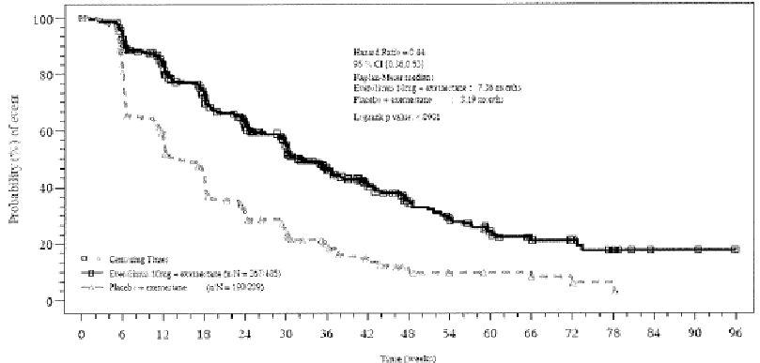
Solid line: everolimus plus exemestane; dotted line: placebo plus exemestane.
Table 1: Analysis of PFS as per investigator and independent central radiology review – FAS.
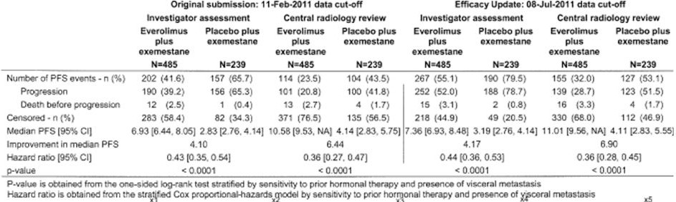
Robustness of the primary analysis was confirmed by results from the independent central radiological review and is indicated in Table 1 with a 6.9 months prolongation of median PFs from 4.1 months to 11.01 months and an estimated PFS HR of 0.36 (95% CI, 0.28, 0.45), P<0.0001 for the everolimus arm relative to placebo.
Examining the concordance rate between PFS per investigator and independent central radiology review (events versus censored), it was slightly higher for the everolimus arm at 67.8% compared to placebo at 62.8%. Further analyses performed to explore the overall concordance rates considering both PFS, event type and dates of progression continued to indicate slightly higher concordance rates for the everolimus arm at 46.6% relative to placebo at 40.2%. Various exploratory analyses confirmed that despite the difference in the observed concordance rates, the treatment effect was robust across both investigator and central radiology assessment. The data provided no evidence of bias per investigator that would have favoured everolimus plus exemestane arm. This is summarised in Table 2.
Table 2: Summary of the censoring reasons for PFS per investigator and central radiology review – FAS.
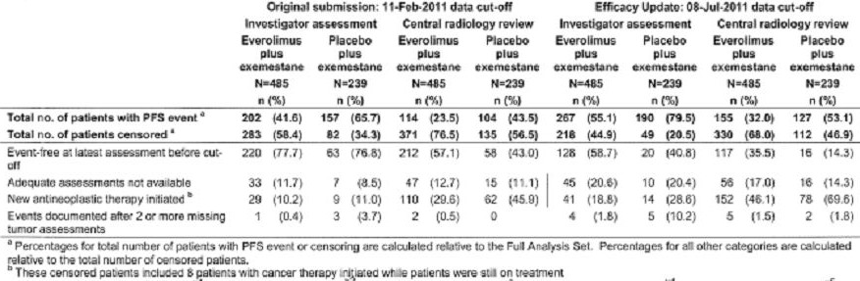
The weight of evidence in favour of everolimus also continued to be supported by multiple pre planned sensitivity analyses. All analyses were consistent with the primary analysis.
In relation to OS at the time of the updated analysis in July 2011, 138 deaths were observed (17.3% in everolimus versus 22.6% in placebo). Per protocol, no statistical analysis comparing the two survival curves was performed.
By 31 October 2011, 182 deaths had occurred which did not exceed the interim analysis stopping boundary; accordingly, no tabular or statistical analyses were performed. The final analysis with regard OS is planned after 398 deaths.
In relation to objective response and clinical benefit rate, the objective response for investigator based on Response Evaluation Criteria In Solid Tumours (RECIST) criteria noted a response rate of 12% (95% CI, 9.2, 15.2) in the everolimus arm compared with 1.3% (95% CI, 0.3, 3.6) in the placebo arm with a P value <0.0001. In relation to the clinical benefit rate, a clinical benefit rate of 50.5% for the everolimus arm was noted compared to 25.5% in the placebo arm with a P value <0.0001. Two patients in the everolimus arm achieved a complete response and progressive disease was the best overall response in 10.1% of these patients compared with 32.6% of patients receiving placebo. Best overall response rates per independent central radiology review were in concordance with those rates observed per investigator assessment.
Evidence of tumour reduction was also apparent from the waterfall plots as indicated in Figure 3. Results indicated that 70.8% of patients in the everolimus arm experienced some degree of tumour shrinkage versus 29.7% of patients in the placebo arm.
Figure 3: Tumour shrinkage: best percentage change from baseline in sum of longest diameters per investigator – FAS.
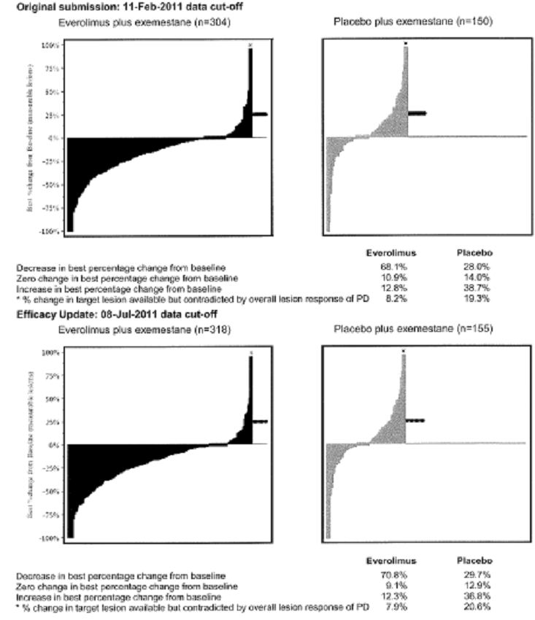
In relation to patient reported outcomes, a numerical trend in favour of the everolimus arm was apparent from the time to deterioration of at least 1.5% of the global health status/quality of life domain score of the EORTC QLQ-C30 questionnaire being seven months and 5.5 months for everolimus and placebo arms, respectively. Similar trends were also observed for the physical functioning (8.31 months versus 5.42 months), emotional function (8.48 months versus 6.93 months) and social functioning (6.7 months versus 8.44 months).
In relation to median time to deterioration of ECOG performance status, this was 12.6 months with everolimus versus 8.8 months for placebo (HR 0.88, 95% CI, 0.66, 1.18, P=0.1912). The median estimates provided no evidence of any difference in time to deterioration for ECOG performance status between the two treatment arms.
In order to assess the consistency of results in subpopulations, subgroup analyses were conducted and for each of the subgroups. The HR and associated 95% CI were calculated using an unstratified Cox proportional hazard model. Consistency of the updated estimated treatment effect was supported by the planned subgroup analysis of PFS per investigator. Positive treatment effects were observed for all 31 subgroups analysed in favour of the everolimus arm with estimated HRs ranging from 0.25 - 0.56.
Comment: These data from a single quite large study demonstrates superior efficacy for the addition of everolimus to exemestane in hormone receptor-positive advanced breast cancer. The HRs of 0.44 and 0.36 for the investigator and central radiology analyses respectively together with the corresponding improvement in median PFS indicate benefit over the exemestane alone arm. Secondary endpoints including objective response rates, clinical benefit rate, quality of life and changes in performance status as well as sensitivity analyses were supportive. Any major improvement in PFS was also observed and consistent across all subgroups.
It is noted that the survival data remains immature and as of July 2011 there has been a total of 17.3% of deaths in the everolimus arm and 22.6% of deaths in the placebo arm. Further follow up is required to evaluate the effects of everolimus on overall survival in this patient population. Nevertheless, the robustness of the available data in relation to PFS in particular is convincing.

Safety
Safety data in this evaluation is derived from the pivotal Study Y2301. Demographic and pre treatment characteristics of this patient population have been given in the Efficacy section. The safety set population consisted of 720 patients (482 in the everolimus arm and 238 in the placebo arm) who received at least one dose of the study treatment and had at least one valid post baseline safety assessment. Four patients, three in the everolimus plus exemestane arm and one on the placebo arm, were randomised but subsequently did not receive study treatment.
Data for this safety evaluation derived from the initial data cut off date of 11 February 2011. The update involving an additional five months of follow up went to 8 July 2011. Results are principally presented from the updated analysis.
Overall exposure to everolimus involved a total of 179 patients (37.1%) for periods of at least 32 weeks. The median duration of exposure to everolimus was 23.9 weeks and to exemestane in the same arm 26.6 weeks. This compared to the placebo plus exemestane arm where treatment was administered for medians of 30.4 weeks and 14.1 weeks for each agent.
Median dose intensities were 8.7 mg per day with a range of 0.3 - 10 and 10 mg per day with a range of 1.3 - 10 for the everolimus and placebo arms, respectively.
Dose interruptions and dose reductions were more frequent for the patients in the everolimus arm with 53.7% of patients in the everolimus arm requiring dose adjustment. These were primarily attributable to adverse events. Overall, disease progression was the most common reason for treatment discontinuation although adverse events were more frequent for discontinuation of everolimus therapy at 23.7% compared to placebo at 4.6% or exemestane at 8% versus 2.9% in the placebo plus exemestane arm.
Median follow up is 12.5 months for the study and more patients discontinued treatment from the placebo arm than the everolimus arm as of the updated analysis. A total of 344 patients or 71.4% had discontinued both everolimus and exemestane and 214 patients or 89.9% had discontinued placebo plus exemestane. Disease progression remained the primary reason for treatment discontinuation for both treatment arms. There was a far greater proportion of discontinuations from the placebo arm as a result of disease progression 83.2% compared to everolimus at 61.9% which resulted in a median duration of therapy being lower for the placebo arm of treatment.
Adverse events caused discontinuation of all study drugs in 46 patients, 8.1% for the everolimus arm and 2.9% for the placebo arm. Death being the primary reason for discontinuation in 7 patients in the everolimus arm compared to 1 in the placebo arm.

Reviewing adverse events
The majority of patients experienced at least one adverse event during the course of the trial and this is indicated in Table 3. It is indicated the adverse events were more frequent in the everolimus arm including a higher percentage of patients who discontinued treatment as a result of adverse events. Overall adverse events were reported by 100% of patients in the everolimus arm and 90.3% of patients in the placebo arm. This is summarised in Table 4. Gastrointestinal disorders continued to reflect the system organ class with the highest incidence of adverse events in both treatment arms. It is noted that those adverse events by System Organ Class more frequent in the everolimus arm included skin and subcutaneous disorders, gastrointestinal disorders, respiratory disorders, metabolism and nutrition disorders, blood and lymphatic system disorders, infections and infestations, general disorders and administration site conditions, nervous system disorders and investigations.
Table 3: Summary of adverse event categories – Safety Set.
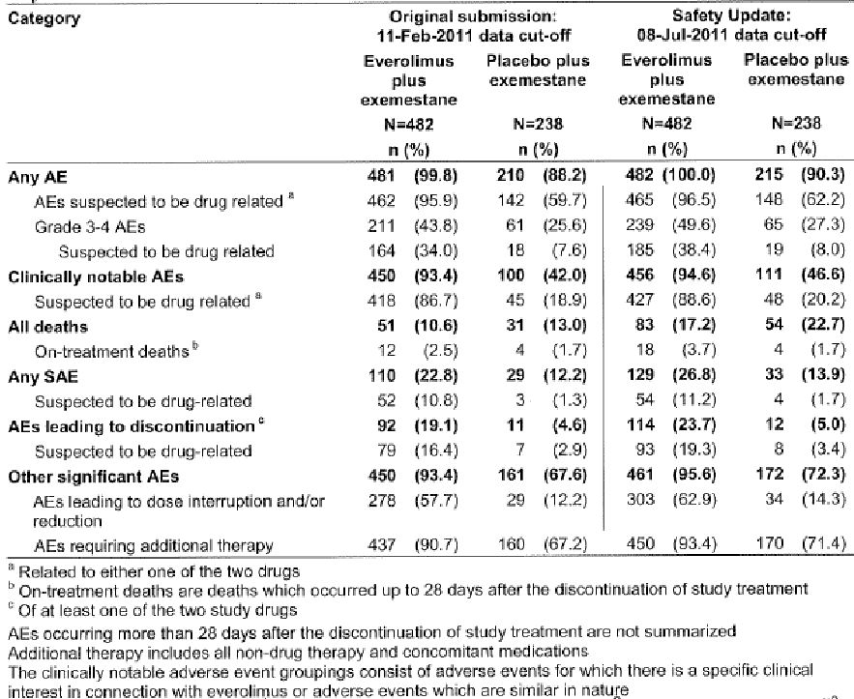
Table 4: Adverse events by System Organ Class irrespective of causality – Safety Set.
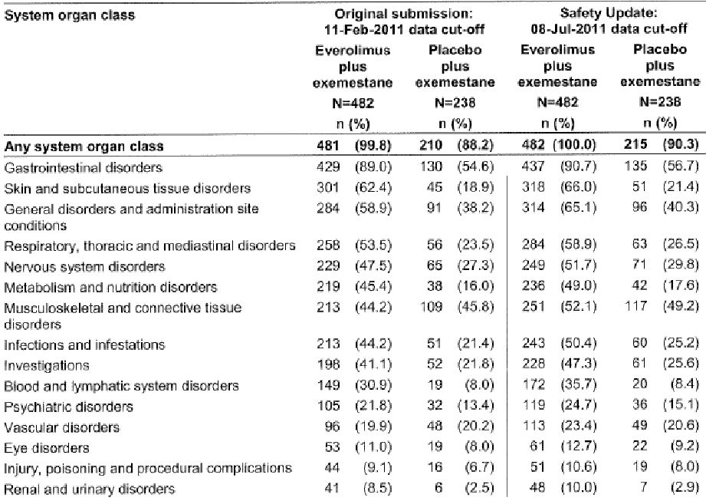
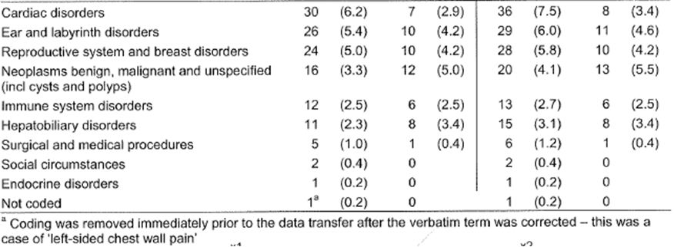
As indicated in Table 5, stomatitis, rash and fatigue were the most common adverse events in the everolimus arm, each being reported in more than 30% of patients. These events were primarily grade I or II and consistent with the known safety profile of everolimus. Those specific adverse events with a greater incidence in the everolimus patients included stomatitis, rash, decreased weight, decreased appetite, epistaxis, dysgeusia, pneumonitis, anaemia, diarrhoea, peripheral oedema, cough, thrombocytopenia, hyperglycaemia and dyspnoea.
Table 5: Adverse events by Preferred Terms and grading irrespective of causality (with at least 10% incidence in either group) – Safety Set.
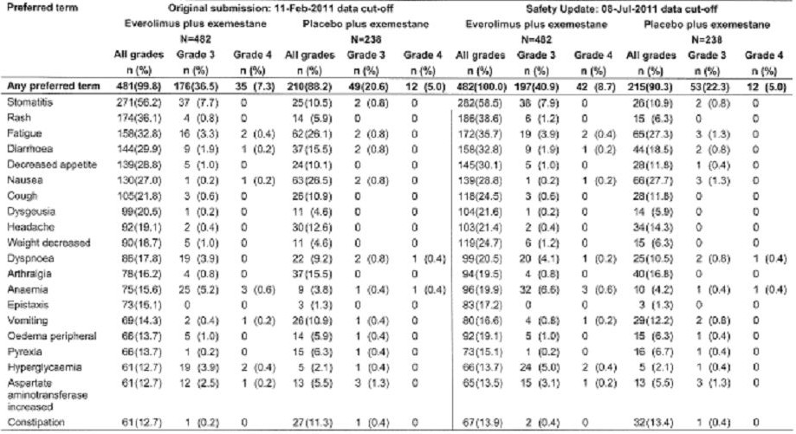
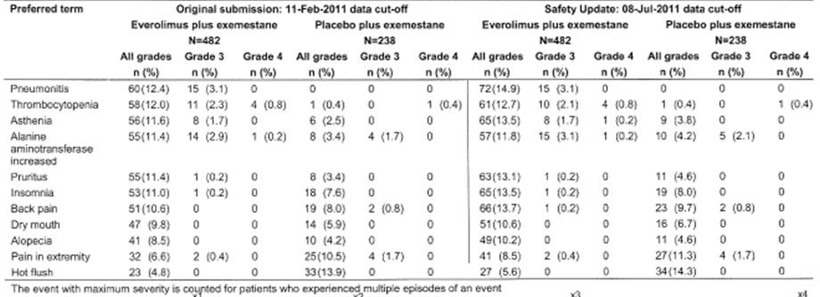
Overall, grade III and IV events were more frequent when the patients were receiving everolimus with 40.9% of patients experiencing a grade III event and 8.7% a grade IV event. This compared to 22.3% and 5% of patients in the placebo arm. The most common grade III to IV events were stomatitis, anaemia and hyperglycaemia. Also more frequent among the everolimus patients with grade III/IV events were dyspnoea, fatigue and pneumonitis.
Assessment of the incidence of adverse events suspected to be related to study drug by the investigator also demonstrated a higher incidence with everolimus patients and indicated in Table 6. The most frequent of these being stomatitis, rash, dysgeusia, pneumonitis, decreased appetite, decrease weight, epistaxis, thrombocytopenia and diarrhoea. Similarly, the incidence of grade III/IV adverse events considered related to study drug were also more frequent in the everolimus arm overall being 38.4% versus 8%. The only grade III to IV adverse event with an incidence >5% was stomatitis occurring in 7.9% of patients on everolimus.
Table 6: Adverse events by Preferred Terms and grading with suspected relationship to study drug (with at least 5% incidence in either group) – Safety Set.
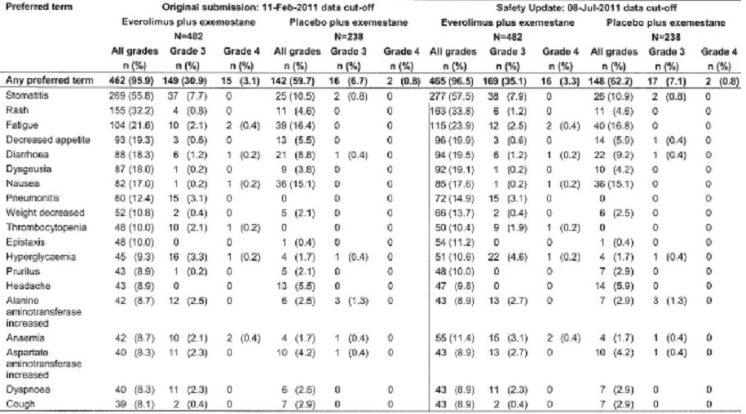
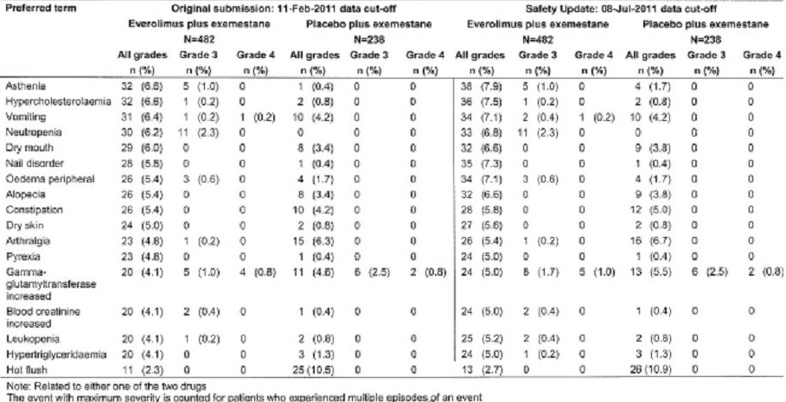
In relation to on treatment deaths, there was a higher incidence of these among the everolimus patients involving 3.7% compared to placebo at 1.7% and is indicated in Table 7. None of the patients who died while receiving everolimus were considered to have had adverse events as their primary cause of death. Only one of the deaths in the everolimus arm was considered by the investigators to be directly related to study treatment in a patient who died as a result of haemorrhage from tumour.
Table 7: On-treatment deaths – Safety Set.
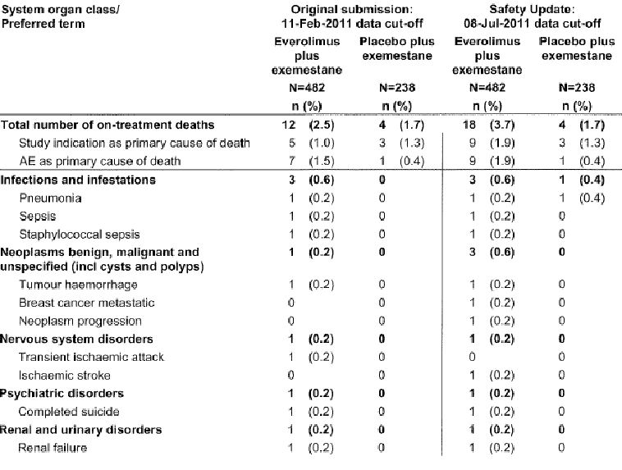
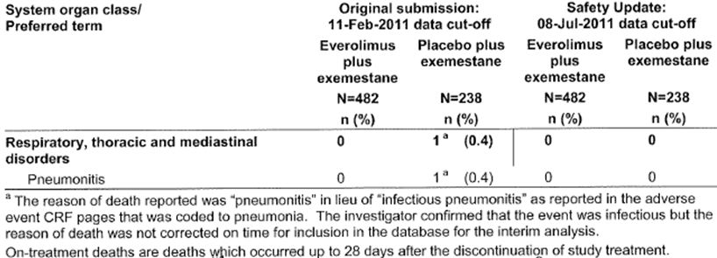
Serious adverse events were reported more frequently in the everolimus arm involving 26.8% of patients versus 13.9% of patients on the placebo arm. This is illustrated in Table 8. The incidence of serious adverse events was low for both treatment arms and consistent with that previously reported. The most common in the everolimus arm included pneumonitis in 2.5%, dyspnoea, pneumonia, anaemia, pulmonary embolism, pleural effusion, pyrexia and vomiting. A total of 54 patients or 11.2% on the everolimus arm and only 4 patients or 1.7% on the placebo arm experienced serious adverse events and suspected by the investigator to be drug related, the most common being pneumonitis in 12 patients on everolimus followed by anaemia in 4 patients and hyperglycaemia in 4 patients.
Table 8: Serious adverse events by System Organ Class and Preferred Term irrespective of causality (with at least 0.5% incidence in either group) – Safety Set.
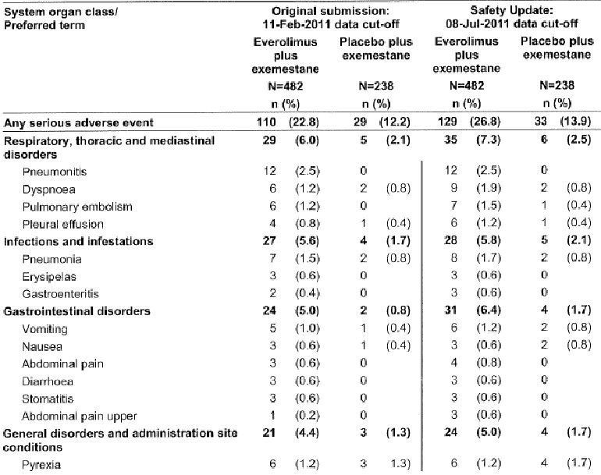
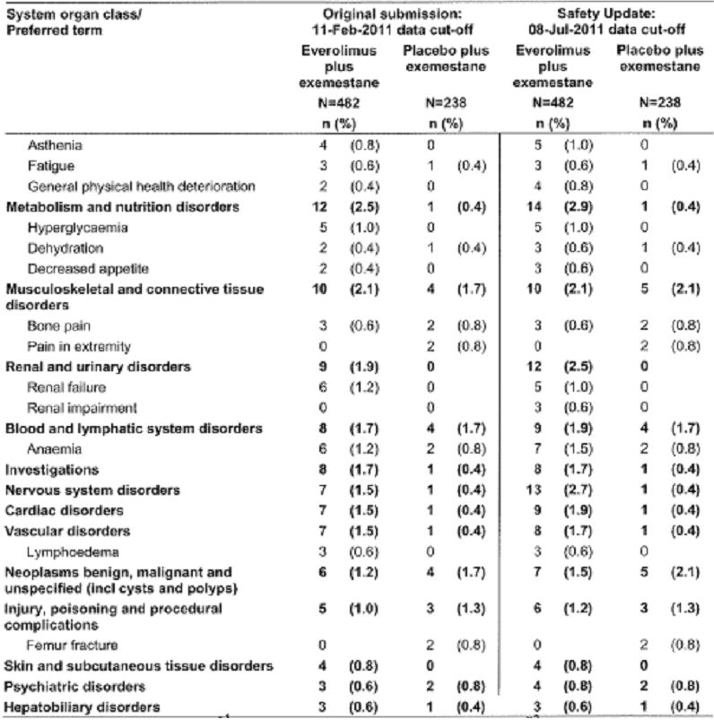
Adverse events leading to discontinuation of study drug were more frequent in the everolimus arm and included pneumonitis in 4.4% of patients, stomatitis in 2.5%, dyspnoea 1.9%, fatigue 1.9%, decreased appetite 1.7%, anaemia 1.7%, and rash 1.5%. Those considered most likely related to treatment included pneumonitis, stomatitis, fatigue, decreased appetite, and dyspnoea. Adverse events requiring dose interruption or dose reduction of study drug were more frequent in the everolimus arm and included stomatitis in 23.7% of patients, pneumonitis 7.3%, and thrombocytopenia in 5.2%.
Reviewing individual adverse events, these were of specific interest in connection with the mechanism of action of everolimus and previously defined from earlier clinical trials included stomatitis; infections, rash and similar events; cytopenia; haemorrhages; bone infectious pneumonitis; hyperglycaemia; renal events; thromboembolism; and hypersensitivity reactions. Overall, these events were observed in 94.6% of patients on everolimus compared to 46.6% of patients on placebo.

Considering individual events
Mucositis related events were more common on the everolimus arm. The first occurrence of these tended to be within a few weeks of initiating therapy and most cases were considered drug related. These were most often grade I to II in severity. Of the 39 patients on everolimus experiencing a grade III mucositis related event, 35 had dose interruption or dose reduction, and 2 patients actually discontinued treatment.
Infections were reported in 243 patients or 50.4% in the everolimus arm and 60 patients or 25.2% in the placebo arm and is indicated in Table 9. The majority of infections were grade I or II with nasopharyngitis and urinary tract infections most frequent. A total of 21 patients or 4.4% in the everolimus arm had grade III infections and 7 patients or 1.5% had grade IV infections. Specific infections among these patients included pneumonia in 6 patients, sepsis in 5 patients, gastroenteritis in 3 patients, and primary atypical pneumonia in 2 patients. Dose interruption or adjustment of treatment was implemented for 18 patients and 2 patients required a permanent discontinuation of study drug because of gastroenteritis and pneumonia. A total of 3 on-treatment deaths were reported as a result of infection, but none were considered to be directly related to study drug. Overall, 4 patients withdrew from treatment because of infection and this is detailed in Table 10.
Table 9: Grading (severity) of infections and infestations by Preferred Term irrespective of causality (at least 1% in the everolimus group) – Safety Set.
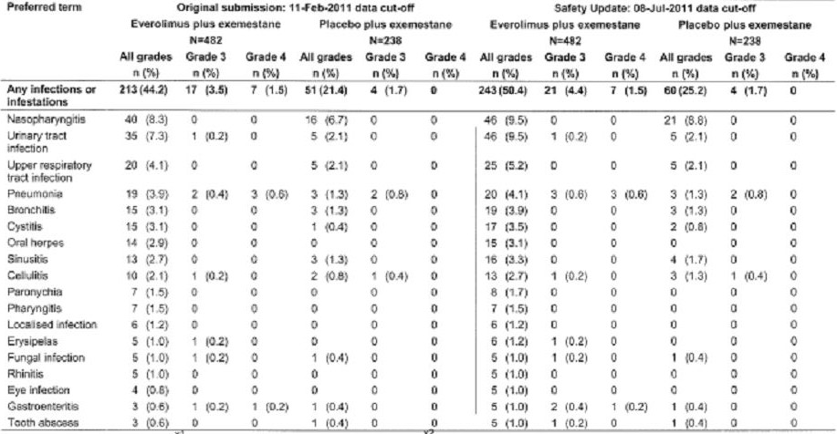
Table 10: Clinical impact of infections and infestation events – Safety Set.
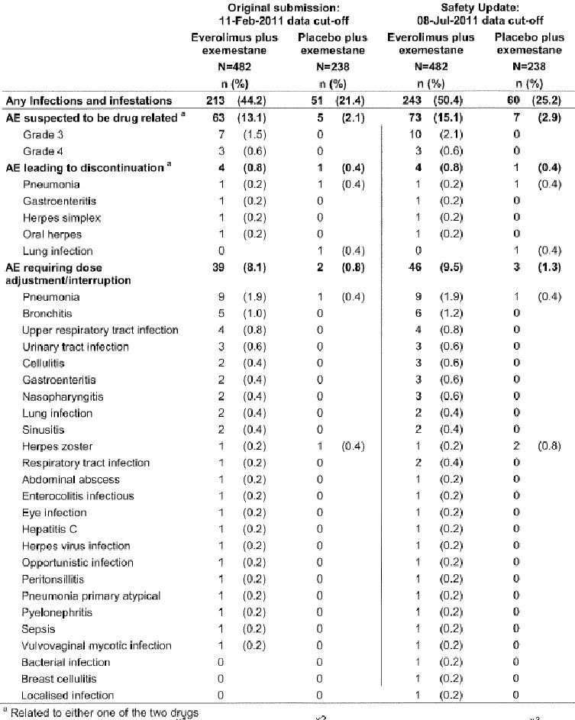
Rash related adverse events were reported in 44% of patients receiving everolimus compared to 8.4% receiving placebo. These were generally of low grade, although 9 patients on everolimus experienced grade III/IV rash or a related event of which 2 had to discontinue therapy. Overall, 8 patients who received everolimus discontinued therapy because of a rash related event.
Cytopenia were more frequently observed in patients on the everolimus arm. There was at least a 5% difference relative to placebo for thrombocytopenia plus 12.3% and neutropenia plus 6.4%. Cytopenia was suspected to be related to treatment in the majority of instances for the patients on everolimus. Nevertheless, only 3 patients required treatment discontinuation as a result of cytopenias.
Everolimus is also associated with a higher frequency of haemorrhage. Epistaxis accounted for the majority of these cases. Haemorrhagic events led to the discontinuation of study drug for 3 patients in the everolimus arm with events of epistaxis, haemoptysis and rectal and tumour haemorrhages.
Non infectious pneumonitis and related conditions were diagnosed in 90 patients or 18.7% on the everolimus arm. All except 3 of these cases were suspected to be related to study drug. A total of 38 patients or 7.9% had grade I, 34 patients or 7.1% grade II, 17 patients or 33.5% grade III, and 1 patient grade IV. A total of 27 patients or 5.6% required treatment discontinuation from everolimus due to either pneumonitis or interstitial lung disease, 1 related to a grade III event, 11 related to a grade II event, and 7 related to a grade I event.
Hyperglycaemia and new onset diabetes mellitus occurred in 15.4% of patients in the everolimus arm were suspected to be drug related in the majority of these cases. A total of 24 patients or 5% experienced a grade III event and two patients or 0.4% were diagnosed with grade IV hyperglycaemia. Only 1 patient discontinued treatment because of hyperglycaemia.
Renal events of any grade irrespective of relationship to study treatment were more frequently reported in patients in the everolimus arm being 10.4% versus 0.8% for placebo. Elevated serum creatinine concentrations reported more commonly among patients receiving everolimus, with 6 patients experiencing a grade III event. One patient experienced renal failure which resulted in death but was not considered related to treatment. Overall, renal events necessitated dose adjustment in 3.9% of patients and treatment discontinuation in 1.7% in the everolimus arm indicated.
Patients in the everolimus arm were more likely to have thromboembolism events of any grade, but all these events were infrequent. A total of 3 cases of grade IV pulmonary embolism were reported in the everolimus arm. These events led to discontinuation of study treatment for 0.4% of patients in the everolimus arm.
In relation to hypersensitivity reactions, these were infrequent across the two treatment arms, with 1 patient on everolimus requiring dose interruption as a result of angioedema.
Review of adverse events in relation to subgroups did not reveal any particular pattern in relation to race. In relation to age there was evidence of somewhat higher overall incidence of adverse effects in those patients >65 years.

Clinical laboratory evaluations

Haematology
Haematological abnormalities were more frequent in the everolimus arm and are illustrated in Table 11. There is >20% difference between the everolimus arm and placebo arm in relation to falls in the platelet count +48.1%, decreased Haemoglobin (HB) +34.8%, decrease White Blood Cell (WBC) count +34.6%, decreased lymphocytes +22%, and decreased absolute neutrophil count +20.5%. The most common grade III haematological abnormalities in the everolimus arm were decreased absolute lymphocyte count and HB.
Table 11: Grading (severity) of newly occurring or worsening abnormal haematology values – Safety Set.
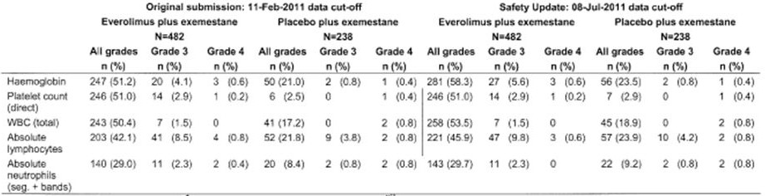

Biochemistry
The frequency of newly occurring or worsening biochemical abnormalities was observed to be higher in the everolimus arm. New or worsened biochemical events of any grade with a >20% increase for everolimus compared to placebo was noted with an increased glucose 32.6%, increased cholesterol 31.2%, increased triglycerides +26.9%, decreased potassium +22.8%, and elevated aspartate transaminase (AST) +22%. Grade III elevations of serum glucose were greater in the everolimus group at 8.1% compared to 0.8% for the placebo patients. Frequency of new or worsened biochemical abnormalities of grade IV severity was similar between the two treatment arms at 4.1% and 4.2%, respectively.
There were no clinically noteworthy differences in vital signs throughout the study for either treatment group
Comment: The data provided from this pivotal study re safety, essentially mirrors that previously reported in earlier clinical trials of everolimus. The most common adverse events suspected to be related to treatment in an incidence of at least 20% includes stomatitis, rash and fatigue. Overall, the severity of adverse events was not commonly grade III or grade IV. Nevertheless, the risks associated with the everolimus therapy including non infectious pneumonitis, infections, stomatitis and related events all are clinically significant requiring careful monitoring and early intervention.
It is also noted that the discontinuation rate of everolimus approached 24% of patients but this is in line with that previously documented. There was only one death considered directly related to treatment involving a haemorrhage from tumour.
Overall, it would appear the adverse effect of the safety profile from this pivotal study is consistent with that previously reported and generally appears to be manageable.

List of questions
1. The sponsor is requested to provide mature overall survival data when this becomes available to support evidence favouring the role of everolimus in combination with exemestane.
2. What supportive studies, if any, are presently underway to substantiate the benefit of everolimus in combination with AIs compared to AIs alone in post menopausal patients with advanced stage breast cancer who have failed prior endocrine therapy?

Clinical summary and conclusions

First round benefit-risk assessment

First round assessment of benefits
The data from the pivotal Study Y2301 has demonstrated clinically significant benefit for the primary endpoint of PFS for the everolimus plus exemestane arm compared to placebo plus exemestane in a quite large study resulting in a 57% risk reduction in favour of the everolimus arm with a HR 0.43 and P <0.0001 (11 February 2011 data cut off). There was a median prolongation of PFS of 4.1 months from 2.83 months for placebo plus exemestane to 6.93 months for everolimus plus exemestane. This result was consistent both with independent investigators and a central radiology review. Various pre planned sensitivity analyses also confirmed the benefit of everolimus and subgroup analyses also confirmed homogenous and consistent treatment effect.
In relation to secondary efficacy endpoints, the ORR and CBR also demonstrated significant superiority of the everolimus arm, but at this time there is no evidence of advantage in relation to OS. It is recognised that while the data still remains immature in relation to this efficacy variable, appropriate long term follow up will be necessary to determine whether there is an OS benefit. Accordingly, it is appropriate to be a little conservative in relation to declaring benefit for the addition of everolimus to exemestane therapy. Nonetheless, in the context of available data the evidence is supportive for the addition of everolimus to exemestane in therapy for patients with post menopausal advanced stage breast cancer who have failed prior endocrine therapy.

First round assessment of risks
The adverse effect profile demonstrated in this pivotal trial is consistent with that known in relation to administration of everolimus. Certainly it does not appear to be any untoward increase in adverse effects with a combination of everolimus with exemestane. Everolimus still retains a definite adverse effect profile, particularly with concern regarding more serious adverse effects such as stomatitis and/or mucositis, and an increase that leads to infection and particularly non infectious pneumonitis. All these have previously been well recognised and appropriately highlighted in PI. Nevertheless, careful monitoring is appropriate with early intervention required when utilising everolimus either alone or in combination.
Recognising the increased incidence of overall adverse effects including grade III/IV events, this falls within the recognised side effect profile for everolimus as currently appropriately managed in routine clinical settings for approved indications for everolimus.

First round assessment of benefit-risk balance
This reviewer considered that in view of the clear cut evidence of significant benefit for PFS from quite a large pivotal trial and confirmation of this in relation to subgroup and sensitivity analyses as well as secondary efficacy endpoints including ORR and CBR, the balance favours benefit over risk in relation to the recognised risk profile for everolimus.

First round recommendation regarding authorisation
This reviewer considers that it is appropriate to recommend approval to extend the indications for everolimus to include use in combination with AI for the treatment of post menopausal women with advanced breast cancer after prior endocrine therapy.
As previously discussed, PK Study X2103 – an open label two period fixed sequence study to investigate the effect of everolimus on the PK of midazolam in healthy volunteers – demonstrated a co administration of midazolam with everolimus and resulted in a 25% increase in midazolam Cmax and a 30% increase in AUC_{0-∞}. Similar effects were observed for the metabolite 1-hydroxy-midazolam. Accordingly, it is appropriate to indicate that the PI recommends caution when everolimus is taken in combination with orally administered CYP3A4 substrates with a narrow therapeutic index indicating potential for drug interactions.

Second round benefit-risk assessment
This is an updated response to previous evaluation of an original submission to extend the currently approved indication for advanced renal cell carcinoma to include the use in combination with AI for the treatment of post menopausal women with advanced breast cancer after prior endocrine therapy. This is a Section 31 response from the sponsor, and as indicated a further change in the proposed indication for the treatment of post menopausal women with hormone receptor positive, HER2 negative advanced breast cancer in combination with an AI, after failure of treatment with letrozole or anastrozole.
It has been noted that a recommendation for change in the initial indication from the evaluators suggested the indication being for the treatment of post menopausal women with hormone receptor positive, HER2 negative advanced breast cancer in combination with exemestane after a failure of treatment with letrozole or anastrozole.
The sponsor has provided a significant response to this with considerable detail regarding reasons for their proposed new indication for the treatment of post menopausal women with hormone receptor positive, HER2 negative advanced breast cancer in combination with AI after failure of treatment with letrozole or anastrozole.
This evaluator accepts the sponsor proposed change in indication on the basis of the reviewed justification.
In the sponsor’s consolidated Section 31 request for information, the material provided included a covering letter together with consolidated response to questions together with update proposed PI and Consumer Medicine Information (CMI). Also provided is an updated summary of clinical efficacy together with several appendices related to additional data supporting the clinical efficacy update.

Clinical efficacy
In the original submission analyses in relation to PFS, ORR and OS were provided as of 8 July 2011. This Section 31 response provides updated material in relation to a further cut off date of 15 December 2011 at which time final PFS data was presented and updated results for response rates as well as a further statement regarding OS.
This updated analysis of PFS has provided a further five months of evaluation.
Reviewing this update, it is noted again that 724 post menopausal women with ER+ locally advanced or metastatic breast cancer whose disease was refractory to non steroidal AIs and with documented recurrence or progression on last therapy for breast cancer enrolled to the trial from 1.96 centres in 24 countries worldwide. Of these 724 individuals, 485 were assigned to treatment with everolimus plus exemestane and 239 were randomised to placebo plus exemestane.
As previously indicated, treatment arms were well balanced for baseline demographics, tumour burden and previous cancer therapy and no clinicalIy meaningful differences were seen between the two treatment groups.
As of 15 December 2011 at data cut off, median follow up extended to 17.7 months and the updated analysis of the primary endpoint is based on 510 disease progression events.
Updated results of the primary efficacy endpoint, re PFS per investigator again confirms the evidence of benefit for everolimus plus exemestane relative to placebo plus exemestane with a 55% risk reduction evident. This was statistically significant with an HR 0.45; 95% CI 0.38, 0.54; P<0001. This is illustrated in Figure 4 and Table 12. The median PFS was prolonged by 4.63 months from 3.19 months (95% CI 2.76, 4.14) for patients receiving placebo plus exemestane to 7.82 months (95% CI 6.93, 8.48) for everolimus plus exemestane treated patients. These results were consistent with those reported for the original submission based on the earlier analyses. Robustness of the primary analyses were again confirmed by results for independent central radiology review with a 6.87 month prolongation in median progression free survival from 4.14 months to 11.01 months and an estimated HR of 0.38 95%CI 0.31, 048, PFS 0.0001 for the everolimus plus exemestane arm relative to the placebo plus exemestane arm as indicated in Table 13.
Figure 4: Kaplan-Meier plot of PFS per investigator (FAS).
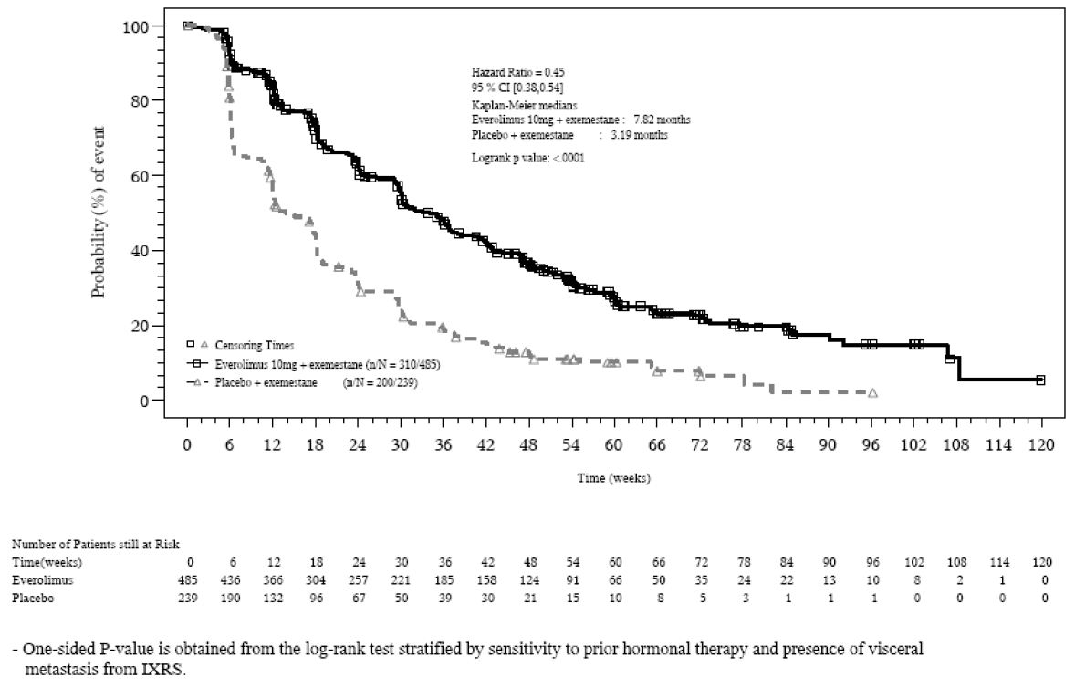
Table 12: Analysis of PFS per investigator (FAS).
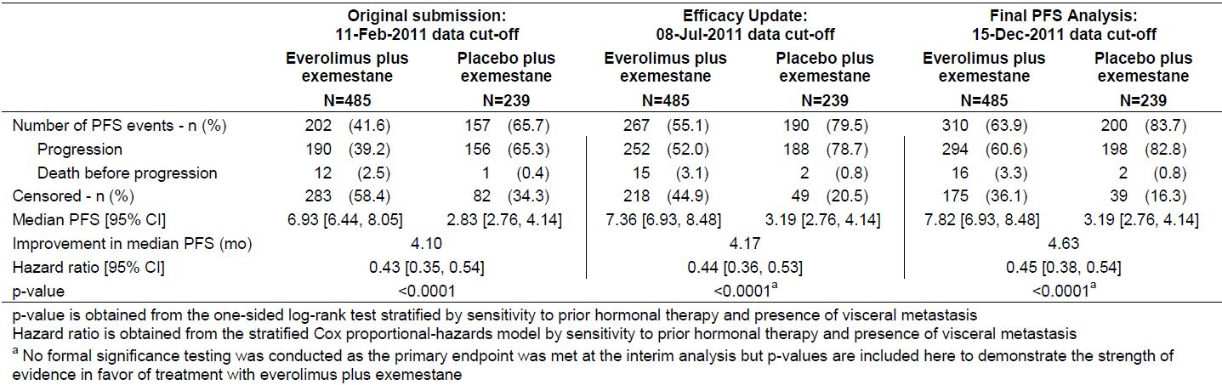
Table 13: Analysis of PFS per central radiology review (FAS).
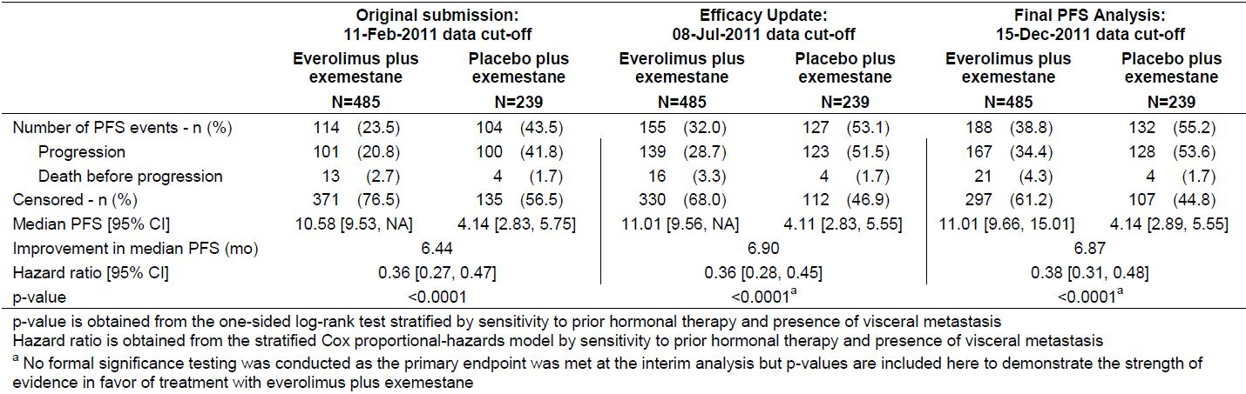
Objective response per investigator based on RECIST criteria was observed in 12.6% of patients with a 95% Cl of 9.8, 15.9 for the everolimus plus exemestane arm compared with 1.7% of patients (95% CI 0.5,4.2) in the placebo plus exemestane arm. Further evidence of response activity is indicated by assessment of the clinical benefit rate which include stable disease for at least 12 weeks and a clinical benefit rate for the combination was 51.3% compared with 26.4% for the placebo plus exemestane arm. Again these response data were in accordance with results from the independent central radiology review.
In relation to OS as of 15 December 2011 data cut off, 200 deaths were recorded (25.4% with everolimus plus exemestane versus 32.2% with placebo plus exemestane). Accordingly as per protocol, no statistical comparison to treatment arms has been performed to this time. It is noted that the next pre specified survival analysis is planned after observing 275 deaths and if the stopping boundary is not crossed at this stage again after 398 deaths as the final analysis.

Comment:
These data again confirmed the statistical and clinical benefit for the combination of everolimus plus exemestane when compared to exemestane alone. These add further support to the originally submitted data from the pivotal study.

Second round assessment of benefits
After consideration of the new data presented in relation to updates of PFS and response rates, the benefits for the proposed combination of everolimus with AI in the proposed usage are unchanged from those identified in the first round benefit risk assessment.

Second round assessment of risks
No new clinical information was submitted in relation to this aspect of evaluation and accordingly the risks of everolimus plus an AI are unchanged from those identified in the first assessment of risks.

Second round assessment of benefit-risk balance
The benefit/risk balance of everolimus together with an AI given for the proposed usage and in particular the change in proposed indication to be discussed further below is favourable.

Review of comments from sponsor
The sponsor provides a detailed response to various questions raised by the evaluators in the original submission. It is worth reviewing some of these responses in relation to authorisation as well as consideration of aspects of product documentation and Risk Management Plan (RMP). The latter two will be discussed further below.
Questions regarding mature OS data and the latest PFS data has been provided and indicated above.
With relation to the issue of supportive studies, the sponsor has stated there would be some difficulties in undertaking such supportive studies. Nevertheless they have indicated a new proposed trial, that is, BOLERO-4 or Y24135 which will assess the efficacy of everolimus plus letrozole in first line treatment of patients with metastatic breast cancer and also explore the efficacy of continued treatment with everolimus plus exemestane after initial progression. A further study is also proposed, re BOLERO-6 or Study Y2201. which is a three arm randomised study to investigate the combination of everolimus with exemestane versus everolimus alone versus capecitabine in patients with oestrogen receptor positive metastatic breast cancer after recurrence or progression on letrozole or anastrozole.
It would be appropriate for the TGA to request results of these studies when they become available.
It is worth commenting at this time on the proposed indications. The original proposed indication was for everolimus treatment in post menopausal women with hormone receptor positive, advanced breast cancer in combination with an AI after prior endocrine therapy. The TGA evaluator recommended that on the basis of the results from the BOLERO-2 trial that the indication be stated as for the treatment of post menopausal women with hormone receptor positive HER2 negative, advanced breast cancer in combination with exemestane after failure of treatment with letrozole or anastrozole. The sponsor has responded with a detailed review which effectively indicates that with evidence of resistance there is resensitisation with further endocrine therapy and recent clinical evidence supports everolimus adds to the anti cancer activity of different classes of endocrine agents and is therefore logical to assume that the efficacy observed in the everolimus plus exemestane arms would be similar to the efficacy expected if everolimus was to be used in combination with another AI in the treatment of post menopausal women with HR+ advanced breast cancer. The sponsor’s proposed recommendation is that the indication be for the treatment of post menopausal women with hormone receptor positive HER2 negative, advanced breast cancer in combination with an AI after failure of treatment with letrozole or anastrozole.
It is this evaluator's opinion that the weight of evidence from the sponsor supports a more general use of AIs rather than restricting it to exemestane. Taking into account the recognised equivalence for third generation AIs there seems no reason to limit the proposed indication of exemestane. Certainly both experimental and clinical data supports the fact that several AIs are likely to be associated with benefit when combined with everolimus.
The next question as to whether or not clinical benefit rate represents a valid secondary endpoint has been raised in relation to its inclusion in product information.
This evaluator accepts the fact that there is difficulty in determining that stable disease represents a direct influence of therapy rather than just a determinant of the ongoing biological behaviour of the malignancy. Nevertheless, various studies have shown that prolonged stable disease in experimental arms of trials compared to control arms is indicative of benefits in PFS. Accordingly, this evaluator considers it reasonable to include the clinical benefit rate data in the product information so that clinicians will have the opportunity to assess this on its own merits.

Second round recommendation regarding authorisation
Taking into account the updated information regarding PFS and ORR together with various issues which have been mentioned above in relation to indications, the proposed new indication for Everolimus is for the treatment of post menopausal women with hormone receptor positive HER2 negative, advanced breast cancer in combination with AI after failure of treatment with letrozole or anastrozole.
This evaluator supports the proposed indication for marketing.

V. Pharmacovigilance findings

Risk management plan
The sponsor submitted a RMP that was reviewed by the TGA’s Office of Product Review (OPR).

Safety specification
The sponsor provided a summary of Ongoing Safety Concerns which are shown at Table 14.
Table 14: Summary of Ongoing Safety Concerns for Afinitor.
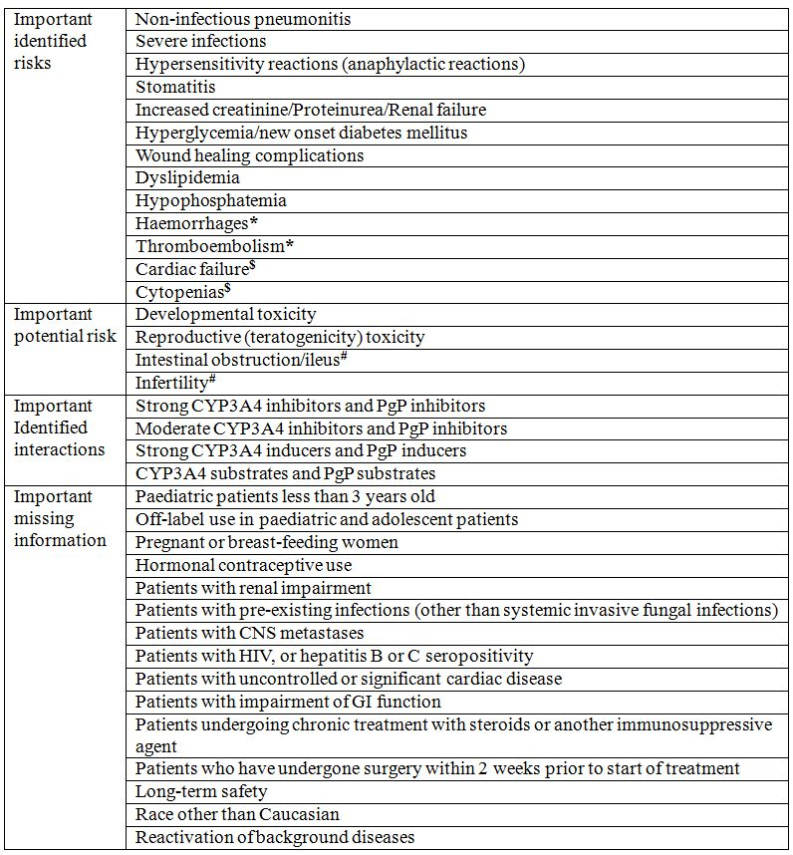

OPR reviewer’s comments
It is considered acceptable that the inclusion of the potential risk of ‘Secondary amenorrhoea in post adolescent females’ as an Ongoing Safety Concern will be delayed until the next RMP update, as proposed by the sponsor because this risk does not pertain to post menopausal women with advanced breast cancer, who are the intended exposure population for this current proposed extension of indication.
The draft Australian PI indicated that patients with severe hepatic impairment (Child Pugh class C) are not recommended to use Afinitor. The currently approved EU Summary of Product Characteristics (SmPC) has similarly recommended against the use of Afinitor in patients with severe hepatic impairment (Child Pugh class C). This is consistent with the implementation of a routine risk minimisation strategy for this subset of the population. However, ‘patients with severe hepatic impairment’ is not formally included in the RMP as an Ongoing Safety Concern. It is noted that ‘safety in patients with severe hepatic impairment’ is listed as an important identified risk in a recent RMP submitted to the European Medicines Agency (EMA), as summarised in the recent Assessment Report (dated 21 June 2012) published by the EMA on 7 August 2012 for the variation to extend the indication to hormone receptor-positive advanced breast cancer in the EU. This EMA reviewed RMP version also listed additional safety concerns that are not currently included in the RMP:
- Important potential risks: ‘pancreatitis’ and ‘cholelithiasis’,
- Important missing information: ‘carcinogenicity’, ‘product impurities’ and ‘comparative safety of everolimus combination versus monotherapy in BOLERO-6’.
It is recommended the sponsor provides a brief update in the Australian Specific Annex (ASA) the relevance of the abovementioned safety concerns (additional safety concerns listed in the EMA reviewed RMP) for inclusion in the Australian implementation of the RMP, in context of this current Australian submission, and including summary description of any appropriate and acceptable pharmacovigilance and/or risk minimisation activities.
Section 1.4.3 of the RMP indicated that:
“on 24 Feb 2011, the EMA provided feedback adopting the following conclusions … intestinal obstruction and/or ileus, bowel perforation, and reproductive toxicity should be included as important potential risks”.
However, ‘bowel perforation’ has not been formally included as an important potential risk in the RMP, but no further information is provided. It is recommended the sponsor provides a brief comment to justify why ‘bowel perforation’ has not been formally included as an important potential risk in the RMP.
The above summary of Ongoing Safety Concerns is otherwise considered acceptable, unless additional concerns are raised from the evaluation of the nonclinical and clinical aspects of the Safety Specification.

Pharmacovigilance plan

Proposed pharmacovigilance activities
Routine pharmacovigilance activities are proposed for all safety concerns. In addition, the following additional pharmacovigilance activities are proposed:
- Targeted follow up questionnaires/checklists for:
  - important identified risks: non infectious pneumonitis, severe infections, hypersensitivity (anaphylactic reactions), increased creatinine/proteinuria/renal failure, cardiac failure,
  - important potential risks: developmental toxicity, reproductive (teratogenicity) toxicity,
  - important area of missing information: pregnant or breast feeding women, patients with renal impairment, reactivation of background diseases, patients with pre existing infections (other than systemic invasive fungal infections), patients with HIV or hepatitis B or C seropositivity.
- Study CRAD001M2301: protocol provided but not evaluated for this report as this study is ongoing and has a specific focus for the SEGA associated with TSC indication:
  - for important potential risks ‘developmental toxicity’ and important area of missing information ‘long term safety’,
  - entitled “A randomised, double blind, placebo controlled study of RAD001 in the treatment of patients with SEGA associated with Tuberous Sclerosis Complex (TSC),
- Study CRAD001C2485: protocol provided but not evaluated for this report as this study is ongoing and has a specific focus for the SEGA associated with TSC indication:
  - for important potential risks ‘developmental toxicity’ and important area of missing information ‘long-term safety’,
  - entitled “Everolimus (RAD 001) Therapy of Giant Cell Astrocytomas in Patients with Tuberous Sclerosis Complex”,

OPR reviewer’s comments in regard to the pharmacovigilance plan (PP) and the appropriateness of milestones
Table 2-30 of the RMP indicated that only routine pharmacovigilance activities are proposed for the following important areas of missing information: ‘patients with pre existing infections (other than systemic invasive fungal infections)’ and ‘patients with HIV or hepatitis B or C seropositivity’. However, Section 3.1 of the ASA indicated that additional pharmacovigilance activities in the form of targeted follow up questionnaires/checklists are proposed for both of these areas of missing information. There is no objection to the sponsor implementing these additional pharmacovigilance activities.
A total of seven targeted follow up questionnaires/checklists are proposed:
- ‘Afinitor Non infectious Pneumonitis’,
- ‘Afinitor Serious Infections, including hepatitis reactivation’,
- ‘Hypersensitivity including Anaphylaxis’,
- ‘Renal Impairment or Failure’,
- ‘Acute and Congestive Heart Failure’,
- ‘Pregnancy’ and,
- ‘Afinitor Reactivation, Aggravation, Exacerbation of Background Disease’.
Table 2-32 ‘Outstanding actions and milestones’ of the RMP listed a completed
“retrospective study and updated review of amenorrhoea, including a description in detail of a proposal to further mechanistically define the observations and to characterise the reversibility, taking into account the findings from the preclinical studies on the male and female reproductive organs” (milestone: 29 August 2011).
This potential risk does not pertain to post menopausal women with advanced breast cancer, who are the intended exposure group for this current proposed extension of indication. Therefore, it is considered acceptable if the sponsor commits to providing the results from this study in a future submission to the TGA.
The anticipated dates for the final clinical study reports for Study CRAD001M2301 and Study CRAD001C2485 are provided in the ASA. It is recommended the sponsor confirms the indicated anticipated dates have not changed.
A recent Afinitor Assessment Report (dated 21 June 2012) published by the EMA listed the following additional pharmacovigilance activities proposed for the area of missing information ‘long term safety’ with a specific focus on breast cancer patients:
- Study CRAD001J2301: A randomised, Phase III, double blind, placebo controlled multicenter trial of everolimus in combination with trastuzumab and paclitaxel as first line therapy in women with HER2+ locally advanced or metastatic breast cancer
- Study CRAD001W2301: A randomised, Phase III, double blind, placebo controlled multicenter trial of daily everolimus in combination with trastuzumab and vinorelbine, in pre treated women with HER2/neu over expressing locally advanced or metastatic breast cancer
- Study CRAD001Y2301: A randomised, double blind, placebo controlled study of everolimus in combination with exemestane in the treatment of postmenopausal women with oestrogen receptor positive locally advanced or metastatic breast cancer who are refractory to letrozole or anastrozole.
It is recommended the sponsor provides a brief update in the ASA the relevance of the abovementioned studies for inclusion in the Australian implementation of the RMP, in context of this current Australian submission.

Risk minimisation activities
Sections 4.1 and 4.3 of the ASA stated that:
“Novartis Pharmaceuticals Australia will be implementing ‘routine’ risk minimisation activities in Australia through the provision of the TGA approved PI and CMI...There is no additional risk minimisation activities planned in Australia.”

OPR reviewer’s comments
As Afinitor should only be initiated by a physician experienced in the use of anticancer therapies, the proposed use of routine risk minimisation activities are considered acceptable, unless additional concerns are raised by the clinical and/or nonclinical evaluator(s).

Potential for medication errors
Section 3.2 ‘Potential for medication errors’ of the RMP stated that the selection of the tradename, tablet presentation (engraving and package labelling), and instructions for use have been taken into account to minimise the potential risk of medication errors. Afinitor is available in 2.5 mg (engraved with “LCL” and “NVR” on each side), 5 mg (engraved with “5” and “NVR” on each side) or 10 mg (engraved with “UHE” and “NVR” on each side).

OPR reviewer’s comments
As Afinitor should only be initiated by a physician experienced in the use of anticancer therapies, the proposed use of routine risk minimisation activities are considered acceptable, unless additional concerns are raised by the clinical and/or nonclinical evaluator(s).

Summary of recommendations
The OPR provides the recommendation in the context that the submitted RMP is supportive to this application with some amendments, under the provision that no additional safety concerns are raised by the clinical and/or nonclinical evaluator(s):
- the implementation of the RMP identified as the Safety Risk Management Plan Version 5 updated with Breast Cancer Submission (dated 10 October 2011) with the Safety Risk Management Plan Australian Implementation (dated 23 March 2012) and subsequent updates, is imposed as a condition of registration.
If this submission is approved, it is recommended the Delegate considers requesting the sponsor to incorporate the following amendments to the Australian implementation of the RMP post registration, unless acceptable justification can be provided by the sponsor:
- Safety specifications
  - To include “safety in patients with severe hepatic impairment” as a safety concern for ongoing monitoring.
  - To include ‘pancreatitis’, ‘cholelithiasis’, ‘carcinogenicity’, ‘product impurities’ and ‘comparative safety of everolimus combination versus monotherapy in BOLERO-6’ as new safety concerns if appropriate.
- Additional pharmacovigilance activities
To include the following additional pharmacovigilance activities for the area of missing information ‘long term safety’ as relevant:
  - Study CRAD001J2301: A randomised, phase III, double blind, placebo controlled multicentre trial of everolimus in combination with trastuzumab and paclitaxel as first line therapy in women with HER2+ locally advanced or metastatic breast cancer,
  - Study CRAD001W2301: A randomised, phase III, double blind, placebo controlled multicenter trial of daily everolimus in combination with trastuzumab and vinorelbine, in pretreated women with HER2/neu over expressing locally advanced or metastatic breast cancer,
  - Study CRAD001Y2301: A randomised, double blind, placebo controlled study of everolimus in combination with exemestane in the treatment of postmenopausal women with oestrogen receptor-positive locally advanced or metastatic breast cancer who are refractory to letrozole or anastrozole.

Other information
It is noted to the Delegate that additional information pertaining to this proposed extension of indication will be anticipated from the below two studies. It is recommended the Delegate considers requesting the sponsor to commit to submitting the results of these studies when they are available, to the TGA for review post registration:
- Final report, including datasets, for the final overall survival results from trial CRAD001Y2301 (BOLERO-2);
- A three arm randomised study to investigate the combination of everolimus with exemestane versus everolimus alone versus capecitabine in patients with oestrogen receptor-positive metastatic breast cancer after recurrence or progression on letrozole or anastrozole.

VI. Overall conclusion and risk/benefit assessment
The submission was summarised in the following Delegate’s overview and recommendations:

Quality
There was no requirement for a quality evaluation in a submission of this type.

Nonclinical
The pharmacology studies showed that everolimus inhibited mTOR signalling and had anti tumour activity supporting the proposed mechanism of action. An in vitro study showed everolimus and letrozole were synergistic in inhibiting aromatase expressing tumour cells.
The evaluator had no objections to registration.

Clinical

Pharmacokinetics
In a subset of patients from the pivotal Study Y2301 (referred to as BOLERO-2) described under ‘Efficacy’, everolimus increased the plasma exemestane Cmin and C2h by 45% and 71%, respectively. There was no significant impact of exemestane on plasma everolimus concentration. The increased exemestane concentration did not significantly affect plasma oestradiol concentration, so there is unlikely to be an impact on efficacy or safety.

Efficacy
A global randomised, double blind trial (BOLERO-2) was presented to support the new indication. Randomisation was 2:1 to oral everolimus 10 mg/day or placebo in combination with oral exemestane 25 mg/day. Treatment continued until disease progression. Subjects were postmenopausal women with oestrogen receptor-positive, HER2-negative advanced breast cancer refractory to letrozole or anastrozole. Refractory was defined as recurrence within 12 months of completing adjuvant treatment or within 1 month of completing treatment for advanced disease. The median age of subjects was 62 years, range 28-93 years. ECOG performance status was ≤ 2. The primary endpoint was PFS assessed radiographically by investigators.
Two interim analyses with data cut offs of 11 February 2011 and 8 July 2011 and the final PFS analysis with data cut off 15 December 2011 were presented. Their results were consistent. The first analysis has been published. The addition of everolimus to exemestane significantly increased PFS by a median 4.6 months in the investigator assessment (Table 15). Independent assessment was supportive. Overall response rate was also increased. There were no significant differences between treatments in the quality of life measures. OS results were immature. The median duration of treatment was 6.8 months (range 0.2-28.4 months) for everolimus + exemestane and 3.2 months (range 0.2-23.2 months) for placebo + exemestane. The median follow up was 17.7 months.
Table 15: BOLERO-2 Efficacy Results: PFS 15 Dec 2011 cut off, OS 31 Oct 2011 cut off.
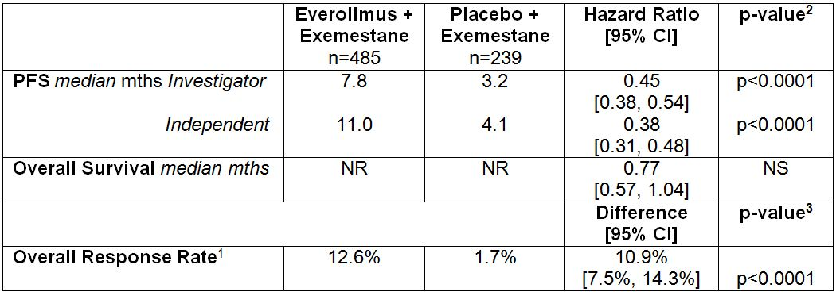
1 Complete Response Rate + Partial Response Rate assessed by investigator using RECIST.
2 Log-Rank test. 3 Exact CMH test using stratified Cochran-Armitage permutation test.
NR – Not Reached. NS – Not Stated.
Increases in PFS in subgroups were consistent with the increase in the overall trial population.

Safety
The safety data were from the BOLERO-2 trial. The safety population (at least one dose of study treatment) was 482 in the everolimus + exemestane group and 238 in the placebo + exemestane group. There was a greater incidence of serious adverse events with everolimus + exemestane (26.8%) than placebo + exemestane (13.9%) and also a greater incidence of severe adverse events (49.6% versus 27.3%). Discontinuations due to adverse effects were also greater with everolimus + exemestane (23.7%) than placebo + exemestane (5.0%).
Common serious adverse events were pneumonitis (2.5% versus 0%), dyspnoea (1.9% versus 0.8%), pneumonia (1.7% versus 0.8%), anaemia (1.5% versus 0.8%) and pulmonary embolism (1.5% versus 0.4%) in the everolimus + exemestane versus placebo + exemestane groups. Common severe adverse events were stomatitis (7.9% versus 0.8%), anaemia (7.2% versus 0.8%) hyperglycaemia (5.4% versus 0.4%) and dyspnoea (4.4% versus 1.3%). Nine deaths (1.9%) were due to adverse events with everolimus + exemestane compared with one (0.4%) with placebo + exemestane. One death (due tumour haemorrhage) was attributed to everolimus. Overall, adverse events attributed to everolimus were consistent with the known safety profile.
The evaluator recommended approval.

Risk management plan
No additional safety concerns were identified by the nonclinical or clinical evaluators.
The evaluator recommended RMP and PSUR conditions of registration.

Risk-benefit analysis

Delegate considerations
The addition of everolimus to exemestane in the BOLERO-2 trial in postmenopausal women with oestrogen receptor-positive, HER2-negative advanced breast cancer refractory to letrozole or anastrozole significantly increased PFS by a median 4.6 months. The OS data were immature. Further survival data are needed to confirm the benefit.
Exemestane, letrozole and anastrozole are AIs. They compete for the aromatase enzyme which converts androgens to oestrogens. Exemestane is a steroidal irreversible inhibitor whereas letrozole and anastrozole are nonsteroidal reversible inhibitors. Exemestane is registered for the treatment of oestrogen receptor-positive postmenopausal breast cancer whereas letrozole and anastrozole are registered for the treatment of hormone receptor-positive postmenopausal breast cancer. An AI is a standard component of first line therapy for postmenopausal women with hormone receptor-positive breast cancer.
The proposed indication is broader than in the BOLERO-2 trial. It is reasonable to extrapolate from “oestrogen receptor-positive” in the trial to “hormone receptor-positive”. However, extrapolation from everolimus “in combination with exemestane” in the trial to everolimus “in combination with an AI” is contentious. The clinical evaluator accepted extrapolation based on the sponsor’s justification. The sponsor hypothesises that resistance to any previous AI treatment will be overcome by concomitant administration with everolimus. This is based on the BOLERO-2 trial of everolimus with exemestane. The subjects in this trial had been resistant to letrozole or anastrozole but not exemestane. The sponsor adds that the three third generation AIs are accepted as equivalent. However, there is no direct evidence that after failure of treatment with letrozole or anastrozole, resistance to these drugs will be overcome by adding everolimus. The Delegate recommends the indication be limited to “combination with exemestane”. The US and EU did not accept the broader “combination with an AI” indication.
The Clinical Trials section of the PI includes clinical benefit rate. Clinical benefit rate is a composite of the proportions of patients with objective tumour responses and stable disease. It is difficult to determine if stable disease is simply a part of the natural history of the disease or is due to drug treatment. Therefore, the endpoint has doubtful value. It is not recognised in the European guideline. Also, it is not necessary in the PI because efficacy is adequately described by the other endpoints including objective response rate. Therefore, the Delegate does not support its inclusion in the PI.
Everolimus was associated with serious adverse reactions; however, these were consistent with the established safety profile. Careful monitoring is appropriate.
The benefit-risk balance is in favour of approval at the present time based on the benefit in PFS.

Draft decision
The Delegate proposes to approve the application for the indication:
For the treatment of postmenopausal women with hormone receptor-positive, HER2-negative advanced breast cancer in combination with exemestane, after failure of treatment with letrozole or anastrozole
subject to finalisation of the PI.
Proposed conditions of registration:
- Submission of the final analysis of overall survival from the BOLERO-2 study when available.
- RMP and PSUR conditions and subsequent updates as agreed with the OPR.

Questions for the Advisory Committee on Prescription Medicines (ACPM):
- Has the efficacy of everolimus in the new indication been satisfactorily established in view of the lack of mature overall survival data?
- Should clinical benefit rate be included in the PI?
- Should the preliminary data of a favourable effect on bone be included in the product information?
- Should the indication be restricted to everolimus “in combination with exemestane” in line with the population in the BOLERO-2 trial?
- Is the benefit-risk balance of everolimus favourable in the new indication?
The Delegate submits to the ACPM for advice.

Response from sponsor
Presented here is Novartis’ pre ACPM Response to the TGA Delegate’s Overview [DO] and Request for ACPM Advice in relation to the application to vary the conditions of Registration – extension of indication of Afinitor (everolimus) 2.5, 5 and 10 mg tablets. Where appropriate, comments have been cross referenced to the DO, the clinical evaluation report [CER], the Section 31 response [S31], or to the submission for marketing authorisation [MA].

Introduction
The sponsor welcomes the Delegate’s proposal to approve the application to extend the indications of Afinitor to the treatment of advanced breast cancer. However, the sponsor notes the Delegate has recommended restricting combination to Afinitor plus exemestane, reflecting the trial regimen. The Clinical Evaluator on the other hand, supported the use of Afinitor in combination with an AI as proposed by the sponsor [CER]. The Delegate has sought advice from the Committee on extension of indications. The sponsor respectfully proposes the indication wording submitted below for consideration by the Committee:
For the treatment of postmenopausal women with hormone receptor-positive, HER2-negative advanced breast cancer in combination with an aromatase inhibitor, after failure of treatment with letrozole or anastrozole
For completeness, in this pre ACPM response, the sponsor provides responses to all issues raised by the Delegate. In particular, the sponsor wishes to reaffirm the reasons at the outset for why the body of evidence supports the sponsor’s proposed indication.

Response to the Delegate’s questions [DO]

Q4. Should the indication be restricted to everolimus “in combination with exemestane” in line with the population in the BOLERO-2 trial?
The sponsor acknowledged the Delegate’s recommendation reflects the population in the BOLERO-2 trial; however, we do not agree it is warranted to restrict combination to only Afinitor plus exemestane.
The rationale for combination of Afinitor with endocrine therapy is to address the problem of endocrine resistance, that is, to restore sensitivity to endocrine therapy in patients who have become endocrine resistant. The biology underlining this rationale is independent of the type of endocrine therapy used.
While the BOLERO-2 study design specified exemestane as the combination partner, the underlying hypothesis assessed the benefit of adding Afinitor to long term oestrogen deprivation that can be achieved by any of the third generation AIs. The reason for specifying exemestane was to minimise the heterogeneity of the patient population enrolled.
Approximately 70% of all invasive breast cancers are positive for oestrogen receptor and/or progesterone receptor (PgR) expression at the time of diagnosis indicating a degree of oestrogen dependence for tumour growth. Treatment options for such patients include endocrine therapies (a current standard of care for oestrogen receptor-positive metastatic breast cancer) that inhibit oestrogen receptor signalling, either by antagonising ligand binding to oestrogen receptor (tamoxifen), down regulating oestrogen receptor (fulvestrant), or blocking oestrogen biosynthesis (AIs). Approximately 50% of women with hormone receptor-positive breast cancer do not respond to initial treatment with endocrine therapy and 50-60% of women who fail their first line hormonal therapy will not respond to the next line of hormonal therapy, thus developing acquired resistance. Nearly all initial responders will develop resistance at some point. Response to one form of endocrine therapy after progression on another is a key part of management of patients with metastatic disease. Subsequent responses to serial endocrine therapy tend to be shorter, suggesting a gradual shift from dependence on oestrogen receptor to an alternative escape pathway.
The Delegate does not refute resistance as the cause for non response to endocrine therapy and agrees with the proposed mechanism of action (PI). The Delegate disputes:
“direct evidence is presented that after failure of treatment with letrozole or anastrozole, resistance to these drugs will be overcome by adding everolimus [DO].”
The pre clinical data and clinical data submitted in this application support the proposed indication by Novartis.

Preclinical Evidence
The preclinical studies and submitted literature in support of this application show in the presence of endocrine therapy, the oestrogen receptor non genomic pathway directly intersects with and upregulates PI3K-AKT activity at the cell surface. In addition, transcription factors activated as a result of mTOR activity can synergise with genomic oestrogen receptor actions and facilitate the transcription of pro survival/proliferative genes. Alterations in each of these transcriptional and signalling elements can mediate resistance to endocrine therapy either by modulating oestrogen receptor activity or by acting as escape pathways to provide alternative proliferation and survival stimuli. Thus, concurrent targeting of mTOR and oestrogen receptor is a rational approach to restore sensitivity to endocrine therapy given that the PI3K/mTOR/AKT pathway is a key downstream signalling component of cell surface growth factor receptors (see Figure 1).

Supporting Clinical Evidence (in addition to BOLERO-2)
Afinitor, an inhibitor of mTOR, in combination with endocrine therapy has demonstrated potent anti tumour activity with two proof of concept Phase II studies.

Afinitor plus letrozole in neoadjuvant breast cancer
In a Phase II, randomised, double blind, placebo controlled trial, 270 postmenopausal women with operable oestrogen receptor positive breast cancer were randomly assigned to receive four months of neoadjuvant treatment with letrozole 2.5 mg/day and either Afinitor 10 mg/day (N=138) or placebo (N=132). The primary endpoint was clinical response by palpation. Secondary endpoints included response rate by ultrasound, biomarker assessment, safety, and PK evaluations.
Response rate in the Afinitor plus letrozole arm was higher than with letrozole alone (68.1% Afinitor versus 59.1% placebo), which was statistically significant at the pre planned, one sided alpha level of 0.1 (p=0.062). The results of this study demonstrated the Afinitor anti tumour activity when used in combination with an AI in the adjuvant setting. It is important to note that patients included in this trial were endocrine therapy naïve. Therefore, a bigger difference in response rate between the two groups could have potentially been observed in a patient population resistant to endocrine therapy.

Afinitor plus tamoxifen in metastatic breast cancer (TAMRAD)
In an open label Phase II trial, 111 postmenopausal women with hormone receptor-positive, HER2-negative metastatic breast cancer resistant to AI (in the adjuvant or metastatic setting) were randomly assigned to receive tamoxifen 20 mg/day with Afinitor 10 mg/day (N=54) or tamoxifen 20 mg/day alone (N=57). The primary endpoint was CBR defined as the percentage of all patients with a complete, or partial response (PR) or stable disease (SD) at six months. No formal statistical comparison between groups was planned.
Median duration of follow up was similar for tamoxifen plus Afinitor and tamoxifen alone: 23.7 months (range: 2.6 to 32.7 months) and 24.2 months (range: 0.9 to 36.2 months), respectively.
The 6 month CBR was 61% (95% CI, 47 to 74) with tamoxifen plus Afinitor and 42% (95% CI, 29 - 56) with tamoxifen alone. Time to progression (TTP) increased from 4.5 months with tamoxifen alone to 8.6 months with tamoxifen plus Afinitor, corresponding to a 46% reduction in risk of progression with the combination (HR = 0.54; 95% CI, 0.36 - 0.81).
At the last update of OS in September 2011, 16 patients in the tamoxifen plus Afinitor and 31 patients in the tamoxifen alone groups had died. Median OS was 32.9 months with tamoxifen alone and was not reached with tamoxifen plus Afinitor. The risk of death was reduced by 55% with tamoxifen plus Afinitor versus tamoxifen alone (HR = 0.45; 95% CI, 0.24 to 0.81) (Figure 5). The results of this study demonstrate the efficacy of Afinitor in re-sensitising women to endocrine therapy other than exemestane [S31 response].
Figure 5: Overall survival in the intention to treat population in the TAMRAD trial.
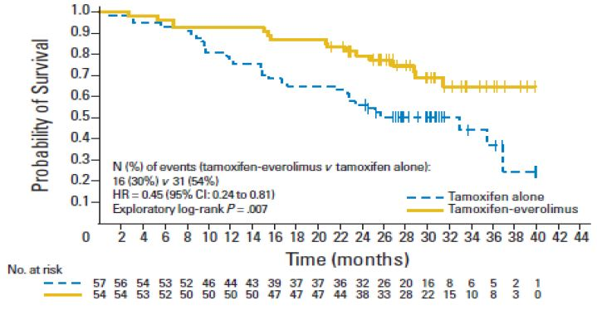

Recent Phase II data in combination with letrozole and fulvestrant
Following agreement with the Delegate’s office, we have also taken this opportunity to inform the ACPM of more recent clinical information that further lend support to combining Afinitor with an endocrine therapy. Preliminary results from two single arm Phase II studies combining Afinitor with other endocrine therapy partners were presented at the recent San Antonio Breast Cancer Symposium (December 2012). Both studies provided data consistent with the magnitude of efficacy and safety profile seen in BOLERO-2, suggesting consistent outcome irrespective of combination partner.
Safra and colleagues combined letrozole 2.5 mg with Afinitor 10 mg in women who had failed a median of two prior endocrine therapies of which 37.7% had received prior letrozole. At a median follow up of 8.1 months the median PFS was 8.7 months, ORR was 17.7% and CBR was 75.8%.
Croley and colleagues combined fulvestrant 500 mg with Afinitor 10 mg in women who had failed prior AI. At the time of analysis the study was 82% recruited (32/40), median TTP was 7.4 months, ORR was 13% and CBR 45%.

Interchangeability of 3rd generation AIs
In addition to the mechanisms of resistance and re-sensitisation to endocrine therapy, the rationale for adding Afinitor to long term oestrogen deprivation using any of the third generation AIs is based on the recognised interchangeability of the third generation AIs in clinical practice. We note that other therapies herceptin and tykerb were approved for use for advanced breast cancer when combined with an AI although the treatment arms in the advanced breast cancer studies were herceptin plus anastrozole versus anastrozole alone and tykerb plus letrozole versus letrozole alone.
PBAC and NCCN (2012) have recognised the similar safety and efficacy between anastrozole 1 mg, letrozole 2.5 mg and exemestane 25 mg in the treatment of advanced breast cancer (ABC).
The Therapeutic Relativity Sheets (1 January 2012), under the ATC LO2 for endocrine therapy (effective date of December 2010), the PBAC state:
“In the treatment of advanced breast cancer, exemestane tablet 25 mg was recommended for listing on the basis of similar safety and efficacy to 1 mg anastrozole and 2.5 mg letrozole.”
The NCCN (2012) Guideline states:
“The panel believes the three selective AIs (anastrozole, letrozole, and exemestane) have similar antitumour activity and a similar toxicity profile”.
In summary, when viewed collectively, Novartis believes the body of evidence supports the proposal to combine Afinitor with an AI.

Q1. Has efficacy of everolimus in the new indication been satisfactorily established in view of the lack of mature overall survival data?
PFS was the pre defined primary efficacy endpoint in an adequately designed Phase III clinical trial. The combination of Afinitor with exemestane showed significant improvement in efficacy, in terms of PFS, response rate, and CBR relative to exemestane monotherapy. The BOLERO-2 study demonstrated a statistically significant clinical benefit of Afinitor plus exemestane over placebo plus exemestane by a 2.4 fold prolongation in median PFS (median: 7.8 months versus 3.2 months), resulting in a 55% risk reduction of progression or death (PFS HR 0.45; 95%CI: 0.38, 0.54; one sided log-rank test P value <0.0001 per local investigator assessment. The combination of Afinitor and exemestane has received a marketing authorisation in the US, EU and many other countries based on the results of this study.
OS is a protocol defined key secondary endpoint of the BOLERO-2 study. Final analysis of this endpoint is scheduled to occur after 398 deaths, a milestone expected to occur at the end of 2013. The data is not yet mature, and no statistically significant treatment related difference has thus far been demonstrated. The final OS report will be provided to TGA as soon as it becomes available.
Novartis is of the view that the PFS data is sufficient to support the efficacy and overall favourable benefit-risk profile of Afinitor for the new indication.

Q2. Should clinical benefit rate be included in the product information?
The sponsor acknowledges the concerns raised by the Delegate but maintain a preference to retain CBR in the Afinitor PI to help inform clinical decision making.
In the BOLERO-2 study, CBR is a protocol defined secondary endpoint comprising of the proportion of patients with best overall response of complete response (CR), PR or SD lasting at least 24 weeks, according to RECIST criteria.
Given that baseline characteristics were well balanced between the two treatment arms in the study and that a clear difference was observed in objective response rate, the sponsor would contend the difference observed in the proportion of patients that achieved stable disease between the two arms (71.3% versus 59.0%) is due to drug treatment and is not attributable to the natural biology of the disease. Therefore, the sponsor believes that retention of CBR (and by default stable disease ≥ 24 weeks) has clinical utility.
The treatment goals for patients with advanced breast cancer are palliative in nature, primarily focused on disease control – typically delay of progression and/or reduction of tumour burden – while minimising toxicity and maintaining quality of life. Choice of active second line treatment for HR positive advanced breast cancer basically comprises either chemotherapy or endocrine therapy and is dependent upon disease characteristics.
In patients with a significant tumour burden and symptomatic visceral disease, the indication of chemotherapy is supported by the perception of a more rapid and higher objective response rate.
Endocrine responsive patients with liver or lung metastasis and no or few clinical symptoms do have both chemotherapy and hormonal therapy as therapeutic alternatives. Objective responses are relatively uncommon with both options (15-30% for single agent chemotherapy versus 2-7% for a steroidal AI). Estimates of disease control in this setting, assessed by CBR and PFS, are more relevant than response rate as a measure of efficacy, as progression dictates change of therapy. Therefore, maintenance of long term stable disease (≥24 weeks) with endocrine therapy becomes a useful clinical indicator of disease control and helps provide context for the clinical decision of using Afinitor plus AI versus chemotherapy. As such Novartis would like to maintain a reference to both ORR and CBR (ORR plus SD ≥ 24 weeks) in the PI so that long term stable disease rate is available to aid clinical decision making.
Although the Delegate states the endpoint is not recognised in the European guideline, the EU did include CBR in their SmPC. The sponsor agrees with the evaluator’s recommendation to ‘leave CBR in the PI so that clinicians will have the opportunity to assess this on its own merits’ [CER].

Q3. Should the preliminary data of a favourable effect on bone be included in the product information?
It was the sponsor’s intention to inform patients and clinicians of the effects of Afinitor on bone health. The postmenopausal population generally has low oestrogen levels which are associated with a decrease in bone mineral density and the use of exemestane is associated with a high increase in bone turnover markers. The sponsor agrees with the Delegate there is a need for long term data on bone effects. The submitted bone effects statement and table of data have been removed from the PI pending the outcome of the meeting.

Q5. Is the benefit-risk balance of everolimus favourable in the new indication?
Both the Delegate and evaluator agree the benefit-risk balance is in favour of the Afinitor treatment arm for the proposed use. The beneficial effect of Afinitor plus exemestane treatment in patients with metastatic breast cancer is clinically relevant. Median PFS was prolonged by 4.63 months: from 3.19 months for patients receiving placebo plus exemestane to 7.82 months for patients treated with Afinitor plus exemestane. The secondary endpoints were supportive of the primary analysis. In addition, the OS data so far suggests a trend favouring the combination treatment. No new major safety signal was detected in the BOLERO-2 study; planned pharmacovigilance actions are managed as per the submitted RMP.

Conclusion
The sponsor welcomes the Delegate’s recommendation to approve Afinitor for the new indication. Novartis believes that our proposed indication for use of Afinitor in combination with an AI is warranted as shown by the body of evidence. There is also a medical need for this treatment option since nearly all initial responders will develop endocrine resistance at some point. Flexibility is required to accommodate patients who have failed or are intolerant to exemestane. Furthermore, clinical benefit rate should remain in the PI. Maintenance of long term stable disease with endocrine therapy becomes a useful clinical indicator of disease control and will assist in clinical decision making.

Advisory Committee Considerations
The ACPM, taking into account the submitted evidence of efficacy, safety and quality, agreed with the Delegate and considered these products to have an overall positive benefit-risk profile for the following indication:
For the treatment of postmenopausal women with hormone receptor-positive, HER2-negative advanced breast cancer in combination with exemestane, after failure of treatment with letrozole or anastrozole.
In making this recommendation, the ACPM noted the lack of mature OS data and limited data on PFS; however, highlighted the clinical significance of the reported rates of benefit in the context of this population group.
The ACPM agreed with the delegate to the proposed amendments to the PI and CMI.
- a statement in the ‘Clinical Trials’ section of the PI to ensure clear guidance to prescribers and consumers about the evidence of clinical benefit.
- a statement in the ‘Dosage and Administration’ section of the PI and relevant sections of the CMI to ensure the reference to impact of dosing with a fatty meal.
The ACPM advised that the implementation by the sponsor of the recommendations outlined above to the satisfaction of the TGA, in addition to the evidence of efficacy and safety provided would support the safe and effective use of these products.

Outcome
Based on a review of quality, safety and efficacy, TGA approved the registration of Caprelsa tablets containing everolimus 2.5 mg, 5 mg and 10 mg. The approved indication reads as follows:
Afinitor is indicated for the treatment of postmenopausal women with hormone receptor-positive, HER2-negative advanced breast cancer in combination with exemestane after failure of treatment with letrozole or anastrozole.
The full indications are now for the treatment of:
    - Postmenopausal women with hormone receptor-positive, HER2-negative advanced breast cancer in combination with exemestane after failure of treatment with letrozole or anastrozole;
    - Progressive, unresectable or metastatic, well or moderately differentiated neuroendocrine tumours (NETs) of pancreatic origin;
    - Advanced renal cell carcinoma after failure or treatment with sorafenib or sunitinib; and
    - Subependymal giant cell astrocytoma (SEGA) associated with tuberous sclerosis (TS) who require therapeutic intervention but are not candidates for curative surgical resection.

Specific conditions of registration applying to these therapeutic goods
1. The final analysis of overall survival from BOLERO-2 study will be submitted when available.
2. The implementation in Australia of the European Union Risk Management Plan for everolimus Version 7 (RMP), dated 18 May 2012 (date lock point 31 March 2012) including Australian Specific Annex Version 3 dated 1 August 2012, and any future updates agreed with the TGA Office of Product Review.
3. Provide Periodic Safety Update Reports (PSURs) in line with the European Union reference dates and frequency until the period covered by such reports is not less than three years from the date of this letter. The reports are to meet the requirements of the ICH E2C (R2) guideline on periodic Benefit-Risk Evaluation Reports and Module VII of the EMA Guideline on Good Pharmacovigilance Practices relating to PSURs. Submission of the report must be within 70 days of the data lock point for PSURs covering intervals up to and including 12 months and within 90 days of the data lock point for PSURs covering intervals in excess of 12 months. The submission may consist of two PSURs each covering six months.

Attachment 1. Product Information
The Product Information approved at the time this AusPAR was published is at Attachment 1. For the most recent Product Information please refer to the TGA website at <http://www.tga.gov.au/hp/information-medicines-pi.htm>.

Sponsor comment: “The same application has since been approved in the US, EU, Canada and Switzerland.”
Tabernero J, et al. (2008) Dose- and schedule-dependent inhibition of the mammalian target of rapamycin pathway with everolimus: a phase I tumor pharmacodynamic study in patients with advanced solid tumors. J Clin Oncol. 26: 1603-1610.
Ellard SL, et al. Randomized phase II study comparing two schedules of everolimus in patients with recurrent/metastatic breast cancer: NCIC Clinical Trials Group IND.163. J Clin Oncol. 27: 4536-4541; Baselga J, et al. (2009) Phase II randomised study of neoadjuvant everolimus plus letrozole compared with placebo plus letrozole in patients with estrogen receptor-positive breast cancer. J Clin Oncol. 27: 2630-2637.
Sponsor comment: “The Section 31 letter recommendation after first round is: ‘For the treatment of postmenopausal women with hormone receptor-positive, HER2-negative advanced breast cancer in combination with exemestane, after failure of treatment with letrozole or anastrozole’.”
Baselga J, et al. (2012) Everolimus in postmenopausal hormone-receptor-positive advanced breast cancer. N Engl J Med. 366: 520-529.
Sponsor comment: “PFS subgroup HR changed to 0.25 to 0.62 with Dec 2011 cut off.”
Miller T, et al. (2010) Hyperactivation of phosphatidylinositol-3 kinase promotes escape from hormone dependence in estrogen receptor–positive human breast cancer. J Clin Invest. 120: 2406-2413.
Normanno M, et al. (2005) Mechanisms of endocrine resistance and novel therapeutic strategies in breast cancer. Endocr Relat Cancer 12: 721-747.
Schiff R, Massarweh S, Shou J et al (2003) Breast cancer endocrine resistance: how growth factor signalling and estrogen receptor coregulators modulate response. Clin Cancer Res. 9: 447S-454S; Hurvitz S, Pietras R (2008) Rational management of endocrine resistance in breast cancer: a comprehensive review of estrogen receptor biology, treatment options, and future directions. Cancer 113: 2385-2397.
Moy B, Paul G (2006) Estrogen receptor pathway: resistance to endocrine therapy and new therapeutic approaches. Clin Cancer Res. 12: 4790-4793; Normanno M, et al. (2005) Mechanisms of endocrine resistance and novel therapeutic strategies in breast cancer. Endocr Relat Cancer 12: 721-747; Pink J, et al. (1996) Irreversible loss of the oestrogen receptor in T47D breast cancer cells following prolonged oestrogen deprivation. Br J Cancer 74: 1227-1236; Schiff R, Massarweh S, Shou J et al (2003) Breast cancer endocrine resistance: How growth factor signalling and estrogen receptor coregulators modulate response. Clin Cancer Res. 9: 447S-454S.
Osborne K, Schiff R (2011) Mechanisms of endocrine resistance in breast cancer. Ann Rev Med. 62: 233-247.
Baselga J, et al. (2009) Phase II randomised study of neoadjuvant everolimus plus letrozole compared with placebo plus letrozole in patients with estrogen receptor-positive breast cancer. J Clin Oncol. 27: 2630-2637; Bachelot T, et al. (2012) Randomised phase II trial of everolimus in combination with tamoxifen in patients with hormone receptor-positive, human epidermal growth factor receptor 2-negative metastatic breast cancer with prior exposure to aromatase Inhibitors: a GINECO study. J Clin Oncol. 30: 2718-2724.
Baselga J, et al. (2009) Phase II randomised study of neoadjuvant everolimus plus letrozole compared with placebo plus letrozole in patients with estrogen receptor-positive breast cancer. J Clin Oncol. 27: 2630-2637.
Bachelot T, et al. (2012) Randomised phase II trial of everolimus in combination with tamoxifen in patients with hormone receptor-positive, human epidermal growth factor receptor 2-negative metastatic breast cancer with prior exposure to aromatase Inhibitors: a GINECO study. J Clin Oncol. 30: 2718-2724.
Bachelot T, et al. (2012) Randomised phase II trial of everolimus in combination with tamoxifen in patients with hormone receptor-positive, human epidermal growth factor receptor 2-negative metastatic breast cancer with prior exposure to aromatase Inhibitors: a GINECO study. J Clin Oncol. 30: 2718-2724.
Safra, et al. (2012) RAD001 (everolimus) in combination with letrozole in the treatment of postmenopausal women with estrogen receptor positive metastatic breast cancer after failure of hormonal therapy – A Phase II study. San Antonio Breast Cancer Symposium, Poster P5-20-06.
Croley J, et al. (2012) Phase II study of combined fulvestrant and RAD001 (everolimus) in metastatic estrogen receptor (ER) positive breast cancer after aromatase inhibitor (AI) failure. San Antonio Breast Cancer Symposium Poster, P2-14-05.
Barrios CH (2010) The role of chemotherapy in hormone receptor positive advanced breast cancer. Gaceta mexicana de oncologia (GAMO) 9: 215-221.
Based on results from EFECT, SoFEA and BOLERO-2, all studies using exemestane as a control arm for second line therapy after progression of NSAI.

