First round: March 2016
Second round: July 2016

AusPAR Attachment 2

Extract from the Clinical Evaluation Report for Everolimus
  - Proprietary Product Name: Afinitor
  - Sponsor: Novartis Pharmaceuticals Australia Pty Ltd

About the Therapeutic Goods Administration (TGA)
- The Therapeutic Goods Administration (TGA) is part of the Australian Government Department of Health, and is responsible for regulating medicines and medical devices.
- The TGA administers the Therapeutic Goods Act 1989 (the Act), applying a risk management approach designed to ensure therapeutic goods supplied in Australia meet acceptable standards of quality, safety and efficacy (performance), when necessary.
- The work of the TGA is based on applying scientific and clinical expertise to decision-making, to ensure that the benefits to consumers outweigh any risks associated with the use of medicines and medical devices.
- The TGA relies on the public, healthcare professionals and industry to report problems with medicines or medical devices. TGA investigates reports received by it to determine any necessary regulatory action.
- To report a problem with a medicine or medical device, please see the information on the TGA website <https://www.tga.gov.au>.
About the Extract from the Clinical Evaluation Report
- This document provides a more detailed evaluation of the clinical findings, extracted from the Clinical Evaluation Report (CER) prepared by the TGA. This extract does not include sections from the CER regarding product documentation or post market activities.
- The words [Information redacted], where they appear in this document, indicate that confidential information has been deleted.
- For the most recent Product Information (PI), please refer to the TGA website <https://www.tga.gov.au/product-information-pi>.
Copyright
© Commonwealth of Australia 2017
This work is copyright. You may reproduce the whole or part of this work in unaltered form for your own personal use or, if you are part of an organisation, for internal use within your organisation, but only if you or your organisation do not use the reproduction for any commercial purpose and retain this copyright notice and all disclaimer notices as part of that reproduction. Apart from rights to use as permitted by the Copyright Act 1968 or allowed by this copyright notice, all other rights are reserved and you are not allowed to reproduce the whole or any part of this work in any way (electronic or otherwise) without first being given specific written permission from the Commonwealth to do so. Requests and inquiries concerning reproduction and rights are to be sent to the TGA Copyright Officer, Therapeutic Goods Administration, PO Box 100, Woden ACT 2606 or emailed to <tga.copyright@tga.gov.au>.

Contents
List of common abbreviations 5
1. Introduction 8
1.1. Drug class and therapeutic indication 8
1.2. Dosage forms and strengths 8
2. Clinical rationale 9
2.1. Treatment 10
2.2. Formulation development 11
2.3. Guidance 11
3. Contents of the clinical dossier 12
3.1. Scope of the clinical dossier 12
3.2. Paediatric data 12
3.3. Good clinical practice 12
4. Pharmacokinetics 12
5. Pharmacodynamics 14
6. Dosage selection for the pivotal studies 14
7. Clinical efficacy 14
7.1. Neuroendocrine tumours (GIT/Lung) 14
7.2. Tuberous sclerosis 34
7.3. Analyses performed across trials (pooled analyses and meta-analyses) 38
7.4. Evaluator’s conclusions on clinical efficacy 39
8. Clinical safety 40
8.1. Neuroendocrine tumours (GIT/Lung) 40
8.2. TSC studies 51
8.3. Post-marketing experience 53
8.4. Safety issues with the potential for major regulatory impact 53
8.5. Evaluator’s overall conclusions on clinical safety 55
9. First round benefit-risk assessment 56
9.1. Neuroendocrine Tumours (GIT/Lung) 56
9.2. Tuberous sclerosis 57
10. First round recommendation regarding authorisation 57
10.1. Neuroendrocrine tumours 57
10.2. Tuberous sclerosis 57
11. Clinical questions 57
11.1. General 57
11.2. Efficacy 57
12. Second round evaluation of clinical data submitted in response to questions 57
13. Second round benefit-risk assessment 59
13.1. Second round assessment of benefits 59
13.2. Second round assessment of risks 59
13.3. Second round assessment of benefit-risk balance 59
14. Second round recommendation regarding authorisation 59
15. References 60

List of common abbreviations
Abbreviation | Meaning
AE | Adverse Event
ALKP | Alkaline Phosphatase
ALT | Alanine Transaminase
aPTT | activated partial thromboplastin time
ARTG | Australian Register of Therapeutic Goods
AST | Aspartate Transaminase
AUC | Area under the curve
BIL | Bilirubin
CgA | Chromogranin A
CI | Confidence interval
Cmax | Maximum concentration
Cmin | Minimum concentration
CMI | Consumer Medicines Information
CL | Clearance
CR | Complete Response
CrCl | Creatinine clearance
CT | X-Ray Computed Tomography
CTCAE | Common terminology criteria for adverse events
CUP | Carcinoma of unknown primary origin
CV | Coefficient of variation
DCR | Disease Control Rate
DoR | Duration of Response
ECG | Electrocardiograph
EMA | European Medicines Agency
FACT-G | Functional Assessment of Cancer Therapy-General
FDA | Food and Drug Administration
GCP | Good Clinical Practice
GIT | Gastrointestinal tract
ICH | International Conference on Harmonisation
INR | International normalised ratio
L | Litre(s)
LDH | Lactate Dehydrogenase
LFTs | Liver function tests
MEDRA | Medical dictionary for regulatory activities
MRI | Magnetic Resonance Imaging
mTOR | Mammalian target of rapamycin
NET | Neuroendocrine tumour
NSE | Neuron-specific enolase
OD | Once daily
ORR | Overall response rate
OS | Overall Survival
PD | Pharmacodynamics
PFS | Progression free survival
PI | Product Information
PK | Pharmacokinetics
PR | Partial Response
PRO | Patient reported outcomes
PS | Performance status
QoL | Quality of Life
RECIST | Response evaluation criteria in solid tumours
SAE | Serious Adverse Event
SD | Stable Disease
SEGA | Subependymal giant cell astrocytoma
SSA | Somatostatin analogue
TGA | Therapeutic Goods Administration
Tmax | Time of maximum concentration
TSC | Tuberous sclerosis complex
TTP | Time to Progression

Introduction
This is an abridged application seeking registration of an additional indication for the product.
The application also seeks to update the product information (PI) with the final results of three previously evaluated studies relating to the tuberous sclerosis complex (TSC) indications.

Drug class and therapeutic indication
Everolimus is an inhibitor of mTOR (mammalian target of rapamycin). mTOR is an intracellular serine/threonine protein kinase which is a central controller of multiple signalling pathways involved in regulating cell growth, proliferation and apoptosis.
The currently approved indications for Afinitor are:
For the treatment of:
‘Postmenopausal women with hormone receptor-positive, HER2 negative advanced breast cancer in combination with exemestane after failure of treatment with letrozole or anastrozole;
Advanced renal cell carcinoma after failure of treatment with sorafenib or sunitinib.
Subependymal giant cell astrocytoma (SEGA) associated with tuberous sclerosis complex (TSC) who require therapeutic intervention but are not candidates for curative surgical resection.
Patients with tuberous sclerosis complex (TSC) who have renal angiomyolipoma not requiring immediate surgery.
Progressive, unresectable or metastatic, well or moderately differentiated neuroendocrine tumours (NETs) of pancreatic origin’.
The proposed additional indication is for the treatment of:
‘Progressive, unresectable or metastatic, well-differentiated, non-functional neuroendocrine tumours (NET) of gastrointestinal or lung origin’.
As shown, the current indications include the treatment of pancreatic NETs. The present application seeks approval for the drug in patients with gastrointestinal or lung NETs.
Everolimus is marketed by the same sponsor under a different trade name (as Certican) for the prophylaxis of rejection in organ transplant recipients. Other mTOR inhibitors registered in Australia are sirolimus and temsirolimus. These agents are not approved for the treatment of NETs.

Dosage forms and strengths
The following dosage forms and strengths are currently registered:
- 2.5, 5.0 and 10.0 mg tablets;
- 2.0, 3.0 and 5.0 mg dispersible tablets.
No new dosage forms or strengths are proposed.

Clinical rationale
A neuroendocrine tumour (NET) can be defined as a tumour that forms from cells that release hormones into the blood in response to a signal from the nervous system. NETs are a diverse collection of tumours that demonstrate varied clinical behaviour. They can arise in most organs of the body. Common sites include the, gastrointestinal tract, lungs, pancreas and thymus. Other less common sites include the parathyroid, thyroid, adrenal and pituitary glands.
NETs are rare malignancies with an estimated annual incidence of approximately 5 cases per 100,000 of population.
There are currently a number of systems used to classify, grade and stage NETs. Relevant documents include guidelines produced by the World Health Organisation (WHO); the European Neuroendocrine Tumor Society (ENETS); the North American Neuroendocrine Tumor Society (NANETS); and guidelines produced by the National Comprehensive Cancer Network (NCCN) in the United States^{.4} Guidelines generally classify NETs as either well differentiated or poorly differentiated. They are also graded as low grade (Grade 1), intermediate grade (Grade 2) or high grade (Grade 3) tumours on the basis of the rate of proliferation of cells in the tumour. Rate of proliferation is determined using the number of mitoses per 10 high-power microscopic fields (HPF) or the percentage of cells expressing Ki-67, a nuclear protein that is a general marker of tumour proliferation.³
A proportion of NETs express excessive amounts of hormones, resulting in distinct clinical syndromes. Examples include Zollinger-Ellinson syndrome associated with excess production of gastrin (gastrinoma) and hypoglycaemia with excess insulin (insulinoma). Tumours that secrete excess amounts of vasoactive peptides such as serotonin can be associated with a distinct clinical syndrome known as ‘carcinoid syndrome’ which is characterised by flushing, diarrhoea and abdominal pain. Tumours producing excessive amounts of hormones are referred to as ‘functioning’ NETs whereas those not producing excessive hormones are referred to as ‘non-functioning’ NETs. Functioning NETs may produce more than one hormone.²
Chromogranin A (CgA) is a protein contained in the secretory granules of neuroendocrine cells. Serum CgA levels can be used to monitor disease burden for both functioning and non-functioning NETs. Another biomarker often overexpressed by NETs is neuron-specific enolase (NSE), a glycolytic enzyme found in neuronal and neuroendocrine tissues. Other biomarkers include 5-hydroxyindole acetic acid (5-HIAA), the urinary breakdown product of serotonin, and specific hormones associated with functioning tumours (for example, gastrin, insulin).
Extent of disease is usually described using a tumour, nodes and metastasis (TNM) staging systems such as those produced by the American Joint Committee on Cancer (AJCC). Separate staging systems are used for the various anatomical sites of primary tumour. The most common sites for metastases are regional liver nodes, the liver and bone.⁴ Approximately 50% of subjects have metastatic disease at the time of initial diagnosis.⁹
NETs typically express receptors for somatostatin, an endogenous hormone that has inhibitory effects on a number of cellular functions. These receptors provide a target for imaging of the disease through the use of radiolabelled somatostatin analogues (use of Octreoscan, for example). Somatostatin analogues are also used in the treatment of these tumours.
NETs usually occur sporadically but may be a feature of various inherited genetic syndromes such as multiple endocrine neoplasia types 1 and 2 (MEN1 and MEN2), von Hippel-Lindau disease, tuberous sclerosis complex and neurofibromatosis.⁴

Treatment
Surgery is the treatment of choice for patients with resectable disease. For patients with poorly differentiated unresectable or metastatic disease, cytotoxic chemotherapy is used (used of platinum-based regimens, for example).
For subjects with unresectable or metastatic well-differentiated disease, established treatments include the following:
- Somatostatin analogues (SSAs): octreotide (Sandostatin) and lanreotide (Somatuline);
- sunitinib;
- everolimus.
The approved indications for these products in Australia are summarised below in Table 1. The indications for the various products are limited to NETs arising in certain anatomical locations. In particular sunitinib and everolimus are currently restricted for use in subjects with pancreatic NETs. The rationale for this submission was that there are limited treatment options available for subjects with advanced NETs arising from sites other than the pancreas.

Table 1. Drugs registered in Australia for the treatment of NETs
Generic | Tradename | Approved indication
Octreotide | Sandostatin | For the relief of symptoms associated with the following functional tumours of the gastro-entero-pancreatic endocrine system:  Carcinoid tumours with features of the carcinoid syndrome;  Vasoactive intestinal peptide secreting tumours (VIPomas).  Sandostatin is not curative in these patients.
Octreotide | Sandostatin LAR | Treatment of patients with progression of well-differentiated, advanced neuroendocrine tumours of the midgut or suspected midgut origin.  For the relief of symptoms associated with the following functional tumours of the gastro-entero-pancreatic endocrine system:  Carcinoid tumours with features of the carcinoid syndrome;  Vasoactive intestinal peptide secreting tumours (VIPomas) in patients who are adequately controlled on subcutaneous treatment with Sandostatin.  Sandostatin LAR is not curative in these patients.
Lanreotide | Somatuline Autogel | For the treatment of gastroenteropancreatic neuroendocrine tumours (GEP-NETs) in adult patients with unresectable locally advanced or metastatic disease.  For the treatment of symptoms of carcinoid syndrome associated with carcinoid tumours.
Sunitinib | Sutent | For the treatment of unresectable, well-differentiated pancreatic neuroendocrine tumours (pancreatic NET).
Everolimus | Afinitor | Progressive, unresectable or metastatic, well or moderately differentiated neuroendocrine tumours (NETs) of pancreatic origin.
Other registered agents that are used for well-differentiated NETs, but do not have regulatory approval in Australia include interferon alpha 2b and various cytotoxic agents (examples include temozolomide, 5-fluorouracil, capecitabine, and dacarbazine). Radionuclide therapy with radiolabelled somatostatin analogues (LuTate for example) is an experimental therapy that has shown promising results in these patients.⁴

Formulation development
The pivotal study in this submission was conducted with a 5 mg tablet formulation. The sponsor should be asked to provide an assurance that this formulation was identical to that registered in Australia.

Guidance
The following EMA guidelines, which have been adopted by the TGA, are considered relevant to the current submission:
- Guideline on the evaluation of anticancer medicinal products;
- Appendix 1 to the guideline on the evaluation of anticancer medicinal products in man. (Methodological consideration for using progression-free survival or disease-free survival in confirmatory trials);
- Points to consider on application with 1. Meta-analyses; 2. One pivotal study.
Compliance with these guidelines will be considered in the relevant sections of this report.

Contents of the clinical dossier

Scope of the clinical dossier
The submission contained the following clinical information relevant to the proposed new indication:
- A single pivotal efficacy/safety study (Study CRAD001T2302 (RADIANT-4), otherwise referred to as the RADIANT-4 study), and
additional tables and figures relating to efficacy and safety in support of the clinical summaries. These were referred to as appendices.
- A Clinical Overview, Summary of Clinical Pharmacology, Summary of Clinical Efficacy, and a Summary of Clinical Safety.
- Literature references
In support of the updates to the PI concerning TSC studies, the submission included final study reports for 3 trials: M2301, M2302, and C2485. The submission also included summaries of efficacy and safety for these studies.

Paediatric data
The submission did not include paediatric data. The sponsor has obtained waivers for paediatric data from both the FDA in the USA and the EMA in Europe. In the USA the waiver appears to have been based on the fact that the drug had received orphan designation. In Europe it appears that the waiver was granted on the grounds that gastro-entero-pancreatic NETs do not normally occur in children.

Good clinical practice
The submission included one new trial to support the proposed new indication. The study report included an assurance that the trial was conducted in accordance with the ICH Harmonised Guidelines for Good Clinical Practice and with the ethical principles laid down by the Declaration of Helsinki.

Pharmacokinetics
The pivotal study in GIT/lung NETs collected a very limited amount of PK data. These data are summarised below in Table 2. No significant new information was generated regarding the PK of everolimus.

Table 2. Summary of the PK data from the RADIANT-4 study
Summary of PK data
Objectives | This was the pivotal efficacy study supporting the proposed new indication. One of the secondary objectives of the study was to determine the exposure of everolimus at the steady state pre-dose concentration (C_{min}) at Cycle 2 (Day 29). Two of the exploratory objectives were to explore the relationship between C_{min} and progression-free survival and PFS, and to explore the relationship between C_{min} and safety endpoints.
Methodology | Design: Details of the study design, treatments and so on are given in Section 7: Clinical Efficacy of this report.  PK sampling and analysis: A single blood sample for PK analysis was collected on pre-dose on day 29 of the study (that is, Day 1 of Cycle 2). Whole blood everolimus concentrations were determined by a liquid chromatography mass spectrometry method. The lower limit of quantitation (LLOQ) was 0.3 ng/mL.
Study participants | Enrolled: Full details of study participants are summarised under Section 7: Clinical efficacy of this report.  Analysed: Only 51 subjects in the everolimus arm provided suitable samples that were analysed. 48 subjects were receiving 10 mg per day and 3 subjects were receiving 5 mg/day.
PK results | 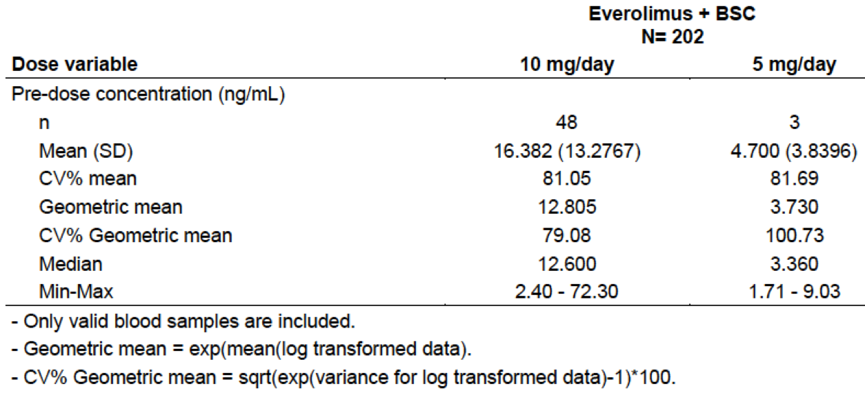  According to the sponsor, these data were consistent with values observed in previous studies for the everolimus 5 mg and 10 mg daily doses.
PK efficacy analyses | The relationship between PFS and C_{min} was analysed using a Cox regression analysis. For a two-fold increase in C_{min} there was a non-significant trend towards improved PFS (HR = 0.898; 95%CI: 0.586, 1.374). Another analysis indicated that a two-fold increase in C_{min} was associated with an increased probability of a reduction in tumour size (Odds ratio = 1.58; 95% CI: 1.23, 2.04). There was no relationship demonstrated between C_{min} and the change from Baseline in tumour biomarkers.
PK safety analyses | The relationship between C_{min} and time to first onset of three AEs (stomatitis, non-infectious pneumonitis and infections) were explored. No relationship was demonstrated.  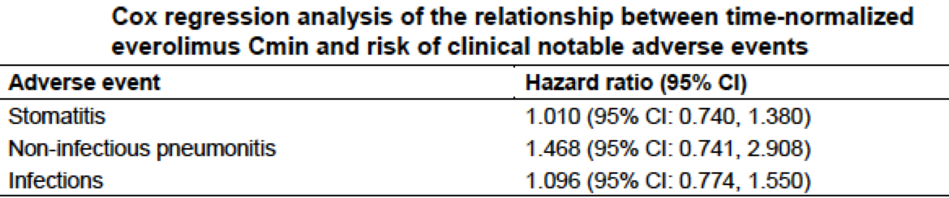
Evaluator’s comments | The study design, conduct and analysis were satisfactory.

Pharmacodynamics
There were no new pharmacodynamic data in the submission.

Dosage selection for the pivotal studies
The dosage of everolimus used in the pivotal study was 10 mg once daily. This dose had been associated with evidence of efficacy in previous Phase II and Phase III studies conducted in patients with NETs (for example, in the RADIANT-2 and RADIANT-3 studies).

Clinical efficacy

Neuroendocrine tumours (GIT/Lung)

Pivotal efficacy study: Study CRAD001T2302 (RADIANT-4)

Study design, objectives, locations and dates
The RADIANT-4 study was a randomised, double blind, placebo controlled Phase III study with two parallel groups (everolimus plus best supportive care (BSC) versus placebo plus BSC). A study schema is shown below in Figure 1.
Figure 1. Study CRAD001T2302 (RADIANT-4) Schema
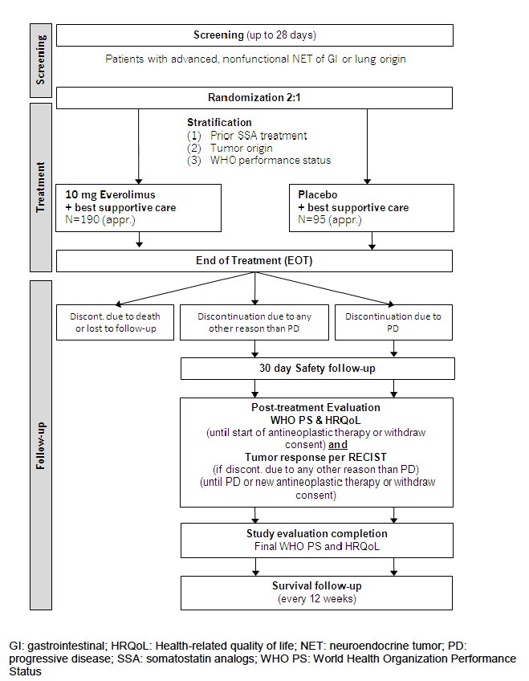
The study consisted of:
- A screening period (lasting up to 28 days);
- A treatment period (including a randomisation visit, visits every 28 days during treatment and an end-of-treatment (EOT) visit);
- A follow-up period (including a follow-up safety visit at 30 days after EOT, and post-treatment evaluation visits every 8 or 12 weeks depending on each subject’s situation).
The primary objective of the study was to determine whether treatment with everolimus 10 mg daily plus best supportive care prolonged progression-free survival (PFS) compared with placebo plus best supportive care in patients with advanced NETs of GI or lung origin without a history of, or current symptoms of carcinoid syndrome.
The key secondary objective was to compare overall survival (OS) between study arms.
Other secondary objectives were to:
- Determine the safety and tolerability of everolimus in this patient population.
- Evaluate overall response rate (ORR) and disease control rate (DCR) in the two study arms.
- Compare the Health-Related Quality of Life (HRQoL) based on the Functional Assessment of Cancer Therapy-General (FACT-G) total score between study arms.
- Compare changes from Baseline in chromogranin A (CgA) and neuron-specific enolase (NSE) levels between study arms.
- Compare time to deterioration for WHO performance status between study arms.
Another secondary objective was to determine the exposure of everolimus at the steady-state pre-dose concentration (C_{min}) at Cycle 2 (Day 29). PK data from the study are summarised above in Section 4.
Subjects were enrolled in 97 centres in 25 countries; these were: Austria (2 centres), Belgium (4), Canada (7), China (5), Colombia (1), Czech Republic (3), Germany (7), Greece (1), Hungary (2), Italy (13), Japan (3), Lebanon (2), Netherlands (1), Poland (2), Republic of Korea (5), Russian Federation (1), Saudi Arabia (1), Slovakia (1), South Africa (1), Spain (3), Taiwan (5), Thailand (2), Turkey (2), UK (6), and USA (17).
The study commenced in April 2012 and the data cut-off date for inclusion in the study report was 28 November 2014. The study report itself was dated 1 July 2015. The study has been published.

Inclusion and exclusion criteria

Inclusion criteria
Patients eligible for inclusion in this study had to meet all of the following criteria:
- Pathologically confirmed, well-differentiated (G 1 or G2), advanced (unresectable or metastatic), neuroendocrine tumour of GI or lung origin
- No history of and no active symptoms related to carcinoid syndrome
- In addition to treatment-naïve patients, patients previously treated with SSA, interferon (IFN), up to one prior line of chemotherapy, and/or peptide radionuclide receptor therapy (PRRT) were allowed into the study. Pre-treated patients must have progressed on or after the last treatment
- Patients had discontinued treatment prior to the day of randomisation as follows:
- Prior SSA for at least 4 weeks
- Prior IFN for at least 4 weeks
- Prior chemotherapy for at least 4 weeks
- Prior PRRT for at least 6 months
- Radiological documentation of disease progression within 6 months prior to randomisation (that is, a maximum of 24 weeks from documentation of progression until randomisation)
- Measurable disease according to RECIST 1.0 determined by multiphasic computed tomography (CT) or magnetic resonance imaging (MRI). Any lesions which have been subjected to percutaneous therapies, or radiotherapy should not be considered measurable, unless the lesion has clearly progressed since the procedure
- WHO performance status < 1;
- Adequate bone marrow function as shown by:
- absolute neutrophil count (ANC) > 1.5 x 109/L
- platelets > 100 x 109/L
- haemoglobin (Hb) > 9 g/dL
- Adequate liver function as shown by:
- Total serum bilirubin < 2.0 mg/dL
- ALT and AST < 2.5 x ULN 5 x ULN in patients with liver metastases)
- INR < 2
- Adequate renal function: serum creatinine < 1.5 x ULN
- Fasting serum cholesterol < 300 mg/dL or < 7.75 mmol/L and fasting triglycerides < 2.5 x ULN. (Note: In case one or both of these thresholds are exceeded, the patient can only be included after initiation of appropriate lipid lowering medication).
- Adult male or female patients > 18 years of age
- Written informed consent obtained prior to any screening procedures.

Exclusion criteria
Patients eligible for this study were not to meet any of the following criteria:
- Patients with poorly differentiated neuroendocrine carcinoma, high-grade neuroendocrine carcinoma, adenocarcinoid, pancreatic islet cell carcinoma, insulinoma, glucagonoma, gastrinoma, goblet cell carcinoid, large cell neuroendocrine carcinoma, and small cell carcinoma
- Patients with pancreatic NET or NET of origins other than GI and lung
- Patients with history of or active symptoms of carcinoid syndrome
- More than one prior line of chemotherapy
- Prior targeted therapy
- Hepatic infra-arterial embolisation within the last 6 months. Cryoablation or radiofrequency ablation of hepatic metastases within 2 months of randomisation
- Prior therapy with mTOR inhibitors (such as sirolimus, temsirolimus, deforolimus)
- Known intolerance or hypersensitivity to everolimus or other rapamycin analogs (such as sirolimus, temsirolimus)
- Known impairment of gastrointestinal function or gastrointestinal disease that may significantly alter the absorption of oral everolimus
- Uncontrolled diabetes mellitus as defined by HbA1c > 8% despite adequate therapy. Patients with a known history of impaired fasting glucose or diabetes mellitus may be included, however blood glucose and anti-diabetic treatment must be monitored closely throughout the trial and adjusted as necessary
- Patients who have any severe and/or uncontrolled medical conditions such as:
  - unstable angina pectoris, symptomatic congestive heart failure, myocardial infarction < 6 months prior to randomisation, serious uncontrolled cardiac arrhythmia
  - active or uncontrolled severe infection
  - liver disease such as cirrhosis, decompensated liver disease, and chronic hepatitis (that is quantifiable HBV DNA and/or positive HbsAg, quantifiable HCV RNA)
  - known severely impaired lung function (spirometry and DLCO 50% or less of normal and O₂ saturation 88% or less at rest on room air)
  - active, bleeding diathesis
- Chronic treatment with corticosteroids or other immunosuppressive agents
- Known history of human immunodeficiency virus seropositivity
- Patients who had received live attenuated vaccines within 1 week of start of study drug and during the study. Patients were also to avoid close contact with others who had received live attenuated vaccines. Examples of live attenuated vaccines include intranasal influenza, measles, mumps, rubella, oral polio, BCG, yellow fever, varicella and TY2 la typhoid vaccines
- Patients who had a history of another primary malignancy, with the exceptions of:
  - non-melanoma skin cancer, and carcinoma in situ of the cervix, uterus, or breast from which the patient had been disease free for > 3 years
  - a primary malignancy which had been completely resected and in complete remission for > 5 years
- Patients with a history of non-compliance to medical regimens or who were considered potentially unreliable or were not able to complete the entire study
- Patients who were part of or had participated in any clinical investigation with an investigational drug within 1 month prior to dosing
- Pregnant or nursing (lactating) women, where pregnancy was defined as the state of a female after conception and until the termination of gestation, confirmed by a positive hCG laboratory test
- Women of child-bearing potential, defined as all women physiologically capable of becoming pregnant, unless they are using highly effective methods of contraception during dosing and for 8 weeks after stopping study treatment.
- Sexually active males, unless they used a condom during intercourse while taking drug and for 8 weeks after stopping study medication. Males also were not to father a child in this period. A condom was required to be used also by vasectomized men in order to prevent delivery of the drug via seminal fluid.
Comment: Subjects with functioning tumours (that is, those with symptoms of carcinoid syndrome) were excluded, presumably on the grounds that standard treatment of these subjects would be with an SSA and therefore allocation to a placebo arm would be unethical. According to the study protocol, SSAs had not been approved worldwide for the treatment of non-functioning tumours and therefore SSA-naïve subjects could be enrolled.
The study only included subjects with good performance status (WHO PS 0 or 1).

Study treatments
Subjects were randomised (2:1) to one of the following treatment arms:
- Everolimus 10 mg once daily with best supportive care;
- Placebo once daily with best supportive care.
Everolimus was supplied as 5 mg tablets. Subjects were advised to take the study drug with a glass of water, once daily at the same time each day, either consistently with food or consistently without food. Treatment was to continue until disease progression, start of a new anticancer therapy, intolerable toxicity or withdrawal of consent. Although study drug was taken continuously, treatment was described as being administered in cycles, with each cycle lasting 28 days. Patients in the placebo arm were not permitted to crossover to everolimus following disease progression.
‘Best supportive care’ included all care deemed necessary by the treating physician, such as anti-diarrhoeal agents and analgesics. It excluded the use of anti-tumour therapies such as SSAs, interferon, tumour ablative procedures, radiation or chemotherapy. Palliative radiation or surgery was permitted. SSA therapy was permitted for a patient whose tumour became functional (prior to radiological progression) and whose symptoms could not be controlled with standard therapy (for example, with loperamide).
Dose delays and dose reductions were permitted in the event of toxicity. Two levels of reduced dose were permitted (to 5 mg OD and then to 5 mg every other day). If a subject required further dose reduction, discontinuation of the drug was required.

Efficacy variables and outcomes
The main efficacy variables were:
- Survival;
- Change in tumour size;
- Change in tumour biomarkers;
- Quality of life.
The primary efficacy endpoint was progression-free survival (PFS) defined as the time from the date of randomization to the date of first documented radiological progression or death due to any cause. Disease progression was defined according to a modified version of the Response Evaluation Criteria In Solid Tumours (RECIST) version 1.0. A central independent review panel of diagnostic radiologists decided whether progression had occurred.
Comment: The modifications made to the standard RECIST 1.0 criteria were minor and were mainly to ensure that any suspected new lesions or disease were unequivocally established prior to disease progression being declared.
The key secondary endpoint was overall survival (OS) defined as the time from the date of randomization to date of death due to any cause.
Other secondary endpoints included:
- Overall response rate (ORR) defined according to the modified RECIST 1.0 criteria;
- Disease control rate (DCR) defined according to the modified RECIST 1.0 criteria;
- Quality of life, as assessed by the Functional Assessment of Cancer Therapy (General) (FACT-G) instrument.
Comment: The FACT-G questionnaire is a validated general quality of life instrument consisting of 27 items in four domains: Physical Well-Being (PWB; 7 items), Social/Family Well-Being (SWB; 7 items), Emotional Well-Being (EWB; 6 items) and Functional Well-Being (FWB; 7 items). Patients respond to questions based on their health state in the past seven days on a five-point (0 to 4) response scale (not at all, a little bit, somewhat, quite a bit, very much). Scores are summed and not transformed. The possible range for the total score is 0 to 108. Higher scores indicate better quality of life. For this study, the specified endpoint of interest was time to definitive deterioration in FACT-G total score, where deterioration was defined as a decrease by at least 7 points compared to Baseline.
- Changes from Baseline in the levels of biomarkers (CgA and NSE) between study arms.
- Time to definitive deterioration in WHO performance status (defined below in Table 3) where deterioration was defined as an increase of at least one category compared to Baseline.

Table 3. Definitions of WHO performance status grades
Grade | Explanation of activity
0 | Fully active, able to carry on all pre-disease performance without restriction
1 | Restricted in physically strenuous activity but ambulatory and able to carry out work of a light or sedentary nature, for example, light house work, office work
2 | Ambulatory and capable of all self care but unable to carry out any work activities. Up and about more than 50% of waking hours
3 | Capable of only limited self-care, confined to bed or chair more than 50% of waking hours
4 | Completely disabled. Cannot carry on any self-care. Totally confined to bed or chair
5 | Dead
Subjects were required to undergo CT or MRI scans of the chest, abdomen and pelvis at screening. Subsequent imaging was performed every 8 weeks after randomisation for the first 12 months and every 12 weeks thereafter until disease progression was documented or the subject commenced new anticancer therapy. Imaging of the abdomen was always required and imaging of the chest and pelvis was required if involvement of these areas was documented at Baseline. The FACT-G questionnaire was administered at randomisation and then every 8 weeks for the first 12 months and every 12 weeks thereafter. CgA and NSE were measured at the randomisation visit and at each visit during the treatment period. WHO PS was recorded at each study visit. After study completion subjects were followed up for survival status every 12 weeks.
Comment: The efficacy endpoints were generally standard for a phase III oncology study and consistent with the recommendations of the relevant EMA guideline adopted by the TGA.¹²

Randomisation and blinding methods
Subjects were randomised (2:1) to the everolimus or placebo arm via an interactive voice or web response system. Randomisation was stratified by the following prognostic factors:
- Prior SSA treatment: Yes versus no. Prior SSA treatment was defined as patients who had received SSA continuously for ≥ 12 weeks any time prior to study inclusion;
- Tumour origin: stratum A (better prognosis: appendix, caecum, jejunum, ileum, duodenum, carcinoma of unknown primary origin (CUP)) versus stratum B (worse prognosis: lung, stomach, rectum, colon except caecum). CUP was defined as well differentiated (G1 or G2) NET where any other primary tumour origin than gastrointestinal or lung has been excluded by appropriate diagnostic procedures. NET lesions found solely in the liver were coded as CUP;
- WHO performance status (0 versus 1).
Blinding was achieved through the use of matching placebo. All patients, investigators, site personnel and sponsor staff were blinded to treatment allocation.

Analysis populations
The following analysis sets were defined:
- The Full Analysis Set (FAS) included all randomised subjects. This population was used for most efficacy analyses, including that for the primary endpoint. Subjects were analysed according to the treatment arm they were assigned to at randomisation, regardless of the treatment they actually received.
- The Per Protocol Set (PPS) included all subjects in the FAS ‘who were compliant with the protocol’. Reasons for exclusion from the PPS were listed and these were generally violations of the entry criteria. This population was used for some supportive efficacy analyses.
- The Safety Set included all patients who received at least one dose of the study drug and had at least one post-baseline safety evaluation. This population was used for safety analyses. Subjects were analysed according to treatment actually received.

Sample size
Based on previously published data, the median PFS in the placebo arm was expected to be approximately 5 months. It was hypothesised that treatment with everolimus would result in a 41% reduction in the hazard rate (corresponding to 70% increase in the median PFS to 8.5 months). Using a one-sided stratified log-rank test at a 2.5% significance level, it was calculated that a total of 176 PFS events would give the study a power of 91.3% to detect such an improvement, if subjects were randomised 2:1. Randomisation of 242 subjects would be required to obtain 176 PFS events approximately 6 months after randomisation of the last patient. Assuming a dropout rate of approximately 15%, it was planned to randomise a total of 285 subjects (190 to everolimus and 95 to placebo).

Statistical methods
Analysis of PFS was conducted using Kaplan-Meier methods. The treatment groups were compared using a stratified log-rank test at one-sided 2.5% level of significance. The hazard ratio (HR) for PFS with 95% confidence interval was estimated using a stratified Cox proportional hazards analysis (using the same stratification factors used at randomisation) with treatment as a single covariate. Similar methods were used for the analysis of overall survival, time to deterioration in total FACT-G score and time to deterioration in WHO PS.
ORR and DCR were compared between treatment arms using the Cochran-Mantel-Haenszel chi-square test (stratified by the three stratification factors used for randomisation) and analysed in the FAS at a one-sided 2.5% level of significance. Descriptive statistics were used for changes in biomarkers.
No interim analyses were planned for PFS. An interim analysis of OS was planned at the time of the PFS analysis, and the final OS analysis would occur after a total of 191 deaths. Another interim analysis was planned when 50% of the 191 deaths had occurred. A hierarchical testing procedure was planned such that OS would not be analysed if the PFS result were not statistically significant.

Participant flow
A total of 302 subjects were randomised in the study: 205 to everolimus and 97 to placebo. Subject disposition is summarised below in Table 4 and the analysis sets Table 5. At the time of data cut-off (28 November 2014) the median duration of follow-up was 21.3 months.

Table 4. Study CRAD001T2302 (RADIANT-4) Subject disposition
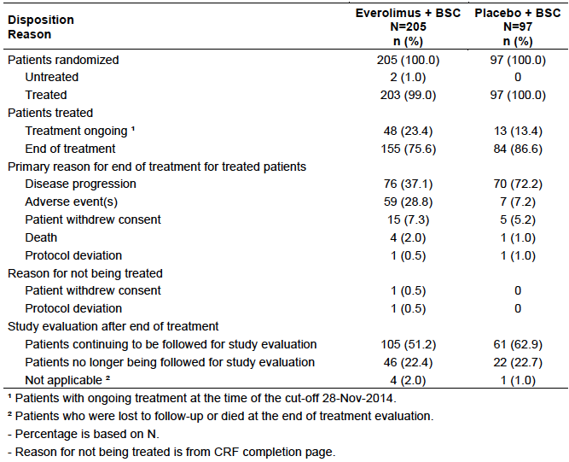

Table 5. Study CRAD001T2302 (RADIANT-4) Analysis sets
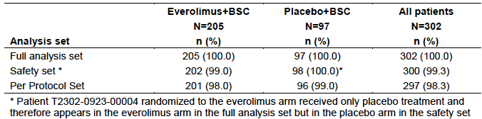

Major protocol violations/deviations
Protocol deviations are summarised below in Table 6. Major violations were uncommon and occurred with comparable frequency in the two arms. Minor violations occurred more frequently in the everolimus arm (33.7% versus 28.9%). The most common minor violations were incorrect stratification factor used at randomisation (13.7% everolimus versus 15.5% placebo), no radiological documentation of disease progression within 3 months prior to randomisation (4.9% versus 0%), study drug interrupted for > 4 weeks (3.4% versus 2.1%) and missing pregnancy test (3.4% versus 2.1%).

Table 6. Study CRAD001T2302 (RADIANT-4) Protocol deviations
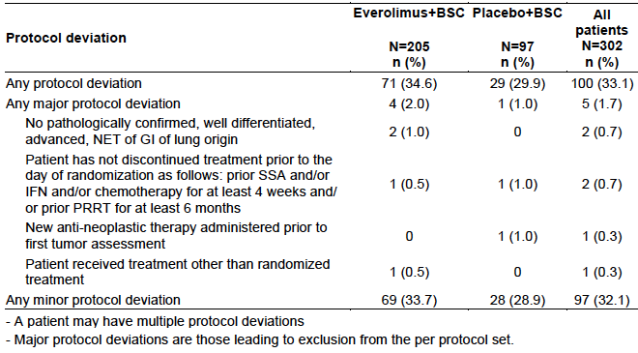
Comment: The protocol violations are unlikely to have affected the outcomes of the study significantly.

Baseline data
Baseline demographic characteristics are summarised in Table 7. Median age was 63 years and the population was predominantly Caucasian (76.2%).
Table 7. Study CRAD001T2302 (RADIANT-4) Baseline demographic characteristics
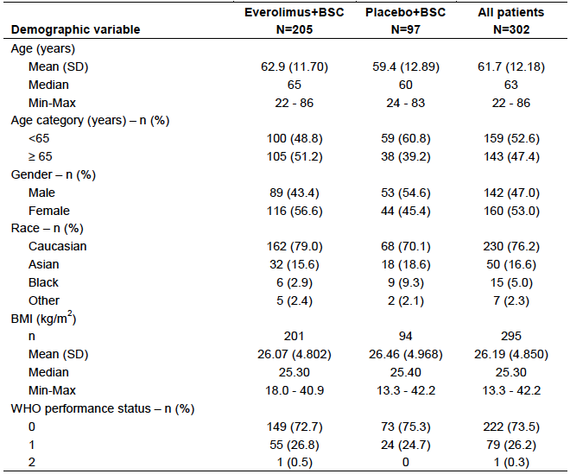
Baseline disease characteristics are summarised below in Table 8. Approximately 70% of subjects had tumours arising in the gastrointestinal tract and 30% in the lung. The vast majority of subjects (94.7%) had Stage IV (distant metastases) disease. The most common sites for distant metastases were liver (81.8% of subjects), lung (23.2%), para-aortic abdominal lymph nodes (14.2%), thoracic lymph nodes (13.6%), peritoneum (12.9%) and bone (9.3%).
Distribution of the three stratification factors at Baseline is summarised below in Table 9. Approximately 50% of subjects in each arm had previously received continuous SSA treatment for a period at least 12 weeks.
History of any SSA treatment is summarised in Table 10. Of those subjects that had received prior SSA therapy, most had been treated with long-acting octreotide. Median duration of exposure was approximately 15 months. History of other antineoplastic therapy is summarised in Table 11.
Comment: Overall the two treatment groups were reasonably well balanced with respect to baseline factors. In the placebo group, a higher proportion of subjects was male (54.6% versus 43.4%) and had had prior surgery (72.2% versus 59.0%). These differences would be unlikely to influence the results of the study.

Table 8. Study CRAD001T2302 (RADIANT-4) Baseline disease characteristics
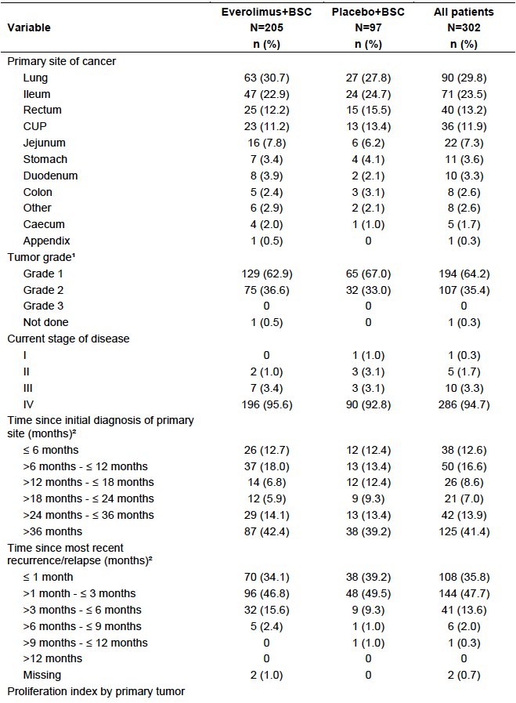

Table 8 (continued). Study CRAD001T2302 (RADIANT-4) Baseline disease characteristics
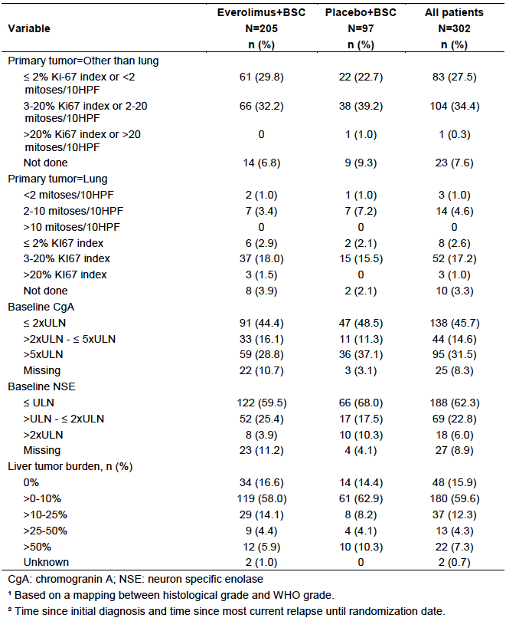

Table 9. Study CRAD001T2302 (RADIANT-4) Stratification factors at Baseline
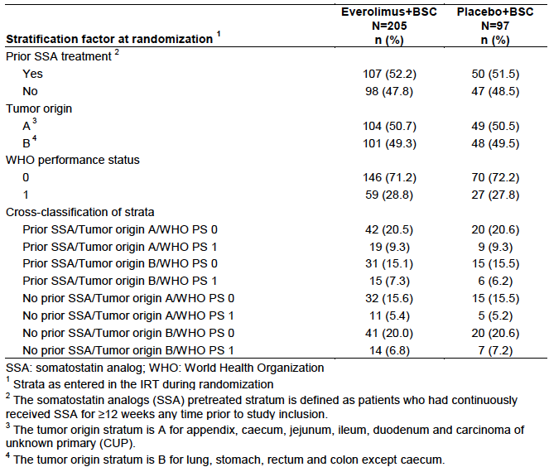

Table 10. Study CRAD001T2302 (RADIANT-4) Prior SSA treatment at Baseline
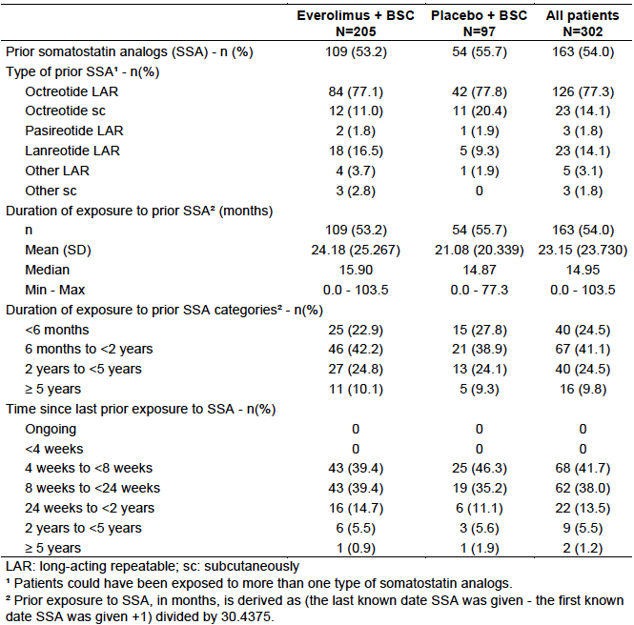

Table 11. Study CRAD001T2302 (RADIANT-4) Other previous antineoplastic therapy at Baseline
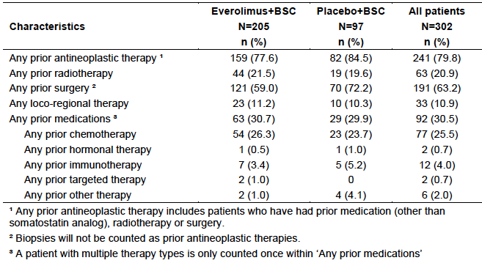

Results for the primary efficacy outcome
The analysis of PFS was conducted after a total of 178 PFS events had occurred. Results for PFS, as assessed by the blinded central review panel are summarised below in Table 12 and Figure 2. Treatment with everolimus was associated with a significant reduction in the risk of a PFS event (HR = 0.48; 95%CI: 0.35 to 0.67; p < 0.001. Median PFS was increased by 7.1 months (11.01 versus 3.91 months). The estimated proportion of subjects alive and progression free at 12 months after randomisation was increased from 28.1% to 44.4%.

Table 12. Study CRAD001T2302 (RADIANT-4) Progression-free survival (Primary endpoint)
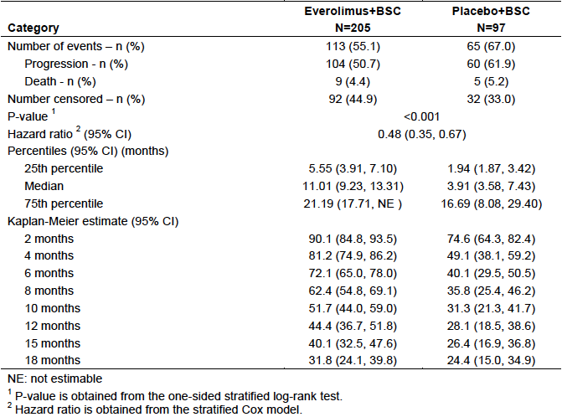
Figure 2. Study CRAD001T2302 (RADIANT-4) Progression-free survival (Primary endpoint)
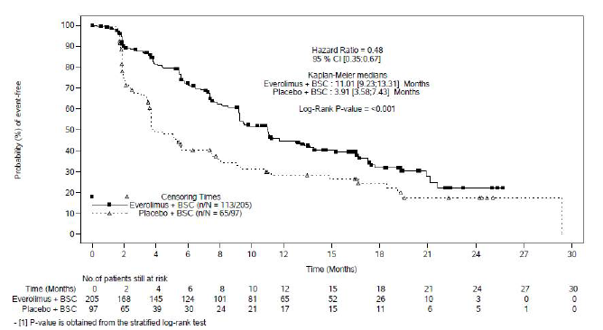
Various sensitivity and supportive analyses of PFS were conducted, including an analysis in the per-protocol set and an analysis using progression as determined by the investigators. The results of all these analyses were consistent with the primary analysis.
The results of subgroup analyses are shown below in Figures 3 and 4. The beneficial effect of everolimus was consistent across most subgroups with hazard ratios being < 1.0. There was a trend towards a harmful effect for everolimus in the group of subjects who had tumours arising in the ileum (HR = 1.34; 95% CI: 0.63 to 2.87). There also appeared to be notable differences in efficacy between genders and between races. For the subgroup analyses hazard ratios were calculated using unstratified Cox analysis. Further exploratory analyses using a stratified Cox analysis (using the three stratification factors at randomisation) and a stratified Cox analysis adjusted for baseline prognostic factors (such as tumour grade, prior chemotherapy, baseline biomarker levels, liver metastases and age) produced lower HRs for the ileum subgroup and reduced the variability between genders and races as shown below in Figure 4.
Figure 3. Study CRAD001T2302 (RADIANT-4) Subgroup analyses of PFS, by study plan stratification factor (FAS)
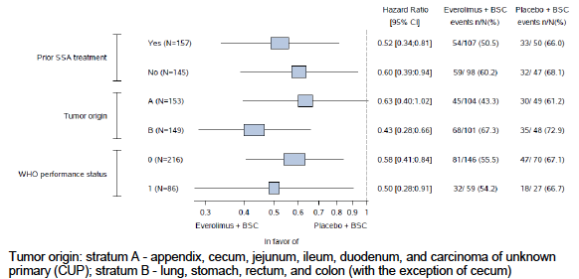
Figure 4. Study CRAD001T2302 (RADIANT-4) Subgroup analyses of PFS (FAS)
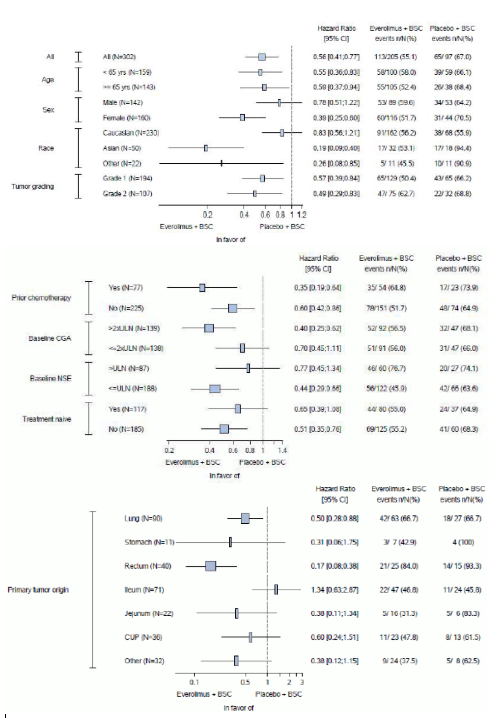

Table 13. Study CRAD001T2302 (RADIANT-4) Additional subgroup analyses of PFS
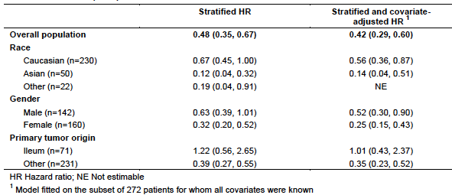

Results for other efficacy outcomes

Overall survival
OS data were not mature with only 70 of 302 subjects (23.2%) having died. Results are summarised below in Table 13 and Figure 5. There was a trend towards improved survival with everolimus treatment (HR = 0.64; 95% CI: 0.40 to 1.05; p = 0.037). This was an interim analysis and the pre-defined p-value threshold to claim statistical significance was 0.000213. The result was therefore not statistically significant. As indicated above, further analyses of OS are planned after approximately 95 and 191 deaths.

Table 14. Study CRAD001T2302 (RADIANT-4) Overall survival
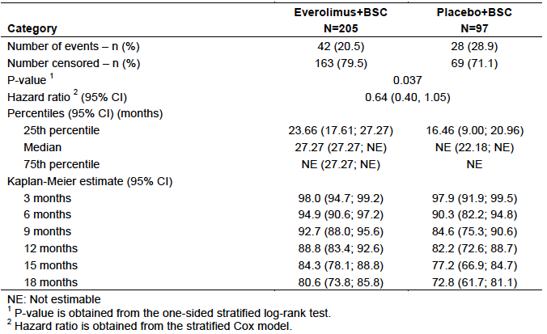
Figure 5. Study CRAD001T2302 (RADIANT-4) Overall survival
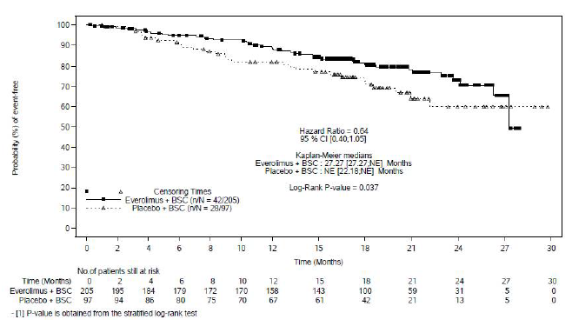

Overall Response Rate/Disease Control Rate
Results are summarised below in Table 15. There was no significant difference in ORR (2.0% versus 1.0%; p = 0.478). DCR was significantly better in the everolimus arm (82.4% versus 64.9%; p = 0.001).

Table 15. Study CRAD001T2302 (RADIANT-4) Overall response and disease control rates
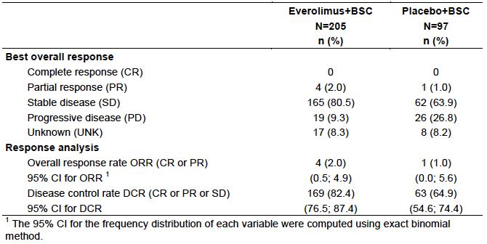

FACT-G questionnaire
Compliance was reasonably high with over 80% of subjects still on study completing the questionnaire in the first year. Results for the time to deterioration in the FACT-G total score are summarised below in Table 16 and Figure 6. There was no significant difference between treatment arms.

Table 16. Study CRAD001T2302 (RADIANT-4) Time to deterioration in total FACT-G score (FAS)
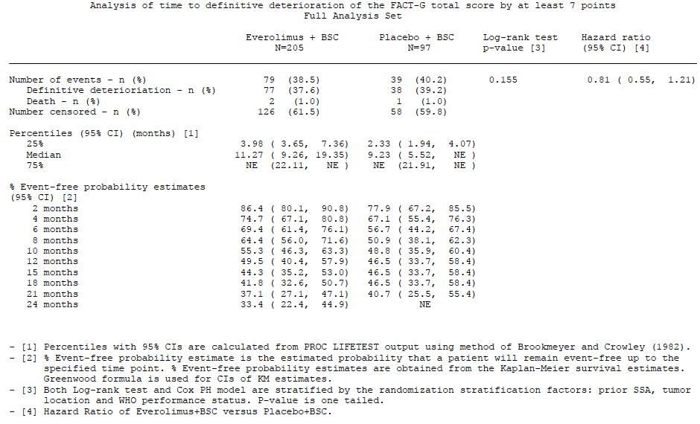
Figure 6. Study CRAD001T2302 (RADIANT-4) Time to deterioration in total FACT-G score
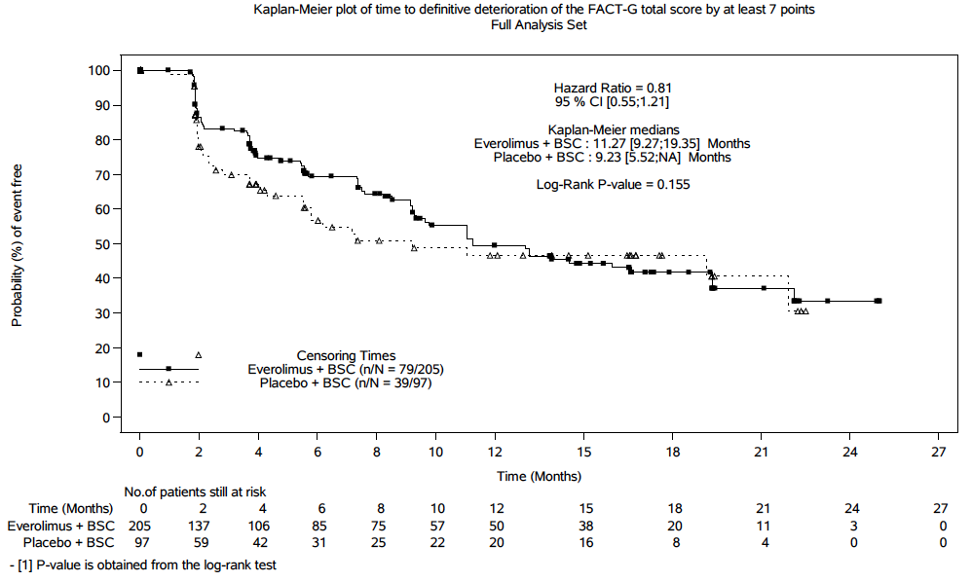

WHO Performance status
Results for the time to deterioration in WHO Performance Status are shown below in Table 17 and Figure 7. Only 93 of 302 subjects (30.8%) had experienced deterioration at the time of the analysis. There was no significant difference between treatment arms.

Table 17. Study CRAD001T2302 (RADIANT-4) Time to deterioration in WHO Performance Status (FAS)
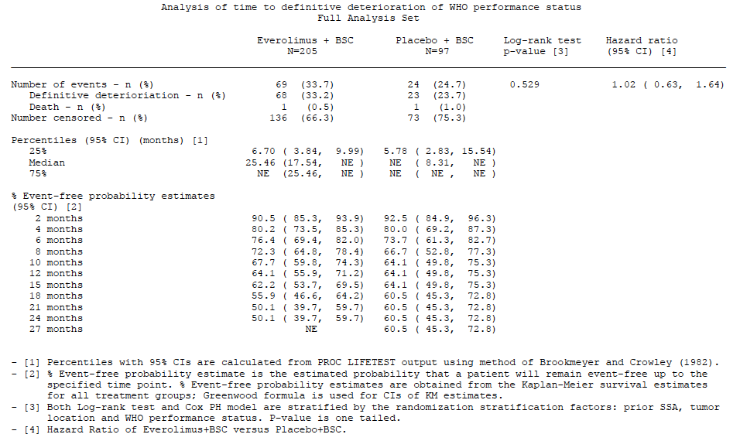
Figure 7. Study CRAD001T2302 (RADIANT-4) Time to deterioration in WHO Performance Status
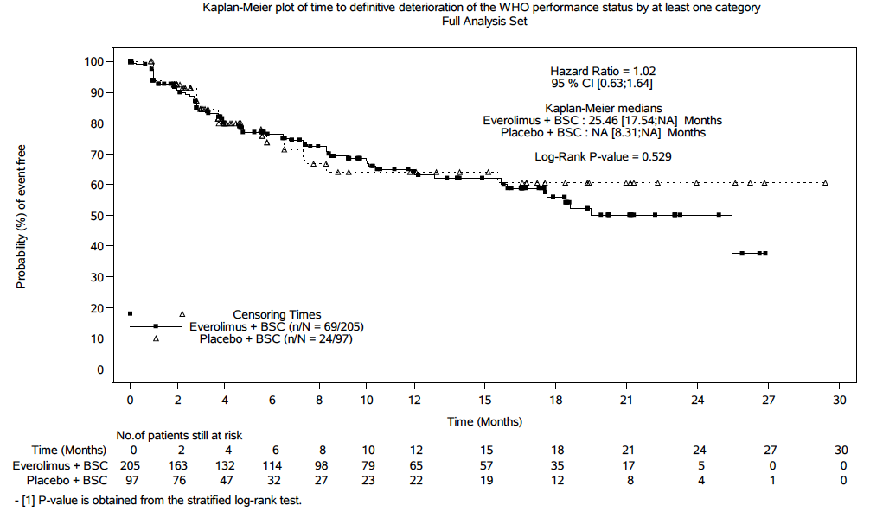

Biomarkers
At Baseline, median serum levels were comparable between treatment arms for both CgA and NSE. As shown below in Figure 8, serum CgA levels increased over time in both arms, with increases in the placebo arm being higher. NSE levels were comparable over time.
Figure 8. Study CRAD001T2302 (RADIANT-4) Changes in serum biomarkers
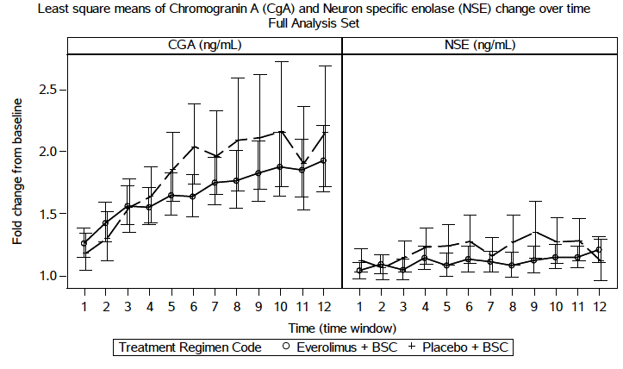

Exploratory endpoints
A number of exploratory efficacy analyses were conducted. Findings included the following:
- The PFS benefit achieved with everolimus was not affected by the extent of liver involvement at Baseline. For subjects with > 50% liver involvement the HR was 0.13 (95% CI: 0.03 to 0.52). For subjects with no liver involvement the HR was 0.49 (95%CI: 0.20 to 1.20);
- The incidence of tumours becoming functional was 5.0% in the everolimus arm and 7.1% in the placebo arm.

Tuberous sclerosis
Tuberous sclerosis complex is an autosomal dominant disorder characterized by benign tumours (hamartomas) in multiple organ systems, including the brain, skin, kidney, lung, heart, and retina. Afinitor is currently registered for the treatment of two manifestations of the disease subependymal giant cell astrocytoma (SEGA) and renal angiomyolipoma. In this submission the sponsor has included final study reports for three studies that were the basis for TGA approval of these indications. The sponsor is seeking to update the information in the PI based on these study reports.

Study C2485 (SEGA)
This study was a Phase II, open, single arm trial. Subjects enrolled were ≥ 3 years of age, with a definite diagnosis of TS (on clinical or genetic criteria) and had a SEGA demonstrating a serial increase in size on at least two MRI scans. The study enrolled 28 subjects, aged 3 to 34 years (median age = 11.0 years).
The primary endpoint was change in SEGA tumour size at 6 months. Tumour size was measured by assessing tumour volume on MRI, as assessed by an independent review. At the time of the primary analysis (date for data cut-off 9 December 2009) the median reduction in tumour volume was 0.80 cm³.
Previously submitted data provided results after a median duration of follow up of 34.2 months. The current submission included the final study report, which provided data after a median follow up of 67.9 months (date for data cut-off 28 January 2014). 6 subjects had withdrawn from the study and 22 subjects had completed at least 60 months of treatment. Efficacy results are summarised below in Table 18. These data demonstrate continuing efficacy of the drug with reduced tumour size compared to Baseline being maintained for up to 72 months.

Table 18. SEGA tumour volume and change in volume from Baseline over time
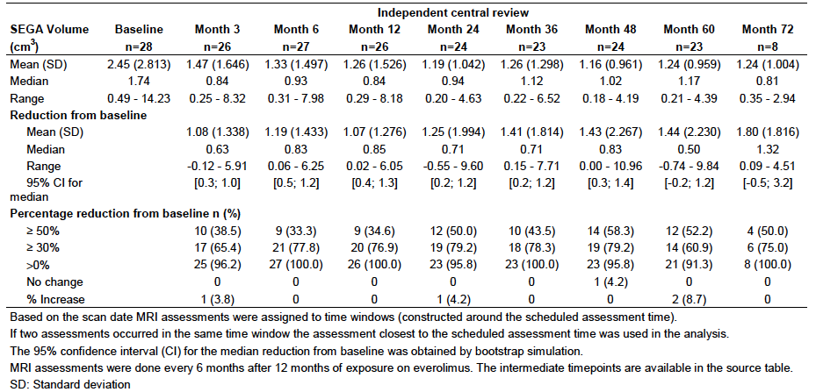

Study M2301 (SEGA)
This was a Phase III, randomised double blind study with two parallel groups. The trial enrolled subjects of any age with a definite diagnosis of TSC, at least 1 SEGA lesion with a longest diameter ≥ 1.0cm on MRI and evidence of progressive disease. Subjects were randomised (2:1) to receive everolimus or placebo. Everolimus was commenced at a dose of 4.5 mg/m²/day and subsequently titrated to achieve trough concentrations in the range of 5 to 15 ng/mL.
The primary efficacy endpoint was SEGA response rate. A SEGA response required all of the following:
- A ≥ 50% reduction in SEGA volume relative to Baseline; and
- No unequivocal worsening of non-target SEGA lesions; and
- No new SEGA lesions; and
- No new or worsening hydrocephalus.
A total of 117 subjects were randomised: 78 to everolimus and 39 placebo. At the time of the primary analysis, median duration of treatment was 52.2 weeks for everolimus and 46.6 weeks for placebo. SEGA response rates were 34.6% with everolimus and 0% with placebo (p < 0.0001).
Following the primary analysis showing superiority of everolimus over placebo, the study was unblinded and subjects in the placebo arm were permitted to receive everolimus. The current submission included the final analysis of the study, which provided results after patient crossover. Six of the 39 subjects originally treated with placebo did not receive everolimus. The remaining 33 subjects did crossover and received active treatment. Therefore, a total of 111 subjects received everolimus in the whole study.
For the 111 subjects, median age was 9.5 years (range 1.1 to 27.4), 64 were male and 47 were female and 93.7% of subjects were Caucasian. At the time of data cut-off for the final analysis median duration of exposure to everolimus was 204.9 weeks (range 8.1 to 253.7).
Results for the primary endpoint are shown below in Table 19. SEGA response rate was 57.7% (95% CI: 47.9% to 67.0%). Median time to SEGA response was 5.32 months (95% CI: 3.02 to 5.59). Median duration of SEGA response had not been reached as only 5 of the 64 responders had experienced disease progression.

Table 19. Study M2301 SEGA response rate (final analysis)
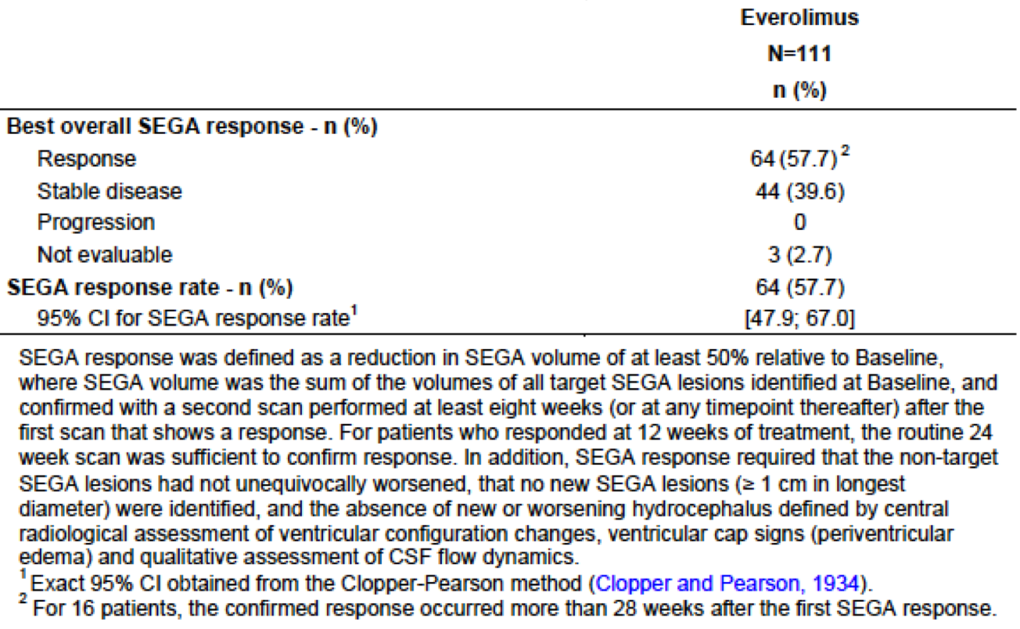
Median time to progression for the entire population (n = 111) could also not be determined, as only 13 subjects (11.7%) had experienced progression. The probability of being progression free at 3 years after the start of treatment was estimated to be 88.8% (95% CI: 80.6 to 93.6). Reductions in SEGA tumour were sustained over time, results are shown below in Table 20.

Table 20. Study M2301 Reductions in SEGA tumour volume (final analysis)
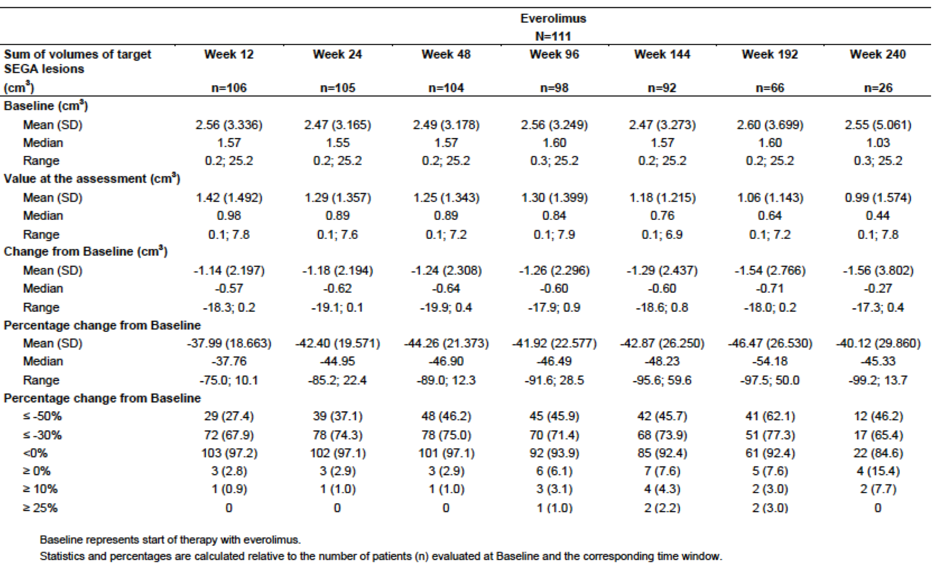
Other endpoints studied included skin lesion response rate and angiomyolipoma response rate.
Skin lesion response rate was defined as the proportion of subjects with skin disease at baseline who achieved either a partial response (> 50% improvement) or complete response (no evidence of disease) as assessed using a Physician’s Global Assessment (PGA) grading scale. This was a secondary endpoint. In the primary analysis skin lesion response rate was 41.7% in the everolimus group and 10.5% in the placebo group (p = 0.0004). In the final analysis (n = 105) the skin lesion response rate was 58.1% (95% CI: 48.1 to 67.7).
Angiomyolipoma response rate was defined the proportion of patients with renal angiomyolipoma at Baseline who achieved a reduction in angiomyolipoma volume of at least 50% relative to Baseline. This was an exploratory endpoint. In the primary analysis angiomyolipoma response rate was 53.3% in the everolimus group and 0% in the placebo group (p value not stated). In the final analysis (n = 41) the angiomyolipoma response rate was 73.2% (95% CI: 57.1 to 85.8).

Study M2302 (Renal angiomyolipoma)
This was a Phase III, randomised double blind study with two parallel groups. The trial enrolled subjects aged ≥ 18 years with a definite diagnosis of TSC or sporadic lymphangioleiomyomatosis (LAM) who had renal angiomyolipoma, with at least one angiomyolipoma ≥ 3 cm in its longest diameter using CT/MRI. Subjects were randomised (2:1) to receive everolimus 10 mg daily or placebo.
The primary efficacy endpoint was angiomyolipoma response rate. An angiomyolipoma response required all of the following:
- A ≥ 50% reduction in angiomyolipoma volume relative to Baseline; and
- No increase in size of either kidney by more than 20% from nadir; and
- No new angiomyolipoma lesions (> 1.0 cm); and
- No angiomyolipoma-related bleeding of Grade 2 or worse.
A total of 118 subjects were randomised: 79 to everolimus and 39 placebo. At the time of the primary analysis, median duration of treatment was 48.1 weeks for everolimus and 45.0 weeks for placebo. Angiomyolipoma response rates were 41.8% with everolimus and 0% with placebo (p < 0.0001).
Following the primary analysis showing superiority of everolimus over placebo, the study was unblinded and subjects in the placebo arm were permitted to receive everolimus. The current submission included the final analysis of the study, which provided results after patient crossover. Six of the 39 subjects originally treated with placebo did not receive everolimus. The remaining 33 subjects did crossover and received active treatment. Therefore a total of 112 subjects received everolimus in the whole study.
For the 112 subjects, median age was 32.2 years (range 18.1 to 61.6), 39 were male and 73 were female, 88.4% of subjects were Caucasian and 9.8% were Asian. At the time of data cut-off for the final analysis median duration of exposure to everolimus was 204.1 weeks (range 2 to 278).
Results for the primary endpoint are shown below in Table 21. Angiomyolipoma response rate was 58.0% (95%CI: 48.3% to 67.3%). Median time to angiomyolipoma response was 2.89 months (95% CI: 2.79 to 3.19). Median duration of angiomyolipoma response had not been reached as only 2 of the 65 responders had experienced disease progression.

Table 21. Study M2302 Angiomyolipoma response rate (final analysis)
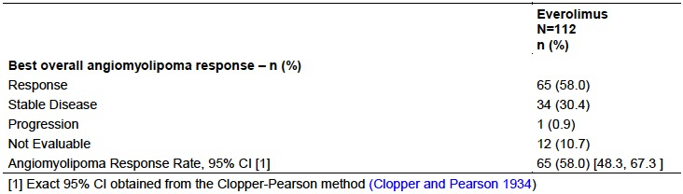
Median time to progression for the entire population (n = 112) could also not be determined, as only 16 subjects (14.3%) had experienced progression. The probability of being progression free at 4 years after the start of treatment was estimated to be 83.1% (95%CI: 73.4 to 89.5). Reductions in angiomyolipoma tumour were sustained over time, results are shown below in Table 22.

Table 22. Study M2302 Reductions in angiomyolipoma tumour volume (final analysis)
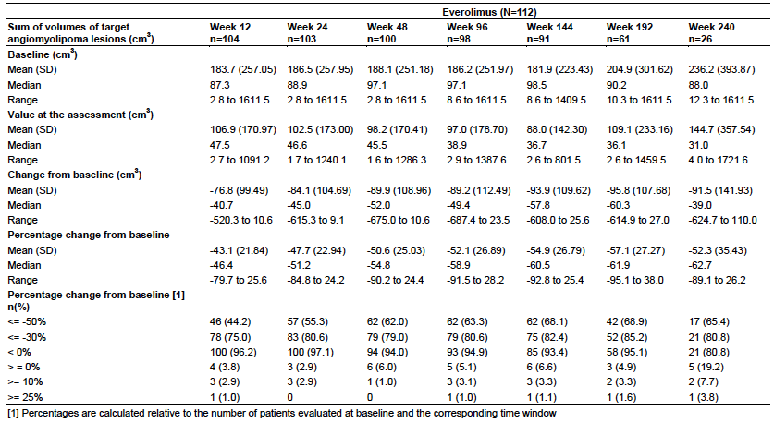
In the primary analysis skin lesion response rate was 26.0% in the everolimus group and 0% in the placebo group (p = 0.0002). In the final analysis (n = 107) the skin lesion response rate was 68.2% (95% CI: 58.5 to 76.9).
In the primary analysis SEGA response rate was 10.3% in the everolimus group and 0% in the placebo group. In the final analysis (n = 50) the SEGA response rate was 48.0% (95% CI: 33.7 to 62.6).

Analyses performed across trials (pooled analyses and meta-analyses)
There were no pooled analyses or meta-analyses of efficacy data submitted.

Evaluator’s conclusions on clinical efficacy

Neuroendocrine tumours
Study CRAD001T2302 (RADIANT-4) was well designed and executed. The design of the study complied with the recommendations of the relevant EMA guidelines adopted by the TGA for anticancer agents.^{12,13} The study demonstrated that compared to placebo, everolimus was associated with a significant reduction in the risk of experiencing a PFS event. The magnitude of the reduction was clinically significant with a prolongation of median PFS of approximately 7 months and an increase in the proportion of subjects alive and progression free at 12 months from 28.1% to 44.4%. The efficacy benefit was apparent across most patient subgroups. The magnitude of the clinical benefit also appeared comparable to that seen with other agents that have been granted TGA approval for NETs in recent years on the basis of PFS as the primary endpoint, as shown below in Table 23.

Table 23. Recent TGA drug approvals for NETs, pivotal Phase III studies using PFS as primary endpoint
Trial | Indication | Drug | Comparator | HR  (95% CI) | Median PFS (months) |  | p-value
 |  |  |  |  | Drug | Comparator | p-value
PROMID^{(a)} | NET: GIT (midgut) | Octreotide LAR | Placebo | 0.34 (0.20, 0.59) | 14.3 | 6.0 | = 0.000072
CLARINET^{(b)} | NET: GIT or pancreas | Lanreotide | Placebo | 0.47 (0.30, 0.73) | NR | 18.0 | < 0.001
NCT00428597^{(c)} | NET: Pancreas | Sunitinib | Placebo | 0.42 (0.26, 0.66) | 11.4 | 5.5 | < 0.001
RADIANT-3^{(d)} | NET: Pancreas | Everolimus | Placebo | 0.35 (0.27, 0.45) | 11.0 | 4.6 | < 0.0001
Radiant–4 | NET: GIT or lung | Everolimus | Placebo | 0.48 (0.35, 0.67) | 11.01 | 3.91 | < 0.001
a) Rinke A et al. Placebo Controlled, Double Blind, Prospective, Randomi`ed Study on the Effect of Octreotide LAR in the Control of Tumor Growth in Patients With Metastatic Neuroendocrine Midgut Tumors: A Report From the PROMID Study Group. J Clin Oncol. 2009; 27 (28): 4656-4663.
b) Caplin M et al. Lanreotide in Metastatic Enteropancreatic Neuroendocrine Tumors. N Engl J Med 2014; 371:224-33.
c) Raymond E et al. Sunitinib Malate for the Treatment of Pancreatic Neuroendocrine Tumors. N Engl J Med 2011; 364:501-13.
d) Yao J et al. Everolimus for Advanced Pancreatic Neuroendocrine Tumors. N Engl J Med 2011; 364:514-23.
Everolimus treatment was also associated with a non-significant trend towards improved overall survival. The sponsor should be asked to provide a summary of any further analyses of overall survival that have been conducted. The drug did not have any significant effects on quality of life compared to placebo.
The submission for the new indication is based on a single pivotal study and the TGA has adopted an EMA guideline that deals with this situation.¹⁴ This guideline sets out certain ‘prerequisites’ that must be met for approval of such a submission. In the opinion of the evaluator, the design and results of the pivotal study allow the conclusion that these prerequisites have been met.
Overall the evidence submitted to support the efficacy of everolimus for the new indication is considered acceptable.

Tuberous sclerosis
Data from the three TSC studies demonstrate that efficacy of everolimus is maintained and even improved with long-term use.

Clinical safety
Safety issues previously identified with everolimus include the following:
- Non-infectious pneumonitis/interstitial lung disease;
- Immunosuppression resulting in infections;
- Impaired wound healing;
- Hypersensitivity reactions;
- Angioedema when used in common with ACE inhibitors;
- Stomatitis/oral mucositis;
- Renal impairment;
- Hyperglycaemia;
- Dyslipidaemia;
- Haematological cytopaenias.

Neuroendocrine tumours (GIT/Lung)

Studies providing evaluable safety data
Study CRAD001T2302 (RADIANT-4) was the only study submitted in support of the new indication. The following safety data were collected:
General adverse events (AEs) were assessed by non-directive questioning of the patient at each study visit. AEs were graded according to the Common Terminology Criteria for Adverse Events (CTCAE) version 4.03. AEs were coded using Medical Dictionary for Regulatory Activities (MedDRA) terminology.
AEs of particular interest were referred to as ‘Clinically Notable AEs’ (CNAEs). Each CNAE was a pooled collection of similar MedDRA terms. They were of interest as a result of signals identified during earlier trials of everolimus. The specific CNAE terms are shown below in Table 24.

Table 24. Study CRAD001T2302 (RADIANT-4) Clinically notable AEs
 | Everolimus + BSC  (N = 202, PYE = 180.7) |  |  |  | Placebo + BSC  (N = 98, PYE = 65.8)
 | All grades |  | Grade 3/4 |  | All grades |  | Grade 3/4
 | n (%) | Adj. rate | n (%) | Adj. rate | n (%) | Adj. rate | n (%) | Adj. rate
Stomatitis | 128 (63.4) | 70.8 | 18 (8.9) | 10.0 | 22 (22.4) | 33.4 | 0 | 0
Infections | 118 (58.4) | 65.3 | 22 (10.9) | 12.2 | 28 (28.6) | 42.6 | 2 (2.0) | 3.0
Rash and similar events | 77 (38.1) | 42.6 | 1 (0.5) | 0.6 | 12 (12.2) | 18.2 | 0 | 0
Haemorrhages | 52 (25.7) | 28.8 | 4 (2.0) | 2.2 | 10 (10.2) | 15.2 | 0 | 0
Hyperglycaemia/new onset diabetes | 33 (16.3) | 18.3 | 11 (5.4) | 6.1 | 3 (3.1) | 4.6 | 0 | 0
Non-infectious pneumonitis | 32 (15.8) | 17.7 | 3 (1.5) | 1.7 | 2 (2.0) | 3.0 | 0 | 0
Renal failure/ proteinuria | 30 (14.9) | 16.6 | 9 (4.5) | 5.0 | 6 (6.1) | 9.1 | 4 (4.1) | 6.1
Cytopaenia | 21 (10.4) | 11.6 | 10 (5.0) | 5.5 | 4 (4.1) | 6.1 | 1 (1.0) | 1.5
Cardiac disorders (incl. cardiac failure) | 18 (8.9) | 10.0 | 8 (4.0) | 4.4 | 3 (3.1) | 4.6 | 0 | 0
Intestinal obstruction/ Ileus | 12 (5.9) | 6.6 | 10 (5.0) | 5.5 | 3 (3.1) | 4.6 | 2 (2.0) | 3.0
Thrombotic and embolic events | 12 (5.9) | 6.6 | 4 (2.0) | 2.2 | 2 (2.0) | 3.0 | 1 (1.0) | 1.5
Hepatic impairment | 8 (4.0) | 4.4 | 6 (3.0) | 3.3 | 2 (2.0) | 3.0 | 1 (1.0) | 1.5
Cholelithiasis | 5 (2.5) | 2.8 | 2 (1.0) | 1.1 | 2 (2.0) | 3.0 | 1 (1.0) | 1.5
Muscle wasting/ muscle loss | 3 (1.5) | 1.7 | 0 | 0 | 1 (1.0) | 1.5 | 0 | 0
Hypersensitivity | 2 (1.0) | 1.1 | 1 (0.5) | 0.6 | 1 (1.0) | 1.5 | 0 | 0
Female fertility (incl. secondary amenorrhoea) | 1 (0.5) | 0.6 | 0 | 0 | 0 | 0 | 0 | 0
Pancreatitis | 1 (0.5) | 0.6 | 1 (0.5) | 0.6 | 1 (1.0) | 1.5 | 1 (1.0) | 1.5
PYE (patient year exposure) is the sum of each patient's exposure in years. The adjusted rate for a given AEs is calculated as number of patients with a given AE per 100 patient year exposure. (=[n/PYE]*100). Table was produced using MedDRA dictionary version 17.1
Physical examination, including measurement of vital signs, was performed at Baseline, every study visit during the treatment period and at the 30-day safety follow-up visit.
Laboratory tests were performed as follows:
- Haematology: Tests were collected at Baseline and at every study visit during the treatment period. Tests performed were haemoglobin, haematocrit, platelets, red blood cell (RBC) count, total white blood cell (WBC) count and differential.
- Biochemistry: Tests were collected at Baseline and at every study visit during the treatment period. Tests performed were sodium, potassium, chloride, bicarbonate, creatinine, LDH, GGT, albumin, total protein, SGOT (AST), SGPT (ALT), total bilirubin, alkaline phosphatase, uric acid, BUN, calcium, magnesium, phosphate, and fasting glucose.
- Lipid profile: (total cholesterol, triglycerides, LDL, HDL) and coagulation testing (prothrombin time and the international normalized ratio) were performed at Baseline, every 8 weeks for the first 12 months and then every 12 weeks thereafter, and at the EOT visit.
- Urinalysis: (pH, specific gravity, protein, glucose, blood, ketones, and leukocytes) was performed at Baseline and at every study visit during the treatment period.

Patient exposure
The safety analysis set consisted of 300 subjects: 202 treated with everolimus and 98 subjects treated with placebo. Details of duration of exposure are summarised below in Table 25. Duration of exposure to study drug was longer in the everolimus arm than in the placebo arm (median duration: 40.43 versus 19.64 weeks; patient-years of exposure: 180.7 versus 65.8). In the everolimus arm 137 subjects were treated for at least 24 weeks and 86 were treated for at least 48 weeks. Mean dose intensity was 79.4% in the everolimus arm and 96.2% in the placebo arm.

Table 25. Study CRAD001T2302 (RADIANT-4) Duration of exposure
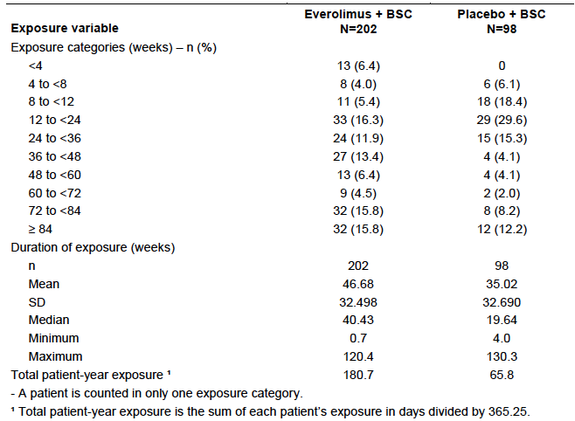

Adverse events
An overall summary of AEs that occurred in the study is shown below in Table 26.

Table 26. Study CRAD001T2302 (RADIANT-4) Overall summary of AEs
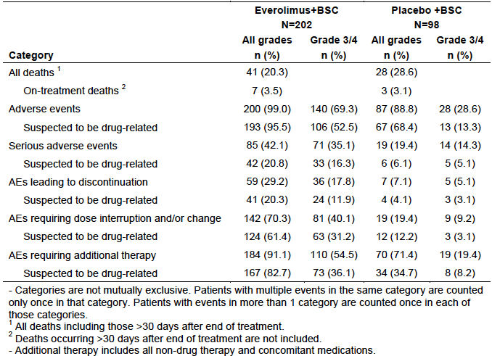

All adverse events (irrespective of relationship to study treatment)
AEs occurred in 99.0% of subjects in the everolimus arm and 88.8% of subjects in the placebo arm. Common AEs (those occurring in > 10% of subjects in either arm) are summarised below in Table 27. Toxicities that occurred more frequently in the everolimus arm included:
- GIT toxicity (stomatitis, diarrhoea, nausea, decreased appetite, dysgeusia);
- Skin toxicity (rash, pruritus);
- Respiratory toxicity (cough, dyspnoea, pneumonitis);
- Asthenia;
- Pyrexia;
- Peripheral oedema;
- Hyperglycaemia;
- Anaemia;
- Hypertension.

Table 27. Study CRAD001T2302 (RADIANT-4) Common AEs (incidence > 10% in either arm)
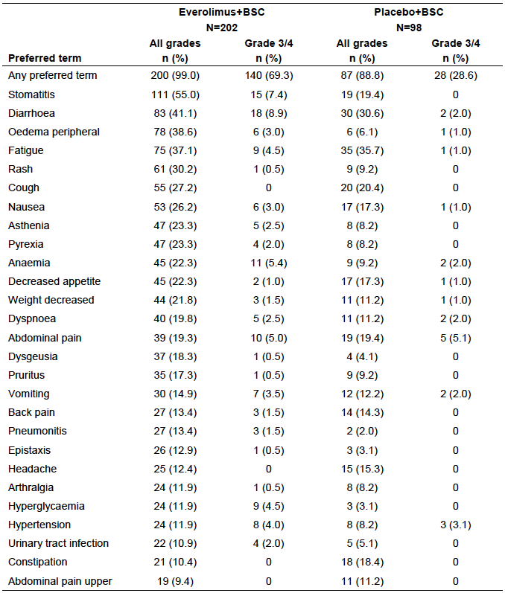
Comment: The above pattern of toxicities is consistent with that previously observed with everolimus. Differences in incidence between arms may have been in part due to the longer exposure to study drug in the everolimus arm. Exposure-adjusted incidence rates were not provided in the study report.
Grade 3 or 4 AEs occurred in 69.3% of subjects in the everolimus arm and in 28.6% of subjects in the placebo arm. The pattern of toxicities was similar to that observed with all AEs.

Treatment-related adverse events (adverse drug reactions)
Treatment-related AEs occurred in 95.5% of subjects in the everolimus arm and 68.4% of subjects in the placebo arm. Common treatment related AEs (those occurring in > 10% of subjects in either arm) are summarised below in Table 28. The pattern of toxicities was again similar to that observed with all AEs.
Grade 3 or 4 treatment-related AEs occurred in 52.5% of subjects in the everolimus arm and in 13.3% of subjects in the placebo arm.

Table 28. Study CRAD001T2302 (RADIANT-4) Common treatment related AEs (incidence > 10% in either arm)
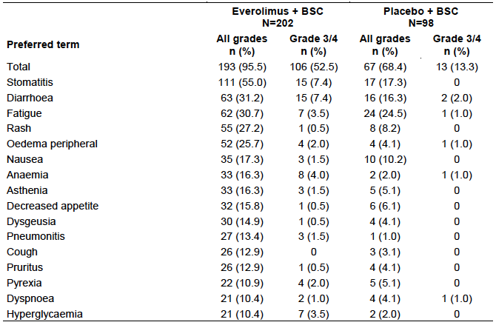

Deaths and other serious adverse events

Deaths
Seven patients (3.5%) in the everolimus arm and 3 patients (3.1%) in the placebo arm died while receiving study medication or within 30 days after end of treatment. These deaths are summarised below in Table 29.

Table 29. Study CRAD001T2302 (RADIANT-4) On-treatment deaths
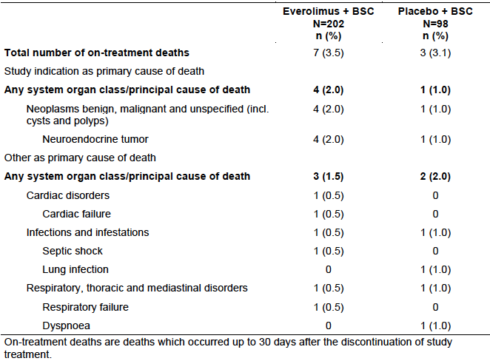
In the everolimus arm 4 of the 7 deaths were assessed as due to disease progression. The remaining 3 deaths were:
- An 81-year-old female who developed interstitial pneumonitis after 1 month of treatment. She subsequently developed respiratory failure and died after 3 months of treatment. The investigator suspected the respiratory failure was related to everolimus.
- A 67-year-old female was diagnosed with pneumonia on Day 56 of treatment. She subsequently developed multi-organ failure due to septic shock and died on Day 58. The investigator suspected the septic shock was related to everolimus.
- A 75-year-old male with a history of cardiomyopathy prior to randomisation presented with cardiac failure after 120 days of treatment. The cardiac failure subsequently worsened and the patient died on Day 160. The investigator did not suspect a relationship between the cardiac failure and everolimus.
In the placebo arm, 1 of the 3 deaths was assessed as due to disease progression. The remaining 2 deaths were:
- A 75-year-old female with lung NET developed worsening dyspnoea and a pleural effusion on Day 29 of treatment, and died two days later. The investigator suspected a relationship between the event and the study medication.
- A 50-year old female presented with a lung infection on Day 71 of treatment. Chest X-ray showed bilateral infiltration. She subsequently developed respiratory failure and died on Day 93. The investigator did not suspect a relationship between the lung infection and study medication.
Comment: Two of the deaths in the everolimus arm were plausibly due everolimus (interstitial pneumonitis, septic shock). However, over the entire study period, everolimus was associated with a lower incidence of death (20.3% versus 28.6%).

Serious AEs (SAEs)
SAEs occurred in 42.1% of subjects in the everolimus arm and 19.4% of subjects in the placebo arm. Common SAEs (those occurring in > 1% of subjects in either arm) are summarised below in Table 30. The pattern of SAEs was similar to that observed for all AEs.

Table 30. Study CRAD001T2302 (RADIANT-4) Serious AEs (irrespective of relationship to study drug) by SOC and PT
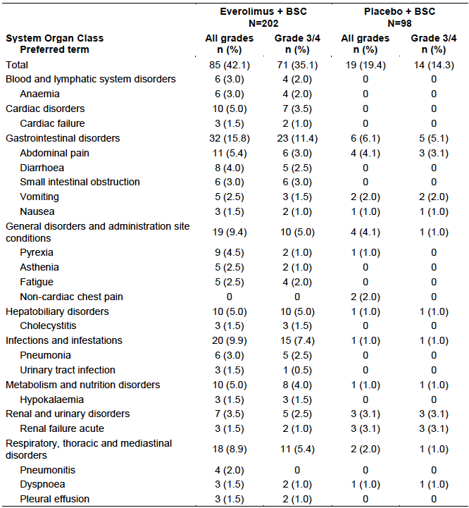

Discontinuation due to adverse events
AEs leading to discontinuation occurred in 29.2% of subjects in the everolimus arm and 7.1% of subjects in placebo arm. AEs leading to discontinuation that occurred in > 0.5% of subjects in either arm are summarised below in Table 31.

Table 31. Study CRAD001T2302 (RADIANT-4) AEs leading to discontinuation (irrespective of relationship to study drug) by SOC, PT and maximum grade
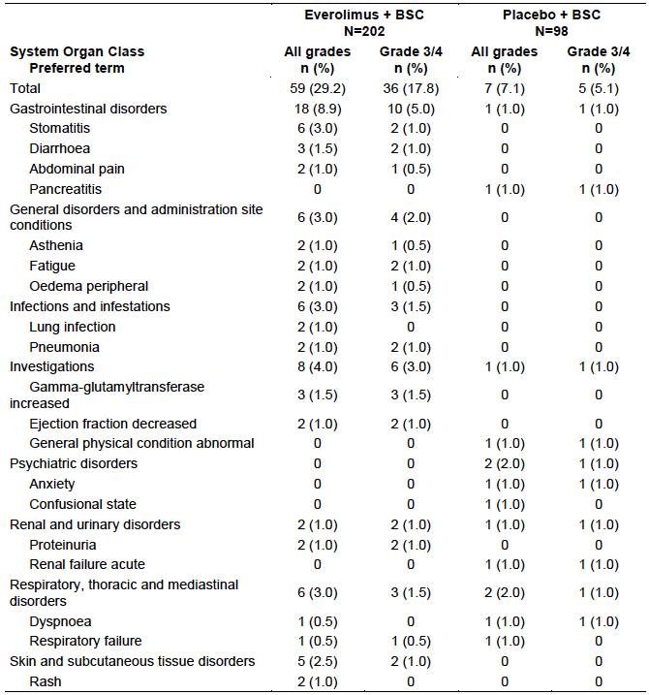

Clinically Notable AEs
The incidences of these AEs are summarised above in Table 24. For CNAEs the sponsor also provided exposure-adjusted incidence figures. Most of these events occurred more commonly in the everolimus arm, even after adjustment for the increased duration of treatment. Most of the CNAEs with an increased incidence in the everolimus arm were those previously associated with the drug such as stomatitis, infections, cytopaenias, pneumonitis etc. Other CNAEs with a notably increased incidence in the everolimus arm were the following:
- Haemorrhages: The most common haemorrhages with an increased incidence were epistaxis and haemoptysis. These two events are listed in the adverse reactions section of the current PI;
- Cardiac disorders: Cardiac CNAEs are listed below in Table 32. The most common cardiac event with an increased incidence was cardiac failure, which is also listed in the adverse reactions section of the current PI. However, there were slightly elevated incidences of a range of cardiac AEs.

Table 32. Study CRAD001T2302 (RADIANT-4) Clinically notable AEs, Cardiac disorders
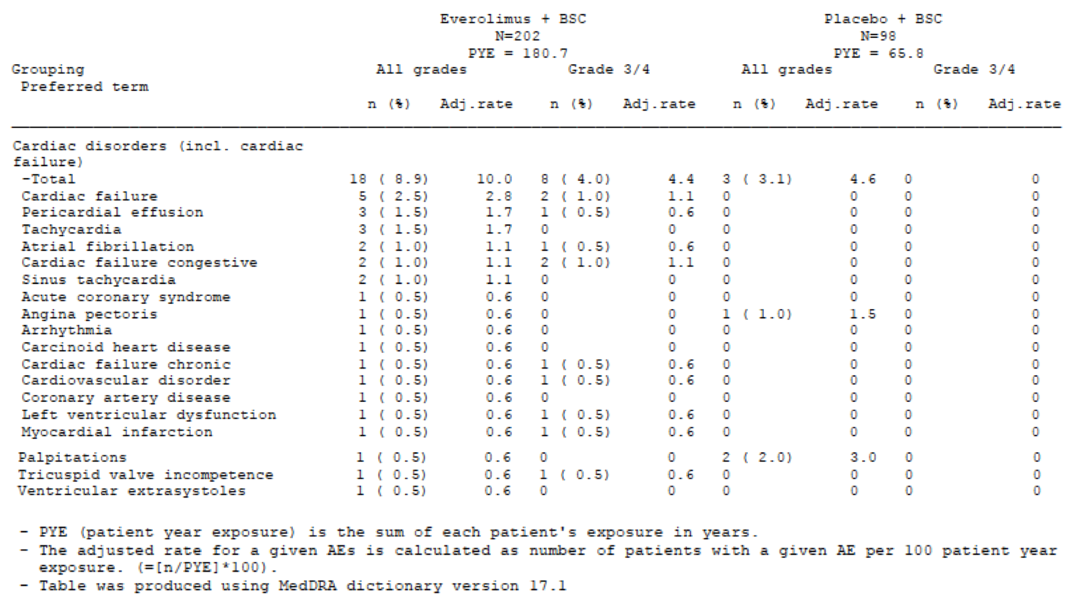

Laboratory tests
A summary of biochemistry laboratory test abnormalities is shown in Table 33 below.

Table 33. Study CRAD001T2302 (RADIANT-4) Abnormalities in biochemistry laboratory tests
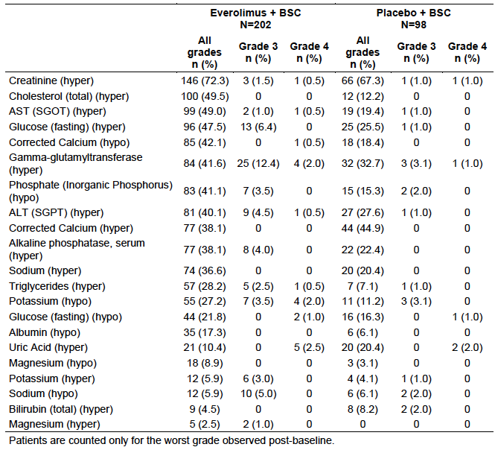

Liver function
The incidence of LFT abnormalities is shown in Table 33 above. There were elevations in AST, ALT, γ-GT and alkaline phosphatase, and decreases in serum albumin, occurred more commonly in the everolimus arm. However, elevations in bilirubin occurred more commonly in the placebo arm.
Comment: Approximately 80% of subjects in this study had disease in the liver. The current PI lists elevations in AST and ALT and decreases in albumin as common adverse reactions to everolimus in previous oncology trials.

Kidney function
Renal impairment and proteinuria are known adverse events associated with everolimus. In the pivotal study, elevations in serum creatinine, including Grade 3 or 4 increases, occurred with comparable frequency in the two study arms (see Table 33 above).

Other clinical chemistry
Hyperglycaemia, hypophosphataemia and hypokalaemia were more common in the everolimus arm. These events are listed in the current PI as known AEs associated with everolimus. Hypocalcaemia hypernatraemia, and abnormalities of magnesium were also more common in the everolimus arm. However, Grade 3 or 4 abnormalities were comparable in frequency (see Table 33 above).

Lipids
Elevations in cholesterol and triglycerides occurred more frequently in the everolimus arm as shown in Table 33 above. These are known AEs associated with the drug.

Haematology
Cytopaenias occurred more frequently in the everolimus arm, as shown in Table 34 below. These are known AEs associated with the drug. Grade 3/4 abnormalities were infrequent.

Table 34. Study CRAD001T2302 (RADIANT-4) Abnormalities in haematology laboratory tests
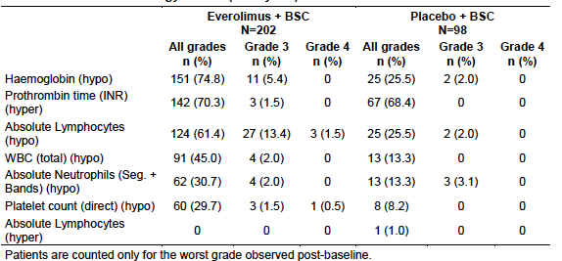

Coagulation studies
Abnormalities in prothrombin time occurred with a similar frequency in the two study arms as shown in Table 34 above.

Urinalysis
An analysis of urinalysis results was not provided in the study report. The report stated that in only a few cases was a value was reported below or above normal range.

Electrocardiograph
ECGs were not routinely monitored in the pivotal study.

Vital signs
Decreases in weight of ≥ 10% occurred in 28.2% of subjects on everolimus and 8.2% of subjects on placebo. Decreased weight is listed as a very common adverse event in the current PI. Elevations in systolic blood pressure to ≥ 180 mmHg occurred in 4.0% of subjects on everolimus and 0% of subjects on placebo. Hypertension is listed as a common adverse event in the current PI. Otherwise, notably abnormal vital signs occurred with comparable frequency in the two treatment arms.

TSC studies

Study C2485 (SEGA)
The pattern of AEs observed in this single arm study was consistent with that previously established for everolimus. The incidence of AEs decreased over time as shown below in Table 35.

Table 35. Study C2485 AEs irrespective of drug relationship and reported by ≥ 15% of patients (by PT and by year of emergence)
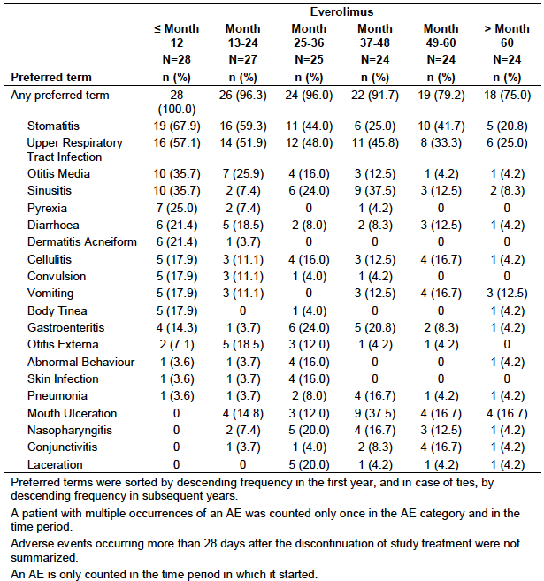

Study M2301 (SEGA)
The pattern of AEs observed in the open-label single arm extension phase of the study was consistent with the known adverse event profile of everolimus. AE incidence decreased over time as shown below in Table 36.

Table 36. Frequency of AEs (≥ 5% in any column) by year of appearance
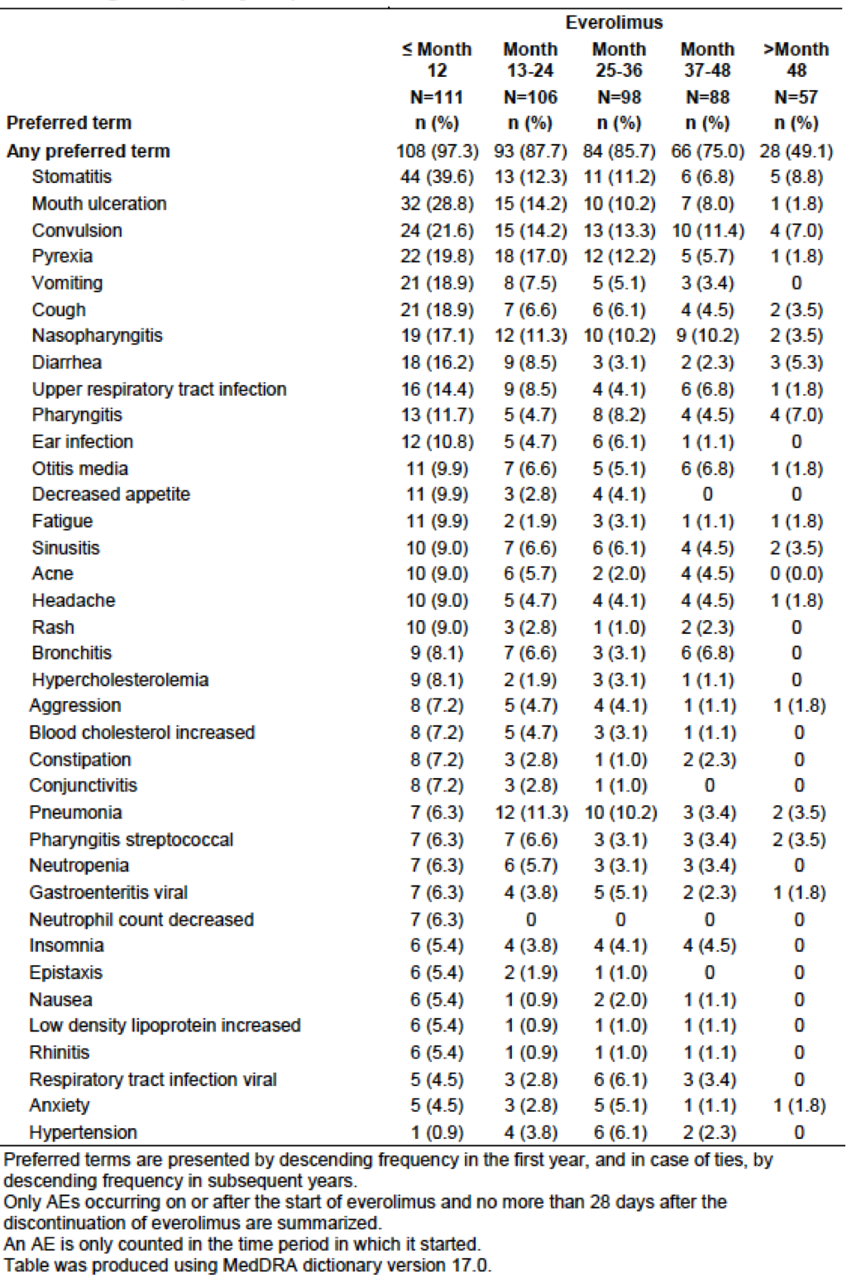

Study M2302 (Renal angiomyolipoma)
Observed toxicity of everolimus was again was again consistent with that previously associated with the drug. As with the other long-term TSC studies, the incidence of AEs appeared to decrease with time as shown below in Table 37.

Table 37. AEs in everolimus treated patients, regardless of study drug relationship by PT and year of emergence (≥ 7% in any column with > 10 patients ongoing)
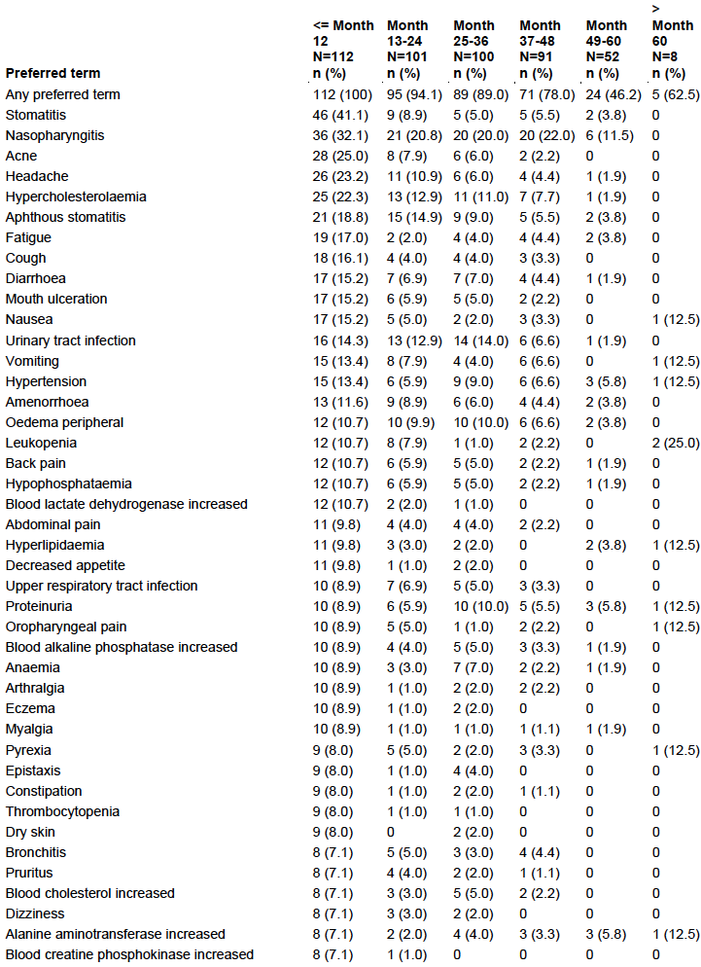

Post-marketing experience
There were no post-marketing data included in the submission.

Safety issues with the potential for major regulatory impact

Liver toxicity

Neuroendocrine tumours
As discussed above under Laboratory tests, elevations in AST, ALT, γ-GT and alkaline phosphatase, and decreases in serum albumin, occurred more commonly in the everolimus arm in the pivotal study. However, elevations in bilirubin occurred more commonly in the placebo arm.
There were two cases of hepatic failure in the everolimus arm versus none in the placebo arm.
- A 61 year old male, who had metastatic disease in the liver at Baseline, received 27 days of everolimus treatment. The drug was then stopped due to stomatitis. On Day 36 he presented with Grade 4 hepatic failure and died on the same day. No details of LFTs or imaging were presented. The investigator attributed the death to disease progression and did not suspect a relationship with the drug.
- A 75 year old male, with metastatic disease in the liver at Baseline received 82 days of everolimus. On Day 83 he presented with grade 3 hepatic failure and the drug was discontinued. The hepatic failure subsequently improved to Grade 2. Abdominal ultrasound revealed suspected diffuse focal lesions in the liver. However, the investigator suspected a relationship between the hepatic failure and everolimus. The patient subsequently died due to disease progression.
Comment: Due to hepatic metastases in both cases it is difficult to attribute these events to everolimus.

TSC studies
There were no cases of serious hepatic toxicity in the three TSC studies.

Haematological toxicity

Neuroendocrine tumours
Everolimus is known to be associated with an increased incidence of haematological cytopaenias. This was confirmed in the pivotal study with increased incidence of anaemia (22.3% versus 9.2%), thrombocytopaenia (3.5% versus 1.0%) and neutropaenia 2.5% versus 1.0%) in the everolimus arm. There was one report of pancytopaenia in the everolimus arm and none in the placebo arm.

TSC studies
Cytopaenias were also observed in the three TSC studies.

Serious skin reactions

Neuroendocrine tumours
Everolimus is known to be associated with dermatological toxicity. In the pivotal study skin disorders occurred in 67.8% of everolimus-treated subjects and 27.6% of placebo-treated subjects. The most common events were rash and pruritus. Serious skin disorders occurred in 2.0% of subjects with everolimus (n = 4) versus no subject with placebo. The specific serious events reported were angioedema, drug eruption, hyperhidrosis and toxic skin eruption (Grade 2).

TSC studies
No serious skin reactions were reported in the TSC studies.

Cardiovascular safety

Neuroendocrine tumours
As shown above in Table 32 there was an increase in the incidence of cardiac disorders with everolimus in the pivotal study. The most common event was cardiac failure. Table 38 (shown below) lists vascular AEs (irrespective of relationship to study treatment) observed in the study. AEs of hypertension and hypotension occurred more frequently with everolimus. The other vascular events occurred with comparable frequency in the two study arms.

Table 38. Study CRAD001T2302 (RADIANT-4) Vascular AEs by SOC and PT
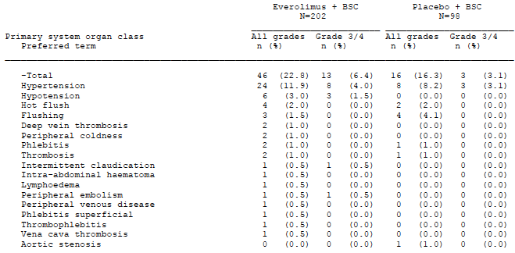

TSC studies
Some serious cardiovascular AEs were reported in Study M2302. Hypertension (n = 2) was the only event reported in more than 1 subject.

Unwanted immunological events

Neuroendocrine tumours
Hypersensitivity events (for example, anaphylaxis and angioedema) are known to occur with everolimus. In the pivotal study there were 2 cases of angioedema reported, both in the everolimus arm. There were no reports of anaphylaxis.

TSC studies
There were no reports of serious immunological reactions in the TSC studies.

Evaluator’s overall conclusions on clinical safety

Neuroendocrine tumours (GIT/Lung)
Data from the pivotal study indicate that everolimus is associated with significant toxicity in subjects with advanced neuroendocrine tumours. Compared to placebo, everolimus was associated with a notably increased incidence of Grade 3 or 4 AEs (69.3% versus 28.6%) and serious AEs (42.1% versus 19.4%). Approximately an extra 20% of subjects had to discontinue study treatment due to AEs (29.2% versus 7.1%). Some of the increased incidence in AEs may have been due to the longer duration of treatment with everolimus and therefore longer duration of follow-up for AEs. Table 39 (below) presents a cross-trial comparison of the incidence of AEs in Studies 2324 and CRAD001T2302 (RADIANT-4). Study 2324 (RADIANT-3) was the pivotal study that led to TGA approval of everolimus for pancreatic NETs. Although there were differences in the design of the two studies, a notable increase in the incidence of AEs compared to placebo was observed in both trials.

Table 39. Comparison of AE incidence in pivotal NET studies
 | Study 2324^{(a)}  (Pancreatic NETs) versus placebo | Study CRAD001T2302 (RADIANT-4)  (GIT/Lung NETs) versus placebo
Grade 3 or 4 AEs | 59.8% versus 38.9% | 69.3% versus 28.6%
Serious AEs | 40.2% versus 24.6% | 42.1% versus 19.4%
Discontinuation due to AEs | 19.1% versus 5.9% | 29.2% versus 7.1%
a) Data available from the AusPAR for this TGA approved indication.
There were two deaths on treatment that were plausibly related to everolimus. However, the drug was associated with a trend towards improved overall survival.
The pattern of adverse events observed in the pivotal study was generally consistent with that previously observed with the drug. No new safety issues were identified.

Tuberous sclerosis
Long-term follow-up of subjects in the three TSC studies did not identify any novel safety issues. The incidence of AEs generally decreased over time.

First round benefit-risk assessment

Neuroendocrine Tumours (GIT/Lung)

First round assessment of benefits
The benefits of everolimus in the proposed usage are:
- A significant reduction in the risk of experiencing a PFS event (disease progression or death), with prolongation of median PFS by approximately 7 months.

First round assessment of risks
The risks of everolimus in the proposed usage are:
- A range of adverse events, consistent with those previously documented for the drug.
- Although the drug produces a notable increase in the risk of significant AEs (Grade 3 or 4 AEs, serious AEs and so on) compared to placebo, the increase is of a similar magnitude to that observed when everolimus is used for the treatment of pancreatic NETs.

First round assessment of benefit-risk balance
The benefit-risk balance of everolimus given the proposed usage is favourable.

Tuberous sclerosis
The benefit-risk balance of everolimus in the treatment of TSC with SEGA or angiomyolipoma remains favourable.

First round recommendation regarding authorisation

Neuroendrocrine tumours
It is recommended that the proposed new indication (NETs of gastrointestinal or lung origin) be approved. The wording of the indication proposed by the sponsor is considered acceptable.

Tuberous sclerosis
The updated data on TSC with SEGA or angiomyolipoma supports continued registration of these indications.

Clinical questions

General
- Please provide an assurance that the formulation of everolimus tablets used in Study CRAD001T2302 (RADIANT-4) was identical to that currently registered in Australia.

Efficacy
- Please provide a summary of the results of any further analyses of overall survival conducted for Study CRAD001T2302 (RADIANT-4).

Second round evaluation of clinical data submitted in response to questions
The sponsor confirmed that the formulation of everolimus tablets used in Study CRAD001T2302 (RADIANT-4) was identical to that currently registered in Australia.
The sponsor provided a report on the results of the second interim analysis of overall survival from Study CRAD001T2302 (RADIANT-4). The data cut-off date for inclusion in the report was 30 November 2015 (that is, 12 months after the cut-off for the first interim analysis). The report itself was dated 26 January 2016. At the time of data cut-off, the median duration of follow-up was 33.4 months (compared with a value of 21.3 months for the first interim analysis). A total of 101 deaths (33.4% of the population) had occurred (compared with 70 deaths for the first interim analysis).
Results of the analysis are summarised below in Table 40 and Figure 9. There remained a trend towards improved survival with everolimus treatment (HR = 0.73; 95% CI: 0.48 to 1.11; p = 0.071). The pre-defined p-value threshold to claim statistical significance for this second interim analysis was 0.001982. The result was therefore not statistically significant.

Table 40. Study CRAD001T2302 (RADIANT-4) Second interim analysis of overall survival
Figure 9. Study CRAD001T2302 (RADIANT-4) Second interim analysis of overall survival
A greater proportion of subjects in the placebo arm had received further antineoplastic therapy after study discontinuation (62.9% versus 50.7%, see Table 41 below). However, only 4.1% of subjects randomised to placebo had received everolimus after study discontinuation.

Table 41. Study CRAD001T2302 (RADIANT-4) Antineoplastic therapy received after discontinuation
Comment: The results for overall survival from the second interim analysis are essentially unchanged from those obtained with the first analysis. The sponsor estimates that the 191 deaths necessary for the final analysis will not occur until 2021/2022.

Second round benefit-risk assessment

Second round assessment of benefits
After consideration of the responses to clinical questions, the benefits of everolimus in the proposed usage are unchanged from those identified in the first round assessment of benefits in Section 9 above.

Second round assessment of risks
No new clinical information was submitted in response to questions. Accordingly, the risks of everolimus are unchanged from those identified in the first round assessment of risks in Section 9 above.

Second round assessment of benefit-risk balance
The benefit-risk balance of everolimus, given the proposed usage, is favourable.

Second round recommendation regarding authorisation
It is recommended that the proposed new indication (NETs of gastrointestinal or lung origin) be approved.

References
Bergsland E. The evolving landscape of neuroendocrine tumors. Semin Oncol. 2013; 40 (1): 4-22.
Edge SE, Byrd DR, Carducci MA et al. AJCC Cancer Staging Handbook. 7th edition (2010). New York. Springer.
European Neuroendocrine Tumor Society (ENETS). Current Guidelines. (2016).
European Medicines Agency. Guideline on the evaluation of anticancer medicinal products in man. EMA/CHMP/205/95/Rev.4; (2012).
European Medicines Agency. Appendix 1 to the guideline on the evaluation of anticancer medicinal products in man. Methodological consideration for using progression-free survival (PFS) or disease-free survival (DFS) in confirmatory trials. EMA/CHMP/27994/2008/Rev.1; (2012).
European Medicines Agency. Points to consider on application with 1. Meta-analyses; 2. One pivotal study; CPMP/EWP/2330/99 (2001).
Klimstra D et al. The pathologic classification of neuroendocrine tumors: a review of nomenclature, grading, and staging systems. Pancreas. 2010; 39 (6): 707-12.
National Comprehensive Cancer Network (NCCN). NCCN Clinical Practice Guidelines in Oncology. Neuroendocrine Tumours. Version 1.2015 (2014).
National Cancer Institute (NCI) Dictionary of Cancer Terms
North American Neuroendocrine Tumor Society (NANETS). NANETS 2010 Guidelines (2010).
Oberg K et al. Neuroendocrine gastro-entero-pancreatic tumors: ESMO Clinical Practice Guidelines for diagnosis, treatment and follow-up. Ann Oncol. 2012;23 Suppl 7: vii 124-30.
Oberg K. The Management of Neuroendocrine Tumours: Current and Future Medical Therapy Options. Clin Oncol. 2012; 24: 282-293.
Rindi G et al (2010) Nomenclature and classification of neuroendocrine neoplasms of the digestive system. In: Bosman FT, Carneiro F, Hruban RH et al (eds.) WHO classification of Tumours of the Digestive System. 4th rev. ed; Lyon: IARC Press.
Therapeutic Goods Administration. Australian Public Assessment Report for Everolimus (Afinitor). February 2013.
Therasse P et al. New guidelines to evaluate the response to treatment in solid tumors. European Organization for Research and Treatment of Cancer, National Cancer Institute of the United States, National Cancer Institute of Canada. J Natl Cancer Inst. 2000; 92 (3): 205-16.
Yao J et al. Everolimus for the treatment of advanced, non-functional neuroendocrine tumours of the lung or gastrointestinal tract (RADIANT-4): a randomised, placebo-controlled, Phase III study. Lancet. 2016; 387: 968-977.
Yao J et al. One hundred years after ‘carcinoid’: epidemiology of and prognostic factors for neuroendocrine tumors in 35,825 cases in the United States. J Clin Oncol. 2008; 26:3063-72.

Therapeutic Goods Administration
PO Box 100 Woden ACT 2606 Australia
Email: info@tga.gov.au Phone: 1800 020 653 Fax: 02 6232 8605
https://www.tga.gov.au

National Cancer Institute (NCI), NCI Dictionary of Cancer Terms
Bergsland E. The evolving landscape of neuroendocrine tumors. Semin Oncol. 2013; 40 (1): 4-22.
Klimstra D et al. The pathologic classification of neuroendocrine tumors: a review of nomenclature, grading, and staging systems. Pancreas. 2010; 39 (6): 707-12.
National Comprehensive Cancer Network (NCCN). NCCN Clinical Practice Guidelines in Oncology. Neuroendocrine Tumours. Version 1.2015 (2014).
Yao J et al. One hundred years after ‘carcinoid’: epidemiology of and prognostic factors for neuroendocrine tumors in 35,825 cases in the United States. J Clin Oncol. 2008; 26:3063-72.
Rindi G et al (2010) Nomenclature and classification of neuroendocrine neoplasms of the digestive system. In: Bosman FT, Carneiro F, Hruban RH et al (eds.) WHO classification of Tumours of the Digestive System. 4th rev. ed; Lyon: IARC Press.
European Neuroendocrine Tumour Society (ENETS). Current Guidelines. (2016).
North American Neuroendocrine Tumor Society (NANETS). NANETS 2010 Guidelines (2010).
Oberg K. The Management of Neuroendocrine Tumours: Current and Future Medical Therapy Options. Clin Oncol. 2012; 24: 282-293.
Oberg K et al. Neuroendocrine gastro-entero-pancreatic tumors: ESMO Clinical Practice Guidelines for diagnosis, treatment and follow-up. Ann Oncol. 2012;23 Suppl 7: vii 124-30.
Edge S et al. AJCC Cancer Staging Handbook. 7th edition (2010). New York. Springer.
EMA/CHMP/205/95/Rev.4; (2012): Guideline on the evaluation of anticancer medicinal products in man; European Medicines Agency.
EMA/CHMP/27994/2008/Rev.1; (2012): Appendix 1 to the guideline on the evaluation of anticancer medicinal products in man. Methodological consideration for using progression-free survival (PFS) or disease-free survival (DFS) in confirmatory trials; European Medicines Agency.
CPMP/EWP/2330/99 (2001): Points to consider on application with 1. Meta-analyses; 2. One pivotal study; European Medicines Agency.
Yao J et al. Everolimus for the treatment of advanced, non-functional neuroendocrine tumours of the lung or gastrointestinal tract (RADIANT-4): a randomised, placebo-controlled, Phase III study. Lancet. 2016; 387: 968-977.
Therasse P et al. New guidelines to evaluate the response to treatment in solid tumors. European Organization for Research and Treatment of Cancer, National Cancer Institute of the United States, National Cancer Institute of Canada. J Natl Cancer Inst. 2000; 92 (3): 205-16.
Therapeutic Goods Administration. Australian Public Assessment Report for Everolimus (Afinitor). February 2013

