First round evaluation: 7 April 2015
Second round evaluation: 20 July 2015

AusPAR Attachment 2

Extract from the Clinical Evaluation Report for Evolocumab (rch)
  - Proprietary Product Name: Repatha
  - Sponsor: Amgen Australia Pty Ltd

About the Therapeutic Goods Administration (TGA)
- The Therapeutic Goods Administration (TGA) is part of the Australian Government Department of Health, and is responsible for regulating medicines and medical devices.
- The TGA administers the Therapeutic Goods Act 1989 (the Act), applying a risk management approach designed to ensure therapeutic goods supplied in Australia meet acceptable standards of quality, safety and efficacy (performance), when necessary.
- The work of the TGA is based on applying scientific and clinical expertise to decision-making, to ensure that the benefits to consumers outweigh any risks associated with the use of medicines and medical devices.
- The TGA relies on the public, healthcare professionals and industry to report problems with medicines or medical devices. TGA investigates reports received by it to determine any necessary regulatory action.
- To report a problem with a medicine or medical device, please see the information on the TGA website <https://www.tga.gov.au>.
About the Extract from the Clinical Evaluation Report
- This document provides a more detailed evaluation of the clinical findings, extracted from the Clinical Evaluation Report (CER) prepared by the TGA. This extract does not include sections from the CER regarding product documentation or post market activities.
- The words [Information redacted], where they appear in this document, indicate that confidential information has been deleted.
- For the most recent Product Information (PI), please refer to the TGA website <https://www.tga.gov.au/product-information-pi>.
Copyright
© Commonwealth of Australia 2016
This work is copyright. You may reproduce the whole or part of this work in unaltered form for your own personal use or, if you are part of an organisation, for internal use within your organisation, but only if you or your organisation do not use the reproduction for any commercial purpose and retain this copyright notice and all disclaimer notices as part of that reproduction. Apart from rights to use as permitted by the Copyright Act 1968 or allowed by this copyright notice, all other rights are reserved and you are not allowed to reproduce the whole or any part of this work in any way (electronic or otherwise) without first being given specific written permission from the Commonwealth to do so. Requests and inquiries concerning reproduction and rights are to be sent to the TGA Copyright Officer, Therapeutic Goods Administration, PO Box 100, Woden ACT 2606 or emailed to <tga.copyright@tga.gov.au>.

Contents
List of common abbreviations 5
1. Introduction 10
1.1. Clinical rationale 10
2. Contents of the clinical dossier 10
2.1. Scope of the clinical dossier 10
2.2. Paediatric data 11
2.3. Good clinical practice 12
3. Pharmacokinetics 12
3.1. Studies providing pharmacokinetic data 12
3.2. Summary of pharmacokinetics 13
3.3. Evaluator’s overall conclusions on pharmacokinetics 44
4. Pharmacodynamics 47
4.1. Studies providing pharmacodynamic data 47
4.2. PCSK9 52
4.3. Concomitant LDL-C and PCSK9 changes 55
4.4. Evaluator’s overall conclusions on pharmacodynamics 55
5. Dosage selection for the pivotal studies 56
6. Clinical efficacy 56
6.1. Primary hyperlipidaemia and mixed dyslipidaemia 56
6.2. Evaluator's conclusions on clinical efficacy for primary hyperlipidaemia (heterozygous familial or non-familial) or mixed dyslipidaemia 125
6.3. Homozygous familial hypercholesterolaemia 131
6.4. Evaluator's conclusions on clinical efficacy for subjects with HoFH 145
7. Clinical safety 146
7.1. Total exposure in the clinical development program (both indications) 146
7.2. Adverse Events 151
7.3. Homozygous Familial Hyperlipidaemia (HoFH) 196
7.4. Post-marketing safety 199
7.5. Evaluator's overall conclusions of clinical safety 199
8. First round benefit-risk assessment 207
8.1. First round assessment of benefits 207
8.2. First round assessment of risks 213
8.3. First round assessment of benefit-risk balance 217
8.4. First round recommendation regarding authorisation 217
9. Clinical questions 217
9.1. Pharmacokinetics 217
9.2. Safety 217
10. Second round evaluation of clinical data submitted in response to questions 218
10.1. Pharmacokinetics 218
10.2. Safety 219
11. Second round benefit-risk assessment 225
11.1. Second round assessment of benefits 225
11.2. Second round assessment of risks 225
11.3. Second round assessment benefit-risk balance 225
11.4. Second round recommendation regarding authorisation 226
12. References 226
12.1. References CER Round 1 226
12.2. References Sponsor's response included in CER Round 2 226

List of common abbreviations
Abbreviation | Meaning
ACC | American College of Cardiology
ACTH | Adrenocorticotropic hormone
AE | Adverse event
AHA | American Heart Association
AI/Pen | Auto injector/pen
ALP | Alkaline phosphatase
ALT | Alanine aminotransferase
AMD | Automated mini-doser
ANCOVA | Analysis of covariance
ApoA1 | Apolipoprotein A1
ApoB | Apolipoprotein B
AST | Aspartate aminotransferase
AUC | Area under the curve
BP | Blood pressure
CABG | Coronary artery bypass graft
CAS | Completer analysis set
CBC | Complete blood count
CEC | Clinical endpoint committee
CETP | Cholesterylester transfer protein
CHD | Coronary heart disease
CK | Creatine kinase
C_{max} | Maximal concentration
CMH | Cochran-Mantel Haenszel statistical test for categorical variables
CRP | C-reactive protein
CSR | Clinical study report
CTCAE | NCI Common Terminology Criteria for AEs
CVS | Cardiovascular system
CVD | Cardiovascular disease
DBP | Diastolic blood pressure
DILI | Drug-induced liver injury
DMC | Data monitoring committee
EAS | European atherosclerosis committee
ECG | Electrocardiogram
eCRF | Electronic case report form
eGFR | Estimated glomerular filtration rate
EOS | End of study (for individual subject)
EU | European Union
EvoMab | Evolocumab
FAS | Full analysis set
FDA | Food and Drug Administration
FH | Familial hypercholesterolaemia
FSH | Follicle-stimulating hormone
GCP | Good Clinical Practice
HbA1c | Haemoglobin A1c
HeFH | Heterozygous familial hypercholesterolaemia
HCV | Hepatitis C virus
HDL-C | High density lipoprotein cholesterol
HLGT | High level group term
HoFH | Homozygous familial hypercholesterolaemia
HR | Heart Rate
hsCRP | High sensitivity CRP
IBG | Independent Biostatistical Group
ICH | International Conference on Harmonization
IEAAS | Integrated expansion all-IP period analysis set
IECAS | Integrated extension SOC-controlled period analysis set
IEC/IRB | Independent Ethics Committee / Institutional Review Board
INR | International normalized ratio
IP | Investigational product
IPAS | Integrated parent analysis set
iSAP | Integrated statistical analysis plan
ISE | Integrated summary of efficacy
ISS | Integrated summary of safety
IVRS/IWRS | Interactive Voice Response System/Interactive Web Response System
IV | Intravenous
LDH | Lactate dehydrogenase
LDL-C | Low-density lipoprotein cholesterol
LDLR | LDL receptor
LH | Luteinizing hormone
LLN | Lower limit of normal
LLOQ | Lower limit of quantitation
LOCF | Last observation carried forward
Lp(a) | Lipoprotein(a)
LS | Least squares
LSM | Least squares mean
MAS | Monotherapy analysis set
MedDRA | Medical dictionary for regulatory activities
NCEP ATP III | National Cholesterol Education Program Adult Treatment Panel III
NYA | New York Heart Association
PCI | Percutaneous coronary intervention
PCSK9 | Proprotein convertase subtilisin/kexin type 9
PD | Pharmacodynamic
PFS | Pre-filled syringe
PK | Pharmacokinetic
PK/PD | Pharmacokinetic / pharmacodynamic
PO | Oral administration
PopPK | Population pharmacokinetics
Q2W | Q2W is defined as every 2 weeks with a window of ± 3 days for each visit
Q4W | Every 4 weeks
QD | Each day
QM | QM is defined as every 4 weeks with a window of ± 3 days for each visit
QT | Interval from start of Q wave to end of T wave
QTc | QT interval corrected for heart rate
QTcB | QT interval using Bazzett's correction
QTcF | QT interval using Fridericia's correction
QW | Every week
RBC | Red blood cells
SAE | Serious adverse event
SBP | Systolic blood pressure
SC | Subcutaneous
SD | Standard deviation
SE | Standard error
TIA | Transient ischemic attack
T_{max} | Time to maximum concentration
TSH | Thyroid stimulating hormone
ULN | Upper limit of normal
VLDL-C | Very low-density lipoprotein cholesterol
WBC | White blood cell

Introduction
This is a Category 1 submission to register Repatha (evolocumab) for the treatment of hyperlipidaemia (heterozygous familial and non-familial), mixed dyslipidaemia and homozygous familial hypercholesterolaemia.
Repatha (evolocumab) is a first in class fully human monoclonal immunoglobulin G2 (IgG2) directed against human proprotein convertase subtilisin/kexin type 9 (PCSK9). Evolocumab binds selectively and with high affinity to PCSK9 and inhibits circulating PCSK9 from binding to the low density lipoprotein receptor (LDLR) on the liver cell surface, thus preventing PCSK9-mediated LDLR degradation. Increasing liver LDLR levels results in associated reductions in serum low density lipoprotein-cholesterol (LDL-C).

Clinical rationale
The following clinical rationale was provided in the sponsor’s letter of application: ‘Cardiovascular disease (CVD) remains the leading cause of death and disability in both the developed and developing world. The causes of CVD are varied, but atherosclerosis and hypertension are common. Hyperlipidaemia is a major modifiable risk factor for atherosclerosis. However, despite the availability of existing therapies to treat hyperlipidaemia, approximately 25% of all patients, and 33% of high-risk patients, are unable to adequately control their lipid levels. Thus, despite current, widely available lipid-lowering therapies, there is a large unmet medical need to provide new and more effective therapies, which can be used to improve patient outcomes.’
Comment: The clinical rationale is acceptable.

Contents of the clinical dossier

Scope of the clinical dossier
The submission included comprehensive clinical data provided to support the registration of evolocumab for the proposed indications. The clinical program included 26 clinical individual clinical studies.
The submission contained the following clinical information:
- 10 clinical pharmacology studies (3 Phase I studies evaluating the pharmacokinetics and initial tolerability of evolocumab in healthy subjects; three Phase 0 studies evaluating the initial tolerability of drug product presentations containing placebo; 1 Phase I study evaluating the pharmacokinetics and initial tolerability of evolocumab in subjects with primary hyperlipidaemia and mixed dyslipidaemia; 1 Phase I study evaluating the pharmacokinetics of evolocumab in subjects with mild or moderate hepatic impairment; 2 Phase I biopharmaceutic studies [PK equivalence studies] in healthy subjects).
- 2 population PK modelling and simulation analyses.
- 4 pivotal Phase III clinical efficacy and safety studies in subjects with primary hyperlipidaemia and mixed dyslipidaemia.
- 4 supportive Phase II dose-ranging clinical efficacy and safety studies in subjects with primary hyperlipidaemia and mixed dyslipidaemia.
- 3 long-term efficacy and safety studies (2 Phase III, 1 Phase II) in subjects with primary hyperlipidaemia and mixed dyslipidaemia.
- 2 supportive Phase III efficacy and safety studies in subjects with primary hyperlipidaemia assessing user ability to self-administer evolocumab.
- 2 Phase II/III clinical efficacy and safety studies in subjects with homozygous familial hypercholesterolaemia (including 1 study in subjects with severe FH and HoFH).
- 1 Integrated Immunogenicity Report, 1 Statistical Analysis Plan for the Integrated Summary of Efficacy, 1 Integrated Summary of Efficacy (tables and figures), 1 Statistical Analysis Plan for the Integrated Summary of Safety, 1 Integrated Summary of Safety (tables and figures),

Paediatric data
- The submission included limited data to support the use of evolocumab in adolescents aged 12 to < 18 years with HoFH. A total of 14 adolescent subjects (≥ 12 to < 18 years) with HoFH were enrolled in Studies 20110233 and 20110271 of the evolocumab clinical program. All adolescent subjects from 20110233, with the exception of 1 adolescent subject in Part B, continued in the 20110271 extension study. Three additional adolescent subjects, who did not participate in the 20110233 parent study, were also enrolled in Study 20110271. Of the 10 HoFH adolescents in Study 20110233 Part B, 7 subjects received evolocumab 420 mg QM, and 3 subjects received placebo. The submission included no data in subjects aged < 18 years with primary hyperlipidaemia and mixed dyslipidaemia.
- The sponsor states that it has an agreed Paediatric Investigation Plan (PIP) with the European Union (EU) for studies in a population aged ‘from 12 to less than 18 years’ for the treatment of elevated cholesterol in patients with heterozygous and homozygous familial hypercholesterolaemia. The PIP required the first study to be completed by October 2012.
- The sponsor states that a waiver from the EU exists for the paediatric population ‘from birth to less than 12 years’ for the treatment of elevated cholesterol on the grounds that the specific medicinal product does not represent a significant therapeutic benefit over existing treatments. In addition, the sponsor states that a waiver from the EU exists for the paediatric population ‘from birth to less than 18 years’ for the treatment of mixed dyslipidaemia on the grounds that the specific medicinal product does not represent a significant therapeutic benefit over existing treatments.
- The sponsor states that it has submitted paediatric data to the US Food and Drug Administration (FDA) for adolescents aged 12 to 17 years. The sponsor does not have an agreed Pediatric Plan under the Pediatric Research Equity Act (PREA) in the USA. The sponsor does not have a waiver or deferral from having to submit a Pediatric Assessment in the USA. However, the sponsor has a Pediatric Study Plan (PSP) under review by the FDA. The PSP was initially submitted to the FDA on 25 July 2013, and requested a waiver for subjects aged 0 to 17 years of age for non-familial primary hyperlipidaemia and mixed dyslipidaemia. The FDA indicated that the request for a waiver in the patient population ‘seems reasonable’ and recommended that the sponsor submit epidemiological information ‘on the incidence of lipid abnormalities in children and provide data for statin and other lipid-lowering drug use’ to support the request. The sponsor stated that it is ‘providing a response to the FDA in the September 2014 in the BLA [Biological License Application] submission.’ Presumably the sponsor has now submitted its response to the FDA.
- The sponsor indicates that it has not received a Written Request from the US FDA relating to paediatric clinical studies for the indications being applied for in Australia.
- The sponsor indicates that two clinical studies (20120123 and 20120124) are planned to evaluate evolocumab paediatric patients in order to accord with regulatory requirements.

Good clinical practice
The sponsor's studies were stated to have been conducted in accordance with International Conference on Harmonization (ICH) Good Clinical Practice (GCP) regulations and guidelines.

Pharmacokinetics

Studies providing pharmacokinetic data

Overview of the studies
The submission included 10 key clinical studies providing PK data (that is, 8 clinical pharmacology plus 2 biopharmaceutic PK equivalence studies). These studies are listed below in Table 1. In addition, 15 of the 16 Phase II and III clinical efficacy and safety studies included sparse or limited PK data. Each of the studies with PK data also included PD data relating primarily to shifts from baseline in PCSK9 and LDL-C concentrations following treatment with evolocumab. The submission also included 2 population PK modelling and simulation studies (116744 [evolocumab from Phase I and II studies]; 119663 [update for evolocumab from Phase I, II, and III studies]). The submission also included an Integrated Immunogenicity Report. All relevant PK and PD data provided in the submission has been reviewed and evaluated in this CER.

Table 1: Individual clinical pharmacokinetic studies provided in the submission.
Study ID | Topic | N | Study Objectives
20080397  Phase I | PK and initial tolerability | 56  HS | To assess safety, tolerability, PK, PD and immunogenicity of evolocumab at 5 ascending single SC doses and 2 ascending single IV doses. Evolocumab administered to 42 subjects, placebo to 14 subjects
20110121  Phase I | PK and initial tolerability | 32  HS | To assess safety, tolerability, PK, PD and immunogenicity at 3 ascending single SC doses in Japanese subjects, and compare the results with White subjects. Evolocumab administered to 18 Japanese and 2 White subjects, placebo administered to 6 Japanese and 6 White subjects.
20120136  Phase I | PK intra-subject variability | 20  HS | To determine intra-subject variability in the PK and PD of evolocumab 140 mg SC 2-doses separated by 56 days in a cross-over design; to evaluate the safety, tolerability, and immunogenicity of evolocumab.
20110234  Phase 0 | Tolerability of placebo | 48  HS | To compare pain scores with various SC infusion rates of 3.5 mL viscous placebo buffer across infusion rates with 1.2 mL rapid SC injection administered as single doses; to assess tolerability of the infused buffer.
20120101  Phase 0 | Tolerability of placebo | 36  HS | To compare pain scores and adverse events of placebo buffers of different volumes, strengths, and viscosities administered as single doses.
20120135  Phase 0 | AMD placebo  performance | 100  HS | To assess SC delivery, performance, safety, and tolerability of 3.5 mL AMD; single dose administered as 3 SC injections into abdominal wall at different sites.
20080398  Phase I | PK and initial tolerability | 56  Patients | To evaluate the safety, tolerability, PK, PD and immunogenicity of multiple ascending doses of evolocumab in adult patients with hyperlipidaemia taking a statin or adults with HeFH.
2012031 | Hepatic impairment | 24 | To evaluate the safety, tolerability, PK, PD and immunogenicity of single SC doses of evolocumab in subjects with mild or moderate hepatic impairment.
20110168 | Comparative  BA & BE  SC injection | 292  HS | Primary: to demonstrate PK equivalence of the personal injector AMD (420 mg; 3.5 mL of 140 mg/mL) SC to the AI/pen (3 x 140 mg/mL) SC; Secondary: (a) to evaluate single-dose safety, tolerability, and additional PK parameters of evolocumab; (b) to compare LDL-C responses; (c) to assess complete delivery of 3.5 mL personal injector AMD and 3 x AI/pens.
20120133 | Comparative  BA & BE  SC injection | 96  HS | Primary: to demonstrate the PK equivalence of the PFS to the AI/pen following single-dose evolocumab 140 mg SC. Secondary: (a) to evaluate single-dose safety, tolerability, and additional PK parameters of evolocumab; (b) to compare LDL-C responses; (c) to assess complete delivery of AI/pen.
Source: Relevant CSR documents. Notes: N = number of subjects; SC = subcutaneous; BA = bioavailability; BE = bioequivalence; HS = healthy subjects; PK = pharmacokinetics; PFS = pre-filled syringe; AI/pen = pre-filled auto-injector pen; AMD = automated mini-doser LDL-C = low density lipoprotein cholesterol.

Summary of pharmacokinetics
The information in the following summary is derived from conventional pharmacokinetic studies unless otherwise stated.

Physicochemical characteristics of the active substance
The following information is derived from the sponsor’s summaries in Module 2. Evolocumab is a human monoclonal immunoglobulin of the IgG2 subclass, consisting of 2 heavy chains of the gamma subclass and 2 light chains of the lambda subclass. It is produced in Chinese hamster ovary (CHO) cells. The intact evolocumab molecule contains 18 disulfide bonds. Each heavy chain contains an N-linked glycan at the consensus N-glycosylation site at asparagine 291. The total expected mass of the peptide backbone of intact evolocumab, assuming the presence of 2 unmodified light chains, 2 unmodified heavy chains, and 18 disulphides is 141,789 Da. This excludes the presence of post-translational modifications. The theoretical mass for deglycosylated evolocumab is 141,534 Da. The PI states that Repatha has an approximate molecular weight of 144 kDa. A schematic of the molecule is shown below in Figure 1, depicting the predominant IgG2-A disulfide bonding pattern.
Figure 1: Schematic of evolocumab structure.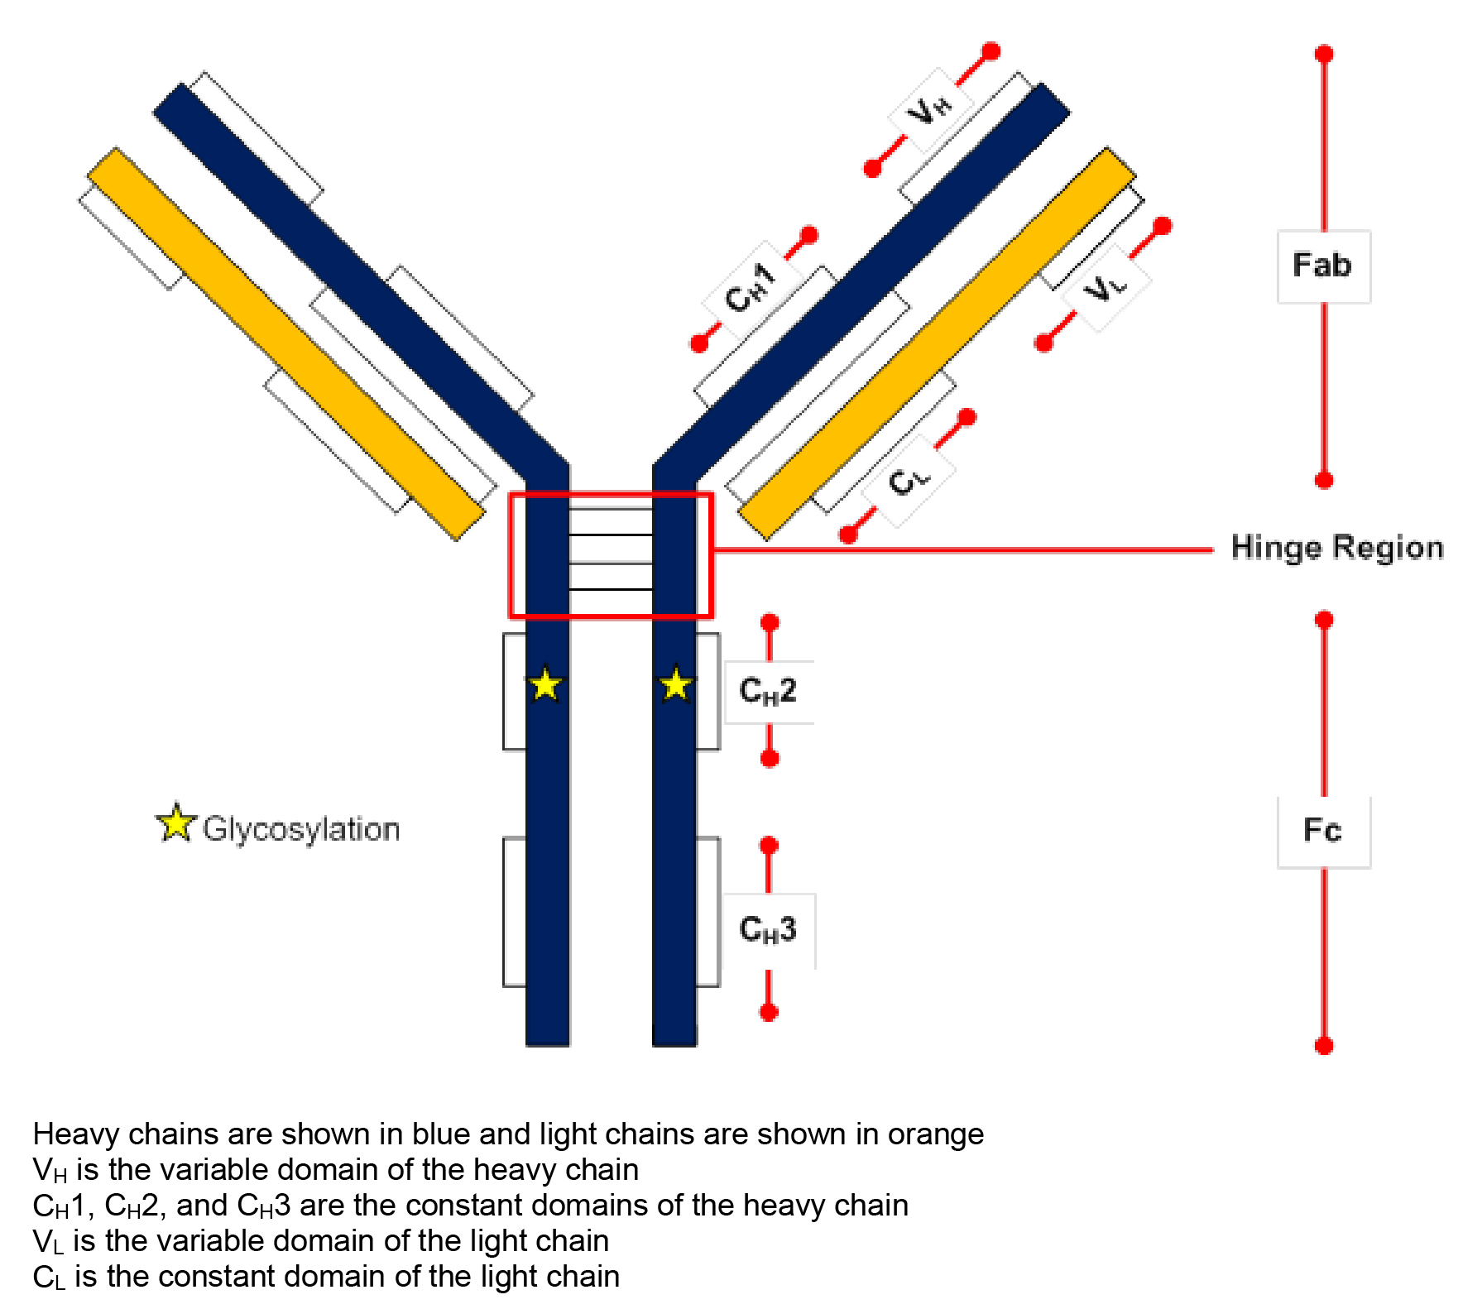

Pharmacokinetics in healthy subjects and patients with hyperlipidaemia

Absorption

Sites and mechanisms of absorption
The proposed method of administration of evolocumab is by subcutaneous (SC) injection. The proposed dosages are 140 mg every 2 weeks (Q2W) or 420 mg once every month (QM) for patients with hyperlipidaemia and mixed dyslipidaemia, and 420 mg QM or 420 mg Q2W for patients with homozygous familial hypercholesterolaemia.
Two bioavailability/bioequivalence (BA/BE) studies investigated single SC doses of 420 mg and 140 mg administered to healthy subjects. In Study 2110168, single SC 420 mg doses of evolocumab were administered in a parallel design to healthy subjects using an automated mini doser (AMD; 120 mg/mL x 3.5 mL) or an auto injector pen (AI; 140 mg/mL x 3 pens). Mean serum concentrations of unbound evolocumab were below the LLOQ (800 ng/mL) after 42 days post-dose, and serum concentrations were below the LLOQ for > 90% of subjects by 84 days post-dose. In Study 20120133, single SC 140 mg doses of evolocumab were administered in a crossover design to healthy subjects using a prefilled pen (PFS; 140 mg/mL) and an AI/pen (140 mg/mL). Mean concentrations were below the LLOQ (800 ng/mL) after 21 days post-dose, and serum concentrations were below the LLOQ by 56 days post-dose for all subjects. The C_{max}, AUC_{(last)} and T_{max} values for both studies are summarised below in Table 2.

Table 2: PK parameters for unbound evolocumab following SC administration of 420 mg and 140 mg doses to healthy subjects; Studies 20110168 and 20120133
Study | Dose and Device | C_{max} (µg/mL) | AUC_{(last)} (day x µg/mL) | T_{max} (days)
20110168 | 420 mg SC AMD | 59.0 (17.2) [n=130] | 924 (346) [n=118] | 4.0 (2.0, 9.9) [n=130]
20110168 | 420 mg SC AI/pen | 53.7 (16.8) [n=135] | 870 (309) [n=122] | 4.0 (1.9, 10) [n=135]
20120133 | 140 mg SC AI/pen | 18.6 (7.28) [n=85] | 188 (98.6) [n=74] | 3.0 (0.97, 7.1) [n=85]
20120133 | 140 mg SC PFS | 18.9 (6.36) [n=87] | 185 (86.0) [n=74] | 3.0 (2.0, 7.0) [n=87]
The C_{max} and AUC_{(last)} values are mean (SD) and the T_{max} value is median (range).

Bioavailability

Absolute bioavailability
No absolute bioavailability study in humans was submitted. The sponsor is requested to submit a formal justification for not providing an absolute bioavailability study in humans. The absolute bioavailability of evolocumab after SC administration was estimated to be 72% in the population PK analysis (Study 119633), and the mean absorption time was estimated to be approximately 3 days. In the Nonclinical Overview (Module 2.4), the absolute bioavailability of evolocumab following SC administration to monkeys was stated to be approximately 82%.

Bioequivalence of clinical trial and market formulations

Overview
Evolocumab drug substance for the Phase I and Phase II clinical studies was initially manufactured at Amgen Thousand Oaks (USA) using a manufacturing process referred to as Process 1. Evolocumab drug substance for the majority of the Phase III studies was manufactured at Amgen Rhode Island (USA) using a manufacturing process referred to as Process 2. The commercial drug substance will be manufactured at Amgen Rhode Island (USA) using Process 2. The commercial drug substance is stated to be analytically comparable to that used in the pivotal Phase III studies.
All Phase III studies were initiated with the auto injector pen (AI/pen) containing commercial drug substance manufactured by Process 2 at Amgen Rhode Island (USA), except for 2 studies in subjects with homozygous familial hypercholesterolaemia (HoFH) (20110233 and 20110271), and 1 study supporting long-term safety and efficacy (20110109) that were initiated with a 70 mg/mL vial containing drug substance manufactured by Process 1 at Amgen Thousand Oaks (USA). However, in both HoFH studies evolocumab drug substance shifted during the course of the studies from vials to AI/pens. In addition, patients in Study 20110109 were allowed to enrol in a long-term open label study (20120138) that used the AI/pens.

Bridging studies (20110168 and 20120133)
Two (2) clinical pharmacokinetic (PK) equivalence studies were conducted to bridge the data from the Phase III studies using AI/pens containing commercial drug substance to AMD and PFS presentations containing commercial drug substance. These two studies were:
- Study 20110168, an open-label, randomised, parallel-group study in 292 healthy subjects conducted to demonstrate PK equivalence of 1 AMD (test) to 3 AI/pens (reference). Both evolocumab formulations used in this study were stated by the sponsor to be identical to the proposed commercial formulations.
- Study 20120133, an open-label, randomised, crossover study in 96 healthy subjects conducted to demonstrate PK equivalence of 1 PFS (test) to 1 AI/pen (reference). Both evolocumab formulations used in this study were stated by the sponsor to be identical to the proposed commercial formulations.

Measurement of unbound evolocumab in the two bridging studies
Unbound evolocumab serum concentrations from the two PK equivalence studies were measured using a validated ELISA method. The lower limit of quantification (LLOQ) of the assay was 800 ng/mL and the upper limit of quantification was 10000 ng/mL (ULOQ). The sponsor stated that the concentration range was appropriate for the doses used and exposures observed in the 2 studies.

Statistical methods used to assess the C_{max} and AUC_{(last)} unbound evolocumab
In both bridging studies, the pharmacokinetics of evolocumab were determined from individual unbound evolocumab serum concentration-time data using standard non-compartmental methods. The maximum observed unbound serum concentration (C_{max}) and area under the serum concentration curve from time zero to the time of the last quantifiable concentration (AUC_{last}) were the primary endpoints. Assessing a terminal elimination slope with sufficient accuracy to assess either half-life or area under the serum concentration curve from time zero to infinity (AUC_{inf}) was not possible following single-dose evolocumab, because unbound serum concentrations of the drug declined in a concentration-dependent manner with faster elimination occurring at lower concentrations.
The C_{max} and the AUC_{last} were calculated using an analysis of variance (ANOVA) model, with both parameters being log-transformed prior to the analysis. For Study 20110168, the independent variable was treatment, and the AMD was used as the test article and the AI/pen as the reference article. For Study 20120133, the independent variables were treatment, period, and sequence, with treatment, period, and sequence being evaluated as fixed effects and subject nested within sequence as a random effect. The PFS was used as the test article and the AI/pen as the reference article.
In both analyses, the data were back-transformed to produce the geometric mean. The 2 treatments were considered to be pharmacokinetically equivalent if the 90% CI for the ratio (test/reference) for the C_{max} and AUC_{(last)} values fell completely within the interval 0.80 and 1.25 (that is, standard approach to establishing bioequivalence).

Results - serum unbound evolocumab
In Study 20110168, subjects were randomised 1:1 into 1 of 2 parallel treatment groups, with subjects in both groups receiving a total evolocumab dose of 420 mg SC administered as a single-dose by clinical staff. One group (n=144) received evolocumab by single AMD (that is, 3.5 mL of 120 mg/mL formulation) and the other group (n=145) received evolocumab by 3 x AI/pens (that is, 3 x 140 mg/mL formulation). In the AMD group, evolocumab was administered as a single-dose (420 mg/3.5 mL) administered SC into the anterior abdominal wall over 9 minutes. In the AI/pen group, evolocumab was administered as a single-dose (420 mg, 3 x AI/pens [3 x 140 mg/mL]) administered SC into three different quadrants of the abdominal wall, with consecutive injections separated by no more than 1 minute. Subjects were followed from the day of the single-dose through study day 85 for safety, tolerability, PK and PD assessments. Samples for unbound serum evolocumab concentrations were collected pre-dose, then at 4, 24 and 48 hours post-dose, followed by sampling at Days 4, 5, 7, 8, 11, 15, 22, 29, 36, 43, 57, 71, and 85. The unbound evolocumab serum concentration-time profiles for the test and references articles are summarised below in Figure 2.
Figure 2: 20110168 - Mean (SD) unbound evolocumab serum concentration-time profiles after SC administration of evolocumab 420 mg to healthy subjects using an AMD (test) versus AI/pens (reference).
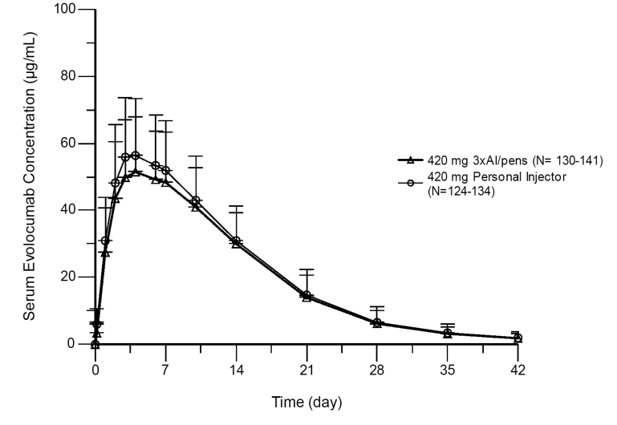
Note: Mean and SD values are shown for time points at which more than 50% of the unbound serum evolocumab concentrations are above the lower limit of quantitation. SD = standard deviation; AI/Pen =auto injector/pen; Personal Injector = automated mini-doser (AMD).
In Study 20120133, a total of 96 healthy subjects were randomised to receive evolocumab 140 mg SC by both PFS and by AI/pen in 1 of 2 sequences: Sequence 1 consisted of AI/pen crossed-over to AMD, and Sequence 2 consisted of AMD crossed-over to AI/pen. The injections were administered by clinical staff. The treatments were administered by SC injection (140 mg/mL) into the anterior abdominal wall on Day 1 and day 57 of each treatment period. Each single-dose administration was separated by a 56 day washout period and each period consisted of 56 days. Subjects were followed from the day of the single injection through to study Day 113 for safety, PK and PD assessments. The sampling schedule for each sequence was pre-dose on Day 1 followed by post-dose at 4, 24, and 48 hours followed by collection on Days 4, 6, 8, 11, 15, 22, 29, 43, and 50 (that is, treatment Period 1), and then alternate treatment on Day 57 with collection pre-dose, and then 4, 24, and 48 hours post-dose followed by collection on Days 60, 62, 64, 67, 71, 78, 85, 99, 106, and 113 (that is, treatment Period 2). The unbound evolocumab serum concentration-time profiles for the test and references articles are summarised below in Figure 3.
Figure 3: 20120133 - Mean (SD) unbound evolocumab serum concentration-time profiles after SC administration of evolocumab 140 mg to healthy subjects using a PFS (test) versus AI/pen (reference).
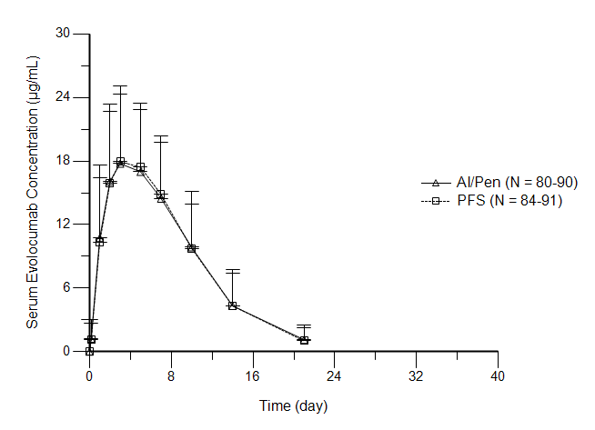
Note: The mean concentration-time profiles were based on all evaluable concentration values. SD = standard deviation; AI/Pen = auto injector/pen; Personal Injector = automated mini-doser (AMD).
Studies 20110168 and 201202133: The PK equivalence results for the two studies are summarised below in Table 3.

Table 3: Summary of the PK equivalence results
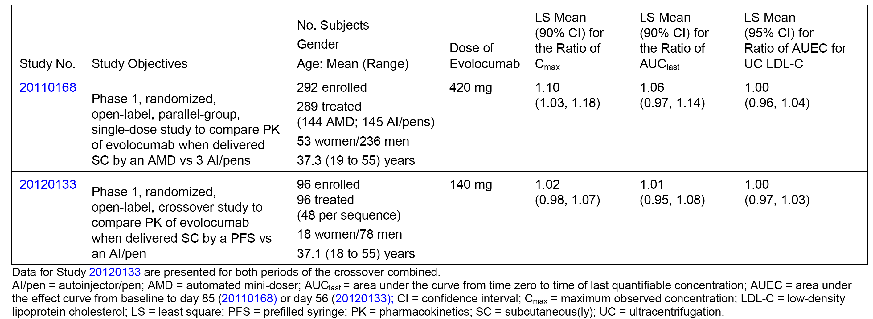
Comment: Study 20110168 showed that a single SC dose of evolocumab 420 mg administered with the AMD presentation at 120 mg/mL with a 3.5 mL fill was pharmacokinetically equivalent to the reference presentation of 3 AI/pens (3 x 140 mg/mL). The 90% CI for the ratio of both the C_{max} and the AUC_{(last)} was enclosed entirely within the predefined PK equivalence interval of 0.80 to 1.25. The serum concentration-time curves for the two products were similar. The median T_{max} value was 4.0 days for both the AMD (range: 2.0, 9.9 days) and the 3 AI/pens (range: 1.9, 10 days). Mean unbound evolocumab serum concentrations were below the LLOQ after 42 days post-dose, and > 90% of subjects had unbound evolocumab serum concentrations below the LLOQ by 84 days post-dose. These concentrations indicate that sampling for 84 days in this study was adequate to characterise evolocumab exposure following both formulations.
Study 20120133 showed that a single SC dose of evolocumab 140 mg administered with the PFS presentation at 140 mg/mL with a 1 mL fill was pharmacokinetically equivalent to the reference presentation of 1 AI/Pen (1 x 140 mg/mL). The 90% CI for the ratio of both the C_{max} and the AUC_{(last)} was enclosed entirely within the predefined PK equivalence interval of 0.80 to 1.25. The serum concentration-time curves for the two products were similar. The median T_{max} value was 3.0 days for both the PFS (range: 2.0, 7.0 days) and the AI/pen (range: 0.97, 7.1 days). Mean unbound evolocumab concentrations were below the LLOQ by 21 days post-dose and all subjects had serum concentrations below the LLOQ by 56 days post-dose. These concentrations indicate that sampling for 56 days in this study was adequate to characterise evolocumab exposure following both formulations.
Although not directly compared, the PK equivalence of a single SC dose of dose evolocumab 420 mg administered using 3 PFS injections or 1 AMD injection can be reasonably inferred from the results of the 2 bridging studies.

Dose proportionality
In Study 20080397 (single-dose, healthy subjects), evolocumab exhibited non-linear pharmacokinetics after single-dose SC and IV administration over the dose range of 21 mg to 420 mg, with exposure measured by mean C_{max} and AUC_{inf} increasing in a more than dose proportional manner. Using a power model to assess dose proportionality in the SC groups, the slopes of the model for C_{max}, AUC_{(last)} and AUC_{inf} exceeded unity. The C_{max} (n=21) and AUC_{inf} (n=18) point estimates of the slopes were 1.23 (90% CI: 1.06, 1.40) and 1.63 (90% CI: 1.29, 1.96), respectively, over a 20 fold range of SC doses (21 mg to 420 mg). Using a power model to assess dose proportionality in the IV groups, the slopes of the model for AUC_{(last)} and AUC_{inf} exceeded unity. The AUC_{inf} (n=12) point estimate of the slope was 1.59 (90%CI: 1.51, 1.66) over a 20 fold dose range IV doses (21 mg to 420 mg). The data from the power model show that evolocumab unbound serum concentration increases in a greater than dose proportional manner with increasing dose following both SC and IV administration.
In Study 20080398 (SC multiple-dose, patients with hyperlipidaemia), evolocumab exhibited nonlinear pharmacokinetics for the comparison between the 140 mg Q2W x 3 group and the 280 mg Q2W x 3 group with exposure being greater than dose proportional after the last dose. The C_{max} increased from a mean of 20.3 ng/mL in the 140 mg Q2W x 3 group (n=6) to a mean of 62.8 ng/mL in the 280 mg Q2W x 3 group (n=6), representing a 3.1 fold increase in the C_{max} for a 2 fold increase in dose. Similarly, the AUC_{(tau)} increased from a mean of 168 day x μg/mL in the 140 mg Q2W x 3 group (n=6) to a mean of 749 day x μg/mL in the 280 mg Q2W x 3 group (n=6), representing a 4.5 fold increase in the AUC_{(tau)} for a 2 fold increase in dose.

Bioavailability during multiple dosing
Unbound evolocumab serum trough concentrations were measured in a number of Phase II/III clinical efficacy and safety studies. In the Phase II clinical efficacy and safety Studies 20101154 (evolocumab monotherapy) and 20101155 (evolocumab + statin ± ezetimibe) in subjects with primary hyperlipidaemia and mixed dyslipidaemia, comparison of Week 10 to Week 2 unbound serum trough values demonstrated an approximately 3 fold accumulation in mean unbound evolocumab serum concentration for the 140 mg SC Q2W regimen after the sixth dose, and less than 2 fold accumulation for the 420 mg SC QM regimen after the third dose. Similar accumulation was observed in the Phase III Studies 20110114 (evolocumab monotherapy) and 20110115 (evolocumab + statin ± ezetimibe) in subjects with primary hyperlipidaemia and mixed dyslipidaemia for the 140 mg SC Q2W dose, based on unbound serum evolocumab trough concentrations at Weeks 2, 10, and 12, and for the 420 mg SC QM dose, based on concentrations at Weeks 2 and 10. Representative evolocumab trough concentrations for Studies 20101154 and 20101155 are summarised below.
In Study 20110154, the mean (SD) unbound evolocumab serum trough concentrations (Weeks 2, 4, 6, 8, 10, and 12 for the 140 mg SC Q2W regimen and Weeks 4, 8, and 12 for 420 SC Q4W regimen) demonstrated accumulation within each treatment regimen. At Weeks 2 (n=44), 10 (n=41), and 12 (n=40) for the 140 mg Q2W regimen, the mean (SD) concentrations were 3.72 (5.40), 9.21 (8.17), and 10.6 (9.06) 10.6 μg/mL, respectively (that is, accumulation from week 2 to Weeks 10 and 12 were 2.4 fold and 2.8 fold, respectively). For the 420 mg SC Q4W dose, the mean (SD) evolocumab trough concentrations at Weeks 2 (n=35) and 10 (n=42) were 29.6 (19.0) µg/mL and 47.2 (27.9) µg/mL, respectively (that is, accumulation from week 2 to 10 was 1.6 fold).
In Study 20101155, the mean ± SD unbound evolocumab serum trough concentrations (Weeks 2, 4, 6, 8, 10, and 12 for the 140 mg SC Q2W regimen and weeks 4, 8, and 12 for 420 SC Q4W regimen) demonstrated accumulation within each treatment regimen at Weeks 2 (n=75), 10 (n=76), and 12 (n=73) for the 140 mg Q2W regimen, the mean ± SD evolocumab trough concentrations were 2.24 ± 3.04 µg/mL, 6.10 ± 5.92 μg/mL, and 7.21 ± 6.55 μg/mL, respectively (that is, accumulation from Week 2 to Weeks 10, and 12 were 2.7 fold and 3.2 fold, respectively). For the 420 mg Q4W cohort, the mean ± SD evolocumab trough concentrations at Weeks 2 (n=69) and 10 (n=76) were 30.9 ± 21.8 μg/mL and 40.1 ± 27.2, respectively (that is, accumulation from Week 2 to 10 was 1.3 fold).
In Study 20110109, a long-term Phase III study in subjects with primary hyperlipidaemia and mixed dyslipidaemia treated with evolocumab 420 mg SC QM, mean ± SD unbound evolocumab serum trough concentrations at Weeks 12, 24, 36, and 52 were stable and ranged from 8.23 ± 9.05 to 10.3 ± 11.2 μg/mL. Mean ± SD C_{max} for unbound evolocumab serum concentrations at Weeks 13 and 37 were 47.4 ± 24.4 and 49.4 ± 23.2 μg/mL, respectively. At the end of the 52-week treatment period, unbound evolocumab serum trough concentrations declined, but the half-life could not be determined due to concentration-dependent elimination. These results indicate that unbound evolocumab pharmacokinetics did not change substantially with time, and that steady state was achieved by 12 weeks of dosing with evolocumab.

Distribution
In Study 20080397, the mean ± SD volume of distribution at steady state (Vss) following evolocumab 420 mg administered IV in healthy subjects (n=6) was 3.340 ± 0.460 L. The Vss estimate is similar to plasma volume, and suggests that evolocumab is not extensively distributed to the tissues. IgG antibodies have limited distribution from serum to tissue due to their molecular size. However, the sponsor comments that the Vss estimate may underestimate the true Vss, because the calculation is based on the assumption that the site of antibody elimination is in rapid equilibrium with the plasma (that is, assumed that all distribution is from the central compartment). This assumption is often not valid for an antibody due to the possibility that the antibody may be eliminated from sites that are not in rapid equilibrium with plasma, such as the peripheral compartment.² Given the known biodistribution features of monoclonal antibodies, most are anticipated to have a Vss that is 2 to 5 times the plasma volume.^{1.2}

Metabolism
There were no clinical studies investigating the metabolism of evolocumab. However, it can be anticipated that evolocumab will be metabolised to peptides and amino acids via catabolic pathways in various body tissues. Mass balance studies are considered to be not useful for determining the excretion pattern of therapeutic proteins (CHMP/EWP/89249/2004).

Excretion

Mechanisms of elimination of unbound serum evolocumab
The combined PK data consistently showed that unbound evolocumab displays nonlinear pharmacokinetics across a wide dose range (7 to 420 mg SC). With multiple doses at or above the proposed fixed dose of 140 mg SC, evolocumab display approximately linear pharmacokinetics, as evidenced by dose-proportional increases in AUC and C_{max} for unbound evolocumab. In single-dose studies, a greater than proportional increase in AUC was observed when the SC dose was increased from 70 mg to 210 mg, while a dose-proportional increase in AUC was observed when the SC dose was increased from 210 mg to 420 mg. The mean dose-normalised AUC increased in a greater than dose proportional manner between doses of 21 mg and 210 mg, but was comparable between doses of 210 mg and 420 mg SC
The sponsor states that the data are consistent with two mechanisms of elimination for unbound evolocumab: a saturable mechanism that predominates at low doses or serum concentrations and becomes saturated as serum concentrations increase, and a non-saturable mechanism that governs the rate of evolocumab elimination at higher doses or serum concentrations. The saturable mechanism of elimination is likely to be related to evolocumab binding to PCSK9 and elimination of the antibody-PCSK9 complex (that is, target mediated disposition). The sponsor states that unbound PCSK9 measurements in the same blood samples support this hypothesis because when PCSK9 is fully suppressed the pharmacokinetics of unbound evolocumab are linear. The non-saturable mechanism of evolocumab elimination is likely to be through non-specific catabolism in cells of the reticuloendothelial system. The mean clearance for evolocumab 420 mg IV (Study 20080397) of approximately 12 mL/hr is around 1.5 fold greater than values reported for natural IgG of 6.0 to 8.4 mL/hr. The sponsor states that this represents both linear (associated with the clearance processes and rates for natural immunoglobulins) and nonlinear (associated with the PCSK9 target) contributions to the total clearance of unbound evolocumab. The sponsor states that population-PK modelling predicts that 77% of a single 140 mg SC dose and 51% of a single 420 mg SC dose are eliminated through the non-linear PCSK9 target-mediated pathway.

Total systemic clearance
In Study 20080397 (single-dose, healthy subjects), the mean ± SD systemic clearance of evolocumab (CL) was 68.3 ± 16.0 mL/hr following an IV dose of 21 mg and 11.6 ± 2.26 mL/hr following an IV dose of 420 mg IV. The results show that the clearance of evolocumab is dose dependent, indicating that clearance is nonlinear. However, mean ± SD apparent clearance (CL/F) values following single evolocumab SC doses of 210 mg and 420 mg were similar (25.6 ± 6.86 ml/hr and 24.2 ± 12.5 mL/hr, respectively), while both values were lower than that following an evolocumab SC dose of 70 mg (101 ± 120 mL/hr). The CL/F results suggest that systemic clearance is linear over the SC dose range 210 mg to 420 mg.

Renal clearance
There were no data relating to the renal clearance of evolocumab. However, no renal excretion of evolocumab is anticipated due to its large molecular size.

Target population

Primary hyperlipidaemia and mixed dyslipidaemia versus healthy subjects
Module 2.7.2 (Summary of Clinical Pharmacology Studies) included a comparison of the pharmacokinetics of evolocumab between patients with primary hyperlipidaemia and mixed dyslipidaemia and healthy subjects. The review of the comparison described below has been adapted from Module 2.7.2, with the provided data being cross-checked with that from the individual study reports. In the Phase II Study 21011154 (patients), limited PK sampling was performed at Weeks 2, 4, 6, 8, 10, and 12 to characterise the pharmacokinetics and pharmacodynamics of evolocumab monotherapy in patients with hyperlipidaemia. The study also included a PK substudy with additional sample collection at Weeks 9 and 11 to characterise unbound evolocumab AUC_{(Weeks 8-12)} and C_{max} after 6 doses of evolocumab 140 mg SC Q2W or 3 doses of evolocumab 420 mg SC QM. Rich PK sampling in healthy subjects was performed in the Phase I pharmacokinetic Study 20080397 and in the Phase I pharmacokinetic equivalence Studies 20110168 and 20120133. Cross-study comparisons included AUC and C_{max} for unbound evolocumab, as well as serum concentrations of unbound evolocumab, LDL-C, and unbound PCSK9 at 2 weeks after a dose of evolocumab 140 mg SC and at 2 and 4 weeks after a dose of evolocumab 420 mg SC.
The C_{max} and AUC values for unbound evolocumab in healthy subjects and patients with primary hyperlipidaemia and mixed dyslipidaemia following evolocumab 140 mg SC (single dose in healthy subjects, two doses in patients) are summarised below in Table 4. Because the AUC_{(last)} was measured after a single 140 mg SC dose and AUC_{(Weeks 8-12)} included 2 doses of evolocumab, AUC_{(last)} in healthy subjects was multiplied by 2 for comparison. After this multiplication, mean unbound evolocumab AUC for the 140 mg SC dose was comparable between healthy subjects 376 μg x day/mL (2 x 188 μg x day/mL) and patients (387 μg x day/mL).

Table 4: Unbound evolocumab pharmacokinetics in healthy subjects and patients; evolocumab 140 mg SC (single dose in healthy subjects, two doses in patients).
Study | Population | AUC ^{c} (µg x day/mL) |  |  | C_{max} (µg/mL)
 |  | Mean (SD) | CV% | N | Mean (SD) | CV% | N
20120133 ª | Healthy Subjects | 188 (95.6) ^{d} | 51.0% | 42 | 18.8 (7.45) | 39.7% | 46
20101154 ^{b} | Patients ^{e} | 387 (271) ^{d} | 70.0% | 21 | 23.7 (14.7) | 61.7% | 21
a = Evolocumab was administered by prefilled auto injector/pen in Period 1. b = Evolocumab was administered by prefilled syringe. c = AUC for Study 20120133 is AUC_{(last)}; AUC for Study 20101154 is AUC_{(Weeks 8-12)}. d = AUC_{(last)} in healthy subjects (which was based on a single dose) was multiplied by 2 for comparison with AUC_{(Weeks 8-12)} (which was based on two doses). e = Patients with primary hyperlipidaemia and mixed dyslipidaemia.
The C_{max} and AUC values for unbound evolocumab in healthy subjects and patients with primary hyperlipidaemia and mixed dyslipidaemia following single-dose evolocumab 420 mg SC are summarised below in Table 5. Both mean AUC and C_{max} for unbound evolocumab were comparable between healthy subjects and patients following 420 mg SC (single-dose).

Table 5: Unbound evolocumab pharmacokinetics in healthy subjects and patients; evolocumab 420 mg SC (single dose in healthy subjects and in patients).
Study | Population | AUC ^{d} (µg x day/mL) |  |  | C_{max} (µg/mL)
 |  | Mean (SD) | CV% | N | Mean (SD) | CV% | N
20080397 ª | Healthy Subjects | 842 (333) | 39.6% | 6 | 46.0 (17.2) | 37.4% | 6
20110168 ^{b} | Healthy Subjects | 924 (346) | 37.5% | 118 | 59.0 (17.2) | 29.2% | 130
20101154 ^{c} | Patients ^{e} | 962 (459) | 47.7% | 21 | 62.9 (24.3) | 38.6% | 21
a = Evolocumab was administered by prefilled auto injector/pen in Period 1. b = Evolocumab was administered by an automated mini-doser c = Evolocumab was administered by a prefilled syringe d = AUC for Study 20080397 is AUC_{(0-t)}; AUC for Study 20110168 is AUC_{(last)}; AUC for Study 20101154 is AUC_{(Weeks 8-12)}. e = Patients with primary hyperlipidaemia and mixed dyslipidaemia.
Mean ± SD unbound evolocumab serum concentrations following evolocumab 140 mg SC at Week 2 in healthy subjects (20120133 [n=46]) and patients (20101154 [n=44]) were comparable (4.18 ± 3.18 µg/mL and 3.72 ± 5.40 µg/mL, respectively). Mean ± SD unbound evolocumab serum concentrations following evolocumab 420 SC mg in healthy subjects (20110168) and patients (20101154) were comparable at Week 2 (31.0 ± 10.2 µg/mL, n=129 and 29.6 ± 19.0 µg/mL, n=35, respectively) and at Week 4 (6.55 ± 4.64, n=124 and 5.44 ± 5.60, n=44, respectively).
Comments: Collectively, the data show that the pharmacokinetics of evolocumab are similar in healthy subjects and patients with primary hyperlipidaemia and mixed dyslipidaemia. The observed differences between healthy subjects and patients are considered to be not clinically meaningful. Therefore, the results of the Phase I pharmacokinetic equivalence studies in healthy subjects (20110168 and 20120133), in which evolocumab formulations identical to those being proposed for registration were assessed, can be considered to be applicable to patients with primary hyperlipidaemia and mixed dyslipidaemia.

Treatment with statins
Module 2.7.2 (Summary of Clinical Pharmacology Studies) included a comparison of the pharmacokinetics of evolocumab in patients with primary hyperlipidaemia and mixed dyslipidaemia treated with evolocumab monotherapy (Phase II Study 20101154) and treated with evolocumab in combination with a statin (Phase II Study 20101155). A PK substudy was included in the two studies with sample collection at Weeks 8, 9, 10, 11, and 12, to characterise unbound evolocumab AUC and C_{max} following Q2W or QM dosing. The review of the comparison described below has been adapted from Module 2.7.2, with the data being cross-checked with that provided in the individual study reports.
Following evolocumab 140 mg SC Q2W, the AUC_{(Weeks 8-12)} mean ± SD after dosing on Weeks 8 and 10 was approximately 21% lower in the evolocumab plus statin group (304 ± 200 µg x day/mL, n=19) compared to the evolocumab monotherapy group (387 ± 371 µg x day/mL, n=21), and the C_{max} mean ± SD was approximately 26% lower in the evolocumab plus statin group compared to the evolocumab monotherapy group (17.6 ± 9.06 µg/mL, n=19 and 23.7 ± 14.7 µg/mL, n=21, respectively).
Following evolocumab 420 mg SC QM, the AUC_{(Weeks 8-12)} mean ± SD after dosing on Weeks 8 and 10 was 22% lower in the evolocumab plus statin group (746 ± 342 µg x day/mL, n=21) than in the evolocumab monotherapy group (962 ± 459 µg x day/mL, n=21), and the C_{max} mean ± SD was approximately 26% lower in the evolocumab plus statin group compared to the evolocumab monotherapy group (17.6 ± 9.06 µg/mL, n=19 and 23.7 ± 14.7 µg/mL, n=21, respectively).
In the Phase III studies, unbound evolocumab trough mean ± SD serum concentrations at Week 12 with 140 mg SC Q2W dosing were comparable between evolocumab monotherapy (Study 20110114) and evolocumab treatment in statin intolerant (Study 20110116) patients (12.0 ± 10.1 µg/mL, n=112 and 10.8 ± 8.88 µg/mL, n=88, respectively), and concentrations were higher in both populations compared to evolocumab with statin (Study 20110115) (5.37 ± 5.66 µg/mL, n=513).
In the Phase III studies, unbound evolocumab trough mean ± SD serum concentrations at Week 12 with 420 mg SC dosing were comparable between evolocumab monotherapy (Study 20110114) and evolocumab treatment in statin intolerant (Study 20110116) patients (16.4 ± 12.6 µg/mL, n=133 and 15.9 ± 11.5 µg/mL, n=95, respectively), and concentrations were higher in both populations compared to evolocumab with statin (Study 20110115) (9.68 ± 9.20 µg/mL, n=482).
In Study 20110155, when evolocumab was administered with low dose atorvastatin 10 mg or high dose atorvastatin 80 mg, unbound evolocumab trough serum concentrations at Week 12 were overlapping and were lower with high atorvastatin dose compared to low dose atorvastatin (approximately 24% lower for evolocumab 140 mg SC Q2W and approximately 30% lower for evolocumab 420 mg SC QM).
In Study 20110155, when evolocumab was administered with low dose of rosuvastatin 5 mg or high dose rosuvastatin 40 mg, unbound evolocumab trough serum concentrations at Week 12 were lower with high rosuvastatin dose compared to low rosuvastatin dose (approximately 50% lower for evolocumab 140 mg SC Q2W and approximately 34% lower for evolocumab 420 mg SC QM)
Comment: Treatment with evolocumab in combination with statins was associated with lower exposure to unbound evolocumab trough serum concentrations compared to treatment with evolocumab as monotherapy and treatment with evolocumab in statin intolerant subjects. However, pharmacodynamic effects (percent reduction of LDL-C and unbound PCSK9 from baseline) were comparable between evolocumab monotherapy and evolocumab combined with a statin. The pharmacokinetic and pharmacodynamic profiles of evolocumab in statin intolerant subjects were comparable to those in subjects treated with evolocumab monotherapy. Therefore, the sponsor considered that the dose of evolocumab does not need to be adjusted when used in combination with statins.

Heterozygous familial hypercholesterolaemia (HeFH)
Module 2.7.2 (Summary of Clinical Pharmacology Studies) included a comparison of the pharmacokinetics of evolocumab in patients with HeFH (Phase III, Study 20110117) and evolocumab plus statin in patients with primary hyperlipidaemia and mixed dyslipidaemia (Phase III, Study 20110115). Cross-study comparisons of these two Phase III studies included serum concentrations of unbound evolocumab, LDL-C, and unbound PCSK9 at 12 weeks. On the basis of Phase III Study 20110109, Week 12 trough concentrations were considered to represent steady-state concentrations of unbound evolocumab, LDL-C, and unbound PCSK9. Cross-study comparisons also included LDL-C at the mean of Weeks 10 and 12, which was a co-primary study endpoint in each of these studies. The review of the PK results described below has been adapted from Module 2.7.2, with the data being cross-checked with that provided in the individual study reports.
In the Phase III studies, the unbound evolocumab mean ± SD serum trough level at Week 12 was comparable between patients with HeFH (Study 20110117) and patients with primary hyperlipidaemia and mixed dyslipidaemia (Study 20110115) when evolocumab 140 mg SC Q2W was administered with a statin (5.57 ± 7.46 µg/mL, n=101 and 5.37 ± 5.66 µg/mL, n=513, respectively), and when evolocumab 420 mg SC QM was administered with a statin (8.50 ± 7.17 µg/mL, n=105 and 9.68 ± 9.20 µg/mL, n=482, respectively).
In the Phase I, ascending, multiple-dose study in subjects with hyperlipidaemia taking evolocumab plus statin (Study 20080398), the PK and PD responses to treatment were compared between subjects with and without HeFH. In this study, the C_{max} of unbound evolocumab in subjects with HeFH (n=4) was slightly lower compared to subjects without HeFH (n=6) on low to moderate dose statins receiving the same evolocumab dose regimen of 140 mg SC Q2W x 3 (point estimate 0.83 [90%CI: 0.48, 1.45]), but AUC_{(last)} values were comparable between the two groups (point estimate 0.94 [90%CI: 0.40, 2.21]).
Comment: In the Phase III studies, similar pharmacokinetic profiles were observed for patients with HeFH compared to the overall population of patients with primary hyperlipidemia and mixed dyslipidemia who were treated with a statin and either evolocumab 140 mg SC Q2W or 420 mg SC QM for 3 months. These results indicate that 140 mg SC Q2W or 420 mg SC QM are appropriate doses for patients with HeFH.

Homozygous Familial Hypercholesterolaemia (HoFH)
Module 2.7.2 (Summary of Clinical Pharmacology Studies) included a comparison of the pharmacokinetics of evolocumab in patients with HoFH (Phase III study, 20110233 controlled and 20110115 open-label extension) and patients with primary hyperlipidaemia and mixed dyslipidaemia (Phase III Study 20110115). Patients in each study were stabilised on lipid-lowering medications including statins before initiating evolocumab treatment. Cross-study comparisons included serum concentrations of unbound evolocumab, LDL-C, and unbound PCSK9 at 12 weeks. The sponsor considered that it was not necessary to compare the pharmacokinetic and pharmacodynamic profiles in patients with HoFH to those in patients with HeFH, because the profiles are comparable in the two patient populations. The review of the PK results described below has been adapted from Module 2.7.2, with the data being cross-checked with that provided in the individual study reports.
Unbound evolocumab trough mean ± SD serum concentrations at Week 12 following evolocumab 420 mg SC QM were comparable for patients with HoFH not on apheresis (10.9 ± 7.02 µg/mL, n=30 [20110115]; 13.1 ± 11.5 µg/mL, n=45 [20110271]) and patients with primary hyperlipidemia and mixed dyslipidemia (9.68 ± 9.20 µg/mL, n=482 [20110115]). Among 9 adolescent patients aged 12 to < 18 years with HoFH in Study 20110271 who were not on apheresis and had received evolocumab 420 mg SC QM, unbound evolocumab trough serum concentrations at Week 12 were highly variable and ranged from 8.60 to 46.9 μg/mL. These values fell within the range of unbound evolocumab concentrations in Study 20110115 in adults with primary hyperlipidemia and mixed dyslipidemia.
In patients with HoFH on apheresis treated with evolocumab 420 mg SC Q2W for 12 weeks (Study 20110271), unbound evolocumab mean ± SD serum concentration at the Week 12 visit was approximately 20% lower post-apheresis than pre-apheresis (for example, 61.3 ± 26.1 µg/mL, n=16 versus 77.0 ± 27.2 µg/mL, n=22, respectively). The mean unbound evolocumab serum trough concentration at Week 12 in patients on apheresis (that is, pre-apheresis concentration) in Study 20110271 was higher than the mean unbound evolocumab serum trough concentrations reported at Week 12 in patients not on apheresis in Studies 20110233 and 20110271. The difference is possibly due to the more frequent evolocumab dosing schedule used in patients on apheresis (that is, 420 mg SC Q2W) than in patients not on apheresis (that is, 420 mg QM).
Comment: Collectively, the results indicate that the PK profile of evolocumab in adult and adolescent patients with HoFH is consistent with the PK profile of evolocumab in adults with primary hyperlipidaemia and mixed dyslipidaemia.

Pharmacokinetics in special populations

Pharmacokinetics in subjects with impaired hepatic function
The effect of mild and moderate hepatic impairment on the pharmacokinetics of evolocumab was examined in Study 201204341. After a single dose of evolocumab 140 mg SC, exposure decreased with increasing hepatic impairment. Compared to healthy subjects (n=8) with no hepatic impairment, subjects with mild (n=8) and moderate hepatic (n=8) impairment had AUC (last) LS mean values that were 39% and 47% lower, respectively (p=0.090), and C_{max} LS mean values that were 21% and 34% lower, respectively (p=0.18). However, the PK changes observed in subjects with hepatic impairment did not appear to affect the PD endpoints relating to PCSK9 concentration and LDL-C lowering. In addition, no safety issues emerged in subjects with mild and moderate hepatic impairment treated with evolocumab.

Pharmacokinetics in subjects with impaired renal functions
There were no studies in subjects with renal impairment. The sponsor stated that diminished renal function is not expected to modify the pharmacokinetics of monoclonal antibodies. Therefore, a dedicated renal impairment study was not conducted. A population PK analysis was used to estimate individual AUC_{(Weeks 8-12)} for subjects in Studies 20090158, 20090159, 20101154, and 20101155. In addition, the Week 12 unbound evolocumab trough serum concentration for renal function groups using pooled data from Phase II and III studies was also assessed (Studies 20090158, 20090159, 20101154, 20101155, 20110109, 20110114, 20110115, 20110116, and 20110117). The effect of renal impairment on the pharmacokinetics of evolocumab was compared across the studies using both Cockcroft-Gault creatinine clearance (CrCL) and the Modification of Diet in Renal Disease (MDRD) estimated glomerular filtration rate (eGFR). No clinically meaningful effect was evident between renal function markers and the model-predicted AUC_{(Weeks 8-12)} for either the evolocumab 140 mg SC Q2W regimen or the evolocumab 420 SC mg regimen. Similarly, no clinically meaningful effect was evident between renal function markers and the unbound evolocumab trough serum concentration at Week 12 for either the evolocumab 140 mg SC Q2W regimen or the evolocumab 420 SC mg regimen. In addition, CrCL and eGFR were tested as covariates in the PopPK model (Study 119663), and no statistically significant relationship emerged.

Other special populations
Evolocumab PK and PD and demographic data from Phase I studies (20080397 and 20080398), Phase II studies (20090158, 20090159, 20101154, and 20101155), and Phase III studies (20110109, 20110114, 20110115, 20110116, and 20110117) were used to evaluate the potential effects of body weight, age, sex, and race on the pharmacokinetics and pharmacodynamics of single or multiple doses of evolocumab 140 mg SC Q2W or 420 mg SC QM. For covariates that appeared to affect the unbound evolocumab serum concentration at Week 12, clinical importance was assessed by evaluating the potential effect on evolocumab pharmacodynamics, based on changes in LDL-C at Week 12 and at the mean of Weeks 10 and 12. These comparisons addressed the proposed clinical doses of 140 mg SC Q2W and 420 mg SC QM with a large sample size (n = 2813), including either rich or limited pharmacokinetic sampling of women (n = 1403) and men (n = 1410) with a wide range in age (18 to 80 years) and body weight (38 to 175 kg).
Body weight: In patients with primary hyperlipidemia and mixed dyslipidemia, exposure based on unbound evolocumab trough serum concentrations at Week 12 tended to be lower in heavier subjects than in lighter subjects with both evolocumab 140 mg SC Q2W (n=912) and 420 mg SC QM (n=1615). However, due to large inter-subject variability in exposure, there was extensive overlap in unbound evolocumab exposures across the weight range explored (38 to 175 kg). No effect of body weight on LDL-C reduction was observed for the 140 mg SC Q2W or 420 mg SC QM dose regimens using LDL-C at Week 12 or at the mean of Weeks 10 and 12 as endpoints. These findings indicate that the relationship between evolocumab and total body weight is likely to be of little clinical importance, because exposures attained with 140 mg SC Q2W and 420 mg SC QM dosing regimens are sufficient to lower LDL-C across the wide range evaluated for total body weight.
Age: In patients with primary hyperlipidemia and mixed dyslipidemia, no relationship was observed between age and unbound evolocumab trough serum concentrations at Week 12 in patients 18 to 80 years of age.
Sex: The median unbound evolocumab trough serum concentrations at Week 12 were approximately 48% and 18% higher for evolocumab 140 mg SC Q2W and evolocumab 420 mg SC QM, respectively, in female patients compared to male patients. This might be a function of lower body weight in females compared to males (that is, higher concentrations in lighter subjects).
Race: Unbound evolocumab trough mean serum concentrations at Week 12 were similar for White, Black and Asian subjects. In addition, the pharmacokinetic and pharmacodynamic profiles were similar in Japanese and White subjects following single dose evolocumab 210 mg SC (Study 20110121). Collectively, these results suggest that race does not have a substantial effect on the pharmacokinetic and pharmacodynamic profiles of evolocumab.

Effects of immunogenicity on the pharmacokinetics of evolocumab
The submission included an Integrated Immunogenicity Report, dated 21 July 2014, describing the results for the immune response in the clinical studies. During the conduct of clinical trials, serum samples were tested for anti-evolocumab binding antibodies using an electrochemiluminescent (ECL) bridging immunoassay. If positive, samples were then tested for neutralising antibodies (NAb) using a validated receptor binding assay. The immunogenicity rate observed across all human clinical studies was low. From the 14 integrated Phase II and Phase III studies in patients with primary hyperlipidaemia and mixed dyslipidaemia, 7 out of 4846 of subjects (0.1%) developed binding antibodies after at least one dose of evolocumab (Studies 20101154, 20101155, 20090158, 20090159, 20110114, 20110115, 20110116, 20110117, 20110231, 20110109, 20110110, 20120138, 20120348, and 20120356). Four out of these 7 subjects were transiently positive (negative at the last time point tested) and none of the subjects developed neutralising antibodies. From the 2 studies in subjects with HoFH (20110233 and 20110271) in subjects aged ≥ 12 years, no subject (0 out of 96, of which 80 were HoFH subjects and 16 were Severe FH subjects) developed anti-evolocumab antibodies.
Binding antibodies in the baseline sample were detected in 5 out of 4662 of subjects (0.1%) from the Phase II and Phase III integrated parent studies (Studies 20101154, 20101155, 20090158, 20090159, 20110114, 20110115, 20110116, 20110117, 20110231, 20110109, 20120348, and 20120356). Neutralising antibodies were not detected in any of these subjects. The sponsor speculates that positive results from baseline samples may be due to the presence of pre-existing antibodies capable of binding to evolocumab. These cross-reacting antibodies may have previously developed against another antigen which contains a region of homology with evolocumab.
In subjects not treated with evolocumab, based on data from Phase II and Phase III integrated parent studies, 2 out of 769 subjects (0.3%) tested positive for the development of binding antibodies. The most likely explanation is that these were low level pre-existing antibodies that were detected intermittently at different time points due to borderline positive results.

Summaries of the studies providing clinical pharmacology data

Individual studies in healthy subjects

Study 20080397 (Phase I) - PK/PD and initial tolerability
This was the first-in-human evolocumab study. It was a single-centre (USA), randomised, double-blind, placebo-controlled, ascending single-dose Phase I study in 7 dose cohorts of healthy young adult male and female subjects (n=56) designed to evaluate the safety, tolerability, pharmacokinetics, and pharmacodynamics (LDL-C) of evolocumab. The first subject was enrolled on 21 July 2009 and the last subject visit was 14 June 2010.
The primary objective of the study was to evaluate the safety and tolerability of single SC or IV evolocumab in healthy subjects. The secondary objectives were: (a) to characterise the PK profile of evolocumab; (b) to characterise the PD profile of LDL-C; and (c) to assess the immunogenicity profile of evolocumab.
The evolocumab doses ranged from 7 mg to 420 mg, and the routes of administration were SC or IV. The 7 dosing cohorts each included 8 subjects (randomised 3:1 to evolocumab or placebo), and were 7 mg SC (Cohort 1), 21 mg SC (Cohort 2), 70 mg SC (Cohort 3), 21 mg IV (Cohort 4), 210 mg SC (Cohort 5), 420 mg SC (Cohort 6), and 420 mg IV (Cohort 7). For each cohort, the first 2 enrolled subjects (sentinel pair) were randomised double-blind to evolocumab or placebo (1:1) and were dosed on the same day at the same study centre. The remaining subjects in each cohort were dosed 24 hours later, when it was considered safe to proceed, and were randomised (5:1) to evolocumab or placebo
Dose escalation decisions were primarily based on the safety and tolerability of evolocumab. Except in the case of Cohort 4 (commenced after all 8 subjects in Cohort 3 had been dosed), escalation to a higher-dose cohort proceeded only when the previous dose regimen had been found to be reasonably tolerated based on blinded review by the Dose Level Review Team (DLRT) of all available study data to at least study day 15 for all subjects (that is, demographics, medical history, concomitant medications, adverse events, ECG, vital signs, laboratory data, PK data). Following a dose-escalation decision, the next cohort was opened for enrolment by day 28 of the current cohort, except for Cohort 4.
Subjects were admitted to the study centre on the day (-1) before the first day (1) of dosing. On day 1, after completion of all pre-dose procedures, subjects received a single dose of investigational product (IP). Subjects remained in the study centre until completion of all assessments on day 4 (approximately 72 hours after dosing), and were then discharged. Subjects in cohorts 1, 2, 3, and 4 returned to the study centre for additional assessments on Days 5, 6, 8, 11, 15, 22, 29, 36, 43, 57, 71, and 85 (Day 85 = end of study [EOS]), and subjects in cohorts 5, 6, and 7 returned to the study centre for additional assessments on the same days as the other 4 cohorts plus Days 99 and 113 (Day 113 = EOS).
Blood was collected for measurement of unbound evolocumab serum concentrations pre-dose on day 1 and then post-dose at 0.5 (IV only), 1 (IV only), 4, 8, 12 and 24 hours and then on Days 3, 4, 5, 6, 7, 8, 11, 15, 22, 29, 36, 43, 57, 71, 85 (all dose cohorts [day 85 = EOS for cohorts 1, 2, 3, and 4) plus Days 99, and 113 (=EOS) for cohorts 5, 6, and 7. Unbound evolocumab serum concentrations were measured by a validated ELISA (LLOQ = 800 mg/mL). The PK parameters for evolocumab were calculated from the unbound serum concentration-time profile using standard non-compartmental methods. The unbound evolocumab mean serum concentration-time profiles by cohort after IV and SC administration are summarised below in Figure 4.
Figure 4: 20080397 - Unbound evolocumab mean ± SD serum concentration-time profiles (semi-log) for the 7 dosing cohorts (healthy subjects).
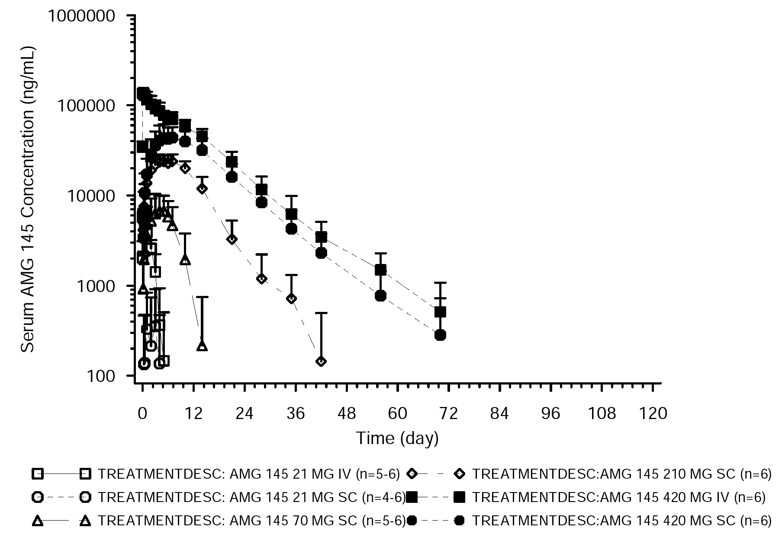
The PK parameters for unbound serum evolocumab in the 7 dose cohorts following SC and IV administration are summarised below in Table 6.

Table 6: 20080397 - PK parameter mean (SD) estimates for unbound serum evolocumab (AMG 145) in the 7 dose cohorts following SC or IV administration.
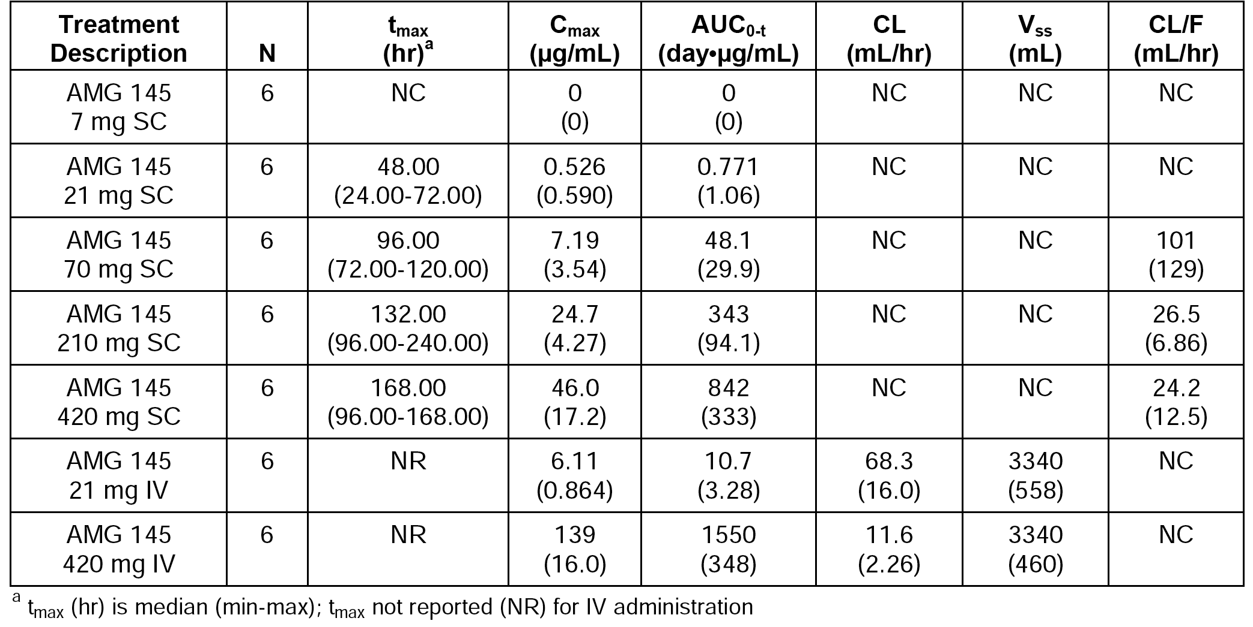
Comment: The systemic clearance (CL) and volume of distribution at steady state (Vss) for evolocumab were estimated from the IV cohorts. The mean CL was notably lower following the 420 mg IV dose than following the 21 mg IV dose, which is indicative of non-linear pharmacokinetics. The mean Vss was identical following the 21 mg IV and the 420 mg IV doses. The estimated Vss of 3340 mL approximates plasma volume, but the sponsor states that this value might be an underestimation of the true value. This matter has been discussed above under Distribution.
As expected, the 420 mg IV group had the highest mean C_{max} (139 μg/mL) and AUC_{(0-t)} values (1550 day x μg/mL). Exposure (AUC_{(0-t)} was 1.8 fold higher following evolocumab 420 mg IV relative to evolocumab 420 mg SC. The apparent clearance (CL/F) decreased with increasing SC dose (101 mL/h at 70 mg SC to 24.2 mL/h at 420 mg SC). However, the CL/F values were similar for the 210 mg SC and the 420 mg SC doses. The CL/F results indicate that the pharmacokinetics of evolocumab are non-linear following SC administration over the dose range 70 mg to 420 mg, but linear over the dose range 210 to 420 mg. Issues related to linearity arising from this study have been discussed above under Proportionality.

Study 20110121 (Phase I) - PK/PD and initial tolerability
This was a Phase I, single centre (USA) randomised, double-blind, placebo-controlled, single-dose study in healthy Japanese and Caucasian subjects. The study period was 14 September 2011 to 2 March 2012. The primary objective was to assess the safety, tolerability, and immunogenicity profile of evolocumab following a single SC dose in healthy Japanese subjects. The secondary objectives were: (a) to characterise the PK profile of evolocumab in healthy Japanese subjects following single-dose SC administration; (b) to characterise the PD profile (LDL-C) of evolocumab in healthy Japanese subjects following single-dose SC administration; and (c) to compare the safety, tolerability, PK, and PD profiles of Japanese and Caucasian subjects at a evolocumab dose of 210 mg SC.
Eligible subjects (n=32) were healthy Japanese (n=24) or Caucasian adults (n=8) between the ages of 18 and 55 years, with LDL-C ≥ 1.8 mmol/L and ≤ 4.9 mmol/L at screening. Healthy Japanese subjects were randomised 6:2 to receive evolocumab or matching placebo SC at 70, 210, or 420 mg, and healthy Caucasian subjects were randomised 6:2 to receive evolocumab or matching placebo SC at 210 mg. Evolocumab was provided in vials with 1 mL deliverable volume (70 mg/mL).
Unbound serum concentrations of evolocumab were measured from blood samples collected pre-dose on day 1 and then post-dose at 4, 24, 48 hours, and then on Days3, 4, 5, 7, 8, 11, 15, 22, 29, 36, 43, 57, 71 and 85 (EOS). Serum concentrations of evolocumab were measured by a validated ELISA, with a LLOQ of 800 ng/mL. The PK parameters for evolocumab (secondary endpoints) were calculated using non-compartmental methods, and were AUC_{(last)}, AUC_{inf}, C_{max} and T_{max}.
The PK parameters in Japanese and Caucasian subjects were summarised. The unbound evolocumab serum concentration time-profiles are provided below in Figure 5. Unbound evolocumab exhibited non-linear pharmacokinetics in Japanese subjects after single-dose SC administrations over the dose range of 70 mg to 420 mg.
Figure 5: 20120121 - Mean (SD) serum concentration-time profile for unbound evolocumab by treatment group in healthy Japanese and Caucasian subjects; semi-log.
The unbound evolocumab serum concentration-time profiles for Japanese and Caucasian subjects following single-dose evolocumab 210 mg SC are summarised below in Figure 6.
Figure 6: 20120121 - Unbound evolocumab mean ± SD serum concentration-time profile for in healthy Japanese and Caucasian subjects following a single SC dose of evolocumab 210 mg.
The C_{max} LS mean values after evolocumab 210 mg SC (single-dose) were 30.0 µg/mL and 31.4 µg/mL in Japanese (n=6) and Caucasian (n=5) subjects, respectively, and the point estimate of the C_{max} ratio comparing Japanese to Caucasian subjects was 0.955 (90% CI: 0.655, 1.391). The AUC_{inf} LS mean values after evolocumab 210 mg SC (single-dose) were 465.3 day x µg/mL and 491.2 day x µg/mL in Japanese (n=6) and Caucasian (n=5) subjects, respectively, and the point estimate of the AUC_{inf} ratio comparing Japanese to Caucasian subjects was 0.947 (90% CI: 0.589, 1.524). The median T_{max} was 6.5 days (range: 4.0, 9.0 days) in Japanese subjects and 6.0 days (range: 3.0, 7.0) in Caucasian subjects.
Comment: Evolocumab showed non-linear pharmacokinetics after over the single-dose dose range 70 mg SC to 420 mg SC in Japanese subjects. The PK profiles of evolocumab were similar in Japanese and Caucasian subjects following single-dose evolocumab 210 mg SC.

Study 20120136 (Phase I) - PK/PD and initial tolerability
This was a Phase I, single-centre (USA), open-label, cross-over study in healthy subjects. The first subject was enrolled on 30 June 2012 and the last subject completed on 16 December 2012. The primary objectives were to determine the intra-subject variability in the pharmacokinetic and pharmacodynamic (LDL-C) profiles of evolocumab following 140 mg SC dose administration. The secondary objectives were to evaluate the safety, tolerability, and immunogenicity profiles of evolocumab following 140 mg SC dose administration.
Eligible subjects were required to meet all of the inclusion criteria and have none of the exclusion criteria. The main inclusion criteria included, but were not limited to, men and women ≥ 18 and ≤ 45 years of age with direct LDL-C level ≥ 1.8 mmol/L and ≤ 4.9 mmol/L at the time of screening and a body mass index (BMI) between 18 and 32 kg/m², inclusive.
Twenty subjects were enrolled and received evolocumab 140 mg administered as a single SC dose in each of the two, 56 day treatment periods (that is, washout period between doses of 56 days). Subjects were followed through study day 112 for safety, tolerability, PK and PD assessments. Evolocumab was provided in single-use vials containing approximately 1 mL of study medication with a concentration of 70 mg/mL.
Unbound serum concentrations of evolocumab were measured from blood collected pre-dose on day 1 and then post-dose at 4, 24, 48 hours, and then on Days3, 4, 5, 6, 8, 11, 15, 22, 29, 43, and 50 (treatment Period 1), and pre-dose on Day 57 and then post-dose at 4, 24, 48 (Day 59) hours, and then on Days 60, 62, 64, 67, 70, 77, 84, 98, 105, and 112 (EOS). Serum concentrations of evolocumab were measured by a validated ELISA, with a LLOQ of 800 ng/mL. The PK parameters for evolocumab (secondary endpoints) were calculated using non-compartmental methods, and were C_{max}, T_{max} and AUC_{(last)}.
The PK parameters were estimated for all 20 subjects in the first treatment period, and 18 subjects in the second treatment period (2 subjects excluded because they did not receive the second dose of the study drug). The mean evolocumab unbound serum concentration-time profiles for the two treatment periods are provided below in Figure 7, and the PK results are summarised below in Table 7.
Figure 7: Study 20120136 - Evolocumab unbound serum concentration-time profiles following evolocumab 140 mg SC (single-dose) in Period 1 (n=20) and Period 2 (n=18).
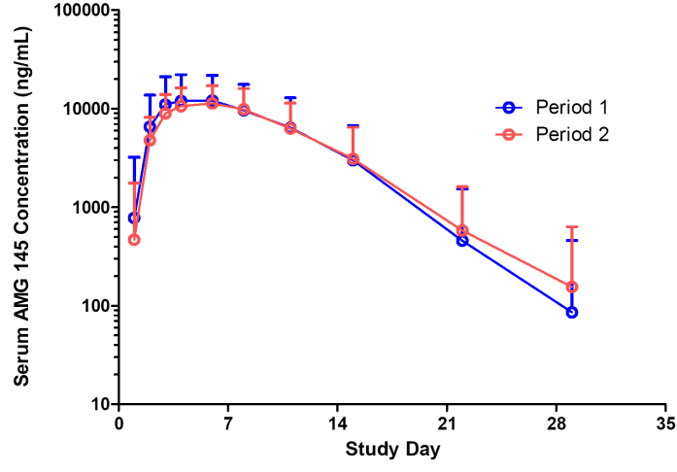
Note: Evolocumab concentrations reported as mean (SD) were determined by setting below the quantitation limit (< 800 ng/mL) to zero.

Table 7: 20120136 - Results for the PK analysis following evolocumab 140 mg SC (single-dose) in treatment Periods 1 and 2.
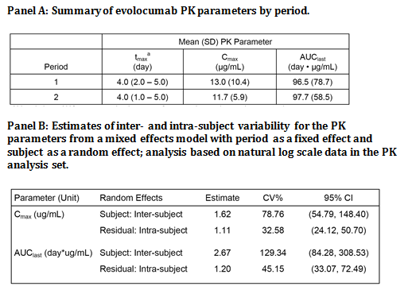
Comment: The PK parameters were similar in the first and second treatment periods, suggesting no period effects. The intersubject variability (CV%) for both C_{max} and AUC_{(last)} was high. Intra-subject variability for both C_{max} and AUC_{(last)} was lower than inter-subject variability, but was still moderately high.

Study 20110234 (Phase 0 - no evolocumab) - tolerability
This was a Phase 0, single-centre (USA), randomised, crossover study in which 48 healthy subjects were randomised (1:1:1:1) to receive a 1.2 mL subcutaneous (SC) injection and a 3.5 mL infusion of placebo buffer at 3 different infusion rates in 4 unique sequences using the Williams' design. The first subject was enrolled on 20 November 2011 and the last subject's final visit was 16 December 20122.
The primary objective was to compare the visual analogue scale (VAS) pain scores associated with various SC infusion rates of a 3.5 mL viscous placebo buffer assessed immediately after administration. The secondary objectives were: (a) to assess adverse events related to SC infusion/injection of the placebo buffer; (b) to compare the VAS scores associated with various 3.5 mL SC infusion rates to the VAS scores associated with the 1.2 mL SC injection assessed immediately after administration; (c) to compare the VAS scores assessed at 1 hour (± 5 minutes) after initiation of administration among the 4 treatments; (d) to compare the VAS scores assessed at 1 hour (± 5 minutes) after initiation of administration to the VAS scores assessed immediately after administration within each treatment; (e) to compare pain perception based on subject’s ranking of pain associated with each treatment; and (f) to evaluate the swelling associated with each treatment if applicable.
The PK and PD profiles of evolocumab were not evaluated, because all subjects received placebo buffer containing sodium carboxymethylcellulose (CMC) to match the viscosity of the final evolocumab formulation. All 48 subjects received each of the 4 SC administrations in the abdomen (each quadrant injected once) from the same staff member, with each administration being separated by approximately 2 hours. The 4 SC administrations were:
- A: 1.2 mL – injection within 5 seconds.
- B: 3.5 mL – infusion over 1 minute, with infusion rate of 3500 μL/min,
- C: 3.5 mL – infusion over 4 minutes, with infusion rate of 875 μL/min.
- D: 3.5 mL – infusion over 10 minutes, with infusion rate of 350 μL/min.
The primary endpoint was the VAS pain score assessed immediately after administration using the 1 to 100 mm scale (100 mm being the most painful). After the fourth administration, subjects ranked the 4 SC administrations in order of least to most painful (1 to 4, respectively). The secondary endpoints were incidence of AEs related to SC infusion or injection, subjective assessment of pain determined by ranking, VAS pain scores assessed at 1 hour after administration, and spread ratio and swelling index. The results for the VAS Pain Scores (primary and secondary endpoints) are summarised below in in Table 8.

Table 8: 20110234 - VAS pain scores immediately post-administration before removal of needle and one hour after initiation of administration.
Results of the statistical analysis of VAS scores assessed immediately after administration showed that Treatments B and D were statistically significantly different relative to Treatment A (p ≤ 0.001 and p = 0.004, respectively). However, the sponsor considered that the small differences in mean VAS scores were not clinically meaningful on a 100 mm scale (that is, treatment B approximately 7 units higher than treatment A and treatment D approximately 6 units lower than treatment A). Similar results were noted for Treatments A and C. For all treatments, VAS scores were significantly lower 1 hour after administration relative to scores assessed immediately after administration.
On a scale ranking each treatment from 1 (least painful) to 4 (most painful), the order (with mean rank) was Treatment D (1.9), Treatment A (2.3), Treatment C (2.6), and Treatment B (3.1). Although subjects rated Treatment B as most painful based on both VAS scores and pain ranking, the mean score for Treatment B on the 100 mm VAS was < 20 mm, which the sponsor considered remained in the acceptable range.
Comment: All 4 treatments had relatively low mean VAS pain scores (< 20 mm on a 100 mm scale) immediately after administration, with the least painful being treatment D (3.5 mL infusion over 10 minutes) and the most painful being treatment B (that is, 3.5 mL infusion over 1 minute). Mean VAS pain scores were lower for all 4 treatments 1 hour after administration (< 3.5 mm on a 100 mm scale) compared to immediately after administration, with no clinically meaningful difference across the 4 treatments.

Study 20120101 (Phase 0 - no evolocumab) - tolerability
This was a Phase 0, single-centre (USA), randomised, crossover study in which 36 healthy subjects were randomised (1:1:1:1:1:1) to 1 of the treatment 6 sequences to receive all 3 placebo sodium CMC formulations. The first subject enrolled on 16 April 2012 and the last subject's final visit was 12 May 2012.
The primary objective was to compare the VAS pain scores after SC bolus injection of 1.1% sodium CMC and 0.7% sodium CMC placebo formulations that were matched to the viscosity of the 140 mg/mL and 120 mg/mL evolocumab formulations, respectively. The secondary objectives were: (a) to assess adverse events related to SC bolus injection of the placebo formulations; (b) to compare pain perception based on subjective ranking of pain associated with each treatment; and (c) to compare VAS pain scores after SC bolus injections of the CMC placebo formulations to the positive control (sodium citrate) formulation.
The PK and PD profiles of evolocumab were not evaluated, because all subjects received placebo buffer containing sodium CMC to match the viscosity of the 140 mg/mL and 120 mg/mL evolocumab formulations. All 36 enrolled subjects completed all three SC administrations (bolus injections within 5 seconds into the abdominal wall, different quadrants for each injection):
- Treatment A = 1.2 mL of placebo buffer containing CMC (0.7%) to match the viscosity of the evolocumab formulation 120 mg/mL.
- Treatment B = 1.0 mL of placebo buffer containing CMC (1.1%) to match the viscosity of the evolocumab formulation 140 mg/mL.
- Treatment C = 1.0 mL of 20 mM sodium citrate, pH 5.0, 5% sorbitol, which is known to cause discomfort in subjects (positive control).
Each administration was separated by approximately 1 hour. Immediately (within 30 seconds) after each injection and before removal of needle, subjective assessment of injection site pain was determined using VAS scores (0-100 mm scale, no pain to most pain). Immediately (within 2 minutes) after the third administration, subjective ranking of pain associated with the injections was undertaken (least to most painful).
The primary endpoint was VAS pain score assessed immediately after administration. The secondary endpoints were the AE incidences related to SC injection and to the subject's perception of pain based on ranking the injections (least to most painful). The primary endpoint VAS results are summarised below in Table 9.

Table 9: 20120101 - VAS pain scores immediately post-administration before removal of needle.
Although Treatment A had a higher VAS LS mean score than Treatment B, the mean difference between treatments was not statistically different (-1.50 mm [95%CI: -8.61, 5.61]). The small mean difference in VAS scores between the two treatments was considered to be not clinically significant. Both Treatments A and B had statistically significant (p < 0.001) lower VAS LS mean scores compared to Treatment C (B minus C = -14.82 [95%CI: -21.93, -7.72]; A minus C = -13.2 [95%CI: -20.46, -6.18]).
The mean ± SD perception of pain scores (a secondary endpoint) were ranked in the following order (most to least painful): Treatment C = 2.6 ± 0.7 > Treatment A = 1.8 ± 0.7 > Treatment B = 1.7 ± 0.8. A greater percentage of subjects (63.9%, 23/36) ranked the positive control (Treatment C) as the most painful treatment compared to Treatment B (19.4%, 7/36) or Treatment A (16.7%, 6/36).
Comments: The pain scores (VAS immediately after injection) and perception of pain rankings for Treatments A and B were similar, with the observed differences being unlikely to be clinically meaningful. Both Treatments A and B were less painful that the Treatment C (the positive control).

Study 20120135 (Phase 0 - no evolocumab) - tolerability
The primary objective of this Phase 0, single-centre (USA), open-label study was to assess the SC delivery performance of the 3.5 mL personal injector device with placebo buffer containing 0.7% of sodium CMC in healthy subjects. The secondary objective was to assess the safety of tolerability of use of the device. Study entry criteria included, but were not limited to, healthy men and women ≥ 18 to ≤ 55 years of age with a BMI between 18.0 and 35.0 kg/m², inclusive. The first subject was enrolled on 12 June 2013 and the last subject completed the study on 10 July 2013.
One hundred subjects were enrolled to receive 3 separate applications of the 3.5 mL personal injector device containing 3.5 mL placebo buffer in a single day, separated by at least 15 minutes between applications, and applied by clinical staff. Subjects received a follow-up phone call the next day to report any adverse events. The primary endpoint was complete delivery of 3.5 mL of placebo buffer as defined by the device light-emitting diode (LED) turning solid green, no observed fluid leakage during delivery, and the window on the device showing complete delivery. The secondary endpoint was treatment emergent adverse events.
All 100 enrolled subjects received 3 applications of the personal injector device containing 3.5 mL buffer and no subjects withdrew from the study. Complete SC delivery of 3.5 mL placebo buffer (primary endpoint) was achieved in 94.7% (95% CI: 91.5%, 96.7%) of device applications (284/300 applications). The percentage of device applications that resulted in complete application of placebo buffer increased from 86.0% (95% CI: 77.9%, 91.5%) in Period 1, when the first of 3 devices was applied to each subject, to 99.0% (95% CI: 94.6%, 99.8%) in periods 2 and 3.
Treatment-emergent adverse events were reported in 72% of subjects (72/100 subjects). No serious adverse events, fatal adverse events, or adverse events leading to discontinuation were reported during the study. The treatment emergent adverse events reported in ≥ 5% of subjects were: erythema (56%); skin induration (43%); induration (23%); pruritus (20%); abdominal distension (17%); abdominal pain upper (16%); abdominal pain lower (7%); and localised oedema (5%).
Comment: The study demonstrated that the 3.5 mL personal injector device had a high rate of successful placebo buffer delivery, with approximately 95% of attempts resulting in complete delivery. Complete delivery was lower (86%) for the first application of the 3.5 mL personal injector device and higher (99%) in the second and third applications.

Individual studies in the target population

Study 20080398 - PK and tolerability data

Design and objectives
This Phase I, multicentre (USA x 10 sites), randomised, placebo-controlled study was designed to investigated the safety, tolerability, immunogenicity, pharmacokinetics and pharmacodynamics of multiple ascending-doses of evolocumab in patients with hyperlipidaemia. The first subject was enrolled on 28 June 2010 and the last subject completed follow-up on 14 September 2011.
The primary objective was to evaluate the safety, tolerability and immunogenicity of evolocumab following multiple SC doses of evolocumab in subjects with hyperlipidaemia on a stable dose of statin. The secondary objectives were (a) to characterise the PK and PD (LDL-C) profiles of evolocumab following multiple SC doses when administered as an add-on to stable statin therapy; (b) to characterise the exposure-response relationship between evolocumab, PCSK9, and LDL-C when administered as an add-on to stable statin therapy; (c) to compare the PK and PD response to evolocumab between subjects using low-dose to moderate-dose statins and subjects using high-dose statins; (d) to compare the PK and PD response to evolocumab between subjects with and without HeFH.

Methods
The study planned to enroll 58 subjects. Seven dose cohorts were planned to receive investigational product doses ranging from 14 mg administered once weekly to 420 mg administered once every 4 weeks for a total of 6 or 8 weeks, respectively (see Table 10, below). In cohorts 1 to 5, subjects were randomly allocated (3:1) to evolocumab or placebo. In cohorts 6 and 7, subjects were randomised based on eligibility criteria to evolocumab or placebo (3:1 [Cohort 6]; 2:1 [Cohort 7]). The study was double-blind.
Ascending doses were chosen for cohorts 1 to 5, with the decision made to proceed to a next-dose level cohort only if safety in the preceding cohort was considered acceptable on the basis of blinded safety review after all subjects had been monitored for at least 21 days after dosing. Cohort 6 consisted of subjects receiving the highest approved doses of either atorvastatin (80 mg/day) or rosuvastatin (40 mg/day). Subjects in Cohort 7 had HeFH and data from this cohort were expected to provide initial experience with evolocumab before planning subsequent Phase II studies in this patient population. Evolocumab was provided in 5 mL vials at a concentration of 70 mg/mL and all doses were administered by SC injection.

Table 10: 20080398 - Cohort assignment and dose regimens.
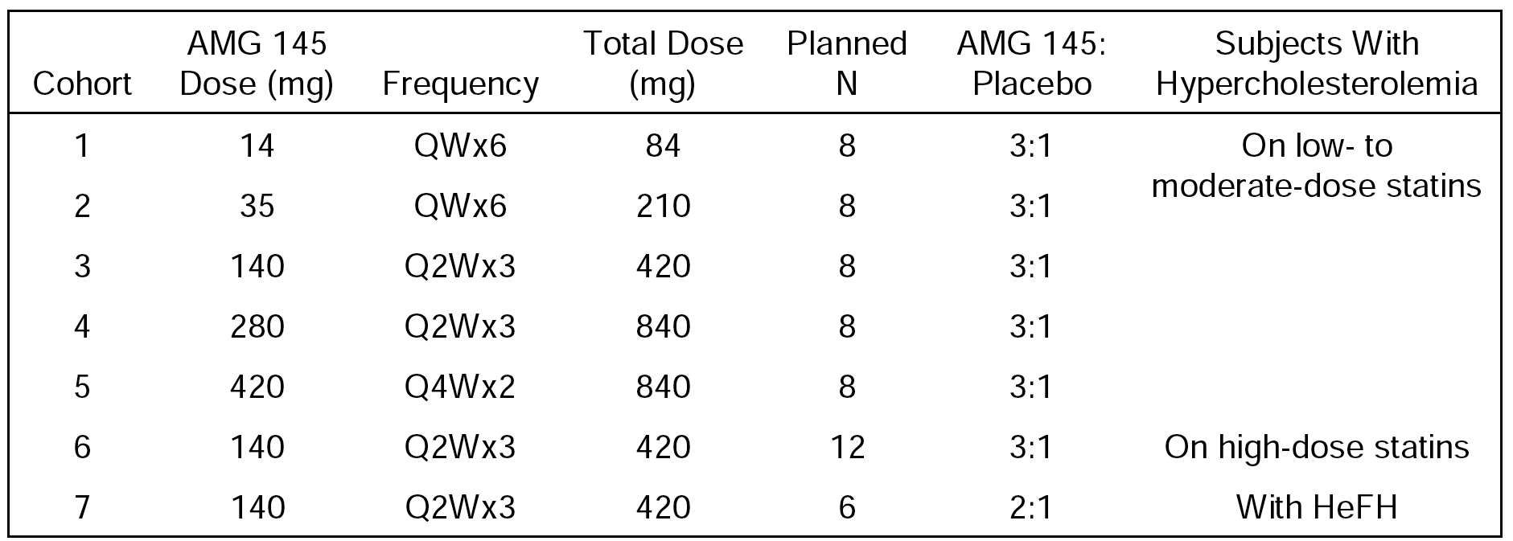
Notes: QW = once weekly; Q2W = once every 2 weeks; Q4W = once every 4 weeks; HeFH = heterozygous familial hypercholesterolaemia.

Study population
In cohorts 1 to 5, eligible subjects comprised men and women, 18 to 70 years of age (inclusive) with a diagnosis of hyperlipidemia, BMI ≥ 18 and ≤ 35 kg/m², LDL-C level of 1.8 to 5.7 mmol/L, and triglyceride level of ≤ 4.5 mmol/L. Subjects were required to be on a stable regimen of a low- to moderate-dose statin for at least 1 month before enrolment and were expected to remain on that dose for the duration of the study (low-dose statin to moderate-dose statin therapy included the following statin type and dose: rosuvastatin < 40 mg/day, atorvastatin < 80 mg/day, and simvastatin 20 to 80 mg/day). Subjects in cohorts 1 to 5 were excluded if they had used any medication (other than statins) known to affect lipid levels within 30 days of screening. Subjects were excluded from cohorts 1 to 5 if they had a diagnosis of autosomal dominant hypercholesterolaemia (including HeFH) or HoFH.
In Cohort 6, the inclusion and exclusion criteria were the same as for cohorts 1 to 5 with the exception that subjects in Cohort 6 were required to be on stable high-dose statin therapy, defined as rosuvastatin 40 mg/day or atorvastatin 80 mg/day, for ≥ 1 month. In Cohort 7, the inclusion and exclusion criteria were similar to those for cohorts 1 to 5 with the exception that this population was restricted to subjects with HeFH. No low or high dose statin requirement was set for the HeFH cohort, but subjects who were on any lipid-modifying medication were required to be on a stable dose for ≥ 3 months before enrolment and were expected to remain on this dose for the remainder of the study.

Pharmacokinetic assessment
Blood samples for determination of serum concentrations of unbound evolocumab were collected pre-dose at screening (days -35 to -5), baseline (day -4), and day 1, and then post-dose at 2 hours, 72 hours (Day 4), 168 hours (Day 8), 336 hours (Day 15), 504 hours (Day 22), and 672 hours (day 29), and then at Days 36, 40, 43, 50, 57, 64, 71, 78, 85, and 113 (EOS). Serum concentrations of unbound evolocumab were measure by a validated ELISA, with LLOQ of 800 ng/mL. The PK parameters (secondary endpoint) for unbound evolocumab were calculated using standard non-compartmental methods (C_{max}, AUC_{(last)}, AUC_{(tau)} and T_{max}).

Pharmacokinetic Results
The key PK parameters for the 7 dose cohorts were summarised. Unbound evolocumab exhibited non-linear pharmacokinetics following multiple doses. Exposures measured by AUC_{(tau)} following the last dose were less than dose-proportional following the 140 mg Q2W regimen compared to both the 280 mg Q2W and 420 mg Q4W regimens. However, comparison between the 140 mg Q2W x 3 dose-escalation cohort (Cohort 3) and the 280 mg Q2W x 3 dose-escalation cohort (Cohort 4) showed a greater than dose proportional increase in the C_{max} and AUC_{(tau)}, consistent with the previously described non-linear pharmacokinetic behaviour of evolocumab in healthy subjects. The AUC_{(tau)} increased from a mean of 168 day x μg/mL to 749 day x μg/mL, representing a 4.5 fold increase for a 2 fold increase in dose. Increases in AUC_{(tau)} were approximately dose proportional in regimens greater than 140 mg Q2W. The sponsor stated that when doses of evolocumab resulted in concentrations associated with near complete suppression of PCSK9 (that is, doses > 140 mg SC), evolocumab exhibited principally linear kinetics and had a half-life consistent with other IgG2 antibodies (approximately 21 days). Maximum serum concentrations of evolocumab occurred approximately 1 week following SC dosing after the first and last doses.
Unbound evolocumab serum concentrations demonstrated accumulation during the 140 mg and 280 mg Q2W x 3 regimens, but less accumulation occurred with the 420 mg Q4W x 2 regimen consistent with a longer dosing interval (see Figure 8, below). A dose of 140 mg administered Q2W x 3 resulted in trough concentrations of 3480 ng/mL, 5130 ng/mL, and 6110 ng/mL following the first, second, and third doses, respectively. Similarly, a dose of 280 mg Q2W x 3 resulted in trough concentrations of 21900 ng/mL, 34500 ng/mL, and 43600 ng/mL. Following 420 mg Q4W x 2 doses, trough concentrations following the first and second doses were 4180 ng/mL and 6920 ng/mL, respectively.
Figure 8: 20080398 - Mean (SD) unbound evolocumab serum concentrations-time profiles by treatment.
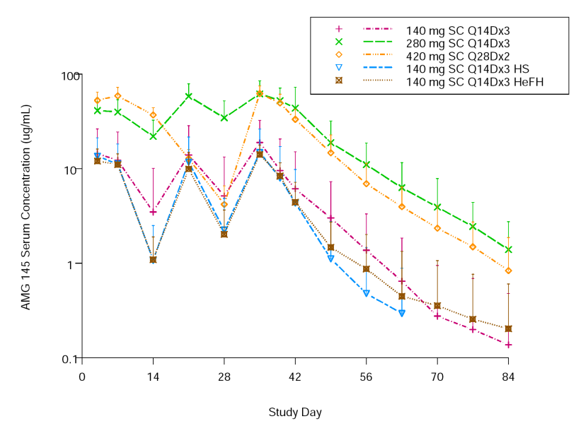
Notes: HeFH = heterozygous familial hypercholesterolaemia; HS = healthy subject; Q14D = once every 14 days (every 2 weeks); Q28D = once every 28 days (once every 4 weeks); SC = subcutaneous. Cohort 3: 140 mg SC Q2Wx3 (n=6); Cohort 4: 280 mg SC Q2Wx3 (n=6); Cohort 5: 420 mg SC Q4Wx2 (n=6); Cohort 6: 140 mg SC Q2Wx3 High Statin (n=9); Cohort 7: 140 mg SC Q2Wx3 HeFH (n=4).
The highest mean C_{max} (approximately 60 µg/mL) occurred in Cohort 4 (280 mg Q2Wx3) and Cohort 5 (420 mg Q4Wx2) (that is, 62.8 and 63.6 µg/mL, respectively). The mean AUC_{(last)} was higher in Cohort 4 (280 mg Q2Wx3) than in Cohort 5 (420 mg Q4Wx2) (that is, 1200 and 903 day x µg/mL, respectively), while the AUC_{(tau)} was higher in Cohort 5 compared to Cohort 4 (823 and 749 day x µg/mL, respectively).
The C_{max} LS geometric mean in subjects in Cohort 6 (n=9) receiving high dose-statin combined with evolocumab 140 mg Q2Wx3 (12.8 µg/mL) was lower than in subjects in Cohort 3 (n=6) receiving low-moderate dose statin combined with evolocumab 140 mg Q2Wx3 (17.5 µg/mL). Similarly, the AUC_{(last)} LS geometric mean was also lower in subjects receiving high-dose statin (119.3 day x µg/mL) compared to subjects receiving low-dose to moderate-dose statin (160.8 day x μg/mL). The point estimates for the ratios of C_{max} and AUC_{(last)} between the high-dose statin cohort (test) and the low-dose to moderate-dose statin cohort (reference) were 0.728 (90%CI: 0.369, 1.438) and 0.741 (90%CI: 0.289, 1.900), respectively. Due to the relatively large variability in pharmacokinetics and the small number of subjects, the precision of the estimate was poor as can be seen from the wide 90% CIs for both ratios. Pharmacokinetic differences between the two cohorts did not result in differences in the PCSK9 and LDL-C responses.
The C_{max} in subjects in Cohort 7 with HeFH (n=4) was lower than in subjects in Cohort 3 without HeFH on low-moderate dose statin (n=4) receiving the same evolocumab dose regimen (140 mg Q2Wx3) (that is, 14.5 and 17.5 μg/mL, respectively). The AUC_{last} values were comparable in subjects with HeFH compared to subjects without HeFH on low-dose to moderate-dose statin receiving the same evolocumab dose regimen (140 mg Q2Wx3) (that is, 151.7 and 160.8 day x μg/mL, respectively). The point estimates for the ratios of C_{max} and AUC_{(last)} between the subjects with HeFH (test) and the subjects without HeFH on low-dose or moderate-dose statin receiving the same evolocumab dose regimen (reference) were 0.829 (90%CI: 0.475, 1.446) and 0.943 (90%CI: 0.403, 2.207), respectively. Again, due to the small number of subjects and relatively large variability in pharmacokinetics, the precision of the estimates was poor. Pharmacokinetic differences between the two cohorts did not result in differences in the PCSK9 and LDL-C responses.

Individual studies in special populations

Study 20120341 - hepatic impairment
The primary objective of this Phase I, multicentre (USA x 3 centres), open-label, parallel-group study was to compare the pharmacokinetics of evolocumab in subjects with mild and moderate hepatic impairment to the pharmacokinetics of evolocumab in healthy subjects. The secondary objectives included evaluation of safety and tolerability, and evaluation of LDL-C and PSCK9 responses. The first subject was enrolled on 22 March 2013 and the last subject completed the study on 6 August 2013.
The study included men and women, ≥ 18 to ≤ 55 years of age, who were healthy or had Child-Pugh Class A or B hepatic impairment and who had a calculated LDL-C value ≥ 1.8 mmol/L and ≤ 4.9 mmol/L and a BMI of 18 to 35 kg/m². Subjects were assigned to 1 of 3 groups (n=8 per group) based on the degree of hepatic impairment. The 3 groups were:
- Group 1: Child-Pugh Class A (mild hepatic impairment);
- Group 2: Child-Pugh Class B (moderate hepatic impairment); and
- Group 3: Healthy (no hepatic impairment).
Each subject received a single 140 mg SC dose (1 mL) of evolocumab administered via an AI/pen. The estimated length of the study for each subject was 85 days, including a 27 day screening period and a 57-day follow-up period. Blood samples for determination of serum concentrations of unbound evolocumab were collected pre-dose on day 1, and then post-dose at 2, 4, 24, and 48 hours, and then on Days 4, 6, 8, 11, 15, 22, 29, 43, 50, and 57 (EOS). Serum concentrations of unbound evolocumab were measure by a validated ELISA, with LLOQ of 800 ng/mL. The concentration-time profiles for evolocumab for the three groups are provided below in Figure 9.
Figure 9: 20120341 - Concentration - time profiles for evolocumab unbound mean ± SD serum concentrations after single SC doses of evolocumab 140 mg to subjects with hepatic impairment and healthy subjects. 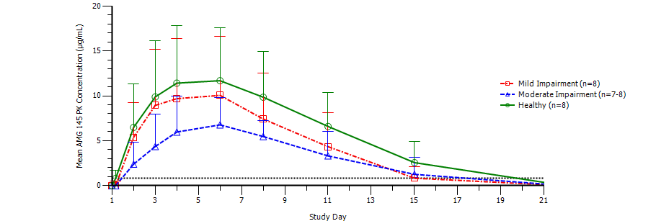
After a single 140 mg SC dose of evolocumab, exposure, as assessed by AUC_{last} and C_{max} decreased with increasing hepatic impairment. The median T_{max} was 4.5 to 5.0 days in both subjects with hepatic impairment (mild or moderate) and healthy subjects. The C_{max} LS geometric means were 8.6, 7.3, and 11.0 µg/mL for subjects with mild hepatic impairment, moderate hepatic, and normal hepatic function, respectively. The C_{max} LS geometric means were 21.5% and 34% lower in subjects with mild and moderate hepatic impairment, respectively, compared to healthy subjects. The AUC_{(last)} LS geometric means were 58.1, 51.5 and 96.8 day x µg/mL for subjects with mild hepatic impairment, moderate hepatic, and normal hepatic function, respectively. The AUC_{(last)} LS geometric means were 39.2% and 46.8% lower in subjects with mild and moderate hepatic impairment, respectively, compared to healthy subjects.
Comment: Systemic exposure to evolocumab was notably lower in subjects with mild and moderate hepatic impairment compared to healthy subjects, based on the AUC_{(last)} and C_{max}. However, the PK changes observed in subjects with hepatic impairment did not appear to affect the extent and time course of PCSK9 and LDL-C lowering. Treatment emergent adverse events were reported in 1 (13%) subject in the healthy group, 4 (50%) subjects in the mild hepatic impairment group and 2 (25%) subjects in the moderate hepatic impairment group. All treatment emergent adverse events were mild (Grade 1) or moderate (Grade 2) in severity. A serious treatment emergent adverse event of depression was reported in 1 (4%) subject with mild hepatic impairment. The investigator determined that the adverse event was not related to study treatment and the subject continued study participation. No treatment emergent adverse event was determined by the investigator to be related to evolocumab treatment. There were no fatal treatment emergent adverse events. None of the treatment emergent adverse events led to discontinuation of evolocumab or discontinuation from the study. There were no clinically important abnormalities in vital signs, ECG, or clinical laboratory test in subjects treated with evolocumab. Overall, the data indicate that no dose adjustments are required for patients with mild of moderate hepatic impairment. There were no data in subjects with severe hepatic impairment.

Population PK studies

Studies 116744 and 119663

Overview
Study 119633 reported the results of a Population Pharmacokinetic Modelling and Simulation (M&S) Update for Evolocumab from Phase I, II and III Studies updating the population pharmacokinetic (PopPK) model reported in a previous study (Study 11674). Study 119633 added data from five additional Phase III studies to the data from the six Phase I and II studies included in the initial PopPK model reported in Study 116744.
In the popPK models, the AUC_{(Weeks 8-12)} and the Week 12 trough serum concentrations of unbound evolocumab were considered to be the outcomes of interest for the PK predictions. Simulation techniques were employed to further assess the effect of significant covariates on the pharmacokinetics of unbound evolocumab.

Objectives
Study 116744: The primary objectives of the analyses reported in Study 116744 were: (a) to investigate the pharmacokinetic time course of evolocumab; (b) to facilitate the prediction of the week 10 and 12 average LDL-C level; (3) to quantify the degree of between-subject variability of key evolocumab pharmacokinetic and exposure-response parameters; and (4) to understand the effect of intrinsic and extrinsic covariates on the response to evolocumab.
Study 119633: The primary objectives of the analyses reported in Study 119633 were: (a) to update the model of the PK time course of unbound evolocumab using Phase III data; (b) to quantify the degree of between-subject variability of key evolocumab PK parameters; and (c) confirm the effects of intrinsic and extrinsic covariates defined in the Phase I+2 PK covariate model (Study 116744) on evolocumab exposure.

Methods
The PopPK data were analysed using the nonlinear-mixed effects modelling software program NONMEM (version 7.2), on the NONMEM High Performance Cluster (NONMEM HPC). The methodology of the analysis was extensively described and is considered to be consistent with the relevant TGA adopted guideline relating to the reporting of popPK analyses (CHMP/EWP/185990/06)

Studies included in the updated popPK model
The updated analyses reported in Study 119663 were based on pooled data from 5474 subjects from eleven Phase I, II, and III studies, including 3414 subjects who received evolocumab and were included in the popPK analysis. The 10 studies contributing data to the final popPK analysis are summarised below in Table 11. The median age and body weight across the studies were 58 years (range: 18, 80 years) and 83 kg (41.0, 175 kg), respectively. The median PCSK9 was 375 ng/mL (range: 15.5, 1233 ng/mL). A total of 1708 (50%) subjects were men. The proportion of subjects who were White, Black, Asian, or other races was 87%, 7%, 4% and 2%, respectively.

Table 11: Studies included in the final population PK analysis.
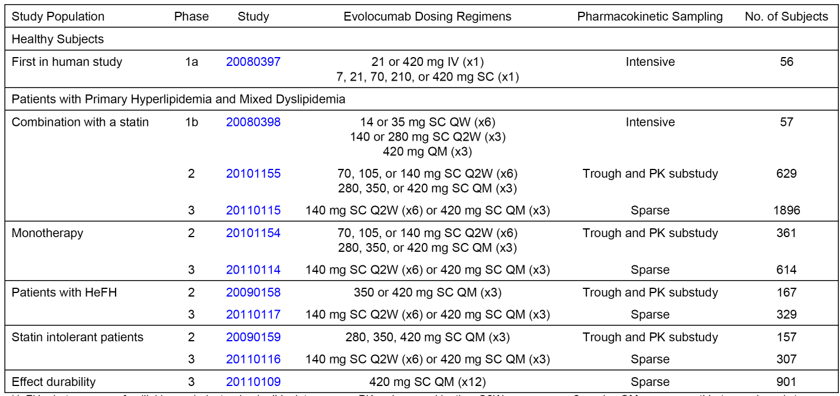

Population PK model development
Evolocumab exhibited nonlinear pharmacokinetics after single-dose SC and IV administration in healthy subjects over the dose range of 7 mg to 420 mg (Study 20080397). A parallel linear and nonlinear elimination model was selected to describe serum evolocumab concentration-time profiles. In the initial popPK modelling steps (Study 116744), Phase I and II PK data were used to develop the model. A one-compartment open model with linear and nonlinear elimination pathways from the central compartment was parameterized by volume of distribution in the central compartment (V), linear drug clearance (CL), and nonlinear clearance (Vmax, km).³ Absorption after SC administration was described by a first order process (ka) from the depot compartment to the central compartment, and bioavailability (F) was used to scale IV to SC dosing. Estimates of ka and F were fixed from the Phase Ia data for subsequent modelling activities. The differential equations describing the pharmacokinetics of evolocumab in amounts and a schematic representation of the popPK model are provided below in Table 12.

Table 12: 116744 - Differential equation describing the pharmacokinetics of evolocumab in amounts (Panel A) and pharmacokinetic model (Panel B). 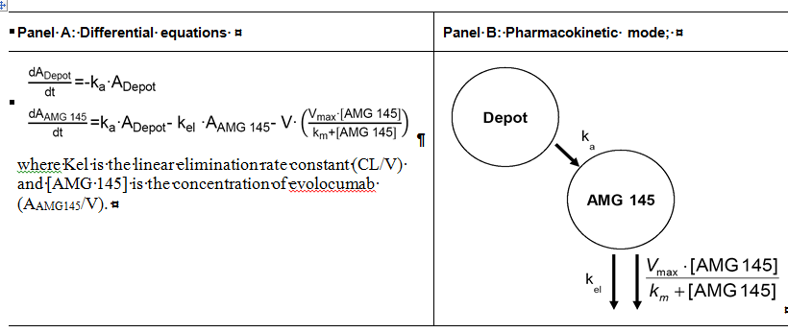
In Study 119663, data from 5 Phase III studies were used to update the model developed in Study 11674 from the Phase I and II studies. The Phase III pooled data for the observed evolocumab unbound serum concentration-time profiles for the 140 mg Q2W and 420 mg QM regimens were overlaid on the predictions for these profiles estimated from the Phase I + II model to ensure that no major differences were evident between the Phase III PK data and the Phase I and II PK data. The observed PK profiles from the Phase III studies were in line with the Phase I+II model prediction profiles, indicating that the structural model based on the Phase I and II data from Study 11674 was appropriate to describe the pooled evolocumab concentration-time profiles observed in the Phase III studies.

Key results from the PK population analysis
A 1-compartment model with linear and nonlinear elimination pathways characterised the pharmacokinetics of unbound evolocumab after IV and SC dosing. Evolocumab is likely eliminated through a nonspecific (linear) pathway via the reticuloendothelial system and a target-mediated (nonlinear) pathway, which is implemented in the model as a capacity-limited (that is, saturable) elimination process. Model predictions suggest that approximately 77% of a single-dose is eliminated through this nonlinear pathway for the 140 mg SC Q2W dose, and 51% of a single-dose is eliminated through this nonlinear pathway for the 420 mg SC QM dose. The volume of distribution is similar to plasma volume, which is consistent with a lack of extensive extravascular distribution. The model predicted effective half-lives for the 140 mg SC Q2W and 420 mg QM doses are 11.4 days and 16.8 days, respectively.
The population typical values for the structural model parameters and residual variability estimates are shown below in Table 13. The structural model parameters (F, ka,) and residual variability (error) estimates were precisely estimated (RSE < 5%). Covariate effects (CL, V, Vmax, and non-linear clearance [Vmax, km]) were also precisely estimated (RSE % < 8%), with the exception of body weight covariate effects on CL (RSE = 30.4%) and Vmax (RSE = 33.0%).

Table 13: 119663 - Parameter estimates for the final PopPK model.
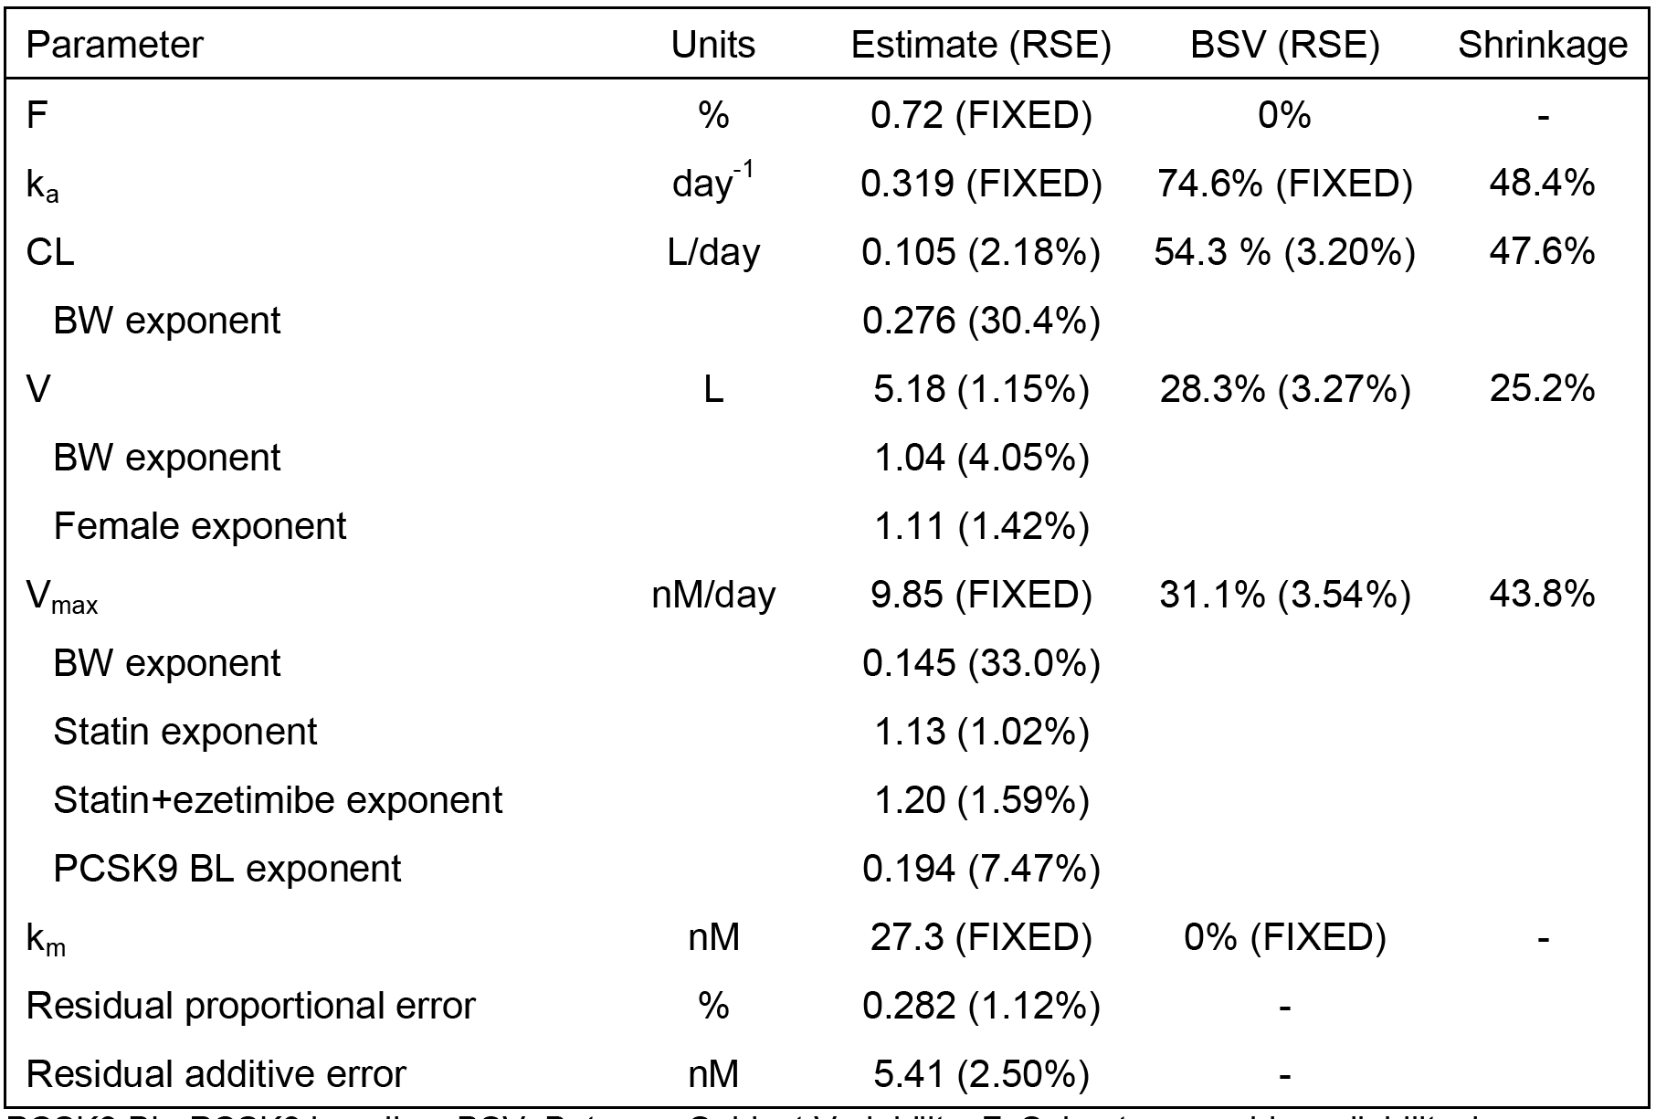
PCSK9 BL: PCSK9 baseline; BSV: Between-Subject Variability; F: Subcutaneous bioavailability; ka: absorption rate constant; CL: linear clearance; V: volume of distribution; Vmax: nonlinear clearance capacity; km: concentration of half maximal nonlinear clearance; %RSE: Relative Standard Error, determined by NONMEM standard error after Importance Sampling.
In the final PK covariate model, body weight, female sex, statin coadministration, statin plus ezetimibe coadministration, and PCSK9 baseline concentration remained statistically significant covariates on evolocumab pharmacokinetics. The statin covariate represents patients only on a statin without co-medication. The statin plus ezetimibe covariate includes all patients on ezetimibe, regardless of co-medication, but most generally represents a statin plus ezetimibe combination as 93% (377/404) patients on ezetimibe in the model were also on statin.
Exposure-response modelling (Study 116744) suggests the 140 mg SC Q2W and 420 mg SC QM doses achieve exposures that are within the plateau of the E_{max} relationship, so differences in PK due to covariates are unlikely to modify response. In line with this observation, simulations suggest that the response to evolocumab is predicted to be within 74% to 126% of the reference patient at the extremes of these covariate conditions, and intrinsic and extrinsic covariates are therefore not predicted to be clinically significant.

Evaluator’s overall conclusions on pharmacokinetics
- The pharmacokinetics of evolocumab following SC administration have been adequately characterised in 8 Phase I clinical pharmacology studies, 2 PK equivalence studies, 2 population PK modelling and simulation studies, and 15 Phase II and III clinical efficacy and safety studies including limited or sparse PK data in subjects with hyperlipidaemia.
- The available data from cross-study comparisons indicates that the pharmacokinetics of evolocumab are similar in healthy subjects and subjects with primary hyperlipidaemia (HeFH and non-familial) and mixed dyslipidaemia (Studies 2000397 [healthy subjects], 20110168 [healthy subjects], 20120133 [healthy subjects], 20101154, 20101155, 20090158, 20090159, and 20110231 [patients]). The data also show that the pharmacokinetics of evolocumab are similar in subjects with and without HeFH (Study 20080398).
- Cross-study comparisons also show that unbound evolocumab trough serum concentrations following evolocumab 420 mg SC QM for 12 weeks in subjects with HoFH not on apheresis are similar to those in subjects with primary hyperlipidaemia (Studies 20110115, 20110271, and 20110115). In subjects with HoFH on apheresis, unbound evolocumab trough serum concentrations were approximately 20% to 30% lower than before apheresis (Study 20110271). In adolescents with HoFH not on apheresis (n=9), unbound evolocumab trough serum concentrations were highly variable, but fell within the range of adult subjects with primary hyperlipidaemia and mixed dyslipidaemia.
- In the Phase II clinical efficacy and safety Studies 20101154 (evolocumab monotherapy) and 20101155 (evolocumab combined with statin) in subjects with primary hyperlipidaemia and mixed dyslipidaemia, comparison of Week 12 to week 2 unbound evolocumab trough serum concentrations demonstrated an approximately 3 fold accumulation for the 140 mg SC Q2W dose, and comparison of Week 10 to Week 2 unbound evolocumab trough serum concentrations demonstrated a less than 2 fold accumulation for the 420 mg QM dose. Similar accumulation was observed in the Phase III Studies 20110114 (evolocumab monotherapy) and 20110115 (evolocumab combined with statin) in patients with primary hyperlipidaemia and mixed dyslipidaemia for the 140 mg SC Q2W dose based on unbound evolocumab trough serum concentrations at Weeks 2, 10, and 12, and for the 420 mg SC QM dose based on unbound evolocumab trough serum concentrations at Weeks 2 and 10.
- In the long-term Phase III study in subjects with primary hyperlipidaemia and mixed dyslipidaemia (Study 20110109), unbound evolocumab trough serum concentrations remained relatively stable over 52 weeks dosing with evolocumab 420 mg SC QM, with steady state being achieved at Week 12. In the Phase II and III clinical efficacy and safety studies of 12 weeks duration in subjects with primary hyperlipidaemia and mixed dyslipidaemia, steady state unbound evolocumab trough serum concentrations approached steady state by Week 12 in subjects being treated with evolocumab alone (Studies 20110114 and 20101154) or evolocumab in combination with a statin (Studies 20101155 and 20110115).
- The pharmacokinetics of unbound evolocumab demonstrated moderate intersubject variability in both healthy subjects and subjects with mixed hyperlipidaemia and dyslipidaemia (for example, CVs for AUC of 51% and 70%, respectively, and CVs for C_{max} 39.7% and 61.7%, respectively, following 140 mg SC in Studies 20120133 and 20101154). Moderate intra-subject variability was also demonstrated in healthy subjects following a single SC evolocumab dose of 140 mg (that is, CV approximately 33% for C_{max} and 45% for AUC_{(last)}) (Study 20120136).
- There were no absolute bioavailability studies following SC dosing. The absolute bioavailability of evolocumab after SC administration was estimated to be 72% in the population PK analysis (Study 119633), and the mean absorption time was estimated to be approximately 3 days. In the Nonclinical Overview (Module 2.4), the absolute bioavailability of evolocumab following SC administration was stated to be approximately 82% in monkeys.
- A single dose of evolocumab 420 mg SC administered with the AMD presentation at 120 mg/mL with a 3.5 mL fill was pharmacokinetically equivalent to the reference presentation of 3 x AI/pens (3 x 140 mg/mL) in healthy subjects (Study 20110168). A single dose of evolocumab 140 mg SC administered with the PFS presentation at 140 mg/mL with a 1 mL fill was pharmacokinetically equivalent to the reference presentation of 1 x AI/Pen (1 x 140 mg/mL) in healthy subjects (Study 20120133). Following single SC evolocumab doses of 140 mg or 420 mg, median peak serum concentrations (T_{max}) were attained in 3 to 4 days. Although not directly compared, the PK equivalence of a single SC dose of evolocumab 420 mg administered using 3 x PFS injections or 1 x AMD injection can be reasonably inferred from the results of Studies 20110168 and 20120133. SC administration of evolocumab was into the abdominal wall (three quadrants when a total dose of 420 mg SC was administered). There was no bioavailability data comparing SC administered into different anatomical sites.
- The PK data consistently showed that unbound evolocumab displays non-linear pharmacokinetics across a wide dose range (7 to 420 mg SC). In Study 20080397, neither the SC doses (7, 21, 70, 210, and 420 mg) nor the IV doses (21 or 410 mg) were dose proportional over the dose ranges tested in healthy subjects. The slopes of the power model used to assess dose proportionality in Study 20080397 exceeded unity for C_{max}, AUC_{inf}, and AUC_{(last)} following SC administration and for AUC_{inf} and AUC_{(last)} following IV administration. Non-linearity was more pronounced at low than at high evolocumab doses, with the mean dose-normalised AUC_{(0-t)} being approximately 22 fold higher for single-dose 210 mg SC compared to single-dose 21 mg SC and approximately 1.2 fold higher for single-dose 420 mg SC compared to single-dose 210 mg SC. The dose-normalised data from Study 20080397 showed that single-doses of 210 mg SC and 420 mg SC were approximately dose proportional, based on AUC_{(0-t)} and C_{max}.
- The exposure data are consistent with 2 mechanisms of elimination for unbound evolocumab: (1) PCSK9 target-mediated non-linear (saturable) elimination predominating at low evolocumab serum concentrations and saturating when PCSK9 is fully suppressed; and (2) linear (non-saturable) elimination by endogenous IgG clearance mechanisms involving nonspecific catabolism in cells of the reticuloendothelial system at higher evolocumab serum concentrations. PopPK modelling predicts that approximately 77% and 51% of a single-dose of 140 mg SC Q2W and 420 mg SC QM, respectively, is eliminated through the target-mediated (that is, PCSK9) non-linear pathway. The model predicted effective half-lives for the 140 mg SC Q2W and the 420 mg QM doses are 11.4 and 16.8 days, respectively.
- The Vss (mean ± SD) following evolocumab 420 mg IV in healthy subjects (n=6) was 3.340 ± 0.460 L (Study 20080397). The Vss is similar to plasma volume suggesting that evolocumab is not extensively distributed to the tissues and remains predominantly in the intravascular space. However, estimated Vss might be an underestimation of the true Vss.
- In Study 20080397, the systemic clearance (mean ± SD) of evolocumab was 68.3 ± 16.0 mL/hr following a single IV dose of 21 mg and 11.6 ± 2.26 mL/hr following a single IV dose of 420 mg. The results show that the systemic clearance of evolocumab is dose dependent, indicating that systemic clearance is nonlinear. However, the results for the apparent clearance (mean ± SD) of evolocumab following single SC evolocumab doses of 210 mg and 420 mg were similar (25.6 ± 6.86 and 24.2 ± 12.5 mL/hr, respectively), and lower than for evolocumab 70 mg SC (101 ± 120 mL/hr). Overall, the results suggest that apparent clearance is linear over the SC dose range 210 mg to 420 mg, but non-linear over the SC dose range 70 mg to 420 mg.
- There were no clinical studies investigating the metabolism of evolocumab. However, it can be predicted that evolocumab will be metabolised to peptides and amino acids via catabolic pathways in various body tissues. Mass balance studies are considered to be not useful for determining the excretion pattern of therapeutic proteins (CHMP/EWP/89249/2004). There were no data on renal clearance. However, given the large molecular weight of evolocumab (144 kDa) it can be predicted that renal elimination of the intact molecule will be negligible.
- There were no data on subjects with renal impairment. However, as mentioned above, renal elimination of evolocumab is not anticipated and, consequently, increased systemic exposure to evolocumab is not expected in subjects with renal impairment. PopPK modelling showed mild to moderate renal impairment had no significant effects on unbound evolocumab trough serum concentrations at Week 12 following evolocumab 140 mg SC Q2W and evolocumab 420 mg SC QM. There were no data on subjects with severe hepatic impairment, but PK data in subjects with mild and moderate hepatic impairment demonstrated decreased systemic exposure to unbound serum evolocumab as assessed by both AUC_{(last)} and C_{max}. However, no significant difference in pharmacodynamics or safety were observed in subjects with mild or moderate hepatic impairment compared to healthy subjects, which suggests that no dose adjustment in these subjects is required.
- No formal PK drug-drug interaction clinical studies were undertaken. No in vitro permeability, in vitro metabolism, or in vitro metabolic drug-drug interaction studies that used human biomaterials were undertaken. Data in subjects with hyperlipidaemia showed that exposure to unbound evolocumab was lower when evolocumab was administered with a statin compared to evolocumab administration without a statin, and that the effect was more pronounced with co-administration of high-dose statin compared to low-dose statin (Study 20080398). However, as discussed later, the pivotal clinical efficacy and safety data show that evolocumab administered as monotherapy and in combination with statins has similar effects on lowering LDL-C concentrations, with comparable safety profiles. Therefore, the dose of evolocumab does not need to be adjusted when the drug is administered with statins.
- Based on population pharmacokinetic and pharmacodynamic analyses, unbound evolocumab pharmacokinetics did not appear to be significantly affected by sex, age (but limited HoFH data in subjects aged ≥ 12 to < 18 years, no data in subjects with HoFH aged < 12 years, and no data in subjects with primary hyperlipidaemia mixed dyslipidaemia aged < 18 years), or race (but limited data on all subjects apart from Whites). Exposure to unbound evolocumab decreased with increasing body weight, but this did not affect the pharmacodynamic endpoint of LDL-C reduction.
- The incidence of anti-evolocumab binding antibodies was low in the integrated analysis from 14 Phase II and III studies (0.1% of subjects [7/4846]) (Integrated Immunogenicity Report). None of the 7 anti-evolocumab antibody positive subjects tested positive for neutralising antibodies.

Pharmacodynamics

Studies providing pharmacodynamic data
Pharmacodynamic data were provided in 3 Phase I studies in healthy subjects, 1 Phase I study in patients with hyperlipidaemia, 1 Phase I study in patients with hepatic impairment, 11 Phase I and II efficacy and safety studies in primary hyperlipidaemia and mixed dyslipidaemia, 2 Phase III efficacy and safety studies patients with HoFH and 2 Phase III efficacy and safety studies assess home use of the device. In addition to the individual studies containing PD data, the submission also included pooled data from subjects from 4 Phase II studies, and a population PK/PD analysis based on pooled Phase II data (Study 116744).
The two key PD parameters were LDL-C serum concentrations and unbound PCKS9 serum concentrations. In each study, a central laboratory (Amgen or a designated contract research organisation) conducted pharmacodynamic assessments. Serum LDL-C concentrations and other lipid parameters were quantified using standard laboratory procedures. A direct measure of LDL-C by ultracentrifugation (UC) was also used in each study. A validated ELISA was used to quantify unbound PCSK9 serum concentrations. The review of pharmacodynamics in this report focuses on the data from the dedicated clinical pharmacology studies and the PK/PD analysis. Reductions in LDL-C concentrations from baseline were the primary efficacy endpoint for the Phase II and III studies and have been examined in full in the evaluation of efficacy provided in this CER.

LDL-C

Healthy subjects with normal baseline LDL-C concentrations
In Study 20080397, evolocumab reduced LDL-C concentration from baseline in a dose-dependent manner following single-doses of evolocumab over the dose range 7 mg to 420 mg (SC and/or IV) (see Figure 10, below). Baseline mean LDL-C concentrations were in the range of 2.9 to 3.7 mmol/L. The maximum dose reductions were observed with the 420 mg dose administered IV and SC, with LDL-C nadirs of 1.0 to 1.1 mmol/L that were reached approximately 22 days after dosing and concentrations returning to near baseline levels by approximately 71 days. Mean reductions in LDL-C concentration in the intermediate dose groups (70 mg SC and 210 mg SC) reached nadirs of approximately 1.4 mmol/L at between Day 11 and Day 15 after dosing, respectively, with subsequent returns to baseline by approximately Day 29 and Day 43 to Day 57, respectively. Decreases in mean LDL-C concentrations were dose-related with respect to magnitude of decrease, time to nadir, and overall duration of decrease, and were independent of route of administration (SC or IV). Qualitatively, results for mean total cholesterol and mean apolipoprotein B (ApoB) were similar to those for LDL-C.
Figure 10: 20080397 - Geometric means (± SE) of ultracentrifugation LDL-C over time.
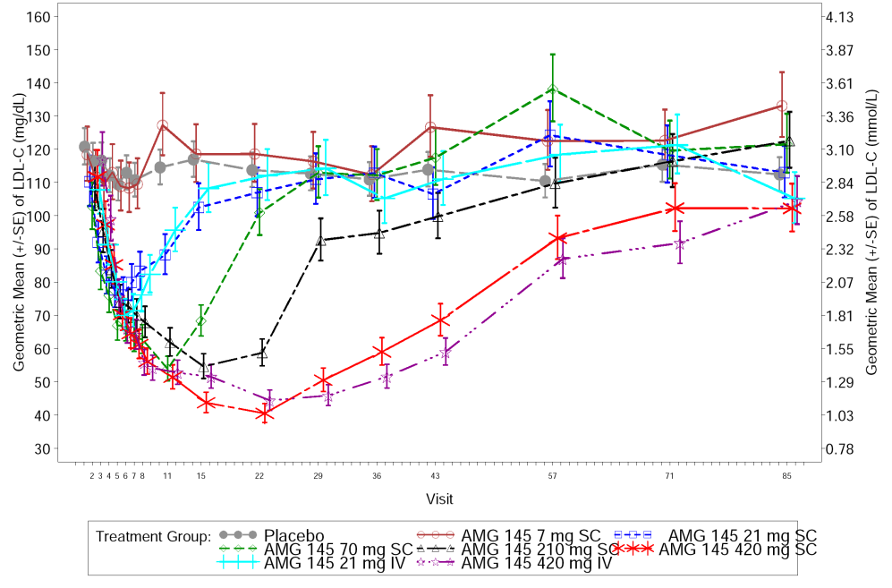
In Study 20110121, in Japanese subjects LDL-C concentrations were reduced from baseline in the evolocumab 70, 210, and 420 mg SC dose groups. The maximum mean percent reduction from baseline in the 70, 210, and 420 mg SC dose groups relative to placebo were 40.7%, 60.3% and 57.6%, respectively. The effect of evolocumab 210 mg SC on LDL-C concentrations over time was similar for Japanese and Caucasian subjects. The maximum percent reduction from baseline LDL-C, relative to placebo, after the single dose of 210 mg SC was 60.3% for Japanese subjects, compared to 66.3% for Caucasian subjects. Each group achieved an LDL-C nadir at Day 15, following which concentrations gradually returning to near baseline levels by the end of study (Day 85). LDL-C nadir at Day 15 in Caucasian subjects in the evolocumab 210 mg SC treatment group was 1.3 mmol/L.
In Study 20120136, inter-subject variability and intra-subject variability of LDL-C were estimated for all 20 subjects following evolocumab 140 mg SC by comparing Period 1 to Period 2. The variability in LDL-C was greater between subjects than within subjects. The LDL-C inter-subject variability (CV%) in the point estimate of the LDL-C AUC(day 1-56) ratio of 1.04 was 18.7% (95% CI: 12.3%, 28.9%), and the LDL-C intra-subject variability (CV%) in the point estimate of the LDL-C AUC(day 1-56) ratio of 1.01 was 7.5% (95% CI: 5.1%, 14.0%)

Subjects with hepatic impairment
In Study 21020341, LDL-C LS geometric mean concentrations at baseline were similar in healthy subjects, subjects with mild hepatic impairment, and subjects with moderate hepatic impairment. No significant difference in the AUEC(Day1-57) for the LDL-C was observed in the three subject groups. In each group, nadir LDL-C concentrations were observed at study Day 11 and the maximum mean percent change from baseline was greater than 50% (see Figure 11, below).
Figure 11: 20120341 - Geometric mean percentage change from baseline (± SE) of ultracentrifugation LDL-C (mg/dL) over time in subjects with hepatic impairment.

Patients with hyperlipidaemia

Study 20080398
In Study 20080398, the effect of multiple-dose evolocumab on lowering LDL-C concentration was tested in subjects with mixed hyperlipidaemia and dyslipidaemia taking a stable dose of statin. The results showed that evolocumab in combination with a statin resulted in dose-dependent decreases in LDL-C concentration. The study included 7 cohorts, including 5 dose-escalation cohorts on low- to moderate-dose statins and 1 cohort on high-dose statins in subjects without HeFH, and 1 cohort in subjects with HeFH. At the end-of-treatment time point (Day 43 for QW or Q2W; Day 57 for QM), mean LDL-C decreases from baseline in the 3 highest dose-escalation cohorts in subjects without HeFH (140 mg SC Q2W, 280 mg SC Q2W, and 420 mg SC QM) were 73%, 75%, and 63%, respectively (see Figure 12, below). Maximum observed LDL-C mean reductions from baseline at any time point during the study for the 3 highest dose-escalation cohorts were 81% (Day 40), 75% (Days 36 and 43), and 79% (Days 36 and 40), respectively.

Figure 12: 20080398 - Mean ± SE percent change from baseline of ultracentrifugation LDL-C over time for cohorts 1 to 5 on low to moderate dose statins; subjects with hyperlipidaemia and mixed dyslipidaemia.
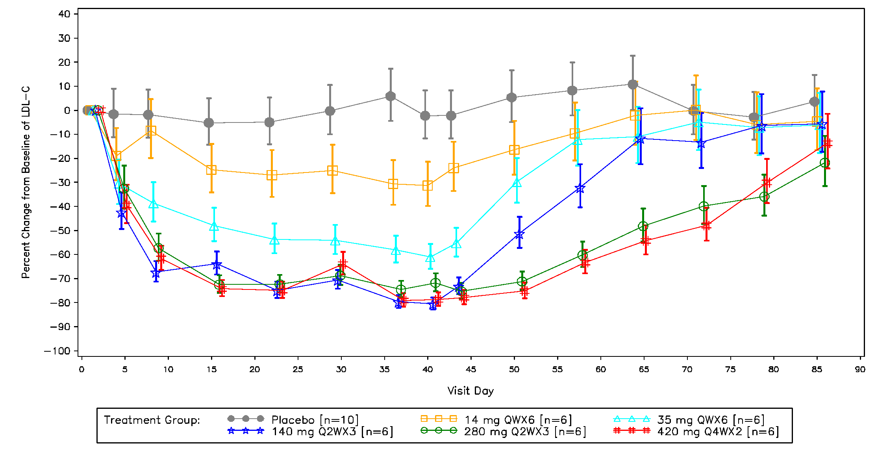
In subjects without HeFH, the analysis of the LDL-C data in subjects on low to moderate doses of statin (cohorts 1-5) showed statistically significant decreases (p<0.001) in LDL-C normalised AUC in all evolocumab dose cohorts (except 14 mg QW x 6) versus placebo (see Table 14, below).

Table 14: 20080398 - LS geometric mean and comparison to placebo for normalised AUC of LDL-C in dose-escalation cohorts 1-5; subjects without HeFH.
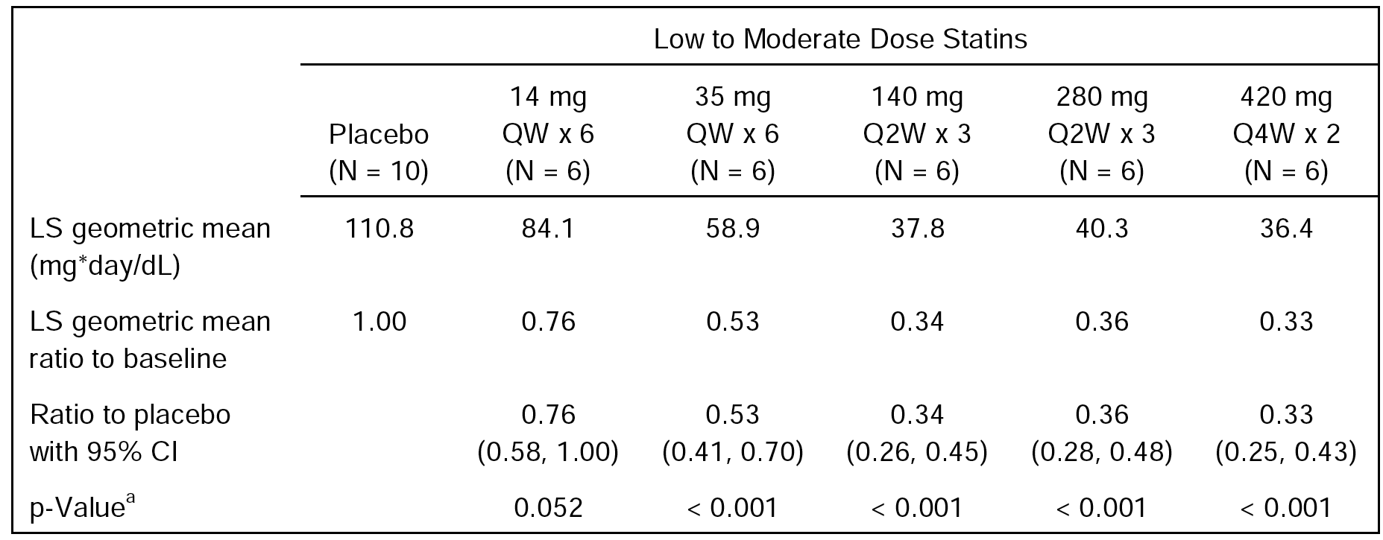
Note: a = p-value is associated with each dose level versus corresponding placebo. Ratio to baseline is calculated by normalised AUC divided by baseline LDL-C. For subjects in 420 mg Q4W x 2 cohort, the normalised AUC is calculated by AUC(day1-57)/(actual duration between Day 1 and day 57 planned visit). For subjects in the other cohorts, the normalised AUC is calculated by AUC(Day1-43)/(actual duration between Day 1 and Day 43 planned visit). For one subject with missing result of LDL-C at Day 43 planned visit, the value is imputed from Day 40 and Day 50 planned visits using linear interpolation formula.
Overall, reductions in LDL-C concentration in subjects without HeFH in the high-dose statin cohort (Cohort 6) were similar for subjects in the low to moderate statin dose cohorts (Cohorts 1-5). In general, reductions in LDL-C concentration were similar in subjects with HeFH (Cohort 7) and subjects without HeFH (Cohorts 1-6).

Phase II studies (20101154, 20101155, 20090158, and 20090159)
In the pooled data from the Phase II PK sub-studies (20101154, 20101155, 20090158, and 20090159), treatment with evolocumab 140 mg SC Q2W and 420 mg SC QM resulted in similar reductions in LDL-C from baseline (see Figure 13, below), and similar reductions in other lipid parameters from baseline. The more frequent Q2W dosing regimen resulted in less return toward baseline in LDL-C concentration at the end of the dosing interval than the less frequent QM dosing regimen.
Figure 13: Median percent change from baseline (25th to 75th percentiles) in calculated LDL-C from Weeks 8 to 12 with administration of 140 mg SC Q2W or 420 mg SC QM in patients with primary hyperlipidaemia and mixed dyslipidaemia (Studies 20101154, 20101155, 20090158, and 20090159).
Note: Observed median LDL-C percent change from baseline with 25th and 75th percentiles for the 140 mg SC Q2W dose (left) and 420 mg SC QM dose (right). % CFB = percent change from baseline; LDL-C = low-density lipoprotein cholesterol; SC = subcutaneous(ly); Q2W = once every 2 weeks; QM = once monthly (every 4 weeks).

Population pharmacodynamics
The submission included a population PK/PD analysis (Study 116744) based on pooled data from 1312 patients in 4 Phase II studies (20101154, 20101155, 20090158, and 20090159). The median baseline LDL-C concentration across the studies was 3.4 mmol/L (range: 1.5, 10.9 mmol/L). For patients in Studies 20090158 and 20090159 who did not participate in the PK sub-studies, the week-12 LDL-C concentrations were included because LDL-C was not evaluated at Week 10. The observed Phase III data were overlaid on the model predictions from the Phase I and II model to ensure no major differences in response were evident between the Phase III LDL-C data and the Phase I and II LDL-C data. The observed LDL-C responses from the Phase III studies were in line with the model predictions based on the Phase I and II studies. As the existing model described the data well and because of the increased shrinkage in the updated PK model, the exposure-response model based on the Phase II and III studies was not updated with data from Phase III studies.
A Week 8-12 exposure-response model was used to characterise the relationship between evolocumab exposure and LDL-C at the mean of Weeks 10 and 12 for combined data from all the Phase II studies. Model predictions suggest that doses of 140 mg SC Q2W and 420 mg SC QM achieve approximately 80% of the model-predicted maximal reduction in LDL-C at the mean of Weeks 10 and 12. The model-predicted maximal reduction in the mean LDL-C at Weeks 10 and 12 was 2.6 mmol/L, or 66% reduction from baseline (see Figure 14, below).
Figure 14: PopPK analysis (116744) - Observed data and 90% prediction interval for Week 10 and Week 12 mean calculated LDL-C for Phase II studies by Week 8-12 evolocumab AUC for evolocumab 140 mg SC Q2W and 420 mg SC QM.
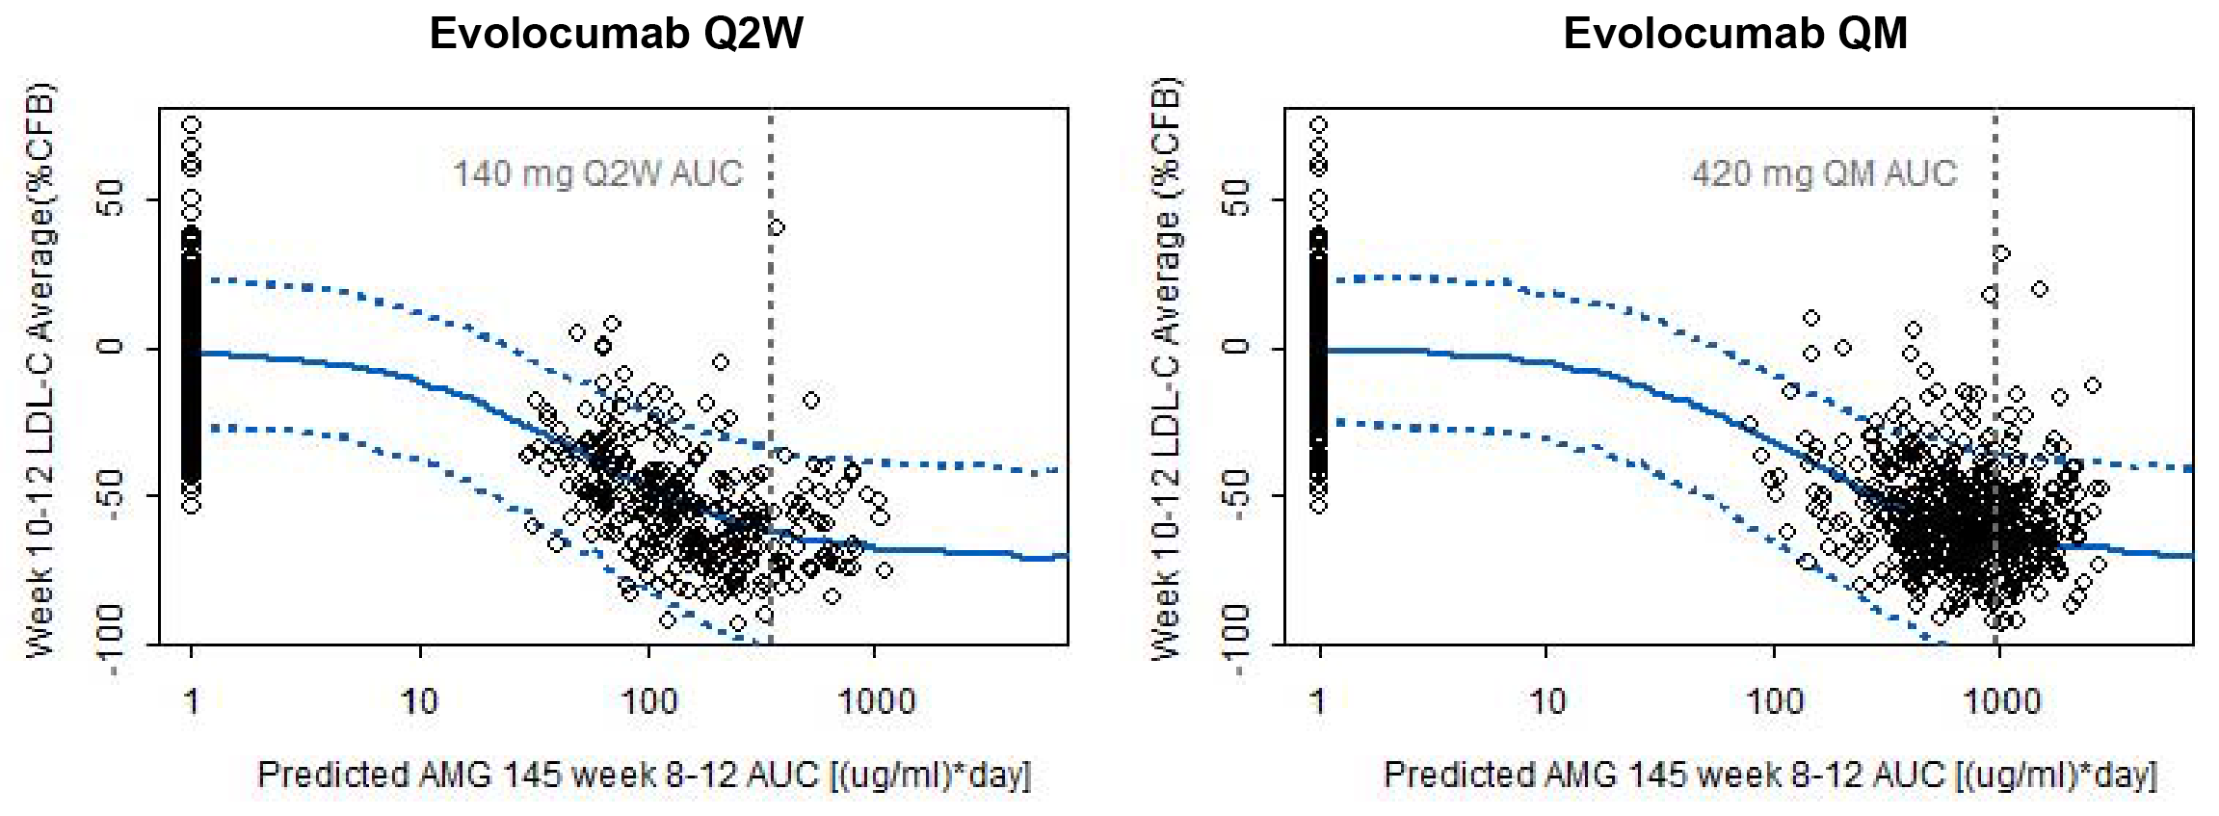
Note: %CFB = percent concentration change from baseline; AMG 145 = evolocumab; AUC = area under the concentration-time curve; LDL-C = low-density lipoprotein cholesterol; Q2W = once every 2 weeks; QM = once monthly (every 4 weeks). Prediction of the mean week 10 and 12 calculated LDL-C concentration, in mg/dL (top) and percent change from baseline (bottom), 50th (solid line) and 5th and 95th (dashed lines) percentiles. Simulations were formed for n = 2000 patients. Points: observed individual mean week 10 and 12 LDL-C measurements.
In the final exposure-response covariate model, concomitant use of a statin, concomitant use of ezetimibe, and HeFH emerged as statistically significant covariates on evolocumab response. The between-subject variability on baseline LDL-C was reduced from 22.7% to 20.0% with the inclusion of covariates. Using the updated Phase III PK covariate PopPK model and the exposure-response response model, simulations for 1000 individuals were constructed and the reduction in LDL-C at the mean of 10 weeks and 12 weeks in subjects receiving evolocumab was predicted to be within ± 26% for those of the reference patient at the extremes of the covariate conditions (that is, reference patient = 84 kg male with hypercholesterolaemia not taking other lipid-lowering medications, with baseline PCSK9 of 5.9 nM). Therefore, the effects of intrinsic factors (such as body weight, age, race, and sex) and extrinsic factors (such as concomitant treatment with statin or statin plus ezetimibe) on LDL-C concentration were not predicted to be clinically meaningful.

PCSK9

Healthy subjects
In Study 20080397, mean baseline (pre-dose) PCSK9 concentrations were in the range 219 to 320 ng/mL for all evolocumab groups 7 mg to 420 mg, with the mean ± SD concentration in all evolocumab groups combined (n=42) being 270 ± 65 ng/mL compared to 265 ± 48 ng/mL in the placebo group (n=14). In the 7 mg SC group, the means were clearly lower than those in the placebo group at many time-points, but the reductions from baseline in the 7 mg SC dose group were not as marked as those seen in the higher dose groups. In all dose groups, except the 7 and 21 mg groups, mean PCSK9 rapidly decreased to below the LLOQ (15 ng/mL), remained below the LLOQ until study Day 11, and subsequently returned to or towards baseline. The geometric mean PCSK9 concentrations over time for each of the dose groups are summarised below in Figure 15.
Figure 15: 20080397 - Geometric means (± SD) of PCSK9 (ng/mL) over time.
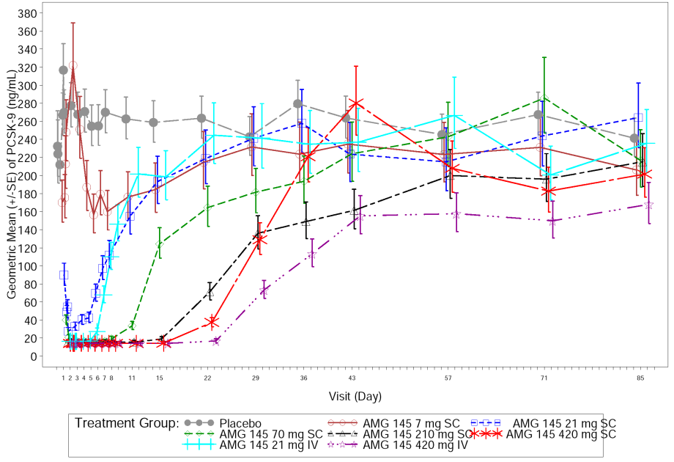
In Study 20110121, administration of evolocumab resulted in immediate and substantial reductions in unbound PCSK9 serum concentrations in Japanese subjects. An approximate 90% decrease from baseline levels was observed for all 3 evolocumab treatment groups (70, 210, and 420 mg SC) by Day 2 and was maintained through Day 11 for the 420 mg group. Thereafter, PCSK9 levels gradually returned to near baseline levels by the end of the study (Day 85). Following 210 mg SC, maximum percent reductions in PCSK9 relative to placebo were similar in Japanese and Caucasia subjects (96.2%, n=6 and 96.0%, n=6, respectively).
In Study 20120136, PCSK9 (mean ± SD) baseline concentrations were 308 ± 71 ng/mL in Period 1 (n=18) and 281 ± 61 ng/mL in Period 2 (n=18). PCSK9 concentrations decreased substantially within 4 hours of each single 140 mg SC dose of evolocumab, with mean reductions from baseline of 91% in Period 1 and 88% in Period 2. Between Days 2 to 6, for each dose of evolocumab the PCSK9 concentrations reached the LLOQ of the assay (≥ 93% percent mean reductions from baseline). By Day 15, the mean percent reduction from baseline in PCSK9 concentrations had fallen to approximately 75%, returning to baseline levels by Day 43 of each period.

Subjects with hepatic impairment
In Study 21010341, PCSK9 LS geometric mean concentrations at baseline were similar across the healthy, mild hepatic impairment, and moderate hepatic impairment groups (343 ng/mL, 339 ng/mL, and 343 ng/mL, respectively; p = 0.43). Following a single SC dose of evolocumab 140 mg, the concentration-time profiles for PCSK9 were similar across the three groups. PCSK9 mean concentrations decreased rapidly in each group after evolocumab, with reductions from baseline that were 84% or greater in each group 4 hours after the dose and 94% or greater in each group from study Day 2 through study Day 8.

Patients with hyperlipidaemia

Study 20080398 - subjects with hyperlipidaemia (with or without HeFH) and mixed dyslipidaemia
In Study 20080398, treatment with evolocumab SC resulted in dose-dependent decreases in unbound PCSK9 serum concentrations in subjects with hyperlipidaemia and mixed dyslipidaemia without HeFH. At the end-of-treatment time-point (Day 43), mean unbound PCSK9 decreases from baseline were greatest in the 140 mg and 280 mg dose cohorts (77% and 94%, respectively). Maximum mean observed unbound PCSK9 reductions from baseline at any time point during the study were ≥ 96% for both dose cohorts, corresponding to full inhibition of PCSK9 to below the quantification limit of 15 ng/mL. Maximum mean observed unbound PCSK9 reductions from baseline occurred on Days4 and 36 for subjects receiving 140 mg and on Days4, 8, 22, and 36 for subjects receiving 280 mg. For the 420 mg dose cohort, mean unbound PCSK9 reductions at the end-of-treatment time-point (Day 57) were lower (36%) than for the 140 mg and 280 mg dose cohorts, but the maximum mean observed reduction in unbound PCSK9 at any time during the study in the 420 mg dose cohort was identical to the 140 mg and 280 mg dose cohorts (≥ 96%; full inhibition). In the 420 mg dose cohort, the maximum mean observed unbound PCSK9 reductions from baseline occurred on Days 4, 8, 15, 36, and 40.
The analysis of PCSK9 data showed statistically significant decreases (all p-values < 0.001) for the normalised AUC of PCSK9 in every evolocumab cohort versus placebo (see Table 15, below). Statistically significant decreases (p-values ≤ 0.05) in PCSK9 were observed in each of the evolocumab dose cohorts compared to placebo at the first post-baseline time-point (Day 4) and continued through at least the end-of-treatment time-point (Day 43 or Day 57, respectively) for each of the evolocumab cohorts (except 14 mg).

Table 15: 20080398 - Summary of least square geometric mean and comparison to placebo for normalised AUC in dose-escalation cohorts (cohorts 1-5); subjects without HeFH.
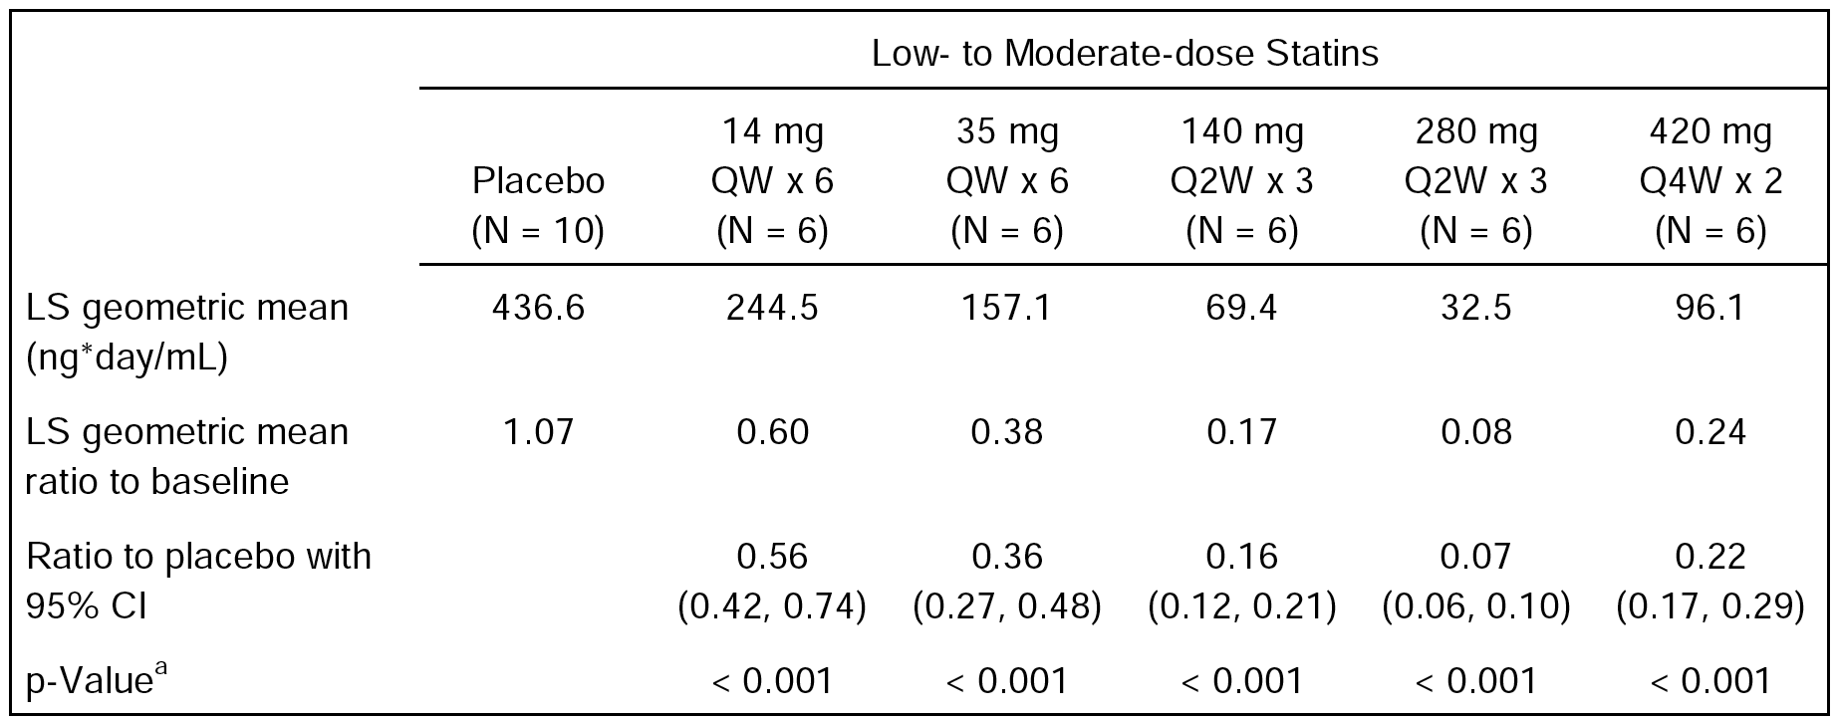
Note: AUC = area under the concentration-time curve; BQL = below quantification limit; CI = confidence interval; LS = least squares; PCSK9 = proprotein convertase subtilisin/kexin type 9; QW = once weekly; Q2W = once every 2 weeks; Q4W = once every 4 weeks; a = p-value is associated with each dose level versus corresponding placebo. BQL of PCSK9 is set at low limit level of 15 ng/mL. Ratio to baseline is calculated by normalised AUC divided by baseline PCSK9. For subjects in the 420-mg Q4Wx2 cohort, the normalised AUC is calculated by AUC_{(Day1-57)}/(actual duration between Day 1 and Day 57 planned visit). For subjects in the other cohorts, the normalised AUC is calculated by AUC_{Day1-43}/(actual duration between Day 1 and Day 43 planned visit).
In subjects without HeFH in the evolocumab 140 mg Q2W x 3 plus high-dose statin cohort (Cohort 6; n=9), at the end-of-treatment time-point (Day 43) the mean unbound PCSK9 decrease from baseline relative to placebo was 70% and the maximum decrease from baseline relative to placebo during the treatment period was 97%. In subjects without HeFH in the evolocumab 140 mg Q2W x 3 plus low to moderate statin dose cohort (Cohort 3; n=9), at the end-of-treatment time-point (Day 43) the mean unbound PCSK9 decrease from baseline relative to placebo was 78% and the maximum decrease from baseline relative to placebo during the treatment period was 96%.
In subjects with HeFH in the evolocumab 140 mg Q2W x 3 cohort (Cohort 7; n=4), at the end-of-treatment time-point (Day 43) the mean unbound PCSK9 decrease from baseline relative to placebo was 78% and the maximum decrease from baseline relative to placebo during the treatment period was 97%. The results in subjects with HeFH (Cohort 7) were consistent with the results in subjects without HeFH (Cohort 3), with subjects in both cohorts receiving the same dose of evolocumab (140 mg Q2W x 3).

Study 20110233 - subjects with HoFH
In the Phase II/III study in subjects with HoFH (Study 20110233), evolocumab 420 mg QM (n=29) compared to placebo (n=16) significantly reduced PCSK9 concentration from baseline (p<0.001) at both Week 12 and at the mean of Weeks 6 and 12. The treatment difference (mean percent reduction ± SE) was 39.7% ± 9.6% at Week 12 (that is, at the end of a QM dosing interval) and 68.7% ± 6.2% at the mean of Weeks 6 and 12 (that is, once at the middle of a dosing interval and once at the end of the dosing interval). In the evolocumab group, percent reduction in PCSK9 (mean ± SE) at Week 6 (90.1% ± 2.1%) was greater than in Week 4 (32.1% ± 4.1%), Week 8 (33.3% ± 5.6%), or Week 12 (26.6% ± 5.7%). In the placebo group, PCSK9 (mean ± SE) remained near baseline, with increases between 2.5% ± 7.5% and 10.9% ± 7.8% at all visits. The analysis of change in PCSK9 serum concentrations from baseline was an exploratory endpoint in this study.

Concomitant LDL-C and PCSK9 changes
Key PK and PD characteristics support the effectiveness of the evolocumab 140 mg SC Q2W and evolocumab 420 mg SC QM dosing regimens for the primary hyperlipidaemia and mixed dyslipidaemia indication. This is illustrated in Figure 16, below, which depicts mean unbound evolocumab serum concentrations and percent change from baseline in serum LDL-C and unbound PCSK9 concentrations following a single SC administration of evolocumab 140 mg or 420 mg in healthy subjects (Studies 20120133 and 20110168). The C_{max} for unbound evolocumab is typically attained at 1 week after a dose, which precedes the maximal and sustained reduction in LDL-C. For evolocumab 140 mg SC, after achievement of C_{max} at a median of 3 days after dose, mean unbound evolocumab serum concentrations decrease to the LLOQ (800 ng/mL) 21 days after dose, with a corresponding return to baseline for unbound PCSK9 and the LDL-C approximately 28 and 56 days after dose, respectively (Study 20120133). For evolocumab 420 mg SC, after achievement of C_{max} at a median of 4 days after a dose, mean unbound evolocumab serum concentrations decrease to the LLOQ (800 ng/mL) 42 days after a dose, with a corresponding return to baseline for unbound PCSK9 and LDL-C approximately 42 and 84 days after a dose, respectively (Study 20110168).
Figure 16: Mean unbound evolocumab serum concentrations and geometric mean percent change from baseline in UC LDL-C and unbound PCSK9 in healthy subjects.
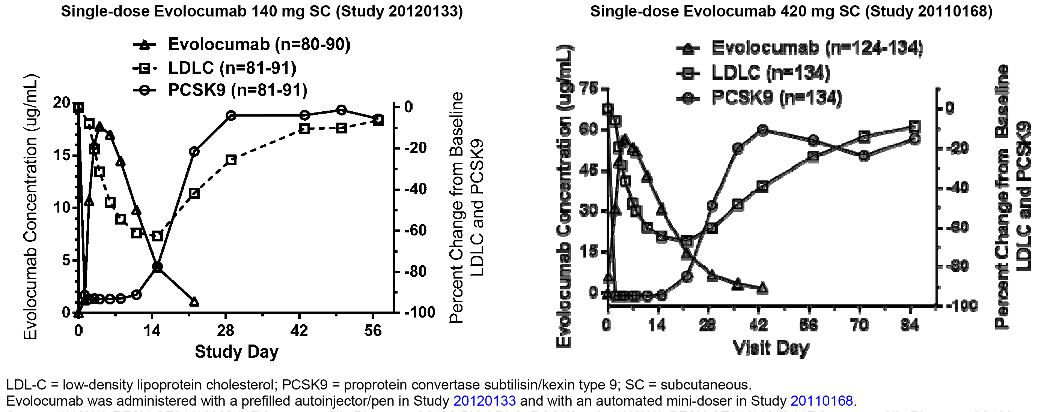

Evaluator’s overall conclusions on pharmacodynamics
The PD results consistently showed that in subjects with hyperlipidaemia and mixed dyslipidaemia (with and without HeFH) evolocumab, at the proposed doses of 140 mg Q2W and 420 mg QM, markedly reduced LDL-C serum concentrations from baseline and achieved maximal inhibition of PCSK9. In addition, PD data in subjects with HoFH showed that evolocumab at the proposed dose of 420 mg QM can reduce LDL-C serum concentrations and unbound PCSK9 serum concentrations.

Dosage selection for the pivotal studies
Dose selection for the pivotal Phase III studies was based on an interim integrated analysis of the safety, tolerability, and efficacy data from four, Phase II, placebo-controlled, dose-escalating studies (Studies 20090158, 20090159, 20101154, and 20101155). Based on these data, the 140 mg Q2W and 420 mg QM doses provided the greatest effects on LDL-C and other lipid parameters and were clinically equivalent with respect to effects on these parameters. In addition, the safety and tolerability profiles of the 140 mg SC Q2W and 420 mg SC QM dosing regimens were comparable to those of the other 4 lower-dose regimens tested in the Phase II studies (that is, 70 and 105 mg Q2W and 280 and 350 mg QM). As a result, the 140 mg Q2W and 420 mg QM doses were selected for the pivotal Phase III studies. The results of the interim integrated analyses were confirmed by the final analyses of the Phase II studies. In addition, based on PK/PD modelling, doses of 140 mg SC Q2W and 420 mg SC QM were predicted to achieve approximately 80% of the model-predicted maximal reduction in calculated LDL-C at the mean of Weeks 10 and 12.

Clinical efficacy

Primary hyperlipidaemia and mixed dyslipidaemia

Overview of the studies
- The submission include four, pivotal Phase III clinical efficacy and safety studies of 12 weeks duration supporting evolocumab for the treatment of patients with primary hyperlipidaemia (HeFH and non-FH) and mixed dyslipidaemia (see Table 16, below). In this submission, primary hyperlipidaemia was defined as elevated LDL-C cholesterol only and mixed dyslipidaemia was defined as elevated LDL-C along with high triglycerides or low HDL-C. Specifically, mixed dyslipidaemia was defined as triglycerides (≥ 1.7 mmol/L), triglycerides (≥ 2.3 mmol/L) or HDL-C (< 1.0 mmol/L in males or < 1.3 mmol/L in females).
- The four pivotal Phase III studies were of similar design, had the same co-primary endpoints of percent change from baseline in reflexive LDL-C at Week 12 and mean percent change from baseline in reflexive LDL-C at Weeks 10 and 12, and evaluated the same two evolocumab dose regimens (140 mg SC Q2W and 420 SC QM) against placebo and/or against ezetimibe. Each of the four, pivotal Phase III studies assessed the efficacy of evolocumab in four separate therapeutic settings (that is, in combination with statins; as monotherapy; in statin intolerant subjects; and in subjects with HeFH).

Table 16: Pivotal Phase III studies in patients with primary hyperlipidaemia (HeFH and non-FH) and mixed dyslipidaemia.
ID | Name | Evolocumab | N * | Title of Study
20110115 | LAPLACE-2 | In combination with statin | 1899 | A Double-blind, Randomised, Placebo and Ezetimibe Controlled, Multicenter Study to Evaluate Safety, Tolerability and Efficacy of AMG 145 [evolocumab] on LDL-C in Combination With Statin Therapy in Subjects With Primary Hypercholesterolaemia and Mixed Dyslipidemia.
20110114 | MENDEL-2 | Monotherapy | 615 | A Double-blind, Randomised, Placebo- and Ezetimibe-controlled, Multicenter Study to Evaluate Safety and Efficacy of Lipid Lowering Monotherapy With AMG 145 [evolocumab] in Subjects With a 10 year Framingham Risk Score of 10% or Less.
20110116 | GAUSS-2 | In statin intolerant subjects. | 307 | A Double-blind, Randomised, Multicenter Study to Evaluate Safety and Efficacy of AMG 145 [evolocumab], Compared With Ezetimibe, in Hypercholesterolemic Subjects Unable to Tolerate an Effective Dose of a HMG-CoA Reductase Inhibitor.
20110117 | RUTHERFORD-2 | HeFH | 331 | A Double-blind, Randomised, Placebo-controlled, Multicenter Study to Evaluate Safety, Tolerability and Efficacy of AMG 145 [evolocumab] on LDL-C in Subjects With Heterozygous Familial Hypercholesterolaemia
N * = number of subjects randomised to investigational product (IP).
- The submission also included four, Phase II studies, of 12 weeks duration which were the ‘parent’ studies to the four pivotal Phase III studies. These studies were identified as Study 20101155 (LAPLACE-1), Study 20101154 (MENDEL-1), 20090154 (GAUSS-1) and 20090158 (RUTHERFORD-1). The key similarities and difference of the Phase II and III studies were summarised. In addition to the 4 ‘parent’ Phase II studies of 12 weeks duration, the submission also included a Phase II study of 12 weeks duration in Japanese patients.
- The submission also included a pre-specified Integrated Summary of Efficacy (ISE) analysing pooled data from the 4, pivotal Phase III, 12-week studies (Studies 20110114, 20110115, 20110116, and 20110117) in subjects with primary hyperlipidaemia and mixed dyslipidaemia. This analysis was provided in the Summary of Clinical Efficacy and Clinical Overview. In addition, the submission included the Statistical Analysis Plan (SAP) for the ISE and a comprehensive list of Tables and Figures relating to the integrated analysis.
- In this report, the efficacy data have been evaluated separately for each of the 4 pivotal Phase III studies with emphasis on the primary and secondary endpoints. In addition, the integrated efficacy data from the 4 pivotal Phase III studies have also been reviewed. The efficacy data for each of the parent Phase II studies have been evaluated a supportive data. In addition, 2 long-term Phase III studies, 1 long-term Phase II study have been evaluated, and 2 Phase III studies assessing home use of evolocumab have been evaluated.

Phase III Study 20110115 (LAPLACE-2) - Combination with statin

Study design, objectives, locations and dates

Design
This Phase III, multinational, multicentre, randomised, double-blind, double-dummy, placebo- and ezetimibe-controlled study was designed to evaluate the effect of 12 weeks of evolocumab SC administered Q2W or QM, in combination with a statin, on percent change from baseline in LDL-C in subjects with primary hypercholesterolaemia and mixed hyperlipidaemia The study was conducted at 198 centres in the United States, Czech Republic, United Kingdom, Canada, Denmark, Germany, Russia, Hungary, Italy, Australia, Netherlands, Belgium, Sweden, Switzerland, Spain, France, and Hong Kong. The first subject was enrolled on 15 January 2013 and the last subject completed follow-up on 4 December 2014. The study was conducted in accordance with ICH GCP regulations and guidelines. The study was sponsored by Amgen. The study is also known by the name LAPLACE-2 = LDL-C Assessment w/ PCSK9 MonoclonaL Antibody Inhibition Combined with Statin ThErapy.

Objectives
The primary objective was to evaluate the effect of 12 weeks of evolocumab administered SC Q2W and SC QM when used in combination with a statin, compared to placebo, on percent change from baseline in LDL-C in subjects with primary hypercholesterolaemia and mixed dyslipidemia.
The secondary objectives were: (1) to evaluate the safety and tolerability of evolocumab SC Q2W and SC QM used in combination with a statin, compared with placebo or ezetimibe, in subjects with primary hypercholesterolaemia and mixed dyslipidemia; (2) to assess the effects of 12 weeks of evolocumab SC Q2W and SC QM used in combination with a statin compared to placebo or ezetimibe, on change from baseline in LDL-C, and percent change from baseline in non-HDL-C, ApoB, total cholesterol/HDL-C ratio, ApoB/ApoA1, triglycerides, VLDL-C, and HDL-C in subjects with primary hypercholesterolaemia and mixed dyslipidemia; and (4) to assess the effects of 12 weeks evolocumab SC Q2W and QM compared with ezetimibe, on percent of subjects attaining LDL-C < 70 mg/dL (1.8 mmol/L).
Comment: It is noted that the objectives of this study refer to subjects with hypercholesterolaemia rather than hyperlipidemia. In addition to primary and secondary objectives listed above, the study also included a number of tertiary and exploratory objectives. However, in the evaluation of the efficacy data in this CER the focus is on the primary and secondary objectives supported by the pre-specified primary and secondary efficacy endpoints.

Methods
Prior to the first randomisation, subjects entered a screening period to determine eligibility. During screening, SC administration of placebo was performed to confirm tolerability prior to randomisation. All subjects received placebo SC corresponding to the QM dose volume (3.0 mL) using 3 consecutively administered AI/pens. During the screening period, the subject (or designee) was trained by study site staff to prepare and administer the (investigational product) IP.
This study involved 2 randomisation steps: first step, after screening eligible subjects were randomised to 1 of 5 open-label statin cohorts (atorvastatin 10 mg or 80 mg, rosuvastatin 5 mg or 40 mg, or simvastatin 40 mg) for a 4-week lipid stabilisation period based on statin therapy at the time of study entry (no statin use versus non-intensive statin use versus intensive statin use); second step, following the 4-week lipid stabilisation period, eligible subjects were randomised within each statin dose cohort to blinded IP groups (see Figure 17, below).
Figure 17: 20110115 - Randomisation scheme.
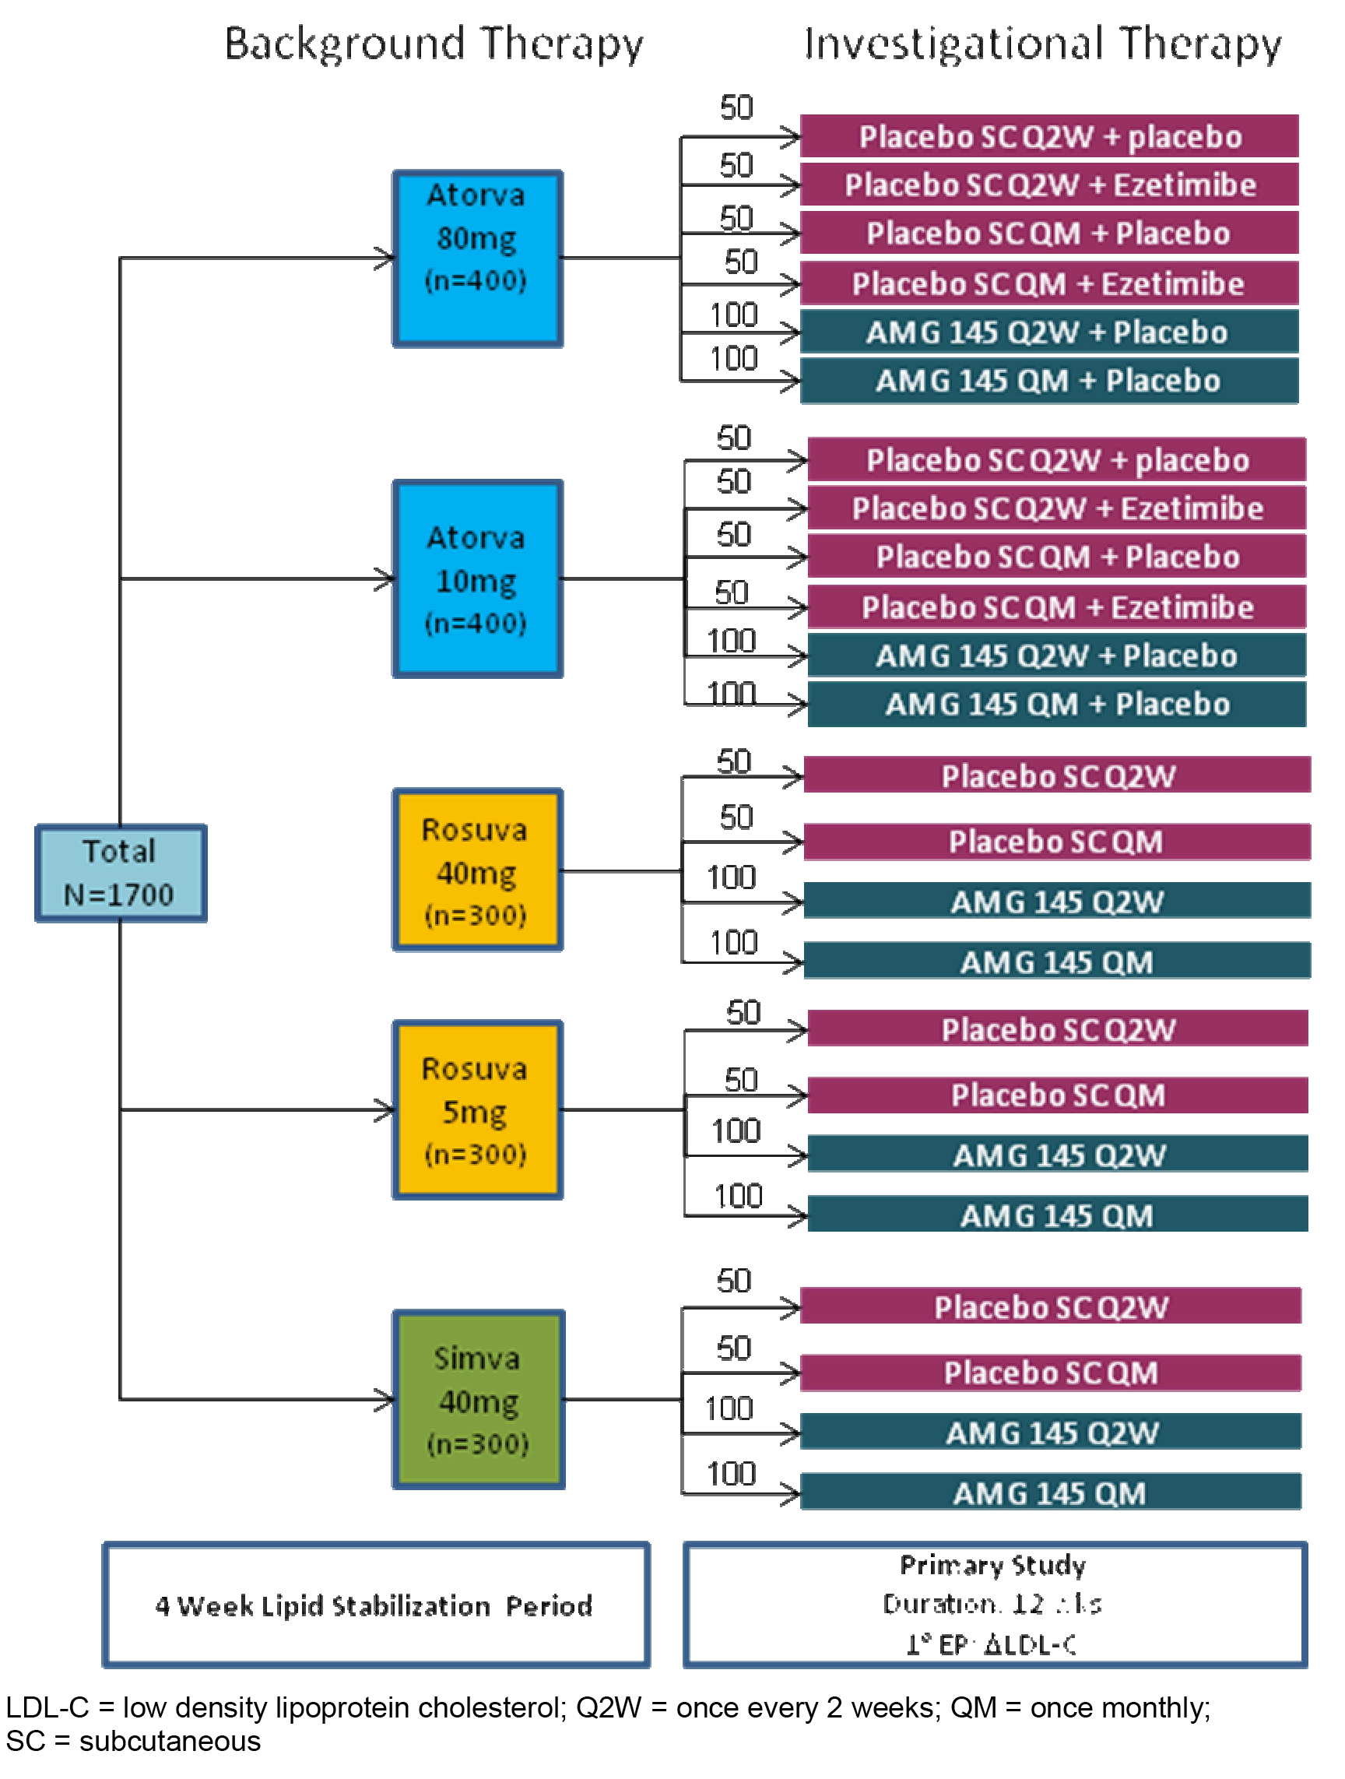
Subjects received their first dose of IP (SC and PO) on Day 1 (while continuing their background statin therapy) and returned to the study centre for assessment at Weeks 2, 8, 10, and 12. Blood samples for determination of evolocumab and PCSK9 serum concentrations were collected on Day 1 and at Weeks 2, 10, and 12. The end-of-study (EOS) visit occurred at the study centre at Week 12 for subjects randomised to the QM schedule, and by phone call at Week 14 for subjects randomised to the Q2W schedule.
An external independent Data Monitoring Committee (DMC) was responsible for formally reviewing the accumulating data from this and other completed and ongoing studies of evolocumab in order to identify potential risks. The independent DMC was chaired by an external academic cardiologist who was an expert in lipids and clinical trials. Analyses for the DMC were provided by an independent biostatistical group (IBG).

Inclusion and exclusion criteria
Eligible subjects were men and women ≥ 18 to ≤ 80 years of age, with fasting triglycerides ≤ 4.5 mmol/L) Subjects already on an intensive statin were required to have fasting LDL-C at screening of ≥ 2.1 mmol/L. Subjects on a non-intensive statin were required to have a fasting LDL-C at screening of ≥ 2.6 mmol/L. Subjects not taking a statin at screening were required to have a fasting LDL-C of ≥ 4.0 mmol/L. Subjects were excluded if they had a current or prior history of statin intolerance, as determined by investigator. Subjects were also excluded if they had a history or evidence of clinically significant diseases and conditions that would pose a risk to their safety or interfere with study assessments. The inclusion and exclusion are considered to be satisfactory.

Study treatments

Investigational products (IPs)
The IPs were evolocumab SC administered by AI/pens (140 mg/mL), placebo (SC administered by AI/pens or PO), and ezetimibe PO (for the atorvastatin cohort only). The two evolocumab SC treatments were 140 mg Q2W (1 x 140 mg/mL injection via AI/Pen) and 420 mg QM (3 x 140 mg/mL injections via AI/Pens), and each evolocumab dosing regimen had a matching placebo control regimen. Ezetimibe was administered at a dose of 10 mg QD for the atorvastatin cohort only, and this dosing regimen had a matching placebo regimen.
The 3 injections for QM administration could be administered into different injection sites, but were administered in a consecutive fashion within 30 minutes. After IP administration at the first dosing visit, subjects were required to remain at the study centre for observation for at least 30 minutes before being discharged. The remaining doses were administered in the clinic or in a home-use setting. The SC IP was administered within the visit window for each scheduled visit. The visit window was ± 3 days for each scheduled visit after study Day 1. In the case of a missed dose, a QM dose was not administered within < 7 days of a previous dose. If 2 x Q2W doses were administered within < 7 days of each other, any subsequent dose was administered ≥ 7 days after the most recent dose. Oral IP was administered QD, with or without food, at a time convenient to the subject.
Dose adjustments were not permitted. If, in the opinion of the investigator, a subject was unable to tolerate a specific dose of IP, that subject discontinued the IP but continued to return for all other study procedures until the end of the study. Subjects who missed a dose of background statin were advised to take the missed dose as soon as they could, and subsequent doses were to be taken at the usual time. However, if the next scheduled dose was due in less than 6 hours, the subject was advised to omit the missed dose entirely and to take the next dose at the normal time. If stopping a statin was medically warranted during the trial, the subject continued to receive the IP. In addition, if a medical decision was made to withhold the IP during the study, subjects continued to receive statin background therapy.
Due to the well-known side effect profile for statins, special attention was made to detect possible drug-induced myopathy or drug-induced liver injury. After each visit, investigators were required to review reports from the central laboratory (excluding lipid results) before administering the IP at the next scheduled visit. If it was determined from these laboratory reports that a subject had an elevation in creatine kinase (CK) or liver function tests (LFTs) that met pre-specified criteria the IP was withheld or discontinued. If triglycerides were > 11.3 mmol/L, the subject was retested, and if confirmed both the sponsor and the investigator were informed so that appropriate medical follow-up could be initiated.

Concomitant medications
Throughout the study, investigators could prescribe any concomitant medications or treatments deemed necessary to provide adequate supportive care, except for those specified in the protocol.

Concomitant diet and exercise
Subjects were required to maintain their current regimen of diet and exercise, and to refrain from unaccustomed intensive exercise (for example, heavy lifting or long runs) 48 hours prior to each visit.

Compliance with IPs
Information regarding each administered dose of SC IP was recorded on the IP administration electronic case report form (eCRF). Subject compliance with PO IP administration was determined at Weeks 2, 8, and 12 by counting the number of tablets returned against the number of days the subject should have taken the drug. Once the subject was randomised, if compliance with PO IP fell below 80% or went above 120%, the investigator was responsible for re-instructing the subject on IP dosing as well as determining the factors that resulted in poor compliance.

Removal from therapy of assessment
Subjects had the right to withdraw fully or partially from the study at any time and for any reason without prejudice to his or her future medical care by the physician or at the institution. Procedures for full and partial withdrawal were described in the protocol and are considered to be acceptable.

Efficacy variables and outcomes

Endpoints
The co-primary endpoints were:
- percent change in LDL-C at Week 12; and
- mean percent change from baseline in LDL-C at Week 10 and 12.
The co-secondary endpoints were at Week 12 and the means at Weeks 10 and 12 for:
- Tier 1 endpoints:
  - change from baseline in LDL-C;
  - percent change from baseline in non-HDL-C;
  - percent change from baseline in ApoB;
  - percent change from baseline in the total cholesterol/HDL-C ratio; and
  - percent change from baseline in ApoB/ApoA1 ratio.
- Tier 2 endpoints:
  - percent of subjects with LDL-C < 70 mg/dL (1.8 mmol/L);
  - percent change from baseline in Lp(a);
  - percent change from baseline in triglycerides;
  - percent change from baseline in VLDL-C; and
  - percent change from baseline in HDL-C

Description of key endpoint assessments
Fasting (at least 9 hours) blood samples were shipped to a central laboratory for analysis of complete lipid profiles, and standard laboratory procedures were used to calculate the lipid concentrations. Calculated LDL-C was determined based on the Friedewald equation.⁴ The LDL-C was also assessed using ultracentrifugation (UC), which separates VLDL from the other lipids by UC and eliminates any inaccuracies introduced when the VLDL-C is estimated in the Friedewald equation. In order to robustly assess LDL-C levels when calculated LDL-C concentrations were low (that is, < 1.0 mmol/L) or triglycerides were high (that is, > 4.5 mmol/L) a reflexive approach was used to report LDL-C concentrations. Using the reflexive approach, if the calculated LDL-C was < 1.0 mmol/L or triglycerides were > 4.5 mmol/L then the calculated LDL-C measurements were replaced by UC LDL-C measurements from the same blood sample, if available.

Randomisation and blinding methods
A subject was considered randomised into the study after successfully completing the screening period, meeting all inclusion and exclusion criteria including meeting final laboratory safety criteria, and undergoing the two-step randomisation procedures via an Interactive Voice/Web Response System (IVRS). Randomisation was stratified based on statin usage at entry (that is, intensive statin usage [n=586, 28.6%]; non-intensive statin usage [n=852, 41.5%]; or no statin usage [n=614 [29.9%]); see paragraph below for definitions of statin usage. In addition, due to changes in simvastatin labelling, randomisation into IP was stratified by use of certain concomitant medications (any verapamil or diltiazem versus amlodipine, amiodarone or ranolazine alone versus none).
Subjects were stratified into the intensive statin usage cohort if they had received at least one of the following treatments: simvastatin 80 mg QD; atorvastatin ≥ 40 mg QD; rosuvastatin ≥ 20 mg QD; or any statin plus ezetimibe (any statin includes atorvastatin, fluvastatin, lovastatin, pitavastatin, pravastatin, rosuvastatin an simvastatin). Subjects were stratified into the non-intensive statin usage cohort if they had received at least one statin and were not in the intensive statin usage cohort. Subjects in the intensive statin cohort were required to have a fasting LDL-C at screening of ≥ 2.1 mmol/L; subjects in the non-intensive statin cohort were required to have a fasting LDL-C at screening of ≥ 2.6 mmol/L; and subjects in the no statin usage at screening were required to have a fasting LDL-C of ≥ 4.0 mmol/L.
In order to maintain blinding of SC IP, subjects received either evolocumab SC or placebo SC within each dosing frequency; the SC dosing frequencies (Q2W or QM) were not blinded. Evolocumab and corresponding placebo were both administered at the study site or in appropriate home-use settings using identical AI/pens. In order to maintain blinding of oral IP in the atorvastatin cohorts, subjects received either ezetimibe PO or placebo PO. Oral placebo was available to match ezetimibe through over-encapsulation. Background statin therapy was open-label. Treatment assignment was unblinded when knowledge of the treatment was essential for safety or for further medical management. Un-blinding occurred for 1 subject during the study.
The external independent DMC members and IBG had access to unblinded subject data per the DMC charter. Amgen PK scientists and the programmers preparing the population PK/PD datasets had access to the treatment assignments and limited subject level data. To maintain study integrity, these Amgen staff members were not included in the evolocumab investigative study team.

Analysis populations
The full analysis set (FAS) included all subjects randomised to IP who received at least 1 dose of IP (SC or PO). This analysis set was used in both efficacy and safety analyses for the double-blind treatment period.
The lipid stabilisation analysis set (LSAS) included all subjects enrolled who receive at least 1 dose of a randomised statin. The LSAS was used in safety summaries during the lipid stabilisation period.
In the efficacy analyses, subjects were grouped according to their randomised treatment group. For safety analyses, subjects were grouped according to their randomised group with the following exception: if a subject received treatment throughout the study that was different from the randomised group, then the subject was grouped by the actual treatment received.
The completer analysis set (CAS) included subjects in the FAS who adhered to the scheduled IP regimen and had observed values for the co-primary endpoints. The completer analysis set was used in sensitivity analyses of the co-primary endpoints.
The PK analysis set included subjects with at least 1 evolocumab or PCSK9 result.

Sample size
The planned total sample size was 1700 subjects randomised into 5 statin dose cohorts. Within each statin dose cohort and dose frequency (either Q2W or QM), 100 subjects were randomised to evolocumab and 50 subjects were randomised to placebo. Furthermore, for the atorvastatin dose cohorts, 50 subjects were randomised to receive ezetimibe within each dosing frequency. The primary analysis required the tests of each co-primary endpoint to be significant at the full test size. This sample size provided adequate power to determine the superiority of an evolocumab dose relative to ezetimibe or placebo as measured by the co-primary endpoints.
The power calculation was derived assuming a true treatment effect of evolocumab (Q2W or QM) over ezetimibe in the percent reduction of LDL-C of at least 20% at Week 12, with a common standard deviation (SD) of 20%. This SD assumption was based on literature review and was consistent with the Phase II study results. For the atorvastatin dose cohorts, the overall family-wise error rate of 0.05 was allocated to be 0.01 and 0.04 for the comparisons of evolocumab against each control arm (placebo or ezetimibe, respectively) within each dose frequency (Q2W or QM). It was anticipated that the treatment effect would be attenuated due to the following assumptions: (a) approximately 15% of subjects randomised in the primary study phase would end IP early but would remain on study. It was assumed there would be no treatment effect difference between the evolocumab and ezetimibe cohort subjects after they ended IP early; (b) approximately 5% of subjects randomised in the primary study phase would end the study early. It was assumed that the treatment effect of evolocumab over ezetimibe was a LDL-C reduction of approximately 10%.
After accounting for treatment attenuation and assuming 10% of randomised subjects would not receive any IP in the primary study phase, the sample size provided approximately 96% power in testing the superiority of each evolocumab dosing regimen over ezetimibe at Week 12. The sample size calculation was performed using a two-sided t-test with a 0.04 significance level, an attenuated treatment effect of 16.5% reduction in LDL-C and an attenuated common SD of 23%. Therefore, the sample size as planned provided at least 92% (96% x 96%) power in testing the superiority of each evolocumab dosing regimen over ezetimibe on the co-primary endpoints.
Assuming a true treatment effect of evolocumab (Q2W or QM) over placebo in the percent reduction of LDL-C of at least 30% at Week 12, with a common standard deviation (SD) of 20%, the sample size provided approximately 99% power in testing the superiority of each evolocumab dosing regimen over placebo at Week 12. The sample size calculation was performed using a two-sided t-test with a significance level of 0.01, attenuated treatment effect of 24.8% reduction in LDL-C and an attenuated common SD of 26%. Therefore, the sample size as planned provided at least 98% (99% x 99%) power in testing the superiority of each evolocumab dosing regimen over placebo on the co-primary endpoints.
Since the testing statistics from the Q2W and QM groups are independent, there was at least an 85% (92% x 92%) and 96% chance (98% x 98%) of showing superiority of both evolocumab dosing regimens over ezetimibe and placebo, respectively.

Statistical methods

Statistical hypothesis
Within each randomised statin treatment group and SC IP dose frequency, the null hypothesis was that there was no difference in the percent change from baseline at Week 12 in LDL-C or in the mean percent change from baseline at Weeks 10 and 12 between evolocumab and placebo, and the alternative hypothesis was that a mean difference did exist.
For the randomised atorvastatin treatment groups, within each randomised atorvastatin dose and SC IP dose frequency, the null hypothesis was that there was no mean difference in the mean percent change from baseline at Weeks 10 and 12 or in the percent change from baseline at Week 12 in LDL-C between evolocumab and ezetimibe, and the alternative hypothesis was that a mean difference did exist.

General approach and adjustments for multiplicity
The final analysis was conducted when all subjects had either completed all the scheduled study visits or had prematurely discontinued. All efficacy and safety analyses were performed on the FAS, unless otherwise specified, and data were summarised by randomised treatment group. Analyses were performed separately within each statin dose cohort and dose frequency (Q2W and QM), unless otherwise specified. Differences in model estimates between evolocumab Q2W and QM and associated confidence intervals for the differences were calculated by statin cohort for each lipid parameter. The superiority of evolocumab to either placebo or ezetimibe was assessed for all efficacy endpoints.
No multiplicity adjustments were made between the statin dose cohorts and IP dose frequencies. A full alpha of 0.05 was allocated to each of the 10 statin dose cohorts by IP dose frequencies (5 statin dose cohorts being atorvastatin 80 mg, atorvastatin 10 mg, rosuvastatin 40 mg, rosuvastatin 5 mg, and simvastatin 40 mg and two IP dose frequencies being Q2W and QM). In order to preserve the family-wise type I error rate at 0.05, for each independent dose frequency (Q2W and QM) a significance level of 0.05 was allocated for comparisons of evolocumab to placebo for each of the rosuvastatin 5 mg and 40 mg and simvastatin 40 mg dose cohorts, and significance levels of 0.01 and 0.04 were allocated for comparisons of evolocumab to placebo and ezetimibe, respectively, for the atorvastatin 10 mg and 80 mg dose cohorts.
Methods of adjusting for multiplicity due to multiple endpoints (co-primary and co-secondary endpoints) within each dose frequency and against each control arm are summarised below in Figure 18. The hierarchal testing strategy outlined in Figure 18 was executed 14 times: once for each statin dose cohort by IP dose frequency for testing versus placebo (10 combinations) and once for each atorvastatin dose cohort by IP dose frequency for testing versus ezetimibe (4 combinations). For each control (either placebo or ezetimibe) within each statin dose cohort and IP dose frequency, testing of each co-endpoint pair resulted in a single p-value, and for co-secondary endpoints these p-values were then used in the Hochberg procedure to adjust for multiplicity. Unless specified, all other hypothesis testing was 2-sided with significance level of 0.05.
Figure 18: 20110115 - Methods for adjusting for multiplicity.
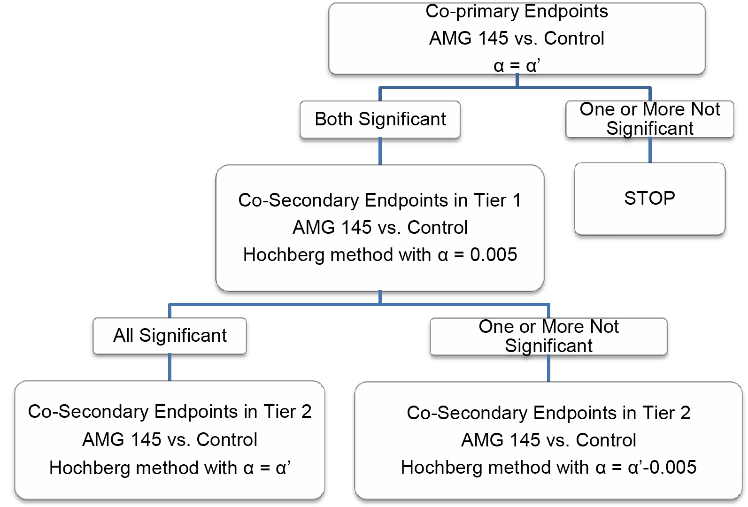
Note: For each dose frequency, the significance level α’ in in the diagram was defined as 0.05 for the comparison of evolocumab to placebo for each of the rosuvastatin and simvastatin dose cohorts and 0.01 and 0.04 for comparisons of evolocumab with placebo and ezetimibe in the atorvastatin dose cohorts, respectively.

Analyses of the co-primary endpoints
Primary analyses: To assess the co-primary endpoints of the percent change from baseline at Week 12 and the mean percent change from baseline in LDL-C at Weeks 10 and 12, a repeated measures linear effects model was used in each statin dose cohort and dose frequency (that is, Q2W or QM) to compare the efficacy of evolocumab with control (that is, placebo or ezetimibe). The repeated measures model included terms for treatment group, stratification factors, scheduled visit and the interaction of treatment with scheduled visit. Missing values were not imputed when the repeated measures linear effects model was used. For all analyses related to LDL-C, unless specified otherwise, a reflexive approach was used, where the calculated LDL-C was employed unless the calculated LDL-C was < 1.0 mmol/L or triglycerides were > 4.5 mmol/L, in which case UC LDL-C was used. Multiplicity adjustment procedures have been described above.
Sensitivity analyses: To evaluate the robustness of the primary analysis, the following sensitivity analyses were performed: (1) the primary analysis was repeated using the completer analysis set; and (2) non-parametric analyses (Quade test) were performed on the completer analysis set.
Subgroup analyses: Subgroup analyses on the co-primary efficacy endpoints were conducted using the stratification factors and pre-specified baseline covariates, as applicable.
Combined statin analyses: The lipid parameters were also assessed within each dose frequency with the statins pooled. All subjects in the FAS except those randomised to ezetimibe were included in the model. The model included terms for the stratification factor, randomised statin dose group, randomised IP treatment group, visit, and randomised IP treatment group by visit. Pooling of treatment effects across statins was conducted with the primary analysis estimators using a random effects meta-analysis model. Each statin cohort was treated as a separate study in the study level random effects model. Measures of heterogeneity in treatment effects across statin dose cohorts were provided. No adjustments for multiplicity were made for these supportive analyses.

Analyses of co-secondary endpoints, tertiary and exploratory endpoints
The statistical model and testing of the Tier 1 co-secondary efficacy endpoints were similar to the primary analysis of the co-primary endpoints. Analyses of the Tier 2 co-secondary efficacy endpoints used the same analysis model as the Tier 1 endpoints, and testing used a union-intersection test. Achievement of LDL-C < 1.8 mmol/L was analysed using the Cochran-Mantel Haenszel (CMH) test adjusted by the stratification factors. An additional analysis of LDL-C response was assessed within each dose frequency (Q2W and QM) with atorvastatin 10 mg and 80 mg pooled. Subject incidence of LDL-C < 1.8 mmol/L, < 2.6 mmol/L, and < 3.4 mmol/L was also summarised. The analysis of the tertiary endpoints was similar to the primary analysis of the co-primary endpoints, but no multiplicity adjustment was applied. Exploratory endpoints relating to lipid parameters were summarised by treatment group and by scheduled visit using descriptive statistics.

Changes in study conduct
The original SAP (dated 55 February 2013) was amended once, Amendment 1 dated 27 September 2013, and was approved prior to study un-blinding. Changes in Amendment 1 reflected Amgen study team decisions made during study conduct, added clarifications to facilitate programming, and made editorial corrections to previous versions of the SAP. These changes were unlikely to have affected the study analysis.

Participant flow
A total of 2067 subjects were first randomised to 1 of the 5 open-label statin cohorts. These subjects then underwent a 4 week lipid stabilisation period and were then assessed for eligibility for the double-blind IP treatment portion of the study. Of the 2067 subjects initially randomised, 1899 were subsequently randomised to IP treatment (evolocumab, placebo, or ezetimibe [only for atorvastatin cohort]) within their statin cohort.
Of the1899 subjects randomised to IP in the double-blind treatment period: 1896 (99.8%) received statin treatment and at least 1 dose of IP and were included in the FAS; 1807 (95.2%) completed statin and IP treatment; and 1826 (96.2%) completed the study. Of the 1826 (96.2%) subjects who completed the study, 73 (3.8%) discontinued early, including 40 (2.1%) who withdrew consent, 26 (1.4%) discontinued due to sponsor decision (23 of these subjects enrolled in the extension study prior to completing the last follow up visit in this study), 6 (0.3%) were lost to follow-up, and 1 (0.1%) subject died. Study completion rates were similar across treatment groups and statin cohorts. Subject disposition with reason for discontinuation in the double-blind treatment period (all randomised IP subjects) was summarised.

Major protocol violations/deviations
Overall, 43 (2.3%) subjects experienced at least 1 important protocol deviation during the IP double-blind treatment period. The subject incidence of important protocol deviations was similar across treatment groups. The important protocol deviations in the IP groups are unlikely to have invalidated the efficacy analyses.

Baseline data
Demographic characteristics were summarised for the FAS. In the total population (n=1896), the mean ± SD age was 59.8 ± 9.9 years (range: 20, 80 years), and the majority of subjects (64.6%, n=1255) were < 65 years of age. The total population included 1028 (54.2%) men and 868 (45.8%) women. The majority of subjects were White (94.0%), followed by Black or African American (4.0%), and Asian (1.3%). The mean ± SD height of the population was 169.4 ± 9.9 cm (range: 125, 198 cm) and the mean ± SD BMI was 29.4 ± 5.4) kg/m² (range: 17, 62 kg/m²). Baseline demographics were comparable across treatment groups and statin cohorts.
Baseline lipid, hsCRP and PCSK9 parameters were summarised for the FAS. In the total population, the mean ± SD serum LDL-C concentration at baseline was 2.8 ± 1.1 mmol/L, and was comparable across treatment groups and statin cohorts. Baseline concentrations were also comparable across treatment groups and statin cohorts for Tier 1 secondary lipid parameters (total cholesterol, ApoB, ApoA1, non-HDL-C, total cholesterol/HDL-C ratio, and ApoB/ApoA1 ratio) and for Tier 2 secondary lipid parameters (Lp(a), triglycerides, VLDL-C, and HDL-C), as well as for hsCRP and PCSK9.
Baseline coronary heart disease and other pre-specified cardiovascular disease characteristics in the FAS were summarised for the IP groups. As classified by NCEP criteria, 39.0% of subjects in the FAS were considered high risk for coronary heart disease (range across IP groups 35.2% to 41.5%), 11.3% moderately high risk (range across IP groups 8.3% to 13.5%), 28.1% moderate risk (range across IP groups 27.2% to 29.2%), and 21.6% lower risk (range across IP groups 19.1% to 23.2%). The risk categories at baseline were comparable across treatment groups and statin cohorts. A history of coronary artery disease was reported in 22.5% of the total population (range across the IP groups 17.0% to 24.4%). A total of 772 (40.7%) subjects had 2 or more cardiovascular risk factors and 593 (31.3%) subjects had baseline metabolic syndrome (3 or more factors) without diabetes mellitus. Overall, baseline coronary heart disease characteristics were comparable across treatment groups in the FAS.
Use of lipid regulating concomitant medications of interest at study entry (day 1 of IP phase) were reported in 1134 (70.4%) subjects; 69.1% used statins, with atorvastatin (26.0%), simvastatin (21.9%), and rosuvastatin (16.0%) being the most commonly used statins among subjects at study entry. Other lipid regulating medications reported in ≥ 2% of the total population were ezetimibe (8.4%) and fish oil (3.1%), with all other lipid regulating medications being used in ≤ 1% of the total population. The use and type of lipid regulating medication was comparable across the statin cohorts at study entry.

Results for the co-primary endpoints
The results of the co-primary endpoint analyses by statin cohort are summarised below in Table 17.

Table 17: 20110155 - Primary analysis of the co-primary endpoints for percent change from baseline in reflexive LDL-C; FAS.
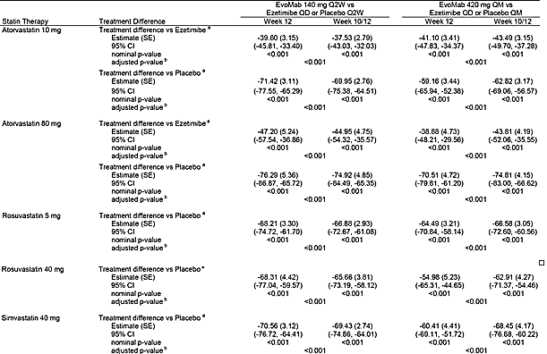
a = Treatment differences are within each dose frequency group using placebo in the same group as the reference. b = Adjusted p-value is based on a combination of sequential testing, the Hochberg procedure, and the fallback procedure to control the overall significance level for all primary and secondary endpoints. Each individual adjusted p-value is compared to 0.05 to determine statistical significance.
The primary analysis used a reflexive approach to calculate the LDL-C (described above). Approximately 40% to 60% of the LDL-C measurements in the overall evolocumab group were provided by UC LDL-C in the atorvastatin 10 mg, rosuvastatin 5 mg, and simvastatin 40 mg cohorts, and approximately 70% were provided by UC LDL-C in the atorvastatin 80 mg and rosuvastatin 40 mg cohorts. The majority (≥ 90%) of these UC LDL-Cs were provided because the calculated LDL-C was < 1.0 mmol/L. The comparison of the co-primary endpoint analyses using reflexive and calculated LDL-C concentrations in the FAS were provided.
Results of sensitivity analyses of the co-primary endpoints for percent change from baseline in reflexive LDL-C, including the completer and the nonparametric analyses were consistent with and similar in magnitude to the primary efficacy analysis.
Evolocumab Q2W and QM were effective in all subgroups relative to placebo and ezetimibe, with no notable differences observed between subgroups. The subgroups tested were: age (< 65 and ≥ 65 years); sex; race; geographical region; baseline LDL-C level < median, ≥ median; BMI; glucose tolerance status (Type 2 diabetes mellitus , metabolic syndrome, neither Type 2 diabetes mellitus nor metabolic syndrome); hypertension (yes, no); current smoker (yes, no); baseline CHD risk factors ≥ 2 (yes, no); family history of premature coronary heart disease: yes, no; PCSK9 level < baseline median, ≥ baseline median; triglycerides; and NCEP high risk (yes, no). Analyses that adjusted for each of the covariates in the primary analysis model showed results that were consistent with the primary analysis.
The results of the combined statin analysis of the co-primary endpoints showed that fixed effect treatment differences for percent change in reflexive LDL-C for the comparison between evolocumab Q2W versus placebo was -70.79% (95% CI: -74.13%, -67.44%) at Week 12 and -69.22% (95% CI: -72.19%, -66.25%) for the mean of Weeks 10 and 12, with the corresponding results for evolocumab QM versus placebo being -62.18% (95% CI: -65.93%, -58.43%) and -67.33% (95%CI: -70.88%, -63.98%), with p < 0.001 for each of the four comparisons.
Comment: Both co-primary endpoints demonstrated statistically significant treatment differences in favour of evolocumab (140 mg Q2W and 420 mg QM) compared to placebo (adjusted for multiplicity p<0.001) in each statin cohort, and compared to ezetimibe (adjusted for multiplicity p < 0.001) in the atorvastatin cohort. In addition, the combined statin analyses of the co-primary endpoints showed that both doses of evolocumab produced statistically significantly greater reductions in LDL-C from baseline compared to placebo.

Results for the co-secondary endpoints
Treatment with evolocumab 140 mg Q2W and 420 mg QM in combination with statins resulted in statistically significant changes (p<0.001, multiplicity adjusted) compared to placebo for all statin cohorts and compared to ezetimibe for the atorvastatin cohorts for all Tier 1 co-secondary efficacy endpoints, and most Tier 2 co-secondary efficacy endpoints. The results for most co-secondary efficacy endpoints in the combined statin cohort statistically significantly favoured both doses of evolocumab compared to placebo.

Phase III Study 20110114 (MENDEL-2)

Study design, objectives, locations and dates

Design
This Phase III, multinational, multicentre, double-blind, randomised, double-dummy, placebo- and ezetimibe-controlled, parallel-group study was designed to evaluate the efficacy, safety, tolerability and pharmacokinetics of evolocumab administered subcutaneously (SC) as monotherapy every 2 weeks (140 mg Q2W) or once monthly (420 mg QM) for 12 weeks in subjects with hyperlipidaemia with a 10 year Framingham Risk Score for CHD of 10% or less. The study was conducted at 71 centres in the United States of America, Denmark, Belgium, Australia, Canada, France, South Korea, Taiwan, and Turkey. The first subject was enrolled on 21 January 2013 and the last subject completed follow-up on 29 October 2013. The CSR was dated 18 March 2014. The study was conducted in accordance with ICH GCP regulations and guidelines. The study was sponsored by Amgen. The study is also known by the name MENDEL-2 = Monoclonal antibody against PCSK9 to reduce Elevated LDL-C in subjects currently Not receiving Drug therapy for Easing Lipid levels.

Objectives
The primary objective was to evaluate the effect of 12 weeks of evolocumab SC monotherapy Q2W and QM, compared to placebo and ezetimibe, on percent change from baseline in LDL-C in subjects with a 10 year Framingham risk score of 10% or less.
The secondary objectives were: (a) to evaluate the safety and tolerability of evolocumab SC monotherapy Q2W and QM, compared with placebo and ezetimibe, in subjects with a 10 year Framingham risk score of 10% or less; (b) to assess the effects of 12 weeks of evolocumab SC monotherapy Q2W and QM, compared to placebo and ezetimibe, on change from baseline in LDL-C, and percent change from baseline in non-HDL-C, ApoB, total cholesterol/HDL-C ratio, ApoB/ApoA1 ratio, Lp(a), triglycerides, VLDL-C, and HDL-C in subjects with a 10 year Framingham risk score of 10% or less; and (c) to assess the effects of 12 weeks evolocumab SC monotherapy Q2W and QM, compared to placebo and ezetimibe, on percent of subjects attaining LDL-C < 1.8 mmol/L in subjects with a 10 year Framingham risk score of 10% or less
Comment: In addition to the primary and secondary objectives referred to above, the study included a number of tertiary and exploratory endpoints. However, in the evaluation of the efficacy data in this CER the focus is on the primary and secondary objectives supported by the pre-specified primary and secondary efficacy endpoints.

Methods
Prior to randomisation, subjects entered a 6 week screening period to determine eligibility. During screening, SC administration of placebo was performed to confirm tolerability of SC administration prior to randomisation. All subjects received placebo SC (3.0 mL) corresponding to the QM dose volume using 3 consecutively administered AI/pens. During the screening period, the subject (or designee) was trained by study site staff to prepare and administer the IP.
Subjects who completed the screening period and met final eligibility criteria were randomised 2:2:1:1:1:1 into 6 treatment groups (see Figure 19, below). Randomisation was stratified on the basis of screening LDL-C concentration (< 3.4 mmol/L] or ≥ 3.4 mmol/L]). Subjects received their first dose of IP (SC and PO) on day 1 and returned to the study centre at Weeks 2, 8, 10, and 12 for assessment. Blood samples for determination of evolocumab and PCSK9 serum concentrations were collected on day 1 and at Weeks 2, 10, and 12. The subject (or trained designee) or qualified site staff administered SC IP by AI/pen in a clinic setting on day 1 and at Weeks 2 (Q2W), 8 (Q2W or QM), and 10 (Q2W). The subject (or trained designee) administered SC IP by AI/pen in non-clinic setting (that is, home-use) at Weeks 4 (Q2W or QM) and 6 (Q2W). Each Q2W dose of evolocumab was administered using a single AI/pen that delivered a 140 mg/mL, and each QM dose was administered by 3 AI/pens for a total evolocumab dose of 420 mg. All doses of oral IP were self-administered. The end of study (EOS) occurred at the study centre at Week 12 for subjects randomised to the QM IP schedule, and by phone call at Week 14 for subjects randomised to the Q2W IP schedule. The study design and treatment scheme is presented schematically below in Figure 19.
Figure 19: Study 20110114 - Study deign and with randomised treatment groups.
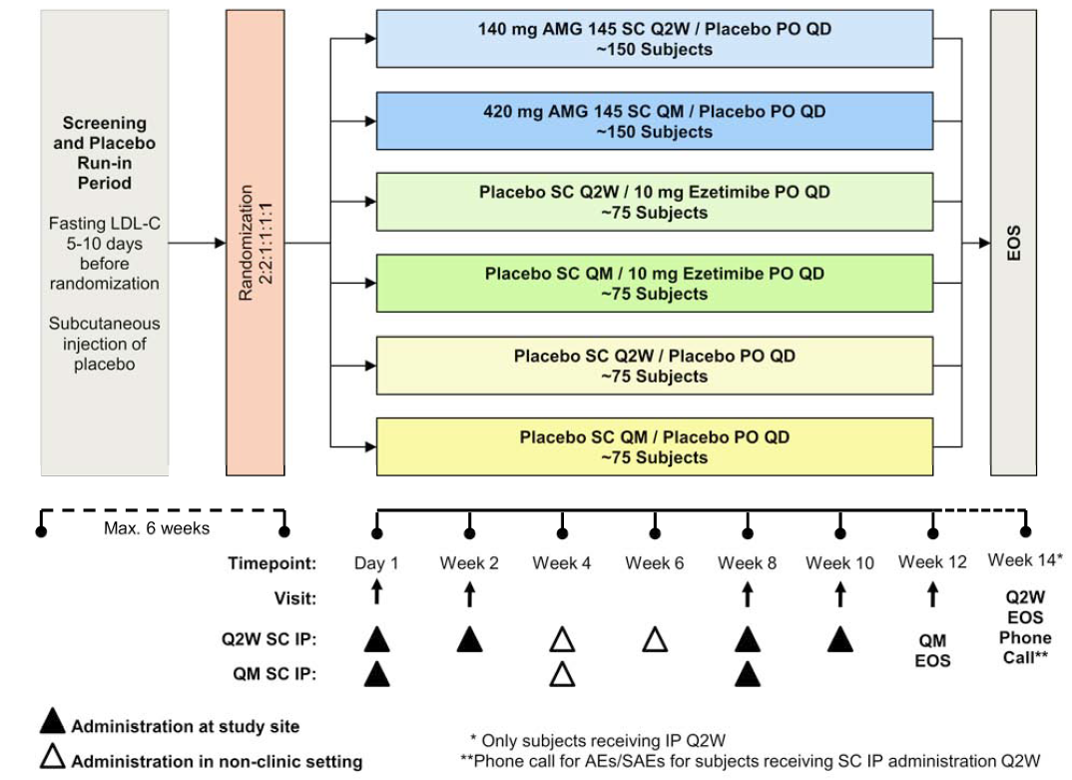

Inclusion and exclusion criteria
Eligible subjects included men and women aged ≥ 18 to ≤ 80 years with fasting LDL-C ≥ 2.6 mmol/L and < 4.9 mmol/L and fasting triglycerides ≤ 4.5 mmol/L at screening. To ethically allow for a placebo-controlled evolocumab monotherapy design, subjects were required to have NCEP ATP III Framingham risk score of ≤ 10% (that is, ≤ 10% risk of CHD in the next 10 years). Subjects were excluded from participation if they had used a lipid-regulating drug in the last 3 months prior to LDL-C screening. Subjects were also excluded if they had a history or evidence of clinically significant diseases and conditions that would pose a risk to their safety or interfere with assessment. The inclusion and exclusion criteria are considered to be satisfactory.

Study treatments

Investigational Products (IPs)
Evolocumab SC (AI/pen 140 mg/mL, delivering 1 mL), placebo SC (identical presentation to evolocumab SC), ezetimibe PO (over encapsulated 10 mg tablets), and placebo PO (identical presentation to ezetimibe PO) were the IPs in this study. The SC IPs were evolocumab 140 mg evolocumab Q2W or placebo in 1.0 mL (1 injection by prefilled AI/pen), and evolocumab 420 mg QM or placebo in 3.0 mL (3 injections by prefilled AI/pen). The 3 injections for the QM administration could be administered into different injection sites, but were to be administered in a consecutive fashion within 30 minutes. After IP administration at the first dosing visit, subjects were required to remain at the study centre for observation for at least 30 minutes before being discharged. The visit window was ± 3 days for each scheduled visit after day 1. QM doses were not administered within < 7 days of a previous dose. If two Q2W doses were administered within < 7 days of each other, any subsequent dose was administered ≥ 7 days after the most recent dose.
Dose adjustments were not permitted. If, in the opinion of the investigator, a subject was unable to tolerate a specific dose of IP, that subject discontinued IP but continued to return for all other study procedures and measurements until the end of the study. Due to the well-known side effect profile of statins, special attention was made to detect possible drug-induced myopathy or drug-induced liver injury, and procedures to be followed were the same as those previously described for Study 20110115. The procedures to be followed in the case of elevated triglyceride levels were that same as those described for Study 20110115.

Prior and concomitant therapy
Throughout the study, investigators could prescribe any concomitant medications or treatments deemed necessary to provide adequate supportive care, except for those specified in the protocol.

Concomitant diet and exercise.
Subjects were required to maintain their current regimen of diet and exercise, and to refrain from unaccustomed intensive exercise (eg, heavy lifting or long runs) 48 hours prior to each visit.

Compliance with IPs
Compliance was assessed in the same manner as described above for Study 20110115.

Removal from therapy or assessment
The criteria for removal from therapy or assessment were consistent with those described above for Study 20110115.

Efficacy variables and outcomes

Endpoints
The co-primary endpoints were identical to those described previously for Study 20110115. The co-secondary endpoints were the same as those for Study 20110115, apart from percent of subjects with LDL-C < 1.8 mmol/L being a Tier 1 endpoint in Study 20110114 rather than a Tier 2 endpoint as in Study 20110115. The tertiary and exploratory endpoints were identical to those described previously for Study 20110115.

Descriptions of key endpoint assessments
The lipid parameters were determined using the same methods as those described for Study 20110115.

Randomisation and blinding methods
Eligible subjects were assigned to 1 of the 6 treatment groups on the basis of a computer-generated randomisation schedule. Randomisation was stratified on the basis of screening LDL-C serum concentration (< 3.4 mmol/L versus ≥ 3.4 mmol/L. A site representative used an IVRS to assign a randomisation number and group to the subject. A subject was considered randomised into the study after successfully completing the screening period, meeting all inclusion/exclusion criteria including meeting final laboratory safety criteria, and undergoing randomisation procedures by IVRS. The blinding procedures used in this study were consistent with those previously described for Study 20110115. No subject in Study 20110114 was unblinded during the study.

Analysis populations
The populations for the analysis of efficacy were the full analysis set (FAS) and the completer analysis set (CAS). These sets were identical to those described previously for Study 20110115.

Sample size
The planned total sample size was 600 subjects (150 evolocumab Q2W, 150 evolocumab QM, 75 placebo Q2W, 75 placebo QM, 75 ezetimibe 10 mg QD [Q2W group], and 75 ezetimibe 10 mg QD [QM] group). The primary analysis required the tests of each co-primary endpoint to be significant at an alpha of 0.025. The sample size provided adequate power to determine the superiority of evolocumab (either 140 mg Q2W or 420 mg QM) relative to ezetimibe and placebo as measured by the co-primary endpoints.
From the global Phase II studies in the evolocumab program, treatment effects measured as the mean of Weeks 10 and 12 were as large or larger than Week 12 and highly correlated (> 85%) with those at Week 12. The power calculation was derived assuming a true treatment effect of evolocumab (140 mg Q2W or 420 mg QM) over ezetimibe and placebo in percent reduction of LDL-C of at least 20% at Week 12, with a common standard deviation (SD) of 20%. This SD assumption was based on literature review (FDA statistical reviews of ezetimibe and pitavastatin) and was consistent with the Phase II results. The overall family-wise error rate of 0.05 was allocated evenly for the comparisons of evolocumab against each control arm (placebo or ezetimibe) within each dose frequency (Q2W or QM). It was anticipated that the treatment effect would be attenuated due to the following assumptions: (a) approximately 15% of randomised subjects would end IP early but would remain on study. It was assumed there would be no treatment effect difference between the evolocumab and ezetimibe or placebo subjects after they ended IP early; and (b) approximately 5% of subjects within the evolocumab and placebo treatment groups would end the study early. It was assumed that the treatment effect of evolocumab over ezetimibe or placebo would be a LDL-C reduction of approximately 10%.
After accounting for treatment attenuation and assuming 2% of randomised subjects would not receive any IP, the sample size provided approximately 99% power in testing the superiority of each evolocumab dosing regimen over ezetimibe at Week 12. The sample size calculation was performed using a two-sided t-test with a 0.025 significance level for each test, an attenuated treatment effect of 16.5% reduction in LDL-C and an attenuated common SD of 23%. Therefore, the sample size as planned provided at least 98% (99% x 99%) power in testing the superiority of each evolocumab dosing regimen over ezetimibe on the co-primary endpoints.
Assuming a true treatment effect of evolocumab (Q2W or QM) over placebo in the percent reduction of LDL-C of 40% at Week 12, with a common SD of 20%, the sample size provided approximately 98% (99% x 99%) power for testing evolocumab over placebo on the co-primary endpoints. The sample size calculation was performed using a two-sided t-test with a 0.025 significance level, attenuated treatment effect of 33% reduction in LDL-C and an attenuated common SD of 29%.
There was at least 92% power (98% x 98% x 98% x 98%) to show the superiority of both evolocumab dosing regimens over placebo and ezetimibe for the co-primary endpoints.

Statistical methods

Statistical hypothesis
Primary statistical hypotheses (Q2W and QM): The null hypothesis was that there was no mean difference in the mean percent change from baseline at Weeks 10 and 12 or in the percent change from baseline at Week 12 in LDL-C between evolocumab and placebo, and the alternative hypothesis was that a mean difference did exist. Secondary statistical hypotheses (Q2W and QM): The null hypothesis was that there was no mean difference in the mean percent change from baseline at Weeks 10 and 12 or in the percent change from baseline at Week 12 in LDL-C between evolocumab and ezetimibe, and the alternative hypothesis was that a mean difference did exist.

General approach/considerations and adjustments for multiplicity
All efficacy and safety analyses were performed on the FAS, unless otherwise specified. Analyses were performed separately within each dose frequency (Q2W and QM), unless otherwise specified. The superiority of evolocumab to placebo and ezetimibe was assessed for all efficacy endpoints. Each independent dose frequency (Q2W and QM) was allocated a significance level of 0.05 as they made use of independent samples for statistical tests. To preserve the family-wise error rate at 0.05 within a dose frequency, each comparison against a control arm (placebo SC and ezetimibe) was allocated a significance level of 0.025. The methods of adjusting for multiplicity due to multiple endpoints (co-primary and co-secondary endpoints) within each dose frequency and against each control arm are shown below in Figure 20.
Figure 20: 20110114 - Methods for adjusting for multiplicity.
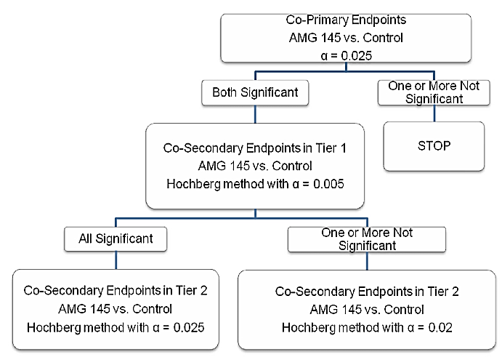
For each control (either placebo or ezetimibe) within each dosing frequency, testing of each co-endpoint pair resulted in a single p-value, and for co-secondary endpoints these p-values were used in the Hochberg procedure to adjust for multiplicity. The following method was used to preserve the family-wise error rate at 0.05 for testing the co-primary and co-secondary efficacy endpoints within each dose frequency:
- If the treatment effect from the primary analysis of the co-primary endpoints were both significant at a significance level of 0.025, statistical testing of the Tier 1 co-secondary efficacy endpoints followed the Hochberg procedure at a significance level of 0.005.
- If all Tier 1 co-secondary efficacy endpoints were significant, the Tier 2 co-secondary efficacy endpoints were tested using the Hochberg procedure at a significance level of 0.025.
- If not all Tier 1 co-secondary efficacy endpoints were significant, the Tier 2 co-secondary efficacy endpoints were tested using the Hochberg procedure at a significance level of 0.02.
Unless otherwise specified, all other hypothesis testing was 2-sided with a significance level of 0.05.

Analyses of the co-primary endpoint
Primary analysis: To assess the co-primary endpoints, a repeated measures linear effects model was used within each dose frequency (that is, Q2W or QM) to compare the efficacy of evolocumab with placebo and ezetimibe. The repeated measures model included terms for treatment group, stratification factor, scheduled visit and the interaction of treatment with scheduled visit. Missing values were not imputed when the repeated measures linear effects model was used. For all analyses related to LDL-C, unless specified otherwise, a reflexive approach was used (as described for Study 20110115). Multiplicity adjustment procedures have been described.
Sensitivity analyses were undertaken using the methods described previously for Study 20110511. Subgroup analyses on the co-primary endpoints were conducted using the stratification factor and baseline covariates.

Analyses of co-secondary endpoints
The statistical model and testing of the Tier 1 co-secondary endpoints were similar to the primary analysis of the co-primary endpoints. Response defined by LDL-C < 1.8 mmol/L was analysed using the CMH test adjusted by the stratification factor. Analyses of the Tier 2 co-secondary endpoints used the same analysis model as the Tier 1 endpoints, and testing used a union-intersection test. Due to outliers in the Tier 2 secondary endpoints (Lp(a), triglycerides, VLDL-C, and HDL-C), nonparametric analysis of these endpoints was conducted in which median difference and 95% CI were obtained from the McKean-Schrader algorithm and p-values were obtained from Quade test adjusting for baseline. Multiplicity procedures have been described above.

Changes in statistical method
The original SAP (dated 29 January 2013) was amended once. Amendment 1 (dated 25 October 2013) was approved prior to study un-blinding on 10 December 2013. Changes in Amendment 1 reflected Amgen study team decisions made during study conduct, added clarifications to facilitate programming, and made editorial corrections to the previous version of the SAP. These changes were unlikely to have affected the study analysis.

Participant flow
Overall, 615 subjects were randomised to 1 of the 6 treatment groups. A total of 614 (99.8%) subjects received IP (SC and PO), while 1 (1.3%) subject in the placebo Q2W group did not receive either SC IP or PO IP. A total of 581 (94.5%) subjects completed SC IP, 576 (93.7%) subjects completed PO IP, and 573 (93.2%) subjects completed both SC IP and PO IP. Rates of IP completion and reasons for IP discontinuation were comparable across the 6 treatment groups. A total of 598 (97.2%) subjects completed the study, and 17 (2.8%) subjects discontinued the study early, including 8 (1.3%) due to sponsor decision (all of these subjects completed IP and entered an open-label extension study before they completed the EOS phone call at Week 14]), 6 (1.0%) who were lost to follow-up, and 3 (0.5%) who withdrew consent. Study completion rates were comparable across treatment groups. Subject disposition (all randomised subjects) was summarised.
The FAS population included the 614 (99.8%) subjects who received IP. The CAS population included 489 (79.5%) subjects. A total of 113 (18.4%) subjects were excluded from the CAS population for missing data for the co-primary endpoint and 42 (6.8%) subjects were excluded because they did not complete all doses. The reasons for exclusion from the CAS population were comparable across treatment groups. Subjects excluded for missing data for the co-primary endpoint included 73 (11.9%) subjects who were missing data at Week 10 and 68 (11.1%) subjects who were missing data at Week 12. Of the 614 subjects who received at least 1 dose of IP, 181 (29.5%) had a screening LDL-C concentration of < 3.4 mmol/L and 433 (70.5%) had a screening LDL-C concentration of ≥ 3.4 mmol/L. Data-derived stratifications from the last non-missing LDL-C concentration before day 1 matched the randomisation stratifications in 604 (98.4%) subjects.

Major protocol violations/deviations
Overall, 31 (5.0%) subjects had important protocol deviations and the subject incidence of important protocol deviations was comparable across treatment groups. Of note, only 6 (1.0%) subjects in the total subject population had a Framingham risk score ≥ 10%. No other important protocol deviations were reported in ≥ 1% of the total number of subjects. The important protocol deviations were summarised. The observed differences in important protocol deviations across the 6 treatment group are unlikely to have invalidated the efficacy analyses.

Baseline data
Baseline characteristics were summarised for the FAS. The study population (n=614) consisted of 405 (66.0%) women and 209 (34.0%) men. The mean ± age of the study population at baseline was 53.1 ± 12.1 years (range: 20, 80 years) and most subjects were < 65 years of age (81.9%). Most subjects were White (83.1%), followed by Asian (9.4%) and Black or African American (6.5%). The mean ± SD height of the study population was 166.7 ± 9.9 cm (range: 124, 195 cm) and the mean ± SD BMI was 28.6 ± 6.0 kg/m² (range: 17, 64 kg/m²). Baseline demographics were comparable across treatment groups.
Baseline lipids parameters, hsCRP and PCSK9 were summarised. In the total study population, mean ± SD serum reflexive LDL-C concentration at baseline was 3.7 ± 0.6 mmol/L, and was comparable across treatment groups. Baseline concentrations were also comparable across treatment groups for Tier 1 secondary lipid parameters (total cholesterol, ApoB, ApoA1, non-HDL-C, total cholesterol/HDL-C ratio, and ApoB/ApoA1 ratio), for Tier 2 secondary lipid parameters (Lp(a), triglycerides, VLDL-C, and HDL-C), and for hsCRP and PCSK9.
Baseline coronary artery disease characteristics were comparable across the treatment groups. NCEP CHD risk categories at baseline were lower risk in 57.2% of subjects, moderate risk in 36.8%, moderately high risk in 4.9%, and high risk in 1.1%. The proportion of subjects in each risk category was comparable across treatment groups. At baseline, 2 (0.3%) subjects had coronary artery disease and 4 (0.7%) subjects had cerebrovascular or peripheral arterial disease. A total of 103 (16.8%) subjects had 2 or more cardiovascular risk factors. A total of 187 (30.5%) subjects had metabolic syndrome (3 or more factors) without diabetes mellitus at baseline.
Other pre-specified cardiovascular disease history characteristics were comparable across treatment groups. A history of atrial fibrillation/flutter was documented in 5 (0.8%) subjects at baseline, including 2 (0.3%) with a current history and 3 (0.5%) with a previous history. Left ventricular systolic dysfunction was reported in 7 (1.1%) subjects. No subject had a documented history at baseline of congestive heart failure, or cardiac devices or pacemakers.
The use of lipid regulating medications of interest at baseline were reported in 9 (1.5%) subjects; 1 (0.2%) reported use of nicotinic acid and 8 (1.3%) reported use of other lipid-regulating medications such as DHA omega-3, fish oil, or omega-3 fatty acids. No subjects reported the use of statins.

Results for the co-primary endpoints
The results of the co-primary endpoint analyses are summarised below in Table 18 (Week 12) and Table 19 (mean of Weeks 10 and 12). Both co-primary endpoints demonstrated statistically significant reductions in reflexive LDL-C for evolocumab 140 mg Q2W and 420 mg QM compared to placebo and ezetimibe (p < 0.001, multiplicity adjusted).

Table 18: Primary analysis of co-primary endpoint (Week 12) change from baseline in reflexive LDL-C; FAS. 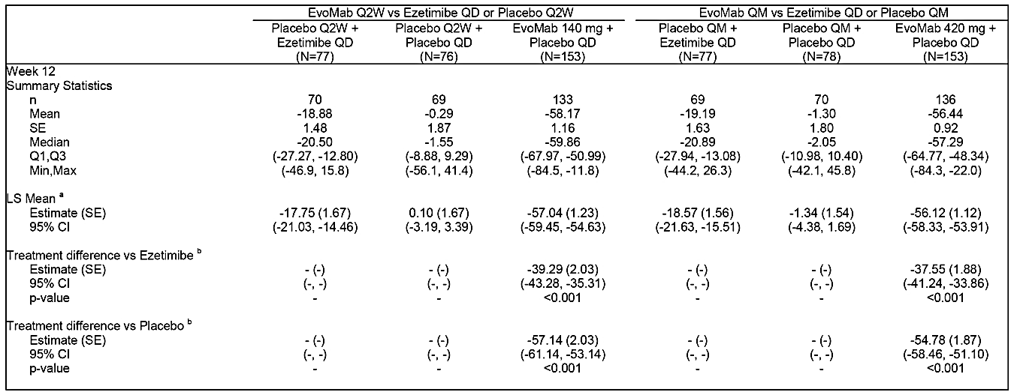
a = Least squares mean is from the repeated measures model which includes treatment group, stratification factor (from IVRS), scheduled visit and the interaction of treatment with scheduled visit as covariates. b = Treatment differences are within each dose frequency group using subcutaneous placebo + oral placebo or subcutaneous placebo + ezetimibe as the reference. c = the maximum p-value for the co-endpoints. d = Adjusted p-value is based on a combination of sequential testing, the Hochberg procedure, the fallback procedure to control the overall significance level for all primary and secondary endpoints. Each individual adjusted p-value is compared to 0.05 to determine statistical significance

Table 19: Primary analysis of co-primary endpoint (mean of Weeks 10 and 12) change from baseline in reflexive LDL-C; FAS. 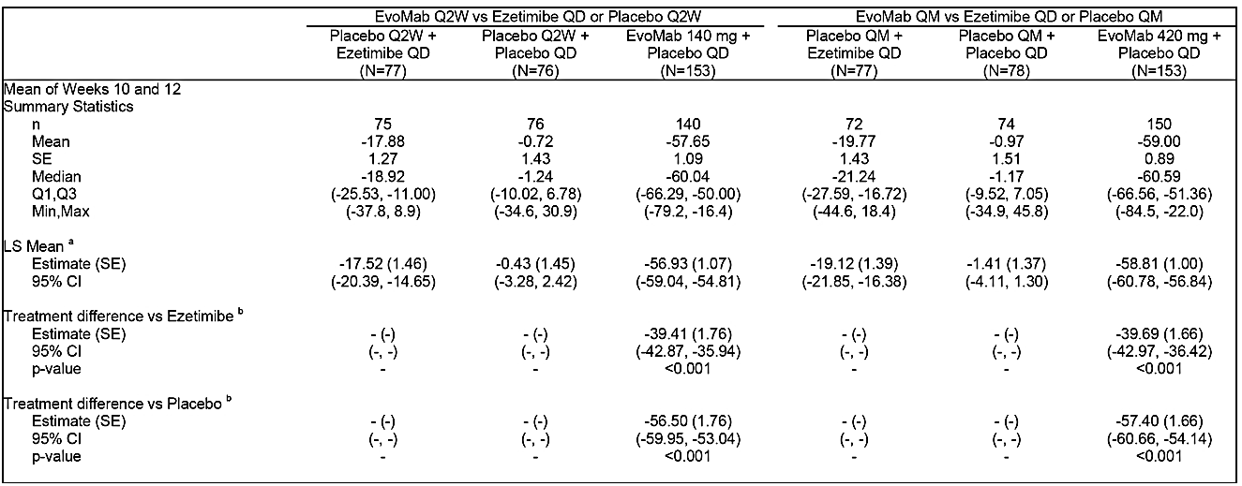
Notes: As for table immediately above.
Mean percent change from baseline in reflexive LDL-C by scheduled visit and treatment group was summarised. At the scheduled post-baseline assessments at Weeks 2, 8, 10, and 12, mean reduction from baseline in reflexive LDL-C ranged from 51% to 61% for evolocumab (140 mg Q2W or 420 mg QM), compared to ≤ 20% for ezetimibe and ≤ 2% for placebo.
The primary efficacy analysis used a reflexive approach to assessment of LDL-C, and of the 614 baseline reflexive LDL-C concentrations, 9 (1.5%) were based on UC LDL-C triggered by elevated triglycerides or other reasons with none being triggered by low LDL-C. Of 1126 post-baseline reflexive LDL-C concentrations in the evolocumab groups, 211 (18.7%) were based on UC LDL-C concentrations, including 197 (17.5%) triggered by calculated LDL-C < 1.0 mmol/L, 8 (0.7%) triggered by triglycerides > 4.5 mmol/L, and 6 (0.5%) for other reasons. Of 1148 post-baseline reflexive LDL-C concentrations in the control groups (placebo or ezetimibe), 16 (0.7%) were based on UC LDL-C concentrations triggered by elevated triglycerides; no UC LDL-C concentration in the control groups was triggered by low LDL-C or other reasons. The comparison of the co-primary endpoints using reflexive or calculated LDL-C showed that results were similar for both methods (see Table 20, below).

Table 20: 20110114 - Treatment differences in the co-primary endpoints in percent change from baseline in LDL-C concentration using reflexive or calculated methods; FAS.
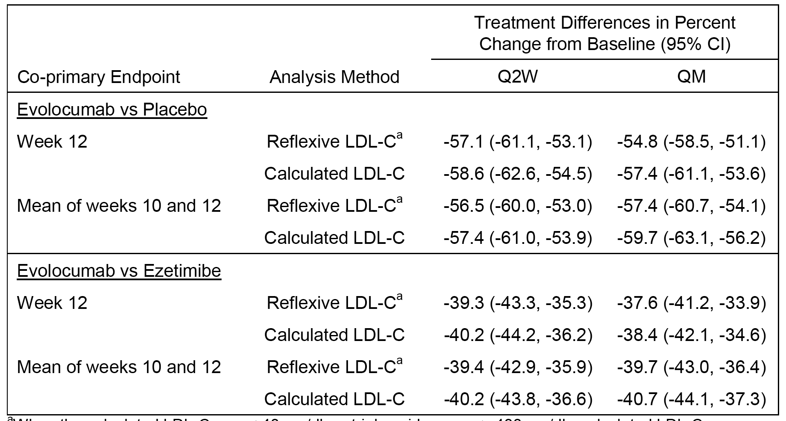
Results of sensitivity analyses of the co-primary endpoints for percent change from baseline in reflexive LDL-C, including the completer analysis and the nonparametric analysis, were consistent and similar in magnitude to the primary efficacy analysis.
Evolocumab 140 mg Q2W and 420 mg QM were effective in all subgroups relative to placebo and ezetimibe, with no notable differences between subgroups based on changes from baseline in reflexive LDL-C concentrations. The subgroups included: screening LDL-C (< 3.4, ≥ 3.4 mmol/L); baseline median LDL-C (< 3.7, ≥ 3.7 mmol/L); age (< 65, ≥ 65 years); sex; race (White, Black, other); BMI (< 25, 25 - < 30, ≥ 30 kg/m²); hypertension (yes, no); current smoker (yes, no). Analyses that adjusted for each of the covariates in the primary analysis model showed results that were consistent with the primary analysis. The covariates included: screening LDL-C (< 3.4, ≥ 3.4 mmol/L); age; sex; race; region; baseline LDL-C; baseline BMI; hypertension; current smoker; glucose tolerance status; baseline CHD factor ≥ 2; family history of CHD; baseline PCKS9 concentration; and baseline triglycerides.
Comment: Both co-primary endpoints demonstrated statistically significant reductions in reflexive LDL-C for evolocumab 140 mg Q2W and 420 mg QM compared to placebo and ezetimibe (p < 0.001, adjusted for multiplicity). The differences between evolocumab 140 mg Q2W and 420 mg QM and both placebo and ezetimibe were observed at the first post-baseline assessment at Week 2 and were maintained through week 12.

Results for the co-primary secondary endpoints
Treatment with evolocumab Q2W and QM resulted in significant changes compared to placebo and ezetimibe (p < 0.001, multiplicity adjusted) for all Tier 1 co-secondary endpoints. Results for the non-parametric analysis of the Tier 2 co-primary endpoints showed that evolocumab improved each of the endpoints compared to placebo and ezetimibe. The treatment differences were statistically significant (multiplicity p < 0.05, multiplicity adjusted) for all comparisons for Lp(a) and HDL-C, for some comparisons for triglycerides (evolocumab Q2W versus placebo Q2W; evolocumab QM versus placebo QM and ezetimibe [QM]) and for some comparisons for VLDL-C (evolocumab QM versus placebo QM and ezetimibe [QM].

Phase III Study 20110116 (GAUSS-2)

Study design, objectives, locations and dates

Design
This was a Phase III, multinational, multicentre, randomised, double-blind, double-dummy, ezetimibe-controlled, parallel-group study designed to evaluate the efficacy and safety of evolocumab in statin intolerant subjects with hypercholesterolaemia.
Statin intolerant subjects were defined as those who had tried at least 2 statins and were unable to tolerate any dose, or an increase in statin dose above a total weekly maximum specified in the protocol, due to intolerable myopathy (that is, atorvastatin 70 mg, simvastatin 140 mg, pravastatin 140 mg, rosuvastatin 35 mg, lovastatin 140 mg, or fluvastatin 280 mg or 7 times the smallest tablet size for any other statins resulting in myalgia [muscle pain, ache, or weakness without CK elevation], myositis [muscle symptoms with increased CK levels], or rhabdomyolysis [muscle symptoms with marked CK elevation]).
The study was conducted at 51 centres in the United States, Australia, Netherlands, Denmark, Spain, Germany, United Kingdom, Belgium, France, Canada, Switzerland, Hong Kong, and Poland. The first subject was enrolled on 23 January 2013, and the last subject completed follow-up on 19 November 2013. The CSR was dated 6 April 2014. The study was conducted in accordance with ICH GCP regulations/guidelines. The study was sponsored by Amgen. The study is also known by the name GAUSS-2 = Goal Achievement after Utilizing an anti-PCSK9 antibody in Statin Intolerant Subjects.

Objectives
The primary objective was to evaluate the effect of 12 weeks of SC evolocumab every 2 weeks (Q2W) and monthly (QM), compared to ezetimibe, on percent change from baseline in low-density lipoprotein cholesterol (LDL-C) in subjects with hypercholesterolaemia unable to tolerate an effective dose of a statin.
The secondary objectives were: (a) to evaluate the safety and tolerability of evolocumab SC Q2W and QM, compared to ezetimibe, in subjects with hypercholesterolaemia unable to tolerate an effective dose of a statin; (b) to evaluate the effect of 12 weeks of evolocumab SC Q2W and QM compared to ezetimibe, on percent change from baseline in LDL-C in subjects with hypercholesterolaemia unable to tolerate an effective dose of a statin and not receiving any lipid-regulating medications at study entry; (c) to assess the effects of 12 weeks of evolocumab SC Q2W and QM, compared to ezetimibe, on change from baseline in LDL-C, and percent change from baseline in non-high-density lipoprotein cholesterol (non-HDL-C), apolipoprotein B (ApoB), total cholesterol/HDL-C ratio, ApoB/Apolipoprotein A1 (ApoA1) ratio, lipoprotein(a) [Lp(a)], triglycerides, very low-density lipoprotein cholesterol (VLDL-C), and HDL-C in subjects with hypercholesterolaemia unable to tolerate an effective dose of a statin and in subjects unable to tolerate an effective dose of a statin and not receiving any lipid-regulating medications at study entry; and (d) to assess the effects of 12 weeks treatment with evolocumab SC Q2W and QM, compared to ezetimibe on percent of subjects who are unable to tolerate an effective dose of a statin attaining LDL-C < 1.8 mmol/L.
Comment: It is noted that the objectives refer to subjects with hypercholesterolaemia rather than primary hyperlipidaemia. In addition to the primary and secondary objectives the study included a number of tertiary and exploratory endpoints. However, in the evaluation of the efficacy data in this CER the focus is on the primary and secondary objectives supported by the pre-specified primary and secondary efficacy endpoints.

Methods
Prior to randomisation, all subjects entered a 6-week screening period to determine eligibility. During screening, placebo was administered to confirm tolerability of SC administration prior to randomisation. All subjects received placebo SC corresponding to the QM dose volume (3.0 mL) using 3 consecutively administered AI/pens. During the screening period, the subject (or designee) was trained by study site staff to prepare and administer the IP.
Subjects who completed the screening period and met final eligibility criteria were randomised 2:2:1:1 into 4 treatment groups (see Figure 21, below). Randomisation was stratified by screening LDL-C level (<4.7 versus ≥ 4.7 mmol/) and by baseline statin use (yes versus no). Subjects received their first dose of SC IP and oral IP on day 1 and returned to the study centre at Weeks 2, 8, 10, and 12 for assessments, including blood samples for the determination of lipid parameters. Blood samples for determination of evolocumab and PCSK9 concentration were collected at day 1 and at Weeks 2, 10, and 12.
The subject (or trained designee) or qualified site staff administered SC IP via AI/pen in a clinic setting at the study visits on Day 1 and at Weeks 2 (Q2W), 8 (Q2W or QM), and 10 (Q2W). The subject (or trained designee) administered SC IP by AI/pen in a non-clinic setting (that is, home-use) at Weeks 4 (Q2W or QM) and 6 (Q2W). Each Q2W dose of evolocumab was administered using a single AI/pen that delivered a 140 mg dose, and each QM dose was administered via 3 AI/pens for a total evolocumab dose of 420 mg. All doses of oral IP were self-administered. The end of study (EOS) occurred at the study centre at Week 12 for subjects randomised to the QM IP schedule and by phone call at Week 14 for subjects randomised to the Q2W IP schedule. The study design and treatment scheme is summarised below in Figure 21.
Figure 21: 20110116 - Study design and randomised treatment groups.

Inclusion and exclusion criteria
Men and women ≥ 18 to ≤ 80 years of age were eligible for this study. Subjects must have tried at least 2 statins and have been unable to tolerate any dose or an increase in statin dose above the total weekly maximum doses specified in the protocol due to intolerable myopathy. Statin symptoms must have resolved when the statin was discontinued or the dose reduced. Depending on the risk category (based on NCEP ATP III treatment goals), the following fasting LDL-C criteria must have been met at screening:
- ≥ 2.6 mmol/L for subjects with CHD or CHD risk equivalent;
- ≥ 3.4 mmol/L for subjects without diagnosed CHD or risk equivalent and 2 or more risk factors;
- ≥ 4.1 mmol/L) for subjects without diagnosed CHD or risk equivalent and with 1 risk factor; or
- ≥ 4.9 mmol/L for subjects without diagnosed CHD or risk equivalent and with no risk factors.
Fasting triglycerides must have been ≤ 4.5 mmol/L at screening. Subjects were excluded if they had a history or evidence of clinically significant diseases and conditions that would pose a risk to their safety or interfere with the study evaluation, procedures, or completion. The inclusion and exclusion criteria are considered to be satisfactory.

Study treatments

Investigational Products (IPs)
Evolocumab SC (AI/pen 140 mg/mL delivering 1 mL), placebo SC (identical presentation to placebo), ezetimibe PO (over encapsulated 10 mg tablets), and placebo PO (identical presentation to ezetimibe PO) were IPs in this study. Administration of the IPs was consistent with that previously described for Study 20110114.

Prior and concomitant therapy
Throughout the study, investigators could prescribe any concomitant medications or treatments deemed necessary to provide adequate supportive care except for those listed in the protocol (consistent with those listed for Study 20110114).

Concomitant diet and exercise
Subjects were required to maintain their current regimen of diet and exercise and to refrain from unaccustomed intensive exercise (eg, heavy lifting or long runs) 48 hours prior to each visit.

Compliance with IPs
Compliance was assessed in the same manner as previously described for Study 20110115.

Removal from therapy or assessment
The criteria for removal from therapy or assessment were consistent with those previously described for Study 20110115.

Efficacy variables and outcomes

Endpoints
The co-primary efficacy endpoints were identical to those in Studies 20110115 and 20110114. The co-secondary efficacy endpoints were identical to those in Study 20110114. The tertiary and exploratory endpoints were consistent with those in Studies 20110115 and 20110114.

Analysis of lipid parameters
The lipid parameters were determined using the same methods as those described in Studies 20110115 and 20110114.

Randomisation and blinding methods
Eligible subjects were assigned to 1 of 4 treatment groups on the basis of a computer-generated randomisation schedule prepared by Amgen before the start of the study. Randomisation was stratified by screening LDL-C level (<4.7 versus ≥ 4.7 mmol/L) and by baseline statin use (yes versus no). A site representative used an IVRS to assign a randomisation number and group to the subject. A subject was considered randomised into the study after successfully completing the screening period, meeting all inclusion/exclusion criteria including meeting final laboratory safety criteria, and undergoing randomisation procedures via IVRS. The blinding procedures were consistent with those previously described for Study 20110115. No subject in Study 20110116 was unblinded to IP assignment during the course of the study.

Analysis populations
The populations for analysis of efficacy were the full analysis set (FAS), the completer analysis set (CAS) and the monotherapy analysis set (MAS). The FAS and CAS were identical to those described previously for Study 20110115, while the MAS contained the FAS subjects who were not taking baseline lipid-regulating medications at study entry.

Sample size
The planned total sample size was 300 subjects (100 evolocumab 140 mg Q2W, 100 evolocumab 420 mg QM, 100 ezetimibe). The primary analysis required the tests of each co-primary endpoint to be significant at a level of 0.05. The sample size provided adequate power to determine the superiority of evolocumab (either 140 mg Q2W or 420 mg QM) relative to ezetimibe as measured by the co-primary endpoints. The sample size, as planned, provided at least 96% (98% x 98%) power in testing the superiority of each evolocumab dosing regimen over ezetimibe on the co-primary endpoints. Since the testing statistics from the Q2W and QM groups were independent, there was a 92% chance (96% x 96%) to show the superiority of both evolocumab dosing regimens over ezetimibe. The method used to determine the sample size was identical to that previously described for Study 20110114.

Statistical methods

Statistical hypothesis
Within each dose frequency, the null hypothesis was that there is no mean difference in the mean percent change from baseline at Weeks 10 and 12 or in the percent change from baseline at Week 12 in LDL-C between evolocumab and ezetimibe, and the alternative hypothesis is that a mean difference does exist. Unless otherwise specified all other hypothesis testing was 2-sided with a significance level of 0.05.

General approach
All efficacy and safety analyses were performed on the FAS, unless otherwise specified. Efficacy analyses were also performed on the MAS which contained the subjects in the FAS who did not take any baseline lipid-regulating medications at study entry. Analyses were performed separately within each dose frequency (Q2W and QM) unless otherwise specified. The superiority of evolocumab to ezetimibe was assessed for all efficacy endpoints.

Adjustment for multiplicity
Each independent dose frequency (Q2W and QM) was allocated a significance level of 0.05 as they made use of independent samples for statistical tests. Testing of each co-endpoint pair in each analysis set (FAS and MAS) resulted in a single p-value. For the co-secondary endpoints in the FAS and all co-endpoints in the MAS, these p-values were then used in the Hochberg procedure to adjust for multiplicity. In order to adjust for multiplicity, the following procedure was used to preserve the family-wise error rate at 0.05 for testing the co-primary and co-secondary efficacy endpoints within each dose frequency:
- If the treatment effect from the primary analysis of the co-primary endpoints in the FAS was significant at a significance level of 0.05, statistical testing of the Tier 1 co-secondary efficacy endpoints followed the Hochberg procedure at a significance level of 0.005. If one or more of the co-primary endpoints in the FAS was not significant, then no further testing was undertaken.
- If all Tier 1 co-secondary efficacy endpoints were significant in the FAS, the Tier 2 co-secondary efficacy endpoints in the FAS, co-primary and all co-secondary efficacy endpoints in the MAS were tested using the Hochberg procedure at a significance level of 0.05.
- If one or more Tier 1 co-secondary efficacy endpoints were significant in the FAS, the Tier 2 co- secondary efficacy endpoints in FAS, co-primary and all co-secondary efficacy endpoints in the MAS were tested using the Hochberg procedure at a significance level of 0.045.

Analyses of co-primary endpoints
The methods were consistent with those previously described for Study 20110114.

Analyses of co-secondary endpoints.
The methods were consistent with those previously described for Study 20110114.

Changes in statistical methods
The original SAP (version 1, dated 05 February 2013) was amended once (version 2, dated 27 September 2013), and both versions were approved prior to study un-blinding on 14 January 2014. Changes in version 2 reflected Amgen study team decisions made during study conduct, added clarifications to facilitate programming, and made editorial corrections to previous versions of the SAP. These changes were unlikely to have affected the study analysis.

Participant flow
Overall, 307 subjects were randomised to 1 of the 4 treatment groups. A total of 306 (99.7%) subjects received IP (SC and PO); 1 (1.0%) subject in the evolocumab QM group did not receive PO IP. A total of 293 (95.4%) subjects completed SC IP, 276 (89.9%) subjects completed PO IP, and 273 (88.9%) subjects completed both SC and PO IP. The rates of IP completion and reasons for IP discontinuation were similar across the treatment groups. A total of 290 (94.5%) subjects completed the study. Of the 17 (5.5%) subjects who did not complete the study, 13 (4.2%) completed IP and Week 12 visits but entered an open-label extension Study 20120138 before they completed the EOS phone call at Week 14 (category of ‘sponsor decision’), 3 (1.0%) withdrew consent, and 1 (0.3%) was lost to follow-up. Study completion rates were similar across treatment groups.
The FAS population for analyses of efficacy and safety endpoints included the 307 (100%) subjects who received investigational product. The CAS population included 247 (80.5%) subjects. A total of 37 (12.1%) subjects were excluded from the CAS for missing data for the co-primary endpoints and 34 (11.1%) subjects were excluded because they did not complete all doses. The reasons for exclusion from the CAS population were generally similar across treatment groups. Subjects excluded for missing data for the co-primary endpoint included 25 (8%) subjects who were missing data at Week 10, 19 (6%) subjects who were missing data at Week 12, and 7 subjects (2%) who were missing data at Week 10 and week 12.
The two stratification factors in this study were screening level LDL-C (< 4.7 mmol/L versus ≥ 4.7 mmol/L), and baseline statin use (yes, no). Of the 307 subjects in the total population, 156 (50.8%) had a screening LDL-C concentration of < 4.7 mmol/L and 151 (49.2%) had a screening LDL-C concentration of ≥ 4.7 mmol/L. Of the 307 subjects in the total 249 (81.1%) had no baseline statin use and 58 (18.9%) had baseline statin use. Randomisation stratification factors were similar between the IVRS stratification and data-derived stratification from the last non-missing LDL-C concentration before study Day 1.

Major protocol violations/deviations
Overall, 14 (4.6%) subjects had important protocol deviations and the subject incidence of important protocol deviations was similar across treatment groups. In the total group, the only important protocol deviation reported in ≥ 1.0% of subjects was ‘received expired or compromised IP’ (1.6%, n=5). The important protocol deviations are unlikely to have biased the efficacy analyses.

Baseline data
Baseline characteristics were summarised for the FAS. The study population (n=307) consisted of 166 (54.1%) men and 141 (45.9%) women. The mean ± SD age of the study population was 61.5 ± 9.8 years (range: 22, 80 years), with 180 (58.6%) subjects being aged < 65 years. The majority of subjects were White (93.5%), followed by Asian (3.3%) and Black or African American (2.3%). The mean ± SD height was 169.7 ± 9.6 cm (range: 142, 196 cm) and the mean ± BMI was 28.9 ± 4.9 kg/m² (range: 18, 54 kg/m²). The baseline characteristics were similar across the four treatment groups.
Statin intolerance to 2 or more statins was reported in all 307 (100%) subjects, with 45.0% being intolerant to 2 statins, 33.9% being intolerant to three statins and 21.2% being intolerant to 4 or more statins. Approximately 18% of subjects had a family history of muscular symptoms and approximately 16% of subjects had a family history of muscular symptoms with statins. Atorvastatin, simvastatin, and rosuvastatin were the most commonly reported statins associated with muscle intolerance, reported in 77%, 73%, and 71% of subjects, respectively. Of the 307 subjects, 306 (99.7%) reported muscle related symptoms of statin intolerance, with the most commonly reported worst muscle related side effect for any statin being myalgia (80.1% of subjects; muscle symptoms without CK elevation). The majority of subjects had no history of CK elevation (76.9%, n=236), while 15.6% (n=48) had a history of CK elevations > 1 x ULN to < 10 x ULN, and 1.9% (n=6) had a history of CK elevations ≥ 10 x ULN. Of the 307 subjects, 90 (29.3%) reported non-muscle related statin intolerance symptoms, with the most commonly reported symptoms (≥ 1% of subjects) being fatigue (7.8%), insomnia (5.5%), depression (4.6%), cognitive decline (2.6%), agitation (2.3%), confusion (2.3%), anxiety (1.6%), and somnolence (1.6%). The statin intolerance profile was similar for subjects in the ezetimibe group (n=102, overall) and the evolocumab group (n=205, overall).
Baseline lipid parameters, hsCRP and PCKS9 were summarised. In the total study population (n=307), the mean ± SD serum concentration of reflexive LDL-C at baseline was 5.00 ± 1.52 mmol/L, and was similar across treatment groups. Baseline concentrations were also similar across treatment groups for Tier 1 secondary lipid parameters (total cholesterol, ApoB, ApoA1, non-HDL-C, total cholesterol/HDL-C ratio, and ApoB/ApoA1 ratio), Tier 2 secondary lipid parameters (Lp(a), triglycerides, VLDL-C, and HDL-C), hsCRP and PCSK9.
Baseline coronary artery disease characteristics were similar across the treatment groups. NCEP CHD risk categories at baseline were lower risk in 11.7% of subjects, moderate risk in 17.3%, moderately high risk in 14.7%, and high risk in 56.4%; the risk categories were similar across treatment groups. At baseline, 90 (29.3%) subjects had coronary artery disease and 49 (16.0%) subjects had cerebrovascular or peripheral arterial disease. A total of 147 (47.9%) subjects had 2 or more cardiovascular risk factors. A total of 114 (37.1%) subjects had baseline metabolic syndrome (3 or more factors) without diabetes mellitus.
Other pre-specified cardiovascular disease history characteristics were similar across treatment groups. A history of atrial fibrillation/flutter was documented in 18 (5.9%) subjects overall at baseline, including 8 (2.6%) with a current history and 10 (3.3%) with a previous history. A total of 6 (2.0%) subjects had a history of congestive heart failure (4 subjects with NYHA class I and 2 subjects with NYHA class II). A total of 60 (19.5%) subjects had a documented history at baseline of left ventricular dysfunction (56 with normal systolic function, 1 subject with mild dysfunction, and 3 subjects with moderate dysfunction) and 2 (0.7%) subjects had cardiac devices (permanent pacemaker or resynchronization device).

Results for the co-primary endpoints
Results for the co-primary endpoints are summarised below in Table 21 and Table 22, respectively.

Table 21: 20110116 - Primary analysis of co-primary endpoint change from baseline in reflexive LDL-C (Week 12); FAS.
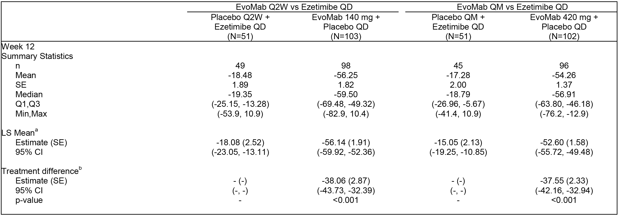
a = Least squares mean is from the repeated measures model which includes treatment group, stratification factor (from IVRS), scheduled visit and the interaction of treatment with scheduled visit as covariates. b = Treatment differences are within each dose frequency group using subcutaneous placebo + oral placebo or subcutaneous placebo + ezetimibe as the reference. c = the maximum p-value for the co-endpoints. d = Adjusted p-value is based on a combination of sequential testing, the Hochberg procedure, the fallback procedure to control the overall significance level for all primary and secondary endpoints. Each individual adjusted p-value is compared to 0.05 to determine statistical significance.

Table 22: 20110116 - Primary analysis of co-primary endpoint percent change from baseline in reflexive LDL-C (mean Weeks 10 and 12); FAS.
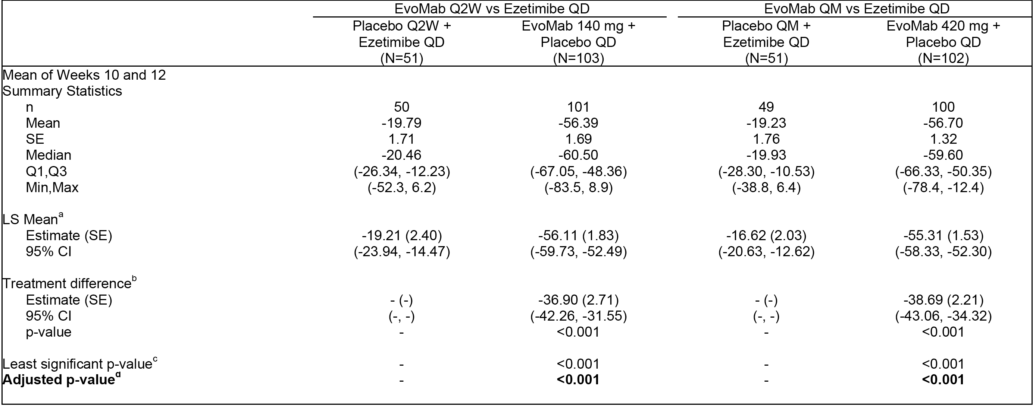
Note: see Table immediately above for superscript definitions.
Mean percent changes from baseline in reflexive LDL-C by scheduled visit and treatment group were shown for 140 mg Q2W) and 420 mg QM. At the scheduled post-baseline assessments at Weeks 2, 8, 10, and 12, mean reduction from baseline in reflexive LDL-C ranged from 50% to 58% for the overall evolocumab group and was < 21% for the overall ezetimibe group.
Of 307 baseline reflexive LDL-C concentrations, 6 (2.0%) were based on UC LDL-C triggered by elevated triglycerides, with none being triggered by low LDL-C at baseline. Of 782 post-baseline reflexive LDL-C concentrations in the evolocumab groups, 84 (10.7%) were based on UC LDL-C concentrations, including 69 (8.8%) triggered by calculated LDL-C < 1.0 mmol/L, 13 (1.7%) triggered by triglycerides > 4.5 mmol/L, and 2 (0.3%) for other reasons. Of 387 post-baseline reflexive LDL-C concentrations in the ezetimibe groups, 13 (3.4%) were based on UC LDL-C concentrations triggered by elevated triglycerides; no UC LDL-C concentrations in the ezetimibe groups were triggered by low LDL-C or other reasons. The comparison of the co-primary endpoints using reflexive or calculated LD-L concentrations showed that results were similar for both methods (see Table 23, below).

Table 23: 20110116 - Treatment differences in the co-primary endpoints, using reflexive or calculated LDL-C concentrations; FAS.
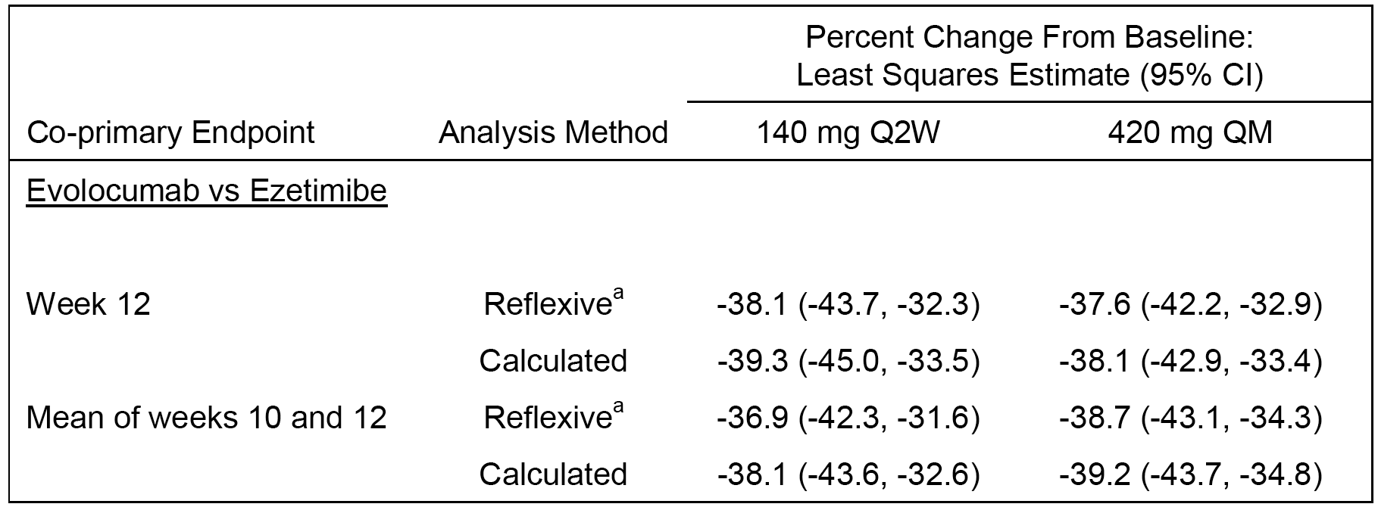
a = When the calculated LDL-C was < 1.0 mmol/L or triglycerides were > 4.5 mmol/L, calculated LDL-C was replaced with ultracentrifugation LDL-C from the same blood sample, if available.
Results of sensitivity analyses of the co-primary endpoints for percent change from baseline in reflexive LDL-C, including the completer analysis and the nonparametric analysis, were consistent and similar in magnitude to the primary efficacy analysis.
Evolocumab 140 mg Q2W and 420 mg QM were effective in all subgroups relative to ezetimibe, with no notable differences between subgroups, based on changes from baseline in reflexive LDL-C concentrations. The subgroups included: screening LDL-C (< 3.4 versus ≥ 3.4 mmol/L); baseline statin use; intolerance to statin; baseline median LDL-C (< 4.6 versus ≥ 4.6 mmol/L); age (< 65 versus ≥ 65 years); sex; race (White, Black, other); BMI (< 25 v 25 - < 30 versus ≥ 30 kg/m²); hypertension (yes, no); CHD risk factors (< 2 versus ≥ 2); current smoker (yes, no); and region. Analyses that adjusted for each of the covariates in the primary analysis model showed results that were consistent with the primary analysis. The covariates included: screening LDL-C; age; sex; race; region; baseline LDL-C; baseline BMI; hypertension; current smoker; baseline CHD factor ≥ 2; family history of CHD; NCEP high risk; statin use; baseline PCKS9 concentration; and baseline triglycerides.
In the MAS, both co-primary endpoints demonstrated statistically significant reductions in reflexive LDL-C for evolocumab 140 mg Q2W or 420 mg QM compared to ezetimibe ( p < 0.001, multiplicity adjusted) when subjects who were taking any lipid-regulating medications were excluded from the analysis. Compared with ezetimibe, evolocumab treatment resulted in statistically significant reductions in LDL-C from baseline to Week 12, with treatment differences ± SE of 40% ± 4% and 39% ± 3% in the 140 mg Q2W and 420 mg QM groups, respectively. Evolocumab also resulted in statistically significant reductions in reflexive LDL-C from baseline to the mean of Weeks 10 and 12 compared with ezetimibe, with treatment differences ± SE of 38% ± 3% and 40% ± 3% in the 140 mg Q2W and 420 mg QM treatment groups, respectively, for subjects in the monotherapy analysis set. The were 3 subjects (2 in the evolocumab 140 mg Q2W group and 1 in the ezetimibe 10 mg QD group (Q2W)) who did not receive any lipid modifying therapy at baseline but had an IVRS at record at stratification indicating baseline statin use. Repeated measure modelling for both co-primary endpoints using actual rather than IVRS stratification factors showed minimal impact to the LSM estimates of the treatment group differences on evolocumab compared to the ezetimibe. However, the estimated treatment effects in the ezetimibe group from the model using the actual stratification value was more aligned with published data on ezetimibe effects.
Comment: In both the FAS and the MAS, both co-primary endpoints demonstrated statistically significant reductions in reflexive LDL-C for evolocumab 140 mg Q2W and 420 mg QM compared to ezetimibe (p < 0.001, multiplicity adjusted). In the FAS, the differences between evolocumab and ezetimibe for both dose frequencies (Q2W and QM) were observed at the first post-baseline assessment at Week 2 and were maintained through Week 12. Evolocumab 140 mg Q2W and 420 mg QM were effective in all subgroups relative to ezetimibe, with no notable differences between subgroups, based on changes from baseline in reflexive LDL-concentrations. Analyses that adjusted for each of the covariates in the primary analysis model showed results that were consistent with the primary analysis.

Results for the secondary efficacy endpoints
In the FAS, treatment with evolocumab Q2W and QM resulted in statistically significant changes compared to ezetimibe (all multiplicity adjusted p-values < 0.001) for all Tier 1 co-secondary efficacy endpoints at Week 12 and at the mean of Weeks 10 and 12 and in the Tier 2 co-secondary endpoint of % change from baseline Lp(a) at Week 12 and at the mean of Week 10 and 12 for both the Q2W and QM treatment groups.
In the MAS, treatment with evolocumab Q2W and QM resulted in significant changes compared to ezetimibe (p < 0.001, multiplicity adjusted) for all Tier 1 co-secondary efficacy endpoints, and in the Tier 2 co-secondary endpoint of % change from baseline in Lp(a) at Week 12 and at the mean of Week 10 and 12 for both the Q2W and QM treatment groups.

Phase III Study 20110117 (RUTHERFORD-2)

Study design, objectives, locations and dates

Design
This Phase III, multinational, multicentre, randomised, double-blind, placebo-controlled, parallel-group study was designed to evaluate the efficacy, safety, tolerability, and pharmacokinetics of evolocumab administered 140 mg SC Q2W or 420 mg SC QM for 12 weeks in subjects with heterozygous familial hypercholesterolaemia (HeFH). The study was conducted at 39 centres in Canada, Netherlands, South Africa, Spain, United States, Germany, United Kingdom, Norway, Sweden, France, Switzerland, Australia, New Zealand, and Hong Kong. The first subject was enrolled on 7 February 2013 and the last subject completed follow-up on 19 December 2013. The CSR was dated 8 April 2014. The study was conducted in accordance with ICH GCP regulations and guidelines. The study was sponsored by Amgen. The study is also called RUTHERFORD-2 - RedUction of LDL-C with PCSK9 InhibiTion in HEteRozygous Familial Hypercholesterolaemia Disorder Study.

Objectives
The primary objective was to evaluate the effect of 12 weeks of evolocumab SC Q2W and QM, compared to placebo, on percent change from baseline in LDL-C in subjects with HeFH.
The secondary objectives were: (a) to evaluate the safety and tolerability of evolocumab SC Q2W and QM, compared to placebo, in subjects with HeFH; (b) to assess the effects of 12 weeks of evolocumab SC Q2W and QM, compared to placebo, on change from baseline in LDL-C and percent change from baseline in non-high density lipoprotein cholesterol (non-HDL-C), apolipoprotein B (ApoB), total cholesterol/HDL-C ratio, ApoB/apolipoprotein A (ApoA1) ratio, lipoprotein (Lp(a)), triglycerides, very low-density lipoprotein cholesterol (VLDL-C), and HDL-C in subjects with HeFH; and (c) to assess the effects of 12 weeks of evolocumab SC Q2W and QM, compared to placebo, on percent of subjects with HeFH attaining LDL-C < 1.8 mmol/L.
Comment: In addition to the primary and secondary objectives the study included a number of tertiary and exploratory endpoints. However, in the evaluation of the efficacy data in this CER the focus is on the primary and secondary objectives supported by the pre-specified primary and secondary efficacy endpoints.

Methods
Prior to randomisation, subjects entered a 6 week screening period to determine eligibility. During screening, SC administration of placebo was performed to confirm tolerability of SC administration prior to randomisation. All subjects received placebo SC corresponding to the QM dose volume (3.0 mL) using 3 consecutively administered AI/pens. During the screening period, the subject (or designee) was trained by study site staff to prepare and self-administer (or administer) the IP. Subjects who completed the screening period and met final eligibility criteria were randomised in a ratio of 2:2:1:1 into 4 treatment groups (see Figure 22, below). Randomisation was stratified by screening LDL-C level (<4.2 versus ≥ 4.2 mmol/L) and ezetimibe use at baseline (yes versus no).
Subjects received their first dose of SC IP on day 1 and returned to the study centre at Weeks 2, 8, 10, and 12 for study assessments, including blood samples for the determination of lipid parameters. Blood samples for determination of evolocumab and PCSK9 serum concentrations were collected at Day 1 and at Weeks 2, 10, and 12. The subject (or trained designee) or qualified site staff administered SC IP by AI/pen in a clinic setting at the study visits on Day 1 and at Weeks 2 (Q2W), 8 (Q2W or QM), and 10 (Q2W). The subject (or trained designee) self-administered (or administered) SC IP by AI/pen in a non-clinic setting (that is, home-use) at Weeks 4 (Q2W or QM) and 6 (Q2W). Each Q2W dose of evolocumab was administered using a single AI/pen that delivered a 140 mg dose; each QM dose was administered by 3 AI/pens for a total evolocumab dose of 420 mg. The end of study (EOS) visit occurred at the study center at Week 12 for subjects randomised to the QM IP schedule and by phone call at Week 14 for subjects randomised to the Q2W IP schedule. The study design and treatment schedule are summarised below in Figure 22.
Figure 22: 20110117 - Study design and treatment scheme.
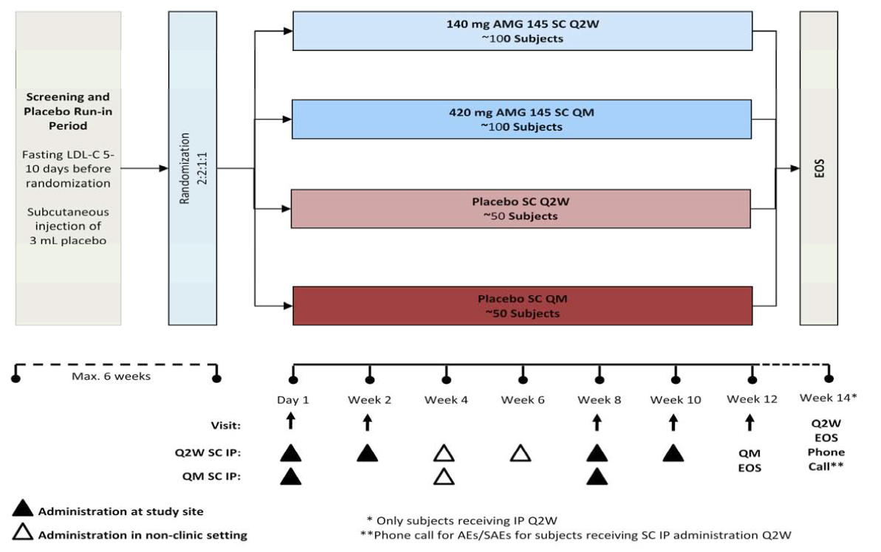

Inclusion and exclusion criteria
Men and women ≥ 18 to ≤ 80 years of age with a diagnosis of HeFH by the diagnostic criteria of the Simon Broome Register Group who were on a stable dose of an approved statin and on a stable dose of all other allowed lipid-regulating drugs for at least 4 weeks before LDL-C screening, with fasting LDL-C ≥ 2.6 mmol/L and fasting triglycerides ≤ 4.5 mmol/L at screening, were eligible for this study. Subjects were excluded from participation if they had HoFH, LDL or plasma apheresis within 4 months prior to randomisation, heart failure of New York Heart Association (NYHA) class III or IV, or last known left ventricular ejection fraction < 30%. Subjects were also excluded if they had a history or evidence of clinically significant diseases and conditions that would pose a risk to their safety or interfere with the study evaluation, procedures, or completion. The inclusion and exclusion are considered to be satisfactory.

Study treatments

Investigational Products (IP)
Evolocumab SC (AI/pen 140 mg/mL, delivering 1 mL) and placebo SC (identical prefilled AI/pen) were the IPs in this study. During screening, SC administration of placebo was performed to confirm tolerability of SC administration prior to randomisation. All subjects received placebo SC that corresponded to the QM dose volume (3.0 mL) using 3 consecutively administered AI/pens. The selection and timing of dose for each subject were consistent with those previously described for Study 20110114.

Prior and concomitant therapy
Throughout the study, investigators could prescribe any concomitant medications or treatments deemed necessary to provide adequate supportive care except for those listed in the protocol, which were consistent with those for Study 20110114. It was anticipated that subjects would remain on a stable dose of statin and/or other approved lipid regulating drugs from screening until EOS.

Concomitant diet and exercise
Subjects were required to maintain their current regimen of diet and exercise and to refrain from unaccustomed intensive exercise (eg, heavy lifting or long runs) 48 hours prior to each visit.

Compliance with IP treatment
Compliance was assessed in the same manner as for Study 20110115.

Removal from therapy or assessment
The criteria for removal from therapy or assessment were consistent with those previously described for Study 20110115.

Efficacy variables and endpoints

Endpoints
The co-primary endpoints were identical to those in Studies 20110115, 20110114, and 20110116. The co-secondary endpoints were identical to those in Studies 20110114, and 20110116.

Analysis of lipid parameters
The lipid parameters were determined using the same methods as those described for Studies 20110115, 20110114 and 20110116.

Randomisation and blinding methods
Eligible subjects were assigned to 1 of 4 treatment groups on the basis of a computer-generated randomisation schedule prepared by Amgen before the start of the study. Randomisation was stratified on the basis of screening LDL-C concentration (< 4.2 versus ≥ 4.2 mmol/L) and baseline ezetimibe use (yes versus no). A site representative used an IVRS to assign a randomisation number and group to the subject. A subject was considered randomised into the study after successfully completing the screening period, meeting all inclusion/exclusion criteria including meeting final laboratory safety criteria, and undergoing randomisation procedures by IVRS. The blinding procedures were consistent with those previously described for Study 20110115. No subject was unblinded in during the course of this study.

Analysis populations
The full analysis set (FAS) included all randomised subjects who received at least 1 dose of IP. This analysis set was used in both efficacy and safety analyses. In efficacy analyses, subjects were grouped according to their randomised treatment group assignment. The completer analysis set (CAS) included subjects in the FAS who adhered to the scheduled IP regimen and had observed values for the co-primary endpoints. The PK analysis set included subjects with at least 1 evolocumab or PCSK9 result.

Sample size
The planned total sample size was 300 subjects (100 evolocumab Q2W, 100 evolocumab QM, 50 placebo Q2W and 50 placebo QM). The primary analysis required that the tests of each co-primary endpoint be significant at a level of 0.05. The sample size provided adequate power to determine the superiority of evolocumab (either Q2W or QM) compared to placebo, as measured by the co-primary endpoints. The sample size as planned provided at least 96% (98% x 98%) power in testing the superiority of each evolocumab dosing regimen over its respective placebo for the co-primary endpoints. Because the testing statistics from Q2W and QM groups were independent, there was at least 92% power (96% x 96%) to show the superiority of both evolocumab dosing regimens over placebo. The assumptions on which the power calculations were based were identical to those previously described for Study 20110114.

Statistical methods

Statistical hypothesis
Within each dose frequency, the null hypothesis was that there was no mean difference in the percent change from baseline at Week 12 or in the mean percent change from baseline at Weeks 10 and 12 in LDL-C between evolocumab and placebo, and the alternative hypothesis was that a mean difference did exist.

General approach
All efficacy and safety analyses were performed on the FAS, unless otherwise specified. Analyses were performed separately within each dose frequency (Q2W and QM) unless otherwise specified. The superiority of evolocumab to placebo was assessed for all efficacy endpoints. Subject disposition, demographics, baseline characteristics, and exposure to IP were summarised. Summary statistics for continuous variables included the number of subjects, mean, median, standard deviation or standard error, minimum, and maximum. For categorical variables, the frequency and percentage were given. Missing data were not imputed for safety endpoints.

Adjustment for multiplicity
Adjustments for multiplicity were identical to those previously described for the FAS in Study 20110116.

Analyses of co-primary endpoints
The analyses of the co-primary endpoints were consistent with those previously described for Study 20110114.

Analyses of co-secondary endpoints
The analyses of the co-secondary efficacy endpoints were consistent with those described for Study 20110114.

Changes in statistical methods
The original SAP (dated 06 February 2013) was revised once before it was finalised (dated 02 October 2013). The revisions were minor and did not impact the power of the study or affect the size of any analysis dataset. The SAP was finalised prior to study un-blinding. There were no significant changes in the statistical methods used to analyse the efficacy endpoints.

Participant flow
Overall, 331 subjects were randomised to 1 of 4 treatment groups. A total of 329 (99.4%) subjects received IP; 2 (0.6%) subjects (1 evolocumab Q2W and 1 placebo Q2W) did not receive IP. A total of 324 (97.9%) subjects completed IP. Of the 5 subjects who discontinued IP, all subjects were discontinued at the subject’s request (evolocumab, 3 [1.4%] subjects; placebo, 2 [1.8%] subjects). No subject discontinued IP or the study due to a treatment emergent adverse event. A total of 312 (94.3%) subjects completed the study and 19 (5.7%) subjects discontinued the study early, including 13 (3.9%) subjects due to sponsor decision (all of these subjects completed IP and entered an open-label extension study before they completed the EOS phone call at Week 14) and 6 (1.8%) subjects who withdrew consent. There were some differences in the percentage of subjects completing the studies in the treatment groups, ranging from a low of 89.1% in the placebo Q2W group to a high of 98.2% in the evolocumab 420 mg QM group. The main differences between the treatment groups related to differences in the percentage of subjects discontinuing due to withdrawal of consent and sponsor's decision. Subject disposition with reason for discontinuation was summarised.
The FAS population for analyses of efficacy and safety endpoints included the 329 (99.4%) subjects who received at least 1 dose of IP. The CAS population included 289 (87.3%) subjects. A total of 42 (12.7%) subjects were excluded from the CAS population for missing data for the co-primary endpoint and 7 (2.1%) subjects were excluded because they did not complete all doses. Subjects excluded for missing data for the co-primary endpoint included 23 (6.9%) who were missing data at Week 10 and 27 (8.2%) who were missing data at Week 12. For the subjects who were excluded from the CAS population for missing data at Week 12, 11 were excluded because they had a visit that was outside of the analytical time window defined (that is, the visit occurred beyond study Day 91).
The two stratification factors in this study were screening LDL-C concentration (< 4.2 versus ≥ 4.2 mmol/L) and baseline use of ezetimibe (yes or no). Of the 329 subjects who received at least 1 dose of IP, 210 (63.8%) had a screening LDL-C level of < 4.2 mmol/L and 119 (36.2%) had a screening LDL-C of ≥ 4.2 mmol/L, while 201 (61.1%) were receiving ezetimibe at baseline and 128 (38.9%) were not receiving ezetimibe at baseline.

Major protocol violations/deviations
No subjects in the evolocumab group and 3 (5.5%) subjects in the placebo QM group had an important protocol deviation (1 subject each with type 1 diabetes, negative diagnosis of HeFH, and on-study lipid lowering drug dose altered).

Baseline data
Baseline characteristics for subjects in the FAS were summarised. The study population (n=329) consisted of 139 (42.2%) females and 190 (57.8%) males. The mean ± SD age of the total population was 51.2 ± 12.6 years (range: 19, 79 years), and most were aged < 65 years (85.1%). Most subjects were White (90.0%), followed by Asian (4.9%), other (4.3%), and Black or African American (0.9%). The mean ± SD height of the study population was 170.8 ± 9.6 cm (range: 143, 196 cm) and the mean ± SD BMI was 27.9 ± 4.6 kg/m² (range: 16, 47 kg/m²). The mean weight, BMI and weight circumference were all notably lower in the Q2W placebo treatment group compared to the three other treatment groups.
Baseline lipid parameters, hsCRP and PCSK9 were summarised. In the study population (n=329), mean ± SD serum concentration of reflexive LDL-C at baseline was 4.0 ± 1.2 mmol/L and ranged from 3.914 ± 0.9 mmol/L to 4.2 ± 1.3 mmol/L across treatment groups. Baseline concentrations were clinically equivalent across treatment groups for Tier 1 secondary lipid parameters (ApoB, ApoA1, non-HDL-C, total cholesterol/HDL-C ratio, and ApoB/ApoA1 ratio), Tier 2 secondary lipid parameters (Lp(a), triglycerides, VLDL-C, and HDL-C), hsCRP and PCSK9.
Simon Broome register group diagnostic criteria for HeFH were summarised. Overall, 257 (78.1%) subjects had a definite diagnosis of HeFH and 72 (21.9%) subjects had a possible diagnosis, with the rates being similar across treatment groups.
Baseline coronary heart disease characteristics were summarised. NCEP CHD risk categories at baseline (evolocumab versus placebo) were mostly high risk (45.5% versus 38.5%), followed by moderate risk (28.6% versus 24.8%), lower-risk (19.1% versus 33.0%), and moderately high risk (6.8% versus 3.7%). Other baseline coronary heart disease characteristics (evolocumab versus placebo) included a history of coronary artery disease (35.0% versus 23.9%), cerebrovascular or peripheral arterial disease (17.3% versus 16.5%), type 2 diabetes (6.8% versus 8.3%), 2 or more cardiovascular risk factors (45.9% versus 43.1%), and 3 or more metabolic syndrome factors and without diabetes (30.9% versus 24.8%). The placebo group contained more low-risk subjects, fewer coronary artery disease subjects, and those with fasting glucose > 5.6 mmol/L compared to the evolocumab group.
Other pre-specified cardiovascular disease characteristics were similar across the treatment groups. A history of atrial fibrillation/flutter was documented in 4 (1.2%) subjects overall at baseline, including 1 (0.3%) with a current history and 3 (0.9%) with a previous history. No subject had NYHA Class III or IV congestive heart failure; 8 subjects (evolocumab; placebo) had NYHA Class II (1.8%; 3.7%) and 1 subject in the placebo group had NYHA class I. Overall, 63 (19.1%) subjects had a documented history of left ventricular systolic function, of which most had normal systolic function (LVEF ≥ 50%) (evolocumab versus placebo) (16.4% versus 14.7%), followed by mild dysfunction (LVEF 40% to 49%) (2.3% versus 0.9%), and moderate dysfunction (LVEF 30% to 39%) (0.9% versus 2.8%), and no subject had severe dysfunction (LVEF < 30%). A total of 6 subjects (evolocumab: 3 subjects; placebo: 3 subjects) had a documented history of cardiac devices or a pacemaker.
Lipid regulating concomitant medications at baseline was reported in all subjects in the four treatment groups. All (100% [n=329]) subjects reported baseline statin use, 62.0% (n=204) reported ezetimibe use, 7.9% (n=26) reported bile acid sequestrant use, and 2.1% (n=2.1%) reported nicotinic acid/derivatives use. The most commonly used statins at baseline (≥ 10% of subjects) were rosuvastatin (48.9%), atorvastatin (35.0%), and simvastatin (12.2%).

Results for co-primary endpoints
Results from analysis of the co-primary endpoints are summarised in below in Table 24 and Table 25, respectively. Both co-primary endpoints demonstrated statistically significant reductions in reflexive LDL-C for evolocumab 140 mg Q2W and 420 mg QM compared to placebo (p < 0.001, multiplicity adjusted).

Table 24: 20110117 - Primary analysis of co-primary endpoint (week 12) for percent change from baseline in reflexive LDL-C.
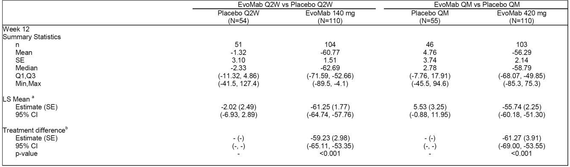
a = Least squares mean is from the repeated measures model which includes treatment group, stratification factor (from IVRS), scheduled visit and the interaction of treatment with scheduled visit as covariates. b =Treatment differences are within each dose frequency group using either as the reference. c =the maximum p-value for the co-endpoints. d = Adjusted p-value is based on a combination of sequential testing, the Hochberg procedure, the fallback procedure to control the overall significance level for all primary and secondary endpoints. Each individual adjusted p-value is compared to 0.05 to determine statistical significance.

Table 25: 20110117 - Primary analysis of co-primary endpoint (mean for Weeks 10 and 12) for percent change from baseline in reflexive LDL-C.
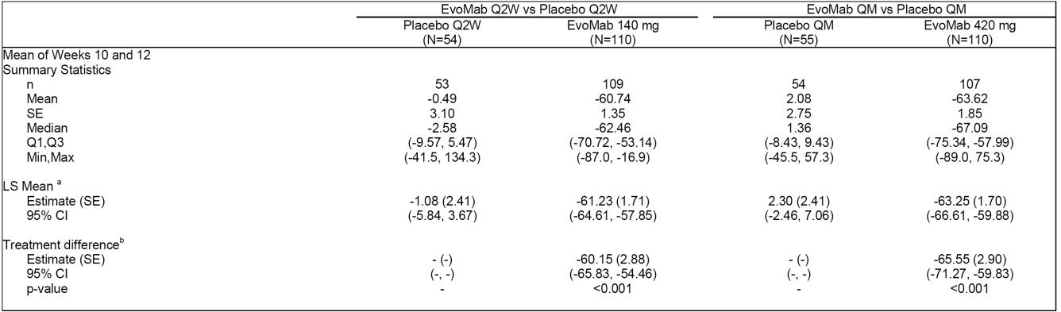
Note: See Table immediately above for relevant comments.
Mean percent change from baseline in reflexive LDL-C by scheduled visit and treatment group were shown. At the scheduled post-baseline assessments at Weeks 2, 8, 10, and 12, mean reduction from baseline in reflexive LDL-C ranged from 58% to 66% for the overall evolocumab group and was ≤ 2% for the overall placebo group.
Of the 329 subjects with baseline reflexive LDL-C concentrations (220 evolocumab, 109 placebo), 2 (0.6%) were based on UC LDL-C triggered by elevated triglycerides, and none were triggered by calculated LDL-C < 1.0 mmol/L at baseline. Of 839 post-baseline reflexive LDL-C concentrations in the evolocumab groups, 293 (34.9%) were based on UC LDL-C concentrations, including 283 (33.7%) triggered by calculated LDL-C < 1.0 mmol/L, 7 (0.8%) triggered by triglycerides > 4.5 mmol/L), and 3 (0.4%) for other reasons. Of 407 post-baseline reflexive LDL-C concentrations in the placebo group, 4 (1.0%) were based on UC LDL-C concentrations triggered by elevated triglycerides, and no UC LDL-C concentration in the placebo groups was triggered by calculated LDL-C < 1.0 mmol/L or other reasons. The comparison of the co-primary endpoints using reflexive or calculated LDL-C concentrations showed that the results were similar for both methods (see Table 26, below).

Table 26: 20110117 - Treatment differences in the co-primary endpoints, using reflexive or calculated LDL-C concentrations; FAS.
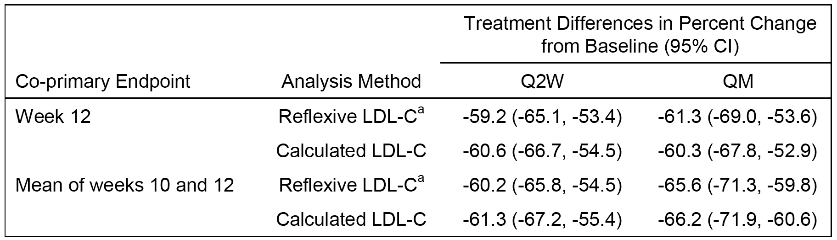
Results of sensitivity analyses of the co-primary endpoints for percent change from baseline in reflexive LDL-C, including the completer analysis and the non-parametric analysis were consistent and similar in magnitude to the primary efficacy analysis.
Evolocumab 140 mg Q2W and 420 mg QM were effective in all subgroups relative to placebo, with no notable differences between subgroups. The subgroups were: screening LDL- C (< 4.1 versus ≥ 4.1 mmol/L); ezetimibe use at baseline (yes, no); age (< 65, ≥ 65 years); sex (male, female); race (White, black, other); region (North America, Europe, other); baseline LDL-C median (< 3.7 versus ≥ 3.7 mmol/L); baseline BMI (< 25, 25 to < 30, ≥ 30 kg/m²); diabetes mellitus type 2; metabolic syndrome; glucose tolerance status; hypertension (yes, no); current smoker (yes, no); CHD risk factors (< 2, ≥ 2); family history of premature heart disease (yes, no); PCSK9 baseline median (< 424.5, ≥ 424.5 ng/mL); triglycerides baseline median (< 1.2 versus ≥ 1.2 mmol/L); triglycerides (< 1.7 versus ≥ 1.7 mmol/L); triglycerides (< 2.3 versus ≥ 2.3 mmol/L); HeFH status (definite, possible); baseline status usage (intensive, non-intensive); NCEP high risk (no, yes). Analyses that adjusted for each of the co-variates in the primary analysis model showed that the results were consistent with the primary analysis.
Comment: Both co-primary endpoints demonstrated statistically significant reductions in reflexive LDL-C for evolocumab 140 mg Q2W and 420 mg QM compared to placebo (p < 0.001, multiplicity adjusted). The difference between evolocumab and placebo for both dose regimens was observed at the first post-baseline assessment at Week 2 and was maintained through Week 12. Evolocumab 140 mg Q2W and 420 mg QM were effective in all subgroups, based on changes from baseline in reflexive LDL-C concentrations for the co-primary endpoints. Analyses adjusting for each of the individual covariates in the primary analysis model showed similar results to those for the primary analysis.

Results for the co-secondary endpoints
Treatment with evolocumab 140 mg Q2W and 420 mg QM resulted in significant changes compared to placebo (p-values < 0.001, multiplicity adjusted) for all Tier 1 co-secondary efficacy endpoints, and for all Tier 2 co-secondary efficacy endpoints.

Comparison across studies (primary hyperlipidaemia or mixed dyslipidaemia).

Integrated Analysis - 4 pivotal Phase III studies

Overview
The submission included a pre-specified integrated efficacy analysis of the four, 12-week, pivotal Phase III studies. The analysis included a total of 3152 randomised subjects from 24 countries in Europe (52.2%), North America (40.4%), and Asia/Pacific (7.5%). Of the 3152 subjects, 3146 (99.8%) received IP and were included in the FAS: (a) 1848 received evolocumab (921 evolocumab 140 mg SC Q2W, 927 evolocumab 420 mg SC QM); (b) 821 received placebo (411 placebo SC Q2W, 410 placebo SC QM); and (c) 477 received ezetimibe (240 ezetimibe QD in the Q2W analysis, 237 ezetimibe QD in QM analysis). Of the 3152 subjects, 3005 (95.3%) completed treatment with IP, 3026 (96.0%) completed the study and 69 (2.2%) discontinued the study early, not including the 57 (1.8%) subjects who enrolled into extension studies without completing the final follow-up visit. The disposition of the 3152 subjects in the integrated cohort is summarised below in Table 27.

Table 27: Integrated cohort (Phase III studies) - summary of disposition.
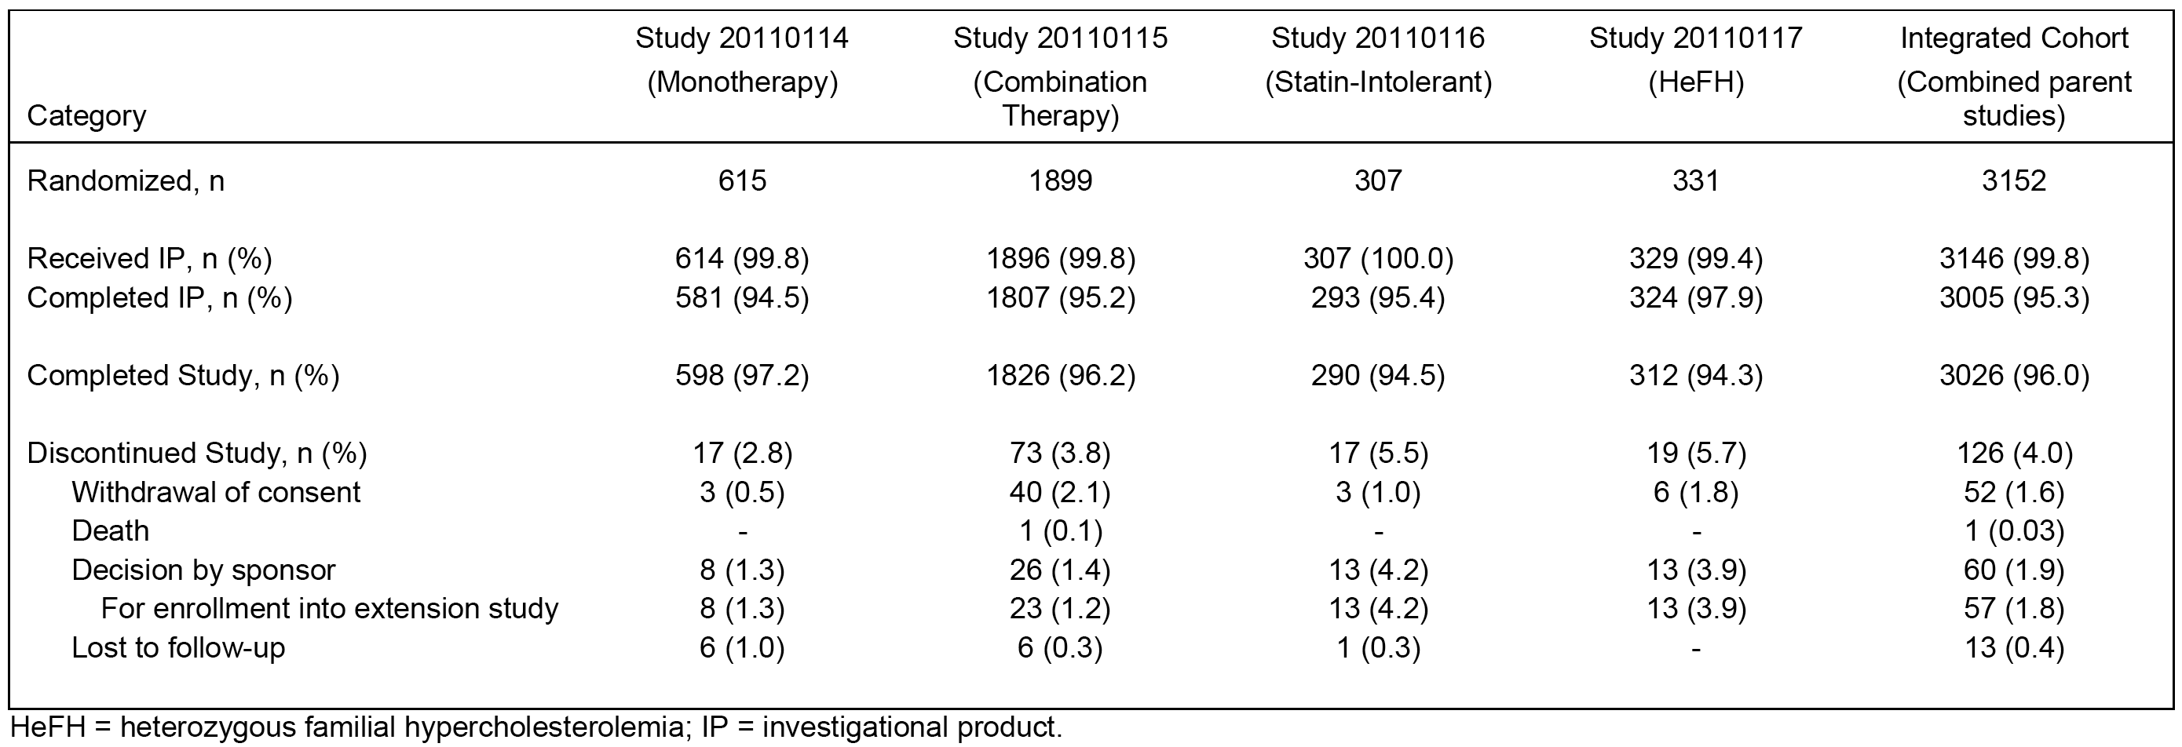

Key baseline characteristics of the integrated FAS cohort.
The key baseline characteristics of the FAS cohort (n=3146) were summarised and comparison of key baseline characteristics across the four studies compared to the integrated cohort was provided. The mean ± SD age at baseline in the integrated FAS cohort was 57.8 ± 11.2 years, with majority of subjects being aged < 65 years (69.5%). The FAS cohort included 49.4% females and 50.6% males. Most subjects were White (91.5%), followed by Black or African American (3.9%) and Asian (3.4%). At baseline, 19.8% of the FAS cohort (n=3146) had coronary artery disease and 9.8% had cerebrovascular or peripheral arterial disease. The NCEP CHD risk categories in the integrated FAS cohort were high (33.8%), moderately high (9.8%), moderate (29.7%) and lower (27.8%). The most commonly reported cardiovascular risk factors were hypertension (49.2%), low HDL-C (28.4%), and family history of premature heart disease (23.4%). The baseline incidences of other cardiovascular risk factors were current cigarette use (14.0%), Type 2 diabetes mellitus (12.1%), and peripheral arterial disease (3.3%).
In the integrated FAS cohort, statins were used at baseline in 72.4% of subject. Using the ACC/AHA definition of statin-intensity, 32.5%, 38.3%, 1.5%, and 27.6% of the subjects were on high-intensity, moderate-intensity, low-intensity, and no statin therapy, respectively. In addition to statins, subjects were using other lipid-regulating medications (as allowed by individual parent study criteria) such as fish oil and bile acid sequestrants.
In the integrated FAS cohort, statin use was lower in the ezetimibe group (50.3%) compared to the evolocumab groups (74.2%) and placebo (81.1%) groups. This difference was due to differences in design of the four Phase III studies. Similarly, differences in Phase III study design resulted in minor differences in some baseline characteristics (for example, coronary artery disease, family history of premature CHD, baseline PCSK9 levels). However, the key baseline characteristics were generally comparable across the four Phase III studies contributing subjects to the integrated analysis population. The lipid regulating concomitant medications of interest were summarised. The mean (SD) serum concentration of reflexive LDL-C at baseline was 3.3 ± 1.3 mmol/L). The baseline lipid parameters for the total cohort were summarised.

Endpoints
The co-primary efficacy endpoints of the cohort for the integrated analysis were the same as for each individual Phase III study contributing data to the analysis (that is, percent change from baseline in reflexive LDL-C compared to placebo at Week 12 and at the mean of Weeks 10 and 12).
The co-secondary endpoints were also assessed at Week 12 and at the mean of Weeks 10 and 12. The Tier 1 co-secondary endpoints were: change from baseline in LDL-C (absolute); % change from baseline in total cholesterol; % change from baseline in non-HDL-C; % change from baseline in ApoB; % change from baseline in the total cholesterol/HDL-C ratio; and % change from baseline in ApoB/ApoA1 ratio. The Tier 2 co-secondary endpoints were: % change from baseline in Lp(a); % change from baseline in triglycerides; % change from baseline in HDL-C; and % change from baseline in VLDL-C.
Pooling of treatment effects across studies was conducted with the treatment effect estimators using a random effects meta-analysis model. Measures of heterogeneity in treatment effects across studies were provided. Multiplicity adjustments for the co-primary and co-secondary efficacy endpoints were undertaken.

Co-primary endpoints - Results
Both co-primary endpoints of the integrated analyses demonstrated statistically significant reductions in reflexive LDL-C for evolocumab 140 mg Q2W and 420 mg QM (p < 0.001, multiplicity adjusted). The LDL-C results indicate that the two evolocumab dose regimens are clinically equivalent, with observed differences between the two dose regimens being clinically insignificant. The key results for the reductions in LDL-C assessed using reflexive and calculated methods are summarised below in Table 28. The key results show that the difference between each pairwise comparison are statistically significant (p<0.000, adjusted for multiplicity), and consistent for both LDL-C measurement methods.

Table 28: Integrated Analysis - Summary of co-primary endpoint results.
a = Treatment difference estimated using Dersimonian-Laird random effect estimator. b = When the calculated LDL-C is < 40 mg/dL or triglycerides are > 400 mg/dL, calculated LDL-C will be replaced with ultracentrifugation LDL-C from the same blood sample, if available.

Co-secondary endpoint results - other lipids.
The integrated analyses demonstrate that evolocumab 140 mg Q2W and 420 mg QM significantly improved all Tier 1 and Tier 2 co-secondary endpoints compared to both placebo and to ezetimibe (p < 0.001, multiplicity adjusted). The results for the Tier 1 and 2 co-secondary efficacy endpoints were summarised.

Subpopulations - primary hyperlipidaemia and mixed dyslipidaemia
In the submission, primary hyperlipidaemia was defined as elevated LDL-C cholesterol only and mixed dyslipidaemia was defined as elevated LDL-C together with high triglycerides or low HDL-C. Specifically, mixed dyslipidaemia was defined as triglycerides ≥ 1.7 mmol/L, triglycerides ≥ 2.2 mmol/L or HDL-C < 1.0 mmol/L in males or < 1.3 mmol/L in females.
Subpopulation analysis within the integrated Phase III study cohort population was performed on 4 pre-specified subsets of subjects with mixed dyslipidaemia and severe hypercholesterolaemia. Of the 3152 subjects in the integrated analysis, the following cohorts comprised each of the subpopulation analyses:
- A total of 1148 (36.4%) subjects met Definition 1 for mixed dyslipidaemia (elevated LDL-C and screening triglycerides ≥ 1.7 mmol/L).
- A total of 535 (17.0%) subjects met Definition 2 for mixed dyslipidaemia (elevated LDL-C and screening triglycerides ≥ 2.2 mmol/L).
- A total of 855 (27.1%) subjects met Definition 3 for mixed dyslipidaemia (elevated LDL-C and screening HDL-C < 1.0 mmol/L for men or < 1.3 mmol/L for women).
- A total of 438 (13.9%) subjects met the criteria for severe hypercholesterolaemia (screening calculated LDL-C ≥ 4.1 mmol/L for subjects receiving a statin or ≥ 6.2 mmol/L for subjects not receiving a statin).
The results for the co-primary endpoint analysis are summarised below in Table 29. The results of this analysis demonstrated superiority of evolocumab in reducing LDL-C compared to placebo and ezetimibe in subjects with mixed dyslipidaemia (all 3 definitions) and severe hypercholesterolaemia. Both co-primary endpoints demonstrated statistically significant reductions in LDL-C for evolocumab 140 mg Q2W and 420 mg QM compared to both placebo and ezetimibe (p < 0.001, multiplicity adjusted). The treatment differences were greater for the comparisons between evolocumab 140 mg Q2W and placebo than for the comparisons between evolocumab 420 mg QM and placebo.

Table 29: Integrated Analysis (Phase III studies) - Subpopulations co-primary endpoint results; FAS
a = Treatment difference within each dose frequency group using placebo or ezetimibe in the same group as the reference. b = Adjusted p-value is based on a combination of sequential testing, the Hochberg procedure, the fallback procedure to control the overall significance level for all primary and secondary endpoints. Each individual adjusted p-value is compared to 0.05 to determine statistical significance.
In every subpopulation, evolocumab Q2W and QM significantly improved all Tier 1 co-secondary endpoints compared with placebo and ezetimibe (p ≤ 0.002, multiplicity adjusted), and the treatment differences were generally comparable across the subpopulations. For the Tier 2 co-secondary endpoints, evolocumab 140 mg Q2W significantly reduced Lp(a), triglycerides, and VLDL-C compared to placebo in every subpopulation, and significantly increased HDL-C in the mixed dyslipidaemia subpopulations. Evolocumab 420 mg QM significantly reduced Lp(a) and increased HDL-C compared to placebo in every subpopulation, and significantly reduced triglycerides and VLDL-C in the mixed dyslipidaemia subpopulations. Compared to ezetimibe, evolocumab 140 mg Q2W and 420 mg QM significantly reduced Lp(a) in every subpopulation, and evolocumab 420 mg QM significantly increased HDL-C in the mixed dyslipidaemia subpopulations.

Supportive Phase II studies

Study 20101155 (LAPLACE-1) - evolocumab combination with statin

Design and objectives
This was a Phase II, multinational, multicentre, randomised, placebo-controlled, double-blind dose-ranging study designed to evaluate the efficacy and safety of 12 weeks of SC evolocumab administered Q2W or Q4W, compared to placebo, in combination with a statin on the percent change from baseline in LDL-C in subjects with hypercholesterolaemia. After a screening and placebo run-in period of up to 6 weeks, eligible subjects who were on stable doses of statin therapy for at least 4 weeks with or without ezetimibe were randomised equally into 8 treatment groups to evolocumab or placebo SC. Randomisation was stratified by screening LDL-C level (< 3.4 versus or ≥ 3.4 mmol/L) and ezetimibe use at baseline (yes or no). The study was conducted in 78 centres in the USA, Canada, and Europe. The first subject was enrolled on 18 July 2011 and the last subject completed the follow-up visit on 5 April 2012. The CSR was dated 21 March 2014. The study was conducted in accordance with USA FDA and ICH GCP regulations and guidelines and sponsored by Amgen.

Eligible Subjects
Eligible subjects were men and women, aged ≥ 18 to ≤ 80 years, who were on a statin, with or without ezetimibe, with stable doses for at least 4 weeks before LDL-C screening, not requiring up titration, and a fasting LDL-C at screening of ≥ 2.2 mmol/L. Enrolment of subjects with a screening fasting LDL-C ≥ 2.2 mmol/L and < 2.6 mmol/L was limited to no more than approximately 20% of total planned enrolment. Major exclusion criteria included the use of prescription lipid-regulating drugs other than statins or ezetimibe (for example, bile-acid sequestering resins, fibrates and derivatives), or the use of stanols, red yeast rice, niacin (> 200 mg/day), or omega-3 fatty acids (> 1000 mg/day) in the last 6 weeks before the LDL-C screening assessment. Subjects were also excluded if they had a history or evidence of clinically significant diseases and conditions that would pose a risk to their safety or interfere with the study evaluation, procedures, or completion.

Treatments
The study planned to enrol a total of 600 subjects randomised into 1 of 8 treatment groups (75 subjects per group). The 8 treatment groups were evolocumab Q2W (70 mg, 105 mg, 140 mg), evolocumab Q4W (280 mg, 350 mg, 420 mg), and placebo (Q2W and Q4W). All doses of evolocumab were administered using a dose concentration of 70 mg/mL (1 mL vials). All treatments were administered for 12 weeks.

Endpoints
The primary endpoint was the percent change from baseline in LDL-C at Week 12.
The key secondary efficacy endpoints were: (a) absolute change from baseline in LDL-C at Week 12; (b) percent change from baseline in non-HDL-C at Week 12; (c) percent change from baseline in ApoB at Week 12; (d) percent change from baseline in the total cholesterol/HDL-C ratio at Week 12; and (c) percent change from baseline in ApoB/ApoA1 ratio at Week 12.
All primary and secondary endpoint analyses of LDL-C used ultracentrifugation (UC) LDL-C, if available. For the exploratory endpoints and longitudinal analyses, calculated LDL-C was used.

Statistical methods
For the primary endpoint of percent change in LDL-C from baseline at Week 12, the efficacy of evolocumab was evaluated using a hierarchical sequential testing procedure to control the family-wise error rate for multiple comparisons at ≤ 0.05. For each dosing frequency, the primary efficacy endpoint was analysed by using an analysis of covariance (ANCOVA) model to assess the efficacy of each evolocumab dose group to its respective placebo. The ANCOVA model included terms for the treatment group and stratification factors. The highest evolocumab dose was compared to placebo by using the 0.05 (Type 1 error) significance level. If the highest evolocumab dose was found to reach statistical significance, then the next highest dose was assessed. Testing of the doses in descending dose level continued until the 0.05 statistical significance level was not met or the lowest dose within the dosing frequency was tested, whichever occurred first. Analyses of the secondary endpoints of change and percent change from baseline were similar to the primary analysis for the primary endpoint. No multiplicity adjustments were made for secondary and other non-primary endpoints.
The planned sample size of 75 subjects per treatment group (that is, 600 subjects total) provide approximately 98% power to detect a treatment effect of evolocumab versus placebo. The sample size calculation was performed by using a two-sided t-test with a 0.025 significance level (adjusted for testing within Q2W and Q4W treatment groups), an attenuated treatment effect of 16.5% reduction in LDL-C and an attenuated common SD of 23%.

Brief subject disposition and baseline demographics
A total of 631 patients were randomised to 1 of the 8 treatment groups: 474 subjects were randomised to 1 of the 6 evolocumab groups (79 to 70 mg Q2W; 79 to 105 mg Q2W; 78 to 140 mg Q2W; 79 to 280 mg Q4W; 79 to 350 mg Q2W; 80 to 420 mg Q4W); 78 subjects were randomised to receive placebo Q2W; and 79 subjects were randomised to receive placebo Q4W. The mean ± SD age of the population was 60.5 ± 9.5 years, 50.7% women, 49.3% men, 88.7% White, 7.9% black, and 1.9% Asian.
A total of 629 (99.7%) subjects received IP and 630 (99.8%) completed the study. The 629 subjects who received IP were included in the FAS population used for analyses of efficacy and safety endpoints. Two subjects were randomised but did not receive IP; 1 subject could not comply with study procedures and elected not to receive IP and 1 subject was found to be ineligible post-randomisation and was withdrawn from IP by the investigator. However, both of these subjects were followed until their planned end of study visit.

Results of the endpoint analyses
The results of the primary efficacy endpoint analyses showed statistically significant reductions in the percent change from baseline in UC LDL-C at Week 12 relative to placebo for all evolocumab treatment groups within the Q2W and Q4W dosing frequencies (p < 0.001). The greatest LS mean ± SE treatment reductions (evolocumab minus placebo at Week 12) were 66% ± 3% in the 140 mg Q2W group and 50% ± 3% in the 420 mg Q4W group.
The results of secondary efficacy endpoint analyses showed statistically significant (p < 0.001) reductions relative to placebo for all evolocumab groups within the Q2W and Q4W dosing frequencies for each of the pre-specified secondary efficacy endpoints. The results of the analyses for the pre specified secondary efficacy endpoints and other secondary endpoints were summarised.
Comment: The study provides supportive evidence for the efficacy of evolocumab at the proposed doses (140 mg SC Q2W and 420 mg SC QM) in combination with statins for the treatment of patients with primary hyperlipidaemia and mixed dyslipidaemia.

Study 20101154 (MENDEL-1) - evolocumab monotherapy

Design
This Phase II, multinational, multicentre, randomised, placebo- and ezetimibe-controlled, dose-ranging study was designed to evaluate the efficacy and safety of 12 weeks of evolocumab compared with placebo when administered as monotherapy Q2W or Q4W on percent change from baseline in LDL-C in subjects with hypercholesterolaemia. In order to allow for a placebo-controlled design, subjects with a 10 year Framingham risk score of ≤ 10% were enrolled. After a 6-week screening and placebo run-in period, eligible subjects were randomised equally into 1 of 8 treatment groups. Randomisation was stratified on the basis of screening LDL-C concentration (< 3.4 versus ≥ 3.4 mmol/L). The study was conducted at 52 centres in the United States, Canada, Australia, Belgium, and Denmark. The first subject was enrolled on 6 July 2011 and the last subject completed the study on 2 March 2012. The CSR was dated 23 August 2012. The study was conducted in accordance with ICH GCP regulations and guidelines, and was sponsored by Amgen.

Eligible subjects
Eligible subjects were adult men and women 18 to 75 years of age, inclusive, with a fasting LDL-C ≥ 2.6 mmol/L and < 4.9 mmol/L) and a fasting triglyceride ≤ 4.5 mmol/L. Subjects were excluded from participation if they had used a lipid-regulating drug in the last 3 months prior to LDL-C screening. Subjects were also excluded if they had a history or evidence of clinically significant diseases and conditions that would pose a risk to their safety or interfere with the study evaluation, procedures, or completion.

Treatments
The study planned to enrol 45 subjects into 9 treatment groups (that is, 405 subjects in total). The 9 treatment groups were evolocumab and placebo Q2W (4 x groups) and Q4W (4 x groups) and ezetimibe 10 mg QD (1 x group). The 4 x Q2W groups were placebo and evolocumab 70 mg, 105 mg, and 140 mg. The 4 x Q4W groups were placebo and evolocumab 280 mg, 350 mg, and 420 mg. All doses of evolocumab were administered using a dose concentration of 70 mg/mL (1 mL vials). All treatments were administered for 12 weeks.

Endpoints
The primary efficacy endpoint was the percent change from baseline in LDL-C at Week 12.
The secondary efficacy endpoints were: (a) absolute change from baseline in LDL-C at Week 12; (b) percent change from baseline in non-HDL-C at Week 12; (c) percent change from baseline in ApoB at Week 12; (d) percent change from baseline in the total cholesterol/HDL-C ratio at Week 12; and (e) percent change from baseline in ApoB/ApoA1 ratio at Week 12.
All primary and secondary endpoint analyses of LDL-C used ultracentrifugation (UC) LDL-C, if available. For the exploratory endpoints and longitudinal analyses, calculated LDL-C was used.

Statistical methods
For the primary endpoint analysis, the treatment effects of evolocumab were assessed for the 2 dose frequency groups separately (that is, Q2W and Q4W) and the doses within each dose frequency group (that is, evolocumab versus placebo). A type I error of 0.05 was used for testing within each dose-frequency group. For each dosing frequency, the primary efficacy endpoint of percent change in LDL-C from baseline at Week 12 was analysed using an analysis of covariance (ANCOVA) model to assess the efficacy of each evolocumab dose group to placebo. The ANCOVA model included terms for the treatment group and stratification factor. The efficacy of evolocumab was evaluated by using a hierarchical sequential testing approach to control the family-wise error rate for multiple comparisons at ≤ 0.05. The highest evolocumab dose was compared with placebo using the 0.05 significance level. If the highest evolocumab dose reached statistical significance, then the next highest dose was assessed. Testing of the doses continued in descending strength until the 0.05 statistical significance was not met or the lowest dose within the dosing frequency was tested, whichever occurred first. Primary analysis of the secondary endpoints of change and percent change from baseline was similar to the primary analysis for the primary endpoint. No multiplicity adjustment was made for secondary and other non-primary endpoints.
The planned sample size of 45 subjects per treatment group provided more than 99% power to detect a treatment effect of evolocumab versus placebo. The sample size was calculated by using a 2-sided t-test with a 0.05 significance level adjusted for testing within Q2W and Q4W treatment groups and an attenuated treatment effect of 33% reduction in LDL-C and an attenuated common SD of 29.3%.

Brief subject disposition and baseline demographics
A total of 411 subjects were randomised to 1 of the 9 treatment groups. Overall, 274 subjects were randomised to 1 of the 6 evolocumab groups (45 to 70 mg Q2W, 45 to 140 mg Q2W, 46 to 105 mg Q2W, 46 to 280 mg Q4W, 46 to 350 mg Q4W, 46 to 420 mg Q4W), 46 subjects were randomised to placebo Q2W, 45 subjects were randomised to placebo Q4W, and 46 subjects were randomised ezetimibe. A total of 406 (98.8%) subjects received IP and 397 (96.6%) completed the study. The 406 subjects who received IP were included in the FAS population used for analyses of efficacy and safety endpoints. The mean ± SD age of the study population was 50.6 ± 11.8 years, 34.2% were male, 65.8% were female, 78.6% were White, 15.8% were Black, and 4.2% were Asian.

Results of the endpoint analyses
The results of the primary efficacy analyses showed statistically significant reductions in the percent change from baseline in UC LDL-C at Week 12 compared to placebo for all evolocumab treatment groups within both the Q2W and Q4W dosing frequencies (p < 0.001). Compared to placebo, the greatest reductions in LDL-C (treatment difference ± SE) were 47% ± 4% in the 140 mg Q2W group and 53% ± 5% in the 420 mg Q4W group.
The results of the secondary endpoint analyses showed dose-dependent, statistically significant (p ≤ 0.001) reductions relative to placebo and relative to ezetimibe for all evolocumab groups within both the Q2W and Q4W dosing frequencies for each of the pre-specified secondary efficacy endpoints.
Comment: The study provided supportive evidence for the efficacy of evolocumab at the proposed doses (140 mg SC Q2W and 420 mg SC QM) as monotherapy for the treatment of patients with primary hyperlipidaemia and mixed dyslipidaemia.

Study 20090159 (GAUSS-1) - statin-intolerant subjects

Design
This was a Phase II, multinational, multicentre, randomised, double-blind, placebo- and ezetimibe-controlled study to evaluate the tolerability and efficacy of evolocumab compared to ezetimibe in subjects with hypercholesterolaemia unable to tolerate an effective statin dose (that is, statin intolerant). After a screening and placebo run-in period, eligible subjects were randomised equally to 1 of 5 treatment groups. Randomisation was stratified by screening LDL-C level (< 3.4 versus ≥ 3.4 mmol/L) and statin use at baseline (yes or no). The study was conducted at 33 centres in Australia, Belgium, Canada, Denmark, Finland, Spain, Sweden, and the United States. The first subject was enrolled on 28 July 20110 and the last subject completed the study on 8 May 2011. The CSR was dated 8 October 2008. The study was conducted in accordance with USA FDA and ICH GCP regulations and guidelines, and was sponsored by Amgen.

Eligible subjects
Males and females ≥ 18 to ≤ 75 years of age were eligible for this study. Subjects were either not to be on a statin or were to be on a low-dose statin (defined as a maximal total weekly dose of atorvastatin ≤ 70 mg, simvastatin ≤ 140 mg, pravastatin ≤ 140 mg, rosuvastatin ≤ 35 mg, lovastatin ≤ 140 mg, or fluvastatin ≤ 280 mg; for other statins the maximal total weekly dose was defined as 7 times the smallest available tablet size). Subjects were not to be at LDL-C goal as evidenced by their NCEP ATP III risk category and specified LDL-C concentrations. Subjects were to have a history of statin intolerance (must have tried at least 1 statin and been unable to tolerate any dose or an increased statin dose above the total weekly maximum doses specified in the protocol because of intolerable myalgia or myopathy, with symptoms resolving or improving when the statin dose was decreased or discontinued). Fasting triglycerides were required to be ≤ 4.5 mmol/L at screening. Subjects were excluded if they had taken red yeast rice, niacin (> 200 mg/day), omega-3 fatty acids (> 1000 mg/day), or prescription lipid regulating drugs (for example, fibrates and derivatives) other than statins, ezetimibe, bile-acid sequestering resin, or stanols and stanol esters in the 6 weeks prior to LDL-C screening. Other major exclusions included NYHA Class III or IV heart failure; last known left ventricular ejection fraction < 30%; or uncontrolled serious cardiac arrhythmia, myocardial infarction, unstable angina, percutaneous coronary intervention (PCI), coronary artery bypass graft, or stroke in the 3 months prior to randomisation.

Treatments
The study planned to enrol 150 subjects into 5 treatment groups (30 subjects per group). The 5 treatment groups were evolocumab SC Q4W (280 mg, 350 mg, 420 mg), evolocumab plus ezetimibe (420 mg SC Q4W and 10 mg PO, respectively), and placebo plus ezetimibe (SC Q4W and 10 mg PO, respectively). All doses of evolocumab were administered using a dose concentration of 70 mg/mL (1 mL vials). All treatments were administered for 12 weeks.

Endpoints
The primary endpoint was the percent change from baseline in LDL-C at Week 12.
The secondary efficacy endpoints were: (a) absolute change from baseline in LDL-C at Week 12; (b) percent change from baseline in non-HDL-C at Week 12; (c) percent change from baseline in ApoB at Week 12; (d) percent change from baseline in the total cholesterol/HDL-C ratio at Week 12; and (e) percent change from baseline in ApoB/ApoA1 ratio at Week 12.
All primary and secondary endpoint analyses of LDL-C used ultracentrifugation (UC) LDL-C, if available. For the exploratory endpoints and longitudinal analyses, calculated LDL-C was used.

Statistical methods
For the primary endpoint of percent change in LDL-C from baseline at Week 12, the efficacy of evolocumab was evaluated using a hierarchical sequential testing approach to control the family-wise error rate for multiple comparisons at ≤ 0.05. The primary efficacy endpoint used an analysis of covariance (ANCOVA) model to assess the efficacy of each evolocumab dose group to ezetimibe alone. The ANCOVA model included terms for the treatment group (evolocumab dose groups alone and ezetimibe alone) and stratification factors. If the highest evolocumab dose reached statistical significance, then the next highest dose was assessed. Testing of the doses continued in descending strength until the 0.05 statistical significance was not met or the lowest dose was tested, whichever occurred first. Analyses of the secondary endpoints of change and percent change from baseline were similar to the primary analysis for the primary endpoint. No multiplicity adjustment was made for the secondary endpoints, and all tests were based on a significance level of 0.05.
The planned sample size of 30 subjects per treatment group provided an approximately 84% power to detect a treatment effect of evolocumab over ezetimibe. The sample size calculation was performed by using a 2-sided t-test with a 0.05 significance level, and an attenuated treatment effect of 17.5% reduction in LDL-C, and an attenuated common SD of 21.93%.

Brief subject disposition and baseline demographics
A total of 160 subjects were randomised. Overall, 96 subjects were randomised to 1 of the 3 evolocumab Q4W alone groups (32 subjects to each of the 280, 350, and 420 mg Q4W groups), 31 subjects were randomised to evolocumab 420 mg Q4W plus ezetimibe, and 33 subjects were randomised to placebo Q4W plus ezetimibe. A total of 157 (98.1%) subjects received IP and a total of 155 (96.9%) subjects completed the study. The mean ± SD age of the study population was 61.8 ± 8.4 years, 38.6% were male, 63.7% were female, 88.5% were White, 5.1% were Black and 5.1% were Asian.

Results of the endpoint analyses
Statistically significant, dose-dependent reductions in the percent change from baseline in UC LDL-C at Week 12 were observed for all evolocumab alone treatment groups relative to the placebo plus ezetimibe group (p < 0.001). The reduction in LDL-C (treatment difference ± SE) at Week 12 was 36% ± 4% for evolocumab 420 mg Q4W alone compared to ezetimibe QD plus placebo Q4W (p<0.001). Statistically significant, dose-dependent reductions in the percent change from baseline in UC LDL-C at Week 12 were observed for all evolocumab combined with ezetimibe groups relative to ezetimibe alone (p < 0.001). The reduction in LDL-C (treatment difference ± SE) at Week 12 was 47% ± 3% for evolocumab 420 mg Q4W plus ezetimibe QD relative to ezetimibe QD plus placebo Q4W (p<0.001). The results for the primary analyses were summarised.
The results for the pre-specified secondary efficacy endpoint analyses showed dose-dependent, statistically significant (p ≤ 0.05) reductions for all evolocumab alone treatment groups relative to the placebo plus ezetimibe group and for all evolocumab combined with ezetimibe groups relative to ezetimibe alone. The results for the pre-specified and other secondary efficacy endpoint analyses were summarised.
Comment: This study provides support for the evolocumab 420 mg SC QM treatment regimen, alone or in combination with ezetimibe, in subjects with primary hyperlipidaemia and mixed dyslipidaemia who are statin intolerant. There were no data in this study in subjects taking evolocumab 140 mg Q2W.

Study 20090158 (RUTHERFORD-1) - HeFH subjects

Design
This was a Phase II, multinational, multicentre, randomised, placebo-controlled, double-blind study designed to compare the efficacy and safety profile of evolocumab versus placebo in subjects with HeFH. Eligible subjects completing the screening and placebo run-in periods were randomised to 1 of 3 treatment groups. Randomisation was stratified by screening LDL-C level (< 3.4 or ≥ 3.4 mmol/L) and ezetimibe use at baseline (yes or no). Randomised subjects were treated for 12 weeks and then underwent an end-of-study (EOS) follow-up visit, which completed the study. The study was conducted at 24 centres in Asia, Canada, Europe, South Africa, and the United States. The first subject was enrolled on 2 August 2011 and the last subject completed their last visit on 16 May 2012. The CSR was dated 25 September 2012. The study was conducted in accordance with USA FDA and ICH GCP regulations and guidelines, and was sponsored by Amgen.

Eligible subjects
Men and women ≥ 18 to ≤ 75 years of age, with a diagnosis of HeFH by the diagnostic criteria of the Simon Broome Register Group, fasting LDL-C of ≥ 2.6 mmol/L, and fasting triglycerides ≤ 4.5 mmol/L were eligible for this study. Subjects had to be on stable dose of a statin, with or without ezetimibe, for at least 4 weeks prior to screening. Major exclusions were HoFH and LDL or plasma apheresis within 12 months prior to randomisation, use of prescription lipid-regulating drugs (other than statins or ezetimibe), or use of red yeast rice, niacin (> 200 mg/day), or omega-3 fatty acid (> 1,000 mg/day) for more than 2 weeks in the 3 months prior to screening.

Treatments
The study planned to enrol 150 subjects (50 subjects to each of the three treatment groups). The three treatment groups were evolocumab 350 mg SC Q4W, evolocumab 420 mg SC Q4W and placebo SC Q4W. All doses of evolocumab were administered using a dose concentration of 70 mg/mL (1 mL vials). All treatments were administered for 12 weeks (3 doses of each treatment).

Endpoints
The primary endpoint was the percent change from baseline in LDL-C at Week 12.
The secondary efficacy endpoints were: (a) absolute change from baseline in LDL-C at Week 12; (b) percent change from baseline in non-HDL-C at Week 12; (c) percent change from baseline in ApoB at Week 12; (d) percent change from baseline in the total cholesterol/HDL-C ratio at Week 12; and (e) percent change from baseline in ApoB/ApoA1 ratio at Week 12.
All primary and secondary endpoint analyses of LDL-C used ultracentrifugation (UC) LDL-C, if available. For the exploratory endpoints and longitudinal analyses, calculated LDL-C was used.

Statistical methods
For the primary endpoint of percent reduction in LDL-C from baseline at Week 12, the efficacy of evolocumab was evaluated by using a Hochberg adjustment to control the error rate for multiple comparisons at ≤ 0.05. The treatment effects of evolocumab were assessed for the 2 evolocumab doses at the Q4W frequency by using an analysis of covariance model (ANCOVA). The ANCOVA model included terms for the treatment group and stratification factors. Missing values were imputed by using the last observation carried forward (LOCF) approach. Analysis of the secondary endpoints of change and percent change from baseline were similar to the analysis of the primary endpoint. No multiple comparison adjustment was made for the secondary endpoint analyses, and all tests were based on a significance level of 0.05.
The planned sample size of 50 subjects per treatment group provided an approximately 89% power to detect a treatment effect of evolocumab versus placebo. The sample size calculation was performed using a 2-sided t-test with a 0.025 significance level to account for the Hochberg adjustment for multiple comparisons, an attenuated treatment effect of 16.5% reduction in LDL-C, and an attenuated common SD of 23%.

Brief subject disposition and baseline demographics
A total of 168 subjects were randomised, 112 to 1 of the 2 evolocumab groups (56 subjects each to 350 mg Q4W and 420 mg Q4W) and 56 subjects were randomised to placebo. A total of 167 (99.4%) subjects received investigational product, completed the study, and were included in the FAS. The mean ± SD age of the subjects was 49.6 ± 12.7 years, 53.4% were male, 46.7% were female, 86.7% were White, 4.2% were Asian, 2.4% were Black, 0.6% were mixed race and 4.2% were ‘other’ racial groups.

Efficacy results
For the primary endpoint analyses, statistically significant reductions in the percent change from baseline in UC LDL-C at Week 12, relative to placebo, were observed for both the 350 mg and 420 mg evolocumab SC Q4W treatment groups (p < 0.001), with reductions (treatment difference ± SE) of 44% ± 4% and 56% ± 4%, respectively. Reductions in LDL-C were dose-dependent and greater in the evolocumab 420 mg Q4W group compared to the 350 mg Q4W group. Pairwise comparisons between the 350 mg and 420 mg evolocumab SC Q4W groups showed statistically significant reductions (p<0.001) for the 420 mg group in the percent change from baseline in UC LDL-C at Week 12 relative to the 350 mg. The results for the primary efficacy analysis were summarised.
For the secondary endpoint analyses, statistically significant reductions (p ≤ 0.001) from baseline relative to placebo were observed for both evolocumab dose groups for the pre-specified secondary efficacy endpoints. The results for the pre-specified and other secondary and other efficacy analyses were summarised.
Comment: The study supports the efficacy of evolocumab 420 mg SC QM for the treatment of patients with HeFH. There were no data in this study in subjects treated with evolocumab 140 mg Q2W.

Study 20110231 (YUKAWA-1) - In combination with stable statin (Japan)

Design
This was a Phase II, single-country (Japan), multicentre, randomised, placebo-controlled study designed to evaluate the tolerability and efficacy of evolocumab in combination with stable statin therapy in Japanese subjects with hypercholesterolaemia and high cardiovascular risk. In this study, subjects were randomised to 1 of 6 treatment groups. Randomisation was stratified by screening LDL-C level (≤ 3.4 versus ≥ 3.4 mmol/L]) and by diagnosis of HeFH (yes versus no).
The study was conducted in 40 centres in Japan. The first subject was enrolled on 10 July 2012 and the last subject completed follow-up on 30 May 2013. The CSR was dated 16 October 2013. The study was conducted in accordance with Japanese Ministry of Health and Welfare and ICH GCP regulations and guidelines. The study was sponsored by Amgen.
The primary objective was to evaluate the effect of 12 weeks of SC evolocumab administered Q2W or QM, compared with placebo, on percent change from baseline in UC LDL-C when used in addition to statin therapy in Japanese subjects with hypercholesterolaemia and high cardiovascular risk. Secondary objectives were comprised of safety and tolerability, effect on other lipid parameters, and pharmacokinetic evaluation.

Eligible subjects
Eligible subjects were men or women ≥ 20 to ≤ 80 years of age who were Japanese by self-identification and who were at high risk for cardiovascular events. The protocol defined ‘high risk’ for cardiovascular events were any of the following - history of coronary artery disease, diagnosis of arteriosclerosis obliterans / peripheral artery disease, history of cerebral infarction, diagnosis of HeFH, diagnosis of diabetes mellitus type 2 ≥ 3 months prior to randomisation, fasting plasma glucose > 6.1 mmol/L ≥ 3 months prior to randomisation or presence of ≥ 3 risk factors (45 years of age if male/50 years of age if female), past diagnosis of hypertension or high blood pressure at screening, history of smoking, history of coronary artery disease in a 1st degree relative, HDL-C < 1.1 mmol/L. Subjects had to be on a stable dose of an approved statin (with or without ezetimibe) for ≥ 4 weeks before LDL-C screening and had to have fasting LDL-C ≥ 3.0 mmol/L and fasting triglycerides ≤ 4.5 mmol/L.

Treatment
The study planned to enrol 300 subjects (50 subjects in each of the 6 treatment groups). Eligible subjects were randomised in equal numbers into 1 of 6 treatment groups: evolocumab 70 mg or 140 mg SC Q2W; evolocumab 240 mg or 420 mg SC Q4W; or placebo SC Q2W or SC Q4W. All doses of evolocumab were administered using a dose concentration of 70 mg/mL (1 mL vials). All treatments were administered for 12 weeks. Subjects were required to remain on a stable dose of statin without brand changes and, if taking ezetimibe, a stable dose of ezetimibe from screening until the end of study.

Endpoints
The primary efficacy endpoint was percent change from baseline in ultracentrifugation (UC) LDL-C at Week 12.
The secondary efficacy endpoints included change from baseline in LDL-C at Week 12, LDL-C response (<1.8 mmol/L) at Week 12, and percent change from baseline to Week 12 in each of the following lipid parameters: non-HDL-C, ApoB, VLDL-C, total cholesterol/HDL-C ratio, and ApoB/ApoA1 ratio.

Statistical methods
In order to control for multiple comparisons to preserve the family-wise error rate of the primary analyses of the primary endpoint at ≤ 0.05, a Hochberg adjustment was used. The treatment effects of evolocumab were assessed for the 2 dose frequency groups separately and the doses within each dose frequency group as follows: (1) the treatment effects of various evolocumab doses administered Q2W compared to Q2W placebo; (2) the treatment effects of various evolocumab doses administered Q4W compared to Q4W placebo. A type I error of 0.05 was used for testing within each dose frequency group. The efficacy analyses were performed using the FAS, which included all randomised subjects who received at least 1 dose of IP. Subjects were analysed according to randomisation group.
For each dosing frequency, the primary efficacy endpoint was analysed using an analysis of covariance (ANCOVA) model to assess the efficacy of each evolocumab dose group to placebo. The ANCOVA model included terms for the treatment group and stratification factor of screening LDL-C level. The high dose was compared to placebo first, using the 0.05 significance level. If the high evolocumab dose was found to reach statistical significance, the low dose was assessed with the 0.05 significance level. Otherwise, the low dose was not assessed.
Analyses of secondary efficacy endpoints of change and percent change from baseline were similar to the primary analysis for the primary endpoint. However, the secondary endpoint of LDL-C response at Week 12 was analysed using logistic regression, including terms for treatment group and the stratification factor of screening LDL-C level. There was no multiplicity adjustment for secondary and other non-primary efficacy endpoint analyses.

Brief subject disposition and baseline demographics
A total of 310 subjects were randomised and 307 subjects (FAS) received IP (205 evolocumab and 102 placebo). The number of randomised subjects in each of the 6 treatment groups was as follows: evolocumab 70 mg SC Q2W (49 subjects), 140 mg SC Q2W (52 subjects), 240 mg SC Q4W (51 subjects and 420 mg Q4W (53 subjects), and placebo SC Q2W (52 subjects) and SC Q4W (50 subjects). A total of 297 of 310 subjects (95.8%) completed treatment with IP. The mean ± SD age of the study population (n=307) was 61.5 (9.7) years, 37.1% men, 62.9% women, and all subjects (100%) were Japanese.

Results of the endpoint analyses
Statistically significant reductions in the primary endpoint of percent change from baseline in UC LDL-C at Week 12 relative to placebo were observed for all evolocumab dose groups within the SC Q2W and SC Q4W dosing frequencies (p < 0.001). Treatment effects were evident at Week 2 in both the SC Q2W and SC Q4W dosing frequencies. Within the SC Q2W doses, the 140 mg dose showed greater LDL-C lowering effects than the 70 mg dose. Within the Q4W doses, the 420 mg dose showed greater LDL-C reduction compared than the 280 mg dose. Statistically significant changes were observed in the primary, secondary, and other key parameters, except for the percent change from baseline in HDL-C and ApoA1 in the evolocumab 70 mg dose group. The results for key lipid parameters and PCSK9 at Week 12 were summarised.
Comment: This study in Japanese subjects provides support for evolocumab SC 140 mg Q2W and evolocumab SC 420 mg Q4W in combination with stable statin dose for the treatments of patient with hyperlipidaemia and mixed dyslipidaemia. Evolocumab doses of 140 mg SC Q2W and SC 420 mg QM were clinically equivalent.

Long-term studies - primary Hyperlipidaemia and mixed dyslipidaemia

Phase III Study 20110109 - (DESCARTES)

Study design, objectives, locations, and dates

Design
This pivotal, Phase III, multinational, multicentre, randomised, placebo-controlled, double-blind, double-dummy study was designed to evaluate the long-term (52 weeks) tolerability and durable efficacy of evolocumab on LDL-C in subjects with hyperlipidaemia. This study was conducted at 88 centres in the USA, Canada, South Africa, Czech Republic, Denmark, Hungary, Belgium, Australia, and Austria. The first subject was enrolled on 5 January 2012 and the last subject completed on 7 November 2013. The CSR was dated 19 June 2014. The study was conducted in accordance with ICH GCP regulations and guidelines. The study is also called DESCARTES - Durable Effect of PCSK9 antibody CompARed wiTh placEbo Study.

Objectives
The primary objective was to evaluate the effect of 52 weeks of SC evolocumab monthly (QM), compared to placebo, on percent change from baseline in low-density lipoprotein cholesterol (LDL-C) when added to background lipid-lowering therapy.
The secondary objectives were: (a) to evaluate the safety and tolerability of SC evolocumab, given for 52 weeks compared to placebo in subjects with hyperlipidemia on background lipid-lowering therapy; (b) to assess the effects of 52 weeks of SC evolocumab compared to placebo on change from baseline in LDL-C, and percent change from baseline in non-HDL-C, ApoB, total cholesterol/HDL-C ratio, and ApoB/Apolipoprotein A-1 (ApoA1) ratio, Lp(a), triglycerides, total cholesterol, VLDL-C and HDL-C in subjects with hyperlipidaemia on background lipid-lowering therapy; and (c) to evaluate the consistency of the long-term treatment effect of SC evolocumab compared to placebo in subjects with hyperlipidaemia on background lipid-lowering therapy (Week 12 compared with Week 52).
The study also included a number of tertiary and exploratory objectives. However, the evaluation of efficacy in this CER focuses on the primary and secondary objectives relating to change from baseline through 52 weeks in the lipid parameters.

Methods
The study planned to enrol 900 subjects (600 to evolocumab 420 mg SC and 300 to placebo). Eligible subjects with screening central laboratory LDL-C values ≥ 1.9 mmol/L were instructed to follow NCEP ATP III Therapeutic Lifestyle Changes (TLC) diet and were assigned to 1 of the following 4 background lipid-lowering therapies for a 4 week stabilisation period based on their screening LDL-C and its relationship to the individual’s required goal as stipulated by their NCEP ATP III risk category:
- No drug therapy required - diet alone
- Low dose drug therapy required - diet plus atorvastatin 10 mg orally (PO) once daily (QD).
- High dose drug therapy required - diet plus atorvastatin 80 mg PO QD.
- Maximal drug therapy required - diet plus atorvastatin 80 mg PO QD plus ezetimibe 10 mg PO QD.
At the end of the 4 week stabilisation period, subjects who still exceeded the goal LDL-C value for their NCEP ATP III risk category underwent background therapy up-titration to the next therapy level and entered an additional 4 week stabilisation period after which study eligibility based on LDL-C was reassessed. A maximum of 2 up-titrations were permitted. Subjects were randomised if they met entry criteria (that is, achieved NCEP ATP III risk category LDL-C goal of < 2.6 mmol/L for those with CHD or CHD risk equivalents or < 3.4 mmol/L for those without CHD or CHD risk, and had LDL-C value ≥ 1.9 mmol/L). Subjects who were on maximal drug therapy (diet plus atorvastatin 80 mg PO QD plus ezetimibe 10 mg PO QD) were eligible if their LDL-C was ≥ 1.9 mmol/L at the end of the 4 week stabilisation period. Subjects on maximal background therapy whose LDL-C was < 1.9 mmol/L at the end of the 4 week stabilisation period were allowed to undergo a single background therapy down-titration to diet plus atorvastatin 80 mg PO QD and enter an additional 4 week lipid stabilisation period, after which study eligibility based on a final LDL-C value was reassessed.
Subjects whose eligibility was confirmed were randomised 2:1 to receive evolocumab 420 mg SC QM or placebo SC QM. Randomisation was stratified by background therapy. In addition to the randomised treatment groups, central laboratory results of the lipid panel, ApoA1, ApoB, hsCRP, and Lp(a) were blinded to investigators, subjects, and the study team after the lipid stabilisation period until un-blinding of the clinical database.
The last dose of IP was administered at Week 48. The end-of-study (EOS) visit and the last estimation of lipids occurred at Week 52. Subjects were encouraged to complete all study visits regardless of their adherence to IP administration. The study design is summarised below in Figure 23.
Figure 23: 20110109 - Study design.
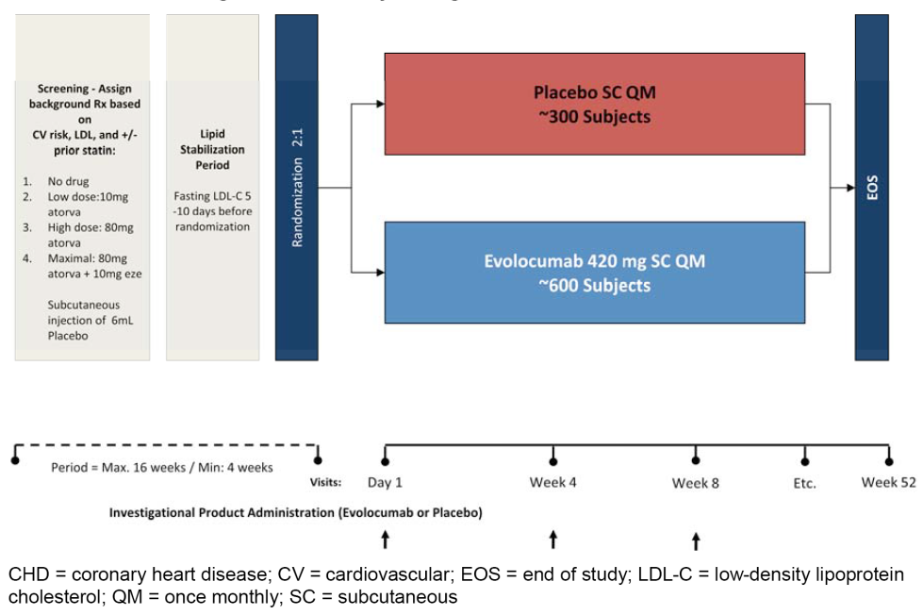

Inclusion and exclusion criteria
The sponsor stated that Study 20110109 was designed to allow subjects with a wide range of cardiovascular risk to enter the study. Key entry criteria included but were not limited to men and women ≥ 18 to ≤ 75 years of age with fasting LDL-C ≥ 1.9 mmol/L and fasting triglycerides ≤ 4.5 mmol/L at screening and end of lipid stabilisation period. LDL-C values at end of lipid stabilisation period LDL-C values had to be ≥ 1.9 and < 2.6 mmol/L for those with CHD or CHD risk equivalents or ≥ 1.9 and < 3.4 mmol/L for those without CHD or CHD risk equivalents or ≥ 1.9 mmol/L for those on maximal background therapy to be eligible for randomisation. Subjects who did not reach their NCEP ATP III risk level LDL-C goal during the stabilisation period had their background therapy up-titrated to the next higher dosage level and were reassessed for eligibility. The complete list of inclusion criteria was provided.
Major exclusion criteria included, but were not limited to, subjects diagnosed with CHD or CHD risk equivalent and not receiving statin therapy with LDL-C at screening ≤ 2.6 mmol/L; NYHA class II, III or IV heart failure, or last known left ventricular ejection fraction < 30%; cardiac arrhythmia within 3 months prior to randomisation that was not controlled by medication, myocardial infarction, unstable angina, percutaneous coronary intervention, coronary artery bypass graft or stroke within 3 months prior to randomisation; planned cardiac surgery or revascularisation; type 1 diabetes, newly diagnosed type 2 diabetes (within 6 months of randomisation or new screening fasting plasma glucose ≥ 7.0 mmol/L or HbA1c ≥ 6.5%), or poorly controlled type 2 diabetes (HbA1c > 8.5%).
(3) Study treatments

Investigational products
Evolocumab SC (70 mg/mL, vial delivering 1 mL volume) and placebo SC (identical presentation to evolocumab SC) were the IPs in this study. All IP was administered SC at the investigational site by a qualified staff member. All subjects received 6 mL (that is, equivalent volume to deliver 420 mg SC) placebo by SC injections to start the screening period to ensure their ability to comply with investigational product administration. IP (evolocumab or placebo) was administered QM according to the pre-specified schedule of assessments after vital signs, electrocardiogram (ECG), and blood sampling were performed. The 6 mL dose volume was split (for example, 3 injections at 2 mL each) and administered into different injection sites in a consecutive manner, all within 30 minutes. Study centres were instructed to administer IP within the visit window for each scheduled visit specified in the protocol. If a subject was late for a scheduled IP visit, administration was to occur as soon as possible, but not within 7 days of a previous dose. Subjects who completely missed a dose of SC IP were to continue in the study and receive the next dose of IP per their treatment schedule. Dose adjustments were not allowed in this study. If, in the opinion of the investigator, a subject was unable to tolerate a specific dose of study drug, the investigational product could be discontinued, but the subject was encouraged to return for all other study procedures and measurements through end of the study.

Prior and concomitant therapy
Throughout the study, investigators could prescribe any concomitant medications or treatments deemed necessary to provide adequate supportive care except for those specified in the protocol (consistent with those previously listed for the pivotal Phase III, 12-week studies). Investigators were instructed to maintain the subjects on stable background lipid lowering therapy (for example, diet, atorvastatin, and ezetimibe) from screening until the end of study (EOS). Over-the-counter drugs that may alter lipid levels were to be stable for at least 4 weeks before screening and remain constant through the study. The use of antacids was not recommended within the period of 2 hours before and 2 hours after dosing with statins.

Concomitant diet and exercise
Investigators were instructed to maintain subjects on a stable diet. All subjects were encouraged to maintain their current regimen of exercise. Subjects were required to refrain from unaccustomed intensive exercise (for example, heavy lifting or long runs) 48 hours prior to each visit.

Compliance with IPs.
The IPs were administered at the investigator site by a qualified staff member.

Removal from therapy or assessment
The criteria for removal from therapy or assessment were consistent with those previously described for the pivotal, Phase III, 12-week studies.

Efficacy variables and outcomes
The primary endpoint was percent change from baseline in LDL-C at Week 52.
The secondary efficacy endpoints (hypothesis testing) were: Tier 1 - (a) change from baseline in LDL-C at Week 52, (b) LDL-C response < 1.8 mmol/L at Week 52, (c) percent change from baseline in LDL-C at Week 12, (d) percent change from baseline in total cholesterol at Week 12, (e) percent change from baseline in total cholesterol at Week 52, (f) percent change from baseline in non-HDL-C at Week 52, (g) percent change from baseline in ApoB at Week 52, (h) percent change from baseline in the total cholesterol/HDL-C ratio at Week 52, (i) percent change from baseline in ApoB/ApoA1 ratio at Week 52; and Tier 2 - (a) percent change from baseline in Lp(a) at Week 52; (b) percent change from baseline in triglycerides at Week 52; (c) percent change from baseline in HDL-C at Week 52; and (d) percent change from baseline in VLDL-C at Week 52
The study included a large number of other endpoints including secondary efficacy (estimate), tertiary exploratory, safety, and PK endpoints.
All primary and secondary endpoint analyses of LDL-C in this study used UC LDL-C (if available). For the exploratory endpoint and longitudinal analyses of LDL-C over time, calculated LDL-C was used. Reflexive testing used for sensitivity analyses was the method for selecting the appropriate LDL-C value to use. In the LDL-C reflexive approach, the calculated LDL-C values are used, unless the value is < 1.0 mmol/L or triglycerides are > 4.5 mmol/L, in which case, the calculated LDL-C value was replaced with the ultracentrifugation (UC) LDL-C value from the same blood sample, if available. Standard laboratory procedures were used for analysis of all other lipid parameters.

Randomisation and blinding methods
Randomisation was based on an IVRS Assignment to the 2 treatment arms was based on a computer-generated randomisation schedule prepared by Amgen before the start of the study (2:1 randomisation to evolocumab or placebo). Randomisation was stratified by background lipid-lowering therapy at the time (that is, diet alone, low dose drug therapy, high dose drug therapy, maximal drug therapy).
Subjects received blinded IP (evolocumab or placebo) SC QM. All subjects and Amgen investigative staff were blinded to treatment assignments. Amgen staff members who were involved in randomisation and biological sample management were unblinded to treatment assignment information, but they did not have access to subject level data from the clinical trial database. Investigators, subjects, and the study team involved with the trial were blinded to post-randomisation central laboratory lipid values for the duration of the study, beginning at randomisation until un-blinding of the final clinical database. The DMC and IBG had access to unblinded subject data. Amgen scientists and the programmers preparing the population PK/PD datasets had access to the treatment assignments and limited subject level data. To maintain study integrity, these Amgen staff members were not within the evolocumab investigative study team. Individual treatment assignment was only unblinded when knowledge of the treatment was essential for safety or for further medical management. Un-blinding for any reason was considered a protocol deviation. No subject was unblinded to IP assignment during this study.

Analysis populations
The full analysis set (FAS) included all randomised subjects who received at least 1 dose of IP. This analysis set was used in both efficacy and safety analyses. Subjects were grouped according to their randomised treatment assignment. For safety analyses, subjects were grouped according to their actual treatment group.
The completer analysis set (CAS) included subjects in the FAS who adhered to the scheduled IP and had an observed UC LDL-C value for the primary endpoint.
The effect durability analysis set included subjects in the FAS who adhered to the scheduled IP and had non-missing UC LDL-C values at baseline, Week 12 and week 52.
The lipid stabilisation analysis set (LSAS) included all screened subjects who received at least 1 dose of lipid stabilisation therapy or were assigned to diet alone. This analysis set was used to summarise data collected during the lipid stabilisation period. If randomised, subjects were grouped according to their randomised treatment assignment.
Approximately 100 subjects (50 subjects per treatment arm) were selected to participate in a vitamin E substudy.

Sample size
The planned total sample size was 900 randomised subjects (600 to evolocumab 420 mg QM and 300 to placebo). This sample size provided sufficient power to determine whether there was a treatment effect of evolocumab compared to placebo at Week 52 (> 99% power after accounting for treatment attenuation and assuming 2% of randomised subjects did not receive any IP). The power calculation was derived by assuming a true treatment effect of evolocumab QM over placebo in the percent reduction of LDL-C of at least 20%, with a common standard deviation (SD) of 20%. The assumptions on which the sample size calculations were based were consistent with those described previously for the pivotal Phase III, 12-week studies.
In addition to evaluating the treatment effects at Week 52, an endpoint of percent change from Week 12 at Week 52 was used to evaluate changes in LDL-C. With the same assumption of SD as used in the primary endpoint, the expected 95% CI width for the difference between groups (evolocumab minus placebo) in the Week 52 treatment effect versus the Week 12 treatment effect was ± 4 % when using the effect durability analysis set. In addition, the difference between the Week 52 treatment effect and the Week 12 treatment effect could be estimated for the evolocumab QM treatment group. The expected width of the 95% CI for this estimate was ± 3%.

Statistical methods

Statistical hypothesis
The null hypothesis was that there was no difference between evolocumab SC 420 mg QM and placebo in percent change in LDL-C from baseline at Week 52, and the alternative hypothesis was that there was a difference between the two treatments.

General approach/considerations and adjustments for multiplicity
The final analysis was conducted when all subjects either completed all the scheduled study visits or terminated early from the study. Efficacy and safety analyses were performed on the FAS, unless otherwise specified. Subjects were grouped by randomised treatment, unless otherwise specified. Subject disposition, demographics, baseline characteristics and exposure to IP were summarised, and summary statistics of adverse events, LDL-C, and background lipid-regulating therapy during the lipid stabilisation period were presented. Summary statistics for continuous variables included the number of subjects, mean, median, SD or standard error, minimum, and maximum. For categorical variables, the frequency and percentage were calculated. Missing data were not imputed for safety endpoints. The family-wise error rate was controlled at 0.05 for the primary and secondary endpoints (Tier 1 and Tier 2 only) using appropriate hierarchal methods based on the Hochberg procedure for multiplicity testing. Unless otherwise specified, all other hypothesis testing was 2-sided with a significance level of 0.05.

Analyses of the primary endpoint
Primary analysis: For the primary endpoint of percent change in UC LDL-C from baseline at Week 52, evolocumab 420 mg SC QM was evaluated by comparing the treatment effect with that of placebo SC QM. The analysis used a repeated measures linear effects model, including terms for treatment group, stratification factor (background therapy group), scheduled visit and the interaction of treatment with scheduled visit. Missing values were not imputed for the repeated measures analysis. The long-term treatment effect of evolocumab 420 mg SC QM versus placebo SC QM was estimated from the repeated measures linear effects model by fitting a contrast between evolocumab and placebo at Week 52. The 95% CI of the treatment effect was estimated from the model. This model was also used to estimate treatment effect and 95% CI of the treatment effect at Week 12, and the 95% CI of the difference of the treatment effect at Week 52 and at Week 12 Summary statistics of the percent change from baseline in LDL-C at Week 52 by randomised treatment group were also calculated.
Sensitivity analyses: To evaluate the robustness of the primary analysis results, the following sensitivity analyses were performed: (a) the primary analysis was repeated using the CAS; (b) the primary analysis (on the FAS) was repeated using the reflexive LDL-C approach for selecting LDL-C for each subject visit in the repeated measures model without imputation; (c) an ANCOVA model was used to assess the effect of evolocumab 420 mg SC QM compared to placebo SC QM at Week 52 in the FAS. The model included terms for treatment group and stratification factor (background therapy group). The dependent variable in this analysis was the percent change from baseline at Week 52. Missing values were imputed using last observation carried forward (LOCF). Two analytical approaches where taken: an ‘On-treatment’ approach (that is, for subjects who terminated IP early, UC LDL-C values measured after termination of IP was censored); and an ‘As observed’ approach (that is, all available Week 52 UC LDL-C values measured on study were used, regardless of IP status at time of assessment).
Non-parametric analyses were also performed using the FAS.
Subgroup analyses on the primary efficacy endpoint were conducted using the stratification factor (background therapy group) and each baseline covariate. Covariate-adjusted analyses were performed using the baseline covariates in their original format, one at a time, in the primary model. Treatment effect differences among subgroups, which represent subgroup by treatment interactions, were estimated and tested based on statistics from the subgroup repeated measures models.

Analyses of secondary efficacy endpoints (hypothesis testing)
Analyses of the Tier 1 and Tier 2 secondary efficacy hypothesis testing endpoints were similar to the primary analysis of the primary endpoint, with the exception that the analysis of LDL-C response (percent of subjects with LDL-C < 1.8 mmol/L]) was analysed using the CMH test adjusted by stratification factor.

Changes in statistical methods
The original SAP (dated 14 June 2012) was amended twice, and both amendment 1 (dated 2 May 2013) and amendment 2 (dated 8 October 2013) were approved prior to study un-blinding. Changes in amendments 1 and 2 reflected Amgen study team decisions made during study conduct, added clarifications to facilitate statistical programming, and made editorial corrections to previous versions of the SAP. These changes did not change the power of the study or affect the size of any analysis dataset.

Participant flow
A total of 2120 subjects were screened and 905 subjects were randomised (602 to evolocumab; 303 to placebo). A total of 901 subjects received at least 1 dose of SC IP and were included in the FAS (599 evolocumab; 302 placebo). The percentage of subjects in the FAS by background therapy was: (a) 12.3% diet alone; (b) 42.5% diet plus atorvastatin 10 mg; (c) 24.2% diet plus atorvastatin 80 mg; and (d) 21.0% diet plus atorvastatin 80 mg plus ezetimibe 10 mg. In total, 855 subjects completed the study including 568 (94.4%) in the evolocumab group and 287 (94.7%) in the placebo group. Eight hundred (800) subjects completed IP dosing per protocol over the duration of the study (52 weeks), including 526 (87.4%) in the evolocumab group and 274 (90.4%) in the placebo group. A total of 101 subjects discontinued IP, including 73 (12.1%) in the evolocumab group and 28 (9.2%) in the placebo group. The most frequent reasons for discontinuation of IP in the evolocumab group included subject request (4.0%), ‘other’ (2.3%), and adverse event (2.0%), while in the placebo group the two most frequent reasons for discontinuation of IP were subject request (2.6%) and full consent withdrawn (2.6%).

Major protocol violations/deviations
At least one important protocol deviation was reported in 17 (2.8%) subjects in the evolocumab group and 14 (4.6%) subjects in the placebo group. None of these subjects were excluded from the FAS. The most common important protocol deviation included receiving the wrong IP (7 [1.2%] evolocumab, 5 [1.7%] placebo), receiving prohibited lipid-regulating medications (4 [0.7%] evolocumab, 4 [1.3%] placebo), and not meeting the LDL-C end of lipid stabilisation criteria (4 [0.7%] evolocumab QM, 3 [1.0%] placebo QM). The important protocol deviations in the two treatment groups are considered not to have invalidated the efficacy analyses.

Baseline data
- Overall, of the 901 subjects included in the FAS, 47.7% were male. The majority of subjects were White (80.4%), with most of the remainder being Black/African American (8.4%) or Asian (6.3%). Most of the subjects (57.8%) were from North America, followed by Europe (26.9% of subjects) and Asia Pacific (15.3% of subjects). The mean subject ± SD age was 56.2 ± 10.6 years and 77.2% of subjects were < 65 years old. The mean ± SD height, weight, BMI, and waist circumference of subjects in the FAS (placebo [n=302] versus evolocumab [n=593-595]) were 168 ± 11 versus 168 ± 10 cm, 86 ± 19 versus 85 ± 18 kg, 30.5 ± 5.9 versus 29.9 ± 6.1 kg/m², and 101 ± 15 versus 99 ± 13.5 cm.
- Overall by background therapy, in the diet alone and diet plus atorvastatin 10 mg group, more women than men were enrolled (55.0% and 56.1 % versus 45.0% and 43.9%, respectively), while more men than women were enrolled in the diet plus atorvastatin 80 mg plus ezetimibe 10 mg group (54.5% versus 45.5%, respectively). The diet alone group had the highest percentage of subjects who were either Asian (14.4%) or Black/African American (16.2%). The diet plus atorvastatin 80 mg group had the highest mean ± SD age (58.0 ±9.2 years).
- Overall, as classified by NCEP ATP III criteria, 26.1% of subjects in the FAS (n=901) were considered at high risk for CHD, 9.4% at moderately high risk, 33.3% at moderate risk, and 31.2% at lower risk. Approximately 15% of subjects had a medical history of coronary artery disease and 4.1% had cerebrovascular or peripheral arterial disease. The most common cardiovascular risk factors were hypertension (48.6%) and low HDL-C (30.9%), followed by a family history of premature CHD (23.1%), current cigarette use (15.0%), and Type 2 diabetes mellitus (11.5%). Approximately 39% of subjects had 2 or more CV risk factors.
- As subjects were assigned to 1 of 4 background therapies based on NCEP ATP III risk categories and screening LDL-C, there were differences in baseline CHD factors in the 4 groups. As expected, subjects stratified to the diet plus atorvastatin 80 mg therapy or the diet plus atorvastatin 80 mg plus ezetimibe 10 mg therapy were more likely to have coronary artery disease, including angina and myocardial infarction, and had a greater history of cerebrovascular or peripheral arterial disease including transient ischaemic attack. Subjects stratified to the diet plus atorvastatin 80 mg plus ezetimibe 10 mg therapy had the highest current usage of cigarettes, the highest incidence of Type 2 diabetes mellitus, the highest family history of premature CHD, and the highest incidence of 2 or more CV risk factors.
- Baseline mean lipid parameters, hsCRP and PCSK9 were summarised for all evolocumab and all placebo groups. All parameters were similar for the two treatment groups. Approximately half (45.9%) of the subjects in the FAS reported the use of at least 1 lipid-regulating concomitant medication of interest at screening (before entry to lipid stabilisation period). These medications included statins (42.6%), fibrates (0.2%), nicotinic acid and derivatives (0.1%), and other lipid-modifying agents (11.3%). For all subjects in the FAS, non-study prescribed concomitant use of atorvastatin or ezetimibe was reported by 136 (15.1%) subjects and 59 (6.5%) subjects, respectively. Less than 1% (0.4%) of subjects reported use of lipid-regulating concomitant medications other than the protocol-assigned during the lipid stabilisation period.

Results for the primary efficacy endpoint
Compared to placebo, the reduction in UC LDL-C at Week 52 (treatment difference ± SE) in the evolocumab 420 mg QM group was 57% ± 2% (p<0.001, multiplicity adjusted) (see Table 30, below). The results were consistent for the LDL when analysed by three methods (see Table 31, below). Statistically significant differences in percent change from baseline in UC LDL-C at Week 12 were observed in subjects treated with evolocumab 420 mg QM compared to placebo QM and these differences were maintained through Week 52 (EOS). LDL-C concentrations in the placebo group remained unchanged from baseline through the entire study period (see Figure 24, below).

Table 30: 20110109 - primary analysis of percent change from baseline in UC LDL-C at Week 52; FAS.
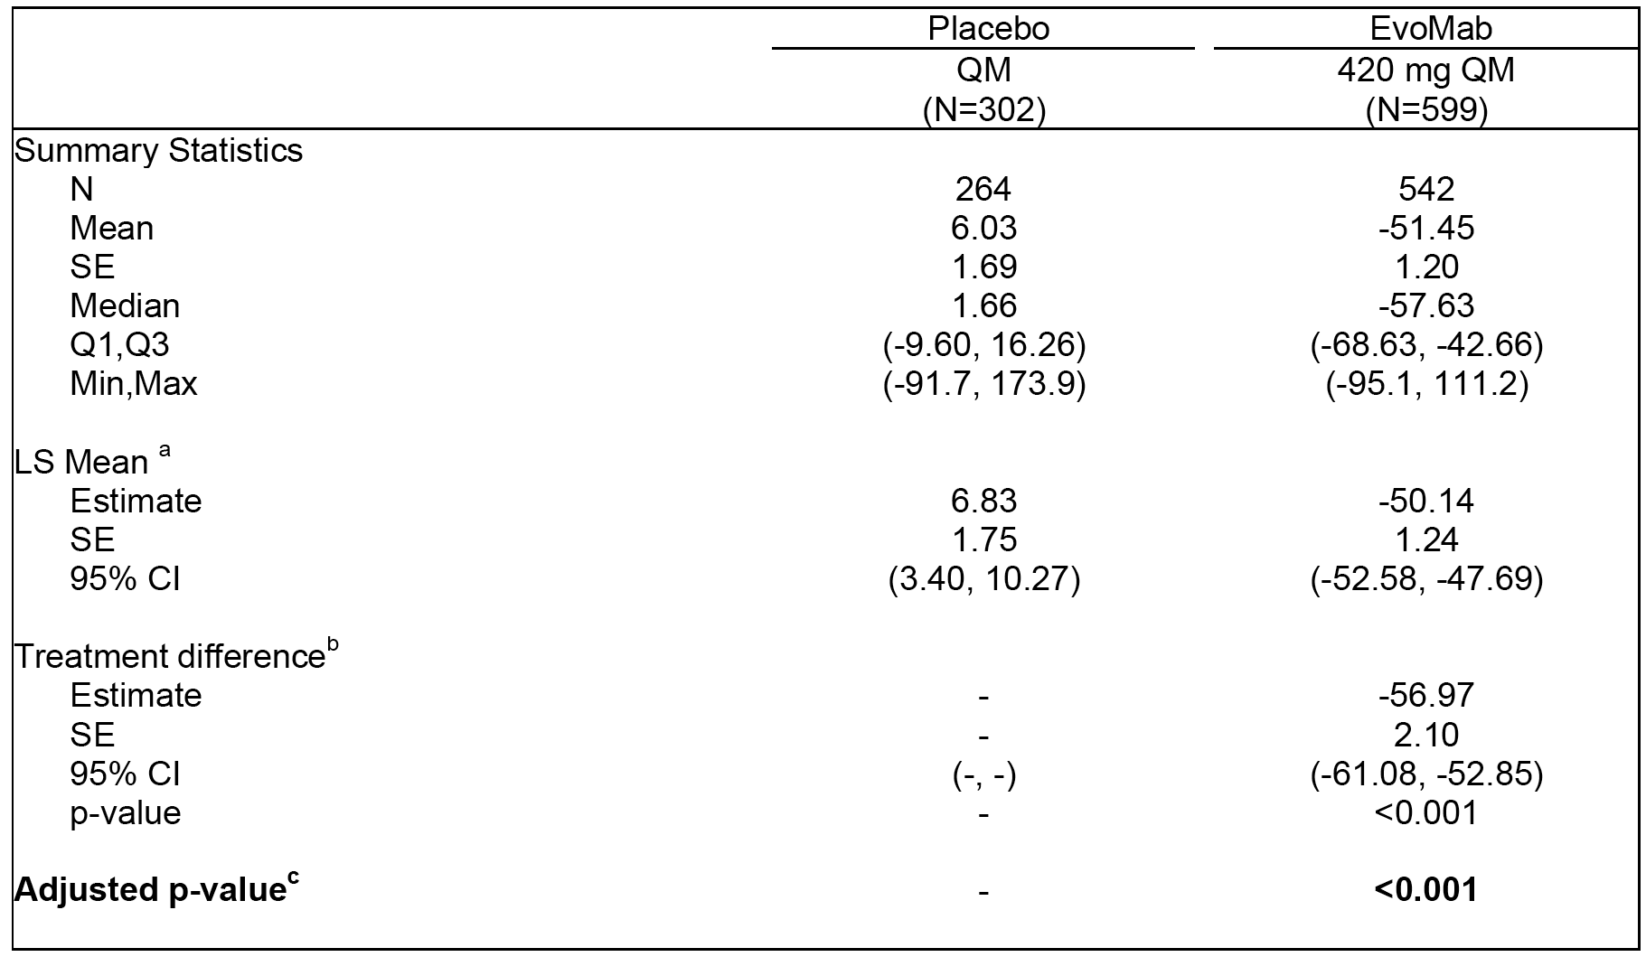

Table 31: 20110109 - Treatment difference in percent change from baseline at Week 52 compared with placebo using LDL-C analysed by three different methods; FAS.
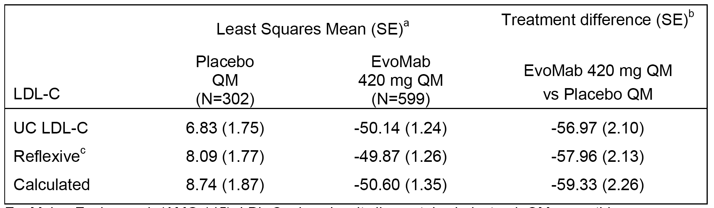
a = Least squares mean is from the repeated measures model which includes treatment group, stratification factor(s) (from IVRS), scheduled visit and the interaction of treatment with scheduled visit as covariates. b = Treatment difference is within each background therapy group using placebo in the same group as the reference. c = When the calculated LDL-C is <40 mg/dL or triglycerides are > 400 mg/dL, calculated LDL-C will be replaced with UC LDL-C from the same blood sample, if available.
Figure 24: 20110109 - Plot of mean change from baseline in UC LDL-C by scheduled visit and IP; FAS.
Arrows indicate dosing schedule. Vertical lines represent the standard error around the mean. Plot is based on observed data and no imputation is used for missing values.
Results of the primary analysis for percent change from baseline to Week 52 in UC LDL-C by background therapy and IP were provided. Briefly, compared to placebo QM, the treatment difference ± SE for the percent reduction from baseline at Week 52 in UC LDL-C for the evolocumab 420 mg QM treatment group was 55.7% ± 4.2% in the diet alone group, 61.6% ± 2.6% in the diet plus atorvastatin 10 mg group, 56.8% ± 5.3% in the diet plus atorvastatin 80 mg group, and 48.5% ± 5.2% in the diet plus atorvastatin 80 mg plus ezetimibe 10 mg group, with the difference being statistically significant for each pair-wise comparison (p<0.001).
Results of the sensitivity analyses for percent change from baseline in UC LDL-C at Week 52 in the completer analysis and the non-parametric analysis were consistent and appeared comparable in magnitude to the primary efficacy analysis, as were the results from the sensitivity analyses using ANCOVA models with ‘on-treatment’ and ‘as-observed’ approaches.
Results of subgroup analyses of the percent change from baseline in UC LDL-C at Week 52 for evolocumab QM compared with placebo QM demonstrated that evolocumab QM was effective across all subgroups with no notable differences being observed (that is, age; sex; race; geographic region; UC LDL-C; BMI; glucose tolerance status; hypertension; current smoker; CHD risk factors; family history of premature CHD; PCSK9; triglycerides above or below the median; triglycerides above or below 1.7 mmol/L; triglycerides above or below 2.3 mmol/L; and NCEP high risk. A forest plot summarising the percent change from baseline in UC LDL-C at Week 52 for the sub-group analyses was provided. Analyses adjusting for each of the covariates in the primary analysis were consistent with the primary analysis, and significant treatment effects were seen for the percent change from baseline in UC LDL-C in the evolocumab QM treatment group compared with placebo QM.

Results for the secondary endpoints (Tier 1 and Tier 2)
Results of the Tier 1 and Tier 2 secondary efficacy analyses showed statistically significant differences in the percent change from baseline in all lipid parameters for the evolocumab 420 mg QM treatment group compared with placebo QM (p < 0.001, adjusted for multiplicity). The treatment effect of percent reduction in mean UC LDL-C for evolocumab 420 mg QM compared to placebo remained stable from Week 12 to Week 52 (see Table 32, below).

Table 32: 20110109 - Analysis of consistence of treatment effects (evolocumab versus placebo) at Week 12 and week 52; FAS.
a = Least squares mean is from the repeated measures model which includes treatment group, stratification factor(s) (from IVRS), scheduled visit and the interaction of treatment with scheduled visit as covariates. No imputation for missing data.

Phase II Study 20110110 (OSLER-1)

Design
This ongoing Phase II multinational, multicentre, randomised, controlled, open-label 5-year extension study is designed to assess the long-term safety and efficacy of evolocumab in subjects with primary hyperlipidaemia and mixed dyslipidaemia. Subjects who completed 1 of the 5, Phase II studies were eligible to participate in OSLER-1 (that is, Studies 20090158, 20090159, 20101154, 20101155, and 20110231). Subjects were randomised 2:1 to receive either evolocumab 420 mg QM plus standard care or standard care alone for the first 12 months of treatment. At the end of the first year of treatment, all subjects received evolocumab 420 mg QM alone for the remainder of the 5 year study. The first subject was enrolled on 7 October 2011 and the study is ongoing. The submission included the results of an interim analysis.
This study is being conducted at 189 study centres in the United States, Europe (11 countries), Japan, Canada, South Africa, Australia, and other countries in the Asia-Pacific region. The study was ongoing at the data cut-off date for the interim CSR of 1 April 2014. The study is being conducted in accordance with ICH GCP regulations and guidelines. The study is being sponsored by Amgen. The study is also known by the name of OSLER-1 - Open-label Study of Long Term Evaluation Against LDL-C Trial.

Objectives
The primary objective was to characterise the safety and tolerability of long-term administration of evolocumab. The secondary objectives are to characterise the efficacy of long-term administration of evolocumab as assessed by LDL-C and non-HDL-C, ApoB, total cholesterol/HDL-C ratio, and ApoB/Apolipoprotein A-1 (ApoA1) ratio in subjects with hypercholesterolaemia.

Methods
During the first 12 weeks of the extension study, LDL-C levels remained masked to investigators and no changes to background lipid-lowering therapy from the parent Phase II study were allowed. After extension study week 12, the investigators were allowed to change background therapy per local standards of care. However, during Year 1, investigators were prohibited from down-titrating statins (continued from the parent Phase II study) in response to unmasked LDL-C levels. At the end of the first year (extension study Week 52), subjects were eligible to enter the all IP period (referred to as Year 2+) in which all subjects could receive open-label evolocumab for another 4 years or until the investigator recommended discontinuation, Amgen recommended discontinuation, the subject decided to discontinue for any reason, or until an administrative decision is made to close the study. After Year 1, investigators could down-titrate background therapy, if deemed necessary.

Inclusion and exclusion criteria
Key entry criteria included, but were not limited to, subjects who completed a qualifying evolocumab study and did not experience a treatment related serious adverse event that led to IP discontinuation in the parent study.

Treatment
Evolocumab was the IP in this study and was administered 420 mg SC QM using 2 different formulations. Prior to protocol amendment 5, all evolocumab was administered during year 1 via single-use 1 mL vial (70 mg/mL) and syringe at the investigator site by a qualified staff member. After protocol amendment 5 and once the AI/pen (140 mg/mL) became available, evolocumab was also self-administered during Year 2+ at home or other locations by the subject or a trained designee. Subjects received evolocumab 420 mg SC QM plus standard of care (evolocumab group) or standard of care alone (control group) for year 1 of the study. At the end of year 1 (extension study Week 52), all subjects were eligible to receive open-label evolocumab for up to another 4 years (Year 2+). All subjects were encouraged to maintain their current regimen of diet and exercise throughout the study. Subjects were required to refrain from unaccustomed intensive exercise 48 hours prior to each visit. The use of magnesium or aluminum hydroxide-containing antacids was not recommended for 2 hours before and for 2 hours after dosing with statins.

Endpoints
The primary endpoint was the incidence of adverse events in the participating subjects.
The secondary endpoints were: (a) percent change from parent study baseline in LDL-C at each visit with planned lipid measurements; (b) change from parent study baseline in LDL-C at each visit with planned lipid measurements; (c) percent change from parent study end of study (parent Phase II study week 12) in LDL-C at each visit with planned lipid measurements; (d) change from parent study end of study (parent Phase study week 12) in LDL-C at each visit with planned lipid measurements
The study included a large number of exploratory endpoints. In this CER, the evaluation of efficacy focuses on the lipid parameters pre-specified as secondary endpoints.

Analysis populations
The Interim Standard of Care Controlled Period Analysis Set (ICOAS) included all subjects randomised in this study. Subjects were analysed according to the treatment group to which they were randomised in Year 1. All data from year 1 were summarised, regardless of possible IP discontinuation.
The Interim All Investigational Product period Analysis Set (IAAS) included all subjects that were randomised in this study and dosed with IP and who were on study in Year 2+.

Statistical methods and sample size
No formal hypothesis was tested in this study. There were no formal sample size calculations. The number of subjects entering this study was dependent on the number of subjects who completed the respective evolocumab parent studies and elected to enroll in the extension study. Approximately 2000 subjects were randomised in the qualifying parent studies. Assuming 80% of those subjects rolled over into OSLER-1, the sample size would be approximately 1600 subjects.
Statistical analyses in this extension study were descriptive. Subject disposition, demographics, and baseline characteristics were summarised. Summary statistics for continuous variables included the number of subjects, mean, median, standard deviation (SD) or standard error (SE), first and third quartiles, minimum, and maximum. For categorical variables, the frequency and percentage were provided. All analyses were carried out separately for Year 1 using the ICOAS and for Year 2+ using the IAAS, unless otherwise specified. There was no imputation for missing data.

Enrolment and disposition of subjects
A total of 1648 subjects completed 1 of 5 parent Phase II studies, and 1324 (80%) subjects entered the open-label extension study (see Table 33, below).

Table 33: 20110110 - Summary of subject enrolment by parent Phase II study.
Of the 1324 randomised subjects enrolled in the extension study, 882 were randomised to evolocumab and 442 were randomised to control. Randomisation was stratified on the basis of the treatment arm a subject had been randomised to in the parent study (that is, evolocumab QM, evolocumab Q2W, or no evolocumab). Of the 1324 randomised subjects, 580 (43.8%) had received evolocumab QM, 385 (29.1%) had received evolocumab Q2W, and 359 (27.1%) had not received evolocumab in the parent study.
As of the data cut-off date for the interim analysis, 681 (77.2%) subjects in the evolocumab group and 325 (73.5%) subjects in the control group completed Year 1. A total of 144 (16.3%) subjects in the evolocumab group and 73 (16.5 %) subjects in the control group were continuing in Year 1. A total of 57 (6.5%) subjects in the evolocumab group and 44 (10.0%) subjects in the control group discontinued from the study during Year 1. The reasons for discontinuation from the study during Year 1 in the evolocumab and control groups (respectively) were withdrawal of consent (33 [3.7%] versus 24 [5.4%]), decision by sponsor (1 [0.1%] versus 0 [0.0]%), lost to follow-up (7 [0.8%] versus 8 [1.8%]), death (1 [0.1%] versus 2 [0.5%]), and other reasons (15 [1.7%] versus 10 [2.3%]).
In Year 1, 12.2% (n=108) of the 882 subjects randomised to evolocumab discontinued treatment with the drug for the following reasons: full consent withdrawn (2.8%); adverse event (3.1%); subject request (4.0%); physician decision (0.5%); lost-to-follow up (0.6%); and other (1.4%).
No subjects have completed the Year 2+ period (that is, all IP period in which all subjects could receive open-label evolocumab for up to 4 years). Of the 1006 subjects who completed Year 1 and were eligible for continued participation in the study, 962 (95.6%) were continuing in Year 2+ at the time of the data cut-off date, while 44 (4.4%) had discontinued from the study during this period. The reasons for discontinuation from the study in Year 2+ were withdrawal of consent (20 subjects; 2.0%) lost to follow-up (14 subjects; 1.4%), other reasons (8 subjects; 0.8%) and death (2 subjects; 0.2%).
Of the subjects continuing in Year 2+, 43 (4.3%) discontinued the IP (that is, evolocumab) but could remain in the study for follow-up. The reasons for discontinuation of the IP in Year 2+ were AEs (n=13, 1.3%), subject request (n=8, 0.8%), lost to-follow up (n=8, 0.8%), full consent withdrawn (n=5, 0.5%), decision by sponsor (n=3, 0.3%), physician decision (n=1, 0.1%), death (n=1, 0.1%), pregnancy (n=1, 0.1%), and other (n=3, 0.3%).

Demographics and other baseline (that is, parent study baseline) characteristics
In the ICOAS (Year 1 [n=1324]), the mean ± SD age of the total population was 57.1 ± 11.6 years, with 70.9% of subjects being aged < 65 years and 29.1% of subjects being aged ≥ 65 years. The total population included 47.1% males and 52.9% females, and the majority of the population was White (73.5%), with most of the remainder of the population being Asian (19.3%), Japanese (16.6%) or Black/African American (5.9%). NCEP CHD risk categories were high (35.5%), moderately high (9.4%), moderate (29.9%), and lower (25.2%). Baseline coronary artery disease was present in 19.8% of subjects, baseline cerebrovascular or peripheral arterial disease was present in 7.9% of subjects, and 42.3 % of subjects had 2 or more cardiovascular risk factors (hypertension 54.4%). The baseline coronary heart disease risk factors for the ICOAS (Year 1) for the ICOAS were summarised. Other pre-specified cardiovascular disease characteristic included atrial fibrillation/flutter (current 0.8%, former 0.9%), current CHF (NYHA) 2.9%, LVEF < 30 % (0%), and cardiac devices/pacemakers (1.1%). In general, treatment groups were balanced, and none of the demographic or baseline characteristic differences between treatment groups was considered to have an effect on study interpretation

Results - LDL-C
The interim results for the year 1 analysis are summarised below in Table 34.

Table 34: 20110110 - Analysis of percent change from baseline in calculated LDL-C at Week 12 (upper panel) and Week 52 (lower panel); ICOAS.
Week 12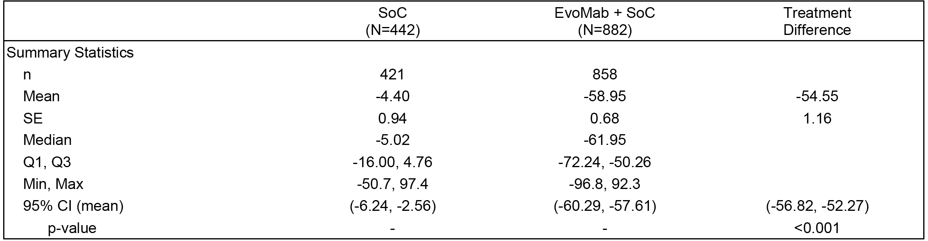

Week 52
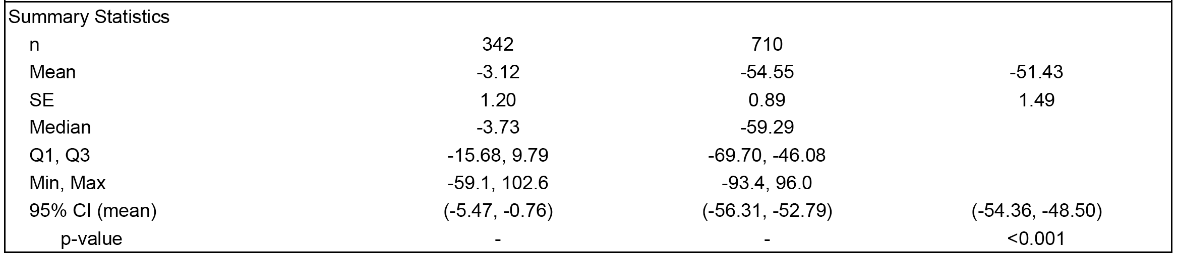
N = number of subjects that were randomised in 20110110; EvoMab = Evolocumab (AMG145); SoC = standard of care; OLE = open-label extension. Summary is based on observed data and no imputation is used for missing values. Baseline is defined as the parent study baseline. Treatment difference using SoC treatment group as the reference. 95% CI is from Satterthwaite CI and p-value from Satterthwaite two-sided t-test under normal assumption with unequal variances.
The interim results for the Year 2+ analysis included data on 937 subjects treated with evolocumab. For the Year 2+ data, for the evolocumab group the mean ± SE percent reductions in reflexive LDL-C from parent study baseline at extension study year 1 and extension year 124 were 53.5% (0.8%) and 49.8% ± 4.4%, respectively For the Year 2+ data, for the control group the mean ± SE percent reductions in reflexive LDL-C from parent study baseline to the first visit after switching to evolocumab (that is, week 64) and at extension study week 124 were 54.3% ± 1.2% and 51.4% ± 6.7%m respectively. The data indicate that reductions in LDL-C concentrations reported with evolocumab can be maintained for ≥ 52 weeks.

Results - other secondary endpoints (lipid parameters)
Evolocumab significantly reduced non-HDL-C, Apo B, total cholesterol, Lp(a), triglycerides and VLDL-C, and increased HDL-C and ApoA1 from parent study baseline to extension study Week 12 and to extension study Week 52 compared to control (all treatment differences p < 0.001 at Week 12 and ≤ 0.002 at Week 52).

Phase III Study 20120138 (OSLER-2)

Design
This ongoing, Phase III, multinational, multicentre, randomised, controlled (standard of care), open-label, 2-year extension study was designed to assess the long-term safety and efficacy of evolocumab (140 mg SC Q2W or 420 mg SC QM) in subjects with primary hyperlipidaemia and mixed dyslipidaemia. At the time of the data cut-off for the CSR (1 April 2014), subjects from Studies 20110109, 20110114, 20110115, 20110116, 20110117, 20120348 and 20120356 contributed data to this interim analysis. The first subject was enrolled on 23 April 2013 and the study is ongoing.
This study is being conducted at approximately 450 study centres. The interim analysis included subjects enrolled at 282 centers in the US, Canada, Denmark, Czech Republic, Australia, the United Kingdom, Belgium, Germany, the Netherlands, Hungary, South Africa, Spain, Italy, Sweden, the Russian Federation, France, Switzerland, Norway, Hong Kong, New Zealand, Taiwan, and South Korea. The study is being conducted in accordance with ICH regulations and guidelines. The study is being sponsored by Amgen. The alternative name of this study is OSLER-2.

Objectives
The primary objective was to characterise the safety and tolerability of long-term administration of evolocumab. The secondary objective was to characterise the efficacy of long-term administration of evolocumab as assessed by LDL-C in subjects with primary hyperlipidemia and mixed dyslipidemia.

Methods
Eligible subjects were randomised 2:1 to receive either evolocumab (140 mg SC Q2W or 420 mg SC QM) plus standard of care (referred to as the evolocumab group) or standard of care alone (referred to as the control group) for the first 48 weeks of the study (referred to as the standard of care controlled period: 1 year). Randomisation was stratified by parent study and parent dose frequency (Q2W or QM). At the end of the first year (Week 48), subjects entered the IP period (referred to as Year 2) in which all subjects received open-label evolocumab (140 mg SC Q2W or 420 mg SC QM) for approximately 1 year or until the investigator recommends discontinuation, Amgen recommends discontinuation, the subject decides to discontinue for any reason, or until an administrative decision is made to close the study.

Inclusion and exclusion criteria
Subjects who completed a qualifying evolocumab protocol and did not discontinue IP in the parent study for any reason including an adverse event were eligible for this study.

Treatment
Evolocumab was the IP in this study. Evolocumab was administered using prefilled AI/pens (140 mg/mL in 1 mL deliverable volume). Subjects randomised to the evolocumab group during Year 1 of this study and all subjects in Year 2 were able to choose 1 of 2 dosing regimens: evolocumab 140 mg SC Q2W plus standard of care or evolocumab 420 mg SC QM plus standard of care, and could switch between dosing regimens at 3 month intervals.
Since lipids were masked for the first 12 weeks of this study to preserve the parent study blind, the investigator prescribed background lipid-lowering therapy that the subject was expected to tolerate (for example, therapy prior to parent study participation, or statin and/or ezetimibe therapy received during the parent study). After 12 weeks in this extension study, LDL-C concentrations were available to the investigator and lipid-lowering therapy could be modified if necessary based on local standards of care, although subjects were encouraged to remain on stable, background lipid-lowering therapy throughout the study period.
For subjects randomised to evolocumab in Year 1 and for all subjects in Year 2, IP was administered using 1 of 2 dosing regimens based on subject selection: that is, evolocumab 140 mg (1 prefilled AI/pen injection) SC Q2W or evolocumab 420 mg (3 prefilled AI/pen injections) SC QM. Subjects randomised to evolocumab could not only select their dosage regimen but could also switch between dosage regimens at 3 month intervals during study visits.
Throughout the study, investigators could prescribe any concomitant medications or treatments deemed necessary to provide appropriate care, except for those specified in the protocol. Background lipid-lowering concomitant medications were required to be stable throughout study participation. Subjects were instructed to maintain baseline levels of exercise during the first year of study participation. Subjects were required to refrain from unaccustomed intensive exercise 48 hours before each visit. The use of magnesium or aluminum hydroxide-containing antacids was not recommended 2 hours before and 2 hours after dosing with statins.

Endpoints
The primary endpoint was the incidence of adverse events in the participating subjects.
The secondary endpoints for this interim analysis were: (a) percent change from parent study baseline in LDL-C at each visit with planned lipid measurements; (b) change from parent study baseline in LDL-C at each visit with planned lipid measurements; (c) percent change from parent study end of study in LDL-C at each visit with planned lipid measurements; and (d) change from parent study end of study in LDL-C at each visit with planned lipid measurements
The study included a large number of exploratory endpoints. In this CER, the evaluation of efficacy focuses on the changes in LDL-C defined as secondary endpoints.

Analysis populations
The interim standard of care controlled period analysis set (ICOAS) included all randomised subjects with at least 12 weeks of potential follow-up. Subjects were analysed according to the treatment group to which they were randomised during the standard of care controlled period (referred to as year 1). All data from the standard of care controlled period was summarised, regardless of possible IP discontinuation.
The interim all investigational product period analysis set (IAAS) included all subjects who were on study and had known dosing data during the all-investigational product period (referred as Year 2). Data were summarised from the start of year 2 (Week 48) to end of study or the data cut-off date, whichever occurred first.

Statistical methods and sample size
No formal hypothesis was tested in this study. The number of subjects entering the study is dependent on the number of subjects completing their respective evolocumab parent studies and their willingness to enroll in the extension study. Based on the planned enrolment in the parent studies (approximately 4750) and an anticipated enrolment to this study of approximately 74% overall, the sample size is expected to be approximately 3500 subjects. Additional parent studies may be identified in the future resulting in further additions to the sample size.
Statistical analyses in this open-label extension study were descriptive in nature. The pre-planned interim analyses summarised data collected through a data cut-off date of 11 April 2014. Safety and efficacy results focused on analyses in the ICOAS during the standard of care-controlled period (Year 1; defined as Day 1 to Week 48). The ICOAS included all randomised subjects who had at least 12 weeks of potential follow-up. Results of the analyses in the IAAS, which included subjects who were on study and had known dosing data during the all-investigational product period (Year 2; defined as Week 48 through end-of-study) were also provided. However, the sample size in the IAAS was small at the date of the interim analysis (n=17), which precludes meaningful interpretation of the data from these subjects. Therefore, the focus in this CER is on the ICOAS data.
For all endpoints, results were summarised by the treatment group to which subjects were randomised in Year 1 (that is, evolocumab or control). Both doses of evolocumab (140 mg Q2W and 420 mg QM) were grouped for the analysis, because subjects were allowed to select their initial evolocumab dosing regimen (that is, Q2W or QM) and were also periodically allowed to switch between the two dosing regimens throughout the study. Subjects were further categorised according to whether they were randomised to evolocumab or control in their parent study. For these analyses, the combined treatment group had 4 levels: (i) evolocumab in parent/evolocumab in OLE; (ii) evolocumab in parent/control in OLE; (iii) control in parent/evolocumab in OLE; and (iv) control in parent/control in OLE.
Unless otherwise specified, baseline values were defined as the baseline value from the parent study. Summary statistics for continuous variables included the number of subjects, mean, median, SD or SE, first and third quartiles, and minimum and maximum. For categorical variables, the frequency and percentage were provided, and 95% CIs were calculated for select continuous endpoints. There was no imputation for missing data.
Analysis of LDL-C used a reflexive testing approach whereby calculated LDL-C was used in the analysis, except when calculated LDL-C was < 1.0 mmol/L or triglycerides were > 4.5 mmol/L; these values were replaced with UC LDL-C for the analysis when available. Analyses of LDL-C across time were presented using the reflexive approach. An additional analysis of LDL-C at all time points using calculated LDL-C

Enrolment and disposition of subjects
At the time of the data cut-off for this interim report, 3122 subjects had been screened for the study and 3121 subjects had been randomised (2080 to the evolocumab group and 1041 to the control group). Subject enrolment by parent study and inclusion in the ICOAS is summarised below in Table 35. The study contributing most subjects to the ICOAS was 20110115 (LAPLACE-2).

Table 35: 20120138 Summary of subject enrolment by parent study; ICOAS.
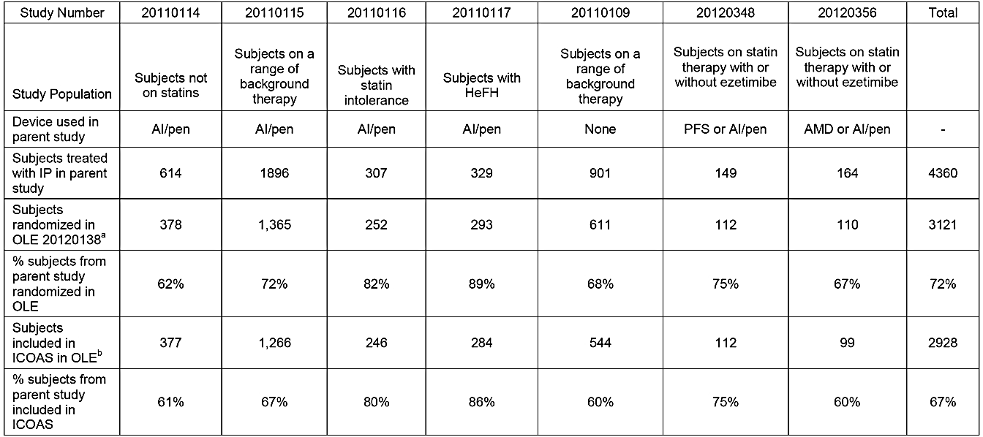
a = As of data cut-off date of 01 April 2014 b = ICOAS was the interim standard of care controlled period analysis set and included all subjects randomised in Study 20120138 as of the data cut-off date who had at least 12 weeks of potential follow up.
Subjects entering this extension study who were randomised to evolocumab were allowed to choose between Q2W and QM dosing of evolocumab and allowed to switch dosing regimens after 12 weeks. When given the choice at the start of the OLE study, 255 (32%) subjects on Q2W and 323 (28%) subjects on QM dosing in the parent studies elected to switch to the alternate regimen. At the next opportunity, at Week 12 of OLE, only 30 (4%) subjects receiving Q2W dosing and 28 (3%) subjects receiving QM dosing switched to the alternate dosing regimen. At the time of the data cut-off date, only 32 (4%) subjects who had selected Q2W dosing and 30 (3%) subjects who had selected QM dosing at the beginning of the OLE study chose to switch dosing regimens after their initial selection.
Of the 2928 subjects included in the ICOAS, 1872 (63.9%) had previously received evolocumab in a parent study and 1056 (36.1%) had previously received control in a parent study. In the ICOAS (n=2928), 1951 (66.6%) received evolocumab plus standard of care in Year 1 and 977 (33.4) received standard of care (control) without evolocumab. In the ICOAS (n=2928), 27 (0.9%) subjects had completed Year 1 of the study (11 [1.1%] in the control group and 16 [0.8%] in the evolocumab group) at the time of data cut-off, while 2866 (97.9%) subjects were continuing in Year 1 of the study (958 [98.1%] in the control group and 1908 [97.8%] in the evolocumab group) and 35 (1.2%) subjects had discontinued during year 1 (8 [0.8%] in the control group and 27 [1.4%] in the evolocumab group). Of the 35 (1.2%) of subjects who had discontinued in Year 1, the reasons were withdrawal of consent (23 [0.8%]), decision by sponsor (2 [0.1%]), lost-to-follow up (6 [0.2%]), and death (4 [0.1%]).

Baseline demographics and other characteristics (ICOAS)
In general, treatment groups were balanced, and none of the minor demographic or baseline characteristic differences between treatment groups were considered to have an effect on study interpretation. The ICOAS included 2928 subjects, with mean ± SD age 58.3 ± 10.7 years and 1517 (51.8%) males and 1411 (48.2%) females. The majority of subjects were White (91.2%) with most of the remainder being Black/African American (4.3%) or Asian (3.3%). At the beginning of the extension study, 70.1% of subjects in the evolocumab group and 76.2% of subjects in the control group reported use of lipid-regulating medications. The most commonly used concomitant medications were statins which were reported in 1303 (66.8%) subjects randomised to evolocumab and 698 (71.4%) subjects randomised control. Ezetimibe use at the start of the extension study was reported in 232 (11.9%) subjects randomised to evolocumab and 157 (16.1%) subjects randomised control.
At parent study baseline, mean ± SD calculated LDL-C in the total population (n=2928) was 3.2 ± 1.2 mmol/L, and was comparable across treatment groups. Baseline concentrations of other lipid parameters (mean ± SD) were also comparable across the treatment groups (that is, total cholesterol 5.3 ± 1.3 mmol/L; HDL-C 1.4 ± 0.4 mmol/L, triglycerides 1.5 ± 0.8 mmol/L, and VLDL-C 0.67 ± 0.34 mmol/L.

Efficacy results - LDL-C
At the time of the interim analysis, the number of subjects with measurements at Week 48 (n=7) in the extension study was significantly less than the number with measurements at Week 12 (n=2784) and week 24 (n=1904). Meaningful interpretation of the data at Week 48 is precluded by the small number of subjects with data at this time-point. The results for percent change from parent study baseline in reflexive and calculated LDL-C by scheduled visit (Weeks 12, 24, and EOS) are summarised below in Table 36. At Weeks 12 and 24 of the extension study, reductions in LDL-C from baseline value in the parent study in each of the evolocumab groups was statistically significantly greater than in the control groups (p < 0.001, no adjustment for multiplicity). In the combined

Table 36: 20120138 - Summary of percent change from parent study baseline in reflexive and calculated LDL-C by scheduled visit in Year 1; ICOAS
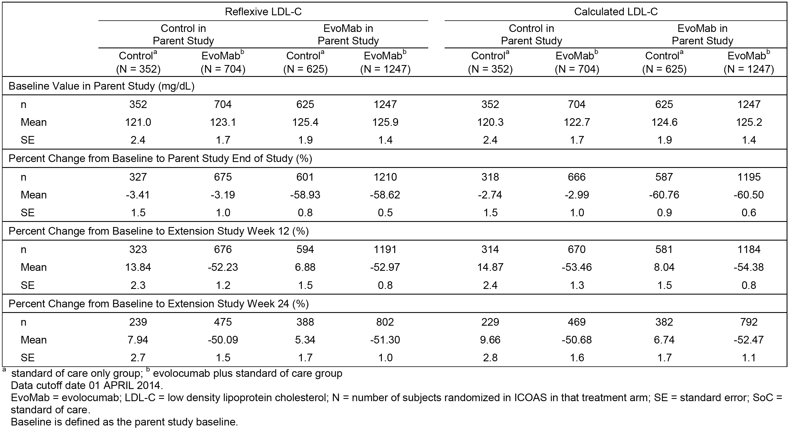

Home-use setting studies

Study 20120348 (THOMAS-1)
THOMAS-1 was a multinational (USA, Canada), multicentre (22 centres), randomised, open-label, Phase III study in subjects with primary hypercholesterolaemia or mixed dyslipidaemia designed to assess subjects' ability to administer a full dose of evolocumab (140 mg SC Q2W) in a home-use setting, using either a PFS or a pre-filled AI/pen. The study planned to enrol 140 subjects. The first subject was enrolled on 18 April 2013 and the last subject completed on 30 September 2013. The CSR was dated 20 March 2014. The study was conducted in accordance with ICH GCP regulations and guidelines. The sponsor was Amgen. The name THOMAS is derived from - Trial for home-use of prefilled auto-injector pen and prefilled syringe in AMG 145 administrations.
The primary objective of this study was to assess the ability of subjects to administer a full dose of evolocumab in a home-use using either a prefilled syringe (PFS) or a prefilled auto injector/pen (AI/pen). The secondary objective was to assess the effect of evolocumab on low-density lipoprotein cholesterol (LDL-C) using the two specified drug delivery options. Statistical analyses in this study were descriptive.
Eligible subjects were men and women ≥ 18 and ≤ 80 years of age with fasting LDL-C at screening of ≥ 2.2 mmol/L and fasting triglycerides ≤ 4.5 mmol/L. Subjects were required to be on a stable dose of a statin with or without ezetimibe for at least 4 weeks prior to randomisation. The subject self-administered (or designee administered) evolocumab under clinical site supervision in the clinic on Day 1, and then without supervision in a home-use setting at Weeks 2 and 4. Administration using the PFS or the AI/pen was to be at 1 of 3 distinct locations on the abdominal wall, upper thigh, or outer arm of each injection, with arm injections requiring care-giver assistance.

Primary endpoint - subject reported outcomes of full-dose administration:
The primary endpoint was the subject-reported outcome of attempted full-dose administration at each of weeks 2 and 4. Subjects who discontinued IP had responses recorded as discontinued IP prior to administration time. Each primary endpoint had 3 possible values (yes/no/discontinued IP prior to administration time).
Full administration of evolocumab at both week 2 and week 4 was reported in 96.0% of subjects in the PFS group (n = 72) and 89.2% of subjects in the AI/pen group (n = 66). The observed difference for AI/pen versus PFS was -6.8% (95% CI: -16.3%, 2.0%); the 95% CI for the difference includes zero.
By Week 4, 2.7% and 4.1% of subjects had discontinued evolocumab in the PFS and AI/pen groups, respectively, and 1.3% and 6.7% of subjects did not administer a full dose of evolocumab at Week 2 and/or Week 4 in the PFS and AI/pen groups, respectively. The percentage of subjects who fully administered evolocumab in a home-use setting using the PFS was 97.3% (95% CI: 90.8%, 99.3%) at Week 2 and 96.0% (95% CI: 88.9%, 98.6%) at Week 4. For the AI/pen, the percentage of subjects who fully administered evolocumab in a home-use setting was 95.9% (95% CI: 88.7%, 98.6%) at Week 2 and 91.9% (95% CI: 83.4%, 96.2%) at Week 4. At both Week 2 and Week 4, the 95% CIs overlapped for successful self-administration of a full dose of evolocumab.

Secondary endpoint - effect of administration on LDL-C:
The secondary endpoint was the percent change from baseline in LDL-C at Week 6. The effect was estimated using an ANCOVA model, with covariates of treatment and stratification factor (screening LDL-C < 3.4 versus ≥ 3.4 mmol/L). The percent reduction from baseline in reflexive LDL-C at Week 6 using least squares mean ± SE change, including treatment group and stratification factor as covariates, was 59.7% ± 2.8%) in the PFS group and 63.4% ± 2.7% in the AI/pen group, with an estimated treatment difference of -3.7% ± 3.4%), with 95% CI of -10.4% to 3.0%.
Comment: The study showed that a full-dose of evolocumab (140 mg Q2W) can be successfully administered by PFS and AI/Pen at both Weeks 2 and 4 in nearly all subjects. There was no clinically meaningful difference in percent change from baseline in reflexive LDL-C at Week 6 between PFS and AI/Pen administration. The percent reductions from baseline in reflexive LDL-C at Week 6 were consistent with those observed at Week 12 in the pivotal Phase III studies.

Study 20120356 (THOMAS-2)
THOMAS-2 was a multinational (USA, Canada), multicentre (23 centres), randomised, open-label, Phase III study in subjects with primary hypercholesterolaemia or mixed dyslipidaemia designed to assess subjects' ability to administer a full dose of evolocumab (420 mg SC QM) in a home-use setting, using either a personal auto injector (AMD) or a pre-filled AI/pen. The study planned to enrol 140 subjects. The study period was from 11 July 2013 to 16 December 2013. The CSR was dated 24 March 2014. The study was conducted in accordance with ICH GCP regulations and guidelines. The sponsor was Amgen.
The primary objective of was to assess users’ ability to administer a full dose of evolocumab in a home-use setting using either an AMD or AI/pen. The secondary objective of was to assess the effect of evolocumab on LDL-C. Statistical analyses in the study were descriptive.
Eligible subjects were men and women ≥ 18 and ≤ 80 years of age with fasting LDL-C ≥ 2.2 mmol/L at screening and fasting triglycerides ≤ 4.5 mmol/L. Subjects were required to be on a stable dose of a statin with or without ezetimibe for at least 4 weeks prior to randomisation. Subjects self-administered evolocumab in the clinic on Day 1 under supervision of site staff and then self-administered in a home setting at Weeks 4 and 8. At each visit (that is, in the clinic on Day 1 and by telephone at Weeks 4 and 8), site staff documented on the IP administration electronic case report form (eCRF) whether the subject was able to successfully administer a full dose of evolocumab (that is, the entire set of three 1.0 mL injections [AI/pen] or the entire 3.5 mL injection [AMD]).
Subjects returned to the clinical trial site at Week 10 for LDL-C measurement. The end-of-study (EOS) visit was a site visit at Week 12 (approximately 28 days after last IP administration) for LDL-C measurement and adverse event follow-up.

Primary endpoint - subject reported outcomes of full-dose administration:
The primary endpoint was the subject-reported outcome of attempted full-dose administration at each of Weeks 4 and 8. Subjects who discontinued IP had subsequent responses recorded as ‘discontinued IP prior to administration time’. Each primary endpoint had 3 possible values (yes/ no/ discontinued IP prior to administration time).
Full home administrations of evolocumab at both Week 4 and Week 8 were reported by 93.9% of subjects in the AMD group (n=77) and 91.5% of subjects in the AI/pen group (n=75). The observed difference in the proportion for AI/pen versus AMD was -2.4% (95% CI: -11.2%, 6.1%); the 95% CI of the difference included zero. Overall, 97.6% of subjects in the AMD group (n = 80) and 95.1% of subjects in the AI/pen group (n = 78) had at least 1 home administration of evolocumab.
By Week 8, discontinuations were seen for 1.2% of subjects in the AMD group and 4.9% of subjects in the AI/pen group. For reasons other than discontinuation, 4.9% and 2.4% of subjects in the AMD and AI/pen groups, respectively, did not administer a full dose of evolocumab at Week 4, and 2.4% of subjects in each group did not administer a full dose at Week 8. In an analysis of administration by week, the percentage of subjects who fully administered a dose of evolocumab by AMD was 95.1% (95% CI: 88.1%, 98.1%) at Week 4 and 96.3% (95% CI: 89.8%, 98.7%) at Week 8; one subject (1.2%) administered a full dose outside the planned visit window (± 2 days). In the AI/pen group, the percentage of subjects who fully administered evolocumab in a home-use setting was 93.9% (95% CI: 86.5%, 97.4%) at Week 4 and 92.7% (95% CI: 84.9%, 96.6%) at Week 8; one subject (1.2%) administered a full dose outside the planned visit window (± 2 days).

Secondary endpoint - effect of administration if LDL-C
The secondary endpoint was the mean at Weeks 10 and 12 for percent change from baseline in LDL-C. The percent change from baseline in LDL-C at the mean of Weeks 10 and 12 was estimated by treatment group using a repeated measures mixed effects model containing the stratification factor (< 3.4 mmol/L or ≥ 3.4 mmol/L), treatment group, visit, and treatment group by visit terms. The percent reduction from baseline in reflexive LDL-C at the mean of Weeks 10 and 12 (least squares mean ± SE) was 67.9% ± 2.4% in the AMD group and 64.5% ± 2.4% in the AI/pen group, with an estimated treatment difference of 3.4% ± 3.2%, with a 95% CI of -2.9% to 9.7%.
Comment: The study showed that a full-dose of evolocumab (420 mg SC QM) can be successfully administered by AMD and AI/Pen at both weeks 4 and 8 in nearly all subjects. There was no clinically meaningful difference in percent change from baseline in reflexive LDL-C at Week 12 between AMD and AI/Pen administration of evolocumab 420 mg SC QM. The percent reductions from baseline in reflexive LDL-C at Week 12 were consistent with those observed at Week 12 in the pivotal Phase III studies.

Evaluator's conclusions on clinical efficacy for primary hyperlipidaemia (heterozygous familial or non-familial) or mixed dyslipidaemia

General conclusions
- The submitted data have satisfactorily established the efficacy of evolocumab 140 mg SC Q2W and 420 mg SC QM for the sponsor's proposed indication of primary hyperlipidaemia (including heterozygous familial and non-familial) defined by elevated LDL-C only, or mixed dyslipidaemia defined by elevated LDL-C along with high triglycerides or low HDL-C.
- In the integrated efficacy analysis (n=3152), efficacy was assessed in three sub-groups of subjects with different definitions for mixed dyslipidaemia, namely, definition 1 elevated LDL-C and screening triglycerides ≥ 1.7 mmol/L in a total of 1148 subjects (36.4%), definition 2 elevated LDL-C and screening triglycerides ≥ 2.2 mmol/L in a total of 535 subjects (17.0%), and definition 3 elevated LDL-C and screening HDL-C < 1.0 mmol/L in men and < 1.3 mmol/L in women in a total of 855 subjects (27.1%). Based on the number of subjects with mixed dyslipidaemia in the integrated efficacy population it can be calculated that 614 (19.4%) subjects in the integrated efficacy analysis had primary hyperlipidaemia (elevated LDL-C). The integrated efficacy analysis also included a sub-group analysis in subjects with hypercholesterolaemia defined as calculated LDL-C ≥ 4.1 mmol/L at screening while receiving a statin or ≥ 6.2 mmol at screening without receiving a statin.
- The efficacy of evolocumab for primary hyperlipidaemia and mixed dyslipidaemia was demonstrated in 4 pivotal Phase III studies of 12 weeks duration, 5 supportive studies of 12 weeks duration (including 1 in Japanese subjects), 3 long-term studies of ≥ 52-weeks duration (2 Phase III and 1 Phase II), and 2 Phase III studies of evolocumab in a home-use setting. The results of the studies consistently demonstrated that evolocumab at the proposed doses significantly reduced the primary efficacy endpoint of LDL-C from baseline concentrations, and notably improved other secondary lipid parameters of interest.
- The co-primary efficacy endpoints in each of the pivotal, Phase III studies was percent change from baseline in reflexive LDL-C at Week 12 and mean percent change from baseline in reflexive LDL-C at Weeks 10 and 12, and the co-secondary efficacy endpoints included change from baseline at the same time-points for other lipid parameters of clinical interest. In the Phase II studies, percent change from baseline in LDL-C at Week 12 was the primary efficacy endpoint, and change from baseline at this time-point in other lipid parameters of clinical interest were secondary efficacy endpoints.
- As mentioned above, the pivotal Phase III studies had two co-primary efficacy endpoints. The sponsor states that treatment with evolocumab results in a U-shaped LDL-C-reduction curve over the dosing interval, due to the inhibition of unbound PCSK9 and continued endogenous production of PCSK9 which eventually depletes the unbound evolocumab. As the unbound PCSK9 levels return towards pre-treatment levels, the LDL-C follows suit approximately 1 week later. The nadir and duration of LDL-C lowering with evolocumab are dependent on both the dose and the dosing interval. Using the area under the curve approach, the time-averaged effect (TAE) of evolocumab treatment (calculated as Week 8 percent change from baseline plus the average incremental percent change from baseline over Weeks 8 to 12) was determined from weekly LDL-C assessments in PK/PD sub-studies in the Phase II Study 20101154 (evolocumab alone as an adjunct to diet) and the Phase II Study 20101155 (evolocumab in combination with statins with or without ezetimibe). The data from these two PK/PD sub-studies along with the population PK/PD data from the evolocumab Phase II studies were used to evaluate the time-averaged LDL-C reduction and its relationship to other lipid parameters. The analyses revealed that the mean percent change from baseline at Weeks 10 and 12 in LDL-C and other lipid parameters was representative of the time-averaged effect and characterised LDL-C reduction and other lipid parameters better than the percent change at Week 12 alone. In addition, the Phase II data showed that evolocumab 140 mg Q2W and 420 mg QM were clinically equivalent in terms of their effects on LDL-C and other lipid parameters over time. The sponsor concludes that the mean percent change from baseline in LDL-C at Weeks 10 and 12 provides a practical and easily understood alternative to calculating LDL-C TAE over a dosing interval.
- Although the sponsor's rationale for the mean of Weeks 10 and 12 data is acceptable, in practice the results for co-primary efficacy endpoints appear to be highly correlated, with the difference in outcome between the co-primary endpoints being clinically insignificant. For example, in the integrated Phase III analysis, the fixed effects treatment difference between evolocumab 140 mg Q2W and placebo in reflexive LDL-C from baseline to the mean of Weeks 10 and 12 was -65.7% (95% CI: -70.9%, -60.6%) and from baseline to Week 12 was -66.7% (95% CI: -72.2%, -61.2%). Similarly, the fixed effects treatment difference between evolocumab 420 mg QM and placebo in reflexive LDL-C from baseline to the mean of Weeks 10 and 12 was -65.0% (95% CI: -69.5%, -60.5%) and from baseline to Week 12 was -60.4% (95% CI: -64.6%, -56.2%).
- In the four, pivotal Phase III studies of 12 weeks duration, statistical analysis of the co-primary efficacy endpoints was by a repeated measures linear effect model on subjects randomised and receiving at least one dose of IP. The primary analysis model compared evolocumab with placebo and/or ezetimibe and included terms for treatment group, stratification factors, scheduled visit, and the interaction of treatment with scheduled visit. The co-secondary efficacy endpoints were analysed using a CMH (adjusted for stratification factors) for the categorical LDL-C response endpoint, and repeated measures linear effects models for the endpoints of percent change from baseline. Appropriate adjustments for multiplicity were made to control the family-wise error rate at 0.05 for all co-primary and co-secondary endpoints.
- None of the pivotal Phase III or supportive Phase II studies included primary or secondary efficacy endpoints relating to cardiovascular morbidity and mortality. The TGA adopted Guideline on Clinical Investigation of Medicinal Products in the Treatment of Lipid Disorders (EMA/CHMP/748108/2013) state that ‘[a] relative reduction in LDL-C level is acceptable as a primary efficacy endpoint in patients with primary hypercholesterolaemia, provided that claims in the label are restricted to a lipid lowering effect.’ In addition, the guidelines state that for medicinal products acting on LDL-C [other than statins] ‘at least a detrimental effect on mortality and morbidity should also be excluded prior to registration’. As discussed later in this CER, the safety data suggest that that evolocumab does not appear have detrimental effects on mortality and morbidity. In the submission, the sponsor refers to the Clinical Overview which provides a rationale for the use of LDL-C as a ‘therapeutic target and validated surrogate for cardiovascular outcomes’. The rational refers to epidemiological data showing that LDL-C is a strong independent predictor of CHD across diverse patient populations, genetic data showing an association between LDL-C life-long exposure arising from genetic polymorphisms in the gene coding for LDL-C and cardiovascular risk, and interventional studies with LDL-C lowering therapies showing reduced cardiovascular risk. Overall, it is considered that the use of LDL-C as a surrogate marker of cardiovascular morbidity and mortality in the submission is acceptable.
- The sponsor is seeking approval of evolocumab for the treatment of primary hyperlipidaemia (heterozygous familial and non-familial) or mixed dyslipidaemia. However, the majority of the Phase II and III studies referred to patients with hypercholesterolaemia rather than hyperlipidaemia. In addition, the inclusion criteria and primary efficacy outcomes referred specifically to subjects with LDL-cholesterol. Furthermore, the term hypercholesterolaemia more clearly defines the target population than the term hyperlipidaemia. Based on these considerations it is recommended that the relevant indication for evolocumab should be for the treatment of patients with primary hypercholesterolaemia (heterozygous familial and non-familial) or mixed dyslipidaemia. The wording of the proposed indication is consistent with the wording of the other indication being sought by the sponsor, namely, homozygous familial hypercholesterolaemia. In addition, the use of the term hypercholesterolaemia rather than hyperlipidaemia is in keeping with the approved indications for the statins. It is noted that the relevant indication being sought by the sponsor in the EU is primary hypercholesterolaemia (heterozygous familial and non-familial) or mixed dyslipidaemia, while in the USA the relevant indication sough is hyperlipidaemia or mixed dyslipidaemia and in Canada the relevant indication being sought is primary hyperlipidaemia (heterozygous familial and non-familial) or mixed dyslipidaemia.

Evolocumab in combination with a statin
- Evolocumab in combination with a statin was investigated in one, pivotal, Phase III study (LAPLACE-2 [n=1896]) of 12 weeks duration in subjects with primary hypercholesterolaemia (HeFH or non-FH) or mixed dyslipidaemias, with fasting LDL-C ≥ 2.1 mmol/L (subjects on intensive statin), ≥ 2.6 mmol/L (subjects on non-intensive statin), or ≥ 4.0 mmol/L (subjects not on statin) and fasting triglycerides ≤ 4.5 mmol/L. In this study, both doses of evolocumab in combination with a statin demonstrated significantly superior efficacy compared to placebo in combination with a statin and to ezetimibe in combination with a statin. The data in the pivotal study were supported by one, Phase II study (LAPLACE-1 [n=629]) of 12 weeks duration. LAPLACE-2 and LAPLACE-1 were also identified as Studies 20110115 and 20101155, respectively.
- In LAPLACE-2, both co-primary efficacy endpoints demonstrated statistically significant reductions in reflexive LDL-C in the evolocumab 140 mg Q2W and 420 mg QM groups compared to the placebo group when treatments were administered in combination with atorvastatin 10 mg, atorvastatin 80 mg, rosuvastatin 5 mg, rosuvastatin 40 mg, or simvastatin 40 mg (p < 0.001, adjusted for multiplicity). In addition, both co-primary efficacy endpoints demonstrated statistically significant reductions in reflexive LDL-C for evolocumab 140 mg Q2W and 420 mg QM compared to ezetimibe when the treatments were administered in combination with atorvastatin 10 mg or 80 mg (p < 0.001, adjusted for multiplicity)
- In LAPLACE-2, the co-secondary efficacy endpoints relating to changes from baseline in reflexive LDL-C, non-HDL-C, ApoB, TC/HDL-C ratio, ApoB/ApoA1 ratio, and Lp(a), both evolocumab 140 mg Q2W and 420 mg QM showed statistically significant improvements compared to placebo when the treatments were administered with all statin cohorts, and compared to ezetimibe when the treatments were administered with the atorvastatin cohorts. However, no statistically significant difference was seen between treatments for the co-secondary efficacy endpoints of triglycerides and VLDL-C (evolocumab 140 mg Q2W in combination with atorvastatin 10 mg and 80 mg compared to placebo), triglycerides and VLDL-C (evolocumab 140 mg Q2W and 420 mg QM in combination with atorvastatin 10 mg and 80 mg compared to ezetimibe), and HDL-C (evolocumab 140 mg Q2W in combination with atorvastatin 80 mg compared to placebo).
- In addition, subgroup analyses of the co-primary efficacy endpoints in LAPLACE-2 showed that both proposed doses of evolocumab were effective in all subgroups compared to placebo when the treatments were administered with a statin (all cohorts), and compared to ezetimibe when the treatments were administered with the atorvastatin cohorts. No notable differences treatment effect were in observed between subgroups based on age, sex, race, geographical region, Type 2 diabetes mellitus , metabolic syndrome, baseline median LDL-C concentration, screening LDL-C concentration, BMI, hypertension, current smoking status, baseline CHD risk factors, family history of CHD risk, baseline PCSK9 concentration, baseline median triglyceride concentration, baseline triglyceride concentrations, NCEP high-risk, and entry statin therapy.
- The data from LAPLACE-2 support the sponsor's proposal that evolocumab be administered with a statin, without reference to specific statins. In this study, evolocumab was administered with high and low dose rosuvastatin (5 mg and 40 mg), high and low dose atorvastatin (10 mg and 80 mg) and moderate dose simvastatin (40 mg), and was similarly effective in combination with all statins. Therefore, it can reasonably be inferred that evolocumab at the proposed doses will be effective irrespective of the particular statin with which it is combined. Consequently, it is considered that specifying the statin by name in the indication is not required. The data from LAPLACE-2 also support administration of both proposed doses of evolocumab in combination with high and low dose atorvastatin (10 mg and 80 mg) and ezetimibe 10 mg QD. The results support the sponsor's proposal that evolocumab be administered in combination with a statin with other lipid lowering therapies. The issue of whether the indication should specifically refer to the statin and the other lipid lowering therapy when administered in combination with evolocumab is discussed below.

Evolocumab in combination with a statin and other lipid lowering therapies
- Evolocumab in combination with a statin and other allowed lipid-regulating medications was investigated in subjects with heterozygous familial hypercholesterolaemia (HeFH) with fasting LDL-C ≥ 2.6 mmol/L and fasting triglycerides ≤ 4.5 mmol/L in one pivotal Phase III study (RUTHERFORD-2 [n=329]). In this study, both doses of evolocumab demonstrated significantly superior efficacy to placebo when the treatments were administered in combination with a statin and other allowed lipid-regulating medications. The pivotal study was supported by one Phase II study (RUTHERFORD-1 [n=167]) of 12 weeks duration in subjects with HeFH. RUTHERFORD-2 and RUTHERFORD-1 were also identified as Studies 20110117 and 20090158, respectively.
- In RUTHERFORD-2, both co-primary efficacy endpoints demonstrated statistically significant reductions in reflexive LDL-C in the evolocumab 140 mg Q2W and 420 mg QM groups compared to the placebo group when the treatments were administered in combination with statin and other allowed lipid-regulating medications (p < 0.001, multiplicity adjusted). In addition, evolocumab 140 mg Q2W and 420 mg QM resulted in significant improvement for all co-secondary efficacy lipid endpoints compared to placebo when the treatments were administered in combination with a statin and other allowed lipid-regulating medications (p < 0.001, multiplicity adjusted). Both proposed doses of evolocumab were also effective in reducing LDL-C concentrations in all subgroups relative to both placebo and ezetimibe when the treatments were administered in combination with statin and other allowed lipid-regulating medications. The subgroups were identical to, or consistent with those described above for LAPLACE-2.
- The sponsor is proposing that evolocumab be approved for the treatment of primary hyperlipidaemia or mixed dyslipidaemia when administered with a statin in combination with other lipid lowering therapies. The proposed indication does not identify either statins by name (discussed above) or other lipid lowering therapies by name. RUTHERFORD-2 included subjects with HeFH who were on a stable dose of an approved statin and on stable doses of other lipid regulating-relating medications for at least 4 weeks before screening. All 329 subjects in the study were on statins (n=109 [100%] placebo versus n=220 [100%] evolocumab), 204 (62.0%) subjects were on ezetimibe (n=69 [60.9%] placebo versus n=135 (61.4%) evolocumab), 26 (n=7.9%) subjects were on bile acid sequestrants (n=8 [7.3%] placebo versus n=18 [8.2%] evolocumab), 15 (4.6%) subjects were on fish oil (n=4 [3.7%] placebo versus n=11 (5.0%) evolocumab), 7 (2.1%) subjects were on nicotinic acid and derivatives (n=2 [1.8%] placebo versus n=5 [2.3%] evolocumab), and small numbers of subjects were on a wide variety of other lipid-regulating medications. The data indicate that the majority of subjects in the study were on a statin in combination with ezetimibe, with only a small number of subjects being on a statin combined with other lipid-regulating medications.
- In view of the small number of subjects in RUTHERFORD-2 on lipid lowering medications (other than ezetimibe) in combination with statins, the issue arises of whether the indication should refer to a statin with other lipid lowering therapies (unspecified) or whether the indication should refer to a statin specifically with ezetimibe. In the submission, the sponsor comments that ‘[w]hile the number of subjects in the clinical trial program who used lipid-modifying therapies such as fish oil, niacin, and bile acids is small, analyses demonstrate that these subjects had similar LDL-C reductions with evolocumab as compared with the overall integrated analysis population’. In the Clinical Overview, it is stated that these ‘additional lipid lowering therapies have different mechanisms of action and thus, were not anticipated to adversely interact with evolocumab’.
- Review of data from the integrated efficacy analysis supports the efficacy of evolocumab in combination with fish oil or baseline acid sequestrants but the number of patients in the relevant analyses are small. The percent change from baseline to Week 12 in reflexive LDL-C (mg/dL) for subjects receiving concomitant fish oil at baseline was -86.3% for the evolocumab group (n=77), -30.9% for the ezetimibe group (n=19) and -9.5% for the placebo group (n=23). The percent change from baseline to Week 12 in reflexive LDL-C (mg/dL) for subjects receiving concomitant bile acid sequestrants at baseline was -48.50% for the evolocumab group (n=26), -15.98% for the ezetimibe group (n=5) and 6.98% for the placebo group (n=9). The data in RUTHERFORD-2 did not included subgroup analyses of subjects taking different lipid-regulating medications in combination with a statin. On balance, it is considered that the data support the sponsor's proposal for evolocumab to be used in combination with statin with other lipid lowering therapies without specifying the therapies.

Evolocumab as monotherapy
- Evolocumab as monotherapy was investigated in subjects with a 10 year Framingham risk score of ≤ 10% and fasting LDL-C ≥ 2.6 mmol/L and < 4.9 mmol/L and fasting triglycerides ≤ 4.5 mmol/L in one, pivotal Phase III study of 12 weeks duration (MENDEL-2 [n=613]). In this study, evolocumab monotherapy at both doses being proposed for registration was significantly more effective in lowering LDL-C and other lipid concentrations than both placebo and ezetimibe. This study was supported by one Phase II study of 12 weeks duration in subjects with hypercholesterolaemia and a 10 year Framingham risk score of ≤ 10% (MENDEL-1 [n=406]). MENDEL-2 and MENDEL-1 were also identified as Studies 20110114 and 20101154, respectively. The submitted data support evolocumab as monotherapy for the treatment of primary hypercholesterolaemia of mixed dyslipidaemia.
- In MENDEL-2, both co-primary efficacy endpoints demonstrated statistically significant greater reductions in reflexive LDL-C in the evolocumab 140 mg Q2W and 420 mg QM groups compared to the placebo and ezetimibe groups when the treatments were administered as monotherapy (p < 0.001, multiplicity adjusted). In addition, treatment with evolocumab 140 mg Q2W and 420 mg QM resulted in statistically significant greater improvements compared to placebo and ezetimibe for all Tier 1 co-secondary efficacy endpoints (reflexive LDL-C, non-HDL-C, ApoB, TC/HDL-C ratio, ApoB/ApoA1 ratio), and selected Tier 2 secondary co-efficacy endpoints (Lp(a)) (p < 0.001, multiplicity adjusted). There were no statistically significant differences between evolocumab and placebo and evolocumab and ezetimibe for the Tier 2 co-secondary efficacy endpoints of triglycerides, VLDL-C, or HDL-C. Evolocumab 140 mg Q2W and 420 mg QM were effective in all subgroups relative to placebo and ezetimibe, with no notable differences for the co-primary efficacy endpoints being observed between subgroups. The subgroups were identical to or consistent with those described above for LAPLACE-2.

Evolocumab in statin-intolerance
- Evolocumab was investigated in one, pivotal Phase III study (GAUSS-2 [n=307]) in statin-intolerant subjects with screening LDL-C ≥ 2.6 mmol/L (with CHD or CHD risk equivalent), ≥ 3.4 mmol/L (diagnosed CHD or CHD risk equivalent and ≥ 2 risk factors), ≥ 4.1 mmol/L (without diagnosed CHD or CHD risk equivalent and with 1 risk factor), or ≥ 4.9 mmol/L (without diagnosed CHD or CHD risk equivalent and no risk factors) and fasting triglycerides ≤ 4.5 mmol/L. The results of the pivotal study were supported by one Phase II study of 12 weeks duration (GAUSS-1 [n=157]). GAUSS-2 and GAUSS-1 were also identified as Studies 20110116 and 20090159, respectively. The submitted data support treatment with evolocumab alone or in combination with other lipid-lowering medications in patients who are statin-intolerant or for who a statin is not considered clinically appropriate.
- In GAUSS-2, efficacy in two analysis sets was investigated (FAS and MAS). The FAS included all subjects who received at a least one dose of IP (evolocumab, ezetimibe, placebo), and included subjects who were taking approved lipid-regulating medications (that is, approved statins, bile-sequestrants, or stanols). The FAS included 307 subjects (102 in the ezetimibe groups and 205 in the evolocumab groups). A total of 37 (18.0%) subjects in the evolocumab groups and 19 (18.6%) subjects in the ezetimibe groups reported statin usage at baseline, and all of these subjects remained on concomitant statin therapy post-baseline. A total of 47 (15.3%) subjects in the evolocumab groups and 12 (11.8%) subjects in the ezetimibe groups received a non-statin lipid modifying therapy at baseline, and all of these subjects remained on these non-statin therapies post-baseline and none received a statin therapy post-baseline. The most commonly administered non-statin lipid modifying therapy was fish oil, which was taken by 39 (19%) subjects in the evolocumab groups and 14 (13.7%) subjects in the ezetimibe groups. The MAS included FAS subjects who did not take any baseline lipid-regulating medications at study entry. The MAS included a total of 205 subjects (71 in the ezetimibe groups and 134 in the evolocumab groups).
- In GAUSS-2, in both the FAS and the MAS both the co-primary endpoints demonstrated statistically significant reductions in reflexive LDL-C for evolocumab 140 mg Q2W and 420 mg QM compared to ezetimibe (p < 0.001, multiplicity adjusted). In addition, treatment with evolocumab 140 mg Q2W and 420 mg QM resulted in statistically significant improvements compared to ezetimibe for the co-secondary efficacy endpoints of reflexive LDL-C (absolute change), percent of subjects with reflexive LDL-C < 1.8 mmol/L, percent reduction of non-HDL-C, percent reduction of ApoB, percent reduction of TC/HDL-C ratio, percent reduction of ApoB/ApoA1 ratio, and percent reduction in Lp(a) (p < 0.001, multiplicity adjusted). Statistically significant improvements in other co-secondary endpoints of HDL-C, triglycerides, and VLDL-C for evolocumab relative to ezetimibe were not observed. In the FAS, evolocumab 140 mg Q2W and 420 mg QM were also effective in all subgroups of interest relative to placebo and ezetimibe for the co-primary endpoints, with no notable differences being observed between subgroups.

Long-term efficacy
- The submission included long-term efficacy data from three studies in subjects with primary hyperlipidaemia and mixed dyslipidaemia. In DESCARTES (Study 20110109), evolocumab 420 mg SC QD (n=599) was statistically superior to control (n=302), comprising pooled background lipid lowering treatments, in reducing LDL-C (UC, reflexive, calculated) and improving other lipid parameters from baseline (end of lipid lowering period) at Week 52. In addition, reductions in LDL-C observed at Week 12 were consistent with those observed at Week 52, indicating that the effect of evolocumab was maintained over long-term use. In OSLER-1 (Study 20110110), an interim 1 year analysis showed that evolocumab 420 mg QM (n=882) compared to standard of care (n=442) statistically significantly lowered calculated LDL-C from parent study baseline to extension study weeks 12 and 52. In addition, the reductions in calculated LDL-C at Weeks 12 and 52 of the extension study were similar, indicating that the effect of evolocumab was maintained over long-term use. The study also showed that the effect of evolocumab on all other lipids (secondary efficacy endpoints) was statistically significantly superior to standard of care at both weeks 12 and 52. In OSLER-2 (Study 20120138), an interim analysis including 2928 randomised subjects (1951 to evolocumab 140 mg Q2W or 420 mg QM; 977 to control standard of care) showed that percent change in reflexive LDL-C from parent study baseline to Weeks 12 and 24 of the extension study was notably greater in the evolocumab than in the control arm for each of the 4 different treatment combinations based on treatment received in the parent (control or evolocumab) and extension (parent or evolocumab) studies. An analysis of the treatment difference between pooled groups showed that evolocumab significantly reduced calculated LDL-C from baseline at Weeks 12 and 24 compared to control standard of care (p<0.001).

Homozygous familial hypercholesterolaemia

Study 20110233 (Phase III) - 12 weeks duration

Design, objectives, locations and dates

Design
This was a 2-part (Parts A and B), Phase II/III, multi-national, multicentre study designed to assess the safety, tolerability and efficacy of evolocumab in subjects with homozygous familial hypercholesterolaemia (HoFH). Part A was an open-label, single-arm, multicentre pilot study to evaluate safety, tolerability and efficacy of evolocumab in subjects with HoFH. Part B was a double-blind, randomised, placebo-controlled, multicentre study to evaluate safety, tolerability and efficacy of evolocumab in subjects with HoFH. Phase II was conducted at a total of 2 centres in the USA and South Africa, and Phase III was conducted at a total of 17 centres in South Africa, the Netherlands, the Czech Republic, Spain, Canada, the United States, Belgium, France, Italy, and Lebanon. The first subject was enrolled in Phase II on 5 April 2012 and the last subject completed follow-up in Phase III on 31 January 2014. The CSR was dated 3 June 2014. The study was conducted in accordance with ICH GCP regulations and guideline. The study was sponsored by Amgen. The study was identified by the name TESLA in the draft PI. The origin of the name TESLA could not be identified in the submitted data.

Objectives (Phase III)
The primary objective was to evaluate the effect of 12 weeks of evolocumab, compared to placebo, on percent change from baseline in LDL-C in subjects with HoFH. The secondary objective was to assess the effects of 12 weeks of evolocumab, compared to placebo, on percent change from baseline in ApoB and Lp(a) in subjects with HoFH.

Methods
The Phase II pilot study was designed to characterise the effect of evolocumab on LDL-C concentration in adolescents and adults with HoFH, while the Phase III study was designed to evaluate the effect of evolocumab on LDL-C concentration compared to matching placebo in adolescents and adults with HoFH. In Phase II, all enrolled subjects received open-label evolocumab 420 mg SC QM for 12 weeks, administered at the investigator site by a qualified staff member at Day 1, Week 4, and Week 8. At each visit, information on adverse events, vital signs, and concomitant medications were collected and laboratory tests were performed. Lipids were also assessed at Week 6 to evaluate nadir LDL-C. The EOS visit and the last estimation of lipids occurred at Week 12.
Phase III, was a randomised, double-blind, placebo-controlled study and was initiated after effective LDL-C reduction was demonstrated in Phase II (that is, average reduction in LDL-C of ≥ 15% at Week 12). In Phase III, 50 new HoFH subjects were randomised 2:1 and stratified on the basis of screening LDL-C (< 10.9 versus ≥ 10.9 mmol/L) to receive evolocumab 420 mg SC QM or placebo. Study visits occurred every 4 weeks, with 2 optional visits at Weeks 2 and 10. Both evolocumab and placebo were administered at the investigator site by a qualified staff member at Day 1, Week 4, and Week 8. Study visits included collection of adverse event data, vital signs, concomitant medication, and laboratory tests. Lipids were also assessed at Week 6 to evaluate nadir LDL-C. The study included collection of biomarker samples and all subjects were invited to participate in pharmacogenetic analyses. To ensure blinding, investigators did not perform non-protocol testing of the lipid panel, ApoA1, ApoB, Lp(a), and high sensitivity C-reactive protein (hsCRP) until at least 4 weeks after the EOS visit at Week 12.

Inclusion and exclusion criteria
Inclusion criteria included, but were not limited to, male and female adults and adolescents ages ≥ 12 to ≤ 65 years (≥ 12 to ≤ 80 years in Phase III) with a diagnosis of HoFH by genetic confirmation or a clinical diagnosis based on a history of an untreated LDL-C concentration > 13 mmol/L together with either xanthoma before 10 years of age or evidence of heterozygous familial hypercholesterolaemia in both parents. Eligible subjects had to be stabilised on a low-fat diet and pre-existing lipid lowering therapies for at least 4 weeks, with fasting LDL-C concentration ≥ 3.4 mmol/L, triglyceride concentration ≤ 4.5 mmol/L, and body weight ≥ 40 kg at screening.

Study treatments

Investigational products (IPs)
In Phase III, subjects were randomised 2:1 to evolocumab 420 mg SC QM or placebo. Evolocumab was initially administered using a concentration of 70 mg/mL presented in 1 mL vials, and subsequently administered using a prefilled AI/pen (140 mg/mL). In this study, both evolocumab and placebo were administered SC QM for 12 weeks (that is, 3 doses) at study centres using qualified staff. Each subject was observed for 30 minutes after each dose.
Evolocumab or placebo was administered every 4 weeks with a window of ± 3 days for each visit. If a subject was late for a scheduled IP visit, administration occurred as soon as possible, but not within 7 days of a previous dose. Subjects who completely missed a dose of IP were to continue in the study and to receive the next dose of IP per their treatment schedule. Subjects who were late in receiving the last dose of IP at Week 8 received the dose as soon as possible, regardless of the relationship to visit window. If the last dose was not received by the Week 12 visit, it was omitted entirely. Dose adjustments were not allowed in this study. If, in the opinion of the investigator, a subject was unable to tolerate a specific dose of study drug, that subject discontinued IP but continued to return for all other study procedures and measurements until the end of the study.

Prior and concomitant medication
Subjects were permitted to remain on a stable dose of lipid-lowering medications throughout the study, and investigators could prescribe any concomitant medications necessary to provide adequate supportive care. Prescribed amphetamines, amphetamine derivatives, and weight loss medications were prohibited during the study. Treatments not recommended during the study period included concomitant medications or foods known to be inhibitors of CYP3A4 for subjects taking atorvastatin, simvastatin or lovastatin.

Concomitant diet and exercise
Subjects were required to maintain their current regimen of diet and exercise. Subjects were required to refrain from unaccustomed intensive exercise 48 hours before each visit.

Compliance
Evolocumab or placebo was administered and dispensed at the study centre by a qualified staff member, which ensured treatment compliance. The date, time of administration, and volume of each individual injection were recorded in source documents and on the electronic case report form (eCRF).

Removal from therapy or assessment
Subjects had the right to withdraw fully or partially from the study at any time and for any reason without prejudice to his or her future medical care by the physician or at the institution. Procedures for full and partial withdrawal were described in Section 8.1 of the protocol. These procedures have been examined and are considered to be acceptable. The procedures are standard for clinical trials and included: withdrawal of full consent; subject request to end investigational product administration; administrative decision by Amgen; decision by the primary investigator / physician; pregnancy in a female subject; and adverse event.

Efficacy variables and outcomes
The primary efficacy endpoint (Phase III) was percent change from baseline in LDL-C at Week 12. The secondary efficacy endpoints (Phase III) were: percent change from baseline in LDL-C at the mean of Weeks 6 and 12; percent change from baseline in ApoB at Week 12; percent change from baseline in ApoB at the mean of Weeks 6 and 12; percent change from baseline in Lp(a) at Week 12; percent change from baseline in Lp(a) at the mean of Weeks 6 and 12. The study also included a number of exploratory efficacy endpoints (Phase III) relating to other lipid parameters. The lipid parameters were assessed using the same analytical methods described for the pivotal Phase III primary mixed hyperlipidaemia and dyslipidaemia studies.

Randomisation and blinding methods
Phase III was randomised, double-blind, and placebo-controlled. Randomisation occurred within 5-10 days of the screening LDL-C blood sample that determined eligibility. In Phase III, eligible subjects were assigned in a 2:1 ratio to evolocumab or placebo using and IVRS. Randomisation was stratified on the basis of screening LDL-C serum concentration (< 10.9 versus ≥ 10.9 mmol/L). To maintain blinding in Phase III, evolocumab and placebo were provided in identical presentations. The site was unblinded to subject treatment assignment only when knowledge of the treatment was essential for safety or for further medical management. No subject was unblinded to IP assignment during the course of this study. The DMC and IBG had access to unblinded subject data. Amgen PK scientists and programmers preparing the population PK/PD datasets had access to the treatment assignments and limited subject level data. To maintain study integrity, these Amgen staff members were not within the evolocumab study team.

Analysis populations
The full analysis set (FAS) in Phase III included all enrolled subjects who received at least one dose of IP. The FAS was the primary analysis set for both efficacy and safety analyses. In Phase III, subjects were grouped according to their randomised treatment assignment in the efficacy analyses and their actual treatment group in the safety analyses. The completer analysis set included subjects in the FAS who adhered to the scheduled IP regimen and had observed values for the primary endpoint. The LDLR defective analysis set included subjects in the FAS who had genetic data confirming that at least 1 LDLR allele had ≥ 5% activity. The PK analysis set included subjects with at least one evolocumab or PCSK9 result.

Sample size
In Phase III, the planned sample size was 51 subjects (34 evolocumab, 17 placebo). The power calculation assumed a treatment effect of evolocumab over placebo of at least 20%, with a common standard deviation (SD) of 20% for the primary endpoint of percent reduction in LDL-C. This SD assumption was based on published information. After accounting for treatment attenuation and assuming 2% of randomised subjects would not receive any IP, the sample size provided approximately 81% power. The sample size calculation was performed using a 2-sided t-test with a 0.05 significance level, an attenuated treatment effect of 18.1% reduction in LDL-C and an attenuated common SD of 20.85%.

Statistical methods

Statistical hypothesis
The primary hypothesis was that evolocumab, when used with guideline-consistent background drug therapy in subjects with HoFH, would be well-tolerated and would result in greater lowering of LDL-C than placebo, defined as the percent change from baseline at Week 12. Phase II provided an estimate of the LDL-C reduction in this particular population and was used to guide the decision to initiate Phase III. The primary hypothesis was formally tested in Phase III.

Baseline covariates
The stratification factor in Phase III was screening LDL-C (< 10.9 mmol/L versus ≥ 10.9 mmol/L). Other baseline covariates of interest in Phase III were: age (< median, ≥ median; < 18 years, ≥ 18 years); gender (male, female); race (Black, White, and other); baseline LDL-C (< median, ≥ median); and baseline PCSK9 (< median, ≥ median).

General considerations
The final analysis was conducted after un-blinding when all subjects had either completed all the scheduled study visits or had discontinued the study early. Summary statistics for continuous variables included the number of subjects, mean, median, SD or SE, 25th percentile, 75th percentile, minimum, and maximum. For categorical variables, the frequency and percentage were given. Unless otherwise specified, all hypothesis testing was 2-sided with a significance level of 0.05. Efficacy analyses used both UC and calculated LDL-C concentrations. Data from Phase II and Phase III were summarised separately.

Multiplicity adjustment
In Phase III, when the primary endpoint (using UC LDL-C) was statistically significant at a significance level of 0.05, statistical testing of the secondary efficacy endpoints followed the Hochberg procedure at a significance level of 0.05.

Analysis of the primary efficacy endpoint
The primary endpoint of Phase III was the percent change in LDL-C from baseline at Week 12. The primary analysis of the primary endpoint used both UC LDL-C and calculated LDL-C and the repeated measures linear mixed effects model, including terms for treatment group, stratification factor, scheduled visit, and the interaction of treatment with scheduled visit. Missing values were not imputed.
The following sensitivity analyses of the primary efficacy endpoint (Phase III) were undertaken: the primary analysis was repeated using the LDLR defective analysis; the primary analysis was repeated using the completer analysis set; a nonparametric analysis (Wilcoxon rank-sum test) was also performed in the FAS.
In Phase III, covariate-adjusted analyses and subgroup analyses on the primary efficacy endpoint were conducted on each baseline covariate. The stratification factor from the eCRF was used for these analyses. Differences in stratum between IVRS and eCRF were tabulated.

Secondary efficacy endpoint analyses
In Phase III, analyses of secondary endpoints were similar to the primary analyses for the primary endpoints.

Changes in statistical methods
The original Statistical Analysis Plan (SAP) was amended 3 times; Amendment 3 (dated 15 November 2013) was approved prior to study un-blinding. Changes reflected Amgen study team decisions made during study conduct, added clarifications to facilitate programming, and made editorial corrections to the previous version of the SAP. These changes did not affect the power of the study or affect the size of any analysis dataset. In addition to the analyses that were specified in Amendment 3 to the SAP, analyses on the primary and secondary efficacy endpoints in Phase III were conducted with the subgroup of adolescent subjects (subjects aged < 18 years in the FAS), and the subgroup of subjects with indeterminate/negative LDLR (subjects in the FAS who were not in the LDLR defective analysis set).

Participant flow
In Phase III, a total of 50 subjects were randomised, 33 to evolocumab and 17 to placebo. All 33 (100.0%) subjects in the evolocumab group and 16 (94.1%) subjects in the placebo group received IP (that is, the FAS). The subject disposition is summarised below in Table 37.

Table 37: 20110233 - Phase III subject disposition; all randomised subjects.
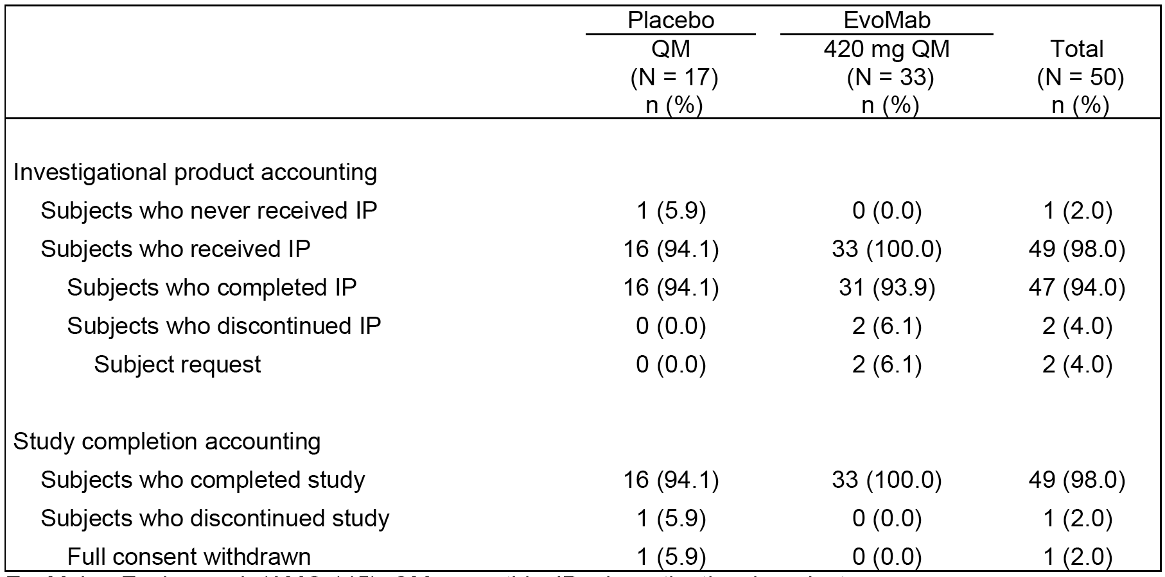
The IVRS randomisation stratification was based on a screening LDL-C of < 10.9 mmol/L for 31 (63.3%) subjects (21 evolocumab, 10 placebo) and a screening LDL-C of ≥ 10.9 mmol/L for 18 (36.7%) subjects (12 evolocumab, 6 placebo). One subject whose IVRS stratification was based on a screening LDL-C of ≥ 10.9 mmol/L had a non-missing LDL-C concentration before study day 1 that was < 10.9 mmol/L; for all other subjects, the data-derived LDL-C stratification matched the IVRS stratification.

Major protocol deviations
No important protocol deviations and no eligibility deviations were reported in Phase III.

Baseline data
Baseline demographics and characteristics for the 49 subjects were comparable between the two treatment groups. The mean age of the total population (n=49) was 30.9 years (range: 13, 57), with 10 (20.4%) subjects being < 18 years and 39 (79.6%) subjects being ≥ 18 years. Of the total subject population (n=49), 25 (51.0%) were male and 24 (49.0%) were female, 44 (89.8%) were White, 3 (6.1%) were ‘other’ and 2 (4.1%) were Asian. The mean ± SD height was 170.2 ± 10.4 cm (range: 150, 198 cm); the mean ± SD weight was 74.3 ± 20.3 kg (range: 41, 145 kg); and the mean ± SD BMI was 25.4 ± 5.3 kg/m² (range: 21.5, 28. 4 kg/m²).
Baseline lipid, hsCRP and PCSK9 parameters for the total Phase III population (n=39) were summarised. In the total population (n=49), in the placebo group (n=16) the mean ± baseline UC LDL-C was 8.7 ± 3.8 mmol/L (range: 3.5, 17.3 mmol/L) (n=16) and 9.2 ± 3.5 mmol/L (range: 3.9, 14.5 mmol/L) in the evolocumab group (n=33). In the 10 adolescent subjects (aged < 18 years to ≥ 13 years), the mean ± SD UC LDL-C was 10.0 ± 4.3 mmol/L in the placebo group (n=3) and 8.4 ± 3.4 mmol/L in the evolocumab group (n=7). Compared to the total population, the subgroup of adolescent subjects had lower baseline concentrations for triglycerides and Lp(a), while other baseline lipid, hsCRP, and PCSK9 concentrations were comparable between adolescents and total population.
Of the total population, 21 (42.9%) subjects had a history of coronary artery disease (similar for the two treatment groups), 4 (8.2%) subjects had a history of cerebrovascular or peripheral arterial disease (all in the evolocumab group), 27 subjects had 2 or more cardiovascular risk factors (similar between the two treatment groups), and all subjects met HoFH protocol criteria. Overall, 24 (49.0%) subjects (16 evolocumab, 8 placebo) had a homozygous genotype, 24 (49.0%) subjects (16 evolocumab, 8 placebo) had a compound heterozygous genotype, and 1 (2.0%) subject (1 evolocumab, 0 placebo) had a heterozygous genotype. The gene affected was the LDLR for 47 (95.9%) subjects (32 evolocumab, 15 placebo), ApoB for 2 (4.1%) subjects (0 evolocumab, 2 placebo), and autosomal recessive hypercholesterolaemia for 1 (2.0%) subject in the evolocumab group. One (2.0%) subject in the placebo group had mutations of both LDLR and ApoB.
No subjects had atrial fibrillation (current or former), 1 subject (placebo) had current CHF NYHA class 1, 1 subject (evolocumab) out of the 18 subjects with LVEF data had mild dysfunction (LVEF 40-49%), and 3 (6.1%) subjects (n=1, placebo; n=2, evolocumab) had cardiac devices/pacemakers. Twenty-four (49.0%) subjects (n=19 [57.6%] evolocumab, n=4 [31.3%] placebo) had current aortic valve disease, most commonly native aortic valve stenosis (17 [51.5%] evolocumab, 4 [25.0%] placebo) or aortic valve replacement (4 [12.1%] evolocumab; 3 [18.8%] placebo). One subject (in the evolocumab group) had severe native aortic valve stenosis, while all other cases were mild or moderate in severity. No subjects had a history of DVT or PE.
Medical history (other than cardiovascular disease) was reported in 42 (85.7%) subjects (n=15 [93.8%] placebo; 27 [81.8%] evolocumab). Other medical condition reported in ≥ 20% of subjects in either group (placebo versus evolocumab) were: musculoskeletal (n=10, 62.5% versus n=19, 57.6%); dermatological (n=7, 43.8% versus n=16, 48.4%); special senses (n=5, 31.3% versus n=14, 42.4%); respiratory (n=5, 31.3% versus n=7, 21.2%); genitourinary/reproductive (n=4, 25.0% versus n=6, 18.2%); and other (n=5, 31.3% versus n=7, 21.2%).
Post-baseline, all 49 (100%) subjects were taking statins, 45 (91.8%) subjects were taking ezetimibe (n=15, [93.8%] placebo; n=30 [90.9%] evolocumab), 2 subjects were taking bile acid sequestrants (1 in each group), and 1 subject was taking fish oil (evolocumab group). Intensive statin use (rosuvastatin ≥ 10 mg QD or atorvastatin ≥ 40 mg QD) post-baseline was reported in 48 of the 49 subjects, and non-intensive statin use was reported in 1 subject.

Results for the efficacy endpoints

Primary efficacy endpoints
The results for the primary efficacy endpoint analysis are summarised below in Table 38. The primary efficacy analysis shows that evolocumab is significantly more efficacious than placebo in reducing LDL-C concentration from baseline to Week 12 in subjects with HoFH. In the evolocumab group, mean ± SE reduction of UC LDL-C ranged from 25 % ± 4 to 31% ± 4 %, beginning at the first assessment at Week 4 after the first dose and continuing throughout the study to Week 12. In the placebo group, UC LDL-C remained near baseline (mean change from baseline < 2%) at Weeks 4, 6, and 8, and increased by a mean ± SE of 6% ± 5% at Week 12.

Table 38: 20110233 - Results for primary efficacy analysis.
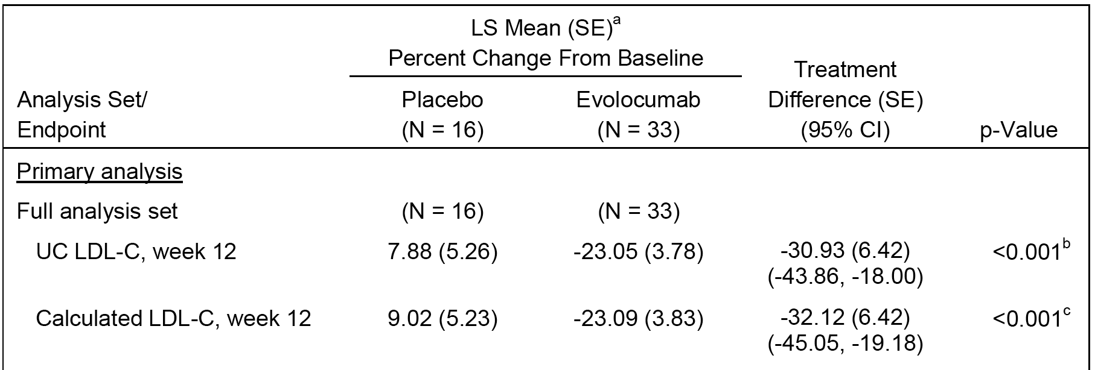
a = LS mean is from the repeated measures model, b = Multiplicity adjusted p-value. c = Nominal p-value.
The results for the three sensitivity analyses were consistent with the primary analysis. The percent change from baseline in UC LDL-C to Week 12 was not statistically significant (nominal p = 0.20) between the two treatment groups for the LDLR indeterminate/negative groups. Evolocumab treatment resulted in a non-statistically significant reduction (treatment difference ± SE) in UC LDL-C compared to placebo of 27% ± 16% (nominal p = 0.14). However, the additional analyses for LDL indeterminate/negative and adolescent groups are underpowered due to the small subject numbers.
In the sensitivity analysis of the LDLR defective analysis set, the treatment difference between evolocumab and placebo was 40.8% ± 6.1% for reduction of UC LDL-C (p < 0.001) and 41.3% ± 6.1% for reduction of calculated LDL-C (p < 0.001). The treatment differences in the LDLR defective analysis set were greater than those in the full analysis set. This was due in part to both a greater mean reduction from baseline in the evolocumab group and a greater mean increase from baseline in the placebo group.
The results of the subgroup analyses for the primary efficacy endpoint were summarised in a Forest Plot. Evolocumab was effective in all subgroups relative to placebo. However, reduction in LDL-C for evolocumab compared to placebo was less robust in subjects with higher LDL-C at baseline, with reductions (treatment difference ± SE) of 9.2% ± 13.7% in subjects with screening LDL-C ≥ 10.9 mmol/L and 43.8% ± 5.7% in subjects with screening LDL-C < 10.9 mmol/L. The sponsor speculated that this could have been due to a greater prevalence of unrecognized negative LDLR function within the subjects with higher LDL-C at baseline, but this interpretation is limited by the small number of documented LDLR negative subjects (n = 3). Results of covariate analyses of percent change from baseline in UC LDL-C at Week 12 (adjusted individually by the factors of age, baseline PCSK9, baseline LDL-C, randomisation stratification factors, race, or sex) were similar to the results of the primary analysis, with treatment differences being approximately 30% for each analysis (p < 0.001).

Results for the secondary efficacy endpoints
Results for the secondary efficacy endpoints were summarised. In the total population, the pre-specified secondary efficacy endpoints relating to reductions in LDL-C and ApoB concentrations statistically significantly favoured evolocumab compared to placebo (p<0.001, multiplicity adjusted, while there were no statistically significant difference in Lp(a) changes between the two treatment groups. There were no statistically significant changes between evolocumab and placebo in adolescent subjects relating to changes in LDL-C, ApoB and Lp(a) changes.

Results for the exploratory endpoints
The results for the exploratory analyses for other lipid endpoints consistently favoured evolocumab compared to placebo, and the majority of the pairwise comparisons were nominally statistically significant. No statistical adjustment was made to account for the numerous pairwise comparisons.

Study 20110271 (interim analysis) - open-label long-term

Design, objectives, locations and dates

Design
This was Phase II/III, open-label extension study designed to characterised the safety and efficacy of long-term evolocumab 420 mg SC QM or evolocumab 420 mg SC Q2W in subjects with severe familial hypercholesterolaemia (FH), including homozygous FH (HoFH). As of the 1 April 2014 data cut-off for the interim analysis, a total of 36 centres in South Africa, the United States, the Czech Republic, France, Canada, Japan, Netherlands, Italy, Spain, New Zealand, the United Kingdom, Belgium, Greece, Australia, and Hong Kong had enrolled subjects. The first subject was enrolled on 1 June 2012 and the study is ongoing. The Interim Analysis Set included all 198 subjects who had received at least 1 dose of evolocumab before the data cut-off date. The interim clinical report was dated 17 July 2014. The study was conducted in accordance with ICH GCP regulations and guidelines. The study was sponsored by Amgen. The study was also identified by the name TAUSSIG - Trial Assessing long-term USe of PCKS9 Inhibition in Subjects wIth Genetic LDL Disorders.

Objectives
The primary objective was to characterise the safety and tolerability of long-term administration of evolocumab in subjects with severe FH, including HoFH. The secondary objective was to characterise the durable efficacy of long-term administration of evolocumab as assessed by LDL-C and non-HDL-C, Lp(a), ApoB, TC/HDL-C ratio, ApoB/ApoA1 ratio, and ≥ 15% LDL-C reduction from baseline in subjects with severe FH, including HoFH. The study included exploratory objectives relating to potential biomarker development and the pharmacokinetics of evolocumab and PCSK9.

Investigational plan
Subjects not on apheresis at enrolment or within the prior 8 weeks (‘non-apheresis subjects’) initiated treatment with 420 mg QM, and subjects on apheresis at enrolment (‘apheresis subjects’) initiated treatment with evolocumab 420 mg Q2W. Subjects visited the site QM (non-apheresis subjects) or Q2W (apheresis subjects) until open-label extension (OLE) Week 24, after which they received a 12 week supply of evolocumab if they decided to self-administer evolocumab. Beyond OLE Week 24, these subjects visited the site every 12 weeks for central laboratory tests. Subjects who decided to continue to receive evolocumab at the study centre continued to visit the site QM or Q2W.
At OLE Week 12, subjects with < 5% LDL-C reduction from baseline and serum unbound PCSK9 < 100 ng/mL could discontinue evolocumab. If serum unbound PCSK9 was ≥ 100 ng/mL with QM dosing the subject could switch to evolocumab 420 mg Q2W treatment at OLE week 12. Subjects with < 5% reduction of LDL-C after an adequate trial of evolocumab could be removed at either the OLE Week 12 or OLE Week 24 study visit pending a final benefit/risk discussion with the medical monitor.
Subjects on apheresis with ≥ 5% LDL-C reduction from baseline and serum unbound PCSK9 < 100 ng/mL with Q2W treatment could switch to QM dosing at OLE Week 12. At OLE Week 24, apheresis subjects who had switched to QM dosing could revert to Q2W dosing if clinically indicated. If the subject discontinued apheresis therapy at a visit other than OLE Week 12 or OLE Week 24, switching to QM dosing was permitted at that time.
If a non-apheresis subject had an LDL-C reduction of ≥ 5% from baseline after 12 weeks and PCSK9 was maximally suppressed (serum unbound PCSK9 < 100 ng/mL), the subject could continue QM treatment. If serum unbound PCSK9 was ≥ 100 ng/mL at OLE Week 4 and/or OLE Week 8, the dose could be changed to 420 mg Q2W at the OLE Week 12 visit. If the observed LDL-C reduction from baseline was < 5% and serum unbound PCSK9 was maximally suppressed, the subject could be withdrawn from the study at OLE Week 12. At OLE Week 24, subjects who had switched to Q2W dosing at OLE Week 12 could continue Q2W dosing, return to QM dosing, or be withdrawn from the study. Dosing changes after OLE Week 24 were discouraged. It is planned that subjects will continue to receive open-label evolocumab for up to 5 years or until evolocumab becomes commercially available in the relevant patient population, whichever occurs first. The study design and treatment plan are summarised below in Figure 25.
Figure 25: 20110271 - Study design and treatment plan.

Inclusion and exclusion criteria
Male or female subjects of ≥ 12 to ≤ 80 years of age were eligible if they had been diagnosed with FH (HoFH or severe FH), had completed Study 20110233 or another qualifying Amgen protocol, and did not have a treatment-related serious adverse event. Subjects were also eligible for enrolment if they had genetic causes for their condition that had not been studied in Study 20110233 (such as gain of function mutations in PCSK9) and if they could benefit from evolocumab. In addition subjects were also eligible if they had HoFH and were interested in enrolling after Study 20110233 closed.
Non-apheresis subjects were required to have elevated LDL-C (≥ 2.6 mmol/L for subjects with diagnosed CHD or risk equivalent, or ≥ 3.4 mmol/L for subjects without diagnosed CHD or risk equivalent). Apheresis subjects did not have a minimum LDL-C requirement. All subjects were required to have fasting triglycerides ≤ 4.5 mmol/L by central laboratory at screening. The complete list of inclusion and exclusion criteria was provided.

Study treatments

Investigational product (IP)
Evolocumab was the only investigational product (IP) in this study. Evolocumab was initially administered using a concentration of 70 mg/mL presented in 1 mL vials. However, evolocumab was subsequently administered using a prefilled AI/pen (140 mg/mL). All subjects received evolocumab 420 mg SC, initially administered either QM (non-apheresis subjects) or Q2W (apheresis subjects). The evolocumab 420 mg dose was administered either as 6 mL (vials and syringes) or as 3 mL (3 prefilled AI/pens). The 6 mL dose could be split (for example, 3 injections at 2 mL each) and administered into different injection sites. The SC injections were administered consecutively with all injections completed within 30 minutes. Evolocumab doses administered at the study centre were administered after vital signs, electrocardiogram (ECG), and blood draw procedures. Self-administration of evolocumab by the subject (or by a designee or a qualified health care professional) was permitted in a non-clinic setting (for example, at home or at a location where a qualified health care professional was available). Prior to OLE Week 24, subjects who received evolocumab 420 mg Q2W could self-administer evolocumab between monthly site visits. Starting at the OLE Week 24 visit, all subjects could self-administer evolocumab.
Reports from the central laboratory after each visit were reviewed before administration of evolocumab at the next visit. Criteria for withholding evolocumab based on creatine kinase (CK) elevation, criteria for withholding evolocumab based on elevation of liver function tests and criteria for re-challenge of evolocumab after potential hepatotoxicity were provided in the protocol. If the subject was receiving other lipid therapies that could result in such elevations, the additional therapies were also evaluated for a potential role in these elevations and considered for discontinuation.
Evolocumab was not administered within 7 days of a previous dose. If a subject arrived for a visit outside the dosing window the dose was not administered, but all other study procedures were conducted. These subjects received their next evolocumab administration as previously scheduled. The QM and Q2W dosing window was ± 7 days for a visit.

Prior and concomitant medication
After the 4 week blinded period following the parent study, investigators were permitted to prescribe any concomitant medications or treatments deemed necessary to provide adequate supportive care.

Compliance with treatment
Evolocumab was administered at the investigative site by a qualified staff member during site visits. Between site visits and after OLE Week 24, evolocumab could be administered by the subject (or their designee) at home or by a qualified health care professional at another location. The date, time of administration, and volume of each individual injection was recorded in the subject’s source documents and on the individual subject’s electronic case report form (eCRF).

Removal from therapy or assessment
The criteria and procedures were consistent with those described above for Study 20110233. Subjects who withdrew from the study were not replaced.

Efficacy variables and outcomes
The primary endpoint was the incidence of treatment emergent adverse events in participating studies during the extension period
The secondary efficacy endpoints at each scheduled visit within each study period were: (a) percent change in LDL-C from baseline; (b) percent change in non-HDL-C from baseline; (c) percent change in Lp(a) from baseline; (d) percent change in ApoB from baseline; (e) percent change in TC/HDL-C ratio from baseline; (f) percent change in ApoB/ApoA1 ratio from baseline; and (g) response rate of subjects with 15% or greater reduction in LDL-C
The study included a large number of exploratory endpoints (safety, lipids, and biomarkers) and other safety endpoints. In this review of efficacy, the focus is on the pre-specified secondary efficacy endpoints relating to the lipid parameters.

Randomisation and blinding methods
This was an open-label involving only one IP (evolocumab).

Analysis populations
HoFH Interim Analysis Set: all subjects who received at least 1 dose of evolocumab in Study 20110271 and either met clinical criteria of HoFH or who had supportive genetic information.
Evolocumab Titration Analysis Set: subjects who were exposed to evolocumab 420 mg QM for at least 12 weeks in Study 20110271 and then to evolocumab 420 mg Q2W for at least 12 weeks in Study 20110271 (all subjects in this analysis set had HoFH).
Adolescent subgroup: all adolescent subjects (ages 12 to < 18 years) who received at least 1 dose of evolocumab in Study 20110271 (all adolescent subjects had HoFH).
Severe FH Interim Analysis Set: all subjects who received at least 1 dose of evolocumab in Study 20110271 and were not included in the HoFH Interim Analysis Set.
Interim Analysis Set: all subjects enrolled in this study at the time of the data cut-off date who received at least 1 dose of evolocumab in Study 20110271; this analysis set included subjects with either HoFH or severe FH.
Key efficacy and safety analyses were repeated in the following analysis sets: (a) Responder Analysis Set - all subjects included in the Interim Analysis Set who had UC LDL-C reduction ≥ 15% at any time during Study 20110233 (all subjects in this analysis set had HoFH). (b) LDLR Defective Analysis Set - all subjects from Study 20110233 who had documented defective LDLR (all subjects in this analysis set had HoFH); and (3) LDLR Indeterminate/Negative Analysis Set - all subjects from Study 20110233 who had documented indeterminate or negative LDLR (all subjects in this analysis set had HoFH).
The Pharmacokinetics Analysis Set included all subjects in the Interim Analysis Set for whom there were unbound evolocumab or unbound PCSK9 results. Pharmacokinetics analyses were conducted separately in subjects with HoFH and subjects with severe FH.

Sample size
The planned sample size was approximately 250 subjects. For an approximate 5% incidence rate using the binomial distribution for particular adverse events in the final analysis, this sample size provided a 95% confidence interval of (0.02, 0.08). There were no sample size calculations based on efficacy considerations as the study was open-label and single-arm.

Statistical methods
Statistical analyses for this open-label, single-arm long-term safety and efficacy study were descriptive. No statistical inference or missing-value imputation was planned. Baseline covariates were not used in this interim analysis. The interim analysis included data collected through 1 April 2014. The study was not anticipated to stop early unless a major unexpected safety signal was detected. An external DMC was established to formally review the accumulating data from this and other ongoing studies with evolocumab to ensure there was no avoidable increased risk for harm to subjects. There were a number of changes to the interim Statistical Analysis Plan, none of which are considered to have invalidated the descriptive interim efficacy analysis.

Participant flow
The interim analysis set included 198 subjects who received at least 1 dose of evolocumab before the data cut-off date. A total of 96 subjects with HoFH comprised the HoFH Interim Analysis Set and 102 subjects with severe FH comprised the Severe FH Interim Analysis Set. The disposition of all enrolled subjects is summarised below in Table 39.

Table 39: 20110271 - Disposition all enrolled subjects.
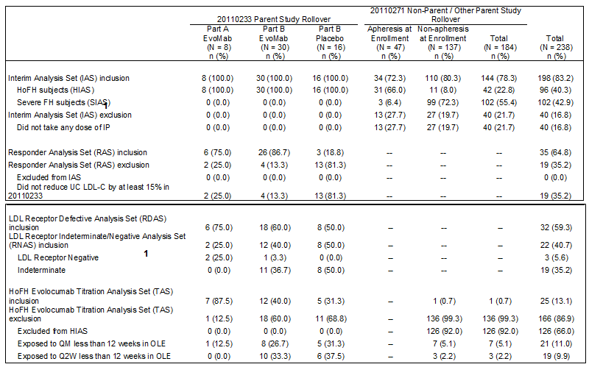

Major protocol violations
In the Interim Analysis Set, 4 (2.0%) subjects had an important protocol deviation and 4 (2.0%) subjects did not meet the eligibility criteria. The important protocol deviation was failed eligibility criterion for 3 subjects, including 2 subjects with active liver disease or hepatic dysfunction, and 1 subject who did not sign the informed consent form prior to receiving the first dose of evolocumab. One (1) subject received expired or compromised evolocumab that was not properly refrigerated at home (not a failed eligibility criterion), and 1 subject had a failed eligibility criterion (malignancy in the last 5 years) that was not an important protocol deviation. The important protocol violations and failures to meet the eligibility criteria are considered no to have invalidated the efficacy or safety analyses of the study.

Baseline data
The mean ± age of subjects in the interim analysis set (n=198) was 44.2 ± 16.9 years (range: 13, 77 years), with 13 (6.6%) subjects aged 13 to < 18 years (all with HoFH [10 non-apheresis, 3 apheresis]), 185 (93.4%) subjects aged ≥ 18 years, and 29 (14.6%) subjects aged ≥ 65 years of age. There were 111 (56.1%) males and 87 (43.9%) females, and the majority of the subjects were White (176, 88.9%) followed by Asian (15, 7.6%), other (4, 2.0%) and Black/African American (2, 1.0%, with all other identified racial groups accounting for 1 or no patients.
The baseline demographics of the 96 subjects in the HoFH Interim Analysis Set and the 102 subjects in the Severe FH Interim Analysis Set were generally comparable to those of the total population in the Interim Analysis Set. However, subjects with HoFH were younger than subjects with severe FH (mean ± SD age 33.7 ± 14.3 years and 54.0 ± 12.7 years, respectively), which is likely to reflect greater disease severity at an earlier age in the HoFH population.
Baseline lipid parameters, hsCRP, and PCSK9 for subjects with severe FH and HoFH in the total Interim Analysis Set were summarised. In the total Interim Analysis Set, the mean ± serum concentration of UC LDL-C at baseline was 6.5 ± 3.2 mmol/L. In the HoFH Interim Analysis Set, the mean ± serum concentration of UC LDL-C at baseline was 8.76 ± 3.60 mmol/L in non-apheresis subjects and 7.31 ± 2.66 mmol/L in apheresis subjects. Baseline concentrations for other lipid parameters were consistent with the diagnosis of HoFH. Baseline hsCRP and PCSK9 concentrations in subjects with HoFH were comparable to those for the Interim Analysis Set. In the severe FH Interim Analysis Set, mean ± SD serum concentration of UC LDL-C at baseline was 5.43 ± 1.48 mmol/L in apheresis subjects and 4.74 ± 1.60 mmol/L in non-apheresis subjects. Baseline concentrations for other lipid parameters were consistent with the diagnosis of severe FH. Compared to subjects in the HoFH Interim Analysis Set, subjects in the Severe FH Interim Analysis Set had lower LDL-C concentrations at baseline and the profile for other lipids at baseline was superior except for comparable Lp(a), higher triglycerides, higher VLDL-C, higher HDL-C, and higher ApoA1. Baseline hsCRP was higher in subjects with severe FH than in subjects with HoFH and baseline PCSK9 was comparable in the two populations.
In the total Interim Analysis Set, 48.5% (n=96) of subjects had a history of coronary artery disease, 16.7% (n=33) had a history of peripheral arterial disease, 56.1% (n=111) had a family history of premature coronary artery disease, 50.0% (n=99) had a history of low HDL-C, 32.8% (n=65) had a history of hypertension, and 49.5% (n=98) had ≥ 2 cardiovascular risk factors.
At baseline (defined as medication use on Day 1), 187 (94.4%) subjects in the total Interim Analysis Set were using a statin, 151 (76.3%) subjects were using ezetimibe, 13 (6.6%) were using bile acid sequestrants, and all other lipid-regulating medications were being used by less than 5% of subjects.

Efficacy results in subjects with HoFH

LDL-C efficacy endpoint
- HoFH Interim Analysis set
The results for percent reductions from baseline in UC LDL-C at OLE Weeks 12, 24, 36, and 48, respectively) in the HoFH Interim Analysis Set by study visit are summarised below in Table 40.

Table 40: 20110271 - Mean ± SE percent change from baseline in UC LDL-C by study visit in subjects with HoFH.
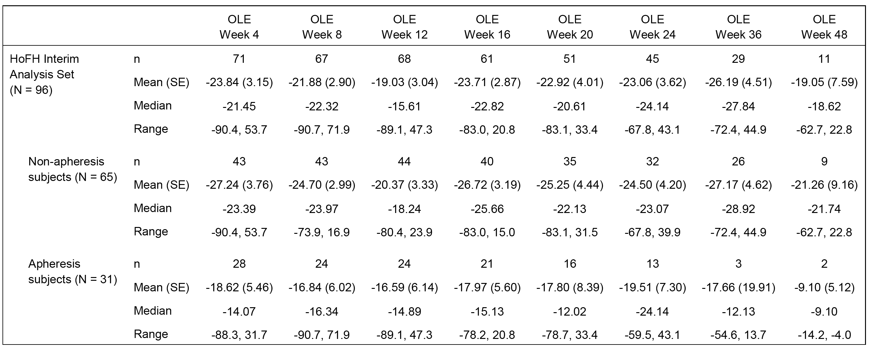
Reductions at OLE Week 48 were consistent with those at the other visits, but the small number of subjects who provided data at this visit limited interpretation of the results.
Rates of treatment response (≥ 15% reduction in UC LDL-C from baseline) in the HoFH Interim Analysis Set were 51.5% (35/68), 64.4% (29/45), 65.5% (19/29 subjects), and 54.5% (6/11 subjects) at OLE Weeks 12, 24, 36, and 48, respectively.
- Subjects with HoFH who titrated from 420 mg QM to 420 mg Q2W
A total of 25 subjects were included in the HoFH Evolocumab Titration Analysis Set because they received evolocumab 420 mg QM for at least 12 weeks in the OLE study and then received evolocumab 420 mg Q2W for at least 12 weeks in the OLE study. All of the subjects in the HoFH Evolocumab Titration Analysis Set were non-apheresis subjects. The results indicate that greater reductions in LDL-C concentration following Q2W than QM. Mean ± SE percent reductions from baseline in UC LDL-C in the HoFH Evolocumab Titration Analysis Set were 15.5% ± 3.9% at Week 12 of QM treatment and 21.7% ± 4.3% at Week 12 of Q2W treatment. Median (Q1, Q3) percent reductions from baseline in UC LDL-C in the HoFH Evolocumab Titration Analysis Set were -15.9% (-27.3%, -5.4%) at Week 12 of QM treatment and -21.9% (-33.3%, -9.9%) at Week 12 of Q2W treatment. Comparable results were observed for percent changes from baseline in calculated LDL-C.
- Efficacy in adolescent subjects with HoFH
In the subset of 13 adolescent subjects with HoFH, mean ± percent reductions from baseline in UC LDL-C at OLE Weeks 12, 24, and 36 were 15.0% ± 8.1%, 21.5% ± 8.9%, and 33.3% ± 9.6%, respectively. Mean reduction from baseline in UC LDL-C was not observed in the 3 adolescent apheresis subjects, but these subjects only provided LDL-C data through OLE Week 4 (1 subject), OLE Week 16 (1 subject), or OLE week 24 (1 subject). One of the adolescent apheresis subjects had defective LDLR, and the other 2 adolescent apheresis subjects were genetically homozygous and had indeterminate LDLR.

Other efficacy lipid endpoints
  - Subjects with HoFH
The percent change in lipid parameters from baseline to Week 24 for the overall HoFH (n=46) was summarised. The number of subjects included in the analyses after 24 weeks was small but the results were consistent with the results before 24 weeks. The results indicate that improvement in lipid parameters can be maintained over time in subjects with HoFH (Interim Analysis Set [n=49]), with results for non-apheresis subjects (n=33) being superior to apheresis subjects (n=13). In addition to reducing LDL-C concentration, long-term evolocumab therapy also improved other lipid parameters, including non-HDL-C, ApoB, total cholesterol (TC)/HDL-C ratio, ApoB/ApoA1 ratio, and Lp(a).
Non-apheresis subjects with HoFH had mean reductions in ApoB, total cholesterol/HDL-C ratio, total cholesterol, non-HDL-C, ApoB/ApoA1, and Lp(a), as well as mean increases in ApoA1 at every visit of the OLE study through the last reported measurements at OLE Week 84. Non-apheresis subjects with HoFH also had mean increases in HDL-C through OLE Week 36. Apheresis subjects with HoFH had mean reductions in ApoB, total cholesterol/HDL-C ratio, total cholesterol, non-HDL-C, ApoB/ApoA1, and Lp(a), as well as mean increases in ApoA1 at every visit of the OLE study through the last reported measurements at OLE Week 84. Apheresis subjects with HoFH also had mean increases in HDL-C through OLE Week 36.
Subjects who received evolocumab in Study 20110233 had reductions in ApoB, total cholesterol/HDL-C ratio, total cholesterol, non-HDL-C, and ApoB/ApoA1 ratio in the parent study that were maintained with continued evolocumab treatment in the OLE study. Subjects who received placebo in Study 20110233 had stable concentrations for each of these lipids during the parent study and after switching to evolocumab treatment in the OLE study had reductions in lipid concentrations comparable to those for the subjects who received evolocumab in both studies.
In the Evolocumab Titration Interim Analysis Set (n=25, all non-apheresis) switching from 420 mg QM for 12 weeks to 420 mg Q2W for 12 weeks was associated with greater mean reductions from baseline in calculated LDL-C, ApoB, TC/HDL-C ratio, TC, non-HDL-C, ApoB/ApoA1 ratio, and Lp(a), and a greater mean increase from baseline in ApoA1. However, switching from 420 mg QM treatment to 420 mg Q2W did not improve triglycerides, VLDL-C, or HDL-C.
In adolescent subjects with HoFH (n=13), at most visits of the OLE study, adolescent subjects with HoFH had mean reductions from baseline in ApoB, total cholesterol/HDL-C ratio, TC non-HDL-C, ApoB/ApoA1, and Lp(a), and mean increases from baseline in HDL-C and ApoA1. The results for selected lipid parameters at Week 24 of the OLE study for adolescent subjects with HoFH (n=8) were summarised.

Efficacy results in subjects with severe FH
- LDL-C efficacy endpoint
All subjects with severe FH who provided post-baseline data for UC LDL-C as of the 1 April 2014 data cut-off date were non-apheresis subjects (all adults). Reductions from baseline in UC LDL-C were seen throughout the study in the Severe FH Interim Analysis Set (see Table 41, below). However, subject numbers in the OLE were small from week 4 (n=14) through to Week 48 (n=4).

Table 41: 20110271 - severe FH Interim Analysis Set in UC LDL-C by study visit.
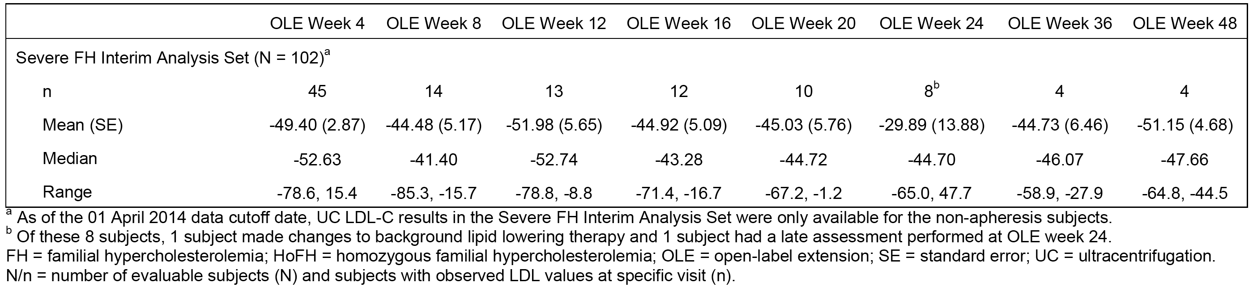
- Other lipid efficacy endpoints
At every visit of the OLE study, subjects with severe FH had mean reductions from baseline in ApoB, total cholesterol/HDL-C ratio, total cholesterol, non-HDL-C, ApoB/ApoA1, and Lp(a). At most visits of the OLE study, subjects with severe FH also had mean reductions from baseline in VLDL-C and triglycerides, and mean increases from baseline in HDL-C and ApoA1.

(14) Efficacy results in the total Interim Analysis Set (that is, severe FH plus HoFH)
- LDL-C efficacy endpoint
In the Interim Analysis Set (n=198), mean ± SE reductions in the OLE at Weeks 12, 24, 36 weeks, respectively, were 24.3% ± 3.0% (n=81), 24.1% ± 3.7% (n=53), 28.4% ± 4.2% (n=33), and 27.6% ± 6.8% (n=15). In the Interim Analysis Set (n=198), responders with ≥ 15% reduction from baseline in the OLE were 58.0% (47/81), 66.0% (35/53), 69.7% (23/33), and 66.7% (10/15), at Weeks 12, 24, 36 and 48, respectively.
- Other lipid efficacy endpoints
In the Interim Analysis Set, evolocumab was associated with mean percent reductions of ApoB, TC/HDL-C ratio, TC, non-HDL-C, ApoB/ApoA1 ratio, and Lp(a) from baseline at each visit, while there were no consistent changes in triglycerides and VLDL-C. In subjects who did not roll over from Study 20110233 in the Interim Analysis Set, HDL-C and ApoA1 increased from baseline.

Evaluator's conclusions on clinical efficacy for subjects with HoFH
- The efficacy of evolocumab for the treatment of patients with HoFH has been demonstrated in one randomised, placebo-controlled, double-blind study in 50 subjects with HoFH (n=33 evolocumab, n=17 placebo) (Study 20110233; Part 3), and one long-term, open-label study in 96 subjects with HoFH (Study 20110271). However, the analysis of ongoing Study 2011271 was an interim analysis.
- In Study 20110233, treatment with evolocumab 420 mg QM in combination other lipid-regulating medications (n=33) resulted in a statistically significant reduction (treatment difference ± SE) from baseline at Week 12 in UC LDL-C compared to placebo (n=16) of 30.9% ± 6.4% (p < 0.001, multiplicity adjusted; 95% CI [18.0%, 43.9%]). The mean ± SE reduction in UC LDL-C in the evolocumab group compared to placebo remained constant from Week 4 (24.7% ± 3.7%) through Week 12 (30.9% ± 6.4%). The results for calculated LDL-C were consistent with the results for UC LDL-C. In general, the results for the secondary efficacy lipid endpoints analyses supported the results for the primary efficacy analysis of change in LDL-C concentration. Subgroup analyses in the total population of change in LDL-C concentration from baseline through to Week 12 supported the superiority of evolocumab compared to placebo.
- In Study 20110233, there was no statistically significant difference in adolescent subjects between evolocumab 420 mg QM (n=7) and placebo (n=3) in mean change in UC LDL-C from baseline at Week 12 (-26.0% versus -0.7%, respectively, p=0.14, nominal). However, the comparison was underpowered due to the small number of subjects in the two treatment groups. The percent reduction in UC LDL-C in the evolocumab 420 mg QM groups from baseline through to Week 12 was consistent in adolescent subjects and all subjects (26.0% versus 23.1%, respectively).
- In Study 20110271, the open-label, single-arm interim data showed that evolocumab 420 mg QM in combination with other lipid-regulating medications (predominantly statins) was effective in maintaining LDL-C reductions through to 48 weeks in subjects with HoFH (n=96). Compared to baseline, LDL-C reductions of approximately 19% (n=68), 23% (n=45), 26% (n=29) and 19% (n=11) were observed at Weeks 12, 24, 36 and 48 weeks respectively. However, the Week 48 data should be interpreted cautiously due to the smaller number of subjects with data at this time-point. In the subset of 13 adolescent subjects with HoFH, mean± SE percent reductions from baseline in UC LDL-C at OLE Weeks 12, 24, and 36 were 15.0% ± 8.1%, 21.5% ± 8.9%, and 33.3% ± 9.6%, respectively.
- In Study 20110271, compared to baseline, LDL-C reductions of approximately 25% in HoFH subjects not on apheresis (n=32) and approximately 20% in HoFH subjects on apheresis (n=13) were maintained at Week 24 with evolocumab 420 mg QM. The small number of subjects in the apheresis group at Weeks 36 and 48 (3 and 2, respectively) preclude meaningful comparison with non-apheresis subjects at these two later time-points. Increasing the frequency of dosing from 420 mg QM for 12 weeks to 420 mg Q2W for 12 weeks in subjects with HoFH resulted in an approximately 6% greater reduction of LDL-C (that is, from approximately 16% QM to 22% Q2W). Improvements in other lipid parameters were also achieved and maintained with long-term evolocumab treatment in HoFH subjects.

Clinical safety

Total exposure in the clinical development program (both indications)
A total of 6801 subjects (including studies for both intended indications) were treated with evolocumab (alone or in combination with other lipid-regulating medications, primarily statins), placebo, or any control (including standard of care [SoC]) in the clinical development program for both proposed indications. A total of 5710 subjects were exposed to any dose of evolocumab representing 4638 patient-years of exposure. The number of subjects exposed to evolocumab across all studies for ≥ 6 months and ≥ 12 months was 3350 and 1824, respectively. The exposure data for the clinical development program for both proposed indications are summarised below in Table 42.

Table 42: Overall exposure (Phase I, II, and III studies) on the clinical development program (both indications).
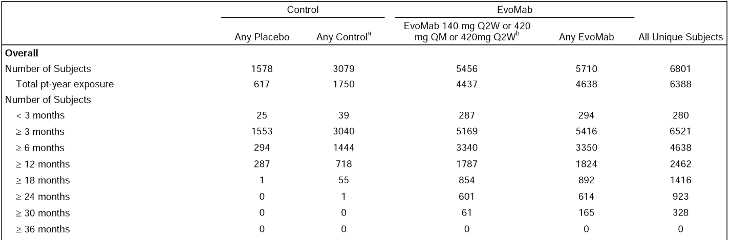
Subjects with the following conditions have been treated with any evolocumab for at least 1 year: (a) 407 subjects (1079 patient-years) with established CVD; (b) 559 subjects (1427 patient-years) at NCEP ATP III high risk for CVD; (c) 162 subjects (429 patient-years) with NCEP ATP III moderately high risk for CVD; (d) 213 subjects (525 patient-years) with Type II diabetes mellitus; 649 subjects (1577 patient-years) with metabolic syndrome; (e) 503 subjects (1268 patient-years) on concomitant high intensity statin; (f) 605 subjects (1612 patient-years) on concomitant, moderate intensity statin; and (g) 486 subjects (1255 patient-years) ≥ 65 years old.

Primary hyperlipidaemia and mixed dyslipidaemia

Studies providing evaluable safety data
The submission included an Integrated Summary of Safety (ISS) of data from the 14, Phase II and III clinical efficacy and safety studies in subjects with primary hyperlipidaemia and mixed dyslipidaemia. The ISS analysis was pre-specified in an Integrated Statistical Analysis Plan (iSAP) dated 27 September 2013. The methodology used for the ISS analysis is considered to be sound and comprehensively addresses the safety of evolocumab for the treatment of primary hyperlipidaemia and mixed dyslipidaemia. Therefore, in this CER the evaluation of the safety of evolocumab for the treatment of primary hyperlipidaemia and mixed dyslipidaemia focuses on the data presented in the ISS. The safety data for subjects with severe FH (Study 20110271) were not included in the ISS data set for patients and have been evaluated separately in this CER.
The 14 Phase II and III studies included in the ISS analysis were grouped into three safety analysis sets: the Integrated Parent Analysis Set (IPAS), the Integrated Extension SoC-controlled Period Analysis Set (IECAS), and the Integrated Extension All-Investigational Product Period Analysis Set (IEAAS). The three safety analysis sets are summarised below in Table 43.

Table 43: Safety analysis sets in the ISS analysis of the primary hyperlipidaemia and mixed dyslipidaemia studies.
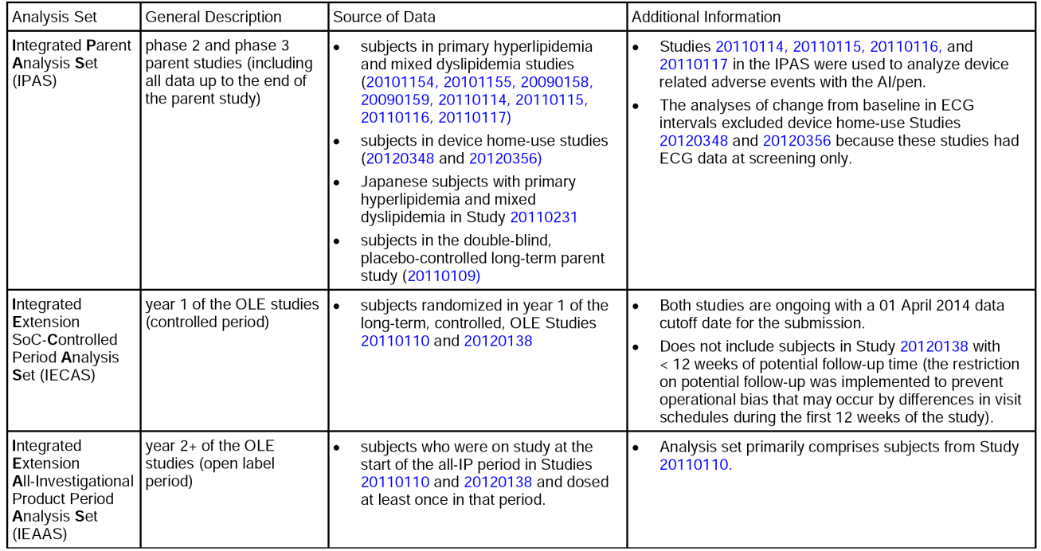

Evolocumab exposure
The ISS included 6026 subjects with total exposure of 6165 patient-years (see Table 44, below).

Table 44: Overall summary of exposure in subjects with hyperlipidaemia and mixed dyslipidaemia (IPAS, IECAS, and IEAAS)
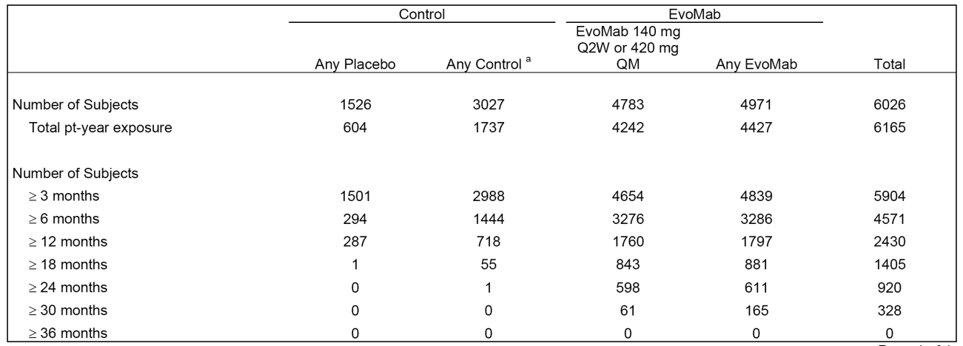
Includes the following studies: Studies 20090158, 20090159, 20101154, 20101155, 20110109, 20110114, 20110115, 20110116, 20110117, 20110231, 20120348, 20120356, 20110110, and 20120138. a Any includes placebo, ezetimibe or standard of care. Patients can contribute data to more than one treatment group. pt-year = patient years, where years are calculated as the sum of period durations for the treatment group across subjects divided by 365.25. Months are calculated by multiplying the patient years by 12 and rounding to the nearest whole month.
The integrated parent studies (IPAS) included 5981 subjects exposed to any IP, comprising 3946 subjects exposed to any evolocumab for a mean ± SD of 3.95 ± 3.21 months (range: 0, 12.3 months), and 2035 subjects exposed to any control for a mean ± SD of 3.99 ± 3.19 months (range: 0.1, 12.3 months). The integrated parent studies (IPAS) included 1245 subjects exposed to evolocumab 140 mg Q2W and 1956 subjects exposed to evolocumab 420 mg QM. The mean ± SD durations of evolocumab exposure in the 140 mg Q2W and 420 mg QM groups were 2.57 ± 0.55 months (range: 0, 3.3 months) and 5.29 ± 4.13 months (range 0.4, 12.3 months), respectively. The longer exposure reported in subjects treated with evolocumab 420 mg QM compared to evolocumab 140 mg Q2W is accounted for by inclusion of subjects from the long-term Study 20110109 treated only with the 420 mg QM dose. Exposure in the IPAS treatment groups is summarised below in Table 45.

Table 45: IPAS - Summary of exposure during the integrated parent studies.
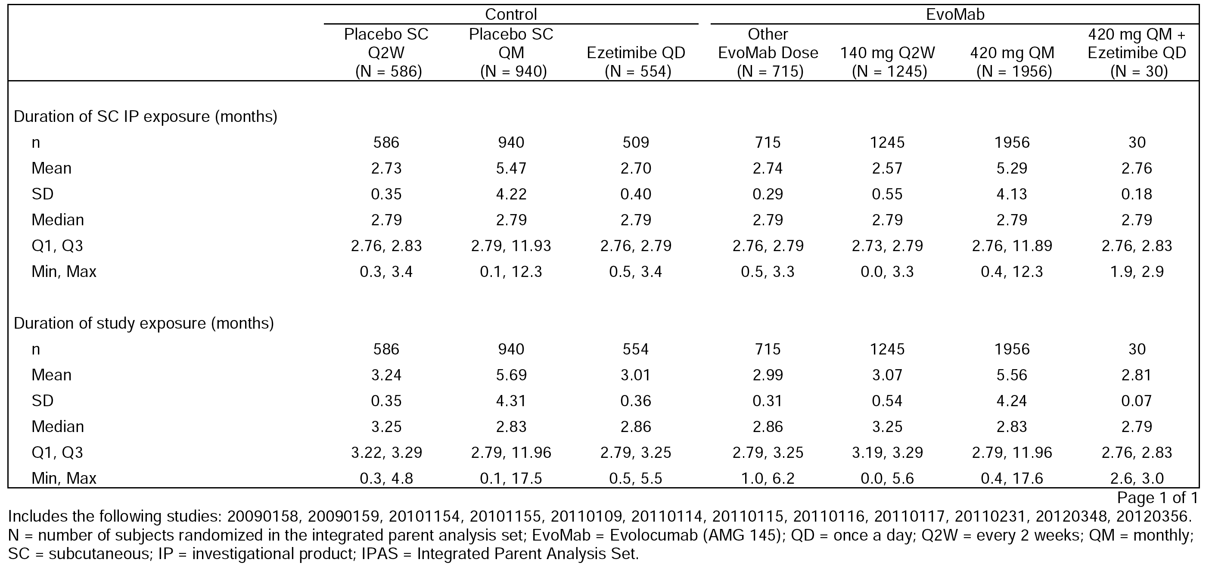
The Year 1 SoC-controlled period of the OLE studies (IECAS) included a total of 4252 subjects from the two long-term extension studies (20110110; 20120138). For subjects assigned to control during the parent study and evolocumab plus SoC during the extension study, the mean ± SD duration of evolocumab exposure was 8.06 ± 3.09 months. For subjects assigned to evolocumab in the parent study and evolocumab plus SoC during the extension study, the mean ± SD exposure to evolocumab was 8.35 ± 3.35 months. The summary of exposure in treatment groups in the IECAS is provided below in Table 46.

Table 46: IECAS - Summary of exposure during the 1 year SoC-controlled period of the extension studies.
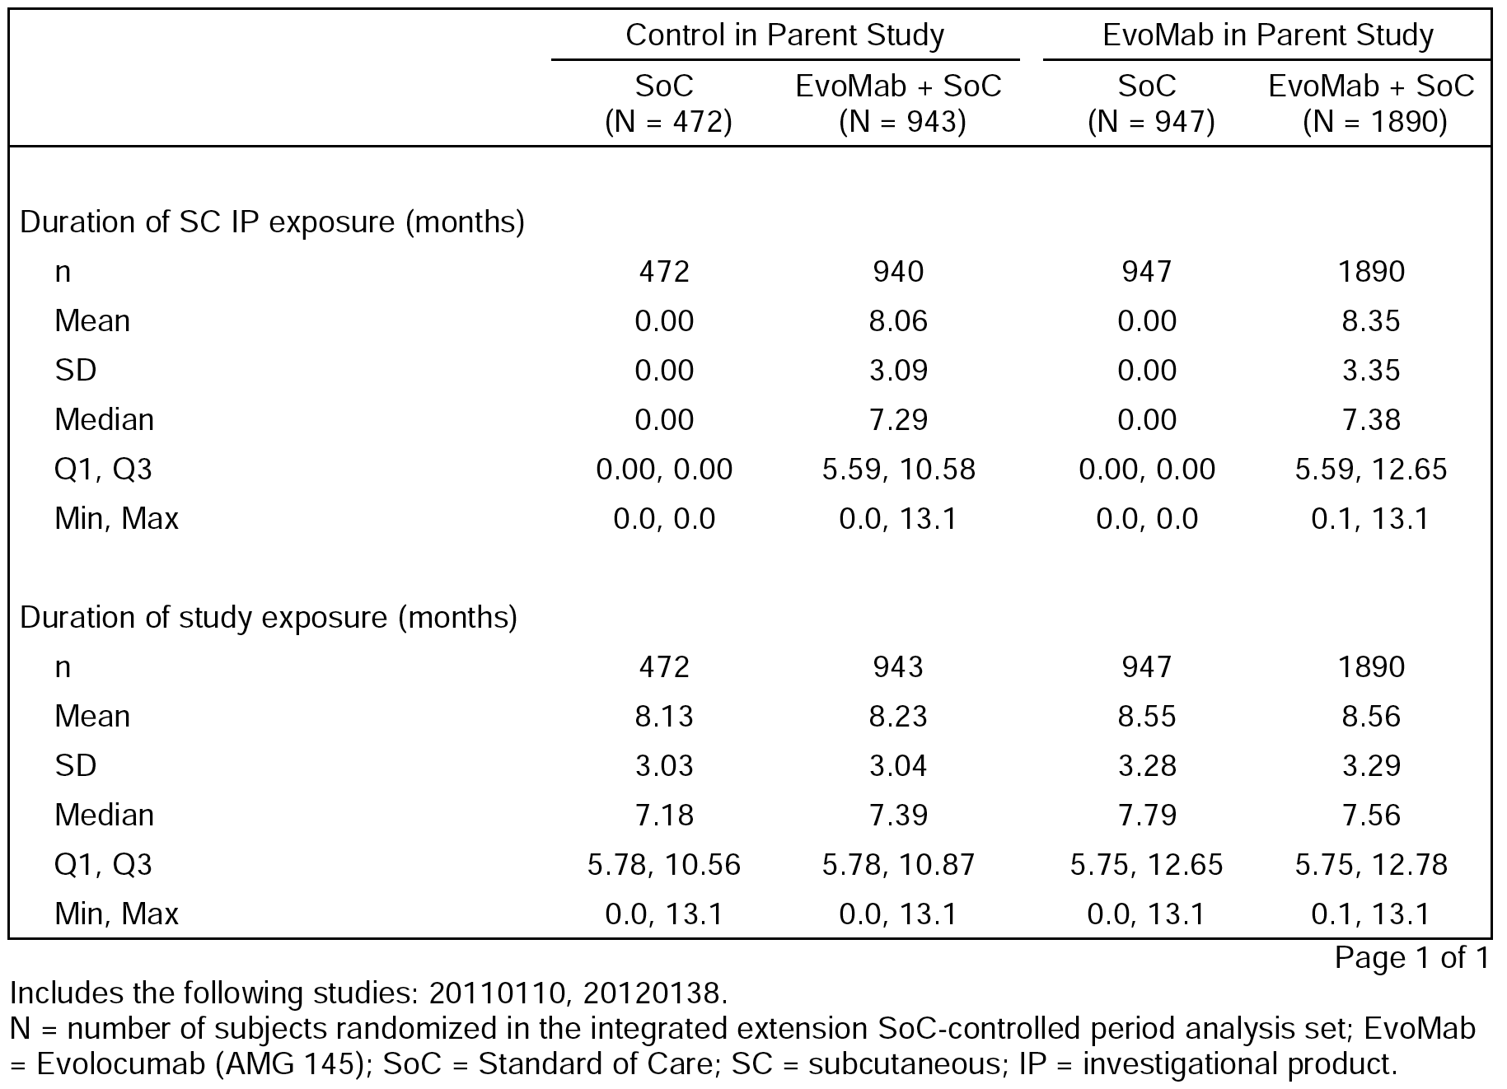
The Year 2+ of the OLE period of the extension studies (IEAAS) included a total of 954 subjects from the two long-term extension studies (20110110; 20120138). The mean ± SD for the total evolocumab plus SoC group was 12.64 ± 2.92 months (range 0, 16.9 months). The summary of exposure in the treatment groups in the IEAAS is provided below in Table 47.

Table 47: IEAAS - Summary of exposure during the Year 2+ OLE period of the extension studies.
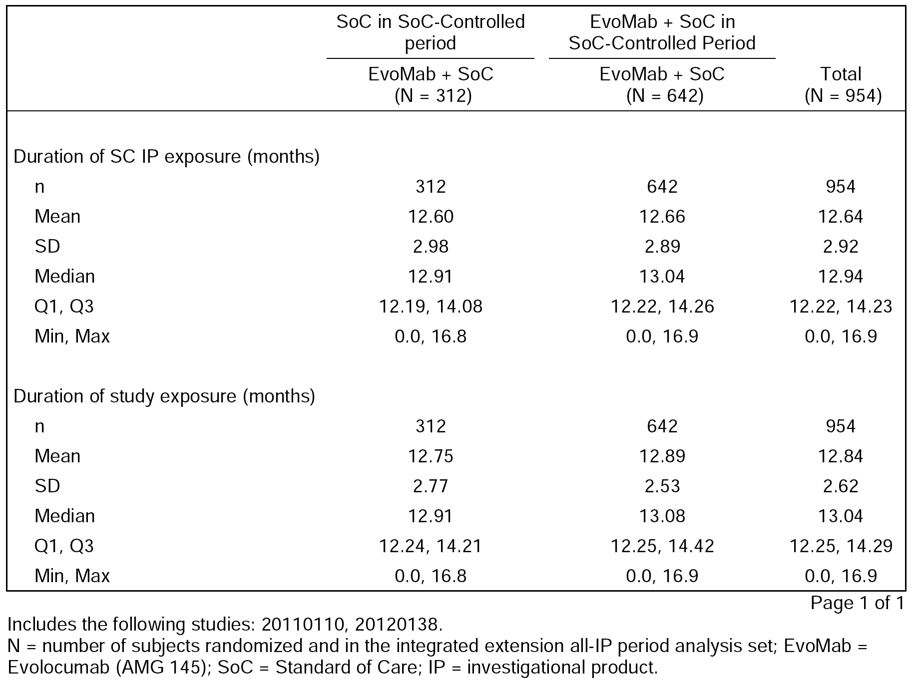
The longer duration of exposure to evolocumab in the OLE extension studies (IECAS; IEAAS) compared to integrated parent studies (IPAS) means that direct comparison of the frequency of AEs across the three data sets should be undertaken cautiously. In general, the data showed that the frequency of AEs reported in subjects treated with evolocumab increased with the duration of exposure. Therefore, the frequency of AEs was greater in the IEAAS compared to the IECAS and the IPAS, and the frequency of AEs in the IECAS was greater than the frequency in the IPAS.

Demographic and baseline characteristics
In the integrated parent studies (IPAS), baseline characteristics were generally well balanced across the treatment groups. In the integrated extension studies (IECAS, IEAAS), demographics and baseline characteristics were similar to those in the parent studies, which was to be expected as the majority of patients in the parent studies rolled over into the extension studies. In the integrated parent studies (IPAS) (n=6026), the mean ± age was 57.5 ± 11.2 years; no subjects were aged < 18 years, 4247 (70.5%) subjects were aged < 65 years, 1779 (29.5%) subjects were aged ≥ 65 years and 223 (3.7%) subjects were aged ≥ 75 years. There were 2982 (49.5%) males and 3044 (50.5%) females. The majority of subjects were White (n=5024, 83.4%) followed by Asian (n=539, 8.9%). More than 75% of the subjects were located in sites in North America (n=2956, 49.1%) and Europe (n=2324, 38.6%), with the remainder being located in the Asia Pacific (n=746, 12.4%).
In terms of baseline characteristics, 4392 (72.9%) subjects were at moderate risk or higher according to the NCEP CHD risk categories, 5187 (86.1%) subjects were at moderate risk or higher according to the according to ESC/EAS guidelines, 1141 (18.9%) subjects had coronary artery disease, 803 (13.3%) subjects had type 2 diabetes, 2003 (33.2%) subjects had metabolic syndrome (3 or more factors) without diabetes, and 674 (11.2%) subjects had renal impairment (eGFR < 60 mL/min/1.73 m²). The top three cardiovascular risk factors for subjects in the parent studies were hypertension (n=3100 [51.4%] subjects), low HDL-C (n=1785 [29.6%] subjects), and family history of premature coronary heart disease (n=1406 [23.3%] subjects). There were 2370 (39.3%) subjects with ≥ 2 cardiovascular risk factors. Subjects in the any evolocumab and any placebo groups were more likely to be using use high-intensity statin therapy (per ACC/AHA definition) at screening (29.5% and 33.6%, respectively), compared to subjects in the ezetimibe group (20.0%).

Adverse Events

Overview

IPAS - integrated parent studies
In the IPAS (n=6026), the primary overall assessment of safety was between the any control group (n=2080) and the any evolocumab group (n=3946). The ‘collapsed’ any control group (n=2080) consisted of the individual groups of placebo Q2W (n=586), placebo QM (n=940) and ezetimibe QD (n=554), and the ‘collapsed’ any evolocumab group (n=3946) consisted of the individual groups of evolocumab 140 mg Q2W (n=1245), evolocumab 420 mg QM (n=1956), other evolocumab doses Phase II studies (n=715), and evolocumab + ezetimibe QD (n=30) from the statin-intolerant study. In the IPAS, AEs were reported in 51.1% (n=2016) of subjects in the any evolocumab group and 49.6% (n=1031) of subjects in the any control group. The high-level AE profiles of the any control and any evolocumab groups were similar, with no notable differences between the two groups (see Table 48, below).

Table 48: IPAS - Summary of subject incidence of AEs during the parent studies, collapsed groups.
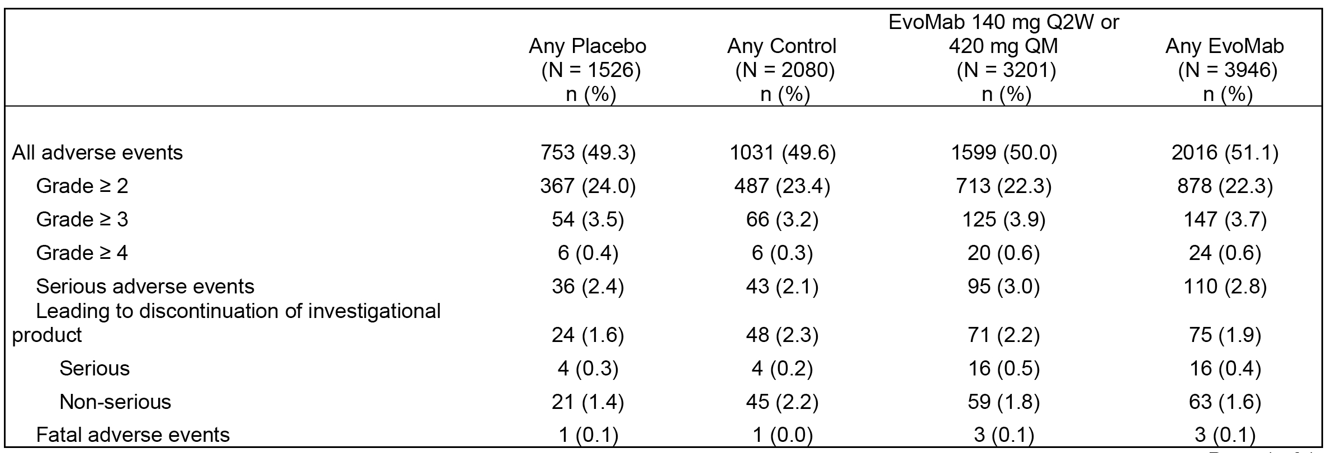
In the IPAS, the incidence of AEs in the evolocumab 140 mg Q2W and Q2W placebo groups was similar (43.6% versus 41.0%, respectively), as was the incidence of AEs in the evolocumab 420 mg QM and placebo QM groups (54.0% versus 54.6%, respectively). The high-level AE profiles of the detailed treatment groups are summarised below in Table 49.

Table 49: IPAS - Summary of subject incidence of AEs during the integrated parent studies, detailed groups.
Comment: The sponsor comments that the higher incidence of AEs with QM dosing was likely to be due to an additional 901 subjects reporting AEs only for QM dosing from the long-term Study 20110109 (DESCARTES). To address this discrepancy, the sponsor repeated some integrated analyses excluding the 420 mg QM data from Study 20110109. When the subjects (n=901) from this long-term study treated with QM dosing were excluded from the integrated analysis, the incidence of AEs for the evolocumab 420 mg QM and QM placebo groups were 44.8% (change from 54.0%) and 45.3% (change from 54.6%), respectively. Without the effects of the data from Study 20110109, the initial difference in AE incidence between the 140 mg Q2W and 420 mg QM decreased from 10.4% to 1.2%. SAEs were reported in 3.0% of subjects in the 420 mg QM group (versus 2.6% for QM placebo) when Study 20110109 was included, and 1.9% for the 420 mg QM group (versus 1.7% for QM placebo) when data from Study 20110109 were excluded. AEs leading to discontinuation of IP were reported in 2.1% of subjects in the 420 mg QM group (versus 1.5% for QM placebo) when Study 20110109 was included, and 2.1% for the 420 mg QM group (versus 1.7% for QM g placebo) when data from Study 20110109 were excluded. In the evaluation of safety evaluated in this CER, the data from the integrated parent studies (IPAS) includes the 901 patients from Study 20110109, unless otherwise specified.

IECAS - year 1 of the OLE studies (controlled-period)
In the IECAS, in the evolocumab plus standard of care (SoC) (n=1419) and SoC (n=2833) groups, AEs were reported in 1708 (60.3%) and 781 (55.0%) subjects, respectively. The high-level AE profiles of the two groups were similar with no notable differences between the two groups (see Table 50, below).

Table 50: IECAS - Summary of subject incidence of AEs during the Year 1 SoC control period.
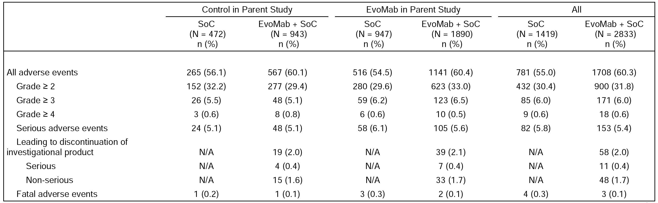

IEAAS - Year 2+ of the OLE studies (open-label period)
In IEAAS, the incidence of AEs for subjects who received evolocumab plus SoC in both year 1 and Year 2+ (75.4% [484/642]) was similar to the incidence of subjects who received SoC alone in Year 1 and evolocumab plus SoC in Year 2+ (73.4% [229/312]). The high-level AE profiles of the two groups were similar (see Table 51, below).

Table 51: IEAAS - Summary of subject incidence of AEs during the Year 2+ OLE period.
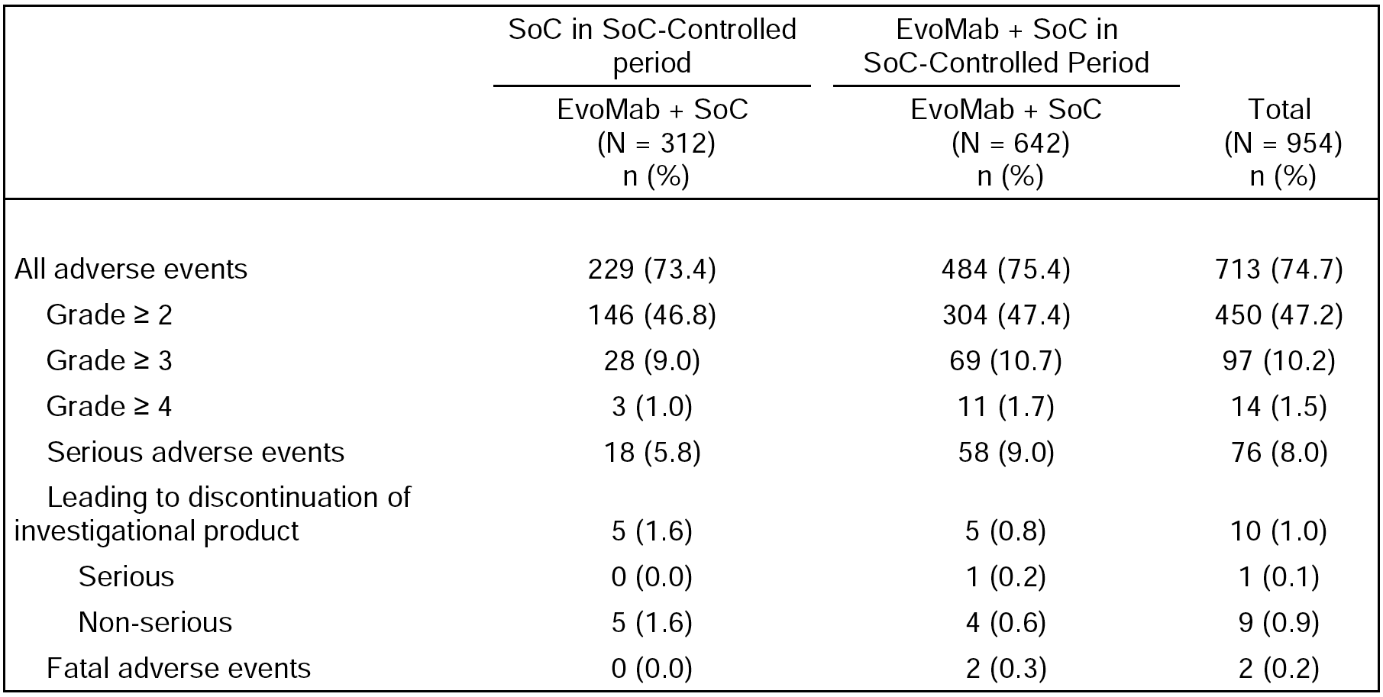

Common adverse events

Adverse events by system, organ, class (SOC)
- In the IPAS, AEs by SOC disorders occurring in ≥ 5% of subjects in the any evolocumab group (n=3946) in descending order of frequency compared to the any control group (n=2080) were, respectively: infections and infestations (21.0% versus 19.1%); musculoskeletal and connective tissue disorders (14.7% versus 13.7%); gastrointestinal disorders (9.8% versus 10.0%); general disorders and administration site conditions (8.9% versus 8.0%); nervous system disorders (7.6% versus 7.9%); respiratory, thoracic and mediastinal disorders (5.7% versus 5.1%); and injury, poisoning and procedural complications (5.4% versus 4.3%).
- In the IECAS, during the Year 1 SoC-controlled period AEs by SOC occurring in ≥ 5% of subjects in the evolocumab plus SoC group (n=2833) in descending order of frequency compared to the SoC group (n=1419) were, respectively: infections and infestations (28.8%versus 27.3%); musculoskeletal and connective tissue disorders (19.1% versus 15.2%); gastrointestinal disorders (11.5% versus 8.9%); general disorders and administration site conditions (10.8% versus 4.8%); nervous system disorders (8.4% versus 7.0%); respiratory, thoracic and mediastinal disorders (7.8% versus 6.8%); injury, poisoning, and procedural complications (7.7% versus 6.6%); skin and subcutaneous tissue disorders (6.3% versus 4.3%); and vascular disorders (5.1% versus 3.5%).
- In the IEASS, during the Year 2+ OLE period AEs by SOC reported in ≥ 5% of subjects in the total evolocumab plus SoC group (n=954) by descending order of frequency were: infections and infestations (45.3%); musculoskeletal and connective tissue disorders (28.1%); gastrointestinal disorders (16.8%); respiratory, thoracic and mediastinal disorders (14.6%); general disorders and administration site conditions (11.3%); injury, poisoning, and procedural complications (12.9%); nervous system disorders (12.5%); vascular disorders (8.5%); skin and subcutaneous tissue disorders (8.1%); and psychiatric disorders (5.2%).

Adverse events reported in ≥ 2% of subjects
- In the IPAS, the most commonly reported AEs occurring in ≥ 2% of subjects in the any evolocumab group versus the any control group, respectively, were nasopharyngitis (5.9% versus 4.8%), upper respiratory tract infection (3.2% versus 2.7%), headache (3.0% versus 3.2%), back pain (3.0% versus 2.7%), myalgia (2.5% versus 2.6%), arthralgia (2.3% versus 2.2%), influenza (2.1% versus 2.0%), diarrhoea (2.0% versus 2.4%), and cough (2.0% versus 1.3%). AEs reported in ≥ 2% of subjects in the any evolocumab group and more commonly than in the any control group were nasopharyngitis (5.9% versus 4.8%), upper respiratory tract infection (3.2% versus 2.7%), back pain (3.0 versus 2.7%), arthralgia (2.3% versus 2.2%), influenza (2.1% versus 2.0%), nausea (2.1% versus 1.8%), and cough (2.0% versus 1.3%).
- In the IPAS, no meaningful patterns were noted for time to onset of the most commonly reported AEs in the any evolocumab and any control groups. The median time to onset of AEs reported in ≥ 2% of subjects in the any evolocumab group versus the any control group were, respectively: nausea 57 versus 61 days; upper-respiratory tract infection 76 versus 58 days; headache 36 versus 35 days; back pain 55 versus 67 days; myalgia 28 versus 32 days; arthralgia 52 versus 51 days; influenza 75 versus 65 days; nausea 34 versus 45 days; diarrhoea 41 versus 43 days; and cough 70 versus 54 days.
- In the IECAS, during the Year 1 SoC-controlled period the most commonly reported AEs in ≥ 2% of subjects in the all evolocumab plus SoC group (versus the SoC group) were nasopharyngitis (8.5% versus 7.9%), upper respiratory tract infection (4.2% versus 4.0%), arthralgia (3.4% versus 2.5%), back pain (3.1% versus 2.5%), hypertension (3.1% versus 2.7%), influenza (3.0% versus 2.6%), headache (2.9% versus 1.7%), bronchitis (2.6% versus 3.0%), cough (2.5% versus 2.7%), myalgia (2.5% versus 2.4%), pain in extremity (2.5% versus 1.5%), diarrhoea (2.2% versus 1.5%), sinusitis (2.2% versus 2.6%), and fatigue (2.1% versus 0.8%). The only AE occurring with an incidence of ≥ 5% in either treatment group was nasopharyngitis. No meaningful patterns were noted for time of onset of the most commonly reported AEs in the evolocumab plus SoC and the SoC alone groups.
- In the IEASS, during the Year 2+ OLE period the most commonly reported AEs in ≥ 5% of subjects in the total evolocumab plus SoC group were nasopharyngitis (11.7%), upper respiratory tract infection (7.7%), arthralgia (6.7%), back pain (6.6%), cough (5.5%), hypertension (5.5%), bronchitis (5.3%) and sinusitis (5.1%).

Treatment-related adverse events
The ISS included no summary of treatment-related AEs. This reflects the fact that treatment-related AEs were not summarised in the four pivotal, Phase III, 12 week Studies (20110115, 20110117, 20110116, and 20110114) or the Phase III, 52 week study (20110109). In each of these studies, the protocol specified that treatment related AEs would be tabulated by system organ class and preferred term for each treatment group. However, in each of these studies the CSR stated that ‘the relationship to IP is intended to support safety review at a subject level and not for unblinded comparisons of adverse event profiles between treatment groups. This tabulation was not included in the primary analysis’. The absence of summarised treatment-related AE data should not preclude registration. AE data (irrespective of causality) provide a conservative assessment of the safety of evolocumab for the proposed indication.

Death and serious adverse events (SAEs)

Death
In the 6801 unique subjects in the Phase I, II and III studies in the evolocumab clinical program for both proposed indications, 15 (0.2%) deaths were reported. All 15 deaths were reported in the Phase II and III primary hyperlipidaemia and mixed dyslipidaemia studies, with no deaths reported in the Phase I or HoFH studies. There were 9 deaths in 5710 subjects (0.16%) in the any evolocumab group and 6 deaths in the 3079 subjects (0.19%) in the any control group.
The 15 deaths reported in the primary hyperlipidaemia and mixed dyslipidaemia studies were summarised. There were 4 deaths in the IPAS - 3 (0.1%) in the any evolocumab group (cardiac failure, myocardial infarction, and cardiac failure congestive), and 1 (< 0.1%) in the any control group (acute myocardial infarction); 7 deaths in the IECAS - 3 (0.1%) in the evolocumab plus SoC group (1 event of sudden death and 2 events of myocardial infarction) and 4 (0.3%) in the SoC alone group (lung neoplasm malignant, clostridium difficile infection, pulmonary embolism, and death); 2 deaths in the IEASS - both (0.2%) in the evolocumab plus SoC group (cholangiocarcinoma and peripheral ischaemia); and 2 deaths occurring after the study - 1 due to CVA in a patient who had received ezetimibe in the parent study and 1 sudden cardiac death in a patient who had received evolocumab 420 mg QM in the parent study. Only 1 sudden death in a 69-year-old female subject (Study 20120138) receiving evolocumab 420 mg QM and SoC in the IECAS was reported by the investigator to be related to the IP. The investigator reported the cause of sudden death as unknown, but presumed it to be myocardial infarction.
Of the 15 deaths, 11 deaths were deemed to be cardiovascular following adjudication by 2 members of an independent Clinical Endpoint Committee (CEC) convened to identify potential cardiovascular endpoints in the integrated analysis: IPAS - 1 (0.2%) in the placebo Q2W group, 1 (0.2%) in the ezetimibe group, 1 (0.1%) in the evolocumab 140 mg Q2W group, and 3 (0.2%) in the evolocumab 420 mg QM group; IECAS - 3 (0.1%) in the evolocumab plus SoC group and 1 (0.1%) in the SoC alone group; and IEAAS - 1 (0.1%) in the Year 2+ OLE period in the evolocumab plus SoC group. Overall, it can be estimated that there were 8 adjudicated cardiovascular deaths in 5710 subjects (0.14%) treated with evolocumab in the total clinical program and 3 in 3079 subjects (0.10%) treated with control.

Other serious adverse events (SAEs)
- In the IPAS, SAEs were reported in 110 (2.8%) subjects in the any evolocumab group and 43 (2.1%) subjects in the any control group. SAEs were reported in 36 (2.9%) subjects in the 140 mg evolocumab Q2W group versus 12 (2.0%) subjects in the Q2W placebo group, and 59 (3.0%) subjects in the evolocumab 420 QM group versus 24 (2.6%) subjects in the QM placebo group, while SAEs were reported in 7 (1.3%) subjects in the ezetimibe group. SAEs reported in ≥ 2 subjects in the evolocumab 140 mg Q2W group versus the Q2W placebo group were myocardial infarction (n=2, 0.2% versus 0%), acute myocardial infarction (n=2, 0.2% versus n=1, 0.2%) and hepatic enzyme increased (n=2, 0.2% versus 0%). SAEs reported in ≥ 2 subjects in the evolocumab 420 mg QM group versus the QM placebo group were angina pectoris (n=3, 0.2% versus n=2, 0.2%), unstable angina (n=2, 0.1% versus 0%); appendicitis (n=2, 0.1% versus 0%), back pain (n=2, 0.1% versus 0%), myocardial infarction (n=2, 0.1% versus 0%), palpitations (n=2, 0.1% versus 0%), acute pancreatitis (n=2, 0.1% versus 0%), pneumonia (n=2, 0.1% versus 0%), pulmonary embolism (n=2, 0.1% versus n=1, 0.1%), ventricular extra systoles (n=2, 0.1% versus 0%), and positional vertigo (n=2, 0.1% versus 0%).
- In IECAS, during the Year 1 SoC-controlled period, 153 (5.4%) subjects in the evolocumab plus SoC group and 82 (5.8%) subjects in the SoC alone group reported a SAE. The most commonly reported SAEs in ≥ 5 subjects in the evolocumab plus SoC group (versus the SoC alone group) were osteoarthritis (n=9, 0.3% versus n=2, 0.1%), angina pectoris (n=7, 0.2% versus n=2, 0.1%), myocardial infarction (n=5, 0.2% versus n=3, 0.2%), and non-cardiac chest pain (n=2, 0.2% versus n=2, 0.1%).
- In the IEASS, during the Year 2+ OLE period, 76 (8.0%) subjects in the evolocumab plus SoC group reported SAEs. In the evolocumab plus SoC group the most commonly reported SAEs ≥ 3 subjects were non-cardiac chest pain (n=4, 0.4%), pneumonia (n=4, 0.4%), angina pectoris (n=3, 0.3%), cardiac failure (n=3, 0.3%), chest pain (n=3, 0.3%), and myocardial infarction (n=3, 0.3%).

Adverse events leading to discontinuation

IPAS - integrated parent studies
In the IPAS, AEs leading to discontinuation of the IP were reported in 75 (1.9%) subjects in the any evolocumab group compared to 48 (3.2%) subjects in the any control group. In the any evolocumab group, AEs leading to discontinuation of the IP reported in ≥ 3 subjects (versus any control group) were myalgia (n=12, 0.3% versus n=10, 0.5%), pain in extremity (n=4, 0.1% versus n=1, < 0.1%), nausea (n=6, 0.2% versus n=3, 0.1%), blood CK increased (n=6, 0.2% versus n=5, 0.3%), pain in extremity (n=4, 0.1% versus n=1, < 0.1%), fatigue (n=3, 0.1% versus n=3, 0.1%), arthralgia (n=3, 0.1% versus n=2, 0.1%), muscle spasms (n=3, 0.1% versus n=2, 0.1%), and headache (n=3, 0.1% versus n=3, 0.1%).
The proportion of subjects discontinuing was similar in the evolocumab 140 mg Q2W and 420 mg QM groups (2.3%, n=29 and 2.1%, n=42; respectively), and was higher in both evolocumab groups than in the corresponding placebo Q2W and QM placebo groups (1.7%, n=10 and 1.5%, n=14, respectively). AEs leading to discontinuation were reported more frequently in subjects in the ezetimibe QD group (4.3%, n=24) than in either the evolocumab 140 mg Q2W or 420 mg QM groups. Most subjects in the IPAS rolled over into the extension studies.

IECAS - Year 1 SoC controlled period
In the IECAS, during the Year 1 SoC-controlled period, 58 (2.0%) subjects in the evolocumab plus SoC group reported an AE leading to discontinuation. Comparison with SoC alone group is not applicable as no subjects in this group were taking IPs. In the evolocumab plus SoC group, AEs leading to discontinuation of the IP reported in ≥ 3 patients were myalgia (n=7, 0.2%), arthralgia (n=4, 0.1%), fatigue (n=3, 0.1%), injection site pain (n=3, 0.1%).

IEASS - Year 2+ open-label extension period
In the IEASS, during the Year 2+ OLE period, 10 (1.0%) subjects reported an AE leading to discontinuation of IP. No individual AEs leading to discontinuation of the IP occurred in > 1 subject.

Adverse events across three therapeutic settings (monotherapy, combined with statins, and statin intolerant)

Overview
The safety analysis in the entire integrated safety population in the three safety analysis sets was repeated in the three therapeutic settings (monotherapy, combined with statin and statin intolerant). The monotherapy cohort included data from Studies 20111154, 20110114 and subjects in 201109 in the diet-alone background therapy cohort. The combination with statin cohort included data from Studies 20101155, 20110115, 20110231, 20120348, 20120356, 20090158, 20110117, and subjects in 20110109 in the low, high, or maximal background drug therapy cohorts. The statin intolerant cohort included data from Studies 20090159 and 20110116. The number of subjects in the three therapeutic setting cohorts are summarised below in Table 52.

Table 52: Number of subjects in the three therapeutic setting cohorts
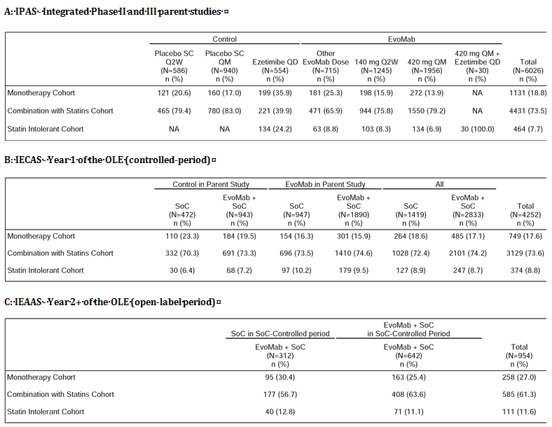

Monotherapy cohort

IPAS - integrated parent studies
Of the 6026 subjects in the IPAS, 1331 (18.8%) received monotherapy (n=651, any evolocumab cohort; n=480, any control cohort). The percentage of subjects experiencing AEs was similar in the any evolocumab and the any control cohorts (49.8% versus 49.2%, respectively). AEs reported in ≥ 1% of subjects in the any evolocumab cohort versus the any control cohort were nasopharyngitis (4.3% versus 4.0%), upper respiratory tract infection (4.3% versus 5.2%), diarrhoea (3.2% versus 2.9%), headache (3.2% versus 3.1%), back pain (2.5% versus 2.5%), constipation (2.0% versus 1.3%), nausea (2.0% versus 1.0%), injection site erythema (2.0% versus 1.5%), urinary tract infection (2.0% versus 2.5%), cough (2.0% versus 1.7%), fatigue (1.8% versus 2.3%), bronchitis (1.8% versus 0.6%), myalgia (1.7% versus 1.7%), arthralgia (1.5% versus 2.1%), pain in extremity (1.5% versus 1.3%), influenza (1.4% versus 1.0%), sinusitis (1.4% versus 1.3%), injection site induration (1.4% versus 0%), hypertension (1.4% versus 0.8%), injection site pain (1.2% versus 0.8%), musculoskeletal pain (1.2% versus 1.3%), dizziness (1.2% versus 1.3%), sinus congestion (1.2% versus 0.4%), and rash (1.1% versus 0.8%).
SAEs were reported in 1.4% (n=9) of subjects in the any evolocumab cohort compared to 1.0% (n=5) of subjects in the any control cohort. In the 7 subjects in the any evolocumab cohort each of the 10 SAEs was reported once and the events were acute pancreatitis, cholelithiasis, appendicitis, humerus fracture, upper limb fracture, hepatic enzyme increased, renal cancer, cerebrovascular accident, IgA nephropathy, and pleural effusion. In the 5 subjects in the any control cohort each of the 6 SAEs was reported once and the events were multiple fractures, road traffic accident, overdose, hepatic enzyme increased, bladder cancer, and breast cancer.
AEs leading to discontinuation of IP were reported in 1.2% (n=8) of subjects in the any evolocumab cohort and 2.7% (n=13) of subjects in the any control cohort. In the 8 subjects in the any evolocumab cohort each of the 13 events were reported once and the events were constipation, acute pancreatitis, fatigue, injection site erythema, injection site pruritus, injection site swelling, injection site urticaria, blood creatine kinase increased, hepatic enzyme increased, muscular weakness, musculoskeletal chest pain, myalgia, and dizziness. In the 13 subjects in the any control cohort each of the 19 events were reported once and the events were vertigo, upper abdominal pain, nausea, fatigue, herpes zoster, blood creatine kinase increased, hepatic enzyme increased, liver function test abnormal, arthralgia, pain in extremity, muscle spasms, pain in extremity, dizziness, headache, involuntary muscle contractions, libido decreased, rash and peripheral coldness.
Cardiac Disorders (SOC) in the monotherapy cohorts: Cardiac disorder AEs were reported in 7 (1.1%) subjects in the any evolocumab cohort (3x palpitations, 1x angina pectoris, 1x AV first degree block, 1x tachycardia, 1x ventricular extra systoles) and 0.2% (n=1) of subjects in the any control cohort (1x palpitations). No SAEs for cardiac disorders were reported in either the any evolocumab or any control cohort. No AEs for cardiac disorders resulted in discontinuation of IP in the any evolocumab or the any control cohort.
Evolocumab 140 mg Q2W and 420 mg QM: AE, SAE, and AEs leading to discontinuation profiles were similar in the any evolocumab, evolocumab 140 mg Q2W and evolocumab 420 mg QM cohorts AEs were reported in 44.6% (n=54) of subjects in the Q2W placebo cohort versus 50.5% (n=100) od subjects in the evolocumab 140 mg Q2W cohort, 53.8% (n=86) of subjects in the QM placebo cohort versus 48.9% (n=133) of subjects in the evolocumab 420 mg QM cohort, and 48.2% (96/199) of subjects in the ezetimibe cohort. SAEs were reported in no subjects (0%) in the Q2W placebo cohort versus 2.0% (n=4) of subjects in the evolocumab 140 mg Q2W cohort, 2.5% (n=4) of subjects in the QM placebo cohort versus 1.1% (n=3) of subjects in the evolocumab 420 mg QM cohort, and 0.5% (n=1) in the ezetimibe cohort. AEs leading to discontinuation of the IP were reported 3.3% (n=4) of subjects in the Q2W placebo cohort versus 2.0% (n=4) of subjects in the evolocumab 140 mg Q2W cohort, 2.5% (n=4) of subjects in the QM placebo cohort versus 1.5% (n=4) of subjects in the evolocumab 420 mg QM cohort, and 2.5% (n=5) of subjects in the ezetimibe cohort.

IECAS - Year 1 SoC controlled period
Of the 4252 subjects in the IECAS, 749 (17.6%) received monotherapy (n=485 evolocumab plus SoC; n=264 SoC alone). The percentage of subjects experiencing AEs was greater in the evolocumab plus SoC cohort than in the SoC alone cohort (67.4% versus 58.7%). AEs reported in ≥ 2% of subjects in the evolocumab plus SoC cohort (versus the SoC alone cohort) were nasopharyngitis (7.0% versus 4.2%), upper respiratory tract infection (6.8% versus 5.3%), urinary tract infection (4.3% versus 2.7%), cough (3.9% versus 2.7%), arthralgia (3.5% versus 3.8%), bronchitis (3.5% versus 5.3%), hypertension (3.5% versus 1.9%), diarrhoea (3.1% versus 2.3%), pain in extremity (2.9% versus 1.9%), nausea (2.9% versus 1.1%), back pain (2.7% versus 3.0%), sinusitis (2.5% versus 3.4%), headache (2.5% versus 2.7%), influenza (2.3% versus 1.1%), fatigue (2.1% versus 1.5%), insomnia (2.1% versus 1.5%), and oropharyngeal pain (2.1% versus 1.1%).
SAEs were reported in 5.4% (n=26) of subjects in the evolocumab plus SoC cohort compared to 3.4% (n=9) subjects in the SoC alone cohort. No SAEs in either of the two treatment cohorts were reported in more than one subject. No AEs by SOC occurred in ≥ 1.0% of subjects in either of the two treatment cohorts.
AEs leading to discontinuation of IP were reported in 2.7% (n=13) of subjects in the evolocumab plus SoC cohort (no subjects received IP in the SoC alone cohort). The 20 AEs leading to discontinuation of evolocumab plus SoC in the 13 subjects were two each for injection site erythema, injection site pain, injection site swelling, insomnia, and one each for impaired gastric emptying, nausea, generalised oedema, injection site pruritus, alanine aminotransferase increased, myalgia, cerebrovascular accident, memory impairment, erectile dysfunction, generalised pruritus, urticaria, and hypertension.
Cardiac Disorders (SOC) for the monotherapy cohorts: Cardiac disorder AEs were reported in 1.2% (n=6) of subjects in the evolocumab plus SOC cohort (2x coronary artery disease, 1x angina pectoris, 1x atrial fibrillation, 1 x bradycardia, 1 x myocardial infarction, 1x supraventricular tachycardia, 1x tachycardia) and 0.4% (n=1) of subjects in the SoC alone cohort (1x myocardial infarction). SAEs for cardiac disorders were reported in 0.4% (n=2) subjects in the evolocumab plus SoC cohort (1x coronary artery disease, 1 x myocardial infarction) and 0.4% (n=1) of subjects in the SoC alone cohort. AEs for cardiac disorders leading to discontinuation were reported in 1 (0.1%) subject in the evolocumab plus SoC cohort (1x palpitations) and no subjects in the SoC alone cohort.

IEASS - Year 2+ open-label extension period
Of the 954 subjects in the total evolocumab plus SoC in the IEAAS, 258 (27.0%) received monotherapy, and 196 (76.0%) reported AEs. AEs reported in ≥ 2% subjects were upper respiratory tract infection (12.0%), sinusitis (9.3%), nasopharyngitis (8.1%), bronchitis (7.4%), influenza (7.0%), cough (6.6%), urinary tract infection (5.8%), arthralgia (7.8%), hypertension (5%), pain in extremity (4.7%), headache (4.7%), oropharyngeal pain (4.7%), back pain (4.3%), diarrhoea (4%), nausea (4%), dyspepsia (3.9%), fatigue (3.2%), injection site erythema (3.1%), seasonal allergy (3.1%), gastroenteritis viral (3.1%), cystitis (2.7%), dizziness (2.7%), rash (2.7%), vomiting (2.3%), injection site bruising (2.3%), tooth abscess (2.3%), musculoskeletal pain (2.3%), and depression (2.3%).
SAEs were reported in 3.5% (n=9) of subjects in the evolocumab plus SoC cohort. Each of the SAEs was reported once and no pattern could be identified. AEs leading to discontinuation of the IP were reported in 1.9% (n=9) of subjects and the events were one each for hypogonadism, dyspepsia, fatigue, blood testosterone decreased, weight increased, anxiety, and angioedema.
Cardiac Disorders (SOC) for the monotherapy cohort: Cardiac disorder AEs in the evolocumab plus SoC cohort were reported in 1.2% (n=3) of subjects (1x bradycardia, 1x palpitations, 1x supraventricular extra systoles). No SAEs for cardiac disorders were reported in the evolocumab cohort plus SoC cohort. No AEs for cardiac disorders leading to discontinuation of the IP were reported in the evolocumab plus SoC cohort.

Combination with statins cohort

IPAS - integrated parent studies
Of the 6026 subjects in the IPAS, 4431 (73.5%) received treatment in combination with statins (n=2965, any evolocumab cohort; n=1466, any control cohort). AEs were experienced by a similar percentage of subjects in the any evolocumab and any control cohorts (49.9%, n=1479 versus 47.9%, n=702, respectively). AEs reported in ≥ 1% of subjects in the any evolocumab cohort (versus the any control cohort) were nasopharyngitis (6.3% versus 4.9%), upper respiratory tract infection (3.1% versus 2.1%), back pain (2.9% versus 2.9%), headache (2.6% versus 2.9%), arthralgia (2.4% versus 2.0%), influenza (2.4% versus 2.1%), cough (2.0% versus 1.1%), nausea (1.9% versus 1.6%), myalgia (1.9% versus 1.9%), diarrhoea (1.7% versus 1.9%), fatigue (1.6% versus 1.2%), bronchitis (1.6% versus 1.7%), dizziness (1.6% versus 1.7%), muscle spasms (1.6% versus 1.8%), pain in extremity (1.5% versus 2.1%), urinary tract infection (1.4% versus 1.4%), hypertension (1.4% versus 1.4%), sinusitis (1.3% versus 1.0%), contusion (1.1% versus 0.8%), blood creatine kinase increased (1.0% versus 0.4%), and musculoskeletal pain (1.0% versus 1.0%).
SAEs were reported in 3.0% (n=90) of subjects in the any evolocumab cohort and 2.3% (n=34) of subjects in the any control cohort. SAEs reported in ≥ 2 patients in the any evolocumab cohort versus the any control cohort were angina pectoris (n=4, 0.1% versus n=2, 0.1%), myocardial infarction (n=4, 0.1% versus 0%), pneumonia (n=4, 0.1% versus 0%), appendicitis (n=2, 0.1% versus 0%), cellulitis (n=2, 0.2% versus 0%), acute myocardial infarction (n=3, 0.1% versus n=1, 0.1%), unstable angina (n=3, 0.1% versus 0%), pulmonary embolism (n=3, 0.1% versus n=1, 0.1%), atrial fibrillation (n=2, 0.1% versus n=1, 0.1%), cardiac failure (n=2, 0.1% versus 0%), palpitations (n=2, 0.1% versus 0%), ventricular extra systoles (n=2, 0.1% versus 0%), positional vertigo (n=2, 0.1% versus 0%), cholecystitis (n=2, 0.1% versus 0%), hypomagnesaemia (n=2, 0.1% versus 0%), back pain (n=2, 0.1% versus 0%), transient ischaemia attack (n=2, 0.1% versus 0%), and asthma (n=2, 0.1% versus n=1, 0.1%).
AEs leading to discontinuation of IP were reported in 1.4% (n=33) subjects in the any evolocumab cohort and 1.4% (n=17) subjects in the any control cohort. AEs leading to discontinuation of IP reported in ≥ 2 subjects in the any evolocumab cohort versus the any control cohort were vertigo (n=2, 0.1% versus 0%), nausea (n=3, 0.1% versus 0%), myalgia (n=3, 0.1% versus n=5, 0.4%), arthralgia (n=2, 0.1% versus n=1, 0.1%), pain in extremity (n=2, 0.1% versus 0%), diarrhoea (n=2, 0.1%), fatigue (n=2, 0.1% versus n=1, 0.1%), blood CK increased (n=2, 0.1% versus 0%), and headache (n=2, 0.1% versus 0%).
Cardiac Disorders (SOC) in the combined with statins cohorts: Cardiac disorder AEs (SOC) were reported in 2.6% (n=76) of subjects in the any evolocumab cohort, with events being reported for ≥ 0.2% subjects being palpitations (n=17, 0.6%), angina pectoris (n=10, 0.3%), ventricular extra systoles (n=10, 0.3%) and atrial fibrillation (n=8, 0.3%). Cardiac disorder AEs were reported in 1.8% of subjects in the any control cohort, with events in ≥ 0.2% of subjects being atrial fibrillation (n=7, 0.5%), palpitations (n=4, 0.3%), angina pectoris (n=4, 0.3%).
Cardiac disorder SAEs were reported in 0.7% (n=22) of subjects in the any evolocumab cohort and 0.3% (n=5) of subjects in the any control cohort. SAEs reported in ≥ 3 subjects in the any evolocumab cohort versus the any control cohort were angina pectoris (n=4, 0.1% versus n=2, 0.1%), myocardial infarction (n=4, 0.1% versus 0%), acute myocardial infarction (n=3, 0.1% versus n=1, 0.1%), and unstable angina (n=3, 0.1% versus 0%).
Cardiac disorder AEs leading to discontinuation of the IP were reported in 0.1% (n=4) of subjects in the any evolocumab cohort (2x cardiac failure, 2x myocardial infarction, 1x supraventricular extra systoles, 1x ventricular fibrillation) and 0.1% (n=1) of subjects in the any control cohort (1x acute myocardial infarction).
Evolocumab 140 mg Q2W and 420 mg QM: AEs were reported in 40.0% (n=186) of subjects in the Q2W placebo cohort versus 40.3% (n=380) of subjects in the evolocumab 140 mg Q2W cohort, 54.7% (n=427) of subjects in the QM placebo cohort versus 53.6% (n=831) of subjects in the evolocumab 420 mg QM cohort, and 40.3% (n=89) of subjects in the ezetimibe cohort. SAEs were reported in 2.6% (n=12) of subjects in the Q2W placebo cohort versus 2.9% (n=27) of subjects in the evolocumab 140 mg Q2W cohort, 2.6% (n=20) of subjects in the QM placebo cohort versus 3.4% (n=53) of subjects in the evolocumab 420 mg QM cohort, and 0.9% (n=2) of subjects in the ezetimibe cohort. AEs leading to discontinuation of the IP were reported in 1.3% (n=6) of subjects in the Q2W placebo cohort versus 2.0% (n=19) of subjects in the evolocumab 140 mg Q2W cohort, 1.3% (n=10) of subjects in the QM placebo cohort versus 1.6% (n=25) of subjects in the evolocumab 420 mg QM cohort, and 1.8% (n=4) of subjects in the ezetimibe cohort.

IECAS - Year 1 SoC controlled period
Of the 4252 subjects in the IECAS, 3129 (73.6%) subjects were included in the combination with statins cohort (72.4%, n=1028 in the SoC alone cohort; 73.6%, n=2101 in the evolocumab plus SoC cohort). AEs were reported more commonly in subjects in the evolocumab plus SoC cohort compared to the SoC alone cohort (57.9% versus 52.3%, respectively). AEs reported in ≥ 2% of subjects in the evolocumab plus SoC cohort (versus the SoC alone cohort) were nasopharyngitis (8.7% versus 8.2%), upper respiratory tract infection (3.6% versus 3.8%), arthralgia (3.4% and 2.1%), back pain (3.3 % and 2.1%), hypertension (3.0% and 2.9%), influenza (2.9% versus 2.7%), headache (2.9% versus 1.4%), bronchitis (2.2% versus 1.9%), pain in extremity (2.2% versus 1.3%), cough (2.1% versus 2.6%), diarrhoea (2.0% versus 1.1%), fatigue (2.0% versus 0.4%), and myalgia (2.0% versus 2.0%).
SAEs were reported in 5.2% (n=110) of subjects in the evolocumab plus SoC cohort and 5.8% (n=60) of subjects in the SoC alone cohort. SAEs reported in ≥ 0.2% of subjects in the evolocumab plus SoC cohort versus the SoC alone cohort were angina pectoris (0.3% versus 0.2%), osteoarthritis (0.3% versus 0.1%), myocardial infarction (0.2% versus 0.2%), and chest pain (0.2% versus 0.2%).
AEs leading to discontinuation of the IP were reported in 1.7% (n=36) of subjects in the evolocumab plus SoC cohort (no subjects received IP in the SoC alone cohort). AEs leading to discontinuation of the IP reported in ≥ 2 subjects were myalgia (n=3, 0.1%), fatigue (n=2, 0.1%), arthralgia (n=2, 0.1%), headache (n=2, 0.1%), and dyspnoea (n=2, 0.1%).
Cardiac Disorders (SOC) in combined with statins cohorts: AEs for Cardiac disorder AEs were reported in 2.4% (n=51) of subjects in the evolocumab plus SoC cohort and 2.9% (n=30) of subjects in the SoC alone cohort. Cardiac disorder SAEs were reported in 1.0% (n=20) of subjects in the evolocumab plus SoC cohort and 1.4% of subjects in the SoC alone cohort. Cardiac disorder AEs leading to discontinuation of the IP were reported in 1 (< 0.1%) subject in the evolocumab plus SoC cohort and no (0%) subjects in the SoC alone cohort.

IEASS - Year 2+ open-label extension period
Of the 954 subjects in the total evolocumab plus SoC group (IEAAS), 585 (61.3%) were in the combination with statins cohort, and 439 (75.0%) of these subjects reported AEs. AEs reported in ≥ 2% subjects were nasopharyngitis (13.2%), back pain (7.4%), upper respiratory tract infection (6.7%), arthralgia (7.6%), hypertension (5.6%), cough (5.1%), bronchitis (5.0%), pain in extremity (3.9%), influenza (3.8%), dizziness (3.4%), sinusitis (3.1%), headache (2.9%), cystitis (2.4%), gastroenteritis (2.4%), pneumonia (2.4%), procedural pain (2.4%), musculoskeletal pain (2.4%), myalgia (2.4%), osteoarthritis (2.4%), contusion (2.2%), diarrhoea (2.6%), fatigue (2.2%), peripheral oedema (2.2%), and insomnia (2.1%).
SAEs were reported in 9.6% (n=56) of subjects in the evolocumab plus SoC cohort. No SAEs were reported in ≥ 1.0% of subjects. AEs leading to discontinuation of IP were reported in 0.5% (n=3) of subjects in the evolocumab plus SoC cohort.
Cardiac Disorders (SOC) in combined with statins cohorts: Cardiac disorder AEs were reported in 6.2% (n=36) of subjects in the evolocumab plus SoC cohort. Cardiac disorder SAEs were reported in 2.4% of subjects in the evolocumab plus SoC cohort, with events being reported in ≥ 2 subjects being angina pectoris (n=3, 0.5%), myocardial infarction (n=3, 0.5%), and cardiac failure (n=2, 0.3%). No cardiac disorder AEs leading to discontinuation of the IP were reported in the evolocumab plus SoC cohort.

Statin intolerant cohort

IPAS - integrated parent studies
Of the 6026 subjects in the IPAS, 464 (7.7%) were in the statin intolerant cohort (n=330, any evolocumab; n=134 any control). In the statin intolerant cohort, the any control cohort consisted only of subjects treated with ezetimibe. The incidence of AEs in subjects in the ezetimibe cohort was greater than in the any evolocumab cohort (that is, 69.4%, n=93 versus 64.5%, n=213, respectively). AEs reported in ≥ 2% of subjects in the any evolocumab cohort (versus the any control cohort [ezetimibe]) were myalgia (9.1% versus 14.2%), headache (7.0% versus 6.7%), pain in extremity (5.8% versus 1.5%), muscle spasms (5.2% versus 5.2%), back pain (4.5% versus 2.2%), nasopharyngitis (4.5% versus 6.0%), nausea (3.9% versus 6.0%), fatigue (3.9% versus 9.0%), constipation (3.3% versus 0%), arthralgia (3.0% versus 3.7%), dizziness (2.7% versus 2.2%), diarrhoea (2.4% versus 6.0%), upper respiratory tract infection (2.4% versus 0%), sinusitis (2.1% versus 2.2%), and abdominal distension (2.1% versus 0.7%).
In the statin intolerant cohort, SAEs were reported in 3.3% (n=11) of subjects in the any evolocumab cohort and 3.0% (n=4) of subjects in the ezetimibe cohort. No SAEs were reported in ≥ 1.0% of subjects in the any evolocumab cohort.
In the statin intolerant cohort, AEs leading to discontinuation of the IP were reported in 6.4% (n=21) of subjects in the any evolocumab cohort and 11.2% (n=15) of subjects in the ezetimibe cohort. AEs leading to discontinuation of the IP reported in ≥ 2 subjects in the any evolocumab cohort versus the ezetimibe cohort were myalgia (n=6, 1.8% v n=5, 3.7%), back pain (n=2, 0.6% versus 0%), muscle spasms (n=2, 0.6% versus n=1, 0.7%), pain in extremity (n=2, 0.6% versus 0%), abdominal pain (n=2.0.6% versus n=2, 1.5%), and nausea (n=2, 0.6% versus n=1, 0.7%).
Cardiac Disorders (SOC) in the statin intolerant cohort: Cardiac disorder AEs were reported in 1.8% (n=6) of subjects in the any evolocumab cohort (2x [0.6%] palpitations, 1x [0.3%] angina pectoris, 1x [0.3%] bradycardia, 1x [0.3%] coronary artery disease, 1x [0.3%] myocardial infarction), and 1.5% (n=3) of subjects in the ezetimibe cohort. Cardiac disorder SAEs were reported in 0.6% (n=2) of subjects in the any evolocumab cohort (1x coronary artery disease, 1x myocardial infarction) and no (0%) subjects in the ezetimibe cohort. Cardiac disorder AEs leading to discontinuation of IP were reported in no subjects in either the any evolocumab cohort or the ezetimibe cohort.
Evolocumab 140 mg Q2W and 420 mg QM: AEs were reported in 61.2% (n=63) of subjects in the evolocumab 140 mg Q2W cohort, 68.7% (n=92) of subjects in the 420 mg QM cohort, and 69.4% (n=93) of subjects in the ezetimibe cohort. SAEs were reported in 4.9% (n=5) of subjects in the evolocumab 140 mg Q2W cohort, 2.2% (n=3) of subjects in the 420 mg QM cohort, and 3.0% (n=4) of subjects in the ezetimibe cohort. AEs leading to discontinuation of IP were reported in 5.8% (n=6) of subjects in the evolocumab 140 mg Q2W cohort, 9.7% (n=13) of subjects in the 420 mg QM cohort, and 11.2% (n=15) of subjects in the ezetimibe cohort.

IECAS - Year 1 SoC controlled period
Of the 4252 subjects in IECAS, 374 (8.8%) were in the statin intolerant cohort (8.9%, n=127, SoC alone cohort; 8.7%, n=247, evolocumab plus SoC cohort). AEs were reported in 69.3% (n=88) of subjects in the SoC only cohort and 72.1% (n=178) of subjects in the evolocumab plus SoC cohort. AEs reported in ≥ 2% of subjects in the evolocumab plus SoC cohort (versus the SoC alone cohort) were nasopharyngitis (10.1% versus 13.4%), myalgia (8.5% versus 7.9%), influenza (4.9% versus 4.7%), pain in extremity (4.5% versus 2.4%), upper respiratory tract infection (4.5% versus 2.4%), sinusitis (4.5% versus 4.7%), bronchitis (4.0% versus 7.1%), headache (3.6% versus 2.4%), arthralgia (3.6% versus 3.1%), fatigue (3.6% versus 3.1%), hypertension (3.6% versus 3.1%), cough (3.2% versus 3.1%), muscle spasms (3.2% versus 3.1%), influenza like illness (2.8% versus 2.4%), back pain (2.8% versus 3.9%), blood CK increased (2.8% versus 0.8%), dizziness (2.4% versus 5.5%), gastro-oesophageal reflux (2.4% versus 1.6%), cataract (2.0% versus 0.8%), injection site bruising (2.0% versus 0%) and diabetes mellitus (2.0% versus 0%).
In the statin intolerant cohort, SAEs were reported in 6.9% (n=17) of subjects in the evolocumab plus SoC cohort and 10.2% (n=13) subjects in the SoC alone cohort. The only SAE reported in ≥ 2 subjects in the evolocumab plus SoC cohort versus the SoC alone cohort was osteoarthritis (0.8%, n=2 versus 0.8%, n=1).
In the statin intolerant cohort, AEs leading to discontinuation of the IP were reported in 3.6% (n=9) of subjects in the evolocumab plus SoC cohort (no subjects received IP in the SoC alone cohort). AEs leading to discontinuation of the IP in ≥ 2 subjects in the evolocumab plus SoC cohort were myalgia (n=3, 1.2%) and arthralgia (n=2, 0.8%)
Cardiac Disorders (SOC) in the statin intolerant cohort: Cardiac disorder AEs were reported in 4.9% (n=12) of subjects in the evolocumab plus SoC cohort and 7.9% (n=10) of subjects in the ezetimibe cohort. SAEs for cardiac disorders (SOC) were reported in 1.2% (n=3) of subjects in the evolocumab plus SoC cohort versus 3.1% (n=4) of subjects in the ezetimibe cohort. No AEs for cardiac disorders (SOC) leading to discontinuation of the IP were reported in the evolocumab plus SoC cohort or the ezetimibe cohort.

IEASS - Year 2+ open-label extension period
Of the 954 subjects treated with evolocumab plus SoC in the IEAAS, 111 (11.6%) were in the statin intolerant cohort and of 78 (70.3%) of these subjects reported AEs. AEs reported in ≥ 2% subjects were nasopharyngitis (12.6%), arthralgia (9.9%), back pain (8.1%), pain in extremity (8.1%), sinusitis (6.3%), diarrhoea (5.4%), hypertension (5.4%), peripheral oedema (4.5%), muscle spasms (4.5%), musculoskeletal pain (4.5%), myalgia (4.5%), cough (4.5%), cystitis (3.6%), neck pain (3.6%), upper abdominal pain (2.7%), vomiting (2.7%), bronchitis (2.7%), influenza (2.7%), pneumonia (2.7%), upper respiratory tract infection (2.7%), arthropod bite (2.7%), fall (2.7%), headache (2.7%), and syncope (2.7%).
In the statin intolerant cohort, SAEs were reported in 9.9% (n=11) of subjects in the evolocumab plus SoC cohort, and no events were reported in ≥ 1 subject. AEs leading to discontinuation of the IP in the evolocumab plus SoC cohort were reported in 2 subjects (1.8%) (1x arthralgia; 1x oesophageal carcinoma)
Cardiac Disorders (SOC) in the statin intolerant cohort: Cardiac disorder AEs were reported in 7.2% (n=8) of subjects in the evolocumab plus SoC cohort, with events being reported in ≥ 2 subjects being angina pectoris (n=2, 1.8%) and tachycardia (n=2, 1.8%). Cardiac disorder SAEs were reported in 1.8% (n=2) of subjects in the evolocumab plus SoC cohort (1x unstable angina, 1 x cardiac failure). No cardiac disorder AEs leading to discontinuation of the IP were reported in the evolocumab plus SoC cohort.

Safety in subjects with LDL-C levels < 1.0 mmol/L

Background
In view of the epidemiological and clinical trial data suggesting that very low levels of LDL-C might increase the risk of cancer, haemorrhagic stroke, and non-cardiovascular death, the sponsor provided an analysis of the safety of evolocumab in subjects achieving LDL-C levels < 0.1 mmol/L. Analyses of AEs were performed by LDL-C subgroup (< 0.6 mmol/L, < 1.0 mmol/L, and ≥ 1.0 mmol/L), and compared with the AEs in the entire integrated population in each of the three safety analysis sets (IPAS, IECAS, IEAAS). The requirement for entry into an LDL-C subgroup was the occurrence of at least one LDL-C value that was below cut-off value for the subgroup.
IPAS - integrated parent studies
In the IPAS, AEs were compared between the any evolocumab and the any control groups for each of the LDL-C subgroups. However, the marked imbalance between the number of subjects in the any evolocumab group and the any control group in the LDL-C < 0.6 mmol/L subgroup (n=1609 versus n=6, respectively) and in the LDL-C < 1.0 mmol/L subgroup (n=2565 versus n=30) precludes meaningful comparisons of the safety data between the two treatment groups. Therefore, review of the safety data in the LDL-C subgroups concentrates on the comparison of the data from the any evolocumab groups.
AEs (all) in the any evolocumab group
AEs were reported in 51.3% (n=826), 51.0% (n=1308), and 52.0% (n=696) of subjects in the LDL-C < 0.6, < 1.0 and ≥ 1.0 mmol/L subgroups, respectively, compared to 51.1% (n=2016) of subjects in the entire integrated population. In the LDL-C < 0.6 mmol/L subgroup, AEs reported in ≥ 1.0% of subjects compared to the LDL-C < 1.0 mmol/L and ≥ 1.0 mmol/L subgroups in the any evolocumab group, respectively, and in descending order of frequency in the LDL-C < 0.6 mmol/L subgroup were: nasopharyngitis (6.5% versus 6.6% versus 4.6%); upper respiratory tract infection (4.0% versus 3.6% versus 2.6%); back pain (3.5% versus 3.2% versus 2.5%); headache (2.6% versus 2.7% versus 3.6%); arthralgia (2.7% versus 2.4% versus 2.2%); influenza (2.0% versus 2.3% versus 1.9%); diarrhoea (2.3% versus 2.0% versus 2.0%); cough (2.3% versus 2.5% versus 1.1%); myalgia (2.2% versus 1.9% versus 3.6%); dizziness (2.1% versus 1.7% versus 1.5%); pain in extremity (2.0% versus 1.9% versus 1.9%); bronchitis (2.0% versus 1.7% versus 1.5%); nausea (1.9% versus 1.9% versus 2.4%); muscle spasms (1.9% versus 1.8% versus 1.7%); sinusitis (1.7% versus 1.5% versus 1.1%); urinary tract infection (1.6% versus 1.7% versus 1.3%); fatigue (1.6% versus 1.6% versus 2.0%); hypertension (1.3% versus 2.3% versus 1.6%); musculoskeletal pain (1.2% versus 1.1% versus 1.2%); oropharyngeal pain (1.2% versus 1.1% versus 1.0%); vomiting (1.1% versus 0.9% versus 1.0%); and contusion (1.0% versus 1.0% versus 0.8%).
Comment: The AE profile in the any evolocumab group for commonly occurring events was similar in the three LDL-C subgroups and consistent with that in the entire integrated population.
SAEs in the any evolocumab group
SAEs in the LDL-C < 0.6, < 1.0 and ≥ 1.0 mmol/L subgroups were reported in 2.9% (n=47), 2.7% (n=70), and 2.6% (n=35) of subjects, respectively, compared to 2.8% (n=110) of subjects in the entire integrated population. SAEs reported in ≥ 0.1% of subjects (≥ 2 subjects) in the LDL-C < 0.6 mmol/L group compared to the < 0.1 mmol/L group and the ≥ 1.0 mmol/L group, respectively, were: angina pectoris (0.2%, n=3 versus 0.1%, n=3 versus 0.1%, n=1); cardiac failure (0.1%, n=2 versus 0.1%, n=2 versus 0%); coronary artery disease (0.1%, n=2 versus 0.1%, n=2 versus 0%); ventricular extra systoles (0.1%, n=2 versus 0.1%, n=2 versus 0%); positional vertigo (0.1%, n=2 versus 0.1%, n=2 versus 0%); pneumonia (0.2%, n=3 versus 0.2%, n=4 versus 0%); appendicitis (0.1%, n=2 versus 0.1%, n=2 versus 0.1%, n=1); back pain (0.1%, n=2 versus 0.1%, n=2 versus 0.1%, n=1); and asthma (0.1%, n=2 versus 0.1%, n=2 versus 0%).
Comment: The SAE profiles in the any evolocumab group were similar in the three LDL-C subgroups and were consistent with that in the entire integrated population. The incidence of SAEs in the any evolocumab group for selected SOCs of interest (cardiac disorders, neoplasms, nervous system disorders and psychiatric disorders) was similar in subjects in the three LDL-C subgroups. In the any evolocumab group, SAEs in subjects in the LDL-C < 0.6 versus < 1 versus ≥ 1.0 mmol/L subgroups, respectively, were: 0.6%, n=9 versus 0.5%, n=13 versus 0.7%, n=9 for cardiac disorders (SOC); 0.3%, n=5 versus 0.3%, n=7 versus 0.4%, n=5 for neoplasms benign, malignant, and unspecified (SOC); 0.1%, n=1 versus 0.2%, n=4 versus 0.4%, n=6 for nervous system disorders (SOC); and 0.1%, n=1 versus <0.1%, n=1 versus 0.1%, n=2 for psychiatric disorders (SOC).

IECAS - Year 1 SoC controlled period
In the IECAS, AEs have been compared between the evolocumab plus SoC and the SoC any groups for each of the LDL-C subgroups. However, the marked imbalance between the number of subjects in the evolocumab plus SoC group and the SoC alone group in the LDL-C < 0.6 mmol/L subgroup (n=666 versus n=4, respectively) and in the LDL-C < 1.0 mmol/L subgroup (n=1369 versus n=12) precludes meaningful comparisons of the safety data between the two treatment groups. Therefore, review of the safety data in the LDL-C subgroups concentrates on the comparison of the data from the evolocumab plus SoC groups.
AEs (all) in the evolocumab plus SoC group: AEs were reported in 59.2% (n=394), 59.5% (n=1369) and 61.8% (n=882) of subjects in the LDL-C < 0.6, LDL-C < 1.0 and LDL-C ≥ 1.0 mmol/L subgroups, respectively, compared to 60.3% (n=1708) of the entire patient population. In the LDL-C < 0.6 mmol/L subgroup, AEs reported in ≥ 1.0% of subjects compared to the LDL-C < 1.0 mmol/L and ≥ 1.0 mmol/L subgroups, respectively, and in descending order of frequency in the LDL-C < 0.6 mmol/L subgroup were: nasopharyngitis (10.2% versus 9.2% versus 8.1%); upper respiratory tract infection (4.4% versus 3.9% versus 4.6%); back pain (4.2% versus 3.7% versus 2.7%); arthralgia (3.8% versus 4.2% versus 2.7%); hypertension (3.5% versus 3.7% versus 2.7%); osteoarthritis (2.3% versus 1.8% versus 1.8%); pain in extremity (2.3% versus 3.7% versus 2.7%); diarrhoea (3.3% versus 2.6% versus 2.0%); bronchitis (2.9% versus 2.7% versus 2.5%); headache (2.7% versus 2.7% versus 3.2%); myalgia (2.1% versus 2.2% versus 2.9%); fatigue (2.1% versus 2.0% versus 2.2%); gastroenteritis (2.1% versus 1.7% versus 1.0%); influenza (2.0% versus 2.2% versus 3.8%); urinary tract infection (2.0% versus 2.1% versus 2.5%); dizziness (1.7% versus 1.6% versus 1.7%); diabetes mellitus (1.7% versus 1.0% versus 0.6%); muscle spasms (1.5% versus 1.5% versus 1.9%); sinusitis (1.4% versus 2.0% versus 2.2%); muscle strain (1.4% versus 1.1% versus 0.6%); rash (1.4% versus 1.4% versus 1.1%); constipation (1.2% versus 1.1% versus 1.3%); insomnia (1.2% versus 1.2% versus 1.2%); injection site bruising (1.2% versus 1.1% versus 1.1%); oropharyngeal pain (1.2% versus 1.2% versus 1.3%); injection site pain (1.1% versus 1.0% versus 1.3%); chest pain (1.1% versus 0.9% versus 0.7%); gastritis (1.1% versus 1.0% versus 0.4%); and musculoskeletal pain (1.1% versus 1.9% versus 1.5%)
Comment: The AE profile in the evolocumab plus SoC for commonly occurring events was similar in the three LDL-C subgroups and consistent with that in the entire integrated population.
SAEs in the evolocumab plus SoC group: The incidence of AEs was similar in the LDL-C < 0.6 mmol/L group (5.1%, n=34), the LDL-C < 1.0 mmol/L group (5.0%, n=68), the LDL-C ≥ 1.0 mmol/L group (6.0%, n=85), and the entire patient population (5.4%, n=153). SAEs reported in ≥ 0.3% of subjects (≥ 2 subjects) in the evolocumab plus SoC group in the LDL-C < 0.6 mmol/L group compared to the < 0.1 mmol/L group and the ≥ 1.0 mmol/L group, respectively, were: chest pain (0.5%, n=3 versus 0.3%, n=4 versus 0%); osteoarthritis (0.5%, n=3 versus 0.2%, n=3 versus 0.4%, n=6); and prostate cancer (0.3%, n=2 versus n=2, 0.1% versus 0%).
Comment: The SAE profiles in the evolocumab plus SoC group were similar for the three LDL-C subgroups and were consistent with that for the entire integrated population. The incidence of SAEs for selected SOCs was generally similar in subjects in the three LDL-C subgroups. In subjects in the evolocumab plus SoC group, SAEs in the LDL-C < 0.6 versus < 1 versus ≥ 1.0 mmol/L subgroups, respectively, for cardiac disorders (SOC) were 0.2%, n=1 versus 0.6%, n=8 versus 1.2%, n=17, for neoplasms benign, malignant, and unspecified (SOC) were 0.8%, n=5 versus 0.5%, n=7 versus 0.7%, n=10, for nervous system disorders (SOC) were 0.3%, n=2 versus 0.4%, n=6 versus 0.6%, n=8, and for psychiatric disorders (SOC) were 0% versus 0.1%, n=1 versus 0.3%, n=4.

IEASS - Year 2+ open-label extension period
In the IEAAS, AEs in the evolocumab plus SoC group were reported more frequently in subjects in the LDL-C < 0.6 and < 1.0 mmol/L subgroups than in the LDL-C ≥ 1.0 mmol/L subgroup (82.4%, n=159 versus 77.3%, n=324 versus 74.5%, n=386, respectively). AEs in the entire integrated population were reported in 74.7% (n=713) of subjects.
AEs reported in the evolocumab plus SoC group: In the LDL-C < 0.6 mmol/L subgroup, AEs reported in ≥ 2.0% of subjects compared to the LDL-C < 1.0 mmol/L and ≥ 1.0 mmol/L subgroups were, respectively, and in descending order of frequency in the LDL-C < 0.6 mmol/L subgroup: upper respiratory tract infection (11.9% versus 9.3% versus 6.6%); nasopharyngitis (10.6% versus 12.2% versus 11.8%); back pain (7.8% versus 6.2% versus 7.1%); hypertension (7.8% versus 5.7% versus 5.4%); bronchitis (5.2% versus 4.1% versus 6.6%); cough (5.2% versus 4.5% versus 6.4%); arthralgia (4.7% versus 5.3% versus 7.9%); dizziness (4.7% versus 3.8% versus 2.1%); contusion (4.1% versus 2.6% versus 1.2%); procedural pain (3.6% versus 1.9% versus 0.4%); pain in extremity (3.6% versus 4.1% versus 5.2%); headache (3.1% versus 3.1% versus 3.7%); influenza (3.1% versus 3.3% versus 5.6%); sinusitis (3.1% versus 4.5% versus 5.8%); sinus congestion (3.1% versus 1.9% versus 0.5%); constipation (3.1% versus 1.7% versus 1.0%); blood CK increased (3.1% versus 2.4% versus 3.5%); osteoarthritis (2.6% versus 1.9% versus 2.3%); musculoskeletal pain (2.6% versus 2.1% versus 3.1%); viral gastroenteritis (2.6% versus 1.7% versus 1.4%); diarrhoea (2.6% versus 3.3% versus 3.5%); allergic rhinitis (2.1% versus 1.0% versus 1.0%); myalgia (2.1% versus 2.1% versus 2.9%); sciatica (2.1% versus 1.2% versus 0.8%); abdominal pain (2.1% versus 1.2% versus 1.4%); cystitis (2.1% versus 2.1% versus 2.9%); gastroenteritis (2.1% versus 2.1% versus 1.7%); pneumonia (2.1% versus 1.7% versus 2.5%); urinary tract infection (2.1% versus 2.9% versus 3.1%); nausea (2.1% versus 3.1% versus 1.7%); fatigue (2.1% versus 1.9% versus 2.9%); rash (2.1% versus 1.2% versus 1.7%); and seasonal allergy (2.1% versus 1.4% versus 1.7%)
Comment: AEs were reported more commonly in the LDL-C < 0.6 mmol/L subgroup compared to both the LDL-C < 1.0 mmol/L and ≥ 1.0 mmol/L subgroup and the entire integrated population. Despite the apparent inverse relationship between the overall AE rate and the LDL-C level, the AE profile in the evolocumab plus SoC for commonly occurring events was similar in the three LDL-C subgroups and consistent with that in the entire integrated population.
SAEs in the evolocumab plus SoC group: SAEs were reported in 13.0% (n=25), 8.8% (n=37), and 7.5% (n=39) of subjects in the LDL-C < 0.6 mmol/L, < 1.0 mmol/L and ≥ 1.0 mm/L group, respectively, compared to 8.0% (n=76) in the entire integrated population. SAEs reported in ≥ 0.1% of subjects (≥ 2 subjects) in the evolocumab plus SoC group in the LDL-C < 0.6 mmol/L group compared to the < 0.1 mmol/L group and the ≥ 1.0 mmol/L group, respectively, were: myocardial infarction (1.0%, n=2 versus 0.5%, n=2 versus 0.2%, n=1) and pneumonia (1.0%, n=2 versus 0.5%, n=2 versus 0.4%, n=2.
Comment: AEs were reported more commonly in the LDL-C < 0.6 mmol/L subgroup compared to both the LDL-C < 1.0 mmol/L and ≥ 1.0 mmol/L subgroup and the entire integrated population. The difference appears to be primarily driven by the greater proportion of subjects in LDL-C < 0.6 mmol/L with cardiac disorders (SOC) and neoplasms, benign, malignant, and unspecified (SOC). However, the absolute number of subjects contributing to the imbalance in SAEs is small. In subjects in the evolocumab plus SoC group, SAEs in the LDL-C < 0.6 versus < 1 versus ≥ 1.0 mmol/L subgroups, respectively, for cardiac disorders were 3.6% (n=7) versus 2.1%, n=9 versus 1.4%, n=7, for neoplasms benign, malignant, and unspecified were 2.1% (n=4) versus 1.0%, n=4 versus 1.4%, n=7, for nervous system disorders were 1.6%, n=3 versus 1.4%, n=6 versus 0.6%, n=3, and for psychiatric disorders were 0% versus 0.2%, n=1 versus 0%.

Neurocognitive adverse events
Searched high level grouped terms (HLGT) terms for neurocognitive adverse events were: deliria (including confusion); cognitive and attention disorders and disturbances; dementia and amnestic conditions; disturbances in thinking and perception; mental impairment disorders.
In the LDL-C < 0.6 mmol/L subgroup, 2 subjects in the evolocumab treatment groups reported amnesia, including 1 (0.1%) in the 420 mg QM group in the IPAS and 1 (0.2%) in the evolocumab plus SoC subgroup in the IECAS.
In the LDL-C < 1.0 mmol/L subgroup, 9 subjects in the evolocumab treatment groups reported neurocognitive events, including amnesia in 3 subjects (1 [0.1%] in the 420 mg QM group [IPAS]; 2 [0.1%] in the evolocumab plus SoC group [IECAS]), disorientation in 1 subject (1 [0.1%] in the evolocumab plus SoC group [IECAS]), mental impairment in 1 subject (1 [0.1%] in the evolocumab plus SoC group [IECAS]), and memory impairment in 4 subjects (4 [0.3%] in the evolocumab plus SoC group [IECAS]).
Comment: There was no evidence suggesting that neurocognitive impairment is associated with low LDL-C levels.

Safety in subjects with severe hyperlipidaemia (severe FH)

Study 20110271

Exposure
The subjects with severe FH from Study 20110271 were not included in the integrated safety analysis for primary hyperlipidemia and mixed dyslipidemia, but have been evaluated separately. A total of 102 subjects with severe FH were included in the interim analysis safety set in open-label extension Study 20110271, and received at least one dose of either evolocumab 420 mg QM or 420 mg Q2W. Of the 102 subjects, at enrolment 3 subjects were on apheresis and 99 were not on apheresis.
At baseline, nearly all subjects were taking lipid lowering agents, with more than 90% of subjects taking statins. At baseline, the mean ± SD calculated LDL-C concentration in the 102 subjects with severe FH was 4.9 ± 1.6 mmol/L (range: 2.6, 10.9 mmol/L) and the mean ± SD triglyceride concentration was 1.5 ± 0.8 mmol/L (range: 0.4 to 4.8 mmol/L). The mean ± SD duration of exposure for the 102 subjects was 2.04 ± 4.01 months (range: 0, 22 months), representing 17.3 years of patient exposure. Exposure to evolocumab was ≥ 3 months for 17 (16.7%) subjects and ≥ 6 months for 8 (7.8%) subjects.

Adverse events
The high-level summary of AEs in the 102 subjects in the severe FH interim analysis set is provided below in Table 53.

Table 53: Study 20110271 - Adverse events during the IP exposure period; severe FH interim analysis set.
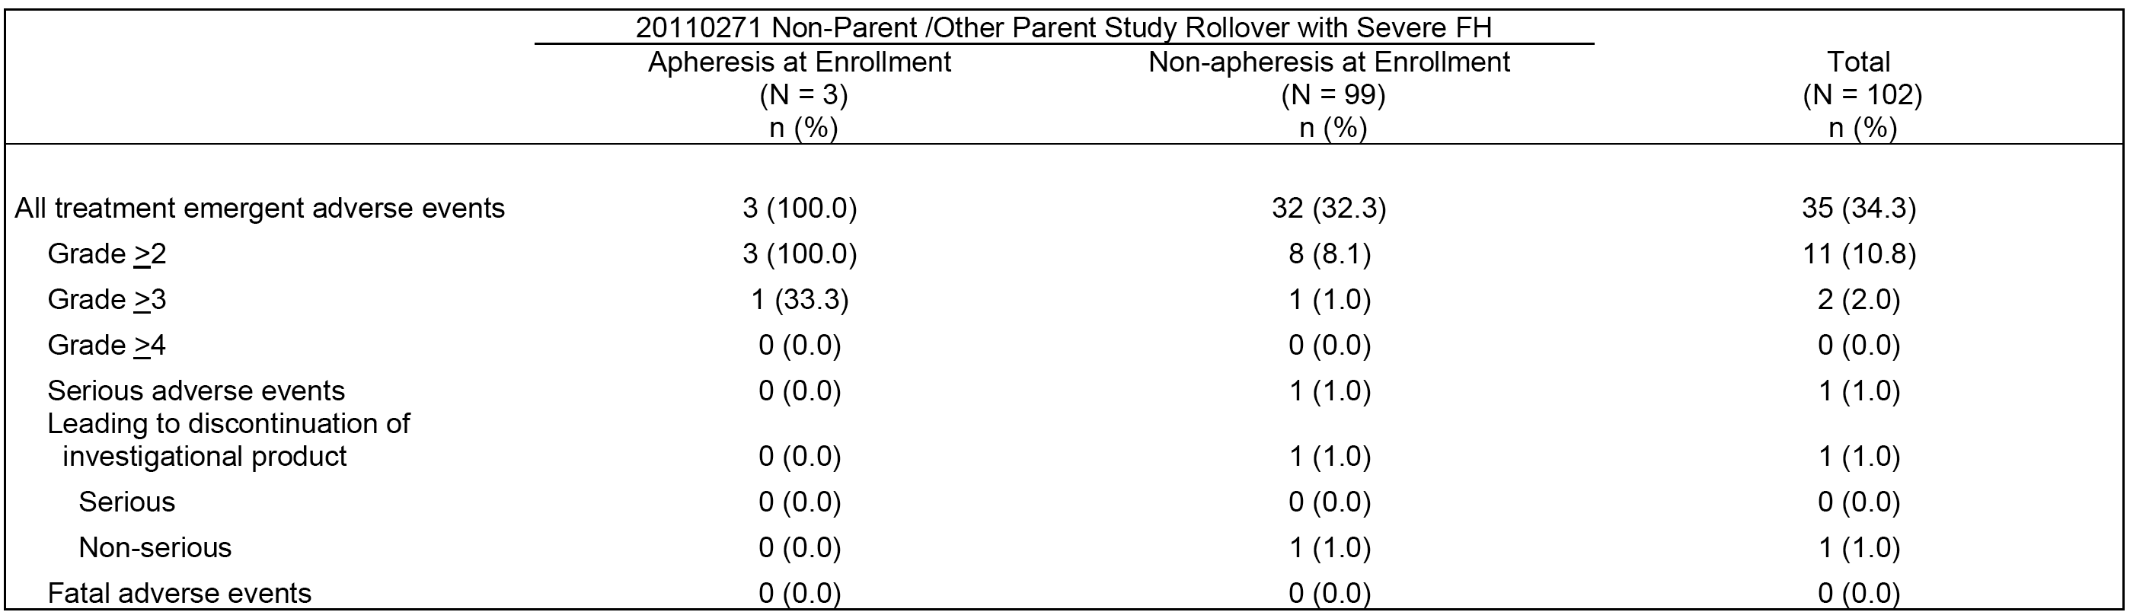
In subjects with severe FH (n=102), 36 (34.3%) reported at least 1 treatment-emergent AE. AEs reported in ≥ 2% of subjects were nasopharyngitis (n=7, 6.9%), asthenia (n=4, 3.9%), muscle spasms (n=3, 2.9%), injection site erythema (n=3, 2.9%), nausea (n=2, 2.0%), headache (n=3, 2.9%), fatigue (n=2, 2.0%), gastroenteritis (n=2, 2.0%), influenza (n=2, 2.0%), contusion (n=2, 2.0%), epicondylitis (n=2, 2.0%), back pain (n=2, 2.0%), alopecia (n=2, 2.0%), and hyperhidrosis (n=2, 2.0%).
SAEs were reported in 1 (1.0%) subject (uterine prolapse). AEs leading to withdrawal of the IP were reported in 1 (1.0%) subject (that is, glossitis, hyperhidrosis, malaise, muscle spasms, myalgia, nasal congestion, and pyrexia , each Grade 1 or 2 in severity, and starting between study days 64 to 71 and not considered related to evolocumab by the investigator). No deaths were reported.
Two (2.0%) subjects with severe FH had at least one AE potentially associated with cardiac repolarisation or proarrhythmia identified by the broad search strategy (dizziness, syncope, palpitations or lethargy). No subject experienced a positively adjudicated cardiovascular endpoint event or non-coronary revascularisation.

Clinical laboratory evaluation
No significant post-baseline changes in haematology parameters, clinical chemistry parameters, or urinalysis findings were observed in the total HoFH and severe FH population (n=198). Separate haematology laboratory data for subjects with severe FH were not presented.
None of the 101 subjects with severe FH with data had baseline ALT or AST elevations > 3 x ULN or > 10 x ULN, and none of the 16 subjects with post-baseline data had ALT or AST elevations > 3 x ULN or > 10 x ULN
One (1, 1.0%) of the 101 subjects with severe FH with data had a baseline CK > 5 x ULN, and no subjects had a baseline CK > 10 x ULN. Of the 16 subjects post-baseline data, none had CK elevations > 5 x ULN or > 10 x ULN.
One (1, 1.0%) subject with severe FH tested positive for anti-evolocumab binding antibodies at baseline, but no post-baseline antibody results were available for this subject before the data cut-off date. The subject tested negative for anti-evolocumab neutralizing antibodies. The serum evolocumab concentrations in this subject were within the range observed for subjects without anti-evolocumab binding antibodies.

Vital signs and ECG changes
No notable changes from baseline in vital signs were reported in the total HoFH and severe FH population (n=198). Post-baseline QTcF data were available on only 9 (4.5%) subjects in the total HoFH and severe FH population. In this small number of subjects, no maximum post-baseline increases in QTcF > 450 ms were reported.

Integrated data from the three safety analysis sets
AEs were analysed for subjects with mixed dyslipidemia or severe hypercholesterolaemia according to the following definitions: (a) mixed dyslipidaemia definition 1 - screening triglycerides ≥ 1.7 mmol/L; (b) mixed dyslipidaemia definition 2 - screening triglycerides ≥ 2.3 mmol/L; (c) mixed dyslipidaemia definition 3: screening HDL-C <1.0 mmol/L (males) or < 1.3 mmol/L (females); and (d) severe hypercholesterolaemia - screening calculated LDL-C ≥ 4.1 mmol/L for subjects on statin therapy at screening or ≥ 6.2 mmol/L for subjects not on statin therapy at screening. In general, analyses of AEs, SAEs, AEs leading to discontinuations of IP, and deaths were consistent across the cohorts and with those in the overall integrated analysis population.

Adverse events of special interest

Overview
The organ systems of special interest discussed in this section were selected based on the frequency of AEs reported by SOC and on AEs in organ systems with potential for major regulatory impact. The organ systems are considered in alphabetically order.

Blood and lymphatic system disorders (SOC)
- IPAS (any evolocumab versus any control): Blood and lymphatic system disorders (SOC) were reported in 5 (0.2%) subjects in the any control group and 31 (0.8%) subjects in the any evolocumab group. AEs reported in ≥ 2 subjects in either group (any evolocumab versus any control) were anaemia (n=16, 0.4% versus n=1, <0.1%), lymphadenopathy (n=6, 0.2% versus n=1, <0.1%), increased tendency to bruise (n=2, 0.1% versus n=0), spontaneous haematoma (n=2, 0.1% versus n=0), and neutropenia (n=0 versus n=2, 0.1%). The only SAE reported in the two treatment groups was anaemia; 1 (<0.1%) subject in the any evolocumab group.
- IPAS (140 mg Q2W) - In the evolocumab 140 mg Q2W, Q2W placebo, and ezetimibe groups, AEs for blood and lymphatic system disorders (SOC) were reported in 0.7% (n=9), 0.2% (n=1), and 0.4% (n=2) of subjects, respectively. In the evolocumab 140 mg Q2W group, AEs reported in ≥ 0.2% of subjects versus Q2W placebo versus ezetimibe were anaemia (0.4% versus 0% versus 0%) and lymphadenopathy (0.2% versus 0.2% versus 0%). In the evolocumab 140 mg Q2W group, 1 (0.1%) subject reported 1 (0.1%) SAE (anaemia), while no SAEs were reported in the Q2W placebo or ezetimibe groups.
- IPAS (420 mg QM) - In the evolocumab 420 mg QM, QM placebo, and ezetimibe groups, AEs for blood and lymphatic system disorders (SOC) were reported in 0.9% (n=18), 0.2% (n=2), and 0.4% (n=2) of subjects, respectively. In the evolocumab 420 mg QM group, AEs reported in ≥ 0.2% of subjects) versus QM placebo versus ezetimibe were anaemia (0.5% versus 0.1% versus 0%) and lymphadenopathy (0.2% versus 0% versus 0%). No SAEs were reported in the three treatment groups.
- In the Year 1 SoC-controlled period (IECAS), AEs for blood and lymphatic system disorders (SOC) were reported in 0.9% (n=25) of subjects in the evolocumab plus SoC group and 1.1% (n=15) of subjects in the SoC alone group. The most commonly reported AE in the evolocumab plus SoC group versus the SoC alone group was anaemia (0.4% versus 0.6%). All other AEs in the evolocumab plus SoC group were reported with an incidence of ≤ 0.1%. No SAEs were reported in either treatment group.
- In the Year 2+ OLE period (IEAAS), AEs blood and lymphatic system disorders (SOC) were reported in 10 (1.0%) subjects in the evolocumab plus SoC group. The most commonly reported AE in the evolocumab plus SoC group was anaemia (0.6%). All other AEs were reported with an incidence of ≤ 0.1%. No SAEs were reported in the evolocumab plus SoC group.
Comment: No safety issues of concern were identified for blood and lymphatic disorders (SOC) with evolocumab use.

Cardiovascular disorders

(1) Cardiac disorders (SOC)
- IPAS (any evolocumab versus any control): Cardiac disorders (SOC) were reported in 2.3% (n=89) of subjects in the any evolocumab group and 1.4% (n=29) of subjects in the any control group. No AEs in either treatment group were reported in > 0.6% of subjects. SAEs were reported in 0.6% (n=24) of subjects in the any evolocumab group and 0.2% (n=5) of subjects in the evolocumab group. SAEs reported in ≥ 2 subjects in either treatment group were (any evolocumab versus any control) myocardial infarction (n=5, 0.1% versus n=0), angina pectoris (n=4, 0.1% versus 0%), acute myocardial infarction (n=3, 0.1% versus 0%), unstable angina (n=3, 0.1% versus 0%), atrial fibrillation (n=2, 0.1% versus n=1, <0.1%), cardiac failure (n=2, 0.1% versus n=0), coronary artery disease (n=2, 0.1% versus n=1, < 0.1%), palpitations (n=2, 0.1% versus n=0), and ventricular extra systoles (n=2, 0.1% versus n=0),
- IPAS (140 mg Q2W) - In the evolocumab 140 mg Q2W, Q2W placebo, and ezetimibe groups, AEs for cardiac disorders (SOC) were reported in 1.9% (n=24), 1.5% (n=9), and 0.9% (n=5) of subjects, respectively. In the evolocumab 140 mg Q2W group, no AEs were reported in ≥ 1.0% of subjects. In the evolocumab 140 mg Q2W group, the most commonly reported AEs (≥ 0.2% of subjects) versus the Q2W placebo group versus the ezetimibe group were: palpitations (0.4% versus 0.3% versus 0.2%), angina pectoris (0.3% versus 0% versus 0.2%); cardiac failure (0.2% versus 0% versus 0%); myocardial infarction (0.2% versus 0% versus 0%); acute myocardial infarction (0.2% versus 0% versus 0%); cardiac failure congestive (0.2% versus 0.2% versus 0%); and left bundle branch block (0.2% versus 0% versus 0%). SAEs were reported in 0.8% (n=10) of subjects in the evolocumab 140 mg Q2W group, compared to 0.3% (n=2) and 0% (n=0) of subjects in the Q2W and ezetimibe groups, respectively. In the evolocumab 140 mg Q2W group, SAEs reported in ≥ 0.2% of subjects were myocardial infarction (0.2%, n=2) and acute myocardial infarction (0.2%, n=2).
- IPAS (420 mg QM) - In the evolocumab 420 mg QM, QM placebo, and ezetimibe groups, AEs for cardiac disorders (SOC) were reported in 2.7% (n=53), 1.6% (n=15), and 0.9% (n=5) of subjects, respectively. In the evolocumab 420 mg QM group, no AEs were reported with in ≥ 1.0% of subjects. In the evolocumab 420 mg QM group, the most commonly reported AEs (≥ 0.2% of subjects) versus the QM placebo group versus the ezetimibe group were: palpitations (0.7% versus 0.3% versus 0.2%); ventricular extra systoles (0.4% versus 0.2% versus 0%); and angina pectoris (0.3% versus 0.4% versus 0.2%). SAEs were reported in 0.6% (n=11) of subjects in the evolocumab 420 mg QM group, and 0.3% (n=2) and 0% (n=0) of subjects in the QM and ezetimibe groups, respectively. In the evolocumab 420 mg QM group, the only SAE reported in ≥ 0.2% of subjects was angina pectoris (0.2%, n=3),
- In the Year 1 SoC-controlled period (IECAS), AEs for cardiac disorders (SOC) were reported in 2.4% (n=69) subjects in the evolocumab plus SoC group and 2.9% (n=41) of subjects in the SoC alone group. No AEs were reported in ≥ 1.0% of subjects. AEs reported in ≥ 0.2% of subjects in the evolocumab plus SoC group versus the SoC group were: angina pectoris (0.6% versus 0.7%); palpitations (0.3% versus 0.6%); atrial fibrillation (0.2% versus 0.3%); coronary artery disease (0.2% versus 0.1%); unstable angina (0.2% versus 0.5%); and myocardial infarction (0.2% versus 0.2%). SAEs were reported in 0.9% (n=25) and 1.3% (n=19) of subjects in the evolocumab plus SoC and SoC alone groups, respectively. SAEs reported in ≥ 0.2% of subjects in the evolocumab plus SoC group versus the SoC alone group were: angina pectoris (0.2% versus 0.1%) and myocardial infarction (0.2% versus 0.1%).
- In the Year 2+ OLE period (IEAAS), AEs for cardiac disorders (SOC) were reported in 4.9% (n=47) of subjects in the total evolocumab plus SoC group. The only AE reported in ≥ 1% of subjects was angina pectoris (1.3%). AEs reported in ≥ 0.2% of subjects were: angina pectoris (1.3%); palpitations (0.7%); bradycardia (0.5%); unstable angina (0.4%); atrial fibrillation (0.3%); cardiac failure (0.3%); myocardial infarction (0.3%); mitral valve incompetence (0.2%); and tachycardia (0.2%). SAEs were reported in 1.7% (n=16) of subjects in the evolocumab plus SoC group. SAEs reported in ≥ 0.2% of subjects were: angina pectoris (0.3%); cardiac failure (0.3%); myocardial infarction (0.3%); and unstable angina (0.2%).
Comment: In the IPAS, cardiac disorders (SOC) were reported more frequently in the any evolocumab group compared to the any control group (2.3% v 1.4%). SAEs were reported infrequently in both the any evolocumab and any control groups, but more commonly in the evolocumab group compared to the any control group (0.6% versus 0.2). In the IECAS, cardiac disorders (SOC) were reported less commonly in the evolocumab plus SoC group compared to the SoC alone group (2.4% versus 2.9%, respectively), as were SAEs (0.9% versus 1.3%, respectively). In the IEAAS, cardiac disorders (SOC) were reported in 4.9% of subjects in the evolocumab plus SoC group, and SAEs in this SOC were reported in 1.7% of subjects.

Vascular disorders (SOC)
- IPAS (any evolocumab versus any control): Vascular disorders (SOC) were reported in 2.4% (n=96) of subjects in the any evolocumab group and 2.6% (n=55) of subjects in the any control group. The only AE reported in ≥ 1% of subjects in either treatment group was hypertension, which was reported in 1.4% (n=56) of subjects in the any evolocumab group and 1.3% (n=26) of subjects in the any control group. SAEs were reported in 0.1% (n=5) of subjects in the any evolocumab group and 0.1% (n=2) of subjects in the any control group. No SAEs in either of the two treatment groups were reported in more than 1 subject.
- IPAS (140 mg Q2W) - In the evolocumab 140 mg Q2W, Q2W placebo, and ezetimibe groups, AEs for vascular disorders (SOC) were reported in 2.2% (n=27), 2.2% (n=13) and 3.1% (n=17) of subjects, respectively. In the evolocumab 140 mg Q2W group, the only AE reported in ≥ 1.0% of subjects was hypertension, which was reported in 1.3% (n=10) of subjects compared to 0.9% (n=5) and 0.9% (n=5) of subjects in the Q2W placebo and ezetimibe groups, respectively. All other vascular disorder AEs in the evolocumab 140 mg Q2W group were each reported in ≤ 0.2% of subjects. SAEs were reported in 0.2% (n=2) of subjects in the evolocumab 140 mg Q2W group, and 0% (n=0) and 0.2% (n=1) of subjects in the Q2W and ezetimibe groups, respectively. The SAEs reported in the 2 subjects in the evolocumab 140 mg QW2 group were aortic aneurysm (1x [0.1%]) and orthostatic hypotension (1x [0.1%]).
- IPAS (420 m QM) - In the evolocumab 420 mg QM, QM placebo, and ezetimibe groups, AEs for vascular disorders (SOC) were reported in 2.8% (n=54), 2.7% (n=25) and 3.1% (n=17) of subjects, respectively. In the evolocumab 420 mg QM group, the only AE reported in ≥ 1.0% of subjects was hypertension, which was reported in 1.5% (n=30) of subjects in the evolocumab 420 mg QM group compared to 1.7% (n=16) and 0.9% (n=5) of subjects in the QM placebo and ezetimibe groups, respectively. All other vascular disorder AEs in the evolocumab 420 mg Q2W group were each reported in ≤ 0.3% of subjects. SAEs were reported in 0.1% (n=2) of subjects in the evolocumab 420 mg QM group, and 0% (n=0) and 0.2% (n=1) of subjects in the QM placebo and ezetimibe groups, respectively. The SAEs reported in the 2 subjects in the evolocumab 420 mg QM group were deep vein thrombosis (1x [0.1%]) and hypotension (1x [0.1%]).
- In the Year 1 SoC-controlled period (IECAS), AEs for vascular disorders (SOC) were reported in 5.1% (n=145) of subjects in the evolocumab plus SoC group and 3.5% (n=49) of subjects in the SoC alone group. In the evolocumab plus SoC group, the only AE reported in ≥ 1.0% of subjects was hypertension, which was reported in 3.1% (n=89) of subjects versus 2.7% (n=39) of in the SoC alone group. All other vascular disorder AEs in the evolocumab plus SoC group were each reported in ≤ 0.3% of subjects. SAEs were reported in 0.3% (n=8) of subjects in the evolocumab plus SoC group and 0.1% (n=2) of subjects in the SoC group. The SAEs reported in the 8 (0.3%) subjects in the evolocumab plus SoC group were accelerated hypertension (2x [0.1%]), aortic stenosis (2x [0.1%], hypertension (2x [0.1%]), haematoma (1x [< 0.1%]), peripheral arterial occlusive disease (1x [<0.1%]), and peripheral artery aneurysm (1x [<0.1%]). The SAEs reported in the 2 (0.1%) subjects in the SoC alone group were hypertension (1x [0.1%]) and peripheral ischaemia (1x [0.1%]).
- In the Year 2+ OLE period (IEAAS), AEs for vascular disorders (SOC) were reported in 8.5% (n=81) of subjects in the evolocumab plus SoC group. The only AE reported in ≥ 1.0% of subjects was hypertension (5.5%, n=52). All other vascular disorder AEs were each reported in ≤ 0.5% of subjects. SAEs were reported in 0.3% (n=3) of subjects (1x [0.1%] each for deep vein thrombosis, hypertension and peripheral ischaemia).
Comment: No safety issues of concerns were identified for vascular disorders (SOC) with evolocumab use.

Prolongation of cardiac repolarisation or proarrhythmia
The sponsor undertook an analysis of AEs potentially associated with prolongation of cardiac repolarisation or proarrhythmia by preferred term using broad search strategies (cardiac arrhythmias SMQ and potential syncope).
- IPAS (any evolocumab versus any control): In the integrated parent studies, 155 (3.9%) subjects in the any evolocumab group and 74 (3.6%) subjects in the any control group reported AEs potentially associated with prolongation of cardiac repolarisation or proarrhythmia. No events of Torsades de pointes or ventricular tachycardia were reported. Syncope was reported in 14 (0.4%) subjects in the any evolocumab group (serious in 2 cases) and 6 (0.3%) subjects in the any control group (serious in 1 case). One episode of ventricular fibrillation was reported in a subject with a history of coronary and non-coronary atherosclerosis treated with evolocumab 140 mg Q2W. Six subjects had 6 AEs associated with seizure. Two of the AEs (convulsion and grand mal convulsion) were Grade 3 events reported in subjects receiving placebo and were associated with confounding factors. The other 4 AEs (all grade ≤ 2) were reported in subjects who received evolocumab, with a medical history or concurrent illness as confounding factors.
- IPAS (140 mg Q2W) - In the evolocumab 140 mg Q2W, Q2W placebo, and ezetimibe groups, AEs were reported in 2.9% (n=36), 3.1% (n=18) and 3.8% (n=21) of subjects, respectively. AEs reported in ≥ 0.2% of subjects in the evolocumab 140 mg Q2W versus Q2W placebo versus ezetimibe groups were: dizziness (1.0% versus 1.4% versus 2.0%); disturbances in consciousness (0.5% versus 0.2% versus 0.9%); palpitations (0.4% versus 0.3% versus 0.2%); fall (0.4% versus 0% versus 0.5%); lethargy (0.3% versus 0% versus 0.5%); left bundle branch block (0.2% versus 0% versus %); and syncope (0.2% versus 0.2% versus 0.4%). No events of Torsades de pointes or ventricular tachycardia were reported.
- IPAS (420 mg QM) - In the evolocumab 420 QM, QM placebo, and ezetimibe groups, AEs were reported in 4.9% (n=95), 3.7% (n=35) and 3.8% (n=21) of subjects, respectively. AEs reported in ≥ 0.2% of subjects in the evolocumab 140 mg Q2W versus Q2W placebo versus ezetimibe groups were: dizziness (2.1% versus 1.6% versus 2.0%); palpitations (0.7% versus 0.3% versus 0.2%); syncope (0.5% versus 0.3% versus 0.4%); ventricular extra systoles (0.4% versus 0.2% versus 0%); atrial fibrillation (0.2% versus 0.3% versus 0.2%); and fall (0.2% versus 0.6% versus 0.5%). No events of Torsades de pointes or ventricular tachycardia were reported.
- In the Year 1 SoC-controlled period (IECAS), AEs were reported in 4.2% (n=118) of subjects in the evolocumab plus SoC group and 3.5% (n=49) subjects in the SoC alone group. AEs reported in ≥ 0.2% of subjects in the evolocumab plus SoC group versus the SoC group were: dizziness (1.6% versus 1.6%); fall (0.8% versus 0.3%); syncope (0.4% versus 0.5%); palpitations (0.3% versus 0.6%); and atrial fibrillation (0.2% versus 0.3%). Ventricular tachycardia was reported in 2 (0.1%) subjects in the evolocumab plus SoC group (both subjects reported serious events) compared to no subjects in the SoC alone group. Both of the subjects with ventricular tachycardia events had chronic ischaemic heart disease with prior coronary revascularisation. Two subjects in the evolocumab plus SoC group reported 3 AEs associated with seizure (1x convulsion; 2x grand mal convulsions), and both subjects continued treatment with IP following the seizures. In 1 of the subjects, the convulsion was reported to be possibly due to head trauma and was considered by the investigator to be unrelated to IP. In 1 of the subjects, 1 of the 2 events was considered by the investigator to be related to IP, although the subject had a history of partial seizures.
- In the Year 2+ OLE period (IEAAS), AEs were reported in 6.9% (n=66) subjects in the evolocumab plus SoC group. AEs reported in ≥ 0.2% of subjects were: dizziness (2.8%); syncope (1.7%); fall (1.3%); palpitations (0.7%); bradycardia (0.5%); atrial fibrillation (0.3%); lethargy (0.2%); postural dizziness (0.2%); pre-syncope (0.2%); and tachycardia (0.2%). No events of Torsades de pointes or ventricular tachycardia were reported.
Comment: No safety issues of concern were identified for events related to prolongation of cardiac repolarisation or proarrhythmia with evolocumab use.

Adjudicated cardiovascular events and non-coronary revascularizations
- During the Phase II and III studies, potential cardiovascular endpoints were identified and adjudicated by an independent Clinical Endpoint Committee (CEC) in order to facilitate an integrated analysis of cardiovascular events across the clinical study program. The CEC coordinator compiled an endpoint event packet consisting of the subject profile and supporting source documentation (for example, relevant ECGs, hospitalisation records, imaging). Each complete endpoint event packet was randomly assigned to 2 CEC adjudicators who independently reviewed each potential endpoint. Appropriate procedures were in place to resolve discordant endpoint determinations. The potential endpoints were adjudicated based on the Clinical Data Interchange Standards Consortium (CDISC) definitions provided in the ‘Standardized Definitions for End Point Events in Cardiovascular Trials’5 and are listed below in Table 54. For Phase II studies, adjudicated cardiovascular events were not reported as AEs in the CSRs, but were included for the purpose of the integrated analyses. In Phase III studies, cardiovascular events were reported as adverse events regardless of the adjudication outcome.

Table 54: Adjudication of potential cardiovascular endpoints.
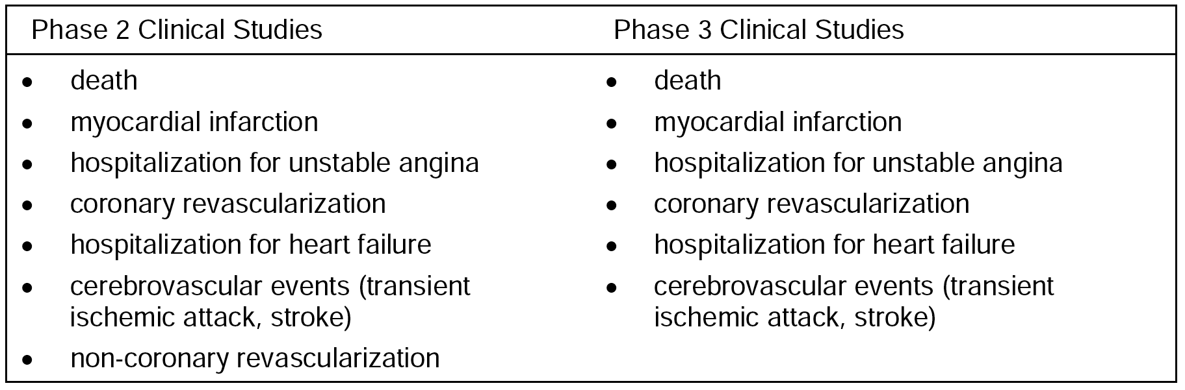
- The results for the positively adjudicated events in the 3 safety analysis sets were summarised. In the integrated parent studies (IPAS), the incidence of subjects with any positively adjudicated cardiovascular event was similar in the any evolocumab and the any control groups (0.6%, n=25 versus 0.4%, n=9, respectively). In the Year 1 SoC-controlled period (IECAS), the incidence of subjects with positively adjudicated cardiovascular events was similar in the evolocumab plus SoC group and the SoC alone group (0.8%, n=22 versus 1.3%, n=19). In the Year 2+ OLE period (IEAAS), the incidence of subjects with adjudicated cardiovascular events in the evolocumab plus SoC group was similar to the incidence in the evolocumab plus SoC group in the Year 1 SoC controlled period (1.3%, n=12 versus 0.8%, n=22, respectively).
Comment: Overall, the number of positively adjudicated cardiovascular events was small. In the integrated parent studies (IPAS), the incidence of subjects with positively adjudicated cardiovascular events was similar in the any evolocumab group (n=25, 0.6%) compared to the any control group (n=9, 0.4%). The incidence of subjects with positively adjudicated cardiovascular events was 0.8% in the evolocumab 140 mg Q2W group (versus 0.7% in the Q2W placebo group) and 0.6% in the evolocumab 420 mg QM group (versus 0.3% in the QM placebo group). Myocardial infarction was reported in 8 (0.2%) subjects in the any evolocumab group and 2 (0.1%) subjects in the any control group (1 event in the any control group was fatal). Coronary revascularisation was reported in 11 (0.3%) subjects in the any evolocumab group and 5 (0.2%) subjects in the any control group. Stroke was reported in 3 (0.1%) subjects in the any evolocumab group and 3 (0.1%) subjects in the any control group (the haemorrhagic stroke event in the any control group was fatal). Three subjects had positively adjudicated cardiovascular events of heart failure, and all were in the any evolocumab group (0.1%). Of these 3 events, 2 were fatal (congestive cardiac failure occurred in a subject in the evolocumab 140 mg Q2W group and cardiac failure in a subject in the evolocumab 420 mg QM group). Overall, the results for the positively adjudicated cardiovascular events do not give rise to safety concerns associated with evolocumab use.

Endocrine disorders (SOC)
- IPAS (any evolocumab versus any control): Endocrine disorders (SOC) were reported in 0.3% (n=11) of subjects in the any evolocumab group and < 0.1% (n=1) of subjects in the any control group. The only AEs reported in ≥ 2 subjects in either treatment group (any evolocumab versus any control) were hyperthyroidism (n=7, 0.2% v n=1, <0.1%) and hypothyroidism (n=2, 01 % versus n=0). There were no SAEs reported in endocrine disorders (SOC) in the any evolocumab or the any control group.
- IPAS (140 mg Q2W) - In the evolocumab 140 mg Q2W, Q2W placebo, and ezetimibe groups, AEs for endocrine disorders (SOC) were reported in 0.1% (n=1), 0% (n=0) and 0% (n=0) of subjects, respectively. The only AE reported in the evolocumab 140 mg Q2W group was hypothyroidism. There were no SAEs in the three treatment groups.
- IPAS (420 mg QM) - In the evolocumab 420 mg QM, QM placebo, and ezetimibe groups, AEs for endocrine disorders (SOC) were reported in 0.5% (n=9), 0.1% (n=1) and 0% (n=0) of subjects, respectively. In the 9 subjects in the evolocumab 420 mg QM group with AEs, the 4 events were hypothyroidism (5x [0.3%]), hyperthyroidism (2x [0.1%]), goitre (1x [0.1%]) and hyperparathyroidism (1x [0.1%]). In the QM placebo group, the 1 AE in 1 subject was hyperthyroidism (0.1%). There were no SAEs in the three treatment groups.
- In the Year 1 SoC-controlled period (IECAS), AEs for endocrine disorders (SOC) were reported in 0.4% (n=12) of subjects in the evolocumab plus SoC group and 0.6% (n=9) of subjects in the SoC alone group. In the evolocumab plus SoC group, the most commonly reported AEs (≥ 0.2% of subjects) versus the SoC group was hypothyroidism (0.3% versus 0.2%). There were no SAEs in the two treatment groups.
- In the Year 2+ OLE period (IEAAS), AEs for endocrine disorders (SOC) were reported in 4 (0.4%) subjects in the evolocumab plus SoC group. In these 4 subjects, the AEs were hypothyroidism (2x [0.2%]), hypogonadism (1x [0.1%]) and thyroid cyst (1x [0.1%]). No SAEs were reported.
Comment: The only endocrine disorder of note was hypothyroidism, with 21 subjects reporting hypothyroidism as an AE. The 21 subjects included 7 (0.2%) in the any evolocumab group and none in the any control group in the integrated parent studies (IPAS); 9 (0.2%) in the evolocumab plus SoC group and 3 (0.3%) in the SoC alone group in the Year 1 SoC-controlled period (IECAS); and 2 (0.2%) in the evolocumab plus SoC group in the Year 2+ OLE period (IEAAS). Of the 18 evolocumab-treated subjects with hypothyroidism, 2 had a previous history of hypothyroidism, and 2 had a history of post-ablative hypothyroidism from prior treatment for hyperthyroidism. Of the 3 subjects in the SoC alone group with hypothyroidism, 2 had a previous history of hypothyroidism. Baseline thyroid stimulating hormone levels were obtained in 17 of the 21 subjects and were elevated in 2 subjects treated with evolocumab. The sponsor comments that the observation that hypothyroidism was the most endocrine disorder is consistent with the known association of this disorder with hypercholesterolaemia. No safety issues were identified for endocrine disorders (SOC) with evolocumab use.

Eye disorders (SOC)
- IPAS (collapsed treatment groups): Eye disorders (SOC) were reported in 1.5% (n=60) of subjects in the any evolocumab group and 1.4% (n=30) of subjects in the any control group. No AEs in either of the two treatment groups were reported in ≥ 1% of subjects. No SAEs in the eye disorders (SOC) were reported in either the any evolocumab group or the any control group.
- IPAS (140 mg Q2W) - In the evolocumab 140 mg Q2W, Q2W placebo, and ezetimibe groups, AEs for eye disorders (SOC) were reported in 1.2% (n=15), 1.2% (n=7), and 2.0% (n=11) of subjects, respectively. In the evolocumab 140 mg Q2W group, AEs reported in ≥ 0.2% of subjects versus the Q2W and the ezetimibe groups were blurred vision (0.2% versus 0.3% versus 0%) and allergic conjunctivitis (0.2% versus 0% versus 0%). There were no SAEs in the three treatment groups.
- IPAS (420 mg QM) - In the evolocumab 420 mg QM, QM placebo, and ezetimibe groups, AEs for eye disorders (SOC) were reported in 1.5% (n=29), 1.3% (n=12), and 2.0% (n=11) of subjects, respectively. In the evolocumab 420 mg QM group, AEs reported in ≥ 0.2% of subjects versus the QM and the ezetimibe groups were cataract (0.2% versus 0.1% versus 0%) and blurred vision (0.2% versus 0% versus 0%). There were no SAEs in the three treatment groups.
- In the Year 1 SoC-controlled period (IECAS), AEs for eye disorders (SOC) were reported in 2.7% (n=77) of subjects in the evolocumab plus SoC group and 2.0% (n=28) of subjects in the SoC alone group. The most commonly reported AEs in the evolocumab plus SoC group (≥ 0.2% of subjects) versus the SoC group were cataract (0.8% versus 0.8%), dry eye (0.4% versus 0%), and allergic conjunctivitis (0.2% versus n=0). SAEs were reported in 1 (< 0.1%) subject in the evolocumab plus SoC group (1x cortical cataract) and 1 (0.1%) subject in the SoC alone group (1x keratitis).
- In the Year 2+ OLE period (IEAAS), AEs for eye disorders (SOC) were reported in 2.9% (n=28) subjects in the evolocumab plus SOC group. The most commonly reported AE was cataract (0.6%, n=6). No SAEs were reported.
Comment: No safety issues of concern were identified for eye disorders (SOC) with evolocumab use.

Gastrointestinal disorders (SOC)
- IPAS (any evolocumab versus any control): Gastrointestinal disorders (SOC) were reported in a similar proportion of subjects in the any evolocumab group and the any control group (n=386, 9.8% versus n=208, n=10.0%, respectively). AEs reported in ≥ 1% of subjects in either the any evolocumab group or the any control group, respectively, were nausea (n=81, 2.1% versus n=37, 1.8%), diarrhoea (n=79, 2.0% versus n=50, 2.4%), and constipation (n=38, 1.0% versus n=17, 0.8%). SAEs were also reported in a similar proportion of subjects in the any evolocumab group and the any control group (n=7, 0.2% versus n=6, 0.3%). The only SAEs reported in ≥ 2 subjects in either the any evolocumab group or the any control group, respectively, were acute pancreatitis (n=3, 0.1% versus n=0), gastrointestinal haemorrhage (n=0 versus n=2, 0.1%) and inguinal hernia (n=0 versus n=2, 0.1%).
- IPAS (140 mg Q2W) - In the evolocumab 140 mg Q2W, Q2W placebo, and ezetimibe groups, AEs for gastrointestinal disorders (SOC) were reported in 7.6% (n=94), 8.4% (n=49), and 9.6% (n=53) of subjects, respectively. The most commonly reported AEs in the evolocumab 140 mg Q2W group (≥ 1.0% subjects) versus the Q2W placebo group versus the ezetimibe group were: nausea (1.7% versus 1.0% versus 2.2%); diarrhoea (1.7% versus 1.7% versus 2.5%); and constipation (1.3% versus 1.7% versus 0.5%). In the evolocumab 140 mg Q2W, Q2W placebo, and ezetimibe groups, SAEs were reported in 0.2% (n=2), 0.5% (n=3) and 0.4% (n=2) of subjects, respectively. In the 2 evolocumab 140 mg Q2W subjects with SAEs, the events were upper abdominal pain (1x [0.1%]) and GORD (1x [0.1%]).
- IPAS (420 mg QM) - In the evolocumab 420 mg QM, QM placebo, and ezetimibe groups, AEs for gastrointestinal disorders (SOC) were reported in 10.8% (n=212), 11.3% (n=106), and 9.6% (n=53) of subjects, respectively. The most commonly reported AEs in the evolocumab 420 mg QM group (≥ 1.0% subjects) versus the QM placebo group versus the ezetimibe group were: nausea (2.4% versus 2.0% versus 2.2%); diarrhoea (2.1% versus 2.8% versus 2.5%); vomiting (1.1% versus 0.7% versus 0.4%); and upper abdominal pain (1.1% versus 0.9% versus 0.4%). In the evolocumab 420 mg QM, QM placebo, and ezetimibe groups, SAEs were reported in 0.2% (n=4), 0.1% (n=1) and 0.4% (n=2) of subjects, respectively. In the 4 evolocumab 420 mg QM subjects with SAEs, the events were acute pancreatitis (2x [0.1%]), gastritis (1x [<0.1%]), and haemorrhoids (1x [<0.1%]). No cases of pancreatitis were reported in the QM placebo or ezetimibe groups.
- In the Year 1 SoC-controlled period (IECAS), AEs for gastrointestinal disorders (SOC) were reported in 11.5% (n=327) of subjects in the evolocumab plus SoC group and 8.9% (n=126) subjects in the SoC alone group. AEs reported in ≥ 1% of subjects in the evolocumab plus SoC group versus the SoC alone group were: diarrhoea (2.2% versus 1.5%); nausea (1.6% versus 0.9%); vomiting (1.2% versus 0.6%); constipation (1.3% versus 0.6%); and GORD (1.1% versus 0.9%). SAEs were reported in 0.5% (n=13) of subjects in the evolocumab plus SOC group and 0.6% (n=8) subjects in the SoC alone group. No SAEs were reported in more than 1 subject in the evolocumab plus SoC group. Of note, pancreatitis was reported in both the evolocumab plus SoC group (1x [<0.1%]) and the SoC alone group (1x [0.1%]), while acute pancreatitis was reported 1x (< 0.1%) in the evolocumab plus SoC and not in the SoC group.
- In the Year 2+ OLE period (IEAAS), AEs for gastrointestinal disorders (SOC) were reported in 16.8% (n=160) subjects in the evolocumab plus SoC group. AEs reported with an incidence of ≥ 1.0% were diarrhoea (3.5%), nausea (2.3%), dyspepsia (1.8%), vomiting (1.7%), upper abdominal pain (1.4%), abdominal pain (1.3%), constipation (1.3%), GORD (1.3%), and toothache (1.0%). SAEs were reported in 6 (0.6%) subjects, with the events being abdominal pain (2x [0.2%]), inguinal hernia (2x [0.2%]), upper abdominal pain (1x [0.1%]), lumbar hernia (1x [0.1%]), and pancreatitis (1x [0.1%]).
Comment: The only gastrointestinal disorder (SOC) safety issue of note was pancreatitis. This AE was reported in 6 subjects (7 events): 3 (0.1%) subjects in the any evolocumab group and no subjects in the any control group during the Phase II and III parent studies (IPAS); 2 (0.1%) subjects in the evolocumab plus SoC group and 1 (0.1%) subject in the SoC alone group in the Year 1 SoC-controlled period (IECAS); and 1 (0.1%) subject in the Year 2+ OLE period (IEAAS). All events were reported as serious and required hospitalisation. All 7 events resolved, with 5 events either resolving while the subjects were on IP and 2 events resolving after the subjects discontinued IP. One subject reported recurrent adverse events of pancreatitis. There is a known association between hypertriglyceridaemia and acute pancreatitis. No safety issues were identified for gastrointestinal disorders (SOC) with evolocumab use.

General disorders and administration site conditions
- IPAS (collapsed groups): General disorders and administration site conditions (SOC) were reported in a similar proportion of subjects in the any evolocumab and any control groups (n=350, 8.9% versus n=166, 8.0%, respectively). AEs reported in ≥ 1% of subjects in either group (any evolocumab versus any control) were fatigue (1.8% versus 1.9%), injection site erythema (1.0% versus 0.9%), and injection site pain (1.0% versus 0.5%). SAEs were reported in 3 (0.1%) subjects in the any evolocumab group and 1 (< 0.1%) subject in the any control group.
- IPAS (140 mg Q2W) - In the evolocumab 140 mg Q2W, Q2W placebo, and ezetimibe groups, AEs for general disorders and administration site conditions (SOC) were reported in 6.9% (n=86), 4.8% (n=28), and 9.6% (n=53) of subjects, respectively. The most commonly reported AEs in the evolocumab 140 mg Q2W group (≥ 0.5% subjects) versus the Q2W placebo group versus the ezetimibe group were: fatigue (1.6% versus 1.2% versus 3.4%); injection site erythema (0.7% versus 0% versus 1.1%); chest pain (0.6% versus 0.3% versus 0.5%); and injection site pain (0.5% versus 0.2% versus 0.2%). There was 1 SAE (pain) in one (0.1%) subject in the evolocumab 140 mg Q2W group and no SAEs in the two other treatment groups.
- IPAS (420 mg QM) - In the evolocumab 420 mg QM, QM placebo, and ezetimibe groups, AEs for general disorders and administration site conditions (SOC) were reported in 9.9% (n=194), 4.8% (n=28), and 9.6% (n=53) of subjects, respectively. The most commonly reported AEs in the evolocumab 420 mg QM group (≥ 0.5% subjects) versus the QM placebo group versus the ezetimibe group were: fatigue (2.0% versus 1.5% versus 3.4%); injection site erythema (1.1% versus 1.4% versus 1.1%); injection site pain (1.1% versus 0.9% versus 0.2%); injection site bruising (0.9% versus 1.2% versus 0.9%); peripheral oedema (0.9% versus 0.7% versus 0.9%); influenza like illness (0.6% versus 0.3% versus 0.5%); pyrexia (0.6% versus 0.4% versus 0.5%); non-cardiac chest pain (0.5% versus 0.4% versus 0.2%); and local swelling (0.5% versus 0.5% versus 0.4%). There were 2 SAEs (1x [0.1%] device breakage; 1x [0.1%] non-cardiac chest pain) in two (0.1%) subjects in the evolocumab 420 mg QM group and no SAES in the two other treatment groups.
- In the Year 1 SoC-controlled period (IECAS), AEs for general disorders and administration site conditions (SOC) were reported in 10.8% (n=307) of subjects in the evolocumab plus SoC group and 4.8% (n=68) subjects in the SoC alone group. The difference in the incidence between the two groups was due to the increased number of AEs associated with injections in the evolocumab plus SoC group (that is, the SoC alone group did not receive injections in Year 1). AEs reported in ≥ 1.0% of subjects in the evolocumab plus SoC group versus the SoC group were: fatigue (2.1% versus 0.8%); injection site pain 1.2% versus n=0); injection site erythema (1.1% versus n=0); and injection site bruising (1.1% versus n=0). SAEs were reported in 0.4% (n=12) of subjects in the evolocumab plus SoC group (5x [0.2%] non-cardiac chest pain; 4x [0.1%] chest pain; 2x [0.1%] chest discomfort; 1x [<0.1%] gait disturbance; 1x [<0.1%] sudden death), and 0.6% (n=8) of subjects in the SoC alone group (3x [0.2%] chest pain; 2x [0.1%] non-cardiac chest pain; 1x [0.1%] asthenia; 1x [0.1%] death; 1 x pain [0.1%]).
- In the Year 2+ OLE period (IEAAS), AEs for general disorders and administration site conditions (SOC) were reported in 11.3% (n=108) subjects in the evolocumab plus SoC group. AEs reported in ≥ 1.0% of subjects were fatigue (2.4%), peripheral oedema (2.3%); and injection site erythema (1.6%). SAEs were reported in 0.8% (n=8) of subjects (4x [0.4%] non-cardiac chest pain; 3x [0.3%] chest pain; 1x [0.1%] hypothermia; 1x [0.1%] pain).
Comment: The only general disorders and administration site conditions (SOC) safety issues of note were injection site reactions with evolocumab (pain, erythema, bruising). Injection site reactions were reviewed by the sponsor and were considered to be adverse drug reactions. However, the incidence of these reactions was low and no reaction was reported in ≥ 2% of subjects. No injection site reactions were reported as serious.

Hepatobiliary disorders (SOC)
- IPAS (collapsed groups): Hepatobiliary biliary disorders (SOC) were reported infrequently in the any evolocumab and any control groups and in a similar proportion of subjects in both groups (n=13, 0.3% versus n=9, 0.4%). No AEs in either treatment group were reported in ≥ 0.4% of subjects. SAEs were reported in 4 (0.1%) subjects in the any evolocumab group (2x cholecystitis [0.1%], 2 x cholelithiasis [0.1%], 1x biliary tract disorder [<0.1%]) and 2 (0.1%) subjects in the any control group (1x acute cholecystitis [<0.1%], 1x drug-induced live injury [<0.1%]).
- IPAS (140 mg Q2W) - In the evolocumab 140 mg Q2W, Q2W placebo, and ezetimibe groups, AEs for hepatobiliary disorders (SOC) were reported in 0.2% (n=2), 0.7% (n=4), and 0.2% (n=1) of subjects, respectively. In the 2 (0.2%) subjects in the 140 mg Q2W group the AEs were cholelithiasis (1x [0.1%]), biliary colic (1x [0.1%]), and cholecystitis (1x [0.1%]). SAEs were reported in 1 (0.1%) subject in the evolocumab 140 mg Q2W group (1x [0.1%] cholecystitis; 1x [0.1%] cholelithiasis), 1 (0.2%) subject in the Q2W placebo group (1x [0.2%] acute cholecystitis), and no subjects in the ezetimibe group.
- IPAS (420 mg QM) - In the evolocumab 420 mg QM, QM placebo, and ezetimibe groups, AEs for hepatobiliary disorders (SOC) were reported in 0.5% (n=10), 0.7% (n=4), and 0.2% (n=1) of subjects, respectively. In the evolocumab 420 mg QM group, the most commonly reported AEs (≥ 0.1% of subjects) were hepatic steatosis (n=3, [0.2%]) and cholelithiasis (n=2, [0.1%]). SAEs were reported in 3 (0.2%) subjects in the evolocumab 420 mg QM group (1x [0.1%] biliary tract disorder; 1x [0.1%] cholecystitis; 1x [0.1%] cholelithiasis), 1 (0.2%) subject in the QM placebo group (1x [0.1%] drug-induced liver injury), and no subjects in the ezetimibe group.
- In the Year 1 SoC-controlled period (IECAS), AEs for hepatobiliary disorders (SOC) were reported in 0.5% (n=15) of subjects in the evolocumab plus SoC group and 0.6% (n=8) of subjects in the SoC alone group. In the evolocumab plus SoC group, the most commonly reported AEs (≥ 0.2% of subjects) versus the SoC alone group were: hepatic steatosis (n=6, [0.2%] versus n=2, [0.2%]); cholelithiasis (n=3, [0.1%] versus n=3, [0.2%]); and hepatic function abnormal (n=3, [0.1%] versus 0%). SAEs were reported in 3 (0.1%) subjects in the evolocumab plus SoC group (1x [<0.1%] cholelithiasis; 1x [<0.1%] hepatic function abnormal; 1x [<0.1%] hepatotoxicity), and 1 (0.1%) subject in the SoC group (1x [0.1%] bile duct stone; 1x [0.1%] chronic cholecystitis).
- In the Year 2+ OLE period (IEAAS), AEs for hepatobiliary disorders (SOC) were reported in 0.9% (n=9) of subjects in the evolocumab plus SoC group. The most commonly reported AE was cholelithiasis (3x [0.3%]). SAEs were reported in 0.5% (n=5) of subjects (1x [0.1%] biliary dyskinesia; 1x [0.1% cholecystitis; 1x [0.1%] acute cholecystitis; 1x [0.1%] cholelithiasis; 1x [0.1%] hepatic lesion).
- As liver-related AEs have been observed with approved lipid-lowering therapies, the sponsor undertook an extensive analysis using broad and narrow search strategies to evaluate potential hepatic safety risks associated with evolocumab therapy. In the IPAS, transaminase elevations and potential hepatic disorders in the any placebo, any control, evolocumab 140 mg Q2W/420 mg QM, and any evolocumab groups were reported in 1.0% (n=15), 0.8% (n=17), 0.9% (n=30), and 0.9% (n=37) of subjects, respectively. In Year 1 SoC-controlled period (IECAS), transaminase elevations and potential hepatic disorders in the evolocumab plus SOC and SoC alone groups were reported in 1.1% (n=32) and 1.2% (n=17) of subjects respectively. In the Year 2+ OLE period (IEAAS), transaminase elevations and potential hepatic disorders in the evolocumab plus SOC were reported in 1.4% (n=13) of subjects.
Comment: No safety issues were identified for hepatobiliary disorders (SOC) with evolocumab use.

Immune system disorders (SOC)
- IPAS (collapsed groups): Immune system disorders (SOC) were reported infrequently in the any evolocumab and any control groups and in a similar proportion of subjects in both groups (n=20, 0.5% versus n=14, 0.7%). The only AEs reported in ≥ 0.1% of subjects in either treatment group were seasonal allergy (0.4% versus 0.5%), and hypersensitivity (0.1% versus 0.1%). No SAEs were reported in either of the two treatment groups.
- IPAS (140 mg Q2W) - In the evolocumab 140 mg Q2W, Q2W placebo, and ezetimibe groups, AEs for immune system disorders (SOC) were reported in 0.3% (n=4), 0.2% (n=1) and 0.4% (n=2) of subject, respectively. In the evolocumab 140 mg Q2W group, the AEs were seasonal allergy (3x [0.3%]) and drug hypersensitivity (1x [0.1%]). There were no SAEs in the three treatment groups.
- IPAS (420 mg QM) - In the evolocumab 420 mg QM, QM placebo, and ezetimibe groups, AEs for immune system disorders (SOC) were reported in 0.7% (n=14), 1.2% (n=11), and 0.4% (n=2) of subjects, respectively. In the evolocumab 420 mg QM group the AEs were seasonal allergy (12x [0.6%]), allergy to arthropod sting (1x [0.1%]), and hypersensitivity (1x [0.1%]). There were no SAEs in the three treatment groups.
- In the Year 1 SoC-controlled period (IECAS), AEs for immune system disorders (SOC) were reported in 1.1% (n=31) of subjects in the evolocumab plus SoC group and 0.8% (n=12) subjects in the SoC alone group. The most frequently reported AEs in the evolocumab plus SoC group (≥ 0.2% of subjects) versus the SoC group were: seasonal allergy (n=19, 0.7% versus n=7, 0.5%); hypersensitivity (n=5, 0.2% versus n=3, 0.1%); drug hypersensitivity (n=3, 0.1% versus n=1, 0.1%); and contrast media allergy (n=2, 0.1% versus 0%). SAEs were reported in 0.1% (n=3) of subjects in the evolocumab plus SoC group (2x [0.1%] contrast media allergy; 1x [<0.1%] allergy to arthropod sting).
- In the Year 2+ OLE period (IEAAS), AEs for immune system disorders (SOC) were reported in 2.3% (n=22) of subjects in the evolocumab plus SoC group. One SAE was reported in 1 (0.1%) subject (drug hypersensitivity).
Comment: The only immune system disorders (SOC) safety issue of note was drug hypersensitivity. Nine events of drug hypersensitivity were reported: 1 (< 0.1%) subject in the any evolocumab group and 1 (< 0.1%) subject in the any control group in the integrated parent studies; 3 (0.1%) subjects in the evolocumab plus SoC group and 1 (0.1%) subject in the SoC alone group in the Year 1 SoC-controlled period; and 2 (0.2%) subjects in the Year 2+ OLE period. Eight AEs were reported as non-serious and 1 adverse event was reported as serious, all events were reported as Grade 1 or 2 in severity. One SAE (anaphylactic reaction) occurred in a subject in the evolocumab plus SoC group and was associated administration of moxifloxacin for bronchitis. Of the 6 evolocumab treated subjects with hypersensitivity events, 4 subjects reported drug hypersensitivity caused by antibiotic administration, and 1 subject reported the event as caused by prednisone administration. The other subject reported 2 hypersensitivity AEs on the same day, which the narrative suggests might have been related to evolocumab. In both subjects in the control group with hypersensitivity AEs the underlying cause appeared to be antibiotic administration. Overall, the incidence of drug hypersensitivity reactions in subjects treated with evolocumab was very low and similar to the incidence in subjects in the control groups. Drug hypersensitivity associated with evolocumab does not appear to be a significant safety issue.

Infections and infestations (SOC)
- IPAS (collapsed groups): Infections and infestations (SOCS) were reported frequently in both the any evolocumab and any control groups and in a similar proportion of subjects in both groups (n=828, 21.0% versus 397, 19.1%). AEs reported in ≥ 2% of subjects in either treatment group (any evolocumab versus any control) were nasopharyngitis (5.9% versus 4.8%), upper respiratory tract infection (3.2% versus 2.7%), and influenza (2.1% versus 2.0%). SAEs were reported in 12 (0.3%) subjects in the any evolocumab group and 6 (0.3%) subjects in the any control group. The only SAEs reported in ≥ 2 subjects occurred in the any evolocumab group and were pneumonia (x4 [0.1%]), appendicitis (x3 [0.1%]), cellulitis (2x [0.1%]). Each of these three events was not reported in the any control group.
- IPAS (140 mg Q2W) - In the evolocumab 140 mg Q2W, Q2W placebo, and ezetimibe groups, AEs for infections and infestations (SOC) were reported in 14.9% (n=185), 15.2% (n=89), and 15.5% (n=86) of subjects, respectively. AEs reported in ≥ 1.0% of subjects in the evolocumab 140 mg Q2W group versus the Q2W placebo group versus the ezetimibe group were: nasopharyngitis (1.8% versus 2.6% versus 2.3%); URTI (1.4% versus 0.5% versus 1.6%); and urinary tract infection (1.1% versus 1.2% versus 1.4%). In the evolocumab 140 mg Q2W, Q2W placebo, and ezetimibe groups, SAEs were reported in 0.5% (n=6), 0.5% (n=3) and 0.2% (n=1) of subjects, respectively. The SAEs in the 6 (0.5%) subjects in the evolocumab 140 mg Q2W were appendicitis (1x [0.1%]); pneumonia (1x [0.1%]); campylobacter infection (1x [0.1%]); cellulitis (1x [0.1%]); infected bites (1x [0.1%]); and acute pyelonephritis (1x [0.1%]). The SAEs in the 3 (0.5%) subjects in the Q2W placebo group were gastroenteritis (1x [0.2%]), herpes simplex (1x [0.2%]), and urinary tract infection (1x [0.2%]). The SAE which occurred in the 1 (0.2%) subject in the ezetimibe group was kidney infection (1x [0.2%]).
- IPAS (420 mg QM) - In the evolocumab 420 mg QM, QM placebo, and ezetimibe groups, AEs for infections and infestations (SOC) were reported in 23.7% (n=463), 23.6% (n=222), and 15.5% (n=86) of subjects, respectively. AEs reported in ≥ 1.0% of subjects in the evolocumab 420 mg QM group versus the QM placebo group versus the ezetimibe group were: nasopharyngitis (5.8% versus 5.7% versus 4.0%); URTI (4.1% versus 3.0% versus 2.3%); influenza (2.9% versus 3.1% versus 1.6%); urinary tract infection (2.2% versus 2.0% versus 1.4%); bronchitis (1.8% versus 2.2% versus 0.4%); sinusitis (1.8% versus 1.1% versus 1.6%); and gastroenteritis (1.4% versus 1.0% versus 0.4%). In the evolocumab 420 mg QM, QM placebo, and ezetimibe groups, SAEs were reported in 0.3% (n=5), 0.2% (n=2), and 0.2% (n=1) of subjects, respectively. The SAEs in the 5 (0.3%) subjects in the evolocumab 420 mg QM group were appendicitis (2x [0.1%]), pneumonia (2x [0.1%]), post-operative wound infection ); 1x [0.1%] and skin infection (1x [0.1%]).
- In the Year 1 SoC-controlled period (IECAS), AEs for infections and infestations (SOC) were reported in 28.8% (n=815) of subjects in the evolocumab plus SoC group and 27.3% (n=388) of subjects in the SoC alone group. AEs reported in ≥ 1.0% of subjects in the evolocumab plus SoC group versus the SoC alone group were: nasopharyngitis (8.5% versus 7.9%); URTI (4.2% versus 4.0%); influenza (3.0% versus 2.6%); bronchitis (2.6% versus 3.0%); urinary tract infection (2.3% versus 1.8%); sinusitis (2.2% versus 2.6%); and gastroenteritis (1.3% versus 0.6%). SAEs were reported in 0.6% (n=17) of subjects in the evolocumab plus SoC group and 0.6% (n=9) of subjects in the SoC alone group. SAEs reported in ≥ 0.1% subjects in the evolocumab plus SoC group versus the SoC alone group were: appendicitis (n=4, 0.1% versus n=1, 0.1%); pneumonia (n=3, 0.1% versus n=1, 0.1%); and urinary tract infection (n=2, 0.1% versus 0%).
- In the Year 2+ OLE period (IEAAS), AEs for infections and infestations (SOC) were reported in 45.3% (n=432) of subjects in the evolocumab plus SoC group. The most commonly reported AEs (≥ 5% subjects) were nasopharyngitis (11.7%), URTI (7.7%), bronchitis (5.3%) and sinusitis (5.1%). SAEs were reported in 1.7% (n=16) subjects. SAEs reported in ≥ 0.2% of subjects were: pneumonia (n=4, 0.4%); infected bursitis (n=2, 0.2%); and pyelonephritis (n=2, 0.2%).
Comment: No safety issues were identified for infections and infestations (SOC) with evolocumab use.

Metabolism and nutrition disorders (SOC)
- IPAS (collapsed groups): Metabolism and nutrition disorders (SOC) were reported in a similar proportion of subjects in the any evolocumab any control groups (n=94, 2.4% versus n=37, 1.8%). No AEs in either treatment group were reported in ≥ 1% of subjects. SAEs were reported in 3 (0.1%) subjects in the any evolocumab group (2x [0.1%] hypomagnesaemia; 1 [<0.1%] dehydration), and no subjects in the any control group.
- IPAS (140 mg Q2W) - In the evolocumab 140 mg Q2W, Q2W placebo, and ezetimibe groups, AEs for metabolism and nutrition disorders (SOC) were reported in 1.8% (n=22), 1.4% (n=8), and 1.6% (n=9) of subjects, respectively. In subjects in the evolocumab 140 mg Q2W group, the most frequently reported AE was hyperglycaemia (n=4, 0.3%), with all other AEs each being reported in ≤ 3 subjects. In the evolocumab 140 mg Q2W, Q2W placebo, and ezetimibe groups, SAEs were reported in 0.2% (n=2), 0% (n=0) and 0% (n=0) of subjects, respectively. The SAEs in the 2 [0.2%] subjects in the evolocumab 140 mg Q2W group were hypomagnesaemia (1x [0.1%]) and dehydration (1x [0.1%]).
- IPAS (420 mg QM) - In the evolocumab 420 mg QM, QM placebo, and ezetimibe groups, AEs for metabolism and nutrition disorders (SOC) were reported in 2.7% (n=27), 2.1% (n=20), and 1.6% (n=9) of subjects, respectively. The most frequently reported AEs in subjects in the evolocumab plus SOC group (≥ 0.3% of patients) versus the QM placebo group versus the ezetimibe group were: gout (0.5% versus 0.2% versus 0%); decreased appetite (0.4% versus 0% versus 0.2%); diabetes mellitus (0.3% versus 0.3% versus 0.2%); Type 2 diabetes mellitus (0.3% versus 0.4% versus 0%); and vitamin D deficiency (0.3% versus 0.2% versus 0%). In the evolocumab 420 mg QM, QM placebo, and ezetimibe groups, SAEs were reported in 0.1% (n=1), 0% (n=0) and 0% (n=0) of subjects, respectively. The SAE in 1 [0.1%] subject in the evolocumab 420 mg QM group was hypomagnesaemia (1x [0.1%]).
- In the Year 1 SoC-controlled period (IECAS), AEs for metabolism and nutrition disorders (SOC) were reported in 3.6% (n=103) of subjects in the evolocumab plus SoC group and 3.1% (n=44) subjects in the SoC any group. AEs reported in ≥ 0.5% of subjects in the evolocumab plus SoC group versus the SoC any group were: diabetes mellitus (1.0% versus 0.4%); gout (0.6% versus 0.4%); and Type 2 diabetes mellitus (0.5% versus 0.4%). SAEs were reported in 4 (1.0%) subjects in the evolocumab plus SoC group (diabetes mellitus n=2, 0.1%; gout n=1, < 0.1%; hyponatraemia n=1, < 0.1%), and 1 (0.1%) subject in the any SoC group (n=1, 0.1% hyponatraemia)
- In the Year 2+ OLE period (IEAAS), AEs for metabolism and nutrition disorders (SOC) were reported in 3.9% (n=37) subjects in the evolocumab plus SoC group. SAEs were reported in 3 (0.3%) subjects (n=1, 0.1% diabetic ketoacidosis; n=1, 0.1% fluid retention; n=1, 0.1% hypoglycaemia).
Comment: No safety issues were identified for metabolism and nutrition disorders (SOC) with evolocumab use.

Musculoskeletal and connective tissue disorders (SOC)
- IPAS (collapsed groups): Musculoskeletal and connective tissue disorders (SOC) were reported commonly in the any evolocumab and any control groups and in a similar proportion of subjects in both groups (n=581, 14.7% versus n=384, 13.7%). AEs reported in ≥ 2% of subjects in either of the two groups (any evolocumab versus any control) were back pain (3.0% versus 2.7%), myalgia (2.5% versus 2.6%), and arthralgia (2.3% versus 2.2%). SAEs were reported in 9 (0.2%) subjects in the any evolocumab group and 2 (0.1%) subjects in the any control group. The only SAE reported in > 1 subject in either treatment group was back pain, which was reported in 3 (0.1%) subjects in the evolocumab group and no subjects in the any control group.
- IPAS (140 mg Q2W) - In the evolocumab 140 mg Q2W, Q2W placebo, and ezetimibe groups, AEs for musculoskeletal and connective tissue disorders (SOC) were reported in 11.2% (n=140), 8.7% (n=51), and 15.9% (n=88) of subjects, respectively. In the 140 mg Q2W group, commonly reported AEs (≥ 1.0% of subjects) in descending order of frequency versus the Q2W placebo group versus the ezetimibe group were: back pain (2.3% versus 1.4% versus 2.3%); myalgia (1.7% versus 0.9% versus 4.9%); arthralgia (2.0% versus 1.4% versus 2.2%); pain in extremity (1.4% versus 1.4% versus 1.1%); and muscle spasms (1.4% versus 1.4% versus 1.1%). SAEs were reported in 2 (0.2%) subjects in the 140 mg Q2W group (1x [0.1%] back pain; 1x [0.1%] rotator cuff syndrome) and no subjects in the Q2W placebo or ezetimibe groups.
- IPAS (420 mg QM) - In the evolocumab 420 mg QM, QM placebo, and ezetimibe groups, AEs for musculoskeletal and connective tissue disorders (SOC) were reported in 16.7% (n=326), 15.4% (n=145) and 15.9% (n=88) of subjects, respectively. In the 420 mg QM group, commonly reported AEs (≥ 1.0% of subjects) in descending order of frequency versus the QM placebo group versus the ezetimibe group were: back pain (3.6% versus 3.8% versus 2.3%); myalgia (2.5% versus 2.4% versus 4.9%); arthralgia (2.4% versus 27% versus 2.2%); pain in extremity (2.4% versus 2.7% versus 1.1%); muscle spasms (2.0% versus 1.7% versus 1.1%); and musculoskeletal pain (1.6% versus 1.3% versus 1.4%). SAEs were reported in 6 subjects in the 420 mg QM group (2x [0.1%] back pain; 1x [0.1%] arthralgia; 1x [0.1%] intervertebral disc protrusion; 1x [0.1%] osteoarthritis; 1x [0.1%] spinal pain), 2 (0.2%) subjects in the QM placebo group (1x [0.1%] myalgia; 1x [0.1%] spinal osteoarthritis), and no subjects in the ezetimibe group.
- In the Year 1 SoC-controlled period (IECAS), AEs for musculoskeletal and connective tissue disorders (SOC) were reported in 19.1% (n=541) of subjects in the evolocumab group and 15.2% (n=216) of subjects in the SoC any group. AEs reported in ≥ 1% of subjects in the evolocumab plus SOC group versus the any SoC group were: arthralgia (3.4% versus 2.5%); back pain (3.1% versus 2.5%); myalgia (2.5% versus 2.4%); pain in extremity (2.5% versus 1.5%); osteoarthritis (1.8% versus 1.0%); muscle spasms (1.7% versus 1.5%); and musculoskeletal pain (1.7% versus 1.8%). SAEs were reported in 0.7% (n=19) of subjects in the evolocumab plus SoC group and 0.4% (n=5) of subjects in the SoC alone group. The only SAEs reported in ≥ 1 patient in either of the two treatment groups was osteoarthritis (n=9, 0.3% in the evolocumab plus SoC group versus n=2, 0.1% in the SoC alone group).
- In the Year 2+ OLE period (IEAAS), AEs for musculoskeletal and connective tissue disorders (SOC) were reported in 28.1% (n=268) subjects in the evolocumab plus SoC group. The most commonly reported AEs (≥ 5% of subjects) were arthralgia (6.7%) and back pain (6.6%). SAEs were reported in 6 (0.6%) subjects, and no event was reported in more than 1 subject.
Comment: No safety issues were identified for musculoskeletal and connective tissue disorders (SOC) with evolocumab use.

Neoplasms benign, malignant, and unspecified (SOC)
- IPAS (collapsed groups): Neoplasms (SOC) were reported infrequently in both the any evolocumab and any control groups and in a similar proportion of subjects in both groups (n=43, 1.1% versus n=17, 0.8%). No AEs in either treatment group were reported in > 0.2% of subjects. SAEs were reported in 12 (0.3%) subjects in the any evolocumab group and 6 (0.3%) subjects in the any control group (0.3%). The only SAE reported in ≥ 2 subjects in either treatment group was bladder cancer, which was reported in 2 (0.1%) subjects in the any control group and no subjects in the any evolocumab group.
- IPAS (140 mg Q2W) - In the evolocumab 140 mg Q2W, Q2W placebo, and ezetimibe groups, AEs for neoplasms were reported in 1.0% (n=12), 0.7% (n=4), and 1.1% (n=6) of subjects, respectively. In the 140 mg Q2W group, the only neoplasm reported in more than 1 subject was lipoma (n=2). In the evolocumab 140 mg Q2W, Q2W placebo, and ezetimibe groups, SAEs were reported in 0.5% (n=6), 0.3% (n=2), and 0.4% (n=2) of subjects, respectively. The SAEs in the 6 subjects in the evolocumab 140 mg Q2W group were bladder transitional cell carcinoma (x1), metastatic colon carcinoma (x1), lipoma (x1), metastatic lung adenocarcinoma (x1), and renal cancer (x1).
- IPAS (420 mg QM) - In the evolocumab 420 mg Q2W, Q2W placebo, and ezetimibe groups, AEs for neoplasms were reported in 1.5% (n=30), 0.7% (n=7) and 1.1% (n=6) of subjects, respectively. In the evolocumab 420 mg QM group, neoplasms reported in ≥ 2 subject versus QM placebo versus ezetimibe were: basal cell carcinoma (n=5, 0.3% versus n=0 versus n=1, 0.2%); skin papilloma (n=5, 0.3% versus n=0 versus n=1, 0.2%); benign neoplasm of the skin (n=2, 0.1% versus n=0 versus n=0); and lipoma (n=2, 0.1% versus n=1, 0.1% versus n=0). In the evolocumab 420 mg Q2W, Q2W placebo, and ezetimibe groups, SAEs were reported 0.3% (n=6), 0.2% (n=2), and 0.4% (n=2) of subjects, respectively. The SAEs in the 6 subjects in the evolocumab 420 mg QM group were breast cancer (x1), carcinoid tumour of caecum (x1), metastatic ovarian cancer (x1), prostate cancer (x1), renal neoplasm (x1), and uterine cancer (x1).
- In the Year 1 SoC-controlled period (IECAS), AEs for neoplasms (SOC) were reported in 2.0% (n=57) of subjects in the evolocumab plus SoC group and 2.7% (n=34) of subjects in the SoC alone group. The 57 subjects in the evolocumab plus SoC group reported 63 total neoplasm events of which 28 were benign neoplasms and 35 were solid malignant tumors; the 34 subjects in the SoC alone group reported 35 total neoplasm events of which 13 were benign neoplasms, 21 were solid malignant tumors, and 1 was a haematologic malignancy. AEs reported in ≥ 4 subjects in the evolocumab plus group versus the SoC alone group were: basal cell carcinoma (n=9, 0.3% versus n=4, 0.3%); squamous cell carcinoma (n=6, 0.2% versus n=0); skin papilloma (n=4, 0.1% versus n=4, 0.3%); uterine leiomyoma (n=4, 0.1% versus n=2, 0.1%). SAEs were reported in 0.6% (n=17) of subjects in the evolocumab plus SoC group and 0.8% (n=11) of subjects in the SoC alone group. SAEs reported in ≥ 2 subjects in the evolocumab plus SoC group versus the SoC alone group were intraductal proliferative breast lesion (n=2, 0.1% versus n=0) and prostate carcinoma (n=2, 0.1% versus n=2, 0.1%).
- In the Year 2+ OLE period (IEAAS), AEs for neoplasms (SOC) were reported in 3.8% (n=36) of subjects in the evolocumab plus SoC group. AEs reported in ≥ 2 subjects in the evolocumab plus SoC group were: basal cell carcinoma (n=4, 0.4%); lipoma (n=4, 0.4%); skin papilloma (n=3, 0.3%); B-cell lymphoma (n=2, 0.2%); melanocytic naevus (n=2, 0.2%); and seborrhoeic keratosis (n=2, 0.2%).
Comment: No safety issues were identified neoplastic disorders with evolocumab use.

Nervous system disorders (SOC)
- IPAS (collapsed groups): Nervous system disorders were reported in a similar proportion of subjects in the any evolocumab and any control groups (n=298, 7.6% versus n=164, 7.9%). AEs reported in ≥ 1% of subjects in either group (any evolocumab versus any control) were headache (3.0% versus 3.2%) and dizziness (1.6% versus 1.6%). SAEs were reported in 11 (0.3%) subjects in the any evolocumab group and 5 (0.2%) subjects in the any control group. SAEs reported in ≥ 2 subjects in either treatment group (any evolocumab versus any control) were cerebrovascular accident (n=2, 0.1% versus n=1, <0.1%), syncope (n=2, 0.1% versus n=1, <0.1%), and transient ischaemic attack (n=2, 0.1% versus n=0).
- IPAS (140 mg Q2W) - In the evolocumab 140 mg Q2W, Q2W placebo, and ezetimibe groups, AEs for nervous system disorders (SOC) were reported in 6.1% (n=76), 6.7% (n=39) and 9.4% (n=52) of subjects, respectively. In the evolocumab 140 mg Q2W group, commonly reported AEs (≥ 1.0% of subjects) versus the Q2W placebo group versus the ezetimibe group were headache (2.6% versus 3.2% versus 3.6%) and dizziness (1.0% versus 1.4% versus 2.0%). In the evolocumab 140 mg Q2W, Q2W placebo, and ezetimibe groups, SAEs were reported in 0.3% (n=4), 0.5% (n=3), and 0% (n=0) of subjects, respectively. In the 4 (0.3%) subjects with SAEs in the evolocumab 140 mg Q2W group the events were CVA (x1), coma (x1), ischaemic stroke (x1), and neurological symptom (x1)
- IPAS (420 mg) - In the evolocumab 420 mg QM, QM placebo, and ezetimibe groups, AEs for nervous system disorders (SOC) were reported 8.7% (n=170), 7.8% (n=73) and 9.4% (n=52) of subjects, respectively. In the evolocumab 420 mg QM group, commonly reported AEs (≥ 1.0% of subjects) versus the QM placebo group versus the ezetimibe group were headache (3.4% versus 2.9% versus 3.6%) and dizziness (2.1% versus 1.4% versus 2.0%). In the 4 (0.2%) subjects with SAEs in the evolocumab 420 mg QM group the events were CVA (x1), epilepsy (x1), migraine with aura (x1), and syncope (x1).
- In the Year 1 SoC-controlled period (IECAS), AEs for nervous system disorders (SOC) were reported in 8.4% (n=239) of subjects in the evolocumab plus SoC group and 7.0% (n=100) of subjects in the SoC alone group. AEs reported in ≥ 1.0% of subjects in the evolocumab group plus SoC group versus the SoC alone group were headache (2.9% versus 1.7%) and dizziness (1.6% versus 1.6%). SAEs were reported in 0.5% (n=14) of subjects in the evolocumab plus SoC group and 0.6% (n=9) of subjects in the SoC alone group. The most commonly reported SAEs in the evolocumab plus SoC group versus the SoC alone group was syncope (n=3, 0.1% versus n=1, 0.1%). No other SAEs in the evolocumab plus SoC group were reported in ≥ 3 subjects.
- In the Year 2+ OLE period (IEAAS), AEs for nervous system disorders (SOC) were reported in 12.5% (n=119) of subjects in the evolocumab plus SoC group. AEs reported in ≥ 1.0% of subjects in the evolocumab plus SoC group were headache (3.4%), dizziness (2.8%), hypoaesthesia (1.4%), and syncope (1.0%). SAEs were reported in 0.9% (n=9) of subjects in the evolocumab plus SoC group, and the most commonly reported events were CVA (x2) and TIA (x2). No other SAEs were reported in ≥ 2 subjects.
Comment: No safety issues were identified for nervous system disorders (SOC) with evolocumab use.

Psychiatric disorders (SOC)
- IPAS (collapsed groups): Psychiatric disorders (SOC) were reported in a similar proportion of subjects in the any evolocumab group and the any control group (n=85, 2.2% versus n=41, 2.0%, respectively). No AEs were reported in ≥ 1.0% of subjects in either treatment group. SAEs were reported in 3 (0.1%) subjects in the any evolocumab group and 1 (< 0.1%) subject in the any evolocumab group.
- IPAS (140 mg Q2W) - In the evolocumab 140 mg Q2W, Q2W placebo, and ezetimibe groups, AEs for psychiatric disorders (SOC) were reported in 1.4% (n=18), 1.5% (n=9), and 2.2% (n=12) of subjects, respectively. The most commonly reported AEs in subjects in the evolocumab group 140 mg Q2W (≥ 3 % of subjects) versus the Q2W placebo group versus the ezetimibe group were insomnia (0.4% versus 0.5% versus 0%) and anxiety (0.3% versus 0% versus 0.2%). In the evolocumab 140 mg Q2W, Q2W placebo, and ezetimibe groups, SAEs were reported in 0.2% (n=3), 0% (n=0), and 0% (n=0) of subjects, respectively. In the 3 subjects with SAEs in the evolocumab 140 mg Q2W group the events were affective disorder (x1), alcohol withdrawal syndrome (x1), delirium (x1), and substance abuse (x1).
- IPAS (420 mg QM) - In the evolocumab 420 mg QM, QM placebo, and ezetimibe groups, AEs for psychiatric disorders (SOC) were reported in 2.7% (n=52), 2.1% (n=20), and 2.2% (n=12) of subjects, respectively. The most commonly reported AEs in subjects in the evolocumab group 420 mg QM (≥ 0.5% of subjects) versus the QM placebo group versus the ezetimibe group were insomnia (0.8% versus 0.7% versus 0%), anxiety (0.7% versus 0.3% versus 0.2%), and depression (0.5% versus 0.3% versus 1.3%). All other AEs in the evolocumab 420 mg QM group were each reported in ≤ 0.1% of subjects only. There were no SAEs reported in subjects in the evolocumab 420 mg QM or ezetimibe groups and there was 1 (0.1%) subject in the QM placebo group with 1 SAE (1x depression).
- In the Year 1 SoC-controlled period (IECAS), AEs for psychiatric disorders (SOC) were reported in 3.3% (n=94) of subjects in the evolocumab plus SoC group and 2.3% (n=33) of subjects in the SoC alone group. The only AE reported in ≥ 1.0% of subjects in the evolocumab group plus SoC versus the SoC alone group was insomnia (1.2% versus 0.9%). SAEs were reported in 0.2% (n=5) subjects in the evolocumab plus SoC group compared to 0% (n=0) of subjects in the SoC group. The 5 subjects with SAEs in the evolocumab group experienced 6 events (1 each for alcohol withdrawal syndrome, alcoholism, anxiety, bipolar I disorder, depression, and suicidal ideation).
- In the Year 2+ OLE period (IEAAS), AEs for psychiatric disorders (SOC) were reported in 5.2% (n=50) of subjects in the evolocumab plus SoC group. AEs reported in ≥ 1% of subjects were depression (1.8%), insomnia (1.7%) and anxiety (1.4%). Two SAEs were reported in 1 (0.1%) subject (depression [1x] and suicidal ideation [1x]).
Comment: No safety issues were identified for psychiatric system disorders (SOC) with evolocumab use.

Neurocognitive impairment:
- The sponsor undertook an analysis of AEs relating to cognitive functioning using high level group terms (HLGT) consisting of deliria (including confusion), cognitive and attention disorders and disturbances; dementia and amnestic conditions; disturbances in thinking and perception; and mental impairment disorders.
- In the IPAS, AEs relating to cognitive functioning in the evolocumab 140 mg Q2W, Q2W placebo, and ezetimibe groups, were reported in 0.2% (n=2), 0.2% (n=1), and 0.5% (n=3) of subjects, respectively. In the evolocumab 420 mg QM, QM placebo and ezetimibe groups AEs relating to cognitive functioning were reported in 0.2% (n=3), 0.2% (n=2), and 0.5% (n=3) of subjects, respectively. The AEs were: 2 events (1 each for delirium and amnesia) in 2 subjects in the evolocumab 140 mg Q2W group; 3 events (1 each for disorientation, amnesia, and memory impairment) in 3 subjects in the evolocumab 420 mg QM group; 1 event (disorientation) in 1 subject in the Q2W placebo group; 2 events in the QM placebo group (1 each for memory impairment and dementia with Lewy bodies); and 3 events in 3 subjects in the ezetimibe group (1 each for disorientation, cognitive disorder, and disturbance in attention). No safety issues relating to neurocognitive AEs with evolocumab 140 mg Q2W or 420 mg QM emerged from the IPAS data.
- In the Year 1 SoC-controlled period (IECAS), neurocognitive impairment was reported in 0.6% (16 subjects; 19 AEs) of subjects in the evolocumab plus SoC group and 0.2% (3 subjects; 3 AEs) of subjects in the SoC alone group. Deliria (including confusion) was reported in 0.1% (n=2) of subjects in the evolocumab plus SoC group and no subjects in the SoC alone group, while mental impairment disorders were reported in 0.5% (n=14) and 0.2% (n=3) of subjects in the two groups, respectively. Overall, 13 of the 16 subjects in the evolocumab plus SoC group (IECAS) had at least 1 risk factor associated with neurocognitive events, including previous memory loss, history of depression, concurrent statins, benzodiazepine use, gabapentin use, and topiramate use. One of the subjects who had a history of depression was also receiving 8 concomitant psychotropic medications.
- In the 16 subjects in the evolocumab plus SoC group reporting 19 neurocognitive AEs in the Year 1 SoC-controlled period (IECAS), 14 of these events did not require either temporary treatment interruption or permanent treatment discontinuation, 3 resulted in temporary treatment interruption (2x mental impairment, 1x memory impairment), and 2 resulted in permanent treatment discontinuation (1x memory impairment, 1x dementia). Of the 14 neurocognitive events which did not result in evolocumab treatment being either temporarily interrupted or permanently discontinued, 9 events were ongoing as of the data cut-off date (5x mental impairment, 2x amnesia, 1x disorientation, 1x dementia), and 5 events had resolved 1 to 187 days after the event occurred (3x memory impairment, 1 x mental impairment, 1x confusional state).
- In the Year 1 SoC-controlled period (IECAS), 3 of the 16 subjects treated with evolocumab had recurrent neurocognitive adverse events. In 1 subject, both events were considered by the investigator to be related to topiramate therapy. In 1 subject with a history of depression and taking concurrent alprazolam and atorvastatin, recurrent events of cyclical decreased mental acuity were considered by the investigator to be possibly related to evolocumab were reported. In 1 subject taking concurrent atorvastatin, recurrent events of mental impairment were reported. In this subject, the first event was considered by the investigator not to be related to evolocumab, and the second event was considered to be possibly related.
- In the Year 2+ OLE period (IEAAS), no subjects in the evolocumab plus SoC group experienced an AE relating neurocognitive impairment.
- In the OLE studies, the sponsor undertook a detailed analysis of neurocognitive functioning in evolocumab treated subjects using HLGT and found that the average time from the first dose of evolocumab to cognitive impairment was 150 days, although subjects may have also received evolocumab in the preceding 12 week parent study. All AEs were reported as Grade 1 or 2 in severity except for one Grade 3 event of mental impairment that occurred in a subject who had previously reported a Grade 1 event of mental impairment. Both mental impairment events in this subject were considered by the investigator to be possibly related to evolocumab. This subject also had a history of depression and was receiving alprazolam and atorvastatin. One of 2 events of mental impairment in another subject was considered by the investigator to be possibly related to evolocumab. Apart from these 3 events, no other neurocognitive events were considered to be related to evolocumab.
Comment: The sponsor concludes that the majority of neurocognitive events occurred in subjects who had risk factors for such events (that is, medical history and/or concomitant medications). The sponsor states that no overall pattern related to time to onset, resolution, or outcome was identified for the neurocognitive events. The sponsor's conclusions are considered to be reasonable. No safety issues were identified for neurocognitive impairment with evolocumab use.

Renal and urinary disorders (SOC)
- IPAS (collapsed groups): Renal and urinary disorders (SOC) were reported in a similar proportion of subjects in the any evolocumab and any control groups (n=58, 1.5% versus n=24, 1.2%). No AEs were reported in ≤ 1% of subjects in either of the two treatment groups. SAEs were reported in 4 (0.1%) subjects in the any evolocumab group (1x [<0.1%] each for acute glomerulonephritis, glomerulonephritis minimal lesion, IgA nephropathy, and acute renal failure) and no subjects in the any control group.
- IPAS (140 mg Q2W) - In the evolocumab 140 mg Q2W, Q2W placebo, and ezetimibe groups, AEs for renal and urinary disorders (SOC) were reported in 1.6% (n=20), 0.9% (n=5) and 1.6% (n=9) of subjects, respectively. No AEs in the evolocumab 140 mg Q2W group were reported in ≥ 1.0% of subjects. AEs reported in the evolocumab 140 mg Q2W group in ≥ 0.2% of subjects versus the Q2W placebo group versus the ezetimibe group were haematuria (0.2% versus 0.2% versus 0.7%) and pollakiuria (0.2% versus 0.2% versus 0%). SAEs were reported in 1 (0.1%) subject in the evolocumab 140 mg Q2W group (1x glomerular nephritis minimal lesion) and no subjects in the Q2W placebo and ezetimibe groups.
- IPAS (420 mg QM) - In the evolocumab 420 mg QM, QM placebo, and ezetimibe groups, AEs for renal and urinary disorders (SOC) were reported in 1.6% (n=32), 1.1% (n=10) and 1.6% (n=9) of subjects, respectively. No AEs in the evolocumab 420 mg QM group were reported in ≥ 1.0% of subjects. AEs reported in the evolocumab 420 mg QM group in ≥ 0.2% of subjects versus the Q2W placebo group versus the ezetimibe group were nephrolithiasis (0.5% versus 0% versus 0.4%), haematuria (0.3% versus 0.2% versus 0.7%), and pollakiuria (0.2% versus 0.2% versus 0%). SAEs were reported in 2 (0.1%) subjects in the evolocumab 420 mg QM group (1x [0.1%] acute glomerular nephritis acute, 1x [0.1%] renal failure acute).
- In the Year 1 SoC-controlled period (IECAS), AEs for renal and urinary disorders (SOC) were reported in 1.7% (n=47) of subjects in the evolocumab plus SoC group and 2.0% (n=29) subjects in the SoC alone group. No AEs were reported in ≥ 1.0% of subjects in the evolocumab plus SoC group. The only AE reported in ≥ 0.2% of subjects in the evolocumab plus SoC group versus the evolocumab SoC group was nephrolithiasis (0.2% versus 0.4%). SAEs were reported in 6 (0.2%) subjects in the evolocumab group (2x [0.1%] each for nephrolithiasis and urinary incontinence; 1x [0.1%] each for ureteric calculus and acute renal failure), and 1 (0.1%) subject in the SoC group (1x [0.1%] acute renal failure).
- In the Year 2+ OLE period (IEAAS), AEs renal failure and urinary disorders (SOC) were reported in 2.3% (n=22) of subjects in the evolocumab plus SoC group. No AEs were reported in ≥ 1% of subjects. The most commonly reported AE was nephrolithiasis (7x [0.7%]). SAEs were reported in 2 (0.2%) subjects (2x [0.2%] nephrolithiasis).
Comment: For renal and urinary tract disorders (SOC), the only safety issue of concern related to AEs of glomerulonephritis associated with evolocumab. In the IPAS, there were two cases of glomerulonephritis reported in association with evolocumab. In the evolocumab 140 mg Q2W group, glomerulonephritis minimal lesion (SAE) was reported in 1 subject with a history of proteinuria and hesitancy. The day after receiving the first dose of evolocumab, the subject developed oedema in his legs and 2 weeks later, he was hospitalised for shortness of breath that increased with exertion. A 24-hour urine collection showed 5.4 g of protein per day, and minimal change disease was diagnosed on renal biopsy. The event was reported to have resolved approximately 1 month later. The investigator reported that the event was unrelated to evolocumab. Evolocumab was discontinued, and the subject withdrew from the study. The sponsor stated that presence of proteinuria prior to initiation of evolocumab ‘indicated pre-existing proteinuric renal disease’. In the 420 mg QM group, acute glomerulonephritis (SAE) was reported in 1 subject with type 2 diabetes. The subject was diagnosed with acute glomerulonephritis, diabetic nephropathy, and nephrotic syndrome a little over 1 week following her first dose of evolocumab. The investigator reported that the acute glomerulonephritis event was related to evolocumab. Evolocumab was discontinued, and the adverse event persisted. Unspecified statin therapy was considered to be a co-suspect medication. The sponsor stated that ‘the presence of 3+ proteinuria on the day of evolocumab initiation indicated pre-existing proteinuric renal disease’. There was 1 additional SAE of nephropathy in a subject who received evolocumab 105 mg Q2W in Study 20101154, but further evaluation indicated that it was IgA nephropathy. The subject’s concomitant medications included paracetamol, omeprazole, minocycline, furosemide, and ibuprofen. The sponsor stated that the presence of proteinuria and haematuria at baseline indicated pre-existing renal disease.
A total of 4 subjects reported AEs of proteinuria. Two of these subjects (1 in the any evolocumab group and 1 in the any control group) were in the integrated parent studies (IPAS), and 2 subjects were in the Year 1 SoC-controlled period (IECAS) and both were in evolocumab plus SoC group. All of the proteinuria events were Grade 1 or 2 and were considered by the investigator as not related to evolocumab. Time to onset of the proteinuria events ranged from 1 to 97 days.

Skin and subcutaneous tissue disorders (SOC)
- IPAS (collapsed groups): Skin and subcutaneous disorders (SOC) were reported in a similar proportion of subjects in the any evolocumab and any control groups (n=188, 4.8% versus n=93, 4.5%). No AEs were reported in ≥ 1% of subjects in either of the two treatment groups. SAEs were reported in 1 (≤ 0.1%) subject in the any evolocumab group (1x [<0.1%] erythema).
- IPAS (140 mg Q2W) - In the evolocumab 140 mg Q2W, Q2W placebo, and ezetimibe groups, AEs for skin and subcutaneous tissue (SOC) were reported in 3.8% (n=47), 2.4% (n=14) and 6.3% (n=35) of subjects, respectively. No AEs in the evolocumab 140 mg Q2W group were reported in ≥ 1.0% of subjects. AEs reported in the evolocumab 140 mg Q2W group reported in ≥ 0.5% of subjects versus the Q2W placebo group versus the ezetimibe group were rash (0.9% versus 0.9% versus 1.1%) and urticaria (0.5% versus 0% versus 0.2%). In the evolocumab plus SoC group 1 (0.1%) subject reported 1 SAE (erythema), and no subjects in the Q2W placebo or ezetimibe groups reported SAEs.
- IPAS (420 mg QM) - In the evolocumab 420 mg QM, QM placebo, and ezetimibe groups, AEs skin and subcutaneous tissue (SOC) were reported in 5.5% (n=107), 4.7% (n=44) and ezetimibe 6.3% (n=35) of subjects, respectively. No AEs in the evolocumab 420 mg QM group were reported in ≥ 1.0% of subjects. AEs reported in the evolocumab 420 mg QM group in ≥ 0.5% of subjects versus the QM placebo group versus the ezetimibe group were rash (0.9% versus 0.3% versus 1.1%) and eczema (0.5% versus 0.3% versus 0%). No SAEs were reported in the three treatment groups.
- In the Year 1 SoC-controlled period (IECAS), AEs for skin and subcutaneous tissue disorders (SOC) were reported in 6.3% (n=178) of subjects in the evolocumab plus SoC group and 4.3% (n=61) of subjects in the SoC alone group. The only AE reported in ≥ 1.0% of subjects in the evolocumab plus SoC group versus the SoC alone group was rash (1.2% versus 0.6%). No SAEs were reported in either of the two treatment groups.
- In the Year 2+ OLE period (IEAAS), AEs for skin and subcutaneous tissue disorders (SOC) were reported in 8.1% (n=77) of subjects in the evolocumab plus SoC group. AEs reported in ≥ 1.0% of subjects were rash (1.5%) and pruritus (1.0%). SAEs were reported in 1 (0.1%) subject (1x urticaria) in the evolocumab plus SoC group.
Comment: The sponsor evaluated skin and subcutaneous disorders (SOC) that could potentially be hypersensitivity events or drug reactions (that is, angioedema, urticaria, rash, dermatitis and eczema). The sponsor concluded that rash and urticaria were adverse drug reactions. Overall, 5 subjects (all on evolocumab) reported AEs of angioedema, with 4 of the subjects each reporting 1 event, and 1 subject reporting multiple events. All 5 subjects reported the events as Grade 1 or 2, non-serious. All events were deemed by the investigator to be not related to evolocumab. Overall, 38 subjects reported AEs of urticaria: 14 (0.4%) subjects in the any evolocumab group and 3 (0.1%) subjects in the any control group during the integrated parent studies (IPAS); 12 (0.4%) subjects in the evolocumab plus SoC group and 5 (0.4%) subjects in the SoC alone group in the Year 1 SoC-controlled period (IECAS); and 4 (0.4%) subjects in the Year 2+ OLE period (IEAAS). Of the 38 subjects with urticaria, 30 subjects on evolocumab reported 32 non-serious AEs and 1 SAE of urticaria. Four of the non-serious AEs were considered by the investigator to be related to evolocumab. One SAE of urticaria (Grade 1 severity) was reported in a 60 year old female who developed hives due to metronidazole treatment, and the event was considered to be unrelated to evolocumab. Of the 38 subjects with urticaria, 8 subjects in the control groups reported Grade 1 or 2 non-serious events. All urticaria events were reported as resolved.
Overall, 103 subjects reported AEs of rash (that is, rash, rash pruritic, rash generalised, rash erythematous, rash macular, and rash papular). Rash was reported in 41 (1.0%) subjects in the any evolocumab group and 16 (0.8%) subjects in the any control group during the integrated parent studies (IPAS); 29 (2.2%) subjects in the evolocumab plus SoC group and 3 (0.5%) subjects in the SoC alone group in the Year 1 SoC-controlled period (IECAS); and 14 (1.5%) subjects in the Year 2+ OLE period. No subject had a SAE of rash. In the 84 subjects who received evolocumab treatment, 15 subjects had AEs of rash that were considered by the investigator to be related to evolocumab. All events were reported as Grade 1 or 2. Four subjects reported AEs that occurred within 1 to 3 days of the first evolocumab dose. Ten subjects reported recurrent AEs (2 or more events each); only 1 of the 10 events was considered by the investigator related to evolocumab. One subject who reported generalised rash withdrew from evolocumab, and the subject reported that the rash resolved after evolocumab was discontinued. In the 19 subjects who received control treatment, all events were reported as Grade 1 or 2 events.
Overall, 90 subjects reported 102 AEs designated as dermatitis (that is, contact dermatitis, allergic dermatitis, atopic dermatitis, hand dermatitis, and seborrhoeic dermatitis). Dermatitis was reported in 31 (0.8%) subjects in the any evolocumab group and 12 (0.6%) subjects in the any control group of the integrated parent studies (IPAS); 30 (1.1%) subjects in the evolocumab plus SoC group and 14 (1.0%) subjects in the SoC alone group of the Year 1 SoC-controlled period (IECAS); and 12 (1.3%) subjects in the Year 2+ OLE period (IEAAS). All AEs were Grade 1 or 2 and none were considered serious by the investigator. Two events in 2 subjects on evolocumab (1 with eczema in medical history) and 2 events in 1 subject on placebo were reported by the investigator as related to IP. The time to onset for dermatitis events in subjects on evolocumab ranged from 13 days to 804 days. No subjects withdrew from IP due to dermatitis, and at the end of study, 23 events (15 subjects on evolocumab) were reported as ongoing.
Overall, 49 subjects reported 50 AEs designated as eczema. Eczema was reported in 16 (0.4%) subjects in the any evolocumab group, and 3 (0.1%) subjects in the any control group of the integrated parent studies (IPAS); 11 (0.4%) subjects in the evolocumab plus SoC group and 13 (0.9%) subjects in the SoC alone group in the Year 1 SoC-controlled period (IECAS); and 6 (0.6%) subjects in the Year 2+ OLE period (IEAAS). Of the 49 subjects who reported eczema, 15 subjects had a medical history of eczema or other skin disorders (10 eczema, 2 psoriasis and 1 each of dry skin, dermatitis and rash). Thirty-three of the 49 subjects (reporting 34 events) received evolocumab. All 34 AEs were Grade 1 or 2, and none were serious. Six subjects on evolocumab reported eczema within 10 days of the first dose, 3 of whom had a medical history of eczema, and the range for time to onset for eczema in evolocumab treated subjects was 1 to 694 days. No subjects who received placebo or SoC had IP withdrawn, and of the 33 subjects who received evolocumab, 1 subject had IP withdrawn. One of the 34 events in subjects on evolocumab and none of the 16 events in subjects on placebo or SoC alone were reported by the investigator as related to evolocumab. There was 1 other SAE of note in the SOC of skin and subcutaneous tissue disorders; an AE of erythema associated with pruritus reported as being possibly related to evolocumab. However, evolocumab was continued and the subject completed the study. In addition, the subject had experienced erythema and pruritus before the study.

Laboratory tests

Liver function tests (LFTs)
- In the IPAS, 0.4% (n=17) of subjects in the any evolocumab group and 1.0% (n=20) of subjects in the any control group had ALT or AST > 3 x ULN at any post-baseline visit. In the evolocumab 140 mg Q2W, Q2W placebo and ezetimibe groups, ALT or AST > 3 x ULN at any post-baseline visit were reported in 0.4% (n=5), 1.0% (n=6), and 0.9% (n=5) of subjects, respectively. In the evolocumab 420 mg QM, QM placebo and ezetimibe groups, ALT or AST > 3 x ULN at any post-baseline visit were reported in 0.4% (n=8), 1.0% (n=9), and 0.9% (n=5) of subjects, respectively. Six (0.2%) subjects in the any evolocumab group and 3 (0.1%) subjects in the any control group had total bilirubin > 2 x ULN at any post-baseline visit. No subjects had both ALT and AST > 3 x ULN and total bilirubin > 2 x ULN or INR > 1.5 at any study visit. In subjects with normal baseline LFTs, 8 (0.2%) in the any evolocumab group and 4 (0.2%) in the any control group had ALT or AST > 3 x ULN at any post-baseline visit.
- In the Year 1 SoC-controlled period (IECAS), 1.0% (n=27) of subjects in the evolocumab plus SoC group and 1.2% (n=17) subjects in the SoC alone group had ALT or AST > 3 x ULN at any post-baseline visit. Eight (0.3%) subjects in the evolocumab plus SoC group and 2 (0.1%) subjects in the SoC alone group had total bilirubin > 2 x ULN at any post-baseline visit. Among subjects with normal baseline LFTs in the Year 1 SoC-controlled period, 15 (0.6%) subjects in the evolocumab plus SoC group and 7 (0.6%) subjects in the SoC alone group had ALT or AST > 3 x ULN at any post-baseline visit.
- In the Year 1 SoC-controlled period (IECAS), 3 (0.1%) subjects in the evolocumab plus SoC group had ALT or AST > 3 x ULN and total bilirubin > 2 x ULN or INR > 1.5. In the first case, the LFT abnormalities occurred 3 days after the subject admitted himself to rehabilitation for alcohol detoxification. In the second case, the subject (who had a medical history of unexplained jaundice and chronic kidney disease, Stage 3) had ALT or AST > 3 x ULN and total bilirubin > 2 x ULN at Weeks 12 and 24 post-baseline. The subject was being treated for a urinary tract infection with nitrofurantoin (suspected by the investigator to be a possible cause of the LFT abnormalities). This subject was also taking simvastatin, diclofenac, ramipril and IP. Liver biopsy was consistent with drug-induced hepatitis. LFTs normalised after suspending nitrofurantoin, evolocumab, simvastatin and other medications. In the third case, the event was deemed non-serious, the bilirubin was normal and the subject was taking warfarin. Additionally, transaminases declined despite continuation of evolocumab treatment.
- In the Year 2+ OLE period (IEAAS), 1.4% (n=13) subjects in the evolocumab plus SoC group had ALT or AST > 3 x ULN at any post-baseline visit. Two (0.2%) subjects had total bilirubin > 2 x ULN at any post-baseline visit. No subjects had both ALT and AST > 3 x ULN and total bilirubin > 2 x ULN or INR > 1.5 at any study visit. In subjects with normal baseline LFTs, 9 (1.1%) had ALT or AST > 3 x ULN at any post-baseline visit.
- The sponsor also analysed LFTS by therapeutic setting (that is, monotherapy, combination therapy, statin intolerant). Overall, the results were consistent across the three therapeutic settings.
Comment: No safety issues were identified for laboratory abnormalities relating to liver function tests with evolocumab use. In the 3 (0.1%) subjects in the evolocumab plus SoC group in the Year 1 SoC-controlled period with ALT or AST > 3 x ULN and total bilirubin > 2 x ULN or INR > 1.5, plausible explanations for the findings were present, other than evolocumab drug-induced liver injury.

Renal function tests
- IPAS (140 mg Q2W) - In the evolocumab 140 mg Q2W, Q2W placebo and ezetimibe groups, the mean ± SD baseline eGFR values were 79.2 ± 17.9, 78.5 ± 14.1 and 79.2 ± 18.0 mL/min/1.73 m2, respectively. The mean ± SD values at Week 12 and mean ± SD change from baseline at Week 12 (Δ) for the three treatment groups, respectively, were 79.3 ± 17.6 (∆ = -0.2 ± 9.6), 78.0 ± 15.7 (∆ = -0.4 ± 9.0) and 78.5 ± 17.7 (∆ = -0.5 ± 9.2) mL/min/1.73 m².
- IPAS (420 mg QM) - In the evolocumab 420 mg QM, QM placebo and ezetimibe groups, the mean ± SD baseline eGFR values were 79.0 ± 16.6, 79.3 ± 17.6 and 79.2 ± 18.0 mL/min/1.73 m², respectively. The mean ± SD values at Week 12 and mean ± SD change from baseline to Week 12 (∆) for the three treatment groups, respectively, were 78.7 ± 16.6 (∆ = -0.2 ± 9.7), 79.4 ± 17.2 (∆ = 0.1 ± 10.1) and 78.5 ± 17.7 (∆ = -0.5 ± 9.2) mL/min/1.73 m².
- In the IPAS, of the subjects with no baseline proteinuria at baseline in the evolocumab 140 mg Q2W, Q2W placebo and ezetimibe groups, the percentages shifting to proteinuria post-baseline were 4.0%, 3.7% and 4.5%, respectively. Of the subjects with no baseline proteinuria at baseline in the evolocumab 420 mg QM, QM placebo and ezetimibe groups, the percentages shifting to proteinuria post-baseline were 6.4%, 6.9% and 4.5%, respectively.
- In the Year 1 SoC-controlled period (IECAS), in the evolocumab plus SOC and the SoC alone groups the mean ± SD parent study baseline eGFR values were 78.4 ± 16.5 and 78.9 ± 17.1 mL/min/1.73 m2, respectively. The mean ± SD values at Week 52 and mean ± SD change from baseline to Week 52 (∆) for the evolocumab plus SoC and the SoC alone groups were 78.0 ± 19.9 (∆ = 0.9 ± 15.2) and 77.4 ± 17.4 (∆ = 0.6 ± 9.6) mL/min/1.73 m². Of the subjects with no baseline proteinuria, 8.4% (n=217) of subjects in the evolocumab plus SoC group and 8.3% (8.3%) of subjects in SoC alone group had post-baseline proteinuria. There were 103 (3.6%), 15 (0.5%), and 2 (0.1%) subjects in the evolocumab plus SoC group with shifts in proteinuria from baseline negative to post-baseline positive 1+, 2+, and 3+, respectively, compared to 61 (4.3%), 6 (0.4%), 1 (0.1%) subjects in the SoC alone group.
- In the Year 2+ OLE period, 1 (0.1%) subject in the evolocumab plus SoC group had a shift from negative baseline to post-baseline positive 1+, and no subjects had shifts from negative baseline to post-baseline positive 2+, or 3+. For subjects who had 1+, 2+ or 3+ proteinuria at baseline, 3 subjects shifted to a negative or lesser grade post-baseline.
- Overall, the results for shift to post-baseline proteinuria in subjects with no baseline proteinuria were consistent across the three therapeutic settings (that is, monotherapy, combination therapy, statin intolerant). However, in the Year 1 SoC-controlled period, post-baseline proteinuria in statin intolerant subjects was reported more frequently in the evolocumab plus SoC group than in the SoC alone group (14.0% versus 5.1%, respectively). The reason for this difference is unknown.
Comment: No safety issues were identified for laboratory abnormalities relating to renal function tests with evolocumab use.

Creatine kinase
- In the IPAS, 0.7% (n=27) of subjects in the any evolocumab group and 0.7% (n=14) of subjects in the any control group had CK levels > 5 x ULN at any post-baseline visit, and the percentages with CK levels > 10 x ULN were 0.2% (n=9) and 0.2% (n=5), respectively. In subjects in the evolocumab 140 mg Q2W, Q2W placebo, and ezetimibe groups the percentages of subjects with CK levels > 5 x ULN at any post-baseline visit were 0.2% (n=2), 0.5% (n=3) and 0.7% (n=4), respectively, and the percentages with CK levels > 10 x ULN were 0.2% (n=2), 0.2% (n=1), and 0.2% (n=1), respectively. In subjects in the evolocumab 420 mg QM, QM placebo, and ezetimibe groups the percentages of subjects with CK levels > 5 x ULN at any post-baseline visit were 0.8% (n=16), 0.8% (n=7), and 0.7% (n=4), respectively, and the percentages with CK levels > 10 x ULN were 0.3% (n=5), 0.3% (n=3) and 0.2% (n=1), respectively.
- In the Year 1 SoC-controlled period (IECAS), 0.5% (n=14) of subjects in the evolocumab plus SoC group and 1.2% (n=17) of subjects in the SoC alone group had CK levels > 5 x ULN at any post-baseline visit, and the percentages of subjects with CK levels > 10 x ULN were 0.2% (n=5) and 0.6% (n=8), respectively. In subjects with normal baseline CK levels, 0.3% (n=8) of subjects in the evolocumab plus SoC group and 0.7% (n=8) of subjects in the SoC alone group had CK levels > 5 x ULN at any post-baseline visit, and the percentages of subjects with CK levels > 10 x ULN were 0.2% (n=9) and 0.2% (n=5), respectively. In the Year 2+ OLE period, in the evolocumab plus SoC group 1.8% (n=17) of subjects had CK > 5 x ULN and 0.6% (n=6) of subjects had CK > 10 x ULN at any post-baseline visit. In subjects with normal baseline CK, 1.3% (n=10) of subjects had CK levels > 5 x ULN at any post-baseline visit, and 0.6% (n=5) of subjects had CK levels > 10 x ULN at any post-baseline visit.
Comment: No safety issues relating to CK elevations was identified with evolocumab use.

Other laboratory tests
- HbA1c - In the integrated parent studies, the mean change from baseline HbA1c ranged from 0.01% to 0.08% in the any evolocumab group and from 0% to 0.05% in the any control group. In the Year 1 SoC-controlled period, the mean change from baseline in HbA1c ranged from 0.02% to 0.11% in the evolocumab plus SoC group and from 0.02% to 0.11% in the SoC alone group. In the Year 2+ OLE period, the mean change from baseline HbA1c ranged from -0.20% to 0.70% in the evolocumab plus SoC group. No safety issues were identified for increased HbA1c with evolocumab use.
- Fasting blood glucose: In the integrated parent studies, the mean change from baseline in fasting blood glucose ranged from 0.04 mmol/L to 0.19 mmol/L in the any evolocumab group and from 0.02 mmol/L to 0.15 mmol/L in the any control group. In the Year 1 SoC-controlled period, the mean change from baseline in fasting glucose ranged from 0.10 mmol/L to 0.17 mmol/L in the evolocumab plus SoC group and from 0.04 mmol/L to 0.14 mmol/L in the SoC alone group. In the Year 2+ OLE period, the mean change from baseline in fasting glucose ranged from -0.11 mmol/L to 0.26 mmol/L in the evolocumab plus SoC group. No safety issues were identified relating to changes in fasting blood glucose concentration with evolocumab.
- Vitamin E - Concentrations of overall vitamin E and vitamin E (normalised to total cholesterol) were evaluated in the long-term Study 20110109, the Phase II OLE Study 20110110, and the Phase III OLE Study 20120138 (only when UC LDL-C was < 0.6 mmol/L). At Week 52 in Study 20110110, the mean concentration of normalised serum vitamin E was comparable to baseline concentrations for both the evolocumab plus SoC and the SoC alone groups. The sponsor stated that, as expected, the serum total vitamin E decreased in the evolocumab plus SoC group compared to the SoC alone group. The decrease in serum total vitamin E reflected evolocumab-mediated decrease in serum total cholesterol (vitamin E transporter). When serum total vitamin E was normalised by total cholesterol, the normalised serum total vitamin E was unchanged. During Year 2+, the mean concentrations of serum total vitamin E and normalised serum total vitamin E in the evolocumab plus SoC group were similar to those for subjects who received evolocumab plus SoC in the Year 1 SoC-controlled period. Similar to the year 1 results, in the evolocumab plus SoC group the serum total vitamin E levels were modestly reduced in Year 2+ while the normalised total vitamin E concentrations remained stable. No unexpected changes in total serum vitamin E levels were observed with evolocumab.
- Vitamin E sub study - To more extensively evaluate the potential impact of evolocumab on vitamin E levels, 100 subjects (including 55 subjects in the evolocumab 420 mg QM group and 45 subjects in the QM placebo group) in Study 20110109 were enrolled in a vitamin E sub study. The sub study was designed to provide additional data regarding the potential effects of evolocumab on vitamin E concentrations (that is, serum vitamin E, LDL-vitamin E, HDL-vitamin E, RBC-vitamin E, and non-HDL-vitamin E). From baseline to Week 12 and week 52, mean total vitamin E in the placebo QM group was stable but declined in the evolocumab 420 mg QM group. The decrease in vitamin E resulted from a reduction in total cholesterol. Mean LDL vitamin E in the placebo QM group was stable from baseline to Week 12 and 52, while LDL vitamin E declined over time in the evolocumab 420 mg QM group. However, LDL vitamin E normalised by LDL-C remained stable in both groups at baseline, Week 12, and Week 52. Mean HDL vitamin E concentrations in both the placebo QM and evolocumab 420 mg QM groups were stable from baseline to Week 12 and Week 52. Similar to normalised LDL vitamin E, HDL vitamin E normalised by HDL-C remained stable in both groups. The sponsor concludes that these data suggest that the modest increase in HDL-C observed in the setting of evolocumab 420 mg QM treatment did not affect HDL-vitamin E or the serum concentration of vitamin E. Mean RBC vitamin E levels in both the placebo QM and evolocumab 420 mg QM groups were stable from baseline to Week 12 and week 52. RBC vitamin E normalised by haematocrit also remained stable in both groups. The sponsor concludes that the RBC data show that tissue vitamin E was not impacted by evolocumab treatment, and suggest that overall absorption and transport of vitamin E was not impacted by evolocumab 420 mg QM.
- Steroid analytes - To determine the effect of long-term treatment with evolocumab on steroid hormone biosynthesis, steroid analytes were measured from all subjects in Study 20110109 and from subjects participating in the steroid hormone sub study during Year 1 of Study 20110110. In the steroid sub study (20110110 [OSLER-1]), from Week 0 to Week 52, mean and median levels of ACTH and cortisol remained within normal limits in both the evolocumab 420 mg QM plus SoC and the SoC alone treatment groups. The mean levels for FSH, LH, testosterone, and oestradiol also remained within normal limits in both treatment groups. When subjects treated with hormone replacement therapy were excluded from the analysis, and remaining subjects were separated by sex and baseline FSH was < 25 mIU/mL in women and baseline LH was < 15 mIU/mL in men, no clinically notable differences were apparent between the groups. In integrated safety analyses, measurement of steroid analytes was also undertaken in LDL-C subgroups (< 0.6 mmol/L, < 1.0 mmol/L or ≥ 1.0 mmol/L). Overall, the analyses were consistent across the LDL-C subgroups. No safety issues were identified relating to changes in steroid hormone concentrations with evolocumab use.
- Haematology - No integrated analyses for clinical laboratory haematology results were undertaken. However, clinical laboratory haematology results were presented for each individual study. No clinically relevant changes in laboratory haematology changes were identified in the individual pivotal Phase III studies (LAPLACE-2, RUUTHERFORD-2, GAUSS-2, or MENDEL-2) and the long-term studies (DESCARTES and OSLER-2). These finding are consistent with the small number of AEs for blood and lymphatic system disorders (SOC) observed in the integrated analyses. No safety issues were identified for haematology disorders (SOC) with evolocumab use.

Vital signs and ECG evaluation

Vital signs
No clinically relevant changes in vital signs were observed with evolocumab treatment in the submitted studies. In the IPAS, 51.4% (n=3100) of subjects had baseline hypertension as a cardiovascular risk factor. In the integrated parent studies, the mean change from baseline to each study time point in blood pressure ranged from -1.1 to 0.6 mmHg (systolic) and from -0.8 to 0.2 mmHg (diastolic) in the any evolocumab group and from -1.0 to 1.0 mmHg (systolic) and from -0.8 to 0.1 mmHg (diastolic) in the any control group. In the Year 1 SoC-controlled period (IECAS), the mean change from baseline to each study time point in blood pressure ranged from -0.9 to 2.1 mmHg (systolic) and from -1.5 to 0.8 mmHg (diastolic) in the evolocumab plus SoC group and from -0.4 to 2.0 mmHg (systolic) and from 0.2 to 0.9 mmHg (diastolic) in the SoC alone group. In the Year 2+ OLE period (IEAAS), the mean change from baseline to each study time point up to week 124 in systolic and diastolic blood pressure ranged from -1.5 to 4.9 mmHg (systolic) and from -0.9 to 2.7 mmHg (diastolic) in the evolocumab plus SoC group. Overall, the observed mean changes from baseline observed with evolocumab are considered to be not clinically significant. Similarly, no clinically significant changes in heart rate were observed in evolocumab treated subjects in the submitted data.

ECG changes

Integrated cardiac safety study

QTcF interval
The submitted data included an Integrated Cardiac Safety Report which summarised the nonclinical and clinical effects of evolocumab on the QTc interval. Correcting for heart rate using Bazett’s formula seemed to result in over-correction for high heart rate (short RR) and under-correction for low heart rate (long RR), while correction using Fridericia’s formula demonstrated the least relationship with RR interval. Therefore, the primary analysis of changes in the QTc interval used the QTcF.
The QTcF results for the IPAS (excluding Studies 20120348 and 20120356 which did not include relevant ECG data) showed that the mean ± SD baseline QTcF intervals in the evolocumab 140 mg QW2 (n=1046), Q2W placebo (n=565), and ezetimibe (n=525) groups were 416 ± 18.4, 417 ± 18.3, and 415.7 ± 18.6 msec, respectively. The mean ± SD Week 12 QTcF intervals in the evolocumab 140 mg QW2 (n=885), Q2W placebo (n=426), and ezetimibe (n=499) groups and mean ± SD change from baseline to Week 12 (∆) were 416.2 ± 18.9 ms (∆ = 0.5 ± 11.3 ms); 416 ± 17.8 ms (∆ = -1.7 ± 11.5 ms); and 415.4 ± 19.2 ms (∆ = -0.5 ± 11.1 ms), respectively.
The QTcF results for the IPAS (excluding Studies 20120348 and 20120356 which did not include relevant ECG data) showed that the mean ± SD baseline QTcF intervals in the evolocumab 420 mg QM (n=1716), QM placebo (n=909), and ezetimibe (n=525) groups were 415.0 ± 18.9, 415 ± 18.5 and 415 ± 18.6 ms, respectively. The mean ± SD Week 12 QTcF intervals in the evolocumab 420 mg QM (n=1097), QM placebo (n=593), and ezetimibe (n=499) groups and mean ± SD change from baseline to Week 12 (∆) were 415.3 ± 18.4 ms (∆ = -0.3 ± 11.2 ms); 414.5 ± 19.5 ms (∆ = -0.1 ± 11.7 ms); and 415.4 ± 19.2 ms (∆ = -0.5 ± 11.1 ms), respectively.
QTcF interval changes of > 30 ms and > 60 ms from baseline with absolute baseline levels > 450 ms, > 480 ms, and > 500 ms for the IPAS (excluding Studies 20120348 and 20120356 which did not include relevant ECG data) were summarised. In all treatment groups, the maximum increase from baseline in the QTcF was ≤ 30 ms for > 90% of subjects. The proportion of subjects who experienced a maximum increase from baseline of > 30 ms was similar in the evolocumab 140 mg Q2W and Q2W placebo groups (1.6% versus 1.2%, respectively) and in the evolocumab 420 mg QM and QM placebo groups (2.6% versus 2.2%, respectively). Maximum increases from baseline of ≥ 60 ms were reported in 1 (0.1%) subject in the evolocumab 140 mg Q2W group and 1 (0.1%) subject in the evolocumab 420 mg QM group. None of these subjects reported clinical relevant AEs associated with the ECG findings. No subjects in any of the treatment groups had maximum post-baseline QTcF intervals of > 500 msec. One case of sudden death was reported in the evolocumab plus SoC group. The cause of the death was reported as unknown, but presumed to be myocardial infarction or cardiac arrhythmia.
Comment: No safety issues were identified relating to increase in the QTc interval with evolocumab use.

New ECG abnormalities
In the IPAS (excluding Studies 20120348 and 20120356 which did not include relevant ECG data), the incidence of new ECG abnormalities reported after baseline was the same for subjects treated with any evolocumab and for subjects treated with any control (6.3%, n=229 and 6.3%, n=132, respectively). The most frequently reported events were sinus bradycardia, which was reported in 152 (4.2%) subjects in the any evolocumab group and 91 (4.4%) subjects in the any control group, and prolonged QTc, which was reported in 14 (0.4%) subjects in the any evolocumab group and 8 (0.4%) subjects in the any control group. The incidence of new ECG abnormalities was lower in the evolocumab 140 mg Q2W group compared to the Q2W placebo group (5.6% versus 7.7%, respectively), while the incidence of prolonged QTc was similar in the two treatment groups (0.8% versus 0.7%, respectively). The incidence of new ECG abnormalities was similar in the evolocumab 420 mg QM and QM placebo groups (6.5% and 5.7%, respectively), while the incidence of prolonged QTc was the same in the two treatment groups (0.2%). The results for the new baseline ECG abnormalities for all treatment groups in the IPAS (excluding Studies 20120348 and 20120356 which did not include relevant ECG data) were summarised.
Comment: No safety issues were identified relating to new ECG abnormalities with evolocumab use.

Other safety issues

Safety in special populations

Age
The integrated parent studies (IPAS) contained no paediatric subjects (< 18 years of age), 4247 (70.5%) subjects aged < 65 years, 1779 (29.5%) subjects aged ≥ 65 years, and 223 (3.7%) subjects aged ≥ 75 years. The overall incidence of AEs (any evolocumab versus any control) in subjects ≥ 65 years of age was 51.9% versus 48.1% and in subjects ≥ 75 years was 43.7% versus 46.2%. The most common AEs (any evolocumab versus any control, respectively) for subjects aged ≥ 75 years were nasopharyngitis (5.7% and 1.5%), arthralgia (3.2% versus 3.1%), fatigue (3.1% versus 1.5%), and hypertension (3.2% and 1.5%). All other AEs in the any evolocumab group were reported in < 3% of subjects. The AE results for subjects aged ≥ 65 years and ≥ 75 years in the three safety analysis sets were summarised. Analyses of SAEs, and AEs leading to discontinuation of IP were also performed and showed no significant differences between the two age groups. Overall, there were no marked differences in the safety profiles of subjects aged ≥ 65 years and ≥ 75 years.

Sex
The integrated parent studies (IPAS) included 2982 (49.5%) males and 3044 (50.5%) females. Analyses of AEs, SAEs, and AE leading to discontinuations of IP performed by sex were consistent with those in the overall integrated population.

Race
In the integrated parent studies (IPAS), the majority of subjects were White (5024, 83.4%) followed by Asian (539, 8.9%). Analyses of AEs, SAEs, and AE leading to discontinuations of IP performed by race were consistent with those in the overall integrated population.

Use in pregnancy and lactation
No studies of evolocumab have been conducted in pregnant women. No studies have been conducted to determine whether evolocumab is present in breast milk or to assess the effects of evolocumab in breast-fed infants. Across the evolocumab clinical program, 7 pregnancies following maternal evolocumab exposure and 9 following paternal evolocumab exposure have been reported out of approximately 6800 subjects. There have been no reports of lactation in the clinical program. The data are too limited to make meaningful safety conclusions about the effects of evolocumab during pregnancy and lactation.

Overdose
The effects of overdose of evolocumab are unknown. Evolocumab is not known to have pharmacological attributes that make it a candidate for intentional overdose, abuse, or illegal use. The sponsor states that the risk of accidental overdose is low, because each administration device contains a single 420 mg dose (for AMD administration) or a single 140 mg dose (for AI/pen or PFS administration.

Drug abuse
Evolocumab does not affect the central nervous system, is not chemically or pharmacologically similar to other drugs with known abuse potential, and does not produce psychoactive effects. Therefore, an assessment of abuse potential was not performed.

Withdrawal and rebound
The sponsor states that evolocumab is unlikely to get across the blood brain barrier and that the mechanism of action is unrelated to neurologic processes. Therefore, there is no evidence that evolocumab would produce neurologic or neurobehavioral withdrawal or rebound. The sponsor stated that the effects of evolocumab on lipids, reductions in LDL-C and other lipid parameters are reversible upon cessation of treatment, and gradually return to baseline with no evidence of rebound approximately 12 weeks following cessation of therapy.

Effects on ability to drive or operate machinery or impairment of mental ability.
The sponsor states that there is no pharmacological basis or clinical evidence that evolocumab would affect the ability to operate machinery or cause impairment of mental ability.

Safety related to drug-drug interactions
No studies on potential drug-drug or drug-food interactions were conducted with evolocumab. The sponsor stated that no PK drug-drug interactions are expected with evolocumab. Evolocumab is a monoclonal antibody that binds specifically to PCSK9, and there are no known mechanisms or previous PK or PD experience whereby evolocumab may precipitate PK drug-drug interactions.

Homozygous Familial Hyperlipidaemia (HoFH)

Studies providing safety data
The safety evaluation in patients with HoFH is based on Phase II/III Study 20110233 (Phase II, single-arm pilot study; Phase III, randomised, double-blind, placebo-controlled) and HoFH subjects in Study 20110271 (ongoing, long-term, open-label study with data through cut-off date of 1 April 2014). The two studies with HoFH safety data have been evaluated separately. The sponsor states that the totality of the safety data available from the primary hyperlipidaemia and mixed dyslipidaemia integrated analysis set serve as supportive safety evidence for the HoFH indication.

Study 20110233

Exposure
The study included two parts: Part A (Phase II, open-label pilot) included 8 subjects who received all three doses of evolocumab 420 mg QM (that is, baseline, week 4 and week 8) with mean ± SD duration of exposure of 2.7 ± 0.04 months; and Part B (Phase III, randomised, double-blind, placebo controlled) included 33 subjects treated with evolocumab 420 mg QM (1 dose for 1 subject; 2 doses for; 3 doses for 31 subjects) with mean ± SD duration of exposure of 2.68 ± 0.36 months, and 16 subjects treated with placebo (all 16 received three doses) with a mean ± SD duration of exposure of 2.79 ± 0.02 months.

Adverse events

Overall results
All subjects in Part A continued to receive intensive statin therapy (rosuvastatin ≥ 10 mg QD or atorvastatin ≥ 40 mg QD) and ezetimibe post-baseline. Two (25.0%) subjects received a bile acid sequestrant, and 2 (25.0%) received nicotinic acid post-baseline. In Part B, all subjects continued to receive statin therapy and most also received ezetimibe (90.9% evolocumab, 93.8% placebo).
In Part A, treatment-emergent AEs (TEAEs) were reported in 4 (50.0%) subjects and included 1 event each of allergic rhinitis, dyspepsia, bronchitis, and pain. All events were Grade 1 or 2 (mild or moderate) in severity. No subject discontinued evolocumab due to an AE. There were no SAEs and no deaths.
In Part B, TEAEs were reported in 12 (34.6%) subjects in the evolocumab group and 10 (62.5%) subjects in the placebo group. All events were Grade 1 or 2 in severity. No SAEs or deaths were reported in either the evolocumab or placebo groups. TEAEs reported in > 1 subject in either treatment group (evolocumab versus placebo) were upper-respiratory tract infection (9.1% versus 6.3%), influenza (9.1% versus 0%), gastroenteritis (6.1% versus 0%), nasopharyngitis (6.1% versus 0%), and nausea (0% versus 12.5%).
In Part B, the only SOC in which AEs were reported in > 10% of evolocumab treated subjects versus placebo was infections and infestations (30.3% versus 6.3% placebo), including influenza (9.1% versus 0%), upper respiratory tract infection (9.1% versus 0%), gastroenteritis (6.1% versus 0%), nasopharyngitis (6.1% versus 0%), viral gastroenteritis (3.0% versus 0%) and urinary tract infection (3.0% versus 0%). Investigators did not consider any of the infections and infestations to be related to IP. The subject incidence of AEs for other SOCs was ≤ 5% higher in the evolocumab group than in the placebo group.
Events of death by any cause, cardiovascular death, myocardial infarction hospitalisation for unstable angina, coronary revascularisation, stroke, TIA, and hospitalisation for heart failure in Part B were adjudicated by an independent CEC. No subject experienced a positively adjudicated cardiovascular endpoint event or a non-coronary revascularisation.

Special groups (Part B)
- In the subgroup of adolescent subjects < 18 years of age, TEAEs were reported in 3 of 7 subjects (42.9%) in the evolocumab group (1x abdominal pain, 1x gastroenteritis, 1x influenza, 1x nasopharyngitis, 1x upper respiratory tract infection, 1x tendonitis, 1x asthma) and 2 of 3 subjects (66.7%) in the placebo group (1x abdominal pain, 1x nausea, 1x injection site pain, 1x weight decreased, 1x dysmenorrhoea).
- In males, TEAEs were reported in 5 of 8 subjects (62.5%) in the placebo group and 8 of 17 subjects (47.1%) in the evolocumab group. The major difference between the two treatment groups was the higher incidence of infections and infestations (SOC) in the evolocumab group (41.2%) compared to the placebo group (0%). In females, TEAEs were reported in 5 out of 8 subjects (62.5%) in the placebo group and 4 out of 16 subjects (25%) in the evolocumab group. There were no significant difference in the AE profile between male and females in the limited number of subjects with data.
- The majority of subjects were White (n=44, 89.8%) with the remainder being Asian (n=2, 4.1%) or other (n=3, 6.1%). The imbalance in the number of subjects in the different racial groups precludes meaningful comparison of safety based on racial origin.

Laboratory results
In Part A, no subject had CK > 5 x ULN at any visit, and 1 subject had a shift in CK from grade 0 at baseline to Grade 1 maximum value post-baseline. In Part B, no subjects had a baseline CK > 5 x ULN, 1 (3.0%) subject in the evolocumab group had a post-baseline shift to CK > 5 x ULN, 1 (3.0%) subject in the evolocumab group had a post-baseline shift to CK > 10 x ULN, and 1 (6.3%) subject in the placebo group had a post-baseline shift to CK > 5 x ULN.
In Part A, no subject had ALT or AST > 3 x ULN and total bilirubin > 2 x ULN, or INR > 1.5. In Part B, in the evolocumab group 2 (6.1%) subjects had both post-baseline shifts to ALT or AST > 3 x ULN and 1 (3.0%) subject had a post baseline-shift to ALT or AST > 5 x ULN. In the placebo group, no subjects had post-baseline shifts to ALT or AST > 3 x ULN (1 subject had baseline ALT or AST > 3 x ULN and the level remained elevated post-baseline). No subjects had both post-baseline ALT and AST > 3 x ULN and total bilirubin > 2 x ULN, or INR > 1.5.
In Part A, no subjects tested positive for anti-evolocumab antibodies. In Part B, a total of 49 subjects (33 evolocumab and 16 placebo) were tested for anti-evolocumab antibodies. One subject in the evolocumab group tested positive for pre-existing anti-evolocumab binding antibodies at baseline. The presence of anti-evolocumab binding antibodies had no effect on serum unbound evolocumab concentrations for this subject. No subject tested positive for anti-evolocumab binding antibodies post-baseline and no subject tested positive for anti-evolocumab neutralising antibodies at any visit.

Vital signs and QTc interval results
In Part A and B, there were no notable changes from baseline in vital signs. In Part A, no subject had a QTcB value > 450 ms reported at a post-baseline visit or an increase from baseline that was > 60 msec. An increase from baseline > 30 ms for QTcB was reported in 1 (12.5%) subject. No subject had a QTcF value > 450 ms reported at a post-baseline visit or an increase from baseline that was > 30 msec. In Part B, 1 subject in the evolocumab group had a QTcB value > 500 ms reported at a post-baseline visit and no subject in either treatment group had an increase from baseline that was > 60 ms for QTcB. A QTcB value > 480 ms was reported in no subjects at baseline and 2 (6.1%) subjects in the evolocumab group post-baseline. An increase from baseline > 30 ms for QTcB was reported in 1 (3.0%) subject in the evolocumab group and no subject in the placebo group. The results for the QTcF were the same as for the QTcB.

Study 20110271

Exposure
Study 20110271 (open-label, single-arm) included 96 subjects with HoFH treated with evolocumab in the interim analysis set. These 96 subjects each received at least 1 dose of evolocumab. The mean ± SD duration of evolocumab exposure in these 96 subjects was 6.44 ± 4.99 months (range: 0.1, 21.1 months). Of the 96 subjects, 47 (49.0%) were exposed for ≥ 24 weeks. In this study, nearly all patients were treated with concomitant statins.

Adverse events

Overall adverse event profile
TEAEs were reported in 55 (55.2%) subjects, with the majority of events being categorised as Grade 1 or 2 with category ≥ 3 AEs being reported in 8 (8.3%) subjects and category ≥ 4 AEs in no subjects. SAEs were reported in 7 (7.3%) subjects and AEs leading to discontinuation of IP were reported in 1 (1.0%) subject. There were no deaths reported in the study.

Commonly reported AEs
AEs reported in ≥ 5% of subjects were nasopharyngitis (6.3%), headache (5.2%), and influenza (5.2%). All AEs reported in HoFH were summarised. In the interim analysis set, SOCs reported in ≥ 10% of subjects were infections and infestations (22.9%), nervous system disorders (13.5%), general disorders and administration conditions (12.5%, n=12), and gastrointestinal disorders (11.5%, n=11).

Serious adverse events
SAEs were reported in 7 (7.3%) subjects, 4 (4.2%) subjects with cardiac disorders (1 each for angina pectoris, aortic valve disease, coronary artery disease), 2 (2.1%) subjects with general disorders and administration site conditions (1 each for chest pain and non-cardiac chest pain), 1 (1.0%) subject with renal and urinary disorders (1 haematuria), 1 subject (1.0%) with a vascular disorder (1 aortic stenosis).

Withdrawals due to adverse events
One subject had an AE leading to discontinuation of IP (rash, Grade 3 AE, on study Day 212 considered by the investigator to be related to evolocumab).

Adverse events of special interest
AEs associated with other lipid lowering therapies (that is, diabetes, liver, and muscle events), those associated with other injectable protein therapies (that is, hypersensitivity events, injection site reactions), and those that could theoretically be associated with PCSK9 inhibition/LDLR up regulation (that is, hepatitis C events) were evaluated using standardised MedDRA queries or Amgen search strategies. Using broad search strategies, AEs of interest were reported in 11 (11.5%) subjects, including 1 (1.0%) subject with potential diabetes event (1x hyperglycaemic conditions NEC, 1x hyperglycaemia), 3 (3.1%) subjects with potential hepatitis C events (2x ALT increased, 2x AST increased, 1x LFT abnormal), no potential hypersensitivity events in any subjects, 6 (6.3%) subjects with potential injection site reaction events (3x injection site erythema, 3x injection site pain, 1x injection site bruising, 1x injection site pruritis, 1x vessel puncture site bruise, 1x vessel puncture site haemorrhage), 4 (4.2%) subjects with potential muscle events (3x CK increased, 1x myalgia), 3 subjects with transaminase and potential hepatic disorders (2x ALT increased, 2x AST increased, 1x LFT abnormal).

Adverse events potentially associated with cardiac repolarisation or proarrhythmia
There were 5 (5.2%) subjects reporting AEs potentially associated with prolongation of cardiac repolarisation or proarrhythmia using a broad search strategy (2x dizziness, 2x syncope and 1x palpitations.

Adjudicated cardiovascular endpoints
Events of death by any cause, cardiovascular death, myocardial infarction, hospitalisation for unstable angina, coronary revascularisation, stroke, TIA, and hospitalisation for heart failure were adjudicated by an independent CEC. No subject experienced a positively adjudicated cardiovascular endpoint event or non-coronary revascularisation.

Clinical Laboratory investigations
- There were 2 (2.1%) subjects with a single CK elevation > 10 x ULN. Both subjects were adolescents with LDLR defective HoFH. Evolocumab was continued in both subjects and CK levels had normalised by the next assessment.
- There were 4 (4.2%) subjects with ALT or AST > 3 x ULN at any post-baseline visit, and 2 (2.1%) of these subjects had ALT or AST > 5 x ULN at any post-baseline visit. One (1.1%) subject had total bilirubin > 2 x ULN at post-baseline visits. No subjects had both (ALT or AST > 3 x ULN) and (total bilirubin > 2 x ULN or INR > 1.5) at any study visit.
- There were no significant changes in mean vitamin E concentrations and mean normalised vitamin E concentrations from baseline during treatment with evolocumab.
- One (1.1%) subject with HoFH tested positive for anti-evolocumab binding antibodies at baseline of the parent study (prior to evolocumab treatment) and at Week 12 of the OLE, but negative at OLE week 24 and week 36. This subject tested negative for neutralising antibodies. The subject reported no TEAEs. The serum unbound evolocumab concentrations remained within the range observed for all subjects.

Vital signs and ECG changes
There were no notable changes from baseline in vital signs. Limited ECG data showed that no subject had a QTcB or QTcF value > 450 ms post-baseline and no subject had an increase of > 30 ms in QTcB or QTcF. However, QTcB and QTcF values were only determined for 9 (4.5%) subjects post-baseline.

Post-marketing safety
Not applicable.

Evaluator's overall conclusions of clinical safety

Overall extent of exposure
The total subject population for the clinical program (both indications) included 6801 unique subjects in the Phase I, 2, and 3 studies, representing 6388 patient-years of exposure. Of the 6801 unique subjects, 5710 subjects representing 4638 patient-years of exposure had been treated with any evolocumab (including 5456 patients representing 4437 patient years of exposure treated with evolocumab 140 mg Q2W, 420 mg Q2W or 420 mg QM) and 3079 subjects with any control representing 1750 patient-years of exposure. For subjects treated with any evolocumab, 3350 subjects had been treated for ≥ 6 months, 1824 subjects for ≥ 12 months, 614 subjects for ≥ 24 months and none for ≥ 36 months.

Hypercholesterolaemia and mixed dyslipidaemia indication

Overall extent of exposure
The safety of evolocumab at the proposed doses for the treatment of hyperlipidaemia and mixed dyslipidaemia has been adequately demonstrated. A total of 14, Phase II and III lipid-lowering studies in subjects with hyperlipidaemia and mixed dyslipidaemia were included in the integrated safety summary (ISS). The ISS population for the proposed indication comprised 6026 subjects, including 4971 subjects who received any evolocumab representing 4427 patient-years of exposure. Of the 4971 subjects who received any evolocumab, 3286 were treated for ≥ 6 months, 1797 were treated for ≥ 12 months and 611 were treated for ≥ 24 months. The total ISS population included 4783 subjects who received evolocumab 140 mg Q2W, 420 mg Q2W or 420 mg QM representing 4242 years of exposure. Of the 4783 subjects who received evolocumab 140 mg Q2W, 420 mg Q2W, or 420 mg Q2M, 3276 subjects were treated for ≥ 6 months, 1760 for ≥ 12 months, 598 for ≥ 24 months, 61 for ≥ 30 months and no subjects for ≥ 36 months
The ISS included three safety analysis sets: the integrated parent studies (IPAS) included 6025 subjects from the 12 parent Phase II and III studies, including data up to the end of the parent study; the data from the Year 1 SoC-controlled period of the OLE studies (IECAS) included 4252 subjects from the 2 open-label extension studies; and data from the Year 2+ OLE period of the extension studies (IEAAS) included 954 subjects from the 2 open-label extension study. The mean duration of exposure to evolocumab differs across the three safety analysis sets: that is, 2.6 and 5.3 months for the evolocumab 140 mg Q2W and 420 QM groups included in the IPAS; 8.6 months for the evolocumab plus SoC group from the IECAS; and 12.8 months for the evolocumab plus SoC group from the IEASS. AE rates in the three safety analysis sets are not directly comparable because they have not been adjusted for differences in duration of exposure.

IPAS (integrated parent studies)
The IPAS comprised integrated data from the Phase II and III, 12 week studies in addition to the Phase III, 52 week study (201101099). The IPAS included a total of 6025 subjects, including 3946 in the any evolocumab group and 2080 in the any control group. AEs were reported in a similar proportion of subjects in the any evolocumab and any control groups (51.1% versus 49.6%, respectively). The majority of AEs in both the any evolocumab and any control groups were CTCAE Grade 1 or 2 in severity, with CTCAE Grade ≥ 3 events being reported in 3.7% of subjects in the any evolocumab group and 3.2% of subjects in the any control group and CTCAE grade ≥ 4 events being reported in 0.6% and 0.3% of subjects, respectively.
The only AE reported in ≥ 5% of subjects in the any evolocumab and any control groups was nasopharyngitis (5.9% versus 4.8%, respectively). AEs reported in ≥ 2% of subjects in the any evolocumab group and more frequently than in the any control group were nasopharyngitis, upper respiratory tract infection, back pain, arthralgia, influenza, nausea and cough. The sponsor identified nasopharyngitis, upper respiratory tract infection, back pain, arthralgia, influenza, and nausea as adverse reactions based on the criteria of AEs reported in > 2% of subjects in the any evolocumab group and more frequently than in the any control group.
SAEs occurred infrequently and with a similar incidence in subjects in the any evolocumab and any control groups (2.8% versus 2.1%, respectively). No SAEs in either treatment group were reported in ≥ 0.2% of subjects. The most frequently reported SAEs in any the evolocumab group (≥ 4 patients) versus the any control group were myocardial infarction (n=5, 0.1% versus n=0), angina pectoris (n=4, 0.1% versus n=2, 0.1%) and pneumonia (n=4, 0.1% versus n=0). AEs resulting in discontinuation of the IP occurred infrequently and with a similar incidence in subjects in the any evolocumab and any control groups (1.9% versus 2.3%, respectively). The only AEs leading to discontinuation of IP occurring in ≥ 0.2% subjects in the any evolocumab group or the any control group (respectively) were myalgia (0.3% v 0.5%), nausea (0.2% versus 0.1%), and dizziness (0% versus 0.2%).
The IPAS included data allowing direct comparison of the two evolocumab doses proposed for registration with placebo and ezetimibe control groups. The comparisons of interest were: (a) evolocumab 140 mg Q2W (n=1245) versus Q2W placebo (n=586); (b) evolocumab 420 mg QM (n=1956) versus QM placebo (n=940); and (c) both evolocumab dose groups versus ezetimibe (n=544). The higher number of subjects in the evolocumab 420 mg QM and placebo QM groups compared to the evolocumab 140 mg Q2W and placebo Q2W groups is primarily due to the inclusion of approximately 900 subjects from the long-term Phase III study (201101099), which included only QM dose groups. When the QM AE data from Study 201101099 were excluded from the integrated dataset the incidence of AEs in subjects in the evolocumab 420 mg QM group fell from 54.0% to 44.8% and from 54.6% to 45.3% in the QM placebo group.
AEs were reported in a similar proportion of subjects in the evolocumab 140 mg Q2W and placebo Q2W groups (43.6% versus 41.0%, respectively), and in the evolocumab 420 mg QM and QM placebo groups (54.0% versus 54.6%, respectively). The incidence of AEs in subjects in the evolocumab 140 mg Q2W and 420 mg QM groups was comparable to that in subjects in the ezetimibe group (43.6% versus 54.0% versus 50.2%, respectively).
No AEs in the evolocumab 140 mg Q2W group were reported in ≥ 5% of subjects. AEs reported in ≥ 2% of subjects in the evolocumab 140 mg Q2W versus the Q2W placebo versus the ezetimibe group, respectively, were nasopharyngitis (3.2% versus 3.9% versus 4.0%), headache (2.6% versus 3.2% versus 3.6%), back pain (2.3% versus 1.4% versus 2.3%), and arthralgia (2.0% versus 1.4% versus 2.2%). No AEs reported in ≥ 2% of subjects in the evolocumab 140 mg Q2W occurred more frequently than in both the Q2W placebo and ezetimibe groups. The only AE in the evolocumab 420 mg QM group reported in ≥ 5% of subjects was nasopharyngitis (5.8% [420 mg QM] versus 5.7% [QM placebo] versus 4.0% [ezetimibe]). AEs reported in ≥ 2% of subjects in the evolocumab 420 mg QM group and more frequently in both the QM placebo and ezetimibe groups were nasopharyngitis, upper respiratory tract infection, nausea and cough.
SAEs were reported in a similar proportion of subjects in the evolocumab 140 mg Q2W and Q2W placebo groups (2.9% versus 2.0%, respectively), and in the evolocumab 420 mg QM and QM placebo group (3.0% versus 2.6%, respectively). SAEs were reported more frequently in subjects in the evolocumab 140 mg Q2W and 420 mg QM groups than in the ezetimibe group (2.9% versus 3.0% versus 1.3%, respectively). No SAEs were reported in ≥ 1% of subjects in the three treatment groups. SAEs reported in ≥ 0.2% of subjects in the evolocumab 140 mg Q2W versus the Q2W placebo versus the ezetimibe group were myocardial infarction (0.2% versus 0% versus 0%), acute myocardial infarction (0.2% versus 0.2% versus 0%), and hepatic enzyme increased (0.2% versus 0% versus 0%). The only SAE reported in ≥ 0.2% of subjects in the evolocumab 420 mg QM versus the QM placebo versus the ezetimibe group was angina pectoris (0.2% versus 0.2% versus 0%).
AEs leading to discontinuation of IP were reported in a similar proportion of subjects in the evolocumab 140 mg Q2W and Q2W placebo groups (2.3% versus 1.7%, respectively), and in the evolocumab 420 mg QM and QM placebo groups (2.1% versus 1.5%, respectively). AEs leading to discontinuation of IP were reported approximately 2 fold more frequently in the ezetimibe group than in the evolocumab 140 mg Q2W and 420 mg QM groups (4.3% versus 2.3% versus 2.1%, respectively). AEs leading to discontinuation of IP reported in ≥ 0.2% of subjects in the evolocumab 140 mg Q2W versus the Q2W placebo versus the ezetimibe group were myalgia (0.4% versus 0% versus 1.1%), fatigue (0.2% versus 0% versus 0.4%), upper abdominal pain (0.2% versus 0% versus 0.2%), and blood CK increased (0.2% versus 0% versus 0%). AEs leading to discontinuation of IP reported in ≥ 0.2% of subjects in the evolocumab 420 mg QM versus the QM placebo versus the ezetimibe group were myalgia (0.3% versus 0.4% versus 1.1%), nausea (0.3% versus 0.1% versus 0.4%), arthralgia (0.2% versus 0% versus 0.4%), muscle spasms (0.2% versus 0% versus 0.2%), and pain in extremity (0.2% versus 0% versus 0%). Most subjects in the parent Phase II and III studies continued treatment in the extension studies, suggesting that all treatments were well tolerated.

IECAS (Year 1 SoC-controlled)
The IECAS comprises integrated data in 4252 subjects from the Year 1 SoC-controlled period of the two OLE studies. In this analysis set, the evolocumab plus SoC group included 2833 subjects and the SoC alone group included 1419 subjects. The mean ± SD duration of exposure was 8.35 ± 3.35 months in subjects who received evolocumab during the parent study and evolocumab plus SoC in the extension period compared to 8.06 ± 3.09 months in subjects who received control in the parent study and evolocumab plus SoC in the extension period.
AEs were reported in a similar proportion of subjects in the evolocumab plus SoC and the SoC alone groups (60.3% versus 55.0%, respectively). The majority of AEs in both treatment groups were categorised as CTCAE Grade 1 or 2 in severity. CTCAE Grade ≥ 3 events were reported in the same proportion of subjects in both the evolocumab plus SoC group and the SoC alone group (6.0%), as were CTCAE grade ≥ 4 events (0.6%). AEs reported in ≥ 2% of subjects in the evolocumab plus SoC group and more commonly than in the SoC alone group were nasopharyngitis, upper respiratory tract infection, arthralgia, back pain, hypertension, influenza, headache, myalgia, pain in extremity, urinary tract infection, diarrhoea, and fatigue. However, for each of these studies the difference between the two treatment groups was ≤ 2% of subjects.
SAEs were reported in a similar proportion of subjects in the evolocumab plus SoC and the SoC alone groups (5.4% versus 5.8%, respectively). No SAEs were reported in ≥ 1% of subjects in either of the two treatment groups. SAEs reported in ≥ 0.2% of subjects in the evolocumab plus SoC group compared to the SoC alone group were osteoarthritis (0.3% versus 0.1%), angina pectoris (0.2% versus 0.1%), myocardial infarction (0.2% versus 0.2%), and non-cardiac chest pain (0.2% versus 0.1%).
AEs leading to discontinuation of IP were reported in 2.0% of subjects in the evolocumab plus SoC group, with the AEs leading to discontinuation of IP in ≥ 0.1% of subjects being myalgia (0.2%), arthralgia (0.1%), injection site swelling (0.1%), headache (0.1%), memory impairment (0.1%), insomnia (0.1%), dyspnoea (0.1%), and urticaria (0.1%). Assessment of AEs leading to discontinuations of IP in the SoC alone group was not applicable as no subjects in this group received IP.

IEAAS (Year 2+ OLE)
The IEAAS comprises integrated data from the Year 2+ (the all IP period) of the two OLE studies. The IEAAS included 954 subjects in the evolocumab plus SoC group. In this group, the mean ± SD duration of exposure was 12.64 ± 2.92 months (range: 0, 16.9 months). In the evolocumab plus SOC group (n=954), AEs were reported in 74.7% of subjects. The majority of AEs were categorised as CTCAE Grade 1 or 2 in severity, with CTCAE Grade ≥ 3 events and grade ≥ 4 events being reported in 10.2% and 1.5% of subjects, respectively. AEs reported in ≥ 5% of subjects were nasopharyngitis (11.7%), upper respiratory tract infection (7.7%), arthralgia (6.7%), back pain (6.6%), cough (5.5%), hypertension (5.5%), bronchitis (5.3%) and sinusitis (5.1%). In the total evolocumab plus SoC group, SAEs were reported in 8.0% of subjects. No SAEs were reported in ≥ 1% of subjects. The most commonly reported SAEs in ≥ 0.4% of subjects were non-cardiac chest pain (0.4%) and pneumonia (0.4%). AEs leading to discontinuation of IP were reported in 1% of subjects. No AEs leading to discontinuation of IP were reported in ≥ 0.2% of subjects, and all 10 AEs leading to discontinuation of IP were each reported in 1 subject (0.1%).

Death
There were 15 (0.2%) deaths reported in the 6801 unique subjects included in the clinical program for both indications. All 15 deaths occurred in the subjects with hyperlipidaemia and mixed dyslipidaemia. Of the 15 deaths, 4 occurred during the parent study period (IPAS), 7 occurred during the 1 year controlled period (IECAS), 2 occurred during the Year 2+ OLE period (IEAAS), and 2 occurred after the end of the studies. Only 1 sudden death in a 69-year-old subject receiving evolocumab 420 mg QM and SoC in the IECAS was reported by the investigator to be related to the IP. The investigator reported the cause of sudden death as unknown, but presumed it to be myocardial infarction.
Of the 15 deaths, 11 were positively adjudicated by the independent CEC to be due to cardiovascular causes. Overall, in the total clinical program (both indications) it can be estimated that there were 8 (0.14%) cardiovascular deaths in the 5710 subjects treated with evolocumab and 3 (0.10%) cardiovascular deaths in subjects treated with control. There appears to be no increased risk of cardiovascular death in subjects treated with evolocumab relative to control. The high proportion of cardiovascular deaths relative to all deaths in the clinical program is not expected, given the characteristics of the subject population enrolled in the studies.

Safety across therapeutic settings (monotherapy, combined with statins or statin intolerant)
In the integrated parent studies (IPAS), all AEs, SAEs and AEs leading to discontinuation were reported in a similar or lower proportion of subjects in the monotherapy cohort and the combination with statin cohort compared to the entire integrated population. In contrast, in the statin intolerant cohort, all AEs, SAEs and AEs leading to discontinuation were reported in a greater proportion of subjects in the any evolocumab and any control groups compared to the entire integrated population. However, in the statin intolerant cohort, all AEs were reported more frequently in the any control group compared to the any evolocumab group (69.4% versus 64.5%, respectively). In the statin intolerant cohort, SAEs were reported with similar frequencies in the any evolocumab and any control groups (3.3% versus 3.0%, respectively), while AEs leading to discontinuation were reported more frequently in the any control group compared to the any evolocumab group (11.2% versus 6.4%). Overall, the data from the IPAS indicates that the safety profile of evolocumab is satisfactory in the monotherapy, combined with statins and statin intolerant cohorts. In the 1 year SoC-controlled period (IECAS) and the Year 2+ OLE period (IEAAS), the safety profile of the evolocumab plus SoC is considered to be satisfactory in the three therapeutic settings.

AEs of regulatory interest
AEs of special interest were analysed in various organ systems. No significant safety issues associated with evolocumab were identified in these analyses. The incidence of positively adjudicated cardiovascular events was similar in subjects treated with evolocumab or control. No significant safety issues with were identified for hepatic, renal, haematological or immune system disorders. Medical review by the sponsor identified rash, urticaria and injection site reactions as adverse reactions. There were 2 cases of glomerulonephritis and 1 case of IgA nephropathy associated with evolocumab.

AEs of special interest with evolocumab using broad and narrow search strategies
AE events known or suspected to be associated with approved lipid-lowering therapies were monitored in clinical studies with evolocumab (that is, muscle-related events, liver-related events, events potentially related to low levels of LDL-C, diabetes-related events, and neurocognitive events). Other events of special interest monitored in the studies were those known to be associated with injectable proteins (that is, hypersensitivity events, injection site reactions), and events that could theoretically be associated with PCSK9 inhibition/LDLR up-regulation (that is, hepatitis C events).⁶
Muscle-related events for rhabdomyolysis-myopathy (SMQ) were evaluated using broad and narrow preferred term searches. The narrow preferred term AEs were muscle necrosis, myoglobin blood increased, myoglobin blood present, myoglobin urine present, myoglobinaemia, myogolobinuria, myopathy, necrotising myositis, and rhabdomyolysis. Using the SMQ narrow search strategy, only 1 muscle-related event was found in the three safety analysis sets (one case of CTCAE Grade 1 non-serious myopathy occurring in a subject in the SoC alone group in the IECAS). No muscle-related events were found in any evolocumab subjects using the SMQ narrow search strategy. No safety issues were identified for muscle-related events with evolocumab.
Liver-related events were evaluated using SMQ broad and narrow searches. Using narrow search strategies, the incidence of transaminase elevations and potential hepatic disorders was low in subjects in the integrated parent studies (0.9%, any evolocumab versus 0.8%, any control), the Year 1 SoC-controlled period (1.1%, evolocumab plus SoC versus 1.2%, SoC alone), and the Year 2+ OLE period (1.4%, evolocumab plus SoC). The results were similar for each of the safety analysis sets when preferred AE terms were analysed using broad search strategies. ALT or AST levels > 5 x ULN were reported in 13 subjects during the integrated parent studies (n=6 [0.2%] any evolocumab versus n=7 [0.3%] any control), 12 subjects during the 1 year SoC-controlled period (n=9 [0.3%] evolocumab plus SoC versus n=3 [0.2%] SoC alone), and 2 (0.2%) subjects in the evolocumab plus SoC group during the Year 2+ OLE period. Overall, most of the subjects with liver-related events had confounding factors at baseline that possibly contributed to increased ALT or AST events (that is, hepatotoxic medications, alcohol use, LFT abnormalities at baseline, hepatitis A). There were 3 subjects in the evolocumab plus SoC group (IECAS) with ALT or AST > 3 x ULN and total bilirubin > 2 x ULN or INR > 1.5. However, each of these subjects had confounding factors that could explain these results. No safety issues were identified for liver-related events or for drug-induced liver injury with evolocumab.
Analyses of AEs were performed by LDL-C subgroup. The type and incidence of AEs observed in subjects with LDL-C concentrations < 0.6 mmol/L and <1.0 mmol/L were generally similar to those observed in subjects with LDL-C concentrations ≥ 1.0 mmol/L. In the integrated parent studies, AEs in subjects in the any evolocumab group were reported in 826 (51.3%) subjects in the LDL-C < 0.6 mmol/L group and 1308 (51.0%) subjects in the LDL-C < 1.0 mmol/L group compared to 696 (52.0%) subjects in LDL-C ≥ 1.0 mmol/L group. In the Year 1 SoC -controlled period, AEs in the evolocumab plus SoC group were reported in 394 (59.2%) subjects in the LDL-C < 0.6 mmol/L group and 814 (59.5%) subjects in the < 1.0 mmol/L group compared to 882 (61.8%) subjects in the ≥ 0.1 mmol/L. However, in the IEAAS group a greater proportion of subjects in the LDL-C < 0.6 mmol/L and < 1.0 mmol/L groups reported an AE compared to the ≥ 1.0 mmol/L group (n=159, 82.4% versus n=324, 77.3% versus 386, 74.5%, respectively). The number of subjects in the any control groups (IPAS) and the SoC alone groups (IECAS) in the LDL-C < 0.6 mmol/L and < 1.0 mmol/L groups was too small to undertake a meaningful comparison of AEs in these groups with subjects in the corresponding evolocumab groups.
Diabetes-related events were evaluated using broad and narrow searches. In the narrow searches, the incidence of potential diabetes-related events was low in subjects in the integrated parent studies (0.9%, any evolocumab versus 0.8%, any control), the Year 1 SoC-controlled period (2.1%, evolocumab plus SoC versus 1.6%, SoC alone), and the Year 2+ OLE period (1.8%, evolocumab plus SoC). In the broad searches, the incidence of potential diabetes-related events was similar in subjects in the two treatment groups in the integrated parent studies (1.6%, any evolocumab versus 1.5% any control), higher in the evolocumab plus SoC group than in the any evolocumab group (2.1% versus 1.6%), and 1.8% in the evolocumab plus SOC group in the Year 2+ OLE period. There were no safety issues identified for diabetes-related events with evolocumab.
Neurocognitive events in the integrated parent studies reported in 5 (0.1%) subjects in the any evolocumab group and 6 (0.3%) of subjects in the any control group, 16 (0.6%) subjects in the evolocumab plus SoC group and 3 (0.2%) of subjects in the SoC alone group in the 1 year SoC-controlled period, and no subjects in the evolocumab plus SoC group in the Year 2+ OLE period. In the integrated parent studies, the HLGT for AEs related to impaired cognitive function were similar in the any evolocumab and any control groups, and in the evolocumab plus SoC group and the SoC alone group in the 1 year SoC-controlled period. There was no safety issues identified for neurocognitive impairment with evolocumab.
Injection-site related reactions were evaluated using broad and narrow search strategies. In the narrow searches, the incidence of potential injection-site reactions was similar in subjects in the two treatment groups in the integrated parent studies (3.3%, any evolocumab versus 3.0%, any control). In the Year 1 SoC controlled period, the incidence in subjects in the evolocumab plus SoC group was 3.7%, while subjects in the SoC alone group did not receive injections. In the Year 2+ OLE period, the incidence was 3.1% in subjects in the evolocumab plus SoC group. Injection-site related reactions reported in subjects using broad search strategies were similar to those using narrow search strategies in the three safety analysis sets. The incidence of injection-site reactions was low in evolocumab treated subjects. Medical review by the sponsor identified injection site reactions as adverse reactions.
Hypersensitivity events using narrow search strategies were reported more frequently in subjects in the any evolocumab group than in the any control group in the integrated parent studies (3.2% versus 2.4%), more frequently in subjects in the evolocumab plus SoC group than in the evolocumab alone group in the Year 1 SoC-controlled period (4.4% versus 3.3%), and in 5.7% of subjects in the evolocumab plus SoC group in the Year 2+ OLE period. In the broad searches, in the integrated parent studies the incidence of potential hypersensitivity was the same in subjects in the any evolocumab and any control groups (5.0%), in the Year 1 SoC-controlled period the incidence was higher in subjects in the evolocumab plus SoC group compared to the SoC alone group (7.4% versus 5.3%), while in the Year 2+ OLE period the incidence was 10.0% in the evolocumab plus SoC group. Most of the hypersensitivity AEs were skin related (that is, rash, urticaria, angioedema). Hypersensitivity events related to evolocumab use do not appear to be a significant safety issue.
Hepatitis C events were evaluated using narrow and broad search strategies. In the narrow searches, no hepatitis C events were reported in the any evolocumab or any control group in the integrated parent studies, 0% and 0.1% in subjects in the evolocumab plus SoC and SoC alone groups, respectively, in the Year 1 SoC-controlled period, and 0.1% in subjects in the evolocumab plus SoC group in the Year 2+ OLE period (1 subject hepatitis C antibody positive). In the broad searches, hepatitis C events were reported with a similar incidence in subjects in the any evolocumab and any control groups (0.8% versus 0.7%) in the integrated parent studies, and in the evolocumab plus SoC and SoC alone groups (1.0% versus 1.1%) in the Year 1 SoC-controlled period, while in the evolocumab plus SoC group in the Year 2+ OLE period events were reported in 1.3% of subjects. No safety issues were identified for hepatitis with evolocumab.

Laboratory investigations and immunogenicity
Elevated AST and ALT levels (> 3 x ULN) and bilirubin levels (> 2 x ULN) were reported infrequently in subjects in the safety analysis sets. No evidence of drug-induced liver injury associated with evolocumab treatment emerged from the LFT analyses. Renal function (tested by eGFR and proteinuria) remained stable during treatment with evolocumab. There was no evidence that treatment with evolocumab results in increased CK levels. There was no evidence that evolocumab has detrimental effects on a range on other tested laboratory parameters including haematologic, Hb1Ac, blood glucose, vitamin E levels and steroid hormone concentrations (ACTH, FSH, LH, testosterone, oestradiol).
The overall incidence of anti-evolocumab binding antibody development after at least 1 dose of evolocumab was 0.1% (7 out of 4846 subjects) in the integrated Phase II and Phase III primary hyperlipidemia and mixed dyslipidemia studies. No neutralising antibodies have been detected in any subject treated with evolocumab, while a 0.3% incidence was observed in placebo or other control groups.

Vital signs and ECG changes
There was no evidence that treatment with evolocumab results in clinically significant changes in blood pressure or heart rate. Specifically targeted investigation of the effect of evolocumab on QTc interval prolongation was undertaken by the sponsor, and no signals emerged suggesting that subjects treated with evolocumab are at an increased risk of QTc prolongation. There were no cases of Torsades de pointes identified in the study population. New ECG findings reported after baseline in the IPAS (excluding Studies 20120348 and 20120356 which did not include relevant ECG data), do not give rise to concern, and were reported in the same proportion of subjects in the any evolocumab and any control groups (6.3%, n=229 and 6.3%, n=132, respectively).

Safety in special groups
The short-term interim safety data from subjects (n=102) with severe FH from Study 20110271 were consistent with the safety data for patients with hyperlipidaemia and mixed dyslipidaemia from the ISS. The analysis of the sub-group data from the IPAS, IECAS and IEASS for subjects with severe hypercholesterolaemia and mixed dyslipidaemia of varying severity showed that AEs, SAEs, and AEs leading to discontinuations of IP, and deaths were consistent across the sub-groups and with the overall integrated analysis population.
No clinically significant safety differences were seen between subjects aged ≥ 65 years and ≥ 75 years; there were no data in subjects aged < 18 years of age. There were no clinically significant safety differences between male and female subjects. The majority of subjects were White (83.9%) with most of the other subjects being Asian. No clinically significant safety differences were seen in the different racial groups.
There were no safety data in subjects with hepatic or renal impairment (the studies excluded subjects with eGFR < 30 mL/min/1.73 m²). No studies on potential drug-drug or drug-food interactions were conducted with evolocumab. However, it is considered that the absence of specific studies in these special patient groups should not preclude registration of evolocumab.

Homozygous familial hypercholesterolaemia
- The submission included substantially less safety data in subjects with HoFH. This is not unexpected as HoFH is a rare disease with an estimated prevalence of 1 in 1 million persons. However, the general AE profile of evolocumab in subjects with HoFH was consistent with that in subjects with primary hyperlipidaemia and mixed dyslipidaemia.
- Safety data from 99 unique subjects with HoFH with 63 patient-years of any evolocumab exposure were included in the submission (96 subjects from Study 20110271 and 3 subjects from Study 20110233 who rolled-over into Study 20110271). Of the 99 subjects, 31 subjects received evolocumab 420 mg Q2W and 68 subjects received evolocumab 420 mg QM for the first dose. Of the 99 subjects, 14 subjects were aged ≥ 12 to < 18 years. In Study 20110233, mean exposure to evolocumab was approximately 2.7 months in 41 patients (range: 2.7, 2.9 months). In Study 20110271, mean exposure to evolocumab was approximately 6.5 months in 96 patients (range: 0.1, 21.1 months). The longest duration of exposure in subjects in Study 20110271 was in the 8 subjects from Study 20110233 (Part A) who rolled over into Study 20110271 (mean of 18.02 months, range 11.9 to 21.1 months). Long-term exposure data on subjects with HoFH was limited, with only 47 subjects in Study 20110271 being exposed for ≥ 24 weeks.
- The HoFH data included safety data on a total of 14 adolescent subjects (≥ 12 to < 18 years). All adolescent subjects from Study 20110233 with the exception of 1 subject in Part B continued in the 20110271 extension study. Three additional adolescent subjects who did not participate in the parent Study 20110233 were enrolled into Study 20110271. Of the 10 HoFH adolescents in Study 20110233 Part B, 7 subjects received evolocumab 420 mg QM, and 3 subjects received placebo. In the subgroup of adolescent subjects, AEs were reported in 3 (42.9%) subjects in the evolocumab group and 2 (66.7%) subjects in the placebo group. Overall, the number of adolescent subjects with HoFH treated with evolocumab is too small to specifically evaluate the safety in this patient group. However, there is no biological reason to expect that the safety profile of evolocumab in subjects with HoFH aged ≥ 12 years to < 18 years will significantly differ from subjects aged > 18 years. Therefore, the limited safety data in adolescents aged ≥ 12 to < 18 years with HoFH should not preclude registration of evolocumab in these subjects.

First round benefit-risk assessment

First round assessment of benefits

Primary hyperlipidaemia and mixed dyslipidaemias

General comments
- The benefits of evolocumab administered by SC injection for the treatment of patients with primary hypercholesterolaemia (HeFH and non-familial) or mixed dyslipidaemia have been satisfactorily demonstrated in the four pivotal Phase III studies of 12 weeks duration, supported by the four Phase II studies of 12 weeks duration, and the three long-term studies at least 52 weeks duration (2x Phase III, 1x Phase II).
- The benefits of treatment with evolocumab primarily relate to reductions in LDL-C serum concentrations, while improvements in other lipid parameters have also been observed. There were no clinical data demonstrating that evolocumab reduces cardiovascular morbidity and mortality. However, elevated serum LDL-C concentrations are an accepted surrogate marker for cardiovascular morbidity and mortality.

Combination with statins, evolocumab versus placebo (LAPLACE-2; 20110115)
- In subjects on atorvastatin 10 mg, compared to placebo the reductions (treatment difference) in reflexive LDL-C from baseline to Week 12 and to the mean of week 10 and 12 for evolocumab 140 mg Q2W were 71% (95% CI: 65%, 78%) and 70% (95% CI: 65%, 75%), respectively, and for evolocumab 420 mg QM the reductions were 59% (95% CI: 52%, 66%) and 63% (95% CI: 57%, 69%), respectively. The treatment difference for the LS mean estimate for change from baseline in LDL-C concentration at Week 12 for evolocumab 140 mg Q2W compared to placebo was -2.2 mmol/L (95% CI: -2.5, -2.0 mmol/L) and for evolocumab 420 mg QM compared to placebo was -2.0 mmol/L (95% CI: -2.2, -1.7 mmol/L). The treatment difference for the percent of subjects with reflexive LDL-C < 1.8 mmol/L at Week 12 for evolocumab 140 mg Q2W compared to placebo was 83% (95% CI: 72%, 89%) and for evolocumab 420 mg QM compared to placebo was 78% (95% CI: 65%, 85%). The multiplicity adjusted p-value was < 0.001 for all pairwise comparisons between evolocumab and placebo. The results indicate that both doses of evolocumab produce significant reductions in serum LDL-C concentration when combined with atorvastatin 10 mg QD compared to atorvastatin 10 mg QD alone, and that both evolocumab doses are clinically equivalent.
- In subjects on atorvastatin 80 mg, compared to placebo the reductions (treatment difference) in reflexive LDL-C from baseline to Week 12 and to the mean of week 10 and 12 for evolocumab 140 mg Q2W were 76% (95% CI: 66%, 87%) and 75% (95% CI: 65%, 84%), respectively, and for evolocumab 420 mg QM the reductions were 71% (95% CI: 61%, 80%) and 75% (95% CI: 61%, 73%), respectively. The treatment difference for the LS mean estimate for change from baseline in LDL-C concentration at Week 12 for evolocumab 140 mg Q2W compared to placebo was -1.8 mmol/L (95% CI: -2.1, -1.5 mmol/L) and for evolocumab 420 mg QM compared to placebo was -1.7 mmol/L (95% CI: -1.9, -1.5 mmol/L). The treatment difference for the percent of subjects with reflexive LDL-C < 1.8 mmol/L at Week 12 for evolocumab 140 mg Q2W compared to placebo was 80% (95% CI: 66%, 88%), and for evolocumab 420 mg QM compared to placebo was 81% (95% CI: 68%, 88%). The multiplicity adjusted p-value was < 0.001 for all pairwise comparisons between evolocumab and placebo. The results indicate that both doses of evolocumab produce significant reductions in serum LDL-C concentration when combined with atorvastatin 80 mg QD compared to atorvastatin 80 mg QD alone, and that both evolocumab doses are clinically equivalent.
- In subjects on rosuvastatin 5 mg, compared to placebo the reductions (treatment difference) in reflexive LDL-C from baseline to Week 12 and to the mean of week 10 and 12 for evolocumab 140 mg Q2W were 68% (95% CI: 62%, 75%) and 67% (95% CI: 61%, 73%), respectively, and for evolocumab 420 mg QM the reductions were 65% (95% CI: 58%, 71%) and 67% (95% CI: 61%, 73%), respectively. The treatment difference for the LS mean estimate for the change from baseline LDL-C concentration at Week 12 for evolocumab 140 mg Q2W compared to placebo was -2.0 mmol/L (95% CI: -2.1, -1.7 mmol/L), and for evolocumab 420 mg QM compared to placebo was -2.0 mmol/L (95% CI: -2.3, -1.8 mmol/L). The treatment difference for the percent of subjects with reflexive LDL-C < 1.8 mmol/L at Week 12 for evolocumab 140 mg Q2W compared to placebo was 77% (95% CI: 64%, 85%), and for evolocumab 420 mg QM compared to placebo was 81% (95% CI: 69%, 87%). The multiplicity adjusted p-value was < 0.001 for all pairwise comparisons between evolocumab and placebo. The results indicate that both doses of evolocumab produce significant reductions in serum LDL-C concentration when combined with rosuvastatin 5 mg QD compared to rosuvastatin 5 mg QD alone, and that both evolocumab doses are clinically equivalent.
- In subjects on rosuvastatin 40 mg, compared to placebo the reductions (treatment difference) in reflexive LDL-C from baseline to Week 12 and to the mean of week 10 and 12 for evolocumab 140 mg Q2W were 68% (95% CI: 60%, 77%) and 66% (58, 73), respectively, and for evolocumab 420 mg QM the reductions were 55% (95% CI: 45%, 65%) and 63% (95% CI: 54%, 71%), respectively. The treatment difference for the LS mean estimate of change from baseline LDL-C concentration at Week 12 for evolocumab 140 mg Q2W compared to placebo was -1.5 mmol/L (95% CI: -1.7, -1.3 mmol/L) and for evolocumab 420 mg QM compared to placebo was -1.2 mmol/L (95% CI: -1.5, -0.9 mmol/L). The treatment difference for the percent of subjects with reflexive LDL-C < 1.8 mmol/L at Week 12 for evolocumab 140 mg Q2W compared to placebo was 53% (95% CI: 38%, 65%), and for evolocumab 420 mg QM compared to placebo was 64% (95% CI: 49%, 75%). The multiplicity adjusted p-value was < 0.001 for all pairwise comparisons between evolocumab and placebo. The results indicate that both doses of evolocumab produce significant reductions in serum LDL-C concentration when combined with rosuvastatin 40 mg QD compared to rosuvastatin 40 mg QD alone, and that both evolocumab doses are clinically equivalent.
- In subjects on simvastatin 40 mg, compared to placebo the reductions (treatment difference) in reflexive LDL-C from baseline to Week 12 and to the mean of week 10 and 12 for evolocumab 140 mg Q2W were 71% (95% CI: 64%, 77%) and 69% (95% CI: 64%, 75%), respectively, and for evolocumab 420 mg QM the reductions were 60% (95% CI: 52%, 69%) and 68% (95% CI: 60%, 77%), respectively. The treatment difference for the LS mean estimate for change from baseline LDL-C concentration at Week 12 for evolocumab 140 mg Q2W compared to placebo was -2.0 mmol/L (95% CI: -2.3, -1.8 mmol/L) and for evolocumab 420 mg QM compared to placebo was -1.9 mmol/L (95% CI: -2.2, -1.6 mmol/L). The treatment difference for the percent of subjects with reflexive LDL-C < 1.8 mmol/L at Week 12 for evolocumab 140 mg Q2W compared to placebo was 93% (95% CI: 82%, 96%), and for evolocumab 420 mg QM compared to placebo was 78% (95% CI: 65%, 85%). The multiplicity adjusted p-value was < 0.001 for all pairwise comparisons between evolocumab and placebo. The results indicate that both doses of evolocumab produce significant reductions in serum LDL-C concentration when combined with simvastatin 40 mg QD compared to simvastatin 40 mg QD alone, and that both evolocumab doses are clinically equivalent.
- Compared to placebo, treatment with evolocumab in combination with statins resulted in statistically significant reductions (treatment difference ± SE) in reflexive LDL-C from baseline at Week 12 of 68% ± 3% to 76% ± 5% across all cohorts in the evolocumab 140 mg Q2W group and 55% ± 5% to 71% ± 5% across all cohorts in the 420 mg QM group. Evolocumab also resulted in statistically significant reductions (treatment difference ± SE) in reflexive LDL-C from baseline to the mean of Weeks 10 and 12 of 66% ± 4% to 75% ± 5% across all cohorts in the 140 mg Q2W group and 63% ± 4% to 75% ± 4% across all cohorts in the 420 mg QM group. The individual statins comprised low and high doses of atorvastatin (10 mg and 80 mg), high and low doses of rosuvastatin (5 mg and 40 mg) and moderate doses of simvastatin 40 mg. The results were robust and support approval of evolocumab in combination with all statins.

Combination with statins, evolocumab versus ezetimibe (LAPLACE-2; 20110115)
- In subjects on atorvastatin 10 mg, compared to ezetimibe the reductions (treatment difference) in reflexive LDL-C from baseline to Week 12 and to the mean of Weeks 10 and 12 for evolocumab 140 mg Q2W were 40% (95% CI: 33%, 46%) and 38% (95% CI: 32%, 43%), respectively, and for evolocumab 420 mg QM the reductions were 41% (95% CI: 34%, 48%) and 43% (95% CI: 37%, 50%), respectively. The treatment difference for the LS mean estimate for change from baseline LDL-C concentration at Week 12 for evolocumab 140 mg Q2W compared to ezetimibe was -1.2 mmol/L (95% CI: -1.5, -1.0 mmol/L) and for evolocumab 420 mg QM compared to ezetimibe was -1.3 mmol/L (95% CI: -1.6, -1.1 mmol/L). The treatment difference for the percent of subjects with reflexive LDL-C < 1.8 mmol/L at Week 12 for evolocumab 140 mg Q2W compared to placebo was 63% (95% CI: 47%, 74%), and for evolocumab 420 mg QM compared to ezetimibe was 65% (95% CI: 50%, 75%). The multiplicity adjusted p value was < 0.001 for all pairwise comparisons between evolocumab and ezetimibe. The results indicate that both doses of evolocumab produce significant reductions in serum LDL-C concentration when combined with atorvastatin 10 mg QD compared to atorvastatin 10 mg QD combined with ezetimibe, and that both evolocumab doses are clinically equivalent.
- In subjects on atorvastatin 80 mg, compared to ezetimibe reductions (treatment difference) in reflexive LDL-C from baseline to Week 12 and to the mean of week 10 and 12 for evolocumab 140 mg Q2W were 47% (95% CI: 37%, 58%) and 45% (95% CI: 36%, 54%), respectively, and for evolocumab 420 mg QM the reductions were 39% (95% CI: 30%, 48%) and 44% (95% CI: 36%, 52%), respectively. The treatment difference for the LS mean estimate for change from baseline LDL-C concentration at Week 12 for evolocumab 140 mg Q2W compared to ezetimibe was -1.2 mmol/L (95% CI: -1.5, -0.9 mmol/L) and for evolocumab 420 mg QM compared to ezetimibe was -1.0 mmol/L (95% CI: -1.2, -0.8 mmol/L). The treatment difference for the percent of subjects with reflexive LDL-C < 1.8 mmol/L at Week 12 for evolocumab 140 mg Q2W compared to placebo was 41% (95% CI: 25%, 55%), and for evolocumab 420 mg QM compared to placebo was 35% (95% CI: 21%, 49%). The multiplicity adjusted p value was < 0.001 for all pairwise comparisons between evolocumab and ezetimibe. The results indicate that both doses of evolocumab produce significant reductions in serum LDL-C concentration when combined with atorvastatin 80 mg QD compared to atorvastatin 80 mg QD combined with ezetimibe 10 mg QD, and that both evolocumab doses are clinically equivalent.

Combination with statins and other lipid-regulating medications in subjects with HeFH, evolocumab v placebo (RUTHERFORD-2; 20110117)
- In subjects with HeFH on statins and other lipid-regulating medications, compared to placebo reductions (treatment difference) in reflexive LDL-C from baseline to Week 12 and to the mean of Weeks 10 and 12 for evolocumab 140 mg Q2W were 59% (95% CI: 53%, 65%) and 60% (95% CI: 54%, 66%), respectively, and for evolocumab 420 mg QM the reductions were 61% (95% CI: 54%, 69%) and 66% (95% CI: 60%, 71%), respectively. The treatment difference for the LS mean change from baseline LDL-C concentration at Week 12 for evolocumab 140 mg Q2W compared to placebo was -2.4 mmol/L (95% CI: -2.7, -2.1) and for evolocumab 420 mg QM compared to placebo was -2.4 mmol/L (95% CI: -2.7, -2.0). The treatment difference for the percent of subjects with reflexive LDL-C < 1.8 mmol/L at Week 12 for evolocumab 140 mg Q2W compared to placebo was 66% (95% CI: 54%, 75%) and for evolocumab 420 mg QM compared to placebo was 61% (95% CI: 48%, 70%). The multiplicity adjusted p value was < 0.001 for all pairwise comparisons between evolocumab and placebo.
- The results indicate that, in subjects with HeFH, both doses of evolocumab combined with statins and other lipid-regulation medications produce significant reductions in serum LDL-C concentrations compared to statins with other lipid-regulating medicines taken without evolocumab, and that both doses are clinically equivalent. In this study, all subjects (n=329) were taking statins at baseline, 62.0% (n=204) were taking ezetimibe, 7.9% (n=26) were taking bile acid sequestrants, 4.6% (n=15) were taking fish oil, 2.1% (n=7) were taking nicotinic acid and derivatives, and a small number of subjects were taking a range of other lipid-regulating products.

Statin intolerant subjects, evolocumab versus ezetimibe in combination with statins and/or other lipid-regulating medications (GAUSS-2; 20110116; FAS)
- In the full analysis set (incudes subjects taking statins and/or other lipid regulating medications), compared to ezetimibe the reductions (treatment difference) in reflexive LDL-C from baseline to Week 12 and to the mean of Weeks 10 and 12 for evolocumab 140 mg Q2W were 38% (95% CI: 33%, 44%) and 37% (95% CI: 32%, 42%), respectively, and for evolocumab 420 mg QM the reductions were 38% (95% CI: 33%, 42%) and 39% (95% CI: 34%, 43%), respectively. The treatment difference for the LS mean change from baseline LDL-C concentration at Week 12 for evolocumab 140 mg Q2W compared to ezetimibe was -1.8 mmol/L (95% CI: -2.1, -1.5 mmol/L) and for evolocumab 420 mg QM compared to ezetimibe was -1.8 mmol/L (95% CI: -2.1, -1.6 mmol/L). The treatment difference for the percent of subjects with reflexive LDL-C < 1.8 mmol/L at Week 12 for evolocumab 140 mg Q2W compared to ezetimibe was 48% (95% CI: 35%, 58%) and for evolocumab 420 mg QM compared to ezetimibe was 38% (95% CI: 26%, 47%). The multiplicity adjusted p value was < 0.001 for all pairwise comparisons between evolocumab and ezetimibe.
- The results indicate that in statin intolerant subjects, both doses of evolocumab in combination with statins and other lipid-regulating medications produced significant reductions in serum LDL-C concentration compared to ezetimibe in combination with statins and other lipid-regulating medications, and that both evolocumab doses are clinically equivalent. At baseline, 47 (15.3%) subjects in the overall evolocumab group and 12 (11.8%) subjects in the overall ezetimibe group used a non-statin lipid lipid-regulating medication. All of these subjects remained on these non-statin medications during the study and none used a statin post-baseline. The most commonly administered non-statin lipid-regulating medication was fish oil, which was taken by 39 (19%) subjects in the overall evolocumab group and 14 (13.7%) subjects in the overall ezetimibe group. A total of 37 (18.0%) subjects in the overall evolocumab group and 19 (18.6%) subjects in the overall ezetimibe group reported using a statin baseline, and all of these subjects remained on statin therapy post-baseline.

Statin-intolerant subjects, evolocumab monotherapy compared to ezetimibe, monotherapy (GAUSS-2; 20110116).
- In the MAS (excludes all subjects taking lipid-lowering medications), compared to ezetimibe the reductions (treatment effect) from baseline in reflexive LDL-C to Week 12 and to the mean of Weeks 10 and 12 for evolocumab 140 mg Q2W were 40% (95% CI: 33%, 47%) and 38% (95% CI: 31%, 45%), respectively, and for evolocumab 420 mg QM the reductions were 39% (95% CI: 33%, 44%) and 40% (95% CI: 35%, 45%), respectively. The treatment difference for the LS mean change from baseline LDL-C concentration at Week 12 for evolocumab 140 mg Q2W compared to ezetimibe was -1.9 mmol/L (95% CI: -2.3, -1.5 mmol/L) and for evolocumab 420 mg QM compared to ezetimibe was -1.8 mmol/L (95% CI: -2.1, -1.5 mmol/L). The treatment difference for the percent of subjects with reflexive LDL-C < 1.8 mmol/L at Week 12 for evolocumab 140 mg Q2W compared to ezetimibe was 43% (95% CI: 31%, 53%) and for evolocumab 420 mg QM compared to ezetimibe was 42% (95% CI: 30%, 52%). The multiplicity adjusted p value was < 0.001 for all pairwise comparisons between evolocumab and ezetimibe. The results indicate that in statin intolerant subjects, both doses of evolocumab administered as monotherapy produced significant reductions in serum LDL-C concentration compared to ezetimibe administered as monotherapy, and that both evolocumab doses are clinically equivalent.

Evolocumab compared to placebo, monotherapy, in subjects with primary hyperlipidaemia and dyslipidaemia with a 10 year Framingham risk score of 10% or less (MENDEL-2; 20110114):
- Compared to placebo, the reductions (treatment difference) from baseline in reflexive LDL-C to Week 12 and to the mean of Weeks 10 and 12 for evolocumab 140 mg Q2W were 57% (53, 61) and 57% (53, 60), respectively, and for evolocumab 420 mg QM the reductions were 55% (51, 58) and 57% (54, 61), respectively. The treatment difference for the LS mean change from baseline LDL-C concentration at Week 12 for evolocumab 140 mg Q2W compared to placebo was -2.1 mmol/L (95% CI: -2.2, -1.9 mmol/L) and for evolocumab 420 mg QM compared to placebo was -2.0 mmol/L (95% CI: -2.2, -1.9 mmol/L). The treatment difference for the percent of subjects with reflexive LDL-C < 1.8 mmol/L at Week 12 for evolocumab 140 mg Q2W compared to placebo was 72% (95% CI: 61%, 78%) and for evolocumab 420 mg QM compared to placebo was 65% (95% CI: 56%, 73%). The multiplicity adjusted p value was < 0.001 for all comparisons between evolocumab and placebo. The results indicate that, both doses of evolocumab administered as monotherapy to subjects with a 10 year Framingham risk score for CHD of ≤ 10% produced significant reductions in serum LDL-C concentration compared to placebo, and that both evolocumab doses are clinically equivalent.

Evolocumab compared to ezetimibe, monotherapy, in subjects with mixed hyperlipidaemia and dyslipidaemia with a 10 year Framingham risk score of 10% or less (MENDEL-2; 20110114):
- Compared to ezetimibe, the reductions (treatment difference) from baseline in reflexive LDL-C to Week 12 and to the mean of Weeks 10 and 12 for evolocumab 140 mg Q2W were 39% (35, 43) and 39% (36, 43), respectively, and for evolocumab 420 mg QM the reductions were 38% (95% CI: 34%, 41%) and 40% (95% CI: 36%, 43%), respectively. The treatment difference for the LS mean change from baseline LDL-C concentration at Week 12 for evolocumab 140 mg Q2W compared to ezetimibe was -1.4 mmol/L (95% CI: -1.6, -1.3 mmol/L) and for evolocumab 420 mg QM compared to ezetimibe was -1.4 mmol/L (95% CI: -1.5, -1.2 mmol/L). The treatment difference for the percent of subjects (95%CI) with reflexive LDL-C < 1.8 mmol/L at Week 12 for evolocumab 140 mg Q2W compared to placebo was 72% (95% CI: 61%, 78%) and for evolocumab 420 mg QM compared to placebo was 64% (95% CI: 54%, 72%). The multiplicity adjusted p value was < 0.001 for all comparisons between evolocumab and ezetimibe. The results indicate that both doses of evolocumab administered as monotherapy to subjects with a 10 year Framingham risk score for CHD of ≤ 10% produced significant reductions in serum LDL-C concentration compared to ezetimibe, and that both evolocumab doses are clinically equivalent.

Long-term benefits of treatment with evolocumab
In DESCARTES (long-term, Phase III study), compared to placebo (n=264) the reduction (treatment difference) in UC LDL-C from baseline observed at Week 52 with evolocumab 420 mg QM (n=542) for all background therapies combined was 57% (95% CI: 53, 61); multiplicity adjusted p < 0.001. The difference between placebo and evolocumab 420 mg QM was present at the Week 12 visit and was maintained through week 52. The benefits of evolocumab 420 mg QM compared to placebo were demonstrated for each of the four background therapies. Compared to placebo, the reductions (treatment difference) in UC LDL-C from baseline to Week 52 for the evolocumab 420 mg QM treatment group were 56% (95% CI: 47%, 64%) in the diet alone group, 62% (95% CI: 56%, 67%) in the diet plus atorvastatin 10 mg group, 57% (95% CI: 46%, 67%) in the diet plus atorvastatin 80 mg group, and 49% (95% CI: 38%, 59%) in diet plus atorvastatin 80 mg plus ezetimibe 10 mg group; multiplicity adjusted p < 0.001 for each comparison between evolocumab and placebo. Results of the subgroup analyses for reductions in UC LDL-C baseline to Week 52 demonstrated that evolocumab 420 mg QM was effective across all subgroups. Results of the secondary efficacy analyses for all lipid parameters showed that statistically significant improvements occurred for all parameters in the evolocumab 420 mg QM group compared to placebo from baseline to Week 12, and that these improvements were maintained through Week 52.

Homozygous Familial Hyperlipidaemia (HoFH)
- The benefits of evolocumab 420 mg QM in combination with other lipid-regulating medications (predominantly statins) in reducing LDL-C and other lipids in subjects with HoFH have been satisfactorily demonstrated in the submitted data.
- In Study 20110233 (Phase III, Part B), in the FAS (n=49), evolocumab 420 mg QM (n=33) significantly reduced the UC LDL-C from baseline to Week 12 by 31% (95% CI: 18%, 44%) compared to placebo (n=16) (multiplicity adjusted p<0.001). The corresponding reduction in UC LDL-C in the adolescent subgroup (n=10, evolocumab [n=7], placebo [n=3]) was similar (27% [95% CI: 12%, 66%]) to the reduction in the FAS, but the difference between the evolocumab and placebo groups in adolescent subjects was not statistically significant (nominal p=0.14). However, the number of adolescent subjects was small and the comparison between evolocumab and placebo was underpowered to detect a statistically significant difference between the two treatments. In the LDLR indeterminate/negative subgroup (n=21, evolocumab [n=13], placebo [n=8]), compared to placebo the reduction in UC LDL-C from baseline to Week 12 was 16% (95% CI: -9, to 41), and the nominal p-value was 0.20.
- In the evolocumab 420 mg QD group (Study 20110233, Phase III, Part B), the reductions (treatment difference ± SE) in UC-LDL from baseline to week 4 (first assessment after first dose) and Week 12 (last assessment after the third dose) were similar (25% ± 4% and 31% ± 4%, respectively). In the evolocumab 420 mg QM group, percent reductions in secondary efficacy endpoints from baseline in UC LDL-C at mean of 6/12 weeks, and calculated LDL-C and ApoB at Week 12 and mean of weeks 6/12 were significantly greater in the evolocumab 420 mg QM group compared to the placebo group (multiplicity adjusted p<0.001). However, while the percent reductions from baseline to Week 12 and mean of Weeks 6/12 for Lp(a) (secondary efficacy endpoint) were numerically greater in the evolocumab 420 mg QD group compared to placebo, the results were not statistically significant (multiplicity adjusted p=0.088 for each comparison).
- In Study 20110233 (Phase III, Part B), the results for the exploratory lipid endpoints (change from baseline to Week 12, change from baseline to mean of Weeks 6/12) of absolute mean change for UC and calculated LDL-C and percent change for TC/HDL-C ratio, TC, non-HDL-C, and ApoB/ApoB ratio all favoured evolocumab 420 mg QM compared to placebo (nominal p<0.001 for each pairwise comparison). However, no nominally statistically significant differences between evolocumab 420 and placebo were observed for the corresponding analysis for the exploratory lipid endpoints percent change for triglycerides, VLDL-C and HDL-C.
- In the long-term study (20110271), evolocumab 420 mg QM (interim data HoFH [n=96]) was effective in maintaining LDL-C reductions through to 48 weeks. Compared to baseline, LDL-C reductions of 19% (n=68), 23% (n=45), 26% (n=29) and 19% (n=11) were observed at Weeks 12, 24, 36 and 48 weeks respectively. In the subgroup of 13 adolescent subjects, mean percent reductions from baseline in UC LDL-C at OLE Weeks 12, 24, and 36 were 15.0%, 21.5%, and 33.3%, respectively. Compared to baseline, LDL-C reductions of approximately 25% in HoFH subjects not on apheresis (n=32) and approximately 20% in HoFH subjects on apheresis (n=13) were achieved at Week 24 with evolocumab 420 mg QM. Increasing the frequency of dosing from 420 mg QM for 12 weeks to 420 mg Q2W for 12 weeks in subjects with HoFH resulted in approximately 6% greater reduction of LDL-C (that is, from approximately 16% to 22%). Improvements in other lipid parameters were also achieved and maintained with long-term evolocumab treatment in the HoFH subjects.

First round assessment of risks

Primary hyperlipidaemia and mixed dyslipidaemia
- No significant safety issues associated with evolocumab treatment emerged from the clinical program. The study population (n=6026) included subjects with a prior history of coronary artery disease (18.9%), cerebrovascular disease (8.4%), Type 2 diabetes mellitus (13.3%), metabolic syndrome (≥ 3 factors) without diabetes (33.2%) and hypertension (51.4%). The majority of the subjects had normal renal function, with 11.2% having renal impairment (eGFR < 60 mL/min/1.73 m²). Of the total study population, 33.7% of subjects were categorised as high risk for CHD based on NCEP criteria.
- In the total clinical study program investigating evolocumab for the treatment of hypercholesterolaemia, 5710 subjects were exposed to any dose of evolocumab. Based on the ‘rule of threes’, it can be estimated that the number of subjects exposed to evolocumab was sufficient to identify ADRs with an incidence of ≥ 0.05% (3/5710) with 95% confidence. No subjects in the clinical program were exposed to evolocumab for ≥ 3 years, 1824 were exposed for ≥ 12 months and 614 were exposed for ≥ 24 months.
- In the evolocumab 140 mg Q2W group, 43.6% of subjects experienced an AE in the integrated parent studies compared to 41.0% of subjects in the Q2W placebo group and 50.2% of subjects in the ezetimibe group. The majority of AEs were rated CTCAE Grade 1 or 2 in severity. No AEs in the evolocumab 140 mg Q2W group were reported in ≥ 5% of subjects. AEs reported in ≥ 2% of subjects in the evolocumab 140 mg Q2W versus the Q2W placebo versus the ezetimibe group, respectively, were nasopharyngitis (3.2% versus 3.9% versus 4.0%), headache (2.6% versus 3.2% versus 3.6%), back pain (2.3% versus 1.4% versus 2.3%), and arthralgia (2.0% versus 1.4% versus 2.2%). No AEs were reported in ≥ 2% of subjects in the evolocumab 140 mg Q2W occurred more frequently than in both the Q2W placebo and ezetimibe groups.
- In the evolocumab 140 mg Q2W group, 2.9% of subjects experienced a SAE in the integrated parent studies compared to 2.0% of subjects in the Q2W placebo group and 1.3% of subjects in the ezetimibe group. No SAEs were reported in the evolocumab 140 mg Q2W group in ≥ 1% of subjects. SAEs reported in ≥ 0.2% of subjects in the evolocumab 140 mg Q2W versus the Q2W placebo versus the ezetimibe group, respectively, were myocardial infarction (0.2% versus 0% versus 0%), acute myocardial infarction (0.2% versus 0.2% versus 0%), and hepatic enzyme increased (0.2% versus 0% versus 0%). AEs leading to discontinuation of IP in the evolocumab 140 mg Q2W group were reported in 2.3% of subjects compared to 1.7% of subjects in the Q2W placebo group and 4.3% of subjects in the ezetimibe group. AEs leading to discontinuation of IP reported in ≥ 0.2% of subjects in the evolocumab 140 mg Q2W versus the Q2W placebo versus the ezetimibe group, respectively, were myalgia (0.4% versus 0% versus 1.1%), fatigue (0.2% versus 0% versus 0.4%), upper abdominal pain (0.2% versus 0% versus 0.2%), and blood CK increased (0.2% versus 0% versus 0%).
- In the evolocumab 420 mg QM group, 54.0% of subjects experienced an AE in the integrated parent studies compared to 54.6% of subjects in the QM group and 50.2% of subjects in the ezetimibe group. The majority of AEs were rated CTCAE Grade 1 or 2 in severity. The only AE in the evolocumab 420 mg QM group reported in ≥ 5% of subjects was nasopharyngitis (5.8% [420 mg QM] versus 5.7% [QM placebo] versus 4.0% [ezetimibe]). AEs reported in ≥ 2% of subjects in the evolocumab 420 mg QM group and more frequently than in both the QM placebo and ezetimibe groups were nasopharyngitis, upper respiratory tract infection, nausea and cough.
- In the evolocumab 420 mg QM group, 3.0% of subjects experienced a SAE in the integrated parent studies compared to 2.6% of subjects in the QM placebo group and 1.3% of subjects in the ezetimibe group. No SAEs were reported in ≥ 1% of subjects in the 420 mg QM group. The only SAE reported in ≥ 0.2% of subjects in the evolocumab 420 mg QM was angina pectoris (0.2%), which was reported with the same frequency in the QM placebo group (0.2%) and more frequently than in the ezetimibe group (0%). AEs leading to discontinuation of IP reported in ≥ 0.2% of subjects in the evolocumab 420 mg QM versus the QM placebo versus the ezetimibe group, respectively, were myalgia (0.3% versus 0.4% versus 1.1%), nausea (0.3% versus 0.1% versus 0.4%), arthralgia (0.2% versus 0% versus 0.4%), muscle spasms (0.2% versus 0% versus 0.2%), and pain in extremity (0.2% versus 0% versus 0%).
- Most subjects treated with evolocumab 140 mg QM or 420 mg Q2W in the parent Phase II and III studies continued treatment in the extension studies, suggesting that these doses were well tolerated over the first 12 weeks of treatment and that AEs were generally manageable without treatment discontinuations.
- In the IECAS (Year 1 SoC-controlled period of the OLE studies), AEs were reported in 60.3% of subjects in the evolocumab plus SoC group compared to 55.0% of subjects in the SoC alone group. The majority of AEs were CTCAE Grade 1 or 2 in severity. The only AE reported in ≥ 5% of subjects in the evolocumab plus SoC group was nasopharyngitis (8.5% [evolocumab + SoC] versus 7.9% [SoC alone]). AEs reported in ≥ 2% of subjects in the evolocumab plus SoC group and more commonly than in the SoC alone group were nasopharyngitis, upper respiratory tract infection, arthralgia, back pain, hypertension, influenza, headache, myalgia, pain in extremity, urinary tract infection, diarrhoea, and fatigue. SAEs were reported in a similar proportion of subjects in the evolocumab plus SoC and the SoC alone groups (5.4% versus 5.8%, respectively). No SAEs were reported in ≥ 1% of subjects in the either of the two treatment groups. SAEs reported in ≥ 0.2% of subjects in the evolocumab plus SoC group compared to the SoC alone group were osteoarthritis (0.3% versus 0.1%), angina pectoris (0.2% versus 0.1%), myocardial infarction (0.2% versus 0.2%), and non-cardiac chest pain (0.2% versus 0.1%). AEs leading to discontinuation of IP were reported in 2.0% of subjects in the evolocumab plus SoC group, with the AEs leading to discontinuation of IP in ≥ 0.1% of subjects being myalgia (0.2%), arthralgia (0.1%), injection site swelling (0.1%), headache (0.1%), memory impairment (0.1%), insomnia (0.1%), dyspnoea (0.1%), and urticaria (0.1%). Assessment of AEs leading to discontinuations of IP in the SoC alone group was not applicable as no subjects in this group received IP.
- In the IEAAS (Year 2+ of the OLE studies), were reported in 74.7% of subjects in the evolocumab plus SoC group. The majority of AEs were categorised as Grade 1 or 2 in severity, with grade ≥ 3 AEs being reported in 10.2% (n=97) of subjects. AEs reported in ≥ 5% of subjects were nasopharyngitis (11.7%), upper respiratory tract infection (7.7%), arthralgia (6.7%), back pain (6.6%), cough (5.5%), hypertension (5.5%), bronchitis (5.3%) and sinusitis (5.1%). In the total evolocumab plus SoC group, SAEs were reported in 8.0% (n=76) of subjects. No SAEs were reported in ≥ 1% of subjects. The most commonly reported SAEs in ≥ 0.4% of subjects were non-cardiac chest pain (0.4%) and pneumonia (0.4%). AEs leading to discontinuation of IP were reported in 1% (n=10) of subjects. No AEs leading to discontinuation of IP were reported in ≥ 0.2% of subjects, and all 10 AEs leading to discontinuation of IP were each reported in 1 subject (0.1%). The general profile of AEs in the evolocumab plus SoC group in the IEAAS was similar to that in the evolocumab plus SoC group in the IECAS.
- Of the 15 deaths occurring in subjects with hyperlipidaemia and mixed dyslipidaemia, 11 were positively adjudicated cardiovascular events (one of which [sudden death] was considered by the investigator to be related to treatment with evolocumab). In the total clinical trial program it can be estimated that there were 8 positively adjudicated cardiovascular deaths in 5710 subjects (0.14%) treated with evolocumab and 3 in 3079 subjects (0.1%) treated with control.
- No significant safety issues with the potential for major regulatory impact were identified (that is, hepatic toxicity, haematological toxicity, serious skin reactions, cardiovascular safety, unwanted immunological events). Positively adjudicated cardiovascular events were reported infrequently in the clinical program, and were reported with a similar incidence in subjects with primary hyperlipidaemia or mixed dyslipidaemia in the evolocumab and control groups. The sponsor identified rash and urticaria as adverse reactions. Glomerulonephritis was reported in 2 subjects treated with evolocumab, and there was a temporal relationship between the onset of these events and the administration of evolocumab. However, it is possible that the association between evolocumab and these events may have been confounded by pre-existing renal disease. There was one case of IgA nephropathy associated with evolocumab.
- No significant risks of AEs known to be associated with approved lipid-lowering therapies were identified; including muscle-related events (that is, myopathy, rhabdomyolysis), liver-related events, neurocognitive events, events potentially related to low LDL-C concentrations and diabetes related events. No significant risks of AEs known to be associated with approved other injectable protein therapies were identified (that is, hypersensitivity events, injection site reactions). The sponsor identified injection site reactions associated with evolocumab as adverse reactions. However, the incidence of these reactions was low and none appear to have been reported as SAEs. No significant risks of AEs that could theoretically be associated with PCSK9 inhibition/LDLR up-regulation were identified (that is, hepatitis C events).
- There appears to be no significant risk of increased CK, AST or ALT levels associated with evolocumab treatment. In addition, evolocumab does not appear to significantly affect serum vitamin E levels or steroid hormone levels (ACTH, cortisol, FSH, LH, or testosterone).
- There appears to be no significant risks of changes in vital signs or ECGs associated with evolocumab treatment. Evolocumab does not appear to prolong the QTc interval.
- In view of concerns arising from some studies suggesting that very low levels of LDL-C might increase the risk of cancer, haemorrhagic stroke and non-cardiovascular death, the risks of treatment with evolocumab in patients with low LDL-C was investigated in the clinical development program. In the any evolocumab group (IPAS) and the evolocumab plus SoC group (IECAS), AEs and SAEs were reported in similar proportions of subjects who achieved LDL-C levels < 0.6, < 1.0 mmol/L, ≥ 1.0 mmol/L and in the entire integrated population. However, in the Year 2+ OLE period (IEAAS), AEs and SAEs were reported more frequently in subjects in the LDL-C < 0.6 mmol/L subgroup compared to the LDL-C < 1.0 and ≥ 1.0 mmol/L subgroups and the entire integrated population. The difference appears to be related to a higher percentage of subjects in the LDL-C < 0.6 mmol/L subgroup with cardiac disorders (SOC) and neoplasms benign, malignant and unspecified (SOC). However, associations were not observed in the two other safety analysis sets (that is, IPAS and IECAS). Furthermore, the absolute number of patients contributing to the observed difference in the incidence of subjects with these events in the IEAAS is small. There was no evidence of neurocognitive impairment associated with low LDL-C levels. Analyses of vitamin E and steroid analytes were performed by LDL-C subgroup, and the analyses were consistent across the subgroups.
- The risks of treatment with evolocumab in subjects with severe hypercholesterolaemia and in patients with mixed dyslipidaemia defined by different criteria are consistent with the risks in the total population of subjects with primary hypercholesterolaemia and mixed hyperlipidaemia.
- The risks of treatment with evolocumab were similar when the drug was administered as monotherapy, or in combination with statins (IPAS; IECAS), and were consistent with the risks of treatment observed in the entire integrated population. However, in statin resistant subjects, the safety profile of evolocumab appeared to be inferior to the safety profiles in subjects treated with evolocumab as monotherapy and in combination with statins. Nevertheless, the safety of evolocumab in statin intolerant subjects is considered to be satisfactory.
- The risks of treatment with evolocumab are similar in subjects aged > 65 years and > 75 years, and in both males and females. There are no data on the risks of treatment with evolocumab in patients with hepatic or renal impairment. However, evolocumab was not associated with hepatic or renal toxicity. There was no formal drug-drug interaction studies conducted with evolocumab. However, evolocumab was well tolerated when administered with statins and other lipid-regulating medications. Furthermore, throughout the Phase II and III studies investigators could prescribe any concomitant medications or treatments deemed necessary to provide adequate supportive care, except for those specified in the protocols. Therefore, it is likely that a wide range of commonly used medications were administered with evolocumab during the clinical trial program.

Homozygous familial hypercholesterolaemia
- The number of subjects with HoFH was substantially less than the number of subjects treated with primary hyperlipidaemia and mixed dyslipidaemia. However, the safety profile in subjects with HoFH was similar to the safety profile in subjects with primary hyperlipidaemia and mixed dyslipidaemia. No additional safety issues were observed in subjects with HoFH. There were limited data in adolescent subjects aged ≥ 12 to < 18 years with HoFH (n=7).

First round assessment of benefit-risk balance
The benefit-risk balance of evolocumab, given the proposed usage is favourable. The benefits of treatment with evolocumab relate to significant reductions in LDL-C serum concentrations and improvement in other lipid parameters compared to statins, ezetimibe, and other lipid-regulating medications. There were no data on whether evolocumab reduces cardiovascular morbidity and/or mortality. However, the safety data suggest that evolocumab does not increase the risk of death from all causes or death due to cardiovascular events, or significantly increase the risk of cardiovascular morbidity compared to statins, ezetimibe, or other lipid-regulating medications.

First round recommendation regarding authorisation
It is recommended that Repatha (evolocumab) be approved for the following indications:
Repatha should be used as an adjunct to diet when the response to diet and exercise is inadequate.
Repatha is indicated in patients with primary hypercholesterolaemia (heterozygous familial and non-familial) or mixed dyslipidaemia:
    - in combination with a statin or statin with other lipid-lowering therapies, or
    - alone or in combination with other lipid-lowering therapies in patients who are statin-intolerant or for whom a statin is not considered clinically appropriate.
Repatha is indicated in patients with homozygous familial hypercholesterolaemia in combination with other lipid-lowering therapies.

Clinical questions

Pharmacokinetics
- Please provide a justification for not submitting an absolute bioavailability study in humans for evolocumab following SC injection.

Safety
- Please comment on the two cases of hypomagnesaemia reported in the any evolocumab group in the integrated parent studies (primary hyperlipidaemia and mixed dyslipidaemia).
- Please comment on the two cases of glomerulonephritis and the one case of IgA nephropathy associated with evolocumab in subjects with primary hyperlipidaemia and mixed dyslipidaemia. Does the sponsor consider that these cases represent a signal for glomerular pathology associated with evolocumab?
- In the subgroup analysis of subjects with LDL-C levels < 25 mg/dL (<0.6 mmol/L) in the integrated extension SoC-controlled period analysis set, the tabulated summary of AEs provided two values for the incidence of diabetes mellitus in the evolocumab plus SoC group under Metabolism and Nutrition Disorders (that is, 0.2%, n=1 and 1.7%, n=11). Please account for this apparent discrepancy.
- In the Year 2+ OLE period (IEAAS) subgroup analysis of subjects who achieved LDL-C levels < 0.6 mm/L, < 1.0 mmol/L and ≥ 1.0 mmol/L, the percentage of subjects with AEs (all) and SAEs was higher in subjects in the LDL-C < 0.6 mmol/L subgroup than in subjects in the higher LDL-C level subgroups and in the entire integrated patient population. The difference in the results for SAEs appears to be driven primarily by the higher proportion of subjects with cardiac disorders (SOC) and neoplasms benign, malignant and unspecified (SOC) in the LDL-C < 0.6 mmol/L subgroup compared to the LDL-C < 1.0 and ≥ 1.0 mmol/L subgroups. Please comment on this observation.
- Please comment on the potential safety of evolocumab when administered with drugs other than statins and other lipid-lowering medications. For the ISS population, please provide a summary of drugs taken by subjects during the studies (other than statins and other lipid-lowering medications).

Second round evaluation of clinical data submitted in response to questions

Pharmacokinetics

Question 1
Please provide a justification for not submitting an absolute bioavailability study in humans for evolocumab following SC injection.

Sponsor's response (abbreviated, substance unchanged)
Amgen did not perform a dedicated absolute bioavailability (henceforth bioavailability) study since the subcutaneous (SC) bioavailability of monoclonal antibodies is recognized to be high, typically around 60%-80% (Richter and Jacobsen, 2014). However, in the early development stage, Amgen administered single 21 mg and 420 mg evolocumab doses by both the intravenous (IV) and SC routes to healthy volunteers with the intent of characterizing its pharmacokinetics properties, including an estimate of bioavailability with SC administration (Study 20080397). In the initial characterization of pharmacokinetics, it was recognized that there were concentration-dependent changes in evolocumab clearance, typical of monoclonal antibodies with significant target-mediated elimination. The estimated mean systemic clearances from non-compartmental analysis following 21 mg IV and 420 mg IV doses were 68.3 mL/h and 11.6 mL/h, respectively.
Bioavailability is typically assessed through non-compartmental analysis by comparing the area under the curve (AUC) ratios of SC to IV routes after adjusting for any dose differences. The major assumption is that clearance is constant during the assessment of AUCs, which did not hold true because evolocumab exhibits concentration-dependent elimination. Therefore, non-compartmental assessment of the AUC ratio (determined to be 0.55 for the 420 mg dose) does not accurately reflect the SC bioavailability of evolocumab.
Instead, a pharmacokinetic model-based approach was used that had previously determined bioavailability for a number of monoclonal antibodies.⁷ This approach has the theoretical advantage of accounting for nonlinear clearance as well as leveraging all of the Phase I data in the estimate. The model-based estimate of SC bioavailability was derived from single-dose IV and SC data collected in the Phase Ia Study 20080397. Using this approach, the estimate of evolocumab SC bioavailability was 0.78, consistent with SC bioavailability of other monoclonal antibodies. Also, the estimated high SC bioavailability was apparent from the observed magnitude and time course of low-density lipoprotein cholesterol (LDL-C) lowering between subjects receiving either a 420 mg SC or IV evolocumab dose.

Clinical evaluator's comment
The sponsor's response is acceptable.

Safety

Question 2
Please comment on the two cases of hypomagnesaemia reported in the any evolocumab group in the integrated parent studies (primary hyperlipidaemia and mixed dyslipidaemia).

Sponsor's response (abbreviated, substance unchanged)
A total of 3 of 3946 subjects (0.1%) in the any evolocumab group of the integrated parent studies reported an adverse event of hypomagnesaemia. The event was reported as serious for 2 subjects and non-serious for 1 subject. All 3 adverse events resolved, and none were considered related to evolocumab by the investigator. Based on the reported information in each case and the very low proportion of subjects reporting hypomagnesaemia, no identified or potential safety risk for hypomagnesaemia exists with evolocumab administration.

Clinical evaluator's comment
The sponsor's response is acceptable. The response included case narratives for the 3 subjects with an adverse event of hypomagnesaemia. Review of the narratives provides no evidence that hypomagnesaemia is causally linked to treatment with evolocumab. The relevant information from the three case narratives are summarised below.
In 1 subject, hypomagnesaemia was report during hospitalisation following admission for multiple traumas resulting from a road traffic accident. The subject’s magnesium levels were between 0.741 and 0.782 mmol/L at study screening/baseline and between 0.699 and 0.864 mmol/L during the evolocumab treatment period before the hypomagnesaemia event. The level corresponding to the hypomagnesaemia adverse event was measured during hospitalisation but was not reported by the investigator. Although the cause of the hypomagnesaemia was not reported by the investigator, the sponsor commented that it was likely to be related to the subject’s underlying alcoholism (alcohol withdrawal syndrome following hospitalisation) and/or trauma from the car accident. Evolocumab had been discontinued 9 days before the accident due to an adverse event of elevated creatine kinase (CK).
In 1 subject, hypomagnesaemia was reported during hospitalisation following admission for angina pectoris, palpitations and ventricular extra systoles approximately 6 months after initiating evolocumab 420 mg once monthly, with background therapy with atorvastatin 10 mg once daily. The subject’s magnesium levels were between 0.782 and 0.905 mmol/L at study screening/baseline and between 0.823 and 0.864 mmol/L during the evolocumab treatment period before the hypomagnesaemia event. The only magnesium level reported during the hypomagnesaemia event was 0.699 mmol/L, which was within the normal reference range for the study (0.617 to 1.275 mmol/L. The subject was treated with magnesium, and the magnesium level returned to 0.864 mmol/L within 3 weeks. The angina pectoris, palpitations, and ventricular extra systoles resolved in 5 days. The subject continued evolocumab dosing. The investigator did not consider the hypomagnesaemia to be related to evolocumab.
In 1 subject, hypomagnesaemia developed in the context of food poisoning, worsening gastro-oesophageal reflux disease, nausea and ischaemic changes on an ECG. The subject’s magnesium levels were between 0.823 and 0.905 mmol/L at study screening/baseline. The only magnesium level reported on the day of the hypomagnesaemia event was 0.782 mmol/L, which was within the normal reference range for the study (0.617 to 1.275 mmol/L). The subject was treated with IV magnesium and the hypomagnesaemia adverse event resolved the same day. The subject’s magnesium level was 0.823 mmol/L at the next study visit, which was approximately 3 months later. Food poisoning, worsening gastro-oesophageal reflux disease, nausea, and abnormal ECG findings resolved with treatment in 1, 2, 3, and 27 days, respectively, and evolocumab dosing was reinitiated. Although the cause of the hypomagnesaemia was not reported by the investigator, the sponsor comments that it may have been secondary to the food poisoning.

Question 3
Please comment on the two cases of glomerulonephritis and the one case of IgA nephropathy associated with evolocumab in subjects with primary hyperlipidaemia and mixed dyslipidaemia. Does the sponsor consider that these cases represent a signal for glomerular pathology associated with evolocumab?

Sponsor's response (abbreviated, substance unchanged)
The sponsor does not consider these cases to represent a signal for glomerular pathology associated with evolocumab. [The response provided a review of nonclinical and clinical data including the noted events involving glomerular pathology, as well as nephropathy of any cause]. Analyses of these data demonstrate the following:
- Nonclinical safety studies up to lifetime exposure did not identify a safety risk for nephropathy with evolocumab use.
- Incidences of nephropathy were very low in the primary hyperlipidaemia and mixed dyslipidaemia populations and occurred in subjects with laboratory values and/or medical histories indicating pre-existing renal disease.
- No nephropathy adverse events were reported in the homozygous familial hypercholesterolaemia (HoFH) population.
- No safety signal was identified from adverse events for glomerular pathology or nephropathy of any cause in subjects who have received evolocumab.

Clinical evaluator's comment
The sponsor's response is acceptable. There is no evidence from the available data of a causal link between evolocumab and nephropathy. The sponsor examined the data from a more mature safety dataset than presented in the original submission (that is, from data cut-off dates 1 July 2014 versus 1 April 2014, respectively). Using the high level term (nephropathies), the sponsor identified 4 subjects (0.1% [4/3946]) in the any evolocumab group with nephropathies in the integrated parent studies and no subjects (0% [0/2080]) in the control group. The 4 cases in subjects in the any evolocumab group were one each for IgA nephropathy (SAE), acute glomerulonephritis (SAE), glomerulonephritis minimal lesion (SAE), and urate nephropathy (non-SAE). In the Year 1 SoC-controlled period, there were no subjects with nephropathies in the evolocumab plus SoC group (0% [0/2976]) and 1 (0.1% 1/1489]) subject with nephropathy in the SoC alone group (diabetic nephropathy). No subjects reported nephropathy during the Year 2+ open label extension (OLE) period (0/1675).
Review of the case narratives for each of the 4 subjects in the any evolocumab group (integrated parent studies) with nephropathy showed the following:
- One case of IgA nephropathy (SAE) occurred in a subject with proteinuria, haematuria and low-normal albumin at baseline, stated by the sponsor to indicate the presence of IgA nephropathy prior to the start of treatment with evolocumab. The investigator reported that there was no reasonable possibility that the case was related to evolocumab.
- Ones case of acute glomerulonephritis (SAE) occurred in a subject receiving unspecified statin therapy and in this subject 3+ proteinuria was found on the day evolocumab was initiated. The investigator reported that the event was possibly related to evolocumab. Evolocumab was discontinued, and the adverse event persisted.
- One case of minimal lesion glomerulonephritis (SAE) occurred in a subject with a history of proteinuria prior to initiation of treatment with evolocumab, indicating pre-existing renal disease. The event was considered by the investigator to be not to be related to evolocumab. The subject withdrew from the study.
- One case of urate nephropathy (non-SAE) occurred in a subject with a history of hyperuricaemia and tubulointerstitial nephritis. The event was considered by the investigator to be not related to evolocumab.

Question 3
In the subgroup analysis of subjects with LDL-C levels < 25 mg/dL (< 0.6 mmol/L) in the integrated extension SoC-controlled period analysis set, the tabulate summary of AEs provided two values for the incidence of diabetes mellitus in the evolocumab plus SoC group under Metabolism and Nutrition Disorders (that is, 0.2%, n=1 and 1.7%, n=11). Please account for this apparent discrepancy.

Sponsor's response (complete)
Amgen acknowledges that the presentation of diabetes mellitus could be misinterpreted. However, the values for the incidence of diabetes mellitus among subjects in the evolocumab + standard of care (SoC) group as presented in the table do not represent a discrepancy. The incidence of the preferred term of ‘diabetes mellitus’ in the evolocumab + SoC group was 1.7% (n = 11). The second set of values cited in the question (0.2%; n = 1) refers to the preferred term of ‘diabetes mellitus inadequate control’, in which the words ‘inadequate control’ did not fit on the same line and were displayed on a separate row.

Clinical evaluator's comment
The sponsor's response is acceptable.

Question 4
In the Year 2+ OLE period (IEAAS) subgroup analysis of subjects who achieved LDL-C levels < 0.6 mm/L, < 1.0 mmol/L and ≥ 1.0 mmol/L, the percentage of subjects with AEs (all) and SAEs was higher in subjects in the LDL-C < 0.6 mmol/L subgroup than in subjects in the higher LDL-C level subgroups and in the entire integrated patient population. The difference in the results for SAEs appears to be driven primarily by the higher proportion of subjects with cardiac disorders (SOC) and neoplasms benign, malignant and unspecified (SOC) in the LDL-C < 0.6 mmol/L subgroup compared to the LDL-C < 1.0 and ≥ 1.0 mmol/L subgroups. Please comment on this observation.

Sponsor's response (complete)
Analysis of more recent safety data (data cut-off date, 01 July 2014) showed similar results to the original analysis by low-density lipoprotein cholesterol (LDL-C) subgroup, except for serious adverse event rates in the neoplasms system organ class (SOC), which were similar across LDL-C subgroups in the newer data set. Differences in baseline characteristics across the subgroups likely contributed to differences in adverse event rates in Year 2+. The subjects with lower LDL-C in Year 2+ had a higher risk for cardiac events at baseline and they were older, which is the most important risk factor for common cancers. No neoplasm was reported for > 1% of subjects in any LDL-C subgroup. The most commonly reported neoplasm in each LDL-C subgroup in Year 2+ was basal cell carcinoma.

Adverse Events by Minimum LDL-C in Year 2+
Amgen re-examined safety data for these LDL-C subgroups using a more recent data cut-off date of 01 July 2014 [see below in Table 55]. The rates of adverse events continued to be numerically higher for subjects with any LDL-C < 0.65 mmol/L (< 25 mg/dL) or any LDL-C < 1.0 mmol/L (< 40 mg/dL) than for subjects with all LDL-C ≥ 1.0 mmol/L (≥ 40 mg/dL) in Year 2+ for any adverse event and any serious adverse event, for adverse events and serious adverse events in the cardiac disorders SOC, and for adverse events in the neoplasms (benign, malignant, and unspecified [including cysts and polyps]) SOC. The rates of serious adverse events in the neoplasms SOC were similar across the LDL-C subgroups in the newer analysis. The rates of adverse events and serious adverse events in the cardiac SOC and neoplasms SOC were low in each LDL-C subgroup.

Table 55: Adverse events in Year 2+ by LDL-C sub group
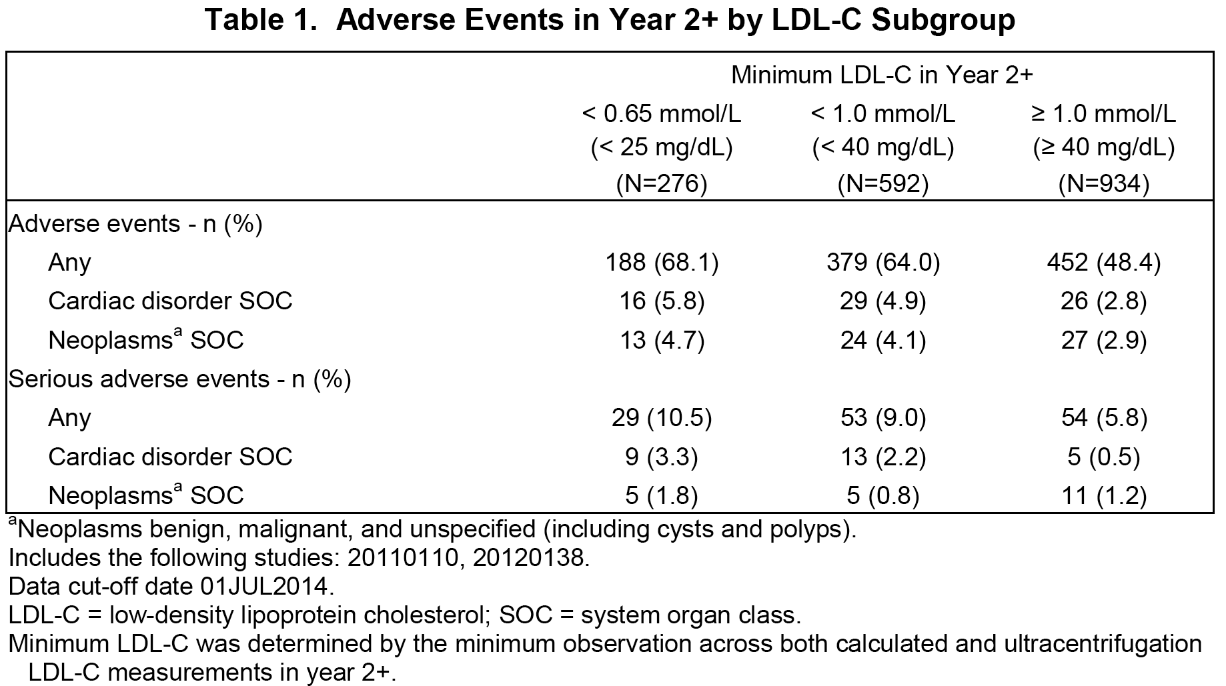

Differences at Baseline across LDL-C Subgroups
The results of analyses by minimum LDL-C in Year 2+ are difficult to interpret because there was no concurrent control group. Additionally, the characteristics of these subgroups were not well-balanced at baseline [see below, Table 56]. Subjects with any LDL-C <0.65 mmol/L (< 25 mg/dL) or < 1.0 mmol/L (< 40 mg/dL) in Year 2+ were more likely than subjects with all LDL-C ≥ 1.0 mmol/L (≥ 40 mg/dL) in Year 2+ to have high risk or moderately high risk for coronary heart disease at baseline. Subjects with lower minimum LDL-C were more likely to be age ≥ 65 years at baseline; older age is a fundamental risk factor for common cancers.⁹ Subjects with lower minimum LDL-C were also more likely to be male, non-Asian, and North American. The observed differences across the LDL-C subgroups at baseline likely contributed to differences in adverse event rates in Year 2+, particularly the differences in cardiac events.

Table 56: Baseline demographics by LDL-C sub group in Year 2+
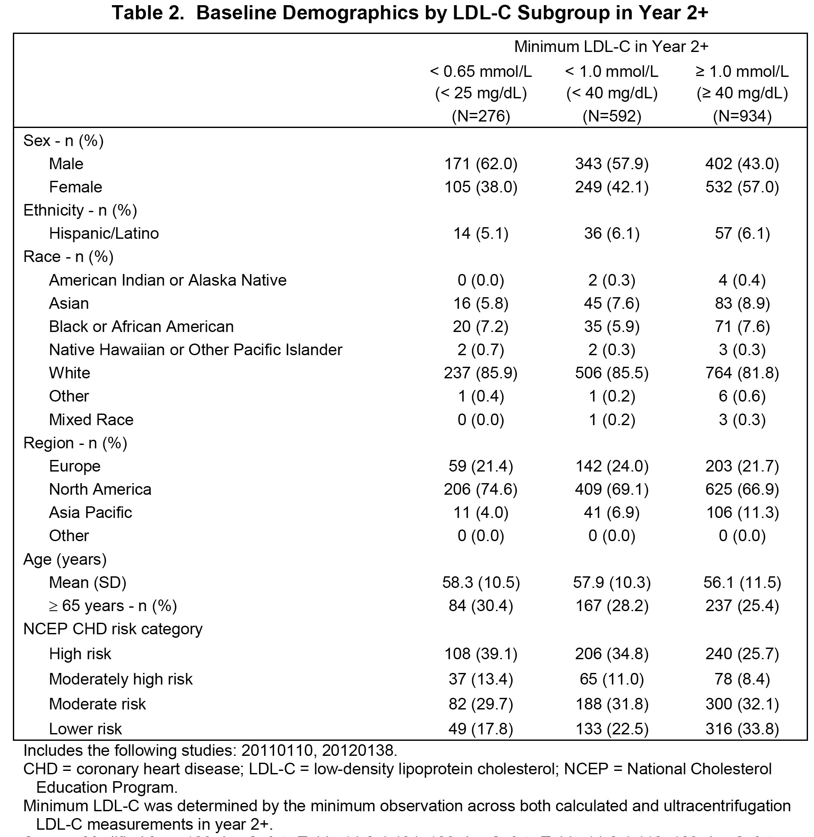

Neoplasms (Benign, Malignant, and Unspecified) in Year 2+
A tabulated summary of adverse events in the neoplasms SOC that were reported in Year 2+ for > 1 subject any LDL-C subgroup was included. No neoplasm was reported for > 1% of subjects in any LDL-C subgroup in Year 2+ and the incidences of specific neoplasms were similar across LDL-C subgroups. Of the top three most common events in the neoplasm SOC, two of them were benign (lipoma and skin papilloma). The most commonly reported neoplasm in each LDL-C subgroup was basal cell carcinoma. In the general population, non-melanoma skin cancers are among the most commonly reported neoplasms and the prevalence of skin cancer is greater than that of all other cancers combined.¹⁰

Relative Risk Analysis
Furthermore, a relative risk analysis (hazard ratio and 95% confidence interval) of adverse events from the 01 April 2014 and 01 July 2014 datasets showed no evidence of increased risk of adverse events in subjects with any LDL-C 0.65 mmol/L (< 25 mg/dL) or 1.0 mmol/L (< 40 mg/dL) compared with subjects with all LDL-C ≥ 1.0 mmol/L (≥ 40 mg/dL) [see Table 57 below]. With additional exposure from the 01 July 2014 dataset, the hazard ratios and 95% CIs of each of the comparisons moved closer to 1.0, further supporting the position that no increased risk was observed with very low LDL-C.

Table 57: Hazard ratio of adverse events in evolocumab-treated subjects with any LDL-C < 0.65 mmol/L (< 25 mg/dL) and any LDL-C < 1.0 mmol/L (< 40 mg/dL) compared with subjects with all LDL-C ≥ 1.0 mmol/L (≥ 40 mg/dL) in Year 2+
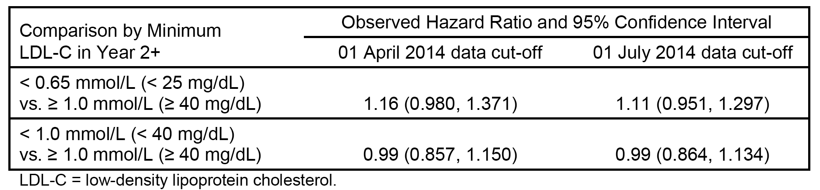

Conclusions
The analysis of adverse events by LDL-C subgroup was based on post-randomization subgroups. Differences at baseline across the LDL-C subgroups likely contributed to the observed differences in adverse event rates, because subjects with lower minimum LDL-C during evolocumab therapy were more likely to have greater cardiovascular risk and they were older. No neoplasm was reported for > 1% of subjects in any LDL-C subgroup. The most commonly reported neoplasm in Year 2+ was basal cell carcinoma. Hazard ratio risk analysis showed no increased risk of adverse events in Year 2+ in the low LDL-C subgroups. Collectively, these analyses did not identify a safety risk for low minimum LDL-C with long-term evolocumab therapy.

Clinical evaluator's comment
The analysis of the updated safety data (cut-off date 1 July 2014) showed that the incidence of AEs (any) in Year 2+ was notably greater in subjects in the LDL-C < 0.65 mmol/L group than in the LDL-C ≥ 1.0 mmol/L group (68.1% versus 48.4%). The relative risk (hazard ratio with 95% CI) of AEs between the LDL-C < 0.65 mmol/L subgroup and the LDL-C ≥ 1.0 mmol/L subgroup was 1.11 (95% CI: 0.951, 1.297), indicating that although the risk of experiencing an AE was 11% higher in the LDL-C < 0.65 mmol/L subgroup relative to the LDL-C ≥ 1.0 mmol/L subgroup the increase was not statistically significant.
In the LDL-C < 0.65 mmol/L subgroup, the incidence of cardiac disorders (AEs) was greater than in the ≥ 1.0 mmol/L subgroup (5.8% versus 2.8%, respectively), as was the incidence of cardiac disorders (SAEs) (3.3% versus 0.5%, respectively). The sponsor comments that the comparisons were between post-randomisation subgroups, and notes that the baseline demographic characteristics differed in subjects in the LDL-C subgroups. In particular, the proportion of subjects in the LDL-C < 0.65 mmol/L subgroup aged ≥ 65 years was greater than in the LDL-C ≥ 1.0 mmol/L subgroup (30.4% versus 25.4%, respectively), as was the proportion of subjects at high risk of CHD (39.1% versus 25.7%, respectively), and moderately high risk of CHD (13.4% v 8.4%, respectively). The difference in the CHD risk between the two LDL-C subgroups might contribute to the higher incidence of cardiac disorders observed in the LDL-C < 0.65 mmol/L sub group compared to the LDL-C ≥ 1.0 mm/L subgroup. In the LDL-C < 0.65 mmol/L subgroup, neoplasms were reported more commonly than in the LDL-C ≥ 1.0 mmol/L group (4.7% versus 2.9%, respectively), although the proportion of subjects with neoplasms categorised as SAEs were similar between the two groups (1.8% versus 1.2%).
Overall, it is considered that the updated data have not definitively confirmed that the risks in subjects with LDL-C concentrations < 0.65 mmol/L are no greater than the risks in subjects with LDL-C concentrations ≥ 1.0 mmol/L. The absolute difference in the AE (any) rate between the two subgroups was 19.7%, which is clinically meaningful, while the relative risk was 11% higher in the LDL-C < 0.65 mmol/L subgroup compared to the LDL-C ≥ 1.0 mmol/L (not statistically significant). It is possible that baseline demographic differences between the two subgroups might account for some of the observed difference in the AE rate between the two subgroups, particularly for the higher rate of cardiac disorders in the LDL-C < 0.65 mmol/L subgroup compared to the LDL-C ≥ 1.0 mmol/L subgroup. Nevertheless, it is recommended that the Precautions section of the PI include a statement that treatment with Repatha may lead to very low serum cholesterol levels (that is, LDL-C < 0.65 mmol/L) where safety has not yet been established.

Question 5
Please comment on the potential safety of evolocumab when administered with drugs other than statins and other lipid-lowering medications. For the ISS population, please provide a summary of drugs taken by subjects during the studies (other than statins and other lipid-lowering medications).

Sponsor's response (abbreviated, substance unchanged)
Because of its mechanism of action, evolocumab is not anticipated to interact with any other drugs. Pivotal evolocumab studies enrolled a patient population with a broad range of comorbidities who were on a diverse regimen of concomitant medications. No safety risks were identified based on concomitant medication use.

Clinical evaluator's comment
The sponsor's response is acceptable. The sponsor listed all drugs (other than investigational product) taken by subjects during studies with evolocumab. Nearly all subjects treated with evolocumab used concomitant medications, and the range of concomitant medication being taken was extensive.

Second round benefit-risk assessment

Second round assessment of benefits
After consideration of the responses to the clinical questions, the benefits of evolocumab for the treatment of primary hypercholesterolaemia and mixed dyslipidaemia, and homozygous familial hypercholesterolaemia remain unchanged from those identified in the first round evaluation.

Second round assessment of risks
After consideration of the responses to the clinical questions, the risks of evolocumab for the treatment of primary hypercholesterolaemia and mixed dyslipidaemia, and homozygous familial hypercholesterolaemia remain unchanged from those identified in the first round evaluation.

Second round assessment benefit-risk balance
The benefit-risk balance of evolocumab for the treatment of primary hypercholesterolaemia and mixed dyslipidaemia, and homozygous familial hypercholesterolaemia is favourable. The benefits of treatment with evolocumab relate to significant reductions in LDL-C serum concentrations and improvement in other lipid parameters compared to statins, ezetimibe, and other lipid-regulating medications. There were no data on whether evolocumab reduces cardiovascular morbidity and/or mortality. However, the safety data suggest that evolocumab does not increase the risk of death from all causes or death due to cardiovascular events, or significantly increase the risk of cardiovascular morbidity compared to statins, ezetimibe, or other lipid-regulating medications.

Second round recommendation regarding authorisation
It is recommended that Repatha (evolocumab) be approved for the following indications:
Repatha should be used as an adjunct to diet when the response to diet and exercise is inadequate.
Primary hypercholesterolaemia and mixed dyslipidaemia
Repatha is indicated in patients with primary hypercholesterolaemia (heterozygous familial and non-familial) or mixed dyslipidaemia:
    - in combination with a statin or statin with other lipid lowering therapies, or
    - alone or in combination with other lipid-lowering therapies in patients who are statin-intolerant or for whom a statin is not considered clinically appropriate.
Homozygous familial hypercholesterolaemia
Repatha is indicated in patients with homozygous familial hypercholesterolaemia in combination with other lipid lowering therapies.

References

CER Round 1
- Tabrizi M, Bornstein GG, Suria H. Biodistribution mechanisms of therapeutic monoclonal antibodies in health and disease. AAPS J. 2010;12:33-43.
- Lobo ED, Hansen RJ, Balthasar JP. Antibody pharmacokinetics and pharmacodynamics. J Pharm Sci 2004;93:2645-2668.
- Gibiansky L, Gibiansky E, Kakkar T, et al. Approximations of the target-mediated drug disposition model and identifiability of model parameters. J Pharmacokinet Pharmacodyn. 2008;35:573-591,
- Friedewald WT, Levy RI, Fredrickson DS. Estimation of the concentration of low-density lipoprotein cholesterol in plasma, without use of the preparative ultracentrifuge. Clin Chem. 1972;18:499-502.
- Hicks KA, Hung HM, Mahaffey KW, Mehran R, Nissen SE, Stockbridge NL, Targum SL, Temple R; on behalf of the Standardized Data Collection for Cardiovascular Trials Initiative. Standardized Definitions for End Point Events in Cardiovascular Trials. CDISC Web site. Published October 20, 2010.
- Labonté P, Begley S, Guevin C, et al. PCSK9 impeded hepatitis C virus infection in vitro and modulates liver CD81 expression. Hepatology. 2009; 50(1):17-24.

Sponsor's response included in CER Round 2
- Dirks NL, Meibohm B. Population pharmacokinetics of therapeutic monoclonal antibodies. Clin Pharmacokinet. 2010;49:633-659. Seq0000 M5
- Richter WF, Jacobsen B. Subcutaneous absorption of biotherapeutics: knowns and unknowns. Drug Metab Dispos. 2014;1881-1889.
- WHO, 2015; AIHW, 2015
- Stern R.S. Prevalence of a History of Skin Cancer in 2007. Results of an Incidence-Based Model. Arch Dermatol. 2010;146(3):279-282
Therapeutic Goods Administration
PO Box 100 Woden ACT 2606 Australia
Email: info@tga.gov.au Phone: 1800 020 653 Fax: 02 6232 8605
https://www.tga.gov.au

No clinically significant safety differences were seen between subjects aged ≥ 65 years and ≥ 75 years; there were limited data in subjects aged < 18 years of age (see Homozygous familial hypercholesterolaemia below).

