|  |
| --- |
| **Date of CER: April 2013** |

|  |
| --- |
| AusPAR Attachment 2 |
| Extract from the Clinical Evaluation Report for ezetimibe and rosuvastatin (as calcium) |
| Proprietary Product Name: Ezalo Composite Pack / Rosuzet Composite Pack |
| Sponsor: Merck Sharp & Dohme Australia Pty Ltd |

About the Therapeutic Goods Administration (TGA)

* The Therapeutic Goods Administration (TGA) is part of the Australian Government Department of Health, and is responsible for regulating medicines and medical devices.
* The TGA administers the *Therapeutic Goods Act 1989* (the Act), applying a risk management approach designed to ensure therapeutic goods supplied in Australia meet acceptable standards of quality, safety and efficacy (performance), when necessary.
* The work of the TGA is based on applying scientific and clinical expertise to decision-making, to ensure that the benefits to consumers outweigh any risks associated with the use of medicines and medical devices.
* The TGA relies on the public, healthcare professionals and industry to report problems with medicines or medical devices. TGA investigates reports received by it to determine any necessary regulatory action.
* To report a problem with a medicine or medical device, please see the information on the TGA website <<http://www.tga.gov.au>>.

About the Extract from the Clinical Evaluation Report

* This document provides a more detailed evaluation of the clinical findings, extracted from the Clinical Evaluation Report (CER) prepared by the TGA. This extract does not include sections from the CER regarding product documentation or post market activities.
* The words [Information redacted] indicate confidential information has been deleted.
* For the most recent Product Information (PI), please refer to the TGA website <<http://www.tga.gov.au/hp/information-medicines-pi.htm>>.

Copyright

© Commonwealth of Australia 2014  
This work is copyright. You may reproduce the whole or part of this work in unaltered form for your own personal use or, if you are part of an organisation, for internal use within your organisation, but only if you or your organisation do not use the reproduction for any commercial purpose and retain this copyright notice and all disclaimer notices as part of that reproduction. Apart from rights to use as permitted by the *Copyright Act 1968* or allowed by this copyright notice, all other rights are reserved and you are not allowed to reproduce the whole or any part of this work in any way (electronic or otherwise) without first being given specific written permission from the Commonwealth to do so. Requests and inquiries concerning reproduction and rights are to be sent to the TGA Copyright Officer, Therapeutic Goods Administration, PO Box 100, Woden ACT 2606 or emailed to <[tga.copyright@tga.gov.au](mailto:tga.copyright@tga.gov.au)>.

Contents

1. List of abbreviations 5

2. Clinical rationale 6

3. Contents of the clinical dossier 6

3.1. Scope of the clinical dossier 6

3.2. Paediatric data 7

3.3. Good clinical practice 7

4. Pharmacokinetics 7

4.1. Studies providing pharmacokinetic data 7

4.2. Summary of pharmacokinetics 8

4.3. Evaluator’s overall conclusions on pharmacokinetics 14

5. Pharmacodynamics 14

5.1. Studies providing pharmacodynamic data 14

5.2. Summary of pharmacodynamics 15

5.3. Evaluator’s overall conclusions on pharmacodynamics 16

6. Dosage selection for the pivotal studies 16

7. Clinical efficacy 16

7.1. Hypercholesterolemia and HoFH 16

7.2. Other efficacy studies for any statin plus ezetimibe 17

7.3. Analyses performed across trials (pooled & meta analyses) 17

7.4. Study P139V1: pivotal study for rosuvastatin and ezetimibe 18

7.5. Literature review for rosuvastatin and ezetimibe 21

7.6. Evaluator’s conclusions on clinical efficacy 31

8. Clinical safety 33

8.1. Studies providing evaluable safety data 33

8.2. Pivotal studies that assessed safety as a primary outcome 36

8.3. Patient exposure 36

8.4. Adverse events 37

8.5. Laboratory tests 42

8.6. Post-marketing experience 42

8.7. Evaluator’s overall conclusions on clinical safety 42

9. First round benefit-risk assessment 43

9.1. First round assessment of benefits 43

9.2. First round assessment of risks 43

9.3. First round assessment of benefit-risk balance 43

10. First round recommendation regarding authorisation 43

11. Clinical questions 44

## List of abbreviations

| **Abbreviation** | **Meaning** |
| --- | --- |
| ALT | Alanine transaminase |
| AST | Aspartate transaminase |
| ATP | Adult treatment panel |
| CI | Confidence Interval |
| CPK | Creatine phosphokinase |
| CKD | Chronic Kidney Disease |
| Cmax | Maximum concentration |
| CRF | Case Report Form |
| CSR | Clinical Study Report |
| CV | Coefficient of variation |
| DDI | Drug drug interaction |
| ECG | Electrocardiogram |
| FDC | Fixed dose combination |
| GCRP | Good Clinical Research Practice |
| GMP | Good Manufacturing Process |
| HeFH | Heterozygous Familial Hypercholesterolemia |
| HoFH | Homozygous Familial Hypercholesterolaemia |
| ICSR | Individual Case Safety Reports |
| LCC | Local Coordinating Centre |
| LDL | Low density lipoprotein |
| MAH | Medicines Authorisation Holder |
| PD | Pharmacodynamic |
| PI | Product Information |
| PK | Pharmacokinetic |
| PSUR | Period Safety Update Report |
| RMP | Risk Management Plan |
| RR | Risk Ratio |

## Clinical rationale

Rosuvastatin is a statin used for treatment of primary hypercholesterolemia and prevention of cardiovascular events in people at high risk. Ezetimibe inhibits cholesterol absorption and is indicated in the treatment of primary hypercholesterolemia or HoFH and phytosterolemia as monotherapy or in conjunction with a statin.

The rationale for the composite pack provided by the sponsor is that

*Having both products contained in one calendar pack would increase the awareness and emphasise the clinical importance of taking both medications concurrently and at the same time when both medications are co-prescribed.*

It would also reduce costs to the patient as there is one co-payment not two. There was no evidence provided to support the improved medication use nor the reduction in costs to the patients.

## Contents of the clinical dossier

### Scope of the clinical dossier

This submission comprises 8 volumes of clinical data.

The submission comprises two new studies, 1 PSUR and 69 publications (including abstracts) that are all evaluated in this clinical evaluation report. The submission relies on the original studies submitted by MSD for the registration of ezetimibe as monotherapy and when co-administered with a statin plus this additional data in this submission. It is noted that the original ezetimibe submission did not include clinical studies with rosuvastatin. A CD called PART IV was also included; this included clinical study data from the ezetimibe submission (January 2002) that was reviewed and referred to but not re-evaluated.

Of the two new studies in this submission:

* One was a clinical Safety and Efficacy study with three associated publications
  + P139V1: A 6 week randomised, double blind, parallel arm study to evaluate the effects of ezetimibe 10 mg add on to rosuvastatin (5 mg or 10 mg) compared with doubling rosuvastatin dose (10 mg or 20 mg) in patients (n = 440) with hypercholesterolemia at moderately high and high risk for coronary heart disease (CHD).
* One was a PK/PD study with three associated publications
  + P03317: A 14 day study evaluating the effects of ezetimibe 10 mg and rosuvastatin 10 mg either alone or in combination in hypercholesterolaemic subjects.

The PSUR provided is that of ezetimibe, for 2011.

The literature based search was approved by the TGA on 30 May 2012 and included 69 references. As 21 of these included data that published in more than one journal or abstracts submitted to more than one conference, there were thereby 48 literature studies, with either safety or efficacy data, for review:

* 11 Level II randomised controlled studies
* 3 Level III-1 controlled studies without randomization
* 6 Level III-2 studies with cohort or case controls
* 18 Level III-3 rime series studies
* 8 Level IV other observational studies including case series and case reports
* 2 Level I systematic reviews of statins (rosuvastatin was grouped with other statins)

### Paediatric data

There are no paediatric studies examining co-administered ezetimibe and rosuvastatin in children and this application does not include children. The rosuvastatin part of the PI states that rosuvastatin is not recommended for use in children. The ezetimibe part of the PI states that there is no data for ezetimibe in children less than 10 and data for 10-18 years old is in HoFH and sitosterolemia. Therefore, this combination is not recommendation for paediatric use.

### Good clinical practice

The studies contained in the submissions for ezetimibe and for the FDC of ezetimibe and rosuvastatin were stated as having been conducted in accordance with GCP standards and relevant ethical and regulatory approval.

## Pharmacokinetics

### Studies providing pharmacokinetic data

There was one new study with pharmacokinetic data, Study P03317 (Table 1). This was a 14 day study evaluating the effects of ezetimibe 10 mg and rosuvastatin 10 mg either alone or in combination in hypercholesterolaemic subjects. In summary, there was no clinically significant drug interactions reported between ezetimibe 10 mg and rosuvastatin 10 mg.

Table 1. Submitted pharmacokinetic studies.

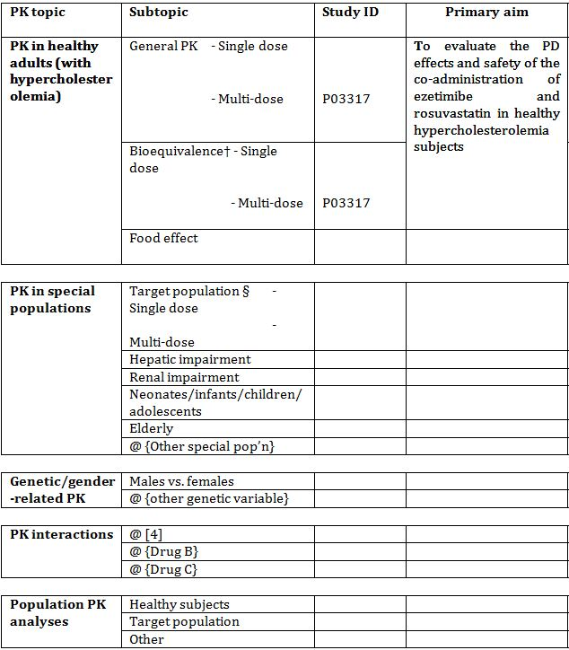

† Bioequivalence of different formulations.

§ Subjects who would be eligible to receive the drug if approved for the proposed indication.

There were three publications arising from this dataset.

One literature reference, by Kosoglou et al.[1] was a summary of the main study P03317. The other two references (Kosoglou et al.[2] and a Schering-Plough study[3]) did not provide new data.

No other new pharmacokinetic data were submitted.

### Summary of pharmacokinetics

The sponsor states that as the products in the composite packs are the same as the registered products, no new biopharmaceutic or pharmacokinetic data were submitted.

In study P03317, the relative bioavailability (90% CI) of rosuvastatin 10 mg when administered concomitantly with ezetimibe 10 mg compared to rosuvastatin 10 mg administered with placebo was 117% (84-163%) and 119% (87-162%) based on the log transformed Cmax and AUC. Plasma rosuvastatin concentrations following co-administration of ezetimibe 10 mg plus rosuvastatin 10 mg were non-clinically significantly higher than those following administration of rosuvastatin alone. The co-administration of ezetimibe 10 mg + rosuvastatin 10 mg resulted in a statistically significant average % change from baseline to endpoint of -16.4% in LDL-C compared with rosuvastatin 10 mg alone. The relevance of the change in LDL-C on clinical outcomes was not examined in this study however it can be extrapolated from various statin meta-analyses, with an understanding of potential limitations of this approach. These include the population studied in this group and the statin trials, and the fact that the meta-analyses of LDL-C lowering and clinical outcomes are predominantly from LDL-C lowering with statins and not ezetimibe.

#### Physicochemical characteristics of the active substance

The following information is derived from the sponsor’s summaries, the previous submissions for the approval of rosuvastatin and ezetimibe, and the PI.

##### Ezetimibe

The chemical name of ezetimibe is 1-(4-flurophenyl)-3(R) – [3-(4- flurophenyl)-3(S)-hydroxylpropyl]-4(S)-(4-hydorxyphenyl)-2-azetidione. The empirical formula is C2H21FNO3. Its molecular weight is 409.4 and its structural formula is shown in Figure 1.

Figure 1. Structure of ezetimibe.

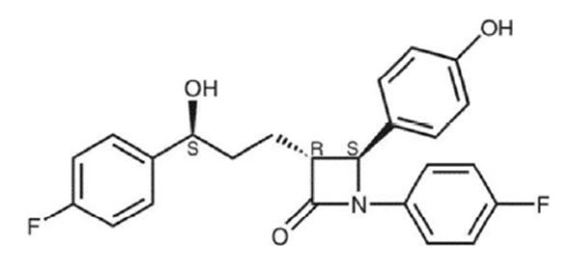

##### Rosuvastatin

The chemical name is bis [(E)-7-[4-(4-flurophenyl)-6-isopropyl-2-[methyl(methylsulfonyl) amino]pyrimidin -5-yl] (3R,5S)-3,5-dihudroxyhept-6-enoic acid] calcium salt. The CAS Number is 147098-20-2. The empirical formula is (C22H27FN3O6S)2Ca. Its molecular weight is 1001.14. The chemical structure is shown in Figure 2.

Figure 2. Structure of rosuvastatin.

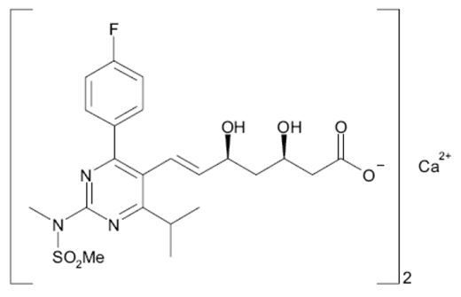

#### Pharmacokinetics in healthy subjects

##### Absorption

###### Sites and mechanisms of absorption

Ezetimibe

After oral administration, ezetimibe is absorbed and extensively conjugated to a pharmacologically active phenolic glucuronide (ezetimibe-glucuronide). After a single 10 mg dose of ezetimibe in fasting adults, mean ezetimibe peak plasma concentrations (Cmax) of 3.4 to 5.5 ng/mL were attained within 4 to 12 hours (Tmax). Ezetimibe-glucuronide mean Cmax values of 45 to 71 ng/mL were achieved between 1 and 2 hours (Tmax).

Rosuvastatin

After oral administration, rosuvastatin is absorbed linearly along the dose range. Peak plasma levels occur at 5 hours. The half-life is 19 hours and does not increase with increasing dose. There is minimal accumulation on once daily dosing.

##### Bioavailability

###### Absolute bioavailability

Ezetimibe

The absolute bioavailability of ezetimibe cannot be determined as the compound is virtually insoluble in aqueous media suitable for injection. Ezetimibe has wide inter-subject variability in bioavailability, with the coefficient of variation for AUC being 35 to 60%.

Rosuvastatin

Absolute biovailability is 20%.

###### Bioavailability and bioequivalence studies

As the tablets in the blister pack (Ezetrol 10 mg AUSTR 91161, rosuvastatin SZ 5 mg AUSTR 183601; 10 mg AUSTR 183603; 20 mg AUSTR 183605; 40mg AUSTR 183607) are identical to the Australian registered products, no bioequivalence or other biopharmaceutical data was submitted.

###### Influence of food

Ezetimibe

Concomitant administration of food (high fat or non-fat meals) was not shown to affect the oral bioavailability of ezetimibe 10 mg tablets.

Rosuvastatin

Rosuvastatin may be given at any time of the day, with or without food.

###### Dose proportionality

Ezetimibe

There is no substantial deviation from dose proportionality between 5 and 20 mg.

Rosuvastatin

Absorption increases linearly over the dose range.

###### Bioavailability during multiple-dosing

Ezetimibe

The AUC for ezetimibe increased 4-fold from Day 1-14 in a study using 10 mg ezetimibe in a population group with hepatic failure (Child-Pugh score 7-9) and 1.7 for mild hepatic insufficiency (Child-Pugh score 5-6).

Rosuvastatin

Minimal accumulation occurs on multiple dosing.

###### Effect of administration timing

Administration timing does not affect absorption for either drug.

##### Distribution

###### Volume of distribution

Ezetimibe

Ezetimibe and ezetimibe-glucuronide are highly bound (>90%) to human plasma proteins.

Rosuvastatin

Mean volume of distribution of rosuvastatin is approximately 134 litres. Rosuvastatin is ≥90% bound to plasma proteins, mainly albumin.

A blood/plasma ratio of approximately 0.25 indicates poor drug penetration of rosuvastatin into red blood cells. Based on observations in rats, rosuvastatin is likely to be secreted in human milk.

##### Metabolism

Ezetimibe

Ezetimibe is primarily metabolised in the small intestine and liver via glucuronide conjugation (a Phase II reaction) with subsequent biliary and renal excretion. Minimal oxidative metabolism (a Phase I reaction) has been observed in all species evaluated. In humans, ezetimibe is rapidly metabolised to ezetimibe-glucuronide.

Ezetimibe and ezetimibe-glucuronide are the major drug-derived compounds detected in plasma, constituting approximately 10 to 20%and 80 to 90% of the total drug in plasma, respectively. Both ezetimibe and ezetimibe-glucuronide are eliminated from plasma with a half-life of approximately 22 hours for both ezetimibe and ezetimibe-glucuronide.

Plasma concentration-time profiles exhibit multiple peaks, suggesting enterohepatic recycling. Following oral administration of 14C-ezetimibe (20 mg) to human subjects, total ezetimibe (ezetimibe + ezetimibe-glucuronide) accounted for approximately 93% of the total radioactivity in plasma. After 48hours, there were no detectable levels of radioactivity in the plasma.

Rosuvastatin

Rosuvastatin is not extensively metabolised; approximately 10% of a radiolabelled dose is recovered as metabolite. The major metabolite is N-desmethyl rosuvastatin which is formed principally by cytochrome P450 2C9. In vitro studies have demonstrated that N-desmethyl rosuvastatin has approximately one-sixth to one-half the HMG-CoA reductase inhibitors activity of rosuvastatin. Overall, greater than 90% of active plasma HMG-CoA reductase inhibitory activity is accounted for by rosuvastatin.

###### Active metabolites

Ezetimibe

Both ezetimibe and its metabolite ezetimibe-glucuronide are pharmacologically active, with ezetimibe-glucuronide inhibiting cholesterol absorption to at least as great an extent as the unconjugated parent. Thus, total ezetimibe (unconjugated ezetimibe + ezetimibe-glucuronide) represents the sum of both active ezetimibe-derived substances in plasma following an oral dose.

Rosuvastatin

The major metabolite is N-desmethyl rosuvastatin which is formed principally by cytochrome P450 2C9. In vitro studies have demonstrated that N-desmethyl rosuvastatin has approximately one-sixth to one-half the HMG-CoA reductase inhibitors activity of rosuvastatin.

##### Excretion

###### Routes and mechanisms of excretion

Ezetimibe

Following oral administration of 14C-ezetimibe (20 mg) to human subjects, approximately 78% and 11% of the administered radioactivity were recovered in the faeces and urine, respectively, over a 10-day collection period. Ezetimibe was the major component in faeces and accounted for 69% of the administered dose, while ezetimibe-glucuronide was the major component in urine and accounted for 9% of the administered dose.

Rosuvastatin

About 10% of rosuvastatin is metabolised, 90% is excreted as parent drug in faeces and a small amount excreted unchanged in urine.

#### Pharmacokinetics in the target population

Not available

#### Pharmacokinetics in other special populations

##### Pharmacokinetics in subjects with impaired hepatic function

Ezetimibe

##### After a single 10 mg dose of ezetimibe, AUC for total ezetimibe was increased approximately 1.7-fold in patients with mild hepatic impairment (Child-Pugh score 5 to 6), compared to healthy subjects. The mean AUC values for total ezetimibe and ezetimibe were increased approximately 3-4 fold and 5-6 fold, respectively, in-patients with moderate (Child-Pugh score 7 to 9) or severe hepatic impairment (Child-Pugh score 10 to 15). In a 14 day, multiple-dose study (10 mg daily) in patients with moderate hepatic impairment, the mean AUC values for total ezetimibe and ezetimibe were increased approximately 4-fold on Day 1 and Day 14 compared to healthy subjects. Due to the unknown effects of the increased exposure to ezetimibe in patients with moderate or severe hepatic impairment, ezetimibe is not recommended in these patients.

Rosuvastatin

Pharmacokinetic evaluation in subjects with varying degrees of hepatic impairment determined that there was no evidence of increased exposure to rosuvastatin other than 2 subjects with the most severe liver disease (Child Pugh scores of 8 and 9). In these subjects systemic exposure was increased by at least 2-fold compared to subjects with lower Child-Pugh scores.

##### Pharmacokinetics in subjects with impaired renal function

Ezetimibe

After a single 10 mg dose of ezetimibe in patients with severe renal disease (n = 8; mean CrCl ≤30 mL/min/1.73 m2), the mean AUC values for total ezetimibe, ezetimibe-glucuronide, and ezetimibe were increased approximately 1.5-fold, compared to healthy subjects (n = 9).

Rosuvastatin

Pharmacokinetic evaluation in subjects with varying degrees of renal impairment determined that mild to moderate renal disease had little influence on plasma concentrations of rosuvastatin. However subjects with severe renal impairment (CrCl <30ml/min) had a 3-fold increase in plasma concentrations compared to healthy volunteers.

##### Pharmacokinetics according to age

###### Paediatric Patients

Ezetimibe

In a multiple-dose study with ezetimibe given 10 mg once daily for 7 days, the absorption and metabolism of ezetimibe were similar in adolescents (10 to 18 years) and adults. Based on total ezetimibe (ezetimibe + ezetimibe-glucuronide), there are no pharmacokinetic differences between adolescents and adults. Pharmacokinetic data in the paediatric population <10 years of age were not available.

Rosuvastatin

There is no clinically relevant effect on adult age on pharmacokinetics although paediatric data was not available.

###### Geriatric patients

Ezetimibe

In a multiple-dose study with ezetimibe given 10 mg once daily for 10 days, plasma concentrations for total ezetimibe were about 2-fold higher in older (≥65 years) healthy subjects compared to younger subjects.

Rosuvastatin

It is stated that there are no clinically relevant effect of age on pharmacokinetics although specific geriatric data was not available.

##### Pharmacokinetics related to genetic factors

###### Gender

Ezetimibe

In a multiple-dose study with ezetimibe given 10 mg once daily for 10 days, plasma concentrations for total ezetimibe were slightly higher (<20%) in women than in men.

Rosuvastatin

There is no clinically relevant effect of gender on pharmacokinetics.

###### Race

Ezetimibe

Based on a meta-analysis of multiple-dose pharmacokinetic studies, there were no pharmacokinetic differences between Blacks and Caucasians. Studies in Asian subjects indicated that the pharmacokinetics of ezetimibe were similar to those seen in Caucasian subjects.

Rosuvastatin

A population pharmacokinetic analysis revealed no clinically relevant differences in pharmacokinetics among Caucasian, Hispanic and Black of Afro-Carribean groups. However pharmacokinetic studies including one in the US have demonstrated a 2 fold elevation in median exposure (AUC and Cmax) in Asian subjects compared to a Caucasian control group.

#### Pharmacokinetic interactions

##### Pharmacokinetic interactions demonstrated in human studies

Ezetimibe

Adverse drug-drug interactions are known to occur between ezetimibe and the following drugs cholestyramine; fenofibrate; gemfibrozil; cyclosporine; and warfarin. The co-administration of ezetimibe with fibrates other than fenofibrate has not been studied and therefore is not recommended. From the Clinical Evaluation Report of ezetimibe, seven studies assessed the potential interaction of ezetimibe with HMG CoA reductase inhibitors in healthy volunteers with hypercholesterolaemia (LDL-C ≥130 mg/dL). The studies assessed simvastatin (10 and 20 mg), lovastatin (20 and 40 mg), pravastatin (10 mg), atorvastatin 10 mg), cerivastatin (0.3 mg) and fluvastatin (20 mg). There was no significant effect on the PK of ezetimibe reported. The PI of ezetimibe states

*No clinically significant pharmacokinetic interactions were seen when ezetimibe was co-administered with atorvastatin, simvastatin, pravastatin, lovastatin, or fluvastatin.*

Rosuvastatin

Actual or potential adverse drug-drug interaction are known to occur between rosuvastatin and the following drugs: warfarin, cyclosporin, fusidic acid, gemfibrozil, protease inhibitors, oral contraceptives (increases concentrations) and antacids.

##### Clinical implications of in vitro findings

The in vitro studies were the basis of previous submissions for ezetimibe and statins and there are no apparent new clinical implications of this work applied to the current submission for registration.

### Evaluator’s overall conclusions on pharmacokinetics

The new pharmacokinetic study undertaken for this application provided pharmacokinetic data that shows that there are minor changes in the pharmacokinetics with co-administration however these are unlikely to be clinically significant.

It is noted that Crestor (from the Netherlands) was the rosuvastatin used in the clinical trials assessing the combination of ezetimibe and rosuvastatin evaluated in this application.

## Pharmacodynamics

### Studies providing pharmacodynamic data

Study P03317 also provided pharmacodynamic data. In summary, this was a single centre, randomised, investigator/evaluator blind placebo controlled, multiple dose, parallel group study to assess the PD and PK effects of ezetimibe 10 mg and rosuvastatin 10 mg alone and in combination in otherwise healthy hypercholesterolemic subjects.

The pivotal Study P139V1 was a multicentre 6 week randomised, double blind, parallel arm study to evaluate the effects of ezetimibe 10 mg add on to rosuvastatin (5 mg or 10 mg) compared with doubling rosuvastatin dose (10 mg and 20 mg) in patients (n = 440) with hypercholesterolemia at moderately high and high risk for CHD, provided PD and safety data.

No other new pharmacodynamic data were submitted.

Table 2 shows the studies relating to each pharmacodynamic topic.

Table 2. Submitted pharmacodynamic studies.

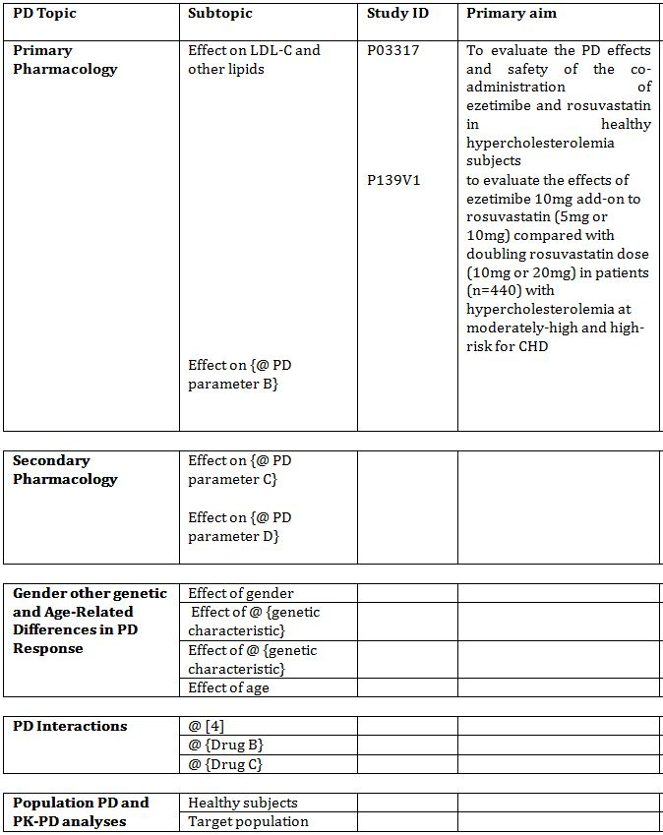

Neither of the pharmacodynamic studies had deficiencies that excluded their results from consideration. There were no other PD studies that were excluded from consideration due to study deficiencies.

### Summary of pharmacodynamics

Both P03317 and P139V1 showed that the co-administration of ezetimibe and rosuvastatin had an additive effect on the primary endpoint of LDL-C lowering compared to either drug alone.

In addition there were 21 studies assessing the PD of ezetimibe with statin co-administration in this submission. These found that the combination of ezetimibe with any of the studied statins, some including patients on rosuvastatin, was generally more effective in lowering lipids (LDL-C and total cholesterol) than either agent alone.

It should be noted that both of the new studies submitted in this Application were very short-term studies (2 weeks and 6 weeks), for drugs that are likely to be used for many years. Further, the primary outcomes of the studies were pharmacodynamic endpoints, whilst although conforming to Guidelines did not examine clinical outcomes. However, there are now several studies and 2 meta-analyses which clearly show the relationship between LDL-C lowering with statins and reductions in cardiovascular events. Lastly, the populations in these studies are predominantly those that were otherwise healthy, which may be different to the populations in Australia which are likely to use these therapies.

### Evaluator’s overall conclusions on pharmacodynamics

It should be noted that both of the new studies submitted in this Application were very short-term studies (2 weeks and 6 weeks), for drugs that are likely to be used for many years. Further, the primary outcomes of the studies were pharmacodynamic endpoints, not clinical outcomes. However, there are now many studies and 2 meta-analyses which clearly show the relationship between LDL-C lowering and reductions in cardiovascular events. The studies show the incremental benefit on LDL-C from using ezetimibe and rosuvastatin together.

## Dosage selection for the pivotal studies

The proposed dosage is the same as the currently registered products (ezetimibe 10 mg and rosuvastatin 5, 10, 20, 40 mg) in the combinations of 10/5 mg, 10/10 mg, 10/20 mg and 10/40 mg.

## Clinical efficacy

The evidence establishing efficacy for ezetimibe co-administered with rosuvastatin is based on the original approval of ezetimibe co-administered with statins, summarised in the Ezetrol PI (Clinical trials section), the two new studies, and the 69 publications (including the abstracts) for review. It should be noted that the original Ezetrol/statin application did not include data for the statin discussed in this application i.e. rosuvastatin.

The evaluator has reviewed the Ezetrol CD submitted with this application that had the original ezetimibe studies presented to the TGA for registration. In addition, the 14 day PK/PD study or rosuvastatin and ezetimibe (P03317) has been evaluated. The clinical study report from the relatively pivotal study in this application (P0319V1 - 6 week randomised, double-blind, parallel-arm study to evaluate the effects of ezetimibe 10 mg add-on to rosuvastatin (5 mg or 10 mg) compared with doubling rosuvastatin dose (10 mg or 20 mg) in patients (n=440) with hypercholesterolemia at moderately-high and high-risk for CHD) is evaluated. A further 46 additional datasets (63 publications) presented as a literature review were also evaluated and relevant aspects added where appropriate for this application.

In this section, the evaluator has summarised the relevant new studies and literature data in two sections: efficacy of ezetimibe with statins generally and efficacy of ezetimibe with rosuvastatin specifically.

The methodology of the Search Strategy for the literature review in this application was approved by the TGA. Essentially, the strategy aimed to examine any published studies containing data related to co-administration of ezetimibe and rosuvastatin, by searching EMBASE, PubMed, ClinicalTrials.gov, Cochrane library, Toxline and MSD’s internal databases (CLIC). It is noted that a large number of references were from the same datasets, many were abstracts and acknowledgement of ethics approval is often not provided.

### Hypercholesterolemia and HoFH

#### Any statin and ezetimibe

##### Study design, objectives, locations and dates

###### Co-administration with statin

The previous ezetimibe submission contained four multi-centre, phase III, randomised, placebo-controlled, 12 week factorial studies of ezetimibe co-administered with statins in 1861 patients with primary hypercholesterolaemia (P0679, P0680, P0691, P0692). The four statins studied were lovastatin, simvastatin, pravastatin, and atorvastatin. Efficacy of ezetimibe with co-administered statin was compared to the statin monotherapy. Inclusion required mean plasma LDL-C (from 2 pre-randomisation visits) of 145-250 mg/dL and mean TG ≤350 mg/dL.

The mean percentage change from baseline in direct LDL-C was -39.0%, -49.9%, -37.7% and -54.5% for the co-administration of ezetimibe with pooled doses of lovastatin, simvastatin, pravastatin and atorvastatin, respectively. This compared to -24.7%, -36.1%, -24.3% and -42.4% for the pooled statin monotherapy doses, respectively. The difference of approximately -13.8% was consistent across statins and statistically significant (p≤0.01). The effect was seen from Week 2 and sustained to Week 12. A statistically significant reduction in LDL-C was noted for each dose of ezetimibe + statin and overall it was seen that adding 10 mg ezetimibe to any dose of statin is shown to achieve a greater reduction in LDL-C than that achieved by doubling the dose of statin. The reduction in LDL-C can be visualised in Tables 3-4.

Table 3. Average percentage change from baseline in plasma concentrations of calculated LDL-C for ezetimibe administered with statins.

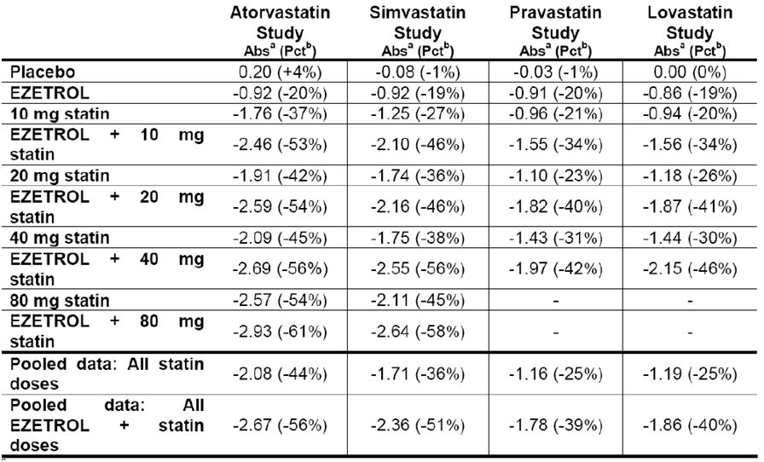

Table 4. Response to addition of ezetimibe to on-going statin (40% atorvastatin, 31% simvastatin and 29% other – lovastatin, cerivastatin, fluvastatin, pravastatin) in patients with hypercholesterolemia (% change from baseline).

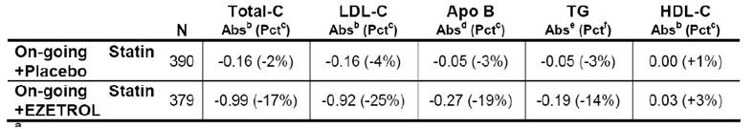

### Other efficacy studies for any statin plus ezetimibe

The literature for any statin plus ezetimibe (excluding rosuvastatin) has been previously evaluated and summarised above. Specific data is attached as an appendix.

### Analyses performed across trials (pooled & meta analyses)

There were no new pooled analyses or meta-analyses in this application.

### Study P139V1: pivotal study for rosuvastatin and ezetimibe

This is a 6 week multicentre randomised, double-blind, parallel-arm study to evaluate the effects of ezetimibe 10 mg add-on to rosuvastatin (5 mg or 10 mg) compared with doubling rosuvastatin dose (10 mg or 20 mg) in patients (n=440) with hypercholesterolemia at moderately-high and high-risk for CHD.

#### Study dates, location

* Dates: 23 Jan 2009 to 9 May 2010
* Locations: Multicentre - US, Canada, Hungary, Puerto Rico, Peru, Denmark, Poland, Croatia, Finland, Colombia

#### Inclusion and exclusion criteria

##### Inclusion criteria

* Male and female patients at moderately high and high risk for CHD with primary hypercholesterolemia.
* 18-79 years of age.
* Currently taking an approved stable dose of rosuvastatin (5 or 10 mg) or a stable dose of lipid lowering therapy of equal or lesser potency for at least 6 weeks prior to screening or are naïve (defined as not being treated with a statin and/or ezetimibe for the past 6 weeks prior to the pre-screen visit) to lipid lowering therapy eligible.

##### Exclusion criteria

* Patient weight <45 or >159 kg.
* Pregnant or lactating.
* Hypersensitivity or intolerance.
* Regular drinker of >2 alcoholic drinks per day.
* Participating in another study within last 30 days.
* Abnormal biochemistry: TG > 3.96mmol/L, ALT and AST> 2x ULN, eGFR </= 30ml/min/m2, CK>3 x ULN, TSH out of range.
* Prohibited medical disorders: secondary causes of hyperlipidaemia, CHF Class III or IV, unstable angina, arrhythmia, angioplasty or severe PVD within 3 months, significant malabsorption, poorly controlled or recent diagnosis Type 1 or 2 diabetes, general disorders that would limit study participation, chronic hepatobiliary or hepatic disease, HIV positive, malignancy < 5 years, mental instability or psychiatric illness, anything else that might confound the results of the study.
* Prohibited drugs (other lipid lowering therapies, itraconazole, lopinavir, ritonavir, cyclosporine, steroids, weight loss programme, OTC therapies that affect lipids, warfarin and does not have stable INR for 6 weeks prior to Visit 1.

#### Study treatments

These were the addition of ezetimibe to rosuvastatin vs. doubling of rosuvastatin dose in patients on rosuvastatin 5 mg or 10 mg and not at their NCEP ATPIII LDL-C goal in an approximately 12 week study with 6 weeks of active treatment.

#### Efficacy variables and outcomes

The main efficacy variables were:

* LDL-C lowering efficacy

The primary efficacy outcome was LDL-C lowering efficacy of ezetimibe vs. doubling the rosuvastatin group, in patients already on rosuvastatin 5 or 10 mg, measured as percentage change from baseline at completion of study.

Other efficacy outcomes included:

* Comparative effects of other lipoprotein fractions, apolipoprotein and hs CRP
* Safety and tolerability

#### Randomisation and blinding methods

This study was randomised, double blind and parallel-arm study. Subjects were stratified based on their run-in rosuvastatin dose and were randomised using a 1: 1 ratio to 1 of 2 double-blinded daily treatment groups. There were:

* Stratum I:
  + Ezetimibe 10 mg plus rosuvastatin 5 mg
  + Rosuvastatin 10 mg
* Stratum II:
  + Ezetimibe 10 mg plus rosuvastatin 10 mg
  + Rosuvastatin 20 mg

#### Analysis populations

There were 4 analysis populations: rosuvastatin 5 mg plus ezetimibe, rosuvastatin 10 mg, rosuvastatin 10 mg plus ezetimibe, rosuvastatin 20 mg and patients were analysed based on this assigned treatment at randomisation.

The efficacy data were analysed primarily based upon the full analysis set population (FAS). The FAS is a subset of all randomised patients minus exclusions for failure to receive at least one dose of study treatment of lack of baseline data.

A supportive analysis of the per protocol set (PPS) population was performed for the primary efficacy variable (percent change from baseline in LDL-C). The PPS was a subset of the FAS minus important protocol deviations (that could potentially have effect on outcomes).

Details of patients excluded from the FAS and PPS and reasons for exclusion are detailed.

#### Sample size

The sample size was 440 randomised subjects, of which 428 completed.

#### Statistical methods

For the primary endpoint, a *constrained full likelihood longitudinal data analysis* method was used. This model includes baseline and the calculated post-baseline percent change from LDL-C as response variables (pooled doses and then across each stratum). The repeated measures model included terms for treatment, time and the interaction of time by treatment with a restriction of the same baselines mean across treatment groups. The model adjusted for each Stratum. Time was treated as a categorical variable with one level at week 6. An unstructured covariance baseline matrix was used to model the correlation among repeated measurements.

#### Participant flow

Patient disposition for the Study is seen in Table 5.

Table 5. Patient disposition: Study P139V1.

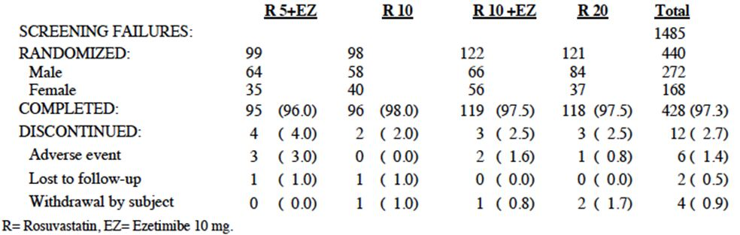

#### Major protocol violations/deviations

These included violation of the compliance rule (5), violation of the off-drug rule (20) and clinical violation (3).

#### Baseline data

The treatment groups were overall relatively comparable at baseline. Essentially, the majority of patients were white (76.8%), and the majority (67.5%) were high risk of CHD with AVD. Overall, the mean duration of hypercholesterolemia was 9 years.

#### Results for the primary efficacy outcome

Analysis of the primary variable showed that the addition of ezetimibe 10 mg to rosuvastatin (5 or 10 mg) (pooled across doses) daily for 6 weeks reduced LDL-C more (p-value <0.001) than doubling the baseline dose of rosuvastatin. Pooled across strata, the LS mean percent change from baseline in LDL-C at study endpoint was -20.96% on rosuvastatin (5 or 10 mg) + ezetimibe 10 mg and -5.71% on rosuvastatin (10 or 20 mg). The LS mean treatment difference was -15.25% with a 95% CI (-19.89, -10.60).

A sensitivity analysis was performed based on a subset of patients from the FAS population: this subset consisted of patients who were above their target LDL-C goal at baseline (i.e. those at their target LDL-C goal at baseline were excluded). The results were consistent with the results of the main analysis based on the FAS population.

#### Results for other efficacy outcomes

Within stratum I, addition of ezetimibe 10 mg to rosuvastatin 5 mg daily for 6 weeks reduced LDL-C to a greater extent (p value <0.01) than doubling the baseline dose to rosuvastatin 10 mg. The treatment difference was -12.31% (95%CI -18.95, -5.67).

Within stratum II, addition of ezetimibe 10 mg to rosuvastatin 10 mg daily for 6 weeks reduced LDL-C to a greater extent (p value <0.001) than doubling the baseline dose to rosuvastatin 20 mg. The treatment difference was -17.46% (95% CI -23.92, -10.99).

Addition of ezetimibe to rosuvastatin (5 or 10 mg) (pooled across doses) daily for 6 weeks resulted in a significantly greater proportion of patients reaching their LDL-C goal (< 70mg/dL for patients at high risk for CHD with AVD and <100mg/dL for patients at moderately high risk and high risk for CHD without AVD) compared with doubling the baseline dose or rosuvastatin (pooled) (59.4% vs. 30.9%, adjusted odds ratio = 4.5, p value <0.001).

According to the pre-defined step down ordered testing procedure to control for multiplicity, *all treatment comparisons related to the primary and secondary efficacy hypotheses were statistically significant*.

Other secondary objectives: within stratum I, addition of ezetimibe 10 mg to rosuvastatin 5 mg for 6 weeks resulted in more patients reaching their LDL-C goal compared with doubling the baseline dose to rosuvastatin 10 mg (55.1% vs. 31.3%, adjusted odds ratio = 3.1; p value <0.001). Within Stratum II, addition of ezetimibe 10 mg to rosuvastatin 10 mg daily for 6 weeks resulted in a significantly greater proportion of patients reaching their LDL-C goal compared with doubling the baseline dose to rosuvastatin 20 mg (62.8 vs. 30.6%, adjusted odds ratio = 6.5; p value <0.001). Addition of ezetimibe 10 mg to rosuvastatin (5 or 10 mg) was also significantly better than doubling the baseline dose of rosuvastatin (pooled) in the secondary variables, the percent change from baseline TC, non HDL-C, LDL-C/HDL-C ratio, TC-HDL-C ratio, non HDL-C/HDL-C ratio, Apo-B and ApoB/ ApoA-I ratio. No significant difference was detected for the percent change from baseline in HDL-C, TG, Apo A-I and hs-CRP.

Three publications[4] present efficacy data.

It should be noted that almost all of the results from the literature express LDL-C in units of mg/dL whereas In Australia SI units are used (mmol/L). 1mg/dL= 0.0259mmol/L. There is no effect on percentage changes.

### Literature review for rosuvastatin and ezetimibe

#### Comparison of monotherapy (either rosuvastatin or ezetimibe) to combination therapy (rosuvastatin and ezetimibe)

Evidence for this was provided in 4 studies: Study P139V1, EXPLORER study (Ballantyne et al.[5]), Kouvelos et al.[6] and the ESSENTIAL study (Sawayama et al.[7]). Overall, the combined therapy reduced LDL-C more than either ezetimibe or rosuvastatin monotherapy and (when data was available) more in the combination group reached LDL-C targets than either monotherapy alone.

##### EXPLORER (Ballantyne et al.[8])

This study investigated the efficacy and safety of rosuvastatin 40 mg alone or in combination with ezetimibe 10 mg in patients at high risk of coronary heart disease. A total of 469 patients were randomly assigned to rosuvastatin alone or in combination with ezetimibe for 6 weeks. The primary end point was the percentage of patients achieving the Adult Treatment Panel III (ATP III) LDL cholesterol goal (<100 mg/dL) at Week 6. Secondary end points included the percentage of patients achieving other ATP III and 2003 European lipid goals, changes from baseline in lipid, lipoprotein, and inflammatory parameters, and safety and tolerability. Significantly more patients receiving rosuvastatin/ezetimibe than rosuvastatin alone achieved their ATP III LDL cholesterol goal (<100 mg/dl, 94.0% vs. 79.1%, p <0.001) and the optional LDL cholesterol goal (<70 mg/dl) for very high-risk patients (79.6% vs. 35.0%, p <0.001). The combination of rosuvastatin/ezetimibe reduced LDL cholesterol significantly more than rosuvastatin (-69.8% vs. -57.1%, p <0.001). Other components of the lipid/lipoprotein profile were also significantly (p <0.001) improved with rosuvastatin/ezetimibe. Both treatments were generally well tolerated although 3 patients had 3x ULN reported for ALT.

Evaluator comment:

1. This was a 6 week study (short term)
2. Surrogate marker (LDL-C) used, not a clinical endpoint
3. Prospective and multicentre
4. Helpful in that it examined the effect of the combination on surrogate marker of LDL-C lowering in a relatively large (469) group of people at high risk of CHD. The combination enabled 15% more patients to achieve their LDL goals. It is disappointing that in this high risk group the study was not continued to examine whether this LDL lowering had a beneficial effect on CHD outcomes, compared to rosuvastatin alone as the effect of 15% more people achieving the targets on clinical outcomes relies on a number of uncertain assumptions. *ALT increases 3 x ULN were reported in 3 patients in the combination and none in the statin group.*

Several journal articles were published from this EXPLORER data, with two subgroup analyses. One of these papers[9] showed in a subgroup analysis that both patients with and without metabolic syndrome had beneficial further LDL-C reductions when adding ezetimibe to rosuvastatin.

##### Kouvelos et al.[10]

This was a prospective randomized, open-label study of 262 patients to investigate the 12 month effect of lipid-lowering treatment by statin monotherapy (rosuvastatin 136 patients) 10 mg/day or rosuvastatin 10 mg/d plus ezetimibe (126 patients) 10 mg/day starting prior to scheduled vascular procedure. The primary end point was the first major cardiovascular event, including death from cardiac causes, nonfatal myocardial infarction, ischemic stroke, and unstable angina. There were 6.6% of patients in the rosuvastatin group who had a major cardiovascular event within 30 days after surgery versus 5.6% in the combination group (P = 0.72). This lack of difference was despite combination therapy having a greater decrease in low-density lipoprotein cholesterol levels compared with rosuvastatin (75.87 +/- 31.64 vs. 87.19 +/- 31.7, P = .004). There was no differential effect on triglyceride, high-density lipoprotein cholesterol or high-sensitivity C-reactive protein levels between groups. Although the reported data showed that from month 1 to 12 of the follow-up period the primary end point was observed in 9 (6.6%) of the rosuvastatin group vs. 2 (1.6%) in the combination [P = .04], as there were no differences in the 2 groups at 1 month (6.6.vs 5.6, p=0.72), when this figure includes the first month figures the late (12 month) rate appears to be 13.2 vs. 7.1, p= 0.11, i.e. non significantly different between the groups.

This study also omits to report important information about the 8 patients that underwent re-operation and how many of these were in each group. Similarly also is the lack of knowledge re which group the 12 with the recent cardiovascular event and the 9 with acute cardiovascular events were in. If these were commenced on the therapy 2 weeks prior to operation (as at the least the re-operation group would have been), it is not clear why these were not included in the analysis.

Lastly, it is not stated whether this study is powered for cardiovascular survival, although appears significantly underpowered. But it seems that after the first 12 months, including the 1st month data that there is no difference in overall survival between the groups, despite significantly greater decreases in LDL-C in the rosuvastatin/ezetimibe group.

##### Sawayama et al.[11]

This study aimed to examine the efficacy and safety of ezetimibe 10 mg/day administered to Japanese patients with dyslipidaemia. Here, ezetimibe 10 mg/day alone was given to 33 patients for 12 weeks. In the other two groups, ezetimibe was given with an HMG-CoA reductase inhibitor (statin) to 13 patients for 12 weeks: pravastatin 10 mg/day (n = 7) or rosuvastatin 2.5 mg/day (n = 6). The main outcome measure was the effect of ezetimibe on low-density lipoprotein cholesterol (LDL-C) and other lipid levels from baseline to 12 weeks. After 12 weeks of treatment, all groups showed marked reductions in mean +/- SD LDL-C level (from 155.4 +/- 22.0 mg/dL at baseline to 118.0 +/- 28.1 mg/dL, i.e. -37.4 mg/dL; p < 0.001). The mean reduction in LDL-C level with ezetimibe monotherapy was significantly greater in patients with impaired LDL-C metabolism, glucose metabolism or hypertension than in those without such abnormalities (-21.0% vs. -8.4%, p < 0.01; -22.7% vs. -9.5%, p < 0.05; and -22.5% vs. -5.9%, p < 0.05; respectively). The reduction in LDL-C levels with ezetimibe monotherapy was also significantly correlated with the number of metabolic abnormalities.

Evaluator comment: Although it is concluded that both ezetimibe monotherapy and combination therapy with ezetimibe and a statin were able to reduce LDL-C levels in dyslipidaemia including those with metabolic abnormalities, this was a non randomised 12 week study with only 33 on ezetimibe and 6 patients taking rosuvastatin/ezetimibe in this study. The 2.5 mg rosuvastatin in this study is half the lowest dose proposed in the FDC and 1/16th of the highest dose proposed. It is noted that half of the rosuvastatin/ezetimibe combination group had slight increases of ALT (25 to 36, 28 to 36 and 26 to 41IU/ml) and one had a mild increase in ALT. There were also a large number of exclusions for this study which would preclude a lot of people currently taking statins in Australia.

#### Addition of ezetimibe to rosuvastatin

There were six studies[12] that examined the effect of adding ezetimibe to rosuvastatin. Overall, the reduction in LDL-C when ezetimibe 10 mg was added to rosuvastatin was between 10.6 and 70%.

##### Inoue et al.[13]

This was a retrospective study of people who did not meet their LDL-C targets on statins (60 people rosuvastatin for 2 years). There was a 31% reduction in LDL-C. This did not include hard clinical endpoints. Further, the numbers on different doses of rosuvastatin was not clear.

##### Leibovitz et al.[14]

20 patients who did not meet their ATPIII goals on 40mg rosuvastatin had ezetimibe 10 mg added. LDL-C was reduced by 30% with rosuvastatin and a further 21% with ezetimibe. 2 patients still required LDL apheresis. All were said to tolerate the therapy well.

##### Madrigal et al.[15]

Of the 48 patients in this observational prospective study were 21 on rosuvastatin 10 mg who were given ezetimibe 10 mg due to failure to meet NCEP targets. The combination had an additive effect on LDL-C lowering. Safety and tolerability were not reported. This report was poorly written, and dates of the study were not given, amongst other omissions.

##### Ose et al.[16]

This was a two centre AstraZeneca 12 weeks study in a patient group of 36 people with HoFH on rosuvastatin 40mg for 3.5 years and whom had not met NCEP ATP III targets. Adding ezetimibe enabled 26/36 patients to meet NCEP ATP targets. There were no tolerability issues reported. No clinical endpoints measured.

##### Stein et al. (2005)[17]

This is a single centre, 12 week study in 73 patients on rosuvastatin 40mg who had not met NCEP targets. Addition of 10 mg ezetimibe resulted in 50% of people meeting targets. There were no hepatic or CK elevations.

##### Stein et al. (2007)[18]

This is a similar study to the above but included 107 patients as a substudy of people with severe hypercholesterolemia including HoFH whom had not met their targets. In this study 59% of patients achieved their LDL-C targets. The therapy was well tolerated.

##### Fras and Mikhailidis[19]

This was a 16 week retrospective study of people with mixed dyslipidaemias predominantly primary hypercholesterolemia and mixed dyslipidaemia who were not meeting lipid targets (unspecified). Of the 1053 patients, 113 had rosuvastatin added. Changes in LFTs and CK were not reported. Here, a 33.1% reduction in LDL-C with combination rosuvastatin and ezetimibe compared with ezetimibe alone was seen.

There were some poor quality abstracts provided in the following three publications [21-23]. Groups were non randomised and the same data was apparently submitted to 3 different conferences. This dataset was small (146), a short (4 week) study examining hsCRP, a surrogate, the lowering of which is still not universally accepted as a surrogate in cardiovascular disease and had no clinical outcome data. There was a slight decrease in hsCRP in the group that received combination ezetimibe but the clinical relevance of that is this study is unknown.

##### Sakuma and Kishimoto[20]

This study examined the LDL-C lowering effect of switching people from 10 mg rosuvastatin to 2.5 mg combined with ezetimibe 10 mg. The LDL-C decreased from 74.4 +/- 23.5 to 66.5 +/- 24.2mg/dL after 3 months. This is another short-term study using a surrogate endpoint and the dose of rosuvastatin is below the lowest dose proposed in this application.

##### Nagai[21]

In this small observational retrospective study of 33 patients receiving ezetimibe and 36 receiving statin combination therapy (13 rosuvastatin group). Over 13 months there was one dropout (unspecified) and no ‘remarkable’ clinical signs of laboratory markers (unspecified) were documented. The decrease in LDL-C in the combination group was 28.4% greater than the ezetimibe group (p not stated). The combination results were not stratified by specific statin used.

#### Addition of ezetimibe to rosuvastatin compared to doubling or titrating the dose of rosuvastatin

In general, addition of ezetimibe to rosuvastatin reduced LDL-C numerically more than doubling or titrating the dose of rosuvastatin. This was demonstrated in the pivotal P139V1 study, Okada and colleagues[22] and Yamagishi.[23]

##### Okada et al. (2011)[24]

This was a multicentre, prospective, open label, parallel arm, randomised study in 14 centres in Japan where people with coronary artery disease on atorvastatin 10 or rosuvastatin 2.5 mg/day for 4 weeks were assigned to either receive ezetimibe 10 mg day (50 in ezetimibe-atorvastatin, 50 in ezetimibe-rosuvastatin 2.5 mg) or to double the statin dose for 12 weeks (50 receiving atorvastatin 20, 50 receiving rosuvastatin 5 mg). Doubling the rosuvastatin to 5 mg and adding 10 mg ezetimibe were both associated with a significant decrease in LDL-C (120 mg/dL +/- 18.4 to 102 mg/dL +/- 22.5 in the rosuvastatin 5 mg; 120 mg/dL +/- 13.1 mg/dL to 91 mg/dL +/- 17.8 mg/dL in the ezetimibe 10 mg/rosuvastatin 2.5 mg) (Table 6). Thus, there was a 10 mg/dL extra reduction in LDL-C overall in the ezetimibe-rosuvastatin 2.5 mg than in the rosuvastatin 5 mg group. The large SDs are noted and the clinical relevance of this small difference was not discussed.

Table 6. Change in LDL-C over 12 week period in study by Okada et al.

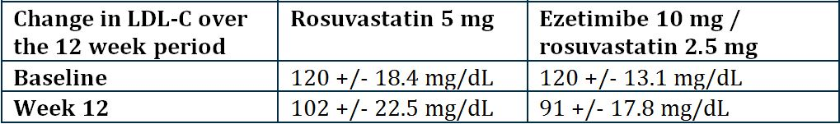

##### Okada et al. (2010)[25]

In the multicentre study described above, the benefit of combined therapy was higher in patients with a cholesterol absorption marker campesterol. Although this is interesting, it is not directly relevant to this application which is not requesting access to the combination for patients with specific cholesterol synthesis or absorption markers.

##### Okada et al. (2011)[26]

This is the same piece of work but focuses on the effect of the ezetimibe-statin combinations greater effect on LDL-C lowering than statins alone. Rosuvastatin was not mentioned in the abstract. Okada et al. (2011)[27] was the same work as above and hypothesised a mechanistic reason to support the effect of combination ezetimibe/statin therapy on cholesterol metabolism and did not differentiate the statins individually.

##### McDermott et al.[28]

This is a letter of reply to a study where the addition of ezetimibe to statins as a group showed greater LDL-C lowering. Post hoc analysis detailed in the letter showed that the increase in LDL-C lowering seen across the study was associated with more people taking more potent statins such as rosuvastatin at the study completion. This may have confounded the interpretation of the results if examining individual statin efficacy only.

##### Yamagishi[29]

In this study, 34 patients with dyslipidaemia, on rosuvastatin 2.5 mg and not meeting targets were half randomised to up-titration to 5 mg and half to addition of ezetimibe 10 mg for 6 months. Results are as Table 7. After rosuvastatin alone, patients had baseline LDL concentrations of 130.1 (+/- 34.4mg/dL) in the group randomised to rosuvastatin uptitration and 129 (+/- 21.7 mg/dL) in the group randomised to rosuvastatin and ezetimibe; 6 months after randomisation the LDL-C concentrations were 105.9 (+/- 26.7) and 88 (+/- 18.3) mg/dL, both reductions were statistically significant.

Table 7. Effects if the lipid profile after uptitrating from rosuvastatin 2.5 mg to rosuvastatin 5 mg (R uptitration group) or switching to rosuvastatin 2.5 mg plus ezetimibe 10 mg (R+E group).

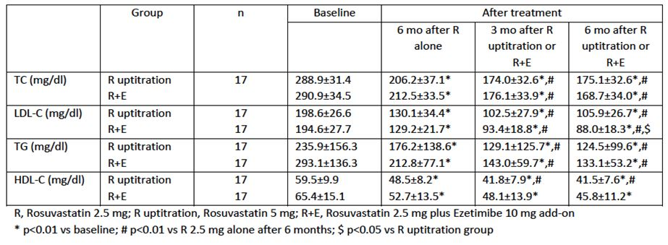

#### Addition of ezetimibe to rosuvastatin compared to addition of ezetimibe to other statins

There were numerous studies that examined the effect of the addition of rosuvastatin compared to the addition of ezetimibe to other statins.

##### Okada et al. (2011)[30]

This has been reviewed above.

##### Sharma et al.[31]

This was a randomised controlled prospective multicentre study to investigate the comparative efficacy of 2 FDC in dyslipidemia – atorvastatin/ezetimibe (10/10) and rosuvastatin/ezetimibe (10/10) in 244 Indian patients with hypercholesterolemia for 8 weeks. Although the rosuvastatin/ezetimibe combination significantly improved lipid parameters more than atorvastatin/ezetimibe, it should be noted that the dose proportionality for the statins may not have been reasonable, with 10 of rosuvastatin equating to 20-30 mg of atorvastatin on potency.

Micromedex states that the LDL-C lowering ability of rosuvastatin 10 mg is -45.7 vs 36.7% for atorvastatin 10 mg. Therefore the results above are not suprising (i.e. rosuvastatin/ezetimibe -41.6% vs atorvastatin/ezetimibe -31.5% in this study for LDL-C lowering).

##### Boufidou et al.[32]

This abstract was similar to the previous work i.e. 63% vs 59.4% for LDL-C lowering in rosuvastatin/ezetimibe vs. atorvastatin/ezetimibe for same dose statin.

##### Styliadis et al.[33]

In this 6 month study, there were 8 high risk males commenced on rosuvastatin and ezetimibe. No AEs were reported and 75% met the lipid targets, with LDL-C lowered by 60% from baseline.

##### Tripoten et al.[34]

This abstract was not directly applicable to this application as was unable to break down the rosuvastatin data from the other statins. Further, AE data was not reported.

##### Foody et al.[35]

This retrospective chart review compared statin titration (without specifying dose) vs. adding on ezetimibe. *Bias over selection decision and dose choice was not acknowledged but this is potentially a large confounder*. Further, tolerability was not reported.

##### Madrigal et al.[36]

This has been reviewed above.

##### Ballantyne et al.[37]

GRAVITY was a 12-week open label sponsor study that had 4 groups:

* Rosuvastatin 10 mg followed by Rosuvastatin 10/Ezetimibe 10
* Rosuvastatin 20 mg followed by Rosuvastatin 20/Ezetimibe 10
* Simvastatin 40mg followed by Simvastatin 40/Ezetimibe 10
* Simvastatin 80mg followed by Simvastatin 80/Ezetimibe 10

Each group took the statin alone for 6 weeks, followed after 6 weeks by the addition of ezetimibe.

The Clinical Trials documents[38] showed that percentage change in LDL-C (+/-SD) from baseline was -59.72 (14.166), -63.48 (16.697), -55.22 (15.75), -57.43 (20.46) across groups 1-4 respectively. This data was published in the abstract in Ballantyne et al.[39]

The data published in the Ballantyne et al.[40] was that where rosuvastatin 20/ezetimibe 10 significantly reduced LDL-C, trigylcerides, HDL and ApoB more than simvastatin 40/ezetimibe 10 or simvastatin 80/ezetimibe 10. However, this comparison is not directly relevant to this application, which is more about the added benefit of taking combination therapy over monotherapy.

##### Fras and Mikhailidis[41]

This has been reviewed above.

##### Teramoto et al.[42]

In this study, 53.8% of people in the primary prevention group (63.8% in the secondary prevention group) of patients achieved LDL-C targets when ezetimibe was added to a variety of statins which included rosuvastatin (100 patients in rosuvastatin and ezetimibe group). Specifically for rosuvastatin, the average (SD) LDL-C concentration reduced from 172.7 (35.4) to 116.9 (31.5) mg/dL, a -31.7% reduction (13.2%).

##### Inoue et al.[43]

This has been reviewed above.

##### Other studies of ezetimide and statins

###### Steg et al.[44]

This study is a randomised study without a control of 3 different counselling strategies in patients on a statin who have not met the target LDL-C and whom were commencing ezetimibe. The data for rosuvastatin (13% of patients) in this study was unable to be differentiated from that of other statins, but overall, there was a 30% reduction in LDL-C when ezetimibe was added to statin. AEs were not reported so this study is not directly relevant to the application.

###### SP-05464 study[45]

This was another study of change in LDL-C when ezetimibe is added onto an existing statin. Although rosuvastatin is one of the statins included, the study is presented as overall change in LDL-C with the combination, as opposed to statin monotherapy (32 +/- 15.59% vs. 26.8 +/- 19.85% for statin dose titration vs. 28.24 +/- 20.78% for a new statin).

###### Bennett et al.[46]

In this small study of 40 HIV patients that had been prescribed ezetimibe, 33 were eligible for analysis. 24 were taking statin co-therapy, 15 of these rosuvastatin. However, rosuvastatin data on its own was unable to be analysed (as opposed to analysis of all statins). The combination therapy altogether (i.e. all statins) showed a reduction in LDL-C compared to monotherapy by 26%.

###### Gonzalez et al.[47]

In this retrospective study of 256 patients who had not met LDL-C targets on a statin (16% of these patients on rosuvastatin), addition of 10 mg ezetimibe significantly reduced LDL-C from 160 +/- 42.8 to 100 +/-36mg/dL across all statins.

###### Gkogkos et al.[48]

The addition of 10 mg ezetimibe per day to a variety of statins at unspecified doses reduced LDL-C by 21% in a group of patients who had not met their LDL targets. The clinical relevance of that and any clinical endpoints were not measured nor commented on.

###### Igarashi et al.,[49] Teoh et al.[50] and Pitsavos et al.[51]

These were all studied in a similar vein – people with type 2 diabetes mellitus with dyslipidaemia, high risk atherosclerotic disease and HeFH and showed similar results.

###### Sakurada et al.[52]

This was similarly not directly relevant to the application as it compared the change in LDL-C in 11 patients on statins with new addition of ezetimibe compared to baseline. Further, only 1 of the patients actually had rosuvastatin and at low dose (2.5 mg). There was a -32.5% reduction in LDL-C in the combination group compared to baseline.

###### Toth et al.[53] and Morrone et al.[54]

These two abstracts were a pooled analysis of >21,000 patients from 27 trials that randomised people to statin (N = 10,517) or ezetimibe + statin (N = 11,714) for 6-24 weeks. The analysis showed that overall the combination reduced LDL-C by an additional 15.1 % (p<0.0001). Statins included rosuvastatin but the results were not stratified by type or dose in the abstract.

###### Tuncelli et al.[55]

This was a sponsor abstract that undertook a meta-analysis of RCTs of statin alone vs. statin-ezetimibe (13 studies with over 5000 patients). There was a significantly greater number of people who met their LDL-C targets in the combination group than the statin alone group. Weighted mean difference 14.11% (96% CI: 6.13, 12.1, p<0.001) further the odds ratio was 2.38 (95% CI 1.89-2.94, p < 0.001) of meeting the LDL-C goal in the combination group.

##### Non-relevant to the application

###### Kawashiri et al.[56]

In this abstract there was no data for the ezetimibe plus rosuvastatin vs ezetimibe alone as was all lumped in together with a colestamide group.

###### Hegele et al.,[57] Palcoux et al.,[58] Rallidis et al.[59] and Javed et al.[60]

Guo et al.,[61] Hermans et al.[62] and Kauffman et al.[63] are observational studies surveying numbers of people achieving LDL-C goals are also not directly relevant to this application.

Case reports submitted in this application were also not directly relevant to this application; specifically Mitchell and Bertorini,[64] Sorokin et al.,[65] Fung et al.[66] and King et al.[67] These all presented case reports of people achieving LDL-C goals and are not directly to this application.

### Evaluator’s conclusions on clinical efficacy

Overall, clinical efficacy in terms of greater LDL-C reduction was seen in both hypercholesterolemia and HoFH with the combination therapy. In the pivotal study P139V1, the addition of ezetimibe 10 mg to rosuvastatin (5 or 10 mg) daily for 6 weeks reduced LDL cholesterol significantly more than doubling the baseline dose of rosuvastatin. Pooled across strata, the LS mean percent change from baseline in LDL cholesterol at study endpoint was -20.96% on rosuvastatin (5 or 10 mg) + ezetimibe 10 mg but only -5.71% on rosuvastatin alone (10 or 20 mg).

Specifically addition of ezetimibe 10 mg to rosuvastatin 5 mg daily for 6 weeks reduced LDL-C to a greater extent than doubling the baseline dose to rosuvastatin 10 mg. The treatment difference was -12.31% (95% CI [Confidence Interval] -18.95, -5.67). The clinical significance of 5% reduction is not stated.

Addition of ezetimibe 10 mg to rosuvastatin 10 mg daily for 6 weeks reduced the levels of LDL-C more than doubling the baseline dose to rosuvastatin 20 mg. The treatment difference was -17.46% (95% CI -23.92, -10.99).

Addition of ezetimibe to rosuvastatin (5 or 10 mg) (pooled across doses) daily for 6 weeks resulted in a significantly greater proportion of patients reaching their LDL-C goal compared with doubling the baseline dose of rosuvastatin (pooled) (59.4 versus 30.9, adjusted odds ratio = -4.5, p = <0.001).

Data from this short term study with data on only 2 of the fixed dose combination (FDC) doses proposed in this application is of much higher direct relevance to this application than the 69 references which were all reviewed. Specifically, the data from the literature review is, in general, in short term studies examining the effect of combination therapy on LDL-C lowering compared to monotherapy alone. In this regard, the data for statins ezetimibe generally is very clearly supportive of the added efficacy on LDL-C targets. What is not so clear from these studies is the magnitude of the effects specifically from the use of rosuvastatin, a more potent statin than many of the statins used in the combined studies. Also, as the doses used in the studies were either not specified, or used a dose lower than that requested in this application (2.5 mg), the actual likely effect on LDL-C for each of the dosing combinations proposed in this application is not known with certainty.

The limitations of the data are thus three fold:

* the effect on clinical outcomes is not measured
* the long term efficacy was not measured
* the dose response of LDL-C for the different doses proposed in the FDC is not clear

Published guidelines[68] make reference to these issues. Specifically, the data has shown a reduction in LDL-C and other lipid targets for monotherapy as per the guidelines. However, the guidelines states that ‘in principle, combination strategies are not expected to be licensed as first line therapy on the basis on their effect on LDL-C and other lipid parameters, in particular triglyceride (TG) and HDL-C alone, unless the applicant is able to justify the benefit of such strategy in terms of morbidity and mortality.’

Most of the data in the review appeared to be in ‘high risk’ vascular patients or patients with hypercholesterolemia. Most of the data related to HoFH was in case reports; here there were patients still not meeting LDL-C targets with the combination (although many were, and in those who still did not meet targets, plasmapheresis appeared to be an effective additional therapy).

Importantly also, although the sponsor studies conform with Good Clinical Practice (GCP) guidelines, much of the literature is in abstract form and ethics approval is not stated.

The tolerability in short term studies appears to be similar to that seen with other statin ezetimibe studies, although long term data was not presented here.[69]

## Clinical safety

### Studies providing evaluable safety data

P139V1 provided evaluable safety data: many studies in the literature review (which included many retrospective audits) also collected clinical and/or laboratory safety data.

#### Pivotal efficacy studies

In the pivotal efficacy study P139V1 the following safety data were collected:

* General adverse events (AEs) were assessed by physical examination, ECG, vital signs, AE assessment and blood tests - hematology, blood chemistry, urinalysis CK, ALT, AST. The All Patients as Treated population was used for safety in this study - consisting of all randomised patients who received at least one dose of study treatment.
* The analysis of safety followed a 3-tiered approach
  + Tier 1: Including gastrointestinal related AEs, gallbladder-related AEs, allergic reaction or rash AEs, hepatitis-related AEs, elevations in ALT/AST ≥ 3 x ULN, elevations in CK ≥ 10 x ULN, elevations in CPK ≥ 10 x ULN with muscle symptoms and elevations in CPK ≥ 10 x ULN with drug-related muscle symptoms.
  + Tier 2: One or more AEs, drugs related AEs, serious AEs, discontinuations due to an AE
  + Tier 3 was everything else
* AEs of particular interest, including laboratory measurements of ALT/AST and CPK were assessed by laboratory tests.

Laboratory tests, including AST, ALT, CPK and urinalysis, were performed at Visits 1,3,4. Other tests included serum glucose, ALP, bicarbonate, urea, chloride, creatine kinase, creatinine, GGT, sodium, potassium, uric acid, bilirubin, TSH. Hematology collected at Visits 2,3,5 – blood hemoglobin, white cell count, platelets, red cell count, blood haematocrit. Urinalysis for blood, protein, glucose, creatinine and pH measured at Visits 1, 3 and 4.

Overall, the addition of ezetimibe to rosuvastatin was generally well tolerated across the groups. The overall safety profile also appeared generally comparable between treatment groups. Specifically, pooled across Strata, there were no clinically relevant differences between rosuvastatin (5 and 10 mg) + ezetimibe 10 mg and rosuvastatin (10 or 20 mg) in the proportion of patients with clinical adverse experiences, SAEs, drug related AEs leading to discontinuation.

There were no significant differences between rosuvastatin (5 or 10 mg) + ezetimibe 10 mg and rosuvastatin (10 or 20 mg) with respect to the percentage of patients with GI-related, allergic reactions or rash, and hepatitis-related AEs, elevations in ALT or AST ≥ 3x ULN or CK elevations ≥ 10x ULN. *As can be seen from the summary (Table 8), 3 (3%) in the rosuvastatin 5 mg + ezetimibe 10 mg and 2 (1.6%) in the rosuvastatin 10 mg /ezetimibe 10 mg discontinued due to a drug-related AE, cf 0 in either of the two rosuvastatin groups alone. These are small numbers but the fact that they occurred in the ezetimibe-combination groups and not the rosuvastatin alone should be highlighted.*

Table 8. Summary: Clinical AEs in P139V1.

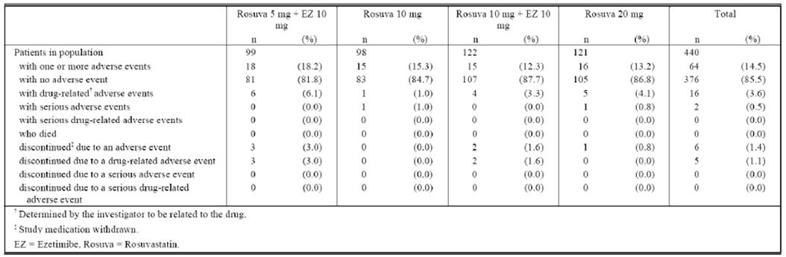

#### Pivotal studies that assessed safety as a primary outcome

There were no pivotal studies that assessed safety as a primary outcome.

Study P03317 (Section 5 and Section 18) was predominantly a pharmacodynamic study but additionally provided safety data for a 14 day study of ezetimibe +/- rosuvastatin combination. In this study there was an increase in ALT to 1.2 x upper limit of normal that had resolved at the follow-up visit.

#### Dose-response and non-pivotal efficacy studies

There was no formal dose-response or non-pivotal efficacy studies providing safety data, although P139V1 did examine two different doses or rosuvastatin.

#### Other studies evaluable for safety only

##### Periodic Safety Update Report (PSUR) for ezetimibe

During the six month reporting period of this PSUR (April 2011-October 2011), there were approximately 1,703,146 patient-years of treatment with ezetimibe with approximately 292 patients exposed to ezetimibe in Marketing Authorisation Holder (MAH) sponsored clinical trials.

In this reporting period, 433 spontaneous individual case safety reports (ICSRs) (88 serious) and 2 study ICSRs meeting PSUR criteria were received (Table 9). Until the cut-off date of this PSUR, 18, 178 spontaneous ICSRs (3213 serious) and 142 study ICSRs meeting PSUR criteria were received.

Table 9. Summary Tabulation of Spontaneous Reports from Healthcare Providers for Ezetimibe from 17 April 2011 to 16 October 2011.

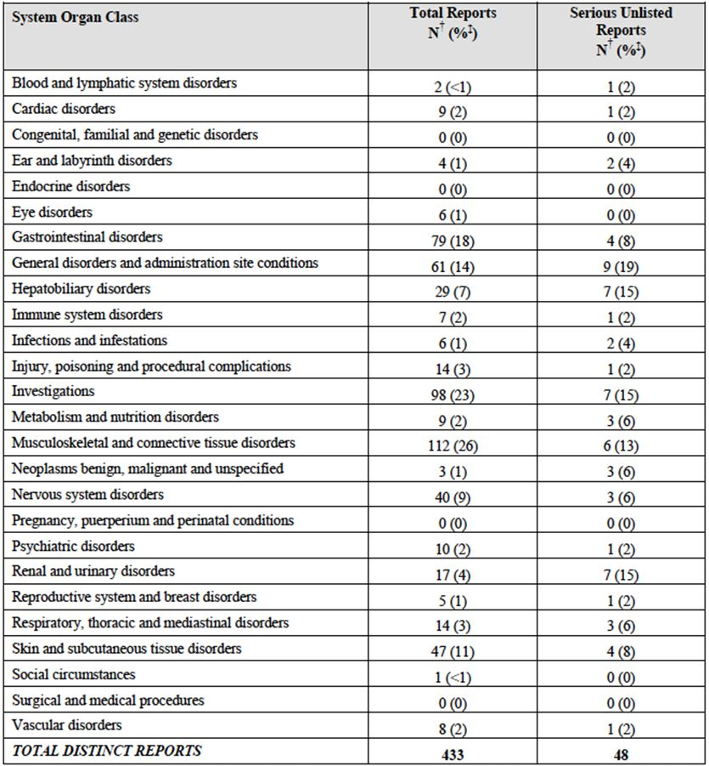

Hepatic failure, musculoskeletal and connective tissue disorders, neoplasms were the majority of the ICSRs but there were no new safety issues apparent.

During the reporting period, 7 efficacy-related ICSRs were identified by the MAH. A review of these ICSRs did not suggest a hazard to the treated population.

One quarter of the ICSRs received in this period were musculoskeletal, consisting of myalgia (59), muscle spasm (13), rhabdomyloysis (11), muscular weakness (10) and arthralgia (6). *Muscular weakness is not labelled in the company core data sheet (CCDS).*

In the gastrointestinal disorders (18% of all reports), the most frequent ADRS were diarrhoea (23), abdominal pain upper/lower (14), nausea (10) and constipation (7), all noted in the CCDS.

General disorders (14% of all reports) included malaise (11), fatigue (8), asthenia (6) and drug interactions (5). Fatigue and pain are listed in the CCDS *whilst asthenia and malaise are not*.

Skin and subcutaneous tissue disorder included rash (9), pruritis (5), alopecia (5), hyperhidrosis (4) and urticarial. These were all non serious apart from one report of urticarial. This is listed in the CCDS.

Overall the most serious unlisted ADRs were ARF, drug ineffective, general physical condition, drug interaction, deafness, autoimmune hepatitis, jaundice, neoplasm malignant, liver disorder, malaise and dyspnoea. Review of the serious ADR information raised no new safety concern. Overall there was no substantive change in frequency or severity of events reported.

*There was one fatal outcome in an elderly patient who developed pancreatitis whilst on ezetimibe.*

There were 5 possible drug reactions notified – 1 lacked information to make a decision, 3 of the 4 were with drugs that are known to interact – statin, coumarin products and cyclosporine. *1 had an impact on thyroxine which is not currently listed in the PI*

Review of the ICSRs revealed no new ADRs in the off label use of ezetimibe

Of the 18 reports identified for rhabdomyolysis, myopathy related events and CPK, 14 reports included confounding factors for the onset of the muscle related ADRs either concomitant statin therapy or related to underlying history or concomitant conditions that may have lowered the risk for myopathy. The remaining 4 cases did not have enough information for causal analysis. *It should be noted that one of the elevated CPKs were in a patient on concomitant rosuvastatin.*

##### Clinical pharmacology studies

###### P03317

In summary, there were no SAEs, deaths or withdrawal due to AE during the study. The occurrence of AEs was similar across the 4 treatment groups. There were no other clinically significant abnormalities detected in laboratory measurements although there were values outside the reference range. There were no abnormalities in urinalysis.

No abnormalities in vital signs, physical examination and ECG findings were noted during the study (ECG done at screening only).

Study P139V1 is covered below as pivotal efficacy study.

### Pivotal studies that assessed safety as a primary outcome

Nil.

### Patient exposure

The application relies on the approvals of the individual components of the combination as well as the world-wide exposure to the monotherapy components, the safety data in the two new trials P139V1 and P00317 and the literature which includes observational data and the PSUR for 6 months (April-October 2011), covered above.

In the literature review, the number of patients being co-administered ezetimibe and rosuvastatin was identified in 40 datasets (over 2700 patients). Approximately 250 patients received the combination for 52 weeks. In other datasets, the design or the reporting of the study meant that rosuvastatin could not be distinguished from other statins, or numbers of patients on rosuvastatin were not stated.

The overall duration included studied from 2 weeks to more than 52 weeks. Dose went from 2.5 mg (lower than that proposed) to 40 mg daily, however the 40mg studies were largely observational.

Table 10. Summary of overall extent of exposure from all studies with clearly distinguishable co-administration of ezetimibe and rosuvastatin.

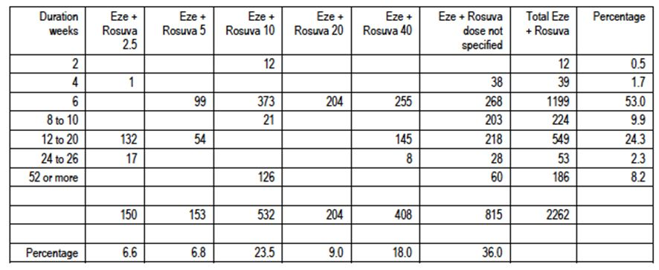

#### Individual components

Ezetimibe was first approved in 2003. Both efficacy and safety data from that application, and that from co-administration with other statins summarised in the Australian PI, is used as supporting evidence.

MSD Rosuvastatin, the rosuvastatin used in the proposed FDC was approved in 2012 and the safety text is taken from the PI for MSD Rosuvastatin.

Safety and efficacy data for the combination are taken from the two new studies P03317 and P139V1 and from the literature.

##### Two new studies

Study P139VI examined the use of rosuvastatin 5 mg, rosuvastatin 10 mg, rosuvastatin 20 mg and ezetimibe 10 mg for up to 6 weeks in 440 patients.

Study P03317 examined the use of rosuvastatin 10 mg and ezetimibe in 40 patients for 40 days.

##### Literature

Overall exposure for ezetimibe and rosuvastatin included identifiable co-administration of ezetimibe and rosuvastatin in over 2262 patients. *However, only 186 received the combination for 52 weeks*, yet many of those in the proposed population will be using this medication for many years. The doses used in these studies ranged from 2.5 to 40 mg, however there were very small numbers with the 2.5 mg and 40 mg dose. Patient population included men and women up to the age of 89 and had hypercholesterolemia. Many also had CHD risk factors. There were studies and case reports of people with HoFH, in some studies these were included with HeFH. Only 27 of these presented safety data however.

### Adverse events

#### All adverse events (irrespective of relationship to study treatment)

##### Pivotal studies P139V1

Overall the safety profile between the groups was comparable i.e. between rosuvastatin 5 or 10 mg + ezetimibe and rosuvastatin 10 or 20 mg. Specifically, there was no differences between these groups in gastrointestinal-related, allergic reactions or rashes, and hepatic-related clinical adverse reactions, percentages of patients with ALT ≥ 3x ULN and CPK ≥ 10x ULN. There were no ALT ≥ 3x ULN and CPK ≥ 10x ULN associated with muscle symptoms and gallbladder related events.

##### Other studies P03317

Headache, flatulence, pharyngitis, rhinitis, abdominal pain and myalgia were reported in Study P03317. Only 7 subjects reported AEs that were considered moderate in intensity. The occurrence of AEs was similar among the four treatment groups (Table 11).

Table 11. Study P03317 - Frequency of treatment related treatment emergent AEs by body system.

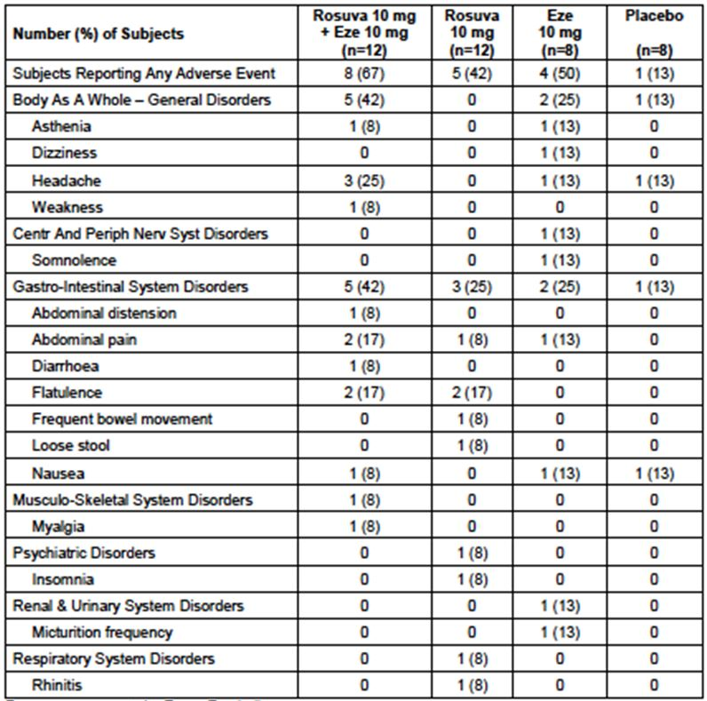

#### Treatment-related adverse events (adverse drug reactions)

##### Pivotal studies - P139V1

Overall, 64 out of 440 patients (14.5%) reported one or more AE, the most common were gastrointestinal (Tables 12-13). A total of 16 were reported as having a drug-related AE. *It is noted that there were double the number of drug-related AEs in the groups with ezetimibe - with 10 (4.5%) on rosuvastatin (5 or 10 mg) + ezetimibe 10 mg and 6 (2.7%) on rosuvastatin 10 or 20 mg.*

Table 12. Summary of ADRs in Study P139V1.

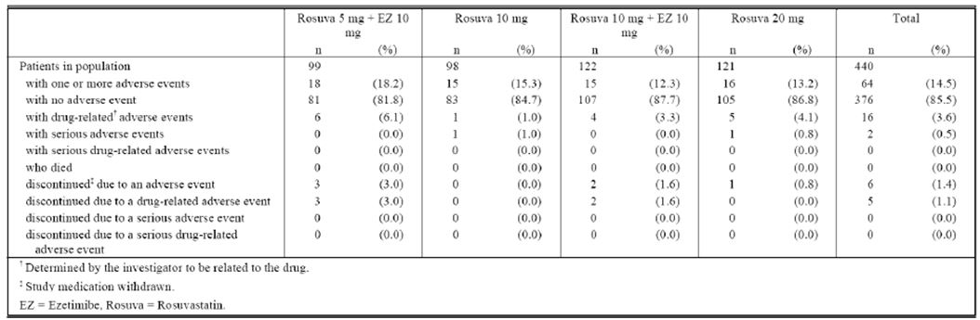

Table 13. Analysis of patients with Tier I AEs of special interest (incidence >0 patients in one or more treatment groups) across strata (all patients as treated population).

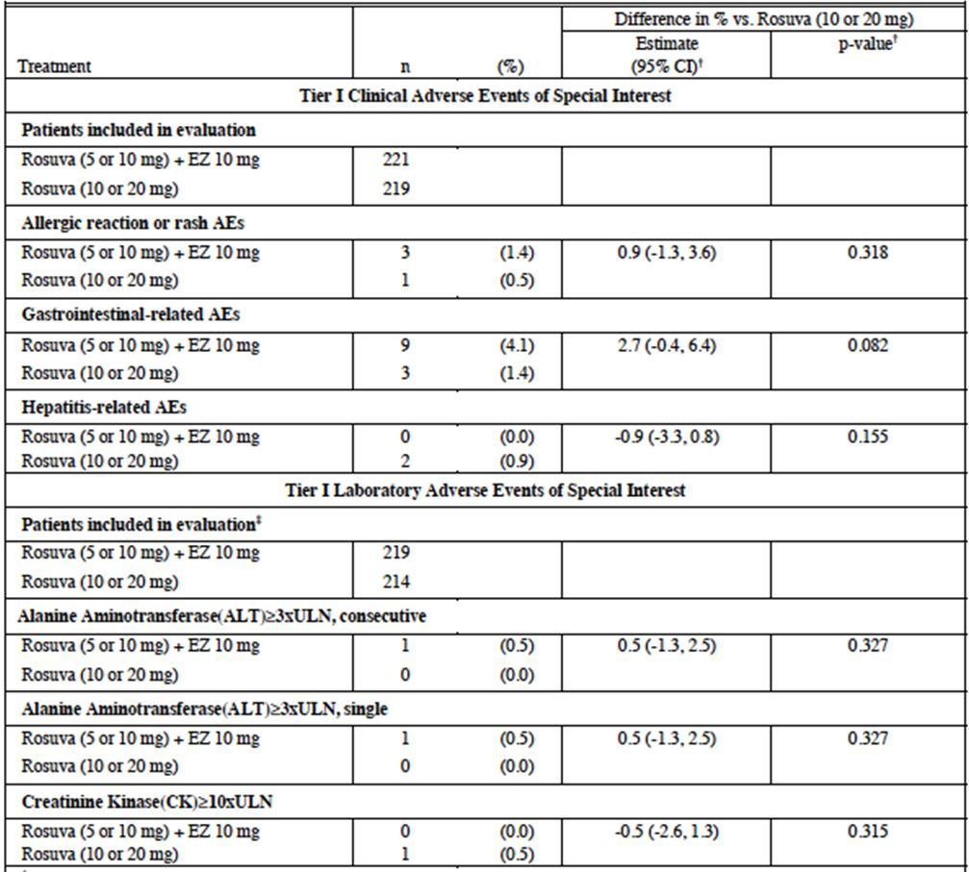

Gastrointestinal events were the most common, with 5 out of 7 of these occurring in the combination group and 2 occurring in the rosuvastatin 20 mg group (Table 14).

Table 14. Patients with drug related clinical AEs (incidence >0% in one or more treatment groups) (all patients as treated population).

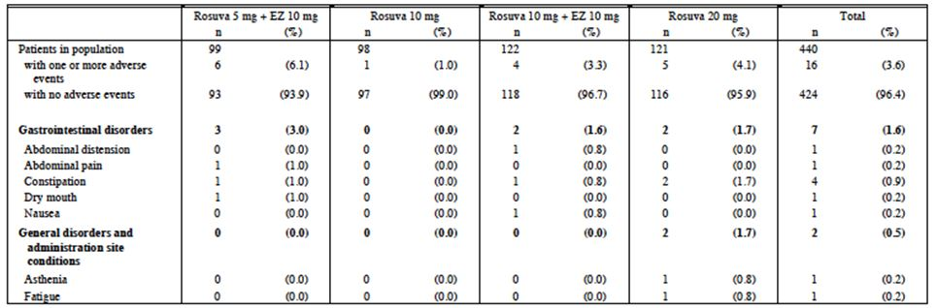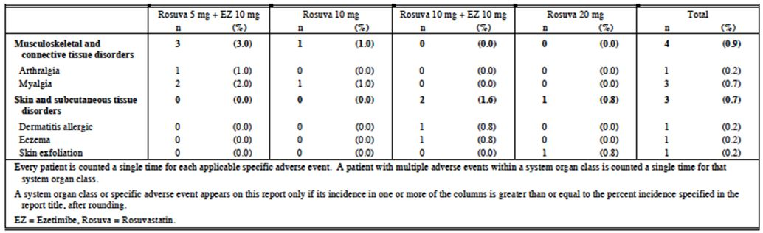

##### Other studies

In P03317 (Kosoglou et al.[70] and Schering Plough[71]), 3 subjects had elevated ALT <1.2 x ULN which resolved at the end of the study. In this study, 9/40 reported musculoskeletal complaints including pain and myalgia. All reports of myalgia were transient and considered not treatment related. None were associated with elevated CPK.

###### Literature Review

* The EXPLORER study[72] reported elevated transaminases up to 3x ULN but did not lead to discontinuation.
* Sharma[73] reported no abnormalities in ECG, clinical lab tests or vitals.
* Yamagishi[74] reported no differences in biochemical data in combination (2.5 mg/10 mg) vs. rosuvastatin (5 mg) alone.
* Kouvelos et al.[75] reports of elevated CK and ALT in both groups (10 mg/10 mg) and rosuvastatin 10 mg alone.
* Steg et al.[76] did not differentiate the statins but CPK elevations 5 x ULN were seen in two patients after the addition of ezetimibe (0.1%). A patient (0.1%) developed ALT> 3 x ULN after commencing ezetimibe.
* Sawayama et al.[77] 1 ezetimibe and 3 ezetimibe + rosuvastatin 2.5 had slight increase in AST, 1 in each group had slight increase in ALT.
* In the studies reported by Leibovitz et al.,[78] Fras and Mikhailidis,[79] Bennett et al.,[80] González et al.,[81] Igarashi et al.,[82] Ose et al.,[83] Stein et al.[84] and Pitsavos et al.,[85] no elevations in enzyme levels were reported.
* Sakurada et al.[86] one patient had elevated CPK but confounded by heavy labour before the study test. In a case report in HoFH from Martinez et al.[87] the patients were treated with ezetimibe 10 mg/rosuvastatin 20 mg then ezetimibe 10 mg/rosuvastatin 40mg – treatment was then suspended due to elevations in transaminases.

#### Deaths and other serious adverse events

##### Pivotal studies- P139V1

There were no deaths in this study.

SAEs: 1 on rosuvastatin 10 mg (tendon rupture), 1 on rosuvastatin 20 mg (sick sinus syndrome). Neither SAEs were considered to be drug related.

##### Other studies P03317

No deaths reported and, no SAEs and no treatment withdrawals.

#### Discontinuation due to adverse events

##### Pivotal studies P139V1

The proportion of patients with clinical AEs, SAEs, drug related AEs or AEs leading to discontinuation were slightly higher among the treatment groups with ezetimibe, although numbers were small. Specifically, the numbers of patients with known side effects from either ezetimibe or rosuvastatin such as myalgia, allergic reaction and elevated enzymes were small.

Overall, 6 patients (1.4%) discontinued study therapy due to a clinical AE:

* 5 patients (2.3%) in the rosuvastatin (5 or 10 mg) + ezetimibe 10 mg group with arthralgia, constipation, myalgia, dermatitis (allergic and eczema)
* 1 patient (0.5%) in the rosuvastatin (10 or 20 mg) group with dizziness

There were 5 patients who had myalgia:

* 2 on rosuvastatin 5 mg + ezetimibe
* 1 on rosuvastatin 10 mg
* 2 on rosuvastatin 20 mg

There were 4 patients who had an allergic reaction or rash:

* 3 in the rosuvastatin 10 mg/ezetimibe 10 mg had allergic dermatitis, eczema and rash
* 1 from rosuvastatin 20 mg group had skin exfoliation

There were 12 patients (2.7%) with gastrointestinal AEs:

* 9 in the rosuvastatin (5 or 10 mg) + ezetimibe 10 mg group,
* 3 (1.4%) in the rosuvastatin 10 or 20 mg group

No gallbladder-related AEs were reported during the study

Two (2) patients from the rosuvastatin (10 or 20 mg) group experienced increased bilirubin and GGT.

##### Other studies P03317

No treatment withdrawals.

### Laboratory tests

There were no further abnormal liver, renal, other chemistry, urinalysis, haematology results.

#### Electrocardiograph (ECG) and vital signs

##### Nil abnormalities in ECG and vital signs.

### Post-marketing experience

This has been covered above with the previous exposure to the individual components of this FDC and the PSUR for ezetimibe. There are known safety issues with both if these individual components but nil new are apparent for the FDC.

### Evaluator’s overall conclusions on clinical safety

There appear to be no new safety issues with the use of these two compounds together as opposed to the two components individually as monotherapy. It is difficult to make causality judgements without information regarding the fatal outcome due to pancreatitis in an elderly woman on rosuvastatin commencing ezetimibe. However, the practice of lowering LDL to meet ‘targets’ in an elderly woman deserves some discussion; specifically around a cut off age in the indication. The application states there is worldwide exposure to people up to the age of 89 years old.

It is noted that there were several reports in the ezetimibe PSUR of AEs which were not part of the Company Core Data Sheet (CCDS). These included:

* Muscular weakness
* Asthenia and malaise

Also in the PSUR, there were 5 possible drug interactions notified, 4 of which were on drugs known to interact with ezetimibe. 1 report describes a potential interaction with thyroxine which is not currently listed in the PI.

It should be noted that one of the elevated CPKs was in a patient on concomitant rosuvastatin.

In the pivotal Study P139V1, the summary of AEs showed that 3 (3%) in the rosuvastatin 5 mg + ezetimibe 10 mg and 2 (1.6%) in the rosuvastatin 10 mg/ezetimibe 10 mg discontinued due to a drug related AE, compared to zero in either of the two rosuvastatin groups alone even though these were used at double the dose. These are small numbers but the fact that they occurred in the ezetimibe combination groups and not the rosuvastatin alone should be highlighted. These also included a doubling of GI AEs in the combination arms compared to the double dose rosuvastatin.

In the literature study, use of the combination was very short; often 4-6 weeks and therefore safety data was either not reported, or unlikely to occur to the short term nature of the studies. In the study by Steg et al.,[88] statins as a group were not differentiated but it should be noted that CPK elevations 5x ULN were seen in two patients after the addition of ezetimibe (0.1%). A patient (0.1%) developed ALT >3x ULN after commencing ezetimibe.[89]

## First round benefit-risk assessment

### First round assessment of benefits

The benefits of Ezalo/Rosuzet in the proposed usage are:

* Lowers LDL-C than either drug alone;
* May reduce difficulties of people taking two drugs in two different packaging at once;
* Reduces the need to use high doses of potent statin, by providing an alternative LDL-C lowering agent;
* Lowers co-payment for people taking the two drugs separately, although this is not relevant in the context of this report and is beyond the remit of the TGA.

### First round assessment of risks

The risks of Ezalo/Rosuzet in the proposed usage are:

* There is no clinical data to show that the use of both drugs reduced clinical endpoints compared to monotherapy, although it is known that lowering LDL-C in population studies (notably predominantly with statins) has shown LDL-C to be a surrogate marker of clinical outcomes;
* Increased side effects compared to using monotherapy or from doubling the dose of statin;
* May encourage use of two therapies when one in higher dose could suffice.

### First round assessment of benefit-risk balance

The benefit-risk balance of Ezalo/Rozuset is unfavourable given the proposed usage, but would become favourable if the changes recommended are adopted, specifically a tightened indication.[90]

## First round recommendation regarding authorisation

The requested indication is:

***Primary Hypercholesterolaemia:*** *Rosuzet Composite Pack and Ezalo Composite Pack is indicated as adjunctive therapy to diet in patients with primary (heterozygous familial and non-familial) hypercholesterolaemia where use of a combination product is appropriate in those patients:*

* + - *Not appropriately controlled with rosuvastatin or ezetimibe alone; or*
    - *Already treated with rosuvastatin and ezetimibe.*

***Homozygous Familial Hypercholesterolaemia (HoFH):*** *Rosuzet Composite Pack and Ezalo Composite Pack is indicated for patients with HoFH. Patients may also receive adjunctive treatments (e.g., LDL apheresis).*

Based on the evidence in this report and safety and efficacy data from previous submissions, the evaluator believes there is reasonable support from both an efficacy basis (lowering LDL-C) and safety (known safety profile of both drugs) to support an application for a FDC. However, without clinical data from the LDL-C lowering perspective, any benefit to the population is uncertain. Further, the justification to reduce an extra script cost is non compelling given the lack of evidence showing any effect in a population that is already on a number of medications, and the effect of a prescription safety net for high users. It is also beyond the remit of the TGA.

The indication needs to be tighter with an explicit statement not to be used as a first line agent, and in people who are already stabilised on doses of the two drugs individually. Lastly, the doses studied in the two new studies were 10/5 ezetimibe/rosuvastatin and 10/10 ezetimibe/rosuvastatin versus 10 and 20 mg rosuvastatin, and 10 mg rosuvastatin versus 10 mg combination ezetimibe/rosuvastatin. The efficacy and safety evidence for the 40 mg is provided in some of the observational data in the literature review, but is single cases or non randomised, small numbers and observational data only. Similarly, the data for the benefit of the FDC which includes rosuvastatin 2.5 mg is also weak, with small numbers only. Evidence for the benefit of 20 mg/10 mg FDC compared to 20 mg rosuvastatin alone was also sparse. Therefore, the evaluator believes that the 2.5 mg, the 20 and the 40 mg rosuvastatin dose in the FDC should not be included until further data is available.

Specifically the evaluator is concerned that although it is likely, evidence of an actual clinical benefit from the LDL-C lowering, or of a benefit that outweighs risk (increased side effects) of taking combination therapy has not been clearly demonstrated. Although the additional LDL-C lowering benefit is clearly seen, the translation of a percentage change in LDL-C on clinical outcomes is assumed from data using predominantly statin populations. The size of that benefit from combination therapy on outcomes here is thus difficult to have certainty in. This could be mitigated by a statement in the PI to this effect.

The only clinical data supplied in this submission that queries the strength of this assumption was the published study (Kouvelos et al.[91]) examining the risk of cardiovascular events in a group receiving rosuvastatin 10 mg versus rosuvastatin 10 mg/ezetimibe 10 mg. Here there was no difference between the two groups (p = 0.72).

Thus, the recommendation of this evaluator would be to recommend approval of the FDC in the 5 and 10 mg rosuvastatin-ezetimibe FDC but for people who are already stabilised on the two therapies. Without clinical endpoint data the evidence does not support it being used first line.[92] This is also consistent with published guidelines.[93]

## Clinical questions

None.

1. Kosoglou T, et al. (2004) Pharmacodynamic interaction between ezetimibe and rosuvastatin. *Current Medical Research and Opinion* 20: 1185-1189.
2. Kosoglou T, et al. (2004) M.660 Pharmacodynamic interaction between ezetimibe and rosuvastatin. *Atherosclerosis Supplements* 5: 153.
3. Schering-Plough/Merck . (2008) Assessment of potential interaction between ezetimibe and rosuvastatin in healthy subjects with high cholesterol (P00317) <clinicaltrials.gov/show/ NCT00651144>.
4. Bays HE, et al. (2011) Safety and efficacy of ezetimibe added on to rosuvastatin 5 or 10 mg versus up-titration of rosuvastatin in patients with hypercholesterolemia (the ACTE Study). *Am J Cardiol.* 108: 523-530; Bays HE, et al. (2011) Efficacy and safety of ezetimibe plus rosuvastatin versus rosuvastatin up-titration in hypercholesterolemic patients at risk for atherosclerotic coronary heart disease. *J Clin Lipidol.* 5: 217-218; Merck. (2011) A study of ezetimibe added on to rosuvastatin versus up titration of rosuvastatin in patients with hypercholesterolemia (MK0653-139) <clinicaltrials.gov/show/ NCT00783263>.
5. Ballantyne CM, et al. (2007) Efficacy and safety of rosuvastatin 40 mg alone or in combination with ezetimibe in patients at high risk of cardiovascular disease (results from the EXPLORER study). *Am J Cardiol.* 99: 673-680.
6. Kouvelos GN, et al. (2013) Effects of rosuvastatin with or without ezetimibe on clinical outcomes in patients undergoing elective vascular surgery: results of a pilot study. *J Cardiovasc Pharmacol Ther.* 18: 5-12.
7. Sawayama Y, et al. (2010) Efficacy and safety of ezetimibe for Japanese patients with dyslipidaemia: The ESSENTIAL Study. *Clin Drug Investig.* 30: 157-66.
8. Ballantyne CM, et al. (2007) Efficacy and safety of rosuvastatin 40 mg alone or in combination with ezetimibe in patients at high risk of cardiovascular disease (results from the EXPLORER study). *Am J Cardiol.* 99: 673-680.
9. Ballantyne CM, et al. (2007) Efficacy and safety of rosuvastatin 40 mg alone or in combination with ezetimibe in patients at high risk of cardiovascular disease (results from the EXPLORER study). *Am J Cardiol.* 99: 673-680.
10. Kouvelos GN, et al. (2013) Effects of rosuvastatin with or without ezetimibe on clinical outcomes in patients undergoing elective vascular surgery: results of a pilot study. *J Cardiovasc Pharmacol Ther.* 18: 5-12.
11. Sawayama Y, et al. (2010) Efficacy and safety of ezetimibe for Japanese patients with dyslipidaemia: The ESSENTIAL Study. *Clin Drug Investig.* 30: 157-66.
12. Inoue I, et al. (2010) Retrospective, observation study: Quantitative and qualitative effect of ezetimibe and HMG-CoA reductase inhibitors on LDL-cholesterol: are there disappearance thresholds for small, dense LDL and IDL? *Recent Pat Cardiovasc Drug Discov.* 5: 143-152; Leibovitz E, et al. (2006) Th-P16:276 Efficacy and safety of rosuvastatin-ezetemibe combination for the treatment of severe hypercholesterolemia. *Atherosclerosis Supplements* 7: 554; Madrigal J, et al. (2007) Efectos de la combinacion de ezetimiba mas estatinas sobre los lipidos en pacientes mexicanos. (Ezetimiba plus statins effects over lipids in Mexican patients). *Medicina Interna de Mexico* 23: 280-285; Ose L, et al. (2005) W16-P-064 Ezetimibe added to rosuvastatin for severely hypercholesterolemicpatients: Effects on lipid measures and C-reactive protein. *Atherosclerosis Supplements* 6: 117; Stein E, et al. (2005) Ezetimibe added to rosuvastatin for severely hypercholesterolemic patients: effects on low-density lipoprotein cholesterol and C-reactive protein, in 54th Annual Scientific Session of the American College of Cardiology, Journal of American College of Cardiology: Orlando, Florida USA. p. 392A; Stein EA, et al. (2007) Further reduction of low-density lipoprotein cholesterol and C-reactive protein with the addition of ezetimibe to maximum-dose rosuvastatin in patients with severe hypercholesterolemia. *J Clin Lipidol.* 1: 280-286; Fras Z, Mikhailidis DP. (2008) Statin plus ezetimibe treatment in clinical practice: the SI-SPECT (Slovenia (SI) Statin Plus Ezetimibe in Cholesterol Treatment) monitoring of clinical practice study. *Current Medical Research and Opinion* 24: 2467-2476.
13. Inoue I, et al. (2010) Retrospective, observation study: Quantitative and qualitative effect of ezetimibe and HMG-CoA reductase inhibitors on LDL-cholesterol: are there disappearance thresholds for small, dense LDL and IDL? *Recent Pat Cardiovasc Drug Discov.* 5: 143-152.
14. Leibovitz E, et al. (2006) Th-P16:276 Efficacy and safety of rosuvastatin-ezetemibe combination for the treatment of severe hypercholesterolemia. *Atherosclerosis Supplements* 7: 554.
15. Madrigal J, et al. (2007) Efectos de la combinacion de ezetimiba mas estatinas sobre los lipidos en pacientes mexicanos. (Ezetimiba plus statins effects over lipids in Mexican patients). *Medicina Interna de Mexico* 23: 280-285.
16. Ose L, et al. (2005) W16-P-064 Ezetimibe added to rosuvastatin for severely hypercholesterolemicpatients: Effects on lipid measures and C-reactive protein. *Atherosclerosis Supplements* 6: 117.
17. Stein E, et al. (2005) Ezetimibe added to rosuvastatin for severely hypercholesterolemic patients: effects on low-density lipoprotein cholesterol and C-reactive protein, in 54th Annual Scientific Session of the American College of Cardiology, Journal of American College of Cardiology: Orlando, Florida USA. p. 392A.
18. Stein EA, et al. (2007) Further reduction of low-density lipoprotein cholesterol and C-reactive protein with the addition of ezetimibe to maximum-dose rosuvastatin in patients with severe hypercholesterolemia. *J Clin Lipidol.* 1: 280-286.
19. Fras Z, Mikhailidis DP. (2008) Statin plus ezetimibe treatment in clinical practice: the SI-SPECT (Slovenia (SI) statin plus ezetimibe in cholesterol treatment) monitoring of clinical practice study. *Current Medical Research and Opinion* 24: 2467-2476.
20. Sakuma I, Kishimoto N. (2009) Abstract: P968 Quarter and a half dose of rosuvastatin plus ezetimibe ameriolated LDL-cholesterol, other lipid parameters and high sensitive CRP compared with regular dose rosuvastatin alone. *Atherosclerosis Supplements* 10: e1122.
21. Nagai Y. (2009) Effects of ezetimibe in patients with hypercholesterolemia. *Yakuri To Chiryo* 37: 325-332.
22. Okada K, et al. (2011) Clinical usefulness of additional treatment with ezetimibe in patients with coronary artery disease on statin therapy - From the viewpoint of cholesterol metabolism. *Circ J.* 75: 2496-2504.
23. Yamagishi T. (2010) Efficacy and safety of ezetimibe added onto rosuvastatin (2.5 mg) compared with uptitration of rosuvastatin (5 mg) in hyperlipidemic patients. *Jpn Pharmacol Ther.* 38: 305-311.
24. Okada K, et al. (2011) Clinical usefulness of additional treatment with ezetimibe in patients with coronary artery disease on statin therapy - From the viewpoint of cholesterol metabolism. *Circ J.* 75: 2496-2504.
25. Okada K, et al. (2010) Measuring the baseline cholesterol absorption and synthesis marker can predict the LDL-C lowering response to ezetimibe-statin combination therapy in patients with coronary artery disease: a multi-centre prospective randomized trial. *Circ J.* 122(21 Suppl.): 1-3.
26. Okada K, et al. (2011) Long-term effect of ezetimibe-plus-statin vs double-dose statin on low-denstiy lipoprotein cholesterol lowering in coronary artery disease patients pre-treated with a statin focus on cholesterol absorption and synthesis. *Circ J.* 124(21 Suppl.): A12204
27. Okada K, et al. (2011) Long-term effect of ezetimibe-statin combination therapy on low-density lipoprotein cholesterol lowering in patients with coronary artery disease; focus on cholesterol absorption and synthesis. *J Am Coll Cardiol.* 57(14 Suppl.): E524.
28. McDermott M, et al. (2012) The Reply. *Am J Med.* 125: e15-e16.
29. Yamagishi T. (2010) Efficacy and safety of ezetimibe added onto rosuvastatin (2.5 mg) compared with uptitration of rosuvastatin (5 mg) in hyperlipidemic patients. *Jpn Pharmacol Ther.* 38: 305-311
30. Okada K, et al. (2011) Clinical usefulness of additional treatment with ezetimibe in patients with coronary artery disease on statin therapy - From the viewpoint of cholesterol metabolism. *Circ J.* 75: 2496-2504; Okada K, et al. (2011) Long-term effect of ezetimibe-plus-statin vs double-dose statin on low-denstiy lipoprotein cholesterol lowering in coronary artery disease patients pre-treated with a statin focus on cholesterol absorption and synthesis. *Circ J.* 124(21 Suppl.): A12204.
31. Sharma AD, et al. (2008) Comparative evaluation of the efficacy, tolerability and safety of rosuvastatib + ezetimibe and atorvastatin + ezetimibe in Indian patients with dyslipidaemia. *Arteriothrombosis* e97.
32. Boufidou A, et al. (2007) PO23-757 comparison of the efficacy and safety of 6 months co-administration of atorvastating/ezetimibe versus rosuvastatin/ezetimibe in mixed dyslipidemia. *Atherosclerosis Supplements* 8: 202.
33. Styliadis IH, et al. (2007) PO23-758 efficacy and safety of 6 months co-administration of ezetimibe plus rosuvastatin in patients with mixed dyslipidemia. *Atherosclerosis Supplements* 8: 202.
34. Tripoten M, et al. (2010) Arterial wall function in patients with coronary artery disease and dyslipidaemia, comparative efficacy of ezetimibe, statins and their combination (abstract). *Artery Research* 157.
35. Foody J, et al. (2011) Changes in LDL-C levels and goal attainment associated with adding ezetimibe onto simvastatin, atorvastatin and rosuvastatin compaed with titrating statins. *Atherosclerosis* 1(12 Suppl.): 19; Foody JM, et al. (2011) Changes in LDL-C levels and goal attainment associated with adding ezetimibe onto simvastatin, atorvastatin, and rosuvastatin versus titrating statins. *J Clin Lipid.* 5: 207-208; Foody J, et al. (2011) Changes in LDL-C levels and goal attainment associated with addition of ezetimibe to simvastatin, atorvastatin and rosuvastatin compared with titrating statin monotherapy. *Eur J Cardiovasc Prev Rehabil.* 18(1 Suppl. 1): S79.
36. Madrigal J, et al. (2007) Efectos de la combinacion de ezetimiba mas estatinas sobre los lipidos en pacientes mexicanos. (Ezetimiba plus statins effects over lipids in Mexican patients). *Medicina Interna de Mexico* 23: 280-285.
37. Ballantyne CM, et al. (2010) Randomized comparison of rosuvastatin plus ezetimibe versus simvastatin plus ezetimibe: results of the GRAVITY study. *J Am Coll Cardiol.* 55: A49.E463; Ballantyne CM, et al. (2010) A randomised comparison of rosuvastatin plus ezetimibe vs simvastatin plus ezetimibe: results of the GRAVITY (abstract). *Atherosclerosis Supplements* 11: 69; AstraZeneca (2008) 12 Week open label Phase IIIb study comparing efficacy and safety of rosuvastatin or simvastatin (CRESTOR TM) in combination with ezetimibe (GRAVITY) in LDL in patients with hypercholesterolemia and CHD or a CHD equivalent, atherosclerosis or a 10-year CHD risk of >20%. ClinicalTrials.gov NCT00525854
38. AstraZeneca (2008) 12 Week open label Phase IIIb study comparing efficacy and safety of rosuvastatin or simvastatin (CRESTOR TM) in combination with ezetimibe (GRAVITY) in LDL in patients with hypercholesterolemia and CHD or a CHD equivalent, atherosclerosis or a 10-year CHD risk of >20%. ClinicalTrials.gov.au NCT00525854.
39. Ballantyne CM, et al. (2010) Randomized comparison of rosuvastatin plus ezetimibe versus simvastatin plus ezetimibe: results of the GRAVITY study. *J Am Coll Cardiol.* 55: A49.E463.
40. Ballantyne CM, et al. (2010) A randomised comparison of rosuvastatin plus ezetimibe vs simvastatin plus ezetimibe: results of the GRAVITY (abstract). *Atherosclerosis Supplements* 11: 69.
41. Fras Z, Mikhailidis DP. (2008) Statin plus ezetimibe treatment in clinical practice: the SI-SPECT (Slovenia (SI) statin plus ezetimibe in cholesterol treatment) monitoring of clinical practice study. *Current Medical Research and Opinion* 24: 2467-2476.
42. Teramoto T, et al. (2012) Cross-sectional survey to assess the status of lipid management in high-risk patients with dyslipidemia: clinical impact of combination therapy with ezetimibe. *Curr Ther Res.* 73:1-15
43. Inoue I, et al. (2010) Retrospective, observation study: Quantitative and qualitative effect of ezetimibe and HMG-CoA reductase inhibitors on LDL-cholesterol: are there disappearance thresholds for small, dense LDL and IDL? *Recent Pat Cardiovasc Drug Discov.* 5: 143-152.
44. Steg PG, et al. (2008) A randomised trial of three counselling strategies for lifestyle changes in patients with hypercholesterolemia treated with ezetimibe on top of statin therapy (TWICE). *Archives of Cardiovascular Diseases* 101: 723-735.
45. Schering-Plough (2008) Observational study of approaches to lipid-lowering therapy in Russian patients with coronary heart disease. Clinicaltrials.gov. NCT00730132.
46. Bennett MT, et al. (2007) Ezetimibe is effective when added to maximally tolerated lipid lowering therapy in patients with HIV. *Lipids Health Dis.* 6: 15.
47. González C, et al. (2007) Effectiveness and safety of ezetimibe added to statin therapy in patients with primary dyslipidaemia not achieving the LDL-C treatment goal on statin monotherapy. *Clin Drug Investig.* 27: 333-337.
48. Gkogkos K, et al. (2007) PO23-783 Achieving treatment targets combining a statin with ezetimibe. *Atherosclerosis Supplements* 8: 208.
49. Igarashi M, et al. (2010) Effect of ezetimibe on the changes of lipids and metabolic outcomes in type 2 diabetic patients with dyslipidemia. *Ther Res.* 31: 389-397.
50. Teoh H, et al. (2009) Usefulness of statin-ezetimibe combination to reduce the care gap in dyslipidemia management in patients with a high risk of atherosclerotic disease. *Am J Cardiol.* 104: 798-804.e2.
51. Pitsavos C, et al. (2009) The impact of ezetimibe and high-dose of statin treatment on LDL levels in patients with heterozygous familial hypercholesterolemia. *Int J Cardiol.* 134: 280-281.
52. Sakurada M, et al. (2008) Efficacy of ZETIA: Intestinal cholesterol transporter inhibitor, as mono therapy and combination therapy with statin in patients with hypercholesterolemia. *Yakuri To Chiryo* 36: 811-815.
53. Toth PP, et al. (2011) 75 efficacy of ezetimibe/statins and statin monotherapy and factors associated with treatment response: pooled analysis of >21,000 subjects from 27 trials. *Atherosclerosis Supplements* 12: 18.
54. Morrone D, et al. (2011) Efficacy of ezetimibe/statins and statin monotherapy and factors associated with treatment response: pooled analysis of >21,000 subjects from 27 trials. *J Clin Lipid.* 5: 236-237.
55. Tunceli, K., et al., (2010) PCV12 comparative efficacy of ezetimibe-statin combination theraphy and statin monotherapy in patients with hypercholesterolemia: systematic review and metaanalysis of randomised controlled trials. *Value in Health* 13: A342
56. Kawashiri M-A, et al. (2011) Impact of elevated PCSK9 levels on regulation of LDL-cholesterol after statin treatment: Study with different types of lipid lowering drugs. *J Am Coll Cardiol.* 57: E577-E577
57. Hegele R, et al. (2005) NPC1L1 haplotype is associated with inter-individual variation in plasma low-density lipoprotein response to ezetimibe. *Lipids in Health and Disease* 4: 16.
58. Palcoux J-B, et al. (2008) Low-density lipoprotein apheresis in children with familial hypercholesterolemia: Follow-up to 21 years. *Therapeutic Apheresis and Dialysis* 12: 195-201.
59. Rallidis LS, et al. (2011) Attainment of optional low-density lipoprotein cholesterol goal of less than 70 mg/dl and impact on prognosis of very high risk stable coronary patients: a 3-year follow-up. *Expert Opinion on Pharmacotherapy* 12: 1481-1489.
60. Javed U, et al. (2010) Use of intensive lipid-lowering therapy in patients hospitalized with acute coronary syndrome: An analysis of 65,396 hospitalizations from 344 hospitals participating in Get with the Guidelines (GWTG). *Am Heart J.* 161: 418-424.e3.
61. Guo Y-L, et al. (2011) A multi-centre survey of achieving recommended lipid goals in Chinese patients with coronary artery disease in real world cardiovascular practice. *Int J Cardiol.* 153: 211-212.
62. Hermans MP, et al. (2009) Centralized Pan-european survey on the undertreatment of hypercholesterolaemia (CEPHEUS). *Acta Cardiologica* 64: 177-185; Hermans MP, et al. (2010) Centralized Pan-European survey on the under-treatment of hypercholesterolaemia (CEPHEUS): Overall findings from eight countries. *Current Medical Research and Opinion* 26: 445-454.
63. Kauffman AB, et al. (2010) Attainment of low-density lipoprotein cholesterol goals in coronary artery disease. *Journal of Clinical Lipidology* 4: 173-180.
64. Mitchell CW and Bertorini TE (2007) Diffusely increased insertional activity: "EMG disease" or asymptomatic myotonia congenita? A report of 2 cases. *Archives of Physical Medicine and Rehabilitation* 88: 1212-1213.
65. Sorokin AV, et al. (2006) Rhabdomyolysis associated with pomegranate juice consumption. *Am J Cardiol.* 98: 705-706.
66. Fung M, et al. (2011) Case series of type III hyperlipoproteinemia in children. *BMJ Case Rep.* Jun 9.
67. King RI, et al. (2010) Homozygous familial hypercholesterolaemia and treatment by LDL apheresis. *N Z Med J.* 123: 79-82.
68. European Medicines Agency, “Committee for medicinal products for human use (CHMP): Notes for Guidance on Clinical Investigation of medicinal products in the treatment of lipid disorders (CPMP/EWP/3020/03)”, 29 July 2004, Web, accessed 23 January 2014 <www.ema.europa.eu/docs/en_GB/document_library/Scientific_guideline/2009/09/WC500003235.pdf>.
69. The sponsor responded to comments in this section. Details of this response are beyond the scope of this report.
70. Kosoglou T, et al. (2004) Pharmacodynamic interaction between ezetimibe and rosuvastatin. *Current Medical Research and Opinion* 20: 1185-1189.
71. Schering-Plough (2008) Observational study of approaches to lipid-lowering therapy in Russian patients with coronary heart disease. Clinicaltrials.gov. NCT00730132.
72. Ballantyne CM, et al. (2007) Efficacy and safety of rosuvastatin 40 mg alone or in combination with ezetimibe in patients at high risk of cardiovascular disease (results from the EXPLORER study). *Am J Cardiol.* 99: 673-680.
73. Sharma AD, et al. (2008) Comparative evaluation of the efficacy, tolerability and safety of rosuvastatib + ezetimibe and atorvastatin + ezetimibe in Indian patients with dyslipidaemia. *Arteriothrombosis* e97.
74. Yamagishi T. (2010) Efficacy and safety of ezetimibe added onto rosuvastatin (2.5 mg) compared with uptitration of rosuvastatin (5 mg) in hyperlipidemic patients. *Jpn Pharmacol Ther.* 38: 305-311.
75. Kouvelos GN, et al. (2013) Effects of rosuvastatin with or without ezetimibe on clinical outcomes in patients undergoing elective vascular surgery: results of a pilot study. *J Cardiovasc Pharmacol Ther.* 18: 5-12.
76. Steg PG, et al. (2008) A randomised trial of three counselling strategies for lifestyle changes in patients with hypercholesterolemia treated with ezetimibe on top of statin therapy (TWICE). *Archives of Cardiovascular Diseases* 101: 723-735.
77. Sawayama Y, et al. (2010) Efficacy and safety of ezetimibe for Japanese patients with dyslipidaemia: The ESSENTIAL Study. *Clin Drug Investig.* 30: 157-166.
78. Leibovitz E, et al. (2006) Th-P16:276 Efficacy and safety of rosuvastatin-ezetemibe combination for the treatment of severe hypercholesterolemia. *Atherosclerosis Supplements* 7: 554.
79. Fras Z, Mikhailidis DP. (2008) Statin plus ezetimibe treatment in clinical practice: the SI-SPECT (Slovenia (SI) Statin Plus Ezetimibe in Cholesterol Treatment) monitoring of clinical practice study. *Current Medical Research and Opinion* 24: 2467-2476.
80. Bennett MT, et al. (2007) Ezetimibe is effective when added to maximally tolerated lipid lowering therapy in patients with HIV. *Lipids Health Dis.* 6: 15.
81. González C, et al. (2007) Effectiveness and safety of ezetimibe added to statin therapy in patients with primary dyslipidaemia not achieving the LDL-C treatment goal on statin monotherapy. *Clin Drug Investig.* 27: 333-337.
82. Igarashi M, et al. (2010) Effect of ezetimibe on the changes of lipids and metabolic outcomes in type 2 diabetic patients with dyslipidemia. *Ther Res.* 31: 389-397.
83. Ose L, et al. (2005) W16-P-064 Ezetimibe added to rosuvastatin for severely hypercholesterolemicpatients: Effects on lipid measures and C-reactive protein. *Atherosclerosis Supplements* 6: 117.
84. Stein E, et al. (2005) Ezetimibe added to rosuvastatin for severely hypercholesterolemic patients: effects on low-density lipoprotein cholesterol and C-reactive protein, in 54th Annual Scientific Session of the American College of Cardiology, Journal of American College of Cardiology: Orlando, Florida USA. p. 392A; Stein EA, et al. (2007) Further reduction of low-density lipoprotein cholesterol and C-reactive protein with the addition of ezetimibe to maximum-dose rosuvastatin in patients with severe hypercholesterolemia. *J Clin Lipidol.* 1: 280-286.
85. Pitsavos C, et al. (2009) The impact of ezetimibe and high-dose of statin treatment on LDL levels in patients with heterozygous familial hypercholesterolemia. *Int J Cardiol.* 134: 280-281.
86. Sakurada M, et al. (2008) Efficacy of ZETIA: Intestinal cholesterol transporter inhibitor, as mono therapy and combination therapy with statin in patients with hypercholesterolemia. *Yakuri To Chiryo* 36: 811-815.
87. Martinez L, et al. (2011) Hipercolesterolemia familiar homocigota por la mutacion c227 1delT del gen del receptor LDL, detectada unicamente en Mexicanos (Homozygous familial hypercholesterolemia c2271delT by mutation of the LDL receptor gene, detected only in Mexican). *Gac Med Mex.* 147: 394-398.
88. Steg PG, et al. (2008) A randomised trial of three counselling strategies for lifestyle changes in patients with hypercholesterolemia treated with ezetimibe on top of statin therapy (TWICE). *Archives of Cardiovascular Diseases* 101: 723-735.
89. The sponsor responded to comments in this section. Details of this response are beyond the scope of this report.
90. The sponsor responded to comments in this section. Details of this response are beyond the scope of this report.
91. Kouvelos GN, et al. (2013) Effects of rosuvastatin with or without ezetimibe on clinical outcomes in patients undergoing elective vascular surgery: results of a pilot study. *J Cardiovasc Pharmacol Ther.* 18: 5-12.
92. The sponsor responded to comments in this section. Details of this response are beyond the scope of this report.
93. European Medicines Agency, “Committee for medicinal products for human use (CHMP): Guideline on clinical development of fixed combination medicinal products (CHMP/EWP/240/95 Rev. 1)”, 19 February 2009, Web, accessed 22 January 2014 <www.ema.europa.eu/docs/en_GB/document_library/Scientific_guideline/2009/09/WC500003686.pdf>.