|  |
| --- |
| **First round CER 5 March 2014**  **Second round CER 4 August 2014** |

|  |
| --- |
| AusPAR Attachment 2 |
| Extract from the Clinical Evaluation Report for Ezetimibe/atorvastatin as calcium |
| Proprietary Product Name: Atozet and Zeteze |
| Sponsor: Merck Sharpe & Dohme (Australia) Pty Ltd |

About the Therapeutic Goods Administration (TGA)

* The Therapeutic Goods Administration (TGA) is part of the Australian Government Department of Health, and is responsible for regulating medicines and medical devices.
* The TGA administers the *Therapeutic Goods Act 1989* (the Act), applying a risk management approach designed to ensure therapeutic goods supplied in Australia meet acceptable standards of quality, safety and efficacy (performance), when necessary.
* The work of the TGA is based on applying scientific and clinical expertise to decision-making, to ensure that the benefits to consumers outweigh any risks associated with the use of medicines and medical devices.
* The TGA relies on the public, healthcare professionals and industry to report problems with medicines or medical devices. TGA investigates reports received by it to determine any necessary regulatory action.
* To report a problem with a medicine or medical device, please see the information on the TGA website <<https://www.tga.gov.au>>.

About the Extract from the Clinical Evaluation Report

* This document provides a more detailed evaluation of the clinical findings, extracted from the Clinical Evaluation Report (CER) prepared by the TGA. This extract does not include sections from the CER regarding product documentation or post market activities.
* The words (Information redacted), where they appear in this document, indicate that confidential information has been deleted.
* For the most recent Product Information (PI), please refer to the TGA website <<https://www.tga.gov.au/product-information-pi>>.

Copyright

© Commonwealth of Australia 2014  
This work is copyright. You may reproduce the whole or part of this work in unaltered form for your own personal use or, if you are part of an organisation, for internal use within your organisation, but only if you or your organisation do not use the reproduction for any commercial purpose and retain this copyright notice and all disclaimer notices as part of that reproduction. Apart from rights to use as permitted by the *Copyright Act 1968* or allowed by this copyright notice, all other rights are reserved and you are not allowed to reproduce the whole or any part of this work in any way (electronic or otherwise) without first being given specific written permission from the Commonwealth to do so. Requests and inquiries concerning reproduction and rights are to be sent to the TGA Copyright Officer, Therapeutic Goods Administration, PO Box 100, Woden ACT 2606 or emailed to <[tga.copyright@tga.gov.au](mailto:tga.copyright@tga.gov.au)>.

Contents

List of abbreviations 5

1. Intoduction 7

2. Clinical rationale 8

2.1. Guidance 8

3. Contents of the clinical dossier 8

3.1. Scope of the clinical dossier 8

3.2. Paediatric data 9

3.3. Good clinical practice 10

4. Pharmacokinetics 10

4.1. Studies providing pharmacokinetic data 10

4.2. Pharmacokinetic in healthy subjects. bioavailability/bioequivalence. 11

4.3. Evaluator's overall conclusions on pharmacokinetics 23

5. Pharmacodynamics 25

5.1. Studies providing pharmacodynamic data 25

6. Dosage selection for the pivotal studies 27

7. Clinical efficacy 27

7.1. Studies with clinical efficacy data 27

7.2. Pivotal study P162 28

7.3. Supportive studies: P185 and P190 46

7.4. Other studies (previously submitted and evaluated by the TGA) 60

7.5. Evaluator’s conclusions on clinical efficacy 71

8. Clinical safety 73

8.1. Studies with clinical safety data 73

8.2. Study P162 - Pivotal study 73

8.3. Studies P185 and P190 - Supportive studies 82

8.4. Summary of clinical safety 91

8.5. Post-marketing experience 99

8.6. Evaluator's overall conclusions on safety 101

9. First round benefit-risk assessment 107

9.1. First round assessment of benefits 107

9.2. First round assessment of risks 109

9.3. First round assessment of benefit-risk balance 114

10. First round recommendation regarding authorisation 115

11. Clinical questions 115

11.1. Pharmacokinetics 115

11.2. Pharmacodynamics 115

11.3. Efficacy 115

11.4. Safety 116

12. Second round evaluation of clinical data submitted in response to questions 116

12.1. Evaluation of clinical data submissted in response to questions. 116

13. Second round benefit-risk assessment 119

13.1. Second round assessment of benefits 119

13.2. Second round assessment of risks 119

13.3. Second round assessment of benefit-risk balance 119

14. Second round recommendation regarding authorisation 119

15. References 119

## List of abbreviations

| Abbreviation | Meaning |
| --- | --- |
| ACE | Angiotensin-converting enzyme |
| AE | Adverse event/experience (used interchangeably) |
| ALT | Alanine aminotransferase |
| ALP | Alkaline phosphatase |
| ANCOVA | Analysis of covariance |
| APaT | All Patients as Treated |
| Apo | Apolipoprotein |
| AST | Aspartate aminotransferase |
| Atorva | Atorvastatin |
| BMI | Body mass index |
| BUN | Blood urea nitrogen |
| CER | Clinical Evaluation Report |
| CHD | Coronary heart disease |
| CI | Confidence interval |
| CK | Creatine kinase or creatine phosphokinase |
| cLDA | Constrained longitudinal data analysis |
| CRA | Cardiovascular risk assessment |
| CSR | Clinical study report |
| CVD | Cardiovascular disease |
| CYP | Cytochrome P-450 |
| DAO | Data as observed |
| DHA | Docosahexaenoic acid |
| ECG | Electrocardiogram |
| eCRF | Electronic case report form |
| eGFR | Estimated glomerular filtration rate |
| EPA | Eicosapentaenoic acid |
| EZ | Ezetimibe |
| FAS | Full Analysis Set |
| FDA | Food and Drug Administration |
| GCP | Good Clinical Practice |
| GGT | Gamma glutamyl transferase |
| HbA1c | Haemoglobin A1c |
| HDL-C | High-density lipoprotein cholesterol |
| HIV | Human immunodeficiency virus |
| HMG-CoA | Hydroxymethylglutaryl coenzyme A |
| hs-CRP | High-sensitivity C-reactive protein |
| ICH | International Conference on Harmonisation |
| IEC | Independent Ethics Committee |
| IRB | Institutional Review Board |
| IQR | Interquartile range |
| IVRS | Interactive voice response system |
| LFT | Liver function test |
| LDL-C | Low-density lipoprotein cholesterol |
| LS | Least squares |
| MedDRA | Medical Dictionary for Regulatory Activities |
| MI | Multiple imputation |
| NCEP ATP III | National Cholesterol Education Program Adult Treatment Program III |
| PP | Per-Protocol |
| PPS | Per-Protocol Set |
| REML | Restricted or Residual Maximum Likelihood |
| Rosuva | Rosuvastatin |
| RReg | Robust regression |
| SAE | Serious adverse event |
| SAP | Statistical Analysis Plan |
| SCS | Summary of Clinical Safety |
| SD | Standard deviation |
| SE | Standard error |
| TGA | Therapeutic Goods Administration |

## Intoduction

This is a Category 1 type submission to register a new fixed dose combination (FDC) tablet of ezetimibe/atorvastatin as calcium for the treatment of hypercholesterolaemia.

The ezetimibe/atorvastatin FDC tablet is a lipid-lowering product that selectively inhibits the intestinal absorption of cholesterol and related plant sterols and inhibits the endogenous synthesis of cholesterol. Ezetimibe is a selective inhibitor of intestinal cholesterol and related phytosterol absorption and atorvastatin is a 3-hydroxy-3-methylglutaryl-coenzyme A (HMG-CoA) reductase inhibitor.

The proposed FDC tablet (proposed formulation) is a re formulation of an ezetimibe/atorvastatin FDC tablet previously submitted (previous formulation). The reformulation is intended to address the TGA’s concerns about the known instability of the previous formulation.The ezetimibe/atorvastatin FDC tablet is a bilayer dosage form available in four strengths, each containing 10 mg of ezetimibe and 10 mg, 20 mg, 40 mg, or 80 mg of atorvastatin calcium, respectively. The goal of the formulation development program was to develop a physically and chemically stable dosage form that is bioequivalent to the commercial products.

The ezetimibe/atorvastatin FDC tablet is packaged in aluminium foil blisters with a nitrogen overlay. The nitrogen overlay is used as a precautionary measure to maximize shelf-life because prior work with previous formulation of atorvastatin indicated sensitivity to oxygen.

The sponsor plans to launch Atozet/Zeteze FDC Tablets to replace the registered Atozet/Zeteze FDC Composite Packs. The Composite Packs contain ezetimibe + atorvastatin in the following strengths: 10 mg + 10 mg; 10 mg + 20 mg; 10 mg + 40 mg; and 10 mg + 80 mg.

The proposed indications are:

***Primary Hypercholesterolaemia***

*Atozet/Zeteze is indicated as adjunctive therapy to diet in patients with primary (heterozygous familial and non-familial) hypercholesterolaemia where use of a combination product is appropriate in those patients:*

* + - *not appropriately controlled with atorvastatin, rosuvastatin or ezetimibe alone; or*
    - *already treated with atorvastatin or rosuvastatin and ezetimibe.*

***Homozygous Familial Hypercholesterolaemia (HoFH)***

*Atozet/Zeteze is indicated in patients with HoFH. Patients may also receive adjunctive treatments (e.g., LDL apheresis).*

**Comment**: The only difference between the proposed indications for the Atozet and Zeteze FDC combination tablets and the approved indications for the currently registered Atozet and Zeteze Composite Packs relates to the addition of reference to previous treatment with rosuvastatin for primary hypercholesterolaemia.

## Clinical rationale

The following rationale for the FDC of ezetimibe and atorvastatin is provided in the sponsor's covering letter:

* complementary mechanism of action for the two components and lack of interaction between them demonstrating that this is a rational combination
* an improvement in benefit/risk balance demonstrated by greater efficacy compared to the individual components with an acceptable safety profile
* the simplification of therapy by provision of a single dose unit of frequently co-prescribed medications.

**Comment**: The sponsor's rationale is considered to be satisfactory.

### Guidance

The sponsor agreed to the TGA's request to include two additional previously unevaluated supportive clinical efficacy and safety studies (P185 and P190), and to provide copies of 12 previously submitted and evaluated clinical efficacy and safety studies.

## Contents of the clinical dossier

### Scope of the clinical dossier

The clinical data were comprehensive and sufficient to support registration of the proposed FDC products. The relevant clinical data provided in the submission are outlined below.

Module 5:

* 1 new comparative bioavailability study comparing the FDC product in the fed and fasted states in healthy volunteers (P415).
* 2 new comparative bioavailability and bioequivalence studies in healthy volunteers comparing the FDC product (10/10 mg and 10/80 mg) with co-administration of the two constituent medicines (P391, P392).
* 3 new reports of bioanalytical and analytical methods used in the human studies (1887, 1888, 1889).
* 1 previously submitted and evaluated multiple-dose pharmacodynamic and pharmacokinetic interaction study between ezetimibe and atorvastatin in healthy volunteers (P460).
* 1 new pivotal Phase III clinical efficacy and safety study (P162).
* 2 new supportive Phase III clinical efficacy and safety studies (P185, P190).
* 10 previously submitted and evaluated controlled clinical efficacy and safety studies provided as E-copies only (P112, P090, P692, P079, P693, P040, P1030, P2173, P02173R, P02154).
* 2 previously submitted and evaluated uncontrolled clinical studies provided as E-copies only (P1417, P1418).
* 1 Merck Research Laboratories (MRL) Report: statistical analysis plan (amendment 002), integrated summary of safety, 2013 (P4651).
* 1 CIOMS Suspect Adverse Reactions Report - 10 October 2005 to 22 May 2013.
* Literature references.

Module 1:

* Note to evaluator Module 1; application letter; application forms; proposed Australian Product Information (PI); proposed Australian Consumer Medicine Information (CMI); information about the sponsor’s experts; details of compliance with meetings and pre- submission processes; overseas regulatory status (no draft OS prescribing information documents provided); summary of biopharmaceutic studies; justification for not providing appropriate pharmaceutic studies; statement regarding paediatric development program; Risk Management Plan (RMP), including Australian Specific Annex.

Module 2:

* Clinical Overview, with supplementary data including the CER, Delegate's Overview, and ratified minutes of Advisory Committee on Prescription Medicines (ACPM) relating to the previous application to register the Atozet and Zeteze Composite Packs; Summary of Biopharmaceutic Studies with Associated Analytical Methods; Summary of Clinical Pharmacological Studies; Summary of Clinical Efficacy; Summary of Clinical Safety; literature references; synopses of individual studies.

The sponsor states that the efficacy and safety of the ezetimibe/atorvastatin Composite Pack has been established in the clinical development program previously evaluated by the TGA (PM-2011-04091-3-3). The sponsor states that the clinical efficacy and data package supporting the current application consists of the same studies that supported registration of the Composite Pack plus one additional previously unevaluated study (P162). In addition to study P162, the TGA requested the sponsor to provide two previously unevaluated clinical efficacy and safety studies with an FDC product including the previous formulation of atorvastatin calcium (P185, P190). The sponsor included these two studies in Module 5, but the studies were not referred to in the Clinical Overview (Module 2.5), Summary of Clinical Efficacy (Module 2.7.3), or the Summary of Clinical Safety (Module 2.7.4). Other previously unevaluated clinical studies in the dossier included the comparative bioavailability (fasted/fed) study (P415), and two bioavailability/bioequivalence studies (P391/P392). The sponsor provided a tabulated comparison of the clinical data packages for registration of the approved Composite Packs and for the proposed registration of the FDC products that are the subject of this submission.

### Paediatric data

The submission included no paediatric data. The sponsor states that it has been granted a product specific waiver from the EMEA (Paediatric Committee (PDCO)) for the ezetimibe/atorvastatin FDC product on the grounds that ‘*this specific medicinal product does not represent a significant therapeutic benefit over existing treatments for paediatric patient. The waiver applies to all subsets of the paediatric population from birth to less than 18 years of age, for both conditions: Treatment of hypercholesterolemia and treatment of mixed hyperlipidemia*’ (EMEA/ PDCO/ 909929/2011). In addition, the sponsor states that the FDA waived the paediatric study requirement for the ezetimibe/atorvastatin FDC product (Lipruzet) ‘*because for ages 0 through 9 years necessary studies are impossible or highly impracticable; for pediatric patients aged 10 through 17 this product does not represent a meaningful therapeutic benefit over existing therapies for pediatric patients and is not likely to be used in a substantial number of pediatric patients*’.

### Good clinical practice

All sponsored studies were conducted in accordance with the principles of good clinical practice (GCP).

## Pharmacokinetics

### Studies providing pharmacokinetic data

The clinical dossier included three new bioavailability/bioequivalence studies in healthy volunteers (P415, P391, P392), and these studies are outlined below in Table 1. The full evaluations of these three studies are provided in the body of this CER, supplemented by relevant tables and figures from the studies presented throughout this extract. The only other study in the dossier providing PK data was the previously submitted and evaluated study P460, which provided both PK and PD data in healthy volunteers. This study has been briefly reviewed in the Pharmacodynamics section of this CER. There were no new PK studies in patients with hypercholesterolaemia.

Table 1. Outline of three new bioavailability/bioequivalence studies in healthy volunteers; P391, P392, P415.

| Study | Objectives | Design | N | Treatment | Parameters |
| --- | --- | --- | --- | --- | --- |
| P391 | Comparative BA - EZ/AT FDC (10/10 mg), AT (10 mg), EZ (10 mg), single-dose, fasting, healthy volunteers. | Open-label, single-dose, 4-period, 2-sequence, 2-treatment, crossover, full replicate study. | 70 | FDC EZ/AT (10/10 mg); tablet; EZ 10 mg tablet + AT 10 mg tablet; single-dose, fasting. | AT, unconjugated EZ, total EZ: AUCt, AUCinf, Cmax, Tmax, Kel and Thalf. |
| P392 | Comparative BA - EZ/AT FDC (10/80 mg), EZ (10 mg), AT (80 mg), single-dose, fasting, healthy volunteers. | Open-label, single-dose, 4-period, 2-sequence, 2-treatment, crossover, full replicate study. | 70 | FDC EZ/AT (10/80 mg) tablet; EZ 10 mg tablet + AT 80 mg tablet; single-dose, fasting. | AT, unconjugated EZ, total EZ: AUCt, AUCinf, Cmax, Tmax, Kel and Thalf. |
| P415 | Comparative BA of EZ/AT FDC (10/80 mg) tablets in the fed and fasted states healthy volunteers. | Single-dose, randomized, 2-period, 2-sequence, 2-treatment, crossover, fed and fasted states. | 24 | EZ/AT FDC tablet (10/80 mg); single-dose, fasting and fed. | AT, unconjugated EZ, total EZ: AUCt, AUCinf, Cmax, Tmax, Kel and Thalf. |

### Pharmacokinetic in healthy subjects. bioavailability/bioequivalence.

#### Study P391

Study P391. Ezetimibe/atorvastatin 10 mg/10 mg - fasting. A Single Dose, Full Replicate, Comparative Bioavailability Study of Two Formulations of Ezetimibe/Atorvastatin Calcium 10 mg/10 mg FDC tablets versus Ezetroladministered with Lipitor under Fasting Conditions.

##### Design, objectives, location and dates

This was an open label, single dose, randomized, four period, two sequence, two treatment, crossover full replicate study. The objective of the study was to evaluate the comparative bioavailability of ezetimibe/atorvastatin calcium 10 mg/10 mg FDC tablets and co administered Ezetrol (ezetimibe) 10 mg plus Lipitor (atorvastatin) 10 mg tablets in healthy volunteers (n = 70) as a single-dose under fasting conditions.

The study was undertaken in a single-centre in Canada in 2012 (initiated on 10 March 2012, completed on 25 April 2012), and the final report was dated August 2012. It was conducted in accordance with: (1) the current EMA *Guideline on the Investigation of Bioequivalence (CPMP/QWP/EWP/1401/98 Rev. 1. 2010 Jan 20)*; (2) *Good Clinical Practice*, as established by the ICH; (3) the basic principles defined in the U.S. Code of Federal Regulations (21 CFR Part 312); and (4) the World Medical Association Declaration of Helsinki (Seoul, October 2008). The study was sponsored by MSD Corp (USA).

**Comment:** The design of this pivotal study was standard for comparative bioavailability studies of this type, but with the addition of full replication in which each subject was exposed to each of the two treatments twice. The ezetimibe/atorvastatin calcium 10/10 mg FDC tablets (MK-0635C) were supplied by MSD Corp (USA), the Ezetrol 10 mg tablet was sourced from MSD-SP Limited, UK, and the Lipitor 10 mg tablet was sourced from Pfizer Ltd, UK. The sponsor states that the ezetimibe/atorvastatin calcium 10/10 mg FDC tablet used in this study is identical to the formulation proposed for registration. The sponsor provides an assurance that the UK sourced Ezetrol 10 mg tablet is identical to that marketed in Australia. In addition, the sponsor provided a statement from Pfizer stating that the pharmacokinetic profiles of the UK and Australian Lipitor 10 mg tablets are comparable, including the batches used in the bioequivalence studies.

##### Inclusion and exclusion criteria

The study population included non-smoking, male and female volunteers aged from 18 to 55 years, with a BMI of from ≥ 18.5 to ≤ 35.0 kg/m2, who were judged to be healthy based on a medical history, ECG, vital signs measurements, laboratory evaluations and physical examination. The inclusion criteria have been inspected and are considered to be standard for studies of this type. Subjects were free to withdraw from the study at any time. In addition, if necessary subjects could be removed from the study to protect their health or the integrity of the study. The inclusion and exclusion criteria were provided.

##### Study treatments

* Treatment A (Test Product 1): ezetimibe/atorvastatin calcium 10 mg/10 mg FDC tablet.
* Treatment B (Reference Product 1): Ezetrol 10 mg tablet co administered with Lipitor 10 mg tablet.

Subjects were randomized to one of two dosing sequences, ABAB or BABA. Study drugs were dispensed according to the randomization scheme prior to each study period. Each tablet was administered after an overnight fast of at least 10 hours, and fasting was continued for at least 4 hours following administration of treatment. Standardised xanthine free meals with caffeine free beverages were provided to subjects at least 4 hours after treatment in each period. Other standardised meals were served throughout the remainder of the confinement period. The meals were identical for all periods. With the exception of water taken with the drug, water was not allowed from 1 hour prior to drug administration until 1 hour post dose.

The washout interval between successive drug administrations was 14 days. The washout interval is acceptable, given that the half-life of both ezetimibe and ezetimibe-glucuronide is approximately 22 hours (that is, elimination can be predicted to take approximately 4.5 days (5 x half-lives)) and the plasma half-life of atorvastatin is approximately 14 hours (that is, elimination can be predicted to take 3 days (5 x half-lives)).

Subjects were confined to the clinical facility from 10 hours predose until 24 hours post dose for each administration, and refrained from strenuous activity during this period. If at all possible, subjects were to remain seated for 4 hours following drug administration, and were then allowed to resume normal activities. Standard checking methods were undertaken by clinical staff to ensure treatment compliance.

Subjects were under constant supervision while confined in the clinical facility and were observed and/or questioned at regular intervals through out the study. Standard laboratory evaluations including haematological, biochemical and urinary parameters were conducted before discharge from the study and follow up phone contact was undertaken approximately 14 days after the last dose.

The following were restricted from 14 days pre-dose until completion of the study: (1) prescription or over-the-counter medications; (2) herbal/natural products; (3) nutritional supplements and vitamins; and (4) grapefruit and products containing grapefruit. Exceptions were made for non systemic and/or topically applied products and the occasional use of common analgesics. Consumption of alcohol, caffeine, and xanthine containing products was restricted from 48 hours before dosing until after the last blood sample from each period was collected. Consumption of all other juices was restricted from 24 hours prior to dosing until after the last blood sample from each period was collected.

##### Randomization and blinding

The study was open label. Balanced random allocation of subjects into treatment sequences was computer generated. Study drugs were administered according to the randomization scheme on March 10, 2012 (Period 1), March 24, 2012 (Period 2), April 07, 2012 (Period 3) and April 21, 2012 (Period 4).

##### Objective

The objective of this study was to evaluate the comparative bioavailability of ezetimibe/atorvastatin calcium 10 mg/10 mg FDC tablets and co administered Ezetrol(ezetimibe) 10 mg tablets plus Lipitor(atorvastatin) 10 mg tablets after a single dose in healthy volunteers under fasting conditions.

##### Pharmacokinetic parameters

The following PK parameters were estimated for unconjugated ezetimibe, total ezetimibe and atorvastatin using a non compartmental approach:

* AUC(t): The area under the analyte concentration versus time curve, from time zero (0) to the time of the last measurable analyte concentration (t), as calculated by the linear trapezoidal method.
* AUC(inf): The area under the analyte concentration versus time curve from time zero to infinity. AUC(inf) = AUC(t) + Ct/Kel, where Ct is the last measurable analyte concentration.
* AUC(t)/ AUC(inf): The ratio of AUC(t) to AUC(inf).
* Cmax: Maximum measured analyte concentration over the sampling period.
* Tmax: Time of the maximum measured analyte concentration over the sampling period.
* Kel (λ): The apparent first order elimination rate constant.
* T(half) (T1/2): The apparent elimination half-life.

Kel, T1/2 and AUC(inf) were not estimated for concentration time profiles if the terminal linear phase was not clearly defined for the following reasons: (1) less than 3 data points on the terminal linear segment of the semi-logarithmic representation of the concentration-time profiles; (2) rising concentration levels at the end of the concentration-time profile; (3) coefficient of correlation less than 0.8.

##### Plasma sampling time and methods of analysis

Plasma samples were assayed for unconjugated ezetimibe, total ezetimibe and atorvastatin. In each period, 19 venous blood samples from 19 time points were obtained. Blood samples were collected prior to drug administration and at the following scheduled times 0.25, 0.5, 0.75, 1, 1.5, 2, 2.5, 3, 4, 6, 8, 12, 16, 24, 36, 48, 72 and 96 hours following drug administration. The actual time that each sample was collected was recorded.

Concentrations of unconjugated ezetimibe and total ezetimibe were measured from the samples collected over a 96 hour interval after dosing in each period. Concentrations of atorvastatin were measured from the samples collected over a 48 hour interval after dosing in each period. Ortho-hydroxy atorvastatin and para-hydroxy atorvastatin concentrations were not assayed.

The plasma samples were analysed and the submission included a bioanalytical report detailing the analytical procedures undertaken. The plasma sample concentrations for atorvastatin, ezetimibe total, and unconjugated ezetimibe were determined by validated liquid chromatography, tandem mass spectrometry (LC/MS/MS) methods. The validated calibration range for the atorvastatin assay was from 49.80 to 9,600.00 pg/mL, and the lower limit of quantification (LLOQ) for atorvastatin was 49.68 pg/mL. The validated calibration range for ezetimibe total assay was from 0.20 to 202.88 ng/mL, and the LLQ for ezetimibe total was 0.20 ng/mL. The validated calibration range for the unconjugated ezetimibe assay 40.58 to 20,288,00 pg/mL, and the LLOQ for unconjugated ezetimibe was 40.32 pg/mL.

##### Statistical methods

Descriptive statistics were calculated for plasma concentrations and all PK parameters, and tabulated by analyte and by treatment. Geometric means and the percent coefficient of variation (CV) for AUC, Cmax and T1/2 were provided. Individual and mean plasma concentration versus time curves were plotted. The AUC(t), AUC(inf) and Cmax of atorvastatin, unconjugated ezetimibe and total ezetimibe were analyzed separately using the linear mixed effects model after log transformation on the data. The 90% confidence intervals (CIs) were computed for the geometric mean ratios (GMRs FDC/co-administration) AUC(t), AUC(inf) and Cmax of atorvastatin, unconjugated ezetimibe and total ezetimibe. The within-subject variability of the unconjugated ezetimibe and atorvastatin data within each treatment was estimated from replicate administration of the test and reference products. Statistical analysis on total ezetimibe PK parameters was presented for information only. Subjects who discontinued from the study were not replaced. The analysis was performed on available data from all subjects enrolled in the study.

The following criteria were used in declaring bioequivalence:

* AUC(t): The 90% CI of the relative mean AUC(t) of the test to reference products should be between 80.00 to125.00%; and
* Cmax:
  + If the intra-subject variability for Cmax of the reference product is ≤ 30%, the 90% CI of GMR for Cmax (test versus reference) should be between 80.00 to 125.00%.
  + If the intra-subject variability for Cmax of the reference product is > 30% then, (1) the 90% CI of the GMR for Cmax (test versus reference) should be within a maximum range of 69.84% to 143.19%, and (2) the GMR for CmaxCmax (test to reference) should be within 80.00 to 125.00%.

**Comment:** The statistical methods were standard for the analysis of bioequivalence data. However, the study included replicate administration of the test and reference products in order to determine within-subject variability. If within-subject variability of Cmax was > 30%, then wider 90% CIs (69.84%, 143.19%) for the GMR for Cmax (test versus reference) were to be applied and the GMR was to be within 80.00 to 125.00%. These criteria are consistent with the current TGA adopted EMA Guideline on the Investigation of Bioequivalence (CPMP/EWP/QWP/1401/98 Rev.1/Corr.). This guideline allows widening or the 90% CI acceptance criteria for bioequivalence of Cmax to 69.84% to 143.19% for highly variable drugs where the within-subject variability for the parameter is greater than 30% (demonstrated in a replicate design), provided the GMR lies within the conventional acceptance range of 80.00% to 125.00%.

The pre-specified statistical analysis of ezetimibe focused on unconjugated ezetimibe rather than total ezetimibe, with the results for total ezetimibe being provided for information. This is consistent with the current EMA bioavailability and bioequivalence guidance document, which states that ‘*in principle, evaluation of bioequivalence should be based upon measured concentrations of the parent compound. The reason for this is that Cmax of a parent compound is usually more sensitive to detect differences between formulations in absorption rate than Cmax of a metabolite*’. The sponsor notes that both ‘*ezetimibe and ezetimibe-glucuronide are pharmacologically active, with ezetimibe-glucuronide inhibiting cholesterol absorption to at least as great an extent as the unconjugated parent.*’ The sponsor considers that unconjugated ezetimibe is the primary analyte for examining the bioequivalence of the ezetimibe component of the FDC product since it is the ‘*parent compound, pharmacologically active, and easily measured in plasma following oral administration*’ and is consistent with the EMA bioavailability and bioequivalence guidance document.

The pre-specified statistical analysis of atorvastatin focused on the parent compound rather than its metabolites. The sponsor notes that ‘*approximately 70% of circulating inhibitory activity (of atorvastatin) for HMG-CoA reductase is attributed to circulating metabolites*’ (for example, ortho- and para-hydroxylated metabolites). The analysis of bioequivalence based on the atorvastatin parent compound is considered to be acceptable, and is consistent with the EMA bioavailability and bioequivalence guidance document.

###### Sample size

The sponsor referred to data from previous pooled studies indicating estimated intra subject standard deviations for atorvastatin AUC(t) and Cmax of 0.154 (log ng·hr/mL) and 0.350 (log ng/mL), respectively, and of unconjugated ezetimibe AUC(t) and Cmax of 0.186 (log ng·hr/mL) and 0.310 (log ng/mL), respectively. Assuming a difference between GMRs of 10% or less from 1, the necessary sample size for an 80% probability of the 90% CI of GMR (test versus reference) to be within the 80.00% to 125.00% range in a replicate design was estimated to be 60 subjects. In this study, 70 subjects were enrolled to allow for up to 10 potential dropouts.

###### Disposition of subjects

Of the 70 enrolled subjects, 65 subjects completed all 4 periods. In Period 1, 33/35 subjects completed sequences ABAB and BABA, and 4 subjects did not complete Period 1 (2 were withdrawn for non compliance (urine positive for TCA), 1 was withdrawn due to progression of AEs, 1 withdrew for personal reasons relating to scheduling). In Period 2, 33/33 subjects completed sequences ABAB and BABA. In Period 3, 33/33 subjects completed sequence ABAB and 32/33 subjects completed sequence BABA (1 withdrawn due to AE of fever). In Period 4, 33/33 subjects completed sequence ABAB and 32/32 subjects completed sequence BABA.

###### Protocol violations

There were 4 subjects with protocol violations characterized by deviations from scheduled blood sampling times ≥ 1 minute. All subjects in the study had protocol violations characterized by blood sampling deviations from scheduled times. However, deviations from the scheduled sampling time were accounted for in the PK calculations since the actual sampling times were used. There were a small number of other protocol deviations unrelated to post-blood sampling deviations. These have been examined and it is considered unlikely that they have invalidated the statistical analysis.

###### Baseline demographic data

The baseline demographic data for the 70 enrolled healthy volunteers were: 34 males/36 females; mean age 38 years (range: 19 to 53); mean height 167.8 cm (range: 147.7, 192.5); mean weight 73.0 kg (range: 49.2, 113.0); mean BMI 25.8 kg/m2 (range: 18.6, 33.4); and 17 Black/41 White/12 Asian.

##### Results

###### Unconjugated ezetimibe

The bioequivalence analysis for unconjugated ezetimibe based on plasma concentrations are summarized below in Table 2, and the mean plasma concentration versus time profiles were provided.

Table 2. P391. Unconjugated ezetimibe (parameters based on plasma concentration); subject numbers (replicate measures) - A1 and B1 (n = 68); A2 (n = 65); B2 (n = 66).

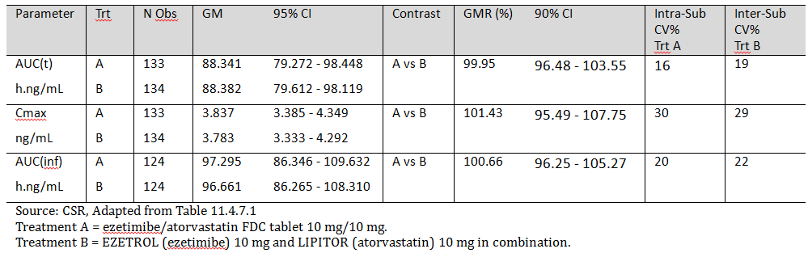

The median Tmax values for Treatments A and B were 1.00 hour (range: 0.5, 24.00) and 1.00 hour (range: 0.50, 47.02), respectively, and the GM T1/2values for Treatments A and B were 23.1 hours (CV% = 55%) and 22.6 hours (CV% = 56%), respectively.

**Comment:** The data show that Treatment A and Treatment B are bioequivalent as regards unconjugated ezetimibe. The 90% CIs for the unconjugated ezetimibe GMR values for AUC(t), AUC(inf) and Cmax are within the standard BE interval of 80.00 to 125.00%. The results for total ezetimibe also showed that Treatment A and Treatment B are bioequivalent.

###### Atorvastatin

The bioequivalence analysis for atorvastatin based on plasma concentrations are summarized below in Table 3, and the mean plasma concentration versus time profiles were provided.

Table 3. P391 - Atorvastatin (parameters based on plasma concentration); subject numbers (replicate measures) - A1 and B1 (n = 68); A2 (n = 65); B2 (n = 66).

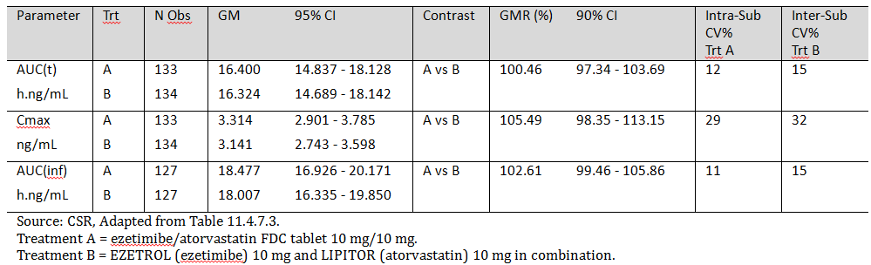

The median Tmax values for Treatments A and B were 0.75 hours (range: 0.25, 4.00) and 0.52 hours (range: 0.25, 3.00), respectively, and the GM T1/2values for Treatments A and B were 12.5 hours (CV% = 37%) and 11.8 hours (CV% = 37%), respectively.

**Comment:** The data show that Treatment A and Treatment B are bioequivalent as regards atorvastatin. The 90% CIs for atorvastatin GMR values for AUC(t), AUC(inf) and Cmax are within the standard BE interval of 80.00 to 125.00%.

##### Safety

There were 105 AEs reported during the study involving 30 (42.9%) subjects. The most frequently reported AEs were sleepiness and headache, which were reported by 10 (14.3%) treated subjects; 2 after the Test product and 8 after the Reference products. There were no deaths or other SAEs reported in this study. The safety data in this study in healthy volunteers do not give rise to concern.

#### Study P392

Study P392 . Ezetimibe/atorvastatin 10 mg/80 mg; fasting A Single Dose, Full Replicate, Comparative Bioavailability Study of Two Formulations of Ezetimibe/Atorvastatin Calcium 10 mg/80 mg FDC Tablets versus Ezetrol administered with Lipitor under Fasting Conditions

##### Design, objectives, location and dates

This was an open label, single dose, randomized, four period, two sequence, two treatment, crossover full replicate study. The objective of the study was to evaluate the comparative bioavailability of ezetimibe/atorvastatin calcium 10 mg/80 mg FDC tablets and co administered Ezetrol 10 mg tablets plus Lipitor 80 mg tablets in healthy volunteers (n = 70) as a single dose under fasting conditions.

The study was undertaken in a single centre in Canada in 2012 (initiated on 17 March 2012, completed on 2 May 2012), and the final report was dated August 2012. The study was conducted in accordance with the same ethical principles as study P391, and was sponsored by MSD Corp (USA).

**Comment:** The design of this pivotal study was identical to that of study P391, differing only in the strength of atorvastatin in the FDC table test treatment and the Lipitor tablet reference treatment. The ezetimibe/atorvastatin calcium 10/80 mg FDC tablets (MK-0635C) were supplied by MSD Corp (USA), the Ezetrol 10 mg tablet was sourced from MSD-SP Limited, UK, and the Lipitor 80 mg tablet was sourced from Pfizer Ltd, UK. The sponsor states that the ezetimibe/atorvastatin calcium 10/80 mg tablet used in this study is identical to the formulation proposed for registration. The sponsor provided an assurance that the UK sourced Ezetrol 10 mg tablet is identical to that marketed in Australia. In addition, the sponsor provided a statement from Pfizer stating that the pharmacokinetic profiles of the UK and Australian Lipitor 80 mg tablets are comparable, including the batches used in the bioequivalence studies.

##### Inclusion and exclusion criteria

The inclusion and exclusion criteria were identical to study P391.

##### Study treatments

* Treatment A (Test Product 1): ezetimibe/atorvastatin calcium 10 mg/80 mg FDC tablet.
* Treatment B (Reference Product 1): Ezetrol 10 mg tablet administered with Lipitor 80 mg tablet.

The procedures relating to the administration of the treatments were identical to study P391.

##### Randomization and blinding

The study was open label. The randomization method was identical to study P391. Study drugs were administered according to the randomization scheme on March 17, 2012 (Period 1), March 31, 2012 (Period 2), April 14, 2012 (Period 3) and April 28, 2012 (Period 4).

##### Objective

The objective of this study was to evaluate the comparative bioavailability of ezetimibe/atorvastatin calcium 10 mg/80 mg FDC tablets and co administered Ezetrol(ezetimibe) 10 mg tablets plus Lipitor (atorvastatin) 80 mg tablets after a single dose in healthy volunteers under fasting conditions.

##### Pharmacokinetic parameters

The PK parameters were identical to study P391.

##### Plasma sampling time and methods of analysis

Plasma sampling times and analytes were identical to study P391.

The plasma samples were analysed and the submission included a bioanalytical report detailing the analytical procedures undertaken for the plasma samples. The plasma sample concentrations for atorvastatin, ezetimibe total, and unconjugated ezetimibe were determined by validated liquid chromatography, tandem mass spectrometry (LC/MS/MS) methods. The validated calibration range for the atorvastatin assay was from 50.16 to 50,160.00 pg/mL, and the lower limit of quantification (LLOQ) for atorvastatin was 49.68 pg/mL. The validated calibration ranges and LLOQs for the ezetimibe total and unconjugated ezetimibe assays were identical to those in study P391.

##### Statistical methods

The statistical methods were identical to those used in study P391.

###### Sample size

The methods used to calculate the sample size were identical to those used in study P391.

###### Disposition of subjects

Of the 70 enrolled subjects, 65 subjects completed all 4 periods. In Period 1, 33/35 subjects completed sequence ABAB and 34/35 completed sequence BABA, and 3 subjects did not complete Period 1 (1 withdrew due to non-compliance (positive urine test for THC), 1 was withdrawn due to AEs of coughing and sneezing, 1 was withdrawn due to AEs of cough and chest pain). In Period 2,33/33 subjects completed sequence ABAB and 32/34 subjects completed sequence ABAB and 32/33 subjects completed sequence BABA (2 withdrew for personal reasons due to death in the family). In Periods 3 and 4, 33/33 subjects completed sequence ABAB and 32/32 subjects completed sequence BABA.

###### Protocol violations

There were a number of protocol violations characterized by deviations in sampling times ≥ 1 minute from those scheduled. All subjects in the study had protocol deviations characterized by deviations from schedule sampling times. However, deviations from scheduled sampling times were accounted for in the PK calculations since the actual sampling times were used. There were a number of other protocol deviations unrelated to sampling time deviations. These have been examined and it is considered unlikely that they have invalidated the statistical analysis.

###### Baseline demographic data

The baseline demographic data for the 70 enrolled healthy volunteers were: 26 males/44 females; mean age 36 years (range: 18, 54); mean height 168.1 cm (range: 148.7, 187.4); mean weight 73.0 kg (range: 49.6, 111.4); mean BMI 25.7 kg/m2 (range: 19.0, 34.1); and 16 Black, 42 White, 12 Asian.

##### Results

###### Unconjugated ezetimibe

The results for the statistical analysis of unconjugated ezetimibe based on plasma concentrations are summarized below in Table 4, and the mean unconjugated ezetimibe plasma concentration versus time profiles were provided.

Table 4. P392. Unconjugated ezetimibe (parameters based on plasma concentration); subject numbers (replicate measures) - A1 (n = 69), B1 (n = 68); A2 and B2 (n = 65).

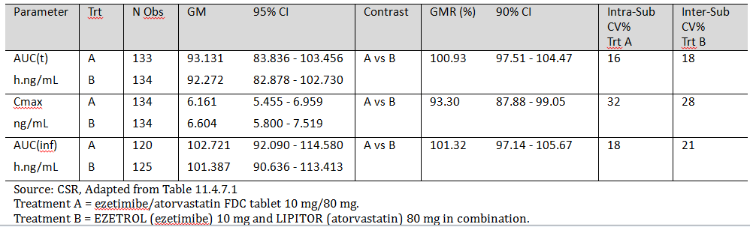

The median Tmax for treatments A and B were 0.75 hours (range: 0.5, 12.0) and 0.75 hours (range: 0.5, 6.0), respectively, and the GM T1/2 for treatments A and B were 23.6 hours (CV% = 50%) and 24.1 hours (CV% = 56%), respectively.

**Comment:** The data show that Treatment A and Treatment B are bioequivalent as regards unconjugated ezetimibe. The 90% CIs for the unconjugated ezetimibe GMR values for AUC(t), AUC(inf) and Cmax are within the standard BE interval of 80.00 to 125.00%. The results for total ezetimibe also show that Treatment A and Treatment B are bioequivalent.

###### Atorvastatin

The results for the statistical analysis of atorvastatin based on plasma concentrations are summarized below in Table 5 and the mean atorvastatin plasma concentration versus time profiles were provided.

Table 5. P392. Atorvastatin (parameters based on plasma concentration); subject numbers (replicate measures) - A1 and B1 (n = 68); A2 (n = 65); B2 (n = 66).

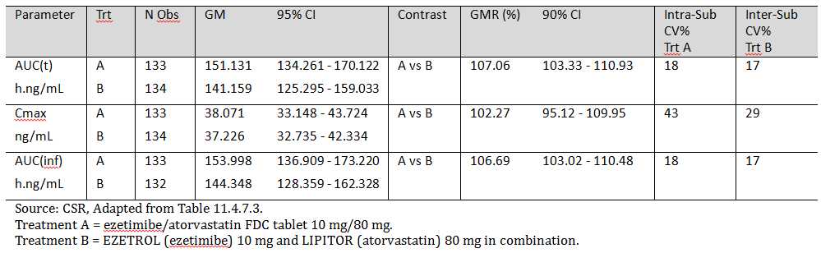

The median Tmax for Treatments A and B were 1.50 hours (range: 0.50, 6.05) and 0.75 hours (range: 0.50, 6.00), respectively, and the GM T1/2 for Treatments A and B were 9.8 hours (CV% = 20%) and 10.1 hours (CV% = 25%), respectively.

**Comment:** The data show that Treatment A and Treatment B are bioequivalent as regards atorvastatin. The 90% CIs for the atorvastatin GMR values for AUC(t), AUC(inf) and Cmax are within the standard BE interval of 80.00 to 125.00%.

##### Safety

There were 143 AEs in 36 subjects. The most frequently reported AEs were bacteria in urine and mucous in urine, which were reported in 9 (12.9%) of the treated subjects and were considered by the investigator to be unrelated to treatment. No deaths or other SAEs were reported in this study. The safety data in this study in healthy volunteers do not give rise to concern.

#### Justification - no studies with FDC tablets 10/20 mg or 10/40 mg

The submission included relevant comparative bioavailability studies involving the lowest (10/10 mg) and highest (10/80 mg) proposed strengths of the ezetimibe/atorvastatin FDC tablets, but no comparative bioavailability studies involving the two proposed intermediate dose strengths (10/20 mg and 10/40 mg). The sponsor's justification for not providing biopharmaceutical studies with the 10/20 mg and 10/40 mg strengths are: (a) the manufacturing process is the same for the four strengths; (b) the qualitative composition is the same for the four strengths; (c) the quantitative proportional composition is the same for the four strengths; and (d) the dissolution profiles of the four strengths meet the relevant EU guideline. These are matters for the pharmaceutical chemistry evaluator.

The sponsor did not provide a clinical justification supporting the absence of comparative bioavailability studies for the 10/20 mg and 10/40 mg strengths. However, given the robustness of the comparative bioavailability data for the 10/10 mg strength (study P391) and the 10/80 mg strength (study P392), it is considered unlikely that comparative bioavailability studies for the 10/40 mg and 10/80 mg strengths would demonstrate clinically significant bio-inequivalence. Therefore, from a clinical perspective it is considered that comparative bioavailability studies for the proposed FDC intermediate strength tablets of 10/20 mg and 10/40 mg are not required.

#### Study P415: food effect study

Study P415. Food effect on 10/80 mg FDC tablet. A Study of the Comparative Fed and Fasted Bioavailability of MK-0653C 10/80 mg in Healthy Subjects.

##### Design, objectives, location and dates

This was an open label, single dose, randomized, two period, two sequence, two treatment, crossover fed versus fasting bioavailability study. The objective was to evaluate the comparative bioavailability of ezetimibe/atorvastatin calcium (MK-0653C) 10/80 mg FDC tablets (MSD Corp., USA) after a single dose in healthy volunteers (n = 24) under fasting and fed conditions.

The study was undertaken in a single centre in Canada in 2013 (initiated on 12 February 2013, completed on 26 February 2012), and the final report was dated May 2013. It was conducted in accordance with the same ethical principles as studies P391 and P392. It was also conducted in accordance with the FDA document *Guidance for Industry – Food-Effect Bioavailability and Fed Bioequivalence Studies. Center for Drug Evaluation and Research (CDER), Food and Drug Administration. December 2002.* The study was sponsored by MSD Corp (USA).

**Comment:** The design of this pivotal study was standard for studies investigating the effect of food on bioavailability.

##### Inclusion and exclusion criteria

The study population included non-smoking, male and female volunteers from 18 to 55 years of age, with a BMI from ≥ 19.0 to ≤ 33.0 kg/m2, who were judged to be healthy based on a medical history, ECG, vital signs measurements, laboratory evaluation and physical examination. The inclusion criteria have been inspected and are considered to be standard for studies of this type. The inclusion and exclusion criteria were provided.

##### Study treatments

* Treatment A: single dose ezetimibe/atorvastatin calcium 10/80 mg FDC tablet administered with 240 mL of water after an overnight fast of at least 10 hours. Subjects continued fasting for at least 4 hours following drug administration.
* Treatment B: single dose ezetimibe/atorvastatin calcium 10/80 mg FDC tablet administered 30 minutes prior to the start of a high fat, high calorie breakfast.

Study drugs were dispensed according to the randomization scheme. The washout interval between successive drug administrations was 14 days. Subjects were confined to the clinical facility from at least 10.5 hours prior to each drug administration and for 24 hours post dose. The general procedures relating to the conduct and supervision of subjects in this study were consistent with those in studies P391 and P392.

##### Randomization and blinding

The study was open label study. Study drugs were administered on 12 February 2013 (Period 1), and on 26 February 2013 (Period 2), according to a computer generated balanced randomization scheme.

##### Objective

The objective of this study was to evaluate the comparative bioavailability of ezetimibe/atorvastatin calcium 10/80 mg FDC tablets after a single dose in healthy volunteers under fasting and fed conditions.

##### Pharmacokinetic parameters

The PK parameters were estimated for unconjugated ezetimibe, total ezetimibe and atorvastatin using a non compartmental approach. The parameters were consistent with those calculated in studies P391 and P392.

##### Plasma sampling time and methods of analysis

Plasma samples were assayed for unconjugated ezetimibe, total ezetimibe and atorvastatin. In each period, 19 venous blood samples from 19 time points were obtained. Blood samples were collected prior to drug administration and at the following scheduled times 0.25, 0.5, 0.75, 1, 1.5, 2, 2.5, 3, 4, 6, 8, 12, 16, 24, 36, 48, 72 and 96 hours following drug administration. The actual collection time for each sample was recorded.

The submission included a bioanalytical report detailing the analytical procedures undertaken for the plasma samples. The plasma sample concentrations for atorvastatin, ezetimibe total, and unconjugated ezetimibe were determined by validated liquid chromatography, tandem mass spectrometry (LC/MS/MS) methods. The validated calibration range for the atorvastatin assay was from 50.16 to 50,160.00 pg/mL, and the lower limit of quantification (LLOQ) for atorvastatin was 50.00 pg/mL. The validated calibration range for ezetimibe total assay was from 0.20 to 202.88 ng/mL, and the LLQ for ezetimibe total was 0.20 ng/mL. The validated calibration range for the unconjugated ezetimibe assay was 40.58 to 10,144.00 pg/mL, and the LLOQ for unconjugated ezetimibe was 40.00 pg/mL.

##### Statistical methods

The effect of food on the pharmacokinetic parameters AUC(inf) and Cmax of atorvastatin and AUC(t) and Cmax of unconjugated ezetimibe were evaluated using a mixed effect model. The model included treatment and period as fixed effects. A log transformation was applied to the AUC and Cmax data. Back transformed summary statistics and inferential results were reported for PK parameters. The 90% CI, based on the t distribution, was generated from the mixed effect model for the geometric mean ratios (GMRs, fed/fasted) for AUC and Cmax parameters. Similar analyses were applied to AUC and Cmax of total ezetimibe. Standard descriptive statistics were provided for each treatment. Subjects who were discontinued from the study were not replaced. The analysis was performed on available data from all subjects enrolled in the study.

###### Sample size

The calculations for atorvastatin and unconjugated ezetimibe were based on study MK-0653C P146 (food effect), within subject standard deviations of 0.266 (ln ng.hr/mL), 0.591 (ln ng/mL), 0.181 (ln ng·hr/mL) and 0.402 (ln ng/mL) for atorvastatin AUC(inf) and Cmax, unconjugated ezetimibe AUC(t) and Cmax, respectively. Based on these assumptions and given a 2 period crossover with 24 subjects, assuming the true GMR (fed/fasted) is 1.00, the 90% two-sided CIs should be (0.88, 1.14) and (0.75, 1.34) for atorvastatin AUC(inf) and Cmax respectively, and (0.91, 1.09) and (0.82, 1.22) for unconjugated ezetimibe AUC(t) and Cmax, respectively. Twenty four subjects were enrolled into this study.

###### Disposition of subjects

Twenty four subjects were enrolled and all completed the study.

###### Protocol violations

All subjects in the study had protocol violations characterized by deviations from scheduled sampling times. However, deviations from the scheduled sampling time were accounted for in the PK calculations since the actual sampling times were used. There were no other protocol violations in this study.

###### Baseline demographic data

The baseline demographic data for the 24 enrolled healthy volunteers were: 10 males/14 females; mean age 41 years (range: 22, 25); mean height 168.5 cm (range: 154.0, 184.5); mean weight 73.4 kg (range: 52.8, 101.3); mean BMI 25.8 kg/m2 (range: 19.2, 31.1); and 5 Black, 15 White, 4 Asian.

##### Results

###### Unconjugated ezetimibe

The bioequivalence analysis for unconjugated ezetimibe based on plasma concentrations are summarized below in Table 6, and the mean plasma concentration versus time profiles were provided.

Table 6. P415. Fasting versus Fed - unconjugated ezetimibe parameters based on plasma concentration.

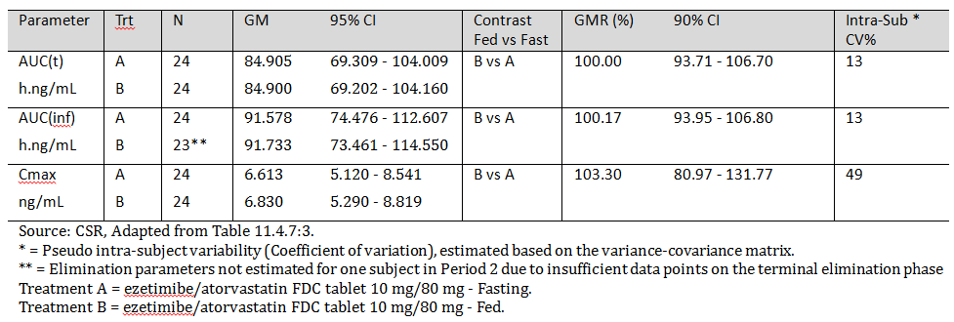

The median Tmax values for Treatments A (n = 24) and B (n = 24) were 0.75 hours (range: 0.5, 12.0) and 1.5 hours (range: 0.5, 3.00), respectively, and the GM T1/2 valuesfor Treatments A (n = 24) and B (n = 23) were 20.9 hours (CV% = 60%) and 19.3 (CV% = 61%), respectively.

**Comment:** Food had no significant effect on the AUC(t) or AUC(inf) unconjugated ezetimibe (Fed versus Fasting) as the 90% CI of the GMR for both parameters was within the standard BE limit of 80 to 125%. However, the 90% CI for the Cmax GMR was outside the standard BE limits, but the GMR was only 3.3% higher in the fed compared with the fasted state. The observed difference in the Cmax for unconjugated ezetimibe between the fed and fasted states is considered unlikely to be clinically significant.

###### Total ezetimibe

The bioequivalence analysis for total ezetimibe based on plasma concentrations are summarized below in Table 7, and the mean plasma concentration versus time profiles were provided.

Table 7. P415. Fasting versus Fed - total ezetimibe parameters based on plasma concentration.

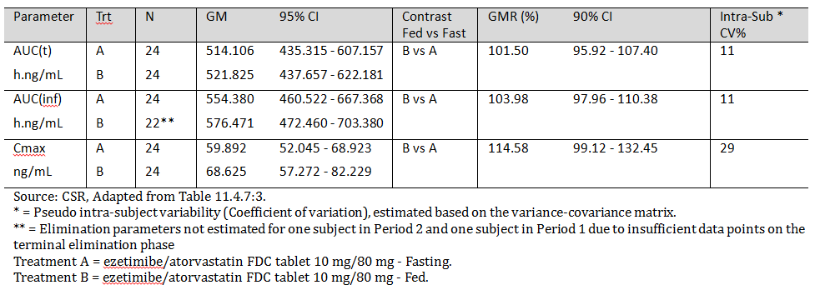

The median Tmax values for Treatments A (n = 24) and B (n = 24) were 0.75 hours (range: 0.5, 2.0) and 1.25 hours (range: 0.75, 3.00), respectively, and the GM T1/2 valuesfor Treatments A (n = 24) and B (n = 22) were 22.6 hours (CV% = 54%) and 21.9 hours (CV% = 58%), respectively.

**Comment:** Food had no significant effect on the AUC(t) or AUC(inf) total ezetimibe (Fed versus Fasting) as the 90% CI of the GMR for both parameters was within the standard BE limit of 80 to 125%. However, the Cmax GMR for total ezetimibe was approximately 15% higher when the FDC tablet was administered in the fed state compared with the fasting state, and the 90% CI for the GMR was outside the standard BE limits. The observed difference in the Cmax for total ezetimibe between the fed and fasted states is considered unlikely to be clinically significant.

###### Atorvastatin

The bioequivalence analysis for atorvastatin based on plasma concentrations are summarized below in Table 8, and the mean plasma concentration versus time profiles were provided.

Table 8. P415. Fasting versus Fed - atorvastatin parameters based on plasma concentration.

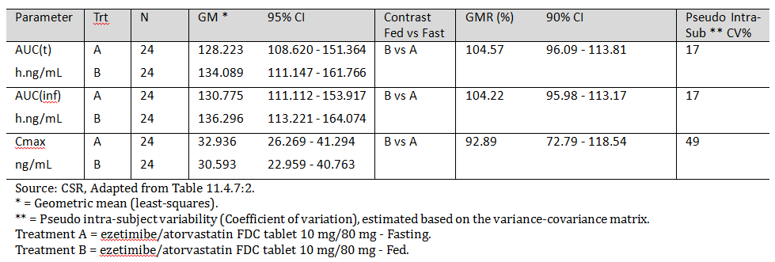

The median Tmax values for Treatments A (n = 24) and B (n = 24) were 1.00 hour (range: 0.5, 4.00) and 2.25 hours (range: 1.00, 4.00), respectively, and the GM T½ values for Treatments A (n = 24) and B (n = 24) were 10.4 hours (CV% = 23%) and 10.1 hours (CV% = 21%), respectively.

**Comment:** Food had no significant effect on the bioavailability of atorvastatin based on the AUC(t), and AUC(inf), with the 90% CI for the GMR (fed/fasted) for both parameters being with the standard BE interval. However, the atorvastatin Cmax GMR was approximately 7% lower when the FDC was administered with food and the 90% CI for the GMR (fed/fasted) was outside the standard BE limits. The observed difference Cmax between and fasted states is considered unlikely to be clinically significant.

##### Safety

There were 20 AEs involving 12 (50.0%) subjects. The most frequent AE was hypertension, which occurred in 3 (12.5%) treated subjects. All hypertension AEs were reported during Treatment B (that is, fed state), were mild in intensity and were considered by the investigator to be definitely not related to the study drug. There were no deaths, other SAEs, or significant AEs reported during this study. Overall, the FDC 10/80 mg tablet was well tolerated in both the fed and fasting states in healthy volunteers following single-dosing.

### Evaluator's overall conclusions on pharmacokinetics

The submission included two new, previously unevaluated comparative bioavailability studies in 140 healthy volunteers (P391 (n = 70), P392 (n = 70)) and one new, previously unevaluated food effect study in 24 healthy volunteers (P415). There were no new biopharmaceutical studies in patients with hyperlipidaemia.

The proposed FDC ezetimibe/atorvastatin 10/10 mg tablet was bioequivalent to co administered ezetimibe 10 mg plus atorvastatin 10 mg tablets, as regards both components of the combination, following single dose treatment in the fasting state in healthy volunteers (P391). The 90% CIs for the GMRs for unconjugated ezetimibe, total ezetimibe, and atorvastatin were all within the standard bioequivalence interval of 80 to 125%. The FDC ezetimibe/atorvastatin 10/10 mg tablet was the formulation proposed for registration, the ezetimibe 10 mg tablet (Ezetrol) sourced from the UK was stated by the sponsor to be identical to the Australian registered product, and the atorvastatin 10 mg tablet (Lipitor) sourced from the UK was stated by the sponsor to be comparable to the corresponding Australian registered product based on information provided by Pfizer, the sponsor of Lipitor.

The proposed FDC ezetimibe/atorvastatin 10/80 mg tablet was bioequivalent to co administered ezetimibe 10 mg plus atorvastatin 80 mg tablets, as regards both components of the combination, following single dose treatment in the fasting state in healthy volunteers (P392). The 90% CIs for the GMRs for unconjugated ezetimibe, total ezetimibe, and atorvastatin were all within the standard bioequivalence interval of 80 to 125%. The FDC ezetimibe/atorvastatin 10/80 mg tablet was the formulation proposed for registration, the ezetimibe 10 mg tablet (Ezetrol) sourced from the UK was stated by the sponsor to be identical to the Australian registered product, and the atorvastatin 80 mg tablet (Lipitor) sourced from the UK was stated by the sponsor to be comparable to the corresponding Australian registered product based on information provided by Pfizer, the sponsor of Lipitor.

There were no bioavailability/bioequivalence studies with the FDC ezetimibe/atorvastatin tablets proposed for registration at the two intermediate strengths of 10/20 mg and 10/40 mg. However, the sponsor submitted a justification for not providing such studies based on similar manufacturing and pharmaceutical chemistry criteria for the four proposed strengths. The evaluation of these criteria is primarily a matter for the pharmaceutical chemistry evaluator. No clinical justification for not providing such studies could be identified in the submission. However, based on the robustness of the two submitted bioavailability/bioequivalence studies investigating the lowest (10/10 mg) and the highest (10/80 mg) strengths of the proposed FDC tablets, it is the opinion of this evaluator that clinically significant bio-inequivalence of the two intermediate FDC tablets and their individual components is unlikely.

The bioavailability of the proposed FDC ezetimibe/atorvastatin 10/80 mg tablet in the fasting and fed state was investigated in a single dose study in 24 healthy volunteers (P451). In this study, food had no significant effects on the bioavailability of atorvastatin or unconjugated ezetimibe based on the AUC(t), and AUC(inf) values for the two analytes, with the 90% CI for the GMR (fed/fasted) for both parameters being with the standard BE interval (80 to 125%). However, the GM Cmax for atorvastatin was approximately 7% lower in the fed state and the 90% CI for the GMR (fed/fasted) was outside the standard BE interval of 80 to 125% (that is, GMR = 92.89% (90% CI: 72.9, 118.54)), the GM Cmax for unconjugated ezetimibe was approximately 3% higher in the fed state and the 90% CI for GMR (fed/fasted) was outside the standard BE of 80 to 125% (that is, GMR = 103.3% (95% CI: 80.97, 131.77), and the GM Cmax for total ezetimibe was approximately 15% higher in the fed state and the 90% CI for GMR (fed/fasted) was outside the standard BE of 80 to 125% (that is, GMR = 114.58% (95% CI: 99.12, 132.45).

The efficacy of the FDC tablet is likely to be primarily based on total systemic exposure (which was equivalent in the fed and fasted states for atorvastatin, unconjugated ezetimibe and total ezetimibe), while the safety of the tablet is likely to be based primarily on peak exposure (which was approximately 3% higher for unconjugated ezetimibe with an upper 90% CI of approximately 32%, approximately 15% higher for total ezetimibe with an upper 90% CI of approximately 33% in the fed state, and approximately 7% lower for atorvastatin with a lower 90% CI of approximately 27% in the fasted state). Based on the relatively small differences in Cmax in the fed and fasted states for the three analytes, it is considered unlikely that there will be clinically significant differences in the safety of the proposed FDC tablets when administered in the fasted and fed states. Therefore, it is recommended that the proposed FDC tablets be administered without regard to food (as proposed by the sponsor).

Overall, it is considered that the submitted bioavailability/bioequivalence data indicate that the efficacy and safety of the proposed FDC tablets at the proposed doses are unlikely to differ significantly from the efficacy and safety of the registered Composite Packs at the corresponding doses. Therefore, it is considered that the submitted bioavailability/bioequivalence data allow the known efficacy and safety data of the registered Composite Packs to be safely extrapolated to the proposed FDC tablets.

## Pharmacodynamics

### Studies providing pharmacodynamic data

There were no new pharmacodynamic data in the clinical dossier. However, the submission included one previously submitted and evaluated Phase I study (P460) in which the primary objectives were to investigate the safety, tolerance and pharmacodynamic effects of co administered ezetimibe 10 mg tablets and atorvastatin 10 mg tablets for 14 days in healthy subjects with hypercholesterolaemia (calculated LDL-C ≥ 130 mg/dL and TG ≤ 400 mg/dL at screening), and the secondary objectives were to evaluate the potential PK drug interaction of ezetimibe on atorvastatin.

The study was initially submitted to support the registration of ezetimibe. The CSR states that the study was undertaken with ezetimibe to ‘obtain pharmacodynamic, pharmacokinetic, and safety data with atorvastatin which will support ezetimibe/atorvastatin clinical efficacy and safety trials’.

The study was randomized, investigator/evaluator blind, placebo controlled, multiple dose, and parallel dose in design. Subjects were randomized to placebo, ezetimibe (EZ) 10 mg, atorvastatin (Atorva) 10 mg, or co administered Atorva 10 mg + EZ 10 mg. In each group, treatment was combined with the NCEP Step 1 Diet for 14 days, following an NCEP Step 1 Diet stabilization period of 7 days. No formal sample size calculations were undertaken, and it was stated in the CSR that ‘*the sample size was based on empirical rather than statistical considerations*’.

#### Pharmacodynamic results

The mean (SE) percent changes from baseline to Day 14 on serum lipids in the four treatment groups are summarized below in Table 9.

Table 9. P460. Mean (SE) Day 14 from baseline in serum lipids.

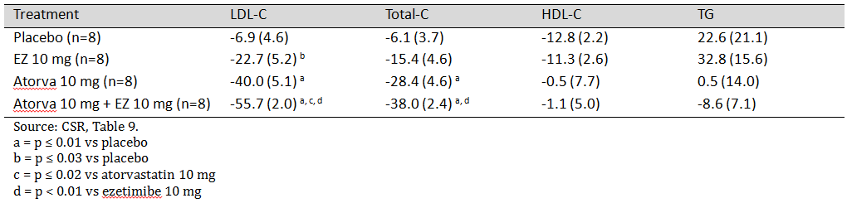

**Comment:** Atorva 10 mg + EZ 10 mg resulted in a statistically significant greater mean percent reduction in LDL-C from baseline at Day 14 than placebo (p ≤ 0.01), Atorva 10 mg (p ≤ 0.02) and EZ 10 mg (p < 0.01), and a statistically significant greater mean percent reduction in Total-C at Day 14 than placebo (p ≤ 0.01) and EZ 10 mg (p < 0.01), but not for Atorva 10 mg. The mean percent reduction from baseline at Day 14 for the comparisons between Atorva 10 mg + EZ 10 mg and placebo, Atorva 10 mg and EZ 10 mg were not statistically significant (p > 0.05) for HDL-C and TG. No sample size calculations were undertaken and the small sample size suggests that the study was underpowered to detect statistically significant differences for all the undertaken pairwise comparisons. It is considered that the pharmacodynamic results of this small, short term (14 days) study should be interpreted as being exploratory rather than confirmatory.

#### Pharmacokinetic results

##### Atorvastatin and orthohydroxy atorvastatin

The pharmacokinetic parameters (Cmax, AUC(0-24 hr), Tmax) for atorvastatin and orthohydroxy atorvastatin at Day 14 following co administered Atorva 10 mg + EZ 10 mg and Atorva 10 mg alone are summarized below in Table 10.

Table 10. P460. Mean (CV%) for Cmax and AUC(0-24 hr) and median (range) for Tmax.

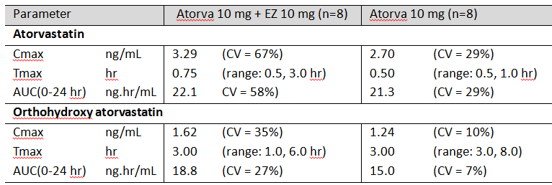

The GMR ((A + E)/(A)) for the atorvastatin Cmax was 107% (90% CI: 72, 159), and for the atorvastatin AUC(0-24 hr) was 95.6% (90% CI: 68, 134). The GMR ((A + E)/(A)) for the orthohydroxy atorvastatin Cmax was 125% (90% CI: 102, 154), and for the orthohydroxy atorvastatin AUC(0-24 hr) was 122% (90% CI: 103, 144).

**Comment:** Plasma atorvastatin and orthohydroxy atorvastatin exposures were similar following co-administration of Atorva 10 mg + EZ 10 mg and those following administration of Atorva 10 mg alone. The 90% CIs for the relevant Cmax and AUC(0-24 hr) GMRs indicate that the two treatments were not BE as regards the two analytes (that is, 90% CIs not enclosed within the standard BE interval of 80 to 125%). However, this small study was not designed to investigate bioequivalence of Atorva 10 mg + EZ 10 mg and Atorva 10 mg.

##### Total ezetimibe, ezetimibe, and conjugated ezetimibe

The pharmacokinetic parameters (Cmax, AUC(0-24 hr), Tmax) for total ezetimibe, ezetimibe, and conjugated ezetimibe at Day 14 following co administered Atorva 10 mg + EZ 10 mg and Ezetimibe 10 mg alone are summarized below in Table 11.

Table 11. P460. Mean (CV%) for Cmax and AUC(0-24 hr) and median (range) for Tmax.

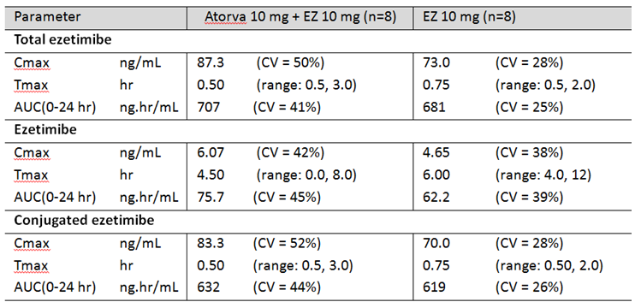

* Total Ezetimibe: The GMR ((A + E)/(A)) for the Cmax was 112% (90% CI: 80, 157), and for the AUC(0-24 hr) was 98.5% (90% CI: 72, 134).
* Ezetimibe: The GMR ((A + E)/(A)) for the Cmax was 131% (90% CI: 98, 176), and for the AUC(0-24 hr) was 121% (90% CI: 88, 166).
* Conjugated ezetimibe: The GMR ((A + E)/(A)) for the Cmax was 110 (90% CI: 78, 157), and for the AUC(0-24 hr) was 95.4% (90% CI: 68, 134).

**Comment:** Plasma total ezetimibe, ezetimibe, and conjugated ezetimibe exposures were similar following co-administration of Atorva 10 mg + EZ 10 mg and those following administration of Ezetimibe 10 mg alone. The 90% CIs for the relevant Cmax and AUC(0-24 hr) GMRs indicate that the two treatments were not BE as regards these three analytes (that is, 90% CIs not enclosed within the standard BE interval of 80 to 125%). However, this small study was not designed to investigate the bioequivalence of Atorva 10 mg + EZ 10 mg and Ezetimibe 10 mg.

## Dosage selection for the pivotal studies

The ezetimibe and atorvastatin dosages selected for the FDC tablets were the same as the approved dosages for the Composite Packs.

## Clinical efficacy

### Studies with clinical efficacy data

The submission included one, previously unevaluated, pivotal Phase III study assessing the efficacy and safety of co administered ezetimibe tablets and crystalline atorvastatin as calcium tablets in patients with primary hypercholesterolaemia and high cardiovascular risk (P162). In this study, the proposed atorvastatin as calcium formulation used in the administered tablets was stated by the sponsor to be the same as that used in the FDC tablets proposed for registration. This study has been fully evaluated.

In addition to the pivotal study, the submission included two previously unevaluated supporting studies, provided by the sponsor in response to a request from the TGA, which assessed the efficacy and safety of two FDC ezetimibe/atorvastatin tablets in patients with primary hypercholesterolaemia at low, moderate or moderately high risk of CVD: FDC 10/20 mg in study P185 and FDC 10/40 mg in study P190. In these two supportive studies the previous formulation of the FDC was used. These two studies appear to be the key studies supporting the registration of the ezetimibe/atorvastatin FDC tablet in the USA. Both of these studies have been fully evaluated.

In addition to the one pivotal and two supportive studies, the submission included 12 previously submitted and evaluated clinical efficacy and safety studies supporting registration of the Composite Pack. The efficacy results from these studies have been briefly summarized.

There were no clinical efficacy and safety studies using the FDC tablets proposed for registration.

### Pivotal study P162

#### Study design, objectives, locations and dates

This Phase III, multinational, multicentre, randomized, double blind, active controlled, two phase efficacy and safety study of 18 weeks total duration in patients with primary hypercholesterolemia at high cardiovascular risk not adequately controlled with atorvastatin 10 mg was designed to investigate the effects on LDL-C levels of switching to co administered ezetimibe and atorvastatin mg, doubling the dose of atorvastatin or switching to rosuvastatin. The LDL-C criteria for inclusion in the study were levels ≥ 100 mg/dL (2.59 mmol/L) and ≤ 160 mg/dL (4.14 mmol/L).

The primary objectives were to evaluate at the end of Phase 1[1]:

1. the additional LDL-C percentage reduction by switching to co administered ezetimibe 10 mg + atorvastatin 10 mg compared with atorvastatin 20 mg in patients not adequately controlled with atorvastatin 10 mg prior to randomization
2. the additional LDL-C percentage reduction by switching to co administered ezetimibe 10 mg + atorvastatin 10 mg compared with rosuvastatin 10 mg in patients not adequately controlled with atorvastatin 10 mg prior to randomization.

The secondary objectives were:

1. to evaluate at the end of Phase 2, the additional LDL-C percentage reduction by switching to co administered ezetimibe 10 mg + atorvastatin 20 mg compared with atorvastatin 40 mg in patients not adequately controlled with atorvastatin 10 mg prior to randomization and not adequately controlled with atorvastatin 20 mg during Phase 1
2. to evaluate at the end of Phase 2, the additional LDL-C percentage reduction by switching to co administered ezetimibe 10 mg + atorvastatin 20 mg compared with rosuvastatin 20 mg in patients not adequately controlled with atorvastatin 10 mg prior to randomization and not adequately controlled with rosuvastatin 10 mg during Phase 1
3. to evaluate at the end of Phase 1, the percentage of patients reaching LDL-C < 100 mg/dL (2.59 mmol/L) with co administered ezetimibe 10 mg + atorvastatin 10 mg compared with atorvastatin 20 mg, and compared with rosuvastatin 10 mg in patients not adequately controlled with atorvastatin 10 mg prior to randomization
4. to evaluate at the end of Phase 2, the percentage of patients reaching LDL-C < mg/dL (2.59mmol/L) with co administered ezetimibe 10 mg + atorvastatin 20 mg compared with atorvastatin 40 mg in patients not adequately controlled with atorvastatin 10 mg prior to randomization and not adequately controlled with atorvastatin 20 mg during Phase 1, and compared with rosuvastatin 20 mg in patients not adequately controlled with atorvastatin 10 mg prior to randomization and not adequately controlled with rosuvastatin 10 mg during Phase 1
5. to evaluate at the end of Phase 1, the percentage of patients reaching LDL-C < 70 mg/dL (1.81mmol/L) with co administered ezetimibe 10 mg + atorvastatin 10 mg compared with atorvastatin 20 mg, and compared with rosuvastatin 10 mg in patients not adequately controlled with atorvastatin 10 mg prior to randomization
6. to evaluate at the end of Phase 2, the percentage of patients reaching LDL-C < 70 mg/dL (1.81mmol/L) with co administered ezetimibe 10 mg + atorvastatin 20 mg compared with atorvastatin 40 mg in patients not adequately controlled with atorvastatin 10 mg prior to randomization and not adequately controlled with atorvastatin 20 mg during Phase 1, and compared with rosuvastatin 20 mg in patients not adequately controlled with atorvastatin 10 mg prior to randomization and not adequately controlled with rosuvastatin 10 mg during Phase 1
7. to evaluate at the end of Phase 1, the additional percent changes in TC, TG, HDL-C, Apo B, ApoA-I, non-HDL-C, TC/HDL-C ratio, LDL-C/HDL-C ratio, Apo B/Apo A-I ratio, non-HDL C/HDL-C ratio and high-sensitivity C-reactive protein (hs-CRP) by switching to co administered ezetimibe 10 mg + atorvastatin 10 mg compared with atorvastatin 20 mg and compared with rosuvastatin 10 mg in patients not adequately controlled with atorvastatin 10 mg prior to randomization
8. to evaluate at the end of Phase 2, the additional percent changes in TC, TG, HDL-C, Apo B, Apo A-I, non-HDL-C, TC/HDL-C ratio, LDL-C/HDL-C ratio, Apo B/Apo A-I ratio, non-HDL-C/HDL-C ratio and hs-CRP by switching to co administered ezetimibe 10 mg + atorvastatin 20 mg compared with atorvastatin 40 mg in patients not adequately controlled with atorvastatin 10 mg prior to randomization and not adequately controlled with atorvastatin 20 mg during Phase 1, and compared with rosuvastatin 20 mg in patients not adequately controlled with atorvastatin 10 mg prior to randomization and not adequately controlled with rosuvastatin 10 mg during Phase 1
9. to evaluate the safety and tolerability of co administered ezetimibe 10 mg + atorvastatin 10 mg compared with atorvastatin 20 mg and rosuvastatin 10 mg and the safety of co- administered ezetimibe 10 mg + atorvastatin 20 mg compared with atorvastatin 40 mg and rosuvastatin 20 mg.

The study was undertaken in 29 countries (296 sites) including, Argentina (18), Belgium (2), Bulgaria (11), Canada (15), Chile (7), Columbia (5), Croatia (4), Czech Republic (19), Denmark (5), Estonia (4), Finland (5), France (7), Germany (9), Hungary (13), Israel (14), Italy (8), Lithuania (8), Netherlands (4), Norway (4), Poland (14), Portugal (4), Romania (18), Slovakia (12), Slovenia (3), Spain (11), Sweden (6), Turkey (8), United Kingdom (12) and the United States (46).

The study was initiated on 5 August 2010 and completed on 18 October 2012. The study was conducted in accordance with Good Clinical Practice (GCP), and the protocol and all applicable amendments were approved by site specific Independent Ethics Committees (IECs)/Institutional Review Boards (IRBs).

#### Investigational plan

The study was an 18 week randomized, double blinded, active controlled, multicentre Phase III study comprising of a 6 week screening/run-in and a 12 week double blinded treatment period (2 phases, each of 6 weeks duration). Approximately 1,508 patients with hypercholesterolemia and high cardiovascular risk not adequately controlled with atorvastatin 10 mg at the end of a 5 week run-in were randomized to 1 of 6 double blind treatment sequences.

Patients with high cardiovascular risk without cardiovascular disease (CVD) included patients who had (1) diabetes, or (2) multiple risk factors and a 10 year risk for coronary heart disease (CHD) > 20% (as determined by the Framingham calculation), and patients with high cardiovascular risk included patients with CVD with established coronary and other atherosclerotic vascular disease. High cardiovascular, risk with and without CVD, were defined according to the 2004 NCEP ATP III / 2006 AHA ACC updated guidelines and 2007 Fourth Joint European Societies recommendations (see Appendix B, page 191). Patients eligible for screening were to be naïve to, or currently on a statin, ezetimibe, or statin + ezetimibe combination with LDL-C lowering efficacy equivalent to or less than atorvastatin 10 mg, with an LDL-C screening value within the protocol specified range.

Eligible patients discontinued prior statin, ezetimibe, or statin + ezetimibe combination at Visit 2 and entered an open label atorvastatin 10 mg once daily 5 week run in period during which they received life style counselling, diet counselling and treatment compliance recommendations. At the end of the run in period, patients not adequately controlled (defined as a Visit 3 LDL-C ≥ 100 mg/dL (2.59 mmol/L) and ≤ 160 mg/dl (4.14 mmol/L) were eligible for randomization to 1 of 6 double blinded treatment sequences in a 3:1:8:8:16:16 ratio as shown below in Table 12. The randomized treatment sequence defined treatment to be followed in both Phase 1 and Phase 2 of the study.

Table 12. P162. Randomized treatment sequences to be followed in Phase 1 and Phase 2.

| Treatment Sequence | Phase 1 | Phase 2 |
| --- | --- | --- |
| 1 | ezetimibe 10 mg + atorvastatin 10 mg | - |
| 2 | ezetimibe 10 mg + atorvastatin 10 mg | ezetimibe 10 mg + atorvastatin 10 mg |
| 3 | atorvastatin 20 mg | ezetimibe 10 mg + atorvastatin 20 mg |
| 4 | atorvastatin 20 mg | atorvastatin 40 mg |
| 5 | rosuvastatin 10 mg | ezetimibe 10 mg + atorvastatin 20 mg |
| 6 | rosuvastatin 10 mg | rosuvastatin 20 mg |

At the end of Phase 1, patients who had been randomized to atorvastatin 20 mg (Treatment Sequence 3 or 4) or rosuvastatin 10 mg (Sequence 5 or 6) and had whose LDL-C level had not adequately controlled were to continue to Phase 2 on the treatment determined by the sequence to which they had been initially randomized. In these patients, inadequate control was defined as an LDL-C level ≥ 100 mg/dL (2.59 mmol/L) and ≤ 160 mg/dl (4.14 mmol/L) at Visit 5. Lipid evaluations used to determine whether patients continued into Phase 2 were managed by a central laboratory and IVRS interface to ensure the site remained blinded to treatment. At the end of Phase 1, in order to maintain the double blind design approximately 25% of patients who had been initially randomized to co administered ezetimibe 10 mg + atorvastatin 10 mg were to continue to Phase 2 on this regimen (Treatment Sequence 2), and approximately 75% of patients who had been initially randomized to co administered ezetimibe 10 mg + atorvastatin 10 mg discontinued the study (Treatment Sequence 1).

All patients not proceeding to Phase 2 of the study completed an End of Study visit occurring 1 week after Visit 5. The study schedule is summarized in Table 13. The investigational plan is provided schematically below in Figure 1. The number of patients (N) in this figure represents the number of patients planned rather than the actual number of patients who actually participated in the study.

Figure 1: P162. Investigational plan; N estimates the number of patients planned, not the actual number who participated in the study.

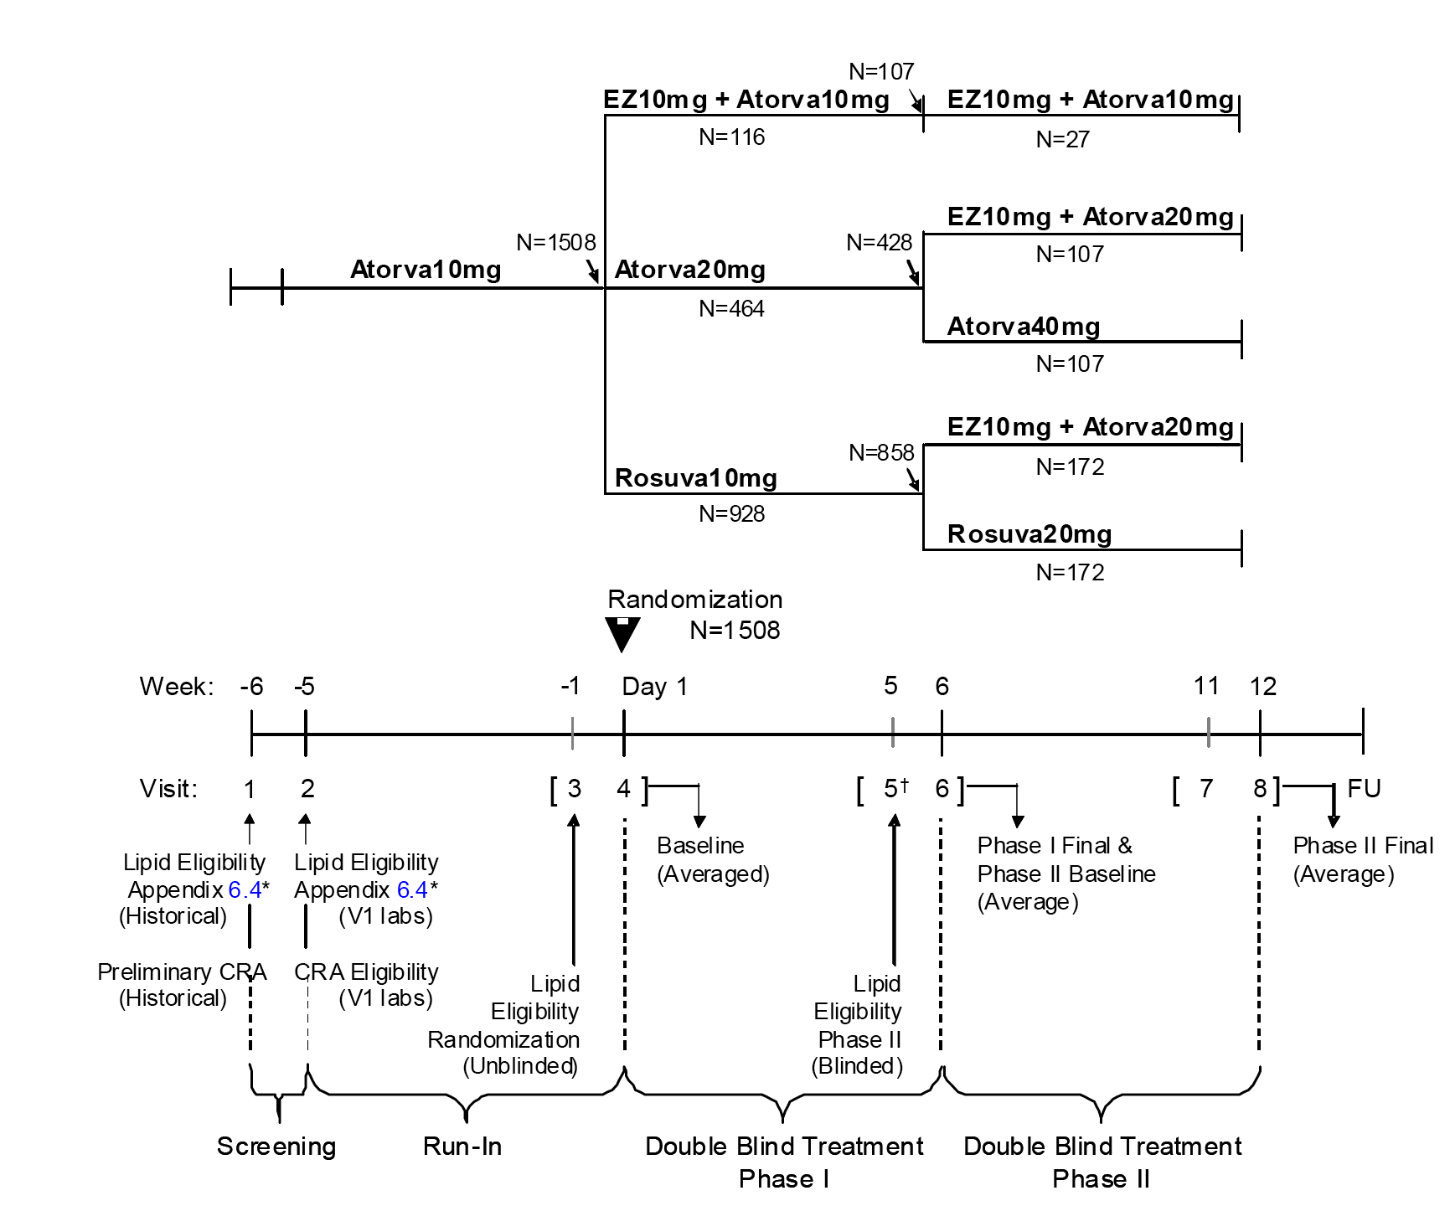

**Comment:** The design of this two Phase study was complex. The key comparisons in Phase 1 were between the co administered ezetimibe 10 mg + atorvastatin 10 mg versus atorvastatin 20 mg groups and the co administered ezetimibe 10 mg + atorvastatin 10 mg versus rosuvastatin 10 mg groups, in patients whose LDL-C had not been adequately controlled by atorvastatin 10 mg at the end of the 5 week run in period prior to randomization. The key comparisons in Phase 2 were between the co administered ezetimibe 10 mg + atorvastatin 20 mg versus atorvastatin 40 mg groups in patients whose LDL-C levels had not been adequately controlled by atorvastatin 20 mg during Phase 2, and between the co administered ezetimibe 10 mg + atorvastatin 20 mg versus rosuvastatin 20 mg groups in patients whose LDL-C level had not been adequately controlled by rosuvastatin 10 mg during Phase 1.

Table 13. P162. Schedule of assessments.

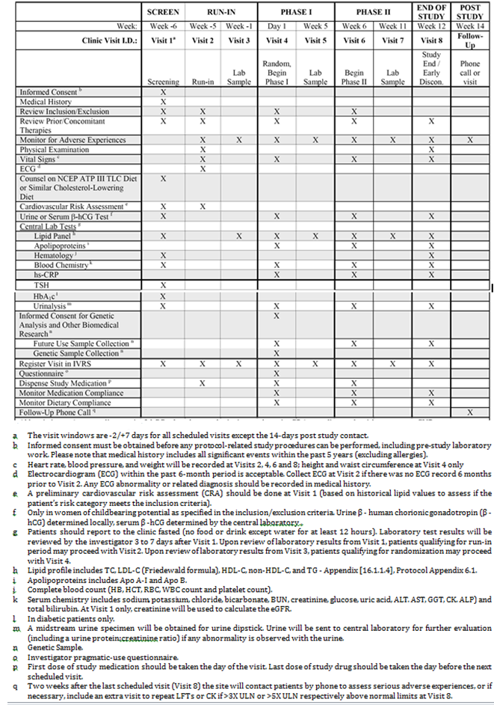

#### Inclusion and exclusion criteria

The study included patients aged ≥ 18 to < 80 years of both sexes at high cardiovascular risk who were naive to lipid lowering therapy (or had been off such therapy for ≥ 6 weeks prior to Visit 1) and had a historical LDL-C value approximately within the range specified in the protocol or who were currently taking a stable dose of a statin, ezetimibe, or statin + ezetimibe with LDL-C lowering efficacy equivalent to or less than atorvastatin 10 mg and had a historical LDL-C value approximately within the range specified in the protocol. A stable daily dose was defined by a history of taking > 80% of daily doses for 6 weeks prior to Visit 1. Visit 4 criteria included, completion of the 5 week atorvastatin 10 mg run in period with a LDL-C level ≥ 100 mg/dL (2.59 mmol/L) and ≤ 160 mg/dl (4.14 mmol/L), and TG concentrations ≤ 400 mg/dL (4.52 mmol/L) from the sample collected at Visit 3. The exclusion criteria included general criteria, prohibited medical conditions, and prohibited therapies. The inclusion and exclusion criteria were provided.

The study also included pre-specified discontinuation and withdrawal criteria, which were standard for investigational clinical efficacy and safety studies. In addition withdrawal from the study or discontinuation of all study medication was mandated if any of the following circumstances were met: consecutive (2 or more measurements) elevations in ALT/AST ≥ 3 x ULN; consecutive elevations in CK ≥ 10 x ULN with or without muscle symptoms; consecutive elevations in CK ≥ 5 x ULN to < 10 x ULN with muscle symptoms; patients who required any treatment with cyclosporine; patients who required any treatment with a potent inhibitor of CYP3A4 such as, itraconazole, ketoconazole, erythromycin, clarithromycin or HIV protease inhibitors; conditions that exposed the patient to significant risk by continuing in the trial or did not allow the patient to adhere to the requirements of the protocol; positive serum pregnancy test; patients who were unblinded to treatment regimen during the study.

#### Study treatments

* During the 5 weeks run in period, eligible patients received open label atorvastatin 10 mg administered as 1 tablet orally on a daily basis.
* Eligible patients were randomized at Visit 4 (Day 1, Phase 1) to:
  + co administered ezetimibe 10 mg + atorvastatin 10 mg (randomization Sequences 1 and 2)
  + atorvastatin 20 mg (randomization Sequences 3 and 4); or
  + rosuvastatin 10 mg (randomization Sequences 5 and 6).
* Eligible patients at the end of Phase 1 (that is, completion of 6 weeks double blind treatment) continued in Phase 2 (that is, 6 weeks of double blind treatment) on one of 5 treatments that were predetermined by the Treatment Sequence to which they had been initially randomized:
  + continued treatment with ezetimibe 10 mg or atorvastatin 10 mg (Sequence 2)
  + switched from atorvastatin 20 mg to co administered ezetimibe 10 mg + atorvastatin 20 mg (Sequence 3)
  + doubled the dose of atorvastatin from 20 mg to 40 mg (Sequence 4)
  + switched from rosuvastatin 10 mg to co administered ezetimibe 10 mg + atorvastatin 20 mg (Sequence 5); or
  + doubled the dose of rosuvastatin from 10 mg to 20 mg (Sequence 6).

During both phases, patients in the statin monotherapy groups also took placebo tablets in order to maintain the blind with patients in the co administered ezetimibe + atorvastatin groups.

The daily oral dose could be taken with or without food, with a recommendation to take the dose at a consistent time each day in order to promote compliance.

#### Efficacy variables and outcomes

##### Primary efficacy variable

The primary efficacy variable was the percent change from baseline in LDL-C at endpoint.

##### Secondary efficacy variables

The secondary efficacy variables included: (1) the percentage of patients who reached target LDL-C level of < 100 mg/dL (2.59 mmol/L) at endpoint; (2) the percentage of patients who reached target LDL-C level of < 70 mg/dL (1.81 mmol/L) at endpoint; and (3) the percent change from baseline to endpoint in TC, TG, HDL-C, non-HDL-C, LDL-C/HDL-C ratio, TC/HDL-C ratio, non-HDL-C/HDL-C ratio, Apo B, Apo A-I, Apo B/Apo A-I ratio and hs-CRP.

#### Randomization and blinding methods

Eligible patients were randomized at Visit 4 in a ratio of 3:1:8:8:16:16 to 1 of 6 double blind treatment sequences (see Table 12 above). Randomization was performed centrally using an IVRS. The study was double-double blind. The official, final database was not unblinded until medical/scientific review was performed, protocol violators were identified, and data was declared final and complete. The sites were instructed that emergency unblinding was to be undertaken only for the welfare of the patient. Every effort was made not to unblind the patient unless necessary. Prior to unblinding, the investigator was told to contact the clinical monitor. During the study, all lipid values collected at Visit 4 and beyond were blinded by the central laboratory. No local laboratory testing for lipids or related testing was allowed.

#### Analysis populations

##### The full analysis set (FAS)

The Full Analysis Set (FAS) was the primary population for the analysis of efficacy data in this study. The FAS for the Phase 1 analysis consisted of all randomized patients who received at least one dose of study treatment during Phase 1, had a baseline measurement for Phase 1, and had at least one measurement after the start of Phase 1 study drug. The FAS population for the Phase 2 analysis consisted of all randomized patients who completed Phase 1 and continued to Phase 2 due to inadequate LDL-C control at the end of Phase 1, had received at least one dose of study treatment during Phase 2, had a baseline measurement for Phase 2 (collected at end of Phase 1), and had at least one measurement after the start of Phase 2 study drug.

##### The per-protocol set (PPS)

The Per-Protocol Set (PPS) was the supportive population for analysis of efficacy data during Phase 1 and 2 for the primary efficacy variable. The PPS excluded patients due to important deviations from the protocol that may have substantially affected the results of the primary analysis.

##### The all patients as treated (APaT)

The All Patients as Treated (APaT) population was used for the analysis of safety data. The APaT population consisted of all randomized patients who received at least one dose of study drug, and patients were included in the treatment group corresponding to the study drug actually received.

#### Sample size

The primary hypotheses (first (1.1) and second (1.2)) of the study were:

* the first primary hypothesis was that at the end of Phase 1, co administered ezetimibe 10 mg + atorvastatin 10 mg is superior to atorvastatin 20 mg in patients not adequately controlled with atorvastatin 10 mg prior to randomization (1.1)
* the second primary hypothesis was that at the end of Phase 1, co administered ezetimibe 10 mg + atorvastatin 10 mg is superior to rosuvastatin 10 mg in patients not adequately controlled with atorvastatin 10 mg prior to randomization (1.2).

The secondary hypotheses (first (2.1) and second (2.2)) of the study were:

* the first secondary hypothesis was that at the end of Phase 1, co administered ezetimibe 10 mg + atorvastatin 20 mg is superior to atorvastatin 40 mg in patients not adequately controlled with atorvastatin 10 mg prior to randomization and not adequately controlled with atorvastatin 20 mg at the end of Phase 1 (2.1)
* the second secondary hypothesis was that at the end of Phase 1, co administered ezetimibe 10 mg + atorvastatin 20 mg is superior to rosuvastatin 20 mg in patients not adequately controlled with atorvastatin 10 mg prior to randomization and not adequately controlled with rosuvastatin 10 mg at the end of Phase 1 (2.2).

For both the primary and secondary hypotheses, patients were defined as being inadequately controlled prior to randomization and at the end of Phase 1 if the LDL‑C was ≥ 100 mg/dL (2.59 mmol/L) and ≤ 160 mg/dL (4.14 mmol/L).

Prior studies have shown variability estimates (SD) ranging from 18% to 22% for percent change from baseline in LDL-C for high cardiovascular risk patients. In the current study, power calculations were based on an assumed SD of 20% change from baseline in LDL-C (that is, average value of 2 follow up visits at the end of each treatment phase). Estimated treatment differences in LDL-C were based on previous studies, and conservative treatment differences in LDL-C at study ‘endpoint’ were assumed.

The sample size estimation was based upon achieving at least 90% power for the evaluation of each of the primary and secondary hypotheses relating to percent reduction from baseline in the LDL-C level. Power calculations were done using an alpha-level of 0.045 for the primary hypotheses and an alpha level of 0.05 for the secondary hypotheses (adaptive alpha allocation method).

At the end of Phase 1, with 107 evaluable patients in the co administered ezetimibe 10 mg + atorvastatin 10 mg group, 428 patients in the atorvastatin 20 mg group and 858 evaluable patients in the rosuvastatin 10 mg group, the study would have more than 99% power for the first primary hypothesis (1.1) of Phase 1, assuming an expected treatment difference of 12% and a SD of 20% using a 2-sided test at alpha = 0.045, and more than 99% power for the second primary hypothesis (1.2) of Phase 1, assuming an expected treatment difference of 9%, and a SD of 20% using a 2-sided test at alpha = 0.045.

At the end of Phase 2, with 98 evaluable patients in each of the co administered ezetimibe 10 mg + atorvastatin 20 mg and atorvastatin 40 mg groups, the study would have 93% power to demonstrate the first secondary hypothesis (2.1) of Phase 2, assuming an expected treatment difference of 10% and a SD of 20% using a 2 sided test at alpha = 0.05.

At the end of Phase 2, with 159 evaluable patients in each of the co administered ezetimibe 10 mg + atorvastatin 20 mg and rosuvastatin 20 mg groups, the study would have 90% power to demonstrate the second secondary hypothesis (2.2) of Phase 2 assuming an expected treatment difference of 7.3% and a SD of 20% using a 2 sided test at alpha = 0.05.

**Comment:** The actual number of patients in each of the three treatment groups in Phase 1 and each of the four treatment groups in Phase 2 was greater than the number of patients on which the power calculations were based. Consequently, the study was adequately powered to estimate the primary (both first and second) and secondary (both first and second) hypotheses relating to percent reduction in LDL-C level from baseline to study endpoints.

#### Statistical methods

##### Gatekeeping testing to adjust for multiplicity of endpoints

The primary hypotheses (first and second) and the secondary hypotheses (first and second) have been defined above under the description of the sample size.

In view of the multiple comparisons, a parallel gatekeeping testing approach applying an adaptive alpha allocation method proposed by Li and Mehrotra (2008) was applied to control the overall Type I error rate at 0.05 The two primary hypotheses were considered as gatekeeper family, the two secondary hypotheses as secondary family. The primary hypotheses were tested at α = 0.045, applying Hochberg’s procedure adjusting for multiplicity. The secondary hypotheses were tested at an adaptive alpha level depending on the hypotheses testing result of the primary hypotheses (gatekeeper family), applying Hochberg’s procedure. In this analysis, the secondary hypotheses are tested only if the gatekeeper is passed.

In summary the multiplicity strategy was:

1. if both primary hypotheses of the gatekeeper family are rejected at α = 0.045 (that is, null hypotheses of no difference between treatments rejected), then the two secondary hypotheses of secondary family will be tested at α = 0.050 using Hochberg's procedure;
2. if only one of the two primary hypotheses of the gate keeper family is rejected (that is, only one of the null hypotheses of no difference between treatments rejected), then the two secondary hypotheses of secondary family will be tested using Hochberg's procedure at a modified alpha level of α = 0.045; and
3. if both primary hypotheses were not rejected (that is, null hypotheses of no difference between treatments not rejected), then both secondary hypotheses of the secondary family will not be tested.

##### Statistical methods - Phase 1 and phase 2

The statistical methods used to analyse the key efficacy variables are summarized below in Table 14.

Table 14. P162 – Analysis strategy for efficacy variables.

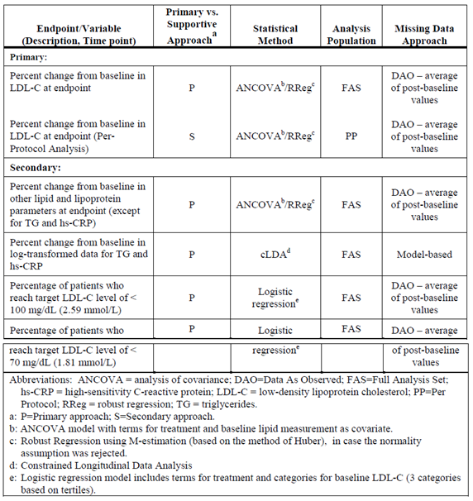

The data were summarized using standard descriptive statistics, and treatment effect for the primary efficacy endpoint included between treatment difference with 95% CIs. For all objectives not associated with a hypothesis, the false discovery rate FDR was controlled at 5% within a given lipid/lipoprotein parameter. The conclusions drawn from the unadjusted p-values for the treatment comparisons were similar to those after adjusting for the false discovery rate. The primary efficacy variable was analyzed in prespecified subgroups of age, gender, race, and diabetic status.

**Comment:** The primary analysis of all lipid/lipoprotein parameters in this study was based on the Robust Regression (RReg) approach using M-estimation (based on the method of Huber 1973), in conjunction with a multiple imputation (MI) approach (Rubin 1987) for calculating missing values. This approach was adopted because the assumption of normality for the percent change from baseline analysis for all lipid/lipoprotein parameters, using the residuals of the ANCOVA analysis (Residual Maximum Likelihood (REML) based method), was rejected at a significance level of 0.001 (based on the Shapiro-Wilk test) for both the Phase 1 and Phase 2 analyses. The ANCOVA analyses were repeated on the log scale, but even for log transformed data the assumption of normality was violated for most of the lipid/lipoprotein parameters during Phase 1 (based on the Kolmogorov-Smirnov test) except LDL-C/HDL-C ratio, and for most of the lipid/lipoprotein parameters during Phase 2 (Shapiro-Wilk test), except for Apo-B and the non-HDL-C/HDL-C ratio. The study noted that the REML-based analysis assumes that the vector of model based residuals follows a normal distribution and that under departures from normality (α = 0.001 level), this analysis can be inefficient or potentially misleading. Therefore, it was pre-specified that if normality was rejected (even after a transformation of the data such as logarithmic), then the primary analysis was to be conducted using MI of missing values (if any) in conjunction with a Robust Regression approach that used M-estimation.

#### Participant flow

A total of 5,134 patients were screened for inclusion in the study, and 1,547 patients were randomized into the Phase 1 treatment groups: 120 patients in the ezetimibe 10 mg + atorvastatin 10 mg (*EZ 10 mg + Atorva 10 mg*) group; 483 patients in the atorvastatin 20 mg (*Atorva 20 mg*) group; and 944 patients in the rosuvastatin 10 mg (*Rosuva 10 mg*) group. The reasons for 3,587 screened patients not being randomized were: screen failure 98.5% (n = 3,534); withdrawal by subject 0.6% (n = 22); adverse event 0.5% (n = 17); lost to follow up 0.4% (n = 15); and protocol violation 0.2% (n = 6). The disposition of all patients randomised to Phase 1 is summarized in Table 15 below, and the disposition of all patients who entered Phase 2 is summarized below in Table 16.

Table 15. P162. Disposition of all patients randomized to Phase 1.

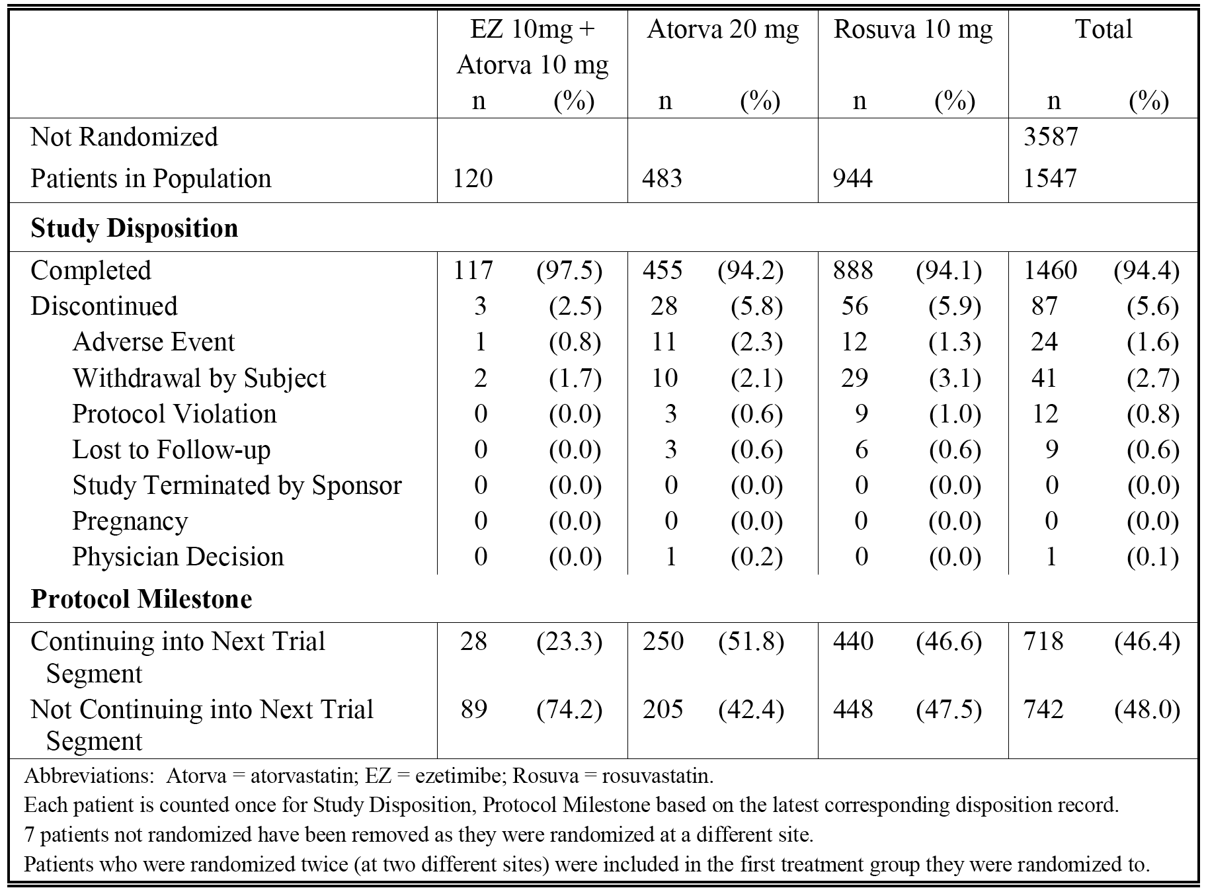

Table 16. P162. Disposition of all patients who entered Phase 2.

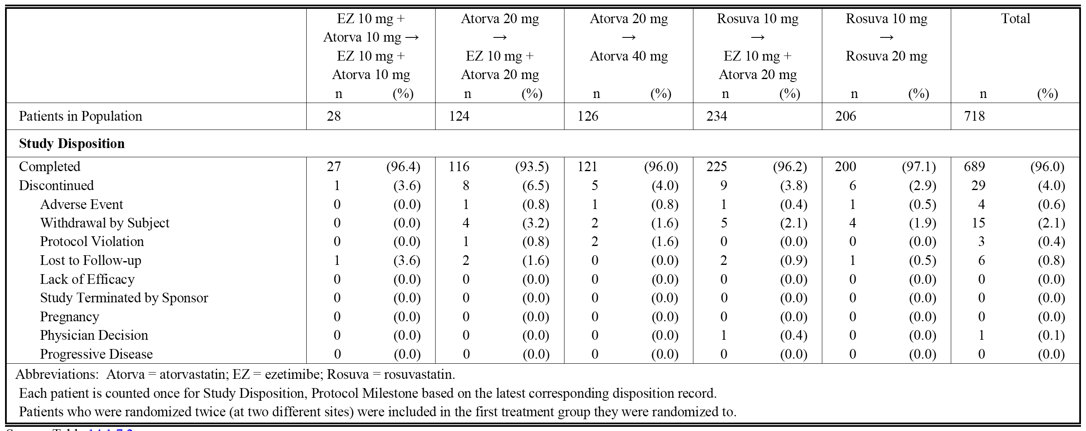

#### Major protocol violations/deviations

##### Phase 1- patients excluded from the analysis of percent change from baseline in LDL-C

The number of patients excluded from the FAS analysis at the end of Phase 1 was 1 (0.8%) in the *EZ 10 mg + Atorva 10 mg* group, 12 (2.5%) in the *Atorva 20 mg* group and 29 (3.1%) in the *Rosuva 10 mg* group. The major reasons for exclusion of patients from the FAS analysis at the end of Phase 1 were: LDL-C unavailable at Phase 1 baseline; LDL-C unavailable on Phase 1 treatment; not treated during Phase 1 and randomized twice. The most commonly occurring reason for exclusion from the FAS analysis was LDL-C unavailable on Phase 1 treatment.

The number of patients excluded from the PP analysis at the end of Phase 1 was 2 (1.7%) in the *EZ 10 mg + Atorva 10 mg group*, 31 (6.4%) in the *Atorva 20 mg* group and 63 (6.7%) in the *Rosuva 10 mg* group. The major protocol deviations resulting in exclusion from the PP analysis at the end of Phase 1 were: compliance with study medication is < 75% in the 6 weeks treatment Phase 1; patient failed to take assigned drug therapy for 3 or more consecutive days, and is back on the assigned therapy for < 14 consecutive days prior to observation in Phase 1; and patient took prohibited medication. The most commonly occurring major protocol deviation resulting in exclusion from the PP Phase 1 analysis was patient failed to take assigned drug therapy for 3 or more consecutive days, and is back on the assigned therapy for < 14 consecutive days prior to observation in Phase 1 The number of patients excluded from the Phase 1 analysis was provided.

##### Phase 2 - patients excluded from the analysis of percent change from baseline in LDL-C.

The number of patients excluded from the FAS analysis at the end of Phase 2 was 0 (0%) in the *EZ 10 mg + Atorva 10 mg → EZ 10 mg + Atorva 10* *mg* group, 4 (3.2%) in the *Atorva 20 mg → EZ 10mg + Atorva 20 mg* group, 3 (2.4%) in the *Atorva 20 mg → Atorva 40 mg* group, 6 (2.6%) in the *Rosuva 10 mg → EZ 10 mg + Atorva 20 mg* group, and 5 (2.4%) in the *Rosuva 10 mg → Rosuva 20 mg group*.

The major reasons for patient exclusion from the FAS analysis at the end of Phase 2 were: LDL-C unavailable at Phase 2 baseline; LDL-C unavailable on Phase 2 treatment; not treated during Phase 2 and randomized twice. The most commonly occurring reason for exclusion from the FAS analysis was LDL-C unavailable on Phase 2 treatment.

The number of patients excluded from the PP analysis at the end of Phase 2 was 0 (0%) in the *EZ 10 mg + Atorva 10 mg → EZ 10 mg + Atorva 10 mg* group, 8 (6.5%) in the *Atorva 20 mg → EZ 10mg + Atorva 20 mg* group, 7 (5.6%) in the *Atorva 20 mg → Atorva 40 mg* group, 20 (8.5%) in the *Rosuva 10 mg → EZ 10 mg + Atorva 20 mg group*, and 12 (5.8%) in the *Rosuva 10 mg → Rosuva 20 mg* group.

The major protocol deviations resulting in exclusion from the PP analysis at the end of Phase 2 were: compliance with study medication is < 75% in the 6 weeks treatment Phase 2; patient failed to take assigned drug therapy for 3 or more consecutive days, and is back on the assigned therapy for < 14 consecutive days prior to observation in Phase 2; and patient took prohibited medication. The most commonly occurring major protocol deviation resulting in exclusion from the PP Phase 2 analysis was patient failed to take assigned drug therapy for 3 or more consecutive days, and is back on the assigned therapy for < 14 consecutive days prior to observation in Phase 2.

The number of patients excluded from the Phase 2 analysis was provided.

#### Baseline data

##### **All patients randomized into Phase 1 (n = 1547)**

###### Demographics

In Phase 1 (n = 1547), 47.4% of all patients were male and 52.6% were female, the mean (SD) age was 59.8 (9.79) years (86.3% ≥ 50 years, 32.8% ≥ 65 years), 95.3% were White, 2.8% were Black, none were Asian, and 66.3% were non smokers. Overall, the mean (SD) height was 166.8 (9.57) cm, mean (SD) weight was 82.7 (16.04) kg, mean (SD) BMI was 29.7 (5.02) kg/m2 (55.5% with BMI < 30 kg/m2, 43.7% with BMI ≥ 30 kg/m2), median waist circumference was 102.0 cm (range: 62, 239 cm) for males and 98.0 cm (range: 56, 226 cm) for females, and median duration of hypercholesterolaemia was 5 years (range: 1, 58 years). The baseline demographic characteristics were similar for the three Phase 1 treatment groups.

###### CVD, systolic blood pressure, metabolic syndrome, and diabetes mellitus status

In all randomized Phase 1 patients (n = 1,547), the cardiovascular status was high risk without CVD in 49.7% and high risk with CVD in 50.3%, 91.5% had a systolic blood pressure of ≥ 120 mm Hg at Visit 2, 22.2% had a family history of CHD, and 82.5% had a history of prior treatment for hypercholesterolemia. These baseline characteristics were similar for the three Phase 1 treatment groups. The prevalence of factors associated with the metabolic syndrome was similar across treatment groups. In all Phase 1 randomized patients (n = 1,547), 63.5% had a waist circumference ≥ 102 cm (males) or ≥ 88 cm (females), 44.8% had TG ≥ 150 mg/dL, 27.3% had HDL-C < 40 mg/dL (males) or < 50 mg/dL (females), 89.7% had a blood pressure ≥ 130/85 mm Hg or on prescription drug treatment for hypertension, and 71.6% had fasting glucose ≥ 100 mg/dL or on prescription drug treatment for elevated glucose. Diabetes status for patients in the three Phase 1 treatment groups was similar. In all randomized Phase 1 patients (n = 1,547), 47.4% were diagnosed with diabetes, 29.5% had metabolic syndrome without diabetes, and 23.1% had neither metabolic syndrome nor diabetes. Baseline characteristics of patients randomized into Phase 1summarized by CVD status, systolic blood pressure, metabolic syndrome, diabetes, family history of premature CHD, prior treatment and treatment group were provided.

###### Medical history

In all randomized patients in Phase 1 (n = 1,547), all patients had one of more pre-existing medical conditions. The most commonly occurring pre-existing conditions reported in ≥ 10% of patients were hypertension (72.1%), diabetes mellitus T2 (32.3%), myocardial ischaemia (24.3%), obesity (16.2%), diabetes mellitus (14.6%), and coronary artery disease (10.5%).

###### Prior medications

In all randomized patients in Phase 1 (n = 1,547), 98.4% (n = 1,523) had a history of taking 1 or more prior medications. The most commonly taken prior medications reported in ≥ 10% of patients were HMG CoA reductase inhibitors (80.1%), salicylic acid and derivatives (40.1%), angiotensin converting enzyme (ACE) inhibitors plain (39.7%), selective beta blocking agents (33.5%), biguanides (27.9%), dihydropyridine derivatives (17.6%), angiotensin II antagonists (15.8%), sulfonamides plain (12.6%), and sulfonamides urea derivative (11.6%).

###### Concomitant medications

In all randomized patients in Phase 1(n = 1,547), the most commonly taken concomitant medications reported in ≥ 10% of patients were salicylic acid and derivatives (40.1%), ACE inhibitors plain (39.4%), selective beta blocking agents (33.5%), biguanides (27.8%), dihydropyridine derivatives (17.4%), angiotensin II antagonists (15.9%), sulfonamides plain (12.6%), and sulfonamides urea derivative (11.4%).

###### Baseline lipid and lipoprotein variables

In all randomized patients in Phase 1 (n = 1,547), the mean (SD) baseline LDL-C was 3.1 (0.46) mmol/L, the median level was 3.1 mmol/L and the range was 2 to 5 mmol/L. The baseline lipid and lipoprotein profiles were similar across the treatment groups for all parameters. The baseline levels for the lipid and lipoprotein variables in all patients randomized into Phase 1 were provided.

##### All patients entering phase 2 (n = 718)

###### Demographics

In patients entering Phase 2 (n = 718), 50.7% were male and 49.3% were female, the mean (SD) age was 58.7 (10.39) years (82.7% ≥ 50 years, 29.7% ≥ 65 years), 95.5% were White, 3.5% were Black, none were Asian, and 66.5% were non-smokers. Overall, the mean (SD) height was 167.4 (9.51) cm, mean (SD) weight was 82.9 (16.15) kg, mean (SD) BMI was 29.4 (4.89) kg/m2 (56.0% with BMI of < 30 kg/m2, 43.2% with BMI of ≥ 30 kg/m2), median waist circumference was 102.0 cm (range: 64, 239 cm) for males and 97.0 cm (range: 56, 226 cm) for females, and median duration of hypercholesterolaemia was 5 years (range: 1, 48 years). The baseline demographic characteristics were provided. The basic demographic profile was similar in patients randomized to Phase 1 and continuing in Phase 2.

###### CV, systolic blood pressure, metabolic syndrome, and diabetes mellitus status

In patients entering Phase 2 (n = 718), high cardiovascular risk without CVD was observed in 51.1% and with CVD was observed in 48.9%, systolic blood pressure of ≥ 120 mm Hg at Visit 2 was reported in 91.9%, 25.1% had a family history of CHD, and 84.1% had prior treatment for hypercholesterolemia. In all patients entering Phase 2, 63.6% had a waist circumference of ≥ 102 cm (males) or ≥ 88 cm (females), 45.0% had TG ≥ 150 mg/dL, 27.6% had HDL‑C < 40 mg/dL (males) or < 50 mg/dL (females), 90.8% had a blood pressure ≥ 130/85 mm Hg or on prescription drug treatment for hypertension, and 69.8% had fasting glucose ≥ 100 mg/dL or on prescription drug treatment for elevated glucose. In all patients entering Phase 2, 46.1% were diagnosed with diabetes, 50.9% had metabolic syndrome without diabetes, and 23.0% had neither metabolic syndrome nor diabetes. The clinical characteristics of patients entering Phase 1 summarized by CVD status, systolic blood pressure, metabolic syndrome, diabetes, family history of premature CHD, prior treatment and treatment group were provided. The CVD, systolic blood pressure, metabolic syndrome and diabetes mellitus profiles for patients randomized to Phase 1 were similar to those for patients continuing in Phase 2.

###### Medical history

In patients entering Phase 2 (n = 718), all patients had one of more pre-existing medical conditions. The most commonly occurring pre existing conditions reported in ≥ 10% of patients were hypertension (73.7%), diabetes mellitus T2 (33.4%), myocardial ischaemia (24.1%), obesity (14.2%), diabetes mellitus (12.3%), and osteoarthritis (10%). The medical history profile was similar for patients randomized to Phase 1 and for patients continuing to Phase 2.

###### Prior medications

In patients entering Phase 2 (n = 718), 98.5% (n = 701) had a history of taking 1 or more prior medications. The most commonly taken prior medications reported in ≥ 10% of patients were HMG CoA reductase inhibitors (80.8%), salicylic acid and derivatives (37.3%), angiotensin converting enzyme (ACE) inhibitors plain (39.8%), selective beta blocking agents (32.3%), biguanides (26.3%), dihydropyridine derivatives (18.4%), sulfonamides urea derivative (10.6%) and sulfonamides plain (10.4%). The pattern of prior medication use was similar for patients randomized to Phase 1 and for patients continuing to Phase 2.

###### Concomitant medications

In patients entering Phase 2 (n = 718), the most commonly taken concomitant medications reported in ≥ 10% of patients were ACE inhibitors plain (39.7%), salicylic acid and derivatives (37.5%), selective beta blocking agents (32.6%), biguanides (26.0%), dihydropyridine derivatives (18.1%), angiotensin II antagonists plain (16.2%), sulfonamides plain (10.7%), and sulfonamides urea derivative (10.4%). The pattern of concomitant medication use was similar for patients randomized to Phase 1 and for patients continuing to Phase 2.

###### Baseline lipid and lipoprotein variables

In patients entering Phase 2, in the 204 patients with data the mean (SD) baseline LDL-C was 3.1 (0.46) mmol/L, the median level was 3.1 mmol/L and the range was 2 to 4 mmol/L. The baseline levels for the lipid and lipoprotein variables in all patients randomized into Phase 1 were provided. The lipid and lipoprotein profiles for patients randomized to Phase 1 and patients continuing in Phase 2 were similar.

#### Results for the primary efficacy variable

##### Primary hypotheses

The pre specified primary hypotheses for the primary efficacy variable of mean percent change in LDL-C from baseline to the end of Phase 1 (that is, after 6 weeks treatment) were met:

* co-administration of *EZ 10 mg + Atorva 10 mg* was superior to *Atorva 20 mg*, with a between treatment difference in in M-estimates of percent change from baseline in LDL-C of - 12.7% (95% CI: - 16.6, - 8.7,); p < 0.001.
* co-administration of *EZ 10 mg + Atorva 10 mg* was superior to *Rosuva 10 mg*, with a between treatment difference in in M-estimates of percent change from baseline in LDL-C of - 9.1% (95% CI: - 12.9, - 5.4,); p < 0.001.

The results for the robust regression are summarized below in Table 17.

Table 17. P162. Robust regression in percent change from baseline LDL-C (mmol/L) at end of Phase 1; FAS.

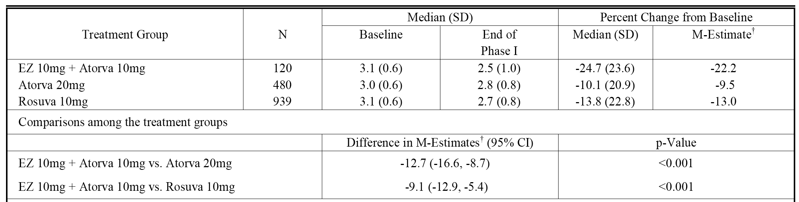

N = included patients who may only have either a baseline or an endpoint observation, as well as those patients with both. M-Estimates, 95% CI and p value were obtained from fitting a robust regression model with terms for treatment and baseline LDL-C, after imputing missing values. Baseline was taken as the average of the values at Visits 3 and 4 for patients who had those two measurements recorded. If the Visit 3 or Visit 4 value (Day 1) was missing, the latest available value prior to this was used, provided this measurement was taken within 2 weeks prior to Visit 4.

Treatment with *EZ 10 mg + Atorva 10 mg* resulted in a significantly higher percentage of patients achieving LDL-C < 2.59 mmol/L after 6 weeks of treatment in Phase 1 compared with *Atorva 20 mg* (56.3% (67/110) versus 37.4% (176/471), respectively; odds ratio = 2.51 (95% CI: 1.62, 3.89), p < 0.001). Similarly, treatment with *EZ 10 mg + Atorva 10 mg* resulted in a significantly higher percentage of patients achieving LDL-C < 2.59 mmol/L after 6 weeks of treatment compared with *Rosuva 10 mg* (56.3% (67/119) versus 43.6% (399/915), respectively; odds ratio = 1.77 (95% CI: 1.17, 2.67), p = 0.007).

Treatment with *EZ 10 mg + Atorva 10 mg* resulted in a significantly higher percentage of patients achieving LDL-C < 1.81 mmol/L after 6 weeks of treatment in Phase 1 compared with *Atorva 20 mg* (19.3% (23/119) versus 3.0% (14/471), respectively; odds ratio = 9.46 (95% CI: 4.56, 19.62), p < 0.001). Similarly, treatment with *EZ 10 mg + Atorva 10 mg* resulted in a significantly higher percentage of patients achieving LDL-C < 1.81 mmol/L after 6 weeks of treatment compared with *Rosuva 10 mg* (19.3% (23/119) versus 6.6% (60/915), respectively; odds ratio = 3.90 (95% CI: 2.23, 6.82), p < 0.001).

The sub group analysis (FAS) of change from baseline in LDL-C levels at the end of Phase 1 for age (< 65, ≥ 65 years), gender (female, male), race (White, Non-White), and diabetic status (diabetic, metabolic syndrome without diabetes, neither) were generally consistent with the analysis in the total population. The results of the subgroup analysis were summarized and provided.

**Comment:** In patients with hypercholesterolemia and high cardiovascular risk whose LDL-C was not controlled on atorvastatin 10 mg after 6 weeks treatment, switching to co-administration of ezetimibe 10 mg + atorvastatin 10 mg resulted in significantly greater reductions in LDL-C compared with doubling the dose of atorvastatin to 20 mg or switching to rosuvastatin 10 mg. Switching to ezetimibe 10 mg + atorvastatin 10 mg in this context was also associated with significantly greater achievement of LDL-C treatment goal levels < 2.59 mmol/L and < 1.81 mmol/L.

The treatment differences based on the M-estimates for both ezetimibe 10 mg + atorvastatin 10 mg versus atorvastatin 20 mg and ezetimibe 10 mg + atorvastatin 10 mg versus rosuvastatin 20 mg were greater than the expected treatment differences used to calculate the power for the comparisons. Consequently, it is reasonable to assume that the treatment differences are not only statistically significant for both treatment comparisons, but are also clinically meaningful.

##### Secondary hypotheses

The pre-specified secondary hypotheses for the primary efficacy variable of mean percent change in LDL-C from baseline to the end of Phase 2 (that is, after 6 weeks treatment) were met:

* *EZ 10 mg + Atorva 20 mg* is superior to *Atorva 40 mg* in patients not adequately controlled with *Atorva 20 mg* in Phase 1, with a between treatment difference in M-estimates of percent change from baseline in LDL-C of - 10.5% (95% CI: - 15.9, - 5.1); p < 0.001.
* *EZ 10 mg + Atorva 20 mg* is superior to *Rosuva 20 mg* in patients not adequately controlled with *Rosuva 10 mg* in Phase 1, with a between treatment difference in in M-estimates of percent change from baseline in LDL-C of - 9.5% (95% CI: - 13.6, - 5.4); p < 0.001.

The results for the robust regression are summarized below in Table 18.

Table 18. P162. Robust regression in percent change from baseline LDL-C (mmol/L) at end of Phase 2; FAS.

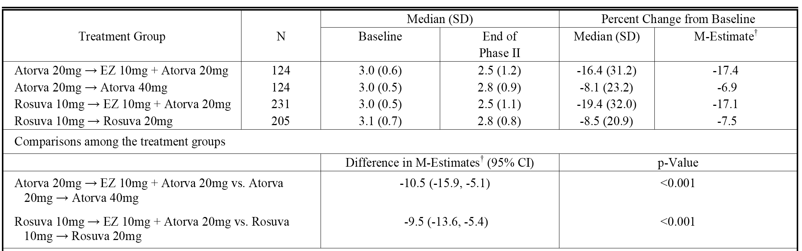

N = included patients who may only have either a baseline or an endpoint observation, as well as those patients with both. M-Estimates, 95% CI and p value were obtained from fitting a robust Regression model with terms for treatment and baseline LDL-C, after imputing missing values. Baseline was taken as the average of the values at Visits 5 and 6 for patients who had those two measurements recorded. If the Visit 5 or Visit 6 value (Day 1) was missing, the latest available value prior to this was used, provided this measurement was taken within 2 weeks prior to Visit 6.

Treatment with *EZ 10 mg + Atorva 20 mg* resulted in a significantly higher percentage of patients achieving LDL-C < 2.59 mmol/L after 6 weeks of treatment in Phase 2 compared with *Atorva 40 mg* (55.8% (67/120) versus 34.1% (42/123), respectively; odds ratio = 2.71 (95% CI: 1.55, 4.73), p < 0.001). Similarly, treatment with *EZ 10 mg + Atorva 20 mg* resulted in a significantly higher percentage of patients achieving LDL-C < 2.59 mmol/L after 6 weeks of treatment compared with *Rosuva 20 mg* (53.5% (122/228) versus 35.8% (72/201), respectively; odds ratio = 2.38 (95% CI: 1.56, 3.63), p < 0.001).

Treatment with *EZ 10 mg + Atorva 20 mg* resulted in a significantly higher percentage of patients achieving LDL-C < 1.81 mmol/L after 6 weeks of treatment in Phase 2 compared with *Atorva 40 mg* (18.3% (22/120) versus 0.8% (1/123), respectively; odds ratio = 27.77 (95% CI: 3.64, 211.83), p = 0.001). Similarly, treatment with *EZ10 mg + Atorva 20 mg* resulted in a significantly higher percentage of patients achieving LDL-C < 1.81 mmol/L after 6 weeks of treatment compared with *Rosuva 20 mg* (15.4% (55/228) versus 3.0% (6/201), respectively; odds ratio = 7.08 (95% CI: 2.85, 17.56) p < 0.001).

The sub-group analysis (FAS) of change from baseline in LDL-C levels at the end of Phase 2 for age (< 65, ≥ 65 years), gender (female, male), race (White, Non-White), and diabetic status (diabetic, metabolic syndrome without diabetes, neither) were generally consistent with the analysis in the total population. The results of the subgroup analysis were provided.

**Comment:** In patients not adequately controlled on atorvastatin 20 mg for 6 weeks (Phase 1), switching to co-administration of ezetimibe 10 mg + atorvastatin 20 mg for 6 weeks (Phase 2) resulted in significantly greater reductions in LDL-C compared with doubling the dose of atorvastatin from 20 mg to 40 mg. Similarly, in patients not adequately controlled on rosuvastatin 10 mg for 6 weeks (Phase 1), switching to co-administration of ezetimibe 10 mg + atorvastatin 20 mg for 6 weeks (Phase 2) resulted in significantly greater reductions in LDL-C compared with doubling the dose of rosuvastatin from 10 mg to 20 mg. Switching to ezetimibe 10 mg + atorvastatin 20 mg in this context was also associated with significantly greater achievement of LDL-C treatment goal levels < 2.59 mmol/L and < 1.81 mmol/L.

The treatment differences based on the M-estimates for both ezetimibe 10 mg + atorvastatin 20 mg versus atorvastatin 40 mg and ezetimibe 10 mg + atorvastatin 20 mg versus rosuvastatin 20 mg were greater than the expected treatment differences used to calculate the power for the comparisons. Consequently, it is reasonable to assume that the treatment differences are not only statistically significant for both treatment comparisons but are also clinically meaningful.

#### Results for the secondary efficacy variables

##### Phase 1

The summary of percent changes for all lipid/lipoprotein endpoints (mg/dL) based on M-estimates at the end of Phase 1 is presented in Table 19. The results for nearly all lipid/lipoprotein parameters were statistically significantly superior in the co administered *EZ 10 mg + Atorva 10 group* compared with either the *Atorva 20 mg* group or the *Rosuva 10 mg* group.

Table 19. P162. Robust regression analysis summary of percent change from baseline in lipid endpoints (mg/dL) at end of PHASE 1; FAS.

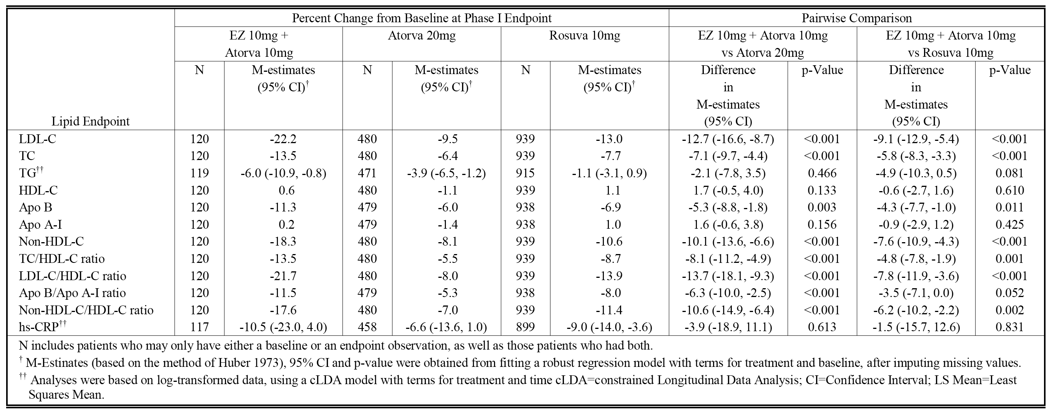

##### Phase 2

The summary of percent changes in all lipid/lipoprotein endpoints (mg/dL) based on M-estimates at the end of Phase 2 was provided. The results for just over half of the lipid/lipoprotein parameters statistically significantly favoured the *Atorva 20 mg → EZ 10 mg + Atorva 20 mg* group over the *Atorva 20 mg → Atorva 40 mg* group, while the results for nearly all of the lipid/lipoprotein parameters statistically significantly favoured the *Rosuva 20 mg → EZ 10 mg + Atorva 20 mg* group over the *Rosuva 10 mg → Rosuva 40 mg* group.

### Supportive studies: P185 and P190

#### Design, objectives, location, dates

The submission included two, Phase III clinical efficacy and safety studies of identical design, apart from the strength of the ezetimibe/atorvastatin FDC combination product being assessed (for example, 10/20 mg in study P185 and 10/40 mg in study P190). The studies were designed to compare the efficacy and safety of co administered ezetimibe + atorvastatin compared with FDC Tablet administration at the same strengths in patients with primary hypercholesterolaemia. In view of the identical design of the two studies they have been evaluated together in this report.

The primary objectives were:

* to evaluate the low density lipoprotein cholesterol (LDL-C) lowering efficacy of ezetimibe 10 mg co administered with atorvastatin 20 mg compared with the ezetimibe/atorvastatin FDC 10/20 mg tablet (P185)
* to evaluate the low density lipoprotein cholesterol (LDL-C)-lowering efficacy of ezetimibe 10 mg co administered with atorvastatin 40 mg compared with the ezetimibe/atorvastatin 10/40 mg FDC tablet (P190).

The secondary objectives were:

* to compare the effects of the co administered group with the FDC group in studies P185 and P190, with respect to total cholesterol (TC), high density lipoprotein cholesterol (HDL-C), non-HDL-C, apolipoprotein (Apo) B, and triglycerides (TG).
* to evaluate the safety and tolerability of the co administered group with the FDC group in studies P185 and P190.

Both P185 and P190 were undertaken in the USA at 58 and 50 centres, respectively. Study P185 was undertaken from 24 October 2011 to 19 April 2012, and the CSR was dated 23 July 2012. Study P190 was undertaken from 21 October 2011 to 30 May 2012, and the CSR was dated 20 August 2012. In both studies, Independent Ethics Committees (IECs) reviewed and approved the protocol and applicable amendments. The studies were conducted in accordance with Good Clinical Practice (GCP) standards and applicable country and/or local statutes and regulations regarding ethical committee review, informed consent, and the protection of human subjects participating in biomedical research. Both studies were sponsored by MSD.

#### Investigational plan

Both studies were 25 week multicentre, randomized, double blind, 2 period, and crossover in design comprising a 5 week washout followed by a 2 week single blind placebo run in period, and two 6 week treatment periods separated by a 6 week single blind placebo washout period. Eligible patients with primary hypercholesterolaemia were to be at low, moderate, or moderately high risk cardiovascular risk (according to NCEP/ATP III guidelines), and naïve to lipid lowering agents or currently taking allowable statin or ezetimibe-statin combination therapy from which they could be washed off and switched to study medication. High risk patients (CHD or CHD risk equivalent) were not eligible. The NCEP ATP III Guidelines and CHD/CHD risk equivalents factors were provided. Acceptable on treatment LDL-C screening values for patients on allowable statins and ezetimibe/statin combination therapies were specified in the protocols. Eligible patients were enrolled in a 7 week washout/run in period. During this time they received lifestyle and diet counsel, treatment compliance recommendations, and placebo treatment during the run in from Week - 2 to Day - 1 of the study. Eligibility for randomization was determined at the end of the run in phase.

#### Study P185

It was planned that approximately376 patients were to be randomized in a 1:1 ratio to one of two blinded treatment sequences. Patients received either an ezetimibe/atorvastatin FDC 10/20 mg tablet or co administered ezetimibe 10 mg + atorvastatin 20 mg once daily for 6 weeks (Period I), underwent washout for 6 weeks while taking single blind placebo, and then crossed over to the corresponding dose of co-administration ezetimibe 10 mg + atorvastatin 20 mg or an ezetimibe/atorvastatin FDC 10/20 mg tablet for an additional 6 weeks of treatment (Period II). Study endpoints were assessed at the end of Periods I and II. The LDL-C value measured at randomization served as the baseline for both Periods I and II. A follow up/post study phone call or visit (if necessary) was scheduled 14 days after the final dose of the double blind study medication. The study schedule is summarized schematically in Figure 2 below, and the study flow chart was provided.

Figure 2. P185 Study plan.

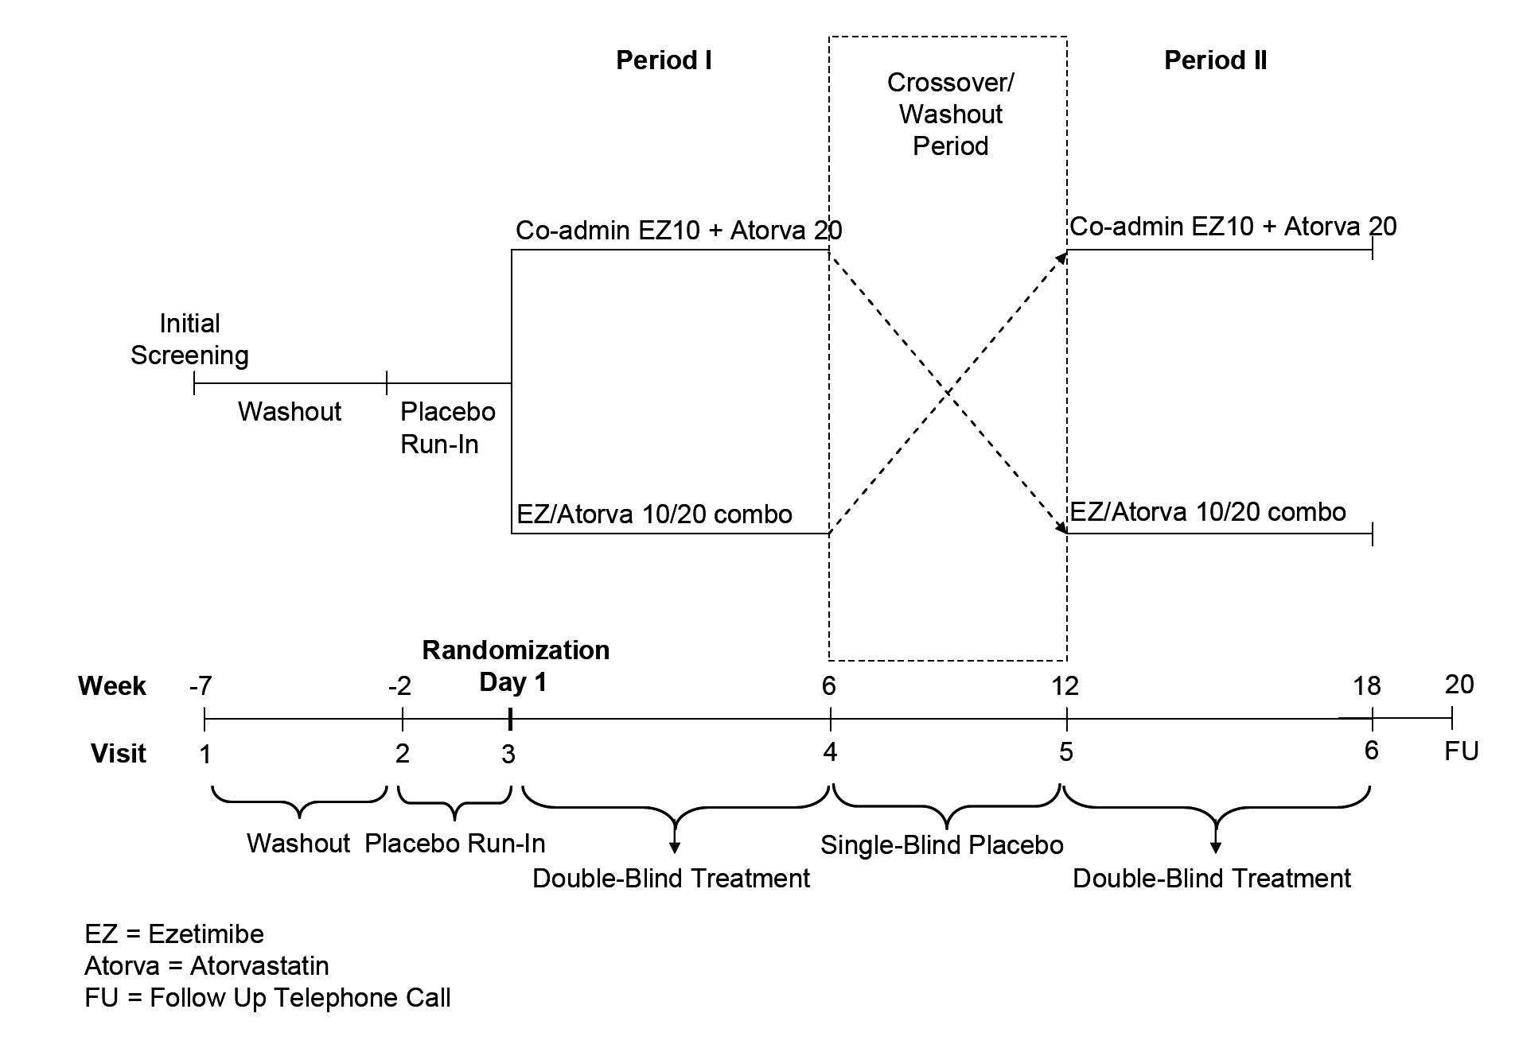

#### Study P190

It was planned that approximately 300 patients were to be randomized in a 1:1 ratio to one of two blinded treatment sequences. Patients received either an ezetimibe/atorvastatin FDC 10/40 mg tablet or co administered ezetimibe 10 mg + atorvastatin 40 mg once daily for 6 weeks (Period I), underwent washout for 6 weeks while taking single blind placebo, and then crossed over to the corresponding dose of co-administration ezetimibe 10 mg + atorvastatin 40 mg or an ezetimibe/atorvastatin FDC 10/40 mg tablet for an additional 6 weeks of treatment (Period II). Study endpoints were assessed at the end of Periods I and II. The LDL-C value measured at randomization served as the baseline for both Periods I and II. A follow-up/post study phone call or visit (if necessary) was scheduled 14 days after the final dose of the double blind study medication. The study schedule is summarized schematically in Figure 3, below, and the study flow chart is similar to that for study P185.

Figure 3. P190 Study plan.

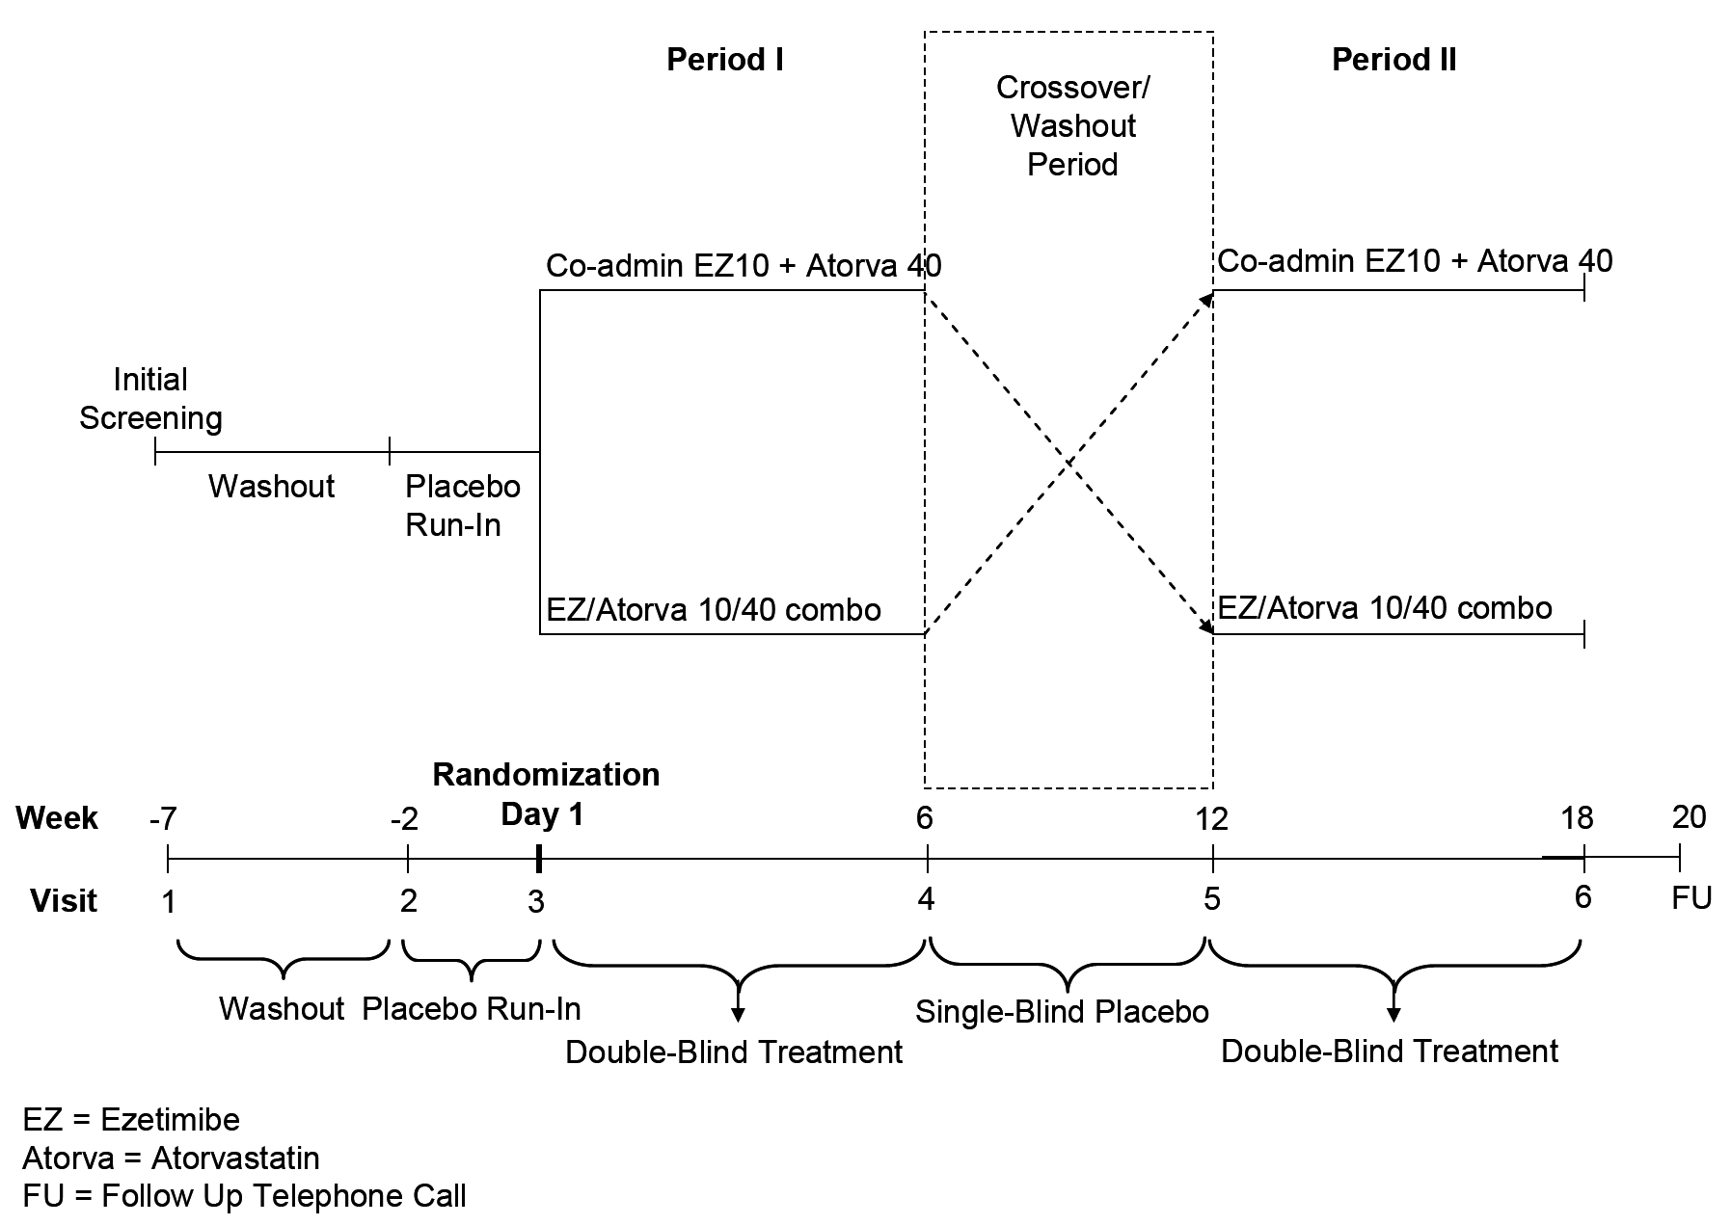

**Comment**: While unusual for a Phase III study, a crossover design is considered to be appropriate for a condition such as primary hypercholesterolaemia where spontaneous changes in lipid/lipoprotein levels over a 12 week period would be unlikely, provided diet and levels of physical activity remain constant. Both studies included a 6 week washout period between the two active treatment periods. Based on the half-life values for ezetimibe, atorvastatin and HMG-CoA reductase activity the 6 week washout period between the two active treatment periods is considered to be sufficient to avoid carry over effects of treatment from Period I to Period II. The pre active treatment phase prior to Period I was 7 weeks in duration (an initial 5 week washout followed by a 2 week placebo run- n). The 7 week washout/run in phase is considered to be sufficient to exclude carry over effects from pre-treatment lipid lowering therapies.

#### Inclusion and exclusion criteria

The inclusion and exclusion criteria were the same for both studies. Summaries of the inclusion and exclusion criteria for study P185 (identical to study P190) were provided.

##### Visit 1 criteria:

The study population included men and women aged ≥ 18 and < 80 years, with primary hypercholesterolaemia at low, moderate, or moderately high cardiovascular risk (according to NCEP ATP III guidelines, as determined by the Visit 1 Cardiovascular Risk Assessment), and either statin naïve with off therapy LDL-C ≥ 3.36 mmol/L) for low risk or ≥ 2.59 mmol/L for moderate or moderately high risk OR on allowable statin or ezetimibe statin combination therapy dosage with on therapy LDL-C level within the protocol specified range, and could be safely washed off their current lipid lowering therapy and switched to study medication. In addition, patients had to be willing to maintain a European Society of Cardiology (ESC)/NCEP Therapeutic Lifestyle Changes (TLC) diet or similar cholesterol lowering diet for the duration of the study.

##### Visit 2 criteria:

Off therapy LDL-C levels at Visit 2 were: for low risk patients ≥ 3.36 mmol/L and ≤ 7.76 mmol/L; for moderate risk patients ≥ 2.59 mmol/L and ≤ 7.76 mmol/L; and for moderately high risk patients ≥ 2.59 mmol/L and ≤ 7.11 mmol/L. Other criteria included: liver transaminases (ALT and AST) ≤ 2 x ULN (sample collected at Visit 1) with no active liver disease at Visit 2.CK levels ≤ 3 x ULN at Visit 2 (sample collected at Visit 1); met NCEP ATP III low risk criteria (0 to 1 risk factors), moderate risk criteria (2+ risk factors and 10 year risk < 10%), or moderately high risk criteria (2+ risk factors and 10 year risk 10 to 20%). Cardiovascular risk criteria were determined by the Framingham calculation (using lipid values obtained at Visit 2).

##### Visit 3 criteria:

Patient had completed the 2 week placebo run in period. Patient had ≥ 75% compliance with study medication during the placebo run in period. If the patient was < 75% compliant with run in study therapy, then they could be allowed to continue if, in the opinion of the investigator, compliance would improve with additional counselling. Patient had TG concentrations ≤ 4.52 mmol/L) (sample collected at Visit 2).

Both studies also included identical pre specified criteria relating to discontinuation from therapy and/or study observation including: (a) consecutive (2 or more measurements) elevations in ALT/AST ≥ 3 x ULN; (b) consecutive elevations in CK ≥ 10 x ULN with or without muscle symptoms; (c) consecutive elevations in CK ≥ 5 to < 10 x ULN with muscle symptoms; (d) patients requiring any treatment with cyclosporine; (e) patients requiring any treatment with a potent inhibitor of CYP3A4 such as, itraconazole, ketoconazole, erythromycin, clarithromycin, or HIV protease inhibitors; (f) any condition that exposed the patient to significant risk by continuing in the trial or did not allow the patient to adhere to the requirements of the protocol; (g) positive serum pregnancy test; (h) any patient who was unblinded to treatment regimen during the study.

#### Study treatments

* Single blind placebo run in treatment for 2 weeks prior to the start of Period 1 (P185, P190).
* FDC 10/20 mg tablet and placebos for ezetimibe 10 mg and atorvastatin 20 mg tablets (that is, three tablets) OR co administered ezetimibe 10 mg + atorvastatin 20 mg tablets and placebo for FDC 10/20 mg tablet (that is, three tablets) for 6 weeks during Period I with a crossover to the alternate treatment for 6 weeks during Period II (P185).
* FDC 10/40 mg tablet and placebos for ezetimibe 10 mg and atorvastatin 40 mg tablets (that is, three tablets) or co administered ezetimibe 10 mg + atorvastatin 40 mg tablets and placebo for FDC 10/40 mg tablet (that is, three tablets) for 6 weeks during Period I with a crossover to the alternate treatment for 6 weeks during Period II (P190).
* During the washout period all patients received single blind placebo for 6 weeks (P185, P190).

In both studies, treatments (three tablets using double dummy blinding) were to be taken once daily with or without food. As there was no recommended time for the dosage, patients were encouraged to take their treatment at a consistent time each day in order to promote compliance. Treatment compliance was provided. Treatment compliance (defined as patient taking ≥ 75% of expected dose) was reported in nearly all patients in both studies.

**Comment**: The ezetimibe/atorvastatin FDC 10/20 mg and 10/40 mg tablets are not the same formulation as those being proposed for registration but are the previous formulation.

#### Efficacy variables

In both studies, the primary efficacy variable was the percent change from baseline in LDL-C after 6 weeks of treatment.

In both studies, the secondary efficacy variables were the percent changes from baseline in: TC; TG; HDL-C; non-HDL-C; and Apo B after 6 weeks of treatment.

In both studies, fasting blood samples (obtained at least 12 hours after intake of last meal/food/beverage other than water) were collected (lipids at Visits 1, 2, 3, 4, and 6; apolipoproteins an hs-CRP at Visits 3, 4, and 6). All lipid/apolipoproteins/hs-CRP determinations were carried out by a certified central laboratory. LDL-C was calculated using the Friedewald method when TG < 3.95 mmol/L and by beta quantification ultracentrifugation if TG ≥ 3.95 mmol/L).

#### Randomization and blinding methods

In both studies, patients were randomly allocated in a 1:1 ratio to either an FDC tablet or co administered ezetimibe + atorvastatin, and administration of placebo tablets was used to maintain the blind. The biostatistics designee of the sponsor generated the randomized allocation schedules with block size of 4 for study treatment assignment. Randomization was performed centrally via interactive response technology (IRT).

Both studies included a 2 week single-blind placebo run-in period, and two 6 week double blind treatment periods separated by a 6 week single blind placebo washout period. The double blind in Periods I and II included investigator site personnel and patients, and sponsor and Clinical Research Organization (CRO) personnel. Only patients were blinded to the study treatment during the placebo run in and placebo washout period. All placebo tablets were manufactured by the sponsor in the image of the active tablets to ensure blinding. Research personnel remained blinded to the individual patient treatment assignment until the study was completed, the in house review of the patient level data was finished, and the data file was frozen. Investigators and patients remained blinded to the treatment assignment until all patients completed the study. Drug identification information was to be unmasked only if necessary for the welfare of the patient. Every effort was to be made not to unblind the patient unless necessary. Once a patient was randomized at Visit 3, lipid values were blinded for the remainder of the study. Local evaluation of lipid values was not allowed once active therapy had been issued to a patient.

#### Analysis populations

Both studies included two populations for the analysis of efficacy; the Per-Protocol (PP) population and the Full Analysis Set (FAS) population.

The Per-Protocol (PP) population was the primary population for the analysis of efficacy data in both studies. The PP population excluded patients due to important deviations from the protocol that may have substantially affected the results of the primary efficacy endpoints. A patient may have been a protocol violator in one treatment period but not in the other treatment period. In this case, only the data corresponding to the treatment period for which the patient was a protocol violator was excluded from the analysis.

Potential violations that may have resulted in the exclusion of period specific patient data from the PP population included: patient received less than 4 weeks of study medication in the 6 weeks treatment period; compliance with study medication was less than 75% in the 6 weeks treatment period; patient received the same treatment in both Period I and Period II; patient failed to take assigned drug therapy for 3 or more consecutive days, and was back on the assigned therapy for < 14 consecutive days prior to observation; patient did not have baseline observation; or patient did not have a post-baseline observation for the analysis endpoint within 3 days of the last study medication in the treatment period.

The final determination on protocol violations and, consequently, the composition of the PP population, was made prior to the final unblinding of the database. Patients were included in the treatment group to which they were randomized for the analysis of efficacy data using the PP population.

The Full Analysis Set (FAS) population provided the patients for a supportive analysis performed for the primary efficacy endpoint. The FAS population consisted of all randomized patients who received at least one dose of study treatment, had a baseline observation, and had at least one post baseline observation for the analysis endpoint subsequent to at least one dose of study treatment. Patients were included in the treatment group to which they were randomized for the analysis of efficacy data using the FAS population.

**Comment**: In this crossover study primary analysis of efficacy was in the PP population, but with patients being included in the treatment group to which they were randomized for the analysis. This is acceptable as the studies were designed as non inferiority studies (see discussion of statistical methods below), and analysis in such studies based on the PP population provides a more conservative estimate of non-inferiority than analysis in the FAS population.

#### Sample size

##### Study 185

Planned enrollment in this study was 376 patients, 188 patients to each of the two treatment sequences (1:1 ratio). It was anticipated that 85% of these patients would be evaluable, providing 320 patients (160 patients per each treatment sequence) to achieve 95% power to establish that the two treatments are equivalent, with respect to percent change from baseline in LDL-C after 6 weeks of treatment, using two one sided tests each at 2.5% alpha level, and assuming the underlying true treatment difference is ± 1.40% and that the standard deviation of the difference is 12.8%. The power and sample size were based on the following assumptions: (1) evaluability rate of 85%; (2) an equivalence margin of ± 4%; (3) a standard deviation of 12.8%; and (4) true treatment difference of ± 1.40%.

##### Study 190

Planned enrollment in this study was 300 patients, 150 patients to each of the two treatment sequences (1:1 ratio). It was anticipated that 85% of these patients would be evaluable, providing 254 patients or 127 patients per each treatment sequence to achieve 95% power in order to establish that the two treatments are equivalent, with respect to percent change from baseline in LDL-C after 6 weeks of treatment, using two one-sided tests each at 2.5% alpha level, and assuming the underlying true treatment difference is ± 1.40% and that the standard deviation of the difference is 12.8%. The power and sample size were based on the following assumptions: (1) evaluability rate of 85%; (2) an equivalence margin of ± 4%; (3) a standard deviation of 12.8%; and (4) true treatment difference of ± 1.08% (note that the true difference assumption was smaller than that for study P185).

##### Both studies - power and sample size assumptions

The assumptions on which the power and sample size were based were derived from previous studies. The 85% evaluable patient figure was based partly on study P128, a 12 week study, where a 92% evaluable patient rate in the PP was observed, and partly on study P091 where 78% of enrolled patients completed the first 24 weeks of the study under the ezetimibe/simvastatin arm. The active treatment period in P185 was 12 weeks, just as in Protocol 128, but the 6 week washout period between the two 6 week active treatment periods in study P185 might reduce the evaluability rate. The equivalence margin is regarded as two-thirds of the effect of doubling a statin dose. The assumption relating to the standard deviation of the within patient treatment difference was based on data from 6 prior studies (P005, P038, P071, P091, P128, and P 0692) with treatment arms including ezetimibe/simvastatin or ezetimibe/atorvastatin and similar patient populations to study P185. The standard deviation assumption of 12.8% was based on the pooled estimate of the standard deviation of within-patient difference in percent change from baseline in LDL-C between Week 12 and Week 6 (or Week 8 in studies where Week 6 measurements were not available). The true treatment difference assumptions of ± 1.40% (P185) and ± 1.08% (P190) were based on a published model (Mandema et al., 2005), which relates percent change in LDL-C to dose response parameters, and on internal pharmacokinetic/pharmacodynamic (PK/PD) data. The sample size calculation is based on the two one-sided tests procedure of Schuirmann (1987).

The criterion for success was that the 95% CI for the mean difference between the combination and co-administration in percent change from baseline in LDL-C be contained within ± 4%. Given the assumed standard deviation, the 95% CI for the mean difference in percent change from baseline in LDL-C was expected to be contained within ± 4% when the observed difference is approximately 2.59% (P185) of 2.42% (P190) or smaller, in absolute value (expected half-width of the 95% CI for the mean difference is 1.41 (P185) or 1.58 (P190)).

#### Statistical methods

##### Primary hypothesis

###### Study 185

The ezetimibe/atorvastatin FDC 10/20 mg tablet is equivalent to co administered ezetimibe 10 mg + atorvastatin 20 mg tablets with respect to the percent change from baseline in LDL-C after 6 weeks of treatment. The two treatments will be considered equivalent if the 97.5% expanded confidence interval (CI) for the mean difference in percent change from baseline in LDL-C after 6 weeks of treatment is contained within ± 4%.

###### Study 190

The ezetimibe/atorvastatin FDC 10/40 mg tablet is equivalent to co administered ezetimibe 10 mg + atorvastatin 40 mg tablets with respect to the percent change from baseline in LDL-C after 6 weeks of treatment. The two treatments will be considered equivalent if the 97.5% expanded confidence interval (CI) for the mean difference in percent change from baseline in LDL-C after 6 weeks of treatment is contained within ± 4%.

**Comment:** Both studies were equivalence studies, with equivalence being based on pre-specified criteria relating to the primary efficacy endpoint of percent change from baseline in LDL-C at Week 6. The equivalence criterion of ± 4% is considered to be reasonable, and is stated by the sponsor to be two thirds of the effect of doubling a statin dose. No equivalence criteria were specified for the secondary efficacy variables.

##### Analysis strategy

The analysis strategy for the key efficacy variables for both studies (P185, P190) was identical (see Table 20 below).

Table 20. Studies P185 and P190. Analysis strategy for key primary and secondary efficacy variables.

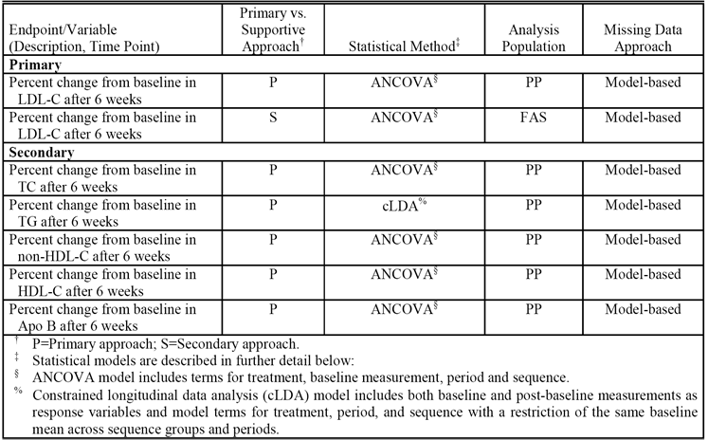

##### *Primary efficacy endpoint analysis (identical for both studies (P185, P190))*

The primary endpoint of this study was the percent change from baseline in LDL-C after 6 weeks of treatment. An analysis of covariance (ANCOVA) repeated measures model with fixed effects for treatment (2 levels, combination versus co-administration), baseline LDL-C, period (2 levels, Period I versus Period II, and sequence (2 levels, combination-co-administration versus co-administration-combination) was used to compare the treatment effects. Interpretation of the significance of the equivalence of the combination versus co-administration was based on the 97.5% expanded CI (Bofinger, 1985) for the difference between treatments. Given the nominal 95% CI (L, U), the corresponding 97.5% expanded CI is given by (min (0,L), max (0,U)). Within treatment adjusted mean percent changes from baseline, standard errors, and 95% CIs for the adjusted mean percent changes were obtained from the same ANCOVA model. No imputation method for missing data was used, as missing data were accounted for in the model used for the analysis.

**Comment**: In describing the ANCOVA model used to analyse the percent change from baseline in LDL-C after 6 weeks of treatment it is stated in both CSRs that the ‘ANCOVA model is expected to be robust to potential assumption violations of homogeneity of variance and normality. Past studies of ezetimibe plus statins have shown that the normal distribution is a reasonable fit to the percent change from baseline in LDL-C’. However, in the pivotal study (P162) study in this submission the assumption of normality for the percent change from baseline in LDL-C was violated resulting in the data being analysed by robust regression using M-estimation, in conjunction with multiple imputation to calculate missing values. No data could be identified in either study P185 or study P190 confirming that the percent change from baseline in LDL-C data or other lipid/lipoprotein variables did not violate the assumptions of homogeneity of variance and normality. The sponsor will be asked to comment on whether the data violated these assumptions.

Clinical equivalence was based the 97.5% expanded CI method (Bofinger, 1985) for the difference between treatments in the percent change from baseline in LDL-C after 6 weeks treatment. In this method, the 97.5% CI for the upper and lower bound limits are calculated and if the upper bound limit is < 0 then the limit is expanded forwards to 0, and if the lower bound limit is > 0 then the limit is expanded backwards to 0. This is a conservative method for the assessment of clinical equivalence because the CI may be widened to an upper bound of 0 in the event that the CI is entirely less than 0, or widened to a lower bound of 0 in the event that the CI is entirely greater than 0.

##### Secondary efficacy endpoint analysis (identical for both studies (P185, P190))

No pre specified equivalence criteria were provided for the secondary efficacy variables. The secondary efficacy lipid parameters measuring percentage change from baseline were analyzed using the same ANCOVA model as that used to analyze the primary efficacy endpoint, except that each model included a baseline covariate corresponding to the parameter being analyzed (TC, HDL-C, non-HDL-C, Apo B). The exception was the percent change from baseline for TG, which was analyzed differently due to the fact that these data tend to significantly violate key assumptions for analysis by ANCOVA. For TG, a constrained longitudinal data analysis (cLDA) method was used that included both baseline and post baseline measurements as response variables and model terms for treatment, period, and sequence with a restriction of the same baseline mean across sequence groups and periods. The TG data for this analysis was transformed by the natural logarithm, and the back transformation was used to estimate the geometric mean percent changes from baseline TG levels and 97.5% expanded CIs for the differences between means.

#### Participant flow

##### Study P185

A total of 1092 patients were screened, 686 were excluded and 406 were randomized. The main reasons for patients not being randomized were ‘screen failure’ (43.0% (n = 295)) and ‘study terminated by the sponsor’ (55.0% (n = 377)). Due to the rapid enrollment, the target number of randomized patients was reached before screening was stopped. Consequently, patients who were still being screened, but had not yet been randomized were terminated from the study by the sponsor.

Of the 406 patients randomized, 364 (89.7%) completed the study and 42 (10.3%) discontinued study drug prior to completing the trial. Most of the discontinuations (27/42) occurred in Period I, with 12/42 occurring in the crossover washout period and 3/42 occurring in Period II. The most common reason for discontinuation was AE (12 patients in Period I, 5 patients during the crossover washout period, 1 patient in Period II). The disposition of all patients in the study was provided.

##### Study P190

A total of 570 patients were screened, 242 were excluded and 328 were randomized. The main reasons for patients not being randomized were ‘screen failure’ (81.4% (n = 197)) and ‘study terminated by the sponsor’ (15.3% (n = 37)). Due to the rapid enrollment, the target number of randomized patients was reached before screening was stopped. Consequently, patients who were still being screened, but had not yet been randomized were terminated from the study by the sponsor.

Of the 328 patients randomized, 284 (86.6%) completed the study and 44 (13.4%) discontinued study drug prior to completing the trial. Most of the discontinuations (24/44) occurred in Period I, with 13/44 occurring in the crossover washout period and 7/44 occurring in Period II. The most common reasons for discontinuation were AE (16 patients) and patient withdrawal of consent. The disposition of all patients in the study wasprovided.

#### Major protocol violations

##### Study P185

The number of patients excluded from the analysis of percent change from baseline in the LDL-C after 6 weeks treatment and the reasons for exclusion are provided below in Table 21. There were 5 randomized patients excluded from the primary analysis in the PP population in both Periods I and II. It is considered that reasons for exclusion in the PP and FAS populations are unlikely to have invalidated the efficacy analyses of percent change from baseline in LDL-C after 6 weeks.

Table 21. P185. Summary of exclusions from the analysis of percent change from baseline in LDL-C after 6 weeks; all patients randomized.

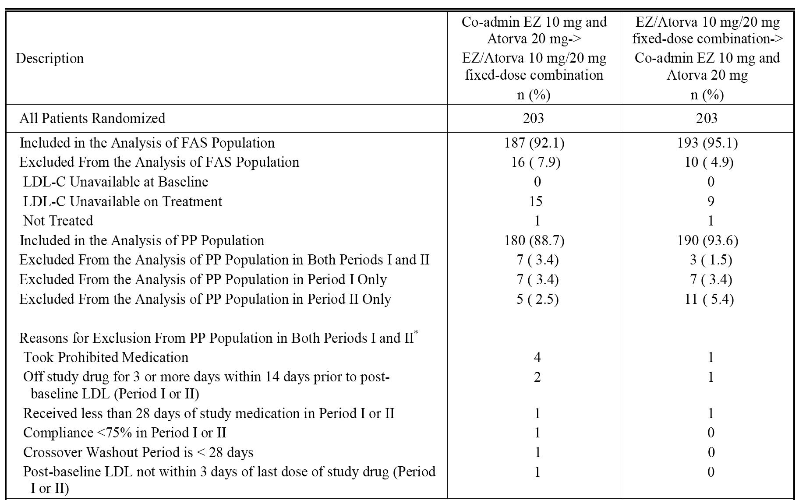

In the PP population, patients may have been excluded for more than 1 reason.

##### Study 190

The number of patients excluded from the analysis of percent change from baseline in the LDL-C after 6 weeks treatment and the reasons for exclusion are provided below in Table 22. There were 9 randomized patients excluded from the primary analysis in the PP population in both Periods I and II. It is considered that reasons for exclusion in the PP and FAS populations are unlikely to have invalidated the efficacy analyses of percent change from baseline in LDL-C after 6 weeks.

Table 22. P190. Summary of exclusions from the analysis of percent change from baseline in LDL-C after 6 weeks; all patients randomized.

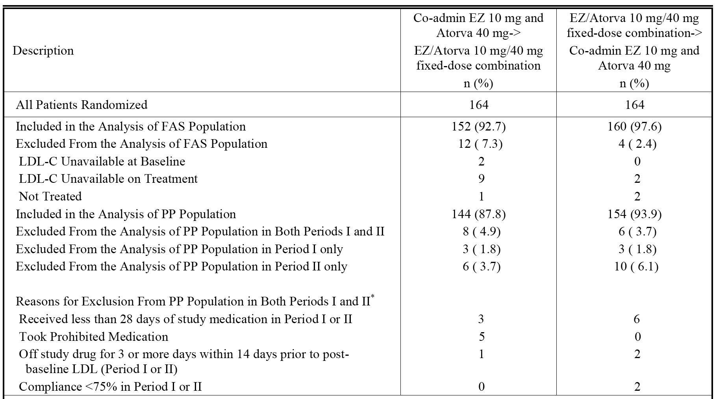

In the PP population, patients may have been excluded for more than 1 reason.

#### Baseline data

##### Demographic data

In study P185, the mean age of the 406 randomized patients was 56.1 years (range: 30, 79 years), 38.9% were male and 61.1% were female, 54.2% BMI < 30 kg/m2, 45.8% BMI ≥ 30 kg/m2, and the majority were White (84.2%). The mean duration of hypercholesterolaemia in the 404 randomized patients with data was 7.6 years (range: 1, 42 years). The baseline demographic data for study P185 were provided.

In study P190, the mean age of the 328 randomized patients was 55.4 years (range: 30, 70 years), 43.3% were male and 56.7% were female, 53.4% BMI < 30 kg/m2, 46.5% BMI ≥ 30 kg/m2, and the majority were White (81.7%). The mean duration of hypercholesterolaemia in the 325 randomized patients with data was 8.5 years (range: 1, 39 years). The baseline demographic data for study P190 was provided.

##### Baseline values for clinical efficacy parameters

In study P185, the mean (SD) LDL-C at baseline in the 406 randomized patients was 4.20 (0.823) mmol/L, the median value was 4.12 mmol/L and the range was 2.4 to 8.7 mmol/L. In study P190, the mean (SD) LDL-C at baseline in the 328 randomized patients was 4.20 (0.787) mmol/L, the median value was 4.12 mmol/L and the range was 2.1 to 6.7 mmol/L. The baseline values for the lipid and lipoprotein values were provided.

##### Patient medical history

In study P185, excluding hypercholesterolemia, almost all patients had a secondary diagnosis (97.8% (397/406)). The most commonly reported specific secondary diagnoses reported in ≥ 10% of the 406 randomized patients were hypertension (39.2%), osteoarthritis (23.6%), drug hypersensitivity (21.2%), gastro-oesophageal reflux disease (20.0%), seasonal allergy (17.5%), depression (17.2%), myopia (14.5%), back pain (14.5%), insomnia (13.5%), obesity (12.6%), anxiety (12.6%), and hysterectomy (11.8%).

In study P190, excluding hypercholesterolaemia, almost all patients had a secondary diagnosis (96.3% (316/328)). The most commonly reported specific secondary diagnoses reported in ≥ 10% of the 328 randomized patients were hypertension (45.7%), gastro-oesophageal reflux disease (22.9%), depression (22.3%), back pain (17.4%), osteoarthritis (17.4%), drug hypersensitivity (14.6%), insomnia (14.0%), seasonal allergy (13.7%), anxiety (12.5%), hypothyroidism (12.2%), headache (10.7%), and hysterectomy (10.4%).

##### Prior therapies

In study P185, at least one prior therapy had been taken by 89.2% (n = 362) of the 406 randomized patients. The most common prior therapies taken by ≥ 10% of the 406 randomized patients were vitamins (39.2%), analgesics (33.0%), lipid modifying agents (26.6%), anti inflammatory and anti rheumatic products (24.6%), agents acting on the renin angiotensin system (23.2%), drugs for acid related disorders (17.2%), psychoanaleptics (17.0%), mineral supplements (16.0%), diuretics (12.3%), and anti-histamines for systemic use (11.6%).

In study P190, at least one prior therapy had been taken by 90.5% (n = 297) of the 328 randomized patients. The most common prior therapies taken by ≥ 10% of the 328 randomized patients were lipid modifying agents (40.2%), analgesics (33.5%), vitamins (32.0%), agents acting on the renin angiotensin system (28.7%), anti inflammatory and anti rheumatic products (26.2%), drugs for acid related disorders (20.7%), psychoanaleptics (18.0%), mineral supplements (11.9%), diuretics (13.4%), psycholeptics (13.4%), thyroid therapy (11.9%), and calcium channel blockers (10.4%).

##### Concomitant therapies

In study P185, at least one concomitant therapy was taken by 89.7% (n = 364) of the 406 randomized patients. The most common prior therapies taken by ≥ 10% of the 406 randomized patients were vitamins (39.9%), analgesics (37.7%), anti inflammatory and anti rheumatic products (30.8%), agents acting on the renin angiotensin system (23.9%), psychoanaleptics (18.0%) drugs for acid related disorders (17.7%), mineral supplements (15.5%), antibacterials for systemic use (13.5%), antihistamines for systemic use (13.5%), and diuretics (12.6%).

In study P190, at least one concomitant therapy was taken by 86.9% (n = 285) of the 328 randomized patients. The most common prior therapies taken by ≥ 10% of the 328 randomized patients were analgesics (37.5%), anti-inflammatory and anti-rheumatic products (31.4%), vitamins (31.1%), agents acting on the renin angiotensin system (29.0%), drugs for acid related disorders (21.6%), psychoanaleptics (18.3%), mineral supplements (13.4%), diuretics (13.7%), psycholeptics (13.1%), antihistamines for systemic use (11.0%), calcium channel blockers (10.4%), and beta blocking agents (10.1%).

#### Results for the primary efficacy endpoint

The primary hypotheses for both studies was tested by using the 97.5% expanded CI for the comparison between ezetimibe/atorvastatin 10/20 mg (P185) or 10/40 mg (P190) FDC tablets versus co-administration of ezetimibe 10 mg + atorvastatin 20 mg (P185) or 40 mg (P190), with respect to the percent change from baseline in LDL-C for the PP population. In both studies, the 97.5% expanded CI was completely enclosed within the pre-specified ±4% equivalence interval. The results are summarized below in Table 23 for study P185, and in Table 24 for study P190. For both analyses, the LS means, 95% CIs and p-values were obtained from fitting an ANCOVA repeated measures model with terms for treatment, baseline LDL-C, period and sequence; an unstructured covariance matrix was used. The baseline LDL-C values for Periods I and II were the values measured at randomization.

Table 23. Study P185. Results for change from baseline from baseline in LDL-C (mmol/L) after 6 weeks treatment in the PP population (primary analysis); ANCOVA.

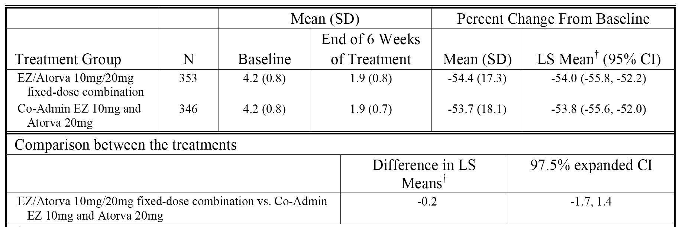

Table 24. Study P190. Results for change from baseline from baseline in LDL-C (mmol/L) after 6 weeks treatment in the PP population (primary analysis); ANCOVA.

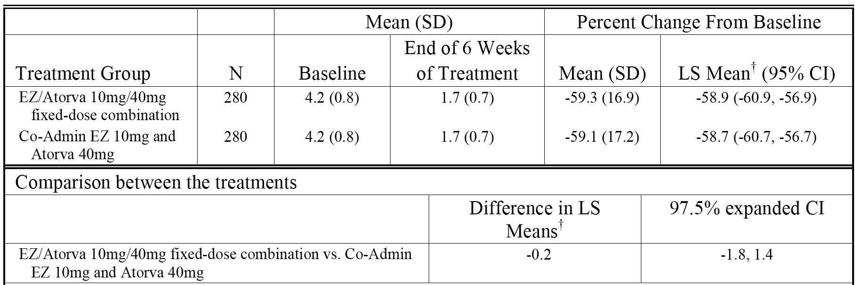

The supportive analyses of the primary efficacy endpoint in the FAS population were consistent with the primary analyses in the PP population. In Study P185, the difference in LS means between the two treatments (FDC minus co-administration) in percent change from Baseline in LDL-C (mmol/L) was - 0.1% (97.5% expanded CI: - 1.6%, 1.4%). In Study P190, the difference in LS means between the two treatments (FDC minus co-administration) in percent change from Baseline in LDL-C (mmol/L) was 0.1% (97.5% expanded CI: - 1.5%, 1.7%).

Both studies included an analysis of the primary efficacy endpoint in subgroups defined by age (< 65, ≥ 65 years), gender (male, female), and race (White, Black, Asian, others). In both studies, the 97.5% expanded CI was within ± 4% for males, females, patients aged < 65 years, and whites (n = 232), while for patients aged ≥ 65 years the 97.5% expanded CI was within ± 4% in study P185 but not in study P190, and for blacks the 97.5% expanded CI was outside ± 4% in both studies. In both studies, the number of patients in the Asian and other racial groups precluded meaningful comparisons between treatments.

**Comment:** In both studies, the FDC tablets were equivalent to the corresponding co administered tablets based on the percent change from baseline in LDL-C after 6 weeks of treatment in both the primary (PP population) and the supportive (FAS population) analyses. The treatment period in this study was short (6 weeks) and it would have been preferable if the treatment duration had been 12 weeks. However, the 6 weeks treatment duration is considered to be adequate based on the known efficacy data for ezetimibe and atorvastatin when co administered for the treatment of hypercholesterolaemia. The baseline values for both Periods 1 and 2 were the values at randomization (that is, single values), and it would have been preferable to have used average values at 3 to 4 times point in the 2 week placebo run in in order to reduce potential variability in the baseline value.

In both studies, analysis of the primary efficacy endpoint was based on an ANCOVA repeated measures model with covariate terms for treatment, baseline LDL-C, period and sequence. In the ANCOVA analysis of percent change from baseline in LDL-C (mmol/L) in the PP population, there was a statistically significant period effect (p = 0.011) in study P185 and a statistically significant baseline LDL-C effect in both study P185 and study P190 (p < 0.001, both studies). In neither study was there a statistically significant covariate effect for treatment or sequence. In study P185, the percent change from baseline in LDL-C (mmol/L) by treatment and period are summarized below in Table 25. For the ezetimibe/atorvastatin 10/20 mg FDC tablet, the mean (SD) percent change from baseline was notably greater in Period 1 compared with Period 2 while the mean (SD) percent change from baseline was marginally higher in Period 2 compared with Period 1 when ezetimibe 10 mg and atorvastatin 20 mg were co administered. The reason for the statistically significant period effect in study P185 is unknown, but does not appear to be due to a carry-over effect (which would be unlikely given the half-lives of the products). No discussion relating to this finding was provided in the CSR. However, while the period effect observed in study P185 for percent change from baseline in LDL-C (mmol/L) is considered to be clinically insignificant, the sponsor will be asked to comment on this effect. In addition, the sponsor will be asked to comment on the significant baseline LDL-C effects in both studies.

Table 25. Study P185. Percent change from baseline in LDL-C (mmol/L) after 6 weeks, by treatment and period; PP population.

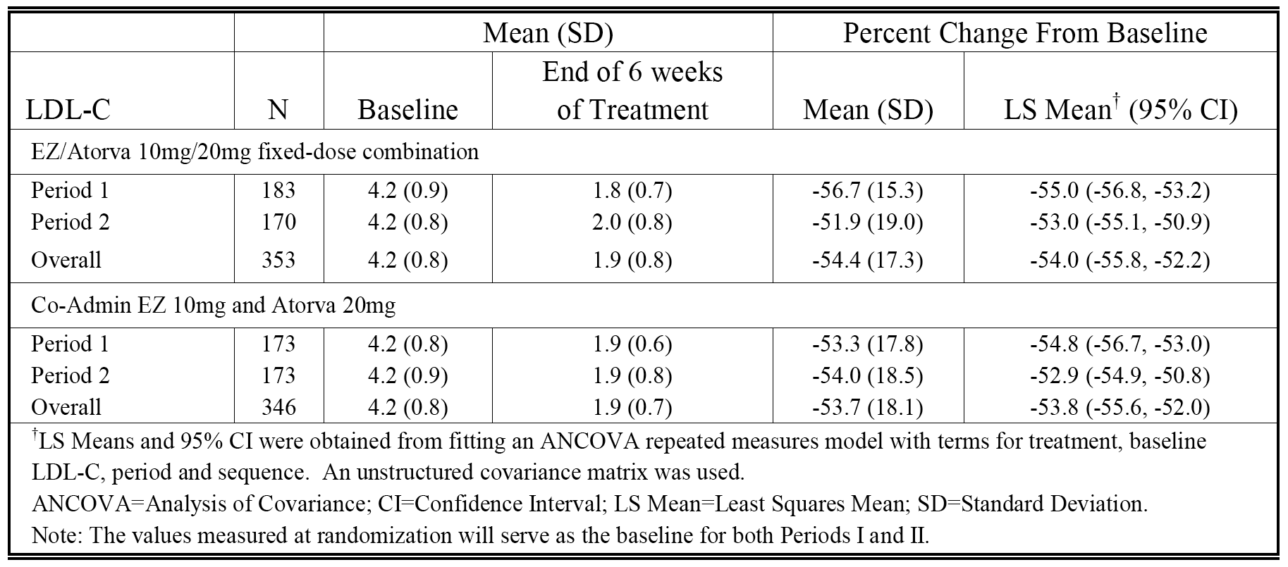

#### Results for the secondary efficacy endpoints

The results for the secondary efficacy endpoints in the PP population (primary analysis) are summarized below in Table 26 for study P185 and in Table 27 for study P190.

Table 26. P185. Percent change from baseline in lipid endpoints (mmol/L apart from Apo-B (g/L)) after 6 weeks of treatment; PP population.

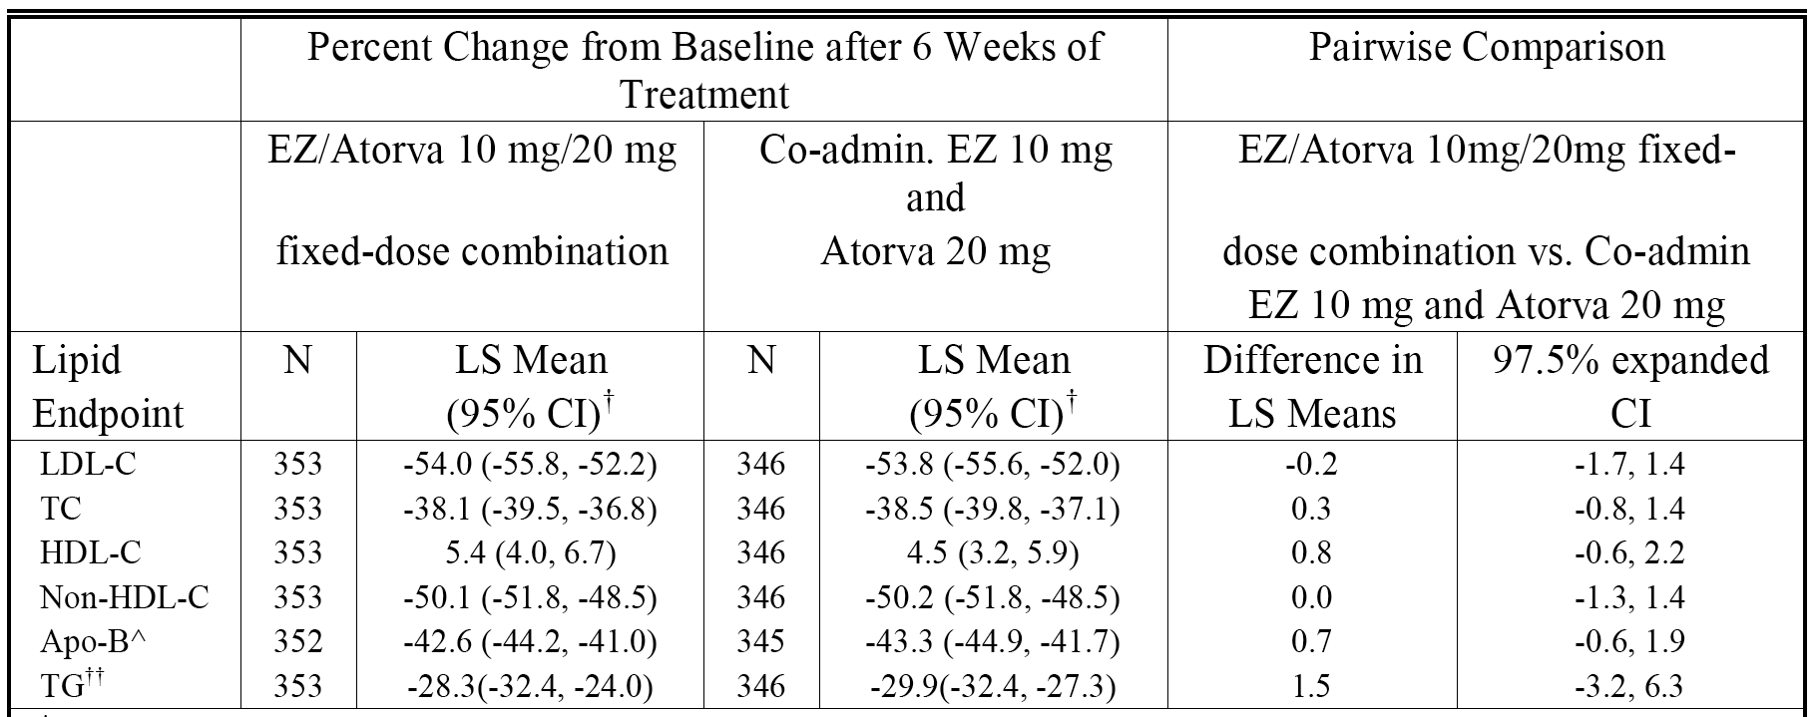

Table 27. P190. Percent change from baseline in lipid endpoints (mmol/L apart from Apo-B (g/L)) after 6 weeks of treatment; PP population.

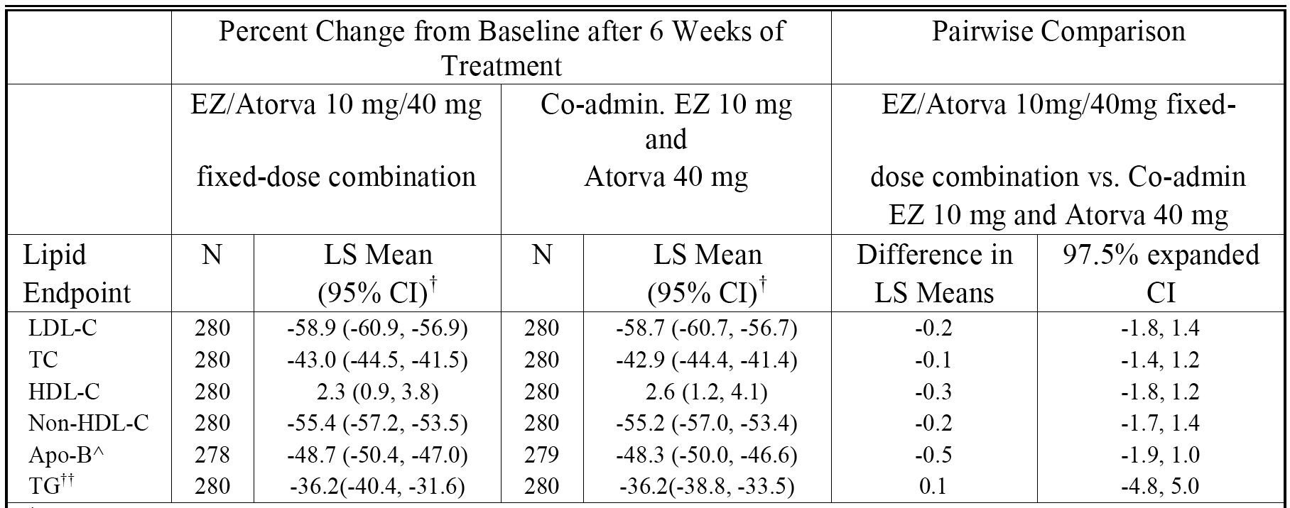

**Comment**: No clinical equivalence criteria were defined for the secondary efficacy lipid variables. However, LS mean values for both treatments were similar in both studies and the 97.5% expanded CI was within ± 4% for all parameters apart from TG. In addition, all expanded 97.5% expanded CIs include zero indicating that there were no statistically significant differences between the two treatments. Consequently, it is considered that the secondary efficacy endpoint analyses in both studies support the equivalence of the two treatments.

### Other studies (previously submitted and evaluated by the TGA)

#### Short-term factorial studies

##### P00692

P00692 was evaluated in the submission to register the ezetimibe/atorvastatin Composite Packs. It was a multicentre, randomized, double blind, placebo controlled, parallel group study of 628 patients with primary hypercholesterolemia. Patients received treatment with placebo, ezetimibe 10 mg, atorvastatin (10, 20, 40, or 80 mg), or ezetimibe 10 mg co administered with atorvastatin (10, 20, 40, or 80 mg) daily for 12 weeks. Patients were 18 to 86 years of age with baseline LDL-C levels of 145 mg/dL to 250 mg/dL (3.76 – 6.48 mmol/L) and baseline TG levels ≤350 mg/dL (3.96 mmol/L).

The primary efficacy variable was mean percent change in direct LDL-C from baseline to study endpoint with atorvastatin monotherapy pooled across all doses versus ezetimibe + atorvastatin pooled across all doses. The statistical analyses used an analysis of variance (ANOVA) model that extracted effects due to dose, treatment, and dose-by-treatment interaction. The results for the primary efficacy analysis are summarized below in Table 28.

Table 28. P00692. Mean percent change in plasma concentration of direct LDL-C between baseline and endpoint; ITT data set (pooled treatment groups).

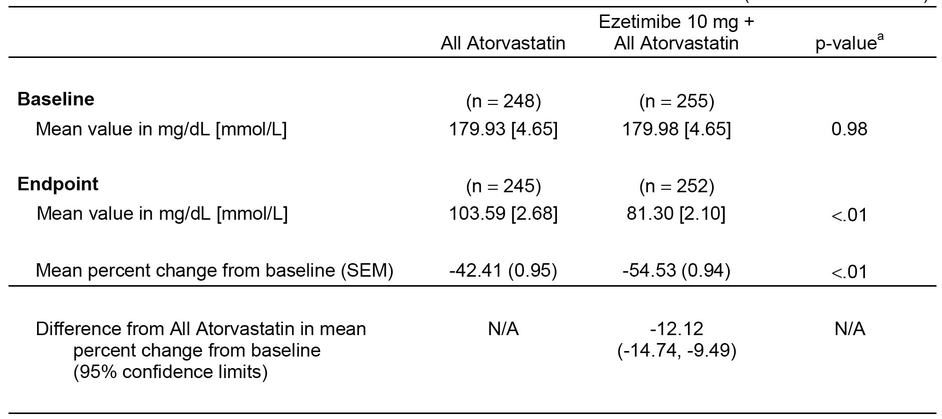

Secondary efficacy variables included mean percent changes from baseline to study endpoint for calculated other lipoprotein and apolipoprotein variables. Comparisons were made for the individual doses of ezetimibe + atorvastatin versus the corresponding atorvastatin monotherapy groups, ezetimibe alone versus placebo, and individual doses of ezetimibe + atorvastatin versus the next higher atorvastatin monotherapy dose group. The percentage of patients attaining therapeutic LDL-C goals with co-administration versus atorvastatin monotherapy was an exploratory endpoint.

Across the individual treatment groups, mean percent reductions from baseline to endpoint in LDL-C ranged from approximately 50% to approximately 60% for co-administration of ezetimibe 10 mg + atorvastatin (10, 20, 40, 80 mg) therapy compared with reductions of approximately 35% to approximately 51% for atorvastatin monotherapy (10, 20, 40, 80 mg). The incremental mean percent reduction observed with the co-administration of ezetimibe 10 mg to each dose of atorvastatin ranged from approximately 8% to approximately 15%, and was statistically significant in all cases when compared with each corresponding dose of atorvastatin monotherapy (p < 0.01). The mean incremental LDL-C lowering effects resulting from co-administration of ezetimibe 10 mg with each dose of atorvastatin were seen as early as 2 weeks and were maintained throughout the duration of the study.

In addition, a significantly greater reduction in mean percent reduction in LDL-C was observed between ezetimibe 10 mg co administered with each dose of atorvastatin and the next higher dose of atorvastatin monotherapy, and between ezetimibe 10 mg co administered with atorvastatin 10 mg and atorvastatin 40 mg alone. Co-administration of ezetimibe 10 mg with atorvastatin 10 mg resulted in a similar mean percent reduction in LDL-C (approximately 50%) as atorvastatin 80 mg administered alone (approximately 51%). In addition, when ezetimibe 10 mg was co administered with atorvastatin 80 mg, a further mean percent reduction of LDL-C was observed (approximately 60% for co-administration versus approximately 51% for atorvastatin 80 mg alone).

**Comment**: This study demonstrated that co-administration of ezetimibe 10 mg + atorvastatin (pooled across all doses) was more effective than atorvastatin alone (pooled across all doses) in reducing LDL-C from baseline to 12 weeks. In addition, greater reductions in LDL-C were observed with ezetimibe 10 mg + atorvastatin compared with the next higher dose of atorvastatin.

#### Short-term add-on studies (P02173/P2246; P040)

##### P02173/P2246

P02173/P2246 was included in the submission to register ezetimibe. It was a multinational, multicentre, randomized, double blind, placebo controlled study in 769 patients with primary hypercholesterolemia, known coronary heart disease, or multiple cardiovascular risk factors who had not reached their NCEP Adult Treatment (ATP) Program II target LDL-C levels with ongoing statin monotherapy. Patients were randomized to ezetimibe 10 mg or placebo, taken orally once daily with currently prescribed statin medication continued at unchanged dosage. The primary efficacy variable was change from baseline in calculated LDL-C after 8 weeks of treatment. Secondary efficacy variables included percentage of patients attaining NCEP ATP II LDL-C goals. Statistical analysis used an ANOVA model that included terms for statin, stratum, region, and treatment. For analyses of other lipid and lipid subclass endpoints, post-hoc analyses were undertaken with a similar ANOVA model to that used for analysis of the primary efficacy variable. The results for percent change in plasma LDL-C levels from baseline after 8 weeks treatment in the subgroup of 308 atorvastatin treated patients are summarized below in Table 29.

Table 29. P02173/P2246. Atorvastatin sub-group - percent change in plasma concentration of LDL-C from baseline after 8 weeks treatment; intent-to-treat data set.

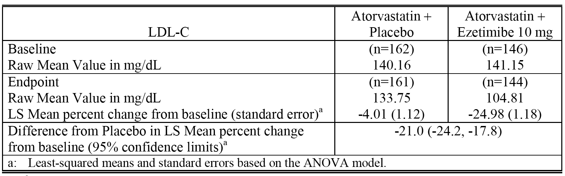

**Comment**: The percent reduction in plasma concentration of LDL-C from baseline after 8 weeks treatment was statistically significantly greater in the co administered ezetimibe 10 mg + atorvastatin group compared with the atorvastatin + placebo group. The results of the secondary efficacy variable analysis in patients not at their NCEP ATP II LDL-C goal at baseline showed that a greater percentage reached their goal at endpoint with ezetimibe 10 mg + atorvastatin (55.6% (80/146)) than with atorvastatin monotherapy (16.1% (26/162)). In this study, the atorvastatin dose ranged from 5 mg to 80 mg. The frequency distribution of the 10 to 80 mg doses of atorvastatin in the atorvastatin + placebo group and the ezetimibe 10 mg + atorvastatin groups, respectively, were 10 mg (11.8% (n = 46) versus 10.0% (n = 38)), 20 mg (10.5% (n = 41) versus 11.1% (n = 42)), 40 mg (0.0% (n = 35) versus 7.4% (n = 28)), and 80 mg (7.7% (n = 30) versus 7.4% (n = 28)).

##### Reversibility study (P2173R including pooled data from P2173 and P2246).

P2173R was included in the submission to register the Composite Packs. The data from the US study P2173 were pooled with data from the identical international study P2246 for analyses. The purpose of the reversibility period was to evaluate the pharmacodynamics of changes in lipid profiles following discontinuation of ezetimibe 10 mg in subjects who completed the 8 week treatment program of co-administration with statin + ezetimibe 10 mg or statin + placebo 10 mg (P2173/P2246). No objectives or hypotheses were pre specified for the reversibility period in the protocol, and consequently no inferential testing was conducted. In the double blind, randomized, 6 week reversibility period, all subjects from the 8 week treatment study period (double blind treatment with statin + ezetimibe or placebo 10 mg) maintained their statin monotherapy, but discontinued ezetimibe or placebo. The statin was maintained at the original dose at entry for the duration of both the 8 week treatment period and the 6 week reversibility period. The exploratory analysis focused on LDL-C, HDL-C, TG and TC. Safety and tolerability were assessed by clinical and/or statistical review of all safety parameters. A total of 730 subjects participated in the reversibility period, and 724 (99%) of these subjects had at least 1 lipid measurement during the 6 week reversibility period. The mean percent changes in LDL-C levels over time are summarized below in Table 30.

Table 30. P2173R. Mean percent changes in LDL-C levels over time.

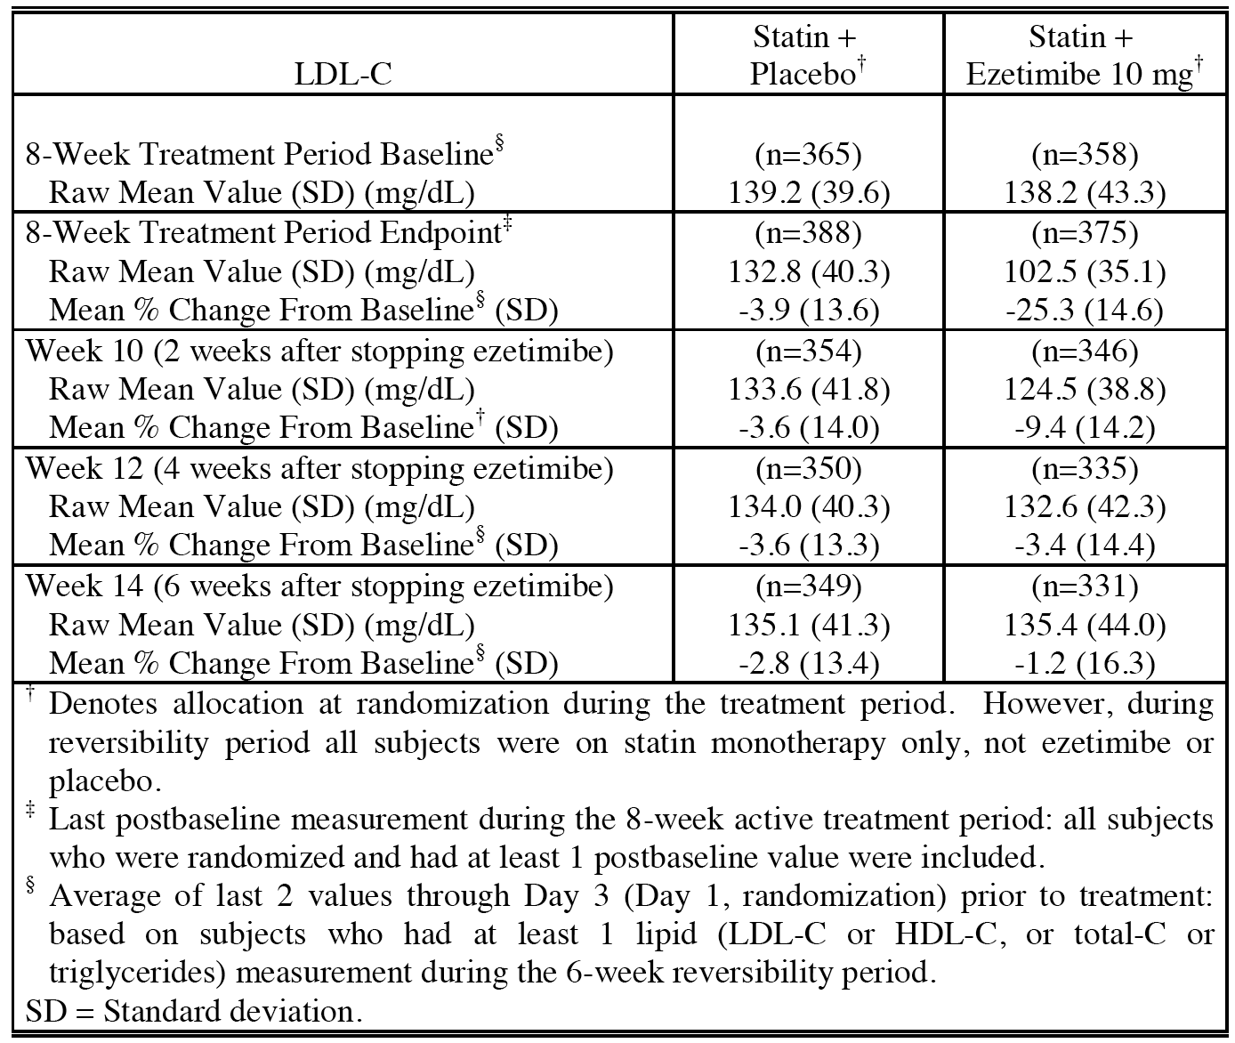

**Comment:** The LDL-C response to discontinuation of ezetimibe 10 mg following 8 weeks co-administration with statins was a reversion to baseline (that is, statin monotherapy) levels of LDL-C within 6 weeks. Over 95% of the reversal in the LDL-C level occurred within 4 weeks of discontinuation of ezetimibe 10 mg. Similar reversions to baseline levels were observed for the other lipid variables of HDL-C, TG, and TC. The pattern of reversibility was generally similar regardless of the statin type or dose. There was no evidence of rebound in LDL-C, HDL-C, TC, or TG levels following discontinuation of ezetimibe 10 mg.

##### P040

P040 was evaluated as part of the submission to register the Composite Packs. It was a multicentre (311 US centres), double blind, randomized, placebo controlled study assessing the effect of ezetimibe 10 mg added to ongoing statin therapy compared with continued statin therapy alone (at unchanged dose) in 3030 patients with primary hypercholesterolemia not at NCEP ATP III target LDL-C levels. The primary efficacy variable was change from baseline in plasma LDL-C after 6 weeks of treatment. The secondary efficacy variables included percentage of patients attaining NCEP ATP III LDL-C goals as well as change from baseline in TG and HDL-C. Statistical analysis of the primary efficacy variable used an ANOVA model with terms for treatment, NCEP ATP III risk category, and percentage of values above LDL-C target at baseline. The study included a sub-group of 1,115 patients who had been receiving atorvastatin therapy alone (mean dose 30 mg, range 5 to 80 mg), and the results for the analysis of the primary efficacy variable in this sub-group is summarized below in Table 31.

Table 31. P040. Percent change from baseline in LDL-C (mg/dL) in the atorvastatin sub-group after 6 weeks; modified ITT population.

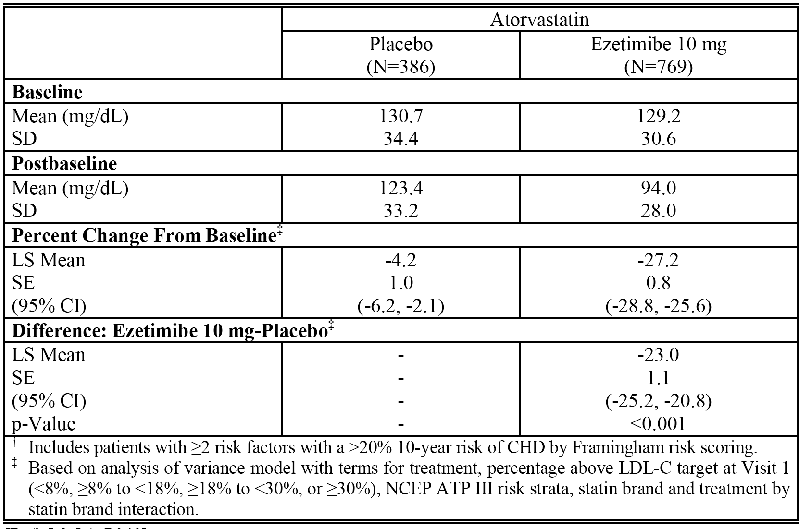

**Comment**: The percent reduction in plasma concentration of LDL-C from baseline after 6 weeks treatment was statistically significantly greater in the co administered ezetimibe 10 mg + atorvastatin group compared with the atorvastatin + placebo group. The results of the secondary efficacy variable analysis in patients not at their NCEP ATP II target LDL-C level at baseline showed that a greater percentage reached their target at endpoint with ezetimibe 10 mg + atorvastatin (74.6% (462/619)) than with atorvastatin alone (23.9%(75/314)); adjusted or = 11.09 (95% CI: 7.94, 15.49), p < 0.001, based on logistic regression model. The results of the analyses of the other secondary lipid variables supported the results of the primary efficacy analysis.

#### Short-term add-on titration studies (P079, P090, P112, P00693)

##### P079

P079 was evaluated as part of the submission to register the Composite Packs. It was a multinational, multicentre double blind, randomized study assessing the percent change from baseline in LDL-C after 6 weeks of atorvastatin 20 mg plus ezetimibe 10 mg compared with doubling the dose of atorvastatin from 20 mg to 40 mg in 196 patients with hypercholesterolaemia, at moderately high risk for CHD who had not reached the NCEP ATP III LDL-C goal of < 100 mg/dL (2.59 mmol/L) on atorvastatin 20 mg alone. The primary efficacy variable was mean percent change in plasma LDL-C concentration from baseline to study endpoint. Secondary efficacy variables included the percentage of patients attaining an LDL-C target of < 100 mg/dL (2.59 mmol/L) as well as effects on lipids, lipoproteins, apolipoproteins (HDL-C, non-HDL, TC, TG, Apo-B, Apo A-I), relevant ratios, lipoprotein subclasses and hs-CRP. Statistical analysis for the primary endpoint used an ANCOVA model with terms for treatment group and baseline LDL-C. The results for the analysis of the primary efficacy end point are summarized below in Table 32.

Table 32. P079. Percent change from baseline in LDL-C (mg/dL) at week-6; FAS population.

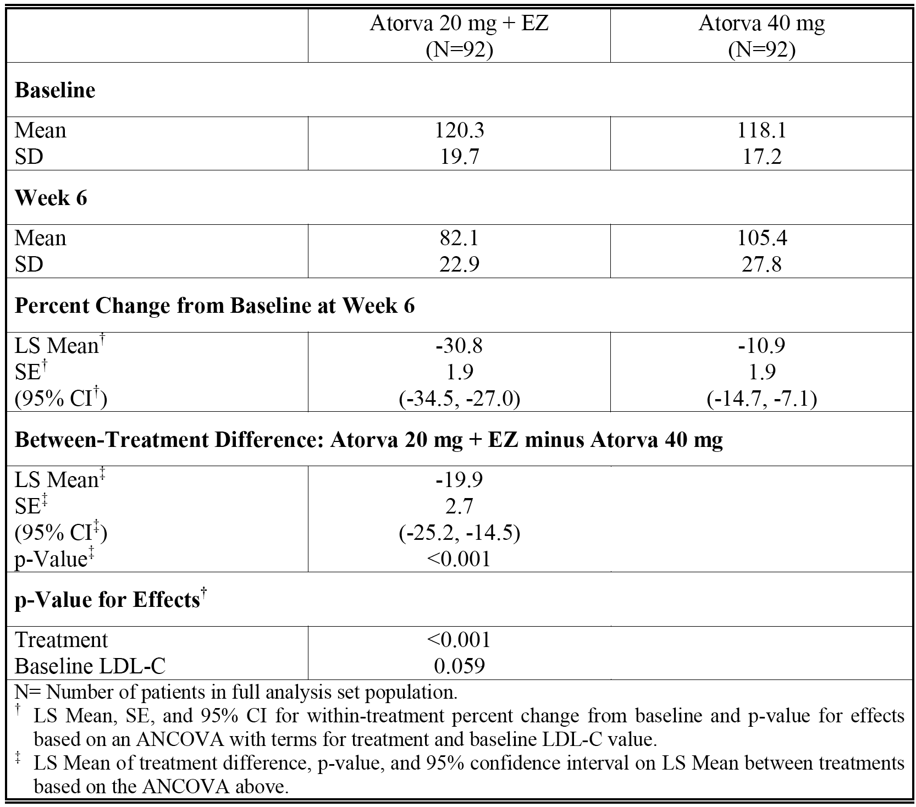

**Comment**: The percent reduction in plasma concentration of LDL-C from baseline after 6 weeks treatment was statistically significantly greater in the co administered ezetimibe 10 mg + atorvastatin 20 mg group compared with the atorvastatin 40 mg group. The results for the secondary efficacy variable analysis in patients not at their NCEP ATP II target LDL-C level at baseline showed that a greater percentage of patients reached their target at endpoint with ezetimibe 10 mg + atorvastatin 20 mg (83.7% (77/92)) than with atorvastatin 40 mg (48.9% (45/92)); adjusted or = 8.60 (95% CI: 3.80, 19.47), p < 0.001, based on logistic regression model with terms for treatment and baseline LDL-C concentration. The results of the analyses of the other secondary efficacy lipid/lipoprotein variables supported the results of the primary efficacy analysis.

##### P090

P079 was evaluated as part of the submission to register the Composite Packs. It was a North American, multicentre, double blind, randomized, parallel group study with a primary objective to determine the LDL-C lowering efficacy of adding ezetimibe 10 mg to atorvastatin 40 mg compared with doubling the dose of atorvastatin from 40 mg to 80 mg in 579 patients with hypercholesterolaemia at high risk for CHD who had not reached target NCEP ATP III LDL-C levels of < 70 mg/dL (1.81 mmol/L) on atorvastatin 40 mg alone. The primary efficacy variable was mean percent change in plasma LDL-C concentration from baseline to study endpoint. The secondary efficacy variables included percentage of patients attaining NCEP ATP III LDL-C level of < 70 mg/dL (1.81 mmol/L), as well as effects on other lipids/lipoproteins. Statistical analysis of the primary endpoint used an ANCOVA model with terms for treatment group and baseline LDL-C. The results for the analysis of the primary efficacy variable are summarized below in Table 33.

Table 33. P090. Percent change from baseline in LDL-C (mg/dL) at Week 6.

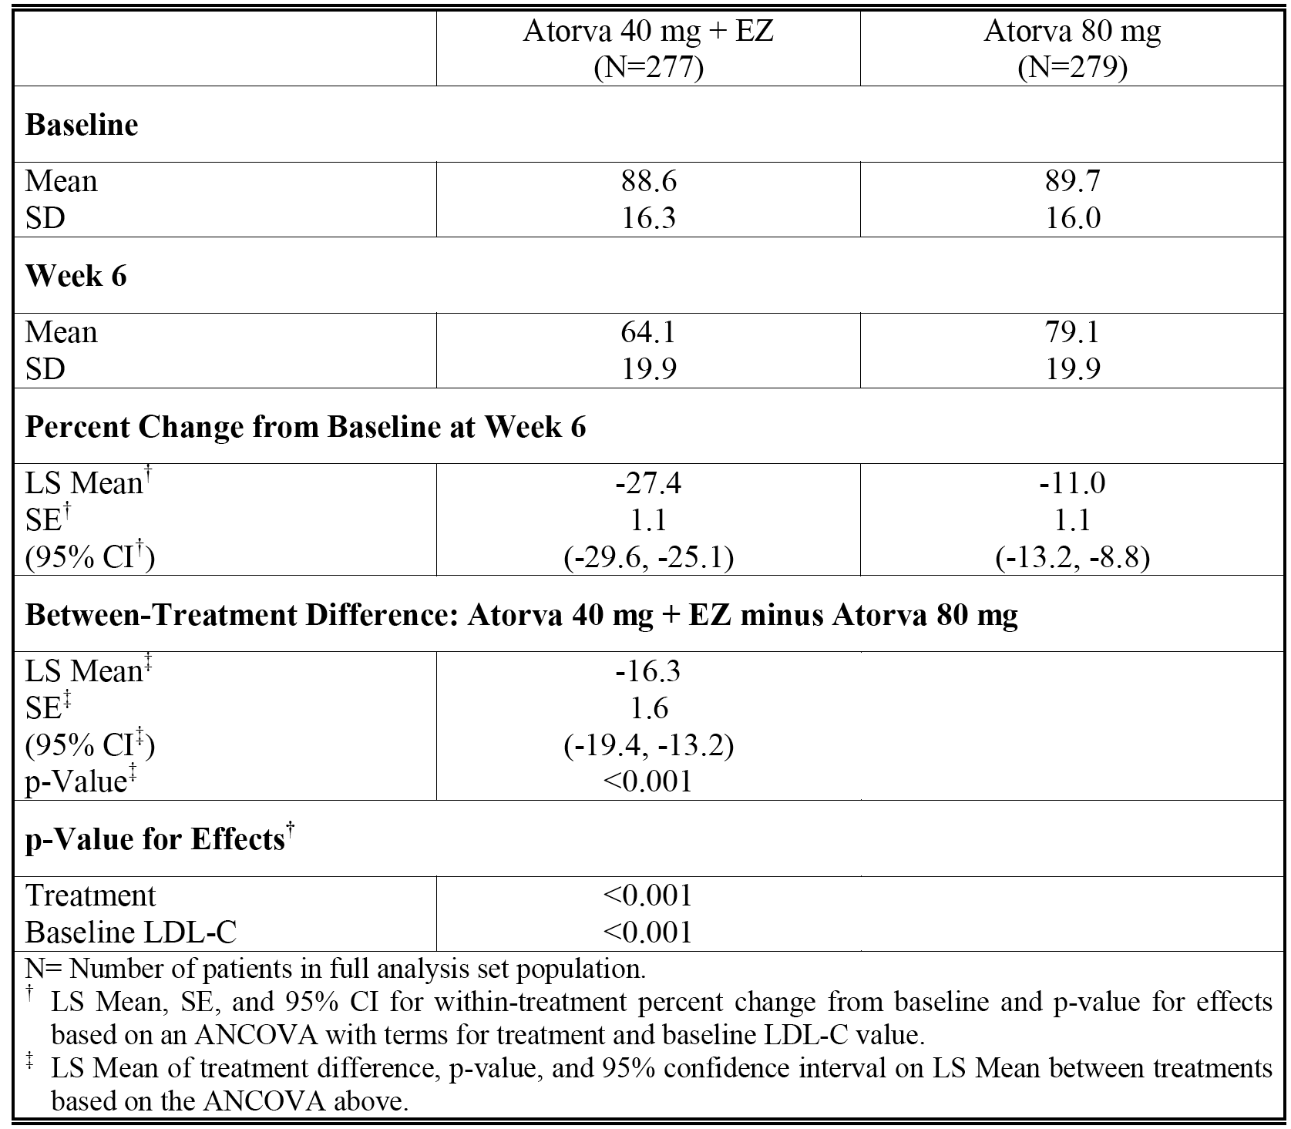

**Comment**: The percent reduction in plasma concentration of LDL-C from baseline after 6 weeks treatment was statistically significantly greater in the co administered ezetimibe 10 mg + atorvastatin 40 mg group compared with the atorvastatin 80 mg group. The results for the secondary efficacy variable analysis in patients not at target NCEP ATP II LDL-Cs level at baseline showed that a greater percentage reached their target at endpoint with ezetimibe 10 mg + atorvastatin 40 mg (73.6% (204/277)) than with atorvastatin 80 mg (31.5% (88/279)); adjusted or = 8.37 (95% CI: 5.45, 12.84), p < 0.001, based on logistic regression model with terms for treatment and baseline LDL-C concentration. The results of the analyses of the other secondary efficacy lipid/lipoprotein variables supported the results of the primary efficacy analysis.

##### P112

P112 was evaluated as part of the submission to register the Composite Packs. It was a multinational, multicentre, randomized, double blind, parallel arm, 12 week study in elderly patients (≥ 65 years of age) designed to assess the effect of adding ezetimibe 10 mg to atorvastatin 10 mg compared with doubling the dose of atorvastatin from 10 mg to 20 mg followed by further up titration to 40 mg in 1,053 patients with hypercholesterolaemia at high risk for CHD with or without diagnosed atherosclerotic vascular disease (AVD) who had not reached an LDL-C level of < 70 mg/dL (1.81 mmol/L) or < 100 mg/dL (2.59 mmol/L), respectively, on atorvastatin 10 mg/day. The primary efficacy variable was mean percent change in plasma LDL-C concentration, as measured both from baseline to 6 weeks (primary objective) and from baseline to 12 weeks (secondary objective). The secondary efficacy variables included percentage of patients attaining NCEP ATP III LDL-C goals of < 70 mg/dL (1.81 mmol/L) and < 100 mg/dL (2.59 mmol/L) after 6 or 12 weeks, as well as effects on other lipoproteins and apolipoproteins. Statistical analysis for both the primary and secondary continuous endpoints used an ANCOVA model with terms for treatment group, baseline LDL-C, and status of atherosclerotic vascular disease. The results for the primary (Week 6) analysis of the primary efficacy endpoint are summarized below in Table 34.

Table 34. P112. Percent change from baseline in LDL-C (mg/dL) at Week 6.

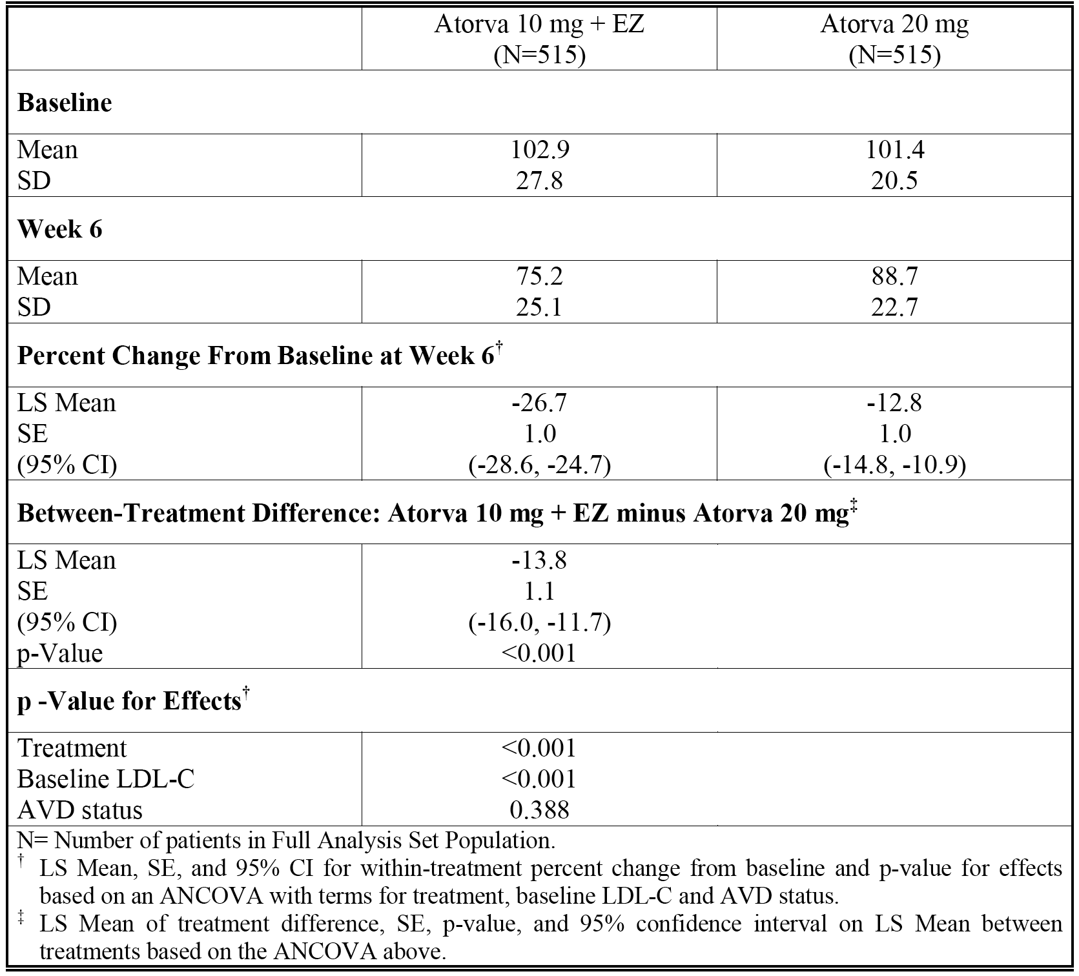

**Comment**: The percent reduction in plasma concentration of LDL-C from baseline after 6 weeks treatment was statistically significantly greater in the co administered ezetimibe 10 mg + atorvastatin 10 mg group compared with the atorvastatin 20 mg group. Following up titration of atorvastatin from 20 mg to 40 mg, the percent reduction in plasma concentration after 6 weeks treatment remained significantly greater in the ezetimibe 10 mg + atorvastatin 40 mg group (- 22.5% versus - 17.9%, respectively, difference of - 4.6% (95% CI: -7.4%, -1.8%), p = 0.001). The results for the secondary efficacy variable analysis in patients not at their NCEP ATP II target LDL-C level at baseline showed that a greater percentage reached their target (LDL-C < 70 mg/dL (1.81 mmol/L)) after 6 weeks treatment (that is, Week 6 endpoint) with ezetimibe 10 mg + atorvastatin 10 mg (47.4% (244/515)) than with atorvastatin 20 mg (17.9% (92/515)); adjusted or = 6.32 (95% CI: 4.52, 8.84), p < 0.001. Similarly, the percentage of patients in the ezetimibe 10 mg + atorvastatin 10 mg group reaching their target LDL-C (< 70 mg/dL (1.81 mmol/L)) after 6 weeks treatment (that is, Week 12 endpoint) was greater than in patients up-titrated to atorvastatin 40 mg from 20 mg (43.6% (225/516) versus 32.2% (164/509), respectively, adjusted or = 1.87 (95% CI: 1.40, 2.50), p < 0.001). The results of the analyses of the other secondary efficacy lipid/lipoprotein variables supported the results of the primary efficacy analysis.

##### P00693

P00693 was evaluated as part of the submission to register the Composite Packs. It was conducted in patients with heterozygous familial hypercholesterolemia (HeFH) or in patients with primary hypercholesterolaemia CHD or multiple cardiovascular risk factors (≥ 2) adhering to an NCEP ATP Step I, or stricter diet, who were not controlled by a starting dose of atorvastatin 10 mg. The study was double blind, randomized, and active controlled in 621 patients, 18 to 82 years of age, with baseline LDL-C ≥ 130 mg/dL (≥ 3.37 mmol/L) and TG ≤ 350 mg/dL (≤ 3.96 mmol/L) on atorvastatin 10 mg. It was designed to assess whether ezetimibe 10 mg co administered with atorvastatin (up titrated if necessary to 40 mg) over 14 weeks, resulted in more patients meeting a target LDL-C level of ≤ 100 mg/dL (≥ 2.59 mmol/L) than atorvastatin alone (up titrated if necessary to 80 mg). Patients were up titrated on the basis of their calculated LDL-C concentration at Weeks 4 and/or 9. By Week 10, most subjects had been assigned to the maximum possible titration dose in their treatment arm.

The primary endpoint was the proportion of subjects achieving target LDL-C levels (≤ 100 mg/dL (≤ 2.59 mmol/L) as directly measured by ultracentrifugation at the Week 14 visit. Key secondary endpoints included the mean percent change from baseline in direct LDL-C at Week 4 and the proportion of subjects achieving target LDL-C levels (≤ 100 mg/dL (≤ 2.59 mmol/L)) at Week 4. Other secondary endpoints were mean percent changes from baseline at Week 4 for calculated LDL-C, total cholesterol (TC), TG, and HDL-C. In addition, the effect of treatment on quality of life as measured by the Health Related Quality of Life assessment (SF-36) and a Patient Questionnaire about muscle aches and pains was evaluated in an exploratory manner. Statistical analyses of the primary endpoints were performed using a Chi-square test. Statistical analyses of the secondary endpoints were performed using an ANOVA model that extracts source of variation due to treatment. All secondary efficacy variable endpoints occurred prior to the beginning of atorvastatin titration, and were an ‘Add-On’ type comparison between ezetimibe 10 mg + atorvastatin 10 mg and atorvastatin 20 mg monotherapy. The results for the primary efficacy analysis are summarized below in Table 35.

Table 35. P00693. Number of subjects (%) achieving target LDL-C level (≤ 100 mg/dL (2.59 mmol/L)) at Week 14; ITT population.

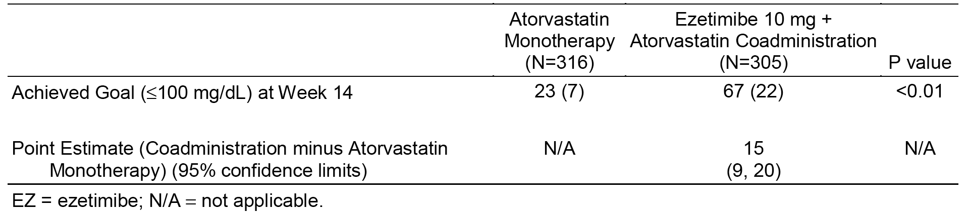

**Comment**: Results of the primary efficacy analysis demonstrated that the addition of ezetimibe 10 mg/day to a starting dose of atorvastatin 10 mg/day, followed by response based titration up to atorvastatin 40 mg/day was significantly more effective in achieving target LDL-C plasma (≤ 100 mg/dL (≤ 2.59 mmol/L)) than response based titration of atorvastatin alone up to 80 mg/day at Week 14. The results for the key secondary efficacy analysis showed that the percent reduction in direct LDL-C between baseline and Week 4 was statistically significantly greater in the ezetimibe 10 mg + atorvastatin 10 mg group than in the atorvastatin 20 mg group (- 23% versus - 9%, respectively, difference of - 14% (95% CI: - 16%, - 12%)).

#### Long term efficacy studies (P02154, P0148)

##### P02154 (extension study to factorial study P00692)

P02154 was included in the submission to register the Composite Packs. In this study, patients with primary hypercholesterolaemia from factorial study P00692 were permitted to continue in a 12 month extension after successfully completing the 12 week, randomized, double blind treatment period with placebo, ezetimibe 10 mg, atorvastatin monotherapy all doses, or co administered ezetimibe 10 mg + atorvastatin all doses. In the extension study patients were initially dosed with either double blind ezetimibe 10 mg or matching placebo co administered with open label atorvastatin 10 mg once daily. After a maximum of at least 6 weeks, the atorvastatin dose could be titrated up incrementally to a maximum of 80 mg daily to achieve the NCEP ATP II target LDL-C level. The primary objective of the extension study was to evaluate the long term safety and tolerability of co administered ezetimibe 10 mg + atorvastatin all doses for up to 12 consecutive months. The secondary objectives were to further evaluate the effect of ezetimibe 10 mg + atorvastatin all doses on LDL-C, HDL-C, and TG levels. The study included 246 subjects, of whom 45 were randomized to the placebo + atorvastatin arm and 201 to the ezetimibe + atorvastatin arm. The changes in the lipid parameters over time were summarized using descriptive statistics. The mean percent changes from baseline over the course of the study in the two treatment groups are summarized below in Table 36.

Table 36. P2154. Mean percent change from baseline in calculated LDL-C over time.

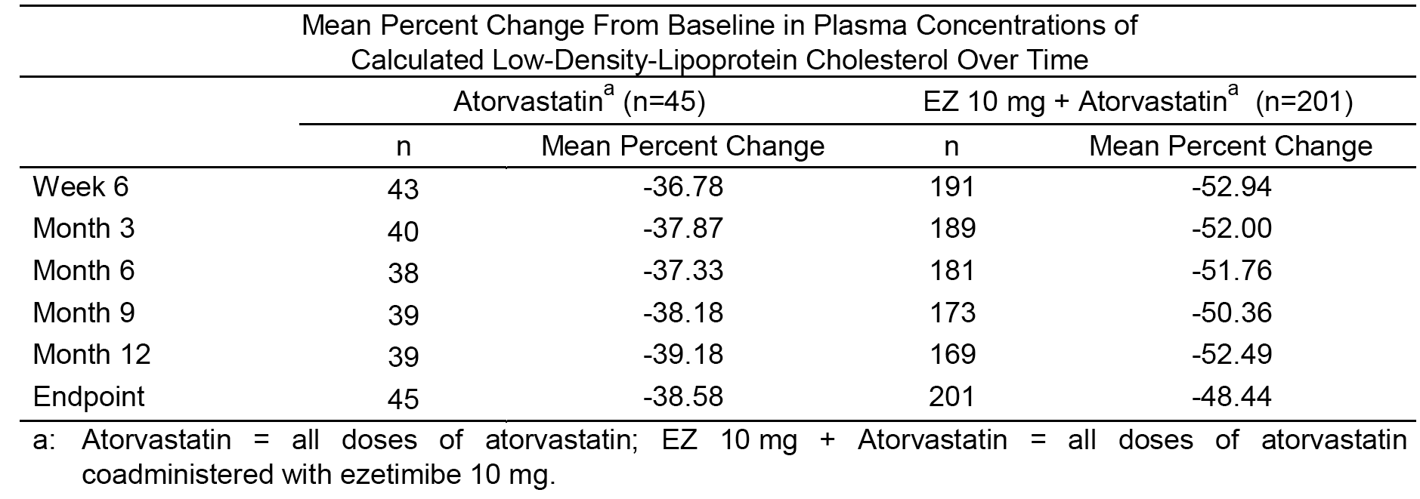

**Comment**: In this study, reductions in LDL-C were greater with co administered ezetimibe 10 mg + atorvastatin all doses than with atorvastatin all doses at all time points from Week 6 through to Month 12/Endpoint. The mean percent change from baseline in LDL-C in both treatment groups was maintained from Week 6 through to Month 12/Endpoint. Most subjects in both treatment groups were at or below NCEP ATP II LDL-C goal throughout the 12 month study period. Up titration at some point in the study was required by 10 (22%) of the 45 subjects in the atorvastatin monotherapy group and 19 (9%) of the 201 subjects in the co administered group. In the monotherapy group, atorvastatin was up titrated to a maximum dose of 20 mg for 3 (7%) subjects, 40 mg for 4 (9%) subjects and 80 mg for 3 (7%) subjects. In the co administered group, atorvastatin was up titrated to a maximum dose of 20 mg for 9 (4%) subjects, 40 mg for 7 (3%) subjects, and 80 mg for 3 (1%) subjects. Changes in TC, TG and HDL-C levels were consistent with the changes in the LDL-C levels in both treatment groups.

##### P0148 (open label extension study to P00693)

P0148 was evaluated as part of the submission to register the Composite Packs. This long term extension study included patients with HeFH or primary hypercholesterolaemia and CHD or multiple cardiovascular risk factors (≥ 2) who had successfully completed the 14 week, double blind, efficacy and safety study P00693. Of the 621 patients randomized and treated in study P00693, 432 enrolled and received treatment in extension study P0148 and received initial treatment with open label ezetimibe 10 mg + atorvastatin 10 mg. The atorvastatin dose could be up titrated to a maximum of 80 mg to achieve the target LDL-C level of ≤ 100 mg/dL (≤ 2.59 mmol/L). The primary objective was to evaluate the long term safety and tolerability of co administered ezetimibe 10 mg + atorvastatin 10-80 mg for up to 12 consecutive months. The secondary objectives were to evaluate the proportion of subjects achieving target LDL-C levels and endpoint, and the effect of co administration on other lipid and lipoprotein parameters. Changes in lipid and lipoprotein parameters were summarized using descriptive parameters. The number of subjects reaching target LDL-C levels is summarized below in Table 37.

Table 37. P01418. Number of subjects reaching target LDL-C goal (≤100 mg/dL (2.59 mmol/L)).

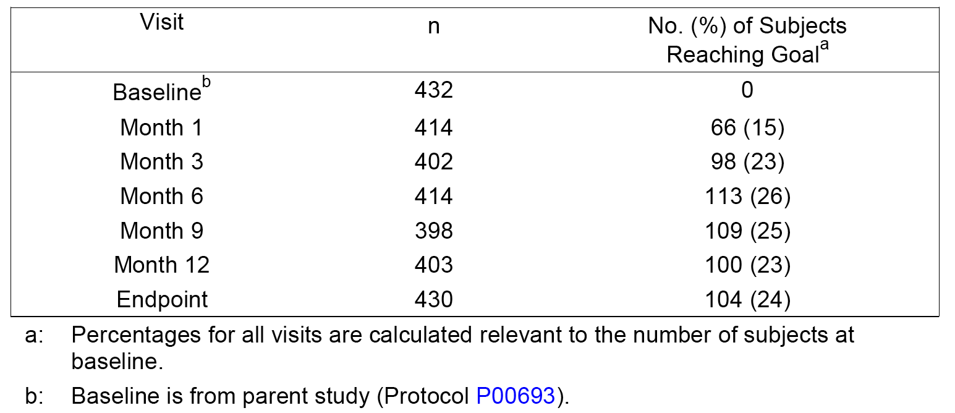

**Comment**: At Month 1 of the extension study, prior to possible up titration of atorvastatin, 15% of subjects reached the LDL-C target goal of ≤ 100 mg/dL (≤ 2.59 mmol/L). An additional 10% of the total cohort reached the LDL-C target goal at Month 3 and subsequent study visits, which is similar to the result at Week 14 in the parent study (22% of subjects achieved the goal). Study investigators were allowed discretion regarding the decision to titrate the atorvastatin dose. If an LDL-C target goal was not met, investigators were allowed to continue the subject in the study if they considered it not appropriate to increase the atorvastatin dose. The majority of subjects were on the lower doses of co administered therapy, either 10 mg or 20 mg atorvastatin in addition to ezetimibe 10 mg, at Month 3 (79%), Month 6 (66%) and Month 9 (59%). At study endpoint, defined as the last available non missing value for each subject, 63% of subjects were receiving either 10 mg or 20 mg atorvastatin in addition to ezetimibe 10 mg. Over the 12 month study period, co administered ezetimibe 10 mg + atorvastatin 10 to 80 mg was effective in achieving and maintaining a reduction in LDL-C. The mean LDL-C value at study end was reduced by 30.5% from the parent study baseline. Reductions were noted at Month 1 (26.4%), were slightly greater at Month 3 (32.3%) and were maintained at similar levels throughout the remainder of the study period. Reductions in TC and non-HDL-C were observed, and reductions in TG and an increase in HDL-C were also noted over time.

#### Studies in homozygous familial hypercholesterolaemia (HoFH)

##### P1030 (short-term treatment)

P1030 was evaluated as part of the submission to register the Composite Packs. The primary objective of this North American multicentre, double blind, parallel group study was to evaluate the efficacy and safety of co administered ezetimibe 10 mg with either atorvastatin or simvastatin in patients with HoFH. Following dietary assessment and a 6 to 14 week atorvastatin or simvastatin 40 mg lead in period, eligible subjects were randomized to one of the six treatment arms: atorvastatin or simvastatin 80 mg; ezetimibe 10 mg + atorvastatin or simvastatin 40 mg; or ezetimibe 10 mg + atorvastatin or simvastatin 80 mg. Subjects continued their open-label statin 40 mg from the lead in period as part of their total dose. Subjects received 12 weeks of double blind treatment. The primary efficacy endpoint was percent change from baseline to endpoint in direct LDL-C, in the ezetimibe 10 mg + statin 40/80 mg treatment group versus the statin 80 mg group. Secondary efficacy endpoints included change from baseline in other lipid and lipoprotein variables. The reduction in LS mean percent reduction in direct LDL-C from baseline to endpoint in the ezetimibe 10 mg + statin 40/80 mg group (n = 33) was statistically significantly greater than in the statin 80 mg group (n = 17) (20.7% versus 6.7%; p = 0.0072). The differences between the two treatment groups were not statistically significant for most of the other lipid and lipoprotein variables.

**Comment**: In this study in patients with HoFH, a small subgroup analyses showed that the mean percent reductions from baseline at endpoint in LDL-C were greater in the ezetimibe 10 mg + atorvastatin 40 mg group (n = 12) and the ezetimibe 10 mg + 80 mg group (n = 12) than in the atorvastatin 80 mg group (n = 12), with the respective values being 3.5% (SEM = 3.5%), 13.0% (SEM = 6.4%), and 24.7% (SEM = 4.4%).

##### P1417 (long term treatment)

P1417 was evaluated as part of the submission to register the Composite Packs. It was a multinational, multicentre, open label extension study evaluating the safety and tolerability of long term ezetimibe plus statin in patients with HoFH who completed Study P1030. The primary objective was to evaluate the long term safety and tolerability of ezetimibe 10 mg + atorvastatin 40 to 80 mg or simvastatin 40 to 80 mg co administered for up to 24 consecutive months. The initial dose of all patients (n = 44) enrolled in the extension study was co administered ezetimibe 10 mg + atorvastatin or simvastatin at a dose of 40 mg or 80 mg. The atorvastatin or simvastatin dose was doubled if an LDL-C target concentration of 100 mg/dL (per NCEP ATP II criteria) was not achieved after ≥ 1 month of treatment. Subjects received open label co administration treatment for up to 24 months and were required to adhere to the NCEP Step I diet or stricter for the duration of the study. The change from baseline and the percent change from baseline to endpoint and to other intermediate time points were examined for LDL-C, HDL-C, TC, and TG using descriptive statistics.

**Comment**: In this small extension study in patients with HoFH, the mean percent reductions from baseline at endpoint in LDL-C diminished over time in subjects treated with ezetimibe 10 mg + atorvastatin 40/80 mg, with the respective values being 23.8% (SD = 22.1), 19.3% (SD = 21.5%), and 14.9% (SD = 23.9%) at Month 12 (n = 27), Month 24 (n = 28), and Endpoint (n = 35).

### Evaluator’s conclusions on clinical efficacy

The pivotal efficacy study (P162) was undertaken in patients with primary hypercholesterolaemia and high cardiovascular risk. The study demonstrated that the percent reduction in LDL-C from baseline after 6 weeks treatment (Phase 1) in patients who had not been controlled on atorvastatin during a 5 week run in period was significantly greater after switching to co-administration of ezetimibe 10 mg + atorvastatin 10 mg (n = 120) compared with doubling the dose of atorvastatin to 20 mg (n = 480) (difference = - 12.7% (95% CI: ‑ 16.6, ‑ 8.7); p < 0.001), and after switching to co-administration of ezetimibe 10 mg + atorvastatin 10 mg (n = 120) compared with switching to rosuvastatin 10 mg (n = 939) (difference = - 9.1% (95% CI: - 12.9, - 5.4,); p < 0.001). The difference between treatments for both comparisons is considered to be clinically meaningful.

The pivotal efficacy study (P162) also showed that the percent reduction in LDL-C from baseline after 6 weeks treatment (Phase 2) in patients who had not been controlled on atorvastatin 10 mg during the 5 week run in period or atorvastatin 20 mg during the 6 week Phase 1 treatment period was significantly greater after switching to ezetimibe 10 mg + atorvastatin 20 mg (n = 124) compared with doubling the dose of atorvastatin to 40 mg (n = 123) (difference = ‑10.5% (95% CI: -15.9, -5.1); p < 0.001). Similarly, the percent reduction in LDL-C from baseline after 6 weeks treatment (Phase 2) in patients who had not been controlled on atorvastatin 10 mg during the 5 week run in period or rosuvastatin 10 mg during the 6 week Phase 1 treatment period was significantly greater after switching to ezetimibe 10 mg + atorvastatin 20 mg (n = 231) compared with doubling the dose of rosuvastatin to 20 mg (n = 205) (difference = -9.5% (95% CI: -13,6, -5.4); p < 0.001). The difference between treatments for both comparisons is considered to be clinically meaningful.

In addition, the pivotal efficacy study (P162) showed co-administration of ezetimibe 10 mg + atorvastatin 10 mg achieved a significantly greater proportion of patients achieving target LDL‑C levels < 2.59 mmol/L and < 1.81 at Week 6 (Phase 1) than both atorvastatin 20 mg and rosuvastatin 10 mg. Similarly, co administration of ezetimibe 10 mg + atorvastatin 20 mg achieved a significantly greater proportion of patients achieving target LDL-C levels < 2.59 mmol/L and < 1.81 at Week 6 (Phase 2) than both atorvastatin 40 mg and rosuvastatin 20 mg.

In the pivotal efficacy study (P162), the results for the secondary efficacy lipid/lipoprotein efficacy endpoints at the end of Phase 1 and Phase 2 supported the results for the primary efficacy endpoint for LDL-C at the corresponding time points. In general, the efficacy outcomes for the secondary lipid/lipoprotein endpoints were significantly better in patients in the co administered ezetimibe 10 mg + atorvastatin 10 mg group than in the atorvastatin 20 mg and rosuvastatin 10 mg groups (Phase 1), and in patients in the co administered ezetimibe 10 mg + atorvastatin 20 mg group than in the atorvastatin 40 mg and rosuvastatin 20 mg groups (Phase 2).

In contrast to the pivotal efficacy study (P162), the two supportive efficacy studies (P185, P190) were undertaken in patients with primary hypercholesterolaemia with low, moderate, or moderately high cardiovascular risk, with high risk patients (CHD or CHD risk equivalent) being excluded. Study P185 showed that FDC ezetimibe/atorvastatin 10/20 mg (n = 353) was equivalent to co administered ezetimibe 10 mg + atorvastatin 20 mg (n = 346), based on the percent change in LDL-C from baseline after 6 weeks treatment (difference = - 0.2% (97.5% expanded CI = - 1.7%, 1.3%)). Study P190 showed that FDC ezetimibe/atorvastatin 10/40 mg (n = 280) was equivalent to co administered ezetimibe 10 mg + atorvastatin 40 mg (n = 280) based on the percent change in LDL-C from baseline after 6 weeks treatment (difference = ‑ 0.2% (97.5% expanded CI = - 1.8%, 1.4%)). In both studies, the 97.5% expanded CIs for the difference in means were well within the prespecified clinical equivalence limits of ‑4% to +4%. In both studies, the secondary efficacy lipid/lipoprotein equivalence analyses supported the results for primary efficacy equivalence analyses relating to the LDL-C.

In the previously evaluated studies:

* the factorial study (P00692) showed that co administered ezetimibe + atorvastatin (pooled across all doses) was more effective than atorvastatin alone (pooled across all doses) in reducing LDL-C from baseline through to 12 weeks
* the add on studies (P02173/P2246, P040), demonstrated that co administered ezetimibe 10 mg + atorvastatin was more effective in reducing LDL-C than atorvastatin alone, and that patients not at target LDL-C levels were more likely to achieve target LDL-C levels after co administered ezetimibe 10 mg + atorvastatin compared with atorvastatin alone
* the add on titration studies (P079, P090, P112, P00693) demonstrated that the addition of ezetimibe 10 mg to atorvastatin was more effective in reducing LDL-C than atorvastatin alone even when the atorvastatin monotherapy dose was titrated upwards
* the long term studies of co administered ezetimibe + atorvastatin was effective in achieving and maintaining reductions in LDL-C levels over 12 months (P2154, P1418)
* co administered ezetimibe + atorvastatin was effective for the treatment of homozygous familial hypercholesterolaemia (P1030, P1417).

## Clinical safety

### Studies with clinical safety data

The pivotal Phase III study (P162) included a comprehensive review of the safety of co administered ezetimibe and the formulation of atorvastatin as calcium being proposed for registration, and the two supportive Phase III studies (P185, P190) included a comprehensive review of the safety of co administered ezetimibe + atorvastatin and ezetimibe/atorvastatin fixed-dose combination tablets containing the previously withdrawn atorvastatin as calcium formulation. The safety data from these three studies have been evaluated and the results discussed in the body of this CER extract.

The submission also included a Summary of Clinical Safety providing data from 12 studies assessing the safety of co administration of ezetimibe + atorvastatin. These 12 studies included safety data from 11 previously submitted and evaluated studies (P00692, P00693, P01030, P01417, P01418, P02154, P02173/P2246, P040, P079, P090, P112) and 1 newly submitted study (P162). The Summary of Clinical Safety did not include data from the two new supportive studies (P185, P190). The substance of the Summary of Clinical Safety provided in the current submission remains unchanged that in the previously submitted and evaluated corresponding document relating to the application to register the Composite Packs. However, the updated integrated safety data in the Summary of Clinical Safety for the Core Safety Pool (CSP) containing data from eight, 6 to 14 weeks studies has been evaluated as this pool includes information from the newly submitted pivotal study (P162). However, the safety data in the summary document relating to the long term studies and studies in patients with HoFH have not been evaluated, as the data remain unchanged from that previously evaluated (Composite Pack application).

In the submitted studies, the terms ‘adverse experience’ and ‘adverse event’ were generally used interchangeably, but in this evaluation of the safety data the term ‘adverse event’ is used as this is the term most commonly employed in clinical trials to describe safety findings.

### Study P162 - Pivotal study

#### Safety analysis

Safety and tolerability were assessed by statistical and/or clinical review of all safety parameters, including adverse events (AEs), physical examination, vital signs, and laboratory results. Central laboratory evaluations were performed for both serum and urine parameters. An AE was defined as any unfavorable and unintended change in the structure (signs), function (symptoms), or chemistry (laboratory data) of the body temporally associated with any use of a sponsor product whether or not considered related to the use of the product. AEs were reported up to the Week 14 follow up visit (that is, 2 weeks after last dose of study drug). SAEs were defined using the standard criteria for clinical trials.

The analysis of safety results followed a tiered approach (1, 2, or 3). Tier 1 consisted of prespecified safety parameters or AEs of special interest, and were subject to inferential testing for statistical significance with p-values and 95% CIs provided for between group comparisons. Tier 2 parameters were assessed as point estimates with 95% CIs for between-group comparisons, while Tier 3 parameters were assessed only as point estimates by treatment group.

#### Exposure

The safety assessment in the pivotal study focused on the 12 week double blind treatment period (Phase 1 and Phase 2). Overall, 1539 (99.5%) of the 1547 randomized patients took at least one dose of study medication and were included in the all patients as treated population (the safety analysis population).

In Phase 1, the extent of exposure was comparable for the three treatment groups with an overall mean (SD) exposure of 42.1 (6.5) days. In Phase 2, the extent of exposure was also comparable for the five treatment groups with an overall mean exposure of 41.7 (5.5) days.

#### Adverse experiences

##### Overall

In Phase 1, at least one AE occurred in 194 (12.6%) of 1,539 randomized patients who took at least one dose of study medication. The percentage of patients experiencing one or more AEs in Phase 1 was similar in the three treatment groups: 7.5% (9/120) in the EZ 10 mg + Atorva 10 mg group, 11.9% (57/480) in the Atorva 20 mg group, and 13.6% (128/939) in the Rosuva 10 mg group. The overall Phase 1 AE experience was provided.

In Phase 2, at least one AE occurred in 79 (11.1%) of 712 patients who continued into Phase 2 and took at least one dose of study medication. The percentage of patients who experienced at least one AE in Phase 2 was highest in the *Rosuva 10 mg → EZ 10 mg +Atorva 20 mg* group (15.6% (36/231)), followed by the *Atorva 20 mg → Atorva 40 mg* group (10.5% (13/124), the *Atorva 20 mg → EZ 10 mg + Atorva 20 mg group* (8.9%, (11/124)), the *Rosuva 10 mg → Rosuva 20 mg* group (8.8%, (18/205)), and the *EZ 10 mg +Atorva 10 mg → EZ 10 mg + Atorva 10 mg* group(3.6% (1/28)).

#### Commonly occurring AEs

##### ***AEs grouped by system organ class (SOC)***

In Phase 1, AEs reported most frequently grouped by SOC in all patients as treated (n = 1539) were ‘infections and infestations’ (47/1539 (3.1%)), and ‘gastrointestinal disorders’ (33/1539 (2.1%)). AEs grouped by SOC reported in ≥ 1% of patients in any of the three treatment groups are summarized below in Table 38.

Table 38: P162. Phase 1 patients with specific AEs (incidence of ≥ 1.0% in a SOC in at least one treatment group); all patients treated population, n (%).

|  | EZ 10 mg + Atorva 10 mg N = 120 | Atorva 20 mg N = 480 | Rosuva 10 mg N = 939 |
| --- | --- | --- | --- |
| Patients with 1 or more AEs | 9 (7.5) | 57 (11.9) | 128 (13.6) |
| Infections and infestations | 1 (0.8) | 11 (2.3) | 35 (3.7) |
| Gastrointestinal disorders | 2 (1.7) | 12 (2.5) | 19 (2.0) |
| Musculoskeletal & connective tissue disorders | 3 (2.5) | 7 (1.5) | 18 (1.9) |
| Investigations | 0 (0.0) | 9 (1.9) | 14 (1.5) |
| Nervous system disorders | 0 (0.0) | 4 (0.8) | 17 (1.8) |
| General disorders & administration site conditions | 0 (0.0) | 4 (0.8) | 11 (1.2) |
| Renal & urinary disorders | 2 (1.7) | 2 (0.4) | 2 (0.2) |

In Phase 2, AEs reported most frequently grouped by SOC in all patients as treated (n = 712) were ‘investigations’ (18/712 (2.5%)) and ‘infections and infestations’ (17/712 (2.4%)). AEs grouped by SOC reported in ≥ 1% of patients in a SOC in any of the five treatment groups are summarized below in Table 39.

Table 39. P162. Phase 2 patients with specific AEs (incidence of ≥ 1.0% in a SOC in at least one treatment group); all patients treated population, n (%).

|  | E10 + A10 *→* E10 + A10 N = 28 | A20 *→* E10 + A10 N = 124 | A20 *→* A40 N = 124 | R10 *→* E10 + A20 N = 231 | R10 *→* R20 N = 205 |
| --- | --- | --- | --- | --- | --- |
| Patients with one or more AE | 1 (3.6) | 11 (8.9) | 13 (10.5) | 36 (15.6) | 18 (8.8) |
| Investigations | 0 (0.0) | 3 (2.4) | 2 (1.6) | 8 (3.5) | 5 (2.4) |
| Infections and infestations | 0 (0.0) | 3 (2.4) | 4 (3.2) | 5 (2.2) | 5 (2.4) |
| Musculoskeletal & connective tissue disorders | 0 (0.0) | 0 (.0.0) | 1 (0.8) | 8 (3.5) | 1 (0.5) |
| Nervous system disorders | 0 (0.0) | 2 (1.6) | 3 (2.4) | 3 (1.3) | 1 (0.5) |
| Gastrointestinal disorders | 1 (3.6) | 2 (1.6) | 2 (1.6) | 2 (0.9) | 2 (1.0) |
| General disorder & admin site conditions | 0 (0.0) | 2 (1.6) | 1 (0.8) | 2 (0.9) | 1 (0.5) |
| Cardiac disorders | 0 (0.0) | 0 (0.0) | 2 (1.6) | 3 (1.3) | 0 (0.0) |
| Metabolism and nutrition disorders | 0 (0.0) | 0 (0.0) | 0 (0.0) | 3 (1.3) | 1 (0.5) |
| Injury, poisoning & procedural complications | 0 (0.0) | 0 (0.0) | 0 (0.0) | 3 (1.3) | 0 (0.0) |
| Renal & urinary disorders | 0 (0.0) | 0 (0.0) | 0 (0.0) | 3 (1.3) | 0 (0.0) |

Note: A10, 20, 40 = atorvastatin 10, 20, 40 mg; E10 = ezetimibe 10 mg; R10, 20 = rosuvastatin 10 mg, 20 mg; + = co administered with.

**Comment:** In Phase 1, there were no statistically significant differences between *EZ 10 mg + Atorva 10 mg versus Atorva* *20 mg* in the incidence of patients with at least one AE (difference = - 4.4% (95% CI: - 9.2, 2.2)), or between *EZ 10 mg + Atorva 10 mg versus Rosuva 10 mg* (difference = -6.1% (95% CI: - 10.4, 0.3)). In Phase 1, there was only one SOC in which the percentage of patients was statistically significantly greater in the *EZ 10 mg + Atorva 10 mg* group than in *Rosuva 10 mg* group; ‘renal and urinary disorders’ percent difference = 1.5% (95% CI: 0.2, 5.7). However, the number of patients with ‘renal and urinary disorders’ was small in each of the two treatment groups (n = 2), and the specific events in the *EZ 10 mg + Atorva 10 mg* group were haematuria and micturition disorder and in the *Rosuva 10 mg* group were dysuria and proteinuria. Therefore, based on the small number of AEs it is considered that the difference between the *EZ 10 mg + Atorva 10 mg* group and the *Rosuva 10 mg* group for ‘renal and urinary disorders’ is not clinically significant.

In Phase 2, there was no statistically significant difference between *Atorva 20 mg → EZ 10 mg + Atorva 20 mg* and *Atorva 20 mg → Atorva 40 mg* in the incidence of patients with at least one AE (difference = - 1.6% (95% CI: - 9.4, 6.0)). However, the incidence of patients with at least one AE was statistically significantly higher in the *Rosuva 10 mg → EZ 10 mg + Atorva 20 mg* group compared with the *Rosuva 10 mg → Rosuva 20 mg* group (15.6% versus 8.8%, respectively; difference = 6.8% (95% CI: 0.6, 13.0)). The only statistically significant difference between treatment groups in the incidence AEs grouped by SOC (≥ 4 patients in at least one treatment group) was the greater incidence of ‘musculoskeletal and connective tissue disorders’ in the *Rosuva 10 mg → EZ 10 mg + Atorva 20 mg* group compared with the *Rosuva 10 mg → Rosuva 20 mg* (3.5% versus 0.5%, respectively, difference = 3.0% (95% CI: 0.4, 6.3)).

##### Specific AEs

In Phase 1, the only specific AE reported in ≥ 1.0% of patients in any of the three treatment groups was CK increased in the *Atorva 20 mg* group (1.0%, n = 5).

In Phase 2, the specific AEs reported in ≥ 1.0% of patients in any of the five treatment groups are summarized below in Table 40.

Table 40. P162. Phase 2 patients with specific AEs (incidence of ≥ 1.0% in at least one treatment group); all patients treated population, n (%).

|  | E10 + A10 *→* E10 + A10 N = 28 | A20 *→* E10 + A10 N = 124 | A20 *→* A40 N = 124 | R10 *→* E10 + A20 N = 231 | R10 *→* R20 N = 205 |
| --- | --- | --- | --- | --- | --- |
| Patients with one or more AE | 1 (3.6) | 11 (8.9) | 13 (10.5) | 36 (15.6) | 18 (8.8) |
| Upper abdominal pain | 1 (3.6) | 0 (0.0) | 1 (0.8) | 1 (0.4) | 0 (0.0) |
| Nasopharyngitis | 0 (0.0) | 2 (1.6) | 2 (1.6) | 0 (0.0) | 0 (0.0) |
| Influenza | 0 (0.0) | 0 (0.0) | 0 (0.0) | 1 (0.4) | 2 (1.0) |
| Viral infection | 0 (0.0) | 0 (0.0) | 0 (0.0) | 0 (0.0) | 2 (1.0) |
| Alaninine aminotransferase increased (ALT) | 0 (0.0) | 1 (0.8) | 2 (1.6) | 3 (1.3) | 2 (1.0) |
| Aspartate aminotransferase increased (AST) | 0 (0.0) | 0 (0.0) | 2 (1.6) | 3 (1.3) | 0 (0.0) |
| Blood creatinine kinase increased (CK) | 0 (0.0) | 0 (0.0) | 0 (0.0) | 1 (0.4) | 2 (1.0) |
| Gamma-glutamyltransferase increased (GGT) | 0 (0.0) | 1 (0.8) | 0 (0.0) | 3 (1.3) | 0 (0.0) |

Note: A10, 20, 40 = atorvastatin 10, 20, 40 mg; E10 = ezetimibe 10 mg; R10, 20 = rosuvastatin 10 mg, 20 mg; + = co administered with

#### Drug related AEs

In Phase 1, a total or 43 (2.8%) patients experienced at least one drug related AE: 1 (0.8%) in the *EZ 10 mg + Atorva 10 mg* group; 15 (3.1%) in the *Atorva 20 mg* group; and 27 (2.9%) in the *Rosuva 10 mg* group. The only drug related specific AEs group by SOC occurring in ≥ 1% of patients in at least one of the three treatment groups were ‘gastrointestinal disorders’ (1.5%, n = 7, in the *Atorva 20 mg* group). Specific drug related AEs occurring in ≥ 0.5% of patients in at least one of the three treatment groups are summarized below in Table 41.

Table 41. P162. Phase 1 patients with drug related AEs (incidence of ≥ 0.5% or ≥ 4 patients in at least one treatment group); all patients treated population, n (%).

|  | EZ 10 mg + Atorva 10 mg | Atorva 20 mg | Rosuva 10 mg |
| --- | --- | --- | --- |
|  | N = 120 | N = 57 | N = 939 |
| Patients with 1 or more drug related AE | 1 (0.8) | 15 (3.1) | 27 (2.9) |
| Blood creatinine kinase increased (CK) | 0 (0.0) | 3 (0.6) | 4 (0.4) |
| Headache | 0 (0.0) | 0 (0.0) | 4 (0.4) |

In Phase 2,a total of 16 (2.2%) patients experienced at least one drug related AE. No drug related AEs grouped by SOC occurred in ≥ 1.0% of patients in any of the five treatment groups. The most frequently reported drug related AEs grouped by SOC were ‘investigations’, which occurred most commonly in patients in the *Rosuva 10 mg → EZ 10 mg + Atorva 20 mg* group (1.3%, n = 3), followed by the *Rosuva 10 mg → Rosuva 20 mg* group(1.0%, n = 2), the *Atorva 20 mg → EZ 10 mg + Atorva 20 mg* an*d Atorva 20 mg → Atorva 40 mg* groups (0.8%, n = 1, each group), and the *EZ 10 mg + Atorva 10 mg → EZ 10 mg + Atorva 10 mg* group (0%, n = 0).Specific drug related AEs occurring in ≥ 0.5% in any of the five treatment groups are summarized below in Table 42. No specific drug related AEs occurred in ≥ 4 patients in any of the five treatment groups.

Table 42. P162. Phase 2 patients with specific drug related AEs (incidence of ≥ 0.5% in at least one treatment group); all patients treated population, n (%).

|  | E10 + A10 *→* E10 + A10 N = 28 | A20 *→* E10 + A20 N = 124 | A20 *→* A40 N = 124 | R10 *→* E10 + A20 N = 231 | R10 *→* R20 N = 205 |
| --- | --- | --- | --- | --- | --- |
| Patients with one or more drug related AE | 1 (3.6) | 2 (1.6) | 3 (2.4) | 8 (3.5) | 2 (1.0) |
| Upper abdominal pain | 1 (3.6) | 0 (0.0) | 1 (0.8) | 0 (0.0) | 0 (0.0) |
| Fatigue | 0 (0.0) | 1 (0.8) | 0 (0.0) | 0 (0.0) | 0 (0.0) |
| Alanine aminotransferase increased (ALT) | 0 (0.0) | 1 (0.8) | 1 (0.8) | 1 (0.4) | 0 (0.0) |
| Aspartate aminotransferase increased (AST) | 0 (0.0) | 0 (0.0) | 1 (0.8) | 2 (0.9) | 0 (0.0) |
| Blood creatinine increased (CK) | 0 (0.0) | 0 (0.0) | 0 (0.0) | 1 (0.4) | 2 (1.0) |
| Dysgeusia | 0 (0.0) | 0 (0.0) | 1 (0.8) | 0 (0.0) | 0 (0.0) |
| Headache | 0 (0.0) | 0 (0.0) | 1 (0.8) | 1 (0.4) | 0 (0.0) |

Note: A10, 20, 40 = atorvastatin 10, 20, 40 mg; E10 = ezetimibe 10 mg; R10, 20 = rosuvastatin 10 mg, 20 mg; + = co administered with.

#### Death and other serious adverse events (SAEs)

##### Deaths

Of the patients who entered Phase 1 but did not enter Phase 2, 2 (0.1%) deaths were reported during Phase 1 or during the 14 day post-study follow up period. Both deaths occurred in the *Rosuva 10 mg* group: 1 due to bile duct cancer in a 74 year old White male; 1 due to myocardial infarction (SAE) in a 71 year old White male. The 2 deaths were not considered by investigators to be related to treatment with the study drug.

Of the patients who entered Phase 2, 1 (0.1%) death due to alcohol poisoning was reported in the *Rosuva* *10 mg → EZ 10 mg + Atorva 20 mg* group in a 53 year old White male. The death was not considered the investigator to related to treatment with the study drugs.

##### Serious adverse events

In Phase 1, a total of 13 (0.8%) patients experienced at least one SAE during the course of treatment. SAEs were reported more frequently in the Rosuva 10 mg (1.1% (10/939)) and Atorva 20 mg (0.6%, 3/480) groups than in the EZ 10 mg + Atorva 10 mg group (0% (0/120)). Of the 13 patients who experienced an SAE in Phase 1, 8 did not continue to Phase 2 (5 in the Rosuva 10 mg group and 3 in the Atorva 20 mg group), and 5 continued to Phase 2 (all in the *Rosuva 10 mg* group). No specific SAEs occurred in more than 1 patient in any of the three treatment groups. There were no drug related SAEs reported in Phase 1.

The SAEs in the 5 patients in the *Rosuva 10 mg* group who did not continue to Phase 2 were: transient ischaemic attack (resolved), anaemia (resolved) and haemorrhoids (sequelae) in 1 patient; uterine leiomyoma (resolved) in 1 patient; bile duct cancer (fatal) in 1 patient; asthma (resolved) in 1 patient; and myocardial infarction (fatal) in 1 patient. The SAEs in the 3 patients *Atorva 20 mg* group who did not continue to Phase 2 were: malignant lung neoplasm (not resolved in 1 patient); coronary artery disease (resolved) in 1 patient; and RTA (resolved), deep vein thrombosis (resolved), mental status changes (resolved), urinary tract infection (resolved) and acute renal failure (resolved) in 1 patient. The SAEs in the 5 patients in the Rosuva 10 mg group with SAEs in Phase 1 who continued to Phase 2 were: basal cell carcinoma (resolved) in 1 patient; ventricular extrasystoles (resolved) in 1 patient; back pain (sequelae) in 1 patient; gastro oesophageal reflux disease (resolved) in 1 patient; and acute myocardial infarction (resolved) in 1 patient.

SAEs grouped by SOC occurring in a total of ≥ 4 patients overall were ‘cardiac disorders’ in 4 (3.0%) patients, and ‘neoplasms benign, malignant, and unspecified, including cysts and polyps’ in 4 patients (3.0%).

In Phase 2, a total of 10 (1.4%) patients experienced at least one SAE during the course of treatment: 0 (0%) in the *EZ 10 mg + Atorva 10 mg → EZ 10 mg + Atorva 10 mg* group, 2 (1.6%) in the *Atorva 20 mg → EZ 10 mg + Atorva 20 mg* group, 2 (1.6%) in the *Atorva 20 mg → Atorva 40 mg* group, 5 (2.2%) in the *Rosuva* *10 mg → EZ 10 mg + Atorva 20 mg* group, and 1 (0.5%) in the *Rosuva 10 mg* *→ Rosuva 20 mg* group. No SAE occurred in more than 1 patient in any of the four key treatment groups. No drug related SAEs were reported in Phase 2.

The SAEs in the 2 patients in the *Atorva 20 mg → EZ 10 mg + Atorva 20 mg* group were: angina pectoris (resolved) in 1 patient; and hyperglycaemia (resolved) in 1 patient. The SAEs in the *Atorva 20 mg → Atorva 40 mg* group were: myocardial infarction (sequelae) in 1 patient; unstable angina (resolved) in 1 patient. The SAEs in the 5 patients in the Rosuva 10 mg → EZ 10 mg + Atorva 20 mg group were: angina pectoris (resolved) in 1 patient; hyperglycaemia (resolved) in 1 patient; urinary calculus (resolved) in 1 patient; coronary artery disease (resolved) in 1 patient; and alcohol poisoning (fatal) in 1 patient. The SAE in the 1 patient in Rosuva 10 mg → Rosuva 20 mg group was cerebral infarction (resolved).

SAEs grouped by SOC occurring in a total of ≥ 4 patients occurred only for ‘cardiac disorders’ (4 patients; 0.6%).

#### Discontinuations due to AEs

In Phase 1, there were 21 (1.4%) patients who discontinued from double blind treatment due to an AE: 1 (0.8%) in the *EZ 10 mg + Atorva 10 mg* group, 9 (1.9%) in the *Atorva 20 mg* group, and 11 (1.2%) in the *Rosuva 10 mg* group. Most of the AEs resulting in discontinuation were reported to be drug related (that is, 16 of the total 21 events). In the total population, discontinuations due to drug related AEs were reported in 1.0% (n = 16) of patients, including 1.3% (n = 6) in *Atorva 20 mg* group, 1.0% (n = 9) in the *Rosuva 10 mg* group, and 0.8% (n = 1) in the *EZ 10 mg + Atorva 10 mg* group. The drug related AEs resulting in discontinuation were muscle spasms (x 1) in the *EZ 10 mg + Atorva 10 mg* group, nausea (x 1), peripheral oedema (x 1), ALT increased (x 1), myalgia (x 1), and urticaria (x 2) in the *Atorva 20 mg* group, and upper abdominal pain (x 1), dyspepsia (x 1), nausea (x 1), ALT increased (x 1), AST increased (x 1), GGT increased (x 1), dizziness (x 1), headache (x 1), allergic dermatitis (x 1) and pruritic rash (x 1) in the *Rosuva 10 mg* group.

In Phase 2, there were 4 (0.6%) patients who discontinued double blind treatment due to an AE: none in the *EZ 10 mg + Atorva 10 mg → EZ 10 mg + Atorva 10 mg* group; 1 (0.8%) in the *Atorva 20 mg → EZ 10 mg + Atorva 20 mg* group (abdominal pain); 1 (0.8%) in the *Atorva 20 mg → Atorva 40 mg group* (ALT increased); 1 (0.4%) in the *Rosuva 10 mg → EZ 10 mg + Atorva 20 mg* group (muscle spasms); and 1 (0.5%) in the *Rosuva 10 mg → Rosuva 20 mg* group (ALT increased).

#### Adverse events of special interest

The following safety parameters were Tier 1 events:

* serum ALT or AST consecutive elevations ≥ 3 x ULN
* serum ALT or AST elevations ≥ 5 x ULN and ≥ 10 x ULN
* serum ALT consecutive elevations ≥ 3 x ULN and serum AST consecutive elevations ≥ 3 x ULN
* serum ALT elevation ≥ 5 x ULN and serum AST elevation ≥ 5 x ULN
* serum ALT elevation ≥ 10 x ULN and serum AST elevation ≥ 10 x ULN
* serum ALT or serum AST elevations > 3 x ULN, with serum ALP < 2 x ULN and total bilirubin ≥ 2 x ULN (potential Hy’s Law cases to be confirmed by clinical review of the medical history and concomitant medications)
* serum CK elevations ≥ 10 x ULN, or serum CK elevations ≥ 10 x ULN with muscle symptoms (within ± 7 days of laboratory result), or serum CK elevations ≥ 10 x ULN with drug related muscle symptoms (within ± 7 days of laboratory result)
* gastrointestinal related AEs, gallbladder related AEs, allergic reaction or rash AEs, hepatitis related AEs.

##### Overview of the tier 1 results in phase 1 and 2

In Phase 1, the most frequently reported Tier 1 AEs were gastrointestinal related and were reported in 2 patients (1.7%) in the *EZ 10 mg + Atorva 10* mg group, 12 patients (2.5%) in the *Atorva 20 mg* group, and 19 patients (2.0%) in the *Rosuva 10 mg* group. No other Tier 1 AEs were reported in ≥ 1.0% of patients in any of the three treatment groups. There were no statistically significant differences in the incidence of Tier 1 AEs between *EZ 10 mg + Atorva 10 mg* and *Atorva 10 mg* or between *EZ 10 mg + Atorva 10 mg* and *Rosuva 10 mg*.

In Phase 2, the most frequently reported Tier 1 AEs were also gastrointestinal related and were reported in 1 patient (3.6%) in the *EZ 10 mg + Atorva 10 mg → EZ 10 mg + Atorva 10* mg group, 2 patients (1.6%) in the *Atorva 20 mg → EZ 10 mg + Atorva 20 mg* group, 2 patients (1.6%) in the *Atorva 20 mg → Atorva 40 mg* group, 2 patients (0.9%) in the *Rosuva 10 mg → EZ 10 mg + Atorva 20 mg* group, and 2 patients (1.0%) in the *Rosuva 10 mg → Rosuva 20 mg* group. No other Tier 1 AEs were reported in ≥ 1.0% of patients in any of the three treatment groups. There were no statistically significant differences in the incidence of Tier 1 AEs between *Atorva 20 mg → EZ 10 mg + Atorva 20 mg* and *Atorva 20 mg → Atorva 40 mg* or between *Rosuva 10 mg → EZ 10 mg + Atorva 20 mg* and *Rosuva 10 mg → Rosuva 20 mg.*

##### Gastrointestinal related AEs

In Phase 1, gastrointestinal related AEs were reported in 2 patients (1.7%) in the *EZ 10 mg + Atorva 10 mg* group, 12 patients (2.5%) in the *Atorva 20 mg* group, and 19 patients (2.0%) in the *Rosuva 10 mg* group. No specific gastrointestinal event was reported in ≥ 1% of patients in any of the three treatment groups. The most frequently occurring gastrointestinal related AEs reported in ≥ 4 patients overall were upper abdominal pain (7, 0.5%), constipation (5, 0.3%), and nausea (5, 0.3%). There were no clinically meaningful differences between the three treatment groups in the incidence of specific gastrointestinal related AEs.

In Phase 2, gastrointestinal related AEs were reported in 1 patient (3.6%) in the *EZ 10 mg + Atorva 10 mg → EZ 10 mg + Atorva 10 mg group*, 2 patients (1.6%) in the *Atorva 20 mg → EZ 10 mg + Atorva 20 mg* group, 2 patients (1.6%) in the *Atorva 20 mg → Atorva 40 mg* group, 2 patients (0.9%) in the *Rosuva 10 mg → EZ 10 mg + Atorva 20 mg* group, and 2 patients (1.0%) in the *Rosuva 10 mg → Rosuva 20 mg* group. The only specific gastrointestinal related AE reported in ≥ 1% of patients in the five treatment groups was upper abdominal pain in 1 (3.6%) patient in the *EZ 10 mg + Atorva 10 mg → EZ 10 mg + Atorva 10 mg* group. Overall, no specific gastrointestinal related AEs were reported in ≥ 4 patients overall. There were no clinically meaningful differences between the five treatment groups in the incidence of specific gastrointestinal related AEs.

##### Allergic reaction/rash related AEs

In Phase 1, allergic reaction/rash related AEs were reported in no patients in the *EZ 10 mg + Atorva 10 mg* group, 2 (0.4%) patients in the *Atorva 20 mg* group, and 8 (0.9%) patients in the *Rosuva 10 mg* group. No allergic reaction/rash related AEs were reported in ≥ 1% of patients in any of the three treatment groups. Overall, no allergic reaction/rash related AEs occurred in ≥ 4 patients. The most frequently reported allergic reaction/rash related AE was rhinitis, which was reported in 3 (0.3%) patients in the *Rosuva 10 mg* group. Urticaria was reported in 2 (0.4%) patients in the *Atorva 20 mg* group. There were no clinically meaningful differences between the three treatment groups in the incidence specific allergic reaction/rash related AEs.

In Phase 2, the only allergic reaction/rash related AE reported in the total population was urticaria in 1 patient (0.8%) in the *Atorva 20 mg → Atorva 40 mg* group.

##### ALT and AST elevations

* No patients in this study met the Hy’s law criteria for potential drug-induced liver injury.
* A total of 4 patients experienced consecutive ALT elevation ≥ 3 x ULN during Phase 1 or Phase 2, including 1 patient who also experienced consecutive AST elevations ≥ 3 x ULN in Phase 2. One patient in the *Atorva 20 mg → Atorva 40 mg* group (Phase 2), 1 patient in the *Rosuva 10 mg* group (Phase 1), and 1 patient in the *Rosuva 10 mg → EZ 10 mg + Atorva 20 mg* group (Phase 2) had consecutive ALT elevations ≥ 3 x ULN. One patient in the *Rosuva 10 mg → Rosuva 20 mg* group experienced consecutive ALT elevations ≥ 3 x ULN during both Phase 1 and Phase 2. One patient in the *Rosuva 10 mg → EZ 10 mg + Atorva 20 mg* group also experienced consecutive AST elevations ≥ 3 x ULN during Phase 2.
* Increases in ALT ≥ 5 x ULN were reported in 2 patients (1 in the *Rosuva 10 mg* group (Phase 1) and 1 in the *Rosuva 10 mg → EZ 10 mg + Atorva 20 mg* group (Phase II)); and increases in AST ≥ 5 x ULN were reported in 1 patient (the same patient in the *Rosuva 10 mg → EZ 10 mg + Atorva 20 mg* group (Phase 2) who experienced an increase in ALT ≥ 5 x ULN).
* Increases in ALT ≥ 10 x ULN were reported in 1 patient in the *Rosuva 10 mg → EZ 10 mg + Atorva 20 mg* group (Phase 2); and increases in AST ≥ 10 x ULN were reported in 1 patient in the *Rosuva 10 mg* group (Phase 1).

##### Other AEs

There were no Tier 1 reports of CK elevations ≥ 10 x ULN, hepatitis related AEs, or gall bladder related AEs in either Phase 1 or Phase 2 of the study.

#### Laboratory values

The Tier 1 laboratory values of special interest (ALT, AST, CK) have been described above. There were no patients in Phase 1 who exceeded predefined limits of change for other selected blood chemistry parameters of special interest (that is, serum creatinine > 176.8 µmol/L, total serum bilirubin > 25.65 µmol/L, and serum ALP > 125 IU/L). In Phase 2, there was 1 (0.5%) patient in the *Rosuva 20 mg → EZ 10 mg + Atorva 20 mg* group who experienced serum ALP ≥ 125 IU/L, while no patients experienced serum creatinine or total serum bilirubin levels above the predefined limits. There were no abnormal laboratory values of clinical relevance other than the AEs previously described.

##### Vital signs

No clinically meaningful differences in changes from baseline were observed in systolic blood pressure, diastolic blood pressure, pulse rate, weight or BMI for patients in Phase 1 and Phase 2.

### Studies P185 and P190 - Supportive studies

#### Exposure

##### P185

Overall, 404 out of 406 randomized patients took at least one dose of study treatment and were included in the safety analysis. The mean (SD) duration of exposure in the *EZ/Atorva 10/20 mg FDC* group was 41.8 (5.6) days (range: 1, 56 days), and 41.7 (6.0) days (range: 1, 70 days) in the co administered *EZ 10 mg + Atorva 20 mg* group.

##### P190

Overall, 325 out of 328 randomized patients took at least one dose of study treatment and were included in the safety analysis. The mean (SD) duration of exposure in the *EZ/Atorva 10/40 mg FDC* group was 41.5 (5.2) days (range: 1, 56 days), and 40.7 (7.6) days (range: 1, 53 days) in the co administered *EZ 10 mg + Atorva 40 mg* group.

#### Overview of adverse events

##### Study 185

One or more AEs were reported in 24.5% (94/383) of patients in the *EZ/Atorva 10/20 mg* group, and 26.5% (103/388) of patients in the *EZ 10 mg + Atorva 20 mg* group; calculated difference of - 2.04% (95% CI: - 7.58, 3.50). The calculated difference and 95% CI were estimated using the efficient score method associated with the modified McNemar's test. The summary overview of AEs in study P185 was provided.

##### Study 190

One or more AEs were reported in 30.0% (91/303) of patients in the EZ/Atorva 10/40 mg group and 27.5% (86/313) of patients in the EZ 10 mg + Atorva 40 mg group; calculated difference of 2.49% (95% CI: - 4.33, 9.30). The calculated difference and 95% CI were estimated using the efficient score method associated with the modified McNemar's test. The summary overview of AEs in study P190 was provided.

#### Commonly occurring adverse events

##### Study P185

AEs grouped by SOC reported in ≥ 1% of patients in at least one of the treatment groups in descending order of frequency in the total population were (FDC 10/20 mg versus co administered 10 + 20 mg): ‘infections and infestations’ (8.4%, n = 32 versus 8.2%, n = 32); ‘musculoskeletal and connective tissue disorders’ (3.9%, n = 15 versus 7.7%, n = 30); ‘gastrointestinal disorders’ (4.4%, n = 17 versus 3.6%, n = 14); ‘injury, poisoning and procedural complications’ (2.3%, n = 9 versus 3.1%, n = 12); ‘nervous system disorders’ (2.9%, n = 11 versus 1.5%, n = 6); ‘general disorders and administration site conditions’ (1.3%, n = 5 versus 1.5%, n = 6); ‘respiratory, thoracic and mediastinal disorders’ (1.3%, n = 5 versus 1.3%, n = 5); ‘skin & subcutaneous tissue disorders’ (1.8%, n = 7 versus 0.8%, n = 3); ‘psychiatric disorders’ (1.8%, n = 7 versus 0.5%, n = 2); ‘investigations’ (0.8%, n = 3 versus 1.3%, n = 5); and ‘vascular disorders (1.0%, n = 4 versus 0.8%, n = 3). The calculated difference between the FDC group and the co administered group was statistically significant for ‘musculoskeletal and connective tissue disorders’: 3.9% versus 7.7%, respectively, calculated difference of - 3.77% (95% CI: ‑7.08, - 0.67). The between group comparisons for all other AEs grouped by SOC occurring with an incidence of ≥ 1.0% in at least one of the two treatment groups were not statistically significant.

Specific AEs with an incidence of ≥ 1% patients in at least one of the two treatment are summarized below in Table 43. The only statistically significant differences between the two treatment groups for the commonly occurring specific AEs were the lower incidences of patients with dyspepsia and nasopharyngitis in the FDC group compared with the co administered group (see Table 43, below).

Table 43. P185. Specific adverse events (incidence ≥ 1% in at least one treatment group) in descending order of frequency in the total population; all patients treated population.

|  | E/A 10/20 FDC N= 383 | E10 + A20 Co-Admin n=388 | Calculated difference (95% CI) FDC minus Co-admin |
| --- | --- | --- | --- |
| Patients with one or more AE | 94 (24.5) | 103 (26.5) | -2.04 (95% CI: -7.58, 3.50) |
| Upper respiratory tract infection | 11 (2.9) | 6 (1.5) | 1.37 (95% CI: -0.62, 3.58) |
| Nasopharyngitis | 3 (0.8) | 10 (2.6) | -1.79 (95% CI: -3.94, -0.01) |
| Arthralgia | 5 (1.3) | 8 (2.1) | -0.76 (95% CI: -2.83, 1.17) |
| Myalgia | 3 (0.8) | 6 (1.5) | -0.77 (95% CI: -2.61, 0.87) |
| Fatigue | 4 (1.0) | 3 (0.8) | 0.27 (95% CI: -1.29, 1.92) |
| Muscle spasms | 3 (0.8) | 4 (1.0) | -0.29 (95% CI: -1.71, 1.00) |
| Sinusitis | 2 (0.5) | 4 (1.0) | -0.51 (95% CI: -2.12, 0.92) |
| Back pain | 2 (0.5) | 4 (1.0) | -0.51 (95% CI: -2.11, 0.92) |
| Dyspepsia | 1 (0.3) | 4 (1.0) | -1.03 (95% CI: -2.57, -0.08) |

Note: E/A 10/20 FDC = ezetimibe/atorvastatin 10/20 mg fixed-dose combination; E10 + A20 Co-Admin = ezetimibe 10 mg + atorvastatin 20 mg co administered. Calculated difference and 95% CI calculated using the efficient score method associated with the modified McNemar's test.

##### Study P190

AEs grouped by SOC reported in ≥ 1% of patients in at least one treatment group in descending order of frequency in the total population were (FDC 10/40 mg versus co administered 10 + 40 mg): ‘musculoskeletal and connective tissue disorders’ (10.2%, n = 31 versus 6.1%, n = 19); ‘infections and infestations’ (7.6%, n = 23 versus 6.7%, n = 21); ‘gastrointestinal disorders’ (5.9%, n = 18 versus 6.4%, n = 20); ‘investigations’ (4.0%, n = 12 versus 4.8%, n = 15); ‘general disorders and administration site conditions’ (2.6%, n = 8 versus 1.9%, n = 6); ‘nervous system disorders’ (2.6%, n = 6 versus 2.2%, n = 7); ‘injury, poisoning & procedural complications’ (1.7%, n = 5 v 1.9%, n = 6); ‘skin and subcutaneous tissue disorders’ (1.7%, n = 5 versus 1.9%, n = 6); ‘respiratory, thoracic and mediastinal disorders’ (2.3%, n = 7 versus 1.0%, n = 3); and ‘metabolism and nutrition disorders’ (1.3%, n = 4 versus 1.3%, n = 4). The calculated difference between the FDC group and the co administered group was statistically significant for ‘musculoskeletal and connective tissue disorders’: 10.2% versus 6.1%, respectively, calculated difference of 3.97% (95% CI: 0.157, 7.99). The between group comparisons for all other AEs grouped by SOC occurring with an incidence of ≥ 1.0% in at least one of the two treatment groups were not statistically significant.

Specific AEs with an incidence of ≥ 1% patients in at least one of the two treatments are summarized below in Table 44. The only statistically significant difference between the two treatment groups for the commonly occurring specific AEs was the lower incidence of patients with ALT increased in the FDC group compared with the co administered group (see Table 44, below).

Table 44. P190. Specific adverse events (incidence ≥ 1% in at least one treatment group) in descending order of frequency in the total population; all patients treated population.

|  | E/A 10/40 FDC N = 303 | E10 + A40 Co-Admin N = 313 | Calculated difference (95% CI) FDC minus Co-admin |
| --- | --- | --- | --- |
| Patients with one or more AE | 91 (30.0) | 86 (27.5) | 2.49 (95% CI: -4.33, 9.30) |
| Nasopharyngitis | 8 (2.6) | 6 (1.9) | 0.72 (95% CI: -1.79, 3.35) |
| Arthralgia | 7 (2.3) | 7 (2.2) | 0.08 (95% CI: -2.49, 2.66) |
| Myalgia | 7 (2.3) | 4 (1.3) | 1.02 (95% CI: -1.20, 3.46) |
| Upper respiratory tract infection | 4 (1.3) | 6 (1.9) | -0.60 (95% CI: -2.92, 1.59) |
| Gamma-GT increased | 5 (1.7) | 5 (1.6) | 0.12 (95% CI: -1.93, 2.20) |
| Blood CK increased | 4 (1.3) | 5 (1.6) | -0.28 (95% CI: -2.49, 1.86) |
| ALT increased | 1 (0.3) | 7 (2.2) | -1.91 (95% CI: -4.20, -0.22) |
| Back pain | 4 (1.3) | 3 (1.0) | 0.36 (95% CI: -1.58, 2.41) |
| Diarrhoea | 3 (1.0) | 4 (1.3) | -0.28 (95% CI: -2.32, 1.67) |
| Nausea | 1 (0.3) | 6 (1.9) | -1.59 (95% CI: -3.78, 0.06) |
| Pain in extremity | 5 (1.7) | 2 (0.6) | 1.00 (95% CI: -0.18, 2.80) |
| Dizziness | 3 (1.0)) | 4 (1.3) | -0.29 (95% CI: -2.33, 1.66) |
| Fatigue | 2 (0.7) | 4 (1.3) | -0.62 (95% CI: -2.61, 1.16) |

#### Drug related adverse events

##### Study 185

Drug related AEs were reported in a similar proportion of patients in the FDC 10/20 mg group and the co administered 10 mg + 20 mg group: 3.9% (n = 15) versus 4.4% (n = 17), respectively, calculated difference of - 0.46% (95% CI: - 3.19, 2.24).

Drug related AEs grouped by SOC reported in ≥ 1% of patients in at least one of the two treatment groups in descending order of frequency in the total population were (FDC 10/20 mg versus co administered 10 + 20 mg): ‘musculoskeletal and connective tissue disorders’ (1.3%, n = 5 versus 2.3%, n = 9); ‘gastrointestinal disorders’ (1.6%, n = 6 versus 1.5%, n = 6); and ‘nervous system disorders’ (1.0%, n = 4 versus 0.8%, n = 3). There were no clinically significant differences between the two treatment groups for any drug related AEs grouped by SOC.

The only specific drug related AE reported in ≥ 1% of patients in either of the two treatment groups was muscle spasms reported in 1.0% (n = 4) of patients in the co administered group. Drug related AEs reported in ≥ 0.5% of patients in at least one of the two treatment groups in descending order of frequency in the total population were (FDC 10/20 mg versus co administered 10 + 20 mg): muscle spasms (0.5%, n = 2 versus 1.0%, n = 4); fatigue (0.8%, n = 3 versus 0.5%, n = 2); constipation (0.8%, n = 3 versus 0.3%, n = 1); dyspepsia (0.3%, n = 1 versus 0.8%, n = 3); abdominal discomfort (0%, n = 0 versus 0.5%, n = 2); and arthralgia (0.5%, n = 2 versus 0%, n = 0). There were no clinically significant differences between the two treatment groups for any specific treatment related AEs.

##### Study 190

Drug related AEs were reported more frequently in the FDC 10/40 mg group than in the co administered 10+40 mg group, but the difference was not statistically significant: 8.3% (n = 25) versus 5.1% (n = 16), respectively, calculated difference of 3.16% (95% CI: -0.40, 6.93).

Drug related AEs by SOC reported in ≥ 1% of patients in at least one of the treatment groups in descending order of frequency in the total population were (FDC 10/20 mg versus co administered 10+20 mg): ‘musculoskeletal and connective tissue disorders’ (4.0%, n = 12 versus 1.0%, n = 3); ‘gastrointestinal disorders’ (2.3%, n = 7 versus 1.3%, n = 4); ‘investigations’ (1.3%, n = 4 versus 2.2%, n = 7); and ‘general disorders and administration site conditions’ (1.0%, n = 3 versus 0.6%, n = 2). There were no clinically significant differences between the two treatment groups for any drug related AEs grouped by SOC.

Specific drug related AEs reported in ≥ 1% of patients in either of the two treatment groups were arthralgia (1.0%, n = 3) and gamma-GT increased (1.0%, n = 3) in the FDC 10/40 mg group, and dyspepsia (1.0%, n = 3), ALT increased (1.0%, n = 3) and blood CK increased (1.0%, n = 3) in the co administration 10+40 mg group. Drug related AEs reported in ≥ 0.5% of patients in at least one of the two treatment groups in descending order of frequency in the total population were (FDC 10/40 mg versus co administered 10+40 mg): gamma-GT increased (1.0%, n = 3 versus 0.6%, n = 2); blood creatinine increased (0.3%, n = 1 versus 1.0%, n = 3); arthralgia (1.0%, n = 3 versus 0%, n = 0); dyspepsia (0%, n = 0 versus 1.0%, n = 3); ALT increased (0%, n = 0 versus 1.0%, n = 3); AST increased (0%, n = 0 versus 0.6%, n = 2); and diarrhoea (0.7%, n = 2 versus 0, 0%). There were no clinically significant differences between the two treatment groups for any specific treatment-related AEs.

#### Deaths and serious adverse events (SAEs)

##### Study P185

No AEs resulting in death were reported in this study.

SAEs were reported in a similar proportion of patients in the FDC 10/20 mg group and the co administered group 10 + 20 mg group: 0.5% (n = 2) versus 1.0% (n = 4), respectively, calculated difference of - 0.51% (95% CI: - 2.12, 0.92) No drug related SAEs were reported in either treatment group. Overall, there were no clinically significant differences between the two treatment groups as regards SAEs.

In the 2 patients in the FDC 10/20 mg group with SAEs: 1 patient had a myocardial infarction resulting in discontinuation of drug-treatment; and 1 patient with hypokalaemia with no change to study drug treatment reported.

In the 4 patients in the co administered 10 + 20 mg group: 1 patient had ventricular extrasystoles resulting in discontinuation of drug treatment; 1 patient had ‘stress cardiomyopathy’ resulting in interruption of drug treatment; 1 patient had ischaemic colitis resulting in interruption of drug treatment; and 1 patient had basal cell carcinoma with no change to study drug treatment reported.

Two patients experienced SAEs in the placebo run in period (1 x malignant melanoma; 1 x URTI).

##### Study 190

No AEs resulting in death were reported in this study.

SAEs were reported in a similar proportion of patients in the FDC 10/40 mg group and the co administered 10 + 40 mg group: 1.0% (n = 3) versus 0.6% (n = 2), respectively, calculated difference of 0.35% (95% CI: - 1.37, 2.22). No drug related SAEs were reported in either treatment group. Overall, there were no clinically significant differences between the two treatment groups as regards SAEs.

In the 3 patients in the FDC 10/40 mg group with SAEs: 1 patient had both acute cholecystitis and sepsis, and action taken regarding drug treatment was reported as not applicable for both events; 1 patient had unstable angina reported and no action was taken as regards drug treatment; and 1 patient had squamous cell carcinoma and no action was taken as regards drug treatment.

In the 2 patients in the co administered 10 + 40 mg group with SAEs: 1 patient had a myocardial infarction resulting in discontinuation of the study drug; and 1 patient had coronary artery disease, and action taken regarding drug treatment was reported as not applicable.

One patient experienced 1 SAE in the placebo run in period (1 x breast cancer), and 2 patients experienced SAEs during the placebo washout (1 x AE reported as ‘general disorders and administration site conditions’ with no further information about the specific nature of the AE due to patient withdrawing consent for additional information; 1 x COAD).

#### Discontinuations due to adverse events

##### Study P185

AEs leading to discontinuation were reported in a total of 16 patients, 6 (1.6%) in the FDC 10/20 mg group and 10 (2.6%) in the co administered 10 + 20 mg group. The only specific AEs leading to discontinuation in ≥ 1 patient in the two treatment groups were muscle spasm in 2 (0.5%) patients and myalgia in 2 (0.5%) patients in the co administered 10+20 mg group. AEs leading to drug discontinuation were considered to be drug related in 5 (1.3%) patients in the FDC 10/20 mg group (1 each for flatulence, hyperbilirubinaemia, pain in extremity, migraine and paraesthesia), and 8 (2.1%) patients in the co administered 10 + 20 mg group (2 each for muscle spasms and myalgia, and 1 each for abdominal discomfort, gastrointestinal pain, muscular weakness and pain in extremity).

##### Study 190

AEs leading to discontinuation were reported in a total of 13 patients, 5 (1.7%) in the FDC 10/40 mg group and 8 (2.6%) in the co administered 10 + 40 mg group. There were no specific AEs leading to discontinuation in ≥ 1 patient in either of the two treatment groups. AEs leading to drug discontinuation were considered to be drug related in 3 (1.0%) patients in the FDC 10/40 mg group (1 each for abdominal pain, myalgia and loss of libido), and 5 (1.6%) patients in the co administered 10 + 40 mg group (1 each for fatigue, ALT increased, blood CK increased, myalgia, and dizziness).

##### Adverse events of special interest

##### Study P185 (AEs of special interest same definitions as pivotal study P162)

###### Overview of tier 1 AEs

The number patients with events was small in both the FDC 10/20 mg and the co administered 10 + 20 mg treatment groups. The only Tier 1 events with more than 1 patient in both treatment groups were ‘gastrointestinal related AEs’ (17 (4.4%) patients in the FDC group and 14 (3.6%) patients in the co administered group), and ‘allergic reaction/rash related AEs’ (4 (1.0%) patients in each of the two treatment groups). There were no statistically significant differences between the two treatment groups with respect to any Tier 1 events. The results for all Tier 1 events were provided.

###### Gastrointestinal related AEs

Gastrointestinal related AEs were reported in 4.4% (n = 17) of patients in the FDC 10/20 group and 3.6% (n = 14) patients in the co administered 10 + 20 mg group. The only events with ≥ 2 patients in at least one of the treatment groups in descending number in the total patient population were (FDC versus co administration): dyspepsia (n = 1, 0.3% versus n = 4, 1.0%); diarrhoea (n = 3, 0.8% versus n = 2, 0.5%); flatulence (n = 1, 0.3% versus n = 2, 0.5%); abdominal distension (n = 1, 0.3% versus n = 2, 0.5%); upper abdominal pain (n = 2, 0.5% versus n = 1, 0.3%); and nausea (n = 0, 0% versus n = 2, 0.5%).

Allergic reaction/rash related AEs or rash: Allergic reaction/rash related AEs were reported in 1.0% (n = 4) of patients in both treatment groups. Each AE was reported in no more than 1 patient in the total patient population. The AEs reported in 1 patient each in the FDC group were dermatitis, drug hypersensitivity, erythema, and pruritus. The AEs reported in 1 patient each in the co administered group were contact dermatitis, eczema, hypersensitivity and rash.

###### ALT elevations

Consecutive ALT levels ≥ 3 x ULN were observed in 1 (0.3%) patient in the FDC group and 1 (0.3%) patient in the co administered group. Consecutive events includes those patients with (a) two or more consecutive measurements ≥ 3 x ULN (‘consecutive elevation’), (b) a single, last measurement ≥ 3 x ULN (‘presumed consecutive elevation’), or (c) a measurement ≥ 3 x ULN followed by a measurement < 3 x ULN that was taken more than 2 days after the last dose of study medication (‘presumed consecutive elevation’). ALT levels ≥ 5 x ULN were observed in no patients in the FDC group and 1 (0.3%) patient in the co administered group, while ALT levels ≥ 10 ULN were observed in no patients in either of the two treatment groups. AEs of ALT elevation were reported in 1 (0.3%) patient in the FDC group and 2 (0.5%) patients in the co administered group. None of the reports of ALT AEs were considered to be treatment related, and none resulted in treatment discontinuation.

###### AST elevations

Consecutive AST levels ≥ 3 x ULN were observed in 1 (0.3%) patient in the FDC group and 1 (0.3%) patient in the co administered group. No patient in either of the two treatment groups had AST levels ≥ 5 x ULN or ≥ 10 x ULN. AEs of AST elevation were reported in 1 (0.3%) patient in the FDC group and 2 (0.5%) patients in the co administered group. None of the reports of AST AEs were considered to be treatment related, and none resulted in treatment discontinuation.

###### ALT and AST elevations

Consecutive ALT and AST levels ≥ 3 x ULN were observed in no patients in the FDC group and 1 (0.3%) patient in the co administered group. No patient in either of the two treatment groups had ALT and AST levels ≥ 5 x ULN or ≥ 10 x ULN.

###### Hy's Law

No patients in this study met Hy’s law criteria for potential drug-induced liver injury.

###### CK elevations

CK levels ≥ 10 x ULN were observed in 1 (0.3%) patient in the FDC group and no patients in the co administered group. CK levels ≥ 10 x ULN with muscle symptoms were observed in 1 (0.3%) patient in the FDC group and no patients in the co administered group. No patients in either of the two treatment groups had CK levels ≥ 10 x ULN with muscle symptoms considered to be drug related. AEs of CK elevations were reported in 3 (0.8%) patients in the FDC group and 1 (0.3%) patient in the co administered group. None of the cases were considered to be drug related, and no patients discontinued due to an elevation in CK.

###### Hepatitis related AEs and gall bladder related AEs

None of these AEs were observed in either of the two treatment groups.

##### Study P190

AEs of special interest same definitions as pivotal study P162

###### Overview of tier 1 AEs

The number of patients with events was small for both the FDC 10/40 mg and the co administered 10+40 mg treatment groups. The only Tier 1 events with more than 1 patient in both treatment groups were ‘gastrointestinal-related AEs’ (16 (5.3%) patients in the FDC group and 19 (6.1%) patients in the co administered group), and ‘allergic reaction/rash-related AEs’ (5 (1.7%) patients in the FDC group and 5 (1.6%) patients in the co administered group). There were no statistically significant differences between the two treatment groups with respect to any Tier 1 events. The results for all Tier 1 events were provided.

###### Gastrointestinal AEs

Gastrointestinal-related AEs were reported in 5.3% (n = 16) of patients in the FDC group and 6.1% (n = 19) of patients in the co administered group. The only events with ≥ 2 patients in at least one of the two treatment groups in descending number in the total patient population were (FDC versus co administered) were: nausea (n = 1, 0.3% versus n = 6, 1.9%); diarrhoea (n = 3, 1.0% versus n = 4, 1.4%); vomiting (n = 3, 1.0% versus n = 1, 0.3%); dyspepsia (n = 1, 0.3% versus n = 3, 1.0%); flatulence (n = 3, 1.0% versus n = 0, 0%); abdominal pain (n = 1, 0.3% versus 0.6%, n = 2); and upper abdominal pain (n = 1, 0.3% versus 0.6%, n = 2).

###### Allergic reaction/rash related AEs

Allergic reaction/rash related AEs were reported in 1.7% (n = 5) of patients in the FDC group (3 x allergic reaction, 1x dermatitis, 1x eczema), and 1.6% (n = 5) of patients in the co administered group (2 x generalized pruritus, 1 x contact dermatitis, 1 x pruritus, 1 x rash).

###### ALT elevations

Consecutive ALT levels ≥ 3 x ULN were observed in 1 (0.3%) patient in the FDC group and 2 (0.6%) patients in the co administered group. ALT levels ≥ 5 x ULN were observed in 1 (0.3%) patient in the FDC group and no patients in the co administered group, while ALT levels ≥ 10 ULN were observed in no patients in either of the two treatment groups. AEs of elevated ALT were reported in 1 (0.3%) patient in the FDC group and 2 (0.6%) patients in the co administered group. One patient in the co administered group discontinued due to elevation in ALT.

###### AST elevations

Consecutive AST levels ≥ 3 x ULN, ≥ 5 x ULN, or ≥ 10 x ULN were observed in no patients in either treatment group, and no AEs of elevated AST were reported in either treatment group. One patient in the FDC group discontinued due to elevation in AST.

###### ALT and AST elevations

Consecutive ALT and AST levels ≥ 3 x ULN, ≥ 5 x ULN, or ≥ 10 x ULN were observed in no patients in either treatment group. AEs of transaminases increased (included both ALT and AST) were reported in no patients in the FDC group and 1.6% (n = 5) of patients in the co administered group.

###### Hy's law

No patients in this study met Hy’s law criteria for potential drug induced liver injury.

###### CK elevations

CK levels ≥ 10 x ULN, ≥ 10 x ULN without muscle symptoms, or ≥ 10 x ULN with muscle symptoms considered to be drug related were reported in no patients in either treatment group. AEs of CK elevations were reported in 4 (1.3%) patients in the FDC group and 5 (1.6%) patients in the co administered group. Drug related AEs of CK elevations were reported in 1 (0.3%) patient in the group and 3 (1.0%) patients in the co administered group. One patient in the co administered group discontinued due to elevation in CK.

###### Hepatitis related AEs

No patients in either treatment group reported hepatitis-related AEs.

###### Gall bladder related AEs

One gall bladder related AE (cholelithiasis) was reported in 1 (0.3%) patient in the co administered group.

#### Laboratory values

##### Study 185

###### Liver function tests (LFTs)

The Tier 1 results for ALT and AST elevations have been described above. Other laboratory tests reflecting liver function were conducted during the course of the study (GGT, total bilirubin and SAP). The mean change from baseline to end of treatment in the FDC versus co administered group for GGT was 1.1 IU/L (range: - 90, 61) versus - 0.1 IU/L (range: - 103, 77), for total bilirubin was 0.1 mg/dL (range: - 1, 1) versus 0.0 mg/dL (range: - 1, 1), and for SAP was 4.4 IU/L (range: - 57, 65) versus 4.6 IU/L (range: - 56, 47). Overall, the differences between the two treatment groups as regards LFTS are considered clinically insignificant.

###### Pre-defined limits of change

Pre-defined increases were specified for creatinine level (> 176.8 µmol/L), total bilirubin (> 25.65 µmol), and SAP (> 125 IU/L). No patients in either of the two treatment groups had levels above those pre-defined for any of the three parameters. One patient in the FDC group (Period 1) experienced a drug related AE of hyperbilirubinaemia, which resulted in treatment discontinuation. The observed change in total bilirubin level in this patient (1.15 mg/dL) did not exceed the pre-defined limit of change (1.5 mg/dL), and the ALT and AST levels in this patient were within normal levels.

##### Study 190

###### Liver function tests (LFTs)

The Tier 1 results for ALT and AST elevations have been described above. Other laboratory tests reflecting liver function were conducted during the course of the study (GGT, total bilirubin and SAP). The mean change from baseline to end of treatment in the FDC group versus the co administered group for GGT was 3.4 IU/L (range: - 222, 873) versus 1.9 IU/L (range: - 103, 333), for total bilirubin was 0.1 mg/dL (range: - 1, 1) versus 0.1 mg/dL (range: - 1, 1), and for SAP was 6.4 IU/L (range: - 33, 253) versus 5.0 IU/L (range: - 52, 215). Overall, the differences between the two treatment groups as regards LFTS are considered clinically insignificant.

**Pre-defined limits of change:** Pre-defined limits of change were specified for creatinine level (> 176.8 µmol/L, total bilirubin (> 25.65 µmol), and SAP (> 125 IU/L). There were 2 patients with SAP levels above the predefined limit: 1/292 (0.3%) in the FDC group and 1/298 (0.3%) in the co administered group. No patients in either of the two treatment groups had serum creatinine or total serum bilirubin levels above the predefined limits.

#### Vital signs

##### Study P185

Mean changes from baseline to end of treatment in the two treatment groups in vital signs were (FDC group versus co administered group): pulse rate bpm (- 0.6 (SD = 7.7) versus - 0.4 (SD = 8.0)); systolic BP mmHg (- 1.3 (SD = 11.6) versus - 0.7 (SD = 12.0)); diastolic BP mmHg (- 1.2 (SD = 8.1) versus - 0.7 (SD = 7.3)); weight kg (0.4 (SD = 3.1) versus 0.2 (SD = 3.2)); and BMI kg/m2 (0.1 (SD = 1.19) versus 0.1 (SD = 1.2)). Overall, no clinically meaningful differences were observed between treatment groups as regards changes from baseline to end of treatment in vital signs.

##### Study P190

Mean changes from baseline to end of treatment in the two treatment groups for vital signs were (FDC group versus co administered group): pulse rate bpm (- 1.0 (SD = 8.2) versus - 0.1 (SD = 8.2)); systolic BP mmHg (- 2.7 (SD = 12.8) versus - 1.1 (SD = 13.4)); diastolic BP mmHg (‑1.6 (SD = 8.4) versus - 0.8 (SD = 9.1)); weight kg (0.5 (SD = 2.5) versus 0.2 (SD = 2.1)); and BMI kg/m2 (0.2 (SD = 0.9) versus 0.1 (SD = 0.7)). Overall, no clinically meaningful differences were observed between treatment groups as regards changes from baseline to end of treatment in vital signs.

### Summary of clinical safety

#### Studies contributing to the core safety pool

The Core Safety Pool(CSP) included safety data from 8 studies, P040, P079, P090, P112, P162 (Phase 1), P692, P693, and P2173/P2246, all of which recruited similar patient populations and had a double blind design of between 6 and 14 weeks of active treatment. The studies included a total of 5,169 randomized and treated patients, including 2,521 patients randomized to atorvastatin monotherapy (all doses) (*Atorva*), 2,523 patients randomized to ezetimibe 10 mg + atorvastatin (all doses) (*EZ 10 mg + Atorva*), and 125 patients randomized to either placebo or ezetimibe (*EZ 10 mg*). Therefore, the studies provided up to 14 weeks of treatment comparing *Atorva* with *EZ 10 mg + Atorva* in a total of 5,044 patients. The key features of the patient population contributing to the CSP are summarized below in Table 45.

Table 45. Core Safety Pool.

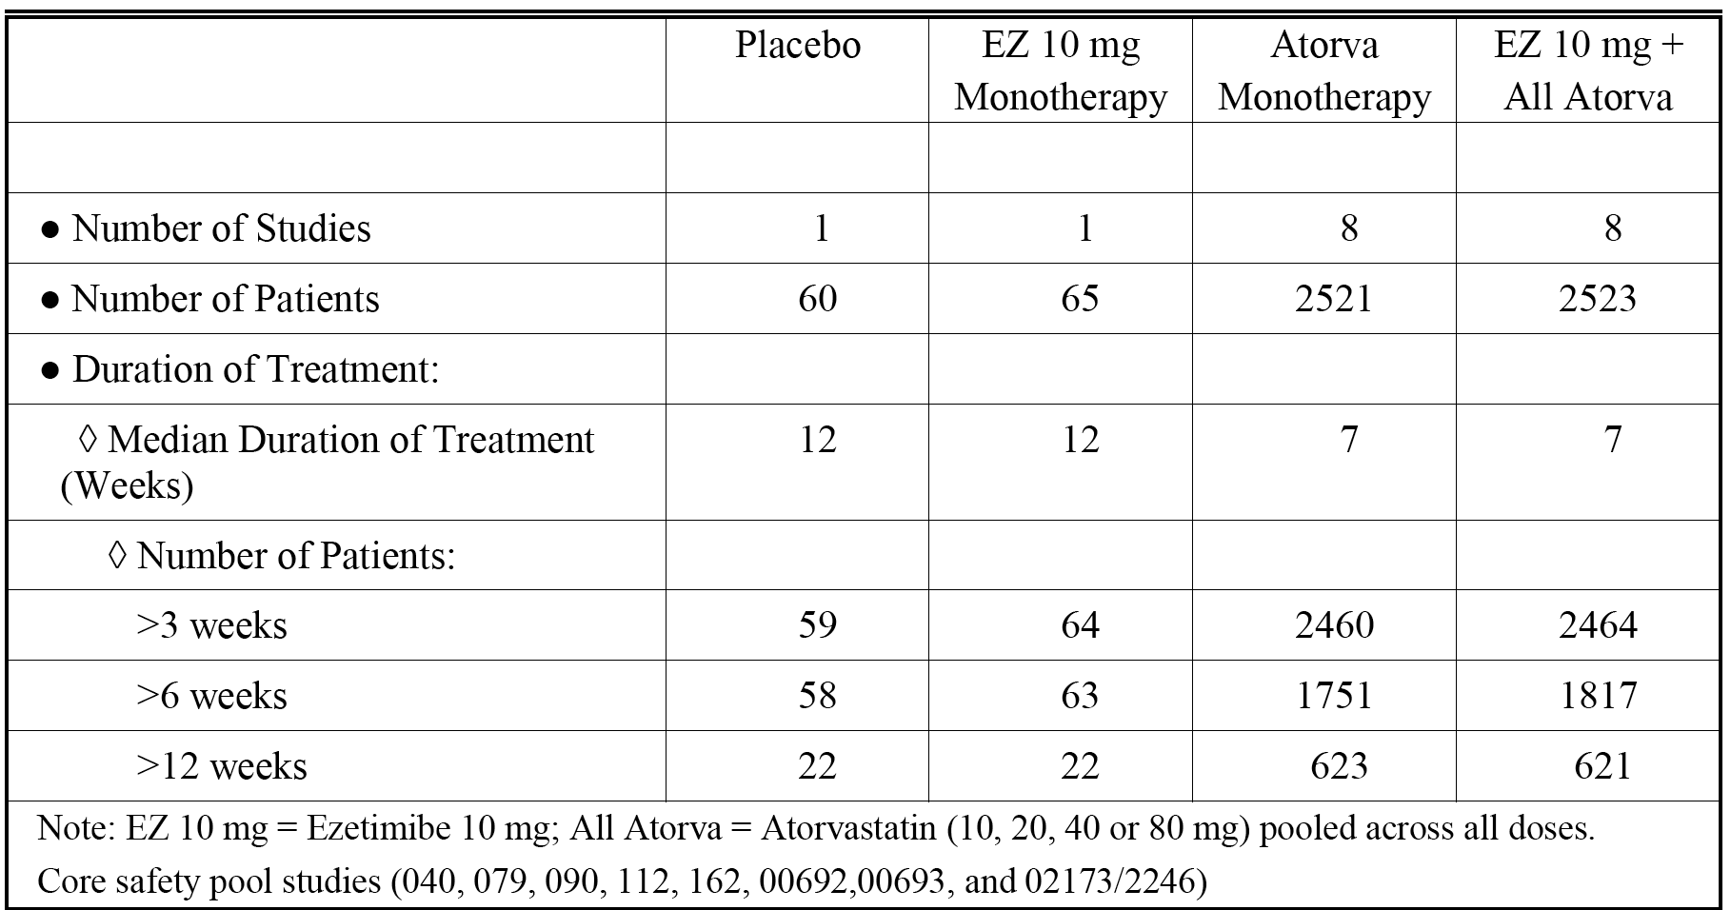

**Comment:** Study P162 differed from the other studies in the CSP due to its complex design involving switching treatments or dose doubling when moving from Phase 1 to Phase 2. Consequently, only the safety data from Phase 1 (that is, initial 6 week double blind treatment period) for patients in the ezetimibe 10 mg + atorvastatin 10 mg group (n = 480) and the atorvastatin 20 mg group (n = 120) were included in the updated CSP.

##### Disposition

The disposition of the patients in the CSP is summarized below in Table 46.

Table 46. Core Safety Pool. Disposition of subjects.

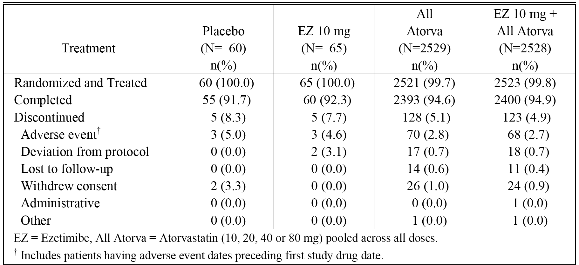

Studies in the CSP include P00692, P00693, P02173, P040, P079, P090, P112, and P162.

**Comment:** More than 90% of patients in each of the five treatment groups completed treatment, with the main reason for discontinuation in each of the treatment groups being AEs. The discontinuation rate due to AEs in the placebo group was higher than the corresponding rates in the three active treatment groups.

##### Exposure

The mean treatment duration was 82 days (range: 10, 95 days) for *placebo*, 82 days (range: 4, 102 days) for *EZ 10 mg*, 62 days (range: 1, 162 days) for *Atorva*, and 62 days (range: 1, 136 days) for *EZ 10 mg + Atorva*.

The treatment duration by dose in the CSP was provided. There were 1,327 patients in the *EZ 10 mg + Atorva 10 mg* group (mean exposure 61 days (range: 1, 120 days), 270.5 patient-years), 693 patients in the *EZ 10 mg + Atorva 20 mg* group (mean exposure 47 days (range: 1, 110 days), 129.2 patient-years), 741 patients in the *EZ 10 mg + Atorva 40 mg* group (mean exposure 43 days (range: 1, 105 days), 124.0 patient years; and 208 patients in the *EZ 10 mg + Atorva 80 mg* group (mean exposure 55 days (range: 1, 96 days), 31.6 patient years).

##### Common adverse experiences

Crude AE rates and exposure adjusted event rates per 100 patient-years were reported in the CSP population. In addition, statistical significance for the difference between exposure-adjusted event rates per 100 patient-years for *EZ 10 mg + Atorva* versus *Atorva* was provided for selected parameters, based on the 95% CI using the Miettinen and Nurminen method with study as a stratification factor. Where the comparisons were not statistically significant either the complete results will be provided or the abbreviation ‘NS’ will be used.

Of the 5,169 patients in the CSP, 33.4% (n = 1725) reported one or more AEs. The crude event rates in descending order of frequency were 63.1% (41/65) in the *EZ 10 mg* group, 56.7% (34/60) in the *placebo* group, 33.2% (837/2523) in the *EZ 10 mg + Atorva* group, and 32.2% (813/2521) in the *Atorva* group.

The exposure adjusted event rates per 100 patient-years in descending order of frequency by treatment group were *EZ 10 mg* (390.4), *placebo* (305.5)*, EZ 10 mg + Atorva* (203.0),and *Atorva* (199.0). There was no statistically significant difference in the exposure adjusted event rate per 100 patient-years between *EZ 10 mg + Atorva* and *Atorva* (difference = 0.05 (95% CI: - 20.03, 20.14)).

Specific AEs occurring in ≥ 2% of patients in the *Atorva* or *EZ 10 mg + Atorva* groups were nasopharyngitis, myalgia, and headache. The distribution of these three AEs across the four treatment groups (crude event rates) were: nasopharyngitis(*placebo* (8.3%), *EZ 10 mg* (6.2%), *Atorva* (1.6%), and *EZ 10 mg + Atorva* (2.1%)); myalgia(*placebo* (6.7%), *EZ 10 mg* (7.7%), *Atorva* (2.3%), and *EZ 10 mg + Atorva* (2.4%)); and headache(*placebo* (8.3%), *EZ 10 mg* (7.7%), *Atorva* (2.1%), and *EZ 10 mg + Atorva* (2.3%)).

The exposure adjusted event rates per 100 patient-years for *Atorva* versus *EZ 10mg + Atorva* for nasopharyngitis were 7.4 versus 9.7 (NS), for myalgia 10.6 versus 11.0 (NS), and for headache 9.6 versus 10.8 (NS). Specific AEs occurring in ≥ 2% of patients in the *Atorva* or *EZ 10 mg + Atorva* groups were provided.

##### Drug related adverse experiences

Of the 5169 patients in the CSP, 9.9% (n = 513) reported one or more drug related AEs. The drug related crude event rates in descending order of frequency were 20.0% (12/60) in the *placebo* group, 18.5% (12/65) in the *EZ 10 mg* group, 10.3% (261/2523) in the *EZ 10 mg + Atorva* group, and 9.0% (228/2521) in the *Atorva* group.

The exposure adjusted event rates per 100 patient-years in descending order of frequency by treatment group were *placebo* (74.0), *EZ 10 mg* (68.0)*, EZ 10 mg + Atorva* (51.3) and *Atorva* (44.7). There was no statistically significant difference between the exposure adjusted event rates per 100 patient-years between *EZ 10 mg + Atorva* and *Atorva* (difference = 6.41 (95% CI: ‑2.38, 15.37).

Drug related AEs grouped by the SOCs of ‘gastrointestinal disorders’ and ‘musculoskeletal and connective tissue disorders’ were reported in ≥ 2% of patients in the *Atorva* and/or the *EZ 10 mg + Atorva* groups. The distribution of the crude event rates for these two SOCs across the four treatment groups were: ‘gastrointestinal disorders’ (*placebo* (8.3%), *EZ 10 mg* (6.2%), *Atorva* (3.8%), and *EZ 10 mg + Atorva* (4.9%)); and ‘musculoskeletal and connective tissue disorders’(*placebo* (5.0%), *EZ 10 mg* (4.6%), *Atorva* (2.3%), and *EZ 10 mg + Atorva* (2.8%)).

The exposure adjusted event rates per 100 patient-years for *Atorva* versus *EZ 10mg + Atorva* for ‘gastrointestinal disorders’ were 17.8 versus 18.6 (NS), and for ‘musculoskeletal and connective tissue disorders’ were 10.8 versus 12.9 (NS).

There were no specific drug related AEs reported in ≥ 2% of patients in either the *Atorva* or *EZ 10 mg + Atorva* groups. Drug related specific AEs reported in ≥ 1% of patients in either the Atorva or EZ 10 mg + Atorva groups, respectively, were myalgia (1.2%, n = 31 versus 1.5%, n = 38) and diarrhoea (0.7%, n = 17 versus 1.0%, n = 24).

##### Deaths and serious adverse events (SAEs)

There were 4 deaths reported in the CSP: 2 were reported in the *Atorva* group (1 x brain stem haemorrhage, 1 x myocardial infarction); and 2 were reported in the *EZ 10 mg + Atorva group* (1 x cerebrovascular accident, 1 x death). None of the 4 deaths were considered by the investigator to be drug related.

SAEs in the 5,169 patients in the CSP were reported in 2.3% (n = 118) of patients. The SAE crude event rate in descending order of frequency was 3.3% (2/60) in the *placebo group*, 3.1% (2/65) in the *EZ 10 mg* group, 2.6% (65/2523) in the *EZ 10 mg + Atorva* group, and 1.9% (49/2521) in the *Atorva* group.

The exposure adjusted event rates per 100 patient-years in descending order of frequency by treatment group were *EZ 10 + Atorva* (11.9), *placebo* (11.0), *EZ 10 mg* (10.2), and *Atorva* (9.0). There was no statistically significant difference in the exposure adjusted event rate per 100 patient-years between the *EZ 10 mg + Atorva* and *Atorva* groups (difference = 2.43 (95% CI: ‑15.3, 6.43)).

There were no specific SAEs reported in ≥ 2.0% of patients in any of the four treatment groups, and there were no specific SAEs reported in ≥ 0.3% of patients in either the *Atorva* or *EZ 10 mg + Atorva* groups. The most commonly reported specific SAEs occurring in ≥ 3 patients in the *Atorva* group or the *EZ 10 mg + Atorva* group, respectively, in descending order of frequency based on the total number of patients in the two groups, were: myocardial infarction (6, 0.2% versus 6, 0.2%); chest pain (3, 0.1% versus 4, 0.2%); angina pectoris (3, 0.1% versus 3, 0.1%); coronary artery disease (4, 0.2% versus 0, 0%); pneumonia (0, 0% versus 3, 0.1%); and nausea (3, 0.1% versus 0, 0%).

Drug related SAEs were reported in 11 (0.2%) patients in the CSP, including no patients in the *placebo* or *EZ 10 mg* groups, and 3 (0.1%) patients in the *Atorva* group and 8 (0.3%) patients in the *EZ 10 + Atorva* group. There was no statistically significant difference between the *EZ 10 mg + Atorva* and *Atorva* group as regards drug related AEs.

##### Discontinuation due to adverse events

Of the 5,169 patients in the CSP, 2.6% (n = 135) discontinued due to AEs. The crude event rates in descending order of frequency were 5.0% (3/60) in the *placebo* group, 4.6% (3/65) in the *EZ 10 mg* group, 2.6% (65/2521) in the *Atorva* group, and 2.5% (64/2523) in the *EZ 10 mg + Atorva* group.

The exposure adjusted event rates per 100 patient-years in descending order of frequency by treatment group were *placebo* (16.5), *EZ 10 mg* (15.3), *Atorva* (11.9), and *EZ 10 mg + Atorva* (11.6). There was no statistically significant difference in the exposure adjusted event rate per 100 patient-years between the *EZ 10 mg + Atorva* group and the *Atorva* group (difference = - 0.32 (95% CI: - 3.58, 2.89)).

There were no specific AEs resulting in discontinuation reported in ≥ 2.0% of patients in any of the treatment groups, and there were no specific AEs resulting in discontinuation reported in ≥ 0.4% of patients in either the *Atorva* or *EZ 10 mg + Atorva* groups. The most commonly reported specific AEs resulting in discontinuation occurring in ≥ 3 patients in the *Atorva* or *EZ 10 mg + Atorva* groups, respectively, in descending order of frequency based on the total number of patients in the two groups, were: myalgia (8, 0.3% versus 8, 0.3%); fatigue (3, 0.1% versus 4, 0.2%); nausea (7, 0.3% versus 3, 0.1%); diarrhoea (3, 0.1% versus 4, 0.2%); abdominal pain (4, 0.2% versus 2, 0.1%); myocardial infarction (5, 0.2% versus 1, < 0.1%); and dizziness (0, 0% versus 3, 0.1%).

##### Adverse events of special interest

###### Allergic reactions/rash related adverse events

Of the 5169 patients in the CSP, 1.3% (n = 68) reported allergic reaction/rash related AEs. The crude event rates for allergic reaction/rash related AEs in descending order of frequency were 3.1% (2/65) in the *EZ 10 m*g group, 1.7% (1/60) in the *placebo* group, 1.3% (33/2523) in the *EZ 10 mg + Atorva* group, and 1.3% (32/2521) in the *Atorva* group.

The exposure-adjusted event rates per 100 patient years for allergic reaction/rash related AEs in descending order of frequency by treatment groups were *EZ 10 mg* (10.1), *EZ 10 mg + Atorva* (5.98), *Atorv*a = (5.88), and placebo (5.5). There was no statistically significant difference in the exposure adjusted event rate per 100 patient-years between the *EZ 10 mg + Atorva* group and the *Atorva* group (difference = - 0.10 (95% CI: - 3.22, 2.99), p = 0.947).

The most commonly reported specific allergic reaction/rash-related AEs occurring in ≥ 3 patients in the *Atorva* or *EZ 10 mg + Atorva* groups, respectively, in descending order of frequency based on the total number of patients in the two groups, were: pruritus (8, 0.3% versus 5, 0.2%); rash (6, 0.2% versus 6, 0.2%); urticaria (7, 0.3% versus 4 (0.2%); and hypersensitivity (3, 0.1% versus 6, 0.2%).

###### Gall bladder related adverse events

There were 3 (0.06%) patients in the CSP population (n = 5169) with gall bladder related AEs. The specific events were cholelithiasis in 2 patients (1 in the *EZ 10 mg + Atorva* group and 1 in the *Atorva* group) and cholecystitis in 1 patient in the *Atorva* group).

###### Gastrointestinal related adverse events

Of the 5169 patients in the CSP, 8.3% (n = 428) reported gastrointestinal related AEs. The crude event rates in descending order of frequency were 21.5% (14/65) in the *EZ 10 mg* group, 13.3% (8/60) in the *placebo* group, 8.3% (209/3523) in *EZ 10 mg + Atorva* group, and 7.8% (197/2523) in the *Atorva* group.

The exposure adjusted event rates per 100 patient-years in descending order of frequency by treatment group were *EZ 10 mg* (81.0), *placebo* (47.2), *EZ 10 mg + Atorva* (38.28), and *Atorva*. (38.28). There was no statistically significant difference in the exposure adjusted event rate per 100 patient-years between the *EZ 10 mg + Atorva* group and the *Atorva* group (difference = ‑0.12 (95% CI: - 8.05, 7.81), p = 0.977).

No specific gastrointestinal related AEs occurred in ≥ 2% of patient in either the *Atorva* group or the *EZ 10 mg + Atorva* group. The most commonly reported gastrointestinal related AEs occurring in ≥ 0.5% of patients in either the *Atorva* group or the *EZ 10 mg + Atorva* group, respectively, in descending order of frequency based on the total number of patients in the two groups, were: diarrhoea (37, 1.5% versus 43, 1.7%); constipation (27, 1.1%versus 29, 1.1%); dyspepsia (25, 1.0% versus 20, 0.8%); abdominal pain (19, 0.7% versus 23, 0.9%); upper abdominal pain (20, 0.8% versus 14, 0.6%); flatulence (9, 0.4% versus 22, 0.9%); and vomiting (12, 0.6% versus 9, 0.4%).

###### Hepatitis related adverse events

There were 3 (0.06%) patients in the CSP population (n = 5169) with hepatitis related AEs. The specific events were cholestasis in 2 patients in the *Atorva* group, and hepatitis in 1 patient in the *EZ 10 mg + Atorva* group).

###### Hy's law cases

There were 2 (0.04%) patients in the CSP population (n = 5169) meeting Hy's law criteria for drug induced liver injury, and both cases occurred in the *EZ 10 mg + Atorva* group.

###### ALT and/or AST, consecutive elevations

The definition of consecutive or ‘presumed consecutive’ post-baseline elevations was consistent across the studies. The following explanation is derived from information provided in the submission relating to the definition of ‘consecutive’ or ‘presumed consecutive’ ALT or AST levels ≥ 3 x ULN. It is assumed that the principles relating to consecutive’ or ‘presumed consecutive’ ALT or AST levels ≥ 3 x ULN also apply to consecutive levels ≥ 5 x ULN and ≥ 10 x ULN, although an express statement to this effect could not be identified in the submission. In essence, a subject is deemed to have ALT (AST) ≥ 3 x ULN on two consecutive occasions post baseline if one of the following conditions is met:

* ALT (AST) is ≥ 3 x ULN and is still ≥ 3 x ULN at the next available observation (that is, ‘consecutive elevations’);
* ALT (AST) is ≥ 3 x ULN and no follow up values for that parameter are available (that is, ‘presumed consecutive elevation’);
* ALT (AST) is ≥ 3 x ULN followed by a measurement < 3 x ULN that was taken more than 2 days after the last dose study medication (that is, ‘presumed consecutive elevation’).

ALT and or/ AST ≥ 3 x ULN, consecutive elevations

The crude event rates for consecutive ALT and/or AST ≥ 3 x ULN events were 0.4% (11/2467) in the *Atorva* group and 0.6% (14/2474) in the *EZ 10 mg + Atorva* group, and the respective exposure adjusted rates per 100 patient-patient years were 2.02 and 2.54 (difference = 0.33 (95% CI, -1.66, 2.34), p = 0.721). There were no patients in the *placebo* or *EZ 10 mg* groups with consecutive ALT and/or AST ≥ 3 x ULN events.

ALT and/or AST ≥ 5 x ULN, consecutive elevations

The crude event rates for consecutive ALT and/or AST ≥ 5 x ULN events were 0.2% (5/2467) in the *Atorva* group and 0.2% (4/2474) in the *EZ 10 mg + Atorva* group, and the respective exposure adjusted rates per 100 patient-years were 0.92 and 0.72 (difference = - 0.19 (95% CI, ‑1.58, 1.11), p = 0.739). There were no patients in the placebo or EZ 10 mg groups with consecutive ALT and/or AST ≥ 10 x ULN events.

ALT and/or AST ≥ 10 x ULN, consecutive elevation

The crude event rate for consecutive ALT and/or AST ≥ 10 x ULN events was < 0.1% (1/2474) in the *EZ 10 mg + Atorva* group, and the respective exposure adjusted rate per 100 patient-years was 0.18. There were no patients in the *placebo*, *Atorva* or *EZ 10* mg groups with consecutive ALT and/or AST ≥ 10 x ULN events.

ALT or AST elevation reported as AEs

ALT elevations as AEs were reported in 15 (0.6%) patients in the *Atorva* group, 23 (0.9%) patients in the *EZ 10 mg + Atorva* group, and no patients in the placebo or EZ 10 mg groups. AST elevations as AEs were reported in 12 (0.5%) patients in the *Atorva* group, 18 (0.7%) patients in the *EZ 10 mg + Atorva* group, and no patients in the placebo or *EZ 10 mg* groups. Transaminases increased as AEs were reported in 3 (0.1%) patients in the *Atorva* group and no patients in the *placebo*, *EZ 10 mg* groups or *EZ 10 mg + Atorva* groups.

ALT or AST elevation reported as drug related AEs

ALT elevations as AEs were reported in 11 (0.4%) patients in the *Atorva* group, 19 (0.8%) patients in the *EZ 10 mg + Atorva* group, and no patients in the *placebo* or *EZ 10 mg* groups. AST elevations as AEs were reported in 7 (0.3%) patients in the *Atorva* group, 16 (0.6%) patients in the *EZ 10 mg + Atorva* group, and no patients in the *placebo* or *EZ 10* mg groups. Transaminases increased as AEs were reported in 2 (0.1%) patients in the *Atorva* group and no patients in the *placebo, EZ 10 mg* or *EZ 10 mg + Atorva* groups.

###### Creatinine kinase (CK) elevations

10 x ULN

CK elevations ≥ 10 x ULN were reported in 2 (0.1%) patients in the *Atorva* group, and no patients in the *placebo*, *EZ 10 mg* or *EZ 10 mg + Atorva* groups.

10 x ULN with muscle symptoms

CK elevations ≥ 10 x ULN with muscle symptoms were reported in 1 (< 0.1%) patient in the *Atorva* group, and no patients in the *placebo*, *EZ 10 mg* or *EZ 10 mg + Atorva* groups.

10 x ULN with muscle symptoms considered drug related

CK elevations ≥ 10 x ULN with muscle symptoms considered to be drug related group were reported in no patients in the *placebo*, *EZ 10 mg*, *Atorva* or *EZ 10 mg + Atorva* groups.

Reports of AEs

There were no AE reports of rhabdomyolysis or myopathy in the CSP, although 1 patient in *EZ 10 mg + Atorva 40* mg group met the criteria for myopathy (reported as a SAE of CK elevation). CK elevations were reported as AEs in 17 (0.7%) of patients in the *Atorva* group and 20 (0.8%) of patients in the *EZ 10 mg + Atorva* group. Discontinuations due to CK AEs were reported in 1 (< 0.1%) patient in the *Atorva* group and 1 (< 0.1%) patient in the *EZ 10 mg + Atorva* group.

##### Laboratory values

###### Liver function tests

There results for ALT and/or AST elevations have been described above. Other laboratory tests reflecting liver function were conducted during the course of the studies (GGT, SAP, and total bilirubin). The percentage of patients exceeding the GGT predefined limit of 50 IU/mL was 15.6% (7/45) in the *Atorva* group and 12.5% (25/200) in the *EZ 10 mg + Atorva* group. The percentage of patients exceeding the SAP predefined limit of 125 mIU/mL was 2.2% (1/45) in the *Atorva* group and 1.5% (3/200) in the *EZ 10 mg + Atorva* group. The percentage of patients exceeding the total bilirubin limit of 1.5 mg/dL was 4.4% (2/45) in the *Atorva* group and 4.0% (8/200) in the *EZ 10 mg + Atorva* group.

###### Serum creatinine

The percentage of patients exceeding the serum creatinine predefined limit of 2 mg/dL was 0.4% (4/1109) in the *Atorva* group and 0.3% (4/1642) in the *EZ 10 mg + Atorva* group. No patients exceeded this level in the *placebo* group (0/60) or the *EZ 10 mg* group (0/65).

###### Haematology

The percentage of patients exceeded predefined haematology laboratory parameters were provided. No clinically meaningful differences were observed between patients in the *Atorva* and *EZ 10 mg + Atorva* groups. The only haematology parameters in which ≥ 5.0% of patients in the *Atorva* or *EZ 10 mg + Atorva* groups exceeded the predefined values were haematocrit values < 39% in females (7.2% (26/359) in the *Atorva* group, 6.9% (24/347) in the *EZ 10 mg + Atorva* group), and haemoglobin value in females < 13 g/dL (5.3% (19/359) in the *Atorva* group).

###### Urinalysis

No clinically meaningful differences were observed between patients in the *Atorva* and *EZ 10 mg + Atorva groups*, respectively, for RBC count > 5/HPF (11.8% versus 17.8%), WBC count > 5 HPF (22,1% versus 23.1%), urinary protein ≥ 30 mg/dL (5.1% versus 7.3%), or urinary glucose > 100 mg/dL (0.7% versus 1.3%).

##### Safety in special groups

###### Age

The CSP data were evaluated in the SCS for evidence of differential risk between the treatment groups for younger versus older patients (< 65 years versus ≥ 65 years and < 75 years versus ≥ 75 years). There were no patients under 18 years old in the CSP. The overall AE rates between the *Atorva group* versus the *EZ 10 mg + Atorva* group, respectively, were similar in patients aged < 65 years (34.4% (461/1342) versus 36.9% (487/1318)), in patients aged ≥ 65 years (29.9% (352/1179) versus 29.0% (350/1205)), in patients aged < 75 years (32.4% (733/2264) versus 33.5% (745/2222)), and in patients aged ≥ 75 years (31.1% (80/257) versus 30.6% (92/301)).

The crude event rate for AEs for patients in the pooled *Atorva* and *EZ 10 mg + Atorva* groups were reported in a higher proportion of patients aged < 65 years (35.6% (948/2260) versus ≥ 65 years (29.4%, (702/2384)), and a higher proportion of patients aged < 75 years (32.9% (1478/4486) versus ≥ 75 years of age (30.8% (172/558)). The largest differences were seen for AEs grouped by the SOCs of ‘infections and infestations’ and ‘musculoskeletal and connective tissue disorders’. In the pooled patients in the *Atorva* and *EZ 10 mg + Atorva* groups, AEs grouped by the SOC of ‘infections and infestations’ were reported in a higher proportion of patients < 65 years (10.5%) versus ≥ 65 years (6.4%) and patients age < 75 years (8.8%) versus ≥ 75 years (6.3%). In the pooled patients in the *Atorva* and *EZ 10 mg + Atorva* groups, AEs grouped by the SOC of ‘musculoskeletal and connective tissue disorders’ were reported in a higher proportion of patients aged < 65 years (9.5%) versus aged ≥ 65 years (6.2%) and in patients aged < 75 years (8.2%) versus aged ≥ 75 years (6.1%). No specific AEs in these two SOCs appeared to contribute disproportionately to the observed differences in the two age group comparisons in the pooled *Atorva* and *EZ 10 mg + Atorva* group.

In the *placebo* group, AEs were also reported in higher proportion of patients < 65 years (58.5% (24/41)) versus ≥ 65 years (52.6% (10/19), and patients < 75 years (56.9% (33/58) versus ≥ 75 years (50.0% (1/2)). In the *EZ 10 mg* group, AEs were also reported in a higher proportion of patients < 65 years (68.1% (32/47)) versus ≥ 65 years (50.0% (9/18)), but there was a slightly lower proportion for patients with AEs aged < 75 years (62.9% (39/62)) versus aged ≥ 75 years (66.7% (1/3)). However, the number of patients aged ≥ 75 years in the *placebo* and *EZ 10 mg* groups were very small (n = 2 and n = 3, respectively), precluding meaningful comparisons in these two treatment groups for patients aged ≥ 75 years.

The overall AE experience for patients aged < 65 years, ≥ 65 years, < 75 years and ≥ 75 years were summarized and provided.

###### Gender

The CSP data were evaluated in the SCS for evidence of differential risk between treatment groups for gender. Overall, AEs were reported more approximately 4% to 6% more commonly in females that in males in both the *Atorva* and *EZ 10 mg + Atorva* groups. The overall crude AE rate in females versus males in the *Atorva* group was 35.1% (442/1261) versus 29.4% (371/1260), and in the *EZ 10 mg + Atorva* group was 34.6% (425/1227) versus 31.8% (412/1296). In the placebo group, the overall crude AE rate was approximately 4% higher in males versus females (58.6% (17/29) versus 54.8% (17/31)), and in the *EZ 10 mg* group the rates were similar in males versus females (62.1% (18/29) versus 63.9% (23/36)). SAE rates were similar in both males and females in both the *Atorva* and *EZ 10 mg + Atorva* groups and were reported in approximately 2.0% of female patients and approximately 2.6% of male patients in both treatment group groups combined.

Review of the crude rates of AEs of special interest showed that the results were generally similar for female and male patients in the *Atorva* and *EZ 10 mg + Atorva* groups. For gastrointestinal related AEs, the crude event rates in the Atorva group for females versus males were 9.3% versus 6.3% and in the EZ 10 mg + Atorva group were 9.1% versus 7.5%. AEs in female and male patients in the CSP were summarized and provided.

###### Race

The CSP data were evaluated in the SCS for evidence of differential risk in the different racial groups (White, Black, Asian, Other). However, it is considered that the imbalance in the proportion of patients across the four racial groups precludes meaningful evaluation of the comparative safety profiles (that is, White 88% (4541/5169); Black 6% (294/5169); Asian 2% (92/5169); Other 5% (242/5169)).

##### Adverse events and ezetimibe plus atorvastatin dose

AEs by dose were provided. The overall rate of AEs was higher in the *EZ 10 mg + Atorva 80* mg group (37.5%) than in the *EZ 10 mg + Atorva 10, 20, or 40 mg* groups (30.7%, 29.3%, 30.6%, respectively). This pattern was also seen for drug related AEs (overall). However, SAE rate were similar for the four co administered *EZ 10 mg + Atorva* dosage groups as were the rates for discontinuation due to AEs.

Crude event rates for Tier 1 AEs (that is, AEs of special interest) were provided. No dose relationship was seen between *EZ 10 mg + Atorva 10 to 80 mg* for predefined AST and/or ALT levels, CK levels, hepatitis related AEs, or gall bladder related AEs. However gastrointestinal related AEs occurred more commonly in the *EZ 10 mg + Atorva 80 mg* group (11.1%) than in the *EZ 10 mg + Atorva 10, 20 and 40 mg* groups (7.2%, 5.3%, and 7.6%). Allergic reaction/rash related AEs occurred in ≤ 2.0% of patients in the four *EZ 10 mg + Atorva 10-80 mg* groups. The 2 potential Hy's Law cases in the CSP were reported in the *EZ 10 mg + Atorva 10 mg* group (0.2% of patients).

### Post-marketing experience

The submission included CIOMS Suspected Adverse Reaction Reports relating to co-administration of ezetimibe and atorvastatin received by the manufacturer from 10 October 2005 to 22 May 2013. There were no CIOMS reports relating to the FDC product, as this product did not receive marketing approval until after the analysis of CIOMS reports.

The Summary of Clinical Safety included a review of the CIOMS Suspected Adverse Reaction Reports. The summary indicated that a total of 2,142 spontaneous individual case reports (ICSRs) involving ezetimibe as suspect therapy and atorvastatin as a concomitant or secondary suspect therapy had been received from health care providers from the date of market introduction of ezetimibe on 17 October 2002 through to 1 April 2013. A total of 2,142 ICSRs were identified for this time period and the CIOMS reports accompanied this submission. Of the 2,142 cases, 613 (29%) were serious and 1,529 (71%) were non serious. Age was reported in 1,634 (76%) of the 2,142 cases, including 983 (60%) cases between 18 and 64 years of age, 647 (40%) cases ≥ 65 years of age, and 4 cases aged < 18 years of age. Gender was noted in 1,990 (93%) of the reports, including 1117 (56%) reports in males and 873 (44%) reports in females.

The SOC with ≥ 10% of ADRs in decreasing order of frequency were: ‘investigations’ (32%; 687 events); ‘musculoskeletal and connective tissue disorders’ (29%, 612 events); ‘gastrointestinal disorders’ (21%, 451 events); ‘general disorders and administration site conditions (21%, 444 events); ‘nervous system disorders’ (13%, 288 events); and ‘skin and subcutaneous tissue disorders’ (10%, 222 events).

The most commonly occurring serious ADRs reported in ≥ 1% of the 2,142 cases in decreasing order of frequency: were myalgia (3.5%, n = 75); rhabdomyolysis (2.4%, n = 52); blood CK increased (2.1%, n = 46); drug interactions (1.5%, n = 33); ALT increased (1.5%, n = 32); AST increased (1.5%, n = 32); asthenia (1.3%, n = 28); muscle spasms (1.3%, n = 27); fatigue (1.2%, n = 25); muscle weakness (1.1%, n = 24); and pain in extremity (1.1%, n = 24).

Fatal outcomes were reported to be associated with hepatobiliary related ADRs (13 deaths), and myopathy related ADRs (5 deaths).

The ADRs by SOC for spontaneous ICSRs reported by health care professionals are summarized in Table 47, and most commonly reported SOCs are summarized in Table 48.

Table 47. Post marketing data. Summary tabulation of ADRs by SOC for spontaneous HCP ICSRS ezetimibe co administered with atorvastatin; market introduction to 01-APR-2013.

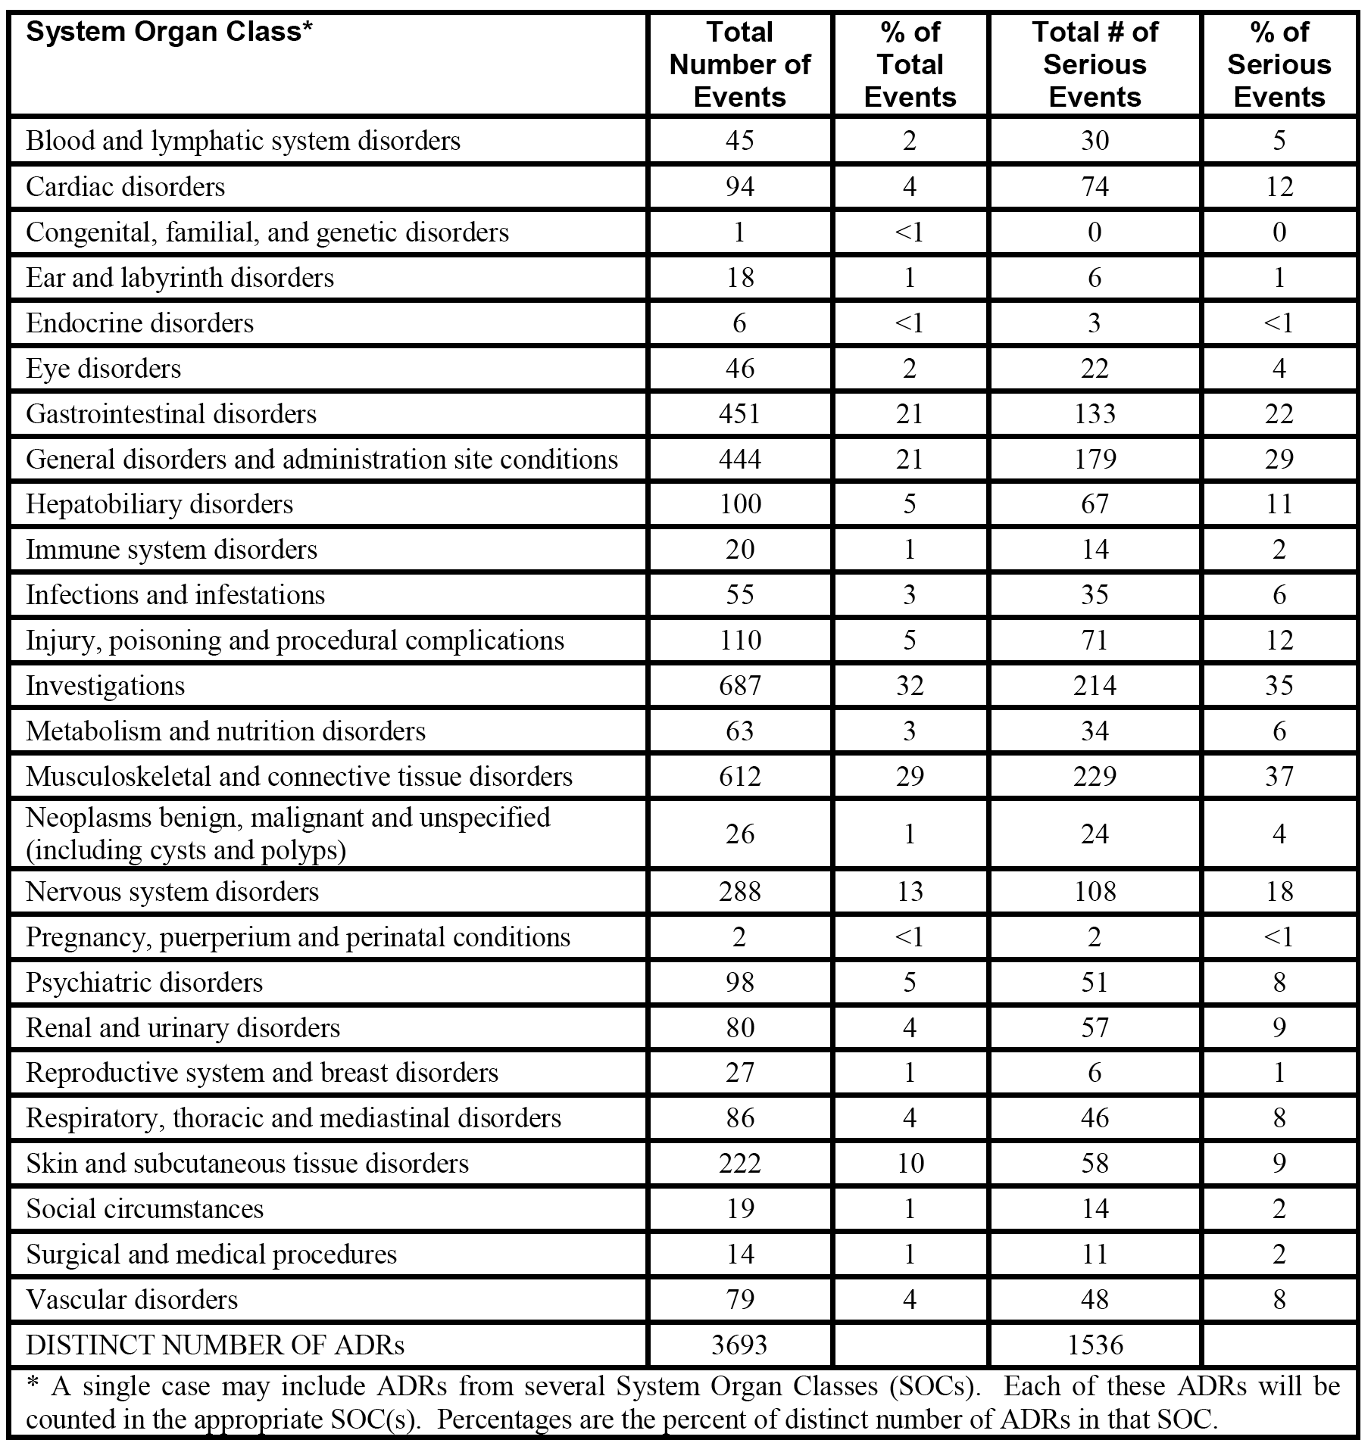

Table 48. Post marketing data. Most common SOCs spontaneous HCP ICSRS ezetimibe co administered with atorvastatin; market introduction to 01-APR-2013.

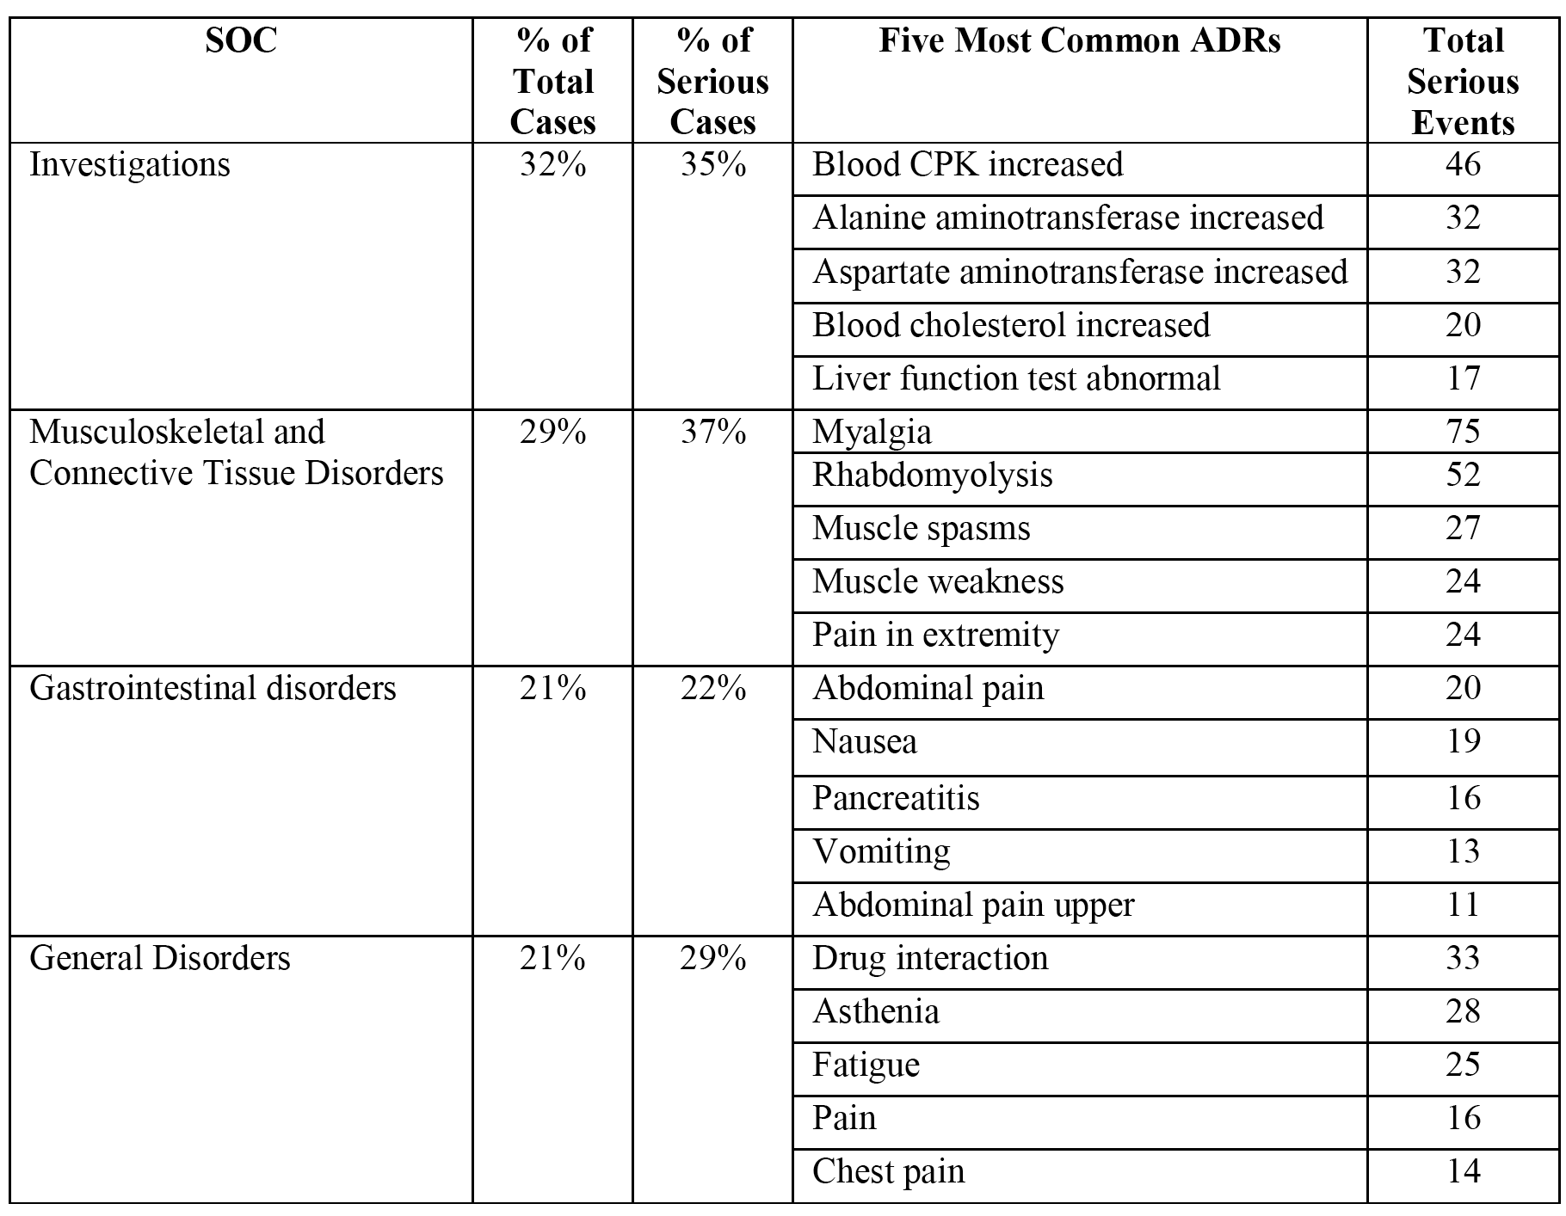

**Comment**: The post marketing ADRs from ICSRs provided by health care providers for co administered ezetimibe and atorvastatin are consistent with the known safety profile for co administration of these two drugs. In addition, the post marketing ADRs are similar to the AE experience observed in the clinical trial program for co administration of the two drugs. No new or unexpected ADRs were observed in the submitted post marketing safety data.

### Evaluator's overall conclusions on safety

#### Study P162

The pivotal Phase III efficacy and safety study (P162) included 1,547 randomized patients, 1,539 (99.5%) of whom took at least one dose of study medication and were included in the all patients as treated population used for the safety analysis. The study consisted of two double blind treatment Phases of 6 weeks duration each (Phase 1 and Phase 2), and the conclusions relating to safety for these two phases have been discussed separately.

##### Phase 1 (initial 6 week double blind treatment phase)

In Phase 1, the all patients as treated population (n = 1,539) included 120 patients in the *EZ 10 mg + Atorva 10 mg* group, 480 patients in *Atorva 20 mg* group and 939 patients in the *Rosuva 10 mg* group. The mean duration of treatment for all patients was 42.1 days (SD = 6.5) with a range of 1 to 77 days, and the mean duration treatment for the three treatment groups was similar (42 to 43 days).

AEs occurred in 12.6% of patients in the three treatment groups combined, and were reported more frequently in patients in the *Rosuva 10 mg* group (n = 13.6%) than in the *Atorva* (11.9%) and *EZ 10 mg + Atorva 10 mg* (7.5%) groups. There were no statistically significant differences in the AE rates between the *EZ 10 mg + Atorva 10 mg* and *Atorva 20 mg* groups or the *EZ 10 mg + Atorva 10 mg* and *Rosuva 20 mg* groups. Overall, there were no clinically significant differences in the AE profiles of the three treatment groups.

Drug related AEs occurred in 2.8% of patients in the three treatment groups combined, and were reported more commonly in patients in the *Atorva 20 mg* group (3.1%) than in the *Rosuva 10 mg* (2.9%) and *EZ 10 mg + Atorva 10 mg* (0.8%) groups. There were no statistically significant differences in drug related AE rates between the *EZ 10 mg + Atorva 10 mg* and *Atorva 20 mg* groups or the *EZ 10 mg + Atorva 10 mg* and *Rosuva 20 mg* groups. No specific drug related AEs occurred in ≥ 1.0% of patients in any of the three treatment groups. Overall, there were no clinically significant differences in the drug related AE profiles of the three treatment groups.

Two deaths occurred in Phase 1, both in the *Rosuva 10 mg* group and both were considered to be unrelated to the treatment drug (1 x bile duct carcinoma, 1 x myocardial infarction). SAEs (including deaths) occurred infrequently and were reported in 0.8% of patients in the three treatment groups combined. There were no SAEs in the *EZ 10 mg + Atorva 20* mg group (0%), while SAEs occurred marginally more frequently in patients in the *Rosuva 10 mg* group (1.1%) than in the *Atorva* (0.6%). There were no statistically significant differences in the SAEs between the *EZ 10 mg + Atorva 10 mg* and *Atorva 20 mg* groups or the *EZ 10 mg + Atorva 10 mg* and *Rosuva 20 mg* groups. No specific SAEs occurred in more than 1 patient in any of the three treatment groups. No drug related SAEs occurred in any of the three treatment groups. Overall, no specific patterns of SAEs were observed in any of the three treatment groups.

Discontinuations due to AEs occurred in 1.4% of patients in the three treatment groups combined, and were reported more commonly in the *Atorva 20 mg* group (1.9%) than in the *Rosuva 10 mg* (1.2%) and *EZ 10 mg + Atorva 10 mg* (0.8%). The majority of discontinuations were considered to be due to drug related AEs and these events were reported in a total of 1.0% of patients (1.3% in *Atorva 20 mg* group, 1.0% in the *Rosuva 10 mg* group, and 0.8% in the *EZ 10 mg + Atorva 10 mg* group). There were no statistically significant differences in the discontinuations due to drug related AE rates between the *EZ 10 mg + Atorva 10 mg* and *Atorva 20 mg* groups or the *EZ 10 mg + Atorva 10 mg* and *Rosuva 20 mg* groups.

AEs of special interest occurring in the study were comprehensively reported. These events occurred relatively infrequently in the three treatment groups. There were no statistically significant differences AE (any) rates of special interest between the *EZ 10 mg + Atorva 10 mg* and *Atorva 20 mg* groups or the *EZ 10 mg + Atorva 10 mg* and *Rosuva 20 mg* groups. The most commonly occurring AEs of special interest in the three treatment groups were gastrointestinal related AEs, and these were reported in 2.1% of patients in the three treatment groups combined and in a similar proportion of patients in the *Atorva 20 mg* (2.5%), *Rosuva 10 mg* (2.0%) and the *EZ 10 mg + Atorva 10 mg* (1.7%) groups. Allergic-reaction/rash related AEs of special interest occurred in 0.6% of patients in the three treatment groups combined, and were reported in no patients in *EZ 10 mg + Atorva* group and marginally more frequently in patients in the *Rosuva 10 mg* group (0.9%) than in the *Atorva 20 mg* group (0.4%). Prespecified ALT and/or AST elevations of special interest were reported only in the *Rosuva 10 mg* group (2 (0.2%) patients ≥ 3 x ULN (consecutive events), and 1 (0.1%) patient each for ≥ 5 x ULN and ≥ 10 x ULN). No prespecified CK elevations of special interest occurred in the three treatment groups. No hepatitis-related AEs or gall bladder related AEs of special interest occurred in the three treatment groups. No cases meeting Hy's Law criteria for drug induced liver injury were reported in the three treatment groups.

No events of note in the three treatment groups occurred relating to blood chemistry parameters exceeding predefined limits (that is, serum creatinine, total bilirubin, serum ALP), or for changes in vital signs over the course of treatment.

##### Phase 2 (subsequent 6 week double blind treatment phase)

In Phase 2, a total of 712 patients in the all patients as treated population continued from Phase 1. Patients continuing from Phase 1 with an inadequate response to *Atorva 20* mg were either switched to *EZ 10 mg + Atorva 20 mg* (n = 124) or had their *Atorva* dose doubled to *40 mg* (n = 124), and patients continuing from Phase 1 with an inadequate response to *Rosuva* 10 mg were either switched to *EZ 10 mg + Atorva 20 mg* (n = 231) or had their *Rosuva* dose doubled to *20 mg* (n = 205). In addition, of the patients who had been initially randomized to *EZ 10 mg + Atorva 10 mg*, 28 continued on this regimen in Phase 2 in order to maintain the double blinded study design.

The key safety comparisons in Phase 2 were between Atorva 20 mg → EZ 10 mg + Atorva 20 mg and Atorva 20 mg → Atorva 40 mg and between Rosuva 10 mg → EZ 10 mg + Atorva 20 mg and Rosuva 10 mg → Rosuva 20 mg. The conclusions relating to Phase 2 will focus on the 4 treatment groups included in these comparisons. The mean duration of exposure in all patients was 41.7 days (SD = 5.5), with a range of from 1 to 62 days. In the 4 key treatment groups, the mean duration of exposure ranged from approximately 41 to 42 days and the total days of exposure ranged from 1 to 62 days.

AEs occurred in 11.1% (n = 79) of the 712 all patients as treated population. In the 4 key treatment groups, AEs were reported in decreasing order of frequency in the *Rosuva 10 mg → EZ 10 mg + Atorva 20 mg* group (15.6%), the *Atorva 20 mg → Atorva 40 mg* group (10.5%), the *Atorva 20 mg → EZ 10 mg + Atorva 20 mg* group (8.9%)and the *Rosuva 10 mg → Rosuva 20 mg* group (8.8%). There was no statistically significant difference in the incidence of AEs between the *Atorva 20 mg → EZ 10 mg + Atorva 20 mg and**Atorva 20 mg → Atorva 40 mg groups.* However, the difference in the incidence of AEs between *Rosuva 10 mg → EZ 10 mg + Atorva 20 mg and Rosuva 10 mg → Rosuva 20 mg* was statistically significant (difference = 6.8% (95% CI: 0.6, 3.0)).

The statistically significant difference in the incidence of patients with AEs between the *Rosuva 10 mg → EZ 10 mg + Atorva 20 mg and Rosuva 10 mg → Rosuva 20 mg* groups appears to have been driven primarily by the higher proportion of patients in the co administered group with ‘musculoskeletal and connective tissue disorders’ compared with the monotherapy group (3.5% versus 0.5%, respectively, difference = 3.0% (95% CI: 0.4, 6.3)). No specific AEs were reported in ≥ 4 patients or in ≥ 2% of patients in the four treatment groups. The observed differences in the incidence of AEs occurring in ≥ 1% of patients in at least one of the four treatment groups were small, and demonstrate no clinically meaningful difference in the AE profiles across the four treatment groups.

Drug related AEs occurred in 2.2% (n = 16) of the 712 all patients as treated population. In the 4 key treatment groups, drug related AEs were reported in decreasing order of frequency in the *Rosuva 10 mg → EZ 10 mg + Atorva 20 mg* group (3.5%), the *Atorva 20 mg → Atorva 40 mg* group (2.4%), the *Atorva 20 mg → EZ 10 mg + Atorva* 20 mg group (1.6%) and the Rosuva 10 mg → Rosuva 20 mg group (1.0%). There were no statistically significant differences in the incidence of drug related AEs in the two pairwise comparisons of interest. No drug related AEs grouped by SOC occurred in ≥ 1.0% of patients in the four key treatment groups.

There was 1 death in the *Rosuva* *10 mg → EZ 10 mg + Atorva 20 mg* group (alcohol poisoning considered to be unrelated to the study-drug). SAEs (including death) occurred in 1.4% (n = 10) of the 712 all patients as treated population. In the 4 key treatment groups, drug related AEs were reported in decreasing order of frequency in the *Rosuva 10 mg → EZ 10 mg + Atorva 20 mg* group (2.2%), the *Atorva 20 mg → Atorva 40 mg* and *Atorva 20 mg → EZ 10 mg + Atorva 20 mg* groups (1.6% in each group), and the *Rosuva 10 mg → Rosuva 20 mg* group (0.5%). There were no statistically significant differences in the incidence of drug related AEs in the two pairwise comparisons of interest. No patterns of SAEs were observed in the 4 key treatment groups, and the differences among the groups are not considered to be clinically meaningful.

Discontinuations due to AEs occurred in in 4 (0.6%) of the 712 all patients as treated population. In the 4 key treatment groups, discontinuations due to AEs were reported in 1 patient each in the *Atorva 20 mg → EZ 10 mg + Atorva 20 mg* (0.8%), *Atorva 20 mg → Atorva 40 mg* (0.8%), *Rosuva 10 mg → Rosuva 20 mg* (0.5%), and *Rosuva 10 mg → EZ 10 mg + Atorva 20 mg* (0.4%) groups. There were no statistically significant differences in the incidence of drug related AEs in the two pairwise comparisons of interest. Discontinuations were reported in 1 patient each in the *Atorva 20 mg → Atorva 40 mg* (0.8%) and *Rosuva 10 mg → EZ 10 mg + Atorva 20 mg* (0.4%) groups (ALT increased and muscle spasms, respectively), and in no patients in the two other key treatment groups. No clinically meaningful differences were seen across the 4 key studies for discontinuations due to AEs.

AEs of special interest occurring in the study were comprehensively reported. These events occurred relatively infrequently in the 712 patients in the all as treated population. There were no statistically significant or clinically meaningful differences for any of the AEs of interest in the two pairwise comparisons of interest. The most only occurring AEs of special interest in the 4 key treatment groups were gastrointestinal-related, reported in 1.6% of patients in both the *Atorva 20 mg → EZ 10 mg + Atorva 20 mg* and *Atorva 20 mg → Atorva 40 mg* groups, 1.0% of patients in the *Rosuva 10 mg → Rosuva 20 mg* group, and 0.9% of patients *Rosuva 10 mg → EZ 10 mg + Atorva 20 mg.* Allergic reactions/rash-related AEs of special interest were reported in 1 (0.8%) patient in the *Atorva 20 mg → Atorva 40 mg* group and no patients in the 3 other key treatment groups. Prespecified ALT and/or AST elevations of special interest were reported in 1 (0.8%) patient in the *Atorva 20 mg → Atorva 40 mg* group for a ≥ 3x ULN (consecutive) event, 1 (0.4%) patient in the *Rosuva 10 mg → EZ 10 mg + Atorva 20 mg* group for each of ≥ 3 x ULN (consecutive), ≥ 5 x ULN, and ≥ 10 x ULN events, and no patients in the *Atorva 20 mg → EZ 10 mg + Atorva 20 mg* and *Rosuva 10 mg → Rosuva 20 mg* groups. Prespecified CK elevations of special interest occurred in none of the 4 key treatment groups. No hepatitis-related AEs or gall bladder related AEs of special interest occurred in the 4 key treatment groups. No cases meeting Hy's Law criteria for drug induced liver injury were reported in the 4 key treatment groups.

No events of note in the 4 key treatment groups occurred relating to blood chemistry parameters exceeding predefined limits (that is, serum creatinine, total bilirubin, serum ALP), or for changes in vital signs over the course of treatment.

#### Studies P185 and P190

Studies P185 and P190 showed that ezetimibe/atorvastatin FDC tablets (10/20 mg (P185) and 10/40 mg (P190)) had similar safety profiles to co administered ezetimibe 10 mg and atorvastatin 20 mg (P185) and ezetimibe 10 mg and atorvastatin 40 mg (P190)) tablets. In addition, the safety profiles of the ezetimibe/atorvastatin FDC 10/20 mg (P185) and 10/40 mg (P190) tablets were comparable. Furthermore, the safety profiles of co administered ezetimibe 10 mg and atorvastatin 20 mg and ezetimibe 10 mg and atorvastatin 40 mg observed in the two supportive studies (P185, P190) were consistent with the safety profiles of co administered ezetimibe 10 mg and atorvastatin 10 mg and ezetimibe 10 mg and atorvastatin 20 mg observed in the pivotal study (P162).

##### Study P185

In this study, 404 out of 406 randomized patients took at least one dose of study treatment and were included in the all patients as treated population used for the analysis of safety. The study included 383 patients treated with combination (FDC) ezetimibe/atorvastatin 10/20 mg and 388 patients treated with co administered ezetimibe 10 mg + atorvastatin 20 mg, The overall mean duration of treatment in the FDC group was 41.8 days (SD = 5.6), with a range of 1 to 56 days, and 41.7 days (SD = 6.0), with a range of 1 to 70 days in the co administered group.

The incidence of patients with at least one AE was similar for both treatments (24.5% for the FDC group; 26.5% for the co administered group), and the difference between the two treatment groups was not statistically significant. For AEs grouped by SOC (≥ 1% of patients in at least one of the treatment groups), the only SOC in which the comparison between FDC and co administered treatments was statistically significant was ‘musculoskeletal and connective tissue disorders’. In this SOC, the incidence was lower in patients in the FDC group compared with patients in the co-co administered group (3.9% versus 7.7%, respectively, calculated difference of - 3.77% (95% CI: -7 .08, - 0.67)). The only statistically significant difference between the two treatment groups for specific AEs occurring with an incidence of ≥ 1% of patients in at least one of the two treatment groups were for dyspepsia and nasopharyngitis, both of which occurred more frequently in the co administered group than in the FDC group (2.6% versus 0.8%, nasopharyngitis; 1.0% versus 0.3%, dyspepsia).

Drug related AEs were reported in a similar proportion of patients in the FDC group and the co administered group (3.9% versus 4.4%, respectively), and the difference between the two treatment groups was not statistically significant. Drug related AEs reported in ≥ 0.5% of patients in at least one of the two treatment groups (FDC versus co administered) in descending order of frequency in the total population were muscle spasms (0.5% versus 1.0%), fatigue (0.8% versus 0.5%), constipation (0.8% versus 0.3%), dyspepsia (0.3% versus 0.8%), abdominal discomfort (0% versus 0.5%), and arthralgia (0.5%, n = 2 versus 0%, n = 0).

SAEs were reported in a total of 6 patients in both treatment groups combined. The proportion of patients with SAEs was similar in the FDC and co administered groups (0.5%, n = 2 versus 1.0%, n = 4, respectively), and the difference between the two groups was not statistically significant. In the FDC group, the SAEs were myocardial infarction in 1 patient and hypokalaemia in 1 patient. In the co administered group, the SAEs were ventricular extrasystoles in 1 patient, ‘stress cardiomyopathy’ in 1 patient, ischaemic colitis in 1 patient and basal cell carcinoma in 1 patient. None of the SAEs in either treatment group were considered by the investigators to be related to drug treatment. There were no deaths reported during the course of the study.

AEs leading to discontinuation of the study drug were reported in a total of 16 patients, 6 (1.6%) in the FDC group and 10 (2.6%) in the co administered group. The only specific AEs leading to discontinuation in ≥ 1 patient occurred in the co administered group; muscle spasm in 2 (0.5%) patients and myalgia in 2 (0.5%) patients. AEs leading to drug discontinuation were considered to be drug related in 5 (1.3%) patients in the FDC group (1 each for flatulence, hyperbilirubinaemia, pain in extremity, migraine and paraesthesia), and 8 (2.1%) patients in the co administered group (2 each for muscle spasms and myalgia, and 1 each for abdominal discomfort, gastrointestinal pain, muscular weakness, and pain in extremity).

There was no statistically significant difference between the two treatment groups with respect to any of the AEs of special interest (Tier 1 events). The most commonly occurring AEs of special interest were gastrointestinal related events reported in 4.4% of patients in the FDC group and 3.6% of patients in the co administered group. Allergic reaction/rash related AEs were reported in 1% of patients in both treatment groups. There were no patients in either treatment group meeting Hy's Law criteria for drug induced liver injury, nor were there any patients in either treatment group with hepatitis or gall bladder related AEs.

Predefined increases in ALT levels observed in patients in the FDC group compared with the co administered group were ≥ 3 x ULN (1 (0.3%) in each group), 5 x ULN (0 (0%) versus 1 (0.3%), respectively) and 10 x ULN (none in either group). Predefined increases in AST levels observed in patients in the FDC group and the co administered group were 3 x ULN (1 (0.3%) in both groups), and no patients in either treatment group had AST levels ≥ 5 x ULN or ≥ 10 x ULN. Predefined increase in CK levels ≥ 10 x ULN were reported in 1 (0.3%) patient in each group, while CK levels ≥ 10 x ULN with muscle symptoms were reported in 1 (0.3%) patient in the FDC group and CK levels ≥ 10 x ULN with muscle symptoms considered to be drug related were reported in no patients in either of the two treatment groups.

No clinically significant differences between the two treatment groups were observed for prespecified clinical laboratory abnormalities or for changes in vital signs.

##### Study P190

In this study, 325 out of 328 randomized patients took at least one dose of study treatment and were included in the all patients as treated population used for the analysis of safety. The study included 303 patients treated with combination (FDC) ezetimibe/atorvastatin 10/40 mg and 313 patients treated with co administered ezetimibe 10 mg + atorvastatin 20 mg, The overall mean duration of treatment in the FDC group was 41.6 days (SD = 5.2), with a range of 1 to 56 days, and 40.7 days (SD = 7.6), with a range of 1 to 53 days in the co administered group.

The incidence of patients with at least one AE was similar in both treatment groups (30.0% for the FDC group; 27.5% for co administered group), and the observed difference between the two groups was not statistically significant. For AEs grouped by SOC (≥ 1% of patients in at least one of the treatment groups), the only SOC in which the comparison between the FDC and co administered groups was statistically significant was ‘musculoskeletal and connective tissue disorders’. In this SOC, the incidence was higher in patients in the FDC group compared with the co administered group (10.2% versus 6.1%, respectively, calculated difference of 3.97% (95% CI: 0.157, 7.99)). The only statistically significant difference between the two treatment groups for specific AEs occurring in ≥ 1% of patients in at least one of the two treatment groups was ALT increased, which occurred more frequently in the co administered group than in the FDC group (2.2% versus 0.3%).

Drug related AEs were reported more frequently in the FDC group than in the co administered group (8.3% versus 5.1%), but the difference was not statistically significant. Drug related AEs reported in ≥ 0.5% of patients in at least one of the two treatment groups (FDC versus co administered) in descending order of frequency in the total population were gamma-GT increased (1.0% versus 0.6%), blood creatinine increased (0.3% versus 1.0%), arthralgia (1.0%, versus 0%), dyspepsia (0% versus 1.0%), ALT increased (0% versus 1.0%), AST increased (0% versus 0.6%), and diarrhoea (0.7% versus 0%).

SAEs were reported in a total of 5 patients in both treatment groups combined. The proportion of patients with SAEs was similar in the FDC and co administered groups (1.0%, n = 3 versus 0.6%, n = 2, respectively) and the difference between the two groups was not statistically significant. In the FDC group the SAEs were cholecystitis and sepsis in 1 patient, unstable angina in 1 patient, and squamous cell carcinoma in 1 patient. In the co administered group, the SAEs were myocardial infarction in 1 patient and coronary artery disease in 1 patient. None of the reported SAEs in either treatment group were considered by investigators to be drug related. There were no deaths reported during the course of the study.

AEs leading to discontinuation of the study drug were reported in a total of 13 patients, 5 (1.7%) in the FDC group and 8 (2.6%) in the co administered group. There were no specific AEs leading to discontinuation in ≥ 1 patient in either of the two treatment groups. AEs leading to drug discontinuation were considered to be drug related in 3 (1.0%) patients in the FDC group (1 each for abdominal pain, myalgia and loss of libido), and 5 (1.6%) patients in the co administered group (1 each for fatigue, ALT increased, blood CK increased, myalgia, and dizziness).

There was no statistically significant difference between the two treatment groups with respect to any of the AEs of special interest (Tier 1 events). The most commonly occurring AEs of special interest were gastrointestinal related events, and these events were reported in 5.3% of patients in the FDC group and 6.1% of patients in the co administered group. Allergic reaction/rash related AEs were reported in a similar proportion of patients in the FDC group and the co administered group (1.7% versus 1.6%, respectively). There was 1 (0.3%) patient in the co administered group with a gall bladder related AE (cholelithiasis). There were no patients in either treatment group meeting Hy's Law criteria for drug induced liver injury, nor were there any patients in either treatment group with hepatitis-related AEs.

Predefined increases in ALT levels observed in patients in the FDC group compared with the co administered group were ≥ 3 x ULN (1 (0.3%) versus 2 (0.6%), respectively), ≥ 5 x ULN (1 (0.3%) versus 0 (0%), respectively) and ≥ 10 x ULN (none in either group). Predefined increases in AST levels of ≥ 3 ULN, ≥ 5 x ULN, and ≥ 10 x ULN were reported in neither treatment group. Predefined increases in CK levels ≥ 10 x ULN, ≥ 10 x ULN with muscle symptoms, and ≥ 10 x ULN with muscle symptoms considered to be drug related were reported in neither treatment group.

No clinically significant differences between the two treatment groups were observed for prespecified clinical laboratory abnormalities or for changes in vital signs.

#### Summary of clinical safety

In this submission, the updated integrated safety profile based on all patients in the Core Safety Pool (CSP) included additional 6 week double blind data from Study P162 (Phase 1 for 120 patients treated with atorvastatin 20 mg and 480 patients treated with ezetimibe 10 mg + atorvastatin 10 mg. The updated CSP now includes data from 8 studies (compared with 7 studies in the Composite Pack submission), all of which recruited similar patient populations, had a double blind design and a duration of 6 to 14 weeks of active treatment. These 8 studies are P00692, P00693, P02173, P040, P079, P090, P112, P162 (Phase 1). The CSP included a total of 5,169 randomized patients, and the key comparison was between the *atorvastatin monotherapy group* (n = 2,521) including pooled doses from 10 to 80 mg, and the *co administered ezetimibe 10 mg + atorvastatin group* (n = 2,523) including pooled atorvastatin doses from 10 to 80 mg. The mean duration of treatment was 62 days (range: 1, 162 days) in the *Atorva* group and 62 days (range: 1, 136) days in the *EZ 10 mg + Atorva* group. In addition to the 5,044 patients in the two key treatment groups, the CSP also included information on 60 patients treated with *placebo* and 65 patients treated with *ezetimibe 10 mg.*

The safety profiles for the *atorvastatin monotherapy group* andthe *co administered ezetimibe 10 mg* groups in the updated CSP do not substantially differ from those in the previously submitted and evaluated CSP. Furthermore, the safety profiles of these two groups are consistent with the safety profiles of the corresponding groups in the pivotal study (P162) and the two supportive studies (P185, P190). No new safety signals have emerged from the updated safety analysis in the CSP. There were no new long term safety data in the submission and there were no new safety data from studies exclusively in patients with HoFH.

#### Post marketing safety data

The post marketing safety data were consistent with the known safety profile of co administered ezetimibe 10 mg and atorvastatin 10 to 80 mg.

## First round benefit-risk assessment

### First round assessment of benefits

There were no clinical efficacy and studies in the submission using the proposed ezetimibe/atorvastatin FDC tablet formulation to treat patients with hypercholesterolaemia. Therefore, the assessment of the benefits of the proposed FDC tablets for the proposed indications is based on the data from the pivotal study (P162) relating to co administration of the two medicines in patients with primary hypercholesterolaemia with high cardiovascular risk, the data from the two supportive studies (P185, P190) relating to co administration of the two medicines and to administration of the two medicines in FDC tablets in patients with primary hypercholesterolaemia with low, moderate, or moderately high cardiovascular risk (excluding patients with CHD or CHD risk equivalent), and from the previously submitted and evaluated efficacy data provided to support registration of the fixed-dose Composite Packs.

Based on the submitted clinical efficacy data in patients with hypercholesterolaemia and the bioavailability data from studies P391 and 392 in healthy volunteers, it is considered that clinically meaningful differences between the benefits of the proposed ezetimibe/atorvastatin FDC tablets and the known benefits of co administration of the two medicines are unlikely.

The benefits of treatment are discussed below:

* In the pivotal study (P162), percent reduction in LDL-C from baseline to Week 6 (Phase 1) was significantly greater in patients uncontrolled by prior treatment with atorvastatin 10 mg (5 week run in period) who had been switched to co administered ezetimibe 10 mg + atorvastatin 10 mg (n = 120) compared with patients whose atorvastatin dose had been doubled to 20 mg (n = 480): difference = - 12.7% (95% CI: - 16.6, - 8.7); p < 0.001.
* In the pivotal study (P162), percent reduction in LDL-C from baseline to Week 6 (Phase 1) was significantly greater in patients uncontrolled by prior treatment with atorvastatin 10 mg (5 week run in period) who had been switched to co administered ezetimibe 10 mg + atorvastatin 10 mg (n = 120) compared with patients who had been switched to rosuvastatin 10 mg (n = 939): difference = - 9.1% (95% CI: - 12.9, - 5.4); p < 0.001.
* In the pivotal study (P162), percent reduction in LDL-C from baseline to Week 6 (Phase 2) was significantly greater in patients uncontrolled by prior treatment with atorvastatin 10 mg (5 week run in) followed by atorvastatin 20 mg (6 week Phase 1) who had been switched to co administered ezetimibe 10 mg + atorvastatin 20 mg (n = 124) compared with patients whose atorvastatin dose had been doubled to 40 mg (n = 124): difference = - 10.5% (95% CI: - 15.9%, - 5.1); p < 0.001.
* In the pivotal study (P162), percent reduction in LDL-C from baseline to Week 6 (Phase 2) was significantly greater in patients uncontrolled by prior treatment with atorvastatin 10 mg (5 week run in) followed by rosuvastatin (6 week Phase 1) who had been switched to co administered ezetimibe 10 mg + atorvastatin 20 mg (n = 231) compared with patients whose rosuvastatin dose had been doubled to 20 mg (n = 205): difference = - 9.5 (95% CI: ‑13.6, - 5.5); p < 0.001.
* The pivotal study (P162) also showed that co administration of ezetimibe 10 mg + atorvastatin 10 mg achieved a significantly greater proportion of patients achieving target LDL-C levels of < 2.59 mmol/L and < 1.81 mmol/L at Week 6 (Phase 1) than both atorvastatin 20 mg and rosuvastatin 10 mg. Similarly, co administration of ezetimibe 10 mg + atorvastatin 20 mg achieved a significantly greater proportion of patients achieving target LDL-C levels of < 2.59 mmol/L and < 1.81 mmol/L at Week 6 (Phase 2) than both atorvastatin 40 mg and rosuvastatin 20 mg. In addition, the results in the pivotal study (P162) for percent changes from baseline in the secondary efficacy lipid/lipoprotein parameters at the end of Phase 1 and Phase 2 supported the results for the primary efficacy parameter analysis of percent change from baseline in LDL-C at these two time points.
* The two supportive equivalence studies showed that, based on percent change from baseline in LDL-C levels after 6 weeks treatment, FDC ezetimibe/atorvastatin 10/20 (n = 353) mg was equivalent to co administered ezetimibe 10 mg + atorvastatin 20 mg (n = 346) (study P185), and FDC ezetimibe/atorvastatin 10/40 (n = 280) mg was equivalent to co administered ezetimibe 10 mg + atorvastatin 40 mg (n = 280) (study P190). In both studies, the difference in means (FDC minus co administered) for percent change in LDL-C from baseline after 6 weeks treatment was - 0.2%, and the 97.5% expanded CIs for the differences were well within the prespecified clinical equivalence limits of - 4% to + 4% (that is, - 1.7% to + 1.3% (study P185) and - 1.9% to + 1.4% (study P190)). In both supportive studies, the results for the secondary efficacy lipid/lipoprotein equivalence analyses supported the results for primary efficacy equivalence analyses (that is, percent reduction in LDL-C after 6 weeks treatment).

In the previously evaluated studies in patients with hypercholesterolaemia:

1. the factorial study (P00692) showed that in patients with primary hypercholesterolaemia co administered ezetimibe 10 mg + atorvastatin (pooled across doses 10 to 80 mg) was more effective than atorvastatin alone (pooled across doses 10 to 80 mg) in reducing LDL-C from baseline through to 12 weeks;
2. the add on studies (P02173/P2246, P040) in patients with primary hypercholesterolaemia demonstrated that co administered ezetimibe 10 mg + atorvastatin (pooled across doses 5 to 80 mg) was more effective in reducing LDL-C than atorvastatin (pooled across doses 5 to 80 mg) alone, and that patients not at target LDL-C levels were more likely to achieve target LDL-C levels after co administered ezetimibe 10 mg + atorvastatin compared with atorvastatin alone;
3. the add on titration studies in patients with hypercholesterolaemia (P079, P090, P112, P00693) demonstrated that the addition of ezetimibe 10 mg to atorvastatin was more effective in reducing LDL-C than atorvastatin alone even when the atorvastatin monotherapy dose was titrated upwards;
4. the long term studies of co administered ezetimibe + atorvastatin was effective in achieving and maintaining reductions in LDL-C levels over 12 months in patients with primary hypercholesterolaemia (P2154, P1418); and
5. co administered ezetimibe + atorvastatin was effective for the treatment of homozygous familial hypercholesterolaemia (p1030, P1417).

### First round assessment of risks

There were no clinical efficacy and safety studies in the submission using the proposed ezetimibe/atorvastatin FDC tablet formulations. Therefore, the assessment of the risks of the proposed FDC tablets is based on the data from the pivotal study (P162) relating to co administration of the two medicines in patients with primary hypercholesterolaemia and high cardiovascular risk, the data from the two supportive studies (P185, P190) relating to co administration of the two medicines and to administration of the two medicines in FDC tablets in patients with primary hypercholesterolaemia and low, moderate, or moderately high cardiovascular risk (excluding patients with CHD or CHD risk equivalent), from the updated safety data relating to co-administration of the two medicines from the Core Safety Pool (CSP) including 8 studies of 6 to 14 weeks duration and from the previously submitted and evaluated safety data from the long term studies and the studies in patients with HoFH.

Based on the evaluation of the submitted clinical safety data in patients with hypercholesterolaemia and the bioavailability data from studies P391 and 392 in healthy volunteers, it is considered unlikely that there will be clinically meaningful differences in the risks of treatment with the proposed ezetimibe/atorvastatin FDC tablets compared with the known risks of treatment associated with co administration of the two medicines.

The risks of special interest observed in the pivotal study (P162), the two supportive studies (P185, P190) and the updated CSP are discussed below. There were no studies updating the risks of long term treatment or the risks of treatment in patients with HoFH. However, there is no reason to believe that risks of treatment in patients with HoFH with the proposed FDC formulation will significantly differ from the known risks associated with co administration of the two medicines established for the Composite Packs.

#### Gastrointestinal disorders

* The most frequently occurring risks of special interest were gastrointestinal disorders. The most commonly occurring specific gastrointestinal risks include diarrhoea, nausea, constipation and dyspepsia.
* In the pivotal study (P162/Phase 1), gastrointestinal related AEs were reported in 1.7% of patients in the *EZ 10 mg + Atorva 10 mg* group, 2.5% of patients in the *Atorva 20 mg* group and 2.0% of patients in the *Rosuva 20 mg* group. No specific gastrointestinal AEs were reported in ≥ 1.0% of patients in any of the four treatment groups.
* In the pivotal study (P162/Phase 2), gastrointestinal related AEs were reported in 1.6% of patients in both the *Atorva 20 mg → EZ 10 mg + Atorva 20 mg* group and the *Atorva 20 mg* → *Atorva 40 mg group*, and in 0.9% of patients in the *Rosuva 10 mg → EZ 10 mg + Atorva 20 mg* group and 1.0% of patients in the *Rosuva 10 mg → Rosuva 20 mg* group. No specific gastrointestinal AEs were reported in ≥ 1.0% of patients in any of the four treatment groups. Doubling the doses of atorvastatin (co administered and monotherapy) or rosuvastatin from Phase 1 to Phase 2 did not increase the risks of gastrointestinal related AEs.
* In the supportive study (P185), gastrointestinal related AEs were reported in 4.4% of patients in the *FDC 10/20* mg group and 3.6% of patients in the *co administered 10+20 mg* group. The only specific gastrointestinal AE reported in either treatment group in ≥ 1.0% of patients was dyspepsia (1.0% *co administered* versus 0.3% *FDC*).
* In the supportive study (P190), gastrointestinal related AEs were reported in 5.3% of patients in the *FDC 10/40* mg group and 6.1% of patients in the *co administered 10+40 mg* group. Specific gastrointestinal AEs reported in either treatment group in ≥ 1.0% of patients (FDC versus co administered) were nausea (0.3% versus 1.9%), diarrhoea (1.0% versus 1.3%), vomiting (1.0% versus 0.3%), dyspepsia (0.3% versus 1.0%) and flatulence (1.0% versus 0%).
* In the CSP, the crude event rate for gastrointestinal disorders was 7.8% in the *Atorva 10-80 mg* group and 8.3% in the *EZ 10 mg + Atorva 10 to 80 mg* group, and the respective exposure-adjusted exposure rates per 100-patient years were 38.28 and 40.14. The most commonly reported specific gastrointestinal AEs reported in ≥ 1.0% of patients in one or both treatment groups (*Atorva 10 to 80 mg* versus *EZ 10 mg + Atorva 10 to 80 mg*) were diarrhoea (1.5% versus 1.7%), nausea (1.6% versus 1.1%), constipation (1.1% versus 1.1%), and dyspepsia (1.0% versus 0.8%).

#### Allergic reaction/rash related adverse events

* Risks of special interest related to allergic reactions/rash related AE were reported infrequently. The most commonly occurring specific risks of allergic reactions/rash related AEs include urticaria, rash, pruritis and hypersensitivity.
* In the pivotal study (P162/Phase 1), allergic reactions/rash related AEs were reported in no patients in the *EZ 10 mg + Atorva 10 mg* group, 0.4% in the *Atorva 20 mg* group and 0.9% in the *Rosuva 10 mg* group.
* In the pivotal study (P162/Phase 2), allergic reactions/rash related AEs were reported in no patients in the *Atorva 20 mg → EZ 10 mg + Atorva 20 mg* group and 1 (0.8%) patient in the *Atorva 20 mg* → *Atorva 40 mg* group(urticaria), and no patients in the *Rosuva 10 mg → EZ 10 mg + Atorva 20 mg* group and *Rosuva 10 mg → Rosuva 20 mg* *group*.
* In the supportive study (P185), allergic reactions/rash related AEs were reported in 1.0% of patients in the both the *FDC 10/20* mg group and the *co administered 10+20 mg* group. No specific events were reported in ≥ 1 patient in either treatment group. In the supportive study (P190), allergic reaction/rash related AEs were reported in 1.7% of patients in the *FDC 10/40* group and 1.6% of patients in the *co administered 10+40 mg* group. Specific events reported in ≥ 2 patients in either treatment group were allergic rhinitis (n = 3) in the *FDC 10/40 mg* group and generalised pruritus (n = 2) in the *co administered 10+40 mg* group.
* In the CSP, the crude event rate for allergic reaction/rash related AEs was 1.3% in both the *Atorva 10 to 80 mg* group and the *EZ 10 mg + Atorva 10 to 80 mg* group, and the respective exposure adjusted exposure rates per 100-patient years were 5.88 and 5.98. No allergic reaction/rash related AEs were reported in ≥ 1.0% of patients in either treatment group. Specific AEs reported in ≥ 0.2% of patients in one or both treatment groups (*Atorva 10 to 80 mg* versus *EZ 10 mg + Atorva 10 to 80 mg*) were urticaria (0.3% versus 0.2%), rash (0.2% versus 0.2%), pruritus (0.3% versus 0.2%), hypersensitivity (0.1% versus 0.2%). Exposure adjusted event rates per 100 patient-years for these specific events (*Atorva 10 to 80 mg* versus *EZ 10 mg + Atorva 10 to 80 mg*) were urticaria (1.28 versus 0.72), rash (1.09 versus 1.08), pruritis (1.46 versus 0.90), and hypersensitivity (0.55 versus 1.08).

#### Gall bladder related AEs:

* Gall bladder related AEs were reported infrequently, and the only specific events reported were cholelithiasis and cholecystitis.
* In the pivotal study (P162/Phase 1), gall bladder related AEs were reported in no patients in the EZ 10 mg + Atorva 10 mg, Atorva 20 mg or Rosuva 10 mg groups.
* In the pivotal study (P162 /Phase 2), gall bladder related AEs were reported in no patients in the Atorva 20 mg → EZ 10 mg + Atorva 20, Atorva 20 mg → Atorva 40 mg, Rosuva 10 mg → EZ 10 mg + Atorva 20 mg, or Rosuva 10 mg → Rosuva 20 mg groups.
* In the supportive study (P185), no gall bladder related AEs were reported in either the FDC 10/20 mg group or the co administered 10+20 mg group. In the supportive study (P190), gall bladder related AEs were reported in no patients in the FDC 10/40 mg group and 1 (0.3%) patient in the co administered 10+40 mg group (cholelithiasis).
* In the CSP, the crude event rate for gall bladder related AEs was < 0.1% (n = 1) in the Atorva 10 to 80 mg group (cholelithiasis) and 0.1% (n = 2) in the EZ 10 mg + Atorva 10 to 80 mg group (1 x cholecystitis, 1 x cholelithiasis).

#### Hepatitis related AEs:

* Hepatitis related AEs were reported infrequently, and were limited to specific events of cholestasis, cholestatic hepatitis and hepatitis.
* In the pivotal study (P162/Phase 1), hepatitis related AEs were reported in no patients in the *EZ 10 mg + Atorva 10 mg*, *Atorva 20 mg* or *Rosuva 10 mg* groups.
* In the pivotal study (P162/Phase 2), hepatitis related AEs were reported in no patients in the *Atorva 20 mg → EZ 10 mg + Atorva 20, Atorva 20 mg* → *Atorva 40 mg, Rosuva 10 mg → EZ 10 mg + Atorva 20 mg, or Rosuva 10 mg → Rosuva 20 mg* groups.
* In the supportive study (P185), no hepatitis related AEs were reported in either the *FDC 10/20* mg group or the *co administered 10+20 mg* group. In the supportive study (P190), no hepatitis related AEs were reported in either the *FDC 10/40 mg* group or the *co administered 10/40 mg* group.
* In the CSP, the crude event rate for hepatitis related AEs was 0.1% (n = 2) in the *Atorva 10 to 80 mg* group (2 x cholestasis), and < 0.1% (n = 1) in the *EZ 10 mg + Atorva 10 to 80 mg* group (1 x hepatitis).

#### Hy's law criteria for drug induced liver injury (DILI)

* In the CSP, there were 2 (0.1%) patients in the *EZ 10 mg + Atorva 10 to 80 mg* group reported as meeting Hy's law criteria for DILI. There were no patients meeting Hy's law criteria for DILI in the pivotal study (P162) or either of the two supportive studies (P185, P190).

#### ALT and/or AST elevations

* In the pivotal study (P162, Phase 1), in the *Rosuva 10 mg* group, ALT and/or AST (consecutive) elevations ≥ 3 x ULN were reported in 2 (0.2%) patients, ≥ 5 x ULN in 1 (0.1%) patient, and ≥ 10 x ULN in 1 (0.1%) patient. No patients in the *EZ 10 mg + Atorva 10 mg* or *Atorva 20 mg* groups reported AST and/or AST elevations (consecutive) ≥ 3 x ULN, elevations ≥ 5 x ULN or elevations ≥ 10 x ULN.
* In the pivotal study (P162/Phase 2), ALT and/or AST (consecutive) elevations ≥ 3 x ULN were reported in 1 (0.8%) patient in *Atorva 20 mg* → *Atorva 40 mg* group, 1 (0.4%) patient in the *Rosuva 10 mg → EZ 10 mg + Atorva 20 mg* group, and no patients in the *Atorva 20 mg → EZ 10 mg + Atorva 20 mg* or *Rosuva 10 mg → Rosuva 20 mg* groups. ALT and/or AST elevations ≥ 5 x ULN were reported in 1 (0.8%) patient in the *Rosuva 10 mg → EZ 10 mg + Atorva 20 mg* group and no patients in the 3 other key treatment groups. ALT and/or AST elevations ≥ 10 x ULN were reported in 1 (0.4%) patient in the *Rosuva 10 mg → EZ 10 mg + Atorva 20 mg* group and no patients in the 3 other key treatment groups.
* In the supportive study (P185), ALT (consecutive) elevations ≥ 3 x ULN were reported in 1 (0.3%) patient in both the *FDC 10/20* mg group and the *co administered 10+20 mg* group, ALT elevations ≥ 5 x ULN were reported in no patients in the *FDC 10/20* mg group and 1 (0.3%) patient in the *co administered 10+20 mg* group, and ALT elevations ≥ 10 x ULN were reported in no patients in either treatment group. AST elevations (consecutive) ≥ 3 x were reported in 1 (0.3%) patient in both the *FDC 10/20* mg group and the *co administered 10+20 mg* group, AST elevations ≥ 5 x ULN and ≥ 10 x ULN were reported in no patients in either treatment group.
* In the supportive study (P190), ALT elevations (consecutive) ≥ 3 x ULN were reported in 1 (0.3%) patient in the *FDC 10/40* mg group and 2 (0.3%) patients in the *co administered 10+40 mg* group, ALT elevations ≥ 5 x ULN were reported in 1 (0.3%) patient in the *FDC 10/40* mg group and no patients in the *co administered 10+40 mg* group, and ALT elevations ≥ 10 x ULN were reported in no patients in either treatment group. No patients in either treatment group were reported with AST elevations (consecutive) ≥ 3 x ULN, AST elevations ≥ 5 x ULN or AST elevations ≥ 10 x ULN.
* In the CSP, the data for ALT and/or AST elevations equal to or greater than specified levels for the *Atorva 10 to 80 mg* and *EZ 10 mg + Atorva 10 to 80 mg* groups are summarized below in Table 49.

Table 49. CSP. Summary of ALT and/or AST elevations in the all Atorva (10 to 80 mg) and EZ 10 mg + all Atorva (10 to 80 mg) groups.

|  | Crude event rate | | Exposure-adjusted event rate per 100 patient-years | |
| --- | --- | --- | --- | --- |
| ALT and/or AST | Atorva all (N=2467) | EZ 10 mg + Atorva all (N=2474) | Atorva all | EZ 10 mg + Atorva all |
| 2 x ULN to < 3 x ULN | 42 (1.7) | 59 (2.4) | 7.79 | 10.84 |
| ≥ 3 x ULN | 17 (0.7) | 22 (0.9) | 3.13 | 4.01 |
| ≥ 3 x ULN, consecutive | 11 (0.4) | 14 (0.6) | 2.02 | 2.54 |
| ≥ 5 x ULN | 5 (0.2) | 8 (0.3) | 0.92 | 1.45 |
| ≥ 5 x ULN, consecutive | 5 (0.2) | 4 (0.2) | 0.92 | 0.72 |
| ≥ 10 x ULN | 0 | 2 (0.1) | 0.0 | 0.36 |
| ≥ 10 x ULN, consecutive | 0 | 1 (< 0.1) | 0.0 | 0.18 |

Note: Consecutive includes those patients with (a) two consecutive measurements, (b) a single, last measurement, or (c) a measurement followed by a measurement that was taken more than 2 days after the last dose of study medication.

#### CK elevations

* CK elevations ≥ 10 x ULN, ≥ 10 x ULN with muscle symptoms and ≥ 10 x ULN with muscle symptoms considered drug related were reported infrequently.
* In the pivotal study (P162/Phase 1), CK elevations ≥ 10 x ULN, ≥ 10 x ULN with muscle symptoms and ≥ 10 x ULN with muscle symptoms considered drug related were reported in no patients in the *EZ 10 mg + Atorva 10 mg*, *Atorva 20 mg* or *Rosuva 10 mg* groups.
* In the pivotal study (P162, Phase 2), CK elevations ≥ 10 x ULN, ≥ 10 x ULN with muscle symptoms and ≥ 10 x ULN with muscle symptoms considered drug related were reported by no patients in the *Atorva 20 mg → EZ 10 mg + Atorva 20 mg*, *Atorva 20 mg → Atorva 40 mg*, *Rosuva 10 mg → EZ 10 mg + Atorva 20 mg*, or *Rosuva 10 mg → Rosuva 20 mg* groups.
* In the supportive study (P185), CK elevations ≥ 10 x ULN and ≥ 10 x ULN with muscle symptoms were each reported in 1 (0.3%) patient in the *FDC 10/20* mg group and no patients in the *co administered 10+20 mg* group, and CK elevations ≥ 10 x ULN with muscle symptoms considered drug related were reported by no patients in either treatment group. In supportive study (P190), CK elevations ≥ 10 x ULN, ≥ 10 x ULN with muscle symptoms and ≥ 10 x ULN with muscle symptoms considered drug related were reported in no patients in either the *FDC 10/40 mg* group or the *co administered 10+40 mg* group.
* In the CSP, CK elevations ≥ 10 x ULN were reported in 2 (0.1%) patients in the *Atorva 10 to 80 mg* group and no patients in *the EZ 10 mg + Atorva 10 to 80 mg* group, CK elevations ≥ 10 x ULN with muscle symptoms were reported in 1 (< 0.1%) patient in the *Atorva 10 to 80 mg group* and no patients in the *EZ 10 mg + Atorva 10 to 80 mg* group, and CK elevations ≥ 10 x ULN with muscle symptoms considered drug related were reported in no patients in either treatment group.

### First round assessment of benefit-risk balance

The benefit-risk balance of Atozet and Zeteze fixed dose combination (ezetimibe/atorvastatin as calcium) 10/10 mg, 10/20 mg, 10/40 mg and 10/80 mg tablets, given the proposed usage is favourable.

There were no clinical efficacy and safety studies in the submission using the fixed dose combination ezetimibe/atorvastatin formulation proposed for registration in patients with hypercholesterolaemia. However, based on the evaluation of the submitted clinical efficacy and safety data in patients with hypercholesterolaemia and the bioavailability data from studies P391 and P392 in healthy volunteers, it can be reasonably inferred that the benefit-risk balance of the proposed ezetimibe/atorvastatin FDC formulation will be similar to the known favourable benefit-risk balance of co administration of the two medicines. The safety data provided in the submission for the ezetimibe/atorvastatin combination are consistent with the known risks associated with the two drugs and give rise to no new safety signals.

The proposed indications include patients with primary hypercholesterolaemia not adequately controlled on rosuvastatin alone or already being treated with rosuvastatin and ezetimibe. In the Pivotal study (P162), the percent reduction (M-estimate) in the LDL-C level from baseline at the end of Phase 1 was statistically significantly greater in the *EZ 10 mg + Atorva 10 mg* group than in the *Rosuva 10 mg* group (- 22.2% versus - 13.0%, respectively; difference = - 9.1% (95% CI: - 12.9, - 5.4), p < 0.001). In addition, in the Pivotal study (P162), the percent reduction (M-estimate) in the LDL-C level from baseline at the end of Phase 2 was statistically significantly greater in the *Rosuva 10 mg → EZ 10 mg + Atorva 20 mg* group than in the *Rosuva 10 mg → Rosuva 20 mg* group (- 17.1% versus - 7.5%, respectively; difference = - 9.5% (95% CI: - 13.6, ‑5.5), p < 0.001). The Pivotal study (P162) also demonstrated that the safety profile of co administered ezetimibe and atorvastatin did not markedly differ from that of rosuvastatin alone.

Based on the greater efficacy of co administration of ezetimibe and atorvastatin compared with rosuvastatin alone and the similar safety profiles of the two treatments, it can be reasonably inferred that the benefit risk profiles of the proposed ezetimibe/atorvastatin as calcium tablets 10/10 mg, 10/20 mg, and 10/40 mg tablet will be superior to rosuvastatin monotherapy 10 mg, 20 mg, and 40 mg respectively. Therefore, it is considered that patients not adequately controlled on rosuvastatin alone can be safely switched to ezetimibe/atorvastatin FDC tablets with an expectation of superior benefits and no significant change in the risks.

However, for patients already being treated with co administered rosuvastatin and ezetimibe, switching to the proposed ezetimibe/atorvastatin FDC tablet is more problematic. There were no pivotal efficacy and safety data comparing ezetimibe plus atorvastatin with ezetimibe plus rosuvastatin. Consequently, the benefit/risk balance for switching from rosuvastatin plus ezetimibe to atorvastatin plus ezetimibe can not be satisfactorily determined. Furthermore, there were no data on the most appropriate dose of atorvastatin to be used in the ezetimibe/atorvastatin FDC tablet when switching from co administered rosuvastatin and ezetimibe. This is of particular importance as rosuvastatin at doses of 10 mg, 20 mg, and 40 mg reduces LDL-C levels to a significantly greater extent than atorvastatin at the corresponding doses (see Crestor PI).

## First round recommendation regarding authorisation

1. It is recommended that Atozet and Zeteze fixed dose combination (ezetimibe/atorvastatin as calcium) 10/10 mg, 10/20 mg, 10/40 mg and 10/80 mg tablets be approved for:

***Primary Hypercholesterolaemia***

*Atozet/Zeteze is indicated as adjunctive therapy to diet in patients with primary (heterozygous familial and non-familial) hypercholesterolaemia where use of a combination product is appropriate in those patients:*

* *not appropriately controlled with atorvastatin, rosuvastatin or ezetimibe alone; or*
* *already treated with atorvastatin and ezetimibe*

***Homozygous Familial Hypercholesterolaemia***

*Atozet/Zeteze is indicated in patients with HoFH. Patients may also receive adjunctive treatments (for example LDL apheresis).*

1. It is recommended that Atozet and Zeteze fixed dose combination (ezetimibe/atorvastatin as calcium) 10/10 mg, 10/20 mg, 10/40 mg and 10/80 mg tablets be rejected for the treatment of patients with primary hypercholesterolaemia already treated with rosuvastatin and ezetimibe.

This indication should be rejected as there are no pivotal studies in the submission assessing the benefit-risk balance of switching from co administered ezetimibe and rosuvastatin to co administered ezetimibe and atorvastatin. In addition, the are no data in the submission relating to the most appropriate dose of atorvastatin to be used in the ezetimibe/atorvastatin FDC tablet when switching from co administered rosuvastatin and ezetimibe. This is of particular importance as rosuvastatin at doses of 10 mg, 20 mg, and 40 mg reduces LDL-C levels to a significantly greater extent than atorvastatin at the corresponding doses (see Crestor PI).

## Clinical questions

### Pharmacokinetics

No questions submitted.

### Pharmacodynamics

No questions submitted.

### Efficacy

1. Supportive studies P185 and P190: In either of the two studies, did the percent change from baseline in LDL-C or other lipid/lipoprotein variables analyzed by the ANCOVA violate the assumption of normality? If so, please justify using the ANCOVA model in these circumstances rather than a robust regression analysis using M-estimates with multiple imputation of missing values.
2. In studies P185 and P190, analysis of the primary efficacy endpoint of percent change from baseline in LDL-C (mmol/L) was based on an ANCOVA repeated measures model in the PP population with covariate terms for treatment, baseline LDL-C, period and sequence. In the analyses, statistically significant covariate effects were seen for baseline LDL-C (p < 0.001) in both studies and period (p = 0.011) in study P185. Please comment on clinical significance of the statistically significant covariate effects observed in the primary analyses in both studies.

### Safety

1. Please provide the definitions for consecutive ALT and/or AST elevations ≥ 5 x ULN and ≥ 10 x ULN used in the Summary of Safety (Module 2.7.4) for Tier 1 events occurring in the relevant patient populations (for example, Core Safety Pool). The definitions of the identifying superscripts for these elevations provided in the explanatory notes immediately under all relevant Tables for Tier 1 events in the Clinical Summary (Module 2.7.4) appear to be incorrect as they relate to consecutive ≥ 3 x ULN elevations.

## Second round evaluation of clinical data submitted in response to questions

### Evaluation of clinical data submissted in response to questions.

#### Efficiacy question 1

**Sponsor’s response:** While we have responded to your question above, it is worth noting that P185 and P190 were only submitted as supportive studies to this application.

The normality assumption has been evaluated in prior Merck trials for ezetimibe and ezetimibe combination studies and has proved to be reasonable. Historically, we had routinely evaluated the normality assumption and done supportive non parametric tests. Results of the non parametric test tended to be consistent with the primary parametric approach. Thus, we moved away from routinely evaluating normality.

In Study P139[2], which included rosuvastatin treatment, we found a more significant deviation from the normality assumption in % change LDL-C, and following an internal guidance the study protocol for P162 was amended to include a non parametric approach if the normality assumption was violated. However, studies P185 and P190 were near completion at the time P162 was amended, and thus a similar amendment was not made. Analysis of LDL % change with both ANOVA and the non-parametric approach produced similar results, as shown below, (Figure 4) for P162. The difference between the LDL-C reduction resulting from these two statistical approaches is not clinically meaningful.

Figure 4. Analysis of LDL % change with both ANOVA and the non-parametric approach for P162.

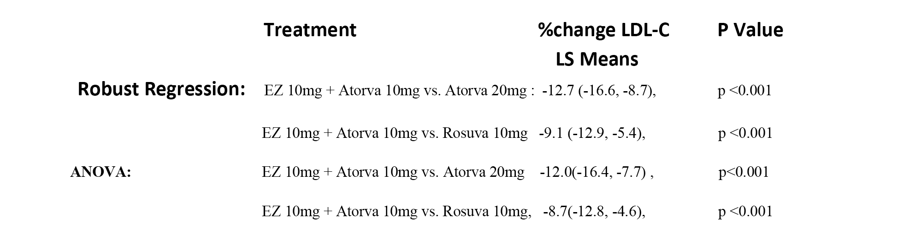

**Clinical evaluator's comment:** The sponsor's response is acceptable. The tabulated results for % change in LDL-C (LS means) for the Robust Regression and ANOVA analyses for study P162 are similar and the differences between the two analyses for the relevant treatment comparisons are considered to be clinically insignificant.

#### Efficiacy question 2

**Sponsor’s response:** For the baseline LDL, the parameter estimate (slope) in P185 and P190 is - 0.109 and - 0.117, respectively, and are both statistically significant. It indicates a consistent trend between the 2 studies that patients with higher baseline LDL-C had slightly more % reduction after treatment. On average, for every 50 mg/dL increase in baseline LDL-C, there was about 5.5 percentage point (for example 55.5% versus. 50%) higher post treatment reduction in both treatment groups. This is consistent with the analysis performed by Morrone et al[3] of over 21,000 subjects in 27 clinical trials of ezetimibe plus statin and statin monotherapy. It is important to note that this covariate effect is small and should not detract from the benefit of treating at lower baseline LDL-C levels. In addition, provided that a subject’s LDL-C returned approximately to baseline between treatment periods, this observation should not affect the interpretability of the trial.

As seen in the following Tables 50 and 51, the baseline LDL-C was very similar between the treatment groups in both protocol 185 and 190. Therefore the relationship between % reduction in LDL-C and baseline LDL-C should not have led to any bias in treatment comparison.

The period effect is marginally significant in protocol 185. However, the difference in treatment effect between Period 1 and Period 2 is clinically insignificant, and the difference between treatment groups is consistent across period.

Table 50. Protocol 185.

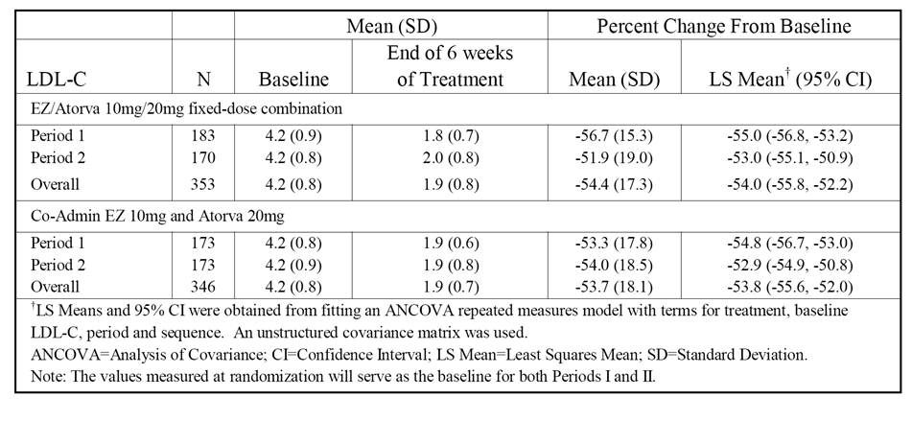

Table 51. Protocol 190.

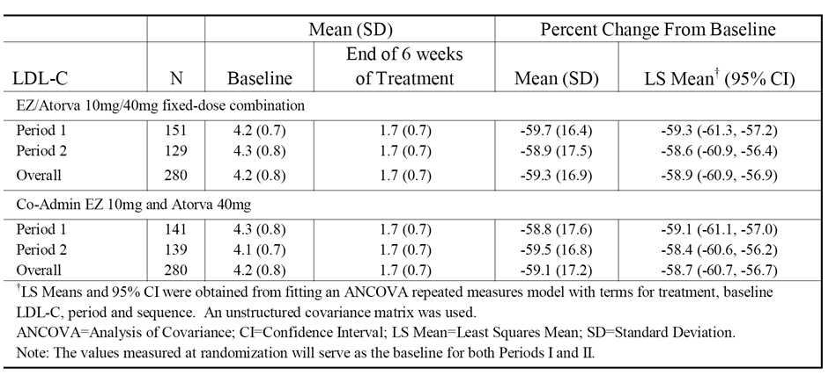

**Clinical evaluator's comment:** The sponsor's response is acceptable. The paper referred to in the response (Morrone et al., 2012) has been examined. The results of the analyses showed that higher baseline LDL-C levels were associated with significantly greater percent reductions in LDL-C levels compared with lower baseline LDL-C levels regardless of treatment (that is, ezetimibe + statin or statin alone). In the overall study population, for every 10 mg/dL increase in baseline LDL-C there was a 0.8% greater reduction in LDL-C level (p < 0.0001).

#### Safety question 1

**Sponsor’s response:** The following definition applies to consecutive ALT and/or AST elevations 3 x ULN, 5 x ULN and 10 x ULN used in the Summary of Safety (Module 2.7.4):

The consecutive category includes those patients with (a) two or more consecutive measurements ≥ (3 or 5 or 10) x ULN (‘consecutive elevation’), (b) a single, last measurement ≥ (3 or 5 or 10) x ULN (‘presumed consecutive elevation’), or (c) a measurement ≥ (3 or 5 or 10) x ULN followed by a measurement < (3 or 5 or 10) x ULN that was taken more than 2 days after the last dose of study medication (‘presumed consecutive elevation’).

**Clinical evaluator's comment:** The sponsor's response is satisfactory.

## Second round benefit-risk assessment

### Second round assessment of benefits

No new clinical information was submitted in response to the clinical questions. Accordingly, the benefits of the proposed ezetimibe/atorvastatin fixed-dose combination tablet formulations to treat patients with hypercholesterolaemia are unchanged from those identified in the first round assessment of benefits.

### Second round assessment of risks

No new clinical information was submitted in response to the clinical questions. Accordingly, the risks of the proposed ezetimibe/atorvastatin fixed-dose combination tablet formulations to treat patients with hypercholesterolaemia are unchanged from those identified in the first round assessment of risks.

### Second round assessment of benefit-risk balance

The benefit-risk balance of Atozet and Zeteze fixed dose combination (ezetimibe/atorvastatin as calcium) 10/10 mg, 10/20 mg, 10/40 mg and 10/80 mg tablets, given the proposed usage is favourable.

## Second round recommendation regarding authorisation

It is recommended that Atozet and Zeteze fixed dose combination (ezetimibe/atorvastatin as calcium) 10/10 mg, 10/20 mg, 10/40 mg and 10/80 mg tablets be approved for:

***Primary Hypercholesterolaemia***

*Atozet/Zeteze is indicated as adjunctive therapy to diet in patients with primary (heterozygous familial and non-familial) hypercholesterolaemia where use of a combination product is appropriate in those patients:*

* *not appropriately controlled with atorvastatin, rosuvastatin or ezetimibe alone; or*
* *already treated with atorvastatin and ezetimibe*

***Homozygous Familial Hypercholesterolaemia***

*Atozet/Zeteze is indicated in patients with HoFH. Patients may also receive adjunctive treatments (e.g. LDL apheresis).*

## References

1. Bofinger E. Expanded confidence intervals. Communications in Statistics, Theory and Methods, 1985;14:1849-1864.
2. Huber PJ. Robust regression: The 1972 Wald Memorial Lecture: Asymptotics, conjectures and Monte Carlo. The Annals of Statistics. 1973; 1(5):799-121.
3. Li J and Mehrotra DV. Gatekeeping testing by adaptive alpha allocation. Biometrical Journal. 2008; 50: 704-715.
4. Mandema JW, Hermann D, Wang D, Sheiner T, Milad M, Bakker-Arkema R, et al. Model-Based Development of Gemcabene, a New Lipid-Altering Agent. The AAPS Journal, 2005;7(3):E513-22.
5. Schuirmann, DJ. A Comparison of the Two One-Sided Tests Procedure and the Power Approach for Assessing the Equivalence of the Average Bioavailability. J. Pharmacokin. Biopharm. 1987; 15(6):657-680.

|  |
| --- |
| Therapeutic Goods Administration |
| PO Box 100 Woden ACT 2606 Australia  Email: [info@tga.gov.au](mailto:info@tga.gov.au) Phone: 1800 020 653 Fax: 02 6232 8605  [**https://www.tga.gov.au**](https://www.tga.gov.au) |

1. For clarity in this report the nomenclature of the two phases of Study P162 are referred to using Arabic numerals(that is Phase 1 and Phase 2) to distinguish them from Phase I, Phase II and Phase III clinical studies. In the submission documents all were numbered using Roman numerals.
2. P139: A multicenter, randomized, double-blind, titration study to evaluate the efficacy and safety of ezetimibe added on to rosuvastatin versus up titration of rosuvastatin in patients with hypercholesterolaemia at risk for coronary heart disease. This study was evaluated as part of the previous applications.
3. Morrone D et al Lipid-altering efficacy of ezetimibe plus statin and statin monotherapy and identification of factors associated with treatment response: A pooled analysis of over 21,000 subjects from 27 clinical trials. Atherosclerosis 2012; 223: 251-261.