|  |
| --- |
| AusPAR Attachment 3 |
| Extract from the Clinical Evaluation Report for ezetimibe and ezetimibe/simvastatin |
| Proprietary Product Name: Ezetrol and Vytorin |
| Sponsor: Merck Sharp & Dohme Australia Pty Ltd |

|  |
| --- |
| First round report: November 2015  Second round report: April 2016 |
|  |

About the Therapeutic Goods Administration (TGA)

* The Therapeutic Goods Administration (TGA) is part of the Australian Government Department of Health, and is responsible for regulating medicines and medical devices.
* The TGA administers the *Therapeutic Goods Act 1989* (the Act), applying a risk management approach designed to ensure therapeutic goods supplied in Australia meet acceptable standards of quality, safety and efficacy (performance), when necessary.
* The work of the TGA is based on applying scientific and clinical expertise to decision-making, to ensure that the benefits to consumers outweigh any risks associated with the use of medicines and medical devices.
* The TGA relies on the public, healthcare professionals and industry to report problems with medicines or medical devices. TGA investigates reports received by it to determine any necessary regulatory action.
* To report a problem with a medicine or medical device, please see the information on the TGA website <<https://www.tga.gov.au>>.

About the Extract from the Clinical Evaluation Report

* This document provides a more detailed evaluation of the clinical findings, extracted from the Clinical Evaluation Report (CER) prepared by the TGA. This extract does not include sections from the CER regarding product documentation or post market activities.
* The words [Information redacted], where they appear in this document, indicate that confidential information has been deleted.
* For the most recent Product Information (PI), please refer to the TGA website <<https://www.tga.gov.au/product-information-pi>>.

Copyright

© Commonwealth of Australia 2017  
This work is copyright. You may reproduce the whole or part of this work in unaltered form for your own personal use or, if you are part of an organisation, for internal use within your organisation, but only if you or your organisation do not use the reproduction for any commercial purpose and retain this copyright notice and all disclaimer notices as part of that reproduction. Apart from rights to use as permitted by the *Copyright Act 1968* or allowed by this copyright notice, all other rights are reserved and you are not allowed to reproduce the whole or any part of this work in any way (electronic or otherwise) without first being given specific written permission from the Commonwealth to do so. Requests and inquiries concerning reproduction and rights are to be sent to the TGA Copyright Officer, Therapeutic Goods Administration, PO Box 100, Woden ACT 2606 or emailed to <[tga.copyright@tga.gov.au](mailto:tga.copyright@tga.gov.au)>.

Contents

List of abbreviations 5

1. Introduction 9

1.1. Drug class and therapeutic indication 9

1.2. Dosage forms and strengths 10

1.3. Dosage and administration 11

2. Clinical rationale 13

3. Contents of the clinical dossier 14

3.1. Scope of the clinical dossier 14

3.2. Paediatric data 14

3.3. Good clinical practice 14

4. Pharmacokinetics 15

4.1. Studies providing pharmacokinetic data 15

5. Pharmacodynamics 15

5.1. Studies providing pharmacodynamic data 15

6. Dosage selection for the pivotal studies 15

7. Clinical efficacy 15

7.1. Indication: coronary heart disease (CHD) 15

8. Clinical safety 41

8.1. Studies providing evaluable safety data 41

8.2. Pivotal studies that assessed safety as a primary outcome 41

8.3. Patient exposure 42

8.4. Adverse events 42

8.5. Laboratory tests 49

8.6. Post-marketing experience 57

8.7. Safety issues with the potential for major regulatory impact 60

8.8. Other safety issues 62

8.9. Evaluator’s overall conclusions on clinical safety 62

9. First round benefit-risk assessment 64

9.1. Ezetrol 64

9.2. Vytorin 67

10. First round recommendation regarding authorisation 71

10.1. Ezetrol 71

10.2. Vytorin 71

11. Clinical questions 72

11.1. Additional expert input 72

11.2. Clinical questions 72

11.3. Efficacy 72

12. Second round evaluation of clinical data 74

12.1. Efficacy 74

12.2. Safety 76

12.3. Evaluation of sponsor’s response to first round CER 77

13. Second round benefit-risk assessment 83

13.1. Second round assessment of benefits 83

13.2. Second round assessment of risks 83

13.3. Second round assessment of benefit-risk balance 84

14. Second round recommendation regarding authorisation 84

14.1. Ezetrol 84

14.2. Vytorin 84

15. References 85

## List of abbreviations

| Abbreviations | Meaning |
| --- | --- |
| 4S | Scandinavian Simvastatin Survival Study |
| ACS | Acute Coronary Syndrome |
| AE | Adverse Event |
| AESI | Adverse Event of Special Interest |
| ALT | Alanine Aminotransferase (SGPT) |
| ANOVA | Analysis of variance |
| ANCOVA | Analysis of covariance |
| ARR- | Absolute risk reduction |
| AST | Aspartate Aminotransferase (SGOT) |
| ATP | Adult Treatment Panel |
| AUC | Area under the concentration-time curve |
| BMI | Body mass index |
| BP | Blood pressure |
| BUN | Blood urea nitrogen |
| CABG | Coronary Artery Bypass Grafting |
| CEC | Clinical Events Committee |
| CHD | Coronary Heart Disease |
| CHF | Congestive Heart Failure |
| CI | Confidence interval |
| CK | Creatine Phosphokinase |
| CK-MB | Creatine Kinase, MB Fraction |
| Cmax | Maximum concentration |
| CMH | Cochran-Mantel-Haenszel |
| CrCl | Creatinine Clearance |
| CSR | Clinical study report |
| CTD | Clinical Trial Directive |
| CTT | Cholesterol Treatment Trialists |
| CV | Cardiovascular |
| DAP | Data Analysis Plan |
| DCRI | Duke Clinical Research Institute |
| DSMB | Data and Safety Monitoring Board |
| ECG | Electrocardiogram |
| eCRF | Electronic Case Report Form |
| EDC | Electronic Data Capture |
| EMEA | European Medicines Agency |
| ERC | Ethical Review Committee |
| FDA | Food and Drug Administration, USA |
| FSG | Fasting serum glucose |
| GCC | Global Clinical Compliance |
| GCP | Good Clinical Practice |
| GI | Gastrointestinal |
| GMR | Geometric mean ratio |
| GPV | Global Pharmacovigilance |
| HPS | Heart Protection Study |
| HR | Heart rate |
| HRT | Hormone replacement therapy |
| hs-CRP | High sensitivity C-Reactive Protein |
| ICU | Intensive Care Unit |
| IEC | Independent Ethics Committee |
| IM | Intramuscular |
| IND | Investigational New Drug |
| IRB | Institutional Review Board |
| ITT | Intention-to-Treat |
| IUD | Intrauterine device |
| IV | Intravenous |
| IVRS | Interactive Voice Response System |
| LBBB | Left Bundle Branch Block |
| LDL-C | Low-Density-Lipoprotein Cholesterol |
| LDH | Lactate Dehydrogenase |
| LMC | LDL-C Monitoring Committee LPLV Last patient last visit |
| LS means | Least-squares means |
| MAE | Major atherosclerotic event |
| MED | Minimal effective dose |
| MI | Myocardial Infarction |
| MSE | Mean square error |
| MVE | Major vascular event |
| NCEP | National Cholesterol Education Program |
| NNH | Number needed to harm |
| NNT- | Number Needed to Treat |
| NSAID | Nonsteroidal anti-inflammatory drug |
| NSTE | Non-ST Segment Elevation |
| NSTEMI | Non-ST Segment Elevation Myocardial Infarction |
| OTC | Over the counter |
| PCI | Percutaneous Coronary Intervention |
| PD | Pharmacodynamic(s) |
| PDF | Portable Document Format |
| PK | Pharmacokinetic(s) |
| PLL | Prescription Lipid Lowering |
| QA | Quality Assurance |
| QC | Quality Control |
| RBC | Red blood (cell) count |
| RRR | Relative risk reduction |
| SAE | Serious Adverse Event |
| SAP | Statistical analysis plan |
| SC | Subcutaneous |
| SD | Standard deviation |
| SEM | Standard error of the mean |
| SGOT | Serum Glutamic Oxaloacetic Transaminase (AST) |
| SGPT | Serum Glutamic Pyruvic Transaminase (ALT) |
| SOP | Standard Operating Procedure |
| SPRI | Schering-Plough Research Institute |
| STEMI | ST-Elevation Myocardial Infarction |
| TAAL | Test Article Accountability Ledger |
| TC | Total Cholesterol |
| TG | Triglycerides |
| TIA | Transient Ischemic Attack |
| TIMI | Thrombolysis In Myocardial Infarction |
| ULN | Upper limit of normal |
| UA | Unstable Angina |
| WBC | White blood (cell) count |
| WHO-ART | World Health Organisation Adverse Reaction Terminology |

## Introduction

This is a submission for extension of indications. There are actually two submissions for extension of indications: Ezetrol (PM-2015-01524-1-3) and Vytorin (PM-2015-01545-1-3). As the data submitted in both the dossiers are identical, these have been combined into one evaluation report for practical reasons.

### Drug class and therapeutic indication

This submission is for the registration of a new indication for both ezetimibe (Ezetrol) and the fixed dose combination (FDC) of ezetimibe/simvastatin (Vytorin). Ezetrol (ezetimibe) is in a class of lipid-modifying compounds that inhibit the intestinal absorption of cholesterol and related plant sterols. Ezetimibe has a mechanism of action that differs from other classes of cholesterol reducing compounds (eg. statins, bile acid sequestrants [resins], fibric acid derivatives, and plant sterols).

The approved indications for Ezetrol are:

***Adults (≥ 18 Years)***

* + - *Primary Hypercholesterolaemia - Ezetrol administered alone, or with an HMG CoA reductase inhibitor (statin), is indicated as adjunctive therapy to diet in patients with primary (heterozygous familial and non-familial) hypercholesterolaemia*
    - *Homozygous Familial Hypercholesterolaemia (HoFH) - Ezetrol, administered with a statin, is indicated for patients with HoFH. Patients may also receive adjunctive treatments (e.g., LDL apheresis)*
    - *Homozygous Sitosterolaemia (Phytosterolaemia) - Ezetrol is indicated for the reduction of elevated sitosterol and campesterol levels in patients with homozygous familial sitosterolaemia*

***Children and Adolescents 10-17 Years***

***(pubertal status: boys Tanner Stage II and above and girls who are at least one year post-menarche)***

* + - *Heterozygous Familial Hypercholesterolaemia (HeFH) - Ezetrol co-administered with simvastatin (doses up to 40 mg) is indicated as an adjunctive therapy to diet in adolescent patients (10-17 years old) with heterozygous familial hypercholesterolaemia where use of a combination product is appropriate:*
    - *Patients not appropriately controlled with a statin or ezetimibe alone*
    - *Patients already treated with a statin and ezetimibe*
    - *Homozygous Familial Hypercholesterolaemia (HoFH) - Ezetrol co-administered with simvastatin (doses up to 40 mg) is indicated in adolescent patients (10-17 years old) with HoFH. Patients may also receive adjunctive treatments (e.g. LDL apheresis)*

The proposed additional indications for Ezetrol are:

***Adults (≥ 18 Years)***

* + - *Prevention of Cardiovascular Disease - Ezetrol, administered with a statin, is indicated to reduce the risk of cardiovascular events (cardiovascular death, nonfatal myocardial infarction, nonfatal stroke, hospitalisation for unstable angina, or need for revascularisation) in patients with coronary heart disease (CHD)*

Vytorin (ezetimibe/simvastatin) is a lipid-lowering product that selectively inhibits the intestinal absorption of cholesterol and related plant sterols and inhibits the endogenous synthesis of cholesterol.

The approved indications for Vytorin are:

***Adults (≥ 18 Years)***

* + - *Primary Hypercholesterolaemia - Vytorin is indicated as adjunctive therapy to diet in patients with primary (heterozygous familial and non-familial) hypercholesterolaemia or mixed hyperlipidaemia where use of a combination product is appropriate:*
    - *Patients not appropriately controlled with a statin or ezetimibe alone*
    - *Patients already treated with a statin and ezetimibe*
    - *Homozygous Familial Hypercholesterolaemia (HoFH) - Vytorin is indicated in patients with HoFH. Patients may also receive adjunctive treatments (e.g., LDL apheresis)*

***Children and Adolescents 10-17 Years***

***(pubertal status: boys Tanner Stage II and above and girls who are at least one year post-menarche)***

* + - *Heterozygous Familial Hypercholesterolaemia (HeFH) - Vytorin is indicated as adjunctive therapy to diet in adolescent patients (10-17 years old) with heterozygous familial hypercholesterolaemia where use of a combination product is appropriate:*
    - *Patients not appropriately controlled with a statin or ezetimibe alone*
    - *Patients already treated with a statin and ezetimibe*
    - *Homozygous Familial Hypercholesterolaemia (HoFH) - Vytorin is indicated in adolescent patients (10-17 years old) with HoFH. Patients may also receive adjunctive treatments (e.g., LDL apheresis)*

The proposed additional indications for Vytorin are:

***Adults (≥ 18 Years)***

* + - *Prevention of Cardiovascular Disease - Vytorin is indicated to reduce the risk of cardiovascular events (cardiovascular death, nonfatal myocardial infarction, nonfatal stroke, hospitalisation for unstable angina, or need for revascularisation) in patients with coronary heart disease (CHD)*

### Dosage forms and strengths

The following dosage forms and strengths are currently registered:

* Ezetrol 10mg white-to-off white capsule shaped tablets available in blister packs of 5, 10 and 30
* Vytorin is available as white to off-white, capsule shaped, biconvex compressed tablets containing 10 mg of ezetimibe with 10 mg of simvastatin (Vytorin 10/10), 20 mg of simvastatin (Vytorin 10/20), 40 mg of simvastatin (Vytorin 10/40) or 80 mg of simvastatin (Vytorin 10/80). Each of these formulations is available in blister packs of 5, 10 and 30

No new dosage forms or strengths are proposed for Ezetrol or Vytorin.

### Dosage and administration

The following text has been added to the proposed PI for Ezetrol which is related to addition of dosing recommendations for Use in Patients with Coronary Heart Disease:

*Combination Therapy with a Statin for incremental cardiovascular event reduction in patients with coronary heart disease, Ezetrol 10 mg may be administered with a statin with proven cardiovascular benefit.*

The following dosage and administration is already approved for Ezetrol:

**Use in Patients with Primary Hypercholesterolemia**

The recommended dose of Ezetrol is 10 mg once daily, used alone or with a statin. Ezetrol can be administered at any time of the day, with or without food. Ezetrol may be administered with a statin for incremental effect

**Use in Patients with Renal Impairment/Chronic Kidney Disease**

*Monotherapy*

In patients with renal impairment, no dosage adjustment of Ezetrol is necessary (see Characteristics in Patients [Special Populations]).

*Combination Therapy with Simvastatin*

In patients with mild renal impairment (estimated GFR ≥60 mL/min/1.73 m2), no dosage adjustment of Ezetrol or simvastatin is necessary. In patients with chronic kidney disease and estimated glomerular filtration rate <60 mL/min/1.73 m2, the dose of Ezetrol is 10 mg and the dose of simvastatin is 20 mg once a day in the evening. In such patients, the use of higher doses of simvastatin should be closely monitored (see PRECAUTIONS, *Characteristics in Patients [Special Populations],* and CLINICAL TRIALS, Prevention of Major Vascular Events in Chronic Kidney Disease (CKD).

***Use in the Elderly***

No dosage adjustment is required for elderly patients (see *Characteristics in Patients [Special Populations]*).

***Paediatric Use***

Initiation of treatment must be performed under review of a specialist.The clinical experience in paediatric and adolescents patient (aged 10-17 years old) is however limited and mostly includes children and adolescents (10-17 years old) with Heterozygous Familial Hypercholesterolaemia. There are also no long-term (>1 year) safety data in this population.

Ezetrol co-administered with simvastatin has not been studied in pre-menarchal girls or in pre-pubertal boys and is not recommended. When Ezetrol is administered with a statin, the dosage instructions for the statin in children should be followed.

***Paediatric Patients < 10 Years of Age***

Children < 10 years: Ezetrol is not recommended for use in children below 10 years of age. There are limited data on safety and efficacy in children 6-10 years of age. See CLINICAL STUDIES, Clinical Studies in Paediatric (6 to 17 Years of Age) Patients; PRECAUTIONS, Paediatric (6 to 17 Years of Age) Patients, ADVERSE EFFECTS, Paediatric (6 to 17 Years of Age) Patients). There is no available data on use of Ezetrol in children < 6 years (see Characteristics in Patients [Special Populations]).The use of Ezetrol in combination with statins has not been studied in children < 10 years of age.

***Hepatic Insufficiency***

No dosage adjustment is required in patients with mild hepatic insufficiency (Child Pugh score 5 to 6). Treatment with ezetimibe is not recommended in patients with moderate (Child Pugh score 7 to 9) or severe (Child Pugh score > 9) liver dysfunction (see CONTRAINDICATIONS, PRECAUTIONS and Characteristics in Patients [Special Populations]).

The following text has been added to the proposed PI for Vytorin which is related to addition of dosing recommendations for Use in Patients with Coronary Heart Disease:

*In the cardiovascular events risk reduction study (IMPROVE-IT), the starting dose was 10/40 mg once a day in the evening. The 10/80-mg dose is only recommended when the benefits are expected to outweigh the potential risks. (See PRECAUTIONS and CLINICAL TRIALS).*

The following dosage and administration is already approved for Vytorin:

The patient should be placed on a standard cholesterol-lowering diet before receiving Vytorin and should continue on this diet during treatment with Vytorin. In patients with primary hypercholesterolaemia or mixed hyperlipidaemia, Vytorin can be administered within the range of 10/10 mg/day to 10/80 mg/day. The usual starting dose is 10/10 mg/day to 10/40 mg/day. The dosage should be individualised according to the baseline LDL-C level, the recommended goal of therapy, and the patient's response. The 10/80mg dose of Vytorin should only be used in patients at high risk for cardiovascular complications who have not achieved their treatment goals on lower doses and when the benefits are expected to outweigh the potential risks (see PRECAUTIONS, *Myopathy/Rhabdomyolysis*). Vytorin should be taken as a single daily dose in the evening, with or without food. After initiation or titration of Vytorin, lipid levels may be analysed after 2 or more weeks and dosage adjusted, if needed.

***Patients with Homozygous Familial Hypercholesterolaemia***

The recommended dosage for patients with homozygous familial hypercholesterolaemia is Vytorin 10/40 mg/day or 10/80 mg/day in the evening. The 10/80 mg dose should only be used when the benefits are expected to outweigh the potential risks (see CONTRAINDICATIONS; PRECAUTIONS, Myopathy/Rhabdomyolysis). Vytorin should be used as an adjunct to other lipid-lowering treatments (e.g., LDL apheresis in these patients or if such treatments are unavailable. In patients taking lomitapide concomitantly with Vytorin, the dose of Vytorin should not exceed 10/40 mg/day (see PRECAUTIONS, Myopathy/Rhabdomyolysis and INTERACTIONS WITH OTHER MEDICINES).

***Patients with Renal Impairment/Chronic Kidney Disease***

In patients with mild renal insufficiency (estimated GFR ≥60 mL/min/1.73 m2) no dosage adjustment is necessary. In patients with chronic kidney disease and estimated glomerular filtration rate <60 mL/min/1.73 m2, the dose of Vytorin is 10/20 mg once a day in the evening. In such patients, the use of higher doses should be closely monitored (See PRECAUTIONS, Characteristics in Special Populations and CLINICALTRIALS).

***Use in the Elderly***

No dosage adjustment is required for elderly patients (see Characteristics in Special Populations).

***Paediatric Use – Heterozygous or Homozygous Familial Hypercholesterolaemia***

Initiation of treatment must be performed under review of a specialist. The use of Vytorin in children and adolescent patients (10-17 years old) is recommended only for patients with Heterozygous Familial Hypercholesterolaemia (HeFH) or Homozygous Familial Hypercholesterolaemia (HoFH). There are no clinical safety and efficacy data on the use of Vytorin in children and adolescent patients (10-17 years old) with non-familial hypercholesterolaemia, or mixed hyperlipidaemia.

***Adolescents 10 to 17 years old (pubertal status: boys Tanner Stage II and above and girls who are at least one year post-menarche)***

The clinical experience in paediatric and adolescent patients (aged 10-17 years old) is limited and mostly includes children and adolescents (10-17 years old) with Heterozygous Familial Hypercholesterolaemia. There are also no long-term (>1 year) safety data in this population. The recommended usual starting dose is 10/10 mg once a day in the evening. The recommended dosing range is 10/10 to a maximum of 10/40 mg/day (see Characteristics in Patients [Special Populations]).

***Children < 10 Years***

Vytorin is not recommended for use in children below age 10 due to very limited data on safety and efficacy (see Characteristics in Patients [Special Populations] and PRECAUTIONS). Vytorin has not been studied in pre-menarchal girls or in pre-pubertal boys and is not recommended in children <10 years.

***Hepatic Insufficiency***

No dosage adjustment is required in patients with mild hepatic insufficiency (Child-Pugh score 5 or 6). Treatment with Vytorin is not recommended in patients with moderate (Child-Pugh score 7 to 9) or severe (Child-Pugh score >9) liver dysfunction (see PRECAUTIONS and Characteristics in Special Populations).

## Clinical rationale

High LDL-C is a major risk factor for CHD. The effectiveness of LDL-C-lowering therapy for reducing the risk of coronary events in patients with and without CHD is firmly established. The Cholesterol Treatment Trialists’ (CTT) meta-analysis of data from 26 large, randomised, double-blind, placebo-controlled studies shows that statin therapy reduces cardiovascular (CV) risk by about 20% per 1 mmol/L (39.7 mg/dL) LDL-C reduction (CTT, 2010). The proportional reduction in major vascular events was observed to be generally consistent across several subgroups, including age, gender, baseline lipids, diabetics, and various other demographic characteristics, and was generally consistent for all statins studied. The magnitude of the proportional reduction has been found to be directly proportional to the absolute LDL-C reduction achieved, down to LDL-C levels at least as low as 70 mg/dL (1.8 mmol/L)(CTT, 2010; ESC guidelines of CV prevention in clinical practice, 2012). The treatment effect observed during the first year of therapy was approximately one-half that seen after the first year. Despite the availability of statins, lipid lowering CV outcome trials show that many at-risk subjects are still having CV events, and a significant proportion of the CHD population fails to achieve adequate LDL-C lowering (Waters DD, 2009; Santos RD, 2012; Karlis DG, 2012; Steinberg BA, 2008). The sponsor states that this residual risk represents a significant unmet medical need and the development of improved pharmacologic therapies for risk reduction in subjects with CHD is essential.

Ezetimibe is an azetidinone inhibitor which selectively inhibits the intestinal absorption of cholesterol and related phytosterols via an interaction with NPC1L1. Ezetimibe therapy offers a unique and complementary mechanism of action which yields incremental LDL-C reductions when combined with statins. An extensive preclinical and clinical program has been conducted with ezetimibe alone and in combination with statins. When ezetimibe 10 mg/d is added to ongoing statin therapy, an average reduction in LDL-C of up to 25% relative to the on-statin baseline has been observed in pooled analyses of clinical trials (Morrone D, 2012). The magnitude of the observed reductions with ezetimibe on top of statins is generally independent of statin type, potency/dose and patient characteristics. Recent research has shown that naturally occurring NPC1L1 genetic variants associated with reduced plasma LDL cholesterol levels are associated with a reduced risk of CHD (MI Genetics Consortium, 2014), suggesting that ezetimibe mediated LDL-C lowering should reduce CV risk.

Ezetimibe was approved in the United States in October 2002, in the Reference Member State for the European Union (Germany) in October 2002, and subsequently in numerous countries for use as monotherapy or in co-administration with statins in primary hypercholesterolemia. Ezetimibe plus statin co-administration is also indicated for treatment of homozygous familial hypercholesterolemia (HoFH) and as monotherapy in the treatment of patients with homozygous sitosterolemia.

Based on the results from the large IMPROVE-IT study, the sponsor is seeking an indication for ezetimibe (when used with a statin) and ezetimibe/simvastatin to reduce the risk of CV events in patients with CHD. Although IMPROVE-IT studied patients presenting with acute coronary syndrome (ACS), used simvastatin as the background statin and entered patients with defined low density lipoprotein cholesterol (LDL-C) levels, the sponsor believes that the results support conclusions that apply to patients with chronic CHD, those receiving any statin, and to subjects with a broad range of LDL-C levels.

## Contents of the clinical dossier

### Scope of the clinical dossier

The submission contained the following clinical information:

* No clinical pharmacology studies
* No population pharmacokinetic analyses
* One pivotal efficacy/safety study: IMPROVE-IT
* No dose finding or other efficacy/safety studies
* No pooled analyses, meta-analyses, Integrated Summary of Efficacy, Integrated Summary of Safety, etcetera
* Post-marketing safety analysis was provided.

### Paediatric data

The submission did not include paediatric data.

### Good clinical practice

The IMPROVE-IT study was conducted in conformance with GCP standards and applicable country and/or local statutes and regulations regarding ethical committee review, informed consent, and the protection of human subjects participating in biomedical research.

*Comment: Throughout the trial, study sites noted to have GCP non-compliance issues were reviewed by GCP compliance committee. A total of 24 sites were reported to this committee, of which there were 7 where serious GCP non-compliance issues were noted. Because IMPROVE IT was a large, event-driven trial, the principle of Intention-to-Treat was followed and no subject’s data were excluded from the efficacy analyses on the basis of GCP violations.*

## Pharmacokinetics

### Studies providing pharmacokinetic data

No new pharmacokinetic studies were provided in the current dossier.

## Pharmacodynamics

### Studies providing pharmacodynamic data

No new Pharmacodynamic studies were provided in this submission. The pharmacodynamics of ezetimibe and ezetimibe/simvastatin FDC are well-documented due to their approved use for other indications.

## Dosage selection for the pivotal studies

No new data was provided.

## Clinical efficacy

### Indication: coronary heart disease (CHD)

* Indication: Adults (≥ 18 Years) Prevention of Cardiovascular Disease to reduce the risk of cardiovascular events (cardiovascular death, nonfatal myocardial infarction, nonfatal stroke, hospitalisation for unstable angina, or need for revascularisation) in patients with coronary heart disease (CHD).

#### Pivotal efficacy study P04103 (IMPROVE-IT)

##### Study design, objectives, locations and dates

P04103 was a Phase 3b, multicentre, randomised, double-blind, active-controlled study.

The primary objective of this study was to evaluate the clinical benefit of ezetimibe/simvastatin combination compared with simvastatin in stabilised ACS subjects defined as the reduction in the risk of the occurrence of the composite endpoint of CV death, major coronary events and non-fatal stroke. Major coronary events included non-fatal MI, documented UA that required admission into a hospital and all coronary revascularisation with either percutaneous coronary intervention (PCI) or coronary artery bypass grafting (CABG) occurring at least 30 days after randomised treatment assignment.

The secondary objectives were to evaluate the clinical benefit of ezetimibe/simvastatin combination compared with simvastatin in stabilised ACS subjects on the occurrence of the following supportive composite endpoints (change from primary endpoint noted in bold):

* Composite endpoint of death due to any cause, major coronary events or non-fatal stroke.
* Composite endpoint of death due to coronary heart disease (CHD death), non-fatal MI, and urgent coronary revascularisation (either PCI or CABG occurring at least 30 days after randomisation);
* Composite endpoint of CV death, non-fatal MI, documented UA that requires admission into a hospital, all revascularisation (including both coronary and non-coronary) occurring at least 30 days after randomisation, and non-fatal stroke.

The tertiary objectives were to evaluate the clinical benefit of ezetimibe/simvastatin combination compared with simvastatin in stabilised ACS subjects on each of the following endpoints analysed individually: death from any cause, CHD death, CV death, MI, documented UA that requires admission into a hospital, all coronary revascularisation with either PCI or CABG occurring at least 30 days after randomisation, urgent coronary revascularisation with either PCI or CABG (occurring at least 30 days after randomisation, all revascularisation (including both coronary and non-coronary) occurring at least 30 days after randomisation, stroke, any cardiovascular event leading to admission into a hospital, and CHF that requires hospitalisation occurring at least 30 days after randomisation. Other tertiary objectives were to evaluate the proportion of subjects achieving reductions in LDL-C and hs-CRP[1] and to evaluate the potential relationship between the risk of occurrence of any primary endpoint event and the concentrations of LDL-C and high sensitivity-C-reactive protein (hs-CRP) following 1 month and 4 months of treatment with ezetimibe/simvastatin combination or simvastatin. Safety and tolerability of ezetimibe/simvastatin combination compared with simvastatin was also evaluated.

The study was conducted in 18,144 subjects with stabilised high-risk Acute Coronary Syndrome (ACS) who were enrolled within 10 days of hospitalisation for either an Non-ST elevation –ACS (unstable angina or Non-ST Elevation Myocardial Infarction [NSTEMI] or ST-elevation Myocardial Infarction (STEMI). After randomisation subjects were to have clinical visits at the end of Month 1 and Month 4, and every 4 months, thereafter. Subjects who discontinued from study therapy were generally followed by phone visit at the same visit schedule as subjects remaining on drug. All subjects, including subjects who discontinued from treatment, were monitored for suspected clinical endpoint event until the termination of the trial. The trial was specified to end after all subjects had been followed for a minimum of 2.5 years and a primary endpoint event had been documented in at least 5250 subjects. All subjects, including subjects who discontinued treatment, were to be monitored for clinical endpoint events until the termination of the study. An independent Clinical Events Committee (CEC) reviewed and adjudicated each suspected clinical endpoint event and was blinded to treatment. Suspected clinical endpoint events included death from any cause, MI, UA, all revascularisation (including both coronary and non-coronary), stroke, any CV event leading to hospitalisation, and congestive heart failure (CHF) requiring hospitalisation occurring at least 30 days after randomisation. In addition, the CEC adjudicated instances of malignancies and instances of unexplained myalgia based on pre-specified review criteria. An independent Data Safety Monitoring Board (DSMB) evaluated safety findings at regular intervals, and efficacy findings at specified interim analyses. An independent LDL-C Monitoring Committee (LMC) periodically reviewed the achieved LDL-C results by treatment group during the recruiting phase of the trial and advised the Executive Committee regarding potential need to increase the targeted number of primary endpoint events in order to preserve study power (if the difference in median LDL-C between treatment groups was less than anticipated).

The study was conducted from 26 Oct 2005 to 4 May 2015 at 1400 centres of which 1147 allocated subjects to study treatment: 24 trial centres were in Argentina, 10 in Australia, 16 in Austria, 19 in Belgium, 33 in Brazil, 64 in Canada, 9 in Chile, 19 in Colombia, 23 in Czech republic, 19 in Denmark, 4 in Ecuador, 2 in Estonia, 17 in Finland, 28 in France, 55 in Germany, 2 in Hong Kong, 15 in Hungary, 23 in India, 25 in Israel, 69 in Italy, 4 in Malaysia, 40 in Netherlands, 8 in New Zealand, 20 in Norway, 13 in Peru, 30 in Poland, 13 in Portugal, 2 in Singapore, 13 in Slovakia, 17 in South Africa, 12 in South Korea, 38 in Spain, 24 in Sweden, 13 in Switzerland, 6 in Taiwan, 7 in Turkey, 16 in Ukraine, 36 in United Kingdom and 359 in the United States.

*Comment: The IMPROVE-IT study was a multicentre, randomised, double-blind, parallel-group study designed to establish the additional clinical benefit and safety of ezetimibe (administered as part of ezetimibe/simvastatin combination) compared with simvastatin monotherapy in high-risk coronary artery disease subjects that aimed to address the question of whether the additional ezetimibe-mediated reduction of LDL-C translates into a clinical benefit.*

*Selection of simvastatin as the active comparator with which to assess the potential additional benefit of ezetimibe was appropriate because simvastatin is a commonly used statin approved for reducing cholesterol and cardiovascular events and mortality in high-risk subjects. The clinical benefit of simvastatin has been demonstrated in two large placebo-controlled clinical trials: the Scandinavian Simvastatin Survival Study (4S) (1994) and the Heart Protection Study (HPS) (Collins R, 2002). The results from both the 4S and HPS studies demonstrated that simvastatin reduced the risk of total mortality by reducing the risks of CHD death, non-fatal myocardial infarction, and stroke, and also reduced the need for coronary and non-coronary revascularisation procedures. The CTT analyses have also demonstrated that the simvastatin effect related to CV outcomes is equivalent to the effect with other statins, thus supporting the extrapolation of IMPROVE-IT results to other statins. In addition, relatively high-dose lipid-lowering therapies were selected (i.e., simvastatin 40mg) to evaluate whether lowering LDL-C from low to very low levels translates to better CV outcomes.*

*In addition to IMPROVE-IT, two outcomes studies (The Simvastatin and Ezetimibe in Aortic Stenosis [SEAS] and Study of Heart and Renal Protection [SHARP] and one imaging trial (Ezetimibe and Simvastatin in Hypercholesterolemia Enhances Atherosclerosis Regression [ENHANCE]) were planned as part of the ezetimibe related development program to answer important scientific questions but the results of these studies led to additional uncertainty related to the cardiovascular risk reduction and safety of ezetimibe. The results of the large randomised SEAS trial demonstrated that ezetimibe/simvastatin 10/40 mg daily is not associated with a reduction in the primary Composite endpoint of cardiovascular death, aortic valve replacement surgery, nonfatal myocardial infarction (MI), congestive heart failure (CHF) from AS progression, coronary artery bypass grafting (CABG), percutaneous coronary intervention (PCI), hospitalised unstable angina and non-haemorrhagic stroke. However, there was a significant reduction in the incidence of atherosclerotic adverse events in the ezetimibe/simvastatin arm compared with placebo (15.7% vs. 20.1%, p = 0.02), which has been demonstrated in other trials of statins as well. The results and limitation of the SHARP study are discussed below. The ENHANCE trial is a randomised study aimed at studying the effect of ezetimibe on top of simvastatin versus simvastatin on carotid intima–media thickness in 720 patients with heterozygous familial hypercholesterolemia. Despite achieving a significant differential reduction in LDL-C, no regression in carotid intima–media thickness was observed at the end of the 2-year follow-up period.*

*The sponsors claim that the IMPROVE-IT study now provides data to address the uncertainty related to reduction of CV risk and safety of ezetimibe.*

##### Inclusion and exclusion criteria

Adult men and women aged > 50 years presenting with NSTEMI, STEMI, or hospitalised, documented UA were eligible for entry into the trial. A subject in whom a PCI was planned as management for the qualifying ACS event should have undergone PCI prior to randomisation and within the 10-day period after initial hospitalisation for the qualifying ACS event.[2] Subject must have had NSTE-ACS (unstable angina or NSTEMI) or STEMI according to the following criteria:

* A NSTE-ACS (unstable angina or NSTEMI) subject participating in the EARLY-ACS Trial who had been clinically stabilised was eligible for entry in IMPROVE-IT under <10 days (<240 hours) of presenting to the hospital. The subject must have completed the 96-hour primary endpoint of the acute segment[3] of EARLY-ACS treatment and have been clinically stable before enrolling in IMPROVE-IT; OR
* A subject not participating in the EARLY-ACS Trial, but who was defined as NSTE-ACS (unstable angina or NSTEMI)[4] by meeting all of the criteria listed below:
  + The subject had experienced symptoms of cardiac ischemia at rest prompting acute care hospitalisation with at least one episode lasting at least 10 minutes
  + ≥50 years of age; and
  + Any 1 of the following criteria:
    - Electrocardiogram changes characterised by either of the following: New or presumably new ST-segment depression >0.1 mV in at least 2 contiguous ECG leads; or Transient (<30 minutes) ST-segment elevation >0.1 mV in at least 2 contiguous ECG leads;
    - Any of the following cardiovascular biomarkers elevated above the upper limit of normal (ULN): Troponin I; Troponin T; and/or Creatine kinase-MB fraction (CK-MB)
    - Diabetes mellitus;
    - History of prior MI;
    - History of peripheral arterial disease;
    - History of cerebrovascular disease;
    - History of CABG >3 years prior to entry;[5] or
    - Multivessel coronary artery disease previously documented by catheterisation (2 or 3 vessels with >50% stenosis) including the catheterisation performed during the index admission for the qualifying event.
  + Subject must have met the following criteria for LDL-C concentrations at the time of admittance into a hospital (Each measurement of LDL-C performed within the first 24 hours of admittance must have met the criteria).
    - Definition of “chronic prescription lipid-lowering therapy” and “lipid-therapy naïve was clearly provided in the protocol: A subject was considered to be receiving chronic prescription lipid-lowering therapy if he/she had been receiving any prescription lipid-lowering therapy continuously for >4 weeks prior to and continuing until the qualifying ACS hospital admission; a subject receiving chronic prescription lipid-lowering therapy must have been receiving therapy with a lipid-lowering potency equal to or less than simvastatin 40 mg QD. All other subjects (including those who initiate prescription lipid-lowering therapy after the qualifying ACS hospital admission) were considered to be ‘lipid-therapy naïve’.
    - A lipid-therapy naïve subject was to be eligible to enrol if his/her LDL-C concentration was >50 mg/dL (>1.3 mmol/L) and <125 mg/dL (<3.2 mmol/L);
    - A subject receiving chronic prescription lipid-lowering therapy was to be eligible to enrol, if his/her LDL-C concentration was >50 mg/dL (>1.3 mmol/L) and <100 mg/dL (<2.6 mmol/L);
    - The following conditions concerning lipid concentrations and experience with chronic prescription lipid-lowering therapy had to be met:
    - Blood lipid levels, including LDL-C, were to have been measured as close as possible to each subject’s presentation to a hospital, but no later than 24 hours after admission;
    - A subject’s baseline LDL-C and lipid-lowering-therapy status were to be based on the subject’s status at the time of the initial acute event leading to admittance into a hospital;
    - The specimens did not need to be obtained after fasting. In addition if the blood lipid levels were not measured at the time of admittance, they may have been determined later on blood from the subject that was obtained at the time of admittance into the hospital;
    - If a recent lipid panel (<6 months prior to presentation) was available, the values may have been used for subject screening and determination of eligibility if the subject’s therapy had not changed since the lipid measurement and if no specimen was drawn within the first 24 hours after admission to a hospital;
    - If only a total cholesterol (TC) level was available at the time of admission, the subject was still eligible if TC concentrations met certain criteria[6] at the time of admission and repeat lipid measurements; Subject must have had a plasma triglyceride (TG) level <350 mg/dL (<4.0 mmol/L). A subject found to have had a non-fasting TG >350 mg/dL (>4.0 mmol/L) but <1500 mg/dL (<17.0 mmol/L), upon admittance into a hospital, must have had TG <350 mg/dL (<4.0 mmol/L) on a fasting specimen obtained as soon as possible (preferably within 24 hours of admission).

Other inclusion criteria were that the subject’s clinical laboratory tests must be within reference ranges or clinically acceptable to the investigator/sponsor and women of child-bearing[7] potential must have agreed to use a medically accepted method of contraception while receiving protocol-specified medication and for 6 weeks after stopping the medication.

The main exclusion criteria were: Clinically unstable patients with haemodynamic events[8] recurrent symptoms of cardiac ischaemia [stroke or transient ischaemic attack (TIA)] and/or arrhythmic events;[9] Subject who planned or underwent CABG in response to the initial episode of ACS; Subject who must have continued to receive prohibited treatments. These prohibited medications were to be stopped at entry and not to be taken during the trial after randomisation. There were no washout periods for medications prohibited at entry.

The treatments prohibited during the study were in the interests of subject safety and to protect the scientific interests of the trial.

A subject receiving chronic lipid-lowering therapy with LDL-C lowering potency greater than simvastatin 40 mg was not eligible. The prohibited chronic lipid lowering therapies included all doses of simvastatin/ atorvastatin >40 mg; all doses of rosuvastatin; all doses of ezetimibe/ simvastatin combination; and Ezetimibe co-administered with any dose of any statin. Other exclusion criteria were allergy/ sensitivity to any statin, ezetimibe and/ or their excipients; active liver disease or persistent serum transaminase elevations (>2xUL:N); calculated creatine clearance (CrCl)<30ml/min or dialysis within 30 days; history of alcohol or drug abuse; pregnant/lactating women; other clinically significant condition; use of other investigational drug within 30 days of screening/randomisation and subjects participating in other clinical trials with some exceptions.[10]

*Comment: The sponsor mentions that the benefits of statin use in patients with elevated LDL-C are well established and so this study enrolled subjects presenting with ACS with relatively low baseline LDL-C values as it was considered unethical to study patients not already at optimal LDL-C goal, per 2004 NCEP ATP III guidelines.[11] Subjects presenting with ACS were chosen for this study because of their relatively high event rate which facilitated having study power to detect the risk reduction anticipated for patients in the LDL-C range studied. Specifically, subjects with acute coronary syndromes from one of three categories according to the diagnosis of the qualifying event were included: Subjects with a diagnosis of NSTEMI or UA from the Early ACS trial; Subjects with a diagnosis of STEMI; Subjects with a diagnosis of NSTEMI or UA.*

*Minimum follow-up of 2.5 years also assured that the ACS subjects had transitioned to a phase of chronic CHD. In addition, a prior study (PROVE-IT) (Cannon CP, 2004) had demonstrated that reductions in CV events attributable to LDL-C reductions achieved through chronic statin therapy in a population presenting with ACS was of a similar magnitude to that seen in ‘stable’ CHD populations. Thus, IMPROVE-IT was designed as a study to assess the efficacy of the additional LDL-C reduction from ezetimibe in high-risk subjects with CHD presenting with ACS.*

*Hence, the CVD risk of the target population was reasonably well-defined in compliance with the CHMP guidelines for evaluation of medicinal products for cardiovascular disease prevention (2008).*

##### Study treatments

Eligible subjects received randomised, double-blind treatment assignments in a 1:1 ratio to the following groups: ezetimibe/simvastatin 10/40 mg and simvastatin 40 mg. All subjects were dosed with study drug in the evening, consistent with the ezetimibe/simvastatin Combination label and simvastatin label. Prior to Amendment 5 (see comments below), the IMPROVE-IT protocol allowed for the simvastatin dose to be increased in a blinded manner to the maximum dose of 80 mg in either treatment group according to the following algorithm:

* If a subject was found to have an LDL-C concentration of >79 mg/dL (>2.0 mmol/L) at any visit (in the absence of non-compliance with dosing and diet), that subject was to be instructed to return in 2 months for a repeat blood draw.
* If the LDL-C concentration from the repeat blood draw was confirmed to be >79 mg/dL (>2.0 mmol/L) at 2 consecutive observations in the absence of noncompliance with dosing and diet, that subject was to have his/her simvastatin dose increased to 80 mg in a double-blind manner at the next visit.
* If a subject, whose simvastatin dose had already been increased to 80 mg due to LDL-C >79 mg/dL (>2.0 mmol/L), was found to have an LDL-C concentration >100 mg/dL (>2.6 mmol/L) in the absence of noncompliance with dosing and diet and the observation was confirmed to be >100 mg/dL (>2.6 mmol/L) on 2 consecutive measurements, the subject was to be discontinued from study medication at the investigator’s and subject’s discretion, but was to be monitored for any endpoint event until the termination of the study. To achieve the increase in the simvastatin dose to 80 mg without unblinding treatment, a simvastatin 40 mg tablet was to replace a simvastatin 40 mg placebo tablet in the dosing regimen. If a subject had his/her simvastatin dose increased to 80 mg during the study, a CK measurement was to be performed at the time of the next scheduled visit.

*Comment: In June 2011, the FDA communicated changes to simvastatin labelling based on findings from large clinical trials and other databases that suggested that the risk of serious muscle toxicity with simvastatin 80 mg is greater than that seen with certain newer statins that produce similar or greater LDL-C lowering. The increased risk was noted to be greatest during the first year of treatment. These changes to the simvastatin prescribing information, prompted dose restrictions on simvastatin as outlined in Amendment 5 to IMPROVE-IT study protocol. Specifically, use of simvastatin 80 mg in the study was modified as follows:*

* + - *No additional subjects were to have their simvastatin dose increased to 80 mg;*
    - *Subjects who had been taking the simvastatin dose of 80 mg for less than 12 months were to have their dose decreased to 40 mg;*
    - *Subjects who were taking simvastatin 80 mg and also amlodipine or ranolazine and were not able stop those concomitant treatments or change to an alternative were to have their simvastatin dose decreased to 40 mg;*
    - *Subjects who had been tolerating the simvastatin dose of 80 mg for 12 months or longer without evidence of significant toxicity and were also not receiving amlodipine or ranolazine were to continue on the 80 mg dose.*

Treatment compliance was assessed by tablet and bottle count at each visit.[12] Every effort was made to maintain adherence as close as possible to 100%. If a subject was found to have reduced compliance, centre personnel was to make contact with subject on a regular basis to remind him/her to take the study medication.

##### Efficacy variables and outcomes

Suspected clinical endpoint events included: death from any cause, MI, unstable angina, all revascularisation (including both coronary and non-coronary), stroke, any CV event leading to hospitalisation and CHF requiring hospitalisation. Suspected clinical endpoint events were collected along with the dates of occurrence and assessment throughout the course of the trial, up to a subject’s final study visit which was set to be on or after May 1, 2014. Information concerning such events was recorded on specific eCRFs. Potential endpoints with an onset date after the subject’s final visit that were spontaneously reported were sent for adjudication by the CEC and entered into the database. Events that were adjudicated to have an onset date after the final study visit were not included in any prespecified analyses. Abbreviated Lipid Panel was performed at the 1, 4, 8 and 16 month study visits in patients continuing on study medication and included LDL-C, TC, HDL-C and TG. Extended Lipid Panel was performed at Screening/Randomisation Visit, Annually, at study completion in patients continuing on study medication, and at the early discontinuation of study treatment visit in those who discontinued study drug prematurely and included Apolipoprotein A-I, Apolipoprotein B, Lipoprotein (a), HDL subfractions (HDL2-C and HDL3-C), Non-HDL-C; Lipid ratios LDL-C:HDL-C and TC:HDL-C.

The primary efficacy endpoint measure was the time from randomisation to the first occurrence of one of the following: CV death, major coronary events (non-fatal MI, documented UA that requires admission into a hospital, all coronary revascularisation with either PCI or CABG occurring at least 30 days after randomisation) or non-fatal stroke. An independent Clinical Events Committee (CEC) was responsible for review and adjudication of all suspected clinical endpoint events. All events identified as potential efficacy endpoints were adjudicated in a blinded fashion.

* The secondary composite endpoints were time from randomisation to the first occurrence of:  
  death due to any cause, major coronary events, or non-fatal stroke.
* CHD death, non-fatal MI, or urgent coronary revascularisation with either PCI or CABG occurring at least 30 days after randomisation.
* CV death, non-fatal MI, documented UA that requires admission into a hospital, all revascularisation (including both coronary and non-coronary) occurring at least 30 days after randomisation, and non-fatal stroke.

The tertiary endpoints were time from randomisation to the first occurrence of the individual endpoint events: death from any cause; CHD death; CV death; MI (fatal or non-fatal); Documented UA that requires admission into a hospital; All coronary revascularisation with either PCI or CABG occurring at least 30 days after randomisation; Urgent coronary revascularisation with either PCI or CABG occurring at least 30 days after randomisation; All revascularisation occurring at least 30 days after randomisation (including both coronary and non-coronary); Stroke (fatal or non-fatal); Any cardiovascular event leading to admission into a hospital; CHF that requires hospitalisation occurring at least 30 days after randomisation.

Other tertiary endpoints included Percent of subjects achieving concentrations of LDL-C <70 mg/dL(1.81mmol/L) in addition to hs-CRP <2.0 mg/L (at month 1 and month 4) and Event rate of the primary endpoint at the end of the study in the group of subjects achieving concentrations of LDL-C <70 mg/dL (1.81mmol/L) in addition to hs-CRP <2.0 mg/L and the group that do not achieve the goal for LDL-C and hs-CRP, regardless of treatment (this was done based on the LDL-C and CRP measurements at month 1 and month 4).

*Comment: The clinical outcome endpoints in the pivotal submitted study (IMPROVE-IT) were objective and clinically relevant and generally complied with the TGA adopted CHMP guidelines for evaluation of medicinal products for cardiovascular disease prevention (2008). However, it is important to note that the TGA adopted guidelines for composite endpoints in trials of CV disease prevention mentions that: “All-cause mortality is preferred over cardiovascular mortality as primary endpoint or as one component of the primary endpoint. CV mortality if objectively and conservatively defined may also be acceptable and may be more sensitive to detect differences in non-inferiority approaches. Sufficient confidence regarding overall mortality and non-CV mortality is necessary in this case. Composite endpoints may be appropriate if they include hard clinical events such as non-fatal MI, stroke. However, including in the composite, components which have markedly different weight in term of clinical benefit is discouraged. An example is the combination in the primary composite endpoint of fatal events and clinician decision outcomes such as hospitalisation, coronary revascularisation, amputation, use of rescue therapy, hospitalisation for heart failure. In such a case, the statistical significance of the primary composite endpoint is often driven by the clinician-decision outcome component, presenting further challenges for the interpretation of the study overall results. The more clearly components of a composite endpoint directly refer to the disease process, the less there is problem of interpretation.”*

*The primary endpoint in IMPROVE-IT was the composite of CV death, non-fatal stroke and major coronary events (non-fatal MI, documented unstable angina leading to hospitalisation, or all coronary revascularisation- PCI or CABG occurring at least 30 days after randomisation). Hence, although the primary composite endpoint did include some clinician-decision outcomes (hospitalisation for UA and coronary revascularisation), these outcomes were still directly related to the coronary heart disease and hence the primary composite endpoint for this study was acceptable and consistent with those used for other major studies examining the effect of treatment of statins for CV prevention.*

*Secondary, tertiary and other analyses were also consistent with those for event-driven trials examining the effect of treatment on atherosclerotic vascular events. Other analyses included the components of the composite endpoints and subgroup analyses. Changes in lipid levels were also assessed to verify the lipid-reduction of treatments and to facilitate exploratory assessments of the relationship between lipids and CV risk reduction.*

*Statin therapy reduces LDL-C, which has been demonstrated to reduce the risk of atherosclerotic cardiovascular events. The results of both 4S and HPS demonstrated that simvastatin reduced the risk of total mortality by reducing the risks of CHD death, and also reduced the risk of non-fatal myocardial infarction, stroke and need for coronary and non-coronary revascularisation procedures. The co-administration of ezetimibe with a statin results in an additional reduction of approximately 14% in LDL-C over the LDL-C reduction attributable to the statin (i.e., relative to the pre-statin baseline). This pivotal study (IMPROVE-IT) examines whether this additional reduction in LDL-C attributable to ezetimibe results in an additional reduction in the risk of CV events and the efficacy endpoints selected are acceptable. However, the proposed indication mentions ‘need for revascularisations’ which implies coronary and non-coronary revascularisation. This is not justified as the primary composite endpoint in the pivotal IMPROVE IT study specifically includes ‘all coronary revascularisation with either PCI or CABG occurring at least 30 days after randomisation’.*

##### Randomisation and blinding methods

Subjects received randomised,[13] double-blind treatment assignment in a 1:1 ratio to either Ezetimibe/Simvastatin Combination 10/40 or simvastatin 40 mg QD. Randomisation was stratified by three factors:

* Randomised treatment assignment for subjects entering the current study (P04103) from the EARLY-ACS study (P03684): assigned eptifibatide or placebo;
* Statin experience: prior statin use or statin naïve. Enrolment of statin experienced subjects were limited to <=50% of all subjects within each country;
* High-risk ACS diagnosis: NSTE-ACS or STEMI.

No further stratification of randomised treatment assignment based on age, sex or other characteristics was performed.

IMPROVE-IT was a double-blind study in which the sponsor, investigator, study personnel and study participants were blinded with respect to treatment. Treatment was prepared according to the randomisation schedule provided by the sponsor and dispensed in a blinded fashion by a third party for administration by the investigator/designee. An independent Duke Clinical Research Institute (DCRI) statistician[14] was the only individual with access to the randomisation code and unblinded study data, for the sole purpose of preparing reports for the DSMB and LMC. All Serious Adverse Events (SAEs) that were considered by the investigator to be related to study therapy and were unexpected according to the product core safety information met the criteria for expedited reporting to regulatory agencies. The randomisation schedule for blinding of treatments was maintained by the sponsor, provided to the Central Randomisation Centre and disclosed only after study completion and database closure. No personnel involved directly in the conduct of the study had access to the treatment codes. Unblinding[15] was to occur only in the event of an emergency or adverse event for which it was necessary to know the study treatment to determine an appropriate course of therapy for the subject.

##### Analysis populations

Efficacy and safety were analysed using the protocol-defined “intention-to-treat” (ITT) Population which included all subjects who received randomised treatment assignment. Specifically, any subject who received randomised treatment assignment but never took study drug was analysed using the assigned treatment. All other subjects were analysed using the actual treatment that they received. The following rules were used to assign protocol-defined ITT treatment group: The randomised treatment group was used if the subject took at least one dose of study drug to which subject was randomised, even if the subject took incorrect study drug at some other point in the study. The randomised treatment group was also used if subject never took study drug. The other treatment group (i.e., not the treatment group to which subject was randomised) was assigned if the subject took incorrect study drug for their entire time on treatment in the trial.

In addition to the protocol-defined intention-to-treat analysis (ITT) approach, pre-specified “on-treatment” analyses was performed on the primary composite endpoint, key secondary composite endpoints and tertiary endpoints.

##### Sample size

The trial began with a sample size of 10,000 patients with approximately 5000 subjects per treatment group, and the assumption that the expected 15 mg/dl (0.39mmol/L) difference in LDL-C between the treatment groups would translate into a 10% reduction in risk at 2 years, and a total of 2955 primary endpoint events were estimated to be needed to show this difference with 90% power. With an enrolment phase of about 2 years, a specified minimum follow-up of 2.5 years, and a 2-year event rate in the control arm of 23.5%, it was estimated that the full trial duration would be no longer than 5 years (60 months). However, the sample size was changed from an original size of 10,000 subjects to up to 18,000 subjects because the primary endpoint event rate was lower than anticipated in the original design. The trial was to continue until accrual of approximately 5250 primary endpoint events and a minimum follow-up of 2.5 years which would maintain trial power at approximately 90%. This sample size was determined from a statistical model approach based on pooled blinded endpoint rates and evaluated the effects of a reduced treatment effect in the first 6 months, enrolment rate, follow-up duration, lag in event rate reporting, differences in population event rates (STEMI and NSTE) and dropout on power and total event accumulation during the trial.

##### Statistical methods

The primary hypothesis was that in stabilised high-risk ACS subjects, the administration of ezetimibe/simvastatin combination compared with simvastatin monotherapy would reduce the incidence of the composite endpoint of CV death, major coronary events, and non-fatal stroke. This hypothesis was evaluated using a Cox proportional-hazard model (COX PH model) with covariates of treatment (simvastatin, ezetimibe/simvastatin) and stratification factors (early use of eptifibatide, statin experience and high-risk ACS diagnosis). Treatment difference was tested at alpha level of 0.0438 accounting for the two pre-specified interim analyses. Estimates of the hazard ratio and associated 95 percent confidence interval comparing simvastatin with ezetimibe/ simvastatin combination were provided with the use of this model. Event curves by treatment group were presented based on the Kaplan-Meier estimates. Since revascularisation occurring up to 30 days after randomisation was not included in the primary endpoint, a sensitivity analysis by including these events in the primary endpoint was performed using the same COX PH model specified above. The hazards proportionality assumption of Cox model for the primary endpoint was assessed by testing interaction between treatment and follow-up time in the Cox model at a level of 5%. If the proportionality assumption was not satisfied, the estimate of the hazard ratio for the primary endpoint was interpreted as an average treatment effect over the time range of the study. Due to the imbalance between two treatments groups in number of patients titrated to higher statin dose, the treatment effect may be under-estimated. To explore the impact of the titration effect, the same COX PH model specified for the primary endpoint was performed by including all subjects’ non-titrated experience with titrated subjects censored at time of titration.

Analysis of the composite secondary endpoints was similar to that for the primary endpoint described above. The tertiary endpoints measuring outcomes were also analysed by the same Cox proportional-hazard model specified for the primary endpoint. For the other tertiary efficacy endpoints, the CMH test adjusting for the stratification factors was used to compare the two treatment groups with respect to the percent of subjects achieving concentrations of LDL-C<70 mg/dL (1.81mmol/L) in addition to hs-CRP<2.0 mg/L achieved at month 1. The primary endpoint was analysed using a COX PH model with covariate of target goal indicator (achieved goal for both LDL-C <1.81mmol/L and hs-CRP <2.0 mg/L, vs. not). These tests were repeated for LDL-C and CRP achieved at month 4. The actual, change and percent change from baseline in lipid parameters (LDL-C, HDL-C, total-C, Non-HDL-C, TG, Apo B, Apo A-I, Lp (a), LDL-C:HDL-C, total-C:HDL-C) and CRP was summarised (N, mean, SD, median, IQR) by treatment group at each scheduled visits when applicable. P-value for treatment difference based on a non-parametric approach using a one-way ANOVA model on the ranks extracting treatment effects was also provided.

There was a single primary efficacy endpoint (composite of CV death, major coronary events and non-fatal stroke) and one primary comparison (simvastatin vs. ezetimibe/simvastatin) defined in the primary hypothesis and hence no additional adjustment for multiplicity was needed for the primary hypothesis other than accounting for the two pre- specified interim analyses. Two pre-specified interim efficacy analyses were performed when approximately 50% and 75% of the expected total primary events were available and the primary analysis was based on the adjudicated events using the same COX PH model specified for the primary endpoint. Supportive analyses were performed based on both adjudicated and un-adjudicated events.

*Comment: Overwhelming efficacy for early study termination minimally requires significance for the primary efficacy endpoint at the specified nominal significance levels and a directionally consistent reduction in total mortality. However, the IMPROVE-IT study did not demonstrate such overwhelming efficacy and there was no early termination of study.*

Control of type 1 error for testing the primary hypothesis at the interim analyses was achieved by use of the Lan DeMets approximation to the O’Brien-Fleming bounds.[16] Hochberg’s procedure was used to control alpha at 0.05 for tests of the secondary hypotheses. The secondary analyses were performed only if the primary analysis was statistically significant. Analyses of all tertiary and exploratory variables were intended to be supportive of the primary and secondary endpoints with no additional multiplicity adjustments.

Treatment differences and the associated 95% confidence intervals for the primary endpoint were provided within the following subgroups: Gender; Age (<65, >=65); Age (<75, >=75); Race (Caucasian, non-Caucasian); Diabetes; Smoking; Statin experience (prior statin use, statin naïve); High-risk ACS diagnosis (NSTE-ACS, STEMI); Baseline LDL-C (<=median, >median); Baseline HDL-C (<=median, >median); Baseline TRIG (<=median, >median).

Handling of missing data: For time-to-event type efficacy endpoints, patients without experiencing the endpoint events during the study were censored at the time of last available information. For post baseline lipid data, only available measurement at the time point of interest was used.

##### Participant flow

A total of 18,144 subjects were randomised into the study. The protocol-defined intent-to-treat (ITT) population included 9,067 subjects in the ezetimibe/simvastatin group and 9,077 subjects in the simvastatin monotherapy group. The disposition of subjects was similar in both treatment groups. Overall, 13,728 (75.7%) subjects completed the study defined as having a final study visit on or after 01-May-2014. A total of 8,462 (46.6%) completed on study drug and 5,108 (28%) completed off study drug. A total of 1932 subjects died before their final visit which includes deaths that occurred within 4 months of an office or telephone visit. There were 2484 subjects who did not complete a final visit on or after May 1 2014. Of these subjects, 1603 had withdrawn consent; however vital status was determined in 1043 subjects. Vital status could not be determined for 75 additional subjects who came from sites that had been closed and 93 subjects were lost to follow-up. Overall, data relating to 8.8% of potential follow-up time for the primary endpoint in the protocol-defined ITT population and 2.6% of potential follow-up for all-cause mortality were missing. The median clinical follow-up[17] achieved during the trial was 71.4 months (mean=64.7 months) resulting in a total of 97,822 patient-years of follow-up.

##### Major protocol violations/deviations

IMPROVE-IT was designed to enrol a large number of subjects with ACS receiving clinical care consistent with the local standards at sites all over the world. The main goal was to collect suspected clinical endpoint events while monitoring subjects to ensure the safest possible participation, but otherwise with relatively few specifications for their medical management. The primary analysis of IMPROVE-IT is Intention-to-Treat, consequently there were no criteria for identifying an ‘evaluable population’ by excluding some subjects for protocol deviations. Minor protocol deviations were therefore not tracked beyond determination whether the protocol-specified entry criteria were met. The following five protocol deviations were identified as important for overall assessment of compliance with the protocol and standards for the conduct of the study, however, they did not lead to exclusion from the analysis:

* The subject did not sign the ICF prior to being randomised, taking study medication, or participating in any trial activities;
* The investigator indicated on the CRF that the subject did not meet the entry criteria, but the subject was randomised in the trial;
* The subject did not receive the correct treatment kit corresponding to his/her assigned treatment;
* The subject was randomised more than 10 days after being hospitalised with the index ACS event;
* An instance of GCP non-compliance was found at a site.

*Comment: Listing of subjects with the above protocol deviations was provided but summary tables were not provided. The sponsor has been requested to provide summary tables to determine if the incidence of these protocol deviations was similar in the two treatment groups. This has been included as a question to the sponsors.*

During the course of the study, 8 subjects were unblinded[18] at the request of the investigator.

*Comment: It is important to note that 6 of the 8 unblinded subjects were in the ezetimibe/simvastatin group and only 2 were in the simvastatin monotherapy group.*

##### Baseline data

Majority of subjects were male (75.7%), Caucasian (83.6%) and aged <75 years (84.6%) with mean age of 63.6 years. Majority (72.5%) of subjects qualified for the study with NSTE-ACS, and approximately one-third qualified with a STEMI event. Mean time from qualifying event to randomisation was 5.4 days with no significant differences between treatment groups in these baseline characteristics. The most common medical conditions at baseline were hypertension (61%), previously documented MI (21%), history of Coronary Heart Disease (26.6% with 29.2% exhibiting disease in 3 vessels), diabetes (27.2% with 20.4% of subjects treated with antidiabetic medications). Prior to the qualifying event, 19% of subjects reported a previous PCI and 9.3% of previously underwent CABG. Nearly 4% of subjects reported a history of stroke. Overall 64% of were naïve to lipid lowering therapy prior to their qualifying ACS event and statin use accounted for almost all of those on lipid lowering therapy at baseline. The incidence of these medical conditions was similar in both treatment groups. Only 34.4% of subjects were taking statin therapy prior to their qualifying event but at the time of randomisation, a total of 77% of all subjects were treated with statins reflecting the initiation of statin treatment between presentation for qualifying event and randomisation. Over 72% of subjects were using statins at potency ≤ simvastatin 40 mg at the time of the qualifying event. Although treatment during the acute phase of the qualifying ACS event was not controlled by the protocol, medication use at the time of and during the treatment for the qualifying event was well balanced between the treatment groups. However, the numbers of subjects who at some point had their dose of simvastatin increased from 40 to 80 mg per day was much greater in the simvastatin group compared to the ezetimibe/simvastatin group (6.2% in the ezetimibe/simvastatin and 27.0% in the simvastatin monotherapy group).

At the time of study qualifying event, the mean LDL-C of subjects in the protocol-defined ITT population was 2.4mmol/L in both the ezetimibe/simvastatin and simvastatin treatment groups; the mean LDL-C at the time of qualifying event was 2.4mmol/L in subjects with prior prescription lipid lowering experience while it was 2.6mmol/L for those subjects who were naïve to lipid lowering therapy. In contrast, the mean LDL-C was 2.1mmol/L on the day of randomisation.

*Comment: The mean time from presentation with the qualifying ACS event to randomisation was 5.5 days. The levels of LDL-C were lower at the time of randomisation because some patients received statin therapy in the context of treatment for the ACS event.*

IMPROVE-IT enrolled a large number of subjects who were followed for a median duration of 71.4 months in varying geographic locations under differing conditions of standard clinical practice. Subjects were encouraged at each visit to continue participation in accordance with the protocol and to maintain the daily dosing schedule. The median length of follow-up for the primary endpoint in the protocol defined ITT population was 56.9 months (4.7 years). Percent of follow-up for the primary composite endpoint was balanced between the treatment groups (ezetimibe/ simvastatin vs simvastatin monotherapy: 90.9% vs 91.4%). The median length of on-treatment follow-up for the primary endpoint was 40 months (3.3 years). Percent of on-treatment follow-up for the primary composite endpoint was balanced between the treatment groups (68.6 vs. 68.3%). The median duration of follow-up for all-cause mortality was 74.8 months (6.2 years) and the trial achieved 104,135.0 patient years of follow-up for all-cause mortality which is 97.4% of total follow-up. Overall, 80% of patients had >90% treatment compliance with similar compliance rates in both treatment groups.

##### Results for the primary efficacy outcome

Treatment with ezetimibe/simvastatin resulted in a 6.4% relative risk reduction in the primary efficacy endpoint compared to treatment with simvastatin monotherapy (Hazard Ratio [HR] 0.936; 95% CI 0.887 - 0.988; p=0.016). The primary endpoint occurred in 2,572 of 9,067 subjects (7-year Kaplan-Meier [KM] rate 32.72%) in the ezetimibe/simvastatin group and 2,742 of 9,077 subjects (7-year KM rate 34.67%) in the simvastatin monotherapy group in the protocol defined ITT population.

Figure 1: Cumulative incidence rate of primary composite endpoint: CV death, MCE, or non-fatal stroke (protocol-defined ITT population).

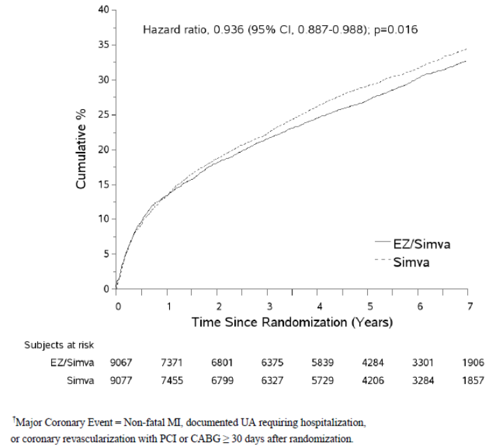

*Comment: It is important to note that the most frequently occurring events contributing to the composite endpoint were ‘all coronary revascularisations (PCI and CABG)’ [ezetimibe/ simvastatin vs simvastatin: 1153 (12.72%) vs 1175 (12.94%)], non-fatal MI [782 (8.62%) vs 902 (9.94%)] and CV death [342 (3.77%) vs 319 (3.51%)]. The incidence of non-fatal stroke [170 (1.96%) vs 239 (2.63%)] and documented UA requiring hospitalisation [117 (1.29%) vs 107 (1.18%)] was much lower in both treatment groups (Table 1). The benefits observed in the primary composite appeared to be mainly driven by reductions in non-fatal MI and non-fatal stroke; in fact incidence of CV death, UA requiring hospitalisation and coronary revascularisation in the ezetimibe/ simvastatin group was slightly higher or similar to that in the simvastatin group.*

Table 1: Analysis of primary composite endpoint: CV death, MCE, or non-fatal stroke (protocol-defined ITT population).

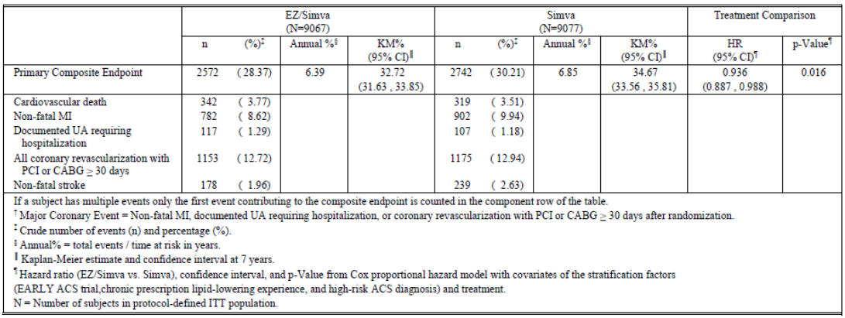

A pre-specified sensitivity analysis of the primary composite endpoint including all coronary revascularisation events (i.e., not excluding those that occurred within 30 days of the qualifying ACS event) revealed similar findings with HR 0.947 (95% CI 0.900 – 0.996).

*Comment: The CSR states that the sensitivity analysis of the primary composite endpoint censoring subjects at the time of simvastatin up-titration showed that the results were generally consistent (Table 2). This statement by the sponsors in the CSR is inaccurate since the results in the table actually show a greater number of events in the ezetimibe/simvastatin group (2461/9067, 27.14%) compared with simvastatin alone (2205/9077, 24.29%) including a higher incidence of CV death, non-fatal MI, UA requiring hospitalisation and coronary revascularisation (PCI or CABG) in the ezetimibe/simvastatin group compared with the simvastatin monotherapy group. The number of subjects who at some point had their dose of simvastatin increased from 40 to 80 mg per day was greater in the simvastatin group compared to the ezetimibe/simvastatin group (6.2% in the ezetimibe/simvastatin and 27.0% in the simvastatin monotherapy group) and the sponsors have stated that this would give a more conservative estimate of benefit of ezetimibe/simvastatin and hence this sensitivity analysis was conducted censoring subjects at time of uptitration of simvastatin dose. Hence, the observation regarding a higher incidence of overall events and the individual components of the composite endpoint in the ezetimibe/simvastatin group is of concern. The sponsors have been asked to clarify this below.*

Table 2: Sensitivity analysis of primary composite endpoint: subjects censored at time of titration, CV death, MCE, or non-fatal stroke (protocol-defined ITT population).

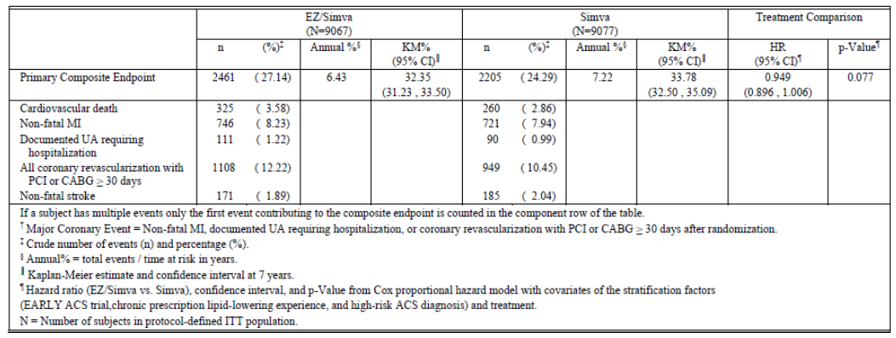

The effect of ezetimibe/simvastatin relative to simvastatin monotherapy on the primary composite endpoint was generally consistent across the subgroups including race, region, smoking status, prior PCI, prior stroke, statin experience and baseline LDL-C quartiles. The HRs of the subgroups was almost all less than one and the confidence intervals were broadly overlapping. However, the effect of ezetimibe/simvastatin relative to simvastatin monotherapy on the primary composite endpoint was greater in diabetics and patients aged >75 years; the unadjusted interaction p-values for age (<75 years vs. ≥ 75 years) and diabetes (Yes vs. No) were   
< 0.05 (p=0.005 and p=0.023, respectively).

##### Results for other efficacy outcomes

###### Secondary efficacy endpoints

###### Ezetimibe/simvastatin reduced the incidence of the composite endpoint of death due to all causes, major coronary events and non-fatal stroke (7-year KM rate for ezetimibe/simvastatin vs simvastatin monotherapy group was 38.6% vs 40.25%; HR= 0.948, 95% CI: 0.903- 0.996; p=0.035).

Ezetimibe/simvastatin reduced the incidence of the composite endpoint of death due to CHD, non-fatal MI and urgent coronary revascularisation with either PCI or CABG occurring at least 30 days after randomisation (7-year KM rate:17.52% vs 18.88%; HR= 0.912, 95% CI: 0.847-0.983; p=0.016).

Ezetimibe/simvastatin also reduced the incidence of the composite endpoint of CV death, non-fatal MI, documented unstable angina that requires admission into a hospital, all revascularisation (including both coronary and non-coronary) occurring at least 30 days after randomisation and non-fatal stroke (7-year KM rate: 34.49% vs 36.20%; HR=0.945, 95% CI: 0.897- 0.996; p=0.035). Results for these secondary endpoints were also displayed in the form of Kaplan-Meier plots and are generally consistent with the results for the primary endpoint.

Figure 2: Cumulative incidence rate of secondary composite endpoint: death from any cause, MCE, or non-fatal stroke (protocol-defined ITT population)

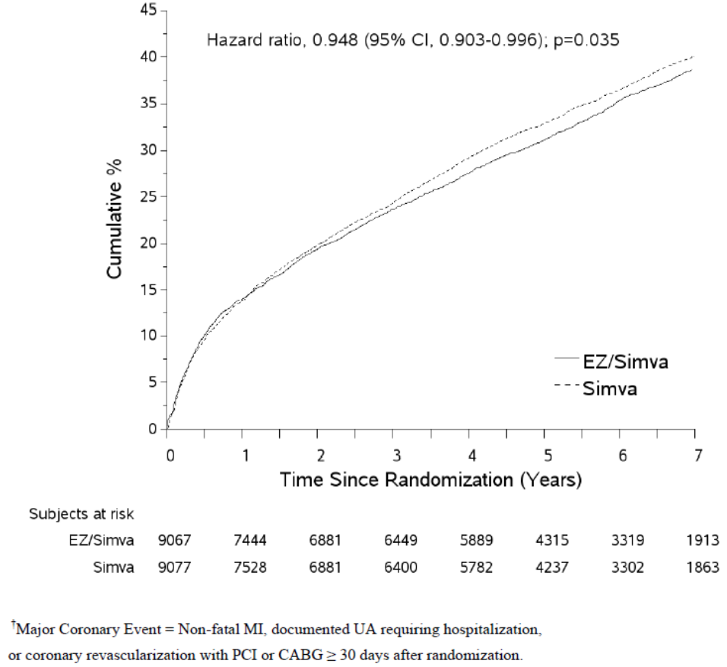

Figure 3: Cumulative incidence rate of secondary composite endpoint: CHD death, non-fatal MI, or urgent coronary revascularisation with PCI or CABG ≥ 30 days after randomisation (protocol-defined ITT population)

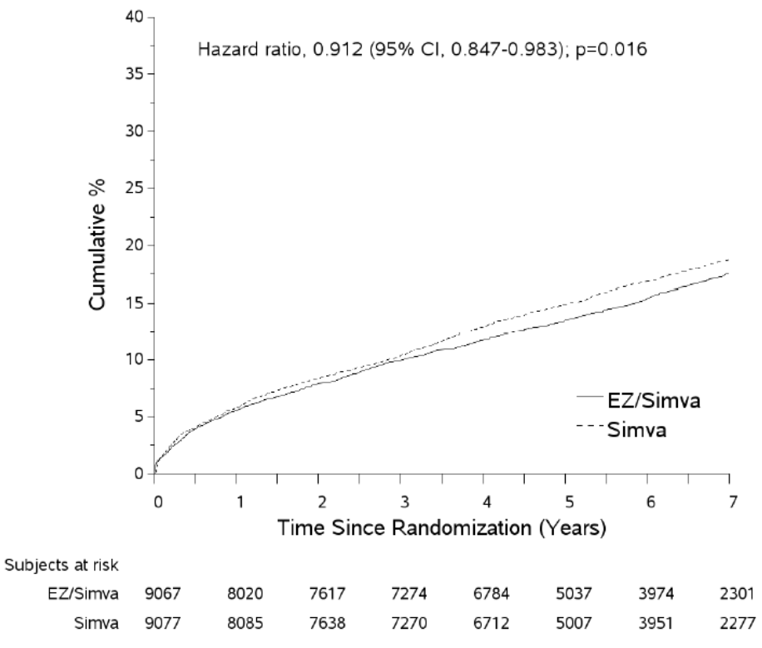

Figure 4: Cumulative incidence rate of secondary composite endpoint: CV death, non-fatal MI, documented UA requiring hospitalisation, all revascularisation, or non-fatal stroke (protocol-defined ITT population)

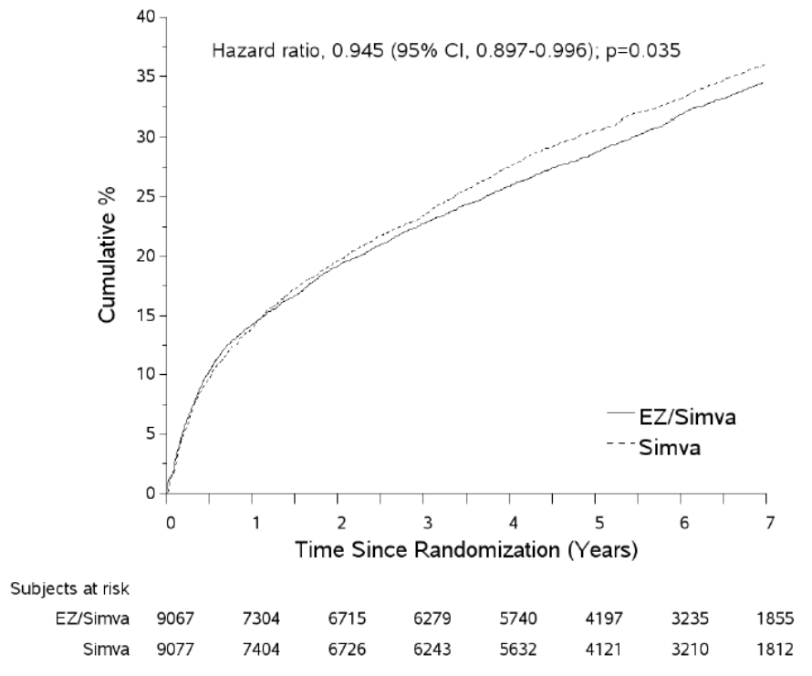

*Comment: It is important to note that incidence of death from any cause, CHD death and CV death in these secondary composite endpoints was slightly higher in the simvastatin-ezetimibe group compared to the simvastatin monotherapy group. Interpretation may have been confounded by fact that the analysis of the components of each secondary composite endpoint captures only the first event in each category that contributed to the secondary composite. Analysis of the component categories independent of whether they represented first events within a given composite constituted tertiary endpoints and are discussed in the section below.*

###### Tertiary efficacy endpoints

Individual CV event categories: The rates of death from any cause, CV death, or CHD death were similar between the treatment groups. Furthermore, no differences were noted between the treatment groups in unstable angina requiring hospitalisation or all coronary revascularisation with PCI or CABG (> 30 days after randomisation). Treatment with ezetimibe/simvastatin was shown to reduce the rate of MI (fatal or non-fatal) with a HR of 0.872 (95% CI: 0.800 -0.950; p=0.002) but this was driven mainly by reduction in non-fatal MI (7-year KM rate for non-fatal MI was 12.77% in the ezetimibe/simvastatin group compared to 14.41% in the simvastatin monotherapy group; HR 0.871, 95% 0.798 – 0.950; p=0.002) while the rate of fatal MI was low and similar between the treatment groups.

Treatment with ezetimibe/simvastatin was shown to reduce the incidence of rate of stroke event (fatal or non-fatal) [296 of 9,067 subjects in the ezetimibe/simvastatin group compared to 345 of 9,077 in the simvastatin monotherapy group; HR= 0.857, 95% CI: 0.734 - 1.001; p=0.052), but this reduction in stroke events was mainly driven by reduction in non-fatal stroke (7 year KM rate for non-fatal stroke was 3.49% vs 4.24%; HR 0.802 95% CI : 0.678 - 0.949; p=0.010). The rate of fatal stroke was low and similar between the treatment groups. The rate of non-haemorrhagic stroke or unknown stroke was reduced in the ezetimibe/simvastatin group (7-year KM rate: 3.48% vs. 4.23%; HR= 0.793, 95% CI: 0.670 - 0.939; p=0.007). However, the incidence of haemorrhagic stroke was higher in the ezetimibe/simvastatin group compared to in the simvastatin monotherapy group (HR 1.377, 95% CI: 0.930 – 2.040; p=0.110).

*Comment: Overall, analysis of the individual CV event categories did not show any benefit for ezetimibe/simvastatin compared to simvastatin monotherapy in rates of death from any cause, CV death, CHD, fatal MI, fatal stroke, unstable angina requiring hospitalisation or all coronary revascularisation with PCI or CABG (> 30 days after randomisation. Clear benefit of simvastatin/ezetimibe treatment over simvastatin monotherapy was only observed for non-fatal MI, non-fatal (non-haemorrhagic and unknown) stroke; risk of haemorrhagic stroke appears to increase with simvastatin/ ezetimibe treatment. Interpretation may have been limited by lack of adjustment for multiplicity for the tertiary endpoints.*

###### Other composite endpoint

In addition to the protocol-specified primary, secondary and tertiary endpoints defined above, the following pre-specified exploratory composite endpoints were examined: (1) CV death, non-fatal MI, and non-fatal stroke; (2) coronary death, MI, and coronary revascularisation; (3) CHD Death or Non-fatal MI; (4) CV Death or Non-fatal MI. Treatment with ezetimibe/simvastatin was noted to reduce the risk of all 4 exploratory composite endpoints and the results were generally consistent with the primary and other endpoints discussed above. Ezetimibe/simvastatin treatment was associated with a 9.9% reduction in risk for the occurrence of CV death, non-fatal MI and stroke endpoint (HR 0.901; 0.841 – 0.965, p=0.003).

###### On treatment analyses

Due to the large number of subjects who had discontinued study treatment, on-treatment analyses were pre-specified and performed on the primary composite endpoint and key secondary composite endpoints. Results for the primary composite endpoint with events censored at 30 days after the date of permanent discontinuation of study drug supported the findings in the protocol defined ITT population and a 7.60% reduction in risk for the primary composite endpoint was observed (HR 0.924; 0.868 – 0.983, p=0.012). Results for the primary composite endpoint with events censored at 6 months and 12 months after the date of permanent discontinuation of study drug were also consistent with the ITT results.

*Comment: While on-treatment analyses may assist in understanding the treatment effect for subjects who remained on study drug, such subgroup analyses should be interpreted with caution as they represent a non-randomised comparison.*

Analyses of total endpoint events (i.e. not only the first event) were pre-specified and performed to explore the potential benefit of ezetimibe/simvastatin compared to simvastatin monotherapy having a sustained effect and preventing multiple occurrences of the primary and secondary composite endpoints. A total of 5314 subjects had at least 1 primary endpoint event, 2307 subjects had at least 2 events, 965 subjects had at least 3 events and 453 subjects had at least 4 events.[19] The risk reduction in the primary endpoint of ezetimibe/simvastatin compared to simvastatin was consistent (p=0.688) across the 1st, 2nd, 3rd, and 4th events and was associated with an average risk reduction of 6.6% (HR= 0.934; 95% CI: 0.885-0.986; p=0.013). Overall, there were 4563 total events in the ezetimibe/simvastatin group and 4971 events in the simvastatin group.

“Landmark” analyses were performed for the primary composite endpoint and for the three secondary composite endpoints before and after the 6-month time point following randomisation. However, these results should be interpreted with caution as it was a non-randomised comparison and subject to bias. Analysis of all the data in the trial indicates that the treatment effect begins at or after 12 months. The HR and 95% CI for the first 6 months were HR 1.012 (95% CI 0.921 - 1.113) and for 6 months to the last visit were HR 0.901 (95%CI 0.844 - 0.962). The p-value for treatment by time interaction was 0.047. Sensitivity analysis to assess impact of missing data on the treatment effect also showed consistent results.

###### Other efficacy endpoints

###### **Lipid,[20] Lipoproteins, Apolipoproteins and hs-CRP:** The LS mean LDL-C at the time of the qualifying event was 93.8 mg/dL (2.43 mmol/L) in both treatment groups. LDL-C lowering was observed at 1 month and was generally sustained over the duration of follow-up. The corresponding LS mean LDL-C levels at 1 year were 55.0 mg/dL (1.4mmol/L) in the ezetimibe/simvastatin group vs. 71.8 mg/dl (1.86mmol/L) in the simvastatin group, representing a 16.8 mg/dL (0.434mmol/L) between group difference (95% CI -17.5 to 16.0; p<0.001). The between-group difference remained relatively similar at all time-points, reflecting a consistency of the treatment effect of the study medication and the fact that lipids were generally measured only on subjects continuing on study drug. Averaged over the course of the trial and with inclusion of all available lipid values (ITT), the ezetimibe/simvastatin treatment group achieved an additional mean reduction in LDL-C of 14.2 mg/dL (0.367mmol/L) or 15.9% (95% CI -16.7 to 15.2, p<0.001) compared to the simvastatin treatment group. The average measured LDL-C levels at the time of randomisation were lower than the values obtained at the time of presentation with the index ACS event, presumably due to confounding effects of the ACS acute coronary event / hospitalisation, in addition to the fact that substantial numbers of subjects started statin therapy as part of their medical care during the interval between presentation and randomisation. A total of 8041 subjects who were continuing on study drug returned for measurement of LDL-C, along with a total of 2113 subjects who had prematurely discontinued study drug at some point before this end-of-study closeout visit. LDL-C levels by treatment status (on-treatment vs. off-treatment) and by randomised treatment group were provided. For subjects off treatment at the final visit, the mean LDL-C is very similar between the two treatment groups and only slightly lower than the LDL-C level at Qualifying Event.

The change from to baseline (at time of qualifying event) to 12 months showed significantly greater reductions in Total C, Non-HDL-C, and TG for ezetimibe/simvastatin compared to simvastatin alone. Similarly, the change from baseline (at time of randomisation) to 12 months showed significantly greater reductions in Total C, non-HDL-C, Apo B, Apo B/Apo A-I ratio, Total/HDL-C ratio, non- HDL-C/HDL-C ratio and hs-CRP for ezetimibe/simvastatin.

The proportion of subjects that achieved LDL-C <70 mg/dL (1.81mmol/L) and hs-CRP <2 mg/L was significantly greater in the ezetimibe/simvastatin compared to the simvastatin monotherapy group at 1 month (50.6% vs 30.5%) and 4 months (53.4% vs 29.9%). Analysis of the primary composite endpoint based on the achievement of both LDL-C <70 mg/dL (1.81mmol/L) and hs-CRP <2 mg/L at 1 month and 4 months, respectively showed lower event rates for those subjects who achieved both LDL-C <70 mg/dL (1.81mmol/L) and hs-CRP <2 mg/L compared to those who did not irrespective of the treatment group.

*Comment: Analysis of patients with LDL-C <1.8mmol/L and hs-CRP <2mg/L was not provided as later timepoint in this study. This would have been important as the CV benefit with ezetimibe began to emerge only after one year of treatment.*

###### Relationship of LDL-C reduction to outcomes treatment benefit

###### The relationship between LDL-C reduction and outcomes treatment benefit was assessed through analysis of observed reductions in CV events per 1.0 mmol/L reduction in LDL-C. This assessment facilitates comparison with observations from the 2010 Cholesterol Treatment Trialist meta-analysis (of 26 randomised statin trials with ~170,000 participants) where lowering LDL-C (assessed at 1 year in each trial) by 1 mmol/L (38.67 mg/dL) with statin therapy reduced the incidence of major vascular events by 22%. In order to perform these analyses, a composite endpoint for IMPROVE-IT that was consistent with the CTT major vascular event endpoint namely CHD death, non-fatal MI, coronary revascularisation that occurred ≥ 30 days after randomisation and stroke was identified and assessed; this was similar to the primary endpoint of IMPROVE IT excluding unstable angina. Additionally, to maintain consistency with the approach used in the CTT collaboration,[21] imputation of baseline LDL-C values was performed for subjects with missing LDL-C values at 1-year. The HR for clinical benefit per mmol of LDL-C reduction with ezetimibe in IMPROVE IT was 0.80, which is consistent with the HR (0.78) observed with statins in the meta-analysis performed by the CTT in 2010. Furthermore, the components of the CTT-MVE composite showed results generally similar to those for the composite (Figure 5). A similar analysis was performed in which on-treatment LDL-C reduction was utilised along with CTT-MVE censored 30 days after study drug discontinuation and results for these analyses were similar to the results in the protocol defined-ITT population using the CTT adjustment described above.

Figure 5: MVEs composite endpoint per CTT: MCE, coronary revascularisation ≥ 30 days randomisation, or stroke per 1.0 mmol/L LDL-C reduction at one year (protocol defined ITT population with baseline value imputation).

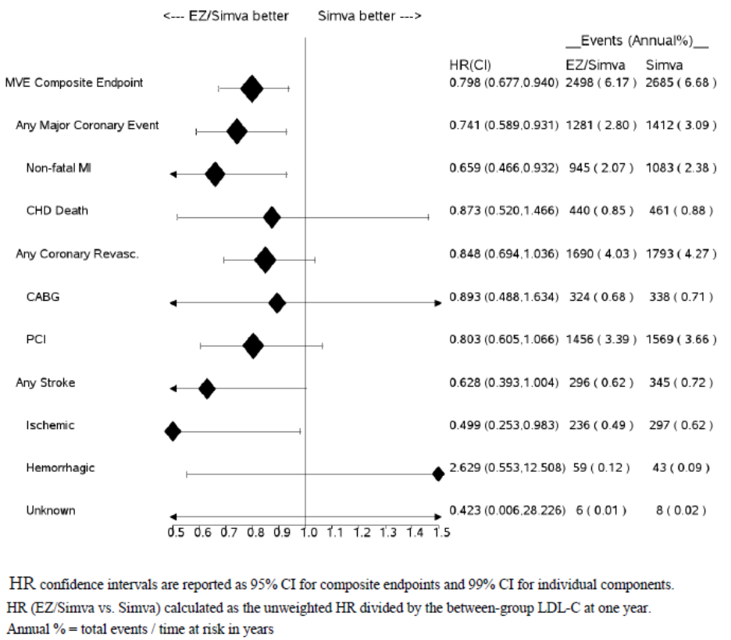

*Comment: Caution should be exercised in interpretation of these results as this analysis was not pre-defined and was only done post-hoc.*

#### Other efficacy studies

There were a number of other references which were not evaluated although the information was analysed to check consistency of pivotal data results.

#### Analyses performed across trials (pooled and meta analyses)

None.

#### Evaluator’s conclusions on clinical efficacy for indication 1: “Prevention of Cardiovascular Disease: Ezetimibe with a statin and Vytorin (ezetimibe/ simvastatin) is indicated to reduce the risk of cardiovascular events (cardiovascular death, nonfatal myocardial infarction, nonfatal stroke, hospitalisation for unstable angina, or need for revascularisation) in patients with coronary heart disease (CHD)

IMPROVE-IT was a Phase 3b, multicentre, randomised, double-blind, active-controlled study in 18144 subjects with stabilised ACS which evaluated the clinical benefit of ezetimibe/simvastatin combination (n=9067) compared with simvastatin monotherapy (n=9077). This study enrolled subjects presenting with ACS with relatively low baseline LDL-C values as it was considered unethical to study patients not already at optimal LDL-C goal, per 2004 NCEP ATP III guidelines.[22] All patients included in the IMPROVE-IT study were high-risk subjects with acute coronary syndromes from one of three categories according to the diagnosis of the qualifying event:

* Subjects with a diagnosis of NSTEMI or UA from the Early ACS trial;
* Subjects with a diagnosis of STEMI;
* Subjects with a diagnosis of NSTEMI or UA.

The criteria for entry into the IMPROVE-IT trial stipulated enrolment within 10 days of a subject’s qualifying ACS event. ACS guidelines define the acute period as the period during hospitalisation, followed by a subacute period extending from discharge to approximately 3 months. After 3 months, patients are considered to have entered the chronic phase of their disease. The risk for recurrent events appears generally consistent over a prolonged period of follow up beginning at around 3 months, as has been observed in other studies such as ISIS2 (Baigent, 1998). Subjects presenting with ACS were chosen for this study because of their relatively high event rate which facilitated having study power to detect the risk reduction anticipated for patients in the LDL-C range studied. Minimum follow-up of 2.5 years also assured that the ACS subjects had transitioned to a phase of chronic CHD. The prolonged follow-up treatment period of IMPROVE-IT allowed for the evaluation of the persistence of benefit of the study therapy and included longer term follow-up to assess the effects of ezetimibe during the chronic and more stable phase of CHD. A prior study (PROVE-IT) (Cannon CP, 2004) had demonstrated that reductions in CV events attributable to LDL-C reductions achieved through chronic statin therapy in a population presenting with ACS was of a similar magnitude to that seen in ‘stable’ CHD populations. Thus, IMPROVE-IT was designed as a study assessing the efficacy of the additional LDL-C reduction from ezetimibe in subjects with CHD presenting with ACS.

Compared to simvastatin monotherapy, treatment with ezetimibe/simvastatin reduced the rate of the first occurrence of the primary composite endpoint of CV death, non-fatal MI, documented unstable angina that requires admission into a hospital, coronary revascularization with either PCI or CABG occurring at least 30 days after randomisation, or non-fatal stroke. The primary endpoint occurred in 2,572 of 9,067 subjects (7-yr KM rate 32.72 %) in the ezetimibe/ simvastatin group and 2,742 of 9,077 subjects (7-yr KM rate 34.67 %) in the simvastatin monotherapy group in the protocol-defined ITT population (HR 0.936, 95% CI 0.887 – 0.988; p=0.016), corresponding to a relative risk reduction of 6.4 %. This modest risk reduction following ezetimibe/simvastatin combination compared to simvastatin monotherapy was mainly driven by a reduction in risk of non-fatal MI and non-fatal stroke both as individual events as well as components of the composite endpoint. However, no differences were noted between the treatment groups in the rate of unstable angina requiring hospitalisation, or all coronary revascularisation with PCI or CABG (> 30 days after randomisation) whether as components of the composite endpoint or as individual events.

Treatment with ezetimibe/simvastatin was associated with a reduction in the rate of total stroke (HR 0.857, 95% CI 0.734 – 1.001, p=0.052) compared with simvastatin monotherapy mainly driven by significant reduction in the incidence of non-haemorrhagic (i.e. ischemic stroke and stroke of undetermined type) compared to simvastatin monotherapy (HR 0.793, 95% CI 0.670 – 0.939; p=0.007). Although not significantly different, it is important to note that more subjects allocated to ezetimibe/simvastatin suffered a haemorrhagic stroke: 59 (0.65%) versus 43 (0.47%) in the simvastatin monotherapy group, of which 28 and 11, respectively, were fatal (HR 1.377, 95% CI 0.930 – 2.040; p=0.110). A similar imbalance for haemorrhagic stroke has been reported in previous statin studies (CTT, 2010).

The secondary composite endpoints focused on coronary events and provide additional clinically relevant information that supports the findings in the primary composite endpoint. The results were also consistent across the 4 exploratory composite endpoints studied, including a 9.9% reduction in the risk of the composite endpoint of CV death, non-fatal MI and non-fatal stroke (HR 0.901, 95% CI 0.841 – 0.965; p=0.003). Given the number of discontinuations from study therapy, and the limited information related to lipid values for those who discontinued study therapy, prespecified on-treatment analyses were also conducted. The on-treatment analyses were consistent with the results in the protocol-defined ITT population further supporting the finding that ezetimibe added to a statin resulted in reduction in cardiovascular events. However, on-treatment analyses should be interpreted with caution as they represent a non-randomised comparison.

The CHMP guidelines state that:

*to provide supportive information, and to ensure reliable interpretation, analysis of each separate component of the composite should be presented. For overall mortality and cardiovascular mortality both confidence intervals and point estimates are relevant for assessment and any point estimate considerably in favour of the comparator is a matter of concern.*

With regard to the individual components of the primary composite endpoint, the rates for non-fatal MI and non-fatal stroke were reduced in the ezetimibe/ simvastatin compared with simvastatin monotherapy groups. The rates of CV death, CHD death, and death from any cause either as components of the composite or as individual events were similar between the treatment groups. However, patients in the ezetimibe/simvastatin group were at higher risk of experiencing fatal stroke (HR: Ez/Sim: Sim=1.217) and haemorrhagic stroke (HR=1.377), although interpretation was limited by wide confidence intervals.

The consistency of the treatment effect for the primary endpoint was generally consistent across 20 pre-specified subgroups (including race, region, smoking status, prior PCI, prior stroke, statin experience and baseline LDL-C quartiles) with the vast majority of the HR point estimates favouring ezetimibe/simvastatin with broadly overlapping confidence intervals.Although these analyses suffer from limited power and absence of multiplicity control, the results are consistent with the results in the overall cohort studied. It is important to note that majority (75%) of patients enrolled in the study were males, but the benefit in terms of reduction in the primary efficacy endpoint was lesser in males with 95% confidence intervals including unity. The relative risk reduction in primary efficacy endpoint appears to be slightly greater in the female patient population.

At year 1, (in subjects who had laboratory evaluations completed), the LS mean difference in LDL-C levels achieved was 16.8 mg/dl (0.44 mmol/L, p<0.001) representing a 23% further lowering of LDL-C by ezetimibe relative to the LDL-C on simvastatin monotherapy with similar reduction observed over the entire trial (averaging all LDL-C values obtained over time). However, measurement of lipid values was not required after a subject permanently discontinued study therapy, therefore excluding subjects who had discontinued study drug prematurely. When imputing LDL-C values for subjects with no blood sample collected at 1 year using baseline levels, the between-group LDL-C difference was still 12.7 mg/dl (0.33 mmol/L). It is important to note that prior to the institution of Amendment #5, subjects with LDL-C >79 mg/dL (>2.0 mmol/L) based on protocol specified criteria were to have their simvastatin dose increased to 80 mg in a blinded manner. The use of simvastatin 80 mg was not balanced between the 2 groups with 6.2% and 27.0% in the ezetimibe/simvastatin and simvastatin groups, respectively, receiving simvastatin 80 mg sometime during the trial. Thus the difference in LDL-C between the treatment groups would be expected to be smaller than that generally attributed to the addition of ezetimibe to a statin at a given dose. The observed changes and between-group differences in other lipids and apolipoproteins were also consistent with the known effects of simvastatin and ezetimibe from previous studies. Specifically, treatment with ezetimibe produced additional reductions in non-HDLC and apolipoprotein B compared with simvastatin monotherapy, with a more modest additional reduction in TG. HDL-C was slightly increased by addition of ezetimibe, with no significant between-group difference in apolipoprotein AI.

###### Relevance of IMPROVE-IT results for patients with Chronic CHD

The IMPROVE-IT results showed that the benefit with ezetimibe began to emerge after one year of treatment, and continued over the ensuing years of the trial. Given that the benefit of further LDL-C lowering with ezetimibe occurred predominantly after 1 year strongly suggests that its benefits are not associated with events immediately surrounding the acute ACS event. Furthermore, an analysis of total events (first and recurrent events) demonstrated that subjects in the ezetimibe/ simvastatin group had a reduced hazard for total events for the primary and secondary composite endpoints compared to subjects in the simvastatin group. Although this analysis has limitations due the inherent bias that may be introduced with a non-randomised comparison, the results support the durability of the treatment benefit of ezetimibe/simvastatin beyond the prevention of the first event, which is an important clinical benefit for high-risk subjects.

###### Relevance of IMPROVE-IT Results in Patients with Higher LDL-C levels

The 2010 CTT meta-analysis, including data from 26 lipid lowering statin trials and 170,000 subjects, demonstrated a strong relationship between the absolute degree of LDL-C lowering and proportional decrease in CV disease risk across a broad range of LDL-C levels and patient characteristics (CTT, 2010; CTT, 2012). This relationship also holds for ezetimibe where the proportional change in LDL-C with ezetimibe is independent of baseline LDL-C levels (Morrone D, 2012; PI for Ezetimibe). The CTT meta-analysis reported a 22% CV risk reduction per mmol/L LDL-C lowering. Therefore at higher baseline LDL-C levels, statins produce larger absolute changes in LDL-C and, as shown in the CTT meta-analysis, greater cardiovascular risk reduction. Although the IMPROVE IT study enrolled patients with lower LDL-C levels, the results of IMPROVE IT should be relevant to patients whose LDL-C levels are not well controlled on a statin and, based on the larger absolute LDL-C change observed in these patients, one would expect the CV benefits to be even greater.

###### Relevance of IMPROVE-IT Results to Patients Treated with Any Statin

Ezetimibe targets NPC1L1, largely in the small intestine to inhibit intestinal cholesterol absorption. Statins inhibit HMGCoA reductase to decrease hepatic cholesterol synthesis. These mechanisms are complementary, and when ezetimibe and statins are administered together, help block potential compensatory increases in cholesterol absorption or cholesterol synthesis. These two complementary mechanisms also share a final common pathway that lowers LDL-C via the up-regulation of hepatic LDL receptors.

Ezetimibe supports a consistent proportional additive decrease in LDL-C levels when added to or co-administered with any statin. A pooled analysis from 27 lipid lowering trials including over 21,000 subjects showed that ezetimibe has a consistent additive lipid lowering effect when added to different statins, different doses of a statin, and statins of varying potency, and across a diverse patient population and this is reinforced by the fact that ezetimibe is approved for lipid lowering with all statins (Morrone D, 2012). All approved statins also have a similar safety profile, and the safety profile of ezetimibe is similar when administered with all statins (PI for Ezetimibe). Statin related CV outcomes benefit is associated with the degree of statin mediated LDL-C lowering and does not vary for different statins (ESC/EAS Guidelines for the management of dyslipidaemias, 2011; CTT, 2010; CTT, 2005]. The sponsors claim that that these observations support the conclusion that co-administration of ezetimibe with an inhibitor of HMG CoA reductase (any statin) will have additive benefit on CV risk reduction, and that this incremental benefit is expected to be similar with co-administration of other statins which are already shown to be effective in reducing the risk of cardiovascular events.

The clinical information relating to the consistent lipid lowering of ezetimibe when administered with or added to a statin is also consistent with information relating to persons with both NPC1L1 and HMGCoA reductase LDL-C lowering genetic variants. In such individuals, the observed LDL-C lowering is consistent with the sum of the LDL-C lowering associated with each genetic variant individually. This mimics the clinical situation when ezetimibe is given with a statin, and the observation that the LDL-C lowering mediated each by ezetimibe and statins is also additive. The CV risk reduction associated with presence of both NPC1L1 and HMGCoA reductase genetic variants is similarly additive. This is consistent with the IMPROVE-IT result which demonstrated that co-administration of ezetimibe with an inhibitor of HMG CoA reductase will have additive benefit on CV risk reduction. However, genetic testing for these variants was not done in the IMPROVE-IT study.

To determine whether larger reductions in LDL cholesterol safely produce further reductions in major vascular events, several trials have compared more intensive versus standard statin regimens (de Lemos, 2004; Cannon, 2004; Pedersen, 2005; LaRosa, 2005; SEARCH Collaborative Group, 2010). Although their results tend to suggest further benefit (Cannon, 2006) only two had significant results for their primary outcome (Cannon, 2004; La Rosa, 2005). The results of the IMPROVE IT study provide some evidence that the additional LDL-C reduction associated with addition of ezetimibe to simvastatin is translated into additive benefit on CV risk reduction, although the clinical relevance of the modest 6.4% relative risk reduction is not clear (see limitations below).

Although IMPROVE-IT studied patients presenting with acute coronary syndrome (ACS), used only simvastatin as the background statin, and entered patients with LDL-C levels, the sponsors have provided information to justify that the modest benefits observed in terms of reduction of CV events may apply to patients with chronic CHD, those receiving any statin and to subjects with a broad range of LDL-C levels. However, there were limitations (see below) in the submission which preclude any definite conclusions regarding efficacy of ezetimibe (Ezetrol) when used with a statin and ezetimibe/simvastatin (Vytorin) for the proposed indication to reduce the risk of CV events (cardiovascular death, nonfatal myocardial infarction, nonfatal stroke, hospitalisation for unstable angina, or need for revascularisation) in patients with CHD.

###### Limitations of efficacy data

* Overall, the results from the IMPROVE IT pivotal study do not support all of the components of the proposed indication:
  + CV death: ezetimibe/ simvastatin did not show any reduction in CV or overall mortality
  + non-fatal MI: ezetimibe/ simvastatin showed significant reduction in nonfatal MI
  + non-fatal stroke: ezetimibe/simvastatin showed significant reduction in nonfatal stroke but this was limited to non-haemorrhagic stroke but this is similar to stroke findings with other statins (CTT, 2010).
  + hospitalisation for unstable angina: ezetimibe/simvastatin did not show any reduction in hospitalisation for unstable angina, although interpretation was limited by very low event rates in both treatment groups.
  + need for revascularisation: this is very generalised term and not justified as the primary composite endpoint in the pivotal IMPROVE IT study specifically includes ‘all coronary revascularisation with either PCI or CABG occurring at least 30 days after randomisation’. Furthermore, this component of the composite primary endpoint failed to show any clear benefits with ezetimibe/ simvastatin compared to simvastatin alone.
* The absolute risk reduction (ARR) and Number Needed to Treat (NNT) following combination treatment with ezetimibe/ simvastatin compared to simvastatin monotherapy was not provided in the IMPROVE IT study report. The absolute reduction of risk (ARR or NNT) is very important as it would be useful to determine the clinical relevance of the relative reduction of risk (RRR) since RRR does not take the baseline level of risk of the subjects into consideration. This is especially important as the sample size was changed from an original size of 10,000 subjects to up to 18,000 subjects because the primary endpoint event rate was lower than anticipated in the original design. It is important to determine the actual clinical benefit following the modest 6.4% relative risk reduction (RRR) in the primary composite endpoint and information on the ARR and NNT would provide clarification on this issue. This information has been requested from the sponsor.
* The number of subjects who at some point had their dose of simvastatin increased from 40 to 80 mg per day was greater in the simvastatin group compared to the ezetimibe/simvastatin group (6.2% in the ezetimibe/simvastatin and 27.0% in the simvastatin monotherapy group) and the sponsors have stated that this would give a more conservative estimate of benefit of ezetimibe/ simvastatin and hence this sensitivity analysis was conducted censoring subjects at time of up-titration of simvastatin dose. However, results of this sensitivity actually were a cause for concern due to greater number of events in the ezetimibe/simvastatin group (2461/9067, 27.14%) compared with simvastatin alone (2205/9077, 24.29%) including a higher incidence of CV death, non-fatal MI, UA requiring hospitalisation and coronary revascularisation (PCI or CABG).
* Efficacy and safety of the ezetimibe in combination with simvastatin dose > 40mg was not adequately evaluated. Majority of the patients received 40mg simvastatin and exposure to the higher dose of 80mg simvastatin was limited especially in the ezetimibe/simvastatin group. Overall only 561 patients of the 9067 patients in the ezetimibe/ simvastatin group received 80mg simvastatin at any time during the study. However, it is important to note that 229 of these 561 patients were down-titrated to 40mg during the study (due to protocol amendment #5 or other reasons). Hence, only 332 patients received the 80mg dose of simvastatin in the ezetimibe/ simvastatin group for the duration of the study.

## Clinical safety

### Studies providing evaluable safety data

The following studies provided evaluable safety data:

#### Pivotal efficacy study

In the pivotal IMPROVE-IT study, the following safety data were collected: laboratory tests (including liver function tests and CK levels), physical examinations, adverse events (AEs) and clinic evaluations. General AEs were recorded at each visit. Serious AEs (SAE) were recorded within 1 working day of the investigator learning of the event. Suspected clinical endpoint events, including death, were exempt from being reported as SAEs (as per the IMPROVE-IT protocol). The protocol also specified that monitoring and recording of AEs (including SAEs) was only required if they occurred 30 days or less following permanent discontinuation of study drug. In addition to the protocol-defined ITT approach, the selected safety parameters of SAEs, CEC-reviewed myopathy/rhabdomyolysis, hepatic ALT/AST elevations, and CK elevations were also analysed[23] as follows.

AEs were summarised by frequency of occurrence. No statistical inferential analysis of safety data was planned except for the following parameters of interest, for which point estimates, 95% CIs, and p-values for the differences in incidences between the treatment groups are provided using the Miettinen and Nurminen method: myopathy, rhabdomyolysis, cholecystectomy, AEs reflective of gallbladder disease, and ALT and/or AST elevations >3xULN. Cancer and cancer-related death were analysed using a Cox proportional hazards model with treatment as a covariate. Inferential analysis of cancer or cancer-related death AEs was not specified in the study protocol, but was added to the SAP due to the interest raised by the findings of the SEAS study. Additionally, other relevant AESI were reviewed and summarised including new-onset diabetes, pancreatitis, acute renal failure, interstitial lung disease, hypersensitivity reactions, and haemorrhagic stroke. The Medical Dictionary of Regulatory Activities (MedDRA) Version 17.0 was used in reporting of all AEs.

#### Pivotal studies that assessed safety as a primary outcome

#### None.

#### Dose-response and non-pivotal efficacy studies

#### None.

#### Other studies evaluable for safety only

#### None.

#### Clinical pharmacology studies

#### None.

### Pivotal studies that assessed safety as a primary outcome

None.

### Patient exposure

###### IMPROVE-IT study

###### The mean duration of exposure was 1389 days in the ezetimibe/simvastatin group and 1427 days in the simvastatin group. A total of 5710 subjects were on treatment for at least 72 months. For the first 6 years of the trial, IMPROVE-IT called for compliant subjects in either treatment group who had LDL-C >79 mg/dL (2.0 mmol/L) on two consecutive measurements to have their dose of simvastatin increased from the initial 40 mg per day to 80 mg per day in a blinded manner. With amendment 5 to the protocol, subjects who had been receiving simvastatin 80 mg for less than a year or who required taking the potentially interacting drugs ranolazine or amlodipine, had their simvastatin dose returned to 40 mg per day. As expected, the numbers of subjects who at some point had their dose of simvastatin increased from 40 to 80 mg per day was greater in the simvastatin group compared to the ezetimibe/simvastatin group (27% vs 6.2%). With protocol amendment #5, a greater proportion of subjects in the simvastatin monotherapy group were down-titrated from simvastatin 80 mg to simvastatin 40 mg (8.7% vs 2.5%). Compliance was >85% in over 86% of the patients with similar compliance rates in both treatment groups.

*Comment: Overall only 561 patients of the 9067 patients in the ezetimibe/ simvastatin group received 80mg simvastatin at any time during the study. However, it is important to note that 229 of these 561 patients were down-titrated to 40mg during the study (due to protocol amendment #5 or other reasons). Hence, only 332 patients received the 80mg dose of simvastatin in the ezetimibe/simvastatin group.*

### Adverse events

#### All adverse events (irrespective of relationship to study treatment)

##### Pivotal study (IMPROVE-IT)

At least one AE occurred in 15516 (85.5%) of the randomised subjects. The incidence of all AEs (Ezetimibe/Simvastatin vs Simvastatin alone: 85.6% vs 85.4%) and the different AE categories were similar between the treatment groups. The most common AEs were musculoskeletal and connective tissue disorders (46%), gastrointestinal disorders (34%), infections and infestations (38%), respiratory, thoracic and mediastinal disorders (27%) and nervous system disorders (27%) (Table 3).[24]

Table 3: Subjects with AEs (incidence ≥2 in one or more treatment groups) (protocol defined ITT population)

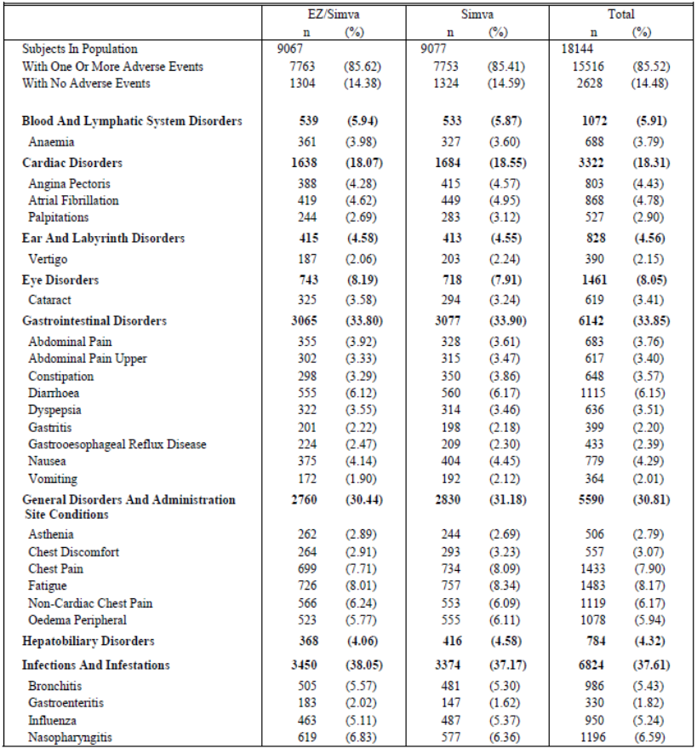

Table 3 (continued): Subjects with AEs (incidence ≥2 in one or more treatment groups) (protocol defined ITT population).

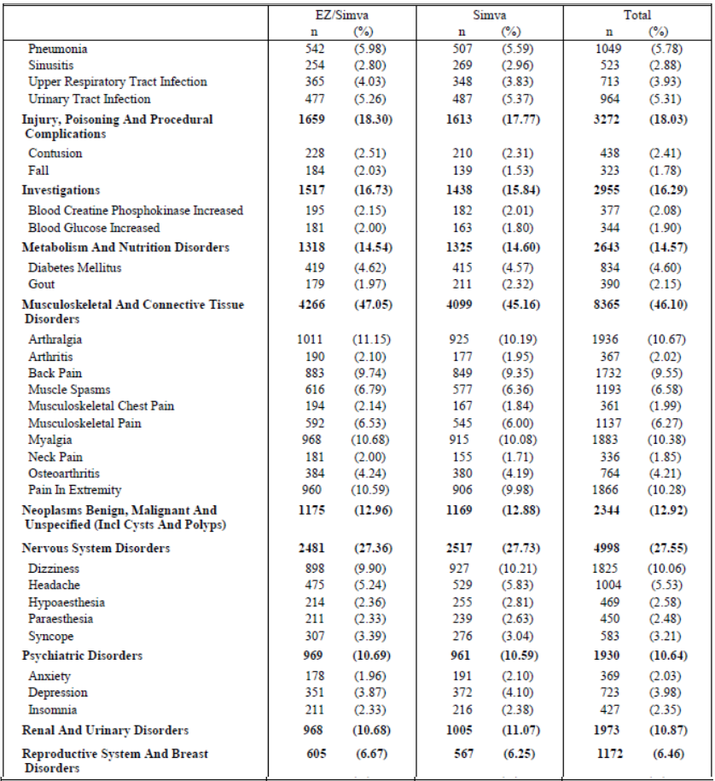

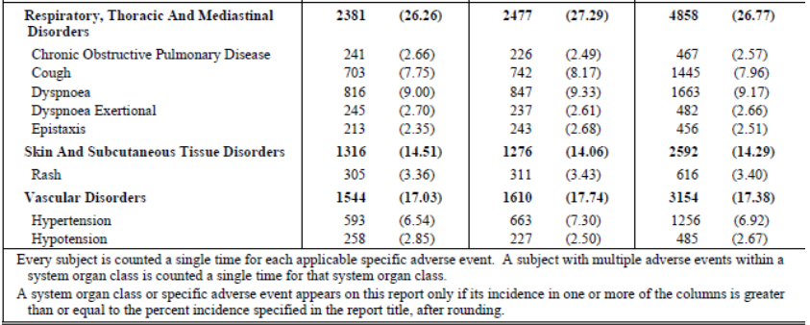

##### Other study (SHARP)

In the SHARP study only adverse events that were serious, or that led to discontinuation of study treatment were recorded. Non-serious AEs (NSAEs) were not routinely collected in SHARP unless they led to study discontinuation.

#### Treatment-related adverse events (adverse drug reactions)

##### Pivotal study (IMPROVE-IT)

Overall, 4818 (26.55%) patients experienced at least one treatment-related AE (Ezetimibe/ Simvastatin vs Simvastatin alone: 26.8% vs 26.3%). Table 4 summarises the number of patients with specific AEs (incidence ≥ 2.0% in one or more treatment groups) by SOC that were considered by the investigator to be related to study therapy during the double-blind treatment period and showed no significant differences in specific drug-related AEs between treatment groups. Review of the summary of patients with specific AEs (incidence >0.0% in one or more treatment groups) by SOC that were considered to be treatment-related also revealed similar incidence in both treatment groups.

Table 4: Subjects with AEs (incidence ≥2 in one or more treatment groups): drug related (protocol defined ITT population).

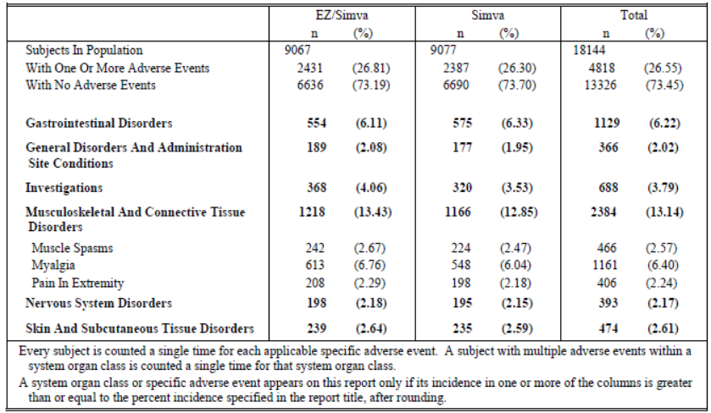

##### Other study (SHARP)

Treatment-related AEs were not reported in the SHARP study.

#### Deaths and other serious adverse events

##### Pivotal study (IMPROVE-IT)

There were 7289 (40.2%) subjects who experienced at least one SAE; 3640 (40.1%) in the ezetimibe/simvastatin group and 3649 (40.2%) in the simvastatin group. The most common SAEs were neoplasms (benign and malignant) musculoskeletal disorders and infections/ infestations with similar incidence in the treatment groups (Table 5). It is important to note that events considered and reported by the investigator as potential study endpoints (including deaths) were not reported as SAEs; consequently, the events in this category represent only non-cardiovascular SAEs or cardiovascular SAEs that were not considered to be study endpoints.

Table 5: Subjects with AEs (incidence ≥2 in one or more treatment groups): serious (protocol defined ITT population).

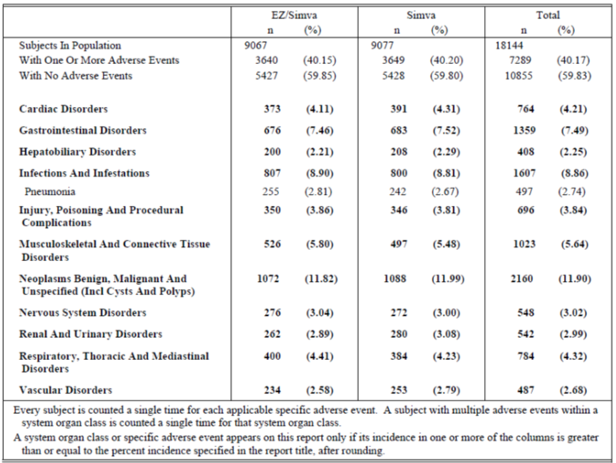

AEs resulting in death occurred in 672 (3.7%) subjects, 347 (3.8%) in the ezetimibe/simvastatin group vs. 325 (3.6%) in the simvastatin monotherapy group. Since death was considered a study endpoint, death was not routinely reported as a SAE. As a result, the number of AEs resulting in death differs from the number of CEC reported deaths in the efficacy analysis. Non-cardiovascular deaths were adjudicated into the following categories: accidental, diabetes, malignancy, renal, suicide, or other. Cause-specific and overall mortality is summarised in Table 6, based on the categories utilised by the CEC for adjudication. Of the 18,144 subjects in the ITT population, 2446 (13.48%) died during the course of the study: 1215 (13.40%) in the ezetimibe/simvastatin group and 1231 (13.56%) in the assigned simvastatin group. No meaningful differences were noted between the treatment groups in the incidence of CV (5.92 vs. 5.93%) or non-CV-deaths (5.64 vs 5.45%).

Table 6: Summary of CEC adjudicated deaths (protocol defined ITT population).

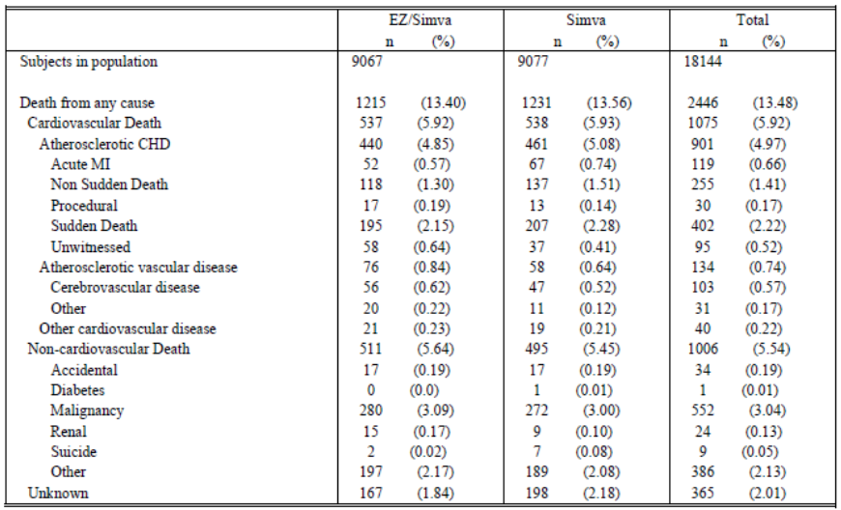

##### Other study (SHARP)

In the SHARP study, during the first year of treatment, suspected serious adverse reactions (SSARs) were observed in 5 patients allocated to ezetimibe/simvastatin, 1 patient allocated to simvastatin and 5 patients allocated to placebo (Table 7). During the overall study period, of 33 patients with suspected SSARs, 20 (0.4%) patients were allocated to ezetimibe/simvastatin 10/20 mg and 13 (0.3%) patients were allocated to placebo. The most common SSARs were CK elevations >10xULN, which were observed in 7 patients allocated to ezetimibe/simvastatin 10/20 mg and 4 patients allocated to placebo.

Table 7: Suspected serious adverse experience reactions during first year of treatment in each arm of study.

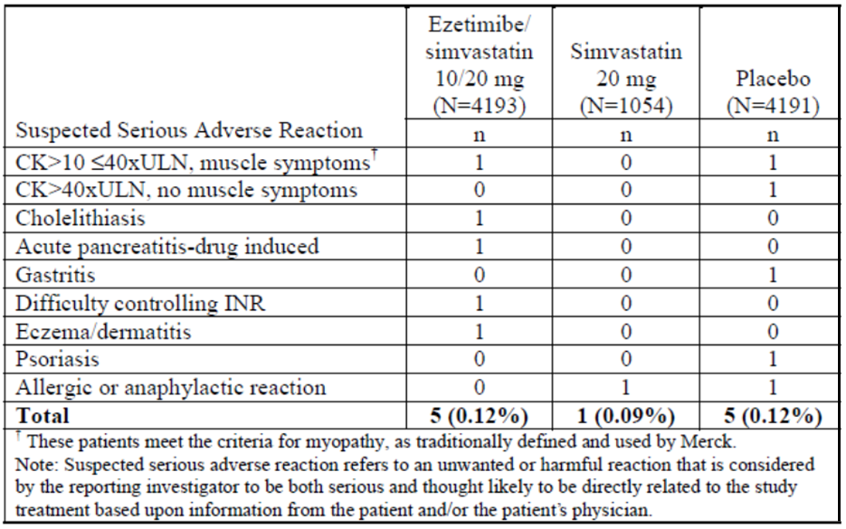

The numbers of deaths overall and of deaths due to non-vascular causes collectively were not significantly different in patients allocated to ezetimibe/simvastatin 10/20 mg versus placebo. There were no significant differences between the ezetimibe/simvastatin and placebo groups in mortality from specific non- CHD or non-vascular causes, including cancer.

Overall, 70% of patients allocated to ezetimibe/simvastatin and 71% of patients allocated to placebo had non-fatal SAEs (NSAEs).[25] The most common SAEs were renal (42%) and gastrointestinal SAEs not related to the liver, pancreas, and/or the biliary tract (21%). There was no significant imbalance in any particular SAE in patients randomised to ezetimibe/simvastatin versus placebo with the exception of haemodialysis access[26] which was less frequent in patients allocated to ezetimibe/simvastatin compared to placebo.

#### Discontinuation due to adverse events

##### Pivotal study (IMPROVE-IT)

A total of 1880 (10.4%) subjects had an AE that led to study drug discontinuation during double-blind treatment period, 962 (10.6%) in the ezetimibe/simvastatin group and 918 (10.1%) in the simvastatin monotherapy group. There were no meaningful differences between the two treatment groups although the incidence of discontinuations due to musculoskeletal an connective tissue disorders was slightly higher in the ezetimibe/simvastatin mg group compared with the simvastatin group (4.27% vs 3.80%) (Table 8).

Table 8: Serious adverse reactions attributed to study treatment: arms 2+3b versus 1+3a.

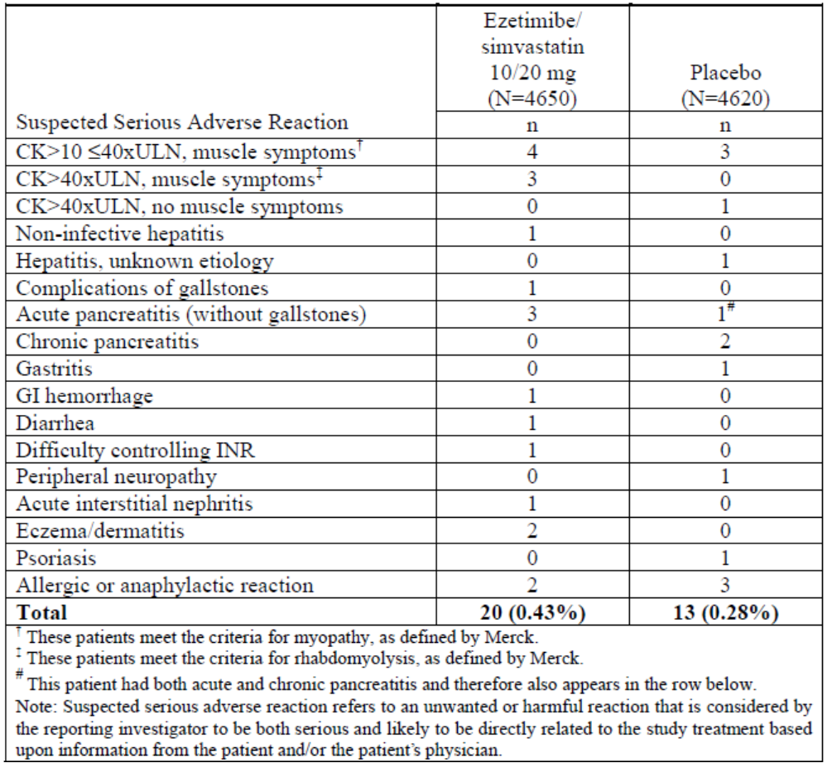

##### SHARP study

The total number of patients stopping study medication due to any AE, whether serious or not, or drug-related or not, was 10.4% and 9.8% in the ezetimibe/simvastatin and placebo groups, respectively. Patients stopping study medication due to an AE accounted for about one-third of the non-compliant patients. SSARs led to discontinuation of study treatment in 17 (0.4%) and 12 (0.3%) patients in the ezetimibe/simvastatin and placebo groups, respectively; four patients (3 allocated to ezetimibe/simvastatin 10/20 mg and 1 allocated to placebo) had a SSAR but continued taking study medication. The most common SAE that led to discontinuation of study treatment was renal transplantation (often because of starting cyclosporine), which occurred in 152 (3.3%) and 148 (3.2%) patients in the ezetimibe/simvastatin and placebo groups, respectively. Non-serious AEs (NSAEs) were not routinely collected in SHARP and were only collected when the NSAE was a reason for stopping study treatment. There was a greater number of NSAEs that led to study drug discontinuation in patients allocated to ezetimibe/simvastatin 10/20 mg versus placebo (3.5% vs 2.8%) and the most common NSAEs that led to discontinuation of study treatment were muscle pain, abnormal safety blood results and skin symptoms (Table 9).

Table 9: Non-serious AEs that resulted in discontinuation of study treatment: arms 2+3b versus 1+3a.

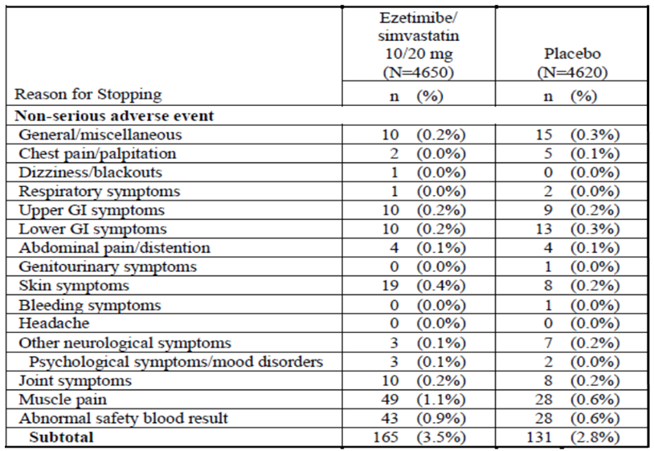

### Laboratory tests

#### Liver function

##### Pivotal study (IMPROVE-IT)

At screening, subjects with active liver disease or persistent unexplained serum transaminase elevations (≥2 x ULN) were ineligible for the study. Subjects with transient increases in serum transaminases due to the index MI were eligible for the study. Per protocol**,** ALT and AST testing was performed at screening/randomisation, Month1, Month 4, Month 8, Month 16, annually and at study completion/early discontinuation. Total bilirubin and alkaline phosphatase were evaluated only at the screening/randomisation visit, the annual visit and at the time of study completion/ early discontinuation.

If a subject was found to have an ALT and/or AST measurement ≥3 x ULN believed to be related to study drug, then the subject was to have repeat laboratory tests performed within 1 week. If the same transaminase activity was ≥3 x ULN on two consecutive occasions, the study medication was interrupted. Investigative sites were instructed to repeat the subject’s laboratory tests approximately every 2 weeks until the transaminase activity decreased to <2 x ULN, at which time study drug could be restarted at the discretion of the investigator, following discussion with the sponsor’s clinical monitor. A subject who had a second episode of two consecutive observations of transaminase activity ≥3 x ULN believed to be related to study drug was to be discontinued from study medication, but would be monitored for any clinical endpoint event until the termination of the trial.

Overall, the incidence of elevations in ALT and AST with or without bilirubin elevations was generally similar between the ezetimibe/simvastatin and simvastatin treatment groups across the different range of elevations. The largest numbers of elevations occurred during the first 4 months of treatment, dropped and remained fairly constant over the rest of the first year and then dropped further in the subsequent years. There was no apparent difference in the time course between treatment groups. The number of AEs leading to discontinuation attributed to transaminase elevations was small in both groups. The incidence of discontinuations was slightly higher in the ezetimibe/ simvastatin group compared to the simvastatin group due to ALT increased (0.23% vs 0.08%) and AST increased (0.19% vs 0.06%).

Approximately 17% of randomised subjects were up-titrated to simvastatin 80mg during the trial (27% in the simvastatin treatment group, and 6% in the ezetimibe/simvastatin treatment group). Due to the imbalance in the treatment groups for those up-titrated to simvastatin 80mg, exposure-adjusted analyses for instances of ALT/AST elevations > 3X ULN consecutive were also conducted in both the ITT population (excluding subjects who never took study drug) and the on-treatment population. The exposure adjusted rate of consecutive ALT or AST ≥3xULN was similar between the treatment groups in subjects taking simvastatin at a dose of 40 mg. Comparisons at the 80 mg dose were limited by the lesser use and the smaller number of cases in the ezetimibe/simvastatin group, however the risk appeared similar between the treatment groups in both the ITT population excluding subjects who never took study therapy and the on-treatment population. However, results of the above analysis should be interpreted with caution as this assessment was not randomised.

##### SHARP study

During the first year of treatment, incidence of persistent elevations[27] in transaminases was higher in patients allocated to ezetimibe/simvastatin 10/20 mg (n=13, 0.31%) compared to simvastatin 20 mg (n=1, 0.09%) and placebo (n=6, 0.14%)**.** There were 18 cases of hepatitis in the first year. Most cases were of infectious aetiology; hepatitis that was non-infective or of unknown aetiology was identified in 4 (0.1%) patients allocated to ezetimibe/ simvastatin and 2 (0.05 %) patients allocated to placebo. There was no evidence for any significant between-group differences with regard to complications of gallstones, hospitalisation for gallstones or pancreatitis.

During the complete follow-up period, the incidence of elevations in ALT and/or AST>3xULN was higher in the ezetimibe/simvastatin compared to placebo; at least one elevation of ALT and/or AST>3xULN was observed in 105 (2.3%) and 76 (1.7%) patients, respectively. Throughout the study, the incidence of elevations in transaminases >3xULN was greater in the ezetimibe/simvastatin group. The incidence of persistently elevated transaminases was low (<1%) and similar in both treatment groups; in 14 (0.30%) patients allocated to ezetimibe/simvastatin and 10 (0.22%) patients allocated to placebo, consecutive elevations in transaminases were associated with hepatitis. There was no meaningful difference between the treatment groups in the number of patients who developed infective hepatitis, non-infective hepatitis, or hepatitis of unknown aetiology.

#### Kidney function

##### Pivotal study (IMPROVE-IT)

In order to assess changes in renal function over time in subjects enrolled in the IMPROVE-IT trial, summary statistics for change from baseline in creatinine clearance (ml/min) were calculated using the Cockcroft-Gault Equation and no clinically meaningful changes were noted over the course of the study in either treatment group at any point in time. Additional analyses of creatinine clearance over time were also performed by categories of LDL-C level at the time of qualifying event (<70 mg/dL [<1.81 mmol/L], 70 to 100 mg/dL [1.81 to 2.59 mmol/L], >100 mg/dL [>2.59 mmol/L]) with the higher LDL-C groups exhibiting slightly greater creatinine clearance at baseline. However, there was a considerable amount of variability around the point estimates. The changes in creatinine clearance between the two treatment groups were similar within the three LDL-C categories over the course of the study. Overall, no clinically meaningful changes in renal function were noted in any of the baseline LDL-C categories examined, or between the treatment groups in IMPROVE-IT.

##### SHARP study

The deterioration of renal function and progression to ESRD was covered in the Efficacy Section, as a secondary endpoint.

#### Other clinical chemistry

##### Pivotal studies

There was little change in serum creatine kinase (CK)[28] from baseline over time and no apparent difference in change from baseline in CK between the treatment groups.

##### SHARP study

CK tends to be higher in patients with CKD and this was also observed in the SHARP study. CK was measured at every follow-up visit. Overall incidence of CK elevation on routine testing in all patients allocated to ezetimibe/simvastatin vs. placebo was similar for CK>5≤10xULN, >10x ≤40xULN, and >40xULN.

#### Haematology

##### Pivotal IMPROVE-IT study

Summary statistics for changes in haematology laboratory parameters were not provided in the CSR.

##### SHARP study

Haematology tests were not an endpoint of the study and no adverse events were reported that required an analysis of haematology laboratory measures.

#### Electrocardiograph

##### IMPROVE-IT study

The CSR for this pivotal study did not clarify if ECG was assessed and effects on ECG in the two treatment groups were not provided.

##### SHARP study

ECG testing was not an endpoint of the study and no adverse events were reported that required an analysis of ECG measurements.

#### Vital signs

##### Pivotal IMPROVE-IT study

There were no meaningful changes from baseline in vital signs (pulse, SBP and DBP) with no difference between the two treatment groups.

##### SHARP study

Throughout the trial, systolic, diastolic BP and BMI remained stable and there were no differences between the ezetimibe/simvastatin and placebo treatment groups.

#### Adverse events of special interest (AESI)

##### Pivotal study (IMPROVE-IT)

###### Pre-specified analysis of adverse events of special interest

Pre-specified analysis of adverse events of special interest (AESI) described in the protocol and SAP, included myopathy/rhabdomyolysis, defined elevations in CK above pre-specified limits, defined elevations in AST, ALT, gallbladder-related AEs and cholecystectomy. There were no significant differences between the treatment groups with respect to the percentage of subjects with the pre-defined AESI.

###### Rhabdomyolysis/ myopathy

The rates of muscle related events, especially the more severe events, were generally similar between the two treatment groups. The combined endpoint of myopathy/rhabdomyolysis occurred in 0.3% of subjects in both treatment groups. There was no meaningful difference between the groups in the incidence of CEC reported rhabdomyolysis (ezetimibe/simvastatin vs simvastatin: 0.1% vs 0.2%) and myopathy (0.2% vs 0.1%).

The incidence of events considered rhabdomyolysis with or without renal involvement by the CEC was balanced between the two treatment groups in both the protocol-defined ITT and on-treatment population.

The occurrence of CEC adjudicated myopathy events was similar between the groups. These 22 subjects (13 on ezetimibe/simvastatin and 9 on simvastatin)[29] had taken at least 1 dose of study drug in the 30 day period leading up to the event (Estimate Difference 0.05; 95% CI: -0.06 to 0.16; p=0.393). Of the 13 cases of myopathy in subjects on ezetimibe/simvastatin within 30 days of the event, 12 were treated with ezetimibe/simvastatin 40 mg and 1 subject was treated with ezetimibe/simvastatin 80 mg. Of the 12 subjects treated with ezetimibe/simvastatin 40 mg, 5 were associated with circumstances which potentially contributed to the event or provided alternate explanations (treatment with amlodipine and clarithromycin; herpes zoster; dermatomyositis). Eight of the 12 subjects developed the event of myopathy within 4 months of beginning study therapy and 11of the 12 subjects permanently discontinued study drug, with resolution of the event following drug discontinuation in 10 of these subjects. The exception was the subject diagnosed with dermatomyositis who died of unknown cause with myalgia and dermatomyositis reported as ongoing at their final visit. The single subject on ezetimibe/simvastatin 80 mg was a 68 year old diabetic male who experienced CEC adjudicated myopathy after approximately 20 months on ezetimibe/simvastatin 80 mg.

However, given the known higher risk of myopathy with simvastatin 80 mg, and the higher proportional use of simvastatin 80 mg in subjects allocated to treatment with simvastatin monotherapy, additional analyses by dose and exposure adjusted rates of CEC adjudicated myopathy/rhabdomyolysis were performed. In patients receiving 40 mg simvastatin, the exposure adjusted rate of the combined endpoint of myopathy/rhabdomyolysis was higher in the subjects taking ezetimibe/ simvastatin 40 mg compared to those taking simvastatin 40 mg (for analysis excluding subjects who never took study drug; 7.2 per 10,000 patient years compared to 4.7 per 10, 000 patient years, respectively). These on treatment analyses were based on nonrandomised comparisons and therefore should be interpreted with caution. Given the small number of patients exposed to simvastatin 80 mg in the ezetimibe/simvastatin group, it is difficult to make comparisons between groups with regard to the myopathy/rhabdomyolysis incidence in patients receiving 80 mg.

###### Myalgia (without myopathy)

From study outset, investigators queried all subjects regarding muscle symptoms at each visit and all subjects were advised to promptly report any unexplained or unusual muscle symptoms (e.g., pain, tenderness or weakness) to the investigator, which in turn was to prompt measurement of serum CK and the completion by the investigator of a specific eCRF “Myopathy” form.[30] A total of 3,171 cases of unexplained myalgia were reported by the investigators on the MYO form during the IMPROVE-IT study. Excluding the relatively small number of cases (56 [0.3%]) that were adjudicated as meeting the criteria for myopathy or rhabdomyolysis, the remaining cases potentially represent unexplained myalgia of the type reported by some to occur much more commonly than true myopathy/rhabdomyolysis in subjects taking statins. Over the course of the IMPROVE-IT trial, there were 1607 (17.7%) subjects who experienced this type of myalgia in the ezetimibe/simvastatin group compared with 1564 (17.2%) subjects in the simvastatin group. The rate of AEs with the preferred term of myalgia was also similar between the treatment groups (10.68% in the ezetimibe/simvastatin group and 10.08% in the simvastatin group). Additionally, AEs with the preferred term of myalgia led to discontinuation in 209 (2.31%) subjects in the ezetimibe/simvastatin group and 201 (2.21%) subjects in the simvastatin monotherapy group.

*Comment: The sponsors suggest that the similar incidence of myalgia in the ezetimibe/ simvastatin and simvastatin monotherapy groups indicate no contribution from ezetimibe towards this common AE associated with statin therapy. However, it is important to note that there were more patients on the higher dose of simvastatin (80mg) in the monotherapy group which may also imply that although more patients in the combination treatment group were on the lower dose of simvastatin (40mg), the incidence of myalgia was similar in the two treatment groups suggesting a potential contributory role of ezetimibe. Exposure-adjusted rate of “unexplained myalgia” was not provided in the CSR.*

Gallbladder-related AEs were reported as AESI and Standardised MedDRA Queries (SMQs) were used to identify the preferred terms[31] that were representative of gallbladder related events. The rate of gallbladder AEs was generally similar between the treatment groups (Ezetimibe/Simvastatin vs Simvastatin alone: 3.11% vs 3.54%).

###### Cancer

Following the reporting of the SEAS trial, in which an imbalance was observed in the incidence of cancer and cancer-related mortality between the ezetimibe/simvastatin and the placebo treatment groups, closer monitoring of malignancy/neoplasm was implemented in IMPROVE-IT study.[32]

The incidence of new cancers or death due to cancer did not show any meaningful differences between the treatment groups. The HRs for these endpoints are all very near 1.0 (range 0.993-1.032).

###### Post hoc analysis of other relevant adverse events of special interest

In addition to the protocol specified AESIs discussed above, the following AEs were identified post hoc as being of special interest because they represent potential risks associated with lipid lowering therapies: New-onset diabetes; Pancreatitis; Acute renal failure; Interstitial lung disease; Hypersensitivity reactions; Haemorrhagic Stroke.

New onset of diabetes was defined at the subject level as any subject with no recorded prior history of diabetes who had a diabetes-related AE reported during IMPROVE-IT and/or received antidiabetic medication post-randomisation when such medication was not reported at baseline. Overall, approximately 7.2% of subjects were either reported or deduced to have developed diabetes over the course of the trial with no clinically meaningful differences between treatment groups [650 (7.2%) subjects with New Onset Diabetes in the ezetimibe/simvastatin group and 659 (7.3%) in the simvastatin group].

There were no clinically meaningful differences between treatment groups in specific pancreatitis related adverse experiences; there were 57 (0.63%) subjects with an AE of pancreatitis in the ezetimibe/simvastatin group and 58 (0.64%) in the simvastatin group.

There were no clinically meaningful differences between treatment groups in specific renal failure related adverse experiences; the incidence of acute renal failure AEs was 259 (2.86%) subjects in the ezetimibe/simvastatin group vs. 235 (2.59%) in the simvastatin group.

There were 34 (0.37%) subjects in the ezetimibe/simvastatin group and 40 (0.44%) in the simvastatin group who had an adverse event related to interstitial lung disease with no meaningful difference between treatment groups.

There were 735 (8.11%) subjects in the ezetimibe/simvastatin group and 748 (8.24%) in the simvastatin monotherapy group who had an adverse event related to hypersensitivity reactions with no meaningful difference between treatment groups.

In the ITT analysis, there were 59 haemorrhagic strokes in the ezetimibe/simvastatin group and 43 in the simvastatin group, with an annualized rate of 0.12 and 0.09, respectively. At 7 years, the KM estimates were 0.77% in the ezetimibe/simvastatin group and 0.59% in the simvastatin group (HR 1.377; 0.930 – 2.040; p=0.110). In the on-treatment analysis which censored events occurring beyond 30 days after the date of permanent discontinuation of study drug, there were 32 haemorrhagic stroke events in the ezetimibe/simvastatin group compared with 34 in the simvastatin group. These findings suggest that a large proportion of the haemorrhagic stroke events occurring in subjects allocated to ezetimibe/simvastatin occurred after the subjects had discontinued study therapy.

###### Potential Endpoint Events Not Included in the Safety Analysis

Potential CEC reviewed safety events endpoints that were spontaneously reported after a subject’s final study visit (defined as a study visit occurring on or after May 1, 2014) were captured as SAEs and sent for adjudication by the CEC and also entered into the clinical database. Events that were adjudicated as having an onset date after the final study visit were not included in any pre-specified clinical endpoint analyses.

Potential CEC reviewed safety events identified through the SAE/Hospitalization process were sent for adjudication by the CEC and included 19 subjects with cancer, 16 of which were negatively adjudicated by the CEC and 3 were positively adjudicated. Due to a database flagging error, an inconsistency exists in how negatively adjudicated cancers were handled in the AE summary tables. For 14 subjects with negatively adjudicated cancer, the event was correctly flagged as a CEC reviewed safety event and not included in the AE summary tables. However, in 2 cases, the negatively adjudicated cancer events were incorrectly flagged as AEs and were included in the AE summary tables.

*Comments: These CEC reviewed safety events reported after subject’s final study visit did not significantly change the safety profile of ezetimibe/ simvastatin.*

##### AESIs in the SHARP study

The following AESIs were evaluated in the SHARP study: -Cause specific mortality; development of diabetes mellitus;[33] Cancer; Hepatitis; Biliary disease; Pancreatitis; Events reported as myopathy, muscle symptoms or rhabdomyolysis; CK elevations >10xULN.

###### Pre-specified muscle safety endpoints

The incidence of muscle symptoms during the first year of treatment did not differ significantly among patients randomised to ezetimibe/simvastatin 10/20mg (11.2%), simvastatin 20mg (10.6%) or placebo (10.6%). Elevations in CK>10xULN but <40xULN occurred in 11 patients, 4 (0.10%) randomised to ezetimibe/simvastatin, 1 (0.09%) patient allocated to simvastatin 20 mg, and 6 (0.14%) patients allocated to placebo. In the first year of treatment, 2 patients developed myopathy 1 randomised to ezetimibe/simvastatin and 1 placebo and there were no cases of rhabdomyolysis in the first year.

Overall, approximately 21% of all patients reported muscle pain during the study (21.5% in the ezetimibe/simvastatin group and 20.9% in the placebo group). The incidence tended to be slightly higher during the first year in patients allocated to ezetimibe/simvastatin 10/20 mg versus placebo, but was similar overall. More patients in the ezetimibe/ simvastatin group compared to the placebo group discontinued treatment because of muscle pain: 49 (1.1%) versus 28 (0.6%). Overall incidence of CK elevation was similar in patients allocated to ezetimibe/ simvastatin compared with placebo for CK>5≤10xULN, >10x ≤40xULN, and >40xULN.

Of 20 patients (9 allocated to ezetimibe/simvastatin 10/20 mg and 11 allocated to placebo) who were not receiving dialysis and had CK elevations >10xULN and ≤40xULN, 7 patients (3 allocated to ezetimibe/simvastatin and 4 to placebo) had muscle symptoms. In 13 patients on dialysis with this degree of elevation in CK, 2 patients (both allocated to ezetimibe/simvastatin) complained of muscle symptoms, while 11 patients (6 allocated to ezetimibe/simvastatin 10/20 mg and 5 allocated to placebo) did not report muscle symptoms despite direct questioning. CK elevations >40xULN were infrequent, and occurred in 5 patients (2 allocated to ezetimibe/simvastatin and 3 allocated to placebo) who were not on dialysis and in 4 patients (2 patients allocated to ezetimibe/simvastatin and 2 patients allocated to placebo) on dialysis. All 4 patients allocated to ezetimibe/simvastatin had associated muscle complaints. However, in the placebo group, of 5 patients with CK>40xULN, only 1 patient (not on dialysis at the time of the CK elevation, but who developed renal damage) had associated muscle symptoms and was taking a non-study statin.

###### Myopathy and rhabdomyolysis

The Merck definitions of myopathy and rhabdomyolysis[34] were used in the SHARP study. The incidence of myopathy (in patients not taking a non-study statin) was higher in patients taking ezetimibe/simvastatin (n=8, 0.17%) compared to placebo (n=3, 0.065%). Of these cases, 4 in the ezetimibe/simvastatin group and none in the placebo group had rhabdomyolysis compared to none in the placebo[35] group; the onset of rhabdomyolysis occurred between 1.5 years and 4.6 years after randomization. Only one of the 8 patients taking ezetimibe/ simvastatin was taking a concomitant medication (amlodipine) believed to interact with simvastatin to increase the risk of myopathy and this patient did not have rhabdomyolysis. CK elevations >40xULN were infrequent, and occurred in 5 patients (2 allocated to ezetimibe/simvastatin and 3 allocated to placebo) who were not on dialysis and in 4 patients (2 patients allocated to ezetimibe/simvastatin and 2 patients allocated to placebo) on dialysis. All 4 patients allocated to ezetimibe/simvastatin had associated muscle complaints. However, in the placebo group, of 5 patients with CK>40xULN, only 1 patient (not on dialysis at the time of the CK elevation, but who developed renal damage) had associated muscle symptoms. The incidence of CK elevations >10xULN without regard to muscle symptoms was 0.45% in both patients allocated to ezetimibe/simvastatin 10/20 mg and in placebo allocated patients. Nine of these patients, 4 (0.09%) allocated to ezetimibe/simvastatin 10/20 mg and 5 (0.1%) allocated to placebo had CK elevations >40xULN, regardless of the presence or absence of muscle symptoms.

###### Pancreatitis and gallstones

During the whole follow-up period, there was no evidence that patients allocated to ezetimibe/ simvastatin had increased risk of complications of gallstones, hospitalizations for gallstones or pancreatitis. The number of patients who developed complications of gallstones, or who were hospitalised with gallstones but did not have complications, was similar in both treatment groups. Also, the number of patients who developed pancreatitis as a complication of gallstones, or pancreatitis without gallstones was similar in both groups. Acute pancreatitis as a complication of gallstones occurred in 11 (0.24%) patients allocated to ezetimibe/simvastatin and in 12 (0.26%) patients allocated to placebo. Pancreatitis without gallstones occurred in about twice as many patients in the placebo group compared to the ezetimibe/simvastatin group: 27 (0.58%) patients allocated to placebo compared to 12 (0.26%) patients allocated to ezetimibe/simvastatin 10/20 mg.

###### New diabetes

Patients allocated to ezetimibe/simvastatin compared to placebo did not have increased risk of developing new diabetes[36] (RR 1.06; 95% CI: 0.85-1.32; p=0.59). Among patients with diabetes mellitus, patients allocated to ezetimibe/simvastatin 10/20 mg had numerically more complications[37] than those allocated to placebo but the difference was not statistically significant. Hypoglycaemic episodes were more common in patients with diabetes at baseline who were randomised to ezetimibe/simvastatin, but the difference between the ezetimibe/simvastatin and placebo groups did not reach statistical significance (risk ratio 1.50; 95% CI 0.99-2.28; p=0.06).

###### Cancer

The total number of patients with any incident cancer did not differ between the two groups (RR 0.99 (0.87-1.13); p=0.89) and there was no evidence that treatment with ezetimibe/ simvastatin 10/20 mg increased the incidence of cancer at any particular site. There were numerically more deaths from cancer in patients allocated to ezetimibe/simvastatin, but the difference from placebo was not statistically significant. For deaths from any incident cancer, the RR was 1.15 (HR 0.90-1.48) and for deaths from any cancer including those present pre-randomisation, the RR was 1.17 (95% CI: 0.92-1.48). There was no difference between the groups in cancer death by site.

### Post-marketing experience

#### Ezetrol

The MAH reviewed cumulatively more than 12 years of post-marketing data (from 2002 through 30 Nov 2014) for 8 events of interest with the use of ezetimibe (rhabdomyolysis/ myopathy; malignancies; gallbladder disorders; interstitial lung disease; haemorrhagic stroke; pancreatitis; acute renal failure; hypersensitivity). A cumulative search of the company global pharmacovigilance database through 30 Nov 2014 was performed for all medically confirmed spontaneous reports, including literature cases, and cases received from regulatory agencies reported with the use of ezetimibe coded with at least one preferred term (PT) from the standardised MedDRA queries (SMQs) (version 17.1) and only narrow terms were included in the search.

Over this period of time, an estimated 12,702,461,463 tablets have been distributed with an estimated 34,801,264 patient-treatment years of use of ezetimibe. This review was conducted using all reports received in the global safety database because the population studied in IMPROVE-IT could not be isolated in the post-approval reports.

###### Rhabdomyolysis/ myopathy

A total of 662 cases were retrieved that included 642 medically confirmed (666 events, 463 serious and 203 non-serious) and 20 consumer reports (23 events- 13 serious and 10 non-serious).[38] Of the 463 serious events, the three most often reported events were rhabdomyolysis (395 events), myopathy (55 events) and myoglobin blood increased (6 events). Of the 203 non-serious events, there were 181 events of myopathy, 14 events of myoglobin blood increased, 6 events of rhabdomyolysis and 2 events of myoglobin urine increased. Patients were reported to be recovered or recovering in 336 cases (including 6 reports with sequelae), patients did not recover in 58 cases and the outcome was unknown in 248 reports. Of the 642 medically confirmed reports, there were 7 cases with a fatal outcome. Five of the seven cases with a fatal outcome involved patients with comorbid conditions and reported the use of statins as secondary suspect medications. The remaining two cases lacked sufficient information to allow for medical assessment. One of the 20 non-medically confirmed cases reported a fatal outcome;[39] six patients were noted to be recovered or recovering, while 6 patients did not recover; the outcome was unknown in the remaining 8 reports.

###### Malignancies

A total of 121 cases were retrieved that included both medically confirmed (100) and consumer reports (21). Of these 121 cases, 100 reports containing 114 events within the SMQ were received from health care professionals (98 serious and 2 non-serious) with breast cancer (11 events), neoplasm malignant (11events) and pancreatic cancer (10 events) reported most frequently. A fatal outcome due to malignancy or complications associated with metastatic disease progression was reported in 11 cases; 24 patients did not recover, 12 were noted to be recovered or recovering and the outcome was unknown in 55 reports. Of the 21 reports received from consumers, 20 were serious and 1 was non-serious; neoplasm malignant (4 events), colon cancer (4 events) and breast cancer (3 events) were the most commonly reported serious events. A fatal outcome due to malignancy was reported in 2 cases; 4 patients did not recover, 6 patients were noted to be recovered or recovering, and the outcome was unknown in the remaining 9 cases.

###### Gallbladder disorders

A total of 304 cases were retrieved that included 266 medically confirmed reports of which 150 were serious (most common were cholelithiasis-44, jaundice-21 and blood bilirubin increased-17 events) and 116 were non-serious (blood bilirubin increased-48, cholelithiasis-41and jaundice-26 events were most common); six reports had fatal outcome, 104 patients recovered or were recovering, 30 patients did not recover and the outcome was unknown for 133 cases. Of the 38 consumer reports 25 were serious and 13 were non-serious (cholelithiasis and cholecystitis most common); one report had a fatal outcome, 11patients were recovered or recovering, 7 patients did not recover and the outcome was not provided in the remaining 20 cases.

###### Interstitial lung disease

A total of 27 cases were retrieved that included 26 medically confirmed (19 serious and 7 non-serious) and 1 consumer report. There were no reports with a fatal outcome; 12 patients were recovered or recovering (one with sequelae), 7 patients did not recover and the outcome was not provided in the remaining 8 cases.

###### Haemorrhagic stroke

A total of 51 cases were retrieved that included 41 medically confirmed (40 serious and 1 non-serious). There were four reports with a fatal outcome, 16 patients were recovered or recovering, 2 patients were not recovered and the outcome was unknown in the remaining 19 cases. All 10 consumer reports were serious; one report with a fatal outcome. The outcome was reported as recovering in one case; recovered with sequelae in one case; not recovered in 2 cases and unknown in the remaining 5 cases.

###### Pancreatitis

A total of 321 cases were retrieved that included 300 medically confirmed reports (291 serious and 9 non-serious); 4 reports had a fatal outcome; outcome was reported as recovered in 119 cases, recovering in 36 cases, recovered with sequelae in 4 cases; not recovered in 21 cases and, unknown in 121 cases. All 21 consumer reports were serious; none of the reports had a fatal outcome, outcome was reported as recovered in 10 cases, recovering in 2 cases, not recovered in one case; and unknown in the remaining 8 cases.

###### Acute renal failure

A total of 185 cases were retrieved that included 173 medically confirmed reports (159 serious and 14 non-serious); 10 reports with a fatal outcome. Outcome was reported as recovered in 62 cases, recovering in 21 cases; recovered with sequelae in 2 cases; not recovered in 13 cases and unknown in 65 cases. Of the 12 consumer reports, 7 were serious and 5 were non-serious; fatal outcome for one case, 1 each recovered and recovering, 2 not recovered and unknown in the remaining 6 cases.

###### Hypersensitivity

A total of 2,303 cases were retrieved that included 1896 medically confirmed reports (367 serious and 1529 non-serious) with rash, angioedema, urticarial and hypersensitivity reported most commonly. There were five reports with a fatal outcome. The outcome was reported as recovered in 937 cases, recovering in 213 cases; recovered with sequelae in 5 cases; not recovered in 163 cases, and unknown in 732 cases. Of the 407 consumer reports, 41 were serious and 366 were non-serious with rash, hypersensitivity, urticarial reported most frequently; no fatal outcome for any reports, outcome was reported as recovered in 90 cases, recovering in 63 cases; not recovered in 132 cases and unknown in 137 cases.

*Comment: Overall, review of more than 12 years of marketed data did not reveal new safety issues or emerging information about a change in the known characteristics of the risks of ezetimibe. These events/ conditions are adequately and accurately described in the Ezetrol label.*

#### Vytorin

The MAH reviewed cumulatively more than 10 years of post-marketing data (from 2004 through 30 Nov 2014) for each of the 8 events of interest[40] with the use of ezetimibe/simvastatin. Over this period of time, an estimated 10,768,170,172 tablets have been distributed with an estimated 29,501,836 patient-treatment years of use of ezetimibe/simvastatin. This review was conducted using all reports received in the global safety database as the population studied in IMPROVE-IT could not be isolated in the post approval reports.

###### Rhabdomyolysis/ myopathy

A total of 702 cases were retrieved that included 681 medically confirmed reports (591 serious and 101 non-serious); rhabdomyolysis, myopathy and myoglobin blood increased were reported most frequently. Of the 681 medically confirmed reports, 7 cases had a fatal outcome, patients were reported to be recovered or recovering in 386 reports (including 4 reports with sequelae), patients did not recover in 61 cases and the outcome was unknown in 230 reports. Of the 21 consumer reports, 10 were serious and 11 were non-serious (rhabdomyolysis, myopathy and myoglobin blood increased most common). None of the 21 non-medically confirmed cases reported a fatal outcome; 11 patients were noted to be recovered or recovering, while 6 patients did not recover and outcome was unknown in the remaining 4 reports.

###### Malignancies

A total of 113 cases were retrieved that included 91 medically confirmed (all serious). A fatal outcome due to malignancy was reported in 6 cases, 24 patients did not recover, 10 were noted to be recovered or recovering and the outcome was unknown in the remaining 51 reports. Of the 22 consumer reports (all serious), fatal outcome due to malignancy was reported in 3 cases, 4 patients did not recover, 2 patients were noted to have recovered and the outcome was unknown for the remaining 13 reports. Neoplasm malignant, breast cancer and lung neoplasm malignant were most commonly reported (for both medically confirmed and consumer reports).

###### Gallbladder disorders

A total of 174 cases were retrieved that included 143 medically confirmed reports (80 serious and 63 non-serious) and cholelithiasis, cholecystitis, jaundice and blood bilirubin increased were reported most commonly. There were 2 reports with a fatal outcome, 75 patients recovered or were recovering; 21 patients did not recover; and the outcome was unknown for the remaining 77 reports. Of the 31 consumer reports, 17 were serious and 14 non-serious; there were no reports with a fatal outcome, 9 patients were recovered or recovering; 11 patients did not recover; and the outcome was not provided in the remaining 13 reports.

###### Interstitial lung disease

A total of 17 cases were retrieved that included 14 medically confirmed (9 serious and 5 non-serious). There were 2 reports with a fatal outcome,[41] 2 patients recovered or were recovering, 2 patients did not recover, and outcome was unknown in 8 cases. Of the 3 consumer reports (all non-serious), there was no fatal outcome, 2 were reported as not recovered and remaining case was unknown.

###### Haemorrhagic stroke

A total of 87 cases were retrieved that included 31 medically confirmed (all serious); there were no reports with a fatal outcome, 10 patients were considered recovered or recovering (two with sequelae), 4 patients did not recover and the outcome was unknown in the remaining 20 reports. Of the 56 consumer reports (all serious), there were no cases with a fatal outcome, 1 patient recovered and the outcome was unknown in the other 55 reports.

###### Pancreatitis

A total of 152 cases were retrieved that included 144 medically confirmed reports (all serious) of whom 2 reports had a fatal outcome; 95 patients were considered recovered or recovering and 9 patients did not recover. Of the 8 consumer reports (all serious), none had a fatal outcome, 3 patients were considered recovered or recovering and 3 patients did not recover, while outcome was unknown in two reports.

###### Acute renal failure

A total of 198 cases were retrieved that included 182 medically confirmed reports (172 serious and 10 non-serious) and 5 reports with a fatal outcome;[42] 98 patients recovered or were recovering (one with sequelae), 17 did not recover and outcome was unknown in the remaining 62 reports. Of the 16 consumer reports (12 serious and 4 non-serious), one had a fatal outcome (insufficient information received from the consumer did not allow for an assessment); 6 patients were recovered or recovering (one with sequelae), 4 patients did not recover and the outcome was unknown in the remaining 5 reports.

###### Hypersensitivity

A total of 1236 cases were retrieved that included 906 medically confirmed reports (169 serious and 737 non-serious) with rash, angioedema, urticarial and hypersensitivity reported most commonly. There were no reports with a fatal outcome, 493 patients were recovered or recovering (including one with sequelae), 79 patients did not recover and the outcome in the remaining 355 cases was unknown. In 56 cases, drug hypersensitivity was listed as a concurrent condition. Of the 330 consumer reports (25 serious and 305 non-serious), none had a fatal outcome; 120 patients were considered recovered or recovering (including two with sequelae), 132 patients did not recover and the outcome was unknown in the remaining 87 cases. In 77 cases, drug hypersensitivity or drug intolerance was listed as a concurrent condition.

*Comment: The post-marketing report for Vytorin represents a review of the safety information in a group or patients reporting AEs who received ezetimibe/simvastatin for any indication. No new safety issue or emerging information about a change in the known characteristics of the risks of ezetimibe/ simvastatin was revealed. These events/conditions are adequately and accurately described in the Vytorin label.*

### Safety issues with the potential for major regulatory impact

#### Liver toxicity

All narratives for deaths in the IMPROVE-IT study adjudicated by the CEC into the category of “Other” or “Unknown” were searched to determine if they contained text that may indicate death caused by liver failure such as the terms ‘hepatic’ or ‘liver’. This evaluation was not pre-specified and was carried out after database lock. All narratives containing these terms were then reviewed by a Merck physician to determine if the death could be attributed to a hepatic cause. This review revealed 14 deaths related to hepatic causes (9 subjects in the ezetimibe/simvastatin group and 5 in the simvastatin group). Of the 9 subjects in the ezetimibe/simvastatin group with a hepatic cause of death, 5 cases were related to non-alcoholic cirrhosis. For one [information redacted] patient, death occurred within 30 days of permanent discontinuation of study therapy who developed a surgical wound infection post Coronary Artery Bypass Graft (CABG) and subsequently ‘oedematous ascetic syndrome caused by hepatic cirrhosis.’ The investigator considered the liver failure which resulted in death unlikely related to study drug. The remainder of the deaths due to non-alcoholic cirrhosis occurred between 1 and 5 years after discontinuation of study therapy. For one subject who also had an event meeting the biochemical criteria for DILI, death occurred nearly 2 years after study drug was discontinued. The CEC reported liver failure as cause of death for [information redacted] patient[43] – a diabetic smoker – who withdrew consent during the trial. In both of these cases, death occurred more than 1 year after permanent discontinuation of study therapy. In 4 of the 5 subject deaths in the simvastatin treatment group, nonalcoholic steatohepatitis was a contributing factor and 1 was related to cirrhosis.[44]

AEs related to hepatitis included preferred terms of ‘chronic hepatitis’, drug induced liver injury’, ‘hepatic failure’, ‘hepatocellular injury’, ‘hepatitis’, and ‘hepatitis acute’. These terms were not pre-specified and cases of hepatitis were not adjudicated. There were no meaningful differences in the occurrence of these events between treatment groups.

A total of 49 subjects met the biochemical criteria for potential DILI[45] with similar incidence in both groups; 26/8027 (0.3%) in the ezetimibe/simvastatin group and 23/8068 (0.3%) in the simvastatin group. However, the criteria for Hy’s Law (meeting biochemical criteria referenced above *and* no alternative cause identified) were only met in 3 cases (an alternative explanation for the elevated transaminase level was identified and Hy’s Law was not met for all the other cases). These 3 cases are described in detail below:

* An [information redacted] patient (ezetimibe/simvastatin 40 mg) with elevated bilirubin on randomisation who was hospitalised with elevated transaminases and weakness approximately one month later, was diagnosed with an MI one week later and subsequently died.
* An [information redacted] patient (ezetimibe/simvastatin 40 mg) on aspirin and beta blocker who developed transaminase elevations approximately 1.5 years after randomisation when she presented with weakness, malaise and anaemia. Study drug was stopped, the patient underwent colonoscopy (details not available) and transaminase elevations resolved.t
* An [information redacted] patient (simvastatin 40 mg) developed transaminase elevations approximately one month after randomisation to simvastatin 40 mg. Medications included aspirin and beta blocker and one year following study drug discontinuation, the subject presented with cholelithiasis and pancreatitis and underwent cholecystectomy.

#### Haematological toxicity

None.

#### Serious skin reactions

None.

#### Cardiovascular safety

None.

#### Unwanted immunological events

None.

### Other safety issues

#### Safety in special populations

No new information was provided in the current submission.

#### Safety related to drug-drug interactions and other interactions

No new information was provided in the current submission.

### Evaluator’s overall conclusions on clinical safety

#### Safety for proposed indication of CV prevention in patients with CHD

In the IMPROVE-IT study, involving 18,144 patients treated with either ezetimibe/simvastatin 10/40 mg (n=9067; of whom 6% were up-titrated to ezetimibe/simvastatin 10/80 mg) or simvastatin 40 mg (n=9077; of whom 27% were up-titrated to simvastatin 80 mg), the safety profiles were similar during a median follow-up period of 6.0 years. The overall safety profile of ezetimibe/simvastatin in IMPROVE-IT is consistent with the known safety profile as described in the product labels and no unexpected, important adverse effects were observed during the study. There were no meaningful differences between the treatment groups in clinical adverse events, including those reported as serious. There were also no meaningful differences in discontinuations due to clinical adverse experiences between the two treatment groups. All deaths were adjudicated by the CEC and classified as to whether or not they were considered attributable to cardiovascular disease. Of the 18,144 subjects in the ITT population, 2446 (13.48%) died during the course of the study: 1215 (13.40%) and 1231 (13.56%) in the ezetimibe/simvastatin and simvastatin groups, respectively with no meaningful differences noted between the treatment groups in CV or Non-CV deaths.

More subjects in the ezetimibe/simvastatin group experienced a haemorrhagic stroke than in the simvastatin group, but the number of haemorrhagic strokes was relatively small in both treatment groups, and the HR for all strokes suggests an overall benefit for the ezetimibe/simvastatin group. This result of a benefit for overall strokes, but a smaller increase in risk for haemorrhagic strokes is consistent with the stroke data from the CTT meta-analysis of statin based lipid lowering trials.

In both the ITT analysis and on-treatment analysis, which censored events that occurred > 30 days after the last dose of study therapy, there were no clinically meaningful differences between treatment groups with respect to the incidence of pre-defined AESI. The following were the incidence rates in the ITT population: CEC determined myopathy/ rhabdomyolysis (0.3% in both treatment group), CEC determined myopathy (ezetimibe/simvastatin vs simvastatin: 0.2% vs 0.1%); rhabdomyolysis (0.1% vs 0.2%), defined elevations in CK above prespecified limits (0.7% in both treatment groups; elevated CK with symptoms (0.3% in both treatment groups), defined elevations in AST and/or ALT (2.5% vs. 2.3%), gallbladder-related AEs (3.1% vs. 3.5%) and cholecystectomy (1.5% in both treatment groups).

Over the course of the IMPROVE-IT trial, there were 1607 (17.7%) subjects who experienced myalgia (muscle pain, tenderness or weakness without myopathy) in the ezetimibe/simvastatin group compared with 1564 (17.2%) subjects in the simvastatin group. The rate of AEs with the preferred term of myalgia was also similar between the treatment groups (10.68% in the ezetimibe/simvastatin group and 10.08% in the simvastatin group). Additionally, AEs with the preferred term of myalgia led to discontinuation in 209 (2.31%) subjects in the ezetimibe/ simvastatin group and 201 (2.21%) subjects in the simvastatin monotherapy group. The sponsors suggest that the similar incidence of myalgia in the ezetimibe/ simvastatin and simvastatin monotherapy groups indicate no contribution from ezetimibe towards this common AE associated with statin therapy. However, it is important to note that there were more patients on the higher dose of simvastatin (80mg) in the monotherapy group which may also imply that although more patients in the combination treatment group were on the lower dose of simvastatin (40mg), the incidence of myalgia was similar in the two treatment groups suggesting a potential contributory role of ezetimibe. Exposure-adjusted rate of unexplained myalgia was not provided in the CSR.

With regard to hepatic safety analyses, there were no clinically meaningful differences between treatment groups, and no data suggestive of previously unknown significant hepatic toxicity related to treatment assignment. The incidence of death due to hepatic causes was relatively low and several of these occurred well after study drug had been discontinued. No pattern for hepatic death or potential DILI cases suggesting a clinically relevant difference between treatment groups was evident. The rate of subjects with consecutive ALT and/or AST values ≥ 3xULN was similar between the treatment groups. The rate of gallbladder AEs was generally similar between the treatment groups.

Following the prior SEAS trial, in which an imbalance was observed in the incidence of cancer and cancer-related mortality between the ezetimibe/simvastatin and the placebo treatment groups, closer monitoring and adjudication of all potential malignancies (cancers) and neoplasms was implemented. The resulting incidences of adjudicated new cancers or death due to cancer did not differ between the ezetimibe/simvastatin and simvastatin treatment groups.

Safety analyses were also conducted for adverse events of interest not specified in the protocol that were noted to be risks potentially associated with ezetimibe or the statins during the course of the trial. There were no clinically meaningful differences between treatment groups with regard to the number of subjects classified with new onset diabetes [ezetimibe / simvastatin vs simvastatin 650 (7.2%) vs 659 (7.3%)]. In addition, no clinically meaningful differences between treatment groups were noted in pancreatitis AEs [57 (0.63%) vs 58 (0.64%)], acute renal failure [259 (2.86%] vs. 235 (2.59%)], interstitial lung disease related AEs [34 (0.37%) vs 40 (0.44%)] or hypersensitivity reaction-related AEs [735 (8.11%) vs 748 (8.24%)]. The safety analyses show no evidence of an imbalance in the incidence of these additional adverse events of special interest. Overall rates of diabetes and acute renal failure were generally consistent with those seen in the literature on statins.

In order to assess changes in renal function over time in subjects enrolled in the IMPROVE-IT trial, summary statistics for change from baseline in creatinine clearance (ml/min) were calculated using the Cockcroft-Gault Equation and no clinically meaningful changes were noted over the course of the study in either treatment group at any point in time. Additional analyses of creatinine clearance over time were also performed by categories of LDL-C level at the time of qualifying event (<70 mg/dL [<1.81 mmol/L], 70 to 100 mg/dL [1.81 to 2.59 mmol/L], >100 mg/dL [>2.59 mmol/L]) with the higher LDL-C groups exhibiting slightly greater creatinine clearance at baseline. However, there was a considerable amount of variability around the point estimates. The changes in creatinine clearance between the two treatment groups were similar within the three LDL-C categories over the course of the study. Overall, no clinically meaningful changes in renal function were noted in any of the baseline LDL-C categories examined, or between the treatment groups in IMPROVE-IT.

The postmarketing report for Ezetrol and Vytorin represents a review of the safety information in a group or patients reporting AEs who received ezetimibe/simvastatin for any indication over the 10-12 years of marketing since initial registration. No new safety issue or emerging information about a change in the known characteristics of the risks of ezetimibe/ simvastatin was revealed. These events/conditions are adequately and accurately described in the Ezetrol and Vytorin labels.

The overall safety and tolerability of ezetimibe/simvastatin in IMPROVE-IT revealed no new safety findings and was consistent with current ezetimibe/simvastatin product labelling.

## First round benefit-risk assessment

### Ezetrol

#### Ezetrol for indication: “Prevention of Cardiovascular Disease: Ezetrol, administered with a statin, is indicated to reduce the risk of cardiovascular events (cardiovascular death, nonfatal myocardial infarction, nonfatal stroke, hospitalisation for unstable angina or need for revascularisation) in patients with coronary heart disease (CHD).”

##### First round assessment of benefits

The benefits of Ezetrol (when used with any statin) in the proposed usage for CV prevention in patients with coronary heart disease (CHD) are:

* Ezetimibe is an azetidinone inhibitor which selectively inhibits the intestinal absorption of cholesterol and related phytosterols via an interaction with NPC1L1. Ezetimibe therapy offers a unique and complementary mechanism of action which yields incremental LDL-C reductions when combined with statins.
* The database supporting this indication is considerable with a study population of 18,144 subjects with CHD presenting with ACS and median clinical follow-up of 71.4 months (mean=64.7 months) in the pivotal IMPROVE IT study.
* Treatment with ezetimibe/simvastatin resulted in a 6.4% relative risk reduction (RRR) in the primary composite efficacy endpoint (cardiovascular death, non-fatal MI, documented UA requiring hospitalisation, all coronary revascularisation and non-fatal stroke) compared to treatment with simvastatin monotherapy (Hazard Ratio [HR] 0.936; 95% CI 0.887 - 0.988; p=0.016).
* The effect of ezetimibe/simvastatin relative to simvastatin monotherapy on the primary composite endpoint was generally consistent across the subgroups, including sex, age, race, medical history of diabetes mellitus, baseline lipid levels, prior statin therapy, prior stroke, hypertension and region (US/Non-US)**.** The HRs of the subgroups was almost all less than one, and the confidence intervals were broadly overlapping.
* Given that the benefits of CV event reduction following additional LDL-C lowering with ezetimibe occurred predominantly after 1 year strongly suggests that its benefits are not associated with events immediately surrounding the acute ACS event. Furthermore, an analysis of total events (first and recurrent events) demonstrated that subjects in the ezetimibe/ simvastatin group had a reduced hazard for total events for the primary and secondary composite endpoints compared to subjects in the simvastatin group. Although this analysis has limitations due the inherent bias that may be introduced with a non-randomised comparison, the results support the durability of the treatment benefit of ezetimibe/simvastatin beyond the prevention of the first event, which is an important clinical benefit for high-risk subjects.
* The overall safety and tolerability of ezetimibe/simvastatin in IMPROVE-IT revealed no new safety findings related to study therapy and was consistent with current ezetimibe/simvastatin product labelling.

##### First round assessment of risks

* The risks of Ezetrol (when used with any statin) in the proposed usage for CV prevention in patients with CHD are:
* The absolute risk reduction (ARR) and Number Need to treat (NNT) to get the modest 6.4% relative risk reduction in CV events was not provided in the submission.
* The relative risk reduction in the primary composite endpoint appears to be mainly driven by reduction in non-fatal MI and non-fatal stroke (mainly non-haemorrhagic stroke). There was no reduction in risk of CV death, hospitalisation for unstable angina or need for revascularisation although these are included in the proposed indication.
* The proposed indication mentions ‘need for revascularisations” which implies coronary and non-coronary revascularisation. This is not justified as the primary composite endpoint in the pivotal IMPROVE IT study specifically includes ‘all coronary revascularisation with either PCI or CABG occurring at least 30 days after randomisation’.
* Although it is expected that the additional LDL-C lowering with ezetimibe with any statin would further reduce the risk of CV disease, the incremental CV benefits of ezetimibe on top of other newer statins has not been directly assessed.
* The incidence of myalgia (muscle pain, tenderness or weakness without myopathy) was 17.7% and 17.2% in ezetimibe/simvastatin and simvastatin groups, respectively with myalgia leading to discontinuation in 2.31% and 2.21% of patients, respectively. The sponsors suggest that the similar incidence of myalgia in the ezetimibe/ simvastatin and simvastatin monotherapy groups indicate no contribution from ezetimibe towards this common AE associated with statin therapy. However, it is important to note that there were more patients on the higher dose of simvastatin (80mg) in the monotherapy group which may also imply that although more patients in the combination treatment group were on the lower dose of simvastatin (40mg), the incidence of myalgia was similar in the two treatment groups suggesting a potential contributory role of ezetimibe. Exposure-adjusted rate of unexplained myalgia was not provided in the CSR.
* Increased risk of haemorrhagic stroke.
* Risk of rhabdomyolysis/ myopathy, malignancies; gallbladder disorders, pancreatitis and interstitial lung disease, acute renal failure and hypersensitivity.

##### First round assessment of benefit-risk balance

The proposed indication is as follows: **“Prevention of Cardiovascular Disease:** Ezetrol, **administered with a statin**, is indicated to reduce the risk of cardiovascular events (**cardiovascular death, nonfatal myocardial infarction, nonfatal stroke, hospitalisation for unstable angina or need for revascularisation**) in patients with coronary heart disease (CHD).”

Ezetimibe is an azetidinone inhibitor which selectively inhibits the intestinal absorption of cholesterol and related phytosterols via an interaction with NPC1L1 and it offers a unique and complementary mechanism of action which yields incremental LDL-C reductions when combined with statins. An extensive preclinical and clinical program has been conducted with ezetimibe alone and in combination with statins. When ezetimibe 10 mg/d is added to ongoing statin therapy, an average reduction in LDL-C of up to 25% relative to the on-statin baseline has been observed in pooled analyses of clinical trials (Morrone D, 2012). The magnitude of the observed reductions with ezetimibe on top of statins is generally independent of statin type, potency and dose, and patient characteristics [Davidson MH, 2002; Kerzner 2003; Melani 2003; Ballantyne 2003). Furthermore, ezetimibe is approved for lipid lowering with all statins. All approved statins also have a similar safety profile, and the safety profile of ezetimibe is similar when administered with all statins.

After a heart attack, treatment with a statin is first-line, evidence-based management. Some of the largest studies ever conducted in medicine have demonstrated that statins decrease further heart attacks and save lives. The Heart Foundation recommends that all individuals who have had a heart attack or who have a diagnosis of coronary heart disease (CHD) receive lipid lowering therapy, namely statins. This recommendation is strongly supported by other main health organisations. Since 1994, large, multi-centre trials including more than 170,000 people have shown that people taking statins to lower their LDL-C have fewer major coronary events (non-fatal heart attack or death from CHD) - Major coronary events are reduced by a quarter (24%) - 1 in 5 coronary deaths are prevented (i.e. 20% reduction) - Death from any-cause is reduced by 10% - Coronary artery surgery and coronary angioplasty is reduced by a quarter (25%) and nearly a third (28%) respectively (CTT, 2010). The benefits can be seen with every 1.0 mmol/L reduction in LDL cholesterol. The most recent Cholesterol Treatment Trialists’ Collaboration (CTT) meta-analysis of 26 trials involving approximately 170,000 people confirmed this benefit seen with every 1.0 mmol/L reduction in LDL cholesterol (CTT, 2012). A meta-analysis involving 13 individual trials and in excess of 91,000 patients showed that treating 255 patients with a statin for 4 years led to the prevention of 5.4 cardiovascular events and one extra case of diabetes (CTT Collaborators, 2010).

At the time IMPROVE-IT was initiated, the benefit of statin-mediated lipid lowering was well established, but the impact of incremental LDL-C reductions through the addition of lipid-lowering therapies to background statin therapy on cardiovascular patient outcomes had not been demonstrated. While IMPROVE-IT was underway, other large-scale evaluations (ACCORD, FIELD, AIM-HIGH, Dalcetrapib Outcomes, and HPS2-THRIVE) of incremental clinical benefit of additional lipid lowering therapy on top of statins had negative primary endpoint results (ACCORD study group, 2010; LaRosa, 2005; Guyton JR, 2013; Schwartz, 2012; HPS2-THRIVE Collaboration group, 2014). The drugs included in these studies (fibrates, niacin and a CETP inhibitor) were not primarily LDL-C lowering drugs and had other unique properties that may have contributed to their failure. Some in the scientific community also theorised that these add-on therapies had not shown benefit as the subjects’ lipids in these trials were already well controlled with statin therapy (Tariq, SM, 2014). In any event, this raised questions if add-on therapy to statins could be beneficial and even questions relating to the LDL-C hypothesis itself.

The question to be answered is whether the additional reduction in LDL-C following treatment with ezetimibe in combination with a statin translates into a clinically relevant benefit in terms of prevention of CV events. IMPROVE-IT was the first study to actually evaluate this and the database supporting this indication was considerable with a study population of 18,144 subjects with CHD presenting with ACS and median clinical follow-up of 71.4 months (mean=64.7 months). Over the course of the study, the ezetimibe/simvastatin treatment group achieved an additional mean reduction in LDL-C of 14.2 mg/dL (0.367mmol/L) or 15.9% (95% CI: 16.7 to 15.2, p<0.001) relative to the simvastatin treatment group. The primary composite endpoint showed a modest 6.4% relative risk reduction (RRR) with ezetimibe/ simvastatin compared to treatment with simvastatin monotherapy (Hazard Ratio [HR] 0.936; 95% CI: 0.887 - 0.988; p=0.016). The absolute risk reduction (ARR) and NNT was not provided in the CSR for IMPROVE-IT limiting interpretation of the true clinical relevance of the modest 6.4% RRR following additional ezetimibe therapy in patients with CHD. The absolute reduction of risk (ARR) and NNT is very important since RRR does not take the baseline level of risk of the subjects into consideration. This is especially important as the sample size was changed from an original size of 10,000 subjects to up to 18,000 subjects because the primary endpoint event rate was lower than anticipated in the original design. When only the RRR is used to describe an effect of treatment, it concentrates only on the people who will die or experience the serious CV event and ignores all of the people who will be unaffected. Therefore using a description for the treatment that ignores the much larger chance that they will be in the group that survives regardless of the treatment (while still being subjected to the potential harms and side effects of the treatment) is very misleading. This needs to be provided in order to determine the true clinical benefit of adding ezetimibe to a statin for prevention of CV events in patients with CHD.

Overall, analysis of the individual CV event categories did not show any benefit in rates of death from any cause, CV death, CHD, fatal MI, fatal stroke, unstable angina requiring hospitalisation or all coronary revascularisation with PCI or CABG (> 30 days after randomisation. Clear benefit of simvastatin/ ezetimibe treatment over simvastatin monotherapy was only observed for non-fatal MI, non-fatal (non-haemorrhagic) stroke. The risk of haemorrhagic stroke appears to increase with simvastatin/ ezetimibe treatment.

In 2011, FDA implemented changes to simvastatin labelling based on findings from large clinical trials and other databases that suggested risk of serious muscle toxicity with simvastatin 80mg is greater than that seen with certain newer statins that produce similar or greater LDL-C lowering. Due to this FDA communication, there was a protocol amendment which limited the number of patients receiving 80mg simvastatin in the IMPROVE-IT study. The sponsors suggest that the similar incidence of myalgia (muscle pain, tenderness and weakness without myopathy) in the ezetimibe/ simvastatin and simvastatin monotherapy groups indicate no contribution from ezetimibe towards this common AE associated with statin therapy. However, there were more patients on the higher dose of simvastatin (80mg) in the monotherapy group which may also imply that although more patients in the ezetimibe/simvastatin combination treatment group were on the lower dose of simvastatin (40mg), the incidence of myalgia was similar in the two treatment groups suggesting a potential contributory role of ezetimibe.

The proposed indication mentions ‘need for revascularisations” which implies coronary and non-coronary revascularisation. This is not justified as the primary composite endpoint in the pivotal IMPROVE IT study specifically includes ‘all coronary revascularisation with either PCI or CABG occurring at least 30 days after randomisation’

The proposed indication states that ezetimibe 10mg could be used with ‘any statin’ but the only data available is from the IMPROVE-IT study which used only simvastatin and there is no evidence to support administration of ezetimibe 10mg with simvastatin doses >40mg.

While it is accepted that the CV prevention benefits of ezetimibe with a statin are related to its LDL-C lowering capacity, this has not been directly assessed for any of the newer statins.

Furthermore, it is important to stress that for incremental cardiovascular event reduction in patients with coronary heart disease, ezetimibe 10 mg may only be administered with a statin with proven cardiovascular benefit (statins which have already received approval for indication of CV prevention in patients with CHD).

While it is accepted that the CV prevention benefits of ezetimibe with a statin are related to its LDL-C lowering capacity, the evidence from the IMPROVE-IT study is that the incremental LDL-C reduction observed by adding ezetimibe 10mg to simvastatin 40mg only translated into a modest 6.4% relative risk reduction in CV events.

Overall, the benefit risk balance of Ezetrol (used with any statin) for the proposed usage is unfavourable.

### Vytorin

#### Vytorin for indication: “Prevention of Cardiovascular Disease: Vytorin is indicated to reduce the risk of cardiovascular events (cardiovascular death, nonfatal myocardial infarction, nonfatal stroke, hospitalisation for unstable angina or need for revascularisation) in patients with coronary heart disease (CHD).”

##### First round assessment of benefits

The benefits of Vytorin in the proposed usage for CV prevention in patients with CHD are:

* Ezetimibe is an azetidinone inhibitor which selectively inhibits the intestinal absorption of cholesterol and related phytosterols via an interaction with NPC1L1. Ezetimibe therapy offers a unique and complementary mechanism of action which yields incremental LDL-C reductions when combined with statins.
* The database supporting this indication is considerable with a study population of 18,144 subjects with CHD presenting with ACS and median clinical follow-up of 71.4 months (mean=64.7 months) in the pivotal IMPROVE-IT study.
* Treatment with ezetimibe/simvastatin resulted in a 6.4% relative risk reduction (RRR) in the primary composite efficacy endpoint (cardiovascular death, non-fatal MI, documented UA requiring hospitalisation, all coronary revascularisation and non-fatal stroke) compared to treatment with simvastatin monotherapy (Hazard Ratio [HR] 0.936; 95% CI: 0.887 - 0.988; p=0.016).
* The effect of ezetimibe/simvastatin relative to simvastatin monotherapy on the primary composite endpoint was generally consistent across the subgroups, including sex, age, race, medical history of diabetes mellitus, baseline lipid levels, prior statin therapy, prior stroke, hypertension and region (US/Non-US)**.** The HRs of the subgroups was almost all less than one, and the confidence intervals were broadly overlapping.
* Given that the benefits of CV event reduction following additional LDL-C lowering with ezetimibe occurred predominantly after 1 year strongly suggests that its benefits are not associated with events immediately surrounding the acute ACS event. Furthermore, an analysis of total events (first and recurrent events) demonstrated that subjects in the ezetimibe/ simvastatin group had a reduced hazard for total events for the primary and secondary composite endpoints compared to subjects in the simvastatin group. Although this analysis has limitations due the inherent bias that may be introduced with a non-randomised comparison, the results support the durability of the treatment benefit of ezetimibe/simvastatin beyond the prevention of the first event, which is an important clinical benefit for high-risk subjects.
* The overall safety and tolerability of ezetimibe/simvastatin in IMPROVE-IT revealed no new safety findings related to study therapy, and was consistent with current ezetimibe/simvastatin product labelling.

##### First round assessment of risks

The risks of Vytorin in in the proposed usage for CV prevention in patients with CHD are:

* The absolute risk reduction (ARR) and Number Need to treat (NNT) to get the modest 6.4% relative risk reduction in CV events was not provided in the submission.
* The relative risk reduction in the primary composite endpoint appears to be mainly driven by reduction in non-fatal MI and non-fatal stroke (mainly non-haemorrhagic stroke). There was no reduction in risk of CV death, hospitalisation for unstable angina or need for revascularisation although these are included in the proposed indication. Furthermore, the primary composite endpoint in the pivotal IMPROVE IT study specifically includes ‘all coronary revascularisation with either PCI or CABG occurring at least 30 days after randomisation’ while the proposed indication is generalised and mentions ‘need for revascularisations”.
* The incidence of myalgia (muscle pain, tenderness or weakness without myopathy) was 17.7% and 17.2% in ezetimibe/simvastatin and simvastatin groups, respectively with myalgia leading to discontinuation in 2.31% and 2.21% of patients, respectively. The sponsors suggest that the similar incidence of myalgia in the ezetimibe/ simvastatin and simvastatin monotherapy groups indicate no contribution from ezetimibe towards this common AE associated with statin therapy. However, it is important to note that there were more patients on the higher dose of simvastatin (80mg) in the monotherapy group which may also imply that although more patients in the combination treatment group were on the lower dose of simvastatin (40mg), the incidence of myalgia was similar in the two treatment groups suggesting a potential contributory role of ezetimibe. Exposure-adjusted rate of unexplained myalgia was not provided in the CSR.
* Increased risk of haemorrhagic stroke.
* Risk of rhabdomyolysis/ myopathy, malignancies; gallbladder disorders, pancreatitis and interstitial lung disease, acute renal failure and hypersensitivity.

##### First round assessment of benefit-risk balance

**The proposed indication is as follows: “Prevention of Cardiovascular Disease:** Ezetrol, **administered with a statin**, is indicated to reduce the risk of cardiovascular events (**cardiovascular death, nonfatal myocardial infarction, nonfatal stroke, hospitalisation for unstable angina or need for revascularisation**) in patients with coronary heart disease (CHD).”

Ezetimibe is an azetidinone inhibitor which selectively inhibits the intestinal absorption of cholesterol and related phytosterols via an interaction with NPC1L1 and it offers a unique and complementary mechanism of action which yields incremental LDL-C reductions when combined with statins. An extensive preclinical and clinical program has been conducted with ezetimibe alone and in combination with statins. When ezetimibe 10 mg/d is added to ongoing statin therapy, an average reduction in LDL-C of up to 25% relative to the on-statin baseline has been observed in pooled analyses of clinical trials (Morrone D, 2012). The magnitude of the observed reductions with ezetimibe on top of statins is generally independent of statin type, potency and dose, and patient characteristics [Davidson MH, 2002; Kerzner 2003; Melani 2003; Ballantyne 2003). Furthermore, ezetimibe is approved for lipid lowering with all statins.

At the time IMPROVE-IT was initiated, the benefit of statin-mediated lipid lowering was well established. After a heart attack, treatment with a statin is first-line, evidence-based management. Some of the largest studies ever conducted in medicine have demonstrated that statins decrease further heart attacks and save lives. The Heart Foundation recommends that all individuals who have had a heart attack or who have a diagnosis of coronary heart disease (CHD) receive lipid lowering therapy, namely statins. This recommendation is strongly supported by other peak health organisations. Since 1994, large, multi-centre trials including more than 170,000 people have shown that people taking statins to lower their low-density (LD) cholesterol have fewer major coronary events (non-fatal heart attack or death from CHD)(2). - Major coronary events are reduced by a quarter (24%) - 1 in 5 coronary deaths are prevented (i.e. 20% reduction) - Death from any-cause is reduced by 10% - Coronary artery surgery and coronary angioplasty is reduced by a quarter (25%) and nearly a third (28%) respectively.(3) The benefits can be seen with every 1.0 mmol/L reduction in LDL cholesterol. The most recent Cholesterol Treatment Trialists’ Collaboration (CTT) meta-analysis of 26 trials involving approximately 170,000 people confirmed this benefit seen with every 1.0 mmol/L reduction in LDL cholesterol. A meta-analysis involving 13 individual trials and in excess of 91,000 patients showed that treating 255 patients with a statin for 4 years led to the prevention of 5.4 cardiovascular events and one extra case of diabetes.

However, the impact of incremental LDL-C reductions through the addition of lipid-lowering therapies to background statin therapy on cardiovascular patient outcomes had not been demonstrated. While IMPROVE-IT was underway, other large-scale evaluations (ACCORD, FIELD, AIM-HIGH, Dalcetrapib Outcomes, and HPS2-THRIVE) of incremental clinical benefit of additional lipid lowering therapy on top of statins had negative primary endpoint results (ACCORD study group, 2010; LaRosa, 2005; Guyton JR, 2013; Schwartz, 2012; HPS2-THRIVE Collaboration group, 2014). The drugs included in these studies (fibrates, niacin and a CETP inhibitor) were not primarily LDL-C lowering drugs and had other unique properties that may have contributed to their failure. Some in the scientific community also theorised that these add-on therapies had not shown benefit as the subjects’ lipids in these trials were already well controlled with statin therapy (Tariq, SM, 2014). In any event, this raised questions if add-on therapy to statins could be beneficial and even questions relating to the LDL-C hypothesis itself.

The question to be answered is whether the additional reduction in LDL-C following treatment with ezetimibe in combination with a statin translates into a clinically relevant benefit in terms of prevention of CV events. IMPROVE-IT was the first study to actually evaluate this and the database supporting this indication was considerable with a study population of 18,144 subjects with CHD presenting with ACS and median clinical follow-up of 71.4 months (mean=64.7 months). Over the course of the study, the ezetimibe/simvastatin treatment group achieved an additional mean reduction in LDL-C of 14.2 mg/dL (0.367mmol/L) or 15.9% (95% CI:16.7 to 15.2, p<0.001) relative to the simvastatin treatment group. The primary composite endpoint showed a modest 6.4% relative risk reduction (RRR) with ezetimibe/ simvastatin compared to treatment with simvastatin monotherapy (Hazard Ratio [HR] 0.936; 95% CI: 0.887 - 0.988; p=0.016). The absolute risk reduction (ARR) and NNT was not provided in the CSR for IMPROVE-IT limiting interpretation of the true clinical relevance of the modest 6.4% RRR following additional ezetimibe therapy in patients with CHD. The absolute reduction of risk (ARR) and NNT is very important since RRR does not take the baseline level of risk of the subjects into consideration. This is especially important as the sample size was changed from an original size of 10,000 subjects to up to 18,000 subjects because the primary endpoint event rate was lower than anticipated in the original design. When only the RRR is used to describe an effect of treatment, it concentrates only on the people who will die or experience the serious CV event and ignores all of the people who will be unaffected. Therefore using a description for the treatment that ignores the much larger chance that they will be in the group that survives regardless of the treatment (while still being subjected to the potential harms and side effects of the treatment) is very misleading. This needs to be provided in order to determine the true clinical benefit of adding ezetimibe to a statin for prevention of CV events in patients with CHD.

Overall, analysis of the individual CV event categories did not show any benefit in rates of death from any cause, CV death, CHD, fatal MI, fatal stroke, unstable angina requiring hospitalisation or all coronary revascularisation with PCI or CABG (> 30 days after randomisation. Clear benefit of simvastatin/ ezetimibe treatment over simvastatin monotherapy was only observed for non-fatal MI, non-fatal (non-haemorrhagic) stroke. The risk of haemorrhagic stroke appears to increase with simvastatin/ ezetimibe treatment.

The proposed indication mentions ‘need for revascularisations’ which implies coronary and non-coronary revascularisation. This is not justified as the primary composite endpoint in the pivotal IMPROVE IT study specifically includes ‘all coronary revascularisation with either PCI or CABG occurring at least 30 days after randomisation’.

In 2011, FDA implemented changes to simvastatin labelling based on findings from large clinical trials and other databases that suggested risk of serious muscle toxicity with simvastatin 80mg is greater than that seen with certain newer statins that produce similar or greater LDL-C lowering. Due to this FDA communication, there was a protocol amendment which limited the number of patients receiving 80mg simvastatin in the IMPROVE-IT study. The sponsors suggest that the similar incidence of myalgia (muscle pain, tenderness and weakness without myopathy) in the ezetimibe/ simvastatin and simvastatin monotherapy groups indicate no contribution from ezetimibe towards this common AE associated with statin therapy. However, there were more patients on the higher dose of simvastatin (80mg) in the monotherapy group which may also imply that although more patients in the ezetimibe/ simvastatin combination treatment group were on the lower dose of simvastatin (40mg), the incidence of myalgia was similar in the two treatment groups suggesting a potential contributory role of ezetimibe.

While it is accepted that the CV prevention benefits of ezetimibe with a statin are related to its LDL-C lowering capacity, the evidence from the IMPROVE-IT study is that the incremental LDL-C reduction observed by adding ezetimibe 10mg to simvastatin 40mg only translated into a modest 6.4% relative risk reduction in CV events. There is no evidence that the benefit-risk profile would be favourable at simvastatin doses >40mg.

Overall, the benefit risk balance of Vytorin for the proposed usage is unfavourable.

## First round recommendation regarding authorisation

### Ezetrol

It is recommended that submission for registration of Ezetrol for the proposed indication of

*Prevention of Cardiovascular Disease: Ezetrol, administered with a statin, is indicated to reduce the risk of cardiovascular events (cardiovascular death, nonfatal myocardial infarction, nonfatal stroke, hospitalisation for unstable angina or need for revascularisation) in patients with coronary heart disease (CHD)*

be rejected at this stage. The main reasons for the rejection are as follows.

* Lack of information on absolute risk reduction and NNT to determine the true clinical relevance of the modest 6.4% relative risk reduction in CV events observed with ezetimibe/ simvastatin compared to simvastatin monotherapy in patients with CHD in the IMPROVE-IT study.
* The proposed indication mentions ‘need for revascularisations’ which implies coronary and non-coronary revascularisation. This is not justified as the primary composite endpoint in the pivotal IMPROVE IT study specifically includes ‘all coronary revascularisation with either PCI or CABG occurring at least 30 days after randomisation’.

### Vytorin

It is recommended that submission for registration of Vytorin for the proposed indication of:

*Prevention of Cardiovascular Disease: Vytorin is indicated to reduce the risk of cardiovascular events (cardiovascular death, nonfatal myocardial infarction, nonfatal stroke, hospitalisation for unstable angina, or need for revascularisation) in patients with coronary heart disease (CHD)*

be rejected at this stage. The main reasons for the rejection are as follows.

* Lack of information on absolute risk reduction and NNT to determine the true clinical relevance of the modest 6.4% relative risk reduction in CV events observed with ezetimibe/ simvastatin compared to simvastatin monotherapy in patients with CHD in the IMPROVE-IT study.
* The proposed indication mentions ‘need for revascularisations’ which implies coronary and non-coronary revascularisation. This is not justified as the primary composite endpoint in the pivotal IMPROVE IT study specifically includes ‘all coronary revascularisation with either PCI or CABG occurring at least 30 days after randomisation’.

## Clinical questions

### Additional expert input

None.

### Clinical questions

#### Pharmacokinetics

None.

#### Pharmacodynamics

None.

### Efficacy

Question 1

In the CSR of the IMPROVE-IT study, listing of subjects with the major protocol deviations was provided but summary tables were not provided. Listing of individual subjects with majority protocol deviations was provided but summary tables were not provided. Could the sponsor please provide the summary tables to confirm if the incidence of these protocol deviations was similar in the two treatment groups?

Question 2

The CSR states that the sensitivity analysis of the primary composite endpoint censoring subjects at the time of simvastatin up-titration showed that the results were generally consistent (Table 2). This statement by the sponsors in the CSR is inaccurate since the results in the table actually show a greater number of events in the ezetimibe/simvastatin group (2461/9067, 27.14%) compared with simvastatin alone (2205/9077, 24.29%) including a higher incidence of CV death, non-fatal MI, UA requiring hospitalisation and coronary revascularisation (PCI or CABG) in the ezetimibe/simvastatin group compared with the simvastatin monotherapy group (Table 10). The number of subjects who at some point had their dose of simvastatin increased from 40 to 80 mg per day was greater in the simvastatin group compared to the ezetimibe/simvastatin group (6.2% in the ezetimibe/simvastatin and 27.0% in the simvastatin monotherapy group) and the sponsors have stated that this would give a more conservative estimate of benefit of ezetimibe/simvastatin and hence this sensitivity analysis was conducted censoring subjects at time of up-titration of simvastatin dose. Hence, the observation regarding a higher incidence of overall events and the individual components of the composite endpoint in the ezetimibe/simvastatin group is of concern. Could the sponsors clarify this issue?

Table 10: IMPROVE-IT study – sensitivity analysis of primary composite endpoint: subjects censored at time of titration: CV death, MCE, or non-fatal stroke (protocol-defined ITT population).

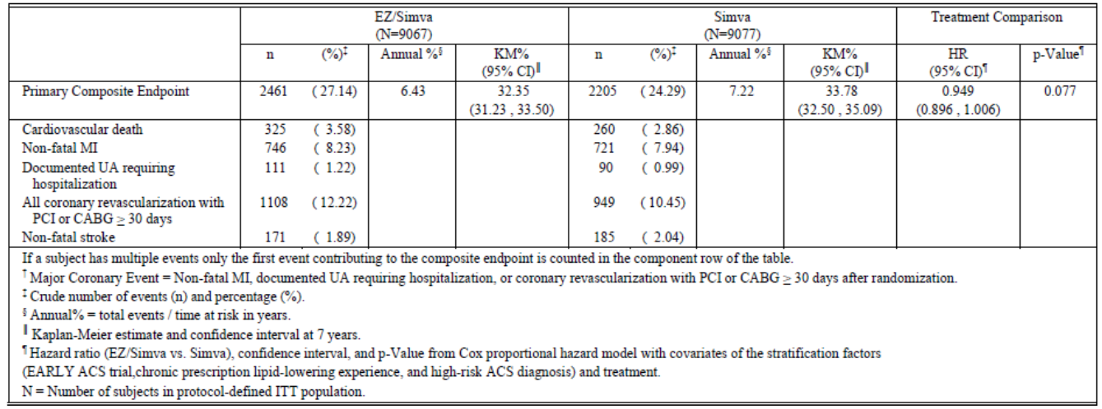

##### ***Question 3***

The ARR and NNT following combination treatment with ezetimibe/simvastatin compared to simvastatin monotherapy was not provided in the IMPROVE-IT study report. This is important to determine the actual clinical benefit following the modest 6.4% RRR in the primary composite endpoint and the sponsors are requested to provide this information.

##### Question 4

The proposed indication mentions ‘need for revascularisations’ which implies coronary and non-coronary revascularisation. This is not justified as the primary composite endpoint in the pivotal IMPROVE IT study specifically includes ‘all coronary revascularisation with either PCI or CABG occurring at least 30 days after randomisation’. Can the sponsors please provide justification for using the generalised term ‘need for revascularisations’ in the proposed indication?

Question 5

Could the endpoints in the pivotal IMPROVE-IT be considered competing events? Is the Cox PH model the best way of analysing data with co-dependent variables?

#### Safety

Question 6

The sponsors suggest that the similar incidence of myalgia in the ezetimibe/simvastatin and simvastatin monotherapy groups in the IMPROVE-IT study indicate no contribution from ezetimibe towards this common AE associated with statin therapy. However, it is important to note that there were more patients on the higher dose of simvastatin (80 mg) in the monotherapy group which may also imply that although more patients in the combination treatment group were on the lower dose of simvastatin (40 mg), the incidence of myalgia was similar in the two treatment groups suggesting a potential contributory role of ezetimibe. Due to the imbalance in use of simvastatin 80 mg in the two treatment groups, an exposure-adjusted rate of unexplained myalgia would have helped in interpretation of role of ezetimibe in myalgia. However, this was not provided in the CSR. Could the sponsor conduct an exposure-adjusted analysis of myalgia and provide the results for evaluation?

## Second round evaluation of clinical data

The sponsors have provided a Section 31 response to clinical questions raised by evaluators in Section 12. The S31 responses to the questions were similar for both Ezetrol and Vytorin and so evaluation of the S31 data is not presented separately.

Review of the sponsor’s response followed by evaluator’s comments on their response is presented below.

### Efficacy

#### Question 1

In the CSR of the IMPROVE-IT study, listing of subjects with the major protocol deviations was provided but summary tables were not provided. Listing of individual subjects with majority protocol deviations was provided but summary tables were not provided. Could the sponsor please provide the summary tables to confirm if the incidence of these protocol deviations was similar in the two treatment groups?

##### Sponsor response

The sponsors have provided a table (Table 11) which shows that the incidence of protocol deviations was similar across EZ/Simva and Simva treatment groups.

Table 11: Subjects with protocol deviations by treatment group.

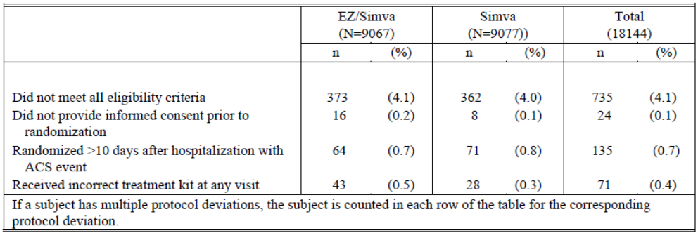

##### Evaluation of response

The response is satisfactory.

#### Question 2

The CSR states that the sensitivity analysis of the primary composite endpoint censoring subjects at the time of simvastatin up-titration showed that the results were generally consistent (Table 2). This statement by the sponsors in the CSR is inaccurate since the results in the table actually show a greater number of events in the ezetimibe/simvastatin group (2461/9067, 27.14%) compared with simvastatin alone (2205/9077, 24.29%) including a higher incidence of CV death, non-fatal MI, UA requiring hospitalisation and coronary revascularisation (PCI or CABG) in the ezetimibe/simvastatin group compared with the simvastatin monotherapy group (Table 10). The number of subjects who at some point had their dose of simvastatin increased from 40 to 80 mg per day was greater in the simvastatin group compared to the ezetimibe/simvastatin group (6.2% in the ezetimibe/simvastatin and 27.0% in the simvastatin monotherapy group) and the sponsors have stated that this would give a more conservative estimate of benefit of ezetimibe/ simvastatin and hence this sensitivity analysis was conducted censoring subjects at time of uptitration of simvastatin dose. Hence, the observation regarding a higher incidence of overall events and the individual components of the composite endpoint in the ezetimibe/ simvastatin group is of concern. Could the sponsors clarify this issue?

##### Sponsor response

The sponsors have clarified that key issues that affected the sensitivity analysis were the large discrepancy in titration rates between the ezetimibe/simvastatin and simvastatin only groups and the **number of events that were eliminated from the analysis** when censored at the time of titration. One hundred eleven (111) events in the ezetimibe/simvastatin group were eliminated from the sensitivity analysis compared to 537 events in the simvastatin only group. Hence, the sponsors suggest that the raw percentage is subject to bias due to the differential follow-up between the ezetimibe/simvastatin and simvastatin only groups caused by censoring at the time of titration. The annualised percentage, which takes into account the amount of time at risk, and the Kaplan-Meier rate, which takes into account the time to event and time to censoring are more appropriate measures than the raw percentage. Both the annualized percentage and the KM rate were lower in the ezetimibe/simvastatin group compared to the simvastatin only group in the sensitivity analysis and were generally consistent with the primary analysis [KM rates = (32.35% vs 33.78%); annualized percentages = (6.43 vs. 7.22 events per 100 patient years)].

##### Evaluator of response

The response is satisfactory although interpretation of these results were confounded by the huge difference between the ezetimibe/simvastatin and simvastatin groups in number of events that were eliminated from the sensitivity analysis.

#### Question 3

The ARR and NNT following combination treatment with ezetimibe/simvastatin compared to simvastatin monotherapy was not provided in the IMPROVE-IT study report. This is important to determine the actual clinical benefit following the modest 6.4% RRR in the primary composite endpoint and the sponsors are requested to provide this information.

##### Sponsor response

The number needed to treat, based on the primary efficacy endpoint for total trial follow-up in IMPROVE-IT is 50. IMPROVE-IT demonstrated benefit of add-on lipid lowering therapy in the context of well controlled LDL-C levels (~70 mg/dL or lower). In real world clinical practice, ezetimibe is generally considered as add-on therapy when subjects are farther from their LDL-C targets and have generally higher baseline LDL-C levels. In these settings, ezetimibe add-on treatment would be expected to result in larger absolute changes in LDL-C, and based upon our understanding of risk reduction with LDL-C lowering (CTT Collaborators, Lancet 2010), these patients will have an even greater CV benefit and thus a lower NNT would be anticipated. As a result, 50 is a reasonable NNT, given the study population, the well-controlled lipid values at baseline, and the minimal risks with utilization of Ezetimibe add-on therapy for prevention of CV events. In addition, while there are limitations in comparing NNTs across studies (due to differences in patient populations, comparator products and use of placebo control, different lengths of study length/follow-up, etc), it is helpful to put the IMPROVE-IT 7 year NNT into context with a comparison to the NNT of the TNT trial (Treating to New Targets). The TNT evaluated Atorva 80mg vs Atorva 10mg, with a primary endpoint of occurrence of first CV event of coronary death, non-fatal MI, resuscitated cardiac arrest or stroke. TNT had a median follow-up of 4.9 years, and an NNT of 45.

##### Evaluator of response

The patient population studied in the IMPROVE-IT study was different and as the sponsors mention, it is not possible to compare NNTs across studies. Hence, the following statement in the sponsor’s response is not justified: “In real world clinical practice, ezetimibe is generally considered as add-on therapy when subjects are farther from their LDL-C targets and have generally higher baseline LDL-C levels and that ezetimibe add-on treatment would be expected to result in larger absolute changes in LDL-C, and based upon our understanding of risk reduction with LDL-C lowering (CTT Collaborators, Lancet 2010), these patients will have an even greater CV benefit and thus a lower NNT would be anticipated.”

Results of the IMPROVE-IT study showed that additional reduction in LDL-C following add-on ezetimibe treatment was translated into a modest 6.4% relative risk reduction in the composite primary endpoint. Furthermore, the benefits were not robust due to no clear reduction in overall/ CV mortality, hospitalisation due to unstable angina and need for coronary revascularisation along with increased risk of fatal and haemorrhagic stroke.

#### Question 4

The proposed indication mentions ‘need for revascularisations’ which implies coronary and non-coronary revascularisation. This is not justified as the primary composite endpoint in the pivotal IMPROVE IT study specifically includes ‘all coronary revascularisation with either PCI or CABG occurring at least 30 days after randomisation’. Can the sponsors please provide justification for using the generalised term ‘need for revascularisations’ in the proposed indication?

##### Sponsor response

The sponsor agrees with the point raised, and is submitting a revised indication statement for review which utilizes the term “coronary revascularization”.

##### Evaluator of response

The response is satisfactory.

#### Question 5:

Could the endpoints in the pivotal IMPROVE-IT be considered competing events? Is the Cox PH model the best way of analysing data with co-dependent variables?

##### Sponsor response

The primary endpoint was a composite of 5 components and the analysis consisted of time to first event regardless of which component constituted the first event. Therefore, competing risks among the 5 components of the primary endpoint is not an issue and the Cox PH model is an appropriate method of analysis. Non-cardiovascular/unknown cause of death could be considered a competing risk with the primary endpoint. We performed a sensitivity analysis of the primary endpoint with non-cardiovascular/unknown cause of death as a competing risk using the method described by Fine and Gray. The results of the sensitivity analysis of the primary endpoint using the Fine and Gray method were supportive of the primary analysis: 1021 subjects without primary endpoint had non-cardiovascular/unknown death (ezetimibe/simvastatin = 517, simvastatin only = 504).

Primary endpoint results using standard Cox model: HR (95% CI) = 0.936 (0.887, 0.988), p=0.016.  
Primary endpoint results using Fine and Gray method: HR (95% CI) = 0.935 (0.886, 0.986), p=0.014.

##### Evaluator of response

The response is satisfactory, although it is important to note the upper limit of the 95% CI is almost unity for both the analyses.

### Safety

#### Question 6

The sponsors suggest that the similar incidence of myalgia in the ezetimibe/simvastatin and simvastatin monotherapy groups in the IMPROVE-IT study indicate no contribution from ezetimibe towards this common AE associated with statin therapy. However, it is important to note that there were more patients on the higher dose of simvastatin (80 mg) in the monotherapy group which may also imply that although more patients in the combination treatment group were on the lower dose of simvastatin (40 mg), the incidence of myalgia was similar in the two treatment groups suggesting a potential contributory role of ezetimibe. Due to the imbalance in use of simvastatin 80 mg in the two treatment groups, an exposure-adjusted rate of unexplained myalgia would have helped in interpretation of role of ezetimibe in myalgia. However, this was not provided in the CSR. Could the sponsor conduct an exposure-adjusted analysis of myalgia and provide the results for evaluation?

##### Sponsor response

The requested exposure-adjusted analysis of investigator reported unexplained myalgia was provided (Table 12). The exposure-adjusted rates do not suggest a difference in the risk of myalgia with ezetimibe/simvastatin compared to simvastatin alone.

Table 12: Exposure-adjusted rate of investigator reported unexplained myalgia by treatment group and dose (excluding subjects who never took study drug).

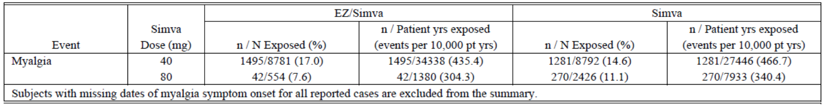

##### Evaluator of response

The response is satisfactory.

### Evaluation of sponsor’s response to first round CER

The sponsors have disagreed with certain statements made in the CER. These are mentioned here followed by the sponsor’s response and then the evaluator’s comments.

* *“It is important to note that majority (75%) of patients enrolled in the study were males, but the benefit in terms of reduction in the primary efficacy endpoint was lesser in males (compared to females) with 95% confidence intervals including unity. The relative risk reduction in the primary efficacy endpoint appeared to be slightly greater in the female population. Furthermore, there appears to be significantly greater benefit in patients aged>75years with smaller relative risk reduction in patients aged <75 years; however, interpretation may have been confounded by small sample size of patients aged >75 years.”*

##### Sponsor response

In the gender subgroup the hazard ratio in males was 0.952 (95% CI 0.895-1.012) and females was 0.885 (95% CI 0.791-0.991) with an unadjusted interaction p value of 0.267. Nominal p values exceeded the threshold of an unadjusted p value of 0.05 for an interaction in the age above and below 75 and diabetes subgroups. While such subgroup findings may be interesting and hypothesis-generating, firm conclusions are not possible. In addition these findings for gender, age, and diabetes were not observed in SHARP. The overall subgroup results of IMPROVE-IT are consistent with the CTT meta-analysis of statin trials where a consistent effect of statins was observed across various subgroups assessed, including gender, elderly subjects, diabetics, and high and low CV risk groups. The lack of biologic rationale (i.e., a difference in LDL-C change within subgroups was not observed), and in view of the overall consistency of the study and the lack of confirmation of the gender, age, and diabetes subgroup finding, makes the play of chance a reasonable explanation for these apparent differences.

##### Evaluator of response

The sponsor’s response is satisfactory.

* *(2A) “Overall, the benefit risk balance of Vytorin [Ezetrol (used with any statin)] for the proposed usage is unfavourable Overall, analysis of the individual CV event categories did not show any benefit in rates of death from any cause, CV death, CHD, fatal MI, fatal stroke, unstable angina requiring hospitalisation or all coronary revascularisation with PCI or CABG (> 30 days after randomisation). Clear benefit of simvastatin monotherapy was only observed for non-fatal MI, non-fatal (non-haemorrhagic) stroke. The risk of haemorrhagic stroke appears to increase with simvastatin/ezetimibe treatment.”*

##### Sponsor response

IMPROVE-IT demonstrated that treatment with ezetimibe/simvastatin provided incremental benefit in reducing the primary composite endpoint of cardiovascular death, major coronary event (MCE), and non-fatal stroke compared with simvastatin alone (HR 0.936; 95% CI 0.887 - 0.988; p=0.016). Consistent with the primary endpoint analysis, the 3 secondary composite endpoint analyses were also significant. Given power and lack of multiplicity control, firm conclusions relating to individual endpoints (such as components of the primary endpoint) are not possible. In the ezetimibe/ simvastatin treatment group fewer subjects experienced stroke events compared to the simvastatin monotherapy group; (fatal or non-fatal stroke HR 0.857, 95% CI 0.734 – 1.001; p=0.052, non-fatal stroke HR 0.802, 95% CI 0.678 – 0.949; p=0.010). The rate of fatal stroke was low and similar between the treatment groups. Haemorrhagic strokes occurred much less frequently than non-haemorrhagic strokes in IMPROVE-IT. However, more subjects in the protocol-specified ITT population treated with ezetimibe/ simvastatin suffered a haemorrhagic stroke (59 events [7-yr KM 0.77%] in the ezetimibe/ simvastatin group and 43 events [7-yr KM 0.59%] in the simvastatin group) (HR 1.377; 95% CI 0.930 – 2.040; p=0.110). Furthermore, an imbalance for haemorrhagic stroke was not evident in the on-treatment analysis, which censored events that occurred 30 days after study drug discontinuation. In this on-treatment analysis there were 32 subjects (7-yr KM 0.58%) with occurrence of haemorrhagic stroke in the ezetimibe/simvastatin group and 34 subjects (7-yr KM 0.59%) with occurrence of haemorrhagic stroke in the simvastatin group (HR 0.937; 95% CI 0.578 -1.519, p=0.793). Given these findings, concrete conclusions are not possible. It should be noted a similar imbalance for haemorrhagic stroke has been reported in previous statin studies, and as highlighted in the CTT analyses [3] this imbalance is off-set by the benefit seen in preventing the much more frequently occurring non-haemorrhagic stroke. Haemorrhagic stroke remains an important potential risk as detailed in the Vytorin Risk Management Plan. MSD has committed to performing routine pharmacovigilance of haemorrhagic stroke through the monitoring and evaluation of reports of haemorrhagic stroke and related haemorrhagic stroke events reported in patients treated with ezetimibe/ simvastatin. Upon periodic review of the data, appropriate measures (such as updating of the SmPC) will be taken if new information is obtained that alters the risk/benefit profile of ezetimibe/simvastatin.

##### Evaluator of response

Although, it is accepted that firm conclusions cannot be made regarding individual endpoints of the composite endpoint, it is still concerning that the benefit with ezetimibe/simvastatin compared to simvastatin alone was mainly based on non-fatal MI and non-fatal (non-haemorrhagic) stroke only. As mentioned above, the CHMP guidelines clearly state that “to provide supportive information, and to ensure reliable interpretation, analysis of each separate component of the composite should be presented. For overall mortality and cardiovascular mortality both confidence intervals and point estimates are relevant for assessment and any point estimate considerably in favour of the comparator is a matter of concern. Table 13 shows that HR was ≥ unity for deaths from all causes, CV death, non-CV deaths, unknown deaths and 95% CI also included unity. Furthermore, there was no clear reduction in incidence of hospitalisation due to unstable angina or need for coronary revascularisation although the proposed indication includes these events.

Table 13: Analysis of tertiary and CV events (protocol defined ITT population).

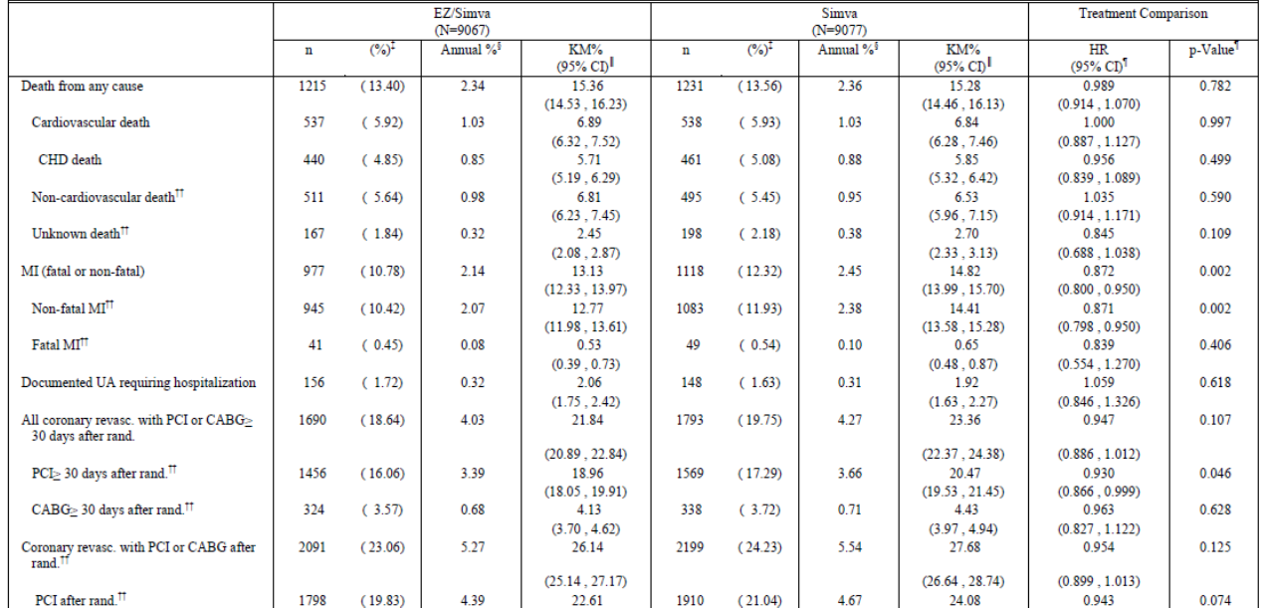

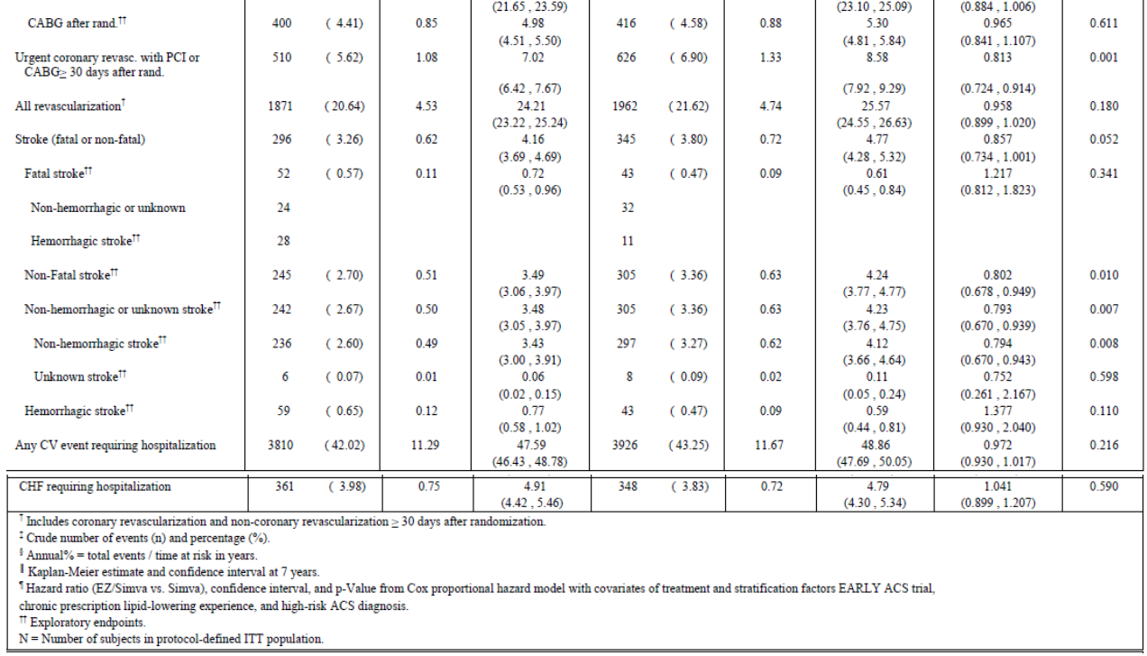

* *(2B) “While it is accepted that the CV prevention benefits of ezetimibe with a statin are related to its LDL-C lowering capacity, the evidence from the IMPROVE-IT study is that the incremental LDL-C reduction observed by adding ezetimibe 10mg to simvastatin 40mg only translated into a modest 6.4% relative risk reduction in CV events.”*

##### Sponsor response

At the time IMPROVE-IT was initiated, LDL-C lowering down to the range of ~70 mg/dL (1.8 mmol/L) became the standard of care for patients presenting with ACS in many parts of the world and was incorporated into lipid treatment guidelines [4]. The entry criteria for IMPROVE-IT therefore, restricted LDL-C at entry in order to ensure that the control group would achieve an average LDL-C <70 mg/dL (1.8 mmol/L). This lipid entry criterion was established to evaluate a critical question related to cholesterol-lowering therapy in general – namely whether reducing LDL-C to levels even lower than those recommended (at the time the study was initiated) would further decrease CV risk. Given the observations from the CTT meta-analyses that CV risk reduction is proportional to absolute changes in LDL-C, this low LDL-C entry criterion for IMPROVE-IT limited the degree of LDL-C lowering that could be achieved, along with the potential related CV risk reduction. Given the LDL-C lowering achieved, the clinical benefit with ezetimibe add-on therapy in IMPROVE-IT is entirely consistent with what would be expected. Furthermore, the additional benefit of ezetimibe add-on therapy is entirely consistent with the expected benefit with statin therapy with a similar degree of LDL-C lowering. This is demonstrated by the comparison of the IMPROVE-IT results with the results from the Cholesterol Treatment Trialist (CTT) meta-analysis. The CTT meta-analysis includes data from 26 statin CV outcome trials of approximately 170,000 subjects. This meta-analysis demonstrated a strong relationship between the absolute degree of LDL-C lowering and proportional decrease in CV disease risk across a broad range of LDL-C levels and patient characteristics. The CTT meta-analysis reported a 22% CV risk reduction per mmol/L LDL-C lowering [3]. Using CTT methodology, as previously described in the CSR [Sec. 5.3.5.1.P04103.4.10.2], IMPROVE-IT identified a very similar relationship for ezetimibe mediated LDL-C lowering and CV risk reduction - a 20% CV risk reduction per mmol/L LDL-C lowering. The consistent nature of the ezetimibe-mediated IMPROVE-IT result with the expected benefit based upon the CTT meta-analysis is clearly demonstrated in Figure 6. Although the risk reduction for the primary endpoint was 6.4%, the results for MACE, the exploratory composite endpoint representing major atherosclerotic events- fatal and non-fatal MIs and stroke, appeared somewhat larger at 9.9% (HR 0.901; 95% CI 0.841 – 0.965) in the ezetimibe/simvastatin group compared to placebo. Also although there was a limited effect on cardiovascular death (HR 1.000; 95% CI 0.887-1.127, p= 0.997)), treatment with ezetimibe/simvastatin was shown to reduce the rate of non-haemorrhagic stroke (HR 0.794; 95% CI 0.670 - 0.943, p=0.008) and fatal and non-fatal myocardial infarction (HR 0.872; 95% CI 0.800-0.950, p=0.002). MSD concludes that the benefit demonstrated in IMPROVE-IT is as expected, given the current state of knowledge related to lipid lowering therapy and expected CV benefit and risk reduction. To expect a larger risk reduction in IMPROVE-IT would require ezetimibe to have benefits that go beyond its effect on LDL-C and beyond the risk reduction expected with statin therapy with an equivalent degree of LDL-C lowering. It is important to note the CV risk reduction benefit provided by ezetimibe add-on therapy comes with minimal risk for the patient.

Figure 6: Plot of IMPROVE-IT trial data and statin trials for change in LDL-C versus clinical benefit.

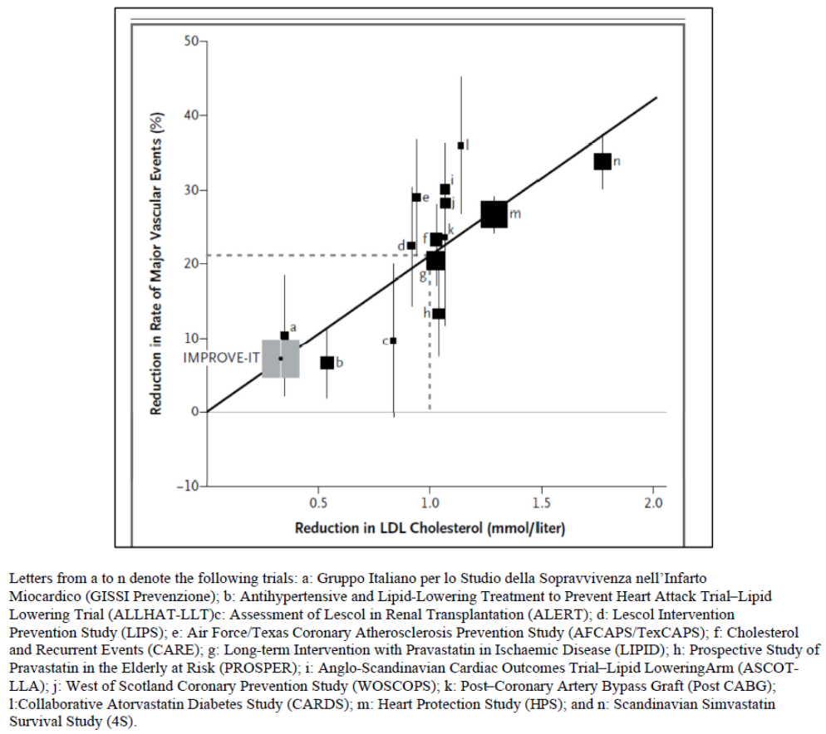

##### Evaluator of response

Given the observations from the CTT meta-analyses that CV risk reduction is proportional to absolute changes in LDL-C, the low LDL-C entry criterion for IMPROVE-IT limited the degree of LDL-C lowering that could be achieved, along with the potential related CV risk reduction. The sponsor states that given the LDL-C lowering achieved, the clinical benefit with ezetimibe add-on therapy in IMPROVE-IT is consistent with what would be expected in a patient population with baseline line LDC-L ≤70mg/dL). However, the additional reduction in LDL-C was translated into a modest 6.4% relative risk reduction in the composite primary endpoint. Furthermore, the benefits were not robust due to no clear reduction in overall CV mortality, hospitalisation due to unstable angina and need for coronary revascularisation along with increased risk of fatal and haemorrhagic stroke.

* *(2C) “The proposed indication states that ezetimibe 10mg could be used with ‘any statin’ but the only data available is from the IMPROVE-IT study which used only simvastatin and there is no evidence to support administration of ezetimibe 10mg with simvastatin doses >40mg. While it is accepted that the CV prevention benefits of ezetimibe with a statin are related to its LDL-C lowering capacity, this has not been directly assessed for any of the newer statins. Furthermore, it is important to stress that for incremental cardiovascular event reduction in patients with coronary heart disease, ezetimibe 10mg may only be administered with a statin with proven cardiovascular benefit (statin which have already received approval for indication of CV prevention in patients with CHD).”*

##### Sponsor response

The sponsors have agreed with the evaluators initial statements and proposed the following indications text for Ezetrol:

*Indications: Adults (>18 years) Prevention of Cardiovascular Disease: Ezetrol, administered with a statin* ***with proven cardiovascular benefit****, is indicated to reduce the risk of cardiovascular events (cardiovascular death, nonfatal myocardial infarction, nonfatal stroke, hospitalization for unstable angina, or need for* ***coronary*** *revascularisation), in patients with coronary heart disease (CHD).*

In response to the statement in the CER that there is no evidence that the benefit-risk profile would be favourable at simvastatin doses>40mg, the sponsors provided the following response:

Although ezetimibe/simvastatin 10/40 mg was the starting dose in IMPROVE-IT, MSD believes the results support the use of ezetimibe/simvastatin across the dose range, for prevention of cardiovascular disease in patients with coronary heart disease. As noted below, MSD’s current proposed label for Vytorin provides dosing guidance for patients with CHD by referencing the starting dose used in IMPROVE-IT:

*[In the cardiovascular events risk reduction study (IMPROVE-IT), the starting dose was 10/40 mg once a day in the evening.]*

Ezetimibe provides a consistent proportional additive decrease in LDL-C levels when added to or co-administered with any statin at any statin dose. A pooled analysis from 27 lipid lowering trials including over 21,000 subjects showed clearly that ezetimibe has a consistent additive lipid lowering effect when added to different statins, different doses of statin, and statins of varying potency, and across a diverse patient population. This is consistent with the fact that ezetimibe co-administered with a statin is approved for the treatment of hypercholesterolemia, without any specific limitation on statin type or dose. The CTT meta-analysis of 26 statin CV outcomes trials evaluating various statins at a broad range of doses demonstrated a strong relationship between the absolute degree of LDL-C lowering and proportional decrease in CV disease risk irrespective of the statin brand or statin dose used in the trial. As previously discussed, the CTT meta-analysis reported a 22% CV risk reduction per mmol/L LDL-C lowering. Using CTT methodology, IMPROVE-IT identified a very similar relationship for ezetimibe mediated LDL-C lowering and CV risk reduction – a 20% CV risk reduction per mmol/L LDL-C lowering. Given this consistency, we would expect the add-on benefit of ezetimibe to be consistent across the range of LDL-C values in the CTT analysis, supporting effectiveness of ezetimibe in a broad range of patient populations, and statin types and potencies.

Given the consistent LDL-C lowering efficacy of ezetimibe with all statins and all doses, and the consistency of IMPROVE-IT with the CTT meta-analysis, one would expect ezetimibe to have similar CV event reduction when administered with any statin at any dose. Therefore, MSD believes Vytorin should be indicated to reduce the risk of cardiovascular events in patients with CHD, across the available dosage range.

In regards to risk, based on the findings in the SEARCH trial MSD’s proposed label cautions about the use of the 10/80 mg dose:

*[The risk of myopathy is greater in patients on simvastatin 80 mg compared with other statin-base therapies with similar LDL-C lowering efficacy. Therefore the 10/80 mg dose of Vytorin should only be used in patients at high risk for cardiovascular complications who have not achieve their treatment goals on lower doses and when the benefits are expected to outweigh the potential risks.]*

##### Evaluator of response

The modified indication for Ezetrol addresses the evaluator’s query.

The sponsor’s explanation that there are adequate identification of cautions in the proposed label for Vytorin regarding use of the 80 mg dose of simvastatin is also satisfactory. Furthermore, the sponsor has also agreed to the removal of the following sentence from the proposed PI for Vytorin:

*The 10/80 mg dose is only recommended when the benefits are expected to outweigh the potential risks.*

## Second round benefit-risk assessment

### Second round assessment of benefits

After consideration of responses to clinical questions and other information submitted by the sponsors, the benefits of Ezetrol/Vytorin in proposed use for prevention of cardiovascular disease remain unchanged from those identified above.

### Second round assessment of risks

After consideration of responses to clinical questions and other information submitted by the sponsors, the risks of Ezetrol/ Vytorin in proposed uses are as follows:

The risks of Ezetrol in the proposed usage for CV prevention in patients with CHD are:

* The modest 6.4% relative risk reduction in the primary composite endpoint appears to be mainly driven by reduction in non-fatal MI and non-fatal stroke (mainly non-haemorrhagic stroke). There was no reduction in risk of non-CV and CV deaths, hospitalisation for unstable angina and need for revascularisation although these are included in the proposed indication.
* Patients in the ezetimibe/simvastatin group were at higher risk of experiencing fatal stroke (HR: Ez/Sim: Sim=1.217) and haemorrhagic stroke (HR=1.377); the NNH (Number needed to harm) was not provided.

Although it is expected that the additional LDL-C lowering with ezetimibe with any statin would further reduce the risk of CV disease, the incremental CV benefits of ezetimibe on top of other newer statins has not been directly assessed.

* Risk of rhabdomyolysis/ myopathy, malignancies; gallbladder disorders, pancreatitis and interstitial lung disease, acute renal failure and hypersensitivity.

The risks of Vytorin in the proposed usage for CV prevention in patients with CHD are:

* The modest 6.4% relative risk reduction in the primary composite endpoint appears to be mainly driven by reduction in non-fatal MI and non-fatal stroke (mainly non-haemorrhagic stroke). There was no reduction in risk of non-CV and CV deaths, hospitalisation for unstable angina and need for revascularisation although these are included in the proposed indication.
* Patients in the ezetimibe/simvastatin group were at higher risk of experiencing fatal stroke (HR: Ez/Sim: Sim=1.217) and haemorrhagic stroke (HR=1.377); the NNH (Number needed to harm) was not provided
* Risk of rhabdomyolysis/ myopathy, malignancies; gallbladder disorders, pancreatitis and interstitial lung disease, acute renal failure and hypersensitivity.

### Second round assessment of benefit-risk balance

After consideration of responses to clinical questions and other information submitted by the sponsors, the benefit-risk profile of Ezetrol (with a statin) and Vytorin remain unfavourable for the proposed indication of:

*Prevention of cardiovascular disease to reduce the risk of cardiovascular events (cardiovascular death, nonfatal myocardial infarction, nonfatal stroke, hospitalization for unstable angina, or need for* ***coronary*** *revascularisation), in patients with coronary heart disease (CHD).*

## Second round recommendation regarding authorisation

### Ezetrol

In response to the first round CER, the sponsors have modified the proposed indication to the following:

*Indications: Adults (>18 years) Prevention of Cardiovascular Disease: Ezetrol, administered with a statin with proven cardiovascular benefit, is indicated to reduce the risk of cardiovascular events (cardiovascular death, nonfatal myocardial infarction, nonfatal stroke, hospitalization for unstable angina, or need for coronary revascularisation), in patients with coronary heart disease (CHD).*

After review of the S31 response, it is still recommended that submission for registration of Ezetrol for the indication of prevention of major cardiovascular events in patients with coronary heart disease (CHD) be rejected . The main reason for the rejection is:

* The additional reduction in LDL-C achieved due to ezetimibe add-on treatment was translated into a modest 6.4% relative risk reduction in composite primary endpoint with ezetimibe/simvastatin compared to simvastatin alone. The proposed indication states that Ezetrol with a statin reduces the risk of cardiovascular events (cardiovascular death, nonfatal myocardial infarction, nonfatal stroke, hospitalization for unstable angina, or need for coronary revascularisation), in patients with coronary heart disease (CHD). However, clear benefits were only observed in terms of reduced risk of nonfatal MI and nonfatal stroke. There was no clear reduction in CV death, hospitalisation due to unstable angina and need for coronary revascularisation (incidence in the ezetimibe/simvastatin was similar to or slightly higher than that in the simvastatin group) and there appears to be an increased risk of haemorrhagic stroke and fatal stroke.
* Although a stand-alone indication for CV prevention is not acceptable, it is acknowledged that the IMPROVE-IT trial has provided vast clinical data in over 18000 patients evaluating CV prevention role of ezetimibe when used in combination with simvastatin. Hence, the information regarding results of the IMPROVE-IT trial could still be retained (with appropriate caveats regarding effects on CV death, hospitalisation due to unstable angina and need for coronary revascularisation and increased risk of fatal/haemorrhagic stroke) in the ‘Clinical trials’ section of the proposed PI for Ezetrol as discussed.

### Vytorin

In response to the first round CER, the sponsors have modified the proposed indication to the following:

*Indications: Adults (>18 years) Prevention of Cardiovascular Disease: Vytorin is indicated to reduce the risk of cardiovascular events (cardiovascular death, nonfatal myocardial infarction, nonfatal stroke, hospitalization for unstable angina, or need for coronary revascularisation), in patients with coronary heart disease (CHD).*

After review of the S31 response, it is still recommended that submission for registration of Vytorin for the above indication be rejected. The main reason for the rejection is:

* The additional reduction in LDL-C achieved due to ezetimibe add-on treatment was translated into a modest 6.4% relative risk reduction in composite primary endpoint with ezetimibe/simvastatin compared to simvastatin alone. The proposed indication states that Vytorin reduces the risk of cardiovascular events (cardiovascular death, nonfatal myocardial infarction, nonfatal stroke, hospitalization for unstable angina, or need for coronary revascularisation), in patients with coronary heart disease (CHD). However, clear benefits were only observed in terms of reduced risk of nonfatal MI and nonfatal stroke. There was no clear reduction in CV death, hospitalisation due to unstable angina and need for coronary revascularisation (incidence in the ezetimibe/simvastatin was similar to or slightly higher than that in the simvastatin group) and there appears to be an increased risk of haemorrhagic stroke and fatal stroke.
* Although a stand-alone indication for CV prevention is not acceptable, it is acknowledged that the IMPROVE-IT trial has provided vast clinical data in over 18000 patients evaluating CV prevention role of ezetimibe when used in combination with simvastatin. Hence, the information regarding results of the IMPROVE-IT trial could still be retained (with appropriate caveats regarding effects on CV death, hospitalisation due to unstable angina and need for coronary revascularisation and increased risk of fatal/haemorrhagic stroke) in the ‘Clinical trials’ section of the proposed PI for Ezetrol as discussed.

## References

Baigent C, et al. ISIS­2: 10 year survival among patients with suspected acute myocardial infarction in randomised comparison of intravenous streptokinase, oral aspirin, both, or neither. BMJ 1998; 316:1337–43.

Ballantyne CM, et al: Effect of ezetimibe coadministered with atorvastatin in 628 patients with primary hypercholesterolemia: a prospective randomised, double-blind trial. Circulation (2003); 107: 2409-2415.

Bengt CF, et al. Rosuvastatin and cardiovascular events in patients undergoing haemodialysis. N Engl J Med 2009;360:1395-407.

Bhatt D, et al. Comparative determinants of 4-year cardiovascular event rates in stable outpatients at risk of or with atherothrombosis. JAMA. 2010; 304(12):1350-1357

Cannon CP, Braunwald E, McCabe CH, et al. Intensive versus moderate lipid lowering with statins after acute coronary syndromes. N Engl J Med 2004; 350: 1495–504.

Cannon CP, Braunwald E, McCabe CH, Rader DJ, Rouleau JL, Belder R, et al. Intensive versus moderate lipid lowering with statins after acute coronary syndromes. N Engl J Med 2004; 350:1495-504.

Cannon CP, Steinberg BA, Murphy SA, Mega JL, Braunwald E. Meta-analysis of cardiovascular outcomes trials comparing intensive versus moderate statin therapy. J Am Coll Cardiol 2006; 48: 438–45.

Cholesterol Treatment Trialists’ (CTT) Collaboration: Efficacy and safety of more intensive lowering of LDL cholesterol: a meta-analysis of data from 170 000 participants in 26 randomised trials. Lancet 2010; 376: 1670–81

Cholesterol Treatment Trialists’ (CTT) Collaboration: The effects of lowering LDL cholesterol with statin therapy in people at low risk of vascular disease: meta-analysis of individual data from 27 randomised trials. Lancet 2012; 380: 581–90

Collins R, Armitage J, Parish S, Sleight P, Peto R. MRC/BHF heart protection study of cholesterol lowering with simvastatin in 20 536 high-risk individuals: a randomised placebo controlled trial. Articles 2002;360:7-22.

CTT collaborators: Efficacy and safety of cholesterol-lowering treatment: prospective meta-analysis of data from 90 056 participants in 14 randomised trials of statins. Lancet 2005; 366: 1267–78.

Davidson MH, et al; Ezetimibe co-administered with simvastatin in patients with primary hypercholesterolemia. J Am Coll Cardiol 2002; 40: 2125-34.

de Lemos JA, Blazing MA, Wiviott SD, et al. Early intensive vs a delayed conservative simvastatin strategy in patients with acute coronary syndromes: phase Z of the A to Z trial. JAMA 2004; 292: 1307–16.

ESC guidelines of CV prevention in clinical practice (version 2012): The Fifth Joint Task Force of the European Society of Cardiology and Other Societies on Cardiovascular Disease Prevention in Clinical Practice (constituted by representatives of nine societies and by invited experts. European Heart Journal (2012) 33, 1635–1701

ESC/EAS Guidelines for the management of dyslipidaemias The Task Force for the management of dyslipidaemias of the European Society of Cardiology (ESC) and the European Atherosclerosis Society (EAS). European Heart Journal (2011) 32, 1769–1818

Guyton JR, et al. Relationship of lipoproteins to cardiovascular events. The AIM-HIGH Trial (Atherothrombosis Intervention in Metabolic Syndrome With Low HDL/High Triglycerides and Impact on Global Health Outcomes). Journal of American College of Cardiology. Vol. 62, No. 17, 2013.

Holme I, et al. Observed and Predicted Reduction of Ischemic Cardiovascular Events in the Simvastatin and Ezetimibe in Aortic Stenosis Trial Am J Cardiol 2010 (article in press)

HPS2-THRIVE Collaboration group. Effects of extended-release Niacin with Laropiprant in High-risk patients. N Engl J Med 2014;371:203-12.

Karlis DG, et al. Use of Lipid-Lowering Medications and the Likelihood of Achieving Optimal LDL-Cholesterol Goals in Coronary Artery Disease Patients. Cholesterol Volume 2012, Article ID 861924, 7 pages.

Kerzner B, et al. Efficacy and safety of ezetimibe co-administered with lovastatin in primary hypercholesterolemia. Am J Cardiol 2003; 91: 418-424.

LaRosa JC, et al. Intensive lipid lowering with atorvastatin in patients with stable coronary disease. N Engl J Med 2005; 352: 1425-35

LaRosa JC, Grundy SM, Waters DD, et al. Intensive lipid lowering with atorvastatin in patients with stable coronary disease. N Engl J Med 2005; 352: 1425–35.

Mahaffey KW, et al. Comparison of clinical trial outcome patterns in patients following acute coronary syndromes and in patients with chronic stable atherosclerosis. Clin. Cardiol. 37, 6, 337–342 (2014)

Melani L, et al. Efficacy and safety of exetimibe coadministered with pravastatin in primary hypercholesterolemia: a prospective randomised, double-blind trial. European Heart Journal (2003) 24: 717-728.

Morrone D, et al: Lipid-altering efficacy of ezetimibe plus statin and statin monotherapy and identification of factors associated with treatment response: A pooled analysis of over 21,000 subjects from 27 clinical trials. Atherosclerosis (2012); 223: 251e261.

Myocardial infarction Genetics Consortium: Inactivating mutations in NPC1L1 and protection from coronary heart disease. New England Journal of Medicine 2014; 371: 2072-82.

Pedersen TR, Faergeman O, Kastelein JJ, et al. High-dose atorvastatin vs usual-dose simvastatin for secondary prevention after myocardial infarction: the IDEAL study: a randomised controlled trial. JAMA 2005; 294: 2437–45.

Ray KK, et al. Early and Late Benefits of High-Dose Atorvastatin in Patients With Acute Coronary Syndromes Results From the PROVE IT-TIMI 22 Trial. Am Coll Cardiol 2005;46:1405–10

Rosseba AB, et al. Intensive Lipid Lowering with Simvastatin and Ezetimibe in Aortic Stenosis N Engl J Med 2008;359:1343-56.

Santos Rd, et al. A comparison of non-HDL and LDL cholesterol goal attainment in a large, multinational patient population: The Lipid Treatment Assessment Project 2. Atherosclerosis 2012; 224: 150e153.

Scandinavian Simvastatin Survival Study Group. Randomised trial of cholesterol lowering in 4444 patients with coronary heart disease: the Scandinavian Simvastatin Survival Study (4S). Lancet 1994;344:1383-9.

Schwartz GC, et al. Effects of Dalcetrapib in patients with recent Acute Coronary Syndrome. N Engl J Med 2012;367:2089-99.

Steinberg BA, et al. Nine-year trends in achievement of risk factor goals in the US and European outpatients with cardiovascular disease. Am Heart J 2008;156:719-27

Study of the Effectiveness of Additional Reductions in Cholesterol and Homocysteine (SEARCH) Collaborative Group. Intensive lowering of LDL cholesterol with 80 mg versus 20 mg simvastatin daily in 12 064 survivors of myocardial infarction: a double-blind randomised trial. Lancet 2010; published online Nov 9. DOI:10.1016/S0140-6736(10)60310-8.

Tariq SM, et al. HDL Hypothesis: Where do we stand now? Curr Atheroscler Rep (2014) 16:398

The ACCORD study group. Effects of combination lipid therapy in Type 2 Diabetes Mellitus. N Engl J Med 2010;362:1563-74.

Wanner MD,et al. Atorvastatin in patients with Type 2 Diabetes Melitus undergoing haemodialysis. N Engl J Med 2005;353: 238-48.

Waters DD, et al: Lipid Treatment Assessment Project 2 A Multinational Survey to Evaluate the Proportion of Patients Achieving Low-Density Lipoprotein Cholesterol Goals Circulation. 2009;120: 28-34.

|  |
| --- |
| Therapeutic Goods Administration |
| PO Box 100 Woden ACT 2606 Australia  Email: [info@tga.gov.au](mailto:info@tga.gov.au) Phone: 1800 020 653 Fax: 02 6232 8605  <https://www.tga.gov.au> |

1. To evaluate the percentage of subjects achieving endpoint concentrations of LDL-C of <70 mg/dL (<1.8 mmol/L) and hs-CRP of <2.0 mg/L following 1 month and 4 months of treatment with Ezetimibe/Simvastatin Combination compared with simvastatin.
2. Although subsequent staged PCI procedures were permitted, all planned PCIs that were known at the time of screening must have been completed within 30 days of Randomisation. Whenever possible, PCI procedures (including staged procedures) known to be indicated at the time of screening should have been completed prior to Randomisation.
3. The acute segment of EARLY-ACS treatment was the initial phase of administration of randomised treatment with eptifibatide or matching placebo through catheterisation.
4. Furthermore, subject was eligible to enter directly into the current trial ≤ 10 days (≤ 240 hours) of acute admittance into a hospital if he/she had been clinically stable for at least 24 hours prior to screening/randomisation.
5. This was 1 item in a list of 8 criteria. If the subject had had CABG within the 3 years prior, they still may have been eligible if at least one criterion of a–f or h from this list were met.
6. TC concentration ≤190 mg/dL (≤4.9 mmol/L) for a lipid-therapy naïve subject; b. TC concentration ≤150 mg/dL (≤3.9 mmol/L) for a subject receiving chronic prescription lipid-lowering therapy.
7. All postmenarchal women who were <2 years menopausal or who had not had surgical sterilisation or a hysterectomy were considered to be women of child-bearing potential. Acceptable methods of contraception included condoms (male or female) with or without a spermicidal agent, diaphragm or cervical cap with spermicide, medically prescribed intrauterine device (IUD), oral or injectable hormonal contraceptive, and surgical sterilisation (e.g., hysterectomy or tubal ligation).
8. Hypotension was defined as (1) sustained systolic blood pressure of <90 mmHg due to cardiac failure with associated symptoms; (2) Unstable or severe pulmonary oedema/decompensated CHF; (3) Acute mitral regurgitation; (4) Acute ventricular septal defect.
9. Ventricular fibrillation; Sustained ventricular tachycardia lasting >30 seconds or in association with symptoms; Complete heart block; High grade second degree heart block.
10. A subject participating in the EARLY-ACS Trial (Protocol No. P03684) was not necessarily to be excluded. A subject participating in clinical research of approved therapy being administered according to the therapy’s labeled use was not to be excluded.
11. National Cholesterol Education Program, National Heart Lung and Blood Institute, National Institutes of Health. Third report of the National Cholesterol Education Program (NCEP) expert panel on detection, evaluation, and treatment of high blood cholesterol in adults (Adult Treatment Panel III) final report. NIH publication no. 02-5215.
12. Study staff maintained an ongoing record of the dispensing and return of all study medication for each subject on the Test Article Accountability Ledger (TAAL) that was to be verified by the sponsor’s study monitor.
13. At randomisation, subjects were assigned a randomisation number corresponding to an initial treatment group according to their sequential entrance into the trial. This randomisation number was determined by a computer-generated random code. It was provided to the trial site by the Central Randomisation Centre at the time the subject received randomised treatment assignment. Treatment was to be started as close as possible to the date in which randomised treatment is assigned, preferably on the same day.
14. This independent statistician was not involved in the day-to-day project activities. The remaining DCRI study personnel, like all other persons associated with the trial (with the exception of the DSMB and unblinding to LDL-C for the LMC) remained completely blinded throughout the duration of the trial.
15. If the investigator needed to identify the treatment assignment of an individual subject, the investigator or qualified designee was to call the TIMI Hotline. The TIMI Hotline would then contact the Central Randomisation Centre. Unblinding performed by the Central Randomisation Centre at the request of the investigator was to be reported in writing by the investigator to the sponsor, including a written explanation of the reason why the blind was broken.
16. Specifically, a nominal alpha level of 0.003 will be used for the first interim analysis (50% of events) and a nominal alpha level of 0.0184 will be used for the second interim analysis (75% of events). For the final analysis, the primary endpoint was tested at a nominal alpha level of 0.0438.
17. Clinical follow-up was defined as time from randomisation to the last office or telephone visit or time to death, provided that death occurred within 4 months of an office or telephone visit.
18. Unblinding during the study was to occur only in the event of an emergency or adverse event for which it was necessary to know the study treatment to determine an appropriate course of therapy for the subject.
19. The analysis uses up to the 4th event per subject since only a small number of subjects had more than 4 events.
20. During the trial, subjects were requested to fast for 12 hours prior to scheduled blood work, however, blood was collected regardless of the fasting state of the subject in the event that they failed to fast.
21. A composite endpoint for IMPROVE-IT that was consistent with the CTT major vascular event endpoint (CTT-MVE: namely CHD death, non-fatal MI, coronary revascularisation that occurred ≥ 30 days after randomisation and stroke; e.g. the primary endpoint of IMPROVE IT excluding unstable angina) was identified and assessed.
22. National Cholesterol Education Program, National Heart Lung and Blood Institute, National Institutes of Health. Third report of the National Cholesterol Education Program (NCEP) expert panel on detection, evaluation, and treatment of high blood cholesterol in adults (Adult Treatment Panel III) final report. NIH publication no. 02-5215.
23. Analysis similar to the protocol-defined ITT approach in the SAP, but excluding subjects who never took study drug. Analysis similar to the protocol-defined ITT approach in the SAP, but excluding subjects who never took study drug and limited to the time period when subjects are on- treatment up to and including 30 days after the last dose of study drug.
24. In all AE tables, an individual is counted only once for each system organ class (SOC) (e.g. gastrointestinal disorders) where he/she reported one or more adverse experiences. However, for each specific adverse experience term (e.g. nausea), the total number of patients reporting that adverse experience was recorded. Thus, the same patient may appear in different categories.
25. NSAEs excluded MVE, cancer, TIA, hospitalisation for angina or heart failure, dialysis access revision, diabetes and hypoglycaemia, initiation of dialysis, renal transplantation, pancreatitis, hepatitis, gallstone complications/hospitalisations, myopathy and rhabdomyolysis.
26. Haemodialysis access (excluding revision) comprises a number of adverse events and/or procedures related to access lines or fistulas for dialysis: venoplasty of central venous stenosis, insertion of a tunneled or temporary venous line, creation of a permanent arteriovenous fistula, creation of a synthetic graft for dialysis, removal of an arteriovenous fistula/graft, bleeding from an arteriovenous fistula/graft, infected arteriovenous fistula/graft, infection of a localised dialysis catheter, sepsis secondary to a dialysis catheter infection, and removal of a haemodialysis catheter.
27. Persistently elevated transaminases were defined as at least 2 consecutive elevations in ALT and/or AST>3xULN.
28. Serum CK was measured at baseline and at regularly scheduled visits after the initiation of Amendment #5 . Prior to Amendment 5 (June22, 2011) CK was only routinely measured at baseline, or when a subject reported unexplained muscle symptoms.
29. Four subjects received 40mg and 5 received 80mg simvastatin; resolved following discontinuation of drug in 7 of 9 subjects and many subjects had contributing factors.
30. This form included a brief narrative of the episode, specifics around exercise, concomitant medications, associated illnesses or renal injury, and CK and other laboratory values (if obtained). The investigator indicated as well whether the case reflected elevated CK without associated myalgia symptoms (such cases were not considered true myalgia for purposes of this analysis).
31. Biliary Tract Disorders SMQ; Gallbladder Related Disorders SMQ; Gallstone Related Disorders SMQ.
32. Investigators were required to report (on a specific “Malignancy” eCRF) detailed information for any malignancy/neoplasm that was newly diagnosed after randomisation (regardless of the timing of the last dose of study drug), as well as pre-existing malignancies that worsened, relapsed, or caused a new AE after randomisation. Source documentation for all such events was collected and all cases were submitted for adjudication by oncology members of the CEC. These events were classified as to whether or not they were malignant, site of origin, extent of disease involvement, and relationship to vital status. The IMPROVE-IT SAP was amended to include inferential testing on the incidence of cancer and cancer-related death.
33. A tertiary endpoint in both the protocol and the SAP assessed by reports of diabetes as an SAE and by the initiation of diabetic medications in patients not known to have diabetes mellitus at randomisation.
34. Myopathy is defined as unexplained muscle pain or weakness accompanied by an elevation of CK above 10xULN. Rhabdomyolysis is defined as the subset of patients with myopathy who have CK elevations >40xULN.
35. One subject allocated to placebo who had CK elevation >40xULN and muscle symptoms, but was taking a non-study statin and was therefore excluded from the on-treatment analysis.
36. New diabetes was assessed by reports of diabetes as an SAE and by the initiation of diabetic medications in patients not known to have diabetes mellitus at randomisation.
37. Complications of diabetes were defined by the following SAEs: pancreas transplant, diabetic eye disease, laser treatment for diabetic eye disease, diabetes (newly diagnosed), unstable diabetes/hyperglycaemia, diabetic coma, diabetic ketoacidosis, diabetic non-ketotic hyperosmolar state, and diabetic foot, toe, or leg ulcer.
38. There were 13 serious events reported, 11 events of rhabdomyolysis and 2 events of myopathy. There were 10 non-serious events; myopathy (8 events) and myoglobin blood increased (2 events).
39. This case concerned a [information redacted] patient with reported liver disease (8 years) and diabetes (3-4) years that was placed on therapy with ezetimibe and developed rhabdomyolysis, kidney failure and removal of her gallbladder. Concomitant therapy included omeprazole, lactulose, neomycin, levothyroxine Na, calcium carbonate, furosemide, colesevelam hydrochloride and venlafaxine hydrochloride. Therapy with ezetimibe was discontinued and the patient died several months later.
40. Rhabdomyolysis/ myopathy; malignancies; gallbladder disorders; interstitial lung disease; haemorrhagic stroke; pancreatitis; acute renal failure; hypersensitivity.
41. One of which was being treated with methotrexate, which confounded the report. The second patient, who had a history of diffuse systemic sclerosis, interstitial interstitial lung disease (ILD) and renal insufficiency, had possible active ILD in the upper lobe and chronic fibrotic changes in multiple lobes prior to succumbing to their illness.
42. Rhabdomyolysis was reported as the cause of death in four reports and the fifth report did not contain sufficient information for a medical assessment.
43. This subject had withdrawn consent to participate in the study and the only available information related to his death was listed in the civil death registry which reported “severe liver failure” as cause of death.
44. For an [information redacted] patient with a history of hypertension death due to hepatorenal syndrome occurred within 2 months of discontinuation of the study therapy. The investigator reported the hepatorenal syndrome as unrelated to study drug. In the remainder of the subjects, death occurred greater than 1 year after the subjects had stopped study therapy
45. To identify possible DILI cases, laboratory tests that were performed in conjunction with the annual safety panel, together with any local laboratory tests performed in relation to reported AEs were screened. Specifically, the following post baseline laboratory test results derived from the same blood sample or from combinations of blood samples collected on the same study day constituted the criteria used to screen for potential DILI cases:- ALT and/or AST activity ≥3 x ULN; AND total bilirubin concentration ≥2 x ULN; AND alkaline phosphatase concentration <2 x ULN. In order to be considered a DILI case, the subject would need to meet the biochemical criteria listed above without an alternate cause for the laboratory abnormalities. Cases meeting these criteria were not adjudicated.