|  |
| --- |
| **Date of CER: November 2012** |

|  |
| --- |
| AusPAR Attachment 2 |
| Extract from the Clinical Evaluation Report for fenofibrate |
| Proprietary Product Name: Lipidil |
| Sponsor: Abbott Australasia Pty Ltd |

About the Therapeutic Goods Administration (TGA)

* The Therapeutic Goods Administration (TGA) is part of the Australian Government Department of Health, and is responsible for regulating medicines and medical devices.
* The TGA administers the *Therapeutic Goods Act 1989* (the Act), applying a risk management approach designed to ensure therapeutic goods supplied in Australia meet acceptable standards of quality, safety and efficacy (performance), when necessary.
* The work of the TGA is based on applying scientific and clinical expertise to decision-making, to ensure that the benefits to consumers outweigh any risks associated with the use of medicines and medical devices.
* The TGA relies on the public, healthcare professionals and industry to report problems with medicines or medical devices. TGA investigates reports received by it to determine any necessary regulatory action.
* To report a problem with a medicine or medical device, please see the information on the TGA website <<http://www.tga.gov.au>>.

About the Extract from the Clinical Evaluation Report

* This document provides a more detailed evaluation of the clinical findings, extracted from the Clinical Evaluation Report (CER) prepared by the TGA. This extract does not include sections from the CER regarding product documentation or post market activities.
* The words [Information redacted], where they appear in this document, indicate that confidential information has been deleted.
* For the most recent Product Information (PI), please refer to the TGA website <<http://www.tga.gov.au/product-information-pi>>.

Copyright

© Commonwealth of Australia 2012  
This work is copyright. You may reproduce the whole or part of this work in unaltered form for your own personal use or, if you are part of an organisation, for internal use within your organisation, but only if you or your organisation do not use the reproduction for any commercial purpose and retain this copyright notice and all disclaimer notices as part of that reproduction. Apart from rights to use as permitted by the *Copyright Act 1968* or allowed by this copyright notice, all other rights are reserved and you are not allowed to reproduce the whole or any part of this work in any way (electronic or otherwise) without first being given specific written permission from the Commonwealth to do so. Requests and inquiries concerning reproduction and rights are to be sent to the TGA Copyright Officer, Therapeutic Goods Administration, PO Box 100, Woden ACT 2606 or emailed to <[tga.copyright@tga.gov.au](mailto:tga.copyright@tga.gov.au)>.

Contents

List of abbreviations 5

1. Clinical rationale 6

2. Contents of the clinical dossier 7

2.1. Scope of the clinical dossier 7

2.2. Paediatric data 7

2.3. Good clinical practice 7

3. Pharmacokinetics 7

3.1. Summary of pharmacokinetics 7

3.2. Evaluator’s overall conclusions on pharmacokinetics 7

4. Pharmacodynamics 8

4.1. Summary of pharmacodynamics 8

4.2. Evaluator’s overall conclusions on pharmacodynamics 8

5. Dosage selection for the pivotal studies 8

6. Clinical efficacy 8

6.1. Pivotal efficacy studies 8

6.2. Evaluator’s conclusions on clinical efficacy for fenofibrate in slowing the progression of diabetic retinopathy 26

7. Clinical safety 26

7.1. Studies providing evaluable safety data 26

7.2. Pivotal studies that assessed safety as a primary outcome 26

7.3. Patient exposure 27

7.4. Adverse events 27

7.5. Laboratory tests 28

7.6. Post-marketing experience 29

7.7. Evaluator’s overall conclusions on clinical safety 29

8. First round benefit-risk assessment 29

8.1. First round assessment of benefits 29

8.2. First round assessment of risks 30

8.3. First round assessment of benefit-risk balance 30

9. First round recommendation regarding authorisation 30

10. Clinical questions 30

11. Second round evaluation of clinical data submitted in response to questions 30

12. Second round benefit-risk assessment 31

13. Second round recommendation regarding authorisation 31

14. References 31

## List of abbreviations

| Abbreviation | Meaning |
| --- | --- |
| ACCORD | Action to control cardiovascular risk in diabetes |
| ACR | Albumin/creatinine ratio |
| BCVA | Best corrected visual acuity |
| BMI | Body mass index |
| CSME | Clinically significant macular oedema |
| CI | Confidence interval |
| CVD | Cardiovascular disease |
| DB | Double-blind |
| DBP | Diastolic blood pressure |
| DME | Diabetic macular oedema |
| DR | Diabetic retinopathy |
| ETDRS | Early treatment diabetic retinopathy study |
| FIELD PSP-DR | Fenofibrate intervention and event lowering in diabetes primary and secondary prevention of diabetic retinopathy |
| HbA1c | Glycaeted haemoglobin |
| HDL | High density lipoprotein |
| HE | Hard exudates |
| HR | Hazard ratio |
| ITT | Intent-to-treat |
| LDL | Low density lipoprotein |
| N/A | Not available |
| NNT | Number needed to treat |
| NPDR | Non proliferative diabetic retinopathy |
| OCT | Optical coherence tomography |
| SAP | Statistical analysis plan |
| SBP | Systolic blood pressure |
| SD | Standard deviation |
| TC | Total cholesterol |
| T2DM | Type 2 diabetes mellitus |
| TZD | Thiazolidinedione |

## Clinical rationale

Fenofibrate is a fibric acid derivative whose lipid modifying effects reported in humans are mediated via activation of the Peroxisome Proliferator Activated Receptor type alpha (PPARα). After oral administration, Fenofibrate is rapidly hydrolysed by esterases to the active metabolite fenofibric acid. No unchanged fenofibrate can be detected in the plasma.

Fenofibrate was initially approved in 1975 and is currently marketed in more than 70 countries. It is available in several strengths and formulations either in the form of capsules or tablets. The usual dose recommended in adults corresponds to 200 mg micronised fenofibrate (capsule) or 160 mg tablets or 145 mg (nanoparticles formulation). These three strengths have been demonstrated to be bioequivalent.

Fenofibrate is currently approved in Australia as an adjunct to diet in the treatment of hypercholesterolaemia; type II, III, IV and V dyslipidaemia and dyslipidaemia associated with Type 2 Diabetes.

Diabetic retinopathy (DR) is one of the leading risk factors and causes of blindness worldwide. Tight glucose and blood pressure control has been shown to significantly decrease the risk of development as well as the progression of retinopathy and represents the cornerstone of medical management of DR. The two most threatening complications of DR are diabetic macular oedema (DME) and proliferative diabetic retinopathy (PDR). Photocoagulation is a standard treatment for both DME and PDR. However, some patients suffer permanent visual loss despite therapy. Treatment with fibrates first showed reduction in hard exudates, an effect subsequently shown with statins in short term studies, in particular two randomised studies in patients with macular oedema.

This application evaluates the clinical data obtained in patients with type 2 diabetes mellitus (T2DM) treated with fenofibrate and fenofibric acid in order to support the update of the Summary of Product Characteristics (SmPC) to include information on treatment of diabetes eye complications, such as reduction in the progression of diabetic retinopathy in patients with type 2 diabetes.

**Comment:** Fenofibrate is used in dyslipidaemia and this application is to extend its use to diabetic retinopathy. DR is a major complication of diabetes. From the ACCORD Eye Study, the evidence shows that fenofibrate is useful for slowing progression of DR in diabetics with mild to moderate DR at baseline. It was not particularly effective among patients without DR at baseline. The FIELD-PSP-DR Study also shows that fenofibrate is not effective in diabetic patients with no DR at baseline, while there was proven benefit in the study for the minority of diabetic patients who had some diabetic retinopathy at baseline. Patients in the ACCORD Eye Study had diabetes that was more long-standing and also more likely to have mild to moderate DR at baseline.

Also the interaction term between treatment with fenofibrate and dyslipidaemia as per LDLs significant (with TGL’s trending) in the ACCORD Study despite both arms of the trial being concurrently administered a statin on top of fenofibrate therapy.

The proposed indication for this drug is slowing DR progression. The disease process involved here is the effect of diabetes in causing a complication of DR, which becomes *progressively worse*. The claim here is not to cure DR, but to slow the rate of progression of DR, which is measured by changed in EDTRS steps as per TGA guidelines.

Lastly, the sponsor makes the claim of bioequivalence with no reference to any TGA documents.

## Contents of the clinical dossier

### Scope of the clinical dossier

The submission contained the following clinical information:

* Tabular listing of all clinical studies
* Clinical study reports
* Reports of efficacy and safety studies [indication: Dyslipidaemia]
* Study reports of controlled clinical studies pertinent to the claimed indication
* Literature references

### Paediatric data

No new information available.

### Good clinical practice

No new information available.

## Pharmacokinetics

No new information available.

### Summary of pharmacokinetics

No new information available.

### Evaluator’s overall conclusions on pharmacokinetics

No new information available.

## Pharmacodynamics

### Summary of pharmacodynamics

No new information available.

### Evaluator’s overall conclusions on pharmacodynamics

No new information available.

## Dosage selection for the pivotal studies

ACCORD Eye Study: 160mg tablet

FIELD PSP-DR Study: 200 mg micronised capsule

**Comment:** While the sponsor claims bioequivalence between the 160mg, 200mg and 145mg (145 mg is available in Australia), the sponsor does not present any documents proving bioequivalence.

## Clinical efficacy

### Pivotal efficacy studies

#### ACCORD Eye – a supportive study

##### Study design, objectives, locations and dates

ACCORD Eye is a pre-specified sub-study of the main ACCORD trial conducted in 10251 T2DM subjects at risk for CV disease in seven centre networks in the US and Canada. Its primary aim was to determine whether any of the three interventions (glycaemia, lipid and blood pressure) evaluated in the main ACCORD trial reduced the risk of development or progression of DR, as compared with the respective standard treatments[1][2].. The Lipid trial from ACCORD was conducted in a subset of patients, all on simvastatin therapy, and compared the usual dose of fenofibrate (160 mg or bioequivalent formulations) to placebo. Dose reduction to fenofibrate 54 mg was foreseen in the protocol for those subjects with reduced renal function or increased creatinine on double-blind treatment.

The ACCORD Eye Study consisted of two ophthalmologic examinations with fundus photography of seven stereoscopic fields, scheduled at baseline and Year 4 of follow-up. ACCORD trial participants were evaluated for eligibility for the ACCORD Eye Study. Patients who at baseline had a history of laser photocoagulation or vitrectomy for diabetic retinopathy in either eye were excluded from the Eye Study.

The fundus photographs were evaluated by trained graders, unaware of the treatment assignments, at the University of Wisconsin, on the basis of the photographic standards defined for ETDRS and graded according to an abbreviated and modified version of the ETDRS Final Retinopathy 17-step severity scale for persons who combined the severity levels from both eyes from each person. Visual acuity, measured every two years, was examined for treatment effects on moderate vision loss, defined as worsening in either eye by three or more lines on the ETDRS visual acuity chart. Clinical events (laser photocoagulation or vitrectomy for diabetic retinopathy and cataract extraction) were recorded yearly.

**Comments:** Note both treatment and placebo arm received simvastatin. Also if comparisons were to be made with Lucentis, visual acuity as an outcome was statistically non-significant in the ACCORD Eye Study. ACCORD EYE was submitted as a publication and in two summary documents but not as a full regulatory package, and neither the ACCORD publication nor the regulatory package for ACCORD was submitted. If these submissions were present ACCORD Eye would be a pivotal study rather than a supportive study.

##### Inclusion and exclusion criteria

ACCORD trial participants were evaluated for eligibility for the ACCORD Eye Study. Patients who at baseline had a history of laser photocoagulation or vitrectomy for diabetic retinopathy in either eye were excluded from the Eye Study.

**Comment:** The detailed exclusion and inclusion criteria were not provided in the application.

##### Study treatments

The Lipid Trial from ACCORD was conducted in a subset of patients, all on simvastatin therapy, and compared the usual dose of fenofibrate (160 mg or bioequivalent formulations) to placebo. Dose reduction to fenofibrate 54 mg was foreseen in the protocol for those subjects with reduced renal function or increased creatinine on double-blind treatment.

##### Efficacy variables and outcomes

The primary outcome was the composite endpoint of either progression of DR by at least three steps on a specific ETDRS Severity scale combining the grade in the two eyes or development of proliferative DR necessitating photocoagulation therapy or vitrectomy. Secondary outcome variables included loss of visual acuity, cataract extraction and development or progression of macular oedema. **[3]**[4].

##### Randomisation ACCORD Eye

The three studies were randomised into two parallel arms, with active treatment or placebo. FIELD PSP-DR and ACCORD Eye used the same treatment allocation as in the main FIELD and ACCORD Lipid Studies, namely that participants should qualify for the main study and then volunteer for the ophthalmologic sub-study. The ACCORD Lipid Study was part of the overall ACCORD Study which tested two glucose lowering strategies.[5]. Thus the ACCORD Lipid Study used a two-by-two factorial design, testing a “lipid hypothesis”, described in this report whereas the whole ACCORD Study tested a “glucose hypothesis”. The “glucose hypothesis” compared intensive glycaemic control (targeting glycaeted hemoglobin (HbA1c) <6%) or standard glycaemic control (targeting HbA1c 7.0 to 7.9%). In the next sections the primary ophthalmology endpoint in the ACCORD Eye Study will be reported overall and according to HbA1c targets whereas other eye results are given overall.

**Comments:** Surprisingly in the statistical methods section, the clinical overview or the summary of clinical efficacy there was not mention of power calculations or sample size calculations. In the results, glycaemic control was not a significant interaction term; however, patients with intensive glycaemic control in the ACCORD Study did not show a statistically significant treatment effect for fenofibrate in slowing diabetic retinopathy.

That is, while fenofibrate was effective in patients in this study, in the subgroup of patients with intensive glycaemic control this effect was not significant. Also the interaction term was not significant. The interaction term was likely underpowered to detect a difference, but had it been significant this result (fenofibrate being more effective in those with poor glycaemic control) would be more robust in the face of a post-hoc analysis. Only the substudy looking at patients taking fenofibrate with intensive glycaemic control was not significant, whereas patients taking fenofibrate with standard glycaemic control was statistically significant. This substudy analysis is not as robust but it is good for hypothesis generation to direct further research.

This adds to the theory that good glycaemic control will slow progression of DR, thus reducing the therapeutic benefit of fenofibrate.

##### Analysis populations

Table 1: Subjects Characteristics in FIELD PSP-DR and ACCORD Eye

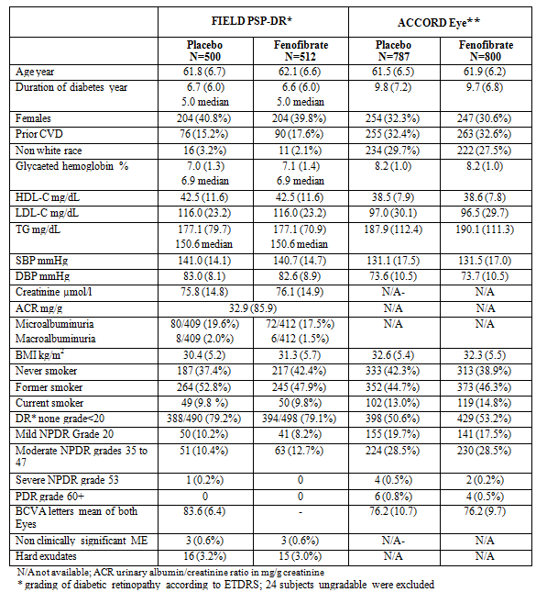

Data are mean (SD), numbers (%) and/or median when indicated

**Comment:** The FIELD study will be described in the next section, but it is another key clinical trial on diabetic patients, which has a substudy (FIELD-PSP-DR) with the outcome of diabetic retinopathy. In this way it is similar to ACCORD.

ACCORD-Eye patients had longer standing diabetes at the beginning of the trial compared to FIELD PSP-DR patients. Also ACCORD-Eye patients were more likely to have prior CVD and prior mild or moderate diabetic retinopathy at baseline. The results showed an effect in three step ETDRS only in those patients in ACCORD-Eye and FIELD-PSP-DR where they had prior DR. Also the FIELD-PSP-DR Study was statistically non-significant for the primary endpoint, likely because the majority of patients (79.2%) did not have prior DR where as ACCORD-Eye was statistically significant, likely because only 51.9% of patients did not have prior DR. This theme is relevant in restricting the proposed indication of fenofibrate to diabetics with prior DR.

From a simple comparison of means, ACCORD-Eye patients had a higher HbA1c on average by 1.15% and this was statistically significant P=0.0001, based on the data in the above table. The ACCORD-Eye was statistically significant whereas FIELD-PSP-DR was not and this may be partly due to the poorer glycaemic control in ACCORD-Eye as mentioned earlier. Note that the ACCORD-Eye was also statistically non-significant in patients with intensive glycaemic control.

However there was a statistically significant difference in blood pressure between the two studies with ACCORD-Eye patients having 9mmHg BP points lower than FIELD-PSP-DR patients.

##### Sample size

ACCORD-Eye: 1593 patients, 787 patients on placebo and 806 patients on fenofibrate.

##### Statistical methods for FIELD-PSP DR and ACCORD EYE including pooled results.

Summary statistics are mean (SD) median and percentages. Data are derived from the main publications of FIELD and the study report of FIELD PSP-DR[6] [7] [8], the database of FIELD and from the different publications of ACCORD[9] [10] [11] [12] [13] [14] [15]. The numbers and percentages of subjects in FIELD presenting with the predefined main ACCORD-Eye individual or combined endpoints were computed. When data on the lipid arm of ACCORD Eye are not available (N/A), data on the full ACCORD Study are provided when already published.[Primary and secondary treatment effects were available from the ACCORD Eye Study.]

In the whole FIELD Study, Cox proportional hazards analysis was used to compute hazard ratios (HR) and 95% confidence intervals (CI) to assess the effect of fenofibrate on the time to first laser photocoagulation treatment, one of the pre-specified tertiary endpoints. For analysis of all events of photocoagulation treatment, a Poisson model yields an incidence density ratio analogous to HR reflecting the relative change in event rate.

In ACCORD Eye, Cox proportional hazards analysis was used to compute HRs and 95% CIs to assess the effect of fenofibrate on the time to first of progression by three steps or more in ETDRS severity scale, photocoagulation or vitrectomy for PDR as well as on the occurrence of moderate vision loss. The analysis was adjusted for presence of previous cardiovascular events, the centre network and assignment to intensive or standard glucose control.

Tests of interaction of baseline characteristics with treatment effect were performed by adding the subgroup and the interaction term to the primary model and applying a likelihood-ratio test for interaction.

In order to evaluate the effect of fenofibrate versus placebo on eye events reported in the same way in ACCORD-Eye and FIELD PSP-DR, the odds ratios were combined using a fixed effect model using the inverse variance method. The between-study heterogeneity was assessed with the Cochrane’s Q test. When heterogeneity was significant at the 10% level (p<0.10), the DerSimonian and Laird random-effect model was chosen as preferred model[16]. Tables of results provide the preferred model whereas forest plots in figures give both and heterogeneity value.

The same analyses were also carried out for the three main pre-defined subgroups of FIELD (by gender, age, prior cardiovascular disease) as well as using the ACCORD definition of dyslipidemia (TG≥204 mg/dL and HDL-C≤34 mg/dL) and using median HbA1c at baseline in FIELD. Combining odds ratios for subgroup analysis was possible as odds ratios by subgroup in ACCORD Eye have been reported with similar stratification in the main study. Summary data (odds ratios with 95% CIs) are presented graphically as forest plots.

**Comment:** The two studies were shown to be non-heterogeneous (that is, similar) and they were pooled using meta-analysis, which was done by pooling the odds ratios in both studies. This is not at the individual data level, but since the endpoint used was the same, such a pooling can be considered statistically equivalent to pooling at the individual data level.

##### Participant flow

Information is not clearly presented in a participant flow diagram.

##### Major protocol violations/deviations

Nil mentioned.

##### Baseline data

Nil mentioned.

##### Results for the primary efficacy outcome

Components

Table 2: Progression of Diabetic Retinopathy in ACCORD Eye - Composite Primary Endpoint and its

|  | Placebo | fenofibrate | HR * (95% CI) p |
| --- | --- | --- | --- |
| 3-step ETDRS scale, photocoagulation or vitrectomy for PDR | 80/787 10.2% | 52/80  6 6.5% | 0.60  (0.42-0.87) 0.006 |
| 3-step ETDRS scale, photocoagulation or vitrectomy for PDR in those with DR at baseline | 56/412  13.6% | 27/405  6.7% | N/A |
| 3-step ETDRS scale, photocoagulation or vitrectomy for PDR in those without DR at baseline | 24/375  6.4% | 25/401  6.2% | N/A |
| Progression 3+ steps ETDRS scale | 70 | 41 | 0.003 |
| Photocoagulation for PDR | 21 | 13 | 0.145 |
| Vitrectomy | 6 | 5 | 0.732 |

* HR hazard ratio adjusted on prior CVD, centre network and assignment to intensive or standard glucose control.

N/A: not available.

Component of the primary endpoint 7-field photographs at baseline and 4 years, eye events collected at each annual visit were compared by Chi square tests.

Source: ACCORD Eye main results ACCORD Eye NEJM 2010 and correspondence NEJM 2010.

**Comment:** Plus three step ETDRS is significant in this study and composite primary endpoint is overall significant, but only significant in patients with DR at baseline. Even though separating the study into DR at baseline or not is a post hoc comparison, it is founded on sound clinical reasoning. As not all diabetics patients without DR at baseline will even develop any DR during the follow-up of the study. Hence the question of whether patients with DR at baseline benefitting from fenofibrate is clinically relevant. By not using this data as evidence for patients with DR at baseline, we are making a Type II error, that is, we are potentially failing to reject a false null hypothesis (Null Hypothesis: Fenofibrate has no effect on DR progression).

Also post hoc analyses are validated by reproducibility. Two independent studies (FIELD-PSP-DR and ACCORD-Eye) both showed a statistically significant effect of fenofibrate slowing DR progression only in patients who had DR at baseline. This shows the results are reproducible and the caution regarding post hoc analysis has been addressed.

The studies were likely highly underpowered and too short of a follow-up to test the hypothesis that fenofibrate slowed DR progression in all T2DM patients regardless of whether they had DR at baseline.

Figure1: ACCORD Eye – Primary Endpoints in sub groups

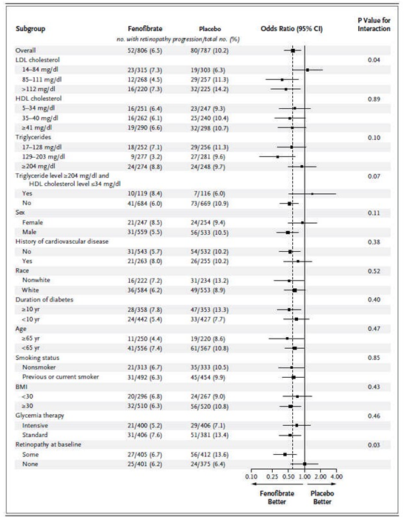

**Comment:** Note that certain subgroups are statistically significant and they include retinopathy at baseline and high LDL. The HDL grouping is non-significant, but a recent large Mendelian RCT showed that HDL did not impact on myocardial infarction and may not be so important in cardiovascular pathophysiology.

1. Triglycerides are however implicated in the aetiology of cardiovascular disease, using the same Mendelian RCT design.
2. Patients with triglycerides between 3.3-5.2 mmol/L did significantly better on fenofibrate in the ACCORD Eye Study.

##### Results for other efficacy outcomes

Table 3: Change in ETDRS Scale combining both eyes in ACCORD Eye

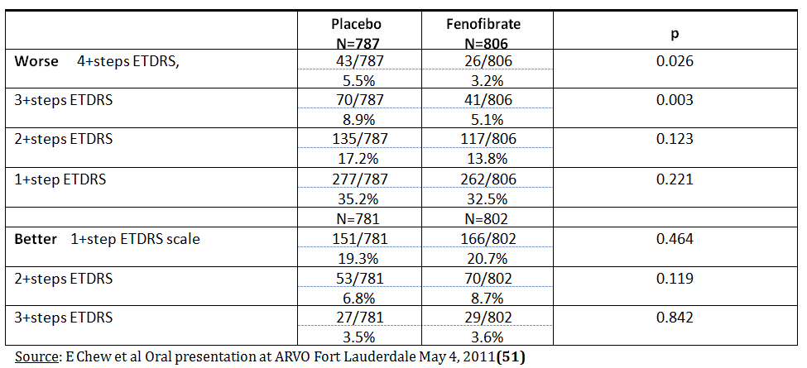

* The rate of laser photocoagulation was statistically non-significant.
* The rate of vitrectomy and cataract extraction was statistically non-significant.
* The worsening in visual acuity was statistically non-significant.

**Comment**: According to the TGA guideline an improvement of ETDRS by 3 steps in those who had prior DR is considered clinically significant.

There was no relevant information regarding thiazolidinedione, either in adjusting post-hoc or in exclusion or inclusion criteria. Note that the full inclusion and exclusion criteria for ACCORD Eye were not provided.

#### FIELD study

##### Study design, objectives, locations and dates

FIELD PSP-DR is a pre-specified and planned study as part of the Fenofibrate Intervention and Event Lowering in Diabetes (FIELD) Trial. This double-blinded, placebo-controlled study, conducted in 23 centres in Australia, Finland and New Zealand, had as a primary objective to evaluate the benefit of five years (on average) of treatment with 200 mg micronised fenofibrate on the occurrence or progression of DR in type-2 diabetes (T2DM) subjects using Early Treatment Diabetic Retinopathy Study (ETDRS) classification of fundus pictures. The secondary objectives were to evaluate the benefit of the treatment to prevent the occurrence or the progression of DME and HEs and to evaluate as well the benefit of the treatment on subgroups of subjects presenting at baseline with no or questionable retinopathy (primary prevention), or existing DR (those presenting with any grade of NPDR (secondary prevention)). The evaluation of primary prevention benefit was to be assessed after an average of five years treatment, and for the secondary prevention subgroup, after two and five years. Treatments were those given in the FIELD study: 200 mg micronised fenofibrate, or matching placebo.

The following subjects were to be excluded for medical or technical reasons: proliferative stages of DR; pre-proliferative stages of DR, in presence of clinically significant macular oedema (CSME); photographs which cannot be graded due to severe cataract lesions or other technical problems and/or having a recent history of cataract surgery.

The screening for the study was carried out independently from the screening for the main study. The protocol excluded the subjects who presented with retinal lesions likely to benefit from photocoagulations, which are effective treatments for diabetic maculopathy or proliferative retinopathy.

After screening (selection and baseline), all subjects could benefit from the follow-up and the standard care provided by their ophthalmologists. Only the subjects, who were randomised in the main FIELD study, were invited to attend the follow-up visits of the PSP-DR study.

All participating subjects were planned to have two-field colour fundus photographs (stereoscopic picture of macular fields with 30/45° camera and one nasal field with 50/45° camera) of both eyes during the placebo run in and after two and five years or at the close-out visit. The photographs were taken at the ophthalmic clinic related to the FIELD study site by trained personnel. Best corrected visual acuity (BCVA), when appropriate using a pinhole device, was recorded at the same visits using Snellen charts in Australian and New Zealand centres. Eye events (laser photocoagulations, cataract surgery and vitrectomy) were recorded at each visit.

The centralised grading was done by two ophthalmologists from Finland and Australia, unaware of treatment assignment, using an adaptation of the ETDRS classification for two-field photographs. A quality control procedure was developed for the validation of the scoring. Double grading was performed in 10% of the photographs with satisfactory agreement (weighted kappa 0.74 for the grade of retinopathy and 1.0 for presence of macular oedema).

##### Inclusion and exclusion criteria

Inclusion criteria patient eligible for FIELD study:

* man or woman, 50-75 years
* with NIDDM (TYPE II)
* no clear indication for lipid lowering treatment
* total cholesterol between 3.0 and 6.5 mmol/l plus either TC/HDL C 4.0 or TG >1.0 mmol/l
* no clear contraindication to study therapy (see FIELD study protocol)

Presenting with:

* either no or questionable grade of diabetic retinopathy, grades 10, 14 or 15,
* or any grade of non proliferative diabetic retinopathy, grades 20, 35, 43, or 47, but without clinically significant macular oedema.

Written informed consent.

Exclusion criteria Indication for focal/local or grid laser treatment for CSME.

Indication for panretinal photocoagulation.

Scars of photocoagulation.

Topical treatment for glaucoma.

Significant other retinal disease.

Technical problems: severe cataract, vitreous hemorrhage, small pupil, non-evaluable photographs.

History of cataract interventions in the last 6 months or indication for cataract intervention within 12 months**.**

**Comment:** In terms of generalisability, patients with severe DR (proliferative/pre-proliferative + CSME) were excluded and as such fenofibrate cannot be recommended for patients with severe DR. Note that the study selects patient with cholesterol over 3 mmol/L and under 6.5 mmol/L, who were not on a lipid lowering therapy. Patients with cholesterol over 5.5 mmol/L are routinely given statins by GPs so this limits the study’s generalisability.

##### Study treatments

The FIELD PSP-DR Study is also a randomised trial of monotherapy with micronised fenofibrate (200 mg per day).

##### Efficacy variables and outcomes

The primary endpoint in the total population was the progression in the DR ETDRS grade classification in the reference eye which was the worst eye at baseline or, if equal grade, the right eye. In the primary prevention population, the primary endpoint was the progression to grade ≥ 20 in the DR classification. In the secondary prevention population, it was the progression in the DR grade classification.

The secondary criteria were:

* Global evolution of DR (improvement, no change, worsening)
* Incidence of Macular Oedema (ME) and Clinically Significant ME (CSME)
* Incidence of Hard Exudates (HE)
* Incidence of focal/local and panretinal laser photocoagulations
* Incidence of vitrectomies and cataract surgeries
* Best corrected visual acuity (BCVA) in a subset of participants
* A post-hoc analysis of the following combined endpoints was performed:
* Progression of at least 2 Steps ETDRS grade or laser photocoagulation
* Progression of at least 2 Steps ETDRS grade or CSME or laser photocoagulation
* Progression of at least 2 Steps ETDRS grade or ME or laser photocoagulation.

**Comment:** According to the TGA guideline an improvement of ETDRS by three steps in those who had prior DR is considered clinically significant. In the same guidelines for patients without DR at baseline, two steps are also considered clinically significant.

##### Analysis populations

See 6.1.1.6.

##### Sample size

FIELD PSP-DR Study: 1012 patients, 500 on placebo 512 on fenofibrate.

##### Statistical methods

Listed together with the ACCORD Study (6.1.1.8).

##### Participant flow

Figure 2: FIELD PSP-DR: Participant flow and analysis sets.

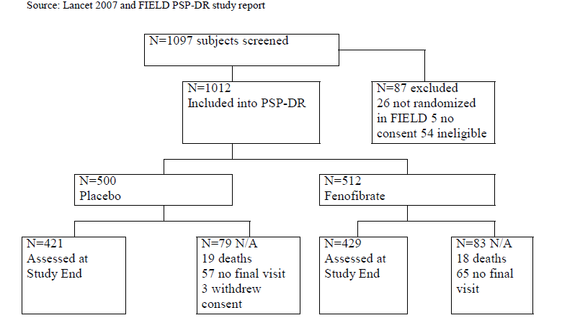

##### Major protocol violations/deviations

Nil mentioned.

##### Baseline data

See 61.1.6 Analysis populations.

##### Results for the primary efficacy outcome

For the full analysis set (FAS), the primary outcome is progression or regression in the DR grading of one step, two steps.. n steps by the end of the study (after an average of five years of follow-up).

**Comment:** The quote above was excerpted directly from the statistical analysis plan and this states that progression of steps in DR is the primary efficacy outcome; therefore the results in Table 4 are a per-protocol analysis.

Table4: Progression of ETDRS Grade in FIELD PSP-DR - Worse Eye at Baseline (4-5 yrs follow-up)

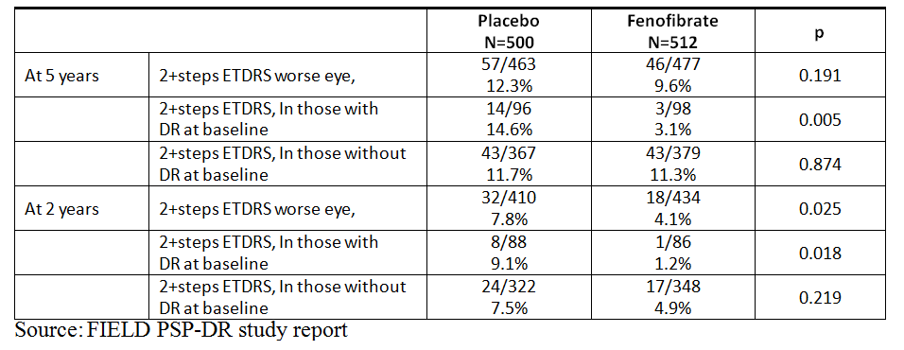

**Comment:** The primary endpoint was statistically non-significant in the overall study and in patients without DR at baseline. Although the study showed statistical significance in patients with DR at baseline, current TGA guidelines note that a clinically significant effect with patients who have DR at baseline is three+ steps ETDRS not two+ steps ETDRS. Note that in the pooled results (Table 9) three+ steps ETDRS as a composite outcome with photocoagulation or vitrectomy for PDR is given for both studies for follow-up of four to five years. Here again, only those patient groups with DR at baseline had statistically significant results with clinically significant benefits.

There was a reduction in three steps in the subgroup of patients with DR at baseline. Note that it is difficult to understand what the equivalent of a change in grade by 20 points is in relation to steps in the ETDRS system. Therefore in this report the clinically significant benefit of three steps in ETDRS is the focus.

##### Results for other efficacy outcomes

Secondary Criteria: The analysis of the secondary criteria on the total population showed a statistically significant reduction (p < 0.001) in the need for laser treatment for diabetic eye disease with fenofibrate (n = 5, 1.0%) as compared to placebo (n = 23, 4.6%); the effect was mainly seen in the subjects with DR at baseline: n = 4 with fenofibrate as compared to n = 21 with placebo, no statistically significant differences between groups, but a trend in favor of fenofibrate on:

* any ME; four subjects (0.8%) with fenofibrate and 10 subjects (2.2%) with placebo at last follow-up, two (0.5%) and seven (1.7%), respectively at two years
* occurrence of ME; four subjects (0.8%) with fenofibrate and 10 subjects (2.2%) with placebo at last follow-up, two (0.5%) and seven (1.7%), respectively at two years
* occurrence of CSME; three subjects (0.6%) with fenofibrate and six subjects (1.3%) with placebo at last follow-up, two (0.5%) and four (1.0%), respectively at two years
* occurrence of HEs at two years: five subjects with fenofibrate (1.2%) versus. 10 subjects (2.5%) with placebo.

No statistically significant effect as compared to placebo on:

* any progression of at least one Step ETDRS; 104 subjects (21.8%) with fenofibrate and 106 subjects (22.9%) with placebo at last follow-up; 48 (11.1%) and 61 (14.9%), respectively at two years,
* occurrence of DR (primary prevention population); 46 subjects (12.1%) with fenofibrate and 45 subjects (12.3%) with placebo at last follow-up, 21 (6.0%) and 25 (7.8%), respectively at two years
* at least one Step progression of DR (secondary prevention population); 30 subjects (30.6%) with fenofibrate and 34 subjects (35.4%) with placebo at last follow-up, 17 (19.8%) and 23 (26.1%), respectively at two years
* occurrence of HEs at last follow-up; 16 subjects (3.5%) with fenofibrate versus 14 subjects (3.1%) with placebo
* any progression of HEs; two subjects (13.3%) with fenofibrate and two subjects (14.3%) with placebo at last follow-up, two (15.4%) and 0 (0.0%), respectively at two years
* occurrence of vitrectomies and cataract extractions.

The visual acuity data were not analysed and will be reported separately.

The analysis of combined endpoints showed statistically significant improvement with fenofibrate as compared to placebo in the pre-defined combined endpoints at last follow-up:

In the total population:

* progression of at least two Steps ETDRS or laser therapy: 50 subjects (9.8%) with fenofibrate versus 73 subjects (14.6%) with placebo
* progression of at least two Steps ETDRS or CSME or laser therapy: 11 subjects (2.1%) with fenofibrate versus 37 subjects (7.4%) with placebo,
* progression of at least two Steps ETDRS or ME or laser therapy: 53 subjects (10.4%) with fenofibrate versus 75 subjects (15.0%) with placebo.

In the secondary prevention population:

* progression of at least two Steps ETDRS or CSME or laser therapy: nine subjects (9.2%) with fenofibrate versus 31 subjects (32.3%) with placebo, p < 0.001.

Table 5: Progression of Diabetic Retinopathy in FIELD PSP-DR - Composite Endpoints

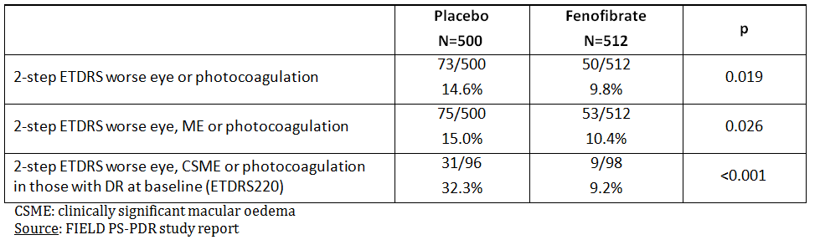

**Comment:** All composited endpoints were statistically significant, but noting three+ steps would have been more clinically relevant.

Table 6: Need for Laser Photocoagulation in FIELD and FIELD PSP-DR

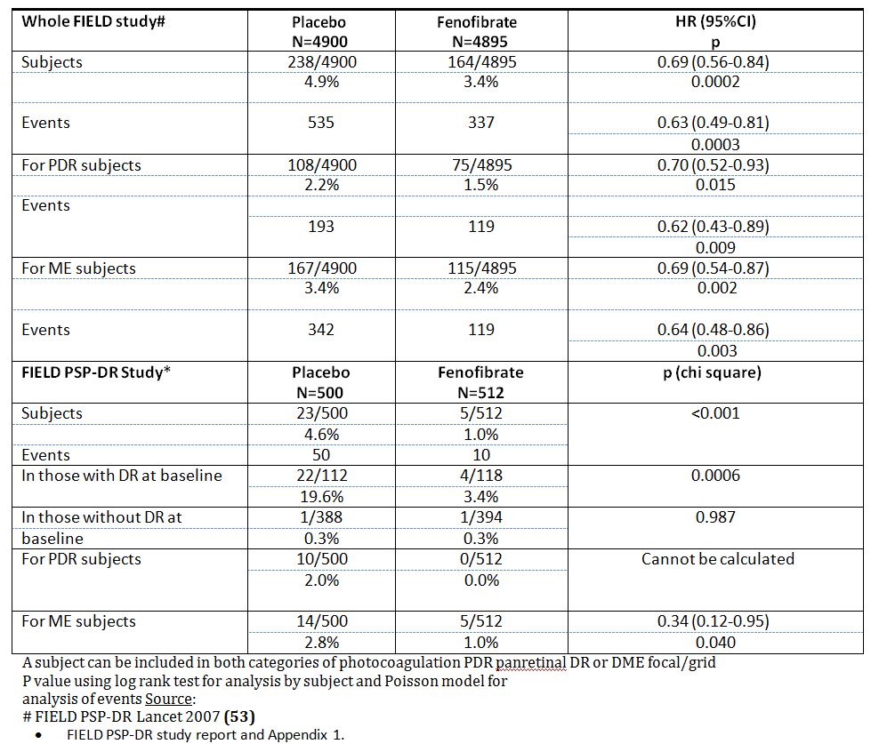

**Comment:** The secondary endpoint for laser photocoagulation was statistically significant with quite marginal absolute risk differences. However, these results are only significant in patients with prior DR and statistically non-significant in patients without prior DR.

* The difference in rates of macular oedema was statistically non-significant.
* The difference in rates of vitrectomy and cataract extraction was statistically non-significant.
* The difference in rates of worsening in best-corrected visual acuity was statistically non-significant.

#### Other efficacy studies

##### S348.2.001 – A supportive phase 2 study.

###### Study design, objectives, locations and dates

In order to assess the effect of fibrate treatment in subjects with a more advanced stage of DR (moderate to severe non proliferative DR or mild PDR), the Study S348.2.001 was conducted. One hundred and ten (110) T2DM subjects presenting with macular oedema (DME) in whom laser photocoagulation could be postponed by at least three months were randomised for one year to fenofibric acid 135 mg per day or placebo. Fenofibric acid 135mg capsule is bioequivalent to fenofibrate 200 mg micronised capsule.

Diagnosis of DME was based on increased retinal thickness in the fovea (250µm or more) or its periphery (at least one area 300μm or more) measured by optical coherence tomography (OCT) - Stratus OCT3®. The primary efficacy criterion was the change in total macular volume measured quarterly by OCT.

**Comment:** This study was not statistically significant.

###### Inclusion and exclusion criteria

Patients with T2DM and DME in who laser photocoagulation could be postponed by at least three months.

###### Study treatments

Fenofibrate or Placebo.

###### Efficacy variables and outcomes

The main efficacy variables were:

* Total Macular Volume
* Central Zone Thickness
* Plus two Step progression of ETDRS
* Need for laser photocoagulation

The primary efficacy outcome was Total Macular Volume.

###### Randomisation and blinding methods

The three studies were double-masked. Active treatments were the existing registered capsules or tablets. The patients were randomised to placebo or fenofibrate. (No further details given).

###### Analysis populations

Table7: Subjects Characteristics in Study S348.2.001

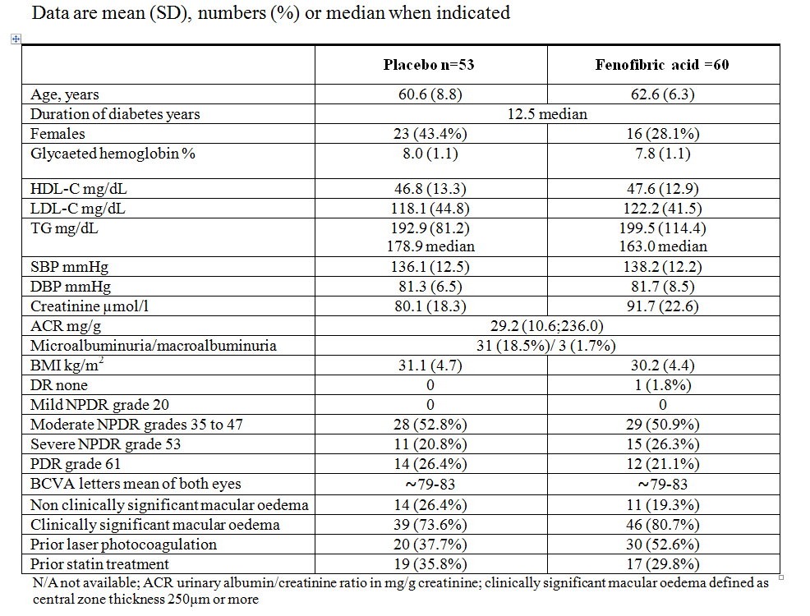

###### Sample size

Placebo 53 patients

Fenofibrate 57 patients

Total 110 patients

###### Statistical methods

**Comment**: The GEE Test was statistically non-significant. Other tests that do not account for repeated measures data have an artificially deflated P value due to under-estimating error. The other tests were also statistically non-significant.

###### Participant flow

All but 6 subjects completed one-year treatment

###### Major protocol violations/deviations

N/A

###### Baseline data

N/A

###### Results for the primary efficacy outcome

Table 8: Effects of Treatment in Study S348.2.001

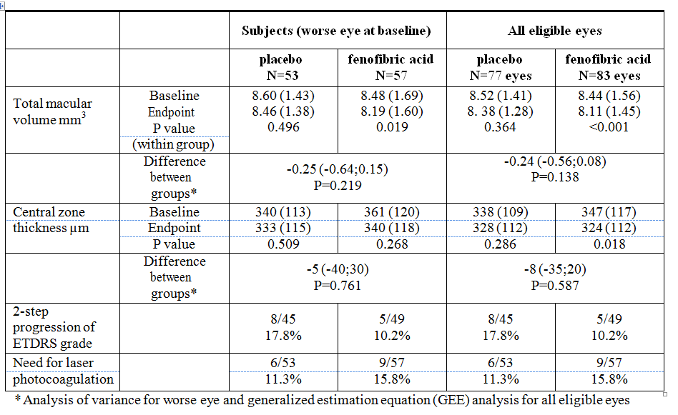

**Comment**: This study was statistically non-significant in its primary outcome as assessed by the GEE test.

###### Results for other efficacy outcomes

**Comment**: This study was statistically non-significant for all its secondary outcomes by the GEE test.

#### Analyses performed across trials (pooled analyses and meta-analyses)

Table 9: Progression of Diabetic Retinopathy in FIELD PSP-DR and ACCORD Eye - Composite Endpoints

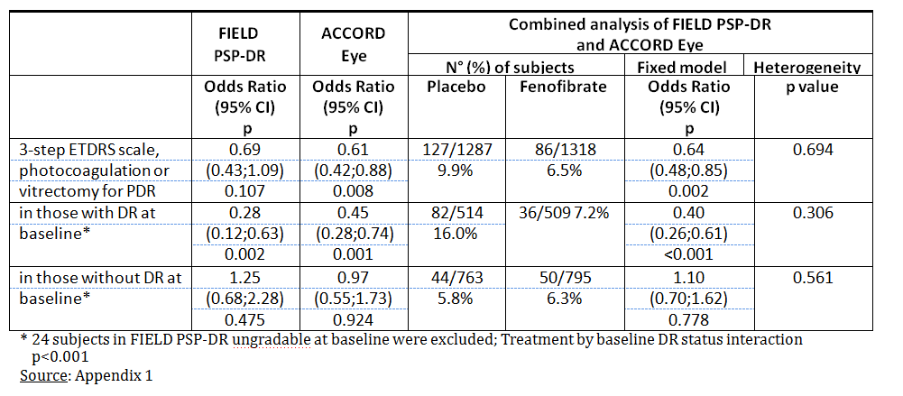

**Comment:** The composite endpoint was only statistically significant in patients with DR at baseline. This is in each individual study and after pooling the studies. This endpoint was for follow-up of four to five years in the respective studies.

There were no other randomised studies regarding fenofibrate and diabetic retinopathy in the literature review provided by Abbott in the application.

### Evaluator’s conclusions on clinical efficacy for fenofibrate in slowing the progression of diabetic retinopathy

The evidence indicates that only diabetic patients with some prior diabetic retinopathy, whether mild or moderate may benefit at all from fenofibrate. An argument can be made that fenofibrate is more clinically efficacious in patients with moderately elevated LDL (2.2 -2.9 mmol/L) and TGL (3.3 - 5.2mmol/L).

There have been no analyses that have been subcategorised by thiazolidinedione usage (TZD), nor are there reports that such patients with such usage have been excluded or whether the trial has been designed to balance TZD usage among patients. It is assumed with randomisation, that TZD usage should be balanced between treatment and placebo arms. If the sample size was sufficient to balance for TZD usage then the effects of fenofibrate would be beyond any interaction with TZD usage. However it would be interesting to see the breakdown of TZD usage in the treatment and placebo arms of the FIELD-PSP-DR and ACCORD Eye Studies.

Also in the submission package the actual ACCORD Study was not submitted, but the ACCORD Eye publication was submitted.

As reported previously their use of the ETDRS scale as an outcome of primary efficacy was questionable as an ETDRS change by three steps is clinically significant in patients with prior DR and two steps is clinically significant in patients with no DR at baseline.

Both studies showed no difference in patients with no DR at baseline and a notable difference in patients with prior DR, but often the reported measures were assessing a two-step change. However, three-step changes were also reported but not in the main efficacy table. This is a minor issue as a three-step change was found to be statistically significant in patients with prior DR.

A summary was presented for the ACCORD Eye Study, whereas a regulatory package was submitted for the FIELD PSP DR Study and the S.348.2001 Study using biomarkers. The FIELD PSP DR Studies were pivotal, the biomarker study and the ACCORD Eye were supportive in that they showed no effect of fenofibrate in patients with proliferative DR or pre-proliferative DR with DME. Had the regulatory package been submitted for the ACCORD EYE package, it would have been a pivotal study.

## Clinical safety

### Studies providing evaluable safety data

FIELD-PSP-DR has safety data. ACCORD Eye does not have a safety submission.

### Pivotal studies that assessed safety as a primary outcome

FIELD-PSP-DR.

### Patient exposure

Fenofibrate.

### Adverse events

#### All adverse events (irrespective of relationship to study treatment)

##### Pivotal studies

FIELD-PSP-DR.

##### Other studies

N/A

#### Treatment-related adverse events (adverse drug reactions)

##### Pivotal studies

Table 10: Primary and Secondary Endpoints in FIELD PSP-DR

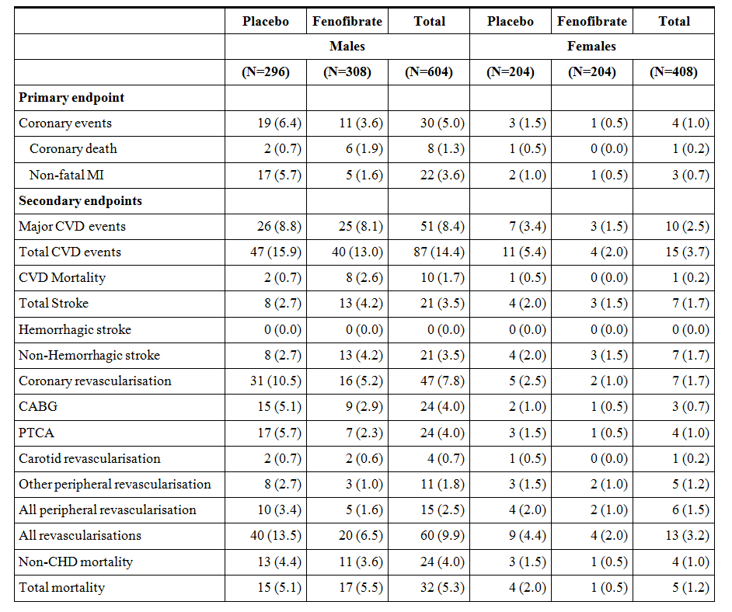

**Comment:** There were no major issues in safety.

##### Other studies

N/A

#### Deaths and other serious adverse events

##### Pivotal studies

**Comment:** From Table 10 there is a statistically non-significant (P=0.3) increase in coronary deaths in patients taking fenofibrate from three deaths out of 500 in the placebo arm and six deaths in the treatment arm. Similarly, this was the case for all CVD mortality (P=0.14).

##### Other studies

N/A

#### Discontinuation due to adverse events

##### Pivotal studies

Table 11: Reasons for Permanent Discontinuation in FIELD PSP-DR

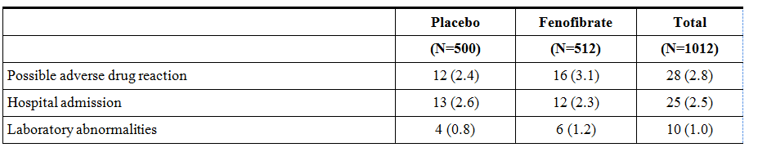

**Comment:** There were no prominent reasons for permanent discontinuation and the differences were not statistically significant.

##### Other studies

N/A

### Laboratory tests

#### Liver function

##### Pivotal studies

N/A

##### Other studies

N/A

#### Kidney function

##### Pivotal studies

The major laboratory parameter influenced by fenofibrate treatment was creatinine. Its level increased from 75.8 at baseline to 80.9 µmol/L at close-out in the placebo group (+7.4%) and from 76.1 to 91.3 µmol/L in the fenofibrate group (+20.5%), comparable changes than in the main study, where they proved to be reversible six to eight weeks after the close-out visit.”

**Comment:** Fenofibrate may prove to be an issue in renally compromised patients and the elderly. The sponsor has recommended alternate doses for elderly and renally compromised patients.

##### Other studies

N/A

#### Other clinical chemistry

##### Pivotal studies

N/A

##### Other studies

N/A

#### Haematology

##### Pivotal studies

N/A

##### Other studies

N/A

### Post-marketing experience

N/A

### Evaluator’s overall conclusions on clinical safety

There are no statistically significant differences in endpoint relating to safety, other than a rise in creatinine. This rise in creatinine is 11 µmol/L over four to five years, which is beyond the rise seen in placebo. Alternative doses have been recommended for renally compromised patients.

## First round benefit-risk assessment

### First round assessment of benefits

Three studies were provided as regulatory packages. The FIELD-PSP-DR and the ACCORD Eye are consistent bases on a statistically non-significant value for the Cochrane Q Test for heterogeneity. The third study is completely different as it uses biochemical markers and follow-up is for one year whereas patients with moderate to severe DR were exclusively selected.

It is difficult to comment on internal and external validity as the inclusion and exclusion criteria were not given. However from the submission, in the ACCORD Eye Study patients with severe DR were excluded, hence there is no evidence to generalise fenofibrate to patients with severe DR.

The benefits of fenofibrate in the proposed usage are:

* It is effective in the subset of diabetic patients with some prior diabetic retinopathy.
* It is especially effective in diabetic patients with dyslipidaemia as per LDL (LDL 2.2-2.9 mmol/L). However, this may just reflect the cut-offs they have chosen for this variable.
* It is also especially effective in diabetic patients with triglycerides between 3.3-5.2 mmol/L. This may also reflect the cut-offs they have chosen for this variable.

This clinical benefit is seen on top of the use of a concurrent statin.

### First round assessment of risks

The risks of fenofibrate in the proposed usage are:

* It can be considered ineffective polypharmacy to treat patients with diabetes that show no diabetic retinopathy.
* By delaying the use of fenofibrate to diabetic patients, the potentially unnecessary side effects, adverse drug reactions and drug interactions of fenofibrate are avoided. This includes the waste of resources in providing fenofibrate in population where it is not effective (diabetics without prior diabetic retinopathy).

### First round assessment of benefit-risk balance

The benefit-risk balance of fenofibrate is unfavourable given the proposed usage, but would become favourable if the changes recommended in Section 9 are adopted.

## First round recommendation regarding authorisation

Fenofibrate should be used in diabetic patients who display mild to moderate diabetic retinopathy to slow the progression of DR. Fenofibrate is especially useful in those patients with LDL in the range of 2.2-2.9 mmol/L or TGLs in the range of 3.3-5.2mmol/L and shows beneficial effects in slowing progression of diabetic retinopathy on top of concurrent statin therapy.

The ACCORD Eye was a study that showed statistically and clinically significant effects in diabetic patients with prior DR. In this study patients in both arms were co-administered with statin therapy, therefore fenofibrate with concurrent statin therapy is recommended.

From the evidence it can be seen that two independent studies have showed that patients with prior DR benefit from fenofibrate. These results are both statistically significant; therefore pooling the studies in this respect would also yield statistically significant results. These studies are non-heterogeneous as the Cochrane Q test for heterogeneity was statistically non-significant.

Also it does not make sense to pool the overall studies and say fenofibrate is a statically and clinically significant treatment for all diabetics regardless of prior DR. This is because in both studies the patients without DR at baseline did not receive any clinical benefit in terms of slowing progression of DR.

Furthermore FIELD PSP DR was not significant, whereas ACCORD Eye was significant likely for the main reason that a higher proportion of ACCORD patients had prior DR and had poorer glycaemic control.

The reasoning is that it takes time to develop DR if you are diabetic but once developed it will usually progress. The follow-up of both studies was not long enough for patients without prior DR to develop and also have varying rates of progression of DR.

## Clinical questions

No further questions.

## Second round evaluation of clinical data submitted in response to questions

N/A

## Second round benefit-risk assessment

N/A

## Second round recommendation regarding authorisation

N/A

## References

Ambrosius WT, Danis RP, Goff Jr DC, Greven CM, Gerstein HC, Cohen RM, et al for the ACCORD study group and ACCORD Eye study group. Lack of association between thiazolidinediones and macular edema in type 2 diabetes. The ACCORD Eye substudy. Arch Ophthalmol, 2010, 128:312-318.

Chew E, Ambrosius WT, Howard LT. Rationale, Design and methods of the Action to control Cardiovascular Risk in Diabetes Eyes Study (ACCORD Eye). Am. J. Cardiol, 2007, 99: S103-S111.

Chew EY, Ambrosius WT, Danis RP for the ACCORD study group and ACCORD Eye study group. Retinopathy progression in type 2 diabetes. N. Engl. J. Med., 2010, 363:2173-2174.

Chew EY, Ambrosius WT, Hubbard L, Davis MD, Gangaputra S, Danis RP et al. Consistency of treatment effect with various diabetic retinopathy outcomes in ACCORD Eye study. ARVO 2011 abstract; May 4. Fort Lauderdale, FL.

Chew EY, Ambrosius WT. Update of the ACCORD Eye study. N. Engl. J. Med., 2011, 364: 188-189.

DerSimonian R, Laird N. Meta-analysis in clinical trials. Controlled Clinical Trials, 1986, 7:177-88.

Ismail-Beigi F, Craven T, Banerji MA, Basile J, Calles J, Cohen RM et al for the ACCORD trial group. Effect of intensive treatment of hyperglycaemia on microvascular outcomes in type 2 diabetes: an analysis of the ACCORD randomised trial. Lancet, 2010, 376:419-430.

Ismail-Beigi F, Craven T, Genuth S, Hramiack I, Karl D. Mixed messages on systemic therapies for diabetic retinopathy. Lancet, 2010, 376:1461-1462.

Keech AC, Mitchell P, Summanen PA, O’Day J, Davis TME, Moffitt MS, Taskinen MR, Simes RJ, Tse D, Williamson E, Merrifield A, Laatikainen LT, d’Emden MC, Crimet DC, O’Connell RL, Colman PG for the FIELD study investigators. Effect of fenofibrate on the need for laser treatment for diabetic retinopathy (FIELD study): a randomised controlled trial. Lancet, 2007; 370:1687-1697.

Primary and Secondary Prevention of Diabetic Retinopathy with 200 mg micronized fenofibrate The PSP-DR FIELD study. Clinical report ID 1000177667 (Protocol CFEN 9807), November 2010.

Sarwar N, Sandhu MS, Ricketts SL, Butterworth AS, Di Angelantonio E, Boekholdt SM, et al. Triglyceride-mediated pathways and coronary disease: collaborative analysis of 101 studies. Lancet. 2010;375(9726):1634-9. Epub 2010/05/1.

The ACCORD study group and ACCORD Eye study group. Effects of medical therapies on retinopathy progression in type 2 diabetes. N. Engl. J. Med., 2010, 363:233-244.

The ACCORD study group. Long term effects of intensive glucose lowering on cardiovascular outcomes. N. Engl. J. Med., 2011, 364: 818-828.

The FIELD study investigators. Effects of long-term fenofibrate therapy on cardiovascular events in 9795 people with type 2 diabetes mellitus (the FIELD study): randomized controlled trial. Lancet 2005; 366:1849-1861.

Voight BF, Peloso GM, Orho-Melander M, Frikke-Schmidt R, Barbalic M, Jensen MK, et al. Plasma HDL cholesterol and risk of myocardial infarction: a mendelian randomisation study. Lancet. 2012;380(9841):572-80.

1. The ACCORD study group and ACCORD Eye study group. Effects of medical therapies on retinopathy progression in type 2 diabetes. N. Engl. J. Med., 2010, 363:233-244
2. Chew E, Ambrosius WT, Howard LT. Rationale, Design and methods of the Action to control Cardiovascular Risk in Diabetes Eyes Study (ACCORD Eye). Am. J. Cardiol, 2007, 99: S103-S111.
3. The ACCORD study group and ACCORD Eye study group. Effects of medical therapies on retinopathy progression in type 2 diabetes. N. Engl. J. Med., 2010, 363:233-244
4. Chew E, Ambrosius WT, Howard LT. Rationale, Design and methods of the Action to control Cardiovascular Risk in Diabetes Eyes Study (ACCORD Eye). Am. J. Cardiol, 2007, 99: S103-S111.
5. The ACCORD study group. Long term effects of intensive glucose lowering on cardiovascular outcomes. N. Engl. J. Med., 2011, 364: 818-828.
6. The FIELD study investigators. Effects of long-term fenofibrate therapy on cardiovascular events in 9795 people with type 2 diabetes mellitus (the FIELD study): randomized controlled trial. Lancet 2005; 366:1849-1861.
7. Keech AC, Mitchell P, Summanen PA, O’Day J, Davis TME, Moffitt MS, Taskinen MR, Simes RJ, Tse D, Williamson E, Merrifield A, Laatikainen LT, d’Emden MC, Crimet DC, O’Connell RL, Colman PG for the FIELD study investigators. Effect of fenofibrate on the need for laser treatment for diabetic retinopathy (FIELD study): a randomised controlled trial. Lancet, 2007; 370:1687-1697.
8. Primary and Secondary Prevention of Diabetic Retinopathy with 200 mg micronized fenofibrate The PSP-DR FIELD study. Clinical report ID 1000177667 (Protocol CFEN 9807), November 2010.
9. The ACCORD study group and ACCORD Eye study group. Effects of medical therapies on retinopathy progression in type 2 diabetes. N. Engl. J. Med., 2010, 363:233-244.
10. Ismail-Beigi F, Craven T, Banerji MA, Basile J, Calles J, Cohen RM et al for the ACCORD trial group. Effect of intensive treatment of hyperglycaemia on microvascular outcomes in type 2 diabetes: an analysis of the ACCORD randomised trial. Lancet, 2010, 376:419-430.
11. Ismail-Beigi F, Craven T, Genuth S, Hramiack I, Karl D. Mixed messages on systemic therapies for diabetic retinopathy. Lancet, 2010, 376:1461-1462.
12. Chew EY, Ambrosius WT, Danis RP for the ACCORD study group and ACCORD Eye study group. Retinopathy progression in type 2 diabetes. N. Engl. J. Med., 2010, 363:2173-2174.
13. Chew EY, Ambrosius WT. Update of the ACCORD Eye study. N. Engl. J. Med., 2011, 364:188-189.
14. Ambrosius WT, Danis RP, Goff Jr DC, Greven CM, Gerstein HC, Cohen RM, et al for the ACCORD study group and ACCORD Eye study group. Lack of association between thiazolidinediones and macular edema in type 2 diabetes. The ACCORD Eye substudy. Arch Ophthalmol, 2010, 128:312-318.
15. Chew EY, Ambrosius WT, Hubbard L, Davis MD, Gangaputra S, Danis RP et al. Consistency of treatment effect with various diabetic retinopathy outcomes in ACCORD Eye study. ARVO 2011 abstract; May 4. Fort Lauderdale, FL.
16. 62. DerSimonian R, Laird N. Meta-analysis in clinical trials. Controlled Clinical Trials, 1986,

    7:177-88