# PRODUCT INFORMATION

PecFent® fentanyl (as citrate) 100 µg per actuation and 400 µg per actuation   
nasal spray solution

## NAME OF THE MEDICINE

Fentanyl citrate

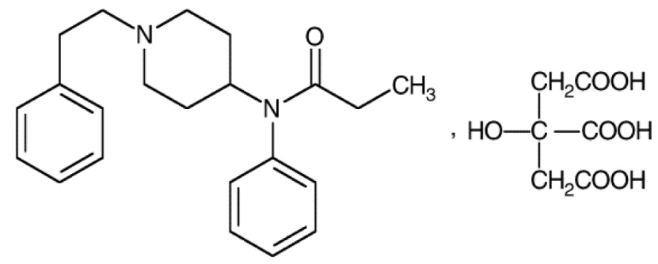

CAS number: 990-73-8

## DESCRIPTION

PecFent (fentanyl nasal spray) is a potent opioid analgesic, intended for intranasal administration. The product consists of a practically-clear to clear, colorless, aqueous solution of fentanyl citrate in a glass multidose container, to which is attached a metered-dose nasal spray pump with a visual and audible spray counter. Each actuation is designed to deliver a spray of 100 µL of solution containing 100 µg or 400 µg of fentanyl base (as the citrate). This enables doses of 100 µg or 400 µg to be administered using a single spray into one nostril (1 spray) and 200 µg or 800 µg to be administered using a single spray into both nostrils (2 sprays).

Active ingredient: Fentanyl citrate, Ph. Eur. is N-(l-Phenethyl-4-piperidyl)propionanilide citrate (1:1).

Fentanyl is a highly lipophilic compound, the octanol-water partition coefficient at pH 7.4 is 816:1. Fentanyl citrate is sparingly soluble in water (1:40). The pKa is 8.4. The molecular weight of the free base and citrate salt are 336.5 and 528.6, respectively.

PecFent is available in 2 strengths of nasal spray: 100 µg fentanyl (yellow label) and 400 µg fentanyl (violet label). The strength is expressed as the amount of fentanyl free base per spray, e.g., the 100 µg strength provides 100 µg of fentanyl free base per 100 µL spray.

Inactive ingredients: mannitol, partially de-esterified pectin, phenethyl alcohol, propyl hydroxybenzoate, sucrose, purified water. Sodium hydroxide and/or hydrochloric acid are added if required for pH adjustment.

## PHARMACOLOGY

Pharmacotherapeutic group: Analgesics; phenylpiperidine derivatives; ATC code: N02A‑B03.

### Pharmacodynamic properties

#### Mechanism of action

Fentanyl is an opioid analgesic, interacting predominantly with the opioid µ-receptor. Its primary therapeutic actions are analgesia and sedation. Secondary pharmacological effects are respiratory depression, bradycardia, hypothermia, constipation, miosis, physical dependence and euphoria.

### Pharmacokinetic properties

#### General introduction

Fentanyl is highly lipophilic and can be absorbed very rapidly through the nasal mucosa and more slowly by the gastrointestinal route. It is subject to first pass hepatic and intestinal metabolism and the metabolites do not contribute to fentanyl’s therapeutic effects.

PecFent utilises the PecSys nasal drug delivery system to modulate the delivery and absorption of fentanyl. The PecSys system allows the product to be sprayed into the front area of the nasal cavity as a fine mist of droplets, which gel on contact with the calcium ions present in the nasal mucosa. Fentanyl diffuses from the gel and is absorbed through the nasal mucosa; this gel-modulated absorption of fentanyl reduces the peak in plasma concentration (Cmax) whilst allowing the attainment of an early time to that peak (Tmax).

The effect of renal or hepatic impairment on the pharmacokinetics of PecFent has not been studied.

#### Absorption

In a pharmacokinetic study comparing PecFent (100, 200, 400 and 800 g) with oral transmucosal fentanyl citrate (OTFC, 200 µg), fentanyl was shown to be rapidly absorbed following single dose intranasal administration of PecFent, with median Tmax ranging from 15 to 21 minutes (Tmax for OTFC was approximately 90 minutes). The variability of the pharmacokinetics of fentanyl was considerable following treatment with both PecFent and OTFC. Relative bioavailability of fentanyl from the PecFent treatment compared to the 200 µg OTFC was approximately 120 %.

The main pharmacokinetic parameters are shown in the following table.

Pharmacokinetic parameters in adult subjects receiving PecFent and OTFC

|  |  |  |  |  |  |
| --- | --- | --- | --- | --- | --- |
| **Pharmacokinetic parameters  (mean (%CV))** | **PecFent** | | | | **OTFC** |
| **100 µg** | **200 µg** | **400 µg** | **800 µg** | **200 µg** |
| Tmax (hours)* | 0.33 (0.08-1.50) | 0.25  (0.17-1.60) | 0.35 (0.25-0.75) | 0.34 (0.17-3.00) | 1.50 (0.50  -8.00) |
| Cmax (pg/ml) | 351.5 (51.3) | 780.8 (48.4) | 1552.1 (26.2) | 2844.0 (56.0) | 317.4 (29.9) |
| AUC (pg.hour/ml) | 2460.5 (17.9 | 4359.9 (29.8) | 7513.4 (26.7) | 17272 (48.9) | 3735.0 (32.8) |
| t1/2 (hour) | 21.9 (13.6) | 24.9 (51.3) | 15.0 (24.7) | 24.9 (92.5) | 18.6 (31.4) |

*Data for Tmax presented as median (range).

The curves for each dose level are similar in shape with increasing dose levels producing increasing plasma fentanyl levels. Dose-proportionality was demonstrated for Cmax and area under the curve (AUC) in the dose range 100 µg to 800 µg (see Figure 1**). If switching to PecFent from another fentanyl product for breakthrough pain, independent dose titration with PecFent is required as the bioavailability between products differs significantly.**

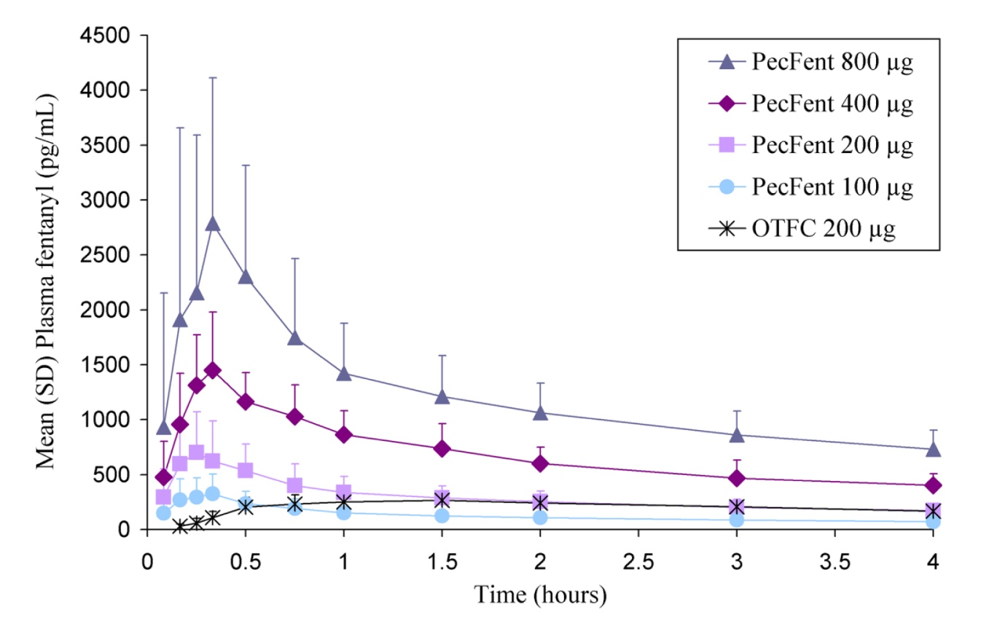Figure 1: Mean plasma fentanyl concentrations following single doses of PecFent and OTFC in healthy subjects

#### Distribution

Fentanyl is highly lipophilic and is well distributed beyond the vascular system, with a large apparent volume of distribution. Animal data have shown that, following absorption, fentanyl is rapidly distributed to the brain, heart, lungs, kidneys and spleen followed by a slower redistribution to muscles and fat.

The plasma protein binding of fentanyl is 80 – 85 %. The main binding protein is alpha-1-acid glycoprotein, but both albumin and lipoproteins contribute to some extent. The free fraction of fentanyl increases with acidosis.

#### Metabolism

The metabolic pathways following nasal administration of PecFent have not been characterised in clinical studies. Fentanyl is metabolised in the liver to norfentanyl by cytochrome CYP3A4 isoform. Norfentanyl is not pharmacologically active in animal studies. It is more than 90 % eliminated by biotransformation to N‑dealkylated and hydroxylated inactive metabolites.

#### Elimination

Disposition of fentanyl following intranasal administration of PecFent has not been characterised in a mass balance study. Less than 7 % of an administered dose of fentanyl is excreted unchanged in the urine and only about 1 % is excreted unchanged in the faeces. The metabolites are mainly excreted in the urine, while faecal excretion is less important.

The total plasma clearance of fentanyl following intravenous administration is approximately 42 L/h.

#### Linearity/non-linearity

Dose-proportionality was demonstrated for Cmax and AUC in the dose range 100 µg to 800 µg.

## CLINICAL TRIALS

The efficacy of PecFent was demonstrated in three clinical trials (CP043, CP044 and CP045) in opioid tolerant adult patients with cancer experiencing breakthrough pain.

Two of the studies (CP043 and CP044) were double-blind controlled studies with reference arms. The third study (CP045) was long term open use.

Breakthrough pain was defined as a transient flare of moderate-to-severe pain occurring in patients with cancer experiencing persistent cancer pain otherwise controlled with maintenance doses of opioid medications including at least 60 mg of oral morphine/day or an equianalgesic dose of another opioid (which could be fentanyl) for a week or longer. All patients were on stable doses of either long-acting oral opioids or transdermal fentanyl for their persistent cancer pain.

### Double-Blind Controlled Studies with Reference Arms

Two double-blind controlled crossover studieswith reference arms (CP043 vs placebo and CP044 vs immediate-release morphine sulpahte [IRMS]) were conducted in patients with cancer to evaluate the effectiveness of PecFent for the treatment of breakthrough pain in cancer patients. Open-label titration identified an effective dose of PecFent, within the range of 100 to 800 mcg. An “effective” dose was defined as a dose in which a patient obtained adequate analgesia with tolerable side effects.

In CP043, 114 patients who experienced on average 1 to 4 episodes of breathrough pain per day while taking maintenance opioid therapy were entered into an initial open-label titration phase in order to identify an effective dose of PecFent . The patients entering the double-blind phase treated up to 10 episodes of breakthrough pain with either PecFent (7 episodes) or placebo (3 episodes) in a random order. Of the patients entering the titration phase, only 7 (6.1%) were unable to be titrated to an effective dose due to lack of efficacy and 6 (5.3%) withdrew due to adverse events.

The primary endpoint was the comparison between the summed pain intensity difference at 30 minutes after dosing (SPID30), which was 6.57 in the PecFent-treated episodes compared to 4.45 for placebo (p<0.0001). The PID for PecFent-treated episodes was also significantly different to placebo at 10 15, 45 and 60 minutes after administration (See Figure 2).

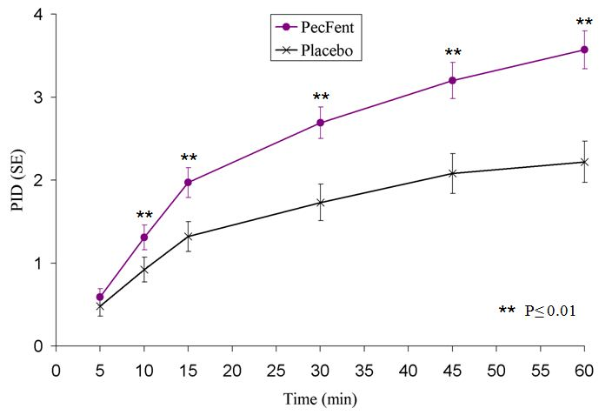Figure 2. Pain Intensity Differences (PID) following PecFent or Placebo in Adult Cancer Patients with Breakthrough Pain

The mean pain intensity scores (73 patients) for all PecFent-treated episodes (459 episodes) compared to those treated with placebo (200 episodes) were significantly lower at 5, 10, 15, 30, 45 and 60 minutes following administration.

The superior efficacy of PecFent over placebo was supported by data from secondary endpoints including the number of breakthrough pain episodes with clinically meaningful pain relief, defined as a reduction in pain intensity score of at least 2 (Figure 3).

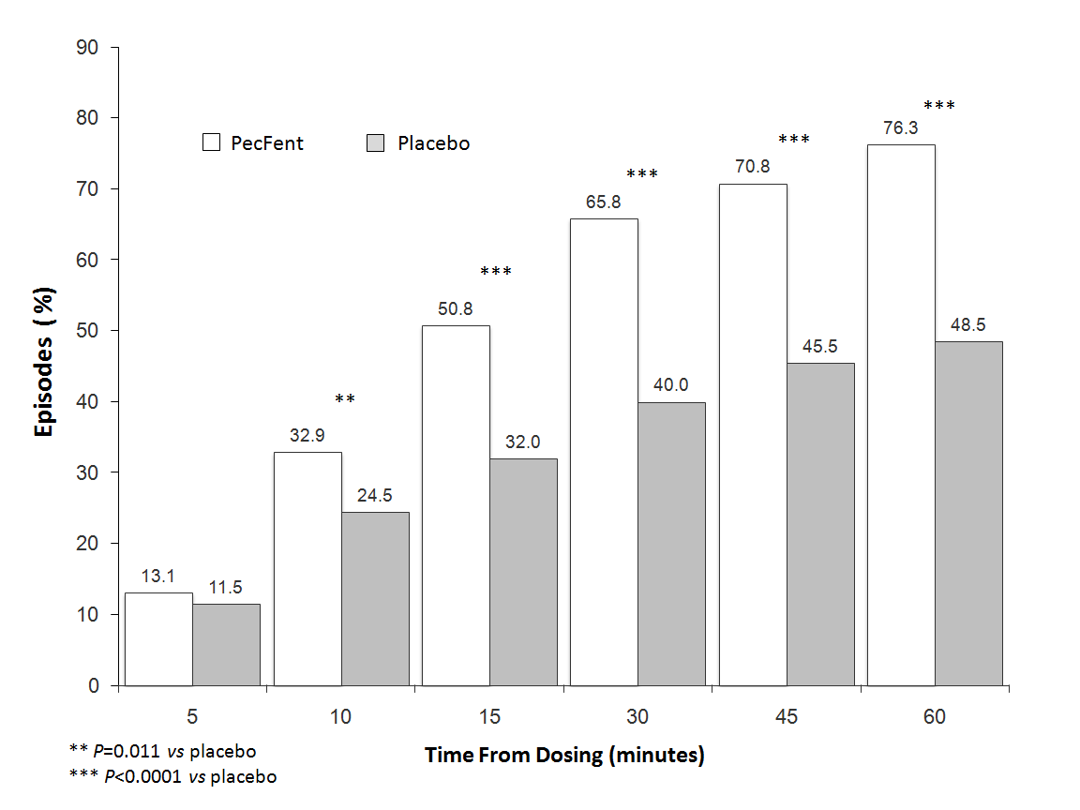Figure 3: Clinically Meaningful Pain Relief – PecFent *vs* placebo: % Patients’ Episodes With ≥2 Point Reduction in Pain Intensity

In Study CP044 of similar design to CP043, conducted in opioid-tolerant cancer patients with breakthrough pain on stable doses of regularly scheduled opioids, PecFent was shown to be superior to IRMS. Superiority was demonstrated by the primary endpoint, Pain Intensity Difference within 15 minutes, which was 3.02 in patients treated with PecFent compared to 2.69 in patients treated with IRMS (p=0.0396) (Figure 4).

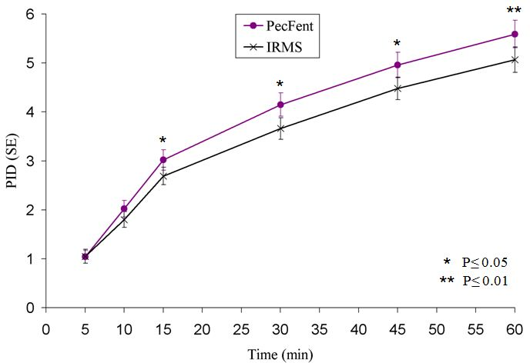Figure 4. Pain Intensity Differences (PID) following PecFent or IRMS in Adult Cancer Patients with Breakthrough Pain

#### Long Term Use

P≤0.01

In CP045, 355 patients entered the 16-week treatment phase, during which 42,227 episodes of breakthrough pain were treated with PecFent during up to 159 days of treatment. One hundred of these patients continued treatment for up to 26 months in an extension phase. Further (rescue) medication was required in only 6% of the 42,227 breakthrough pain epidsodes treated. Of the 355 patients treated in the open-label treatment phase, 90% required no increase in dose.

## INDICATIONS

PecFent is indicated for the management of breakthrough pain in adults with cancer who are already receiving maintenance opioid therapy for chronic pain.

## CONTRAINDICATIONS

Hypersensitivity to the active substance or to any of the excipients (see **PRESENTATION**).  
Use in opioid naïve patients (see **PRECAUTIONS**).  
Severe obstructive lung conditions.

## PRECAUTIONS

**Patients and their carers must be instructed that PecFent contains an active substance in an amount that can be fatal to a child, and therefore to keep PecFent out of the reach and sight of children.**

In order to minimise the risks of opioid-related adverse reactions and to identify the effective dose, it is imperative that patients be monitored closely by health professionals during the titration process.

It is important that the maintenance opioid therapy used to treat the patient’s persistent pain has been stabilised before PecFent therapy begins and that the patient continues to be treated with the maintenance opioid therapy whilst taking PecFent.

Patients considered opioid tolerant are those who are taking at least 60 mg of oral morphine daily, at least 25 µg of transdermal fentanyl per hour, at least 30 mg of oxycodone daily, at least 8 mg of oral hydromorphone daily or an equianalgesic dose of another opioid for a week or longer.

#### Route of administration

PecFent is only intended for intranasal administration, and must not be administered by any other route. Due to physico-chemical properties of excipients included in the formulation, intravenous or intra-arterial injection must be avoided in particular.

#### Effects on fertility

In humans, the prolonged use of opioid analgesics may result in sexual dysfunction, infertility or impairment of fertility in both sexes, and menstrual disturbance in women. Impairment of fertility has been observed in female rats with 160 g/kg/day subcutaneous fentanyl (no-effect dose not established) or 400 g/kg/day intravenous fentanyl (no-effect dose 100 g/kg/day). No effect was observed on the fertility of male rats at 400 g/kg/day intravenous fentanyl.

#### Use in pregnancy (Category C)

Fentanyl crosses the placenta in humans (fetal blood concentrations about 40% of maternal blood concentrations). There are no adequate and well-controlled studies in pregnant women. PecFent should be used during pregnancy only if the potential benefit justifies the potential risk to the fetus. No epidemiological studies of congenital abnormalities in infants born to women treated with fentanyl during pregnancy have been reported. Chronic maternal treatment with fentanyl during pregnancy has been associated with transient respiratory depression, behavioural changes, or seizures in newborn infants characteristic of neonatal abstinence syndrome.

In pregnant rats, fentanyl is embryocidaJ as evidenced by increased resorptions at doses of 30 g/kg/day intravenously or 160 g/kg/day or greater subcutaneously. Intravenous administration to rats at 30 g/kg/day during organogenesis was associated with prolonged delivery time and increased postnatal mortality of offspring. There was no effect on embryofetal development in rats administered fentanyl at subcutaneous doses up to 500 g/kg/day throughout gestation, and no evidence of teratogenicity in rabbits administered fentanyl at intravenous doses up to 400 g/kg/day during organogenesis

#### Use in lactation

Administration of fentanyl to female rats from early gestation to weaning was associated with reduced early postnatal survival. This could be a direct effect on the pups or secondary to maternal toxicity.

#### Use in the elderly

In the PecFent clinical trial programme, 104 (26.1%) of patients were over 60 years of age, 67 (16.8%) over 65 years and 15 (3.8%) over 75 years. There was no indication that older patients tended to titrate to lower doses or experience more adverse reactions. Nevertheless, in view of the importance of renal and hepatic function in the metabolism and clearance of fentanyl, additional care should be exercised in the use of PecFent in the elderly. No data on the pharmacokinetics of PecFent in elderly patients are available.

#### Genotoxicity

Fentanyl showed no evidence of genotoxic potential in assays for gene mutations (bacterial reverse mutation test. mouse lymphoma thymidine kinase assay), chromosomal damage (Chinese hamster ovary cells, mouse micronucleus test) and other genotoxic effects (unscheduled DNA synthesis in rat hepatocytes, mammalian cell transformation assay). The metabolite despropionylfentanyl was negative in assays for reverse mutation in bacteria and chromosomal damage in human lymphocytes. The genotoxic potential of fentanyl is considered to be low

#### Carcinogenicity

ln a two year study in rats, there was no evidence of carcinogenicity following daily subcutaneous administration of fentanyl at the maximum tolerated dose.

### Special risk patients

##### Respiratory:

There is a risk of clinically significant respiratory depression associated with the use of fentanyl. Patients with pain who receive chronic opioid therapy develop tolerance to respiratory depression and hence the risk of respiratory depression in these patients is reduced. The use of concomitant central nervous system depressants may increase the risk of respiratory depression.

In patients with chronic obstructive pulmonary diseases, fentanyl may cause more serious adverse reactions. In these patients, opioids may decrease respiratory drive and increase airway resistance.

##### Head injuries and increased intracranial pressure:

PecFent should only be administered with extreme caution in patients who may be particularly susceptible to the intracranial effects of CO2 retention, such as those with evidence of increased intracranial pressure or impaired consciousness. Opioids may obscure the clinical course of patients with a head injury and should be used only if clinically warranted.

##### Cardiac disease:

Intravenous fentanyl may produce bradycardia. PecFent should therefore be used with caution in patients with pre-existing bradyarrhythmias. Careful consideration should be given to patients with hypovolaemia and hypotension.

##### Impaired hepatic or renal function:

In addition, PecFent should be administered with caution to patients with hepatic or renal impairment. The influence of hepatic and renal impairment on the pharmacokinetics of the medicinal product has not been evaluated; however, when administered intravenously the clearance of fentanyl has been shown to be altered in hepatic and renal impairment due to alterations in metabolic clearance and plasma proteins. Therefore, special care should be taken during the titration process in patients with moderate or severe hepatic or renal impairment.

##### Abuse potential and tolerance:

Tolerance and physical and/or psychological dependence may develop upon repeated administration of opioids such as fentanyl. However, iatrogenic addiction following therapeutic use of opioids is rare.

##### Nasal conditions:

If the patient experiences recurrent episodes of epistaxis or nasal discomfort while taking PecFent, an alternative method of administration for treatment of breakthrough pain should be considered.

##### PecFent excipients

PecFent contains propyl hydroxybenzoate (E216). In some patients this may cause allergic reactions (possibly delayed) and, exceptionally, bronchospasm (if the product is not correctly administered).

##### Paediatric use:

The safety and efficacy of PecFent in children aged below 18 years have not yet been established.

No data are available.

## INTERACTIONS WITH OTHER MEDICINES

Fentanyl is metabolised mainly via the human cytochrome P450 3A4 isoenzyme system (CYP3A4), therefore potential interactions may occur when PecFent is given concurrently with agents that affect CYP3A4 activity. Coadministration with agents that induce 3A4 activity may reduce the efficacy of PecFent. The concomitant use of PecFent with strong CYP3A4 inhibitors (e.g. ritonavir, ketoconazole, itraconazole, troleandomycin, clarithromycin, and nelfinavir) or moderate CYP3A4 inhibitors (e.g. amprenavir, aprepitant, diltiazem, erythromycin, fluconazole, fosamprenavir, grapefruit juice, and verapamil) may result in increased fentanyl plasma concentrations, potentially causing serious adverse drug reactions including fatal respiratory depression. Patients receiving PecFent concomitantly with moderate or strong CYP3A4 inhibitors should be carefully monitored for an extended period of time. Dose increase should be undertaken with caution.

The concomitant use of other central nervous system depressants, including other opioids, sedatives or hypnotics, general anaesthetics, phenothiazines, tranquillisers, skeletal muscle relaxants, sedating antihistamines and alcohol may produce additive depressant effects.

PecFent is not recommended for use in patients who have received monoamine oxidase (MAO) inhibitors within the previous 14 days because severe and unpredictable potentiation by MAO inhibitors has been reported with opioid analgesics.

The concomitant use of partial opioid agonists/antagonists (e.g. buprenorphine, nalbuphine, pentazocine) is not recommended. They have high affinity to opioid receptors with relatively low intrinsic activity and therefore partially antagonise the analgesic effect of fentanyl and may induce withdrawal symptoms in opioid dependant patients.

Concomitant use of nasally administered oxymetazoline may affect (decrease) the absorption of PecFent.

##### Effects on ability to drive and use machines

No studies on the effects on the ability to drive and use machines have been performed.

However, opioid analgesics may impair the mental and/or physical ability required for driving or operating machinery.

Patients should be advised not to drive or operate machinery if they experience somnolence, dizziness, or visual disturbance or other adverse reactions which can impair their ability to drive or operate machinery.

## ADVERSE EFFECTS

A total of 523 patients were evaluated for safety across the clinical trial program and 45,559 episodes of breakthrough pain were treated with PecFent.

Typical opioid adverse reactions are to be expected with PecFent. Frequently, these will cease or decrease in intensity with continued use of the medicinal product, as the patient is titrated to the most appropriate dose. However, the most serious adverse reactions are respiratory depression (potentially leading to apnoea or respiratory arrest), circulatory depression, hypotension and shock and all patients should be monitored for these.

The clinical studies of PecFent were designed to evaluate safety and efficacy in treating breakthrough pain and all patients were also on background opioid therapies, such as sustained-release morphine or transdermal fentanyl, for their persistent pain. Therefore it is not possible to definitively separate the effects of PecFent alone.

Table of adverse events occurring at >1% from the total safety population of 523 patients treated with PecFent

| **System Organ Class** | **100 mcg** | **200 mcg** | | **400 mcg** | | | **800 mcg** | | | **Total** | | |
| --- | --- | --- | --- | --- | --- | --- | --- | --- | --- | --- | --- | --- |
| Number (%) of Subjects with at Least One AE | 125 (25.8) | 93 (23.9) | | 111 (34.8) | | | 90 (49.5) | | | 340 (65.9) | | |
| **Blood and Lymphatic System Disorders** | | | | | | | | | | | | |
| Anaemia | 1 (0.2) | 8 (2.1) | | 4 (1.3) | | | 6 (3.3) | | | 19 (3.7) | | |
| Neutropenia | 1 (0.2) | 2 (0.5) | | 0 (0.0) | | | 4 (2.2) | | | 7 (1.4) | | |
| **Cardiac Disorders** | | | | | | | | | | | | |
| Cardio-respiratory Arrest | 0 (0.0) | 2 (0.5) | | 4 (1.3) | | | 0 (0.0) | | | 6 (1.2) | | |
| **Gastrointestinal Disorders** | | | | | | | | | | | | |
| Vomiting | 20 (4.1) | 20 (5.1) | | 21 (6.6) | | | 14 (7.7) | | | 71 (13.8) | | |
| Nausea | 23 (4.8) | 15 (3.9) | | 12 (3.8) | | | 14 (7.7) | | | 63 (12.2) | | |
| Constipation | 23 (4.8) | 6 (1.5) | | 14 (4.4) | | | 8 (4.4) | | | 50 (9.7) | | |
| Diarrhea | 7 (1.4) | 4 (1.0) | | 6 (1.9) | | | 6 (3.3) | | | 22 (4.3) | | |
| Abdominal Pain | 3 (0.6) | 1 (0.3) | | 6 (1.9) | | | 1 (0.5) | | | 11 (2.1) | | |
| Gastritis | 3 (0.6) | 2 (0.5) | | 3 (0.9) | | | 2 (1.1) | | | 10 (1.9) | | |
| **General Disorders and Administration Site Conditions** | | | | | | | | | | | | |
| Disease Progression | 16 (3.3) | 8 (2.1) | | 16 (5.0) | | | 26 (14.3) | | | 62 (12.0) | | |
| Pyrexia | 7 (1.4) | 6 (1.5) | | 9 (2.8) | | | 7 (3.8) | | | 28 (5.4) | | |
| Pain | 5 (1.0) | 4 (1.0) | | 8 (2.5) | | | 8 (4.4) | | | 24 (4.7) | | |
| Fatigue | 3 (0.6) | 3 (0.8) | | 9 (2.8) | | | 5 (2.7) | | | 19 (3.7) | | |
| Oedema Peripheral | 1 (0.2) | 5 (1.3) | | 7 (2.2) | | | 6 (3.3) | | | 19 (3.7) | | |
| Asthenia | 4 (0.8) | 3 (0.8) | | 7 (2.2) | | | 2 (1.1) | | | 16 (3.1) | | |
| Non-cardiac Chest Pain | 1 (0.2) | 1 (0.3) | | 3 (0.9) | | | 1 (0.5) | | | 6 (1.2) | | |
| **Immune System Disorders** | | | | | | | | | | | | |
| Hypersensitivity | 1 (0.2) | 1 (0.3) | | 2 (0.6) | | | 3 (1.6) | | | 7 (1.4) | | |
| **Infections and Infestations** | | | | | | | | | | | | |
| Urinary Tract Infection | 4 (0.8) | 1 (0.3) | | 4 (1.3) | | | 4 (2.2) | | | 13 (2.5) | | |
| Pneumonia | 3 (0.6) | 4 (1.0) | | 3 (0.9) | | | 1 (0.5) | | | 10 (1.9) | | |
| Nasopharyngitis | 4 (0.8) | 2 (0.5) | | 0 (0.0) | | | 3 (1.6) | | | 9 (1.7) | | |
| Infection | 4 (0.8) | 0 (0.0) | | 2 (0.6) | | | 3 (1.6) | | | 8 (1.6) | | |
| Rhinitis | 2 (0.4) | 3 (0.8) | | | 0 (0.0) | | | 1 (0.5) | | | 6 (1.2) | |
| **Investigations** | | | | | | | | | | | | |
| Weight Decreased | 2 (0.4) | | 0 (0.0) | | | 2 (0.6) | | | 2 (1.1) | | | 6 (1.2) |
| **Metabolism and Nutrition Disorders** | | | | | | | | | | | | |
| Dehydration | 1 (0.2) | | 7 (1.8) | | | 4 (1.3) | | | 7 (3.8) | | | 18 (3.5) |
| Decreased Appetite | 1 (0.2) | | 3 (0.8) | | | 5 (1.6) | | | 2 (1.1) | | | 11 (2.1) |
| Hyperglycaemia | 3 (0.6) | | 2 (0.5) | | | 2 (0.6) | | | 1 (0.5) | | | 8 (1.6) |
| **Musculoskeletal and Connective Tissue Disorders** | | | | | | | | | | | | |
| Back Pain | 1 (0.2) | | 0 (0.0) | | | 5 (1.6) | | | 1 (0.5) | | | 7 (1.4) |
| Pain In Extremity | 0 (0.0) | | 1 (0.3) | | | 4 (1.3) | | | 2 (1.1) | | | 7 (1.4) |
| Cancer Pain | 3 (0.6) | | 2 (0.5) | | | 5 (1.6) | | | 4 (2.2) | | | 13 (2.5) |
| **Nervous System Disorders** | | | | | | | | | | | | |
| Dizziness | 16 (3.3) | | 14 (3.6) | | | 8 (2.5) | | | 9 (4.9) | | | 42 (8.1) |
| Somnolence | 10 (2.1) | | 8 (2.1) | | | 14 (4.4) | | | 7 (3.8) | | | 36 (7.0) |
| Headache | 9 (1.9) | | 7 (1.8) | | | 2 (0.6) | | | 2 (1.1) | | | 20 (3.9) |
| Dysgeusia | 5 (1.0) | | 1 (0.3) | | | 2 (0.6) | | | 1 (0.5) | | | 9 (1.7) |
| **Psychiatric Disorders** | | | | | | | | | | | | |
| Anxiety | 4 (0.8) | | 3 (0.8) | | | 7 (2.2) | | | 3 (1.6) | | | 17 (3.3) |
| Insomnia | 2 (0.4) | | 6 (1.5) | | | 6 (1.9) | | | 3 (1.6) | | | 17 (3.3) |
| Depression | 3 (0.6) | | 2 (0.5) | | | 0 (0.0) | | | 5 (2.7) | | | 10 (1.9) |
| Confusional State | 1 (0.2) | | 0 (0.0) | | | 5 (1.6) | | | 3 (1.6) | | | 9 (1.7) |
| Disorientation | 2 (0.4) | | 2 (0.5) | | | 4 (1.3) | | | 0 (0.0) | | | 7 (1.4) |
| **Respiratory, Thoracic and Mediastinal Disorders** | | | | | | | | | | | | |
| Dyspnoea | 9 (1.9) | | 4 (1.0) | | | 5 (1.6) | | | 5 (2.7) | | | 23 (4.5) |
| Epistaxis | 6 (1.2) | | 3 (0.8) | | | 3 (0.9) | | | 5 (2.7) | | | 15 (2.9) |
| Cough | 4 (0.8) | | 0 (0.0) | | | 7 (2.2) | | | 3 (1.6) | | | 14 (2.7) |
| Pharyngolaryngeal Pain | 4 (0.8) | | 5 (1.3) | | | 3 (0.9) | | | 3 (1.6) | | | 14 (2.7) |
| Nasal Discomfort | 6 (1.2) | | 2 (0.5) | | | 4 (1.3) | | | 1 (0.5) | | | 11 (2.1) |
| Rhinorrhoea | 5 (1.0) | | 2 (0.5) | | | 1 (0.3) | | | 5 (2.7) | | | 11 (2.1) |
| Nasal Congestion | 3 (0.6) | | 3 (0.8) | | | 0 (0.0) | | | 0 (0.0) | | | 6 (1.2) |
| Postnasal Drip | 2 (0.4) | | 1 (0.3) | | | 2 (0.6) | | | 1 (1.2) | | | (0.5) 6 |
| **Skin and Subcutaneous Tissue Disorders** | | | | | | | | | | | | |
| Pruritus | 3 (0.6) | | 2 (0.5) | | | 3 (0.9) | | | 4 (2.2) | | | 12 (2.3) |
| Hyperhidrosis | 3 (0.6) | | 1 (0.3) | | | 3 (0.9) | | | 2 (1.1) | | | 9 (1.7) |
| Decubitus Ulcer | 1 (0.2) | | 1 (0.3) | | | 2 (0.6) | | | 2 (1.1) | | | 6 (1.2) |
| **Vascular Disorders** | | | | | | | | | | | | |
| Hypertension | 5 (1.0) | | 0 (0.0) | | | 2 (0.6) | | | 1 (0.5) | | | 8 (1.6) |
| Deep Vein Thrombosis | 1 (0.2) | | 2 (0.5) | | | 1 (0.3) | | | 2 (1.1) | | | 6 (1.2) |

The adverse events considered to be at least possibly-related to treatment in clinical trials involving 523 patients treated with PecFent that fall below the 1% cut-off are listed below (Uncommon >0.1-1%).

### Blood and Lymphatic System Disorders

*Uncommon* Neutropenia

### Cardiac Disorders

*Uncommon* Cyanosis

### Ear and Labyrinth Disorders

*Uncommon* Vertigo

### Gastrointestinal Disorders

*Uncommon* Abdominal Pain, Diarrhoea, Dry Mouth, Dyspepsia, Hypoaesthesia Oral, Intestinal Perforation, Mouth Ulceration, Paraesthesia Oral, Peritonitis, Retching, Tongue Disorder

### General Disorders and Administration Site Conditions

*Uncommon* Asthenia, Chills, Face Oedema, Fatigue, Gait Disturbance, Malaise, Non-cardiac Chest Pain, Oedema Peripheral, Pain, Pyrexia, Thirst

### Immune System Disorders

*Uncommon* Hypersensitivity

### Infections and Infestations

*Uncommon* Nasopharyngitis, Pharyngitis , Pneumonia, Rhinitis

### Injury, Poisoning and Procedural Complications

*Uncommon* Fall, Intentional Drug Misuse, Medication Error

### Investigations

*Uncommon* Platelet Count Decreased, Weight Decreased

### Metabolism and Nutrition Disorders

*Uncommon* Decreased Appetite, Dehydration, Hyperglycaemia, Increased Appetite

### Musculoskeletal and Connective Tissue Disorders

*Uncommon* Arthralgia, Muscle Twitching

### Nervous System Disorders

*Uncommon* Ageusia, Anosmia, Convulsion, Depressed Level of Consciousness, Lethargy, Loss of Consciousness, Memory Impairment, Parosmia, Sedation, Speech Disorder, Tremor

### Psychiatric Disorders

*Uncommon* Anxiety, Attention Deficit/hyperactivity Disorder, Confusional State, Delirium, Depression, Disorientation, Drug Abuse, Euphoric Mood, Hallucination, Visual, Nervousness

### Renal and Urinary Disorders

*Uncommon* Anuria, Dysuria, Proteinuria, Urinary Hesitation

### Reproductive System and Breast Disorders

*Uncommon* Vaginal Haemorrhage

### Respiratory, Thoracic and Mediastinal Disorders

*Uncommon* Cough, Dyspnoea, Intranasal Hypoaesthesia, Nasal Congestion, Nasal Dryness, Nasal Mucosal Disorder, Pharyngolaryngeal Pain, Postnasal Drip, Rhinorrhoea, Sneezing, Throat Irritation, Upper Airway Obstruction, Upper Respiratory Tract Congestion

### Skin and Subcutaneous Tissue Disorders

*Uncommon* Hyperhidrosis, Night Sweats, Pruritus Generalised, Urticaria

### Vascular Disorders

*Uncommon* Cardiovascular Insufficiency, Hot Flush, Hypotension, Lymphoedema

## DOSAGE AND ADMINISTRATION

Treatment should be initiated by and remain under the supervision of a physician experienced in the management of opioid therapy in cancer patients. Physicians should keep in mind the potential for abuse of fentanyl.

#### Dose and Interval

PecFent should be titrated to an “effective” dose that provides, for two consecutively treated episodes of breakthrough pain, adequate analgesia without causing undue (or intolerable) adverse reactions. The efficacy of a given dose should be assessed over the ensuing 30 minute period.

Patients should be carefully monitored until an effective dose is reached.

One dose of PecFent may include administration of 1 spray (100 µg or 400 µg doses) or 2 sprays (200 µg or 800 µg doses) of the same dose strength (either 100 µg or 400 µg strength).

Patients should not take more than 4 doses per day. Patients should wait at least 2 hours after a dose before treating another breakthrough pain episode with PecFent.

###### Initial dose

* The initial dose of PecFent to treat episodes of breakthrough pain is always 100 µg (one spray), even in patients switching from other fentanyl containing products for their breakthrough pain.
* Patients must wait at least 2 hours before treating another episode of breakthrough pain with PecFent.

###### Method of titration

* Patients should be prescribed an initial titration supply of one bottle (8 full sprays) of PecFent 100 µg/spray.
* Patients whose initial dose is 100 µg and who need to titrate to a higher dose due to a lack of effect can be instructed to use two 100 µg sprays (one in each nostril) for their next breakthrough pain episode. If this dose is not successful, the patient may be prescribed a bottle of PecFent 400 µg/spray and instructed to change to one 400 µg spray for their next episode of pain. If this dose is not successful, the patient may be instructed to increase to two 400 µg sprays (one in each nostril).
* From treatment initiation, patients should be closely followed and the dose titrated until an effective dose is reached and confirmed for two consecutively treated episodes of breakthrough pain.

Titration in patients switching between immediate-release fentanyl containing products

Substantial differences may exist in the pharmacokinetic profile of immediate-release fentanyl products, which result in clinically important differences in the rate and extent of absorption of fentanyl. Therefore, when switching between fentanyl containing products indicated for treatment of breakthrough pain, including intranasal formulations, it is essential that patients are again titrated with the new product, and not switched on a dose-for-dose (µg-for-µg) basis.

Maintenance therapy

Once an effective dose has been established during titration, patients should continue to take this dose up to a maximum of 4 doses per day.

Dose readjustment

Generally, the maintenance dose of PecFent should be increased only where the current dose fails to adequately treat the breakthrough pain for several consecutive episodes.

A review of the dose of the background opioid therapy may be required if patients consistently present with more than four breakthrough pain episodes per 24 hours.

If adverse reactions are intolerable or persistent, the dose should be reduced or treatment with PecFent replaced by another analgesic.

Discontinuation of therapy

PecFent should be discontinued immediately if the patient no longer experiences breakthrough pain episodes. The treatment for persistent background pain should be kept as prescribed.

If discontinuation of all opioid therapy is required, the patient must be closely followed by the doctor as gradual downward opioid titration therapy is necessary in order to avoid the possibility of abrupt withdrawal effects.

Method of administration

PecFent is for administration via the nasal route only.

PecFent can deliver 100, 200, 400 and 800 microgram doses as follows:

|  |  |  |
| --- | --- | --- |
| Dose required (µg) | Product strength (µg) | Amount |
| 100 | 100 | One spray administered into one nostril |
| 200 | 100 | One spray administered into each nostril |
| 400 | 400 | One spray administered into one nostril |
| 800 | 400 | One spray administered into each nostril |

The bottle should be removed from the child resistant container immediately prior to use and the protective cap removed. The bottle must be primed before first use by holding upright and simply pressing and releasing the finger grips either side of the nozzle until a green bar appears in the counting window (should occur after four sprays). During priming aim the spray away from you (and any other people or animals).

If the product has not been used for more than 5 days, re-prime by spraying once in the air. Discard bottle 60 days after first opening. The patient should be advised to write the date of first use in the space provided on the label of the child resistant container.

To administer PecFent the nozzle is placed a short distance (about 1 cm) into the nostril and pointed slightly towards the bridge of the nose. A spray is then administered by pressing and releasing the finger grips either side of the nozzle. An audible click will be heard and the number displayed on the counter will advance by one.

Patients must be advised that they may not feel the spray being administered, and that they should therefore rely on the audible click and the number on the counter advancing to confirm that a spray has been delivered.

Patients should be advised not to blow their nose immediately after PecFent administration.

The protective cap should be replaced after each use and the bottle returned to the child resistant container for safe storage.

## OVERDOSAGE

The symptoms of fentanyl overdose via the nasal route are expected to be similar in nature to those of intravenous fentanyl and other opioids, and are an extension of its pharmacological actions, with the most serious significant effect being respiratory depression.

Immediate management of opioid overdose includes ensuring a patent airway, physical and verbal stimulation of the patient, assessment of the level of consciousness, ventilatory and circulatory status, and assisted ventilation (ventilatory support) if necessary.

For treatment of overdose (accidental ingestion) in the opioid-naïve person, intravenous access should be obtained and naloxone or other opioid antagonists should be employed as clinically indicated. The duration of respiratory depression following overdose may be longer than the effects of the opioid antagonist’s action (e.g. the half life of naloxone ranges from 30 to 81 minutes) and repeated administration may be necessary. Consult the Product Information of the individual opioid antagonist for details about such use.

For treatment of overdose in opioid-maintained patients, intravenous access should be obtained. The judicious use of naloxone or another opioid antagonist may be warranted in some instances, but it is associated with the risk of precipitating an acute withdrawal syndrome.

It should be noted that although statistically significant increases in Cmax levels were seen following a second dose of PecFent given either one or two hours after the initial dose, this increase is not considered to be large enough to suggest that clinically concerning accumulation or over-exposure would occur, providing a wide safety margin for the recommended dose interval of two hours.

Although muscle rigidity interfering with respiration has not been seen following the use of PecFent, this is possible with fentanyl and other opioids. If it occurs, it should be managed by the use of assisted ventilation, by an opioid antagonist, and as a final alternative, by a neuromuscular blocking agent.

## PRESENTATION AND STORAGE CONDITIONS

PecFent nasal spray solution is presented in a bottle (clear Type I glass) with an attached metering pump incorporating a visual and audible dose counter and a protective cap. It is available in two strengths, 100 and 400 µg/actuation. Each ml of solution contains either 1,000 or 4,000 µg fentanyl (as citrate). One full spray (100 µL) contains either 100 or 400 µg fentanyl.

Each PecFent bottle is packed in a clam-shell-like child resistant container. Each bottle contains 1.55 mL ensuring delivery of 8 full sprays.

Bottles in their child resistant containers are supplied in cartons containing 1 or 4 bottles.

#### List of excipients

Partially de-esterified pectin (E440)  
Mannitol (E421)  
Phenethyl alcohol  
Propyl hydroxybenzoate (E216)  
Sucrose  
Hydrochloric acid (0.36%) or sodium hydroxide (for pH adjustment)  
Purified water

#### Storage conditions

Store below 25˚C.   
Do not freeze.  
Keep the bottle in the child resistant container in order to protect from light.  
Store the bottle in the child resistant container at all times, even when finished.

#### Special precautions for disposal

Partially used PecFent bottles may contain enough medicine to be harmful or life-threatening to a child. Even if there is little or no medicine left in the bottle, PecFent must be disposed of properly, according to the following steps:

* + Patients and caregivers must be instructed to properly dispose of all unused, partially used and used PecFent bottles. The patient should be instructed how to do this correctly.
  + If there are any unwanted therapeutic sprays remaining in the bottle, instruct the patient to expel these by aiming the spray away from themselves (and any other people or animals) until the number “8” appears in the counting window and there are no more full therapeutic sprays obtainable from the bottle.
  + After the counter has advanced to “8”, the patient should continue to push down on the finger grips (there will be some increased resistance) a total of four times in order to expel any residual medicine from the bottle.
  + After the 8 therapeutic sprays have been emitted, the patient will not hear a click and the counter will not advance beyond “8”; further sprays emitted will not be full sprays and should **not be** used therapeutically.
  + **The patient and caregiver must be instructed to** continue to store the PecFent bottle in the specially provided child-resistant container out of the reach of children until proper disposal, as described above, is possible.

As soon as PecFent is no longer needed, patients and members of their household must be advised to systematically dispose of any bottles remaining from a prescription as soon as possible by returning them to their child-resistant container and discarding them, according to local requirements or by returning them to the pharmacy.

**NAME AND ADDRESS OF THE SPONSOR**

AstraZeneca Pty Ltd  
ABN 54 009 682 311  
Alma Road  
NORTH RYDE NSW 2113

PecFent is a registered trademark of Archimedes Development Limited, used under licence by AstraZeneca Pty Ltd.

## POISON SCHEDULE OF THE MEDICINE

S8

## DATE OF FIRST INCLUSION IN THE AUSTRALIAN REGISTER OF THERAPEUTIC GOODS (the ARTG)

This Product Information was approved by the Therapeutic Goods Administration on 31 July 2012.

## DATE OF MOST RECENT AMENDMENT

22 February 2013