|  |
| --- |
| **First round CER: 31 August 2012**  **Second round CER: 16 December 2012** |

|  |
| --- |
| AusPAR Attachment 2 |
| Extract from the Clinical Evaluation Report for fentanyl citrate |
| Proprietary Product Name: Instanyl |
| Sponsor: Takeda Pharmaceuticals Australia Pty Ltd |

About the Therapeutic Goods Administration (TGA)

* The Therapeutic Goods Administration (TGA) is part of the Australian Government Department of Health and is responsible for regulating medicines and medical devices.
* The TGA administers the *Therapeutic Goods Act 1989* (the Act), applying a risk management approach designed to ensure therapeutic goods supplied in Australia meet acceptable standards of quality, safety and efficacy (performance), when necessary.
* The work of the TGA is based on applying scientific and clinical expertise to decision-making, to ensure that the benefits to consumers outweigh any risks associated with the use of medicines and medical devices.
* The TGA relies on the public, healthcare professionals and industry to report problems with medicines or medical devices. TGA investigates reports received by it to determine any necessary regulatory action.
* To report a problem with a medicine or medical device, please see the information on the TGA website <<http://www.tga.gov.au>>.

About the Extract from the Clinical Evaluation Report

* This document provides a more detailed evaluation of the clinical findings, extracted from the Clinical Evaluation Report (CER) prepared by the TGA. This extract does not include sections from the CER regarding product documentation or post market activities.
* The words [Information redacted], where they appear in this document, indicate that confidential information has been deleted.
* For the most recent Product Information (PI), please refer to the TGA website <<http://www.tga.gov.au/hp/information-medicines-pi.htm>>.

Copyright

© Commonwealth of Australia 2013  
This work is copyright. You may reproduce the whole or part of this work in unaltered form for your own personal use or, if you are part of an organisation, for internal use within your organisation, but only if you or your organisation do not use the reproduction for any commercial purpose and retain this copyright notice and all disclaimer notices as part of that reproduction. Apart from rights to use as permitted by the *Copyright Act 1968* or allowed by this copyright notice, all other rights are reserved and you are not allowed to reproduce the whole or any part of this work in any way (electronic or otherwise) without first being given specific written permission from the Commonwealth to do so. Requests and inquiries concerning reproduction and rights are to be sent to the TGA Copyright Officer, Therapeutic Goods Administration, PO Box 100, Woden ACT 2606 or emailed to <[tga.copyright@tga.gov.au](mailto:tga.copyright@tga.gov.au)>.

Contents

1. List of abbreviations 4

2. Clinical rationale 6

3. Contents of the clinical dossier 7

3.1. Scope of the clinical dossier 7

3.2. Paediatric data 8

3.3. Good clinical practice 8

4. Pharmacokinetics 11

4.1. Studies providing pharmacokinetic data 11

4.2. Summary of pharmacokinetics 12

4.3. Evaluator’s overall conclusions on pharmacokinetics 17

5. Pharmacodynamics 17

5.1. Studies providing pharmacodynamic data 17

5.2. Summary of pharmacodynamics 17

5.3. Evaluator’s overall conclusions on pharmacodynamics 18

6. Clinical efficacy 18

6.1. Relief of breakthrough cancer pain 18

6.2. Evaluator’s conclusions on clinical efficacy for BTP 45

7. Clinical safety 46

7.1. Studies providing evaluable safety data 46

7.2. Patient exposure 47

7.3. Adverse events 49

7.4. Laboratory tests 53

7.5. Post-marketing experience 54

7.6. Safety issues with the potential for major regulatory impact 55

7.7. Evaluator’s overall conclusions on clinical safety 55

8. First round benefit-risk assessment 56

8.1. First round assessment of benefits 56

8.2. First round assessment of risks 56

8.3. First round recommendation regarding authorisation 56

9. Clinical questions 56

9.1. Additional expert input 56

9.2. Pharmacokinetics 57

9.3. Pharmacodynamics 57

9.4. Efficacy 57

9.5. Safety 57

10. Second round evaluation of clinical data submitted in response to questions 57

10.1. Second round benefit-risk assessment 59

10.2. Second round recommendation regarding authorisation 59

11. References 59

## List of abbreviations

| **Abbreviation** | **Meaning** |
| --- | --- |
| AE | Adverse event |
| ADR | Adverse drug reaction (treatment emergent) |
| ANOVA | Analysis of variance |
| AUC | Area under the plasma concentration-time curve |
| AUC0-∞ | Area under the plasma concentration-time curve from time zero to infinity |
| AUC0-t | Area under the plasma concentration-time curve from time zero to time ‘t’ |
| BMI | Body mass index |
| BTCP / BTP | Break through cancer pain / break through pain |
| CHMP | Committee for Human Medicinal Products (EMA) (formally CPMP, Committee for Proprietary Medicinal Products) |
| CI | Confidence interval |
| Cl/F | Apparent clearance [clearance (CL) divided by bioavailability (F)] |
| Cmax | Maximum plasma concentration |
| CRO | Contract Research Organisation |
| CSR | Clinical study report |
| CV% | Percent coefficient of variation |
| CYP | Cytochrome P450 |
| EPAR | European Public Assessment Report |
| EMA | European Medicines Agency (formally EMEA, European Medicines Evaluation Agency) |
| EU | European Union |
| FNS / INFS / NAF | Fentanyl nasal spray / intranasal fentanyl spray |
| GCP | Good Clinical Practice |
| GI | General Impression Scale |
| ICH | International Conference on Harmonisation |
| IM | Intramuscular |
| IMP / IP | Investigational medicinal product / investigational product |
| INFS | Intranasal fentanyl spray (FNS fentanyl nasal spray) |
| IR | Immediate release |
| ITT | Intention to treat |
| IV | Intravenous |
| Kel / Ke | Elimination rate constant |
| LC-MS/MS | Liquid chromatography with tandem mass spectrometry |
| LLOQ | Lower limit of quantification |
| LS | least squares |
| MDS | Multi-dose system |
| NAF | Nasal fentanyl (FNS) |
| NRS | Numerical Rating Scale |
| NSAID | Non-steroidal anti-inflammatory drug |
| OTFC | Oral transmucsoal fentanyl citrate |
| PCA | Patient controlled analgesia |
| PI | Pain intensity |
| PID | Pain intensity difference |
| PID10 | Pain intensity difference at 10 minutes |
| PD | Pharmacodynamics |
| PK | Pharmacokinetics |
| pn | As needed (pro necessitate) |
| po | per oral |
| PP | Per protocol |
| RM | Rescue medication |
| SAE | Serious Adverse Event |
| SD | Standard deviation |
| SE | Standard error |
| SDS | Single Dose System |
| SPID | Sum of pain intensity difference |
| SPID0-60 | Sum of pain intensity difference over the time interval 0-60 minutes |
| TEAE | Treatment emergent adverse event |
| TESAE | Treatment emergent serious adverse event |
| T½ | Half life |
| Tmax | Time to maximum plasma concentration |
| TOTPAR | Total pain relief |
| URTI | Upper respiratory tract infection |
| Vd | Volume of distribution |
| Vd/F | Apparent volume of distribution (volume of distribution divided by bioavailability [F]) |
| VRS | Verbal rating scale |

## Clinical rationale

The term breakthrough pain (BTP) refers to a transitory exacerbation of severe pain that occurs on a background of otherwise controlled pain, both cancer related as well as non-cancer related, in patients already receiving chronic opioid treatment. Breakthrough cancer pain (BTCP) affects an estimated 52-64% of inpatient cancer patients, 65% of outpatient cancer patients, and 60-90% of hospice patients. Although highly variable, cancer related BTP is typically rapid in onset (peak pain within minutes), often severe in intensity and relatively short in duration, usually no longer than 30-60 minutes with an average frequency of 3-4 pain episodes per day. BTCP episodes are not always recognised and treated optimally due to a variety of factors including lack of a common definition, assessment methods, classification and lack of good treatment options.

In the cancer population, conventional tablets/capsules/mixtures containing immediate release morphine, oxycodone or hydromorphone are mostly used for the treatment of BTCP. The time-action characteristics of oral formulations of immediate release morphine include an onset of analgesic effect in 20-40 minutes and peak effect at 1-2 hours, which may not be optimal for many patients with BTCP and may overshoot the duration of the pain episode. There is now in Europe an oral transmucosal fentanyl citrate (OTFC) sublingual lozenges (Abstral) compressed lozenge with integral oromucosal applicator (Actiq) and a buccal tablet (Effentora) and buccal soluble films (Onsalis, Breakyl). Another fentanyl nasal spray PecFent was approved in Europe in August 2010.[1]

In Australia, Actiq and Pecfent have been approved for the treatment of BTCP.[2]

The development of the Nycomed fentanyl nasal spray (FNS) was aimed at improving treatment of BTP in cancer patients through the delivery of fentanyl as a controlled quantity into the nasal cavity with a rapid systemic absorption as well as a fast onset of effect. The low molecular weight, high potency and lipid solubility of fentanyl makes it suitable for intranasal administration. In addition, intranasal delivery can achieve high bioavailability of fentanyl since this route of administration avoids pre-systemic first-pass hepatic metabolism.

The desirable characteristics of a BTP analgesic include rapid onset of effect, duration of effect to cover the duration of the episode, no long acting metabolites and availability of a non-invasive formulation. FNS is expected to provide these features. The other advantage of the intranasal route is that cancer patients often have a wide range of oral and gastrointestinal problems adversely affecting quality of life, the most common being nausea and/or vomiting, impaired gastrointestinal function, fungal infections, mucosal abnormalities and ‘dry mouth’ syndrome. Use of an intranasal spray offers an alternative route of drug administration in patients that cannot take medications by the conventional oral route and should therefore increase patient compliance and quality of life.

The Nycomed FNS clinical development programme started in 1999 with a combined pilot efficacy and dose-finding trial, FT-001-IN. The development programme was terminated in August 2003 due to unforeseen recruitment problems in the two ongoing trials, FT-003-IN and FT-001-IN. These studies were terminated prior to enrolling the required number of patients. The clinical development programme was subsequently re-opened in 2005 and proceeded with the remaining studies included in the submission.

## Contents of the clinical dossier

### Scope of the clinical dossier

The clinical dossier documented a full clinical development program of pharmacology, efficacy and safety studies. In addition a number of publications are included.

The submission contained the following clinical information:

* 10 clinical pharmacology studies, including 10 that provided pharmacokinetic data and 0 that provided pharmacodynamic data;
* 2 pivotal efficacy/safety studies;
* 2 other efficacy/safety studies;
* 5 Periodic Safety Update Reports (PSURs) covering the period April 2009 to October 2011;
* 33 publications supporting pharmacokinetic data of Fentanyl;
* 4 publications supporting intranasal FNS for BTP (but using different formulations);
* 18 publications supporting intranasal FNS for other indications (post operative pain: 9; burns: 3; acute pain: 5, prostate surgery:1);
* 17 publications supporting the use of oral transmucosal fentanyl citrate in BTP, post operative pain, burns and other acute pain;
* 6 publications supporting the use of fentanyl via other routes for other indications.

### Paediatric data

The submission included some paediatric data in the form of publications. Approval for use in children is not requested. The PI states that use in children less than 18 has not been established.

### Good clinical practice

The submission states that the clinical trials, which were all conducted in Europe and the US, were conducted in accordance with Good Clinical Practice (ICH GCP) (CPMP/EWP/612/00).

In section 2.5 (dated May 2011), the sponsor makes the following statements:

*“In November 2007, suspicion of misconduct arose at one of the trial sites in trial FT-019-IM (site X). In particular, the following aspects were noted: lack of reported serious adverse events (SAEs), the absence of deaths or progression of disease in a population of cancer patients, and fewer reported non-serious AEs than in the trials in general.*

*The responsible investigator could not provide a satisfactory explanation for these results. This site had also contributed patients in trials FT-017-IM and FT-018-IM. Therefore, the data from trials FT-017-IM and FT-018-IM were remonitored for safety data, and then reanalysed with data from this site excluded. The remonitored trial reports were reissued in summer of 2009. Exclusion of site X data from trials FT-017-IM and FT-018-IM yielded only minor differences from the original analysis for all patients, and INFS [intranasal fentanyl spray] in doses of 50, 100, and 200 μg, used in the treatment of BTCP, was superior to placebo and was clinically effective for all patients. Therefore, the reanalysed data are presented in this document. Data from trial FT-019-IM (which was completed after identification of the sites) were analysed after exclusion of all data from this site.”*

This explanation is not consistent with the information provided in the European Public Assessment Report (EPAR) for Instanyl. The following is extracted from the EPAR taken from the European Medicines Agency (EMA) website. The EPAR is dated July 2009.

*“On November 30, 2007 observations were reported giving rise to suspicion of misconduct in FT-019-IM (open label, comparative, randomised, balanced crossover trial comparing nasal fentanyl and oral transmucosal fentanyl (Actiq) in breakthrough pain (BTP) in patients with cancer) at site X. This study is not included in the initial Instanyl application, however this investigator did also recruit patients in the trials FT-017-IM and FT-018-IM, which are part of the dossier.*

*An inspection was conducted following a request from CHMP (May-July 2008). The purpose of the inspection was to verify whether the clinical trials FT-017-IM and FT-018-IM were conducted in compliance with GCP and applicable regulations, in particular where it had impact on the validity of the data or the ethical conduct of the trials. As misconduct in the trials FT-017-IM and FT-018-IM could not be ruled out, the applicant resubmitted the trial data to the EMEA excluding the data of site X. The site X was inspected, together with site Y, which was the one with the highest number of patients recruited in the trials: 24.5% (46 patients) for FT-017-IM and 29.6% (40 patients) for FT-018-IM.*

*The inspections identified major and critical findings regarding the quality and validity of the efficacy data (primary and secondary) reported in the two trials. This is three-fold, firstly because of the deficiencies observed for the IMP [investigational medicinal product] container design and the subsequent lack of dose compliance monitoring, secondly because of the inaccurate protocol and patient diary design and thirdly because of the insufficient quality measures taken by the sponsor and CRO.*

*The safety data reported in the clinical trials FT-017-IM and FT-018-IM were not considered reliable by the inspectors for use in the assessment of the marketing authorisation application for nasal fentanyl (Instanyl) at the initial stage of the assessment.*

*Underreporting of adverse events was observed on three levels:*

*All sites: It was systematic for all investigational sites involved in terms of the complete absence of space on the diary cards allocated to AE entry.*

*Both inspected sites: Both investigators of the inspected sites consistently were unaware of the change according to protocol amendment 1 stating that AEs probably related to the progression of the underlying cancer disease were also to be reported as adverse events.*

*Investigation site Y: At investigation site Y with the highest patient recruitment AE reporting was based on the investigator’s subjective judgement but not on the AE definition according to ICH-GCP.*

*The sponsor started a revisiting of the sites and reassessments of safety data: the results were provided to CHMP.*

*However, only the adverse events which were actually recorded by the investigators could be collected. Adverse events which occurred but were not noted by the investigator could not be collected retrospectively.*

*The CHMP considered that the majority of non reported events could not be remedied retrospectively.*

*The Applicant provided the requested reanalysis. Following the review of the applicant’s responses to the Day 180 List of Outstanding Issues the CHMP still had concerns about the quality and reliability of the safety and efficacy data particularly in relation to the following points:*

1. *Quality Management System*

*During re-monitoring, 49 additional unreported AEs were discovered in trial FT-017-IM (increase by 70%) and 238 additional AEs in FT-018-IM (increase by 100%, doubled). These high numbers of unreported AEs raised the concern that the underreporting of AEs was not limited to the two inspected investigational sites, and it is the result of inadequate quality management system (monitoring and auditing) in the two trials. The applicant was requested to provide reassurance that the quality management system (monitoring and auditing) was sufficient to ensure the quality and integrity of the safety and efficacy data.*

1. *Adverse Event Reporting*

*During the re-monitoring only AEs recorded in the source notes and not reported could be collected retrospectively. The applicant was requested to provide reassurance on the completeness of the safety data.*

1. *Protocol Design*

*The fact that according to the protocol instructions, study staff was allowed to enter efficacy data into the patient diary card is an important issue which might have affected the efficacy data of the trial. The applicant was requested to specifically comment on the impact on the reliability of the data collected.*

*After the Applicant’s responses to the 2nd list of Outstanding Issues, and consideration of the inspectors’ report, the CHMP concluded as follows:*

1. *Quality Management System:*

*The quality management system for the two trials was not only considered insufficient regarding the aspect of AE reporting, but regarding other aspects, too. An effect of this general deficiency on the efficacy data of the trials could still not be excluded, according to the inspectors.*

1. *Adverse Event Reporting:*

*The investigators of both sites which were inspected (site X and Y) were not sufficiently trained in ICH-GCP, which is the essential basis for conducting a clinical trial. Thus even if the investigators have documented according to what is considered by them as “normal clinical practice” relevant safety information might have not been appropriately reported.*

*The adverse events which occurred but were not recorded by the investigators because they were not aware of the reporting requirements according to the protocols and ICH-GCP or which were not recorded by the patients in the diaries because there was no space allocated, could not be collected retrospectively. Thus, the inspectors notified the CHMP that it still could not be excluded that clinical relevant AE information was lost and to which extent it was lost.*

1. *Protocol Design:*

*It was still not clear to which extent the study staff has assisted the outpatients in entering data during visits. Therefore the inspectors notified the CHMP that it was still not assessable whether there was an influence on the efficacy data of the trial.*

*The inspectors concluded that it appeared that the quality management system was insufficient to ensure the quality and integrity of the efficacy and safety data.*

*The results obtained are however consistent between the efficacy studies. The CHMP therefore concluded with regard to the whole documentation that the deficiencies found in the quality system of the sponsor are unlikely to invalidate the quality of the efficacy and safety data.*

*Having reviewed the analysis of the data excluding site X, the CHMP conclusion is that exclusion of site X does not make any substantial changes to the efficacy or safety results as compared to the results for all patients presented in the initial application.”*

*Comment: Without being able to review the inspection report it is difficult to understand the decision of the CHMP. Compliance to GCP is fundamental to acceptance of data and the conclusion of the inspections appears to be that the data from the two pivotal trials is unreliable.[3]*

*Also, given the conclusion of the CHMP that exclusion of site X did not affect the results it is difficult to understand the decision of the sponsor to exclude the data only from site X.[4] Section 2.5 and 2.7 were written after the product was approved in Europe and therefore after the inspection and decision of the EMA/CHMP. The sponsor has made no reference to the findings of the EMA inspection team and appears to have deliberately withheld this information and underemphasised the significance of the inspection report.*

*Based on the findings of the GCP inspection team, the findings in studies FT-017-IM, FT-018-IM and FT-019-IM are considered unreliable and should not be used to support the efficacy and safety of the product.*

## Pharmacokinetics

### Studies providing pharmacokinetic data

Table 1 shows the studies relating to each pharmacokinetic topic and the location of each study summary.

Table 1: Submitted pharmacokinetic studies.

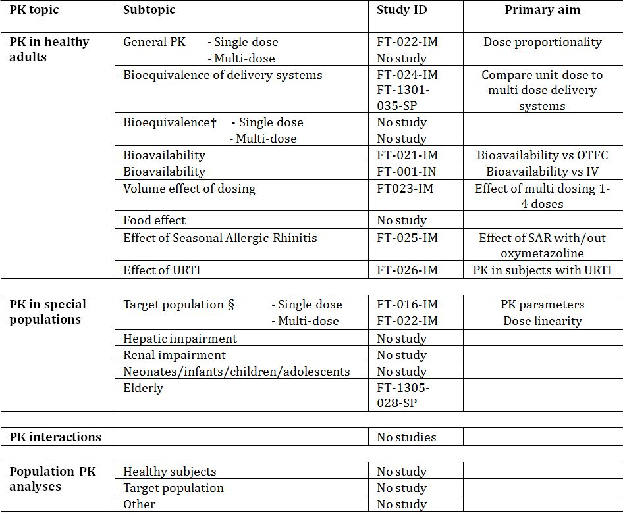

† Bioequivalence of different formulations.

§ Subjects who would be eligible to receive the drug if approved for the proposed indication.

None of the pharmacokinetic studies had deficiencies that excluded their results from consideration.

The publications supplied in support of the pharmacology have not been individually summarised as they either indicate an alternative formulation or route of administration or provide no information on the formulation. They have not used the same formulation as the Nycomed product and therefore do not support the formulation in this application.

### Summary of pharmacokinetics

The information in the following summary is derived from the conventional pharmacokinetic studies and from the sponsor’s summaries unless otherwise stated.

#### Pharmacokinetics in healthy subjects

##### Absorption

Based on literature referenced fentanyl absorption from the nasal mucosa is aided by a highly vascular epithelium and relatively large surface area. The amount of fentanyl delivered and absorbed with intranasal administration is proportional to the surface area of the nasal cavity. Intranasal absorption is best characterised using a multiple phase model with a rapid initial absorption phase followed by a constant and continuous absorption phase. Subsequently fentanyl becomes available to the systemic circulation and after a lag time of a few minutes the clinical effects of fentanyl can be observed.

##### Bioavailability

###### Absolute bioavailability

FT-001-IN was a combined phase I/II placebo controlled, double-blind, cross over study in opioid naive non-cancer dental patients with post operative pain after oral surgery (third molar extraction). The primary objective was to compare the PK profile within the first 3 hours of intranasal fentanyl with intravenous fentanyl. Two strengths (0.75 and 1.0 mg/mL) and four dose levels (75, 100, 150 and 200 μg) were investigated in 24 patients. Subjects received the same dose for the intranasal and IV administrations.

The study found that clearance by the intranasal route was similar to that found for the IV route. The bioavailability of the intranasal formulation was interpreted to be 100% according to a one compartment model analysis, 89% according to a two compartment model (preferred model) and 80% with a three compartment model. The mean Cmax results obtained for the four doses 75, 100, 150 and 200 μg were 0.7, 1.0, 1.4 and 1.7 ng/mL, respectively. Linear dose concentration relationships were found for IV and intranasal administration. When routes of administration were compared, (pooled doses) mean Tmax was 13 minutes for intranasal and 6 minutes for IV administration.

###### Bioavailability relative to an oral lozenge

Study FT-021-IM was a randomised, open label, two-way, cross over study to compare the bioavailability of one dose of 200 μg FNS with one dose of 200 μg oral transmucosal lozenge (Actiq) in 24 healthy volunteers. The study was done under background naltrexone treatment to block the opioid effects of fentanyl and prevent respiratory adverse reactions in opioid naive healthy subjects.

One dose of FNS 200 μg was significantly more bioavailable than Actiq based on area under the plasma concentration time curves (AUC). Although administered for 15 minutes according to the approved US product labelling, consumption of Actiq was incomplete in some subjects. Analysis based on the seven subjects with complete Actiq consumption also indicated significantly higher bioavailability with FNS.

A significant difference was found for maximum drug concentration (Cmax) values, with a much lower mean fentanyl peak plasma concentration observed with Actiq administration than with FNS (196 pg/mL versus 815 pg/mL). A higher maximum plasma concentration (Cmax) was reached earlier with FNS than with Actiq (median 30 minutes and 2 hours respectively). Similarly, the extent of absorption, determined by AUC0-∞ and AUC from time 0 to the last time point with measurable concentration (AUC0-last) was approximately 3-4 fold less after Actiq than after FNS.

###### Bioequivalence of clinical trial and market formulations

Not applicable as all clinical trials (except FT-001-IM) used the formulation intended for marketing.

###### Influence of food

Not applicable as product is inhaled.

###### Dose proportionality

Study FT-022-IM was a randomised, open label, three way Latin square design followed by a fourth dosing period in 12 healthy adults. The primary objective was to explore dose proportionality and assess the PK profiles of 50, 100 and 200 μg FNS using a single dose device. The study was conducted with background naltrexone treatment to bock the opioid effects of fentanyl and prevent potential respiratory adverse reactions in the opioid naive health subjects. In this study there was no formal sample size calculation and it was not powered to demonstrate dose linearity.

Dose proportionality was not achieved for AUC0-∞ and Cmax because the 90% CIs for the ratio of the geometric mean estimates did not fall within the pre-specified limits of 0.8 to 1.25. This may have been because plasma fentanyl concentrations fell below the LLOQ 8 hours after administration of FNS 50 μg in most subjects. A post hoc analysis of AUC0-8h demonstrated dose proportionality for FNS from 50 μg to 200 μg (ratio estimate 1.077; 90% CI: 0.931 – 1.247).

###### Bioavailability during multiple-dosing

FT-023-IM was a randomised, open label, four way, Latin square design trial in 12 healthy subjects that investigated the effect of volume on the PK of FNS by administering one, two, three or four puffs of 50 μg fentanyl into the same nostril (up to 400 μL total volume). The study was conducted with background naltrexone treatment to bock the opioid effects of fentanyl and prevent potential respiratory adverse reactions in the opioid naive health subjects.

Fentanyl was absorbed rapidly with a median Tmax ranging from 30 to 38 minutes following administration of one, two, three or four doses of 50 μg FNS. An ascending trend was observed for Cmax and AUC results with increasing total fentanyl dose (from 50 μg to 200 μg), indicating a dose dependent relationship. Mean T½ was 5.2 hours after one dose and ranged from 7.3 to 10.3 hours after two, three and four doses.

There was no statistically significant difference between dose normalised AUC0-∞, AUC0-last or Cmax results following administration of one, two, three or four doses based on analysis of variance (ANOVA), indicating no apparent volume effect. The dose normalised Cmax results (estimated geometric mean) ranged from 145 to 158 pg/mL, suggesting dose proportionality from 50 to 200 μg FNS regardless of the number of doses administered. Similar conclusions were drawn for AUC0-∞ and AUC0-last.

Dripping from the nose was observed in 7/12 subjects mostly after three or four doses. This nasal dripping did not result in an apparent effect on overall systemic exposure to FNS.

###### Effect of administration timing

Not investigated.

###### Bioequivalence of delivery systems

Study FT-024-IM was a randomised, open label, two-way cross over study to assess the bioequivalence of FNS administered using a single dose or a multi dose delivery system. The trial was terminated after the inclusion of 16 healthy subjects. Analysis of the results of these 16 subjects demonstrated a similar PK profile of 200 μg of FNS, administered via either a single dose or a multi dose delivery system (AUC0-∞).

Study FT-1301-035-SP was a randomised, open label, four period, two sequence, replicate cross over study to assess the bioequivalence of FNS administered using a single dose or multi dose delivery system. The trial was performed in 48 healthy subjects. The ratios of the PK parameters AUC0-∞ and Cmax for 200 μg FNS delivered through single dose and multi dose systems met the pre defined regulatory criteria for bioequivalence (0.8 to 1.25) for both the ITT analysis and the PP analysis populations.

##### Distribution

###### Volume of distribution

Based on the literature provided fentanyl has a high volume of distribution (4L/kg).

###### Plasma protein binding

Based on the literature provided the plasma binding is approximately 80-90% and once absorbed into the systemic circulation, fentanyl passes rapidly across the blood-brain barrier. The free fraction of fentanyl increases with acidosis, hence fentanyl plasma binding capacity increases with increasing ionisation of the drug.

###### Tissue distribution

The literature provided suggests that the PK of IV fentanyl can be described by either a two or three compartment model. Animal studies (rats) indicate that it is widely distributed in lungs, kidneys, spleen, heart, brain, intestinal wall, liver, muscle and adipose tissue. Fentanyl appears in the cerebrospinal fluid. It crosses the placenta and small amounts have been found in breast milk, although the concentration is too low to be pharmacologically active. A warning regarding the use in pregnancy and lactation is included in the product information.

##### Metabolism

###### Sites of metabolism and mechanisms / enzyme systems involved

In humans fentanyl is primarily metabolised in the liver and studies using human liver microsomes demonstrate that fentanyl is mainly metabolised by cytochrome P450 3A4. There is no evidence of metabolism via other CYP isoforms.

###### Metabolites identified in humans

The major metabolite is norfentanyl; minor metabolites include despropionylfentanyl, hydroxyfentanyl and hydroxynorfentanyl. These metabolites show negligible pharmacological activity.

##### Excretion

Fentanyl is rapidly metabolised, with metabolites representing almost 70% of total radioactivity within 90 minutes after IV administration of 3H-fentanyl. The main route of elimination is via the kidneys with a small amount excreted in the stool. Approximately 85% of radioactively labelled fentanyl is recovered in urine and stools up to 72 hours mostly as metabolites.

The half life for IV fentanyl administration is approximately 2-4 hours and the half life for FNS administration is approximately 3-4 hours in cancer patients with BTP (FT-016-IM). The elimination of fentanyl is biphasic and the terminal phase starts around 6 hours following administration. The mean terminal elimination half life was up to 15 hours after a single administration of 200 μg in healthy subjects (FT-021-IM, FT-022-IM, FT-024-IM, FT-1301-035-SP).

###### Intra- and inter-individual variability of pharmacokinetics

Several trials noted a high degree of inter-subject variability in the PK parameters measured after intranasal administration of fentanyl. Estimates of intra and inter subject variability in Cmax and AUC were obtained from the residuals from analysis of variance (ANOVA) and are displayed as the percent coefficient of variation (CV%). In addition, in trial FT-1305-035-SP the real intra subject variability could be estimated as the dose was administered in two periods to the same subjects (n=48). Inter and intra subject variability for the main PK parameters in four of the PK trials is shown in Table 2.

Table 2: Inter-subject and intra-subject variability for the primary pharmacokinetic parameters in trials FT-022-IM, FT-024-IM, FT-1305-028-SP and FT-1305-035-SP.

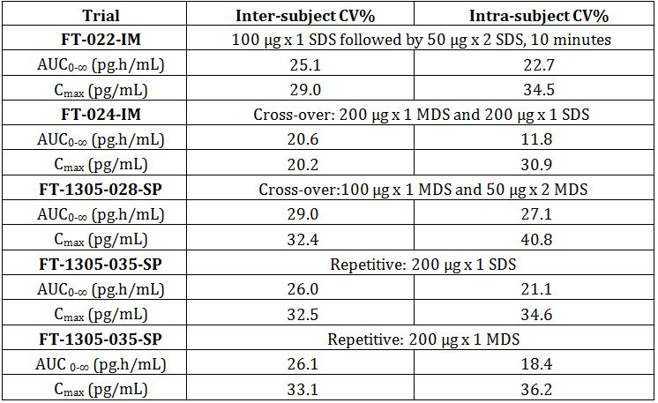

AUC0-∞=area under the plasma concentration-time curve from time 0 to infinity; Cmax=maximum plasma concentration; CV%=percent coefficient of variation; MDS=multi-dose system; SDS=single-dose system. AUC0-∞ excludes results with 20% or more extrapolated AUC0-∞. CV% was derived by analysis of variance.

Despite the relatively high inter and intra patient variability in Cmax the PK studies have demonstrated consistency in the terms of the PK variables.

#### Pharmacokinetics in the target population

Study FT-016-IM was a randomised, open label, two period, cross over trial testing single doses of 50, 100, and 200 μg fentanyl in cancer patients with BTP. Nineteen patients were randomised and completed the trial. The results show that fentanyl was rapidly absorbed following intranasal administration achieving Cmax within 12 to 15 minutes. Overall single doses of FNS showed a dose dependent increase over the dose range 50 to 200 μg.

Table 3 provides the results of different dose levels of intranasal fentanyl spray.

Table 3: Pharmacokinetic comparison of different dose levels of intranasal fentanyl spray; Trials FT-001-IN and FT-016-IM.

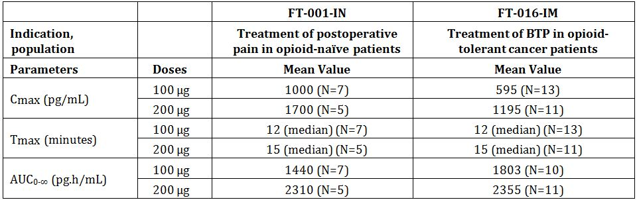

AUC0-∞=area under the plasma concentration-time curve from time 0 to infinity; BTP=breakthrough pain; Cmax=maximum plasma concentration; N=number of patients in group; Tmax=time to Cmax

Note: AUC0-∞ includes results with ≥20% extrapolated AUC.

#### Pharmacokinetics in other special populations

##### Pharmacokinetics in subjects with impaired hepatic function

This was not tested. Based on the literature, after IV administration, the PK of fentanyl is unaffected in patients with compensated liver cirrhosis, whereas high dosages result in a markedly prolonged elimination half life. As fentanyl is metabolised to inactive metabolites in the liver, patients with severe hepatic disease may have a decreased metabolism and should therefore be observed carefully. A warning for use in patients with severe hepatic impairment is included in the product information.

##### Pharmacokinetics in subjects with impaired renal function

Not tested. Based on the literature, approximately 75-80% of a fentanyl dose is excreted into the urine, mostly as metabolites with less than 6% as unchanged drug. Thus patients with renal impairment might have delayed elimination. However, renal insufficiency does not appear to alter PK properties significantly after fentanyl bolus administration. A warning for use in patients with severe renal impairment is included in the product information.

##### Pharmacokinetics according to age

Study FT-1305-028-SP was a randomised, open label, two way, cross over study to assess the PK of one or two doses in 16 non-elderly (>18 and ≤ 45 years) and 7 elderly healthy subjects (≥65 years). Results indicated moderately lower bioavailability and peak plasma fentanyl concentrations following administration of two 50 μg FNS compared to one 100 μg dose. Comparable AUC, half life, clearance and volume of distribution was found. References provided suggest that these results are not consistent with that seen with other studies with intranasal fentanyl where a higher Cmax and significantly longer elimination half life was seen in individuals >60 years. This is thought to result from reduced drug clearance. A warning to observe carefully for fentanyl toxicity in elderly patients should be provided in the product information.

##### Effects of extrinsic factors

As the product is administered using the intranasal route, the influence of food intake, diet, smoking, alcohol consumption, time of administration etc on the PK of fentanyl citrate was considered negligible.

Study FT-026-IM was an uncontrolled, open label trial to assess the effect of upper respiratory infections on FNS absorption in subjects with the common cold. The study comprised 8 otherwise healthy adults with symptoms of the common cold (rhinorrhoea, sneezing and sinus fullness), since nasal congestion might interfere with the absorption of an intranasally delivered drug. The study was conducted under naltrexone block. Following one 200 μg dose of FNS, the extent of absorption was comparable between subjects with a common cold and matched healthy subjects (gender, age, BMI) from other PK studies (FT-021-IM, FT-022-IM or FT-024-IM).

Fentanyl was rapidly absorbed with a median Tmax of 20 minutes (compared to 30 minutes in age matched controls). Mean AUC0-∞ was 4481 pg.h/mL for subjects with the common cold and 4118 pg.h/mL for matched healthy subjects, indicating that upper respiratory infection does not alter the absorption of a single 200 μg dose of FNS.

Study FT-025-IM was a randomised, open label, two-way cross over study to assess the effect of oxymetazoline (0.05%) on FNS absorption in 12 healthy subjects with seasonal allergic rhinitis. Oxymetazoline was chosen because it is an intranasally administered decongestant (nasal vasoconstrictor) and so might affect the absorption of FNS. Following administration of one dose of FNS 200 μg to patients with allergic rhinitis, the prior treatment with oxymetazoline decreased Cmax by over 50% and Tmax was increased by two-fold (median 21 minutes versus 46 minutes). However, the overall extent of exposure to fentanyl in allergic rhinitis after prior treatment with a nasal constrictor was comparable to that in subjects without prior treatment, based on the ratio of means for AUC0-∞ (0.94; 90%CI: 0.71-1.24) and AUC from time zero to last time point measured (AUC0-last) (0.81; 90%CI: 0.61-1.07).

#### Pharmacokinetic interactions

No studies conducted.

### Evaluator’s overall conclusions on pharmacokinetics

Most (7/9) of the PK studies were conducted at the same site by the same investigator and were open label. All studies by this investigator estimated sample size on the basis of “clinical judgement” rather than formal statistical calculation. In several cases this led to less than adequate numbers and comments that caution must be used due to low numbers. This is less than satisfactory especially given the large number of studies conducted.

With this reservation aside the pharmacokinetics are consistent among the trials and demonstrate that both the plasma AUC and the Cmax of FNS increase linearly, or very close to, with dosage. Comparable results for AUC0-∞ and Cmax were observed between the single dose and multi dose delivery systems and the PK parameters did not differ substantially in opioid naive patients and in cancer patients with BTP or in patients with the common cold or with allergic rhinitis.

## Pharmacodynamics

### Studies providing pharmacodynamic data

No pharmacodynamic studies were submitted.

### Summary of pharmacodynamics

The information in the following summary is derived from the summaries provided.

#### Mechanism of action

The principal pharmacological effects of fentanyl are on the central nervous system (CNS). The drug primarily interacts with the opioid μ-receptor as a pure agonist and shows low affinity for the δ and κ opioid receptors. Opioid receptors are located at many sites in the pain pathways of the CNS in mammals. The response to pain can be modulated by application of opioids to these receptors. The mechanisms of opioid induced analgesia in general, however, are only partly understood. Several trials correlate the plasma concentration with analgesia (the desired effect) and respiratory depression (the most dangerous immediate adverse drug reaction). However, the intensity of the effects of fentanyl correlates with the drug concentration at the site of action and not necessarily with the plasma concentration due to the additional time needed for fentanyl to cross the blood-brain barrier.

#### Pharmacodynamic effects

##### Primary pharmacodynamic effect: analgesia

Fentanyl is a potent narcotic analgesic with pharmacological effects similar to morphine and other opioids and has a rapid and short acting after IV or intranasal administration, a property not conducive to long term pain treatment. The analgesic properties of fentanyl have been well documented. Fentanyl is 50 to 100 times more potent than morphine on a weight basis and produces analgesia almost immediately (2-10 minutes) following IV or intranasal application, within 15-30 minutes after oral transmucosal application and gradually over 12-24 hours after transdermal fentanyl application.

### Evaluator’s overall conclusions on pharmacodynamics

No new information was provided in the submission. The intended use of the product is well within the known pharmacodynamics of fentanyl.

#### Dosage selection for the pivotal studies

The selected intranasal dose range for the clinical studies is said to be based on long term clinical experience of treatment of pain with fentanyl, especially OTFC based on the results seen in the literature and from the initial Phase 1/2 supportive study (FT-001-IN/FT-003-IN). Three dose strengths of FNS were developed through the clinical programme. The lowest dose (50 μg) was based on the recommendations for IV fentanyl dosing for post-operative pain and the finding in the first study (FT-001-IN) that bioavailability of FNS was close to 100%. The highest dose (200 μg) was based on experience of tolerability from high doses of transdermal fentanyl and the tolerability of the 200 μg dose in trial FT-001-IN. The 100 μg dose was chosen as an intermediate dose level. The dose range of 50-200 μg is expected to cover the clinical needs of most cancer patients. The company is currently developing a new dose strength of 400 μg.

## Clinical efficacy

### Relief of breakthrough cancer pain

#### Pivotal efficacy studies

*Comment: The submission consists of two pivotal efficacy and safety studies FT-017-IM and FT-018-IM and two supportive studies (FT-019-IM and FT-003-IN/FT-011-IN). In addition the company have included a number of publications of clinical trials with FNS. The inclusion of these publications is not in line with the TGA guideline on literature based submissions - there is a brief and inadequate search strategy and no search output. The justification as to why these studies were included is said to be “clinical judgement”.*

*The company have excluded the data from one site (site X) from the analysis of efficacy because of concerns over compliance with GCP. Audit by the EMA found “major and critical findings regarding the quality and validity of the efficacy data (primary and secondary) reported in the two [pivotal] trials”. The CHMP concluded “with regard to the whole documentation that the deficiencies found in the quality system of the sponsor are unlikely to invalidate the quality of the efficacy and safety data. Having reviewed the analysis of the data excluding site X, the CHMP conclusion is that exclusion of site X does not make any substantial changes to the efficacy or safety results as compared to the results for all patients presented in the initial application.” Given the conclusion of the CHMP it is difficult to understand why the company have presented the studies with only site X excluded and why no reference to the inspection report findings are included in the submission.[5]*

*Given the summary report of the inspection team the data from the two pivotal and one supporting study is considered unreliable and therefore cannot be relied on to support the efficacy and safety of the product.[6]*

##### Study FT-017-IM

Intranasal Fentanyl (FNS) for the Treatment of Breakthrough Pain in Cancer Patients: A Randomised, Double-Blind, Placebo Controlled, Cross-Over Confirmatory Trial Testing the Doses 50, 100, and 200 μg Fentanyl and Placebo in Eight Breakthrough Pain Episodes.

*Comment: Due to suspicion of misconduct in a supportive study (FT-019-IM), an audit was performed in December 2007 at one German site (site X), and EMA was notified about the suspicion of misconduct. The site had also participated in trials FT-017-IM and FT-018-IM. This notification prompted EMA to conduct a GCP inspection in 2008 at this site and furthermore at a site in Poland (site Y) who had contributed the largest number of patients to the trials. All data from only one site (site X) was omitted from the results presented in the study report. Based on the GCP inspection this data is considered unreliable.*

###### Study design, objectives, locations and dates

Randomised, multi-centre, double-blind, placebo controlled, cross over confirmatory trial conducted at 27 centres in Europe (Austria, Germany, Denmark, Finland, France, Italy and Poland) between May 2006 and May 2007.

Primary Objective: to demonstrate the efficacy of intranasal fentanyl (FNS) in the treatment of breakthrough pain (BTPCP) in cancer patients.

Secondary Objective: to explore the relationship between the response to the FNS dose and the stable background pain opioid dose.

The trial design is seen in Figure 1.

Figure 1: Study FT-017-IM trial design schema.

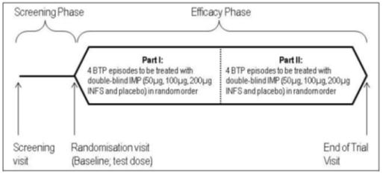

IMP= investigational medical product; INFS=FNS=fentanyl nasal spray

Treatment of 8 BTCP episodes was expected to last up to approximately three weeks. Maximum allowed time in the trial was eight weeks, excluding time for adjustment in background opioid treatment.

At the end of the trial, all patients, either completed or discontinued, who received at least one FNS dose in this trial were offered the opportunity to participate in the long term follow-up trial, FT-018-IM, in which they could receive FNS until recovery, withdrawal or death.

###### Inclusion and exclusion criteria

Inclusion:

* Adult (≥18 years) cancer patients with stable, chronic opioid treatment (oral morphine, oxycodone, hydromorphone or transdermal fentanyl) for background pain, who had a minimum of three BTCP episodes per week (and a maximum of four per day), and who had a life expectancy of at least three months.
* Background pain had to be generally stable (controlled to mild level – defined as ≤4 on 11 point Numerical Rating Scale [NRS]).

Exclusion:

* Recent history of substance abuse
* Pregnancy or nursing during the trial period
* Neurological or psychiatric impairment
* Severe hepatic impairment (investigator judgement based on local practice)
* Any recent therapy which could potentially alter pain or response to analgesics to a degree where the background pain opioid will be
* <60 mg morphine or morphine equivalents/day or
* <25 μg/hour transdermal fentanyl or the number of BTCP episodes will be <3 per week during the trial period
* Facial radiotherapy
* Treatment with Monoamine Oxidase Inhibitor (MAOI) within the last 14 days
* Treatment with methadone or buprenorphine
* Impaired respiratory function which may increase risk of respiratory depression with FNS
* Current use of intranasal drugs or pathological conditions of the nasal cavity
* Head injury, primary brain tumour or other pathological conditions which could significantly increase the risk of increased intracranial pressure or impaired consciousness

###### Study treatments

FNS was supplied in glass bottles with a standard nasal pump and actuator, containing 40 doses. The FNS was available as a phosphate buffered solution of fentanyl citrate in three concentrations: 0.5 mg/mL, 1.0 mg/mL and 2.0 mg/mL fentanyl in multi-dose containers. The corresponding doses were 50, 100 and 200 μg fentanyl/dose.

The placebo was supplied in glass bottles and were identical in appearance to the active FNS. The placebo sprays contain sodium citrate in a phosphate buffered solution.

All investigational medicinal product (IMP) sprays (FNS and placebo) contained 6.0 mL; the volume per dose was 100 μL making it possible to obtain at least 40 doses per spray.

Patients were instructed on the use of the spray with demonstration bottles during the baseline visit. They were also given a FNS test dose of 200 μg before randomisation. Patients who did not tolerate this test dose were not randomised.

For the efficacy phase of the study, each randomised patient was to receive the efficacy kit containing eight sprays numbered 1-8; consisting of 2 placebo and 2 of each of the three dose strengths: 50, 100 and 200 μg fentanyl/dose, in random order.

If pain relief was not sufficient at 20 minutes after first dose of IMP (or 10 minutes after second dose), patients were allowed to take their usual immediate release opioid or any other pain analgesics. All such pain medication taken between 20 and 60 minutes after first study drug dose was defined as rescue medication. Intake of medication after 60 minutes was defined as concomitant medication (Figure 2).

Figure 2: Study FT-017-IM procedure for treating a BTCP episode.

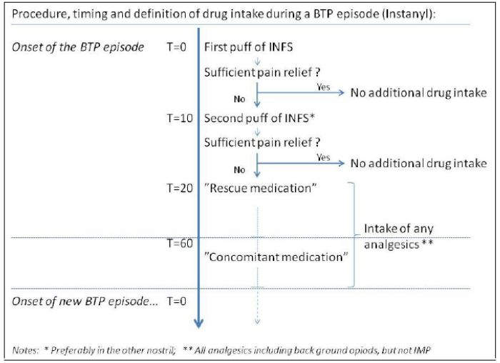

During the trial, patients received their stable fixed-schedule background pain opioids and were allowed to take their usual analgesic for any type of pain.

###### Efficacy variables and outcomes

The primary efficacy outcome was PID10 after dosing with the first study drug. The PID10 was calculated by subtracting the PI at 10 minutes from the PI recorded immediately before treatment (at time = 0: PI0).

The efficacy outcomes were:

* Pain intensity (PI) using the 11 point NRS (0 = no pain to 10 = worst possible pain). The patient recorded their PI just prior to the first dose of study drug, at time 0 and at 10, 20, 40 and 60 minutes after first study drug administration in a patient diary.
* Pain intensity difference (PID) – derived from PI
* Sum of pain intensity difference (SPID) – in the interval 0 – 6 minutes (SPID0-60)
* Patients General Impression (GI) – assessed 60 minutes after the first study drug dose using the categorical 5 point Verbal Rating Scale (VRS): 0 = poor, 1 = fair, 2 = good, 3 = very good, 4 = excellent.

The outcomes were to be assessed by the patient; however, the patient was allowed to receive help from relatives or staff personnel for recording in the diary.

###### Randomisation and blinding methods

Randomisation was of the treatments with all patients receiving all the different strengths of FNS and placebo. Treatment packs were prepared by the company and supplied to the sites.

The trial was double-blind with placebo and active FNS packaged in identical glass bottles with a standard nasal pump and actuator.

###### Analysis populations

Data from one site (in Germany) was excluded from all analysis, summaries and listings due to an internal company decision. This decision is at odds with the findings or conclusions made by the EMA inspection team and the CHMP.

The Intention to treat (ITT) analysis set comprised all randomised patients who took at least one dose of study drug in the efficacy phase of the study (ITT = 152).

The per protocol (PP) analysis set comprised ITT analysis set but excluded the following patients: violation of various inclusion and exclusion criteria (3 patients), did not follow the randomisation schedule (2 patients), did not have at least one per protocol episode for each dose of trial drug (11 patients) (PP = 136).

Safety analysis set comprised all patients who received any study drug (Safety = 165).

###### Sample size

The sample size calculation was based on literature studies of the use of transmucosal fentanyl treatment of BTCP in cancer patients. Based on these studies, an effect size of about 0.5 for PID was deemed relevant. Each dose was assessed in two episodes, with a hypothesis of no difference between the doses, assuming a linear model for the analysis, with a significance level of 5%, and a power of 90%. On this basis, a sample size of 150 completing patients was calculated as appropriate for the trial. Although about 20% of the patients were expected to discontinue before completing the scheduled doses, they were to be included in the ITT analysis with available episodes. Assuming, therefore, and effective drop-out rate of about 15%, it was planned to randomise 175 patients.

Exclusion of the one site from the analysis resulted in less than the planned 150 patients completing the trial; however, since the observed SD (around 1.0) was somewhat lower than assumed, the primary analysis still has a power above 90% to detect a difference in PID10 at 0.4 to 0.6.

###### Statistical methods

Analysis of PID10 was based on a linear model with a step-down testing of the active doses versus placebo. The PID10 was analysed by successive F-tests of the contrasts of 200 μg vs placebo, 100 μg vs placebo and 50 μg versus placebo. To ensure protection of the significance level, the tests were performed sequentially, only proceeding to the next test if the current test was statistically significant so it was not possible to conclude that 100 μg was effective if 200 μg was not. For each test, the hypothesis was that of no difference between mean response on active dose and mean response on placebo with the alternative that they differ. The trial followed a cross-over design with each of the four doses taken twice. The corresponding mixed linear model included the following fixed effects: a randomised dose, centre, baseline PI (mean and deviation from mean).

The Patient GI was analysed as described for the primary endpoint although GI was calculated based on results from a 5 point categorical VRS at 60 minutes after administration of the first investigational medicinal product (IMP) dose.

The SPID0-60 denotes the average change in PI over the 60 minutes interval and was derived from the area under curve (AUC) for PID over the 0-60 minutes interval divided by the length of the interval (60 minutes). SPID0-60 was presented and analysed using the same model as for the primary endpoint.

Average responder rates were calculated by dose. A responder for a treated BTCP episode was defined as having PID10 >2 for that episode. The overall responder rate was equal to:

1. 100% if patient was a responder in both treated BTCP episodes within a dose
2. 50% if patient was a responder in one treated BTP episode and non-responder in the other treated BTCP episode within a dose
3. 0% is patient was a non-responder in both treated BTCP

The relationship between the IMP dose and the baseline dose of the background pain opioid was evaluated for PID10 and for responders (PID10 >2). For this purpose, the background pain opioid dose was standardised to morphine equivalent doses. Based on the distribution of patient on those doses, cut-off points were used to define low (≤180 mg/day), medium (>180 - ≤360 mg/day), and high dose (>360 mg/day) of background pain opioid. Summary statistics for PID10 and for responders by dose were presented by category of baseline pain opioid dose (low, medium, high).

###### Participant flow

Participant flow is shown in Figure 3.

Figure 3: Participant flow for Study FT-01-IM.

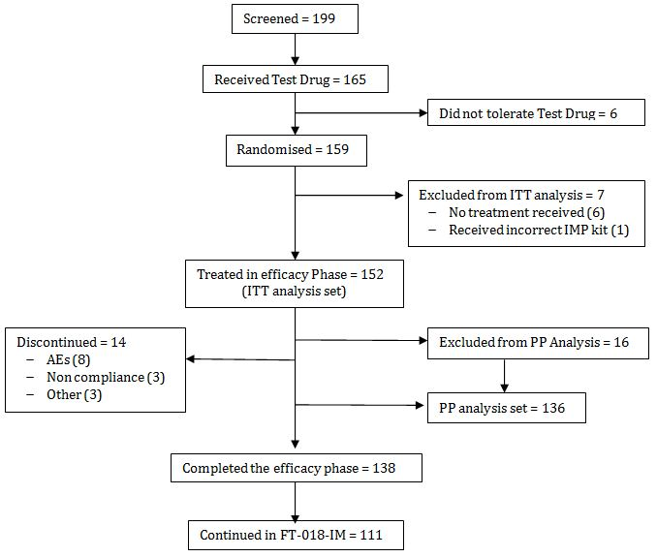

###### Major protocol violations/deviations

The protocol violations related to the following:

* Deviation of inclusion and exclusion criteria – 7 patients
* Violation of inclusion criteria post randomisation – 1 patient
* Deviations related to IMP – 11 patients – one patient received the wrong kit (for another study), 4 did not follow instructions and took sprays out of order, 3 treated more than one BTCP episode per day and 2 patients in France received all 8 sprays at one time instead of only two at a time (France had different kits to other sites).

Sixteen of the protocol deviations led to removal of these patients from the PP analysis.

###### Baseline data

Of the 152 patients in the ITT analysis set, 80 patients (52.6%) were male and 72 patients (47.4%) were female. The mean age was 62 years, the median was 61 years and ranged from 35 years to 79 years. The mean BMI was 23.7 kg/m2, the median was 23.0 kg/m2 and ranged from 13.6 to 50.2 kg/m2 (due to the personal circumstances, one patient had an abnormally high BMI of 50.2 – despite being outside the inclusion criteria, he was enrolled).

The mean weight for male patients was 67 kg (median 66 kg, range 45-104 kg), and 65 kg for females (median 63 kg, range 40-130 kg). The mean height was 171 cm for the male patients (median 171 cm, range 115-192 cm) and 163 cm for females (median 163 cm, range 148-178 cm). All patients for whom race was reported (145- 95.4%) were white (Caucasian).

The mean baseline PI was approximately 6 (range 6.13-6.21) for each of the four different doses, including placebo.

###### Results for the primary efficacy outcome

The primary efficacy variable was PID10 after the first IMP dose. All three FNS doses provided statistically significantly higher (p ≤0.001 compared to placebo) adjusted mean PID10 scores of 1.70, 2.10 and 2.53 for the different doses, and therefore better pain relief, compared with placebo (Table 4 and Figure 4). Similar results were seen for the PP analysis set.

Table 4: Study FT-017-IM Summary of Pain Intensity Difference at 10 Minutes (PID10), ITT Analysis Set.

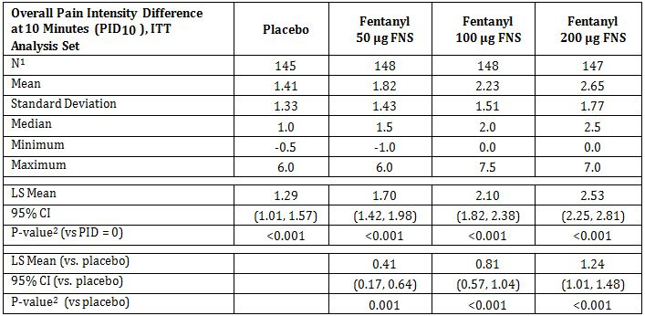

ITT = intent-to-treat; FNS = intranasal fentanyl spray; LS Mean = least squares mean; CI = confidence interval; vs.= versus. 1 Not all patients completed all doses. Therefore the number of patients per dose does not add up to152. 2 The pair wise p-value is based on least squares means from mixed linear model with fixed effects for treatment, centre, average baseline PI (over all treated BTP episodes for a patient), deviation of baseline PI for each treated BTP episode from average baseline PI, and random effect for patient.

Figure 4: Study FT-017-IM Mean (± SD) Overall Pain Intensity Difference (PID) by Treatment dose and time point, ITT analysis.

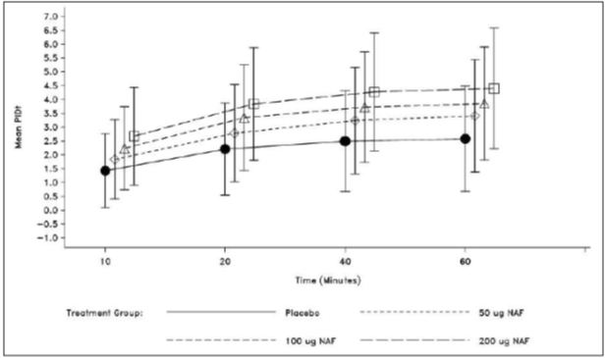

NAF=FNS, PIDt=PID at time point t

The PID10 was used to determine the responder rate at 10 minutes after the first dose of IMP (Table 5). A responder was defined as having a PID10 >2 for a given episode. A responder for a treated BTP episode has pain intensity difference at 10 minutes (PID10) >2 for that episode. Overall responder rate is equal to:

1. 100% if patient is a responder in both treated BTP episodes within a dose
2. 50% if patient is a responder in one treated BTP episode and non-responder in the other treated BTP episode within a dose
3. 0% if patient is a non-responder in both treated BTP episodes.

Table 5: Study FT-017-IM Responder Rate at 10 Minutes, ITT Analysis Set.

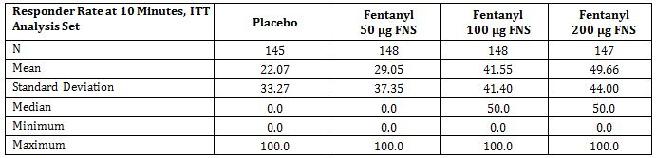

ITT=intent-to-treat; FNS=intranasal fentanyl spray

The overall responder rate (average of first and second BTCP episode) showed a dose response.

###### Results for other efficacy outcomes

###### General Impression Score (GI)

A dose response for FNS was observed, with mean GI scores at 60 minutes of 1.32, 1.57, and 1.90 for the 50, 100, and 200 μg FNS dose groups, respectively (mean score of 0.96 for placebo) (Table 6). All of the FNS dose groups had significantly higher mean GI scores compared with placebo (p<0.001 for all FNS dose groups compared to placebo).

Table 6: Study FT-017-IM Overall General Impression (GI) Score at 60 Minutes, ITT Analysis Set.

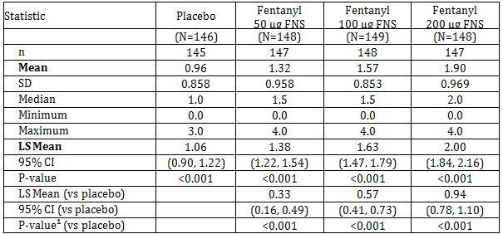

n = number of patients with available data.

¹ The pairwise p-value is based on least squares means from mixed linear model with fixed effects for treatment, centre, and random effect for patient.

Note: Higher scores indicate higher level of satisfaction with pain relief. Overall GI is calculated as the average of the GI scores from the two treated BTP episodes for each dose within a patient.

No clear correlation was noted between the effective doses used for the BTP treatment and the level of opioid medication for background pain.

###### Overall Sum of the Pain Intensity Difference (SPID0-60) From 0 to 60 Minutes

The sum of the PI differences (SPIDs) over the first 60 minutes post dose was significantly higher for the FNS dose (p<0.001) for all FNS dose groups compared to placebo.

A dose response for FNS was also observed, with mean SPID0-60 scores of 2.64, 3.10 and 3.53 for the 50, 100 and 200 μg FNS dose groups, respectively (mean score of 2.02 for placebo).

Although mean PID10 values increased with increasing FNS dose, no clear correlation was noted between the mean PID10 values and the level of opioid medication for background pain. Hence, the background pain opioid (low, medium or high) level did not seem to have any effect on the efficacy of the FNS doses.

*Comment: In this trial the results are presented as per the allocated strengths of the FNS – 50, 100 and 200 μg. However according to the protocol and clinical study report the patients were able to take one or two doses. Nowhere in the results are the actual doses taken provided. Therefore it is difficult to understand the results since patients actually took a range of doses from 50 to 400 μg. In addition, the study staff were able to help the patients enter their results in the patient diaries. This raises concerns over the validity of the efficacy results.*

##### Study FT-018-IM

A Double-Blind, Randomised, Placebo-Controlled Trial Confirming the Efficacy of Intranasal Fentanyl Titrated to 50, 100, or 200 μg with an Open Long Term Safety Follow-Up in Cancer Patients with Breakthrough Pain.

*Comment: Due to suspicion of misconduct in a supportive study (FT-019-IM), an audit was performed in December 2007 at one German site (site X), and EMA was notified about the suspicion of misconduct. The site had also participated in trials FT-017-IM and FT-018-IM. This notification prompted EMA to conduct a GCP inspection in 2008 at this site and furthermore at a site in Poland (site Y) who had contributed the largest number of patients to the trials. All data from only one site (site X) was omitted from the results presented in the study report.*

*This study is not independent of the previous pivotal study FT-017-IM. Entry criteria for this study included that patients had participated in either Study FT-016-IM (see PK) or FT-017-IM. Patients were therefore already selected as responders to therapy. This study therefore confirms the results of FT-017-IM in the same patients. It should be considered a supporting study and not a pivotal study.*

###### Study design, objectives, locations and dates

Randomised, double-blind, placebo controlled, cross over study conducted at 35 sites in Europe (Austria, Germany, Denmark, France and Poland) between June 2006 and March 2008 (Figure 5). The sites and investigators are identical to FT-017-IM. The timing of the trial also overlaps FT-017-IM.

Figure 5: Study FT-018-IM trial design.

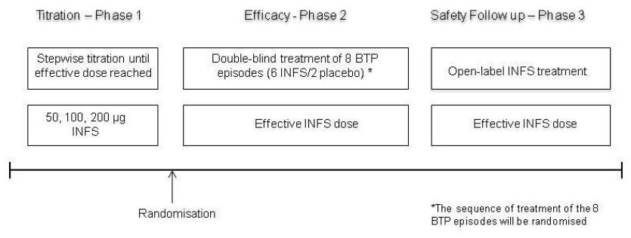

Primary Objectives:

* To confirm the efficacy of FNS titrated to doses of 50, 100, or 200 μg for treatment of BTP in cancer patients
* To establish the long term safety of treatment with FNS

Secondary Objectives:

* To explore the relationship between the dose of background pain opioid treatment and the titrated FNS dose

In Phase 1, patients were titrated to an effective FNS dose via an open label titration. Initial dose was 50 μg FNS, and if needed dependent on efficacy and adverse reactions, the patient could continue by stepwise titration to either 100 μg/dose or 200 μg/dose. An effective dose was reached when three of four BTP episodes had been treated successfully with one or two doses of FNS. Patients who completed a successful titration then entered a double blind efficacy phase (Phase 2) in which they received the effective FNS dose reached in Phase 1 and placebo for treatment of eight BTP episodes (six FNS and 2 placebos in randomised order). Patients continued in a safety follow up Phase 3 in which they were treated on a named patient basis or in countries where named patient use was not acceptable FNS was offered in a safety extension phase.

The titration and efficacy phases were expected to last up to three weeks each, followed by a safety follow up for ten months after the last patient was included.

###### Inclusion and exclusion criteria

Inclusion: Adult in or out patients with cancer, aged 18 or more who had received at least one FNS dose in a previous study (FT-016-IM or FT-017-IM). Patients were receiving stable, chronic opioid treatment equivalent to 60-500 mg oral morphine/day or to transdermal fentanyl 25-200 μg/hour, which in general reduced the intensity of their background pain to a mild level (≤4 on an 11 point NRS). Eligible patients also experienced episodes of BTP at least 3 times per week but no more than 4 times per day.

Exclusion: same as for Study FT-017-IM.

###### Study treatments

FNS was supplied in a brown glass bottle with a standard nasal spray pump and actuator, containing 6 mL corresponding to 40 doses. FNS was available as a phosphate buffered solution of fentanyl citrate in three concentrations: 0.5 mg/mL, 1.0 mg/mL and 2.0 mg/mL fentanyl in multi-dose nasal sprays. The corresponding doses were 50, 100 and 200 μg fentanyl/dose.

Placebo nasal spray was supplied as a phosphate buffered solution of sodium citrate in multi-dose glass containers mounted with a standard spray device. Two of the eight sprays dispensed to the patients in the double-blind efficacy phase were placebo.

FNS and placebo were administered as one dose in one nostril. If the first dose brought insufficient pain relief, a second dose was allowed 10 minutes after the first dose. The maximal total dose was 2 x 200 μg FNS taken 10 minutes apart.

The dosing instructions for the patient are the same as for Study FT-017-IM.

Patients were allowed to take rescue medication for pain, if needed, 20 minutes after the first administration of IMP. Any analgesics (with the exception of FNS) taken within 60 minutes of the first dose of IMP were classified as rescue medication.

During the trial patients continued their normal daily routine and concomitant chemotherapy and palliative radiotherapy (except for facial radiotherapy due to potential effect on uptake of nasally administered fentanyl caused by damage to nasal mucosa).

###### Efficacy variables and outcomes

The primary efficacy outcome was Pain Intensity Difference at 10 minutes (PID10) after administration of first dose of IMP (that is, FNS or placebo). Responder rate was calculated from the number of patients with a PID10 >2.

Other efficacy outcomes included:

* Pain Intensity (PI) assessed using an 11 point NRS (0=no pain to 10=pain as bad as you can imagine). The patient had to assess and record their PI just prior to first dose of IMP, at time 0 and at 10, 20, 40, and 60 minutes after first IMP administration. The derived variable Pain Intensity Differences (PID) and the sum of the PID (SPID) were based on PI.
* General Impression (GI) of efficacy in the treatment was assessed 60 minutes after the first dose of IMP using a categorical 5 point verbal rating scale (VRS): 0=poor, 1=fair, 2=good, 3=very good, 4=excellent.

###### Randomisation and blinding methods

In Phase 1 and Phase 3, the patients were treated in an open label manner, where as in Phase 2 the patients were assigned a double-blind randomised sequence of 6 FNS treatments and 2 placebo treatments. In Phase 2, the treatment sequence was randomised ensuring that one placebo treatment occurred in episodes 1-4 and one in episodes 5-8.

###### Analysis populations

Data from one site (in Germany) was excluded from all analysis, summaries and listings due to an internal company decision. This decision is at odds with the findings or conclusions made by the EMA inspection team and the CHMP:

ITT population = all randomised patients that took at least one dose of IMP in the efficacy phase for treatment of BTP = 152 patients.

PP population = the ITT population and excluding those patients who did not meet inclusion and/or exclusion criteria (3) and those who did not follow the randomisation schedule (2) and those who did not have at least one per protocol episode for each dose of trial drug (11) = 136 patients.

Safety population = all patients exposed to IMP = 165 patients

###### Sample size

Patients in this trial were recruited among patients who completed the FT-016-IM or FT-017-IM trials so the expected sample size was 100 to 150 patients. With 6 episodes treated with active doses and 2 treated with placebo and a hypothesis of no treatment effect, assuming a linear model for the analysis with a significance level of 5%, the sample size of 100 to 150 patients for the efficacy phase was considered to detect treatment effect of size 0.4 to 0.6.

Excluding site X left 111 patients in the ITT population (and 101 in the PP population) which was still within the planned number of patients. The observed intra-patient SD (around 1.4) was somewhat lower than assumed and leaves the power above 90%.

###### Statistical methods

PID10 was calculated by subtracting the PI at 10 minutes from the PI recorded immediately before treatment. Reversal of the scale was applied so that high values indicated a positive result. The variation in PID10 between treated BTP episodes within patient was calculated by treatment (FNS or placebo) and across all doses and expressed as the standard deviation (SD) and coefficient of variation (CV). Summary statistics (n, mean, median, SD, minimum, maximum) for PID10, SD and CV were tabulated by FNS dose and the combined FNS doses. The null hypothesis tested was that the average response to active treatment was the same as the response to placebo versus the alternative that they differed. This was tested using the F-test of the active versus placebo contrast for the treatment effect in the described model.

The primary endpoint was analysed for the ITT and PP datasets. Estimated means by treatment (FNS and placebo) were presented with estimated difference between FNS and placebo with 95% confidence intervals (CI) and p-values. PID10 for each patient for each treatment (FNS or placebo) was calculated as an average score for the treated BTP episodes.

Overall responder rates were computed by treatment. A positive response to treatment of a BTP episode was defined as PID10 >2. The average response rates were calculated by computing the average response rate by treatment (FNS vs placebo) within each patient and then averaging those averages across patients for placebo and FNS treatment, respectively.

The relationship between the FNS dose reached in titration phase and the dose of background pain opioid was evaluated. For this purpose, the background pain opioid dose at the end to the titration phase was standardised to morphine equivalent doses.

General Impression (GI) was analysed as described for the primary endpoint but without covariate adjustment for baseline since no baseline value is available for GI. Although GI was recorded on a 5 point VRS, from poor (0) to excellent (4), the averaging over repeated doses was considered to justify the use of this approach. Average GI scores by treatment were summarised by descriptive statistics.

###### Participant flow

Participant flow is shown in Figure 6.

Figure 6: Study FT-018-IM participant flow.

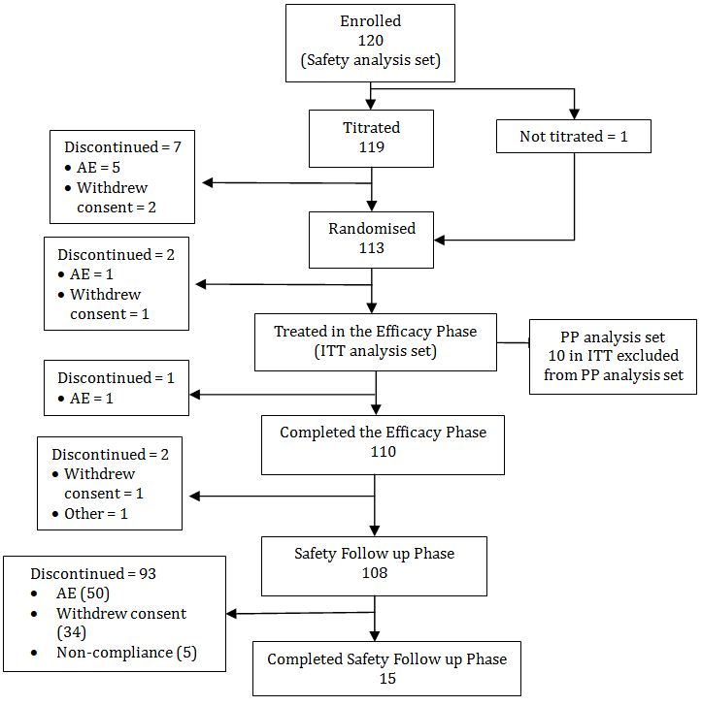

###### Major protocol violations/deviations

The main protocol violations related to dosing. Four patients treated their BTCP episodes in Phase 2 and/or Phase 3 with an FNS dose not proven as successful during the titration phase; 2 patients did not strictly follow the order of use of sprays according to the numbering; 3 patients used a wrong spray for the second IMP dose while treating an episode in the efficacy phase; 3 patients treated more episodes per day and/or with more IMP than was allowed; 9 patients reported more than 4 daily BTCP episodes without the background pain opioid treatment being adjusted; 6 patients had a background pain opioid treatment adjusted without being re-titrated as required.

*Comment: While the company considered that there were no critical protocol violations which were considered to have “a critical impact on the safety of the patients”, the number and nature of the dosing violations for the small number of patients in the trial do raise some concerns on the validity of the efficacy results.*

###### Baseline data

Of the 111 patients in the ITT analysis set, there were 56 males and 55 females. Mean age was 60.6 years and ranged from 35 to 79 years. Mean body mass index (BMI) was 24.0 kg/m2 (range 15.4-50.2). Mean weight was 70.3 kg for the male patients (range 48.0-106.0), and 65.3 kg (range 40.0-130.0) for the females. Mean height was 172.7 cm for the male patients (range 158 – 192), and 163.3 cm (range 150-178) for the females. All patients for whom race was reported were Caucasian (data collected for 107 patients: 96.4%). The most frequently reported primary tumour sites were breast (18 patients, 16.2%), lung/respiratory system (17 patients, 15.3%), colon/rectal (14 patients, 12.6%) and female genital (12 patients, 10.8%).

###### Results for the primary efficacy outcome

The primary efficacy variable was PID10 after the first IMP dose.

All FNS doses provided higher raw mean PID10 scores (in the range 2.00 to 2.74), and therefore better pain relief, compared with placebo (1.28). For the comparison of all FNS doses combined, the least mean squares mean (LS mean) PID10 score was statistically significantly higher (1.26; p<0.001; CI 1.03, 1.48) (Table 7).

Table 7: Study FT-018-IM Summary of Pain Intensity Difference at 10 Minutes (PID10) - Efficacy Phase, ITT Analysis Set.

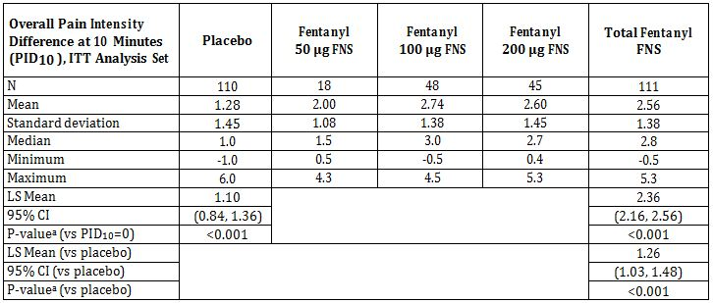

a. The p-value is based on least squares means from mixed linear model with fixed effects for treatment, centre, average baseline pain intensity (PI) (over all treated break through pain (BTP) episodes for a patient), deviation of baseline PI for each treated BTP episode from average baseline PI, and random effect for patient.

PID10=PI0-PI10 for each episode; higher scores indicate better pain relief. Overall PID10 is calculated as the average score from the treated BTP episodes for each treatment (FNS or placebo) within a patient. ITT=Intent-to-Treat; FNS=intranasal fentanyl spray; LS Mean=least squares mean; CI=Confidence Interval; vs.=versus

Similar results were seen for the PP analysis set. A treatment by centre interaction was added to the model for the primary efficacy endpoint, PID10, as a fixed effect. The interaction effect was statistically significant for both analysis and therefore the treatment response profiles were examined by centre (individual or pooled). This examination revealed that all centres, except one, had a positive effect of active versus placebo. This single centre was a pool of four small centres, adding up to a total of 13 patients in the ITT analysis. It was therefore concluded that the treatment by centre interaction effect was merely a result of the variation between and within patients rather than an actual difference in effect between centres (Figures 7-8).

Figure 7: Study FT-018-IM – Mean (± SD) Overall Pain Intensity by Dose and Time Point – Efficacy Phase ITT analysis set.

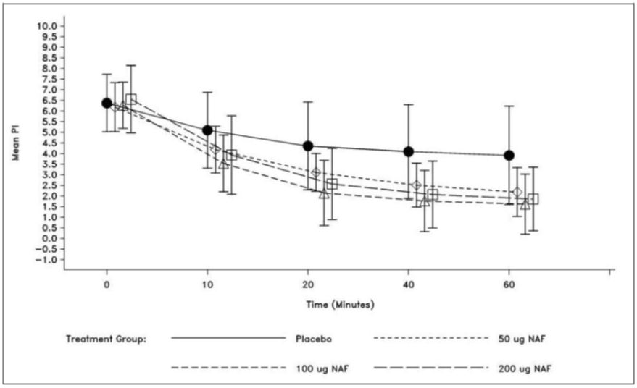

NAF = FNS

Figure 8: Study FT-018-IM Mean (± SD) Overall Pain Intensity Difference by Treatment Dose and Time Point – Efficacy Phase, ITT analysis set.

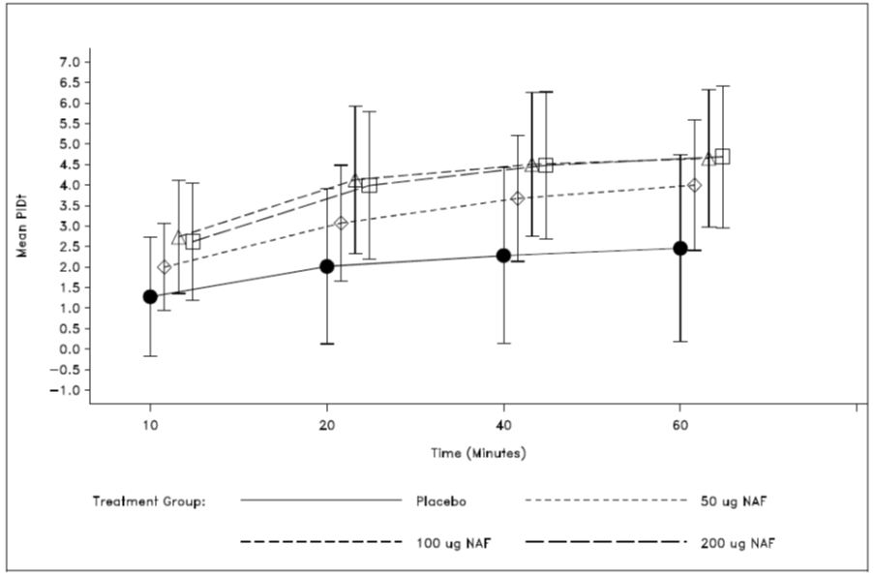

NAF = FNS

###### Results for other efficacy outcomes

###### General Impression score

The General Impression score was taken at 60 minutes. The mean GI scores at 60 minutes were higher with increasing doses: 1.71, 1.80 and 2.00 for the 50, 100 and 200 μg FNS doses respectively. Mean overall GI score for placebo was 0.94. For the comparison of all FNS doses combined, the LS mean GI score was statistically significantly higher (0.93, CI 0.77, 1.8; p<0.001) (Table 8).

Table 8: Study FT-018-IM Overall General Impression (GI) Score at 60 Minutes: Efficacy Phase, ITT Analysis Set.

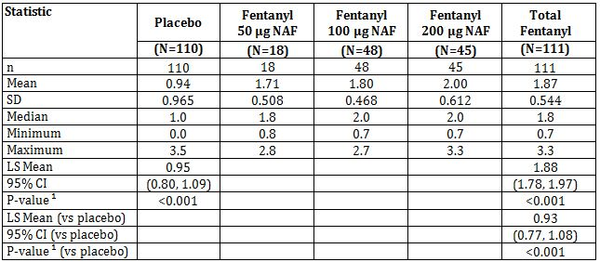

n = number of patients with available data.

¹ The p-value is based on least squares means from mixed linear model with fixed effects for treatment and centre, and random effect for patient. Note: Higher scores indicate higher level of satisfaction with pain relief. Overall GI is calculated as the average score from the treated BTP episodes for each treatment (active or placebo) within a patient.

###### Overall Sum of the PID from 0 to 60 minutes (SPID0-60)

The results show higher mean SPID0-60 scores for all FNS doses compared to placebo. For the comparison of all FNS doses combined, the LS mean SPID0-60 was statistically higher (1.7; CI: 1.45, 1.94, p<0.001) (Table 9).

Table 9: Study FT-018-IM Overall Sum of Pain Intensity Differences in the Time Interval 0 - 60 Minutes (SPID0-60): Efficacy Phase, ITT Analysis Set.

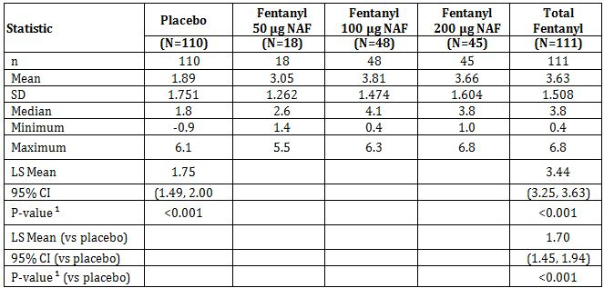

n = number of patients with available data.

¹ The p-value is based on least squares means from mixed linear model with fixed effects for treatment, centre, average baseline PI (over all treated BTP episodes for a patient), deviation of baseline PI for each treated BTP episode from average baseline PI, and random effect for patient. Note: Higher scores indicate better pain relief. Overall SPID0-60 is calculated as the average score from the treated BTP episodes for each treatment (active or placebo) within a patient.

###### Responder rate

Analysis of responder rate was carried out on the PID10 scores. A responder was defined as having a PID10 >2 for a given BTP episode. The average response rate was calculated by computing the average response rate by treatment (FNS or placebo) within each patient and the averaging of those averages across all patients for placebo and active treatment, respectively.

The responder rate was highest for 100 μg compared to the 200 μg and 50 μg FNS doses. The mean responder rate at 10 minutes was 31.5%, 60.4% and 49.0% for the 50, 100 and 200 μg FNS doses respectively and 51.1% for total FNS (Table 10). The mean responder rate at 10 minutes was lowest for placebo (20.9%).

Table 10: Study FT-018-IM Responder Rate at 10 Minutes, ITT Analysis Set.

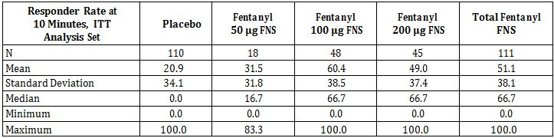

A responder for a treated break through pain (BTP) episode has pain intensity difference at 10 min (PID10)>2 for that episode. Overall responder rate is defined as the percentage of BTP episodes with a positive response to treatment (FNS or placebo) within a patient. ITT= Intent-to-Treat; FNS =intranasal fentanyl spray.

*Comment: In this trial the results are presented as per the allocated strengths of the FNS – 50, 100 and 200 μg. However according to the protocol and clinical study report the patients were able to take one or two doses. Nowhere in the results are the actual doses taken provided. Therefore it is difficult to understand the results since patients actually took a range of doses from 50 to 400 μg. In addition, the study staff were able to help the patients enter their results in the patient diaries. This raises concerns over the validity of the efficacy results.*

#### Other efficacy studies

##### Study FT-019-IM: Summary

An Open Label, Comparative, Randomised, Balanced Cross Over Trial Comparing Nasal Fentanyl and Oral Transmucosal Fentanyl (Actiq) in Breakthrough Pain in Patients with Cancer.

*Comment: Due to suspicion of misconduct in this study (FT-019-IM), an audit was performed in December 2007 at one German (site X) and the EMA was notified about the suspicion of misconduct. The site had also participated in trials FT-017-IM and FT-018-IM. This notification prompted EMA to conduct a GCP inspection in 2008 at site X and furthermore at a site in Poland (site Y) who had contributed the largest number of patients to the trials. All data from only one site (site X) was omitted from the results presented in the study report.[7] As this study was not included in the original European study this trial was not included in the inspection. However, given the problems identified with the sites the data in this study must be considered compromised, at least for those sites which had also participated in the pivotal studies (7 of 44 sites).*

###### Objectives

Primary objective: to compare the efficacy of FNS to Actiq in the management of BTP in cancer patients.

Secondary objectives:

* To compare patients general impression (GI) and preferences of FNS and Actiq
* To explore the relationship between FNS doses and doses of current opioid of BTP and the relationship between dose of FNS and of background opioid
* To assess the safety and tolerability of FNS

###### Methodology

Design: Open label, comparative, randomised cross over trial conducted at 44 centres in seven countries (Austria, Germany, France, Italy, Spain, Great Britain and Poland) conducted from February 2007 to September 2008.

Patients were randomised to receive the two investigational products (IMP) – FNS and Actiq, in a sequential order (either FNS/Actiq or Actiq/FNS). For each IMP the patient went through a titration and an efficacy phase. An effective IMP dose for each treatment of BTP episodes was identified in a step-wise titration phase. This effective dose was reached when 3 of 4 BTP episodes had been treated successfully with one or two doses/lozenges of IMP. This dose was then used to treat 6 BTP episodes in the efficacy phase (Figure 9).

Figure 9: Study FT-019-IM study design.

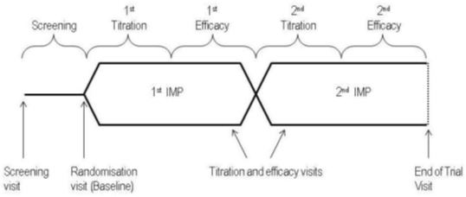

Entry criteria: adult (≥ 18 years) cancer patients in a stable, chronic opioid treatment for background pain, who had a minimum of three BTP episodes per week (and a maximum of four per day), a life expectancy of at least three months and able to use nasal drugs.

Treatments: FNS was supplied as a phosphate buffered solution of fentanyl citrate, available in 0.5 mg/mL, 1.0 mg/mL and 2.0 mg/mL (equivalent to 50, 100, and 200 μg, respectively) in multiple dose glass containers mounted with a standard spray device. One dose of FNS equals one puff of 100 μL in one nostril. Treatment of a BTP episode with IMP was either one or two doses with a minimum of 10 minutes apart. The second dose (puff) could be administered 10 minutes after the first dose if sufficient pain relief was not achieved, this second dose should be administered in the other nostril. The initial dose in the titration phase was 50 μg and the maximum dose of FNS was 2x 200 μg taken 10 minutes apart.

Actiq was supplied as lozenges, available in the doses 200, 400, 600, 800, 1200 or 1600 μg per lozenge. The lozenge was administered with an applicator in the oral cavity during a 15 minute period. If the patient had insufficient pain relief, a second lozenge could be taken 30 minutes after the start of administration of the first lozenge.

If pain relief was still insufficient at 20 minutes after FNS or 60 minutes after Actiq the patient could take their usual immediate release opioid or any other pain medication (rescue medication).

###### Data collection and analysis:

Primary efficacy outcome: Time to onset of meaningful pain relief – defined as the time at which the patient experienced meaningful pain relief. Time to onset was recorded by the patient, using a stopwatch which was started at the time of the first FNS dose or the start of the Actiq administration.

Secondary efficacy outcomes:

* Pain Intensity (PI) was assessed using an 11 point NRS (0=no pain to 10=worst possible pain). Patient recorded their PI just prior to first dose of IMP, at time 0 and at 5, 10, 15, 20, 30 and 60 minutes after first IMP administration. Derived variables PID, sum of PID (SPID) and time to 50% reduction in pain were based on PI.
* GI of efficacy in the treatment of BTPs was assessed 60 minutes after the first FNS dose/start of Actiq® in each episode using a categorical 5 point visual rating scale (VRS), where 0=poor, 1=fair, 2=good, 3=very good, and 4=excellent.
* Ease of administration was assessed at the end of each efficacy phase using a 5 point VRS, from 0-4, where 0=very easy, 1=easy, 2=OK, 3=difficult, and 4=very difficult.
* Patients’ preference for one of the two treatments (either/or) was assessed after completion of the second efficacy phase

The outcome was to be determined by the patient, however, the patients were allowed to receive help from relatives or staff personnel for recording in the diary.

Safety assessments were the incidence and nature of AEs occurring during the trial.

###### Study participants

Enrolled: 196 were screened and 139 were enrolled and randomised

Completed: 86 patients completed

Analysed: 139 as ITT population and 72 as PP population

Baseline: (ITT population) 79 patients were males (56.8%) and 60 females (43.2%); mean age was 62.0 years (range 22 to 94 years); mean BMI was 24.3 kg/m2 (range 14.7-35.5); mean weight was 69.7 kg (range 45-115); and mean height was 169.0 cm (range 149-200); all patients were Caucasian (100.0%). Demographic characteristics were similar for the two treatment sequences.

###### Results

The primary efficacy endpoint was time to onset of meaningful pain relief. The overall median for FNS was 10.6 minutes, for Actiq 15.7 minutes and the within patient difference was 4.3 minutes, indicating a faster time to meaningful pain relief using FNS (Table 11).

Table 11: Summary of Within Patient Median Time to Onset of Meaningful Pain Relief – Censored Values, ITT Analysis Set.

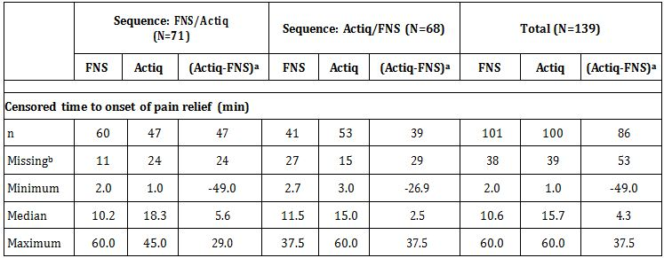

n=number of patients with available data. N=number of patients randomised to sequences.

a Within patient difference=within patient median time to onset on Actiq - within patient median time to onset on INFS. Times were censored at 60 minutes if rescue medication was taken within 60 minutes from taking test treatment and before any meaningful pain relief was recorded or if the time to onset of pain relief was longer than 60 minutes

b Data for these patients is missing and therefore did not contribute to the computation of the median.

Analysis of the time to onset data by treatment sequence indicated that although FNS was fastest regardless of which treatment was taken first, the difference between the time to onset of meaningful pain relief between FNS and Actiq did vary. For the ITT analysis, the difference between median time to onset for FNS and Actiq in the FNS/Actiq sequence was 5.6 minutes, while the difference was 2.5 minutes for the Actiq/FNS sequence (results were similar for the PP analysis). The sponsor explanation for this is that the patient’s perception of the time to onset for FNS was unaffected by the sequence of administration, whereas the difference for Actiq (ie. Actiq seemed to be perceived as working more slowly when it was administered as the second IMP).

Overall, using the imputed values for fastest median time to meaningful pain relief, 65.7% of patients reported fastest relief using FNS. This proportion of patients that experienced the fastest time to onset of pain relief on FNS was compared to 50% under the null hypothesis. Among the 137 patients with imputed values, the 65.7% that considered FNS to be fastest was statistically significant (p<0.001, CI: 57.1, 73.6). FNS was considered fastest to meaningful pain relief similarly for both treatment sequences.

The Kaplan-Meier plot below presents the time to onset of meaningful pain relief by efficacy phase and treatment (Figure 10).

Figure 10: Study FT-019-IM Kaplan-Meier survival estimates.

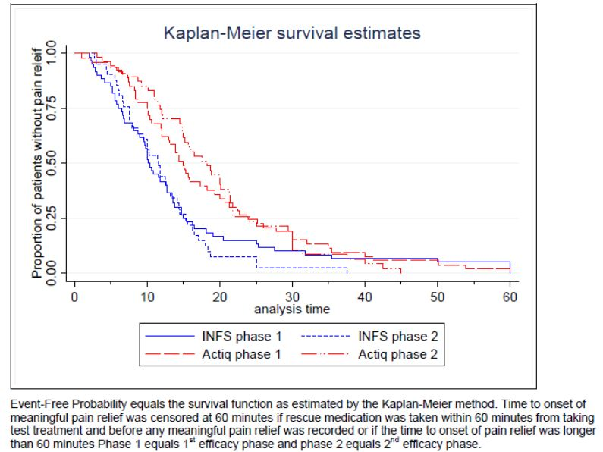

Secondary Efficacy Endpoints: were the PID10, PID30, SPID0-15 and SPID0-60, time to reduction in PI and GI of efficacy of treatment of each episode, ease of administration of each treatment, and patient’s preference for one of the treatments.

###### PID10

PID was evaluated using the 11 point NRS (0=no pain to 10=worst possible pain); a higher PID score indicates better pain relief, with a ≥2 difference considered clinically significant (responder).

All FNS doses provided higher mean PID10 scores (ranging from 1.63 to 3.00) compared with all Actiq doses (ranging from 0.51 to 1.46). The total mean FNS score was 2.39 (model-adjusted least squares mean = 2.27) (Table 12) and the mean total Actiq score was 1.10 (model-adjusted LS Mean = 1.08) (Table 13).

Table 12: Summary of Pain Intensity Differences at 10 Minutes Post Dose (PID10) – FNS (ITT).

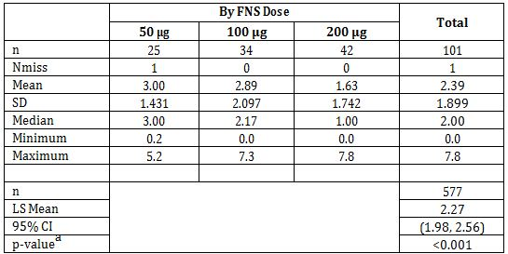

n=number of patients (summary statistics) or number of observations included in analysis

Nmiss=number missing.

a Two-sided p-value from the t-test of the null hypothesis that the model-adjusted LS Mean for the treatment population equals zero.

Pain Intensity Difference at 10 min=PI at 0 minutes minus PI at 10 minutes for each episode; higher scores indicate better pain relief. Overall PID10=average score per patient and treatment.

Table 13: Summary of Pain Intensity Differences at 10 Minutes Post dose (PID10) and F-test for Treatment Effect – Actiq (ITT).

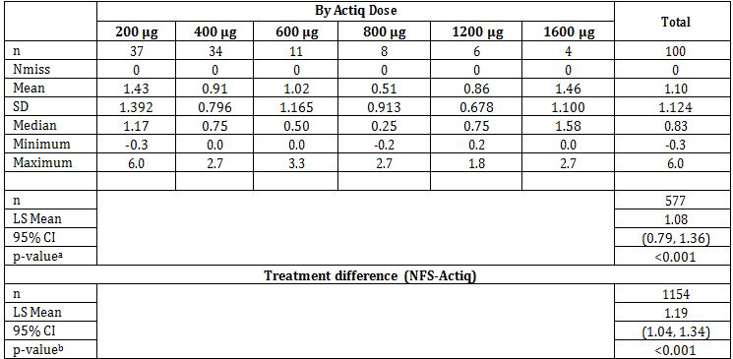

n=number of patients (summary statistics) or number of observations included in analysis (F tests);

Nmiss=number missing.

a Two-sided p-value from the t-test of the null hypothesis that the model-adjusted LS Mean for the treatment population equals zero.

b Two-sided p-value from the F-test of the INFS versus Actiq contrast for treatment effect in the mixed linear model with fixed effects for treatment, country, period, average baseline PI (over all treated BTP episodes for a patient) and deviation of baseline PI. Patient is a random effect.

Pain Intensity Difference at 10 min=PI at 0 minutes minus PI at 10 minutes for each episode; higher scores indicate better pain relief. Overall PID10=average score per patient and treatment.

###### PID30

FNS doses provided higher mean PID30 scores (ranging from 3.90 to 5.08) compared with most Actiq doses (ranging from 1.99 to 4.31) with the exception of FNS 200 μg having a lower mean score than Actiq 200 μg. The mean total FNS score was 4.54 (model-adjusted LS mean=4.15) and the mean total Actiq score was 3.69 (model adjusted LS mean=3.39).

For the comparison of all FNS doses to all Actiq doses combined, model-adjusted LS Mean treatment difference (FNS-Actiq) was 0.76, which was statistically significant (p<0.001, CI: 0.62, 0.90).

###### SPID0-15

All FNS doses provided higher mean SPID0-15 scores (ranging from 1.25 to 2.14) compared with all Actiq doses (ranging from 0.40 to 1.69). The mean total FNS score was 1.77 (model-adjusted LS Mean=1.66) and the mean total Actiq score was 0.85 (model-adjusted LS Mean=0.85).

For the comparison of all FNS doses to all Actiq doses combined, the model-adjusted LS Mean treatment difference (FNS-Actiq) was 0.82, which was statistically significant (p<0.001; CI: 0.72. 0.92).

###### SPID0-60

FNS doses provided higher mean SPID0-60 scores (ranging from 3.27 to 4.33) compared with most Actiq doses (ranging from 1.83 to 3.51), the exception being the Actiq 200 µg dose compared with FNS 200 µg. The mean total FNS score was 3.85 (model adjusted LS Mean=3.52) and the total mean Actiq score was 3.06 (model-adjusted LS Mean=2.83).

For the comparison of all FNS doses to all Actiq doses combined, the model-adjusted LS Mean treatment difference (FNS-Actiq) was 0.70, which was statistically significant (p<0.001; CI: 0.60, 0.80).

###### Time to 50% reduction in PI

The overall median time to a 50% reduction in PI score was 15 minutes for FNS and 30 minutes for Actiq. The difference between the treatments for patients who completed both FNS and Actiq treatment was 5.0 minutes. Overall, 60.9% of patients had fastest median time to 50% reduction using FNS compared with 24.3% using Actiq (14.8% of patients had no difference in time to 50% reduction by treatment). The proportion of patients with a faster reduction using FNS was statistically significantly different from 50% (p=0.025).

###### GI of efficacy of treatment of each episode

GI was assessed 60 minutes after the first treatment of each BTP episode, with 0=poor, 1=fair, 2=good, 3=very good and 4=excellent.

Mean GI scores ranged from 2.1 to 2.4 for FNS and from 1.6 to 2.4 for Actiq. The mean total FNS score was 2.2 (model-adjusted LS Mean=2.1) and the mean total Actiq score was 2.1 (model-adjusted LS Mean=2.0).

For the comparison of all FNS doses to all Actiq doses combined, the model-adjusted LS Mean difference (FNS-Actiq) was 0.2, which was statistically significant (p<0.001; CI: 0.1, 0.2).

###### Ease of administration of each treatment

Patients assessed the ease of trial IMP administration after each efficacy phase where a score of 0=very easy, 1=easy, 2=OK, 3=difficult, and 4=very difficult.

The overall median score for FNS was 0 and for Actiq was 2; this difference was significant (p<0.001).

###### Patient’s preference for one of the treatments

At the end of the second efficacy phase, patients were asked to indicate their preference for one of the two treatments (either/or). Overall 77.4% of patients preferred FNS and 22.6% preferred Actiq; 86 patients completed both phases and 2 patients did not record a preference. The difference was statistically significant (p<0.01). When analysed by treatment sequence, FNS was preferred in both FNS/Actiq (84.8%) and Actiq/FNS (68.4%).

*Comment: In this trial the results are presented as per the allocated strengths of the FNS – 50, 100 and 200 μg. However according to the protocol and clinical study report the patients were able to take one or two doses. Nowhere in the results are the actual doses taken provided. Therefore it is difficult to understand the results since patients actually took a range of doses from 50 to 400 μg. In addition, the study staff were able to help the patients enter their results in the patient diaries. This raises concerns over the validity of the efficacy results.*

##### Study FT-003-IN / FT-011-IN: Summary

FT-003-IN: A randomised double-blind study of the dose schedule finding of successful doses of 50, 100, 200 and 800 μg intranasal fentanyl in breakthrough pain followed by a randomised, controlled, two-way cross-over, double-blind study of the successful doses versus the dose level below in 12 breakthrough pain episodes.

FT-011-IN: an open label safety follow-up study of intranasal fentanyl in the treatment of breakthrough pain in patients completing either the intranasal pharmacokinetic or the dose schedule finding study and receiving chronic opioid or WHO Cancer Pain Ladder, step 1 analgesics for their breakthrough pain.

Termination of study: in August 2003 the sponsor decided to terminate the development program for FNS. The conduct of FT-003-IN had met unforseen problems including an 8-month delay in initiation, slow recruitment, inclusion of patients with more advanced stages of cancer than expected and therefore in need of higher doses of BTP analgesic than foreseen. This decision meant that studies FT-003-IN/FT-011-IN were prematurely terminated. Instead of the planned 100 patients in FT-003-IN, only 17 were included of which 14 continued in FT-011-IN. Further to this the company state that the quality of the data was questionable, making only few statistical analysis relevant. The studies were therefore reported together in an abbreviated report.

###### Objectives

The overall objectives of the studies were to demonstrate effect and tolerability (FT-003-IN) and to evaluate safety and tolerability (FT-011-IN) of FNS in the treatment of BTP.

###### Methodology

Design: randomised, double blind dose finding (50 – 1,200 μg FNS) and then randomised, cross-over, double blind of the effect of the individual successful dose vs half this dose in six episodes of BTP. Study was originally planned for 16 centres: but only 4 enrolled patients: two in Bulgaria and 2 in Romania. The study ran from March to November 2003 when it was terminated. The follow up study was open label.

Entry criteria: Adult (≥18 years) cancer patients with cancer related pain and use of a background analgesic that was equivalent to 60-100 mg oral morphine/day or to transdermal fentanyl 50-300 μg/hour. The background pain had to be stable and on average controlled to a mild level by the background opioid. There had to be at least 3 breakthrough pain episodes per week but no more than 4 per day during the 7 days immediately preceding screening.

Treatments: Fentanyl was supplied as an intranasal spray device containing fentanyl citrate solution. The volume per puff was 100 μL. Each device contained at least 40 puffs. Devices with 5 strengths were available:

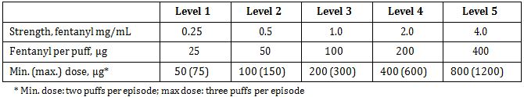

FNS was packed in two series (A and B) with one spray device per step:

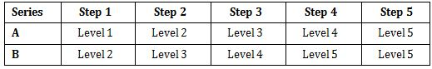

Devices were numbered Level 1 to 5 although for series B the actual dose levels were 2 to 5.

Once the successful FNS dose was identified in the initial phase then the patient tested this dose with half the dose. Twelve BTP episodes were treated per patient. Twelve spray devices – numbered 1 to 12 and each with minimum 40 doses were supplied per patient: six devices with the successful FNS dose and six with half this dose. The distribution of doses was random. The label of each device had a test indication the order of use without disclosing the dose.

Patients who continued in Study FT-011-IN were provided with FNS at strength established in prior study and were instructed to take one puff at time 0 + one optional puff at 15 minutes if the analgesic effect was inadequate. If second dose was inadequate at 45 minutes rescue medication was allowed.

Data collection and analysis: BTP episodes treated with FNS were assessed at 0 (before the first FNS puff) and at 15, 30, 45, 60, 75, and 90 minutes. Efficacy variables were pain intensity (PI) (on 11 point NRS), pain relief and general impression (GI) (both on 5 point VRS). Derived variables were PI difference (PID), sum of PID (SPID), and total pain relief (PAR) (TOTPAR). Due to termination of trial only brief efficacy results are presented.

###### Study participants

Enrolled: 17 patients enrolled at time of termination.

Completed: study prematurely terminated. Of 17 patients who enrolled 3 had died at time at termination. Of the 14 patients continuing in FT-011-IN all 14 discontinued – 13 due to AEs, of which 11 died and one patient withdrew consent.

Analysed: 14 patients in study FT-003-IN and 14 patients who continued in FT-011-IN. Of the 17 patients enrolled 12 were male and 5 female. The mean height for males was 169.4 cm (range 158-178 cm) and for females 162.8 cm (range 158-169 cm); the mean weight for males was 61.6 kg (range 45-80 kg) and for females 53.6 kg (range 40-72 kg). The site of the primary tumour was the lung/respiratory system for 6 patients and the female genital system for 3 patients, whereas the thyroid gland, musculoskeletal system, pancreas, liver, gall bladder, urological system, prostate and testis were each the site of tumour in one patient. Six patients had metastases in the musculoskeletal system, three in the lymph nodes, three in the liver and seven other sites were each implicated in one patient.

###### Results

Efficacy: The doses tested were as follows:

* 50/100 μg – 4 patients
* 100/200 μg – 1 patients
* 200/400 μg – 3 patients
* 400/800 μg – 4 patients
* 50/50 μg – 2 patients – incorrectly took only one dose

Mean SPIDs for low and high doses were 253 and 259, respectively; mean TOTPARs were 199 and 209. Thus the overall differences between the low and high doses were small (Figure 11). The PIDs and PARs by time point were also similar for the low and high doses.

Figure 11: Study FT-003-IN / FT-011-IN overall PID results.

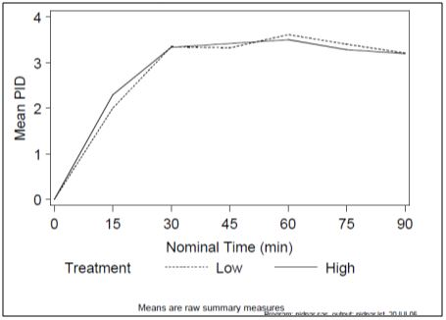

*Comment: The very low numbers in this trial do not provide sufficient evidence to support efficacy.*

The conclusion of the study was that a successful FNS dose was established in the titration phase of the study, when tested randomly against half this dose in 12 BTP episodes per patient, the effects of the low and high doses (mean SPID, mean TOTPAR, PID and PAR by time point) were similar.

##### Publications

A number of publications were submitted in support of the application. This section did not follow the TGA guideline for a literature based submission. Very brief information is provided as to the aim of the inclusion of these publications in the clinical efficacy and safety section. The publications were stated to have been selected on the basis of relevance but no criteria for relevance are provided and the selection of the papers is not consistent with the purpose of providing information concerning the formulation of intranasal fentanyl under consideration. Many papers relating to different routes of administration (IV, transmucosal and transdermal) are included as are many publications relating to indications other than BTCP.

The publications related to other indications and routes of administration have not been evaluated or summarised as the efficacy and safety of these routes or indications is not within the scope of the application.

Publications relating the use of fentanyl nasal spray for use in post operative pain have also not been evaluated or summarised as this indication has not been requested and most of the publications relate to different formulations.

Four publications (from two investigators) were provided which present data on the use of fentanyl nasal spray in the treatment of BTCP. Two appear to have used a competitor product to that of the applicant the other two appear to have used a product with a different formulation and delivery system. None of these publications are considered pivotal or supportive except to the general safety of fentanyl via the intranasal route. The publications have not been summarised.

A table of the publications using fentanyl nasal spray is provided in Tables 14 and 15.

Table 14: Brief overview of scientific literature articles using nasal fentanyl for breakthrough pain.

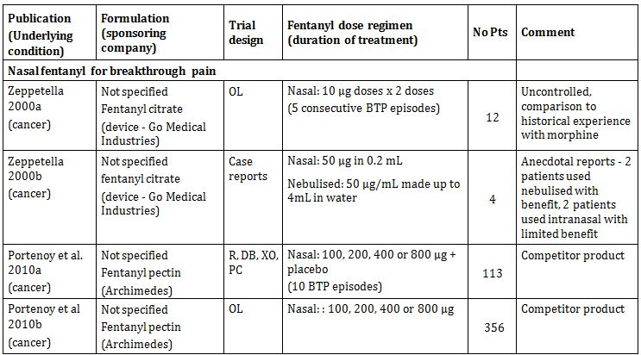

OL=open label; R=randomised; DB=double blind; XO=cross over; PC=placebo controlled

Table 15: Brief overview of scientific literature articles using nasal fentanyl for other indications.

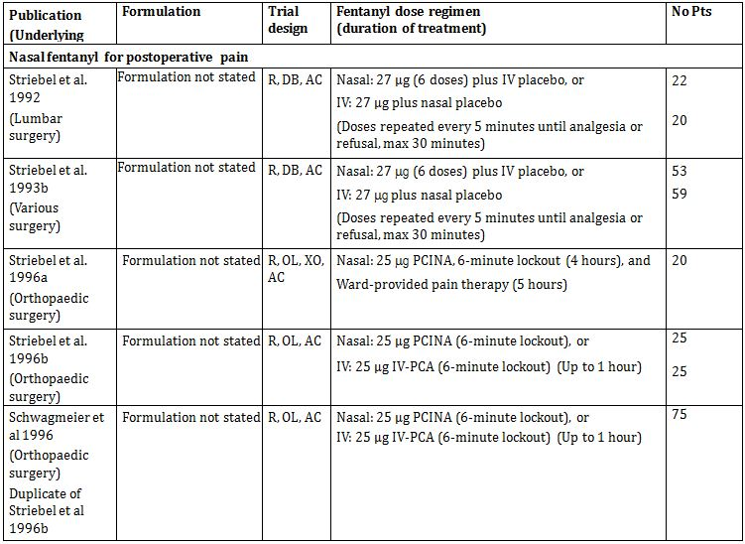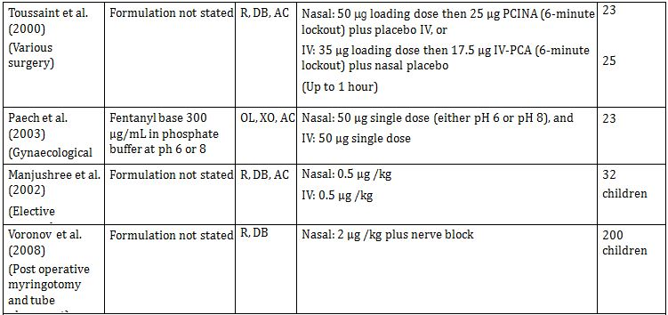

**Table 15 (continued):**

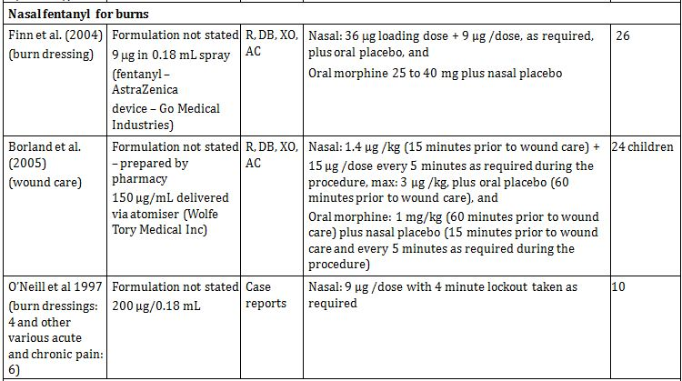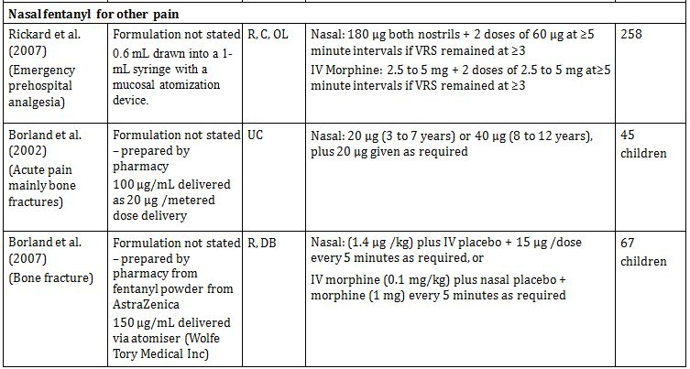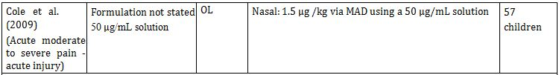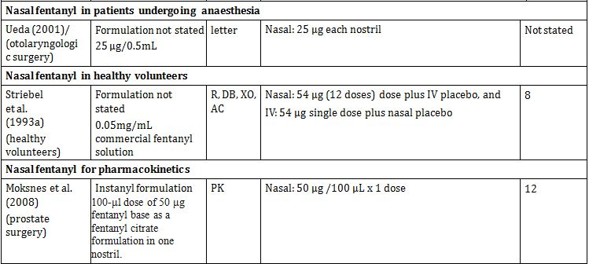

OL=open label; R=randomised; DB=double blind; XO=cross over; PC=placebo controlled; AC=active controlled; IV=intravenous; PCINA=patient controlled intranasal analgesia; IV-PCA=IV patient controlled analgesia; MAD= mucosal atomiser device; PK=pharmacokinetics

#### Analyses performed across trials (pooled analyses and meta-analyses)

Not applicable.

### Evaluator’s conclusions on clinical efficacy for BTP

The main problem with the clinical data is the concern over the conduct of the studies and the compliance with Good Clinical Practice (GCP). The issues raised by the EMA inspection team are critical and raise serious doubt about the acceptance of the data.Even if the issues of GCP were to be put aside (as was done in Europe), there are major concerns about the quality of the clinical studies. The company stated that the clinical data comprised two pivotal studies and two supportive studies. The two pivotal studies are not independent studies, which is generally regarded as one of the criteria for being classified as pivotal. The second Study FT-018-IM is not independent of the first pivotal Study FT-017-IM. The same centres and investigators have been used and the entry criteria for Study FT-018-IM included that patients had participated in either Study FT-016-IM (PK study) or FT-017-IM. Study FT 018-IM is simply a replicate of Study FT-017-IM with the same patients.[8] Study FT-017-IM could be considered a dose-response study which was then used in Study FT-018-IM to test against placebo. Given the alternative therapies available, a pivotal study rather than a supportive study against an active comparator was possible.

The company therefore really has only one pivotal study. TGA have adopted the relevant guideline published by the EMA (CPMP/EWP/2330/99); to quote from this guideline:

*“the fundamental requirement of the Phase III documentation is that it consists of adequate and well-controlled data of good quality from a sufficient number of patients, with a sufficient variety of symptoms and disease conditions, collected by a sufficient number of investigators, demonstrating a positive benefit/risk in the intended population at the intended dose and manner of use ... The minimum requirement is generally one controlled study with statistically compelling and clinically relevant results.”*

This data package does not meet this standard. The supporting Study FT-019-IM also has concerns about the quality of the data (this was not submitted in Europe) and the other supporting Study FT-003-IN/FT-011-IN does not contain sufficient patients to provide any real evidence of efficacy.

Therefore, the concerns about the efficacy are:

* concerns over GCP: the main studies submitted were found to be unreliable on GCP inspection;
* Failure to comply with the relevant adopted guidelines:
  + GCP
* [information redacted]Small number of patients in the submission compared to other submissions for similar products;
* The decision to remove site X but not site Y from the analysis is not explained in light of the Committee for Medicinal Products for Human Use (CHMP) conclusions. It appears it may have related more to the statistics of the studies. Site Y enrolled the largest number of patients and exclusion of this site may have invalidated the results;[9]
* Use of same investigators in the two pivotal studies and ability of investigators to influence efficacy and safety outcomes by assisting patients in completion of efficacy and safety outcomes in the patient diary;
* The study design of Study FT-017-IM of testing different doses in each patient rather than titrating to a successful dose and then testing that dose against an accepted therapy rather than placebo would have been a more acceptable design for a pivotal study;
* Patients in the trials were able to take up to 2 doses of each dose strength. This does not seem to have been reflected in the results when presented by dose. Thus some patients in the 200 µg dose took 200 μg and some presumably took 400 μg. It is not clear how many took what dose and how this affected the results.

## Clinical safety

*Comment: The safety summary provided by the company is very confusing and badly written. It consists of repeated summaries of individual studies and not a consolidated summary of all studies. The main problem is that the patients in study FT-018-IM were previously enrolled in studies FT-016-IM and FT-017-IM and therefore are duplicates of the patients in the previous studies. The numbers of patients in the trials are small (especially given the duplication) and the company have tried to compensate for this by including publications to support the safety of nasal fentanyl. This is not acceptable as the publications relate to alternative currently registered formulations and different routes of administration (IV, transmucosal, etc).*

*The aim of the Summary of Clinical Safety appears to be to demonstrate the safety of fentanyl by any route and for a number of indications and is not focussed on demonstrating the safety of the formulation and route of administration intended for marketing.*

*Given the concerns raised by the inspection team on the collection and reporting of adverse events in the company sponsored trials there are grave concerns about the completeness and relevance of the safety profile provided.*

*Not all the publications considered by the company as pivotal and supportive are summarised and the publications are inconsistently presented in different sections of the submission, making them difficult to find.*

### Studies providing evaluable safety data

The following studies provided evaluable safety data:

#### Pivotal efficacy studies

In the pivotal efficacy studies (FT-017-IM and FT-018-IM), the following safety data were collected:

* General adverse events (AEs) were assessed at each study visit by investigator asking open questions to the patient (eg. “Have you experienced any medical problems since the last contact?”). All AEs, either observed by the investigator or reported by the patient, were recorded by the investigator on the applicable SAE/AE form in the Case Record Form (CRF).
* AEs of particular interest, including known AEs to opioids, were assessed by reviewing the overall AEs and identifying known AEs.
* Laboratory tests were not performed in the efficacy trials.

#### Pivotal studies that assessed safety as a primary outcome

Study FT-018-IM assessed safety as a primary outcome.

#### Dose-response and non-pivotal efficacy studies

The dose-response and non-pivotal efficacy studies provided safety data, as follows:

* Study FT-019-IM provided data on adverse events only.
* Study FT-003IN/FT011-IN provided data on adverse events only.
* Study FT-016-IM provided data on adverse events.

#### Other studies evaluable for safety only

No other studies were submitted.

#### Clinical pharmacology studies

The pharmacokinetic studies conducted in healthy subjects provided data on adverse events and also on routine haematology, clinical chemistry and urinalysis as well as vital signs and oxygen saturation.

#### Pivotal studies that assessed safety as a primary outcome

Study FT-018-IM assessed safety as a primary outcome. Safety was only assessed by the collection of adverse events.

### Patient exposure

Consolidated patient exposure is not presented in the Summary of Clinical Safety. Due to the duplication of patients and the inclusion of different products and routes of administration, the standard exposure table cannot be completed. The total number of patients included in the safety dataset is inconsistently presented in the submission.

The Summary of Clinical Safety reports a total of 364 patients exposed to FNS (including patients who received the test dose) in 7 FNS clinical trials (6 BTP and 1 post-operative pain), plus 128 healthy volunteers exposed to FNS in the Pharmacology studies.

However, in the tabulated listing of adverse events the number of exposed patients adds to a total of 430 patients plus 128 healthy volunteers (Tables 16-18). The difference in numbers could not be reconciled but may be due to exclusion of duplication of patients which is not explained.

Table 16: Exposure to Fentanyl Nasal Spray and comparators in clinical efficacy studies in patients with BTCP.

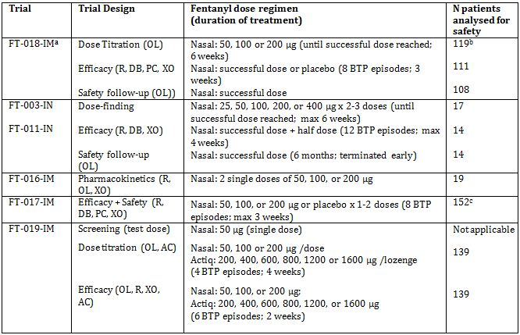

DB = double-blind; OL = open label; PC = placebo controlled; R = randomised; XO = cross-over; AC = Active Controlled. a Trial FT-018-IM enrolled patients who had previously participated in Trials FT-016-IM and FT-017-IM.b In Trial FT-018-IM, 120 patients were enrolled and included in the safety population but 119 were analysed for the dose titration phase.

c In Trial FT-017-IM, 165 patients received a 200 μg INFS test dose; 159 patients tolerated the test dose and were randomised. Of these, 6 patients received no trial treatment and 1 patient received a medication kit from Trial FT-018-IM by mistake. The 152 treated patients were analysed for safety.

Table 17: Exposure to Fentanyl Nasal Spray and comparators in clinical efficacy studies in Healthy Subjects.

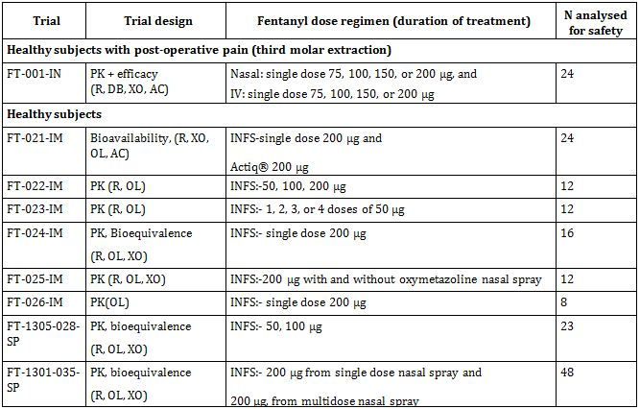

OL = open label; R = randomised; XO = cross-over; AC = Active Controlled

Table 18: Exposure to FNS in clinical studies according to dose.

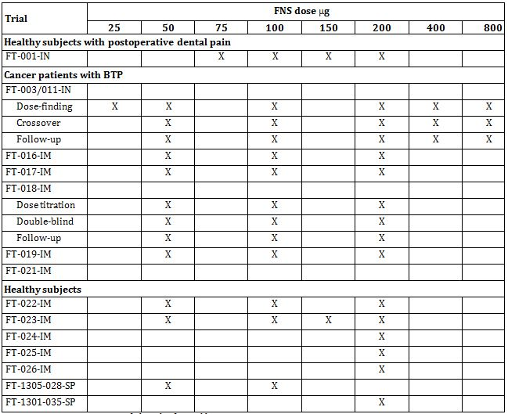

Table 19 on duration of dosage is taken from the Risk Management Report.

Table 19: Duration of continuous exposure for all BTP patients who participated in protocols FT-003/-011-IN, FT-016-IM, FT-017-IM, and FT-018-IM.

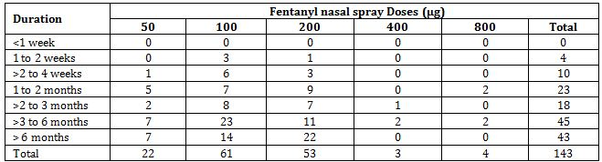

Note: Each BTP patient is counted only once although they participated in more than 1 study (patients in FT-003-IN also were in FT-011-IN and patients in FT-016-IM and FT-017-IM also were in FT-018-IM).

### Adverse events

#### All adverse events (irrespective of relationship to study treatment)

The Summary of Clinical Safety does not provide a summary of the AEs in the total patient population; it simply repeats the safety summaries of each individual study. Table 20 gives the list of all AEs reported at ≥1% for the trials in patients with BTP.

Table 20: Incidence of Adverse Events ≥1% reported by trial: FNS trials in BTP.

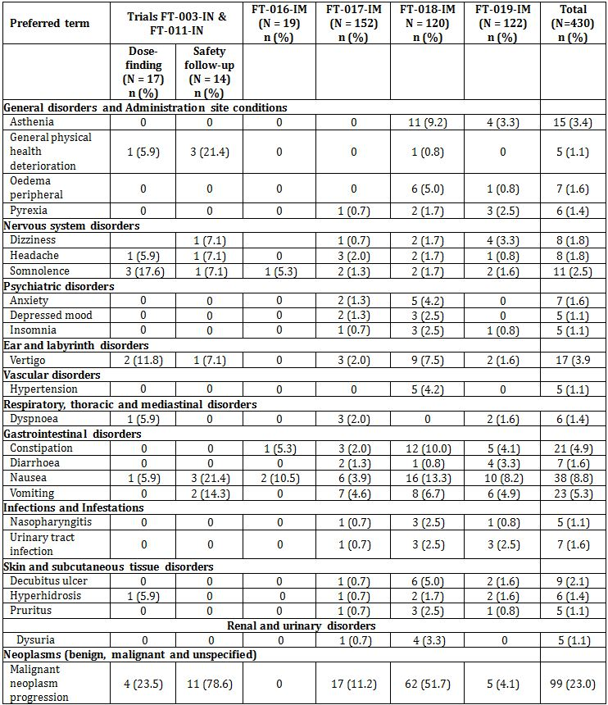

N = number of patients exposed to treatment; n = number of patients with event; % = number of patients with event per patients exposed.

#### Treatment-related adverse events (adverse drug reactions) (TEAs)

##### Pivotal studies

Not reported separately to all AEs.

##### Other studies

Not reported separately to all AEs.

#### Deaths and other serious adverse events

##### Pivotal studies

###### Study FT-017-IM

Deaths

A total of 6 patients died due to treatment emergent serious adverse events (TESAEs) during the efficacy phase of the trial and all were related to the underlying disease – 4 following 50 μg FNS; 1 following 100 μg FNS and 1 following 200 μg FNS.

Four of the deaths were attributed to progression of malignant neoplasms and the remaining 2 deaths were cachexia for one patient and dyspnoea for the other.

The death due to dyspnoea occurred in a [information redacted] patient with prostate cancer who was enrolled when hospitalised at a hospice. He was treated with the 200 μg FNS test dose and was then treated with 100 μg FNS for 2 days. On the third day, 2 hours after the last dose of 50 μg FNS, the patient developed dyspnoea and died three and a half hours later. The patient’s condition had been deteriorating over the last 24 hours and the dyspnoea was considered a symptom of a pulmonary embolus. An autopsy was not performed but the investigator considered the cause of death to be due to a pulmonary embolus and not related to trial treatment. The sponsor agreed with the investigator and also assessed the event as not related.

SAEs

A total of 10 patients (6.6%) reported 12 TESAEs: 5 patients (3.4%), 1 patient (0.7%) and 3 patients (2.0%) following treatment with 50, 100 and 200 μg FNS. One additional patient reported a SAE following the test dose (abdominal pain).

One patient had an SAE that was considered to have a possible relationship to treatment. This 54 year old female patient with sarcoma of the hip region experienced respiratory depression after taking 2 FNS doses of 200 μg 10 minutes apart (total dose 400 μg); the patient recovered from the event with hospital treatment with naloxone and supportive measures.

###### Study FT-018-IM

Deaths

A total of 47 patients (39.2%) died due to TESAEs during the trial (or within 48 hours after a dose of IMP). An additional 8 patients died due to malignant neoplasm progression more than 48 hours after the last dose. None of the deaths were considered by the investigator to be related to the trial treatment. The majority of deaths were attributed to the underlying disease ie progression of malignant neoplasm (43 patients (35.8%) plus 1 patient experienced metastases to the CNS). Three patients died of unrelated events other than progression of disease. One patient died of cardiopulmonary failure, intestinal perforation and gastrointestinal necrosis; 1 patient of general physical health deterioration; and 1 patient of cardiovascular insufficiency.

SAEs

60 patients (50.0%) reported 83 TESAEs. None of the SAEs were considered related to the IMP. The most frequently reported TESAEs was malignant neoplasm progression in 49 patients (40.8%). Anaemia was reported for 2 patients and all other TESAEs were reported for 1 patient each.

##### Other studies

###### Study FT-019-IM

Deaths

A total of 6 patients died during the trial due to TESAEs. None of the deaths were considered by the investigators to be related to IMP. All six deaths were attributed to progression of malignant neoplasm.

SAEs

A total of 21 TESAEs were observed in 19 patients – 13 patients experienced TESAEs allocated to FNS and 6 patients experienced 7 TESAEs allocated to Actiq treatment. None of the reported TESAEs were considered related to IMP. The most frequently reported TESAE was malignant neoplasm progression in 6 patients. Unrelated serious pneumonia was reported in 2 patients and all other TESAEs were reported for 1 patient each.

###### Study FT-003-IN/FT-011-IN

Deaths

Three of the 17 patients in the dose finding study (FT-003-IN) and 11 of the 14 patients in the follow up study (FT-011-IN) died. The cause of death in all cases was said to be progression of malignant disease and all events were considered unlikely related to FNS.

SAEs

3/17 patients in FT-003-IN reported a total of 3 SAEs while 14/14 patients reported a total of 34 SAEs in FT-011-IN. Most SAEs were cancer progression. The investigators considered all SAEs to be unlikely related to FNS.

#### Discontinuation due to adverse events

##### Pivotal studies

###### Study FT-017-IM

A total of 8 patients (5.3%) were discontinued due to AEs. The most common AE leading to discontinuation from the trial was malignant neoplasm progression (4 patients) assessed as unrelated to FNS.

###### Study FT-018-IM

There is some confusion in the study report about patients who withdrew from the study due to AEs. It is described as:

*“there were two categories of recorded withdrawals due to AEs – those patients for whom the primary reason for discontinuation from the trial [...] was due to an AE and those who had IMP withdrawn due to an AE as listed on the AE page of the CRF (these patients did not necessarily discontinue their participation in the trial)”.*

This explanation is difficult to follow as it is not clear if these patients received further treatment.

One part of the report states that during the trial 57 patients discontinued due to an AE primarily reported as malignant neoplasm progression while in another section it states that a total of 22 patients had TEAEs leading to withdrawal of IMP.

Three AEs resulting in discontinuation were considered to have a probable relationship to trial medication: moderate vertigo in 1 patient, moderate accidental overdose in 1 patient and severe dysgeusia in 1 patient.

##### Other studies

###### Study FT-019-IM

The reporting of discontinuations are similar to that for Study FT-018-IM. A total of 17 patients discontinued due to AEs. Of these 10 discontinued because of fatal events. Reasons for discontinuation are only given for 7 patients – opioid toxicity and pneumonia (one patient); nausea, vomiting and gait disturbance (one patient); skin rash, hypotension and sweating (one patient); nasal ulcers (one patient); vertigo and vomiting (one patient) and dry mouth after Actiq (one patient).

A total of 15 patients had one or more TEAEs leading to withdrawal of IMP. The TEAEs most commonly leading to withdrawal of FNS, but not necessarily from trial participation, were nausea and vomiting (3 patients); dizziness (2 patients); and malignant neoplasm progression, altered state of consciousness, dysaesthesia, neuromuscular blockade, dyspnoea, skin pain and nasal ulcer each in one patient.

###### Study FT-003-IN/FT-011

Discontinuations are not discussed presumably because the study was terminated and most of the patients in the follow up trial had died.

### Laboratory tests

No laboratory testing was done in any of the clinical efficacy studies. Laboratory testing was only done in the pharmacology studies in healthy volunteers and at screening only in Study FT-016-IM (PK study in cancer patients).

#### Liver function

##### Pivotal studies

Not recorded. All studies excluded patients with severe hepatic impairment.

##### Other studies

Not recorded. All studies excluded patients with severe hepatic impairment.

#### Kidney function

##### Pivotal studies

Not recorded. All studies excluded patients with severe renal impairment.

##### Other studies

Not recorded. All studies excluded patients with severe renal impairment.

#### Other clinical chemistry

##### Pivotal studies

Not recorded.

##### Other studies

Not recorded.

#### Haematology

##### Pivotal studies

Not recorded.

##### Other studies

Not recorded.

#### Vital signs

Vital signs were not recorded in the clinical studies.

#### Local nasal tolerance

Nasal biopsies were planned before inclusion and after FNS treatment in Studies FT-003-IN/FT-011-IN. However, they are not done as most of the patients died during the trial and the remaining refused or were so severely ill that a biopsy was not possible. In the subsequent trials patients were not specifically monitored for local tolerability and the information was collected as part of the adverse events. Table 21 lists the AEs which were considered to be potential nasal tolerance events.

Table 21: Number of Patients with potential nasal-pharyngeal adverse events by FNS dose and trial: patient with FNS in BTP.

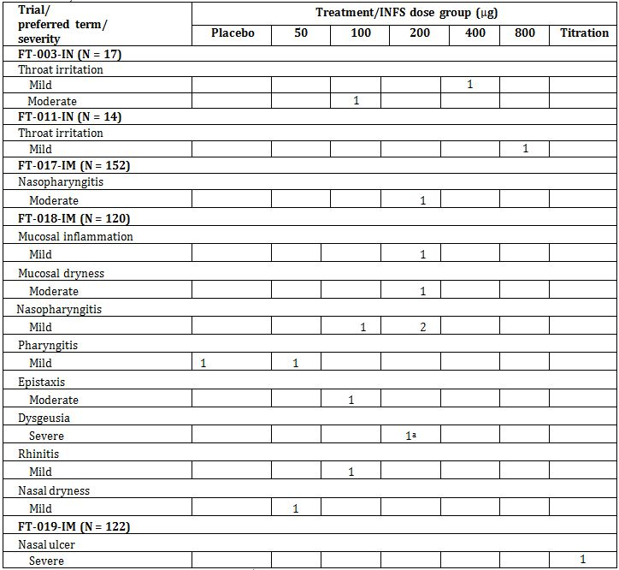

a One subject had 3 incidences of this AE.

### Post-marketing experience

The Summary of Clinical Safety was written in March 2011 and covers the period from product launch until December 2010. In addition to this the company have provided 5 PSURS – 3 covering the period from April 2009 to October 2010 when the summary was written and 2 reports covering the period from Oct 2010 to April 2011 and from April 2011 to October 2011.

Instanyl fentanyl nasal spray was launched in Europe in September 2009 and by the October 2011 had sold approximately 5 million doses with an estimated patient exposure (based on 2.5 BTP episodes per patient per day, treated with one dose per BTP episode, in an average of 45 days) of around 43,000 patients.

A small number of SAEs were reported in each PSUR. All are consistent with the known effects of fentanyl and the information contained in the Clinical Summary of Safety.

The SAEs of note are:

* 1 case of nasal septum perforation in a patient also treated with chemotherapy including eight cycles of bevacizumab which is reported to cause nasal septum perforation
* 7 cases of overdose, two considered serious – one patient developed respiratory depression requiring admission to hospital and the other patient developed “standard symptoms of overdose” and hallucinations
* 4 cases of abuse or misuse of the medication.

### Safety issues with the potential for major regulatory impact

#### Overdosage

No specific actions were taken in the trials to investigate the potential for overdose. Adverse events were the only safety monitoring conducted during the trials and there were 2 cases reported of potential overdosage.

A [information redacted] patient was withdrawn from Study FT-017-IM after experiencing sedation after the test dose. The patient was then enrolled in Study FT-018-IM and experienced dizziness reported as overdosage after one dose of FNS 100 μg. The patient treated a total of 4 BTP episodes on FNS 100 μg (2 episodes with 1 dose and 2 episodes with 2 doses) over 2 days without additional adverse events.

A [information redacted] patient experienced respiratory depression due to an accidental overdose. The patient was enrolled in Study FT-017-IM and had successfully taken the test dose and one blinded dosage (2 doses) the previous day. On the day of the event, the patient took 2 doses of FNS 200 μg over 10 minutes (total dose 400 μg). A few minutes after the second dose, the patient developed muscle stiffness, respiratory depression and fainted. The patient was admitted to hospital and treated with naloxone, oxygen, glucose infusion, metoclopramide and paracetamol. The patient recovered quickly and was diagnosed with oral herpes.

#### Drug abuse

Again only review of AEs were used to review the issue of drug abuse or physical dependence.

In Study FT-011-IN, 3 patients had AEs of dependence during the 6 month safety follow up.

In Study FT-018-IM, during the safety follow up phase, 10 patients treated more than 4 BTP episodes per day stipulated in the protocol.

One patient with metastatic lung cancer started using six 200 μg FNS doses per day in the first month and escalated to as many as 35 per day by the third month. This patient was in the terminal phase of his illness and the investigator agreed to the patients request to use FNS on an as needed basis for pain relief. The patient died of progression of his disease after 5 months of the safety follow up.

The other 9 patients treated a maximum of 5 to 8 BTP episodes per day at doses of 50 μg (1 patient), 100 μg (1 patient) or 200 μg (7 patients). No patients had AEs that were considered related to treatment.

#### Withdrawal and rebound

No adverse events of rebound or withdrawal AEs were reported in the clinical trials.

### Evaluator’s overall conclusions on clinical safety

No routine clinical laboratory evaluations were performed as safety monitoring during the pivotal trials. Safety is therefore totally reliant on adverse event reporting and this has been shown to be less than adequate in the European inspection. Adverse Event (AE) reporting was considered seriously compromised by the GCP inspection team due to:

* Systemic failure in the pivotal trials (FT-017-IM and FT-018-IM) due to the complete absence of space in the diary cards allocated to AE entry;
* Failure of both investigators at inspected sites who were unaware of the protocol amendment requirement to report progression of the underlying disease as an adverse event;
* Failure of the investigator at site Y (the highest patient recruitment) to report AEs based on the AE definition according to ICH-GCP rather than the investigator’s subjective judgement.

Re-monitoring of the sites yielded 49 additional unreported AE in Study FT-017-IM (increase by 70%) and 238 additional AEs in Study FT-018-IM (increase by 100%, doubled). These high numbers of unreported AEs raised the concern that the underreporting of AEs was not limited to the two inspected investigational sites and so the inspection team considered that even with the re-monitoring carried out by the company on all sites the safety of the investigational product was inadequately documented and the studies could not be relied on to provide an accurate safety profile of the product.

It is unusual to rely only on AE monitoring for the safety profile of a product, even one using a well established substance like fentanyl. The absence of any laboratory testing in the pivotal clinical studies is not considered acceptable.

While fentanyl is a well established product, overall safety of this formulation has not been proven.

## First round benefit-risk assessment

### First round assessment of benefits

The benefits of Instanyl in the proposed usage are:

* Pharmacokinetics have been adequately demonstrated;
* Safety in healthy volunteers has been adequately demonstrated;
* Pharmacokinetics in patients with BTP are similar to those in healthy volunteers.

### First round assessment of risks

The risks of Instanyl in the proposed usage are:

* Efficacy has not been proven in well designed and conducted clinical trials;
* Safety has not been proven in well designed and conducted clinical trials.

#### First round assessment of benefit-risk balance

The benefit-risk balance of Instanyl, given the proposed usage, is unfavourable.

### First round recommendation regarding authorisation

Based on the clinical data presented in the submission, it is recommended that the application be rejected.

The reasons for rejection are:

* Lack of efficacy in adequately designed and conducted clinical studies;
* Lack of safety in adequately designed and conducted clinical studies.

## Clinical questions

### Additional expert input

A copy of the EMA GCP inspection report should be obtained.

### Pharmacokinetics

No questions.

### Pharmacodynamics

No questions.

### Efficacy

No questions.

### Safety

No questions.

## Second round evaluation of clinical data submitted in response to questions

The Delegate asked the following questions to the sponsor:

*Q1. Please provide a full copy of the Good Clinical Practice (GCP) inspection report requested by the CHMP (May-June 2008) to verify whether Studies FT-017-IM and FT-018-IM were conducted in compliance with GCP and applicable regulations.*

The sponsor provided the inspection report. The reports provides full details of the inspection teams visits to the two clinical sites (site X and Y) and the contract research organisation (CRO) responsible for monitoring the site. The findings are consistent with the summary provided in the European Public Assessment Report (EPAR).

The full report of the inspection team provides comprehensive documentation of the failure to understand GCP principles and to follow the GCP requirements at both site X and site Y and serious deficiencies at the CRO and by implication the sponsor. It is noted that the CRO failed to find the issues identified by the inspection team.

The inspection team found that at site X there were 11 critical and 6 major findings and at site Y there were 2 critical and 5 major findings.

At site X, the relevant source data (letters confirming the cancer diagnosis of the patients) were not authentic, but manipulated for trial purposes. Some of the source data were intentionally kept back by the investigator and those that were provided were not sufficiently kept. They were incomplete, partly inconsistent and not up to date. The patient files were limited to trial related aspects and several text passages were illegible. For several patients dosages of concomitant medication and rescue medication were missing. Therefore the eligibility of patients for trial enrolment could not be verified.

The conclusion of the inspection team was:

*“In summary, the inspection revealed several serious deficiencies including misconduct and fraud, which give reason to severe concerns about the quality and validity of the data generated for the clinical trials FT-017-IM and FT-018-IM by the inspected investigational site. During the inspection it was confirmed that there was significant non compliance with GCP and therefore the data was not considered to be credible.”*

The inspection of site Y indicated similar problems with understanding and compliance to GCP but no evidence of misconduct or fraud. The conclusion of the team was:

*“Based on these findings, it cannot be concluded that the study was conducted in full compliance with GCP. Additional, it is the inspectors’ opinion that the safety data received from this site is not reliable.”*

The sponsor seems to indicate that only these two sites were a problem and by omitting the data from site X (which is fully justified) and re-monitoring the other sites to collect additional AEs, then the remaining data are acceptable, However, the inspection team noted in the summary that the inspections of sites are also done “to evaluate the quality management of the sponsor/CRO and the possible effects on the quality of the data of the other investigational sites.” The degree of non compliance and the issues raised over protocol design, use of staff to complete study diaries and the non investigation of compliance and abuse raised concerns over all trial sites and led to the conclusion of insufficient quality measures taken by the sponsor and CRO.

Review of the full inspection report confirms the initial opinion that these trials should not be considered acceptable for assessment of efficacy or safety.

*Q2. Please provide an un-redacted copy of the report of the analysis and discussions from the EMA/CHMP that formed the basis of the conclusions that ‘the quality system of the sponsor are unlikely to invalidate the quality of the efficacy and safety data’ and that ‘the exclusion of site X does not make substantial changes to the efficacy of safety results as compared to the results of all patients presented in the initial application’ (refer to Instanyl EPAR).*

The sponsor responded that there is no un-redacted report available; the only report is the EPAR. However to provide more information they provided the Joint Assessment report after the 2nd List of Outstanding Issues which was prepared right before the CHMP meeting.

This report contains the following relevant statements:

*[following re-monitoring of the sites in the study] “the data on the re-assessment of the two pivotal studies show that newly reported AEs identified for both studies did not alter the safety profile previously reported for FNS at doses of 50 to 200 μg administered as one puff or two puffs 10 minutes apart.”*

The conclusion of the inspectors that the responses of the applicant did not change the GCP inspectors’ major concerns about the quality and reliability of the safety and efficacy data of the trials was noted in the Joint Assessment report.

The conclusion of the Joint Assessment report was:

*“In view of the overall data volume as either provided in the Instanyl clinical dossier or as gathered from long-standing clinical experience with fentanyl and considering the responses provided by the applicant, the clinical major issues were solved. The efficacy of Instanyl in the treatment of BTP has been shown, with a fast onset of efficacy, together with a safety profile that seems comparable to the other fentanyl containing products intended to treat BTP. However, potential risk of overdose and danger for children and family circle still remains (until a new device is available).”*

This report provides further information to better understand the decision of the CHMP. It appears they have concluded that because no new safety issues were raised with the re-monitoring and the profile of the drug is similar to that seen for similar products already approved then the trials can be accepted.

This decision is at odds with the requirement that all submissions stand alone and are required to document the safety and efficacy of the product to the standard of GCP as adopted international.

It is not considered acceptable to bypass the very significant GCP issues and accept the data because it is consistent with that know for other similar products.

### Second round benefit-risk assessment

#### Second round assessment of benefits

After consideration of the responses to the clinical questions, the benefits of Instanyl in the proposed usage are unchanged from those identified in the first round.

#### Second round assessment of risks

After consideration of the responses to the clinical questions, the risks of Instanyl in the proposed usage are unchanged from those identified in the first round.

#### Second round assessment of benefit-risk balance

The benefit-risk balance of Instanyl, given the proposed usage, is unfavourable.

### Second round recommendation regarding authorisation

After consideration of the responses to the clinical questions, the recommendation regarding authorisation is unchanged from the first round. It is recommended that the application be rejected for the following reasons:

* Lack of efficacy in adequately designed and conducted clinical studies;
* Lack of safety in adequately designed and conducted clinical studies.

## References

1. EU Guidelines Note for Guidance on Clinical Investigation of Medicinal Products for Treatment of Nociceptive Pain. CPMP/EWP/612/00.
2. EU Guideline: Points to Consider on Application with 1. Meta-Analysis; 2. One Pivotal Study CPMP/EWP/2330/99.
3. Literature Based Submission, TGA 2003.

1. Sponsor comment: “Instanyl was also approved in Europe (multi-dose, approved July 2009; single-dose approved June 2011).”
2. Sponsor commentPecfent Nasal Spray was approved in Australia on 31 July 2012.”
3. Sponsor comment: “Whilst the inspection report was not included in the dossier, this was due to the fact that the data included in the current application excluded all data from site X and the safety data included in the dossier were re-monitored.”
4. Sponsor comment: Site X was excluded due to fraud. It could not be confirmed that the site included any actual patients and therefore the data needed to be excluded from the data analysis.”
5. Sponsor comment: “Site X was excluded due to fraud. It could not be confirmed that the site included any actual patients and therefore the data needed to be excluded from the data analysis.”
6.
7. Sponsor comment: “Site X was excluded due to fraud. It could not be confirmed that the site included any actual patients and therefore the data needed to be excluded from the data analysis.”
8. Sponsor comment: “FT-018 trial patients were titrated to an effective dose. FT-017 trial patients were treated with a fixed dose.”
9. Sponsor comment: “Site X was excluded due to fraud. It could not be confirmed that the site included any actual patients, and therefore the data needed to be excluded from the data analysis.”