November 2013

Australian Public Assessment Report for fentanyl citrate
  - Proprietary Product Name: Instanyl
  - Sponsor: Takeda Pharmaceuticals Australia Pty Ltd
About the Therapeutic Goods Administration (TGA)
- The Therapeutic Goods Administration (TGA) is part of the Australian Government Department of Health and is responsible for regulating medicines and medical devices.
- The TGA administers the Therapeutic Goods Act 1989 (the Act), applying a risk management approach designed to ensure therapeutic goods supplied in Australia meet acceptable standards of quality, safety and efficacy (performance), when necessary.
- The work of the TGA is based on applying scientific and clinical expertise to decision-making, to ensure that the benefits to consumers outweigh any risks associated with the use of medicines and medical devices.
- The TGA relies on the public, healthcare professionals and industry to report problems with medicines or medical devices. TGA investigates reports received by it to determine any necessary regulatory action.
- To report a problem with a medicine or medical device, please see the information on the TGA website <http://www.tga.gov.au>.
About AusPARs
- An Australian Public Assessment Record (AusPAR) provides information about the evaluation of a prescription medicine and the considerations that led the TGA to approve or not approve a prescription medicine submission.
- AusPARs are prepared and published by the TGA.
- An AusPAR is prepared for submissions that relate to new chemical entities, generic medicines, major variations, and extensions of indications.
- An AusPAR is a static document, in that it will provide information that relates to a submission at a particular point in time.
- A new AusPAR will be developed to reflect changes to indications and/or major variations to a prescription medicine subject to evaluation by the TGA.
Copyright
© Commonwealth of Australia 2013
This work is copyright. You may reproduce the whole or part of this work in unaltered form for your own personal use or, if you are part of an organisation, for internal use within your organisation, but only if you or your organisation do not use the reproduction for any commercial purpose and retain this copyright notice and all disclaimer notices as part of that reproduction. Apart from rights to use as permitted by the Copyright Act 1968 or allowed by this copyright notice, all other rights are reserved and you are not allowed to reproduce the whole or any part of this work in any way (electronic or otherwise) without first being given specific written permission from the Commonwealth to do so. Requests and inquiries concerning reproduction and rights are to be sent to the TGA Copyright Officer, Therapeutic Goods Administration, PO Box 100, Woden ACT 2606 or emailed to <tga.copyright@tga.gov.au>.

Contents
I. Introduction to product submission 4
Submission details 4
Product background 4
Regulatory status 5
Product Information 6
II. Quality findings 6
Drug substance (active ingredient) 6
Drug product 7
Biopharmaceutics 8
Quality summary and conclusions 8
III. Nonclinical findings 9
Introduction 9
Pharmacology 9
Pharmacokinetics 10
Toxicology 11
Nonclinical summary and conclusions 11
IV. Clinical findings 11
Introduction 11
Pharmacokinetics 11
Pharmacodynamics 11
Efficacy 11
Safety 11
List of questions 11
Clinical summary and conclusions 11
V. Pharmacovigilance findings 11
Risk management plan 11
VI. Overall conclusion and risk/benefit assessment 11
Quality 11
Nonclinical 11
Clinical 11
Risk management plan 11
Risk-benefit analysis 11
Outcome 11
Attachment 1. Product Information 11
Attachment 2. Extract from the Clinical Evaluation Report 11

I. Introduction to product submission

Submission details
Type of submission: | Major Variation (New Dose Form)
Decision: | Approved
Date of decision: | 3 June 2013

Active ingredient: | Fentanyl citrate
Product name: | Instanyl
Sponsor’s name and address: | Takeda Pharmaceuticals Australia Pty Ltd  2-4 Lyonpark Road  Macquarie Park NSW 2113
Dose forms and strengths: | Nasal spray 50, 100 and 200 μg/100 μL single-dose  Nasal spray 50, 100 and 200 μg/100 μL multi-dose
Containers: | The single-dose nasal spray consists of a glass vial integrated in a plastic spray container, packed in child resistant blister in pack sizes of 2, 6, 8 and 10s. The multi-dose nasal spray consists of a glass bottle with metering pump and dust cap packed in a child resistant outer box and containing 10 and 20 doses per bottle.
Approved therapeutic use: | Instanyl is indicated for the management of breakthrough pain in adults already receiving maintenance opioid therapy for chronic cancer pain.
Route of administration: | Intranasal
Dosage: | Patients are to be titrated from an initial intranasal dose of 50 µg fentanyl. The maximum daily dose is intended for treatment of up to 4 breakthrough pain episodes, each with no more than 2 doses separated by at least 10 minutes. The patient should wait at least 4 h before treating another breakthrough pain episode with Instanyl during both titration and maintenance therapy. The maximum recommended dose is 2 actuations of the highest strength product, that is, 400 μg up to 4 times in a 24 h period.
ARTG numbers: | 197680, 197688, 197689, 197690, 197691, 197692

Product background
This AusPAR describes an application by the sponsor, Takeda Pharmaceuticals Australia Pty Ltd, to register a new dose form for fentanyl citrate (Instanyl). Fentanyl is a potent opioid analgesic chemically related to pethidine with affinity mainly for the µ-receptor present in the brain and spinal cord. This application is for fentanyl citrate presented as a nasal spray for nasal administration. The submission proposes registration of the following dosage forms and strengths:
Nasal spray solution - fentanyl citrate: 50 μg, 100 μg and 200 μg
The proposed indication is:
“for the management of breakthrough pain in patients already receiving maintenance opioid therapy for chronic cancer pain.”
The submission consisted of both clinical study reports and published literature references. The literature provided in the submission is supportive only; therefore, compliance with the TGA literature based submission guidelines is not required.
Instanyl is intended for patients whose background persistent pain is controlled and who experience no more than 4 breakthrough cancer pain (BTP) episodes of pain per day. Patients are to be titrated from an initial intranasal dose of 50 µg fentanyl. The maximum daily dose is intended for treatment of up to four BTP episodes, each with no more than two doses separated by at least 10 minutes. The patient should wait at least 4 h before treating another BTP episode with Instanyl during both titration and maintenance therapy. The maximum recommended dose is 2 actuations of the highest strength product, that is, 400 μg up to 4 times in a 24 h period. If higher doses are required, the dose of background opioid may require adjustment.

Regulatory status
Instanyl was approved in the European Union (EU) via the centralised procedure (Table 1). A submission in Switzerland was withdrawn in 2010 following request for data on nasal tolerability. At the time of the Australian submission, a submission in Canada in 2011 was under evaluation, while no submission had yet been made in the US or New Zealand.
Table 1: Instanyl approvals with indications in other countries.
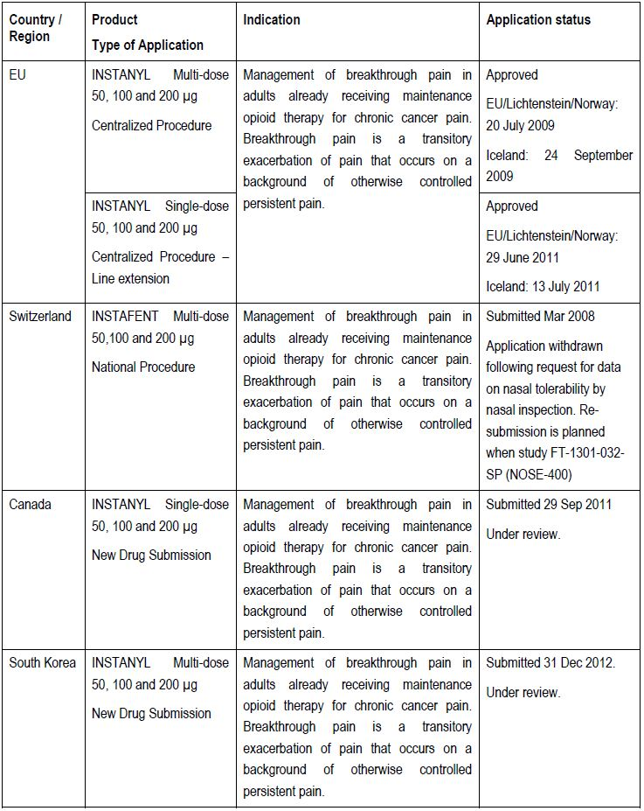

Product Information
The approved Product Information current at the time this AusPAR was prepared can be found as Attachment 1.

II. Quality findings

Drug substance (active ingredient)
Fentanyl citrate is a white or almost white powder, which is soluble in water. There are European Pharmacopoeia and US Pharmacopoeia monographs for fentanyl and fentanyl citrate. The chemical structure of fentanyl citrate is shown in Figure 1. The molecular formula is C₂₂H₂₈N₂O•C₆H₈O₇ and the molecular weight is 528.6 (336.5 for the free base).
Figure 1: Chemical structure of fentanyl citrate.
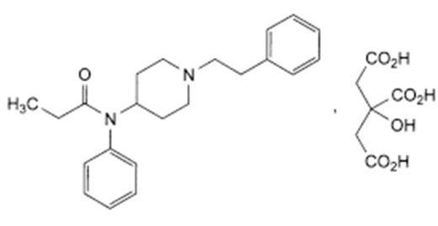

Drug product
The drug product is an aqueous solution of fentanyl citrate, buffered to pH 6.6 with phosphate buffer. It is available in three strengths: 0.5, 1.0 and 2.0 mg/mL. Each strength is proposed for registration as a single dose spray or as a multi-dose spray. Each product is a non pressurised, pump actuated, metered dose nasal spray that delivers 100 μL of solution per actuation as a fine spray. The 0.5 mg/mL and 1.0 mg/mL multi-dose products are available in bottles that deliver 10, 20 or 40 doses. The 2.0 mg/mL product is available in 10 or 20 dose bottles.
The single dose product consists of a glass vial enclosed within a polypropylene sleeve, closed with a rubber stopper and fitted with a polypropylene actuator. Each single dose nasal spray is enclosed in a child resistant blister pack and packed in cartons of 2, 6, 8 or 10 units.
The multi-dose product consists of a 10 mL amber glass bottle with metering pump and dust cap, packed in a re-closable, child resistant outer plastic box. The evaluator considered that the child resistant box is far too difficult to open, requiring significant dexterity and strength. However, it is identical to that which is currently marketed in the EU for Instanyl and it complies with International Organisation for Standardisation (ISO) and Food and Drug Administration (FDA) standards for child resistant containers, which include tests for ease of opening by adults aged 50-70 years.
The single-dose product is manufactured in the US. The multi-dose product is manufactured in Norway. The processes at both sites have been adequately validated.
The droplet size of the spray is controlled so that the majority of droplets (at least 94% for the single dose and at least 95% for the multi-dose) are larger than 10 μm, ensuring deposition in the nasal cavity rather than inhalation into the lungs. The median droplet size is also controlled.
The mean delivered dose of fentanyl decreases significantly during storage of both the single dose and the multi-dose products. In order to ensure that the pharmacopoeial requirement of ± 15% of the labelled dose is met throughout the approved shelf life, the company has agreed to apply a tighter release limit of ± 10%. The company has also agreed to tighten the shelf lives and storage conditions as recommended by the evaluator. The approved shelf lives are:
- single-dose 0.5 mg/mL: 24 months below 25°C
- single-dose 1.0 mg/mL and 2.0 mg/mL: 30 months below 25ºC
- multi-dose 0.5 mg/mL: 30 months below 25°C (store upright, do not freeze)
- multi-dose 1.0 mg/mL and 2.0 mg/mL: 36 months below 30°C (store upright, do not freeze)
Stability studies have shown that significant adsorption of fentanyl to packaging components occurs when the multi-dose bottles are stored inverted. Therefore, they must be stored upright. This means that the child resistant plastic box has to be stood on end. That would not always be easy or practical for the patient to achieve (for example, if the box were carried in a handbag).
It is not practical to store the single dose vials upright because of their small size and the surface tension of the liquid within the vial. The shelf lives recommended above are based on stability data of product stored in the inverted orientation.
All products contain an excess of solution in order to ensure that the stated number of doses can be delivered.

Biopharmaceutics
Four studies were evaluated:
- Study FT-001-1N showed that the absolute bioavailability of fentanyl by the nasal route (using a nasal spray formulation that is not identical to that proposed for registration) is about 100%. The Product Information includes a statement that the absolute bioavailability of Instanyl is about 89%. The latter figure was based on two compartment modelling of the study results. Generally, the figure of 100% obtained by non compartmental analysis would be considered more appropriate.
- Study FT-021-1M showed that the bioavailability of Instanyl nasal spray is several fold greater than that of the Actiq oral transmucosal product. The Product Information includes warnings not to substitute Instanyl for other fentanyl products.
- Study FT-1305-028-SP showed that the bioavailability of fentanyl from two sprays (one in each nostril) of the 50 µg multi-dose Instanyl product is significantly lower than that of a single spray of the 100 µg multi-dose Instanyl product (AUC [area under the plasma concentration-time curve] 27% lower, Cmax [maximum plasma drug concentration] 32% lower). The sponsor claimed that this result was probably due to the high degree of variability observed in the study. The sponsor further claimed that another study, Study FT-022-1M, showed dose proportionality of Instanyl nasal spray from 50 μg/100 μL to 200 μg/100 μL, but this study was not evaluated by the Pharmaceutical Chemistry Section. This matter has been referred to the Delegate for further consideration.
- Study FT-1301-035-SP showed that the 200 µg single dose and multi-dose products are bioequivalent.

Quality summary and conclusions
This submission was considered at the 149th meeting of the Pharmaceutical Subcommittee of the Advisory Committee on Prescription Medicines (ACPM).
Although a number of issues were initially identified that precluded registration of the proposed product the company has since satisfactorily addressed these issues. This includes adequate data to demonstrate that the design of the non vented multi-dose container effectively prevents microbial ingress. Accordingly, the Microbiology Section has recommended that the product be exempted from compliance with the preservative efficacy requirements of TGO 77.
There are now no objections in respect of Chemistry, Manufacturing and Controls to registration of the proposed Instanyl products.

III. Nonclinical findings

Introduction
The nonclinical submission included three new Good Laboratory Practice (GLP) compliant local tolerance studies as well as published studies supporting claims regarding the safety and efficacy of Instanyl. Only the three new local tolerance studies were evaluated but, where relevant, results from the submitted publications are also discussed. One aspect of the submission that hampered assessment was the lack of clarity of some scanned published literature reports.
Two published non GLP compliant literature reports of cardiovascular safety studies came from academic institutions, and it has been assumed that they were conducted to local standards, although the quality with respect to data recording and facilities, environment and investigators cannot be assessed. This is also the case for a publication of an immunotoxicity study. As such, the submitted literature reports were not GLP compliant, although they address the EU and local guidance requirements.

Pharmacology

Primary pharmacology, secondary pharmacodynamics and safety pharmacology
Fentanyl is a potent, short acting, synthetic, pure µ-opioid receptor agonist with an established clinical history as an analgesic. Supporting published literature reports were noted as submitted but most were not evaluated.

Safety pharmacology

Cardiovascular studies

In vivo studies
In a published literature report, continuous infusion of fentanyl for 24 h had no effect on blood pressure, heart rate, cardiac output and left ventricular function in conscious rats at a dose of 20 µg/kg/h intravenous (IV). In subsequent experiments carried out after animal sacrifice, there was no notable difference between fentanyl compared with controls in responses of endothelium intact aortic rings to noradrenaline induced vasoconstriction or acetylcholine induced vasodilatation.
The reason that the haemodynamic parameters were not adversely affected by the continuous infusion of fentanyl for 24 h could reflect the development of tolerance. Another possibility is that there may have been a compensatory activation of the sympatho-adrenergic system (due to findings of higher noradrenaline plasma levels in the fentanyl treated rats compared with controls). Moreover, the significant IV fluid loading given during the course of the experiments may have been protective against possible haemodynamic alterations.

In vitro studies
In dog cardiac Purkinje fibres, fentanyl prolonged the action potential duration at ≥ 95 nM consistent with its effect on hERG channels. Effects of fentanyl have been reported on hERG channel currents recorded in HEK-293 cells. Fentanyl blocked hERG channels with an IC50 of 1.8 μM.

Overall conclusion from cardiovascular safety studies
Clinical doses of fentanyl will range from 50-200 µg/dose (titrated for each patient starting with the lowest dose). Dosing includes up to two nasal administrations of fentanyl, only within 10 min of each other. Pharmacokinetic data from studies in cancer patients with BTP reveals peak plasma levels (Cmax) following the maximum dose of 200 µg of 1.2 ng/mL (Study FT-016-IM), equivalent to around 3.5 nM of fentanyl. Where 2 doses are taken within 10 min of each other, plasma peak plasma levels could be up to 2.4 ng/mL or 7 nM (data not provided). Moreover, the in vitro studies have been performed in the absence of plasma proteins. Since plasma protein binding is about 78% in dogs and 84% in humans, it is expected that only about 20% of the levels of fentanyl in plasma would be available to interact with ion channels.
At doses in the therapeutic range, there is no particular risk in patients regarding fentanyl blocking hERG K+ currents (and thus prolonging the QT interval). The effects of fentanyl administration (infusion) in conscious rats did not reveal any adverse findings on haemodynamic parameters. Overall, there are no specific concerns raised from these studies.
In particular, Instanyl is not considered to represent a torsadogenic risk.

Pharmacokinetics
Some supporting published literature reports were noted as submitted but were not evaluated.
Some of the publications were reviewed. These studies do not involve intranasal administration of fentanyl, but are considered to be relevant to compiling the kinetics of fentanyl and are briefly discussed below.

Absorption
Some kinetic data following IV and subcutaneous (SC) dosing in rats and dogs were reviewed.

Distribution
A single SC dose of 0.2 mg/kg [³H]-fentanyl to rats revealed levels in the brain and lung were greatest at 1 h and fell rapidly, consistent with previous fentanyl studies in rats and rabbits. There were persistent tissue levels in fat, muscle, liver and kidney. The high affinity for fat indicates the possibility of accumulation with repeat dose administration.
Plasma protein binding by fentanyl was high in humans and similar in laboratory animal species with some transfer into red blood cells (RBC). Fentanyl is about 80% protein bound in humans, rats and dogs. A literature report from the early 1980s suggests there are unlikely to be changes in fentanyl plasma levels which could potentially cause adverse effects during clinical use as a result of changes in protein binding and the free, active fraction in plasma. The factors investigated in the study which could potentially affect fentanyl protein binding included: 1) variation in binding between individuals; 2) different doses of fentanyl; and 3) other drugs or endogenous ligands. Slight displacement was found with only a few clinically used agents at high concentrations, but this effect is likely to be negligible at therapeutic plasma levels. Caution was advised in the case of polypharmacy as there may be an additive overall effect on displacement.

Metabolism
It is well known that fentanyl is metabolised mainly in the liver of humans and other mammals by CYP3A4 to norfentanyl (by oxidative N-dealkylation) and other minor metabolites. Similar findings were reported in two reviewed publications in rats and dogs (IV/IV and SC dosing, respectively). For Instanyl, there is potential for interaction with other drugs metabolised by this enzyme, as with other fentanyl formulations.

Excretion
It is well established in humans and animal species that once fentanyl is metabolised, it is primarily excreted in the urine. In dogs, the excretion of fentanyl was slightly greater in faeces than urine. High levels of radioactivity were recovered from bile in rats, with significant biliary recirculation also demonstrated following intra duodenal administration of fentanyl.

Pharmacokinetic drug interactions
No new data were submitted.

Toxicology

Acute toxicity, repeat dose toxicity
No new data were submitted. The systemic toxicity of fentanyl is well established, and the focus of the current submission is the local tolerance of the product.

Clinical exposure at the Maximum Recommended Human Dose (MRHD)
With regard to systemic exposure to fentanyl from the use of Instanyl, it is appropriate to compare the clinical exposure to the opioid at the recommended dose of Instanyl to the clinical exposure to fentanyl at the recommended doses of other fentanyl products, as potential exposure to fentanyl (from the use of Instanyl) greater than exposures previously determined to be acceptable with other fentanyl products could have implications for risk assessment.

Table 2: Fentanyl clinical exposure with various fentanyl products.
Fentanyl clinical exposure with various fentanyl products
Fentanyl product | C_{max} (ng/mL) | AUC (ng.h/mL)
PecFent® nasal spray  [MRHD 3200 μg/day] | 0.35 – 2.8 (100 – 800 μg dose)∧ | 2.5 -17 (100 – 800 μg dose)
Actiq® lozenge  [MRHD 6400 μg/day] | 0.4 – 2.5 (200 – 1600 μg dose) | -
Durogesic® ransdermal patch  [MRHD 300 μg/h] | 1.9 -3.8 (100 μg/h) | -
Instanyl® nasal spray∧∧  [MRHD 1600 μg/day] | 0.35 – 1.2 (50 – 200 μg dose)^{s} | 0.926 – 2.354 (50 – 200 μg dose)&
^ 0.35 ng/mL (100 µg dose); 0.78 ng/mL (200 µg); 1.55 ng/mL (400 µg); 2.84 ng/mL (800 µg) [Study CP042/05]. ^^ From Clinical Overview, see Table 3 (Study FT-016-IM; patients with cancer administered nasal fentanyl for BTP). Data for the single doses of 50, 100 and 200 µg taken directly from clinical study report FT-016-IM. $ Peak concentration will be greater following administration of a second dose 10 min later. & Total daily exposure will be greater following repeated dosing within a 24 h period.
The tabulated systemic exposure (C_{max}, AUC) data indicate that fentanyl exposure from the MRHD of Instanyl is less than (or in the same range as) that resulting from clinical doses of other registered fentanyl products. It is also noted that:
- Many patients will be adequately controlled on doses lower than the MRHD;
- Many of the patients requiring the higher doses will have developed some opioid tolerance, limiting the pharmacological effects of the fentanyl.

Genotoxicity
Supporting published literature reports were also noted as submitted but not evaluated. In particular, a (sponsor) Nonclinical Expert Statement on the Genotoxicity of Fentanyl was made which confirmed that the literature references from published pharmacotoxicological information are appropriate for the genotoxicity safety assessment of fentanyl.
The following is extracted from the Toxicology Written Summary:
“The assessment of the genotoxic potential is summarised in a respective expert statement (nonclinical expert statement on the Genotoxicity of Fentanyl). The results and conclusions are shown below. Remifentanil, a fentanyl opiate analogue, was tested in a standard battery of genotoxicity assays. It was shown not to induce gene mutations in bacteria and chromosomal aberrations in CHO cells in vitro. Both in vivo genotoxicity assays performed were also negative, including the mouse micronucleus test and an in vitro/in vivo UDS assay in male rats. The mouse lymphoma assay with remifentanil was positive in the presence of metabolic activation at a concentration range between 421 and 852 µg/mL. Remifentanil was strongly cytotoxic starting at 602 µg/mL in one experiment and at 910 µg/mL in the repeat experiment, as evidenced by the fact that the relative suspension growths were lower than 10%. The observed mutations were primarily due to small colonies, which were an indication of chromosomal mutations. Because the mutation frequency after treatment with remifentanil was only slightly increased (mutation factors compared to the concurrent controls were 2.0 to 3.3) and was not dose dependent, it is considered that the effect is not biologically relevant. It is well known from the literature that false positive results in mouse lymphoma mutation assays are quite common.”
The cited published literature reference was reviewed briefly, and the following excerpt is taken from the abstract:
…experience shows that out of the genotoxicity test systems which are required according to existing guidelines in the European Union (EU), the in vitro tests for chromosomal aberrations (CA) and the mouse lymphoma tk assays (MLA) yield a rate of positives that is about four fold higher than that of other genotoxicity tests.
…Hence, for new pharmaceuticals it is practice to provide in addition to in vitro results that may be thresholded’ a wealth of information from in vivo studies on genotoxicity, carcinogenicity, metabolism, pharmacokinetics, etcetera, the results of which help in assessing the biological relevance of in vitro positives.
The genotoxicity profile of fentanyl is well established from numerous previous studies.

Carcinogenicity
No data were submitted.

Reproductive toxicity
Some supporting published literature reports were noted as submitted but not evaluated. A submitted published literature report was reviewed and the findings are briefly presented below. These studies do not involve intranasal administration of fentanyl, but are considered relevant to compiling information on the potential toxicity of fentanyl. Tissue radioactivity in pregnant rats or foetal tissue was determined after SC dosing of [³H]-Instanyl to dams on Gestation Day (GD) 12 and 19. Levels of radioactivity in the foetus were about 1.75 times that in the maternal plasma at the early time point, but disappeared rapidly in parallel to the changes in maternal plasma concentrations. Some transfer of fentanyl and/or its metabolites into milk of lactating rats was observed, with levels up to 4 times that of maternal plasma 1 h following dosing.

Local tolerance
Three new GLP compliant local tolerance studies were performed according to the relevant guideline. In all these studies, Instanyl was administered in the clinical formulation proposed for registration as an intranasal spray using the actuator device proposed for use in humans. In the first main study (Study PC-002-FNA), nasal administration of 400 μg fentanyl five times daily to mini pigs for a period of four weeks caused no signs of local or systemic toxic effects and no macroscopic and no treatment related microscopic changes in the nasal cavity. A no observed adverse effect level (NOAEL) was not established (>5 x 400 μg fentanyl doses per day). No toxicokinetics were performed. However, a dose comparison was made by the sponsor on the basis of published guidelines. It was determined that the dose administered in this study of 5x 400 µg fentanyl doses per day (2000 µg in total), would correspond to 1.25x the intended maximum clinical dose per day [2x 200 µg (400 µg) fentanyl four times per day; 1600 µg in total]. Thus, in order to generate a safety margin, the sponsor proposed the mini pigs were administered one more ‘400 µg dose per day’ than the maximum daily number of doses for humans, that is, five 400 µg doses daily for the mini-pig versus four daily doses of 400 µg (2x 200 µg doses) in humans, generating a dose multiple of 1.25 based on the amount of drug (µg) at the application site.
This is appropriate since, according to the abovementioned FDA Guidance, for therapeutics administered by any alternative route [for example, intranasal, SC, IM (intramuscular), for which the dose is limited by local toxicities], scaling between species based on mg/m² is not recommended. Instead, these therapeutics should be normalised to concentration (for example, mg/area of application) or amount of drug (for example, milligrams) at the application site.
Although a similar dose was administered to mini pigs compared with humans, it should be noted that there are quantitative differences in the surface area of absorption.
One other local toxicity and toxicokinetic study in mini pigs (Study 70900) was recently finalised, and submitted following a TGA request. Six mini pigs were administered Instanyl with 2 doses of 400 μg (800 μg), 5 times daily for 28 days (4000 μg/day for 28 days). Macroscopic and microscopic evaluation of the nasal cavity after 4 weeks did not reveal any evidence of intolerability. The NOAEL for local toxicity in the nasal cavity was therefore >5x 800 μg fentanyl citrate doses per day, with a dose multiple of 2.5x based on the amount of drug (µg) at the application site.
These local tolerance studies were of sufficient duration to ensure that any local intolerance should have been detectable under the treatment conditions employed. However, it is acknowledged that such studies may not be fully predictive of clinical local tolerance, and therefore the clinical data will also be assessed on this parameter.

Immunotoxicity
No data were submitted. The objective of this literature publication was to investigate whether opioids may suppress immune function, especially natural killer (NK) cell cytotoxicity. In particular, the study examined the effect of different doses of fentanyl administered at different time points relative to tumour inoculation on: i) experimental tumour metastasis in rats and ii) NK cell cytotoxicity. The results show fentanyl (150 µg/kg given SC to F344 rats) may suppress NK cell cytotoxicity and increase the risk of tumour metastasis. The findings indicate that a moderate dose of fentanyl suppresses NK cell cytotoxicity and may increase the risk of tumour metastasis 2 h (but not 6 h) after administration, suggesting that acute opioid administration and suppression of NK cells prior to surgery may induce tumour dissemination, a critical step in the spread of metastases. The authors suggest caution in administration of high doses of opiates during surgery in cancer patients.

Impurities
The proposed specifications for impurities/degradants in the drug substance/product are below the International Conference on Harmonisation (ICH) qualification thresholds and have been adequately qualified.

Paediatric use
Instanyl fentanyl nasal spray (FNS) is not proposed for paediatric use and no specific studies in juvenile animals were submitted.

Excipients
The two excipients in this formulation (sodium dihydrogen phosphate dehydrate and disodium phosphate dihydrate) are standard pharmaceutical excipients and common phosphate buffering agents. They are widely used and are present in many registered products. They have not specifically been determined to be present in other intranasal registered products, but it seems unlikely that these excipients would be of toxicological concern by intranasal administration.

Nonclinical summary and conclusions

Summary
- The MRHD is 8 doses (4 BTP episodes) per day (1600 μg).
- The pharmacology and toxicology of fentanyl (a µ-opioid receptor agonist) has been well established in extensive previous nonclinical and clinical studies.
- The submission contained no new data on the safety and efficacy of fentanyl and for these areas the submission relies on published studies. The information in these literature reports is well known and was not evaluated but noted as submitted supporting information.
- Three GLP compliant local tolerance studies in mini pigs were submitted (a dose ranging study and two 4 week repeat dose studies), in which fentanyl was administered as an intranasal spray using the formulation proposed for registration. No notable local effects were identified.

Conclusions and recommendation
- There are no nonclinical objections to the proposed new dosage form and route of fentanyl.
- The pharmacology and toxicology of fentanyl are well established and there is extensive clinical history with the use of this opioid in various formulations. The present nonclinical dossier has focussed on the nonclinical assessment of an intranasal formulation.
- It is also noted that human systemic exposure to fentanyl from Instanyl administration is not dissimilar to that resulting from clinical doses of other registered fentanyl products used for similar indications.
- Instanyl does not indicate a particular risk for local toxicity with clinical use on the basis of the nonclinical studies, in which Instanyl was administered to animals by the intended clinical route using the actuator device used in humans. Acceptable local tolerance with clinical/long term use will still require confirmation from assessment of the clinical studies.
- The established use of fentanyl citrate in clinical practice by various methods of delivery provides assurance on the expected clinical outcomes of using Instanyl.

IV. Clinical findings
A summary of the clinical findings is presented in this section. Further details of these clinical findings can be found in Attachment 2.

Introduction
The clinical dossier documented a full clinical development program of pharmacology, efficacy and safety studies. In addition a number of publications are included.
The submission contained the following clinical information:
- 10 clinical pharmacology studies, including 10 that provided pharmacokinetic data and 0 that provided pharmacodynamic data;
- 2 pivotal efficacy/safety studies;
- 2 other efficacy/safety studies;
- 5 Periodic Safety Update Reports (PSURs) covering the period April 2009 to October 2011;
- 33 publications supporting pharmacokinetic data of Fentanyl;
- 4 publications supporting intranasal FNS for BTP (but using different formulations);
- 18 publications supporting intranasal FNS for other indications (post operative pain: 9; burns: 3; acute pain: 5, prostate surgery:1);
- 17 publications supporting the use of oral transmucosal fentanyl citrate in BTP, post operative pain, burns and other acute pain;
- 6 publications supporting the use of fentanyl via other routes for other indications.

Pharmacokinetics

Evaluator’s overall conclusions on pharmacokinetics
Most (7/9) of the pharmacokinetic studies were conducted at the same site by the same investigator and were open label. All studies by this investigator estimated sample size on the basis of “clinical judgement” rather than formal statistical calculation. In several cases this led to less than adequate numbers and comments that caution must be used due to low numbers. This is less than satisfactory especially given the large number of studies conducted.
With this reservation aside the pharmacokinetics are consistent among the trials and demonstrate that both the plasma AUC and the C_{max} of FNS increase linearly, or very close to, with dosage. Comparable results for AUC_{0-∞} (area under the plasma concentration-time curve from time zero to infinity) and C_{max} were observed between the single dose and multi dose delivery systems and the pharmacokinetic parameters did not differ substantially in opioid naive patients and in cancer patients with BTP or in patients with the common cold or with allergic rhinitis.

Pharmacodynamics
No new information was provided in the submission. The intended use of the product is well within the known pharmacodynamics of fentanyl.

Efficacy

Evaluator’s conclusions on clinical efficacy for BTP
The main problem with the clinical data is the concern over the conduct of the studies and the compliance with Good Clinical Practice (GCP). The issues raised by the European Medicines Agency (EMA) inspection team are critical and raise serious doubt about the acceptance of the data.
Even if the issues of GCP were to be put aside (as was done in Europe), there are major concerns about the quality of the clinical studies. The company stated that the clinical data comprised two pivotal studies and two supportive studies. The two pivotal studies are not independent studies. The independence of a study is generally regarded as one of the criteria for being classified as pivotal. However, the second Study FT-018-IM is not independent of the first pivotal Study FT-017-IM. The same centres and investigators have been used and the entry criteria for Study FT-018-IM included that patients had participated in either Study FT-016-IM (PK study) or FT-017-IM. Study FT 018-IM is simply a replicate of Study FT-017-IM with the same patients. Study FT-017-IM could be considered a dose-response study which was then used in Study FT-018-IM to test against placebo. Given the alternative therapies available, a pivotal study rather than a supportive study against an active comparator was possible.
The company therefore has only one pivotal study. TGA have adopted the relevant guideline published by the EMA; to quote from this guideline:
“the fundamental requirement of the Phase III documentation is that it consists of adequate and well-controlled data of good quality from a sufficient number of patients, with a sufficient variety of symptoms and disease conditions, collected by a sufficient number of investigators, demonstrating a positive benefit/risk in the intended population at the intended dose and manner of use ... The minimum requirement is generally one controlled study with statistically compelling and clinically relevant results.”
This data package does not meet this standard. There are concerns about the quality of the data (this was not submitted in Europe) in the supporting Study FT-019-IM and the other supporting Study FT-003-IN/FT-011-IN does not contain sufficient patients to provide any real evidence of efficacy.
Therefore, the concerns about the efficacy are:
- concerns over GCP: the main studies submitted were found to be unreliable on GCP inspection;
- Failure to comply with the relevant adopted guidelines:
  - GCP
- Small number of patients in the submission compared to other submissions for similar products; The decision to remove site X but not site Y from the analysis is not explained in light of the Committee for Medicinal Products for Human Use (CHMP) conclusions. It appears it may have related more to the statistics of the studies. Site Y enrolled the largest number of patients and exclusion of this site may have invalidated the results;
- Use of same investigators in the two pivotal studies and ability of investigators to influence efficacy and safety outcomes by assisting patients in completion of efficacy and safety outcomes in the patient diary;
- The study design of Study FT-017-IM of testing different doses in each patient rather than titrating to a successful dose and then testing that dose against an accepted therapy rather than placebo would have been a more acceptable design for a pivotal study;
- Patients in the trials were able to take up to 2 doses of each dose strength. This does not seem to have been reflected in the results when presented by dose. Thus some patients in the 200 µg dose group took 200 μg and some presumably took 400 μg. It is not clear how many took what dose and how this affected the results.

Safety

Evaluator’s overall conclusions on clinical safety
No routine clinical laboratory evaluations were performed as safety monitoring during the pivotal trials. Safety is therefore totally reliant on adverse event reporting and this has been shown to be less than adequate in the European inspection. Adverse Event (AE) reporting was considered seriously compromised by the GCP inspection team due to:
- Systemic failure in the pivotal trials (FT-017-IM and FT-018-IM) due to the complete absence of space in the diary cards allocated to AE entry;
- Failure of both investigators at inspected sites who were unaware of the protocol amendment requirement to report progression of the underlying disease as an adverse event;
- Failure of the investigator at site Y (the highest patient recruitment) to report AEs based on the AE definition according to ICH-GCP rather than the investigator’s subjective judgement.
Re-monitoring of the sites yielded 49 additional unreported AE in Study FT-017-IM (increase by 70%) and 238 additional AEs in Study FT-018-IM (increase by 100%, doubled). These high numbers of unreported AEs raised the concern that the underreporting of AEs was not limited to the two inspected investigational sites and so the inspection team considered that even with the re-monitoring carried out by the company on all sites the safety of the investigational product was inadequately documented and the studies could not be relied on to provide an accurate safety profile of the product.
It is unusual to rely only on AE monitoring for the safety profile of a product, even one using a well established substance like fentanyl. The absence of any laboratory testing in the pivotal clinical studies is not considered acceptable.
While fentanyl is a well established product, overall safety of this formulation has not been proven.

List of questions

Additional expert input
A copy of the EMA GCP inspection report should be obtained.

Clinical questions
No questions.

Clinical summary and conclusions

First round benefit-risk assessment

First round assessment of benefits
The benefits of Instanyl in the proposed usage are:
- Pharmacokinetics have been adequately demonstrated;
- Safety in healthy volunteers has been adequately demonstrated;
- Pharmacokinetics in patients with BTP are similar to those in healthy volunteers.

First round assessment of risks
The risks of Instanyl in the proposed usage are:
- Efficacy has not been proven in well designed and conducted clinical trials;
- Safety has not been proven in well designed and conducted clinical trials.

First round assessment of benefit-risk balance
The benefit-risk balance of Instanyl, given the proposed usage, was unfavourable.

First round recommendation regarding authorisation
Based on the clinical data presented in the submission, it was recommended that the application be rejected.
The reasons for proposing rejection were:
- Lack of efficacy in adequately designed and conducted clinical studies;
- Lack of safety in adequately designed and conducted clinical studies.

Second round evaluation of clinical data submitted in response to questions
Q1. Please provide a full copy of the Good Clinical Practice (GCP) inspection report requested by the CHMP (May-June 2008) to verify whether Studies FT-017-IM and FT-018-IM were conducted in compliance with GCP and applicable regulations.
The sponsor provided the inspection report. The reports provides full details of the inspection teams visits to the two clinical sites (site X and Y) and the contract research organisation (CRO) responsible for monitoring the site. The findings are consistent with the summary provided in the European Public Assessment Report (EPAR).
The full report of the inspection team provides comprehensive documentation of the failure to understand GCP principles and to follow the GCP requirements at both site X and site Y and serious deficiencies at the CRO and by implication the sponsor. It is noted that the CRO failed to find the issues identified by the inspection team.
The inspection team found that at site X there were 11 critical and 6 major findings and at site Y there were 2 critical and 5 major findings.
At site X, the relevant source data (letters confirming the cancer diagnosis of the patients) were not authentic but manipulated for trial purposes. Some of the source data were intentionally kept back by the investigator and those that were provided were not sufficiently kept. They were incomplete, partly inconsistent and not up to date. The patient files were limited to trial related aspects and several text passages were illegible. For several patients dosages of concomitant medication and rescue medication were missing. Therefore the eligibility of patients for trial enrolment could not be verified.
The conclusion of the inspection team was:
“In summary, the inspection revealed several serious deficiencies including misconduct and fraud, which give reason to severe concerns about the quality and validity of the data generated for the clinical trials FT-017-IM and FT-018-IM by the inspected investigational site. During the inspection it was confirmed that there was significant non compliance with GCP and therefore the data was not considered to be credible.”
The inspection of site Y indicated similar problems with understanding and compliance to GCP but no evidence of misconduct or fraud. The conclusion of the team was:
“Based on these findings, it cannot be concluded that the study was conducted in full compliance with GCP. Additional, it is the inspectors’ opinion that the safety data received from this site is not reliable.”
The sponsor seems to indicate that only these two sites were a problem and by omitting the data from site X (which is fully justified) and re-monitoring the other sites to collect additional AEs, then the remaining data are acceptable, However, the inspection team noted in the summary that the inspections of sites are also done “to evaluate the quality management of the sponsor/CRO and the possible effects on the quality of the data of the other investigational sites.” The degree of non compliance and the issues raised over protocol design, use of staff to complete study diaries and the non investigation of compliance and abuse raised concerns over all trial sites and led to the conclusion of insufficient quality measures taken by the sponsor and CRO.
Review of the full inspection report confirms the initial opinion that these trials should not be considered acceptable for assessment of efficacy or safety.
Q2. Please provide an un-redacted copy of the report of the analysis and discussions from the EMA/CHMP that formed the basis of the conclusions that ‘the quality system of the sponsor are unlikely to invalidate the quality of the efficacy and safety data’ and that ‘the exclusion of site X does not make substantial changes to the efficacy of safety results as compared to the results of all patients presented in the initial application’ (refer to Instanyl EPAR).
The sponsor responded that there is no un-redacted report available; the only report is the EPAR. However to provide more information they provided the Joint Assessment report after the Second List of Outstanding Issues which was prepared right before the CHMP meeting.
This report contains the following relevant statements:
[following re-monitoring of the sites in the study] “the data on the re-assessment of the two pivotal studies show that newly reported AEs identified for both studies did not alter the safety profile previously reported for FNS at doses of 50 to 200 μg administered as one puff or two puffs 10 minutes apart.”
The conclusion of the inspectors that the responses of the applicant did not change the GCP inspectors’ major concerns about the quality and reliability of the safety and efficacy data of the trials was noted in the Joint Assessment report.
The conclusion of the Joint Assessment report was:
“In view of the overall data volume as either provided in the Instanyl clinical dossier or as gathered from long-standing clinical experience with fentanyl and considering the responses provided by the applicant, the clinical major issues were solved. The efficacy of Instanyl in the treatment of BTP has been shown, with a fast onset of efficacy, together with a safety profile that seems comparable to the other fentanyl containing products intended to treat BTP. However, potential risk of overdose and danger for children and family circle still remains (until a new device is available).”
This report provides further information to better understand the decision of the CHMP. It appears they have concluded that because no new safety issues were raised with the re-monitoring and the profile of the drug is similar to that seen for similar products already approved then the trials can be accepted.
This decision is at odds with the requirement that all submissions stand alone and are required to document the safety and efficacy of the product to the standard of GCP as adopted international.
It is not considered acceptable to bypass the very significant GCP issues and accept the data because it is consistent with that know for other similar products.

Second round benefit-risk assessment

Second round assessment of benefits
After consideration of the responses to the clinical questions, the benefits of Instanyl in the proposed usage are unchanged from those identified in the first round.

Second round assessment of risks
After consideration of the responses to the clinical questions, the risks of Instanyl in the proposed usage are unchanged from those identified in the first round.

Second round assessment of benefit-risk balance
The benefit-risk balance of Instanyl, given the proposed usage, was considered to be unfavourable.

Second round recommendation regarding authorisation
After consideration of the responses to the clinical questions, the recommendation regarding authorisation was unchanged from the first round. It was recommended that the application be rejected for the following reasons:
- Lack of efficacy in adequately designed and conducted clinical studies;
- Lack of safety in adequately designed and conducted clinical studies.

V. Pharmacovigilance findings

Risk management plan
The sponsor submitted a RMP which was reviewed by the TGA’s Office of Product Review (OPR) and the Advisory Committee on the Safety of Medicines (ACSOM).
Table 3 summarises the TGA’s evaluation of the RMP and the sponsor’s responses to the issues raised by the OPR.
Table 3: Reconciliation of issues outlined in the RMP report.
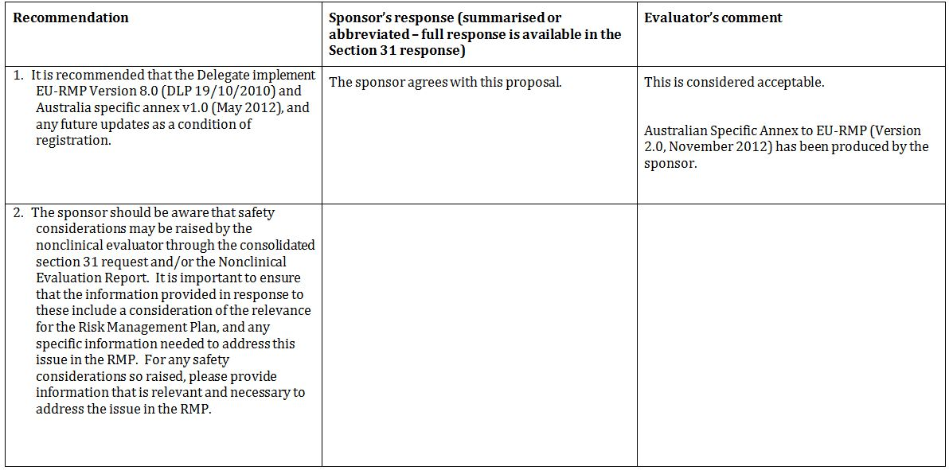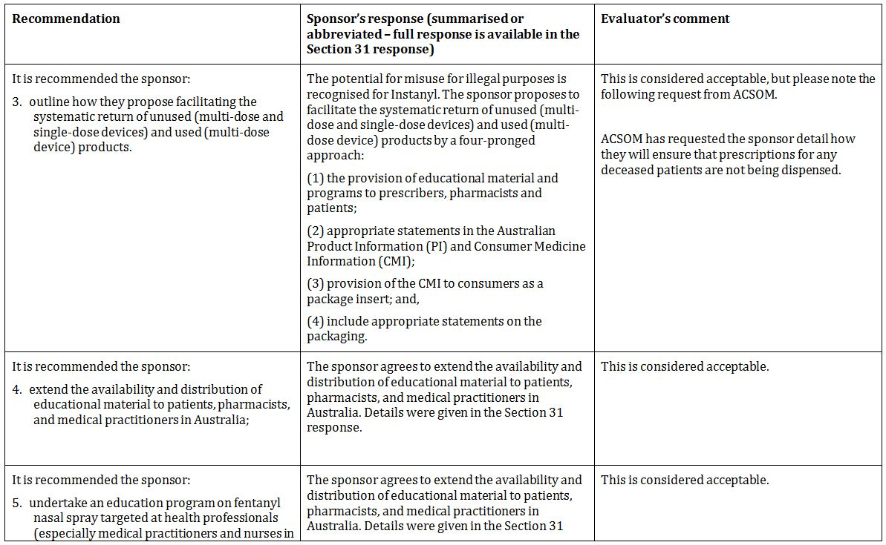
Table 3 (continued): Reconciliation of issues outlined in the RMP report.
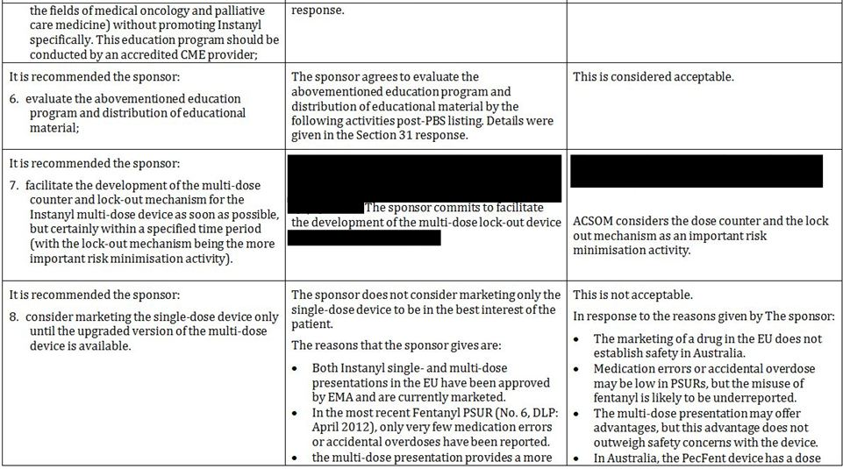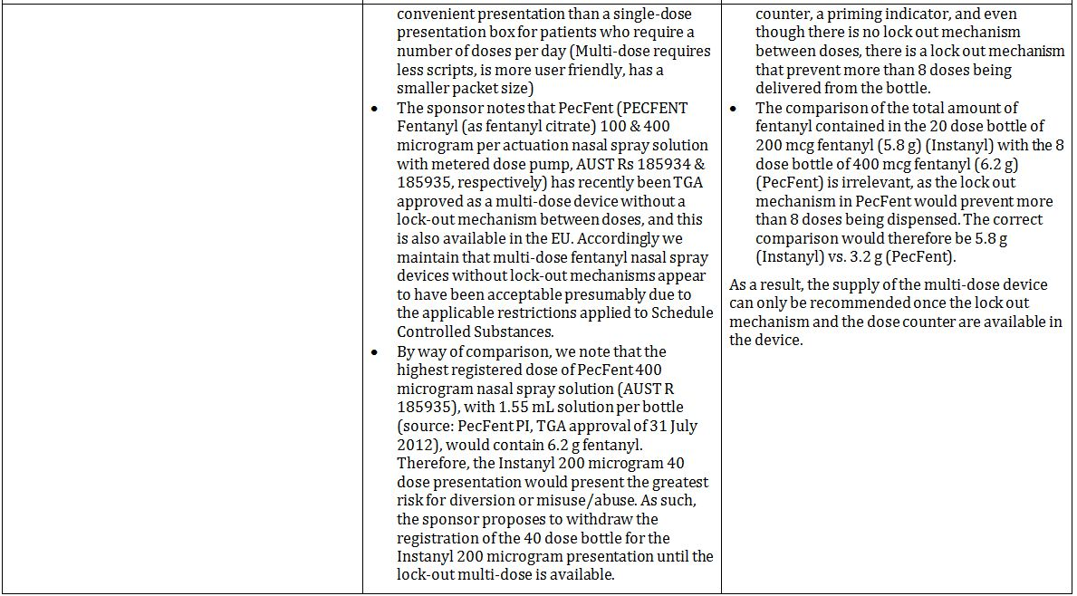
Table 3 (continued): Reconciliation of issues outlined in the RMP report.
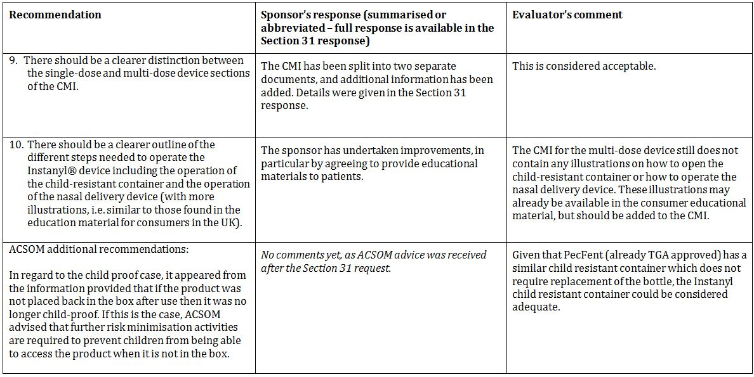
Table 4 contains an abbreviated summary of the Risk Management Plan from the Australian Specific Annex RMP dated November 2012.
Table 4: From Australian Specific Annex (dated November 2012): Abbreviated summary of Risk Management Plan.
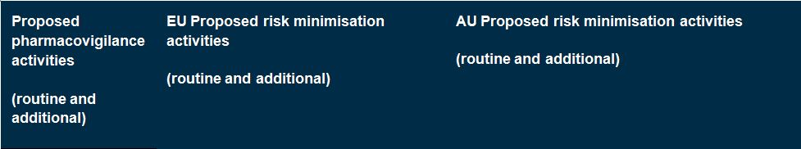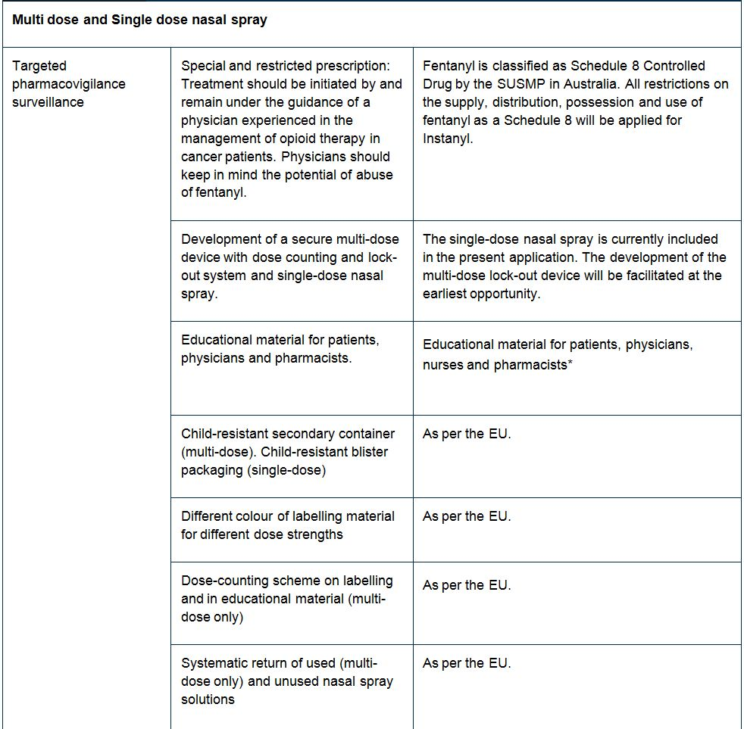
Table 4 (continued): From Australian Specific Annex (dated November 2012):
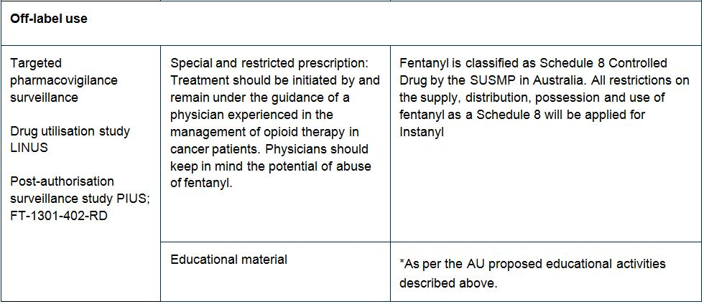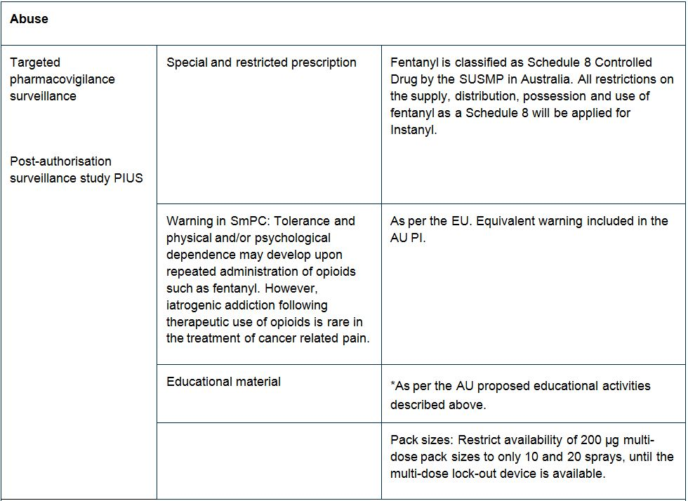

Table 4 (continued): From Australian Specific Annex (dated November 2012):
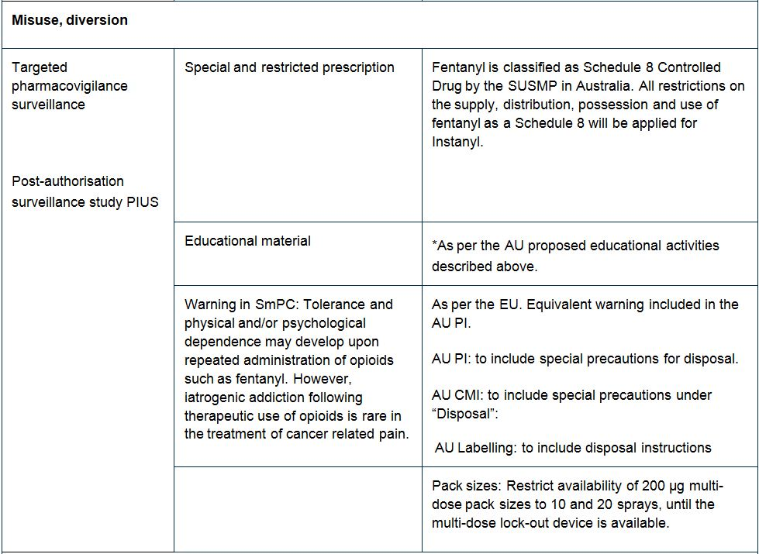

Table 4 (continued): From Australian Specific Annex (dated November 2012):
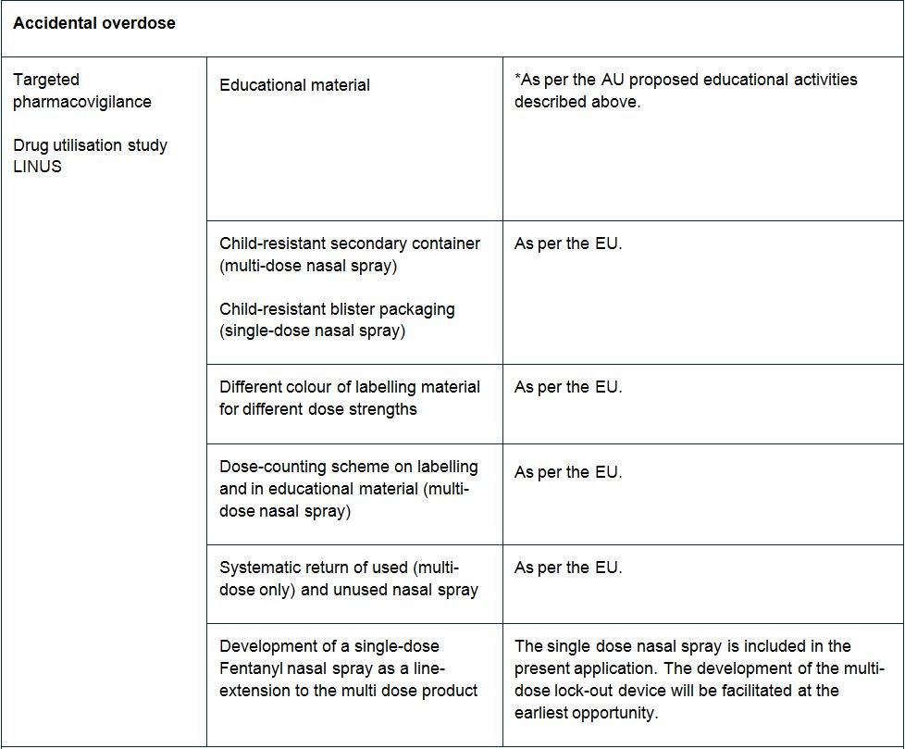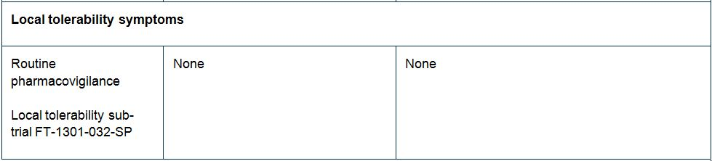

Summary of outstanding issues
- ACSOM has requested the sponsor detail how they will ensure that prescriptions for any deceased patients are not being dispensed.
- The supply of the multi-dose device can only be recommended once the lock out mechanism and the dose counter are available in the device.
- In regard to the child resistant container, ACSOM advised that further risk minimisation activities are required to prevent children from being able to access the product when it is not in the container.

Suggested wording for conditions of registration

RMP
- Implement EU-RMP Version 2 (dated 08/12/2011, DLP 30/06/2010), Australian Specific Annex to EU-RMP (Version 2.0, dated November 2012), and any future updates as a condition of registration.

PSUR
- Post marketing reports are to be provided annually until the period covered by such reports is not less than three years from the date of any approval letter. No fewer than three annual reports are required. The reports are to meet the requirements for Periodic Safety Update Reports (PSURs) as described in the Eudralex Volume 9 relating to PSURs. Unless agreed separately between the supplier, who is the recipient of any approval of the TGA, the first report must be submitted to the TGA no later than 15 calendar months after the date of any approval letter. The subsequent reports must be submitted no less frequently than annually from the date of the first submitted report. The annual submission may be made up of two PSURs each covering six months. If the sponsor wishes, the six monthly reports may be submitted separately as they become available. Submission of the report must be within the sixty days of the data lock point for the report (or, where applicable, the second of the two six monthly reports), as required by the Eudralex Volume 9.

ACSOM advice
The advice received from ACSOM is summarised below:
- The educational activities conducted overseas should be extended to the Australian market.
- The sponsor should detail how they will ensure that prescriptions for any deceased patients are not being dispensed.
- In regard to the child proof case, it appeared from the information provided that if the product was not placed back in the box after use then it was no longer child proof. If this is the case, ACSOM advised that further risk minimisation activities are required to prevent children from being able to access the product when it is not in the box.
- A dose counter and a lock out mechanism are crucial risk minimisation tools and should be included.

Key changes of the RMP update
The EU-RMP remains unchanged. The sponsor has supplied an updated Australian Specific Annex (Version 2.0, November 2012). The main difference to the previous version is that the sponsor now agrees to conduct educational activities for the Australian market.

VI. Overall conclusion and risk/benefit assessment
The submission was summarised in the following Delegate’s overview and recommendations:

Quality
This submission was discussed at the 149th meeting of the Pharmaceutical Subcommittee of the ACPM. Following that meeting there were additional rounds of pharmaceutical chemistry evaluation. Although a number of issues were identified that initially precluded registration of the proposed product, the sponsor has now satisfactorily addressed those issues and there are now no objections in respect of chemistry, manufacturing and controls to registration.
The pharmaceutical chemistry evaluator has noted that stability studies have shown that significant adsorption of fentanyl to packaging components occurs when the multi-dose bottles are stored inverted. Therefore they must be stored upright. This means that the child resistant plastic box has to be stood on end. That will not always be easy or practical for the patient, for example, if the product is carried in a handbag.
The microbiology evaluator has noted that the design of the non vented multi-dose container effectively prevents microbial ingress and has recommended that the product be exempted from compliance with the preservative efficacy requirements of Therapeutics Goods Order Number 77 (TGO 77).
The following issues were referred by the pharmaceutical chemistry evaluator to the Delegate:
- Study FT-021-1M showed that the bioavailability of Instanyl nasal spray is several fold greater than that of an oral transmucosal product. The Delegate was asked to consider whether this should be highlighted in the Product Information as there would be a serious risk of overdose if a patient switched from an oral transmucosal product to Instanyl at the same dose.
- The design of the multi-dose product vial and child resistant container (a sample container will be provided to the committee).
- All products contain an excess of solution in order to ensure that the stated number of doses can be delivered.

Nonclinical
There were no nonclinical objections to the proposed new dosage form and route of fentanyl.
The nonclinical evaluator noted that the pharmacology and toxicology of fentanyl has been well established in extensive previous nonclinical and clinical studies. The submission contained no new data on the safety and efficacy of fentanyl and for these areas the submission relied on published studies. The information in those literature reports is well known and was not evaluated, but noted as submitted supporting information.
Three GLP compliant local tolerance studies in mini pigs were submitted. These were a dose ranging study and two 4 week repeat dose studies, in which fentanyl was administered as an intranasal spray using the formulation proposed for registration. No notable local effects were identified.

Clinical

Pharmacology
The bioavailability of the intranasal formulation was estimated to be 100% according to a one compartment model analysis, 89% according to a two compartment model (preferred model) and 80% with a three compartment model. For the four doses pooled, the mean AUC was higher following intranasal administration than it was following intravenous administration, though the difference was not statistically significant. The sponsor has proposed bioavailability be stated as 100% in the Product Information. In Study FT-022-IM, the mean C_{max} results obtained for Instanyl doses of 75, 100, 150 and 200 μg were 0.7, 1.0, 1.4 and 1.7 ng/mL respectively. Pharmacokinetics was linear within the dose range 50 μg to 200 μg. Mean T_{max} (time to reach maximum plasma concentration) was 13 minutes for intranasal administration in one study and from 30 to 38 minutes in another study where up to 4 actuations (400 µL total volume) of fentanyl were delivered into one nostril. Dose proportionality within the dose range 50 to 200 µg was adequately demonstrated in that study.
Study FT-1305-028-SP did not demonstrate bioequivalence of 2 x 50 µg doses with a single 100 µg dose. That study was a randomised, open label, two way, cross over study to assess the pharmacokinetics of one or two doses in 16 non elderly (>18 and ≤ 45 years) and 7 elderly healthy subjects (≥ 65 years). Results indicated moderately lower bioavailability and peak plasma fentanyl concentrations following administration of 2x 50 μg doses compared to a single 100 μg dose. In older adults the AUC, half life, clearance and volume of distribution was found to be comparable with young adults. These results were not consistent with published references for other intranasal fentanyl products where a higher C_{max} and significantly longer elimination half life was seen in individuals >60 years. This has been thought to result from reduced drug clearance. Study FT-1305-028-SP was a small study and the intra and inter subject CV% for C_{max} and AUC were quite large, which may account for the discordant results of that study.
Instanyl is not interchangeable with Actiq (as marketed in the US) as it has a higher bioavailability, higher C_{max} and shorter T_{max} for the same fentanyl dose. The half life for fentanyl when administered as Instanyl is approximately 3-4 h in patients with cancer and BTP. The elimination of fentanyl is biphasic and the terminal phase starts around 6 h following administration. The mean terminal elimination half life was up to 15 h after a single administration of 200 μg in healthy subjects.
There was a high degree of inter and intra subject variability in pharmacokinetic parameters. No studies were performed in subjects with impaired hepatic or renal function. The pharmacokinetic profile for fentanyl after administration of Instanyl in subjects with nasal congestion, and in subjects using a topically applied nasal decongestant was similar to that of healthy control subjects.
Additional information on the pharmacokinetic of fentanyl is not specific to this product and was obtained from published literature. No pharmacodynamics studies were submitted.

Efficacy
Efficacy data were obtained from two pivotal efficacy and safety studies (FT-017-IM and FT-018-IM) and two supportive studies (FT-019-IM and FT-033-IN/FT-011-IN). The clinical evaluator considered data from Studies FT-017-IM, FT-018-IM and FT-019-IM were unreliable and should not be used to support the efficacy or safety of the product. The clinical evaluator has recommended that Instanyl not be approved for registration.
Following a suspicion of misconduct at one study site in Study FT-019-IM, an inspection was conducted at the request of the CHMP to verify whether Studies FT-017-IM and FT-018-IM were conducted in compliance with GCP and applicable regulations, in particular where it had impact on the validity of the data or the ethical conduct of the trials. The inspection was of two study sites and the CRO. The two study sites (sites X and Y) enrolled subjects in both pivotal clinical safety and efficacy studies. As a result of the CHMP instigated inspection, data from site X were excluded from the final analysis of the above studies. That data have also been excluded from the results included in the clinical evaluation report and the discussion below. Data from site Y were retained. Site Y enrolled 24.5% (46 patients) of the patients in Study FT-017-IM and 29.6% (40 patients) of the patients in Study FT-018-IM.
The inspectors reported 11 critical and 6 major findings at site X and 2 critical and 5 major findings at site Y. These findings included but are not limited to ethical, trial documentation, site management and data quality deficiencies. The inspection report defined critical findings as:
Conditions, practices or processes that adversely affect the rights, safety or well being of the subjects and/or the quality and integrity of data. Critical observations are considered totally unacceptable. Rejection of data and/or legal action required.
The critical findings for site Y were:
- Reporting requirements for AE/SAE were not followed by the investigator. Neither was documentation available which shows that the monitor addressed the failures during monitoring nor was corrective actions taken.
- The deficiencies observed show that the quality control measures (monitoring and auditing) which were performed by the sponsor were insufficient.
The inspection report concluded the following concerning site Y:
Based on these findings, it cannot be concluded that the study was conducted in full compliance with GCP. Additionally, it is the inspectors’ opinion that the safety data received from this site is not reliable.
However, despite of the findings described above it is the impression of the inspection team that the patients in this study have received required and necessary information about the conduct of the study and that they have been very well taken care of by principal investigator.
The response from the investigator was considered by the inspection team and the two critical findings remained unchanged. The inspection report also stated the following with respect to efficacy data from site Y:
Although it was apparent that the investigator at site Y gave his patients the necessary information about the trials and provided thorough medical care, GCP compliance could not be fully confirmed for this site, because several protocol deviations were observed and the source data was not sufficiently kept. However, these deficiencies are not considered to obscure the efficacy data reported by this investigational site. In contrast to this, it must be stated that the safety data reported by the site are not considered complete. This is because the reporting of AEs was based on the investigator's subjective judgment but not on the AE definition according to ICH-GCP. This applies especially to the symptoms of "progression of cancer", which occurred frequently and were in general not reported, since the investigator assessed them not to be AEs.

Study descriptions
Studies FT-017-IM, FT-018-IM and FT-019-IM assessed efficacy based on patient evaluations of Pain Intensity using an 11 point numerical rating scale (NRS), Pain Intensity Difference (PID) at 10 minutes after dosing with the first study drug (PID₁₀) and the sum of pain intensity differences during 60 minutes (SPID₀₋₆₀). The PID₁₀ was calculated by subtracting the Pain Intensity at 10 minutes from the Pain Intensity recorded immediately before treatment. The SPID₀₋₆₀ was derived from the AUC for PID over the 0-60 minutes interval divided by the length of the interval (60 minutes). Patients were considered ‘responders’ if PID₁₀ was >2 on the NRS for a given BTP episode. The patient’s General Impression (GI) of the treatment using a 5-point categorical verbal rating scale (VRS), where 0=poor, 1=fair, 2=good, 3=very good, 4=excellent was a secondary efficacy endpoint.
The sites and investigators from Study FT-017-IM also participated in Study FT-018-IM. An additional eight sites that were not involved in Study FT-017-IM participated in Study FT-018-IM. Patients previously enrolled in Studies FT-017-IM or FT-016-IM (a pharmacokinetic study) were also enrolled in Study FT-018-IM.
Study FT-017-IM was a randomised, double blind, placebo controlled, crossover study examining doses of 50 μg, 100 μg, and 200 μg FNS and placebo in 8 BTP episodes. It was conducted in 27 centres in Europe between May 2006 and May 2007. The primary objective was to demonstrate the efficacy of FNS in the treatment of BTP in patients with cancer. The primary efficacy outcome measure was PID₁₀.
Initially all patients received a test dose of 200 µg FNS to assess tolerability. Patients who tolerated the test dose then received a single dose (placebo or 50 μg, 100 μg or 200 µg FNS) at the onset of each episode of BTP, with a second dose allowed if the first dose provided inadequate pain relief. Patients self treated 8 episodes of BTP (6 with FNS, 2 at each dose level and 2 with placebo, over a period of approximately 3 weeks [maximum one BTP episode per day]). Patients received their stable fixed schedule background pain opioids and were allowed to take their usual analgesic for any type of pain.
A total of 199 patients were screened and 152 randomised to treatment. Not all patients completed all doses, with from 145 to 148 patients receiving at least one dose of each of the study treatments. All FNS doses (50 µg, 100 µg, and 200 µg) provided statistically significantly (p<0.001) higher mean PID₁₀ scores (ranging from 1.82 to 2.65) compared with placebo (1.41). The reduction from baseline in pain intensity showed a clear dose response at each timepoint and overall. The mean responder rate at 10 minutes for a given BTP episode was 29.1%, 41.6%, and 49.7% for the 50 µg, 100 µg and 200 µg FNS dose groups, respectively, compared with 22.1% for placebo. The mean SPID₀₋₆₀ scores for each dose were also statistically significantly higher for each dose of FNS compared with placebo (p<0.001 for all FNS dose groups compared to placebo).
Study FT-018-IM was a double blind, randomised, placebo controlled, crossover study to confirm the efficacy of FNS titrated to 50 µg, 100 µg, or 200 μg with an open, long term safety follow up in cancer patients with BTP. In Phase 1, patients were titrated to an effective FNS dose via open label titration. The initial dose was 50 μg FNS and if needed, dependent on efficacy and adverse reactions, the patient could continue by stepwise titration to either 100 μg/dose or 200 μg/dose. An effective dose was reached when three of four BTP episodes had been treated successfully with one or two doses of FNS. Patients who completed a successful titration then entered a double blind efficacy phase (Phase 2) in which they received the effective FNS dose reached in Phase 1 or placebo for treatment of eight BTP episodes (6 FNS and 2 placebos in randomised order). Patients continued in an open safety follow up Phase 3 in which they were treated on a named patient basis or in countries where named patient use was not acceptable FNS was offered in a safety extension phase.
The titration and efficacy phases were expected to last up to three weeks each, followed by a safety follow up for ten months after the last patient was included. FNS and placebo were administered as one dose in one nostril. If the first dose brought insufficient pain relief, a second dose was allowed 10 minutes after the first dose. The maximal total dose was 2 times 200 μg FNS taken 10 minutes apart. Patients were allowed to take rescue medication for pain if needed from 20 minutes after the first administration of study product. Any analgesics, with the exception of FNS, taken within 60 minutes of the first dose of study product were classified as rescue medication. The primary efficacy outcome was PID₁₀ after administration of first dose of study product (that is, FNS or placebo). The responder rate, SPID₀₋₆₀ and patient’s GI were also recorded.
This study included patients who had also enrolled in Studies FT-016-IM or FT-017-IM. A total of 120 patients were enrolled, 7 withdrew during the titration phase, 113 were randomised and 111 received double blind study drug. The mean standardised morphine equivalent dose of background opioid pain medication was 190.0 mg/day (range 60-560 mg/day) with 67.6% of patients receiving ≤180 mg/day. At the end of the titration phase, the effective dose for BTP episodes was 50 µg for 17 patients (15.2%), 100 µg for 51 patients (45.5%) and 200 µg for 44 patients (39.3%), for one dose. Six patients changed dose levels between the titration and efficacy phases.
The least squares (LS) mean PID₁₀ was 2.36 for all doses of FNS combined and 1.10 for placebo (p<0.001 for the FNS versus placebo difference).
Maximum PID was achieved at approximately 30 minutes then plateaued for both FNS and placebo. For all FNS dose groups combined, mean GI and mean SPID₀₋₆₀ were significantly higher than placebo.
Study FT-019-IM was an open label, randomised, balanced crossover study comparing FNS and oral transmucosal fentanyl (Actiq) in BTP in patients with cancer. It was nominated as a pivotal study by the sponsor.
Patients were randomised to receive FNS and Actiq in a sequential order (either FNS/Actiq or Actiq/FNS). For each product, an effective dose for each treatment of BTP episodes was identified in a titration phase. This dose was reached when 3 of 4 BTP episodes had been treated successfully with one or two doses/lozenges of test product. This dose was then used to treat 6 subsequent BTP episodes over a period of approximately 2 weeks during the efficacy phase. At the onset of each episode of BTP (up to 4 per day), patients took a single dose of study drug, with a second dose allowed after 10 minutes (for FNS) or 30 minutes (for Actiq) if the first dose provided inadequate pain relief. The process was then repeated for the alternative study drug.
The study enrolled adults patients with cancer who were receiving stable opioid treatment for background pain, who had a minimum of three BTP episodes per week and a maximum of four per day, a life expectancy of at least 3 months and who were able to use nasal drugs. The FNS titration dose regimen was the same as has been proposed for registration. The Actiq regimen was the same as the approved dose recommendations for that product.
The primary efficacy measure was time to onset of meaningful pain relief, defined as the time at which the patient experienced meaningful pain relief. It was recorded by the patient, using a stopwatch which was started at the time of the first FNS dose or the start of the Actiq administration. PID and SPID₀₋₆₀ were also obtained. A total of 196 patients were screened and 139 were randomised. The overall median time for onset of meaningful pain relief was 10.6 minutes for FNS and 15.7 minutes for Actiq (ITT analysis). Overall, 65.7% of patients reported fastest pain relief using FNS. Mean PID at 10 minutes and SPID₀₋₆₀ were greater for FNS than for Actiq.
The clinical evaluator’s concerns regarding the efficacy are:
- GCP: the main studies submitted were found to be unreliable on GCP inspection.
- The small number of patients in the submission compared to other submissions for similar products.
- The decision to remove site X but not site Y from the analysis was not explained in light of the CHMP conclusions. It appears it may have related more to the statistics of the studies. Site Y enrolled the largest number of patients and exclusion of this site may have invalidated the results.
- Use of the same investigators in the two pivotal studies and ability of investigators to influence efficacy and safety outcomes by assisting patients in completion of efficacy and safety outcomes in the patient diary.
- The design of Study FT-017-IM included testing different doses in each patient. The clinical evaluator considered that titrating to a successful dose and then testing that dose against an accepted therapy rather than placebo would have been a more acceptable design for a pivotal study.
- Patients in the trials were able to take up to 2 doses of each dose strength. This does not seem to have been reflected in the results when presented by dose. Thus some patients in the 200 µg dose took 200 μg and some presumably took 400 μg. It is not clear how many took what dose and how this affected the results. This last issue was subsequently clarified by the sponsor.

Safety
Safety data were available from the clinical studies and from a number of publications of clinical trials with FNS for a variety of indications and including other formulations of FNS. The clinical evaluator has noted that routine clinical laboratory evaluations were not performed during the pivotal trials. The safety assessment is therefore totally reliant on adverse event reporting and this was shown to be less than adequate by the European inspection. The clinical evaluator stated that AE reporting was considered seriously compromised by the GCP inspection team due to:
- Systemic failure in the pivotal trials (Studies FT-017-IM and FT-018-IM) due to the complete absence of space in the diary cards allocated to AE entry.
- Both investigators at inspected sites were unaware of the protocol amendment requirement to report progression of the underlying disease as an adverse event.
- Failure of the investigator at site Y, which had the highest patient recruitment, to report AEs based on the AE definition according to ICH-GCP rather than the investigator’s subjective judgement.
Re-monitoring of the sites yielded 49 additional unreported AEs in Study FT-017-IM (increased by 70%) and 238 additional AEs in Study FT-018-IM (increased by 100%). These high numbers of unreported AEs raised the concern that the underreporting of AEs was not limited to the two inspected investigational sites and so the inspection team considered that even with the re-monitoring carried out by the company on all sites the safety of the investigational product was inadequately documented and the studies could not be relied on to provide an accurate safety profile of the product.
Patients in Study FT-018-IM were previously enrolled in Studies FT-016-IM and FT-017-IM and therefore are duplicates of the patients in the previous studies. A total of 143 patients BTP have been exposed to FNS in the efficacy studies with 43 receiving treatment for over 6 months. The most frequently used doses were 100 µg and 200 µg.
The pivotal studies excluded patients who were not able to tolerate FNS from continuing in the study. This would have reduced the frequency and severity of reported AEs, because AE reports were obtained from a population known to be able to take FNS.
Table 5 lists the AEs reported in at least 1 % of study subjects in the 6 studies in patients with BTP. The events are consistent with the patient population.
Table 5: Incidence of Adverse Events ≥1% reported by trial: FNS trials in BTP.
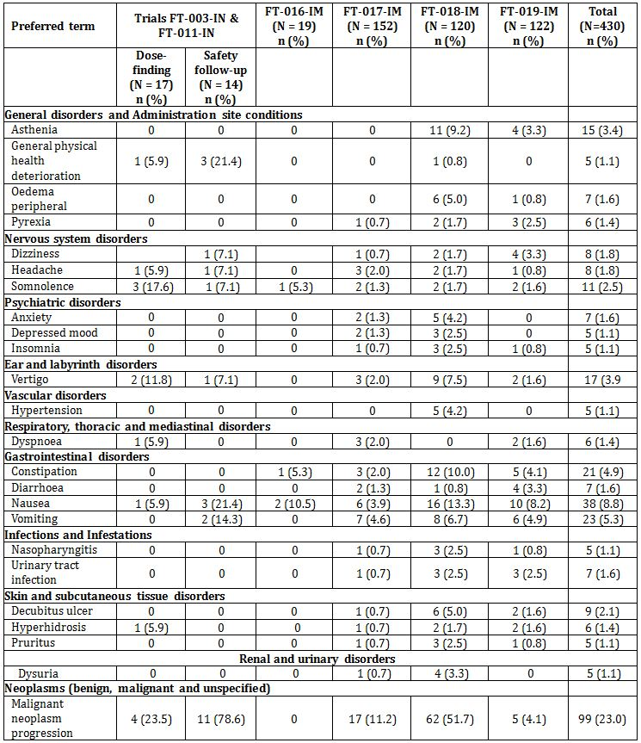
Nasal biopsies were planned before inclusion and after FNS treatment in Studies FT-003-IN/FT-011-IN but were not taken as most of the patients died during the trial and those remaining refused or were so severely ill that a biopsy was not possible. In the subsequent trials patients were not specifically monitored for local tolerability and the information was collected as part of the AEs. There was one report of a severe nasal ulcer in Study FT-019-IM.
The remaining nasopharyngeal adverse events were of mild to moderate severity and included throat irritation, rhinitis, nasal dryness and nasopharyngitis.
The post marketing reports following marketing in Europe covered approximately 12 months of use. Events of note included:
- 7 cases of overdose, two considered serious: one patient developed respiratory depression requiring admission to hospital and the other patient developed “standard symptoms of overdose” and hallucinations.
- 4 cases of abuse or misuse of the medication.

Risk management plan
The RMP evaluator recommended that implementation of EU-RMP Version 8.0 (Data Lock Point (DLP) 19 October 2010) and the Australia specific annex v1.0 (May 2012), and any future updates be a condition of registration. The RMP evaluator also recommended the following activities be performed by the sponsor if Instanyl is approved for registration:
- The sponsor should extend the availability and distribution of educational material to patients, pharmacists and medical practitioners in Australia;
- The sponsor should undertake an education program on FNS targeted at health professionals (especially medical practitioners and nurses in the fields of medical oncology and palliative care medicine) without promoting Instanyl specifically. This education program should be conducted by an accredited Continuing Medical Education (CME) provider;
- The sponsor should evaluate the abovementioned education program and distribution of educational material;
- The sponsor should facilitate the development completion of a multi-dose counter and a lock out mechanism for the Instanyl multi-dose device as soon as possible but certainly within a specified time period; and
- The sponsor should consider marketing the single-dose device only until the upgraded version of the multi-dose device is available.
The sponsor agreed to the above actions except the marketing of the single dose device only until the upgraded version of the multi-dose device is available.
The RMP for this submission was considered by ACSOM. That Committee requested the sponsor detail how they will ensure that prescriptions for any deceased patients are not being dispensed. ACSOM considered that:
- The supply of the multi-dose device can only be recommended once the lock out mechanism and the dose counter are available in the device.
- In regard to the child resistant container, ACSOM advised that further risk minimisation activities are required to prevent children from being able to access the product when it is not in the container.

Risk-benefit analysis

Delegate considerations
The pharmacokinetics of Instanyl has been adequately assessed. Information on the metabolism of fentanyl was obtained from published literature and this was considered to be satisfactory given that the distribution, metabolism and excretion of fentanyl are not product specific. There is a relatively high coefficient of variation for both intra and inter patient pharmacokinetic parameters with Instanyl. This may be contributed to by the route of administration. This product is not interchangeable with any other immediate release, self-administered transmucosal product. Switching from other fentanyl products without undertaking the fairly complex and time consuming dose titration procedures used in the clinical trials would risk overdose. Each product has its own quite variable absorption characteristics.
The Delegate notes that the GMP inspectors reported two critical findings for site Y but considered that those
“deficiencies are not considered to obscure the efficacy data reported by this investigational site”.
Given that the inspectors considered the efficacy data from that site were acceptable the Delegate has accepted these data. The GCP failures that were critical at that site led to the safety reporting from that site being considered unreliable. The Delegate agrees with that assessment and considers that rejection of a submission on the basis of the unfavourable GMP assessment for safety data gathering at 2 sites that was presented is not warranted. There was no suggestion that the assessment of efficacy was inadequate. Inaccuracies and omissions in obtaining and recording adverse events at two sites (from among 27 sites in Study FT-017-IM and 35 sites in Study FT-018-IM) should not preclude consideration of the remaining data. The design deficiency in the diary cards is also considered insufficient to preclude registration.
The clinical evaluator considered the publications included with this submission did not comply with LBS guidelines however these publications provided pharmacology information and general support for the overall safety of use of transmucosal fentanyl. For those purposes, a formal LBS was not required.
The design of Study FT-017-IM was adequate to demonstrate a dose response for Instanyl. The inclusion of patients who participated in that study in the subsequent study (FT-018-IM) where the product was administered as per the proposed dose recommendations was considered to be acceptable. The study numbers are broadly consistent with those of more recent studies in patients with BTP. The PID between fentanyl and placebo were quite large and readily apparent so only relatively small numbers of patients were needed to demonstrate statistically significant differences from placebo. This was the case for both pivotal studies. The actual number of patients given Instanyl was not greatly dissimilar to that given PecFent in the pivotal clinical trial described in the Product Information for PecFent.
Patients selected for these studies were mostly already receiving BTP treatment prior to study entry and had previously responded to treatment so they were a selected group. The proportion of unselected patients with BTP who would tolerate and receive a clinical benefit from Instanyl cannot be estimated from the studies presented.
The evaluator was concerned that the number of patients and BTP episodes where more than one actuation was given for a single BTP episode was not presented so the reviewer could not comment on the proportion and numbers of patients requiring more than one actuation per BTP episode or on the mean total doses of Instanyl given for each BTP episode in those studies. The sponsor subsequently indicated that the efficacy data in the pivotal studies were for a single dose of Instanyl.
The Delegate considered that the major safety concerns are:
- Potential for abuse and misuse. The short T_{max} and high bioavailability relative to other fentanyl products suggests this product would be preferred over other opioid products by individuals likely to abuse opioids yet no study to assess this was undertaken. Instead it was asserted that by the sponsor that this product is an opioid agonist with an abuse and misuse liability similar to other opioid analgesics.
- Potential for accidental overdose with the multi-dose dose container. There is potential for individuals confused after taking Instanyl to take additional doses, particularly if they are in severe pain and want rapid onset of pain relief. Use of the multidose products by others could also occur and was a major concern of ACSOM. The 12 months of PSUR data from Europe provides only limited reassurance that this is unlikely to be a frequent occurrence.
- “Off label” use of Instanyl in patients with chronic pain who may also experience periodic acute exacerbations of pain would place those patients at higher risk of development of dependency. The sponsor is undertaking a drug utilisation study in five European countries. The sponsor should provide a summary interim report for that study that was stated to be due in the second quarter of 2012 in their pre ACPM response. However, if widespread off-label use and dependency are identified there appears to be no plan to manage those events.
Based on PK data alone, it was considered quite likely that this product would have considerable efficacy for its intended use. Efficacy has been adequately assessed in clinical studies though there were flaws in the design and execution of those studies.
There are outstanding pharmaceutical chemistry and risk management issues that require resolution prior to approval of Instanyl. The lack of a dose counter and lock out mechanism in the multi-dose container, concern that the child resistant outer packaging is insufficient to limit access by children and the need to store the multi-dose container upright are major concerns. The Delegate agrees with the pharmaceutical chemistry evaluator that wide variability in the bioavailability between two different transmucosal fentanyl products was demonstrated and that this should be highlighted in the Product Information.
The pharmaceutical chemistry evaluator noted that all Instanyl products contain an excess of solution in order to ensure that the stated number of doses can be delivered. The Delegate noted that there is no dose counter on the product and most patients will not keep a separate tally of how many doses are used. The Delegate accepted that patients will continue to use a multi-dose product until it is apparently empty with no further nasal solution delivered on actuation. It represents no additional risk to than which is inherent in the multi-dose container as a presentation.

Questions for the ACPM
The general advice of the ACPM on the quality, safety and efficacy of Instanyl for the proposed indication of
Instanyl is indicated for the management of breakthrough pain in patients already receiving maintenance opioid therapy for chronic cancer pain is requested.
In addition, the ACPM was requested to provide advice on the following specific issues:
1. Does the ACPM consider that supply of Instanyl should be restricted in a similar manner to the scheme for transmucosal immediate release fentanyl that operates in the US would be warranted given the safety issues for this product? Such a scheme would also be required for other immediate release self administered opioids.
2. Does the ACPM consider that reporting of total sales (volume of product of each dose strength) from both Pharmaceutical Benefits Scheme (PBS) and private prescriptions for at least 3 years after commencement of marketing of this product in Australia would adequately estimate the extent of off label use due to dependency in patients with chronic non malignant pain and/or product diversion in Australia?
3. The multi-dose packs contain up to 20 doses per bottle. ACSOM has recommended this container not be approved until it is re-designed to include a lock out mechanism and dose counter. In addition, there are problems with opening the child resistant outer packaging, adsorption of fentanyl onto the packaging components if the container is not stored in an upright position, a likely increased risk of overdose due to number of doses in the presentation, and a likely high desirability of this presentation for diversion and misuse. Does the Committee consider the proposed dose directions and packaging in a “child resistant outer box” from which the product is removed sufficiently mitigate the risks from this presentation that are listed above? (A demonstration container and outer packaging will be supplied to members at the meeting.)
4. Should all transmucosal immediate release fentanyl products intended to be self administrated have black box warnings in the Product Information to state there is an increased risk of dependency from these dose forms compared with other opioids? If this is recommended, can the ACPM suggest appropriate wording?
5. The proposed contraindication for opioid naïve patients is to be amended to patients not taking maintenance opioid therapy. Actiq has an additional contraindication for treatment of acute pain other than BTP; PecFent does not. In the US, self administered immediate release forms of fentanyl have been contraindicated in the management of acute or postoperative pain, including headache/migraine, dental pain, or use in the emergency room in the US. Does the committee consider a similar additional contraindication is warranted for Instanyl? If so, should this be extended to other immediate release self administered opioids?

Response from sponsor
The sponsor addressed the following items raised during the TGA evaluation:
- Potential for abuse and misuse relative to other opioid products
- Specific risks associated with the multi-dose presentation only:
  - Between dose lock out mechanism
  - Accidental poisoning (for example, children)
  - Dose counter
  - Overdose potential
  - Storage upright
- Potential for off label use
- Risk management of transmucosal immediate release fentanyl products in Australia
- Miscellaneous items
As part of a commitment to ensuring the safe and efficacious use of Instanyl in Australia, the sponsor proposed an extensive RMP to mitigate potential risks raised during the TGA evaluation.
The sponsor provided comments regarding issues raised in the Clinical Evaluation Report (italicised text below) as follows:
- Compliance with Good Clinical Practice (GCP)
“The main problem with the clinical data is the concern over the conduct of the studies and the compliance with Good Clinical Practice (GCP). The issues raised by the EMA inspection team are critical and raise serious doubt about the acceptance of the data.”
“Even if the issues of GCP were to be put aside (as was done in Europe), there are major concerns about the quality of the clinical studies.”

Sponsor response:
It is misleading to base the reliability of the efficacy and safety solely on the inspection team summary report. The CHMP concluded that the deficiencies found in the quality system are unlikely to invalidate the quality of efficacy and safety data.
The GCP issues were not simply put aside in Europe. Significant dialogue and consideration was given to the matter and the outcomes of the inspection report, which culminated in re-monitoring and reanalysis of the data set.
- Design of Studies FT-017-IM and FT-018-IM:
“The two pivotal studies are not independent studies which is generally regarded as one of the criteria for being classified as pivotal. The second study FT-018-IM is not independent of the first study FT-017-IM. The same centers and investigators have been used and the entry criteria included patients that had participated in either 016 or 017.
“The study design of Study FT-017-IM of testing different doses in each patient rather than titrating to a successful dose and then testing that dose against an accepted therapy rather than placebo would have been a more acceptable design for a pivotal study.”
“Patients in the trials were able to take up to 2 doses of each dose strength. This does not seem to have been reflected in the results when presented by dose. Thus some patients in the 200 µg dose group took 200 μg and some presumably took 400 μg. It is not clear how many took what dose and how this affected the results.”

Sponsor comment:
The two clinical trials were different by design. The clinical trial FT-017-IM was a dose-response efficacy trial in accordance with the European guideline for treatment of nociceptive pain (CPMP/EWP/612/00, 2002) where patients were treated with a fixed dose and not titrated to an effective dose. The FT-018-IM was a two-phase trial with an open label titration phase and a double-blind, placebo-controlled efficacy phase and therefore not just a simply a replicate of Study FT-017-IM.
The primary endpoint in the pivotal FT-017-IM and FT-018-IM trials was pain intensity difference at 10 minutes (PID10) with one single dose of Instanyl. The efficacy of Instanyl, and corresponding clinical benefit in terms of pain intensity difference, with one single dose within the currently proposed dose range of 50 to 200 µg. All three Instanyl doses examined were found to provide clinically meaningful pain relief (PID10) which was also statistically significantly greater than the pain relief achieved with placebo.
- Patient numbers in the clinical trials
“Small number of patients in the submission compared to other submissions for similar products.”

Sponsor’s comment:
The number of patients included in the clinical trials and the submission is sufficient for demonstrating efficacy. From an ethical point of view the number of patients is adequate and relevant considering the target population being severe ill cancer patients.

Advisory committee considerations
The ACPM, taking into account the submitted evidence of efficacy, safety and quality, considered this product to have an overall positive benefit-risk profile for the new presentation current indications.

Proposed Product Information/Consumer Medicine Information amendments
The ACPM agreed with the Delegate to the proposed amendments to the Product Information and Consumer Medicine Information and specifically advised on the inclusion of the following:
- a statement in the Dosage and Administration section of the Product Information (and reflected in the Consumer Medicine Information) to ensure suitable emphasise that there is no direct conversion in fentanyl dose between presentations, particularly the nasal and oral formulations and that dose re-titration must be performed.
- a statement in the Contraindications section of the Product Information to limit use in patients who do not have cancer related pain to the hospital or clinic.
- a statement in the Adverse Reactions section of the Product Information (and reflected in the Consumer Medicine Information) on the possible adverse event of nasal ulceration.

Proposed conditions of registration
The ACPM agreed with the Delegate on the proposed conditions of registration.
The ACPM advised that the implementation by the sponsor of the recommendations outlined above to the satisfaction of the TGA, in addition to the evidence of efficacy and safety provided would support the safe and effective use of this product.

Outcome
Based on a review of quality, safety and efficacy, TGA approved the registration of Instanyl fentanyl (as citrate) 50 µg, 100 µg and 200 µg nasal spray single-dose bottle and 50 µg, 100 µg and 200 µg nasal spray multi-dose bottle for the indication:
Instanyl is indicated for the management of breakthrough pain in adults already receiving maintenance opioid therapy for chronic cancer pain.

Specific conditions of registration applying to these therapeutic goods
1. The implementation in Australia of the Instanyl (fentanyl citrate) EU-RMP Version 2 (dated 08/12/2011, DLP 30/06/2010), Australian Specific Annex to EU-RMP (Version 2.0, dated November 2012), and any future updates included with submission PM-2012-00804-3-1, as a condition of registration, as agreed with the TGA and its OPR.
2. The 10 dose multi-dose presentations will not be supplied until such time as the usability of the child resistant exterior packaging component has been established to the TGA’s satisfaction.

Attachment 1. Product Information
The Product Information approved at the time this AusPAR was published is at Attachment 1. For the most recent Product Information please refer to the TGA website at <http://www.tga.gov.au/hp/information-medicines-pi.htm>.

Attachment 2. Extract from the Clinical Evaluation Report

Sponsor comment: “The 50 μg, 100 μg and 200 μg single dose presentations were approved in Canada on 27 June 2013 (the multi-dose presentations were not submitted in Canada).”
Sponsor comment: “The PI has since been updated and describes the absolute bioavailability as close to 100% (when described as a one compartment model).”
Baechtold F, et al. (2001) Cardiovascular effects of fentanyl in conscious rats. Pflugers Arch – Eur J Physiol. 443: 155-162.
Blair JR, et al. (1989) Cardiac electrophysiologic effects of fentanyl and sufentanil in canine cardiac Purkinje fibers. Anesthesiology 71: 565-570.
Katchman AN, et al. (2002) Influence of opioid agonists on cardiac human ether-a-go-go-related gene K(+) currents. J Pharmacol Exp Ther. 303: 688-694.
Meuldermans WE, et al. (1982) Plasma protein binding and distribution of fentanyl, sufentanil, alfentanil and lofentanil in blood. Arch Int Pharmacodyn Ther. 257: 4-19.
Allen JS, et al. (2003) Genetic toxicology of remifentanil, an opiate analgesic. Teratog Carcinog Mutagen. Suppl 1: 137-149.
Muller L, Kasper P (2000) Human biological relevance and the use of threshold-arguments in regulatory genotoxicity assessment: experience with pharmaceuticals. Mutat Res. 464: 19-34.
European Medicines Agency, “Committee for Proprietary Medicinal Products (CPMP): Note for Guidance on Non-Clinical Local Tolerance Testing of Medicinal Products (CPMP/SWP/2145/00)”, 1 March 2001, Web, accessed 26 August 2013 <www.ema.europa.eu/docs/en_GB/document_library/ Scientific_guideline/2009/09/WC500003315.pdf>.
US Food and Drug Administration, “Guidance for Industry: Estimating the Maximum Safe Starting Dose in Initial Clinical Trials for Therapeutics in Adult Healthy Volunteers”, July 2005, Web, accessed 26 August 2013 <www.fda.gov/downloads/Drugs/Guidances/UCM078932.pdf >.
US Food and Drug Administration, “Guidance for Industry: Estimating the Maximum Safe Starting Dose in Initial Clinical Trials for Therapeutics in Adult Healthy Volunteers”, July 2005, Web, accessed 26 August 2013 <www.fda.gov/downloads/Drugs/Guidances/UCM078932.pdf >.
Shavit Y, et al. (2004) Effects of fentanyl on natural killer cell activity and on resistance to tumour metastasis in rats: Dose and timing study. Neuroimmunomodulation 11: 255-60.
See further discussions of this issue by the evaluator on pages 20-22.
Sponsor comment: “FT-018 trial patients were titrated to an effective dose. FT-017 trial patients were treated with a fixed dose.”
European Medicines Agency, “Committee for Proprietary Medicinal Products (CPMP): Points to Consider on Application with 1. Meta-Analyses; 2. One Pivotal Study (CPMP/EWP/2330/99)”, 31 May 2001, Web, accessed 26 August 2013 <www.ema.europa.eu/docs/en_GB/document_library/ Scientific_guideline/2009/09/WC500003657.pdf>.
Sponsor comment: “Site X was excluded due to fraud. It could not be confirmed that the site included any actual patients, and therefore the data needed to be excluded from the data analysis.”

