### PRODUCT INFORMATION

#### FENTORA

#### Fentanyl (as Citrate) Orally Disintegrating Tablets

#### 100, 200, 400, 600 and 800 micrograms

##### NAME OF THE MEDICINE

Fentanyl citrate.



##### DESCRIPTION

FENTORA (fentanyl citrate) is a synthetic opioid analgesic related to pethidine and with similar properties to morphine. Fentanyl citrate is a white, crystalline powder with a molecular weight of 528.6 and the molecular formula C22H28N2O,C6H8O7. Its chemical name is N-(1-Phenethyl-4-piperidyl) propionanilide dihydrogen citrate. The CAS Registry Number for fentanyl citrate is 990-73-8.

The citrate salt is sparingly soluble to soluble in water; sparingly soluble in alcohol; slightly soluble in chloroform; soluble to freely soluble in methyl alcohol.

FENTORA orally disintegrating tablets are available in five unit strengths equivalent to 100, 200, 400, 600 and 800 micrograms of fentanyl base. The excipients include mannitol, sodium starch glycollate type A, sodium hydrogen carbonate, sodium carbonate anhydrous, anhydrous citric acid , magnesium stearate.

##### PHARMACOLOGY

###### Pharmacodynamic properties

Fentanyl is an opioid analgesic, interacting predominantly with the opioid µ-receptor. Its primary therapeutic actions are analgesia and sedation. Secondary pharmacological effects are respiratory depression, bradycardia, hypothermia, constipation, miosis, physical dependence and euphoria.

The analgesic effects of fentanyl are related to its plasma level. In general, the effective concentration and the concentration at which toxicity occurs increase with increasing tolerance to opioids. The rate of development of tolerance varies widely among individuals. As a result, the dose of FENTORA should be individually titrated to achieve the desired effect (see DOSAGE AND ADMINISTRATION).

All opioid µ-receptor agonists, including fentanyl, produce dose dependent respiratory depression. The risk of respiratory depression is less in patients receiving chronic opioid therapy as these patients will develop tolerance to respiratory depressant effects.

###### Pharmacokinetic Properties

Fentanyl is highly lipophilic and can be absorbed very rapidly through the oral mucosa and more slowly by the conventional gastrointestinal route. It is subject to first-pass hepatic and intestinal metabolism and the metabolites do not contribute to fentanyl’s therapeutic effects.

FENTORA employs a delivery technology which utilises an effervescent reaction which enhances the rate and extent of fentanyl absorbed through the buccal mucosa. Transient pH changes accompanying the effervescent reaction may optimise dissolution (at a lower pH) and membrane permeation (at a higher pH).

Dwell time (defined as the length of time that the tablet takes to fully disintegrate following buccal administration), does not affect early systemic exposure to fentanyl. In addition, a comparativestudy evaluating the absorption of one 400 micrograms FENTORA tablet administered either buccally (i.e., between the cheek and the gum) or sublingually met the criteria of bioequivalence.

The effect of renal or hepatic impairment on the pharmacokinetics of FENTORA has not been studied.

*Absorption:*

Following oromucosal administration of FENTORA, fentanyl is readily absorbed with an absolute bioavailability of 65%. The absorption profile of FENTORA is largely the result of an initial rapid absorption from the buccal mucosa, with peak plasma concentrations following venous sampling generally attained within an hour after oromucosal administration. Approximately 50% of the total dose administered is rapidly absorbed transmucosally and becomes systemically available. The remaining half of the total dose is swallowed and slowly absorbed from the gastrointestinal tract where 30% of it becomes systemically available by bypassing hepatic and intestinal first-pass elimination.

The main pharmacokinetic parameters are shown in the following table.

*Pharmacokinetic Parameters* in Adult Subjects Receiving FENTORA*

|  |  |
| --- | --- |
| **Pharmacokinetic**  **parameter (mean)** | FENTORA **400 micrograms** |
| **Absolute**  **bioavailability** | **65%** (**±**20%) |
| **Fraction**  **absorbed transmucosally** | **48%** (**±**31.8%) |
| **Tmax (minute) \*\*** | **46.8** (20-240) |
| **Cmax (ng/ml)** | **1.02** (± 0.42) |
| **AUC0-tmax (ng.hr/ml)** | **0.40** (± 0.18) |
| **AUC0-inf (ng.hr/ml)** | **6.48** (± 2.98) |

* Based on venous blood samples (plasma). Fentanyl citrate concentrations obtained in serum were higher than in plasma: Serum AUC and Cmax were approximately 20% and 30% higher than plasma AUC and Cmax, respectively. The reason of this difference is unknown.

** Data for Tmax presented as median (range).

In pharmacokinetic studies that compared the absolute and relative bioavailability of FENTORA and oral transmucosal fentanyl citrate (OTFC), the rate and extent of fentanyl absorption in FENTORA demonstrated exposure that was between 30% to 50% greater than that for oral transmucosal fentanyl citrate. If switching from another oral fentanyl citrate product, independent dose titration with FENTORA is required as bioavailability between products differs significantly. However, in these patients, a starting dose higher than 100 micrograms may be considered.

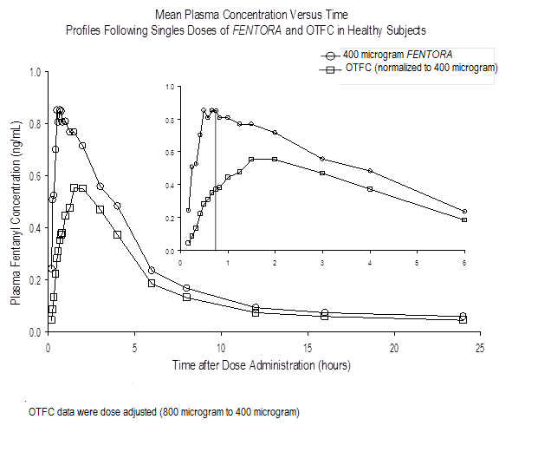

Differences in exposure with FENTORA were observed in a clinical study with patients with grade 1 mucositis. Cmax and AUC0-8 were 1% and 25% higher in patients with mucositis compared to those without mucositis, respectively. The differences observed were not statistically or clinically significant.

**Dose proportionality from 100 micrograms to 1000 micrograms of FENTORA has been demonstrated.**

*Distribution*

Fentanyl is highly lipophilic and is well distributed beyond the vascular system, with a large apparent volume of distribution. After buccal administration of FENTORA, fentanyl undergoes initial rapid distribution that represents an equilibration of fentanyl between plasma and the highly perfused tissues (brain, heart and lungs). Subsequently, fentanyl is redistributed between the deep tissue compartment (muscle and fat) and the plasma.

The plasma protein binding of fentanyl is 80% to 85%. The main binding protein is alpha‑1-acid glycoprotein, but both albumin and lipoproteins contribute to some extent. The free fraction of fentanyl increases with acidosis.

*Metabolism*

The metabolic pathways following buccal administration of FENTORA have not been characterised in clinical studies. Fentanyl is metabolised in the liver and in the intestinal mucosa to norfentanyl by CYP3A4 isoform. Norfentanyl is not pharmacologically active in animal studies. More than 90% of the administered dose of fentanyl is eliminated by biotransformation to N-dealkylated and hydroxylated inactive metabolites.

*Elimination*

Following the intravenous administration of fentanyl, less than 7% of the administered dose is excreted unchanged in the urine, and only about 1% is excreted unchanged in the faeces. The metabolites are mainly excreted in the urine, while faecal excretion is less important.

Following the administration of FENTORA, the terminal elimination phase of fentanyl is the result of the redistribution between plasma and a deep tissue compartment. This phase of elimination is slow, resulting in a median terminal elimination half-life t1/2 of approximately 22 hours following buccal administration of the effervescent formulation and approximately 18 hours following intravenous administration. The total plasma clearance of fentanyl following intravenous administration is approximately 42 L/h.

**CLINICAL TRIALS**

The safety and efficacy of FENTORA have been evaluated in patients taking the drug at the onset of the breakthrough pain episode. BTP is a transitory exacerbation of pain that occurs on a background of otherwise controlled persistent pain. Pre-emptive use of FENTORA for predictable pain episodes was not investigated in the clinical trials.

Two double-blind, randomized, placebo-controlled crossover studies have been conducted involving a total of 248 patients with BTP and cancer who experienced on average 1 to 4 episodes of BTP per day while taking maintenance opioid therapy. Patients receiving maintenance opioid therapy are those who are taking at least 60 mg of oral morphine daily, at least 25 micrograms of transdermal fentanyl per hour, at least 30 mg of oxycodone daily, at least 8 mg of oral hydromorphone daily or an equianalgesic dose of another opioid for a week or longer.

During an initial open-label phase, patients were titrated to an effective dose of FENTORA. Patients who identified an effective dose entered the double-blind phase of the study. The primary efficacy variable was the patient’s assessment of pain intensity. Patients assessed pain intensity on a 11-point scale. For each BTP episode, pain intensity was assessed prior to and at several time points after treatment.

Sixty-seven percent of the patients were able to be titrated to an effective dose.

In the pivotal clinical study (study 1), the primary endpoint was the average sum of differences in pain intensity scores from dosing to 60 minutes, inclusive (SPID60), which was statistically significant compared to placebo (p<0.0001).

+ p<0.0001 FENTORA versus placebo, in favor of FENTORA, by an analysis of variance

PID=pain intensity difference; SEM=standard error of the mean

SPID60 mean (+/- SD)

FENTORA=9.7(5.58) p<0.0001

Placebo=4.9(4.38)

Study 1: Mean (+/- SEM) Pain Intensity Difference at Each Time Point (Full Analysis Set)

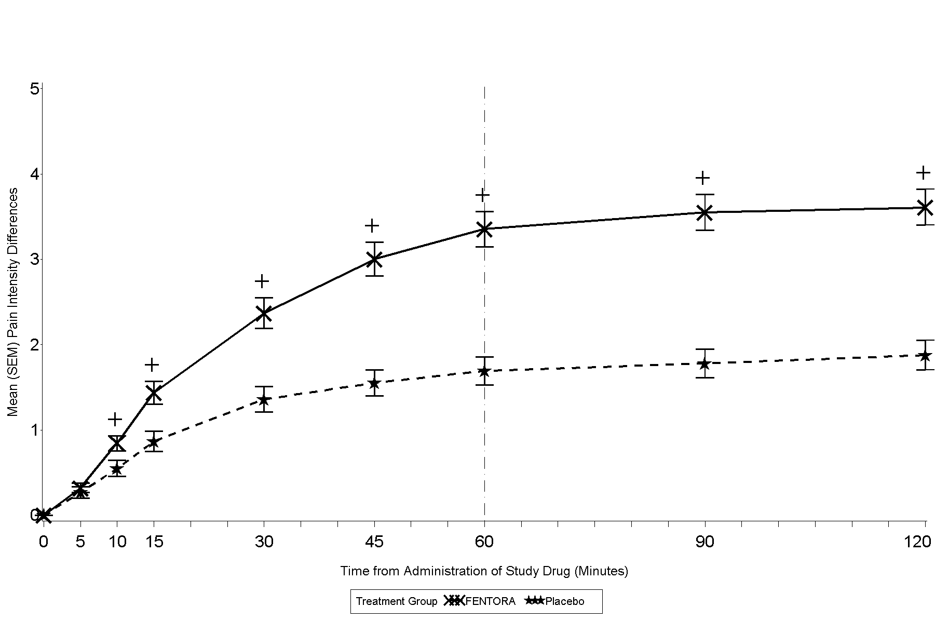

* p<0.01 FENTORA versus placebo, in favor of FENTORA, by one-sample Wilcoxon signed rank test

+ p<0.0001 FENTORA versus placebo, in favor of FENTORA, by one-sample Wilcoxon signed rank test

PID=pain intensity difference; SEM=standard error of the mean

Study 2: Mean (+/- SEM) Pain Intensity Difference at Each Time Point (Full Analysis Set)

SPID30 mean (+/- SD) FENTORA=3.2(2.60) p<0.0001 Placebo=2.0(2.21)

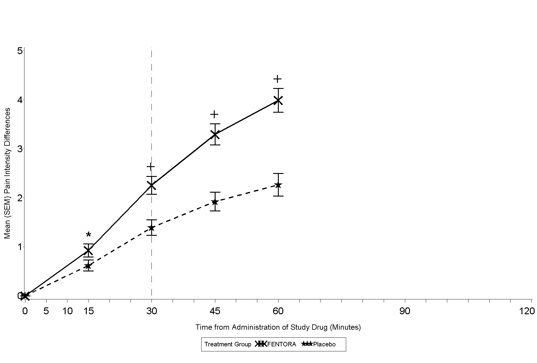

In the second pivotal study (study 2), the primary endpoint was SPID30, which was also statistically significant compared to placebo (p<0.0001).

Statistically significant improvement in pain intensity difference was seen with FENTORA versus placebo as early as 10 minutes in Study 1 and as early as 15 minutes (earliest time point measured) in Study 2. These differences continued to be significant at each subsequent time point in each individual study.

**INDICATIONS**

FENTORA is indicated for the treatment of breakthrough pain (BTP) in adults with cancer who are already receiving maintenance opioid therapy for chronic cancer pain.

**CONTRAINDICATIONS**

FENTORA is contraindicated in:

Hypersensitivity to the active substance or to any of the excipients (see DESCRIPTION).

Patients without maintenance opioid therapy (see CLINICAL TRIALS) as there is an increased risk of respiratory depression.

Severe respiratory depression or severe obstructive lung conditions.

Treatment of acute pain other than breakthrough pain (e.g. postoperative pain, headache, migraine).

Simultaneous use of monoamine-oxidase (MAO) inhibitors, or within 2 weeks after the cessation of the use of MAO inhibitors.

**PRECAUTIONS**

In order to minimise the risks of opioid-related undesirable effects and to identify the effective dose, it is imperative that patients be monitored closely by health professionals during the titration process.

It is important that the long acting opioid treatment used to treat the patient’s persistent pain has been stabilised before FENTORA therapy begins and that the patient continues to be treated with the long acting opioid treatment whilst taking FENTORA.

When switching from another oral fentanyl citrate product, independent dose titration is required as bioavailability between products differ significantly.

Special Risk Patients

*Respiratory depression*

As with all opioids, there is a risk of clinically significant respiratory depression associated with the use of fentanyl. Improper patient selection (e.g., use in patients without maintenance opioid therapy) and/or improper dosing have resulted in fatal outcome with FENTORA as well as with other fentanyl products.

FENTORA should only be used for conditions specified in INDICATIONS.

*CNS Depression*

Use of FENTORA in combination with other CNS depressants can result in increased risk to patients. (see INTERACTIONS WITH OTHER MEDICINES).

*Chronic obstructive pulmonary disease*

Particular caution should be used when titrating FENTORA in patients with non-severe chronic obstructive pulmonary disease or other medical conditions predisposing them to respiratory depression, as even normally therapeutic doses of FENTORA may further decrease respiratory drive to the point of respiratory failure.

*Increased intracranial pressure, impaired consciousness*

FENTORA should only be administered with extreme caution in patients who may be particularly susceptible to the intracranial effects of CO2 retention, such as those with evidence of increased intracranial pressure or impaired consciousness. Opioids may obscure the clinical course of a patient with a head injury and should be used only if clinically warranted.

*Cardiovascular*

Intravenous fentanyl may produce bradycardia. In clinical trials with FENTORA, no clear evidence for bradycardia was observed. However, FENTORA should be used with caution in patients with pre-existing bradyarrhythmias.

Careful consideration should be given to patients with hypovolaemia and hypotension.

*Hepatic and Renal Impairment*

FENTORA should be administered with caution to patients with hepatic or renal impairment. The influence of hepatic and renal impairment on the pharmacokinetics of the medicinal product has not been evaluated, however, when administered intravenously the clearance of fentanyl has been shown to be altered in hepatic and renal impairment due to alterations in metabolic clearance and plasma proteins. After administration of FENTORA, impaired hepatic and renal function may both increase the bioavailability of swallowed fentanyl and decrease its systemic clearance, which could lead to increased and prolonged opioid effects.

Therefore, special care should be taken during the titration process in patients with moderate or severe hepatic or renal impairment.

*Serotonin Syndrome*

Caution is advised when fentanyl is coadministered with drugs that affect the serotoninergic neurotransmitter systems.

The development of a potentially life-threatening serotonin syndrome may occur with the concomitant use of serotonergic drugs such as Selective Serotonin Re-uptake Inhibitors (SSRIs) and Serotonin Norepinephrine Re-uptake Inhibitors (SNRIs), and with drugs which impair metabolism of serotonin (including Monoamine Oxidase Inhibitors [MAOIs]). This may occur within the recommended dose.

Serotonin syndrome may include mental-status changes (e.g., agitation, hallucinations, coma), autonomic instability (e.g., tachycardia, labile blood pressure, hyperthermia), neuromuscular abnormalities (e.g., hyperreflexia, incoordination, rigidity), and/or gastrointestinal symptoms (e.g., nausea, vomiting, diarrhoea).

If serotonin syndrome is suspected, treatment with fentanyl should be discontinued.

*Tolerance, dependence*

Tolerance and physical and/or psychological dependence may develop upon repeated administration of opioids such as fentanyl. However, iatrogenic addiction following therapeutic use of opioids is rare.

*Application site*

Application site reactions, including gum bleeding, irritation, pain and ulcer have been reported in post-marketing use. Therefore caution is advised for patients with mucositis and local tolerability issues.

*Controlled sodium diet*

This medicinal product contains 10 mg sodium per 100 micrograms tablet, and 20 mg sodium per 400, 600 and 800 micrograms tablet. To be taken into consideration by patients on a controlled sodium diet.

*Anaphylaxis and hypersensitivity*

Anaphylaxis and hypersensitivity have been reported in association with the use of oral transmucosal fentanyl products.

**Effects on fertility**

When male rats treated with fentanyl for 28 days prior to and during mating were mated with untreated females, adverse effects on sperm parameters, which reduced fertility, were observed at a high subcutaneous dose of 300 µg/kg/day that also resulted in mortalities. No effects on fertility were observed following administration of the same dose to females mated with untreated males. Estimated fentanyl exposure (plasma AUC) at this dose was about 10-fold that observed following a single dose of 800 µg fentanyl in humans and about 2-fold that observed after four daily doses of 800 µg fentanyl. Corresponding exposure ratios at the no observed effect level for fertility (100 µg/kg/day) were 3 and 0.6

**Use in pregnancy (Category C)**

Fentanyl crosses the placenta in humans and has been found in fetal blood at concentrations about 40% of those found in maternal blood. There are no adequate data from the use of fentanyl in pregnant women. In studies in which fentanyl was administered to rats and rabbits at respective subcutaneous doses of up to 100 and 250 µg/kg/day during the period of organogenesis, no increased incidence of fetal malformations or variations was observed, but fetal weights were reduced in rats at the maternotoxic dose of 100 µg/kg/day. Respective fentanyl exposures (plasma AUC) at these doses in rats and rabbits were about 3- and 5-fold that observed following a single dose of 800 µg fentanyl in humans, and less than or equal to that observed in humans after four daily doses of 800 µg fentanyl.

In a study in which rats received subcutaneous fentanyl from early gestation to weaning, reduced pup survival, growth and development were observed at clearly maternotoxic doses (100 and 400 µg/kg/day). Fentanyl exposure (plasma AUC) at the no-effect dose for pup developmental toxicity (50 µg/kg/day) was similar to that observed following a single dose of 800 µg fentanyl in humans and about 0.2-fold that observed after four daily doses of 800 µg fentanyl.

FENTORA should not be used in pregnancy unless clearly necessary.

**Use in labour and delivery**

It is advised not to use fentanyl during labour and delivery (including caesarean section) because fentanyl passes through the placenta and may cause respiratory depression in the foetus. If FENTORA is administered, an antidote for the child should be readily available.

**Use in Lactation**

Following long-term treatment, fentanyl may cause withdrawal in the new-born infant.

Fentanyl passes into breast milk and may cause sedation and respiratory depression in the breast-fedchild. Fentanyl should not be used by breastfeeding women and breastfeeding should not be restarted until at least 48 hours after the last administration of fentanyl.

**Paediatric Use**

FENTORA is not recommended for use in children and adolescents below 18 years due to a lack of data on safety and efficacy.

Use in the Elderly

In clinical studies patients older than 65 years tended to titrate to a lower effective dose than younger patients. It is recommended that increased caution should be exercised in titrating the dose of FENTORA in elderly patients.

**Genotoxicity**

Fentanyl showed no evidence of genotoxic potential in assays for gene mutations (Ames reverse mutation test, mouse lymphoma thymidine kinase assay), chromosomal damage (Chinese hamster ovary cells, mouse micronucleus test) and other genotoxic effects (unscheduled DNA synthesis in rat hepatocytes, mammalian cell transformation assay). The genotoxic potential of fentanyl is considered to be low.

**Carcinogenicity**

Carcinogenicity studies (26-week dermal bioassay in Tg.AC transgenic mice; two-year subcutaneous study in rats) did not induce any findings indicative of oncogenic potential. At the highest doses tested in these studies (50 µg/day in mice, 50 µg/kg/day in male rats and 100 µg/kg/day in female rats), systemic exposure (plasma Cmax in mice and AUC in rats) was about 3-fold (mice and female rats) and about 2-fold (male rats) that observed following a single dose of 800 µg fentanyl in humans.

Effects on ability to drive and use machines

No studies of the effects on the ability to drive and use machines have been performed. However, opioid analgesics impair the mental and/or physical ability required for the performance of potentially dangerous tasks (e.g., driving a car or operating machinery). Patients should be advised not to drive or operate machinery if they experience somnolence, dizziness, or visual disturbance while taking FENTORA and not to drive or operate machinery until they know how they react.

**INTERACTIONS WITH OTHER MEDICINES**

Fentanyl is metabolised mainly via the human cytochrome P450 3A4 isoenzyme system (CYP3A4), therefore potential interactions may occur when FENTORA is given concurrently with agents that affect CYP3A4 activity. Coadministration with agents that induce 3A4 activity may reduce the efficacy of FENTORA. The concomitant use of FENTORA with strong CYP3A4 inhibitors (e.g., ritonavir, ketoconazole, itraconazole, troleandomycin, clarithromycin, and nelfinavir) or moderate CYP3A4 inhibitors (e.g., amprenavir, aprepitant, diltiazem, erythromycin, fluconazole, fosamprenavir, grapefruit juice, and verapamil) may result in increased fentanyl plasma concentrations, potentially causing serious adverse drug reactions including fatal respiratory depression. Patients receiving FENTORA concomitantly with moderate or strong CYP3A4 inhibitors should be carefully monitored for an extended period of time. Dosage increase should be done with caution.

The concomitant use of other central nervous system depressants, including other opioids, sedatives or hypnotics, general anaesthetics, phenothiazines, tranquillisers, skeletal muscle relaxants, sedating antihistamines and alcohol may produce additive depressant effects.

FENTORA is not recommended for use in patients who have received monoamine oxidase (MAO) inhibitors within 14 days because severe and unpredictable potentiation by MAO inhibitors has been reported with opioid analgesics.

The concomitant use of partial opioid agonists/antagonists (e.g. buprenorphine, nalbuphine, pentazocine) is not recommended. They have high affinity to opioid receptors with relatively low intrinsic activity and therefore partially antagonise the analgesic effect of fentanyl and may induce withdrawal symptoms in opioid dependant patients.

Serotoninergic Drugs

Coadministration of fentanyl with a serotoninergic agent, such as a Selective Serotonin Re-uptake Inhibitor (SSRI) or a Serotonin Norepinephrine Re-uptake Inhibitor (SNRI) or a Monoamine Oxidase Inhibitor (MAOI), may increase the risk of serotonin syndrome, a potentially life-threatening condition.

##### ADVERSE EFFECTS

The adverse events seen with FENTORA are typical opioid side effects. Frequently, these will cease or decrease in intensity with continued use of the medicinal product, as the patient is titrated to the most appropriate dose.  However, the most serious adverse reactions are respiratory depression (potentially leading to apnoea or respiratory arrest), circulatory depression, hypotension and shock. All patients should be closely monitored for these.

Because the clinical studies of FENTORA were designed to evaluate safety and efficacy in treating BTP, all patients were also taking concomitant opioids, such as sustained-release morphine or transdermal fentanyl, for their persistent pain. Thus it is not possible to definitively separate the effects of FENTORA alone.

The table below summarises the adverse events occurring during the titration and posttitration periods in at least 5% of patients with cancer and breakthrough pain from three Phase 3 studies in patients with cancer and BTP:

|  |  |  |  |
| --- | --- | --- | --- |
| **MedDRA system organ class**  **Preferred term, n (%)** | **Percentage of patients (%)** | |  |
| **Titration period (N=358)** | **Posttitration period (N=239)** | **Overall (N=358)** |
| Patients with at least 1 adverse event | 206 (58) | 217 (91) | 305 (85) |
| Blood and lymphatic system disorders | | | |
| Anaemia | 6 (2) | 31 (13) | 40 (11) |
| Neutropenia | 3 (<1) | 15 (6) | 18 (5) |
| Gastrointestinal disorders | | | |
| Nausea | 59 (16) | 71 (30) | 110 (31) |
| Vomiting | 19 (5) | 51 (21) | 63 (18) |
| Constipation | 15 (4) | 34 (14) | 48 (13) |
| Diarrhoea | 8 (2) | 22 (9) | 29 (8) |
| Abdominal pain | 5 (1) | 25 (10) | 27 (8) |
| Stomatitis | 8 (2) | 13 (5) | 20 (6) |
| Dyspepsia | 1 (<1) | 12 (5) | 13 (4) |
| General disorders and administration site conditions | | | |
| Fatigue | 20 (6) | 40 (17) | 58 (16) |
| Oedema peripheral | 5 (1) | 32 (13) | 38 (11) |
| Asthenia | 6 (2) | 27 (11) | 34 (9) |
| Pyrexia | 4 (1) | 19 (8) | 23 (6) |
| Infections and infestations | | | |
| Pneumonia | 3 (<1) | 21 (9) | 24 (7) |
| Urinary tract infection | 4 (1) | 15 (6) | 18 (5) |
| Investigations | | | |
| Weight decreased | 4 (1) | 18 (8) | 22 (6) |
| Metabolism and nutrition disorders | | | |
| Dehydration | 10 (3) | 24 (10) | 33 (9) |
| Anorexia | 3 (<1) | 23 (10) | 25 (7) |
| Hypokalaemia | 5 (1) | 13 (5) | 18 (5) |
| Musculoskeletal and connective tissue disorders | | | |
| Arthralgia | 3 (<1) | 17 (7) | 22 (6) |
| Back pain | 5 (1) | 16 (7) | 20 (6) |
| Pain in extremity | 2 (<1) | 11 (5) | 14 (4) |
| Neoplasms benign, malignant, and unspecified (including cysts and polyps) | | | |
| Cancer pain | 3 (<1) | 12 (5) | 15 (4) |
| Nervous system disorders | | | |
| Dizziness | 64 (18) | 28 (12) | 83 (23) |
| Headache | 28 (8) | 31 (13) | 52 (15) |
| Somnolence | 21 (6) | 22 (9) | 41 (11) |
| Psychiatric disorders | | | |
| Depression | 1 (<1) | 24 (10) | 25 (7) |
| Anxiety | 4 (1) | 15 (6) | 20 (6) |
| Confusional state | 4 (1) | 16 (7) | 18 (5) |
| Insomnia | 2 (<1) | 14 (6) | 16 (4) |
| Respiratory, thoracic and mediastinal disorders | | | |
| Dyspnoea | 6 (2) | 18 (8) | 23 (6) |
| Cough | 3 (<1) | 16 (7) | 19 (5) |

The following adverse reactions have been reported with FENTORA during clinical studies and post marketing experience. Adverse reactions are listed below by system organ class and frequency (frequencies are defined as: very common ≥1/10, common ≥1/100 to <1/10, uncommon ≥ 1/1,000 to <1/100, rare (≥1/10,000 to <1/1,000), not known (cannot be estimated from the available data); within each frequency group, undesirable effects are presented in order of decreasing seriousness:

|  | **Very common** | **Common** | **Uncommon** | **Rare** | **Not known** |
| --- | --- | --- | --- | --- | --- |
| Investigations |  | Weight decreased | Platelet count decreased  Heart rate increased  Haematocrit decreased  Haemoglobin decreased |  |  |
| Cardiac disorders |  | Tachycardia | Bradycardia |  |  |
| Blood and lymphatic system disorders |  | Anaemia  Neutropenia | Thrombocyto-penia |  |  |
| Nervous system disorders | Dizziness Headache | Dysgeusia  Somnolence  Lethargy  Tremor  Sedation  Hypoaesthesia  Migraine | Depressed level of consciousness  Disturbance in attention  Balance disorder  Dysarthria | Cognitive disorder  Motor dysfunction | Loss of consciousness  Convulsion |
| Eye disorders |  |  | Visual disturbance  Ocular hyperaemia  Blurred vision  Visual acuity reduced | Abnormal sensation in eye  Photopsia |  |
| Ear and labyrinth disorders |  |  | Vertigo  Tinnitus  Ear discomfort |  |  |
| Respiratory, thoracic and mediastinal disorders |  | Dyspnoea  Pharyngolaryn-geal pain | Respiratory depression  Sleep apnoea syndrome |  | Respiratory arrest |
| Gastro-intestinal disorders | Nausea  Vomiting | Constipation  Stomatitis  Dry mouth  Diarrhoea  Abdominal pain  Gastro-oesophageal reflux disease  Stomach discomfort  Dyspepsia Toothache | Ileus  Mouth ulceration  Oral hypoaesthesia  Oral discomfort  Oral mucosal discolouration  Oral soft tissue disorder  Glossodynia  Tongue blistering  Gingival pain  Tongue ulceration  Tongue disorder  Oesophagitis  Chapped lips  Tooth disorder | Oral mucosal blistering  Dry lip |  |
| Renal and urinary disorders |  |  | Urinary retention |  |  |
| Skin and subcutaneous tissue disorders |  | Pruritus  Hyperhidrosis  Rash | Cold sweat  Facial swelling  Generalised pruritus  Alopecia | Onychorrhexis |  |
| Musculoskeletal and connective tissue disorders |  | Myalgia  Back pain | Muscle twitching  Muscular weakness |  |  |
| Endocrine disorders |  |  |  | Hypogonadism |  |
| Metabolism and nutrition disorders |  | Anorexia |  |  |  |
| Infections and infestations |  | Oral candidiasis | Pharyngitis | Oral pustule |  |
| Injury, poisoning and procedural complications |  | Fall |  |  |  |
| Vascular disorders |  | Hypotension  Hypertension | Flushing  Hot flush |  |  |
| General disorders and administration site conditions | Application site reactions including bleeding, pain, ulcer, irritation, paraesthesia, anaesthesia, erythema, oedema, swelling and vesicles | Peripheral oedema  Fatigue  Asthenia  Drug withdrawal syndrome  Chills | Malaise  Sluggishness  Chest discomfort  Feeling abnormal  Feeling jittery  Thirst  Feeling cold  Feeling hot |  |  |
| Hepatobiliary disorders |  |  | Biliary dilatation |  |  |
| Psychiatric disorders |  | Depression  Anxiety  Confusional state  Insomnia | Euphoric mood  Nervousness  Hallucination  Visual hallucination  Mental status changes  Drug dependence (addiction)  Disorientation |  |  |
| Immune system disorders |  |  |  | Hypersensitivity |  |

Tolerance, physical and/or psychological dependence may develop upon repeated administration of opioids such as fentanyl.

Opioid withdrawal symptoms such as nausea, vomiting, diarrhoea, anxiety and shivering have been observed in studies with FENTORA.

Loss of consciousness and respiratory arrest have been observed in the context of overdose.

Hypersensitivity reactions have been reported in post-marketing experience, including rash, erythema, lip and face swelling, and urticarial.

##### DOSAGE AND ADMINISTRATION

Treatment should be initiated by and remain under the guidance of a physician experienced in the management of opioid therapy in cancer patients. Physicians should keep in mind the potential of abuse of fentanyl. Patients should be instructed not to use two different formulations of fentanyl concurrently for the treatment of breakthrough pain, and to dispose of any fentanyl product prescribed for BTP when switching to FENTORA. The number of tablet strengths available to the patients at any time should be minimised to prevent confusion and potential overdose.

***Dose titration***

FENTORA should be individually titrated to an “effective” dose that provides adequate analgesia and minimises undesirable effects. In clinical studies, the effective dose of FENTORA for BTP was not predictable from the daily maintenance dose of opioid. Patients should be carefully monitored until an effective dose is reached.

Titration in patients not switching from other fentanyl containing products

The initial dose ofFENTORA should be 100 micrograms, titrating upwards as necessary through the range of available tablets strengths (100, 200, 400, 600, 800 micrograms).

Titration in patients switching from other fentanyl containing products

Due to different absorption profiles, switching must not be done at a 1:1 ratio. If switching from another oral fentanyl citrate product, independent dose titration with FENTORA is required as bioavailability between products differs significantly, especially when a different route of administration is used. However, in these patients, a starting dose higher than 100 micrograms may be considered.

*Method of titration*

During titration, if adequate analgesia is not obtained within 30 minutes after the start of administration of a single tablet, a second FENTORA tablet of the same strength may be used.

If treatment of a BTP episode requires more than one tablet, an increase in dose to the next higher available strength should be considered to treat the next BTP episode.

During titration, multiple tablets may be used: up to four 100 micrograms or up to four 200 micrograms tablets may be used to treat a single episode of BTP during dose titration according to the following schedule:

* If the initial 100 micrograms tablet is not efficacious, the patient can be instructed to treat the next episode of BTP with two 100 micrograms tablets. It is recommended that one tablet should be placed in each side of the mouth. If this dose is considered to be the effective dose, treatment of successive episodes of BTP may be continued with a single 200 micrograms tablet of FENTORA*.*
* If a single 200 micrograms tablet of FENTORA (or two 100 micrograms tablets) is not considered to be efficacious the patient can be instructed to use two 200 micrograms tablets (or four 100 micrograms tablets) to treat the next episode of BTP. It is recommended that two tablets should be placed in each side of the mouth. If this dose is considered to be the effective dose, treatment of successive episodes of BTP may be continued with a single 400 micrograms tablet of FENTORA.
* For titration to 600 micrograms and 800 micrograms, tablets of 200 micrograms should be used.

Doses above 800 micrograms were not evaluated in clinical studies.

No more than two tablets should be used to treat any individual BTP episode, except when titrating using up to four tablets as described above.

Patients should wait at least 4 hours before treating another BTP episode with FENTORA during titration. The frequency may be increased under clinical supervision.



***Maintenance therapy***

Once an effective dose has been established during titration, patients should continue to take this dose as a single tablet of that given strength. Breakthrough pain episodes may vary in intensity and the required FENTORA dose might increase over time due to progression of the underlying cancer disease. In these cases, a second tablet of the same strength may be used. If a second tablet of FENTORA was required for several consecutive times, the usual maintenance dose is to be readjusted (see below).

Patients should wait at least 4 hours before treating another BTP episode with FENTORA during maintenance therapy. The frequency may be increased under clinical supervision.

***Dose readjustment***

The maintenance dose of FENTORA should be increased when a patient requires more than one tabletper BTP episode for several consecutive BTP episodes. For dose-readjustment the same principles apply as outlined for *dose titration* (see above).

Dose readjustment of the background opioid therapy may be required if patients consistently present with more than four BTP episodes per 24 hours. If the dose of background opioid therapy is increased, the dose of FENTORA to treat BTP may need to be reviewed.

It is imperative that any dose re-titration of any analgesic is monitored by a health professional.

***Discontinuation of therapy***

FENTORA therapy may usually be immediately discontinued if no longer required for BTP only, in patients who continue to take their chronic opioid therapy for persistent pain.

For patients requiring discontinuation of all opioid therapy, account should be taken of the FENTORA dose in consideration of a gradual downward opioid titration to avoid the possibility of abrupt withdrawal effects.

***Patients with xerostomia:***

Patients experiencing xerostomia are advised to drink water to moisten the buccal cavity prior to administration of FENTORA. If this recommendation does not result in an appropriate effervescence, then a switch of therapy may be advised.

***Method of administration:***

FENTORA tablet once exposed to moisture utilises an effervescent reaction to deliver the active substance. Therefore patients should be instructed not to open the blister until ready to place the tablet in the buccal cavity.

*Opening the blister package*

Patients should be instructed NOT to attempt to push the tablet through the blister because this could damage the orally disintegrating tablet. The correct method of releasing the tablet from the blister is:

One of the blister units should be separated from the blister card by tearing it apart at the perforations. The blister unit should then be flexed along the line printed on the backing foil where indicated. The backing foil should be peeled back to expose the tablet.

Patients should be instructed not to attempt to crush or split the tablet.

The tablet should not be stored once removed from the blister package as the tablet integrity can not be guaranteed and a risk of accidental exposure to a tablet can occur.

*Tablet administration*

Patients should remove the tablet from the blister unit and immediately place the entire FENTORA tablet in the buccal cavity (near a molar between the cheek and gum). Alternatively, the tablet could be placed sublingually (under the tongue at the deepest part) (see Pharmacokinetics properties).

The FENTORA tablet should not be sucked, chewed or swallowed, as this will result in lower plasma concentrations than when taken as directed.

FENTORA should be placed and retained within the buccal cavity or sublingual cavity for a period sufficient to allow disintegration of the tablet which usually takes approximately 14-25 minutes.

After 30 minutes, if remnants from the FENTORA tablet remain, they may be swallowed with a glass of water.

The length of time that the tablet takes to fully disintegrate following oromucosal administration does not appear to affect early systemic exposure to fentanyl.

Patients should not consume any food and drink when a tablet is in the buccal cavity.

In case of buccal mucosa irritation, a change in tablet placement within the buccal cavity should be recommended.

**Instructions for use, handling and disposal**

Patients and their carers must be instructed that FENTORA contains an active substance in an amount that can be fatal, especially to a child. Therefore they must keep all tablets out of the reach and sightof children.

Patients and carers must be advised to dispose of any unopened tablets remaining from a prescription as soon as they are no longer needed.

Any used or unused but no longer required product or waste material should be returned to a pharmacy for safe disposal. Medicines should not be disposed of via wastewater or household waste.

##### OVERDOSAGE

For information on the management of overdose, contact the Poison Information Centre on 131126 (Australia).

**Acute Toxicity and Symptoms**

The symptoms of fentanyl overdose are expected to be similar in nature to those of intravenous fentanyl and other opioids, and are an extension of its pharmacological actions, with the most serious significant effects being altered mental status, loss of consciousness, hypotension, respiratory depression, respiratory distress, and respiratory failure, which have resulted in death.

**Management and Treatment**

Immediate management of opioid overdose includes removal of the FENTORA orally disintegrating tablet, if still in the mouth, ensuring a patent airway, physical and verbal stimulation of the patient, assessment of the level of consciousness, ventilatory and circulatory status, and assisted ventilation (ventilatory support) if necessary.

For **treatment of overdose (accidental ingestion) in the opioid-naive person**, intravenous access should be obtained and naloxone or other opioid antagonists should be employed as clinically indicated. The duration of respiratory depression following overdose may be longer than the effects of the opioid antagonist’s action (e.g., the half-life of naloxone ranges from 30 to 81 minutes) and repeated administration may be necessary. Consult the Product Information of the individual opioid antagonist for details about such use.

For treatment of **overdose in opioid-maintained patients**, intravenous access should be obtained. The judicious use of naloxone or another opioid antagonist may be warranted in some instances, but it is associated with the risk of precipitating an acute withdrawal syndrome.

Although muscle rigidity interfering with respiration has not been seen following the use of FENTORA, this is possible with fentanyl and other opioids. If it occurs, it should be managed by the use of assisted ventilation, by an opioid antagonist, and as a final alternative, by a neuromuscular blocking agent.

##### PRESENTATION AND STORAGE CONDITIONS

FENTORA orally disintegrating tablets are available in five unit strengths equivalent to 100, 200, 400, 600 and 800 micrograms of fentanyl base. The orally disintegrating tablets are flat-faced, round, beveled-edge tablet, embossed one side with a “C” and on the other side with “1” for FENTORA 100 micrograms, with “2” for FENTORA 200 micrograms, with “4” for FENTORA 400 micrograms, with “6” for FENTORA 600 micrograms, or with “8” for FENTORA 800 micrograms.

FENTORA is supplied in aluminium laminated blister of PVC/aluminium foil/Polyamide/PVC with paper/polyester/aluminium foil lidding.

Blister packs are supplied in cartons of 4 or 28 tablets.

**Storage conditions**

Store below 250C. Store in the original package in order to protect from moisture.

**NAME AND ADDRESS OF THE SPONSOR**

Orphan Australia Pty Ltd

(a member of the Aspen Australia group of companies)

34-36 Chandos Street

St Leonards NSW 2065

Australia

**POISON SCHEDULE OF THE MEDICINE**

S8

**DATE OF FIRST INCLUSION IN THE AUSTRALIAN REGISTER OF THERAPEUTIC GOODS (the ARTG)**

XX XXXX XXX