|  |
| --- |
| **November 2018** |

|  |
| --- |
| Australian Public Assessment Report for Ferric derisomaltose |
| Proprietary Product Name: Monofer |
| Sponsor: Pfizer Australia Pty Ltd[1] |

About the Therapeutic Goods Administration (TGA)

* The Therapeutic Goods Administration (TGA) is part of the Australian Government Department of Health and is responsible for regulating medicines and medical devices.
* The TGA administers the *Therapeutic Goods Act 1989* (the Act), applying a risk management approach designed to ensure therapeutic goods supplied in Australia meet acceptable standards of quality, safety and efficacy (performance) when necessary.
* The work of the TGA is based on applying scientific and clinical expertise to decision-making, to ensure that the benefits to consumers outweigh any risks associated with the use of medicines and medical devices.
* The TGA relies on the public, healthcare professionals and industry to report problems with medicines or medical devices. TGA investigates reports received by it to determine any necessary regulatory action.
* To report a problem with a medicine or medical device, please see the information on the TGA website <<https://www.tga.gov.au>>.

About AusPARs

* An Australian Public Assessment Report (AusPAR) provides information about the evaluation of a prescription medicine and the considerations that led the TGA to approve or not approve a prescription medicine submission.
* AusPARs are prepared and published by the TGA.
* An AusPAR is prepared for submissions that relate to new chemical entities, generic medicines, major variations and extensions of indications.
* An AusPAR is a static document; it provides information that relates to a submission at a particular point in time.
* A new AusPAR will be developed to reflect changes to indications and/or major variations to a prescription medicine subject to evaluation by the TGA.

Copyright

© Commonwealth of Australia 2018

This work is copyright. You may reproduce the whole or part of this work in unaltered form for your own personal use or, if you are part of an organisation, for internal use within your organisation, but only if you or your organisation do not use the reproduction for any commercial purpose and retain this copyright notice and all disclaimer notices as part of that reproduction. Apart from rights to use as permitted by the *Copyright Act 1968* or allowed by this copyright notice, all other rights are reserved and you are not allowed to reproduce the whole or any part of this work in any way (electronic or otherwise) without first being given specific written permission from the Commonwealth to do so. Requests and inquiries concerning reproduction and rights are to be sent to the TGA Copyright Officer, Therapeutic Goods Administration, PO Box 100, Woden ACT 2606 or emailed to < [tga.copyright@tga.gov.au](mailto:tga.copyright@tga.gov.au)> .

Contents

Common abbreviations 5

I. Introduction to product submission 8

Submission details 8

Product background 9

Regulatory status 9

Product Information 10

II. Registration time line 10

III. Quality findings 11

Introduction 11

Drug substance (active ingredient) 11

Drug product 12

Biopharmaceutics 12

Quality summary and conclusions 13

IV. Nonclinical findings 13

Introduction 13

Pharmacology 14

Toxicology 15

Nonclinical summary and conclusions 19

V. Clinical findings 21

Introduction 21

Pharmacokinetics 24

Pharmacodynamics 26

Dosage selection for the pivotal studies 27

Efficacy 31

Safety 32

First round benefit-risk assessment 38

First round recommendation regarding authorisation 41

Second round evaluation 42

Second round benefit-risk assessment 42

VI. Pharmacovigilance findings 42

Risk management plan 42

VII. Overall conclusion and risk/benefit assessment 44

Background 44

Quality 45

Nonclinical 46

Clinical 46

Risk management plan 62

Risk-benefit analysis 62

Outcome 73

Attachment 1. Product Information 73

Attachment 2. Extract from the Clinical Evaluation Report 73

## Common abbreviations

|  |  |
| --- | --- |
| Abbreviation | Meaning |
| ABT-870 | (iron(III)-hydroxide oligosaccharide), an early development form of ferric derisomaltose |
| ADR | Adverse drug reaction |
| AE | Adverse event |
| ALAT | Alanine aminotransferase |
| ALP | Alkaline phosphatase |
| AST | Aspartate aminotransferase |
| AUC0-end | Area under the concentration time curve from time zero to end |
| AUCinf | Area under the concentration time curve |
| BP | Blood pressure |
| CABG | Coronary artery bypass graft surgery |
| CHF | Congestive heart failure |
| CIA | Chemotherapy induced anaemia |
| CI | Confidence interval |
| CKD | Chronic kidney disease |
| Cmax | Maximum concentration |
| CSR | Clinical study report |
| DHCP | Dear Healthcare Professional |
| ECG | Electrocardiogram |
| EU | European Union |
| FAS | Full analysis set |
| FDA | Food and Drug Administration |
| GCP | Good Clinical Practice |
| GD21 | Gestation Day 21 |
| GGT | Gamma glutamyl transpeptidase |
| GLP | Good laboratory practice |
| Hb | Haemoglobin |
| HCP | Healthcare Professional |
| IBD | Inflammatory bowel disease |
| ICSRs | Individual case study reports |
| IDA | Iron deficiency anaemia |
| IV | Intravenous |
| Ke | Elimination rate constant |
| LOCF | Last observation carried forward |
| MFI | Multidimensional fatigue inventory |
| MedDRA | Medical Dictionary for Regulatory Activities |
| N or n | Number of subjects |
| NDD-CKD | Non-dialysis dependent chronic kidney disease |
| p | Probability value |
| PD | Pharmacodynamics |
| PK | Pharmacokinetic(s) |
| PP | Per protocol |
| PPH | Post-partum haemorrhage |
| PT | Preferred Term |
| QoL | Quality of life |
| RBC | Red blood cell |
| RES | Reticuloendothelial system |
| s | Serum |
| SAE | Serious adverse event |
| SAR | Serious adverse reaction |
| SD | Standard deviation |
| SmPC | Summary of Product Characteristics |
| SOC | System Organ Class |
| t½ | Half life |
| TIBC | Total iron binding capacity |
| Tmax | Time taken to reach the maximum concentration |
| TSAT | Transferrin saturation |

## I. Introduction to product submission

### Submission details

|  |  |
| --- | --- |
| *Type of submission:* | New chemical entity |
| *Decision*: | Approved |
| *Date of decision:* | 29 November 2017 |
| *Date of entry onto ARTG:* | 4 December 2017 |
| *ARTG numbers:* | 280666, 290832, 290833, 290834 |
| *Active ingredient:* | Ferric derisomaltose |
| *Product name:* | Monofer |
| *Sponsor’s name and address:* | Pfizer Australia Pty Ltd[2]  PO Box 57  West Ryde NSW 2114 |
| *Dose form:* | Solution for injection |
| *Strengths:* | 100 mg/ 1 mL, 200 mg/ 2 mL, 500 mg/5 mL, and 1000 mg/10 mL |
| *Container:* | vial |
| *Pack sizes:* | 100 mg: 1,5 or 10; 200 mg: 5 or 10; 500 mg: 1, 2 or 5; 1000 mg: 1, 2 or 5 vials |
| *Approved therapeutic use:* | *Monofer is indicated for the treatment of iron deficiency in adults, under the following conditions:*   * *When oral iron preparations are ineffective or cannot be used* * *Where there is a clinical need to deliver iron rapidly*   *The diagnosis must be based on laboratory tests.* |
| *Routes of administration:* | Intravenous infusion or Intravenous bolus |
| *Dosage:* | For details of dosage and administration please see the Product Information |

### Product background

This AusPAR describes the application by Link Medical Products Pty Ltd T/A Link Pharmaceuticals (the sponsor) to register Monofer, ferric derisomaltose 100 mg/mL solution for injection for the following indication:

*Monofer is indicated for the treatment of iron deficiency in the following conditions:*

* *When oral iron preparations are ineffective or cannot be used*
* *Where there is a clinical need to deliver iron rapidly*

*The diagnosis must be based on laboratory tests.*

Iron deficiency develops when:

* iron intake is inadequate for needs (for example during growth spurts or during pregnancy)
* there is malabsorption of iron
* there is increased loss of iron, usually consequent on gastrointestinal or uterine blood loss
* there is renal loss of haemosiderin, as a result of chronic intravascular haemolysis;
* there is a combination of these factors; or, rarely
* there is sequestration of iron at an inaccessible site, as in idiopathic pulmonary haemosiderosis.

Anaemia occurs when a lack of reticuloendothelial storage iron and an inadequate rate of delivery of iron to developing erythroid cells in the marrow leads to reduced synthesis of haem and therefore reduced production of haemoglobin and red blood cells.

In Australia, several intravenous (IV) iron products are registered for the treatment of iron deficiency anaemia. These include; Ferric carboxymaltose (brand name: Ferinject); the iron sucrose product Venofer, and iron polymaltose (brand names: Ferrosig and Ferrum H).

The current submission proposes ferric derisomaltose for the treatment of iron deficiency when oral iron preparations are ineffective or cannot be used and/or where there is a clinical need to deliver iron rapidly.

### Regulatory status

The product received initial registration on the Australian Register of Therapeutic Goods (ARTG) on 4 December 2017.

At the time the TGA considered this application; a similar application had been approved or was under consideration in the countries as outlined Table 1.

Table 1: International regulatory status

|  |  |  |
| --- | --- | --- |
| Country | Approval dates span | Indication |
| Austria, Bulgaria, Denmark, Estonia, Finland, Germany, Greece, Iceland, Ireland, Latvia, Lithuania, Luxemburg, Netherlands, Norway, Poland, Portugal, Romania, Spain, Sweden, United Kingdom | Approval times between  December 2009 to May 2012 | Monofer is indicated for the treatment of iron deficiency in the following conditions:   * When oral iron preparations are ineffective or cannot be used * Where there is a clinical need to deliver iron rapidly |
| Argentina, Costa Rica, Dominican Republic, El Salvador, Guatemala, Honduras, India Serbia South Africa, Ukraine | Approval dates span  January 2013 to April 2016 |
| Croatia, France, Hong Kong, Korea, Macao | December 2012  January 2016 | Monofer is indicated for the treatment of iron deficiency anemia in the following conditions:   * When oral iron preparations are ineffective or cannot be used * Where there is a clinical need to deliver iron rapidly |
| Pakistan, Russia | June 2011 to February 2012 | Monofer is indicated for the treatment of absolute or functional iron deficiency in the following conditions:   * When oral iron preparations are ineffective or cannot be used * Where there is a clinical need to deliver iron rapidly |
| Canada |  | Under review |

### Product Information

The Product Information (PI) approved with the submission which is described in this AusPAR can be found as Attachment 1. For the most recent PI, please refer to the TGA website at <<https://www.tga.gov.au/product-information-pi>>.

## II. Registration time line

Table 2 captures the key steps and dates for this application and which are detailed and discussed in this AusPAR and Attachment 2.

Table 2: Registration time line for Submission PM-2016-02728-1-4

|  |  |
| --- | --- |
| Description | Date |
| Submission dossier accepted and first round evaluation commenced | 1 November 2016 |
| First round evaluation completed | 21 April 2107 |
| Sponsor provides responses on questions raised in first round evaluation | 15 June 2017 |
| Second round evaluation completed | 31 July 2017 |
| Delegate’s Overall benefit-risk assessment and request for Advisory Committee advice | 4 September 2018 |
| Sponsor’s pre-Advisory Committee response | 19 September 2017 |
| Advisory Committee meeting | 5 -6 October 2017 |
| Registration decision (Outcome) | 29 November 2017 |
| Completion of administrative activities and registration on ARTG | 4 December 2017 |
| Number of working days from submission dossier acceptance to registration decision* | 234 |

*Statutory timeframe is 255 working days

## III. Quality findings

### Introduction

The sponsor is proposing to register Monofer solution for injection vials containing ferric derisomaltose, a new chemical entity, for the treatment of iron deficiency when oral iron preparations are ineffective or cannot be used or when there is a clinical need to deliver iron rapidly. Each 1 mL of solution contains the equivalent of 100 mg of elementary iron.

### Drug substance (active ingredient)

Ferric derisomaltose is an iron carbohydrate matrix structure composed of interchanging layers of linear isomalto-oligosaccharide and iron. The proposed structure differs from the traditional iron core carbohydrate shell of other complexes such as iron dextran.

Figure 1: Structure of Ferric derisomaltose

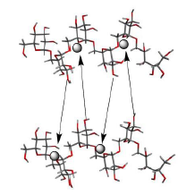

Ferric derisomaltose, CAS number 1345510-43-1 MW approximately 165,000 Daltons

Other similar iron supplement injection products registered in Australia are Ferrum H (iron polymaltose), Ferrosig (iron polymaltose), Venofer (iron sucrose) and Ferinject (iron carboxymaltose).

Ferric derisomaltose is a dark reddish brown powder containing 24% iron(III). It is highly soluble in water, acidic solutions (pH 1 HCl) and in basic solutions (pH 13 NaOH). It is also highly hygroscopic. Potential impurities are adequately controlled.

### Drug product

Monofer is a sterile, dark brown, non-transparent solution with pH 5.0 to 7.0, containing ferric derisomaltose dissolved in water for injections and filled into Type I glass vials. Each 1 mL of solution contains approximately 417 mg of ferric derisomaltose equivalent to 100 mg of elementary iron. No overages are used in the formulation.

The proposed strengths are vials of: 100 mg/1 mL, 200 mg/2 mL, 500 mg/5 mL and 1000 mg/10 mL (expressed as the amount of iron per mL), available packs of 1, 5, and 10 vials, 5 and 10 vials, 1, 2 and 5 vials and 1, 2 and 5 vials, respectively.

The manufacture of the product is conventional for solutions for injection that is by dissolving the drug substance in water, adjusting the pH if necessary, filtration, filling into vials and then terminal sterilisation by autoclaving.

The iron carbohydrate complex is stable in solution. Degradation is controlled in the finished product specifications by control of free iron.

No significant changes were observed during the stability trials. The data supported a shelf-life of 36 months when stored below 30°C.

### Biopharmaceutics

In solution, the iron carbohydrate complex is stable and only a very low concentration of free iron is formed from dissolution (degradation) of the active; this therefore allows slow release of iron.

Six clinical pharmacokinetic studies were carried out with different dosages of ferric derisomaltose in patients with inflammatory bowel disease, chronic kidney disease, and chemotherapy induced anaemia. Total ‘s-iron’ was the pharmacokinetic parameter in these trials.

Intravenously administered ferric derisomaltose showed dose dependency. There was a significantly higher exposure of iron (both maximum concentration (Cmax) and area under the concentration time curve (AUC)) after higher doses compared to lower doses. The t½ was 1 to 4 days with a higher t½ in the 1,000 mg IV infusion group compared to the 100, 200, and 500 mg IV bolus group.

Specific studies performed with radioactive labelled ferric derisomaltose were not conducted; instead studies conducted with 59Fe iron dextran are referred to. No clinical trials measured circulating ferric derisomaltose or differentiating iron species in vivo were presented. No direct pharmacokinetic comparisons of other iron complexes appear to have been studied. This has been brought to the attention of the Delegate.

### Quality summary and conclusions

Registration is recommended with respect to chemistry and quality control aspects. Biopharmaceutic aspects noted above have been brought to the attention of the Delegate.

## IV. Nonclinical findings

### Introduction

Link Medical Products Pty Ltd has applied to register a new chemical entity, ferric derisomaltose (Monofer). Monofer is proposed to be used for the treatment of iron deficiency in patients who are intolerant of, or unresponsive to, oral iron therapy or where there is a clinical need to deliver iron rapidly. The proposed dosing regimen involves parenteral administration of up to 500 mg by a single bolus injection for up to 3 times a week (that is up to 1500 mg/week or 30 mg/kg/week for a 50 kg patient) or by IV infusion of up to 20 mg/kg as a single dose per week. The highest recommended single dose is 20 mg/kg. The iron need and the administration schedule for Monofer must be individually established for each patient.

#### General comments

Ferric derisomaltose belongs to the same pharmacological class (parenteral iron preparations for the treatment of iron-deficiency anaemia) as ferric carboxymaltose (Ferinject), iron polymaltose (Ferrosig and Ferrum H) and iron sucrose (Venofer), which have been approved by the TGA for similar indications.

The majority of the nonclinical safety studies were conducted with ABT-870 (iron(III)-hydroxide oligosaccharide), an early development form of ferric derisomaltose. ABT-870 and ferric derisomaltose (Monofer) contain an identical oligosaccharide, isomaltoside 1000, and differ in the iron/oligosaccharide ratio and free iron (III) concentration (0.01% versus 0.004%). The iron oligosaccharide complex in ABT-870 is less strong than the iron oligosaccharide complex in Monofer due to a higher glucose versus iron atom ratio (0.85 versus 0.66) and a lower apparent peak molecular weight (125 kDa versus 165 kDa). The content of labile (weakly bound) iron is expected to be higher in ABT-870. The sponsor has justified the use of ABT-870 in the submitted nonclinical studies to support the safety profile of Monofer on the basis that there is greater potential for toxicity with ABT-870 since toxicity is associated with free and/or labile iron. However, in the absence of a tissue distribution study comparing the two forms of the drug substance, it is unclear whether the target organs of ABT-870 and ferric derisomaltose are the same.

### Pharmacology

#### *Primary pharmacology*

Only one pharmacology study (Study 2134) was conducted to evaluate the efficacy of ABT‑870 in an animal model of anaemia. In this study a single dose of 50 mg/kg was administered subcutaneously to iron deficient piglets (with microcytic hypochromic iron deficiency anaemia). All haematological parameters assessed returned to normal levels within 1 week post dose, an outcome that would have taken 3 to 4 weeks without iron supplementation. Given the history of clinical use overseas, this single study is considered sufficient to demonstrate pharmacological effects.

##### Secondary pharmacodynamics and safety pharmacology

Specialised safety pharmacology studies with ABT-870 covered the cardiovascular, respiratory, renal, gastrointestinal and central nervous systems. All except one cardiovascular study were conducted according to good laboratory practice (GLP) and all used the intended clinical route of administration (IV). There were no adverse effects on the central nervous system (mice and rats), respiratory system (dogs) and gastrointestinal system (rats) when ferric derisomaltose was administered at doses of up to 80 mg/kg (4 times the maximum recommended clinical dose of 20 mg/kg).

Test article related effects were observed in the cardiovascular studies. In one non GLP study, dogs in the high dose group (21.3 mg iron/kg by a 10 minute infusion) exhibited transient increases in mean arterial pressure (6 to 18% above baseline) and heart rate (28%), but only minor effects by bolus injection at up to 14.3 mg/kg. In a GLP study, dogs receiving a slow IV injection of 80 mg/kg ferric derisomaltose exhibited a rapid, transient increase in heart rate (10 to 30% above baseline) and left ventricular dp/dt (10 to 29%). Heart rate returned to pre-dose values 5 minutes after dosing, while left ventricular dp/dt decreased to below baseline by around 14% from 5 minutes after dosing. There was also a transient decrease in PR (4 to 17%) and increase in QTcb (3 to 10%) intervals (but not QT, QTcf and QTcv). There were small increases in mean blood pressure (5 to 9%) and left ventricular systolic pressure (5 to 9%) from 5 to 30 minute Associated with the cardiovascular effects, respiratory rate and minute volume were increased (approximately30% and approximately20%, respectively) and tidal volume decreased (approximately7%) from 5 to 20 minutes after dosing; however, no effects in respiratory function were detected in another GLP study in dogs at the same dose. Cardiovascular function may be transiently altered in patients receiving Monofer treatment.

In rats administered 80 mg/kg ABT-870, a reduction in urine output (86%) and urinary sodium excretion (78%) and an increase in urinary protein excretion (43%) were observed at 5 hours post-dosing compared with controls. The potential of ABT-870, Venofer or ferric chloride to induce kidney injury was also assessed by measuring urinary nephrotoxicity markers, GSTα and GSTπ. The levels of these markers were similar in all groups over 24 hours after a single dose at 2.9 mg/kg. However, the study lacked a control group, and therefore it was not possible to determine whether any of the test articles caused elevations above normal and hence caused nephrotoxicity. While reduced urinary output and increased protein excretion suggest effects on renal function, repeat dose toxicity studies at up to 80 mg/kg (4 times the maximum recommended clinical dose 20 mg/kg as a single dose or 8 times the maximum weekly clinical dose 30 mg/kg/week) in rats and dogs showed no evidence of renal toxicity (including urinalysis) except for a small increase in serum urea nitrogen in rats at 80 mg/kg.

##### Pharmacokinetics

The submitted pharmacokinetic data were extremely limited, with data available from just two urinary excretion studies in dogs dosed with ABT-870 and one embryofetal study in rabbits dosed with ferric derisomaltose.

Tissue distribution studies were not submitted. These are especially important since the chemical entity used in the nonclinical program, ABT-870, has different chemical properties to ferric derisomaltose (see general comments above). Given the different composition of the two forms, tissue distribution could differ, which is important for assessing target organs of toxicity. The absence of tissue distribution studies is a major deficiency of nonclinical data.

The renal excretion of iron was examined in dogs. Group sizes were small (n = 2) therefore results should be interpreted with caution. At the low dose of 0.7 mg/kg, serum iron concentrations, and the % dose excreted over 24 hours in ABT-870-and Venofer-treated mice were comparable (3.4% and 3.8% of dose). Interestingly, urinary iron excretion in ferric chloride treated mice (0.3% of dose) was significantly lower than the ABT-870 and Venofer groups. At the high dose of 2.9 mg/kg, ABT-870 was excreted via the urine more rapidly than Venofer (7.7% compared with 4.3% of dose). Similar comparative results were obtained in the renal function study in dogs with a larger group size (n = 4).

### Toxicology

#### Acute toxicity

The acute toxicity of ABT-870 was assessed in three mouse and two rat studies where it was administered by the clinical route at doses of up to 2000 mg/kg in mice and 250 mg/kg in rats. Mortality and morbidity was observed in the mouse studies at doses at or greater than 125 mg/kg; mortality was not observed in the rat studies at up to 250 mg/kg. The most prominent pathological findings in these studies were organ discolouration (mainly kidney, liver, lymph nodes and prostate) and occasional lymph node enlargement in one rat study, probably as a result of iron deposition. Thus, ABT-870 exhibited moderate acute toxicity by the IV route.

#### Repeat-dose toxicity

Pivotal studies were conducted with ABT-870 in a rodent species (rats; duration 4 weeks) and a non rodent species (dogs; duration 4 weeks). Group sizes in the studies were adequate and both studies used animals of both sexes and the clinical route (IV). The dosing frequency in these studies was thrice weekly. Preliminary studies of shorter duration were also conducted in rats and dogs with small group sizes and various dosing regimens (daily for 5 days in rats or every second day for up to 13 days).

The longest duration of repeat dose studies conducted was 4 weeks (rats and dogs). However, according to International Conference on Harmonisation (ICH) guideline M3 (R2);[3] nonclinical studies of this length can support a maximum of two weeks of clinical administration. Although ferric derisomaltose was administered only once to patients in all clinical trials (with patients observed for between 72 hours and 4 weeks), the sponsor does not specify the dose or frequency of dosing after the initial dose but states in the PI that ‘After the current iron deficit has been corrected, patients may require continued therapy with Monofer to maintain target levels of haemoglobin (Hb) and acceptable limits of other iron parameters’. Nonclinical studies do not support clinical dosing durations exceeding 2 weeks.

##### Relative exposure

No toxicokinetic data were obtained in the repeat dose toxicity studies, and as discussed above there were no pharmacokinetic data in animal species except for limited urinary excretion data. Although without drug exposure data it is difficult to establish whether the animal studies served as appropriate models for the assessment of drug toxicity in humans, given that ferric derisomaltose is administered IV, and iron, as the active component of the drug substance, is not metabolised, exposure comparisons are made on the weekly dose (Table 3). The animal/human exposure ratios were low; however, animals used in the toxicity studies were not anaemic and had normal iron status.

Table 3: Relative exposure in repeat-dose toxicity studies

|  |  |  |  |
| --- | --- | --- | --- |
| Species | Study duration [Study no.] | Dose (mg/kg) | Exposure ratio# |
| Rat (SD) | 4 weeks  [ITR-5320]  3 doses/week | 5 | 0.5 |
| 20 | 2 |
| 80 | 8 |
| 4 weeks  [ITR-2693]  3 doses/week | 5 | 0.5 |
| 20 | 2 |
| 80 | 8 |
| Human |  | 30 mg/kg/week* | – |

* based on the clinical dose of up to 500 mg for up to 3 times a week by IV bolus injection and assuming a patient’s body weight of 50 kg; # based on the weekly dose.

##### Major toxicities

The principal feature evident in both the rat and dog studies was whole body pigmentation and brown discolouration of urine by gross examination, and the deposition of brown pigment (probably iron) in macrophages, observed in multiple tissues but to a greater extent in lymphoid tissues. Neither the rat nor the dog pivotal study incorporated recovery groups to demonstrate potential reversibility of any adverse findings.

In both the dog and rat studies, brown pigment deposition and hyperplasia of Kuppfer cells, pigmented hepatocytes were observed in all dose groups. Centrilobular hypertrophy of hepatocytes was seen in dogs at ≥ 20 mg/kg. There was an associated dose dependent increase in liver weight and enlarged liver in both rat and dog studies. In both rats and dogs at 80 mg/kg, serum levels of AST and alkaline phosphatase (ALP) were elevated, in dogs at the same dose, serum gamma glutamyl transpeptidase (GGT) and triglycerides increased and albumin decreased, and in rats serum ALT, total bilirubin and cholesterol elevated, all indicating hepatotoxicity.

In rats, a dose dependent increase in spleen weights was accompanied by erythroid extramedullary haematopoiesis at ≥ 20 mg/kg. In dogs, only brown pigmentation was observed in spleen.

There was a 25% increase in leukocytes in rats at 80 mg/kg. Neutrophils, lymphocytes and monocytes increased by approximately 50%, 15% and 50%, respectively, compared to controls. No such changes were observed in dogs.

Serum urea nitrogen was elevated in rats at 80 mg/kg without an increase in serum creatinine or histological abnormalities of kidneys. No signals of renal effects were detected in dogs. The potential for renal toxicity is low.

Atrophy of the prostate and the seminal vesicle, seminiferous epithelium degeneration and degenerative germ cells in the epididymis was observed in rats at 80 mg/kg.

There were significant reductions in body weight gain in the rat at all doses but not in the dog pivotal study. The decreased body weight gain was associated with decreased food consumption.

#### Genotoxicity

An adequate range of studies compliant with ICH guideline S2 (R1);[4] were submitted and included a bacterial reverse mutation test, an in vitro chromosomal aberration assay, and an in vivo bone marrow micronucleus test. ABT-870 was not genotoxic in either of the in vitro assays, in the presence or absence of metabolic activation, or in the in vivo bone marrow micronucleus test.

#### Carcinogenicity

Carcinogenicity studies were not submitted. The sponsor has not provided a justification for this. However, given the negative genotoxicity findings, chemical nature of ferric derisomaltose (iron and simple sugars), as well as its use solely as a replacement therapy product, the lack of carcinogenicity studies is considered acceptable.

#### Reproductive toxicity

A reproductive toxicology assessment of ferric derisomaltose was conducted in rats (combined fertility/embryofetal study) and rabbits (embryofetal study), considered adequate models for human reproductive toxicity testing, after daily IV administration. A pre/post-natal study was not conducted.

All studies were conducted according to Good Laboratory Practice (GLP) and utilised adequate animal numbers. Toxicokinetic data was obtained only in the rabbit embryofetal study. Exposure comparisons were based on mg administered per kg for the reproductive studies (see Table 4). Although the relative exposures achieved in all the studies were low, a significant dose dependent reduction in maternal body weight gain was observed in both the rat and rabbit studies, as well as a significant reduction in food consumption in the high dose rabbits and swollen facial area and forelimbs in high dose rats, indicating maternotoxicity. Serum iron level in umbilical vein blood in rabbits on gestation Day 21 (GD21) (one day after the last dose) was below the limit of quantitation, although quantifiable levels were detected in serum of high dose dams. It is known that iron is transferred from mother to fetus and the transfer is regulated by transporters probably involving ferroportin and divalent metal transporter 1.[5]

##### Relative exposure

Table 4: Relative exposure in reproductive toxicity studies

|  |  |  |  |
| --- | --- | --- | --- |
| **Species** | **Study [Study no.]** | **Dose ( mg/kg/day)** | **Exposure ratio#** |
| **Rat** (SD) | Fertility and embryofetal development  [Study WIL-103501] | 2/3^ | 0.47/0.7^ |
| 6/11^ | 1.4/2.6^ |
| 19/32^ | 4/7.5^ |
| **Rabbit** (NZW) | Embryofetal development  [Study WIL-103502] | 11 | 2.6 |
| 25 | 5.8 |
| 43 | 10 |
| **Human** | Study PK-IBD-02 | 30 mg/kg/week* | – |

^ male/female dose; * based on the clinical dose of up to 500 mg for up to 3 times a week by IV bolus injection and assuming a patient’s body weight of 50 kg; # based on weekly dose.

There were no effects on fertility or reproductive performance in male rats given IV doses up to 19 mg/kg/day or females given 32 mg/kg/ day. Mating, fertility, sperm parameters, and oestrus cycling were unaffected, and implantation, litter size and fetal body weight were unaltered by treatment. However, effects on male reproductive organs were observed in the repeat dose study in rats at 80 mg/kg three times weekly (see repeat dose toxicity above). Fetal examination showed a dose dependent increase in the incidence of bent scapulae in the high dose group and ribs bent in all dose groups. While bent bones in rats may reverse during postnatal development, there is no literature showing bent bones in humans also reverse during postnatal development. It was possible that high iron levels adversely affect bone formation.

In the rabbit embryofetal study, there was a dose dependent increase in the number of some external, visceral and skeletal malformations (including domed head, narrow pectoral regions, carpal and/or tarsal flexure, cleft palate, microglossia, narrow pelvic region, high arched palate, hydrocephaly, septal defects, large anterior fontanel and hyoid bodies and/or unossified arches) at ≥ 25 mg/kg/day. In the high dose rabbits (43 mg/kg/day), there was a significant reduction in viable fetuses, implantation sites, corpora lutea, mean fetal weight, and number of gravid females and an increase in late resorptions and post-implantation loss. Caution should therefore be exercised when Monofer is used in pregnant women.

##### Pregnancy classification

The sponsor has proposed Pregnancy Category B3 on the basis that no adequate and well controlled trials of ferric derisomaltose have been conducted in pregnant women.[6] Pregnancy Category B3 is considered appropriate in view of the embryofetal findings in rats and rabbits, similar embryofetal findings and pregnancy category for other parenteral iron preparations.

#### Local tolerance and anaphylaxis

A number of studies were conducted in rats and guinea pigs to evaluate the pro-inflammatory potential of ferric derisomaltose and anaphylactic potential of ABT-870. In rats, ferric derisomaltose, elicited a significant local inflammatory responsethat was larger in magnitude compared to ferric carboxymaltose (Ferinject) but smaller than iron sucrose (Venofer). ABT-870 caused a moderate anaphylactic response when administered via the intended IV dosing route, and was tolerated comparably to (or slightly less than) iron dextran or iron sucrose. ABT-870 did not cause sensitisation in guinea pigs. Monofer is expected to cause similar anaphylactic reactions to Cosmofer (iron dextran) in patients.

#### Comments on the nonclinical safety specification of the risk management plan

The sponsor’s draft Risk Management Plan (RMP) does not identify any concerns that should be monitored. Toxicity findings were related to iron deposition in various tissues. While extensive nonclinical toxicity studies with ferric derisomaltose may not be necessary, the lack of a tissue distribution study comparing the early development form, ABT-870 with ferric derisomaltose and the short duration of repeat dose studies are significant deficiencies of the nonclinical data package. In addition, the following nonclinical findings are of clinical concern:

* Reproductive toxicity. Ferric derisomaltose caused fetal malformations at subtherapeutic (0.7 fold) exposures in rats and fetal malformations and embryofetal deaths in rabbits at exposures greater than or equal to 5.8 times therapeutic exposures. Embryofetal effects are identified as significant risks in pregnant women.
* Anaphylaxis. Nonclinical studies demonstrated that ferric derisomaltose has the potential to cause anaphylactic reactions. The RMP should include statements to convey that such reactions are possible.

### Nonclinical summary and conclusions

* The majority of the nonclinical safety studies were conducted with ABT-870 (iron(III)-hydroxide oligosaccharide), an early development form of ferric derisomaltose. Only reproductive studies and a local inflammation study were conducted with the clinical form, ferric derisomaltose. All pivotal safety-related studies were GLP compliant. Notable deficiencies of the submitted dossier were the lack of pharmacokinetic data for ferric derisomaltose, particularly tissue distribution studies with ABT-870 and ferric derisomaltose, and the relatively short duration (≤ 4 weeks) of the repeat dose studies.
* Ferric derisomaltose was shown to restore haematological parameters in piglets with severe microcytic hypochromic iron deficiency anaemia.
* Safety pharmacology studies assessed effects on the cardiovascular, respiratory, renal, gastrointestinal and central nervous systems. Minor test article related effects were observed in the cardiovascular studies conducted in dogs (transient increases in mean arterial pressure, heart rate, and left ventricular dp/dt). Reduced urinary output and sodium excretion and increased protein excretion were seen in rats after an IV dose of 80 mg/kg ABT-870, but there were signals indicative of renal effects in the repeat dose studies in rats and dogs at the same dose. No adverse effects were observed in any other study.
* The only pharmacokinetic study in dogs showed urinary excretion of 7.7% of the dose in 24 hours after a single dose of ABT-870, which was more than the urinary excretion for iron sucrose (4.3% of dose).
* ABT-870 exhibited moderate acute toxicity when administered by the clinical route to mice, with mortality occurring at 125 mg/kg. No mortality was observed in rats at up to 250 mg/kg.
* Repeat dose toxicity studies by the IV route were conducted in rats and dogs (up to 1 month duration, 8 times the maximum recommended clinical weekly dose in both species). The major observation in these studies was the deposition of brown pigment (probably iron) in a variety of organs. In addition, increased liver weights, Kupffer cell hyperplasia and centrilobular hypertrophy, accompanied by increased hepatotoxicity markers in serum, were evident in high-dose groups. Other findings in rats included increased spleen weights and extramedullary haematopoiesis, moderate increases in leukocytes, and male reproductive organ abnormalities (atrophy of prostate and seminal vesicles, seminiferous epithelium degeneration of testes, and degenerative germ cells in epididymides).
* Ferric derisomaltose was not mutagenic in the bacterial mutation assay or clastogenic *in vitro* (in human lymphocytes) or *in vivo* (in the mouse micronucleus test).
* No carcinogenicity studies were conducted. This is acceptable since ferric derisomaltose is not intended to be used regularly for extended periods, and is used as an iron replacement therapy.
* Fertility was unaffected in male and female rats treated with ferric derisomaltose at doses up to 4 and 7.5 times the clinical dose, respectively, but abnormalities of male reproductive organs were observed in the 4 week repeat dose toxicity study at 80 mg/kg thrice weekly. Embryofetal losses and malformations were evident in rats and rabbits at doses up to 7.5 and 10 times the clinical dose, respectively.
* ABT-870 caused a moderate anaphylactic response, similar to (or slightly less than) iron dextran (Cosmofer) and iron sucrose (Venofer) when administered via the intended IV dosing route. Monofer induced a considerably greater local inflammatory response in rats than Ferinject but considerably less than iron sucrose.

#### Conclusions and recommendation

* A primary pharmacology study in piglets indicated that ferric derisomaltose is effective in the treatment of iron deficient anaemia.
* Safety pharmacology studies suggest mild to moderate transient cardiovascular effects in patients.
* The pharmacokinetic profile of ferric derisomaltose was not characterised in the nonclinical studies. The majority of nonclinical toxicity studies were conducted with the early development form ABT-870, which is not identical to the clinical moiety, ferric derisomaltose. A tissue distribution study should have been conducted to bridge nonclinical studies with ABT-870 to the clinical moiety, ferric derisomaltose.
* ABT-870 exhibited a low to moderate order of toxicity in both the single-and repeat-dose studies. Toxicity findings were predominantly related to iron deposition in various tissues.
* Ferric derisomaltose is not considered to pose a genotoxic or carcinogenic hazard.
* Ferric derisomaltose did not affect fertility in rats, but adverse effects on male reproductive organs were observed in the repeat dose toxicity study. Embryofetal development studies in rats exposed to subtherapeutic doses and rabbits exposed to supratherapeutic dosages (≥ 5.8 fold) suggest ferric derisomaltose could cause embryofetal malformations in humans. Its use in pregnancy should only be considered if the benefits of treatment outweigh these risks.
* The nonclinical data package is deficient. The short duration of the repeat dose studies do not support clinical administration beyond 2 weeks, and there was no study to compare the tissue distribution of ABT-870 with the clinical moiety. However, given that toxicity of ABT-870 and most likely the clinical form of ferric derisomaltose is mainly related to excess iron deposition in tissues, the deficiency of nonclinical data may not preclude registration of ferric derisomaltose for the proposed indication provided safety has been adequately demonstrated by clinical data.

The nonclinical evaluator also made comments regarding the draft PI but presentation of this is beyond the scope of the AusPAR.

## V. Clinical findings

A summary of the clinical findings is presented in this section. Further details of these clinical findings can be found in Attachment 2.

### Introduction

#### Background

##### Iron deficiency anaemia

Iron deficiency develops when:

1. iron intake is inadequate for needs (for example during growth spurts or during pregnancy)
2. there is malabsorption of iron
3. there is increased loss of iron, usually consequent on gastrointestinal or uterine blood loss
4. there is renal loss of haemosiderin, as a result of chronic intravascular haemolysis
5. there is a combination of these factors
6. there is sequestration of iron at an inaccessible site, as in idiopathic pulmonary haemosiderosis (rare).

Anaemia occurs when a lack of reticuloendothelial storage iron and an inadequate rate of delivery of iron to developing erythroid cells in the marrow leads to reduced synthesis of haem and therefore reduced production of haemoglobin and red blood cells.

Clinical features include those attributable to anaemia, such as fatigue, pallor and exertional dyspnoea. More specific features of iron deficiency, apparent only when iron deficiency is severe, include koilonychia (spoon-shaped nails), angular cheilosis (cracks in the skin at the corners of the mouth) and glossitis (inflammation of the tongue).

##### Current treatment options

The goal of therapy for iron deficiency anaemia is to supply sufficient iron to reverse the haemoglobin deficit and replenish storage iron. Generally, iron therapy for iron deficiency can be deferred until the underlying cause of the lack of iron has been identified. Oral iron is the treatment of choice for most patients because of its effectiveness, safety, and economy and should always be given preference over parenteral iron for initial treatment. The risk of local and systemic adverse reactions restricts the use of parenteral iron to patients who are unable to absorb or tolerate adequate amounts of oral iron. Rarely, red blood cell transfusions are needed to prevent cardiac or cerebral ischemia in patients with severe anaemia or to support patients whose chronic rate of iron loss exceeds the rate of replacement possible with parenteral therapy.

Most patients can tolerate oral iron therapy, but 10% to 20% have symptoms attributable to iron. The most common side effects are gastrointestinal. Decreasing the amount of iron in each dose usually is effective in controlling side effects. Iron preparations with other additives, polysaccharide–iron complexes, or enteric coatings or in sustained release forms do not offer any advantages that cannot be achieved by reducing the dose of plain ferrous salts.

Parenteral iron therapy should be reserved for the exceptional patient who:

* remains intolerant of oral iron despite repeated modifications in dosage regimen;
* has iron needs that cannot be met by oral therapy because of either chronic uncontrollable bleeding or other sources of blood loss;
* has malabsorption of iron; and/or;
* is in need of rapid iron correction.

Iron polymaltose and iron sucrose are approved by the TGA for parenteral iron replacement. Both have been widely used, often in haemodialysis patients receiving recombinant human erythropoietin, but neither prospective, randomised controlled comparisons among the agents or long term safety studies have been done. Although infrequent, immediate life threatening anaphylactic reactions are the most serious risk associated with use of either intramuscular or intravenous iron preparations; these may have a fatal outcome, and can occur with all parenteral iron preparations. Delayed but severe serum sickness like reactions may also develop, with fever, urticaria, adenopathy, myalgias, and arthralgias.

The prognosis for iron deficiency itself is excellent, and the response to oral or parenteral iron also is excellent. Clinical and subjective indications of constitutional improvement are observed within the first few days of treatment, with the patient reporting an enhanced sense of wellbeing and increased vigour and appetite. A reticulocytosis begins within 3 to 5 days, is maximal by 8 to 10 days, and then declines. The Hb concentration begins to increase after the first week and usually returns to normal within 6 weeks. Complete recovery from microcytosis may take up to 4 months. With oral iron dosage totalling 200 mg/day or less, the plasma ferritin concentration usually remains less than 120 µg/L until the anaemia is corrected and then gradually rises as storage iron is replaced over the next several months. Although epithelial abnormalities begin to improve promptly with treatment, resolution of glossitis and koilonychia may take several months. The overall prognosis depends on the underlying disorder responsible for the iron deficiency.

Failure to obtain a complete and characteristic response to iron therapy necessitates a re-evaluation of the patient. A common problem is mistaking the anaemia of chronic disease for the anaemia of iron deficiency. Co-existing conditions, such as other nutritional deficiencies; hepatic or renal disease; or infectious, inflammatory, or malignant disorders, may slow recovery and continuing occult blood loss may be responsible for an incomplete response. With oral iron therapy, the adequacy of the form and dose of iron used should be reconsidered; compliance with the treatment regimen reviewed, and the possibility of malabsorption considered.

#### Clinical rationale

Oral iron therapy is often limited by poor patient compliance. Up to 40% of iron treated patients complain of abdominal pain, nausea, vomiting, or constipation often leading to noncompliance. Complicating illness may also interfere with response to iron therapy. Inflammatory illness can suppress iron absorption and reticulo-endothelial system (RES) release.

#### Guidance

Prior to submission it was agreed with the TGA that Appendices 16.1 and 16.2 were required to be included with the clinical trial study reports. Otherwise, there were no specific issues raised or questions asked.

#### Contents of the clinical dossier

The clinical dossier documented a full clinical development program of pharmacology, efficacy and safety studies.

The indication being sought for this new drug application is supported primarily by safety and efficacy results from 9 pivotal, controlled studies:

* Study P-IDA-01
* Study P-CKD-02
* Study P-CKD-03
* Study P-IBD-01
* Study P-IBD-01-ext
* Study P-CABG-01
* Study P-CIA-01
* Study P-PP-01
* Study P-PP-02

The indication being sought for this new drug application is supported by results from 2 safety studies:

* Study P-CKD-01/P-CHF-01
* Study P-IBD-02

Biopharmaceutic and clinical pharmacology studies included the following 6 studies:

* Study PK-IBD-01 (COSMOS-01)
* Study PK-IBD-02
* Study PK-CKD-05
* Study PK-CKD-03
* Study PK-CIA-06
* Study PK-CIA-04

In addition, there are post-marketing data and periodic safety update report documents provided for evaluation.

The submission also included; clinical overview, summary of clinical pharmacology, summary of clinical efficacy, summary of clinical safety, quality overall summaries of ferric derisomaltose tabulations, and statistical analysis plan and literature references.

#### Paediatric data

The reviewer noted that no paediatric data was provided. The sponsor has an agreed Paediatric Plan under the Paediatric Research Equity Act (PREA) in the USA. The date on which the sponsor is first required to submit a Paediatric Assessment is July 2021. The reason for deferral of the requirements for the age group 0 to < 18 years was recorded as ‘Paediatric studies should be delayed until additional safety and efficacy in the adult population are found acceptable by the Food and Drug Administration (FDA) (chronic kidney disease (CKD) adults).’

The reviewer considers that Monofer has potential clinical value in paediatric patients.

#### Good clinical practice

The clinical study reports in the submission complied with CPMP/ICH/135/95 Note for Guidance on Good Clinical Practice. There were no notable Good Clinical Practice (GCP) deviations.

The protocol, consent form, study subject information sheets, and advertisements were submitted by each investigator to a duly constituted Institutional Review Board for review and approval before study initiation. All patients provided written informed consent after adequate explanation of the aims, methods, objectives, and potential hazards of the study and before undertaking any study related procedures.

### Pharmacokinetics

#### Studies providing pharmacokinetic data

The 6 clinical studies contributing to the clinical pharmacology evaluation of ferric derisomaltose are listed in Table 5.

Table 5: Studies providing pharmacokinetic information

|  |  |  |  |
| --- | --- | --- | --- |
| Subtopic | Study ID | Aim of the study | Synopsis |
| **Pharmacokinetics in special populations** | | | |
| Target population § | PK-IBD-01 (COSMOS-01) | The primary objective of this trial was to provide PK data from 12 subjects with an established diagnosis of inflammatory bowel disease (IBD) after IV bolus injection of iron oligosaccharide (Monofer).* | An open label, randomised, cross over, single centre, pharmacokinetic trial of iron oligosaccharide 100 mg and 200 mg administered by intravenous bolus dose to subjects with Inflammatory Bowel Disease (IBD). |
| PK-IBD-02 | To assess PK properties of higher doses (500 mg and 1,000 mg) of ferric derisomaltose in IBD subjects.* | Open label pharmacokinetic study of ferric derisomaltose (Monofer) administered by 500 mg intravenous bolus injection or 1,000 mg intravenous infusion to subjects with IBD. |
| PK-CIA-06 | To assess PK properties (s-iron) of 250 mg and 500 mg doses of ferric derisomaltose in patients diagnosed with non-haematological malignancies (solid tumours only) associated with CIA.* | A prospective, open label randomised PK trial of ferric derisomaltose conducted at 2 centres in the USA. A total of 11 patients were randomised in a 1:1 ratio to either 250 mg IV bolus injection or 500 mg IV infusion of ferric derisomaltose. |
| PK-CIA-04 | To assess PK properties of escalating doses (500 mg IV bolus and 1,000 mg IV infusion) of ferric derisomaltose in patients with CIA.* | A prospective, open label, randomised PK trial of ferric derisomaltose conducted at 4 centres in India. A total of 16 patients were randomised 1:1 to either 500 mg IV bolus or 1,000 mg IV infusion treatment. |
| Renal impairment | PK-CKD-05 | To assess PK properties (s-iron) of 100 mg, 200 mg, and 500 mg doses of ferric derisomaltose in patients with CKD stage 5D.* | A prospective, open label randomised PK trial of ferric derisomaltose conducted at a single centre in the USA. A total of 18 patients were 1:1:1 randomised to 100 mg, 200 mg, and 500 mg IV bolus treatment. |
| PK-CKD-03 | To assess PK properties (s-iron) of 500 mg and 1,000 mg doses of ferric derisomaltose in patients with NDD-CKD.* | A prospective, open label randomised PK trial of ferric derisomaltose conducted at 6 centres in India. A total of 16 patients were randomised in a 1:1 ratio to either 500 mg IV bolus injection or 1,000 mg IV infusion of ferric derisomaltose. |
| **Genetic/gender related PK** | | | |
| Other genetic variable | PK-IBD-02 | To assess PK properties of higher doses (500 mg and 1,000 mg) of ferric derisomaltose in IBD subjects. All 16 patients were Asian | Open label pharmacokinetic study of ferric derisomaltose (Monofer) administered by 500 mg intravenous bolus injection or 1000 mg intravenous infusion to subjects with IBD. |
| PK-CKD-05 | To assess PK properties (s-iron) of 100 mg, 200 mg, and 500 mg doses of ferric derisomaltose in patients with CKD stage 5D. All 18 patients were African-American | A prospective, open label randomised PK trial of ferric derisomaltose conducted at a single centre in the USA. A total of 18 patients were 1:1:1 randomised to 100 mg, 200 mg, and 500 mg IV bolus treatment. |
| PK-CKD-03 | To assess PK properties (s-iron) of 500 mg and 1,000 mg doses of ferric derisomaltose in patients with NDD-CKD. All 16 patients were Asian. | A prospective, open label randomised PK trial of ferric derisomaltose conducted at 6 centres in India. A total of 16 patients were randomised in a 1:1 ratio to either 500 mg IV bolus injection or 1,000 mg IV infusion of ferric derisomaltose. |

* Indicates the primary PK aim of the study. § Subjects who would be eligible to receive the drug if approved for the proposed indication. NDD-CKD = Non-dialysis dependent chronic kidney disease

#### Evaluator’s conclusions on pharmacokinetics

The application included detailed characterisations of the clinical pharmacology of ferric derisomaltose, which were based on preclinical studies and clinical development in 5 Phase I open label, randomised trials and 1 cross over trial; in subjects with inflammatory bowel disease, chronic kidney disease, and cancer. Pharmacokinetic assessments included PK variables, S-iron (free and bound) and U-iron; and PK endpoints: AUC0-end;[7] Cmax; Tmax;[8] Ke;[9] and t½;[10], and AUCinf. PK blood sampling schedule was performed at appropriate time intervals before and after dosing.

Following IV administration, ferric derisomaltose is taken up by the cells in the RES, mainly in the liver and spleen, from where iron is slowly released for use in haemoglobin production. Cells of the RES split the complex into iron and isomaltoside. The isomaltoside moiety is either metabolised or excreted and iron is immediately bound and stored in ferritin. Negligible amounts of iron are lost via the urinary or alimentary pathways. Similarly, iron is usually not detectable in the dialysate when administered during dialysis treatment (valid for both haemodialysis and peritoneal dialysis).

Six clinical PK trials were conducted with different dosages (100, 200, 250, 500, 1000 mg) of ferric derisomaltose. There was a dose dependent increase in AUC and Cmax which was observed within all 3 indications; inflammatory bowel disease (IBD), CKD, and chemotherapy induced anaemia (CIA). t½ varies between 23.2 to 87.87 hours with the highest value observed for patients dosed with 1000 mg ferric derisomaltose.

The design of each of the 6 PK studies was in accordance with accepted guidelines for ferric derisomaltose and the objectives relevant to the indications for this product for use in treating iron deficiency in a range of clinical settings. It is generally accepted that in equivalent dosages, IV iron compounds are likely to lead to comparable efficacy as measured by the ability to increase Hb. The doses selected for the PK studies, ranging from 100 to 1000 mg, were standardised for subjects with iron deficiency anaemia. Subject groups were chosen to ensure safety and PK values in a subject group relevant for a future potential indication of ferric derisomaltose and where a possible benefit could be envisaged. Sample sizes were adequate and the duration of each study was generalizable to usual practice. For all provided studies inclusion/exclusion criteria were appropriate and compliance with treatment was acceptable.

All studies were conducted as planned and protocol deviations and violations were provided. All patients were accounted for throughout each of the studies and subjects were compliant with treatment. Collection and storage of samples were described and adequate. The assays used to determine blood and urine concentrations were adequately described and validated.

The proposed PI is an adequate summary of the PK data presented in the submission.

### Pharmacodynamics

#### Studies providing pharmacodynamic data

Five clinical trials have been carried out with different dosages of ferric derisomaltose in inflammatory bowel disease (IBD) patients, chronic kidney disease (CKD) patients, and oncology patient with chemotherapy induced anaemia (CIA) to establish the PK profile of ferric derisomaltose across relevant therapeutic areas and different dosages (Table 6 and Table 7). Total s-iron has been used as the PK parameter in these trials.

Table 6: Pharmacodynamics trials

|  |  |  |  |  |  |
| --- | --- | --- | --- | --- | --- |
| Trial ID | Phase | Patients | Location | Dosage  ( mg) | Number of  patients |
| PK-IBD-02 | PK | IBD | India | 500, 1,000 | 16 |
| PK-CKD-03 | PK | Non-dialysis Dependent chronic kidney disease (NDD-CKD) | India | 500, 1,000 | 16 |
| PK-CKD-05 | PK | Haemodialysis CKD | USA | 100, 200, 500 | 18 |
| PK-CIA-04 | PK | CIA | India | 500, 1,000 | 16 |
| PK-CIA-06 | PK | CIA | USA | 250, 500 | 11 |

#### Evaluator’s conclusions on pharmacodynamics

Evidence of a therapeutic response, based on raised reticulocyte count and Hb, was observed within 48 hours of administration of ferric derisomaltose. Following the slow release of bioavailable iron, serum ferritin peaks within days after an intravenous dose of ferric derisomaltose and slowly returns to Baseline after weeks.

All studies were conducted as planned, and protocol deviations and violations were provided. Collection and storage of samples were described and adequate. The assays used to determine blood and urine concentrations were adequately described and validated. For all provided studies inclusion/exclusion criteria were appropriate and compliance with treatment was acceptable.

The variables measured to assess pharmacodynamic (PD) outcomes were in accord with accepted practice and guidelines for iron replacement in iron deficiency anaemia and the study duration was adequate for assessment of effect.

There were no deficiencies in the design or conduct of any of the submitted PK/PD studies and the results are valid and generalizable to the proposed indications for ferric derisomaltose.

The proposed PI is an adequate summary of the PD data presented in the submission.

### Dosage selection for the pivotal studies

#### Pharmacokinetics and pharmacodynamics: dose finding studies

Table 7 shows dosages for each PK study.

Table 7: Dosages for PK studies

|  |  |  |  |
| --- | --- | --- | --- |
| Trial identifier | Trial design and type of control | Test products dosage regimen route of administration | Diagnosis of patients |
| PK-IBD-01(COSMOS-01) | Cross over trial | 100, 200 mg ferric derisomaltose, two doses, IV | IBD patients |
| PK-IBD-02 | Open label, randomised trial | 500, 1,000 mg ferric derisomaltose, single dose, IV | IBD patients |
| PK-CKD-05 | Open label, randomised trial | 100, 200, 500 mg ferric derisomaltose, single dose, IV | CKD patients in dialysis |
| PK-CKD-03 | Open label, randomized trial | 500, 1,000 mg ferric derisomaltose, single dose, IV | NDD-CKD patients |
| PK-CIA-06 | Open label, randomised trial | 250, 500 mg ferric derisomaltose, single dose, IV | Cancer patients with CIA |
| PK-CIA-04 | Open label, randomised trial | 500, 1000 mg ferric derisomaltose, single dose, IV | Cancer patients with CIA |

#### Phase III pivotal studies investigating more than one dose regimen

Table 8 shows dosages for efficacy studies.

Table 8: Dosages used in efficacy studies

|  |  |  |  |
| --- | --- | --- | --- |
| Trial | Trial design and control | Test products Dosage Regimen Route of administration | Diagnosis |
| P-IDA-01 | Open label, randomised, comparative, non inferiority | The cumulative dose of ferric derisomaltose depended on the Hb level and body weight. Doses were 1000 (Hb ≥ 10 g/dL, < 70 kg), 1500 (Hb ≥ 10 g/dL, ≥ 70 kg or Hb < 10 g/dL, < 70 kg), or 2,000 (Hb < 10 g/dL, ≥ 70 kg) mg. Iron sucrose was dosed according to the prescribing information. | IDA of different aetiology |
| P-CKD-02 | Open label, randomised, comparative, non inferiority trial | An adapted Ganzoni formula was used for calculating the iron need. Ferric derisomaltose was administered as maximum 1,000 mg as single doses or bolus injections of 500 mg once weekly. Oral iron was administered as 200 mg daily for 8 weeks | NDD-CKD |
| P-CKD-03 | Open label, randomised, comparative, non inferiority trial | Ferric derisomaltose was administered either as a single bolus injection of 500 mg or as 500 mg split bolus doses of 100 mg, 200 mg, and 200 mg. Iron sucrose was administered as 500 mg split bolus doses of 100 mg, 200 mg, and 200 mg. | HD-CKD |
| P-IBD-01 | Open label, randomized, comparative, non inferiority trial | An adapted Ganzoni formula was used for calculating the iron need. Ferric derisomaltose was administered as maximum 1,000 mg as single doses or bolus injections of 500 mg once weekly. Oral iron was administered as 200 mg daily for 8 weeks. | IBD patients |
| P-IBD-01/Ext | open-label, multi-centre, non-randomised, observational extension trial of the lead-in trial (P-IBD-01) | Ferric derisomaltose was administered according to either a simplified dosing regimen (iron deficiency anaemia criteria) (Hb < 12.0 g/dL, TSAT < 20 %, and s-ferritin < 500 μg/L) or a maintenance dosing regimen (iron deficiency criteria) (stable Hb (Hb ≥ 12.0 g/dL), TSAT < 20 %, and s-ferritin < 500 μg/L). | IBD patients |
| P-CABG-01 | Double blind, randomised, placebo controlled, comparative trial | Ferric derisomaltose was administered as a single infusion of 1000 mg (maximum 20 mg/kg). 100 mL saline was used as placebo. | Non-anaemic patients undergoing elective or sub-acute CABG, valve replacement, or a combination thereof |
| P-CIA-01 | Open label, randomised, comparative, non inferiority trial | An adapted Ganzoni formula was used for calculating the iron need. Ferric derisomaltose was administered as maximum 1000 mg as single doses or bolus injections of 500 mg once weekly | Cancer patients with CIA |
| P-PP-01 | Open label, randomised trial | Allocated to either a single dose of 1200 mg of IV ferric derisomaltose or standard medical care with oral iron. | Post-partum bleeding |
| P-PP-02 | Open label, randomised trial | Allocated to either a single dose of 1500 mg of IV ferric derisomaltose or 1 to 2 units of Red blood cell (RBC) transfusion. | Post-partum bleeding |

#### Evaluator’s conclusions on dose finding for the pivotal studies

Currently, there is no consensus regarding the most appropriate iron deficit repletion dosing in patients with iron deficiency anaemia (IDA), partly because the iron dosing selected for virtually all trials has been based largely on clinical judgment, clinical guidelines in nephrology, or estimates from past studies. A patient’s total body iron deficit can be calculated using the Ganzoni formula (total iron dose = (actual body weight x (15 ‑actual Hb)) x 2.4 + iron stores).[11] However, because iron product labels state specific dosing regimens, this formula is not consistently used in clinical practice.[12] In clinical practice, doses are chosen based on approved product labels and local protocols, which may be weight and Hb based tables or a total cumulative dose.

It is common practice to administer a cumulative dose of approximately 1,000 mg of IV iron for the treatment of IDA. In RCTs reviewed to develop the Kidney Disease Outcomes Quality Initiative and Kidney Disease: Improving Global Outcomes (KDIGO) practice guidelines, a cumulative dose of 1000 mg of IV iron was utilised.[13] Therefore, based on current literature and published guidelines, this reviewer considers that the choice of cumulative dosages used in the PK/PD studies, which ranged from 100 to 1,000 mg, was appropriate.

Although 1,000 mg has become the standard therapeutic dose for iron deficiency of various aetiologies, this dose may not provide sufficient repletion of iron, and retreatment may be required. In many clinical situations, the treatment of IDA with IV iron has not been limited to a cumulative dose of 1000 mg. In oncology patients, two reported RCTs have used a total of up to 3000 mg iron administered in weekly doses of 100 mg.[14] In another RCT, patients with chemotherapy related anaemia received cumulative doses of IV iron ranging from 1000 to 3000 mg.[15] For the management of IDA in inflammatory bowel disease (IBD), guidelines state that anaemic patients rarely present with total iron deficits below 1,000 mg and recommend to use the Ganzoni formula to estimate iron replacement needs. Randomised clinical trials for iron replacement in IBD have shown up to 3,600 mg of iron sucrose can be safely administered.[16] There is also evidence that iron requirements of 1000 to 1500 mg or higher may be required in patients with non dialysis dependent CKD to attain target ferritin and Hb levels; and in menorrhagia, up to 2000 mg may be required to correct iron deficiency.[17]

Based on the results of the PK/PD studies and current guidelines and published reports, the pivotal efficacy and safety studies in IDA, IBD, congestive heart failure (CHF), CIA, CKD, post-partum haemorrhage, and post coronary artery bypass graft surgery (post CABG), used either an adapted Ganzoni formula or a simplified formula based on Hb and weight to calculate iron requirements, or a fixed dose. A cumulative dose of up to 3000 mg was used in the P-IBD-02 safety study.

For calculation of the cumulative amount of iron required to replete iron stores, either the Ganzoni method or the Simplified Method can be used, however it is noted that, to date, only the product information (PI) of Ferinject incorporates the Simplified Method and it is recommended that the PI contain the following statement:

‘Caution is recommended with the simplified method since it is based on experience in a single trial in adults with median Hb 104 g/L (range 61 to 146 g/L) and body weight greater than or equal to 35 kg.[18]’

For the indication, ‘*Replacement for blood loss*’, the sponsor is requested to provide evidence/justification for the statement:

‘If the volume of blood lost is known: The administration of 200 mg Monofer results in an increase of Hb which is equivalent to 1 unit blood:

Iron to be replaced = Number of units blood lost x 200. (mg iron)’.

### Efficacy

#### Studies providing efficacy data

The indication being sought for this new drug application is supported primarily by efficacy results from 9 pivotal, controlled studies:

* Study P-IDA-01
* Study P-CKD-02
* Study P-CKD-03
* Study P-IBD-01
* Study P-IBD-01-ext
* Study P-CABG-01
* Study P-CIA-01
* Study P-PP-01
* Study P-PP-02

For the evaluation of these studies please see Attachment 2, extract from the clinical evaluation report.

#### Evaluator’s conclusions on efficacy

For the treatment of iron deficiency when oral iron preparations are ineffective or cannot be used and/or where there is a clinical need to deliver iron rapidly, the sponsor has provided nine Phase III studies, involving 2,213 subjects. The sponsor has demonstrated that ferric derisomaltose was well tolerated and improved markers of IDA in patients receiving dialysis, those with non-dialysis dependent chronic kidney disease, those with chronic heart failure, inflammatory bowel disease, and underlying cancer, those undergoing cardiac surgery, and women with postpartum haemorrhage. Ferric derisomaltose has been shown to be effective in treating IDA compared to placebo, IV iron sucrose, and oral iron. Monofer has a low immunogenic potential, a low potential to release labile iron, and was not associated with clinically significant hypophosphatemia.

Overall, the submitted trials were designed in accordance with the accepted guidelines for use of Monofer and all comparator were valid. It was noted that for Study P-IBD-01, non inferiority could not be demonstrated with respect to the primary endpoint, which may have resulted from underestimation of the required iron dose and low cumulative IV dosing.

Exclusion/inclusion criteria were reasonable given the target population for Monofer. The trials included a broad population of subjects with different IDA aetiologies[19]. IDA was confirmed in all subjects based on low values of Hb, transferrin saturation (TSAT), and s-ferritin.

The study protocols were followed and all patients were accounted for throughout the study and follow-up period. Protocol violations and deviations were balanced between treatments and patients were compliant with treatments.

The baseline characteristics between study groups were balanced.

The external validity of the findings was high and support the proposed indications. Please refer to the ‘dosage selection for the pivotal studies’ section for the evaluator’s comments on dosing.

### Safety

#### Studies providing safety data

##### Pivotal studies that assessed safety as the sole primary outcome

Pivotal studies in which safety was assessed as the sole primary outcome:

* Study P-CKD-01/P-CHF-01
* Study P-IBD-02

##### Pivotal and/or main efficacy studies

Pivotal/main efficacy studies in which safety was assessed:

* Study P-IDA-01
* Study P-CKD-02
* Study P-CKD-03
* Study P-IBD-01
* Study P-IBD-01-ext
* Study P-CABG-01
* Study P-CIA-01
* Study P-PP-01
* Study P-PP-02

#### Patient exposure

Overall, 2,396 patients have been exposed to trial drug in the clinical trials with ferric derisomaltose including 89 patients in dedicated PK trials of ferric derisomaltose (Table 9). In the Phase II and III clinical trials, a total of 1,640 patients received ferric derisomaltose either as bolus injections up to (or above) 500 mg per single administration (714 patients) or as IV infusions up to 20 mg/kg per single administration (926 patients). The comparator group has included 756 patients treated with oral iron sulphate (338 patients), IV iron sucrose (282 patients), IV placebo (30 patients), Standard medical care (100 patients), or red blood cell (transfusion) (RBC) (6 patients).

Table 9: Patient exposure to Ferric derisomaltose

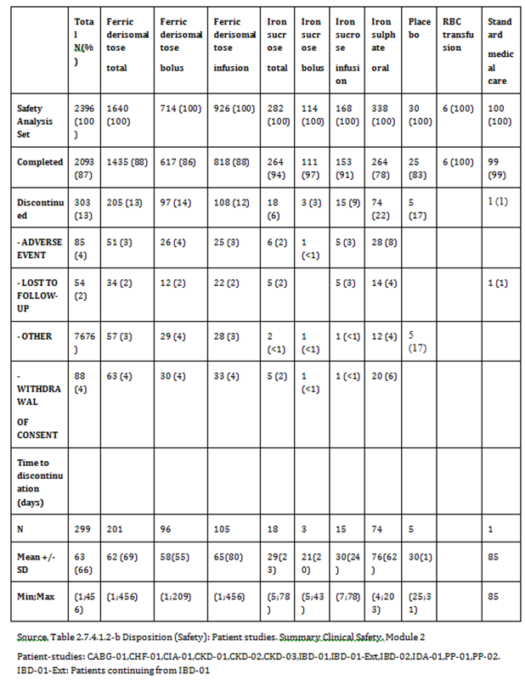

#### Safety issues with the potential for major regulatory impact

Hypophosphatemia can be associated with several complications and IV iron complexes differ in their capability to induce unintended hypophosphataemia. The frequency of hypophosphataemia in ferric derisomaltose treated patients was low and when recognised, was transient and minor. The frequency of observed serious hypersensitivity reactions was very low. However, milder infusion related reactions may occur.

##### Liver function and liver toxicity

###### Main/pivotal studies that assessed safety as the sole primary outcome

A transient increase in hepatic enzymes in 4 patients treated with ferric derisomaltose in the Study P‑IBD-01 was not above the 3 times the upper limit of normal (ULN) for hepatic enzymes. In the P-CIA-01 trial, 2 (< 1%) patients in the ferric derisomaltose group had alanine aminotransferase (ALAT) and aspartate aminotransferase (AST) > 3 x ULN and concurrent bilirubin > 2 x ULN post Baseline. In comparison, one orally treated patient (< 1%) in this study had an increase in the transaminases > 3 x ULN 2 weeks post Baseline and bilirubin > 2 x ULN at the next visit (Week 4) where the transaminases no longer were > 3 x ULN (hence no simultaneous increase).

###### Pivotal and/or main efficacy studies

A search across all patient studies for increases in ALAT/AST and bilirubin has been performed to see if there was a difference between treatments and no other events of ALAT/AST > 3 x ULN and concurrent bilirubin > 2 x ULN post Baseline was observed for any treatment.

Circulating iron carbohydrate complexes are removed from plasma by cells of the RES, mainly in the liver, which splits the complex into its components of iron and carbohydrate. Patients with severe liver impairment (decompensated liver cirrhosis or viral hepatitis (alanine aminotransferase (ALAT) > 3 times UNL)) were excluded from the finalised clinical trials since there are no adequate and controlled safety data from the use of ferric derisomaltose and due to the potential risk of liver toxicity in these populations.

##### Renal function and renal toxicity

###### Pivotal and/or main efficacy studies

Clinical trials included patients with CKD (both dialysis dependent and non-dialysis dependent) and no safety issues in this patient population were identified when compared to other therapeutic areas.

##### Other clinical chemistry

###### Main/pivotal studies that assessed safety as the sole primary outcome

Overall, no differences in the changes in laboratory values were observed in the PK trials.

###### Pivotal and/or main efficacy studies

Except for the liver parameters and phosphate, there were no relevant differences in the changes in laboratory values over time between treatment groups and therapeutic areas in the patient trials by visual inspection.

Overall, there was a slight difference in the frequency of patients experiencing an increase in ALAT and AST between treatment groups. Fifteen (15%), 7%, and 17% reported an increase in AST and 16%, 7%, and 9% in ALAT from a normal to low value at Baseline to above ULN at any post Baseline Visit in the ferric derisomaltose, iron sucrose, and oral iron sulphate groups, respectively.

The same tendency could be observed for the IDA indication where 22% in the ferric derisomaltose group experienced an increase in ALAT compared to 11% and 12% in the iron sucrose and oral iron sulphate groups, respectively. AST increased in 20% in the ferric derisomaltose group compared to 10% and 23% in the iron sucrose and oral iron sulphate groups, respectively. No differences between treatment groups in the change of ALAT or AST could be observed for other therapeutic areas.

The effect of ferric derisomaltose on s-phosphate was and is being measured in all completed and ongoing studies of ferric derisomaltose except CHF- 01, CKD-01 and PK-IBD-01. s‑phosphate is measured prior to iron administration and after administration. Generally, the frequencies of a transient drop in phosphate have been 5 to 7% in patients treated with ferric derisomaltose from the studies in cancer, post-partum haemorrhage and IBD and 1 to 2% in CKD patients. Nadir was in the first weeks. No cases of osteomalacia after ferric derisomaltose use have been received.

Reviewing the overall pooled analysis, there was a slightly higher proportion of patients who experienced a shift in phosphate values from normal or low to below lower limit in the ferric derisomaltose group than in the iron sucrose and oral iron sulphate groups. A total of 16% of patients in the ferric derisomaltose group experienced a decrease from normal or low phosphate values at Baseline to below lower limit of normal at any post Baseline Visit compared to 10% and 5% for iron sucrose and oral iron sulphate, respectively. The same pattern was observed in the IDA indication where 23% of ferric derisomaltose patients compared to 15% and 7% from iron sucrose and oral iron sulphate groups. For the CABG population 47% of patients experienced a decrease in phosphate values compared to 24% in the placebo group. In the CKD indication, no differences in the change of phosphate between treatment groups could be observed, which can be explained by the underlying disease and concomitant medication.

##### Haematology and haematological toxicity

###### Main/pivotal studies that assessed safety as the sole primary outcome

There were no cases of agranulocytosis, aplastic anaemia or severe thrombocytopenia in the safety studies.

###### Pivotal and/or main efficacy studies

There were no cases of agranulocytosis, aplastic anaemia or severe thrombocytopenia in the clinical studies.

##### Electrocardiograph findings and cardiovascular safety

###### Main/pivotal studies that assessed safety as the sole primary outcome

In Study P-CHF-01, electrocardiograms (ECGs) were read by cardiologists. In all other studies, the ECGs were read by the treating physicians. ECG monitoring at Baseline, 2 to 5 minutes, 15 minutes, 30 minutes, 1, 2, 3, 6, 24, and 72 hours after administration of single doses between 100 to 1,000 mg ferric derisomaltose was performed. These time points for ECG monitoring cover the relevant ranges of Tmax found in the PK studies.

There were no clinically significant abnormalities on ECG for any patients.

###### Pivotal and/or main efficacy studies

In clinical trials, ECG monitoring was performed at screening or Baseline and at the end of the study between 4 and 12 weeks after dosing. Specific to evaluating QT prolongation at time points around Cmax, there were no clinically significant abnormalities on ECG for any patients in any of the other clinical trials at any time point.

##### Vital signs and clinical examination findings

###### Pivotal studies that assessed safety as the sole primary outcome

Vital signs included blood pressure (BP), pulse rate, and ECG for all patients included in the trials. In the PK trials 20% of patients experienced an increase in BP (≥ 180 mmHg with ≥ 20 mmHg). No relevant changes were observed for other parameters.

###### Pivotal and/or main efficacy studies

Overall for the patient studies, there was a slight increase in the number of patients with an increase in BP (≥ 180 mmHg with ≥ 20 mmHg) in the isomaltoside (4%) and iron sucrose (4%) groups compared to the oral iron sulphate group (< 1%). No other differences in vital signs were observed overall. Within the CKD dialysis population, the percentage of patients with an increase in BP was also increased for ferric derisomaltose (10%) compared to iron sucrose (5%). An opposite effect was observed in the CABG population where 20% in the placebo group experienced an increase in BP compared to 0% in the ferric derisomaltose group.

##### Immunogenicity and immunological events

Non regulatory studies applying flow cytometry and miRNA expression analysis to morphologically and functionally characterize monocytic differentiation to M1/M2 macrophages in order to investigate substance-specific impacts of different IV iron preparations on monocytic function and differentiation have demonstrated that distinct IV iron preparations substance specifically affect the in vitro differentiation of monocytes towards macrophages and dendritic cells and identified iron sucrose and sodium ferric gluconate which are characterised as less stable IV iron preparations to strongly change phenotype and function of M1 macrophages, M2 macrophages, and dendritic cells. More stable IV iron preparations and ferric derisomaltose had no measurable effects.

##### Serious skin reactions

There were no cases of photosensitivity, erythema multiforme, Stevens Johnson syndrome, drug reaction with eosinophilia and systemic symptoms (DRESS) or toxic epidermal necrolysis reported in the clinical studies.

##### Other safety parameters

There were no other safety issues of significance reported.

#### Other safety issues

##### Safety in special populations

No safety issues related to ethnic origin were identified.

There are no adequate and well controlled trials of ferric derisomaltose in pregnant women. Pregnant or nursing women were excluded from all the initial clinical trials since substantial adequate and controlled data from the use of ferric derisomaltose in non pregnant women were warranted before exposing pregnant women.

##### Safety related to drug-drug interactions and other interactions

No drug interactions studies involving ferric derisomaltose have been conducted. Ferric derisomaltose may reduce the absorption of concomitantly administered oral iron preparations. Other potential concomitant medications utilised in this patient population are erythropoiesis-stimulating agents, vitamin D analogues, phosphate binders, hypertensive agents and/or hypoglycaemic agents.

#### Post marketing data

From the time the product was placed on the market and up to the 31 December 2015, a total of 839 individual case study reports (ICSRs) including 2,892 event terms have been reported for ferric derisomaltose. Based on a total sale of approximately 3.4 million 100 mg doses, this yields an overall reporting rate of 0.0002 (839/3,400,000).

Of the 839 ICSRs, a total of 614 (73%) were reported as serious and 225 (27%) as non‑serious. The outcome was reported as recovered/resolved in 583 cases (69%), recovering/ resolving in 22 cases (3%), recovered/ resolved with sequela in 5 cases (0.6%), not recovered/ not resolved in 22 cases (3%), unknown in 203 cases 24%), and finally, 1 case (0.1%) with fatal outcome was reported (A line listing of all ICSRs is available on request).

Within the System Organ Class (SOC) general disorders and administration site conditions, the most frequently reported terms were chest discomfort (139 adverse events (AEs)) and chest pain (64 AEs). Within the SOC respiratory, thoracic and mediastinal disorders, the far most frequently reported events were dyspnoea (292 AEs). Within the SOC Skin and subcutaneous tissue disorders, the most common AEs were erythema (66 AEs), and hyperhidrosis and rash (36 AEs each).

A few cases of unlisted skin discolouration have been identified and considered a safety signal. Skin discoloration related to IM iron treatment is well recognised. Skin discolouration is a permanent or long lasting cosmetic inconvenience of relevance to the patients. Pharmacosmos has amended the ferric derisomaltose summary of product characteristics (SmPC) with a warning that caution should be exercised to avoid paravenous leakage when administrating ferric derisomaltose and that paravenous leakage may lead to long lasting brown discolouration at the site of injection.

No other relevant unlisted cases or others signal have been identified as part of the ongoing safety evaluation.

#### Evaluator’s conclusions on safety

For the treatment of iron deficiency when oral iron preparations are ineffective or cannot be used and/or where there is a clinical need to deliver iron rapidly, the sponsor has provided 2 safety/efficacy studies, involving 203 patients, 9 Phase III studies, involving 2,213 subjects, and 6 PK studies, involving 89 patients. Overall, 2,396 patients have been exposed to trial drug in the clinical trials with ferric derisomaltose. In the Phase II/III clinical trials, a total of 1,640 patients received ferric derisomaltose either as bolus injections up to (or above) 500 mg per single administration (714 patients) or as IV infusions up to 20 mg/kg per single administration (926 patients). The comparator group has included 756 patients treated with oral iron sulphate (338 patients), IV iron sucrose (282 patients), IV placebo (30 patients), Standard medical care (100 patients), or RBC (6 patients).

AEs observed in the ferric derisomaltose PK trials by SOC and PT, are shown in Table 10. The proportion of patients reporting any AE were highest within the SOC of General Disorders and administration site conditions (9 patients (10%)), Metabolism and Nutrition Disorders (7 patients (8%)), and Gastrointestinal Disorders (7 patients (8%)). The most frequently reported AEs were hypophosphatemia, nausea, and leukopenia, which were reported in 4 patients each (4%). Due to the overall number of patients experiencing AEs (25 patients (28%)), and with only 6 patients experiencing AEs in the infusion group, it was not possible to compare the 2 treatment modes, bolus and infusion.

Overall, there were no significant safety issues identified when analysing safety data of all clinical trials on ferric derisomaltose in patients with IDA, non-dialysis dependent chronic kidney disease (NDD-CKD), and CKD in dialysis, and CABG. Overall, there was no difference in the number of patients experiencing any AE, the number of serious adverse event (SAE), deaths and dropouts between ferric derisomaltose and the comparator treatments. There was no relation between AEs and mode of administration or total dose administered of ferric derisomaltose, although the highest percentage of subjects reported AEs and adverse drug reactions (ADRs) with doses above 1000 mg. No related fatal cases for ferric derisomaltose or any comparator was reported.

Table 10: Incidence of (TAEs) ≥ 5% by System Organ Class and preferred term (Safety); PK-studies

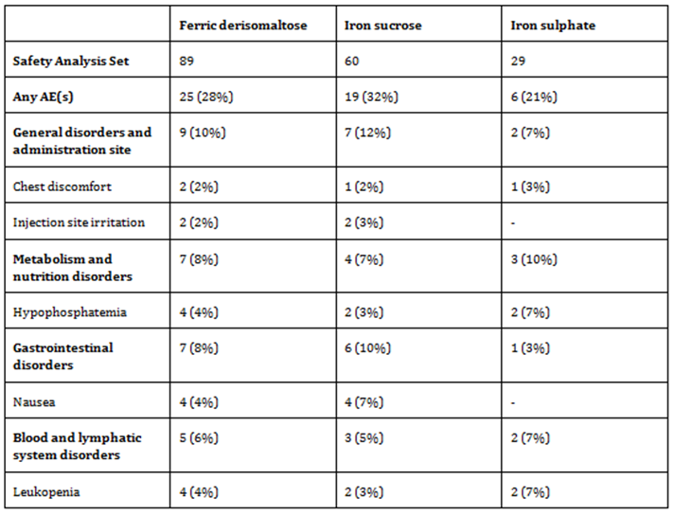

### First round benefit-risk assessment

#### First round assessment of benefits

Table 11: First round assessment of benefits

| **Indication:**  ***Monofer is indicated for the treatment of iron deficiency in the following conditions:***  ***• When oral iron preparations are ineffective or cannot be used***  ***• Where there is a clinical need to deliver iron rapidly*** | |
| --- | --- |
| **Benefits** | **Strengths and uncertainties** |
| Nephrology | NDD-CKD and with renal related anaemia: Increase in s-ferritin concentration with ferric derisomaltose compared to iron sulphate from Baseline to Weeks 1, 2, 4 and 8 (all p < 0.0001). Increase in Hb and a decrease in total iron binding capacity (TIBC) concentration from Baseline to Week 4 (full analysis set (FAS): p = 0.0385; PP: p = 0.0471). for ferric derisomaltose compared to iron sulphate. Significant increase in s-ferritin concentration from Baseline to Week 1, 2, and 4 for ferric derisomaltose compared to iron sucrose (Week 1 and Week 2: p < 0.0001; Week 4: p = 0.0002).  CKD patients in pre-dialysis or haemodialysis: Increase in reticulocyte counts from Baseline to Week 1 for ferric derisomaltose (p = 0.0006) compared to iron sucrose. No statistical significant changes in reticulocyte counts from Baseline to Week 2, 4, and 6 between treatments.  CKD patients in haemodialysis: Increase in s-ferritin concentration from Baseline to Week 1, 2, and 4 compared to iron sucrose (Week 1 and Week 2: p < 0.0001; Week 4: p = 0.0002). Increase in reticulocyte counts from Baseline to Week 1 for ferric derisomaltose (p = 0.0006) as compared to iron sucrose. |
| Cardiology | In patients with chronic heart failure: No adverse drug reaction and no acute or delayed hypersensitivity reactions. No significant changes in routine clinical safety laboratory tests or vital signs. Hb and iron parameters increased at every visit compared with Baseline. Quality of life (QoL) assessments showed a significant increase 4 weeks after Baseline. |
| Inflammatory Bowel Disease | The efficacy of ferric derisomaltose versus oral iron in reducing IDA, evaluated as the ability to increase Hb at Week 8 in patients with IBD and IDA: The mean cumulative dose of ferric derisomaltose in the infusion and the bolus groups was 885 mg (standard deviation (SD): 238 mg, range: 195 to 1,500 mg) and 883 mg (SD: 296 mg, range: 350 to 2500 mg), respectively. Non inferiority could not be demonstrated with respect to the primary endpoint. As the mean cumulative Ganzoni calculated ferric derisomaltose dose administered was not more than 885 mg, the calculation itself might have led to an underestimation of the required iron dose. Such that patients receiving more than 1000 mg ferric derisomaltose (mean: 1,313 mg) had a response rate (Hb increase of ≥ 2 g/dL) of 93% (P.0.001 when compared with oral iron).  A 1 year extension trial of this IBD trial evaluating the need for additional IV ferric derisomaltose doses to maintain a stable Hb.19 In patients with Hb ≥ 12.0 g/dL at Baseline; 74% could maintain their Hb ≥ 12.0 g/dL during 1 year.  Infusions of high dose IV ferric derisomaltose, administered as single doses of up to 2,000 mg and cumulative doses of up to 3,000 mg over a short duration, were completed without safety concerns and were efficacious in increasing Hb levels in patients with IBD. |
| Surgery | Change Hb from Baseline to 4 weeks in elective or subacute coronary artery bypass graft, valve replacement, or a combination thereof: Ferric derisomaltose compared to placebo showed less pronounced anaemia (p = 0.012), and the proportion of non-anaemic patients at Week 4 was significantly higher in the ferric derisomaltose group (38.5% versus 8%; p = 0.05). No difference in the number of patients who needed blood transfusion and the number of postoperative days to discharge between treatment groups.  Ferric derisomaltose can be used safely to prevent anaemia after cardiac surgery and a haemopoietic response is evident at Day 5. |
| Chemotherapy induced anaemia/cancer related anaemia | IV ferric derisomaltose compared to oral iron sulphate in anaemic cancer patients, efficacy determined as change in Hb from Baseline to Week 4: ferric derisomaltose is non-inferior to iron sulphate, (p = 0.0002). In addition, there is a faster onset of the Hb response in the IV ferric derisomaltose infusion group compared to oral iron group at Week 1 (p = 0.03) and a sustained effect on Hb in both groups until Week 24. There is a comparable sustained increase in Hb over time with both ferric derisomaltose and oral iron but more adverse drug reactions for oral iron. |
| Postpartum haemorrhage | Women with postpartum haemorrhage: aggregated change in physical fatigue within 12 weeks postpartum, in favour of ferric derisomaltose compared to standard medical care. In addition, the iron content in maternal milk samples: mean (± SD) iron content in maternal milk 3 days after intervention was 0.72 ± 0.27 and 0.40 ± 0.18 mg/L (p = 0.001) in the two treatment arms, respectively. One week after intervention, the mean iron in maternal milk was 0.47 ± 0.17 and 0.44 ± 0.25 mg/L (p = 0.05), respectively. These mean values were all within the normal reference range for iron content in breast milk. |

#### First round assessment of risks

Table 12, shown below, summarises the assessment of risks at the first round.

Table 12: First round assessment of risks

| **Indication:**  ***Monofer is indicated for the treatment of iron deficiency in the following conditions:***  ***• When oral iron preparations are ineffective or cannot be used***  ***• Where there is a clinical need to deliver iron rapidly***  ***The diagnosis must be based on laboratory tests*** | |
| --- | --- |
| **Risks** | **Strengths and Uncertainties** |
| Hypophosphatemia | Frequencies of a transient drop in phosphate were 5 to 7% in patients treated with ferric derisomaltose from the studies in cancer, post-partum haemorrhage and IBD and 1 to 2% in CKD patients. Nadir was in the first weeks. |
| Hypersensitivity | One of the main areas of concern for IV iron in general is the risk of acute ADRs related to the free iron and immunogenicity of the carbohydrate moiety. Overall in clinical trials, a total of 23 (0.96%) out of 2,396 patients reported a hypersensitivity reaction at any time point after dosing. 17 (1.04%) patients in the ferric derisomaltose group, 3 (1.06%) patients in the iron sucrose group, 2 (0.59%) patients in the iron sulphate group, and 1 (3.33%) patient receiving placebo. the frequency of serious or severe hypersensitivity events associated with ferric derisomaltose treatment is very low and comparable with comparators within all the investigated therapeutic areas.  Ferric derisomaltose has a low immunogenic potential, and a low potential to release labile iron. |
| Nausea | Overall 4% in ferric derisomaltose groups. |
| Tachycardia | Overall 4% in ferric derisomaltose groups |

#### First round assessment of benefit-risk balance

The benefit-risk balance of Monofer for the treatment of iron deficiency when oral iron preparations are ineffective or cannot be used and/or where there is a clinical need to deliver iron rapidly is favourable.

The sponsor has presented evidence that ferric derisomaltose is effective in treating IDA across multiple therapeutic patient groups and compared to placebo, IV iron sucrose, and oral iron. Ferric derisomaltose has a low immunogenic potential, a low potential to release labile iron, and does not appear to be associated with clinically significant hypophosphataemia. The frequency of observed serious hypersensitivity reactions in submitted clinical trials with ferric derisomaltose was low and comparable with comparators within all the investigated therapeutic areas. Milder infusion-related reactions, including nausea and leukopaenia, may occur.

### First round recommendation regarding authorisation

Approval of ferric derisomaltose (Monofer) is recommended for:

*The treatment of iron deficiency in the following conditions:*

*When oral iron preparations are ineffective or cannot be used*

*Where there is a clinical need to deliver iron rapidly*

*The diagnosis must be based on laboratory tests*

A condition of the approval is modification of the PI as described in the evaluation report.

### Second round evaluation

For details of the second round evaluation including the issues raised by the evaluator (Clinical questions), the sponsor’s responses and the evaluation of these responses please see Attachment 2.

### Second round benefit-risk assessment

The second round benefit risk assessment and recommendation regarding Authorisation was that same as that in the first round.

## VI. Pharmacovigilance findings

### Risk management plan

#### Summary of RMP evaluation[20]

* Link Healthcare submitted EU-RMP version 6.0 (dated 9 April 2014; data lock point (DLP) 31 August 2013) and ASA version 0.2 (dated 9 November 2016) in support of this application. In the section 31 response of 15 June 2017, the sponsor provided EU-RMP version 7.1 (dated 31 May 2017; DLP 31 December 2016) and ASA version 1.0 (dated May 2017).
* The proposed Summary of Safety Concerns and their associated risk monitoring and mitigation strategies are summarised below (Table 13)(bold text indicates safety concerns added at Round 2):

Table 13: Summary of safety concerns

|  |  |  |  |  |  |
| --- | --- | --- | --- | --- | --- |
| Summary of safety concerns | | Pharmacovigilance | | Risk Minimisation | |
| Routine | Additional | Routine | Additional |
| Important identified risks | Hypersensitivity reactions | ✓ | ✓* | ✓ | – |
| **Skin discolouration due to extravasation** | **✓** | **–** | **✓** | **–** |
| Important potential risks** | Haemosiderosis | ✓ | – | ✓ | – |
| **Use in patients with immune disorders** | **✓** | **–** | **✓** | **–** |
| **Use in patients with acute or chronic infection** | **✓** | **–** | **✓** | **–** |
| Missing information | Pregnant and lactating women | ✓ | ✓* | ✓ | – |
| **Use in children and adolescents < 18 years of age** | **✓** | **–** | **✓** | **–** |
| **Patients with hepatic impairment** | **✓** | **–** | **✓** | **–** |
| **Use in sub-populations carrying known and relevant polymorphisms** | **✓** | **–** | **✓** | **–** |

*Proposed (initially) for the EU **‘Seizure’ removed as an important potential risk – seizure is identified in the SmPC and no additional risk minimisation is considered by the sponsor to be necessary.

* In addition to routine pharmacovigilance, an EU post authorisation safety study (PASS) was proposed for the safety concern of hypersensitivity reactions, initially intended to be reported in July 2016. Further, in the EU all market authorisation holders of IV iron have been requested to submit annual cumulative reviews of hypersensitivity case reports, all fatal cases and all pregnancy cases, with yearly usage data (first report was due to be issued 31 March 2014). A specific follow-up form for hypersensitivity cases has also been implemented overseas.
* A Dear Healthcare Professional (DHCP) and Healthcare Professional (HCP) checklist were proposed as additional risk minimisation in the EU for the safety concerns of hypersensitivity and use in pregnancy and lactation. However, the sponsor has advised in the response that these materials were provided for a limited time (DHCP submitted through third quarter 2013 to first quarter 2014; prescriber Checklist provided third quarter 2014 to first quarter 2015). No additional risk minimisation has been proposed for the Australian market. This is acceptable as the additional risk minimisation in the EU is not ongoing, and the safety message of the DHCP letter is clearly conveyed through the routine risk minimisation materials.

#### New and outstanding recommendations from second round evaluation

There are no outstanding issues or recommendations.

#### Proposed wording for conditions of registration

Any changes to which the sponsor has agreed should be included in a revised RMP and ASA. However, irrespective of whether or not they are included in the currently available version of the RMP document, the agreed changes become part of the risk management system.

The suggested wording is:

Implement EU-RMP (version 7.1, date 31 May 2017, data lock point 31 December 2016) with Australian Specific Annex (version 1.0, date May 2017) and any future updates as a condition of registration.

## VII. Overall conclusion and risk/benefit assessment

The submission was summarised in the following Delegate’s overview and recommendations:

Please note: The clinical evaluator comments that ‘Throughout the dossier, the active ingredient is referred to by the names 'iron isomaltoside' or 'iron isomaltoside 1000' or 'iron III isomaltoside 1000'. These names are synonyms for ferric derisomaltose and may be used interchangeably.’

The draft PI specifies a chemical name of: Iron (III) hydroxide isomaltoside

Throughout this document, including in study titles, ‘ferric derisomaltose’ has been substituted for the above synonyms of Monofer.

### Background

The clinical evaluator presented the following overview of iron deficiency anaemia:

Iron deficiency develops when:

* iron intake is inadequate for needs (for example during growth spurts or during pregnancy); (ii) there is malabsorption of iron
* there is increased loss of iron, usually consequent on gastrointestinal or uterine blood loss
* there is renal loss of haemosiderin, as a result of chronic intravascular haemolysis
* there is a combination of these factors; or, rarely
* there is sequestration of iron at an inaccessible site, as in idiopathic pulmonary haemosiderosis.

Anaemia occurs when a lack of reticuloendothelial storage iron and an inadequate rate of delivery of iron to developing erythroid cells in the marrow leads to reduced synthesis of haem and therefore reduced production of haemoglobin and red blood cells.

In Australia, several IV iron products are registered for the treatment of iron deficiency anaemia. These include:

* Ferric carboxymaltose (Ferinject) was registered in Australia on the 5 April 2011 and is indicated for ‘*treatment of iron deficiency when oral iron preparations are ineffective or cannot be used. The diagnosis must be based on laboratory tests.*’
* The iron sucrose product Venofer was registered in May 2004 for the more limited indication of ‘*the treatment of iron deficiency anaemia in patients undergoing chronic haemodialysis and who are receiving supplemental erythropoietin therapy*.’ The dose of Venofer is 100 mg of iron (5 mL of Venofer) delivered intravenously during the dialysis session. Frequency of dosing should not be more than three times per week. Most patients will require a minimum cumulative dose of 1,000 mg of iron, administered over 10 sequential dialysis sessions, to achieve a favourable haemoglobin or haematocrit response (see approved Australian Venofer PI).
* Iron polymaltose (brand names Ferrosig and Ferrum H) is indicated for the treatment of iron deficiency anaemia when oral therapy is contraindicated, when enteric absorption of iron is defective, when patient non-compliance or persistent gastrointestinal intolerance makes oral therapy impractical.

#### Regulation; Australia

This is the first submission to register ferric derisomaltose, ferric derisomaltose or iron III isomaltoside 1000 as a new chemical entity.

#### Regulatory guidelines

The following guidelines, which have been adopted by the TGA, are considered relevant to the current application:

* European Agency for the Evaluation of Medicinal Products: Evaluation of Medicines for Human Use. ‘Points to consider on switching between superiority and non-inferiority’

Guidelines are not legally binding but variation from recommendations in such guidelines may suggest a need for close examination of particular quality, efficacy and / or safety issues.

#### Regulation; overseas status

The sponsor states that Sweden was chosen as the reference member state for the European Union Decentralised Procedure (EU DCP). According to the sponsor, the application for Monofer was finalised on 26 November 2009.

The sponsor states that an application for this product has not been rejected or repeatedly deferred in Europe, USA or Canada.

No further comment has been provided by the sponsor regarding whether an application has been made to the USA, Canada, Switzerland or the EMA. However, the sponsor has made comments elsewhere in the dossier which indicate some contact/submissions in these jurisdictions. For example:

*‘The dossier submitted in support of this application was previously submitted in Canada, from which AU dossier is derived. There have been some updates to the data, but the data set remains essentially the same’. The submission date has not been included in the sponsors table titled ‘Foreign Regulatory Status’, no draft PI for Canada has been submitted and no update on the status of this application is available.*

The ‘paediatric development program’ states that ‘deferral of the requirements for the age group 0 to < 18 years until 2021. Paediatric studies should be delayed until additional safety and efficacy in the adult population are found acceptable by FDA (CKD adults)’. The timing of this application to the FDA is not known. It is not known whether an application for adults has been subsequently submitted to the FDA.

*Question for sponsor*: Please clarify the foreign regulatory status for ferric derisomaltose (Monofer) including the timing/status of the application submitted to Canada and whether an application has been made to the United States FDA.

### Quality

The formal quality summary (dated 15 August 2017) states that; ‘Registration is recommended with respect to chemistry and quality control aspects’.

However, the quality summary emphasised that Pharmacokinetic trials demonstrated dose dependence, noting that the t½ (pooled across indications) was 1 to 4 days with a higher t½ in the 1000 mg IV infusion group compared to the 100, 200, and 500 mg IV bolus group. The following limitation regarding biopharmaceutics was identified:

‘Specific studies performed with radioactive labelled ferric derisomaltose were not conducted; instead studies conducted with 59Fe iron dextran are referred to. No clinical trials measured circulating ferric derisomaltose or differentiating iron species in vivo were presented. No direct pharmacokinetic comparisons of other iron complexes appear to have been studied. This has been brought to the attention of the clinical Delegate.’

The limitations identified by the quality evaluator have been included in the Delegate’s discussion below.

### Nonclinical

The nonclinical evaluation report (NCER) was considered.

The nonclinical evaluator stated that the nonclinical data package is deficient, however overall did not object to registration provided safety is adequately demonstrated by the clinical data. The evaluator states:

‘The short duration of the repeat dose studies do not support clinical administration beyond 2 weeks, and there was no study to compare the tissue distribution of ABT-870 with the clinical moiety. However, given that toxicity of ABT-870 and most likely the clinical form of ferric derisomaltose is mainly related to excess iron deposition in tissues, the deficiency of nonclinical data may not preclude registration of ferric derisomaltose for the proposed indication provided safety has been adequately demonstrated by clinical data.’

As stated by the nonclinical evaluator, the majority of the nonclinical safety studies were conducted with ABT-870 (iron(III)-hydroxide oligosaccharide), an early development form of ferric derisomaltose. Only reproductive studies and a local inflammation study were conducted with the clinical form, ferric derisomaltose. Notable deficiencies of the submitted dossier were the lack of pharmacokinetic data for ferric derisomaltose, particularly tissue distribution studies with ABT-870 and ferric derisomaltose, and the relatively short duration (< 4 weeks) of the repeat dose studies.

The pharmacokinetic profile of ferric derisomaltose was not characterised in the nonclinical studies. The majority of nonclinical toxicity studies were conducted with the early development form ABT-870, which is not identical to the clinical moiety, ferric derisomaltose. A tissue distribution study should have been conducted to bridge nonclinical studies with ABT-870 to the clinical moiety, ferric derisomaltose.

The limitations identified by the nonclinical evaluator have been included in the Delegate’s discussion below.

### Clinical

#### Overview of data

The clinical dossier documented a full clinical development program of pharmacology, efficacy and safety studies. A total of 9 pivotal studies (including one extension study) were submitted, along with 2 safety studies, 6 studies with primary PK objectives, plus post marketing data and a periodic safety update report.

No paediatric data is submitted with this application. In light of the FDA advice (above) regarding paediatric data, in addition to the issues raised in this overview (see discussion below), it is recommended that the indication be limited to adult patients only.

#### Formulation

An early development formulation named ABT-870 was used in the nonclinical studies. The sponsor provides the following overview of this formulation:

‘The molecular weight of ABT-870 is reported to be 1000 Da. The iron oligosaccharide complex in ABT-870 is less strong than the iron oligosaccharide complex in ferric derisomaltose (Monofer) due to a higher glucose versus iron atom ratio (0.85 versus 0.66) and a lower apparent peak molecular weight (125 kDa versus 165 kDa). The content of free iron (III) was higher in ABT-870 than it is in Monofer (0.01% versus 0.004%). The content of labile (weakly bound) iron was also expected to be higher in ABT-870. ABT-870 was relatively unstable in human serum compared with Venofer (iron sucrose), Infed (iron dextran) and Ferrlecit (iron gluconate). In addition, ABT-870 showed a higher renal excretion of free iron in Beagle dogs, as compared with Venofer (iron sucrose), at doses of 2.9 mg Fe/kg. In humans, 13% of the administered iron dose after administration of ABT‑870 was renally excreted as free iron, while after administration of Monofer, the renal excretion of free iron was < 1% of the administered dose.’

No tissue distribution study was conducted to bridge nonclinical studies with ABT-870 to the clinical moiety, ferric derisomaltose.

#### Pharmacology

In total, 9 clinical studies provided pharmacology data in patients with solid tumours. These are summarised in Table 5 above. The total serum (S-iron) and geometric mean values were chosen as the relevant PK parameters.

The clinical evaluator’s view of the pharmacokinetic and pharmacodynamic findings can be found in Sections 4 and 5 of Attachment 2. Overall, the clinical evaluator concluded that the submitted data are considered to have adequately characterised the pharmacokinetics (PK) and an adequate summary of the PK data is presented in the PI. No issues were raised by the clinical evaluator outside that discussed in the sponsor’s clinical summary document.

After review of the dossier, following has been noted:

* The pharmacokinetic studies did not investigate the PK of single doses above 1000 mg. Based on the dosing and administration section of the Australian PI, single doses of above 1000 mg may be utilised in an intravenous infusion. Overall in the PK trials, a total of 66 (74 %) patients received a cumulative dose < 1000 mg and 23 (26%) a dose of 1,000 mg.
* The PK studies did not adequately investigate the impact of multiple dosing, as utilised in the clinical trial setting and as proposed in the Australian PI. The PI states for bolus injection the dose should be ‘up to three times a week’ and also makes the general comment: ‘patients may require continued therapy with Monofer to maintain target levels of Hb and acceptable limits of other iron parameters’.
* The dose proportionality of ferric derisomaltose at doses above 1000 mg is not known. Below 1000 mg, clear dose linearity is not demonstrated, with inconsistent findings of dose dependent increases in area under the curve (AUC), AUC0-t, and maximal concentration (Cmax).
* There appears to be a high degree of inter-subject variability in key PK parameters such as AUC and Tmax is noted for both the free s-iron and bound s-iron. For example, Study PK-IBD-01 COSMOS01 in patients with IBD demonstrated a wide range in free s‑iron at each time point across subjects (see Figure 2 below), as did the bound iron serum concentration (see Figure 3 below).
* There appears to be differences in the PK parameters of s-iron with age, however the overall numbers are small. The combined analysis of the six PK trials demonstrates that for an infusion of 500 mg, there is a doubling of the geometric mean terminal half-life for individuals aged > 65years at 60.3 hours (n = 2) compared to those aged < 65 years at 27.3 hours (n = 3). Other geometric mean parameters such as AUC (hours x mg/dL) and maximum concentration (mg/dL) are consistently lower in people aged > 65years at all bolus doses studied (Table 14).
  + The sponsor has provided a subgroup analysis presented Table 15, where a statistically significant difference in AUC or maximum concentration (mg/dL/100 mg) was not seen according to age. However, a number of uncertainties appear pertinent to interpretation of this data. Of note, the analysis did not account for whether the dose was a bolus or infusion; the geometric mean result was divided by 100 mg which may introduce inaccuracy; the analysis utilises a geometric mean value for AUC in patients aged < 65 years of 6.69(hours x mg/dL) which is significantly lower than the geometric mean AUC for a 100 mg dose of 10.3(hours x mg/dL) presented in Table 14; utilises a geometric mean value for AUC in patients aged > 65 years of 6.13 (hours x mg/dL) which is not reflective of the geometric mean AUC data presented in Table 14; similarly, the geometric mean values for maximum concertation in both age groups do not reflect the data presented. The reasons for utilising different mean AUC estimates have not been addressed and the method of calculation for these geometric mean values is not clear.

Table 14: Overviews of PK parameters by age

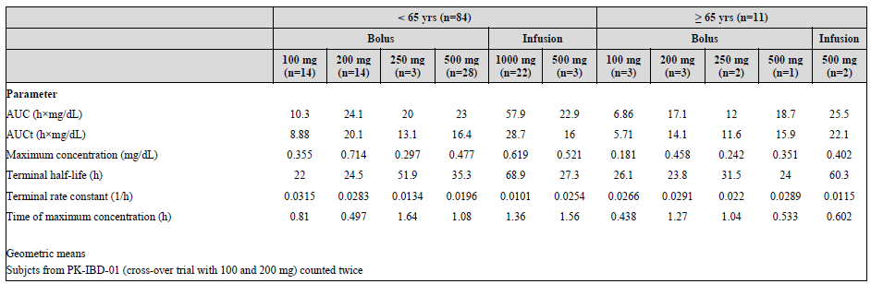

Table 15: Combined analyses of AUC and Cmax across the PK trials

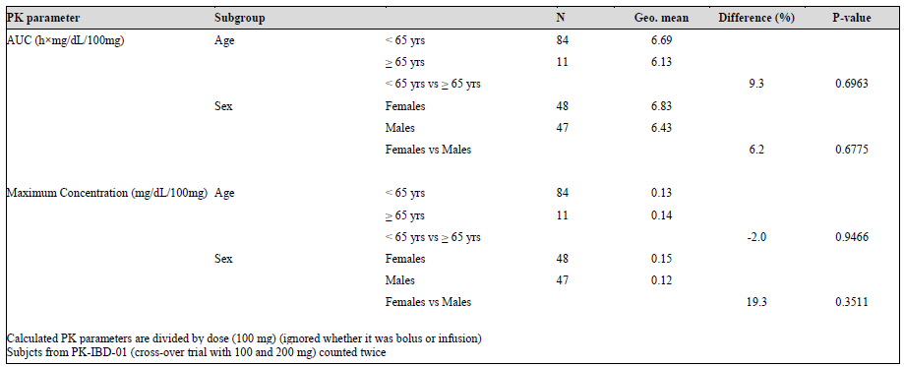

* Differences in PK parameters were noted across indication. For example, studies utilising a 1000 mg infusion demonstrated lower AUC and t½ in the chemotherapy induced anaemia (CIA) group compared to the inflammatory bowel disease (IBD) group (CIA group AUC 35.74 and t½ 47hours compared to AUC 80.31 and t½ 83.08 hours in the IBD group) (see Table 16).
* No dedicated clinical drug-drug interaction studies or population pharmacokinetic studies have been submitted.
* The PI statements regarding the absorption, distribution and metabolism of ferric derisomaltose do not appear to be supported by direct clinical studies. These statements appear to be based on studies of radioactive labelled iron dextran. No specific studies have been performed with radioactive labelled iron isomaltoside (ferric derisomaltose).

Figure 2: mean free -iron serum concentration versus log-time with pointwise 95% confidence interval (CI)(Study PK-IBD-01)

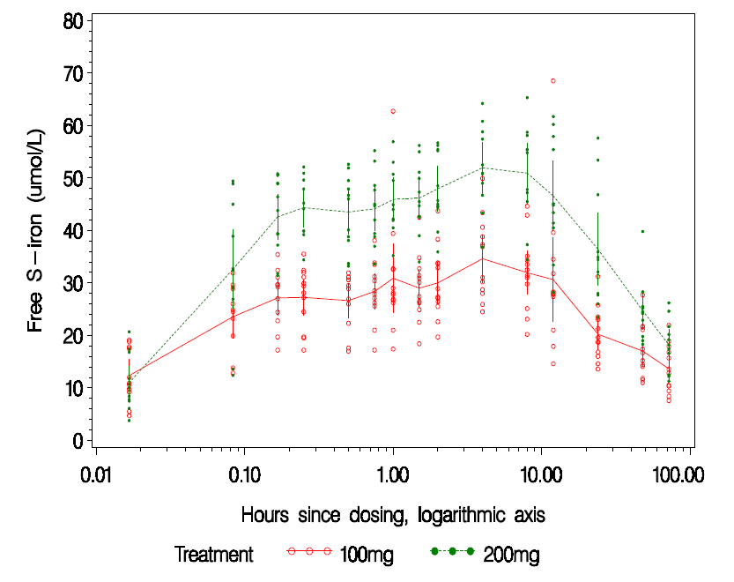

Figure 3: Mean bound-iron serum concentration versus log-time with pointwise 95% CI (Study PK-IBD-01)

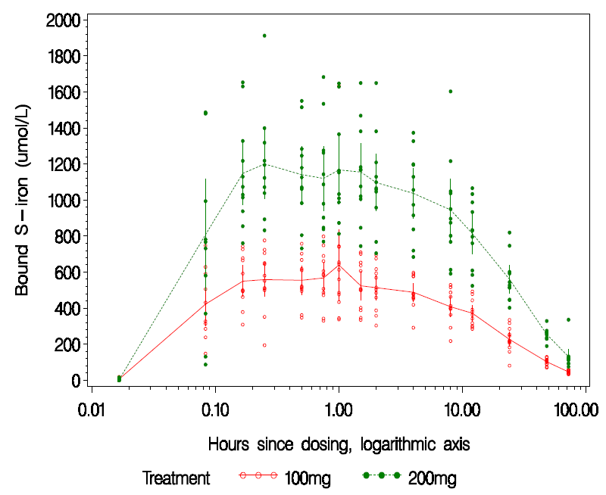

Table 16: Overview of PK data across 6 PK trials as presented by the sponsor

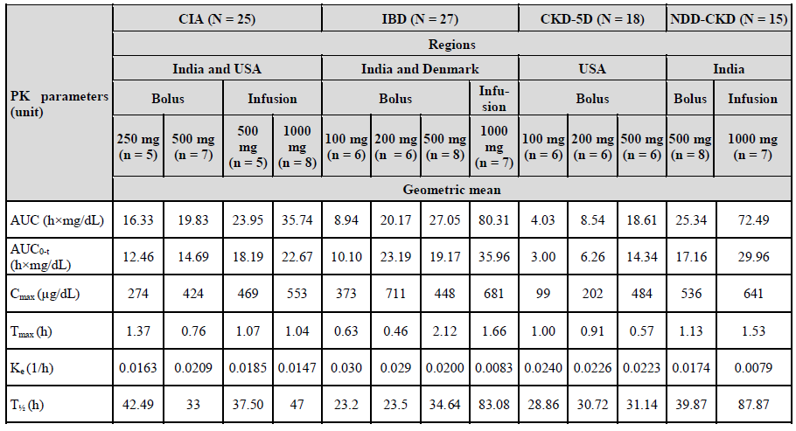

*Questions for sponsor*:

* Have additional PK studies or population PK studies been completed that investigate doses > 1000 mg, multiple dosing, and dose proportionality above 1000 mg?
* Please clarify the source of evidence supporting the PI statements regarding the absorption, distribution and metabolism of ferric derisomaltose?
* Please clarify the specific iron formulation used in the nonclinical, PK and clinical trial settings. Please outline the differences in formulations used compared to the marketed version of ferric derisomaltose (Monofer)?

Overall, the Delegate has concern that that the PK studies submitted do not adequately characterise the PK properties of ferric derisomaltose (Monofer) at clinical dosages or usage (that is, multiple dosing). Furthermore, issues such as the inter-individual variability and differences across indication require additional consideration. The Delegate will be seeking specific advice from the ACM regarding the PK data package.

#### Efficacy

Efficacy data from a total of 8 completed Phase III pivotal studies have been submitted. The submission has nominated multiple comparator products including intravenous iron sucrose, oral iron and red blood cell (RBC) transfusion:

* Two randomised open label, comparative studies of intravenous iron isomaltose in comparison with intravenous iron sucrose in patients with:
  + iron deficiency anaemia who are intolerant or unresponsive to oral iron therapy or who need iron rapidly (Study P-IDA-01); and
  + patients with stage 5 chronic kidney disease on dialysis therapy (Study P-CKD-03).
* Three randomised trials comparing intravenous ferric derisomaltose to oral iron (mainly iron sulphate) in the following settings: patients with non-myeloid malignancies associated with chemotherapy induced anaemia (Study P-CIA-01); chronic kidney disease with renal-related anaemia (Study P-CKD-02); and iron deficiency anaemia associated with inflammatory bowel disease (Study P-IBD-01).
* One randomised trial comparing intravenous ferric derisomaltose to red blood cell transfusion in women with severe post-partum iron deficiency anaemia (Study P‑PP‑02).
* One randomised trial comparing ferric derisomaltose to standard of care in postpartum haemorrhage (Study P-PP-01).
* One randomised, prospective, double blind placebo controlled study of intravenous ferric derisomaltose to non-anaemic patients undergoing elective or sub-acute CABG, valve replacement, or a combination thereof (Study P-CABG-01).

In addition to the 8 Phase III studies, the submission included two Phase II/III open label non comparative clinical trials in patients with CKD and congestive heart failure (Study P‑CKD-01/P-CABG-01, safety as primary endpoint) and 1 comparative international Phase II/III trial representing 39 IBD patients included in a 1 year extension of Study P‑IBD-01.

Of the efficacy studies presented, Study P-IDA-01 was the only trial allowing assessment of comparative effectiveness of IV ferric derisomaltose (Monofer) relative to another IV iron product (iron sucrose, Venofer) in patients with iron deficiency anaemia who are intolerant or unresponsive to oral iron therapy or who need iron rapidly. This was a non-inferiority trial with total of 511 patients randomised and 501 received treatment (333 subjects received ferric derisomaltose and 168 received iron sucrose). The primary efficacy endpoint was the proportion of subjects with an Hb increase of > 2 g/dL from baseline at any time from Week 1 to Week 5. Therefore, the effect did not have to be maintained throughout the trial in order for a subject to be recorded as a responder. Subjects in the ferric derisomaltose group were given a cumulative dose of ferric derisomaltose depending on their screening Hb level and body weight, up to a maximum of 2,000 mg iron. This was achieved with dosing at the baseline visit with either an IV infusion of 1,000 mg or an IV injection of 500 mg, with treatment 1 week later (if required) to reach the cumulative dose for each subject. For subjects in the iron sucrose group, the cumulative dose was calculated using the Ganzoni formula. Subjects were treated at the baseline visit with an IV infusion of 200 mg of iron sucrose, and could be treated twice weekly for up to 5 weeks to receive a maximum cumulative dose of 2,000 mg iron. A full description of the trial can be found in Attachment 2. Key efficacy findings include the following:

* Overall, there were more responders (that is subjects with an increase in Hb of ≥ 2 g/dL from baseline at any time from Week 1 to Week 5) in the ferric derisomaltose group (226 out of 330 or 68.5%) compared to the iron sucrose group (81 out of 161 or 51.6 %) (see Table 17).
* The non-inferiority margin set to -12.5 % points (see Delegate discussion below). Based on this margin, the sponsor claims non-inferiority to iron sucrose with a risk difference of 16.7% (95% confidence interval (CI) 7.5 to 25.7). As non-inferiority was deemed established, the sponsor performed a superiority test which required the lower bound of the 95% CI to be above 0. This test was found to be statistically significant.
* Sensitivity analysis of the primary endpoint showed that in the 2 largest strata with screening Hb ≥ 10 g/dL (gastroenterology and gynaecology groups) the risk difference between treatments was smaller than in the corresponding strata with screening Hb < 10 g/dL, and since the lower end of the 95 % CI was not above -12.5 % points, non-inferiority could not be claimed within these 2 strata.

Table 17: Analysis of proportion of subjects with Hb increase > 2 g/dL (full analysis set and per-protocol set) (Study P-IDA-01)

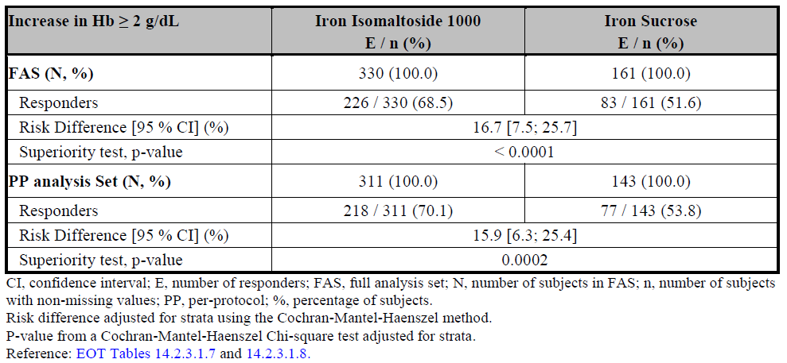

Following review of the P-IDA-01 Clinical Study Report (referred to below as P-IDA-01 clinical study report (CSR)), dated 12 February 2016, the following issues have been identified by the Delegate:

* Overall, the mean cumulative dose of iron administered in the study was higher in the ferric derisomaltose group compared to iron sucrose group (1640.2 mg versus 1127.0 mg respectively). This has important implications for the finding of non-inferiority.
  + The median dose in the ferric derisomaltose group was of 1,500.0 mg compared to 1133.5 mg in the iron sucrose group. A sub-analysis investigating efficacy according to dose has not been presented. Furthermore, the mean compliance (calculated as a percentage of planned versus actual dosing) was higher in the ferric derisomaltose group (98.74%) compared to the iron sucrose group (94.5%).
  + It is important to note that the method of calculating the required cumulative dose of iron for each subject was different between the ferric derisomaltose group compared to the iron sucrose group.
* The choice of comparator in Study P-IDA-01 (Venofer) must be considered with the following context:
  + Venofer is used clinically in the setting of chronic kidney disease and is not marketed for ‘patients with iron deficiency anaemia who are intolerant or unresponsive to oral iron therapy or who need iron rapidly’. Although Study P‑IDA-01 did not specifically exclude subjects with CKD, this was not listed as an underlying cause of IDA for subjects included in the study.
  + Venofer has been approved in Australia for the treatment of iron deficiency anaemia in patients undergoing chronic haemodialysis and who are receiving supplemental erythropoietin therapy. In Australia, the recommended intravenous dose regimen of Venofer is different to that administered during Study P-IDA-01. The Venofer PI states that a dose of 100 mg iron should be delivered IV during dialysis. Frequency of dosing should not be more than three times per week. Most patients will require a minimum cumulative dose of 1,000 mg of iron, administered over 10 sequential dialysis sessions, to achieve a favourable haemoglobin or haematocrit response (see Australian PI for Venofer).
* The non-inferiority margin for Study P-IDA-01 was set to -12.5 % points. The justification for this decision is presented in the Study IDA-01 CSR, dated 12 February 2016. In summary, the sponsor refers to Study IDA-301 which was a double blind, placebo controlled trial designed to compare the safety and efficacy of 1,000 mg IV ferumoxytol to placebo.[21] From the Study IDA-301, more than 80 % of the trial participants treated with ferumoxytol achieved an increase of ≥ 2.0 g/dL in Hb compared to 5.5 % of the subjects who received placebo. The treatment effect of IV ferumoxytol (that is the difference between ferumoxytol and placebo) was estimated to be approximately 75 % points. This formed the basis of the sponsor’s decision that ‘Preserving more than 80 % of this effect was believed to provide reasonable assurance that ferric derisomaltose is efficacious. Hence, using 83 % as preservation fraction, the non-inferiority margin was set to (1-0.83) x 75 % approximately 12.5 % points’. According to the EMA CHMP guideline, ‘It is not appropriate to define the non-inferiority margin as a proportion of the difference between active comparator and placebo’.[22] Furthermore, it is not appropriate to use effect size as justification for the choice of non-inferiority margin. This statistic provides information on how difficult a difference would be to detect, but does not help justify the clinical relevance of the difference.
* It is also reasonable to consider that the question of non-inferiority relative to placebo versus non-inferiority relative to an active comparator is inherently different. The EMA guideline provides the following statement regarding establishing acceptable efficacy relative to the active comparator: ‘the aim may be to provide data to show that there is no important loss of efficacy if the test product is used instead of the reference. This is probably the most common aim of non-inferiority trials. The choice of delta for such an objective cannot be obtained by only looking at past trials of the comparator against placebo. Ideas such as choosing delta to be a percentage of the expected difference between active and placebo have been advocated, but this is not considered an acceptable justification for the choice’.17
* The sponsor has not provided justification for departing from the TGA adopted guideline regarding the choice of non-inferiority margin for Study P-IDA-01.

*Question to sponsor*: Has an additional analysis been completed that takes into account the higher dose of iron administered in the ferric derisomaltose group compared to the iron sucrose group? Is non-inferiority maintained?

*Question for sponsor*: Please provide further justification for the choice of comparator product iron sucrose (Venofer) given the different indication and dose regime for this product.

In contrast to Study P-IDA-01, Study P-CKD-03 compared the efficacy of iron isomaltose to iron sucrose (Venofer) in patients with haemodialysis dependent chronic kidney disease who are on erythropoiesis stimulating agent treatment. This reflects the approved indication for Venofer in Australia and is an appropriate choice of comparator. Study P‑CKD-03 was a randomised, open label, non-inferiority study. A total of 351 subjects were enrolled in the study (with 341 subjects included in the FAS). The primary efficacy objective was to demonstrate that IV ferric derisomaltose is non-inferior to IV iron sucrose determined as ability to maintain haemoglobin (Hb) between 9.5 and 12.5 g/L in subjects with CKD-5D who were on maintenance iron therapy. The iron isomaltodside 100 group (n = 226) was divided into two populations; one group receiving ferric derisomaltose as a single dose at baseline (n = 113) and the second group receiving ferric derisomaltose in fractionated doses (n = 113). A summary of the study can be found in Attachment 2. Key findings include:

* In the full analysis set (FAS) of 341 subjects, a total of 187 (82.7 %) subjects treated with ferric derisomaltose and 95 (82.6 %) subjects treated with iron sucrose were able to maintain Hb between 9.5 and 12.5 g/dL (calculated via adjusted last observation carried forward (LOCF)[23] approach). A similar result was seen in the per protocol (PP) population.
* A post-hoc analysis of the proportion of subjects who maintained Hb of > 9.5g/dL at 6 weeks treatment showed similar results in both treatment groups. However, after review of the Statistical Analysis Report Version 3.0; the single dose ferric derisomaltose group is noted to consistently result in a lower percentage of subjects achieving maintenance compared to both the ferric derisomaltose fractionated and iron sucrose groups. This trend is consistent for the FAS and per protocol (PP) populations across all analysis presented including adjusted and unadjusted LOCF analysis).
* Overall, the sponsor claims that ferric derisomaltose was shown to be non-inferior to iron sucrose in the maintenance of Hb between 9.5 and 12.5 g/dL (both values included) at Week 6 (Study P-CKD-03 CSR) (non-inferiority margin of 10%). However the following results presented in the CSR and Statistical Analysis Report Version 3.0 were noted:
  + In the FAS, the unadjusted analysis with missing values imputed as failures did not show non-inferiority of ferric derisomaltose over iron sucrose for this primary endpoint (p = 0.0840) (P-CKD-03 CSR).
  + In the FAS, the ferric derisomaltose single dosing group did not show non-inferiority over iron sucrose for this primary endpoint (risk difference -0.7%; 95% CI -10.5% to 9.2%) (Table 18). The odds ratio estimate was found to be 0.91 (Table 19).
  + Subgroup analysis for treatment differences between ferric derisomaltose single and ferric derisomaltose fractionated dosing were performed. In the FAS and PP populations, the adjusted risk difference was -3.2 % (FAS: 95 % CI: (-12.9%:6.4%); PP: 95 % CI: -13.2 %:6.8 %). This analysis suggests that single dosing is inferior to fractionated dosing. For both the FAS and PP, the 95 % CIs include 0, and hence no statistically significant difference between the subgroups is noted.

Table 18: Percentage of patients who maintain Hb between 9.5 and 12.5 g/dL at 6 Weeks Treatment (Adjusted Analysis with LOCF approach) (FAS Population N=341)

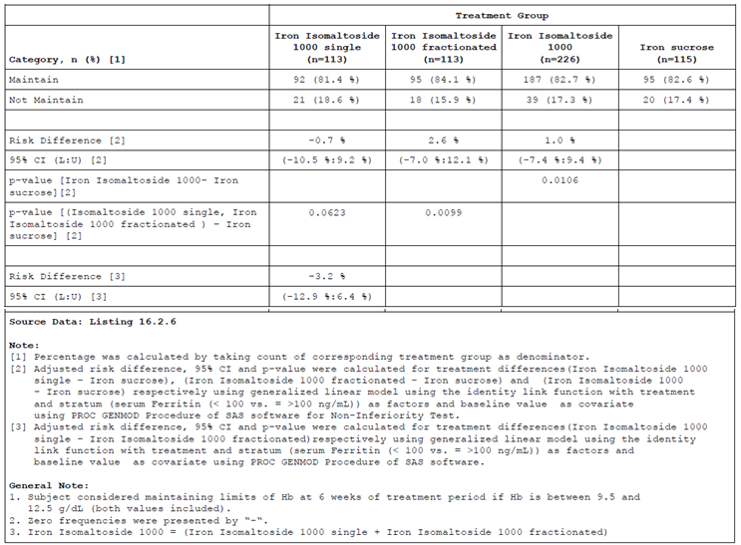

* The choice of non-inferiority margin is described by the sponsor in the CSR. In summary, the sponsor uses the treatment effect from Study P-CKD-01 (comparing IV ferric derisomaltose to oral iron) as the basis for non-inferiority to the active comparator (IV iron sucrose) in this study. The sponsor states ‘It was assumed that approximately 90 % of subjects would be able to maintain Hb between 9.5 and 12.5 g/dL at Week 6. Defining a non-inferiority margin that was maintained at 90 % of this response seemed reasonable that is 0.9 x 0.9 = 0.81 corresponding to a non-inferiority margin of 9 % points. Therefore, a non-inferiority margin of 10 % points was used’ (P-CKD-03 CSR). There was no further justification, evidence or clinical reasoning presented to support this selection of non-inferiority margin. It should also be noted that the selected margin of non-inferiority in Study P-IDA-01 is not supported by clinical Study P-CKD-03 despite using the same active comparator product. As discussed above, this does not represent sufficient justification according to the EMA CHMP guideline on the choice of the non-inferiority margin.17
* A statistical significant increase in s-ferritin concentration from baseline to Week 6 was observed in the iron sucrose group compared to the ferric derisomaltose single dose subgroup (p = 0.0503). No difference in s- ferritin was observed between the fractionated ferric derisomaltose subgroup and iron sucrose group at this time point. Overall, there was a statistical significant higher increase in s-ferritin concentration from baseline to Week 1, 2, and 4 in the ferric derisomaltose group compared to the iron sucrose group.
* There was a statistical significant increase in reticulocyte count from baseline to Week 1 in the ferric derisomaltose group compared to the iron sucrose group (p = 0.0006).

*Question for sponsor*: In the ad hoc analysis of the percentage of patients who maintain Hb ≥ 9.5 g/dL at 6 weeks treatment, was any difference noted between the single and fractionated dosing in the ferric derisomaltose group?

The submission presented three randomised non-inferiority trials comparing intravenous ferric derisomaltose to oral ferric sulphate (FS) in the following settings: patients with non-myeloid malignancies associated with chemotherapy induced anaemia (Study P‑CIA‑01); chronic kidney disease with renal-related anaemia (Study P-CKD-02); and iron deficiency anaemia associated with inflammatory bowel disease (Study P-IBD-01). These studies aimed to present evidence that IV ferric derisomaltose is non-inferior to oral iron using the main efficacy outcome of change in Hb concentration from baseline to the study end. Table 19 presents the mean (SD) change in Hb (g/dL) across the four studies (for further details of each study please see Attachment 2 Section 7).

Table 19: Mean change in Hb from baseline to study end

|  |  |  |  |  |  |
| --- | --- | --- | --- | --- | --- |
| Study ID | Study period | Mean (SD) change in Hb (g/dL) Intravenous ferric derisomaltose | Mean (SD) change in Hb (g/dL)  Oral ferric sulphate (FS) | p-value | Difference (ferric derisomaltose - FS)  (95% CI) (g/dL) |
| P-CIA-01a | 4 weeks | n = 192  0.48 (1.20) | n = 99  0.44 (1.24) | 0.9092 | 0.0161  (-0.261:0.293) |
| P-CKD-02b | 4 weeks | n = 209  0.57 (0.94) | n = 108  0.35(0.96) | 0.0385 | 0.2216 (0.012: 0.431) |
| P-IBD-01c | 8 weeks | n = 198  2.73(1.69) | n = 94  3.04 (2.28) | 0.0945 | -0.37 (-0.80:0.06) |

CI = confidence interval; SD = standard deviation; FS = ferrous sulfate; Hb = haemoglobin; CIA=Chemotherapy induced anaemia; CKD =Chronic Kidney Disease; IBD=Inflammatory Bowel Disease a. CSR P-CIA-01. b CSR P-CKD-02. c CSR P-IBD-01.

The longest study period was 8 weeks. Overall, a smaller change in Hb from Baseline to 8 weeks was noted in the ferric derisomaltose group compared to oral ferric sulphate (CSR P-IBD-01). Non-inferiority of ferric derisomaltose could not be demonstrated on the primary endpoint for this study (FAS: p = 0.0945; PP: p = 0.0355) (CSR P-IBD-01). The sponsor argues that the cumulative dose of IV ferric derisomaltose may have been too small in this trial (mean cumulative dose of 885 mg and 883 mg for the infusion and bolus groups respectively). However, this result raises the question of maintenance of treatment effect for IV ferric derisomaltose compared to ferric sulphate. An extension study (Study P‑IBD‑01-Extension) aimed to investigate the ability of subjects treated with ferric derisomaltose in Study IBD091 to maintain a stable Hb. Of the 39 subjects enrolled, only 24 (61.5 %) completed the study which limits the interpretation of these results. The average change in Hb concentration from baseline to 12 months was 0.69 g/dL (Table 20). The probability of maintaining a Hb ≥ 12.0 g/dL at 1 year in subjects with Hb ≥ 12.0 g/dL at baseline was 0.638 and the probability of maintaining a Hb ≥ 12.0 g/dL at 1 year in subjects with Hb < 12.0 g/dL at baseline was 0.313 (P-IBD-01-Extension CSR).

Table 20: Summary of Hb (g/dl) Concentration at Each Visit - Full Analysis Set (N=35)

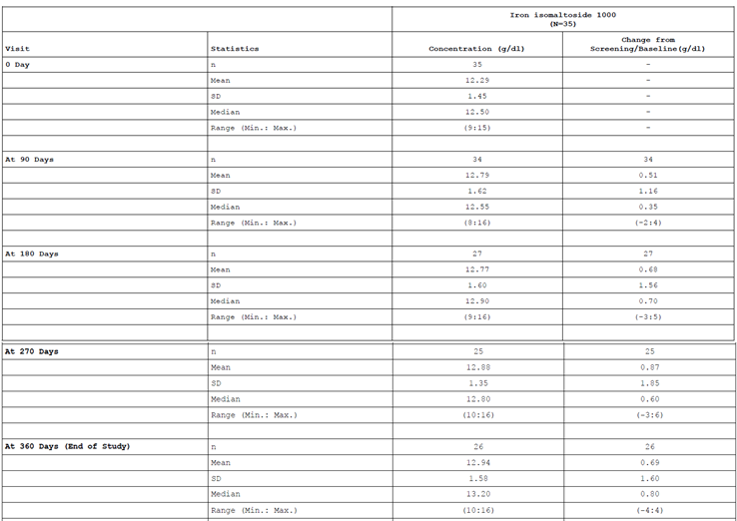

In the shorter study period of 4 weeks, Study P-CKD-02 (chronic kidney disease), demonstrated a statistically significant difference in change in Hb from baseline to Week 4 (CSR P-CKD-02). The results of this study met the designated non-inferiority margin of -0.5g/dL and ferric derisomaltose showed superiority over iron sulphate in its ability to increase Hb from baseline to Week 4 (FAS: p = 0.0385; PP: p = 0.0471). However, the sensitivity analysis with LOCF did not show superiority over iron sulphate in terms of a significant higher increase in Hb concentration from baseline to Week 4 (p = 0.0611) (CSR P-CKD-02). Using the same non-inferiority margin of --0.5g/dL, Study P-CIA-01 showed that ferric derisomaltose was non inferior to iron sulphate in its ability to increase Hb from baseline to Week 4 in both FAS and PP datasets in subjects with iron deficiency anaemia associated with inflammatory bowel disease. (FAS: difference estimate: 0.0161, 95 % CI: -0.261:0.293, p = 0.0002; PP: difference estimate: -0.0071, 95 % CI: -0.291:0.276, p = 0.0006). However, there was no statistically significant difference in change in Hb from baseline to Week 4 (CSR P-CIA-01) and ferric derisomaltose did not show superiority over iron sulphate in terms of change in Hb concentration from baseline to Week 4 in either FAS or PP analysis sets (FAS: p = 0.9092; PP: p = 0.9609) (CSR P-CIA-01).

Two randomised studies are presented in the setting of post-partum haemorrhage (P‑PP‑01, n = 200) and severe post-partum iron deficiency anaemia (P-PP-02, n = 13). Both studies chose the primary efficacy endpoint AUC of change in physical fatigue from Baseline to Week 12 assessed by the multidimensional fatigue inventory (MFI). A secondary endpoint of both studies was the ability to increase Hb. Study P-PP-01 compared a single dose of 1,200 mg ferric derisomaltose to ‘standard of care’ oral iron therapy (varied dose). There was a statically significant decrease in AUC of change in physical fatigue score for the ferric derisomaltose group compared with standard medical care (difference estimate of -0.97 (-1.65; -0.28), p=0.0060) (CSR P-PP-01). However, the estimated difference of 0.97 in physical fatigue score between ferric derisomaltose and standard medical care was less than the pre-defined minimum clinically relevant difference of 1.8 required for claiming superiority. The increase from baseline in Hb concentration was statistically significantly greater in the ferric derisomaltose group compared with the standard medical care group at Week 12 (p < 0.0001) (CSR P-PP-01). Study P-PP02 was a small randomized study which compared 7 women treated with ferric derisomaltose (dose 1,500 mg) to a total of 6 women treated with 1 to 2 RBC transfusions. There was no statistically significant difference between the 2 treatment groups in AUC of change in physical fatigue score from baseline to Week 12 (estimated difference ferric derisomaltose - RBC transfusion (95% CI): -0.63 (-3.28; 2.02), p=0.6051) (CSR P-PP-02). The increase from baseline in Hb concentration was statistically significant in the ferric derisomaltose group compared with the RBC transfusion group at Week 12 (p=0.0115) (Table 21).

Table 21: Analysis of change from baseline in haemoglobin concentration (g/dL) (FAS)

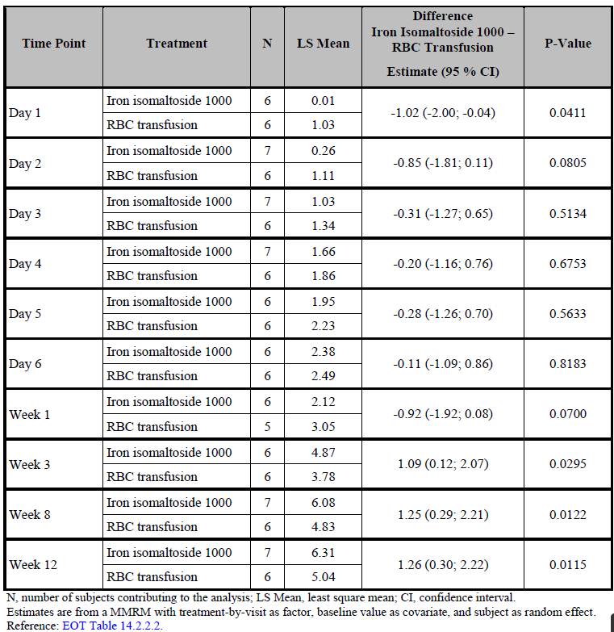

One placebo controlled double blind randomised study was submitted to evaluate the effect of IV ferric derisomaltose in comparison with placebo in non anaemic patients undergoing cardiac surgery (Study P-CABG-01). This study population does not reflect the population proposed for ferric derisomaltose. The primary efficacy endpoint of the study was to assess the change in Hb concentration from baseline to 4 weeks postoperatively in both the FAS and PP populations. There was an expected decrease in Hb from baseline to Week 4 in both treatment groups, but it was significantly less pronounced in the ferric derisomaltose group compared to the placebo group (p = 0.012), and the proportion of non anaemic patients at Week 4 was significantly higher in the ferric derisomaltose group (38.5% versus 8%; p = 0.05) (see Attachment 2).

#### Safety

The safety analyses considered by the evaluator are listed in Attachment 2, Section 8. The clinical evaluator’s overall conclusions on clinical safety are presented in Attachment 2 Section 8 and reflect the sponsor’s summary of safety.

For detail regarding the safety data presented by the sponsor, please see Attachment 2. Key findings on review of the dossier include the following:

* The highest percentage of subjects reported AE’s and ADRs with doses of ferric derisomaltose above 1,000 mg.
* Across all active comparator products in the clinical studies, subjects aged > 65 years experienced a higher rate of adverse events, including serious adverse events, in the ferric derisomaltose group.
* Utilising the pooled data from the clinical trials (excluding PK studies), subjects treated with IV ferric derisomaltose demonstrated an overall higher rate of adverse events compared to subjects treated with IV iron sucrose (53% (869 out of 1,640) compared to 40% (112 out of 282) respectively). A higher rate of death was also seen in the IV ferric derisomaltose group compared to the IV iron sucrose group with 21 out of 1,640 deaths (1.3% versus 0% respectively).
* This corresponded to a higher rate of adverse events leading to withdrawal from the study in the ferric derisomaltose group compared to the iron sucrose group (3% versus 0% respectively); serious adverse events (9% versus 4% respectively) and a higher rate of adverse drug reactions (12% versus 11% respectively).
  + A similar result was seen in the combined analysis of treatment emergent adverse events in the two clinical studies using IV iron sucrose as a comparator (CKD-03 and IDA-01). This analysis is presented in the Table 22 and demonstrates that for IV ferric derisomaltose compared to IV iron sucrose, there was an increase in the rate of treatment emergent adverse events (45% versus 40%); serious adverse events (6% versus 4%); adverse drug reactions (15% versus 11%); adverse events leading to withdrawal from the study (2% versus 0%) and fatal adverse events (4/563 compared to 0/282) is noted.

Table 22: Summary of treatment-emergent adverse events (Safety): Patient studies with iron sucrose as comparator

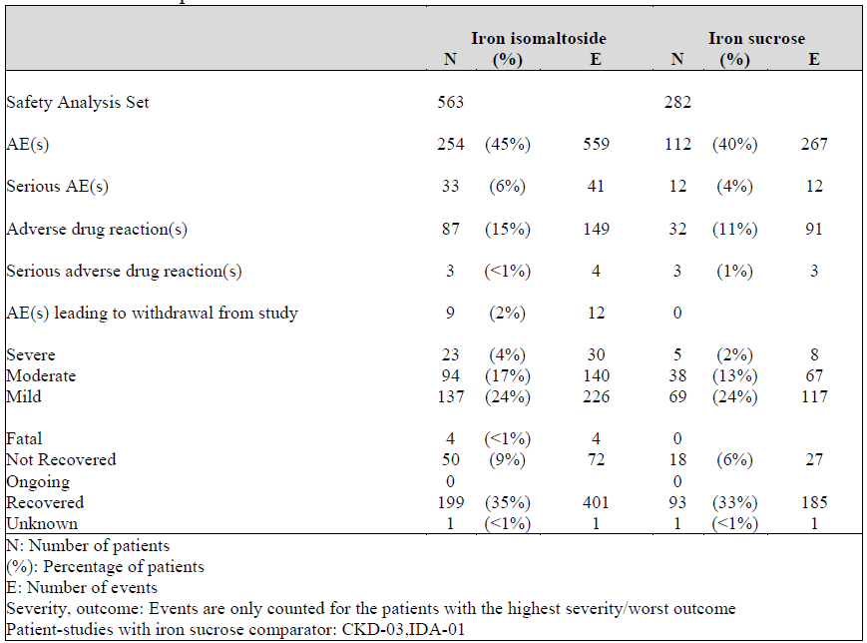

* Compared to oral iron sulphate a higher overall rate of adverse events, including serious adverse events (SAE), was seen in the ferric derisomaltose group (overall 49% AE’s in the iron sulphate group compared to 53% in the IV ferric derisomaltose group). However the rate of adverse drug reactions, adverse events leading to withdrawal from the study and the rate of death were all lower in the ferric derisomaltose group.
* A total of 31 deaths were recorded in the clinical trials. Of these, 21 were reported in the ferric derisomaltose group and 10 deaths in the iron sulphate group. None of the AEs with fatal outcome were considered by the investigator and sponsor as related to study drug.
  + The majority of deaths occurred in the P-CIA-01 trial. In total, 21 patients experienced fatal AEs during participation in this trial with 11 patients in the ferric derisomaltose group and 10 in the oral iron sulphate groups respectively.
  + In total, 3 cases of unexplained deaths were reported in subjects treated with ferric derisomaltose (in each from studies P-CKD-01, P-CKD-03, and PCIA-01).
* Overall, AEs reported by 40 or more patients within the ferric derisomaltose by preferred term (PT) were headache (52 patients (3%)), nasopharyngitis and nausea (45 patients (3 %) each), vomiting (43 patients (3 %)), constipation (41 patients (3 %)), and pyrexia and diarrhoea (40 patients (2 %) each).
* As highlighted by the sponsor, one of the main areas of concern for IV iron in general is the risk of acute ADRs related to the free iron and immunogenicity of the carbohydrate moiety. The sponsor has presented pooled data from the clinical trials demonstrating the rate of serious or severe treatment emergent hypersensitivity reactions:
  + Overall in clinical trials, a total of 23 (0.96 %) out of 2,396 patients reported a hypersensitivity reaction at any time point after dosing. 17 (1.04 %) patients in the ferric derisomaltose group, 3 (1.06%) patients in the iron sucrose group, 2 (0.59%) patients in the iron sulphate group, and 1 (3.33 %) patient receiving placebo.
  + The vast majority of serious or severe hypersensitivity events were observed within the therapeutic group IDA with 11 (1.13 %) events in the ferric derisomaltose group, 2 (1.19 %) events in the iron sucrose group, and 1 (0.45 %) event in the iron sulphate group.
  + There was an imbalance in the rate of hypotension in the Overall, 16 (< 1%) of patients in the ferric derisomaltose group reported an AE of hypotension, the majority of which were reported in the IDA and the CKD in dialysis population. No events of hypotension were reported in any of the other main treatment groups, iron sucrose and oral iron sulphate.
* The percentages of patients experiencing any AE with ferric derisomaltose was also investigated by the sponsor across the therapeutic areas IDA, NDD-CKD, CKD in dialysis and CABG:
  + The proportion of patients experiencing adverse drug reaction (ADRs) within the ferric derisomaltose group was higher for patients with IDA (IDA 143 (15 %), NDD-CKD, 25 (10 %), CKD in dialysis, 24 (6 %)).
  + The proportion of patients experiencing SAE’s within the ferric derisomaltose group was higher in the CKD in dialysis population (IDA, 69 (7 %); NDD-CKD, 17 (7 %), CKD in dialysis, 59 (15 %)).
* In the post-market data presented by the sponsor, a total of 188 cases of hypersensitivity reactions have been reported until December 2015. The reporting rate for hypersensitivity reactions has increased from 2013 to 2015 for Grade II and Grade IV hypersensitivity reactions (Annual Review period January 2015 to December 2015). No post-market data after December 2015 has been submitted. The latest PSUR in the submission is dated 2014.[24]

*Question for sponsor*: Was there any difference in adverse events for patients treated in fractionated dosing versus single dosing in Study CKD-03?

*Question for sponsor*: The pooled data presented in the Summary of Clinical Safety presented data on treatment emergent serious or severe hypersensitivity reactions. What was the overall rate of hypersensitivity reactions from the pooled data across all Phase II or Phase III clinical studies (that is, including mild reactions and those not deemed treatment emergent)? Is there any difference in rate compared to each active comparator product studied?

*Question for sponsor*: Do you have any update to the post-market data presented in this submission (data until 2015 has been submitted).

#### Clinical evaluator’s recommendation (if applicable)

The clinical evaluator’s views are presented in Attachment 2, Sections 9 and 10. The evaluators view is that the benefit-risk balance of Monofer for the treatment of iron deficiency when oral iron preparations are ineffective or cannot be used and/or where there is a clinical need to deliver iron rapidly; is favourable.

### Risk management plan

#### Recommended condition/s of registration

The RMP evaluator recommended the following condition of registration:

Implementation of EU-RMP (version 7.1, date 31 May 2017, data lock point 31 December 2016) with Australian Specific Annex (version 1.0, date May 2017) and any future updates as a condition of registration.

### Risk-benefit analysis

#### Delegate’s considerations

The current submission proposes ferric derisomaltose for the treatment of iron deficiency when oral iron preparations are ineffective or cannot be used and/or where there is a clinical need to deliver iron rapidly. From the data presented, it is not possible to discuss efficacy and safety compared to other IV iron products marketed for this indication, which form the current standard of care in Australia.

As highlighted by the nonclinical evaluator, the pharmacokinetic profile of ferric derisomaltose was not characterised in the nonclinical studies. The majority of nonclinical toxicity studies were conducted with the early development form ABT-870, which is not identical to the clinical moiety, ferric derisomaltose. A tissue distribution to bridge nonclinical studies with ABT-870 to the clinical moiety, ferric derisomaltose was not submitted.

In the clinical data, clinical studies utilising ferric derisomaltose, the pharmacokinetic studies did not investigate the PK of single doses above 1000 mg. Overall in the PK trials, a total of 66 (74 %) patients received a cumulative dose < 1000 mg and 23 (26 %) a dose of 1000 mg. Therefore, the PK parameters and dose proportionality of ferric derisomaltose for doses above 1000 mg is not known. Based on the dosing and administration section of the Australian PI, single doses of above 1000 mg may be utilised in an intravenous infusion. The PK studies did not adequately investigate the effect of multiple dosing as advised in the Monofer PI.

Uncertainty remains regarding the appropriate dosing of ferric derisomaltose. Based on the PK studies (doses at 100 mg or below) clear dose linearity is not demonstrated, with inconsistent findings of dose dependent increases in area under the curve (AUC), AUC0-t, and maximal concentration (Cmax). There is some indication from the clinical studies that the efficacy of ferric derisomaltose may be insufficient at doses < 1000 mg. Study IBD-01 studied a mean cumulative dose of 883 to 885 mg (for the bolus and infusion groups respectively). This study did not meet its primary efficacy endpoint of non-inferiority to oral iron after 8 weeks. The sponsor commented that the dose in this trial may have been too low and the Ganzoni formula may have underestimated the required dose. Subgroup analysis indicated improved efficacy for doses > 1000 mg in the setting of inflammatory bowel disease. This study has important implications for the appropriate dosing of ferric derisomaltose as the Ganzoni formula is included in the Monofer PI.

The submitted clinical trial data nominated multiple comparator products. Study P-IDA-01 provided a direct comparison of the efficacy of ferric derisomaltose to IV iron sucrose in the setting of in patients with iron deficiency anaemia who are intolerant or unresponsive to oral iron therapy or who need iron rapidly (Study P-IDA-01). This study demonstrated that ferric derisomaltose is non-inferior to IV iron sucrose, with subsequent analysis meeting the threshold of superiority. A higher number of responders (that is subjects with an increase in Hb of ≥ 2 g/dL from baseline at any time from Week 1 to Week 5) were seen in the ferric derisomaltose group (226 out of 330 or 68.5%) compared to the iron sucrose group. However, this study chose an active comparator (Venofer) which is indicated for a clinically different population compared to the population studied in the trial. Furthermore, the dosage of the active comparator was lower compared to the ferric derisomaltose group which has implications for the interpretation of non-inferiority. Due to the short duration of study, the maintenance of the treatment effect seen with ferric derisomaltose is not known. The results of clinical Study P-CKD-03 supported non-inferiority to IV iron sucrose in the setting of CKD. However this study also raised the question of whether single dosing of ferric derisomaltose is not as effective as fractionated dosing in haemodialysis dependent CKD, with the potential that maintenance of treatment effect in this group may be poorer at 6 weeks compared to fractionated dosing.

In trials of shorter duration (4weeks) comparing IV ferric derisomaltose to oral ferric sulphate, non-inferiority to oral iron was demonstrated (Studies P-CKD-02 and P‑CIA‑01). However in the longer study duration of 8 weeks (Study P-IBD-01), the primary efficacy endpoint failed and non-inferiority to oral iron was not demonstrated. Subjects in Study P‑IBD-01 demonstrated a lower mean change in Hb from baseline to Week 8. This result highlights the issue of treatment effect maintenance for IV ferric derisomaltose. This requires further consideration both within the setting of IBD compared to oral ferric sulphate (noting the sponsor’s argument that the dose in Study P-IBS-01 may have been too low) and for the broader indication proposed by the sponsor in this submission.

There are important correlations between the quality, nonclinical, PK and clinical efficacy/safety studies. Balanced against the insufficient nonclinical data package; lack of PK data in the clinical dose range; difference in PK parameters including exposure at higher dose ranges; difference in PK parameters with age and suggestion of reduced efficacy at doses < 1,000 mg (Study IBD-01); the overall safety data demonstrated the highest percentage of subjects reported AE’s and ADRs with doses of ferric derisomaltose above 1,000 mg. Furthermore, the safety data demonstrated an increase in adverse events (including serious adverse events) across all active comparator products in the clinical studies for subjects aged > 65 years treated with ferric derisomaltose.

Compared to IV iron sucrose, combined analysis noted an overall higher rate of adverse events in the ferric derisomaltose group (53% (869 out of 1,640) compared to the iron sucrose group (40% (112 out of 282). An imbalance in the rate of death was also noted (21 out of 1,640 deaths (1.3%) versus 0% in the iron sucrose group). Notwithstanding the overall lower dose of IV iron sucrose administered compared to ferric derisomaltose (mean (SD) cumulative dose for ferric derisomaltose 1,016 (588) mg versus 872 (409) mg for iron sucrose), this difference in safety profile compared to IV iron sucrose must be carefully considered. Compared to oral iron sulphate a higher overall rate of adverse events, including serious adverse events, was also seen in the ferric derisomaltose group (overall 49% AE’s in the iron sulphate group compared to 53% in the IV ferric derisomaltose group).

The overall rate of hypersensitivity reactions with IV ferric derisomaltose was similar to that for IV iron sucrose. The data presented does not suggest a clear clinical advantage in regards to rate of hypersensitivity reaction for ferric derisomaltose when compared to IV iron. The sponsors states that ‘Isomaltoside 1000 consists of predominantly 3 to 5 glucose units, is unbranched and has reduced anaphylactogenic potential…. It is therefore theorized that the new iron isomaltoside formulation has the potential to reduce risk for allergic side effects’. According to the post-market data presented, there was an increase in the reporting rate for Grade II and IV hypersensitivity reactions over 2014 to 2015; however the overall reporting rate was lower than that seen in 2013. No post-market data after December 2015 has been submitted.

The long term efficacy, maintenance of treatment effect and impact of more than 3 doses of ferric derisomaltose is not known from the clinical trial data presented. The pharmacokinetic studies did not look at the effect of multiple dosing. The majority of trials exposed subjects for 4 to 6 weeks and utilised three or less separate doses. Two of the three trials with longer study duration failed the primary efficacy endpoint (8 weeks for Study IBD-01 and 12 weeks Study P-PP-02).

Although the Delegate agrees with the clinical evaluator that the sponsor has submitted evidence of efficacy in the proposed indication, a number of uncertainties remain. This includes the clinical implications of an insufficient nonclinical data package, lack of PK data for doses > 1,000 mg, unknown effect of multiple dosing, potential issues with maintenance of treatment effect, imbalance in safety profile when compared to IV iron sucrose and unknown safety profile beyond 12 weeks.

As a result of the uncertainties identified, the Delegate was unable to provide a preliminary opinion regarding approval at this time. The Delegate sought the advice of the Advisory Committee for Medicines (ACM) regarding the issues raised in this overview.

##### Indications

Proposed:

*‘Monofer is indicated for the treatment of iron deficiency in the following conditions:*

* *When oral iron preparations are ineffective or cannot be used*
* *Where there is a clinical need to deliver iron rapidly*

*The diagnosis must be based on laboratory tests’*

Indication proposed by the Delegate:

*Monofer is indicated for the treatment of iron deficiency* ***in adults****, under the following conditions:*

* *When oral iron preparations are ineffective or cannot be used*
* *Where there is a clinical need to deliver iron rapidly*

*The diagnosis must be based on laboratory tests*

##### Dosage

See the draft Australian PI for Monofer for full details of dosage.

The cumulative iron need can be determined using either the Ganzoni formula (1) or the simplified table below (Table 23).

Table 23: Simplified table for calculation of iron need

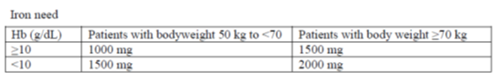

Monofer may be administered by intravenous bolus, intravenous drip infusion or injection into a dialyser.

Monofer may be administered as an intravenous bolus injection up to 500 mg up to three times a week at an administration rate of up to 250 mg iron/minute. It may be administered undiluted or diluted in maximum 20 mL sterile 0.9% sodium chloride.

The cumulative iron dose required may be administered in a single Monofer infusion up to 20 mg iron/kg body weight or as weekly infusions until the cumulative iron dose has been administered. If the cumulative iron dose exceeds 20 mg iron/kg body weight, the dose must be split in two administrations with an interval of at least one week.

##### Summary of issues

* Further consideration is required regarding the adequacy of the PK data package on a background of deficiencies in the nonclinical data.
* Questions regarding the efficacy data set in light of the choice of comparator products, maintenance of treatment effect and the population studied in the clinical trials compared to proposed indication.
* Concern regarding an imbalance in adverse events and mortality compared to IV iron sucrose.

#### Proposed action

The Delegate was unable to provide a preliminary opinion regarding approval at this time. The Delegate sought the advice of the ACM regarding the issues raised in this overview.

#### Request for ACPM advice

The committee is requested to provide advice on the following specific issues:

1. Is the evidence regarding the efficacy of Monofer sufficient to support approval in the proposed indication?
2. What is the Committee’s opinion of the safety of Monofer in the clinical trials? In particular, what is the committee’s opinion on the increase rate of adverse events and mortality compared to IV iron sucrose in the indicated population (patients with IDA when oral iron preparations are ineffective or cannot be used or where there is a clinical need to deliver iron rapidly)?
3. Does the ACM consider that the safety of Monofer in the proposed use is sufficiently well characterised and communicated in the PI?
4. Can the committee comment on the propose dose regimen and instructions. Is this dosage and administration information adequately supported by the evidence presented?
5. Can the committee please comment on the proposed indication for Monofer in light of the efficacy and safety data presented. Is any change to the wording of the indication required, especially in regards to paediatric versus adult patients?
6. Can the committee comment on the risk benefit profile for Monofer based on the data presented? Does the committee feel that the submission is adequate to support approval?

The committee is also requested to provide advice on any other issues that it thinks may be relevant to a decision on whether or not to approve this application.

Please note, the committee was also requested to provide specific expert advice on the PK aspects of the submission prior to the ACM meeting.

#### Response from sponsor

1. ***Is the evidence regarding the efficacy of Monofer sufficient to support approval in the proposed indication?***

It is the opinion of the sponsor that the efficacy of Monofer has been sufficiently demonstrated. Monofer has been studied in a number of clinical conditions where treatment of iron deficiency is required. The efficacy is supported primarily by results from 8 pivotal, well designed controlled comparative trials: P-IDA-01, P-CKD-02, P-CKD-03, P-IBD-01/P-IBD-01-ext, P-CABG-01, PCIA- 01, P-PP-01, P-PP-02, with additional support on PD efficacy endpoints in PK trials and 3 non-comparative trials (P-CKD-01, P- CHF-01, P-IBD-02). All trials were conducted as planned and efficacy has in these trials been convincingly demonstrated against placebo, IV iron, and oral iron. In IDA patients with intolerance to oral iron or lack of response to oral iron, efficacy has been demonstrated against IV iron sucrose.

Evidence of a fast therapeutic response, based on raised reticulocyte count and Hb, was observed after administration of Monofer. Following the slow release of bioavailable iron, serum ferritin peaks within days after an IV dose of Monofer and slowly returns to baseline after weeks. The efficacy variables measured to assess outcomes were in accordance with accepted practice and guidelines for iron replacement and the trial duration was adequate for assessment of effect.

1. ***What is the Committee’s opinion of the safety of Monofer in the clinical trials? In particular, what is the committee’s opinion on the increase rate of adverse events and mortality compared to IV iron sucrose in the indicated population patients with IDA when oral iron preparations are ineffective or cannot be used or where there is a clinical need to deliver iron rapidly)?***

It is the opinion of the sponsor that the safety of Monofer has been sufficiently demonstrated. Monofer has been studied in a number of clinical conditions where treatment of iron deficiency is required.

The safety is supported by results from well-designed controlled comparative trials: P‑IDA-01, PCKD- 02, P-CKD-03, P-IBD-01/P-IBD-01-ext, P-CABG-01, P-CIA-01, P-PP-01, P‑PP-02, PK trials, and 3 non-comparative safety trials (P-CKD-01, P-CHF-01, P-IBD-02). All trials were conducted as planned and safety has in these trials been convincingly demonstrated against placebo, IV iron, and oral iron. In IDA patients with intolerance to oral iron or lack of response to oral iron, safety has been demonstrated against IV iron sucrose. Conclusively, no significant safety issues were identified when analysing safety data of all clinical trials collectively on Monofer in patients with IDA, IBD, CHF, CIA, CKD (NDD and dialysis), post-partum haemorrhage, and post CABG. Overall, there was no difference in the number of subjects experiencing any AE or SAEs between Monofer and the comparator treatments, oral iron sulphate, and iron sucrose. There was no correlation between the number of AEs and mode of administration or total dose administered of Monofer. AE data was also evaluated across gender, region, and indication with no issues identified.

In the full database, a total of 21 subjects randomised to Monofer treatment experienced 24 fatal AEs during participation in the trials. In comparison, 10 subjects in the oral iron sulphate group experienced 11 fatal AEs. No fatal AEs were reported from other comparator groups. Based on a randomisation of 2:1 for Monofer and comparator the frequency of fatal events across comparators is overall considered balanced although slight differences occurred in different trials. The number of deaths was low and individual trials too small for firm conclusions. In some trials higher frequencies were seen on comparator and in some trials on Monofer. These differences are likely random as the larger sample size in the combined database indicates that the overall balance is neutral. Importantly, no fatal AEs were considered related and since several trials were conducted in severely ill patients such non-related fatalities are expected.

The frequency of subjects with possible/probably related SAEs (that is serious adverse reactions (SARs)) with Monofer was comparable to that of iron sucrose. A very limited number of subjects reported serious or severe hypersensitivity reactions within one day of dosing for Monofer (0.43%), and the proportion of subjects was lower than for iron sucrose (0.71%).

1. ***Does the ACM consider that the safety of Monofer in the proposed use is sufficiently well characterised and communicated in the PI?***

The safety section of the PI is based on the current European SmPC (revision date 19 May 2017). The SmPC is based on a pooled analysis covering post marketing and clinical trial data. During the clinical trial programme, relevant indications and patient groups have been investigated to establish the safety and support the proposed indication.

1. ***Can the committee comment on the propose dose regimen and instructions. Is this dosage and administration information adequately supported by the evidence presented?***

Based on the results of the PK/PD trials and current guidelines and published reports, the clinical trials in IDA, IBD, CHF, CIA, CKD, post-partum haemorrhage, and post CABG used either an adapted Ganzoni formula or a simplified dosing table based on Hb and weight to calculate iron requirements, or a fixed dose. Single dosages up to 20 mg/kg body weight has been applied and administered as in proposed label in the trials. The applied dosages and ways of calculating iron need are the same as reflected in the proposed dosages sections in the labelling and provide adequate evidence for the applied dosing and administrations.

1. ***Can the committee please comment on the proposed indication for Monofer in light of the efficacy and safety data presented? Is any change to the wording of the indication required, especially in regards to paediatric versus adult patients?***

Monofer is indicated for the treatment of iron deficiency in adults, under the following conditions:

* When oral iron preparations are ineffective or cannot be used
* Where there is a clinical need to deliver iron rapidly.

Whereas the safety and efficacy in adults is supported by results from well-designed controlled comparative trials: P-IDA-01, P-CKD-02, P-CKD-03, P-IBD-01/P-IBD-01-ext, P-CABG-01, PCIA- 01, P-PP-01, P-PP-02, PK trials, and 3 non-comparative safety trials (P‑CKD-01, P- CHF- 01, P-IBD-02), Monofer has not been studied in paediatrics. The lack of paediatric trials is reflected in the restricted indication limited to adults.

1. ***Can the committee comment on the risk benefit profile for Monofer based on the data presented? Does the committee feel that the submission is adequate to support approval?***

The risk of ADRs to Monofer is low based on the data presented and the corresponding sales. Data presented includes relevant indications and patient population for the proposed indication. Paediatric use has not been investigated as no approval for this indication has been applied for. Analysis of clinical and post marketing data reported for Monofer cumulatively has not revealed any unexpected safety concerns. Based on the data presented and the conclusion of a European referral procedure for all IV iron products (conducted in 2013 followed by annual reports), the benefit/risk balance of Monofer and other IV iron containing medicinal products remains positive as the benefits continue to outweigh the risks in the treatment of iron deficiency (anaemia) when the oral route is insufficient or poorly tolerated.

***Responses to Delegate’s Questions for sponsor***

***Please clarify the foreign regulatory status for ferric derisomaltose (Monofer) including the timing/status of the application submitted to Canada and whether an application has been made to the United States FDA.***

Foreign regulatory status was provided.

An application was submitted in Canada in April 2016 and is currently under review.

No application has been submitted to the US FDA.

***Have additional PK studies or population PK studies been completed that investigate doses > 1,000 mg, multiple dosing, and dose proportionality above 1,000 mg?***

No additional PK trials investigating doses > 1000 mg have been conducted. Six clinical PK trials were conducted with different dosages (100, 200, 250, 500, 1000 mg). As pointed out by the clinical reviewer at TGA, it is common practice to administer a dose of approximately 1,000 mg of IV iron for the treatment of IDA. Based on current literature and published guidelines it is considered that the choice of dosages used in the PK/PD trials, were appropriate. The proposed PI is an adequate summary of the PK data presented in the submission.

***Please clarify the source of evidence supporting the PI statements regarding the absorption, distribution and metabolism of ferric derisomaltose?***

Sponsor’s comments on the PI were provided.

***Please clarify the specific iron formulation used in the nonclinical, PK and clinical trial settings. Please outline the differences in formulations used compared to the marketed version of ferric derisomaltose (Monofer)?***

The development compound ABT-870 has been used for most nonclinical trials, whereas ferric derisomaltose (Monofer) has been used for reproductive and developmental toxicity trials and for PK and clinical trials. The carbohydrate moiety is the same (same specification) as are the raw materials used and the manufacturing method. However, during development of ferric derisomaltose the compounding ratio of ferric chloride and derisomaltose was changed to increase the size of the colloid particle with the purpose of reducing the renal excretion. This was accomplished. Ferric derisomaltose has a molecular weight of approximately 165 kDa and a level of free iron of < 0.003% w/v, whereas the apparent peak molecular weight is approximately 125 kDa for ABT-870 and the level of free iron 0.01% w/v.

The ferric derisomaltoside formulation used for the nonclinical, PK and clinical trials is the same as in the marketed product as is presented in the quality module.

***Has an additional analysis been completed that takes into account the higher dose of iron administered in the ferric derisomaltose group compared to the iron sucrose group? Is non inferiority maintained?***

When the primary endpoint (proportion of subjects with an Hb increase of ≥ 2 g/dL from baseline at any time from Week 1 to Week 5) is analysed with an adjustment for dose category, the analysis still shows non-inferiority on the pre-defined margin of -12.5 % points with a risk difference of 4.7 (95 % CI: -5.1; 14.5).

***Please provide further justification for the choice of comparator product iron sucrose (Venofer) given the different indication and dose regime for this product.***

Iron sucrose was chosen as a comparator since it is the leading IV iron on the market, and it is approved for treatment of iron deficiency globally. Furthermore, it is used as comparator in similar regulatory trials in USA where ferric carboxymaltose was compared to iron sucrose.[25],[26]

The design of the IDA-01 trial was based on interaction with the FDA and the previous comparable and recently conducted regulatory trials in the same indication (IDA) with other IV iron compounds.

***In the ad hoc analysis of the percentage of patients who maintain Hb > = 9.5 g/dL at 6 weeks treatment, was any difference noted between the single and fractionated dosing in the ferric derisomaltose group?***

Several post-hoc analyses were performed on "percentage of patients who maintain Hb ≥ 9.5 g/dL at 6 weeks treatment" on both full analysis set and per protocol analysis set (page 73-82 in SAR trial P-Monofer-CKD-03). All analyses showed that there were no differences between single and fractionated dosing in the ferric derisomaltose group.

***Was there any difference in adverse events for patients treated in fractionated dosing versus single dosing in Study CKD-03?***

Table 24 below describes the adverse events for patients treated with fractionated dosing versus single dosing. There were no difference in number of patients experiencing an adverse event (p = 0.36). The number of patients with related/possible related adverse events were the same in the groups (n = 6, p = 1.0), and there were no difference in severity (p > 0.33) or seriousness (p = 0.50) of the adverse event.

Table 24: Adverse events for patients treated with fractionated dosing versus single dosing

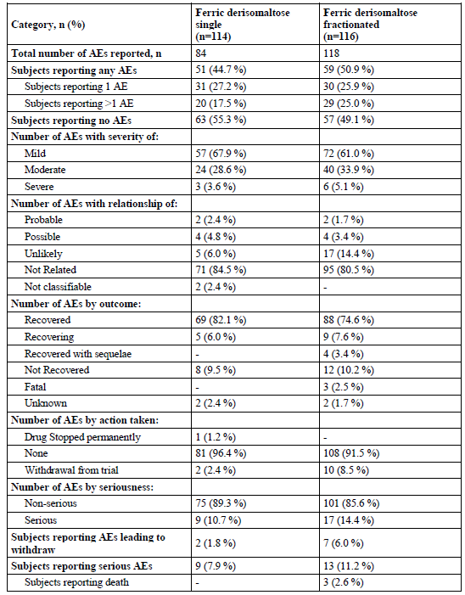

***The pooled data presented in the Summary of Clinical Safety presented data on treatment emergent serious or severe hypersensitivity reactions. What was the overall rate of hypersensitivity reactions from the pooled data across all Phase II-III clinical studies (that is, including mild reactions and those not deemed treatment emergent)? Is there any difference in rate compared to each active comparator product studied?***

The overall incidence of hypersensitivity reactions from the pooled data including all severities, seriousness, and both treatment and non-treatment emergent events is 8.3%. No statistically significant differences between the comparator groups and Monofer could be found.

The presented incidence of hypersensitivity reactions limited to data analysis of serious and severe reactions is 0.96%. Reported hypersensitivity reactions from clinical trials have been characterised by milder non-serious reactions. Hence, the overall incidence is higher when including all data. The same pattern was observed for comparators and no statistically significant differences could be found when comparing Monofer with individual comparators.

***Do you have any update to the post-market data presented in this submission (data until 2015 has been submitted).***

Update to post-market data (data until 1 January 2017) was provided.

###### Conclusion

The provided evidence regarding the safety and efficacy of Monofer is sufficient to support approval in the proposed indication.

#### Specific expert advice regarding pharmacokinetic aspects of the clinical data

Prior to the ACM meeting the Delegate was provided with specific expert advice regarding the pharmacokinetic aspects of the clinical data. This advice was provided (dated 27 September 2017) and included in the documentation provided to the ACM.

#### Advisory Committee Considerations[27]

The Advisory Committee on Medicines (ACM), having considered the evaluations and the Delegate’s overview, as well as the sponsor’s response to these documents, advised the following:

The ACM taking into account the submitted evidence of efficacy, safety and quality, considered Monofer solution for injection containing 100 mg/mL of ferric derisomaltose to have an overall positive benefit-risk profile for the Delegate’s amended indication:

*‘Monofer is indicated for the treatment of iron deficiency in adults, under the following conditions:*

* *When oral iron preparations are ineffective or cannot be used*
* *Where there is a clinical need to deliver iron rapidly*

*The diagnosis must be based on laboratory tests’*

The sponsors initially proposed indication was:

*‘Monofer is indicated for the treatment of iron deficiency in the following conditions:*

* *When oral iron preparations are ineffective or cannot be used*
* *Where there is a clinical need to deliver iron rapidly*

*The diagnosis must be based on laboratory tests’*

In making this recommendation the ACM:

* noted the evidence regarding the use of ferric derisomaltose in the proposed indication;
* expressed concern that no pharmacokinetic data had been provided on multiple dosing;
* was of the view that the multiple methods of calculating ferric derisomaltose doses provided in the PI could complicate use;
* was of the view that a dose cap for single doses should be provided in the PI;
* was of the view that use in iron replacement for blood loss should be limited to post-partum haemorrhage.

##### Specific advice

The ACM advised the following in response to the Delegate’s specific questions on the submission:

1. ***Is the evidence regarding the efficacy of Monofer sufficient to support approval in the proposed indication?***

The ACM considered that sufficient evidence has been provided to approve Monofer, with some amendment to the PI document. The committee considered that use in iron replacement for blood loss should be limited to cases of post-partum haemorrhage, as limited evidence has been provided for other causes of blood loss. The committee also agreed that a maximum dose of 1500 mg for single doses should be described in the PI, due to limited evidence for the use of higher doses.

1. ***What is the Committee’s opinion of the safety of Monofer in the clinical trials? In particular, what is the committee’s opinion on the increase rate of adverse events and mortality compared to IV iron sucrose in the indicated population (patients with IDA when oral iron preparations are ineffective or cannot be used or where there is a clinical need to deliver iron rapidly)?***

The ACM did not consider the safety signal to be concerning and agreed that safety may be monitored through regular pharmacovigilance activities.

1. ***Does the ACM consider that the safety of Monofer in the proposed use is sufficiently well characterised and communicated in the PI?***

The ACM considered that the safety information provided in the PI was adequate.

1. ***Can the committee comment on the propose dose regimen and instructions. Is this dosage and administration information adequately supported by the evidence presented?***

The ACM was concerned that limited pharmacokinetic and safety data had been provided for multiple dosing and that this was further complicated due to suspected possible non-linear pharmacokinetic properties of ferric derisomaltose at higher doses. Based on this the Committee advised that the maximum bolus dose should be 1500 mg.

The Committee advised that the PI should reflect that use of ferric derisomaltose in iron replacement after blood loss should be limited to post-partum haemorrhage, as evidence for use in other causes is limited.

1. ***Can the committee please comment on the proposed indication for Monofer in light of the efficacy and safety data presented. Is any change to the wording of the indication required, especially in regards to paediatric versus adult patients?***

The ACM agreed with the Delegate’s proposed indication, and considered that the use of Monofer should be limited to adults.

1. ***Can the committee comment on the risk benefit profile for Monofer based on the data presented? Does the committee feel that the submission is adequate to support approval?***

The ACM considered that Monofer has a positive risk-benefit profile and the submission is adequate to support approval with the changes described above.

***The committee was also requested to provide advice on any other issues that it thinks may be relevant to a decision on whether or not to approve this application.***

The ACM advised that implementation by the sponsor of the recommendations outlined above to the satisfaction of the TGA, in addition to the evidence of efficacy and safety provided would support the safe and effective use of this product.

### Outcome

Based on a review of quality, safety and efficacy, the TGA approved the registration of:

* Monofer iron (as ferric derisomaltose) 100 mg/1 mL solution for injection vial
* Monofer iron (as ferric derisomaltose) 200 mg/2 mL solution for injection vial
* Monofer iron (as ferric derisomaltose) 500 mg/5 mL solution for injection vial
* Monofer iron (as ferric derisomaltose) 1000 mg/10 mL solution for injection vial

indicated for:

*Monofer is indicated for the treatment of iron deficiency in adults, under the following conditions:*

* *When oral iron preparations are ineffective or cannot be used*
* *Where there is a clinical need to deliver iron rapidly*

*The diagnosis must be based on laboratory tests*.

#### Specific conditions of registration applying to these goods

The ferric derisomaltose EU-Risk Management Plan (EU-RMP), version 7.1, dated 31 May 2017, data lock point 31 December 2016 with Australian Specific Annex (version 1.0, date May 2017), included with submission PM-2016-02728-1-4, and any subsequent revisions, as agreed with the TGA will be implemented in Australia.

## Attachment 1. Product Information

The PI for Monofer approved with the submission which is described in this AusPAR is at Attachment 1. For the most recent PI, please refer to the TGA website at <<https://www.tga.gov.au/product-information-pi>>.

## Attachment 2. Extract from the Clinical Evaluation Report

|  |
| --- |
| Therapeutic Goods Administration |
| PO Box 100 Woden ACT 2606 Australia  Email: [info@tga.gov.au](mailto:info@tga.gov.au) Phone: 1800 020 653 Fax: 02 6232 8605  [**https://www.tga.gov.au**](https://www.tga.gov.au) |

1. The sponsorship at the time of submission of the application was Link Medical Products Pty Ltd T/A Link Pharmaceuticals
2. The sponsorship at the time of submission of the application was Link Medical Products Pty Ltd T/A Link Pharmaceuticals
3. ICH M3 (R2) ICH harmonised tripartite guideline. Guidance on nonclinical safety studies for the conduct of human clinical trials and marketing authorization for pharmaceuticals M3(R2).
4. ICH harmonised tripartite guideline. Guidance on genotoxicity testing and data interpretation for pharmaceuticals intended for human use S2(R1)
5. Gambling L et al. (2011) Fetal regulation of iron transport during pregnancy. *Am. J. Clin. Nutr*. 94(Suppl): 1903S-1907S.
6. Pregnancy Category B3 is defined as ‘Drugs which have been taken by only a limited number of pregnant women and women of childbearing age, without an increase in the frequency of malformation or other direct or indirect harmful effects on the human fetus having been observed. Studies in animals have shown evidence of an increased occurrence of fetal damage, the significance of which is considered uncertain in humans.’
7. AUC0-end: Area under the concentration time curve from time zero to end
8. Tmax Time taken to reach the maximum concentration
9. Ke The elimination rate constant Ke is a value used in pharmacokinetics to describe the rate at which a drug is removed from the system
10. t½ the pharmacokinetic term half-life (t½) refers to the time taken for half the initial dose of medicine administered to be eliminated from the body
11. A. M. Ganzoni, ‘Intravenous iron-dextran: therapeutic and experimental possibilities’; *Schweizerische Medizinische Wochenschrift*, 1970; 100: 301–303
12. Kulnigg, S. et al., “Anovel intravenous iron formulation for treatment of anemia in inflammatory bowel disease: the ferric carboxymaltose (FERINJECT) randomized controlled trial,” *The American Journal of Gastroenterology* 2008; 103: 1182–1192
13. National Kidney Foundation. KDOQI, Clinical practice guidelines and clinical practice recommendations for anemia in chronic kidney disease. *American Journal of Kidney Diseases*, 2006; 47: S1–S145, and Kidney Disease: Improving Global Outcomes (KDIGO) Anemia Work group, KDIGO clinical practice guideline for anemia in chronic kidney disease. *Kidney International Supplements*, 2012; 2: S279–S335
14. Aapro,M et al Prevalence and management of cancer-related anaemia, iron deficiency and the specific role of I.V. iron. *Annals of Oncology* 2012; 23: 1954–1962
15. Auerbachours, M et al. Intravenous iron optimizes the response to recombinant human erythropoietin in cancer patients with chemotherapy related anemia: a multicenter, open label, randomized trial. *Journal of Clinical Oncology* 2004; 22: 1301–1307
16. Gasche, C et al. Guidelines on the diagnosis and management of iron deficiency and anemia in inflammatory bowel diseases. *Inflammatory Bowel Diseases* 2007; 13: 1545–1553
17. Gozzard, D When is high dose intravenous iron repletion needed? Assessing new treatment options. *Drug Design, Development and Therapy* 2011; 5: 51–60
18. Evstatiev, R., et al. (2011). FERGIcor, a randomized controlled trial on ferric carboxymaltose for iron deficiency anemia in inflammatory bowel disease. *Gastroenterology* 2011; 141: 846-853
19. Clarification. The P-CABG-01 trail included non anaemic patients
20. *Routine risk minimisation* activities may be limited to ensuring that suitable warnings are included in the product information or by careful use of labelling and packaging.

    *Routine pharmacovigilance* practices involve the following activities:

    All suspected adverse reactions that are reported to the personnel of the company are collected and collated in an accessible manner;

    Reporting to regulatory authorities;

    Continuous monitoring of the safety profiles of approved products including signal detection and updating of labelling;

    Submission of PSURs;

    Meeting other local regulatory agency requirements.
21. Vadhan-Raj et al., 2014
22. EMEA/CPMP/EWP/2158/99 Guideline on the choice of the non-inferiority margin
23. LOCF In the analysis of clinical trial results, the last observation carried forward (LOCF)is a commonly used way of imputing data with dropouts. The last observed value (non- missing value) is used to fill in missing values at a later point in the study.
24. . The additional PSUR was submitted in the pre-ACM response, thus not available when the Delegate completed the overview.
25. Onken JE et al., 2014. A multicenter, randomized, active-controlled study to investigate the efficacy and safety of intravenous ferric carboxymaltose in patients with iron deficiency anemia. *Transfusion* 2014; 54: 306-315.
26. Hetzel D et al., 2014 A phase III, randomized, open label trial of ferumoxytol compared with iron sucrose for the treatment of iron deficiency anemia in patients with a history of unsatisfactory oral iron therapy. *Am J Hematol* 2014; 89: 646-650.
27. The ACM provides independent medical and scientific advice to the Minister for Health and the Therapeutic Goods Administration (TGA) on issues relating to the safety, quality and efficacy of medicines supplied in Australia including issues relating to pre-market and post-market functions for medicines.

    The Committee is established under Regulation 35 of the Therapeutic Goods Regulations 1990. Members are appointed by the Minister. The ACM was established in January 2017 replacing Advisory Committee on Prescription Medicines (ACPM) which was formed in January 2010. ACM encompass pre and post-market advice for medicines, following the consolidation of the previous functions of the Advisory Committee on Prescription Medicines (ACPM), the Advisory Committee on the Safety of Medicines (ACSOM) and the Advisory Committee on Non-Prescription Medicines (ACNM). Membership comprises of professionals with specific scientific, medical or clinical expertise, as well as appropriate consumer health issues relating to medicines.