March 2012

AusPAR Attachment 2

Extract from the Clinical Evaluation Report for fluticasone propionate / eformoterol fumarate dihydrate
  - Proprietary Product Name: Flutiform
  - Sponsor: Mundipharma Pty Ltd

About the Therapeutic Goods Administration (TGA)
- The Therapeutic Goods Administration (TGA) is part of the Australian Government Department of Health and Ageing, and is responsible for regulating medicines and medical devices.
- The TGA administers the Therapeutic Goods Act 1989 (the Act), applying a risk management approach designed to ensure therapeutic goods supplied in Australia meet acceptable standards of quality, safety and efficacy (performance), when necessary.
- The work of the TGA is based on applying scientific and clinical expertise to decision-making, to ensure that the benefits to consumers outweigh any risks associated with the use of medicines and medical devices.
- The TGA relies on the public, healthcare professionals and industry to report problems with medicines or medical devices. TGA investigates reports received by it to determine any necessary regulatory action.
- To report a problem with a medicine or medical device, please see the information on the TGA website <http://www.tga.gov.au>.
About the Extract from the Clinical Evaluation Report
- This document provides a more detailed evaluation of the clinical findings, extracted from the Clinical Evaluation Report (CER) prepared by the TGA. This extract does not include sections from the CER regarding product documentation or post market activities.
- The words [Information redacted], where they appear in this document, indicate that confidential information has been deleted.
- For the most recent Product Information (PI), please refer to the TGA website <http://www.tga.gov.au/hp/information-medicines-pi.htm>.
Copyright
© Commonwealth of Australia 2013
This work is copyright. You may reproduce the whole or part of this work in unaltered form for your own personal use or, if you are part of an organisation, for internal use within your organisation, but only if you or your organisation do not use the reproduction for any commercial purpose and retain this copyright notice and all disclaimer notices as part of that reproduction. Apart from rights to use as permitted by the Copyright Act 1968 or allowed by this copyright notice, all other rights are reserved and you are not allowed to reproduce the whole or any part of this work in any way (electronic or otherwise) without first being given specific written permission from the Commonwealth to do so. Requests and inquiries concerning reproduction and rights are to be sent to the TGA Copyright Officer, Therapeutic Goods Administration, PO Box 100, Woden ACT 2606 or emailed to <tga.copyright@tga.gov.au>.

Contents
List of abbreviations 5
1. Clinical rationale 9
1.1. Type of application 9
1.2. Aspects of development 10
1.3. Good clinical practice aspects 11
2. Pharmacokinetics 11
2.1. Introduction 11
2.2. Methods 12
2.3. PK studies in healthy volunteers 14
2.4. PK studies in asthma patients 24
2.5. Dose proportionality and time-dependence 29
2.6. Bioequivalence studies 31
2.7. Intra- and inter-individual variability 32
2.8. Pharmacokinetics in target population 32
2.9. Pharmacokinetics in special populations 32
2.10. Interactions 32
2.11. Exposure relevant for safety evaluation 33
2.12. Evaluator’s overall conclusions on pharmacokinetics 33
3. Pharmacodynamics 35
3.1. Introduction 35
3.2. Primary pharmacology 35
3.3. Secondary pharmacology 40
3.4. Relationship between plasma concentration and effect 40
3.5. Pharmacodynamic interactions with other medicinal products or substances 41
3.6. Evaluator’s overall conclusions on pharmacodynamics 41
4. Clinical efficacy 42
4.1. Introduction 42
4.2. Dose-response and main clinical studies 43
5. Clinical safety 81
5.1. Introduction 81
5.2. Safety results in the Phase 1 studies 82
5.3. Safety results in the Phase 2 studies 82
5.4. Safety results in the Phase 3 studies 83
5.5. Pooled safety analyses 87
5.6. Long term safety 100
5.7. Safety in special populations 101
5.8. Adverse events of special interest 101
5.9. Immunological events 103
5.10. Safety related to drug-drug interactions and other interactions 103
5.11. Evaluator’s overall comments on clinical safety 103
6. Clinical questions 105
6.1. Pharmacokinetics 105
6.2. Efficacy 115
6.3. Safety 124
7. Summary and discussion 124
7.1. Clinical aspects 124
7.2. Benefit-risk assessment 129
8. References 133

List of abbreviations
Abbreviation | Meaning
AE | adverse event
ACTH | adrenocorticotrophic hormone
AMP | adenosine monophosphate
API | active pharmaceutical ingredient
AQLQ | asthma quality of life questionnaire
AQLQ (S) | asthma quality of life questionnaire (standardised)
AUC | area under the concentration-time curve
BfArM | Bundesinstitut fuer Arzneimittel und Medizinprodukte
BID | twice daily
CFC | chlorofluorocarbon
CHMP | Committee for Human Medicinal Products
CI | confidence interval
COPD | chronic obstructive pulmonary disease
CPMP | Committee for Proprietary Medicinal Products
Cmax | maximum concentration
CSR | clinical study report
CYP | cytochrome
DPI | dry powder inhaler
ECG | electrocardiogram
EU | European Union
EWP | Efficacy Working Party
FAS | full analysis set
FDA | Food and Drug Administration
Fe | Cumulative fraction (percent of dose) recovered in urine
Fe0-t2 | Cumulative fraction (percent of dose) recovered in urine from 0 to the end of the collection interval, t2
Fe0-12 | Cumulative fraction (percent of dose) recovered in urine from 0 to the end of the first dosing interval
FEF25, 50, 75 | forced expiratory flow at 25%, 50%, 75% of the volume to exhale
FEF25-75 | forced expiratory flow in the middle portion of expiration
FEV1 | forced expiratory volume in the 1st second
FLT | Flutiform
FPD | fine particle dose
FVC | forced vital capacity
GCP | Good Clinical Practice
GINA | Global Initiative for Asthma
GSK | GlaxoSmithKline
HFA | hydrofluoroalkane
HPA | hypothalamic-pituitary-axis
ICH | International Conference on Harmonisation
ICS | inhaled corticosteroid
ISS | Integrated Summary of Safety
ITT | intent-to-treat
IVRS | interactive voice response system
kg | kilogram
L | litre
Lab | laboratory
LABA | long-acting β2-agonist
LLNR | lower limit of the normal range
LOCF | last observation carried forward
LS Mean | least squares mean
MAA | Marketing Authorisation Application
MedDRA | Medical Dictionary for Regulatory Activities
MEF25, 50, 75 | maximum expiratory flow rate at 25, 50, and 75% of the volume to exhale
MEF25-75 | maximum expiratory flow rate in the middle portion of expiration
MHRA | Medicines and Healthcare products Regulatory Agency
NAEPP | National Asthma Education and Prevention Program
PD | pharmacodynamic
PDCO | Paediatrics Committee
PEFR | peak expiratory flow rate
PIP | Paediatric Investigation Plan
PK | pharmacokinetic
pMDI | pressurised metered dose inhaler
PPS | per protocol (analysis) set
RA | Accumulation ratio
Rmax | Maximal rate of urinary excretion after first dose
Rmax,SS | Maximal rate of urinary excretion at steady state
Rt1-t2 | Excretion rate calculated over the collection interval t1 to t2
QD | once daily
QTc QT | (electrocardiographic interval from the beginning of the QRS complex to the end of the T wave) corrected for heart rate
SAE | serious adverse event
SAP | statistical analysis plan
SD | standard deviation
SKP | SkyePharma
SmPC | Summary of Product Characteristics
SMQ | Standardised Medical Dictionary for Regulatory Activities Queries
SOC | System Organ Class
t1/2 | half life
tmax | Time to attain Cmax or Rmax
tmax,SS | Time to attain Cmax,SS or Rmax,SS
UCC | urine creatinine-corrected cortisol
UFC | urinary free cortisol
ULNR | upper limit of the normal range
US | United States
vs | versus

Clinical rationale

Type of application
This is a Category 1 application for registration of Flutiform, a new combination product administered by oral inhalation via a hydrofluoroalkane (HFA) propelled pressurised metered dose inhalation (pMDI) containing a fixed combination of an ICS, fluticasone propionate, and a LABA, eformoterol fumarate dihydrate.
Flutiform HFA pMDI is intended for long-term, twice daily, maintenance treatment of asthma in adult and adolescent patients (≥ 12 years). The proposed indication is: “Flutiform inhaler is indicated for the regular treatment of asthma where the use of a combination product (an inhaled corticosteroid and a long-acting β2 agonist) is appropriate. It is appropriate both for patients not adequately controlled with inhaled corticosteroids and ‘inhaled short-acting β2 agonist on an as required’ basis, and for patients already adequately controlled on both an inhaled corticosteroid and a long -acting β2 agonist.”
The Flutiform HFA pMDI has been developed in 3 dosage strengths: (1) Flutiform 100/10 mg: fluticasone propionate 100 mg and formoterol fumarate (eformoterol fumarate) 10 mg, delivered by 2 actuations (fluticasone propionate 50 mg and formoterol fumarate 5 mg per actuation), (2) Flutiform 250/10 mg: fluticasone propionate 250 mg and formoterol fumarate 10 mg delivered by 2 actuations (fluticasone propionate 125 mg and formoterol fumarate 5 mg per actuation) and (3) Flutiform 500/20 mg: fluticasone propionate 500 mg and formoterol fumarate 20 mg delivered by 2 actuations (fluticasone propionate 250 mg and formoterol fumarate 10 mg per actuation). The proposed dose is two inhalations of Flutiform 50/5ug or 125/5ug twice daily for adults and adolescents. The higher dose of two inhalations of 250/10ug twice daily is for adults only.
The active components of Flutiform have been marketed for many years and are well-established treatments which are frequently co-prescribed in the treatment of asthma. Flixotide pMDI (fluticasone 50ug, 125ug and 250ug actuations; given as 2 actuations with every dose) is approved for the following indication: “For use in the prophylactic management of asthma in adults and children of ages 1 year and older.” Foradil DPI (eformoterol fumarate 12ug capsules; 1-2 capsules to be inhaled twice daily) is approved for the following indication: “The long-term, regular treatment of reversible airways obstruction in asthma (including nocturnal asthma and exercise-induced asthma) in patients aged 5 years or more who are receiving inhaled or oral corticosteroids. It should not be used in patients whose asthma can be managed by occasional use of short-acting inhaled beta-2 agonists. Foradil is also indicated for the prophylaxis and treatment of bronchoconstriction in patients with reversible or irreversible chronic obstructive pulmonary disease (COPD).” Foradil is marketed in four forms: a dry-powder inhaler (DPI), a metered-dose inhaler (MDI), an oral tablet, and an inhalation solution.
Currently, there is no inhaler combination of fluticasone and formoterol available for treatment of asthma. However, there are 2 combination inhalers of ICS + LABA available in Australia: Seretide (fluticasone/salmeterol: 100/50 and 500/50ug) and Symbicort (Budenoside/ formoterol: 100/6, 200/6 and 400/12ug) and both are approved for the following indications:
“For the regular treatment of asthma, where the use of a combination product is appropriate. This may include:
- Patients on effective maintenance doses of long-acting β2-agonists and inhaled corticosteroids
- Patients who are symptomatic on current inhaled corticosteroid therapy
- Initiation of maintenance therapy in those patients with moderate persistent asthma not adequately controlled on ‘as needed’ reliever medication, and who have moderate/severe airway limitation and daily symptoms requiring reliever medication every day. For the symptomatic treatment of patients with severe COPD (FEV1<50% predicted normal) and a history of repeated exacerbations who have significant symptoms despite regular beta- 2 agonist bronchodilator therapy. Seretide is not indicated for the initiation of bronchodilator therapy in COPD.”

Aspects of development
Mundipharma Research Limited has co-developed (with SkyePharma, SKP) a new combination product Flutiform HFA pressurised metered dose inhaler (pMDI) containing fluticasone propionate, subsequently referred to as fluticasone, and formoterol fumarate, subsequently referred to as formoterol, in a hydrofluoroalkane (HFA) propellant administered by metered dose inhaler The development for the United States (US) market has been conducted by SKP in collaboration with Abbott. Flutiform inhaler suspension is contained in an aluminium pressurised canister crimped with a standard metering valve. The canister is inserted into a press-and-breathe actuator fitted with a dust cap, and an integrated dose indicator which indicates the number of doses remaining.
The Flutiform clinical development programme was conducted to evaluate the efficacy and safety of the Flutiform HFA pMDI in 3 dose strengths (fluticasone/ formoterol: 100/10ug, 250/10ug and 500/20ug each delivered by 2 actuations of 50/5ug, 125/5ug and 250/10ug, respectively) in the intended patient populations. These doses were administered twice daily in the Phase III programme and were selected to be comparable to the dosing regimens approved and marketed as individual treatments for asthma (e.g. Flixotide and Foradil, respectively) as well as the dosing regimens approved and marketed in other combination products (e.g. Seretide and Symbicort).
Over 1900 adult and adolescent subjects were treated with at least 1 dose of Flutiform during this development programme. Nine Phase I and II clinical studies were conducted in healthy volunteers/ patients. Nine Phase III studies have been completed. Efficacy and safety of FLUTIFORM was evaluated in four pivotal Phase III studies (SKY2028-3-001, SKY2028-3-002, FLT3503 and SKY2028-3-004) and 5 supportive studies including 2 open-label long-term safety studies (FLT3501, FLT3505, SKY2028-3-005, SKY2028-3-003and FLT3502). The Phase III studies were multicentre, randomised (except SKY2028-3-003), double-blind or open-label, comparative studies in adult and adolescent subjects conducted at sites in North America, Europe, Israel, India and Latin America. For convenience, the naming conventions of the products used in the treatment groups throughout this document are shown in Table 1.
Table 1: Naming Conventions for Treatment Groups.
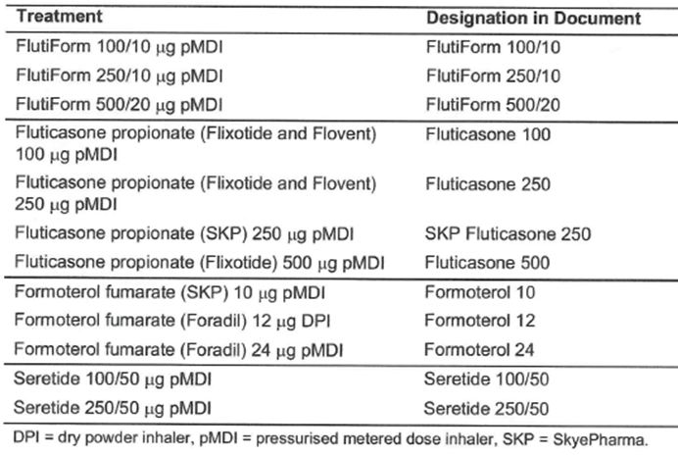
Mundipharma has an approved Flutiform PIP in place. At the time the Paediatric Committee (PDCO) became active in 2007, Mundipharma had already initiated paediatric study FLT3502. i.e. this study was ongoing prior to the requirement to submit a PIP for review and approval by the PDCO. In the approved PIP Mundipharma agreed to initiate a new paediatric phase III clinical trial (FLT3506) to comply with CPMP/EWP/4151/00 Rev. 1; the sponsor also initiated a PK study to demonstrate that systemic exposure of fluticasone from Flutiform HFA pMDI is not different in adolescents vs adults (FLT2502). Planned study FLT3506 was designed to include an ICS arm to demonstrate assay sensitivity. The PDCO advised that some form of feasibility analysis may be required if patients needed to use 3 inhalers (for blinding purposes), i.e. the available ICS inhaler to be used in the study was physically different to the other inhalers used in the study. Exhaled nitric oxide measurements would be included in a subgroup of subjects as an exploratory secondary endpoint. The sponsor was to address the lower leg growth in children by knemometry according to the issue raised in the final guideline. HPA function would be assessed by 12-hour overnight urinary cortisol profiles. The PIP was approved on 06 Feb 2009 and was agreed to be completed by December 2013.

Good clinical practice aspects
The clinical studies were conducted in compliance with local regulations and guidance, the International Conference on Harmonisation (ICH) Guidelines and Good Clinical Practice (GCP) regulations. Subjects were accorded all rights granted by the Declaration of Helsinki. All protocols received approval by the appropriate governing investigational review board, ethics committee, or similar authority. Standard research methodology was utilised for the conduct and performance of each clinical study under consideration.

Pharmacokinetics

Introduction
Nine Phase 1 and 2 studies were conducted. Three studies (AG2028-C101, SKY2028-1-002, SKY2028-2-001) compared the 2 lower doses of Flutiform (fluticasone/ formoterol: 100/10ug and 250/10ug) with its individual components, fluticasone propionate and/or formoterol fumarate. FLT1501 also investigated pharmacokinetics of Flutiform (at a higher dose 500/20) in comparison with its individual components. Study SKYE2201C/8722/01 compared the SKP formoterol component to commercially available Foradil. Another study, FLT2502, compared the pharmacokinetics of Flutiform in adolescents and adults.
There are no specific studies investigating in vitro dissolution, mass-balance studies or studies evaluating the effects of formulation, or food. Although no biopharmaceutic studies have been carried out to date, the influence of variation in actuator use and the presence of a spacer in two clinical pharmacology studies (FLT1501 and FLT2502) on total systemic exposure and peak drug concentration after dosing have been explored.

Methods
Quantitation of fluticasone propionate in plasma, and formoterol fumarate in both urine and plasma was carried out via High Performance Liquid Chromatography (HPLC) analyses with tandem Mass Spectrometry (MS/MS) detection.
Until recently, a plasma formoterol assay with sufficient sensitivity was not available to determine plasma formoterol concentrations resulting from oral inhalations of doses in the currently recommended therapeutic range. Therefore, the earlier studies used only urine concentrations as a measure of subjects’ exposure to formoterol. The methodology associated with the Detection and quantitation of formoterol fumarate in plasma was recently developed and is applicable to the later (FLT) studies only.
Two assays were developed for the determination of fluticasone propionate, first assay (PPD 173 LC/MS/MS) was developed to establish a range of 2.50 to 500 pg/mL and was applied to the analysis of fluticasone propionate plasma samples from the AG2028-C101 study. The second assay (PPD P817 LC/MS/MS) was developed to establish a range of 1.00 to 500 pg/mL and was used for the analysis of samples from studies SKY2028-2-001, SKY2028-1-002, SKY2028-1-004, SKY2028-1-003, FLT1501, and FLT2502 (Table 2).
Table 2: Plasma assay parameters for fluticasone propionate.
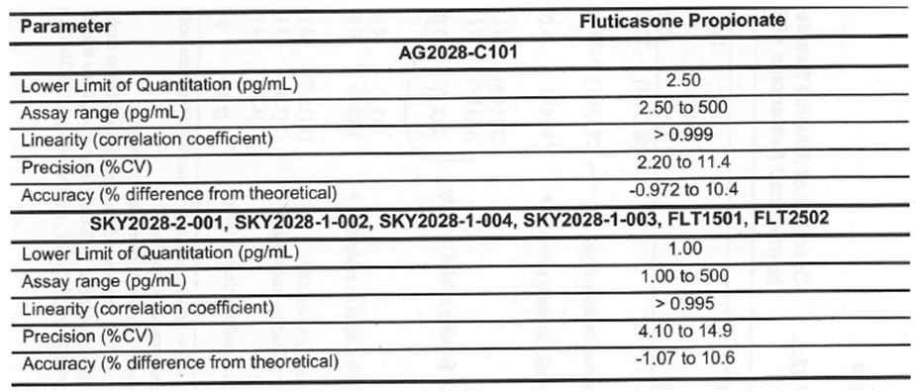
Formoterol fumarate concentrations in human urine were analysed by a validated sensitive and specific LC/MS/MS method developed and qualified by Focus Clinical Drug Development GmbH, Neuss, Germany (R&D/08/1360), and PPD Inc., Middleton, WI, USA (PPD P883 LC/MS/MS) (Table 3). Formoterol fumarate in human plasma containing lithium heparin with Eserine hemisulfate as preservative was analysed by a validated, sensitive, and specific LC/MS/MS method developed and qualified by PPD Inc., Middleton, WI, USA (PPD P860 LC/MS/MS). This LC/MS/MS method was developed to establish a range of 0.5 to 250 pg/mL and was applied to the analysis of formoterol fumarate plasma samples from the FLT1501 and FLT2502 studies.
Table 3: Urine parameters for formoterol fumarate.
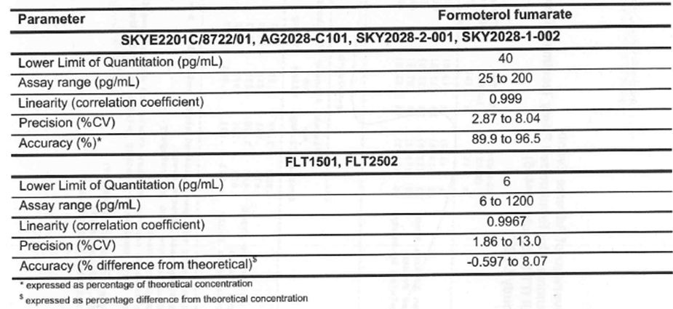

Formulations
The Flutiform HFA MDI formulation is characterised as a pressurised white to off-white suspension of micronised fluticasone propionate and micronised formoterol fumarate suspended in the propellant HFA 227 (1,1,1,2,3,3,3-heptafluoropropane). Excipients include alcohol (ethanol, anhydrous) as a wetting agent and sodium cromoglicate as a suspension aid and moisture scavenger.
Fluticasone propionate has been approved in Australia and Europe as both MDI and DPI formulations (Flixotide, GlaxoSmithKline [GSK]). The same formulations were approved in the United States in 2004 (as Flovent, GSK). Fluticasone propionate HFA pMDI (Flovent) was used in studies SKY2028-1-002 (fluticasone 250), SKY2028-3-001 (fluticasone 100), SKY2028-3-002 (fluticasone 100), SKY2028-3-004 (fluticasone 250), and SKY2028-3-005 (Flovent fluticasone 250), and fluticasone propionate HFA pMDI (Flixotide) was used in studies AG2028-C101 (fluticasone 250), SKY2028-2-001 (fluticasone 250), FLT1501 (fluticasone 500), FLT3503 (fluticasone 500), and FLT3505 (fluticasone 100 and fluticasone 250). Formoterol fumarate is currently available in DPI formulations in the United States and Europe (for example Foradil, Novartis) and in an MDI formulation in Europe. In Australia, only the DPI formulation is available. Foradil DPI (formoterol 12) was used in studies SKYE2201C/8722/01, AG2028- C101, SKY2028-2-001, and FLT3505, and Foradil MDI (formoterol 24) was used in studies FLT1501 and FLT3503.
An in vitro study evaluated the comparability of formoterol fumarate and fluticasone propionate products in the SKP sponsored trials to the European marketed formoterol fumarate and fluticasone propionate products (by comparing critical pharmaceutical performance characteristics, namely in vitro assessment of aerodynamic particle size distribution and delivered dose characteristics of Flovent and Flixotide, and SKP formoterol and Foradil aeroliser DPI and HFA).
The delivered dose results of both Flovent 100 and Flixotide 100 were, in general, found to be more variable than expected, however comparison of the means between the two products showed that the total fluticasone delivered doses were comparable. The particle size of fluticasone propionate and formoterol fumarate in Flutiform pressurised inhalation compared to Flovent 100 and Flixotide 100 showed similar results in terms of both fine and large particle fraction. The total fluticasone dose delivered from both Flixotide 250 and Flovent 250 was found to be more variable than expected: higher doses were observed for Flovent 250 compared to Flixotide 250, however this increased dose did not result in larger differences in either the fine particle dose or particle size distribution profile. An investigation into the variability of delivered dose for Flovent 250 indicated that the higher doses may be associated with the early actuations from the Flovent canister although no corresponding increase in fine particle dose was observed. With respect to particle size distribution, Flixotide 250 had a slightly lower fine particle dose and a higher large particle dose compared to Flovent 250. Overall, both the SKP fluticasone 250 and Flixotide 250 appeared to be comparable in terms of particle size distribution and total fluticasone dose delivered. The mean fine particle dose delivered between these two products was similar, although the individual doses delivered by Flixotide 250 inhaler were more variable. Regarding the overall particle size distribution profile, the particle size fractions were found to be comparable, although the in vitro data for SKP fluticasone were slightly higher and more variable than for Flixotide.
All in vitro data indicated that, in terms of delivery of formoterol, the performance of the SKP formoterol product was comparable to both Foradil MDI and Foradil DPI. The data obtained for the different fractions of the particle size distribution showed that the fine particle dose was similar for SKP formoterol and Foradil MDI, and slightly lower for Foradil DPI compared to both Foradil MDI and SKP formoterol. The large particle fraction was markedly lower for SKP formoterol than for either the Foradil MDI or Foradil DPI batches.
Overall, the important product attributes of fine particle dose and dose content uniformity, showed comparable data of the mono-products for fluticasone propionate (Flovent, Flixotide, and SKP fluticasone) and formoterol fumarate (SKP formoterol, Foradil pMDI, and Foradil DPI).
Comments: The results of the in vitro tests would have to be confirmed by the detailed review of the data provided in module 3.2 by the chemistry evaluator (outside the scope of this evaluation) which would determine if the range of products used throughout the Flutiform clinical programme as comparators was justifiable.
The total daily exposure of sodium cromoglycate from the Flutiform formulation is estimated to be considerably less than the recommended daily dose of sodium cromoglycate from the pMDI brand product INTALR CFC-free Inhaler (5 mg/actuation given up to 8 times per day at 2 actuations per dose, UK Summary of Product Characteristics, 2009), or the recommended daily dose of sodium cromoglycate from GER INTALR N Aerosol (1 mg/actuation given at least 4 times per day at 2 actuations per dose). (All values are based on the metered dose.

PK studies in healthy volunteers
There were 4 studies in healthy subjects which evaluated the fluticasone and formoterol PKs following administration of the proposed combination product compared with that of each of the mono-components separately and concurrently.
A randomised, open-label, 4-way crossover, single-dose study (AG2028-C101) compared the pharmacokinetic parameters of fluticasone and formoterol after single dose exposure of Flutiform (250/10 ug via SkyePharma HFA MDI) with that of commercially available fluticasone propionate (Flixotide Evohaler 250 ug) and formoterol fumarate (Foradil Aerolizer 12 ug) when administered alone and concurrently in 24 healthy subjects. Fluticasone peak and total exposures were similar for treatment groups that received fluticasone propionate only (Flixotide) or fluticasone propionate plus formoterol fumarate (Flixotide + Foradil). When the proposed SKP Flutiform was administered, mean fluticasone peak and total exposure were lower (20 to 24% lower for Cmax and 24 to 31% lower for AUC₀₋₁₂) than the other treatments (Table 4). Bioequivalence between the proposed Flutiform combination product and fluticasone administered alone or in combination with formoterol was not established as the 90% CI were not within the accepted range of 80-125%; in fact the lower 90% CI for fluticasone AUC₀₋₁₂ and AUC_{0-∞} ranged between only 55 and 62% (Table 5). Only a small percentage of formoterol was excreted in urine following administration of formoterol alone (Foradil) or in combination with fluticasone (SKP Flutiform, Flixotide + Foradil). Overall, formoterol urinary recovery following a single dose was comparable across treatments (Table 6). Compared to administration of formoterol (Foradil) alone, a slightly lower Ae₀₋₂₄ was observed for free (by 15%) and total formoterol (by 14%) following administration of Flutiform (Tables 7-8).
Table 4: Pharmacokinetic behaviour of fluticasone propionate in plasma: descriptive statistics (Study AG2028-C101).
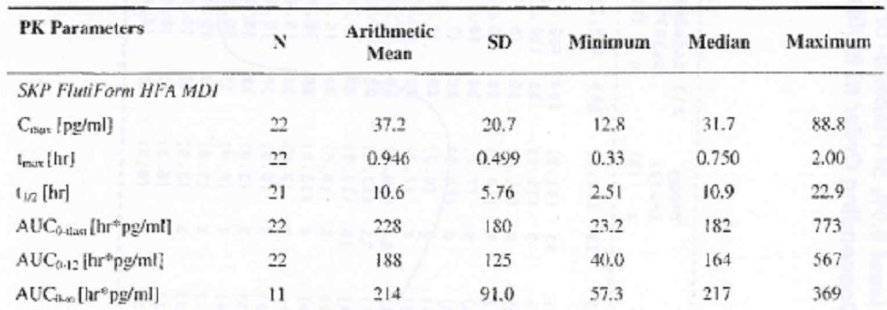
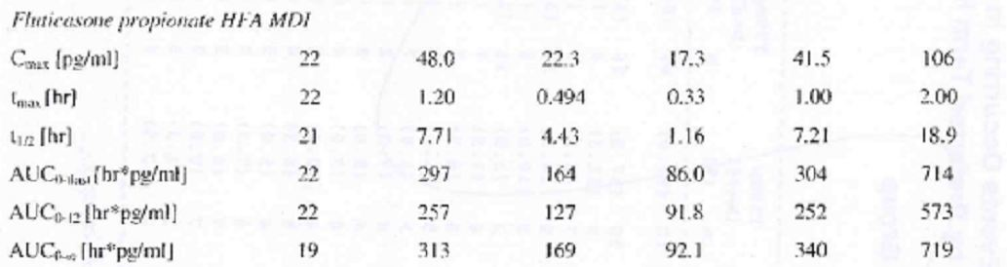
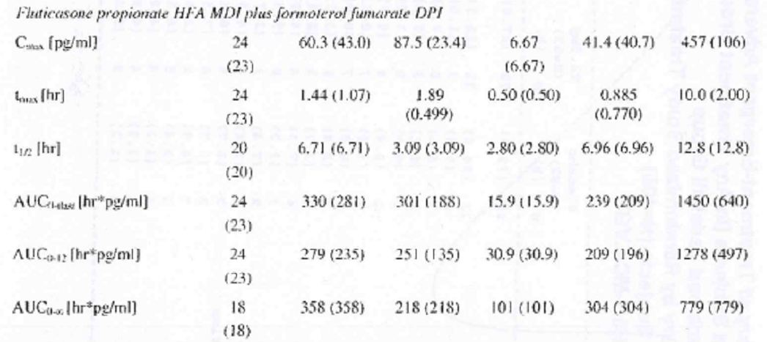
Values in brackets exclude one of the subjects (fluticasone propionate HFA MDI plus formoterol fumarate DPI group), which had an abnormally high plasma fluticasone propionate concentration at 10 hours post-dose. The value for ln AUC_{0-∞} is the same both with and without that subject. This is the result of the fact that extrapolated AUC was >20% for this subject, and therefore no ln AUC_{0-∞} was calculated for this subject.
Table 5: Plasma pharmacokinetics of fluticasone propionate: LS Mean and 90% CI for treatment contrasts (Study AG2028-C101).
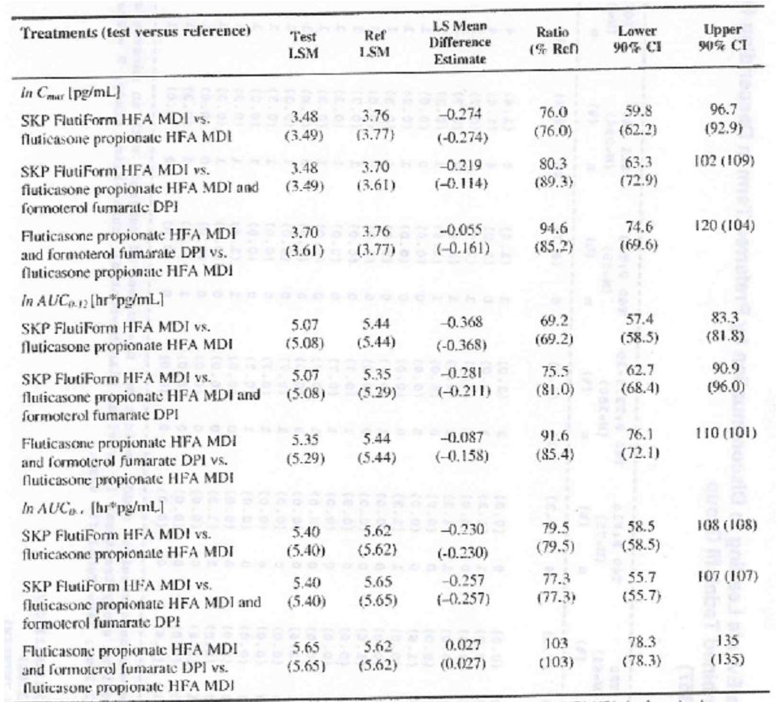
Values in brackets exclude one of the subjects (fluticasone propionate HFA MDI plus formoterol fumarate DPI group), which had an abnormally high plasma fluticasone propionate concentration at 10 hours post-dose. The value for ln AUC_{0-∞} is the same both with and without that subject. This is the result of the fact that extrapolated AUC was >20% for this subject, and therefore no ln AUC_{0-∞} was calculated for this subject. Owing to the fact that the time of the last non-BLOO concentration was observed to be highly variable, AUC₀₋₁₂ was calculated for comparison among groups.
Table 6: Urinary pharmacokinetics of free and total formoterol: LS Mean and geometric means (Study AG2028-C101).
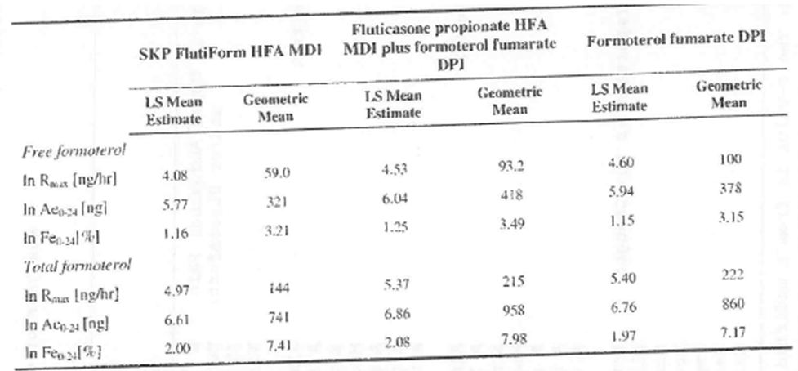
Table 7: Urinary free formoterol pharmacokinetics: LS Mean and 90% CI for treatment contrasts (Study AG2028-C101).
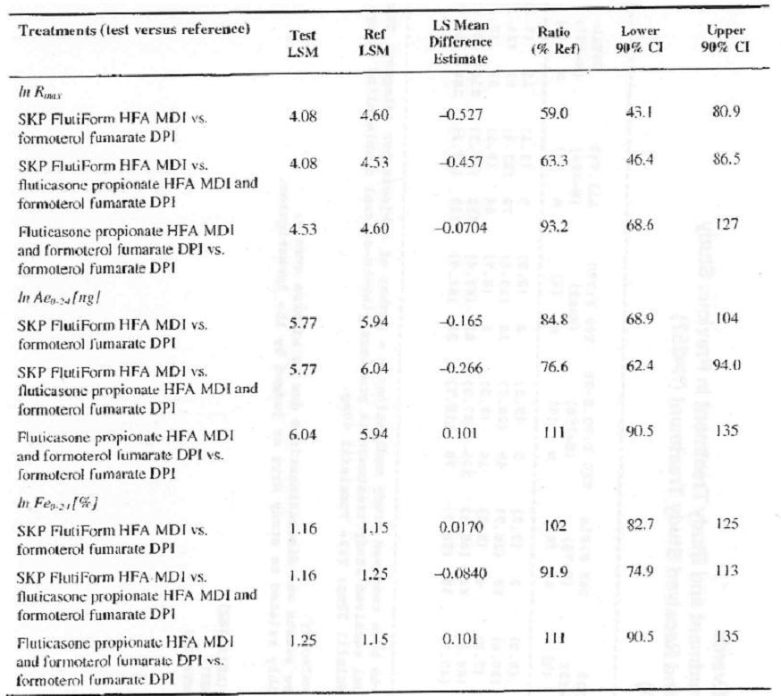
Table 8: Urinary total formoterol pharmacokinetics: LS Mean and 90% CI for treatment contrasts (Study AG2028-C101).
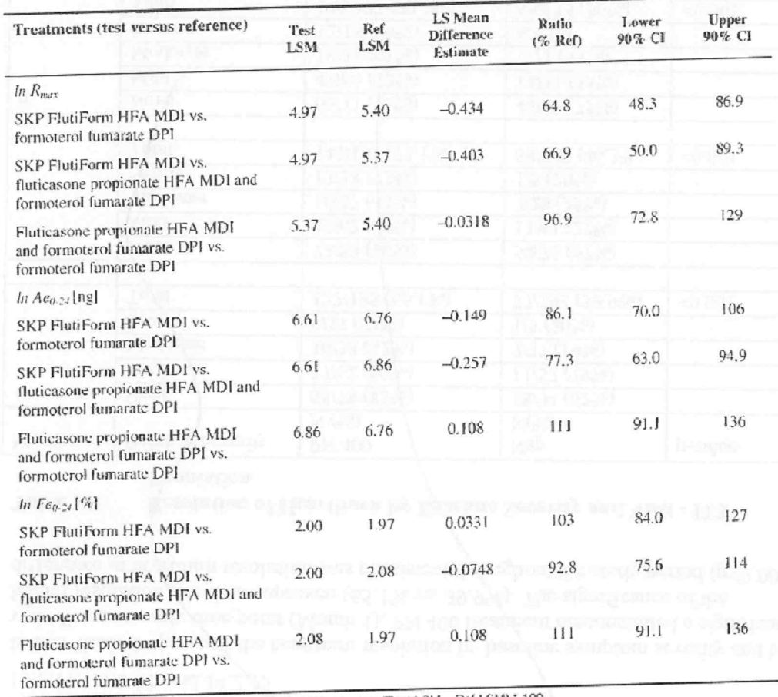
A randomised, open-label, parallel group study (SKY2028-1-002) compared the pharmacokinetic parameters of fluticasone and formoterol after BID administration for 7 days via the SKP Flutiform HFA pMDI combination product (250/10ug and 100/10ug) with that of individual components fluticasone propionate 250 ug (Flovent) and formoterol fumarate 10 ug (SKP formoterol) administered concurrently or alone in 36 healthy subjects. On Day 1, the mean Cmax and AUCt of fluticasone following a single-dose appeared to be lower for Flutiform 250/10 ug compared with fluticasone-only (Flovent 250 ug) and fluticasone (Flovent 250 ug) plus SKP formoterol 10 ug treatments. By Days 6 and 7 (at steady state), the mean Cmax and AUCt of fluticasone were comparable between SKP Flutiform 250/10 ug and fluticasone-only (Flovent 250 ug), although fluticasone levels following both Flutiform and Flovent were lower compared with fluticasone (Flovent 250 ug) plus SKP formoterol 10 ug. Systemic exposure to fluticasone increased with increasing dose in healthy subjects who received Flutiform 100/10 ug and 250/10 ug, although these were not dose proportional (Table 9). Ratios of the geometric means for fluticasone Cmax and AUCtau were less than 2 for Flutiform (250/10 ug) over Flutiform (100/10 ug) for Day 1 AM dose and less than 1.5 for Day 7 AM dose. Following multiple dosing for 7 days, fluticasone had mean accumulation ratios of over 3 for Flutiform (250/10 and 100/20), 1.55 for Flovent (250 ug), and 4.31 for Flovent (250 ug) plus formoterol (10 ug). The median tmax and mean t_{1/2} of fluticasone across the various treatments appeared to be comparable (Table 9). Following dosing on Day 1, the mean fraction of formoterol excreted in the urine for Flutiform 100/10 ug was 7.84% compared with 3.0% for Flutiform 250/10 ug, 2.18% for Flovent 250 ug plus formoterol 10 ug and 2.63% for formoterol 10 ug alone. These were associated with high standard deviations (Table 10) and no conclusion can be drawn in relation to the significance of these figures. As the amount of formoterol in urine was collected for only 12 hours and the subjects were not at steady state following the Day 1 AM dose, the fraction excreted in the urine comparison is not a very reliable comparison. On Day 7, the differences in Fe were not as pronounced with mean % Fe values of 6.61%, 5.14%, 4.12%, and 4.38% for Flutiform100/10 ug, Flutiform 250/10ug, Flovent 250 ug plus formoterol 10 ug, and formoterol 10 ug alone, respectively. Overall, the fraction of formoterol dose excreted in urine was low, with all mean Fe₀₋₁₂ values being less than 10%. Statistical comparisons across treatments for fluticasone or formoterol were not conducted given the small sample size, parallel design, and high variability seen in the PK parameters.
Table 9: Summary of the pharmacokinetic parameters of plasma fluticasone propionate (Study SKY2028-1-002).
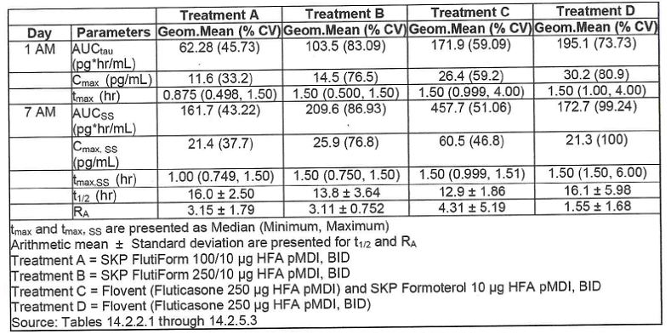
Table 10: Summary of the pharmacokinetic parameters of free formoterol in urine (Study SKY2028-1-002).
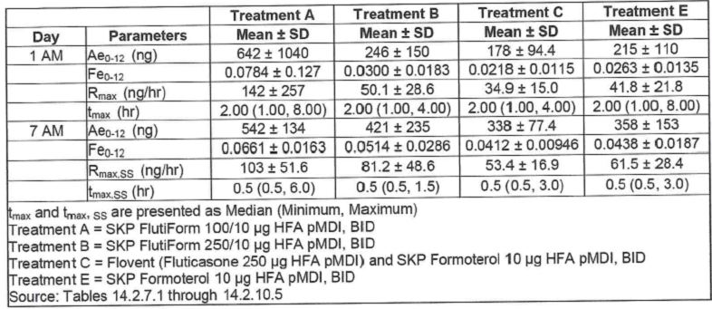
A randomised, open-label, parallel group, multiple-dose exposure study (SKY2028-1-004) compared the pharmacokinetics of fluticasone and formoterol combination (Flutiform 250/10ug) in a single inhaler (SkyePharma HFA pMDI) after BID administration for 7 days with the administration of SKP fluticasone 250 ug alone in healthy male and female subjects (Table 11). On Day 1 the mean AUCt and Cmax of fluticasone associated with Flutiform were slightly lower than those associated with SKP fluticasone alone. However, on Days 6 and 7 the corresponding values were slightly higher following Flutiform. Following multiple dosing for 7 days, the mean accumulation ratio for plasma fluticasone was 2.20 for SKP Flutiform and 1.56 for SKP fluticasone alone. The median tmax was very similar (ranging from 1 hour to 1.5 hours) following both treatments. The median t_{1/2} of fluticasone propionate following Day 7 AM dose was approximately 14 hours for both treatments (Table 12).
Table 11: Statistical analysis of actual FEV1 – ITT population (Study SKY2028-2-001).
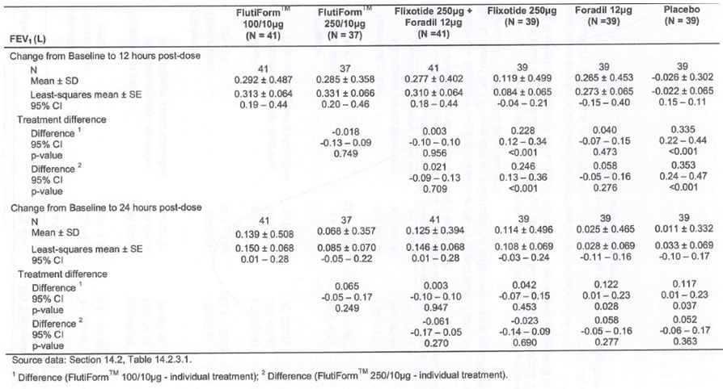
Table 12: Statistical analysis of percentage change from baseline in actual FEV1 – ITT population (Study SKY2028-2-001).
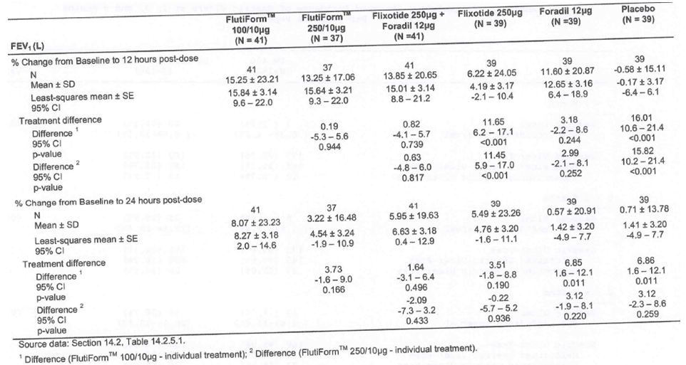
Comments: However, it is unlikely that this long half-life could be accurately estimated from the 12-hour sampling interval following Day 1 AM dose. Although estimates have been made, their values are more reflective of a hybrid between distribution and elimination rate constants On each study day, the inter-subject variability was high. Overall, no significant difference was noted between treatments as differences for the mean estimates on Day 1 and 7 were less than 20% while the observed variability was larger than 30% (Table 13). This study was considered exploratory and did not have any statistical analysis of the PK results.
Table 13: Summary of the pharmacokinetic parameters of plasma fluticasone propionate (Study SKY2028-1-004).
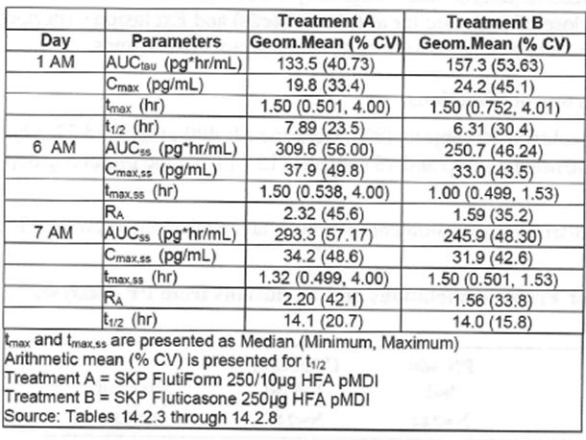
An open-label, multiple dose, 2-treatment, randomised, parallel group study (FLT1501) evaluated the safety and pharmacokinetics of high dose Flutiform pMDI 500/20 mg twice daily and the individual components (fluticasone propionate pMDI 500 mg and formoterol fumarate pMDI 24 mg) in healthy subjects. On Day 1, plasma fluticasone concentrations were markedly lower (by about 37%) from Flutiform when compared with fluticasone and formoterol given together. On Day 29, the availability of fluticasone was higher than had been observed on Day 1 (for both preparations), but the relative availability of fluticasone from Flutiform was still lower than that from the individual components and approximated 67% (Table 14). On Day 1, plasma formoterol concentrations were markedly lower from Flutiform when compared with fluticasone and formoterol given together. The relative availability from Flutiform, based on AUCt values, was only 17%. The availability of formoterol fumarate from Flutiform™ pMDI over a single dosing interval at steady state on Day 29 was higher than had been observed on Day 1, but was still only 75% compared with the reference treatment (Table 15). A similar reduction in geometric mean Cmaxss and Cminss values were observed compared with the reference treatment. Dose-adjusted comparisons were made in two ways: according to nominal dose, and according to delivered dose. Dose-adjusted analyses were not done for fluticasone as nominal and delivered dose were the same. Nominal dose adjustment changed the steady-state relative bioavailability of formoterol fumarate from Flutiform™ relative to the reference treatments from 75% to 90%, Cmaxss ratio changed from 57% to 69%, and the Cminss ratio changed from 76% to 91% (Table 16) Delivered dose adjustment changed the steady-state relative bioavailability of formoterol fumarate from Flutiform™ relative to the reference treatments from 75% to 84%, Cmaxss ratio changed from 57% to 65%, and the Cminss ratio changed from 76% to 85% (Table 17).
Table 14: Statistical analysis results on the bioavailability of fluticasone propionate and formoterol fumarate by analyte (fluticasone propionate, non adjusted): Full Analysis Population for pharmacokinetic parameters (Study FLT1501).
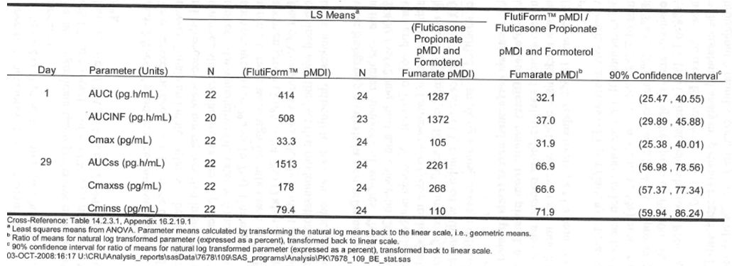
Table 15: Statistical analysis results on the bioavailability of fluticasone propionate and formoterol fumarate by analyte (fluticasone fumarate, non adjusted): Full Analysis Population for pharmacokinetic parameters (Study FLT1501).
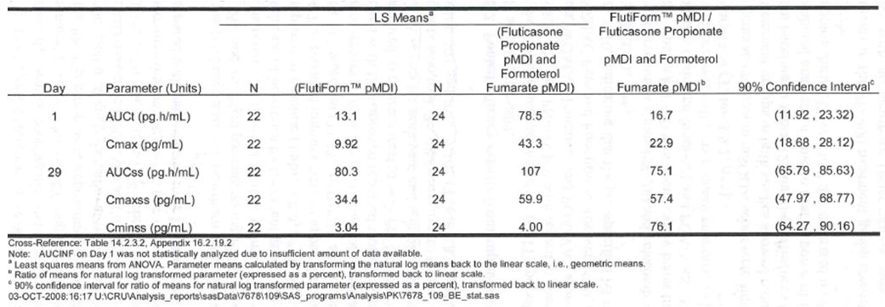
Table 16: Statistical analysis results on the bioavailability of fluticasone propionate and formoterol fumarate by analyte (fluticasone fumarate, nominal dose-adjusted): Full Analysis Population for pharmacokinetic parameters (Study FLT1501).
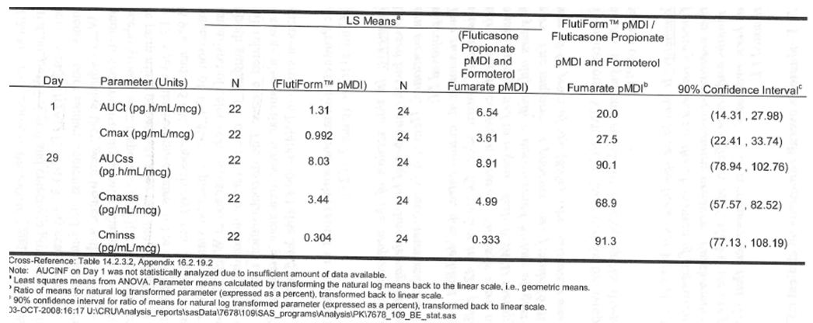
Table 17: Statistical analysis results on the bioavailability of fluticasone propionate and formoterol fumarate by analyte (fluticasone fumarate, delivered dose-adjusted): Full Analysis Population for pharmacokinetic parameters (Study FLT1501).
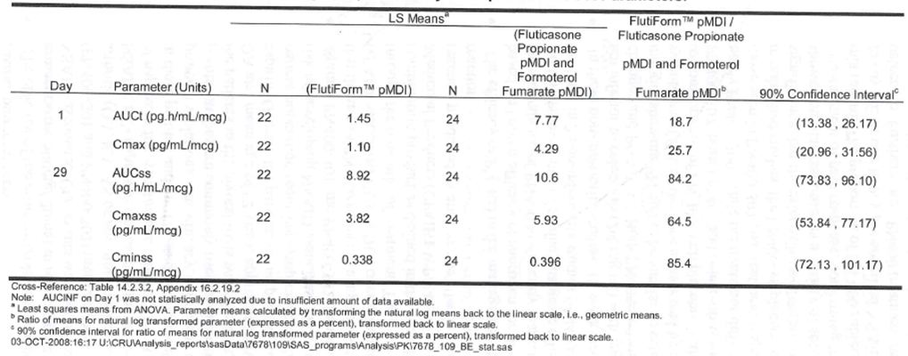
The cumulative fractions recovered in the urine increased between Day 1 and Day 29 for Flutiform™, but remained relatively consistent between Day 1 and Day 29 for the reference treatment. The cumulative amounts of formoterol recovered in urine were higher for the reference treatment than for Flutiform. These differences were relatively small and difficult to interpret as the fraction recovered in the urine accounted for <10% of the dose (Tables 18-19).
Table 18: Summary statistics for formoterol fumarate in urine by treatment, Day 1: Full Analysis Population for pharmacokinetic parameters (Study FLT1501).
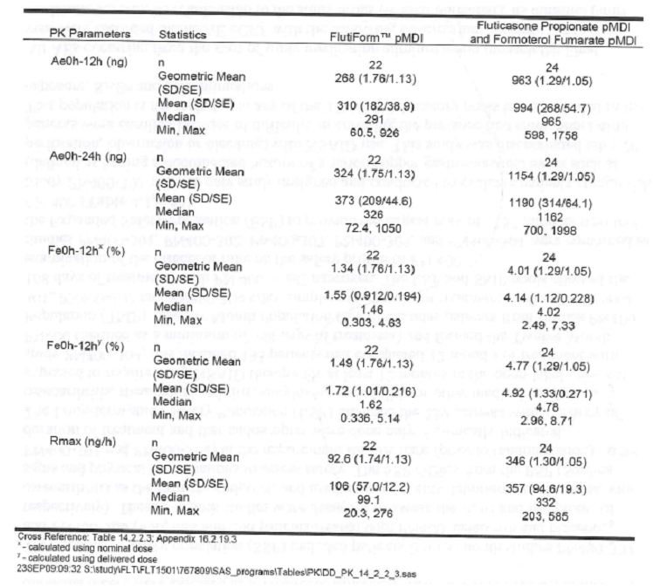
Table 19: Summary statistics for formoterol fumarate in urine by treatment, Day 29: Full Analysis Population for pharmacokinetic parameters (Study FLT1501).
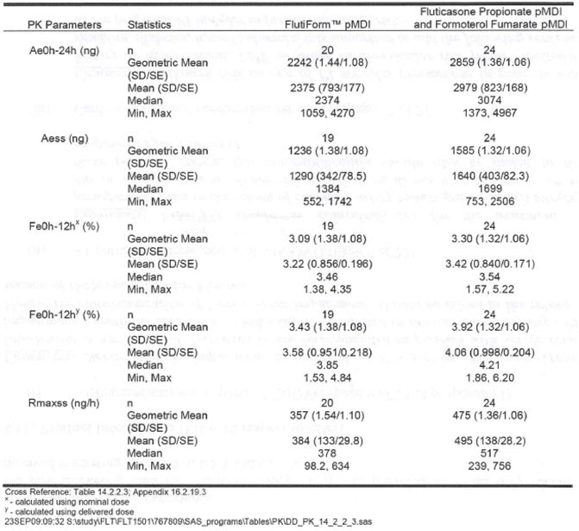

PK studies in asthma patients
A multicentre, randomised, double-blind, placebo-controlled, 5-way crossover, Phase II study (SKYE2201C/8722/01) compared the dose response of 2 and 4 actuations of formoterol fumarate in the SkyePharma HFA pMDI (6 ug/actuation) with one and 2 actuations of formoterol fumarate from the commercially available Foradil DPI (formoterol fumarate 12 ug/actuation) in 45 subjects with asthma. The maximum rate of excretion occurred quite early (between 0.5 and 1.5 hours) for both treatments and both doses. Levels of formoterol were determined in the urine samples over the 48 hour collection period, which amount on average to approximately 5% of the dose for the formoterol HFA MDI and 4% of the dose for the Foradil DPI, regardless of the dose. The maximum values of 13% and 12% were reported for the formoterol HFA MDI and Foradil DPI at the 24 ug dose, respectively. The elimination half-life values were similar between treatments and among doses, i.e., each has an average value of approximately 10 hours. Inter-patient variability (reflected by % CV%) was comparable between formoterol HFA MDI and Foradil DPI, and ranged between approximately 35 to 55% and 35 to 60%, for the formoterol HFA MDI and Foradil DPI, respectively, with an exception for the Foradil DPI Rmax at 24 ug dose (i.e., about 150%). As the rate of drug excretion in urine is proportional to plasma drug concentration (proportionality constant is renal clearance), the time-course of drug in plasma is reflected in the excretion rate versus time plots. Quantitation of drug in urine, when the collections are well-designed, can provide estimates of the relative rate and extent of absorption. At the 12 ug dose level, the mean cumulative amounts of formoterol excreted was on average 24% higher after dosing with SKP formoterol HFA pMDI than after Foradil DPI. At the 24 ug dose level, the mean cumulative amounts of formoterol excreted was on average 39% higher after dosing with SKP formoterol HFA pMDI than after Foradil DPI. This trend of HFA pMDI formulations resulting in higher exposure than DPI has been reported in the literature (Brindley, 2000 and Thorsson, 2001). The systemic exposure to formoterol for both SKP formoterol HFA pMDI and Foradil DPI, respectively, were dose proportional. Based on the results from this study, the strength of formoterol fumarate was reduced from 6 to 5 ug for Flutiform.
A randomised, placebo-controlled, double-blind, incomplete block, 6-treatment, 4-way crossover, single-dose exposure study (SKY2028-2-001) to compare the safety and efficacy of fluticasone and formoterol combination (Flutiform 100/10 ug and 250/10 ug) in a single inhaler (SkyePharma HFA MDI) with the administration of Flixotide 250 ug and Foradil 12ug concurrently or alone in 64 subjects with asthma. Overall, AUC_{0-t} and Cmax of fluticasone in plasma were highly variable for all treatments (CV% range for AUC_{0-t} = 123 – 163% and CV% range for Cmax = 56.7 – 66.5%). The peak plasma concentrations of fluticasone from the Flutiform 100/10ug product and the Flutiform 250/10 ug product (tmax = 0.32 and 0.50 h, respectively) were observed more rapidly than those observed for the Flixotide 250 ug + Foradil 12 ug product and the Flixotide 250 ug product (tmax = 0.78 and 0.79 h, respectively) (Table 20). The rate and extent of absorption of fluticasone from the Flutiform 250/10 ug were similar to Flixotide 250 ug delivery systems as the Ratios of LSM derived from the analyses on the ln-transformed parameters AUC_{0-t}/ Dose and Cmax/Dose for fluticasone propionate were outside the 80-125% limit for the Flutiform 250/10 ug / Flixotide 250 ug comparison, were 116.4% and 123.9%, respectively; the 95% CI for the Ratios were outside the 80.0 – 125.0% range and were confounded by high intrasubject CV% observed for dose-adjusted AUC_{0-t} and Cmax parameters (61.4% and 49.8%, respectively) (Table 21). When the Foradil 12 ug and Flixotide 250 ug products were used concurrently, the ratios of LSM for the Flutiform 250/10 ug / Flixotide 250 ug + Foradil 12 ug comparison were outside 80.0 - 125.0% (137.9% and 160.4%, for AUC_{0-t}/Dose and Cmax/Dose, respectively) (Table 21). This indicated a possible interaction of formoterol on fluticasone PK when administered in the same inhaler compared with administration in separate inhalers. However, the results for AUC _{0-t} /Dose should be interpreted due to the wide confidence intervals. Based on the ratios of LSM derived from the analyses on the ln-transformed parameters AUC_{0-t}/Dose and Cmax/Dose (adjusted for two different doses of fluticasone), the AUC_{0-t} of fluticasone from the Flutiform 100/10ug product was dose-proportional to that observed with the Flutiform 250/10 ug product (i.e., ratio of LSM was within 80-125%). However, the ratio of LSM for Cmax/Dose for the Flutiform 100/10ug / Flutiform 250/10 ug comparison was 150.1%, suggesting a less than proportional increase in the Cmax of fluticasone with dose (Tables 20-21).
Table 20: Pharmacokinetics of fluticasone propionate in plasma – main analysis (default dataset) (Study SKY2028-2-001).
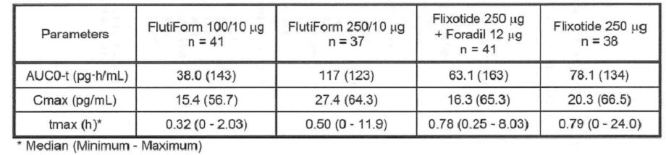
Table 21: LS Mean (90% CI) on dose adjusted PK parameters for fluticasone propionate (Study SKY2028-2-001).
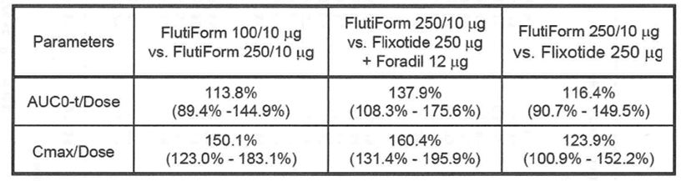
The mean fraction of formoterol excreted in urine over 24 hours, Fe₀₋₂₄, was relatively low for all treatments (10.1 - 12.5%), and Ae_{0-24,} Rmax and tmax were comparable across all treatments. The ratios of least square means and 90% CI for Ae ₀₋₂₄ and Rmax were within the 80.0 to 125.0% range for SKP Flutiform 250/10 ug administered as one inhaler compared with fluticasone + formoterol (Flixotide 250 ug + Foradil 12 ug) administered as 2 inhalers and with formoterol (Foradil 12 ug) administered alone suggesting no interaction between fluticasone and formoterol with respect to formoterol pharmacokinetic parameters. Similar results were observed for SKP Flutiform 100/10 ug when compared with SKP Flutiform 250/10 ug and when SKP Flutiform 100/10 ug was compared with the formoterol (Foradil 12 ug) product administered alone except that the lower bound of the 90% CI around the ratio of least square means was below 80.0%.
Comments: There were some differences in pharmacokinetics of both the plasma fluticasone and urinary formoterol between the treatment groups. The Cmax and AUC_{0-t} of fluticasone from the Flutiform 250/10 ug product were higher than those observed when the Flixotide 250 ug + Foradil 12 ug inhalers were used concurrently, but similar to those observed with the Flixotide 250 ug product alone. This indicated a possible interaction of formoterol on fluticasone PK when administered in the same inhaler compared to in separate inhalers. However, the results for AUC _{0-t} /Dose should be interpreted due to the wide confidence intervals. Combined administration of fluticasone and formoterol fumarate in SKP Flutiform HFA pMDI resulted in similar Ae₀₋₂₄ for formoterol compared with Foradil 12 ug alone, and compared with Flixotide 250 ug + Foradil 12 ug inhalers used concurrently. The Flutiform 250/10 ug product may therefore be considered comparable to the Flixotide 250 ug + Foradil 12 ug products and with the Foradil 12 ug product in patients with asthma in terms of the formoterol component, but not so for the fluticasone component.
Study FLT2502 was a Phase I open-label, single dose, parallel group study to determine the systemic exposure of Flutiform pMDI 125/5 ug (250/10 ug total dose) in adult and adolescent subjects with mild to moderate asthma. Upon receipt of final plasma fluticasone concentration data, it was identified that a significant number of subjects had quantifiable pre-dose fluticasone concentrations (42/65 subjects). Thorough investigations at both the study site and bioanalytical laboratory did not lead to a conclusive explanation for these concentrations. In accordance with the EMEA Draft Guideline on the investigation of bioequivalence (CPMP/EWP/ QWP/1401/98 Rev. 1), the primary analysis excluded all subjects whose pre-dose fluticasone concentration exceeded 5% of the Cmax value for that subject. Hence, the primary analysis only included 29 subjects (15 adults and 14 adolescents). The secondary fluticasone analysis included all subjects with valid plasma concentration data for fluticasone.
The results of the primary analysis (fluticasone primary analysis population for PK parameters) were consistent with the results of the secondary analysis (full analysis population for PK parameters). In both analyses, the systemic availability of fluticasone was higher in adolescents compared with adults, based on comparisons of both AUC_{t} (primary: mean ratio=174%; 90% CI 117.35 – 258.46) and AUC_{inf} (primary: mean ratio=181%; 90% CI 108.15 – 304.02). The maximum observed plasma concentration for fluticasone was similar between adults and adolescents, although the upper bound of the 90% confidence interval was > 125% (primary: mean ratio=117%; 90% CI: 92.58 – 147.01). The fluticasone half-life was found to be similar between adults (primary: 11.36 hours) and adolescents (12.93 hours). Tmax was similar between adults and adolescents for both the primary and secondary fluticasone propionate analyses.
The systemic availability of formoterol was higher in adolescents compared with adults, based on comparisons of both AUCt (mean ratio 116%; 90% CI : 96.93 - 139.08) and AUC_{inf} (mean ratio= 110%; 90% CI: 91.78 - 130.99), but was lesser than that observed for fluticasone. The maximum observed plasma concentration for formoterol was higher in adolescents compared with adults (mean ratio=131%; 90% CI: 105.80 - 161.57) (Table 22). Formoterol half-life was similar between adults (7.11 hours) and adolescents (8.16 hours). Formoterol tmax was also found to be similar between adults and adolescents. The fraction of nominal dose of formoterol excreted in urine over the entire urine collection period (Fe_{0h-36h}) was similar for both adults (2.74%) and adolescents (2.90%). A similar formoterol urinary half-life was observed between adults (9.40 hours) and adolescents (8.12 hours).
Table 22: Statistical results for formoterol fumarate pharmacokinetic parameters – systemic exposure in adults versus adolescents: Full Analysis Population for pharmacokinetic parameters (Study FLT2502 CSR).
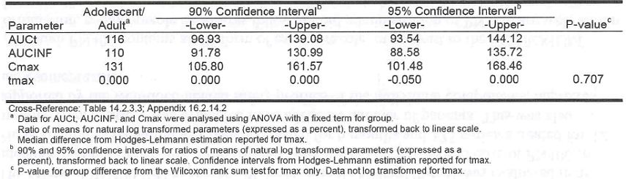
Neither fluticasone nor formoterol showed bioequivalence for adolescent systemic exposure compared with adults in terms of AUC_{t}, AUC_{inf} or Cmax. The increased systemic exposure in adolescents was likely to be due to an increased lung deposition between adults and adolescents along with a lower body weight (and volume of distribution) in the adolescent age group. Therefore this is likely to be class effect for all fluticasone and formoterol containing products. There were some demographic differences between adult and adolescent groups that may explain some of the differences in the systemic exposure of fluticasone seen in the current study. The adult group had more females, more Caucasians, and higher BMI. An exploratory multivariate statistical analysis was carried out to examine the contribution of these subject characteristics (weight, gender, race, age group, FEV1 % predicted at screening) to the differences observed in adult and adolescent fluticasone and formoterol pharmacokinetics. The results of the post-hoc analyses showed that overall systemic exposure for fluticasone (AUCt and Cmax) was consistently higher in adolescents compared with adults. When the subgroups (gender, race, weight, BMI, and FEV1 % predicted) were examined in more detail for adolescents versus adults, the results for AUCt were statistically significantly higher (i.e. 95% CI does not cross 100%) for males, Caucasians, subjects with a lower weight (< 60kg), and lower BMI (< 22.5kg). The FEV1 percentage predicted category had no impact on the results. The results for Cmax were statistically significantly higher for Caucasians, subjects with a higher weight, and subjects with FEV1 percentage predicted ≥ 80% (Tables 23-25). Formoterol AUCt was similar in both the adolescent and adult groups. However, formoterol Cmax was slightly higher for adolescents. These results were only statistically significantly higher for the overall group and FEV1 percentage predicted ≥ 80% subgroup. Despite the lack of statistically significant differences, trends in the data suggest exposure is higher in males and in subjects with a lower weight and BMI (Tables 26-28). Therefore, it is notable that the baseline characteristics showed that the adolescent group had fewer females and more subjects with a lower weight and BMI.
Table 23: Summary statistics for fluticasone propionate AUCt and Cmax by race: Full Analysis Population for pharmacokinetic parameters (Study FLT2502).
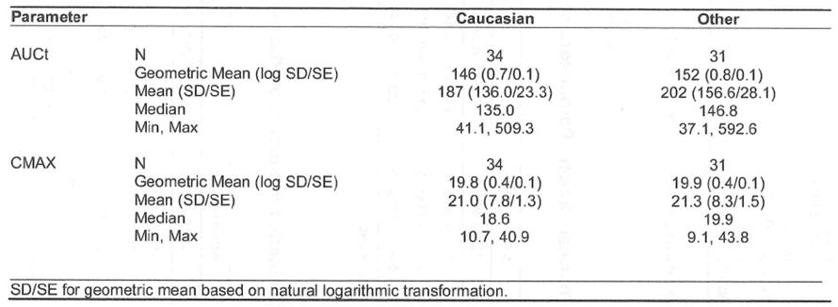
Table 24: Summary statistics for fluticasone propionate AUCt and Cmax by weight group: Full Analysis Population for pharmacokinetic parameters (Study FLT2502).
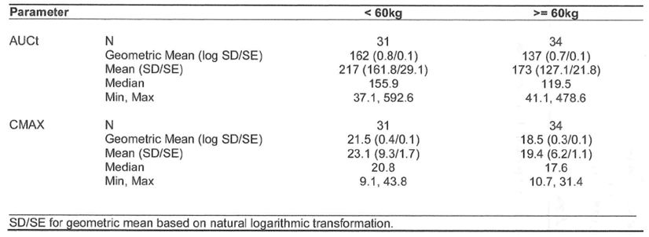
Table 25: Summary statistics for fluticasone propionate AUCt and Cmax by FEV1 percentage predicted groups: Full Analysis Population for pharmacokinetic parameters (Study FLT2502).
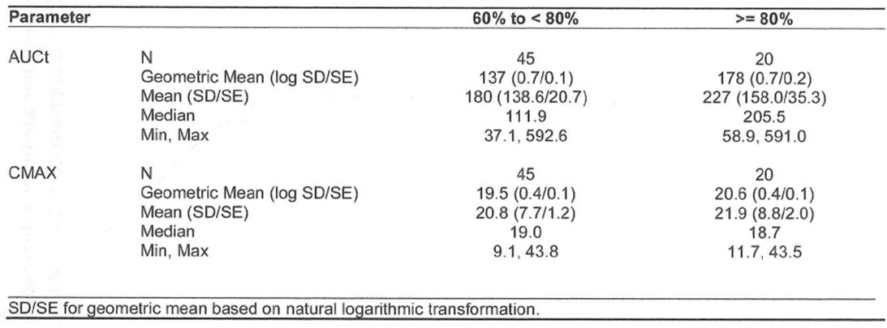
Table 26: Summary statistics for formoterol fumarate AUCt and Cmax by gender: Full Analysis Population for pharmacokinetic parameters (Study FLT2502).
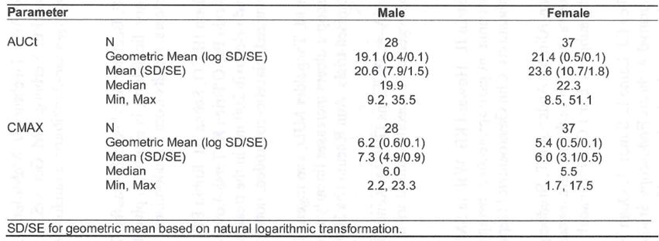
Table 27: Summary statistics for formoterol fumarate AUCt and Cmax by weight group: Full Analysis Population for pharmacokinetic parameters (Study FLT2502).
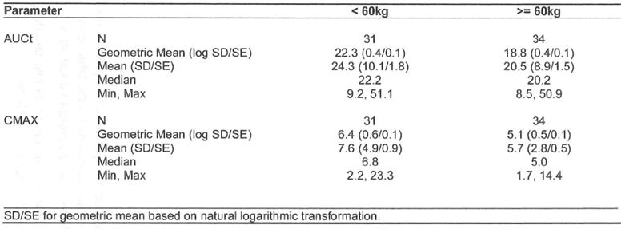
Table 28: Summary statistics for formoterol fumarate AUCt and Cmax by BMI group: Full Analysis Population for pharmacokinetic parameters (Study FLT2502).
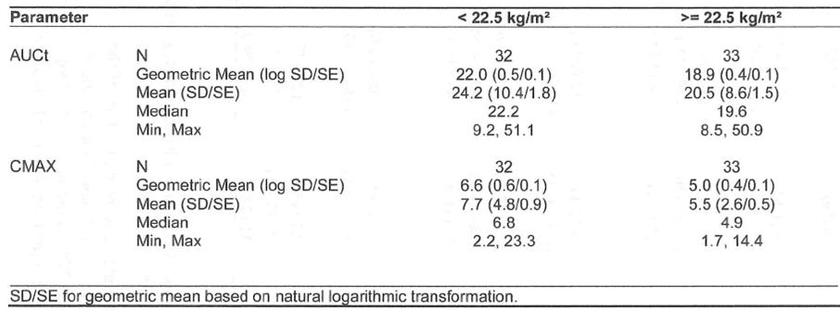

Dose proportionality and time-dependence
Dose proportionality: Two studies investigated plasma fluticasone concentrations after administration of Flutiform 100/10 ug and Flutiform 250/10 ug (SKY2028-1-002 and SKY2028-2-001). Only study FLT1501 investigated plasma fluticasone concentrations after administration of highest dose of Flutiform 500/20 ug. Systemic exposure of fluticasone increased with increasing dose in healthy subjects (SKY2028-1-002) and in subjects with mild to moderate asthma (SKY2028-2-001) who received Flutiform 100/10 ug and 250/10 ug. In both studies, the mean systemic exposures were less than dose proportional and the coefficients of variation associated with the various measures of AUC were high preventing a definitive assessment of dose-proportionality of fluticasone in plasma. Systemic exposure of fluticasone in healthy subjects (FLT1501) who received Flutiform 500/20 ug was higher than would have been predicted from the previous studies in lower doses, but Flutiform was administered with a spacer in this study which may have contributed to the increase in systemic exposure.
Single dose vs multiple dose pharmacokinetics: Three studies investigated the single-dose pharmacokinetic parameters of fluticasone after the administration of Flutiform: Study AG2028-C101 in healthy subjects, SKY2028-2-001 in mild to moderate asthmatic subjects and FLT2502 in adults and adolescents with mild asthma. Additionally, the single dose pharmacokinetic parameters of fluticasone after administration of Flutiform were also evaluated from Day 1 data from the 3 multiple dose studies in healthy subjects (SKY2028-1-002, SKY2028-1-004 and FLT1501). Variability in fluticasone plasma concentrations was high for both healthy subjects and subjects with asthma. Fluticasone concentrations after administration of Flutiform 250/10 ug or Flixotide 250 ug were numerically higher in healthy subjects compared with asthmatic subjects (Table 29). After adjusting for dose, the plasma formoterol exposure in adults and adolescents with asthma after administration of Flutiform was numerically higher than in healthy subjects. The higher exposure of formoterol from Flutiform observed for subjects with asthma was still much lower than the exposure in healthy subjects of formoterol from Foradil pMDI (Table 30). Urinary recovery of formoterol (Fe%) after administration of Flutiform was comparable to that previously observed for Foradil. In healthy subjects dosed with single 12ug dose Foradil (dry powder capsules for inhalation), 3.61% of the (R,R)-enantiomer and 4.8% of the (S,S)-enantiomer for a total of approximately 8.4% was recovered unchanged in the urine after 48 hours (Lecaillon, 1999). In a study with 16 asthmatic subjects, dosing of 12 ug or 24 ug of formoterol fumarate (Foradil) resulted in 10% and 15% to 18% of the total dose excreted unchanged in the urine (Foradil SPC, 2006).
Table 29: Comparison of fluticasone pharmacokinetic parameters among Studies AG2028-C101, SKY20208-2-001 and FLT2502.
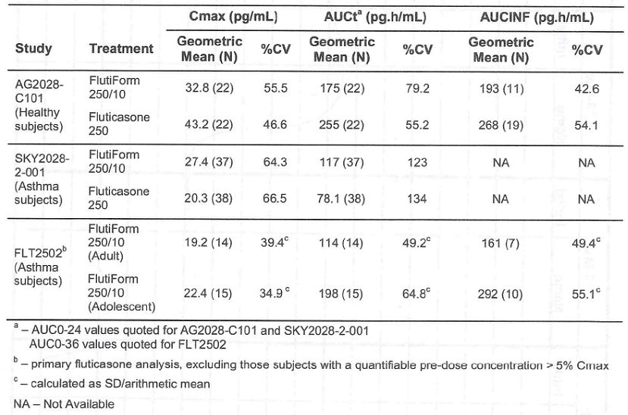
Table 30: Comparison of single dose formoterol pharmacokinetic parameters between Studies FLT1501 and FLT2502.
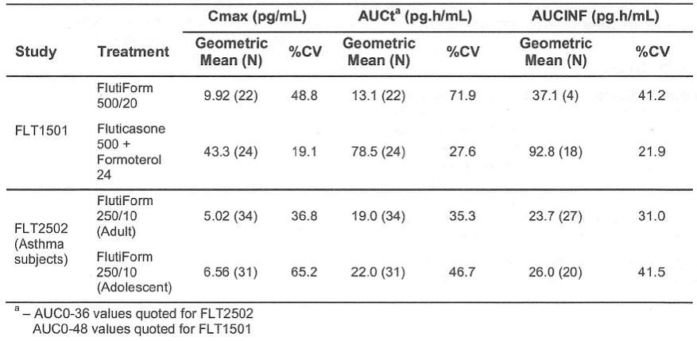
Three studies in healthy subjects investigated the multiple-dose pharmacokinetic parameters of fluticasone after twice daily administration of Flutiform (SKY2028-1-002, SKY2028-1-004 and FLT1501). Variability in fluticasone plasma concentrations was high for healthy subjects. Fluticasone concentrations were higher after 7 days of dosing and an accumulation of fluticasone plasma concentrations between Days 1 and 7 was observed for all preparations. While the accumulation ratio associated with Flutiform is greater than that of the reference treatment in Study FLT1501, the level of systemic exposure of fluticasone is lower from Flutiform compared with the reference treatment at steady state (Table 31). Multiple-dose formoterol pharmacokinetic parameters were studied in studies SKY2028-1-002 and FLT1501 in healthy subjects. Urinary excretion of formoterol was higher following repeated dosing compared with a single dose after Day 1. This extent of accumulation was also seen in a study with asthmatic subjects dosed with 12 ug or 24 ug of formoterol fumarate; accumulation ratios of 1.63 to 2.08 were observed after 4 or 12 weeks compared with the first dose (Foradil SPC, 2006). The urinary recovery of formoterol after treatment with Flutiform was comparable to that after treatment with Foradil.
Table 31: Comparison of multiple dose fluticasone pharmacokinetic parameters between Studies SKY2028-1-002, SKY2028-1-004, FLT1501.
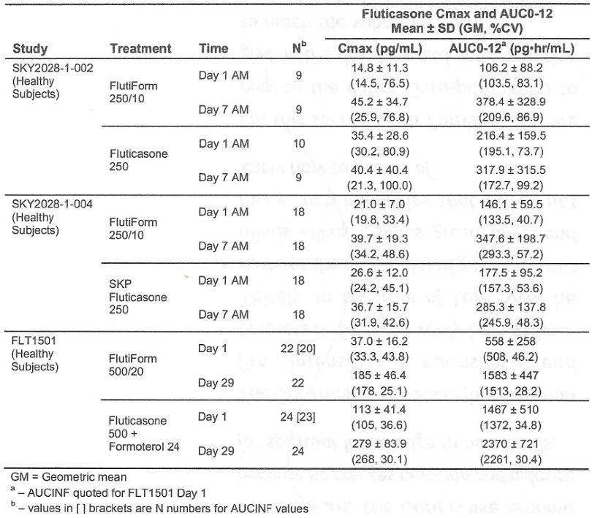

Bioequivalence studies
There were no changes to the Flutiform formulation during the clinical development and the proposed commercial Flutiform formulation was used in all the Phase 3 studies.
Although no biopharmaceutic studies have been carried out to date, the influence of variation in actuator use and the presence of a spacer on total systemic exposure and peak drug concentration after dosing have been explored. Two studies investigated plasma fluticasone and formoterol concentrations after administration of Flutiform with the AerochamberR Plus spacer: Study FLT1501 multiple-dose study in healthy subjects and Study FLT2502 single dose study in adults and adolescents with mild to moderate asthma. The clinical pharmacology studies were not designed to look at the effects of administering fluticasone and formoterol with or without a spacer. The mean single dose fluticasone AUC values for fluticasone 250ug and formoterol 24ug administered concurrently in Study FLT1501 would suggest that use of the Aerochamber® Plus may increase the levels of exposure and is likely due to the spacer mitigating poor inhalation technique and subsequently delivering more of the inhaled dose to the lungs. The levels of exposure following multiple dosing are clinically relevant and mean steady state profiles of fluticasone administered with and without a spacer were evaluated. Consistent with the single dose data, the use of the Aerochamber® Plus spacer appeared to increase the levels of exposure to fluticasone from fluticasone + formoterol. The Flutiform results however, using the same Aerochamber® Plus spacer, indicate that systemic fluticasone exposure is increased to a lesser extent compared with already marketed products. The increase in systemic exposure observed for fluticasone (Flixotide) used in conjunction with the spacer is consistent with its SPC.
The actuator employed in studies AG2028-C101 and SKY2028-2-001 was replaced in all other studies with a different actuator. The difference in actuator diameter was carried out in order to minimise the potential for blockage or obstruction of the orifice by suspension particles. This change also resulted in a decrease in fine particle dose (FPD) of Active Pharmaceutical Ingredient (API) delivered by the second actuator compared with that delivered by first actuator. Module 3 provides further detail on the difference in FPD with the 2 actuator types as well as of the polymeric parts of the valve used in all studies carried out to date (review of this data is outside scope of this evaluation). The use of 2 different actuators was examined across the package of studies in relation to dose-adjusted exposure to fluticasone propionate. The effect on the exposure to formoterol fumarate was not examined because of the limited number of studies where plasma formoterol pharmacokinetic parameters were reported. The different actuators demonstrated a variable effect, and no discernible pattern with respect to exposure levels could be associated with the use of either actuator. The clinical pharmacology studies were not designed to look at the effects of biopharmaceutics. However, there was an increase in the level of exposure to fluticasone propionate (fluticasone 250) using the actuator in study AG2028-C101, although using the same actuator in study SKY2028-2-001 (fluticasone 250) countered this observation. In this study, the actuator appeared to have no direct impact on the dose-adjusted exposure to fluticasone.

Intra- and inter-individual variability
Variability in fluticasone plasma concentrations was high for both healthy subjects and subjects with asthma. In study AG2021-C101 in healthy subjects, observed intersubject variability was high ranging from 46 to 66% for fluticasone Cmax and AUC₀₋₁₂. In study 2028-2-001 in asthma patients, AUC_{0-t} and Cmax of fluticasone in plasma were highly variable (CV% range for AUC_{0-t} = 123 – 163% and CV% range for Cmax = 56.7 – 66.5%). In the Phase 2 study SKYE2201C/8722/01 in asthma patients, inter-patient variability (%CV) was comparable between both treatments and ranged between approximately 35 to 55% and 35 to 60%, for the formoterol HFA MDI and Foradil DPI, respectively.
No population pharmacokinetic analysis was performed for Flutiform.

Pharmacokinetics in target population
There have been no studies that directly compare exposure in healthy and asthmatic subjects after treatment with Flutiform or fluticasone and formoterol administered concurrently. In studies SKY2028-1-002, SKY2028-1-004 and FLT1501, fluticasone concentrations after administration of Flutiform 250/10 ug or Flixotide 250 ug were numerically higher in healthy subjects compared with asthmatic subjects (Table 29).

Pharmacokinetics in special populations
The effects of gender and race on Flutiform PKs have not been evaluated. The effect of renal and hepatic impairment on Flutiform pharmacokinetic parameters has not been investigated.
Following single dose of Flutiform (250/10ug) in patients with mild/ moderate asthma (study FLT2502), fluticasone (AUCt and Cmax) was consistently higher in adolescents compared with adults. Formoterol AUCt was similar in adolescent and adult groups, but Cmax was slightly higher in adolescents.

Interactions
No drug interaction studies were conducted with the proposed Flutiform formulation. However, drug interactions with the individual components of Flutiform, i.e., fluticasone and formoterol have been extensively studied and these have been adequately incorporated in the proposed Flutiform PI.

Exposure relevant for safety evaluation
In healthy volunteers, following inhalation of a single 250ug dose from 2 actuations of Flutiform 125/5ug, fluticasone was rapidly absorbed reaching mean Cmax of 32.8pg/ml within 45 minutes. In asthma patients, mean Cmax of 15.4pg/ml and 27.4pg/ml were achieved after inhalation of single dose of Flutiform 100/10ug (2 actuations of 50/5ug) and 250/10ug (2 actuations of 125/ug) after 20 and 30mins, respectively. Following multiple doses of Flutiform 100/10ug, 250/10ug and 500/20ug in healthy subjects mean Cmax was 21.4, 25.9-34.2 and 178pg/ml, respectively. Data for 100/10 and 250/10ug doses was from studies which did not use a spacer while a spacer was used for the Flutiform 500/20ug dose study. Although there is no data directly comparing exposure to fluticasone from a device with and without a spacer, spacers are known to increase systemic exposure of fluticasone (with potential for systemic effects of fluticasone). In healthy subjects, following single and multiple dose of Flutiform 500/20 (2 actuations of 250/10ug), mean Cmax for eformoterol was 9.92 and 34.4pg/ml, respectively. There have been no studies that directly compare exposure in healthy and asthmatic subjects after treatment with Flutiform or fluticasone and formoterol administered concurrently. There were no studies in patients with renal or hepatic impairment.

Evaluator’s overall conclusions on pharmacokinetics
- In healthy volunteers, following inhalation of a single 250ug dose from 2 actuations of Flutiform 125/5ug, fluticasone was rapidly absorbed reaching mean Cmax of 32.8pg/ml within 45 minutes. In asthma patients, mean Cmax of 15.4pg/ml and 27.4pg/ml were achieved after inhalation of single dose of Flutiform 100/10ug (2 actuations of 50/5ug) and 250/10ug (2 actuations of 125/ug) after 20 and 30mins, respectively. Following multiple doses of Flutiform 100/10ug, 250/10ug and 500/20ug in healthy subjects mean Cmax was 21.4, 25.9-34.2 and 178pg/ml, respectively. Data for 100/10 and 250/10ug doses was from studies which did not use a spacer while a spacer was used for the Flutiform 500/20ug dose study. Although there is no data directly comparing exposure to fluticasone from a device with and without a spacer, spacers are known to increase systemic exposure of fluticasone (with potential for systemic effects of fluticasone). In healthy subjects, following single and multiple dose of Flutiform 500/20 (2 actuations of 250/10ug), mean Cmax for eformoterol was 9.92 and 34.4pg/ml, respectively. There have been no studies that directly compare exposure in healthy and asthmatic subjects.
- The mean terminal half-life (t_{1/2}) of plasma fluticasone for SKP Flutiform after oral inhalation ranges from 10 to 14 hours across the studies. Plasma formoterol data have been gathered only in the more recent studies, FLT1501 and FLT2502.The mean t_{1/2} values of plasma formoterol for Flutiform after oral inhalation ranged from 6.5 to 9 hours across both studies. Hence, the twice daily dosing regimen for Flutiform appears to be justified.
- Justification for selection of formoterol dose of 5ug in Flutiform instead of 6ug in Foradil: The Phase II study SKYE2201C/8722/01 compared the dose response of 2 and 4 actuations of formoterol fumarate in the SkyePharma HFA pMDI (6 ug/actuation) with one and 2 actuations of formoterol fumarate from the commercially available Foradil DPI (formoterol fumarate 12 ug/actuation) in 45 subjects with asthma. The mean cumulative amounts of formoterol excreted in urine was higher following dosing with SKP formoterol pMDI (to be used in the proposed Flutiform) compared to dosing with Foradil DPI (24% and 39% higher after dosing with 12ug and 24ug doses, respectively). Based on the results from this study, the strength of formoterol fumarate was reduced from 6 to 5 ug for Flutiform. However, the justification provided for reducing dose of formoterol in Flutiform is not adequate due to following limitations: (i) The trend of HFA pMDI formulations resulting in higher exposure than DPI has been reported in the literature (Brindley, 2000 and Thorsson, 2001). However, the test and reference product were not inhaled from the same pharmaceutical dosage form (for example both the test and the reference product should be administered via a pMDI or both should be administered via a DPI) when assessing therapeutic equivalence as recommended in the CPMP guidelines (ii) Exposure to formoterol is not an indication of its efficacy, so reducing the dose of formoterol in Flutiform based on PK results is not justified. Furthermore, the increased exposure to formoterol in Flutiform subjects was not translated into an increased effect on lung function as shown by similar or slightly greater improvements in Foradil group compared with Flutiform. (iii) Formoterol concentrations were only based on urine formoterol levels which are not the most accurate method for determination of exposure to formoterol. Interpretation of the results was limited because the statistical analyses used within this study were largely exploratory and not powered to demonstrate superiority or equivalence due to the small sample size. (iv) Study FLT1501 evaluated the pharmacokinetics following 4 weeks administration of Flutiform pMDI 500/20ug and fluticasone pMDI 500ug + formoterol pMDI 24ug in healthy subjects. This study utilized same devices for comparing relative exposure to fluticasone and formoterol from Flutiform compared to its reference products and also measured plasma formoterol. Results from this study showed that relative bioavailability of fluticasone and formoterol from Flutiform was 67% and 75% compared to that following administration of reference treatments. Hence, results from this study contradict those observed in study SKYE2201C/8722/01 which showed increased exposure to formoterol from Flutiform and formed the basis for selection of the 5ug dose in the Flutiform formulation.
- Dose-proportionality: Systemic exposure of fluticasone increased with increasing dose in healthy subjects (SKY2028-1-002) and in subjects with mild to moderate asthma (SKY2028-2-001) who received Flutiform 100/10 ug and 250/10 ug. In both studies, the mean systemic exposures deviated from dose proportionality and the coefficients of variation associated with the various measures of AUC were high, preventing a definitive assessment of dose-proportionality of fluticasone in plasma. Systemic exposure of fluticasone in healthy subjects (FLT1501) who received Flutiform 500/20 ug was higher than would have been predicted from the previous studies in lower doses, but these were confounded by use of spacer.
- There is high variability in PK parameters of fluticasone and formoterol following administration of Flutiform both within and between the pharmacokinetic studies. However, in general there is a trend for the systemic exposure of fluticasone and eformoterol to be less with Flutiform inhaler than with the individual components administered together.
- No specific drug interaction studies were conducted with Flutiform. Results of the Phase 2, single dose study SKY2028-2-001 in asthma patients, wherein, the Cmax and AUC_{0-t} of fluticasone from the Flutiform 250/10 ug product were higher than those observed when the Flixotide 250 ug + Foradil 12 ug inhalers were used concurrently, but similar to those observed with the Flixotide 250 ug product alone indicated a possible interaction of formoterol on fluticasone PK when administered in the same inhaler compared to in separate inhalers. However, the results for AUC _{0-t} /Dose should be interpreted due to the wide confidence intervals. Combined administration of fluticasone and formoterol fumarate in SKP Flutiform HFA pMDI resulted in similar Ae₀₋₂₄ for formoterol compared with Foradil 12 ug alone, and compared with Flixotide 250 ug + Foradil 12 ug inhalers used concurrently. The Flutiform 250/10 ug product may therefore be considered comparable to the Flixotide 250 ug + Foradil 12 ug products and with the Foradil 12 ug product in patients with asthma in terms of the formoterol component, but not so for the fluticasone component. Similar results were observed in the single dose study AG2028-C101 in healthy subjects.
- In vitro studies evaluated the comparability of formoterol fumarate and fluticasone propionate products in the SKP sponsored trials to the European marketed formoterol fumarate and fluticasone propionate products and showed comparable results in terms of fine particle size and dose content uniformity. However, justification for use of the various comparators in the Flutiform clinical studies based on results provided in module 3.2 would require confirmation from the chemistry evaluator as detailed analysis of these studies is outside the scope of this clinical evaluation.
- There were no changes to the Flutiform formulation during the clinical development and the proposed commercial Flutiform formulation was used in all the Phase 3 studies. No specific biopharmaceutics or bioavailability studies have been conducted. The influence of actuators and spacers on the delivery of the Flutiform product was evaluated. Overall, both actuators demonstrated a variable effect and no discernible pattern with respect to exposure levels could be associated with the use of either actuator. All Phase 3 studies and majority of Phase 1 and 2 studies used one actuator. No issues are anticipated when switching from Flutiform administration without an Aerochamber Plus to with an Aerochamber Plus, as results from all studies suggest that although exposure to fluticasone is increased following administration of Flutiform with a spacer, the influence of the spacer on fluticasone exposure is less with FlutifForm than it is with the mono-products.
- The effects of gender, race, weight, baseline FEV on pharmacokinetics of Flutiform have not been evaluated (with exception of the small post hoc subgroup analysis in study FLT2502). The effect of renal and hepatic impairment on Flutiform pharmacokinetic parameters was not evaluated. Following single dose of Flutiform (250/10ug) in patients with mild/ moderate asthma (study FLT2502), fluticasone (AUCt and Cmax) was consistently higher in adolescents compared with adults. Formoterol AUCt was similar in adolescent and adult groups, but Cmax was slightly higher in adolescents.

Pharmacodynamics

Introduction
The individual components of Flutiform- fluticasone and eformoterol are approved drugs for treatment of asthma and their mechanism of action is well established. Fluticasone propionate is a synthetic trifluorinated glucocorticoid with potent anti-inflammatory activity in the lungs when administered by inhalation. Fluticasone reduces the symptoms and exacerbations of asthma with fewer adverse effects than when corticosteroids are administered systemically. Eformoterol fumarate is a long-acting, selective β2-adrenergic receptor agonist. Inhaled eformoterol acts locally in the lungs as a bronchodilator. After a single dose, onset of bronchodilation occurs within 1-3 minutes with a duration of effect of at least 12 hours.
The Phase 2 study (SKY2028-2-002) investigated the early bronchodilating effect of Flutiform. Study FLT1501 compared the effect of treatment with Flutiform pMDI 500/20 ug and the individual components on the hypothalamo-pituitary-adrenal (HPA) axis function using 24-hour urinary free cortisol measurements. Study SKY2028-1-003 was conducted to evaluate the effect of Flutiform low and medium strength on the HPA axis; treatment compliance was also evaluated in this study using pharmacokinetic sampling.

Primary pharmacology
In the Phase 1, randomised, parallel group, open-label PK study in healthy subjects (SK2028-2-001) improvement in lung function was observed as early as 5 minutes at the first postdose assessment, following treatment with Flutiform 100/10ug and 250/10ug and was maintained for 12 hours post-dose. Mean onset of clinical effect in responders was 6.6 minutes (SD: 6.97) after FlutiformTM 100/10, 5.9 minutes (SD: 5.88) after FlutiformTM 250/10, 4.3 minutes (SD: 3.54) after Flixotide 250ug +Foradil 12ug, 4.9 minutes (SD: 5.81) after Flixotide 250ug, 6.9 minutes (SD: 7.66) after Foradil 12ug, and 20.5 minutes (SD: 10.82) after placebo. Analysis of the difference between treatments for onset of clinical effect indicated that both treatment with FlutiformTM 100/10ug and FlutiformTM 250/10ug had statistically significantly earlier onsets than treatment with placebo (p=0.002). Mean duration of clinical effect in responders was 924.4 minutes (SD: 571.84) (approx. 15 hours) after FlutiformTM 100/10ug, 773.3 minutes (SD: 562.53) (approx. 13 hours) after FlutiformTM 250/10ug, 832.9 minutes (SD: 503.03) (approx. 14 hours) after Flixotide 250ug + Foradil 12ug, 889.8 minutes (SD: 627.91) (approx. 15 hours) after Flixotide 250ug, 647.3 minutes (SD: 502.14) (approx. 11 hours) after Foradil 12ug, and 720.9 minutes (SD: 813.05) (approx. 12 hours) after placebo. Analysis of the difference between treatments for duration of clinical effect indicated that the only statistically significant difference was between treatment with FlutiformTM 100/10ug and treatment with placebo (p=0.036).
There was a statistically significant difference in mean actual FEV1 change from Baseline at 12 hours post-dose in favour of treatment with both FlutiformTM 100/10ug and 250/10ug compared to Flixotide 250ug and placebo (Table 11). Similar results were observed for percentage change from baseline in FEV1 and the mean % change in actual FEV1 was greater than 15% for both FlutiformTM 100/10ug and 250/10ug at the first assessment (5 minutes) post-dose (Table 12). There was a statistically significant difference in the FEV1 AUC above Baseline value at 12 hours postdose in favour of treatment with both FlutiformTM 100/10ug and 250/10ug compared to Flixotide 250ug and placebo with similar efficacy also observed at 24 hours. Similar results were observed in change from Baseline of FEV1 % predicted normal values at 12 hours post-dose. Flutiform 250/10ug and 100/10ug showed similar efficacy to that observed for Foradil 12ug and concurrent treatment with Flixotide 250ug+ Foradil 12ug for all the above lung function parameters.
The Phase II randomised, placebo-controlled, double-blind, 3 single-dose crossover study (SKY2028-2-002) evaluated the early bronchodilating effect of Flutiform in 42 adults with mild to moderate asthma. The rationale for the sample size was based on the primary efficacy analysis of Flutiform 250/10ug versus placebo for change in FEV1 from baseline to 3 minutes post study drug dosing. A sample size of 39 (including dropouts) would have 90% statistical power to detect a difference of 0.34L with a common standard deviation of 0.3 using a 2-sided t-test with significance level of 0.05. Flutiform 250/10 ug was demonstrated to be statistically significantly superior to placebo (LS mean difference = 0.11 L, SD=0.03; 95% CI: 0.05, 0.17, P-value < 0.001) for mean change in FEV1 from Baseline predose to 3 minutes postdose.
Comments: It is not clear if the difference of only 0.11 to 0.13L would be clinically relevant and furthermore, the difference was much less than the one assumed for sample size calculation for the study.
Flutiform 100/10 ug was also statistically significantly superior to placebo (LS mean difference = 0.13 L, SD=0.03L; 95% CI: 0.07, 0.19, P < 0.001) for mean change in FEV1 from baseline to 3 minutes postdose. The superiority of Flutiform 250/10 ug and Flutiform 100/10 ug to placebo was demonstrated at 3, 8, 15, 30, and 60 minutes postdose. The maximum difference between Flutiform and placebo appeared to be at about 15mins and was 190ml (Figure 1). The percentage of subjects achieving a ≥ 12% improvement in FEV1 within 15 minutes postdose was statistically significantly (p<0.001) greater in the Flutiform groups compared with placebo (11.9%, 47.6% and 51.2% in placebo, Flutiform 100/10ug and 250/10ug groups, respectively). Similar results were observed for the percentage of subjects achieving a ≥ 15% improvement in FEV1 within 15 minutes postdose (7.1%, 23.8% and 39%, respectively). The mean increase in FEV1 % predicted from Baseline to 3, 8, 15, 30, and 60 minutes post-dose was numerically and statistically significantly (P ≤ 0.05) greater in subjects receiving Flutiform 100/10 and 250/10 ug compared with placebo at each timepoint (Figure 2). For FVC, the mean increase from Baseline to 3, 8, 15, 30, and 60 minutes post-dose was numerically and statistically significantly (P ≤ 0.05) greater in subjects receiving Flutiform 250/10 ug (at each timepoint) and Flutiform 100/10 ug (only at 15 and 30minutes post-dose) (Figure 3). For PEFR, the mean increase from Baseline to 3, 8, 15, 30, and 60 minutes postdose was numerically and statistically significantly (P ≤ 0.05) greater in subjects receiving Flutiform 250/10 ug and Flutiform 100/10 ug compared with placebo at each timepoint (Figure 4). Compared with placebo, the proportion of patients with >15% improvement in FEV1 within 15 mins post-dose was significantly greater in the Flutiform 100/10ug (Flutiform vs placebo: 23.8% vs 7.1%, p=0.039) and 250/10ug (39% vs 7.1%, p<0.001) groups. No clinically important differences between the Flutiform dosage strengths were expected or observed during the first 60 minutes following a single dose of study drug because both doses of Flutiform contained the same 10 ug dose of formoterol. Overall, Flutiform 250/10 ug and Flutiform 100/10 ug demonstrated superior early bronchodilation compared to placebo as early as 3 minutes postdose and was maintained till 60 minutes following a single dose in patients with mild to moderate asthma.
Figure 1: Mean change in FEV1 from baseline to specific time points during the first 60 minutes following study drug dose – Full Analysis Set (Study SKY2028-2-002).
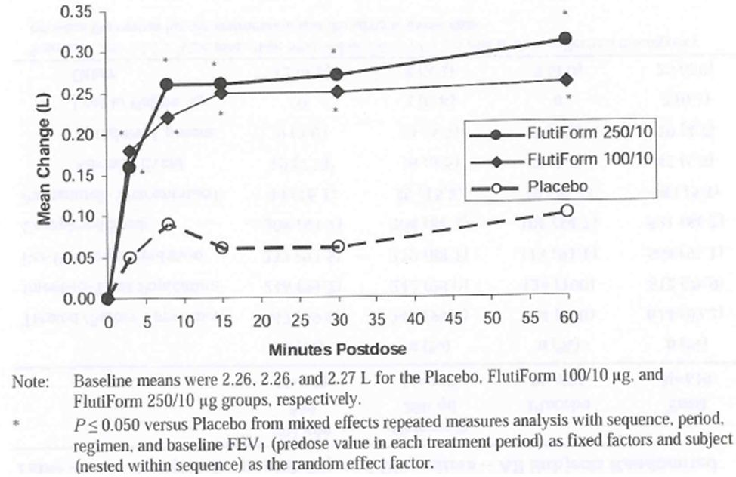
Figure 2: FEV1 % predicted (%): Mean change from baseline (predose) to 3 minutes, 8 minutes, 15 minutes, 30 minutes, and 60 minutes post-dose – Full Analysis Set (Study SKY2028-2-002).
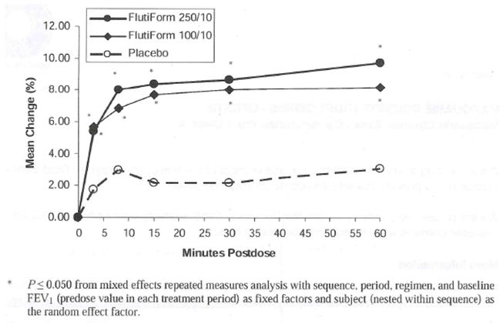
Figure 3: FVC (L): Mean change from baseline (predose) to 3 minutes, 8 minutes, 15 minutes, 30 minutes, and 60 minutes post-dose – Full Analysis Set (Study SKY2028-2-002).
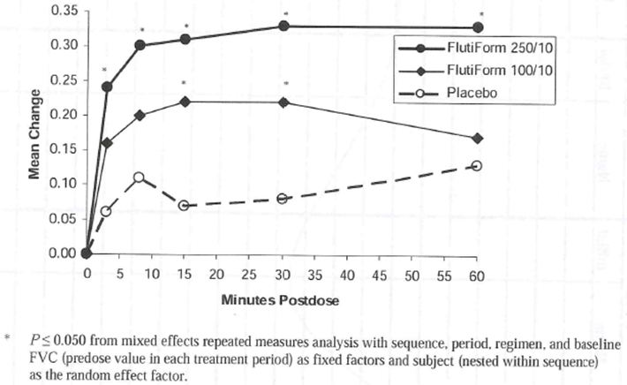
Figure 4: PEFR (L/min): Mean change from baseline (predose) to 3 minutes, 8 minutes, 15 minutes, 30 minutes, and 60 minutes post-dose – Full Analysis Set (Study SKY2028-2-002).
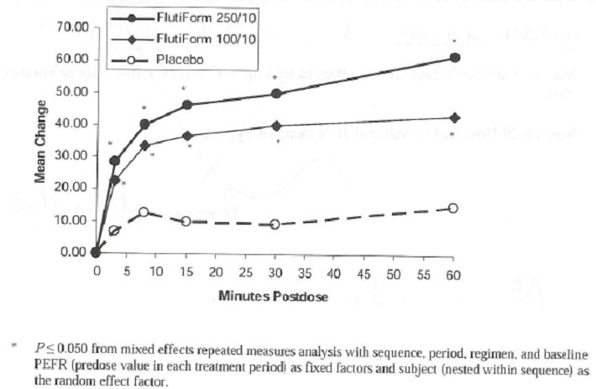
The Phase II study SKYE2201C/8722/01 evaluated the dose response characteristics of SkyePharma HFA MDI and Foradil® DPI at doses of 12 ug and 24 ug by serial measurements of FEVmax and AUC₀₋₂₄ following treatment in 45 patients with moderate asthma. All 4 active treatment groups were significantly superior to placebo in terms of primary efficacy endpoints of FEVmax and AUC₀₋₂₄; however, there were no statistically significant differences between formulations at doses of 12 ug and 24 ug or between the Flutiform and Foradil formulations in both the PP and ITT populations. The statistical analyses used within this study were largely exploratory and not powered to demonstrate superiority or equivalence due to the small sample size. The number of treatment responders was almost twice as high in each of the active treatment groups compared with placebo (Table 32). The time to onset of clinical effect was longest in the placebo group (10mins) compared with the active treatment groups; it was slightly shorter in patients receiving SkyePharma HFA MDI 24 ug (5.4 minutes) and Foradil® DPI 24 ug (5.7 minutes) than SkyePharma HFA MDI 12 ug (6.5 minutes) and Foradil® DPI 12 ug (6.8 minutes) (Table 33). Duration of clinical effect was shorter in patients following placebo than active treatment and patients receiving the higher doses of the active treatments (SkyePharma HFAMDI 24 ug and Foradil® DPI 24 ug) had slightly longer durations of effect than following the SkyePharma HFA MDI 12 ug and Foradil® DPI 12 ug treatment (Table 34). Mean changes from baseline in FEV1 were also higher in patients receiving active treatment compared with placebo in the PP and ITT populations. A clinically significant change (>15%) was detected after 5 minutes post dosing and was maintained for up to 12 hours for patients receiving all four active treatments.
Table 32: Number of treatment responders – ITT population (Study SKYE2201C/8722/01).
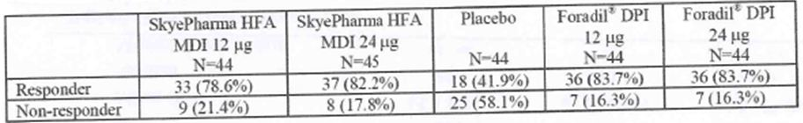
Table 33: Time to onset of clinical effect in treatment responders – ITT population (Study SKYE2201C/8722/01).
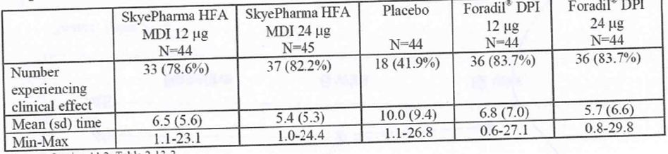
Table 34: Duration of clinical effect in treatment responders – ITT population.
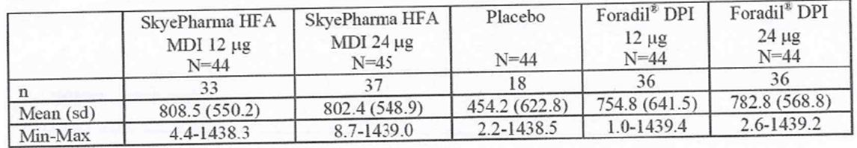

Secondary pharmacology
The Phase 1, randomized, double-blind, placebo- and active-controlled, parallel-group, 6-week, multiple-dose exposure, multicenter study (SKY2028-1-003) in male and female asthmatics evaluated the effect of Flutiform 250/10 ug twice daily (BID), Flutiform 100/10 ug BID, and oral Prednisone on the hypothalamic-pituitary-adrenal (HPA) axis function.
Treatment compliance was assessed by: (1) The percentage of subjects failing to complete the study or discontinuing prematurely, (2) The percentage of planned doses taken during each week and for the study as a whole was displayed by subject, (3) drug concentration, (4) Morning and evening PEFR data. The mean percentage of planned doses taken during each week ranged from 97.0% to 100% across the treatment groups. Mean changes from the Baseline in AM PEFR were greater in the Flutiform 100/10 ug (38.0 to 54.8 L/min) and Flutiform 250/10 ug groups (28.4 to 45.9 L/min) compared to the Prednisone (5.4 to 24.5 L/min) and placebo (–3.0 to 6.8 L/min) groups. Similarly, mean changes from the Baseline in PM PEFR were greater with Flutiform 100/10 ug (37.2 to 53.4 L/min) and Flutiform 250/10 ug (25.0 to 35.1L/min) compared to Prednisone (10.6 to 27.1 L/min) and placebo (0.8 to 7.4 L/min). Samples for UFC (amount of cortisol excreted in urine during a 24-hour collection period) were collected on Days –1 and Day 42. The UFC was analysed by tandem mass spectrometry (LC-MS/MS). The sensitivity of the methodology was 1 ug/L. A one-way ANOVA and ANCOVA were performed on the UFC data at Baseline and at Week 6, respectively. The primary analysis was conducted on the logarithmically transformed 24-hour UFC data. The central UFC values at the end of treatment period (Week 6) were 19.81, 19.04, 6.87, and 18.23 ug/24 hour for Flutiform 250/10 ug, Flutiform 100/10 ug, Prednisone and placebo groups, respectively. The 24-hour UFC central value at Week 6 was statistically significantly reduced for the Prednisone group when compared to the placebo group (P < 0.001). The estimated ratio of central values was 0.38 (95% CI: 0.29 – 0.49) for the Prednisone group relative to the placebo group. Thus, Prednisone produced a 62% reduction in 24-hour UFC, which confirmed the study sensitivity for detecting UFC suppression. At Week 6, neither of the Flutiform treatments differed statistically significantly from placebo (P = 0.510 and 0.733 for Flutiform 250/10 ug and Flutiform 100/10 ug, respectively). An additional analysis was performed for the primary endpoint (UFC) excluding the data from the placebo and Prednisone subjects who had detectable fluticasone levels greater than or equal to the LLOQ (1.0 pg/mL]) reported at 1 or more study visits. The posthoc analysis also showed similar results.
In study FLT1501, the mean 24-hour urinary free cortisol levels (corrected for creatinine) were similar for both treatments at baseline with a more pronounced decrease at the end of the study with individual components (fluticasone 500ug and formoterol 24ug) compared with Flutiform 500/20ug. ACTH stimulation test responses were similar for both Flutiform™ and individual components, both at baseline and at the end of the study period indicating that no significant adrenal insufficiency was induced during the 4 week treatment period.

Relationship between plasma concentration and effect
There is no established correlation between dose, associated plasma concentration and clinical efficacy for inhaled products as the site of therapeutic action is in the lungs. Therefore, measures of fluticasone concentrations in plasma are regarded as surrogates for safety rather than efficacy.
The Phase II study SKYE2201C/8722/01 evaluated the dose response characteristics of SkyePharma HFA MDI and Foradil® DPI at doses of 12 ug and 24 ug by serial measurements of FEVmax and AUC₀₋₂₄ following treatment. All 4 active treatment groups were significantly superior to placebo in terms of primary efficacy endpoints of FEVmax and AUC₀₋₂₄; however, there were no statistically significant differences between formulations at doses of 12 ug and 24 ug or between the Flutiform and Foradil formulations (although some improvements were slightly greater in the Foradil groups) in both the PP and ITT populations. However, it should be noted that the study was not powered to detect statistically significant differences or demonstrate equivalence between formoterol component of Flutiform and Foradil. Mean changes from baseline in FEV1 were also higher in patients receiving active treatment compared with placebo in the PP and ITT populations. A clinically significant change (>15%) was detected after 5 minutes post dosing and was maintained for up to 12 hours for patients receiving all four active treatments.
The Phase II randomised, placebo-controlled, double-blind, 3 single-dose crossover study (SKY2028-2-002) evaluated the early bronchodilating effect of Flutiform in 42 adults with mild to moderate asthma. Overall, Flutiform 250/10 ug and Flutiform 100/10 ug demonstrated superior early bronchodilation compared to placebo as early as 3 minutes postdose and was maintained till 60 minutes following a single dose in patients with mild to moderate asthma.
In the Phase 1, randomised, parallel group, open-label PK study SK2028-2-001 in healthy subjects, improvement in lung functions was observed as early as 5 minutes at the first postdose assessment, following treatment with Flutiform 100/10ug and 250/10ug and was maintained for the 12 hours post-dose. Mean duration of clinical effect in responders was approximately 15, 13, 14, 15, 11 and 12 hours after FlutiformTM 100/10ug, FlutiformTM 250/10ug, Flixotide 250ug + Foradil 12ug, Flixotide 250ug, Foradil 12ug, and placebo, respectively and only FlutiformTM 100/10ug showed a statistically significant difference compared with placebo (p=0.036).

Pharmacodynamic interactions with other medicinal products or substances
Study AG2028-C101 evaluated the pharmacodynamic effects of Flutiform combination product as a marker of systemic safety and compared Flutiform with the individual components for possible pharmacodynamic interaction. The results indicated that the systemic pharmacodynamic effects (systolic/ diastolic blood pressure, heart rate, ECG, serum potassium/ glucose and urinary cortisol predose, 4 and 12 hours postdose) of fluticasone propionate and formoterol were not affected by the combined administration in Flutiform. There were some differences in pharmacokinetics of both the plasma fluticasone propionate and the urinary free and total formoterol between the treatment groups. However the observed differences in pharmacokinetics are unlikely to be clinically significant. However, none of the lung function PD parameters were assessed in this study.
No other specific drug interaction studies were conducted with Flutiform.

Evaluator’s overall conclusions on pharmacodynamics
- In the Phase II study SKYE2201C/8722/01, the formoterol component of Flutiform and Foradil showed similar improvements in lung function PD parameters despite the fact that the PK results had suggested increased exposure to formoterol from Flutiform compared to Foradil and consequently the dose of formoterol to be used in all studies was reduced to 5ug instead of 6ug. Systemic exposure to formoterol is not an indication of efficacy in the lungs and is more an indicator of systemic safety.
- In the Phase 1, randomised, parallel group, open-label PK study in healthy subjects (SK2028-2-001) improvement in lung function was observed as early as 5 minutes at the first postdose assessment, following treatment with Flutiform 100/10ug and 250/10ug and was maintained for 12 hours post-dose. Mean onset of clinical effect in responders was about 6.6, 5.9, 4.3, 4.9, 6.9 and 20.5 minutes after FlutiformTM 100/10, 250/10, Flixotide 250ug +Foradil 12ug, Flixotide 250ug, Foradil 12ug and placebo, respectively. Mean duration of clinical effect in responders was approximately 15, 13, 14, 15, 11 and 12 hours, respectively. There was a statistically significant difference in mean actual FEV1 and FEV1 AUC change from Baseline at 12 hours post-dose in favour of treatment with both Flutiform 100/10ug and 250/10ug compared to Flixotide 250ug and placebo. Overall, combined administration of fluticasone propionate and formoterol fumarate via a single inhaler (SkyePharma HFA MDI [Flutiform 100/10 or Flutiform 250/10]) provided comparable efficacy when compared to the single components administered concurrently and superior efficacy when compared to fluticasone 250 or placebo.
- No pulmonary deposition studies were conducted with Flutiform. Especially important in light of the fact that bioequivalence between Flutiform and its components was not shown (studies AG2008-C101 and FLT1501).
- In study SKY2028-1-003 6 weeks of treatment with Flutiform 250/10 ug or Flutiform 100/10 ug twice daily did not affect the HPA axis function as evaluated by 24-hour UFC in adult subjects with mild to moderate asthma. The study had assay sensitivity in that a prednisone control arm showed suppression of the HPA axis. In study FLT1501, the mean 24-hour urinary free cortisol levels (corrected for creatinine) were at baseline with a more pronounced decrease at the end of four weeks of treatment with individual components (fluticasone 500ug and formoterol 24ug) compared with Flutiform 500/20ug. ACTH stimulation test responses were similar for both Flutiform™ and individual components, both at baseline and at the end of the study period indicating that no significant adrenal insufficiency was induced during the 4 week treatment period. The preferred pharmacodynamic method of assessing the HPA axis is the repeated assessment of the change from baseline in 24-hour plasma cortisol as measured by AUC (as the primary variable) and Cmax; however, the 24-hour UFC excretion is the most sensitive non-invasive measure of systemic activity of ICS on HPA axis function. The 24-hour urinary-free cortisol is a variable which could be used in the assessment of systemic effects of ICSs on the HPA axis although it is a much better test for the measurement of high urinary levels of cortisol than low levels and difficulties are often encountered in the collection of urine samples.

Clinical efficacy

Introduction
The main objective of the Phase 3 studies was to compare the efficacy of Flutiform with combination treatments (fluticasone plus formoterol administered concurrently or Seretide), with its individual components administered separately and administered with and without spacer.
There were 4 pivotal studies: FLT3503 compared Flutiform with combination treatment in patients with moderate to severe asthma (FEV% predicted normal >40% <80%) and studies: SKY2028-3-001, SKY2028-3-002 and SKY2028-3-004 compared Flutiform with individual components administered separately in patients with mild to moderate asthma (FEV% predicted normal >60% <80 to 85%). Two supportive studies (FLT3501 and FLT3505) compared Flutiform with combination treatment in patients with mild/ moderate-severe (FEV% predicted normal >40% <85%) asthma. Comparison of Flutiform administered either with or without a spacer was also done: FLT3501 and FLT3505 (with spacer); SKY2028-3-001, SKY2028-3-002, and SKY2028-3-0004 (without spacer). Further efficacy data was provided from the Phase 3 studies FLT3502 (paediatric study), SKY2028-3-005, SKY2028-3-003 (long-term safety study) and from the phase 2 Studies SKY2028-2-001 and SKY2028-2-002.
The studies were multicentre, generally randomised, double-blind or open-label, comparative studies in paediatric, adolescent and adult subjects conducted at sites in Europe, North America, Israel, India, and Latin America. All studies included male and female subjects with a known history of asthma ≥ 6 months, and a documented reversibility of ≥ 15.0% in FEV1 during the screening phase. Pulmonary function test procedures were carried out in accordance with current guidelines for using a spirometer.
The doses of fluticasone and formoterol used in the 3 Flutiform dosages were selected to be comparable to the doses approved and marketed as individual treatment for asthma (e.g. Flixotide, Flovent, and Foradil) as well as the doses approved and marketed in combination products (e.g. Seretide and Symbicort). The efficacy and safety of these marketed products used by patients with asthma is well documented in the literature. Furthermore, the doses of fluticasone and formoterol selected for Flutiform are used concurrently by patients with persistent asthma. In the FLT-prefixed studies study medications were inhaled using a pMDI with an AeroChamberR Plus spacer device (GlaxoSmithKline [GSK]). The only exception was formoterol (Foradil) in Study FLT3505, which was inhaled using a dry powder inhaler (DPI) without spacer. Spacers were not used in the SKY-prefixed studies. All subjects received asthma rescue medication (salbutamol/albuterol) for both the Run-in Period (where applicable) and the Treatment Period.
All studies were conducted according to GCP guidelines and were generally designed in accordance with the CPMP Note for Guidance on the clinical investigation of medicinal products in the treatment of asthma (CPMP/EWP/2922/01). The study also complied with the Global Initiative for Asthma GINA workshop [Reference 1] and points to consider on the requirements for clinical documentation for orally inhaled products (OIP) [Reference 2].

Dose-response and main clinical studies

Dose response studies
There were no specific dose-response studies, although dose response was evaluated as a secondary endpoint in Phase 3 studies- FLT3503 (500/20ug vs 250/10ug) and study SKY2028-3-004 (250/10 vs 100/10ug).

Main (Pivotal) studies

Pivotal non-inferiority study FLT3503

Methods and objectives
This was a double-blind, double-dummy, 4-arm, parallel-group, multicentre Phase 3 study to show non-inferiority of Flutiform high dose versus fluticasone + formoterol administered concurrently in adult subjects with moderate to severe persistent, reversible asthma (FEV₁ of ≥ 40% to ≤ 80% for predicted normal values). The study was conducted from 27/8/2008 to 15/9/2009 at 90 centres (11 centres in Bulgaria, 8 in the Czech Republic, 15 in Hungary, 11 in India, 5 in Israel, 3 in Latvia, 11 in Poland, 9 in Romania, 5 in Russia, and 12 centres in Ukraine). The primary objective of this study was to show non-inferiority in the efficacy of Flutiform high dose versus fluticasone + formoterol. Secondary objectives of this study were to show superiority in the efficacy of Flutiform high dose versus fluticasone alone (to demonstrate that the study design was sensitive enough to detect differences between treatments) and to show superiority in the efficacy of Flutiform high dose versus Flutiform low dose (to demonstrate dose-response).

Study participants
The main inclusion criteria were: male or female adults (>18years old) with known history of severe persistent, reversible asthma for ≥ 6 months prior to the screening visit characterised by treatment with inhaled corticosteroids (ICS) at a dose of ≥ 500ug fluticasone or equivalent, have an FEV1 of ≥ 40% to ≤ 80% of predicted normal values, and show ≥ 14.95% reversibility in FEV1 after salbutamol inhalation (4 puffs, 100 ug per puff). Inclusion criteria required following run-in period were: Subject had used rescue medication for at least 3 days, and also had either at least 1 night with sleep disturbance (i.e. sleep disturbance score of ≥ 1 ) or at least 3 days with asthma symptoms (i.e. a symptom score of ≥ 1) during the last 7 days of the run-in period.
The main exclusion criteria were: subject had life-threatening asthma within the past year or during the run-in period (including subjects with a history of near-fatal asthma, hospitalization or emergency visit for asthma, or prior intubation for asthma within the past year); history of systemic (oral or injectable) corticosteroid medication within 1 month before the screening visit; history of omalizumab use within previous 6 months; current evidence or history of any clinically significant disease or abnormality including uncontrolled hypertension, uncontrolled coronary artery disease, congestive heart failure, myocardial infarction, or cardiac dysrhythmia; upper or lower respiratory infection within the 4 weeks prior to screening visit or during the Run-in period; significant, nonreversible, pulmonary disease (e.g., chronic obstructive pulmonary disease, cystic fibrosis, bronchiectasis); known Human Immunodeficiency Virus-positive status; smoking history equivalent to "10 pack years" (i.e., at least 1 pack of 20 cigarettes/day for 10 years or 10 packs/day for 1 year, etc.); current smoking history, evidence or history of alcohol and/or substance abuse within 12 months prior to the screening visit; intake of β-blocking agents, tricyclic antidepressants, monoamine oxidase inhibitors, quinidine-type antiarrhythmics, or potent CYP3A4 inhibitors, such as ketoconazole within the past week; current evidence or history of hypersensitivity or idiosyncratic reaction to test medications or components.

Treatments
During the 2-week run-in phase, all subjects took Flixotide pMDI 125 ug (2 puffs bid) and salbutamol 100 ug (2 puffs on up to 4 occasions per day) was used as rescue medication. The run-in phase could be extended to a maximum of 28 days if a subject failed to meet the entry criteria after the initial run-in phase of 14 +/-3 days. At the start of the Treatment period, subjects were randomised to 8 weeks of twice daily treatment with either high dose Flutiform pMDI 500/20 ug (2 puffs of 250/10ug bid) or low dose Flutiform pMDI 100/10ug (2 puffs of 50/5 ug bid) or Flixotide pMDI 500 ug (2 puffs of 250ug bid) plus Foradil pMDI 24ug (2 puffs of 12ug bid; hereafter named Flixotide + Foradil) or Flixotide pMDI 500ug (2 puffs of 250ug bid). Throughout the study, subjects were allowed to take salbutamol/albuterol (2 puffs, 100 ug per puff), on up to 4 occasions per day as rescue medication. The test and reference study medications were inhaled using an AeroChamberR Plus spacer device (GSK). Salbutamol/ albuterol rescue medication was inhaled without a spacer. The dose level of study medication remained the same during the treatment phase. The subject was to be withdrawn from the study if the subject’s asthma was not controlled with study medication and use of salbutamol rescue medication. The assessment of asthma control was based on investigator review of the subject’s electronic diary data and asthma exacerbations. On completion or discontinuation of the study, subjects were followed up by telephone 14 days later for reporting of ongoing AEs and any new AEs that may have occurred.
Comments: Study duration of 8 weeks was less than mentioned in the recommended guidelines (CPMP/EWP/2922/01). Other approved combination inhalation products (seretide and symbicort) had clinical studies of >12 weeks duration.

Assessment of treatment compliance
Subjects were instructed to return all used and unused study drug to the site for drug accountability at each study visit. The amount of study drug dispensed to each subject was recorded on the appropriate page in the subject's CRF. In addition, throughout the Run-in and Treatment Periods, the subject entered twice daily into the telephone diary the number of inhalations for each of the pMDI devices, including rescue albuterol. The subjects were asked to indicate the number of inhalations for each of the pMDI devices. The study site personnel were instructed to check the dose indicators on the inhaler actuators to confirm the approximate number of actuations, where applicable. Subjects who were less than 70% compliant with their fluticasone during the Run-in Period or study drug during the Treatment Period were to be withdrawn from the study.

Randomisation, blinding
Subjects were randomised to twice daily treatment with either Flutiform 500/20ug or Flutiform 100/10ug or fluticasone 500 plus formoterol 24 (fluticasone + formoterol) or fluticasone 500 (fluticasone) in a 1:1:1:1 ratio. The study design intended equal allocation of all 4 treatments within each of the moderate (FEV1 of > 60 to ≤ 80% for predicted normal values) and severe (FEV1 ≥ 40% to ≤ 60% for predicted normal values) strata. However, due to an error with the interactive voice response system (IVRS) in the original study, all but 3 of the subjects in the severe stratum were randomised to receive fluticasone. The original study was consequently stopped and restarted after correction of the randomisation error. The whole sample size was recruited again to ensure that the study was statistically sound. The main efficacy analysis was based on the subjects included after the study was restarted. The study medication was packaged in a double-blind, double-dummy manner. As inhalers for Flutiform, Flixotide and Foradil differ in shape and size, placebos for all three inhaler types were manufactured. The investigator, the study site personnel, and the representatives of the CRO and SkyePharma involved in monitoring, data management, or other aspects of the study were blinded to the study drug.

Efficacy endpoints, sample size, statistical methods
The primary efficacy endpoint was ‘change in pre-morning dose FEV1 values from Day 0 to Day 56 (Flutiform high dose versus Flixotide + Foradil). The co-primary endpoint was the change in the FEV1 value from pre-morning dose at Day 0 (Visit 3) to 120 minutes post-morning dose at Day 56. Secondary efficacy parameters included FEV1 12-hour AUC (AUC₀₋₁₂¸ in a subset of 47 subjects per treatment group), discontinuation due to lack of efficacy, peak flow measurements, daily FEV1 measurements (pre-morning and pre-evening dose), forced vital capacity (FVC), forced expiratory flow at 25%, 50% and 75% of the volume to be exhaled (FEF25, FEF50, FEF75, FEF25-75), asthma symptom scores, sleep disturbance scores, rescue medication use (recorded every morning and evening in electronic diary), asthma exacerbations, compliance with study medication, subject’s assessment of study medication, and the AQLQ. Subjects kept an electronic diary to record diurnal PEFR and FEV1 measurements, rescue medication use, use of study medication, asthma symptom scores and sleep disturbance scores. After screening (visit 1) and run-in period (visits 2 and 3), subjects returned to the investigator’s centre at 2, 4, 6 and 8 weeks following the commencement of treatment (Visits 4, 5, 6, and 7 [or Final Visit for early discontinuations]) for lung function assessments, review of the subject diaries and safety assessments. At each visit the subjects completed a lung function test prior to their morning dose and 2 hours (+/- 15 minutes) after their morning dose of study medication.
The primary analysis was performed on the per protocol set (PPS) and only included those subjects with values observed at Visit 7. Non-inferiority of Flutiform high dose to Flixotide + Foradil was tested using an analysis of covariance (ANCOVA) with treatment as a factor, the pre-morning dose FEV1 values at Day 0 (Visit 3) and asthma severity as linear covariates, and centre as a random effect. The test was performed using a 2-sided level of significance of α=0.05. Additionally, the 95% confidence interval (CI) of the mean treatment difference was calculated. As a supportive analysis, the primary endpoint analysis was also performed on the intent to treat (ITT) set, using a last observation carried forward (LOCF) approach. The co-primary efficacy endpoint, change in the FEV1 value from pre-morning dose at Day 0 (Visit 3) to 120 minutes post-morning dose at Day 56 (Visit 7) as well as the secondary efficacy parameters 12-hour FEV1 AUC, peak flow measurements, daily FEV1 measurements, asthma symptoms and sleep disturbance scores, asthma control days, and AQLQ were analysed analogously using ANCOVA; study rescue medication use was analysed using a Wilcoxon rank sum test; subject assessment of asthma medication was analysed using a proportional odds model with treatment group as a factor; the difference in percentages and 95% CI was calculated for discontinuations due to lack of efficacy. P-values were also provided for the analysis of asthma exacerbations (Fisher’s exact test). All other endpoints were summarised using descriptive statistics (compliance with study medication, and other lung function parameters). All hypothesis tests were 2-sided and conducted at the 5% error level. The sample size was focused on the difference in the pre-morning dose FEV1 values analysed using ANCOVA. Non-inferiority between Flutiform high dose and the Flixotide + Foradil treatment groups would be concluded if the lower limit of the 95% confidence interval was greater than or equal to -0.2 L. The non-inferiority margin of -0.2 L is a widely established non-inferiority margin for comparing asthma treatments. A total sample size of 572 randomised subjects (121 per treatment group in the PPS) would achieve 93% power to reject the null hypothesis (treatment difference of -0.2 L or farther from 0 in the same direction) in the change in pre-morning dose FEV1 values from baseline to the end of the 8-week treatment period. This assumed an observed difference of 0 between treatment groups, an estimated standard deviation (SD) of 0.45 L, a non-inferiority bound of -0.2L, and a 2-sided alpha of 0.05. This also assumed that 15% of the randomised subjects would not be part of the PPS. The overall power for a positive outcome for the primary and co-primary endpoints, and the Flutiform dose-response for the primary endpoint would be 80%. A sample size of 47 subjects in each treatment arm should achieve 90% power to detect a treatment difference of 3.6 L*h in the FEV1 AUC₀₋₁₂. This assumed an observed difference of 0, an estimated SD of 5.3 L*h and a 2-sided alpha of 0.05.

Results

Patient disposition and baseline data
Of the 620 subjects participating in the restarted study, 540 (87.1%) completed the study and 80 (12.9%) discontinued prematurely. Lack of therapeutic effect was the most common primary reason for withdrawal in all 4 treatment groups with the lowest rate observed in the Flutiform high dose group (3.7%, 7.7%, 11.6% and 11% in High dose Flutiform, Flixotide+Foradil, low dose Flutiform and Flixotide alone groups, respectively). Overall, only 6 subjects (1.0%) were withdrawn primarily due to AEs. Major protocol deviations were reported for 91 subjects (14.7%) in the ITT set. The most common major protocol deviations were treatment compliance of < 75%, early discontinuation not due to LOE/AEs related to asthma, and unallowed concomitant medication. The rates of each of these major protocol deviations were higher in the Flutiform low dose and Flixotide treatment groups than in the Flutiform high dose and Flixotide + Foradil treatment groups.
Majority of the patients were females (61%), Caucasians (92%; 8% were Asian and there were no Blacks) aged 18-82 years (mean age of 48-50 years) with median asthma duration of 9 years (52% had asthma duration of <10 years) and mean FEV1 reversibility of 30%. Mean FEV1 % predicted at baseline (Visit 3) was approximately 60% in all treatment groups. Fifteen subjects failed to demonstrate a pre-salbutamol FEV1 value of ≥ 40% to ≤ 80% at the baseline visit; 11 of these subjects also failed to demonstrate post-salbutamol values that were within this range and were excluded from the PPS for this reason. Overall, 52% of the patients had FEV1 value of >40<60% and 46% had FEV1 value of >60<80% at baseline with no significant differences between treatment groups. The most common prior or current medical conditions overall were hypertension (28.2%), rhinitis allergic (26.1%) and menopause (25.5%). With the exception of hypertension (higher in the Flutiform low dose and Flixotide groups than in the Flutiform high dose and Flixotide + Foradil groups, there were no noteworthy differences among the treatment groups with regard to the rates of prior or current medical conditions. All but 7 subjects (1.1%) were taking ICS at screening. The median daily ICS dose was 500 ug in all treatment groups (fluticasone equivalent by using GINA guideline on equipotency of ICS). LABAs were being taken at screening by 75.5% of all subjects (range 72.3% to 79.5%). Good compliance with study medication was shown by subjects in all 4 treatment groups. The percentage of subjects showing compliance of >75% ranged from 91.0% in the Flutiform low dose group to 96.8% in the Flutiform high dose group.

Primary efficacy results
The mean change in pre-morning dose FEV1 from Day 0 to Day 56 in the PP analysis was 0.345 L in the Flutiform high dose group and 0.284 L in the Flixotide + Foradil group. The LSMean of the treatment difference was 0.060 L (95% CI: -0.059 to 0.180). Non-inferiority of Flutiform high dose to Flixotide + Foradil was demonstrated as the lower limit of the 95% CI for the treatment difference exceeded the non-inferiority acceptance limit of -0.2 L (p < 0.001). The ITT analysis confirmed this result (LSMean of the treatment difference 0.079 L; 95% CI: -0.032 to 0.190; p < 0.001) (Table 35).
Table 35: Change in pre-morning dose FEV1 (L) from Day 0 to Day 56 (Study FLT3503).
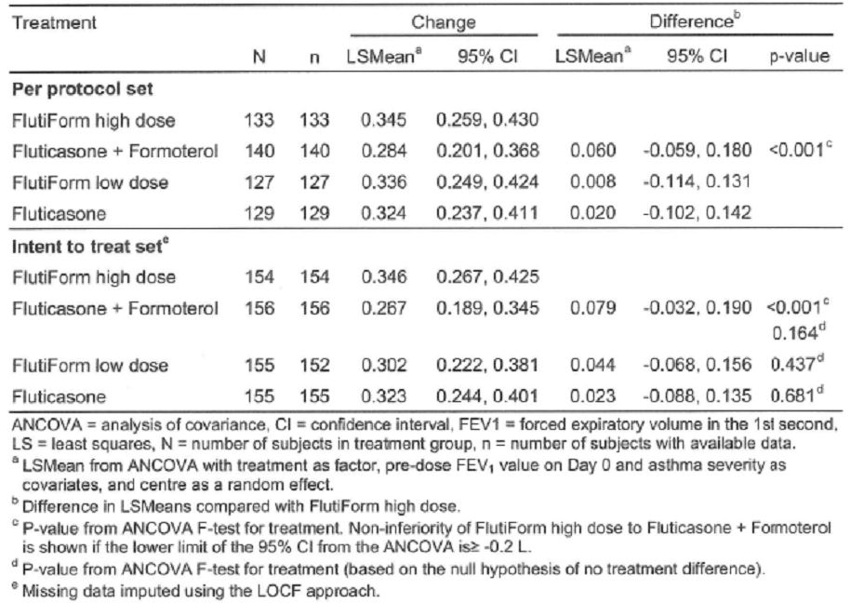
Treatment with Flutiform high dose resulted in a larger increase in pre-morning dose FEV1 than treatment with fluticasone alone, however the difference between the 2 treatment groups was not statistically significant (LSMean of the treatment difference: 0.023 L; 95% CI: -0.088 to 0.135; p = 0.681; ITT). Similarly, the difference between Flutiform high dose and Flutiform low dose was not statistically significant (LSMean of the treatment difference: 0.044 L; 95% CI: -0.068 to 0.156; p = 0.437; ITT).
Since non-inferiority of Flutiform high dose versus Flixotide + Foradil was demonstrated for the primary endpoint, a confirmatory analysis was performed for the co-primary endpoint as well. The mean change in FEV1 from pre-morning dose on Day 0 to 2 hours post-morning dose on Day 56 was 0.518 L in the Flutiform high dose group and 0.500 L in the Flixotide + Foradil group. The LSMean of the treatment difference was 0.018 L (95% CI: -0.098 to 0.135). Non-inferiority of Flutiform high dose to Flixotide + Foradil was demonstrated as the lower limit of the 95% CI for the treatment difference thus exceeded the non-inferiority acceptance limit of -0.2 L (p < 0.001). The analysis of the ITT set confirmed this result (LSMean of the treatment difference: 0.040 L; 95% CI: -0.069 to 0.149; p < 0.001) (Table 36). Superiority of Flutiform high dose to fluticasone alone could be shown (LSMean of the treatment difference: 0.120 L; 95% CI: 0.011 to 0.230; p = 0.032; ITT). This was expected due to the missing contribution of the LABA component to post-dose lung-function measurements in this treatment group. The difference between Flutiform high dose and Flutiform low dose was not statistically significant (LSMean of the treatment difference: 0.011 L; 95% CI: -0.099 to 0.122; p = 0.840; ITT). The mean changes in FEV1 from pre-dose on Day 0 to 2 hours post-dose increased from Day 0 to Day 14 in all treatment groups and remained stable throughout the course of the study. FEV1 values and changes from baseline to each study visit in the group treated with fluticasone alone were clearly lower than in the other treatment groups at all visits during the treatment phase.
Table 36: Change in FEV1 (L) from pre-morning dose on Day 0 to 2 Hours post-morning dose on Day 56 (Study FLT3503).
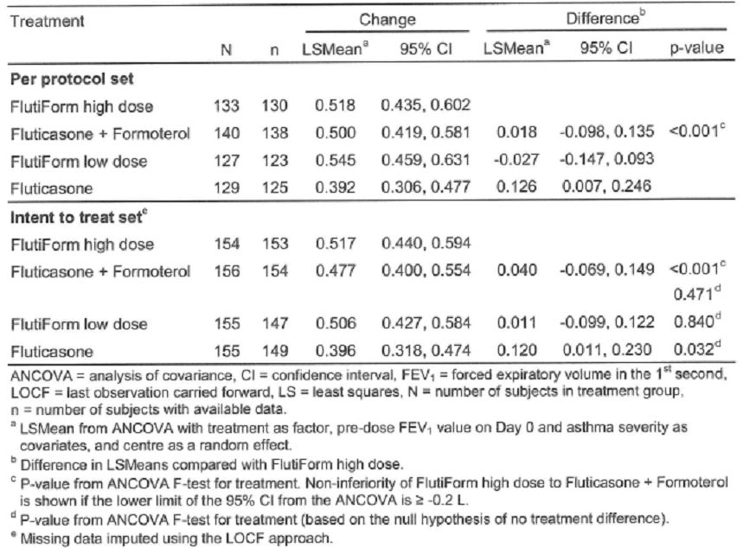

Secondary efficacy results
A subset of 74 to 76 subjects per treatment group had FEV1 values recorded at 30 minutes, 1 hour, 2 hours, 4 hours, 6 hours, 8 hours, 10 hours and 12 hours post-morning dose of study medication on Day 0 and Day 56. Results of the ANCOVA of the 12-hour serial FEV1 on Day 0 and Day 56 showed similar values were obtained in the Flutiform high dose, fluticasone + formoterol and Flutiform low dose groups both at Day 0 and at Day 56 (ITT and FAS). Treatment with Flutiform high dose resulted in a larger 12-hour serial FEV1 AUC than treatment with fluticasone alone, both on Day 0 and on Day 56 (LSMean of the treatment difference: 1.025 L*hours on Day 0 and 0.238 L*hours on Day 56; ITT), although the difference was not statistically significant.
A post-hoc analysis (repeated measures ANCOVA) was performed for the change from pre-dose FEV1 to 0.5, 1, 2, 4, 6, 8, 10, and 12 hours post-dose at Day 0. Superiority of Flutiform high dose versus Flixotide alone was only shown for the change in FEV1 from predose to 1 hour and 2 hours post-dose (LSMean of the treatment difference at 1 hour: 0.140 L, 95% CI: 0.042 to 0.237; LSMean of the treatment difference at 2 hours: 0.116 L, 95% CI: 0.019 to 0.213). However, a similar post-hoc analysis was not performed for the change from pre-dose FEV1 to 0.5, 1, 2, 4, 6, 8, 10, and 12 hours post-dose at Day 56. However, Figure 5 seems to suggest that mean change from pre-dose on day 0 to pre-dose and post-dose on day 56 did not show any significant difference between Flutiform high dose and Flixotide at any time point.
Figure 5: 12-Hour serial FEV1 (L): Mean change from pre-dose on Day 0 to pre-dose and post-dose on Day 56 – ITT (Study FLT3503).
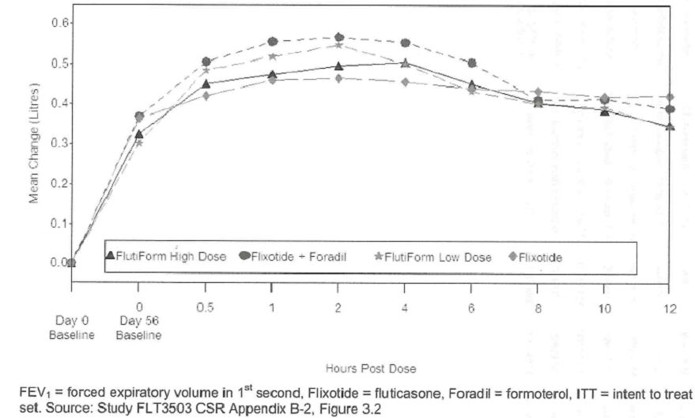
Non-inferiority of Flutiform high dose compared to Flixotide + Foradil was also shown for the secondary endpoint, discontinuations due to lack of efficacy. In the PPS, 6 subjects (4.5%) in the Flutiform high dose group and 11 subjects (7.9%) in the Flixotide + Foradil group discontinued the treatment phase due to lack of efficacy. The upper limit of the 95% CI for the difference was below the pre-defined non-inferiority limit of 10% (95%CI: -9.0 to 2.3). The supportive analysis of the ITT set confirmed this result (95%CI for the treatment difference: -9.0 to 1.4). Confidence intervals were also calculated for the difference between Flutiform high dose and Flutiform low dose or Flixotide. The result indicated superiority of Flutiform high dose compared to these treatment groups: The upper limits of the 95% CI for ITT were less than 0 (-1.8 and -1.3, respectively) for the difference between Flutiform high dose and Flutiform low dose or Flixotide alone. A post-hoc survival analysis to identify differences between treatment groups in the risk for discontinuations at a particular visit and overall showed that Flutiform low dose group subjects started to discontinue soon after Day 14 reflecting that patients were not optimally treated with Flutiform low dose. In the Flixotide group, subjects were able to continue in the study slightly longer than with Flutiform low dose. Most of the discontinuations due to lack of efficacy in the Flutiform low dose and Flixotide groups had occurred by around Day 42 (Figure 6). Flutiform high dose was superior to Flutiform low dose and Flixotide (hazard ratio for Flutiform low dose versus Flutiform high dose: 3.202; p = 0.0136; hazard ratio for Flixotide versus Flutiform high dose: 3.063; p = 0.0184; ITT).
Figure 6: Time to discontinuation due to lack of efficacy (Kaplan-Meier survival curve) – ITT (Study FLT3503).
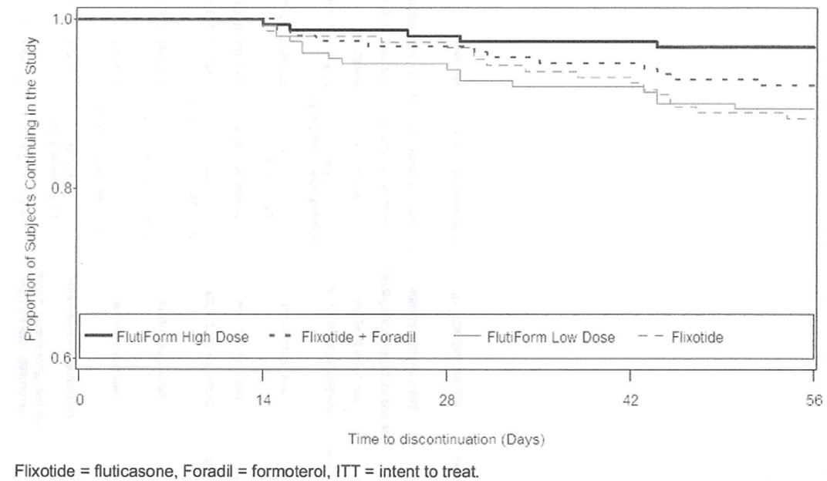

Other respiratory endpoints
The mean pre-dose morning and evening peak flow rates increased from Day 0 to Day 28 in all treatment groups albeit to a lesser extent in the group treated with Flixotide alone; Flutiform high dose was significantly better than Flixotide alone for evening PEFR. However, fluticasone+foradil appeared to produce higher increases in morning and evening peak flow rates compared with Flutiform high dose, although the treatment difference was just short of statistical significance. In all treatment groups, mean FVC, FEF25, FEF50, FEF75, and FEF25-75 values increased from pre-morning dose on Day 0 to pre-morning dose or 2 hours post-morning dose on Day 56. With few exceptions, the largest increases were observed in the Flutiform high dose treatment group and the smallest increases in the fluticasone alone treatment group –especially at 2 hours post-morning dose (Table 37). Statistical tests were not performed.
Table 37: Change in FVC, FEF25, FEF50, FEF75 and FEF25-75 from pre-morning dose on Day 0 to pre-morning dose and to 2 hours post-morning dose on Day 56 – ITT (Study FLT3503).
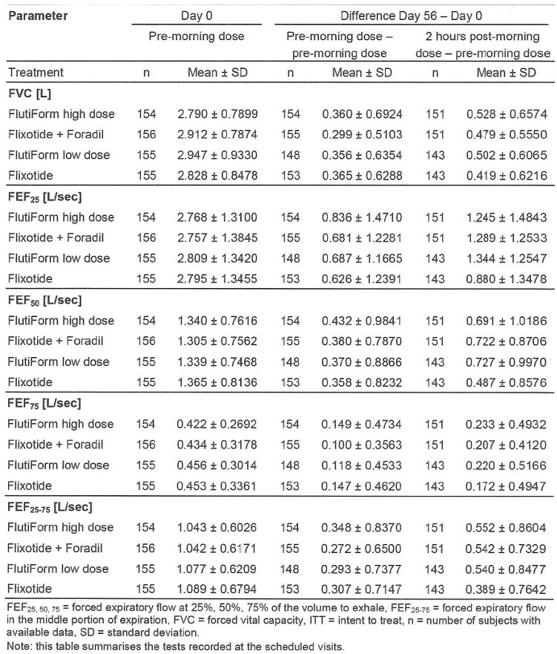

Symptomatic endpoints
The largest numerical improvement in the asthma symptom score was observed in the Flutiform high dose treatment group (LSMean of the change: -0.76), which was superior to treatment with fluticasone alone (LSMean of the treatment difference: -0.16; 95% CI: -0.29 to -0.02; p = 0.020). The results of the ANCOVA of the change in the percentage of symptom-free days showed the largest numerical improvement in the Flutiform high dose treatment group (LSMean of the change: 48.51%), which was superior to treatment with fluticasone alone based on the mean change in percentage of symptom-free days (LSMean of the treatment difference: 8.69; 95% CI: 0.39 to 17.00; p = 0.040). The improvement in sleep disturbance score was very similar in the Flutiform high dose and fluticasone + formoterol groups (LSMean of the change: -0.47 and -0.48, respectively) and numerically larger than the improvements observed in the Flutiform low dose and fluticasone groups (LSMean of the change: -0.35 and -0.44, respectively). Flutiform high dose was superior to Flutiform low dose (LSMean of the treatment difference: -0.12; 95% CI: -0.20 to -0.04; p = 0.005). There were no statistically significant differences between Flutiform high dose and fluticasone + formoterol or Flutiform low dose for asthma symptom score, percentage of symptom-free days, improvement in sleep disturbance score.
The largest numerical improvement in ‘Awakening-free nights’ was observed in the Flutiform high dose treatment group (LSMean of the change: 36.56%) which was superior to Flutiform low dose (LSMean of the treatment difference: 9.87; 95% CI: 3.66 to 16.08; p = 0.002) and to fluticasone alone (LSMean of the treatment difference: 6.67; 95% CI: 0.51 to 12.83; p = 0.034). There was no statistically significant difference between Flutiform high dose and fluticasone + formoterol.
The increase in ‘Asthma control days’ was the same in the Flutiform high dose and fluticasone + formoterol groups (LSMean of the change: 44.14% in both treatment groups) and numerically larger than the increase in the Flutiform low dose and fluticasone groups (LSMean of the change: 41.24% and 38.87%, respectively). However, there were no statistically significant differences between Flutiform high dose and any of the other treatment groups.
The occurrence and severity of asthma exacerbations was assessed at Visits 2 to 7. In the ITT set, between 90 and 112 subjects (57.7% to 72.7%) in each treatment group experienced mild or moderate asthma exacerbations. Severe asthma exacerbations were experienced by 4 subjects in the Flutiform low dose group (2.6%), 3 subjects each in the Flutiform high dose and fluticasone groups (1.9%), and no subject in the fluticasone + formoterol group. For mild/moderate asthma exacerbations the difference was statistically significant in favour of fluticasone + formoterol compared to Flutiform high dose (p = 0.006), while no statistically significant differences were observed between Flutiform high dose and Flutiform low dose or between Flutiform high dose and fluticasone alone.
The median percentage of study days on which salbutamol/albuterol rescue medication was used was comparable between the Flutiform high dose, fluticasone + formoterol, and Flutiform low dose groups (median: 23.95%, 21.05%, and 23.64%, respectively) and slightly higher in the group of subjects using fluticasone alone (median: 29.82%). The median number of uses of rescue medication was very low in all treatment groups (between 0.2 and 0.4 uses per day). No statistically significant difference between Flutiform high dose and the other treatment groups was observed for percentage of study days on which salbutamol/albuterol rescue medication was used or for the number of uses of rescue medication.
More subjects (42.2%) in the Flutiform high dose group assessed the study medication as very good than in any other treatment group (fluticasone + formoterol: 33.3%, Flutiform low dose 27.7%, and fluticasone alone, 23.2%). Furthermore, the ALQL also showed similar improvements for high dose Flutiform and Flixotide+foradil groups.

Ancillary analyses
No subgroup efficacy results were provided in the study report in Mod 5.
Comments: Following twice daily administration (for 8 weeks), non-inferiority was demonstrated between high-dose Flutiform (500/20ug twice daily) and fluticasone 500ug+ formoterol 24ug in terms of primary and co-primary efficacy endpoints. However, interpretation of the results was confounded by several limitations which have been discussed in detail in this clinical evaluation report.

Pivotal superiority Study SKY2028-3-001

Methods and objectives
SKY2028-3-001 was a randomized, double-blind, placebo-controlled, parallel group, stratified, multicenter, 12-week superiority study comparing the safety and efficacy of Flutiform 100/10 ug twice daily in a single inhaler with the administration of placebo, fluticasone (100 ug twice daily) or formoterol (10 ug twice daily) alone in adolescent and adult patients with mild to moderate asthma. The study was conducted at 59 sites in North America and Ukraine from 27/7/2006 to 15/4/2008. The primary objective of this study was to demonstrate the efficacy of SkyePharma (SKP) Flutiform HFA pMDI compared to fluticasone propionate and formoterol fumarate alone and placebo. The secondary objectives of the study were to assess the effect on other pulmonary efficacy endpoints, safety and to assess the 12-hour serial FEV1 area under the curve (AUC) in a subset population (in at least 160 subjects.

Study participants
Male and female subjects ≥ 12 years of age with a documented history of stable, symptomatic asthma for at least 12 months; steroid-requiring (receiving inhaled steroid medication for at least 4 weeks prior to the screening visit at a dose not greater than 500 ug/day fluticasone propionate or equivalent) or steroid-free (no history of steroid asthma medication for at least 12 weeks prior to the screening visit); an FEV1 of 60% to 85% (inclusive) of predicted normal values at both the screening and baseline visits following appropriate withholding of bronchodilator medication; documented reversibility within 12 months of the screening visit. Subjects met the following criteria during any 7 consecutive days of the Run-in Period: subject used 2 or more inhalations per day of rescue albuterol pMDI for at least 3 days, and the subject had 1 of the following asthma symptoms: At least 1 night with sleep disturbance, or at least 3 days with asthma symptoms.
The main exclusion criteria were similar to those discussed in pivotal study FLT3503 (p31 above) with the following exceptions: subjects with history of leukotriene receptor antagonist use, e.g., montelukast, within the past week were excluded; history of systemic (oral or injectable) corticosteroid medication within 3 months before the screening visit (compared to within 1 month for study FLT3503).
Comments: The inclusion criteria was % FEV1 predicted of 60-85%; according to the GINA classification of asthma severity, mild to moderate asthma is defined as between 60-80% and it is not clear why the sponsors chose criteria of 85% for this study.

Treatments
All subjects entered a Run-in Period of 2 to 4 weeks, depending on their history of steroid use. Steroid-requiring subjects had a Run-in Period of 14 ± 3 days during which they received asthma maintenance therapy using fluticasone HFA pMDI (50 ug twice daily). Steroid-free subjects had a Run-in Period between 14 and 28 days during which they did not receive any asthma-controlling medication. However, the use of rescue albuterol pMDI was permitted for all subjects as needed for the control of worsening asthma symptoms during the Run-in Period. Of note, excessive use of rescue albulterol pMDI (≥ 12 actuations/day) on more than 3 of 7 days immediately preceding a study visit was a criterion for premature discontinuation from the study. Eligible subjects were stratified according to prior steroid use (steroid-requiring versus steroid-free) and randomized to 1 of 4 treatment groups, taking 2 inhalations BID from each inhaler: Flutiform 100/10 ug HFA pMDI; or fluticasone 100 ug HFA pMDI; or formoterol 10 ug HFA pMDI; or placebo SKP HFA pMDI. Study drug was administered BID over a 12-week period. During the Treatment Period, subjects could take only their blinded study drug; all other asthma medications were withheld for the duration of the Treatment Period, except the use of rescue albuterol pMDI was permitted as needed for the control of worsening asthma symptoms.
Assessment of treatment compliance was similar to that in pivotal study FLT3503.

Randomisation, blinding
Subjects were randomized into 1 of 4 treatment arms, based on a ratio of 1:1:1:1. Randomization was performed via minimization with biased coin assignment. The factors to be balanced were prior steroid use, site, and the subgroup of subjects aged 12 to 18 years. Randomized study drug was double-blinded by the use of placebo pMDIs. Therefore, all subjects used both active and placebo pMDIs, but only 1 of them contained the active ingredient(s) (for subjects in the placebo group, both inhalers were placebo). The visual appearance of the actuator and canisters for the Flutiform, formoterol, and placebo were identical. The investigator, the study site personnel, and the representatives of the CRO and SkyePharma involved in monitoring, data management, or other aspects of the study were blinded to the study drug.

Efficacy endpoints, sample size, statistical methods
Subject visits occurred at Weeks 2, 4, 8, and 12 during which assessments (including serial PFTs up to 4 hours) were made. In a subset of approximately 160 subjects (40 subjects per treatment group) from selected sites, postdose 12-hour serial PFTs were to be performed at Baseline, Week 2, and Week 12. The co-primary efficacy endpoints were the mean change in FEV1 from morning predose at baseline (Week 0) to predose at Week 12 (to determine efficacy vs fluticasone alone), the mean change in FEV1 from morning predose at baseline (Week 0) to 2 hours postdose at Week 12 (to determine efficacy vs formoterol alone), and discontinuations due to lack of efficacy (to determine efficacy vs placebo). Last observation carried forward (LOCF) analysis was used for the first two co-primary endpoints. If all 3 co-primary endpoints were significant at the 2-sided 0.05 significance level, the secondary efficacy endpoints were evaluated with a hierarchical testing scheme. The secondary endpoints were ranked as follows: Lung function endpoints: Change from baseline to final Week in morning (AM) PEFR and evening (PM) PEFR. Measures of disease control and asthma symptom control: Change from baseline to final Week in rescue medication use, asthma symptom scores, symptom-free days, rescue medication-free days, asthma control days; Proportion of subjects with asthma exacerbations; Change from baseline to final week in sleep disturbance scores and awakening-free nights. Additional (tertiary) efficacy endpoints included PFTs (FEV1 percentage predicted normal, FVC, and PEFR), 12-hour FEV1 AUC (in a subset of ≥ 160 subjects).
The co-primary efficacy endpoints based on the change in FEV1 were compared between treatment groups using an analysis of covariance (ANCOVA) with treatment group (all 4 treatment groups), site, and prior steroid use (steroid-requiring and steroid-free) as main effects and Baseline value as a covariate. A log-rank test with effects for treatment group (Flutiform and placebo) and prior steroid use was performed to analyse the third co-primary endpoint (discontinuations due to lack of efficacy). The change from Baseline to Final for the following secondary endpoints, AM/PM PEFR, asthma symptom scores, sleep disturbance scores, and rescue medication use, were compared between treatment groups using a similar ANCOVA model as for the primary endpoints. Differences between treatment groups for the change from Baseline to Final Week for symptom-free days, rescue medication-free days, asthma control days, and awakening-free nights was assessed using van Elteren's method for combining Wilcoxon rank sum test results from independent strata, with prior steroid use and site as the strata. Differences between treatment groups were assessed using logistic regression with effects for treatment groups (all 4 treatment groups) and prior steroid use for the proportion of subjects experiencing at least 1 treatment-emergent asthma exacerbation.
With 92 subjects per treatment group, the study would have 85% power to detect a significant difference between 2 treatment groups using a two-sided t-test with alpha = 0.05, assuming a difference of 0.2 L with respect to mean change from morning predose Baseline (Week 0) to either morning predose FEV1 at Week 12 or 2-hour postdose FEV1 at Week 12 (considered as clinically significant change) and a common standard deviation (SD) of 0.45. To account for an approximately 15% drop out rate 108 subjects were planned for enrolment in each group. Assuming that 10% of Flutiform and 30% of placebo group subjects would discontinue due to lack of efficacy, with 92 subjects per treatment group there would be 90% power to detect this difference using a two-sided log-rank test with alpha = 0.05.

Results

Patient disposition, baseline characteristics
Among the 475 randomized subjects, 333 were randomized at US sites, 80 were randomized at Canadian sites, and 62 were randomized at Ukrainian sites. Of the 475 randomized subjects, 367 (77.3%) completed the study and 108 (22.7%) discontinued from the study. Fewer subjects prematurely discontinued from the study in the Flutiform group (16.1%) compared to the fluticasone (18.5%), formoterol (25.0%), and placebo (31.4%) groups mainly due to higher discontinuations due to lack of efficacy in the groups other than Flutiform. The incidence of major protocol violations was 10.7% overall with no significant differences between groups with exception of more patients in placebo and formoterol groups ‘not discontinued despite meeting discontinuation criteria’. The predefined data sets for efficacy analyses were the FAS (n=459) and the PP (n=408) Population. The AUC Population included 180 subjects who participated in the subset for 12-hour postdose serial PFTs and who had a minimum of 4 measured FEV1 values. The mean treatment compliance to study drug among the 475 randomized subjects was 84.15%, with 88.4% and 72.4% of subjects having > 70 and > 80% compliance, respectively. Percent compliance to study drug was generally similar across treatment groups. Majority of the 475 randomized subjects were female (60%), white (74.1%) with mean age of 38.7 years (range: 12 to 85 years) and 6.9% of the patients (n=33) were adolescents aged 12-17yrs. The mean duration of asthma was 20.49 years (range: 1.2 to 83.3 years) and approximately half of the subjects required inhaled steroids (49.1%). Asthma characteristics were generally similar across treatment; mean FEV1 % predicted at baseline was 73.0% (range: 53% to 96%) and the mean percent reversibility at screening was 22.63% (range: 14.5% to 83.9%). Approximately 30% of subjects previously received ICS and LABA combination asthma therapy (Seretide=24%; budenoside with formoterol=6%). Baseline disease characteristics, use of previous respiratory medications and use of concomitant medications was similar between treatment groups.

Primary efficacy results
The contribution from the fluticasone component of Flutiform 100/10 was demonstrated by the statistically significant treatment group difference (LS mean difference = 0.101 L; 95% CI:0.002 to 0.199; p = 0.045) between the Flutiform 100/10 and formoterol 10 groups for mean change from Baseline pre-dose to pre-dose at Week 12 using LOCF imputation (coprimary endpoint #1). The contribution from the formoterol component of Flutiform 100/10 was demonstrated by the clinically important and statistically significant treatment group difference (LS mean difference = 0.200 L; 95% CI: 0.109 to 0.292; p < 0.001) between the Flutiform 100/10 and fluticasone 100 groups for mean change from Baseline pre-dose to 2 hours post-dose at Week 12 using LOCF imputation (Table 38). To assess the impact of missing data at Week 12, sensitivity analyses were performed for first 2 co-primary endpoints. Results from all sensitivity analyses numerically supported the contribution of the fluticasone component to Flutiform based on mean change from Baseline predose to predose at Week 12 in FEV1, although the difference was not statistically significant. However, results from all sensitivity analyses demonstrated statistically significant contribution of the formoterol component to Flutiform based on mean change from Baseline predose to 2 hours postdose at Week 12 in FEV1.
Table 38: FEV1 (L): Mean change from pre-dose at baseline to pre-dose and 2 hours post-dose at Week 12 – FAS using LOCF (Study SKY2028-3-001).
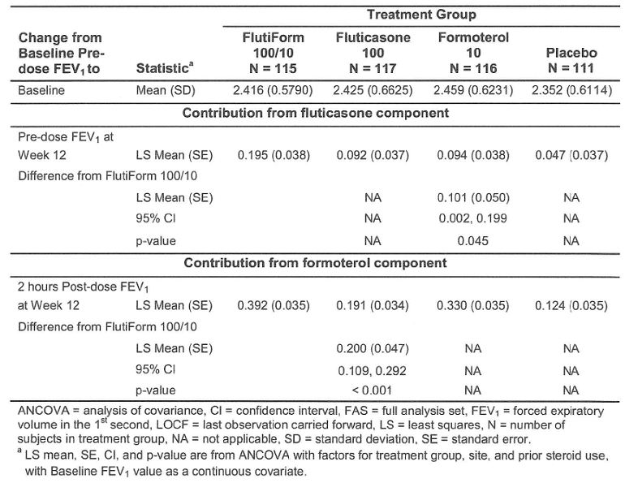
The mean changes in FEV1 from pre-dose at Baseline to pre-dose or 2 hours post-dose were generally numerically greater for Flutiform 100/10 compared to its components and placebo beginning at Week 2 and were sustained throughout the 12-week treatment period (Figure 7). Flutiform 100/10 was superior to placebo for time to discontinuation due to lack of efficacy (co-primary endpoint #3) The number of subjects who prematurely discontinued due to lack of efficacy was 7 (6.1%) in the Flutiform 100/10, 9 (7.7%) in the fluticasone 100, 13 (11.2%) in the formoterol 10, and 18 (16.2%) in the placebo groups.
Figure 7: FEV1 (L): Mean change from pre-dose at baseline to 2 hours post-dose at Weeks 2, 4, 8 and 12 – FAS using LOCF (Study SKY 2028-3-001).
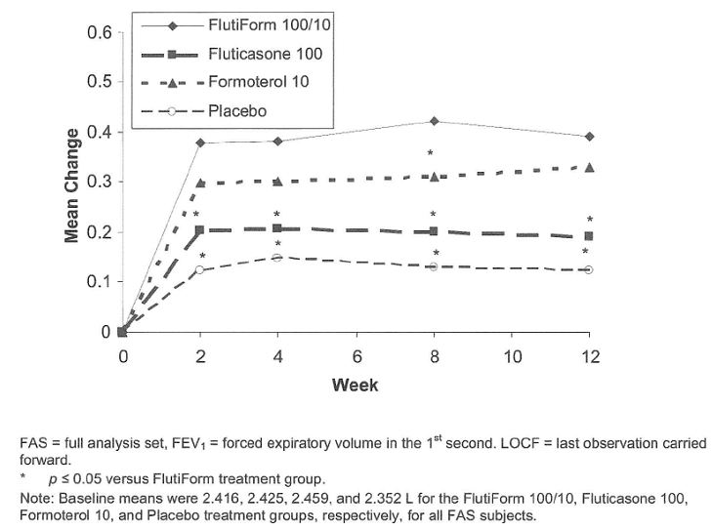

Secondary efficacy results
Flutiform 100/10ug demonstrated numerically greater and statistically significant (based on the sequential gatekeeping approach) improvements in lung function parameters of AM PEFR and PM PEFR compared to its components and to placebo. Compared to its components and to placebo, Flutiform 100/10ug demonstrated numerically greater (but not statistically significant) improvements for measures of disease control. The mean increase in percent of asthma control days was 56.3%, 44%, 41.9% and 36% for the Flutiform 100/10, fluticasone, formoterol, and placebo groups, respectively; incidence of severe asthma exacerbation was 2.6%, 3.4%, 6.9%, and 9.0, respectively; incidence of mild/ moderate exacerbation was 18.3%, 20.5%, 23.3 and 25.2%, respectively; mean increase in percent of rescue medication-free days was 55.9%, 43.3%, 41.9%, and 39.4%, respectively; mean increase in percent of symptom-free days was 49.4%, 37.3%, 38.0%, and 35.6%, respectively; mean increase in percent of awakening-free nights was 28.8%, 25.4%, 19.6%, and 20.9%, respectively.
Tertiary endpoints: The 12-hour serial FEV1 evaluation was performed to compare the efficacy of Flutiform 100/10ug to fluticasone 100ug. The AUC population included 180 subjects: there were 44 45, 45, and 46 subjects in the Flutiform 100/10, fluticasone 100, formoterol 10, and placebo treatment groups, respectively. The mean 12-hour FEV1 AUC of Flutiform 100/10ug was numerically greater than each of its components and placebo at Week 2. The mean 12-hour FEV1 AUC of Flutiform 100/10 was greater than fluticasone and placebo, and similar to formoterol, at Week 0 and Week 12 (Table 39).
Table 39: 12-Hour serial FEV1 AUC (L-Hour) – 12-Hour serial FEV1 analysis set using observed data (Study SKY2028-3-001).
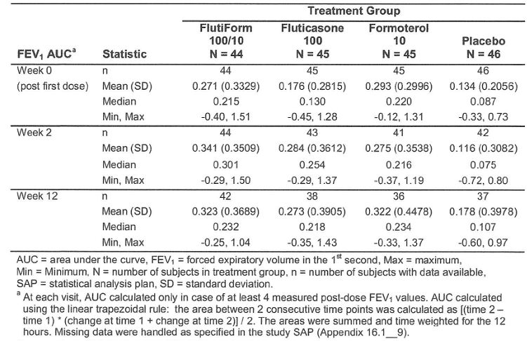

Pivotal superiority Study SKY2028-3-002
SKY2028-3-002 was another pivotal, Phase 3, randomised, double-blind, active-controlled, parallel group, stratified, multicentre study which evaluated the safety and efficacy of Flutiform 100/10ug over 12 weeks compared with fluticasone and formoterol in adolescent and adult subjects with mild to moderate asthma (in both steroid users and steroid-free patients). It was conducted from 2/6/2006 to 31/1/2008 at 43 centres in North America. The study design, inclusion/ exclusion criteria, methodology, efficacy endpoints were similar to that of study SKY2028-3-001 described above with the following 2 exceptions: lack of placebo control group and lack of third co-primary endpoint of ‘time to discontinuation due to lack of efficacy’; Subjects were randomized into 1 of 3 treatment arms, based on a ratio of 1:1:1 and the randomization was performed via minimization (and not using a randomisation schedule); primary and efficacy endpoints were similar to those in SKY2028-3-001 with one exception as 12 hour serial FEV1 was not evaluated in this study. With 92 subjects per treatment group, the study would have 85% power to detect a significant difference between 2 treatment groups using a two-sided t-test with alpha = 0.05, assuming a difference of 0.2 L with respect to mean change in FEV1, which was considered a clinically significant change, and a common standard deviation (SD) of 0.45. To account for a dropout rate of approximately 15%, 108 subjects were planned for enrolment into each group.

Results

Patient disposition, baseline characteristics
A total of 357 subjects were randomised: 119 to Flutiform 100/10ug, 119 to fluticasone 100ug, and 119 to formoterol 10ug. Of the 357 randomised subjects, 269 (75.4%) completed the study and 88 (24.6%) discontinued the study. Fewer subjects prematurely discontinued the study in the Flutiform 100/10 group (16.8%) compared to the fluticasone 100 (25.2%) and formoterol 10 (31.9%) groups. The incidence of major protocol violations was similar in all treatment groups and violation of inclusion/ exclusion criteria was most common. Majority of the 353 subjects in the FAS were white (76.5%), females (58.1%), with mean age of 37.6 years (range: 12 to 79 years) and 40 subjects (11.3%) were 12 to 17 years of age. Among all subjects in the FAS, the mean duration of asthma was 21.02 years (range: 1.0 to 64.5 years), mean FEV1 at baseline was 2.438 L (range: 1.18 to 4.26 L), mean FEV1 % predicted at baseline was 73.4% (range: 56 to 98%) and the mean percent reversibility at screening was 23.52% (range: 14.4 to 105.0%). Approximately half the subjects required inhaled steroids (54.1%) and approximately one third of subjects previously received ICS and LABA combination treatment. Asthma characteristics and intake of previous/ concomitant medications were generally similar across treatment groups. Among the 12 subjects (7 fluticasone, 5 formoterol) who received concomitant prednisone, reasons for use included asthma exacerbation, worsening asthma (2 fluticasone, 1 fluticasone, 5 formoterol), poison ivy (3 fluticasone, 0 formoterol), and upper respiratory infection (1 fluticasone, 0 formoterol). The mean percent compliance to study drug among the 357 subjects in the safety population was 84.65%, with 88.0% and 72.8% of subjects having ≥ 70% and ≥ 80% of compliance, respectively.

Primary efficacy results
The contribution from the fluticasone component of Flutiform 100/10ug was demonstrated by the statistically significant treatment group difference (LS mean difference = 0.118 L; 95% CI: 0.034 to 0.201; p = 0.006) between the Flutiform 100/10ug and formoterol 10ug groups for mean change from baseline pre-dose to pre-dose at Week 12 using LOCF imputation (co-primary endpoint #1). The contribution from the formoterol component of Flutiform 100/10ug was demonstrated by the clinically important and statistically significant treatment group difference (LS mean difference = 0.122 L; 95% CI: 0.040 to 0.204; p=0.004) between the Flutiform 100/10ug and fluticasone 100ug groups for mean change from Baseline pre-dose to 2 hours post-dose at Week 12 using LOCF imputation (co-primary endpoint #2). The sensitivity analysis supported the co-primary efficacy results. The mean changes in FEV1 from pre-dose at baseline to pre-dose or 2 hours post-dose were generally numerically greater for Flutiform 100/10 compared to its components beginning at Week 2 and were sustained throughout the 12-week Treatment Period (Figures 8-9).
Figure 8: FEV1 (L): Mean change from baseline to pre-dose at Weeks 2, 4, 8 and 12 – FAS using LOCF
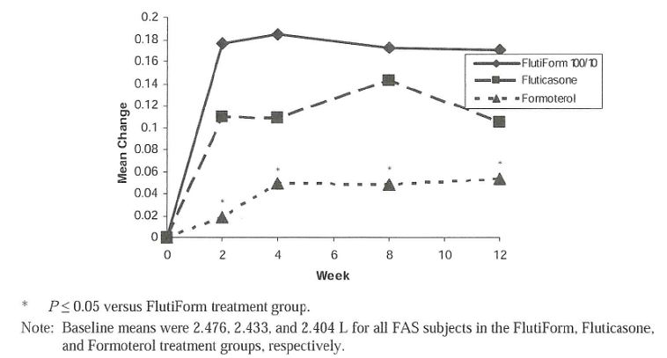
Figure 9: FEV1 (L): Mean change from pre-dose at baseline to 2 Hours post-dose at Weeks 2, 4, 8 and 12 – FAS using LOCF
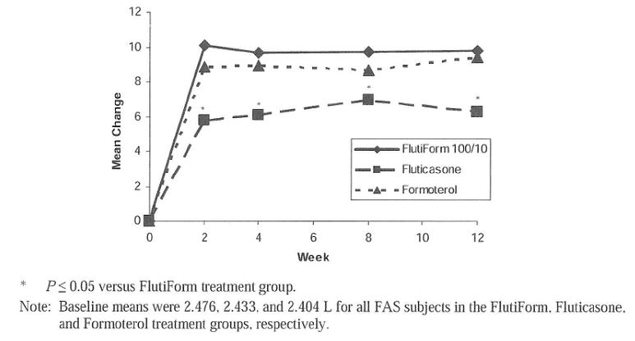

Secondary and tertiary efficacy results
Flutiform 100/10ug demonstrated numerically greater and statistically significant (based on the sequential gatekeeping approach) improvements in lung function parameters of AM PEFR and PM PEFR compared to its components. Compared to its components, Flutiform 100/10ug demonstrated numerically greater (but not statistically significant) improvements for measures of disease control. The mean increase in percent of asthma control days was 51.9%, 39.2% and 37.7% for the Flutiform 100/10, fluticasone, and formoterol groups, respectively; incidence of severe asthma exacerbation was 0.8%, 3.4% and 7.6%, respectively; incidence of mild/ moderate exacerbation was 10.2%, 13.8% and 15.1%, respectively; mean increase in percent of rescue medication-free days was 51.8%, 39.3% and 39.7%, respectively; mean increase in percent of symptom-free days was 46.1%, 37.1% and 37.2%, respectively; mean increase in percent of awakening-free nights was 25.7%, 20.4% and 19.6%, respectively. The results of secondary and tertiary analyses, evaluating lung function, asthma exacerbations, asthma symptoms and rescue medication use, were generally supportive of the superior efficacy of Flutiform 100/10ug compared to its components. Numerically greater improvements with Flutiform 100/10 ug were noted as early as 1 day after the first dose and were maintained throughout the 12-week Treatment Period.

Pivotal superiority Study SKY2028-3-004
SKY2028-3-004 was another pivotal, Phase 3, randomised, double-blind, placebo- and active-controlled, parallel group, stratified, multicentre study which evaluated the safety and efficacy of Flutiform 250/10 (primary) and Flutiform 100/10 (secondary) over 12 weeks compared with placebo, fluticasone, and formoterol in adolescent and adult subjects with moderate to severe asthma who required steroids (inhaled steroid regimen for at least 4 weeks prior to the screening visit at a dose <500 ug/day fluticasone or equivalent ICS). It was conducted from 11/7/2006 to 3/4/2008 at 78 centres in USA and Europe. The co-primary endpoints in this study were similar to those for study SKY2028-3-001 but evaluated the higher Flutiform dose of 250/10ug twice daily. The secondary objectives were :- (1) to estimate the efficacy of SKP Flutiform HFA pMDI (100/10 ug BID) using the same endpoints as for the primary objectives; (2) to demonstrate the efficacy of SKP Flutiform HFA pMDI (100/10 ug or 250/10 ug BID) using other pulmonary function tests (PFTs) (including FEV1 percentage predicted normal, forced vital capacity [FVC], and peak expiratory flow rate [PEFR]) and clinical endpoints (frequency of asthma exacerbations, subject derived data recorded daily using a telephone diary system including daily PEFR); and (3) to examine the effects of SKP Flutiform HFA pMDI at both dose levels (100/10 ug and 250/10 ug BID) with respect to efficacy and to assess the 12-hour serial FEV1 area under the curve (AUC) in a subset population of 282 subjects (done at baseline week 2, and week 12). All subjects entered an open-label Run-in Period of 14+3 days during which subjects received fluticasone (50 ug BID or 100 ug BID, depending on prior ICS dose) as asthma maintenance therapy and received rescue salbutamol/albuterol as needed. At the Baseline Visit (Week 0) following the Run-in Period, eligible subjects were stratified according to FEV1 % predicted category (40% to 60% or > 60% to 80%) and randomised to 1 of the 5 treatment groups: Flutiform 250/10ug, Flutiform 100/10ug, fluticasone 250ug, formoterol 10ug, and placebo. Study visits occurred at Weeks 2, 4, 8, and 12 during which efficacy assessments were made. In a subset of 282 subjects, post-dose 12-hour serial pulmonary function tests were performed at Baseline, Week 2, and Week 12. Other study design, methodology, randomisation, blinding, statistical considerations and sample size determination were similar to those described for study SKY2028-3-001 above.

Results

Patient disposition, baseline characteristics
A total of 557 subjects were randomised: 110 to Flutiform 250/10ug, 114 to Flutiform 100/10ug, 113 to fluticasone 250ug, 111 to formoterol 10ug, and 109 to placebo. Of the 557 randomised subjects, 395 (70.9%) completed the study and 162 (29.1%) discontinued the study. Fewer subjects prematurely discontinued the study in the Flutiform 250/10 and Flutiform 100/10 groups (20.9% and 15.8%, respectively) compared to the fluticasone 250 (24.8%), formoterol 10 (36.9%), and placebo (47.7%) groups. FAS included 543 randomised subjects: there were 108, 111, 109, 110, and 105 subjects in the Flutiform 250/10, Flutiform 100/10, fluticasone 250, formoterol 10, and placebo treatment groups, respectively. Violation of inclusion/ exclusion criteria was most common reason for major protocol violation. Majority of the 543 subjects in the FAS were white (83.6%), females (59.7%), with mean age of 43.1 years (range: 12 to 82 years) and 41 subjects (7.6%) were 12 to 17 years of age. The mean duration of asthma was 20.44 years (range: 1.1 to 69.3 years), mean FEV1 at baseline was 2.104 L (range: 0.91 to 4.10 L), mean FEV1 % predicted at baseline was 64.8% (range: 39% to 225%) and the mean percent reversibility at screening was 26.57% (range: 14.5% to 109.6%); majority of subjects had a baseline FEV1 % predicted of > 60% to 80% (66.9%). Asthma characteristics were generally similar across treatment groups. Approximately 40% of subjects previously received ICS and LABA combination asthma therapy and there were no significant differences between treatment groups for prior or concomitant medications. Among the 23 subjects (1 Flutiform 250/10 ug, 4 Flutiform 100/10 ug, 2 fluticasone, 8 formoterol, and 8 placebo) who received concomitant prednisone, reason for use was asthma or asthma exacerbation in all subjects and all of these subjects were prematurely discontinued from study drug shortly after starting prednisone. The mean percent compliance to study drug among the 556 subjects in the safety population was 86.75%, with 91.9% and 80.2% of subjects having ≥ 70% and ≥ 80% compliance, respectively with no significant difference between treatment groups.

Primary efficacy results
Flutiform 250/10 ug was demonstrated to be statistically significantly superior to each of its components for the first 2 co-primary endpoints (change in FEV1). The contribution from the fluticasone component of Flutiform 250/10 ug was demonstrated by the statistically significant treatment group difference (LS mean difference = 0.189 L; P < 0.001) between the Flutiform 250/10 ug and formoterol groups for mean change from Baseline predose to predose at Week 12 using LOCF imputation. The contribution from the formoterol component of Flutiform 250/10 ug was demonstrated by the statistically significant treatment group difference (LS mean difference = 0.146 L; P = 0.006) between the Flutiform 250/10 ug and fluticasone groups for mean change from Baseline predose to 2 hours postdose at Week 12 using LOCF imputation (Table 40).
Table 40: FEV1 (L): Mean change from pre-dose at baseline to pre-dose and 2 Hours post-dose at Week 12 – FAS using LOCF (Study SKY2028-3-004).
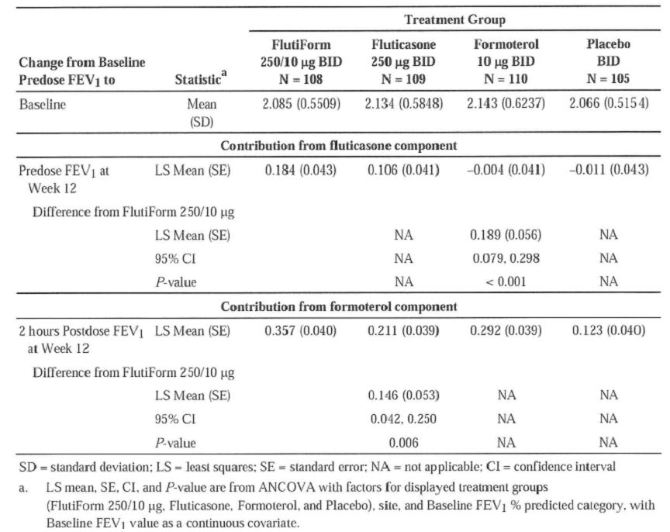
Results from all sensitivity analyses statistically demonstrated the superiority of Flutiform 250/10 ug to each of its components based on mean change from Baseline predose FEV1. The mean changes in FEV1 from pre-dose at baseline to pre-dose or 2 hours post-dose were generally numerically greater for Flutiform 250/10ug compared to its components beginning at Week 2 and were sustained throughout the 12-week Treatment Period (Figures 10-11). Flutiform 250/10 ug was statistically significantly superior to placebo in time to discontinuation due to lack of efficacy (the third co-primary endpoint); number of subjects who prematurely discontinued due to lack of efficacy was 11 (10.2%) in the Flutiform 250/10ug group, 14 (12.8%) in the fluticasone treatment group, 23 (20.9%) in the formoterol treatment group, and 41 (39.0%) in the placebo group. The following sensitivity analyses were performed for the third co-primary endpoint (discontinuations due to lack of efficacy): A: Discontinuations due to lack of efficacy in the PP population. B: Met discontinuation criteria for lack of efficacy in the FAS. C: Discontinuations due to lack of efficacy and/or meeting discontinuation criteria for lack of efficacy in the FAS. Flutiform 250/10 ug was demonstrated to be statistically significantly superior to placebo in time to discontinuation in all 3 sensitivity analyses.
Figure 10: FEV1 (L): Mean change from baseline to pre-dose at Weeks 2, 4, 8 and 12 – FAS using LOCF (Study KSY2028-3-004).
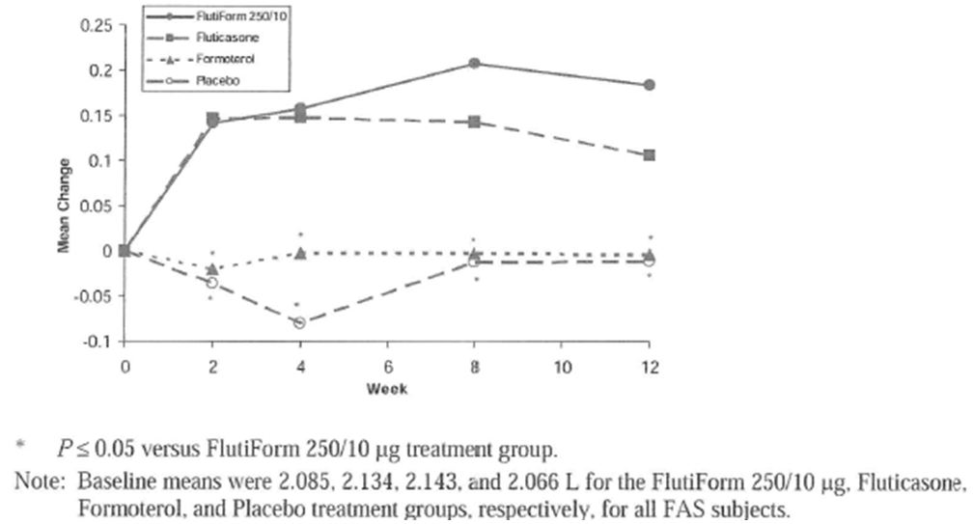
Figure 11: FEV1 (L): Mean change from pre-dose at baseline to 2 Hours post-dose at Weeks 2, 4, 8 and 12 – FAS using LOCF (Study KSY2028-3-004).
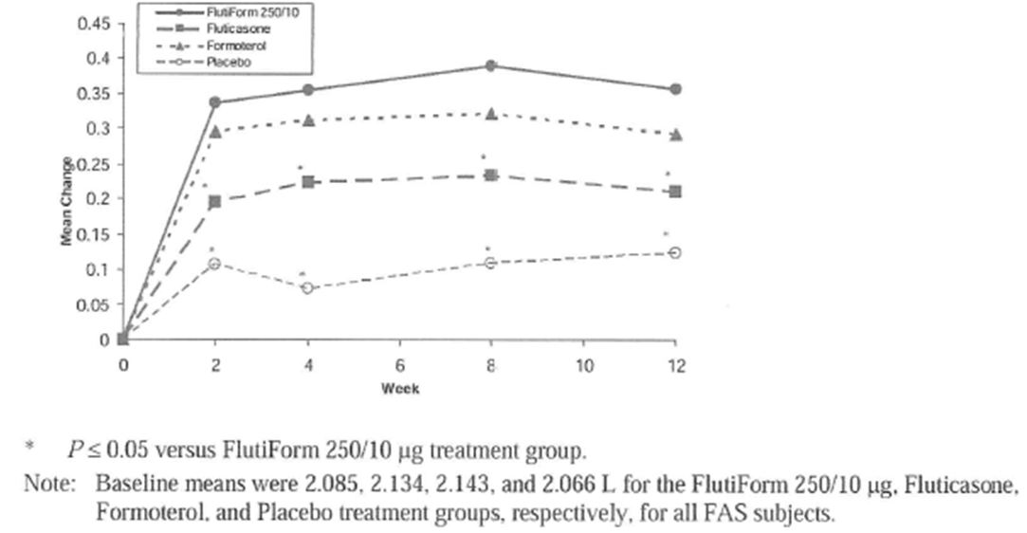

Secondary efficacy results
The mean 12-hour FEV1 AUC of Flutiform 250/10 was greater than each of its components and placebo at Week 2 and Week 12 (Figures 12-13). The mean increase from baseline in AM- PEFR and PM-PEFR was numerically and statistically significantly greater in the Flutiform 250/10 group than in each of the component treatment groups. Disease control in terms of asthma control days, rescue medication-free days was significantly greater in Flutiform 250/10ug group, while that of symptom-free days, and awakening-free night was numerically greater compared to its components and placebo. In the Flutiform 250/10 ug treatment group, the mean percent of asthma control days at Baseline and Final Week was 12.9% and 53.8%, respectively. This corresponds to approximately 0.9 and 3.8 asthma control days per week, respectively with statistically significant improvements over its components and placebo. Fewer patients in the Flutiform 250/10 group experienced asthma exacerbations compared to the placebo and component treatment groups (Table 41). A total of 55 subjects (4 Flutiform 250/10ug, 6 Flutiform 100/10ug, 5 fluticasone, 16 formoterol, and 24 placebo) experienced severe asthma exacerbations. Fifty-four of these subjects were prematurely discontinued from the study due to lack of efficacy; the remaining subject in the formoterol group completed the study. The mean asthma symptom scores at Baseline (Week 0) were low (1.0 to 1.2) in these subjects with moderate to severe asthma. For asthma symptom scores, the mean decrease from Baseline to Final Week was numerically greater in the Flutiform 250/10 ug treatment group compared to the placebo group; the mean decrease was also numerically greater in the Flutiform 250/10 ug treatment group compared to each of the component treatment groups. The difference between the Flutiform 250/10 and formoterol treatment groups (p=0.011) was not considered statistically significant due to the pre-specified sequential gatekeeper approach. The difference between the Flutiform 250/10 and the fluticasone treatment groups was not statistically significant.
Figure 12: 12-Hour serial FEV1 (L): Mean change from baseline pre-dose at baseline (Week 0) – AUC population using observed data (Study SKY2028-3-004).
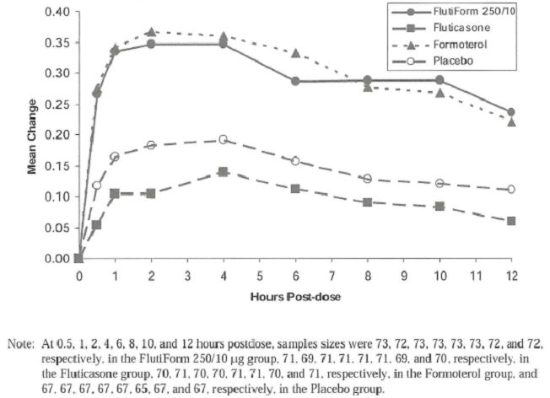
Figure 13: 12-Hour serial FEV1 (L): Mean change from baseline pre-dose at Week 12 – AUC population using observed data (Study SKY2028-3-004).
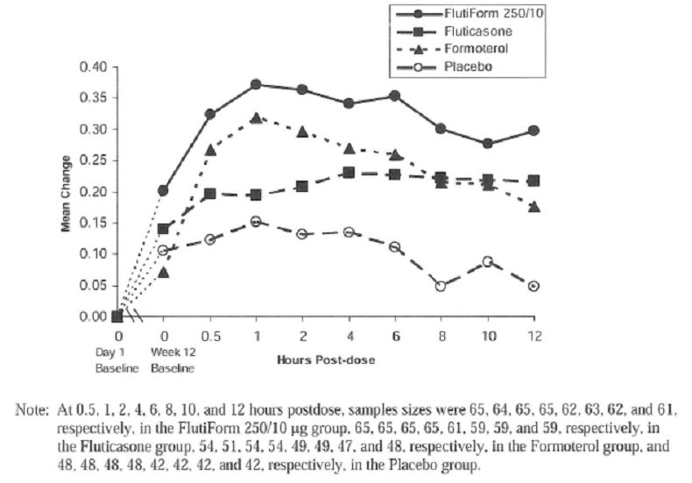
Table 41: Disease Control: Number (%) of subjects with asthma exacerbations in Study SKY2028-3-004 – FAS (Study SKY2028-3-004).
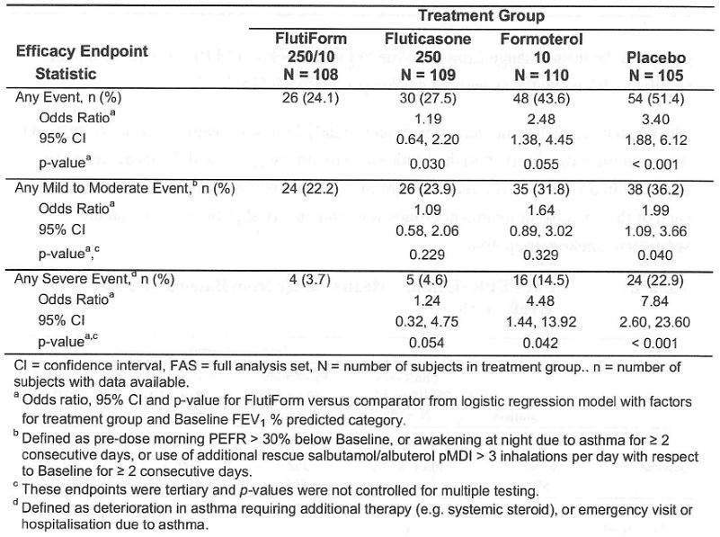
In the study, no statistical analysis was done to compare efficacy of the two Flutiform doses (250/10 and 100/10ug). Results in the Flutiform 100/10 group were demonstrated to be numerically greater than each of the component groups and the placebo group for the first 2 co-primary endpoints (change in FEV1). The % of patients discontinued due to lack of efficacy was greater in the Flutiform 100/10ug dose, although the % of patients who met the criteria of discontinuation due to lack of efficacy was greater in the Flutiform 250/10ug group. Flutiform 100/10ug appeared to show similar results to the 250/10ug dose with respect to key secondary endpoints. When the 2 Flutiform doses were compared based on categories of disease severity (moderate or severe), the majority of results were clinically comparable, with the following exceptions. In subjects with severe disease (defined as FEV1 % predicted of 40% to 60%), the Flutiform 100/10 ug group had a greater mean increase in FEV1 predose at Week 12 (mean difference = 0.268 L) compared to the Flutiform 250/10 ug group (mean difference = 0.166 L). Alternatively, there were a lower percentage of subjects with severe disease who experienced severe asthma exacerbations in the Flutiform 250/10 ug group (5.7%), compared to the Flutiform 100/10 ug group (10.8%) (Table 42).
Table 42: Flutiform 250/10 and Flutiform 100/10 number (%) of subjects with asthma exacerbations and percentage of days with asthma exacerbation – FAS (Study SKY2028-3-004).
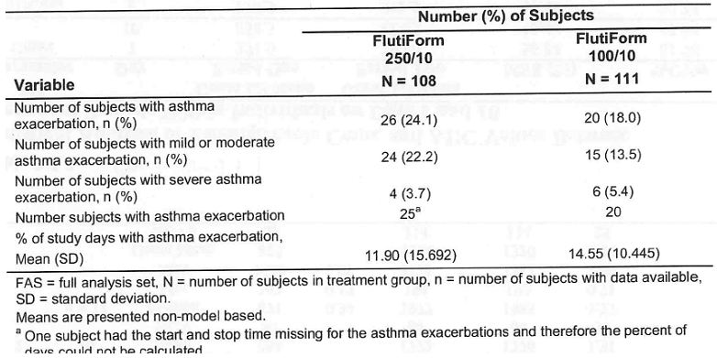

Supportive studies

Non-inferiority studies: FLT3501, FLT3502 and FLT3505
The Phase 3, open, randomised, parallel group, multicentre study FLT3501 was conducted to demonstrate the non-inferiority in efficacy and safety of Flutiform pMDI (fluticasone/formoterol) vs Seretide® pMDI(fluticasone/ salmeterol) in 202 adult subjects with mild to moderate-severe persistent, reversible asthma. The study was conducted from 23/4/2007 to 13/3/2008 at 25 centres in Europe (8 centres in Romania, 6 centres in Poland, 5 centres in Hungary, 3 centres in Germany and 3 centres in the UK). The study consisted of a 4- to 10- day screening phase and a 12-week treatment phase. On completion of the screening phase (Visit 2), eligible subjects were randomised in a 1:1 ratio to 12 weeks of treatment with either Flutiform or Seretide. The starting dose of study medication was based on the patient’s asthma history and prior asthma medication. Subjects returned to the investigator’s site at 2 weeks, 6 weeks and 12 weeks following the commencement of treatment for lung function and safety assessments. At each of these visits the patient completed lung function tests before their morning dose of medication and 5, 10, 30, 60, 90 and 120 minutes following their dose of study medication. Throughout the treatment phase, subjects completed an electronic diary recording daily peak flow measures in the morning and evening, use of rescue medication, use of study medication, asthma symptom scores and sleep disturbance due to asthma. Subjects starting with the low dose of study medication (2 puffs of 50/5 ug Flutiform every 12 hours or 2 puffs 50/25 ug Seretide every 12 hours) could be switched to the high dose (2 puffs of 125/5 ug Flutiform every 12 hours or 2 puffs 125/25 Seretide every 12 hours) if their asthma was not controlled. Throughout the study subjects were allowed to take salbutamol (2 puffs, 100 ug per puff), on up to four occasions per day as rescue medication. Flutiform and Seretide were inhaled using an Aero Chamber® Plus spacer device (GlaxoSmithKline [GSK]).
The study included patients with known history of mild to moderate-severe, persistent, reversible asthma for ≥ 6 months prior to the screening visit; an FEV1 of ≥ 40% to ≤ 85% for predicted normal values. Exclusion criteria were similar to those outlined in study SKY2028-3-001 in the above section.
The primary efficacy endpoint was the pre-dose FEV1 at Day 84. Secondary endpoints included Change in pre-dose FEV1, Post-dose FEV1, Discontinuations due to lack of efficacy, Time to onset of action of study medication, Rescue medication use., PEFR measurements, Other lung function parameters [FVC, maximum expiratory flow at 25, 50 and 75% of volume to exhale (MEF25, MEF50, MEF75)], Asthma symptom scores, Sleep disturbance scores., Asthma exacerbations, Compliance with study medication, Subject’s assessment of study medication, Asthma Quality of Life Questionnaire (AQLQ). The statistical methods were similar to those used in the pivotal non-inferiority study FLT3503. All hypothesis tests were two-sided and conducted at the 5% error level. The non-inferiority bound was fixed to 0.2 and on a two-sided level of significance of α = 0.05 and with a power of 80% (β = 20%), 113 patients per treatment group were required. Assuming a correlation of the 12 weeks FEV1 values and the baseline FEV1 values of approximately 0.5L, the sample size would be reduced to 85 patients per treatment group. The comparison was focused on the per protocol population. Assuming that approximately 10% of the randomised patients would not be part of the per protocol set, 200 patients needed to be randomised to this study.

Results
Of the 202 subjects enrolled and randomised, 189 (93.6%) completed the study. Of the 13 subjects who did not complete the study, five withdrew by choice, four were withdrawn due to lack of therapeutic effect, three were withdrawn for administrative reasons, and one was withdrawn due to an AE. A total of 11 of the 202 randomised subjects (5.4%) were excluded from the per protocol set (PPS) due to one or more major protocol deviation. The PPS included 191 subjects (96.5% of the full analysis set; 96 Flutiform and 95 Seretide) and was the primary analysis set for all efficacy analyses with the objective of showing non-inferiority. Generally only minor differences were observed with regard to the demographic characteristics of the two treatment groups. The median age was 50 years in the Flutiform group and 47 years in the Seretide group (range 18 to 76 years). Female subjects predominated in both treatment groups, although the ratio of female to male patients was higher in the Seretide group. All subjects were Caucasian. Mean pre-salbutamol and post-salbutamol FEV1 values and mean predicted FEV1 values at screening were comparable in the two treatment groups. Over 90% of subjects in each treatment group were taking ICS at screening (92% and 93% in Flutiform and Seretide groups, respectively). The median daily ICS dose was 500 ug in the Flutiform group and 400 ug in the Seretide group. LABAs were taken at screening by 77.2% of subjects in both treatment groups. Good compliance with study medication was shown by subjects in both treatment groups. Compliance was >75% in 99.0% and 98% of subjects in the Flutiform and Seretide groups, respectively. Approximately 75% of subjects in each treatment group started with the high dose of study medication. Only eight subjects required a change in dose strength from low to high during the study (five in the Flutiform group and three in the Seretide group).
The mean pre-dose FEV1 value at Day 84 was approximately 2.4 L in both treatment groups of the per protocol set. Non-inferiority of Flutiform to Seretide was demonstrated as the lower limit of the 95% CI for the treatment difference was -0.161 L, and thus exceeded the non-inferiority acceptance limit of -0.2 L. Similar results were observed in the full analysis set. The sensitivity analysis also demonstrated non-inferiority of Flutiform to Seretide suggesting that the results of the primary efficacy endpoint analysis were not influenced by the inclusion of nine subjects who discontinued the study prematurely and the erroneous exclusion of one subject. Analysis of the secondary efficacy endpoint, change in pre-dose FEV1 from Day 0 to Day 84, showed non-inferiority between Flutiform and Seretide with a clear increase in pre-dose FEV1 from Day 0 to Day 84 in both treatment groups (Flutiform: +196 ml, Seretide: +257 ml) with similar results in the Full analysis set. A supportive ANCOVA of the change in pre-dose FEV1 from Day 0 to Day 84, which included the dose strength by treatment interaction, also demonstrated non-inferiority of Flutiform to Seretide in both analysis sets. The mean FEV1 values obtained 120 minutes post-dose on Day 84 were clearly greater than the predose FEV1 values on Day 0 with non-inferiority between both treatment groups (Flutiform: +464 ml, Seretide: +477 ml, per protocol set). In the per protocol set, non-inferiority of Flutiform to Seretide was demonstrated with respect to discontinuations due to lack of efficacy as the upper limit of the CI was less than 10%. (-1.1%; (95%CI: -4.6, 2.5). Superiority of Flutiform over Seretide was demonstrated with regard to the onset of action of study medication. The probability of the event onset of action occurring was higher in the Flutiform group than in the Seretide group at each post-dose time point on Days 0, 14, 42 and 84. In both treatment groups, onset of action of study medication was most robustly demonstrated on Day 0 (was observed in 78 and 64 subjects in the Flutiform and Seretide groups, respectively), reflecting the fact that the subjects were least well controlled on Day 0, and thus most responsive to study medication. Analysis of time to onset of action using the multiple failures time model showed superiority of Flutiform over Seretide (Hazard ratio: 1.64, 95% CI: 1.28, 2.10, p-value: <0.001).
The percentage of study days on which salbutamol rescue medication was used was slightly higher in the Flutiform group than in the Seretide group, but the difference was not statistically significant. The number of uses of rescue medication was low and comparable in the two treatment groups. The morning and evening peak flow rates, mean FVC, MEF25, MEF50 and MEF75 values obtained 120 minutes post-dose on Day 84 were clearly greater than the corresponding pre-dose values on Day 0 in both treatment groups. No statistically significant differences between the treatment groups were observed for any of these lung function parameters. The mean asthma symptom and sleep disturbance scores decreased, i.e. improved, over the course of the study in both treatment groups with no statistically significant differences between the treatments.
Overall, 23 of the 202 subjects (11.4%) experienced mild or moderate asthma exacerbations. Severe asthma exacerbations were experienced by three subjects in the Flutiform group (3.0%) and by one subject in the Seretide group (1.0%). The differences between the treatment groups were not statistically significant. The odds ratio for the overall patient assessment of study medication for Flutiform compared to Seretide was 0.495 (95% CI: 0.289, 0.848) in favour of Seretide. Nevertheless, the study medication was assessed as very good or good by 84% of subjects in the Flutiform group and by 91% of subjects in the Seretide group. An improvement, in the AQLQ overall scores was observed from Day 0 to Day 84 in the two treatment groups with slightly better improvement in the Seretide group which just fell short of statistical significance.

Study FLT3502 (core phase)
Study FLT3502 was an open, randomised, active-controlled, parallel group, multicentre, phase III study to show non-inferiority of Flutiform compared to Seretide in controlling mild to moderate persistent, reversible asthma in 211 paediatric subjects (4-12 years). The study was conducted from 30/4/2007 to 18/12/2007 at 22 centres in Europe (6 in Poland, 5 in the Czech Republic, 5 in Hungary, 4 in Romania, 1 in France and 1 centre in Germany). The study consisted of a 4- to 10- day screening phase and a 12-week core treatment phase. Subjects were randomised in a 1:1 ratio to 12 weeks of treatment with either Flutiform 100/10ug (2 puffs of 50/5 ug fluticasone/formoterol every 12 hours) or Seretide 100/50ug (as 2 puffs of 50/25 ug fluticasone/salmeterol every 12 hours). Subjects who completed the core treatment phase per protocol specifications were eligible to enter a 24-week extension phase, during which all subjects received Flutiform at the same dose as that given in the core treatment phase, i.e. 2 puffs of 50/5 ug fluticasone/formoterol every 12 hours.
Of the 211 subjects enrolled and randomised, 210 (99.5%) completed the study and 10 (4.7%) were excluded from the per protocol set due to major protocol violations. The PPS included 201 subjects (95.3% of all randomised subjects; Flutiform=102, Seretide=99) and was the primary analysis set for all efficacy analyses with the objective of showing non-inferiority. Majority of the patients were male, aged 7-12 years (81-85%) and Caucasian. Mean pre-salbutamol and post-salbutamol FEV1 values and mean predicted FEV1 values at screening were comparable in the two treatment groups. ICS were taken at screening by 86.8% of subjects in the Flutiform group and 83.8% of subjects in the Seretide group. The median daily ICS dose was 200 ug (fluticasone equivalent by using GINA guideline on equipotency of ICS) in both treatment groups. The percentage of subjects taking LABAs at screening was higher in the Flutiform group (64.2%) than in the Seretide group (52.4%). Baseline demographics and disease characteristics were similar between the Flutiform and Seretide groups.
Pre-dose FEV1 increased from Day 0 to Day 84 in both treatment groups (Flutiform: +182 ml, Seretide: +212 ml, per protocol set). Non-inferiority of Flutiform to Seretide was demonstrated as the lower limit of the 95.35% CI for the treatment difference was -0.093 L, and thus exceeded the noninferiority acceptance limit of -0.1 L. Similar results were observed in the full analysis set. The mean FEV1 values obtained 120 minutes post-dose on Day 84 were clearly greater than the predose FEV1 values on Day 0 in both treatment groups (Flutiform: +308 ml, Seretide: +325 ml, per protocol set). Non-inferiority of Flutiform to Seretide was demonstrated in both the PPS and FAS analysis. None of the subjects discontinued the treatment phase due to lack of efficacy. In both treatment groups, onset of action of study medication was most robustly demonstrated on Day 0. Analysis of the time to onset of action did not show superiority of Flutiform over Seretide. The percentage of study days on which salbutamol rescue medication was used, the number of uses and overall asthma symptom scores were very low and similar in both treatment groups. The overall sleep disturbance score was slightly higher in the Seretide group than in the Flutiform group, but the difference was not statistically significant. No statistically significant differences between the treatment groups were observed for any of these lung function parameters. Only four subjects in the Flutiform group (3.8%) and three subjects in the Seretide group (2.9%) experienced mild or moderate asthma exacerbations. There were no severe asthma exacerbations. Over 95% of subjects in each treatment group assessed the study medication as very good or good.
Study FLT3505 was Phase 3, open-label, randomised, parallel group, multicentre study to compare the efficacy and safety of FlutiformTM pMDI vs fluticasone pMDI plus formoterol DPI in 210 adolescent and adult subjects with mild to moderate-severe persistent, reversible asthma. It was conducted from 25/9/2007 to 1/4/2008 at 30 centres in Europe (9 in Poland, 8 in Romania, 7 in Germany, 4 in Hungary, and 2 centres in the Netherlands). The primary objective of this study was to show non-inferiority in the efficacy of FlutiformTM compared with the individual components Flixotide® (fluticasone) and Foradil® (formoterol) given together, based on mean forced expiratory volume in the 1st second (FEV1) values. Secondary objectives of the study were to compare discontinuation due to lack of efficacy, peak expiratory flow rates (PEFR) and other lung function parameters, amount of rescue medication use, asthma symptom scores, sleep disturbance due to asthma, asthma quality of life questionnaire (AQLQ(S) ≥12 years), exacerbations (requiring oral/parenteral steroid use, medical intervention), subject assessment of study medication, and spontaneously reported adverse events.
The study consisted of a 4- to 10-day screening phase and a 12-week treatment phase. On completion of the screening phase (Visit 2), eligible subjects were randomised in a 1:1 ratio to 12 weeks of treatment with either Flutiform or Flixotide plus Foradil. Depending on their asthma history and prior asthma medication, subjects started treatment with a high or a low dose of study medication/reference medication. The low dose Flutiform (100/10ug as 2 puffs of 50/5 ug fluticasone/formoterol every 12 hours), or Flixotide plus Foradil (1 puff of 12 ug formoterol followed by 2 puffs of 50 ug fluticasone every 12 hours). The high dose Flutiform (250/10ug as 2 puffs of 125/5 ug fluticasone/formoterol every 12 hours), or Flixotide plus Foradil (1 puff of 12 ug formoterol followed by 2 puffs of 125 ug fluticasone every 12 hours). Subjects starting with the low dose of study medication could be switched to the high dose if their asthma was not controlled. Slightly more than 70% of subjects in each treatment group started with the high dose of study medication. Only one subject in each treatment group required a change in dose strength from low to high during the study. Flutiform and Flixotide were inhaled using an AeroChamber® Plus spacer device (GlaxoSmithKline [GSK]) whereas Foradil was inhaled without a spacer.
The main inclusion criteria were male and female subjects aged >12 years with known history of mild to moderate-severe persistent asthma for ≥ 6 months prior to the screening visit with FEV1 of ≥ 40% to ≤ 85% for predicted normal values. Other inclusion and exclusion criteria, primary, secondary endpoints and statistical analyses were similar to that of study FLT3501.

Results
Of the 210 subjects enrolled and randomised, 197 (93.8%) completed the study and 8 subjects (3.8%) were excluded from the per protocol set due to major protocol violations. The FAS consisted of 210 patients (105 in each treatment group) and the PPS consisted of 202 patients (99 in Flutiform and 103 in Flixotide+Foradil group). Generally, only minor differences were observed with regard to the demographic characteristics of the two treatment groups. The median age was 51 years in the Flutiform group and 46 years in the Flixotide+Foradil group (range 12 to 75 years): 16.2% of subjects in the Flutiform group and 22.9% of subjects in the Flixotide+Foradil group were adolescents (age 12 to 17 years). There were more female than male subjects in both treatment groups. All subjects were Caucasian. Mean pre- and post-salbutamol FEV1 values and mean predicted FEV1 values at screening were comparable in the two treatment groups. Over 95% of subjects in each treatment group were taking ICS at screening with median daily ICS dose of 400 ug in both treatment groups. LABAs were taken at screening by slightly more subjects in the Flutiform treatment group (82%) compared to the Flixotide+Foradil (74%) treatment group. Treatment compliance was over 75% in 98.1% of subjects in both treatment groups.
The mean post-dose FEV1 value at Day 84 was approximately 2.6 L in both treatment groups of the per protocol set. Non-inferiority of Flutiform to Flixotide+Foradil was demonstrated as the lower limit of the 95% CI for the treatment difference was -0.148 L, and thus exceeded the non-inferiority acceptance limit of -0.2 L with similar results observed in the full analysis.
Analysis of the secondary efficacy endpoint, change in FEV1 from pre-dose on Day 0 to 30-60 minutes post-dose on Day 84, showed that the mean FEV1 values obtained 30-60 minutes post-dose on Day 84 were clearly greater than the pre-dose FEV1 values on Day 0 in both treatment groups (Flutiform: +401 ml, Flixotide+Foradil: +435 ml, per protocol set). Non-inferiority of Flutiform to Flixotide+Foradil was demonstrated in both the PPS and FAS analysis.
Comment: It was not clearly stated why the post-dose timepoint of 30-60mins was chosen in this study compared to the 120min post-dose timepoint in the other Flutiform studies.
In the per protocol set, one subject in the Flixotide+Foradil group discontinued the treatment phase due to lack of efficacy. The difference in the percentages was -1.0% (95%CI: -2.9, 0.9). Formally, noninferiority of Flutiform to Flixotide+Foradil was demonstrated with respect to discontinuations due to lack of efficacy, as the upper limit of the CI was less than 10%. The percentage of study days on which salbutamol rescue medication was used as well as the number of uses were very low and similar in both treatment groups. No statistically significant differences between the treatment groups were observed for any of these lung function parameters. The overall asthma symptom and sleep disturbance scores were low (mean values <1) in both treatment groups, with no statistically significant differences between the treatments. In the full analysis set, five of the 210 subjects (2.4%) experienced mild or moderate asthma exacerbations. Severe asthma exacerbation was experienced by four subjects in the Flutiform group (3.8%) and by three subjects in the Flixotide+Foradil group (2.9%). The differences between the treatment groups were not statistically significant. A total of seven subjects (3.3%) received oral or parenteral corticosteroids during the study. For six of these subjects this was for treatment of severe exacerbations. The odds ratio for the overall patient assessment of study medication for Flutiform compared to Flixotide+Foradil was 1.250 (95% CI: 0.738, 2.118), indicating no significant difference between the treatments. The study medication was assessed as very good or good by 87% of subjects in the Flutiform group and by 92% of subjects in the Flixotide+Foradil group. A comparable increase, i.e. improvement, in the AQLQ(S) ≥12 years overall scores was observed from Day 0 to Day 84 in the two treatment groups with no statistically significant difference between the two treatment groups.

Supportive superiority study
Study SKY2028-3-005 was a Phase 3, randomized, double-blind, active-controlled, parallel group, stratified, multicenter, 12-week study comparing efficacy and safety of Flutiform® 250/10 ug twice daily in a single inhaler (SkyePharma HFA pMDI) with the administration of fluticasone (250 ug twice daily) alone (given as fluticasone component of Flutiform and as Flovent) in adolescent and adult patients with moderate to severe asthma. It was conducted from 18/3/2008 to 26/9/2008 at 68 sites in Europe, Latin America, and United States. The primary objective of this study was to demonstrate the efficacy in terms of the formoterol component of Flutiform HFA pMDI (250/10 ug) compared to SKP fluticasone HFA pMDI (250 ug) on the change in FEV1 from morning predose at Baseline (Week 0) to 2 hours postdose at Week 12. The secondary objectives of this study included: efficacy of SKP Flutiform HFA pMDI (250/10 ug) compared to Flovent® fluticasone pMDI (250 ug) on the change in FEV1 from morning predose at Baseline (Week 0) to 2 hours postdose at Week 12; efficacy of SKP Flutiform HFA pMDI (250/10 ug BID) using other pulmonary function tests (PFTs) (including FEV1 percentage predicted normal and peak expiratory flow rate [PEFR]) and clinical endpoints (frequency of asthma exacerbations, discontinuation due to lack of efficacy, subject derived data recorded daily in telephone diary system including daily PEFR); To assess the 12-hour serial FEV1 area under the curve (AUC) in a subset population of at least 66 subjects.
Only steroid-requiring subjects (inhaled steroid regimen for at least 4 weeks prior to the screening visit at a dose < 500 ug/day fluticasone propionate or equivalent) were eligible. All subjects entered a 2-week open-label run-in period followed by a 12-week DB treatment period. Eligible subjects were stratified according to their baseline FEV1 % predicted (40% to 60% or > 60% to 80%) and randomized to 1 of 3 treatment groups, taking 2 inhalations BID from each inhaler: Flutiform 250/10 ug HFA pMDI; or SKP fluticasone 250 ug HFA pMDI; or Flovent (fluticasone) 250 ug HFA pMDI. Rescue albuterol was provided for the control of worsening asthma symptoms during the run-in and treatment periods and all other asthma medications were withheld during treatment period. Exclusion criteria were similar to that of study FLT3501, with exception that the subject had history of systemic (oral or injectable) corticosteroid medication within the 3 months (instead of 1 month in other studies) before the screening visit. With 107 subjects per treatment group, the study would have 90% power to detect a significant difference between 2 treatment groups using a 2-sided t-test with alpha = 0.05, assuming a difference of 0.2 L with respect to mean change in morning predose FEV1, which is considered as clinically significant change, and a common standard deviation (SD) of 0.45. To account for an approximately 15% drop-out rate, 125 subjects were planned for each group.

Results
The FAS consisted of 248 subjects (146 in each treatment group) and more patients in the Flutiform group (95.2%) completed the study compared with SKP fluticasone (84.9%) and Flovent fluticasone (88.4%) groups. Approximately, 8% of patients were excluded from the PPS due to major protocol violations; violation of inclusion/exclusion criteria and discontinuation criteria were most common with similar incidence in all groups. The majority of the patients were female (64%), Caucasians (77%) with mean age of 42 years (12% aged 12-17 years and 80% aged 18-65years). The mean duration of asthma ranged from 15.9 to 17.1 years across all treatment groups. The majority of subjects had a Baseline FEV1 % predicted of > 60% to 80% (61.4%).the mean FEV1 % predicted at baseline was 63.5% and the mean percent reversibility at screening was 26.97%. Approximately one-third of subjects previously received ICS and LABA combination asthma therapy. There were no significant differences between treatment groups in terms of baseline demographics, disease characteristics of prior asthma medication use. In the safety population, the mean percent compliance to study drug was 92.39%, 89.51%, and 90.90%, in the Flutiform, SKP fluticasone, and Flovent fluticasone treatment groups, respectively. The percentage of subjects with ≥ 70% and ≥ 80% compliance was higher in the Flutiform treatment group compared to the SKP fluticasone and Flovent fluticasone treatment groups.
The contribution from the formoterol component of Flutiform 250/10 ug was demonstrated by the statistically significant treatment group difference (LS mean difference = 0.161 L, P < 0.001) between the Flutiform 250/10 ug and SKP fluticasone groups for mean change from predose at Baseline to 2 hours postdose at Week 12 (Table 43). All sensitivity analyses supported the primary analyses for the primary endpoint. In a subset of 254 subjects, 12-hour serial pulmonary function testing was performed at Baseline (Week 0), Week 2, and Week 12. The mean 12-hour FEV1 AUC was numerically greater in the Flutiform 250/10 ug group compared to the SKP fluticasone and Flovent fluticasone groups at Week 0, Week 2, and Week 12 (Table 44). Results for mean increases in FEV1 from Baseline to 2 hours postdose were generally numerically greater for Flutiform 250/10 ug compared to SKP fluticasone and Flovent fluticasone beginning at week 2 and were sustained throughout the 12-week treatment period. Results from multiple secondary and tertiary efficacy endpoints assessing lung function, asthma symptoms, and rescue medication use generally supported the superior efficacy of Flutiform 250/10 ug compared to SKP fluticasone and Flovent fluticasone although none of the treatment differences between Flutiform and SKP fluticasone were statistically significant based on the sequential gatekeeper approach.
Table 43: FEV1 (L): Mean change from pre-dose at baseline to 2 Hours post-dose at Week 12 – FAS using LOCF (Study SKY2028-3-005).
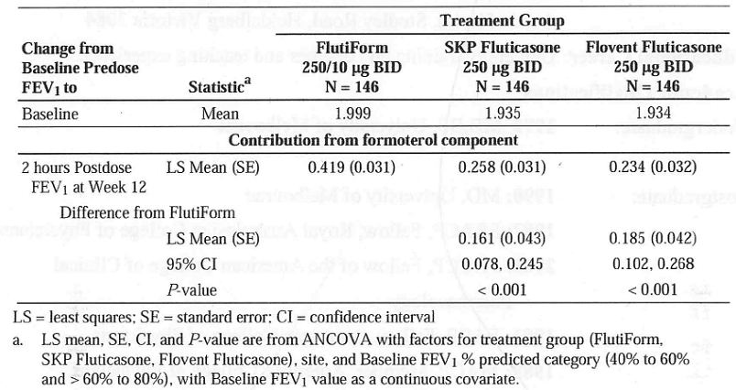
Table 44: 12-Hour serial FEV1 AUC (L-Hour) – AUC population using observed data (Study SKY2028-3-005).
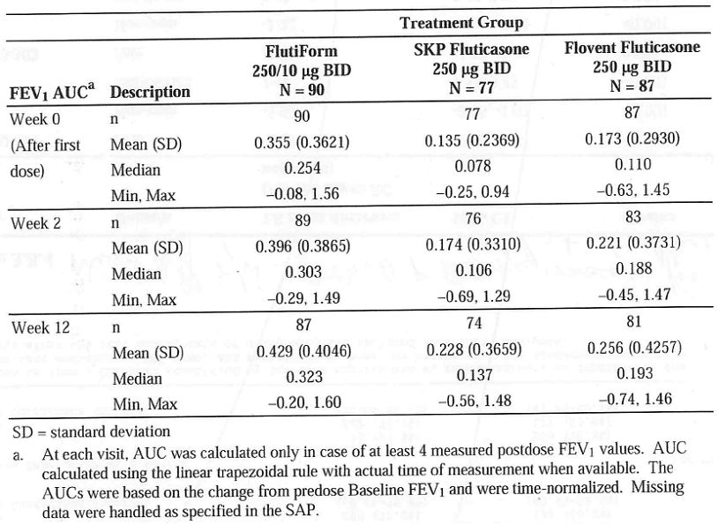

Long term efficacy
The primary objective of the Phase 3 open label, long term study SKY2028-3-003 was to assess long-term safety of SKP Flutiform HFA pMDI (100/10 ug and 250/10 ug) after BID treatment in 472 adult and adolescent patients with mild to moderate-severe asthma over a period of up to 12 months. Efficacy was the secondary objective of this study. It was conducted from 15/3/2006 to 20/7/2008 at 41 centres in 5 European countries (Germany, Hungary, Poland, Romania and United Kingdom). This study consisted of a 2-week open-label Run-in period followed by a 6 to 12-month open-label treatment period. According to their steroid usage prior to screening, subjects were assigned to one of the following dosages of Flixotide™ Evohaler™ HFA pMDI (hereafter referred to as fluticasone) for asthma maintenance therapy during the Run-in Period: 100 ug/day fluticasone (50 ug/actuation; 1 inhalation BID) for subjects using 100 to 249 ug/day fluticasone or equivalent inhaled steroid; 250 ug/day fluticasone (125 ug/actuation; 1 inhalation BID) for subjects using 250 to 500 ug/day fluticasone or equivalent inhaled steroid. Following the run-in period, subjects were randomised to Flutiform 100/10 ug BID for subjects assigned to 100 ug/day fluticasone during the run-in period and to Flutiform 250/10 ug BID for subjects assigned to 250 ug/day fluticasone during the run-in period. Following treatment group allocation, subjects were instructed to withhold all other asthma medications for the duration of the Treatment Period, with the exception of rescue salbutamol as needed for the control of worsening asthma symptoms. Study drug (including salbutamol) was withheld prior to pulmonary function testing for the appropriate duration. During the treatment period, study visits for clinical assessments were scheduled for Week 2, Week 4, and monthly thereafter. Efficacy assessments using spirometry (forced expiratory volume in 1 second [FEV1], forced vital capacity [FVC] and peak expiratory flow rate [PEFR]) were performed predose at each study visit and 1 hour (± 10 minutes) postdose at Week 2, Week 4, Month 2, and Month 3.
The study included patients aged >12years with mild to moderate-severe asthma with FEV1 of 40% to 85% (inclusive) of predicted normal values following appropriate withholding of asthma medications and documented reversibility of at least 15% in FEV1. Other inclusion and exclusion criteria were similar to those of study SKY2028-3-005.
Overall, 224 and 248 patients received Flutiform 100/10ug and 250/10ug, respectively. Of the 472 treated subjects, 256 and 216 subjects enrolled for the 6-month and 12-month treatment periods, respectively. A total 413 (87.5%) completed the study and 59 (12.5%) discontinued from the study; the incidence of discontinuations was slightly higher in patients treated with Flutiform 250/10 compared to 100/10ug (14.9% vs 9.8%) mainly due to higher incidence of AEs and withdrawal of consent. The Full Analysis Set (FAS) included 466 subjects and the Per Protocol (PP) Population included 390 subjects. Overall, 77 of the 472 subjects (16.3%) had major protocol violations. Major protocol violations were categorized as follows: violation of inclusion/exclusion criteria, noncompliance with study drug, prohibited concomitant medication, violation of medication withholding windows. Majority of the patients were female (53%), Caucasians (99%) with mean age of 42.4 years (range: 12 – 79 years). The 100/10 ug BID dose group had a higher percentage of subjects in the 12 to 17 years age group compared with the 250/10 ug BID dose group (17.9% versus 6.5%), and a lower mean age (39.3 versus 45.2 years). Other demographic characteristics were generally similar between dose groups. The mean duration of asthma was 12.64 years (range: 1.1 – 66.7 years), with a mean FEV1 % predicted of 73.0% (range: 38% – 104%) and a mean percent reversibility of 28.12% (range: 14.7% – 116.9%) with similar disease characteristics in the two Flutiform dose groups. Mean changes from predose at baseline/Week 0 to the predose assessment at each visit showed statistically significant improvements in FEV1, FEV1% predicted, FVC and PEFR for Flutiform treatment overall and for each dose group. Clinically important improvements and statistically significant improvements at the α = 0.001 level were observed for all efficacy assessments (FEV1, FEV1 % predicted, PEFR, and FVC) for Flutiform treatment overall and for each dose group (100/10 ug and 250/10 ug) at every assessment time point during long term treatment of up to 12 months.

FLT3502 extension phase
This was an open-label, multicentre extension study to collect safety data on FlutiformTM pMDI long-term treatment in paediatric subjects with mild to moderate persistent, reversible asthma. The study was conducted from 2/8/2007 to 13/6/2008. Following the 12-week core treatment phase, all 208 subjects continued treatment with Flutiform (two puffs of 50/5 ug fluticasone/formoterol every 12 hours) in the open-label 24-week extension period. The primary objective of the extension phase was to assess long term safety in paediatric patients. The core phase treatment groups were comparable with respect to the mean pre-dose lung function values obtained at the start of the extension phase. Of the 208 subjects entered, 205 (98.6%) completed the extension phase study. Of the three subjects who did not complete the extension phase, two subjects withdrew by choice and one subject was withdrawn for administrative reasons. At Day 84, pre-dose FEV1 was approximately 1.86 L, both in subjects who had received Flutiform and in subjects who had received Seretide during the core treatment phase, indicating that the groups were comparable at the start of the extension phase. In the overall open-label Flutiform group, pre-dose FEV1 increased by 105mL between Day 84 and Day 252. Mean pre-dose peak flow rates, mean FVC, and mean MEF50 and MEF75 values increased over the course of the extension phase, whereas mean MEF25 decreased slightly. Compliance with study medication was over 75% in 88.4% of all subjects (87.5% and 89.3% in the core Flutiform and Seretide groups, respectively).

Analysis performed across trials
The main objective of the pooled analysis was to compare the efficacy (show non-inferiority based on the change in FEV1 values from pre-dose at baseline to the 2-hours post-dose at Week 12) of Flutiform with combination treatments, administered as Seretide or fluticasone plus formoterol. This pooled efficacy analysis only included 402 patients who were randomised and received at least one dose of Flutiform or Seretide (or fluticasone + formoterol) in open-label, Phase 3 studies FLT 3501 and FLT3505. The efficacy data from FLT3503 were not pooled with the other studies due to a different treatment dosage and a subject population with more severe asthma. A secondary objective of the metanalysis was to compare the efficacy of Flutiform administered with (FLT3501 and FLT3505) and without a spacer (SKY2028-3-001/-002 /-004).

Flutiform vs combination treatment meta analysis
No adjustments made for multiple treatment comparisons in this metanalyses. For the Flutiform versus combination treatments comparison the efficacy endpoints were ranked in order of importance according to primary and secondary endpoints. The primary endpoint of interest was: Change in FEV1 values from pre-morning dose at baseline to 2-hours (30-60 minutes for FLT3505) post-morning dose at Week 12 – PPS (pre-morning dose FEV1 values were not recorded post baseline for FLT3505). Supportive analysis were conducted on the FAS. The main secondary endpoints of interest were: Exacerbations of asthma; Study rescue medication; Asthma symptom scores; Sleep disturbance scores; Asthma quality of life questionnaire. Through a gate keeping strategy, the secondary efficacy analysis will only have confirmatory statistical significance if the primary analysis shows statistical significance (i.e. rejects the null hypothesis). This metanalysis included all 402 patients who were randomised and received at least one dose of Flutiform or Seretide (or fluticasone + formoterol) in open-label, Phase 3 studies FLT 3501 and FLT3505.
The increase in post-dose FEV1 was comparable in the two treatment groups (Flutiform: +426 mL, combination treatment: +449 mL). The LSMean of the treatment difference was -0.023 L (95% CI: -0.105 to 0.058). Non-inferiority of Flutiform to combination treatment was demonstrated as the lower limit of the 95% CI for the treatment difference exceeded the non-inferiority acceptance limit of -0.2 L. Similar results were obtained for each of the 2 dose groups (100/10ug and 250/10ug Flutiform or combination treatment at the end of study), although the change from Baseline to Week 12 was lower for the 250/10ug dose group than for the 100/10ug dose group. The p-value for the interaction of treatment and dose was 0.069. Similar results were obtained for the FAS (LS mean difference = -0.037 L; 95% CI: -0.117 to 0.044; p < 0.001) thus supporting the non-inferiority of Flutiform versus combination treatment with regard to increase in post-dose FEV1.
As non-inferiority of Flutiform to combination treatment was shown for the primary efficacy endpoint, the secondary efficacy endpoints were tested in a confirmatory manner as well. There was no statistically significant difference in the incidence of asthma exacerbation in the Flutiform vs combination groups. Mild or moderate asthma exacerbations were experienced by 12 subjects (5.8%) in the Flutiform group and by 16 subjects (7.8%) in the combination treatment group. Severe asthma exacerbation was experienced by 7 subjects (3.4%) in the Flutiform group and by 4 subjects (1.9%) in the combination treatment group. In total, 39 subjects experienced at least one exacerbation with higher incidence in the 250/10ug dose group (37 out of 310 subjects; 11.9%) than the 100/10ug dose group (2 out of 102 subjects; 2.0%), which may have been due the fact that allocation to dose groups was based on disease severity in this study pool. The median percentage of study days on which salbutamol/albuterol rescue medication was used as well as the median number of uses were very low with no significant difference between both treatment groups. The mean asthma symptom scores and sleep disturbance scores decreased, i.e. improved, over the course of the study in both treatment groups. The AQLQ scores increased, i.e. improved, from Baseline to Week 12 in each treatment group with no significant differences between Flutiform and combination treatment groups.

Flutiform with and without spacer
For the Flutiform spacer (FLT3501 and FLT3505) versus Flutiform non-spacer (SKY2028-3-001/-002 /-004) comparison only the primary and coprimary endpoints were analysed.
The increase in pre-dose FEV1 was comparable in the two treatment groups; LSMean values from ANCOVA for spacer vs non-spacer: +167 vs +178 mL; difference was -0.011 L, 95% CI: -0.100 to 0.078) and non-inferiority was shown as the lower limit of the 95% CI for the treatment difference exceeded the non-inferiority acceptance limit of -0.2 L. Among subjects receiving the low dose Flutiform 100/10, the mean increase in pre-dose FEV1 was numerically greater in the spacer group compared to the non-spacer group (LSMean of the treatment difference: +0.138 L), while the difference was smaller in subjects receiving the medium dose (250/10ug) by spacer compared to the non-spacer group (LSMean of the treatment difference: -0.084 L). The non-inferiority criterion was met in both dose groups. The interaction between treatment group and dose group was statistically significant (p = 0.017), although the sample size was relatively small in the subgroup of subjects receiving the low dose and using a spacer. The increase in post-dose FEV1 was larger in subjects using a spacer compared to subjects not using a spacer (LSMean values from ANCOVA for spacer: +424 mL, non-spacer: +322 mL; treatment difference was 0.102 L, 95% CI: 0.028 to 0.176). The administration of Flutiform with spacer was non-inferior and even superior to administration without spacer as the lower limit of the 95% CI for the treatment difference was greater than zero (+0.028 L); however, this difference was seen only in the low-dose Flutiform (100/10ug) group and should be interpreted with caution due to the statistically significant interaction between treatment group and dose group (p = 0.016). Similar results were obtained for the FAS analysis confirming the non-inferiority of Flutiform application with spacer versus without spacer with regard to increase in pre-dose FEV1 (LS mean difference = -0.025 L; 95% CI: -0.111 to 0.062; p < 0.001); furthermore, the superiority of Flutiform application with spacer versus without spacer was shown for the increase in postdose FEV1 (LS mean difference = 0.075 L; 95% CI: 0.004 to 0.146; p < 0.001).

Clinical studies in special populations
There were no studies conducted in special populations. The pooled efficacy database (discussed in section 3.4 above) was used for evaluating effect of age, gender, duration/ severity of asthma and prior ICS/combination asthma treatment on efficacy of Flutiform. However, it is important to note that the pooled efficacy dataset included only 402 patients (from supportive studies FLT3501 and FLT3505) and did not include any of the pivotal studies. The Flutiform vs combination subgroup analysis examined the efficacy of Flutiform compared to combination treatment in different subgroups. Non-inferiority of Flutiform compared to combination treatment (measured by the change in FEV1 from predose at baseline to 2 hours postdose at week 12) was not affected by age (12-18years; 18 to <65 years or >65 years), gender, duration of asthma (< or >10 years), baseline FEV1 % Predicted (40% to <60%, >60% to <80% and >80%), exposure to ICS or combination treatment at screening. However, results should be interpreted with caution due to very small sample size for some subgroups, especially those aged 12-18years and >65years as well as those without ICS use at screening.
Similar results were observed in the Flutiform Spacer vs Flutiform non-spacer subgroup analysis. Adolescents were included in the following Phase 3 studies: Pivotal studies SKY2028-3-001, SKY2028-3-002 and SKY2028-3-004; supportive studies FLT3505 and SKY2028-3-005. Overall, 11.5% (210/1817) of the enrolled subjects in these studies were adolescents aged 12-17 years. Another 56 of the 472 subjects randomised in the long term, open label study SKY2028-3-002 were adolescents. The subgroup of patients aged 12-17years was one of the factors that was balanced prior to randomisation in all Phase 3 studies; the other factor that was balanced was prior steroid use. However, there was no separate analysis of efficacy in adolescents in any of the individual Phase 3 studies. Although the subgroup analysis in the pooled efficacy database seems to indicate that age did not affect Flutiform efficacy, this should be interpreted with caution due to small sample size of adolescents in this database (only 55 in study FLT3505 and none in study FLT3501).

Evaluator’s overall comments on clinical efficacy
- Nine Phase 3 studies have been completed. Two assessed efficacy and safety in subjects with mild to moderate asthma (SKY2028-3-001, SKY2028-3-002), 2 studies in subjects with mild to moderate-severe asthma (FLT3501, FLT3505), 2 studies in subjects with moderate to severe asthma (FLT3503, SKY2028-3-004 and SKY2028- 3-005). The severity of asthma was well-defined based on FEV% predicted as well as criteria based on use of rescue medication, sleep disturbance and asthma symptoms. One open-label long-term safety study was completed in subjects with mild to moderate-severe asthma (SKY2028-3-003) and 1 open-label study with a long-term safety extension phase was completed in paediatric subjects with mild to moderate asthma (FLT3502). Overall, 1601 adults and adolescents were treated with Flutiform in the Phase 3 studies. All pivotal studies were of double blind, randomised, parallel group design, and aimed to demonstrate superiority of the combination product over its constituent drugs at each dose strength, or equivalence of the combination product compared to the two drugs taken concurrently from separate inhalers (concurrent therapy). The study designs complied with recommended guidelines on the Clinical Investigation of Medicinal Products in the Treatment of Asthma CPMP/EWP/2922/01 with the exception that the pivotal study FLT3503 had only 8 week treatment duration. The patient populations, study designs, and efficacy measurements utilised in these studies were consistent with standard and accepted approaches to evaluate maintenance asthma therapy and are similar to studies included in development programmes for approved combination products with ICS and LABA. Pulmonary function test procedures were carried out in accordance with current guidelines for using a spirometer.
- Dose-response: There were no specific dose response studies although dose response was assessed in 2 phase III studies (SKY2028-3-004 and FLT3503).
Comparison of Flutiform 500/20 and Flutiform 100/10: One of the main secondary objectives of Study FLT3503 was to demonstrate a dose response effect. Flutiform low dose (100/10ug twice daily) was not shown to be statistically significantly different from the high dose Flutiform (500/20ug bid) in terms of primary or co-primary FEV1 endpoints. Discontinuation due to lack of efficacy (250/10 vs 100/10: 3.8% vs 11.6%), sleep disturbance scores, % of awakening-free nights and subject assessment of medication was significantly better with high dose compared to low dose Flutiform. Results were numerically in favour of Flutiform high dose, although the differences were not statistically significant for: changes in FEV1 from pre-morning dose on Day 0 to 2 hours postmorning dose on Day 56, asthma symptom scores, percentages of symptom-free days, asthma control days, rescue medication-free days, and AQLQ.
The change in FEV1 from pre-morning dose on Day 0 to pre-morning dose on Day 56 was numerically larger after treatment with Flutiform high dose than after treatment with Flutiform low dose. A post-hoc analysis showed superiority of Flutiform high dose vs Flutiform low dose overall including all time points and at each study visit except Day 56. The failure to show a statistically significant difference at Day 56 may be explained by more subjects discontinuing prematurely due to lack of efficacy in the low dose group. However, it is not clear why patients who clearly needed >500ug ICS daily (as stated in the inclusion criteria of the study protocol and shown by median daily dose of ICS at baseline) were given low dose of Flutiform (100ug twice daily) in this study and this highlights a significant limitation of the study design. Despite the fact that patients in the Flutiform low dose (100/10ug) group were clearly undertreated, the study was not able to show a clear difference between the low-dose and high dose Flutiform. This is a major deficiency considering the fact that no definite dose response studies were conducted for Flutiform.
Comparison of Flutiform 250/10 and Flutiform 100/10: A descriptive assessment of dose response effects was provided in Study SKY2028-3-004 as a secondary endpoint, which included 2 groups of subjects with moderate to severe asthma who received either Flutiform 250/10 or Flutiform 100/10. No formal statistical tests were performed to compare the dose groups. In the study, the 2 Flutiform doses were clinically comparable across the reported endpoints. When the 2 Flutiform dose groups were compared based on categories of disease severity (moderate or severe), the majority of results across the reported endpoints were clinically comparable. The following exceptions were noted in the subgroup of subjects with severe disease (defined as FEV1 % predicted of 40% to 60%). For lung function, Flutiform 100/10 had a greater mean increase in FEV1 predose at Week 12 (mean difference = 0.268 L) compared to Flutiform 250/10 (mean difference = 0.166 L). For disease control, there was a lower percentage of subjects who experienced severe asthma exacerbations with Flutiform 250/10 (5.7%) compared to Flutiform 100/10 (10.8%), suggesting that the higher Flutiform dose provided better protection against development of severe asthma exacerbations in the severe population. However, these results should be interpreted with caution due to the small sample size in the severe disease subgroup.
- Non-inferiority of Flutiform 500/20ug and fluticasone 500ug+ formoterol 24ug: Results of the pivotal non-inferiority study FLT3503 demonstrated non-inferiority between twice daily administration (for 8 weeks) of high-dose Flutiform (500/20ug twice daily) and fluticasone 500ug+ formoterol 24ug in adult patients with moderate to severe persistent asthma (who required >500ug fluticasone or equivalent ICS dose daily) in terms of primary and co-primary FEV1 efficacy endpoints supported by other disease control and symptomatic endpoints. However, the results were confounded by limitations of the study outlined below:-
- Duration of double-blind treatment was only 8 weeks which is less than those for other approved LABA+ICS combination products used in treatment of asthma (seretide and symbicort studies were >12 weeks in duration).
- As there was no placebo control in this study, the demonstration of significant benefit of using Flutiform over fluticasone alone was supposed to have provided evidence that the study was sensitive enough to detect treatment differences. Superiority of Flutiform high dose to fluticasone alone was shown for the co-primary endpoint of change from predose at baseline to 2 hours postdose at week 8 (LSMean of the treatment difference: 0.120 L; 95% CI: 0.011 to 0.230; p=0.032; ITT). This was expected due to the missing contribution of the LABA component to post-dose lung-function measurements in this treatment group. However, the clinical relevance of the 120ml increase in FEV1 is not clear. A post-hoc analysis (repeated measures ANCOVA) was performed for the change from pre-dose FEV1 to 0.5, 1, 2, 4, 6, 8, 10, and 12 hours post-dose at Day 0. Superiority of Flutiform high dose versus Flixotide alone was only shown for the change in FEV1 from predose to 1 hour and 2 hours post-dose. A similar post-hoc analysis was not performed for the change from pre-dose FEV1 to 0.5, 1, 2, 4, 6, 8, 10, and 12 hours post-dose at Day 56. However, the 12hour FEV1 mean change from predose on day 0 to predose and postdose on day 56 seems to suggest that mean change from pre-dose on day 0 to pre-dose and post-dose on day 56 did not show any significant difference between Flutiform high dose and fluticasone alone at any time point. Hence, evidence for the clinical benefit of using Flutiform high dose over fluticasone alone was not unequivocal in terms of 12-hour serial FEV1. According to the CHMP guidelines for inhalational products for treatment of asthma, the appropriate primary variables are FEV1AUC (measurement of bronchodilatation over at least 80% of the duration of action after a single inhalation) and change in FEV1 (at an appropriate time points). Hence, evidence of assay sensitivity in this pivotal Phase 3 study was not conclusive.
- For mild/moderate asthma exacerbations the difference was statistically significant in favour of fluticasone + formoterol compared to Flutiform high dose (p = 0.006), while no statistically significant differences were observed between Flutiform high dose and Flutiform low dose or between Flutiform high dose and fluticasone alone.
- No subgroup analysis were performed based on severity of asthma at baseline to explore/ further define patients who were likely to benefit most from treatment with Flutiform.
- Superiority of Flutiform 100/10ug and 250/10ug over its components: Results from the two pivotal superiority studies SKY2028-3-001 and SKY2028-3-002 demonstrated that Flutiform 100/10 provides greater efficacy compared to its components, fluticasone and formoterol, for the management of mild to moderate asthma. These studies enrolled both subjects who were and were not previously receiving ICS, which reflects the mixed population of patients suffering from mild to moderate asthma who will likely be treated with Flutiform The mean changes in FEV1 from pre-dose at baseline to pre-dose or 2 hours post-dose were generally numerically greater for Flutiform 100/10 compared to its components beginning at Week 2 and were sustained throughout the 12-week treatment Period. However, a mean increase of 100 to 118ml in pre-dose FEV1 and increase of 122-200ml in 2 hours post-dose FEV1 may not be clinically relevant. Results from multiple secondary efficacy endpoints assessing lung function, disease control and asthma symptoms generally supported the superior efficacy of Flutiform 100/10 compared to its components, fluticasone and formoterol. SKY2028-3-004 was a pivotal Phase 3, randomised, double-blind, placebo- and active-controlled, parallel group, stratified, 12-week study which established the superiority of Flutiform 250/10ug over its components as well as placebo in adult/adolescent patients with moderate to severe asthma who required steroids (inhaled steroid regimen for at least 4 weeks prior to the screening visit at a dose <500 ug/day fluticasone) in terms of primary endpoints (FEV1) as well as clinical endpoints. However, this study also showed mean increase in pre-dose and 2 hours post-dose FEV1 of only 189 and 146ml, respectively.
- Non-inferiority of Flutiform (250/10 and 100/10ug) to Flixotide + Foradil (250/12 and 100/12ug): Results from the open-label, Phase 3 study FLT3505 showed that Flutiform (100/10 and 250/10ug) was non-inferior to Flixotide plus Foradil (100/12ug and 250/12ug) in 210 adult/ adolescent patients with mild to moderate/severe asthma with regard to post-dose FEV1, change in pre-dose to post-dose FEV1, and discontinuations due to lack of efficacy. However, interpretation of these results were confounded by the fact that flixotide and foradil were administered by DPI while flutiform was by pMDI. Analysis of the other efficacy parameters such as other pulmonary function tests, patient reported outcomes, rescue medication use, asthma exacerbations and AQLQ also showed comparable results for the Flutiform and Flixotide+Foradil treatment groups.
- Non-inferiority of Flutiform and Seretide: Results of the open-label, supportive study FLT3501 demonstrated non-inferiority of Flutiform (fluticasone/ formoterol 250/10 or 100/10ug) to Seretide (fluticasone/salmeterol 250/50 or 100/50ug) in 202 adult patients with mild to moderate/severe persistent asthma with regard to predose and post-dose FEV1 and discontinuations due to lack of efficacy. Superiority of Flutiform over Seretide could be shown for time to onset of action of study medication. Analysis of the other efficacy parameters such as other pulmonary function tests, patient reported outcomes, rescue medication use, asthma exacerbations yielded comparable results for the Flutiform and Seretide treatment groups. However, overall patient assessment of study medication and the improvement in AQLQ scores was slightly better for Seretide, although these could have been confounded by the open-label study design.
Results from the open label study FLT3502 demonstrated non-inferiority of Flutiform 100/10ug (fluticasone/ formoterol) to Seretide 100/50ug (fluticasone/50ug) in children (aged 4-12 years) with mild to moderate persistent asthma with regard to predose and post-dose FEV1 and discontinuations due to lack of efficacy. Analysis of the other efficacy parameters such as other pulmonary function tests, patient reported outcomes, rescue medication use and asthma exacerbations yielded comparable results for the Flutiform and Seretide treatment groups.
- Long term efficacy: Efficacy was the secondary objective of the Phase 3 open label, long term study SKY2028-3-003 in 472 adult and adolescent patients with mild to moderate-severe asthma over a period of up to 12 months following twice daily treatment with SKP Flutiform HFA pMDI (100/10 ug and 250/10 ug). Overall, 224 and 248 patients received Flutiform 100/10ug and 250/10ug, respectively. Of the 472 treated subjects, 256 and 216 subjects enrolled for the 6-month and 12-month treatment periods, respectively. Clinically and statistically significant improvements were observed for all efficacy assessments (FEV1, FEV1 % predicted, PEFR, and FVC) for Flutiform treatment overall and for each dose group (100/10 and 250/10) at every assessment time point following long term treatment of up to 12 months. Compliance with study medication was over 75% in 88.4% of all subjects (87.5% and 89.3% in the core Flutiform and Seretide groups, respectively). Long-term efficacy of flutiform 500/20 was not evaluated beyond 8 weeks.
- Efficacy metanalysis: The pivotal studies were not included in the efficacy metanalysis. No subgroup analysis was done in any of the pivotal studies to explore or define the subgroup of patients most likely to benefit from Flutiform. Adolescents were included in the following Phase 3 studies: Pivotal studies SKY2028-3-001, SKY2028-3-002 and SKY2028-3-004; supportive studies FLT3505 and SKY2028-3-005. Overall, 11.5% (210/1817) of the enrolled subjects in these studies were adolescents aged 12-17 years. Another 56 of the 472 subjects randomised in the long term, open label study SKY2028-3-002 were adolescents. The subgroup of patients aged 12-17years was one of the factors that was balanced prior to randomisation in all Phase 3 studies; the other factor that was balanced was prior steroid use. However, there was no separate analysis of efficacy in adolescents in any of the individual Phase 3 studies. Although the subgroup analysis in the pooled efficacy database seems to indicate that age did not affect Flutiform efficacy, this should be interpreted with caution due to small sample size of adolescents in this database (only 55 in study FLT3505 and none in study FLT3501). No subgroup analysis were done in any of the pivotal phase III studies to explore or further define subgroups of patients most likely to benefit from flutiform. Non-inferiority of Flutiform administered with and without a spacer was established for change from baseline in pre-dose and post-dose FEV1.
- Treatment compliance: In the case of accepted and well-established combination therapy, a co-packaged combination can be justified through increased compliance and adherence to therapy when compared with the same therapy administered as separate active substances each administered via separate devices. However the clinical relevance of this improved compliance has to be adequately investigated and proven in the claimed population. In all Phase 3 studies, mean treatment compliance with Flutiform was >84% with no significant difference between Flutiform and comparator treatment (fluticasone + formoterol or Seretide) groups.

Clinical safety

Introduction
The safety data for Flutiform was derived from 6 Phase 1 studies, 2 Phase 2 studies and 9 Phase 3 studies involving over 1900 adult and adolescent subjects who were treated with at least 1 dose of Flutiform. Pooled summary of safety was done to compare the safety profile of Flutiform with the other treatment groups (Seretide, fluticasone plus formoterol, fluticasone, formoterol, and placebo). Additional purposes were to compare the safety profile across different dose groups and to compare safety of Flutiform administered with and without a spacer. Pooled analyses were performed using data from seven Phase 3 studies. Data from the Phase 1 or Phase 2 studies were not included in the pooled analyses due to the short duration of study medication exposures and/or designs that are not meaningfully integratable with the Phase 3 studies. Study FLT3502 was not included in the pooled analyses as this study was performed in paediatric subjects. Study SKY2028-3-005 was not included because Mundipharma had no right of access to the study database at the time the pooled analysis was performed. Safety results of individual studies will also be presented separately in sections 4.2, 4.3, 4.4 and 4.5 below.
Safety was evaluated on the basis of AE, clinical laboratory measurements, vital signs and ECGs in all clinical studies. AE were coded using the Medical Dictionary for Regulatory Activities (MedDRA) coding system. As different versions of MedDRA were used in the individual studies, all AEs were recoded using the latest version of MedDRA (version 12.0). The assessment of AEs in the Phase 3 studies was performed at every study visit during treatment. Subjects were contacted 14 days after their last study visit for follow-up. In addition to analysis as part of the routine clinical laboratory assessments, pre- and postdose serum potassium and serum glucose were also evaluated in four Phase 1 studies (Studies AG2028-C101, SKY2028-1-002, SKY2028-1-004, and FLT1501) and in one Phase 2 Study (SKY2028-2-001). Serum and urinary free cortisol measurements (UFC) were performed in the Phase 1 studies AG2028-C101 (12-hour UFC), and FLT1501 (24-hour UFC), as well as in the Phase 3 study FLT3505 (24-hour UFC). In study FLT1501, adrenocorticotrophic hormone (ACTH)-stimulated serum cortisol was also examined. 24-hour urinary cortisol was measured in the Phase 1 studies SKY2028-1-002 and SKY2028-1-003, and plasma cortisol measurements were performed during the extension phase of the paediatric study FLT3502. Vital signs were generally measured pre-dose and post-dose in the Phase 1 and Phase 2 studies; blood pressure and pulse rate in all studies, plus body temperature and respiration rate in the FLT-prefixed studies. In the pivotal, 8 and 12-week studies, vital signs and 12 lead ECG were measured at Screening, Baseline, Week 4, 8, 12 or Final Visit. In the open-label long-term study SKY2028-3-003, they were done at Screening, Baseline, and pre-dose at Weeks 2, 4,8, 12, 16, 20, 24, 28, 32, 36, 40, 44, and 48 or Final Visit. In the 12-week study FLT3505, blood pressure, heart rate, respiration rate, temperature and ECG were measured only at Screening and Final Visit.

Safety results in the Phase 1 studies
Four of the 6 Phase 1 studies were in adult healthy volunteers (AG2028-C101, SKY2028-1-002, SKY2028-1-004, FLT1501) and 2 were in subjects with mild to moderate asthma (SKY2028-1-003 in adults, FLT2502 in adults and adolescents). Two studies were single dose studies (AG2028-C101, FLT2502) and 4 were multiple-dose studies (SKY2028-1-002, SKY2028-1-004, FLT1501, SKY2028-1-003). One study (FLT1501) was a high dose study (Flutiform 500/20).
In study AG2028-C101, multiple doses of Flutiform 250/10 were well tolerated in healthy subjects with no unexpected adverse drug reactions and there was no systemic pharmacodynamics interaction between fluticasone and formoterol. In study SKY2028-1-002, multiple doses of Flutiform 250/10 were safe and generally well tolerated in healthy adults. There did not appear to be any treatment-related trends with respect to clinical laboratory values (specifically regarding serum potassium and serum glucose), vital signs, ECG, and physical examination. The 2 test treatments (Flutiform 100/10 and Flutiform 250/10) showed similar 24-hour urine creatinine-corrected cortisol (UCC) profiles to the comparator treatments. There did not appear to be a treatment-related trend regarding UCC changes from Baseline. The results of study SKY2028-1-004 indicate that multiple doses of Flutiform 250/10 was safe and generally well tolerated in healthy adults. Study FLT1501 assessed the safety and pharmacokinetics of Flutiform 500/20 with the individual components fluticasone (Flixotide) 500 plus formoterol (Foradil) 24, administered by inhalation twice daily for 4 weeks in 48 healthy subjects and showed that both treatments were safe and well tolerated.
In Study FLT2502, Flutiform 250/10, administered by inhalation, in adult and adolescent subjects with mild to moderate asthma (steroid-requiring) did not show any other safety concerns.

Safety results in the Phase 2 studies
The 4-week Phase 2 study SKY2028-2-001 in adult subjects with mild to moderate asthma requiring ICS showed that both doses of Flutiform (250/10 and 100/10) were well tolerated in subjects with asthma and had a comparable and acceptable safety profile compared with treatment with the components given concurrently or alone. The Phase 2, single-dose, 3-way crossover study SKY2028-2-002 that evaluated the early bronchodilating effect of Flutiform 100/10 and Flutiform 250/10 compared with placebo in adult subjects with mild to moderate asthma (Only steroid-requiring subjects ICS < 500 ug/day fluticasone propionate or equivalent ICS) showed that Flutiform was well-tolerated with no major safety concerns. An overview of AEs in the Phase 2 studies is provided in Table 45.
Table 45: Overview of subjects with AEs: Phase 1 and Phase 2 single dose studies.
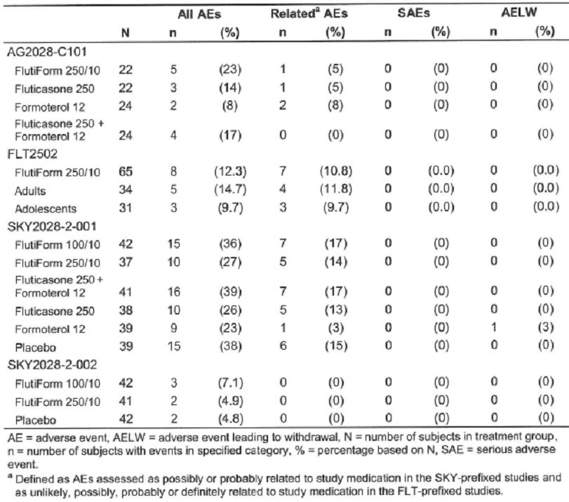

Safety results in the Phase 3 studies
Nine Phase 3 studies have been completed. Two assessed efficacy and safety in subjects with mild to moderate asthma (SKY2028-3-001, SKY2028-3-002), 2 in subjects with mild to moderate-severe asthma (FLT3501, FLT3505), 2 in subjects with moderate to severe asthma (SKY2028-3-004, SKY2028-3-005), and 1 in subjects with severe asthma (FLT3503). One open-label long-term safety study was completed in subjects with mild to moderate-severe asthma (SKY2028-3-003) and 1 open-label study with a long-term safety extension phase was completed in paediatric subjects with mild to moderate asthma (FLT3502). A total of 1601 adult and adolescent subjects were treated with Flutiform in the Phase 3 studies.

Exposure, patient demographics and disposition
Mean exposure times tended to be slightly longer in the Flutiform treatment groups than in the comparator and placebo groups. Median exposure times were generally comparable. The vast majority of subjects treated with Flutiform completed their respective study. In the two placebo-controlled studies (SKY2028-3-001 and SKY2028-3-004), the highest rate of withdrawal was observed in subjects treated with placebo, mostly due to lack of efficacy. Generally only minor differences were observed with regard to the demographic characteristics within and across the treatment groups of the individual studies. In the adult and adolescent studies, the mean age ranged from 38.1 to 50.0 years in the Flutiform treatment groups and from 36.6 years to 49.0 years in the other treatment groups. Female subjects predominated in all treatment groups. There were 266 adolescent subjects (aged 12 to 17 years). The majority of subjects were White/Caucasian. There were no relevant differences within or across the treatment groups of the individual studies regarding mean height or weight. In the adult and adolescent studies, the mean duration of asthma ranged from 11.3 to 21.1 years, mean FEV1 at Screening/Baseline ranged from 1.761 L to 2.477 L and mean FEV1 % predicted at Screening/Baseline ranged from 58.3% to 74.0%. The lowest mean FEV1 values and mean FEV1 % predicted values were observed in Study FLT3503, which included subjects with severe asthma (FEV1 of ≥ 40% to ≤ 80% for predicted normal values). Mean FEV1 reversibility was above 20% in all treatment groups across all studies. Only subjects who were steroid-requiring (ICS) were eligible for participation in studies SKY2028-3-004, SKY2028-3-005, SKY2028-3-003, FLT3503, FLT3501 and FLT3505. In Studies SKY2028-3-001 and SKY2028-3-002, either steroid-requiring or steroid-free subjects could be enrolled. Steroid requirements were not defined for the paediatric study FLT3502.

Adverse events
The overall rates of AEs in the Flutiform groups were generally comparable to those in the active comparator and individual component groups. The rates of related AEs were highest in the placebo groups, otherwise no trends were discernable. There was no consistent trend of a dose-related increase in the rates of all AE, related AE, SAE, and AE leading to withdrawal among the Flutiform 100/10, Flutiform 250/10 and Flutiform 500/20 dose groups.

Deaths, SAEs, withdrawals due to AE
There was 1 death reported in Study FLT3501. A 46-year-old male subject (130404) with a history of congenital arterial cerebral abnormality experienced a haemorrhagic stroke and cardiac arrest about 2 months after starting Flutiform 100/10 twice daily. Both AEs were serious. Study medication was discontinued and the subject was withdrawn from the study. The subject died four days later. Both events were considered to be unrelated to study drug.
SAEs were reported for 42 of the subjects participating in the Phase 3 studies. The vast majority of SAEs were assessed as not related to treatment with study medication. Two subjects experienced SAEs that were assessed as possibly related to study medication: (i) Cerebral infarction in 1 subject treated with fluticasone 500+ formoterol 24 in Study FLT3503, (ii) Myocardial ischaemia in 1 subject treated with fluticasone 500 in Study FLT3503. Seven subjects experienced SAEs that were attributed an unlikely relationship to study medication: Suicide attempt in 1 subject treated with Flutiform 100/10 in Study 2028-3-002; Herpes zoster in 1 subject treated with Flutiform 100/10 in Study 2028-3-003; Pneumonia in 1 subject treated with Flutiform 100/10 in Study FLT3503 and in 1 subject treated with Flutiform 100/10 in Study 2028-3-003; Pneumonia pneumococcal in 1 subject treated with Flutiform 100/10 in Study FLT3502 Extension Phase; Mental disorder in 1 subject treated with Flutiform 250/10 in Study 2028-3-003; Peripheral ischaemia in 1 subject treated with fluticasone 250 + formoterol 12 in Study FLT3505. Pneumonia and pneumonia pneumococcal were reported as SAEs for 6 subjects. Asthma (exacerbation) and appendicitis were each reported as an SAE for 4 subjects; 3 of the subjects with appendicitis were children. None of the other SAE preferred terms occurred in more than 1 subject.
AEs leading to discontinuation were reported for 151 of the 3321 subjects (4.5%) included in the pooled safety set. The rate of discontinuation due to AEs was highest in the placebo group (18.8%). The formoterol group showed the highest rate of discontinuation due to AEs among the active treatment groups (10.6%). The rate of discontinuation due to AEs in the Flutiform group was 2.5%. Asthma was the most frequent AE leading to discontinuation in the Flutiform, fluticasone, formoterol and placebo groups, with the highest rates being observed in the placebo and formoterol groups. The only other AEs which lead to the discontinuation of more than 1 subject in a particular treatment group were ventricular systoles in 2 subjects in the Flutiform group, and contact dermatitis in 3 subjects and sinusitis and upper respiratory tract infection in 2 subjects each in the fluticasone group.

Laboratory parameters, vital signs
Across the 9 Phase 3 studies, no clinically important trends in mean changes over time were observed for haematology or clinical chemistry variables. There were no clinically important differences for Flutiform versus the components fluticasone and formoterol, for Flutiform versus Seretide, or for Flutiform versus placebo. No apparent dose-related trends were observed in the Flutiform dose groups. It should be noted that the protocols did not require fasting blood samples for clinical laboratory assessments in any of the Phase 3 studies. No relevant changes in blood pressure or heart rate were observed during treatment with Flutiform or the comparators in the Phase 3 studies (Study FLT3503, SKY2028-3-003SKY2028-3-001, SKY2028-3-002, SKY2028-3-004, FLT3501, FLT3505, FLT3502 Core Phase and SKY2028-3-005).

Safety results of the individual Phase 3 studies
Clinical laboratory, vital signs, and ECG assessments were generally unremarkable and did not reveal any clinically important or unexpected findings in all pivotal and supportive Phase 3 studies. The only death reported was in supportive study FLT3501.

Pivotal non-inferiority study FLT3503
Of the 1077 subjects randomised, 950 (88.2%) completed the study. Median exposure to study medication was 8.0 weeks in the Flixotide + Foradil treatment group and 7.9 weeks in the other 3 treatment groups. The most frequently reported treatment emergent AEs (≥ 2.0% of subjects in any treatment group) were nasopharyngitis (2.1%, 1.2%, 1.3% and 2.5% in the Flutiform 500/20, fluticasone + formoterol, Flutiform 100/10 and fluticasone groups, respectively), headache (0.8%, 1.2%, 1.7% and 3.0%, respectively), pharyngitis (2.1%, 2.1%, 1.7% and 1.4%), asthma (1.7%, 0%, 2.5% and 2.2%) and cough (0.8%, 2.1%, 0.8% and 0%). Treatment-emergent AE were predominantly mild to moderate in severity; severe AE were reported for a total of 11 subjects (1.0%). The only AE considered severe in more than 1 subject was asthma (2 Flutiform 500/20 [0.8 %], 0 fluticasone + formoterol, 3 Flutiform 100/10 [1.3%], 4 fluticasone [1.1%]). No deaths were reported. Treatment-emergent SAE were reported for 9 subjects: 1 Flutiform 500/20, 2 fluticasone + formoterol, 3 Flutiform 100/10, and 3 fluticasone. AE leading to withdrawal from the study were reported for 15 subjects: 3 Flutiform 500/20 (1.3%), 3 fluticasone + formoterol (1.2%), 3 Flutiform 100/10 (1.3%) and 6 fluticasone (1.7%). Asthma (exacerbation) was the most common AE leading to withdrawal reported for 7 of the subjects. Laboratory, vital signs, and ECG assessments did not reveal any clinically important or unexpected findings.

Pivotal superiority studies
In study SKY2028-3-001, 475 subjects were randomised: 118 to Flutiform 100/10, 119 to fluticasone 100, 120 to formoterol 10, and 118 to placebo. Median extent of exposure was 12.1 weeks in all treatment groups. There was a lower percentage of subjects in the Flutiform treatment group compared with the fluticasone, formoterol, and placebo groups reporting any treatment emergent AE, events leading to study discontinuation, and events related to study drug. The most frequently reported treatment-emergent AEs (≥ 5.0% of subjects in any treatment group) were upper respiratory tract infection (5.9%, 5.0%, 2.5% and 3.4% in the Flutiform, fluticasone, formoterol and placebo groups, respectively), nasopharyngitis (2.5%, 7.6%, 2.5% and 2.5%, respectively), asthma (2.5%, 3.4%, 7.5% and 11.9%, respectively), and headache (1.7%, 5.0%, 2.5% and 7.6%). The only treatment-emergent AEs considered related to study drug in more than 2 subjects were asthma (3 Flutiform [2.5%], 2 fluticasone [1.7%], 3 formoterol [2.5%], 7 placebo [5.9%]) and headache (0 Flutiform, 3 fluticasone [2.5%], 1 formoterol [0.8%], and 3 [2.5%] placebo). Treatment-emergent AEs were predominantly mild to moderate in severity. The only treatment-emergent AE leading to discontinuation in more than 1 subject was asthma (3 Flutiform, 4 fluticasone, 8 formoterol, 14 placebo). One subject in the Flutiform treatment group experienced an SAE of renal colic which was considered by the investigator to be not related to study drug.
In study SKY2028-1-002, 357 subjects were randomised: 119 to Flutiform 100/10, 119 to fluticasone 100, and 119 to formoterol 10. Of the 357 randomised subjects, 269 (75.4%) completed the study and 88 (24.6%) discontinued from the study. Median extent of exposure was about 12 weeks in all groups. A lower percentage of subjects in the Flutiform treatment group compared to the component groups reported treatment-emergent severe AE and events leading to study discontinuation. The most frequently reported (≥ 5.0% of subjects in any treatment group) treatment emergent AEs were upper respiratory tract infection (3.4%, 5.9% and 7.6% in Flutiform, fluticasone and formoterol groups, respectively), nasopharyngitis (6.7%, 2.5% and 3.4%, respectively), asthma (1.7%, 3.4% and 7.6%]), and sinusitis (6.7%, 3.4% and 0.8%). The only treatment-emergent AE considered related to study drug in more than 1 subject was dysphonia (1 Flutiform [0.8%], 1 fluticasone [0.8%]). Treatment-emergent AE were predominantly mild to moderate in severity. The only treatment-emergent AE considered severe in more than 1 subject was asthma (1 Flutiform 4 fluticasone, 9 formoterol). The only treatment-emergent AE leading to discontinuation in more than 1 subject were asthma (1 Flutiform, 3 fluticasone, 9 formoterol), contact dermatitis (3 fluticasone), and upper respiratory tract infection (1 fluticasone, 1 formoterol).
In study SKY2028-1-004, 557 subjects were randomised and 556 subjects were included in the safety analysis (110, 113, 113, 111 and 109 in Flutiform 250/10, Flutiform 100/10, fluticasone, formoterol and placebo groups, respectively). Median extent of exposure was 12 weeks in the Flutiform, fluticasone and formoterol group and 11.4 weeks in the placebo group. There was a lower percentage of subjects in the Flutiform treatment groups compared with the fluticasone, formoterol and placebo groups reporting treatment emergent AE for severe events, events leading to study discontinuation, and events related to study drug. The most frequently reported (≥ 5.0% of subjects in any treatment group) treatment emergent AE were asthma (3.6%, 5.3%, 5.3%, 16.2% and 22.9% in the Flutiform 250/10, 100/10, fluticasone, formoterol and placebo groups, respectively)], nasopharyngitis (4.5%, 7.1%, 5.3%, 2.7% and 2.8%, respectively), and upper respiratory tract infection (2.7%, 1.8%, 3.5%, 5.4% and 2.8%). The only treatment-emergent AE considered related to study drug in more than 2 subjects was asthma (4 Flutiform 250/10 [3.6%], 1 Flutiform 100/10 [0.9%], 3 fluticasone [2.7%], 8 formoterol [7.2%], and 18 placebo [6.5%]). Treatment-emergent AE were predominantly mild to moderate in severity. The only treatment-emergent AE considered severe in more than 1 subject were asthma (3 Flutiform 250/10, 5 Flutiform 100/10, 6 fluticasone, 16 formoterol, 21 placebo) and upper respiratory tract infection (1 formoterol, 1 placebo). The only treatment-emergent AE leading to discontinuation in more than 1 subject was asthma (3 Flutiform 250/10, 5 Flutiform 100/10, 6 fluticasone, 17 formoterol, 24 placebo).

Supportive studies
Study FLT3501 was a Phase 3, multicentre, randomised, open-label, active-controlled, parallel group study that compared the efficacy and safety of Flutiform 100/10 and Flutiform 250/10 with Seretide 100/50 and Seretide 250/50, administered by inhalation twice daily over 12 weeks, in 202adult subjects with mild to moderate-severe asthma (steroid-requiring). Overall, 202 subjects were randomised: 101 subjects were treated with Flutiform and 101 subjects were treated with Seretide. The overall rate of AE was comparable between the two treatment groups (23.8% in each group). The most commonly reported AE (≥ 3% in either treatment group) were nasopharyngitis (Flutiform vs Seretide: 3.0% vs 4.0%) and asthma (3.0% vs 1.0%). Treatment-emergent AE were predominantly mild to moderate in intensity. Two subjects (Flutiform) experienced 3 severe AE: asthma (exacerbation) in 1 subject, and haemorrhagic stroke and cardiac arrest in 1 subject: this subject was withdrawn from the study due to these SAEs. The frequency of treatment-related AE was extremely low, reported for only 1 subject in each treatment group (mild palpitations in the Flutiform group and mild dyspnoea in the Seretide group). Neither of the treatment-related AE was serious. There was 1 death (refer section 4.4.4 above). All SAE were considered not related to study drug.
Study FLT3505 was a Phase 3, multicentre, randomised, open-label, active-controlled, parallel group study that compared the efficacy and safety of Flutiform 100/10 and Flutiform 250/10 with fluticasone (Flixotide) 100 plus formoterol (Foradil) 12 and fluticasone (Flixotide) 250 plus formoterol (Foradil) 12, administered by inhalation twice daily for 12 weeks, in 210 adolescent and adult subjects with mild to moderate-severe asthma (steroid-requiring); 105 subjects were treated with Flutiform and 105 subjects were treated with fluticasone + formoterol. The overall rate of AE was comparable between the 2 treatment groups (Flutiform vs fluticasone + formoterol: 34.3% vs 31.4%). The most commonly reported AE (≥ 3% in either treatment group) were nasopharyngitis (7.6% vs 2.9%), bronchitis (4.8% vs 1.0%), and asthma (3.8% vs 2.9%). The incidence of treatment-related AE was low, being reported for only 5 subjects in the Flutiform group (4.8%) and for 6 subjects in the fluticasone + formoterol group (5.7%). Dysphonia was the most common treatment-related AE, reported for 3 subjects in the fluticasone + formoterol group and for 1 subject in the Flutiform group.
Study SKY2028-3-005 was a Phase 3 multicentre, randomised, double-blind, active-controlled, parallel group, stratified study comparing the safety and efficacy of Flutiform 250/10 with SKP fluticasone 250 and Flovent fluticasone 250 alone, administered by inhalation twice daily over 12 weeks, in 438 adolescent and adult subjects with steroid-requiring moderate to severe asthma. The most frequently reported (≥ 5.0% of subjects in any treatment group) treatment emergent AEs were influenza (5.5%, 2.7% and 5.5% in Flutiform, SKP fluticasone and Flovent fluticasone groups, respectively), nasopharyngitis (4.8%, 6.2% and 6.2%), and allergic rhinitis (5.5%, 0.7% and 4.8%). Treatment-emergent AEs considered related to study drug in more than 2 subjects were dysphonia (0.7%, 2.1 and 0% in Flutiform, SKP fluticasone and Flovent groups, respectively), insomnia (0.7%, 1.4% and 0%), oedema peripheral (1.4%, 0% and 0.7%) and throat irritation (0.7% in each group). The only treatment-emergent AE considered severe in more than 1 subject was asthma (1 Flutiform, 1 SKP fluticasone, 2 Flovent fluticasone). SAEs were experienced by 2 Flovent fluticasone subjects (spontaneous abortion and asthma), both of which were considered by the investigator to be not related to study drug. The only treatment-emergent AEs leading to discontinuation in more than 1 subject were asthma (1 Flutiform, 1 SKP fluticasone, 2 Flovent fluticasone), insomnia (2 SKP fluticasone), and tension (2 SKP fluticasone).

Pooled safety analyses
The purpose of the Pooled summary of safety was to compare the safety profile of Flutiform with the other treatment groups (Seretide, fluticasone plus formoterol, fluticasone, formoterol, and placebo), to compare the safety profile across different dose groups and to compare safety of Flutiform administered with and without a spacer. Pooled analyses were performed using data from seven Phase 3 studies. Six treatment groups and 12 dose groups were defined for pooled safety analyses.

Exposure, patient disposition, baseline patient characteristics
The majority of subjects were treated with study medication for the duration planned in the study protocols. Due to the time intervals allowed for individual visits, the extent of exposure exceeded the planned duration in some subjects. The percentage of subjects who completed their respective studies ranged from 61.9% in the placebo group (138 of 223 subjects) to 95.0% in the Seretide group (95 of 100 subjects). In the Flutiform group, 88.0% of subjects completed their studies (1409 of 1601 subjects). Lack of therapeutic effect was the most common primary reason for withdrawal in all treatment groups, with the highest rate being observed in the placebo group (28.7%), followed by the formoterol group (17.2%). The rate of withdrawal due to lack of therapeutic effect in the Flutiform group was 5.3%. The rate of withdrawal due to AEs was low and generally comparable between the treatment groups, ranging from 0% in the Seretide group to 2.2% in the placebo group. The rate of withdrawal due to AE in the Flutiform group was 1.3%.
The percentage of subjects who completed their respective studies ranged from 69.3% in the formoterol 10 dose group to 96.6% in the fluticasone 100 + formoterol 12 dose group. In the Flutiform dose groups, between 86.1% and 93.2% of subjects completed their studies. Lack of therapeutic effect was the most common primary reason for withdrawal in all dose groups except in the fluticasone 250 + formoterol 12 dose group. The highest rates were observed in the formoterol 10 dose group (17.2%) and the fluticasone 250 group (14.3%). The rates of withdrawal due to lack of therapeutic effect in the Flutiform 100/10, 250/10 and 500/20 dose groups were 6.1%, 4.3% and 4.2%, respectively. The rate of withdrawal due to AEs was low and generally comparable between the dose groups, ranging from 0% to 2.6%. The rates of withdrawal due to AE in the Flutiform 100/10, 250/10 and 500/20 dose groups were 1.0%, 1.6% and 1.7%, respectively.
Generally only minor differences were observed with regard to the demographic characteristics in the 6 treatment groups of the pooled safety set. Subjects were aged between 12 and 85 years. The mean ages ranged from 39.9 years in the formoterol group to 46.8 years in the fluticasone + formoterol group. A total of 211 subject (6.4%) were aged between 12 and 17 years (range 0.0% to 9.7% across treatment groups), and 307 (9.2%) were aged 65 years or older (range 6.0% to 11.9% across treatment groups). Female subjects predominated in all treatment groups (range 57.2% to 64.6%). The majority of subjects were Caucasian (range 76.5% to 100%). There were no relevant differences among the treatment groups regarding weight, height or BMI. Mean asthma duration ranged from 10.6 years in the Seretide treatment group to 21.4 years in the placebo group Mean FEV1 at Screening/Baseline ranged from 1.911 L in the fluticasone + formoterol group to 2.260 L in the formoterol group. Mean FEV1 % predicted at Baseline was highest in the formoterol group (73.9%) and lowest in the fluticasone + formoterol group (64.8%). Most subjects had FEV1 % predicted values of ≥ 60% to < 80% (range 42.1% to 80.0% across treatment groups). The percentage of subjects with FEV1 % predicted values of ≥ 40% to < 60% ranged from 7.2% in the formoterol group to 41.0% in the fluticasone group, and the percentage of subjects with FEV1 % predicted values of ≥ 80% ranged from 5.0% in the Seretide group to 28.1% in the formoterol group. Mean FEV1 reversibility was above 15% in all treatment groups (Table 46). At Screening, 87.1% of the subjects were taking ICS therapy (range 67.6% to 98.0%), 48.3% were taking LABAs (range 28.3% to 78.0%), and 48.1% were taking combined ICS and LABA therapy (range 28.3% to 77.0%). The percentage of subjects taking ICS therapy was greater than 85% in all dose groups except for the fluticasone 100 dose group (51.1%) and the formoterol 10 dose group (67.6%).
Table 46: Asthma characteristics: treatment groups – pooled safety set.
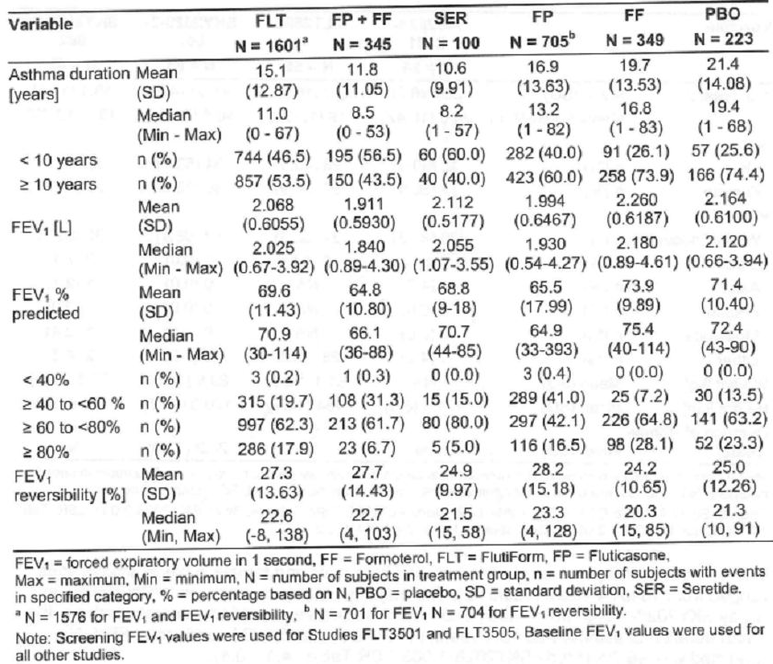

Adverse events
The overall rate of AEs was lowest in the Seretide group (24.0%) and highest in the placebo (43.9%) and formoterol (41.3%) groups. In the Flutiform group, the overall rate of AE was 31.0%. The placebo and formoterol groups also showed the highest rates of treatment-related AE and of AE leading to withdrawal. The rates of SAEs were low and comparable between the treatment groups. SAEs were considered treatment-related for only 8 of the subjects overall (0.2%) (Table 47). The overall AE rates were lowest in the Seretide 100/50 and FLT 500/20 dose groups (16.0% and 18.6%, respectively) and highest in the fluticasone 100, fluticasone 250 and formoterol 10 dose groups (43.8%, 42.9% and 41.3%, respectively). The fluticasone 100, fluticasone 250 and formoterol 10 dose groups also showed the highest rates of treatment related AEs and of AEs leading to withdrawal. The rates of SAEs were low and generally comparable between the dose groups (Table 48).
Table 47: Overview of subjects with AEs: treatment groups – pooled safety set.
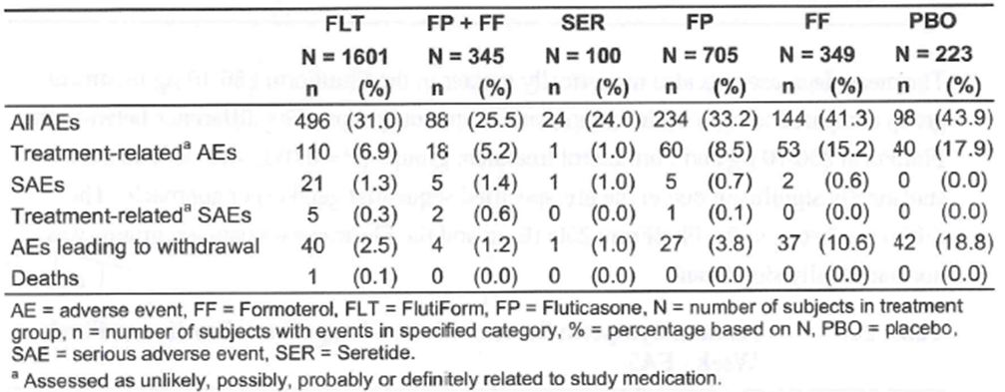
Table 48: Overview of subjects with AEs: dose groups – pooled safety set.
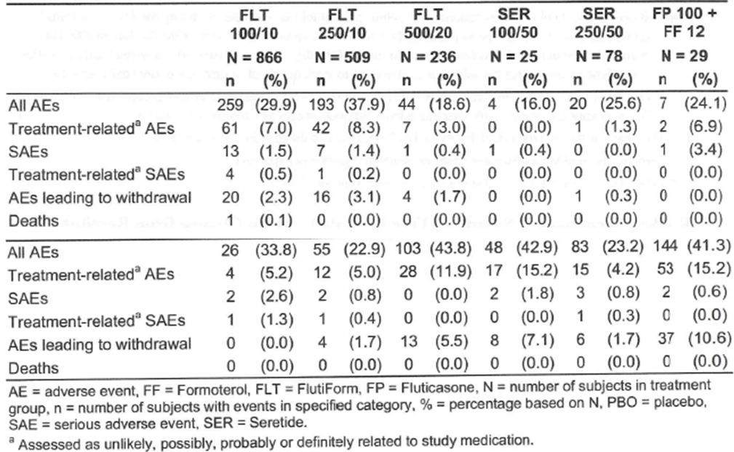
The AE rates in the Flutiform 500/20 dose group were generally lower than those in the Flutiform 100/10 and 250/10 dose groups. The only noteworthy difference in the AE profile in the Flutiform dose groups compared to the other dose groups was a slightly higher incidence of nasopharyngitis, bronchitis, and dyspnoea in the Flutiform 250/10 dose group. The profile of AE was generally comparable among the treatment groups. In all groups, AE classed as infections and infestations and as respiratory, thoracic and mediastinal disorders were most common. At the preferred term level, the most frequent AE (≥2.0%) were: nasopharyngitis (5.5%), asthma (2.7%), upper respiratory tract infection with Flutiform; pharyngitis (2.0%) with fluticasone + formoterol; nasopharyngitis (4.0%) and asthma (2.0%) with Seretide; nasopharyngitis (3.8%), headache (3.3%), asthma (3.1%), and upper respiratory tract infection (3.1%) with fluticasone; asthma (10.3%), upper respiratory tract infection (5.2%), nasopharyngitis (2.9%), urinary tract infection (2.6%), headache (2.6%), and back pain (2.3%) with formoterol; asthma (17.5%), headache (5.4%), upper respiratory tract infection (3.1%), nasopharyngitis (2.7%), and sinusitis (2.2%) with placebo.
The rate of asthma was highest in the placebo group, and it was also higher in the formoterol group than in the other treatment groups. The placebo group also showed the highest rate of headache. No other noteworthy differences were observed. In general, the AE profile of Flutiform was comparable to that of the comparator treatments and consistent with the AE profiles reported for the individual components (Table 49).
Table 49: AEs reported for > 1.0% of subjects in any treatment group – pooled safety set.
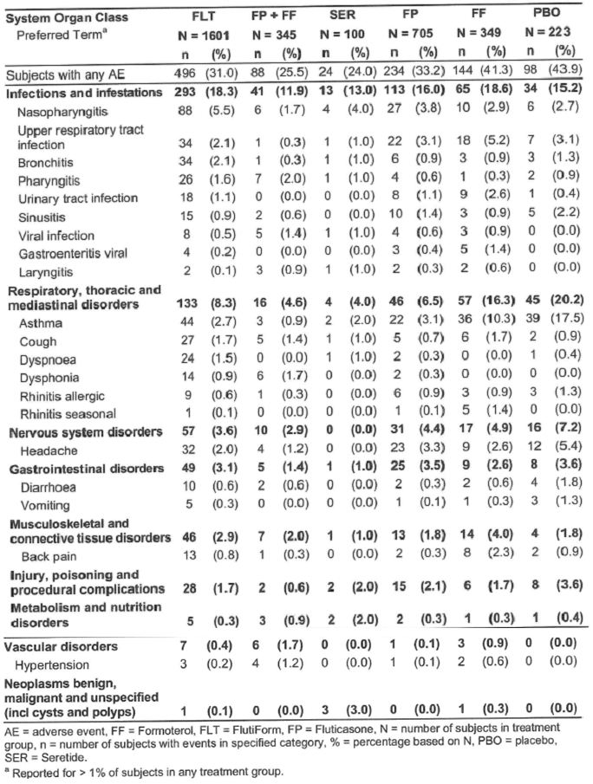
The exposure-time-adjusted analysis of frequent AEs generally yielded similar results to those for the analysis based on the unadjusted rates. The exposure-adjusted rate for all AEs was lowest in the Seretide group and highest in the formoterol and placebo groups. However, the adjusted rate for nasopharyngitis in the Flutiform group, which was highest in the unadjusted analysis, was lower than the adjusted rate in the fluticasone group. At the preferred term level, the most frequent AE (≥ 5 per 100 subject years) were: nasopharyngitis (19.4), headache (8.9), asthma (8.7), upper respiratory tract infection (7.8), dyspnoea (7.2), bronchitis (6.8), cough (5.8), and pharyngitis (5.0) with Flutiform; nasopharyngitis (13.5), pharyngitis (11.8), dysphonia (10.1), viral infection (8.4), cough (8.4), sinusitis (6.7), laryngitis (6.7), headache (6.7), hypertension (6.7), respiratory tract infection viral (5.0), viral rhinitis (5.0), and asthma (5.0) with fluticasone + formoterol; nasopharyngitis (17.8) and asthma (8.9) with Seretide; nasopharyngitis (22.9), headache (21.3), upper respiratory tract infection (18.9), asthma (18.0), sinusitis (9.0), and urinary tract infection (6.6) with fluticasone; asthma (54.5), upper respiratory tract infection (31.8), headache (16.6), nasopharyngitis (15.1), urinary tract infection (13.6), back pain (12.1), cough (9.1), gastroenteritis viral (7.6), rhinitis seasonal (7.6), and sinus headache (6.1) with formoterol; asthma (97.9), headache (31.8), upper respiratory tract infection (19.6), nasopharyngitis (14.7), sinusitis (12.2), diarrhoea (9.8), bronchitis (7.3), rhinitis allergic (7.3), and vomiting (7.3) with placebo. The exposure-time-adjusted analyses also showed that the AE profile of Flutiform was generally comparable to that of the comparator treatments and consistent with the AE profiles reported for the individual components (Table 50).
Treatment-related AE: AE classed as respiratory, thoracic and mediastinal disorders were the most frequent treatment-related AEs in all treatment groups. The highest rates were observed in the formoterol and placebo groups, which was mainly due to the higher rates of treatment-related asthma in these 2 groups. At the preferred term level, the only treatment-related AEs to occur in more than 1.0% of subjects per treatment group were asthma in the Flutiform, fluticasone, formoterol and placebo groups, headache in the fluticasone and placebo groups, cough in the formoterol group, dysphonia in the fluticasone + formoterol group, and bronchitis in the placebo group (Table 51). The highest rates of related AEs were observed in the fluticasone 100, fluticasone 250 and formoterol 10 dose groups (11.9%, 15.2% and 15.2%, respectively). In the Flutiform 100/10, 250/10 and 500/20 dose groups, the rates were 7.0%, 8.3% and 3.0%, respectively. The rates of treatment-related AEs in the other dose groups ranged from 0% to 6.9%. Overall, asthma was the most frequent treatment-related AE, with the highest rates being observed in the fluticasone 100, fluticasone 250 and formoterol 10 dose groups (2.1%, 4.5% and 5.7%). In comparison, the rates of related asthma in the Flutiform 100/10, 250/10 and 500/20 dose groups were 0.9%, 1.4% and 0.8%, respectively. There were no other noteworthy differences concerning the profile of related AE in the Flutiform dose groups compared to the other dose groups.
Table 50: Frequent AEs (> 5) per 100 subject years of exposure in any treatment group – pooled safety set.
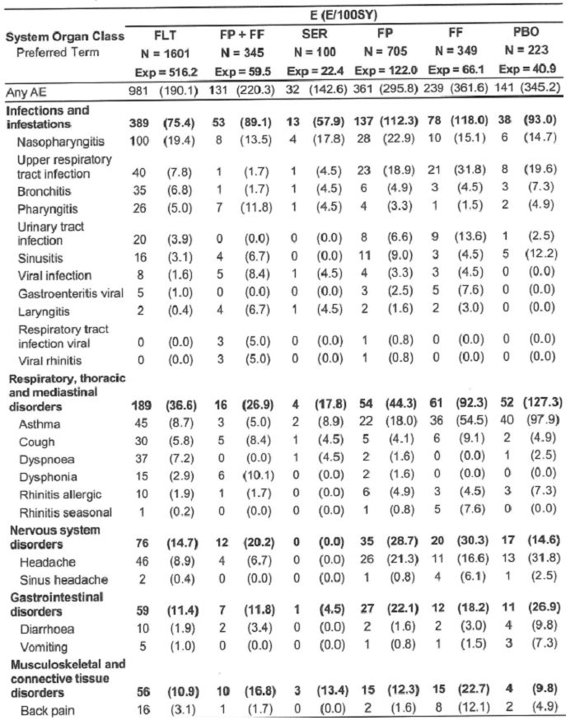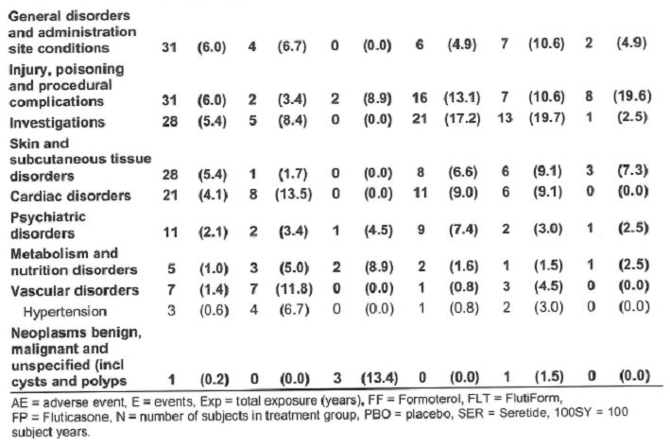
Table 51: Treatment-related AEs by System Organ Class and Preferred Term (>1.0% of subjects in any treatment group): treatment groups – pooled safety set.
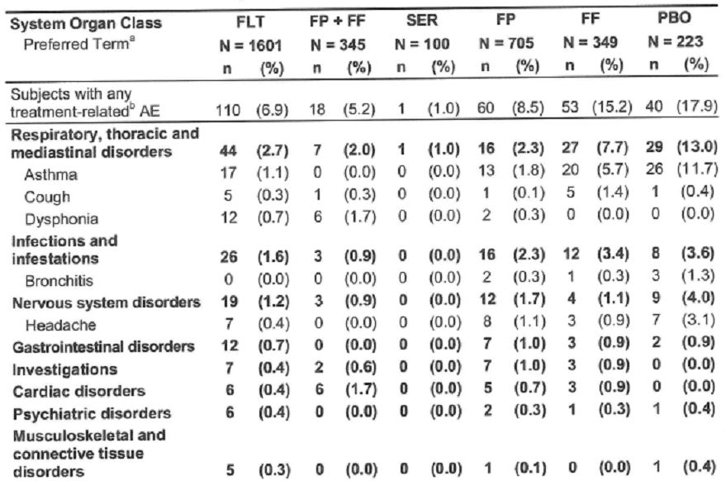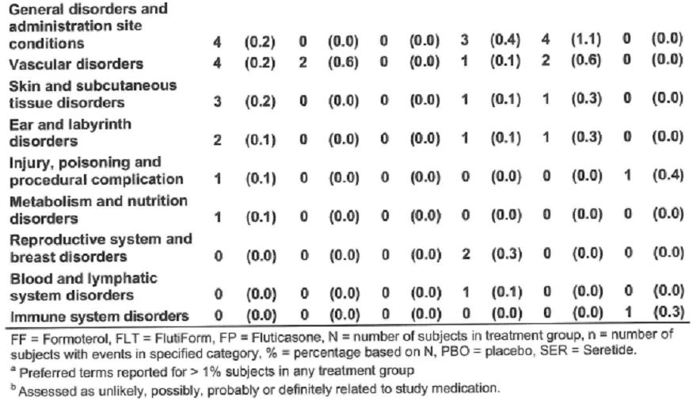

Deaths, SAEs, discontinuations due to AE
There was 1 death reported in Study FLT3501. A 46-year-old male subject with a history of congenital arterial cerebral abnormality experienced a haemorrhagic stroke and cardiac arrest about 2 months after starting Flutiform 100/10 twice daily. Both AEs were serious. Study medication was discontinued and the subject was withdrawn from the study. The subject died four days later. Both events were considered to be unrelated to study drug. No other deaths were reported for any subjects in the Flutiform clinical development programme.
The SAE rates were low and comparable among the active treatment groups. No SAEs were reported in the placebo group (Table 52). The rates of SAEs were low and generally comparable between the various dose groups.
Table 52: SAEs: treatment groups – pooled safety set.
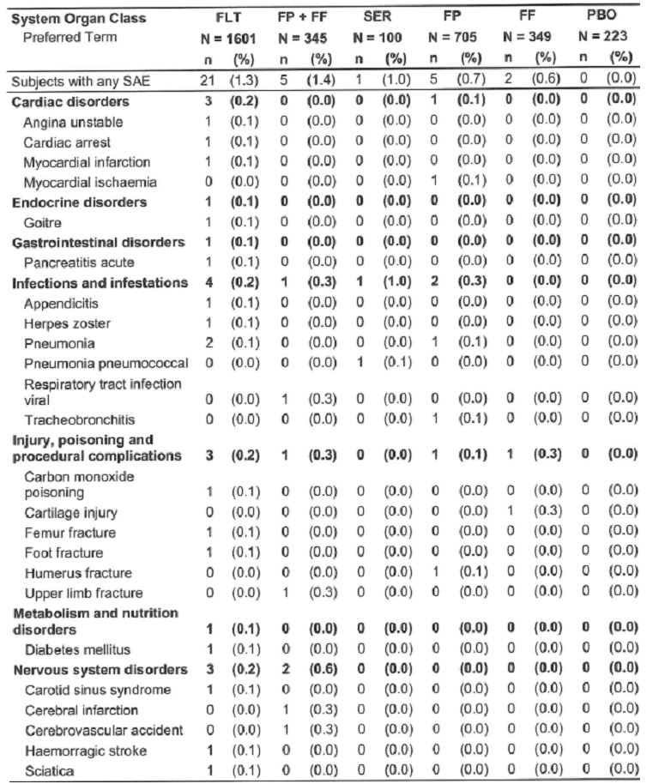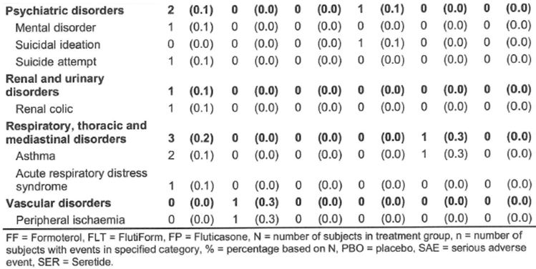
AE leading to discontinuation were reported for 151 of the 3321 subjects (4.5%) included in the pooled safety set. The rate of discontinuation due to AEs was highest in the placebo group (18.8%). The formoterol group showed the highest rate of discontinuation due to AE among the active treatment groups (10.6%). The rate of discontinuation due to AE in the Flutiform group was 2.5%. Asthma was the most frequent AE leading to discontinuation in the Flutiform, fluticasone, formoterol and placebo groups, with the highest rates being observed in the placebo and formoterol groups. The only other AE which lead to the discontinuation of more than 1 subject in a particular treatment group were ventricular systoles in 2 subjects in the Flutiform group, and contact dermatitis in 3 subjects and sinusitis and upper respiratory tract infection in 2 subjects each in the fluticasone group (Table 53). The highest rates of AE leading to discontinuation were observed in the fluticasone 100, fluticasone 250 and formoterol 10 dose groups (5.5%, 7.1% and 10.6%, respectively). In the Flutiform 100/10, 250/10 and 500/20 dose groups, the rates were 2.3%, 3.1% and 1.7%, respectively. The rates of discontinuation due to AE in the other dose groups ranged from 0% to 1.7%. Overall, asthma was the most frequent AE leading to discontinuation, again with the highest rates being observed in the fluticasone 100, fluticasone 250 and formoterol 10 dose groups (3.0%, 5.4% and 9.7%). In comparison, the rates of discontinuation due to asthma in the Flutiform 100/10, 250/10 and 500/20 dose groups were 1.3%, 1.6% and 1.7%, respectively. Most of the other AE leading to discontinuation were reported for 1 or 2 subjects only. There were no noteworthy differences between the profile of AE leading to discontinuation in the Flutiform dose groups and that in the other dose groups.
Table 53: AEs leading to discontinuation of study medication: treatment groups – pooled safety set.
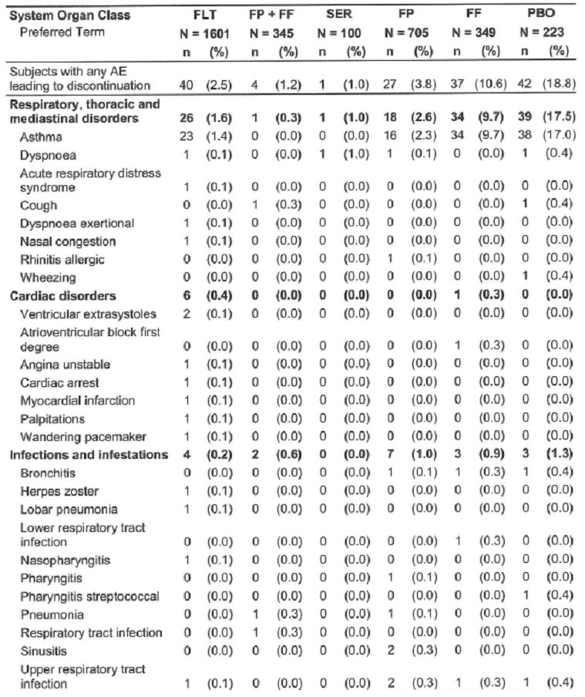
Table 53 (continued): AEs leading to discontinuation of study medication: treatment groups – pooled safety set.
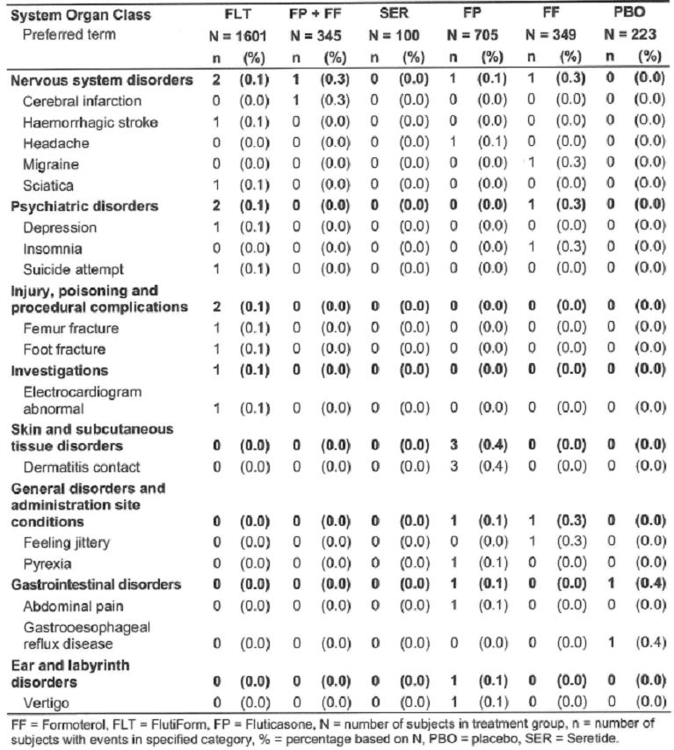

Laboratory parameters, vital signs, ECG in pooled safety analyses
With the exception of glucose and potassium, pooled safety analyses of laboratory variables were not performed. Changes in mean glucose and potassium over time were small and not clinically relevant. The percentage of subjects showing shifts with increases in glucose values from Baseline to End of Study was comparable to the percentage showing shifts with decreases. Potassium values remained within normal range throughout treatment in the vast majority of subjects. Very few subjects showed shifts to lower values (approximately 1%). Similar results were obtained for the dose groups and for the Flutiform spacer and Flutiform non-spacer groups.
Changes in mean heart rate over time were small and not clinically relevant. Heart rate remained within normal range throughout treatment in the vast majority of subjects. No noticeable trends were observed in any of the treatment groups. Mean respiratory rate and mean body temperature remained stable throughout the treatment period in all FLT-prefixed Phase 3 studies. Respiratory rate and body temperature was not measured in the SKY-prefixed Phase 3 studies.
The ECG results for the All Flutiform Analysis Set showed no clinically important mean changes over time for ECG variables for All Flutiform (either dose), Flutiform 100/10, or Flutiform 250/10 with no apparent dose-related trends. The incidence of categorical changes from Baseline (< 30, ≥ 30 to < 60, ≥ 60 msec) based on pre-dose assessments for both QTcF and QTcB was generally similar for the Flutiform dose groups and there were no apparent trends over time; the incidence of subjects with QTcF increases of ≥ 60 msec at any visit was 5.7% for All Flutiform, 4.7% for Flutiform 100/10, and 6.9% for Flutiform 250/10.
In the Phase 3 placebo-controlled comparisons, no clinically important differences in mean changes from Baseline to pre- or post-dose assessments were observed for ECG variables for All Flutiform and Flutiform 100/10 compared with placebo or for Flutiform 250/10 compared with placebo. The incidence of categorical changes from Baseline (< 30, ≥ 30 to < 60, ≥ 60 msec) for both QTcF and QTcB, based on both pre-dose and post-dose assessments, was generally similar for the Flutiform groups compared with placebo.
Only clinically significant ECG findings were documented in the FLT-prefixed Phase 3 studies. There were no reports of clinically significant ECG findings in the FLT3501, FLT3505 and FLT3502 studies. In the pivotal study FLT3503, clinically significant ECG findings were reported for 10 subjects: 2 subjects in the Flutiform 500/20 group, 3 subjects in the fluticasone 500 + formoterol 24 group, 3 subjects in the Flutiform 100/10 group and 2 subjects in the fluticasone 500 group. In the Flutiform 500/20 group 2 subjects showed clinically significant ECG findings at Week 8 (ventricular premature complexes post-dose, and bradycardia, pre-dose). In the fluticasone + formoterol group, clinically significant ECG findings were observed for 3 subjects (left posterior fascicular block at Week 8 pre- and post-dose; premature beat [extrasystole] at Week 8 pre-dose, and tachycardia at Week 4 post-dose). In the Flutiform 100/10 group, clinically significant ECG findings were documented for 3 subjects (several ventricular pre excitations on Day 28 pre-dose; bradycardia on Day 56 post-dose, and bradycardia on Day 28 predose). In the fluticasone group, clinically significant ECG findings were reported for 2 subjects (negative T-wave in V2 on Day 0 post-dose, at Week 4 and Week 8 both pre- and post dose; T-wave flattening, myocardial ischemia suspicion at Week 4 and Week 8 both post-dose). All clinically significant ECG findings were documented as AEs and the following 4 AEs were considered to be treatment-related: Possibly related arrhythmia supraventricular and bundle branch block left in a subject treated with fluticasone + formoterol; Probably related tachycardia in a subject treated with fluticasone + formoterol; Unlikely related ECG T wave inversion in a subject treated with fluticasone; and Possibly related ECG T wave amplitude decreased in a subject treated with fluticasone. Overall, Flutiform does not appear to have significant impact on QTc at any dose level.

Pooled safety analysis in subgroups

Spacers vs non-spacers
Pooled safety analyses were also performed for the following 2 treatment groups: (i) Flutiform Spacer: All subjects randomised in FLT3501, FLT3503 and FLT3505 who received at least 1 dose of Flutiform. (ii) Flutiform Non-Spacer: All subjects randomised in SKY2028-3-001, SKY2028-3-002, SKY2028-3-003 (enrolled in open-label treatment period) and SKY2028-3-004 who received at least 1 dose of Flutiform. Spacers were used in the FLT-prefixed studies but not in the SKY-prefixed studies. The vast majority of subjects completed their respective studies in the Flutiform spacer and Flutiform non-spacer groups (90.6% and 86.1%, respectively). The rate of discontinuation due to lack of therapeutic effect was comparable between the 2 groups (5.2% and 5.4%), as was the rate of discontinuation due to AEs (1.3% in each group). Subjects in the Flutiform spacer group were slightly older, and the percentage of adolescent subjects was slightly lower compared to the Flutiform non-spacer group. The majority of subjects in both groups were Caucasian. The 2 groups were comparable with regard to weight, height and BMI. Mean asthma duration was 13.1 years in the Flutiform spacer group and 16.5 years in the Flutiform non-spacer group. Mean FEV1 and FEV1 % predicted values at Screening/Baseline were slightly higher in the Flutiform non-spacer group than in the Flutiform spacer group. The majority of subjects in both groups had FEV1 % predicted values of ≥ 60% to < 80%. The Flutiform spacer group had a higher proportion of subjects with FEV1 % predicted values of ≥ 40% to < 60% and a lower proportion of subjects with FEV1 % predicted values of ≥ 80% than the Flutiform non-spacer group. Mean FEV1 reversibility was above 15% in both groups. ICS therapy was taken at Screening by 97.6% of subjects in the Flutiform spacer group and by 87.7% of subjects in the Flutiform non-spacer group. A higher percentage of subjects were taking LABAs and/or combination therapy in the Flutiform spacer group than in the Flutiform non-spacer group.
The rates of all AE, treatment-related AE, SAEs and AE leading to withdrawal were higher in the Flutiform non-spacer group than in the Flutiform spacer group (Table 54), although interpretation was confounded by the longer exposure time in the Flutiform non-spacer group compared to the Flutiform spacer group (400.8 years vs 115.4 years). The rates of nasopharyngitis, cough, dyspnoea, and upper respiratory tract infection were higher in the non-spacer group than in the spacer group. No other noteworthy differences were observed (Table 55). Hence, the exposure-time-adjusted analysis was similar in the spacer (207.1 events per 100 subject years) and non-spacer (185.1 events per 100 subject years) group. The adjusted rates of nasopharyngitis were comparable in the 2 groups (19.1 and 19.5 events per 100 subject years, respectively), whereas they were higher for the non-spacer group in the unadjusted analysis. The adjusted rates of asthma, which were comparable in the unadjusted analysis, were higher in the Flutiform spacer group than in the non-spacer group (15.6 vs 6.7 events per 100 subject years). The adjusted rates of bronchitis and pharyngitis were also higher in the spacer group than in the non-spacer group. No other noteworthy differences were observed (Table 56). The overall rate of treatment-related AE was higher in the Flutiform non-spacer group than in the Flutiform spacer group (9.7% vs 3.1%). The overall rate of SAEs was comparable in the Flutiform nonspacer and the Flutiform spacer group (1.6% vs 0.9%). The only SAEs that were reported for more than 1 subject were asthma in 2 subjects in the non-spacer group and pneumonia in 1 subject in each group.
Table 54: Overview of subjects with AEs: Flutiform Spacer versus Flutiform Non-Spacer – Pooled Safety Set.
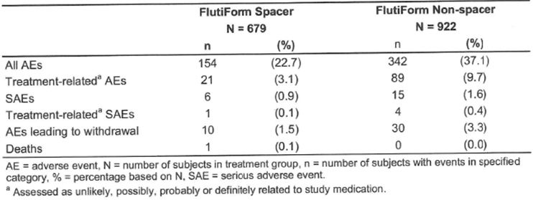
Table 55: AEs reported for > 1.0% of subjects in either group: Flutiform Spacer versus Flutiform Non-Spacer – Pooled Safety Set.
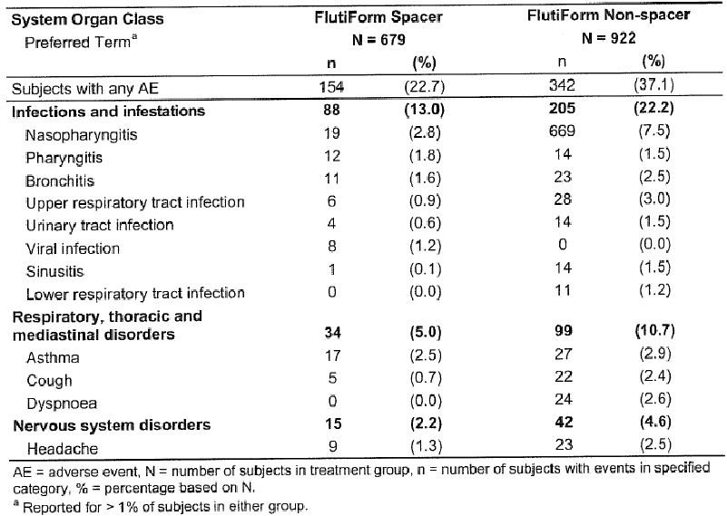
Table 56: Frequent AEs (>5) per 100 subject years of exposure in either group: Flutiform Spacer versus Flutiform Non-Spacer – Pooled Safety Set.
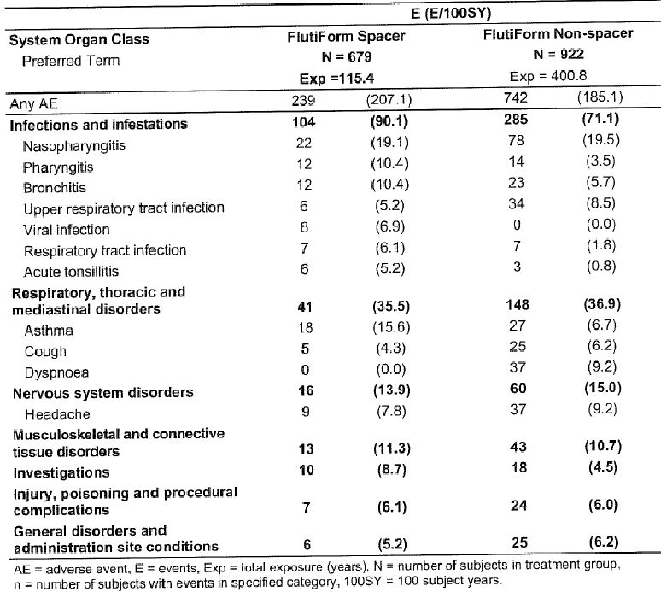
The overall rate of AE leading to discontinuation was higher in the Flutiform non-spacer group than in the Flutiform spacer group (3.3% vs 1.5%). This was mainly due to the slightly higher rate of discontinuation due to asthma in the non-spacer group (1.7% vs 1.0%). There were no other noteworthy differences between the 2 groups.

Safety in other subgroups in the pooled safety analyses
The following subgroups were considered relevant for the pooled safety analysis: Age group (≥ 12 to < 18 years, ≥ 18 to < 65 years, ≥ 65 years); Sex (male, female); Duration of asthma (< 10 years, ≥ 10 years); Baseline FEV1 % predicted (< 40, ≥ 40 to < 60, ≥ 60 to < 80, ≥ 80); Exposure to ICS at Screening (yes/no).; Exposure to combination therapies for asthma at Screening (yes/no) and Geographical Region (Europe and Israel, North America, India).
Age, gender and asthma duration did not appear to have significant effect on the profile and incidence of common AE (incidence >1%) associated with Flutiform treatment. Only minor differences were observed for AE incidence based on baseline predicted FEV%. Generally there were only minor differences regarding the profile of common AEs in subjects using ICS and subjects not using ICS at Screening. There were only minor differences regarding the profile of common AEs in subjects using and subjects not using combination therapy for asthma at Screening. There were no noteworthy differences regarding the profile of common AEs by geographical region of Europe/Israel and North America.

Long term safety
Study SKY2028-3-003 was a Phase 3 multicentre, open-label study that assessed the long-term safety of Flutiform 100/10 and Flutiform 250/10, administered by inhalation twice daily over 6 and 12 months, in adult and adolescent subjects with mild to moderate-severe asthma. Only steroid-requiring subjects (inhaled steroid regimen for at least 4 weeks prior to the Screening Visit at a dose <500 ug/day fluticasone or equivalent ICS) were eligible. Spacers were not used in this study. Of the 472 treated subjects, 256 subjects enrolled for the 6-month Treatment Period, and 216 subjects enrolled for the 12-month Treatment Period. A total 413 (87.5%) completed the study and 59 (12.5%) discontinued from the study. The most common reason for premature discontinuation was withdrawal of consent (9 Flutiform 100/10 [4.0%], 14 Flutiform 250/10 [5.6%]). Of the 472 subjects treated with Flutiform, 435 (92.2%) remained in the study for at least 6 months (regardless of study subset), including 175 subjects who remained in the study for 12 months. The overall median duration of exposure was 25.9 weeks.
The most common AEs (> 2.0% of subjects in any treatment group) were nasopharyngitis (Flutiform 100/10 vs 250/10: 7.6% vs 11.3%), dyspnoea (2.2% vs 7.7%), pharyngitis (2.7% vs 2.8%), headache (3.1% vs 2.4%), lower respiratory tract infection (2.2% vs 2.8%), upper respiratory tract infection (2.7% vs 2.4%), asthma (1.3% vs 3.6%), and cough (0.9% vs 3.2%). Treatment-emergent AE considered possibly or probably related to study drug were reported for 18 subjects, 5 in the Flutiform 100/10 group and 13 in the Flutiform 250/10 group. The only treatment-emergent AE considered related to study drug in more than 1 subject were asthma (2 Flutiform 250/10, 0 Flutiform 100/10) and dysphonia (5 Flutiform 250/10, 0 Flutiform 100/10). Treatment-emergent AE were predominantly mild to moderate in severity. The only severe AE that was reported for more than 1 subject was asthma (6 Flutiform 250/10, 3 Flutiform 100/10). AE that occurred with at least a 2% higher incidence in the Flutiform 250/10 twice daily dose group compared with the Flutiform 100/10 twice daily dose group were related to the respiratory system: nasopharyngitis (11.3% versus 7.6%), dyspnoea (7.7% versus 2.2%), asthma (3.6% versus 1.3%), cough (3.2% versus 0.9%), and dysphonia (2.4% versus 0.4%). The increased incidence of these AE in the Flutiform 250/10 twice daily dose group may have been due to more severe underlying asthma in this dose group (subjects assigned to this dose group were taking higher dosages of inhaled corticosteroids prior to study enrolment).
No deaths were reported in this study. Ten subjects (5 in each dose group) experienced 1 or more SAEs, none of which were considered (possibly or probably) related to study drug by the investigator. Fourteen subjects were prematurely discontinued from study drug, at least in part, due to AE, including 8 subjects due to events that were related to the respiratory system(6 Flutiform 250/10, 2 Flutiform 100/10). Asthma exacerbations were reported for 53 subjects (11.2%). Overall, 46 subjects (9.7%) experienced mild to moderate exacerbations with similar incidence in 100/10ug (9.8%) and 250/10 (9.7%) groups and only 9 subjects (1.9%) experienced severe exacerbations (100/10=1.3%; 250/10=2.4%). Only 1 event of asthma exacerbation was reported as an SAE.
Clinical laboratory results showed no abnormal trends or dose-response related changes. Vital signs assessments showed no abnormal trends or dose-response related changes. Overall, no clinically important ECG changes were observed.
The results of this study suggested that Flutiform (100/10 and 250/10) was generally safe and well tolerated when administered for up to 12 months.

Safety in special populations
The results of this study FLT3502 (Core and Extension Phase) indicate that Flutiform was safe and well tolerated. There was no evidence of an effect of Flutiform on plasma cortisol, or on height or weight in children.
Renal and hepatic impairment: No specific studies were conducted with Flutiform in patients with renal or hepatic impairment.
Use in pregnancy and lactation: No Flutiform studies have been conducted in pregnant women or on the excretion of Flutiform into breast milk. There is no data from the clinical program on the use of Flutiform by nursing mothers. Treatment of pregnant rats and rabbits with Flutiform at inhalation doses confirmed the known embryo foetal abnormalities of the two individual components. In animal studies foetal abnormalities occur after administration of beta-2-adrenoreceptor agonists and glucocorticosteroids. Administration of Flutiform is not recommended during pregnancy, and should only be considered if expected benefit to the mother is greater than any possible risk to the foetus. Because of the potential for beta-agonist interference with uterine contractility, use of Flutiform for management of asthma during labour should be restricted to those patients in whom the benefit outweighs the risks. A total of 3 pregnancies occurred in subjects who received Flutiform treatment: 1 in multiple-dose Study SKY2028-1-003 (Flutiform 250/10) and 2 in multiple-dose Study SKY2028-3-003 (1 Flutiform 100/10 and 1 Flutiform 250/10). All 3 subjects delivered healthy infants with no complications.

Adverse events of special interest

Cardiovascular AE
The most important adverse effects of LABAs, such as formoterol, are those that affect the cardiovascular system such as tachycardia, arrhythmias and myocardial ischemia. The five events of cardiac ischemia were reported for subjects who received Flutiform (3 Flutiform 100/10, 2 Flutiform 250/10): 4 occurred in the open-label long-term Study SKY2028-3-003, and 1 occurred in Study SKY2028-3-004. The events for 4 of the 5 subjects were mild to moderate in severity and non-serious. Three of the 5 subjects had a history of ischemic heart disease or had risk factors for heart disease; a male patient with diabetes mellitus and hypertension suffered a SAE of myocardial infarction that resulted in discontinuation of study drug (Study SKY2028-3-003). For the 2 subjects with no cardiovascular risk factors or history of ischemic heart disease, the AE resolved and the subjects continued receiving Flutiform. The incidence of cardiac ischemia in these studies was less than 1% and is not unexpected in these patients with a history of ischemic heart disease or risk factors for heart disease.
Of the 13 events of cardiac arrhythmia, 3 were reported for subjects treated with Flutiform in the open-label long-term Study SKY2028-3-003, and 10 events were reported for subjects in the double-blind studies: 5 treated with Flutiform 100/10, 1 treated with Flutiform 250/10, 1 treated with fluticasone 100, 1 treated with fluticasone 250, and 2 treated with formoterol 10. All 13 events were mild to moderate in severity and non-serious. Eight of the 13 events resolved with continued study drug treatment. The remaining 5 events resulted in discontinuation of study drug. All of these events resolved without treatment. The cardiovascular events reported in the clinical studies are similar to those previously reported for β2-agonists and are an expected pharmacological effect of β2-agonists. No cardiovascular safety signal was identified.

Local ICS effects
Well-known local ICS effects are oropharyngeal candidiasis and dysphonia. The MedDRA preferred terms oral candidiasis, oropharyngeal candidiasis, and dysphonia were used to identify these events in the 5 SKY-prefixed Phase 3 studies. Four subjects had reports of oral candidiasis or oropharyngeal candidiasis: 1 placebo, 2 fluticasone 250, and 1 Flutiform 100/10. Dysphonia was reported for 14 subjects: 1 fluticasone 100, 3 fluticasone 250, 3 Flutiform 100/10, and 7 Flutiform 250/10. Overall, very few subjects in any treatment group experienced local ICS effects.

Effects on HPA axis
The effects of Flutiform on HPA-axis suppression were investigated in the following 5 studies: SKY2028-1-002, SKY2028-1-003, FLT1501, FLT3505, and FLT3502 (paediatric subjects).
In Study SKY2028-1-002, 7 days treatment with Flutiform 100/10 and 250/10 showed similar 24-hour UCC profiles to the comparator treatments. There did not appear to be a treatment-related trend regarding UCC changes from Baseline. None of the subjects showed out of range UCC values. In Study SKY2028-1-003, 6 weeks of treatment with Flutiform 250/10 ug or Flutiform 100/10 ug twice daily did not affect the HPA axis function as evaluated by 24-hour UFC in adult subjects with mild to moderate asthma. The study had assay sensitivity in that a prednisone control arm showed suppression of the HPA axis. In Study FLT1501, the mean 24-hour urinary free cortisol levels (corrected for creatinine) were similar for both treatments at baseline with a more pronounced decrease at the end of the study with individual components (fluticasone 500ug and formoterol 24ug) compared with Flutiform 500/20ug. ACTH stimulation test responses were similar for both Flutiform™ and individual components, both at baseline and at the end of the study period indicating that no significant adrenal insufficiency was induced during the 4 week treatment period. Study FLT3505 compared the efficacy and safety of Flutiform 100/10 and Flutiform 250/10 with fluticasone 100 plus formoterol 12 and fluticasone 250 plus formoterol 12, administered by inhalation twice daily for 12 weeks, in adolescent and adult subjects with mild to moderate-severe asthma. Blood samples were collected for serum cortisol measurements at Screening, Week 6 and Week 12 Serum cortisol values remained within normal range throughout the treatment phase in the majority of subjects. Shifts from within normal range at Screening to below normal range at Week 12 were observed for 2 subjects in the Flutiform group and 1 subject in the fluticasone + formoterol group. Shifts from within normal range at Screening to above normal range at Week 12 were observed for 7 subjects in the Flutiform group and 2 subjects in the fluticasone + formoterol group. In the paediatric study FLT3502 (Core and Extension Phase) Flutiform did not have any effect on plasma cortisol, or on height or weight in children.
Overall, the studies investigating the effects of Flutiform on HPA-axis function indicate that low (100/10ug) and medium (250/10ug) dose Flutiform do not have significant impact on HPA-axis function. The effect of high dose Flutiform (500/20ug) is less than that seen with the marketed fluticasone product Flixotide.

Immunological events
Not applicable.

Safety related to drug-drug interactions and other interactions
Drug-disease interactions were not formally analysed. No analyses were performed for possible effects of extrinsic factors. No formal drug interaction studies have been performed with Flutiform.
The data from the Flixotide 50, 125, 250 ug Evohaler Summary of Product characteristics (United Kingdom), GlaxoWellcome UK Ltd, 2009, and the Foradil Summary of Product Characteristics, (United Kingdom), Novartis Pharmaceuticals UK Ltd, 2006 were incorporated into the proposed Flutiform PI.

Overdose
There have been no reports of overdose in subjects receiving Flutiform in the clinical studies. However, available data on overdose with the individual components has been incorporated into the proposed PI for Flutiform.

Abuse potential
No assessment of physiological or psychological dependency has been performed. Based upon the known effects of fluticasone propionate and formoterol fumarate, the components of Flutiform, physiological or psychological dependency is not expected to occur with this drug.

Withdrawal and rebound
No studies were performed that allowed evaluation for withdrawal or rebound effects. No AE with the MedDRA preferred term of withdrawal syndrome were reported for subjects treated with Flutiform in any Flutiform studies.

Effects on ability to drive or operate machinery or impairment of mental ability
There is no evidence that Flutiform has adverse effects on ability to drive, operate machinery, or impair mental ability.

Evaluator’s overall comments on clinical safety
- The safety of Flutiform was evaluated in 17 Phase 1, 2 and 3 studies including over 1900 subjects. The Phase 1 and 2 studies did not show any safety concerns. In the Phase 3 studies, the overall rates of AE in the Flutiform groups were generally comparable to those in the active comparator and individual component groups. The rates of related AE were highest in the placebo groups, otherwise no trends were discernable. There was 1 death in the Flutiform group of Study FLT3501. The rates of SAEs were low in all studies. The rates of AE leading to withdrawal were generally comparable in the Flutiform and active comparator groups, and highest in the placebo groups. There was no evidence of a dose-related increase in the rates of all AE, related AE, SAEs, and AE leading to withdrawal among the Flutiform 100/10, Flutiform 250/10 and Flutiform 500/20 dose groups.
- A pooled safety analysis was conducted by Mundipharma to compare Flutiform to the comparator treatments Seretide, fluticasone+formoterol, fluticasone, formoterol and placebo. In the Pooled safety analyses, the overall rate of AE was lowest in the Seretide group (24.0%) and highest in the placebo (43.9%) and formoterol (41.3%) groups. In the Flutiform group, the overall rate of AE was 31.0%. The placebo and formoterol groups also showed the highest rates of treatment-related AE and of AE leading to withdrawal. The overall AE rates were lowest in the Seretide 100/50 and FLT 500/20 dose groups (16.0% and 18.6%, respectively) and highest in the fluticasone 100, fluticasone 250 and formoterol 10 dose groups (43.8%, 42.9% and 41.3%, respectively). The fluticasone 100, fluticasone 250 and formoterol 10 dose groups also showed the highest rates of treatment related AE and of AE leading to withdrawal. The rates of SAEs were low and generally comparable between the dose groups. In all treatment groups, AE classed as infections, infestations or respiratory, thoracic and mediastinal disorders were most common. The rate of asthma was highest in the placebo group, and it was also higher in the formoterol group than in the other treatment groups. The placebo group also showed the highest rate of headache. No other noteworthy differences were observed. The rates of SAEs were low and comparable between the treatment groups. SAEs were considered treatment-related for only 8 of the subjects overall (0.2%). One death due to cardiac arrest was reported in a 46-year-old male subject with underlying structural cerebral vascular abnormality about 2 months after he started receiving Flutiform 100/10. There were no apparent dose-related trends and no clinically important differences for Flutiform vs placebo or its components for clinical laboratory values, vital signs (blood pressure and heart rate), and ECG measurements.
- The rates of all AE, treatment-related AE, SAEs and AE leading to withdrawal were higher in the Flutiform non-spacer group than in the Flutiform spacer group, although interpretation was confounded by the longer exposure time in the Flutiform non-spacer group (long term safety study SKY2028-3-003 did not involve spacer use) compared to the Flutiform spacer group (400.8 years vs 115.4 years). The rates of nasopharyngitis, cough, dyspnoea, and upper respiratory tract infection were higher in the non-spacer group than in the spacer group. Age, gender, duration of asthma, use of ICS or combination therapy at baseline did not affect the safety profile of Flutiform.
- Long term safety data for Flutiform 100/10 and 250/10 are available from study SKY2028-3-003. In this study, 256 and 216 patients were treated with Flutiform (100/10 or 250/20) for 6 months and 12 months, respectively. AE that occurred with at least a 2% higher incidence in the Flutiform 250/10 twice daily dose group compared with the Flutiform 100/10 twice daily dose group were related to the respiratory system: nasopharyngitis (11.3% versus 7.6%), dyspnoea (7.7% versus 2.2%), asthma (3.6% versus 1.3%), cough (3.2% versus 0.9%), and dysphonia (2.4% versus 0.4%). The increased incidence of these AE in the Flutiform 250/10 twice daily dose group may have been due to more severe underlying asthma in this dose group (subjects assigned to this dose group were taking higher dosages of inhaled corticosteroids prior to study enrolment). No deaths were reported in this study. In this study slightly lower number of patients were exposed to each dose level compared to those recommended in the ICH E1 (The Extent of population exposure to assess clinical safety for drugs intended for long-term treatment of non-life-threatening conditions). In this guideline it is recommended that usually 300-600 patients should be treated for 6 months and a minimum of 100 patients to be treated for at least one-year. However given the well-established safety profile of the individual components, consistent with the safety profile of Flutiform demonstrated in the clinical development programme increasing the patient numbers in the long term safety database was deemed not necessary by the sponsors. However, there was lack of any long-term data on safety of the highest dose of Flutiform (500/20).
- Limited paediatric data are provided from study FLT3502 core and extension phase which are supportive of the adult data. No indication for children aged less than 12 years of age is currently requested. There are no studies in patients with renal/ hepatic impairment.
- The two components of Flutiform have been available for many years, and the risks associated with their use are well known. LABAs like formoterol have been associated with cardiovascular risks. A review of adverse events related to heart rate, arrhythmia and cardiac ischaemia identified very few events of interest associated with the use of Flutiform and did not suggest any unexpected findings. ICSs like fluticasone and LABAs like formoterol have been associated with effects on glucose and electrolytes and local oropharyngeal effects. A review of adverse event reports for glucose and potassium and oral candidiasis, oropharyngeal candidiasis, and dysphonia identified very few events associated with use of Flutiform and did not suggest any unexpected findings.
Since use of ICS agents has been associated with suppression of the HPA axis, the effect of treatment with Flutiform was investigated in five studies ranging from 7 days to 36 weeks. Low and medium dose Flutiform produced no significant effects on the HPA axis. High dose Flutiform produced an effect on the HPA function in the study in healthy volunteers (FLT1501), however the effect of Flutiform on the HPA axis was less than that of the individual components, fluticasone+formoterol, at the end of the 4-week treatment period, as evaluated by 24-hour UFC and basal morning serum cortisol. These data suggest that Flutiform should not exert any additional or unusual effect on the HPA axis.

Clinical questions

Pharmacokinetics

Question 1
There were no changes to the Flutiform formulation during the clinical development. Could the sponsor clarify that the formulation in the pivotal Phase 3 studies is identical to the proposed marketing formulation of Flutiform.

Sponsor’s response
The sponsor confirms that the formulation in the pivotal Phase 3 studies was identical to the proposed marketing formulation of Flutiform.

Evaluator’s comments
Evaluator’s concerns have been addressed.

Question 2
Selection of the 5 ug formoterol instead of the approved 6 ug formoterol (Foradil) was based on results from the Phase 2, single dose study SKYE2201C/8722/01 in 45 subjects with asthma. At the 12 ug dose level, the mean cumulative amounts of formoterol excreted was on average 24% higher after dosing with SKP formoterol HFA pMDI than after Foradil DPI. At the 24 ug dose level, the mean cumulative amounts of formoterol excreted was on average 39% higher after dosing with SKP formoterol HFA pMDI than after Foradil DPI. However, interpretation was limited due to the following: (a) The trend of HFA pMDI formulations resulting in higher exposure than DPI has been reported in the literature (Brindley, 2000 and Thorsson, 2001). However, the test and reference product were not inhaled from the same pharmaceutical dosage form (for example both the test and the reference product should be administered via a pMDI or both should be administered via a DPI) when assessing therapeutic equivalence as recommended in the CPMP guidelines (b) Exposure to formoterol is not an indication of its efficacy, so reducing the dose of formoterol in Flutiform based on PK results is not justified. Furthermore, the increased exposure to formoterol in Flutiform subjects was not translated into an increased effect on lung function as shown by similar or slightly greater improvements in Foradil group compared with Flutiform. (c) Formoterol concentrations were only based on urine formoterol levels which are not the most accurate method for determination of exposure to formoterol. (d) Interpretation of the results was limited because the statistical analyses used within this study were largely exploratory and not powered to demonstrate superiority or equivalence due to the small sample and (e) Study FLT1501 evaluated the pharmacokinetics following 4 weeks administration of Flutiform pMDI 500/20 ug and fluticasone pMDl 500 ug + formoterol pMDI 24 ug in healthy subjects. This study utilized same devices for comparing relative exposure to fluticasone and formoterol from Flutiform compared to its reference products and also measured plasma formoterol. Results from this study showed that relative bioavailability of fluticasone and formoterol from Flutiform was 67% and 75% compared to that following administration of reference treatments. Hence, results from this study contradict those observed study SKYE2201C/8722/01 which showed increased exposure to formoterol from Flutiform and formed the basis for selection of the 5 ug dose in Flutiform. Could the sponsor clarify selection of the 5 ug formoterol dose in light of the above limitations.

Sponsor’s response
SKYE2201C/8722/01 was exploratory study conducted to compare a 6 ug per actuation development formulation of formoterol HFA MDI (2 actuations per dose) to the 12 ug per dose Foradil DPI commercial product and the pharmacokinetic data were gathered simply as a guide to early stage product development; it was intended to provide information on how closely the availability of formoterol from Flutiform would match that of Foradil DPI. Based on the results of the study, the dose of formoterol subsequently selected for Flutiform was down-titrated in order to be a better match for the Foradil DPI product. The sponsor believed this to be a cautious approach with respect to the safety of formoterol from Flutiform with the reference product in view of concerns regarding a possible dose-related occurrence of serious adverse respiratory events with Foradil DPI (FDA 2001).
The treatment phase of this study was initiated in September 2002, which pre-dates any formoterol pMDI availability in Europe (Atimos Modulite 12 ug pMDI was first licensed in Europe in 2005), and accounts for the difference in dosage form between the test pMDI and Foradil DPI products. The same study necessarily employed a urine assay to measure formoterol levels as a plasma concentration assay had not yet been developed for formoterol at the time of formulation development. Despite these limitations, the sponsor insists that the selection of a 5 ug per actuation dose has since been substantiated with subsequent clinical evidence which for the 5 ug per actuation dose of formoterol will be summarised in section A below.
The sponsors state that undue significance should not be placed on the cross-trial comparison of PK results from the two studies: FLT2501 which showed that relative bioavailability of fluticasone and formoterol from Flutiform was 67% and 75% compared to that following administration of reference treatments; SKYE2201C/8722/01 which showed increased exposure to formoterol from Flutiform compared to Foradil and formed the basis for a reduction in the formoterol dose within the low and medium strengths of Flutiform.
Data from the Phase III double-blind clinical studies were examined in which Flutiform was utilised as maintenance therapy over a period of 3 months. In all the studies presented (SKY2028-3-001, SKY2028-3-002, SKY2028-3-004, SKY2028-3-005), the dose of Flutiform utilised was either 100/10 or 250/10 bid (administered as 2 actuations of Flutiform 50/5 or 125/5, respectively). Analysis of difference in change from pre-dose FEV₁ at baseline to 2-hour post-dose FEV₁ at end of treatment (day 84) between Flutiform and fluticasone reflects the contribution of the formoterol component which consistently demonstrated significant improvements for Flutiform when compared with the equivalent nominal dose of fluticasone alone (Table 57).
Table 57: Mean change from pre-dose FEV1 at Day 1 to 2-hour post dose on Day 84 – Full Analysis Set.
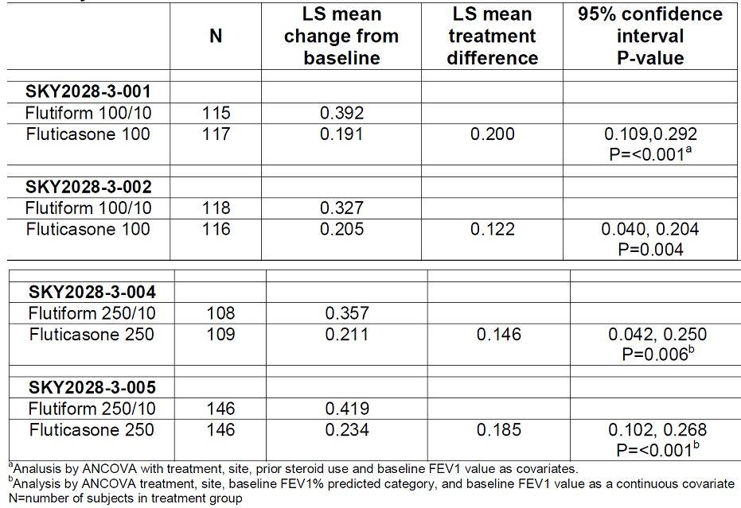
The sponsors also conducted a post-hoc analysis to look specifically at the change from pre-dose FEV₁ to 2-hours post-dose FEV1 on day 1 in the phase III studies incorporating Flutiform doses with the 5 ug per actuation strengths as above (SKY2028-3-001, SKY2028-3-002, SKY2028-3-004, SKY2028-3-005). This endpoint isolates the LABA effect, as fluticasone has no acute bronchodilatory effect, and therefore more specifically demonstrates the additional benefit provided purely by formoterol over fluticasone alone at this dose (Table 58).
Table 58: Mean change from pre-dose FEV1 at Day 1 to 2-hour post dose on Day 1 – Full Analysis Set.
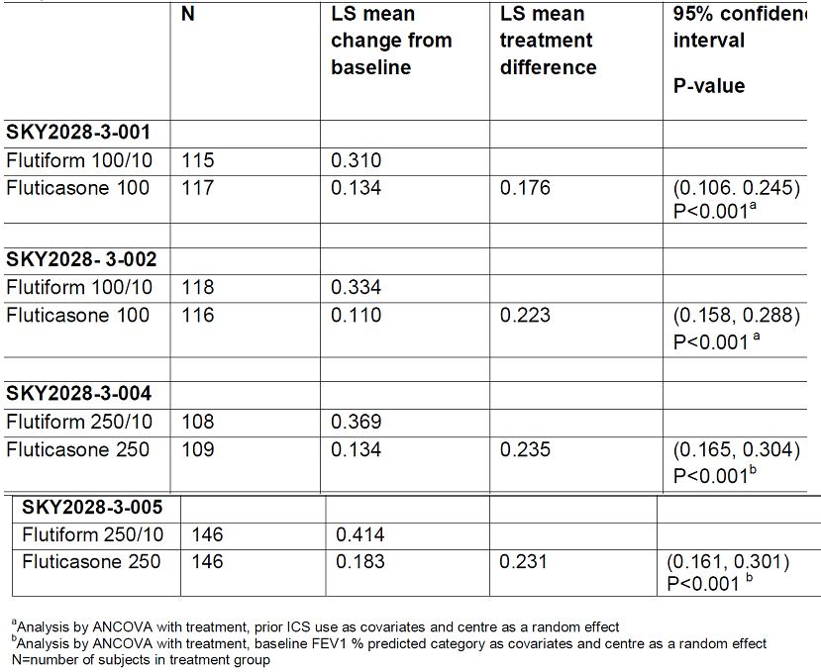
The sponsors state that all orally-inhaled products, particularly corticosteroids but also β2-agonists (such as formoterol) and anti-muscarinics, exhibit a shallow dose-response for standard clinical parameters of efficacy, such as lung function and symptom scores, in most patient populations, particularly those with mild-to-moderate asthma (Fishwick 2001; Adams 2006). Thus several-fold multiples of low drug doses are usually required to demonstrate a large, reliably reproducible difference in efficacy (Busse 1998; Shapiro 1998; Ringdal 1998). Therefore, despite the observed differences in bioavailability of formoterol between the two studies of interest, the magnitude of these differences in exposure relative to the comparator mono-components (Foradil DPI in SKYE2201C/8722/01 and Foradil pMDI in FLT1501) is not sufficient for a difference in efficacy to be expected in either case.
Despite the 25% reduction in formoterol bioavailability from Flutiform compared to Foradil pMDI in study FLT1501. The pivotal study FLT3503 demonstrated non-inferiority of Flutiform with regards to the primary lung function endpoints compared to the individual mono-components Flixotide and Foradil, given concurrently. With respect to the efficacy of formoterol specifically in study FLT3503, the change from pre-dose FEV1 at day 1 to 2-hours post-dose FEV1 at endpoint (day 56) and at day 1 are presented in Table 59.
Table 59: Comparison of Flutiform pMDI 500/20 ug to GSK fluticasone pMDI 500 ug + Novartis formoterol pMDI 24 ug, and to GSK fluticasone pMDI 500 ug alone: ITT population (Study FLT3503).
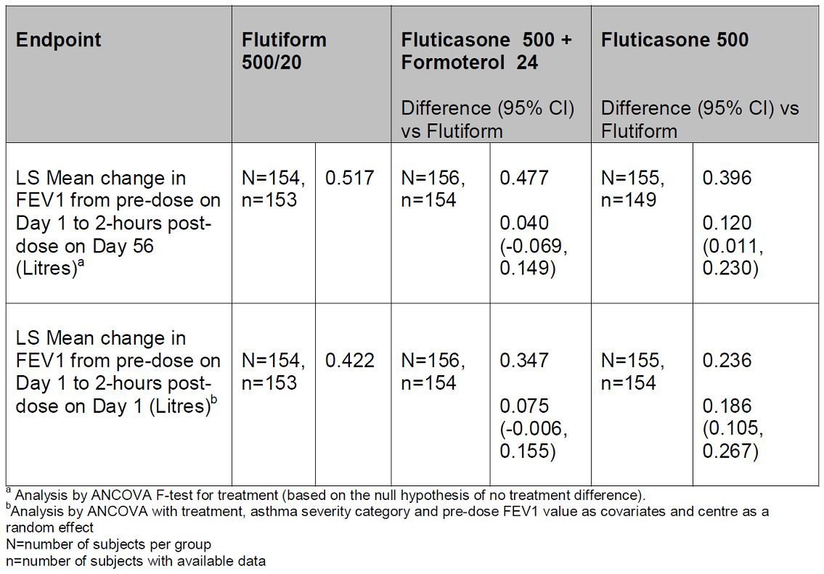

Evaluator’s comments
The concerns raised by evaluators were not adequately addressed by the sponsors due to the following reasons:
- Although it is acknowledged that the exploratory study SKYE2201C/8722/01 pre-dates any formoterol pMDI availability in Europe, the fact remains that a trend of HFA pMDI formulations resulting in higher exposure than DPI has been reported in the literature (Brindley, 2000 and Thorsson, 2001) which could have confounded interpretation of results. Furthermore, it is not clear why reduction of formoterol dose to 5ug was based on results of this exploratory study which did not comply with recommended CPMP guidelines (i.e. the test and reference product were not inhaled from the same pharmaceutical dosage form).
- Results from study FLT1501 which evaluated the pharmacokinetics following 4 weeks administration of Flutiform pMDI 500/20 ug and fluticasone pMDl 500 ug + formoterol pMDI 24 ug in healthy subjects and used the same administration devices (as recommended by the CPMP guidelines) showed that relative bioavailability of fluticasone and formoterol from Flutiform was 67% and 75% compared to that following administration of reference treatments. Furthermore, this study utilised plasma formoterol assessments compared to the exploratory study which only assessed urinary formoterol levels. Results from this study which appear to comply with recommended guidelines do not provide any evidence to support selection of 5 ug formoterol instead of the approved 6 ug formoterol (Foradil). The sponsors repeatedly mention that cross-trial comparisons are not justified and on this note the evaluators would like to make it clear that there is no intention to compare results from these 2 PK studies- there just does not seem to be any justification for using results of an early exploratory PK study (SKYE2201C/8722/01) not complying with CPMP guidelines for selection of the formoterol dose in Flutiform. However, another study (FLT1501) which appears to comply with recommended guidelines showed that in fact exposure to fluticasone and formoterol was slightly reduced following Flutiform compared with the individual reference treatments.
- Although the sponsors state that pivotal study FLT3503 demonstrated non-inferiority of Flutiform with regards to the primary lung function endpoints compared to the individual mono-components Flixotide and Foradil, given concurrently, assay sensitivity in this pivotal Phase 3 study was not conclusive. In the sponsor’s response, they have only provided a table showing change from pre-dose FEV1 at day 1 to 2-hours post-dose FEV1 at endpoint (day 56). There was no analysis of change in FEV1 over 12 hours on day 56 (mentioned as a limitation in earlier evaluation report) and sponsors have not provided this data in this submission either. This along with other limitations of this study (outlined in original report, p38-39) suggests that selection of the 5 ug formoterol dose in the Flutiform combination product was not adequately justified.

Question 3
Following single dose of Flutiform (250/10ug) in patients with mild/moderate asthma (study FLT2502), fluticasone (AUCt and Cmax) was consistently higher in adolescents compared with adults. Formoterol AUCt was similar in adolescent and adult groups, but Cmax was slightly higher in adolescents. The effects of higher systemic exposure to fluticasone and formoterol during long-term maintenance treatment of adolescents would be much more significant. Could the sponsor clarify this issue?

Sponsor’s response
The systemic exposure of both fluticasone and formoterol in Flutiform was shown to be higher in adolescents compared with adult asthmatic subjects in the single-dose study FLT2502 (Table 60). In order to investigate this apparent increase in systemic exposure in adolescents, an exploratory multivariate analysis was done post hoc to investigate the effects as some of the demographic characteristics on the results. Comparison of AUC and Cmax across demographic subgroups regardless of age (gender, race, weight, BMI, and FEV1 % predicted), showed trends in the data suggestive of lower exposure in females (versus males) and in subjects with a lower weight and BMI. Given this observation, it is notable that the baseline characteristics showed fewer females and more subjects with a lower weight and BMI in the adolescent group. Thus the higher systemic exposure levels seen with fluticasone and formoterol in adolescents may partly be explained by the demographic differences between the two age groups. This, along with evidence from the literature to support the notion that lung deposition increases with age and is similar between older children and adults (Devadson SG et al. 2003, Wildhaber JH et al. 1998), has led the sponsor to propose that the increased systemic exposure seen in adolescents in FLT2502 is due to similar pulmonary deposition together with a lower body weight (and volume of distribution), compared with adults and this is attributed to the similar pulmonary deposition together with a lower body weight (and volume of distribution) in this age group, compared with adults.
Table 60: AUCt and Cmax values for the fluticasone and formoterol components of Flutiform in adults and adolescents – Full Analysis population (Study FLT2502).
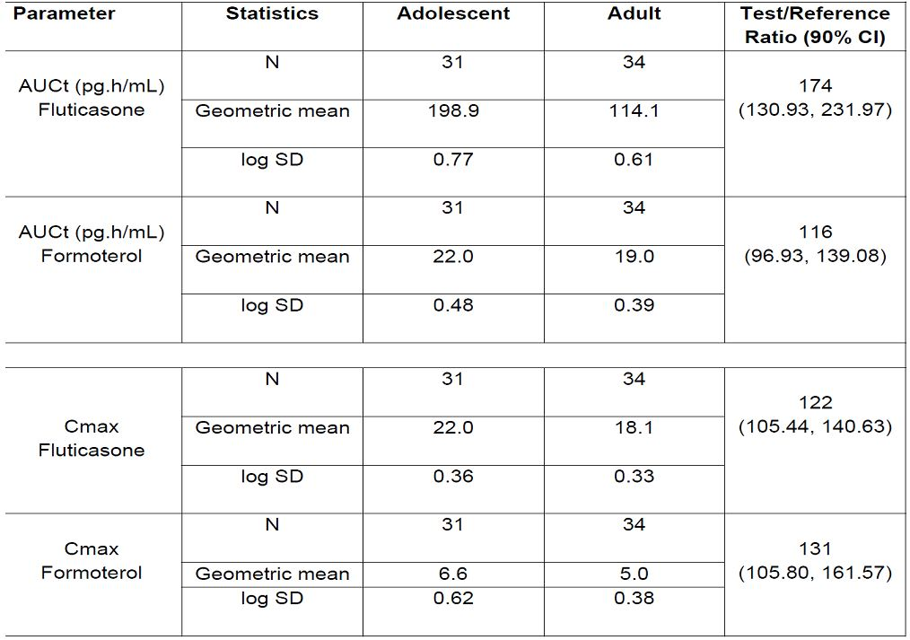
Given the observed increase in systemic exposure of both components of Flutiform in adolescents versus adults following a single dose, the Sponsor has performed a comparative analysis of AEs between adolescents (12 to ≤17 years) versus adults (18 to <65 years) based on pooled data from the randomised, phase III studies with mono-products arms (SKY2028-3-001, -002, -004 -005). These double-blind studies allow the most rigorous comparisons, and as they were of 12 weeks in duration, they provide evidence of the effects of maintenance therapy In order to demonstrate the safety of Flutiform relative to the fluticasone pMDI monoproduct alone in adolescents versus adults, the AE data from studies SKY2028-3-001, -002, -004 and -005 were pooled as all contained a fluticasone-only treatment arm. The overall proportion of patients with any AE was similar for adults and adolescents in the Flutiform group (37.0% vs 35.5%), and the percentages of patients with AEs were lower than for treatment with fluticasone alone for both age groups (46.9% vs 42.2%). There were a slightly higher proportion of treatment-related AEs in adolescents versus adults in both the Flutiform (13.0% vs 9.3% respectively) and fluticasone only treatment groups (12.2% vs 10.3%) (Table 61).
Table 61: Overall summary of AEs: SKY2028-3-001, 002, 004, 005 pooled analysis (safety set) for adolescents versus adults treated with Flutiform or fluticasone (GSK fluticasone pMDI).
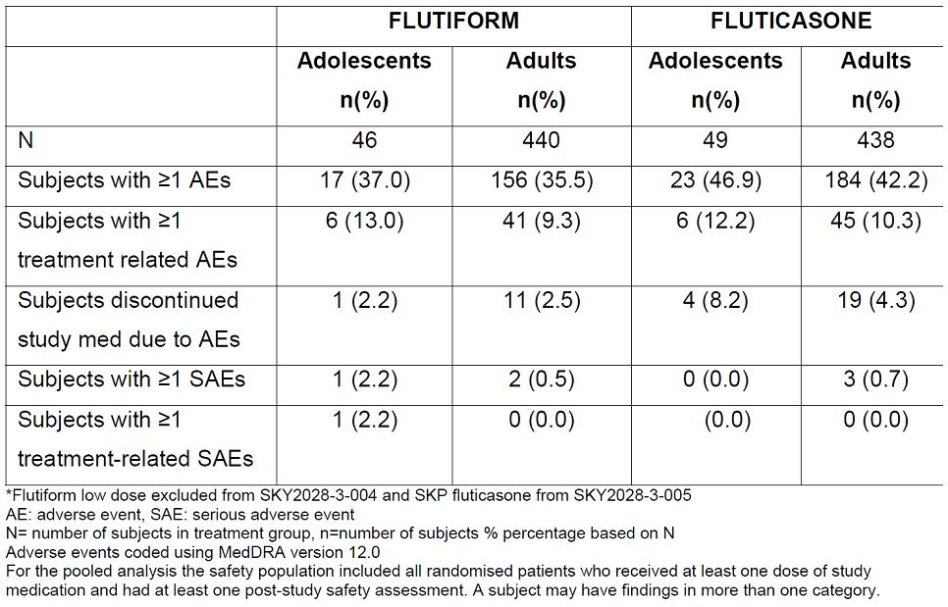
In order to demonstrate the safety of Flutiform relative to formoterol pMDI monoproduct alone in adolescents versus adults, the AE data from studies SKY2028-3-001, -002 and -004 were pooled as all contained a formoterol-only treatment arm. Overall number of patients with any AE was similar for adolescents and adults in the Flutiform group (37% vs 36.3%). There was a slightly higher number of treatment related AEs in adolescents versus adults (14.8% vs 11.1% respectively), although this pattern was reversed for the formoterol only arm (6.1% vs 15.7%) (Table 62). Given that the formoterol formulation and device components in Flutiform and SKP formoterol are identical, this inconsistency in comparative AE rates between adolescents versus adults for the two products argues against formoterol exposure-related causality for the observed AE pattern.
Table 62: Overall summary of AEs: SKY2028-3-001, 002 and 004 pooled analysis (safety set) for adolescents versus adults treated with Flutiform or formoterol (SKP formoterol pMDI).
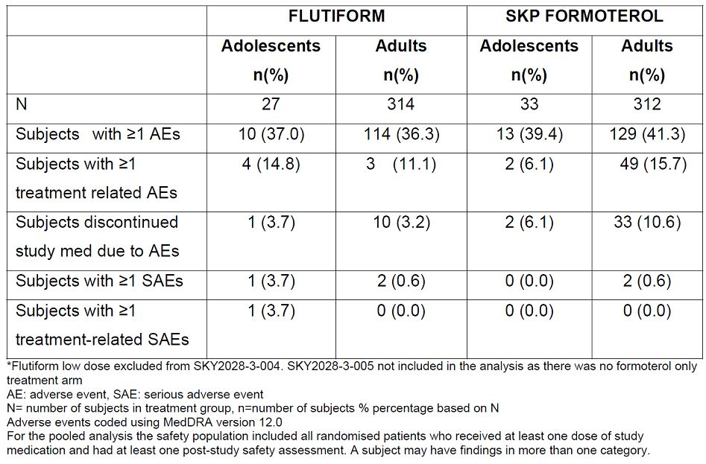
Supporting information about the systemic effects of the fluticasone component of Flutiform during maintenance therapy in adolescents was obtained from reviewing the effects on the HPA axis function which was studied in a small subset of patients in the open-label phase III Study FLT3505. This study compared Flutiform 250/10 ug bid to GSK fluticasone 250 ug pMDI + Novartis formoterol 12 ug DPI administered concurrently bid in adults and adolescents with mild to moderate-severe asthma for a treatment period of 12 weeks. Given the differences in fluticasone exposure noted between adolescents and adults with Flutiform seen in FLT2502, the Sponsor states that the results demonstrate no significant change from baseline in either adolescents or adults in relation to the effect of Flutiform on the HPA-axis as measured by urinary free cortisol i.e. there is no evidence of additional suppression in adolescent patients. This pattern was also replicated for the combination of fluticasone + formoterol administered concurrently via separate devices in the same study (Table 63).
Table 63: Urinary free cortisol (creatinine corrected) – Safety population post-hoc (Study FLT3505).
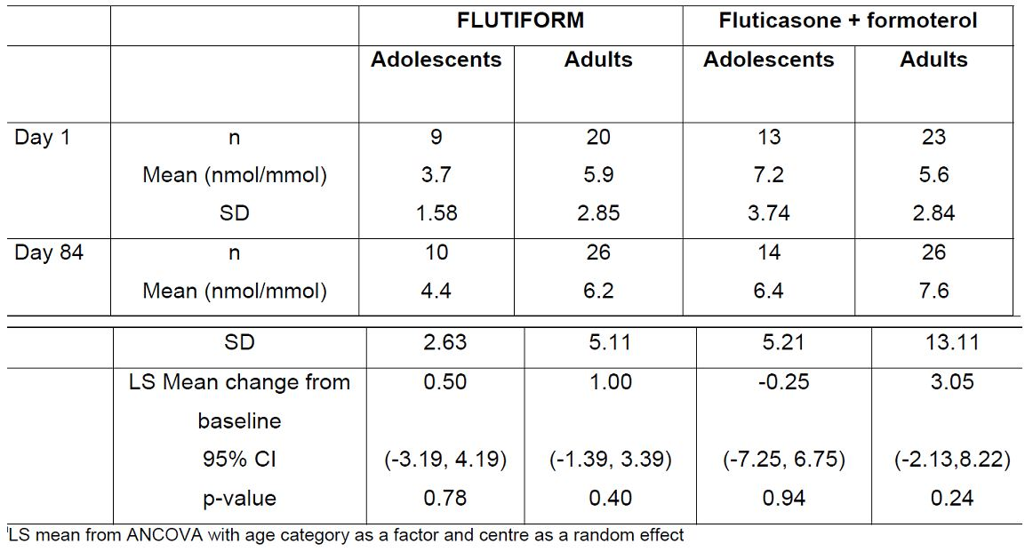
Overall, when combined with the adverse event profile, these data provide additional supportive evidence of the favourable safety profile of Flutiform in adolescents up to the proposed maximum dose (250/10 ug bid) for this age group during maintenance therapy.
With respect to the SOCs and down to the PT level, imbalances were noted for adolescents versus adults for Flutiform for a number of different events but reassuringly, any differences observed were generally of a similar magnitude to those of the individual mono-products for the same event. However, directional inconsistencies for individual adverse events which would be linked to the same safety signal, suggest that such differences reflect random variation between the groups and are not indicative of AE signals. This, coupled with a lack of evidence of any overt differential effect on the HPA axis (as measured by urinary free cortisol) in this age group, provides clarification that despite the observed increase in systemic exposure of fluticasone and formoterol (in study FLT2502), the safety profile of Flutiform is favourable in adolescents up to the proposed maximum dose of Flutiform (250/10 ug bid) and similar to that in adults.

Evaluator’s comments
The sponsor attempted to explain the higher exposure to fluticasone from Flutiform compared to monocomponent to demographic differences in adolescent vs adult groups; however, this was only analysed post hoc and there has been no systematic assessment of effect of age, gender, body weight in the Flutiform clinical trial programme (no population-pharmacokinetic analysis).
Although post-hoc safety analysis comparing AE incidence in adolescents and adults from the pivotal Phase 3 studies do not reveal significant differences in safety, these results have to be interpreted with caution due to very small sample size of adolescents (n-49 ) compared to adults (n=442).
Although urinary cortisol levels also failed to show significant difference between adolescents and adults following Flutiform after 12 weeks of maintenance treatment, actual treatment duration are likely to be much longer and there is no long-term safety data in adolescents. Although the Phase 3, open-label study SKY2028-3-003 did evaluate long term safety in 472 adult and adolescent subjects with mild to moderate-severe asthma, there was no separate safety analysis in adolescents.

Question 4
Systemic exposure of fluticasone increased with increasing dose in healthy subjects (SKY2028-1-002) and in subjects with mild to moderate asthma (SKY2028-2-001) who received Flutiform 100/10ug and 250/10ug. In both studies, the mean systemic exposure deviated from dose proportionality, but high variability prevented a definitive assessment of dose-proportionality of fluticasone in plasma. Systemic exposure of fluticasone in healthy subjects (FLT1501) who received Flutiform 500/20ug was higher that would have been predicted from the previous studies in lower doses, but Flutiform was administered with a spacer in this study which may have contributed to the increase in systemic exposure. Could the sponsor comment on the lack of adequate data on dose-proportionality.

Sponsor’s response
The studies (SKY2028-1-002 and SKY2028-2-001) were not designed to confirm dose-proportionality. Furthermore, with regards to the issue of dose proportionality, standardisation of inspiratory manoeuvres was not rigorous (pre-study training neither incorporated use of an inspiratory flow meter such as the In-Check Dial, nor did monitoring during the study involve use of an inspiratory flow recorder). Moreover the study was of parallel group (not crossover) design which is likely to have led to even greater differences between patients and hence no definitive conclusions on dose proportionality should be drawn from study SKY2028-1-002. The sponsors claim that an assessment of dose proportionality should be made using available pharmaceutical data and provided delivered dose data for the pivotal clinical batches (Table 64). The proportionality of the fine particle dose (FPD) was therefore also evaluated using the pivotal clinical batches at release and on stability (Table 65).
Table 64: Batches used for re-evaluating the target delivered dose with the mean delivered dose data obtained at release and on stability.
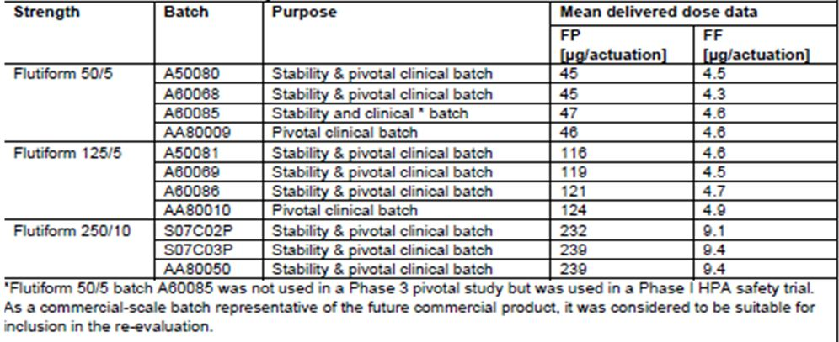
Table 65: Batches used in the assessment of FPD dose proportionality with the mean FPD data of release and stability results.
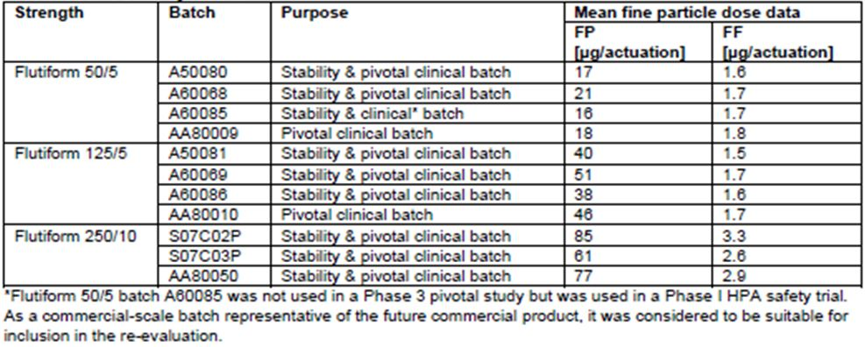

Evaluators comments
Data on delivered dose data and fine particle dose from the clinical studies drug batches cannot be considered as evidence of dose proportionality in human subjects/patients. Furthermore, no pulmonary deposition studies were conducted with Flutiform.

Question 5
The study FLT1501, the results suggest that relative availability of fluticasone and formoterol was only 67% and 75%, respectively following 4 weeks treatment with Flutiform pMDI 500/20 ug compared to administration of fluticasone pMDI 500 ug and formoterol pMDI 24 ug. The sponsors have done a dose-adjusted analysis which suggests that relative availability of formoterol increased to 84-90% when adjusted for ‘nominal dose’ and ‘delivered dose’. However, the study report does not define nominal or delivered dose and also does not state how these were actually assessed. Could the sponsors please provide clarification on this issue?

Sponsor’s response
As outlined in the statistical analysis plan of study FLT1501, pre-defined dose-adjusted analyses for formoterol were performed in order to derive relative systemic availability values, as the nominal and delivered doses are different for the formoterol component of Flutiform and for Foradil. Nominal dose (metered dose) is defined as the quantity of drug substance contained in the delivery device metering chamber and is the amount of drug per actuation delivered from the valve (without the actuator attached) i.e. ex-valve amount. Delivered dose is the quantity of drug substance that is available to the user through the actuator, ex-device, i.e. ex-actuator amount. As pre-specified in the statistical analysis plan, both nominal and delivered dose adjustments were performed prior to the analysis. For the nominal dose-adjusted analyses, the parameters for Flutiform were divided by 10 and the parameters for Foradil were divided by 12. For the delivered dose-adjusted parameters, the parameters for Flutiform were divided by 9 and the parameters for Foradil were divided by 10.1.

Evaluator’s comments
The explanation provided by the sponsors appears to suggest that exposure to formoterol was similar following Flutiform and individual reference treatments following dose-adjusted comparisons which were made in two ways: according to nominal dose, and according to delivered dose. Nominal dose adjustment changed the steady-state relative bioavailability of formoterol fumarate from Flutiform™ relative to the reference treatments from 75% to 90%, Cmaxss ratio changed from 57% to 69%, and the Cminss ratio changed from 76% to 91%. Delivered dose adjustment changed the steady-state relative bioavailability of formoterol fumarate from Flutiform™ relative to the reference treatments from 75% to 84%, Cmaxss ratio changed from 57% to 65%, and the Cminss ratio changed from 76% to 85%. Dose-adjusted analyses were not done for fluticasone as nominal and delivered dose were the same.

Efficacy

Question 1
In the pivotal study FLT3503, there was no placebo control and the demonstration of significant benefit of using Flutiform over fluticasone alone was supposed to provide evidence that the study was sensitive enough to detect treatment differences. Superiority of Flutiform high dose to fluticasone alone was shown for the co-primary endpoint of change from predose at baseline to 2 hours postdose at week 8 (LSMean of the treatment difference: 0.120 L; 95% CI: 0.011 to 0.230; p=0.032; ITT). This was expected due to the missing contribution of the LABA component to post-dose lung-function measurements in this treatment group. However, the clinical relevance of the 120 ml increase in FEV1 is not clear. However, it was not shown for the primary endpoint of change from pre-dose at baseline to pre-dose at week 8. A post-hoc analysis (repeated measures ANCOVA) was performed for the change from pre-dose FEVl to 0.5,1,2,4,6,8,10, and 12 hours post-dose at Day 0. Superiority of Flutiform high dose versus Flixotide alone was only shown for the change in FEV1 from predose to 1 hour and 2 hours post-dose. A similar post-hoc analysis was not performed for the change from pre-dose FEV1 to 0.5,1,2,4,6,8,10, and 12 hours post-dose at Day 56. However, the 12 hour FEV1 mean change from predose on day 0 to predose and postdose on day 56 seems to suggest that mean change from pre-dose on day 0 to pre-dose and post-dose on day 56 did not show any significant difference between Flutiform high dose and fluticasone alone at any time point. Hence, it is important that similar post hoc analysis be done for day 56 too in order to elucidate the true effect of Flutiform on 12-hour serial FEV1. Overall, evidence for the clinical benefit of using Flutiform high dose over fluticasone alone was not unequivocal in terms of 12-hour serial FEV1 and so evidence of assay sensitivity in this pivotal Phase 3 study was not conclusive. Can the sponsor comment on this limitation of a ‘pivotal’ study?

Sponsor’s response
Predose FEV1: The sponsors acknowledge that superiority of Flutiform high dose over fluticasone monotherapy was not shown for change in pre-dose FEV1.. However, the sponsors stress that change in pre-dose FEV1 measures treatment effect when the formoterol component has worn off, i.e. 12 hours post-dose, as evidenced by the comparison between Flixotide + Foradil versus fluticasone given alone: The treatment difference between Flixotide + Foradil versus fluticasone given alone was -40 mL (the same Flixotide product batches were used in both treatment arms, hence similar ICS effect is assured) highlighting that formoterol effects have largely abated pre-dose, i.e. this endpoint assessed a principally ICS-mediated effect. Therefore a substantial difference between Flutiform and fluticasone monotherapy would not be expected for pre-dose FEV1 in study FLT3503. Furthermore, while the sponsor accepts the lack of assay sensitivity of the pre-dose FEV1 endpoint, it should be noted that point estimate differences between Flutiform high dose and Flixotide + Foradil were in favour of Flutiform (60 mL [-59, 180]) (Table 66).
Table 66: Change in pre-dose FEV1 from day 0 to day 56 – PP population.
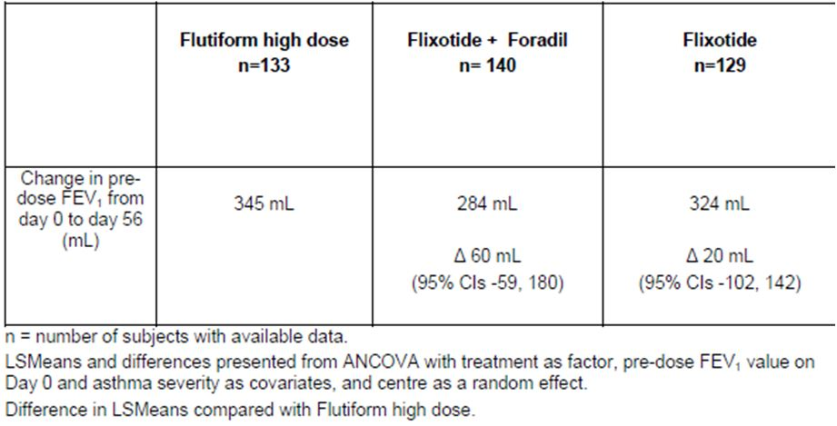
2-hour pose dose FEV1: clinical relevance of an observed treatment difference of 120 mL for 2-hours post-dose FEV1 between Flutiform high dose and fluticasone monotherapy, given that the pre-specified non-inferiority margin was 200 mL. A 200 mL non-inferiority margin was chosen as it is frequently cited in the literature. However, it is widely recognized that the magnitude of a clinically relevant effect is likely to depend upon baseline disease severity and GINA treatment step alongside other variables and that it therefore varies for different patient populations. Regarding the clinical relevance of the observed spirometric effects of Flutiform high dose versus Flixotide it is perhaps best contextualised by considering symptomatic benefits. Compared with fluticasone monotherapy, Flutiform high dose led to a 22% relative increase in both symptom-free days and awakening-free nights, a 12% relative increase in days without rescue medication use, a 14% relative increase in asthma control days and a 33% relative increase in mean AQLQ score, a validated health-related quality of life questionnaire. These observations suggest that spirometric benefits with Flutiform high dose were associated with clinically relevant improvements in symptoms. The 2-hour post-dose FEV1 data in Table 67 demonstrate a separation between the effects of both combination treatments versus fluticasone monotherapy, suggesting assay sensitivity as is required to facilitate a non-inferiority comparison between the combination treatment arms. It is noted that the lower limit of the 95% confidence interval for the LSMean difference between Flutiform and Flixotide + Foradil is (-) 98 mL.
Table 67: Change in pre-dose FEV1 from Day 0 to 2-Hour post-dose FEV1 at Day 56 – PP population.
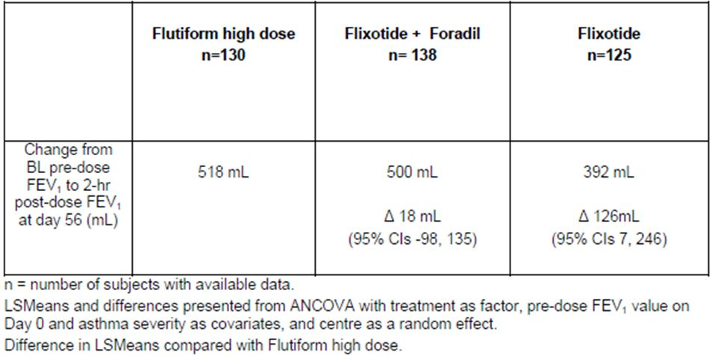
12-hour FEV1 AUC: regards the evidence of assay sensitivity with 12-hour FEV1 AUC as inconclusive as superiority of Flutiform over fluticasone for FEV1 AUC at Day 0 was only seen after a post-hoc analysis at 1 hr and 2 hrs post-dose. Study FLT3503 was not powered to show superiority of Flutiform over fluticasone with regards to 12-hour FEV1 AUC. The FEV1 AUC data at Day 0 were based on a subgroup of only approximately 50% of the total population. The mean difference was 1025 ml*hours in favour of Flutiform compared to Flixotide (ITT population) (Table 68). With the complete population sample it is likely that a significant difference would have been demonstrated for FEV1 AUC.
Table 68: 12-Hour serial FEV1 AUC [L*Hours] at Day 0 – PP population.
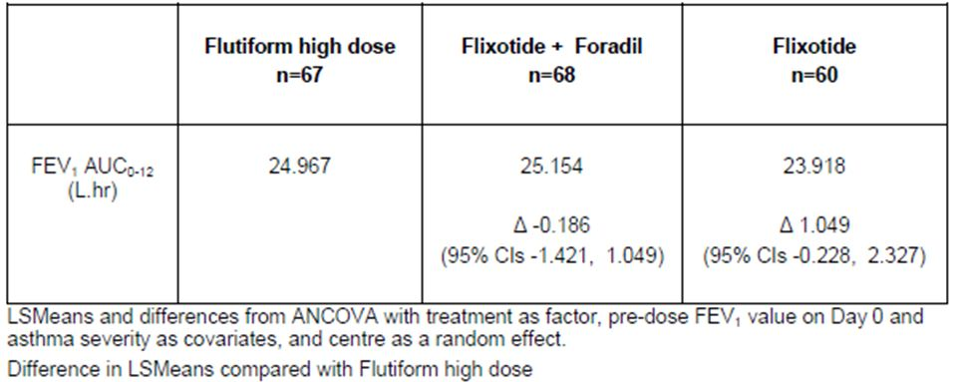
Repeated measures post dose ANCOVA at day 56: repeated measures ANCOVA for FEV1 at Day 56 was based on a subgroup of even less than 50% of the total population as these data were collected at the end of the study. Again this endpoint was not powered to show superiority of Flutiform over fluticasone. Nonetheless mean differences at all endpoints apart from 12 hours post-dose favoured high dose Flutiform and ranged upward from 23 mL at 10 hours post-dose to 104 mL at 4 hours post-dose that despite an underpowered analysis, the lower limit of the 95% confidence interval for the LSMean difference between Flutiform and Flixotide + Foradil of (-) 98 mL is close to the LSMean difference between Flutiform versus fluticasone monotherapy (62 mL), which is suggestive, albeit not confirmatory, of noninferiority between the combination formulations (Table 69).
Table 69: Overall repeated measures analysis of change from pre-dose FEV1 (mL) at Day 56 – ITT population.
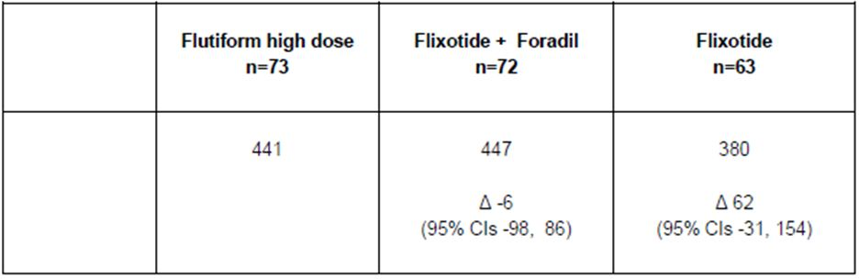

Evaluator’s comments
The sponsor has accepted that there is lack of assay sensitivity of the pre-dose PEV1 endpoint although they stress that point estimate differences between Flutiform high dose and Flixotide + Foradil were in favour of Flutiform (60 mL [-59, 180]). However, it is important to note that the 95% CI were quite wide.
The 2-hour post-dose FEV1 also only showed an observed difference of 120ml between Flutiform high dose and Flixotide + Foradil which was less than the pre-defined non-inferiority margin of 200ml. However, the Flutiform high dose did show relevant symptomatic benefits compared to fluticasone monotherapy but these would be expected considering the added bronchodilator effect of the LABA component in Flutiform and cannot be used to justify assay sensitivity. There were no statistically significant differences between Flutiform high dose and fluticasone + formoterol or Flutiform low dose for asthma symptom score, percentage of symptom-free days, improvement in sleep disturbance score.
More concerning is the fact that 12-hour FEV1 AUC showed superiority of Flutiform over fluticasone only at 1 and 2 hours post-dose. The sponsors justify this by stating that only 50% of the sample size was included in these analyses and <50% of patients were included in the repeated measures post-dose ANCOVA for FEV1 at day 56 which may have accounted for reduced observed effect . However, this is another limitation of the study as the CHMP guidelines for inhalational products for treatment of asthma recommend that the appropriate primary variables are FEV1 AUC (measurement of bronchodilatation over at least 80% of the duration of action after a single inhalation) and change in FEV1 (at an appropriate time points).
Overall, the sponsor’s response fails to address the concerns regarding lack of conclusive evidence of assay sensitivity in the pivotal Phase 3 study FLT3503 confounding interpretation regarding results related to non-inferiority of Flutiform 500/20ug compared to fluticasone 500ug + formoterol 24ug.

Question 2
The ‘pivotal’ study FLT3503 had a treatment duration of only 8 weeks which was clearly below the recommended CPMP guidelines for asthma drugs (CPMP/EWP/2922/01). Other approved LABA+ICS inhaled combination treatments (such as Seretide and Symbicort) evaluated efficacy over treatment periods of ≥12 weeks. The superiority pivotal Phase 3 Flutiform studies as well as most of the non-inferiority and superiority supportive Phase 3 studies were all of 12-weeks duration. The sponsors need to clarify reasons behind a shorter treatment period for the pivotal FLT3503 study.

Sponsor’s response
Eight weeks was chosen as the minimal acceptable trial duration in accordance with the guideline for orally inhaled products, CPMP/EWP/4151/00 Rev. 1, which came into effect in Europe in 2009 and was adopted by TGA effective 23 February 2010. The trial duration was also approved in a scientific advice meeting with the MHRA on 21 July 2008. CPMP/EWP/4151/00 Rev. 1 represents the most recently adopted guideline applicable to orally inhaled products and recommends a study duration for inhaled corticosteroids between 8 and 12 weeks. With corticosteroid-based therapy improvement of lung function and symptom control in asthma typically occurs rapidly, within one to two weeks (GINA 2010). Treatment effects are generally near- maximal by about 4 weeks and maximal by 8 to 12 weeks and do not attenuate thereafter. Therefore a treatment period of 8 or 12 weeks is equally suitable, the only difference being that the latter is more commonly used.
The pooled results of the randomised, double-blind phase 3 studies SKY2028-3-001, -002, -004 and -005 endorse the observations above and the rationale for either an 8 or 12 week trial duration as advocated by CHMP. Figure 14 shows the steepest increase in pre-dose FEV₁ with Flutiform treatment within the first 2 weeks, only further small changes between 2 and 12 weeks of treatment, and little difference in effect between 8 and 12 weeks of treatment. A similar evolution in pre-dose FEV₁ can be seen with Flixotide treatment.
Figure 14: Mean change in pre-morning dose FEV1 (L) from Week 0 to Weeks 2, 4, 8 and 12 for treatment with Flutiform and Flixotide – ITT population (pooled data of SKY2028-3-001, -002, -004 and -005 [LOCF]).
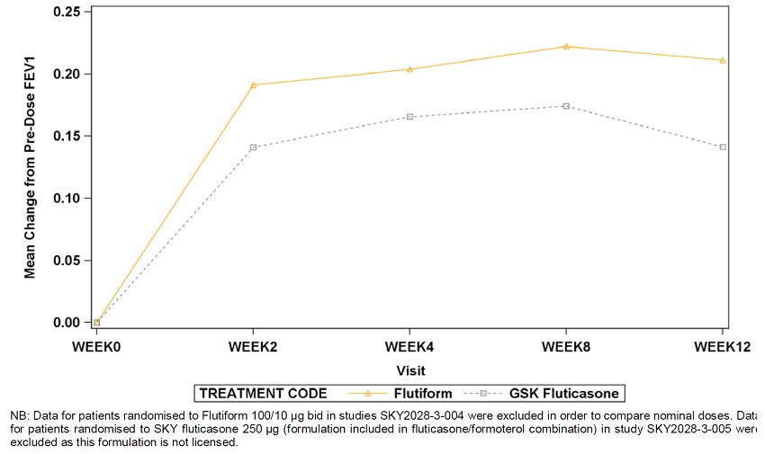
Further support for the trial duration is available from the literature. Multiple longitudinal studies have demonstrated that key conventional endpoints measured in Phase 3 studies, i.e., lung function effects and symptoms scores, are sustained but do not usually improve beyond that seen at 3 months with ICSs and ICS-LABAs (Haathela 1991, Rosenhall 2003, O’Byrne 2007). Haathela et al. (1991) treated 103 asthmatic patients with either 600 ug budesonide or 375 ug terbutaline twice daily. Figure 2 shows the mean morning and evening peak expiratory flow rates recorded for 12 weeks after randomisation and then for the last 4 weeks of the first and second study years lung function improved with budesonide treatment over the first 6 weeks after randomisation and was sustained thereafter (Figure 15). Another study by Scicchitano et al. (2004) randomised 1,890 asthmatic patients to 12 months of treatment with either budesonide 320 ug bid plus 0.4 mg terbutaline as needed or Symbicort 320/9 ug once daily plus additional inhalations as needed. Lung function (measured by morning PEF) improved with budesonide and Symbicort treatment over the first 6 weeks after randomisation and was sustained thereafter (Figure 16).
Figure 15: Mean morning and evening peak expiratory flow rates over 12 weeks of treatment with budesonide and terbutaline and then for the last 4 weeks of the first and second study years (data from Haathela et al. (1991)).
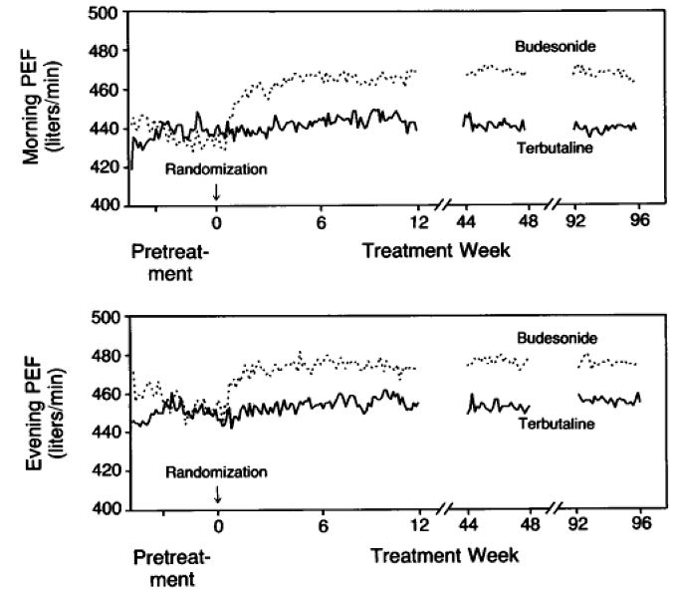
Figure 16: Mean morning peak expiratory flow rates over 12 months of treatment with budesonide 320 ug BID + terbutaline as needed or Symbicort 160/9 ug OD + additional inhalations as needed (data from Scicchitano et al. (2004)).
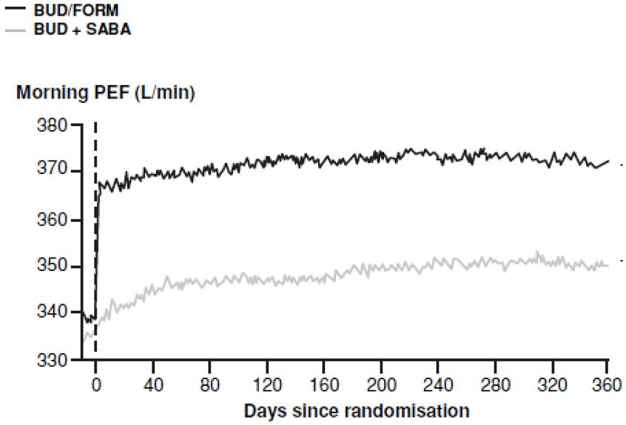
Given that Flutiform is comprised of two well-known active substances supported by an extensive literature base, there does not appear to be an obvious rationale as to why treatment effects would evolve at a similar rate to that previously reported for these well-known substances and the wider drug classes over an 8 or 12 week treatment period but then diverge from the pattern previously reported during long-term treatment.
Indeed, pre-dose FEV₁ data from long-term study SKY2028-3-003 confirm this pattern. In this study 216 patients were treated with Flutiform 100/10 ug or 250/10 ug twice daily over a period of 12 months. the published literature and the sponsor’s previous studies demonstrate that lung function effects with ICSs or ICS-LABAs are maximal at 8 weeks and are sustained thereafter. As such treatment effect differences will be similar whether measured at 8 or 12 weeks and selection of one or other of these treatment durations would not be expected to fundamentally alter the conclusions of the study. The most recently adopted CHMP and TGA regulatory guidance pertaining to orally inhaled products also allows for a study duration of 8 weeks. Finally current GINA guidelines indicate that maintaining patients on a high dose of maintenance treatment for a fixed duration of 6 months should not be standard practice. Given all of the above, the sponsor considers that the 8 week duration of FLT3503 was appropriate to investigate the efficacy of Flutiform.

Evaluator’s comments
The sponsor’s explanation for suggesting that 8-week duration for study FLT3503 was acceptable.

Question 3
In the pivotal study FLT3503, no subgroup efficacy analysis results. Analysis of efficacy in subgroups of patients based on severity of asthma and baseline disease characteristics would help to better define the patients most likely to benefit from Flutiform treatment. Was such a subgroup analysis done for the pivotal studies and if it was, could the sponsors please provide results.

Sponsor’s response
The sponsor has undertaken post-hoc subgroup analyses by asthma severity for all efficacy endpoints in study FLT3503. Randomisation into the study was stratified by % predicted FEV1 at baseline (>40 <60% versus >60 <80%). This provided a straightforward basis for a dichotomised analysis by baseline FEV1 severity, more so since the dichotomy split the total sample into two substantial and very similar sized subgroups (52% and 48% of the total ITT sample, respectively).

Spirometry summary
The main findings from these subgroup analyses were:
i) The comparative spirometric effects of Flutiform 500/20 and Flixotide 500 + Foradil 24 were similar in the overall population and in the “moderate” and “severe” patient subgroups with similar mean improvements in pre-dose and 2-hour post-dose FEV1 and in PEFR that were consistent with or exceeded thresholds defined as being of minimal clinical importance.
ii) Flutiform 500/20 conferred (at least numerically) greater treatment effects than Flixotide 500 monotherapy for most spirometric endpoints. The only clear subgroup trend evident for this product comparison was a greater treatment effect difference (in favour of Flutiform) for FEV1 AUC1 in “moderate” asthma patients. This may suggest that patients with less severe disease manifest a more prolonged treatment response with LABA therapy, appears to be driven by a higher than anticipated treatment effect in the Flixotide 500 “severe” subgroup. Since ICSs have no acute bronchodilatory effects, pre-dose and 2-hour post FEV1 effects with Flixotide 500 should be fairly similar. However , there is approximately 100 mL difference in the pre-dose and 2-hour post-dose values for the Flixotide 500 “severe” subgroup. The “severe” subgroup post-dose value may be spurious and somewhat misleading therefore and may hinder an assessment of the subgroup data for this endpoint. With respect to 12-hour FEV1 AUC at days 0 and 56 greater treatment effect differences between Flutiform 500/20 and Flixotide 500 were evident in the “moderate” asthma subgroup than in “severe” patients. As for the 2-hour post-dose FEV1 data, this trend was also evident when comparing Flixotide 500 + Foradil 24 and Flutiform 100/10, respectively, to Flixotide 500. Unlike the 2-hour post-dose FEV₁ data however, there do not appear to be any outlying and implausible results in any treatment subgroups. As FEV1 AUC reflects LABA effect (in addition to ICS effect in the case of FEV₁ AUC at day 56), the observed results suggests that the duration of LABA-mediated bronchodilatation may be greater in patients with “moderate” versus “severe” asthma. With respect to the pre-dose FEV₁ and the PEFR data, there were no robust, consistent trends to suggest differential treatment effect differences in patients with “moderate” or “severe” asthma.
iii) Neither the overall data nor subgroup analyses (in the “moderate” or “severe” subgroups) demonstrated a dose-response relationship between Flutiform 500/20 and 100/10 doses for spirometric variables.

Symptom-based endpoint summary
The main findings from this subgroup analysis were:
i) Flutiform 500/20 and Flixotide 500 + Foradil 24 exerted similar treatment effects for all symptom-based endpoints in the overall population. Some minor differences between Flutiform 500/20 and Flixotide 500 + Foradil 24 were noted in the subgroup comparisons, but these followed no plausible pattern and are likely to be random differences.
ii) For the overall population Flutiform 500/20 was superior to Flixotide 500 with regards to discontinuations due to lack of efficacy, asthma symptoms, % symptom-free days, % awakening-free nights and AQLQ. Numerical advantages of treatment with Flutiform 500/20 over Flixotide 500 were seen for sleep disturbance scores, % rescue-medication-free days and % asthma control days.
Subgroup analyses of symptom-based endpoints suggested more pronounced treatment effect differences between Flutiform 500/20 and Flixotide 500 in “severe” asthmatics for the following endpoints: % symptom-free days, % awakening-free nights, % rescue-free days and AQLQ scores. These observations are supported by the corresponding “severe” subgroup data for Flixotide 500 + Foradil 24 versus Flixotide 500, which showed a similar trend For the overall population there was no difference in the proportion of Flutiform 500/20 versus Flixotide-treated patients who reported asthma exacerbations (36.4% versus 37.4%, respectively). In “severe” patients there did however appear to be a trend whereby the proportion of patients with exacerbations was numerically lower in the Flutiform 500/20 group versus the Flixotide 500 group (31.6% versus 43.9%). This pattern was however reversed in the “moderate” subgroup with exacerbations reported in more Flutiform 500/20-treated patients (41.3% versus 30.1%). The marked similarity of the Flutiform 500/20 subgroup data to those observed for Flixotide 500 + Foradil 24, and the lack of a plausible explanation for the Flixotide 500 “moderate” subgroup data (patients in the Flutiform 500/20, Flixotide 500 + Foradil 24 and Flixotide 500 treatment groups all received high dose fluticasone therapy) suggests that the Flixotide 500 “moderate” subgroup data may be a random “outlying” result.
iii) A clear dose-response trend was seen when comparing the symptom-based endpoint data for Flutiform 500/20 versus Flutiform 100/10. For the overall population Flutiform 500/20 was statistically superior to Flutiform 100/10 with regards to discontinuations due to lack of efficacy, sleep disturbance scores and % awakening-free nights. Numerical advantages in favour of the high dose were also reported for 7 of 8 remaining symptom-based endpoints. Subgroup analyses showed that treatment effect differences between Flutiform 500/20 and 100/10 were more pronounced in severe asthmatics than in moderate asthmatics for the following endpoints: The change in mean symptom scores, the change in % symptom-free days, the change in mean sleep disturbance scores, the change in awakening free nights, the change in % rescue medications-free days, the change in % asthma control days, the incidence of any asthma exacerbations, the change in AQLQ score and the proportion of patients achieving a minimal important change (. 0.5 units) in AQLQ score. The differences between Flutiform 500/20 and 100/10 in the severe subgroup were statistically significant (at the 5% level) for sleep disturbance scores, % awakening-free nights and mean AQLQ. These data suggest that symptomatic treatment benefits of Flutiform 500/20 are likely to be greatest in patients with severe asthma which is in keeping with established asthma management principles and guidelines.

Evaluator’s comments
The limited subgroup analysis in the pooled efficacy dataset (which only included patients from studies FLT3501 and DLT3505) did not show effect of age, gender, race, prior ICS use and baseline severity of asthma on the efficacy of Flutiform. However, there was no analysis of efficacy in subgroups in any of the pivotal Phase 3 studies which would have helped to better define the patients most likely to benefit from Flutiform treatment. In the sponsor’s response, only efficacy in subgroups based on moderate or severe COPD was done post hoc- no other subgroups analyses were provided. Overall, results of these new subgroup analysis showed a trend suggesting that Flutiform showed better spirometric improvement in patients with moderate asthma and better symptomatic improvement in patients with severe asthma, although these results should be interpreted with caution due the post-hoc nature of these analyses. Furthermore, no other subgroups analyses (such as effect of age, gender, race, other disease characteristics) were done for the pivotal study.

Question 4
In study SKY2028-3-001, the inclusion criteria for patients with mild to moderate asthma was % FEV1 predicted of 60-85%; according to the GINA classification of asthma severity, mild to moderate asthma, is defined as between 60-80% and it is not clear why the sponsors chose criteria of 85% for this study. Please clarify.

Sponsor’s response
Study SKY2028-3-001 was originally designed as part of a study programme to obtain marketing approval for Flutiform in the US. The study started in 2006 and was negotiated with the FDA when GINA and NAEPP guidelines defined mild asthmatic patients with an FEV1 predicted of >80%. As the FDA advised the sponsor company to capture mild asthmatic patients, patients with FEV1 predicted up to 85% were included. This was applied consistently throughout the US study programme for all studies that included mild to moderate asthmatic patients (SKY2028-3-002, SKY2028-3-003, SKY2028-2-002).
In the literature, a number of studies can be found that used 85% or 90% as the upper limit of FEV1 predicted as an inclusion criterion for patients with mild to moderate severe asthma (Adams 2008). There is unlikely to be a different treatment response in patients with an FEV1 of 60-80% predicted, 60-85% predicted or 60-90% predicted. Of note the current GINA guideline no longer classifies asthma severity using FEV1 % predicted, but rather defines asthma severity by the requisite treatment intensity to gain asthma control (GINA 2010).

Evaluator’s comments
The sponsor response to the above query is acceptable.

Question 5
In study FLT3505, the secondary efficacy endpoint was the change in FEV1 from pre-dose on Day 0 to 30-60 minutes post-dose on Day 84. Could the sponsors clarify why the post-dose time point of 30-60 minutes was chosen in this study compared to the 120 minutes post-dose time point in the other Flutiform studies.

Sponsor’s response
In study FLT3505, a pragmatic approach was taken in order to be able to send patients home early from their study visit, and thus a post-dose time point of 30 to 60 minutes was chosen to measure bronchodilation. According to literature, the bronchodilatory effect of formoterol sets in within 1-3 minutes post-dose and reaches its maximum after 1 to 3 hours (Foradil SmPC 2011). Similar effects were observed in the clinical development program for Flutiform. A rapid onset of action starting from 3 minutes was confirmed. To further investigate the bronchodilatory effect of Flutiform and fluticasone over the dosing interval, FEV1 AUC0-12 data from three 12-week, randomised, double-blind adult Flutiform studies (SKY2028-3-001, -004 and -005 in which serial spirometry was performed) were pooled. In all 3 studies Flutiform low and mid dose were compared to an equivalent nominal dose of GSK fluticasone pMDI. These studies are therefore relevant to study FLT3505 in which Flutiform low and mid dose were compared to an equivalent nominal dose of GSK fluticasone pMDI plus Foradil DPI. The spirometric benefit of Flutiform over fluticasone was sustained throughout the dosing interval in these studies with the steepest increase in FEV1 being observed within the first 30 minutes post-dose and the maximum effect being sustained during the first 4 to 6 hours. Of particular note given the assessor’s question the treatment effect difference between Flutiform and fluticasone is very similar at 30-60 minutes post-dose and at 2-hours post-dose (Figure 17). Accordingly, use of the 30-60 minute endpoint in Study FLT3505 would not have be expected to have generated different results compared to the 2 hours post-dose endpoint used in other studies.
Figure 17: Serial spirometry: AUC0-12 at Week 12 (calculated as the change from Day 1 pre-dose FEV1 baseline) in Studies 3-001, -004 and -005 – ITT population.
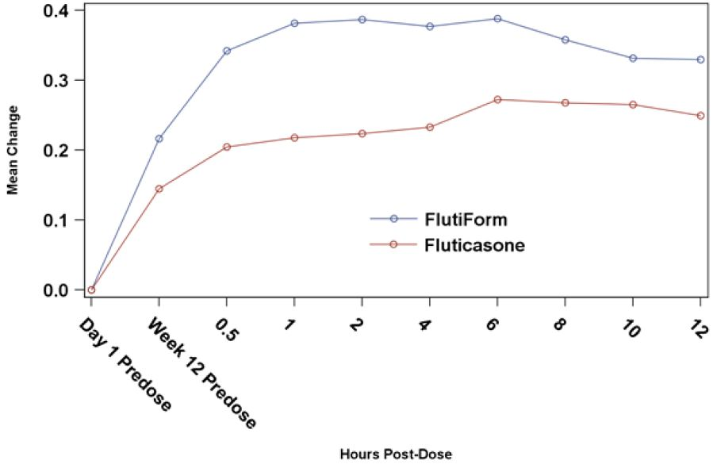

Evaluator’s comments
The sponsor response to the above query is acceptable.

Safety
None.

Summary and discussion

Clinical aspects

Clinical pharmacology
Flutiform is a new combination product administered by oral inhalation via a hydrofluoroalkane (HFA) propelled pressurised metered dose inhalation (pMDI) containing a fixed combination of an ICS- fluticasone propionate and a LABA-eformoterol fumarate dihydrate. Flutiform does not use a chlorofluorocarbon (CFC) as a propellant, making it more environmentally friendly and is in line with the gradual phasing out of all CFC-containing inhalers used in treatment of asthma. . The pMDI selected has been justified and has been used consistently throughout the clinical programme. The use of a spacer is recommended particularly for those with poor coordination such as the young and elderly, or those taking high dose ICS. A comprehensive assessment of 4 spacer devices was conducted, leading to the adoption of the Aerochamber Plus for use in part of the Phase 3 programme and recommendation in the proposed SmPC.
Overall, there is high variability in PK parameters of fluticasone and formoterol following administration of Flutiform both within and between the pharmacokinetic studies. However, in general there is a trend for the systemic exposure of fluticasone and formoterol to be less with Flutiform inhaler than with the individual components administered together as shown in single dose study AG2028-C101 and multiple dose study FLT1501. There have been no studies that directly compare exposure in healthy and asthmatic subjects.
The mean terminal half-life (t_{1/2}) of plasma fluticasone for SKP Flutiform after oral inhalation ranges from 10 to 14 hours across the studies. Plasma formoterol data have been gathered only in the more recent studies, FLT1501 and FLT2502.The mean values t_{1/2} of plasma formoterol for Flutiform after oral inhalation ranged from 6.5 to 9 hours across both studies. Hence, the twice daily dosing regimen for Flutiform appears to be justified.
Systemic exposure of fluticasone increased with increasing dose in healthy subjects (SKY2028-1-002) and in subjects with mild to moderate asthma (SKY2028-2-001) who received Flutiform 100/10 and 250/10. In both studies, the mean systemic exposures deviated from dose proportionality and the coefficients of variation associated with the various measures of AUC were high preventing a definitive assessment of dose-proportionality of fluticasone in plasma. Systemic exposure of fluticasone in healthy subjects (FLT1501) who received Flutiform 500/20 ug was higher than would have been predicted from the previous studies in lower doses, but this study used spacers.
Selection of formoterol dose of 5ug in the Flutiform pMDI formulation instead of 6ug in Foradil is based on the 24% to 39% higher mean cumulative amounts of formoterol excreted in urine in the Phase II study SKYE2201C/8722/01 in 45 subjects with asthma following single dosing with SKP formoterol pMDI 6ug compared to dosing with Foradil DPI (12ug and 24ug). However, this justification seems inadequate as has been discussed in detail this report. The main points were lack of use of similar devices (pMDI vs DPI), ‘increased’ exposure to formoterol was not associated with increased improvement in lung function parameters, urine formoterol is not a very accurate measure of actual exposure to formoterol. Most importantly, in another 4-week study FLT3501 which used similar devices and also measured plasma formoterol, relative bioavailability of fluticasone from Flutiform was only 67%, while that of plasma formoterol from Flutiform was 75% compared with fluticasone + formoterol. In study FLT1501, pre-defined dose-adjusted analyses for formoterol were performed in order to derive relative systemic availability values, as the nominal and delivered doses are different for the formoterol component of Flutiform and for Foradil. Nominal dose (metered dose) is defined as the quantity of drug substance contained in the delivery device metering chamber and is the amount of drug per actuation delivered from the valve (without the actuator attached) i.e. ex-valve amount. Delivered dose is the quantity of drug substance that is available to the user through the actuator, ex-device, i.e. ex-actuator amount. Nominal dose adjustment changed the steady-state relative bioavailability of formoterol fumarate from Flutiform™ relative to the reference treatments from 75% to 90%, Cmaxss ratio changed from 57% to 69%, and the Cminss ratio changed from 76% to 91%. Delivered dose adjustment changed the steady-state relative bioavailability of formoterol fumarate from Flutiform™ relative to the reference treatments from 75% to 84%, Cmaxss ratio changed from 57% to 65%, and the Cminss ratio changed from 76% to 85%.
No specific drug interactions studies were conducted with Flutiform. Results of the Phase 2, single dose study SKY2028-2-001 in asthma patients, wherein, the Cmax and AUC_{0-t} of fluticasone from the Flutiform 250/10 ug product were higher than those observed when the Flixotide 250 ug + Foradil 12 ug inhalers were used concurrently, but similar to those observed with the Flixotide 250 ug product alone indicated a possible interaction of formoterol on fluticasone PK when administered in the same inhaler compared to in separate inhalers.
Effect of age, gender, weight, race, renal/ hepatic impairment on pharmacokinetics of Flutiform was not evaluated. Following single dose of Flutiform (250/10ug) in patients with mild/ moderate asthma (study FLT2502), fluticasone (AUCt and Cmax) was consistently higher in adolescents compared with adults. Formoterol AUCt was similar in adolescent and adult groups, but Cmax was slightly higher in adolescents.
There were no changes to the Flutiform formulation during the clinical development and the proposed commercial Flutiform formulation was used in all the Phase 3 studies. No specific biopharmaceutics or bioavailability studies have been conducted. The influence of actuators and spacers on the delivery of the Flutiform product was evaluated. Overall, the actuators tested demonstrated a variable effect, and no discernible pattern with respect to exposure levels could be associated with the use of either actuator. Furthermore, all Phase 3 studies and majority of Phase 1 and 2 studies used the same actuator. No issues are anticipated when switching from Flutiform administration without an Aerochamber Plus to with an Aerochamber Plus, as results from all studies suggest that although exposure to fluticasone is increased following administration of Flutiform with a spacer, the influence of the spacer on fluticasone exposure is less with FlutiForm than it is with the mono-products.

Clinical efficacy
Flutiform is a fixed dose combination of 2 well known APIs, formoterol and fluticasone, which have been used to treat asthma successfully for many years and are often co-prescribed.
All 4 pivotal studies were of double blind, randomised, parallel group design, and aimed to demonstrate superiority of the combination product over its constituent drugs at each dose strength, or equivalence of the combination product compared to the two drugs taken concurrently from separate inhalers (concurrent therapy). The study design complied with recommended guidelines on the Clinical Investigation of Medicinal Products in the Treatment of Asthma CPMP/EWP/2922/01. The patient populations, study designs and efficacy measurements utilised in these studies were consistent with standard and accepted approaches to evaluate maintenance asthma therapy and are similar to studies included in development programmes for approved combination products with ICS and LABA except in pivotal study FLT3503. Pivotal study FLT3503 and SKY2028-3-004 included patients with severe persistent asthma, while studies SKY2028-3-001 and SKY2028-3-002 included patients with mild to moderate asthma; severity of asthma was well-defined based on FEV1% predicted as well use of rescue medication, sleep disturbance scores and asthma symptoms.
The Phase 3, open-label study 2028-3-005 demonstrated superiority of Flutiform 250/10 ug compared to SKP fluticasone and Flovent fluticasone (250ug) in adult/adolescent patients with moderate to severe asthma requiring inhaled steroids. Results from primary, secondary, and tertiary efficacy endpoints were generally clinically indistinguishable for SKP fluticasone 250 ug and Flovent fluticasone 250 ug which supports the use of Flovent fluticasone as a monotherapy comparator in the other Phase 3 studies.
Dose-response: In the Phase 3 programme, 2 studies (SKY2028-3-004 and FLT3503) assessed the dose-response. One of the main secondary objectives of Study FLT3503 was to demonstrate a dose response effect between Flutiform 500/20 and 100/10. Discontinuations due to lack of efficacy were reported for 6 subjects (3.9%) in the Flutiform high dose group, and 18 subjects (11.6%) in the Flutiform low dose group. In the Flutiform low dose group subjects started to discontinue soon after Day 14 reflecting that subjects were not optimally treated. Hence, there was no dose-response demonstrated for the co-primary efficacy endpoints. A post-hoc analysis showed superiority of Flutiform high dose vs Flutiform low dose overall including all time points and at each study visit except Day 56. The failure to show a statistically significant difference at Day 56 may be explained by more subjects discontinuing prematurely due to lack of efficacy in the low dose group. However, this again highlights the fact that the study population was not appropriate to detect dose-response of Flutiform. However, the high dose of Flutiform provided better outcomes than the low dose of Flutiform for a substantial number of clinically important endpoints. Overall, the evidence for dose-response between Flutiform 500/20ug and 100/10ug was not unequivocal.
In study SKY2028-3-004, no formal statistical analysis was done to evaluate dose response between Flutiform 250/10 and 100/10 with both doses showing comparable results. However, in the subgroup of subjects with severe disease (defined as FEV1 % predicted of 40% to 60%), Flutiform 100/10 had a greater mean increase in FEV1 predose at Week 12 (mean difference = 0.268 L) compared to Flutiform 250/10 (mean difference = 0.166 L), while the incidence of severe asthma exacerbations was lower in the Flutiform 250/10 (5.7%) group compared with Flutiform 100/10 (10.8%). However, these results should be interpreted with caution due to the small sample size in the severe disease subgroup. Overall evidence of dose response for the proposed Flutiform doses of 500/20, 250/10 and 100/10 was not adequate.

Efficacy in pivotal studies
Results of the pivotal non-inferiority study FLT3503 appeared to demonstrate non-inferiority between twice daily administration (for 8 weeks) of high-dose Flutiform (500/20ug twice daily) and fluticasone 500ug+ formoterol 24ug in adult patients with moderate to severe persistent asthma (who required ≥ 500ug fluticasone or equivalent ICS dose daily) in terms of primary and co-primary efficacy endpoints. However, the interpretation of results was confounded by limitations of the study, especially lack of assay sensitivity and other factors as outlined in this report.

Superiority of Flutiform 100/10ug and 250/10ug over its components
Results from the two pivotal superiority studies SKY2028-3-001 and SKY2028-3-002 demonstrated that Flutiform 100/10 provides greater efficacy compared to its components, fluticasone and formoterol, for the management of mild to moderate asthma. These studies enrolled both subjects who were and were not previously receiving ICS, which reflects the mixed population of patients suffering from mild to moderate asthma who will likely be treated with Flutiform The mean changes in FEV1 from pre-dose at baseline to pre-dose or 2 hours post-dose were generally numerically greater for Flutiform 100/10 compared to its components beginning at Week 2 and were sustained throughout the 12-week treatment Period. However, a mean increase of 100 to 118ml in pre-dose FEV1 and increase of 122-200ml in 2 hours post-dose FEV1 may not be clinically relevant. Results from multiple secondary efficacy endpoints assessing lung function, disease control and asthma symptoms generally supported the superior efficacy of Flutiform 100/10 compared to its components, fluticasone and formoterol. SKY2028-3-004 was a pivotal Phase 3, randomised, double-blind, placebo- and active-controlled, parallel group, stratified, 12-week study which established the superiority of Flutiform 250/10ug over its components as well as placebo in adult/adolescent patients with moderate to severe asthma who required steroids (inhaled steroid regimen for at least 4 weeks prior to the screening visit at a dose ≤ 500 ug/day fluticasone) in terms of primary endpoints (FEV1) as well as clinical endpoints. However, this study also showed mean increase in pre-dose and 2 hours post-dose FEV1 of only 189 and 146ml, respectively.

Evidence of efficacy from supportive studies
Results from the open-label, Phase 3 study FLT3505 showed that Flutiform (100/10 and 250/10) was non-inferior to its individual components, Flixotide plus Foradil (100/12ug and 250/12ug) in 210 adult/ adolescent patients with mild to moderate/severe asthma with regard to post-dose FEV1, change in pre-dose to post-dose FEV1, and discontinuations due to lack of efficacy. Analysis of the other efficacy parameters such as other pulmonary function tests, patient reported outcomes, rescue medication use, asthma exacerbations and AQLQ yielded comparable results for the Flutiform and Flixotide+Foradil treatment groups.
Results of the open-label, supportive study FLT3501 demonstrated non-inferiority of Flutiform (fluticasone/ formoterol 250/10 or 100/10ug) to Seretide (fluticasone/salmeterol 250/50 or 100/50ug) in 202 adult patients with mild to moderate/severe persistent asthma with regard to predose and post-dose FEV1 and discontinuations due to lack of efficacy. Superiority of Flutiform over Seretide could be shown for time to onset of action of study medication. Analysis of the other efficacy parameters such as other pulmonary function tests, rescue medication use, asthma exacerbations yielded comparable results for Flutiform and Seretide treatment groups. However, overall patient assessment of study medication and the improvement in AQLQ scores was slightly better for Seretide.

Long term efficacy
Efficacy was the secondary objective of the Phase 3 open label, long term study SKY2028-3-003 in 472 adult and adolescent patients with mild to moderate-severe asthma over a period of up to 12 months following twice daily treatment with SKP Flutiform HFA pMDI (100/10 ug and 250/10 ug). Overall, 224 and 248 patients received Flutiform 100/10ug and 250/10ug, respectively. Of the 472 treated subjects, 256 and 216 subjects enrolled for the 6-month and 12-month treatment periods, respectively. Clinically and statistically significant improvements were observed for all efficacy assessments (FEV1, FEV1 % predicted, PEFR, and FVC) for Flutiform treatment overall and for each dose group (100/10 and 250/10) at every assessment time point following long term treatment of up to 12 months. Long-term efficacy was also shown in children (aged 4-12years) in the 24-week extension phase of study FLT 3502.
The pivotal studies were not included in the efficacy metanalysis. No subgroup analysis was done in any of the pivotal studies to explore or define the subgroup of patients most likely to benefit from Flutiform. Adolescents were included in the following Phase 3 studies: Pivotal studies SKY2028-3-001, SKY2028-3-002 and SKY2028-3-004; supportive studies FLT3505 and SKY2028-3-005. Overall, 11.5% (210/1817) of the enrolled subjects in these studies were adolescents aged 12-17 years. Another 56 of the 472 subjects randomised in the long term, open label study SKY2028-3-002 were adolescents. The subgroup of patients aged 12-17years was one of the factors that were balanced prior to randomisation in all Phase 3 studies; the other factor that was balanced was prior steroid use. However, there was no separate analysis of efficacy in adolescents in any of the individual Phase 3 studies. Although the subgroup analysis in the pooled efficacy database seems to indicate that age did not affect Flutiform efficacy, this should be interpreted with caution due to small sample size of adolescents in this database (only 55 in study FLT3505 and none in study FLT3501).
Non-inferiority of Flutiform administered with and without a spacer was established for change from baseline in pre-dose and post-dose FEV1.
In the Flutiform studies, treatment compliance was good (ranged from 84 to 96%) with no significant differences between the Flutiform and comparator treatment groups.

Clinical safety
The safety of Flutiform was evaluated in 17 Phase 1, 2 and 3 studies including over 1900 subjects. The Phase 1 and 2 studies did not show any safety concerns. In the Phase 3 studies, the overall rates of AEs in the Flutiform groups were generally comparable to those in the active comparator and individual component groups. The rates of related AEs were highest in the placebo groups, otherwise no trends were discernable. There was 1 death in the Flutiform group of Study FLT3501. The rates of SAEs were low in all studies. The rates of AEs leading to withdrawal were generally comparable in the Flutiform and active comparator groups, and highest in the placebo groups. There was no evidence of a dose-related increase in the rates of all AEs, related AEs, SAEs, and AEs leading to withdrawal among the Flutiform 100/10, Flutiform 250/10 and Flutiform 500/20 dose groups.
The rates of all AE, treatment-related AE, SAEs and AE leading to withdrawal were higher in the Flutiform non-spacer group than in the Flutiform spacer group, although interpretation was confounded by the longer exposure time in the Flutiform non-spacer group (long term safety study SKY2028-3-003, in particular, did not involve spacer use) compared to the Flutiform spacer group (400.8 years vs 115.4 years). The rates of nasopharyngitis, cough, dyspnoea, and upper respiratory tract infection were higher in the non-spacer group than in the spacer group. Age, gender, duration of asthma, use of ICS or combination therapy at baseline did not affect the safety profile of Flutiform. There are no Flutiform studies in patients with renal/ hepatic impairment.
Long term safety data are available from the low and medium dose SKY2028-3-003 study providing data up to a year. In this study, 256 and 216 patients were treated with Flutiform (100/10 or 250/20) for 6 months and 12 months, respectively. In this study slightly lower number of patients were exposed to each dose level compared to those recommended in the ICH E1 (The Extent of population exposure to assess clinical safety for drugs intended for long-term treatment of non-life-threatening conditions). In this guideline it is recommended that usually 300-600 patients should be treated for 6 months and a minimum of 100 patients to be treated for at least one-year. However given the well-established safety profile of the individual components, consistent with the safety profile of Flutiform demonstrated in the clinical development programme increasing the patient numbers in the long term safety database was deemed not necessary by the sponsors. However, there was lack of any long-term data on safety of the highest dose of Flutiform (500/20).
Limited paediatric data are provided from study FLT3502 core and extension phase which are supportive of the adult data. No indication for children aged less than 12 years of age is currently requested. There are no studies in patients with renal/hepatic impairment.
The two components of Flutiform have been available for many years, and the risks associated with their use are well known. LABAs like formoterol have been associated with cardiovascular risks. A review of adverse events related to heart rate, arrhythmia and cardiac ischaemia identified very few events of interest associated with the use of Flutiform and did not suggest any unexpected findings. ICSs like fluticasone and LABAs like formoterol have been associated with effects on glucose and electrolytes and local oropharyngeal effects. A review of adverse event reports for glucose and potassium and oral candidiasis, oropharyngeal candidiasis, and dysphonia identified very few events associated with use of Flutiform and did not suggest any unexpected findings.
Since use of ICS agents has been associated with suppression of the HPA axis, the effect of treatment with Flutiform was investigated in five studies ranging from 7 days to 36 weeks. Low and medium dose Flutiform produced no significant effects on the HPA axis. High dose Flutiform produced an effect on the HPA function in the study in healthy volunteers (FLT1501), however the effect of Flutiform on the HPA axis was less than that of the individual components, fluticasone + formoterol, at the end of the 4-week treatment period, as evaluated by 24-hour UFC and basal morning serum cortisol.
Data from the short term efficacy studies and long term safety study SKY2028-3-003 support the conclusions that treatment with Flutiform was safe compared with placebo and that Flutiform has a safety profile consistent with the individual safety profiles of its components, fluticasone and formoterol, as well as comparator products.

Benefit-risk assessment

Benefits
The combination of fluticasone and formoterol in the proposed Flutiform inhaler allows optimisation of therapy by bringing together a potent anti-inflammatory ICS (fluticasone) with a well-established fast acting and long lasting bronchodilator (formoterol) which offers potentially important benefits to asthma patients by improving patient compliance and practical convenience of using only one inhaler. The selection of dose strengths was done based on what was already available on the market. Following the PK-PD studies, the efficacy of the 3 selected product strengths was evaluated in a range of patients with mild, moderate and severe asthma. With the exception of the shorter 8-week duration in pivotal non-inferiority study FLT3503, all other pivotal and supportive Phase 3 studies had treatment duration of ≥ 12 weeks. The test and reference products were inhaled using similar type of inhalation device (pMDI); DPIs were used for the comparator treatments when pMDIs were not available.
The clinical pharmacology studies confirmed lower systemic exposure to the actives in Flutiform compared to the mono-components with a large coefficient of variability. As Flutiform is for ‘local’ use in the lung, systemic exposure correlates with safety and this lower exposure was stated by the sponsors as being a positive finding. The steady state pharmacokinetics also confirmed accumulation of Flutiform fluticasone but to a lesser degree than for the established and widely used mono-component, fluticasone. This positive finding was also confirmed by the studies of effect on HPA axis. Adverse effects of special interest (including effects on HPA, potassium and glucose; heart rate; electrophysiological/cardiac effects; orophayrngeal effects and dysphonia) reported historically in association with either of the components of Flutiform have been carefully examined and assessed with no new safety findings for the proposed Flutiform combination therapy.
Results from individual studies and in the pooled analyses of efficacy showed that Flutiform may be dosed effectively with or without a spacer thus improving patient choice and acceptability across a wide range of patient subgroups. Hence, Flutiform is to be used with or without a spacer and appropriate clinical data supported by in vitro and in vivo data have been generated to support these recommendations in accordance with the recommendations of the Guideline on Orally Inhaled Products (CPMP/EWP/4151/00 Rev.1).
There were 4 pivotal Phase 3 studies involving over 1900 patients with a known history of asthma ≥ 6 months, and a documented reversibility of ≥ 15.0% in FEV1. This exceeds the requirements of the orally inhaled products guideline of ≥ 12% reversibility. The patients enrolled in these studies were representative of the target patient population with 2 studies evaluating efficacy in mild to moderate asthma (SKY2028-3-001; SKY2028-3-002) and 2 studies in moderate to severe asthma (FLT3503; SKY2028-3-004). The asthma grades were well-defined according to accepted guidelines (reference 1). The earlier open label studies (supportive studies discussed in section 3.3 of this report) predated the current Guideline on Orally Inhaled Products (CPMP/EWP/4151/00 Rev. 1, adopted 2009). FLT-prefixed studies conducted prior to FLT3503 were open label, lacked assay sensitivity, and did not have separate endpoints to confirm the contribution of the LABA and ICS components. The SKP-prefixed studies and pivotal study FLT3503 included separate efficacy assessments for LABA (morning pre-dose at baseline to 2 hours post-dose at week 12) and ICS (change in FEV1 from morning pre-dose at baseline to morning pre-dose at week 12). In addition, evidence for efficacy of the LABA was demonstrated in the 12-hour serial FEV1 AUC assessments showing greater bronchodilation with Flutiform to fluticasone alone (SKY2028-3-001, SKY2028-3-004, FLT3503).
The pivotal SKY-prefixed superiority studies have demonstrated consistently significant benefits (in terms of FEV1, disease control, symptomatic and other lung function endpoints) of Flutiform compared to fluticasone, formoterol or placebo administered separately. In addition, supportive evidence of efficacy of Flutiform was provided by studies FLT3501, FLT3502 and FLT3505. Results of the open-label, supportive study FLT3501 demonstrated non-inferiority of Flutiform (fluticasone/ formoterol 250/10 or 100/10ug) to Seretide (fluticasone/salmeterol 250/50 or 100/50ug) in 202 adult patients with mild to moderate/severe persistent asthma with regard to predose and post-dose FEV1 and discontinuations due to lack of efficacy.
Efficacy of Flutiform was evaluated in adolescents aged 12-17 years; they constituted 11.5% (210/1817) of the enrolled subjects in the Phase 3 studies; another 56 of the 472 subjects randomised in the long term, open label study SKY2028-3-002 were also adolescents. There was no separate analysis of efficacy in adolescents in any of the individual Phase 3 studies, although subgroup of patients aged 12-17years was one of the factors that were balanced prior to randomisation in all Phase 3 studies; the other factor that was balanced was prior steroid use. Although the subgroup analysis in the pooled efficacy database seems to indicate that age did not affect Flutiform efficacy, this should be interpreted with caution due to small sample size of adolescents in this database (only 55 in study FLT3505 and none in study FLT3501).
The safety of Flutiform was evaluated in 17 Phase 1, 2 and 3 studies including over 1900 subjects. The Phase 1 and 2 studies did not show any safety concerns. In the Phase 3 studies, the overall rates of AEs in the Flutiform groups were generally comparable to those in the active comparator and individual component groups. The rates of related AEs were highest in the placebo groups, otherwise no trends were discernable. There was only 1 death in the Flutiform group of Study FLT3501. The rates of SAEs were low in all studies. The rates of AEs leading to withdrawal were generally comparable in the Flutiform and active comparator groups, and highest in the placebo groups. There was no evidence of a dose-related increase in the rates of all AEs, related AEs, SAEs, and AEs leading to withdrawal among the Flutiform 100/10, Flutiform 250/10 and Flutiform 500/20 dose groups. Data from the short term efficacy studies and long term safety study SKY2028-3-003 were consistent with the literature for the individual components with no new safety findings for the novel fixed-dose combination. The safety profile was remarkably consistent and benign across the phases of the clinical programme and across patient populations which is highly encouraging for a product which is likely to be used in a very broad range of individuals.

Risks
Selection of the 5ug dose of formoterol were based on increase in mean urinary excretion of formoterol following 6ug formoterol pMDI (of proposed Flutiform formulation) compared to DPI Foradil 6ug in the single-dose, Phase 1 study SKYE2201C/8722/01 which had several limitations, especially due to the fact that urinary excretion of formoterol is not an indication of its efficacy. Results from another multiple dose study FLT1501 showed that relative bioavailability of formoterol following 4 weeks dosing with Flutiform pMDI 500/20 was only 75% of that following administration of Foradil pMDI 24ug. Although dose-adjusted analysis based on nominal and delivered dose increased relative bioavailability of formoterol to 84-90%. However, such a dose-adjusted analysis was not done for the study SKYE2201C/8722/01 which was the basis of the reduction of formoterol dose. Hence, selection of the 5ug dose of formoterol in the Flutiform combination product was not adequately justified.
Lack of unequivocal evidence of assay sensitivity, short 8-week treatment duration and lack of dose response between the highest and lowest Flutiform doses (500/20 and 100/10) in the ‘pivotal’ non-inferiority study FLT3503 confounded interpretation of results suggesting non-inferiority of Flutiform 500/20 compared to fluticasone 500ug + Foradil 24ug in patients with moderate to severe asthma. Furthermore, non-inferiority of Flutiform 250/10 and 100/10 compared to concurrent administration of its monocomponents was not evaluated in a double-blind, randomised study (it was only investigated in open-label supportive studies).
Dose-response of the 3 proposed doses of Flutiform was not adequately demonstrated. No specific dose response studies were conducted. Dose-proportionality was not shown in the PK-PD studies either.
Although long term efficacy of Flutiform 250/10 and 100/10 was shown in 472 adults and adolescents, long term efficacy of the highest dose of Flutiform 500/20 was not evaluated beyond 8 weeks.
Although superiority of Flutiform 100/10 and 250/10 over its monocomponents was shown in the pivotal studies SKY20208-3-001/002/004 in patients representative of target patient population (mild to moderate-severe asthma with or without prior use of ICS), the mean increase of 100-189ml in predose FEV1 and 122-200ml in 2hours post-dose FEV1 may not be clinically relevant.
The limited subgroup analysis in the pooled efficacy dataset (which only included patients from studies FLT3501 and DLT3505) did not show effect of age, gender, race, prior ICS use and baseline severity of asthma on the efficacy of Flutiform. However, there was no analysis of efficacy in subgroups in any of the pivotal Phase 3 studies which would have helped to better define the patients most likely to benefit from Flutiform treatment.

Safety specifications
The Marketing Authorisation Application (MAA) is planned for adult and adolescent patients (≥ 12 years). A paediatric indication for children aged 5 to < 12 years will be considered as per the Paediatric Committee-agreed Paediatric Investigation Plan (PIP). A Paediatric Investigation Plan has been approved by the PDCO and will be implemented if this MAA is successful. The safety specifications or risk management plans were not provided in the dossier.

Balance
Asthma is a chronic airway disorder characterised by airway inflammation and airflow obstruction. Patients experience breathlessness, wheezing, chest tightness and cough. It is one of the most common chronic medical conditions worldwide. Inadequately treated asthma impedes patients' normal daily activities and puts them at risk for potentially life-threatening asthma exacerbations. Effective long-term control of asthma is typically achieved with a disease controller (e.g. an ICS) to suppress airway inflammation and a bronchodilator (e.g. a LABA).
Scientific and clinical data have demonstrated that the complementary mechanisms of ICS and LABA result in maximal long-term asthma control. The current, evidence-based asthma management guideline (Global Initiative for Asthma [GINA], Global Strategy for Asthma Management and Prevention, 2008) recommends ICS and LABA combination treatment as the preferred treatment for persistent asthma. To improve patient convenience and potentially improve compliance, combination inhalers simultaneously deliver ICS and LABA from a single inhaler device. The Marketing Authorisation Application (MAA) is planned for adult and adolescent patients (≥ 12 years).
Flutiform is a new ICS and LABA combination product, containing two active components previously approved individually for asthma treatment, the ICS fluticasone propionate, considered to have the greatest potency in the class, and formoterol fumarate, the LABA with the fastest onset of action. Three Flutiform (fluticasone/ formoterol) dosages were evaluated in the registration programme: Flutiform 100/10, Flutiform 250/10 and Flutiform 500/20. Flutiform HFA pMDI is intended for long term, twice daily, maintenance treatment of asthma 12 years of age and older. Subjects enrolled in the Flutiform development programme were representative of the intended patient populations. Results from the Phase 3 studies demonstrated that all 3 Flutiform doses were safe and well tolerated as a maintenance treatment for persistent asthma. The studies showed non-inferiority of Flutiform to combination therapy (Seretide or fluticasone+formoterol) or superiority of Flutiform over its monocomponents in terms of lung function, disease control and patient reported outcomes. Treatment compliance was high (>85%) with Flutiform in most studies, but there was no obvious difference in treatment compliance compared to its reference treatments.
The main limitations of this submission were:
- Lack of adequate justification for use of 5ug formoterol in Flutiform instead of the 6ug available in approved formoterol products (Foradil). The decision to reduce dose of formoterol was taken based on results of an early exploratory study (SKY2201C/8722/01) which did not comply with CHMP guidelines; test drugs were administered using different devices (pMDI for Flutiform and DPI for formoterol))- so in fact a dose-adjusted analysis based on nominal and delivered dose in this study would have provided more relevant information, but this was not done. In study FLT1501 which was well-conducted and utilised same administration device showed that exposure was reduced from Flutiform relative to reference treatments for both formoterol (84-91% after dose-adjusted analysis) and fluticasone (67%). For fixed combination products of known active substances, where the combination of specific active substances is not new and for which there are reference combination products, therapeutic equivalence should be demonstrated for each/all of the component active substances of a fixed-dose combination product. The only other approved ICS+LABA combination product containing formoterol uses 6ug (Symbicort contains budenoside/ formoterol: 100/6, 200/6 and 400/12ug). The lack of a well-conducted PK study to justify formoterol dose reduction to 5ug is further amplified by the lack of conclusive evidence of non-inferiority of Flutiform to the combination treatment (see below).
- Lack of unequivocal evidence of assay sensitivity along with many other limitations in ‘pivotal’non-inferiority study FLT3503 makes it difficult to interpret results suggesting of non-inferiority between Flutiform 500/20 and fluticasone+formoterol.
- Non-inferiority of Flutiform 250/10 and 100/10 compared to concurrent administration of its monocomponents was not evaluated in a double-blind, randomised study (it was only investigated in open-label supportive studies). However, superiority of Flutiform 250/10 and 100/10 over its individual components was established in 3 pivotal Phase 3 studies.
- The other approved combination products such as Seretide and Symbicort had well-conducted, placebo-controlled studies to establish equivalence between the proposed combination product and the individual components administered through separate devices. For Seretide, four double-blind, double-dummy studies showed clinical equivalence of Seretide with concurrent therapy with salmeterol and fluticasone propionate. Similarly, a placebo-controlled, 12 week study was conducted which established equivalence between Symbicort and concurrent therapy with budenoside and formoterol.
- Long-term efficacy and safety data of the highest dose of Flutiform (500/20) was not evaluated beyond 8 weeks.
When assessing this submission, it should be kept in mind that the mono-components of Flutiform as well as other combination therapy of ICS and LABA are already authorised for the treatment of asthma. Thus there is no unmet medical need for Flutiform.
Based on the above considerations, the application for Flutiform is not approvable at this stage.

Conclusions
The benefit risk profile of Flutiform (250/10, 100/10 and 500/20) is negative for the proposed indication of regular treatment of asthma in patients >12years old.

References
- Adams NP, Jones PW The dose–response characteristics of inhaled corticosteroids when used to treat asthma: An overview of Cochrane systematic reviews. Respiratory Medicine Aug 2006; 100 (8);1297-1306.
- Brindley C, Falcoz C, Mackie AE, Bye A. Absorption kinetics after inhalation of fluticasone propionate via the Diskhaler, Diskus and metered-dose inhaler in healthy volunteers. Clin Pharmacokinet. 2000;39 Suppl 1:1-8.
- Devadason SG, Huang T, Walker S, Troedson R, LeSouëf PN. Distribution of technetium-99m-labelled QVAR™ delivered using an Authohaler™ device in children. Eur Respir J21:1007-1011, 2003.
- Global Initiative for Asthma 2010. Global Strategy for Asthma management and Prevention.
- Global Strategy for Asthma Management and Prevention. Global Initiative for Asthma. Updated 2007.
- Haahtela T, Järvinen M, Kava T, Kiviranta K, Koskinen S, Lehtonen K, Nikander K, Persson T, Reinikainen K, Selroos O, et al. Comparison of a beta 2-agonist, terbutaline, with an inhaled corticosteroid, budesonide, in newly detected asthma. N Engl J Med. 1991 Aug 8;325(6):388-92.
- O'Byrne PM, Bisgaard H, Godard PP, Pistolesi M, Palmqvist M, Zhu Y, Ekström T, Bateman ED. Budesonide/formoterol combination therapy as both maintenance and reliever medication in asthma. Am J Respir Crit Care Med. 2005 Jan 15;171(2):129-36.
- Points to consider on the requirements for clinical documentation for orally inhaled products (OIP). CPMP/EWP/4151/00.
- Rosenhall L, Elvstrand A, Tilling B, Vinge I, Jemsby P, Ståhl E, Jerre F, Bergqvist PB. One-year safety and efficacy of budesonide/formoterol in a single inhaler (Symbicort Turbuhaler) for the treatment of asthma. Respir Med. 2003 Jun;97(6):702-8.
- Scicchitano R, Aalbers R, Ukena D, Manjra A, Fouquert L, Centanni S, Boulet LP, Naya IP, Hultquist C. Efficacy and safety of budesonide/formoterol single inhaler therapy versus a higher dose of budesonide in moderate to severe asthma. Curr. Med. Res. Opin. 2004 Sep;20(9):1403-18.
- Thorsson L, Edsbäcker S, Källén A, Löfdahl, CG. Pharmacokinetics and systemic availability of fluticasone via Diskus® and pMDI, and of budesonide via Turbuhaler®. Br J Clin Pharmacol 52:529-538, 2001.
- Wildhaber JH, Devadason SG, Wilson JM, Roller C, Lagana T, Borgström L, LeSouëf PN.Lung deposition of budesonide from Turbuhaler in asthmatic children. Eur J Pediatr 157:1017- 1022, 1998.

In Europe the active components fluticasone (marketed under various trade names such as Flixotide, and Atemur®) and formoterol (marketed under various trade names such as Foradil and Oxis®) have been available since 1993 and 1990, respectively. In the United States, fluticasone (marketed as Flovent) and formoterol (marketed as Foradil) have been available since 1996 and 2001, respectively. Formoterol has also been approved in combination with budesonide in Symbicort®, (registered in a dry powder inhaler [DPI] across the EU since December 2000 and as a pMDI in the United States since 2006; and also in Switzerland (since 2005). Formoterol has been approved in combination with beclomethasone dipropionate in Fostair® DPI in the European Union (EU) since 2008. Fluticasone propionate has also been approved in combination with salmeterol in Seretide (registered in Accuhaler® [DPI] and Evohaler® [pMDI] in the EU since 1999).
CPMP/EWP/4151/00 Rev 1: Guideline on the Requirements for Clinical Documentation for Orally Inhaled Products (OIP) Including the Requirements for Demonstration of Therapeutic Equivalence Between Two Inhaled Products for Use in the Treatment of Asthma and Chronic Obstructive Pulmonary Disease (COPD) in Adults and for Use in the Treatment of Asthma in Children and Adolescents.
Onset of clinical effect was defined as the time after the last active actuation, or the last actuation for placebo, when an increase of FEV1 ≥15% above Baseline was observed.
Duration of clinical effect was measured from the onset of clinical effect until the time when an increase in FEV1 of <15% above Baseline was observed.
Treatment responders were defined as patients achieving a ≥15% increase in FEV1 over baseline in the first 30 minutes post-treatment.
The time to onset of clinical effect was defined as the time after the last actuation of treatment (active or placebo) that the patient experienced a ≥15% increase above baseline in FEV1.
Duration of clinical effect was defined as the length of time between an increase of ≥15% above baseline in FEV1 until the time when an increase of <15% above baseline in FEV1 was measured.
Duration of clinical effect was measured from the onset of clinical effect until the time when an increase in FEV1 of <15% above Baseline was observed.
Onset of clinical effect was defined as the time after the last active actuation, or the last actuation for placebo, when an increase of FEV1 ≥15% above Baseline was observed.
Duration of clinical effect was measured from the onset of clinical effect until the time when an increase in FEV1 of <15% above Baseline was observed.
Each subject was to be measured with the same spirometer device throughout the study. All lung function tests were over-read by experts and feedback was provided to centres. Subjects were instructed to deliver a maximal forced expiration over as long a duration as possible. Three measurements were made with a one-minute interval between each determination. The best FEV1 value came from the test with the highest acceptable FEV1, the best PEFR came from the test with the highest acceptable PEFR and the best FVC value came from the test with the highest acceptable FVC. The best FEF value was calculated using the test with the highest sum of FEV1 + FVC. Forced vital capacity manoeuvres were first judged for acceptability according to the American Thoracic Society (ATS)/European Respiratory Society (ERS) Guidelines. Pre-morning and pre-evening dose FEV1 and peak flow measurements were recorded daily in the electronic diary.
Asthma symptom scores were assessed every evening in the electronic diary using the following symptom scores: 0 = no symptoms, 1 = asthma for 1 short time in the day, 2 = asthma for 2 or more short times in the day, 3 = asthma for most of the day but no effect on daily activities, 4 = asthma for most of the day which adversely effected daily activities, 5 = asthma so severe you could not carry out daily activities
Sleep disturbance scores were assessed every morning in the electronic diary using the following symptom scores: 0 = slept through the night, no asthma, 1 = awoke once in the night due to asthma, 2 = awoke 2 times or more in the night due to asthma, 3 = awake most of the night due to asthma, 4 = could not sleep at all due to asthma
Subjects assessed their study medication at Visit 7. Subjects were asked to assess the study medication as ‘very good’, ‘good’, ‘fair’, ‘poor’ or ‘very poor’.
Subjects were asked to complete the Asthma Quality of Life Questionaire (AQLQ) at Visits 3 and 7. The AQLQ was self-administered and consisted of 32 questions.
Symptom-free days were defined as days with an asthma symptom score of 0 (no symptoms).
Awakening-free nights were defined as nights with a sleep disturbance score of 0 (slept through the night).
Asthma control days were defined as an asthma symptom score of 0 (no symptoms), a sleep disturbance score of 0 (slept through the night) and no inhalations of rescue medication.
The severity of asthma exacerbations was defined as follows: Mild to moderate: Pre-dose morning PEFR > 30% below baseline (Visit 3 value) on ≥ 2 consecutive days, or Awakening at night due to asthma for ≥ 2 consecutive days, i.e. sleep disturbance score due to asthma > 0,or Use of salbutamol rescue medication > 4 times per day for ≥ 2 consecutive days. Severe exacerbation was defined as Deterioration in asthma requiring additional therapy (oral or parenteral glucocorticosteroid), or Emergency visit or hospitalisation due to asthma.
Defined as a ≥ 14.5% increase from pre-albuterol FEV1 levels 15 to 30 minutes following albuterol inhalation.
FAS included randomized subjects who received at least 1 inhalation of study drug and had a FEV1 at predose baseline (Week 0), at least 1 FEV1 at post-baseline predose, and at least 1 FEV1 at 2 hours postdose.
PPS included subjects in the FAS who did not have a major protocol violation.
Sensitivity analysis for the FEV1 co-primary endpoints: (A)LOCF in the PP population using the same ANCOVA model specified previously; (B)Observed cases in the FAS using the same ANCOVA model; (C)Mixed model repeated measures analysis including all post-Baseline assessments for the FAS, comparing Week 12 means; (D) Baseline Observation Carried Forward (BOCF) in the FAS, resulting in zero change from Baseline for subjects without a Week 12 value; (E) LOCF in the FAS with the same ANCOVA model specified previously, but removing the site effect from the model;(F) Last observation prior to meeting discontinuation criteria carried forward in the FAS population using the same ANCOVA model specified for the primary endpoint (this uses the FEV1 results for the 24 subjects who met pre-specified discontinuation criteria but were not discontinued) at the time they were to have been discontinued per discontinuation criteria.
A sensitivity analysis of the primary efficacy endpoint was performed for the modified per protocol set, which excluded an additional nine subjects who discontinued the study prematurely, but who were not designated as protocol deviators, and re-included one subject who was erroneously excluded from the PPS.
Onset of action was defined as the first time point post-dose at which the FEV1 value was at least 12% greater than the pre-dose value.
The primary endpoint of interest is: Change in FEV1 values from pre-morning dose at baseline to pre-morning dose at Week 12 – PPS. The co-primary endpoint of interest is: Change in FEV1 values from pre-morning dose at baseline to 2-hours (30-60 minutes for FLT3505) post-morning dose at Week 12 – PPS. Supportive analysis was conducted on the FAS.
AEs occurring during treatment with study medication were documented in all studies. Subjects were contacted by phone or attended a follow-up visit 3-14 days after the last dose of study medication for AE follow-up. In the paediatric study FLT3502, the follow-up phone call took place 30 days after last dose of study medication.
All Flutiform Analysis Set, in which safety data from Studies SKY2028-3-001, SKY2028-3-002, SKY2028-3-003, SKY2028-3-004, and SKY2028-3-005 were pooled for the following treatment groups: Flutiform 100/10, Flutiform 250/10 and All Flutiform (either dose).
Placebo-Controlled Analysis Set, in which safety data from Studies SKY2028-3-001 and SKY2028-3-004 were pooled for the following treatment groups: Flutiform 100/10, All Flutiform (either dose) and placebo.
Analysis of the subgroup FEV1 % predicted < 40% was not performed as this subgroup included only 7 subjects.
The results for the subgroup India are not presented as this subgroup included only 25 subjects.

