|  |
| --- |
| **June 2013** |

|  |
| --- |
| Australian Public Assessment Report for fluticasone propionate / eformoterol fumarate dihydrate |
| Proprietary Product Name: Flutiform |
| Sponsor: Mundipharma Pty Ltd |

About the Therapeutic Goods Administration (TGA)

* The Therapeutic Goods Administration (TGA) is part of the Australian Government Department of Health and Ageing, and is responsible for regulating medicines and medical devices.
* The TGA administers the *Therapeutic Goods Act 1989* (the Act), applying a risk management approach designed to ensure therapeutic goods supplied in Australia meet acceptable standards of quality, safety and efficacy (performance), when necessary.
* The work of the TGA is based on applying scientific and clinical expertise to decision-making, to ensure that the benefits to consumers outweigh any risks associated with the use of medicines and medical devices.
* The TGA relies on the public, healthcare professionals and industry to report problems with medicines or medical devices. TGA investigates reports received by it to determine any necessary regulatory action.
* To report a problem with a medicine or medical device, please see the information on the TGA website <<http://www.tga.gov.au>>.

About AusPARs

* An Australian Public Assessment Record (AusPAR) provides information about the evaluation of a prescription medicine and the considerations that led the TGA to approve or not approve a prescription medicine submission.
* AusPARs are prepared and published by the TGA.
* An AusPAR is prepared for submissions that relate to new chemical entities, generic medicines, major variations, and extensions of indications.
* An AusPAR is a static document, in that it will provide information that relates to a submission at a particular point in time.
* A new AusPAR will be developed to reflect changes to indications and/or major variations to a prescription medicine subject to evaluation by the TGA.

Copyright

© Commonwealth of Australia 2013  
This work is copyright. You may reproduce the whole or part of this work in unaltered form for your own personal use or, if you are part of an organisation, for internal use within your organisation, but only if you or your organisation do not use the reproduction for any commercial purpose and retain this copyright notice and all disclaimer notices as part of that reproduction. Apart from rights to use as permitted by the *Copyright Act 1968* or allowed by this copyright notice, all other rights are reserved and you are not allowed to reproduce the whole or any part of this work in any way (electronic or otherwise) without first being given specific written permission from the Commonwealth to do so. Requests and inquiries concerning reproduction and rights are to be sent to the TGA Copyright Officer, Therapeutic Goods Administration, PO Box 100, Woden ACT 2606 or emailed to <[tga.copyright@tga.gov.au](mailto:tga.copyright@tga.gov.au)>.

Contents

I. Introduction to product submission 5

Submission details 5

Product background 5

Regulatory status 7

Product Information 8

II. Quality findings 8

Drug substance (active ingredient) 8

Drug product 9

Bioavailability 11

Advisory committee considerations 13

Quality summary and conclusions 13

III. Nonclinical findings 13

Introduction 13

Pharmacology 14

Pharmacokinetics 14

Toxicology 15

Nonclinical summary and conclusions 19

IV. Clinical findings 20

Introduction 20

Pharmacokinetics 20

Pharmacodynamics 23

Efficacy 24

Safety 31

List of questions 33

Clinical summary and conclusions 51

V. Pharmacovigilance findings 62

Risk management plan 62

VI. Overall conclusion and risk/benefit assessment 65

Quality 65

Nonclinical 65

Clinical 66

Risk management plan 80

Risk-benefit analysis 81

Outcome (initial decision) 89

Final outcome (Section 60 decision) 91

Attachment 1. Product Information 98

Attachment 2. Extract from the Clinical Evaluation Report 98

## I. Introduction to product submission

### Submission details

|  |  |  |
| --- | --- | --- |
| *Type of Submission:* | New combination of active ingredients | |
| *Decision*: | Approved | |
| *Date of Decision:* | 4 February 2013 | |
| *Active ingredients:* | fluticasone propionate / eformoterol fumarate dihydrate |
| *Product Name:* | Flutiform |
| *Sponsor’s Name and Address:* | Mundipharma Pty Ltd 50 Bridge Street Sydney NSW 2000 |
| *Dose form:* | Pressurised metered dose inhaler |
| *Strengths:* | 50 µg/5 µg; 125 µg/5 µg; and 250 µg/10 µg metered doses |
| *Pack sizes:* | 120 actuations per inhaler (packs of one or two inhaler canisters) |
| *Approved Therapeutic use:* | Flutiform inhalation is indicated in the regular treatment of asthma where the use of a combination product (an inhaled corticosteroid and a long-acting beta-2 agonist) is appropriate. It is appropriate both for patients not adequately controlled with inhaled corticosteroids and inhaled short-acting beta-2 agonist on an “as required” basis, and for patients already adequately controlled on both an inhaled corticosteroid and a long-acting beta-2 agonist |
| *Route(s) of administration:* | Inhalation |
| *Dosage:* | Two inhalations twice daily |
| *ARTG Numbers:* | 177869, 177873, 177875 |

### Product background

This AusPAR describes an application by the sponsor, Mundipharma Pty Ltd, to register Flutiform, a new combination product of fluticasone propionate and eformoterol fumarate administered by oral inhalation via a hydrofluoroalkane (HFA) propelled pressurised metered dose inhalation (pMDI) containing a fixed combination of an inhaled corticosteroid (ICS) fluticasone propionate and a long acting β2 agonist (LABA) eformoterol fumarate dihydrate.

Flutiform HFA pMDI is intended for long term, twice daily, maintenance treatment of asthma in adult and adolescent patients (≥ 12 years). The proposed indication is:

*“Flutiform inhaler is indicated for the regular treatment of asthma where the use of a combination product (an inhaled corticosteroid and a long acting β2 agonist) is appropriate. It is appropriate both for patients not adequately controlled with inhaled corticosteroids and ‘inhaled short acting β2 agonist on an as required’ basis, and for patients already adequately controlled on both an inhaled corticosteroid and a long acting β2 agonist.”*

The Flutiform HFA pMDI has been developed in 3 dosage strengths:

1. Flutiform 100/10 µg: fluticasone propionate 100 µg and formoterol fumarate 10 µg, delivered by 2 actuations (fluticasone propionate 50 mg and formoterol fumarate 5 mg per actuation);
2. Flutiform 250/10 µg: fluticasone propionate 250 µg and formoterol fumarate 10 µg delivered by 2 actuations (fluticasone propionate 125 µg and formoterol fumarate 5 mg per actuation); and
3. Flutiform 500/20 µg: fluticasone propionate 500 µg and formoterol fumarate 20 µg delivered by 2 actuations (fluticasone propionate 250 µg and formoterol fumarate 10 µg per actuation).

The proposed dose is 2 inhalations of Flutiform 50/5 µg or 125/5 µg twice daily for adults and adolescents. The higher dose of 2 inhalations of 250/10 µg twice daily is for adults only.

The active components of Flutiform have been marketed for many years[1] and are well established treatments that are frequently co prescribed in the treatment of asthma. Flixotide pMDI (fluticasone 50 µg, 125 µg and 250 µg actuations; given as two actuations with every dose) is approved for the following indication:

*“For use in the prophylactic management of asthma in adults and children of ages 1 year and older.”*

Foradil DPI (dry powder inhaler) (eformoterol fumarate 12 µg capsules; 1-2 capsules to be inhaled twice daily) is approved for the following indication:

*“The long term, regular treatment of reversible airways obstruction in asthma (including nocturnal asthma and exercise induced asthma) in patients aged 5 years or more who are receiving inhaled or oral corticosteroids. It should not be used in patients whose asthma can be managed by occasional use of short acting inhaled β2 agonists. Foradil is also indicated for the prophylaxis and treatment of bronchoconstriction in patients with reversible or irreversible chronic obstructive pulmonary disease (COPD).”*

Foradil is marketed in four forms: a DPI, a MDI, an oral tablet, and an inhalation solution.

Currently, there is no inhaler combination of fluticasone and formoterol available for treatment of asthma. However, there are combination inhalers of ICS + LABA available in Australia:

* Seretide (fluticasone/ salmeterol: 100/50 and 500/50 µg)
* Symbicort (Budenoside/formoterol: 100/6, 200/6 and 400/12 µg)

They are approved for the following indications:

*“For the regular treatment of asthma, where the use of a combination product is appropriate. This may include:*

* *Patients on effective maintenance doses of LABAs and inhaled corticosteroids*
* *Patients who are symptomatic on current inhaled corticosteroid therapy*
* *Initiation of maintenance therapy in those patients with moderate persistent asthma not adequately controlled on ‘as needed’ reliever medication, and who have moderate/severe airway limitation and daily symptoms requiring reliever medication every day.*

*For the symptomatic treatment of patients with severe COPD (FEV1 <50% predicted normal) and a history of repeated exacerbations who have significant symptoms despite regular β2 agonist bronchodilator therapy. Seretide is not indicated for the initiation of bronchodilator therapy in COPD.”*

### Regulatory status

Marketing authorisation applications (MAA) for the use of Flutiform pressurised metered dose inhaler, containing fluticasone propionate and eformoterol fumarate dihydrate, were submitted to 22 European member states in 2010, with the United Kingdom as reference member state in a decentralised procedure.

The European Medicines Agency (EMA) concluded on 19 April 2012 that a marketing authorisation could be granted for Flutiform for the regular treatment of adult and adolescent asthma in the Reference Member State (United Kingdom) and in the following Member States: Austria, Belgium, Bulgaria, Cyprus, Czech Republic, Denmark, Finland, France, Germany, Iceland, Ireland, Italy, Luxembourg, The Netherlands, Norway, Poland, Portugal, Romania, Slovakia and Sweden. The asthma indication was found approvable in all applications.

Individual country Marketing Authorisation Licences have since been received in a number of European markets, including the UK, The Netherlands, Sweden, Germany, Cyprus, Slovakia and Norway.

During the initial Decentralised Country Procedure, the dossier was withdrawn in Spain following advice from the assessor of a lack of agreement with some of the responses to the questions. The issues concerned the fluticasone pharmacokinetic (PK) data and the assay sensitivity of Study FLT3503. However, after an oral hearing the Committee for Medicinal Products for Human Use (CHMP) concluded that all of the issues, including those raised in Spain, had been satisfactorily addressed and that the risk to benefit ratio was positive. Thus, all the responses to the questions were held to be acceptable on a pan European level.

During product development, the Phase 3 clinical program was discussed and agreed with four national European regulatory authorities, including the UK, Sweden, Germany and Denmark. The outcome of the clinical program was submitted in the Australian registration dossier.

The sponsor plans to submit a registration dossier for Flutiform in New Zealand and to re-submit in Spain. Flutiform is also under development in Japan. The sponsor does not have the contractual rights to submit registration applications for Flutiform in Canada or the US.

### Product Information

The approved Product Information (PI) current at the time this AusPAR was prepared can be found as Attachment 1.

## II. Quality findings

The sponsor seeks to register Flutiform fluticasone propionate + eformoterol fumarate pressurised metered dose inhalers for use in the treatment of asthma. This combination is not currently registered, however:

* Seretide **fluticasone propionate** + salmeterol xinafoate (**50**+25, **125**+25, **250**+25) pressurised inhalers are registered by GlaxoSmithKline Australia. These are formulated with drugs and norflurane only.
* Flixotide Junior or Flixotide fluticasone propionate 25, **50**, **125** and **250** μg actuation pressurised metered dose inhalers are registered by GlaxoSmithKline Australia.

An eformoterol pressurised metered dose inhaler has never been registered in Australia (one was made for the clinical trials described in the current application).

(Various dry powder inhaler presentations of these drugs are also registered.)

The application is thus to register a fixed combination of previously approved drug substances. The recommended dose is 2 actuations twice daily from the appropriate inhaler.

### Drug substance (active ingredient)

Fluticasone propionate is a synthetic steroid; it is abbreviated ‘FP’ in the submission. It has multiple chiral centres but a single enantiomer is used as shown.

Eformoterol is a long acting β2 agonist (the international name is formoterol); it is abbreviated ‘FF’ in the submission. It has two chiral centres; the drug substance is the R*,R* racemic mixture (that is, containing the R,R + S,S enantiomeric pair); the fumarate dihydrate form is used.

Figure 1: Chemical structures of fluticasone propionate and eformoterol fumarate duhydrate.

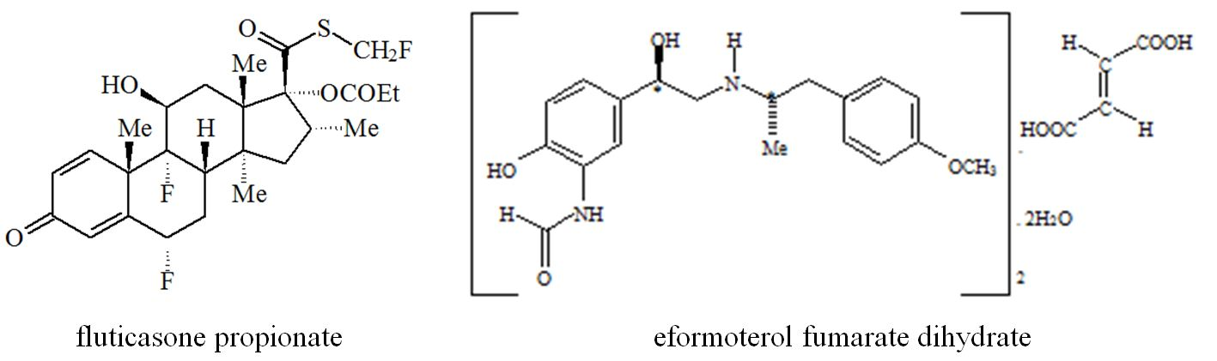

Both drugs have particle size reduced by micronisation. Drug substance aspects are acceptable.

### Drug product

Three metered dose inhaler strengths are proposed. All strengths use the same canister and valve (50 μL = 71 mg). These three strengths have different amounts of fluticasone propionate and eformoterol suspended in the same matrix (Table 1).

Table 1: Amounts of active ingredients in dose inhalers.

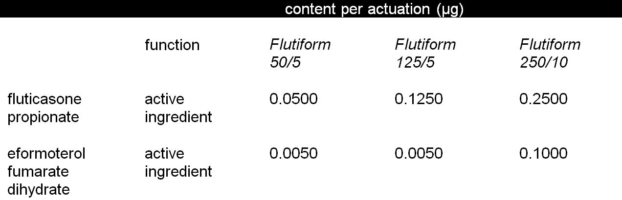

Only 120 actuation inhalers are proposed for registration (that is, doses for 30 days); the inhalers are overfilled to ensure these can be delivered throughout the shelf life. The actuator includes a countdown dose counter which is not currently mandatory, but desirable. All strengths use the same actuator.

The propellant apaflurane (‘hydrofluoroalkane 227’ or ‘HFA 227’) is 1,1,1,2,3,3,3-heptafluoropropane. It is not widely used, but is the propellant in *Symbicort Rapihaler*, *Tilade* nedocromil sodium and *Intal* sodium cromoglycate pressurised metered dose inhalers.

#### Clinical trials

Early development used a Flutiform 125/6, with a different strength of eformoterol fumarate. The eformoterol content was reduced because of observed relatively high systemic eformoterol exposure (Study SKYE2201C/8722/01; these aspects not reviewed in detail here).

Clinical trials otherwise used the proposed formulations. The early developmental studies used a different actuator, but the commercial actuator was used in all pivotal studies.

#### Inactive excipients

##### Sodium cromoglycate

The inactive excipient sodium cromoglycate is included as a moisture scavenger (moisture causes clumping of suspended drug, affecting lung delivery). The dose (0.024 µg/actuation) is notably lower than that from Intal or Intal Forte inhalers (1 or 5 µg; that is, Flutiform has 2.4% or 0.5% of the dose). Its presence is acknowledged in the draft PI as an inactive excipient, and the following statement appears under the heading ‘INTERACTIONS’:

*Flutiform inhaler contains sodium cromoglycate at non pharmacological levels.*

*Patients should not discontinue any cromoglycate containing medication.*

##### Ethanol

Ethanol is a rare inactive inhalation excipient. It is included in QVAR beclomethasone dipropionate pressurised metered dose inhalers (which are formulated with ethanol and norflurane only), but sufficient is used in QVAR to allow complete dissolution of the drug in the propellant mixture. QVAR’s solution formulation then gives a very fine aerosol on evaporation. The dose of ethanol from QVAR is 4.7 µg per actuation. The Flutiform formulation is a suspension formulation, notwithstanding inclusion of ethanol.

##### Labelling of doses

Meaningful expression of dose for inhaled products is problematic. Pressurised metered dose inhalers volumetrically meter an aliquot of suspension within the valve. Some of this metered dose (here 50/5, 125/5, 250/10 μg) is then deposited in the valve and actuator (mouthpiece). The delivered dose (~44/4, 115/4, 230/9 μg) received by the patient is then partially deposited in the mouth and throat, and partially reaching the lungs (the ‘respirable dose’: here ~17/1.6, 43/1.6, 72/3 μg).

Labelling of the metered dose was traditional as it was straightforward to measure *in vitro*. More recently, labelling of the delivered dose has become official practice for new products because it is the total drug taken by the patient, and Mundipharma proposes labelling Flutiform in terms of both the metered and the delivered doses. This is considered reasonable given the precedent for each of the components.

The PI includes information on the corresponding delivered doses:

|  |  |
| --- | --- |
| metered dose | delivered dose |
| (fluticasone propionate : eformoterol fumarate) | |
| 50 μg : 5 μg | 46 μg : 4.5 μg |
| 125 μg : 5 μg | 115 μg : 4.5 μg |
| 250 μg : 10 μg | 230 μg : 9 μg |

The delivered doses are not quite linear *in vitro* (see above), with the higher strengths delivering slightly more drug than expected from the label.

#### Fine particle dose

The critical quality control measure for inhalation products uses *in vitro* testing to characterise the aerosol, under conditions which mimic delivery to the lung. The test is carried out using a cascade impactor which quantifies aerosolised drugs in a set of particle size ranges. Limits have been proposed for the composite **fine particle dose** (defined here by the sponsor as the dose deposited on all stages <5.0 μm aerodynamic diameter); shown here with overall mean results for batches used in pivotal clinical trials (Table 2).

Table 2: Fine particle dose for inhalation products.

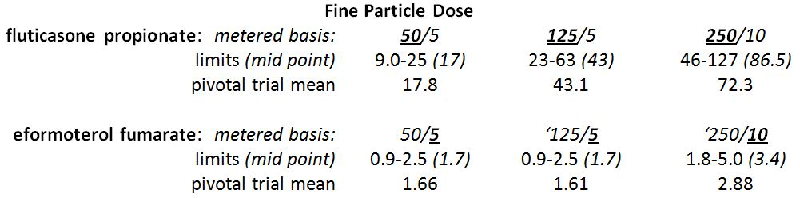

The pivotal clinical trial batches thus show fair linearity in fine particle doses between the strengths, with the higher strengths giving, proportionally, slightly lower ‘lung doses’.

#### Comparisons with registered inhalers

Mundipharma states that the proposed products were developed as a ‘stand alone’ combination, and limited *in vitro* comparisons with other products have been undertaken. (Comparisons between pressurised metered dose inhalers and dry powder inhalers are intrinsically difficult in any case.)

The sponsor undertook an *in vitro* comparison of GlaxoSmithKline’s fluticasone propionate pressurised metered dose inhalers from North American (Flovent) and Europe (Flixotide). These were more variable with respect to delivered and metered doses than expected:

* For ‘125 μg’ inhalers, the fluticasone fine particle doses from five batches of Flovent (US) ranged from 32 to 35 μg, but in three Flixotide (Europe) batches from 31 to 40 μg (compared with Flutiform 125/5 limits of 23-63 μg).
* For ‘250 μg’ inhalers, the fluticasone fine particle doses from five batches of Flovent (US) ranged from 82 to 97 μg, but in three Flixotide (Europe) batches from 75 to 76 μg (compared with Flutiform limits of 46-127 μg).

Chemistry and quality control aspects are considered acceptable.

### Bioavailability

Registration is not being sought on the basis of bioequivalence. The Flutiform products presumably act locally in the lungs. Systemic bioavailability data do not provide good product comparisons for a locally acting product. Thus, PK are only considered by Pharmaceutical Chemistry Section in the context of comparisons of the extent of systemic steroid exposure as part of the safety dataset. (The application is also supported by studies on hypothalamic-pituitary-adrenal suppression which are reviewed separately.)

#### Reference products

The submission included a number of studies with PK and pharmacodynamic (PD) comparisons with various overseas sourced fluticasone inhalation products. The sponsor argues that it is likely that the same reference products are marketed worldwide. The sponsor undertook an *in vitro* comparison of GlaxoSmithKline’s fluticasone propionate pressurised metered dose inhalers from North American (Flovent) and Europe (Flixotide). These were more variable with respect to delivered and metered doses than expected.

Australian sourced products were not compared. There is a curious difference in some of the product literature for GlaxoSmithKline’s inhalers in different markets, with systemic bioavailability of Flixotide Evohaler in healthy subjects reported to be 28.6% but 10.9% in the Australian PI.

It is difficult to conclude or disprove that the various GlaxoSmithKline products are identical on the basis of such data.

No *in vitro* or *in vivo* comparison with fluticasone exposure between Flutiform and GlaxoSmithKline’s Seretide combination inhalers (fluticasone propionate + salmeterol xinafoate) was made.

#### Fluticasone propionate exposure

There were a number of different studies comparing fluticasone propionate PK after inhalation doses of various strengths and combinations by healthy volunteers and by patients. Observed fluticasone profiles are quite variable, especially inter subject. Many individual plasma profiles are frankly strange.[2] Hence, only the crossover studies were reviewed in detail.

The results are contradictory. Studies AG2028-C101 and SKY2028-2-001 provide the only crossover comparisons, but unfortunately these both used Flutiform with the old (Bespak) actuator which may well affect exposure.

Study AG2028-C101 (in healthy volunteers taking single doses without spacers) included a comparison of 2 x 125 μg inhalations from Flutiform and Flixotide Evohaler: mean fluticasone exposure was **lower** following the Flutiform dosing (AUC0-24h [area under the plasma concentration-time curve from time 0 to 24h] geometric mean 175 versus 255 ng/mL), although intersubject variability was large (%CV [coefficient of variation] 79 and 55).

Study SKY2028-2-001 (in asthma patients taking single doses without spacers) included a comparison of 2 x 125 μg inhalations from Flutiform and Flixotide Evohaler: mean fluticasone exposure was **higher** following the Flutiform dosing (AUC0-24h geometric mean 117 versus 78 ng/mL; %CV 123 and 134). (Lower exposures in asthma patients are generally observed.)

(The influence of the necessary co administration of eformoterol in the Flutiform doses was separately investigated, but without clearcut results.)

There were a number of other studies of different doses and with and without spacer use. Mundipharma notes considerable intersubject and intrasubject variability.

No definitive conclusion can be reached on the likely relative fluticasone propionate plasma exposure with Flutiform versus Flixotide in Australia.

#### Spacers

Spacers can improve dose delivery by reducing the need to coordinate firing and inhalation, and can reduce systemic steroid exposure by catching larger particles which are otherwise swallowed. Spacers are poorly regulated in Australia. The draft PI says:

*In multiple dose studies in healthy volunteers, Flutiform inhaler doses of 100 µg/10 µg, 250 µg/10 µg and 500 µg/20 µg resulted in mean maximum plasma fluticasone concentrations of 21.4, 25.9 to 34.2 and 178 pg/mL respectively. The data for the 100 µg/10 µg and 250 µg/10 µg doses were generated by the use of a device without a spacer, and the data for the 500 µg/20 µg dose were generated by the use of a device with a spacer. Although there are no data directly comparing the exposure of fluticasone from a device with or without a spacer, spacers are known to increase the systemic exposure of fluticasone, and this may account for some of the difference in the levels achieved between the different doses. …*

*General Information …*

*Use of a spacer device with Flutiform inhaler is recommended in patients who find it difficult to synchronise aerosol actuation with inspiration of breath. The Aero Chamber Plus spacer device can be used.*

*Patients should be instructed in the proper use and care of their inhaler and spacer and their technique checked to ensure optimum delivery of the inhaled drug to the lungs. Re-titration to the lowest effective dose should always follow the introduction of a spacer device.*

Spacers were used in the clinical trials, and additionally *in vitro* data: several spacer devices were screened. The delivered doses were reduced, as expected, while fine particle doses varied significantly with different spacers. With the Aero Chamber Plus spacer the fine particle doses were similar without and with spacer use in vitro (74 → 78 μg fluticasone; 3.3 → 3.4 μg eformoterol, respectively).

Doses were administered with an Aerochamber Plus spacer in PK Study FLT1501 (but not directly compared to direct inhalation). Mundipharma interprets cross trial comparisons as showing the use of the spacer increased systemic exposure.

### Advisory committee considerations

The application was considered at the 144th (2012/2) meeting of the Pharmaceutical Subcommittee (PSC) of the Advisory Committee on Prescription Medicines (ACPM). The PSC endorsed the pharmaceutical questions raised by the TGA and recommended that the sponsor provide an acceptable justification for the inclusion of sodium cromoglycate in the products. The PSC considered that there should be a greater and obvious differentiation in the packaging of the three strengths. The committee also made detailed PI recommendations, which will be pursued during PI negotiations.

The sponsor has provided data showing that the inclusion of sodium cromoglycate yields a more stable, redispersible suspension, which is pharmaceutically desirable. The label colouring has now been amended to improve strength differentiation.

### Quality summary and conclusions

Registration is recommended with respect to chemistry, quality control and biopharmaceutic aspects.

## III. Nonclinical findings

### Introduction

MundiPharma Pty Ltd has applied to register Flutiform, new fixed dose combinations of the existing asthma agent fluticasone propionate (a synthetic glucocorticosteroid with anti inflammatory activity) and eformoterol fumarate dihydrate (a LABA). Both of the active ingredients are already approved for use in combination with other members of the partnering class (that is, eformoterol fumarate dihydrate/budesonide [Symbicort] and fluticasone propionate/salmeterol xinafoate [Seretide]).

The nonclinical dossier included cardiovascular/respiratory safety, repeat dose toxicity and embryofoetal development studies conducted with the combination, and were sufficient in scope according to the relevant EU guideline.[3] Data on topics not included in the submission (that is, primary pharmacology, PK [other than toxicokinetics], genotoxicity, carcinogenicity and additional aspects of reproductive toxicity) have been evaluated for the individual active ingredients previously (as summarised in the Appendix). All pivotal studies were GLP (Good Laboratory Practice) compliant.

### Pharmacology

#### Safety pharmacology

A cardiovascular and respiratory safety study was conducted with eformoterol fumarate and fluticasone propionate in combination (1:25 dose ratio; up to 15/375 µg/kg) and with eformoterol fumarate alone (at 15 µg/kg) by the inhalational route in dogs. Peak plasma concentrations of eformoterol and fluticasone propionate obtained in the study were 5-42 and 3-12 times higher compared with values in humans with repeated treatment at the maximum proposed clinical dose. The most notable findings were reductions in blood pressure and increases in heart rate. Small increases in P wave amplitude and reduction in PQ and QT intervals were observed but there was little effect on QTc. Respiratory rate was not affected but tidal and minute volumes were increased. In general, the effects of the high dose combination on both cardiovascular and respiratory parameters were similar to those of the same dose of eformoterol fumarate administered alone. Ventricular tachycardia was observed at the high dose level of the combination (in 2/4 animals), but not in any of the dogs given eformoterol fumarate alone. Nevertheless, this effect – like the others – is attributable to the eformoterol fumarate component. No ventricular tachycardia occurred with eformoterol fumarate/fluticasone propionate at 5/125 μg/kg (relative exposure based on Cmax [maximum plasma drug concentration], 14 for eformoterol fumarate and 5 for fluticasone propionate).

ECG (electrocardiogram) examinations were also conducted in all of the repeat-dose toxicity studies in dogs, generally within 5-10 min after the end of dosing. Results were broadly consistent with those of the safety pharmacology study. The highest doses were used in the 2 week study, and 0-5 min plasma concentrations of both eformoterol and fluticasone propionate were well in excess of the highest expected human values. In addition to post dosing tachycardia, a decreased basal heart rate was also observed, which is consistent with the results of original studies submitted for the registration of eformoterol fumarate.

### Pharmacokinetics

No nonclinical PK studies were conducted, but supportive toxicokinetic data were routinely provided for the submitted toxicity studies. Limited data in dogs indicated generally lower Cmax and AUC values for each drug with co administration. Data in a clinical trial apparently showed bioavailabilities of eformoterol and fluticasone propionate to be lower with Flutiform compared with existing single agent products given together (Foradile and Flixotide relative values of 75% and 67%, respectively, at steady state; Summary of Clinical Pharmacology Studies). Furthermore, the maximum recommended daily doses of eformoterol fumarate dihydrate and fluticasone propionate with Flutiform therapy are less than those approved for the existing single agent products (40 and 1000 μg, respectively, compared with 48 and 2000 μg).

### Toxicology

#### Repeat dose toxicity

Studies of up to 3 months duration were conducted with the combination in both rats and dogs, exceeding the recommendation for a 3 month study in one species contained in the relevant guideline.[4] Initial 2 week studies in both species involved administration of eformoterol fumarate/fluticasone propionate in the ratio 1:21, while a dose ratio of 1:10 was used in the pivotal 13 week studies. A 1:25 ratio was additionally used in another 13 week study in dogs. These ratios match or cover those of the strengths proposed for registration (that is, 1:25 and 1:10). Further studies were conducted with eformoterol fumarate alone in rats (2 weeks) and dogs (13 weeks). Single agent comparator groups were included in one 13 week dog study with the combination. All repeat dose toxicity studies utilised the clinical route (inhalation). The studies were adequately conducted.

##### Relative exposure

Exposure ratios have been calculated for eformoterol and fluticasone propionate based on animal:human plasma AUC0-24h values (Table 3). Human values are for steady state at the maximum recommended daily dose, obtained in Clinical Study FLT1501; the AUC0-12h values reported in the study are doubled for the calculation here to reflect BID (twice daily) dosing. In the pivotal rat and dog studies (Studies 855332 and 855289), up to moderate multiples of the maximum anticipated clinical exposure were obtained for eformoterol. Exposure to fluticasone propionate was relatively low, however, and subclinical in the dog. Significantly higher exposures were achieved in the 2 week studies in both species.

Table 3: Exposure ratios.

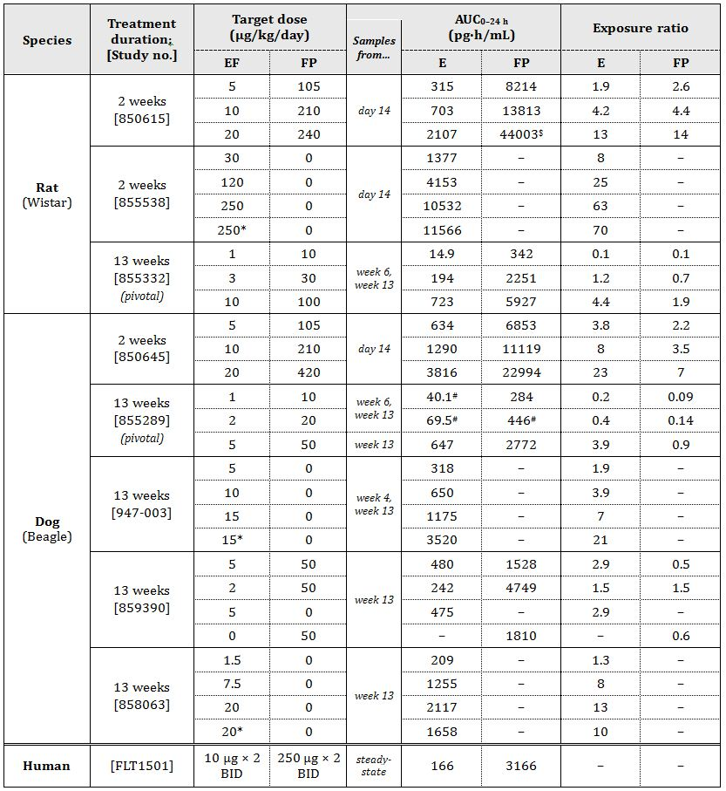

EF = eformoterol fumarate dihydrate; FP = fluticasone propionate; E = eformoterol; data are for the sexes combined;  
AUC0-t values (sampling to 6 h) have been used to estimate AUC0-24h for the rat; * dry powder inhaler (DPI) as opposed to otherwise used metered dose inhaler (MDI); $ female value was 2 times that for males; # not measurable in Week 6.

#### Major findings

Salient histological changes in one or both species (rat, dog) were thymic atrophy, lymphoid depletion (or reduced incidence of lymphoid hyperplasia) of lymph nodes (with Peyer’s patches also affected in some studies and the spleen in the 2 week rat study), and atrophy/replacement of haematopoietic cells with fat cells in bone marrow. Additional changes included atrophy of the zona fasciculata in the adrenals, hepatocellular hypertrophy (and glycogen storage in the liver in dogs), and reduced extramedullary haematopoiesis in the spleen. These changes are considered to be largely attributable to the fluticasone propionate component of the combination as thymic involution, lymphoid depletion of lymph nodes and spleen, bone marrow suppression, atrophy of the adrenal cortex, as well as hepatocytic changes (vacuolation associated with glycogen deposition [mainly in dogs], but not hepatocytic hypertrophy) were observed in previously evaluated repeat dose rat and/or dog studies with this drug, while decreased extramedullary haematopoiesis in the spleen was observed in a rat carcinogenicity study. However, eformoterol fumarate is also likely to have affected the thymus as decreases in thymic weight were observed in the original studies with this drug and thymic atrophy was observed in both rats and dogs in studies in the current submission in which the drug was investigated as the single active agent; this is consistent with stress related to the efomoterol’s pharmacological action to increase heart rate. Myocardial fibrosis was observed at the high dose level of the combination (20/420 μg/kg/day eformoterol fumarate/fluticasone propionate) in the 2 week dog study. Again, this is attributable to the eformoterol fumarate component, stemming from prolonged stimulation of the heart by this β2 adrenoceptor agonist. Cardiac toxicity (myocardial fibrosis/degeneration) was a major finding in the original repeat dose rat and dog studies submitted for the drug’s registration.

The main clinical pathology changes (haematological, serum biochemical, urinalysis) observed with the drug combination in rats and/or dogs were also observed with the individual components of the combination. These included increased potassium (both components), leukocytopenia and lymphocytopenia, increased protein, albumin, triglycerides and phospholipids, and decreased creatinine (fluticasone propionate), and increased erythrocyte parameters, urine volume and urea (eformoterol fumarate). Adrenocorticotropic hormone (ACTH) stimulated plasma cortisol was reduced by combination treatment, and with fluticasone propionate (but not eformoterol fumarate) alone, in the dog studies in which it was monitored, which is an expected effect of corticosteroid administration.

Overall, there were no major toxicity findings with this combination that were not seen with either one or both of the individual components. The 13 week study in dogs that included single agent comparator groups revealed no synergistic toxicity with the combination.

The proposed Flutiform formulations contain sodium cromoglycate as an inactive excipient. This compound is itself a registered therapeutic agent for the treatment of asthma (Intal), with a much higher dose approved (up to 160 mg/day by inhalation in severe cases). The inclusion of this excipient is therefore considered acceptable; based on the low dose, no significant contribution to efficacy would be expected. Sodium cromoglycate was included in the formulations tested in one of the 13 week dog studies, with no effect of treatment evident based on comparisons between placebo and air control groups. On a body surface area basis, the doses of the agent achieved in the study were ~5-8 times higher than for a 50 kg human treated with Flutiform.

#### Genotoxicity and carcinogenicity

Genotoxicity and carcinogenicity studies were not conducted with the Flutiform combination and are not required given the adequate existing data for the individual active agents.

#### Reproductive toxicity

Embryofoetal development studies were conducted with the combination by the inhalational route in rat and rabbits. Fertility and early embryonic development and pre/post natal studies were not conducted with the combination; such studies are not required based on existing data for the individual components.

##### Relative exposure

Doses used in the rat study produced up to moderately high multiples of the human exposure to eformoterol and fluticasone propionate (Table 4). Maternal body weight gain was impaired at all dose levels. The effect of treatment on embryofoetal development in the rat was modest though, with post implantation loss increased slightly (but remaining within the historical control range) and foetal weight decreased at the high dose level (16/160 µg/kg/day eformoterol fumarate/fluticasone propionate), and only a slight increase in the incidence of skeletal variations and of retarded ossification (mainly at the high dose) being seen.

Table 4: Exposure ratios.

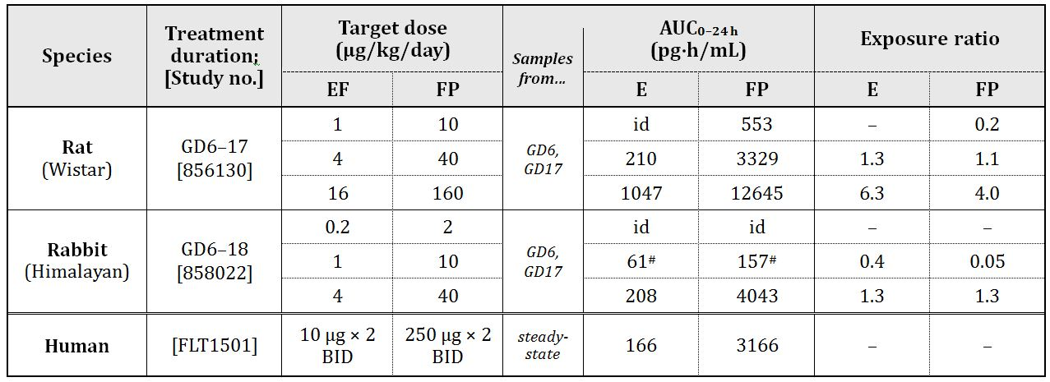

EF = eformoterol fumarate dihydrate; FP = fluticasone propionate; E = eformoterol; AUC0-t values (sampling to 6 h) have been used to estimate AUC0-24h for the laboratory animal species; id = insufficient data; # = not measurable on GD6.

Relative drug exposures achieved in the rabbit study were low. Based on results of the pilot study in the species, and the lack of maternal toxicity in the main study, doses in rabbits probably could have been increased. Nevertheless, they were sufficient to produce adverse effects on embryofoetal development. Treatment was associated with increased post implantation loss and decreased foetal weight, and foetal abnormalities that included cleft palate, enlarged anterior fontanelle and forelimb flexure, as well as impaired ossification of limb bones and irregular ossification of skull bones. Adverse effects on embryofoetal development in the rabbit, including malformations, occurred at subclinical exposure levels and in the absence of maternotoxicity; no NOAEL (No Observed Adverse Effect Level) for embryofoetal development was established in the species.

Insofar as studies can be compared, these findings are consistent with those of previous studies submitted to support registration of fluticasone propionate and eformoterol fumarate. Fluticasone propionate (but not eformoterol fumarate) showed evidence of teratogenicity in those studies, including cleft palate in mice (subcutaneous treatment), and corticosteroids generally are known to produce fetotoxicity and teratogenicity in mice, rats or rabbits.

##### Pregnancy classification

The sponsor has proposed Pregnancy Category B3. This is consistent with the categorisation of both individual agents.

#### Paediatric use

Flutiform is proposed for use in patients aged 12 years and above. No specific studies in young animals were submitted. However, this is acceptable as Foradile (eformoterol fumarate dihydrate) and Flixotide junior inhaler (fluticasone propionate) are currently approved for use in children aged 5 years and above and 1 year and above, respectively.

### Nonclinical summary and conclusions

#### Summary

* MundiPharma Pty Ltd has applied to register Flutiform for the treatment of asthma in adults and children (≥12 years old), representing fixed dose combinations of two existing agents, fluticasone propionate (a corticosteroid) and eformoterol fumarate (a long acting β2 adrenoceptor agonist). Three strengths are proposed; drug ratios are 10:1 or 25:1. Administration is by inhalation, twice daily.
* The nonclinical submission contained new studies on safety pharmacology, repeat dose toxicity and reproductive toxicity, conducted with the combination by the inhalational route. All pivotal studies were GLP compliant. The nonclinical data submitted in support of the application exceeds that required to meet International Conference on Harmonisation (ICH) guidance for such a fixed combination product (given existing nonclinical data for the individual components and clinical experience with the combination of classes).
* No PD studies were conducted to examine efficacy of the combination in animals or *in vitro* models of asthma. A safety pharmacology study in dogs showed effects of drug combination treatment (mainly reductions in blood pressure and increases in heart rate, but also increases in tidal and minute volumes) that were largely due to the eformoterol fumarate component.
* Repeat dose toxicity studies using drug combination treatment were conducted in rats and dogs, with durations of 2 and 13 weeks in both species; one 13 week dog study included single agent comparator groups. Additional studies investigated eformoterol fumarate alone. Dose ratios used in the animal studies (10:1, 21:1 or 25:1) match or cover those proposed for registration. Salient histological changes produced by treatment with the combination (in one or both species) included atrophy of the thymus, lymphoid depletion, atrophy of bone marrow haematopoietic cells (with fatty replacement), adrenal atrophy, hepatocellular hypertrophy, reduced extramedullary haematopoiesis in the spleen and myocardial fibrosis. ACTH stimulated plasma cortisol was reduced in dogs. These findings are mostly attributable to the fluticasone propionate component. Overall, the studies did not reveal any unique toxicities not seen with the individual components previously or synergistic toxicity.
* Sodium cromoglycate is included as an inactive excipient in the proposed products. Its inclusion in Flutiform is considered acceptable and no significant contribution to efficacy is expected.
* Treatment with the combination caused adverse effects on embryofetal development, including malformations, in the rabbit at subclinical exposure levels and in the absence of maternotoxicity. Less serious effects on embryofetal development were found in rats (increased skeletal variations and retarded ossification; together with maternotoxicity). These findings are consistent with those of previous studies with the single agents, and again mostly attributable to the corticosteroid component.

#### Conclusions and recommendation

* The nonclinical dossier is considered to be sufficient to support registration of Flutiform as a combination of two currently approved drugs. The toxicity studies revealed no novel or synergistic toxicity. As no nonclinical PD studies were conducted, assessment of the efficacy of the proposed combination strengths will have to rely on clinical data alone.

## IV. Clinical findings

### Introduction

The clinical studies were conducted in compliance with local regulations and guidance, the ICH Guidelines and Good Clinical Practice (GCP) regulations. Subjects were accorded all rights granted by the Declaration of Helsinki. All protocols received approval by the appropriate governing investigational review board, ethics committee, or similar authority. Standard research methodology was utilised for the conduct and performance of each clinical study under consideration.

### Pharmacokinetics

In healthy volunteers, following inhalation of a single 250 µg dose from 2 actuations of Flutiform 125/5 µg, fluticasone was rapidly absorbed reaching mean Cmax of 32.8 pg/mL within 45 min. In asthma patients, mean Cmax of 15.4 pg/mL and 27.4 pg/mL were achieved after inhalation of single dose of Flutiform 100/10 µg (2 actuations of 50/5 µg) and 250/10 µg (2 actuations of 125/µg) after 20 and 30 min, respectively. Following multiple doses of Flutiform 100/10ug, 250/10ug and 500/20 ug in healthy subjects mean Cmax was 21.4, 25.9-34.2 and 178pg/mL, respectively. Data for 100/10 and 250/10 µg doses was from studies which did not use a spacer while a spacer was used for the Flutiform 500/20 µg dose study. Although there is no data directly comparing exposure to fluticasone from a device with and without a spacer,[5] spacers are known to increase systemic exposure of fluticasone (with potential for systemic effects of fluticasone). In healthy subjects, following single and multiple dose of Flutiform 500/20 (2 actuations of 250/10 µg), mean Cmax for eformoterol was 9.92 and 34.4 pg/mL, respectively. There have been no studies that directly compare exposure in healthy and asthmatic subjects.

The mean terminal half life (t1/2) of plasma fluticasone for SKP (SkyePharma) Flutiform after oral inhalation ranges from 10 to 14 h across the studies. Plasma formoterol data have been gathered only in the more recent studies, FLT1501 and FLT2502.The mean t1/2 values of plasma formoterol for Flutiform after oral inhalation ranged from 6.5 to 9 h across both studies. Hence, the twice daily dosing regimen for Flutiform appears to be justified.

#### Justification for selection of formoterol dose of 5 µg in Flutiform instead of 6 µg in Foradil

The Phase 2 Study SKYE2201C/8722/01 compared the dose response of 2 and 4 actuations of formoterol fumarate in the SkyePharma HFA pMDI (6 μg/actuation) with one and 2 actuations of formoterol fumarate from the commercially available Foradil DPI (Formoterol fumarate 12 μg/actuation) in 45 subjects with asthma. The mean cumulative amounts of formoterol excreted in urine was higher following dosing with SKP formoterol pMDI (to be used in the proposed Flutiform) compared to dosing with Foradil DPI (24% and 39% higher after dosing with 12 µg and 24 µg doses, respectively). Based on the results from this study, the strength of formoterol fumarate was reduced from 6 to 5 µg for Flutiform. However, the justification provided for reducing dose of formoterol in Flutiform is not adequate[6] due to following limitations:

* + 1. The trend of HFA pMDI formulations resulting in higher exposure than DPI has been reported in the literature.[7] However, the test and reference product were not inhaled from the same pharmaceutical dosage form (for example both the test and the reference product should be administered via a pMDI or both should be administered via a DPI) when assessing therapeutic equivalence as recommended in the CPMP guidelines;[8]
    2. Exposure to formoterol is not an indication of its efficacy, so reducing the dose of formoterol in Flutiform based on PK results is not justified. Furthermore, the increased exposure to formoterol in Flutiform subjects was not translated into an increased effect on lung function as shown by similar or slightly greater improvements in Foradil group compared with Flutiform;
    3. Formoterol concentrations were only based on urine formoterol levels which are not the most accurate method for determination of exposure to formoterol. Interpretation of the results was limited because the statistical analyses used within this study were largely exploratory and not powered to demonstrate superiority or equivalence due to the small sample size;
    4. Study FLT1501 evaluated the PK following 4 weeks administration of Flutiform pMDI 500/20 µg and Fluticasone pMDI 500 µg + Formoterol pMDI 24 µg in healthy subjects. This study utilised same devices for comparing relative exposure to fluticasone and formoterol from Flutiform compared to its reference products and also measured plasma formoterol. Results from this study showed that relative bioavailability of fluticasone and formoterol from Flutiform was 67% and 75% compared to that following administration of reference treatments. Hence, results from this study contradict those observed in Study SKYE2201C/8722/01 which showed increased exposure to formoterol from Flutiform and formed the basis for selection of the 5 µg dose in the Flutiform formulation.

#### Dose proportionality

Systemic exposure of fluticasone increased with increasing dose in healthy subjects (SKY2028-1-002) and in subjects with mild to moderate asthma (SKY2028-2-001) who received Flutiform 100/10 μg and 250/10 μg. In both studies, the mean systemic exposures deviated from dose proportionality and the coefficients of variation associated with the various measures of AUC were high, preventing a definitive assessment of dose-proportionality of fluticasone in plasma. Systemic exposure of fluticasone in healthy subjects (FLT1501) who received Flutiform 500/20 μg was higher than would have been predicted from the previous studies in lower doses, but these were confounded by use of spacer.

There is high variability in PK parameters of fluticasone and formoterol following administration of Flutiform both within and between the PK studies. However, in general there is a trend for the systemic exposure of fluticasone and eformoterol to be less with Flutiform inhaler than with the individual components administered together.

No specific drug interaction studies were conducted with Flutiform. Results of the Phase 2, single dose Study SKY2028-2-001 in asthma patients (where the Cmax and AUC0-t of fluticasone from the Flutiform 250/10 μg product were higher than those observed when the Flixotide 250 μg + Foradil 12 μg inhalers were used concurrently, but similar to those observed with the Flixotide 250 μg product alone) indicated a possible interaction of Formoterol on Fluticasone PK when administered in the same inhaler compared to in separate inhalers. However, the results for AUC0-t/Dose should be interpreted due to the wide confidence intervals. Combined administration of fluticasone and formoterol fumarate in SKP Flutiform HFA pMDI resulted in similar Ae0-24h (cumulative amount of unchanged drug excreted into the urine in first 24 h) for formoterol compared with Foradil 12 μg alone, and compared with Flixotide 250 μg + Foradil 12 μg inhalers used concurrently. The Flutiform 250/10 μg product may therefore be considered comparable to the Flixotide 250 μg + Foradil 12 μg products and with the Foradil 12 μg product in patients with asthma in terms of the formoterol component, but not so for the fluticasone component. Similar results were observed in the single dose Study AG2028-C101 in healthy subjects.

*In vitro* studies evaluated the comparability of formoterol fumarate and fluticasone propionate products in the SKP sponsored trials to the European marketed formoterol fumarate and fluticasone propionate products and showed comparable results in terms of fine particle size and dose content uniformity. However, justification for use of the various comparators in the Flutiform clinical studies based on results provided in the Quality evaluation would require confirmation from the chemistry evaluator as detailed analysis of these studies is outside the scope of this clinical evaluation.

There were no changes to the Flutiform formulation during the clinical development and the proposed commercial Flutiform formulation was used in all the Phase 3 studies. No specific biopharmaceutics studies have been conducted. The influence of several different actuators and spacers on the delivery of the Flutiform product was evaluated. Overall, both of the actuators used demonstrated a variable effect and no discernible pattern with respect to exposure levels could be associated with the use of either actuator. All Phase 3 studies and majority of Phase 1 and 2 studies used the final actuator. No issues are anticipated when switching from Flutiform administration without an Aerochamber Plus to with an Aerochamber Plus, as results from all studies suggest that although exposure to fluticasone is increased following administration of Flutiform with a spacer, the influence of the spacer on fluticasone exposure is less with Flutiform than it is with the mono-products.

The effects of gender, race, weight, baseline FEV (forced expiratory volume) on PK of Flutiform have not been evaluated (with exception of the small post hoc subgroup analysis in Study FLT2502). The effect of renal and hepatic impairment on Flutiform PK parameters was not evaluated. Following single dose of Flutiform (250/10 µg) in patients with mild/moderate asthma (Study FLT2502), fluticasone (AUCt and Cmax) was consistently higher in adolescents compared with adults. Formoterol AUCt was similar in adolescent and adult groups, but Cmax was slightly higher in adolescents.

### Pharmacodynamics

In the Phase 2 Study SKYE2201C/8722/01, the formoterol component of Flutiform and Foradil showed similar improvements in lung function PD parameters despite the fact that the PK results had suggested increased exposure to formoterol from Flutiform compared to Foradil and consequently the dose of formoterol to be used in all studies was reduced to 5 µg instead of 6 µg.[9] Systemic exposure to formoterol is not an indication of efficacy in the lungs and is more an indicator of systemic safety.

In the Phase 1, randomised, parallel group, open label PK study in healthy subjects, improvement in lung function was observed as early as 5 min at the first postdose assessment, following treatment with Flutiform 100/10 μg and 250/10 µg and was maintained for 12 h post dose. Mean onset of clinical effect[10] in responders was about 6.6, 5.9, 4.3, 4.9, 6.9 and 20.5 min after Flutiform 100/10, 250/10, Flixotide 250 μg +F oradil 12 μg, Flixotide 250 μg, Foradil 12 μg and placebo, respectively. Mean duration of clinical effect in responders[11] was approximately 15, 13, 14, 15, 11 and 12 h, respectively. There was a statistically significant difference in mean actual FEV1 (forced expiratory volume in first second) and FEV1 AUC change from Baseline at 12 h post dose in favour of treatment with both Flutiform 100/10 μg and 250/10 μg compared to Flixotide 250 μg and placebo. Overall, combined administration of fluticasone propionate and formoterol fumarate via a single inhaler (SkyePharma HFA MDI [Flutiform 100/10 or Flutiform 250/10]) provided comparable efficacy when compared to the single components administered concurrently and superior efficacy when compared to Fluticasone 250 or placebo.

No pulmonary deposition studies were conducted with Flutiform. This was especially important in light of the fact that bioequivalence between Flutiform and its components were not shown (Studies AG2008-C101 and FLT1501).[12]

In Study SKY2028-1-003, 6 weeks of treatment with Flutiform 250/10 μg or Flutiform 100/10 μg twice daily did not affect the HPA (Hypothalamic Pituitary Axis) function as evaluated by 24 h UFC (Urinary Free Cortisol) in adult subjects with mild to moderate asthma. The study had assay sensitivity in that a prednisone control arm showed suppression of the HPA. In Study FLT1501, the mean 24 h UFC levels (corrected for creatinine) were at baseline with a more pronounced decrease at the end of four weeks of treatment with individual components (fluticasone 500 µg and formoterol 24 µg) compared with Flutiform 500/20 µg. ACTH stimulation test responses were similar for both Flutiform and individual components, both at baseline and at the end of the study period indicating that no significant adrenal insufficiency was induced during the 4 week treatment period. The preferred PD method of assessing the HPA is the repeated assessment of the change from baseline in 24 h plasma cortisol as measured by AUC (as the primary variable) and Cmax; however, the 24 h UFC excretion is the most sensitive non invasive measure of systemic activity of ICS on HPA function. The 24 h UFC is a variable which could be used in the assessment of systemic effects of ICSs on the HPA although it is a much better test for the measurement of high urinary levels of cortisol than low levels and difficulties are often encountered in the collection of urine samples.

### Efficacy

Nine Phase 3 studies have been completed. Two assessed efficacy and safety in subjects with mild to moderate asthma (SKY2028-3-001, SKY2028-3-002), two studies in subjects with mild to moderate-severe asthma (FLT3501, FLT3505), two studies in subjects with moderate to severe asthma (FLT3503, SKY2028-3-004 and SKY2028- 3-005). The severity of asthma was well defined based on FEV% predicted as well as criteria based on use of rescue medication, sleep disturbance and asthma symptoms. One open label, long term safety study was completed in subjects with mild to moderate severe asthma (Study SKY2028-3-003) and one open label study with a long term safety extension phase was completed in paediatric subjects with mild to moderate asthma (Study FLT3502). Overall, 1601 adults and adolescents were treated with Flutiform in the Phase 3 studies. All pivotal studies were of double blind, randomised, parallel group design, and aimed to demonstrate superiority of the combination product over its constituent drugs at each dose strength, or equivalence of the combination product compared to the two drugs taken concurrently from separate inhalers (concurrent therapy). The study designs complied with recommended guidelines[13] with the exception that the pivotal Study FLT3503 had only 8 week treatment duration.[14] The patient populations, study designs, and efficacy measurements utilised in these studies were consistent with standard and accepted approaches to evaluate maintenance asthma therapy and are similar to studies included in development programmes for approved combination products with ICS and LABA. Pulmonary function test procedures were carried out in accordance with current guidelines for using a spirometer.

#### Dose response

There were no specific dose response studies although dose response was assessed in two Phase 3 studies (SKY2028-3-004 and FLT3503).

##### Comparison of Flutiform 500/20 and Flutiform 100/10

One of the main secondary objectives of Study FLT3503 was to demonstrate a dose response effect. Flutiform low dose (100/10 µg twice daily) was not shown to be statistically significantly different from the high dose Flutiform (500/20 µg BID) in terms of co primary FEV1 endpoints. The change in FEV1 from pre morning dose on Day 0 to pre morning dose on Day 56 was numerically larger after treatment with Flutiform high dose than after treatment with Flutiform low dose. A post hoc analysis showed superiority of Flutiform high dose vs Flutiform low dose overall including all time points and at each study visit except Day 56. The failure to show a statistically significant difference at Day 56 may be explained by more subjects discontinuing prematurely due to lack of efficacy in the low dose group. Discontinuation due to lack of efficacy (250/10 versus 100/10: 3.8% versus 11.6%), sleep disturbance scores, % of awakening free nights and subject assessment of medication was significantly better with high dose compared to low dose Flutiform. Results were numerically in favour of Flutiform high dose, although the differences were not statistically significant for: changes in FEV1 from pre morning dose on Day 0 to 2 h postmorning dose on Day 56, asthma symptom scores, percentages of symptom free days, asthma control days, rescue medication free days, and AQLQ (Asthma Quality of Life Questionnaire).[15]

However, it is not clear why patients who clearly needed >500 µg ICS daily (as stated in the inclusion criteria of the study protocol and shown by median daily dose of ICS at baseline) were given low dose of Flutiform (100 µg BID) in this study and this highlights a significant limitation of the study design. Despite the fact that patients in the Flutiform low dose (100/10 µg) group were clearly undertreated, the study was not able to show a clear difference between the low dose and high dose Flutiform. This is a major deficiency considering the fact that no definite dose response studies were conducted for Flutiform.[16]

##### Comparison of Flutiform 250/10 and Flutiform 100/10

A descriptive assessment of dose response effects was provided in Study SKY2028-3-004 as a secondary endpoint, which included two groups of subjects with moderate to severe asthma who received either Flutiform 250/10 or Flutiform 100/10. No formal statistical tests were performed to compare the dose groups. In the study, the two Flutiform doses were clinically comparable across the reported endpoints. When the two Flutiform dose groups were compared based on categories of disease severity (moderate or severe), the majority of results across the reported endpoints were clinically comparable. The following exceptions were noted in the subgroup of subjects with severe disease (defined as FEV1% predicted of 40% to 60%). For lung function, Flutiform 100/10 had a greater mean increase in FEV1 predose at Week 12 (mean difference = 0.268 L) compared to Flutiform 250/10 (mean difference = 0.166 L). For disease control, there was a lower percentage of subjects who experienced severe asthma exacerbations with Flutiform 250/10 (5.7%) compared to Flutiform 100/10 (10.8%), suggesting that the higher Flutiform dose provided better protection against development of severe asthma exacerbations in the severe population. However, these results should be interpreted with caution due to the small sample size in the severe disease subgroup.

#### Non inferiority of Flutiform 500/20 µg and Fluticasone 500 µg + formoterol 24 µg

Results of the pivotal non inferiority Study FLT3503 demonstrated non inferiority between twice daily administration (for 8 weeks) of high dose Flutiform (500/20 µg twice daily) and Fluticasone 500 µg + formoterol 24 µg in adult patients with moderate to severe persistent asthma (who required >500 µg fluticasone or equivalent ICS dose daily) in terms of primary and co primary FEV1 efficacy endpoints supported by other disease control and symptomatic endpoints. However, the results were confounded by limitations of the study[17] outlined below:

* + 1. Duration of double blind treatment was only 8 weeks which is less than those for other approved LABA + ICS combination products used in treatment of asthma (seretide and symbicort studies were >12 weeks in duration).[18]
    2. As there was no placebo control in this study, the demonstration of significant benefit of using Flutiform over Fluticasone alone was supposed to have provided evidence that the study was sensitive enough to detect treatment differences. Superiority of Flutiform high dose to Fluticasone alone was shown for the co primary endpoint of change from predose at baseline to 2 h postdose at Week 8 (LSMean of the treatment difference: 0.120 L; 95% CI [Confidence Interval]: 0.011 to 0.230; p=0.032; ITT [Intention To Treat population]). This was expected due to the missing contribution of the LABA component to post dose lung function measurements in this treatment group. However, the clinical relevance of the 120 mL increase in FEV1 is not clear. A post hoc analysis[19] (repeated measures ANCOVA [analysis of covariance]) was performed for the change from pre dose FEV1 to 0.5, 1, 2, 4, 6, 8, 10, and 12 h post dose at Day 0. Superiority of Flutiform high dose versus Flixotide alone was only shown for the change in FEV1 from predose to 1 h and 2 h post dose (Table 5). A similar post hoc analysis was not performed for the change from pre dose FEV1 to 0.5, 1, 2, 4, 6, 8, 10, and 12 h post dose at Day 56. However, Figure 2 showing 12 h FEV1 mean change from predose on Day 0 to predose and postdose on Day 56 seems to suggest that mean change from pre dose on Day 0 to pre dose and post dose on Day 56 did not show any significant difference between Flutiform high dose and Fluticasone alone at any time point. Hence, evidence for the clinical benefit of using Flutiform high dose over Fluticasone alone was not unequivocal in terms of 12 h serial FEV1. According to the CHMP guidelines for inhalational products for treatment of asthma, the appropriate primary variables are FEV1AUC (measurement of bronchodilatation over at least 80% of the duration of action after a single inhalation) and change in FEV1 (at an appropriate time points). Hence, evidence of assay sensitivity in this pivotal Phase 3 study was not conclusive.
    3. For mild/moderate asthma exacerbations the difference was statistically significant in favour of Fluticasone + Formoterol compared to Flutiform high dose (p = 0.006), while no statistically significant differences were observed between Flutiform high dose and Flutiform low dose or between Flutiform high dose and Fluticasone alone.
    4. No subgroup analysis were performed based on severity of asthma at baseline to explore/further define patients who were likely to benefit most from treatment with Flutiform.

Table 5: Repeated measures analysis of change from pre dose FEV1 (L) to post first dose on Day 0 – ITT population (Study FLT3503).

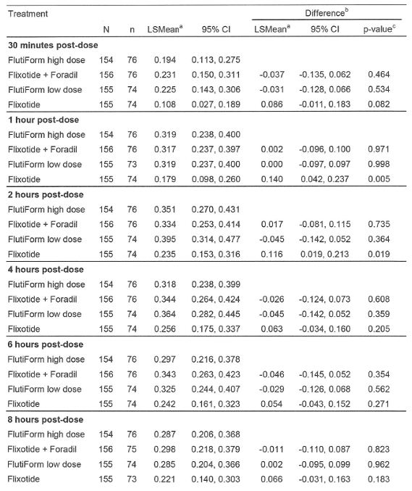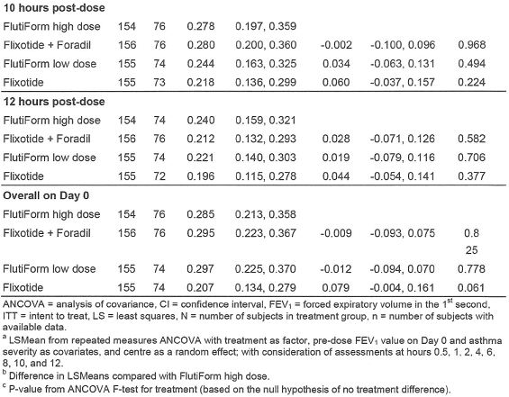

Figure 2: 12 h serial FEV1 (L): Mean change from pre dose on Day 0 to pre dose and post dose on Day 56 – ITT population (Study FLT3503).

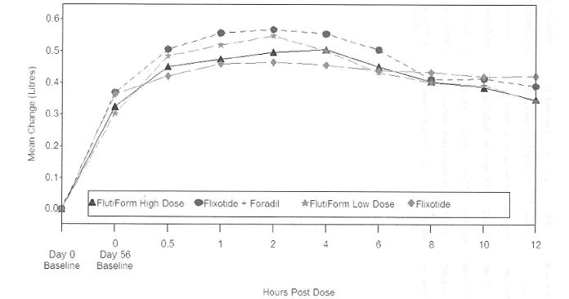

FEV1 = forced expiratory volume in first second; Flixotide = fluticasone; Foradil = formoterol

#### Superiority of Flutiform 100/10 µg and 250/10 µg over its components

Results from the two pivotal superiority Studies SKY2028-3-001 and SKY2028-3-002 demonstrated that Flutiform 100/10 provides greater efficacy compared to its components, fluticasone and formoterol, for the management of mild to moderate asthma. These studies enrolled both subjects who were and were not previously receiving ICS, which reflects the mixed population of patients suffering from mild to moderate asthma who will likely be treated with Flutiform. The mean changes in FEV1 from pre dose at baseline to pre dose or 2 h post dose were generally numerically greater for Flutiform 100/10 compared to its components beginning at Week 2 and were sustained throughout the 12 week treatment period. However, a mean increase versus monotherapy of 100 to 118 mL in pre dose FEV1 and increase versus monotherapy of 122-200 mL in 2 h post dose FEV1 may not be clinically relevant. Results from multiple secondary efficacy endpoints assessing lung function, disease control and asthma symptoms generally supported the superior efficacy of Flutiform 100/10 compared to its components, fluticasone and formoterol. Study SKY2028-3-004 was a pivotal Phase 3, randomised, double blind, placebo and active controlled, parallel group, stratified, 12 week study which established the superiority of Flutiform 250/10 µg over its components as well as placebo in adult/adolescent patients with moderate to severe asthma who required steroids (inhaled steroid regimen for at least 4 weeks prior to the screening visit at a dose <500 μg/day fluticasone) in terms of primary endpoints (FEV1) as well as clinical endpoints. However, this study also showed mean increase versus monotherapy in pre dose and 2 h post dose FEV1 of only 189 and 146 mL, respectively.

#### Non inferiority of Flutiform (250/10 and 100/10 µg) to Flixotide + Foradil (250/12 and 100/12 µg)

Results from the open label, Phase 3 Study FLT3505 showed that Flutiform (100/10 and 250/10 µg) was non inferior to Flixotide plus Foradil (100/12 µg and 250/12 µg) in 210 adult/adolescent patients with mild to moderate/severe asthma with regard to post dose FEV1, change in pre dose to post dose FEV1, and discontinuations due to lack of efficacy. However, interpretation of these results was confounded by the fact that flixotide and foradil were administered by DPI while flutiform was by pMDI. Analysis of the other efficacy parameters such as other pulmonary function tests, patient reported outcomes, rescue medication use, asthma exacerbations and AQLQ also showed comparable results for the Flutiform and Flixotide + Foradil treatment groups.

#### Non inferiority of Flutiform and Seretide

Results of the open label, supportive Study FLT3501 demonstrated non inferiority of Flutiform (fluticasone/ formoterol 250/10 or 100/10 µg) to Seretide (fluticasone/salmeterol 250/50 or 100/50 µg) in 202 adult patients with mild to moderate/severe persistent asthma with regard to predose and post dose FEV1 and discontinuations due to lack of efficacy. Superiority of Flutiform over Seretide could be shown for time to onset of action of study medication. Analysis of the other efficacy parameters such as other pulmonary function tests, patient reported outcomes, rescue medication use, asthma exacerbations yielded comparable results for the Flutiform and Seretide treatment groups. However, overall patient assessment of study medication and the improvement in AQLQ scores was slightly better for Seretide, although these could have been confounded by the open label study design.

Results from the open label Study FLT3502 demonstrated non inferiority of Flutiform 100/10 µg (fluticasone/formoterol) to Seretide 100/50 µg (fluticasone/50 µg) in children (aged 4-12 years) with mild to moderate persistent asthma with regard to predose and post dose FEV1 and discontinuations due to lack of efficacy. Analysis of the other efficacy parameters such as other pulmonary function tests, patient reported outcomes, rescue medication use and asthma exacerbations yielded comparable results for the Flutiform and Seretide treatment groups.

#### Long term efficacy

Efficacy was the secondary objective of the Phase 3 open label, long term Study SKY2028-3-003 in 472 adult and adolescent patients with mild to moderate/severe asthma over a period of up to 12 months following twice daily treatment with SKP Flutiform HFA pMDI (100/10 μg and 250/10 μg). Overall, 224 and 248 patients received Flutiform 100/10 µg and 250/10 µg, respectively. Of the 472 treated subjects, 256 and 216 subjects enrolled for the 6 month and 12 month treatment periods, respectively. Clinically and statistically significant improvements were observed for all efficacy assessments (FEV1, FEV1% predicted, PEFR [peak expiratory flow rate], and FVC [forced vital capacity]) for Flutiform treatment overall and for each dose group (100/10 and 250/10) at every assessment time point following long term treatment of up to 12 months. Compliance with study medication was over 75% in 88.4% of all subjects (87.5% and 89.3% in the core Flutiform and Seretide groups, respectively). Long term efficacy of flutiform 500/20 was not evaluated beyond 8 weeks.

#### Efficacy metanalysis

The pivotal studies were not included in the efficacy metanalysis. No subgroup analysis was done in any of the pivotal studies to explore or define the subgroup of patients most likely to benefit from Flutiform. Adolescents were included in the following Phase 3 studies: pivotal Studies SKY2028-3-001, SKY2028-3-002 and SKY2028-3-004; supportive Studies FLT3505 and SKY2028-3-005. Overall, 11.5% (210/1817) of the enrolled subjects in these studies were adolescents aged 12-17 years. Another 56 of the 472 subjects randomised in the long term, open label Study SKY2028-3-002 were adolescents. The subgroup of patients aged 12-17 years was one of the factors balanced prior to randomisation in all Phase 3 studies; the other factor that was balanced was prior steroid use. However, there was no separate analysis of efficacy in adolescents in any of the individual Phase 3 studies. Although the subgroup analysis in the pooled efficacy database seems to indicate that age did not affect Flutiform efficacy, this should be interpreted with caution due to small sample size of adolescents in this database (only 55 in Study FLT3505 and none in Study FLT3501). No subgroup analysis was done in any of the pivotal Phase 3 studies to explore or further define subgroups of patients most likely to benefit from flutiform. Non inferiority of Flutiform administered with and without a spacer was established for change from baseline in pre dose and post dose FEV1.

#### Treatment compliance

In the case of accepted and well established combination therapy, a co packaged combination can be justified through increased compliance and adherence to therapy when compared with the same therapy administered as separate active substances each administered via separate devices. However, the clinical relevance of this improved compliance has to be adequately investigated and proven in the claimed population. In all Phase 3 studies, mean treatment compliance with Flutiform was >84% with no significant difference between Flutiform and comparator treatment (Fluticasone + formoterol or Seretide) groups.

### Safety

The safety of Flutiform was evaluated in 17 Phase 1, 2 and 3 studies including over 1900 subjects. The Phase 1 and 2 studies did not show any safety concerns. In the Phase 3 studies, the overall rates of adverse events (AEs) in the Flutiform groups were generally comparable to those in the active comparator and individual component groups. The rates of related AEs were highest in the placebo groups, otherwise no trends were discernable. There was one death due to a haemorrhagic stroke in the Flutiform group of Study FLT3501. The rates of serious adverse events (SAEs) were low in all studies. The rates of AEs leading to withdrawal were generally comparable in the Flutiform and active comparator groups, and highest in the placebo groups. There was no evidence of a dose related increase in the rates of all AEs, related AEs, SAEs, and AEs leading to withdrawal among the Flutiform 100/10, Flutiform 250/10 and Flutiform 500/20 dose groups.

A pooled safety analysis was conducted by Mundipharma to compare Flutiform to the comparator treatments Seretide, fluticasone + formoterol, fluticasone, formoterol and placebo. In the pooled safety analyses, the overall rate of AEs was lowest in the Seretide group (24.0%) and highest in the placebo (43.9%) and formoterol (41.3%) groups. In the Flutiform group, the overall rate of AEs was 31.0%. The placebo and formoterol groups also showed the highest rates of treatment related AEs and of AEs leading to withdrawal. The overall AE rates were lowest in the Seretide 100/50 and Flutiform 500/20 dose groups (16.0% and 18.6%, respectively) and highest in the Fluticasone 100, Fluticasone 250 and Formoterol 10 dose groups (43.8%, 42.9% and 41.3%, respectively). The Fluticasone 100, Fluticasone 250 and Formoterol 10 dose groups also showed the highest rates of treatment related AEs and of AEs leading to withdrawal. The rates of SAEs were low and generally comparable between the dose groups. In all treatment groups, AEs classed as infections, infestations or respiratory, thoracic and mediastinal disorders were most common. The rate of asthma was highest in the placebo group, and it was also higher in the formoterol group than in the other treatment groups. The placebo group also showed the highest rate of headache. No other noteworthy differences were observed. The rates of SAEs were low and comparable between the treatment groups. SAEs were considered treatment related for only 8 of the subjects overall (0.2%). One death due to cardiac arrest was reported in a subject with underlying structural cerebral vascular abnormality about 2 months after he started receiving Flutiform 100/10. There were no apparent dose related trends and no clinically important differences for Flutiform versus placebo or its components for clinical laboratory values, vital signs (blood pressure and heart rate), and ECG measurements.

The rates of all AEs, treatment related AEs, SAEs and AEs leading to withdrawal were higher in the Flutiform non spacer group than in the Flutiform spacer group, although interpretation was confounded by the longer exposure time in the Flutiform non spacer group (long term safety Study SKY2028-3-003 did not involve spacer use) compared to the Flutiform spacer group (400.8 years versus 115.4 years). The rates of nasopharyngitis, cough, dyspnoea, and upper respiratory tract infection were higher in the non spacer group than in the spacer group. Age, gender, duration of asthma, use of ICS or combination therapy at baseline did not affect the safety profile of Flutiform.

Long term safety data for Flutiform 100/10 and 250/10 are available from Study SKY2028-3-003. In this study, 256 and 216 patients were treated with Flutiform (100/10 or 250/20) for 6 months and 12 months, respectively. AEs that occurred with at least a 2% higher incidence in the Flutiform 250/10 twice daily dose group compared with the Flutiform 100/10 twice daily dose group were related to the respiratory system: nasopharyngitis (11.3% versus 7.6%), dyspnoea (7.7% versus 2.2%), asthma (3.6% versus 1.3%), cough (3.2% versus 0.9%), and dysphonia (2.4% versus 0.4%). The increased incidence of these AEs in the Flutiform 250/10 twice daily dose group may have been due to more severe underlying asthma in this dose group (subjects assigned to this dose group were taking higher dosages of inhaled corticosteroids prior to study enrolment). No deaths were reported in this study. In this study, slightly lower number of patients was exposed to each dose level compared to those recommended in the relevant industry guidelines.[20] In this guideline it is recommended that usually 300-600 patients should be treated for 6 months and a minimum of 100 patients to be treated for at least one year. However, given the well established safety profile of the individual components, consistent with the safety profile of Flutiform demonstrated in the clinical development programme increasing the patient numbers in the long term safety database was deemed not necessary by the sponsors. However, there was lack of any long term data on safety of the highest dose of Flutiform (500/20).

Limited paediatric data are provided from Study FLT3502 core and extension phase that are supportive of the adult data. No indication for children aged less than 12 years of age is currently requested. There are no studies in patients with renal/hepatic impairment.

The two components of Flutiform have been available for many years, and the risks associated with their use are well known. LABAs like formoterol have been associated with cardiovascular risks. A review of AEs related to heart rate, arrhythmia and cardiac ischaemia identified very few events of interest associated with the use of Flutiform and did not suggest any unexpected findings. ICSs like fluticasone and LABAs like formoterol have been associated with effects on glucose and electrolytes and local oropharyngeal effects. A review of AE reports for glucose and potassium and oral candidiasis, oropharyngeal candidiasis, and dysphonia identified very few events associated with use of Flutiform and did not suggest any unexpected findings.

Since use of ICS agents has been associated with suppression of the HPA, the effect of treatment with Flutiform was investigated in five studies ranging from 7 days to 36 weeks. Low and medium dose Flutiform produced no significant effects on the HPA. High dose Flutiform produced an effect on the HPA function in the study in healthy volunteers (Study FLT1501), however the effect of Flutiform on the HPA axis was less than that of the individual components, fluticasone + formoterol, at the end of the 4 week treatment period, as evaluated by 24 h UFC and basal morning serum cortisol. These data suggest that Flutiform should not exert any additional or unusual effect on the HPA.

### List of questions

#### Pharmacokinetics

##### Question 1

There were no changes to the Flutiform formulation during the clinical development. Could the sponsor clarify that the formulation in the pivotal Phase 3 studies is identical to the proposed marketing formulation of Flutiform?

###### Sponsor’s response

The sponsor confirms that the formulation in the pivotal Phase 3 studies was identical to the proposed marketing formulation of Flutiform.

###### Evaluator’s comments

Evaluator’s concerns have been addressed.

##### Question 2

Selection of the 5 μg formoterol instead of the approved 6 μg formoterol (Foradil) was based on results from the Phase 2, single dose study SKYE2201C/8722/01 in 45 subjects with asthma. At the 12 μg dose level, the mean cumulative amounts of formoterol excreted was on average 24% higher after dosing with SKP Formoterol HFA pMDI than after Foradil DPI. At the 24 μg dose level, the mean cumulative amounts of formoterol excreted was on average 39% higher after dosing with SKP Formoterol HFA pMDI than after Foradil DPI. However, interpretation was limited due to the following:

1. The trend of HFA pMDI formulations resulting in higher exposure than DPI has been reported in the literature.[21] However, the test and reference product were not inhaled from the same pharmaceutical dosage form (for example both the test and the reference product should be administered via a pMDI or both should be administered via a DPI) when assessing therapeutic equivalence as recommended in the CPMP guidelines;
2. Exposure to formoterol is not an indication of its efficacy, so reducing the dose of formoterol in Flutiform based on PK results is not justified. Furthermore, the increased exposure to formoterol in Flutiform subjects was not translated into an increased effect on lung function as shown by similar or slightly greater improvements in Foradil group compared with Flutiform;
3. Formoterol concentrations were only based on urine formoterol levels which are not the most accurate method for determination of exposure to formoterol;
4. Interpretation of the results was limited because the statistical analyses used within this study were largely exploratory and not powered to demonstrate superiority or equivalence due to the small sample; and
5. Study FLT1501 evaluated the PK following 4 weeks administration of Flutiform pMDI 500/20 μg and Fluticasone pMDl 500 μg + Formoterol pMDI 24 μg in healthy subjects. This study utilised same devices for comparing relative exposure to fluticasone and formoterol from Flutiform compared to its reference products and also measured plasma formoterol. Results from this study showed that relative bioavailability of fluticasone and formoterol from Flutiform was 67% and 75% compared to that following administration of reference treatments. Hence, results from this study contradict those observed Study SKYE2201C/8722/01 which showed increased exposure to formoterol from Flutiform and formed the basis for selection of the 5 μg dose in Flutiform. Could the sponsors clarify selection of the 5 μg formoterol dose in light of the above limitations.

###### Sponsor’s response

Study SKYE2201C/8722/01 was an exploratory study conducted to compare a 6 μg per actuation development formulation of formoterol HFA MDI (2 actuations per dose) to the 12 μg per dose Foradil DPI commercial product and the PK data were gathered simply as a guide to early stage product development; it was intended to provide information on how closely the availability of formoterol from Flutiform would match that of Foradil DPI. Based on the results, the dose of formoterol subsequently selected for Flutiform was down titrated in order to be a better match for the Foradil DPI product. The sponsor believed this to be a cautious approach with respect to the safety of formoterol from Flutiform with the reference product in view of concerns regarding a possible dose related occurrence of serious adverse respiratory events with Foradil DPI.

The treatment phase of this study was initiated in September 2002, which pre dates any formoterol pMDI availability in Europe (Atimos Modulite 12 μg pMDI was first licensed in Europe in 2005), and accounts for the difference in dosage form between the test pMDI and Foradil DPI products. The same study necessarily employed a urine assay to measure formoterol levels as a plasma concentration assay had not yet been developed for formoterol at the time of formulation development. Despite these limitations, the sponsor insists that the selection of a 5 μg per actuation dose has since been substantiated with subsequent clinical evidence which for the 5 μg per actuation dose of formoterol will be summarised below.

The sponsors state that undue significance should not be placed on the cross trial comparison of PK results from the two studies:

* Study FLT2501 showed that relative bioavailability of fluticasone and formoterol from Flutiform was 67% and 75% compared to that following administration of reference treatments;
* Study SKYE2201C/8722/01 showed increased exposure to formoterol from Flutiform compared to Foradil and formed the basis for a reduction in the formoterol dose within the low and medium strengths of Flutiform.

Data from the Phase 3 double blind clinical studies were examined in which Flutiform was utilised as maintenance therapy over a period of 3 months. In all the studies presented (SKY2028-3-001, SKY2028-3-002, SKY2028-3-004, SKY2028-3-005), the dose of Flutiform utilised was either 100/10 or 250/10 BID (administered as 2 actuations of Flutiform 50/5 or 125/5, respectively). Analysis of difference in change from pre dose FEV1 at baseline to 2 h post dose FEV1 at end of treatment (Day 84) between Flutiform and fluticasone reflects the contribution of the formoterol component which consistently demonstrated significant improvements for Flutiform when compared with the equivalent nominal dose of fluticasone alone.

The sponsors also conducted a post hoc analysis to look specifically at the change from pre dose FEV1 to 2 h post dose FEV1 on Day 1 in the Phase 3 studies incorporating Flutiform doses with the 5 μg per actuation strengths as above (SKY2028-3-001, SKY2028-3-002, SKY2028-3-004, SKY2028-3-005). This endpoint isolates the LABA effect, as fluticasone has no acute bronchodilatory effect, and therefore more specifically demonstrates the additional benefit provided purely by formoterol over fluticasone alone at this dose.

The sponsors state that all orally inhaled products, particularly corticosteroids but also β2 agonists (such as formoterol) and anti muscarinics, exhibit a shallow dose response for standard clinical parameters of efficacy, such as lung function and symptom scores, in most patient populations, particularly those with mild/moderate asthma.[22] Thus, several fold multiples of low drug doses are usually required to demonstrate a large, reliably reproducible difference in efficacy.[23] Therefore, despite the observed differences in bioavailability of formoterol between the two studies of interest, the magnitude of these differences in exposure relative to the comparator mono components (Foradil DPI in Study SKYE2201C/8722/01 and Foradil pMDI in FLT1501) is not sufficient for a difference in efficacy to be expected in either case.

Despite the 25% reduction in formoterol bioavailability from Flutiform compared to Foradil pMDI in Study FLT1501. The pivotal Study FLT3503 demonstrated non inferiority of Flutiform with regards to the primary lung function endpoints compared to the individual mono components Flixotide and Foradil, given concurrently. With respect to the efficacy of formoterol specifically in Study FLT3503, the change from pre dose FEV1 at Day 1 to 2 h post dose FEV1 at endpoint (Day 56) and at Day 1 are presented in Table 6.

Table 6: Comparison of Flutiform pMDI 500/20 µg to GSK Fluticasone pMDI 500 µg + Novartis Formoterol pMDI 24 µg, and to GSK Fluticasone pMDI 500 µg alone: ITT population (Study FLT3503).

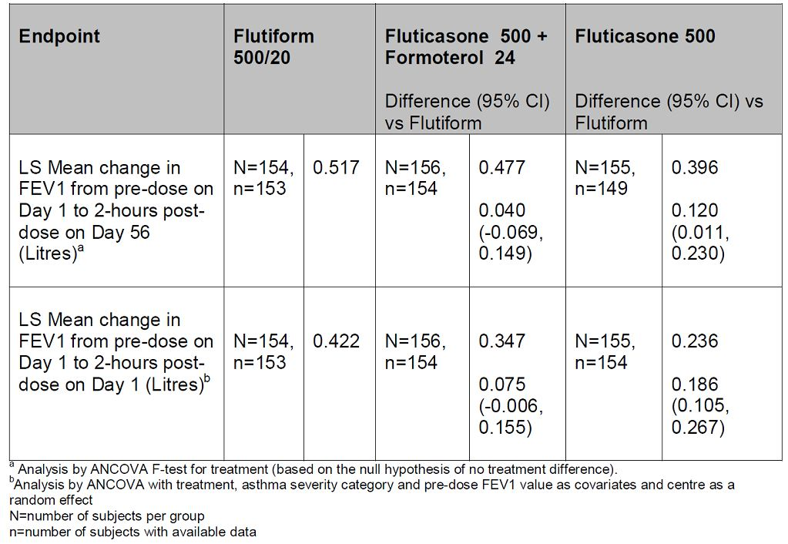

###### Evaluator’s comments

The concerns raised by evaluators were not adequately addressed by the sponsors due to the following reasons:

* Although it is acknowledged that the exploratory Study SKYE2201C/8722/01 pre dates any formoterol pMDI availability in Europe, a trend of HFA pMDI formulations resulting in higher exposure than DPI has been reported in the literature,[24] which could have confounded interpretation of results. Furthermore, it is not clear why reduction of formoterol dose to 5 µg was based on results of this exploratory study which did not comply with recommended CPMP guidelines (that is, the test and reference product were not inhaled from the same pharmaceutical dosage form).
* Results from study FLT1501 evaluating the PK following 4 weeks administration of Flutiform pMDI 500/20 μg and Fluticasone pMDl 500 μg + Formoterol pMDI 24 μg in healthy subjects and using the same administration devices (as recommended by the CPMP guidelines) showed that relative bioavailability of fluticasone and formoterol from Flutiform was 67% and 75%, respectively, compared to that following administration of reference treatments. Furthermore, this study utilised plasma formoterol assessments compared to the exploratory study which only assessed urinary formoterol levels. Results from this study which appear to comply with recommended guidelines do not provide any evidence to support selection of 5 μg formoterol instead of the approved 6 μg formoterol (Foradil). The sponsor repeatedly mentions that cross trial comparisons are not justified and on this note the evaluators would like to make it clear that there is no intention to compare results from these two PK studies: there just does not seem to be any justification for using results of an early exploratory PK study (Study SKYE2201C/8722/01) not complying with CPMP guidelines for selection of the formoterol dose in Flutiform. However, another study (Study FLT1501) which appears to comply with recommended guidelines showed that in fact exposure to fluticasone and formoterol was slightly reduced following Flutiform compared with the individual reference treatments.
* Although the sponsor states that pivotal Study FLT3503 demonstrated non inferiority of Flutiform with regards to the primary lung function endpoints compared to the individual mono components Flixotide and Foradil, given concurrently, assay sensitivity in this pivotal Phase 3 study was not conclusive. In the sponsor’s response, they have only provided a table showing change from pre dose FEV1 at Day 1 to 2 h post dose FEV1 at endpoint (Day 56). There was no analysis of change in FEV1 over 12 h on Day 56 (mentioned as a limitation in earlier evaluation report) and the sponsor has not provided this data in this submission either. This, along with other limitations of this study (outlined in original report), suggests that selection of the 5 μg formoterol dose in the Flutiform combination product was not adequately justified.

##### Question 3

Following single dose of Flutiform (250/10 μg) in patients with mild/moderate asthma (Study FLT2502), fluticasone (AUCt and Cmax) was consistently higher in adolescents compared with adults. Formoterol AUCt was similar in adolescent and adult groups, but Cmax was slightly higher in adolescents. The effects of higher systemic exposure to fluticasone and formoterol during long term maintenance treatment of adolescents would be much more significant. Could the sponsor clarify this issue?

###### Sponsor’s response

The systemic exposure of both fluticasone and formoterol in Flutiform was shown to be higher in adolescents compared with adult asthmatic subjects in the single dose Study FLT2502. In order to investigate this apparent increase in systemic exposure in adolescents, an exploratory multivariate analysis was done post hoc to investigate the effects as some of the demographic characteristics on the results. Comparison of AUC and Cmax across demographic subgroups regardless of age (gender, race, weight, BMI [body mass index], and FEV1% predicted), showed trends in the data suggestive of lower exposure in females (versus males) and in subjects with a lower weight and BMI. Given this observation, it is notable that the baseline characteristics showed fewer females and more subjects with a lower weight and BMI in the adolescent group. Thus, the higher systemic exposure levels seen with fluticasone and formoterol in adolescents may partly be explained by the demographic differences between the two age groups. This, along with evidence from the literature to support the notion that lung deposition increases with age and is similar between older children and adults,[25] has led the sponsor to propose that the increased systemic exposure seen in adolescents in Study FLT2502 is due to similar pulmonary deposition together with a lower body weight (and volume of distribution), compared with adults and this is attributed to the similar pulmonary deposition together with a lower body weight (and volume of distribution) in this age group, compared with adults.

Given the observed increase in systemic exposure of both components of Flutiform in adolescents versus adults following a single dose, the sponsor has performed a comparative analysis of AEs between adolescents (12 to ≤17 years) versus adults (18 to <65 years) based on pooled data from the randomised, Phase 3 studies with mono products arms (Study SKY2028-3-001, -002, -004 -005). These double blind studies allow the most rigorous comparisons, and as they were of 12 weeks in duration, they provide evidence of the effects of maintenance therapy. In order to demonstrate the safety of Flutiform relative to the fluticasone pMDI monoproduct alone in adolescents versus adults, the AE data from Studies SKY2028-3-001, -002, -004 and -005 were pooled as all contained a fluticasone only treatment arm. The overall proportion of patients with any AE was similar for adults and adolescents in the Flutiform group (37.0% versus 35.5%), and the percentages of patients with AEs were lower than for treatment with fluticasone alone for both age groups (46.9% versus 42.2%). There were a slightly higher proportion of treatment related AEs in adolescents versus adults in both the Flutiform (13.0% versus 9.3%, respectively) and fluticasone only treatment groups (12.2% versus 10.3%) (Table 7).

Table 7: Overall summary of AEs: SKY2028-3-001, -002, -004 and -005 pooled analysis (safety set) for adolescents versus adults treated with Flutiform or fluticasone (GSK fluticasone pMDI).

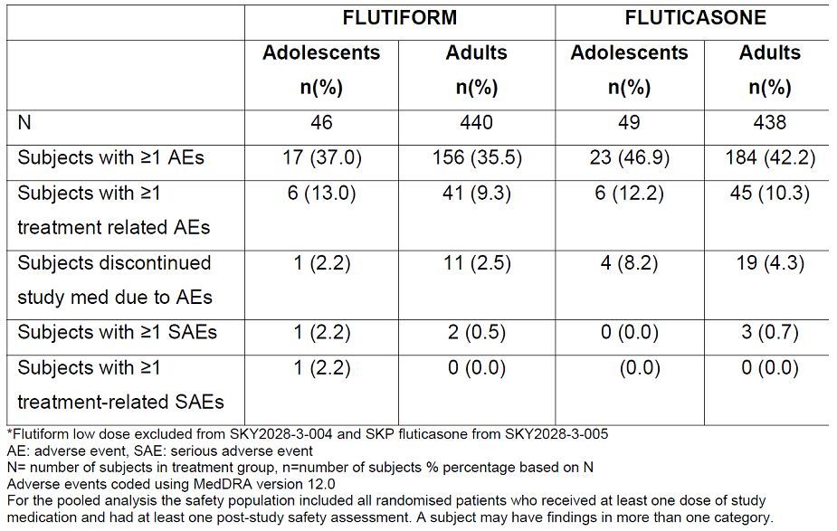

To demonstrate the safety of Flutiform relative to formoterol pMDI monoproduct alone in adolescents versus adults, the AE data from Studies SKY2028-3-001, -002 and -004 were pooled as all contained a formoterol only treatment arm. The overall number of patients with any AE was similar for adolescents and adults in the Flutiform group (37% versus 36.3%). There was a slightly higher number of treatment related AEs in adolescents versus adults (14.8% versus 11.1% respectively), although this pattern was reversed for the formoterol only arm (6.1% versus 15.7%) (Table 8). Given that the formoterol formulation and device components in Flutiform and SKP Formoterol are identical, this inconsistency in comparative AE rates between adolescents versus adults for the two products argues against formoterol exposure related causality for the observed AE pattern.

Table 8: Overall summary of AEs: SKY2028-3-001, -002 and -004 pooled analysis (safety set) for adolescents versus adults treated with Flutiform or formoterol (SKP formoterol pMDI).

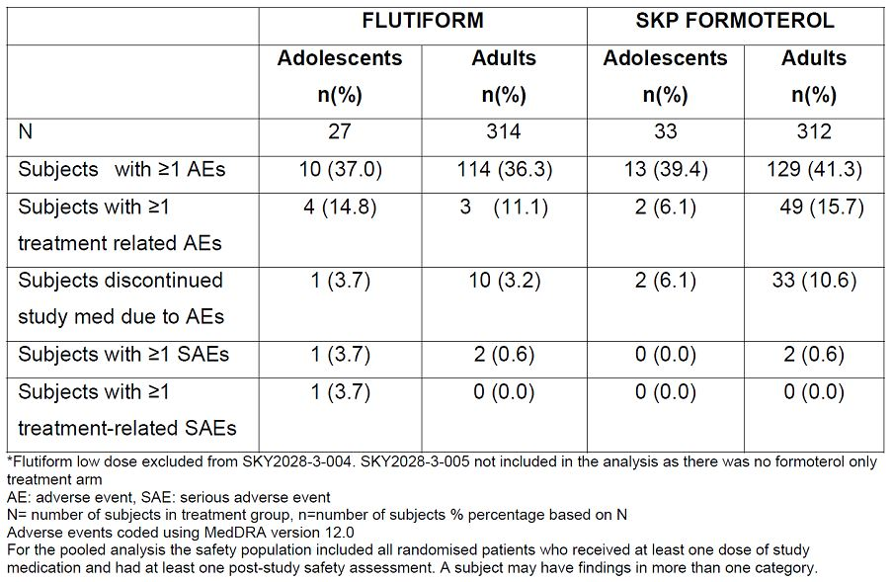

Supporting information about the systemic effects of the fluticasone component of Flutiform during maintenance therapy in adolescents was obtained from reviewing the effects on the HPA function which was studied in a small subset of patients in the open label Phase 3 Study FLT3505. This study compared Flutiform 250/10 μg bid to GSK fluticasone 250 μg pMDI + Novartis formoterol 12 μg DPI administered concurrently bid in adults and adolescents with mild to moderate/severe asthma for a treatment period of 12 weeks. Given the differences in fluticasone exposure noted between adolescents and adults with Flutiform seen in Study FLT2502, the sponsor states the results demonstrate no significant change from baseline in either adolescents or adults in relation to the effect of Flutiform on the HPA as measured by urinary free cortisol, that is, there is no evidence of additional suppression in adolescent patients. This pattern was also replicated for the combination of fluticasone + formoterol administered concurrently via separate devices in the same study.

Overall, when combined with the AE profile, these data provide additional supportive evidence of the favourable safety profile of Flutiform in adolescents up to the proposed maximum dose (250/10 μg BID) for this age group during maintenance therapy.

With respect to the System Organ Classes (SOCs) and down to the Preferred Term (PT) level, imbalances were noted for adolescents versus adults for Flutiform for a number of different events but reassuringly, any differences observed were generally of a similar magnitude to those of the individual mono products for the same event. However, directional inconsistencies for individual adverse events which would be linked to the same safety signal, suggest that such differences reflect random variation between the groups and are not indicative of AE signals. This, coupled with a lack of evidence of any overt differential effect on the HPA (as measured by UFC) in this age group, provides clarification that despite the observed increase in systemic exposure of fluticasone and formoterol (in Study FLT2502), the safety profile of Flutiform is favourable in adolescents up to the proposed maximum dose of Flutiform (250/10 μg BID) and similar to that in adults.

###### Evaluator’s comments

The sponsor attempted to explain the higher exposure to fluticasone from Flutiform compared to monocomponent to demographic differences in adolescent versus adult groups; however, this was only analysed post hoc and there has been no systematic assessment of effect of age, gender, body weight in the Flutiform clinical trial programme (no population PK analysis).

Although post hoc safety analysis comparing AE incidence in adolescents and adults from the pivotal Phase 3 studies do not reveal significant differences in safety, these results have to be interpreted with caution due to very small sample size of adolescents (n = 49 ) compared to adults (n = 442).

Although urinary cortisol levels also failed to show significant difference between adolescents and adults following Flutiform after 12 weeks of maintenance treatment, actual treatment duration are likely to be much longer and there is no long term safety data in adolescents. Although the Phase 3, open label Study SKY2028-3-003 did evaluate long term safety in 472 adult and adolescent subjects with mild to moderate/severe asthma, there was no separate safety analysis in adolescents.

##### Question 4

Systemic exposure of fluticasone increased with increasing dose in healthy subjects (Study SKY2028-1-002) and in subjects with mild to moderate asthma (Study SKY2028-2-001) who received Flutiform 100/10 µg and 250/10 µg. In both studies, the mean systemic exposure deviated from dose proportionality, but high variability prevented a definitive assessment of dose proportionality of fluticasone in plasma. Systemic exposure of fluticasone in healthy subjects (Study FLT1501) who received Flutiform 500/20 µg was higher that would have been predicted from the previous studies in lower doses, but Flutiform was administered with a spacer in this study which may have contributed to the increase in systemic exposure. Could the sponsor please comment on lack of adequate data on dose proportionality?

###### Sponsor’s response

The studies (SKY2028-1-002 and SKY2028-2-001) were not designed to confirm dose proportionality. Furthermore, with regards to the issue of dose proportionality, standardisation of inspiratory manoeuvres was not rigorous (pre study training neither incorporated use of an inspiratory flow meter such as the In Check Dial, nor did monitoring during the study involve use of an inspiratory flow recorder). Moreover the study was of parallel group (not crossover) design, which is likely to have led to even greater differences between patients and hence no definitive conclusions on dose proportionality should be drawn from Study SKY2028-1-002. The sponsor claims that an assessment of dose proportionality should be made using available pharmaceutical data and provided delivered dose data for the pivotal clinical batches. The proportionality of the fine particle dose was therefore also evaluated using the pivotal clinical batches at release and on stability.

###### Evaluator’s comments

Data on delivered dose data and fine particle dose from the clinical studies drug batches cannot be considered as evidence of dose proportionality in human subjects/patients. Furthermore, no pulmonary deposition studies were conducted with Flutiform.

##### Question 5

The Study FLT1501 results suggest that relative availability of fluticasone and formoterol was only 67% and 75%, respectively, following 4 weeks treatment with Flutiform pMDI 500/20 µg compared to administration of Fluticasone pMDI 500 µg and Formoterol pMDI 24 µg. The sponsors have done a dose adjusted analysis which suggests that relative availability of formoterol increased to 84-90% when adjusted for ‘nominal dose’ and ‘delivered dose’. However, the study report does not define nominal or delivered dose and also does not state how these were actually assessed. Could the sponsor please provide clarification on this issue?

###### Sponsor’s response

As outlined in the statistical analysis plan of Study FLT1501, pre defined dose adjusted analyses for formoterol were performed in order to derive relative systemic availability values, as the nominal and delivered doses are different for the formoterol component of Flutiform and for Foradil. Nominal dose (metered dose) is defined as the quantity of drug substance contained in the delivery device metering chamber and is the amount of drug per actuation delivered from the valve (without the actuator attached), that is, ex valve amount. Delivered dose is the quantity of drug substance that is available to the user through the actuator, ex device, that is, ex actuator amount. As pre specified in the statistical analysis plan, both nominal and delivered dose adjustments were performed prior to the analysis. For the nominal dose adjusted analyses, the parameters for Flutiform were divided by 10 and the parameters for Foradil were divided by 12. For the delivered dose adjusted parameters, the parameters for Flutiform were divided by 9 and the parameters for Foradil were divided by 10.1.

###### Evaluator’s comments

The explanation provided by the sponsor appears to suggest that exposure to formoterol was similar following Flutiform and individual reference treatments following dose adjusted comparisons which were made in two ways: according to nominal dose, and according to delivered dose. Nominal dose adjustment changed the steady state relative bioavailability of formoterol fumarate from Flutiform relative to the reference treatments from 75% to 90%, Cmax,ss ratio changed from 57% to 69%, and the Cmin,ss ratio changed from 76% to 91%. Delivered dose adjustment changed the steady state relative bioavailability of formoterol fumarate from Flutiform relative to the reference treatments from 75% to 84%, Cmax,ss ratio changed from 57% to 65%, and the Cmin,ss ratio changed from 76% to 85%. Dose adjusted analyses were not done for fluticasone as nominal and delivered dose were the same.

#### Efficacy

##### Question 1

In the pivotal Study FLT3503, there was no placebo control and the demonstration of significant benefit of using Flutiform over Fluticasone alone was supposed to provide evidence that the study was sensitive enough to detect treatment differences. Superiority of Flutiform high dose to Fluticasone alone was shown for the co primary endpoint of change from predose at baseline to 2 h postdose at Week 8 (LSMean of the treatment difference: 0.120 L; 95% CI: 0.011 to 0.230; p = 0.032; ITT). This was expected due to the missing contribution of the LABA component to post dose lung function measurements in this treatment group. However, the clinical relevance of the 120 mL increase in FEV1 is not clear. However, it was not shown for the primary endpoint of change from pre dose at baseline to pre dose at Week 8. A post hoc analysis (repeated measures ANCOVA) was performed for the change from pre dose FEV1 to 0.5, 1, 2, 4, 6, 8, 10, and 12 h post dose at Day 0. Superiority of Flutiform high dose versus Flixotide alone was only shown for the change in FEV1 from predose to 1 h and 2 h post dose (Figure 3). A similar post hoc analysis was not performed for the change from pre dose FEV1 to 0.5, 1, 2, 4, 6, 8, 10, and 12 h post dose at Day 56. However, Figure 2 showing 12 h FEV1 mean change from predose on Day 0 to predose and postdose on Day 56 seems to suggest that mean change from pre dose on Day 0 to pre dose and post dose on Day 56 did not show any significant difference between Flutiform high dose and Fluticasone alone at any time point. Hence, it is important that similar post hoc analysis be done for Day 56 too in order to elucidate the true effect of Flutiform on 12 h serial FEV1. Overall, evidence for the clinical benefit of using Flutiform high dose over Fluticasone alone was not unequivocal in terms of 12 h serial FEV1 and so evidence of assay sensitivity in this pivotal Phase 3 study was not conclusive. Can the sponsor comment on this limitation of a ‘pivotal’ study?

Figure 3: 12 h serial FEV1 (L): Mean change from pre dose on Day 0 to post first dose on Day 0 – ITT population (Study FLT3503).

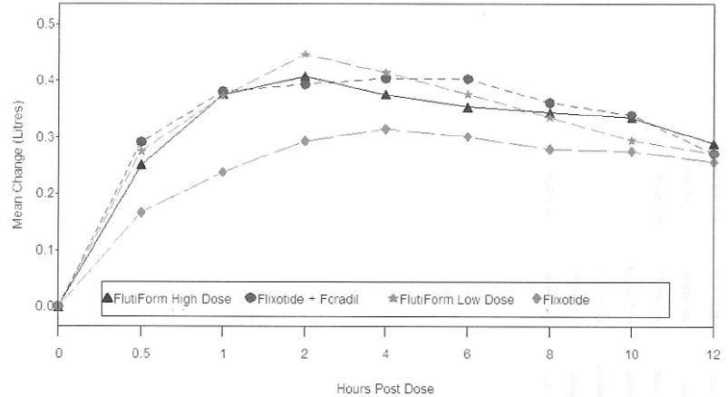

FEV1 = forced expiratory volume in first second; Flixotide = fluticasone; Foradil = formoterol

###### Sponsor’s response

Pre dose FEV1: The sponsor acknowledges that superiority of Flutiform high dose over fluticasone monotherapy was not shown for change in pre dose FEV1. However, the sponsors stress that change in pre dose FEV1 measures treatment effect when the formoterol component has worn off, that is, 12 h post dose, as evidenced by the comparison between Flixotide + Foradil versus fluticasone given alone. The treatment difference between Flixotide + Foradil versus fluticasone given alone was -40 mL (the same Flixotide product batches were used in both treatment arms, hence similar ICS effect is assured) highlighting that formoterol effects have largely abated pre dose, that is, this endpoint assessed a principally ICS mediated effect. Therefore, a substantial difference between Flutiform and fluticasone monotherapy would not be expected for pre dose FEV1 in Study FLT3503. Furthermore, while the sponsor accepts the lack of assay sensitivity of the pre dose FEV1 endpoint, it should be noted that point estimate differences between Flutiform high dose and Flixotide + Foradil were in favour of Flutiform (60 mL [-59, 180]).

2 h pose dose FEV1: clinical relevance of an observed treatment difference of 120 mL for 2 h post dose FEV1 between Flutiform high dose and fluticasone monotherapy, given that the pre specified non inferiority margin was 200 mL. A 200 mL non inferiority margin was chosen as it is frequently cited in the literature. However, it is widely recognised that the magnitude of a clinically relevant effect is likely to depend upon baseline disease severity and GINA (Global Initiative for Asthma)[26] treatment step alongside other variables and that it therefore varies for different patient populations. Regarding the clinical relevance of the observed spirometric effects of Flutiform high dose versus Flixotide it is perhaps best contextualised by considering symptomatic benefits. Compared with fluticasone monotherapy, Flutiform high dose led to a 22% relative increase in both symptom free days and awakening free nights, a 12% relative increase in days without rescue medication use, a 14% relative increase in asthma control days and a 33% relative increase in mean AQLQ score, a validated health related quality of life questionnaire. These observations suggest that spirometric benefits with Flutiform high dose were associated with clinically relevant improvements in symptoms. The 2 h post dose FEV1 data in Table 9 demonstrate a separation between the effects of both combination treatments versus fluticasone monotherapy, suggesting assay sensitivity as is required to facilitate a non inferiority comparison between the combination treatment arms. It is noted that the lower limit of the 95% confidence interval for the LSMean difference between Flutiform and Flixotide + Foradil is (-) 98 mL.

Table 9: Change from pre dose FEV1 at Day 0 to 2 h post dose FEV1 at Day 56 – Per Protocol population.

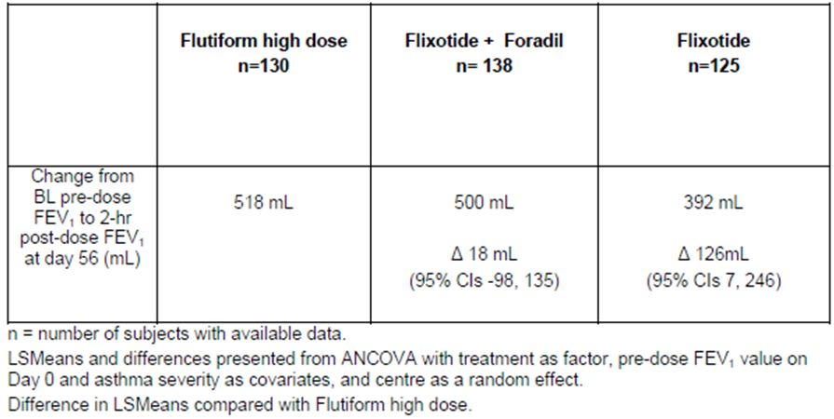

12 h FEV1 AUC: regards the evidence of assay sensitivity with 12 h FEV1 AUC as inconclusive as superiority of Flutiform over fluticasone for FEV1 AUC at Day 0 was only seen after a post hoc analysis at 1 h and 2 h post dose. Study FLT3503 was not powered to show superiority of Flutiform over fluticasone with regards to 12 h FEV1 AUC. The FEV1 AUC data at Day 0 were based on a subgroup of only ~50% of the total population. The mean difference was 1025 mL*h in favour of Flutiform compared to Flixotide (ITT population). With the complete population sample it is likely that a significant difference would have been demonstrated for FEV1 AUC.

Repeated measures post dose ANCOVA at Day 56: repeated measures ANCOVA for FEV1 at Day 56 was based on a subgroup of even less than 50% of the total population as these data were collected at the end of the study. Again, this endpoint was not powered to show superiority of Flutiform over fluticasone. Nonetheless, mean differences at all endpoints apart from 12 hours post dose favoured high dose Flutiform and ranged upward from 23 mL at 10 h post dose to 104 mL at 4 h post dose that despite an underpowered analysis, the lower limit of the 95% confidence interval for the LSMean difference between Flutiform and Flixotide + Foradil of (-) 98 mL is close to the LSMean difference between Flutiform versus fluticasone monotherapy (62 mL). This is suggestive, albeit not confirmatory, of noninferiority between the combination formulations.

###### Evaluator’s comments

The sponsor has accepted that there is lack of assay sensitivity of the pre dose PEV1 endpoint although they stress that point estimate differences between Flutiform high dose and Flixotide + Foradil were in favour of Flutiform (60 mL [-59, 180]). However, it is important to note that the 95% CI were quite wide.

The 2 h post dose FEV1 also only showed an observed difference of 120 mL between Flutiform high dose and Flixotide + Foradil which was less than the pre defined non inferiority margin of 200 mL. However, the Flutiform high dose did show relevant symptomatic benefits compared to fluticasone monotherapy but these would be expected considering the added bronchodilator effect of the LABA component in Flutiform and cannot be used to justify assay sensitivity. There were no statistically significant differences between Flutiform high dose and Fluticasone + Formoterol or Flutiform low dose for asthma symptom score, percentage of symptom free days, improvement in sleep disturbance score.

More concerning is the fact that 12 h FEV1 AUC showed superiority of Flutiform over fluticasone only at 1 and 2 h post dose. The sponsor justifies this by stating that only 50% of the sample size was included in these analyses and <50% of patients were included in the repeated measures post dose ANCOVA for FEV1 at Day 56 which may have accounted for reduced observed effect . However, this is another limitation of the study as the CHMP guidelines for inhalational products for treatment of asthma recommend that the appropriate primary variables are FEV1 AUC (measurement of bronchodilatation over at least 80% of the duration of action after a single inhalation) and change in FEV1 (at an appropriate time points).

Overall, the sponsor’s response fails to address the concerns regarding lack of conclusive evidence of assay sensitivity in the pivotal Phase 3 Study FLT3503 confounding interpretation regarding results related to non inferiority of Flutiform 500/20 µg compared to Fluticasone 500 µg + Formoterol 24 µg.

##### Question 2

The ‘pivotal’ Study FLT3503 had a treatment duration of only 8 weeks which was clearly below the recommended CPMP guidelines for asthma drugs.[27] Other approved LABA + ICS inhaled combination treatments (such as Seretide and Symbicort) evaluated efficacy over treatment periods of ≥12 weeks. The superiority pivotal Phase 3 Flutiform studies as well as most of the non inferiority and superiority supportive Phase 3 studies were all of 12 weeks duration. The sponsors need to clarify reasons behind a shorter treatment period for the pivotal FLT3503 study.

###### Sponsor’s response

Eight weeks was chosen as the minimal acceptable trial duration in accordance with the guideline for orally inhaled products,[28] which came into effect in Europe in 2009 and was adopted by TGA effective 23 February 2010. The trial duration was also approved in a scientific advice meeting with the Medicines and Healthcare products Regulatory Agency (MHRA) on 21 July 2008. The 2009 guideline for orally inhaled products represents the most recently adopted guideline applicable to orally inhaled products and recommends a study duration for inhaled corticosteroids between 8 and 12 weeks. With corticosteroid based therapy improvement of lung function and symptom control in asthma typically occurs rapidly, within one to two weeks. Treatment effects are generally near maximal by about 4 weeks and maximal by 8 to 12 weeks and do not attenuate thereafter. Therefore, a treatment period of 8 or 12 weeks is equally suitable, the only difference being that the latter is more commonly used.

The pooled results of the randomised, double blind Phase 3 Studies SKY2028-3-001, -002, -004 and -005 endorse the observations above and the rationale for either an 8 or 12 week trial duration as advocated by CHMP. Figure 4 shows the steepest increase in pre dose FEV1 with Flutiform treatment within the first 2 weeks, only further small changes between 2 and 12 weeks of treatment, and little difference in effect between 8 and 12 weeks of treatment. A similar evolution in pre dose FEV1 can be seen with Flixotide treatment.

Figure 4: Mean change in pre morning dose FEV1 (L) from Week 0 to Weeks 2, 4, 8 and 12 for treatment with Flutiform and flixotide – ITT population (pooled data from SKY2028-3-001, -002, -004 and -005).

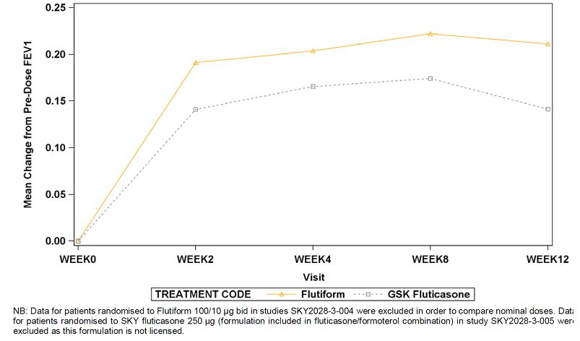

Further support for the trial duration is available from the literature. Multiple longitudinal studies have demonstrated that key conventional endpoints measured in Phase 3 studies, that is, lung function effects and symptoms scores, are sustained but do not usually improve beyond that seen at 3 months with ICSs and ICS-LABAs (O’Byrne 2007).[29] Haathela et al. (1991) treated 103 asthmatic patients with either 600 μg budesonide or 375 μg terbutaline twice daily.[30] Figure 5 shows the mean morning and evening peak expiratory flow rates recorded for 12 weeks after randomisation and then for the last 4 weeks of the first and second study years lung function improved with budesonide treatment over the first 6 weeks after randomisation and was sustained thereafter. Another study by Scicchitano and colleagues randomised 1,890 asthmatic patients to 12 months of treatment with either budesonide 320 μg bid plus 0.4 mg terbutaline as needed or Symbicort 320/9 μg once daily plus additional inhalations as needed.[31] Lung function (measured by morning PEF [peak expiratory flow]) improved with budesonide and Symbicort treatment over the first 6 weeks after randomisation and was sustained thereafter (Figure 6).

Figure 5: Mean morning and evening peak expiratory flow rates over 12 weeks of treatment with budesonide and terbutaline and then for the last 4 weeks of the first and second study years (Haahtela et al., 1991).

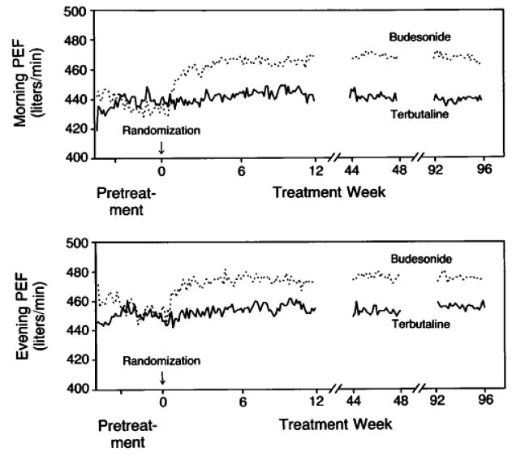

Figure 6: Mean morning peak expiratory flow rates over 12 months of treatment with budesonide 320 µg BID + terbutaline as needed or Symbicort 160/9 µg OD + additional inhalations as needed (Scicchitano et al., 2004).

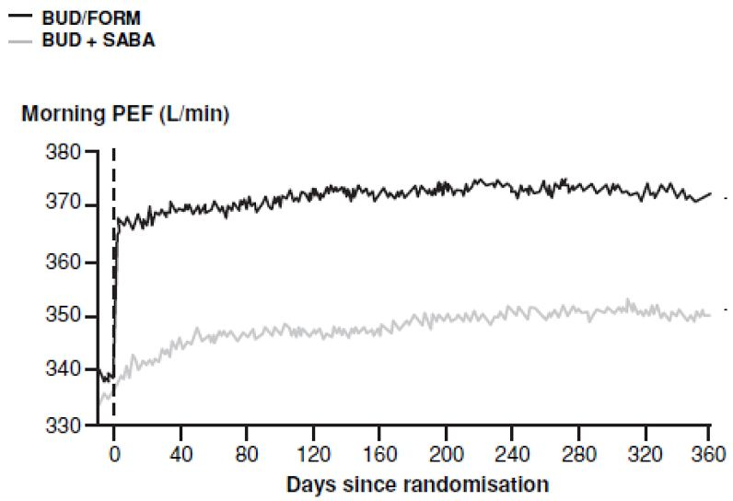

Given that Flutiform is comprised of two well known active substances supported by an extensive literature base, there does not appear to be an obvious rationale as to why treatment effects would evolve at a similar rate to that previously reported for these well known substances and the wider drug classes over an 8 or 12 week treatment period but then diverge from the pattern previously reported during long term treatment.

Indeed, pre dose FEV1 data from long term Study SKY2028-3-003 confirm this pattern. In this study, 216 patients were treated with Flutiform 100/10 μg or 250/10 μg twice daily over a period of 12 months. The published literature and the sponsor’s previous studies demonstrate that lung function effects with ICSs or ICS-LABAs are maximal at 8 weeks and are sustained thereafter. As such, treatment effect differences will be similar whether measured at 8 or 12 weeks and selection of one or other of these treatment durations would not be expected to fundamentally alter the conclusions of the study. The most recently adopted CHMP and TGA regulatory guidance pertaining to orally inhaled products also allows for a study duration of 8 weeks. Finally, current GINA guidelines indicate that maintaining patients on a high dose of maintenance treatment for a fixed duration of 6 months should not be standard practice.[32] Given all of the above, the sponsor considers that the 8 week duration of Study FLT3503 was appropriate to investigate the efficacy of Flutiform.

###### Evaluator’s comments

The sponsor’s explanation for suggesting that 8 week duration for Study FLT3503 was acceptable.

##### Question 3

No subgroup efficacy analysis results were available from the pivotal Study FLT3503. Analysis of efficacy in subgroups of patients based on severity of asthma and baseline disease characteristics would help to better define the patients most likely to benefit from Flutiform treatment. Was such a subgroup analysis done for the pivotal studies and if it was, could the sponsors please provide results?

###### Sponsor’s response

The sponsor has undertaken post hoc subgroup analyses by asthma severity for all efficacy endpoints in Study FLT3503. Randomisation into the study was stratified by % predicted FEV1 at baseline (>40 <60% versus >60 <80%). This provided a straightforward basis for a dichotomised analysis by baseline FEV1 severity, more so since the dichotomy split the total sample into two substantial and very similar sized subgroups (52% and 48% of the total ITT sample, respectively).

Spirometry summary:

The main findings from these subgroup analyses were:

1. The comparative spirometric effects of Flutiform 500/20 and Flixotide 500 + Foradil 24 were similar in the overall population and in the “moderate” and “severe” patient subgroups with similar mean improvements in pre dose and 2 h post dose FEV1 and in PEFR that were consistent with or exceeded thresholds defined as being of minimal clinical importance.
2. Flutiform 500/20 conferred (at least numerically) greater treatment effects than Flixotide 500 monotherapy for most spirometric endpoints. The only clear subgroup trend evident for this product comparison was a greater treatment effect difference (in favour of Flutiform) for FEV1 AUC1 in “moderate” asthma patients. This may suggest that patients with less severe disease manifest a more prolonged treatment response with LABA therapy, appears to be driven by a higher than anticipated treatment effect in the Flixotide 500 “severe” subgroup. Since ICSs have no acute bronchodilatory effects, pre dose and 2 h post FEV1 effects with Flixotide 500 should be fairly similar. However , there is approximately 100 mL difference in the pre dose and 2 h post dose values for the Flixotide 500 “severe” subgroup. The “severe” subgroup post dose value may be spurious and somewhat misleading therefore and may hinder an assessment of the subgroup data for this endpoint. With respect to 12 h FEV1 AUC at Days 0 and 56 greater treatment effect differences between Flutiform 500/20 and Flixotide 500 were evident in the “moderate” asthma subgroup than in “severe” patients. As for the 2 h post dose FEV1 data, this trend was also evident when comparing Flixotide 500 + Foradil 24 and Flutiform 100/10, respectively, to Flixotide 500. However, unlike the 2 h post dose FEV1 data, there do not appear to be any outlying and implausible results in any treatment subgroups. As FEV1 AUC reflects LABA effect (in addition to ICS effect in the case of FEV1 AUC at Day 56), the observed results suggests that the duration of LABA mediated bronchodilatation may be greater in patients with “moderate” versus “severe” asthma. With respect to the pre dose FEV1 and the PEFR data, there were no robust, consistent trends to suggest differential treatment effect differences in patients with “moderate” or “severe” asthma.
3. Neither the overall data nor subgroup analyses (in the “moderate” or “severe” subgroups) demonstrated a dose response relationship between Flutiform 500/20 and 100/10 doses for spirometric variables.

Symptom based endpoint summary:

The main findings from this subgroup analysis were:

1. Flutiform 500/20 and Flixotide 500 + Foradil 24 exerted similar treatment effects for all symptom based endpoints in the overall population. Some minor differences between Flutiform 500/20 and Flixotide 500 + Foradil 24 were noted in the subgroup comparisons, but these followed no plausible pattern and are likely to be random differences.
2. For the overall population, Flutiform 500/20 was superior to Flixotide 500 with regards to discontinuations due to lack of efficacy, asthma symptoms, % symptom free days, % awakening free nights and AQLQ. Numerical advantages of treatment with Flutiform 500/20 over Flixotide 500 were seen for sleep disturbance scores, % rescue medication free days and % asthma control days.
3. Subgroup analyses of symptom based endpoints suggested more pronounced treatment effect differences between Flutiform 500/20 and Flixotide 500 in “severe” asthmatics for the following endpoints: % symptom free days, % awakening free nights, % rescue free days, and AQLQ scores. These observations are supported by the corresponding “severe” subgroup data for Flixotide 500 + Foradil 24 versus Flixotide 500, which showed a similar trend. For the overall population, there was no difference in the proportion of Flutiform 500/20 versus Flixotide treated patients who reported asthma exacerbations (36.4% versus 37.4%, respectively). In “severe” patients there did however appear to be a trend whereby the proportion of patients with exacerbations was numerically lower in the Flutiform 500/20 group versus the Flixotide 500 group (31.6% versus 43.9%). This pattern was however reversed in the “moderate” subgroup with exacerbations reported in more Flutiform 500/20 treated patients (41.3% versus 30.1%). The marked similarity of the Flutiform 500/20 subgroup data to those observed for Flixotide 500 + Foradil 24, and the lack of a plausible explanation for the Flixotide 500 “moderate” subgroup data (patients in the Flutiform 500/20, Flixotide 500 + Foradil 24 and Flixotide 500 treatment groups all received high dose fluticasone therapy) suggests that the Flixotide 500 “moderate” subgroup data may be a random “outlying” result.
4. A clear dose response trend was seen when comparing the symptom based endpoint data for Flutiform 500/20 versus Flutiform 100/10. For the overall population, Flutiform 500/20 was statistically superior to Flutiform 100/10 with regards to discontinuations due to lack of efficacy, sleep disturbance scores and % awakening free nights. Numerical advantages in favour of the high dose were also reported for 7 of 8 remaining symptom based endpoints. Subgroup analyses showed that treatment effect differences between Flutiform 500/20 and 100/10 were more pronounced in severe asthmatics than in moderate asthmatics for the following endpoints:
   * the change in mean symptom scores
   * the change in % symptom free days
   * the change in mean sleep disturbance scores
   * the change in awakening free nights
   * the change in % rescue medications free days
   * the change in % asthma control days
   * the incidence of any asthma exacerbations
   * the change in AQLQ score
   * the proportion of patients achieving a minimal important change (0.5 units) in AQLQ score
5. The differences between Flutiform 500/20 and 100/10 in the severe subgroup were statistically significant (at the 5% level) for sleep disturbance scores, % awakening free nights and mean AQLQ. These data suggest that symptomatic treatment benefits of Flutiform 500/20 are likely to be greatest in patients with severe asthma, which is in keeping with established asthma management principles and guidelines.

###### Evaluator’s comments

The limited subgroup analysis in the pooled efficacy dataset (which only included patients from Studies FLT3501 and DLT3505) did not show effect of age, gender, race, prior ICS use, and baseline severity of asthma on the efficacy of Flutiform. However, there was no analysis of efficacy in subgroups in any of the pivotal Phase 3 studies which would have helped to better define the patients most likely to benefit from Flutiform treatment. In the sponsor’s response, only efficacy in subgroups based on moderate or severe COPD was done post hoc; no other subgroups analyses were provided. Overall, results of these new subgroup analysis showed a trend suggesting that Flutiform showed better spirometric improvement in patients with moderate asthma and better symptomatic improvement in patients with severe asthma, although these results should be interpreted with caution due the post hoc nature of these analyses. Furthermore, no other subgroups analyses (such as effect of age, gender, race, other disease characteristics) were done for the pivotal study.

##### Question 4

In Study SKY2028-3-001, the inclusion criteria for patients with mild to moderate asthma was % FEV1 predicted of 60-85%; according to the GINA classification of asthma severity, mild/moderate asthma is defined as between 60-80% and it is not clear why the sponsor chose criteria of 85% for this study. Please clarify.

###### Sponsor’s response

Study SKY2028-3-001 was originally designed as part of a study programme to obtain marketing approval for Flutiform in the US. The study started in 2006 and was negotiated with the FDA when GINA and National Asthma Education and Prevention Program (NAEPP) guidelines defined mild asthmatic patients with an FEV1 predicted of >80%. As the FDA advised the sponsor company to capture mild asthmatic patients, patients with FEV1 predicted up to 85% were included. This was applied consistently throughout the US study programme for all studies that included mild to moderate asthmatic patients (Studies SKY2028-3-002, SKY2028-3-003 and SKY2028-2-002).

In the literature, a number of studies can be found that used 85% or 90% as the upper limit of FEV1 predicted as an inclusion criterion for patients with mild to moderate severe asthma.[33] There is unlikely to be a different treatment response in patients with an FEV1 of 60-80% predicted, 60-85% predicted or 60-90% predicted. Of note, the current GINA guideline no longer classifies asthma severity using FEV1% predicted, but rather defines asthma severity by the requisite treatment intensity to gain asthma control.[34]

###### Evaluator’s comments

The sponsor response to the above query is acceptable.

##### Question 5

In Study FLT3505, the secondary efficacy endpoint was the change in FEV1 from pre dose on Day 0 to 30-60 mins post dose on Day 84. Could the sponsor clarify why the post dose time point of 30-60 mins was chosen in this study compared to the 120 mins post dose time point in the other Flutiform studies?

###### Sponsor’s response

In Study FLT3505, a pragmatic approach was taken in order to be able to send patients home early from their study visit, and thus a post dose time point of 30 to 60 mins was chosen to measure bronchodilation. According to literature, the bronchodilatory effect of formoterol sets in within 1-3 mins post dose and reaches its maximum after 1 to 3 h (Foradil SmPC 2011). Similar effects were observed in the clinical development program for Flutiform. A rapid onset of action starting from 3 mins was confirmed. To further investigate the bronchodilatory effect of Flutiform and fluticasone over the dosing interval, FEV1 AUC0-12h data from three 12 week, randomised, double blind adult Flutiform studies (Studies SKY2028-3-001, -004 and -005, in which serial spirometry was performed) were pooled. In all three studies, Flutiform low and mid dose were compared to an equivalent nominal dose of GSK fluticasone pMDI. These studies are therefore relevant to Study FLT3505 in which Flutiform low and mid dose were compared to an equivalent nominal dose of GSK fluticasone pMDI plus Foradil DPI. The spirometric benefit of Flutiform over fluticasone was sustained throughout the dosing interval in these studies with the steepest increase in FEV1 being observed within the first 30 mins post dose and the maximum effect being sustained during the first 4 to 6 h. Of particular note given the assessor’s question, the treatment effect difference between Flutiform and fluticasone is very similar at 30-60 mins post dose and at 2 h post dose (Figure 7). Accordingly, use of the 30-60 minute endpoint in Study FLT3505 would not have be expected to have generated different results compared to the 2 h post dose endpoint used in other studies.

Figure 7: Serial spirometry: AUC0-12h at Week 12 (calculated as the change from Day 1 pre dose FEV1 baseline) in Studies SKY2028-3-001, -004 and -005 (ITT population).

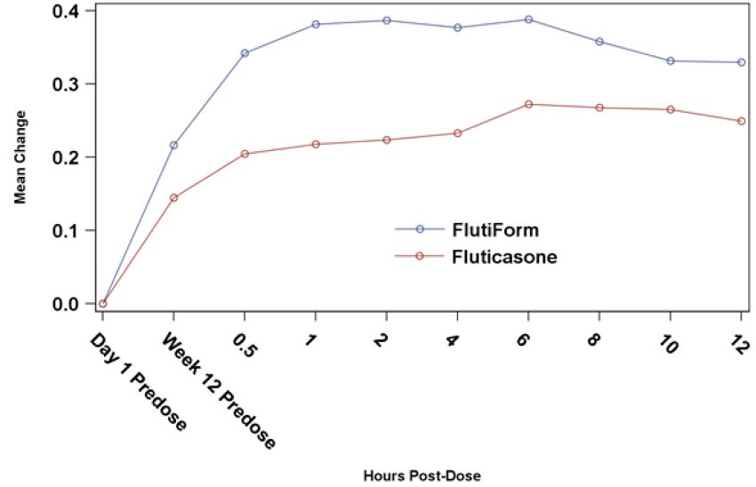

###### Evaluator’s comments

The sponsor response to the above query is acceptable.

#### Safety

None.

### Clinical summary and conclusions

#### Clinical aspects

##### Clinical pharmacology

Flutiform is a new combination product administered by oral inhalation via a hydrofluoroalkane (HFA) propelled pressurised metered dose inhalation (pMDI) containing a fixed combination of an ICS fluticasone propionate and a LABA eformoterol fumarate dihydrate. Flutiform does not use a chlorofluorocarbon (CFC) as a propellant, making it more environmentally friendly and is in line with the gradual phasing out of all CFC containing inhalers used in treatment of asthma. The pMDI selected has been justified and has been used consistently throughout the clinical programme. The use of a spacer is recommended particularly for those with poor coordination such as the young and elderly, or those taking high dose ICS. A comprehensive assessment of four spacer devices was conducted, leading to the adoption of the Aerochamber Plus for use in part of the Phase 3 programme and recommendation in the proposed SmPC.

Overall, there is high variability in PK parameters of fluticasone and formoterol following administration of Flutiform both within and between the PK studies. However, in general there is a trend for the systemic exposure of fluticasone and formoterol to be less with Flutiform inhaler than with the individual components administered together as shown in single dose Study AG2028-C101 and multiple dose Study FLT1501. There have been no studies that directly compare exposure in healthy and asthmatic subjects.

The mean terminal half life (t1/2) of plasma fluticasone for SKP Flutiform after oral inhalation ranges from 10 to 14 h across the studies. Plasma formoterol data have been gathered only in the more recent studies, FLT1501 and FLT2502. The mean values t1/2 of plasma formoterol for Flutiform after oral inhalation ranged from 6.5 to 9 h across both studies. Hence, the twice daily dosing regimen for Flutiform appears to be justified.

Systemic exposure of fluticasone increased with increasing dose in healthy subjects (Study SKY2028-1-002) and in subjects with mild to moderate asthma (Study SKY2028-2-001) who received Flutiform 100/10 and 250/10. In both studies, the mean systemic exposures deviated from dose proportionality and the coefficients of variation associated with the various measures of AUC were high preventing a definitive assessment of dose proportionality of fluticasone in plasma. Systemic exposure of fluticasone in healthy subjects (Study FLT1501) who received Flutiform 500/20 μg was higher than would have been predicted from the previous studies in lower doses, but this study used spacers.

Selection of formoterol dose of 5 µg in the Flutiform pMDI formulation instead of 6 µg in Foradil is based on the 24% to 39% higher mean cumulative amounts of formoterol excreted in urine in the Phase 2 Study SKYE2201C/8722/01 in 45 subjects with asthma following single dosing with SKP formoterol pMDI 6 µg compared to dosing with Foradil DPI (12 µg and 24 µg). However, this justification seems inadequate as has been discussed in detail in this clinical evaluation report. The main points were that in the use of similar devices (pMDI versus DPI), ‘increased’ exposure to formoterol was not associated with increased improvement in lung function parameters, and that urine formoterol is not a very accurate measure of actual exposure to formoterol. Most importantly, in another 4 week Study FLT3501 using similar devices and measuring plasma formoterol, relative bioavailability of fluticasone from Flutiform was only 67%, while that of plasma formoterol from Flutiform was 75% compared with fluticasone + Formoterol. In Study FLT1501, pre defined dose adjusted analyses for formoterol were performed in order to derive relative systemic availability values, as the nominal and delivered doses are different for the formoterol component of Flutiform and for Foradil. Nominal dose (metered dose) is defined as the quantity of drug substance contained in the delivery device metering chamber and is the amount of drug per actuation delivered from the valve (without the actuator attached), that is, ex valve amount. Delivered dose is the quantity of drug substance that is available to the user through the actuator, ex device, that is, ex actuator amount. Nominal dose adjustment changed the steady state relative bioavailability of formoterol fumarate from Flutiform relative to the reference treatments from 75% to 90%, Cmax,ss ratio changed from 57% to 69%, and the Cmin,ss ratio changed from 76% to 91%. Delivered dose adjustment changed the steady state relative bioavailability of formoterol fumarate from Flutiform relative to the reference treatments from 75% to 84%, Cmax,ss ratio changed from 57% to 65%, and the Cmin,ss ratio changed from 76% to 85%.

No specific drug interactions studies were conducted with Flutiform. Results of the Phase 2, single dose Study SKY2028-2-001 in asthma patients where the Cmax and AUC0-t of fluticasone from the Flutiform 250/10 μg product were higher than those observed when the Flixotide 250 μg + Foradil 12 μg inhalers were used concurrently, but similar to those observed with the Flixotide 250 μg product alone, indicated a possible interaction of Formoterol on Fluticasone PK when administered in the same inhaler compared to in separate inhalers.

Effect of age, gender, weight, race, renal/ hepatic impairment on PK of Flutiform was not evaluated. Following single dose of Flutiform (250/10 µg) in patients with mild/moderate asthma (Study FLT2502), fluticasone (AUCt and Cmax) was consistently higher in adolescents compared with adults. Formoterol AUCt was similar in adolescent and adult groups, but Cmax was slightly higher in adolescents.

There were no changes to the Flutiform formulation during the clinical development and the proposed commercial Flutiform formulation was used in all the Phase 3 studies. No specific biopharmaceutics studies have been conducted. The influence of actuators and spacers on the delivery of the Flutiform product was evaluated. Overall, the actuators tested demonstrated a variable effect, and no discernible pattern with respect to exposure levels could be associated with the use of either actuator. Furthermore, all Phase 3 studies and majority of Phase 1 and 2 studies used the final actuator. No issues are anticipated when switching from Flutiform administration without an Aerochamber Plus to with an Aerochamber Plus, as results from all studies suggest that although exposure to fluticasone is increased following administration of Flutiform with a spacer, the influence of the spacer on fluticasone exposure is less with Flutiform than it is with the mono products.

##### Clinical efficacy

Flutiform is a fixed dose combination of 2 well known APIs (active pharmaceutical ingredients), formoterol and fluticasone, which have been used to treat asthma successfully for many years and are often co prescribed.

All four pivotal studies were of double blind, randomised, parallel group design, and aimed to demonstrate superiority of the combination product over its constituent drugs at each dose strength, or equivalence of the combination product compared to the two drugs taken concurrently from separate inhalers (concurrent therapy). The study design complied with recommended guidelines.[35] The patient populations, study designs and efficacy measurements utilised in these studies were consistent with standard and accepted approaches to evaluate maintenance asthma therapy and are similar to studies included in development programmes for approved combination products with ICS and LABA except in pivotal Study FLT3503. Pivotal Studies FLT3503 and SKY2028-3-004 included patients with severe persistent asthma, while Studies SKY2028-3-001 and SKY2028-3-002 included patients with mild to moderate asthma; severity of asthma was well defined based on FEV1% predicted as well use of rescue medication, sleep disturbance scores and asthma symptoms.

The Phase 3, open label Study 2028-3-005 demonstrated superiority of Flutiform 250/10 μg compared to SKP Fluticasone and Flovent Fluticasone (250 µg) in adult/adolescent patients with moderate to severe asthma requiring inhaled steroids. Results from primary, secondary, and tertiary efficacy endpoints were generally clinically indistinguishable for SKP Fluticasone 250 μg and Flovent Fluticasone 250 μg which supports the use of Flovent Fluticasone as a monotherapy comparator in the other Phase 3 studies.

###### Dose response

In the Phase 3 programme, two studies (SKY2028-3-004 and FLT3503) assessed the dose response as part of a range of secondary objectives. One of the main secondary objectives of Study FLT3503 was to demonstrate a dose response effect between Flutiform 500/20 and 100/10. Discontinuations due to lack of efficacy were reported for 6 subjects (3.9%) in the Flutiform high dose group, and 18 subjects (11.6%) in the Flutiform low dose group. In the Flutiform low dose group subjects started to discontinue soon after Day 14 reflecting that subjects were not optimally treated. Hence, there was no dose response demonstrated for the co primary efficacy endpoints.[36] A post hoc analysis showed superiority of Flutiform high dose versus Flutiform low dose overall including all time points and at each study visit except Day 56.[37] The failure to show a statistically significant difference at Day 56 may be explained by more subjects discontinuing prematurely due to lack of efficacy in the low dose group. However, this again highlights the fact that the study population was not appropriate to detect dose response of Flutiform. However, the high dose of Flutiform provided better outcomes than the low dose of Flutiform for a substantial number of clinically important endpoints. Overall, the evidence for dose-response between Flutiform 500/20 µg and 100/10 µg was not unequivocal.[38]

In Study SKY2028-3-004, no formal statistical analysis was done to evaluate dose response between Flutiform 250/10 and 100/10 with both doses showing comparable results. However, in the subgroup of subjects with severe disease (defined as FEV1% predicted of 40% to 60%), Flutiform 100/10 had a greater mean increase in FEV1 predose at Week 12 (mean difference = 0.268 L) compared to Flutiform 250/10 (mean difference = 0.166 L), while the incidence of severe asthma exacerbations was lower in the Flutiform 250/10 (5.7%) group compared with Flutiform 100/10 (10.8%). However, these results should be interpreted with caution due to the small sample size in the severe disease subgroup. Overall, evidence of dose response for the proposed Flutiform doses of 500/20, 250/10 and 100/10 was not adequate.

###### Efficacy in pivotal studies

Results of the pivotal non inferiority Study FLT3503 appeared to demonstrate non inferiority between twice daily administration (for 8 weeks) of high dose Flutiform (500/20 µg twice daily) and Fluticasone 500 µg + formoterol 24 µg in adult patients with moderate to severe persistent asthma (who required >500 µg fluticasone or equivalent ICS dose daily) in terms of primary and co primary efficacy endpoints. However, the interpretation of results were confounded by limitations of the study, especially lack of assay sensitivity and other factors as outlined in this clinical evaluation report.[39]

###### Superiority of Flutiform 100/10 µg and 250/10 µg over its components

Results from the two pivotal superiority Studies SKY2028-3-001 and SKY2028-3-002 demonstrated that Flutiform 100/10 provides greater efficacy compared to its components, fluticasone and formoterol, for the management of mild to moderate asthma. These studies enrolled both subjects who were and were not previously receiving ICS, which reflects the mixed population of patients suffering from mild to moderate asthma who will likely be treated with Flutiform. The mean changes in FEV1 from pre dose at baseline to pre dose or 2 h post dose were generally numerically greater for Flutiform 100/10 compared to its components beginning at Week 2 and were sustained throughout the 12 week treatment period. However, a mean increase versus monotherapy of 100 to 118 mL in pre dose FEV1 and increase of 122-200mL in 2 h post dose FEV1 may be less clinically relevant, according to the evaluator. Results from multiple secondary efficacy endpoints showed statistically significant superiority of Flutiform over its individual components. Assessments of lung function, disease control and asthma symptoms generally supported the superior efficacy of Flutiform 100/10 compared to its components, fluticasone and formoterol. Study SKY2028-3-004 was a pivotal Phase 3, randomised, double blind, placebo and active controlled, parallel group, stratified, 12 week study which established the superiority of Flutiform 250/10 µg over its components as well as placebo in adult/adolescent patients with moderate to severe asthma who required steroids (inhaled steroid regimen for at least 4 weeks prior to the screening visit at a dose <500 μg/day fluticasone) in terms of primary endpoints (FEV1) as well as clinical endpoints. However, this study also showed mean increase versus monotherapy in pre dose and 2 h post dose FEV1 of only 189 and 146 mL, respectively.

###### Evidence of efficacy from supportive studies

Results from the open label, Phase 3 Study FLT3505 showed that Flutiform (100/10 and 250/10) was non inferior to its individual components, Flixotide plus Foradil (100/12 µg and 250/12 µg) in 210 adult/ adolescent patients with mild to moderate/severe asthma with regard to post dose FEV1, change in pre dose to post dose FEV1, and discontinuations due to lack of efficacy. Analysis of the other efficacy parameters such as other pulmonary function tests, patient reported outcomes, rescue medication use, asthma exacerbations and AQLQ yielded comparable results for the Flutiform and Flixotide + Foradil treatment groups.

Results of the open label, supportive Study FLT3501 demonstrated non inferiority of Flutiform (fluticasone/ formoterol 250/10 or 100/10 µg) to Seretide (fluticasone/salmeterol 250/50 or 100/50 µg) in 202 adult patients with mild to moderate/severe persistent asthma with regard to predose and post dose FEV1 and discontinuations due to lack of efficacy. Superiority of Flutiform over Seretide could be shown for time to onset of action of study medication. Analysis of the other efficacy parameters such as other pulmonary function tests, rescue medication use, asthma exacerbations yielded comparable results for Flutiform and Seretide treatment groups. However, overall patient assessment of study medication and the improvement in AQLQ scores was slightly better for Seretide.

###### Long term efficacy

Efficacy was the secondary objective of the Phase 3 open label, long term Study SKY2028-3-003 in 472 adult and adolescent patients with mild to moderate/severe asthma over a period of up to 12 months following twice daily treatment with SKP Flutiform HFA pMDI (100/10 μg and 250/10 μg). Overall, 224 and 248 patients received Flutiform 100/10 µg and 250/10 µg, respectively. Of the 472 treated subjects, 256 and 216 subjects enrolled for the 6 month and 12 month treatment periods, respectively. Clinically and statistically significant improvements were observed for all efficacy assessments (FEV1, FEV1% predicted, PEFR, and FVC) for Flutiform treatment overall and for each dose group (100/10 and 250/10) at every assessment time point following long term treatment of up to 12 months. Long term efficacy was also shown in children (aged 4-12years) in the 24 week extension phase of Study FLT 3502.

The pivotal studies were not included in the efficacy meta analysis. No subgroup analysis was done in any of the pivotal studies to explore or define the subgroup of patients most likely to benefit from Flutiform. Adolescents were included in the following Phase 3 studies: Pivotal Studies SKY2028-3-001, SKY2028-3-002 and SKY2028-3-004; supportive Studies FLT3505 and SKY2028-3-005. Overall, 11.5% (210/1817) of the enrolled subjects in these studies were adolescents aged 12-17 years. Another 56 of the 472 subjects randomised in the long term, open label Study SKY2028-3-002 were adolescents. The subgroup of patients aged 12-17years was one of the factors that were balanced prior to randomisation in all Phase 3 studies; the other factor that was balanced was prior steroid use. However, there was no separate analysis of efficacy in adolescents in any of the individual Phase 3 studies. Although the subgroup analysis in the pooled efficacy database seems to indicate that age did not affect Flutiform efficacy, this should be interpreted with caution due to small sample size of adolescents in this database (only 55 in Study FLT3505 and none in Study FLT3501).

Non inferiority of Flutiform administered with and without a spacer was established for change from baseline in pre dose and post dose FEV1.

In the Flutiform studies, treatment compliance was good (ranged from 84 to 96%) with no significant differences between the Flutiform and comparator treatment groups.

##### Clinical safety

The safety of Flutiform was evaluated in 17 Phase 1, 2 and 3 studies including over 1900 subjects. The Phase 1 and 2 studies did not show any safety concerns. In the Phase 3 studies, the overall rates of AEs in the Flutiform groups were generally comparable to those in the active comparator and individual component groups. The rates of related AEs were highest in the placebo groups, otherwise no trends were discernable. There was one death in the Flutiform group of Study FLT3501. The rates of SAEs were low in all studies. The rates of AEs leading to withdrawal were generally comparable in the Flutiform and active comparator groups, and highest in the placebo groups. There was no evidence of a dose related increase in the rates of all AEs, related AEs, SAEs, and AEs leading to withdrawal among the Flutiform 100/10, Flutiform 250/10 and Flutiform 500/20 dose groups.

The rates of all AE, treatment related AE, SAEs and AE leading to withdrawal were higher in the Flutiform non spacer group than in the Flutiform spacer group, although interpretation was confounded by the longer exposure time in the Flutiform non spacer group (long term safety Study SKY2028-3-003, in particular, did not involve spacer use) compared to the Flutiform spacer group (400.8 years versus 115.4 years). The rates of nasopharyngitis, cough, dyspnoea, and upper respiratory tract infection were higher in the non spacer group than in the spacer group. Age, gender, duration of asthma, use of ICS or combination therapy at baseline did not affect the safety profile of Flutiform. There are no Flutiform studies in patients with renal/ hepatic impairment.

Long term safety data are available from the low and medium dose Study SKY2028-3-003 study providing data up to a year. In this study, 256 and 216 patients were treated with Flutiform (100/10 or 250/20) for 6 months and 12 months, respectively. In this study, a slightly lower number of patients were exposed to each dose level compared to those recommended in published guidelines.[40] In this guideline it is recommended that usually 300-600 patients should be treated for 6 months and a minimum of 100 patients to be treated for at least one year. However, given the well established safety profile of the individual components, consistent with the safety profile of Flutiform demonstrated in the clinical development programme increasing the patient numbers in the long term safety database was deemed not necessary by the sponsor. However, there was lack of any long term data on safety of the highest dose of Flutiform (500/20).

Limited paediatric data are provided from Study FLT3502 core and extension phase, which are supportive of the adult data. No indication for children aged less than 12 years of age is currently requested. There are no studies in patients with renal/hepatic impairment.

The two components of Flutiform have been available for many years, and the risks associated with their use are well known. LABAs like formoterol have been associated with cardiovascular risks. A review of AEs related to heart rate, arrhythmia and cardiac ischaemia identified very few events of interest associated with the use of Flutiform and did not suggest any unexpected findings. ICSs like fluticasone and LABAs like formoterol have been associated with effects on glucose and electrolytes and local oropharyngeal effects. A review of AE reports for glucose and potassium and oral candidiasis, oropharyngeal candidiasis, and dysphonia identified very few events associated with use of Flutiform and did not suggest any unexpected findings.

Since use of ICS agents has been associated with suppression of the HPA, the effect of treatment with Flutiform was investigated in five studies ranging from 7 days to 36 weeks. Low and medium dose Flutiform produced no significant effects on the HPA. High dose Flutiform produced an effect on the HPA function in the study in healthy volunteers (Study FLT1501); however, the effect of Flutiform on the HPA was less than that of the individual components, fluticasone + formoterol, at the end of the 4 week treatment period as evaluated by 24 h UFC and basal morning serum cortisol.

Data from the short term efficacy studies and long term safety Study SKY2028-3-003 support the conclusions that treatment with Flutiform was safe compared with placebo and that Flutiform has a safety profile consistent with the individual safety profiles of its components, fluticasone and formoterol, as well as comparator products.

#### Benefit risk assessment

##### Benefits

The combination of fluticasone and formoterol in the proposed Flutiform inhaler allows optimisation of therapy by bringing together a potent anti inflammatory ICS (fluticasone) with a well established fast acting and long lasting bronchodilator (formoterol) which offers potentially important benefits to asthma patients by improving patient compliance and practical convenience of using only one inhaler. The selection of dose strengths was done based on what was already available on the market. Following the PK-PD studies, the efficacy of the three selected product strengths was evaluated in a range of patients with mild, moderate and severe asthma. With the exception of the shorter 8 week duration in pivotal non inferiority Study FLT3503, all other pivotal and supportive Phase 3 studies had treatment duration of >12 weeks. The test and reference products were inhaled using similar type of inhalation device (pMDI); DPIs were used for the comparator treatments when pMDIs were not available.

The clinical pharmacology studies confirmed lower systemic exposure to the actives in Flutiform compared to the mono components with a large coefficient of variability. As Flutiform is for ‘local’ use in the lung, systemic exposure correlates with safety and this lower exposure was stated by the sponsors as being a positive finding. The steady state PK also confirmed accumulation of Flutiform fluticasone but to a lesser degree than for the established and widely used mono component, fluticasone. This positive finding was also confirmed by the studies of effect on HPA. AEs of special interest (including effects on HPA, potassium and glucose; heart rate; electrophysiological/cardiac effects; orophayrngeal effects and dysphonia) reported historically in association with either of the components of Flutiform have been carefully examined and assessed with no new safety findings for the proposed Flutiform combination therapy.

Results from individual studies and in the pooled analyses of efficacy showed that Flutiform may be dosed effectively with or without a spacer thus improving patient choice and acceptability across a wide range of patient subgroups. Hence, Flutiform is to be used with or without a spacer and appropriate clinical data supported by in vitro and in vivo data have been generated to support these recommendations in accordance with published guidelines.[41]

There were four pivotal Phase 3 studies involving over 1900 patients with a known history of asthma ≥ 6 months, and a documented reversibility of ≥ 15.0% in FEV1. This exceeds the requirements of the orally inhaled products guideline of ≥ 12% reversibility. The patients enrolled in these studies were representative of the target patient population with two studies evaluating efficacy in mild to moderate asthma (Studies SKY2028-3-001; SKY2028-3-002) and two studies in moderate to severe asthma (Studies FLT3503 and SKY2028-3-004). The asthma grades were well defined according to accepted guidelines. The earlier open label studies predated the published guidelines.[42] FLT prefixed studies conducted prior to Study FLT3503 were open label, lacked assay sensitivity, and did not have separate endpoints to confirm the contribution of the LABA and ICS components. The SKP prefixed studies and pivotal study FLT3503 included separate efficacy assessments for LABA (morning pre dose at baseline to 2 h post dose at Week 12) and ICS (change in FEV1 from morning pre dose at baseline to morning pre dose at Week 12). In addition, evidence for efficacy of the LABA was demonstrated in the 12 h serial FEV1 AUC assessments showing greater bronchodilation with Flutiform to fluticasone alone (Studies SKY2028-3-001, SKY2028-3-004, FLT3503).

The pivotal SKY prefixed superiority studies have demonstrated consistently significant benefits (in terms of FEV1, disease control, symptomatic and other lung function endpoints) of Flutiform compared to fluticasone, formoterol or placebo administered separately. In addition, supportive evidence of efficacy of Flutiform was provided by Studies FLT3501, FLT3502 and FLT3505. Results of the open label, supportive Study FLT3501 demonstrated non inferiority of Flutiform (fluticasone/formoterol 250/10 or 100/10 µg) to Seretide (fluticasone/salmeterol 250/50 or 100/50 µg) in 202 adult patients with mild to moderate/severe persistent asthma with regard to predose and post dose FEV1 and discontinuations due to lack of efficacy.

Efficacy of Flutiform was evaluated in adolescents aged 12-17 years; they constituted 11.5% (210/1817) of the enrolled subjects in the Phase 3 studies; another 56 of the 472 subjects randomised in the long term, open label Study SKY2028-3-002 were also adolescents. There was no separate analysis of efficacy in adolescents in any of the individual Phase 3 studies, although subgroup of patients aged 12-17 years was one of the factors that were balanced prior to randomisation in all Phase 3 studies; the other factor that was balanced was prior steroid use. Although the subgroup analysis in the pooled efficacy database seems to indicate that age did not affect Flutiform efficacy, this should be interpreted with caution due to small sample size of adolescents in this database (only 55 in Study FLT3505 and none in Study FLT3501).

The safety of Flutiform was evaluated in 17 Phase 1, 2 and 3 studies including over 1,900 subjects. The Phase 1 and 2 studies did not show any safety concerns. In the Phase 3 studies, the overall rates of AEs in the Flutiform groups were generally comparable to those in the active comparator and individual component groups. The rates of related AEs were highest in the placebo groups, otherwise no trends were discernable. There was only one death (due to haemorrhagic stroke) in the Flutiform group of Study FLT3501. The rates of SAEs were low in all studies. The rates of AEs leading to withdrawal were generally comparable in the Flutiform and active comparator groups, and highest in the placebo groups. There was no evidence of a dose related increase in the rates of all AEs, related AEs, SAEs, and AEs leading to withdrawal among the Flutiform 100/10, Flutiform 250/10 and Flutiform 500/20 dose groups. Data from the short term efficacy studies and long term safety Study SKY2028-3-003 were consistent with the literature for the individual components with no new safety findings for the novel fixed dose combination. The safety profile was remarkably consistent and benign across the phases of the clinical programme and across patient populations which is highly encouraging for a product which is likely to be used in a very broad range of individuals.

##### Risks

Selection of the 5 µg dose of formoterol were based on increase in mean urinary excretion of formoterol following 6 µg formoterol pMDI (of proposed Flutiform formulation) compared to DPI Foradil 6 µg in the single dose, Phase 1 study SKYE2201C/8722/01 which had several limitations, especially due to the fact that urinary excretion of formoterol is not an indication of its efficacy. Results from another multiple dose Study FLT1501 showed that relative bioavailability of formoterol following 4 weeks dosing with Flutiform pMDI 500/20 was only 75% of that following administration of Foradil pMDI 24 µg. Although dose adjusted analysis based on nominal and delivered dose increased relative bioavailability of formoterol to 84-90%. However, such a dose adjusted analysis was not done for the Study SKYE2201C/8722/01 which was the basis of the reduction of formoterol dose. Hence, selection of the 5 µg dose of formoterol in the Flutiform combination product was not adequately justified.

Lack of unequivocal evidence of assay sensitivity, short 8 week treatment duration and lack of dose response between the highest and lowest Flutiform doses (500/20 and 100/10) in the ‘pivotal’ non inferiority Study FLT3503 confounded interpretation of results suggesting non inferiority of Flutiform 500/20 compared to Fluticasone 500 µg + Foradil 24 µg in patients with moderate to severe asthma. Furthermore, non inferiority of Flutiform 250/10 and 100/10 compared to concurrent administration of its monocomponents was not evaluated in a double blind, randomised study (it was only investigated in open label supportive studies).

Dose response of the three proposed doses of Flutiform was not adequately demonstrated. No specific dose response studies were conducted. Dose proportionality was not shown in the PK-PD studies either.[43]

Although long term efficacy of Flutiform 250/10 and 100/10 was shown in 472 adults and adolescents, long term efficacy of the highest dose of Flutiform 500/20 was not evaluated beyond 8 weeks.

Although superiority of Flutiform 100/10 and 250/10 over its monocomponents was shown in the pivotal Studies SKY20208-3-001, -002, and -004 in patients representative of target patient population (mild to moderate/severe asthma with or without prior use of ICS), the mean increase of 100-189 mL in predose FEV1 and 122-200 mL in 2 h post dose FEV1 may not be clinically relevant.

The limited subgroup analysis in the pooled efficacy dataset (which only included patients from Studies FLT3501 and DLT3505) did not show effect of age, gender, race, prior ICS use and baseline severity of asthma on the efficacy of Flutiform. However, there was no analysis of efficacy in subgroups in any of the pivotal Phase 3 studies, which would have helped to better define the patients most likely to benefit from Flutiform treatment.

##### Safety specifications

The MAA is planned for adult and adolescent patients (≥ 12 years). A paediatric indication for children aged 5 to < 12 years will be considered as per the Paediatric Committee-agreed Paediatric Investigation Plan (PIP). A PIP has been approved by the Paediatric Committee (PDCO) and will be implemented if this MAA is successful. The safety specifications or risk management plans were not provided in the dossier.[44]

##### Balance

Asthma is a chronic airway disorder characterised by airway inflammation and airflow obstruction. Patients experience breathlessness, wheezing, chest tightness and cough. It is one of the most common chronic medical conditions worldwide. Inadequately treated asthma impedes patients' normal daily activities and puts them at risk for potentially life threatening asthma exacerbations. Effective long term control of asthma is typically achieved with a disease controller (for example, an ICS) to suppress airway inflammation and a bronchodilator (for example, a LABA).

Scientific and clinical data have demonstrated that the complementary mechanisms of ICS and LABA result in maximal long term asthma control. The current, evidence based asthma management guideline GINA recommends ICS and LABA combination treatment as the preferred treatment for persistent asthma.[45] To improve patient convenience and potentially improve compliance, combination inhalers simultaneously deliver ICS and LABA from a single inhaler device. The MAA is planned for adult and adolescent patients (≥ 12 years).

Flutiform is a new ICS and LABA combination product, containing two active components previously approved individually for asthma treatment, the ICS fluticasone propionate, considered to have the greatest potency in the class, and formoterol fumarate, the LABA with the fastest onset of action. Three Flutiform (fluticasone/formoterol) dosages were evaluated in the registration programme: Flutiform 100/10, Flutiform 250/10 and Flutiform 500/20. Flutiform HFA pMDI is intended for long term, twice daily, maintenance treatment of asthma 12 years of age and older. Subjects enrolled in the Flutiform development programme were representative of the intended patient populations. Results from the Phase 3 studies demonstrated that all three Flutiform doses were safe and well tolerated as a maintenance treatment for persistent asthma. The studies showed non inferiority of Flutiform to combination therapy (Seretide or Fluticasone + Formoterol) or superiority of Flutiform over its monocomponents in terms of lung function, disease control and patient reported outcomes. Treatment compliance was high (>85%) with Flutiform in most studies, but there was no obvious difference in treatment compliance compared to its reference treatments.

The main limitations of this submission[46] were:

* Lack of adequate justification for use of 5 µg formoterol in Flutiform instead of the 6 µg available in approved formoterol products (Foradil). ***The decision to reduce dose of formoterol was taken based on results of an early exploratory study (Study SKY2201C/8722/01), which did not comply with CHMP guidelines; test drugs were administered using different devices (pMDI for Flutiform and DPI for formoterol). So in fact a dose adjusted analysis based on nominal and delivered dose in this study would have provided more relevant information, but this was not done. In Study FLT1501, which was well conducted and utilised same administration device, exposure was reduced from Flutiform relative to reference treatments for both formoterol (84-91% after dose adjusted analysis) and fluticasone (67%).*** For fixed combination products of known active substances, where the combination of specific active substances is not new and for which there are reference combination products, therapeutic equivalence should be demonstrated for each/all of the component active substances of a fixed dose combination product. ***The only other approved ICS + LABA combination product containing formoterol uses 6 µg (Symbicort contains budenoside/ formoterol: 100/6, 200/6 and 400/12 µg). The lack of a well conducted PK study to justify formoterol dose reduction to 5 µg is further amplified by the lack of conclusive evidence of non inferiority of Flutiform to the combination treatment (see below).***
* Lack of unequivocal evidence of assay sensitivity along with many other limitations in ‘pivotal’ non inferiority Study FLT3503 makes it difficult to interpret results suggesting of non inferiority between Flutiform 500/20 and Fluticasone + formoterol.
* Non inferiority of Flutiform 250/10 and 100/10 compared to concurrent administration of its monocomponents was not evaluated in a double blind, randomised study (it was only investigated in open label supportive studies). However, superiority of Flutiform 250/10 and 100/10 over its individual components was established in three pivotal Phase 3 studies.
* The other approved combination products such as Seretide and Symbicort had well conducted, placebo controlled studies to establish equivalence between the proposed combination product and the individual components administered through separate devices. For Seretide, four double blind, double dummy studies showed clinical equivalence of Seretide with concurrent therapy with salmeterol and fluticasone propionate. Similarly, a placebo controlled, 12 week study was conducted which established equivalence between Symbicort and concurrent therapy with budenoside and formoterol.
* Long term efficacy and safety data of the highest dose of Flutiform (500/20) was not evaluated beyond 8 weeks.

When assessing this submission, it should be kept in mind that the mono components of Flutiform as well as other combination therapy of ICS and LABA are already authorised for the treatment of asthma. Thus there is no unmet medical need for Flutiform.

Based on the above considerations, the application for Flutiform is not approvable at this stage.

##### Conclusions

The benefit risk profile of Flutiform (250/10, 100/10 and 500/20) is negative for the proposed indication of regular treatment of asthma in patients >12 years old.

## V. Pharmacovigilance findings

### Risk management plan

The sponsor submitted a Risk Management Plan (RMP) that was reviewed by the TGA’s Office of Product Review (OPR).

#### Safety specification

The sponsor provided a summary of Ongoing Safety Concerns (OSC) which are shown at Table 10.

Table 10: Ongoing Safety Concerns for Flutiform pMDI.

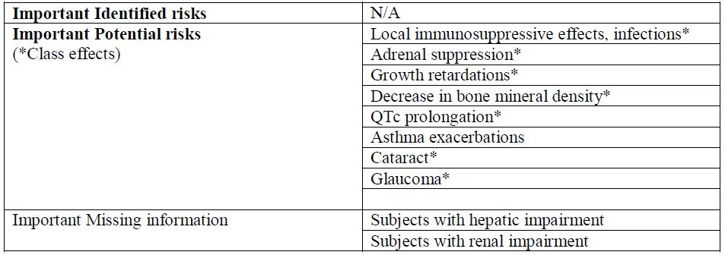

##### OPR reviewer’s comment:

Pursuant to the evaluation of the nonclinical section of the Safety Specification, the above summary of the OSC is considered acceptable.

#### Pharmacovigilance plan

##### Proposed pharmacovigilance activities

Routine pharmacovigilance activities are proposed, including no additional activities or specific safety studies.

##### OPR reviewer’s comments in regard to the pharmacovigilance plan and the appropriateness of milestones:

The routine pharmacovigilance activities that the sponsor has outlined are considered sufficient to monitor the OSC associated with Flutiform.

#### Risk minimisation activities

##### Sponsor’s conclusion in regard to the need for risk minimisation activities

The sponsor has provided a table summarising the planned actions for each OSC associated with Flutiform. The sponsor concludes that for each of these OSC that routine risk minimisation activities are sufficient.

##### OPR reviewer’s comment:

Routine risk minimisation activities are considered sufficient to monitor to OSC associated with Flutiform.

##### Potential for medication errors

As presented in the RMP, possible medication errors with Flutiform pMDI are shown in Table 11.

Table 11: Possible medication areas with Flutiform pMDI.

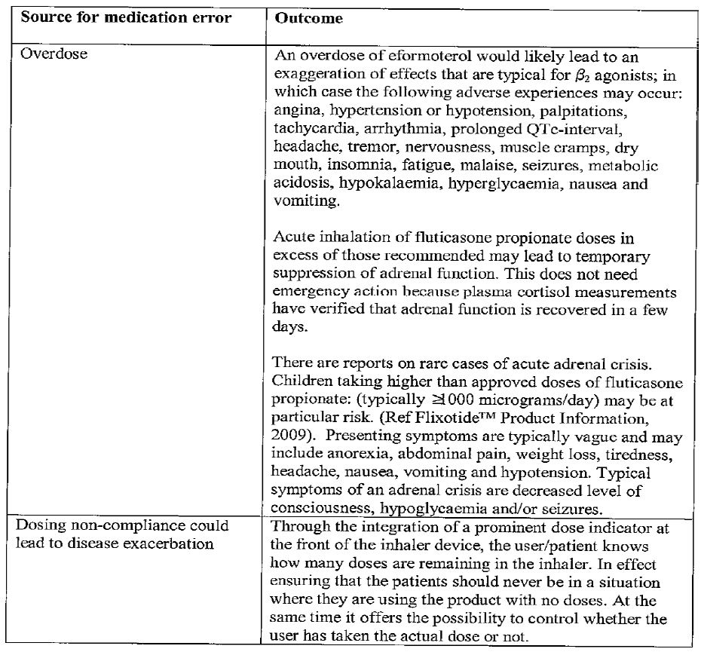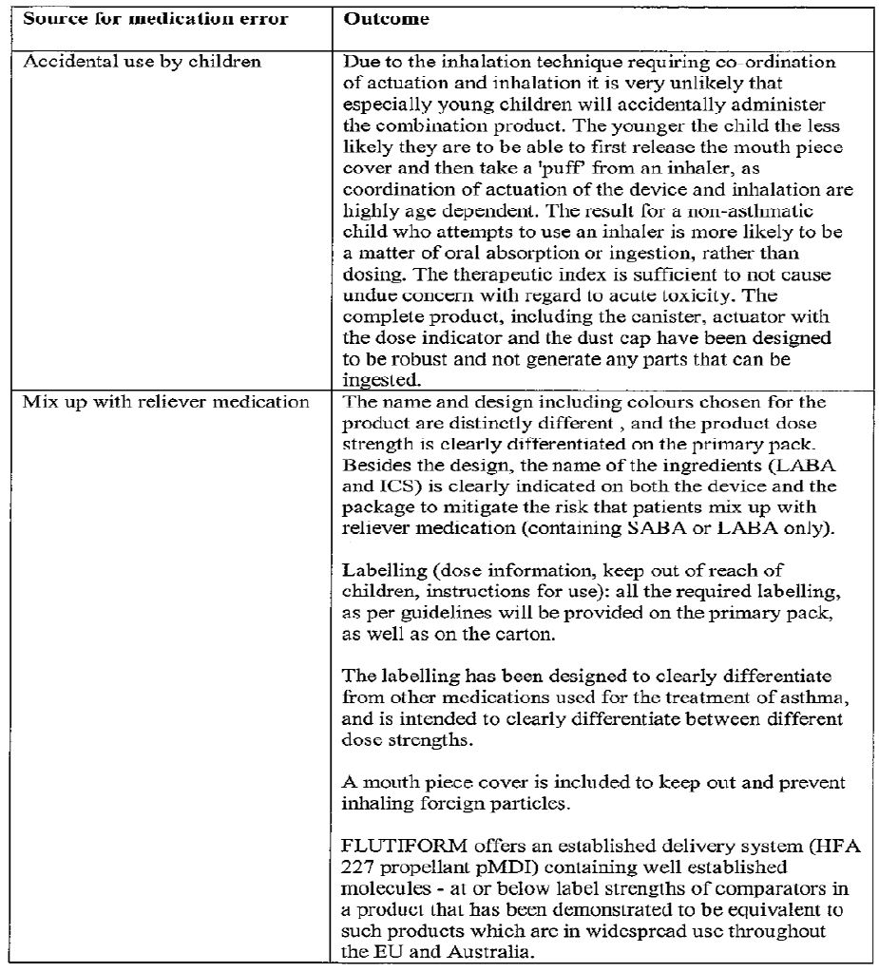

##### OPR reviewer’s comment:

This is considered sufficient.

#### Summary of recommendations

The OPR provides these recommendations in the context that:

* the submitted RMP is supportive to the application;
* the implementation of a RMP satisfactory to the TGA is imposed as a condition of registration; and
* the submitted EU-RMP is applicable without modification in Australia unless so qualified:

It is recommended to the Delegate that the RMP (Version 1, dated December 2010) submitted is acceptable without modification.

## VI. Overall conclusion and risk/benefit assessment

The submission was summarised in the following Delegate’s overview and recommendations:

### Quality

The evaluator mentions that chemistry, quality control aspects have been satisfactorily resolved. A total of 120 actuation inhalers are proposed for registration (that is, doses for 30 days); the inhalers are overfilled to ensure these can be delivered throughout the shelf life.

The propellant apaflurane is the propellant in *Symbicort Rapihaler*, *Tilade* nedocromil sodium and *Intal* sodium cromoglycate pressurised metered dose inhalers.

The pivotal clinical trial batches thus show fair linearity in fine particle doses between the strengths, with the higher strengths giving, proportionally, slightly lower ‘lung doses’.”

Spacer use information is based on *in vitro* data. Several spacer devices were screened.

The PSC considered this submission at its 144th meeting. There were no objections to registration form a chemistry perspective.

The evaluator recommends approval from a chemistry point of view.

### Nonclinical

The evaluator mentions that new studies on safety pharmacology, repeat dose and reproductory toxicity conducted with the combination by the inhalational route are submitted.

The evaluator mentions that a safety pharmacology study in dogs showed effects of drug combination treatment (mainly reductions in blood pressure and increases in heart rate, but also increases in tidal and minute volumes) that were largely due to the eformoterol fumarate component.

Repeat dose toxicity studies using the combination treatment were conducted in rats and dogs for 2 and 13 weeks respectively. Dose ratios used in these studies were similar to those proposed for marketing. The following effects were seen in histology specimens:

* atrophy of the thymus, lymphoid depletion
* atrophy of bone marrow haematopoietic cells (with fatty replacement)
* adrenal atrophy
* hepatocellular hypertrophy
* reduced extramedullary haematopoiesis in the spleen
* myocardial fibrosis.

ACTH stimulated plasma cortisol was reduced in dogs.

These findings are mostly attributable to the fluticasone propionate component. Overall, the studies did not reveal any unique toxicities not seen with the individual components previously, or synergistic toxicity.

Sodium cromoglycate is included as an excipient. Its inclusion is acceptable from a safety point of view.

The evaluator mentions that treatment with the combination caused AEs on embryofoetal development, including malformations, in the rabbit at subclinical exposure levels and in the absence of maternotoxicity. Less serious effects on embryofoetal development were found in rats (increased skeletal variations and retarded ossification; together with maternotoxicity). These findings are consistent with those of previous studies with the single agents, and again mostly attributable to the corticosteroid component.

Overall, the evaluator recommends approval.

### Clinical

#### Pharmacokinetics

The evaluator mentions that there were nine PK studies, of which, 4 studies were conducted on healthy subjects.

The studies, in essence, compared PK parameters of the individual components versus the combination product. The results, though variable, tended to show reduction of systemic fluticasone in combination.

The summary findings are as follows:

* Study AG 2028-C101 was a single dose randomised open label, four way cross over study in 24 healthy subjects. Here, Flutiform MDI (250/10) was administered versus individual components given concurrently or separately. The mean fluticasone peak and total exposure were lower (20 to 24% lower for Cmax and 24 to 31% lower for AUC0-12h) with Flutiform than the other treatments. The evaluator mentions that bioequivalence between the proposed Flutiform combination product and fluticasone administered alone or in combination with formeterol was not established as the 90% CI were not within the accepted range of 80-125%; in fact, the lower 90% CI for fluticasone AUC0-12h and AUC0-∞ ranged between only 55 and 62% (Table 13).

Table 13: Plasma PK of fluticasone propionate: LSMean and 90% CI for treatment contrasts (Study AG2028-C101).

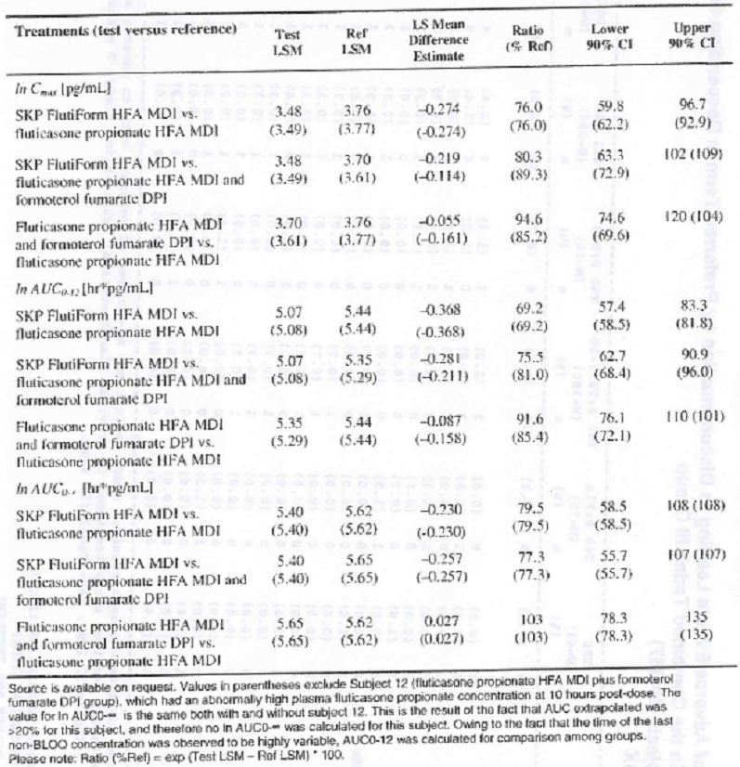

* Study SKY 2028-1-002 was an open label parallel group study that compared the PK of fluticasone and formoterol after BID administration of the combination product versus the individual components, in healthy volunteers. Day 1 measurements showed lower fluticasone levels with the combination product; the levels were similar in both groups after 7 days treatment. Formoterol was assessed by comparing urinary excretion. The results were associated with high standard deviation and the evaluator draws no conclusion based on the results.
* Study SKY 2028-1-004 was a similar design study that was considered exploratory in 36 healthy volunteers. Overall, there were no significant differences observed between treatment groups, however, the variability was large. This study was considered exploratory and did not have any statistical analysis on the PK results.
* Study FLT 1501 was an open label parallel group study that evaluated the safety and PK of high dose Flutiform pMDI 500/20 µg twice daily and the individual components (fluticasone propionate pMDI 500 µg and formoterol fumarate pMDI 24 µg) in healthy subjects. On Day 1, plasma fluticasone concentrations were markedly lower (by about 37%) from Flutiform when compared with fluticasone and formoterol given together. On Day 29, the availability of fluticasone was higher than had been observed on Day 1 (for both preparations), but the relative availability of fluticasone from Flutiform was still lower than that from the individual components and approximated 67% (Table 14).

Table 14: Statistical analysis results on the bioavailability of fluticasone propionate and formoterol fumarate by analyte (fluticasone propionate, non adjusted): Full analysis population for PK parameters (Study FLT1501).

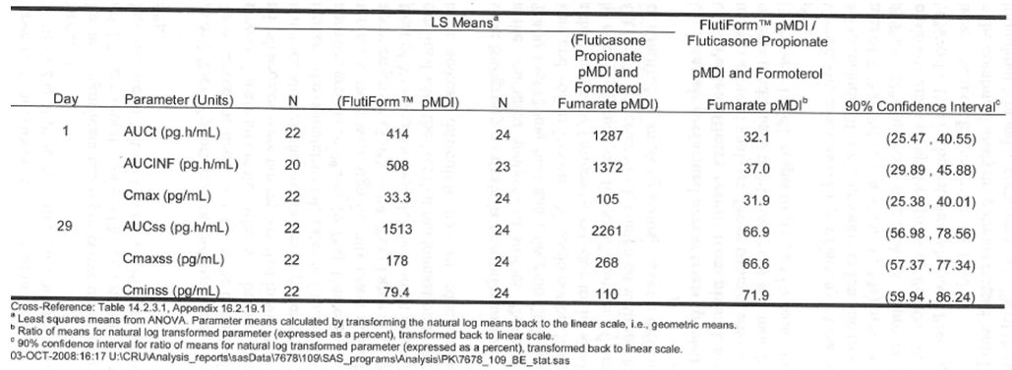

* The evaluator mentions that the cumulative amounts of formoterol recovered in urine were higher for the reference treatment than for Flutiform. These differences were relatively small and difficult to interpret as the fraction recovered in the urine accounted for <10% of the dose.
* Study SKYE2201C/8722/01 was a double blind randomised placebo controlled 5 way crossover Phase 2 study comparing the dose response of 2 and 4 actuations of formoterol fumarate in the SkyePharma HFA pMDI (6 μg/actuation) with one and 2 actuations of formoterol fumarate from the commercially available Foradil DPI (Formoterol fumarate 12 μg/actuation) in 45 subjects with asthma. The systemic exposure was dose proportional and the CV for PK parameters ranged from 40% to 54%. Based on this study, the dose of formoterol was reduced from 6 µg to 5 µg in the proposed product.
* Study FLT2502 was a Phase 1 open label single dose parallel group study to determine the systemic exposure of Flutiform pMDU 125/5 µg (250/10 µg total dose) in adult and adolescent subjects with mild to moderate asthma. The PK analysis was conducted on 29 subjects (15 adults and 14 adolescents). The systemic availability of fluticasone was higher in adolescents compared with adults: AUCt (mean ratio = 174%; 90% CI 117.35-258.46) and AUCinf (mean ratio = 181%; 90% CI 108.15-304.02). Half life and Tmax tended to be similar in both groups. Similarly for formoterol, the systemic availability of formoterol was higher in adolescents compared with adults, based on comparisons of both AUCt (mean ratio 116%; 90% CI: 96.93-139.08) and AUCinf (mean ratio = 110%; 90% CI: 91.78-130.99).

##### Dose proportionality

The evaluator mentions dose proportionality in two studies. These studies (SKY 2028-1-002 and SKY 2028-2-001) showed increasing systemic exposure of fluticasone in healthy volunteers and those with mild/moderate asthma. In both studies the mean systemic exposure was less than dose proportional (with 100/10 µg and 250/10 µg). However the CV was wide. Study FLT1501 examined plasma fluticasone concentration after administration of 500/20 µg (highest dose). The mean fluticasone plasma levels were higher than predicted; the use of a spacer may have contributed to the higher than expected values.

The evaluator discusses single and multiple dose PK studies. There was high variability seen in the single dose studies in relation to fluticasone. The exposure to formoterol was lower than that of Foradil pMDI. Multiple dose studies of Flutiform (Studies SKY2028-1-002, SKY2028-1-004 and FLT1501) also showed high variability. There was accumulation seen with fluticasone and formoterol by Day 7. Urinary recovery of formoterol was similar to that of Foradil.

##### Bioequivalence studies

None have been conducted as the sponsor states that registration is not sought based on bioequivalence data.

Overall conclusions regarding PK studies include:

1. It is mentioned that fluticasone was rapidly absorbed in asthmatic patients with the proposed strengths. Formoterol data are less sensitive as it is based on data derived from urine (Study FLT1501).
2. There was evidence on increased systemic absorption with increase in dose, in relation to fluticasone in subjects with mild to moderate asthma. Dose proportionality could not be confirmed due to high CV and other confounding factors (use of spacers in some studies).
3. There was high variability in PK of fluticasone and formoterol. Generally, the systemic absorption was less following combination than as mono components.
4. There was no change in the formulations in the clinical development.
5. The evaluator mentions that the effects of gender, race, weight, baseline FEV1 on PK of Flutiform have not been evaluated (with exception of the small post hoc subgroup analysis in Study FLT2502). The effect of renal and hepatic impairment on Flutiform PK parameters was not evaluated.
6. Dose selection of formoterol was based on “an early exploratory study (Study SKY2201C/8722/01)” and 5 µg was chosen instead of 6 µg. This study showed an average of 24% higher exposure after SKP Formoterol HFA pMDI than after Foradil DPI with the 12 µg dose. At the 24 µg dose level the cumulative amounts of formoterol excreted was 39% higher. The evaluator was not convinced that this warranted a reduction in dose to 5 µg as the test and reference were administered via pharmaceutically different dose forms. In addition, the degree of efficacy could not be extrapolated based on exposure calculated from PK results; urine levels of determining exposure were not sensitive; the study was also an exploratory study.[47]

#### Pharmacodynamics

In the Phase 1 PK study (SK2028-2-0010) in healthy subjects, improvement in lung function was observed as early as 5 mins post dose and maintained for 12 h with Flutiform 100/10 µg and 250/10 µg. There was a statistically significant difference in mean actual FEV1 and FEV1 AUC (change from baseline at 12 h post dose) in favour of treatment with Flutiform 100/10 and 250/10 µg compared with Flixotide 250 µg and placebo. The evaluator mentions that, “Overall, combined administration of fluticasone propionate and formoterol fumarate via a single inhaler (SkyePharma HFA MDI [Flutiform 100/10 or Flutiform 250/10]) provided comparable efficacy when compared to the single components administered concurrently and superior efficacy when compared to Fluticasone 250 or placebo”.

A Phase 2 double blind, placebo controlled study (SKY 2028-2-002) assessed the bronchodilating effect (change in FEV1 from baseline to 3 mins post study drug). Flutiform 250/10 µg and 100/10 µg were statistically significantly superior to placebo. Other endpoints (FEV1 over 60 mins, FVC, PEFR, etc.) showed statistically superior effect of the actives over placebo. Dose response of the actives was not formally assessed.

The Phase 2 Study SKYE 2201/8722/01 evaluated dose response of SKYE Pharma HFA MDA and Foradil DPI at 12 µg and 24 µg in relation to FEV max and AUC0-24h in 45 patients with moderate asthma. This was an exploratory study and “and not powered to demonstrate superiority or equivalence due to the small sample size.” Superiority over placebo was seen; no formal dose response was conducted between the different dose strengths.

Dose selection is addressed under PK.

##### Effect on HPA:

Study SKY 2028-1-003 was a Phase 1 double blind placebo controlled study where Flutiform 250/10 and 100/10 bd were compared to oral prednisolone (dose not specified) in its effect on the HPA function. Urinary free cortisol levels were assessed on Days 1 and 42. The levels of Flutiform were similar to placebo. Study FLT 1501 also assessed this and the evaluator notes “no significant adrenal insufficiency was seen in the 4 week treatment period”.

There were no pulmonary deposition studies conducted.

#### Efficacy

The Phase 3 studies examined the efficacy of the combination versus individual components; they were also conducted with or without spacer (Table 15).

Table 15: Summary of Phase 3 studies examining efficacy.

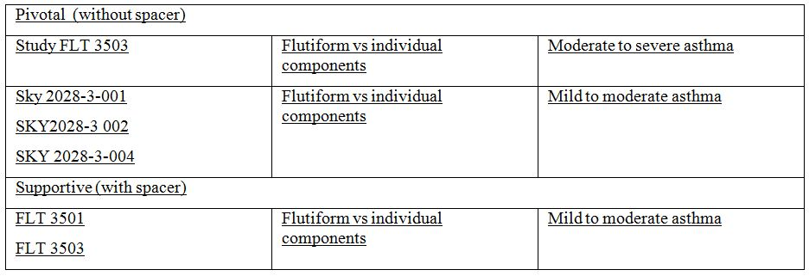

The evaluator also mentions other efficacy studies (FLT3502 (paediatric study), SKY2028-3-005, SKY2028-3-003 (long term safety study) and the Phase 2 Studies, SKY2028-2-001 and SKY2028-2-002). The studies were multicentre, randomised, double blind or open label in design. The subjects were to have a known history of asthma ≥ 6 months and a documented reversibility of ≥ 15% in FEV1.

#### Pivotal studies:

##### I) Non-inferiority study

###### Study FLT 3503

This study was a non inferiority study examining the efficacy of Flutiform high dose versus Fluticasone + Formoterol (as separate dose forms).

The dose used was: Flutiform pMDI 500/20 µg (2 puffs of 250/10 µg BID) or low dose Flutiform pMDI 100/10 µg (2 puffs of 50/5 µg BID) or Flixotide pMDI 500 µg (2 puffs of 250 µg BID) plus Foradil pMDI 24 µg (2 puffs of 12 µg BID) or Flixotide pMDI 500 µg (2 puffs of 250 µg BID). The sponsor should state in its pre ACPM response whether the LABA and ICS were given at the same time or whether there was a gap of a few minutes between the LABA and ICS in the pivotal studies.[48] This was for 8 weeks[49] and the evaluator mentions that it is less than the minimum of 12 weeks stipulated in efficacy studies for asthma in the recommended guidelines.[50]

The main inclusion criteria were: male or female adults (>18 years old) with known history of severe persistent, reversible asthma for ≥ 6 months prior to the screening visit characterised by treatment with ICS at a dose of ≥ 500 μg fluticasone or equivalent, have an FEV1 of ≥ 40% to ≤ 80% of predicted normal values, and show ≥ 14.95% reversibility in FEV1 after salbutamol inhalation (4 puffs, 100 μg per puff).

The primary efficacy endpoint was ‘change in pre morning dose FEV1 values from Day 0 to Day 56 (Flutiform high dose versus Flixotide + Foradil)’. The co primary endpoint was the change in the FEV1 value from pre morning dose at Day 0 (Visit 3) to 120 mins post morning dose at Day 56. It appears that only high dose treatment versus combination treatment was factored in the statistical analysis relating to the primary endpoint. The sponsor should confirm this in its pre ACPM response. If not, why was the high dose treatment chosen and not the lower dose vs the individual compnents?[51]

There were several secondary endpoints that were included and listed in the clinical evaluation report.

A total of 620 subjects were enrolled: Flutiform high dose n = 154, low dose n = 155, Flixotide + Foradil n = 156 and Flixotide n = 155. The mean duration of asthma was 12.7 years and mean predicted FEV1 was 58.4%. A total of 98.5% subjects used ICS at screening and 73.5% LABA. Other demographic details were included in the clinical evaluation report.

###### Results

The mean change in pre morning dose FEV1 from Day 0 to Day 56 in the PP (per protocol) analysis was 0.345 L in the Flutiform high dose group and 0.284 L in the Flixotide + Foradil group. The LSMean of the treatment difference was 0.060 L (95% CI: -0.059 to 0.180). Non inferiority of Flutiform high dose to Flixotide + Foradil was demonstrated as the lower limit of the 95% CI for the treatment difference exceeded the non inferiority acceptance limit of -0.2 L (p < 0.001). The ITT analysis confirmed this result (LSMean of the treatment difference 0.079 L; 95% CI: -0.032 to 0.190; p < 0.001) (Table 16).

Table 16: Change in pre morning dose FEV1 (L) from Day 0 to Day 56 (Study FLT3503).

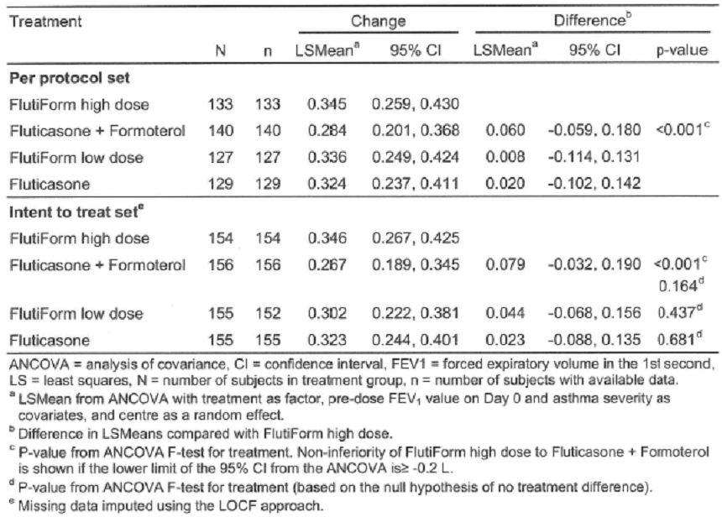

The mean change in FEV1 from pre morning dose on Day 0 to 2 h post morning dose on Day 56 was 0.518 L in the Flutiform high dose group and 0.500 L in the Flixotide + Foradil group. The LSMean of the treatment difference was 0.018 L (95% CI: -0.098 to 0.135). Non inferiority of Flutiform high dose to Flixotide + Foradil was demonstrated as the lower limit of the 95% CI for the treatment difference thus exceeded the non-inferiority acceptance limit of -0.2 L (p < 0.001).

Most secondary endpoints were statistically insignificant in comparison with the high dose formulation.

The deficiencies identified by the evaluator relating to this study are discussed below.[52]

###### 1. Lack of dose response

The evaluator mentions that, “One of the main secondary objectives of Study FLT3503 was to demonstrate a dose response effect between Flutiform 500/20 µg and 100/10 µg. Discontinuations due to lack of efficacy were reported for 6 subjects (3.9%) in the Flutiform high dose group, and 18 subjects (11.6%) in the Flutiform low dose group. In the Flutiform low dose group subjects started to discontinue soon after Day 14 reflecting that subjects were not optimally treated. Hence, there was no dose-response demonstrated for the co primary efficacy endpoints. A post hoc analysis showed superiority of Flutiform high dose versus Flutiform low dose overall including all time points and at each study visit except Day 56. The failure to show a statistically significant difference at Day 56 may be explained by more subjects discontinuing prematurely due to lack of efficacy in the low dose group. However, this again highlights the fact that the study population was not appropriate to detect dose response of Flutiform”.

The evaluator mentions that there was no statistically significant difference in relation to co primary endpoints in relation to the high and low dose form of Flutiform. This comment is of limited meaning if the results examined were not planned a priori. The sponsor should state, in the pre ACPM response, whether statistical significance between the high and low dose Flutiform was factored into the sttaistical plan in the protocol.

###### 2. Poor subject selection

The evaluator also mentions that, “it is not clear why patients who clearly needed >500 µg ICS daily (as stated in the inclusion criteria of the study protocol and shown by median daily dose of ICS at baseline) were given low dose of Flutiform (100 µg twice daily) in this study and this highlights a significant limitation of the study design. Despite the fact that patients in the Flutiform low dose (100/10 µg) group were clearly undertreated, the study was not able to show a clear difference between the low dose and high dose Flutiform. This is a major deficiency considering the fact that no definite dose response studies were conducted for Flutiform.”

###### 3. Short study duration

The duration was shorter than that which is recommended for trials of this nature (8 weeks).

###### 4. Marginal clinical relevance of FEV1 increase between Flutiform high dose and Fluticasone

The evaluator mentions that, “As there was no placebo control in this study, the demonstration of significant benefit of using Flutiform over Fluticasone alone was supposed to have provided evidence that the study was sensitive enough to detect treatment differences. Superiority of Flutiform high dose to Fluticasone alone was shown for the co primary endpoint of change from predose at baseline to 2 h postdose at Week 8 (LSMean of the treatment difference: 0.120 L; 95% CI: 0.011-0.230; p = 0.032; ITT). This was expected due to the missing contribution of the LABA component to post dose lung function measurements in this treatment group. However, the clinical relevance of the 120 mL increase in FEV1 is not clear.”

Several post hoc analyses are discussed in the report that are of limited relevance. The evaluator reports, “a post hoc analysis (repeated measures ANCOVA) was performed for the change from pre dose FEV1 to 0.5, 1, 2, 4, 6, 8, 10 and 12 h post dose at Day 0. Superiority of Flutiform high dose versus Flixotide alone was only shown for the change in FEV1 from predose to 1 h and 2 h post dose ... A similar post hoc analysis was not performed for the change from pre dose FEV1 to 0.5, 1, 2, 4, 6, 8, 10, and 12 h post dose at Day 56. However, Figure 3.1.3b ... showing 12 h FEV1 mean change from predose on Day 0 to predose and postdose on Day 56 seems to suggest that mean change from pre dose on Day 0 to pre dose and post dose on Day 56 did not show any significant difference between Flutiform high dose and Fluticasone alone at any time point. Hence, evidence for the clinical benefit of using Flutiform high dose over Fluticasone alone was not unequivocal in terms of 12 h serial FEV1”.

Overall the evaluator states, “according to the CHMP guidelines for inhalational products for treatment of asthma, the appropriate primary variables are FEV1 AUC (measurement of bronchodilatation over at least 80% of the duration of action after a single inhalation) and change in FEV1 (at an appropriate time points). Hence, evidence of assay sensitivity in this pivotal Phase 3 study was not conclusive”.

###### 5. There were no statistically significant difference observed in relation to asthma exacerbation when comparing Flutiform high dose and low dose or high dose and fluticasone.

###### 6. No subgroup analyses are provided on those likely to benefit from Flutiform high or low dose.

##### II) Superiority studies

There were three studies designed to show superiority of the combined product vs the individual components. These were SKY 2028-3-001, 002 and 004.

###### Study SKY-2028-3-001

This was designed as a superiority study of Flutiform 100/10 µg BID versus its individual components.

This study was a randomised multicentre 12 week study of Flutiform 100/10 µg BID, Fluticasone 100 µg BID, Formoterol (10 µg BID) or placebo in those with mild/moderate asthma. This study enrolled both subjects who were and were not previously receiving ICS, which reflects the mixed population of patients suffering from mild to moderate asthma.

The co primary efficacy endpoints were the mean change in FEV1 from morning pre dose at baseline (Week 0) to pre dose at Week 12 (to determine efficacy versus fluticasone alone), the mean change in FEV1 from morning predose at baseline (Week 0) to 2 h post dose at Week 12 (to determine efficacy versus formoterol alone), and discontinuations due to lack of efficacy (to determine efficacy versus placebo).

The subjects numbers were: Flutiform 100/10 µg BID: n = 118; fluticasone 100 µg BID n = 119; formoterol 10 µg BID n = 120; and placebo BID n = 118. The mean duration of asthma was 20.30 years and mean steroid use was 49.5%.

The changes in the co primary efficacy endpoints were statistically significantly greater with the combination product compared to the individual components and placebo. The secondary efficacy results are included in Table 17. Changes in AM and PM PEFR was statistically significantly greater with the combination product.

Table 17: Overview of ranked secondary efficacy endpoints in Study SKY2028-3-001 (Full analysis set).

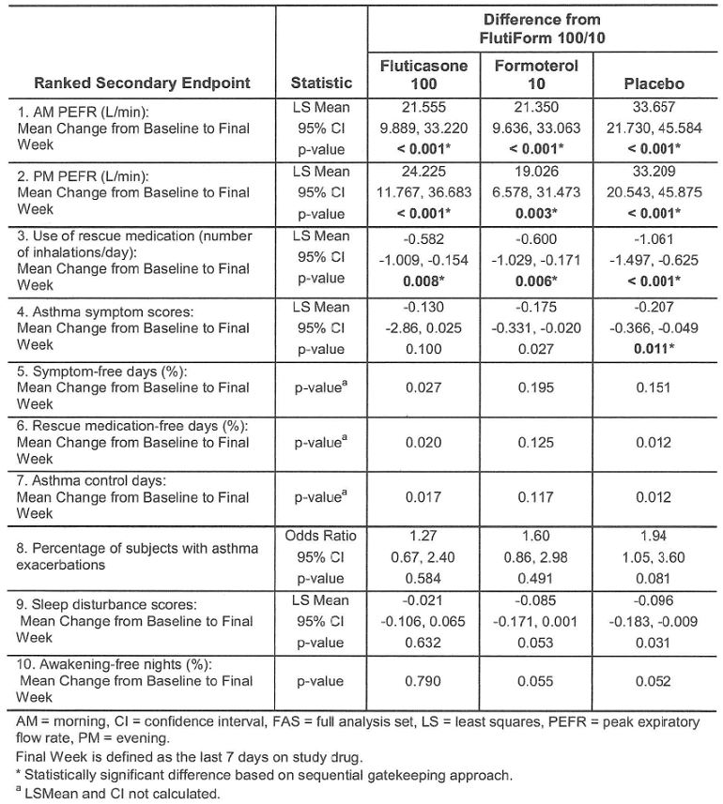

###### Study SKY 2028-3-002

This was similar in design to the previous study except that there was no placebo group. 119 were randomised to Flutiform 100/10 µg, 119 to Fluticasone 100 µg, and 119 to Formoterol 10 µg. The two co primary efficacy endpoints showed statistically greater change with Flutiform. In relation to secondary efficacy endpoints, there were significantly greater change seen with Flutiform in regard to AM and PM PEFR.

The evaluator mentions that the mean changes in FEV1 from baseline to pre dose or 2 h post dose were greater for Flutiform 100/10 µg compared to its components from Week 2 to Week 12. However, the evaluator states that the reported changes of 100-118 mL (pre dose FEV1) and changes of 122-200 mL (2 h post dose) may not be clinically relevant. Secondary efficacy endpoints showed statistically significant superiority of Flutiform over its individual components.

Study SKY 2028-3-004 was a double blind placebo controlled stratified study of Flutiform 250/10 and Flutiform 100/10 over 12 weeks compared with placebo, fluticasone and formoterol. This study is similar in design to Study 2028-3-001 with similar coprimary endpoints. A total of 110 subjects were randomised to Flutiform 250/10 µg, 114 to Flutiform 100/10 µg, 113 to Fluticasone 250 µg, 111 to Formoterol 10µg, and 109 to placebo. Flutiform 250/10 µg was demonstrated to be statistically significantly superior to each of its components for the first two co primary endpoints (change in FEV1). In relation to the secondary efficacy endpoints, AM and PM PEFR showed statistically greater changes with the combination product. However, the evaluator mentions that the mean increase in pre dose and 2 h post dose FEV1 of only 189 and 146 mL, respectively. The evaluator mentions that no formal statistical analysis was done to evaluate dose response.

###### Supportive studies

There were three non inferiority studies (Studies FLT 3501, 3502 and 3505) and one superiority study (SKY 2028-3-005) deemed ‘supportive’ by the evaluator. This was because of the nature of the study design of these studies.

Study FLT 3501 was an open randomised study of Flutiform pMDI versus Seretide in 202 adults with mild to moderate to severe persistent asthma. This was a 12 week study. Subjects starting with the low dose of study medication (2 puffs of 50/5 μg Flutiform every 12 hours or 2 puffs 50/25 μg Seretide every 12 h) could be switched to the high dose (2 puffs of 125/5 μg Flutiform every 12 h or 2 puffs 125/25 Seretide every 12 h) if their asthma was not controlled.

The primary efficacy endpoint was the pre dose FEV1 at Day 84.

A total of 101 subjects were randomised to Flutiform and 101 to Seretide. ICS use was reported in 92% and LABA use was seen in 77%. There was statistical non inferiority seen in relation to the primary efficacy endpoint and the secondary efficacy endpoints.

Study 3502 was an open label randomised study comparing Flutiform with Seretide in children less than 12 years. Since this subpopulation is not a group for which registration is sought, it is not further discussed.

Study FLT 3505 was a Phase 3 open label study comparing Flutiform pMDI (100/10 µg) every 12 h or Flixotide (100 µg BID) + Foradil (12 µg BID) in adolescent and adult subjects with mild to moderate/severe persistent reversible asthma. The treatment could be switched to high dose if asthma is not controlled: high dose Flutiform (250/10 µg as two puffs of 125/5 μg fluticasone/formoterol every 12 h), or Flixotide plus Foradil (one puff of 12 μg formoterol followed by two puffs of 125 μg fluticasone every 12 h).

The mean post dose FEV1 (primary efficacy endpoint) showed non inferiority in relation to treatment groups. Secondary efficacy endpoints also showed non inferiority.

Superiority Study SKY 2028-3-005 was a Phase 3 double blind randomised 12 week study comparing Flutiform 250/10 μg BID versus fluticasone 250 μg BID. A total of 146 subjects were randomised into each group. Mean duration of asthma was 15.9 to 17.1 years. There was a statistically superior change seen in relation to FEV1 (2 h post dosing) at Week 12.

###### Long term evidence of efficacy

Data are included from a 12 month safety study (Study SKY 2028-003).

Study SKY2028-003 was a long term safety study of SKY Flutiform HFA pMDI (100/10 μg and 250/10 μg) after BID treatment of 472 adult and adolescent patients with mild to moderate/severe asthma. The treatment duration was 12 months. Efficacy was a secondary objective. The FEV1 change was statistically significant compared to baseline, in each treatment group and appeared to be sustained over the treatment period. The magnitude of difference was less with the higher dose.

Two studies in the open phase (Studies FLT 3501 and 3505) are included with 402 patients included in the analysis. The evaluator mentions that the pivotal studies were not included in the analysis. Overall, the mean FEV1 change from baseline was similar in the two groups (Flutiform and the components).

###### Overall efficacy conclusions

The evaluator notes that the pivotal studies were designed as superiority studies to show superiority of the combination versus individual strengths; or, equivalence of the combination product compared to the two drugs taken concurrently from separate inhalers (concurrent therapy). The evaluator mentions that the design of the studies was in line with recommended guidelines,[53] with the exception of Study FLT 3503 which was only of 8 weeks duration.[54]

Dose response was assessed as a secondary variable in two Phase 3 Studies SKY2028-3-004 and FLT 3503. In the latter study, Flutiform low dose (100/10 µg BID) was not shown to be statistically significantly different to 500/20 µg BID in terms of primary or co primary FEV1 endpoints. The evaluator mentions that “results were numerically in favour of Flutiform high dose, although the differences were not statistically significant for: changes in FEV1 from pre morning dose on Day 0 to 2 h post morning dose on Day 56, asthma symptom scores, percentages of symptom free days, asthma control days, rescue medication free days, and AQLQ”.[55]

In terms of the comparison of Flutiform 250/10 µg and 100/10 µg, a descriptive assessment was provided in Study SKY 2028-3-004 as a secondary endpoint. These results are of limited relevance as it lacks statistical merit.

This lack of dose response in the pivotal studies has implications for patient selection. These data do not identify the patient groups that will respond to the different dosing regimen proposed.[56]

Subject selection confounds the interpretation of Studies 2028-3-001 and SKY2020-3-002.The evaluator mentions that whilst superiority of Flutiform 100/10 and 250/10 over its components were demonstrated in Studies 2028-3-001 and SKY2020-3-002 in patients enrolled with mild to moderate asthma, the patients were a mixed population receiving ICS and those not receiving ICS.

Clinical relevance of the mean changes in these superiority studies is questioned by the evaluator. Though mean changes in FEV1 predose was numerically greater with the combination product at Week 2 and sustained to Week 12, the evaluator states that, “a mean increase of 100 to 118 mL in pre dose FEV1 and increase of 122-200mL in 2 h post dose FEV1 [versus the monoproducts] may not be clinically relevant”.

#### Safety

Phase 1 and 2 studies were discussed; no trends were observed.

In Phase 3 studies, the overall rate was similar in Flutiform pMDI and active comparator and individual components. The evaluator mentions that the rates of related AEs were highest in the placebo groups, otherwise no trends were discernible. There was no consistent trend of a dose related increase in the rates of all AE, related AE, SAE, and AE leading to withdrawal among the Flutiform 100/10, Flutiform 250/10 and Flutiform 500/20 dose groups. The rates of SAE were low in all the studies. SAEs were considered treatment related in 0.2% of the population. The withdrawal rates due to AEs were comparable in Flutiform and active comparator groups.

In a pooled safety analysis, the overall rate of AEs was 31% (Flutiform pMDI) versus 43.9% (placebo). Fluticasone 100, 250 and Formoterol 10 groups showed the highest rate of treatment related AEs and AE leading to withdrawal.

The evaluator mentions that there was “One death due to cardiac arrest was reported in a male subject with underlying structural cerebral vascular abnormality about 2 months after he started receiving Flutiform 100/10. There were no apparent dose related trends and no clinically important differences for Flutiform versus placebo or its components for clinical laboratory values, vital signs (blood pressure and heart rate), and ECG measurements”.

The evaluator also mentions that, “Long term safety data for Flutiform 100/10 and 250/10 are available from Study SKY2028-3-003. In this study, 256 and 216 patients were treated with Flutiform (100/10 or 250/20) for 6 months and 12 months, respectively. AEs that occurred with at least a 2% higher incidence in the Flutiform 250/10 twice daily dose group compared with the Flutiform 100/10 twice daily dose group were related to the respiratory system: nasopharyngitis (11.3% versus 7.6%), dyspnoea (7.7% versus 2.2%), asthma (3.6% versus 1.3%), cough (3.2% versus 0.9%), and dysphonia (2.4% versus 0.4%). The increased incidence of these AE in the Flutiform 250/10 twice daily dose group may have been due to more severe underlying asthma in this dose group (subjects assigned to this dose group were taking higher dosages of inhaled corticosteroids prior to study enrolment).” There are no long term data on the high dose preparation (500/20).

Effect on HPA was investigated in five studies of 7 days to 3 weeks. There was no clinically significant effect seen.

#### Overall risk benefit analysis by the evaluator

The sponsor’s responses to the evaluator’s questions are reviewed by the evaluator in the clinical evaluation report. These are incorporated in the evaluator’s risk benefit analysis.

Overall, the evaluator recommends rejection.

The main limitations identified by the evaluator are encapsulated in the following section:

##### 1. Lack of adequate justification for use of 5 µg formoterol in Flutiform instead of the 6 µg available in approved formoterol products (Foradil)

The company responds that Study SKYE2201C/8722/01 was an exploratory study. It states that based on this study, the dose of formoterol was down titrated to better match DPI products. This dose selection predates any formoterol pMDI availability in Europe. In addition, the company dismisses the cross trial comparison of the evaluator (Study FLT 2501 versus SKYE2201C/8722/01). It states that there were efficacy data from pivotal studies that showed that formoterol 5 µg was efficacious.

The evaluator’s comments on these responses are as follows:

* “Although it is acknowledged that the exploratory Study SKYE2201C/8722/01 pre dates any formoterol pMDI availability in Europe, the fact remains that a trend of HFA pMDI formulations resulting in higher exposure than DPI has been reported in the literature,[57] which could have confounded interpretation of results. Furthermore, it is not clear why reduction of formoterol dose to 5 µg was based on results of this exploratory study which did not comply with recommended CPMP guidelines (that is, the test and reference product were not inhaled from the same pharmaceutical dosage form).
* “Results from Study FLT1501 which evaluated the PK following 4 weeks administration of Flutiform pMDI 500/20 μg and Fluticasone pMDl 500 μg + Formoterol pMDI 24 μg in healthy subjects and used the same administration devices (as recommended by the CPMP guidelines) showed that relative bioavailability of fluticasone and formoterol from Flutiform was 67% and 75% compared to that following administration of reference treatments. Furthermore, this study utilised plasma formoterol assessments compared to the exploratory study which only assessed urinary formoterol levels. Results from this study which appear to comply with recommended guidelines do not provide any evidence to support selection of 5 μg formoterol instead of the approved 6 μg formoterol (Foradil). The sponsor repeatedly mentions that cross trial comparisons are not justified and on this note the evaluators would like to make it clear that there is no intention to compare results from these two PK studies: there just does not seem to be any justification for using results of an early exploratory PK study (SKYE2201C/8722/01) not complying with CPMP guidelines for selection of the formoterol dose in Flutiform. However, another study (FLT1501) which appears to comply with recommended guidelines showed that in fact exposure to fluticasone and formoterol was slightly reduced following Flutiform compared with the individual reference treatments.
* “Although the sponsor states that pivotal Study FLT3503 demonstrated non inferiority of Flutiform with regards to the primary lung function endpoints compared to the individual mono components Flixotide and Foradil, given concurrently, assay sensitivity in this pivotal Phase 3 study was not conclusive. In the sponsor’s response, they have only provided a table showing change from pre dose FEV1 at Day 1 to 2 h post dose FEV1 at endpoint (Day 56). There was no analysis of change in FEV1 over 12 h on Day 56 (mentioned as a limitation in earlier evaluation report) and sponsors have not provided this data in this submission either. This along with other limitations of this study suggests that selection of the 5 μg formoterol dose in the Flutiform combination product was not adequately justified.”

##### 2. Pivotal study FLT 3503

Was the study sensitive enough to detect treatment differences between Fluticasone and Flutiform? In relation to the sponsor’s response, the evaluator states, “The sponsor has accepted that there is lack of assay sensitivity of the pre dose PEV1 endpoint although they stress that point estimate differences between Flutiform high dose and Flixotide + Foradil were in favour of Flutiform (60 mL [-59, 180]). However, it is important to note that the 95% CI were quite wide.

The 2 h post dose FEV1 also only showed an observed difference of 120 mL between Flutiform high dose and Flixotide + Foradil which was less than the pre defined non inferiority margin of 200 mL. However, the Flutiform high dose did show relevant symptomatic benefits compared to fluticasone monotherapy but these would be expected considering the added bronchodilator effect of the LABA component in Flutiform and cannot be used to justify assay sensitivity. There were no statistically significant differences between Flutiform high dose and Fluticasone + Formoterol or Flutiform low dose for asthma symptom score, percentage of symptom free days, improvement in sleep disturbance score.

More concerning is the fact that 12 h FEV1 AUC showed superiority of Flutiform over fluticasone only at 1 and 2 h post dose. The sponsors justify this by stating that only 50% of the sample size was included in these analyses and <50% of patients were included in the repeated measures post dose ANCOVA for FEV1 at Day 56 which may have accounted for reduced observed effect . However, this is another limitation of the study as the CHMP guidelines for inhalational products for treatment of asthma recommend that the appropriate primary variables are FEV1 AUC (measurement of bronchodilatation over at least 80% of the duration of action after a single inhalation) and change in FEV1 (at an appropriate time points).

Overall, the sponsor’s response fails to address the concerns regarding lack of conclusive evidence of assay sensitivity in the pivotal Phase 3 Study FLT3503 confounding interpretation regarding results related to non inferiority of Flutiform 500/20 µg compared to Fluticasone 500ug + Formoterol 24 µg”.

In addition in this study of non inferiority of Flutiform 500/20 µg compared to Fluticasone 500 µg + Formoterol 24 µg, two nominally dissimilar doses (20 µg and 24 µg are compared) of formoterol are compared, questioning the external validity of reported results. This is also relevant to the dose chosen in relation to formoterol in the proposed Flutiform product range.

##### 3. Non inferiority of Flutiform

Non inferiority of Flutiform 250/10 µg and 100/10 µg compared to concurrent administration of its monocomponents was not evaluated in a double blind, randomised study (it was only investigated in open label supportive studies). However, superiority of Flutiform 250/10 and 100/10 µg over its individual components were established in three pivotal Phase 3 studies (SKY2028-3-001, SKY 2028-3-002 and SKY2028-3-004).

##### 4. Other approved combination products

The other approved combination products such as Seretide and Symbicort had well conducted, placebo controlled studies to establish equivalence between the proposed combination product and the individual components administered through separate devices (see relevant PIs). For Seretide, four double blind, double dummy studies showed clinical equivalence of Seretide with concurrent therapy with salmeterol and fluticasone propionate. Similarly, a placebo controlled, 12 week study was conducted which established equivalence between Symbicort and concurrent therapy with budenoside and formoterol.

##### 5. Long term efficacy and safety data of the highest dose of Flutiform

Long term efficacy and safety data of the highest dose of Flutiform (500/20) was not evaluated beyond 8 weeks.

### Risk management plan

The report is attached. Routine monitoring is considered satisfactory.

### Risk-benefit analysis

#### Delegate’s comments and proposed action:

The data set submitted provides evidence of efficacy of the fixed combination product as comparable to that of the individual components used together in the treatment of mild to moderate asthma.

However, data are not provided on graduated therapy with ICS. There are no studies on switching treatment with other registered ICS + LABA. It is not known how Flutiform compares with registered combination therapies available in Australia as there are no good quality data comparing this product with Symbicort, Seretide, etc. Thus, based on the data set, its place in the treatment of asthma cannot be ascertained.

The pivotal studies only provide efficacy and safety data up to 3 months. The adopted EU guideline[58] states that “claims of chronic treatment should be supported by the results if randomised, double blind parallel controlled clinical trials of at least 6 months duration”. The use of ICS should be studied in trials of at least 6 months duration. Longer term data are required for the proposed indication.

Another significant flaw is the lack of pivotal studies where spacers have been used. The sponsor should consider using Australian registered spacers in conducting a pivotal study in the target population.

There was a lack of dose response with the proposed doses. The populations that would benefit from the bd doses of 50/5 µg, 125/5 µg and 250/10 µg have not been identified in this data set. Also, the gradual increase in ICS that is required in the treatment of asthma cannot be recommended based on the lack of dose response.

The Delegate agrees with the clinical evaluator that the selection of 5 µg instead of 6 µg formoterol is not validated with good quality data. This dose reduction is not supported by fine particle dose data due to the variability and also other factors that influence *in vitro* data.

The pivotal efficacy studies had external validity issues.

The pivotal study, Study FLT 3503, has several deficiencies identified:

1. The coprimary endpoints are designed to examine statistical significance of the high dose Flutiform versus individual components. The low dose Flutiform is not factored in this analysis. Thus, the place of low dose Flutiform in the treatment of asthma is not established based on this study.
2. This study showed superiority of Flutiform high dose to Fluticasone alone for the co primary endpoint: change from pre dose at baseline to 2 h post dose at Week 8 (LSMean of the treatment difference of 0.120 L). The clinical relevance of this difference is not clear. Several post hoc analyses are submitted to justify the deficiencies identified by the evaluator in relation to the endpoints used. Clearly, they do not add value to the results relating to the primary efficacy endpoints as post hoc analyses lack statistical merit.
3. No subgroup analyses are provided to identify those who would benefit from Flutiform.

While studies SKY2028-3-001 and SKY2028-3002 demonstrated superior efficacy of Flutiform 100/10 over its components, the mean increase of 100 to 118 mL in pre dose FEV1 and an increase of 122-200 mL in 2 h post dose FEV1 may not be clinically relevant. These studies enrolled those who were and were not on ICS and reflected a mixed population. Study SKY 2028-3-004 compared 250/10 µg versus its components in those with moderate to severe asthma. The mean increase in pre dose and 2 h post dose FEV1 increases were only 189 and 146 mL. This also may not be clinically relevant.

The Delegate proposes to reject the application to register Flutiform (fluticasone propionate and eformoterol dihydrate) pressurised inhalation 50/5 µg, 125/5 µg and 250/10 µg (120 actuations) for *the regular treatment of asthma where the use of a combination product (an inhaled corticosteroid and a long acting β2 agonist) is appropriate. It is appropriate both for patients not adequately controlled with inhaled corticosteroids and inhaled short acting β2 agonist on an “as required” basis and for patients already adequately controlled on both an inhaled corticosteroid and a long acting β2 agonist* due to inadequate evidence of efficacy.

The Committee’s advice is sought.

#### Response from sponsor

##### Introduction

Mundipharma is disappointed that the TGA has recommended the rejection of Flutiform pressurised metered dose inhaler, when the European Medicine Agency has made a binding recommendation for approval in 21 countries. The CHMP found that of all the responses to the questions were acceptable. Many of the same questions were raised by the TGA, and similar responses to those submitted in Europe were provided to the TGA. A key tenet of the registration of prescription medicines in Australia is that the TGA registration guidelines are based upon the European regulatory guidelines, and Mundipharma would have expected a similar positive outcome from the TGA evaluation.

Marketing licences have already been issued in the United Kingdom, the Netherlands and Sweden. Thus for three of the TGA’s five *acceptable countries* a positive recommendation for approval is available. Mundipharma does not have the contractual rights to the product in the remaining two *acceptable countries*, USA and Canada. That three of Australia’s five *acceptable countries* have recommended Flutiform for marketing authorisation is clearly supportive of the product’s safety and efficacy.

Flutiform inhaler combines two active components that have been used effectively on an individual basis by Australian asthma sufferers for many years. It has been designed to provide a novel combination of a commonly used inhaled corticosteroid (fluticasone propionate) and a fast onset LABA (eformoterol fumarate dipropionate) in a single, easy to use aerosol inhaler. The combination provides a clinically relevant benefit to patients. Asthma patients often use a number of different medicines to control their symptoms and compliance can be a problem. Minimising the number of inhalers used by patients can be expected improve treatment outcomes through simplifying disease management and aiding compliance.

The abbreviations used for the co primary endpoints in Study FLT3503 are:

1. change from pre dose FEV1 at baseline to pre dose FEV1 at Week 8 = ‘pre dose FEV1’ endpoint; and
2. the change from pre dose FEV1 at baseline to 2 h post dose FEV1 at week 8 = ‘2 h postdose FEV1’ endpoint. Foradil pMDI is also marketed as Atimos pMDI in some European countries.

##### 1. Delegate’s Question 1 on Study FLT3503: The sponsor should state whether the LABA and ICS were given at the same time or there was a gap of a few minutes between the LABA and ICS.

###### Sponsor’s response:

Patients in all treatment groups in Study FLT3503 were instructed to leave a gap of ~30 seconds between each inhalation, in accordance with the UK patient information leaflets for the mono products used in the study, formoterol fumarate fumarate dihydrate (Altimos Modulite inhaler) and fluticasone propionate inhaler (Flixotide Evohaler). Patients were also instructed to use their (blinded) Foradil inhaler prior to Fluticasone inhaler.

##### 2. Delegate’s Point 1 in Overall Risk Benefit Analysis: The 5 µg formoterol dose in Flutiform instead of 6 µg in approved formoterol products is inadequately justified. Specific comments are as follows:

* ***It is unclear why dose selection was based on a study (Study SKYE2201C/8722/01) noncompliant with CHMP guidance (in that it compared different pharmaceutical dosage forms [a pMDI versus DPI]).***
* ***Study FLT1501 which showed a lower formoterol bioavailability with Flutiform 500/20 versus Foradil pMDI 24 µg (75% relative bioavailability) does not support the formoterol dose selection in Flutiform.***
* ***The sponsor has only presented data 2 h post dose FEV1 to demonstrate the effect of the formoterol component, but not FEV1 AUC0-12h data as previously requested.***

###### Sponsor’s response:

* When the product development of Flutiform commenced, no formoterol pMDI was available on the market. Study SKYE2201C/8722/01, which was performed in 2002, could therefore only use a marketed formoterol DPI comparator (Foradil DPI) to guide product development. The decision to slightly down titrate the formoterol component of the Flutiform formulation, to more closely match the Foradil DPI, given the results of Study SKYE2201C/8722/01, was reasonable at that time. This decision should also be interpreted in the light of concerns which the FDA expressed in 2001 concerning a possible dose related trend for serious respiratory events with Foradil DPI.[59] The FDA continues to raise the spectre of serious LABA related respiratory events, and as a result has mandated the conduct of four large, ongoing post market studies.
* Study FLT1501 was carried out in 2008. A steady state relative formoterol bioavailability of 75% was noted for Flutiform compared to Foradil pMDI. The Delegate’s view appears to be that the sponsor should have reformulated Flutiform at this point to better match the Foradil pMDI. In the light of this perspective, two issues are relevant:

1. Dose response for all classes of currently marketed inhaled drugs for obstructive lung disease is well recognised to be shallow.[60] The notion that a 20% increase in formoterol dose (corresponding to an increase from 5 to 6 µg) might alter efficacy is not supported by any published literature, despite the use of β2 agonists for ~40 years.
2. There is ongoing debate as to whether PK data are an adequate surrogate to determine the relative *pulmonary* deposition, hence relative *efficacy*, of orally inhaled products (OIPs).[61] PK analysis to determine the relative *systemic* effect of two drugs (OIPs or otherwise) is logical because the systemic circulation transports the drug to systemic sites of action. Consequently, any difference in systemic exposure between two formulations will in turn affect the relative delivery to the systemic sites of action, such as the adrenal glands. However, the situation is more complex where PK data are used to infer the relative pulmonary deposition and efficacy of OIPs. OIPs exert their intended effects via local action in the lung. In this case, and in contrast to the scenario outlined in the preceding paragraph, the systemic circulation is not principally responsible for the delivery of the drug to its site of action. Rather it is the inhalation manoeuvre which primarily fulfils this function. As a consequence, blood concentrations of OIPs are a “post event” surrogate for efficacy, and standard PK analysis does not necessarily define drug residence at the pulmonary site of action.[62] This digression from the conventional PK paradigm is the reason FDA and Health Canada do not accept PK data as a surrogate for OIP efficacy, unlike the CHMP. These issues were discussed at length with the CHMP during the recent European MAA process, and despite the CHMP guideline advocating OIP PK studies as a surrogate for efficacy,[63] the CHMP accepted the sponsor’s position as valid.

In the light of the above, it is reasonable that the available PK data were used during product development as an *approximate* guide to pulmonary deposition and therefore product formulation. Given the FDA’s concern regarding LABA related safety, it was reasonable to slightly down titrate the Flutiform formoterol component following the results of Study SKYE2201C/8722/01. Equally, given that dose response has *never* been reported for any OIP with a 20% dose increase and the ongoing debate regarding the validity of PK data as a surrogate for pulmonary drug deposition with OIPs, it was reasonable not to reformulate Flutiform following the outcome of Study FLT1501.

* The sponsor did present the FEV1 and AUC0-12h data previously requested. Please refer to the response to Clinical Question 1.

##### 3. Delegate’s Question 2 on Study FLT3503: Was only the high dose (500/20) of Flutiform factored into statistical analysis of the primary endpoint. If not, why was the high dose chosen rather than the low dose versus the individual components.

###### Sponsor’s response:

The Statistical Analysis Plan for Study FLT3503 is in Appendix A9 to the study report. The primary objective of the study was to demonstrate the non inferiority of the high dose of Flutiform (500/20) compared to the “free combination” of Fluticasone 500 plus Formoterol 24. The low dose of Flutiform (100/10) was included as a secondary comparator only at the request of the German regulatory authority. The sequential testing scheme, defined *a priori* to deal with multiplicity, addressed only the comparison of high dose Flutiform to the “free combination” via a pre specified sequence of endpoints. It was not intended that any other between group tests should be confirmatory, and accordingly, sequential testing did not address other between group comparisons. Neither the German regulatory agency which requested the inclusion of the Flutiform low dose group, nor any other European agency has indicated a concern with this approach. Please refer to the Statistical Analysis Plan for further details.

As the answer to the first sentence is “yes”, the second sentence is not applicable. The issue of dose response and dosing rationale is dealt with in the following response.

##### 4. Delegate’s Question 3 and Point 2 in Overall Risk Benefit Analysis: Study FLT3503 lacks assay sensitivity in that there is no dose response between the high and the low dose of Flutiform for the co primary endpoints.

###### Sponsor’s response:

The Delegate notes that there is a lack of dose response for the spirometric co primary efficacy endpoints (pre dose FEV1 and 2 h postdose FEV1), and infers from this that the study lacks the sensitivity to conclude that Flutiform is non inferior to the “free combination”. The sponsor accepts that these two endpoints lack may assay sensitivity. However, several important issues are relevant for consideration:

* These endpoints were employed because FEV1 is the preferred primary efficacy variable in regulatory studies at present. However, dose response for spirometric outcomes has never been reported for a fixed dose ICS/LABA combination, including for the products marketed in Australia, and it may be that these endpoints are not feasible in a study that possesses external validity.
* Notwithstanding the limitations of the spirometric data for the co-primary endpoints, in both ITT and PP populations the effects with Flutiform numerically exceeded those of the free combination for each of the four comparisons. The treatment difference (Flutiform minus free combination) ranged from 18 mL to 79 mL. The lower limit of the 95% confidence interval for treatment difference ranged from -32 mL to -98 mL for the four comparisons. The tabulated co primary endpoint data are presented in Appendix A.
* Assay sensitivity *was* exhibited for several *non* spirometric endpoints in Study FLT3503. Of 9 symptom related endpoints defined *a priori*, treatment differences numerically favoured Flutiform 500/20 over Flutiform 100/10 for 8 of these. A similar pattern was seen for the free combination versus Flutiform 100/10 (8 of 9 endpoints numerically favoured the free combination). As these were secondary outcomes the study was not formally powered to evaluate them, but the consistent trend across the multiple endpoints for both high the dose ICS/LABA arms versus low dose Flutiform clearly suggests that the trends are not random. Moreover, the similarity of effects with Flutiform 500/20 and the free combination across the multiple dose responsive endpoints is highly suggestive of non inferiority. The data for these endpoints is presented in Appendix B.
* The evaluator has cited the OIP guideline[64] when justifying the requirement for dose-response and assay sensitivity. This guideline explicitly discusses clinical requirements for *generic* inhalers, and line extensions to existing products. In such studies the CHMP allows for the use of enriched populations, that is, subjects who have been screened for dose response prior to study entry. The CHMP allows this because the overriding requirement in these studies is for the generic product to be shown as equivalent to the reference product in study possessing assay sensitivity. This demonstration of equivalence then allows the generic product to rely upon the clinical dossier for the reference product, without any further provision of clinical data for the generic product. However, for novel products such as Flutiform, which do not “bridge” to reference dossiers but rather rely upon their own unique dataset, the CHMP does *not* allow enriched populations. Instead, the CHMP requires populations that are representative of the intended patient population, that is, study populations that have external validity. Therefore it is not particularly appropriate to stringently extrapolate requirements from generic study models to studies of novel products, as the same subject selection criteria cannot be used.

##### 5. Delegate’s Question 4 on Study FLT3503: The dissimilarity of the nominal formoterol doses (Flutiform 500/20 versus Fluticasone 500 + Formoterol 24) questions the external validity of the reported results.

###### Sponsor’s response:

The external validity, or generalisability, refers to a principle whereby the results from a clinical study can reasonably be extrapolated to patients in routine clinical practice. Predominantly it concerns patient characteristics and medical practice in the two settings. Considerations such as the nominal dose of a test product are not relevant to the generalisability.

##### 6. Delegate’s Point 3 in Overall Risk Benefit Analysis: Non inferiority of Flutiform 250/10 and 100/10 compared to concurrent administration of its monocomponents was not evaluated in a randomised, double blind study.

###### Sponsor’s response:

* *In vitro* data confirm the linearity of the delivered dose and fine particle dose of both components of Flutiform across the three proposed strengths (see Appendix C). These data were also provided in the response to TGA’s questions on the Quality data.
* The PK linearity of GSK’s Fluticasone-HFA pMDI, the ICS comparator in the sponsor’s trials, is reported in the published literature.[65]
* As only one strength of Foradil pMDI is marketed (12 µg), one or two puffs bid of this product inevitably exhibit linearity.
* Linearity for all three products (Flutiform, Flixotide, Foradil) means that the non-inferiority results from Study FLT3503 can reasonably be extrapolated to comparisons of the lower dose strengths of these products.
* The clinical program supporting Flutiform was discussed and agreed upon during product development with four European regulatory authorities, UK, Sweden, Germany and Denmark. None of these agencies requested the comparison of Flutiform to a free combination for all three strengths. During the recent European decentralised procedure none of the 21 member states raised this as a potential issue.

##### 7. Delegate’s Point 4 in Risk Benefit Analysis: Seretide and Symbicort had well conducted, placebo controlled studies to establish equivalence with the respective free combinations. For Seretide four double blind studies showed equivalence with the free combination. For Symbicort a placebo controlled study showed equivalence with the free combination.

###### Sponsor’s response:

The Delegate appears to consider the lack of a placebo control in Study FLT3503 to be a significant limitation of the study design. However, none of the three relevant CHMP guidelines require the inclusion of a placebo arm for a fixed dose combination OIP therapy.[66] Clinicians and ethical committees widely consider placebo controlled trials to be unethical in patient populations suitable for combination therapy. While the FDA still requires placebo controlled trials, the CHMP requirements are considered more ethical and appropriate in Europe, and Australia follows the European clinical guidelines. Study FLT3503 complies with the European requirements.

The Delegate also notes that the Seretide and Symbicort dossiers included “well conducted” studies of the fixed combination product versus the free combinations and refers to the PI. However, the PI description of the four Seretide studies cited by the Delegate makes no reference to the inclusion of a fluticasone monocomparator in these studies, or to any other third arm. Assuming that the four studies only compared Seretide to the free combination, applying the TGA’sapproach, they would lack assay sensitivity. In the Symbicort PI two studies are cited which compared Symbicort to the free combination. Whilst both correctly included a third arm (budesonide) neither appears to have included a placebo arm. In summary, none of the Seretide or Symbicort studies the Delegate has cited appears to include a placebo arm, or a second dose level of combination product, and the Seretide studies do not appear to include any third arm. Therefore, these studies do not appear to satisfy the requirements outlined in the Delegate’s own critique of the current sponsor’s dossier.

##### 8. Delegate’s Point 5 in Overall Risk Benefit Analysis: Long term efficacy and safety data are not available for the high dose of Flutiform (500/20).

###### Sponsor’s response:

Efficacy:

The most recently adopted guideline in this therapeutic area[67] advocates 8 to 12 month studies as adequate to assess the therapeutic effect of ICSs. This is logical given the very substantial literature base clearly demonstrates that the spirometric and symptomatic benefits of ICS and ICS/LABA therapy are maximal within 1 month in most patients and are sustained, mostly not changing beyond effects seen at 3 months.[68] Similar data demonstrating a sustained clinical effect were generated in the long term study safety Study 3-003, in which low and medium doses of Flutiform were administered for 6-12 months (see Appendix D). Study 3-003 did not include high dose Flutiform treatment, but there is no reason why the temporal pattern of effects with the high dose of Flutiform would differ from those seen with the low and medium doses. There is no clear rationale for mandating a long term study to demonstrate that effects seen with the high dose of Flutiform are sustained beyond 8 weeks.

Safety:

Flutiform and formoterol are very well known active substances. Study FLT1501 demonstrated that the effects of Flutiform upon the adrenal axis were less than those with GSK’s Fluticasone-HFA at an equivalent nominal dose (500 µg BID) (see Appendix E). Since daily GSK Fluticasone-HFA doses up to 2000 µg are approved, it is evident that the administration of a total daily fluticasone daily dose of 1000 µg within the high dose of Flutiform does not poses undue safety concerns.

Regarding the formoterol component, a regular formoterol dose of up to 24 µg bid (48 µg daily) is advocated for the Foradil/Atimos pMDI (Foradil/Atimos SmPC). In Study FLT1501, steady state PK data, which is an accepted surrogate for the comparative systemic safety of inhaled drugs, demonstrated slightly lower bioavailability for the formoterol component of Flutiform 500/20 versus Foradil 24 µg BID pMDI (relative bioavailability 75%). These data suggest that the adrenergic safety of high dose Flutiform is no worse than that of Foradil pMDI. Furthermore although head to head comparative data are not available, maximum daily doses of 72 µg of formoterol are approved for the Oxis Turbuhaler (Oxis SmPC), and 96 µg for the Symbicort Turbuhaler (Symbicort SmPC).

In conclusion, there are no grounds to expect the safety of Flutiform at the doses proposed for marketing is any worse than the safety of several other treatments approved in Australia containing the same actives. Thus, there is no clear rationale to require the provision of long term safety data for the high dose of Flutiform. Furthermore scientific advice during development suggested that because of the international asthma management guidelines to titrate down whenever possible, the provision of long term safety data for the high strength was not mandatory.

#### Advisory committee considerations

The ACPM (which has succeeded ADEC), taking into account the submitted evidence of quality, safety and efficacy agreed with the Delegate that these products have an overall **negative** benefit-risk profile.

In making this recommendation, the ACPM advised that there is inadequate data to support a positive assessment, and expressed significant concerns about the:

* Absence of adequate dose response evidence
* Congruence of patients selection and analysis
* Absence of long term safety demonstrated particularly at the highest dose.
* The clinical significance of the results in relation to the primary efficacy endpoints in some pivotal studies

### Outcome (initial decision)

Based on a review of quality, safety and efficacy, TGA decided not to register Flutiform (fluticasone propionate/eformoterol fumarate dihydrate) pressurised metered dose inhaler containing fluticasone propionate and eformoterol fumarate 50 µg/5 µg, 125 µg/5 µg and 250 µg/10 µg (120 actuations) on the grounds that the data submitted were considered inadequate in terms of efficacy and safety.

#### Reasons for decision

In reaching this decision, the Delegate considered the findings of the clinical, nonclinical and the pharmaceutical chemistry and quality control evaluators. The Delegate also took into account their request for ACPM advice, the sponsor’s pre ACPM response, and the OPR’s evaluation of the RMP. The Delegate also took into consideration the sponsor’s response to the clinical evaluation report. In addition, the Delegate also took into consideration the ACPM’s resolution and the discussion of the members of ACPM.

The clinical evaluator recommended rejection. The reasons included issues relating to the lack of adequate justification for use of 5 µg formoterol in Flutiform instead of the 6 µg available in approved formoterol products (for example, Foradil); the lack of assay sensitivity in relation to the efficacy endpoints in the pivotal Study FLT 3503; and the lack of well designed studies that demonstrate non inferiority of Flutiform 250/10 µg and 100/10 µg versus its individual components. In addition, long term efficacy and safety data of the highest dose of Flutiform (500/20) were not evaluated beyond 8 weeks.

The above mentioned deficiencies were also discussed in my Delegate’s Request for ACPM advice. Both the evaluator and Delegate recommended rejection based on our assessment of risk/benefit balance.

The ACPM’s recommendation was in line with the evaluator’s recommendation and reflected in the ACPM resolution:

*“The ACPM, taking into account the submitted evidence of quality, safety and efficacy agreed with the Delegate that these products have an overall* ***negative*** *benefit-risk profile.*

*In making this recommendation, the ACPM advised that there is inadequate data to support a positive assessment, and expressed significant concerns about the:*

* *Absence of adequate dose response evidence*
* *Congruence of patients selection and analysis*
* *Absence of long term safety demonstrated particularly at the highest dose.*
* *The clinical significance of the results in relation to the primary efficacy endpoints in some pivo*tal studies.”

The reasons for the Delegate’s decision were that there were inadequate data submitted on efficacy and safety. In particular:

1. There was inadequate justification of the choice of 5 µg of eformoterol instead of 6 µg dose. The Phase 2 study on which this dose was selected had inherent flaws that related to the type of aerosol inhaler used to compare the proposed eformoterol formulation with a commercially available formulation (pressurised metered dose inhaler formulation compared with the dry powder inhalation). The sponsor’s justification for using 5 µg instead of 6 µg was that this study showed an average higher exposure with SKP Formoterol HFA pMDI than after Foradil DPI when equivalent doses were compared; cumulative dose of formoterol excreted was also higher. The evaluator was not convinced that this warranted a reduction (from 6 µg) in dose to 5 µg as the test and reference were administered via pharmaceutically different dose forms. The Delegate agreed with the evaluator’s conclusions.
2. The Delegate notes in the sponsor’s pre ACPM response that there is ongoing debate on whether PK data are appropriate to determine efficacy of orally inhaled products. Clearly, the Delegate agrees with the sponsor that the clinical studies should establish the efficacy of 5 µg eformoterol. The sponsor has also (in their response to the clinical evaluation report) pointed to the pivotal Study FLT 3503 as showing non inferiority of Flutiform with individual components Flixotide and Foradil, thus providing support to their claim that 5 µg was non inferior to 6 µg. However, this study had significant issues with assay sensitivity that prevents such a conclusion.
3. There is lack of dose response in the pivotal Study FLT3503 in relation to the co primary efficacy endpoints. There was no clinically significant difference between the high and low dose combination in relation to the co primary endpoints. The populations that would benefit from the twice daily doses of 50/5 µg, 125/5 µg and 250/10 µg have not been identified in this data set. Also, the gradual increase in inhaled corticosteroids that is required in the treatment of asthma cannot be recommended based on the lack of dose response with this product.
4. There is poor subject selection in the pivotal Study FLT 3503: it is not clear why patients who clearly needed greater than 500 µg inhaled corticosteroid daily (as stated in the inclusion criteria of the study protocol) were given low dose of Flutiform (100 µg twice daily) in this study and this highlights a significant limitation of the study design. Despite the fact that patients in the Flutiform low dose (100/10 µg) group were clearly undertreated, the study was not able to show a clear difference between the low dose and high dose Flutiform. This is a major deficiency considering the fact that no definite dose response studies were conducted for Flutiform.
5. Non inferiority of Flutiform 250/10 µg and 100/10 µg compared to concurrent administration of its monocomponents was not evaluated in a double blind, randomised study (it was only investigated in open label supportive studies).
6. Long term efficacy and safety data of the highest dose of Flutiform (500/20) was not evaluated beyond 8 weeks. It is recommended that in chronic conditions, such as asthma, studies of longer duration are submitted. Clearly, studies showing safety of the high dose product over a long duration have not been submitted.
7. There is a lack of pivotal studies where spacers have been used. The sponsor should consider using Australian registered spacers in conducting a pivotal study in the target population.

### Final outcome (Section 60 decision)

Following the initial decision by the Delegate under section 25 of the *Therapeutics Goods Act 1989* (the Act) on 18 October 2012, on 11 December 2012 the sponsor sought a review under the provisions of Section 60 of the Act.

The sponsor’s letter seeking a review under section 60 was to the Parliamentary Secretary to the Minister for Health and Ageing. Below is the response from the Delegate of the Minister for the purposes of the review.

Pursuant to section 60 of the Act, the Delegate decided to revoke the initial decision under section 25 of the Act and in substitution of that decision, the Delegate has decided to register Flutiform (fluticasone propionate/eformoterol fumarate dihydrate) pressurised metered dose inhaler containing fluticasone propionate and eformoterol fumarate 50 µg/5 µg, 125 µg/5 µg and 250 µg/10 µg (120 actuations) for the following indication:

*Flutiform inhalation is indicated in the regular treatment of asthma where the use of a combination product (an inhaled corticosteroid and a long-acting beta-2 agonist) is appropriate. It is appropriate both for patients not adequately controlled with inhaled corticosteroids and inhaled short-acting beta-2 agonist on an “as required” basis, and for patients already adequately controlled on both an inhaled corticosteroid and a long-acting beta-2 agonist.*

#### Reasons for decision

In deciding whether registration should be approved, the Delegate relied on the following material related to the submission for registration of Flutiform (fluticasone propionate and eformoterol fumarate), submission PM-2010-03251-3-5:

* The sponsor’s application to register Flutiform (fluticasone propionate and eformoterol fumarate dihydrate) pressurised inhalation 50/5 µg, 125/5 µg and 250/10 µg (120 actuations) dated 27 October 2010 (‘the Application’);
* A section 31 request dated 13 December 2010 for copies of relevant studies as data in Module 5.3.1 showing the extent of systemic exposure to fluticasone;
* A letter dated 6 January 2011 and additional email correspondence relating to Module 3 aspects of the submission;
* A letter dated 15 February 2011 from the TGA notifying the sponsor that the data received in support of the submission had been checked and accepted for evaluation;
* The TGA’s first and second round evaluations of quality and pharmaceutical data dated 18 January 2012 and 15 May respectively (‘the quality evaluation’);
* Section 31 questions regarding quality issues dated 19 January 2012 and 11 May 2012 and responses from Mundipharma dated 27 April 2012 and 17 July 2012;
* Correspondence from the sponsor dated 8 June 2012 which included two samples of each strength of Flutiform pressurised metered dose inhalation as requested by the TGA;
* The recommendations of the PSC of the ACPM following consideration of the application at their meeting on 19 March 2012 (‘the PSC advice’);
* The TGA’s evaluation of nonclinical data dated 11 October 2011 (‘the nonclinical evaluation’);
* The sponsor’s response to the clinical and nonclinical evaluation dated 14 November 2011 (‘the nonclinical evaluation response’);
* The TGA’s initial evaluation of clinical data dated 1 June 2011 and the final evaluation of clinical data dated 21 March 2012 (‘the clinical evaluation’);
* The sponsor’s response to the final clinical evaluation dated 16 May 2012 (‘the clinical evaluation response’);
* The TGA’s evaluation of the RMP dated 15 September 2011 (‘the RMP evaluation’);
* The initial decision maker’s request for advice from the ACPM dated 31 August 2012 (‘the ACPM Request for Advice’);
* The pre ACPM response dated 17 September 2012;
* The ratified minutes of ACPM meeting 286 held on 5 October 2012 relating to Flutiform (‘the ACPM advice’);
* The initial decision letter dated 18 October 2012 in which the application for registration of Flutiform was rejected;
* The letter dated 11 December 2012 and signed by the sponsor requesting reconsideration under section 60(3A) of the *Therapeutic Goods Act 1989* of the decision to reject the application for the marketing authorisation of Flutiform pMDI and accompanying document (‘the Request for reconsideration’);
* Summary regulatory action and scientific discussion for Flutiform available on the European Medicines Agency website;[69] and
* Three TGA adopted European guideline documents.[70]

##### Summary of arguments of the sponsor

The sponsor considers the following should have been accepted by the TGA:

* that the quantity of eformoterol fumarate dihydrate in Flutiform is not required to be linked to the quantity of this active in other inhaler products;
* a dose-response relationship between all strengths of the Flutiform inhaler is not required to be demonstrated;
* the pivotal Study FLT3503 was adequately designed for its intended purpose and was not designed to stratify doses for disease severity;
* non inferiority of Flutiform compared to its individual active components was not required to be demonstrated for the middle and low doses of Flutiform when linearity has been shown between the three doses, thereby allowing extrapolation of the non inferiority comparison of the high dose (500/20 µg) Flutiform to the middle and lower doses;
* that long term efficacy and safety data should not be required because the active components of Flutiform are currently in long term use in Australia at similar or higher doses than have been proposed; and
* that there was adequate assessment of the safety and efficacy of Flutiform when used with spacers available in Australia.

##### Relevant legislation

Subsection 60(3) of the Act provides that the Minister must, as soon as practicable after receiving a request under subsection 60(2), reconsider the initial decision and, as a result of that reconsideration, may:

(a) confirm the initial decision; or

(b) revoke the initial decision, or revoke that decision and make a decision in substitution for the initial decision.

Subsection 60(3A) of the Act provides that in reconsidering the initial decision:

(a) the Minister must take into account any information referred to in subsection (2A); and

(b) the Minister must not take into account any other information provided by, or on behalf of, the person after the making of the request, other than:

(i) information provided in response to a request from the Minister; or

(ii) information that indicates that the quality, safety or efficacy of therapeutic goods is unacceptable.

The information the Minister may take into account in reconsidering the initial decision is not limited by subsection 3(A)(a).

Subsection 60(5) provides that after reconsideration of an initial decision, the Minister must give the sponsor a notice in writing stating the result of the reconsideration and that the sponsor may, except where subsection 28(4) of the *Administrative Appeals Tribunal Act 1975* applies, apply for a statement setting out the reasons for the decision on reconsideration and may, subject to that Act, make an application to the Administrative Appeals Tribunal for review of that decision.

The Delegate considers that this letter fulfils the requirements of Section 60(5) of the Act.

##### Findings of fact

Based on my review of the evidence listed above, the Delegate has made the following findings of fact.

The initial decision maker’s statement of reasons for rejecting the application included six issues where either safety or efficacy was considered insufficient to support registration of Flutiform.

1. *There is inadequate justification of the choice of 5 µg of eformoterol instead of 6 µg dose. The Phase 2 study on which this dose was selected had inherent flaws that related to the type of aerosol inhaler used to compare the proposed eformoterol formulation with a commercially available formulation (pressurised metered dose inhaler formulation compared with the dry powder inhalation). The sponsor’s justification for using 5 µg instead of 6 µg was that this study showed an average higher exposure with SKP Formoterol HFA pMDI than after Foradil DPI when equivalent doses were compared; cumulative dose of formoterol excreted was also higher. The evaluator was not convinced that this warranted a reduction (from 6 µg) in dose to 5 µg as the test and reference were administered via* ***pharmaceutically different*** *dose forms. The Delegate agrees with the evaluator’s conclusions.*

*The Delegate notes in the sponsor’s pre ACPM response that there is ongoing debate on whether pharmacokinetic data are appropriate to determine efficacy of orally inhaled products. Clearly, the Delegate agrees that the clinical studies should establish the efficacy of 5 µg eformoterol. The sponsor has, also, in their response to the clinical evaluation report pointed to the pivotal Study FLT 3503 as showing non inferiority of Flutiform with individual components Flixotide and Foradil, thus providing support to the sponsor’s claim that 5 µg was non inferior to 6 µg. However, this study had significant issues with assay sensitivity that prevents such a conclusion.*

The sponsor responded to this concern by stating that it was reasonable to decrease slightly the amount of eformoterol in the Flutiform formulation because plasma concentration data are only an approximate guide to formulating orally inhaled products.

The Delegate notes there are three registered products containing eformoterol as a single agent: Oxis dry powder inhalers containing 12 µg or 6 µg eformoterol per inhalation and Foradile capsule powder for inhalation containing 12 µg per dose. Eformoterol is also available in combination with budesonide, another ICS in Symbicort Rapihaler pMDI containing doses of 3 µg or 6 µg eformoterol per actuation. Thus, the proposed products are a new pMDI containing new combinations of ICS and eformoterol.

The TGA adopted guideline[71] recommends that clinical development should correspond to each situation/intended claim. In addition, particular attention should be drawn to the doses of each active substance in the fixed combination product. Each dose combination should be carefully justified and clinically relevant (for example, in cases when each component of the fixed combination has several possible dosages, dosages that have shown benefit on hard clinical outcomes may be preferable for the fixed combination when compared with the dosages effective on surrogate endpoints only).

With respect to PK requirements, the aforementioned guideline states that the need for PK documentation depends on the type of fixed combination. It then describes three types of combination. The type of combination most closely matching the proposed use of Flutiform is where the combination contains known active substances and it is a substitution indication (that is, use in patients adequately controlled with the individual products given concurrently, at the same dose level as in the combination, but as separate tablets) or the new fixed combination contains known active substances that have not been used in combination before. The guidelines states that in these cases bioequivalence should be demonstrated between the free combination of the recognised reference formulations of the individual monocomponents and the marketing formulation (fixed combination).

Flutiform is a new fixed combination of known active substances. Assessment of bioequivalence with a recognised reference formulation of the individual monocomponents (registered in Australia) was not performed. This is appropriate because the same strength of separate monocomponents for one of the active substances, that is, eformoterol is not available in Australia. Instead the clinical trial program assessed the safety and efficacy of each active substance and of the combination of the two active substances using the proposed dose regimens in patient groups for whom each of those dose regimens is intended. This approach while not fully consistent with the guideline is accepted because it has included an assessment of the efficacy and safety of each of the proposed combinations. Thus, the Delegate has no objection to the use of 5 µg or 10 µg eformoterol per actuation in the proposed fixed combination products.

1. *There is lack of dose response in the pivotal Study FLT3503 in relation to the co primary efficacy endpoints. There was no clinically significant difference between the high and low dose combination in relation to the co primary endpoints. The populations that would benefit from the twice daily doses of 50/5 µg, 125/5 µg and 250/10 µg have not been identified in this data set. Also, the gradual increase in inhaled corticosteroids that is required in the treatment of asthma cannot be recommended based on the lack of dose response with this product.*

The sponsor responded to this issue by stating to the effect that Study FLT3503 was not primarily intended to demonstrate dose response however, although no dose response was apparent for the primary endpoint in that study, a dose-response relationship was demonstrated in that study for the symptom based endpoints. The sponsor also stated that it is extremely difficult to demonstrate a dose-response relationship for orally inhaled therapeutic products for efficacy parameters such as lung function and symptom scores with all classes of inhaled drugs, including corticosteroids, β2 agonists and anti muscarinics. The PIs of similar combination products Seretide and Symbicort inhalers and the published literature do not include any dose-response studies and they should not be a registration requirement for Flutiform.

The TGA adopted document[72] states the following with respect to dose response relationship:

*The dose related benefit and adverse effects should be characterised in randomised, double blind, placebo controlled studies as suggested in ICH- E-4, Dose Response Information to Support Drug Registration.*

With regard to the lack of dose response studies in the PIs for similar combination products, the Delegate notes that those products were compared with already marketed products either alone or in combination. Flutiform has not been compared with products registered in Australia but rather each dose regimen of Flutiform has been compared with its active components given separately and with placebo. Supportive data was also provided in studies that compared Flutiform with mono component products with marketing authorisations in other countries.

A dose response has not been clearly demonstrated in clinical trials however the efficacy and safety of the proposed dose regimens have been demonstrated in appropriate subject groups, that is, the high dose regimen for subjects with moderate to severe asthma and lower dose regimens for patients with mild to moderate asthma. Secondary efficacy endpoints in the non inferiority Study FLT3503 suggested some benefit from the higher dose Flutiform regimen compared with the lower dose Flutiform regimen for subjects with moderate to severe asthma.

The Delegate considers the evidence for efficacy and safety of the proposed dose regimens of Flutiform in the subject groups for which those regimens have been proposed have been demonstrated. The absence of a specifically designed study to demonstrate a dose response should not by itself preclude registration of Flutiform.

1. *There is poor subject selection in the pivotal Study FLT 3503: it is not clear why patients who clearly needed greater than 500 µg inhaled corticosteroid daily (as stated in the inclusion criteria of the study protocol) were given low dose of Flutiform (100 µg twice daily) in this study and this highlights a significant limitation of the study design. Despite the fact that patients in the Flutiform low dose (100/10 µg) group were clearly undertreated, the study was not able to show a clear difference between the low dose and high dose Flutiform. This is a major deficiency considering the fact that no definite dose response studies were conducted for Flutiform.*

The sponsor has noted that dose response is known to be shallow for all classes of orally inhaled products. The notion of dose-response requires that at least one of the two groups being compared has further room for improvement, that is, that the treatment effects in this group are sub optimal. The differences in symptom based secondary endpoints between the high and low dose Flutiform treatment groups were again noted.

Whether subject selection in Study FLT3503 was poor or not is irrelevant to the overall consideration of the efficacy and safety of Flutiform for its proposed indication. The design of Study FLT3503 allowed for rescue medication for subjects who did not receive a dose regimen that was sufficient to control their asthma symptoms and subjects were able to withdraw if they were inadequately controlled on their assigned treatment. The Delegate is satisfied that this study was not designed to demonstrate a dose response for Flutiform.

1. *Non inferiority of Flutiform 250/10 µg and 100/10 µg compared to concurrent administration of its monocomponents was not evaluated in a double blind, randomised study (it was only investigated in open label supportive studies).*

The sponsor has stated that a linear relationship between the three delivered doses of Flutiform has been demonstrated therefore the results of Study FLT3503 in which non inferiority of Flutiform 500/20 µg per dose with GSK Flixotide (GSK fluticasone 500 µg per dose) + Foradil (Novartis formoterol 24 µg per dose) was demonstrated can be extrapolated to the other dose strengths.[73]

It has been demonstrated that the delivered doses of each active substance were proportional. Efficacy and safety of each of the Flutiform regimens has been demonstrated. The Delegate therefore does not consider that it is necessary to demonstrate non inferiority of each proposed dose regimen with its monovalent components given together to support registration.

1. *Long term efficacy and safety data of the highest dose of Flutiform (500/20) was not evaluated beyond 8 weeks. It is recommended that in chronic conditions, such as asthma, studies of longer duration are submitted. Clearly, studies showing safety of the high dose product over a long duration have not been submitted.*

The sponsor referred to the TGA adopted guideline;[74] section 6.2.3 of that document includes specific considerations in the investigation of therapeutic equivalence and recommends a minimum period of 8 weeks for studies to demonstrate therapeutic equivalence with inhaled glucocorticoids.

The Delegate considers this issue has been satisfactorily responded to by the sponsor.

1. *There is a lack of pivotal studies where spacers have been used. The sponsor should consider using Australian registered spacers in conducting a pivotal study in the target population.*

The sponsor has noted that in the pivotal study to demonstrate therapeutic non inferiority (Study FLT3503) all treatments were administered via an AeroChamber Plus spacer. This spacer is registered in Australia.

The Delegate considers this issue has been satisfactorily responded to by the sponsor.

##### Conclusion

Following from the above consideration of issues raised by the initial Delegate and subsequent addressing of those issues by the sponsor, the Delegate of the Minister is of the view that efficacy and safety of each of the proposed dose regimens of Flutiform have been adequately demonstrated. Flutiform is not a substitute for any combination of monocomponent products containing fluticasone propionate or eformoterol fumarate that are currently registered in Australia.

Therefore, the Delegate of the Minister has decided to register Flutiform pressurised metered dose inhaler containing fluticasone propionate and eformoterol fumarate 50/5 µg, 125/5 µg and 250/10 µg (120 actuations) for the following indication:

*Flutiform inhalation is indicated in the regular treatment of asthma where the use of a combination product (an inhaled corticosteroid and a long-acting beta-2 agonist) is appropriate. It is appropriate both for patients not adequately controlled with inhaled corticosteroids and inhaled short-acting beta-2 agonist on an “as required” basis, and for patients already adequately controlled on both an inhaled corticosteroid and a long-acting beta-2 agonist.*

There is, however, only limited evidence that increasing the dose of Flutiform increases the therapeutic response. It is important that prescribers and patients are aware of the extent of evidence of therapeutic gain that may be achieved when the dose of Flutiform is increased and the lowest dose that controls symptoms should be prescribed. This is reflected in the approved PI at Attachment 1.

#### Specific conditions of registration applying to these therapeutic goods:

1. The actual date of commencement of supply is to be notified to the Director, Office of Prescription Medicines. Should it be decided not to proceed to supply, notification to this effect should be provided.
2. The implementation in Australia of the RMP, version 1 December 2010, included with submission PM-2010-03251-3-5, and any subsequent revisions, as agreed with the TGA and its OPR.

## Attachment 1. Product Information

The following Product Information was approved at the time this AusPAR was published. For the current Product Information please refer to the TGA website at <http://www.tga.gov.au/hp/information-medicines-pi.htm>.

## Attachment 2. Extract from the Clinical Evaluation Report

1. In Europe, the active components fluticasone (marketed under various trade names such as Flixotide, and Atemur) and formoterol (marketed under various trade names such as Foradil and Oxis) have been available since 1993 and 1990, respectively. In the US, fluticasone (marketed as Flovent) and formoterol (marketed as Foradil) have been available since 1996 and 2001, respectively. Formoterol has also been approved in combination with budesonide in Symbicort (registered in a dry powder inhaler [DPI] across the EU since December 2000 and as a pMDI in the United States since 2006, and also in Switzerland since 2005). Formoterol has been approved in combination with beclomethasone dipropionate in Fostair DPI in the EU since 2008. Fluticasone propionate has also been approved in combination with salmeterol in Seretide (registered in Accuhaler [DPI] and Evohaler [pMDI] in the EU since 1999).
2. Sponsor comment: “This is a subjective comment.”
3. European Medicines Agency, “Committee for Medicinal Products for Human Use (CHMP): Guideline on the Non-Clinical Development of Fixed Combinations of Medicinal Products (EMEA/CHMP/SWP/258498/2005)”, 24 January 2008, Web, accessed 21 March 2013 <http://www.ema.europa.eu/docs/en_GB/document_library/Scientific_guideline/2009/10/WC500003976.pdf>.
4. European Medicines Agency, “Committee for Medicinal Products for Human Use (CHMP): Guideline on the Non-Clinical Development of Fixed Combinations of Medicinal Products (EMEA/CHMP/SWP/258498/2005)”, 24 January 2008, Web, accessed 21 March 2013 <http://www.ema.europa.eu/docs/en_GB/document_library/Scientific_guideline/2009/10/WC500003976.pdf>.
5. Sponsor comment: “The bioavailability of Flutiform was assessed with and without a spacer in Study FLT1503, completed in 2011 after submission. Fluticasone bioavailability was increased by ~30% when a spacer was used. Also, the *in vitro* linearity of fluticasone has been demonstrated across all three dose strengths. The cited difference in fluticasone exposure between the 100/10, 250/10 and 500/20 (Cmax 21.4, 25.9-34.2 and 178pg/mL, respectively) is unlikely to be related to the use of a spacer alone in the high dose study.”
6. Sponsor comment: “The formoterol dose is supported by the Flutiform safety and efficacy studies. This has been accepted by the TGA, as summarised in the appeal decision.”
7. Brindley C, *et al.* (2000) Absorption kinetics after inhalation of fluticasone propionate via the Diskhaler, Diskus and metered-dose inhaler in healthy volunteers. *Clin Pharmacokinet.* 39 Suppl 1: 1-8; Thorsson L, *et al.* (2001) Pharmacokinetics and systemic availability of fluticasone via Diskus and pMDI, and of budesonide via Turbuhaler. *Br J Clin Pharmacol.* 52: 529-538.
8. European Medicines Agency, “Committee for Medicinal Products for Human Use (CHMP): Guideline on the Requirements for Clinical Documentation for Orally Inhaled Products (OIP) Including the Requirements for Demonstration of Therapeutic Equivalence Between Two Inhaled Products for Use in the Treatment of Asthma and Chronic Obstructive Pulmonary Disease (COPD) in Adults and for Use in the Treatment of Asthma in Children and Adolescents (CPMP/EWP/4151/00 Rev. 1)”, 22 January 2009, Web, accessed 27 March 2013, <www.ema.europa.eu/docs/en_GB/ document_library/Scientific_guideline/2009/09/WC500003504.pdf>.
9. Sponsor comment: “The formulation is based on safety and efficacy studies and has been accepted by TGA in its appeal decision.”
10. Onset of clinical effect was defined as the time after the last active actuation, or the last actuation for placebo, when an increase of FEV1 ≥15% above Baseline was observed.
11. Duration of clinical effect was measured from the onset of clinical effect until the time when an increase in FEV1 of <15% above Baseline was observed.
12. Sponsor comment: “It is not feasible to radiolabel competitor formulations, particularly suspension formulations, in the absence of propietary details regarding technical methods. We feel this comment is therefore inappropriate. See Adams WP, et al. (2010) Demonstrating Bioequivalence of Locally Acting Orally Inhaled Drug Products (OIPs): Workshop Summary Report. *Journal of Aerosol Medicine and Pulmonary Drug Delivery* 23: 1-29.”
13. European Medicines Agency, “Committee for Medicinal Products for Human Use (CHMP): Note for Guidance on the Clinical Investigation of Medicinal Products in the Treatment of Asthma (CPMP/EWP/2922/01)”, 21 November 2002, Web, accessed 28 March 2013 <www.ema.europa.eu/docs/en_GB/document_library/Scientific_guideline/2009/09/ WC500003555.pdf>.
14. Sponsor comment: “The TGA accepted that the 8 week study duration complied with the relevant EU guidelines. See European Medicines Agency, “Committee for Medicinal Products for Human Use (CHMP): Guideline on the Requirements for Clinical Documentation for Orally Inhaled Products (OIP) Including the Requirements for Demonstration of Therapeutic Equivalence Between Two Inhaled Products for Use in the Treatment of Asthma and Chronic Obstructive Pulmonary Disease (COPD) in Adults and for Use in the Treatment of Asthma in Children and Adolescents (CPMP/EWP/4151/00 Rev. 1)”, 22 January 2009, Web, accessed 22 May 2013, <www.ema.europa.eu/docs/en_GB/document_library/Scientific_guideline/2009/09/WC500003504.pdf>.”
15. Juniper EF, *et al.* (1992) Evaluation of impairment of health related quality of life in asthma: development of a questionnaire for use in clinical trials. *Thorax* 47: 76-83.
16. Sponsor comment: “This text is inappropriate since the TGA has accepted the study was not designed to stratify the dose according to disease severity. The appeal decision stated that the study was not able to show a clear difference between the low dose and high dose Flutiform. Secondary efficacy endpoints in the non inferiority Study FLT3503 suggested some benefit from the higher dose Flutiform regimen compared with the lower dose Flutiform regimen for subjects with moderate to severe asthma.”
17. Sponsor comment: “The TGA accepted that many of the limitations perceived by the initial assessor were not justified.”
18. Sponsor comment: “The TGA accepted that the 8 week study duration complied with the relevant EU guidelines. See European Medicines Agency, “Committee for Medicinal Products for Human Use (CHMP): Guideline on the Requirements for Clinical Documentation for Orally Inhaled Products (OIP) Including the Requirements for Demonstration of Therapeutic Equivalence Between Two Inhaled Products for Use in the Treatment of Asthma and Chronic Obstructive Pulmonary Disease (COPD) in Adults and for Use in the Treatment of Asthma in Children and Adolescents (CPMP/EWP/4151/00 Rev. 1)”, 22 January 2009, Web, accessed 22 May 2013, <www.ema.europa.eu/docs/en_GB/document_library/Scientific_guideline/2009/09/WC500003504.pdf>.”
19. Sponsor comment: “This post hoc analysis is not of particular relevance, and was in fact submitted to the TGA during the assessment procedure.”
20. European Medicines Agency, “ICH Topic E 1 Population Exposure: The Extent of Population Exposure to Assess Clinical Safety” (CPMP/ICH/375/95)”, June 1995, Web, accessed 2 April 2013 <http://www.emea.europa.eu/docs/en_GB/document_library/Scientific_guideline/2009/09/WC500002747.pdf>.
21. Brindley C, *et al.* (2000) Absorption kinetics after inhalation of fluticasone propionate via the Diskhaler, Diskus and metered-dose inhaler in healthy volunteers. *Clin Pharmacokinet.* 39 Suppl 1: 1-8; Thorsson L, *et al.* (2001) Pharmacokinetics and systemic availability of fluticasone via Diskus and pMDI, and of budesonide via Turbuhaler. *Br J Clin Pharmacol.* 52: 529-538.
22. Fishwick D, *et al.* (2001) Cumulative and single-dose design to assess the bronchodilator effects of β2-agonists in individuals with asthma. *Am J Respir Crit Care Med.* 163: 474-477; Adams NP, Jones PW. (2006) The dose-response characteristics of inhaled corticosteroids when used to treat asthma: an overview of Cochrane systematic reviews. *Respir Med.* 100: 1297-1306.
23. Busse WW, *et al.* (1998) Budesonide delivered by Turbuhaler is effective in a dose-dependent fashion when used in the treatment of adult patients with chronic asthma. *J Allergy Clin Immunol.* 101(4 Pt 1): 457-463; Shapiro G, *et al.* (1998) Dose-related efficacy of budesonide administered via a dry powder inhaler in the treatment of children with moderate to severe persistent asthma. *J Pediatr.* 132: 976-982; Ringdal N, *et al.* (1998) Onset and duration of action of single doses of formoterol inhaled via Turbuhaler. *Respir Med.* 92: 1017-1021.
24. Brindley C, *et al.* (2000) Absorption kinetics after inhalation of fluticasone propionate via the Diskhaler, Diskus and metered-dose inhaler in healthy volunteers. *Clin Pharmacokinet.* 39 Suppl 1: 1-8; Thorsson L, *et al.* (2001) Pharmacokinetics and systemic availability of fluticasone via Diskus and pMDI, and of budesonide via Turbuhaler. *Br J Clin Pharmacol.* 52: 529-538.
25. Devadason SG, *et al.* (2003) Distribution of technetium-99m-labelled QVAR delivered using an Autohaler device in children. *Eur Respir J.* 21: 1007-1011; Wildhaber JH, *et al.* (1998) Lung deposition of budesonide from turbuhaler in asthmatic children. *Eur J Pediatr.* 157: 1017-1022.
26. <http://www.ginasthma.org/>
27. European Medicines Agency, “Committee for Medicinal Products for Human Use (CHMP): Note for Guidance on the Clinical Investigation of Medicinal Products in the Treatment of Asthma (CPMP/EWP/2922/01)”, 21 November 2002, Web, accessed 28 March 2013 <www.ema.europa.eu/docs/en_GB/document_library/Scientific_guideline/2009/09/ WC500003555.pdf>.
28. European Medicines Agency, “Committee for Medicinal Products for Human Use (CHMP): Guideline on the Requirements for Clinical Documentation for Orally Inhaled Products (OIP) Including the Requirements for Demonstration of Therapeutic Equivalence Between Two Inhaled Products for Use in the Treatment of Asthma and Chronic Obstructive Pulmonary Disease (COPD) in Adults and for Use in the Treatment of Asthma in Children and Adolescents (CPMP/EWP/4151/00 Rev. 1)”, 22 January 2009, Web, accessed 27 March 2013, <www.ema.europa.eu/docs/en_GB/ document_library/Scientific_guideline/2009/09/WC500003504.pdf>.
29. Haahtela T, *et al.* (1991) Comparison of a beta 2-agonist, terbutaline, with an inhaled corticosteroid, budesonide, in newly detected asthma. *N Engl J Med.* 325: 388-392; Rosenhall L, *et al.* (2003) One-year safety and efficacy of budesonide/formoterol in a single inhaler (Symbicort Turbuhaler) for the treatment of asthma. *Respir Med.* 97: 702-708; Rosenhall L, *et al.* (2003) Budesonide/formoterol in a single inhaler (Symbicort) reduces healthcare costs compared with separate inhalers in the treatment of asthma over 12 months. *Int J Clin Pract.* 57: 662-667; O’Byrne PM, Parameswaran K. (2006) Pharmacological management of mild or moderate persistent asthma. *Lancet* 368: 794-803.
30. Haahtela T, *et al.* (1991) Comparison of a beta 2-agonist, terbutaline, with an inhaled corticosteroid, budesonide, in newly detected asthma. *N Engl J Med.* 325: 388-392.
31. Scicchitano R, *et al.* (2004) Efficacy and safety of budesonide/formoterol single inhaler therapy versus a higher dose of budesonide in moderate to severe asthma. *Curr Med Res Opin.* 20: 1403-1418.
32. Global Initiative for Asthma, “Pocket Guide for Asthma Management and Prevention (for Adults and Children Older than 5 Years: A Pocket Guide for Physicians and Nurses”, 2010, Web, accessed 5 April 2013 <www.stallergenes.com/fileadmin/images/corporate/en/PDF/Consensus-guidelines/GINA_PG_2010.pdf>.
33. Adams NP, *et al.* (2008) Fluticasone at different doses for chronic asthma in adults and children. *Cochrane Database Syst Rev.* 4: CD003534.
34. Global Initiative for Asthma, “Pocket Guide for Asthma Management and Prevention (for Adults and Children Older than 5 Years: A Pocket Guide for Physicians and Nurses”, 2010, Web, accessed 5 April 2013 <www.stallergenes.com/fileadmin/images/corporate/en/PDF/Consensus-guidelines/GINA_PG_2010.pdf>.
35. European Medicines Agency, “Committee for Medicinal Products for Human Use (CHMP): Note for Guidance on the Clinical Investigation of Medicinal Products in the Treatment of Asthma (CPMP/EWP/2922/01)”, 21 November 2002, Web, accessed 28 March 2013 <www.ema.europa.eu/docs/en_GB/document_library/Scientific_guideline/2009/09/ WC500003555.pdf>.
36. Sponsor comment: “The fact that subjects in the Flutiform low dose group subjects were not optimally treated might have contributed to the observation of no dose response for the co primary efficacy endpoints.”
37. Sponsor comment: “The assessor’s viewpoint on this issue was not accepted by the TGA on appeal.”
38. Sponsor comment: “The study not designed for this and also no statistical calculations were performed.”
39. Sponsor comment: “This conclusion is not in accordance with the TGA’s final review conclusions for the appeal.”
40. European Medicines Agency, “ICH Topic E 1 Population Exposure: The Extent of Population Exposure to Assess Clinical Safety” (CPMP/ICH/375/95)”, June 1995, Web, accessed 2 April 2013 <http://www.emea.europa.eu/docs/en_GB/document_library/Scientific_guideline/2009/09/WC500002747.pdf>.
41. European Medicines Agency, “Committee for Medicinal Products for Human Use (CHMP): Guideline on the Requirements for Clinical Documentation for Orally Inhaled Products (OIP) Including the Requirements for Demonstration of Therapeutic Equivalence Between Two Inhaled Products for Use in the Treatment of Asthma and Chronic Obstructive Pulmonary Disease (COPD) in Adults and for Use in the Treatment of Asthma in Children and Adolescents (CPMP/EWP/4151/00 Rev. 1)”, 22 January 2009, Web, accessed 27 March 2013, <www.ema.europa.eu/docs/en_GB/ document_library/Scientific_guideline/2009/09/WC500003504.pdf>.
42. European Medicines Agency, “Committee for Medicinal Products for Human Use (CHMP): Guideline on the Requirements for Clinical Documentation for Orally Inhaled Products (OIP) Including the Requirements for Demonstration of Therapeutic Equivalence Between Two Inhaled Products for Use in the Treatment of Asthma and Chronic Obstructive Pulmonary Disease (COPD) in Adults and for Use in the Treatment of Asthma in Children and Adolescents (CPMP/EWP/4151/00 Rev. 1)”, 22 January 2009, Web, accessed 27 March 2013, <www.ema.europa.eu/docs/en_GB/ document_library/Scientific_guideline/2009/09/WC500003504.pdf>.
43. Sponsor comment: “TGA’s review of the appeal did not endorse the issues considered to be limitations by the original reviewer (raised in the first three paragraphs). These issues were all resolved.”
44. Sponsor comment: “A PIP has since been approved by the Paediatric Committee (PDCO) and is being implemented.”
45. Global Initiative for Asthma, “Pocket Guide for Asthma Management and Prevention (for Adults and Children Older than 5 Years: A Pocket Guide for Physicians and Nurses”, 2010, Web, accessed 5 April 2013 <www.stallergenes.com/fileadmin/images/corporate/en/PDF/Consensus-guidelines/GINA_PG_2010.pdf>.
46. Sponsor comment: “These issues were all resolved.”
47. Sponsor comment: “This final issue was resolved with the TGA upon appeal.”
48. Sponsor comment: “This issue was addressed during the review process.”
49. Sponsor comment: “The TGA accepted that the 8 week study duration complied with the relevant EU guidelines. See European Medicines Agency, “Committee for Medicinal Products for Human Use (CHMP): Guideline on the Requirements for Clinical Documentation for Orally Inhaled Products (OIP) Including the Requirements for Demonstration of Therapeutic Equivalence Between Two Inhaled Products for Use in the Treatment of Asthma and Chronic Obstructive Pulmonary Disease (COPD) in Adults and for Use in the Treatment of Asthma in Children and Adolescents (CPMP/EWP/4151/00 Rev. 1)”, 22 January 2009, Web, accessed 22 May 2013, <www.ema.europa.eu/docs/en_GB/document_library/Scientific_guideline/2009/09/WC500003504.pdf>.”
50. European Medicines Agency, “Committee for Medicinal Products for Human Use (CHMP): Note for Guidance on the Clinical Investigation of Medicinal Products in the Treatment of Asthma (CPMP/EWP/2922/01)”, 21 November 2002, Web, accessed 28 March 2013 <www.ema.europa.eu/docs/en_GB/document_library/Scientific_guideline/2009/09/ WC500003555.pdf>.
51. Sponsor comment: “This issue was addressed during the review process.”
52. Sponsor comment: “These issues have all been resolved with the TGA.”
53. European Medicines Agency, “Committee for Medicinal Products for Human Use (CHMP): Note for Guidance on the Clinical Investigation of Medicinal Products in the Treatment of Asthma (CPMP/EWP/2922/01)”, 21 November 2002, Web, accessed 28 March 2013 <www.ema.europa.eu/docs/en_GB/document_library/Scientific_guideline/2009/09/ WC500003555.pdf>.
54. Sponsor comment: “The TGA has accepted that this study was in line with the EU guidelines. See European Medicines Agency, “Committee for Medicinal Products for Human Use (CHMP): Guideline on the Requirements for Clinical Documentation for Orally Inhaled Products (OIP) Including the Requirements for Demonstration of Therapeutic Equivalence Between Two Inhaled Products for Use in the Treatment of Asthma and Chronic Obstructive Pulmonary Disease (COPD) in Adults and for Use in the Treatment of Asthma in Children and Adolescents (CPMP/EWP/4151/00 Rev. 1)”, 22 January 2009, Web, accessed 22 May 2013, <www.ema.europa.eu/docs/en_GB/document_library/ Scientific_guideline/2009/09/WC500003504.pdf >.”
55. Sponsor comment: “The study was not designed to show dose response and statistics not performed, therefore we feel this conclusion is inappropriate.”
56. Sponsor comment: “The pivotal studies primarily show a dose-response relationship. We feel this conclusion is not justified.”
57. Brindley C, *et al.* (2000) Absorption kinetics after inhalation of fluticasone propionate via the Diskhaler, Diskus and metered-dose inhaler in healthy volunteers. *Clin Pharmacokinet.* 39 Suppl 1: 1-8; Thorsson L, *et al.* (2001) Pharmacokinetics and systemic availability of fluticasone via Diskus and pMDI, and of budesonide via Turbuhaler. *Br J Clin Pharmacol.* 52: 529-538.
58. European Medicines Agency, “Committee for Medicinal Products for Human Use (CHMP): Note for Guidance on the Clinical Investigation of Medicinal Products in the Treatment of Asthma (CPMP/EWP/2922/01)”, 21 November 2002, Web, accessed 28 March 2013 <www.ema.europa.eu/docs/en_GB/document_library/Scientific_guideline/2009/09/ WC500003555.pdf>.
59. US Food and Drug Administration, Centre for Drug Evaluation and Research, “Application 20-831, Foradil Medical Review”, 31 January 2001, Web, accessed 9 April 2013 <www.accessdata.fda.gov/ drugsatfda_docs/nda/2001/20831_Foradil_medr_P1.pdf>.
60. Fishwick D, *et al.* (2001) Cumulative and single-dose design to assess the bronchodilator effects of β2-agonists in individuals with asthma. *Am J Respir Crit Care Med.* 163: 474-477; Adams NP and Jones PW. (2006) The dose-response characteristics of inhaled corticosteroids when used to treat asthma: an overview of Cochrane systematic reviews. *Respir Med.* 100: 1297-1306.
61. Taylor G. (2010) The highs and lows of pharmacokinetics in determining the equivalence on inhaled medicinal products. *Drug Deliv Lungs* 1: 6-9.
62. Taylor G. (2010) The highs and lows of pharmacokinetics in determining the equivalence on inhaled medicinal products. *Drug Deliv Lungs* 1: 6-9.
63. European Medicines Agency, “Committee for Medicinal Products for Human Use (CHMP): Guideline on the Requirements for Clinical Documentation for Orally Inhaled Products (OIP) Including the Requirements for Demonstration of Therapeutic Equivalence Between Two Inhaled Products for Use in the Treatment of Asthma and Chronic Obstructive Pulmonary Disease (COPD) in Adults and for Use in the Treatment of Asthma in Children and Adolescents (CPMP/EWP/4151/00 Rev. 1)”, 22 January 2009, Web, accessed 27 March 2013, <www.ema.europa.eu/docs/en_GB/ document_library/Scientific_guideline/2009/09/WC500003504.pdf>.
64. European Medicines Agency, “Committee for Medicinal Products for Human Use (CHMP): Guideline on the Requirements for Clinical Documentation for Orally Inhaled Products (OIP) Including the Requirements for Demonstration of Therapeutic Equivalence Between Two Inhaled Products for Use in the Treatment of Asthma and Chronic Obstructive Pulmonary Disease (COPD) in Adults and for Use in the Treatment of Asthma in Children and Adolescents (CPMP/EWP/4151/00 Rev. 1)”, 22 January 2009, Web, accessed 27 March 2013, <www.ema.europa.eu/docs/en_GB/ document_library/Scientific_guideline/2009/09/WC500003504.pdf>.
65. Adams NP and Jones PW. (2006) The dose-response characteristics of inhaled corticosteroids when used to treat asthma: an overview of Cochrane systematic reviews. *Respir Med.* 100: 1297-1306.
66. European Medicines Agency, “Committee for Medicinal Products for Human Use (CHMP): Note for Guidance on the Clinical Investigation of Medicinal Products in the Treatment of Asthma (CPMP/EWP/2922/01)”, 21 November 2002, Web, accessed 28 March 2013 <www.ema.europa.eu/docs/en_GB/document_library/Scientific_guideline/2009/09/ WC500003555.pdf>; European Medicines Agency, “Committee for Medicinal Products for Human Use (CHMP): Guideline on the Requirements for Clinical Documentation for Orally Inhaled Products (OIP) Including the Requirements for Demonstration of Therapeutic Equivalence Between Two Inhaled Products for Use in the Treatment of Asthma and Chronic Obstructive Pulmonary Disease (COPD) in Adults and for Use in the Treatment of Asthma in Children and Adolescents (CPMP/EWP/4151/00 Rev. 1)”, 22 January 2009, Web, accessed 27 March 2013, <www.ema.europa.eu/docs/en_GB/ document_library/Scientific_guideline/2009/09/ WC500003504.pdf>; European Medicines Agency, “Committee for Medicinal Products for Human Use (CHMP): Guideline on Clinical Development of Fixed Combination Medicinal Products (CHMP/EWP/240/95 Rev. 1)”, 19 February 2009, Web, accessed 10 April 2013 <www.ema.europa.eu/docs/en_GB/document_library/Scientific_guideline/2009/ 09/WC500003686.pdf>.
67. European Medicines Agency, “Committee for Medicinal Products for Human Use (CHMP): Guideline on the Requirements for Clinical Documentation for Orally Inhaled Products (OIP) Including the Requirements for Demonstration of Therapeutic Equivalence Between Two Inhaled Products for Use in the Treatment of Asthma and Chronic Obstructive Pulmonary Disease (COPD) in Adults and for Use in the Treatment of Asthma in Children and Adolescents (CPMP/EWP/4151/00 Rev. 1)”, 22 January 2009, Web, accessed 27 March 2013, <www.ema.europa.eu/docs/en_GB/ document_library/Scientific_guideline/2009/09/WC500003504.pdf>.
68. Haahtela T, *et al.* (1991) Comparison of a β2-agonist, terbutaline, with an inhaled corticosteroid, budesonide, in newly detected asthma. *N Engl J Med.* 325: 388-392; Rosenhall L, et al. (2003) One-year safety and efficacy of budesonide/formoterol in a single inhaler (Symbicort Turbuhaler) for the treatment of asthma. *Respir Med.* 97: 702-708.
69. <www.ema.europa.eu/ema/index.jsp?curl=pages/medicines/human/referrals/Flutiform/ human_referral_000305.jsp&mid=WC0b01ac05805c516f>
70. European Medicines Agency, “Committee for Medicinal Products for Human Use (CHMP): Guideline on Clinical Development of Fixed Combination Medicinal Products (CHMP/EWP/240/95 Rev. 1)”, 19 February 2009, Web, accessed 10 April 2013 <www.ema.europa.eu/docs/en_GB/ document_library/Scientific_guideline/2009/ 09/WC500003686.pdf>; European Medicines Agency, “Committee for Medicinal Products for Human Use (CHMP): Note for Guidance on the Clinical Investigation of Medicinal Products in the Treatment of Asthma (CPMP/EWP/2922/01)”, 21 November 2002, Web, accessed 28 March 2013 <www.ema.europa.eu/docs/en_GB/ document_library/Scientific_guideline/2009/09/ WC500003555.pdf>; European Medicines Agency, “Committee for Medicinal Products for Human Use (CHMP): Guideline on the Requirements for Clinical Documentation for Orally Inhaled Products (OIP) Including the Requirements for Demonstration of Therapeutic Equivalence Between Two Inhaled Products for Use in the Treatment of Asthma and Chronic Obstructive Pulmonary Disease (COPD) in Adults and for Use in the Treatment of Asthma in Children and Adolescents (CPMP/EWP/4151/00 Rev. 1)”, 22 January 2009, Web, accessed 27 March 2013, <www.ema.europa.eu/docs/en_GB/ document_library/Scientific_guideline/2009/09/ WC500003504.pdf>.
71. European Medicines Agency, “Committee for Medicinal Products for Human Use (CHMP): Guideline on Clinical Development of Fixed Combination Medicinal Products (CHMP/EWP/240/95 Rev. 1)”, 19 February 2009, Web, accessed 10 April 2013 <www.ema.europa.eu/docs/en_GB/ document_library/Scientific_guideline/2009/ 09/WC500003686.pdf>.
72. European Medicines Agency, “Committee for Medicinal Products for Human Use (CHMP): Note for Guidance on the Clinical Investigation of Medicinal Products in the Treatment of Asthma (CPMP/EWP/2922/01)”, 21 November 2002, Web, accessed 28 March 2013 <www.ema.europa.eu/docs/en_GB/ document_library/Scientific_guideline/2009/09/ WC500003555.pdf>.
73. Sponsor comment: “Linearity has also been demonstrated for GSK Flixotide strengths, while linearity is assured for Foradil pMDI across different doses as only one product strength exists.”
74. European Medicines Agency, “Committee for Medicinal Products for Human Use (CHMP): Guideline on the Requirements for Clinical Documentation for Orally Inhaled Products (OIP) Including the Requirements for Demonstration of Therapeutic Equivalence Between Two Inhaled Products for Use in the Treatment of Asthma and Chronic Obstructive Pulmonary Disease (COPD) in Adults and for Use in the Treatment of Asthma in Children and Adolescents (CPMP/EWP/4151/00 Rev. 1)”, 22 January 2009, Web, accessed 27 March 2013, <www.ema.europa.eu/docs/en_GB/ document_library/Scientific_guideline/2009/09/ WC500003504.pdf>.