|  |
| --- |
| **May 2021** |

|  |
| --- |
| Australian Public Assessment Report for Follitropin alfa |
| Proprietary Product Name: Ovaleap |
| Sponsor: Theramex Australia Pty Ltd |

About the Therapeutic Goods Administration (TGA)

* The Therapeutic Goods Administration (TGA) is part of the Australian Government Department of Health and is responsible for regulating medicines and medical devices.
* The TGA administers the *Therapeutic Goods Act 1989* (the Act), applying a risk management approach designed to ensure therapeutic goods supplied in Australia meet acceptable standards of quality, safety and efficacy (performance) when necessary.
* The work of the TGA is based on applying scientific and clinical expertise to decision-making, to ensure that the benefits to consumers outweigh any risks associated with the use of medicines and medical devices.
* The TGA relies on the public, healthcare professionals and industry to report problems with medicines or medical devices. TGA investigates reports received by it to determine any necessary regulatory action.
* To report a problem with a medicine or medical device, please see the information on the TGA website <<https://www.tga.gov.au>>.

About AusPARs

* An Australian Public Assessment Report (AusPAR) provides information about the evaluation of a prescription medicine and the considerations that led the TGA to approve or not approve a prescription medicine submission.
* AusPARs are prepared and published by the TGA.
* An AusPAR is prepared for submissions that relate to new chemical entities, generic medicines, major variations and extensions of indications.
* An AusPAR is a static document; it provides information that relates to a submission at a particular point in time.
* A new AusPAR will be developed to reflect changes to indications and/or major variations to a prescription medicine subject to evaluation by the TGA.

Copyright

© Commonwealth of Australia 2021  
This work is copyright. You may reproduce the whole or part of this work in unaltered form for your own personal use or, if you are part of an organisation, for internal use within your organisation, but only if you or your organisation do not use the reproduction for any commercial purpose and retain this copyright notice and all disclaimer notices as part of that reproduction. Apart from rights to use as permitted by the *Copyright Act 1968* or allowed by this copyright notice, all other rights are reserved and you are not allowed to reproduce the whole or any part of this work in any way (electronic or otherwise) without first being given specific written permission from the Commonwealth to do so. Requests and inquiries concerning reproduction and rights are to be sent to the TGA Copyright Officer, Therapeutic Goods Administration, PO Box 100, Woden ACT 2606 or emailed to <[tga.copyright@tga.gov.au](mailto:tga.copyright@tga.gov.au)>.

Contents

List of abbreviations 4

I. Introduction to product submission 6

Submission details 6

Product background 7

Regulatory status 9

Product Information 11

II. Registration timeline 11

III. Submission overview and risk/benefit assessment 11

Quality 11

Nonclinical 14

Clinical 14

Risk management plan 21

Risk-benefit analysis 21

Outcome 23

Attachment 1. Product Information 24

## List of abbreviations

|  |  |
| --- | --- |
| Abbreviation | Meaning |
| ACM | Advisory Committee on Medicines |
| AE | Adverse event |
| AESI | Adverse event of special interest |
| ARGPM | Australian Regulatory Guidelines for Prescription Medicines |
| ART | Assisted reproductive technologies |
| ARTG | Australian Register of Therapeutic Goods |
| ATP | According to protocol population |
| AUC0-168h | Area under the concentration-time curve from time zero to 168 hours |
| AUC0-∞ | Area under the concentration-time curve from time zero to infinity |
| AUC0-last | Area under the concentration‑time curve from time zero to the last measurable concentration |
| BMI | Body mass index |
| CG | Chorionic gonadotropin |
| CHO | Chinese hamster ovary |
| CI | Confidence interval |
| CL/f | Apparent clearance |
| Cmax | Maximum plasma concentration |
| CNS | Central nervous system |
| CPD | Certified Product Details |
| EU | European Union |
| FSH | Follicle-stimulating hormone |
| GIFT | Gamete intrafallopian transfer |
| GMP | Good Manufacturing Practice |
| GPV | Good Pharmacovigilance Practice(s) |
| hCG | Human chorionic gonadotrophin |
| ICSI | Intracytoplasmic sperm injection |
| ITT | Intent to treat population |
| IU | International units |
| IVF | *In vitro* fertilisation |
| LH | Luteinising hormone |
| Ncalc | Number of subjects used for calculation |
| Neu5Gc | N-glycolylneuraminic acid |
| NICE | National Institute for Health and Care Excellence (United Kingdom) |
| OHSS | Ovarian hyperstimulation syndrome |
| PCOS | Polycystic ovary syndrome |
| PI | Product Information |
| PSUR | Periodic safety update report |
| r-FSH | Recombinant‑follicle stimulating hormone |
| SAE | Serious adverse event |
| SC | Subcutaneous |
| SD | Standard deviation |
| t½ | Elimination half life |
| TEAE | Treatment emergent adverse event |
| tmax | Time to maximum plasma concentration |
| UK | United Kingdom |
| US(A) | United States (of America) |
| Vz/f | Apparent volume of distribution |
| WHO | World Health Organization |
| XM17 | Ovaleap (follitropin alfa) drug development code |

## I. Introduction to product submission

### Submission details

|  |  |
| --- | --- |
| *Type of submission:* | New biosimilar medicine |
| *Product name:* | Ovaleap |
| *Active ingredient:* | Follitropin alfa |
| *Decision*: | Approved |
| *Date of decision:* | 9 March 2021 |
| *Date of entry onto ARTG:* | 10 March 2021 |
| *ARTG numbers:* | 328120, 328121, 328122 |
| *Black Triangle Scheme:[1]* | No |
| *Sponsor’s name and address:* | Theramex Australia Pty Ltd  60 Margaret Street,  Sydney, NSW, 2000 |
| *Dose form:* | Solution for injection |
| *Strengths:* | 300 international units (IU)/0.5 mL, 450 IU/0.75 mL, and 900 IU/1.5 mL |
| *Container:* | Cartridge (fill volumes: 0.5 mL, 0.75 mL, and 1.5 mL) |
| *Pack size:* | One cartridge |
| *Approved therapeutic use:* | *1. The treatment of anovulatory infertility in women who have been unresponsive to clomiphene citrate or where clomiphene citrate is contraindicated.*  *2. For controlled ovarian hyperstimulation in women undergoing assisted reproductive technologies.*  *3. Ovaleap is indicated with concomitant human chorionic gonadotrophin (hCG) therapy for the stimulation of spermatogenesis in gonadotrophin-deficient men in whom hCG alone is ineffective* |
| *Route of administration:* | Subcutaneous (SC) injection |
| *Dosage:* | Treatment with Ovaleap should be initiated under the supervision of a physician experienced in the treatment of fertility disorders.  The injection site should be alternated daily to prevent lipoatrophy. Self-administration of Ovaleap should only be performed by patients who are well motivated, adequately trained and who have access to expert advice. Ovaleap cartridge should only be administered using the Ovaleap Pen, which is separately available.  The recommended dosage of Ovaleap depends on multiple factors, including the condition being treated and the individual patient's response to treatment.  For further information refer to the Product Information. |
| *Pregnancy category:* | D  Drugs which have caused, are suspected to have caused or may be expected to cause, an increased incidence of human fetal malformations or irreversible damage. These drugs may also have adverse pharmacological effects. Accompanying texts should be consulted for further details.  The use of any medicine during pregnancy requires careful consideration of both risks and benefits by the treating health professional. This must not be used as the sole basis of decision making in the use of medicines during pregnancy. The TGA does not provide advice on the use of medicines in pregnancy for specific cases. More information is available from obstetric drug information services in your State or Territory. |

### Product background

This AusPAR describes the application by Theramex Australia Pty Ltd (the sponsor) to register Ovaleap (follitropin alfa) 300 international units (IU)/0.5 mL, 450 IU/0.75 mL and 900 IU/1.5 mL solution for injection for the following proposed indication:

*In adult women,*

* *Ovaleap is indicated for the treatment of anovulatory infertility in women who have been unresponsive to clomiphene citrate or where clomiphene citrate is contraindicated,*
* *Controlled ovarian hyperstimulation in women undergoing assisted reproductive technologies,*
* *Ovaleap in association with a luteinising hormone (LH) preparation is recommended for the stimulation of follicular development in women with severe LH and FSH deficiency. In clinical trials these patients were defined by an endogenous serum LH level < 1.2 IU/L.*

*In adult men,*

* *Ovaleap is indicated with concomitant human chorionic gonadotrophin (hCG) therapy for the stimulation of spermatogenesis in gonadotrophin-deficient men in whom hCG alone is ineffective.*

Follicle-stimulating hormone (FSH) is secreted by the anterior pituitary gland and is necessary for normal gamete growth and maturation in males and females. The therapeutic uses for FSH analogues are where endogenous FSH is insufficient (as in some causes of anovulation in females or impaired spermatogenesis in males) or where endogenous FSH has been suppressed (as in follicular stimulation procedures for harvesting multiple ova for *in vitro* fertilisation (IVF) or gamete intrafallopian transfer (GIFT) procedures).

The World Health Organization (WHO) classifies ovulation disorders into three categories:[2]

* Group 1: Hypothalamic-pituitary failure (hypothalamic amenorrhoea or hypo‑gonadotrophic hypogonadism). Approximately 10% of women with an ovulation disorder have a Group 1 ovulation disorder.
* Group 2: Hypothalamic-pituitary-ovarian dysfunction (predominately polycystic ovary syndrome). Approximately 85% of women with an ovulation disorder have a Group 2 ovulation disorder.
* Group 3: Ovarian failure (hyper-gonadotrophic hypogonadism, ovarian insufficiency) Approximately 5% of women with an ovulation disorder have a Group 3 ovulation disorder.

A serum FSH measurement is the single most useful test for ascertaining the type of ovulatory disorder (Group 1, 2 or 3). Differentiating between hypogonadotropic hypogonadism (Group 1) and anovulation due to hypothalamic/pituitary/ovarian dysfunction (Group 2) can be challenging and requires consideration of history, examination, hormonal and imaging data.

Male factor infertility can arise from a number of anatomical, endocrine, genetic or autoimmune causes. Hypogonadotropic hypogonadism, also known as secondary hypogonadism, results from failure of the hypothalamic–pituitary axis to stimulate normal gonadal function.

The United Kingdom (UK) National Institute for Health and Care Excellence (NICE) Clinical guideline on the assessment and treatment of fertility problems recommends weight loss as a first-line intervention in women with Group 2 anovulatory disorders, if the body mass index (BMI) is ≥ 30 kg/m2.[3] Second-line treatment is clomifene and/or metformin. Gonadotropins are a third‑line option in women who are resistant to clomifene.

Clomifene ovulation induction is suitable for women with ovarian dysfunction (Group 2 ovulation disorders), but because it relies on an intact hypothalamic-pituitary axis, it is not suitable for other causes of anovulation (Group 1 or 3 ovulation disorders). Women with or without polycystic ovary syndrome (PCOS) who are resistant to clomifene ovulation induction are candidates for ovulation induction with gonadotrophins. Gonadotrophin ovulation induction is highly successful in inducing ovulation (> 95% of cases). It also achieves higher live birth rates compared to other methods of ovulation induction. Unlike women with hypogonadotrophic hypogonadism that require preparations with FSH and LH activity, women with PCOS require preparations with FSH only activity.

The same NICE clinical guideline provides guidance for the medical management of male factor infertility, stating ‘*Men with hypo-gonadotrophic hypogonadism should be offered gonadotrophin drugs because these are effective in improving fertility*’.3 No other treatment options are discussed in the NICE guidance. The guidance further states ‘*Men with idiopathic semen abnormalities should not be offered anti-oestrogens, gonadotrophins, androgens, bromocriptine or kinin‑enhancing drugs because they have not been shown to be effective*’.3

This is an application to register Ovaleap (follitropin alfa) as a biosimilar to Gonal-f (follitropin alfa).[4] Ovaleap is presented as a solution for injection in a cartridge for use in conjunction with the Ovaleap Pen, which is separately available.[5] Injection needles are supplied with the Ovaleap cartridges.

In their initial application, the sponsor proposed the registration of the indications of the European Union (EU) reference product (Gonal-f (follitropin alfa) Merck Europe B.V.). The Australian and EU Gonal-f reference products have three similar indications with slightly different wording and the EU reference product has one additional indication regarding combination use with a luteinising hormone (LH) preparation in women with severe LH and FSH deficiency.

The proposed Ovaleap PI is derived from the current Australian Product Information (PI) for Gonal-f apart from the changes to the wording of the indications described above as well as additional information regarding comparability between the two products and product specific information.

### Regulatory status

This product is considered a new biosimilar medicine for Australian regulatory purposes.

At the time the TGA considered this application, similar applications had been approved the EU (approved on 27 September 2013), Switzerland (approved in May 2018), Argentina (approved on 16 May 2017) and Israel (approved on 31 January 2017).

The approved indications in the EU and Switzerland are shown in Table 1.

Table : Approved indications in the European Union and Switzerland

|  |  |  |
| --- | --- | --- |
| Region | Status | Approved indications |
| Switzerland | Approved in May 2018 | *In women*  *a) Treatment with Ovaleap followed by ovulation by human chorionic gonadotropin (hCG) is indicated for the stimulation of follicle growth and ovulation in women with hypothalamic-pituitary dysfunction who have oligomenorrhea or amenorrhea.*  *These women are classified in WHO Group II. You are usually given clomiphene citrate as primary therapy. They have endogenous estrogen production and therefore menstruate either spontaneously or after progestogen administration.*  *Many of these patients have polycystic ovarian syndrome (PCOS). This syndrome is assigned to WHO Group II.*  *b) Ovaleap is indicated for a targeted, multifollicular ovarian stimulation in women who participate in medically assisted reproduction programs such as in vitro fertilization (IVF), intratubar gamete transfer or intratubar zygote transfer.*  *c) Ovaleap is used together with a luteinizing hormone (LH) preparation to stimulate follicular maturation in women who are severely deficient in LH and FSH. In clinical studies, these patients were defined by an endogenous LH serum level < 1.2 IU/L.*  *In men*  *Ovaleap is used together with human chorionic gonadotropin to stimulate spermatogenesis in men who have congenital or acquired hypogonadotropic hypogonadism.* |
| EU  (Centralised Procedure) | Approved on 27 September 2013 | *In adult women*   * *Anovulation (including polycystic ovarian syndrome) in women who have been unresponsive to treatment with clomifene citrate.* * *Stimulation of multifollicular development in women undergoing superovulation for assisted reproductive technologies (ART) such as in vitro fertilisation (IVF), gamete intra-fallopian transfer and zygote intra-fallopian transfer.* * *Ovaleap in association with a luteinising hormone (LH) preparation is recommended for the stimulation of follicular development in women with severe LH and FSH deficiency. In clinical trials these patients were defined by an endogenous serum LH level < 1.2 IU/L.*   *In adult men*  *Ovaleap is indicated for the stimulation of spermatogenesis in men who have congenital or acquired hypogonadotropic hypogonadism with concomitant human chorionic gonadotropin (hCG) therapy.* |

### Product Information

The Product Information (PI) approved with the submission which is described in this AusPAR can be found as Attachment 1. For the most recent PI, please refer to the TGA website at <<https://www.tga.gov.au/product-information-pi>>.

## II. Registration timeline

The following table captures the key steps and dates for this application and which are detailed and discussed in this AusPAR.

Table : Timeline for Submission PM-2019-05982-1-5

|  |  |
| --- | --- |
| Description | Date |
| Submission dossier accepted and first round evaluation commenced | 31 January 2020 |
| First round evaluation completed | 30 June 2020 |
| Sponsor provides responses on questions raised in first round evaluation | 4 September 2020 |
| Second round evaluation completed | 1 October 2020 |
| Delegate’s Overall benefit-risk assessment | 23 January 2021 |
| Sponsor’s pre-Advisory Committee response | Not applicable |
| Advisory Committee meeting | Not applicable |
| Registration decision (Outcome) | 9 March 2021 |
| Completion of administrative activities and registration on the ARTG | 10 March 2021 |
| Number of working days from submission dossier acceptance to registration decision* | 187 |

*Statutory timeframe for standard applications is 255 working days

## III. Submission overview and risk/benefit assessment

The submission was summarised in the following Delegate’s overview and recommendations.

### Quality

The quality evaluator had no objections to the registration of Ovaleap on quality grounds apart from outstanding Good Manufacturing Practice (GMP) clearance for one manufacturing site.[6] Overall, the supplied data was satisfactory and there are no further quality related concerns. Sufficient evidence was provided to demonstrate that the risks related to the manufacturing quality of Ovaleap have been controlled to an acceptable level.

Ovaleap (also referred to as XM17 in the submission)[7] is a human recombinant follicle stimulating hormone (r-FSH), expressed in genetically modified Chinese hamster ovary (CHO) cells. Human r-FSH is a heterodimeric glycoprotein hormone weighing 22,690 Da, the sum of two noncovalently bound subunits, alpha (10,205 Da) and beta (12,485 Da). The alpha chain (common to LH and chorionic gonadotropin (CG)) has 92 amino acids with 10 cysteine residues resulting in five internal disulfide bridges. There are two N‑glycosylation sites (Asn 52 and Asn 78) and three methionine residues. The beta chain, which gives human r-FSH its specificity, consists of 111 amino acids with 12 cysteine residues resulting in six disulfide bridges. It also has two N-glycosylation sites (Asn 7 and Asn 24) and one methionine residue. Figure 1 shows the 3D structure of the polypeptide backbone of human r-FSH.

Figure : 3D structure of human follicle-stimulating hormone

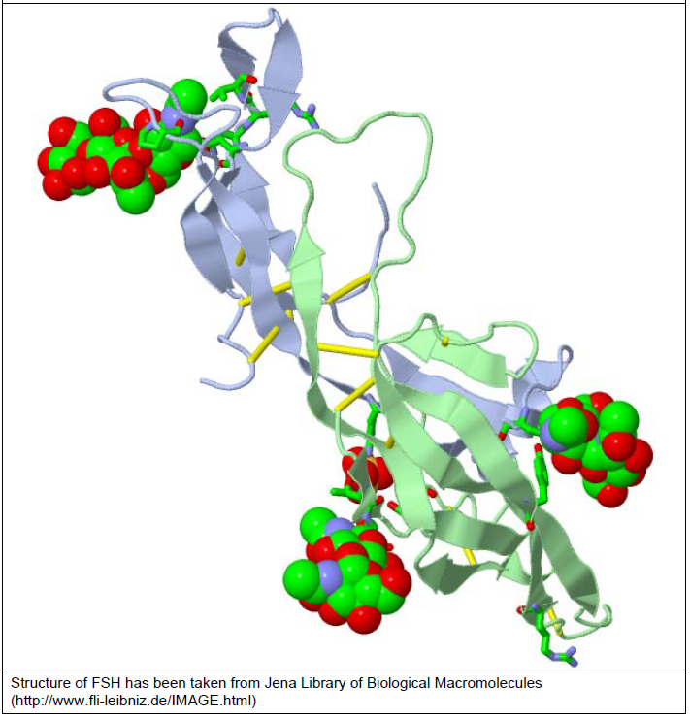

Ribbon model of human follicle-stimulating hormone. Pale blue and green ribbon strands represent the alpha and beta chains; yellow sticks represent the disulphide bridges; coloured balls represent the N‑glycosylation (carbohydrate) sites.

The active substance of Ovaleap (follitropin alfa) has been developed as a biosimilar to the registered reference product Gonal-f (follitropin alfa). Gonal-f (EU‑sourced) was used as the reference product in the clinical studies, Studies XM17-02 and XM17-05. Biosimilarity bridging studies between the innovator EU product used for the biosimilarity comparability study and the product supplied in Australia were not provided. However, the comparison of the manufacturing sites and a search of internal quality database for the Australia market Gonal-f, demonstrated that Gonal-f is manufactured at the same site(s) for global distribution and the Australian market. The evaluator concluded that the Australian marketed reference product is equivalent to that of EU/United States (US) marketed reference product.

Overall, the sponsor has demonstrated that Ovaleap is comparable to Gonal-f in terms of structure, species, function and degradation profile (that is, physicochemically and biologically). The evaluator considered the differences in the quality attributes between Ovaleap and EU/US marketed reference product Gonal-f to be minor. The comparability parameters of Ovaleap and Gonal-f were qualitatively similar to those previously approved for earlier Gonal-f biosimilars (Bemfolia/Afolia)[8] except for the thermal stability of the higher order structure. There were also qualitative differences in the formulations of Gonal-f and Ovaleap. The evaluator states that, as per the TGA and TGA-adopted guidelines, clinical studies are required to confirm that these differences are not clinically relevant.

The data supplied in relation to the physical and chemical properties of Ovaleap were satisfactory. There are no issues pertaining to the specifications or the stability of the drug substance or the drug product.

All manufacturing steps and analytical procedures were validated.

The real time data submitted support a shelf life for the drug product of 36 months when stored at 2°C to 8°C protected from light. During transport, Ovaleap can be stored at 2 to 8°C with no more than 5 hours at 25°C.

There are no objections to the registration of this product from sterility, endotoxin, container safety or an adventitious agent perspective.

#### Proposed quality conditions of registration

* Laboratory testing and compliance with Certified Product Details
  + All batches of:

Ovaleap 450 IU/0.75 mL follitropin alfa (rch) solution for injection- cartridge;

Ovaleap 900 IU/1.5 mL follitropin alfa (rch) solution for injection- cartridge;

Ovaleap 300 IU/0.5 mL follitropin alfa (rch) solution for injection- cartridge

supplied in Australia must comply with the product details and specifications approved during evaluation and detailed in the Certified Product Details (CPD).

* + When requested by the TGA, the sponsor should be prepared to provide product samples, specified reference materials and documentary evidence to enable the TGA to conduct laboratory testing on the product. Outcomes of laboratory testing are published biannually in the TGA Database of Laboratory Testing Results http://www.tga.gov.au/ws-labs-index and periodically in testing reports on the TGA website.
* Certified Product Details

The CPD, as described in Guidance 7: Certified Product Details of the Australian Regulatory Guidelines for Prescription Medicines (ARGPM) (http://www.tga.gov.au/industry/pm-argpm-guidance-7.htm), in PDF format, for the above products should be provided upon registration of these therapeutic goods. In addition, an updated CPD should be provided when changes to finished product specifications and test methods are approved in a Category 3 application or notified through a self-assessable change.

### Nonclinical

There were no nonclinical objections to the registration of Ovaleap follitropin alfa for the proposed indications. Comparability of the Ovaleap and Gonal-f forms of follitropin alfa, and acceptable local tolerability of the Ovaleap formulation, were adequately demonstrated in the submitted nonclinical studies.

The dossier contained comparative studies on primary pharmacology, pharmacokinetics (PK) and repeat-dose toxicity; and non-comparative studies on safety pharmacology, single-dose toxicity, repeat-dose toxicity and local tolerance. The scope of the nonclinical program was adequate according to the relevant TGA-adopted guideline.[9] All safety‑related studies were Good Laboratory Practice-compliant. Comparative studies were performed using EU sourced Gonal-f as the reference product. The use of the EU‑reference product in place of Australian-sourced Gonal-f was previously found to be acceptable.

Comparable serum kinetics were seen for the Ovaleap and Gonal-f after subcutaneous (SC) administration in rats. Comparability of the primary pharmacological activity of the Ovaleap and Gonal-f was demonstrated in:

* *in vitro* assays examining binding affinity and association/dissociation kinetics at the human r-FSH receptor;
* *in vitro* assays examining activation of the recombinant human FSH receptor;
* the *in vivo* Steelman-Pohley assay, examining increased ovarian weight in treated immature rats.

Safety pharmacology studies with Ovaleap revealed no adverse effects on central nervous system (CNS) and respiratory function in rats (at up to 5000 and 1000 IU/kg SC) or on cardiovascular function in dogs (tested up to 100 IU/kg SC). No acute toxic effects were observed with Ovaleap in male and female rats following single SC administration at 5000 IU/kg. Repeat-dose toxicity studies of 2 weeks duration were performed with Ovaleap in female rats and dogs, and with Ovaleap compared against Gonal-f in a 4 week study in male and female rats. The key findings in the studies represented the pharmacological effects of FSH activity, with effects comparable between Ovaleap and Gonal-f.

The excipient profile of Ovaleap differs from that of Gonal-f. Ovaleap was shown to be acceptably well tolerated locally by the SC route, and with intramuscular and paravenous administration.

### Clinical

The submission included a single dose PK study, a single dose bioequivalence study and one pivotal study of efficacy and safety in infertile, but ovulatory, women undergoing superovulation for assisted reproductive technologies (ART) as summarised in Table 3. In addition, there were preliminary data from Study XM17-WH-50005, a post‑marketing study.

Table : Clinical development program for Ovaleap

|  |  |  |  |  |  |  |
| --- | --- | --- | --- | --- | --- | --- |
| Study no. | Study type | Subject/ patient type | Ovaleap | Comparator (Gonal-f) | Treatment duration | No. treated |
| XM17-01 | General PK | Healthy adult female subjects aged 18 to 39 years | 37.5 IU (n = 4)  75 IU (n = 12)  150 IU (n = 12)  300 IU (n = 12) | Not applicable | Single dose | 40 |
| XM17-02 | Bioequivalence | Healthy adult female subjects aged 18 to 39 years | 300 IU | 300 IU | Single dose | 36 |
| XM17-05 | Phase III, randomised, parallel group, assessor blinded | Infertile, but ovulatory, women undergoing superovulation for ART | 150 IU/day for the first 5 days, then adjusted from Day 6 | 150 IU/day for the first 5 days, then adjusted from Day 6 | Multiple doses | 299 |

ART = assisted reproductive technologies; IU = international units; PK = pharmacokinetic(S).

#### Pharmacology

##### Pharmacokinetics

###### Study XM17-01

Study XM17-01 was a single centre, first in human, open label, parallel group, ascending dose study of the PK, tolerability and safety of Ovaleap (XM17). The study included healthy female volunteers, aged 18 to 39 years.

The study treatment was XM17 at doses of 37.5 IU (n = 4), 75 IU (n = 12), 150 IU (n = 12) and 300 IU (n = 12). All patients were treated with a single dose of Zoladex (goserelin) 3.6 mg on Day 0, followed by injection of the study medication on Day 14. The PK evaluation was performed using pre-dose corrected XM17 (FSH) serum concentrations. 70 women were screened, 46 passed the screening, 42 were entered into the study (four were reserves) and two were withdrawn.

The absorption for the 37.5 IU dose level was prolonged compared with the higher dose levels. However, for the remaining three, higher dose levels the PK profiles were proportional to dose. From 75 IU to 300 IU there was dose proportionality for area under the concentration time curve from zero time to the last observed concentration value above lower limit of quantification (AUC0-last) and maximum plasma concentration (Cmax). Dose linearity was demonstrated across this dose range. Median time to maximum plasma concentration (tmax) was 36 hours in the three higher dose groups. Median elimination half life (t½) ranged from 63 to 77 hours.

###### Study XM17-02

The bioequivalence of Ovaleap and Gonal-f was assessed in Study XM17-02, a single centre, open label, randomised, two way, single dose, crossover study. The study included healthy female volunteers, aged 18 to 39 years.

The study treatments were Ovaleap (XM17), 300 IU in 0.5 mL injection volume and Gonal-f (follitropin alfa) 300 IU in 0.5 mL injection volume. The treatments were administered by SC injection and there was an 8 day washout period between doses. Goserelin (Zoladex) was administered for endogenous FSH down-regulation eleven days before study treatment was administered. The study included 36 healthy, FSH down-regulated women with a BMI in the range of 18.1 to 27.9 kg/m2. All 36 subjects completed the study.

The primary PK outcome measures were AUC0-last and Cmax. The analysis was based on baseline corrected FSH concentrations. The plasma concentration time curves for XM17 and Gonal-f were identical (Figure 2). The PK parameters for the two products were similar (Table 4). Bioequivalence was demonstrated for the primary PK parameters. The mean ratio (90% confidence interval (CI)) was 1.028 (0.931 to 1.134) for AUC0-last and 1.017 (0.958 to 1.080) for Cmax (Table 5).

Figure : Study XM17-02 Baseline corrected follicle-stimulating hormone concentrations (IU/L) after treatment with Ovaleap (XM17) and Gonal-f versus time (hours) (linear scale); mean values and standard deviation (pharmacokinetic population)

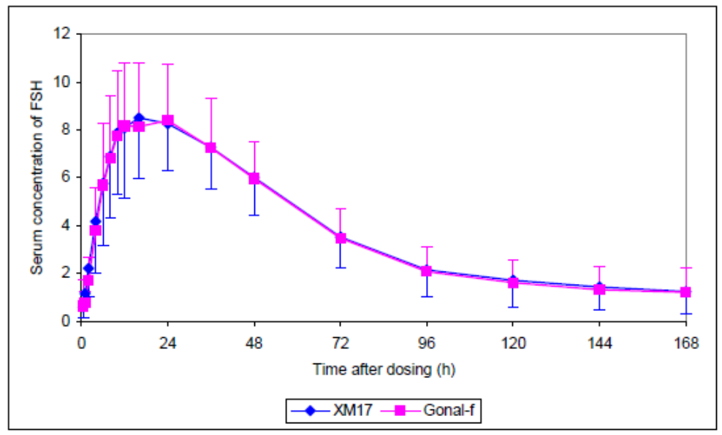

FSH = follicle-stimulating hormone; Gonal-F = follitropin alfa (comparator); XM17 = Ovaleap (follitropin alfa)

Table : Study XM17-02 Descriptive statistics of primary and secondary pharmacokinetic parameters of follicle-stimulating hormone (pharmacokinetic population)

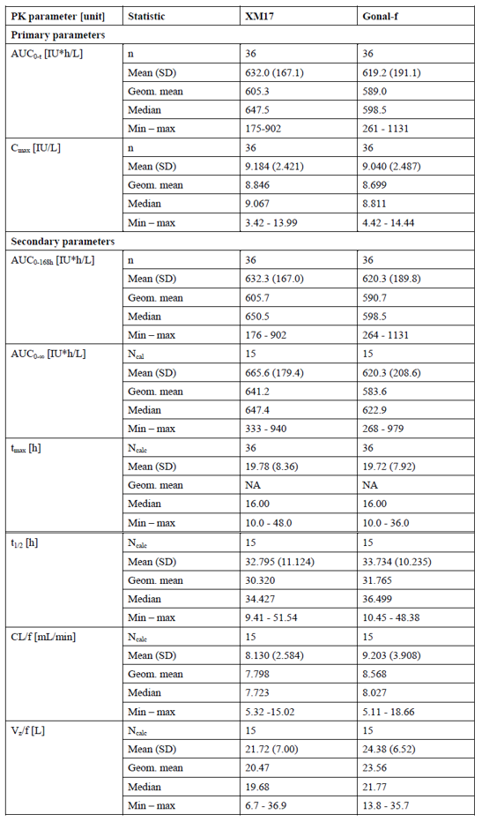

AUC0-168h = area under the concentration-time curve from zero time to the sampling time point at 168 hours, AUC0-t = area under the concentration time curve from zero time to the last observed concentration value above lower limit of quantification, AUC0-∞ = area under the concentration-time curve from zero time to infinity, CL/f = apparent clearance, Ncalc = number of subjects used for calculation, t1/2 = elimination half life, tmax = time to maximum plasma concentration, Vz/f = apparent volume of distribution.

Table : Study XM17-02 Ratios of pharmacokinetic parameters for Ovaleap (XM17) versus Gonal-f with 90% confidence intervals

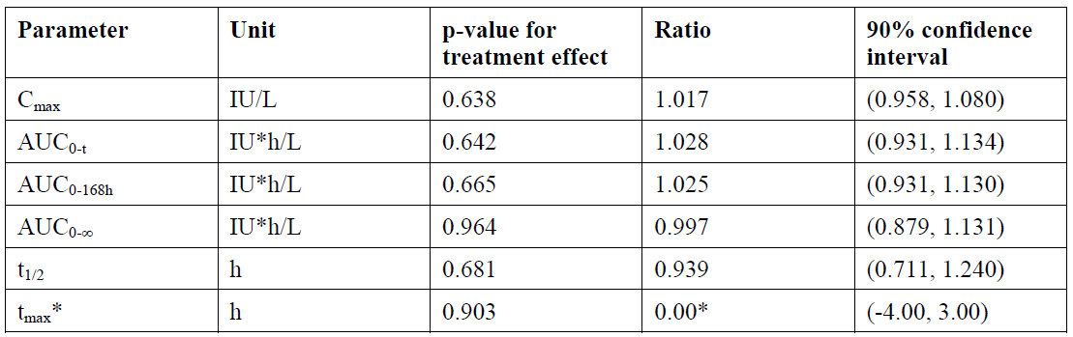

* Difference between XM17 versus Gonal-f.

Log-transformed evaluation (except for tmax) results presented after back-transformation. Ratios derived from least squares geometric means, for tmax nonparametric estimate of difference. Individual parameter estimates of insufficient reliability were excluded from the analyses.

AUC0-168h = area under the concentration-time curve from zero time to the sampling time point at 168 hours, AUC0-t = area under the concentration time curve from zero time to the last observed concentration value above lower limit of quantification, AUC0-∞ = area under the concentration-time curve from zero time to infinity, Cmax = maximum plasma concentration, t1/2 = elimination half life, tmax = time to maximum plasma concentration..

#### Efficacy

##### Study XM17-05

Study XM17-05 was an international, multicentre, Phase III, randomised, assessor blind, comparator controlled, parallel group efficacy and safety study of Ovaleap (XM17) follitropin alfa in comparison to Gonal-f follitropin alfa. A double blind study design was not technically feasible due to differences in product packaging. The primary objective was to demonstrate the bioequivalence of Ovaleap (XM17) and Gonal-f with respect to the number of oocytes retrieved in infertile, but ovulatory, women undergoing superovulation for ART.

The main study was for one cycle. Patients who became pregnant were included in Follow‑up Part A. Patients who did not become pregnant were able to enter Follow-up Part B. Patients in Part B received XM17 for a second or third cycle and the safety and immunogenicity of several cycles of XM17 was assessed.

The study included infertile women undergoing superovulation for ART, aged between 18 to 37 years with regular menstrual cycles and a BMI between 18 and 29 kg/m2, who had not undergone more than two consecutive previously unsuccessful IVF cycles, had not had more than three miscarriages and had no cysts > 2 cm.

The doses of XM17 and Gonal-f were fixed at 150 IU/day for the first 5 days, then adjusted from Day 6 to achieve adequate follicular development. Doses were adjusted in steps or multiples of 37.5 IU, up to 300 IU. Doses > 450 IU were not recommended. All patients received gonadotropin-releasing hormone agonist Metrelef (buserelin acetate) for pituitary down-regulation and recombinant hCG alfa Ovitrelle for final follicular maturation and induction of ovulation.

There were 398 patients enrolled and screened, and 299 were randomised and treated: 153 to XM17 and 146 to Gonal-f. 276 (92.3%) patients completed the study, and 23 (7.7%) were withdrawn: 11 (7.2%) patients in the XM17 group and 12 (8.2%) in the Gonal-f. Nine (3.0%) patients discontinued because no oocytes were fertilised (5 versus 4) and 6 (2.0%) because no embryos were transferred (5 versus 1). The mean (standard deviation (SD)) patient age was 31.6 (3.2) years. The treatment groups were similar in demographic and baseline characteristics.

The primary efficacy outcome measure was the number of oocytes retrieved. At least one oocyte was harvested in 151 (99.3%) subjects in the XM17 group and 143 (98.6%) subjects in the Gonal-f group in the according to protocol population (ATP). The mean (SD) numbers of oocytes per patient was 12.2 (6.8) in the XM17 group and 12.0 (6.8) in the Gonal-f group. The mean difference (95% CI), XM17 minus Gonal-f was 0.03 (-0.76 to 0.82) oocytes which was well within the boundary for non-inferiority (-3). Age and country had a significant effect on the number of oocytes (p < 0.001). The analysis of covariance analysis and the analysis of the intent to treat population (ITT) were supportive of the primary analysis.

The results for the secondary efficacy outcome measures were:

* Total human r-FSH dose was similar in the ITT populations for the two treatments: mean (SD) 1535.8 (495.6) IU for XM17 and 1614.3 (484.9) IU for Gonal-f (p = 0.065). The pattern of dose adaptations was similar in for the two treatment groups.
* The duration of human r-FSH stimulation was similar for the two treatments: mean (SD) 9.3 (1.8) days for XM17 and 9.7 (1.6) days for Gonal-f (p = 0.116).
* Follicle size on Day 6 was similar for the two treatment groups.
* Mean serum oestradiol on Day 6 was higher in the XM17 group: mean (SD) 650.2 (553.8) pg/mL for XM17 and 516.3 (445.4) pg/mL for Gonal-f (p = 0.009).
* Mean endometrial thickness on Day 6 was similar for the two groups: mean (SD) 8.2 (2.1) mm for XM17 and 8.0 (2.1) mm for Gonal-f.
* The mean (SD) number of follicles > 14 mm on day of hCG administration was 10.8 (4.9) for XM17 and 10.5 (4.7) for Gonal-f.
* Mean serum oestradiol on day of hCG administration was similar for the two treatment groups: mean (SD) 2744.3 (1728.5) pg/mL for XM17 and 2598.5 (1562.6) pg/mL for Gonal-f.
* Mean endometrial thickness on day of hCG administration was similar for the two groups: mean (SD) 10.9 (2.0) mm for XM17 and 10.9 (1.9) mm for Gonal-f.
* The cancellation rate prior to oocyte retrieval in the ITT population was 1 (0.7%) patient in the XM17 group and 3 (2.1%) in the Gonal-f.
* Oocyte maturity (intracytoplasmic sperm injection (ICSI) procedure only) was similar for the two treatment groups.
* Oocyte quality (based on the Z-scoring system) was similar for the two treatment groups.
* The mean (SD) fertilisation rate for ICSI was 67.2 (22.9)% for XM17 and 63.3 (26.3)% for Gonal-f. The mean (SD) fertilisation rate for IVF was 42.6 (33.9)% for XM17 and 45.6 (31.2)% for Gonal-f.
* Biochemical pregnancy was detected in 58 (37.9%) patients in the XM17 group and 60 (41.1%) in the Gonal-f group (p = 0.606). Clinical pregnancy was detected in 43 (28.1%) patients in the XM17 group and 52 (35.6%) in the Gonal-f group (p = 0.172).

Follow-up Part A included a total of 99 patients (46 versus 53). An additional four patients who did not have a biochemical pregnancy after an initial embryo transfer but became pregnant after an additional embryo transfer with frozen embryos developed during the main study. In the Part A patient population there was a higher proportion of patients who smoked and who drank alcohol in the Gonal-f group.

There were 42 (27.5% of the main study population) patients in the XM17 group and 49 (33.6%) in the Gonal-f with ongoing pregnancy. Complications during pregnancy were reported in 5 (11.4% of the Part A population) patients in the XM17 group and 7 (13.2%) in the Gonal-f group. There were no ectopic pregnancies reported in the Part A follow-up but in the main study report ectopic pregnancy was reported in 2 (1.3%) patients in the XM17 and 1 (0.7%) in the Gonal-f group. Clinical abortion was reported in two (4.5%) patients in the XM17 group and one (1.9%) in the Gonal-f. Missed abortion was reported in three (6.8%) patients in the XM17 group and three (5.7%) in the Gonal-f group. In the XM17 group there was one trisomy 21-related clinical abortion; and in the Gonal-f group there was a 5;13 chromosomal translocation-related induced abortion.

The take home baby rate was 41 (26.8% of the main study population) in the XM17 group and 47 (32.2%) in the Gonal-f group. In the XM17 group there were multiple births in 13 (31.7%) patients; there were no stillbirths; and four babies were born premature at 32 weeks gestation. In the Gonal-f group there were multiple births in 9 (19.1%) patients; there was one stillbirth; one was born at 24 weeks gestation and died on the third day after delivery; one set of triplets was born at 24 weeks gestation, one of whom died of sepsis and icterus.

#### Safety

In Study XM17-01, 40 healthy female volunteers were exposed to a single dose of Ovaleap (XM17). There were 33 treatment emergent adverse events (TEAEs) reported in 21 (52.5%) volunteers. There was no clear dose relationship for TEAEs. The most common TEAE was headache (27.5%).

In Study XM17-02, 36 healthy female volunteers were exposed to single doses of XM17 and Gonal-f. TEAEs were reported by 17 (43.6%) women with Zoladex (goserelin), 25 (69.4%) with XM17 and 20 (55.6%) with Gonal-f. The most common TEAEs were headache, reported in 17 (47.2%) of the volunteers, and hot flushes, reported in 10 (27.8%) volunteers.

In Study XM17-05, 153 patients were treated with at least one dose of XM17 and 146 with at least one dose of Gonal-f. The mean (SD) total dose of XM17 in the first cycle was 1535.8 (495.6) IU, and mean (SD) duration of stimulation was 9.3 (1.8) days. The mean (SD) total dose of Gonal-f was 1614.3 (484.9) IU, and mean (SD) duration of stimulation was 9.7 (1.6) days. All 147 patients enrolled in Part B were treated with XM17. Of these patients, 80 were from the original XM17 group and 67 from the original Gonal-f group. 220 patients were treated with at least one cycle of XM17, of whom 73 received two cycles and 34 received three cycles. The median total dose of XM17 in Cycles 2 and 3 was 1875 IU. The biochemical pregnancy rate for Cycle 2 was 31.3% and Cycle 3 was 31.1%. The ongoing pregnancy rate for Cycle 2 was 25.9% and for Cycle 3 was 21.7%.

Study XM17-05 included the safety outcome measures adverse events (AEs), adverse events of special interest (AESIs; ovarian hyperstimulation syndrome (OHSS), ectopic pregnancy, pregnancy loss, embolic and thrombotic events), clinical laboratory tests, tolerability, vital signs, body weight and physical examination. TEAEs were reported in 25 (16.3%) patients in the XM17 group and 22 (15.1%) in the Gonal-f. The most frequently reported TEAEs were OHSS (7 (4.6%) and 4 (2.7%) respectively), and abdominal pain (3.3% and 0.7% respectively). As outlined above, there were no ectopic pregnancies reported in the Part A follow-up but in the main study report there were 2 (1.3%) patients in the XM17 and 1 (0.7%) in the Gonal-f group. Pregnancy loss occurred in 7 patients (3 (2.0%) versus 4 (2.7%)). There were no reports of embolic or thrombotic events in Study XM17-05. In Part B, TEAEs were reported by 16 (10.9%) patients in Cycle 2 and 4 (6.6%) in Cycle 3.

No deaths were reported in Studies XM17-01, XM17-02 or XM17-05. There were no serious adverse events (SAEs) reported in Studies XM17-01 or XM17-02.

In Study XM17-05, SAEs were reported in 9 (5.9%) patients in the XM17 group and 7 (4.8%) in the Gonal-f group. There were 3 (2.0%) patients in the XM17 and 2 (1.4%) in the Gonal-f group with OHSS as an SAE. A similar frequency of OHSS was observed in the post-authorisation cohort Study XM17-WH50005 (8 (3.3%) versus 3 (1.7%)). In Study XM17-05 ectopic pregnancy was classified as severe for 2 (1.3%) patients in the XM17 and 1 (0.7%) in the Gonal-f group. In Part B, SAEs were reported by 2 (2.4%) patients in Cycle 2 (appendicitis, OHSS) and 1 (1.6%) in Cycle 3 (borderline ovarian tumour).

Study XM17-05 found local tolerability was similar for the two treatments. Injection site reactions were uncommon in both treatment groups.

##### Immunogenicity

In Study XM17-05, about 18 % of the patients had pre-existing positive findings (17% anti‑N-glycolylneuraminic acid (Neu5Gc), 1% anti-FSH). In these patients there was no relevant increase in the titre during the treatment with XM17 or Gonal-f. A positive response developed, post treatment, in 11 patients in the XM17 group and 5 in the Gonal-f group. During the study, 22 patients (7.4%) showed post-dose positive findings: 12 patients were positive for anti-Neu5Gc, 2 for anti-XM17, 1 for anti- Gonal-f, 1 patient had transient positive findings inhibited by all competitors and 6 patients were classified as having pre-existing anti-Neu5Gc positive findings. None of the samples demonstrated neutralising activity. Biochemical pregnancy was achieved by 11 of these 22 patients (50.0%) compared to 161 of 277 patients (58.1%) without these findings. None of the patients had a hypersensitivity reaction during the study.

#### Clinical evaluator’s recommendation

The clinical evaluator has recommended approval of Ovaleap follitropin alfa for the same indications as the Australian reference product. The evaluator was unable to determine the benefit-risk balance for the additional indication relating to combination use with LH. This indication is not approved for the Australian reference product and the clinical evaluator concluded that there was insufficient data to support the approval of this additional indication. The sponsor removed the additional indication in their response to the second round evaluation reports.

### Risk management plan

There was no requirement for a risk management plan evaluation for a submission of this type.[10]

### Risk-benefit analysis

#### Delegate’s considerations

The sponsor has demonstrated bioequivalence for Ovaleap and Gonal-f. The 90% CIs for the primary PK parameters AUC0-last and Cmax were well within the acceptance interval of 80.00 to 125.00% (see Table 5). Clinical Study XM17-05 demonstrated equivalent efficacy for Ovaleap and Gonal-f with respect to the guideline recommended primary endpoint, ‘number of oocytes retrieved’. The 95% CIs for this endpoint fell within the pre-defined equivalence margin. The summary statistics for effectiveness were similar for the secondary efficacy outcome measures. Pregnancy outcome was noted to be slightly different in Study XM17-05 but this outcome was influenced by differing practices between countries and centres.

The safety and tolerability profile of the two products were similar. The rate of OHSS was slightly higher for Ovaleap in both the pivotal study and the post-marketing study. The pathology of OHSS is multifactorial. Follitropin alfa treatment is a known risk factor for OHSS as related the mechanism of action. Increased oestradiol levels were observed for Ovaleap on Day 6, but not on the day of hCG administration. In clinical practice the risk of OHSS is somewhat mitigated by the close monitoring of a patient’s response to treatment. The risk of OHSS is adequately described in the PI.

The immunogenicity of Ovaleap and Gonal-f can be considered similar. The clinical studies found no indication of neutralising antibodies or hypersensitivity syndromes.

The sponsor has proposed wording for the indication that differs slightly from that of the Australian reference product. The Delegate is of the opinion that the wording of the indication should be as close to the Australian reference product as possible to prevent any differences in interpretation. The sponsor is requested to align the proposed indications with those of the Australian reference product.

#### Proposed action

The Delegate proposes to approve the registration of Ovaleap (follitropin alfa) as a new biosimilar of the reference product Gonal-f (follitropin alfa). The evidence for comparability supports the use of Ovaleap for the same indications as Gonal-f.

#### Questions for the sponsor

The sponsor provided the following response to questions from the Delegate.

1. ***It is noted that the pen device will be distributed separately. Is the pen device already approved in Australia or will a separate application be made to devices?***

The sponsor can confirm that the Ovaleap Pen device has been registered and copy of ARTG certificate is attached as Annex 1 of the response [not included in this AusPAR].5

1. ***Is the proposed/approved pen device for the Australian market the same as that used in the clinical trials, Studies XM17-01 and XM17-05?***

The sponsor confirms that the Ovaleap Pen device registered in Australia is identical to that used in the Phase III clinical trial, Study XM17-05, for Ovaleap. The sponsor highlights that as noted in the Phase I Study XM-17-01 protocol and the clinical study report, the product was not delivered in this study using the Ovaleap pen device but rather administered by 1 mL syringes closed tightly to the cannulas which were sized 27 gauge.

#### Advisory Committee considerations[11]

The Delegate did not refer this application to the Advisory Committee on Medicines (ACM) for advice.

### Outcome

Based on a review of quality, safety and efficacy, the TGA approved the registration of Ovaleap (follitropin alfa) 300 IU/0.5 mL, 450 IU/0.75 mL and 900 IU/1.5 mL solution for injection cartridges, indicated for:

*1. The treatment of anovulatory infertility in women who have been unresponsive to clomiphene citrate or where clomiphene citrate is contraindicated.*

*2. For controlled ovarian hyperstimulation in women undergoing assisted reproductive technologies.*

*3. Ovaleap is indicated with concomitant human chorionic gonadotrophin (hCG) therapy for the stimulation of spermatogenesis in gonadotrophin-deficient men in whom hCG alone is ineffective*

#### Specific conditions of registration applying to these goods

* Post marketing reports are to be prepared annually until the period covered by such reports is not less than three years from the date of the approval letter. No fewer than three annual reports are to be prepared. The reports are to at least meet the requirements for periodic safety update reports (PSURs) as described in the European Medicines Agency’s Guideline on Good Pharmacovigilance Practices (GVP) Module VII Periodic Safety Update Report (Rev 1), Part VII.B. Structures and processes. Reports are to be submitted to the TGA only when requested in writing by the TGA. When requested, reports must be provided to the TGA within ten (10) calendar days. Preparation of the report must be completed within ninety calendar days of the data lock point for that report. An annual report may be made up of two PSURs each covering six months. Note that submission of a PSUR does not constitute an application to vary the registration.
* Laboratory testing and compliance with Certified Product Details
  + All batches of:

Ovaleap 450 IU/0.75 mL follitropin alfa (rch) solution for injection- cartridge;

Ovaleap 900 IU/1.5 mL follitropin alfa (rch) solution for injection- cartridge;

Ovaleap 300 IU/0.5 mL follitropin alfa (rch) solution for injection- cartridge

supplied in Australia must comply with the product details and specifications approved during evaluation and detailed in the Certified Product Details (CPD).

* + When requested by the TGA, the sponsor should be prepared to provide product samples, specified reference materials and documentary evidence to enable the TGA to conduct laboratory testing on the product. Outcomes of laboratory testing are published biannually in the TGA Database of Laboratory Testing Results http://www.tga.gov.au/ws-labs-index and periodically in testing reports on the TGA website.
* Certified Product Details

The CPD, as described in Guidance 7: Certified Product Details of the Australian Regulatory Guidelines for Prescription Medicines (ARGPM) (http://www.tga.gov.au/industry/pm-argpm-guidance-7.htm), in PDF format, for the above products should be provided upon registration of these therapeutic goods. In addition, an updated CPD should be provided when changes to finished product specifications and test methods are approved in a Category 3 application or notified through a self-assessable change.

• For all injectable products the PI must be included with the product as a package insert

## Attachment 1. Product Information

The PI for Ovaleap approved with the submission which is described in this AusPAR is at Attachment 1. For the most recent PI, please refer to the TGA website at <<https://www.tga.gov.au/product-information-pi>>.

|  |
| --- |
| Therapeutic Goods Administration |
| PO Box 100 Woden ACT 2606 Australia  Email: [info@tga.gov.au](mailto:info@tga.gov.au) Phone: 1800 020 653 Fax: 02 6232 8605  [**https://www.tga.gov.au**](https://www.tga.gov.au) |

1. The **Black Triangle Scheme** provides a simple means for practitioners and patients to identify certain types of new prescription medicines, including those being used in new ways and to encourage the reporting of adverse events associated with their use. The Black Triangle does not denote that there are known safety problems, just that the TGA is encouraging adverse event reporting to help us build up the full picture of a medicine's safety profile.
2. Mikhael, S, Punjaal-Patel, A, Gavrilova-Jordan, L. Hypothalamic-Pituitary-Ovarian Axis Disorders Impacting Female Fertility, *Biomedicines* 2019; 7, 5; doi:10.3390/biomedicines7010005.
3. National Institute for Health and Care Excellence (NICE), Fertility problems: assessment and treatment,

   Clinical guideline (CG156), Published date: 20 February 2013 Last updated: 6 September 2017, available from the NICE website.
4. Gonal-f (follitropin alfa), presented as a solution for injection in a cartridge, pre-assembled in a pen (AUST R 96230, 96236, 96237) was registered in Australia on 1 December 2003, and is sponsored by Merck Healthcare Pty Ltd.
5. Ovaleap Pen, injector, Medical Device Class IIa, AUST R 353406, ARTG start date 21 January 2021, sponsored by Theramex Australia Pty Ltd.
6. This required GMP clearance was obtained prior to approval and registration of Ovaleap.
7. XM17 is the drug development code for Ovaleap (follitropin alfa).
8. AusPAR for Bemfolia/Afolia (follitropin alfa) solution for injection. Available from the TGA website at <https://www.tga.gov.au/auspar/auspar-follitropin-alfa-rch-0>.
9. European Medicines Agency (EMA), Committee for Medicinal Products for Human Use (CHMP), Guideline on non-clinical and clinical development of similar biological medicinal products containing recombinant human follicle stimulating hormone (r-hFSH), EMA/CHMP/BMWP/671292/2010, 21 February 2013.
10. The sponsor must still comply with routine product vigilance and risk minimisation requirements.
11. The ACM provides independent medical and scientific advice to the Minister for Health and the Therapeutic Goods Administration (TGA) on issues relating to the safety, quality and efficacy of medicines supplied in Australia including issues relating to pre-market and post-market functions for medicines.

    The Committee is established under Regulation 35 of the Therapeutic Goods Regulations 1990. Members are appointed by the Minister. The ACM was established in January 2017 replacing Advisory Committee on Prescription Medicines (ACPM) which was formed in January 2010. ACM encompass pre and post-market advice for medicines, following the consolidation of the previous functions of the Advisory Committee on Prescription Medicines (ACPM), the Advisory Committee on the Safety of Medicines (ACSOM) and the Advisory Committee on Non-Prescription Medicines (ACNM). Membership comprises of professionals with specific scientific, medical or clinical expertise, as well as appropriate consumer health issues relating to medicines.