|  |
| --- |
| **22 April 2015** |

|  |
| --- |
| AusPAR Attachment 2 |
| Extract from the Clinical Evaluation Report for Follitropin alfa (rch) |
| Proprietary Product Name: Bemfola, Afolia |
| Sponsor: Finox Biotech Australia Pty Ltd |

About the Therapeutic Goods Administration (TGA)

* The Therapeutic Goods Administration (TGA) is part of the Australian Government Department of Health, and is responsible for regulating medicines and medical devices.
* The TGA administers the *Therapeutic Goods Act 1989* (the Act), applying a risk management approach designed to ensure therapeutic goods supplied in Australia meet acceptable standards of quality, safety and efficacy (performance), when necessary.
* The work of the TGA is based on applying scientific and clinical expertise to decision-making, to ensure that the benefits to consumers outweigh any risks associated with the use of medicines and medical devices.
* The TGA relies on the public, healthcare professionals and industry to report problems with medicines or medical devices. TGA investigates reports received by it to determine any necessary regulatory action.
* To report a problem with a medicine or medical device, please see the information on the TGA website <<https://www.tga.gov.au>>.

About the Extract from the Clinical Evaluation Report

* This document provides a more detailed evaluation of the clinical findings, extracted from the Clinical Evaluation Report (CER) prepared by the TGA. This extract does not include sections from the CER regarding product documentation or post market activities.
* The words [Information redacted], where they appear in this document, indicate that confidential information has been deleted.
* For the most recent Product Information (PI), please refer to the TGA website <<https://www.tga.gov.au/product-information-pi>>.

Copyright

© Commonwealth of Australia 2016  
This work is copyright. You may reproduce the whole or part of this work in unaltered form for your own personal use or, if you are part of an organisation, for internal use within your organisation, but only if you or your organisation do not use the reproduction for any commercial purpose and retain this copyright notice and all disclaimer notices as part of that reproduction. Apart from rights to use as permitted by the *Copyright Act 1968* or allowed by this copyright notice, all other rights are reserved and you are not allowed to reproduce the whole or any part of this work in any way (electronic or otherwise) without first being given specific written permission from the Commonwealth to do so. Requests and inquiries concerning reproduction and rights are to be sent to the TGA Copyright Officer, Therapeutic Goods Administration, PO Box 100, Woden ACT 2606 or emailed to <[tga.copyright@tga.gov.au](mailto:tga.copyright@tga.gov.au)>.

Contents

List of abbreviations 5

1. Introduction 7

1.1. Dosage forms and strengths 8

1.2. Dosage and administration 8

2. Clinical rationale 8

2.1. Formulation development 8

3. Contents of the clinical dossier 9

3.1. Scope of the clinical dossier 9

3.2. Paediatric data 9

3.3. Good clinical practice 9

4. Pharmacokinetics 9

4.1. Studies providing pharmacokinetic data 9

4.2. Evaluator’s overall conclusions on pharmacokinetics 10

5. Pharmacodynamics 11

5.1. Studies providing pharmacodynamic data 11

5.2. Summary of pharmacodynamics 11

5.3. Evaluator’s overall conclusions on pharmacodynamics 12

6. Dosage selection for the pivotal studies 12

7. Clinical efficacy 12

7.1. Use in patients undergoing superovulation for assisted reproductive technologies (ART) 12

7.2. Analyses performed across trials (pooled analyses and meta-analyses) 21

7.3. Evaluator’s conclusions on clinical efficacy for all claimed indications 21

8. Clinical safety 22

8.1. Studies providing evaluable safety data 22

8.2. Pivotal studies that assessed safety as a primary outcome 24

8.3. Patient exposure 24

8.4. Adverse events 25

8.5. Laboratory tests 27

8.6. Post-marketing experience 28

8.7. Evaluator’s overall conclusions on clinical safety 28

9. First round benefit-risk assessment 29

9.1. First round assessment of benefits 29

9.2. First round assessment of risks 29

9.3. First round assessment of benefit-risk balance 30

10. First round recommendation regarding authorisation 30

10.1. RMP and OHSS risk. 30

11. Clinical questions 31

## List of abbreviations

| Abbreviation | Meaning |
| --- | --- |
| AE | adverse event |
| AMH | anti-Mullerian hormone |
| ART | assisted reproductive technology |
| AUC | area under curve |
| CHMP | Committee for Medicinal Products for Human Use |
| CI | confidence interval |
| CMI | consumer medicine information |
| Cmax | maximum concentration |
| EMA | European medicines agency |
| EU | European Union |
| FAS | full analysis set |
| FSH | follicle stimulating hormone |
| GCP | good clinical practice |
| GIFT | gamete intrafallopian transfer |
| hCG | human chorionic gonadotropin |
| IU | international unit |
| IVF | in vitro fertilisation |
| LH | luteinising hormone |
| MedDRA | Medical Dictionary for Regulatory Activity |
| OHSS | ovarian hyperstimulation syndrome |
| PCOD | polycystic ovarian disease |
| PD | pharmacodynamic |
| PI | product information |
| PK | pharmacokinetic |
| PP | per protocol |
| r-hFSH | recombinant human follicle stimulating hormone |
| RMP | risk management plan |
| SAE | severe adverse effect |
| SAS | safety analysis set |
| SD | standard deviation |
| TGA | Therapeutic Goods Administration |
| Tmax | time to maximum concentration |
| TOST | two one-sided tests |
| UK | United Kingdom |
| USA | United States of America |
| WHO | World Health Organisation |
| ZIFT | zygote intrafallopian transfer |

## Introduction

This is a category 1 submission to register a preparation of recombinant FSH (follitropin alfa), as a biosimilar medicine to the existing registered product Gonal-f. The submission proposes two trade names, Bemfola and Afolia for the product. The submission proposes that the new product be registered for the same therapeutic indications currently approved for Gonal-f with one addition.

The proposed indication is:

***In adult women***

*Anovulation (including polycystic ovarian disease, PCOD) in women who have been unresponsive to treatment with clomiphene citrate.*

*Stimulation of multi follicular development in patients undergoing superovulation for assisted reproductive technologies (ART) such as in vitro fertilisation (IVF), gamete intra-fallopian transfer (GIFT) and zygote intra-fallopian transfer (ZIFT).*

*Bemfola in association with a luteinising hormone (LH) preparation is recommended for the stimulation of follicular development in women with severe luteinizing hormone (LH) and follicle-stimulating hormone (FSH) deficiency. In clinical trials these patients were defined by an endogenous serum LH level <1.2 IU/L.*

***In adult men***

*Bemfola is indicated for the stimulation of spermatogenesis in men who have congenital or acquired hypogonadotrophic hypogonadism with concomitant human chorionic gonadotropin (hCG) therapy.*

These proposed indications are stated in the sponsor's letter of application to be identical with those of Gonal–F (r-hFSH, follitropin alfa) with the addition of the indication in association with luteinising hormone (LH).

**Comment:** The proposed indications are identical in purpose with those of Gonal-f (with the exception of that indicating use with LH), although worded in more detail. With regard to the development of this list of indications, two important points are noted:

* While the Australian approved indications for Gonal-f do not include use with LH, those approved in the EU do so. The EU marketing approval for Bemfola includes use with LH on the basis that this is included in the EU registered indications for the reference product Gonal-f. Multiple references to this appear in the EU evaluation reports included in the dossier.
* The EU application was approved on the basis of the same clinical data as contained in the current Australian application, obtained by comparing Bemfola with Gonal-f in the ART indication. The EMA approved extrapolation of these clinical findings to the full list of indications, based on the biosimilarity of the two products. As outlined by the sponsor in a pre-submission meeting, the proposed indications in Australia were planned to be identical to the current Gonal-f reference product; however, the sponsor explained that the EU approved indications also include use with LH, which only appeared on the Luveris label in Australia rather than on the Gonal-f labelling. The TGA agreed that the extrapolation of indications could also be proposed in Australia and that the application be accepted for evaluation with these indications; and that the extrapolation would be assessed as part of the evaluation.

### Dosage forms and strengths

The submission proposes registration of the following dosage forms and strengths: 75 IU/0.125 mL, 150 IU/0.25 mL, 225 IU/0.375 mL, 300 IU/0.5 mL and 450IU/0.75mL. Note that these are all the same concentration; that is 600 IU/mL, just different volumes. Each form consists of a prefilled syringe designed to deliver a single dose of the appropriate strength. An ‘auto lock’ mechanism prevents reuse of the syringe.

### Dosage and administration

Dosage recommendations differ for the various indications and are specified in the draft PI. As for most of the PI, these recommendations are identical with those in the existing TGA approved PI for the comparator product Gonal-f and employ the various doses described above, although there are differences in the potential for fine tuning of dosage (see comment below). The product is designed for self-administration by the patient, if necessary under supervision, following appropriate instruction.

**Comment:** The Bemfola product differs from Gonal-f in being presented as single dose syringes, whereas Gonal-f is presented in three pack sizes of 0.5, 0.75 and 1.5 mL, all at the same concentration as for Bemfola, 600 IU/mL but designed to deliver multiple doses of variable quantity as required. The PI and CMI for both products are remarkably uninformative about the mechanisms of these delivery devices and it is presumed that there is separate educational information available regarding this for both patient and prescriber.

The Bemfola product has been designed to deliver all of the various doses required in the therapeutic regimens for the various indications by means of the use of single dose syringes, as opposed to the patient being instructed to vary the amount given with the multiple dose syringe employed for Gonal-f, but the product information is unclear about their mechanism for dose adjustment: paragraph 2 of the section on ‘women with anovulatory infertility’ of the draft PI refers to the dose being *‘increased by 37.5 IU up to 75 IU at 7 or 14 day intervals*’. It is presumed that the word increments is missing from this statement. Both the letter of application and Clinical Overview state that the Bemfola ‘pen’ is capable of minimum 12.5 IU increments by comparison with 37.5 IU for Gonal-f. The sponsor should clarify this matter.

## Clinical rationale

Follitropin alfa is the synthetic form of follicle stimulating hormone (FSH), the pituitary glycoprotein hormone which is a regulator of reproductive function in both females and males - specifically, the initiation of ovarian follicular development and spermatogenesis. The rationale for its clinical use is activation of these biological functions in patients with a variety of fertility problems, as for the comparator product Gonal-f to which biosimilarity is claimed. Additional rationale for the development of this biosimilar product and its form of presentation is to provide a preservative-free injection system which is claimed to be easier, safer and more economical to use and allows greater fine tuning of dosage as noted above.

### Formulation development

Bemfola has been developed using the same active substance (follitropin alfa) as employed in the reference preparation Gonal-f to which biosimilarity is claimed, but in a preservative free formulation presented in single use disposable injection devices capable of administering the full range of doses required for the proposed indications.

#### Excipients

The proposed formulation contains the following excipients; poloxamer, sucrose, sodium phosphate; dibasic dehydrate, sodium phosphate; monobasic dehydrate, methionine, phosphoric acid. As with the active ingredient, the concentrations of the various excipients are the same in each dosage presentation.

## Contents of the clinical dossier

### Scope of the clinical dossier

The submission contained the following clinical information:

* A single clinical pharmacology study, FIN1001, comparing Bemfola with the reference follitropin alfa product Gonal-f to establish bioequivalence in terms of pharmacokinetic properties
* A single pivotal efficacy/safety study, FIN3001
* Clinical Overview, Summary of Clinical Efficacy, Summary of Clinical Safety and literature references.

### Paediatric data

The submission did not include paediatric data, nor was any included in the submissions made in various international jurisdictions. The use of the product in the specified indications is not applicable to the paediatric population.

### Good clinical practice

In the pivotal efficacy study FIN3001, one of the study centres (a major UK hospital) was noted to have breached some major aspects of GCP which resulted in the CHMP of the EMA requesting a reanalysis of the study data with exclusion of the data from that centre. Details were provided; otherwise, both this and the bioequivalence study appear to have been conducted in compliance with GCP guidelines.

## Pharmacokinetics

### Studies providing pharmacokinetic data

The submission contains a single PK study, FIN1001. In accordance with the relevant EU guideline[1] and advice as noted above, this was carried out on healthy subjects.

In these 24 subjects given 225 IU doses of test and reference products in a two way crossover design following down-regulation of endogenous FSH production, the geometric mean AUC(0–192) values for plasma FSH were 424.90 m IU h/mL for Bemfola and 432.75 m IU h/mL for Gonal-f. The test/reference ratios for AUC(0–192) and Cmax were 0.98 and 0.95 for Bemfola versus Gonal-f. The median Tmax was calculated to be 24.0 h (range 6.0 to 24.0) and 24.0 (range 9.0 to 24.0) after FSH administration for Bemfola and Gonal-f, respectively. The mean terminal half-lives were calculated to be 43.58 (SD 14.17) hours for Bemfola and 42.58 (SD 16.47) hours for Gonal-f. The time-concentration profiles for the two products were virtually superimposable, as shown below (Figure 1).

Figure 1. Mean192 hour profiles of serum concentration of FSH (m IU/mL) Afolia versus Gonal-f

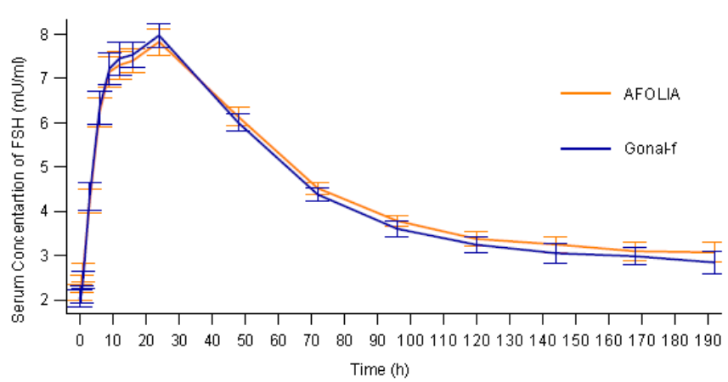

The data confirm bioequivalence of the two products, the point ratios and 90% CI for comparison of AUC(0-192h) being well within the prescribed limits of 0.80 to 1.25, as shown below in Table 1. The statistical analysis was conducted on the basis of bioequivalence, not non inferiority.

Table 1. Bioequivalence confidence intervals of FSH (Afolia versus Gonal F), PP

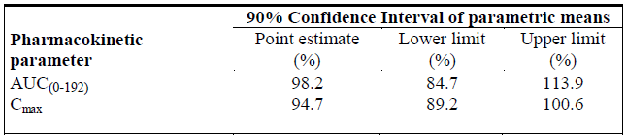

### Evaluator’s overall conclusions on pharmacokinetics

The methodology and outcomes of study FIN1001 are compliant with the requirements, for pharmacokinetic studies, of the EMEA guideline on biosimilarity of products containing biotechnology-derived proteins. For the purpose of this evaluation the demonstration of bioequivalence, that is biosimilarity in pharmacokinetic terms, appears adequate. Additionally, it should be emphasised that the comparator product Gonal-f, to which bioequivalence has been demonstrated, is an existing registered product.

## Pharmacodynamics

### Studies providing pharmacodynamic data

No specific PD study is included in the application. The clinical overview does make reference to a rise in plasma oestradiol being observed in study FIN1001 following the administration of both Bemfola and Gonal-f, and to this being an acceptable market for the PD activity of both products. The study report does not however provide any between treatment comparison of the levels achieved.

Plasma oestradiol was also a parameter of response to both test and reference FSH treatments in efficacy study FIN3001 (reported below). The results are shown in Table 2. Mean (SD) plasma oestradiol at Visit 5, after 8 days of daily FSH injections, was similar at 3,612 (3,395) pmol/L for Bemfola and 3,063 (2,425) pmol/L for Gonal-f. On the day of hCG administration, the timing of which was not directly related to oestradiol response, the values were 8,419 (5,543) pmol/L for Bemfola and 6,935 (4,099) pmol/L for Gonal-f. Statistical analysis (Wilcoxon test) showed these results to be different, but not with a high level of significance (p = 0.045).

**Comment**: These data show that both products are pharmacodynamically active in terms of oestradiol response. The comparison at Visit 5 may be more relevant, as the timing of hCG administration is variable and determined by other factors, that is stage of follicular development rather than oestradiol level. Nevertheless the finding on the day of hCG administration should not be ignored and may be relevant to some of the secondary endpoint findings in the pivotal efficacy study.

**Table 2**. **Estradiol concentration (ES10T)**

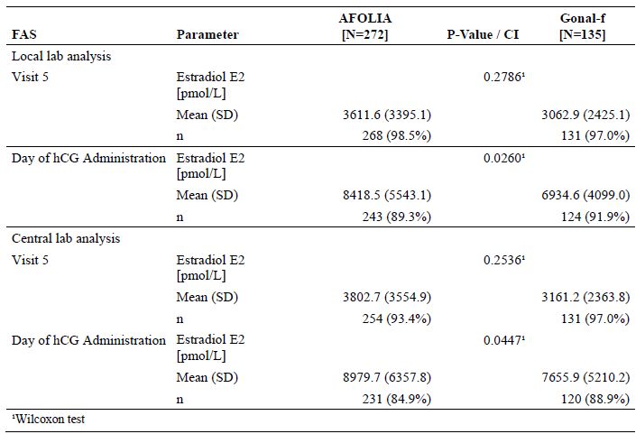

### Summary of pharmacodynamics

Limited PD data obtained in the course of the PK and efficacy studies confirm that plasma oestradiol response to FSH, as an index measurement of the PD activity of these FSH preparations, is equivalent between the applicant product and its comparator Gonal-f.

### Evaluator’s overall conclusions on pharmacodynamics

Detailed comparison of PD response between the applicant and comparator products is not required for this application on the basis of biosimilarity. However the available data confirms that the PD response to Bemfola is as expected. Further confirmation of this is inferred by the bioequivalence of the test and reference products found in the pivotal efficacy study.

## Dosage selection for the pivotal studies

PK study FIN1001 and efficacy study FIN3001 are each regarded as pivotal to this submission. In each of these studies, identical doses of Bemfola and Gonal-f were given as test and reference treatments respectively.

The single dose of 225 IU selected for FIN1001 is was discussed in the study report. 225 IU was used as it is a dose commonly employed in ART protocols and is in the middle of the dose range (150 to 450 IU) employed for ovarian hyperstimulation.

In study FIN3001, a fixed standard dose of 150 IU was used and continued until ultrasound criteria for follicular development were met, up to a maximum of 16 days. As described in the evaluation of this study presented below, the EMA expressed some criticism of dose adjustment not being used. This does not represent a criticism of the selection of 150 IU as the starting dose which is quite appropriate, as is the dose of 225 IU used in the PK study.

## Clinical efficacy

### Use in patients undergoing superovulation for assisted reproductive technologies (ART)

The application is supported by a single efficacy study, FIN3001, conducted in the context of the indication ‘*Use in patients undergoing superovulation for assisted reproductive technologies (ART)*’ which is the second of four categories of indication listed above.

#### Pivotal efficacy study; Study FIN3001

##### Study design, objectives, locations and dates

Assessor blinded, randomised, parallel group multicentre study comparing efficacy and safety of Bemfola (test treatment) with that of Gonal-f (reference treatment) in women undergoing assisted reproductive treatment. The primary objective was to show bioequivalence between the test and reference treatments in the number of oocytes retrieved in the ART protocol. Secondary objectives were to compare therapy related outcomes and safety. The study was conducted between July 2010 and November 2011 at 16 centres in 6 European countries, including 5 in Austria and 3 in the UK.

The basic design of the study was that of a standard ART ovarian hyperstimulation protocol in which endogenous FSH secretion is first down regulated with a GnRH agonist, followed by a period of daily FSH injections (in this case given as either Bemfola or Gonal-f) until follicular development has reached the appropriate stage as judged by ovarian ultrasound, at which point hCG is given to trigger ovulation. This is illustrated in the following schematic diagram (Figure 2).

Note: in this diagram and several subsequent figures and diagrams in this report, Bemfola is referred to as Afolia, a trade name used in other jurisdictions.

Figure 2. Study design; Study FIN3001

Figure 2. Study design; Study FIN3001
Informed consent, screening and inclusion/exclusion criteria, physical examination
V2:GnRH agonist injection
Responding to GnRH  If YES  go to V3 if NO go to step V12 
V3: Baseline Safety assesment, Randomisation to treatment group (either Group Afolia or Group Gonal-f)
Group Afolia (n = 262) Group Gonal-f (n = 131) 
Both groups go to step V3-7
V3-7 :FSH treatment; Daily FSH injections 16 days at most then to step V7( latest possible day of hCG adminsitration)
If responding to FSH Yes go to step V8 to V10 -11  if  NO go to 2nd cycle substudy
V8: Oocyte retreval for IVF or ICSI 34 - 36 hours after hCG administration
V9: Embryo or balsotcyst transfer 2-5 days after oocyte retrieval
V10-11: Follow up visits if pregnant go to follow ups regarding pregnancy (end of study)  if not pregnant go to step V12
V12: early termination from study
The 2nd cyce substudy participants go for a second round within their group of steps V3-7 onwards.

Note that patients who failed to become pregnant were given the opportunity of a second cycle of treatment, which also afforded the opportunity for measurement of anti-FSH antibodies.

##### Inclusion and exclusion criteria

Women aged 20 to 38 with BMI between 18 and 30 kg/m2 could be included, who wished to become pregnant but were experiencing difficulty with conception due to tubal factors, mild endometriosis, male factor or otherwise unexplained infertility. The presence of both ovaries and a normal uterine cavity was required to have been demonstrated by ultrasound, and there were pre-specified criteria for baseline plasma FSH and oestradiol, and antral follicle count.

There was an extensive list of exclusion criteria including previous failed ART treatments, the presence of a variety of systemic and endocrine disorders as would be expected, and a variety of other parameters designed to select a population which would be expected to have a relatively high likelihood of satisfactory response and low likelihood of withdrawal. This is considered a reasonable approach given the goal of assessing the relative efficacy of the two treatments.

##### Study treatments

As noted above, the test and reference treatments for the randomised period of the study protocol consisted of a fixed daily dose of 150 IU of either Bemfola or Gonal-f. The mean (SD) total doses given in the Bemfola and Gonal-f treatment groups were very similar at 1,568.4 (290.83) and 1,582.6 (266.93) IU respectively. In addition, the mean treatment duration was nearly identical in the two treatment arms: 10.7 (1.89) and 10.8 (1.78) days, respectively.

The remaining medications in the study protocol consisted of commercially available preparations of a GnRH agonist, hCG for ovulation induction and progesterone for luteal support, as follows:

* GnRH agonist was administered according to each centre's procedures (for example, Decapeptyl 0.1mg/day); other formulations were allowed by the protocol according to the corresponding SPCs. Depot formulation or nasal sprays were not allowed
* Ovitrelle, a choriongonadotropin, was used for ovulation induction. Ovitrelle was administered at the latest at visit 7 within 24 hours after criteria for ovulation induction had been met (250 µg administered)
* Utrogestan was used as luteal support at a concentration of 3 x 200 mg/day, vaginally administered. The support treatment was started at the day of oocyte retrieval or embryo/blastocyst transfer until after the confirmation of clinical pregnancy up to Visit 11 after oocyte retrieval or upon a negative serum β-hCG test at Visit 10.

With regard to the comparator treatment Gonal-f being relevant to the Australian market, the record of a pre-submission meeting between the sponsor and TGA held on 20 June 2014 suggests that the sponsor provided TGA with evidence that Australian and EU sourced Gonal-f were identical and for the purpose of this evaluation it is assumed that the products are identical.

##### Efficacy variables and outcomes

The main efficacy variables were:

* Number of oocytes retrieved
* Quality of oocytes retrieved
* Fertilisation rate
* Total dose and number of days of FSH treatment required
* Implantation rate
* Clinical pregnancy, ongoing pregnancy and live birth rates

The primary efficacy outcome was the number of oocytes retrieved.

Other efficacy outcomes included:

* Numbers of patients with cycle cancellation
* Number of non-responders.

Additionally, the following defined pharmacodynamic endpoints were measured:

* Number and size of follicles ≥ 12 mm at Day 8 of stimulation and number and size of follicles ≥ 12 mm at the day of hCG administration
* Oestradiol concentration at Day 8 and at the day of hCG administration
* Trough FSH levels after repeated administration of FSH.

##### Randomisation and blinding methods

A double blind design was not possible because of the different nature of the injection devices for the test and reference treatments (single use versus multi dose syringes). The ultrasound assessor and any laboratory personnel involved in the study were blinded with respect to treatment allocation. Patients were instructed not to discuss the drug assignment with any study personnel except for the study nurse responsible for their treatment.

Patients were randomly allocated in a 2:1 ratio, age stratified, to receive either Bemfola or Gonal-f using an interactive web response system.

##### Analysis populations

The following analysis populations were defined:

* The Safety Analysis Set (SAS, n = 410: 275 Bemfola, 135 Gonal-f) composed of all randomised patients having received one administration of the study treatment. This population was used to perform the analysis of safety
* The Full Analysis Set (FAS, n = 407: 272 Bemfola, 135 Gonal-f) composed of all randomised patients having received at least one administration of the study treatment and with an evaluation of the primary criterion. This population was used to perform the analysis of efficacy
* The Per Protocol Data Set (PP, n = 368: 243 Bemfola, 125 Gonal-f), which is the subset of the FAS composed of all patients without any major protocol deviations. This population was used to perform the analysis of efficacy.

##### Sample size

The required sample size was estimated at 393 patients. Calculation of this is described in the study report and was based on a pooled analysis of three published studies which compared oocyte retrieval in response to various FSH preparations. Appropriate margins were used in the calculation which accounted for the 2:1 randomisation process, and an extra 12% was allowed for dropouts.

##### Statistical methods

Equivalence of the test and reference groups was analysed using Shuirmann’s method which employs two one sided tests (TOST), with a p value = 0.025 set as the appropriate level of significance.

##### Participant flow

The disposition of patients through the study can be seen the following table:

Table 3. Study FIN 3001, Patient disposition; all patients screened (EC01T)

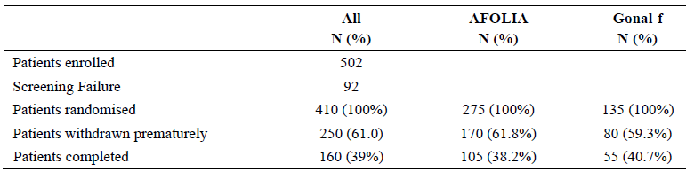

It will be noted that there is a very high proportion of premature withdrawals (61%, 250 patients). Almost all of these withdrawals occurred in the post treatment phase and the reason in the majority (218 patients) was failure to become pregnant. The proportion of these withdrawals was closely balanced between the treatment groups (Bemfola, 52.7%; Gonal-f, 54.1%), but more patients on Bemfola withdrew for other reasons: 6 (2.2%) due to reported adverse events compared with none on Gonal-f, and 7(2.5%) due to increased risk of severe ovarian hyperstimulation syndrome (OHSS) compared with 1 (0.7%) on Gonal-f.

##### Major protocol violations/deviations

Major protocol violations were summarised and provided in the study report. A higher proportion of these occurred in the Bemfola group (11.6%) than with Gonal-f (7.4%), although most were due to procedural failures and the difference is not felt to be treatment related. Altogether, these violations occurred in 32 Bemfola and 10 Gonal-f patients and it is this group of 42 SAS patients who are excluded from the PP population.

As noted above, it was noted during assessment by the EMA of the original dossier for this application that there had been serious breaches of Good Clinical Practice at a single site (Site X [information redacted]) in the UK, comprising the inclusion of non eligible patients and breaking of the blinding of the ultrasound assessor. The validity of results from this site was called into question. Accordingly the sponsor was requested to conduct a reanalysis of the study data excluding that site. This resulted in the exclusion of 38 patients (26 Bemfola, 12 Gonal-f) from the randomised population (SAS). For the purpose of this evaluation report, the original analysis of the primary efficacy outcome for the full study population is presented, together with that for the population with Site X excluded. The reanalysis did not, in fact, dispute the validity of the original analysis. Secondary outcomes are presented as analysed for the population with Site X excluded.

##### Baseline data

Demographic and other baseline data for the entire randomised population (SAS) are shown in Table 4 below.

Table 4. Demographic data (DM01T) SAS population. Study FIN3001

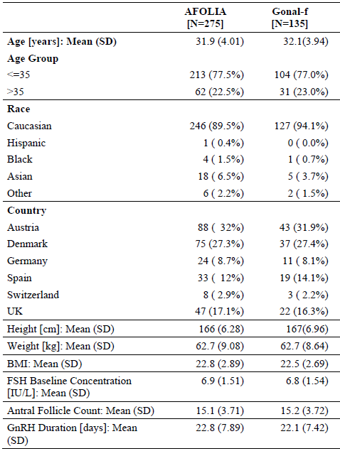

The populations for test and reference treatment were well balanced in physical characteristics overall and also by ethnic group and geographic region. The same applied to the PP population. Details of the medical history and examination and history of previous and concomitant medications are found in the study report and were also well balanced between the two groups. Balance between the groups was not adversely affected by exclusion of Site X.

##### Results for the primary efficacy outcome

The results and statistical analysis for equivalence between the test and reference treatments in respect of the primary efficacy outcome, number of oocytes retrieved, are shown in Tables 5 and 6, both for the full analysis set and per protocol populations.

Table 5. Number of oocytes retrieved; primary efficacy populations (EP01T) Study FIN3001

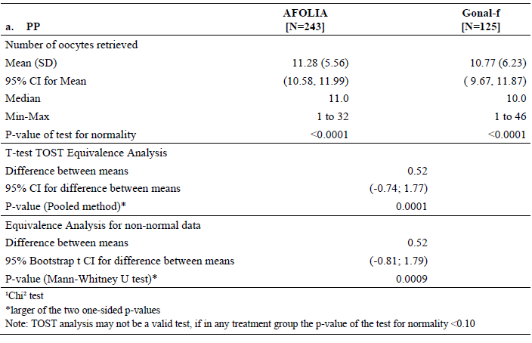

Table 6. Number of oocytes retrieved; primary efficacy populations (EP01T) Study FIN3001

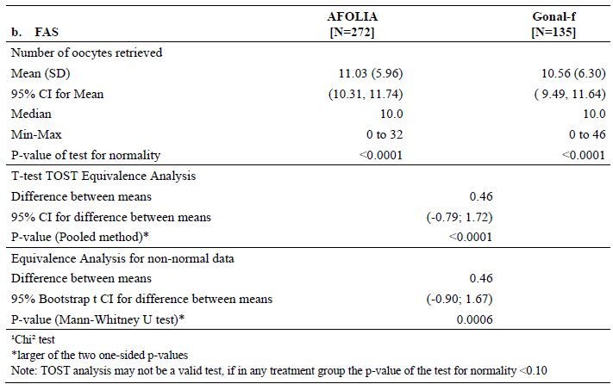

Whether examined in the FAS or the PP, the results between test and reference group are closely similar and satisfy the statistical test for equivalence. Note that due to the distribution of the primary endpoint data not having a normal distribution, an additional test of equivalence was performed on both populations using a Mann-Whitney U test. Both this and the TOST analysis showed equivalence of the treatment groups.

The results of this analysis were not altered by exclusion of the data from Site X, as shown in the following table (Table 7) which illustrates the data for both FAS and PP populations with and without the site excluded. The table also shows the results for the primary efficacy parameter in the second treatment cycle which was conducted on a total of 123 patients (111 with site exclusion) who were offered this if failing to achieve pregnancy in the first cycle.

Table 7. Comparison of primary efficacy endpoints (prior to versus. after exclusion of Site X)

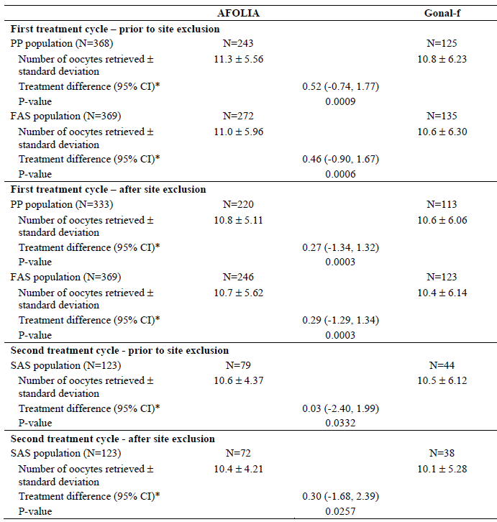

##### Results for other efficacy outcomes

Secondary endpoints were as listed above and were based on scientific advice received from EMA. The results can be summarised as follows:

* Oocyte quality was assessed as ‘mature’ in 75.7% of Bemfola and 75.3% of Gonal-f patients
* Total dosage of FSH (Bemfola or Gonal-f) and number of days of FSH stimulation were closely similar between the two groups
* Rates of implantation, clinical pregnancy, ongoing pregnancy and live births were similar between the two groups, as shown in Table 8.

Table 8. Secondary efficacy endpoint; pregnancy rate

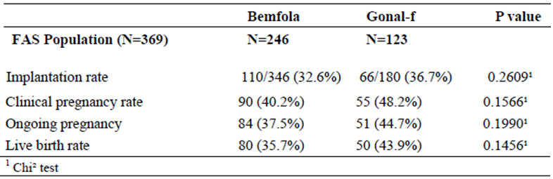

The pharmacodynamic endpoints listed above also showed similar results between the two groups, as follows in Table 9.

Table 9. Secondary efficacy endpoint; PD parameters

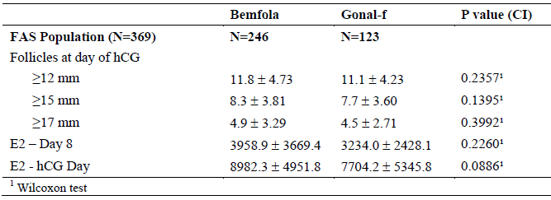

**Comment:** There is some inconsistency in the data regarding oestradiol level following FSH stimulation on the day of hCG administration. The results in the above table (Site X excluded) show that the level was higher in the Bemfola group but not significantly (p = 0.0886). Data from the entire FAS shown above in section 5.1, (studies providing pharmacodynamic data) showed a slightly larger difference with a significance level of p = 0.0447. As indicated in Table 10, these results were from the central laboratory analysis. The same samples analysed in the local laboratories showed the oestradiol values for the Bemfola and Gonal-f groups to be 8,418.5 (5,543.1) and 6,934.6 (4,099.0) pmol/L respectively, the difference being significant at p = 0.026. The proportion of patients analysed by the local laboratory was slightly greater. The overall impression is that there is a greater response in the Bemfola group, that is, Bemfola is slightly more potent than Gonal-f as judged by the oestradiol response.

Table 10. Estradiol concentration (ES10T)

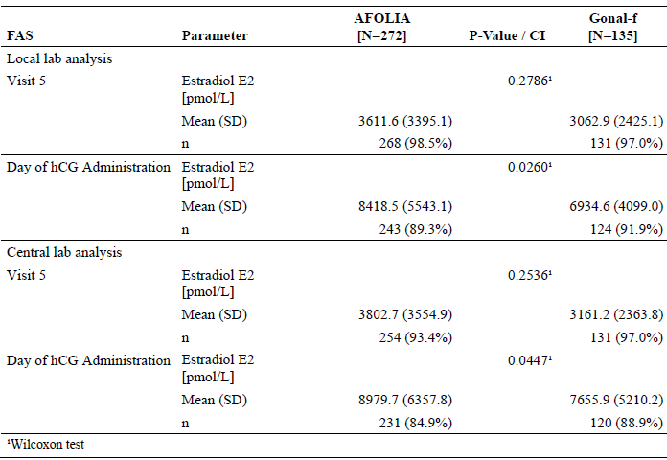

### Analyses performed across trials (pooled analyses and meta-analyses)

No analyses of this nature are included, but there is an indication extension report summarising the scientific evidence for the mechanism of action of FSH in the various claimed indications listed. It concludes that in all these indications, efficacy of FSH treatment is mediated by an increase of cyclic AMP in the relevant effector cell, granulosa cells in females and Sertoli cells in males. It notes that equivalent FSH pharmacodynamic activity has been demonstrated for Bemfola by comparison with Gonal-f and on that basis states the hypothesis that equivalent efficacy for the two products can be expected in the various indications which have the same basis in biological action.

### Evaluator’s conclusions on clinical efficacy for all claimed indications

FSH preparations in general and the comparator product Gonal-f specifically, have well-established efficacy in all the claimed indications. The bioequivalence shown in study FIN3001 is adequate evidence that this efficacy can be extended to Bemfola. The marginal evidence of increased pharmacodynamic potency does not appear, on the evidence presented, to affect its level of clinical efficacy.

In Australia, the comparator product Gonal-f is registered for use in the first, second and fourth indications being claimed for Bemfola. Conclusion of efficacy of Bemfola in these three indications can readily be made on the basis of the bioequivalence demonstrated for the second indication (use in an ART protocol) and also as all three involve the same mechanism of action, namely interaction of FSH with its cell membrane bound receptor linked to activation of adenyl cyclase and generation of cyclic AMP. In the opinion of the evaluator, the same can be concluded for the third claimed indication (use in combination with LH in cases of severe LH and FSH deficiency), as the biological setting and mechanism of action is the same as that in the basic ART setting employed for efficacy study FIN3001, with the addition that the LH deficiency is corrected by concomitant LH therapy. In the Australian regulatory setting, such use is not registered for the comparator product Gonal-f but has been evaluated in the registration of the LH formulation Luveris, efficacy of which is supported by evidence of its use in combination with 150 IU daily doses of rFSH. It is not known to the evaluator whether the FSH product used in that instance was Gonal-f.

In summary, it is concluded that Bemfola has adequate evidence of efficacy for all four proposed indications.

## Clinical safety

### Studies providing evaluable safety data

The majority of data evaluable for this report are provided by pivotal efficacy study FIN3001. A small amount of data was collected in PK study FIN1001.

#### Pivotal efficacy study

In the pivotal efficacy study, the following safety data were collected:

* General adverse events (AEs) were assessed by recording, at scheduled study visits, any abnormal clinical findings on the patient's clinical record. These were categorised to preferred terms using the Medical Dictionary for Regulatory Activities (MedDRA) version 14.1 and WHO version March 2012. Treatment emergent AEs and serious AEs were defined according to standard criteria.
* Ovarian hyperstimulation syndrome (OHSS) was defined as an AE of particular interest, and was assessed as mild, moderate or severe according to the criteria recommended by The Practice Committee of the American Society for Reproductive Medicine. These criteria are well accepted and are described below in Table 11.
* Percentage of patients with dose reduction due to imminent OHSS
* Laboratory tests, including biochemical profiles, haematology and urine analysis, were routinely performed at clinic visits as specified on the schedule of assessment included as Table 12.

Table 11. Classification of OHSS based on recommendation by The Practice Committee of the American Society for Reproductive Medicine

| OHSS Classification | Symptom description |
| --- | --- |
| Mild | Mild manifestations of OHSS were relatively common and included:   * Transient lower abdominal discomfort * Mild nausea * Vomiting * Diarrhoea * Abdominal distention   (Onset of symptoms typically occurred soon after ovulation (in superovulation cycles) or after oocyte retrieval in ART cycles, but could be delayed) |
| Moderate | Mild manifestations of OHSS that persisted, worsened or included ascites |
| Severe | Serious manifestations of OHSS existed when pain is accompanied by one of the following   * Rapid weight gain * Tense ascites * Hemodynamic instability (orthostatic hypotension, tachycardia) * Respiratory difficulty (tachypnea) * Progression of oliguria * Laboratory abnormalities |

Table 12. Schedule of assessment

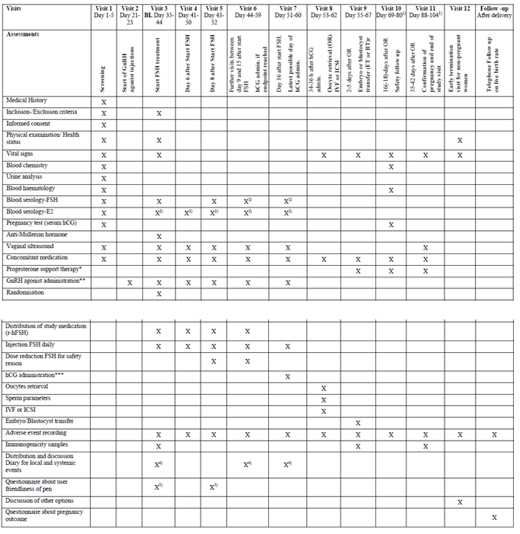

### Pivotal studies that assessed safety as a primary outcome

Not applicable; no such studies conducted for this application.

### Patient exposure

In study FIN1001, 23 patients received a single dose of 225 IU Bemfola and 24 the same dose of Gonal-f.

Duration of exposure to 150 IU daily[2] in the Bemfola and Gonal-f treatment groups for study FIN3001 is shown Table 13. Approximately 75% of each group was exposed to 10 days of treatment and 2.2% receive the maximum 16 day exposure. Total treatment exposure in the study at 150 IU daily was 2,943 days for Bemfola and 1,458 days for Gonal-f.

Table 13. Summary of extent of exposure: Number of treatment days; SAS population. Study FIN3001

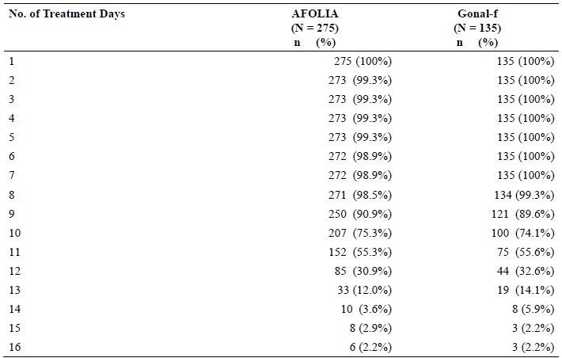

### Adverse events

For simplicity, presentation of data in the following sections is limited to that from pivotal efficacy/safety study FIN3001. There were no safety findings of significance in the single dose PK study FIN1001 conducted in healthy subjects.

#### All adverse events (irrespective of relationship to study treatment)

The overall incidence of AE in study FIN3001 is shown in the following table (Table 14)

Table 14. Overview of AEs; SAS population

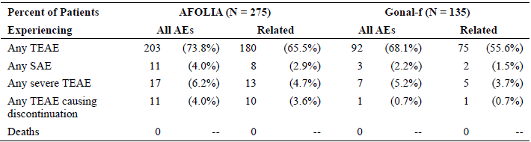

#### Treatment-related adverse events (adverse drug reactions)

The overall incidence of treatment related AE is shown in the second and fourth columns of the above table. Apart from serious events and events causing discontinuation, which are discussed below, the incidence and qualitative pattern of these events was similar in test and reference treatment groups. There was no evidence of a pattern of events affecting body systems except for the reproductive system (OHSS related events as described below), and the category ‘general disorders and administration site conditions’ which was recorded in 44.0% and 37.8% of Bemfola and Gonal-f patients respectively and the majority which is accounted for by the incidence of injection site reactions which are recognised to be common with these medications and were equally distributed between the test and reference groups.

As noted above, OHSS was an AE of special interest as it is a frequent adverse effect of ovarian stimulation with FSH/hCG treatment as part of ART protocols and some incidence of it is an inevitable accompaniment of this type of treatment. OHSS related AE terms were reported more frequently in the Bemfola group (23.3%) by comparison with the Gonal-f patients (13.3%). A large proportion of these, 17.8% and 11.9% respectively, were reported as threatened or imminent OHSS, a situation which the investigators, who were experienced in ART management, would have been anticipating and which was to act as a signal for FSH dose reduction which was implemented in 11.8% and 7.4% of Bemfola and Gonal-f patients respectively.

#### Deaths and other serious adverse events

No deaths occurred in the study. SAEs were reported in 11 (4.0%) of Bemfola and in 3 (2.2%) of Gonal-f patients. 10 of these 14 were considered due to the study drug. The remaining 3 were episodes of abdominal pain, biliary colic, ovarian haemorrhage and syncope. Of the 10 events considered to be treatment related, all but one were episodes of OHSS. In the 7 Bemfola patients so affected, 2 of these episodes were classified as severe, 4 moderate and 1 mild; amongst the Gonal-f patients there was 1 moderate and 1 severe episode. All patients experiencing SAEs, whether OHSS or otherwise, recovered. Narratives of all these events were provided in the study report and are repeated below.

##### Narratives of serious adverse events

Note; the patient numbers and dates have been redacted.

* Patient 1 [actual number redacted] (Gonal-f; OHSS), a 24 year old female with no relevant conditions in her medical history received FSH 150 IU daily in a single subcutaneous injection for stimulation of multifollicular development for ART. On Day 12 treatment was terminated due to increased risk of severe OHSS. The patient recovered without sequelae.
* Patient 2 [actual number redacted] (AFOLIA; OHSS), a 32 year old female with no relevant conditions in her medical history received FSH 150 IU daily in a single subcutaneous injection for stimulation of multifollicular development for ART. On Day 11 treatment was terminated due to moderate OHSS. The patient recovered without sequelae on Day 15.
* Patient 3 [actual number redacted] (AFOLIA; OHSS), a 29 year old female with no relevant conditions in her medical history received FSH 150 IU daily in a single subcutaneous injection for stimulation of multifollicular development for ART. On Day 42, ≥ 20 follicles larger than 10mm and E2 above 3500 prior to HCG were observed. Treatment was therefore terminated due to moderate OHSS. The patient recovered without sequelae.
* Patient 4 [actual number redacted] (AFOLIA; Abdominal Pain), a 33 year old female with no relevant conditions in her medical history received FSH 150 IU daily in a single subcutaneous injection for stimulation of multifollicular development for ART. On Day 12, ≥20 Follicles larger than 10mm and E2 above 3500 prior to HCG were observed. Treatment was terminated due to abdominal pain. The patient recovered without sequelae.
* Patient 5 [actual number redacted] (AFOLIA; OHSS), a 35 year old female with no relevant conditions in her medical history received FSH 150 IU daily in a single subcutaneous injection for stimulation of multifollicular development for ART. On Day 8, an increased risk of severe OHSS was diagnosed and treatment was terminated. The patient recovered without sequelae on Day 21.
* Patient 6 [actual number redacted] (AFOLIA; OHSS), a 35 year old female with no relevant conditions in her medical history received FSH 150 IU daily in a single subcutaneous injection for stimulation of multifollicular development for ART. On Day 24, an increased risk of severe OHSS was diagnosed and treatment was terminated. The patient recovered without sequelae on Day 35.
* Patient 7 [actual number redacted] (AFOLIA; OHSS), a 32-year old female with no relevant conditions in her medical history received FSH 150 IU daily in a single subcutaneous injection for stimulation of multifollicular development for ART. On Day 9, an increased risk of severe OHSS was diagnosed and treatment was terminated. The patient recovered without sequelae.
* Patient 8 [actual number redacted] (AFOLIA; OHSS), a 30 year old female with no relevant conditions in her medical history received FSH 150 IU daily in a single subcutaneous injection for stimulation of multifollicular development for ART. On Day 8, the FSH dose was reduced to 75 IU daily. On Day 20, an increased risk of severe OHSS was diagnosed and treatment was terminated. The patient recovered without sequelae.
* Patient 9 [actual number redacted] (AFOLIA; OHSS), a 26 year old female with no relevant conditions in her medical history received FSH 150 IU daily in a single subcutaneous injection for stimulation of multifollicular development for ART. On Day 14, an increased risk of severe OHSS was diagnosed and treatment was terminated. The patient recovered without sequelae on Day 18.
* Patient 10 [actual number redacted] (AFOLIA; Ovarian haemorrhage), a 38 year old female with no relevant conditions in her medical history received FSH 150 IU daily in a single subcutaneous injection for stimulation of multifollicular development for ART. On Day 18, a serious adverse event (ovarian haemorrhage) was diagnosed and treatment was terminated. The patient recovered without sequelae on Day 22.
* Patient 11 [actual number redacted] (AFOLIA; OHSS), a 28 year old female with no relevant conditions in her medical history received FSH 150 IU daily in a single subcutaneous injection for stimulation of multifollicular development for ART. On Day 10, an increased risk of severe OHSS was diagnosed and treatment was terminated. The patient recovered without sequelae on Day 23.

#### Discontinuation due to adverse events

As shown in Table 14, such discontinuations occurred in 11 Bemfola patients by comparison with 1 Gonal-f patient. In 7 of the Bemfola patients and the single Gonal-f patient, discontinuation was due to assessment of the presence of increased risk of severe OHSS. Two of the remaining Bemfola patients were discontinued because of the presence of moderate OHSS.

### Laboratory tests

#### Liver function

The study report states that no abnormalities of liver function, either values outside the normal range or changes from baseline, were noted at any study visit, although it is noted that the narrative of patient 6 describes elevated liver enzymes having occurred during hospitalisation in the context of an episode of OHSS. This would not have been a routine study visit.

#### Kidney function

No abnormalities found.

#### Other clinical chemistry

No abnormalities found.

#### Haematology

Haemoglobin, haematocrit, leucocyte and platelet counts were measured and showed no changes of significance or differences between the treatment groups at any study visit.

#### Immunogenicity

Tests for antibodies to the administered hormones (r-hFSH, Bemfola or Gonal-f) were conducted at baseline and at Visits 9 and 11, approximately 4 and 8 weeks after the start of exposure to FSH. No evidence of antibodies was found in either group. Testing for antibodies was also conducted in PK study FIN1001 with negative results.

### Post-marketing experience

No data available at this stage.

### Evaluator’s overall conclusions on clinical safety

The single concern raised by the safety data is the increased incidence of OHSS-related adverse events experienced in the Bemfola treated patients by comparison with those treated with Gonal-f. Three possible explanations are seen for this observation. The first, as acknowledged by the FIN3001 investigators in the discussion section of their report, relates to the trial design in which only the ovarian ultrasound assessors were blind to the treatment allocation. The patients were not, as the test and reference products were obviously different (single versus multi-use) and this information was readily available to the clinic staff responsible for decisions including adverse event reporting and withdrawal of treatment. Such staff would be well used to the reference treatment and which have a greater sensitivity towards reporting events with the ‘experimental’ treatment and protecting patients from its effects. This could readily explain the increased incidence of withdrawals due to suspicion that OHSS was ‘threatened’ or ‘imminent’ as reported above. It less readily explains the greater number of OHSS related actual, serious adverse events documented amongst the narratives in the FIN3001 study report, numbering 7 amongst Bemfola patients by comparison with 2 Gonal-f patients, mostly characterised by severe symptoms requiring hospitalisation.

The second possible explanation is that Bemfola is in pharmacodynamic terms slightly more potent than Gonal-f as suggested by the oestradiol response dated documented above. It is also noted that, although none of the individual differences approach clinical or statistical significance, each measured parameter of follicle development or oocyte retrieval is numerically greater for Bemfola patients than for Gonal-f patients (see Table 7 and Table 9 above). Adverse outcomes from such slightly greater exposure to FSH could have been facilitated by another flaw in the study design, that of using a fixed 150 IU dose for the FSH stimulation phase of the treatment protocol. This is contrary to usual practice in which follicle development is observed by daily ultrasound with, if required, daily adjustment of FSH dosage. In discussing this issue, the CHMP day 180 list of outstanding issues document included in the submission assumes ‘that the applicant has misunderstood the EMA advice’ on this aspect of trial design and that the protocol should have been designed to permit such dosage adjustments so as to reveal whether or not there were differences between the test products in the rate of clinically relevant dosage requirements. The CHMP document appears, however, to recognise that the applicant’s proposed risk minimisation measures, including warning of the risk of OHSS, are sufficient.

A further, third confounding factor in consideration of the difference in OHSS incidence is that there was a higher proportion of Bemfola patients with anti-Mullerian hormone (AMH) level > 24 pmol/L, a recognised marker for increased risk of OHSS. The CHMP 180 day document referred to above takes the view that the small difference in proportion of patients with this level between the two groups (4.4%) is insufficient to completely explain the difference in OHSS incidence.

The conclusion of this evaluation is that all three of these factors may have contributed to the increased incidence of OHSS observed in the pivotal efficacy/safety study. Of the three, only the second (possible increased potency) is of relevance with regard to the product’s acceptability for registration. If it exists at all, the difference is of small magnitude and within the limits acceptable for biosimilarity. If the product is used in accordance with usual clinical practice and with due attention to risk minimisation measures, the safety risk in relation to OHSS is acceptable.

There are no other safety concerns of significance.

## First round benefit-risk assessment

In view of the nature of this submission as a biosimilar with Gonal-f, the following benefit-risk assessment is undertaken as a comparison of the benefits and risks with those of Gonal-f as used in the proposed indications, and takes the form of a critique of the benefits and risks of Bemfola as stated in the Clinical Overview of the dossier.

### First round assessment of benefits

The benefits of Bemfola proposed by the sponsor are:

* Provision of a high quality r-hFSH formulation for use in reproductive technology applications, near identical to Gonal-f. This benefit is seen as being equivalent to that of Gonal-f.
* Demonstrated safety and efficacy equivalent to Gonal-f. This statement is acceptable with the exception of some concern about the risk of OHSS as discussed below, but again confers no additional benefit over the comparator product.
* Reduce financial burden to healthcare system and patients. It is recognised that TGA does not consider costs, but a number of statements of this nature appear in the sponsor's benefits and risks conclusions. The preparation is stated to be ‘*more affordable’ and to have been developed ‘in direct response to this pharmaco-economic need’*. No evidence is provided in support of these statements, and once again issues regarding cost are not part of the brief for this evaluation.
* Convenience, improved compliance, improved patient safety and reduce wastage of product associated with the single use injection system. It is difficult to comment upon this without having seen more adequate descriptions of the injection devices concerned. The preservative free, single use formulation has theoretical advantages but no evidence is presented of any significant problems having occurred with the alternative multidose syringe (Gonal-f) formulation. The claim for reduced wastage with Bemfola is difficult to support, as the procedure for administering doses in between those contained in the five presentations of 75, 150, 225, 300 and 450 IU is to adjust the dose downwards and discard the unused portion. This does not occur with a multidose syringe unless it contains insufficient for the last dose required.
* The smaller dosage adjustment claimed to be possible for Bemfola (12.5 IU by comparison with 37.5 IU for Gonal-f) could be advantageous in the ovarian stimulation ART protocol, although not in the other proposed indications.

### First round assessment of risks

The risks of Bemfola in the proposed usage are:

* A possible increased risk of incidence of OHSS when the product is used for ovarian hyperstimulation. The multiple potential reasons for this finding in the pivotal efficacy/safety study have been discussed above (evaluators overall conclusions on clinical safety).

### First round assessment of benefit-risk balance

The benefit-risk balance of Bemfola, given the proposed usage and the comparison with the existing product Gonal-f, is neutral.

## First round recommendation regarding authorisation

Provided appropriate pharmacovigilance is undertaken with regard to the issue of OHSS risk, as discussed below, and pending recommended corrections to the PI, the application is suitable for approval.

### RMP and OHSS risk.

It is particularly noted that as part of the EU RMP it is proposed that a study be conducted to evaluate the risk of OHSS. This will compare incidence of OHSS with use of Bemfola compared with the same comparator product Gonal-f as used in the pivotal efficacy/safety study for this application and will also include safety data on the use of Bemfola in patients > 40 years of age. The details of the study, which is to be conducted in the USA, are given in the Australian specific annex of the draft RMP, as follows (Table 15).

Table 15. Details of study to compare incidence of OHSS with use of Bemfola with the comparator Gonal F[3]

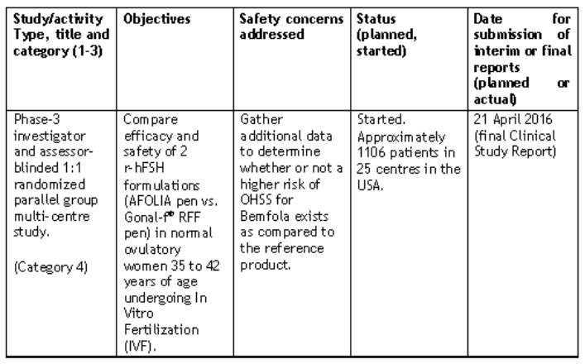

It is presumed that the outcome of this important study will be communicated to TGA as part of the pharmacovigilance for this application

With regard to routine pharmacovigilance, the Australian specific annex to the RMP included in the data package states that the criteria to be used to verify the success of proposed risk minimisation activity will be ‘no increase in the incidence of drug-related adverse events of OHSS compared to historical experience’ and that the proposed review period for this will be according to routine PSUR periodicity.

## Clinical questions

There were no clinical questions.

|  |
| --- |
| Therapeutic Goods Administration |
| PO Box 100 Woden ACT 2606 Australia  Email: [info@tga.gov.au](mailto:info@tga.gov.au) Phone: 1800 020 653 Fax: 02 6232 8605  [**https://www.tga.gov.au**](https://www.tga.gov.au) |

1. Similar Biological Medicinal Products containing Biotechnology-Derived Proteins as Active Substance: European Medicines Agency guideline CHMP/42832/05.
2. Note that a small proportion of Bemfola (11.8%) and Gonal-F (7.4%) patients underwent dose reduction for OHSS at some point in the protocol. This factor is taken into account in the calculation of the mean total dose of FSH in the two treatment groups which was 1,568.4 and 1,582.6 IU respectively.
3. Note: the anticipated completion date for the Study FIN3002 is currently (at March 2016) Q2-2017, as the study is ongoing.