|  |
| --- |
| **September 2020** |

|  |
| --- |
| Australian Public Assessment Report for Fosnetupitant (as chloride hydrochloride)/palonosetron (as hydrochloride) |
| Proprietary Product Name: Akynzeo IV |
| Sponsor: Mundipharma Pty Ltd |

About the Therapeutic Goods Administration (TGA)

* The Therapeutic Goods Administration (TGA) is part of the Australian Government Department of Health and is responsible for regulating medicines and medical devices.
* The TGA administers the *Therapeutic Goods Act 1989* (the Act), applying a risk management approach designed to ensure therapeutic goods supplied in Australia meet acceptable standards of quality, safety and efficacy (performance) when necessary.
* The work of the TGA is based on applying scientific and clinical expertise to decision-making, to ensure that the benefits to consumers outweigh any risks associated with the use of medicines and medical devices.
* The TGA relies on the public, healthcare professionals and industry to report problems with medicines or medical devices. TGA investigates reports received by it to determine any necessary regulatory action.
* To report a problem with a medicine or medical device, please see the information on the TGA website <<https://www.tga.gov.au>>.

About AusPARs

* An Australian Public Assessment Report (AusPAR) provides information about the evaluation of a prescription medicine and the considerations that led the TGA to approve or not approve a prescription medicine submission.
* AusPARs are prepared and published by the TGA.
* An AusPAR is prepared for submissions that relate to new chemical entities, generic medicines, major variations and extensions of indications.
* An AusPAR is a static document; it provides information that relates to a submission at a particular point in time.
* A new AusPAR will be developed to reflect changes to indications and/or major variations to a prescription medicine subject to evaluation by the TGA.

Copyright

© Commonwealth of Australia 2020  
This work is copyright. You may reproduce the whole or part of this work in unaltered form for your own personal use or, if you are part of an organisation, for internal use within your organisation, but only if you or your organisation do not use the reproduction for any commercial purpose and retain this copyright notice and all disclaimer notices as part of that reproduction. Apart from rights to use as permitted by the *Copyright Act 1968* or allowed by this copyright notice, all other rights are reserved and you are not allowed to reproduce the whole or any part of this work in any way (electronic or otherwise) without first being given specific written permission from the Commonwealth to do so. Requests and inquiries concerning reproduction and rights are to be sent to the TGA Copyright Officer, Therapeutic Goods Administration, PO Box 100, Woden ACT 2606 or emailed to <[tga.copyright@tga.gov.au](mailto:tga.copyright@tga.gov.au)>.

Contents

Common abbreviations 4

I. Introduction to product submission 7

Submission details 7

Product background 8

Regulatory status 9

Product Information 10

II. Registration timeline 10

III. Submission overview and risk/benefit assessment 11

Quality 11

Nonclinical 11

Clinical 13

Risk management plan 24

Risk-benefit analysis 25

Outcome 26

Attachment 1. Product Information 27

## Common abbreviations

|  |  |
| --- | --- |
| Abbreviation | Meaning |
| 5-HT3 | Serotonin subtype 3 (receptor) |
| ACM | Advisory Committee on Medicines |
| ALT | Alanine aminotransferase |
| ARTG | Australian Register of Therapeutic Goods |
| ASCO | American Society of Clinical Oncology |
| AST | Aspartate aminotransferase |
| AUC | Area under the plasma concentration time curve |
| AUC0-120h | Area under the plasma concentration time curve from time 0 to 120 hours |
| AUC0-∞ | Area under the plasma concentration time curve from time 0 to infinity |
| BID | Twice daily, Latin: *bis in die* |
| CHMP | Committee for Human Medicinal Products (European Union) |
| CHO | Chinese hamster ovary |
| CI | Confidence interval |
| CINV | Chemotherapy induced nausea and vomiting |
| Cmax | Maximum plasma concentration |
| CMI | Consumer Medicines Information |
| CNS | Central nervous system |
| CPMP | Committee for Proprietary Medicinal Products (European Union) |
| CR | Complete response |
| CYP | Cytochrome P450 |
| DSMB | Drug safety monitoring board |
| ECG | Electrocardiogram |
| EMA | European Medicines Agency (European Union) |
| ESMO | European Society for Medical Oncology |
| EU | European Union |
| EU-RMP | European Union risk management plan |
| FAS | Full analysis set |
| F-CO | Final crossover extension |
| FDC | Fixed dose combination |
| Frel IV | Relative availability factor (intravenous) |
| GLP | Good Laboratory Practice(s) |
| GVP | Good Pharmacovigilance Practice(s) |
| h5-HT6 | Human serotonin subtype 6 (receptor) |
| HEC | Highly emetogenic chemotherapy |
| *hERG* | Human ether-a-go-go-related gene |
| hNK1 | Human neurokinin 1 (receptor) |
| hNK3 | Human neurokinin 3 (receptor) |
| IC50 | Half maximal inhibitory concentration |
| IV | Intravenous(ly) |
| M1 | Primary netupitant metabolite |
| MATE1 | Multidrug and toxin extrusion protein 1 |
| *MDR1* | Multi-drug resistance gene |
| MEC | Moderately emetogenic chemotherapy |
| NEPA | Fosnetupitant / palonosetron IV drug combination; netupitant / palonosetron oral drug (capsule) combination |
| NK1 | Neurokinin 1 (receptor) |
| OATP | Organic anion transporting polypeptides |
| P-CO | Pilot crossover extension |
| PI | Product Information |
| PK | Pharmacokinetic(s) |
| PONV | Postoperative nausea and vomiting |
| PSUR | Periodic safety update reports |
| RMP | Risk management plan |
| SAD | Single ascending dose |
| SAD-CO | Single ascending dose crossover extension |
| SD | Standard deviation |
| TEAE | Treatment emergent adverse event |
| US | United States |

## I. Introduction to product submission

### Submission details

|  |  |
| --- | --- |
| *Type of submission:* | New fixed dose combination of previously approved active ingredients |
| *Product name:* | Akynzeo IV |
| *Active ingredients:* | Fosnetupitant (as chloride hydrochloride) / palonosetron(as hydrochloride) |
| *Decision*: | Approved |
| *Date of decision:* | 12 March 2020 |
| *Date of entry onto ARTG:* | 13 March 2020 |
| *ARTG number:* | 316766 |
| *Black Triangle Scheme:**[1]* | Yes  This product will remain in the scheme for 5 years, starting on the date the product is first supplied in Australia. |
| *Sponsor’s name and address:* | Mundipharma Pty Ltd  88 Phillip Street  Sydney NSW 2000 |
| *Dose form:* | Powder for injection |
| *Strength:* | 235 mg fosnetupitant (as chloride hydrochloride) / 250 µg palonosetron (as hydrochloride) |
| *Container:* | Vial |
| *Pack size:* | One |
| *Approved therapeutic use:* | *Akynzeo IV is indicated in adult patients for:*   * *Prevention of acute and delayed nausea and vomiting associated with initial and repeat courses of highly emetogenic cancer chemotherapy.* * *Prevention of acute and delayed nausea and vomiting associated with initial and repeat courses of moderately emetogenic cancer chemotherapy.* |
| *Route of administration:* | Intravenous infusion |
| *Dosage:* | One vial of Akynzeo IV (235 mg fosnetupitant / 250 micrograms palonosetron) should be administered as an intravenous infusion over 30 minutes, initiated approximately 30 minutes prior to the start of each chemotherapy cycle. At the end of the infusion, flush the infusion line with the same carrier solution to ensure complete drug administration.  For further information regarding dosage, refer to the Product Information. |
| *Pregnancy category:* | D  Drugs which have caused, are suspected to have caused or may be expected to cause, an increased incidence of human fetal malformations or irreversible damage. These drugs may also have adverse pharmacological effects. Accompanying texts should be consulted for further details.  The use of any medicine during pregnancy requires careful consideration of both risks and benefits by the treating health professional. This must not be used as the sole basis of decision making in the use of medicines during pregnancy. The TGA does not provide advice on the use of medicines in pregnancy for specific cases. More information is available from obstetric drug information services in your State or Territory. |

### Product background

This AusPAR describes the application by Mundipharma Pty Ltd (the sponsor) to register Akynzeo IV (fosnetupitant (as chloride hydrochloride) / palonosetron (as hydrochloride)) powder for injection for the following proposed indication:

*Akynzeo IV is indicated in adult patients for:*

* *Prevention of acute and delayed nausea and vomiting associated with initial and repeat courses of highly emetogenic cancer chemotherapy.*
* *Prevention of acute and delayed nausea and vomiting associated with initial and repeat courses of moderately emetogenic cancer chemotherapy.*

Chemotherapeutic drugs can cause nausea and vomiting (emesis) by two main pathways; peripheral or central. The peripheral pathway of chemotherapy induced nausea and vomiting (CINV) occurs through the release of serotonin from enterochromaffin cells of the small intestine. Serotonin then activates serotonin subtype 3 (5-HT3) receptors located on vagal afferents to initiate the vomiting reflex. The peripheral pathway, which is activated within 24 hours after initiation of chemotherapy, is associated primarily with acute chemotherapy induced emesis (occurring 0 to 24 hours after chemotherapy). The central pathway of CINV is located primarily in the brain, and relates to the activation of neurokinin 1 (NK1) receptors by substance P. The central pathway is activated after the first 24 hours after chemotherapy and is associated mainly with delayed chemotherapy-induced emesis (occurring 25 to 120 hours after chemotherapy), although it can also induce acute chemotherapy induced emesis. Chemotherapeutic agents can be classified into 4 categories based on their likelihood of causing emesis in the absence of antiemetic prophylaxis; high (causes emesis in > 90% of patients), moderate (30% to 90% of patients), low (10% to 30% of patients), and minimal (< 10% of patients).[2] Most drugs used as prophylaxis for chemotherapy-induced emesis belong to the classes of dopamine receptor, 5-HT3 receptor, and NK1 receptor antagonists. The American Society of Clinical Oncology (ASCO);2 European Society for Medical Oncology (ESMO)[3] and eviQ;[4] guidelines provide guidance on the use of antiemetic treatment in association with highly emetogenic chemotherapy (HEC) and moderately emetogenic chemotherapy (MEC).

Netupitant (the active moiety of fosnetupitant) is a selective antagonist of human substance P/NK1 receptors. Fosnetupitant is a water soluble phosphorylated pro-drug of netupitant that was developed to overcome solubility challenges with netupitant. The dossier contends that the pharmacology of fosnetupitant is attributable to netupitant because fosnetupitant is rapidly converted to netupitant *in vivo* following intravenous (IV) administration.

Palonosetron is a selective 5-HT3 receptor antagonist with a strong binding affinity for this receptor.

A fixed combination of netupitant 300 mg and palonosetron 500 µg in oral capsule form (Akynzeo capsule);[5] is registered in Australia with the same indication as proposed in this submission for Akynzeo IV. Netupitant is not registered as a single agent. Palonosetron hydrochloride solution for injection is registered as a single agent (Aloxi);[6] and is supplied in two strengths: 250 µg/5 mL and 75 µg/1.5 mL. The current indications are:

*Aloxi is indicated for:*

* *prevention of nausea and vomiting induced by cytotoxic chemotherapy*
* *prevention of postoperative nausea and vomiting (PONV) for up to 24 hours following surgery.*

The rationale provided by the sponsor for the registration of Akynzeo IV is that it will provide an alternative treatment option for CINV, particularly for patients who are unable to tolerate an oral formulation.

### Regulatory status

This product is considered a new fixed dose combination medicine for Australian regulatory purposes.

At the time the TGA considered this application, a similar application had been approved in the United States (US) on 19 April 2018, and was under consideration in the European Union (EU; submitted 29 November 2018).

The indications approved by the US Food and Drug Administration (FDA) were:

*Akynzeo for injection is indicated in combination with dexamethasone in adults for the prevention of acute and delayed nausea and vomiting associated with initial and repeat courses of highly emetogenic cancer chemotherapy. Limitations of Use: Akynzeo for injection has not been studied for the prevention of nausea and vomiting associated with anthracycline plus cyclophosphamide chemotherapy.*

### Product Information

The Product Information (PI) approved with the submission which is described in this AusPAR can be found as Attachment 1. For the most recent PI, please refer to the TGA website at <<https://www.tga.gov.au/product-information-pi>>.

## II. Registration timeline

The following table captures the key steps and dates for this application which are detailed and discussed in this AusPAR.

Table : Timeline for Submission PM-2019-01560-1-4

|  |  |
| --- | --- |
| Description | Date |
| Submission dossier accepted and first round evaluation commenced | 3 June 2019 |
| First round evaluation completed | 15 November 2019 |
| Sponsor provides responses on questions raised in first round evaluation | 17 December 2019 |
| Second round evaluation completed | 31 January 2020 |
| Delegate’s Overall benefit-risk assessment | 27 February 2020 |
| Sponsor’s pre-Advisory Committee response | Not applicable |
| Advisory Committee meeting | Not applicable |
| Registration decision (Outcome) | 12 March 2020 |
| Completion of administrative activities and registration on the ARTG | 13 March 2020 |
| Number of working days from submission dossier acceptance to registration decision* | 172 |

*Statutory timeframe for standard applications is 255 working days

## III. Submission overview and risk/benefit assessment

The submission was summarised in the following Delegate’s overview and recommendations.

### Quality

Fosnetupitant (structure shown below (left) Figure 1) is a water-soluble phosphorylated pro-drug of netupitant that rapidly converts to netupitant *in vivo* following IV administration, the pharmacology of fosnetupitant is attributable to the active moiety netupitant (structure shown below (right) in Figure 1). Fosnetupitant chloride hydrochloride exists as a single isomer.

Figure : Structures of fosnetupitant chloride hydrochloride and netupitant

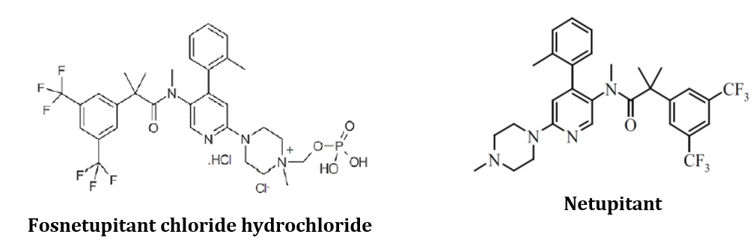

Palonosetron is a selective 5-HT3 receptor antagonist with a strong binding affinity for this receptor, and has the chemical structure shown below in Figure 2.

Figure : Structure of palonosetron hydrochloride

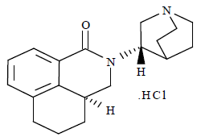

The proposed product is for administration by IV infusion following reconstitution with 20 mL of either 5% glucose solution for injection or 0.9% sodium chloride solution for injection and further dilution with 30 mL of either 5% glucose solution for injection or 0.9% sodium chloride solution for injection in an infusion vial or bag.

There are no outstanding issues from the microbiological, pharmaceutical chemistry and quality evaluations.

### Nonclinical

The following conclusions and recommendations were summarised in the nonclinical evaluation:

* The nonclinical dossier contained studies with fosnetupitant and with fosnetupitant and palonosetron in combination, as well as previously evaluated data for netupitant as a single agent. Nonclinical data are consistent with the relevant TGA-adopted guideline,[7] and all pivotal safety related studies were Good Laboratory Practice (GLP) compliant.
* No animal studies were submitted to support the efficacy of the proposed combination. Primary pharmacodynamic studies with fosnetupitant established affinity for recombinant human NK1 (hNK1) receptors (half maximal inhibitory concentration (IC50) < 0.28 nM), human neurokinin 3 (hNK3) antagonist and agonist ligands (IC50 = 0.58 and 0.42 μM, respectively), human serotonin subtype 6 (h5-HT6) antagonist (IC50 = 6.3 μM), Ca2+ channel (diltiazem site) antagonist (IC50 = 2 μM), and Ca2+ channel (verapamil site) antagonist (IC50 = 5.4 μM), similar to the activities of netupitant. Fosnetupitant was more potent than netupitant in shifting the substance P response to the right (pKB;[8] 8.72 versus 7.54, respectively) in Chinese hamster ovary (CHO) cells expressing hNK1. Fosnetupitant inhibited substance P induced contraction of the guinea pig ilium and inhibited of substance P induced nociceptive behaviour in mice displaying similar potency to netupitant.
* Fosnetupitant did not have any notable effects on central nervous system (CNS) or respiratory function following IV administration and did not produce any proconvulsant or anticonvulsant activity. Fosnetupitant at up to 30 μM had negligible effects on the human ether-a-go-go-related gene (hERG) channel *in vitro*. Cardiovascular parameters including heart rate, blood pressure and electrocardiogram (ECG) were unaffected by fosnetupitant in dogs at doses up to 13.16 mg/kg/day. In studies conducted with the combination in dogs, changes in atrio ventricular conduction, ventricular depolarisation and repolarisation (increases in PR, PQ, QTc interval;[9] and QRS duration) were observed at fosnetupitant/palnosetron doses of 13.2/6 mg/kg/day. Changes in QT and QRS complex were probably due to the main netupitant metabolite, M1, with high concentrations of this metabolite detected in the plasma and heart tissue. Similarly, increased heart rate and prolonged QTc interval were observed in repeat dose toxicity studies in dogs following treatment with fosnetupitant in combination with palonosetron from doses of 3.95 / 3 mg/kg/day. Fosnetupitant and palonosetron may have additive effects on cardiac conduction.
* Following IV administration, fosnetupitant is rapidly converted to netupitant in animal species and humans. Accumulation of fosnetupitant was not observed, however accumulation of netupitant and its metabolites was observed 14 and 28 days of treatment. Plasma protein binding by fosnetupitant was high in humans (92% at 1 μM and 95% at 10 μM), but there were no protein binding data for animal species. Distribution of netupitant and metabolites, but not fosnetupitant, to the brain was evident in rats. The administered dose of fosnetupitant was almost quantitatively converted to netupitant which was then eliminated by biliary excretion and hepatic metabolism. There were no pharmacokinetic (PK) interactions between palonosetron and fosnetupitant in animal species.
* Fosnetupitant was a moderate inhibitor of cytochrome P450 (CYP)2C9, CYP2C19, CYP2C8 and transporters organic anion transporting polypeptides (OATP)1B3, OATP1B1, multidrug and toxin extrusion protein 1 (MATE1) and multi-drug resistance gene (MDR1). In addition, fosnetupitant was a substrate for OATP1B1 and OATP1B3. However, considering the low concentration of fosnetupitant in human plasma and the high plasma protein binding (92 95%), clinically relevant PK interactions of fosnetupitant with co-administered drugs is considered unlikely.
* Repeat dose studies in rats and dogs of 4 weeks duration with fosnetupitant alone did not identify any novel toxicity when compared to treatment with netupitant. The major target organ identified was the liver, with increased liver weights observed at the high dose of 39.47 mg/kg/day in rats which resolved after the recovery period. This was associated with liver centrilobular hypertrophy with cytoplasmic eosinophilia.
* Repeat dose studies in rats and dogs of 4 weeks duration with fosnetupitant alone or the fosnetupitant/palonosetron combination did not identify any novel toxicity when compared to treatment with netupitant or netupitant/palonosetron. The major target organ identified was the liver, with increased liver weights observed at the high dose of 39.47 mg/kg/day fosnetupitant or 13.16/3 mg/kg/day fosnetupitant/palonosetron in rats which resolved after the recovery period. This was associated with liver centrilobular hypertrophy with cytoplasmic eosinophilia. There were also increased liver enzymes (aspartate aminotransferase (AST) and alanine aminotransferase (ALT)) and convulsions observed at 39.47/10 mg/kg/day. Interestingly, phospholipidosis, which was a prominent finding in rats and dogs dosed with netupitant by the oral route, was not observed in repeat dose toxicity studies with fosnetupitant.
* The potential genotoxicity of fosnetupitant was investigated in a standard battery of tests. The results were negative in all tests and fosnetupitant is unlikely to pose a mutagenic or clastogenic risk to humans.
* No carcinogenicity studies conducted with fosnetupitant. This is acceptable for the proposed indication and dosing regimen.
* Fosnetupitant had no effects on fertility or reproductive performance in rats. In embryofetal development studies, unossified pubis in 6 fetuses from 3 different litters were observed in rats, and an increase in intrauterine deaths was observed in rabbits at doses of ≥ 6.25 mg/kg/day. In a pre and postnatal development study in rats, there was an increased incidence of pre-birth loss and pup loss, decreased mean pup weight, and delayed development (pinna detachment, preputial separation, startle response to sound and eye opening) at 39.47 mg/kg/day. A Pregnancy Category of D;[10] is recommended as for netupitant.
* Fosnetupitant did not show evidence of local tolerance or antigenicity and is unlikely to be phototoxic.

There are no objections on nonclinical grounds to the registration of Akynzeo IV. The recommended PI changes have been included by the sponsor.

### Clinical

The clinical studies submitted to support the efficacy and safety of Akynzeo IV (see Table 2, reproduced from a US Food and Drug Administration (FDA) multidiscipline review) build on the established efficacy and safety of Akynzeo oral capsules and Aloxi solution for injection. Two clinical pharmacology studies (Study PNET-13-63;[11] drug-drug interaction in healthy subjects; Study NEPA-15-19;[12] PK in cancer patients) were also submitted.

Study PALO-15-17;[13] was a Phase III non-inferiority study comparing the efficacy of palonosetron 0.25 mg IV infusion over 30 minutes (as proposed for Akynzeo IV) to palonosetron 0.25 mg IV bolus over 30 seconds (the approved posology for Aloxi).

Study PNET-12-23;[14] was a Phase I study assessing the safety and PK of single ascending doses of IV fosnetupitant, and included a relative bioavailability assessment comparing the PK of fosnetupitant chloride hydrochloride 260 mg IV (equivalent to 235 mg fosnetupitant free base) to Akynzeo capsules (oral netupitant 300 mg) in healthy subjects. This study is used to bridge the efficacy of Akynzeo IV (containing fosnetupitant 235 mg) from the established efficacy of Akynzeo capsules, based on equivalent netupitant exposure (area under the plasma concentration time curve (AUC)).

Study NEPA-15-18;[15] was a Phase III safety study, with efficacy as a secondary objective. This study was not designed or powered to demonstrate non-inferiority, so descriptive efficacy findings are provided as supportive evidence.

Table : Clinical studies to support safety and efficacy of Akynzeo IV

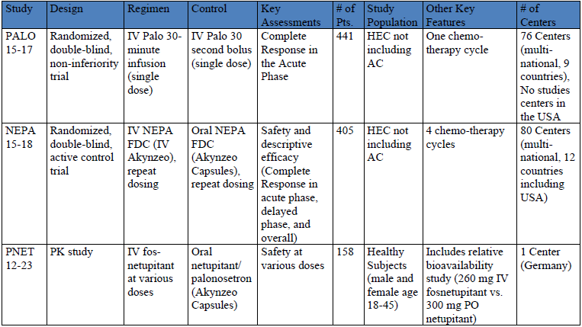  
Source: United States Food and Drug Administration (FDA) Multi-discipline review.[16]

#### Pharmacology

The pharmacology of oral Akynzeo and IV palonosetron (Aloxi) was established at the time of registration and is described in the PIs for these products.

##### Study PNET-12-23

Study PNET-12-23;14 was a Phase I, randomised, double-blind, parallel group, three-part trial assessing the safety and PK of single ascending doses of IV fosnetupitant in healthy subjects, with crossover extensions to establish the dose of fosnetupitant yielding equivalent netupitant exposure to Akynzeo capsules.

The primary objective was to assess the safety of fosnetupitant administered by IV infusion as single ascending doses from 19.5 mg to 390 mg. The secondary objective was to investigate the PK of fosnetupitant, netupitant and netupitant metabolites, and estimate the relative availability factor (Frel IV) for netupitant when given in the form of IV fosnetupitant in comparison to Akynzeo capsules (oral netupitant 300 mg / palonosetron 0.5 mg). This allowed the identification of the IV fosnetupitant dose yielding a netupitant exposure (area under the curve; AUC) equivalent to that provided by a 300 mg dose of oral netupitant.

Part 1 (single ascending dose, SAD) was a parallel group assessment consisting of predefined doses with a crossover extension (SAD-CO) for applicable doses. It was conducted in dose cohorts of 10 subjects (4:1 ratio for fosnetupitant versus oral fixed dose combination (FDC)). Eight doses (19.5, 32.5, 65, 130, 195, 260, 325, 390 mg fosnetupitant chloride hydrochloride) were pre-defined, with the crossover extension for doses from 130 mg to 390 mg. The safety of each dose was assessed by an independent drug safety monitoring board (DSMB).

Part 2 (pilot crossover extension; P-CO) was conducted in dose cohorts of 20 subjects each (1:1 ratio for fosnetupitant versus oral FDC). Two doses of fosnetupitant chloride hydrochloride (195 and 260 mg) were selected based on PK data from the SAD-CO. The 260 mg dose studied is equivalent to 235 mg fosnetupitant free-base (Akynzeo IV).

Part 3 (final crossover extension; F-CO) was conducted in 2 dose cohorts of 20 subjects with 2 doses of fosnetupitant chloride hydrochloride (234 mg and 286 mg, representing 90% and 110% of the ‘target dose’ of 260 mg determined based on the Frel IV derived from the SAD-CO and P-CO.

A total of 160 subjects were randomised into the study, of whom 130 were randomised to the crossover treatment (Figure 3).

Figure : Study PNET-12-23 Schema and subject disposition

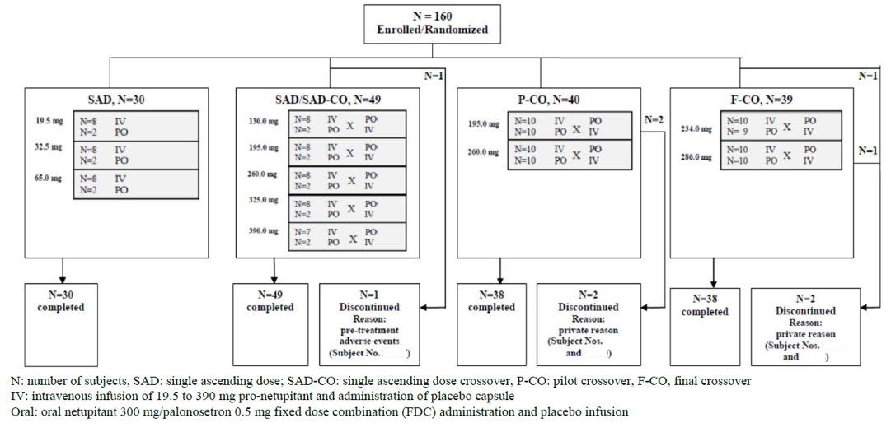

After single dose administration of Akynzeo as a 30 minute IV infusion, fosnetupitant achieved a maximum plasma concentration (Cmax) at the end of the infusion and disappeared rapidly from the systemic circulation with an apparent terminal half-life lower than one hour. Within 30 minutes of infusion completion, fosnetupitant concentration decreased to less than 1% of Cmax.

Bioequivalence with regard to netupitant exposure (AUC) was established for 260 mg IV fosnetupitant relative to 300 mg oral netupitant (Table 3). The Cmax of netupitant was approximately 1.5 fold higher for 260 mg IV fosnetupitant compared to 300 mg oral netupitant.

Table : Study PNET-12-23 Bioequivalence assessment of 260 mg intravenous fosnetupitant versus 300 mg oral netupitant based on netupitant pharmacokinetic parameters

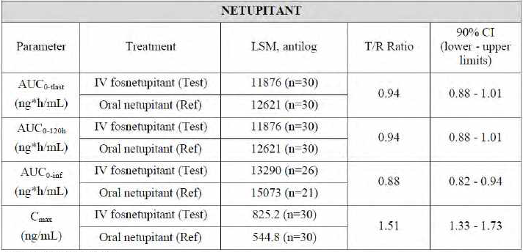

Source: FDA review.16

##### Study PNET-13-63

Study PNET-13-63;11 was a randomised three period, crossover study in healthy subjects to assess the effect of single dose IV fosnetupitant on the PK of oral dexamethasone. The study tested three IV doses of fosnetupitant (130 mg, 195 mg, 260 mg) and a placebo. The dose of oral dexamethasone was 20 mg on Day 1, and 8 mg twice daily (BID) on Days 2, 3 and 4. Dexamethasone exposure (AUC) was increased approximately 1.5 fold on Day 1 and approximately 2.4 fold on Day 4 when co-administered with a single IV dose of fosnetupitant 260 mg.

##### Study NEPA-15-19

Study NEPA-15-19 was a Phase I, open label study to evaluate the PK and safety of Akynzeo IV administered by 30 minute IV infusion in cancer patients receiving HEC (cisplatin). Cmax of netupitant and palonosetron was achieved at the end of the 30 minute infusion. Systemic exposure to netupitant and palonosetron was comparable in cancer patients and healthy subjects.

#### Efficacy

##### Study PALO-15-17

Study PALO-15-17;13 was a Phase III, single-dose, multi-centre, randomised, double-blind, parallel group study to assess the efficacy and safety of palonosetron 0.25 mg administered as a 30 minute IV infusion compared to palonosetron 0.25 mg administered as a 30 second IV bolus for the prevention of CINV in cancer patients receiving HEC (Table 4). The primary objective was to demonstrate non-inferiority of the 30 minute IV infusion versus the 30 second IV bolus in terms of a complete response in the acute phase. This would establish the efficacy of the palonosetron component of Akynzeo IV, based on the established efficacy of Aloxi (palonestron, solution for IV injection).

Table : Study PALO 15-17 Dosing schedule

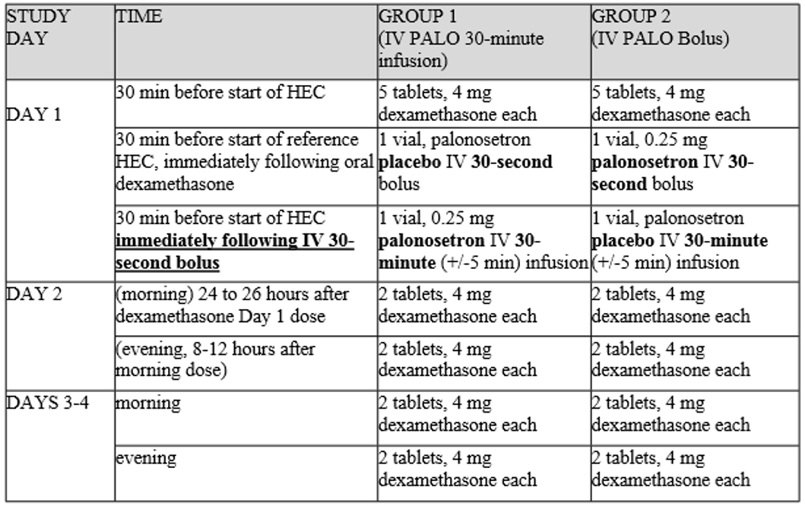

The study recruited adult patients with histologically or cytologically confirmed solid tumour malignancy who were naïve to cytotoxic chemotherapy and were scheduled to receive the first course of one of the following reference HEC, alone or in combination with other chemotherapeutic agents on Day 1: cisplatin administered as a single IV dose of ≥ 70 mg/m2, cyclophosphamide ≥1500 mg/m2, carmustine (tradename BCNU) > 250 mg/m2, dacarbazine (tradename DTIC), mechloretamine (nitrogen mustard).

The primary endpoint was the proportion of patients with a complete response (CR) in the acute phase of CINV. A CR in the acute phase was defined as no emetic episode and no rescue medication during the 0 to 24 hours after the start of HEC administration on Day 1. As part of the regulatory process in the USA, the FDA endorsed the pre-specified -15% non-inferiority margin with two sided 99% confidence interval (CI).

The secondary endpoints were the proportion of patients with CR during the delayed and overall phases, the proportion of patients with no emetic episodes during the acute, delayed, and overall phases, and the proportion of patients with no rescue medications during the acute, delayed, and overall phases. There was no adjustment for multiplicity of secondary endpoints.

441 patients were randomised; 225 to palonosetron 0.25 mg as a 30 minute IV infusion (infusion group) and 216 to palonosetron 0.25 mg as a 30 second IV bolus (bolus group). 440 (99.8%) patients were treated (100% in the infusion group, and 99.5% in the bolus group) and 424 (96.1%) patients completed the study (96.9% in the infusion group, and 95.4% in the bolus group). Baseline disease characteristics were reasonably balanced across the groups.

###### Results

*Primary endpoint*: in the full analysis set (FAS), 186 (82.7%) patients in the infusion group reported CR in the acute phase, compared to 186 (86.5%) patients in the bolus group (Table 5). The difference between the infusion and bolus groups was -3.8% (99% CI: ‑12.2%, 4.7%). Since the lower limit of the two-sided 99% CI was greater than the pre-defined non-inferiority margin of -15%, non-inferiority of palonosetron 30 minute infusion versus 30 second bolus was demonstrated.

Table : Study PALO 15-17 Complete response in the acute phase (full analysis set and per protocol)

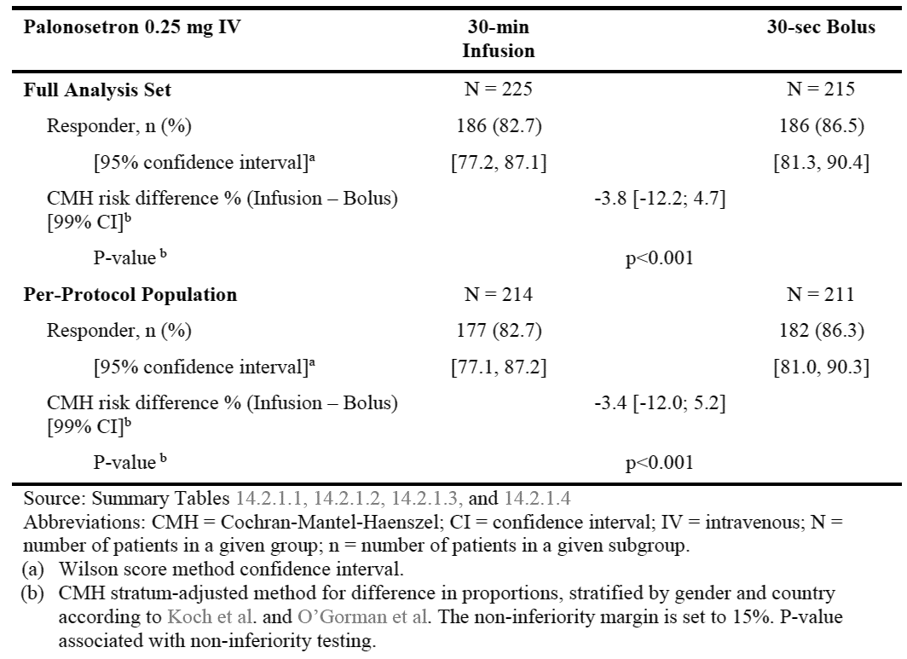

References: Koch et al.[17]; O’Gorman et al.[18]

*Secondary endpoints*: the percentage of patients with CR in the delayed and overall phases was similar following the 30 minute IV infusion and 30 second IV bolus (Table 6).

Table : Study PALO 15-17 Complete response in the delayed and overall phases

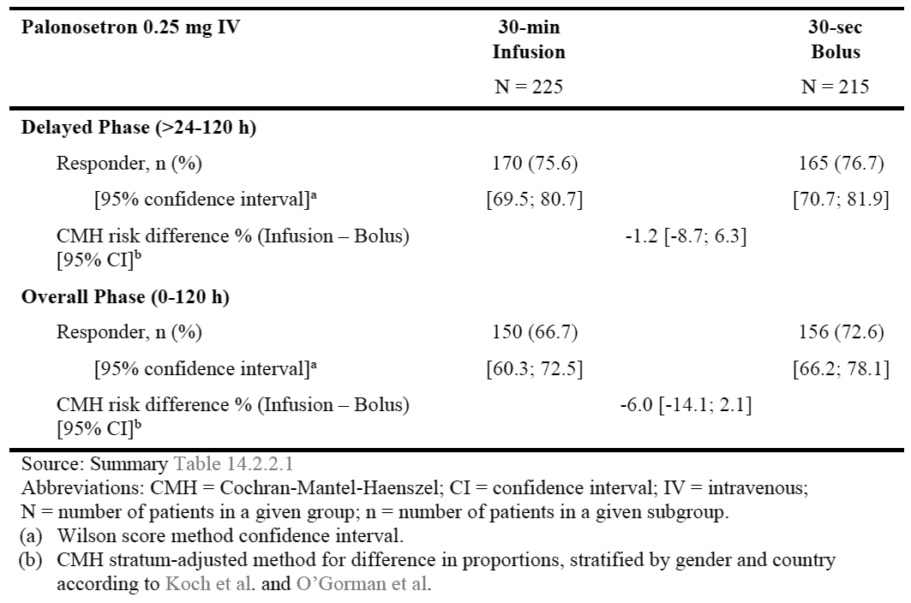

References: Koch et al.;17 O’Gorman et al.18

##### Study NEPA-15-18

Study NEPA-15-18;15 was a Phase III, multi-centre, randomised, double blind, active control study evaluating the safety and describing the efficacy of the IV route fosnetupitant / palonosetron (NEPA) FDC (Akynzeo IV) in cancer patients prior to repeated cycles of HEC. The control treatment was the oral route netupitant / palonosetron (NEPA) FDC (Akynzeo capsule).

The primary objective was to assess the safety and tolerability of a single dose of IV NEPA FDC infused over 30 minutes, with oral dexamethasone, in initial and repeated cycles of HEC. The secondary objective was to describe the efficacy of a single dose of IV NEPA FDC infused over 30 minutes, with oral dexamethasone, during the acute (0 to 24 hours), delayed (> 24 to 120 hours) and overall (0 to 120 hours) phases of initial and repeated cycles of HEC.

The study included adult patients with histologically or cytologically confirmed solid tumour malignancy, naïve to cytotoxic chemotherapy, and scheduled to receive at least 4 consecutive cycles of HEC on Day 1 of each treatment cycle. Patients were not permitted to receive MEC or HEC on Day 2 to Day 5.

IV NEPA FDC (or placebo) was administered by 30 minute IV infusion, 30 minutes prior to chemotherapy. Oral NEPA FDC (or placebo) was administered 60 minutes prior to chemotherapy. Oral dexamethasone was administered in open fashion, with the same dose and schedule for test and control treatments.

Efficacy endpoints included:

* the proportion of patients with CR (no emetic episodes and no rescue medication) during the acute, (0 to 24 hours after the start of reference chemotherapy), delayed (> 24 to 120 hours), and overall (0 to 120 hours) phases;
* the proportion of patients with no emetic episodes during the acute, delayed, and overall phases; and
* the proportion of patients with no significant nausea (visual analogue scale (VAS);[19] < 25 mm) during the acute, delayed, and overall phases.

405 patients were randomised; 203 to IV NEPA FDC and 202 to oral NEPA FDC, and 404 were treated. On Day 1 of Cycle 1, 95.8% of patients received cisplatin, 3.5% received dacarbazine, and 0.7% received cyclophosphamide. The profile of HEC was similar in Cycles 2, 3 and 4.

###### Results

Efficacy outcomes for CR are presented in Table 7, noting that efficacy was a secondary objective of Study NEPA-15-18 and the study was not designed or powered to demonstrate non-inferiority.

Table : Study NEPA 15-18 Complete responses in each cycle, full analysis set

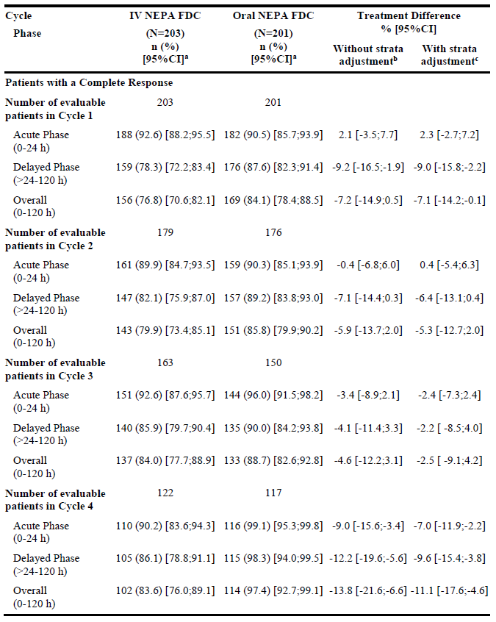

Abbreviations: CI = confidence interval; IV NEPA FDC = intravenous fosnetupitant/palonosetron fixed dose combination; N = number of patients in a given group; n = number of patients in a given subgroup; Oral NEPA FDC = oral netupitant/palonosetron fixed-dose combination.(a) Wilson score method confidence interval; (b) Newcombe-Wilson method for difference in proportions without strata adjustment; (c) Cochran-Mantel-Haenszel method for difference in proportions with strata adjustment (gender and country).

#### Safety

Study NEPA-15-18, comparing the safety of IV NEPA FDC (Akynzeo IV) to oral NEPA FDC (Akynzeo capsules) in cancer patients, is the primary safety study. Safety data are also provided from the Phase III study, Study PALO-15-17 (IV infusion versus IV bolus of palonosetron in cancer patients) and the Phase I SAD safety and PK study, Study PNET-12-23 (IV fosnetupitant in healthy subjects).

##### Study NEPA-15-18

In Study NEPA-15-18;15 404 patients were treated (203 in the IV NEPA FDC (Akynzeo IV) group, 201 in the oral NEPA FDC (Akynzeo capsule group). The mean (standard deviation (SD)) number of infusions administered in the IV NEPA FDC group was 3.3 (1.0) and the mean (SD) number of capsules administered in the oral NEPA FDC group was 3.2 (1.1). All patients also received oral dexamethasone.

Overall, treatment emergent adverse events (TEAEs) were similar between the IV NEPA FDC and oral NEPA FDC arms (Table 8), noting that patients were receiving concurrent chemotherapy. Grade 3 TEAEs were reported for 61 (30.0%) patients in the IV NEPA FDC group and 54 (26.9%) patients in the oral NEPA FDC group, and Grade 4 TEAEs were reported for 15 (7.4%) patients in the IV NEPA FDC group and 22 (10.9%) patients in the oral NEPA FDC group. Neutropenia was the most frequent Grade 3/4 TEAE reported. The profile of serious TEAEs was consistent with chemotherapy treatment for cancer. TEAEs leading to death were reported for 10 (4.9%) patients in the IV NEPA FDC group and 14 (7.0%) patients in the oral NEPA FDC group. None of the deaths were attributable to the study drug.

Constipation, a known TEAE with oral Akynzeo, was reported for 21 (10.3%) patients in the IV NEPA FDC group and 26 (12.9%) patients in the oral NEPA FDC group.

TEAEs assessed by the investigator as study-drug-related were reported for 26 (12.8%) patients in the IV NEPA FDC group and 23 (11.4%) patients in the oral NEPA FDC group. Only 2 types of drug-related TEAEs were reported in ≥ 2% of patients: constipation and ALT increased. The most frequently reported study drug-related TEAE in both treatment groups was constipation (13 (6.4%) patients in the IV NEPA FDC group and 12 (6.0%) patients in the oral NEPA FDC group). ALT increased was reported in 4 patients (2.0%) in each treatment group. None of the patients met Hy’s Law criteria.[20] There were no study drug-related serious TEAEs.

Table : Study NEPA-15-18 Overview of treatment emergent adverse events; safety population

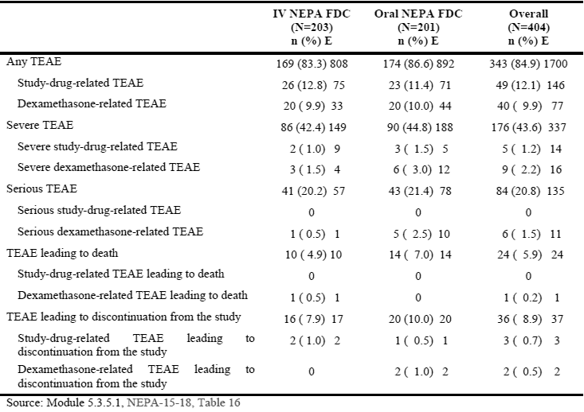

##### Study PALO-15-17

In Study PALO-15-17;13 the incidence of TEAEs was similar between treatment groups: 37.8% in the infusion and 35.8% in the bolus group. Grade 3 TEAEs were reported for 8 (3.6%) patients in the infusion group and 9 (4.2%) patients in the bolus group, and Grade 4 TEAEs for 2 (0.9%) patients in the infusion group and 2 (0.9%) patients in the bolus group. Serious TEAEs were reported for 15 (6.7%) patients in the infusion group and 12 (5.6%) patients in the bolus group. No patient withdrew from the study due to a TEAE. TEAEs related to study drug were reported for 8 (3.6%) patients in the infusion group and 3 (1.4%) patients in the bolus group. Constipation was the only study drug‑related TEAE reported in > 2% of patients in either treatment group (5 (2.2%) patients in the infusion group and 2 (0.9%) patients in the bolus group). TEAEs occurring at ≥ 2% higher frequency in the infusion arm versus bolus arm were diarrhoea (4.9% versus 2.8%) and hypertension (3.6% versus 0.9%). No new safety signals were identified in Study PALO-15-17.

##### Study PNET-12-23

In Study PNET-12-23;14 in healthy subjects, the number of drug-related TEAEs or frequency of subjects with drug related TEAEs did not increase with ascending doses of fosnetupitant. The most frequently reported TEAEs assessed as drug-related by the investigator and DSMB were headache, constipation, infusion site thrombosis, abdominal pain upper, fatigue, dizziness, and nausea. Drug-related infusion site thrombosis events were reported in 8 (5.4%) patients overall, with none reported at the two highest dose levels tested (325 mg, 390 mg). No new safety signals were identified in Study PNET‑12‑23.

##### Cardiac safety

No significant QT prolongation effect; of Akynzeo IV is expected based on cardiac safety data from Studies NEPA-15-18 and PNET-12-23, and the established cardiac safety profiles of Akynzeo capsules and Aloxi IV solution.

### Risk management plan

The sponsor submitted European Union risk management plan (EU-RMP) version 0.1 (data lock point (DLP) 26 March 2018) and Australian specific Annex (ASA) version 0.1 (dated April 2019) with the original application, followed by EU-RMP version 2.7 (6 November 2019; DLP 10 October 2018) and ASA (dated December 2019).

The summary of safety concerns and their associated risk monitoring and mitigation strategies are summarised in Table 9.[21]

Table : Summary of safety concerns

|  |  |  |  |  |  |
| --- | --- | --- | --- | --- | --- |
| Summary of safety concerns | | Pharmacovigilance | | Risk Minimisation | |
| Routine | Additional | Routine | Additional |
| **Important identified risks** | Nil |  |  |  |  |
| **Important potential risks** | Torsade de pointes due to QT/QTc prolongation | ✓ * | – | ✓ | – |
| Serotonin syndrome (due to palonosetron) | ✓ * | – | ✓ | – |
| Teratogenic effects | ✓ * | – | – | – |
| **Missing information** | Effects in children | ✓ | – | ✓ | – |

* Targeted follow-up checklist

The proposed summary of safety concerns is acceptable.

#### Recommended conditions of registration

* The Akynzeo IV EU-risk management plan (RMP) (version 2.7, 6 November 2019, DLP 10 October 2018), with ASA (version 0.2, dated December 2019), included with submission PM-2019-01560-1-4, and any subsequent revisions, as agreed with the TGA will be implemented in Australia.

An obligatory component of risk management plans is routine pharmacovigilance. Routine pharmacovigilance includes the submission of periodic safety update reports (PSURs).

Reports are to be provided in line with the current published list of EU reference dates and frequency of submission of PSURs until the period covered by such reports is not less than three years from the date of the approval letter.

The reports are to at least meet the requirements for PSURs as described in the European Medicines Agency’s Guideline on Good Pharmacovigilance Practices (GVP) Module VII-periodic safety update report (Rev 1), Part VII.B Structures and processes. Note that submission of a PSUR does not constitute an application to vary the registration.

* Akynzeo IV (fosnetupitant and palonosetron) is to be included in the Black Triangle Scheme. The PI and Consumer Medicines Information (CMI) for Akynzeo IV must include the black triangle symbol and mandatory accompanying text for five years, which starts from the date that the sponsor notifies the TGA of supply of the product.

### Risk-benefit analysis

#### Delegate’s considerations

##### Pharmacology

In Study PNET-12-23, fosnetupitant was rapidly converted into netupitant after IV administration. Within 30 minutes of infusion completion, the fosnetupitant concentration decreased to less than 1% of Cmax. IV administration of 260 mg fosnetupitant chloride hydrochloride (equivalent to 235 mg fosnetupitant free-base, as in Akynzeo IV) yielded equivalent systemic netupitant exposure (area under the plasma concentration time curve from time 0 to 120 hours (AUC0-120h) and area under the plasma concentration time curve from time 0 to infinity (AUC0-∞)) to 300 mg oral netupitant. The Cmax of netupitant was approximately 1.5 fold higher for 260 mg IV fosnetupitant compared to 300 mg oral netupitant.

##### Efficacy

Non-inferiority of palonosetron by 30 minute IV infusion compared to 30 second IV bolus was demonstrated in Study PALO 15-17. This establishes the efficacy of the palonosetron component of Akynzeo IV, based on the established efficacy of Aloxi. Non-inferiority for the primary endpoint (CR in the acute phase) was supported by similar findings for CR in the delayed and overall phases. The Australian indication for Aloxi does not differentiate between acute and delayed CINV, or HEC and MEC.

The efficacy of the fosnetupitant component of Akynzeo IV was established by bridging from the established efficacy of Akynzeo capsules, based on bioequivalent netupitant exposure (AUC). The Cmax of netupitant was approximately 50% higher following IV fosnetupitant compared to oral Akynzeo, which would not detract from efficacy but would require a dedicated safety study (Study NEPA-15-18).

Study NEPA-15-18 provides supportive evidence of the efficacy of Akynzeo IV. Efficacy was a secondary objective of NEPA-15-18 and the study was not designed or powered to demonstrate non-inferiority, so the efficacy findings are descriptive only.

##### Safety

Safety data for Akynzeo IV are derived primarily from Study NEPA-15-18, with additional safety data from Study PNET-12-23 (IV fosnetupitant in healthy subjects) and Study PALO‑15-17 (IV palonosetron 30 minute infusion versus 30 second bolus). The safety profile of Akynzeo IV has been adequately characterised, and is similar to the safety profile of oral Akynzeo. No new safety signals have been identified.

##### Proposed conditions of registration

As outlined in the ‘Recommended conditions of registration’ section, above.

##### Conclusion

The Delegate is satisfied that the quality, efficacy and safety of Akynzeo IV have been satisfactorily established. Akynzeo IV offers an alternative treatment option for the prevention of acute and delayed CINV in patients receiving HEC or MEC, particularly patients who are unable to tolerate an oral formulation. The alignment of the Akynzeo IV indication with the Akynzeo indication is acceptable given the strategy of bridging the efficacy of Akynzeo IV from the established efficacy of Akynzeo capsules. There are no outstanding clinical questions requiring expert advice.

#### Proposed action

The Delegate has no reason to say, at this time, that the application for Akynzeo IV should not be approved for registration.

#### Advisory Committee considerations[22]

The Delegate did not refer this application to the Advisory Committee on Medicines (ACM) for advice.

### Outcome

Based on a review of quality, safety and efficacy, the TGA approved the registration of Akynzeo IV (fosnetupitant (as chloride hydrochloride) / palonosetron (as hydrochloride)) powder for injection for the following indications:

*Akynzeo IV is indicated in adult patients for:*

* *Prevention of acute and delayed nausea and vomiting associated with initial and repeat courses of highly emetogenic cancer chemotherapy.*
* *Prevention of acute and delayed nausea and vomiting associated with initial and repeat courses of moderately emetogenic cancer chemotherapy.*

#### Specific conditions of registration applying to these goods

* Akynzeo IV (fosnetupitant and palonosetron) is to be included in the Black Triangle Scheme. The PI and CMI for Akynzeo IV must include the black triangle symbol and mandatory accompanying text for five years, which starts from the date that the sponsor notifies the TGA of supply of the product.
* The Akynzeo IV EU-RMP (version 2.7, 6 November 2019, DLP 10 October 2018), with ASA (version 0.2, dated December 2019), included with submission PM-2019-01560-1-4, and any subsequent revisions, as agreed with the TGA will be implemented in Australia.

An obligatory component of risk management plans is routine pharmacovigilance. Routine pharmacovigilance includes the submission of periodic safety update reports (PSURs).

Reports are to be provided in line with the current published list of EU reference dates and frequency of submission of PSURs until the period covered by such reports is not less than three years from the date of the approval letter.

The reports are to at least meet the requirements for PSURs as described in the European Medicines Agency’s Guideline on good pharmacovigilance practices (GVP) Module VII-periodic safety update report (Rev 1), Part VII.B Structures and processes. Note that submission of a PSUR does not constitute an application to vary the registration.

* For all injectable products the PI must be included with the product as a package insert.

## Attachment 1. Product Information

The PI for Akynzeo IV approved with the submission which is described in this AusPAR is at Attachment 1. For the most recent PI, please refer to the TGA website at <<https://www.tga.gov.au/product-information-pi>>.

|  |
| --- |
| Therapeutic Goods Administration |
| PO Box 100 Woden ACT 2606 Australia  Email: [info@tga.gov.au](mailto:info@tga.gov.au) Phone: 1800 020 653 Fax: 02 6232 8605  [**https://www.tga.gov.au**](https://www.tga.gov.au) |

1. The **Black Triangle Scheme** provides a simple means for practitioners and patients to identify certain types of new prescription medicines, including those being used in new ways and to encourage the reporting of adverse events associated with their use. The Black Triangle does not denote that there are known safety problems, just that the TGA is encouraging adverse event reporting to help us build up the full picture of a medicine's safety profile.
2. Hesketh, P.J et al. Antiemetics: American Society of Clinical Oncology Clinical Practice Guideline Update, *Journal of Clinical Oncology*, 2017; 35:28, 3240-3261.
3. Roila, F. et al. 2016 MASCC and ESMO guideline update for the prevention of chemotherapy- and radiotherapy-induced nausea and vomiting and of nausea and vomiting in advanced cancer patients, *Annals of Oncology*, 2016; 27 (Supplement 5): v119–v133.
4. Cancer Institute NSW, eviQ, Prevention of antineoplastic induced nausea and vomiting, Last reviewed: 17 January 2019. Available from the eviQ website.
5. Akynzeo (netupitant/palonosetron (as hydrochloride) 300 mg/500 µg) capsule blister pack AUST R 222237, fist registered 6 May 2015. Sponsored by Mundipharma Pty Ltd.
6. Aloxi (palonosetron (as hydrochloride)) 75 µg/1.5 mL solution for injection vial AUST R 281464 (first registered 22 August 2017) and 250 µg/5 mL solution for injection vial AUST R 114185 (first registered 26 June 2006). Sponsored by Mundipharma Pty Ltd.
7. European Medicines Agency (EMA), Committee for Proprietary Medicinal Products (CPMP), ICH guideline M3(R2) on non-clinical safety studies for the conduct of human clinical trials and marketing authorisation for pharmaceuticals, EMA/CPMP/ICH/286/1995, December 2009.
8. **pKB** is a measure of the potency of a competitive antagonist.
9. The **QT interval** is the time from the start of the QRS wave complex to the end of the corresponding T wave. It approximates to the time taken for ventricular depolarisation and repolarisation, that is to say, the period of ventricular systole from ventricular isovolumetric contraction to isovolumetric relaxation.

   The **corrected QT interval (QTc)** estimates the QT interval at a standard heart rate. This allows comparison of QT values over time at different heart rates and improves detection of patients at increased risk of arrhythmias.
10. Australian Pregnancy Category D: Drugs which have caused, are suspected to have caused or may be expected to cause, an increased incidence of human fetal malformations or irreversible damage. These drugs may also have adverse pharmacological effects. Accompanying texts should be consulted for further details.
11. Study PNET-13-63; title: ‘Evaluation of the pharmacokinetic interaction between three doses of intravenous fosnetupitant and oral dexamethasone regimen: a randomized three period crossover study in healthy male and female volunteers’. May 2015.
12. Study NEPA-15-19; title: ‘A Phase 1, open label study to evaluate the pharmacokinetic profile and safety of IV NEPA FDC administered for the prevention of chemotherapy-induced nausea and vomiting in cancer patients receiving a single cycle of highly emetogenic chemotherapy’. March 2017.
13. Study PALO-15-17; title: ‘A phase 3, single-dose, multicenter, randomized, double-blind, parallel group study to assess the efficacy and safety of palonosetron 0.25 mg administered as a 30-minute IV infusion compared to palonosetron 0.25 mg administered as a 30-second IV bolus for the prevention of chemotherapy-induced nausea and vomiting in cancer patients receiving highly emetogenic chemotherapy’.

    EudraCT Number: 2015-001747-37; ClinicalTrials.gov Identifier: NCT02557035,
14. Study PNET-12-23; title: ‘A Phase I, double-blind, controlled, parallel groups, unbalanced single ascending dose study to assess the safety of intravenously administered fosnetupitant combined with crossover study extensions to estimate the dose of intravenous fosnetupitant yielding equivalent drug exposure as oral netupitant 300 mg/palonosetron 0.5 mg fixed-dose combination in healthy male and female volunteers’. April 2015.
15. Study NEPA-15-18; title: ‘A phase 3, multicenter, randomized, double-blind, active control study to evaluate the safety and efficacy of IV pro-netupitant/palonosetron (260 mg/0.25 mg) combination for the prevention of chemotherapy-induced nausea and vomiting in repeated chemotherapy cycles in patients receiving highly emetogenic chemotherapy’. March 2017.
16. Table produced from original Table 9 (Source Reviewer’s Table) taken from the Food and Drug Administration, Center for Drug Evaluation and Research, Multi-discipline review. Application number: 210493Orig1s000, Akynzeo for injection; Review completion date: 15 December 2017, available from the FDA website.
17. Koch, G.G. et al. Categorical Data Analysis. In: DA Berry (Ed.) Statistical Methodology in the Pharmaceutical Sciences. Marcel Dekker, New York; 1989; 414–421.
18. O'Gorman, T.W. et al. A comparison of two methods of estimating a common risk difference in a stratified analysis of a multicenter clinical trial. *Control Clin Trials*. 1994; 15(2): 135-153.
19. The **visual analogue scale (VAS)** is a psychometric response scale for characteristics or attitudes that range across a continuum of values and cannot easily be directly measured, such as pain, mood and appetite. The VAS nausea scale ranges along a 10 cm line from ‘no nausea’ (0 cm) to ‘worst nausea’ (10 cm), and patients mark a line at a point along the scale to indicate how they are feeling.
20. **Hy’s Law**: Evidence of hepatocellular injury with a rise in alanine aminotransferase (ALT) and/or aspartate aminotransferase (AST) > 3 x the upper limit of normal (ULN) and total bilirubin > 2 x ULN, and no other reason to explain rise in aminotransferases and total bilirubin. Hy's law is a rule of thumb that a patient is at high risk of a fatal drug-induced liver injury if given a medication that causes hepatocellular injury with jaundice
21. *Routine risk minimisation* activities may be limited to ensuring that suitable warnings are included in the product information or by careful use of labelling and packaging.

    *Routine pharmacovigilance* practices involve the following activities:

    All suspected adverse reactions that are reported to the personnel of the company are collected and collated in an accessible manner;

    Reporting to regulatory authorities;

    Continuous monitoring of the safety profiles of approved products including signal detection and updating of labelling;

    Submission of PSURs;

    Meeting other local regulatory agency requirements.
22. The ACM provides independent medical and scientific advice to the Minister for Health and the Therapeutic Goods Administration (TGA) on issues relating to the safety, quality and efficacy of medicines supplied in Australia including issues relating to pre-market and post-market functions for medicines.

    The Committee is established under Regulation 35 of the Therapeutic Goods Regulations 1990. Members are appointed by the Minister. The ACM was established in January 2017 replacing Advisory Committee on Prescription Medicines (ACPM) which was formed in January 2010. ACM encompass pre and post-market advice for medicines, following the consolidation of the previous functions of the Advisory Committee on Prescription Medicines (ACPM), the Advisory Committee on the Safety of Medicines (ACSOM) and the Advisory Committee on Non-Prescription Medicines (ACNM). Membership comprises of professionals with specific scientific, medical or clinical expertise, as well as appropriate consumer health issues relating to medicines.