|  |
| --- |
| **First round CER: February 2012**  **Second round CER: June 2012** |

|  |
| --- |
| AusPAR Attachment 2 |
| Extract from the Clinical Evaluation Report for glycopyrronium (as bromide) |
| Proprietary Product Name: Seebri Breezhaler/ Tovanor Breezhaler |
| Sponsor: Novartis Pharmaceuticals Australia Pty Ltd |

About the Therapeutic Goods Administration (TGA)

* The Therapeutic Goods Administration (TGA) is part of the Australian Government Department of Health and Ageing, and is responsible for regulating medicines and medical devices.
* The TGA administers the *Therapeutic Goods Act 1989* (the Act), applying a risk management approach designed to ensure therapeutic goods supplied in Australia meet acceptable standards of quality, safety and efficacy (performance), when necessary.
* The work of the TGA is based on applying scientific and clinical expertise to decision-making, to ensure that the benefits to consumers outweigh any risks associated with the use of medicines and medical devices.
* The TGA relies on the public, healthcare professionals and industry to report problems with medicines or medical devices. TGA investigates reports received by it to determine any necessary regulatory action.
* To report a problem with a medicine or medical device, please see the information on the TGA website <<http://www.tga.gov.au>>.

About the Extract from the Clinical Evaluation Report

* This document provides a more detailed evaluation of the clinical findings, extracted from the Clinical Evaluation Report (CER) prepared by the TGA. This extract does not include sections from the CER regarding product documentation or post market activities.
* The words [Information redacted], where they appear in this document, indicate that confidential information has been deleted.
* For the most recent Product Information (PI), please refer to the TGA website <<http://www.tga.gov.au/hp/information-medicines-pi.htm>>.

**Copyright**© Commonwealth of Australia 2013  
This work is copyright. You may reproduce the whole or part of this work in unaltered form for your own personal use or, if you are part of an organisation, for internal use within your organisation, but only if you or your organisation do not use the reproduction for any commercial purpose and retain this copyright notice and all disclaimer notices as part of that reproduction. Apart from rights to use as permitted by the *Copyright Act 1968* or allowed by this copyright notice, all other rights are reserved and you are not allowed to reproduce the whole or any part of this work in any way (electronic or otherwise) without first being given specific written permission from the Commonwealth to do so. Requests and inquiries concerning reproduction and rights are to be sent to the TGA Copyright Officer, Therapeutic Goods Administration, PO Box 100, Woden ACT 2606 or emailed to <[tga.copyright@tga.gov.au](mailto:tga.copyright@tga.gov.au)>.

Contents

List of abbreviations 5

1. Clinical rationale 9

2. Contents of the clinical dossier 9

2.1. Scope of the clinical dossier 9

2.2. Paediatric data 10

2.3. Good clinical practice 10

3. Pharmacokinetics 10

3.1. Studies providing pharmacokinetic data 10

3.2. Summary of pharmacokinetics 10

3.3. Evaluator’s overall conclusions on pharmacokinetics 21

4. Pharmacodynamics 23

4.1. Summary of pharmacodynamics 23

4.2. Evaluator’s overall conclusions on pharmacodynamics 28

5. Dosage selection for the pivotal studies 29

6. Clinical efficacy 32

6.1. Pivotal efficacy studies 32

6.2. Analyses performed across trials 50

6.3. Evaluator’s conclusions on clinical efficacy 61

7. Clinical safety 64

7.1. Studies providing evaluable safety data 64

7.2. Pivotal studies that assessed safety as a primary outcome 66

7.3. Patient exposure 66

7.4. Adverse events 67

7.5. Post-marketing experience 92

7.6. Safety issues with the potential for major regulatory impact 92

7.7. Other safety issues 102

7.8. Evaluator’s overall conclusions on clinical safety 104

8. First round benefit-risk assessment 106

8.1. First round assessment of benefits 106

8.2. First round assessment of risks 107

8.3. First round assessment of benefit-risk balance 107

9. First round recommendation regarding authorisation 109

10. Clinical questions 109

10.1. Pharmacokinetics 109

10.2. Pharmacodynamics 109

10.3. Efficacy 109

10.4. Safety 109

11. Second round evaluation of clinical data submitted in response to questions 109

11.1. Question 1 109

11.2. Question 2 111

12. Second round benefit-risk assessment 115

12.1. Second round assessment of benefits 115

12.2. Second round assessment of risks 116

12.3. Second round assessment of benefit-risk balance 116

13. Second round recommendation regarding authorisation 116

14. References 116

## List of abbreviations

|  |  |
| --- | --- |
| **Abbreviation** | **Meaning** |
| ABC | ATP-binding cassette |
| AE | Adverse event |
| ALT | Alanine aminotransferase |
| ANCOVA | Analysis of covariance |
| AUC | Area under the curve |
| AUClast | AUC from time zero to the time of the last measurable concentration |
| AUCtau | AUC calculated to the end of the dosing interval tau |
| AUC0-t | AUC from time zero to time ‘t’ where t is a defined time point after administration |
| BAV | Bioavailability |
| b.i.d. | Bis in diem/twice daily |
| BDI | Baseline dyspnea index |
| BP | Blood pressure |
| bpm | Beats per minute |
| CI | Confidence interval |
| CL | The systemic (or total body) clearance of the drug from plasma following intravenous administration |
| CL/F | The apparent systemic (or total body) clearance of the drug from plasma following extravascular administration |
| CLr | Renal clearance |
| COPD | Chronic obstructive pulmonary disease |
| CV% | Coefficient of variation (%) |
| CCV | Cardio- and cerebro-vascular |
| Cmax | Maximum peak concentration |
| CTD | Common Technical Document |
| CV | Cardiovascular |
| CYP | Cytochrome |
| Emax | The observed maximum PD effect after dose administration |
| eGFR | Estimated glomerular filtration rate |
| ESRD | End stage renal disease |
| ECG | Electrocardiogram |
| EMEA/EMA | European Medicines Evaluation Agency |
| FAS | Full analysis set |
| FDA | Food and Drug Administration |
| F | Bioavailability of a compound |
| Fabs | absolute bioavailability, i.e. the fraction (or percentage) of the administered extravascular dose systemically available |
| Frel | relative bioavailability, i.e. the bioavailability relative to a reference |
| FEV1 | Forced expiratory volume in 1 second |
| FRC | Functional residual capacity |
| FVC | Forced vital capacity |
| GI | Gastro-intestinal |
| GOLD | Global Initiative for Chronic Obstructive Lung Disease |
| GP | Glycopyrronium bromide or glycopyrrolate |
| HV | Healthy volunteer |
| IC | Inspiratory capacity |
| ICS | Inhaled corticosteroid |
| i.v. | Intravenous(ly) |
| LABA | Long-acting β2-agonist |
| LAMA | Long-acting muscarinic-antagonist |
| LC-MS/MS | Liquid chromatography-tandem mass spectrometry |
| LLOQ | Lower limit of quantification |
| LS | Least square means |
| MACE | Major adverse cardiovascular event |
| MATE1 | Multi-drug and toxin extrusion protein |
| MedDRA | Medical Dictionary for Regulatory Affairs |
| NVA/NVA237 | glycopyrronium bromide |
| NNT | Number needed to treat |
| o.d. | omnie die/every day |
| OCT2 | Organic cation transporter 2 |
| OL | Open label |
| OR | Odds ratio |
| Pbo | Placebo |
| PD | Pharmacodynamic(s) |
| PK | Pharmacokinetic(s) |
| PY | Patient-years |
| Racc | Accumulation ratio |
| RV | Residual volume |
| RI | Renal impairment |
| RTI | Respiratory tract infection |
| SAE | Serious adverse event |
| SCE | Summary of Clinical Efficacy |
| SCP | Summary of Clinical Pharmacology |
| SCS | Summary of Clinical Safety |
| SE | Standard error |
| SVC | Slow vital capacity |
| SD | Standard deviation |
| SDDPI | Single dose dry powder inhaler |
| SLC | Solute Carrier |
| SMQ | Standardized MedDRA query |
| SOC | System organ class |
| SGRQ | St Gorge Respiratory Questionnaire |
| SMETT | Sub-max constant-load cycle ergometry test |
| TDI | Transition dyspnea index |
| Tmax | Time to reach maximum concentration |
| Tio | Tiotropium |
| TLC | Total lung capacity |
| Tmax | The time to reach maximum (peak) plasma drug concentration after dose administration [hr] |
| T1/2 | The elimination half-life [hr] |
| ULN | Upper limit normal |
| URTI | Upper respiratory tract infection |
| Vss | The volume of distribution at steady state following intravenous administration |
| Vz | The volume of distribution during the terminal elimination phase following intravenous administration |
| Vz/F | The apparent volume of distribution during the terminal elimination phase following extravascular administration |
| w/wo | With/without |
| WBC | White blood cell |

## Clinical rationale

Glycopyrronium bromide, (GP) (3-(2-Cyclopentyl-2-hydroxy-2-phenylacetyloxy)-1,1-dimethylpyrrolidinium bromide) is a competitive antagonist at muscarinic receptors in the autonomic nervous system, with little or no activity against nicotinic receptors. Injectable and oral forms of GP are currently marketed in several countries. GP (Robinul and its generics) has a long history of safe therapeutic use, and is indicated for use in anaesthesia (adults: 0.1 mg and repeated every 2-3 minutes as necessary) as a preoperative antimuscarinic to reduce the volume and free acidity of gastric secretion, to block cardiac vagal inhibition reflexes and to protect against the peripheral muscarinic actions of anticholinesterases. Robinul is also used for treatment of hyperhidrosis; GP oral formulation (Cuvposa) was approved in the United States in 2010 for indication of severe drooling in patient

s 3-16 years of age (initial dose 0.02 mg/kg three times daily, titrated to maximum 0.1 mg/kg three times daily) with neurologic conditions.

A dry powder formulation of glycopyrronium bromide was developed by Novartis as a once daily (o.d.) inhalation treatment for patients with chronic obstructive pulmonary disease (COPD) under the compound code NVA237. A full toxicology and pharmacokinetics (PK) program has been conducted to support the clinical program. Glycopyrronium bromide powder for inhalation represents an alternative treatment option for COPD patients. It is claimed to have a faster onset of action to the only currently available once-daily long-acting muscarinic antagonist (LAMA) on the Australian market, tiotropium in the pivotal phase III study (treatment difference of ~0.090L at the five minutes post dose time-point). Glycopyrronium bromide is intended for administration to patients once daily by inhalation via a single dose capsule device (known as the Concept1 device, registered under the tradename, Breezhaler). This is a low resistance device, which would be a potential advantage for COPD patients who find breathing difficult.

## Contents of the clinical dossier

### Scope of the clinical dossier

The submission contained the following clinical information:

* Clinical pharmacology studies:
  + NVA237A2103 (multiple dose study in COPD patients)
  + NVA237A2104 (PKs in Japanese and Caucasian)
  + NVA237A2105 (PK study in renal impairment)
  + NVA237A2108 (absolute bioavailability)
  + NVA237A2109 (drug interaction with cimetidine)
  + Studies QVA149A2101/2103 and 2106 provided some supportive PK data following single and multiple inhaled doses of indacaterol (QAB149) and NVA237 (glycopyrronium bromide) when administered alone or in combination
  + population pharmacokinetic analyses
* Pivotal Phase 3 efficacy/safety studies:
  + NVA237A2303 and 2310
* Dose-finding studies:
  + NVA237A2205, 2206, 2207, 2208

*Comments: The submission was well organised. The electronic data submission was well indexed and hyperlinks were well-structured.*

### Paediatric data

The submission did not include paediatric data. A waiver for Glycopyrronium bromide, inhalation powder, hard capsules, was granted by the Paediatric Committee of the European Medicines Agency on the grounds that the disease or condition for which the specific medicinal product is intended occurs only in adult populations.

### Good clinical practice

All studies were conducted according to Good Clinical Practice and complied with the principles of Declaration of Helsinki.

## Pharmacokinetics

### Studies providing pharmacokinetic data

The PK studies [CQVA149A2101], [CQVA149A2103] and [CQVA149A2106] form part of another development program (i.e. QVA149, a fixed-dose combination of NVA237 and the long-acting β2-agonist indacaterol maleate). Like NVA237, QVA149 is formulated as inhalation powder hard capsules and delivered by the Concept1 device. These studies were included here as they all included NVA237 monotherapy arms and provided PK data for NVA237.

The GP inhalation powder development program was initiated by Arakis/Vectura. At this stage the compound code was AD-237 and the drug was delivered via the Miat Monohaler device. Studies [P-AD237-001], [P-AD237-002], [P-AD237-003] and [P-AD237A-005] are studies with the Miat Monohaler formulation which was not taken into further development and were only provided as supplemental information in this submission. Studies PAD237-001, -003 and -002 did not have any PK sampling. Study PAD237-005 had sparse PK sampling (peak and trough levels only) showed similar results to those observed with the proposed formulation (using Concept 1 device). These studies have not been evaluated and discussed in detail as they do not provide any PK information using proposed formulation/device of NVA237.

### Summary of pharmacokinetics

The information in the following summary is derived from conventional pharmacokinetic studies unless otherwise stated.

#### Pharmacokinetics in healthy subjects

##### Absorption

Following oral inhalation from the inhalation powder hard capsules via the Concept1 device, NVA237 was rapidly absorbed and reached peak plasma levels at 5 minutes post dose. Thereafter, the plasma concentrations declined in a multi-phasic manner (studies CNVA237-A2103, -A2104,-A2105. -A2108 and -A2109].

##### Bioavailability

###### Absolute bioavailability

In study NVA237 A2108, the first part of the study evaluated effectiveness of oral activated charcoal in reducing or blocking gastrointestinal absorption of NVA237. Frel was determined as the ratio of AUClast of NVA237 with charcoal (test) *vs*. NVA237 without charcoal (reference), provided AUClast could be determined in both treatments which was the case for 3 subjects. Frel was set to 0, as defined in the protocol, for 5 other subjects who all had plasma levels below LLOQ in the test treatment. In addition, Frel was also determined based on the Ae0-24h data that could be quantified in the 8 subjects who completed both treatments. Mean Frel was 1.87% (SD=4.21%) based on AUClast and 3.44% (SD=5.14%) based on Ae0-24h. Thus, the charcoal treatment was efficient in blocking at least 96% of the oral absorption of NVA237 (Table 1).

Table 1: Summary of key PK parameters of NVA237 after oral administration (Study NVA237 A2108).

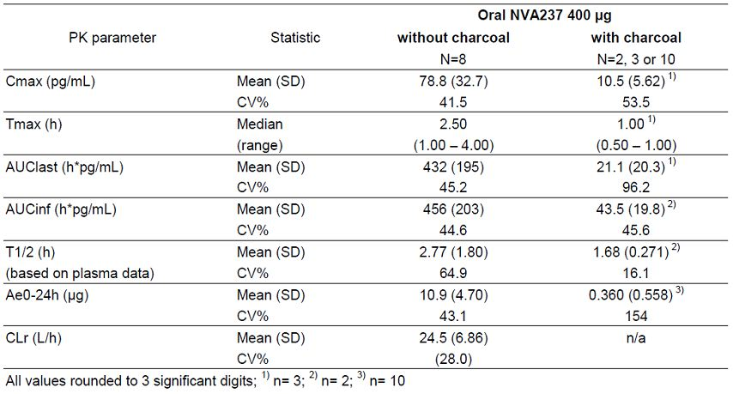

The second part of this study evaluated the absolute bioavailability of inhaled NVA237 (without oral activated charcoal) compared to an i.v. administration of GP. The disposition of NVA237 differed between i.v. dosing and inhalation treatments, especially the terminal elimination was much slower after inhalation than after i.v. administration. Sustained plasma concentrations were observed between 24 and 72h after inhalation, with means between 8.4 and 15.6 pg/mL. After the i.v. dose, the mean concentration had fallen to 4.4 pg/mL at 24 h. Consequently, the mean terminal half-life was about 9-fold longer after the inhalation treatments (52.5 h and 57.2 h) than after the i.v. dose (6.2 h).

The point estimate (90% CI) of the absolute bioavailability (Fabs) of inhaled NVA237 without charcoal to i.v. administration was 32.0 % (30.1, 34.1%) based on AUClast and 42.3 % (38.3, 46.6%) based on AUCinf. Based on the individual AUClast ratios in 16 subjects who provided data for both treatments, the mean Fabs was 32.0% (SD=4.99%) (Figure 1) The calculation of Fabs based on AUClast is biased due to the much slower elimination of NVA237 after inhalation than after i.v. dosing (meaning that AUClast represents a smaller fraction of AUCinf after inhalation than after i.v. dosing. Thus, the Fabs value based on AUClast is likely to be an underestimation. A compartmental analysis enabled the estimation of reliable AUCinf values of NVA237 in 16 subjects after inhalation without charcoal. Based on these values and the corresponding model predicted AUCinf values for the i.v. dose, mean Fabs of inhaled NVA237 was 45.7% (SD=8.61%) (Table 2). Rather than selecting one of the Fabs values (based on AUClast or AUCinf ) as the definitive value, the absolute bioavailability of orally inhaled NVA237 was estimated to be about 40%. For Flung, the fraction of systemic exposure following inhalation of NVA237 which is due to lung absorption, estimates between 86.4% (based on AUClast) and 97.1% (based on non-compartmental AUCinf data) were obtained. The compartmental analysis gave an estimate of 95.9%. It is concluded that about 90% of systemic exposure following oral inhalation of NVA237 is due to lung absorption while about 10% is due to gastrointestinal absorption. If it is assumed that the absolute bioavailability of orally inhaled NVA237 is 40% of which 90% would be attributed to lung absorption, then about 36% of the nominal dose is expected to be deposited and absorbed in the lungs.

Figure 1: Arithmetic mean concentration-time profile of NVA237 after i.v. glycopyrrolate 120 µg and inhaled NVA237 200 µg without charcoal (Study NVA237 A2108).

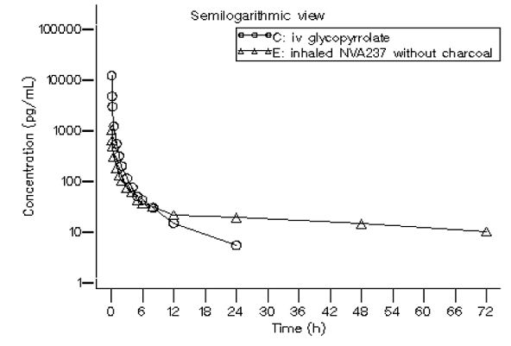

Table 2: Summary of key PK parameters of NVA237 after i.v. infusion and inhalation without and with charcoal (Part 2) (Study NVA237 A2108).

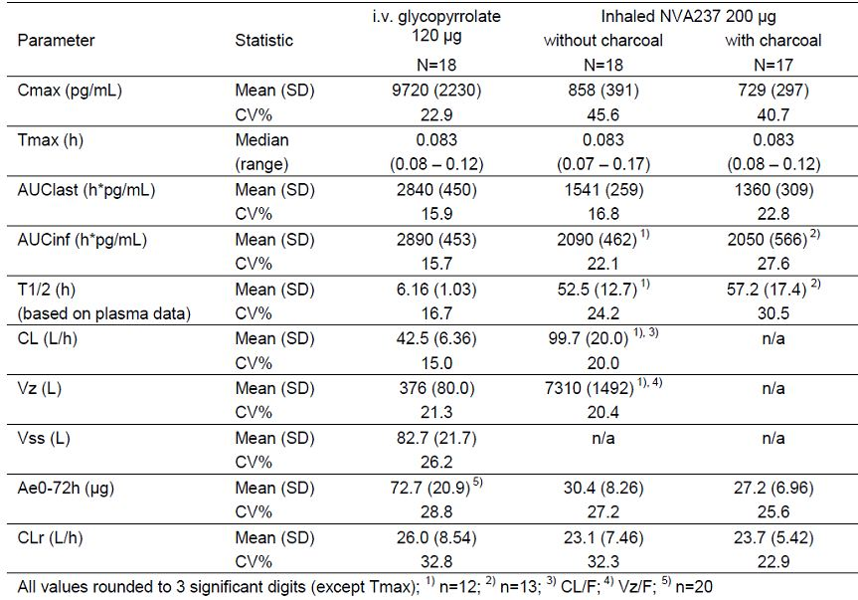

###### Bioavailability relative to an oral solution or micronised suspension

Not applicable.

###### Bioequivalence of clinical trial and market formulations

Formulation of 50 ug capsules used in the clinical trials is identical to formulation to be registered. Furthermore, all clinical trials in this submission were done using the proposed Concept 1 device.

###### Bioequivalence of different dosage forms and strengths

Not applicable.

###### Bioequivalence to relevant registered products

Not applicable.

###### Influence of food

Since NVA237 is an inhaled drug, a formal food effect study was not conducted. The drug effect is achieved topically in the lungs and food is not expected to have an impact on lung deposition.

###### Dose proportionality

In the dose range of 50 μg to 200 μg NVA237, systemic exposure to NVA237 (as well as total urinary excretion) increased about dose-proportionally after single inhalation by healthy volunteers (CNVA237A2104) as well as after repeated once-daily inhalation by patients with COPD at pharmacokinetic steady state (CNVA237A2103).

###### Bioavailability during multiple-dosing

Following repeated once-daily inhalation of NVA237 by patients with COPD, pharmacokinetic steady-state of NVA237 was reached within one week of treatment (CNVA237A2103). The steady-state mean peak and trough plasma concentration of NVA237 for a 50 μg once-daily dosing regimen was 166 and 8 pg/mL, respectively. With once-daily doses of 100 and 200 μg, steady-state exposure (AUC0-24h) to NVA237 was about 1.4- to 1.7-fold higher than after the first dose. Urinary excretion data of NVA237 at steady-state compared to the first dose suggested that systemic accumulation is independent of dose in the dose range of 25 to 200 μg. The effective half-life of accumulation was approximately 16 to 22 hours which is consistent with the observed time to steady-state of about 6 days.

###### Effect of administration timing

In all Phase 1, 2 and 3 clinical trials, the study treatment was administered in the morning between 7.30 to 10am. The effect of administration of NVA237 at another time of the day was not investigated.

##### Distribution

###### Volume of distribution

After i.v. dosing, the steady-state volume of distribution (Vss) of NVA237 was 83 L and the volume of distribution in the terminal phase (Vz) was 376 L. The apparent volume of distribution in the terminal phase following inhalation (Vz/F) was 7310 L, which reflects the much slower elimination after inhalation (CNVA237A2108).

###### Plasma protein binding

*In vitro* blood distribution and plasma protein binding of NVA237 were studied in animals and humans. Plasma protein binding of NVA237 was similar across species. At concentrations of 1 to 10 ng/mL, binding was between 38% and 41% in human and at concentrations of 10 to 10000 ng/mL, between 23% and 44% in dog, rabbit, mouse and rat. Binding to a1-acid glycoprotein was not shown. The NVA237 concentrations tested *in vitro* were at least 6-fold higher than the maximum steady-state plasma concentrations for the proposed therapeutic 50 μg once-daily dosing regimen (mean: 0.166 ng/mL).

###### Erythrocyte distribution

*In vitro* blood distribution and plasma protein binding of NVA237 were studied in animals and humans. Distribution to red blood cells was minor in all species.

###### Tissue distribution

Results from study CNVA237A2108showed thatthe absolute bioavailability of orally inhaled NVA237 was about 40% of which 90% would be attributed to lung absorption, i.e., about 36% of the nominal dose is expected to be deposited and absorbed in the lungs.

##### Metabolism

###### Interconversion between enantiomers

NVA237 (like the currently marketed glycopyrronium bromide) is a racemic mixture of two enantiomers, i.e. the [3S,2R] stereoisomer (Novartis code: QBA608) and the [3R,2S] stereoisomer (Novartis code: QBA609). Since the molecule has two asymmetrical carbon atoms, a second pair of stereoisomers exist with [3R,2R] and [3S,2S] configuration. This pair of stereoisomers is described as an impurity of NVA237 and is limited to ≤ 0.1% in the drug substance. The majority of the biological activity of NVA237 was shown to rest upon the [3S,2R] enantiomer (“eutomer”), which has 100-fold greater affinity for the M3 receptor than the [3R,2S] enantiomer (“distomer”). NVA237 was developed as a racemate consistent with other Marketing Authorizations for clinical uses of GP in other indications and formulations.

Following repeated dose NVA237 inhalation in dogs the plasma concentrations of QBA608 and QBA609 were determined on Day 28. The steady-state plasma concentration-time profiles of both enantiomers were similar and the QBA608/QBA609 concentration ratio at 1 hour post-dose was about 1.1. The enantio-specific LC-MS/MS assay used for the quantification of QBA608 and QBA609 in biological fluids was less sensitive than the assay for ‘racemic’ NVA237 and did not allow the measurement of the enantiomers in plasma of humans after inhalation of NVA237.

However, the disposition of the enantiomers in humans following inhalation of NVA237 could be characterized by measuring the excretion of the enantiomers in urine (the LLOQ was 250 pg/mL for each enantiomer in urine, compared with 3 to 4 pg/mL for ‘racemic’ NVA237 in plasma). The urine concentrations and the total amounts excreted (Ae0-24h or Ae0-48h) of QBA608 and QBA609 were determined after a single 200 μg dose in healthy volunteers ([CNVA237A2104]) and after single and repeated o.d. doses of 100 μg and 200 μg in COPD patients ([CNVA237A2103]). The amounts excreted and the excretion rates of the two enantiomers were similar. In both COPD patients and healthy volunteers and after single and repeated dosing of NVA237, the Ae ratio QBA608/QBA609 was close to 1.0 (mean ratios ranged between 0.85 and 1.04). Based on this data, it was concluded that the NVA237 enantiomers have similar apparent pharmacokinetics in humans.

###### Sites of metabolism and mechanisms/enzyme systems involved

*In vitro* metabolism studies showed consistent metabolic pathways for glycopyrronium bromide between animals and humans. No human specific metabolites were found. Hydroxylation resulting in a variety of mono-and bis-hydroxylated metabolites and direct hydrolysis resulting in the formation of a carboxylic acid derivative (M9) were seen. No glucuronides or glutathione (GSH) adducts were observed. Among the recombinant human cytochrome (CYP) P450 isoenzymes tested, CYP2D6 was found to catalyse the slow biotransformation of NVA237 with measurable turnover, with minor contributions by CYP1A2, CYP2B6, CYP2C9, CYP2C18, CYP2C19 and CYP3A4. *In vitro* investigations showed that multiple CYP isoenzymes contribute to the oxidative biotransformation of glycopyrronium. The hydrolysis to M9 is likely to be catalysed by members from the cholinesterase family.

The hydrolysis metabolite M9 (CJL603) was determined in humans (plasma and urine) after i.v. dosing and inhalation in study CNVA237A2108. After i.v. administration of GP, CJL603 was of minor importance in the circulation. After inhalation of NVA237, systemic exposure to the metabolite was on average in the same order of magnitude as the exposure to the parent drug. After both routes of administration, only minimal amounts of CJL603 were found in the urine. The median Tmax of CJL603 was 5 hours after NVA237 inhalation. Based on these findings and since *in vitro* studies with human lung microsomes did not show metabolism of NVA237, it is assumed that CJL603 is formed from the swallowed dose fraction of orally inhaled NVA237 by pre-systemic hydrolysis (chemical and/or enzymatic cleavage of the ester bound of NVA237) and/or via first-pass metabolism in the gastrointestinal tract. Metabolism of systemically available NVA237 to CJL603 is thought to be negligible, so this metabolic pathway is likely to contribute little to the systemic clearance of NVA237.

###### Non-renal clearance

In study CNVA237A2108 in 20 healthy volunteers who received an i.v. dose of 120 μg GP, the amount excreted unchanged in urine over 72 h was 60.6% (SD=17.4%) of the dose. The systemic plasma clearance (CL) of NVA237 following the i.v. dose was on average 42.5 L/h and the mean renal clearance (CLr) was 26.0 L/h. This means that about 61% of systemic clearance of NVA237 was accounted for by the renal elimination of the drug, while 39% of systemic clearance is due to non-renal mechanisms.

An independent estimate of the relative contributions of renal and non-renal pathways to the clearance of NVA237 was obtained by population pharmacokinetics modelling of the plasma concentration-time data in subjects with varying degrees of renal impairment receiving inhaled doses of NVA237 [NVA237-population-pk-renal impairment]. For the typical patient with normal renal function (eGRF=90 mL/min/1.73m2), renal and non-renal clearance were predicted to account for 69% and 31%, respectively of the total clearance. Taking all the above data together, it was concluded that renal elimination of unchanged drug accounts for about 60 to 70% of systemic or total clearance of systemically available NVA237 whereas non-renal processes account for about 30% to 40%, both after intravenous administration and after inhalation. Biliary clearance (about 5% after i.v. dosing) contributes to the non-renal clearance, but the majority of non-renal clearance is thought to be due to metabolism (via CYP mediated oxidation, glucuronidation/sulfation and hydrolysis).

###### Metabolites identified in humans

Active metabolites

The results of the exploratory analysis of the NVA237 metabolite CJL603 in study NVA237 A2108showed that following the inhalation of NVA237 (without charcoal), the systemic exposure to the metabolite within 24 hour after dosing (i.e. AUC0-24h) was on average in the same order of magnitude as the exposure to parent drug (mean AUC0-24h ratio metabolite to parent based on molar concentrations: 1.23). In contrast to plasma, only minimal amounts of CJL603 were found in the urine following inhalation (about 3% of the amount found as parent). The median Tmax of CJL603 was 5 hours after NVA237 inhalation. Metabolite M9 (CJL603) is a racemic carboxylic acid derivative. A single enantiomer of M9, QAW665, was assessed for its muscarinic receptor activity and off-target activity; no significant binding to any target was found, indicating that QAW665 lacks pharmacological activity.

Other metabolites

Not applicable.

###### Pharmacokinetics of metabolites

Glucuronide/sulfate conjugates accounted for about 3% of the dose at steady state (CNVA2372103), and the hydrolysis metabolite CJL603 accounted for about 0.5% of the dose after a single inhalation (CNVA2372108).

###### Consequences of genetic polymorphism

Not evaluated.

##### Excretion

###### Routes and mechanisms of excretion

Renal elimination of parent drug accounts for about 60 to 70% of systemic or total clearance of systemically available NVA237 whereas non-renal clearance processes account for about 30 to 40%, both after intravenous administration and after inhalation. Biliary clearance (about 5% after i.v. dosing) contributes to the non-renal clearance, but the majority of non-renal clearance is thought to be due to metabolism (oxidation, glucuronidation/sulfation and hydrolysis).

The amounts of NVA237 excreted in the urine after inhalation of single doses between 50 μg and 200 μg by healthy volunteers varied between 9.5% and 15.5% of dose over 48h (CNVA2372104) and between 15.5% and 20.0% of dose over 72 or 96 h (CNVA2372105, CNVA2372108, CNVA2372109). In COPD patients receiving o.d. doses between 50 μg and 200 μg, 7.7% to 9.8% of the dose were excreted as unchanged drug over 24 h after a single dose and 14.1% and 15.0 % of the dose were excreted over 24 h at steady state (CNVA2372103). Based on clinical PK study results both in healthy volunteers and patients with COPD, after single and repeated dosing, mean CLr of NVA237 was estimated to range between 17.4 and 24.4 L/h. This means that CLr is about 2-3 times higher than the reference value of the glomerular filtration rate (7-8 L/hr) suggesting that active tubular secretion was contributing to the renal elimination of NVA237.

NVA237 disappears from the systemic circulation in a multi-phasic manner. After inhalation, the apparent terminal half-life (T1/2) values differed to some extent between studies with means between 13.0 h and 57.2 h. Values around 20 h were obtained in study CNVA237A2103 where sampling was limited to 24 or 48 h after dosing. In studies CNVA237A2105, CNVA237A2108 and CNVA237A2109, with PK sampling up to 72 or 96 h after inhalation and using the most sensitive analytical method (LLOQ = 3 pg/mL in plasma) mean T1/2 values varied between 32.5 and 57.2 h in healthy volunteers after single inhaled doses of 100 or 200 μg. Using the single and repeated dose data from study CNVA237A2103 the effective half-life of accumulation were 16.1 and 21.9 h, respectively in COPD patients.

###### Mass balance studies

After i.v. administration of [3H]GP to humans, the mean urinary excretion of radioactivity in 48h amounted to 85% of the dose (CNVA237 2108). Another about 5% of the dose was found in the bile. Thus, mass balance was almost complete. Parent drug was the major drug related component in urine. Between 61% and at least 70% of an i.v. dose was found as parent drug in urine (CNVA237A2108). Systemic clearance of NVA237 following i.v. administration was on average 42.5 L/h and the mean renal clearance was 26 L/h. Thus, about 61% of systemic clearance of NVA237 was accounted for by the renal elimination of the drug, while 39% is due to non-renal mechanisms [CNVA237A2108]. A population PK analysis of data from inhalation studies where total clearance was modelled as the sum of renal and non-renal clearance gave estimates of 69% and 31% for the renal and non-renal contributions to total clearance [NVA237-population-pk renal impairment].

###### Renal clearance

Following inhalation of single and repeated once-daily doses between 50 and 200 μg NVA237 by healthy volunteers and patients with COPD, 60-70% of elimination of parent drug was by renal clearance; the mean amounts of NVA237 excreted into the urine varied between 7.7% and 20.0% of the dose, depending on the time interval considered (up to 24, 48, 72 or 96h). Mean renal clearance (CLr) of NVA237 following inhalation was in the range of 17.4 and 24.4 L/h, including data for healthy volunteers (after single dose) and patients with COPD (both after single and repeated dosing). Active tubular secretion contributes to the renal elimination of NVA237 (CNVA237A2103, CNVA237A2104, CNVA237A2105, CNVA237A2108 and CNVA237A2109).

##### Intra- and inter-individual variability of pharmacokinetics

No data was provided regarding intra and inter-individual variability of PS of NVA237. The population PK analysis discussed in this report discusses the factors contributing to inter-individual variability in NVA237 PKs.

#### Pharmacokinetics in the target population

NVA237 A2103 was a multi-centre, randomised, double-blind, parallel-group study to investigate the pharmacokinetics, pharmacodynamics, safety and tolerability of multiple inhaled NVA237 doses at four dose levels in COPD patients. NVA237 was systemically available shortly after inhalation. NVA237 was systemically available shortly after inhalation; median tmax was reached 5 or 6.5 minutes after inhalation in all dose groups on both Days 1 and 14. Based on trough plasma concentrations of NVA237 pharmacokinetic steady-state was reached within one week of treatment.

At steady-state (Day 14), systemic exposure (AUC0-24, Cmax) to NVA237 and amount excreted into urine (Ae0-24) increased proportionally with dose over the 50-200 μg range. There was an accumulation in systemic exposure to NVA237 from the first dose administration on Day 1 to Day 14. The point estimates of the AUC accumulation ratio (Day 14/Day 1) were 1.44 and 1.69 for the 100 μg and 200 μg dose, respectively. The point estimates were associated with an important variability (as reflected by the large 90% confidence intervals). The mean apparent elimination half-life (t1/2) of NVA237 determined for the 50 μg (Day 14 only), 100 μg and 200 μg doses ranged between 13 and 22 hours. The mean effective half-life (t1/2,acc) determined from the AUC accumulation ratios for the 100 μg and 200 μg doses was 16 and 22 hours, respectively. The fraction of the NVA237 dose recovered as unchanged drug in urine ranged from 6.7 to 9.8% on Day 1 and from 11.6 to 15.0% on Day 14 over the 25-200 μg dose range. Renal clearance (CLR) of NVA237 was similar across the dose groups (100 μg to 200 μg on Day 1, 50 μg to 200 μg on Day 14) and after single and repeated dosing. The urinary elimination of the NVA237 enantiomers, QBA608 and QBA609, was similar, both with respect to the amount excreted within 24 h and the excretion rate. There was no relative accumulation of one enantiomer over the other upon repeated dosing (for 14 days). At steady state (Day 14), on average about 3% of the dose were recovered in urine as glucuronide and/or sulfate conjugates of NVA237.

Overall there did not appear to be any meaningful differences in systemic exposure between healthy subjects and subjects with COPD both after single dose and at steady-state. Renal clearance (CLr) tended to be smaller in COPD patients (CNVA237A2103) than in healthy subjects (CNVA237A2108). The range of mean CLr values was 17.4 to 20.6 L/h in the COPD patients after single and repeated dose, compared with a range of 19.8 to 24.4 L/h in the healthy subjects. This can be explained because the COPD patients were older (mean age range from 58 to 62 years across the dose groups) than the typical HV population (mean age range from 19 to 45 years) and also because the COPD patient population of this study included patients with mild renal impairment (the range of eGFR was 53 to 95 mL/min/1.73m2 [NVA237-population-pk-renal impairment]). CLr of NVA237 was strongly correlated with the degree of renal impairment.

##### Population Pharmacokinetic analyses

A population PK modelling analysis of NVA237 was done pooling data from: Phase II study: CNVA237A2103 and Phase III studies: CNVA237A2303 and CNVA237A2304. The main objective of this pop-PK analysis was to identify and quantify the covariates effects of baseline age, body weight, eGFR, forced expiratory volume (L), smoking status, gender, race, ethnicity and dose (μg) on the PK parameters of NVA237 in COPD patients.

A three-compartment pharmacokinetic model with first order input adequately characterized the systemic exposure of NVA237 in the COPD population. Two major covariates - age and body weight, were identified as intrinsic physiological factors contributing to inter-patient variability in apparent total body clearance (CL/F), apparent inter-compartmental clearance (Q3/F) and apparent central (V2/F) and peripheral (V3/F) volume of distribution parameters. NVA237 exposure increases with increasing patient age: Median steady state AUCtau [h(pg/mL)] increases with age by 70% between COPD populations of age 40 to <45 years and 75 to 80 years. NVA237 exposure decreases with increasing patient body weight: Median steady state AUCtau [h(pg/mL)] decreases with body weight by 41% between COPD populations of 40 to <50 kg body weight and 90 to 100 kg body weight.

#### Pharmacokinetics in other special populations

##### Pharmacokinetics in subjects with impaired hepatic function

No studies were conducted in patients with hepatic impairment. Assuming that hepatic metabolism accounts for all of the non-renal clearance of NVA237, a ‘worst case’ simulation of completely inhibited hepatic metabolism predicted an increase of systemic exposure of 1.4 to 1.7 fold, similar to the increase for a renally impaired patient with eGFR=30 mL/min/1.73m2. It was concluded that COPD patients with hepatic impairment can be safely dosed with NVA237 50 μg o.d.

*Comments: However, such assumptions based on simulations cannot be considered as evidence and the proposed PI should clearly state that PKs of NVA237 were not evaluated in patients with hepatic impairment (this has been mentioned on page 4 of proposed PI).*

##### Pharmacokinetics in subjects with impaired renal function

In the Phase 1 study NVA237 A2105, the degree of renal impairment (RI) had an impact on the systemic exposure to NVA237 after a single dose of 100 μg and exposure increased with decreasing renal function. In the sensitivity analysis, a moderate increase in NVA237 AUClast of 1.42 and 1.02 fold was estimated in subjects with mild and moderate RI respectively. An increase of 2.21 and 2.07 fold in AUClast was observed in subjects with severe RI and ESRD, respectively compared to the entire control group. Cmax values were similar or even lower in each group of subjects with different degrees of RI as compared to the healthy volunteers. Renal clearance of NVA237 was strongly correlated with the degree of renal impairment, as assessed by the estimated glomerular filtration rate (eGFR) or the creatinine clearance determined by the Cockcroft-Gault formula or from urinary excretion of creatinine over 24 hours. In subjects with severe RI, renal clearance was reduced by about 70% to 80% compared with HVs (Table 3). The modest effect of severe RI on systemic exposure to NVA237 and the correlation analysis of total systemic clearance (CL/F) versus eGFR suggest that non-renal clearance mechanisms play a relevant role in the overall elimination of NVA237. NVA237 was partially cleared during a hemodialysis period of four hours (with an extraction ratio of 24.3%) and an estimated dialysis clearance from plasma of 2.40 L/hr. Results suggested that about 1% of the NVA237 dose was removed from the systemic circulation as unchanged drug by a four hour hemodialysis period AUC last and Cmax were both reduced for ESRD subjects following inhalation of NVA237 with dialysis compared to without dialysis**.**

Table 3: Summary of key plasma and urine PK parameters (PK analysis set, Period 1).

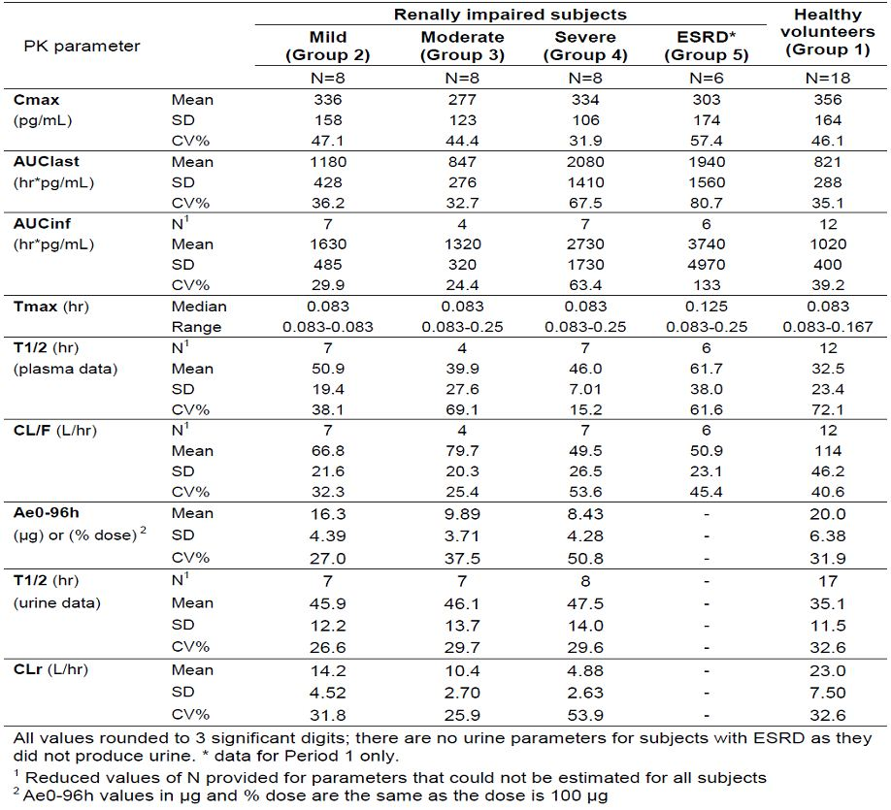

*Comments: The sensitivity analysis shows slightly different results to the primary analysis. A ratio of 1.42 was observed for AUC last in the mild group (vs 1.58 in primary analysis) whilst the moderate group had a similar AUClast with a ratio of 1.02 (vs 0.96 in primary analysis). Ratios for the severe and ESRD groups for AUC were 2.21 and 2.07 respectively. A reason for the difference in results between primary and sensitivity analysis may be due to the fact that, for the latter, all 18 HVs were used to estimate the model parameters, whilst the main primary analysis only compared the RI group with the corresponding matched subset of HVs, i.e. to data in 6 to 8 HVs. The sensitivity analysis comparing each RI group with the entire healthy volunteer (HV) group is considered to be more robust than the analysis of each RI group with paired HVs.*

##### Pharmacokinetics according to age, body weight

A population PK analysis including data of three studies in CODP patients identified body weight and age as intrinsic physiological factors contributing to inter-patient variability in systemic exposure to NVA237. When taking patients of age 60 to <65 years as reference, median AUCtau was 27% higher in patients of age 75 to 80 years, and 25% lower in patients of age 40 to <45 years.

##### Pharmacokinetics related to genetic factors

###### Gender

Gender had no apparent effect on exposure [NVA237-population-pk].

###### Ethnicity

The Phase 2, randomised, crossover study NVA237 A2104 to evaluate effect of race (Japanese vs Caucasian) on NVA237 PKs, NVA237 was systemically available shortly after inhalation. In both ethnic groups, median tmax was reached 5 minutes after inhalation at all dose levels. Systemic exposure (Cmax, AUC0-last) and urinary excretion of NVA237 (Ae0-48) were on average 30% to 80% higher in Japanese than in Caucasian subjects. Renal clearance (CLR), which was determined only for the 100 μg and 200 μg doses, was similar for both ethnic groups. The CLR, which was determined for the 100 ug and 200 μg doses, was similar for both ethnic groups and doses Cmax and Ae0-48 of NVA237 showed dose proportionality across the 50 μg to 200 μg dose range for both Japanese and Caucasian subjects. Mean AUC0-last increased about 6-fold (Caucasians) and 5- fold (Japanese) across the 50 μg to 200 μg dose range. The urinary excretions (Ae 0-48) of QBA608 and QBA609, the enantiomers of NVA237, were determined in a subset of subjects and the QBA608/QBA609 ratio was close to 1.0 in both ethnic groups. The higher systemic exposure to NVA237 in Japanese compared to Caucasian subjects was not associated with any safety concerns.

*Comments: The difference in exposure between Japanese and Caucasian subjects was more marked for Cmax (the point estimates of the ratios of the geometric means Japanese/Caucasians ranged between 1.76 and 1.84 across the three doses) than on the AUC0-last (the ratios ranged between 1.31 and 1.49). However, the Caucasians included in this study showed the lowest exposures when compared with other healthy volunteer studies. The urinary excretion (Ae0-48) of NVA237 was also higher in Japanese subjects, in the same order of magnitude as AUC0-last (the Ae0-24 ratios ranged between 1.38 and 1.46 across the three doses). Hence the renal clearance CLR, which could be determined for the 100 μg and 200 μg doses, was similar for both ethnic groups. This indicates that there is no significant ethnic difference in the renal elimination of NVA237. The mean percentage of the dose of NVA237 excreted into urine ranged from 9.5% to 10.2% in Caucasian subjects and from 13.0% to 15.5% in Japanese subjects across the three doses.*

*The effect of ethnicity was further studied in a population PK analysis which showed no difference in the apparent total clearance of NVA237 between Japanese and Caucasians COPD patients. Therefore, the steady-state total exposure (AUCtau) at the same dose level was similar between these two patient populations. Peak exposure, however, was higher in Japanese compared to Caucasian patients (NVA237-population-pk). Differences in the inhalation technique (which may have an impact on the proportion of the drug substance reaching the lungs), differences in the lung absorption process, or both might be involved.*

##### Pharmacokinetics (in other special population / according to other population characteristic)

Smoking status and baseline FEV1 had no apparent effect on exposure [NVA237-population-pk]. Compared to patients with a body weight of 70 to <80 kg, median steady state AUCtau was 15% lower in patients with a body weight of 90 to 100 kg, and 44% higher in patients with a body weight of 40 to <50 kg.

#### Pharmacokinetic interactions

##### Pharmacokinetic interactions demonstrated in human studies

NVA237 is a substrate for the cationic SLC transporter OCT2 (organic cation transporter 2) and MATE1 (multidrug and toxin extrusion protein). OCT2 and MATE1 are believed to act in concert to accomplish the renal tubular secretion of NVA237 in humans. Study CNVA237A2109 was designed to characterize the effect of inhibition of the organic cation transport in the kidneys on NVA237 disposition using cimetidine as a probe inhibitor. Cimetidine trough concentrations indicated that PK steady state of cimetidine was reached before (Day 2) the single dose of NVA237 was administered in Treatment B. Concomitant administration of cimetidine resulted in an increase of total systemic exposure of NVA237 (AUClast) by 22%, which correlated with a slight decrease of 23% in renal clearance. Peak exposure (Cmax) was not affected. The secondary parameter AUC0-24h showed a similar increase in exposure as AUClast, whereas AUCinf and Ae0-72h were not significantly affected by co-administration of cimetidine (90% CIs included 1.0).

*Comments: The statistical results for AUCinf should be interpreted with caution since AUCinf values could only be estimated in less than half of the subjects in both treatments. When assessing the overall effect of cimetidine on the exposure of NVA237, the results for AUClast and AUC0-24h (which were available for all 20 subjects in both treatments) are considered to be the relevant data.*

In study QVA149 A2101, total systemic exposure (AUC0-last) and Cmax of NVA237 was similar after administration of QVA149 (fixed combination of NVA237 and indacaterol) and the free combination of NVA237 and indacaterol compared to NVA237 alone. Total systemic exposure (AUC0-last) and peak exposure (Cmax) to indacaterol were higher for QVA149 (by 25% and 49%, respectively) and the free combination (by 14% and 18%, respectively) compared to indacaterol alone. In study QVA149 A2103, steady-state systemic exposure (AUC 0-24h and Cmax,ss) of NVA237 was higher (by 34% and 42%, respectively) after administration of the fixed-dose combination QVA149 110/50 μg compared to NVA237 50 μg given alone. *In vitro* investigations showed that there has been an unexpected drop of about 25% in the fine particle dose (FPD) of NVA237 in the mono formulation and this is assumed to be the cause for the lower exposure observed with the mono formulation. Standard bioequivalence criteria were met for AUC0-24h of QAB149. Apparent Cmax,ss of QAB149 was, on average, 24% higher for QVA149 than for QAB149. In study QVA149 A2106, the steady-state systemic exposure to NVA237 was similar between the fixed dose combination QVA149 (110 μg QAB149/50 μg NVA237) and NVA237 (50 μg) given alone; standard bioequivalence criteria (i.e. 90% CI of the treatment ratio within 0.80 to 1.25) were met for AUC 0-24h and Cmax,ss.

##### Clinical implications of in vitro findings

*In vitro* inhibition studies demonstrated that NVA237 has little or no capacity to inhibit CYP1A2, CYP2A6, CYP2C8, CYP2C9, CYP2C19, CYP2D6, CYP2E1 or CYP3A4/5, the ATP-binding cassette (ABC) efflux transporters MDR1, MRP2 or MXR, and the solute carrier (SLC) uptake transporters OCT1 or OCT2. Therefore, NVA237 is unlikely to alter the clearance of drugs that are mainly cleared through metabolism by the major CYP P450 isoenzymes and/or of drugs whose absorption or disposition is mediated by ABC or SLC transporters. *In vitro* enzyme induction studies suggest that there would be no clinically relevant induction by NVA237 for of all the enzymes and transporter tested (CYP1A1, CYP1A2, CYP2A6, CYP2B6, CYP2C8, CYP2C9, CYP2C19, CYP3A4, CYP3A5, UGT1A1, MDR1 and MRP2).

### Evaluator’s overall conclusions on pharmacokinetics

The absolute bioavailability of orally inhaled NVA237 (Fabs) was estimated to be about 40% and about 90% of systemic exposure following inhalation of NVA237 via the Concept1 device is due to lung absorption and 10% is due to gastrointestinal absorption. The fraction of the inhaled dose which is deposited and absorbed in the lungs following inhalation using Concept1 was estimated to be about 36% of the nominal inhalation dose.

While initial absorption from the lung causes an early plasma concentration peak of NVA237 (median Tmax is 5 min after inhalation), a sustained lung absorption and/or transfer of NVA237 into the systemic circulation is thought to result in the late elimination phase of inhaled NVA237. This phase is much longer after NVA237 inhalation (T1/2 was up to 57 hours) than after intravenous NVA237 dosing (T1/2 was up to 6.2 hours) (study A2108). The elimination pattern of inhaled NVA237 is not reproduced after oral ingestion of NVA237 (T1/2 after oral intake is only 2.8 hours).

Following repeated once-daily inhalation of NVA237 by patients with COPD, PK steady-state of NVA237 was reached within one week of treatment. The steady-state mean peak and trough plasma concentration of NVA237 for a 50 μg once-daily dosing regimen was 166 and 8 pg/mL, respectively. With once-daily doses of 100 and 200 μg, steady-state exposure (AUC0-24h) to NVA237 was about 1.4- to 1.7-fold higher than after the first dose.

In the dose range of 50 μg to 200 μg NVA237, systemic exposure to NVA237 as well as total urinary excretion increased about dose-proportionally after single inhalation by healthy volunteers (CNVA237A2104) as well as after repeated once-daily inhalation by patients with COPD (CNVA237A2103) at pharmacokinetic steady state.

Urinary excretion data of NVA237 at steady-state compared to the first dose suggested that systemic accumulation is independent of dose in the dose range of 25 to 200 μg. The effective half-life of accumulation was approximately 16 to 22 hours which is consistent with the observed time to steady-state of about 6 days (CNVA237A2103).

Following inhalation of single and repeated once-daily doses between 50 and 200 μg NVA237 by healthy volunteers and patients with COPD, 60-70% of elimination of parent drug was by renal clearance; the mean amounts of NVA237 excreted into the urine varied between 7.7% and 20.0% of the dose, depending on the time interval considered (up to 24, 48, 72 or 96h). Mean renal clearance (CLr) of NVA237 following inhalation was in the range of 17.4 and 24.4 L/h, including data for healthy volunteers (after single dose) and patients with COPD (both after single and repeated dosing). Active tubular secretion contributes to the renal elimination of NVA237.

NVA237 (like the currently marketed glycopyrronium bromide) is a racemic mixture of two enantiomers, i.e. the [3S,2R] stereoisomer (Novartis code: QBA608) and the [3R,2S] stereoisomer (Novartis code: QBA609). Since the molecule has two asymmetrical carbon atoms, a second pair of stereoisomers exist with [3R,2R] and [3S,2S] configuration. This pair of stereoisomers is described as an impurity of NVA237 and is limited in the drug substance to ≤ 0.1%. Urinary excretion data of the enantiomers of NVA237 ([3S,2R] and [3R,2S] stereoisomers) following inhalation of NVA237 by healthy volunteers and COPD patients suggested similar apparent pharmacokinetics of the two enantiomers [CNVA2372103] [CNVA2372104].

*In vitro* metabolism studies showed consistent metabolic pathways for glycopyrronium bromide between animals and humans. No human specific metabolites were found. Hydroxylation resulting in a variety of mono-and bis-hydroxylated metabolites and direct hydrolysis resulting in the formation of a carboxylic acid derivative (M9) were seen. No glucuronides or glutathione (GSH) adducts were observed. After inhalation, systemic exposure to the metabolite (M9) was on average in the same order of magnitude as the exposure to parent drug. After both IV and inhalation routes of administration, only minimal amounts of CJL603 were found in the urine. Study [CNVA237A2109] was conducted to characterize the effect of inhibition of the organic cation transport on NVA237 disposition using cimetidine as a probe inhibitor. Cimetidine increased total exposure (AUClast) to NVA237 by 22% and decreased renal clearance by 23%. Based on the magnitude of this change, no clinically relevant drug interaction is expected when NVA237 is co-administered with cimetidine or other drugs interacting with this pathway. PKs of NVA237 were not affected by concomitant administration of orally inhaled NVA237 and orally inhaled indacaterol (free combination or fixed combination, QVA149) under steady state conditions in studies QVA149-A2101 and -A2106. In study QVA149 A2103, steady-state systemic exposure (AUC 0-24h and Cmax,ss) of NVA237 was higher (by 34% and 42%, respectively) after administration of the fixed-dose combination QVA149 110/50 μg compared to NVA237 50 μg given alone (which may have been due to an unexpected drop of about 25% in the fine particle dose [FPD] of NVA237 in the mono formulation as shown by i*n vitro* investigations). The involvement of multiple CYP isoenzymes in the oxidation of NVA237 suggests that the metabolism of NVA237 may not be readily inhibited by a single specific CYP inhibitor. Furthermore, metabolism is likely to play a secondary role in the elimination of NVA237 and drug-drug interactions due to inhibition or induction of NVA237 metabolism by co-medications are expected to be of minor clinical importance. The co-administration of NVA237 with inhaled anticholinergic containing drugs has not been studied and is therefore, like for other anticholinergics, not recommended.

NVA237 exposure increases with increasing patient age and decreases with increasing body weight. NVA237 PKs were not evaluated in patients with hepatic impairment, but this has been clearly mentioned in the proposed PI. Exposure to NVA237 was increased in patients with moderate/ severe renal impairment. Systemic exposure (Cmax, AUC0-last) and urinary excretion of NVA237 (Ae0-48) were on average 30% to 80% higher in Japanese than in Caucasian subjects, but the increased exposure did not lead to any safety concerns in Japanese subjects (CNVA237 A2104). Overall there did not appear to be any meaningful differences in systemic exposure between healthy subjects and subjects with COPD both after single dose and at steady-state, although renal clearance was reduced in COPD patients (which may most likely be related to increased age and renal impairment in COPD patients).

Limitations of NVA237 PK data:

* No drug interaction studies were conducted between NVA237 and other oral/inhaled medications commonly used in COPD.
* The possibility of kinetic interaction between NVA237 and smoking cessation aids or nicotine replacement therapy was not investigated (as mentioned in the CPMP guidelines).

## Pharmacodynamics

### Summary of pharmacodynamics

The information in the following summary is derived from conventional pharmacodynamic studies in humans unless otherwise stated.

#### Mechanism of action

Of the five known muscarinic receptor subtypes (M1-5), only subtypes M1-3 have a defined physiological function in the human lung. Glycopyrronium bromide is a high affinity muscarinic receptor antagonist of these three receptor subtypes. It demonstrated 4- to 5-fold selectivity for the human M3 and M1 receptors over the human M2 receptor in competition binding studies. It has a rapid onset of action as evidenced by observed receptor association/dissociation kinetic parameters and the onset of action after inhalation in clinical studies. NVA237 (like the currently marketed glycopyrronium bromide) is a racemic mixture of two enantiomers, i.e. the [3S,2R] stereoisomer (Novartis code: QBA608) and the [3R,2S] stereoisomer (Novartis code: QBA609). Since the molecule has two asymmetrical carbon atoms, a second pair of stereoisomers exist with [3R,2R] and [3S,2S] configuration. This pair of stereoisomers is described as an impurity of NVA237 and is limited in the drug substance to ≤ 0.1%. The majority of the biological activity of NVA237 was shown to rest upon the [3S,2R] enantiomer (“eutomer”), which has 100-fold greater affinity for the M3 receptor than the [3R,2S] enantiomer (“distomer”). NVA237 was developed as a racemate consistent with other Marketing Authorizations for clinical uses of GP in other indications and formulations.

#### Pharmacodynamic effects

##### Primary pharmacodynamic effects

In Phase 2, parallel group study NVA237 A2206, mean trough FEV1 showed statistically significant improvement with NVA237 treatment at both 100μg and 200μg dose levels on Day 28 and Day 1 (Table 4). The improvement was statistically significant relative to placebo for all scheduled time points; the LS means of FEV1 improved relative to placebo from 5 mins post-dose on Day 1 for both NVA237 doses, and was highest in the active treatment groups at 2 to 4 hours post-dose on Days 1, 14, and 28 (Table 5). Both NVA237 treatment groups demonstrated statistically significant improvement compared to placebo in FVC at every post baseline timepoint on Days 1, 14, and 28. At Days 1, 14 and 28, for both NVA237 treatment groups, the highest FEV1 values (FEV1 (L) peak) were statistically significantly higher than recorded with placebo. The standardized AUC of FEV1 5 minutes-5 hours post dose at Day 1, Day 14, and Day 28, was statistically significant in favour of NVA237 compared to placebo.

Table 4: Least squares means of trough FEV1, peak FEV1, and standardised AUC (5 mins – 5 hours) FEV1 by day (ITT population).

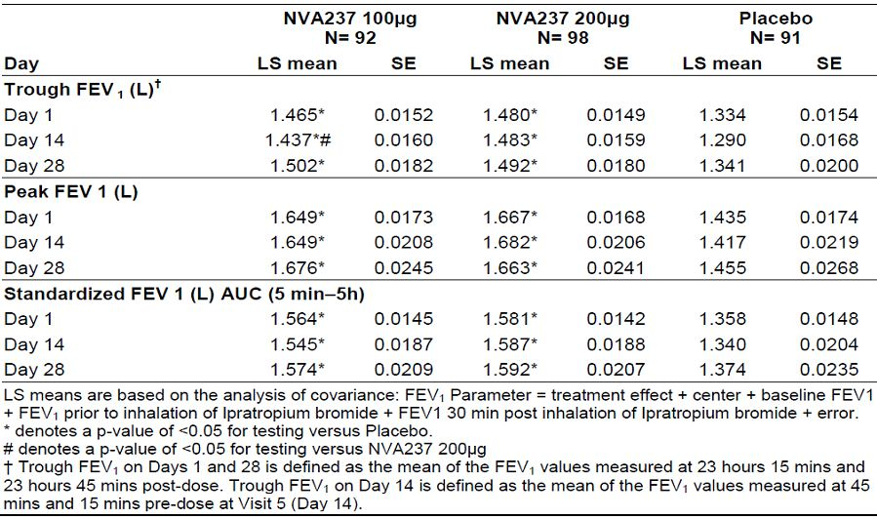

Table 5: Least squares means of FEV1 (L) at single time points on Days 1, 14 and 28 (ITT population).

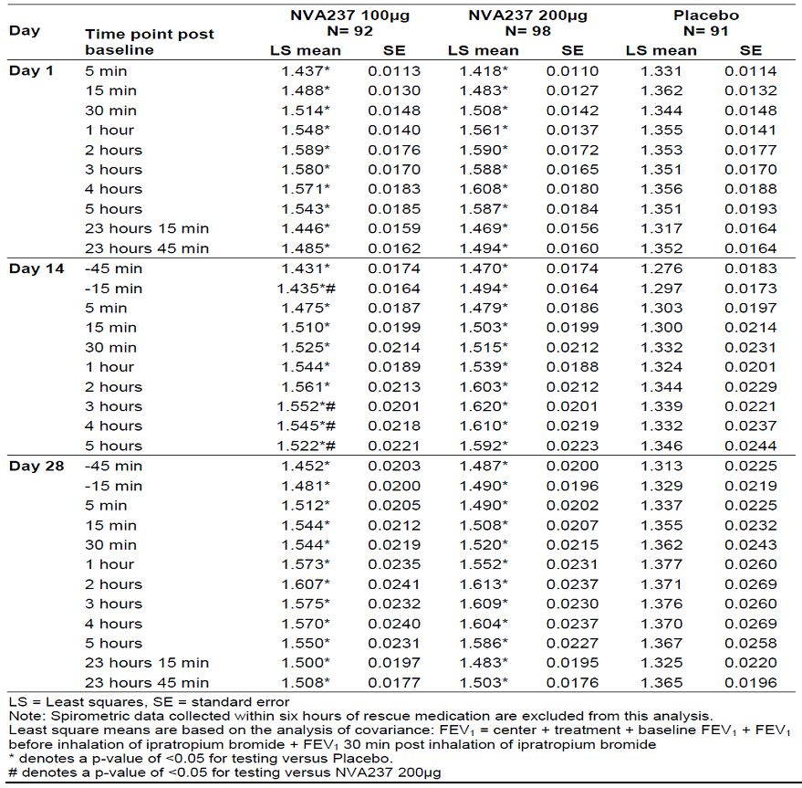

*Comments: This study provided evidence for rapid onset of action of NVA237 although the proposed dose of 50ug was not evaluated in this study.*

##### Secondary pharmacodynamic effects

In the Phase 3, two-period (each of 3 weeks), crossover, placebo-controlled study NVA237 A2310, treatment with 50 μg NVA237 q.d. showed a significant effect on the primary endpoint, exercise endurance time, after 3 weeks of treatment. Endurance time was improved by 89 seconds from 417 s to 506 s (p <0.001). The effect on exercise tolerance was smaller but already significant on Day 1, with the 95% CI for the treatment comparison between NVA237 and placebo exceeding 0. Treatment with 50 μg NVA237 q.d. showed a significant effect on the key secondary endpoint, IC at isotime at Day 21. IC at isotime was improved by 0.20 L from 2.02 L to 2.22 L (p <0.001). Almost the same effect on IC at isotime was already reached at Day 1.

All secondary comparisons based on spirometric and Bodybox parameters at Day 21 showed significant effects of NVA237 as evidenced by 95% CIs excluding 0, with the exception of resting IC at trough and SVC at pre-dose (-1h) which showed numerical trends. For most of the parameters, significant effects were already achieved on Day 1.

NVA237 treatment was observed to be superior to placebo at Day 1 and Day 21 for peak FEV1 with the 95% confidence intervals being above 0 for all treatment comparisons; the difference between treatment groups at Day 21 was 0.25 L. The difference between NVA237 and placebo treatment in FEV1 at trough at Day 1 and Day 21 was 0.11 L on both days, and the 95% confidence intervals for the treatment difference to placebo were above 0, suggesting a significant effect of NVA237. The effects for FVC at peak and trough were consistent with those for FEV1 but the effect magnitude was higher than that for FEV1.

After 3 weeks the NVA237 to placebo difference was an improvement of 1.16 (-1.16) points for exertional dyspnea and an improvement of 0.84 (-0.84) points for leg discomfort, using the Borg CR10 Scale.

Patients taking 50 μg NVA237 o.d. took fewer rescue medications than patients taking placebo between Day 1 and Day 21. There were no consistent effects of 50 μg NVA237 o.d. treatment compared to placebo, at Day 1 and Day 21, on systolic and diastolic blood pressure and heart rate at isotime during the exercise test. At Day 21 the focal score for TDI was much higher in the NVA237 group (2.78) compared to the placebo group (0.49) indicating clinically significant symptomatic improvement from baseline in the NVA237 treatment group.

*Comments: Most patients with COPD have a reduced inspiratory capacity resulting from the fact that their lungs are chronically hyperinflated which is especially relevant under exercise conditions. As the breathing rate of a COPD patient increases under exercise, the time for exhalation of air is reduced which increases the amount of air remaining in the lung at the end of a breath cycle (dynamic hyperinflation) and reduces the amount of air that can be taken up during the next breathing cycle? The parameter for characterizing this amount of air is inspiratory capacity (IC) under exercise conditions. In this study, NVA237 increased the IC under exercise achieving already the full effect size on the first day of treatment but with greater improvements after 3 weeks of treatment which may be due to adaptive responses in the body. Treatment periods longer than 3 weeks may potentially yield larger treatment improvements in exercise endurance, but this was not evaluated. In a trial investigating endurance time after tiotropium inhalation the mean difference in endurance time of 40 s, between tiotropium and placebo after the first dose of trial medication, did not reach statistical significance. There was a statistically significant difference in endurance time between tiotropium and placebo after 21 days (67 s, p=0.039, 13.6% difference) and after 42 days of treatment (105 s, p=0.0098, 21.4% difference) (O’Donnell et al, 2004). Overall the effects on exercise endurance (about 21% improvement after three weeks) in this study were similar to those observed with tiotropium.*

*Limitations of study: Adaptation to exercise may have had an effect on parameters although washout of 2-3 weeks seems adequate. This study only provides preliminary evidence which needs to be explored in long term parallel group studies before beneficial effect on exercise endurance can be claimed for NVA237.*

#### Time course of pharmacodynamic effects

Study NVA 237 A2207 involving 33 COPD patients showed significant bronchodilatory efficacy of 50 μg NVA237 (compared to placebo) over 24 hours following once daily administration for 14 days. On Day 14 there was some fluctuation in the placebo corrected mean FEV1 values with the peak effect 1 hour after dosing. The values decreased from 1 hour to 8 hours post dose and then increased again to a secondary peak at 13 hours post dose. Thus, the bronchodilatory effect at Day 14 was sustained over 24h with some fluctuations. The smallest difference to placebo was at 8h after dosing. However, variability in FEV1 at each sampled time-point as indicated by the SE bars was quite pronounced (Figure 2). The separation between placebo and NVA237 in FEV1 AUC becomes evident when the profiles are averaged over the 24h sampling time. FEV1 AUC0-24h values were higher for NVA237 than placebo with the difference being 163 mL (P<0.001); this difference increased slightly to 168 mL (P<0.001) when the patients who had taken rescue medication within 6 hours of the spirometry assessments were removed from the analysis (2nd efficacy analysis set) and consistent increase in FEV1 by more than 120 mL was shown for all AUCs calculated (P≤0.001). The AUC0-12h and AUC 0-24h which could be obtained from the full 24 h profile on Day 14 were very similar indicating a constant bronchodilator effect over the first and second portion of the dosing interval.

Figure 2: Plot of mean 24h profiles of FEV1 (with SE bars) on Day 14 (Efficacy Analysis Set).

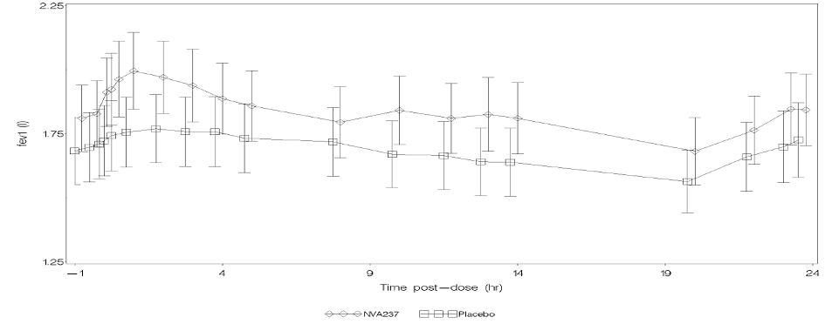

Results of the secondary efficacy analysis were consistent with those of the primary efficacy analysis set. All primary analysis FEV1 comparisons showed a significant effect (at the 5% significance level) with the exception of the treatment difference in trough value for NVA237 on Day 7 which was 91 ml and was statistically significant at the 10% level. Results for FVC reflected those for FEV1 with an improvement observed in all of these analyses when patients were treated with NVA237, the smallest effect being observed for trough values on Day 7 where there was an improvement of 121 mL (P=0.063) which was significant at the 10% level. The maximum improvement in AUC was determined over 0-5hr on Day 14, being equal to 225 mL (95% CI: 0.066, 0.384; P=0.006).

*Comments: The bronchodilatory effect appeared to be well sustained over the full 24 h dosing interval which was evidenced by a sustained trough effect, the FEV1 response profile over 24 h and the similarity of the bronchodilator response over the first (FEV1 AUC0-12h) and second (FEV1 AUC12-24 h) fraction of the dosing interval. However, a modelling and simulation to predict the full dosage interval response from less dense sampling was not feasible due to the high variability within the 24 hour profile. Variability was large, with the 95% confidence intervals spanning a range of about 0.2L, i.e. roughly the size of the drug signal. As a result, the 24 hour profile showed numerous fluctuations making it hard to interpret the results.*

In the Phase 2 study NVA237 A2208 involving 325 COPD patients**,** both once and twice daily dosing with NVA237 was shown to produce bronchodilation which was dose dependent. Of the once daily doses evaluated, only 50μg and 100 μg doses were found to produce clinically relevant improvements in FEV1 over 24h, with the 100 μg dose providing a small incremental benefit over the 50μg dose (Figure 3). An evaluation of the total daily doses 25, 50 and 100 μg, showed that at each dosing level the twice daily regimen gave marginally superior bronchodilation for endpoints assessed between 12 and 24 hours post dosing, conversely, the once daily regimen gave marginally superior bronchodilation for endpoints assessed between 0 and 12 hours post dosing. The values for FEV1 AUC0-24h at day 28 (Figure 4) were very similar for once daily and twice daily therapy at each of the total daily dosing levels evaluated (25, 50 and 100 μg), the largest difference in favour of twice daily therapy being 0.008, which was not expected to be clinically meaningful.

Figure 3: Dose response curves of trough FEV1 for Day 28 for model-averaged analysis by treatment regimen (Full Analysis Set).

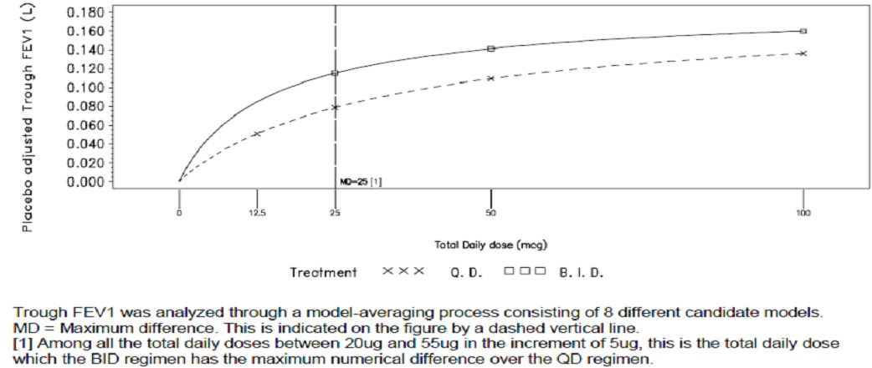

Figure 4: Trough FEV1 (L) (including 90% CIs) for Day 28 for model-averaged analysis by treatment regimen (Full Analysis Set).

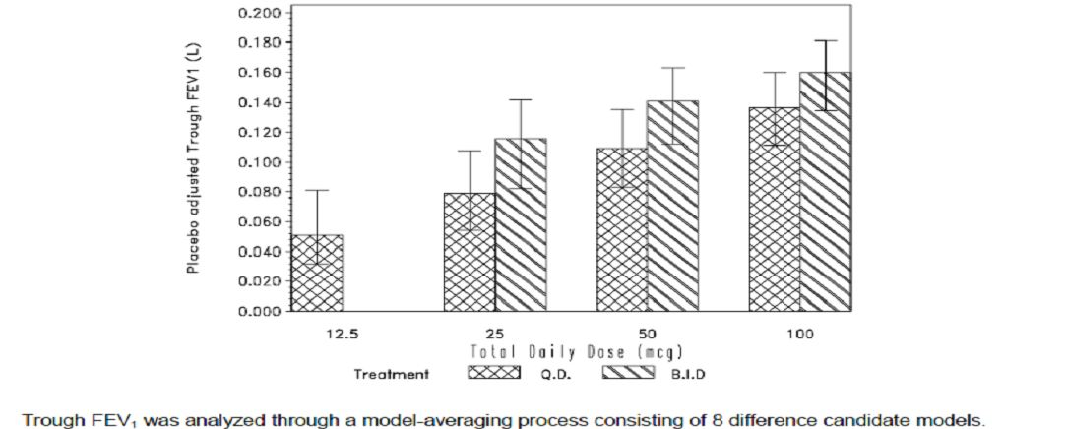

##### Relationship between drug concentration and pharmacodynamic effects:

In study NVA237 A2103, Emax FEV1 increased compared to placebo for all doses on both Days 1 and 14 but most notably for the NVA237 50 and 200 μg doses on Day 1 with mean difference from placebo of 295 mL and 298 mL (P=0.009 and 0.005 respectively). Trough FEV1 on Day 14 showed statistically and clinically significantly greater improvement for NVA237 50 μg compared with placebo (diff= 477 mL, p=0.004). No other dose showed a statistically significant improvement in trough FEV1 .Other secondary variables showed similar results. No pharmacokinetic/pharmacodynamic correlation was observed by comparing the concentration-time profiles to the mean time profiles (corrected for baseline) of FEV1 and FVC. The marked NVA237 concentration peaks observed after inhalation followed by the slow decline in concentrations did not bear any relation to the mean FEV1 and FVC time profiles which showed responses of small amplitudes and multiple small peaks over time. In addition there was a slight dose response observed for spirometry on Day 1, which was less marked on Day 14 as opposed to the accumulation observed in systemic exposure. Overall, there was no PK/PD correlation between the NVA237 systemic exposure after inhalation and the drug response as characterized by FEV1 and FVC.

#### Genetic, gender and age related differences in pharmacodynamic response

Not evaluated.

#### Pharmacodynamic interactions

Not evaluated.

### Evaluator’s overall conclusions on pharmacodynamics

NVA237 is an inhaled anti-muscarinic acetylcholine receptor blocker that has a fast onset and long duration of action. *In vitro* evaluation of the duration of action of NVA237 as an M3 muscarinic receptor antagonist has been measured on the rat isolated trachea and compared with clinically used muscarinic antagonists of differing clinical duration of action. The duration of action of NVA237 (NVP-QAM254) in this model was intermediate between ipratropium bromide and tiotropium bromide. A Brown Norway rat model of bronchoconstriction was used to study the duration of action of NVA237 *in vivo.* Muscarinic agonist-induced bronchoconstriction was markedly reduced by intratracheal installation of NVA237 and this effect was maintained 24h post-dose, although the potency of NVA237 slightly decreased over this time period (Module 2.6.2). In humans, the bronchodilator effect starts within 5 minutes of dosing. Whilst NVA237 has a fast onset of action it shows sustained bronchodilator effects over 24 h as evidenced by the 24h FEV1 response profiles of the compound and the robust and consistent effects on trough FEV1 across Phase II and III trials [CNVA237A2205] [CNVA237A2206] [CNVA237A2207] [CNVA237A2208] (CNVA237A2303) [CNVA237A2304]. The long duration of action of NVA237 may be explained by its pharmacokinetic properties as the inhaled administration of NVA237 leads to a much longer elimination half life (of up to 57 h) when compared to the terminal elimination half life after i.v. administration [CNVA237A2108].

Across dose finding studies, consistent clinically meaningful effects on FEV1 were achieved at a daily dose of 50 μg once daily up to 200 μg once daily (CNVA237A2205, CNVA237A2206, CNVA237A2208). Dose-response and selection of proposed Phase clinical trial and marketing dose of 50ug has been discussed in detail in section 6 (page 31 of this report).

In addition, the bronchodilator effects of NVA237 50 μg lead also to an improvement in exercise tolerance by about 20% within 3 weeks when compared to placebo. This effect is achieved by reducing static and dynamic hyperinflation. The effects on exercise endurance were statistically significant from the first dose onwards (CNVA237A2310). The findings on exercise endurance were consistent with the results of the comprehensive set of spirometric and body plethysmographic endpoints investigated under resting conditions in this trial. FEV1 effects are also in line with the magnitude of effect that has been observed with 50 μg NVA237 in previous clinical trials. The effect on trough FEV1 (stipulated as primary endpoint in most Phase 3 efficacy trials with NVA237) at Day 21 was 0.11 L. Treatment with 50 μg NVA237 q.d. also reduced exertional dyspnea and leg discomfort during exercise, it reduced dyspnoea measured by TDI. There was no consistent effect on heart rate or blood pressure values under exercise being reflective of the low systemic effect potential of NVA237 under exercise conditions. Adaptation to exercise in this crossover study may have had an effect on exercise tolerance although washout of 2-3 weeks seems adequate. Overall, study A2310 provides preliminary evidence which needs to be explored in long term parallel group studies before beneficial effect on exercise endurance can be claimed for NVA237.

The therapeutic index of NVA237 is large. Multifold higher systemic concentrations were well tolerated by healthy subjects after i.v. administration. The peak exposures (Cmax) after i.v. administration constituted more than 10-fold of the peak exposure after inhaled administration of 200 μg NVA237. These exposure levels did not result in any clinically relevant tachycardia as would be expected for high exposures to antimuscarinic compounds and did not result in QTc-prolongation (CNVA237A2108). These findings are in line with the fact that oral and injectable GP has been used in clinical practice for many years at much higher dose levels than inhaled NVA237.

Overall, there was no PK/PD correlation between the NVA237 systemic exposure after inhalation and the drug response as characterized by FEV1 and FVC (study CNVA237A2103).

Therefore, in conclusion, inhaled NVA237 has a rapid onset of action, sustained bronchodilator activity over 24 hours and has a very wide therapeutic index; it also showed preliminary evidence of increased exercise tolerance (by reducing dynamic hyperinflation) in study CNVAA2310, but this action needs to be confirmed in long-term, parallel group studies.

## Dosage selection for the pivotal studies

In the Phase 2, double-blind, dose-ranging, crossover study NVA237 A2205 involving 383 COPD patients, treatment with NVA237 resulted in a dose-related increase in FEV1 values beginning 5 minutes after the inhalation of study drug and lasting for 24 hours. On day 1, all doses of NVA237 resulted in significantly greater LSmean trough FEV1 values than placebo, as did tiotropium bromide. A dose response effect was evident for NVA237 as increasing doses of NVA237 resulted in increased LS mean trough FEV1 values at Day 7The peak FEV1 values on Day 7 were greatest for the highest dose of NVA237 (100 ug), followed by 50, 25 and 12.5 ug. Both the 50 and 100μg NVA237 doses resulted in trough FEV1 values greater than that set for a clinically relevant effect (120 mL). There was no difference in peak FEV1 value between Day 1 and Day 7. All doses of NVA237 showed significantly greater peak FEV1 than placebo, and on Day 1 both the 50 and 100 ug doses were significantly greater than tiotropium bromide. However, on Day 7 the tiotropium bromide peak FEV1 value was no longer significantly lower than NVA237. The minimally effective dose (to produce an increase in trough FEV1 on Day 7 of 120 mL) was calculated to be 42 μg. The MED calculated for Japanese patients were slightly lower than for the non-Japanese population (33 ug versus 45 ug).

The standardized FEV1 AUC5min-5h showed a dose response on both treatment days. Again, NVA237 values were significantly greater than placebo at all doses and on both days, and were greater than tiotropium bromide on Day 1 for the 50 and 100 μg doses. FVC was also increased in a dose-related manner, with all doses of NVA237 increasing FVC to a significantly greater degree than placebo on both Day 1 and Day 7. Levels peaked at approximately 2 to 3 hours post-dose on day 1. Similar results were observed on Day 7. Tiotropium bromide resulted in significantly higher FVC readings than placebo at all postdose time points on Day 1 and at all time points on Day 7. The LS mean FVC values for NVA237 12.5 ug dose were significantly lower than tiotropium bromide from 3 hours postdose onwards on both Day 1 and Day 7. Inhalation of tiotropium bromide did not result in a significantly greater increase in FEV1 or FVC than 50 or 100 μg NVA237. The Japanese sub-population appeared to be as successfully treated by NVA237 as the entire study population**.**

NVA237A2208 was a randomised, double-blind, placebo-controlled, 2-period, cross-over study to assess the efficacy and safety of different doses of NVA237 administered either once daily or twice daily in 388 patients with moderate to severe chronic obstructive pulmonary disease (COPD). On Day 28, the b.i.d. regimen provided greater improvement in trough FEV1 than the q.d. regimen for the total daily doses of 25 μg, 50 μg, and 100 μg (Figures 3-4). For the 50 μg q.d. dose the treatment difference (NVA237 – placebo) was 0.109L (58.5% Emax), compared with 0.141L (75.5% Emax) for 25μg b.i.d. and 0.115L (61.6% Emax) for 12.5 μg b.i.d. The 100 μg q.d. dose provided a small incremental benefit over the 50 μg q.d. dose (0.027L). The model assumed that the differences in treatment effect between regimens would decrease to zero as the total daily dose increased. To evaluate the sensitivity of this assumption, the primary analysis was repeated without this assumption and results from these two analyses were similar.

A key secondary modelling outcome derived from the primary analysis was an overall comparison of b.i.d. and q.d. regimens for NVA237, based on the trough FEV1 responses as predicted after 28 days treatment. The primary comparison was the maximum difference in mean response between b.i.d. and q.d. regimens over the range of 20 to 55 μg daily dose (this dose range was selected based on earlier clinical data and modelling and was intended to reflect the region of the dose response curve which was predicted *a priori* to show the maximum difference between once and twice daily therapy for the efficacy evaluations made in the study). Analysis evaluating the maximum difference in mean response of trough FEV1 between dosing regimens over the total daily dose range of 20 μg to 55 μg[1] indicates that the differences between the two regimens were small and not clinically meaningful (greatest difference between the two regimens was 0.037L; 90% CI=0.013, 0.052). This occurred at the total daily dose of 25 μg, with the b.i.d. regimen providing a larger treatment difference compared to placebo than that observed for the q.d. regimen.

Within each treatment regimen there was a dose-related increase in AUC 0-24h FEV1. The treatment differences for all NVA237 doses compared to placebo ranged from 0.058L (28.9% Emax) for the 12.5 μg q.d. treatment group, to 0.158L (79.3% Emax) for the 50 μg b.i.d. treatment group. There was little difference between the q.d. and b.i.d. regimens for improvement in AUC 0-24h FEV1 compared to placebo for the total daily doses of 25 μg, 50 μg, and 100 μg. For the 50 μg q.d. dose, the treatment difference was 0.123L (61.9% Emax) compared with 0.131L (65.7% Emax) for 25μg b.i.d. and 0.098L (49.0% Emax) for 12.5 μg b.i.d (Figure 5). As with trough FEV1, the 100μg q.d. dose gave only a small incremental benefit over 50μg q.d. (0.024L). For the total daily doses of 25μg, 50ug and 100 μg, the differences between the once and twice daily regimens were neither statistically significant nor clinically meaningful.

Figure 5: FEV1 AUC0-24h for Day 28 for model-averaged analysis by treatment regimen (Full Analysis Set).

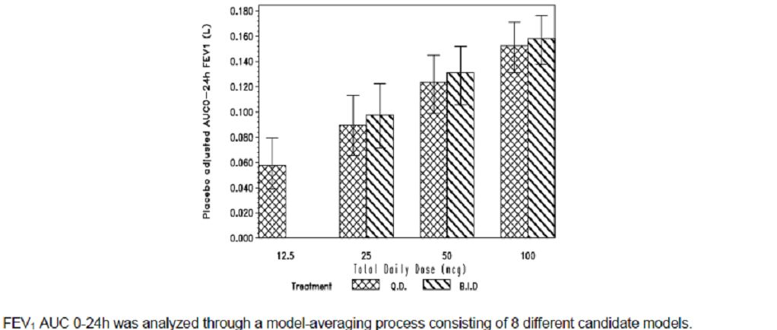

When comparing the regimens, the q.d. regimen provided a greater improvement in AUC0-4h FEV1 than the b.i.d. regimen for the total daily doses of 25 μg, 50 μg and 100 μg. For the 50 μg q.d. dose the treatment difference (NVA237-placebo) was 0.165L (79.7% Emax) compared with 0.153L (73.7% Emax) for 25μg b.i.d. Similar results were observed for AUC 0-8h FEV1 showing greater improvement with once daily regimen than the b.i.d. regimen for total daily doses of 25 μg, 50 μg and 100 μg. For the 50 μg q.d. dose, the treatment difference (NVA237-placebo) was 0.156L (77.1% Emax) compared with 0.145L (71.4% Emax) for 25μg b.i.d. When comparing the regimens, the q.d. regimen provided a greater improvement in AUC0-12h FEV1 than the b.i.d. regimen for the total daily doses of 25 μg, 50 μg and 100 μg. For the 50 μg q.d. dose the treatment difference (NVA237-placebo) was 0.152L (73.6% Emax) compared with 0.139L (67.1% Emax) for 25μg b.i.d., and 0.104 L (50.5% Emax). Within each treatment regimen there was a dose-related increase in AUC12-24h FEV1. The treatment differences for all NVA237 doses compared to placebo ranged from 0.051L (25.6% Emax) for the 12.5 μg q.d. treatment group, to 0.163L (82.4% Emax) for 50 μg b.i.d. When comparing the regimens, the b.i.d. regimen provided a greater improvement in AUC12-24h FEV1 compared to placebo than the q.d. regimen for the total daily doses of 25 μg, 50 μg and 100 μg. For the 50 μg q.d. dose the treatment difference was 0.111L (56.4% Emax) compared with 0.141L (71.4% Emax) for 25μg b.i.d. However, none of the above differences were clinically meaningful.

The q.d. regimen provided a greater improvement in peak FEV1 than the b.i.d. regimen for the total daily doses of 25 μg, 50 μg and 100 μg. For the 50 μg q.d. dose the treatment difference (NVA237-placebo) was 0.168L (81.5% Emax) compared with 0.156L (75.6% Emax) for 25μg b.i.d., and 0.126 L (61.1% Emax) for 12.5 μg b.i.d. For the total daily doses of 25 μg, 50 μg, and 100 μg, the greatest difference was seen between the 25μg q.d. dose and the 12.5μg b.i.d. dose, 0.017L (-0.002, 0.036). However, none of the differences were statistically significant or clinically meaningful.

Within each treatment regimen there was a dose related increase in FVC. The treatment differences for all NVA237 doses compared to placebo ranged from 0.079L (23.3% Emax) for the 12.5 μg q.d. treatment group, to 0.277L (81.4% Emax) for 50 μg b.i.d. When comparing the regimens, the b.i.d. regimen provided a greater improvement in FVC than the q.d. regimen for the total daily doses of 25 μg, 50 μg and 100 μg. For the 50 μg q.d. dose the treatment difference (NVA237-placebo) was 0.184L (54.0% Emax) compared with 0.236L (69.3% Emax) for 25μg b.i.d. and 0.182L (53.6% Emax) for 12.5 μg b.i.d. The greatest difference was seen between the 25μg q.d. dose and the 12.5μg b.i.d. dose, 0.055L (0.005, 0.088) and these differences were not clinically meaningful.

The ratio of peak FEV1/FEV1 at 12 h on Day 28 was slightly higher than those on Day 1 for all NVA237 groups (except 25 μg b.i.d. where the ratio remained generally consistent across the treatment period), although these changes were small and not clinically meaningful.

It was planned to analyse rescue medication usage by means of a model applying the assumptions used for trough FEV1, i.e., the differences in treatment effect between regimens would decrease to zero as the total daily dose increased. These assumptions did not hold for the rescue medication endpoint. This may have been because the study had too short a treatment period to have an effect upon the use of rescue medication. It was therefore not possible to analyse rescue medication usage via the modelling approach.

*Comments: The efficacy and safety data generated by this study support the 50 μg q.d. dose being effective and safe. Lower once daily doses (12.5 and 25ug) failed to demonstrate adequate efficacy and the higher once daily dose (100ug) did not show any additional clinical benefits. The results from studies NVA237A2205 and 2208 provided sufficient evidence to suggest that the proposed marketing dose of 50ug was suitable for evaluation in the Phase 3 studies.*

## Clinical efficacy

### Pivotal efficacy studies

#### Study CNVA237A2303

##### Study design, objectives, locations and dates

This was a Phase 3, 52-week, randomised, double-blind, placebo-controlled, with open label tiotropium, parallel-group study to assess the efficacy and safety of NVA237 in 1066 patients with moderate to severe COPD. The primary objective was to confirm that NVA237 50 μg o.d. significantly increases trough FEV1 (defined as mean evaluation at 23 h 15 min and 23 h 45 min post dose) compared to placebo following 12 weeks of treatment. The key secondary objectives were to evaluate the effect of NVA237 (50 μg o.d.) vs. placebo on: (1) breathlessness measured using the Transition Dyspnea Index (TDI) after 26 weeks treatment, and (2) the health status by measuring the total score of the St George’s Respiratory Questionnaire (SGRQ) after 52 weeks treatment. Other Important secondary objectives were to evaluate the effect of NVA237 (50 μg o.d.) vs. placebo on: (1) time to first COPD exacerbation during 52 weeks treatment, and (2) daily rescue medication use (number of puff s) over 52 weeks. Additional secondary comparisons were to evaluate the effect of NVA237 (50 μg o.d.) on: (1) lung function (FEV1, Forced Vital Capacity (FVC)) at all time points (including FEV1 AUC5min-12h and FEV1 AUC5min-24h in a subset of 330 patients (166 NVA237: 82 placebo, 82 tiotropium); (2) on cardiovascular safety using 24 hour Holter monitoring data in a subset of 120 patients; (3) safety and tolerability of NVA237 (50 μg o.d.) with regard to vital signs, ECGs, laboratory evaluations and AEs over 52 weeks; (4) rate of COPD exacerbations during the 52-week randomised treatment period; and (5) other COPD symptoms collected via patient diary over the 52- week randomised treatment period.

The study was conducted from 29 June 2009 to 28 April 2011 at 170 study centres: Canada (6 centres), Chile (2), Columbia (2), France (3), Germany (8), Hungary (6), Israel (10), Italy (3), Republic of Korea (5), Mexico (3), Netherlands (2), New Zealand (7), Peru (4), Poland (12), Russia (8), South Africa (7), Thailand (3), and United States (79)

##### Inclusion and exclusion criteria

The main inclusion criteria were adult males and females (age 40 years and over) with a clinical diagnosis of stable moderate to severe COPD (Stage II or Stage III according to the GOLD Guidelines 2008) and a smoking history of at least 10 pack years[2] post-bronchodilator FEV1 ≥ 30% and < 80% of the predicted normal and post-bronchodilator FEV1/FVC < 0.7 at Visit 2 (Day −14).[3]

The main exclusion criteria were:

* pregnant women or nursing mothers;[4]
* patients requiring long term oxygen therapy (> 15 h a day) on a daily basis for chronic hypoxemia, or who had been hospitalised for an exacerbation of their airways disease in the prior 6 weeks;
* lower respiratory tract infection within 6 weeks prior to Visit 1 (day - 21);
* patients who developed a lower respiratory tract infection or COPD exacerbation during the screening period;
* clinically relevant laboratory abnormality or a clinically significant condition such as (but not limited to) unstable ischemic heart disease, left ventricular failure, history of myocardial infarction, arrhythmia (excluding chronic stable atrial fibrillation), history of malignancy of any organ system (including lung cancer), with the exception of localized basal cell carcinoma of the skin, narrow-angle glaucoma, symptomatic prostatic hyperplasia or bladder-neck obstruction or moderate to severe renal impairment or urinary retention and any condition which might compromise patient safety or compliance, interfere with evaluation, or preclude completion of the study;
* any history of asthma indicated by (but not limited to) a blood eosinophil count > 600/mm3 (at visit 1) or onset of symptoms prior to age 40 years;
* known history and diagnosis of α-1 antitrypsin deficiency;
* patients involved in the active phase of a supervised pulmonary rehabilitation program; concomitant pulmonary disease, e.g. pulmonary tuberculosis (unless confirmed by x-ray to be no longer active) or clinically significant bronchiectasis;
* allergic rhinitis who use H1 antagonist or intranasal corticosteroids intermittently (treatment with a stable dose was permitted);
* patients contraindicated for tiotropium or ipratropium treatment or who have shown an untoward reaction to inhaled anticholinergic agents or to sympathomimetic amines or inhaled medication;
* patients taking cromoglycate, nedocromil, ketotifen, leukotriene antagonists, non selective beta-blocking agents, long term oral prednisone therapy (or equivalent) defined as ≥ 10mg daily for at least 1 month prior to Visit 1 (day-21);
* history of hypersensitivity to any of the study drugs, including rescue medication;
* patients unable to use a dry powder inhaler (SDDPI) device or pressurised metered-dose inhaler (MDI) (rescue medication);
* patients with a history of long QT syndrome or whose QTc measured at Visit 1 (day -21) (Fridericia method) was prolonged (>450 ms for males or >470 ms for females).

The following medications should not have been used between Visits 1 (day -21) and 3 (day 1):

* The long acting anticholinergic agent tiotropium: 7 days;
* Short acting anticholinergics: 8 h;
* Fixed combinations of β2-agonists and inhaled corticosteroids (ICS)[5]: 48 h;
* Long-acting β2-agonists: 48 h;
* Short acting β2-agonists: 6 h;
* Theophylline (any formulation): 7 days;
* Combinations of inhaled short acting anticholinergics and short acting β2-agonists: 12 h.

##### Study treatments

The study treatments were:

* NVA237A 50 μg delivered via a single-dose dry powder inhaler (SDDPI);
* Matched placebo delivered via SDDPI;
* Open-label tiotropium 18 μg o.d. delivered via the Handihaler.

Duration of the double-blind treatment period was 52 weeks. Double-blind study medication was supplied as identically appearing inhalation capsules in blisters. Tiotropium bromide 18 μg was sourced locally by the investigative sites. Study treatment was taken in the morning between 08:00 and 10:00 h. Patients were instructed to withhold the use of short acting β2-agonists (rescue medication) for at least 6 hours prior to all clinic visits, unless the use was absolutely necessary. No adjustments to study drug dosage or schedule were permitted, other than stopping study drug during the treatment period as a result of a COPD exacerbation; if necessary. Short acting β2-agonist (salbutamol 100ug/albuterol 90ug) were to be used throughout the study as rescue medication. Nebulized albuterol was not allowed as rescue medication. Patients were instructed to abstain from taking rescue salbutamol/albuterol within 6 h of the start of each visit unless absolutely necessary. The following medications were allowed only if treatment had been stabilized as a constant dose regimen prior to Visit 1 and was continued unchanged throughout the study: Inhaled corticosteroids (previously given as part of a fixed dose combination of LABA + ICS) – for at least for one month; Intranasal corticosteroids – for at least one month; H1 antagonists – for at least 5 days. These medications were withheld on the morning of scheduled clinic visits until after completion of the last spirometry measurement at those visits.

##### Efficacy variables and outcomes

Pulmonary function assessments were performed using centralized spirometry. The spirometer was customized and programmed according to the requirements of the study protocol in accordance with American Thoracic Society/European Respiratory Society (ATS/ERS) standards (Miller et al 2005), including predicted reference values. In order to reduce the variability of observations, the same equipment was used and calibrated every morning before taking any spirometric measurements. Whenever possible the same staff member evaluated and coached a given patient at each visit throughout the study. The primary efficacy variable was trough FEV1[6] after 12 weeks. The key secondary efficacy variables were TDI[7] after 26 weeks and SGRQ[8] after 52 weeks. Other important secondary efficacy variables were: time[9] to first moderate or severe COPD exacerbation[10] over 52 weeks of treatment; daily rescue medication use[11] over 52 weeks of treatment.

Other secondary efficacy variables were: the proportion of patients with at least one severe exacerbation requiring hospitalisation over the whole study period (analysed using logistic regression). Similar analyses were conducted for the moderate COPD exacerbations requiring treatment with systemic corticosteroids, COPD exacerbations requiring treatment with antibiotics, and any kind of moderate COPD exacerbation.

Symptoms were recorded morning/evening by the patient in the electronic patient diary. Symptoms consisted of 6 components during the past 12 hours: respiratory symptoms, cough, wheeze, amount of sputum, colour of sputum, and breathlessness. The symptom variables were summarized and analysed for FAS using the similar MIXED model as for the trough FEV1 after 12 weeks of treatment, with the baseline FEV1 term being replaced by the respective baseline symptom variables. Other endpoints were: percentage nights with ‘no nighttime awakenings’,[12] Percentage of days with ‘no daytime symptoms’[13] and the percentage of ‘days able to perform usual daily activities’.[14]

##### Randomisation and blinding methods

Patients were randomised to treatment with NVA237 50 μg o.d., placebo, or open-label tiotropium 18 μg o.d.in a ratio of 2:1:1. Randomisation was stratified by: (1) smoking status (current or ex-smoker), (2) 12/24 hour serial spirometry subgroup (yes or no), and (3) Holter participant (yes or no). This resulted in 8 independently randomised pre-treatment strata. A treatment randomisation of 2:1:1 (NVA237: placebo: tiotropium) was maintained at the region (but not centre) level.

##### Analysis populations

Analysis was done in 4 patient populations: (1) the randomised population (RAN) included all randomised patients, regardless of whether or not they actually received study medication. (2) The Full Analysis Set (FAS) included all randomised patients who received at least one dose of study medication. (3) The per-protocol (PP) population included all patients in the FAS without any major protocol deviations. (4) The safety set included all patients who received at least one dose of study medication whether or not being randomised.

The primary efficacy variable of trough FEV1 after 12 weeks was repeated for the PP. In addition, to explore the impact of rescue medication and systemic corticosteroid use on trough FEV1 after 12 weeks, a sensitivity analysis of the primary endpoint was performed by allowing inclusion of values that fell within 6 h of rescue medication inhalation or 7 days of systemic corticosteroid use.

##### Sample size

The sample size was driven by the joint power of 0.85 for finding the significance of the primary and key secondary hypotheses. Assuming, a difference of 120 mL in trough FEV1 between NVA237 50μg o.d. and placebo with standard deviation of 270 mL, the study sample size of 455 evaluable patients for NVA237 and 225 for placebo would give a two-sided test at the 5% significance level with more than 99% power. Assuming 15% of patients would dropout without providing data for the primary endpoint by week 12, 535 patients for NVA237, 265 for placebo and 265 for tiotropium were to be randomised, giving a total sample size of 1065.

The subsequent comparison in the hierarchical testing procedure of the two key secondary endpoints - Transition Dyspnea Index (TDI) following 26 weeks treatment and total score of the SGRQ after 52 weeks treatment were also to be adequately powered. Percentages of patients with a clinically important improvement of at least 1 in TDI focal score after 26 weeks treatment were estimated to be 28% for placebo and at least 42% for NVA237. Assuming a 20% drop out rate by week 26, 428 evaluable patients for NVA237 and 212 patients for placebo were to give a two-sided test at the 2.5% significance level with 89% power. A difference of -4 to placebo was assumed in SGRQ mean total score after 52 weeks with standard deviation of 13. Given a 30% drop out rate by week 52, 374 evaluable patients for NVA237 and 186 for placebo were to give a two-sided test at the 2.5% significance level with 88% power. The joint power for passing the tests for the primary and key secondary variables is estimated to be 0.99 x 0.93 x 0.92 = 0.85.

Important secondary endpoints: Time to first exacerbation during 52 weeks treatment: Assuming a hazard ratio of 0.69 from an earlier study with an overall probability of exacerbation within 12 months of 35%, 374 evaluable patients for NVA237 and 186 for placebo were to give a two-sided test at the 2.5% significance level with 60% power using Cox’s proportional hazards model.

*Comments: Individually, this present trial cannot stand on its own statistically for this endpoint and so the pooled data from the 2 pivotal trials was used to analyse effect of NVA237 on ‘time to first COPD exacerbation.’*

Daily rescue use (number of puffs) over 52 weeks Assuming a difference of -1 (standard deviation of 3) to placebo in mean number of puffs over 52 weeks, 374 evaluable patients for NVA237 and 186 for placebo were to give a two-sided test at the 2.5% significance level with 93% power.

For exploratory testing of superiority of tiotropium vs. placebo for the trough in FEV1 after 12 weeks, and assuming a difference of 120 mL with standard deviation of 270 mL for the trough in FEV1, 225 evaluable patients for tiotropium and 225 for placebo were to give a two-sided test at the 5% significance level with more than 99% power.

##### Statistical methods

###### Primary efficacy analysis

The least squares (LS) means and the estimated treatment difference (NVA237-placebo, tiotropium-placebo, or NVA237-tiotropium) were displayed along with the associated 95% confidence interval and two-sided p-value. Superiority of active treatment over placebo was demonstrated if the p-value was less than the 5% significance level or the 95% confidence interval was entirely to the right of (higher than) 0 mL.

###### Secondary efficacy analysis

A TDI focal score of 1 was considered to be a clinically significant improvement from baseline. TDI focal score was summarized and analysed using the same MIXED model as specified for the primary analysis, with baseline FEV1 being replaced by BDI. LS means for treatment differences were plotted at each visit, along with the associated 95% confidence intervals. The proportion of patients who achieved the TDI focal score of 1 were analysed using logistic regression.

The total score of SGRQ scores following 12, 26 and 52 weeks of treatment was summarized and analysed using the same MIXED model as specified for the analysis of trough FEV1 following 12 weeks of treatment, with baseline FEV1 replaced by baseline SGRQ score. The proportion of patients who achieved a decrease in total SGRQ score of at least 4 points (considered as clinically important improvement) after 12, 26 and 52 weeks treatment were analysed using logistic regression. The logistic regression model included the same terms as used for the MIXED model. Odds ratios between treatment groups and the corresponding 95% confidence intervals and two-sided p-values were reported.

Time to the first moderate or severe COPD exacerbation was displayed for each treatment group with a Kaplan-Meier curve. The time to the first moderate or severe COPD exacerbation was analysed using a Cox regression model. The model also included terms for treatment, baseline ICS use (Yes/No), baseline daily total symptom score, COPD exacerbation history (the number of moderate or severe COPD exacerbations in the year prior to screening), FEV1 prior to inhalation of short acting bronchodilator, FEV1- 45 min post inhalation of short acting bronchodilator, baseline smoking status and region. The estimated hazard ratio for active treatment group over placebo was displayed along with the associated confidence interval and two-sided p-value. Similar analyses were conducted for time to the first moderate COPD exacerbation (post-hoc analyses).

The mean change from baseline in the daily number of puffs of rescue medication was analysed using the same MIXED model as specified for the primary analysis, with the baseline FEV1 replaced with the baseline daily rescue medication use.

Superiorities of NVA237 versus placebo for the primary, key secondary and important secondary endpoints were tested in three families sequentially using the hierarchical procedure with Hochberg[15] step up adjustment and type one error rate controlled at 0.05 level within each family. To proceed to the next family of tests in the hierarchy, the previous families had to be statistically significant at 0.05 after the Hochberg’s adjustment. This procedure controlled the family wise type I error rate at 0.05 for the primary, key, and important secondary hypotheses, but had no impact on the testing of other secondary variables.

##### Participant flow

A total of 1993 patients were screened from 180 participating sites, of whom 1066 were randomised to one of the three treatment groups in a 2:1:1 ratio (NVA237:placebo:tiotropium). Of the 1066 patients randomised to treatment, 810 patients (76.0%) completed the study as planned and study discontinuations occurred more frequently in the placebo group (22.3%, 28.3% and 23.1% in NVA237, placebo and tiotropium groups, respectively). Overall, the two most common reasons for discontinuing from treatment were withdrawal of consent and AEs (33.9%, 38.2% and 29%, respectively). The total number of patients included in the safety and FAS populations was identical, with only 0.6% of randomised patients being excluded, having taken no study medication. Overall, approximately 15% patients were excluded from the per-protocol analysis.

##### Major protocol violations/deviations

A total of 153 patients (14.4%) had at least one major protocol deviation. Major deviations occurred in a slightly higher percentage of patients in the placebo group (14.0%, 16.0% and 13.4% in NVA237, placebo and tiotropium groups, respectively). Of the three most frequent major protocol deviations, non compliance with time of dosing at the primary endpoint visit was most common, reported in 6.7% patients overall. The other 2 more frequent deviations were spirometry manoeuvres not performed as per protocol at screening and/or baseline and spirometry manoeuvres not performed per protocol under ATS/ERS 2005 criteria.

Minor protocol deviations occurred in 750 (70.4%) patients (69.4%, 72.9% and 69.8% in NVA237, placebo and tiotropium groups, respectively). The most common minor protocol deviations (>20.0% in any treatment group) were taking study drug incorrectly, e.g. <80% or >120% compliance between visits (26.5% overall), and noncompliance with dosing schedule at non-primary endpoint visits (23.2% overall). Both these deviations were reported at similar rates across the treatment groups. At the time of writing this clinical study report, the FDA had initiated disqualification proceedings for the investigator affiliated with study site 5029. Upon receiving notice of this action, Novartis identified the patients (n=2) enrolled at study site 5029 and performed a sensitivity analysis of the primary efficacy variable that excluded these two patients.

##### Baseline data

The three treatment groups were broadly similar for demographic and baseline disease characteristics.Overall, patients had a mean age of 63.6 years with mean duration of COPD of 7 years. Majority of patients were Caucasian (87.5%), male (64%), ex-smokers (580 patients, 54.7% with overall mean smoking history was 49 pack-years.) with moderate COPD (64.0%; severe = 35.2% or very severe = 0.8%). In the year prior to study entry, 73.4% of patients did not have a documented history of a moderate or severe COPD exacerbation, 19.9% of patients had experienced one exacerbation and 6.7% of patients had experienced two or more exacerbations in the past year. The percentage of patients who had been using an inhaled corticosteroid either as a fixed dose combination or as monotherapy was 53.6% overall, a slightly higher usage being recorded in the NVA237 group (55.8%, 51.1% and 51.7in the NVA237, placebo and tiotropium groups, respectively) Treatment groups were broadly comparable for spirometry measurements. The mean post-bronchodilator FEV1 (L) for the total population was 1.55L, with the mean FEV1 percent predicted being 56%. A total of 678 patients (64%) had moderate COPD. Reversibility to ipratropium bromide (80 μg) was 15.8%, and the mean post-bronchodilator FEV1/FVC ratio was 51%. Baseline vital signs data were broadly similar for the three treatment groups; the percentage of patients with abnormal Holter monitoring evaluations at baseline was similar across the treatment groups (approximately 22-28%), while a small number (5 patients, 3.8%) were not evaluable for recording quality reasons. Overall, approximately 49% of the patients in the three treatment groups had hypertension as a co-morbid condition, the highest percentage being in the placebo group (137, 51.1%). The most frequently reported preferred terms for medical history (>10% total patients) were: gastroesophageal reflux disease (19.6%), hypercholesterolemia (16.5%), depression (15.6%), post-menopause (12.6%), osteoarthritis (12.2%), drug hypersensitivity (11.9%), insomnia (11.1%), and back pain (10.1%). Prior to start of study drug, 80% of all patients took COPD-related medications and the most frequently taken medications were short acting beta-agonists (43.8%, 39.2% and 46.9% in NVA237, placebo and tiotropium groups, respectively), beta-agonist and steroid (37%, 32.8% and 36.3%, respectively), long-acting anticholinergic (LAMA) (25.5%, 24.6% and 34.5%, respectively), LABA (11%, 14.2% and 9.4%, respectively) and beta agonist plus anti-cholinergic (9.9%, 9.7% and 11.2%, respectively).

The majority of patients were exposed to more than 26 weeks of treatment in all groups, though with a slightly higher percentage exposure in both NVA237 and tiotropium patients compared with placebo patients. Overall compliance during the whole treatment period was over 97% of doses taken in all treatment groups.

##### Results for the primary efficacy outcome

For the FAS population, the treatment difference for trough FEV1 at 12 weeks compared to placebo was 93 mL in favour of NVA237, and 83 mL in favour of tiotropium (in both treatment comparisons p<0.001). Similarly, for the PP population, both NVA237 and tiotropium were statistically significantly superior to placebo for trough FEV1 after 12 weeks of treatment (both p<0.001), with a treatment difference of 86 mL and 84 mL, respectively. The sensitivity analysis excluding the 2 patients from study site 5029 showed nearly identical results.

##### Results for other efficacy outcomes

###### Key secondary efficacy results

TDI after 26 weeks

Both NVA237 and tiotropium were statistically significantly superior to placebo for TDI focal score after 26 weeks of treatment. For the NVA237 group, LSM difference in TDI focal score was also statistically significantly superior to placebo at Week 12 and Week 52, with p-values of 0.024 and 0.038 respectively. For the tiotropium group, LSM difference in TDI focal score was also improved compared to placebo at Week 12 and Week 52, but was only statistically significant at Week 52 (p=0.037).

A statistically significantly greater proportion of patients treated with NVA237 or with tiotropium responded with a clinically meaningful improvement (>1 point) in the TDI focal score at Week 26 compared with placebo (55.3% NVA237 vs. 44.2% placebo, odds ratio 1.58, p=0.010; 53.4% tiotropium vs. 44.2% placebo, odds ratio 1.54, p=0.032). Similarly, at Week 12, the proportion of patients with a clinically meaningful improvement in TDI focal score was greater in the NVA237 group (57.1%) than in the placebo group (45.5%) (odds ratio 1.63, p=0.006). At this time point, tiotropium was improved relative to placebo, but treatment difference was not statistically significant (52.2% vs. 45.5%, odds ratio 1.41, p=0.088). At Week 52, the proportion of improved patients was statistically significantly greater in the NVA237 and tiotropium groups compared to placebo (NVA237 54.3% vs. placebo 44.0%, odds ratio 1.54, p=0.015; tiotropium 53.8% vs. placebo 44.0%, odds ratio 1.59, p=0.020).

SGRQ score at 52 weeks

Improvement in health-related quality of life, as indicated by a reduction in St. Georges Respiratory Questionnaire (SGRQ) total score, was statistically significantly greater in the NVA237 and tiotropium groups than in the placebo group; SGRQ total score was lower in both comparisons against placebo and the LSM difference between each active treatment group and placebo was -3.32 and -2.84 units, respectively. The results vs. placebo were similar at Week 12 (LSM difference -3.17 and -2.84, respectively) and at Week 26 (LSM difference -3.38 and -2.52, respectively).

The proportion of patients with a clinically meaningful improvement in the SGRQ total score (>4 point reduction) was higher in the NVA237 and tiotropium groups compared with placebo at Week 52, with odds ratios of 1.18 and 1.40, respectively, although the difference was not statistically significant. However, NVA237 was statistically significantly superior to placebo in the proportion of patients with > 4 point reduction in SGRQ total score at Week 12 (57.9% NVA237 vs. 45.3% placebo, odds ratio 1.77, p<0.001) and at Week 26 (58.9% NVA237 vs. 48.8% placebo, odds ratio 1.55, p=0.006) and similar improvements were observed for tiotropium (at Week 12, tiotropium vs. Placebo 58.3% vs 45.3%, odds ratio 1.73, p=0.004 and at Week 26, 61.0% vs. 48.8% odds ratio 1.63, p=0.008).

Analyses of the SGRQ domains of symptoms, activity and impacts component scores showed that the symptoms and activity score was statistically significantly lower with NVA237 and tiotropium compared with placebo at Weeks 12, 26 and 52 (p<0.05 in all comparisons); however, for the impact score only NVA237 showed statistically significantly lower scores (at weeks 12 and 52), while with tiotropium, scores were numerically lower than placebo but the difference did not achieve statistical significance at Week 12, 26 or 52.

###### Important secondary efficacy results

Time to first moderate or severe exacerbation during 52 weeks treatment

Patients in the NVA237 and tiotropium groups had a statistically significantly lower risk of moderate or severe COPD exacerbation compared with patients in the placebo group. The 52-week event rates for COPD exacerbation based on Kaplan-Meier estimates (Figure 6) were 32.8%, 30.1%, and 40.2% for NVA237, tiotropium, and placebo, respectively. The estimated hazard ratios were 0.66 (NVA237 vs. placebo) and 0.61 (tiotropium vs. placebo).

Figure 6: Kaplan-Meier plot of time to first moderate or severe COPD exacerbation (Full Analysis Set).

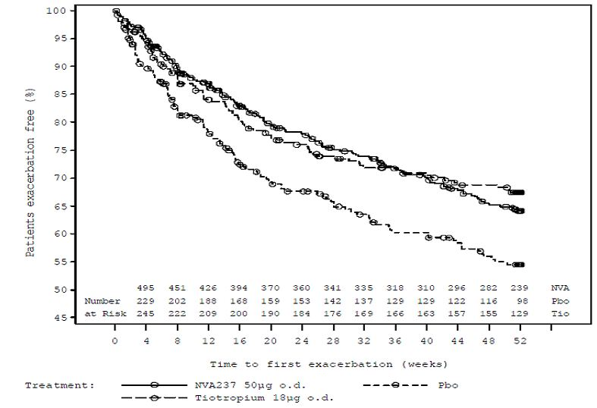

Overall, the rate of moderate or severe COPD exacerbations over the 52 week treatment period was statistically significantly lower in the NVA237 group compared to the placebo group, with a rate ratio of 0.66 (p=0.003). The rate of COPD exacerbations in the tiotropium group was lower than in the placebo group, but difference was not statistically significant (rate ratio 0.80, p=0.179). The number of moderate or severe COPD exacerbations per patient over the 52 week treatment period showed that 353 (67.2%) patients in the NVA237 group did not experience a moderate or severe exacerbation on treatment [compared with 160 (59.7%) in the placebo group, and 186 (69.7%) in the tiotropium group].

Overall, results for the post-hoc analysis of time to first moderate COPD exacerbation were consistent with those for the planned analysis of time to first moderate to severe COPD exacerbation. Percentages of patients with one or more moderate COPD exacerbations over 52 weeks based on Kaplan-Meier estimates were 30.7%, 28.2% and 36.8% for NVA237, tiotropium and placebo, respectively. The estimated hazard ratios were 0.68 (NVA237 vs. placebo, p=0.004) and 0.63 (tiotropium vs. placebo, p=0.003). The percentage of patients experiencing no moderate exacerbations on treatment was 69.3% (364 patients) in the NVA237 group, 63.4% (170 patients) in the placebo group and 71.5% (191 patients) in the tiotropium group.. The proportion of patients with at least one severe COPD exacerbation leading to hospitalisation was numerically smaller in both the NVA237 and tiotropium group than in the placebo group (odds ratios 0.60 and 0.69 respectively), but neither comparison was statistically significant versus placebo.

###### Daily rescue medication use during 52 weeks treatment

Patients in the NVA237 group required rescue medication significantly fewer times compared with patients in the placebo group (treatment difference -0.37 puffs/day, p = 0.039) with similar results observed in patients treated with tiotropium (treatment difference=-0.63 puffs/day, p=0.003). Compared to placebo (26.9%), the percentage of days with no rescue medication use was slightly higher in the NVA237 group (30.6%) and in the tiotropium group (32.8%), however treatment difference only achieved statistical significance in the tiotropium group (p=0.026).

###### Other efficacy endpoints

Effect of NVA237 on FEV1 at time points up to 4 hours post-dose vs. placebo

The treatment difference with NVA237 compared to placebo was more marked than with tiotropium at every visit over the first 4 hours, and NVA237 demonstrated a particularly fast onset of action. At 5 min post dose the NVA237 vs. placebo FEV1 treatment difference was 87 mL, compared to the tiotropium vs. placebo treatment difference of 45 mL. At 15 min post dose, NVA237 demonstrated a treatment difference vs. placebo of 143 mL compared with a treatment difference of 78 mL for tiotropium vs. placebo.

12/24 hour serial spirometry

A subgroup of 299 patients (one-third the size of the total FAS population and in the same randomisation ratio) was used for serial spirometry measurements. At Day 1, measurements were taken up to 12 h post dose and then at trough, while for Weeks 12 and week 52, the 24 hour spirometry also includes 16 and 22 hour time points. These data are shown graphically by visit in profiles of LS means of FEV1 in Figures 7-9 and showed that bronchodilation produced by NVA237 was sustained throughout the treatment duration.

Figure 7: Profile of least squares means of FEV1 (L) from 5 min up to 12 h post-dose, and at 23 h 15 and 23 45 min post-dose at Day 1 (Full Analysis Set, serial spirometry group).

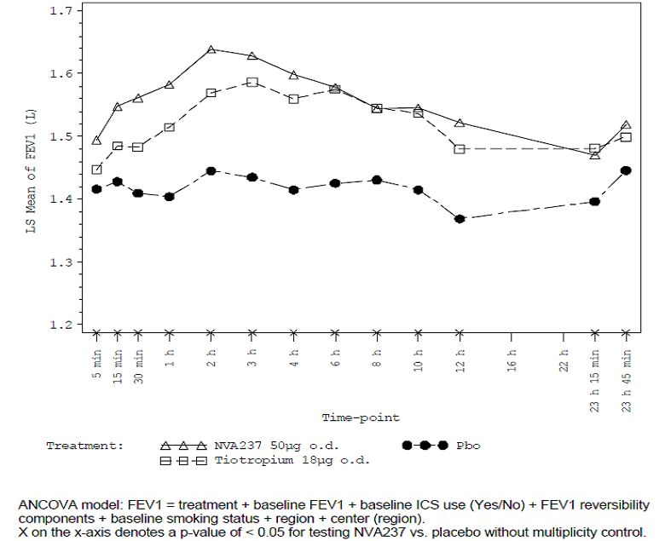

Figure 8: Profile of least squares means of FEV1 (L) from 5 min up to 23 h 45 min post-dose at Week 12 (Full Analysis Set, serial spirometry group).

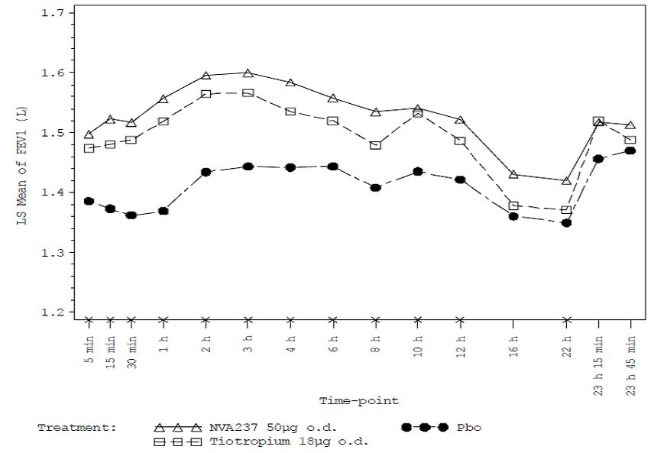

Figure 9: Profile of least squares means of FEV1 (L) from 5 min up to 23 h 45 min post-dose at Week 52 (Full Analysis Set, serial spirometry group).

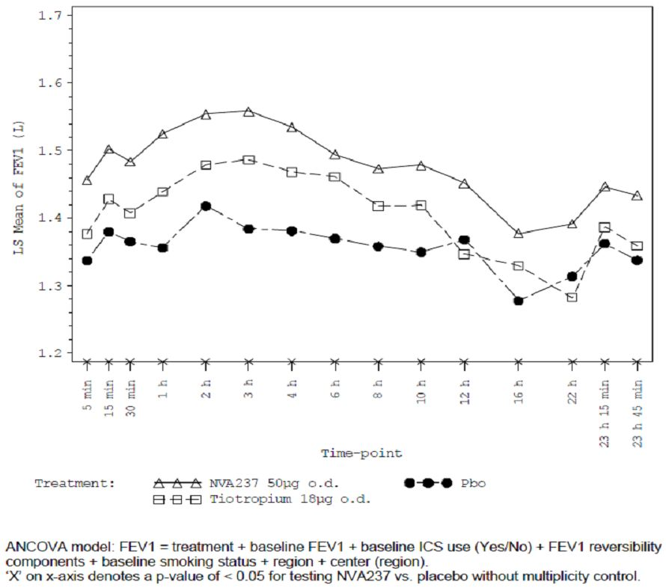

Trough FEV1 at 12, 26 and 52 weeks

An analysis of trough FEV1 at day 1, Week 26 and Week 52 for the FAS population excluding values taken within 6h of rescue medication use or 7 days of systemic corticosteroid use showed statistically significant treatment difference (compared to placebo) in favour of NVA237 od 91 mL, 134 mL and 108 mL at Day 1, Week 26 and Week 52, respectively (treatment difference in favour of tiotropium was 83 mL, 84 mL and 89 mL, respectively).

Peak FEV1 and standardized AUC

Peak FEV1 in the first 4 hours post-dose at Day 1, Week 12, Week 26, and Week 52 was statistically significantly greater in the NVA237 group compared to the placebo group in the FAS Standardized AUC measurements for FEV1 at Day 1, Week 12 and Week 52 (FEV1 AUC5min-12h), FEV1 AUC5min-23h45min), and FEV1 AUC12h-23h45min) were measured in the serial spirometry subgroup. Consistent results for each of the four AUC variables were seen, with higher measurements seen with NVA237 and tiotropium treatment compared to placebo The estimated treatment differences between NVA237 and placebo were statistically significant for FEV1 AUC5min-12h and FEV1 AUC12h-23h45min at Weeks 12 and 52, supporting the conclusion that NVA237 provides consistent bronchodilation over the 24 h time course, although the treatment difference was smaller in the second treatment interval (12 h - 23 h 45 min).

Effect of NVA237 on FVC at all time points vs. placebo

Trough FVC (L) was statistically significantly greater in both the NVA237 and tiotropium groups at Day 1, Week 12, Week 26, and Week 52 than in the placebo group (p<0.001). In addition, in the serial spirometry subgroup, FVC was statistically significantly greater in the NVA237 group than in the placebo group at all assessed time points. However, in the tiotropium group, FVC was statistically significantly greater at most assessed time points apart from a few pre-dose and late time points at Weeks 26, 34, 50 and 52.

Effect of NVA237 on COPD symptoms collected via patient diary

The percentage of nights with no night-time awakenings over the 52-week treatment period was similar across the treatment groups (approximately 52-57% with statistically significant difference in LSM compared to placebo, p = 0.017). The percentage of days with no daytime symptoms over the 52-week treatment period was higher in the NVA237 and tiotropium group (6.5-7.1%) than in the placebo group (3.8%). The LSM differences were both statistically significant (p=0.039 and p=0.029) (Table 6).The percentage of days when patients were able to perform usual daily activities was greater in the NVA237 group (38.02%) than in the placebo group (36.18%). LSM difference was 1.85 which was not statistically significant.

Table 6: Analysis of the percentage of nights with “non night-time awakenings” and the percentage of days with “no day-time symptoms” over the 52 week treatment period (Full Analysis Set).

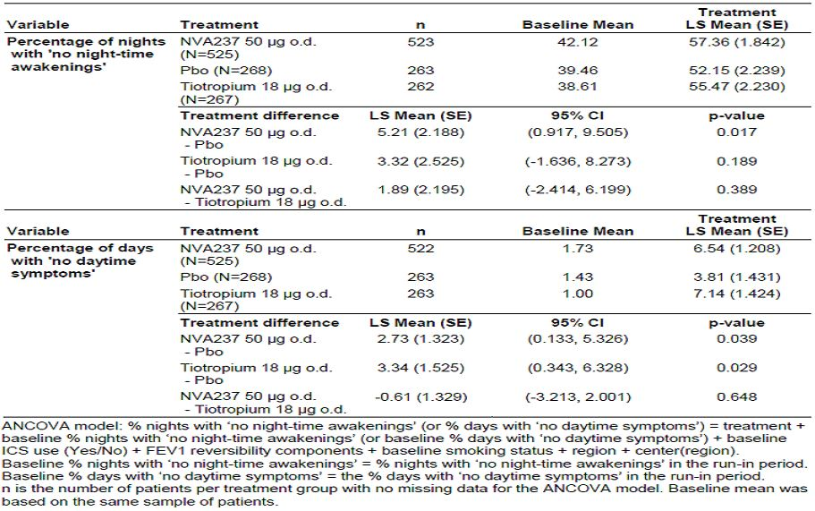

Change from baseline in mean daily total and individual symptom scores

The treatment difference between NVA237 and placebo for the mean daily total symptom score was -0.42 (p=0.003) and similar treatment difference between tiotropium and placebo for the mean daily total symptom score was similar at -0.45 (p=0.006). The change from baseline in the daily respiratory symptom score, daily wheeze symptom score, and mean daily sputum production score were statistically significantly greater in both the NVA237 and tiotropium groups than in the placebo group.

Inspiratory capacity (IC)

IC was statistically significantly greater in the NVA237 and tiotropium groups than in the placebo group at nearly all assessed time points at Day 1, Week 12, Week 26, and Week 52; the only exceptions were pre-dose measurements: tiotropium vs. placebo at −20 min at Week 26 (p=0.072), and NVA237 vs. placebo at −20 min at Week 52 (p=0.053).

Medical resource utilisation

The majority of patients had no hospital admissions during the 52 week treatment period (96.6%, 94.8% and 94.0% in the NVA237, tiotropium and placebo groups, respectively). A total of 4.5% patients overall had ≥ 1 hospital admission. The majority of patients had no ER visits (97.3%, 95.1% and 95.1%, respectively). A total of 3.8% of the patients had ≥ 1 ER visit. The majority of patients had no unscheduled doctor’s visits (83.2%, 80.5% and 76.1%, respectively). Just over 19% of all patients had ≥ 1 unscheduled doctor’s visit.

#### Study CNVA237A2304

##### Study design, objectives, locations and dates

This was a Phase 3, 26-week treatment, randomised, double-blind, placebo-controlled, parallel group study to assess the efficacy and safety of NVA237 in 882 patients with COPD. The primary and secondary objectives were similar to those described in pivotal study A2303. It was conducted from 29/10/2009 to 17/12/2010 at 128 study centres: Argentina (9 centres), Australia (5), Canada (7), India (10), Japan (29), Republic of Korea (4), Netherlands (4), Romania (5), Russia (7), Singapore (3), Spain (6), Turkey (8), and United States (31).

##### Inclusion and exclusion criteria

Similar to those described for study A2303.

##### Study treatments

The study treatments were: NVA237A 50 μg delivered via a single-dose dry powder inhaler (SDDPI); matched placebo delivered via SDDPI. Duration of the double-blind treatment period was 26 weeks. Double-blind study medication was supplied as identically appearing inhalation capsules in blisters.

##### Efficacy variables and outcomes

The primary and secondary efficacy endpoints were similar to those described in study A2303 except for the fact that secondary endpoints were measured at 26 weeks (compared to 52 weeks in study A2303 as duration of this study was only 26 weeks).

##### Randomisation and blinding methods

Patients were randomised to treatment with NVA237 50 μg o.d. (once a day), or placebo in a ratio of 2:1. At Visit 3, all eligible patients were randomised via the Interactive Voice Response System (IVRS) to one of the treatment arms. Randomisation was stratified by: 1) smoking status (current or ex-smoker), (2) 12/24 hour serial spirometry subgroup (yes or no), and (3) Holter participant (yes or no) and/or PK (yes or no). This resulted in 8 independently randomised pre-treatment strata. A treatment randomisation of 2:1 (NVA237: placebo) was maintained at the region (not centre) level.

##### Analysis populations

Similar to those described for study A2303.

##### Sample size

Similar to those described for study A2303.

##### Statistical methods

Similar to those described for study A2303.

##### Participant flow

Of the 822 patients randomised to treatment, a total of 662 patients (80.5%) completed the study as planned. Study discontinuations occurred less frequently in NVA237 group compared to placebo (18.5% vs 21.5%). The two most common reasons for discontinuing from treatment were withdrawal of consent (52 patients, 32.5%) and AEs (46 patients, 28.8%); withdrawals due to AEs were slightly higher in NVA237 group (NVA237 vs placebo: 29.4% vs 27.6%). All 23 patients from site 39 were excluded from the FAS and PP population. Unexplainable ECG discrepancies and unexpected similarities in laboratory results led to suspicion of GCP non-compliance and the data were considered unreliable. The site was closed prematurely. Of the 822 randomised patients, FAS population included 794 patients (NVA237 =534, placebo=260) and the PP population included 703 patients (NVA237=478, placebo=225). Compliance during the whole treatment period was 99% of doses taken in both treatment groups.

##### Major protocol violations/deviations

A total of 91 patients (11.1%) had at least one major protocol deviation with slightly higher incidence in placebo group (35 patients, 13.0%) compared to the NVA237 group (56 patients, 10.1%). The three most frequent major protocol deviations were non-compliance with time of dosing at the primary endpoint visit in 25 patients (3.0%), spirometry manoeuvres not performed as per protocol during reversibility testing in 16 patients (1.9%), and spirometry manoeuvres not performed according to ATS/ERS 2005 criteria in 16 patients (1.9%). Minor protocol deviations occurred in 337 (41.0%) patients (220 patients/39.9% in NVA237group vs. 117 patients/43.3% in the placebo group). The most common minor protocol deviations (>10.0% in either treatment group) were non-compliance with dosing schedule at non-primary endpoint visits (70 patients/12.7% on NVA237 vs. 31 patients/11.5% on placebo) and length of run-in period less than minimum of 14 days.

Six patients who did not have a major protocol deviation were nonetheless excluded from the PP population because they had been administered an incorrect medication pack, did not take study medication or did not comply with the administration of study medication between Visits 7 and 8.

##### Baseline data

The two treatment groups were broadly similar for demographic and baseline disease characteristics. Overall, patients had a mean age of 63.9 years with mean duration of COPD of 6 years. Majority of patients were Caucasian (63%; 35% were Asian), male (82%), ex-smokers (67% with overall mean smoking history was 45 pack-years) with moderate COPD (60.8.%; severe= 38.7% or very severe= 0.4%). In the year prior to study entry, 78.7% of patients had not experienced a moderate or severe COPD exacerbation, 16.3% of patient had experienced one exacerbation and 5.0% had experienced two or more exacerbations. The percentage of patients who had been using an inhaled corticosteroid either as a fixed dose combination or as monotherapy was slightly higher in the NVA237 group (301 patients/54.7%) compared with placebo (136 patients/50.9%). Treatment groups were comparable for spirometry measurements. The mean post-bronchodilator FEV1 (L) was 1.48 L, with the mean FEV1 percent predicted being 55%. Reversibility to ipratropium bromide (80 μg) was 13.7%, and the mean post-bronchodilator FEV1/FVC ratio was 50%. Baseline vital signs data were similar for the two treatment groups as was the baseline Fridericia’s QTc. At baseline approximately 60% of the patients had normal ECGs (about 40% of the patients had clinically insignificant ECG abnormalities according to the investigator’s overall interpretation) and two patients in the NVA237 group (0.4%) had clinically significant ECG abnormalities (a protocol deviation). Baseline 24-hour Holter monitoring data were normal for 47.7% of patients in the Holter subset and abnormal for 44.3%, with no relevant differences between the treatment groups. A total of 687 patients (84.1%) had at least one relevant medical history/current medical condition and hypertension was most common co-morbid condition (41%); other common medical conditions were gastroesophageal reflux disease (8.7%), hypercholesterolemia (7.2%), osteoarthritis (10.2%), depression (6.7%), and cataract (7.5%). Prior to start of study drug, approximately 75% of all patients took COPD-related medications, and the most frequently taken prior medications were short acting beta-agonists (NVA237 vs placebo: 33.1% vs 31.1%), combinations of beta-agonist and inhaled steroid (29.6% vs 25.5%), long-acting anti-cholinergics (LAMA) (28.7% vs 32.2%), combinations of beta agonist and anti-cholinergic (12.7% vs 11.2%) and long-acting beta-agonists (LABA) (7.1% vs 11.2%).

##### Results for the primary efficacy outcome

NVA237 was statistically significantly superior to placebo for trough FEV1 after 12 weeks of treatment. The treatment difference in favour of NVA237 was 108 mL (p<0.001). Similar results were observed for the PP population (treatment diff=111ml, p<0.001).

##### Results for other efficacy outcomes

###### Key secondary efficacy results

TDI after 26 weeks

At Week 26, NVA237 showed a statistically significant (p<0.001) and clinically relevant improvement over placebo (treatment difference >1, it was 1.04) with similar results also observed at Week 12 (diff=0.73 points, p=0.002). A statistically significantly greater proportion of patients treated with NVA237 responded with a clinically meaningful improvement (.>1 point) in the TDI focal score at Week 26 compared with placebo (NVA237 vs placebo: 61.3% vs. 48.3%, p=0.001)with similar results at Week 12 (58.1% vs 48.3%, p=0.013).

SGRQ score at 26 weeks

At Week 26, the treatment difference between NVA237 and placebo was statistically significant in favour of NVA237 (−2.81, p=0.004) with similar results at week 12 (LSM difference −2.71; p=0.002).

The proportion of patients with a clinically meaningful improvement in the SGRQ total score (reduction of ≥ 4 points) was significantly higher with NVA237 compared to placebo at Week 26 (56.8% vs. 46.3%), with an odds ratio of 1.58 (p=0.006) with similar results atWeek 12 (56.9% vs. 47.6%, odds ratio 1.53, p=0.013).

###### Important secondary efficacy results

Time to first moderate or severe exacerbation during 26 weeks treatment

Compared with placebo, patients in the NVA237 group had a significantly prolonged time to first moderate or severe COPD exacerbation. The percentage of patients with one or more moderate or severe COPD exacerbations over 26- weeks based on Kaplan-Meier estimates were 17.5% vs. 24.2% for NVA237 versus placebo (Figure 10). The estimated hazard ratio was 0.69 (95% CI: 0.500 to 0.949; p=0.023). Overall, the rate of exacerbations over the 26 week treatment period was lower in the NVA237 group with rate ratio of 0.72 but did not reach statistical significance; the percentage of patients experiencing no moderate or severe exacerbations on treatment was 82.6% (441 patients) in the NVA237 group and 75.8% (197 patients) in the placebo group. Additional post hoc analysis showed that the percentage of patients with one or more moderate COPD exacerbations over 26 weeks based on Kaplan-Meier estimates was 16.2% vs. 21.5% for NVA237 vs. placebo; estimated hazard ratio was 0.71 (95% CI: 0.509 to 1.001; p=0.050). Overall, the rate of moderate exacerbations over the 26-week treatment period was lower in the NVA237 group with rate ratio of 0.81 but did not reach statistical significance (p=0.268). Patients treated with NVA237 were significantly less likely to experience at least one severe COPD exacerbation leading to hospitalisation than patients treated with placebo (odds ratio 0.34, p=0.024). In patients with moderate COPD exacerbations, there was a trend in favour of NVA237 versus placebo for patients requiring treatment with systemic corticosteroids (odds ratio was 0.71, p=0.138), requiring treatment with antibiotics (odds ratio was 0.80, p=0.288).

Figure 10: Kaplan-Meier plot of the time to first moderate or severe COPD exacerbation (Full Analysis Set).

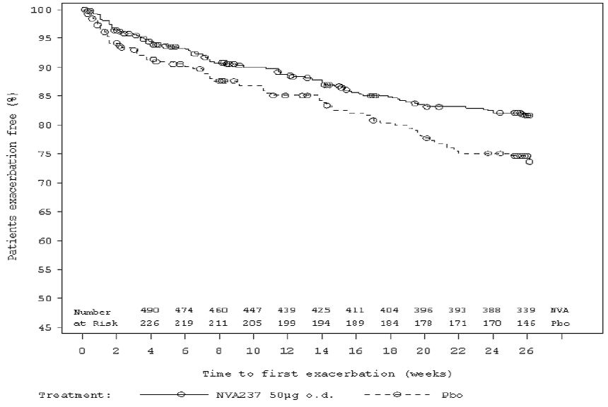

Daily rescue medication use during 26 weeks treatment

Patients in the NVA237 group required rescue medication significantly fewer times compared with patients in the placebo group (treatment difference of −0.46 puffs/day, p=0.005). Furthermore, the percentage of days with no rescue medication use was numerically higher in the NVA237 group (36.59% vs 33.06%, p=0.108), although difference was not statistically significant.

Effect of NVA237 on FEV1 at time points up to 4 hours post-dose vs. placebo

At all time points, NVA237 was significantly superior to placebo (all, p<0.001) and the treatment differences approached >100 mL. On Day 1, the treatment difference was 93 mL at 5 min post dose and 144 mL at 15 min post dose.

12/24 hour serial spirometry

A subgroup of 252 patients (one-third the size of the total FAS population and in the same randomisation ratio) was used for serial spirometry measurements. At Day 1 measurements were taken up to 12 h post dose and then at trough, while for Weeks 12 and week 26, the 24 hour spirometry also includes 16 and 22 hour time points. These data showed that bronchodilation was sustained throughout the treatment duration.

Trough FEV1 at day 1 and week 26

The treatment difference in favour of NVA237 was 105 mL and 113 mL (both, p<0.001) at Day 1 and Week 26, respectively.

Peak FEV1 and standardized AUC

Peak FEV1 in the first 4 hours post-dose at Day 1, Week 12 and Week 26 was statistically significantly greater in the NVA237 group compared to the placebo group in the FAS (all, p<0.001). In the serial spirometry subgroup, FEV1 AUC5min-12h, FEV1 AUC5min-23h45min, and FEV1 AUC12h-23h45min were statistically significantly greater with NVA237 than with placebo (all, p<0.001). The estimated treatment differences between NVA237 and placebo were similar for FEV1 AUC5min-12h and FEV1 AUC12h-23h45min at Weeks 12 and 26, supporting the conclusion that NVA237 provides consistent bronchodilation over the 24 h time course.

Effect of NVA237 on FVC at all time points

Trough FVC was statistically significantly greater in the NVA237 group at Day 1, Week 12 and Week 26 than in the placebo group (all, p<0.001)As observed with FEV1 in the FAS population, analysis of FVC at each time point up to 4 hours post dose and at 23 h 15 min and 23 h 45 min, including pre-dose trough FVC, showed statistically significantly greater FVC values in the NVA237 group at all assessed time points, as compared to placebo (all, p<0.001)**.**

Effect of NVA237 on COPD symptoms collected via patient diary

The percentage of nights with no nighttime awakenings over the 26-week treatment period was similar in the NVA237 and placebo groups (both approximately 55%) with LSM difference of 1.59 and p=0.446. The percentage of days with no daytime symptoms over the 26-week treatment period was similar in the NVA237 and placebo groups (both approximately 5.7%) with LSM difference of −0.08 and p=0.950. The percentage of days when patients were able to perform usual daily activities was greater in the NVA237 group compared with placebo(40.31% vs 35.19%; LSM difference 5.13, p=0.013).

Change from baseline in mean daily total and individual symptom scores

The treatment difference between NVA237 and placebo for the mean daily total symptom score was −0.36 (p=0.012); the change from baseline was greater in the NVA237 group (−1.54) than in the placebo group (−1.18). The change from baseline in the mean daily respiratory symptom score, mean daily wheeze symptom score and mean daily breathless symptom score was statistically significantly greater in the NVA237 group (−0.27, −0.31, −0.27) than in the placebo group (−0.20, −0.22, −0.20) (LSM difference −0.07, p=0.026; −0.09, p=0.004; −0.07, p=0.041). The change from baseline in the mean daily cough symptom score, mean daily sputum production score and the mean daily sputum colour score was similar in the NVA237 and placebo groups.

Inspiratory capacity (IC)

IC was statistically significantly greater in the NVA237 group than in the placebo group at all assessed time points. The treatment difference at Week 26 at trough (23h 40 min) was 113 mL (p<0.001). In the serial spirometry group, IC was statistically significantly greater in the NVA237 group than in the placebo group at Day 1 and Week 26 at all time points, and at Week 12 at all postdose time points. The treatment difference at Week 26 at trough (23 h 40 min) was 159 mL (p<0.001).

Medical resource utilization

The majority of patients had no hospital admissions (NVA237 vs placebo: 98.2% vs 95.9%). A total of 2.6% of patients overall had ≥ 1 hospital admission. More patients in the placebo group (4.1%) than in the NVA237 group (1.8%) had at least one hospital admission. The majority of patients had no ER visits (98.2% vs 98.5%). A total of 1.7% of the patients had ≥ 1 ER visit. Most patients in both treatment groups (90.2% vs 86.9%) did not have an unscheduled doctor’s visit over the 26-week treatment period. A total of 10.9% of patients had at least one unscheduled doctor’s visit.

### Analyses performed across trials

#### Pooled efficacy analysis of pivotal studies A2303 and A2304

Data from the two controlled Phase 3 studies A2304 and A2303 were pooled for combined efficacy analyses of the primary efficacy endpoint, trough FEV1 at Week 12. Overall, results from the pooled analysis confirm those observed in the individual studies. The efficacy endpoints were analysed using the same mixed model as in studies A2303 and A2304 with an additional term study as fixed effect. For subgroup analyses, an additional subgroup variable and appropriate interaction terms were included as fixed effects in the model. For the pooled time to first exacerbation analysis over 52 weeks, all patients from Study A2304 who did not discontinue or had no exacerbations were censored at their last study visits (around 26 weeks). Since this censoring is independent of these patients’ likelihoods of survival without exacerbation in future, all time to first exacerbation estimations based on the pooled data over 26 and 52 weeks are considered valid. The time to first exacerbation over 6 and 12 months of treatment was analysed using the same Cox regression model as A2303 and A2304, and stratified by study. Adjustments for multiplicity testing were not performed. The statistical methods for pooled efficacy analyses were documented prior to unblinding the last study (A2303).

*Comments: As study was included as a factor in the models for pooled analyses wherever possible, all estimations for OL tiotropium have been adjusted under the assumption that the study differences between A2303 and A2304 for NVA237 versus placebo were also applicable to OL tiotropium, although OL tiotropium patients came from Study A2303 only. Hence, the estimations for OL tiotropium based on Study A2303 would be more relevant than the ones based on the pooled data.*

The demographic and disease history for the pooled data reflect the trials contributing to it. Patients were predominantly male (71.5%), Caucasian (77.6%) with mean age was 63.9 years (ranging from 41.0 to 91.0 yrs). All patients in the pooled analysis had a diagnosis of COPD at screening according to GOLD (2008) guideline. In each treatment group, the majority of the patients had moderate to severe COPD and the mean COPD duration was 6.82 years. Approximately half the patients in each group were using ICS at baseline. In total 59.6% of the patients were ex-smokers and the overall mean smoking history was 47.6 pack years. With the exception of a lower percentage of Asian patients in the OL tiotropium group (5.6%) than in the NVA237 and placebo groups (19.4% and 18.8%, respectively) the remaining baseline and demographic characteristics were similar among the treatment groups. The mean post-bronchodilator percent predicted FEV1 was 55.5%. Mean reversibility to ipratropium bromide (80 μg) was 15.1%, and slightly higher in the OL tiotropium group. The mean post-bronchodilator FEV1/FVC ratio was 50.3%.

The pooled population included 1888 randomised patients, majority of whom (78.0%) completed the studies. Study discontinuations occurred more frequently in the placebo (24.9%) and OL tiotropium (23.1%) than in the NVA237 group (20.4%). The two most common reasons for discontinuing were withdrawal of consent (33.9%) and AEs (32.0%). The majority of the pooled randomised patients overall and by treatment group were included in the FAS (98.2%). The FAS serial spirometry subgroup included 29.2% of all patients, 16.6% in the NVA237 group, 8.6% in the placebo group and 4.0% in the OL tiotropium group.

Data pooling between Study A2303 and A2304 could therefore not be applied to the Week 52 spirometry assessments since study duration of studies A2304 and A2303 was 6 months and 1-year, respectively. In confirmation of the individual study results, the LS Mean estimate of the trough FEV1 at Week 12 for the pooled population was statistically significantly greater for NVA237 than for placebo (treatment difference NVA237- placebo was 0.103 L, p < 0.001). NVA237 was statistically significantly (p-values < 0.001) superior to placebo for LS Mean trough FEV1 at Day 1 (treatment diff=0.098 L) and Week 26 (0.125 L). Overall, the mean PTR was similar at all visits and for each treatment group (NVA237, OL tiotropium and placebo); the PTR was approximately 1.1, supporting the effectiveness of once-daily dosing of NVA237. The proportion of patients with at least 10% increase in trough FEV1 from baseline was statistically significantly greater for NVA237 than for placebo at Day 1 (49.4% vs. 18.9%, p < 0.001), Week 12 (45.1% vs. 21.1%, p < 0.001), Week 26 (45.3% vs. 20.2%, p < 0.001) and Week 52 (A2303 data only, 36.8% vs. 21.4%; p = 0.002). OL tiotropium was also significantly superior to placebo at all assessments. The proportion of patients with at least 100 mL increase in trough FEV1 from baseline was statistically significantly greater for NVA237 than for placebo at Day 1 (56.6% vs. 22.1%), Week 12 (52.0% vs. 23.0%), Week 26 (49.7% vs. 22.5%), p < 0.001 in each case and Week 52 (A2303 only, 42.5% vs. 25.5%; p < 0.001). OL tiotropium was significantly superior to placebo at all assessments (Table 7).

Table 7: Analysis of the proportion of patients with at least 100ml increase in trough FEV1 from baseline at Day 1, Week 12, Week 26 and Week 52 excluding values taken within 6 h of rescue medication use or 7 days of systemic corticosteroid use (Full Analysis Set).

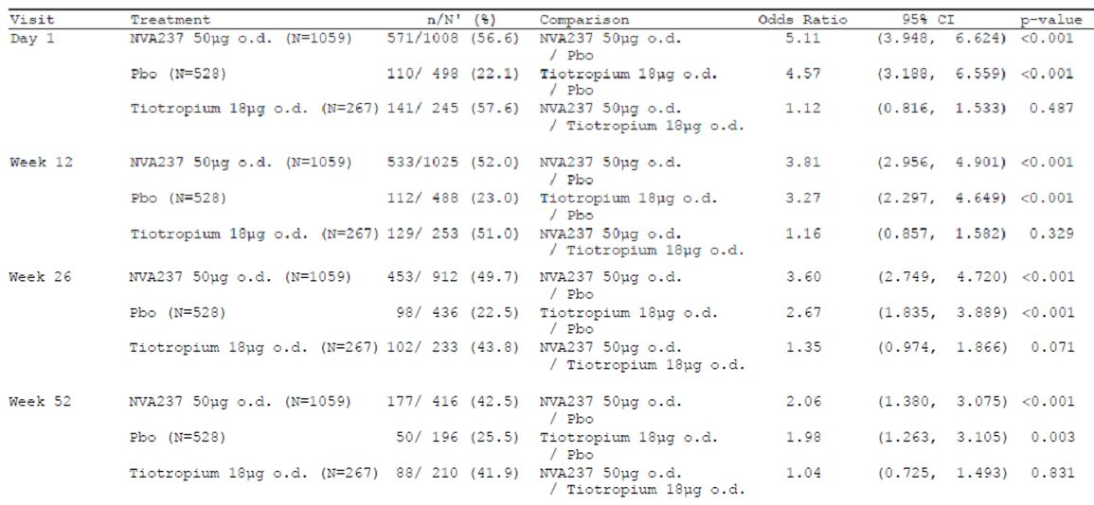

Week 12 LS Mean trough FVC (L) was statistically significantly greater in the NVA237 group than in the placebo group (treatment difference of 0.190 L, p < 0.001); the treatment difference for OL tiotropium vs. placebo was 0.172 L. Similar results were observed for the NVA237 vs. placebo comparison at Day 1 and Week 26 (pooled population, Rx diff=0.205 L, p < 0.001) as well as at Week 52 (Study A2303 data only); OL tiotropium showed a treatment difference of 0.133 L (p < 0.001) at week 26 (Table 8). LS Mean IC was statistically significantly greater in the NVA237 group than in the placebo group at all Day 1, Week 12 and Week 26 assessments. The treatment difference in LS Mean IC for NVA237 vs. placebo at Week 12 was 0.185 L at 25 min post-dose and 0.216 L at 1 h 55 min post-dose. At Week 52 (Study A2303 data only) superiority of NVA237 over placebo was observed at 25 min, 1 h 55 min and 23 h 40 min post-dose. For most of the Day 1 and Week 12 assessments, LS Mean IC was statistically significantly greater in the OL tiotropium group than in the placebo group, but the differences were not statistically significant at Weeks 26 and 52.

Table 8: Trough FVC (L) at Week 12 (Full Analysis Set).

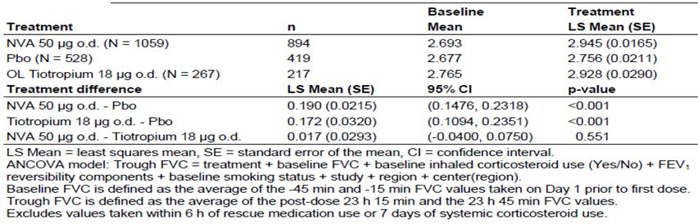

##### Rapid onset of action

NVA237 demonstrated a rapid onset of bronchodilation at the 5 min post-dose time-point on Day 1 with a 0.090 L treatment difference in FEV1 vs. placebo (p < 0.001). At 15 min post-dose on Day 1, the treatment difference for NVA237 vs. placebo was 0.144 L (p < 0.001). Statistically significant treatment differences for OL tiotropium vs. placebo were observed at 5 min (0.047 L, p < 0.001) and 15 min (0.079 L, p < 0.001) postdose on Day 1. The proportion of patients with at least 12% and 200 mL increase in FEV1 from baseline to each post-dose time-point at Day 1 (i.e. 5 min, 15 min, 30 min, 1 h, 2 h, 3 h and 4 h) was statistically significantly higher in the NVA237 group than in the placebo group (p < 0.001). Percentage of responders in the NVA237 group compared to placebo was 12.7% vs. 1.6% at 5 min and 53.8% vs. 10.9% at 4 hours respectively. Percentage of responders in the OL tiotropium group was 4.7% at 5 min and 45.6% at 4 hours. Peak FEV1 in the first 4 hours post-dose at Day 1, Week 12, Week 26 (pooled data), and Week 52 (Study A2303 data only) was statistically significantly greater for NVA237 when compared with placebo. Standardized FEV1 AUC5min-4h was statistically significantly greater for NVA237 vs. placebo at all visits from Day 1 onwards.

##### Dyspnoea

At Week 26, the LS Mean treatment difference in TDI focal score between NVA237 and placebo was statistically significantly in favour of NVA237 (0.93, p < 0.001) and was close to achieving the threshold for clinical relevance (≥ 1 point). For the OL tiotropium vs. placebo comparison, the treatment difference was 1.05 in favour of OL tiotropium.

*Comments: This difference in the pooled analysis compared with the individual study results from A2303 may be due to different placebo responses between A2303 and A2304. Therefore, the estimation for OL tiotropium vs. placebo is more reliable from Study A2303 (0.94).*

Compared with placebo, a statistically significant greater proportion of patients treated with NVA237 responded with a ≥ 1 point improvement in the TDI focal score at Week 26 compared with placebo (NVA237 vs placebo: 58.4% vs. 46.4%, p < 0.001) with similar results for tiotropium vs placebo (53.4% vs 46.4%, p=0.009)**.** Similar results were observed at Weeks 12 and 52. The number needed to treat (NNT) for NVA237 to achieve a clinically relevant improvement of ≥ 1 in the TDI focal score over 26 Weeks was 9. The number needed to treat for OL tiotropium was 15.

##### Health status

A negative change in SGRQ score indicates an improvement in health status. Week 26 LS Mean SGRQ total score was statistically significantly lower for NVA237 compared to placebo (-3.07, p < 0.001) with similar results for OL tiotropium (-2.43, p = 0.017). The proportion of patients with a clinically important improvement in the SGRQ (>4 point reduction in total score) at Week 26 was statistically significantly greater for NVA237 50 μg o.d. than for placebo (57.8% vs. 47.6%, p < 0.001). OL tiotropium was significantly superior to placebo for the SGRQ responder analysis (p = 0.004). The number needed to treat to achieve a clinically relevant reduction of >4 in the SGRQ total score at Week 26 for NVA237 was 10. The number needed to treat for OL tiotropium was 8. NVA237 50 μg was statistically significantly superior to placebo regarding SGRQ symptoms, impacts and activity component scores at all visits (i.e. Weeks 12, 26, and 52). Overall similar results were observed for the OL tiotropium vs. placebo comparisons (p < 0.05) with the exception of the Week 26 activity and Weeks 26 and 52 impact scores.

##### COPD exacerbations

NVA237 significantly delayed and reduced the risk for the time to first moderate or severe exacerbation, exacerbations leading to hospitalisation, exacerbations requiring treatment with systemic corticosteroids and/or antibiotics. At 26-weeks, the proportion of patients with exacerbation was 19.8% for NVA237 vs. 27.2% for placebo and the estimated risk ratio for time to moderate or severe exacerbation was 0.64 [95% CI: 0.520, 0.799; p < 0.001], suggesting a 36% risk reduction vs. placebo. The calculated number needed to treat to prevent one exacerbation for NVA237 patients is 14. The number needed to treat for OL tiotropium was 37. Similarly, the Cox regression analysis showed that the estimated risk ratio for time to first moderate or severe exacerbation leading to hospitalisation was 0.39 [95% CI: 0.205, 0.728; p = 0.003], requiring treatment with systemic corticosteroids was 0.68 [95% CI: 0.521, 0.875; p = 0.003] and requiring treatment with antibiotics was 0.66 [95% CI: 0.521, 0.840; p < 0.001] in favour of NVA237 over placebo after 26 weeks of treatment. The proportion of patients with no moderate or severe exacerbations over 26 weeks was 80.3% in the NVA237 group, 75.3% in the OL tiotropium group and 72.7% in the placebo group

##### Rescue medication use

In all treatment groups, a decrease from baseline in mean daily number of puffs was observed over the 26-week treatment period (LS mean treatment difference was -0.45 puffs/day, p < 0.001) with comparable results observed for the OL tiotropium (-0.71, p < 0.001). Overall, similar results, showing significant decrease, were observed for mean daytime and nighttime number of puffs of rescue medication use for the NVA237 vs. placebo comparison in all assessed visits except mean nighttime at Week 52. Percentage of days with no rescue medication use over the 26-week treatment period was statistically significantly greater in the NVA237 group than in the placebo group (LS Mean treatment difference was 4.03, p = 0.009). Comparable results were observed for the OL tiotropium vs. placebo comparison. The LS Mean treatment difference was 6.84 (p = 0.003). Overall, similar results were observed during the 12- and 52-week treatment periods but for the NVA237 vs. placebo comparison during the 52-week period, which was not statistically significant.

##### Symptoms

The percentage of nights with “no nighttime awakenings” over the 26-week treatment period was statistically significantly in favour of NVA237 in comparison to placebo. There were no significant differences in the percentage of days with “no daytime symptoms” across the treatment groups. The percentage of “days able to perform usual daily activities” was statistically significantly greater in the NVA237 group than in the placebo over the 12- and 26-week treatment periods. No significant difference was observed between NVA237 and placebo for the 52 weeks analysis, which only included A2303 data. For the tiotropium vs. placebo comparisons, statistical significance was observed at Week 12.

#### Subgroup efficacy analyses:

Efficacy of NVA237 was analysed in the following subgroups with the pooled data from pivotal studies A2303 and A2304:

* Age (< 55 years, ≥ 55 and < 65 years, ≥ 65 and < 75 years, ≥ 75 years);
* COPD severity (moderate or mild, severe or very severe, based on the Classification of severity of COPD defined in GOLD 2008);
* FEV1 reversibility (< 5%, ≥ 5% and < 12%, ≥ 12%);
* Gender (Male or Female);
* Race (Caucasian, Black, Asian, and ‘Other race’ patients);
* Region (North America, South America, Asia, European Union, Eastern Europe, Japan);
* Smoking history (Current or Ex-Smoker);
* Hospitalisation history (Yes or No);
* Use of ICS (Yes or No);
* Use of specific COPD related medication at baseline (Yes or No) (Systemic steroids, LABA, LABA & ICS, all Anti-cholinergics, LAMA, Antibiotics, Theophylline [any formulation]).

In addition, subgroup analyses were conducted with respect to ICS usage and Use of specific COPD related medication at baseline for time to first exacerbation over 6 and 12 months of treatment.

##### Effect of demographic factors on efficacy

###### Age

The treatment difference in trough FEV1 at Week 12 was statistically significantly in favour of NVA237 vs. placebo for all age subgroups being 0.098 L, 0.107 L, 0.094 L and 0.122 L for patients < 55 years, ≥ 55 and < 65 years, ≥ 65 and < 75 years, and patients ≥ 75 years, respectively (p-values < 0.001) which was similar to the treatment differences observed in the overall pooled population (0.103 L, p < 0.001) (Table 9) NVA237 showed statically significant and clinically meaningful improvement (≥ 1) at Week 26 in the TDI focal score for patients ≥ 55 and < 65 years (1.24, p < 0.001) and patients ≥ 75 years (1.56, p = 0.002); however, the treatment difference for NVA237 vs. placebo was not statistically significant for patients < 55 years (0.69, p = 0.110) and patients ≥ 65 and < 75 years (0.53, p = 0.065); the treatment difference in the overall pooled population was 0.93, p < 0.001) (Table 10). The SGRQ total score at Week 26 was lower in the NVA237 treatment group than seen with placebo in all the four age groups. The treatment differences in SGRQ total score at Week 26 for NVA237 vs. placebo were statistically significant for patients ≥ 55 and < 65 years (-3.35, p = 0.005) and patients ≥ 75 years old (-6.89, p < 0.001); treatment difference in the overall pooled population was -3.07 (p < 0.001) (Table 11). Comparable results were observed at Weeks 12 and 52 with the treatment differences for NVA237 vs. placebo being statistically significant for patients ≥ 55 and < 65 and patients ≥75 years. Overall the mean daily number of puffs of rescue medication used over the 12, 26 and 52 week treatment periods was statistically significantly reduced in NVA237 vs. placebo for younger patients (< 55 years, and in ≥ 55 and < 65 years except Week 52) and in general was numerically lower for older patients (≥ 65 and < 75 years, and ≥ 75 years.

Table 9: Least squares mean of trough FEV1 (L) at Week 12, by subgroup (Full Analysis Set).

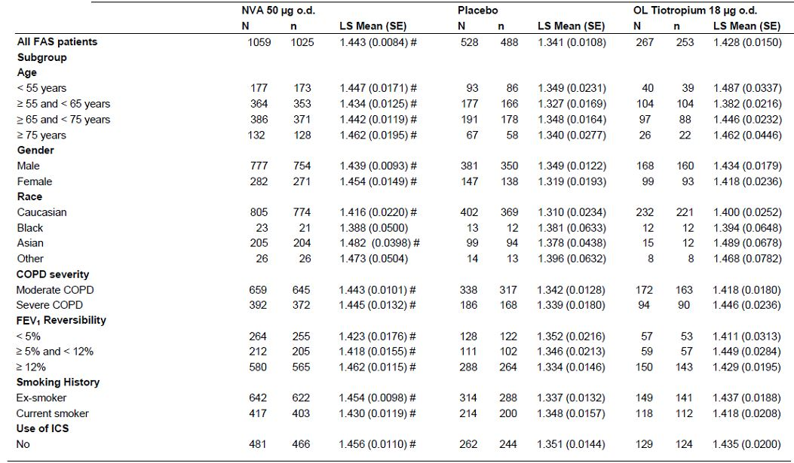

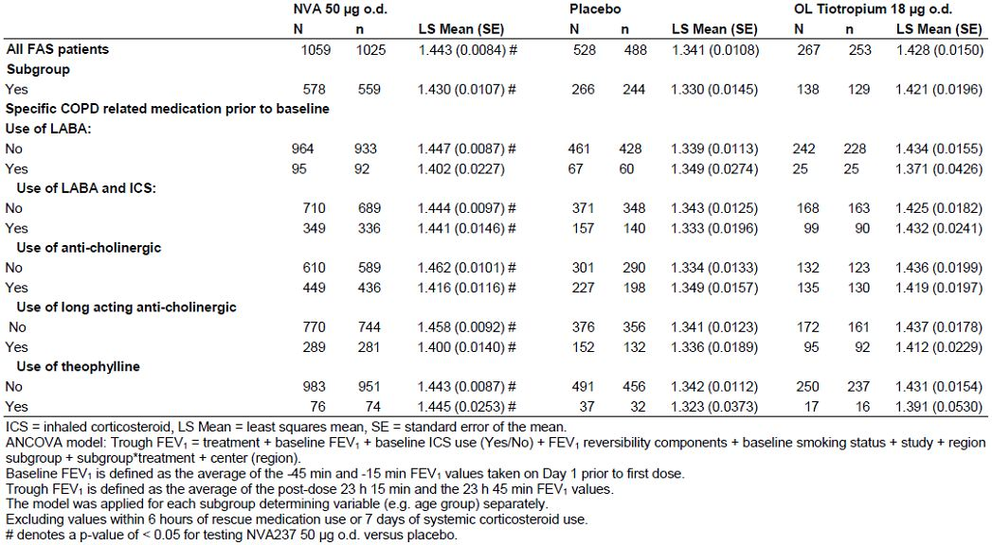

Table 10: TDI focal score at Week 26 by subgroup (Full Analysis Set).

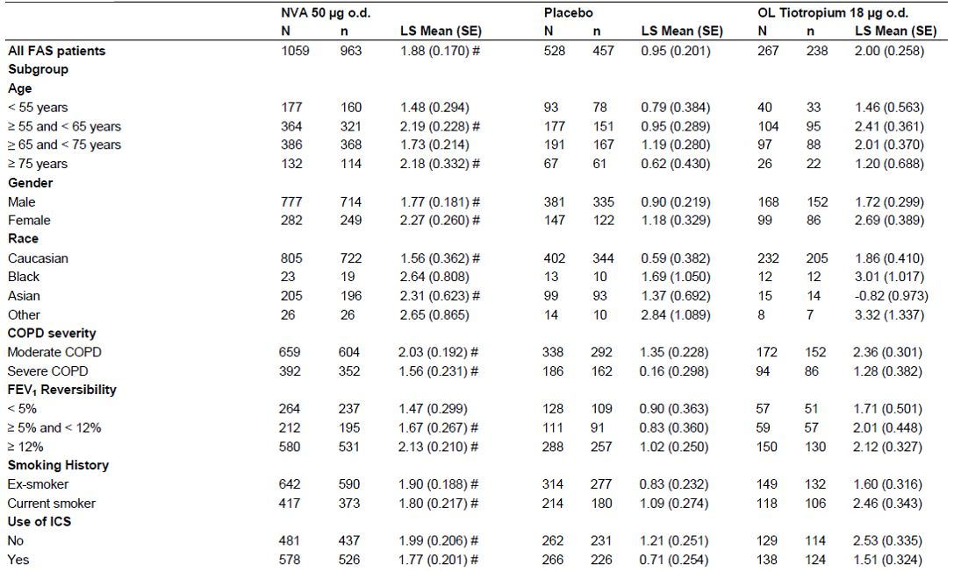

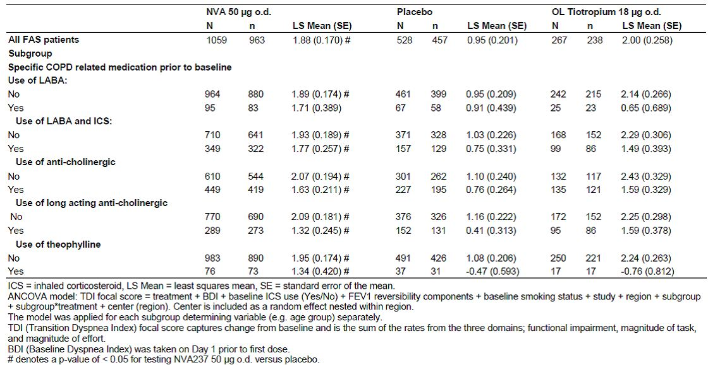

Table 11: SGRQ total score at Week 26 by subgroup (Full Analysis Set).

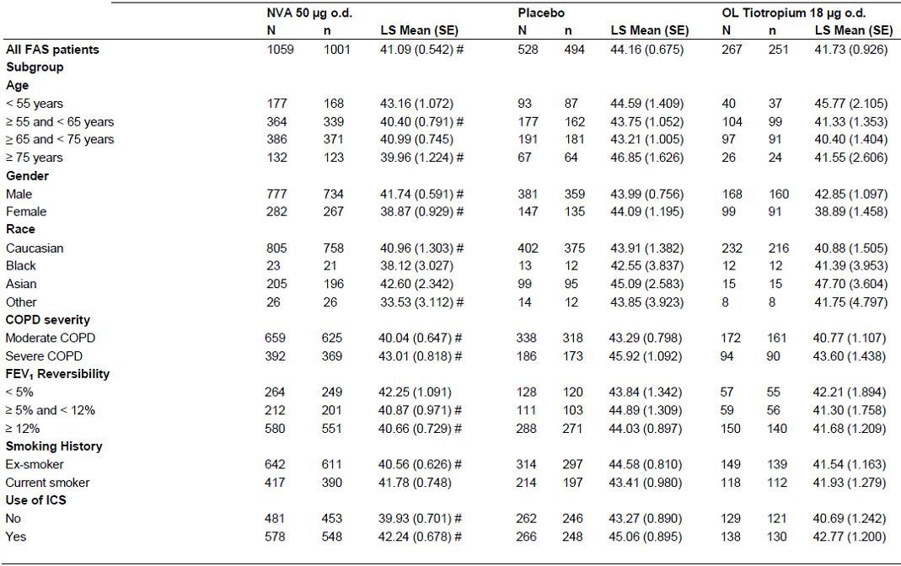

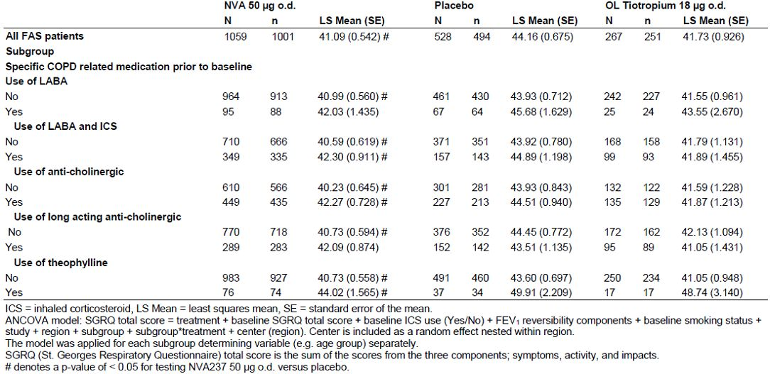

###### Gender

Overall, results were similar for the gender subgroup analyses with statistically significant improvement in lung function, dyspnea and health status being observed for NVA237 vs. placebo. Although, the treatment difference for NVA237 vs. placebo was slightly smaller for males (0.091 L) compared to females (0.134 L), but the response seen with placebo was greater in males than females and the confidence interval for males (0.0646, 0.1165) overlapped with those for females (0.0924, 0.1765). The treatment difference observed in the overall pooled population was 0.103 L (p < 0.001) (Table 9). Similar results were observed at Day 1, Weeks 26 and 52. Comparable results were observed for trough FVC. The treatment difference in TDI focal score at Week 26 was statistically significantly in favour of NVA237 vs. placebo for both males (0.87, p < 0.001) and females (1.09, p = 0.002) and the confidence interval for males (0.464, 1.268) overlapped those for females (0.417, 1.765). In the overall pooled population, the Week 26 treatment difference in TDI for NVA237 vs. placebo was 0.93 (p < 0.001) (Table 10). The SGRQ total score at Week 26 was statistically significantly reduced in NVA237 vs. placebo for males and females; treatment difference was -2.25 for males (p = 0.005) and -5.21 for females (p < 0.001) and the confidence interval for males (-3.817, -0.682) overlapped those for females (-7.796, -2.634); the treatment difference in the overall pooled population was -3.07 (p < 0.001) (Table 11). Overall the mean daily number of puffs of rescue medication used over the 12, 26 and 52 week treatment periods was statistically significantly reduced in NVA237 vs. placebo for male patients and numerically lower for female patients.

###### Race

Due to the small number of Black patients (23 in NVA237 and 13 in placebo) and patients in the race category specified as “Other” (26 in NVA237, and 14 in placebo), no valid conclusions could be drawn for these subgroups. Therefore, efficacy was only analysed in the Caucasian and Asian race subgroups. Furthermore, there were too few Asian patients with Week 52 assessments to make valid comparison (26 patients in NVA237, and 8 in placebo). Trough FEV1 at Week 12 was statistically significantly greater in NVA237 vs. placebo for Caucasian and Asian patients; the treatment difference was 0.106 L and 0.104 L, respectively (p-values < 0.001) which was comparable to the treatment difference observed in the overall pooled population (0.103 L, p < 0.001) (Table 9). The TDI focal score at Week 26 was statistically significantly greater in NVA237 vs. placebo for Caucasian and Asian patients; the treatment difference was 0.97 (p < 0.001) and 0.93 L (p = 0.018), respectively, which was comparable to the treatment difference observed in the overall pooled population (0.93, p<0.001) (Table 10). The SGRQ total score was statistically significantly reduced for Caucasian patients at Week 26 when compared to placebo with a treatment difference of -2.96 (p < 0.001). For Asian patients, the SGRQ total score was numerically lower with a treatment difference of -2.49 (p = 0.112). The treatment difference in the overall pooled population was -3.07 (p < 0.001) (Table 11). The mean daily number of puffs of rescue medication used over the 12, 26 and 52 week treatment periods was statistically significantly reduced in NVA237 vs. placebo for Caucasian patients. No significant differences were observed for Asian patients.

###### Region

The treatment difference in trough FEV1 at Week 12 for NVA237 vs. placebo was statistically significant for all regions studied: North America (0.108 L, p < 0.001), South America (0.130 L, p = 0.006), European Union (0.110 L, p < 0.001), Eastern Europe (0.078 L, p = 0.001), Asia (0.111 L, p<0.001) and Japan (0.101 L, p = 0.028). The treatment difference observed in the overall pooled population was 0.103 L (p < 0.001) (Table 9). In general, similar results were observed for trough FVC.

##### Effect of disease factors on efficacy

###### COPD disease severity

Trough FEV1 at Week 12 were similar in both moderate and severe COPD patients, and were higher than seen with placebo. Treatment differences compared to placebo were statistically significant in patients with moderate COPD (0.101 L, p < 0.001) and patients with severe COPD (0.106 L, p < 0.001) which was comparable to the 0.103 L treatment difference observed in the overall pooled population (Table 9). Similar results were observed at Day 1, Week 26 and Week 52 for each COPD severity subgroup (moderate and severe). Comparable results were observed for trough FVC. The treatment difference in the TDI focal score for NVA237 vs. placebo was statistically significant at Week 26 for both moderate and severe COPD patients; treatment difference was 0.68 (p= 0.002) and 1.40 (p < 0.001), respectively. It should be noted that the response (change from baseline) for placebo was higher in patients with moderate COPD (1.35) compared to patients with severe COPD (0.16). The corresponding figure for NVA237 was 2.03 in patients with moderate COPD and 1.56 in patients with severe COPD. The treatment difference observed in the overall pooled population was 0.93 (p < 0.001) (Table 10). The SGRQ total score at Week 26 was statistically significantly reduced in NVA237 vs. placebo for patients with moderate and patients with severe COPD ; treatment differences for NVA237 vs. placebo were -3.25 (p < 0.001) and -2.91 (p = 0.011), respectively, which were comparable to the treatment difference in the overall pooled population was -3.07 (p < 0.001) (Table 11). Comparable results were observed at Weeks 12 and 52 for patients with moderate severity. For severe COPD patients, the Week 12 and Week 52 SGRQ total scores were numerically lower in NVA237 than in placebo, but treatment difference was not statistically significant. The mean daily number of puffs of rescue medication used over the 12 and 26 week treatment periods was statistically significantly reduced in NVA237 vs. placebo for patients with moderate and patients with severe COPD.

###### FEV1 reversibility

Trough FEV1 at Week 12 was similar in NVA237 for the FEV1 reversibility subgroups (< 5%, ≥ 5% and < 12% and ≥ 12%) and higher than seen with placebo; treatment difference in trough FEV1 at Week 12 was statistically significant and in favour of NVA237 vs. placebo for all FEV1 reversibility subgroups: 0.071 L (p = 0.002) for FEV1 reversibility < 5%, 0.072 L (p = 0.004) for FEV1 reversibility ≥ 5% and < 12%, and 0.128 L (p < 0.001) for FEV1 reversibility ≥ 12%]; the treatment differences observed in the overall pooled population was 0.103 L (p < 0.001); **however, the difference in patients with reduced FEV1 reversibility was numerically lower than that seen in the overall population and in patients with >12% reversibility** (Table 9). Comparable results were observed at Day 1, Week 26 and Week 52 with the exception of Week 52 assessments for patients with FEV1 reversibility ≥ 5% and < 12%. The TDI focal score at Week 26 was statistically significantly greater in NVA237 vs. placebo for patients with FEV1 reversibility ≥ 5% and < 12% and patients with FEV1 reversibility ≥ 12%. The treatment difference was 0.85 (p = 0.034) and 1.11 (p < 0.001), respectively which were comparable to the treatment difference observed in the overall pooled population was 0.93 (p < 0.001). Although, Week 26 LS Mean TDI focal score was numerically higher in NVA237 vs. placebo for patients with FEV1 reversibility < 5% (1.47 vs. 0.90, p = 0.116), although treatment difference was not statistically significant (Table 10). None of the treatment differences in TDI focal score (Weeks 12 and 52) were statistically significant for patients with low FEV1 reversibility (< 5%) and patients with FEV1 reversibility ≥ 5% and < 12%. Statistical significance for NVA237 vs. placebo was observed at Weeks 12 and 52 for patients with the higher FEV1 reversibility (≥ 12%). The SGRQ total score at Week 26 was statistically significantly reduced for patients with FEV1 reversibility ≥ 5% and < 12% and those with FEV1 reversibility ≥ 12%; the treatment difference for NVA237 vs. placebo was -4.01 (p = 0.008) and -3.36 (p < 0.001), respectively which was comparable to the -3.07 treatment difference in the overall pooled population. Patients with FEV1 reversibility < 5% showed a numerical but non-significant reduction in the SGRQ total score (-1.58, p = 0.256) (Table 11). The mean daily number of puffs of rescue medication used over the 12, 26 and 52 week treatment periods was statistically significantly reduced in NVA237 vs. placebo for patients with the higher FEV1 reversibility (≥ 12%). For patients with FEV1 reversibility < 5% and patients with FEV1 reversibility ≥ 5% and < 12% the mean daily number of puffs of rescue medication used over the different treatment periods was in general, numerically lower in NVA237 than placebo.

*Comments: According to CPMP guidelines for evaluation of drugs used for chronic treatment of COPD, it is suggested that 2 categories of assessment of airway reversibility be used for patients recruited into trials- one with beta adrenergic agonists and the second with oral or inhaled corticosteroids. However, in the NVA237 pivotal studies, airway reversibility was determined after inhalation of the short-acting anticholinergic, ipratropium 80ug. Mean reversibility to ipratropium in the pivotal studies was about 15%, but both studies included over one-third of patients with reversibility <5% and efficacy in terms of FEV1, was shown in patients with reversibility <5%, 5-12% and >12%; however, statistically significant improvements in TDI and SGRQ were only observed in patients with >12% reversibility.*

###### Smoking history

Trough FEV1 at Week 12 was similar among ex- and currents smokers and higher than seen with placebo; treatment difference was statistically significantly in favour of NVA237 vs. placebo for each smoking subgroup (0.117 L, and 0.082 L for ex-smokers and current smokers, respectively; p-values < 0.001), which was comparable to the treatment difference seen in the overall pooled population was 0.103 L (p < 0.001) (Table 9). Comparable results were observed at Day 1, Week 26 and Week 52 for both smoking subgroups. Comparable results were observed for trough FVC. The TDI focal score at Week 26 was statistically significantly greater in NVA237 vs. placebo for ex- and current smokers; treatment difference was 1.07 (p < 0.001) and 0.71 (p = 0.012), respectively; the treatment difference observed in the overall pooled population was 0.93 (p < 0.001) (Table 10). Comparable results were observed at Week 12 for ex-smokers. The SGRQ total score at Week 26 was statistically significantly reduced and achieved clinical relevance (≥4 point reduction in total score) in NVA237 vs. placebo for ex-smokers (treatment difference for NVA237 vs. placebo was -4.02, p < 0.001). The SGRQ total score was numerically lower in the NVA237 group for current smokers but did not reach statistical significance (-1.63, p = 0.134). The treatment difference for NVA237 vs. placebo in the overall pooled population was -3.07 (p < 0.001) (Table 11). Comparable results were observed at Weeks 12 and 52 for both smoking subgroups. The mean daily number of puffs of rescue medication used over the 12, 26 and 52 week treatment periods was statistically significantly reduced in NVA237 vs. placebo for ex-smokers and numerically lower for current smokers.

*Comments: According to CPMP guidelines on COPD drugs, tobacco exposure should be monitored carefully throughout the trial in all patients and changes in smoking status documented and reported. The influence of this exposure on the estimates of efficacy should be evaluated by quantifying and illustrating any differences in tobacco exposure between treatment groups and discussing possible quantitative effect of these differences on outcome. The use of nicotine replacement therapy as an aid to smoking cessation was not recorded and its potential effect on efficacy outcomes could not be evaluated. However, this has now been addressed by the sponsors.*

###### Hospitalisation history

The majority of the patients had no hospitalisation history and therefore no valid subgroup comparison could be made.

###### ICS use

Trough FEV1 at Week 12 was similar among ICS non-users and ICS users and higher than seen with placebo; treatment difference for NVA237 vs. placebo was statistically significant for both ICS subgroups (0.105 L and 0.100 L, respectively; p-values < 0.001) which was comparable to the 0.103 L treatment difference observed in the overall pooled population (Table 9). Similar results were observed at Day 1, Week 26 and Week 52 for both ICS use subgroups. Comparable results were observed for trough FVC with NVA237 being statistically significantly superior to placebo at all assessments. The TDI focal score at Week 26 was statistically significantly greater in NVA237 vs. placebo for ICS non-users and ICS users; treatment difference was 0.78 (p = 0.002) and 1.06 (p < 0.001), respectively which was comparable to the 0.93 treatment difference observed in the overall pooled population (Table 10). Comparable results were observed at Week 12 for ICS users only with a treatment difference of 0.83 (p < 0.001). The ICS non-users showed a treatment difference of 0.48 (p = 0.060) at Week 12. The TDI focal score was numerically higher in NVA237 than in placebo at Week 52 for both ICS subgroups, but difference was not statistically significant. The SGRQ total score at Week 26 was statistically significantly reduced in NVA237 vs. placebo for ICS non users and ICS users; treatment differences for NVA237 vs. placebo were -3.34 (p < 0.001) and -2.82 (p = 0.003), respectively which was comparable to the -3.07 treatment difference in the overall pooled population (Table 11). Comparable results were observed at Weeks 12 and 52 for both ICS subgroups. The mean daily number of puffs of rescue medication used over the 12, 26 and 52 week treatment periods was statistically significantly reduced in NVA237 vs. placebo for patients not using ICS and at Week 12 only for patients using ICS.

Analysis of time to the first moderate or severe COPD exacerbation over 26 and 52 weeks by use of ICS indicate comparable results in both the groups as in the overall pooled population. The time to the first moderate or severe COPD exacerbation over 26 and 52 week was significantly longer in the NVA237 treatment group compared to placebo in both ICS users and non-users. At Week 26 and Week 52, the estimated hazard ratios for patients not using ICS were 0.61 and 0.65 while for patients using ICS, the estimated hazard ratios were 0.67 and 0.69, respectively. The estimated hazard ratio in the overall pooled population at Week 26 were 0.64 and at Week 52 was 0.67.

Trough FEV1 at Week 12, TDI focal score at week 26, SGRQ total score at week 26 was similar for the following subgroups of prior medication use (No, Yes): LABA, LABA and ICS, anti-cholinergic and long acting anti-cholinergic and theophylline. In general, the mean daily number of puffs of rescue medication used over the 12, 26 and 52 week treatment periods was statistically significantly reduced in NVA237 vs. placebo patients not using the following prior medications: LABAs, LABAs and ICS, long-acting anticholinergics, and theophylline. For patients using any of these medications prior to baseline, the mean daily number of puffs was numerically lower in NVA237 when compared to placebo. In general, there was no clinically meaningful difference seen among the different groups. The estimated hazard ratios for patients using and not using the following prior medications and by treatment effect (i.e. LABAs, fixed dose combinations of LABAs and ICS, anticholinergic, long-acting anti-cholinergic, and theophylline) were all noted to be statistically significant in favour of NVA237 at Weeks 26 and 52. The only exception was for patients using prior LABAs at Week 26. This could be due to a small number of patients having an exacerbation.

### Evaluator’s conclusions on clinical efficacy

The efficacy claim is supported by seven phase II and phase III studies in the development program. The two pivotal studies (A2303 and A2304) were adequate and well controlled phase 3 studies performed over 6 and 12 months, and which together provide evidence of efficacy in the proposed indication. A smaller phase III study (A2310) provided evidence of improved exercise endurance in the target population. Four further phase II studies provided supportive evidence of efficacy and dose response data that supported dose selection (A2205, A2206, A2207, and A2208). All studies complied with CHMP guidelines on ‘Clinical investigation of medicinal products for chronic treatment of patients with COPD’.

Trough FEV1 was selected as the primary endpoint for the Phase III clinical program for NVA237 as it a well-accepted means to determine the efficacy of a once daily bronchodilator at the end of the dosing interval, providing an indication of the level of bronchodilation over 24 hours. The key secondary symptomatic endpoints and other secondary/ exploratory endpoints adequately assessed the efficacy of NVA237 for the proposed indication. Hence, the studies submitted in the dossier were adequate with an acceptable study design and efficacy endpoints.

#### Dose response and proposed dosing regimen

In Study A2205, a clear dose-response was shown over the NVA237 dose range 12.5 to 100 μg o.d. with confirmation of study sensitivity from the comparison with open-label active comparator (tiotropium 18ug) vs. placebo. There was dose-related increase in FEV1 beginning 5 minutes after the inhalation of study drug which lasted 24 h. This increase was observed both after one inhalation of NVA237, and following 7 days of treatment. The treatment differences (active vs. placebo) for trough FEV1 on Day 7 were dose-ordered, ranging from 0.075 L for the 12.5 μg dose, to 0.142 L for the 100 μg dose. The effect reached a plateau at the 50 μg daily dose with only very small numerical increments with further dose escalation (from 0.131 L for the 50μg dose to 0.142 L for the 100 μg daily dose). In study A2206, there was no incremental therapeutic benefit seen with the 200 μg dose over the 100 μg dose. Although the 50 μg dose was not evaluated in this study, comparison to efficacy results from dose selection Study A2205 suggested that the 100 μg o.d. dose, although safe, did not offer a significant advantage compared to the 50 μg o.d. dose. Based on the data from the Phase II studies A2205 and A2206 the optimal benefit/risk ratio was observed with the NVA237 50 μg o.d. dose, which, in addition demonstrated clinically meaningful bronchodilation comparable to OL tiotropium. This was therefore the dose used for the two Phase III controlled efficacy studies A2303 and A2304.

While the Phase III studies were ongoing, a further confirmatory dose ranging study was performed upon US FDA request, the purpose being to further investigate dose response in the range 12.5 to 100 μg total daily dose, and also dose interval (o.d. or b.i.d.) (study A2208). For the total daily doses of 25 μg, 50 μg and 100 μg, the differences between the once and twice daily regimens were not clinically meaningful. Additional endpoints such as FEV1 AUC0- 24h, FEV1 AUC0-12h, FEV1 AUC0-4h, FEV1 AUC0-8h, FEV1 AUC0-12h, FEV1 AUC12-24h, were included in this study to assess an appropriate dosing regimen for NVA237. While the q.d. regimen was numerically superior to the b.i.d. regimen over the first 12 hours of dosing, the b.i.d. regimen provided greater improvements from 12- 24 hours. However, the differences between the two regimens were small and not considered clinically meaningful. For comparison of the two dosing regimens, FEV1 AUC 0-24h provides perhaps the most comprehensive assessment of efficacy over the whole dosing interval and for this endpoint there were no clinically meaningful differences between the two dosing regimens. The safety and tolerability profile for all NVA237 doses and regimens was similar to placebo.

The efficacy and safety data generated by this study support the 50 μg q.d. dose being effective and safe. Lower once daily doses (12.5 and 25ug) failed to demonstrate adequate efficacy and the higher once daily dose (100ug) did not show any additional clinical benefits. The results from studies NVA237A2205 and 2208 provided sufficient evidence to suggest that the proposed marketing dose of 50ug was suitable for evaluation in the Phase 3 studies.

#### Primary endpoint

In both pivotal efficacy studies, NVA237 demonstrated statistically significant improvement in trough FEV1 at Week 12 when compared with placebo (p<0.001 in each study). The treatment difference was 0.108 L in Study A2304 and 0.097 L in Study A2303. In study 2303, the 0.097L improvement vs. placebo was comparable to that observed for open label (OL) tiotropium (0.083 L, p<0.001). In both studies, treatment differences in trough FEV1 at Day 1, Week 26 and Week 52 (A2303 only) were clinically relevant and statistically significant in favour of NVA237 vs. Placebo.

#### Secondary spirometric parameters

NVA237 demonstrated a rapid onset of action at the 5 min post-dose time-point on Day 1 which was sustained throughout treatment duration. The statistically significant treatment difference for NVA237 vs. placebo in LS Mean FEV1 5 min post-dose was 0.093 L in A2304, and 0.087 L in A2303. In study A2303, onset of action with NVA237 was considerably more rapid than with tiotropium (0.045 L). Trough FVC was statistically significantly greater in the NVA237 group at Day 1, Week 12 and Week 26 than in the placebo group (p<0.001). Similar results were observed at Week 52 for Study A2303. Inspiratory capacity was statistically significantly greater in the NVA237 group than in the placebo group at all assessed time points on Day 1, Week 12 and Week 26 (in study A2304 and A2303) and at week 52 (in study A2303 only). Peak FEV1 and FEV1 AUC in the first 4 hours post-dose at Day 1, Weeks 12 and 26 were statistically significantly greater in NVA237 than in placebo in both pivotal studies A2304 and A2303 (p < 0.05). Similar results were observed at Week 52 in Study A2303.

#### Key secondary symptomatic efficacy endpoints

Key secondary symptomatic efficacy endpoints in both pivotal studies also demonstrated statistically significant improvements compared to placebo. For dyspnea assessed by TDI, NVA237 50 ug o.d. was statistically superior to placebo for TDI focal score in both pivotal studies after 26 weeks of treatment (LS mean difference of 0.81, p=0.002 in Study A2303; 1.04, p=<0.001 in Study A2304;) with a clinically important improvement (>1 point on scale) in a significant proportion of patients, =55.3% in A2303 (p=0.010); =61.3% in A2304 (p=0.001). For improvement in health status after 26 or 52 weeks, NVA237 50ug o.d. was superior to placebo as shown by SGRQ total score (in A2303, LS mean treatment difference of 3.32, p<0.001; in A2304, LS mean treatment difference of 2.81, p=0.004). The proportion of patients achieving a clinically significant improvement in the SGRQ total score (reduction of > 4 points) at Week 26 was statistically significantly greater in the NVA237 treatment group than in the placebo group (56.8% vs. 46.3%, p=0.006 in A2304 and 58.9% vs. 48.8% in A2303, (p=0.006). In Study A2303, the proportion of patients with clinical improvement in SGRQ at Week 52 was numerically higher (54.3% vs. 50.8%, p = 0.312). Comparable results were observed for OL tiotropium vs. placebo at Weeks 12, 26 and 52.

#### Other secondary efficacy endpoints

NVA237 50 ug significantly delayed and reduced the risk for the time to first moderate or severe exacerbation in both pivotal studies. In both pivotal studies, requirements of mean daily number of rescue medication puffs was statistically significantly reduced in the NVA237 group when compared to the placebo group over 26 and 52 weeks of treatment, respectively. In both pivotal studies, NVA237-treated patients were able to have more days to perform usual daily activities. In addition, significant improvements in daily/daytime/night-time symptom scores vs. placebo over 26 weeks were observed in A2304, and over 52 weeks in A2303.

#### Rapid onset of action, 24 hour effect and long term efficacy

Taking the combined efficacy serial spirometry data, NVA237 demonstrated a 0.090 L treatment difference in FEV1 vs. placebo (p < 0.001) at 5 min postdose on Day 1. At 15 min post-dose on Day 1 the treatment difference for NVA237 vs. placebo was 0.144 L (p < 0.001). Smaller but still statistically significant treatment differences for OL tiotropium vs. placebo were observed at 5 min (0.047 L, p < 0.001) and 15 min (0.079 L, p < 0.001) post-dose on Day 1. The 24-hour response in each controlled efficacy trial showed that at the majority of the measured time-point post-dose over 24 hours, NVA237 50 μg produced statistically significant bronchodilation compared with placebo, confirming the long lasting effect and validity of a once daily dose. The effect was maintained up to and including 52 weeks of treatment with no evidence of tachyphylaxis. As shown in Study A2303, the sustained 24- hour NVA237 efficacy was similar in magnitude to that observed with OL tiotropium. In addition NVA237 significantly improved COPD symptoms including dyspnea (TDI assessments), patients’ health status (SGRQ assessments) as well as time to first COPD exacerbation over the 26-week treatment period when compared to placebo. The effects were maintained up to 1-year of treatment as demonstrated in Study A2303.

#### Combined efficacy analysis

Combined efficacy analysis performed on the two pivotal studies confirmed the efficacy results observed in each individual study. This pooling also allowed several of the efficacy parameters to be evaluated in more detail, enabled a larger subpopulation to more effectively evaluate serial (24-hour) spirometry data, and also provided a large pooled population to make extensive analyses exploring the consistency of treatment effect across a range of key population subgroups. Trough FEV1 responder analysis (below) was only reported in the combined analysis. The proportion of patients with at least 10% increase in trough FEV1 from baseline was statistically significantly greater for NVA237 than for placebo at Day 1 (49.4% vs. 18.9%), Week 12 (45.1% vs. 21.1%), Week 26 (45.3% vs. 20.2%), p < 0.001 in each case and Week 52 (A2303 data only, 36.8% vs. 21.4%; p = 0.002). Tiotropium was significantly superior to placebo at all assessments. . The proportion of patients with at least 100 mL increase in trough FEV1 from baseline was statistically significantly greater for NVA237 than for placebo at Day 1 (56.6% vs. 22.1%), Week 12 (52.0% vs. 23.0%), Week 26 (49.7% vs. 22.5%), p < 0.001 in each case and Week 52 (A2303 only, 42.5% vs. 25.5%; p< 0.001). Tiotropium was significantly superior to placebo at all assessments.

Significant reduction in exacerbation rate over the 26 week treatment period was demonstrated in the NVA237 group compared to the placebo group with a rate ratio of 0.66 (95% CI: 0.525, 0.841; p < 0.001). Similarly, the Cox regression analysis showed that the estimated risk ratio for time to first exacerbation leading to hospitalisation was 0.39 (95% CI: 0.205, 0.728; p=0.003), for time to first exacerbation requiring treatment with systemic corticosteroids was 0.68 (95% CI: 0.521, 0.875; p = 0.003) and for time to first exacerbation requiring treatment with antibiotics it was 0.66 (95% CI: 0.521, 0.840; p < 0.001) in favour of NVA237 over placebo after 26 weeks of treatment The number needed to treat to prevent one moderate or severe exacerbation for NVA237 patients was 14. The number needed to treat for OL tiotropium was 37.

Subgroup analyses to assess treatment differences across key patient subgroups including duration of treatment were consistent with the analyses for the total population. Efficacy was shown to persist up to 52 weeks of treatment in Study A2303. No alteration of dose is therefore needed for key patient subgroups. Age, gender, race (Caucasian vs Asians only as there were too few patients belonging to other race groups), region, COPD severity (moderate and severe). Although ICS use did not affect efficacy of NVA237 significantly, numerically lower response was observed for ICS users. Furthermore, NVA237 failed to show significant improvements in symptomatic endpoints of TDI and SGRQ for patients with FEV1 reversibility <5% (improvements in trough FEV1 at week 12 was not affected by FEV1 reversibility status). Current smokers showed statistically significant improvement in trough FEV1 at week 12 and TDI focal score at 26 weeks, but the numerical treatment difference compared to placebo was much smaller than that observed in the ex-smokers and the overall population. The SGRQ total score failed to show statistically significant improvements over placebo in current smokers.

#### Comment on clinical overview

The evaluators have no major disagreement with the ‘clinical overview’ which was well-written by [information redacted].

## Clinical safety

### Studies providing evaluable safety data

The following studies provided evaluable safety data.

#### Pivotal efficacy studies

The pivotal Phase 3 studies A2303 and A2304 provided main safety data in the target patient population and treated for 6-12 months.

#### Dose-response and non-pivotal efficacy studies

The dose-response and non-pivotal efficacy studies providing safety data were studies A2205, A2206, A2207, A2208 and A2310.

#### Pivotal studies that assessed safety as a primary outcome

Not applicable.

#### Other studies evaluable for safety only

Not applicable.

#### Clinical pharmacology studies

There were 5 clinical pharmacology studies including 3 in healthy volunteers (A2108, A2104 and A2109), one (A2103) in COPD patients and one study (A2105) in healthy volunteers and subjects with renal impairment. Three other drug interaction studies (QVA149-A2101, - A2103 and -A2106) using combination product QVA149 (indacaterol+NVA237) had a NVA237 treatment arm and provided safety data for the proposed drug.

Four datasets were defined for the evaluation of safety:

1. The COPD Major Safety database comprised the pooled safety populations from 2 large, pivotal phase III studies (A2303 and A2304), phase III study A2310 on exercise tolerance, and phase II study A2207 on efficacy. This database also includes the NVA237 50 ug o.d. and placebo groups only from 2 additional Phase II studies, A2205 and A2208.
2. The COPD Core Safety database consists of pivotal studies A2303 and A2304 and has been subdivided into 2 sub-databases: - The Core 6-month Safety database, which consists of study A2304 and the first 6 months of treatment of study A2303; - The Core 12-month Safety database, which consists of study A2303.
3. The COPD Short-term Safety database consists of all Phase I studies (A2103, A2104, A2108, A2109, QVA149A2101, QVA149A2103, QVA149A2106); it also includes studies A2205, A2206, and A2208. The Short-term Safety database provides safety data from NVA237 doses and regimens in both COPD patients and healthy volunteers.
4. The All-treated Safety database consists of all studies in the COPD Major and the Short-term Safety database and helped to summarise exposure, AEs and SAEs following treatment with NVA237. The All-treated database was primarily used as the largest exposed population to screen for rare events as well as deaths.

The datasets were used to assess safety in terms of the rate, type, severity and drug relationship of AEs; deaths, SAEs and other clinically significant AEs; changes in clinical laboratory parameters; effects on vital signs; and ECG evaluations.

Summaries of AEs and SAEs were based on treatment-emergent (i.e. newly occurring or worsening) undesirable signs, symptoms, or medical conditions after the first dose of study drug, including events likely to be related to the underlying disease or likely to represent concomitant illness. Any AEs whose start dates were before the first dose date were considered as medical history. The occurrence of AEs was detected by non-directive questioning of the patient at each visit during the study, when they were volunteered by the patient during or between visits, or through physical examination, laboratory test, or other assessments. Patients also recorded daily clinical symptoms in an electronic diary. For patients being prematurely withdrawn from the study or regularly completing the study, only AEs reported within 7 days of the last dose visit (within 30 days for SAEs/deaths) and entered into the clinical database were included in the summary tables. A patient with multiple occurrences of an AE was counted only once in the AE category. A patient with multiple AEs was counted only once in the ‘any preferred term’ row. The AE terms used were the preferred terms included in the Medical Dictionary for Regulatory Activities (MedDRA). The MedDRA dictionary (version 14.0) was used in all SCS summary tables, regardless of the version in use during the individual studies. Therefore, the terms in this SCS may differ slightly from those used in some of the individual study reports, but these coding variations apply equally to all treatment groups and were not considered clinically important. AEs are displayed as preferred terms and/or as group terms, i.e. system organ class or Standardised MedDRA query (SMQ).

For studies A2303 and A2304, all COPD exacerbations were only recorded in the COPD exacerbation episode eCRF. For all other studies without a COPD exacerbation episode eCRF, COPD exacerbations were recorded on the AE episode eCRF using the lower level terms “COPD exacerbation”, “chronic obstructive airways disease exacerbated”, or “obstructive chronic bronchitis with acute exacerbation”. Regardless, COPD exacerbation was reported in the AE summaries under the preferred term of “chronic obstructive pulmonary disease”, together with all other events collected on AE eCRFs with the same preferred term.

The rate and type of AEs in key demographic sub-groups (e.g. age, sex, race), and changes in AEs with duration of therapy were assessed using the COPD Core and Major safety population in both crude incidence and exposure-adjusted analyses.

For known drug-class effects, special safety analyses were performed to evaluate the incidence of events that were potentially anticholinergic in nature using group search terms, e.g. High Level Terms (HLT) or Standard MedDRA Queries (SMQ). In the Risk Management Plan, some of these events were classified as identified or potential risks.

### Pivotal studies that assessed safety as a primary outcome

Not applicable.

### Patient exposure

The Core 6-month Safety database, comprised of study A2304 and the first 6-month data from study A2303 (cut off at first dose + 182 days), included 1877 patients (1060 from A2303 and 817 from A2304), 1075 of whom received NVA237 treatment (525 from A2303 and 550 from A2304), 535 received placebo (268 from A2303 and 267 from A2304), and 267 received tiotropium (all from A2303). The Core 12-month Safety database, comprised of study A2303, includes 1060 patients, 525 of whom received NVA237 treatment. Durations of exposure according to age and gender, race, COPD severity, and baseline cardio and cerebrovascular (CCV) condition for the Core 6-month and 12-month safety databases showed that exposure by subgroups was consistent with the overall exposure within each treatment group. The Major Safety database included 2436 patients, 1353 of whom received NVA237 treatment. The Short-term safety dataset (includes all Phase1 and 2 studies) dataset included 1242 COPD patients: 144 received NVA237 12.5 μg, 251 received NVA237 25 μg, 96 received NVA237 25 μg (12.5 μg b.i.d. and 25 μg q.d.), 8 received NVA237 50 μg q.d., 337 received NVA237 100 μg (50 μg b.i.d. and 100 μg q.d), 107 received NVA237 200 μg q.d., 54 received tiotropium, and 245 received placebo. In COPD patients, the overall mean exposure was 20.1 days (median, 28.0) for NVA237 12.5 μg, 23.3 days (median, 28.0 days) for NVA237 25 μg, 27.9 days (median, 28.0 days) for NVA237 25 μg bid, 15.1 days (median, 14.0 days) for NVA237 50 μg, 24.3 days (median, 28.0 days) for NVA237 100 μg, and 26.6 days (median, 28.0 days) for NVA237 200 μg. Total exposure to NVA237 50 μg in the Short-term Safety population was 0.33 years. The overall number of patients exposed and the duration of exposure for the All-treated Safety database included 3913 subjects and patients, 2535 of whom received NVA237 treatment.

The demographic and disease characteristics of treatment groups in the Core 6-month, 12-month and Major Safety database were generally well-matched. Majority of patients were male (23-29% females), Caucasian (75-85%) ex-smokers (54-60%) with mean age of approximately 63 years. The mean incidence of one COPD exacerbation in past year was approx. 19% and that for >2 COPD exacerbations was 5-6%; approx. 54% of patients used concomitant ICS and the baseline disease characteristics were similar in all treatment groups.

In the Major safety database, the proportion of patients continuing or initiating COPD-related concomitant medications and significant non-drug therapies after the start of study drug were as follows (pre-specified categories with ≥ 5% of patients in any treatment group): corticosteroids (52.1%, 46.2%, and 59.2% in NVA237, placebo and tiotropium groups, respectively), antibiotics (17.1%, 17.9%, and 28.8%, respectively), other concomitant medications and significant non-drug therapies (12.6%, 13.1%, and 15.4%), and short-acting beta-agonists (3.0%, 3.2%, and 6.7%).

### Adverse events

#### All adverse events (irrespective of relationship to study treatment)

##### Pivotal studies

###### Core 6-month safety database

The overall frequency of AEs in the Core 6-month Safety database was lower in the NVA237 group (59.8%) compared to the placebo (66.7%) and tiotropium treatment groups (65.2%). The most frequent AE by preferred term was COPD, which was reported less frequently in the NVA237 (22.4%) and tiotropium (27.7%) groups compared with the placebo (30.3%) group. Other frequent AEs were upper respiratory tract infection (URTI), nasopharyngitis, cough, bacterial URTI, and headache. All of these events were reported with lower frequency in the NVA237 group as compared to the placebo group (Table 12). AEs in the respiratory, thoracic and mediastinal disorders system organ class were less frequent in the NVA237 group (30.3%) compared to the placebo group (38.1%) and tiotropium group (36.7%). AEs in the infections and infestations system organ class were also less frequent in the NVA237 group (28.9%) compared to the placebo group (35.7%) and tiotropium group (38.6%). Musculoskeletal and connective tissues disorder AEs were balanced between NVA237 (9.5%), placebo (8.8%), and tiotropium groups (10.1%) (Table 13).

Table 12: AEs by preferred term (at least 1.5% in any group) (COPD Core 6-month Safety database).

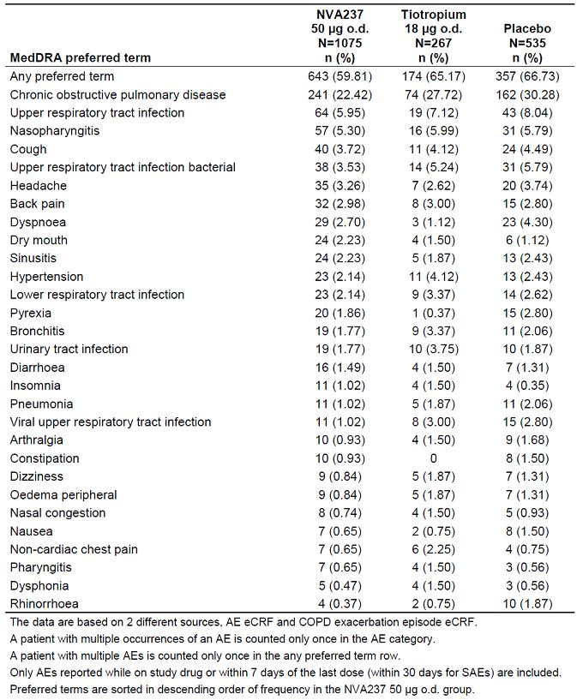

Table 13: AEs by system organ class (COPD Core 6-month Safety database).

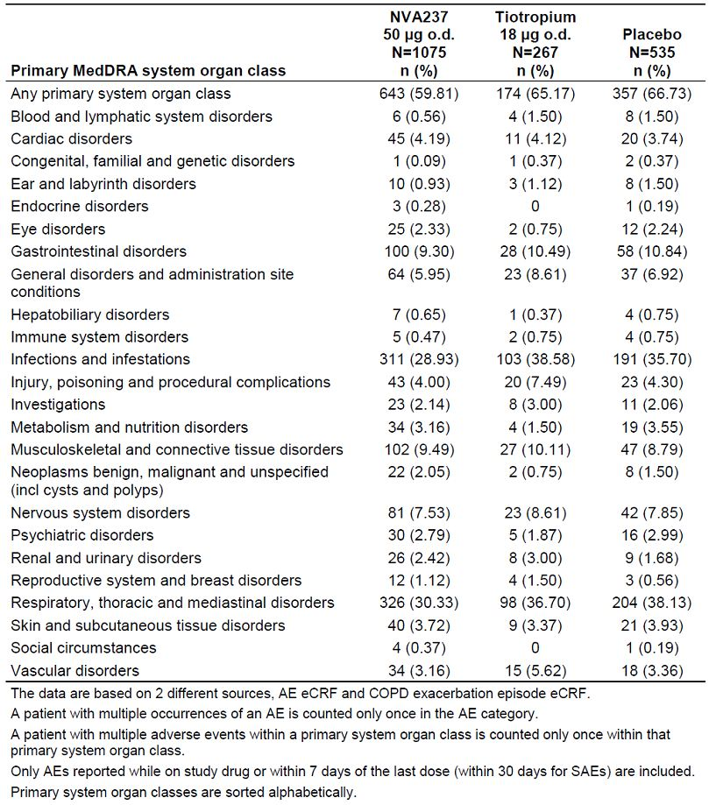

AEs typically associated with anticholinergic treatment that were more frequent in the NVA237 group than the placebo and tiotropium groups included only dry mouth (NVA237: 2.2%, placebo: 1.1%, tiotropium=1.5%). Compared with placebo and tiotropium, the NVA237 group showed a slightly lower incidence of constipation (NVA237 0.9%, placebo 1.5%, and tiotropium- 0) and blurred vision (NVA237 0.5%, placebo 0.6%, and tiotropium 0.4%). Benign prostatic hyperplasia was reported in the NVA237 (0.3%) and tiotropium (0.8%) groups, but not in the placebo group. Glaucoma was reported in 1 patient (0.1%) in the NVA237 group but not in the placebo or tiotropium groups. Urinary tract infection was more frequent in the tiotropium group (3.8%) than the NVA237 and placebo groups (1.8% and 1.9%, respectively). Overall, the frequency of these events was low. The most frequently reported AEs by SMQ[16] (> 5.0% in the system organ class of any treatment group) were related to oropharyngeal disorders (NVA237 5.9%, placebo 4.3%, and tiotropium 5.6%), GI nonspecific inflammation and dysfunctional conditions (NVA237 5.7%, placebo 7.5%, and tiotropium8.6%), and accidents and injuries (NVA237 3.3%, placebo 3.2%, and tiotropium 6.0%).

###### Core 12-month safety database

Overall, the frequency of AEs was similar in the NVA237 group (76.6%) compared to the placebo group (76.5%), and slightly higher in these groups compared to the tiotropium group (74.2%). The most frequently reported AE was COPD, which was reported with a lower frequency in the NVA237 group (36.4%) compared to the placebo group (43.3%). Other frequent AEs were URTI, nasopharyngitis, sinusitis, URTI bacterial, back pain, and headache (Table 14). AEs in the respiratory, thoracic and mediastinal disorders system organ class were less frequent in the NVA237 group (45.1%) compared to the placebo group (53.0%), and slightly more frequent than in the tiotropium group (42.7%). AEs in the infections and infestations system organ class were less frequent in the NVA237 group (45.7%) compared to the placebo group (51.5%) and tiotropium group (48.3%). Musculoskeletal and connective tissues disorder AEs were balanced between NVA237 (16.2%), placebo (12.3%), and tiotropium groups (14.2%) (Table 15).

Table 14: AEs by most frequently reported preferred term (at least 1.5% in any group) (COPD Core 12-month Safety database).

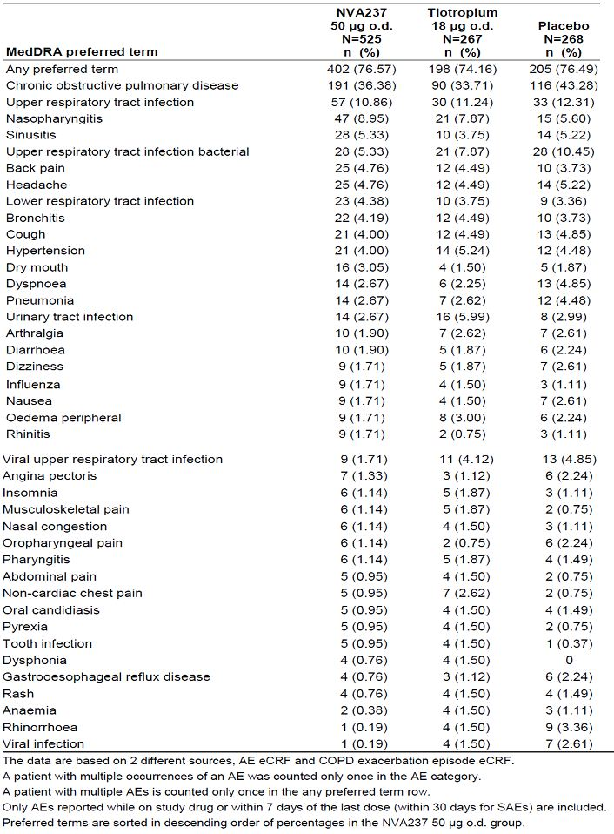

Table 15: AEs by system organ class (COPD Core 12-month Safety database).

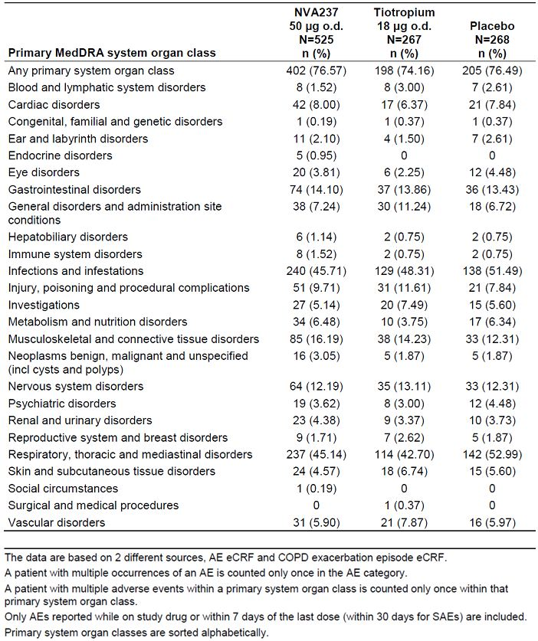

For AEs typically associated with anticholinergic treatment, dry mouth was more frequent in the NVA237 group (3.1%) compared to the placebo (1.9%) and tiotropium group (1.5%) However, constipation (NVA237 1.3%, placebo 1.5%, and tiotropium 0), urinary tract infection (NVA237 2.7%, placebo 3.0%, and tiotropium 6.0%), blurred vision (NVA237 0.6%, placebo 1.1%, and tiotropium 0.4%), and benign prostatic hyperplasia (NVA237 1.0%, placebo 0.4%, and tiotropium 1.1%) were reported with similar frequency in the NVA237 and placebo groups. The frequency of both urinary retention and glaucoma was 0.4% for the tiotropium group but 0% for both the NVA237 and placebo groups.

The most frequently reported AEs by SMQ (> 5.0% in the system organ class of any treatment group) were related to oropharyngeal disorders (NVA237 9.1%, placebo 8.6%, and tiotropium 7.5%), GI nonspecific inflammation and dysfunctional conditions (NVA237 9.0%, placebo 9.3%, and tiotropium 11.6%), and accidents and injuries (NVA237 7.8%, placebo 6.0%, and tiotropium 9.0%). In the between-treatment comparison of NVA237 versus placebo, the lower boundary of the OR 95% CI was below 1 for all SMQs both for the Core 6- and 12-month Safety databases.

##### Other studies

###### AEs in the Major safety database (pivotal and other supportive studies)

Overall, AEs were less frequent in the NVA237 group (58.2%) and placebo group (54.4%) compared to the tiotropium group (74.2%). The most frequent AE by preferred term was COPD, which was reported less frequently in the NVA237 group (22.5%) compared with the placebo (24.0%) and tiotropium (33.7%) groups. Other frequent AEs were nasopharyngitis, URTI, cough, URTI bacterial, and headache. All of these events were reported with lower frequency in the NVA237 group as compared to the placebo group, with the exception of nasopharyngitis (6.2% NVA237, 5.8% placebo, 7.9% tiotropium). The majority of AEs (≥ 10% in any treatment group by system organ class) were related to respiratory, thoracic and mediastinal disorders (30.5%, 30.2% and 42.7% in NVA237, placebo and tiotropium groups, respectively), infections and infestations (28.9%, 30.5%, and 48.3%, respectively), and GI disorders (10.4%, 8.7%, and 13.9%). The most frequently reported AEs by SMQ (> 5.0% in the system organ class of any treatment group) were related to GI nonspecific inflammation and dysfunctional conditions (6.4%, 5.6%, and 11.6% in NVA237, placebo and tiotropium groups, respectively), oropharyngeal disorders (6.4%, 4.4%, and 7.5%, respectively), and accidents and injuries (4.1%, 3.3%, and 9.0%). The number of AEs per 100 patient-years for AEs by SMQ was 96.4, 104.5 and 113.5 in NVA237, placebo and tiotropium groups, respectively.

###### AEs in the All treated safety database

The All treated safety database was based on studies that used different doses and dosing regimens and hence comparison of AEs between treatment groups in this database would be difficult to interpret.

The Short-term Safety database was summarised using different doses and dosing regimens of NVA. Only 8 patients in the COPD subgroup were exposed to NVA237 50 μg once daily. The studies in the Short-term Safety database had shorter duration of exposure (i.e. ranging from 1 day to 28 days) and included healthy volunteers. Hence, these studies only contributed limited short-term safety information regarding NVA237.

In study A2108, NVA237 was well tolerated after oral and inhaled administration with and without charcoal and after intravenous administration. There was a slight consistent bradycardic effect after the i.v. administration of GP. There was no tendency for tachycardia as would have been expected after higher exposures by intravenous administration of NVA237. There were no relevant effects on the QT-interval.

In study A2103, multiple inhaled doses of NVA237 (25, 50, 100 and 200 μg) were well tolerated by patients with COPD. There were no serious adverse events. Most of the AEs reported in the study were mild and moderate in severity. There was one discontinuation due to an adverse event for a patient receiving 200 μg at the time of discontinuation (patient experienced dyspnoea and orthopnoea with onset of symptoms more than 11 hours after the last inhalation). There were no clinically relevant changes in laboratory values, vital signs or ECG.

#### Treatment-related adverse events (adverse drug reactions)

##### Pivotal studies

###### Core 6-month safety database

The incidence of treatment-related AEs (judged by investigator) was similar among treatment groups (7.2%, 7.3% and 7.9% in NVA237, placebo and tiotropium groups, respectively). The most frequently reported AEs suspected to be study drug related (≥ 1.0% in any treatment group for any preferred term) were dry mouth (1.6%, 0.9%, and 1.5%) and COPD (0.7%, 1.1%, and 1.1%). The frequency of blurred vision suspected to be study drug related was 0.1% (1 patient) in the NVA237 group, 0 in the tiotropium group, and 0.2% (1 patient) in the placebo group (Table 16). No other AE typically associated with anticholinergic treatment (e.g. constipation, urinary retention, increased intra-ocular pressure) and suspected to be study drug related was reported in the NVA237 group.

Table 16: AEs suspected to be study drug-related (investigator reported) occurring in at least 2 patients in any treatment group by preferred term (COPD Core 6-month Safety database).

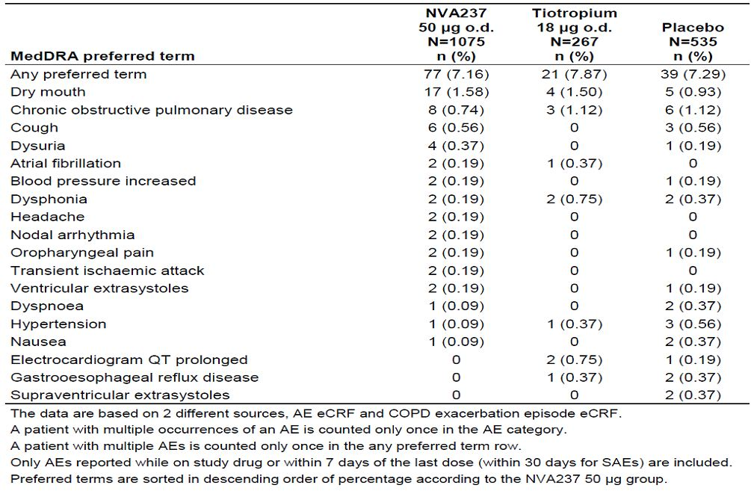

In the Core 6-month safety database, AEs with an absolute frequency in the NVA237 group of at least 0.5% (corresponding to approximately 5 patients) and at least a 1.5-fold higher frequency than in the placebo group were defined as potential ADRs.[17] The most frequent potential ADRs were dry mouth, pain in extremity, and rash. Based on OR and 95% CIs, none of the events reached statistical significance versus placebo (Table 17).

Table 17: Potential adverse drug reactions based on numerical criteria (COPD Core 6-month Safety database).

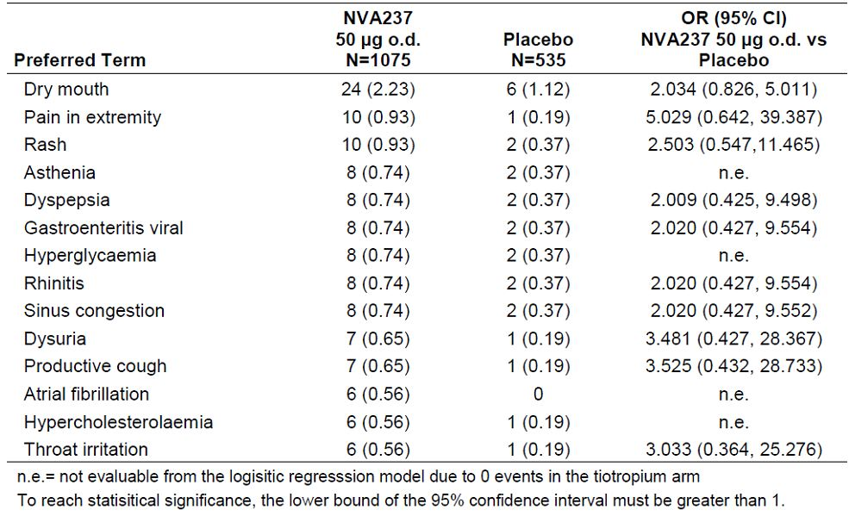

Majority of AEs in the Core 6-month Safety database were moderate in severity. The overall frequency of patients with severe AEs was lower in the NVA237 group (6.6%) compared to the placebo group (10.7%) and tiotropium group (10.5%). The only severe AE occurring in ≥ 2.0% of patients in any treatment group for any preferred term was COPD (1.67%, 4.30% and 2.25%, respectively) (Table 18).

Table 18: Severe AEs by preferred term occurring in at least 2 patients in any treatment group (COPD Core 6-month Safety database).

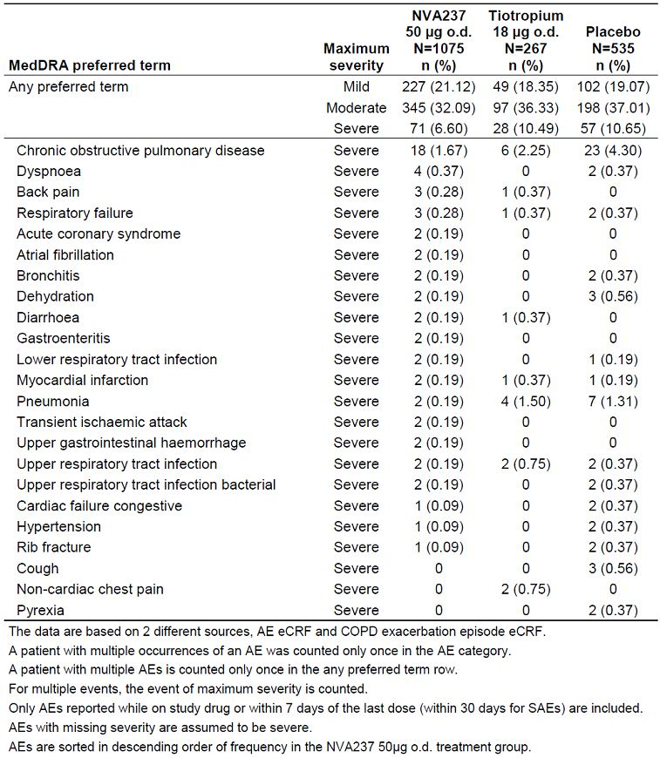

The overall frequency of AEs with onset from 1-13 weeks was lower in the NVA237 group (46.1%, 51.4% and 50.2% in NVA237, placebo and tiotropium groups, respectively). The overall frequency of AEs with onset from 14 weeks onward was also lower in the NVA237 group (37.1%, 41.3% and 42.9%, respectively). The most frequent AE (COPD) with onset from 1-13 weeks was less frequent in the NVA237 group (14.9%, 21.1% and 17.6%, respectively). COPD with onset from 14 weeks onward was also lower in the NVA237 group (11.8%, 16.7% and 17.8%, respectively). The incidence of the most frequent AE (COPD) did not appear increase with prolonged exposure (Table 19).

Table 19: AEs (n [%] of patients) by time of onset overall for the 10 most frequent AEs in the NVA237 group, by preferred term (COPD Core 6-month Safety Database).

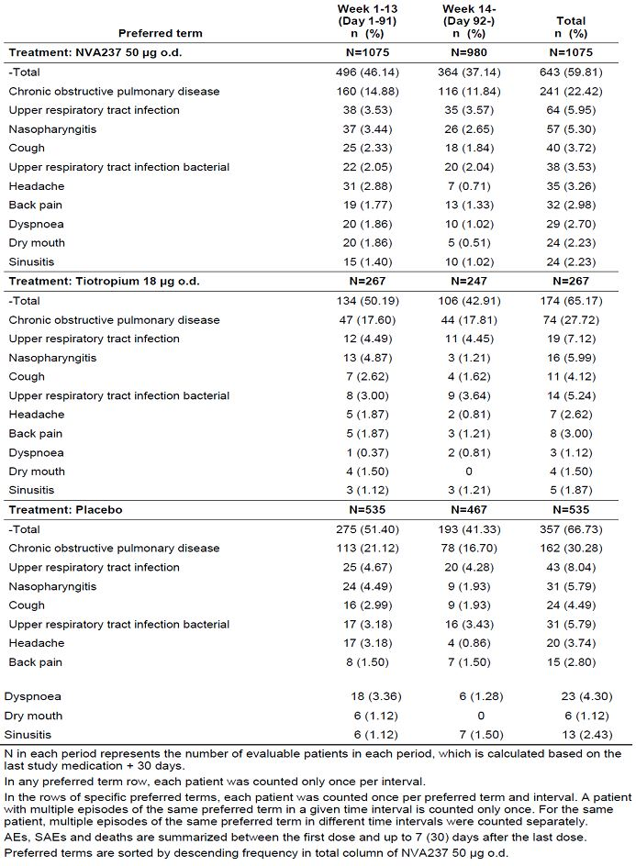

###### Core 12-month safety database

The overall frequency of AEs in the Core 12-month Safety database suspected to be related to study drug based on investigator assessment was higher in the NVA237 group (10.7%) compared to the placebo (9.3%) and tiotropium group (8.2%). The most frequent AEs suspected to be study drug related (≥ 1.0% in any treatment group for any preferred term) were dry mouth (2.5%, 1.1%, and 1.5% in NVA237, placebo and tiotropium groups, respectively), COPD (1.0%, 1.5%, and 1.1%) and cough (1.0%, 0.4%, and 0). Other than dry mouth, no other AE typically associated with anticholinergic treatment and suspected to be study drug related was reported in the NVA237 group (Table 20). In the Core 12-month Safety database, AEs with an absolute frequency in the NVA237 group of at least 1.0% (corresponding to approximately 5 patients) and had at least a 1.5-fold higher frequency than in the placebo group were defined as potential ADRs. The most frequent potential ADRs were nasopharyngitis, dry mouth, and rhinitis. Based on the OR and 95% CIs, none of the events reached statistical significance versus placebo (Table 21).

Table 20: AEs suspected to be study-drug related (investigator reported) occurring in at least 2 patients in any treatment group by preferred term (COPD Core 12-month Safety Database).

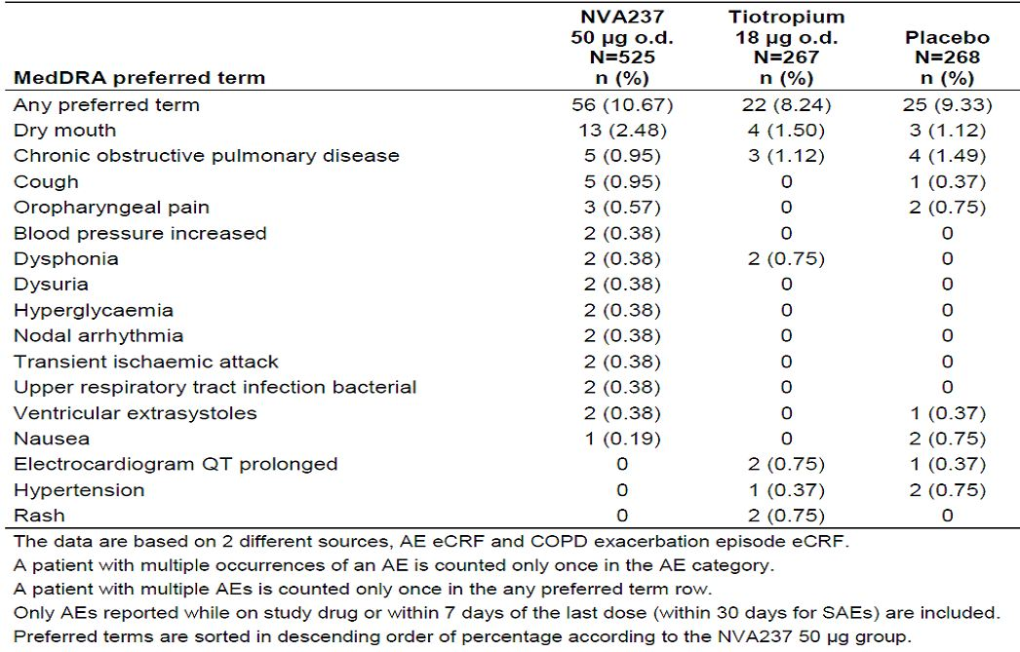

Table 21: Potential adverse drug reactions based on numerical criteria (COPD Core 12-month Safety Database).

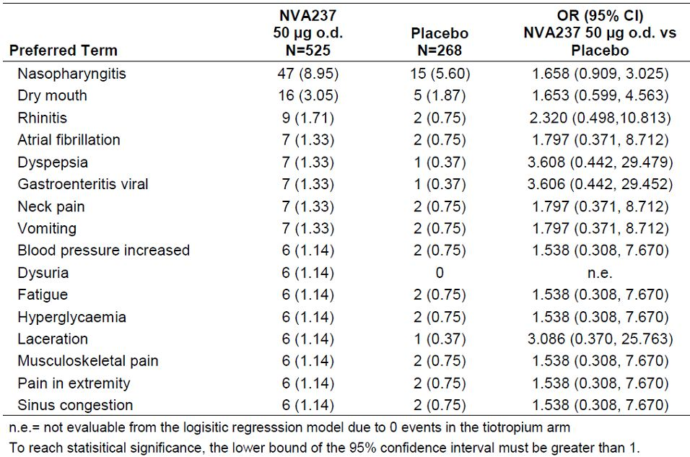

Majority of AEs in the Core 12-month Safety database were moderate in severity. The overall frequency of patients with severe AEs was lower in the NVA237 group (12.6%) compared to the placebo (19.4%) and tiotropium (16.1%) groups. The most frequently reported severe AEs (≥ 2.0% in any treatment group for any preferred term) were COPD and pneumonia.

The overall frequency of AEs with onset from 1-26 weeks was lower in the NVA237 group (61.9%, 68.3% and 64.8%, respectively). The overall frequency of AEs with onset from 27 weeks onward was higher in the NVA237 group (60.1%) compared to placebo (55.5%) and tiotropium (50.9%) groups (Table 22). The most frequent AE (COPD) with onset from 1-26 weeks was less frequent in the NVA237 group (24.6%, 33.2% and 27.7%, respectively). COPD with onset from 27 weeks onward was lower in the NVA237 group (21.2%) compared to the placebo group (26.6%), and higher in the NVA237 group compared to the tiotropium group (18.1%). The incidence of the most frequent AE (COPD) did not appear increase with prolonged exposure (Table 23).

Table 22: Severe adverse events by preferred term occurring in at least 2 patients in any treatment group (COPD Core 12-month Safety Database).

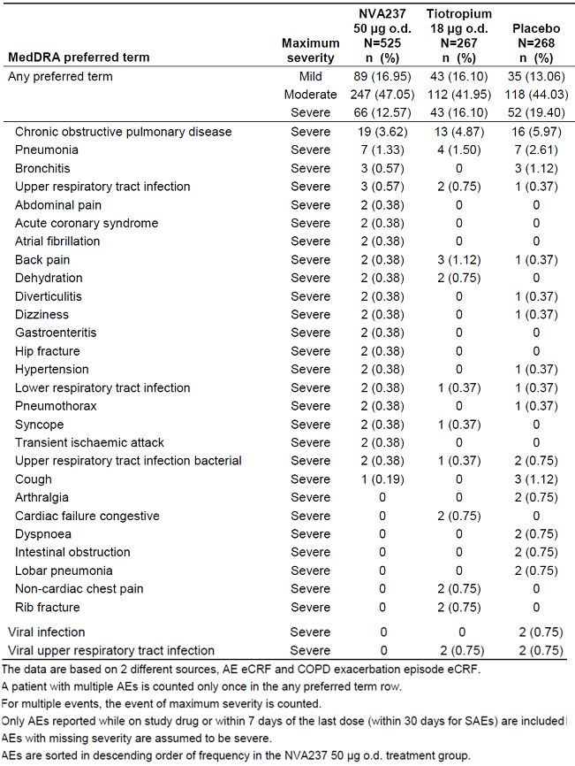

Table 23: AEs (n [%] of patients) by time of onset overall for the 10 most frequent AEs in the NVA237 group, by preferred term (COPD Core 12-month Safety Database).

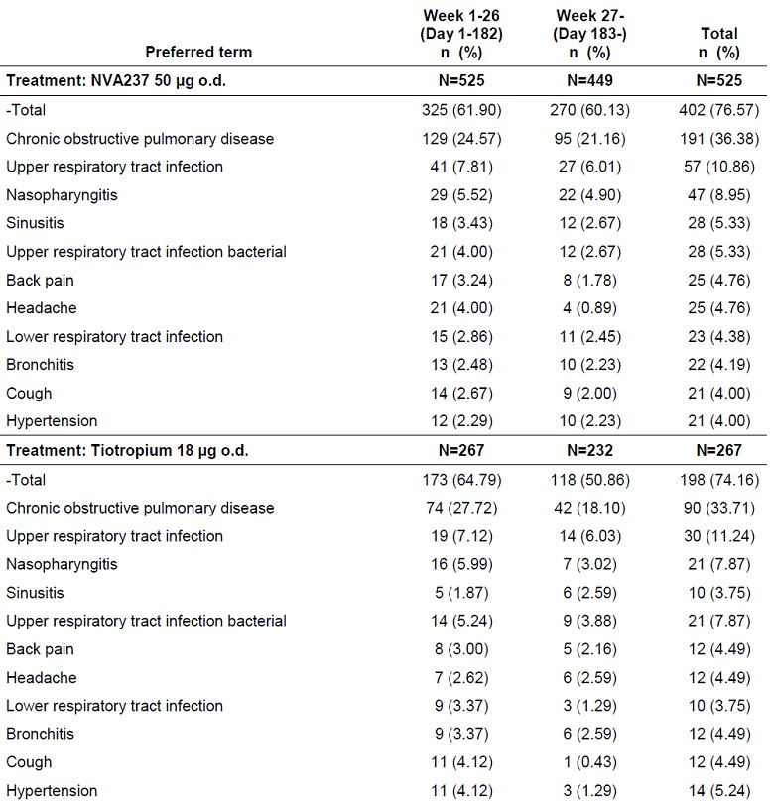

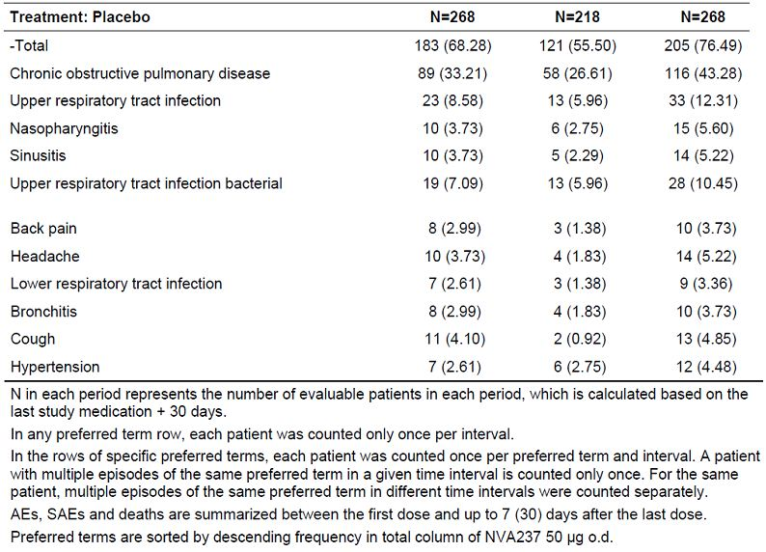

##### Other studies

Not applicable.

#### Deaths and other serious adverse events

##### Pivotal studies

###### Deaths

In all completed studies, a total of 14 deaths occurred, which includes 12 patients who died during the active treatment period and 2 patients who died during the 30 day follow-up period. Seven of these deaths occurred in the NVA237 group, 5 deaths occurred in the placebo group, and 2 deaths occurred in the tiotropium group. A total of 13 deaths occurred in the Core Safety database, including 11 patients who died during the active treatment period and 2 during the 30-day follow-up (Table 24). Six (0.56%) of these deaths occurred in the NVA237 group, 5 (0.93%) deaths occurred in the placebo group and 2 (0.75%) deaths occurred in the tiotropium group. None of the deaths were suspected by the investigator to be related to study medication. In addition, 1 patient died in the 4-week Phase II study A2208 which is not part of the Core Safety database (this patient was in the NVA237 50 μg treatment group and died during the active treatment period). In the NVA237 group in the Core 6-month and 12-month databases, none of the adjudicated primary causes of death were due to cardiovascular events. However, 1 death which occurred in Study A2208 (not part of the Core Safety databases) was adjudicated as a cardiovascular sudden death. Review of deaths during active treatment period or 30 days follow-up period did not show any safety concerns. There were 4 more deaths after the 30-day follow-up period (1 in NVA237 50ug group and 3 in placebo group), none of which appeared to be related to study treatment.

Table 24: Investigator reported primary cause of death by system organ class and preferred term (COPD Core Safety database).

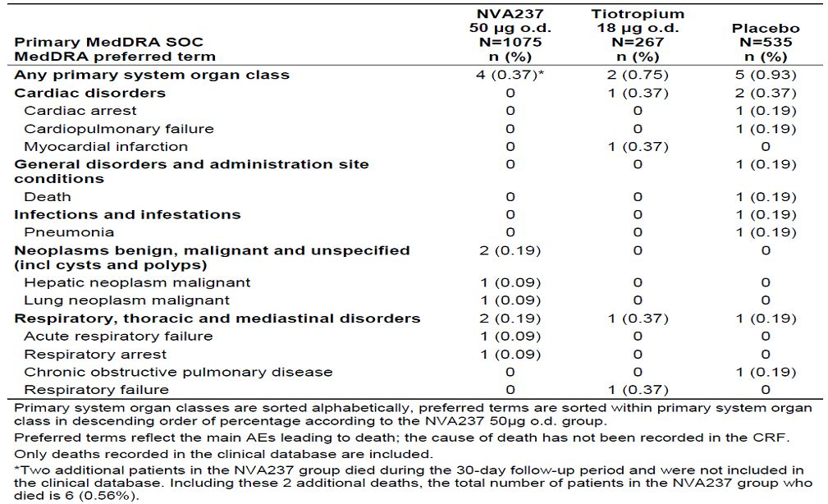

For the Core 6-month Safety database, the OR (95% CI) for NVA237 versus placebo was 0.61 (0.16, 2.31) and the risk difference (95% CI) between NVA237 and placebo was -0.29 (-1.12, 0.55). For the Core 12-month Safety database the OR (95% CI) for NVA237 versus placebo was 0.76 (0.13, 4.60) and the risk difference (95% CI) between NVA237 and placebo was -0.17 (-1.39, 1.04). Hence, there did not appear to be an increased risk of death associated with the NVA237 treatment group after 6 months or 12 months exposure to NVA237 50 μg o.d.

###### SAEs

For the Core 6-month Safety database, the frequency of SAEs was lower in the NVA237 group compared to the placebo and tiotropium groups (7%, 9.9% and 9.4%, respectively). The majority of SAEs sorted by system organ class (≥ 1.5% in any treatment group) were respiratory, thoracic and mediastinal disorders (2.3%, 4.5%, and 3.4% in NVA237, placebo and tiotropium groups, respectively), infections and infestations (1.4%, 3.2%, and 3.4%), and cardiac disorders (1.1%, 1.9%, and tiotropium 0.8%). The most frequently reported SAE by preferred term was COPD (1.7%, 4.3%, and 2.3%). The SAEs of atrial fibrillation, syncope, acute coronary syndrome, acute respiratory failure, and lung neoplasm were reported in only the NVA237 group. However, the number of patients with SAEs reported for these preferred terms was low. There were no other imbalances in the frequency of SAEs among treatment groups. There was 1 patient in the NVA237 treatment group that reported a SAE of cerebrovascular accident (Table 25). The number of SAE episodes per 100 patient-years was lower in the NVA237 group (26.2) compared to the placebo group (48.1) and tiotropium group (31.3). For the preferred term of COPD, the number of SAE episodes per 100 patient-years was lower in the NVA237 (3.9) and tiotropium (4.9) groups compared to the placebo group (11.3). The number of atrial fibrillation SAE episodes was 0.8 per 100 patient-years in the NVA237 group; this SAE episode was not reported in the placebo or tiotropium groups. Overall, the event rate was low.

Table 25: Serious AEs by system organ class and preferred term (≥2 patients with an event in any treatment group) (COPD Core 6-month Safety database).

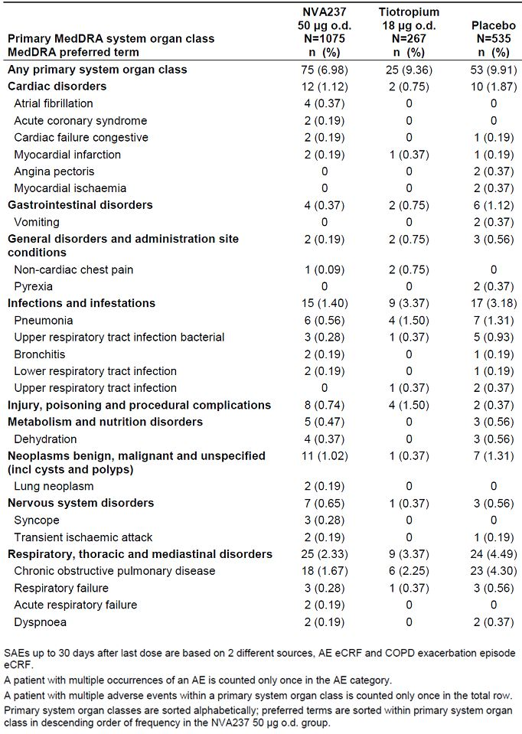

In the Core 12-month Safety database. the frequency of SAEs was lower in the NVA237 group compared to the placebo and tiotropium groups (12.4%, 16% and 15.0%, respectively). The majority of SAEs sorted by system organ class were respiratory, thoracic and mediastinal disorders (4.8%, 6.3%, and 6.0% in NVA237, placebo and tiotropium groups, respectively), infections and infestations (3.4%, 5.2%, and 5.2%), and cardiac disorders (2.1%, 3.0%, and 0.7%). The most frequent SAE by preferred term was COPD (3.6%, 6.0%, and 4.9%). The SAEs of atrial fibrillation, acute coronary syndrome, hip fracture, and hypotension were reported in only the NVA237 group. The number of patients with SAEs reported for these preferred terms was low (< 1.0%) and there were no other imbalances in the frequency of SAEs among treatment groups (Table 26). Additionally, 3 patients had SAEs within 30 days after the last dose of study medication,[18] 2 in the NVA237 group and 1 in the tiotropium group, but these events were not included in the clinical database and were not suspected to be related to study medication. The number of SAEs per 100 patient-years was lower in the NVA237 group (27.6) and tiotropium group (27.3) compared to the placebo group (44.7). For the preferred term of COPD, the number of SAEs per 100 patient-years was lower in the NVA237 (4.6) and tiotropium (6.1) groups compared to the placebo group (7.8). The number of atrial fibrillation SAEs was 0.9 per 100 patient-years in the NVA237 group and this SAE was not reported in the tiotropium or placebo groups.

Table 26: Serious AEs by system organ class and preferred term (≥2 patients with an event in any treatment group) (COPD Core 12-month Safety database).

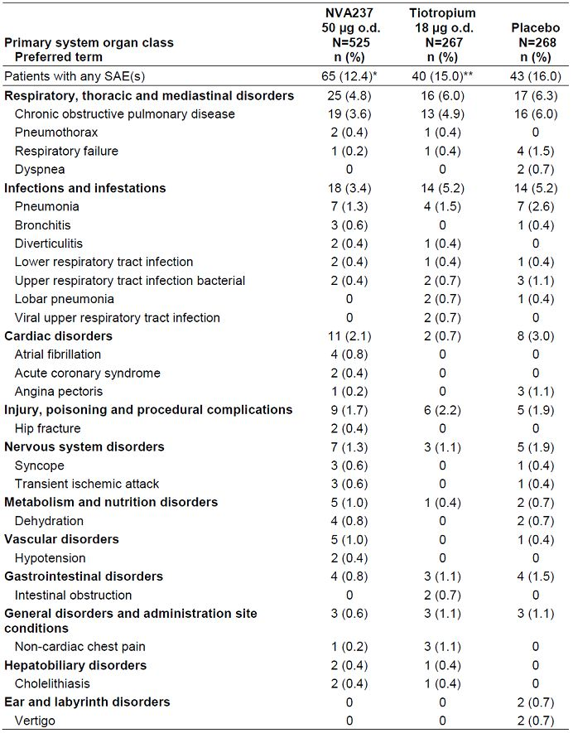

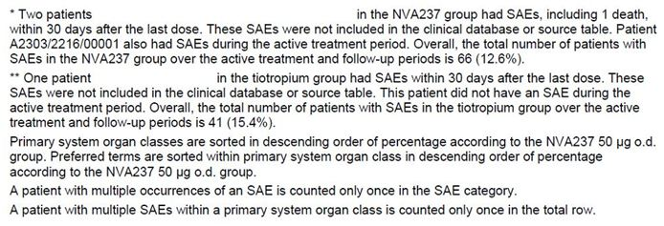

##### Other studies

In the Major safety database, incidence of SAEs was similar in the NVA237 group (8.2%) and the placebo group (8.6%) and lower than that in tiotropium group (15%). The majority of SAEs sorted by system organ class (≥ 1.5% in any treatment group) were respiratory, thoracic and mediastinal disorders (2.7%, 3.4%, and 6.0% in NVA237, placebo and tiotropium groups, respectively), infections and infestations (2.0%, 2.7%, and 5.2%), cardiac disorders (1.3%, 1.6%, and 0.8%), and injury, poisoning and procedural complications (1.0%, 0.7%, and 2.3%). The most frequently reported SAE by preferred term was COPD (2.1%, 3.3%, and 4.9%). Of the SAEs occurring in at least 2 patients in any treatment group by preferred term, SAEs of atrial fibrillation, acute coronary syndrome, gastroenteritis, hip fracture, intervertebral disc protrusion, lung neoplasm, hypoxia, and hypotension were reported in only the NVA237 group. The number of patients with SAEs reported for these preferred terms was low. There were no other imbalances in the frequency of SAEs among treatment groups**.** The number of SAE episodes per 100 patient-years was lower in the NVA237 (27.4) and tiotropium (27.3) groups compared to the placebo group (40.0). For the preferred term of COPD, the number of SAEs per 100 patient-years was lower the NVA237 group (4.2) compared to the placebo group (8.6). The number of SAE episode of atrial fibrillation (preferred term) was 1.0 per 100 patient-years in the NVA237 group; this SAE was not reported in the tiotropium and placebo groups.

In the Short-term Safety database (all Phase 1 and Phase 2 studies), SAEs were not reported in healthy volunteers. In COPD patients, SAEs reported as percentages below reflect the total daily dose and regimen. SAEs were reported in the NVA237 12.5 μg q.d. (1.4%), NVA237 25 μg combined b.i.d. and q.d. total daily dose (1.2%), NVA237 25 μg b.i.d. (4.2%), NVA237 100 μg combined b.i.d. and q.d. total daily dose (1.2%), NVA237 200 μg q.d. (0.9%), and placebo (1.6%) groups. No SAEs were reported in the NVA237 50 μg q.d. and tiotropium groups.

#### Discontinuations due to adverse events

##### Pivotal studies

###### Core 6-month safety database

In the Core 6-month Safety database, discontinuations due to AEs were lower in the NVA237 (6.0%) and tiotropium groups (6.0%) compared to the placebo group (8.2%). The most frequently reported AE leading to discontinuation of study drug by preferred term was COPD (NVA237 1.7%, placebo 3.6%, and tiotropium 3.0%). Myocardial infarction was reported in 0.2% of patients (2 patients) in the NVA237 group and 0.4% of patients (1 patient) in the tiotropium group; no cases were reported in the placebo group. The frequency of atrial fibrillation leading to discontinuation of study drug was 0.28% in the NVA237 group; this AE was not reported in the placebo or tiotropium groups (Table 27). The frequency of AEs leading to hospitalisation or prolongation of hospitalisation was 6.0%, 9.0% and 8.2% in NVA237, placebo and tiotropium groups, respectively; the most frequent AE causing hospitalisation (or prolongation) was COPD (1.7%, 4.3%, and 1.9%). The frequency of AEs requiring study treatment interruptions[19] was 2.1%, 4.7%, and 4.9%, respectively with COPD being most frequent AE leading to discontinuation (0.9%, 1.9%, and 2.3%). The frequency of AEs requiring significant additional therapy was 47.8%, 58.3%, and 57.7% in NVA237, placebo and tiotropium groups, respectively and COPD was again the most frequent AE (≥ 10% in any treatment group by preferred term) requiring significant additional therapy was COPD (21.1%, 27.9%, and 26.2%, respectively).

Table 27: Most frequent AEs leading to discontinuations by preferred term (occurring in ≥2 patients in any treatment group) (COPD Core 6-month Safety database).

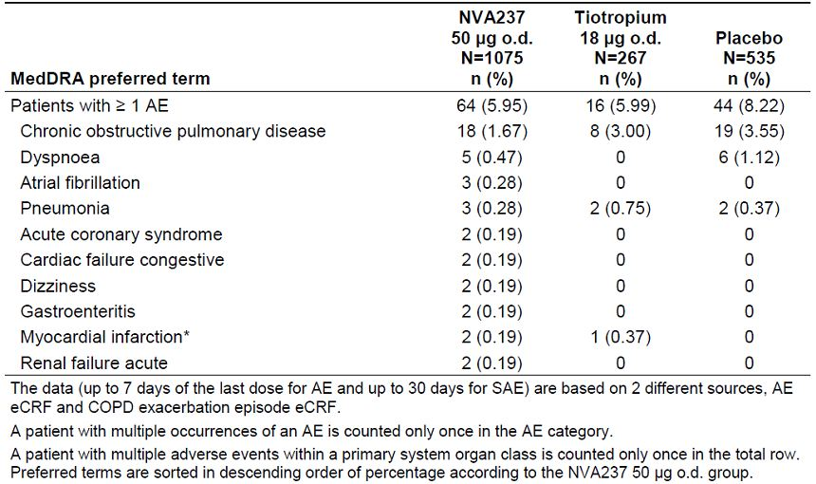

###### Core 12-month safety database

In the Core 12-month Safety database, discontinuations due to AEs were less frequent in the NVA237 (8.0%) and tiotropium (7.5%) groups compared to the placebo group (11.6%). The most frequently reported AE leading to discontinuation of study drug by preferred term was COPD (1.9%, 4.9%, and 3.7% in NVA237, placebo and tiotropium groups, respectively). The frequency of the AE of atrial fibrillation (preferred term) leading to discontinuation of study drug was 0.2% (1 patient) in the NVA237 group; this AE was not reported in the tiotropium or placebo groups (Table 28). The frequency of AEs leading to hospitalisation or prolongation of hospitalisation was 11.6%, 14.6% and 13.9% in NVA237, placebo and tiotropium groups, respectively with COPD being the most frequent AE causing hospitalisation (or prolongation) (3.6%, 6.0%, and 4.5%). The frequency of AEs requiring study treatment interruptions was 4.2%, 8.6% and 7.1% in NVA237, placebo and tiotropium groups, respectively and the most prevalent AE (≥1.0% in any treatment group for any preferred term) requiring study treatment interruption was COPD (1.3%, 2.6%, and 3.0%). The frequency of AEs requiring significant additional therapy was 67.4%, 69.0%, and 67.0%, respectively, and again COPD was the most frequent AE responsible for this (33.7%, 41.4%, and 32.6%).

Table 28: Most frequent AEs leading to discontinuations by preferred term (occurring in ≥2 patients in any treatment group) (COPD Core 12-month Safety database).

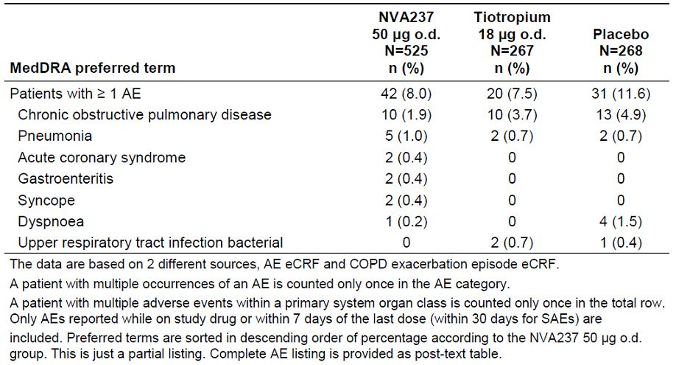

##### Other studies

In the Major Safety database, discontinuations due to AEs were slightly lower in the NVA237 group (5.9%) compared to the placebo (7.1%) and tiotropium (7.5%) groups. The AEs by primary system organ class most frequently leading to discontinuations (> 1.0% in the system organ class of any treatment group) were respiratory, thoracic and mediastinal disorders, cardiac disorders, and infections and infestations. The most frequently reported AE leading to discontinuation of study drug by preferred term was COPD (1.6%, 3.2%, and 3.8% in NVA237, placebo and tiotropium groups, respectively). The frequency of AEs leading to hospitalisation or prolongation of hospitalisation was 7.3%, 7.7% and 13.9%, respectively with COPD being most frequent reason (2.1%, 3.3%, and 4.5%, respectively). The frequency of AEs requiring study treatment interruptions was 2.6, 3.8% and 7.1% in NVA237, placebo and tiotropium groups, respectively with COPD most frequent reason (0.9%, 1.4%, and 3.0%, respectively). The frequency of AEs requiring significant additional therapy was 46.9%, 46.5% and 67.0%, respectively with COPD being the most frequent reason (21.1%, 22.3%, and 32.6%).

#### Laboratory tests

The Major Safety database was used for the analysis of laboratory values as it was the largest pooled database and allowed the analysis of time points up to 3 months, after 6 months, and after 12 months.

##### Liver function

In the major safety database, there was a lower frequency of patients with ≥ 1 LFT elevation in the NV237 group compared to the placebo group up to 3 months (0.7%, 1.7% and 0.8% in NVA237, placebo and tiotropium groups, respectively), after 6 months (1.0%, 2.5%, and 0.8%), and after 12 months (1.0%, 2.7%, and 1.2%). There were no clinically meaningful changes in LFTs across treatment groups at up to 3, and after 6 and 12 months. No patients met laboratory criteria for Hy’s law[20] in any treatment group at any time points.

##### Kidney function

In the Major Safety database, no clinically meaningful differences were observed in urinalysis or clinical chemistry (BUN and serum creatinine) parameters across treatment groups.

##### Other clinical chemistry

In the Major Safety database, the frequencies of all newly occurring or worsening clinically notable values in clinical chemistry parameters were generally similar between groups. In addition, there were no other notable differences in blood chemistry values in terms of change from baseline and shifts relative to normal range from baseline across treatment groups. Overall, no clinically significant changes were observed in clinical chemistry parameters.

##### Haematology

In the Major safety database, there was a slightly higher frequency of patients with a clinically notable decrease in haemoglobin in the NVA237 group compared to the placebo and tiotropium groups up to 3 months (2.2%, 1.7%, and 0.4% in NVA237, placebo and tiotropium groups, respectively), after 6 months (3.1%, 2.3%, and 0.8%), and after 12 months (2.9%, 2.7%, and 1.5%). There was a slightly lower frequency of patients with a clinically notable decrease in haematocrit in the NVA237 group compared to the placebo group, but a slightly higher frequency compared to the tiotropium group up to 3 months (1.2%, 1.3% and 0), after 6 months (1.9%, 2.1%, and 0), and after 12 months (2.7%, 3.5%, and 0.8%). Overall, the mean change from baseline in haemoglobin analytes were generally similar in the NVA237 group compared to the placebo and tiotropium groups up to 3 months (-3.6, -3.0, and -3.5 g/L), after 6 months (-5.0, -4.4, and -4.9 g/L), and after 12 months (-6.6, -6.1, -6.6 g/L). The mean change from baseline in haematocrit up to 3 months, after 6 months, and after 12 months was 0.0 g/L for all treatment groups. The frequency of increased and decreased platelet counts and white blood cell (WBC) counts were similar in the NVA237 group compared to the placebo and tiotropium groups and there were no clinically meaningful differences in haemoglobin and haematocrit across active treatment and placebo groups in shifts from baseline. There were no clinically meaningful differences in other haematology values in terms of change from baseline and shifts relative to normal range from baseline across treatment groups.

##### Electrocardiograph

Electrocardiogram (ECG) data reporting were presented only for the Core Safety database which has the most clinically relevant ECG measurements. In most studies comprising the Core Safety database, each patient had 3 consecutive ECGs at baseline (25 minutes pre-dose on Day 1) and 2 consecutive ECGs at all subsequent scheduled time points. The average of the values at each scheduled time point was calculated for each quantitative ECG assessment and was used for all the following analyses. The baseline value was the average of the last (e.g. 25 min) pre-dose measurements before the first dose. The ECGs were read by a qualified cardiologist at a central ECG vendor (eRT), including quantitative and qualitative assessments. There was no subgroup evaluation of ECGs.

###### QT interval

There were no notable differences in QTcF interval between the NVA237 and placebo group at any time point. Male patients, after 6 months of treatment, experienced notable QTcF (> 450 ms) values with a slightly higher frequency in the NVA237 group compared to the placebo group which was reversed after 12 months of treatment (male patients experienced notable QTcF (> 450 ms) values with a lower frequency in the NVA237 group compared to the placebo group). Female patients, after 6 and 12 months of treatment, experienced notable QTcF (> 470 ms) values with a slightly higher frequency in the NVA237 group compared to the placebo group (Table 29). Patients experienced notable QTcF (> 500 ms) with a slightly lower frequency in the NVA237 group compared to the placebo group. One patient in the NVA237 group was taking amiodarone prior to and during the study, which is known to prolong the QTcF interval. Overall, the notable changes across treatment groups were not considered clinically meaningful. After 6 months of treatment, increases from baseline (30-60 ms) in QTcF were reported with a slightly higher frequency in the NVA237 group compared to the placebo and tiotropium groups (NVA237 11.3%, placebo 9.7%, and tiotropium 9.8%) with similar results after 12 months of treatment (NVA237 15.8%, placebo 14.6%, and tiotropium 16.2%). After 6 months, increases from baseline (> 60 ms) occurred with a slightly higher frequency in the NVA237 group (0.7%) compared to the placebo (0.4%) group. After 12 months, increases > 60 ms occurred in 1 patient (0.2%) in the NVA237 group and 1 patient (0.4%) in the placebo group. No increase from baseline (> 60 ms) were not reported in the tiotropium group after 6 and 12 months of treatment. The differences between treatment groups were small and are not considered clinically meaningful. There were no significant differences between the active treatment and placebo groups for QTcF at any time point. In the NVA237 treatment group of the COPD Core safety database there were two cases with a new QTcF of >500ms and seven with a QTcF prolongation from baseline of >60 ms. In 6 of the 9 cases on NVA237 with QTc prolongation, circumstances have been identified which may explain this change in repolarization, though it should be noted that the time of the intake of the potentially QTc prolonging concomitant medications was identified in all cases. In the placebo treatment group of the COPD safety database, there were two cases with a new QTcF of >500ms and two with a QTcF prolongation from baseline by >60 ms and none of these cases, had any circumstances which may explain ECG findings.

Table 29: QTc Fridericia (ms): Number and percentage of patients with newly occurring or worsening clinically notable values after 6 months and 12 months of treatment by treatment duration and parameter (COPD Core Safety database).

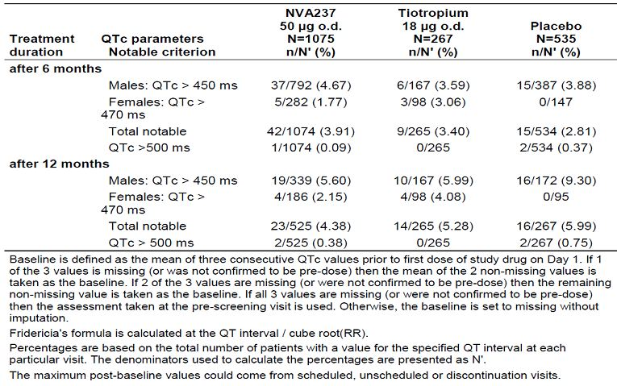

###### Qualitative ECG abnormalities

The most common newly occurring ECG abnormalities after 6 months were Ectopy, Rhythm disturbances (i.e. atrial fibrillation and atrial flutter), and conduction disturbances. Overall, there was a slightly higher frequency of newly occurring atrial fibrillation and atrial flutter on centralised ECG recordings in the NVA237 group compared to placebo (Table 30).

Table 30: Qualitative ECG diagnoses: Number and percentage of patients with newly occurring ECG abnormalities any time post-baseline after 6 months and 12 months of treatment by treatment duration, evaluation type (COPD Core Safety database).

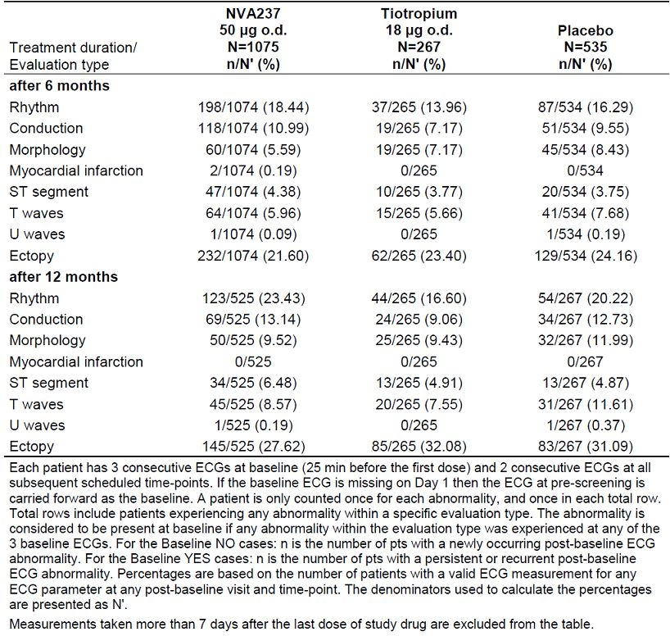

###### 24-h Holter monitoring

A subset of patients in both Study A2303 and Study A2304 had 24-h Holter monitoring. For the Core 6-month Safety database, the frequency of a ≥ 10 fold increase in VEs was 12.5% in the NVA237 group compared to 10.3% in the placebo group. For the Core 12-month Safety database, the frequency of a ≥ 10 fold increase in VEs was similar in the NVA237 and placebo groups (13.1% vs 12.9%). For the Core 6-month and 12-month Safety databases, there were no notable differences in mean 24-hour heart rate of the patients in any of the treatment groups at any visit.

In the Core 6-month Safety database, there were 2 (1.7%) new events of atrial fibrillation in the NVA237 group compared to 0 in the placebo group and 1 (3.1%) in the tiotropium group. For atrial flutter, there was 1 (0.9%) new event in the NVA237 group compared to none (0) in both the placebo and tiotropium groups. In the Core 12-month Safety database, there were 3 new events of atrial fibrillation in the NVA237 group compared to 0 in the placebo group and 1 in the tiotropium group. For atrial flutter, there was 1 new event in the NVA237 group compared to 0 in both the placebo and tiotropium groups. There were no clinically meaningful differences for the other specific events. Overall there was a slightly higher frequency of newly occurring atrial fibrillation and atrial flutter on 24-h Holter monitoring in the NVA237 treatment group as compared to placebo.

##### Vital signs

Vital signs data reporting was presented only for the Major Safety database and included systolic and diastolic blood pressure, pulse rate and body weight. The incidence of notable blood pressure (BP) or pulse readings was generally low. Systolic and diastolic blood pressure (DBP) by visit, time point, and minimum and maximum post-baseline value generally showed no discernible differences between the NVA237, placebo, and tiotropium groups at individual time points. Notably low pulse rates were more frequent in the NVA237 group compared to the placebo group, but similar to the tiotropium group up to 3 months (NVA237 2.0%, placebo 1.2%, and tiotropium 2.3%), after 6 months (NVA237 3.5%, placebo 2.1%, and tiotropium 3.0%), and after 12 months (NVA237 5.5%, placebo 2.6%, and tiotropium 4.5%). Mean change from baseline in values for pulse rate were generally similar across treatment groups. However, at the 6 month time point, analysis of the minimum mean post-baseline pulse rate showed a statistically significant difference between NVA237 and placebo (-0.71 bpm, p = 0.0336; 95% CI: -1.36, -0.06), but not up to 3 or after 12 months; this difference was not considered clinically relevant. Notably higher body weight was more frequent in the NVA237 group compared to the placebo group only after 6 months (NVA237 4.7%, placebo 3.1%) and after 12 months (NVA237 10.5%, placebo 5.8%); maximum mean change from baseline was greater in the NVA237 group compared to the placebo group up to 3 months (NVA237 vs placebo: 0.16 vs -0.11 kg), after 6 months (0.84 vs 0.36 kg) and after 12 months (1.78 vs 1.02 kg). Overall there were no other clinically meaningful findings for BP, pulse rate, or weight.

##### Other safety parameters - AEs of special interest

This section summarises safety events related to:

* cardiac and cerebrovascular disorders;
* those possibly related to the anticholinergic effects of NVA237, including (a) bladder obstruction, urinary retention, (b) dry mouth, (c) constipation and GI hypomotility, (d) glaucoma/hypertension, and (e) anticholinergic syndrome;
* others (Paradoxical bronchospasm).

###### Pivotal studies

The frequency of glaucoma and ocular hypertension AEs was 0.2%, 0% and 0% in NVA237, placebo and tiotropium groups, respectively for the 6-month safety database; it was 0%, 0.4% and 0.4%, respectively for the 12-month safety database. There were no SAEs in the glaucoma and ocular hypertension SMQ in the Core 6- or 12-months databases.

The frequency of bladder obstruction and urinary retention AEs was 1.1%, 0.8% and 1.1% in NVA237, placebo and tiotropium groups, respectively for the 6-month safety database; it was 1.7%, 1.5% and 1.1%, respectively for the 12-month safety database. The only bladder obstruction and urinary retention AE reported in ≥ 0.5% of patients in the NVA237 group was dysuria in 6-month (0.7% 0.2% and 0.8% in NVA237, placebo and tiotropium groups, respectively) and 12-month safety database (1.1%, 0 and 0.8%, respectively). The frequency of SAEs of urinary retention was 0.1%, 0 and 0 in NVA237, placebo and tiotropium groups, respectively, for 6-month core database and no SAEs were reported in any treatment group in the Core 12-month Safety database.

The frequency of ‘anticholinergic symptom’ AEs was slightly higher in the NVA237 group (6.2%, 5.8% and 4.5% in NVA237, placebo and tiotropium groups, respectively) for 6-month core database with similar results for 12-month core database (7.4%, 6.3% and 6%, respectively). In the 6-month core database, the only anticholinergic symptom AEs reported in ≥ 0.5% of patients in the NVA237 group were dry mouth (2.2% 1.1% and 1.5%), pyrexia (1.9% 2.8% and 0.4%), and dizziness (0.8% 1.3% and 1.9%). In the core 12-month database, the only anticholinergic symptom AEs reported in ≥ 0.5% of patients in the NVA237 group were dry mouth (3.1% 1.9% and 1.5%), dizziness (1.7% 2.6%, and 1.9%), pyrexia (1.0% 0.8%, and 1.5%), and vision blurred (0.6% 1.1% and 0.4%). In the Core 6-month Safety database, the frequency of anticholinergic symptom SAEs was 0.2%, 0.6% and 0 in the NVA237, placebo and tiotropium groups, respectively; it was 0.2%, 0.8% and 0, respectively in the Core 12-month Safety database.

In the Core 6-month Safety database, the frequency of dry mouth AEs was slightly higher in the NVA237 group (2.4%, 1.1 and 1.5% in NVA237, placebo and tiotropium groups, respectively) with similar results **i**n the Core 12-month Safety database (3.2%, 1.9%, and 1.5%, respectively). No dry mouth SAEs were reported in the Core 6-month or -12 month databases.

*Comment: Tiotropium was given as an open-label study treatment and patients were not required to report dry mouth symptoms as it is known tiotropium side effect; this bias may be likely reason for low incidence of dry mouth in the tiotropium group.*

In the Core 6-month Safety database, the frequency of constipation and GI hypomotility AEs was lower in the NVA237 (1.2%, 2.4 and 0.8% in NVA237, placebo and tiotropium groups, respectively) with similar resultsin the Core 12-month Safety database (1.9%, 3.4%, and 1.1%). In both the Core 6-month and -12 month databases, no constipation and GI hypomotility SAEs were reported in the NVA237 or tiotropium treatment groups compared to 1 SAE of constipation reported in the placebo group.

There were no AEs or SAEs of bronchospasm or paradoxical bronchospasm in the Core 6-month or 12-month databases.

###### Other studies

The number of glaucoma and ocular hypertension AEs per 100 patient-years was 0.3, 0.3 and 0.4 in NVA237, placebo and tiotropium groups, respectively and there were no SAEs of glaucoma/ocular hypertension. The number of bladder obstruction and urinary retention AEs per 100 patient-years were 2.5, 2.0 and 1.3, respectively and only one SAE of urinary retention was reported for 1 patient in the NVA237 treatment group. The frequency of ‘anticholinergic symptoms’ AEs was slightly higher in the NVA237 group compared to the placebo group but was similar to that in tiotropium group (5.8%, 4.4% and 6%, respectively). The frequency of dry mouth AEs was slightly higher in the NVA237 group (2.2%, 1.0% and 1.5% in NVA237, placebo and tiotropium groups, respectively) and the number of dry mouth AEs per 100 patient-years was 4.5, 2.3 and 1.7, respectively. There were no NVA237-treated patients with dry mouth SAEs. The number of constipation and GI hypomotility AEs per 100 patient-years was 2.7, 4.9 and 1.3, respectively. No constipation and GI hypomotility SAEs were reported in the NVA237 or tiotropium treatment groups compared to 1 SAE of constipation reported in the placebo group. There were no AEs or SAEs of bronchospasm or paradoxical bronchospasm in the Major Safety database.

### Post-marketing experience

There is no post-marketing experience with NVA237 in patients with COPD.

### Safety issues with the potential for major regulatory impact

#### Liver toxicity

Not applicable.

#### Haematological toxicity

Not applicable.

#### Serious skin reactions

Not applicable.

#### Cardiovascular safety

CCV events were explored by 4 different aspects i.e. 1) a broad view on CCV event, 2) MACE, 3) tachyarrhythmias, and 4) events related to QTc prolongation.

##### CCV AEs

In the Core 6-month Safety database, patients with >1 CCV AEs was 4.09%, 3.74% and 4.49% in NVA237, placebo and tiotropium groups, respectively. The most frequently reported CCV AEs were related to the SMQ ‘cardiac arrhythmia (brady- and tachyarrhythmias)’, which was more frequent in the NVA237 group (2.1%) compared to the placebo group (1.5%); the frequency in the tiotropium group was 3.0% for comparison. AEs related to the SMQ ‘other ischaemic heart disease’ were slightly less frequent in the NVA237 group (1.2%) compared with placebo (1.9%); the frequency in the tiotropium group was 0.8%. AEs related to SMQs cerebrovascular disorders, myocardial infarction, and cardiac failure each occurred in < 1% of patients in the NVA237 group. CCV AEs were reported with a similar frequency in the NVA237 (4.1%) and placebo (3.7%) group; the frequency in the tiotropium group was 4.5%. The most frequent CCV AE, atrial fibrillation, was reported in 6 patients (0.6%) in the NVA237 group. Atrial fibrillation was not reported in the placebo group and reported in 3 patients (1.1%) in the tiotropium group. Angina pectoris was reported with a slightly lower frequency in the NVA237 (0.5%, 5 patients) and tiotropium (0.4%, 1 patient) compared to the placebo group (0.8%, 4 patients) (Table 31).

Table 31: CCV AEs by preferred term: COPD Core 6-month Safety database (events with at least one case on NVA237).

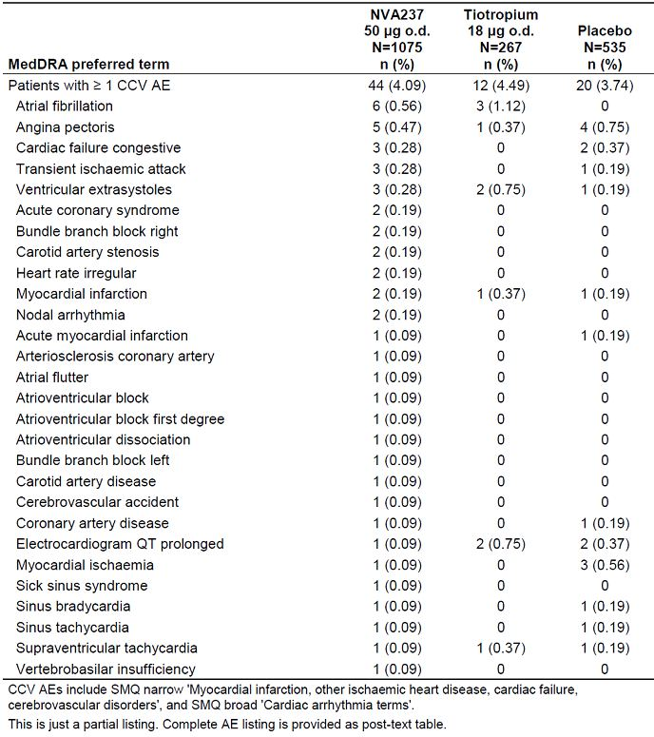

In the Core 12-month Safety database, patients with >1 CCV AEs was 7.62%, 8.21% and 7.12% in NVA237, placebo and tiotropium groups, respectively. The most frequently reported CCV AE was SMQ cardiac arrhythmia (brady- and tachyarrhythmias), which was reported with a similar frequency in all groups (NVA237 4.6%, placebo 4.1%, and tiotropium 4.1%). AEs related to SMQ other ischaemic heart disease were less frequent in the NVA237 group (2.1%) compared to the placebo group (3.4%), but more frequent compared to the tiotropium group (1.5%). AEs related to SMQ cerebrovascular disorders were slightly more frequent in the NVA237 group (1.1%) compared to the placebo group (0.8%), and similar in frequency to the tiotropium group (1.1%). AEs in the myocardial infarction and cardiac failure SMQs each occurred in < 1% of patients in the NVA237 group. CCV AEs were reported with similar frequency in the NVA237 (7.6%), placebo (8.2%), and tiotropium groups (7.1%). The most frequent CCV AEs (≥ 1.0% in any treatment group by preferred term) were angina pectoris and atrial fibrillation. Angina pectoris was reported in 7 patients (1.3%) in the NVA237 group, 6 patients (2.2%) in the placebo group, and 3 patients (1.1%) in the tiotropium group. Atrial fibrillation was reported in 7 patients (1.3%) in the NVA237 group, 2 patients (0.8%) in the placebo group, and 3 patients (1.1%) in the tiotropium group (Table 32).

Table 32: CCV AEs by preferred term: COPD Core 12-month Safety database (events with at least one case on NVA237).

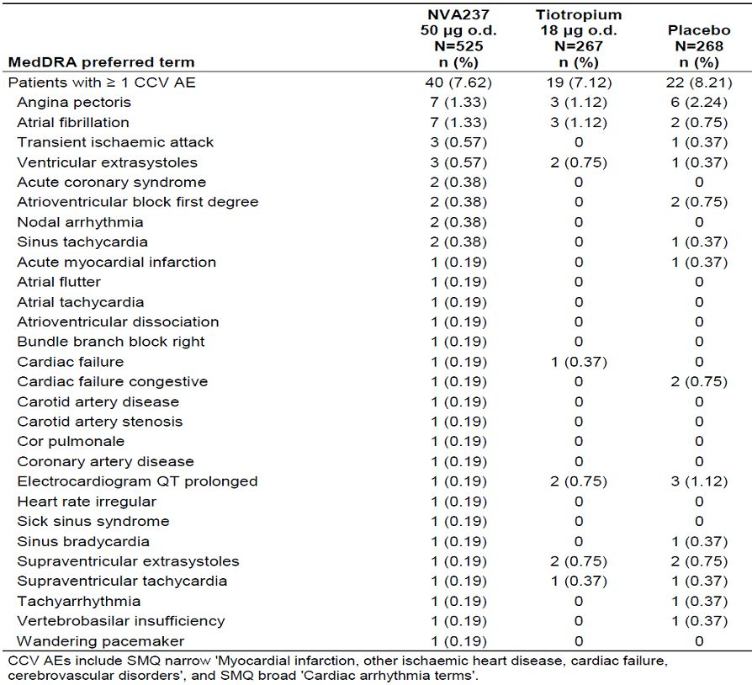

In the Major Safety database (pivotal and supportive studies), the number of CCV events per 100 patient-years was lesser in the NVA237 (10) and tiotropium (10) groups compared with placebo (14.1). The most frequent AEs (≥ 1 event per 100 patient-years in the NVA237 group) were atrial fibrillation (1.5, 0.9 and 1.3 events in NVA237, placebo and tiotropium groups, respectively) and angina pectoris (1.1, 3.2 and 1.3 events, respectively).

##### CCV SAEs

In the Core 6-month Safety database, the proportion of patients with >1 CCV SAEs was 1.4%, 1.87% and 0.75% in NVA237, placebo and tiotropium groups, respectively. CCV SAEs related to SMQ cardiac arrhythmia (brady- and tachyarrhythmias) were reported with a slightly higher frequency in the NVA237 group compared to placebo and tiotropium (0.5%, 0.2% and 0%, respectively. AEs related to the other SMQs were reported at a similar or lower frequency in the NVA237 group compared to the placebo group. The most frequent CCV SAE (preferred term) was atrial fibrillation, reported in 4 patients (0.4%) in the NVA237 group; this CCV SAE was not reported in the placebo or tiotropium groups. Acute coronary syndrome was reported in 2 patients (0.2%) in the NVA237 group; this CCV SAE was not reported in the placebo or tiotropium groups. Cardiac failure congestive, myocardial infarction, and transient ischemic attack were reported in 2 patients each (0.2%) in the NVA237 group and 1 patient each (0.2%) in the placebo group. One case of cerebrovascular accident was reported in the NVA237 treatment group; no cases were reported in the placebo group or tiotropium group. Angina pectoris and myocardial ischemia were reported 2 patients (0.4%) each in the placebo groups. No cases were reported in the NVA237 or tiotropium treatment groups (Table 33). The number of CCV SAEs per 100 patient-years was 3.1, 5.6 and 1.6 in NVA237, placebo and tiotropium groups, respectively. For the preferred term of atrial fibrillation, the number of SAEs per 100 patient-years was 0.8 in the NVA237 group; this CCV SAE was not reported in the placebo or tiotropium groups.

Table 33: CCV serious AEs by preferred term: COPD Core 6-month Safety database.

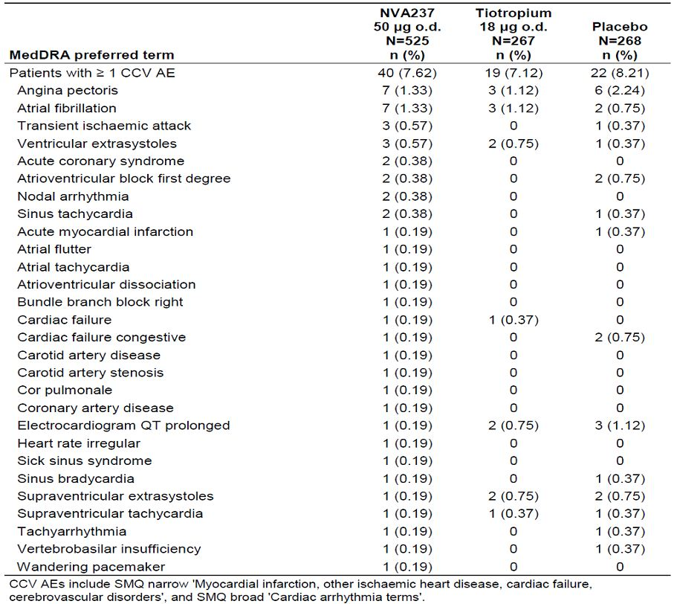

In the Core 12-month Safety database, the proportion of patients with >1 CCV SAEs was 2.48%, 3.36% and 1.12% in NVA237, placebo and tiotropium groups, respectively. CCV SAEs related to SMQ cardiac arrhythmia (brady- and tachyarrhythmias) were reported with a higher frequency in the NVA237 group compared to the placebo and tiotropium groups (1.1%, 0.4% and 0%). AEs related to the other SMQs were reported at a similar or lower frequency in the NVA237 group compared to the placebo group. CCV SAEs were reported with a lower frequency in the NVA237 group (2.5%) compared to the placebo group (3.4%), and with a higher frequency compared to the tiotropium group (1.1%). The most frequent CCV SAEs reported was atrial fibrillation, reported in 4 patients (0.8%) in the NVA237 group; this CCV SAE was not reported in the tiotropium or placebo groups. Transient ischemic attack was reported in 3 patients (0.6%) in the NVA237 group and 1 patient (0.4%) in the placebo group; this event was not reported in the tiotropium group. Acute coronary syndrome was reported in 2 patients (0.4%) in the NVA237 group; this event was not reported in the placebo and tiotropium groups. Angina pectoris was reported in 1 patient (0.2%) in the NVA237 group and 3 patients (1.1%) in the placebo group (Table 34).

Table 34: CCV serious AEs by preferred term: COPD Core 12-month Safety database.

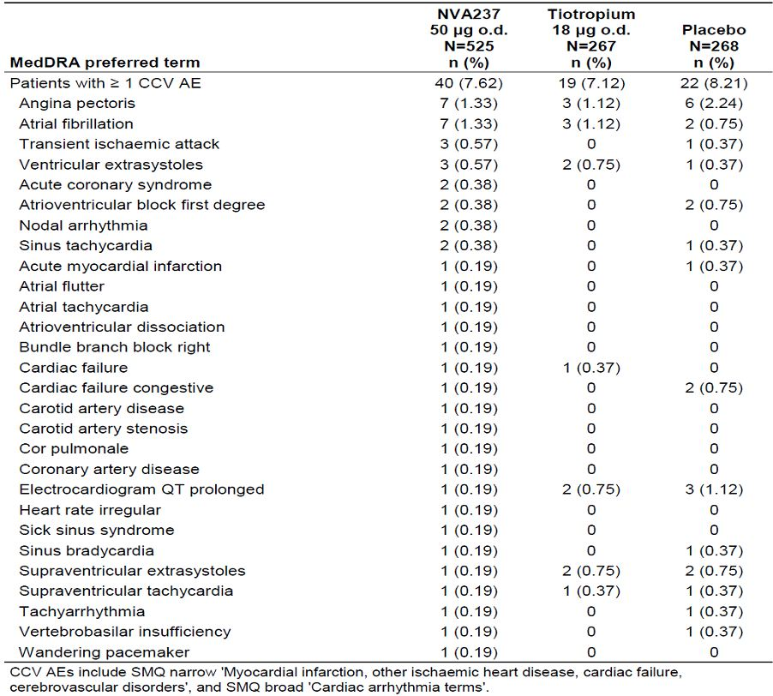

In the Major Safety database, the number of CCV SAEs per 100 patient-years was 3.4 in the NVA237 group, 4.6 in the placebo group, and 1.3 in the tiotropium group. Overall, the rate of the CCV SAEs was low. The most frequent SAEs (0.3 events per 100 patients years in the NVA237 group) were atrial fibrillation (1.0 events NVA237, 0 events placebo, and 0 events tiotropium); this indicates if 100 patients treated with NVA237 are followed for 1 year, only 1 episode of atrial fibrillation would have been observed), acute coronary syndrome (0.3 events NVA237, 0 events placebo, and 0 events tiotropium), cardiac failure congestive (0.3 events NVA237, 0.3 events placebo, and 0 events tiotropium), and myocardial infarction (0.3 events NVA237, 0.3 events placebo, and 0.4 events tiotropium).

##### Subgroup analysis for cardio- and cerebro-vascular events

The following baseline conditions were used to identify CCV risk factors for each patient in the COPD Major Safety database and the Core Safety databases: CCV history/condition at baseline; Hypertension at baseline; Hyperlipidemia at baseline; History of diabetes mellitus; Obesity at baseline (BMI > 30 kg/m2); Age ≥ 65 years; and Current smoker. Missing data of individual risk factors were imputed as not having the respective risk factor. CCV events were analysed for the presence/absence of each CV risk factor and by number of risk factors present at baseline.

In the Core 6-month and 12-month safety database, the most prevalent baseline cardiovascular risk factors were hypertension (56-57%), age ≥ 65 (487-48%), current smoking (40-45%), and hyperlipidemia (28-32%) and more than 40% of patients had 3 or more CV risk factors.

For the Core 6-month safety database, the presence of CCV risks factors has considerable impact on CCV AEs. The frequency of CCV events in patients with 0 or up to 1 CCV risk factor is low in all treatment groups. In patients with 2 or more CCV risk factors at baseline, CCV AEs were reported with a higher frequency in the NVA237 group (4.7%) than in the placebo group (1.4%), but lower frequency compared to the tiotropium group (8.3%). In patients with 3 or more CV risk factors at baseline, CCV AEs were reported with a similar frequency in the NVA237 group (6.7%) and in the placebo group (7.0%), and with higher frequency compared to the tiotropium group (3.4%). In the subgroup of patients ≥ 65 years of age, CCV AEs were reported with a higher frequency in the NVA237 group (5.6%) compared to the placebo group (3.8%) and tiotropium group (4.1%). The frequency of CCV SAEs in patients with 0 or up to 1 CCV risk factor is zero in all treatment groups. In patients with 2 CCV risk factors at baseline, CCV SAEs were reported with a similar frequency in the NVA237 group (1.0%), placebo group (0), and tiotropium group (2.8%). In patients with 3 or more CV risk factors at baseline, CCV SAEs were reported with a lower frequency in the NVA237 group (2.9%) compared to the placebo group (4.4%); CCV SAEs in patients with 3 or more CV risk factors at baseline were not reported in the tiotropium group. In the subgroup of patients ≥ 65 years of age, CCV SAEs in the NVA237 group (1.9%) were reported with a slightly lower frequency compared to the placebo group (2.3%), and with a higher frequency compared to the tiotropium group (0).

For the Core 12-month safety database, In patients with 2 or more CCV risk factors at baseline, CCV AEs were reported with a similar frequency in the NVA237 group (7.4%) compared to the placebo group (7.4%), but lower frequency compared to the tiotropium group (11.1%). In patients with 3 or more CV risk factors at baseline, CCV AEs were reported with lower frequency in the NVA237 group (10.8%) compared to the placebo group (12.1%) and with a higher frequency compared to the tiotropium group (5.9%). In the subgroup of patients ≥ 65 years of age, CCV AEs in the NVA237 group (8.9%) were reported with a slightly lower frequency compared to the placebo group (9.3%), and with a higher frequency compared to the tiotropium group (6.5%). In patients with 2 CCV risk factors at baseline, CCV SAEs were reported with a higher frequency in the NVA237 group (2.7%) than in the placebo group (0), but lower frequency compared to the tiotropium group (4.2%). In patients with 3 or more CV risk factors at baseline, CCV SAEs were reported with a lower frequency in the NVA237 group (3.5%) compared to the placebo group (6.8%); CCV SAEs in patients with 3 or more CV risk factors at baseline were not reported in the tiotropium group. In the subgroup of patients ≥ 65 years of age, CCV AEs in the NVA237 group (3.2%) were reported with a slightly lower frequency compared to the placebo group (3.9%), and with a higher frequency compared to the tiotropium group (0).

For the Major Safety database, the frequency of CCV AEs by baseline CCV risk factors was generally similar between treatment groups.

##### Major cardiovascular events (MACE)

MACE included “well-defined” endpoints (e.g. myocardial infarction, stroke, and/or CV-related deaths). It excluded “less well-defined’ endpoints (e.g. angina pectoris). The number of these terms is relatively small compared to that for the CCV events and includes the FDA version of MACE, plus 3 preferred terms relating to CV-related death (sudden death, sudden cardiac death, and cardiac death).

For the Core 6-month Safety database, MACE events were reported with a similar frequency in the NVA237 (0.4%) and placebo (0.4%) treatment groups; the frequency of MACE events in the tiotropium was 0.8% (Table 35). The number of MACE events per 100 patient-years was 0.8, 0.9 and 1.6 in NVA237, placebo and tiotropium groups, respectively. For the Core 12-month Safety database, MACE events were reported with a lower frequency in the NVA237 group (0.2%) compared to the placebo (0.4%) and the tiotropium (1.1%) groups (Table 36). The number of MACE events per 100 patient-years was 0.2, 0.5 and 1.3, respectively.

Table 35: Major adverse cardiovascular events (MACE) by preferred term (COPD Core 6-month Safety database).

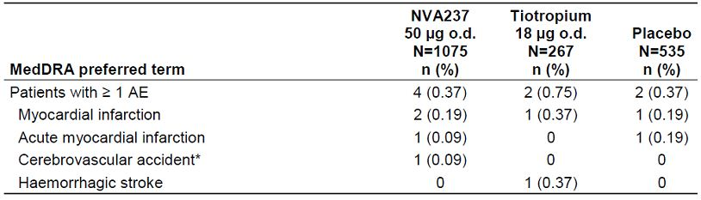

Table 36: Major adverse cardiovascular events (MACE) by preferred term (COPD Core 12-month Safety database).

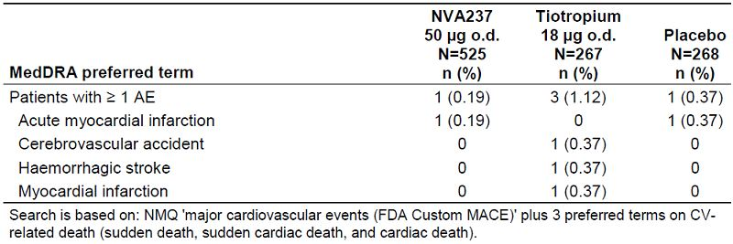

The OR between NVA237 and placebo for MACE events was 0.96 (95% CI: 0.17, 5.54; risk difference of MACE events in the NVA237 group versus placebo was 0) for the Core 6-month database; it was 0.51 (95% CI: 0.03, 8.18; risk difference of MACE events in the NVA237 group versus placebo was -0.18, 95% CI: -1.00, 0.64) for the Core 12-month database.

In the Major Safety database, MACE events were reported with a slightly higher frequency in the tiotropium group compared with both NVA237 and placebo groups (0.4%, 0.3% and 1.1% in NVA237, placebo and tiotropium groups, respectively (Table 37). The number of MACE events per 100 patient-years was 0.8, 0.6 and 1.3, respectively.

Table 37: Major adverse cardiovascular events (MACE) by preferred term (COPD Major Safety database).

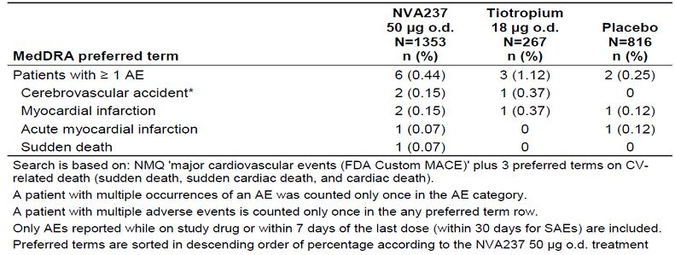

Overall, the number of MACE events was small and the number of events adjusted for exposure was similar across treatments in the Core 6-month and 12-month as well as the Major Safety Databases.

##### Tachyarrhythmias

Search terms included AEs related to “Tachyarrhythmias including supraventricular and ventricular tachyarrhythmias” (SMQ broad). In the Core 6-month Safety database, tachyarrhythmia AEs were reported with a higher frequency in the tiotropium groups compared with both NVA237 and placebo groups (0.9% , 0.8% and 2.3% in NVA237, placebo and tiotropium groups, respectively) . However, frequency of tachyarrhythmia SAEs was slightly higher in the NVA237 group (0.4%, 0.2% and 0). In the Core 6-month Safety database, in patients < 65 years of age, the frequency of tachyarrhythmia AEs was 0.4%, 0.7% and 1.4% in NVA237, placebo and tiotropium groups, respectively; it was 1.6%, 0.5% and 2.1%, respectively in patients 65 to < 75 years of age and it was 1.5%, 1.5% and 7.7%, respectively in patients ≥ 75 years of age.

In the Core 12-month Safety database, tachyarrhythmia AEs were reported with a slightly higher frequency in the NVA237 and tiotropium groups compared with placebo (2.5%, 1.9% and 2.6% in NVA237, placebo and tiotropium groups, respectively). The frequency of tachyarrhythmia SAE was slightly higher in the NVA237 group (1.0%, 0.4% and 0, respectively). In the Core 12-month Safety database, the frequency of tachyarrhythmia AEs was 2.2%, 2.2% and 2.1%, respectively in patients < 65 years of age; 2.1%, 0% and 2.1%, respectively in patients 65 to < 75 years of age and 5.1%, 6.3% and 7.7% in patients ≥ 75 years of age.

In the Major Safety database, the number of tachyarrhythmia AEs per 100 patient-years was 2.7, 2.6 and 3.0, respectively.

##### Atrial fibrillation/Atrial flutter

By protocol inclusion criteria, patients with chronic stable atrial fibrillation were permitted to enrol in the study at the investigators discretion. Cases of Atrial fibrillation/flutter in the COPD Core 6 and 12 month safety database were identified in three different ways, i.e. 1) those reported as AEs, 2) those identified by central reading of 12-lead ECGs, and 3) those reported during 24 hours Holter monitoring . AE data was also collected for studies in the Major safety database, however ECG and 24-h Holter monitoring data was only routinely collected for studies comprising the Core 6 and 12 month safety database (A2303 and A2304). All cases except one occurred in the core safety database.

Atrial fibrillation/flutter serious and non-serious adverse events were reported at a higher rate in the NVA237 group compared to placebo in the COPD core 6 and 12 month databases. In addition, the frequency of newly occurring atrial fibrillation as reported on ECG and 24-h Holter monitoring was also slightly higher in the NVA237 group as compared to the placebo group (Table 38).

Table 38: Number of patients with atrial fibrillation/flutter events post-baseline by source findings (COPD Core 6 and 12 month Safety database).

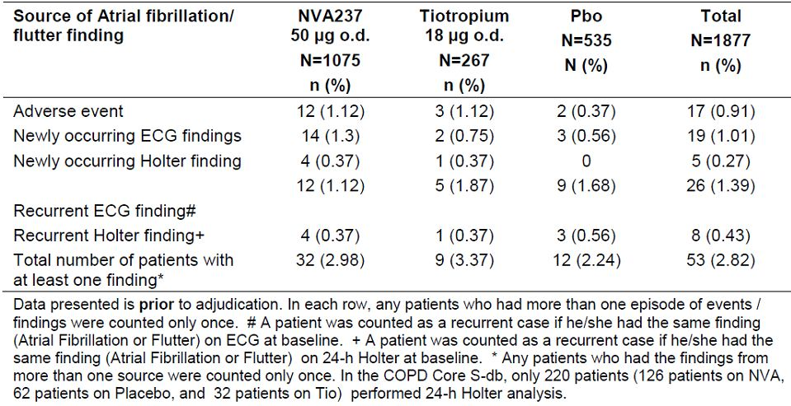

###### Blinded adjudication of Atrial Fibrillation/Flutter cases

Atotal of 54 cases (53 from the core 6 and 12 month database plus one case from Study A2310) were evaluated and adjudicated post-hoc in a blinded fashion by an independent external cardiologist.

In the Core 6-month safety database, the frequency of newly occurring, clinically significant events was similar in the NVA237 group (0.3%, 3/1044) and placebo groups (0.2%, 1/521) compared to 0.8% (2/259) in the tiotropium group. The frequency of recurrent, clinically significant events was higher in the NVA237 group [16.1%, 5/31] compared to none in the placebo (0/8) and tiotropium (0/14) groups. Four of the 5 cases in the NVA237 group were recurrent episodes of atrial fibrillation/flutter and one of these cases was considered permanent atrial fibrillation/flutter.

In the Core 12-month safety database, the frequency of newly occurring, clinically significant events was 0.4% (2/510) in the NVA237 group, 0.4% (1/261) in the placebo group and 0.8% (2/259) in the tiotropium group. The frequency of recurrent, clinically significant events was 20% (3/15) in the NVA237 group compared to none in the placebo (0/8) and tiotropium (0/7) groups.

QT-prolongation events

In the Core 6-month Safety database, the frequency of AEs in the torsade de pointes/QT prolongation SMQ was 0.1% (1 patient), 0.4% (2 patients) and 0.8% (2 patients) in NVA237, placebo and tiotropium groups, respectively. In the Core 12-month Safety database, the frequency of AEs in the torsade de pointes/QT prolongation SMQ was 0.2% (1 patient), 1.1% (3 patients), and 0.8% (2 patients), respectively. All events reported were “Electrocardiogram QT prolonged”, and no ventricular arrhythmias were reported.

##### Cardiovascular safety data from published studies

Cardiovascular disease is the leading cause of morbidity and mortality among patients with chronic obstructive pulmonary disease. The cardiovascular effects of inhaled anticholinergics have been evaluated in recent studies and are briefly summarised below.

A meta-analysis of antimuscarinic drugs in COPD (Singh 2008) raised concerns regarding safety of inhaled anticholiergics (ipratropium bromide and tiotropium bromide) regarding major cardiovascular events. This meta-analysis evaluated 17 randomised, controlled trials enrolling 14,783 patients with follow-up ranging from 6 weeks to 5 years. The primary outcome was a composite of CV, death, myocardial infarction or stroke. The secondary outcome was all-cause mortality. Cardiovascular death, myocardial infarction or stroke occurred in 135 of 7472 (1.8%) patients receiving inhaled anticholinergics and 86 of 7311 (1.2%) patients receiving control therapy (RR: 1.58, 95% CI: 1.21, 2.06, P < 0.001). Among individual components of the primary endpoint, inhaled anticholinergics significantly increased the risk of myocardial infarction (RR: 1.53 95% CI: 1.05, 2.23, P =0.03) and cardiovascular death (RR: 1.80, 95% CI: 1.17, 2.77, P =0 .008) without a statistically significant increase in the risk of stroke (RR: 1.46, 95% CI: 0.81, 2.62, P =0 .20). All-cause mortality was reported in 149 of the patients treated with inhaled anticholinergics (2.0%) and 115 of the control patients (1.6%) (RR: 1.26, 95% CI: 0.99, 1.61, P = 0.06). The authors concluded that inhaled anticholinergics are associated with a significantly increased risk of cardiovascular death, myocardial infarction, or stroke among patients with COPD.

The UPLIFT (Tashkin et al 2008) study concluded that in patients with COPD, therapy with tiotropium was associated with improvements in lung function, quality of life, and exacerbations during a 4-year period but did not significantly reduce the rate of decline in FEV1. In a subsequent analysis of data from the UPLIFT study, mortality was evaluated during treatment and with follow-up of discontinued patients (Celli et al 2009). Cause of death was adjudicated by an independent committee. A total of 5,993 patients were randomised, 3,006 to placebo and 2,987 to tiotropium. While patients were receiving treatment, there were 792 deaths, with a lower risk in the tiotropium group (hazard ratio, 0.84; 95% CI: 0.73, 0.97). Statistical significance was observed at the end of the protocol-defined treatment period (P = 0.034) but not 30 days thereafter (P = 0.086). Adjustment by GOLD stage, sex, age, baseline smoking behaviour, and baseline respiratory medications subgroups did not alter the results of the analysis. The most common causes of death adjudicated by an independent end point committee were lower respiratory, cancer, general disorders, and cardiac disorders. The hazard ratios for lower respiratory and cardiac mortality during treatment were 0.86 (95% CI: 0.68, 1.09) and 0.86 (95% CI: 0.75, 0.99), respectively. The analysis concluded that treatment with tiotropium over 4 years did not show an increase in overall mortality (hazard ratio 0.89; 95% CI: 0.79, 1.02).

Another recent analysis of pooled data (Celli et al 2010) was performed utilizing the tiotropium clinical trial database and consisted of 30 completed randomised, placebo controlled, double-blind, parallel-group studies with a total of 19,545 patients (10,846 tiotropium and 8,699 placebo). Incidence rates were determined for all-cause mortality and selected CV events, including a composite CV end point encompassing CV deaths, nonfatal myocardial infarction, nonfatal stroke, and the terms sudden death, sudden cardiac death, and cardiac death. For all-cause mortality, the IR was 3.44 (tiotropium) and 4.10 (placebo) per 100 patient-years (RR: 0.88 [95% CI: 0.77, 0.999]). IR for the CV end point was 2.15 (tiotropium) and 2.67 (placebo) per 100 patient-years (RR: 0.83 [95% CI: 0.71, 0.98]). The IR for the CV mortality excluding nonfatal myocardial infarction and stroke was 0.91 (tiotropium) and 1.24 (placebo) per 100 patient-years (RR: 0.77 [95% CI: 0.60, 0.98]). For total myocardial infarction, cardiac failure, and stroke the RRs (95% CI) were 0.78 (0.59, 1.02), 0.82 (0.69, 0.98), and 1.03 (0.79, 1.35), respectively. Overall, tiotropium was associated with a reduction in risk of all-cause mortality, cardiovascular mortality, and cardiovascular events.

A meta-analysis of 5 randomised, parallel-group, placebo-controlled trials (Singh 2011) to review the risk of mortality associated with long-term use of tiotropium delivered using a mist inhaler for COPD demonstrated a significant increased risk in mortality in patients using the tiotropium mist inhaler (90/3686 vs. 47/2836; RR: 1.52 [95% CI: 1.06, 2.16]; P = 0.02). Both 10 μg (RR: 2.15 [95% CI: 1.03, 4.51]; P = 0.04) and 5 μg (RR: 1.46 [95% CI: 1.01, 2.10]; P = 0.04) doses of tiotropium mist inhaler were associated with an increased risk of mortality. Overall, this study indicated a 52% increased risk of mortality associated with tiotropium mist inhaler in patients with COPD. Additional tiotropium Respimat safety data is available in Bateman et al (2010).

*Comments: There is no published data with proposed drug NVA237 as it has not been approved for treatment of COPD. The information from the above studies is mainly relating to tiotropium which is a drug belonging to same family as the proposed NVA237. Overall, results from these published studies were conflicting either showing no effect on mortality over 4 years treatment with tiotropium (Celli et al 2009), showing a reduction in all-cause mortality, CV mortality and CCV events (Celli et al, 2010) and others showed increased risk of CV death and overall mortality (Singh 2008 and Singh 2011). Patients receiving tiotropium with the mist inhaler are, however, potentially exposed to higher concentrations and the powder and mist inhaler formulations are considered to be distinct products. Inhaled tiotropium is available in two formulations: as a powder (Spiriva; Boehringer Ingelheim, Germany) delivered with a Handihaler device (Boehringer Ingelheim) and in solution as a mist delivered with the Respimat Soft Mist Inhaler (Boehringer Ingelheim). The mist inhaler is a propellant free device, which generates a fine, slow moving cloud for inhalation and the delivered dose is independent of inspiratory effort and it is recommended for use in patients who have poor manual dexterity and therefore have difficulty using the Handihaler. Pharmacokinetic studies have shown that compared with tiotropium 18 μg delivered by the Handihaler, peak plasma concentrations with the mist inhaler at doses of 5 μg and 10 μg were 35% and threefold higher, respectively. The mist inhaler is available in 55 countries but this formulation has yet to gain regulatory approval in the United States. In Australia, only the Spiriva powder capsule to be taken by Handihaler has been approved.*

*The sponsors have undertaken an extensive and detailed evaluation of CCV AEs in this submission which failed to show any major CCV safety concerns associated with oral inhalation of NVA237 using the Concept1 device (which is similar to the Handihaler used for tiotropium). None of the deaths were due to CCV events in the Core safety database. Compared with placebo, the incidence of serious CCV events was not higher in patients treated with NVA237. The only significant finding was the higher incidence of new and recurring AF/Atrial flutter. Furthermore, risks of CCV AEs was increased with presence of >2 or >3 CCV risk factors, but the risk was increased across all treatment groups (NVA237, placebo and tiotropium).*

#### Unwanted immunological events

Not applicable.

### Other safety issues

#### Safety in special populations

AEs were evaluated in demographic subgroups (age, gender, and race), by baseline characteristics (COPD severity and CCV risk factors) by exposure category and baseline steroid use.

##### Effect of age, race and gender

In both Core 6-month and 12-month Safety database, the distribution of patients in the 3 age groups <65, 65 - <75, and ≥ 75 years was similar between the NVA237 and placebo groups. In both treatment groups, the majority of patients were in the age groups of <65 years (51-53%) and 65 - < 75 years (about 36%) with fewer patients in the age group of ≥ 75 years (11-12%), so observations in the ≥ 75 years age group should be interpreted with caution.

In the Core 6-month safety database, AEs in the three most frequent SOCs (Respiratory, thoracic and mediastinal disorder SOC; Infections and infestation; Musculoskeletal and connective tissue) showed similar incidence between the <65 and 65 - <75 age groups, in both NVA237 and placebo treatment groups, differences in AE frequency between subgroups were not considered clinically significant. The frequency of SAEs in the system organ classes of respiratory, thoracic and mediastinal disorder and infections and infestations were generally higher in the ≥ 75 age group in both the NVA237 and placebo groups, but these differences are not considered clinically significant. Similar results across subgroups of age, race and gender were observed in the Core 12-month safety database.

In the major safety database (pivotal and supportive studies), most analyses showed a pattern of AEs not different from that in the overall population. However, patients ≥ 65 years and those with diabetes had higher rates of cardiovascular events than the overall population.

In study A2104, NVA237 was well tolerated at all doses (50-200ug) and by both ethnic groups (Japanese and Caucasian). There were no deaths, SAEs, or AEs leading to discontinuation. All AEs were mild or moderate in severity. Overall, the number of AEs was low, with three subjects (15.8%) in the Caucasian population and six subjects (33.3%) in the Japanese population reporting AEs. The most common AE reported was headache. There was no trend in the distribution of AEs across the dose groups. There were no relevant findings in vital signs, ECG records or clinical laboratory measurements in Japanese or Caucasian subjects.

*Comment: Subgroup analyses of safety of NVA237 based on COPD severity, drug exposure or concomitant use of ICS was not provided in the initial submission. However this was addressed by the sponsors and is discussed in this report.*

#### Safety related to drug-drug interactions and other interactions

No systemic evaluation of effect of concomitant COPD medications on safety of NVA237 was done.

In human, NVA237 is primarily cleared unchanged via urine. The renal clearance likely involves active secretion by the cationic SLC transporter OCT2 as well as MATE1 (multidrug and toxin extrusion protein). OCT2 and MATE1 are believed to act in concert to accomplish renal tubular secretion of NVA237 in humans. Consequently, inhibition of either OCT2 or MATE1 may affect the renal excretion of NVA237 and its pharmacokinetics. Results of a clinical drug interaction study A2109 in healthy volunteers showed that cimetidine, an inhibitor of organic cation transport, increased NVA237 AUC by approximately 22%, but there were no clinically relevant effects on safety; both NVA237 and cimetidine were safe and well tolerated with no deaths, SAEs or severe adverse events. All adverse events were mild in severity and those suspected to be related to study drug were principally reported with co-administration of cimetidine. There were no other clinically relevant changes over time observed in clinical laboratory tests, vital signs or ECGs.

In the QVA149 studies- A2101, A2103 and A2106, NVA237, alone or in fixed combination with indacaterol was safe and well tolerated. There were no unexpected or serious AEs and all AEs were either mild or moderate in nature. There were no clinically relevant changes in vital signs, ECGs or laboratory values.

In study A2105, NVA237 was well tolerated in this study both by healthy volunteers and renally impaired subjects with no adverse events reported by any subject. There were a number of laboratory values outside the normal ranges as would be expected for the renally impaired subjects. One severe RI subject[21] had prolonged QTcF values during the study but this was not considered significant by the investigator.

#### Other safety issues

##### Use in pregnancy/lactation

There is no clinical data with NVA237 exposure in pregnant COPD patients. NVA237 was not teratogenic in rats or rabbits following inhalation administration. NVA237 and its metabolites did not significantly cross the placental barrier of pregnant mice, rabbits, and dogs. It is not confirmed whether glycopyrronium bromide passes into human breast milk. However, NVA237 and/or metabolites was/were excreted into the milk of lactating rats. As there are no adequate and well-controlled studies in pregnant/lactating women, it is recommended to use NVA237 only during pregnancy/lactation if the expected benefit to the patient justifies the potential risk to the foetus/baby.

##### Overdose

In COPD patients, repeated orally inhaled doses of 100 and 200 μg NVA237 o.d. for 28 days were well tolerated (Study A2206). NVA237 is provided as 50 μg inhalation powder hard capsules for oral inhalation via the Concept1 device. Absolute bioavailability of orally inhaled NVA237 was estimated to be about 40%, and absolute oral bioavailability of NVA237 to be about 5%. If a patient accidentally or intentionally ingests and swallows an inhalation capsule, the systemic bioavailability is expected to be about 8-fold lower than that after oral inhalation from an inhalation capsule. Therefore, a patient would have to swallow approximately 30 capsules to achieve a systemic exposure similar to that following oral inhalation of a 200 μg dose.

Drug abuse was not evaluated in the NVA237 program. There is no known potential for drug abuse of NVA237. Withdrawal and rebound were not evaluated in the NVA237 program. There is no known potential for tolerance, withdrawal, or rebound of NVA237. There is no indication in the clinical studies that NVA237 affects the ability to drive or operate machinery, or impairs mental ability.

### Evaluator’s overall conclusions on clinical safety

In total, 14 studies contributed data to the integrated evaluation of safety of NVA237. Of these, most data came from 8 phase II and III studies: 2 large pivotal Phase III studies, 1 smaller phase III study in exercise tolerance and 5 phase II studies designed to support dose selection and regimen. The other 6 studies were primarily for PK/PD purposes and they contributed limited short-term safety data. The main databases in terms of relevance to the clinical use of NVA237 in the treatment of patients with COPD are the “COPD Major”, and “COPD Core” (6-month and 12-month) populations; the Core 6-month and 12-month Safety databases are nested within the Major Safety database and the Core 6-month Safety database overlaps with the Core 12-month Safety database because they both contain the first 6 months of data from A2303. Hence, the number of events displayed in each treatment group were generally similar in each of these 3 databases.

The baseline disease profile, especially among the 2 pivotal studies, was generally consistent and allowed a reliable assessment regarding the safety profile of NVA237 both in short- and long-term maintenance use in the target patient population, although there is no data beyond 1 year. The total number of subjects exposed to NVA237 is 2535. Overall, over 2500 patients were exposed to NVA237 at any dose, 1462 at the proposed dose for marketing (50 μg once daily) of which 842 completed 6 months treatment, and 351 completed 12 months. which meets International Conference on Harmonisation (ICH) requirements of 1500 patients overall, including 300-600 for six months, and at least 100 for 12 months.

The overall incidence of AEs by system organ class in the NVA237 treatment group was generally similar to that seen with placebo. The most frequently affected system organ classes were respiratory, thoracic and mediastinal disorders, infections and infestations, musculoskeletal and connective tissue disorders, and gastrointestinal disorders. Among imbalances seen, both respiratory, thoracic and mediastinal disorders and infections and infestations were reported noticeably less frequently in the NVA237 treatment group than in the placebo or tiotropium group. The most frequent AE was COPD (i.e. exacerbation), reported less frequently in the NVA237 group compared with the placebo group. Other frequent AEs were upper respiratory tract infection (URTI), nasopharyngitis, cough, bacterial URTI and headache. These events were reported at a higher frequency in the placebo group, with the exception of nasopharyngitis, which was most frequent in the tiotropium group. The percentage of patients experiencing ≥ 1 severe AE was higher with placebo (10.7%) and tiotropium (10.5%) than with NVA237 (6.6%). The only severe AE occurring in ≥2.0% of patients in any treatment group was COPD exacerbation (NVA237 1.7%, placebo 4.3%, tiotropium 2.3%). In the Core 12-month dataset, fewer patients reported severe AEs in the NVA237 group (12.6%) compared to the placebo (19.4%) and tiotropium group (16.1%). The most prevalent severe AEs (≥ 2.0%) were COPD and pneumonia. For AEs typically associated with anticholinergic treatment, more patients on NVA237 reported dry mouth (2.23%) compared to placebo (1.12%) or tiotropium (1.50%). Benign prostatic hyperplasia was reported in the NVA237 and tiotropium groups (0.28% and 0.75%, respectively), but not in the placebo group. Glaucoma (non-serious) was reported in one patient in the NVA237 group but not in the placebo or tiotropium groups. .

The percentage of patients in the Core 6-month safety population who had one or more treatment-related AEs was similar in the NVA237 and placebo groups (7.2% and 7.3%, respectively), and slightly higher in the tiotropium group (7.9%). Suspected AEs ≥1.0% in any treatment group were dry mouth (NVA237 1.6%, placebo 0.9%, tiotropium 1.5%) and COPD exacerbation (NVA237 0.7%, placebo 1.1%, tiotropium 1.1%).

A total of 13 deaths occurred in the Core Safety database, including 2 patients who died during the 30-day follow-up. Six (0.56%) of these deaths occurred in the NVA237 group, 5 (0.93%) deaths occurred in the placebo group and 2 (0.75%) deaths occurred in the tiotropium group. None of the deaths was suspected by the investigator to be related to study medication.

In the Major safety population, the number of SAE episodes per 100 patient years was higher in the placebo group (40.0) compared with the NVA237 group (27.4). For the preferred term of COPD, the number of SAE episodes per 100 patient years was higher in the placebo group (8.6) compared to the NVA237 group (4.2). The number of SAEs of atrial fibrillation (preferred term) was 1.0 per 100 patient years in the NVA237 group; this SAE was not reported in the tiotropium and placebo groups.

In the Major safety population, discontinuations due to AEs were lower in the NVA237 group (5.9%) compared to the placebo (7.1%) and tiotropium (7.5%) groups, with most frequent event being related to SOCs of respiratory, thoracic and mediastinal disorders, cardiac disorders, and infections and infestations. COPD was the most frequent AE causing discontinuation. Events leading to hospitalisation or requiring dose interruption were lower in the NVA237 group than in the placebo or tiotropium groups. In the NVA237 group, events requiring significant additional therapy were similar to placebo and tiotropium in the COPD Core 12- month population, and similar to placebo in the Major safety population.

In the Major safety population, as might be expected, the incidence of anticholinergic AEs was higher in the NVA237 (5.8%) and tiotropium (6%) groups compared with placebo (4.4%). The frequency of anticholinergic symptoms AEs was 5.8% in the NVA237 group, 4.4% in the placebo group, and 6.0% in the tiotropium group. CCV SAEs per 100 patient-years was 3.4 in the NVA237 group, 4.6 in the placebo group, and 1.3 in the tiotropium group.

Cardiovascular safety of NVA237 was evaluated in great detail in this submission due to recent reports concerning increased overall and CV mortality in patients treated with inhaled anticholiergics, especially with tiotropium mist inhaler. Overall, up to 1 year treatment with NVA237 did not show any serious CCV safety concerns and none of the 13 deaths in the core safety database were due to CCV events.. Overall, the rate of the CCV SAEs was low. The most frequent SAE (0.3 events per 100 patients years in the NVA237 group) was atrial fibrillation (1.0 events NVA237, 0 events placebo, and 0 events tiotropium); this indicates if 100 patients treated with NVA237 are followed for 1 year, only 1 episode of atrial fibrillation would have been observed). Among patients without a history of atrial fibrillation, new clinically significant atrial fibrillation/ flutter events were uncommon and comparable between the NVA237 and placebo groups in the core 6 and 12 month databases. In the smaller group of patients with a history of prior atrial fibrillation/ flutter, recurrent atrial fibrillation/flutter events were common and more frequent in the NVA237 treated patients. The patients with recurrent atrial fibrillation also had multiple acute and/or chronic risk factors for atrial fibrillation. Furthermore, the 2 pivotal studies included a high proportion of patients at increased risk for developing atrial fibrillation. About 50% of the combined cohorts were over age 65 with the majority being Caucasian males. In addition all patients with new onset atrial fibrillation had the additional risk factor of hypertension.

The laboratory analyses did not reveal any trends in the data that indicated a clinically important effect on hematology, chemistry or urinalysis with no meaningful differences between treatment groups. Mean and median values were within normal ranges. There were no clinically relevant differences between treatment groups for shifts from normal at baseline to low (< LLN) or high (>ULN) post-baseline in the COPD Major safety population.

There were no consistent changes in ECG values seen across the treatment groups during the longer-term studies. For qualitative ECG assessments such as rhythm disturbance, a slightly higher frequency of newly occurring ECG abnormalities on centralized ECG recordings in the NVA237 group was observed compared to placebo. Increases from baseline of 30-60 ms, and >60 ms in QTcF both occurred with a slightly higher frequency in the NVA237 group. Overall, differences between groups were small, not statistically significant or clinically meaningful. For vital signs, small fluctuations were seen between treatment groups in summary statistics of blood pressure, but overall there were no clinically meaningful findings for blood pressure, pulse rate, or weight.

Overall, NVA237 was well tolerated at the recommended dose, and its use in COPD patients in exposure durations up to one year did not give rise to any unexpected safety concerns. The studied population matches the intended marketing population (with a high percentage of co-morbidity and disease risk factors in the phase III population), and included an adequate representation of patients in subgroups likely to be included within that target population.

Numerous sub-group analyses (age, gender, race) did not reveal a population who were particularly at risk of adverse outcomes. However, there was no subgroup analyses of safety of NVA237 based on COPD severity, drug exposure or concomitant use of ICS. Furthermore, there was no evaluation of NVA237 in patients aged < 40 years or in patients with clinically significant (judgment of the investigator) cardiovascular disease (unstable ischemic heart disease, left ventricular failure, history of myocardial infarction, arrhythmia), and those with significant QTc prolongation.

Overall, no major safety concern for NVA237 was found and long term administration of NVA237 up to 1 year was safe and well tolerated. There was no safety data beyond 1 year of treatment.

## First round benefit-risk assessment

### First round assessment of benefits

The benefits of Seebri Breezhaler 50ug (NVA237) as once daily, maintenance bronchodilator treatment to relieve symptoms of patients with COPD are:

* Rapid onset of action with a statistically significant treatment difference (in FEV1) compared to placebo being evident as early as 5 minutes.
* Convenient once daily dosing due to significant bronchodilation (compared with placebo) observed at the majority of the measured time-points post-dose over 24 hours.
* The sustained 24- hour bronchodilation observed with NVA237 (NVA237-placebo treatment difference after 12 weeks was -0.097L) was similar in magnitude to that observed with OL tiotropium 18ug, which is the recommended and approved dose for tiotropium (-0.083L).
* There was no clinically significant difference between once daily and twice daily dosing regimens according to a new study (A2208) which was conducted (requested by FDA) while the Phase 3 trials were ongoing. While the q.d. regimen was numerically superior to the b.i.d. regimen over the first 12 hours of dosing, the b.i.d. regimen provided slightly greater improvements from 12- 24 hours. For comparison of the two dosing regimens, FEV1 AUC0-24h provided the most comprehensive assessment of efficacy over the whole dosing interval and for this endpoint there were no clinically meaningful differences between the two dosing regimens.
* The improvements in mean trough FEV1 observed at the primary endpoint (12 weeks) were maintained throughout treatment in both the 6- and 12-months studies. Compared to placebo, mean trough FEV1 was increased by 0.113 L at week 26 in the 6-month study and 0.108 L at week 52 in the 12- month study. These data indicate that the 24-hour bronchodilator effect of NVA237 was maintained from the first dose throughout a one-year period with no evidence of tachyphylaxis.
* In addition NVA237 significantly improved COPD symptoms including dyspnea (TDI assessments), patients’ health status (SGRQ assessments) as well as time to first COPD exacerbation over the 26-week treatment period when compared to placebo; the number needed to treat to prevent one moderate or severe exacerbation for NVA237 patients was 14 (the number needed to treat for OL tiotropium was 37).
* Requirements of mean daily number of rescue medication puffs was statistically significantly reduced in the NVA237 group when compared to the placebo group over 26 and 52 weeks of treatment, respectively. Furthermore, NVA237-treated patients were able to have more days to perform usual daily activities and also showed significant improvements in daily/daytime/night-time symptom scores vs. placebo over 26 and 52 weeks.
* The Phase 3, placebo-controlled, crossover study A2310 provided preliminary evidence that NVA237 produced statistically significant 20% (89 seconds) improvement over placebo after 3 weeks of treatment.
* NVA237 was well tolerated at the recommended dose and its use in COPD patients in exposure durations up to one year did not give rise to any unexpected safety concerns. The studied population matched the intended marketing population.

### First round assessment of risks

The risks of NVA237 in the proposed usage are:

* Tobacco exposure and use of nicotine replacement therapy (as an aid to smoking cessation) was not recorded in the pivotal studies and its potential effect on efficacy outcomes was not evaluated.
* The possibility of kinetic interaction between NVA237 and smoking cessation aids or nicotine replacement therapy was not investigated (which is a requirement as mentioned in the CPMP guidelines).
* The efficacy and safety of NVA237 50ug once-daily maintenance bronchodilator treatment to relieve symptoms of patients with chronic obstructive pulmonary disease (COPD) has not been evaluated for treatment periods > 1year.
* Safety of NVA237 in treatment of COPD did not appear to be affected by age, gender, race. However, effect of COPD disease severity, concomitant ICS use, drug exposure on safety of NVA237 was not evaluated. Furthermore, there was no evaluation of NVA237 in patients aged <40 years or in patients with clinically significant (judgment of the investigator) cardiovascular disease (unstable ischemic heart disease, left ventricular failure, history of myocardial infarction, arrhythmia), and those with significant QTc prolongation.
* Overall, the incidence of CCV events was higher in patients with > 2 or 3 CCV risk factors but this increase was similar in the NVA237 and placebo groups. The main CCV safety concern identified in the NVA237 program was the increased risk of new or recurrent AF/atrial flutter. The sponsors have attempted to address this by regular monitoring of CCV events as indicated in the RMP.

### First round assessment of benefit-risk balance

The efficacy of once daily oral inhalation of the anticholinergic drug NVA237 50ug was established in over 2000 patients with moderate to severe COPD in well-conducted clinical studies using well-accepted and valid spirometric and symptomatic efficacy endpoints. Patients treated with NVA237 50 μg once daily demonstrated sustained bronchodilatory effect up to 52 weeks, together with significant improvements in dyspnea, health status, and reduction in COPD exacerbation which was similar to that observed with the established standard of care, i.e. tiotropium 18 μg once daily. Age, gender, race, baseline disease severity, smoking status (although numerically lower benefits observed in current smokers compared to ex-smokers) or use of ICS did not have a significant effect on the bronchodilatory and sympotomatic benefits observed with NVA237. However, tobacco exposure and use of smoking aids such as nicotine replacement was not monitored during pivotal studies and their effect on efficacy was not evaluated. There is no evidence of efficacy/ safety of NVA237 beyond 1 year.

Overall, there were no major safety concerns associated with use of NVA237 up to 1 year other than the ones to be expected with administration of anticholinergic agents. Safety of NVA237 did not appear to be affected by age, gender, or race. However, effect of COPD disease severity, concomitant ICS use, drug exposure on safety of NVA237 was not evaluated. Furthermore, there was no evaluation of NVA237 in patients aged < 40 years or in patients with clinically significant (judgment of the investigator) cardiovascular disease (unstable ischemic heart disease, left ventricular failure, history of myocardial infarction, arrhythmia), and those with significant QTc prolongation.

Recently, results from published studies were conflicting either showing no effect on mortality over 4 years treatment with tiotropium (Celli et al 2009), showing a reduction in all-cause mortality, CV mortality and CCV events (Celli et al, 2010) or showing an increased risk of CV death and overall mortality, especially following use of tiotropium mist inhalers[22] (Singh 2008 and Singh 2011). The mist inhaler is available in 55 countries but this formulation has yet to gain regulatory approval in the United States or Australia. The proposed formulation is to be delivered by a device (Concept1) which is similar to the handihaler device (and not the mist inhaler). The sponsors have undertaken an extensive and detailed evaluation of CCV AEs in this submission which failed to show any major CCV safety concerns. None of the deaths were due to CCV events in the Core safety database and the incidence of serious CCV events was also not higher in patients treated with NVA237 compared with placebo. The only significant finding was the higher incidence of new and recurring AF/Atrial flutter.

Overall, there is adequate evidence to suggest that NVA237 would offer an important therapeutic option for adult patients with moderate to severe COPD due to its consistent bronchodilatory effects, symptomatic benefits as well as convenient once daily dosing. There are no major safety concerns associated with use of NVA237 up to 1 year and proposed RMP is designed to detect any anticholinergic or CCV safety issues.

Overall, the benefit-risk balance of NVA237 50ug once-daily maintenance bronchodilator treatment to relieve symptoms of patients with chronic obstructive pulmonary disease (COPD) is favourable, subject to compliance with recommendations outlined in Section 9 below.

## First round recommendation regarding authorisation

It is recommended that SEEBRI breezhaler (NVA237) 50ug once-daily maintenance bronchodilator treatment to relieve symptoms of patients with chronic obstructive pulmonary disease (COPD) be approved subject to incorporation of recommended changes in Sections 11 and satisfactory response to questions in Section 10.

## Clinical questions

### Pharmacokinetics

None.

### Pharmacodynamics

None.

### Efficacy

*Question 1: According to CPMP guidelines on COPD drugs, tobacco exposure should be monitored carefully throughout the trial in all patients and changes in smoking status documented and reported. The influence of this exposure on the estimates of efficacy should be evaluated by quantifying and illustrating any differences in tobacco exposure between treatment groups and discussing possible quantitative effect of these differences on outcome. It appears that tobacco exposure or the use of nicotine replacement therapy as an aid to smoking cessation was not recorded in the NVA237 pivotal studies and its potential effect on efficacy outcomes could not be evaluated. Could the sponsors clarify this issue and provide results of the analysis if it was done.*

### Safety

*Question 2: Safety of NVA237 in subgroups based on COPD disease severity, drug exposure or concomitant ICS use was not provided. Was safety evaluated in the above subgroups? If it was, could the sponsors provide details of the analysis?*

## Second round evaluation of clinical data submitted in response to questions

### Question 1

*Question 1: According to CPMP guidelines on COPD drugs, tobacco exposure should be monitored carefully throughout the trial in all patients and changes in smoking status documented and reported. The influence of this exposure on the estimates of efficacy should be evaluated by quantifying and illustrating any differences in tobacco exposure between treatment groups and discussing possible quantitative effect of these differences on outcome. It appears that tobacco exposure or the use of nicotine replacement therapy as an aid to smoking cessation was not recorded in the NVA237 pivotal studies and its potential effect on efficacy outcomes could not be evaluated. Could the sponsors clarify this issue and provide results of the analysis if it was done.*

#### Sponsor’s response

##### Monitoring of tobacco exposure throughout trials

In both A2303 and A2304 patients’ prior exposure to tobacco products was assessed at the screening visit in terms of their “pack years”, one pack-year was defined as 20 cigarettes a day for 1 years, or 10 cigarettes a day for 2 years etc. Smoking status (ex-smoker/current smoker) was also collected during the studies at Randomisation, Week 12 and Week 26 in both studies and Week 52 in Study A2303. The potential for changes in smoking status during the study (patients either ceasing smoking or re-starting smoking) to impact on the efficacy analyses was evaluated for the Full Analysis Set Population (FAS). Analysis of change in smoking status at any time during treatment period in Study A2303 and A2304 is summarised in Tables 39-40. The percentage of patients changing smoking status at any time after baseline was low in both studies (~6% patients in 2304, ~12% patients in 2303) and similar between treatment groups. In both studies the percentage of patients changing from current smoker to ex-smoker was higher than for those changing from ex-smoker to current smoker. Whilst the effect of smoking status at baseline on efficacy endpoints was thoroughly characterised, the effect of changing smoking status during the study on efficacy endpoints was not. The reasons for not performing such analyses were:

1. the small number of patients who changed smoking status especially the very small number of patients resumed smoking, and the disparity in size between this subgroup and the larger subgroup who maintained their smoking status would not allow for any statistically meaningful comparison between NVA237 and placebo on efficacy endpoints, particularly symptomatic endpoints which typically require large sample sizes to show differences between treatments;
2. the patient’s experience on treatment, either active or placebo, may have impacted on their decision to change smoking status therefore having a confounding effect of randomisation, so that the observed treatment difference cannot be directly attributed to the randomised group;
3. during the study the eCRF only collected whether the patient was smoking or not smoking at the time of the study visit, not the timeframe over which the patient had changed his/her smoking status, or the actual amount of cigarette consumption; therefore it would be necessary from an analysis perspective to treat patients who had just changed smoking status the same as one who had changed smoking status for several months and their quantities of cigarette consumption could not be factored into the analysis.

Table 39: Percentage of patients changing from baseline smoking status at any time during study (Study A2303).

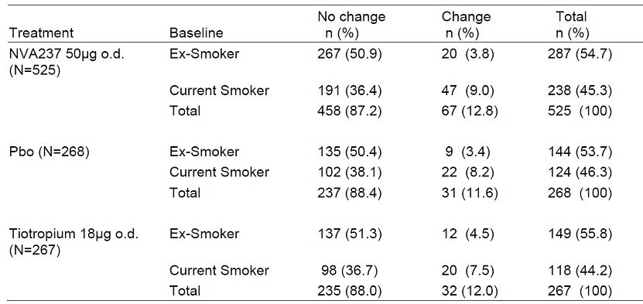

Table 40: Percentage of patients changing from baseline smoking status at any time during study (Study A2304).

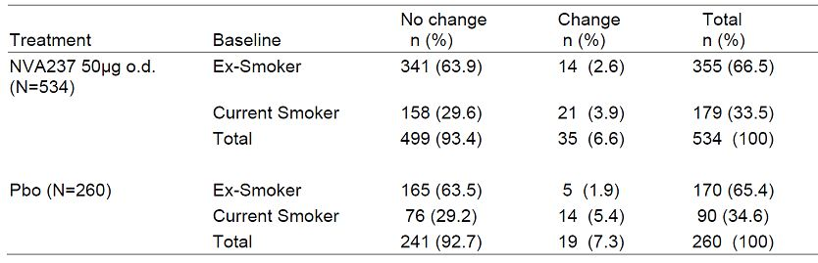

##### Collection of data on the use of nicotine replacement therapy

Nicotine replacement therapy, if used by a patient during the study was to be recorded in the “non COPD concomitant medications” eCRF. In Study A2303, 1.3% of the total patient population used nicotine replacement therapy: NVA237: 1.5%, Placebo: 1.1%, tiotropium: 1.1%. In Study A2304, 0.6% of the total patient population used nicotine replacement therapy: NVA237: 0.7%, placebo 0.4%**.** Since the number of patients using nicotine replacement therapy was very low no attempt was made to analyses the impact of using nicotine replacement therapy on efficacy endpoints.

#### Evaluator’s comments on sponsor’s response

The above explanation by the sponsors is adequate and addresses the evaluator’s concerns regarding effects of change in smoking status or use of nicotine replacement therapy on efficacy of Seebri during the pivotal studies.

### Question 2

*Question 2: Safety of NVA237 in subgroups based on COPD disease severity, drug exposure or concomitant ICS use was not provided. Was safety evaluated in the above subgroups? If it was, could the sponsors provide details of the analysis?*

#### Sponsor’s response

##### COPD severity

The 6-month database included the following numbers of patients per COPD severity group (NVA237/placebo): mild/moderate 663/340 and severe/very severe 412/195. In both severity groups AEs overall were less frequent on NVA237 than on placebo. The proportion of patients with any type of AEs on NVA237 and placebo were 59.0% and 63.8% in mild/moderate COPD, and 61.2% and 71.8% in severe/very severe COPD, respectively with very similar AE profile across COPD severity groups (Table 41-42). There was no SOC with a placebo-corrected SAE frequency differing by more than 0.5% between the two COPD severity groups.

Table 41: AEs in mid/moderate COPD reported greater than 0.5% more frequently than in severe/very severe COPD (6-month database).

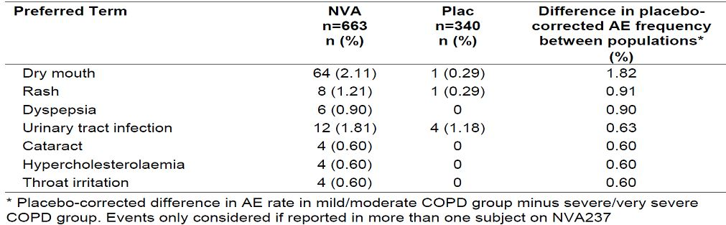

Table 42: AEs in severe/very severe COPD reported greater than 0.5% more frequently than in mild/moderate COPD (6-month database).

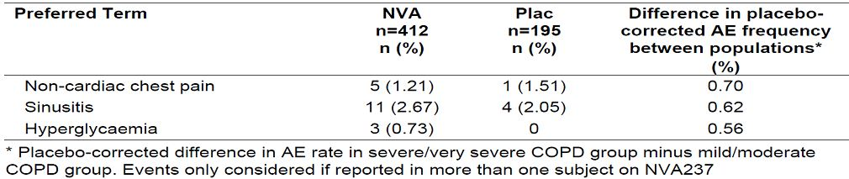

##### ICS use

The 6-month database included the following numbers of patients by co-medication (NVA237/ placebo): No-ICS group n = 478/262 and ICS group n = 591/272. In both co-medication groups AEs overall were less frequent on NVA237 than on placebo. The proportion of patients with any type of AEs on NVA237 and placebo were 55.0% and 66.4% in No-ICS group, and 63.8% and 66.9% in the ICS group, respectively with a very similar AE profile across the two co-medication groups (Tables 43-44).

Table 43: AEs in patients with concomitant ICS reported greater than 0.% more frequently than in those with ICS use (6-month database).

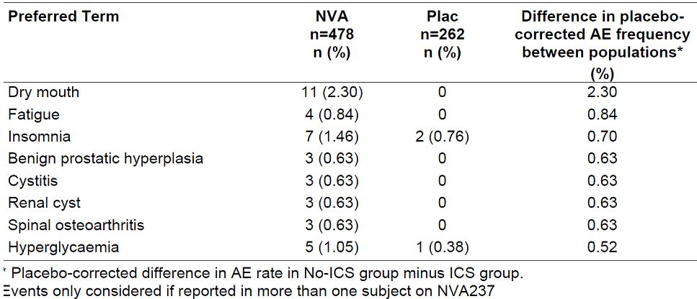

Table 44: AEs in patients on concomitant ICS reported greater than 0.% more frequently than in those without ICS use (6-month database).

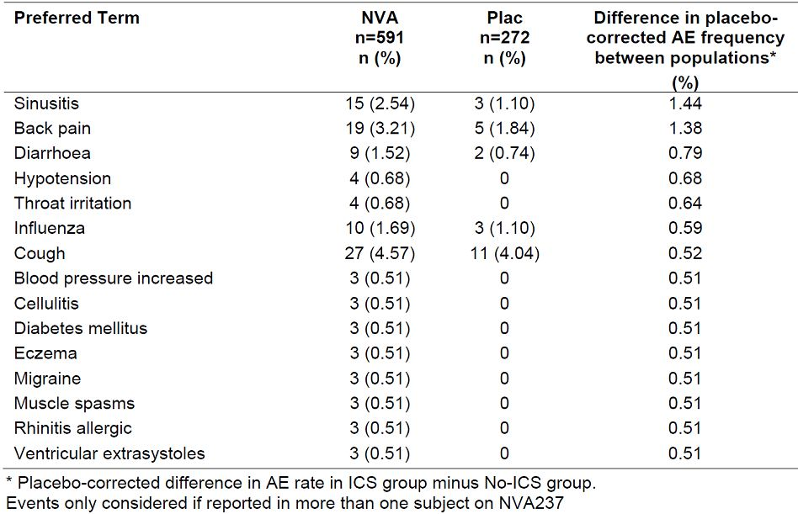

##### Drug exposure

The frequency and pattern of AEs is similar between the first half than in the second half of the treatment interval both in the 6-month and 12-month databases. Placebo-corrected frequencies differ by less than 0.5% between treatment intervals in the vast majority (>96%) of all NVA237 associated AEs. There is no clinically relevant difference between the safety profile of NVA237 over time (Tables 45-48). Since discontinuation rates from trials were generally low and lower on NVA237 than placebo, any bias would be expected to be small and in favour of placebo.

Table 45: AEs in patients during Weeks 1-13 reported greater than 0.5% more frequently than in those in Weeks 14+ (6-month database).

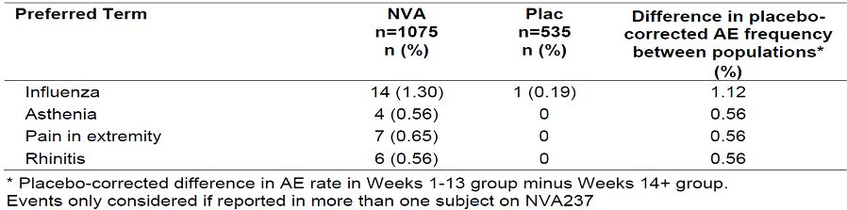

Table 46: AEs in patients during Weeks 14+ reported greater than 0.5% more frequently than in those in Weeks 1-13 (6-month database).

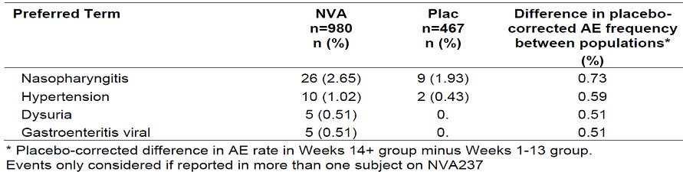

Table 47: AEs in patients during Weeks 1-26 reported greater than 0.5% more frequently than in those in Weeks 27+ (12-month database).

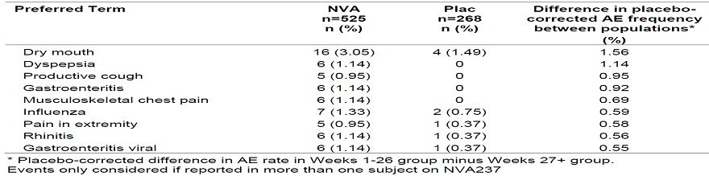

Table 48: AEs in patients during Weeks 27+ reported greater than 0.5% more frequently than in those in Weeks 1-26 (12-month database).

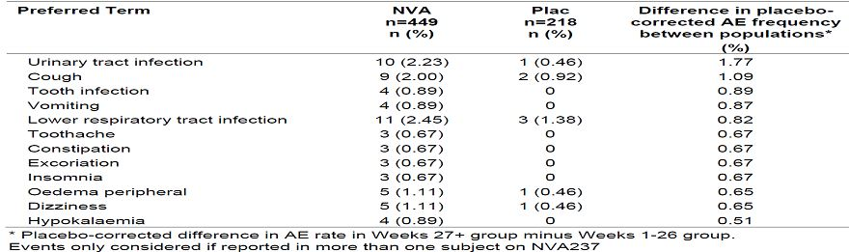

Dry mouth and dyspepsia was reported more frequently in Weeks 1-26, while urinary tract infection and lower respiratory tract infection were more frequent in Weeks 27+ compared to Weeks 1-26. Reports of cough/productive cough were similar across intervals.

There were no SAEs by SOC reported more frequently in Weeks 1-13 than in the Weeks 14+. On the other hand, SAEs related to the SOC Nervous system disorders were more frequent in Weeks 14+ than in Weeks 1-13. These SAEs included a variety of individual PT of which syncope was reported in n=2. There were no SAEs by SOC reported more frequently in Weeks 1-26 than in the Weeks 27+. On the other hand, there were 4 SOC with more SAEs in Weeks 27+ than in the first 26 weeks.

The number of exposure adjusted adverse event episodes in the 6- and 12-month database were similar and did not suggest an increase of events with prolonged treatment. The total number of AE per 100 patient-years was 378.9 (NVA237) and 467.7 (placebo) for the 6- months and 364.5 (NVA237) and 427.8 (placebo) for the 12-month database (Table 49).

Table 49: AE episodes adjusted for exposure by system organ class (6- and 12-month database).

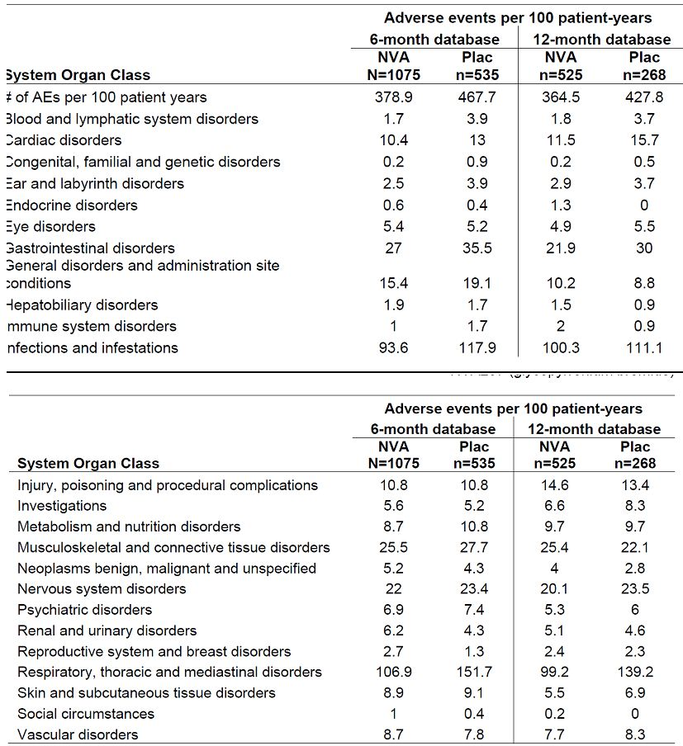

Overall, COPD severity, concomitant ICS use or drug exposure did not have any meaningful effect on safety profile of NVA237.

#### Evaluator’s comments on sponsor’s response

The above explanation by the sponsors is adequate and addresses the evaluator’s concerns regarding safety of Seebri in subgroups of COPD patients based on disease severity, drug exposure or concomitant ICS use.

## Second round benefit-risk assessment

### Second round assessment of benefits

After consideration of the responses to clinical questions, the benefits of Seebri Breezhaler in the proposed usage are unchanged from those identified in Section 9.

### Second round assessment of risks

After consideration of the responses to clinical questions, the risks of Seebri Breezhaler in the proposed usage are:

* The efficacy and safety of NVA237 50ug once-daily maintenance bronchodilator treatment to relieve symptoms of patients with chronic obstructive pulmonary disease (COPD) has not been evaluated for treatment periods > 1year.
* Overall, the incidence of CCV events was higher in patients with > 2 or 3 CCV risk factors but this increase was similar in the NVA237 and placebo groups. The main CCV safety concern identified in the NVA237 program was the increased risk of new or recurrent AF/ Atrial flutter. The sponsors have attempted to address this by regular monitoring of CCV events as indicated in the RMP.

### Second round assessment of benefit-risk balance

The benefit-risk balance of Seebri Breezhaler as once-daily maintenance bronchodilator treatment to relieve symptoms of patients with chronic obstructive pulmonary disease (COPD) is favourable.

## Second round recommendation regarding authorisation

It is recommended that SEEBRI breezhaler (NVA237) 50ug once-daily maintenance bronchodilator treatment to relieve symptoms of patients with chronic obstructive pulmonary disease (COPD) be approved subject to incorporation of changes recommended to the Product Information and Consumer Medicines Information.

## References

Bateman ED, Tashkin D, Siafakas N, et al (2010) A one-year trial of tiotropium Respimat® plus usual therapy in COPD patients. Respir Med; 104:1460-72.

Buch P, Friberg J, Scharling H, et al (2003) Reduced lung function and risk of atrial fibrillation in the Copenhagen City Heart Study. Eur Respir J; 21:1012-6.

Celli B, Decramer M, Kesten S, et al (2009) Mortality in the 4-Year Trial of Tiotropium (UPLIFT) in Patients with Chronic Obstructive Pulmonary Disease. Am J Respir Crit Care Med; 180:948-55.

Celli B, Decramer M, Leimer I, et al (2010) Cardiovascular Safety of Tiotropium in Patients with COPD. Chest; 137:20-30.

EMA (2010)] Clinical investigation of medicinal products in the treatment of Chronic Obstructive Pulmonary Disease, July 2010, draft 3, CPMP/EWP/562/98 Rev. 1

Global Initiative for Chronic Obstructive Lung Disease (GOLD) (2008) Global Strategy for the Diagnosis, Management, and Prevention of Chronic Obstructive Pulmonary Disease. Updated 2008 (Internet) Available from http://www.goldcopd.org (Accessed 25-July-2011).

Kesten S, Jara M, Wentworth C, et al (2006) Pooled clinical trial analysis of tiotropium safety. Chest; 130:1695-703.

Kesten S, Celli B, Decramer M, et al (2009) Tiotropium HandiHaler® in the treatment of COPD: a safety review. Intl J COPD; 4:397-409.

Mapel DW, Dedrick D, Davis K (2005) Trends and cardiovascular co-morbidities of COPD patients in the Veterans Administration Medical System. COPD; 2:35-41.

Michele TM, Pinheiro S, Iyasu S (2010) Perspective: The Safety of Tiotropium - The FDA's Conclusions. N Engl J Med; 363(12):1097-9.

MSSO (2011) Introductory Guide for Standardised MedDRA Queries (SMQs) Version 14.0. MSSO-DI-6226-14.0.0.

Psaty BM, Manolio TA, Kuller LH, et al 1997 Incidence of and risk factors for atrial fibrillation in older adults. Circulation; 96(7):2455-61.

Robinul and Robinul forte Prescribing Information MIKART, INC. Atlanta, GA 30318 (Internet) Available from: http://www.robinul.com/Robinul%20PI.pdf (Accessed 08-Aug-2011)

Singh S, Loke YK, Furberg CD (2008) Inhaled anticholingergics and risk of major adverse cardiovascular events in patients with chronic obstructive pulmonary disease: A systematic review of meta-analysis. JAMA; 300(12):1439-50.

Singh S, Loke YK, Enright PL, et al (2011) Mortality associated with tiotropium mist inhaler in patients with chronic obstructive pulmonary disease: systematic review and metaanalysis of randomised controlled trials. BMJ; 342.d3215 (Internet).

Tashkin DP, Celli B, Senn S, et al (2008) A 4-Year Trial of Tiotropium in Chronic Obstructive Pulmonary Disease. N Engl J Med; 359(15):1543-54.

1. A model-based approach was used to characterize the NVA237 dose-regimen-response relationship for various spirometry outcomes. This quantitative characterization of dose response was then used to evaluate the maximum difference in response for the various endpoints between the modelled dosing regimens over the range of doses 20 μg to 55 μg.
2. Ten pack-years are defined as 20 cigarettes a day for 10 years, or 10 cigarettes a day for 20 years etc.
3. At Visit 2 (Day −14), spirometry measurements were taken to assess eligibility for the study and to assess ipratropium airway reversibility as demonstrated by an increase in FEV1 compared to the pre-bronchodilator value, 45 min after inhalation of 80μg of ipratropium. FVC was also recorded at this 45 min time-point.
4. Women of child-bearing potential (WOCBP), unless they met the criteria for being postmenopausal or had surgical bilateral oophorectomy with or without hysterectomy in the past 6 weeks or where using an acceptable method of contraception.
5. Patients taking fixed combinations of β2-agonists and inhaled corticosteroids had to be switched to the equivalent inhaled corticosteroid as monotherapy plus salbutamol/albuterol as rescue therapy at least 48 hours prior to Visit 2.
6. Trough FEV1 was defined as the mean of the post-dose 23 h 15 min and the 23 h 45 min FEV1 values. The allowable window for the scheduled 23 h 15 min and 23 h 45 min measurements to be taken is 22 h 45 min to 24 h 15 min, and the measurements had to be before the next dose of study medication. Values measured outside of this window were set to missing. If any of the values contributing to the trough FEV1 were collected within 6 h of rescue medication or 7 days of systemic corticosteroid use then the individual FEV1 value was set to missing.
7. TDI each have three domains: functional impairment, magnitude of task and magnitude of effort. The BDI domains were rated from 0 (severe) to 4 (unimpaired) and the rates were summed for the baseline focal score ranging from 0 to 12; the lower the score the worse the severity of dyspnea. The TDI domains were rated from -3 (major deterioration) to 3 (major improvement) and the rates were summed for the transition focal score ranging from -9 to 9; minus scores indicate deterioration. A TDI focal score of 1 was considered to be a clinically significant improvement from baseline.
8. A score was calculated for each component (“Symptoms”, “Activity” and “Impacts”) and a "Total" score was calculated. In each case the lowest possible value was zero and the highest 100. Higher values corresponded to greater impairment of quality of life.
9. The start date for a COPD exacerbation recorded in the eCRF was the first day of symptom worsening (beyond usual symptoms) of two or more major symptoms or one major and one minor symptom as defined above. The end of a COPD exacerbation episode was marked by the return to pre-exacerbation symptom status.
10. COPD exacerbations were defined either as: Worsening of two or more of the following major symptoms for at least 2 consecutive days: dyspnea, sputum volume, sputum purulence OR worsening of any 1 major symptom together with any 1 of the following minor symptoms for at least 2 consecutive days: sore throat, colds (nasal discharge and/or nasal congestion), fever without other cause, increased cough, increased wheeze. COPD exacerbations were considered to be: of moderate severity if treatment with systemic corticosteroids and/or antibiotic was required; of severe severity if treatment for moderate severity (listed above) and hospitalisation was required.
11. The numbers of puffs of rescue medication taken in the previous 12 h were recorded in the Patient Diary in the morning and evening. No imputation was used for missing rescue medication. The total number of puffs of rescue medication per day over the full 52 weeks was calculated and divided by the total number of days with non-missing rescue medication data to derive the mean daily number of puffs of rescue medication taken for the patient.
12. This was defined from diary data as any night where the patient did not wake up due to symptoms. The total number of nights with ‘no nighttime awakenings’ over the 52-week treatment period was divided by the total number of nights where diary recordings.
13. A day with ‘no daytime symptoms’ was defined from the diary data as any day where the patient had recorded in the evening no cough, no wheeze, no production of sputum, no feeling of breathlessness (other than when running) and no puffs of rescue medication during the past 12 hours.
14. A ‘day able to perform usual daily activities’ was defined from diary data as any day where the patient was not prevented from performing their usual daily activities due to respiratory symptoms.
15. Hochberg’s step-up procedure for the two key secondary variables: (1) If both P-values are ≤ 0.05 then both comparisons were reported as statistically significant. If not, then (2) If the smallest P-value is ≤ 0.025 then the corresponding comparison were reported as statistically significant. If not then (3) Both comparisons were reported as not statistically significant. The Hochberg’s procedure was also applied to the two important secondary variables.
16. Adverse events by Standardised MedDRA query: SMQs are terms from 1 or more system organ classes that relate to a defined medical condition or area of interest. They are a tool to aid in the retrieval of potentially relevant safety reports that include a broad selection of terms that may relate to signs, symptoms, diagnoses, syndromes, physical findings, laboratory and other physiological test data, etc. that are associated with the medical condition or area of interest.
17. Selection of potential ADRs underwent internal medical review to assess whether or not they fulfil the criteria for an ADR. These criteria include event severity, temporal relationship, pharmacological action of the compound, dose-response relationship, and the safety profile of other inhaled long-acting muscarinic antagonists.
18. Two of these SAEs were NVA237 patients (1 death due to pneumonia and hospitalisation to repair abdominal incisional hernia at the site of a prior perforated bowel ) and one SAE in a tiotropium patient (hospitalisation due to COPD exacerbation).
19. No dose adjustments were permitted during the studies. Patients were instructed to take 1 capsule every day in the morning. No adjustments were to be made as a result of missed doses.
20. The criteria for Hy’s Law, based on was (alanine aminotransferase [ALT] and/or aspartate aminotransferase [AST] > 3 x the upper limit of normal [ULN]) and (ALP < 2 x ULN) and (bilirubin > 2 x ULN) (FDA 2008).
21. One subject showed an increase in QTcF from 490 ms at baseline and to a maximum of 519 ms at 1 h post dose returning again to 487 ms at the end of study visit; subject did not receive concomitant medication known to prolong QTc interval and had a history of angina, Diabetes, obesity, hypertension in addition to severe renal impairment.
22. Inhaled tiotropium is available in two formulations: as a powder (Spiriva; Boehringer Ingelheim, Germany) delivered with a Handihaler device (Boehringer Ingelheim) and in solution as a mist delivered with the Respimat Soft Mist Inhaler (Boehringer Ingelheim). The mist inhaler is a propellant free device, which generates a fine, slow moving cloud for inhalation and the delivered dose is independent of inspiratory effort and relatively unaffected by problems with breathing manoeuvre compared with other devices. It is recommended for use in patients who have poor manual dexterity and therefore have difficulty using the Handihaler. Pharmacokinetic studies have shown that compared with tiotropium 18 μg delivered by the Handihaler, peak plasma concentrations with the mist inhaler at doses of 5 μg and 10 μg were 35% and threefold higher, respectively.