# SEEBRI® BREEZHALER®

glycopyrronium bromide

## NAME OF THE MEDICINE

**Structural formula:**

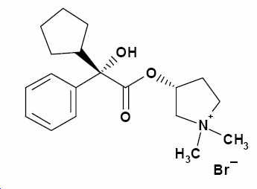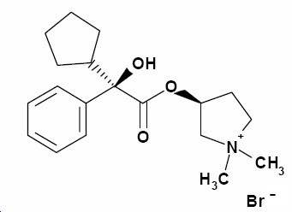

[2S, 3R]-stereoisomer [2R, 3S]-stereoisomer

**Chemical name (IUPAC):** 3-(2-Cyclopentyl-2-hydroxy-2-phenylacetoxy)-1,1-dimethylpyrrolidinium bromide Pyrrolidinium, 3-[(cyclopentylhydroxyphenylacetyl)oxy]-1,1-dimethyl-, bromide-3-Hydroxy-1,1-dimethylpyrrolidinium bromide α-cyclopentylmandelate

**INN/AAN:** Glycopyrronium bromide

**CAS name:** Pyrrolidinium, 3-[(2-cyclopentyl-2-hydroxy-2-

phenylacetyl)oxy]-1,1-dimethyl-, bromide (1:1)

**CAS no.:** 596-51-0

**Molecular formula:** C19H28NO3 . Br

**Molecular weight:** Salt form: 398.33

**Stereochemistry:** 2 asymmetric carbon atoms and is an optically inactive racemic mixture of 2 stereoisomers (S,R) and (R,S)

**Aqueous Solubility:** At 25°C freely soluble in aqueous media across the pH range from 1 to 10 (water solubility >100 mg/mL)

**Partition coefficient:** Distribution coefficient D in Octanol/Water at 37.0 +/- 0.5°C: 0.060 (log D = -1.2)

**pKa:** Glycopyrronium bromide is a quaternary ammonium salt and permanently ionized between pH 1 and 14.

## DESCRIPTION

SEEBRI hard capsules are for oral inhalation only*.* SEEBRI is also supplied with a BREEZHALER inhalation device to permit oral inhalation of the contents of the capsule shell.

### 50 μg inhalation powder hard capsules

Transparent orange capsules containing a white powder, with the product code GPL50 printed in black above a black bar and the company logo (logo) printed under a black bar.

Each capsule contains 63 microgram glycopyrronium bromide equivalent to 50 microgram glycopyrronium.

The delivered dose (the dose that leaves the mouthpiece of the SEEBRI BREEZHALER inhaler) is equivalent to 44 microgram glycopyrronium.

### Excipients:

Capsule fill: Lactose monohydrate and magnesium stearate.

Capsule shell components: Hypromellose, purified water, carrageenan, potassium chloride, Sunset Yellow FCF

Printing Ink: Shellac, absolute ethanol, isopropyl alcohol, propylene glycol, butan-1-ol, ammonium hydroxide, potassium hydroxide, purified water, iron oxide black

## PHARMACOLOGY

### Pharmacodynamics

#### Mechanism of action

SEEBRI BREEZHALER is an inhaled long-acting muscarinic receptor antagonist (anti-cholinergic) for once-daily maintenance bronchodilator treatment of COPD. Parasympathetic nerves are the major bronchoconstrictive neural pathway in airways, and cholinergic tone is the key reversible component of airflow obstruction in COPD. SEEBRI BREEZHALER works by blocking the bronchoconstrictor action of acetylcholine on airway smooth muscle cells thereby dilating the airways.

Of the five known muscarinic receptor subtypes (M1-5), only subtypes M1-3 have a defined physiological function in the human lung. Glycopyrronium bromide is a high affinity muscarinic receptor antagonist of these three receptor subtypes. It demonstrated 4- to 5-fold selectivity for the human M3 and M1 receptors over the human M2 receptor in competition binding studies. It has a rapid onset of action as evidenced by observed receptor association/dissociation kinetic parameters and the onset of action after inhalation in clinical studies.

The long duration of action can be partly attributed to sustained drug concentrations in the lungs as reflected by the prolonged terminal elimination half-life of glycopyrronium after inhalation via the SEEBRI BREEZHALER inhaler in contrast to the half-life after i.v. administration (see PHARMACOLOGY – Elimination). Lung pharmacokinetic data in rats following inhalation of glycopyrronium bromide provides further evidence for this.

### Pharmacodynamics effects

#### Primary Pharmacodynamic Effects

SEEBRI BREEZHALER provided consistently significant improvement in lung function (as measured by the forced expiratory volume in one second, FEV1) over 24 hours in a number of clinical pharmacodynamic and efficacy trials.

In the pivotal studies there was a rapid onset of action within 5 minutes after inhalation of SEEBRI BREEZHALER, with an increase in FEV1 relative to baseline ranging from 0.091 L to 0.094 L. During the first 2 hours after drug administration bronchodilation was significantly greater with SEEBRI BREEZHALER than with the long-acting muscarinic antagonist tiotropium, the treatment difference ranged from 0.041 L to 0.068 L. The bronchodilator effect of SEEBRI BREEZHALER was sustained over 24 hours. There was no evidence for tachyphylaxis to the bronchodilator effect after repeated dosing for up to 52 weeks.

#### Secondary Pharmacodynamic Effects

The effect on heart rate and QTc interval of glycopyrronium bromide 150 µg (equivalent to 120 µg glycopyrronium) administered intravenously was investigated in young healthy subjects. Peak exposures (Cmax) about 50-fold higher than after inhalation of SEEBRI BREEZHALER 50 µg at steady state were achieved and did not result in tachycardia or QT(c) prolongation. Negligible signs of bradycardia were observed (mean difference over 24 h -2 bpm when compared to placebo), which is a known effect of low exposures to anticholinergic compounds in young healthy subjects. No changes in heart rate or QT(c) interval were observed with SEEBRI BREEZHALER 200 µg in COPD patients.

### Pharmacokinetics

#### Absorption

Following oral inhalation using the SEEBRI BREEZHALER inhaler, glycopyrronium was rapidly absorbed and reached peak plasma levels at 5 minutes post dose.

The absolute bioavailability of glycopyrromium inhaled via SEEBRI BREEZHALER inhaler was estimated to be about 40%. About 90% of systemic exposure following inhalation is due to lung absorption and 10% is due to gastrointestinal absorption. The absolute bioavailability of orally administered glycopyrronium was estimated to be about 5%.

Following repeated once-daily inhalation in patients with COPD, PK steady-state of glycopyrronium was reached within one week of treatment. The steady-state mean peak and trough plasma concentrations of glycopyrronium for a 50 µg once-daily dosing regimen were 166 pg/mL and 8 pg/mL, respectively. With once-daily doses of 100 and 200 µg, steady-state exposure to glycopyrronium (AUC over the dosing interval) was about 1.4-to 1.7-fold higher than after the first dose. Urinary excretion data at steady-state compared to the first dose suggest that systemic accumulation is independent of dose in the dose range of 25 to 200 µg.

#### Distribution

After i.v. dosing, the steady-state volume of distribution (Vss) of glycopyrronium was 83 L and the volume of distribution in the terminal phase (Vz) was 376 L. The apparent volume of distribution in the terminal phase following inhalation (Vz/F) was 7310 L, which reflects the much slower elimination after inhalation. The *in vitro* human plasma protein binding of glycopyrronium was 38% to 41% at concentrations of 1 to 10 ng/mL. These concentrations were at least 6-fold higher than the steady state mean peaks levels achieved in plasma for a 50 µg once-daily dosing regimen.

#### Biotransformation/metabolism

*In vitro* metabolism studies showed consistent metabolic pathways for glycopyrronium bromide between animals and humans. No human specific metabolites were found. Hydroxylation resulting in a variety of mono-and bis-hydroxylated metabolites and direct hydrolysis resulting in the formation of a carboxylic acid derivative (M9) were seen.

*In vitro* investigations showed that multiple CYP isoenzymes contribute to the oxidative biotransformation of glycopyrronium. The hydrolysis to M9 is likely to be catalyzed by members from the cholinesterase family.

After inhalation, systemic exposure to M9 was on average in the same order of magnitude as the exposure to the parent drug. Since *in vitro* studies did not show lung metabolism and M9 was of minor importance in the circulation (about 4% of parent drug Cmax and AUC) after i.v. administration, it is assumed that M9 is formed from the swallowed dose fraction of orally inhaled glycopyrronium bromide by pre-systemic hydrolysis and/or via first pass metabolism. After inhalation as well as i.v. administration, only minimal amounts of M9 were found in the urine (i.e. ≤ 0.5% of dose). Glucuronide and/or sulfate conjugates of glycopyrronium were found in urine of humans after repeated inhalation, accounting for about 3% of the dose.

*In vitro* inhibition studies demonstrated that glycopyrronium bromide has no relevant capacity to inhibit CYP1A2, CYP2A6, CYP2C8, CYP2C9, CYP2C19, CYP2D6, CYP2E1 or CYP3A4/5, the efflux transporters MDR1, MRP2 or MXR, and the uptake transporters OCT1 or OCT2. *In vitro* enzyme induction studies did not indicate a clinically relevant induction by glycopyrronium bromide for any of the cytochrome P450 isoenzymes tested as well as for UGT1A1 and the transporters MDR1 and MRP2.

#### Excretion

After i.v. administration of [3H]-labelled glycopyrronium bromide to humans, the mean urinary excretion of radioactivity in 48 h amounted to 85% of the dose. A further 5% of the dose was found in the bile. Thus, mass balance was almost complete.

Renal elimination of parent drug accounts for about 60 to 70% of total clearance of systemically available glycopyrronium whereas non-renal clearance processes account for about 30 to 40%. Biliary clearance contributes to the non-renal clearance, but the majority of non-renal clearance is thought to be due to metabolism.

Following inhalation of single and repeated once-daily doses between 50 and 200 µg glycopyrronium by healthy volunteers and patients with COPD mean renal clearance of glycopyrronium was in the range of 17.4 and 24.4 L/h. Active tubular secretion contributes to the renal elimination of glycopyrronium. Up to 20% of the dose was found in urine as parent drug.

Glycopyrronium plasma concentrations declined in a multi-phasic manner. The mean terminal elimination half-life was much longer after inhalation (33 to 57 hours) than after intravenous (6.2 hours) and oral (2.8 hours) administration. The elimination pattern suggests a sustained lung absorption and/or transfer of glycopyrronium into the systemic circulation at and beyond 24 h after inhalation.

#### Linearity/non-linearity

In COPD patients’ systemic exposure as well as total urinary excretion of glycopyrronium at pharmacokinetic steady state increased about dose-proportionally over the dose range of 50 µg to 200 µg.

### Pharmacokinetics in special patient groups

#### Patients with hepatic impairment

Clinical studies in patients with hepatic impairment have not been conducted. Glycopyrronium is cleared predominantly from the systemic circulation by renal excretion (see PHARMACOLOGY – Elimination). Impairment of the hepatic metabolism of glycopyrronium is not thought to result in a clinically relevant increase of systemic exposure.

#### Patients with renal impairment

Renal impairment has an impact on the systemic exposure to glycopyrronium bromide. A moderate mean increase in total systemic exposure (AUClast) of up to 1.4-fold was seen in subjects with mild and moderate renal impairment and up to 2.2-fold in subjects with severe renal impairment and end stage renal disease. Using a population PK analysis, it was concluded that in COPD patients with mild and moderate renal impairment (estimated glomerular filtration rate eGFR≥30 mL/min/1.73m2) SEEBRI BREEZHALER can be used at the recommended dose.

#### Ethnicity

There were no major differences in total systemic exposure (AUC) between Japanese and Caucasian subjects following inhalation of glycopyrronium bromide. Insufficient PK data is available for other ethnicities or races.

#### Body weight and age

A population PK analysis of data in COPD patients identified body weight and age as factors contributing to inter-patient variability in systemic exposure. SEEBRI BREEZHALER 50 µg once-daily can be safely used in all age and body weight groups.

#### Effects of gender, smoking status and baseline FEV1

Gender, smoking status and baseline FEV1 had no apparent effect on systemic exposure.

## CLINICAL TRIALS

The SEEBRI BREEZHALER Phase III clinical development program consisted of two key efficacy and safety studies (a 6-month placebo-controlled study and a 12-month placebo and active-controlled study) which enrolled 1888 patients with a clinical diagnosis of COPD, who were 40 years old or older, had a smoking history of at least 10 pack years, had a post-bronchodilator FEV1 <80% and ≥30% of the predicted normal value and a post-bronchodilator FEV1/FVC ratio of less than 70%. Efficacy and safety of SEEBRI BREEZHALER beyond 1 year has not been evaluated.

### Lung function

In these studies, SEEBRI BREEZHALER, administered at 50 microgram once-daily showed clinically meaningful improvements in lung function (as measured by the forced expiratory volume in one second, FEV1) over 24 hours. At the 12-week primary endpoint (24-hour trough FEV1), SEEBRI BREEZHALER provided bronchodilation benefits of 0.108 L and 0.097 L compared to placebo (p<0.001) for the 6- and 12-month study respectively. In the latter study, the improvement vs. placebo for the open-label tiotropium 18 microgram once-daily arm was 0.083 L (p < 0.001).

In both studies SEEBRI BREEZHALER demonstrated a rapid onset of bronchodilator effect. In the 6-month study the increase in FEV1 was 0.093 L compared to placebo at 5 minutes, increasing to 0.144 L at 15 minutes after the first dose. In the 12-month study the increase in FEV1 was 0.087 L at 5 minutes and 0.143 L at 15 minutes after the first dose compared to placebo (p<0.001). For tiotropium the increase in FEV1 was 0.045 L at 5 minutes and 0.078 L at 15 minutes after the first dose compared to placebo (p<0.001).

In the pivotal studies there was a rapid onset of action within 5 minutes after inhalation of SEEBRI BREEZHALER, with an increase in FEV1 relative to baseline ranging from 0.091 L to 0.094 L.

The improvements in mean trough FEV1 observed at the primary endpoint (12 weeks) were maintained throughout treatment in both the 6- and 12-months studies. Mean trough FEV1 was increased by 0.113 L at week 26 in the 6-month study and 0.108 L at week 52 in the 12-month study, compared to placebo. These data indicate that the 24-hour bronchodilator effect of SEEBRI BREEZHALER was maintained from the first dose throughout a one-year period.

In the 6-month study serial spirometry was performed on Day 1 (Figure 1), Week 12 (Figure 2) and Week 26. In the 12 month study serial spirometry was performed on Day 1 (Figure 3), Week 12 (Figure 4) and Week 52.

Serial spirometry data was used to calculate FEV1 standardized (for time) area under the curve (AUC). In the 6-month study for FEV1 AUC 0-24h SEEBRI BREEZHALER provided a benefit of 0.133 L and 0.199 L compared to placebo at Week 12 and Week 26 respectively (p<0.001). In the 12-month study at Week 12, SEEBRI BREEZHALER provided a benefit of 0.106 L for FEV1 AUC 0-24h (p<0.001) compared to placebo; for tiotropium the treatment difference was 0.079 L compared to placebo (p=0.014). At Week 52 in the 12-month study SEEBRI BREEZHALER provided a benefit of 0.106 L for FEV1 AUC 0-24h compared to placebo (p<0.001); for tiotropium the treatment difference compared to placebo was 0.040 L (p=0.279).

Figure Six-month pivotal study: Serial spirometry data (least square means of FEV1 (L)) after first dose

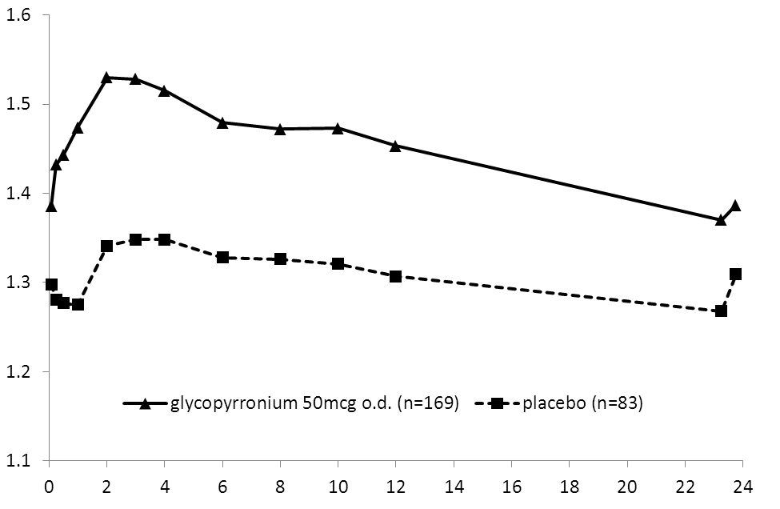

Time (h)

LS mean of FEV1 (L)

Figure Six-month pivotal study: Serial spirometry data (least square means of FEV1 (L)) at week 12

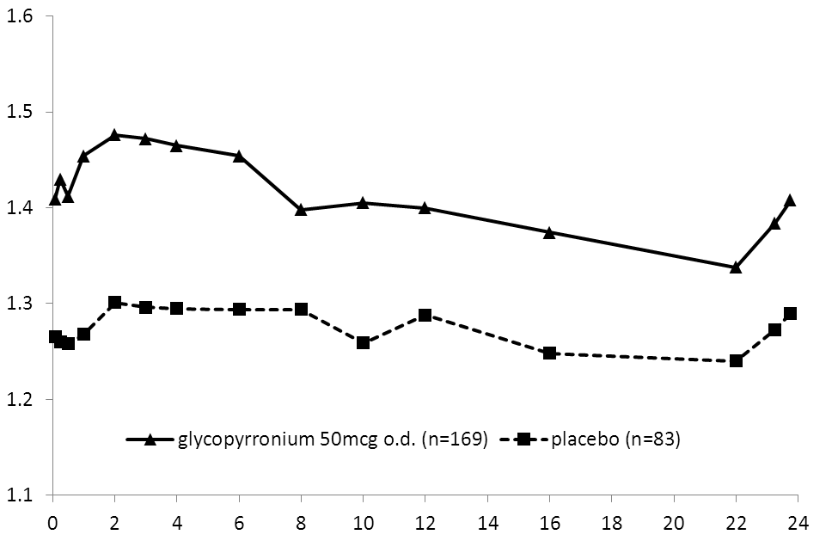

LS mean of FEV1 (L)

Time (h)

Figure Twelve-month pivotal study: Serial spirometry data (least square means of FEV1 (L)) after first dose

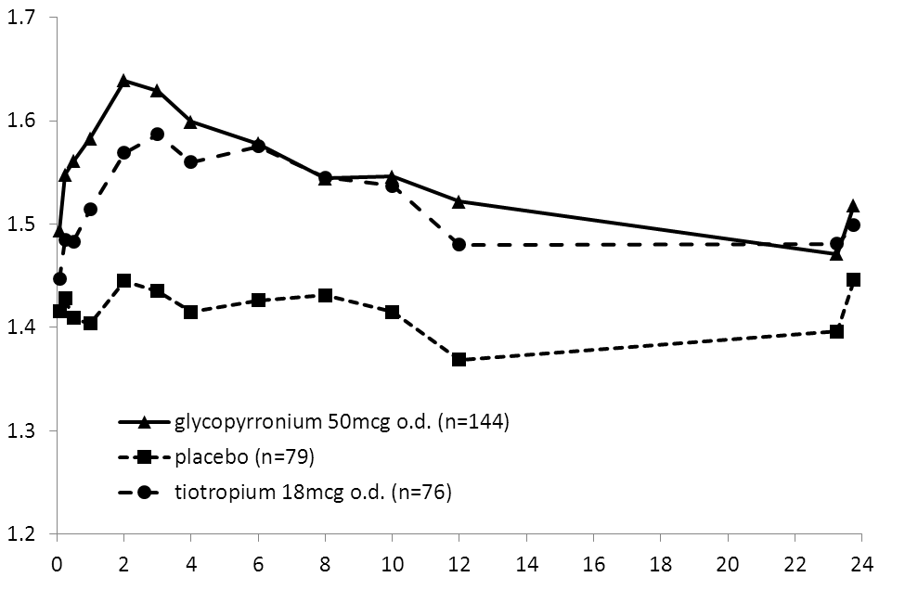

LS mean of FEV1 (L)

Time (h)

Figure Twelve-month pivotal study: Serial spirometry data (least square means of FEV1 (L)) at week 12

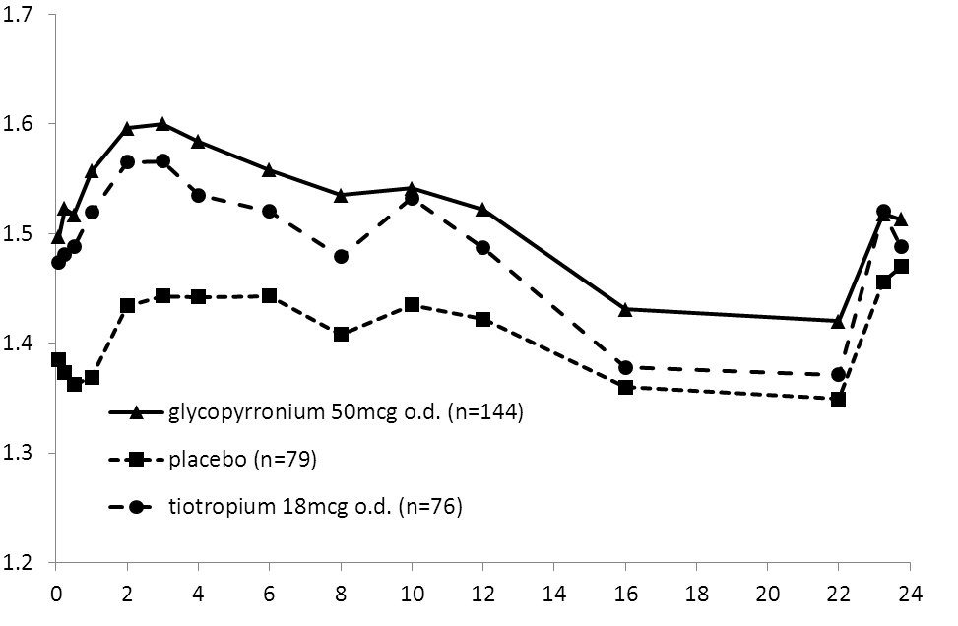

LS mean of FEV1 (L)

Time (h)

In addition to demonstrating improvements in FEV1, SEEBRI BREEZHALER consistently improved forced vital capacity (FVC) and inspiratory capacity (IC) in the two pivotal studies. At Week 12 SEEBRI BREEZHALER was shown to increase mean trough FVC by 0.194 L and 0.183 L compared to placebo (p<0.001) in the 6- and 12-month studies respectively. SEEBRI BREEZHALER improved trough IC at Week 12 by 0.097 L and 0.129 L (p≤0.001) compared to placebo in the 6- and 12-month studies, respectively.

### Symptomatic benefit

SEEBRI BREEZHALER administered at 50 µg once-daily significantly reduced breathlessness as evaluated by the Transitional Dyspnea Index (TDI). In a pooled analysis of the 6- and 12-month pivotal studies the percentage of patients responding with a clinically meaningful difference of ≥ 1 point improvement in the TDI focal score at Week 26 was 58.4% for SEEBRI BREEZHALER compared with 46.4% for patients receiving placebo and 53.4% for patients receiving tiotropium. The differences in responder rates were statistically significant for the comparison of SEEBRI BREEZHALER to placebo (<0.001) and tiotropium to placebo (p=0.009).

SEEBRI BREEZHALER 50 µg once-daily has also a significant effect on health status measured using the St. George’s Respiratory Questionnaire (SGRQ). A pooled analysis of the 6- and 12-month pivotal studies found the percentage of patients responding with a clinically important improvement in the SGRQ total score (≤ -4) at Week 26 was 57.8% for SEEBRI BREEZHALER compared with 47.6% for patients receiving placebo and 61.0% for patients receiving tiotropium. The differences in responder rates were statistically significant for the comparison of SEEBRI BREEZHALER to placebo (<0.001) and tiotropium to placebo (p=0.004).

In a pooled analysis of the 6- and 12-month studies, SEEBRI BREEZHALER 50µg once-daily significantly prolonged the time to first moderate or severe COPD exacerbation and reduced the rate of moderate or severe COPD exacerbations (moderate exacerbations were those requiring treatment with systemic corticosteroids and/or antibiotics, severe exacerbations those resulting in hospitalisation. The proportion of patients with moderate or severe COPD exacerbations in the 26-week pooled analysis was 19.8% for SEEBRI BREEZHALER vs. 27.2% for placebo and the estimated risk ratio for time to moderate or severe exacerbations was 0.64 [95% CI: 0.520, 0.799; p < 0.001], suggesting a 36% risk reduction vs. placebo, similarly the estimated risk ratio for time to first severe exacerbation leading to hospitalization was 0.39 [95% CI: 0.205, 0.728; p = 0.003]. Over the 26-week pooled analysis the exacerbation rate was statistically significantly lower for patients treated with SEEBRI BREEZHALER compared to those treated with placebo, the rate ratio being 0.66 ([95% CI: 0.525, 0.841; p < 0.001]).

SEEBRI BREEZHALER 50µg once-daily significantly reduced the use of rescue medication by 0.46 puffs per day (p = 0.005) over 26 weeks and by 0.37 puffs per day (p = 0.039) over 52 weeks compared to placebo for the 6- and 12-month studies, respectively.

The effect of SEEBRI BREEZHALER reducing dynamic hyperinflation and the associated improvements in exercise tolerance were investigated in a randomised, double-blind, placebo-controlled, crossover trial with a treatment duration of three weeks in 108 patients with moderate to severe COPD. SEEBRI BREEZHALER achieved its full effect of improving inspiratory capacity under exercise (0.23 L) and has statistically significant effects on exercise endurance of 43 seconds (an increase of 10 %) after the first dose. After three weeks of treatment SEEBRI BREEZHALER improved exercise endurance time by 89 seconds (an increase of 21 %) and inspiratory capacity under exercise was increased by 0.20 L.

## INDICATIONS

SEEBRI BREEZHALER is indicated as a once-daily maintenance bronchodilator treatment to relieve symptoms of patients with chronic obstructive pulmonary disease (COPD).

## CONTRAINDICATIONS

Hypersensitivity to any ingredients of the preparation.

SEEBRI capsules contain lactose. Therefore, patients with rare hereditary problems of galactose intolerance, severe lactase deficiency or glucose-galactose malabsorption should not take this medicine.

## PRECAUTIONS

### Not for acute use

SEEBRI BREEZHALER is a once-daily long-term maintenance treatment and is not indicated for the initial treatment of acute episodes of bronchospasm*, i.e.* as a rescue therapy.

### Paradoxical bronchospasm

As with other inhalation therapy, administration of SEEBRI BREEZHALER may result in paradoxical bronchospasm that may be life-threatening. If paradoxical bronchospasm occurs, SEEBRI BREEZHALER should be discontinued immediately and alternative therapy instituted.

### Anticholinergic effect

Like other anticholinergic drugs, SEEBRI BREEZHALER should be used with caution in patients with narrow-angle glaucoma or urinary retention.

Patients should be advised about signs and symptoms of acute narrow-angle glaucoma and should be informed to stop using SEEBRI BREEZHALER and to contact their doctor immediately should any of these signs or symptoms develop.

### Use in Patients with Renal Impairment

For patients with severe renal impairment (estimated glomerular filtration rate below 30 mL/min/1.73m2) including those with end-stage renal disease requiring dialysis, SEEBRI BREEZHALER should be used only if the expected benefit outweighs the potential risk (see PHARMACOLOGY). These patients should be monitored closely for potential adverse drug reactions.

### Use in Patients with Hepatic Impairment

No specific studies have been conducted in patients with hepatic impairment. SEEBRI BREEZHALER is predominantly cleared by renal excretion and therefore no major increase in exposure is expected in patients with hepatic impairment.

### Effects on Fertility

Male and female fertility were unaffected in rats given glycopyrronium bromide by subcutaneous administration at doses up to 1.5 mg/kg/day (yielding plasma AUC levels approximately 900-times [males] and 500-times [females] that of humans at the maximum recommended clinical dose of 50 µg). Slight inhibition of ovulation (decreased corpora lutea) and increased pre-implantation loss were evident at this highest dose, but not at 0.5 mg/kg/day (relative exposure based on AUC, 162)

### Use in Pregnancy (Category B3)

No clinical data on exposed pregnancies in COPD patients are available. Glycopyrronium bromide was not teratogenic in rats or rabbits following inhalational administration at doses up to 3.05 and 3.5 mg/kg/day in the respective species (yielding plasma AUC values 730-times and 250-times higher than in patients at the maximum recommended human dose. Decreased birth weight and postnatal body weight gain were observed in the offspring of rats given the drug by subcutanuous administration at 1.5 mg/kg/day during gestation and lacation; there was no effect at 0.5 mg/kg/day (estimated relative exposure, 162). Glycopyrronium bromide and its metabolites did not significantly cross the placental barrier of pregnant mice, rabbits and dogs. In human parturients undergoing Caesarean section, 86 minutes after a single intramuscular injection of 0.006 mg/kg glycopyrronium bromide, umbilical plasma concentrations were low. As there is no adequate experience in pregnant women, SEEBRI BREEZHALER should only be used during pregnancy if the expected benefit to the patient justifies the potential risk to the fetus.

### Use in Lactation

It is not known whether glycopyrronium bromide passes into human breast milk. However, glycopyrronium bromide (including its metabolites) was excreted into the milk of lactating rats up to 10-fold higher concentrations in the milk than in the blood of the dam and inhibition of postnatal bodyweight gain weight was observed in the species (see Use in pregnancy). The use of SEEBRI BREEZHALER by breast-feeding women should only be considered if the expected benefit to the woman is greater than any possible risk to the infant.

### Pediatric Use

SEEBRI BREEZHALER should not be used in patients under 18 years of age, COPD is an indication of adults only.

### Use in the Elderly

SEEBRI BREEZHALER can be used at the recommended dose in elderly patients 75 years of age and older.

### Genotoxicity

Glycopyrronium bromide was not genotoxic in assays for bacterial mutagenicity, chromosomal aberrations *in vitro* (human lymphocytes) or *in vivo* clastogenicity (rat bone marrow micronucleus test).

### Carcinogenicity

Carcinogenicity studies of six months duration in transgenic mice (rasH2) using oral administration and 2 years duration in rats using inhalation administration revealed no evidence of carcinogenicity with glycopyrronium bromide. The highest dose levels employed (75 and 100 mg/kg/day in male and female mice and 0.45 mg/kg/day in rats) were associated with systemic exposures (AUC) of approximately 53-fold higher in mice and 79-fold higher in rats than in humans at the maximum recommended dose of 50 μg once-daily. The lung deposited dose in rats (per unit alveolar surface area) was up to almost 200-fold higher than the level anticipated in patients.

## INTERACTIONS WITH OTHER MEDICINES

The co-administration of SEEBRI BREEZHALER with inhaled anticholinergic-containing drugs has not been studied and is therefore, like for other anticholinergics, not recommended.

Concomitant administration of SEEBRI BREEZHALER and orally inhaled indacaterol, a beta2-adrenergic agonist, under steady-state conditions of both drugs did not affect the pharmacokinetics of either drug.

In a clinical study in healthy volunteers, cimetidine, an inhibitor of organic cation transport which is thought to contribute to the renal excretion of glycopyrronium, increased total exposure (AUC) to glycopyrronium by 22% and decreased renal clearance by 23%. Based on the magnitude of these changes, no clinically relevant drug interaction is expected when SEEBRI BREEZHALER is co-administered with cimetidine or other inhibitors of the organic cation transport.

*In vitro* studies showed that SEEBRI BREEZHALER is not likely to inhibit or induce the metabolism of other drugs, nor processes involving drug transporters. Metabolism in which multiple enzymes are involved, plays a secondary role in the elimination of glycopyrronium (see PHARMACOLOGY – Biotransformation/metabolism and Elimination). Inhibition or induction of metabolism of glycopyrronium is unlikely to result in a relevant change of systemic exposure to the drug.

## ADVERSE EFFECTS

### Summary of the safety profile

The safety and tolerability of SEEBRI BREEZHALER has been explored at the recommended dose of 50 µg once-daily in 1353 COPD patients. Of these, 842 patients have been treated for at least 26 weeks, and 351 patients for at least 52 weeks. There are no safety data beyond 1 year of treatment.

The safety profile is characterized by symptoms related to the anticholinergic effect including dry mouth while other gastrointestinal effects and signs of urinary retention were infrequent. Adverse drug reactions related to local tolerability included throat irritation, nasopharyngitis, rhinitis and sinusitis. At the recommended dose SEEBRI BREEZHALER is devoid of effects on blood pressure or heart rate.

### Tabulated summary of adverse drug reactions from clinical trials

Adverse drug reactions reported during the first 6 months of two pooled pivotal Phase III trials of 6- and 12-months duration are listed by MedDRA system organ class (Table 1). Within each system organ class, the adverse drug reactions are ranked by frequency, with the most frequent reactions first. Within each frequency grouping, adverse drug reactions are presented in order of decreasing seriousness. In addition, the corresponding frequency category for each adverse drug reaction is based on the following convention (CIOMS III): very common (≥1/10); common (≥1/100 to <1/10); uncommon (≥1/1,000 to <1/100).

###### Table 1 Adverse drug reactions in pooled COPD safety database

| **Adverse drug reactions** | **Glycopyrronium bromide 50µg once daily n=1075**  **N (%)** | **Placebo n=535**  **N (%)** | **Frequency category** |
| --- | --- | --- | --- |
| **Gastrointestinal disorders**  - Dry mouth  - Gastroenteritis  - Dyspepsia  - Dental caries  **Psychiatric disorders**  - Insomnia  **Musculoskeletal and connective tissue disorders**  - Pain in extremity  - Musculoskeletal chest pain  **Skin and subcutaneous tissue disorders**  - Rash  **General disorders and administration site conditions**  - Fatigue  - Asthenia  **Respiratory, thoracic and mediastinal disorders**  - Sinus congestion  - Productive cough  - Throat irritation  - Epistaxis  **Infections and infestations**  - Rhinitis  - Cystitis  **Metabolism and nutrition disorders**  - Hyperglycaemia  **Renal and urinary disorders**  - Dysuria  - Urinary Retention  **Cardiac disorders**  - Atrial fibrillation  - Palpitations  **Nervous system disorders**  - Hypoaesthesia  **Reproductive system and breast disorders**  - Benign prostatic hyperplasia | 26 (2.4)  15 (1.4)  8 (0.7)  4 (0.4)  11 (1.0)  10 (0.9)  8 (0.7)  10 (0.9)  9 (0.8)  8 (0.7)  8 (0.7)  7 (0.7)  6 (0.6)  3 (0.3)  8 (0.7)  3 (0.3)  8 (0.7)  7 (0.7)  2 (0.2)  6 (0.6)  2 (0.2)  6 (0.6)  3 (0.3) | 6 (1.1)  5 (0.9)  2 (0.4)  0 (0)  4 (0.8)  1 (0.2)  3 (0.6)  2 (0.4)  3 (0.6)  2 (0.4)  2 (0.4)  1 (0.2)  1 (0.2)  1 (0.2)  2 (0.4)  0 (0)  2 (0.4)  1 (0.2)  0 (0)  0 (0)  0 (0)  0 (0)  0 (0) | common  common  uncommon  uncommon  common  uncommon  uncommon  uncommon  uncommon  uncommon  uncommon  uncommon  uncommon  uncommon  uncommon  uncommon  uncommon  uncommon  uncommon  uncommon  uncommon  uncommon  uncommon |

In the 12-month study the following additional events were more frequent on SEEBRI BREEZHALER than on placebo: nasopharyngitis (9.0 vs 5.6%), vomiting (1.3 vs 0.7%), musculoskeletal pain (1.1 vs 0.7%), neck pain (1.3 vs 0.7%), diabetes mellitus (0.8 vs 0%).

### Description of selected adverse drug reactions

The most common anticholinergic adverse event was dry mouth. The majority of the reports of dry mouth were suspected to be drug related and of mild degree, none was severe. Rash was uncommon and generally mild.

### Special populations

In elderly patients above 75 years of age the frequencies of urinary tract infection and headache were higher on SEEBRI BREEZHALER than on placebo, with 3.0 versus 1.5% and 2.3 versus 0%, respectively.

## DOSAGE AND ADMINISTRATION

The recommended dosage of SEEBRI BREEZHALER is the once-daily inhalation of the content of one 50 μg SEEBRI capsule using the BREEZHALER inhaler.

### Method of Administration

SEEBRI capsules must be administered only by the oral inhalation route and only using the BREEZHALER inhaler. SEEBRI capsules must not be swallowed.

SEEBRI BREEZHALER is recommended to be administered at the same time of the day each day. If a dose is missed, the missed dose should be taken as soon as possible. Patients should be instructed not to take more than one dose in a day.

SEEBRI capsules must always be stored in the blister to protect from moisture, and only removed IMMEDIATELY BEFORE USE.

When prescribing SEEBRI BREEZHALER patients should be instructed on correct use of the inhaler.

### Patients with Renal Impairment

SEEBRI BREEZHALER can be used at the recommended dose in patients with mild to moderate renal impairment. In patients with severe renal impairment or end-stage renal disease requiring dialysis SEEBRI BREEZHALER should be used only if the expected benefit outweighs the potential risk. (see PRECAUTIONS).

### Patients with Hepatic Impairment

No specific studies have been conducted in patients with hepatic impairment. SEEBRI BREEZHALER is predominantly cleared by renal excretion and therefore no major increase in exposure is expected in patients with hepatic impairment.

### Elderly Patients

SEEBRI BREEZHALER can be used at the recommended dose in elderly patients 75 years of age and older.

## OVERDOSAGE

In COPD patients, repeated orally inhaled administration of SEEBRI BREEZHALER at total doses of 100 and 200 µg once-daily for 28 days were well tolerated.

Acute intoxication by inadvertent oral ingestion of SEEBRI BREEZHALER capsules is unlikely due to the low oral bioavailability (about 5%).

Peak plasma levels and total systemic exposure following i.v. administration of 150 µg glycopyrronium bromide (equivalent to 120 µg glycopyrronium) in healthy volunteers were respectively about 50-fold and 6-fold higher than the peak and total systemic exposure at steady-state achieved with the recommended dose (50 µg once-daily) of SEEBRI BREEZHALER and were well tolerated.

Contact the Poisons Information Centre on 13 11 26 for advice on management.

## PRESENTATION AND STORAGE CONDITIONS

### Pack sizes:

Carton containing 6 SEEBRI capsules and one BREEZHALER inhaler.

Carton containing 30 SEEBRI capsules and one BREEZHALER inhaler.

Multipack comprising 3 packs (each containing 30 SEEBRI capsules and one BREEZHALER inhaler)

**Not all pack sizes may be marketed.**

Storage**:**

Store below 30 degrees Celsius. Protect from moisture.

## NAME AND ADDRESS OF THE SPONSOR

Novartis Pharmaceuticals Australia Pty Limited

ABN 18 004 244 160

54 Waterloo Road

North Ryde NSW 2113

® = Registered Trademark

## POISON SCHEDULE OF THE MEDICINE

Poison schedule: Schedule 4

## DATE OF FIRST INCLUSION IN THE AUSTRALIAN REGISTER OF THERAPEUTIC GOODS

12 November 2012

# TOVANOR® BREEZHALER®

glycopyrronium bromide

## NAME OF THE MEDICINE

**Structural formula:**



[2S, 3R]-stereoisomer [2R, 3S]-stereoisomer

**Chemical name (IUPAC):** 3-(2-Cyclopentyl-2-hydroxy-2-phenylacetoxy)-1,1-dimethylpyrrolidinium bromide Pyrrolidinium, 3-[(cyclopentylhydroxyphenylacetyl)oxy]-1,1-dimethyl-, bromide-3-Hydroxy-1,1-dimethylpyrrolidinium bromide α-cyclopentylmandelate

**INN/AAN:** Glycopyrronium bromide

**CAS name:** Pyrrolidinium, 3-[(2-cyclopentyl-2-hydroxy-2-

phenylacetyl)oxy]-1,1-dimethyl-, bromide (1:1)

**CAS no.:** 596-51-0

**Molecular formula:** C19H28NO3 . Br

**Molecular weight:** Salt form: 398.33

**Stereochemistry:** 2 asymmetric carbon atoms and is an optically inactive racemic mixture of 2 stereoisomers (S,R) and (R,S)

**Aqueous Solubility:** At 25°C freely soluble in aqueous media across the pH range from 1 to 10 (water solubility >100 mg/mL)

**Partition coefficient:** Distribution coefficient D in Octanol/Water at 37.0 +/- 0.5°C: 0.060 (log D = -1.2)

**pKa:** Glycopyrronium bromide is a quaternary ammonium salt and permanently ionized between pH 1 and 14.

## DESCRIPTION

TOVANOR hard capsules are for oral inhalation only*.* TOVANOR is also supplied with a BREEZHALER inhalation device to permit oral inhalation of the contents of the capsule shell.

### 50 μg inhalation powder hard capsules

Transparent orange capsules containing a white powder, with the product code GPL50 printed in black above a black bar and the company logo (logo) printed under a black bar.

Each capsule contains 63 microgram glycopyrronium bromide equivalent to 50 microgram glycopyrronium.

The delivered dose (the dose that leaves the mouthpiece of the TOVANOR BREEZHALER inhaler) is equivalent to 44 microgram glycopyrronium.

### Excipients:

Capsule fill: Lactose monohydrate and magnesium stearate.

Capsule shell components: Hypromellose, purified water, carrageenan, potassium chloride, Sunset Yellow FCF

Printing Ink: Shellac, absolute ethanol, isopropyl alcohol, propylene glycol, butan-1-ol, ammonium hydroxide, potassium hydroxide, purified water, iron oxide black

## PHARMACOLOGY

### Pharmacodynamics

#### Mechanism of action

TOVANOR BREEZHALER is an inhaled long-acting muscarinic receptor antagonist (anti-cholinergic) for once-daily maintenance bronchodilator treatment of COPD. Parasympathetic nerves are the major bronchoconstrictive neural pathway in airways, and cholinergic tone is the key reversible component of airflow obstruction in COPD. TOVANOR BREEZHALER works by blocking the bronchoconstrictor action of acetylcholine on airway smooth muscle cells thereby dilating the airways.

Of the five known muscarinic receptor subtypes (M1-5), only subtypes M1-3 have a defined physiological function in the human lung. Glycopyrronium bromide is a high affinity muscarinic receptor antagonist of these three receptor subtypes. It demonstrated 4- to 5-fold selectivity for the human M3 and M1 receptors over the human M2 receptor in competition binding studies. It has a rapid onset of action as evidenced by observed receptor association/dissociation kinetic parameters and the onset of action after inhalation in clinical studies.

The long duration of action can be partly attributed to sustained drug concentrations in the lungs as reflected by the prolonged terminal elimination half-life of glycopyrronium after inhalation via the TOVANOR BREEZHALER inhaler in contrast to the half-life after i.v. administration (see PHARMACOLOGY – Elimination). Lung pharmacokinetic data in rats following inhalation of glycopyrronium bromide provides further evidence for this.

### Pharmacodynamics effects

#### Primary Pharmacodynamic Effects

TOVANOR BREEZHALER provided consistently significant improvement in lung function (as measured by the forced expiratory volume in one second, FEV1) over 24 hours in a number of clinical pharmacodynamic and efficacy trials.

In the pivotal studies there was a rapid onset of action within 5 minutes after inhalation of TOVANOR BREEZHALER, with an increase in FEV1 relative to baseline ranging from 0.091 L to 0.094 L. During the first 2 hours after drug administration bronchodilation was significantly greater with TOVANOR BREEZHALER than with the long-acting muscarinic antagonist tiotropium, the treatment difference ranged from 0.041 L to 0.068 L. The bronchodilator effect of TOVANOR BREEZHALER was sustained over 24 hours. There was no evidence for tachyphylaxis to the bronchodilator effect after repeated dosing for up to 52 weeks.

#### Secondary Pharmacodynamic Effects

The effect on heart rate and QTc interval of glycopyrronium bromide 150 µg (equivalent to 120 µg glycopyrronium) administered intravenously was investigated in young healthy subjects. Peak exposures (Cmax) about 50-fold higher than after inhalation of TOVANOR BREEZHALER 50 µg at steady state were achieved and did not result in tachycardia or QT(c) prolongation. Negligible signs of bradycardia were observed (mean difference over 24 h -2 bpm when compared to placebo), which is a known effect of low exposures to anticholinergic compounds in young healthy subjects. No changes in heart rate or QT(c) interval were observed with TOVANOR BREEZHALER 200 µg in COPD patients.

### Pharmacokinetics

#### Absorption

Following oral inhalation using the TOVANOR BREEZHALER inhaler, glycopyrronium was rapidly absorbed and reached peak plasma levels at 5 minutes post dose.

The absolute bioavailability of glycopyrromium inhaled via TOVANOR BREEZHALER inhaler was estimated to be about 40%. About 90% of systemic exposure following inhalation is due to lung absorption and 10% is due to gastrointestinal absorption. The absolute bioavailability of orally administered glycopyrronium was estimated to be about 5%.

Following repeated once-daily inhalation in patients with COPD, PK steady-state of glycopyrronium was reached within one week of treatment. The steady-state mean peak and trough plasma concentrations of glycopyrronium for a 50 µg once-daily dosing regimen were 166 pg/mL and 8 pg/mL, respectively. With once-daily doses of 100 and 200 µg, steady-state exposure to glycopyrronium (AUC over the dosing interval) was about 1.4-to 1.7-fold higher than after the first dose. Urinary excretion data at steady-state compared to the first dose suggest that systemic accumulation is independent of dose in the dose range of 25 to 200 µg.

#### Distribution

After i.v. dosing, the steady-state volume of distribution (Vss) of glycopyrronium was 83 L and the volume of distribution in the terminal phase (Vz) was 376 L. The apparent volume of distribution in the terminal phase following inhalation (Vz/F) was 7310 L, which reflects the much slower elimination after inhalation. The *in vitro* human plasma protein binding of glycopyrronium was 38% to 41% at concentrations of 1 to 10 ng/mL. These concentrations were at least 6-fold higher than the steady state mean peaks levels achieved in plasma for a 50 µg once-daily dosing regimen.

#### Biotransformation/metabolism

*In vitro* metabolism studies showed consistent metabolic pathways for glycopyrronium bromide between animals and humans. No human specific metabolites were found. Hydroxylation resulting in a variety of mono-and bis-hydroxylated metabolites and direct hydrolysis resulting in the formation of a carboxylic acid derivative (M9) were seen.

*In vitro* investigations showed that multiple CYP isoenzymes contribute to the oxidative biotransformation of glycopyrronium. The hydrolysis to M9 is likely to be catalyzed by members from the cholinesterase family.

After inhalation, systemic exposure to M9 was on average in the same order of magnitude as the exposure to the parent drug. Since *in vitro* studies did not show lung metabolism and M9 was of minor importance in the circulation (about 4% of parent drug Cmax and AUC) after i.v. administration, it is assumed that M9 is formed from the swallowed dose fraction of orally inhaled glycopyrronium bromide by pre-systemic hydrolysis and/or via first pass metabolism. After inhalation as well as i.v. administration, only minimal amounts of M9 were found in the urine (i.e. ≤ 0.5% of dose). Glucuronide and/or sulfate conjugates of glycopyrronium were found in urine of humans after repeated inhalation, accounting for about 3% of the dose.

*In vitro* inhibition studies demonstrated that glycopyrronium bromide has no relevant capacity to inhibit CYP1A2, CYP2A6, CYP2C8, CYP2C9, CYP2C19, CYP2D6, CYP2E1 or CYP3A4/5, the efflux transporters MDR1, MRP2 or MXR, and the uptake transporters OCT1 or OCT2. *In vitro* enzyme induction studies did not indicate a clinically relevant induction by glycopyrronium bromide for any of the cytochrome P450 isoenzymes tested as well as for UGT1A1 and the transporters MDR1 and MRP2.

#### Excretion

After i.v. administration of [3H]-labelled glycopyrronium bromide to humans, the mean urinary excretion of radioactivity in 48 h amounted to 85% of the dose. A further 5% of the dose was found in the bile. Thus, mass balance was almost complete.

Renal elimination of parent drug accounts for about 60 to 70% of total clearance of systemically available glycopyrronium whereas non-renal clearance processes account for about 30 to 40%. Biliary clearance contributes to the non-renal clearance, but the majority of non-renal clearance is thought to be due to metabolism.

Following inhalation of single and repeated once-daily doses between 50 and 200 µg glycopyrronium by healthy volunteers and patients with COPD mean renal clearance of glycopyrronium was in the range of 17.4 and 24.4 L/h. Active tubular secretion contributes to the renal elimination of glycopyrronium. Up to 20% of the dose was found in urine as parent drug.

Glycopyrronium plasma concentrations declined in a multi-phasic manner. The mean terminal elimination half-life was much longer after inhalation (33 to 57 hours) than after intravenous (6.2 hours) and oral (2.8 hours) administration. The elimination pattern suggests a sustained lung absorption and/or transfer of glycopyrronium into the systemic circulation at and beyond 24 h after inhalation.

#### Linearity/non-linearity

In COPD patients’ systemic exposure as well as total urinary excretion of glycopyrronium at pharmacokinetic steady state increased about dose-proportionally over the dose range of 50 µg to 200 µg.

### Pharmacokinetics in special patient groups

#### Patients with hepatic impairment

Clinical studies in patients with hepatic impairment have not been conducted. Glycopyrronium is cleared predominantly from the systemic circulation by renal excretion (see PHARMACOLOGY – Elimination). Impairment of the hepatic metabolism of glycopyrronium is not thought to result in a clinically relevant increase of systemic exposure.

#### Patients with renal impairment

Renal impairment has an impact on the systemic exposure to glycopyrronium bromide. A moderate mean increase in total systemic exposure (AUClast) of up to 1.4-fold was seen in subjects with mild and moderate renal impairment and up to 2.2-fold in subjects with severe renal impairment and end stage renal disease. Using a population PK analysis, it was concluded that in COPD patients with mild and moderate renal impairment (estimated glomerular filtration rate eGFR≥30 mL/min/1.73m2) TOVANOR BREEZHALER can be used at the recommended dose.

#### Ethnicity

There were no major differences in total systemic exposure (AUC) between Japanese and Caucasian subjects following inhalation of glycopyrronium bromide. Insufficient PK data is available for other ethnicities or races.

#### Body weight and age

A population PK analysis of data in COPD patients identified body weight and age as factors contributing to inter-patient variability in systemic exposure. TOVANOR BREEZHALER 50 µg once-daily can be safely used in all age and body weight groups.

#### Effects of gender, smoking status and baseline FEV1

Gender, smoking status and baseline FEV1 had no apparent effect on systemic exposure.

## CLINICAL TRIALS

The TOVANOR BREEZHALER Phase III clinical development program consisted of two key efficacy and safety studies (a 6-month placebo-controlled study and a 12-month placebo and active-controlled study) which enrolled 1888 patients with a clinical diagnosis of COPD, who were 40 years old or older, had a smoking history of at least 10 pack years, had a post-bronchodilator FEV1 <80% and ≥30% of the predicted normal value and a post-bronchodilator FEV1/FVC ratio of less than 70%. Efficacy and safety of TOVANOR BREEZHALER beyond 1 year has not been evaluated.

### Lung function

In these studies, TOVANOR BREEZHALER, administered at 50 microgram once-daily showed clinically meaningful improvements in lung function (as measured by the forced expiratory volume in one second, FEV1) over 24 hours. At the 12-week primary endpoint (24-hour trough FEV1), TOVANOR BREEZHALER provided bronchodilation benefits of 0.108 L and 0.097 L compared to placebo (p<0.001) for the 6- and 12-month study respectively. In the latter study, the improvement vs. placebo for the open-label tiotropium 18 microgram once-daily arm was 0.083 L (p < 0.001).

In both studies TOVANOR BREEZHALER demonstrated a rapid onset of bronchodilator effect. In the 6-month study the increase in FEV1 was 0.093 L compared to placebo at 5 minutes, increasing to 0.144 L at 15 minutes after the first dose. In the 12-month study the increase in FEV1 was 0.087 L at 5 minutes and 0.143 L at 15 minutes after the first dose compared to placebo (p<0.001). For tiotropium the increase in FEV1 was 0.045 L at 5 minutes and 0.078 L at 15 minutes after the first dose compared to placebo (p<0.001).

In the pivotal studies there was a rapid onset of action within 5 minutes after inhalation of TOVANOR BREEZHALER, with an increase in FEV1 relative to baseline ranging from 0.091 L to 0.094 L.

The improvements in mean trough FEV1 observed at the primary endpoint (12 weeks) were maintained throughout treatment in both the 6- and 12-months studies. Mean trough FEV1 was increased by 0.113 L at week 26 in the 6-month study and 0.108 L at week 52 in the 12-month study, compared to placebo. These data indicate that the 24-hour bronchodilator effect of TOVANOR BREEZHALER was maintained from the first dose throughout a one-year period.

In the 6-month study serial spirometry was performed on Day 1 (Figure 1), Week 12 (Figure 2) and Week 26. In the 12 month study serial spirometry was performed on Day 1 (Figure 3), Week 12 (Figure 4) and Week 52.

Serial spirometry data was used to calculate FEV1 standardized (for time) area under the curve (AUC). In the 6-month study for FEV1 AUC 0-24h TOVANOR BREEZHALER provided a benefit of 0.133 L and 0.199 L compared to placebo at Week 12 and Week 26 respectively (p<0.001). In the 12-month study at Week 12, TOVANOR BREEZHALER provided a benefit of 0.106 L for FEV1 AUC 0-24h (p<0.001) compared to placebo; for tiotropium the treatment difference was 0.079 L compared to placebo (p=0.014). At Week 52 in the 12-month study TOVANOR BREEZHALER provided a benefit of 0.106 L for FEV1 AUC 0-24h compared to placebo (p<0.001); for tiotropium the treatment difference compared to placebo was 0.040 L (p=0.279).

Figure Six-month pivotal study: Serial spirometry data (least square means of FEV1 (L)) after first dose



Time (h)

LS mean of FEV1 (L)

Figure Six-month pivotal study: Serial spirometry data (least square means of FEV1 (L)) at week 12



LS mean of FEV1 (L)

Time (h)

Figure Twelve-month pivotal study: Serial spirometry data (least square means of FEV1 (L)) after first dose



LS mean of FEV1 (L)

Time (h)

Figure Twelve-month pivotal study: Serial spirometry data (least square means of FEV1 (L)) at week 12



Time (h)

LS mean of FEV1 (L)

In addition to demonstrating improvements in FEV1, TOVANOR BREEZHALER consistently improved forced vital capacity (FVC) and inspiratory capacity (IC) in the two pivotal studies. At Week 12 TOVANOR BREEZHALER was shown to increase mean trough FVC by 0.194 L and 0.183 L compared to placebo (p<0.001) in the 6- and 12-month studies respectively. TOVANOR BREEZHALER improved trough IC at Week 12 by 0.097 L and 0.129 L (p≤0.001) compared to placebo in the 6- and 12-month studies, respectively.

### Symptomatic benefit

TOVANOR BREEZHALER administered at 50 µg once-daily significantly reduced breathlessness as evaluated by the Transitional Dyspnea Index (TDI). In a pooled analysis of the 6- and 12-month pivotal studies the percentage of patients responding with a clinically meaningful difference of ≥ 1 point improvement in the TDI focal score at Week 26 was 58.4% for TOVANOR BREEZHALER compared with 46.4% for patients receiving placebo and 53.4% for patients receiving tiotropium. The differences in responder rates were statistically significant for the comparison of TOVANOR BREEZHALER to placebo (<0.001) and tiotropium to placebo (p=0.009).

TOVANOR BREEZHALER 50 µg once-daily has also a significant effect on health status measured using the St. George’s Respiratory Questionnaire (SGRQ). A pooled analysis of the 6- and 12-month pivotal studies found the percentage of patients responding with a clinically important improvement in the SGRQ total score (≤ -4) at Week 26 was 57.8% for TOVANOR BREEZHALER compared with 47.6% for patients receiving placebo and 61.0% for patients receiving tiotropium. The differences in responder rates were statistically significant for the comparison of TOVANOR BREEZHALER to placebo (<0.001) and tiotropium to placebo (p=0.004).

In a pooled analysis of the 6- and 12-month studies, TOVANOR BREEZHALER 50µg once-daily significantly prolonged the time to first moderate or severe COPD exacerbation and reduced the rate of moderate or severe COPD exacerbations (moderate exacerbations were those requiring treatment with systemic corticosteroids and/or antibiotics, severe exacerbations those resulting in hospitalisation. The proportion of patients with moderate or severe COPD exacerbations in the 26-week pooled analysis was 19.8% for TOVANOR BREEZHALER vs. 27.2% for placebo and the estimated risk ratio for time to moderate or severe exacerbations was 0.64 [95% CI: 0.520, 0.799; p < 0.001], suggesting a 36% risk reduction vs. placebo, similarly the estimated risk ratio for time to first severe exacerbation leading to hospitalization was 0.39 [95% CI: 0.205, 0.728; p = 0.003]. Over the 26-week pooled analysis the exacerbation rate was statistically significantly lower for patients treated with TOVANOR BREEZHALER compared to those treated with placebo, the rate ratio being 0.66 ([95% CI: 0.525, 0.841; p < 0.001]).

TOVANOR BREEZHALER 50µg once-daily significantly reduced the use of rescue medication by 0.46 puffs per day (p = 0.005) over 26 weeks and by 0.37 puffs per day (p = 0.039) over 52 weeks compared to placebo for the 6- and 12-month studies, respectively.

The effect of TOVANOR BREEZHALER reducing dynamic hyperinflation and the associated improvements in exercise tolerance were investigated in a randomised, double-blind, placebo-controlled, crossover trial with a treatment duration of three weeks in 108 patients with moderate to severe COPD. TOVANOR BREEZHALER achieved its full effect of improving inspiratory capacity under exercise (0.23 L) and has statistically significant effects on exercise endurance of 43 seconds (an increase of 10 %) after the first dose. After three weeks of treatment TOVANOR BREEZHALER improved exercise endurance time by 89 seconds (an increase of 21 %) and inspiratory capacity under exercise was increased by 0.20 L.

## INDICATIONS

TOVANOR BREEZHALER is indicated as a once-daily maintenance bronchodilator treatment to relieve symptoms of patients with chronic obstructive pulmonary disease (COPD).

## CONTRAINDICATIONS

Hypersensitivity to any ingredients of the preparation.

TOVANOR capsules contain lactose. Therefore, patients with rare hereditary problems of galactose intolerance, severe lactase deficiency or glucose-galactose malabsorption should not take this medicine.

## PRECAUTIONS

### Not for acute use

TOVANOR BREEZHALER is a once-daily long-term maintenance treatment and is not indicated for the initial treatment of acute episodes of bronchospasm*, i.e.* as a rescue therapy.

### Paradoxical bronchospasm

As with other inhalation therapy, administration of TOVANOR BREEZHALER may result in paradoxical bronchospasm that may be life-threatening. If paradoxical bronchospasm occurs, TOVANOR BREEZHALER should be discontinued immediately and alternative therapy instituted.

### Anticholinergic effect

Like other anticholinergic drugs, TOVANOR BREEZHALER should be used with caution in patients with narrow-angle glaucoma or urinary retention.

Patients should be advised about signs and symptoms of acute narrow-angle glaucoma and should be informed to stop using TOVANOR BREEZHALER and to contact their doctor immediately should any of these signs or symptoms develop.

### Use in Patients with Renal Impairment

For patients with severe renal impairment (estimated glomerular filtration rate below 30 mL/min/1.73m2) including those with end-stage renal disease requiring dialysis, TOVANOR BREEZHALER should be used only if the expected benefit outweighs the potential risk (see PHARMACOLOGY). These patients should be monitored closely for potential adverse drug reactions.

### Use in Patients with Hepatic Impairment

No specific studies have been conducted in patients with hepatic impairment. TOVANOR BREEZHALER is predominantly cleared by renal excretion and therefore no major increase in exposure is expected in patients with hepatic impairment.

### Effects on Fertility

Male and female fertility were unaffected in rats given glycopyrronium bromide by subcutaneous administration at doses up to 1.5 mg/kg/day (yielding plasma AUC levels approximately 900-times [males] and 500-times [females] that of humans at the maximum recommended clinical dose of 50 µg). Slight inhibition of ovulation (decreased corpora lutea) and increased pre-implantation loss were evident at this highest dose, but not at 0.5 mg/kg/day (relative exposure based on AUC, 162)

### Use in Pregnancy (Category B3)

No clinical data on exposed pregnancies in COPD patients are available. Glycopyrronium bromide was not teratogenic in rats or rabbits following inhalational administration at doses up to 3.05 and 3.5 mg/kg/day in the respective species (yielding plasma AUC values 730-times and 250-times higher than in patients at the maximum recommended human dose. Decreased birth weight and postnatal body weight gain were observed in the offspring of rats given the drug by subcutanuous administration at 1.5 mg/kg/day during gestation and lacation; there was no effect at 0.5 mg/kg/day (estimated relative exposure, 162). Glycopyrronium bromide and its metabolites did not significantly cross the placental barrier of pregnant mice, rabbits and dogs. In human parturients undergoing Caesarean section, 86 minutes after a single intramuscular injection of 0.006 mg/kg glycopyrronium bromide, umbilical plasma concentrations were low. As there is no adequate experience in pregnant women, TOVANOR BREEZHALER should only be used during pregnancy if the expected benefit to the patient justifies the potential risk to the fetus.

### Use in Lactation

It is not known whether glycopyrronium bromide passes into human breast milk. However, glycopyrronium bromide (including its metabolites) was excreted into the milk of lactating rats up to 10-fold higher concentrations in the milk than in the blood of the dam and inhibition of postnatal bodyweight gain weight was observed in the species (see Use in

pregnancy). The use of TOVANOR BREEZHALER by breast-feeding women should only be considered if the expected benefit to the woman is greater than any possible risk to the infant.

### Pediatric Use

TOVANOR BREEZHALER should not be used in patients under 18 years of age, COPD is an indication of adults only.

### Use in the Elderly

TOVANOR BREEZHALER can be used at the recommended dose in elderly patients 75 years of age and older.

### Genotoxicity

Glycopyrronium bromide was not genotoxic in assays for bacterial mutagenicity, chromosomal aberrations *in vitro* (human lymphocytes) or *in vivo* clastogenicity (rat bone marrow micronucleus test).

### Carcinogenicity

Carcinogenicity studies of six months duration in transgenic mice (rasH2) using oral administration and 2 years duration in rats using inhalation administration revealed no evidence of carcinogenicity with glycopyrronium bromide. The highest dose levels employed (75 and 100 mg/kg/day in male and female mice and 0.45 mg/kg/day in rats) were associated with systemic exposures (AUC) of approximately 53-fold higher in mice and 79-fold higher in rats than in humans at the maximum recommended dose of 50 μg once-daily. The lung deposited dose in rats (per unit alveolar surface area) was up to almost 200-fold higher than the level anticipated in patients.

## INTERACTIONS WITH OTHER MEDICINES

The co-administration of TOVANOR BREEZHALER with inhaled anticholinergic-containing drugs has not been studied and is therefore, like for other anticholinergics, not recommended.

Concomitant administration of TOVANOR BREEZHALER and orally inhaled indacaterol, a beta2-adrenergic agonist, under steady-state conditions of both drugs did not affect the pharmacokinetics of either drug.

In a clinical study in healthy volunteers, cimetidine, an inhibitor of organic cation transport which is thought to contribute to the renal excretion of glycopyrronium, increased total exposure (AUC) to glycopyrronium by 22% and decreased renal clearance by 23%. Based on the magnitude of these changes, no clinically relevant drug interaction is expected when TOVANOR BREEZHALER is co-administered with cimetidine or other inhibitors of the organic cation transport.

*In vitro* studies showed that TOVANOR BREEZHALER is not likely to inhibit or induce the metabolism of other drugs, nor processes involving drug transporters. Metabolism in which multiple enzymes are involved, plays a secondary role in the elimination of glycopyrronium (see PHARMACOLOGY – Biotransformation/metabolism and Elimination). Inhibition or induction of metabolism of glycopyrronium is unlikely to result in a relevant change of systemic exposure to the drug.

## ADVERSE EFFECTS

### Summary of the safety profile

The safety and tolerability of TOVANOR BREEZHALER has been explored at the recommended dose of 50 µg once-daily in 1353 COPD patients. Of these, 842 patients have been treated for at least 26 weeks, and 351 patients for at least 52 weeks. There are no safety data beyond 1 year of treatment.

The safety profile is characterized by symptoms related to the anticholinergic effect including dry mouth while other gastrointestinal effects and signs of urinary retention were infrequent. Adverse drug reactions related to local tolerability included throat irritation, nasopharyngitis, rhinitis and sinusitis. At the recommended dose TOVANOR BREEZHALER is devoid of effects on blood pressure or heart rate.

### Tabulated summary of adverse drug reactions from clinical trials

Adverse drug reactions reported during the first 6 months of two pooled pivotal Phase III trials of 6- and 12-months duration are listed by MedDRA system organ class (Table 1). Within each system organ class, the adverse drug reactions are ranked by frequency, with the most frequent reactions first. Within each frequency grouping, adverse drug reactions are presented in order of decreasing seriousness. In addition, the corresponding frequency category for each adverse drug reaction is based on the following convention (CIOMS III): very common (≥1/10); common (≥1/100 to <1/10); uncommon (≥1/1,000 to <1/100).

###### Table 1 Adverse drug reactions in pooled COPD safety database

| **Adverse drug reactions** | **Glycopyrronium bromide 50µg once daily n=1075**  **N (%)** | **Placebo n=535**  **N (%)** | **Frequency category** |
| --- | --- | --- | --- |
| **Gastrointestinal disorders**  - Dry mouth  - Gastroenteritis  - Dyspepsia  - Dental caries  **Psychiatric disorders**  - Insomnia  **Musculoskeletal and connective tissue disorders**  - Pain in extremity  - Musculoskeletal chest pain  **Skin and subcutaneous tissue disorders**  - Rash  **General disorders and administration site conditions**  - Fatigue  - Asthenia  **Respiratory, thoracic and mediastinal disorders**  - Sinus congestion  - Productive cough  - Throat irritation  - Epistaxis  **Infections and infestations**  - Rhinitis  - Cystitis  **Metabolism and nutrition disorders**  - Hyperglycaemia  **Renal and urinary disorders**  - Dysuria  - Urinary Retention  **Cardiac disorders**  - Atrial fibrillation  - Palpitations  **Nervous system disorders**  - Hypoaesthesia  **Reproductive system and breast disorders**  - Benign prostatic hyperplasia | 26 (2.4)  15 (1.4)  8 (0.7)  4 (0.4)  11 (1.0)  10 (0.9)  8 (0.7)  10 (0.9)  9 (0.8)  8 (0.7)  8 (0.7)  7 (0.7)  6 (0.6)  3 (0.3)  8 (0.7)  3 (0.3)  8 (0.7)  7 (0.7)  2 (0.2)  6 (0.6)  2 (0.2)  6 (0.6)  3 (0.3) | 6 (1.1)  5 (0.9)  2 (0.4)  0 (0)  4 (0.8)  1 (0.2)  3 (0.6)  2 (0.4)  3 (0.6)  2 (0.4)  2 (0.4)  1 (0.2)  1 (0.2)  1 (0.2)  2 (0.4)  0 (0)  2 (0.4)  1 (0.2)  0 (0)  0 (0)  0 (0)  0 (0)  0 (0) | common  common  uncommon  uncommon  common  uncommon  uncommon  uncommon  uncommon  uncommon  uncommon  uncommon  uncommon  uncommon  uncommon  uncommon  uncommon  uncommon  uncommon  uncommon  uncommon  uncommon  uncommon |

In the 12-month study the following additional events were more frequent on TOVANOR BREEZHALER than on placebo: nasopharyngitis (9.0 vs 5.6%), vomiting (1.3 vs 0.7%), musculoskeletal pain (1.1 vs 0.7%), neck pain (1.3 vs 0.7%), diabetes mellitus (0.8 vs 0%).

### Description of selected adverse drug reactions

The most common anticholinergic adverse event was dry mouth. The majority of the reports of dry mouth were suspected to be drug related and of mild degree, none was severe. Rash was uncommon and generally mild.

### Special populations

In elderly patients above 75 years of age the frequencies of urinary tract infection and headache were higher on TOVANOR BREEZHALER than on placebo, with 3.0 versus 1.5% and 2.3 versus 0%, respectively.

## DOSAGE AND ADMINISTRATION

The recommended dosage of TOVANOR BREEZHALER is the once-daily inhalation of the content of one 50 μg TOVANOR capsule using the BREEZHALER inhaler.

### Method of Administration

TOVANOR capsules must be administered only by the oral inhalation route and only using the BREEZHALER inhaler. TOVANOR capsules must not be swallowed.

TOVANOR BREEZHALER is recommended to be administered at the same time of the day each day. If a dose is missed, the missed dose should be taken as soon as possible. Patients should be instructed not to take more than one dose in a day.

TOVANOR capsules must always be stored in the blister to protect from moisture, and only removed IMMEDIATELY BEFORE USE.

When prescribing TOVANOR BREEZHALER patients should be instructed on correct use of the inhaler.

### Patients with Renal Impairment

TOVANOR BREEZHALER can be used at the recommended dose in patients with mild to moderate renal impairment. In patients with severe renal impairment or end-stage renal disease requiring dialysis TOVANOR BREEZHALER should be used only if the expected benefit outweighs the potential risk. (see PRECAUTIONS).

### Patients with Hepatic Impairment

No specific studies have been conducted in patients with hepatic impairment. TOVANOR BREEZHALER is predominantly cleared by renal excretion and therefore no major increase in exposure is expected in patients with hepatic impairment.

### Elderly Patients

TOVANOR BREEZHALER can be used at the recommended dose in elderly patients 75 years of age and older.

## OVERDOSAGE

In COPD patients, repeated orally inhaled administration of TOVANOR BREEZHALER at total doses of 100 and 200 µg once-daily for 28 days were well tolerated.

Acute intoxication by inadvertent oral ingestion of TOVANOR BREEZHALER capsules is unlikely due to the low oral bioavailability (about 5%).

Peak plasma levels and total systemic exposure following i.v. administration of 150 µg glycopyrronium bromide (equivalent to 120 µg glycopyrronium) in healthy volunteers were respectively about 50-fold and 6-fold higher than the peak and total systemic exposure at steady-state achieved with the recommended dose (50 µg once-daily) of TOVANOR BREEZHALER and were well tolerated.

Contact the Poisons Information Centre on 13 11 26 for advice on management.

## PRESENTATION AND STORAGE CONDITIONS

### Pack sizes:

Carton containing 6 TOVANOR capsules and one BREEZHALER inhaler.

Carton containing 30 TOVANOR capsules and one BREEZHALER inhaler.

Multipack comprising 3 packs (each containing 30 TOVANOR capsules and one BREEZHALER inhaler)

**Not all pack sizes may be marketed.**

### Storage:

Store below 30 degrees Celsius. Protect from moisture.

## NAME AND ADDRESS OF THE SPONSOR

Novartis Pharmaceuticals Australia Pty Limited

ABN 18 004 244 160

54 Waterloo Road

North Ryde NSW 2113

® = Registered Trademark

## POISON SCHEDULE OF THE MEDICINE

Poison schedule: Schedule 4

## DATE OF FIRST INCLUSION IN THE AUSTRALIAN REGISTER OF THERAPEUTIC GOODS

12 November 2012