|  |
| --- |
| **July 2013** |

|  |
| --- |
| Australian Public Assessment Report for glycopyrronium (as bromide) |
| Proprietary Product Name: Seebri Breezhaler/ Tovanor Breezhaler |
| Sponsor: Novartis Pharmaceuticals Australia Pty Ltd |

About the Therapeutic Goods Administration (TGA)

* The Therapeutic Goods Administration (TGA) is part of the Australian Government Department of Health and Ageing, and is responsible for regulating medicines and medical devices.
* TGA administers the *Therapeutic Goods Act 1989* (the Act), applying a risk management approach designed to ensure therapeutic goods supplied in Australia meet acceptable standards of quality, safety and efficacy (performance), when necessary.
* The work of the TGA is based on applying scientific and clinical expertise to decision-making, to ensure that the benefits to consumers outweigh any risks associated with the use of medicines and medical devices.
* The TGA relies on the public, healthcare professionals and industry to report problems with medicines or medical devices. TGA investigates reports received by it to determine any necessary regulatory action.
* To report a problem with a medicine or medical device, please see the information on the TGA website <<http://www.tga.gov.au>>.

About AusPARs

* An Australian Public Assessment Record (AusPAR) provides information about the evaluation of a prescription medicine and the considerations that led the TGA to approve or not approve a prescription medicine submission.
* AusPARs are prepared and published by the TGA.
* An AusPAR is prepared for submissions that relate to new chemical entities, generic medicines, major variations, and extensions of indications.
* An AusPAR is a static document, in that it will provide information that relates to a submission at a particular point in time.
* A new AusPAR will be developed to reflect changes to indications and/or major variations to a prescription medicine subject to evaluation by the TGA.

Copyright

© Commonwealth of Australia 2013  
This work is copyright. You may reproduce the whole or part of this work in unaltered form for your own personal use or, if you are part of an organisation, for internal use within your organisation, but only if you or your organisation do not use the reproduction for any commercial purpose and retain this copyright notice and all disclaimer notices as part of that reproduction. Apart from rights to use as permitted by the *Copyright Act 1968* or allowed by this copyright notice, all other rights are reserved and you are not allowed to reproduce the whole or any part of this work in any way (electronic or otherwise) without first being given specific written permission from the Commonwealth to do so. Requests and inquiries concerning reproduction and rights are to be sent to the TGA Copyright Officer, Therapeutic Goods Administration, PO Box 100, Woden ACT 2606 or emailed to <[tga.copyright@tga.gov.au](mailto:tga.copyright@tga.gov.au)>.

Contents

I. Introduction to product submission 4

Submission details 4

Product background 4

Regulatory status 6

Product Information 6

II. Quality findings 6

Drug substance (active ingredient) 6

Drug product 7

Biopharmaceutics 8

Quality summary and conclusions 8

III. Nonclinical findings 8

Pharmacology 8

Pharmacokinetics 10

Toxicology 11

Nonclinical summary and conclusions 17

IV. Clinical findings 19

Introduction 19

Pharmacokinetics 20

Pharmacodynamics 22

Dose selection for the pivotal studies 23

Efficacy 30

Safety 33

Clinical summary and conclusions 36

V. Pharmacovigilance findings 45

Risk management plan 45

VI. Overall conclusion and risk/benefit assessment 48

Quality 49

Nonclinical 49

Clinical 50

Risk management plan 59

Risk-benefit analysis 59

Outcome 66

Attachment 1. Product Information 66

Attachment 2. Extract from the Clinical Evaluation Report 66

## I. Introduction to product submission

### Submission details

|  |  |  |  |
| --- | --- | --- | --- |
| *Type of Submission* | New Chemical Entity | | |
| *Decision*: | Approved | | |
| *Date of Decision:* | 31 October 2012 | | |
| *Active ingredient(s):* | Glycopyrronium (as bromide) | |
| *Product Name(s):* | Seebri Breezhaler/Tovanor Breezhaler | |
| *Sponsor’s Name and Address:* | Novartis Pharmaceuticals Australia Pty Ltd  54 Waterloo Road  North Ryde NSW 2113 | |
| *Dose form(s):* | Powder for inhalation (in hard capsules) | |
| *Strength(s):* | 63 µg glycopyrronium bromide equivalent to 50 µg of glycopyrronium | |
| *Container(s):* | Hard capsules are presented in blisters, packed in a carton together with an inhalation device |
| *Pack size(s):* | Each pack contains 30 capsules and one inhalation device |
| *Approved Therapeutic use:* | Seebri Breezhaler/Tovanor Breezhaler glycopyrronium (as bromide) 50 µg powder for inhalation is indicated as a once daily maintenance bronchodilator treatment to relieve symptoms of patients with chronic obstructive pulmonary disease (COPD). | |
| *Route(s) of administration:* | Oral inhalation | |
| *Dosage:* | The once daily delivered dose is equivalent to 44 µg of glycopyrronium | |
| *ARTG Number (s)* | 191517 (Seebri Breezhaler)  192725 (Tovanor Breezhaler) | |

### Product background

This AusPAR describes an application by the sponsor, Novartis Pharmaceuticals Australia Pty Ltd, to register a new drug product, Seebri Breezhaler/Tovanor Breezhaler glycopyrronium bromide 50 μg powder for inhalation. Seebri Breezhaler/Tovanor Breezhaler glycopyrronium bromide 50 μg powder for inhalation is a muscarinic receptor antagonist indicated as a once daily maintenance bronchodilator treatment to relieve symptoms of patients with chronic obstructive pulmonary disease (COPD).

Glycopyrronium bromide is presented as a dry inhalation powder formulation (hard capsules). Each capsule contains 63 µg glycopyrronium bromide equivalent to 50 µg glycopyrronium. The delivered dose (the dose that leaves the mouthpiece of the Breezhaler inhaler) is equivalent to 44 µg glycopyrronium. The recommended dosage of Seebri Breezhaler is the once daily inhalation of the content of one 50 µg capsule using the Breezhaler inhaler.

The capsules must be administered only by the oral inhalation route and only using the Breezhaler inhaler. Seebri Breezhaler is recommended to be administered at the same time of the day each day. If a dose is missed, the missed dose should be taken as soon as possible. Patients should be instructed not to take more than one dose in a day.

Seebri Breezhaler is the intended tradename for market supply in Australia and is identical to the EU tradename. The sponsor also proposes to register Tovanor Breezhaler as an additional tradename. In this application, glycopyrronium is also referred to as NVA237. The application was presented as a new chemical entity, but the active substance is currently approved (tradename, Robinul) for IV (intravenous) and IM (intramuscular) injection under the Australian Approved Name for the active ingredient (“glycopyrrolate”), having been grandfathered onto the ARTG.[1] Magnesium stearate is included in the formulation, and is a novel excipient by the inhalational route.

Glycopyrronium bromide [3-(2-cyclopentyl-2-hydroxy-2-phenylacetyloxy)-1,1-dimethylpyrrolidinium bromide] is a competitive antagonist at muscarinic receptors in the autonomic nervous system, with little or no activity against nicotinic receptors. Injectable and oral forms of glycopyrronium bromide are currently marketed in several countries. Glycopyrronium bromide (Robinul and its generics) has a long history of safe therapeutic use, and is indicated for use in anaesthesia (adults: 0.1 mg and repeated every 2-3 minutes as necessary) as a preoperative anti muscarinic to reduce the volume and free acidity of gastric secretion, to block cardiac vagal inhibition reflexes and to protect against the peripheral muscarinic actions of anticholinesterases. Robinul is also used for treatment of hyperhidrosis; glycopyrronium bromide oral formulation (Cuvposa) was approved in the United States in 2010 for indication of severe drooling in patients 3-16 years of age (initial dose 0.02 mg/kg three times daily, titrated to maximum 0.1 mg/kg three times daily) with neurologic conditions.

Glycopyrronium is now represented as a long acting muscarinic antagonist (LAMA). This dry powder formulation of glycopyrronium bromide was developed by Novartis as a once daily inhalation treatment for patients with COPD. A full toxicology and PK program has been conducted to support the clinical program. Glycopyrronium bromide powder for inhalation represents an alternative treatment option for COPD patients. It is claimed to have a faster onset of action to the only currently available once daily, long acting LAMA on the Australian market, tiotropium in both pivotal Phase III studies (treatment difference of approximately 0.090 L at the five minutes post dose time point). Glycopyrronium bromide is intended for administration to patients once daily by inhalation via a single dose capsule device (“Breezhaler” Concept1). This is a low resistance device which would be a potential advantage for COPD patients who find breathing difficult.

The device component of the proposed therapeutic good has been previously evaluated in relation to the registration of indacaterol maleate ‘Onbrez Breezhaler’. Ipratropium bromide (metered dose aerosol inhaler) is of the same class but shorter acting, so is given three or four times daily. Ipratropium bromide was considered by the Committee at its 91st meeting in May 1980; approval was recommended. Ipratropium bromide nebuliser solution was considered at the 106th meeting (December 1982); approval was again recommended.

### Regulatory status

The product received registration on the Australian Register of Therapeutic Goods (ARTG) in January 2013.

Table 1 shows the international regulatory history of Seebri Breezhaler. There have been no referrals, withdrawals or rejections of similar applications in other countries.

Table 1: Summary of international regulatory status of Seebri Breezhaler approvals.

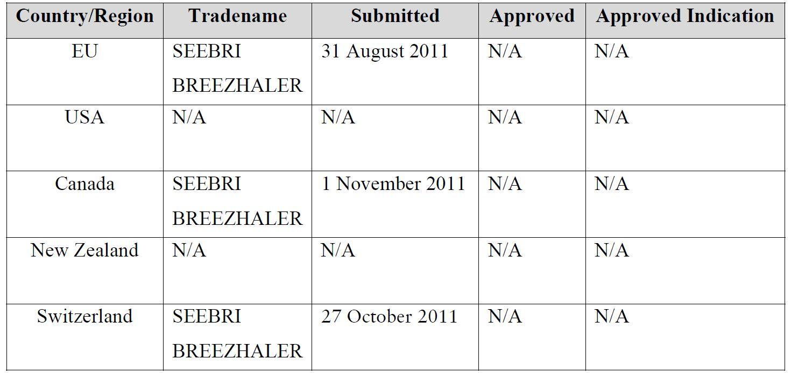

### Product Information

The approved Product Information (PI) current at the time this AusPAR was prepared can be found as Attachment 1.

## II. Quality findings

### Drug substance (active ingredient)

The glycopyrronium bromide is manufactured by Novartis Ringaskiddy Ltd.

The drug substance is a racemic mixture of two of four diastereoisomers (Figure 1).

Figure 1: Drug substance.

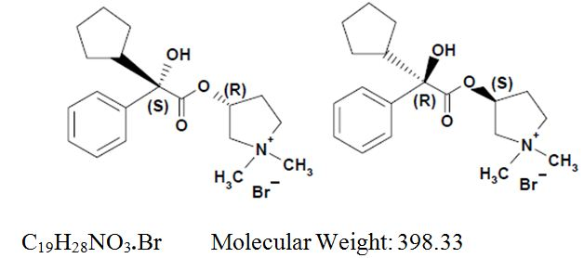

The drug substance is freely soluble in water, but aqueous solubility is of limited relevance given the dosage form.

The drug substance meets the requirements of the default British Pharmacopoeia/European Pharmacopoeia (BP/EP) Glycopyrronium Bromide monograph. Control of the drug substance is acceptable.

### Drug product

Glycopyrronium bromide is further processed and blended with magnesium stearate and lactose before filling into hard (hypromellose based) capsules. Capsules are presented in blisters, packed in a carton together with an inhalation device. Packs of 6 (sample), 30 and 90 capsules are proposed; the 90 pack is a multipack containing 3 packs, each pack containing 30 capsules and one inhaler.

In the manufacture of the powder, the drug substance is dispersed on the surface of comparatively coarse particles of lactose (an inert carrier). During inhalation, the turbulent airflow generated in the mouthpiece causes the drug substance to detach from the surface of the carrier particles. Once released, the drug particles are inhaled and deposited into the lungs.

The capsules contain 63 µg of glycopyrronium bromide which corresponds to 50 µg of glycopyrronium. Doses are labelled in terms of the amount of glycopyrronium content in the capsules (not the delivered dose), which is in accord with Therapeutic Goods Order (TGO) 69. When used with the inhalation device provided, under controlled in vitro conditions, the capsules allow delivery of 44 µg of glycopyrronium (that is, 88%). The dose delivered to the lung as an aerosol powder is estimated in product testing as the ‘fine particle mass (sub 5 µm portion)’ and is controlled to 20-33 µg. The ‘lung dose’ is consistent over the flow rate range expected in patients.

Control of the product is acceptable (for example, assay is controlled to 95.0-105.0%, total degradation products are controlled to NMT [Not More Than] 1.0% at release and NMT 2.0% at shelf life).

The capsules are sensitive to moisture but are adequately protected by the aluminium/aluminium blister packaging. The carton packaging also includes a ‘protect from moisture’ statement.

Upon storage a temperature dependent change in the aerosol is observed. At 30°C the fine particle mass decreased but remained within limits for the stability trial period. As such, the results support a shelf life of 18 months when stored below 30°C, and is appropriate for Australian conditions.

The product is to be delivered to the lungs using the ‘Breezhaler’ device. The device has been previously evaluated in relation to the registration of indacaterol maleate ‘Onbrez Breezhaler’.

The chemistry and quality control aspects of the draft PI and labels have been finalised to the satisfaction of the pharmaceutical chemistry evaluator.

### Biopharmaceutics

Bioavailability data are generally not useful for assessing formulation performance of locally acting products; that said, an absolute and relative bioavailability study was included in the dossier. The absolute bioavailability of NVA237 inhaled with the Concept1 device was estimated to be about 40%. About 90% of systemic exposure following inhalation of NVA237 via Concept1 is due to lung absorption and 10% is due to gastrointestinal absorption

### Quality summary and conclusions

Approval of this submission is recommended with respect to chemistry and quality control.

## III. Nonclinical findings

Novartis Pharmaceuticals Australia Pty Ltd has applied to register Seebri Breezhaler/ Tovanor Breezhaler, containing glycopyrronium bromide as the active ingredient, for the treatment of symptoms of patients with COPD. The proposed dosing regimen is once daily oral inhalation using the Breezhaler inhaler device, yielding a delivered dose of 44 μg glycopyrronium.

The general quality of the submitted nonclinical studies was high. Pivotal studies examining repeat dose toxicity, genotoxicity, carcinogenicity and reproductive toxicity were conducted under GLP (Good Laboratory Practice) conditions. Safety related studies not performed under GLP were adequately documented nevertheless, with the exception of those on single dose toxicity (provided as literature publications dating from 1962-1973).

### Pharmacology

Glycopyrrolate is a muscarinic receptor antagonist. Other member of the class (ipratropium bromide and tiotropium bromide) are already approved as inhalational therapies for COPD.

#### Primary pharmacology

Glycopyrrolate was shown to have high affinity for all five muscarinic acetylcholine (ACh) receptor subtypes (Ki [dissociation constant], 0.15-2.0 nM at human isoforms) and act in a competitive manner. Glycopyrrolate was approximately 10 times less potent than tiotropium, but it displayed higher selectivity for the M3 and M1 subtypes over M2 (approximately 2-4 times more selective). Of relevance to therapy in COPD, bronchoconstriction is mainly mediated by activation of postsynaptic M3 receptors, and M1 and M3 receptor activation results in mucus secretion.[2] Presynaptic M2 receptors operate to inhibit ACh release, so lesser antagonism of this negative feedback mechanism would appear to be desirable (although it may be irrelevant in the context of simultaneous postsynaptic receptor antagonism). M4 and M5 receptor subtypes have not been identified in human lung.[3]

The drug is present as two enantiomers (1:1) in the proposed product. Binding studies identified the S3 ,2R enantiomer as possessing the main activity (>100 times greater affinity for M3 and 20-90 times greater affinity for the other muscarinic receptor subtypes, compared with the 3R, 2S enantiomer).

Glycopyrrolate antagonised the contractile response of isolated rat tracheal strips to the muscarinic receptor agonist bethanechol *in vitro*, acting with a duration of action in between that of ipratropium and tiotropium. *In vivo*, intratracheal or inhalational administration of glycopyrrolate was shown to produce dose dependent inhibition of bronchoconstriction induced by methacholine (muscarinic receptor agonist) in rats (ED50 [effective dose 50%], 0.31 μg/kg), rabbits (ED90, 10 μg) and monkeys (ED50, <0.05 μg/kg). The duration of action was approximately 4-6 h. Glycopyrrolate showed less systemic anticholinergic activity (that is, inhibition of methacholine induced hypotension, bradycardia or salivation), compared with tiotropium or ipratropium in these studies.

#### Secondary pharmacodynamics and safety pharmacology

The individual constituent enantiomers of glycopyrrolate were screened for secondary activity at a wide range of other targets (>200 receptors, enzymes, ion channels and transporters). After muscarinic receptors, the most potent activity was at the σ1 receptor, with 63% inhibition of ligand binding observed for each enatiomer at 10 μM. This concentration is >1000 or >120,000 times the Ki for the two enantiomers at the M3 receptor, and >19,000 times higher than the plasma Cmax (maximum plasma drug concentration) at the maximum recommended human dose. As such, no clinical significance is indicated. One enantiomer of the major metabolite, M9, was also tested for secondary activity against a panel of other targets (65 in total), with only weak inhibition of the human 5-HT2B receptor (IC50 [inhibitory concentration], 10 μM) found. Again, this finding is not considered to be of clinical relevance. Notably, the metabolite M9 enantiomer did not interact with muscarinic receptors.

Specialised safety pharmacology studies covered the core battery of systems (CNS, respiratory and cardiovascular). No treatment related CNS or respiratory effects were observed with glycopyrrolate in rats following inhalational administration at 0.168 mg/kg (approximately 35 times the maximum recommended human dose on a mg/m2 body surface area basis). Respiratory function was also seen to be unaffected in dogs at inhalational doses ≤0.25 mg/kg/day (assessed as part of a 4-week general repeat dose toxicity study). Mydriasis, tremor, dry nose and dry mouth were observed in dogs at IV doses ≥0.1 mg/kg. These are known anti muscarinic effects, and the plasma concentration of glycopyrrolate at this dose was >360 times the clinical Cmax.

Glycopyrrolate was shown to produce concentration dependent inhibition the hERG (human Ether-à-go-go-Related Gene) K+ channel. However, the IC50 value was >300 μM, which is >500,000 times the human Cmax at the maximum recommended dose, and no particular risk of torsades de pointes is indicated for the drug with clinical use. Action potential duration and other electrophysiological parameters were unaffected by glycopyrrolate in the isolated rabbit heart (≤30 μM). Severe tachycardia was observed in dogs at IV doses ≥0.1 mg/kg, together with secondary shortening of the QRS and QT/QTc. With inhalational administration, long lasting tachycardia was observed in dogs at 0.149 mg/kg (82% increase in heart rate for up to 7 h post dose; blood pressure unaffected). In a general repeat dose toxicity study conducted by the inhalational route in dogs (4 weeks duration), no increase in heart rate was observed at a dose of 0.026 mg/kg/day, associated with a plasma Cmax >12 times that of humans at the maximum recommended clinical dose.

### Pharmacokinetics

Absorption of glycopyrrolate after inhalational administration was shown to be rapid in all species, with peak plasma concentrations generally observed immediately after completion of dosing in rats and dogs (0.5-2 h aerosol exposure period), and at 5 min post dose in humans. Plasma AUC (area under the plasma concentration-time curve) was dose proportional in dogs and humans, and slightly less than dose proportional in rats. Half life after IV administration was similar in mice, dogs and humans (approximately 4, 4.4 and 6.2 h, respectively) but longer in rats (23 h). Prolonged systemic exposure was evident with inhalational administration, indicating sustained absorption from the lung. Bioavailability following intratracheal administration was shown to be virtually complete in the rat (96%). In humans, bioavailability following inhalation using the Breezhaler device was estimated to be approximately 40% (with 90% of this due to lung absorption). Glycopyrrolate was very poorly bioavailable by the oral route in mice and rats (approximately 1%), due to limited absorption (20% in rats) and significant first pass metabolism; low oral bioavailability was also reported for humans (approximately 5%). No significant systemic accumulation was seen with repeat daily dosing in animals, and no sex differences were evident. Enantiomer interconversion was demonstrated in the rat.

Rats treated with 0.1 mg/kg/day glycopyrrolate by inhalation for 28 days showed Cmax and  
AUC0-120h (AUC within time span 0 h to 120 h) values for the drug that were >3,000 and >11,000 times greater in lung than for plasma. Half life for clearance from the lung was 20-26 h.

Plasma protein binding by glycopyrrolate was low to moderate (approximately 25-45%) and similar across species (mouse, rat, rabbit, dog, human). At 1 ng/mL in human plasma (the lowest concentration tested; approximately 6 times the clinical Cmax), protein binding was 41%. Distribution into blood cells was minor. Volume of distribution was modest (approximately 5 L/kg in mice and dogs, and 12 L/kg in rats). Rapid and widespread tissue distribution of radioactivity was seen following IV (mice and rats) and intratracheal (rats) administration of 14C glycopyrrolate. The systemic tissues with the highest concentration of radioactivity relative to blood were the liver and kidney. The half life for clearance of radioactivity from the rat lung was estimated to be approximately 96 h (compared with values for blood of 40 h following intratracheal administration and 7.5 h following IV administration), supporting sustained pulmonary absorption from dose deposits. Penetration of the blood-brain barrier was low (with peak levels of radioactivity in the brain 9 times lower than the blood Cmax in mice and 23 times lower in rats). Experiments comparing distribution in pigmented and non pigmented rats indicated some melanin binding (reversible).

Metabolism of glycopyrrolate involved oxidation of the cyclopentyl and phenyl ring moieties, subsequent dehydrogenation of the cyclopentyl ring, and hydrolysis of the ester linkage. It was this latter pathway that was the most prominent (especially after PO administration), generating the sole major metabolite, M9. *In vitro* experiments with mouse, rat, rabbit, dog and human hepatocytes showed more extensive metabolism in the laboratory animal species, and the formation of no unique human metabolites. No metabolism was observed in incubations with lung microsomes (rat, dog and human). Experiments with recombinant human CYPs (cytochromes) identified low metabolism by CYP2D6, and trace metabolism by CYPs 1A2, 2B6, 2C9, 2C18, 2C19 and 3A4.

Excretion of radioactivity following dosing with radiolabelled glycopyrrolate was mainly via the urine (and principally in the form of unchanged drug) after IV dosing in all species investigated (mouse, rat and human). Biliary excretion was demonstrated in rats and humans.

The pharmacokinetic profile in rats was established to be sufficiently similar to that of humans to allow the species to serve as an appropriate model for the assessment of glycopyrrolate toxicity in humans. The metabolism of glycopyrrolate was not investigated *in vivo*, nor was excretion examined, in the dog, the non rodent species used in the pivotal toxicity studies. However, *in vitro* experiments do suggest a similar metabolic profile in the two species, and the systemic terminal elimination half life of glycopyrrolate was also found to similar in dogs and humans. Considering also the absence of pulmonary metabolism for the drug, the dog is considered an appropriate species in which to conduct the toxicity assessment.

#### Pharmacokinetic drug interactions

Glycopyrrolate was shown to be a very weak inhibitor of CYP2D6, acting with an IC50 of 100 μM. This is almost 200,000 times greater than the clinical Cmax, (0.166 ng/mL; 0.52 nM) and no clinical relevance is attached to the finding. IC50 values for other CYPs were weaker still (>200 μM). Glycopyrrolate did not induce CYP isoforms, UGT1A1, MDR1 or MRP2 in cultures of primary human hepatocytes (≤50 nM; approximately 100 times the clinical Cmax), and was found not to be an inhibitor of the MDR1, MXR or MRP2 transporters (≤300 μM). The drug was identified as an inhibitor/substrate of OCT1 and OCT2 (IC50, 17-41 μM; Km, >100 μM) and a substrate of MATE1 (Km [Michaelis constant] not determined; and not a substrate of MATE2K). Based on the margins between these concentrations and the clinical Cmax, no clinical relevance is anticipated.

### Toxicology

#### Acute toxicity

Data on the acute toxicity of glycopyrrolate submitted by the sponsor were sourced from the literature; three publications were submitted. These dated from 1962-1973, prior to the introduction of GLP. Studies were conducted by the PO (oral), IV (intravenous), IP (intraperitoneal) and SC (subcutaneous) routes in mice and rats, PO and IV in rabbits, and IV in dogs and cats. Animals of both sexes were used except for the IV rat and PO rabbit experiments (males only); there were no notable sex differences. The duration of the observation period was 72 h (or otherwise not reported), shorter than the minimum 14 days recommended in the relevant EU guideline (3BS1a). Administration by the IV route was the most toxic, with LD50 (lethal dose 50) values of 12 mg/kg reported for mice and rats, approximately 20 mg/kg for rabbits and approximately 12-24 for dogs and cats. These doses are >1000 times greater than the maximum recommended human dose on a mg/m2 body surface area basis. Median lethal doses by the PO route were 36-85 times greater compared with clinical signs produced by treatment including mydriasis, decreased motor activity, hyperreflexia, laboured respiration, tremors, and tonic and clonic convulsions; these are recognised to be classic anticholinergic effects. The clinically proposed route (inhalation) was not investigated in these studies, but the sponsor’s repeat dose toxicity studies provide relevant data, with no mortality seen after single inhalational doses of up to 13.3 mg/kg in rats and 1.04 mg/kg in dogs (>700 times the maximum recommended human dose on a mg/m2 body surface area basis).

#### Repeat dose toxicity

Studies of up to 4 weeks duration were conducted in mice, 26 weeks in rats and 39 weeks in dogs. All studies were conducted by the inhalational route except for those in mice (PO administration) and one 2 week rat study (SC). The duration of the pivotal studies, the species used (rats and dogs), group sizes and the use of both sexes were consistent with EU guidelines. Administration was once daily. Inhalational dosing involved administration of dry powder containing the excipients included in the clinical formulation – magnesium stearate and lactose. Strengths of glycopyrrolate (bromide salt) and magnesium stearate used in the animal studies ranged from 2-8% and 0.25-1%, respectively (with the highest strengths used in the longest studies), and are considerably higher than the strengths of these ingredients in the clinical formulation (0.25% glycopyrrolate [= 0.2% base], 0.15% magnesium stearate). Aerosolised particles were of respirable size in all studies. Inhalational administration was by nose only exposure in rats and oronasal exposure in dogs. Both air and vehicle control groups were used in the inhalational studies, except for the 7 day studies where only one of the controls was used.

##### Relative exposure

Exposure ratios (Table 2) have been calculated based on animal:human plasma AUC0-24h (for consideration of systemic toxicity) and – for inhalational studies – animal:human lung deposited dose adjusted for alveolar surface area (for consideration of local respiratory tract toxicity). Lung deposited doses were calculated with reference to mean body weights of animals across the course of treatment (specific to each study and dose level), lung deposition fractions of 10% in rat, 25% in the dog[4] and 36% in humans (with respect to the nominal dose; as estimated in clinical Study CNVA237A2108), and alveolar surface areas of 0.39, 51.0 and 89.0 m2 in the respective species.[5] Very high systemic and local exposure multiples were achieved in the studies.

Table 2: PK and relative drug exposures in animals.

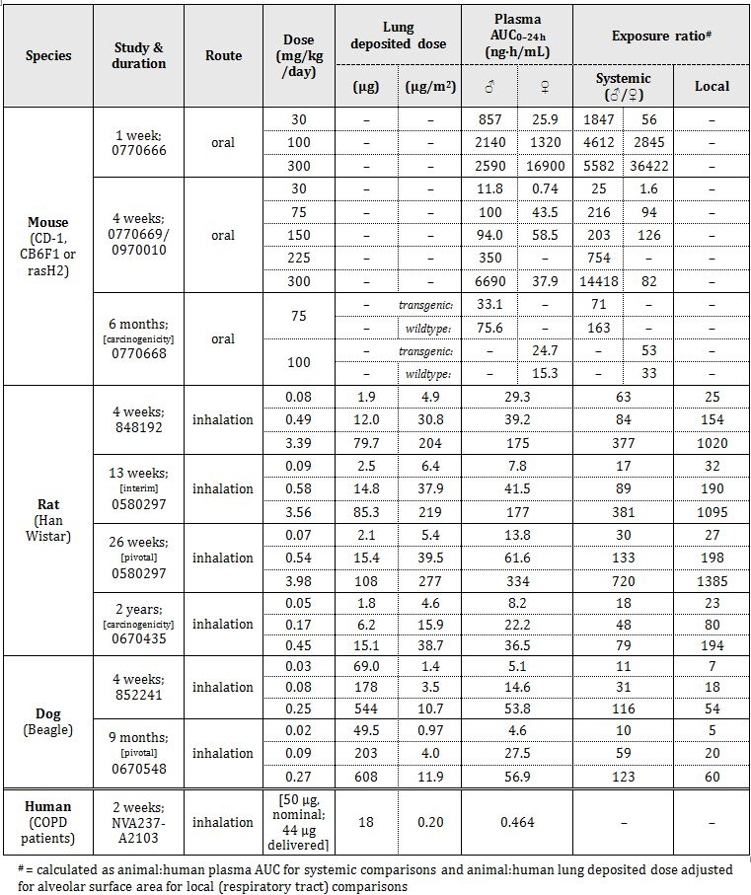

##### Major toxicities

The major target organs for toxicity were respiratory tract tissues, salivary, lacrimal and Harderian glands, eyes, heart, kidney and bladder.

Histopathological findings in the nasal cavity in rats comprised eosinophilic globules in the olfactory and respiratory epithelium, hyperplasia/hypertrophy of goblet cells (≥0.07 mg/kg/day [that is, all dose levels] in the pivotal 26 week study; relative local exposure, ≥27), exudate, inflammation, degeneration of the olfactory epithelium and squamous metaplasia of the respiratory epithelium (≥0.54 mg/kg/day for 26 weeks; relative exposure, ≥198). Similar changes were observed in the rat carcinogenicity study (≥0.05 mg/kg/day for 2 years; relative exposure, ≥23). Nasal cavity hyaline inclusions were observed in rats treated at ≥0.49 mg/kg/day in a 4 week study (relative exposure, 154). There was only a single nasal cavity finding seen in the dog studies – inflammation (minimal in severity) in one female treated at 0.27 mg/kg/day for 9 months (relative exposure, 60). The increased sensitivity of rats compared with dogs to nasal cavity changes by inhaled drugs is consistent with greater relative drug deposition in this region in the species. The significance of these findings for patients is further reduced given that the drug is to be administered by oral inhalation.

Squamous metaplasia of the larynx was observed at all doses in the pivotal rat study (≥0.07 mg/kg/day; relative exposure, ≥27; up to moderate in severity) and hypertrophy at the bronchioloalveolar junction (minimal) was seen at ≥0.54 mg/kg/day (relative exposure, approximately 200). Genomic analysis of lung samples revealed increases in the expression of genes related to xenobiotic mechanism and those associated with mucosa, but not of gene markers for inflammation. Additional lung changes seen in the rat carcinogenicity study comprised bronchiolar eosinophilic inclusions and macrophage accumulation. In dogs, treatment for 9 months was associated with minimal inflammation and minimal to slight ectasia of ducts and/or alveoli of the pharynx at >0.09 mg/kg/day (relative exposure, 20) and goblet cell hypertrophy/hyperplasia in the trachea, bronchi and bronchioles (minimal to slight) at 0.27 mg/kg/day (relative exposure, 60). Necrotising inflammation of the larynx was seen in one dog treated at 1.04 mg/kg/day for 7 days (relative exposure, 171). Treatment did not produce squamous metaplasia in dogs.

The respiratory tract changes are consistent with a response to local irritation. Reversibility after a 4 week treatment free period was shown for all respiratory tract findings in the pivotal dog study and for lung (but not nasal cavity and larynx) findings in the pivotal rat study.

Rats treated with glycopyrrolate for 4 weeks showed changes in the Harderian gland (increased porphyrin deposition and acinar hypertrophy) and salivary glands (acinar atrophy or hypertrophy, and basophilic acini) at ≥0.08 mg/kg/day (relative systemic exposure, ≥ 63), and in lacrimal glands (acinar atrophy) at ≥0.49 mg/kg/day (relative exposure, ≥ 84). Increased Harderian gland porphyrin deposition was also seen in the pivotal rat study (at all doses; relative exposure, ≥30). In dogs, similar salivary gland changes were seen with treatment at 0.08 or 0.25 mg/kg/day for 4 weeks (relative exposure, ≥31) and salivary and lacrimal gland hypertrophy were observed in the pivotal 9-month study at ≥0.09 mg/kg/day (relative exposure, ≥59). Hypertrophy of mucinous acini of the pharynx was seen in a dog treated at 0.25 mg/kg/day for 4 weeks (relative exposure, 54). The salivary gland changes were also seen in the oral studies in mice (at exposure margins ≥82). These findings are consistent with pharmacologically mediated inhibition of glandular secretions by the antimuscarinic agent (non specific stress may also be involved in increased porphyrin deposition). Reductions in food consumption and body weight gain were commonly seen across the studies, which may be attributable to resultant dry mouth and difficulty in swallowing. Changes in skin in the muzzle area (face mask region; hyperkeratosis, epithelial hyperplasia, inflammation, scabs, erosion and ulceration) were seen in dogs in the 4 week study; skin dryness and irritancy of the test article are likely responsible. No skin changes were observed in any of the other studies.

Mydriasis (rats and dogs) and absent/slow pupil response to light (dogs) were observed at doses yielding systemic exposures ≥133 in rats and ≥11 in dogs; this is recognised to be pharmacologically mediated. Lenticular changes, comprising slight anterior capsule opacities, anterior prominent suture lines and anterior slight or punctuate cataracts, were observed in the pivotal rat study at doses ≥0.54 mg/kg/day (relative exposure, 133). A treatment related increase in anterior subcapsular opacities was also seen in the rat carcinogenicity study (at all doses; ≥0.05 mg/kg/day; relative exposure, ≥18). Corneal opacities were observed in dogs treated at 0.25 mg/kg/day in a 4 week study (relative exposure, 116), but the finding was not confirmed in the pivotal study in the species, with no obvious treatment related effect evident at doses ≤0.27 mg/kg/day for 9 months (relative exposure, ≤123). The cornea changes may have occurred secondary to inhibition of lacrimation (pharmacologically mediated) and direct irritation by escaped aerosol. Corneal opacities have also been reported with tiotropium in animal inhalational studies.

Increases in heart rate in dogs after inhalational administration (≥0.032 mg/kg/day; 32 times the clinical Cmax; pharmacologically mediated) were not accompanied by gross or microscopic changes in the heart.

An apparent increase in the incidence and severity of kidney and bladder inflammatory findings was noted for male rats treated at the highest dose in the pivotal study (3.98 mg/kg/day for 26 weeks; relative exposure, 720). Bladder inflammation was also seen in male rats with treatment at 3.56 mg/kg/day for 13 weeks (relative exposure, 381). There were no similar findings in the rat carcinogenicity study (relative exposure, ≤79), nor in dogs (relative exposure, ≤123 for 9 months). No treatment related effects on urinalysis were identified in any study. Urinary retention, increasing the risk of urinary tract infection, is recognised for anticholinergic agents. The draft PI document notes renal/urinary adverse effects in patients.

#### Genotoxicity

The potential genotoxicity of glycopyrrolate was investigated in the standard battery of tests. The conduct of the studies was in accordance with International Conference on Harmonisation of Technical Requirements for Registration of Pharmaceuticals for Human Use (ICH) guidelines. Concentrations/doses used were appropriate. A suitable set of *S. typhimurium* strains was used in the bacterial mutation assay. The upper dose level used in the *in vivo* assay for clastogenicity – conducted by the oral route in rats – produced a high multiple of the clinical Cmax (>3200 times), bone marrow suppression and weight loss. The use of only male animals is acceptable given the absence of notable sex differences in toxicity. All assays were appropriately validated and returned negative results for glycopyrrolate.

#### Carcinogenicity

The carcinogenic potential of glycopyrrolate was investigated in a 6 month study by the oral route in transgenic mice (rasH2) and a 2 year inhalational study in rats. The transgenic mouse study included a positive control group and also additional groups of wildtype animals (vehicle control and high dose). Dual control groups were used in the rat study. Group sizes were adequate and dose selection was adequate. The highest dose levels exceeded the maximum tolerated dose (based on inhibition of body weight gain that exceeded 10%), but survival was either unaffected (rats) or not affected to such a level as to impact study validity (transgenic mice). Very high multiples of the clinical AUC were obtained in both studies. No carcinogenic effect was seen for the drug in either species. Relative systemic exposure was ≤71 in male mice (75 mg/kg/day PO), ≤53 in female mice (100 mg/kg/day PO) and ≤79 in rats (≤0.45 mg/kg/day by inhalation); relative local exposure in the rat study was ≤194. The use of the oral route for the transgenic mouse study is considered acceptable given that the model has not yet been validated for inhalation and that no respiratory tract neoplasia occurred in rats. Non neoplastic lesions were observed in the stomach of mice (epithelial hyperplasia, hyperkeratosis and mixed cell infiltration) and are consistent with local irritation following oral administration at high doses.

#### Reproductive toxicity

Submitted reproductive toxicity studies covered all stages (fertility and early embryonic development, embryofoetal development, and pre/postnatal development). Embryofoetal development studies were conducted in rats and rabbits by the inhalational route; the other studies involved SC administration in rats. Numbers of animals and the timing/duration of treatment were appropriate.

##### Relative exposure

Very high multiples of the clinical plasma AUC were obtained in the studies (Table 3).

Table 3: PK and relative drug exposures in animals.

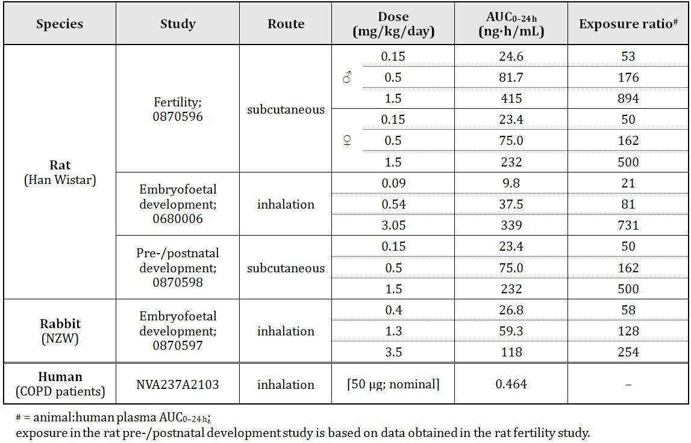

No or very limited placental transfer was reported for glycopyrrolate in mice and dogs in published studies submitted by the sponsor. In the sponsor’s rabbit study, no foetuses from dams treated with glycopyrrolate contained quantifiable levels of drug, although this was not measured until more than 24 h after the last dose. Excretion of glycopyrrolate and its metabolites in milk was shown in lactating rats after IV administration, with concentrations higher in milk than in plasma (approximately 2 times the Cmax and 11 times the AUC for the unchanged drug).

Male and female fertility were unaffected in rats treated with doses ≤1.5 mg/kg/day SC (relative exposure, ≤894 in males and ≤500 in females). There was evidence of slight inhibition of ovulation (decreased corpora lutea) and increased pre implantation loss at the highest dose, though, together causing a reduction in viable litter size. The NOEL is 0.5 mg/kg/day (relative exposure, 162).

Embryofoetal development was unaffected in rats (≤3.05 mg/kg/day; relative exposure, ≤731) and rabbits (≤3.5 mg/kg/day; relative exposure, ≤254). Pup birth weight and postnatal body weight gain were significantly reduced in rats treated at 1.5 mg/kg SC (relative exposure, 500). No effects on other developmental parameters were observed. Relative exposure at the NOEL for pup development (0.5 mg/kg/day SC) is 162.

##### Pregnancy classification

The sponsor has proposed Pregnancy Category B3. This is considered appropriate given the finding of decreased birth weight in rats.

#### Antigenicity

No contact sensitising potential was found for glycopyrrolate in the murine local lymph node assay.

#### Novel excipient by the inhalational route – magnesium stearate

The toxicity of magnesium stearate by the inhalation route was assessed as part of the general repeat dose toxicity studies conducted for glycopyrrolate (included in the tested formulations and used in separate vehicle control groups), and in specialised studies at higher doses. Treatment with the vehicle (magnesium stearate/lactose blend) produced no histopathological changes in the respiratory tract or other tissues in either rats or dogs in the glycopyrrolate studies. Specialised studies of sufficient duration to support chronic use revealed no toxicity for magnesium stearate at up to the highest doses tested, establishing NOAELs of 1.648 mg/kg/day for magnesium stearate in rats (6 month study; featuring microscopic examination of respiratory tract tissues) and 10 mg/kg/day for dogs (12 month study; microscopic examination of respiratory and other tissues). These doses are approximately 840 and 3450 times the clinical dose of magnesium stearate on μg/m2 alveolar surface area (based on the same lung deposition factors and alveolar surface areas as described under repeat dose toxicity earlier). The rat inhalational carcinogenicity study establishes a NOEL for tumourigenicity by magnesium stearate of 60 μg/kg/day; this is 39 times higher than the clinical dose (as animal:human lung deposited dose per unit alveolar surface area). Experiments examining solubility of magnesium stearate in alveolar fluid and uptake in rat lung slices *in vitro* indicate that the lung has the capacity to dissolve and take up the entire daily dose of magnesium stearate provided by Seebri/Tovanor Breezhaler therapy (37 μg in one capsule).

#### Impurities

The product contains no impurities/degradants that exceed the ICH threshold for toxicological qualification.

#### Paediatric use

Glycopyrronium bromide is not proposed for paediatric use and no specific studies in juvenile animals were submitted.

#### Toxicity in combination with indacaterol

Two week repeat dose studies in rats and dogs, and a 13 week study in dogs, conducted by the inhalational route with glycopyrrolate and indacaterol in combination (approximately 1:3 dose ratio), revealed no novel or exacerbated toxicity apart from effects on heart rate in dogs where an additive or slight synergistic effect to increase heart rate was seen (in both studies). Embryofoetal development was unaffected in rats treated with the combination at doses up to 0.71/2.12 mg/kg/day (glycopyrrolate/indacaterol) by inhalation.

### Nonclinical summary and conclusions

#### Summary

* Novartis Pharmaceuticals Australia Pty Ltd has applied to register glycopyrronium bromide [synonym: glycopyrrolate] (Seebri Breezhaler/Tovanor Breezhaler) for the treatment of symptoms of patients with COPD. The proposed dosing regimen is 50 μg (nominal dose) by inhalation once daily.
* The sponsor has conducted adequate studies on the pharmacology, pharmacokinetics and toxicity of glycopyrrolate, with all pivotal studies conducted under GLP conditions. Adequate studies with magnesium stearate – a novel excipient by the inhalational route – were also performed.
* Glycopyrrolate is a competitive muscarinic receptor antagonist with nanomolar or subnanomolar receptor affinity (across human subtypes). Dose dependent inhibition of bronchoconstriction was demonstrated for the drug following intratracheal instillation or inhalational administration in rats, rabbits and monkeys, with a duration of action of approximately 4-6 h.
* Secondary pharmacodynamic studies revealed no clinically significant activities for the drug or its major metabolite (M9). Safety pharmacology studies covered the CNS, respiratory and cardiovascular systems, with classic antimuscarinic effects (mydriasis, tremor, dry nose, dry mouth, tachycardia) observed at plasma concentrations substantially higher than will be achieved in patients.
* Pharmacokinetic studies indicated rapid absorption of glycopyrrolate in all species after inhalational administration. The drug was almost completely bioavailable (96%) after intratracheal administration in rats. Sustained absorption from the lung was evident. Plasma protein binding by glycopyrrolate was low to moderate in all species. IV or intratracheal administration of radiolabelled drug resulted in rapid and wide tissue distribution. Penetration of the blood-brain barrier was poor.
* A sole major metabolite (formed by hydrolysis) was identified in animals and humans. There were no unique human metabolites. Excretion after IV dosing occurred principally via the urine, and chiefly as unchanged drug, in all species investigated.
* Literature publications and the sponsor’s own studies indicate a low order of acute toxicity.
* Pivotal repeat dose toxicity studies were conducted in rats (26 weeks) and dogs (39 weeks) using the inhalational route. Major findings involved respiratory tract tissues (irritation), salivary, lacrimal and Harderian glands (reduced secretion), eyes (pupil dilation and lenticular changes), heart (increased rate), kidney and bladder (inflammation).
* Glycopyrrolate was examined for potential genotoxicity in the standard battery of tests, with negative results in all assays. Carcinogenicity studies in transgenic mice (6 months duration; oral administration) and rats (2 years duration; inhalational administration) revealed no tumourigenicity.
* Very limited placental transfer (mice, rabbits and dogs) and substantial excretion in milk (rats) were shown for the drug. Fertility indices were unaffected in male and female rats, and there were no effects of treatment on embryofoetal development in rats and rabbits. Reductions in birth weight and postnatal body weight gain were observed in rats at a high dose.
* Inhalational administration of magnesium stearate did not produce histopathological lesions in the respiratory tract of rats and dogs, nor carcinogenicity in rats.

#### Conclusions

* The nonclinical dossier contained no major deficiencies.
* Primary pharmacology and pharmacokinetic studies, showing potent antimuscarinic activity and sustained lung exposure, support the drug’s use for the proposed indication.
* Secondary pharmacology and safety pharmacology studies identified no concerns considered likely to be of particular significance in clinical use (based on the relatively low systemic drug levels achieved in patients).
* Findings in the repeat dose toxicity studies were consistent with mild local irritation and exaggerated pharmacology. The NOAEL established in the pivotal dog study (0.02 mg/kg/day) represents a local dose of glycopyrrolate (as lung deposited dose per unit alveolar surface area) 5 times greater than that estimated for humans at the maximum recommended clinical dose, and produces a plasma AUC 10 times greater than in patients.
* Glycopyrrolate was shown to be non genotoxic and non carcinogenic.
* Reproductive toxicity studies revealed no teratogenic potential for the drug. Very large multiples exist at the NOELs for other effects on reproduction, and no particular risk with clinical use is identified.
* The safety of magnesium stearate as a novel excipient by the inhalational route has been established. The maximum human dose provided by therapy with this product is 37 μg/day.
* There are no nonclinical objections to the registration of Seebri Breezhaler/Tovanor Breezhaler for the proposed indication.

## IV. Clinical findings

*A summary of the clinical findings is presented in this section. Further details of these clinical findings can be found in Attachment 2.*

### Introduction

#### Scope of the clinical dossier

Clinical pharmacology studies included:

* NVA237A2103 (multiple dose study in COPD patients)
* NVA237A2104 (PKs in Japanese and Caucasian)
* NVA237A2105 (PKs in renal impairment)
* NVA237A2108 (absolute bioavailability)
* NVA237A2109 (drug interaction with cimetidine)
* Studies QVA149A2101/ 2103 and 2106 provided some supportive PK data following single and multiple inhaled doses of indacaterol (QAB149) and NVA237 (glycopyrronium bromide) when administered alone or in combination
* population pharmacokinetic analyses

Pivotal Phase III efficacy/safety studies were:

* NVA237A2303
* NVA237A2304
* NVA237A2310

Dose finding studies were:

* NVA237A2205
* NVA237A2206
* NVA237A2207
* NVA237A2208

#### Paediatric data

The submission did not include paediatric data. A waiver for Glycopyrronium bromide, inhalation powder, hard capsules, was granted by the Paediatric Committee of the EMA (European Medicines Agency) on the grounds that the disease or condition for which the specific medicinal product is intended occurs only in adult populations.

#### Good clinical practice

All studies were conducted according to GCP (Good Clinical Practice) and complied with the principles of Declaration of Helsinki.

### Pharmacokinetics

The absolute bioavailability of orally inhaled NVA237 was approximately 40%; approximately 90% of systemic exposure following inhalation of NVA237 via the Concept1 device is due to lung absorption and 10% is due to gastrointestinal absorption. The fraction of the inhaled dose which is deposited and absorbed in the lungs following inhalation using Concept1 was estimated to be about 36% of the nominal inhalation dose.

While initial absorption from the lung causes an early plasma concentration peak of NVA237 (median Tmax is 5 min after inhalation), a sustained lung absorption and/or transfer of NVA237 into the systemic circulation is thought to result in the late elimination phase of inhaled NVA237. This phase is much longer after NVA237 inhalation (half life was up to 57 h) than after IV NVA237 dosing (half life was up to 6.2 h) (CNVA237A2108). The elimination pattern of inhaled NVA237 is not reproduced after oral ingestion of NVA237 (half life after oral intake is only 2.8 h).

Following repeated once daily inhalation of NVA237 by patients with COPD, PK steady state of NVA237 was reached within one week of treatment. The steady state mean peak and trough plasma concentration of NVA237 for a 50 μg once daily dosing regimen was 166 and 8 pg/mL, respectively. With once daily doses of 100 and 200 μg, steady state exposure (AUC0-24h) to NVA237 was about 1.4 to 1.7 fold higher than after the first dose.

In the dose range of 50 μg to 200 μg NVA237, systemic exposure to NVA237 as well as total urinary excretion increased about dose proportionally after single inhalation by healthy volunteers (CNVA237A2104) as well as after repeated once daily inhalation by patients with COPD (CNVA237A2103) at pharmacokinetic steady state.

Urinary excretion data of NVA237 at steady state compared to the first dose suggested that systemic accumulation is independent of dose in the dose range of 25 to 200 μg. The effective half life of accumulation was approximately 16 to 22 h which is consistent with the observed time to steady state of about 6 days (CNVA237A2103).

Following inhalation of single and repeated once daily doses between 50 and 200 μg NVA237 by healthy volunteers and patients with COPD, 60-70% of elimination of parent drug was by renal clearance; the mean amounts of NVA237 excreted into the urine varied between 7.7% and 20.0% of the dose, depending on the time interval considered (up to 24, 48, 72 or 96h). Mean renal clearance (CLr) of NVA237 following inhalation was in the range of 17.4 and 24.4 L/h, including data for healthy volunteers (after single dose) and patients with COPD (both after single and repeated dosing). Active tubular secretion contributes to the renal elimination of NVA237.

NVA237 (like the currently marketed glycopyrronium bromide) is a racemic mixture of two enantiomers, that is, the [3S,2R] stereoisomer (Novartis code: QBA608) and the [3R,2S] stereoisomer (Novartis code: QBA609). Since the molecule has two asymmetrical carbon atoms, a second pair of stereoisomers exist with [3R,2R] and [3S,2S] configuration. This pair of stereoisomers is described as an impurity of NVA237 and is limited in the drug substance to ≤ 0.1%. Urinary excretion data of the enantiomers of NVA237 ([3S,2R] and [3R,2S] stereoisomers) following inhalation of NVA237 by healthy volunteers and COPD patients suggested similar apparent pharmacokinetics of the two enantiomers (Studies CNVA2372103, CNVA2372104).

*In vitro* metabolism studies showed consistent metabolic pathways for glycopyrronium bromide between animals and humans. No human specific metabolites were found. Hydroxylation resulting in a variety of mono and bis hydroxylated metabolites and direct hydrolysis resulting in the formation of a carboxylic acid derivative (M9) were seen. No glucuronides or glutathione (GSH) adducts were observed. After inhalation, systemic exposure to the metabolite (M9) was on average in the same order of magnitude as the exposure to parent drug. After both IV and inhalation routes of administration, only minimal amounts of CJL603 were found in the urine. Study CNVA237A2109 was conducted to characterise the effect of inhibition of the organic cation transport on NVA237 disposition using cimetidine as a probe inhibitor. Cimetidine increased total exposure (AUClast) to NVA237 by 22% and decreased renal clearance by 23%. Based on the magnitude of this change, no clinically relevant drug interaction is expected when NVA237 is co administered with cimetidine or other drugs interacting with this pathway. The pharmacokinetics of NVA237 were not affected by concomitant administration of orally inhaled NVA237 and orally inhaled indacaterol (free combination or fixed combination, QVA149) under steady state conditions in Studies QVA149-A2101 and QVA149-A2106. In Study QVA149A2103, steady state systemic exposure (AUC0-24h and Cmax,ss) of NVA237 was higher (by 34% and 42%, respectively) after administration of the fixed dose combination QVA149 110/50 μg compared to NVA237 50 μg given alone (which may have been due to an unexpected drop of approximately 25% in the fine particle dose [FPD] of NVA237 in the mono formulation as shown by i*n vitro* investigations). The involvement of multiple CYP isoenzymes in the oxidation of NVA237 suggests that the metabolism of NVA237 may not be readily inhibited by a single specific CYP inhibitor. Furthermore, metabolism is likely to play a secondary role in the elimination of NVA237 and drug-drug interactions due to inhibition or induction of NVA237 metabolism by co medications are expected to be of minor clinical importance. The co administration of NVA237 with inhaled anticholinergic containing drugs has not been studied and is therefore, like for other anticholinergics, not recommended.

NVA237 exposure increases with increasing patient age but decreases with increasing body weight. NVA237 PKs were not evaluated in patients with hepatic impairment, but this has been clearly mentioned in the proposed PI. Exposure to NVA237 was increased in patients with moderate/severe renal impairment. Systemic exposure (Cmax, AUC0-last) and the amount of unchanged drug excreted into the urine within the first 48 h (Ae0-48) of NVA237 were on average 30% to 80% higher in Japanese than in Caucasian subjects, but the increased exposure did not lead to any safety concerns in Japanese subjects (CNVA237 A2104). Overall there did not appear to be any meaningful differences in systemic exposure between healthy subjects and subjects with COPD both after single dose and at steady state, although renal clearance was reduced in COPD patients (which may most likely be related to increased age and renal impairment in COPD patients).

Limitations of NVA237 PK data:

* No drug interaction studies were conducted between NVA237 and other oral/inhaled medications commonly used in COPD.
* The possibility of kinetic interaction between NVA237 and smoking cessation aids or nicotine replacement therapy was not investigated (as mentioned in the CPMP [Committee for Proprietary Medicinal Products] guidelines[6]).

### Pharmacodynamics

NVA237 is an inhaled anti muscarinic acetylcholine receptor blocker that has a fast onset and long duration of action. *In vitro* evaluation of the duration of action of NVA237 as an M3 muscarinic receptor antagonist has been measured on the rat isolated trachea and compared with clinically used muscarinic antagonists of differing clinical duration of action. The duration of action of NVA237 (NVP-QAM254) in this model was intermediate between ipratropium bromide and tiotropium bromide. A Brown Norway rat model of bronchoconstriction was used to study the duration of action of NVA237 *in vivo.* Muscarinic agonist induced bronchoconstriction was markedly reduced by intratracheal installation of NVA237 and this effect was maintained 24 h post dose, although the potency of NVA237 slightly decreased over this time period. In humans, the bronchodilator effect starts within 5 min of dosing. Whilst NVA237 has a fast onset of action it shows sustained bronchodilator effects over 24 h as evidenced by the 24 h FEV1 (Forced Expiratory Volume in 1 second) response profiles of the compound and the robust and consistent effects on trough FEV1 across Phase II and III trials (Studies CNVA237A2205, CNVA237A2206, CNVA237A2207, CNVA237A2208, CNVA237A2303, CNVA237A2304). The long duration of action of NVA237 may be explained by its pharmacokinetic properties as the inhaled administration of NVA237 leads to a much longer elimination half life (of up to 57 h) when compared to the terminal elimination half life after IV administration (Study CNVA237A2108).

Across dose finding studies, consistent clinically meaningful effects on FEV1 were achieved at a daily dose of 50 μg once daily up to 200 μg once daily (Studies CNVA237A2205, CNVA237A2206, CNVA237A2208). Dose response and selection of proposed Phase clinical trial and marketing dose of 50 µg are discussed in detail in the clinical evaluation report.

In addition, the bronchodilator effects of NVA237 50 μg lead also to an improvement in exercise tolerance by ~20% within 3 weeks when compared to placebo. This effect is achieved by reducing static and dynamic hyperinflation. The effects on exercise endurance were statistically significant from the first dose onwards (Study CNVA237A2310). The findings on exercise endurance were consistent with the results of the comprehensive set of spirometric and body plethysmographic endpoints investigated under resting conditions in this trial. FEV1 effects are also in line with the magnitude of effect that has been observed with 50 μg NVA237 in previous clinical trials. The effect on trough FEV1 (stipulated as primary endpoint in most Phase III efficacy trials with NVA237) at Day 21 was 0.11 L. Treatment with 50 μg NVA237 once daily also reduced exertional dyspnea and leg discomfort during exercise, it reduced dyspnea measured by TDI (Transition Dyspnea Index). There was no consistent effect on heart rate or blood pressure values under exercise being reflective of the low systemic effect potential of NVA237 under exercise conditions. Adaptation to exercise in this crossover study may have had an effect on exercise tolerance although washout of 2-3 weeks seems adequate. Overall, Study A2310 provides preliminary evidence which needs to be explored in long term parallel group studies before beneficial effect on exercise endurance can be claimed for NVA237.

The therapeutic index of NVA237 is large. Multifold higher systemic concentrations were well tolerated by healthy subjects after IV administration. The peak exposures (Cmax) after IV administration constituted more than 10 fold of the peak exposure after inhaled administration of 200 μg NVA237. These exposure levels did not result in any clinically relevant tachycardia as would be expected for high exposures to anti muscarinic compounds and did not result in QTc prolongation (Study CNVA237A2108). These findings are in line with the fact that oral and injectable glycopyrronium bromide has been used in clinical practice for many years at much higher dose levels than inhaled NVA237.

Overall, there was no pharmacokinetic/pharmacodynamic correlation between the NVA237 systemic exposure after inhalation and the drug response as characterised by FEV1 and FVC (Study CNVA237A2103).

Therefore, in conclusion, inhaled NVA237 has a rapid onset of action, sustained bronchodilator activity over 24 h and has a very wide therapeutic index; it also showed preliminary evidence of increased exercise tolerance (by reducing dynamic hyperinflation) in Study CNVAA2310, but this action needs to be confirmed in long term, parallel group studies.

### Dose selection for the pivotal studies

In the Phase II, double blind, dose ranging, crossover Study NVA237A2205 involving 383 COPD patients, treatment with NVA237 resulted in a dose related increase in FEV1 values beginning 5 min after the inhalation of study drug and lasting for 24 h. On Day 1, all doses of NVA237 resulted in significantly greater LSmean (least squares means) trough FEV1 values than placebo, as did tiotropium bromide (Table 4). A dose response effect was evident for NVA237 as increasing doses of NVA237 resulted in increased LSmean trough FEV1 values at Day 7**.** The peak FEV1 values on Day 7 were greatest for the highest dose of NVA237 (100 μg), followed by 50, 25 and 12.5 μg. Both the 50 and 100 μg NVA237 doses resulted in trough FEV1 values greater than that set for a clinically relevant effect (120 mL). There was no difference in peak FEV1 value between Day 1 and Day 7. All doses of NVA237 showed significantly greater peak FEV1 than placebo, and on Day 1 both the 50 and 100 μg doses were significantly greater than tiotropium bromide. However, on Day 7 the tiotropium bromide peak FEV1 value was no longer significantly lower than NVA237 (Table 5). The minimally effective dose (to produce an increase in trough FEV1 on Day 7 of 120 mL) was calculated to be 42 μg. The MED calculated for Japanese patients were slightly lower than for the non Japanese population (33 μg versus 45 μg).

Table 4: Analysis of covariance of trough FEV1 (L) at Day 1 (mITT [modified Intention to Treat] population).

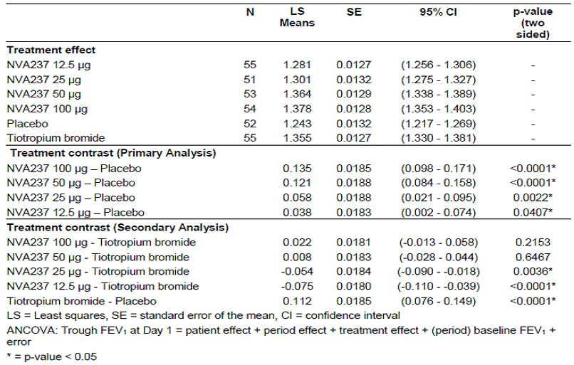

Table 5: Analysis of covariance of trough FEV1 (L) at Day 7 (mITT population).

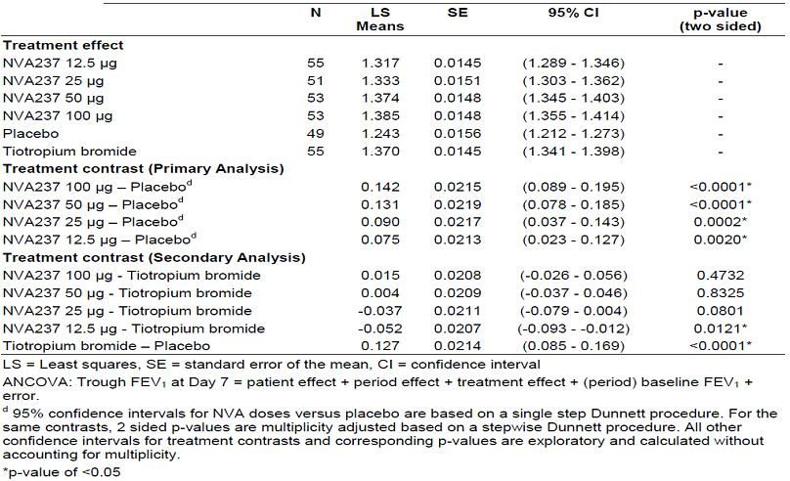

The standardised FEV1 AUC5min-5h showed a dose response on both treatment days. Again, NVA237 values were significantly greater than placebo at all doses and on both days, and were greater than tiotropium bromide on Day 1 for the 50 and 100 μg doses (Table 6). FVC was also increased in a dose related manner, with all doses of NVA237 increasing FVC to a significantly greater degree than placebo on both Day 1 and Day 7. Levels peaked at approximately 2 to 3 h post dose on Day 1. Similar results were observed on Day 7. Tiotropium bromide resulted in significantly higher FVC readings than placebo at all postdose time points on Day 1 and at all time points on Day 7. The LSmean FVC values for NVA237 12.5 μg dose were significantly lower than tiotropium bromide from 3 h post dose onwards on both Day 1 and Day 7 (Table 7). Inhalation of tiotropium bromide did not result in a significantly greater increase in FEV1 or FVC than 50 or 100 μg NVA237. The Japanese subpopulation appeared to be as successfully treated by NVA237 as the entire study population (Table 8).

Table 6: Least squares means of peak FEV1 (L) and standardized FEV1 AUC5min-5h (L) at Day 1 and Day 7 by treatment (mITT population).

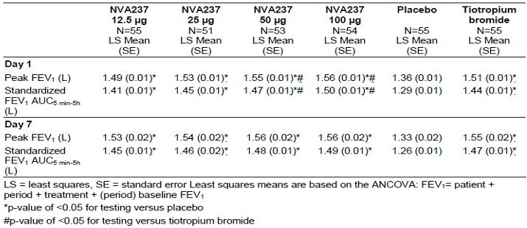

Table 7: Least squares means of peak FVC (L) at Day 1 and Day 7 by timepoint (mITT population).

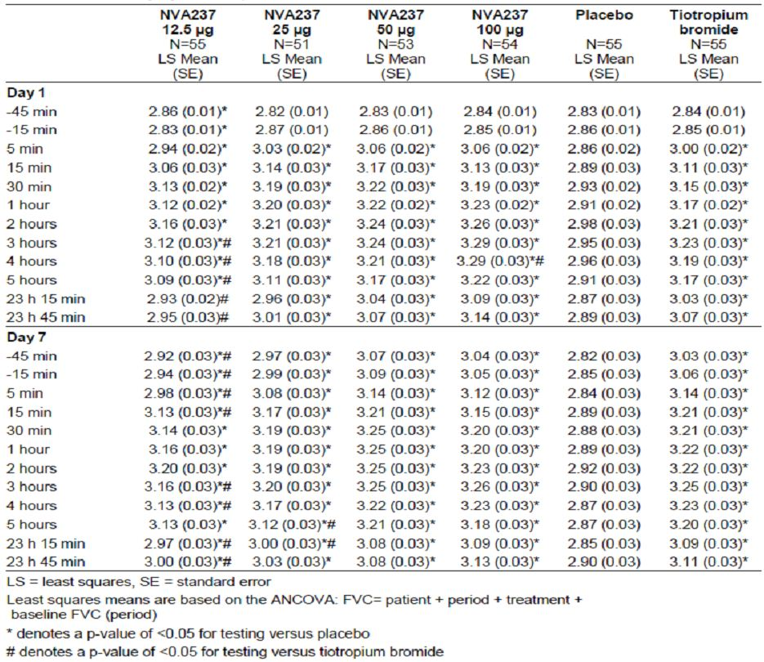

Table 8: Least squares means of trough, peak and AUC5min-5h of FEV1 (L) on Day 7 by treatment (mITT population).

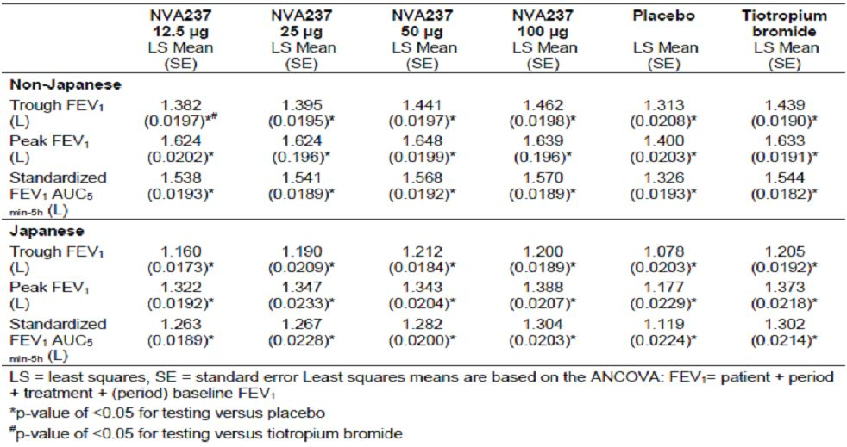

Study NVA237A2208 was a randomised, double blind, placebo controlled, two period, crossover study to assess the efficacy and safety of different doses of NVA237 administered either once daily or twice daily in 388 patients with moderate to severe COPD. On Day 28, the b.i.d. (twice daily) regimen provided greater improvement in trough FEV1 than the q.d. (once daily) regimen for the total daily doses of 25 μg, 50 μg, and 100 μg (Figures 2-3). For the 50 μg q.d. dose, the treatment difference (NVA237-placebo) was 0.109 L (58.5% Emax [maximum efficacy]), compared with 0.141 L (75.5% Emax) for 25 μg b.i.d. and 0.115L (61.6% Emax) for 12.5 μg b.i.d. The 100 μg q.d. dose provided a small incremental benefit over the 50 μg q.d. dose (0.027 L). The model assumed that the differences in treatment effect between regimens would decrease to zero as the total daily dose increased. To evaluate the sensitivity of this assumption, the primary analysis was repeated without this assumption and results from these two analyses were similar.

Figure 2: Dose response curves of trough FEV1 for Day 28 for model averaged analysis by treatment regimen (Full Analysis set).

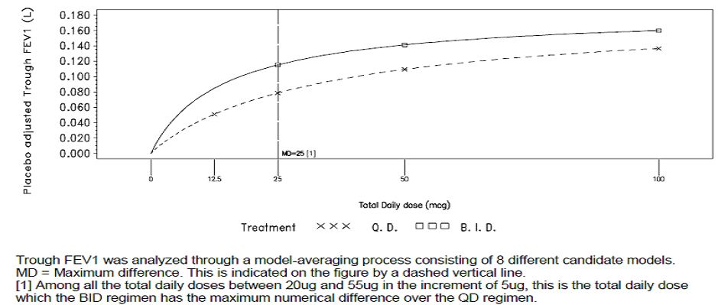

Figure 3: Trough FEV1 (L) (including 90% confidence limits) for Day 28 for model averaged analysis by treatment regimen (Full Analysis set).

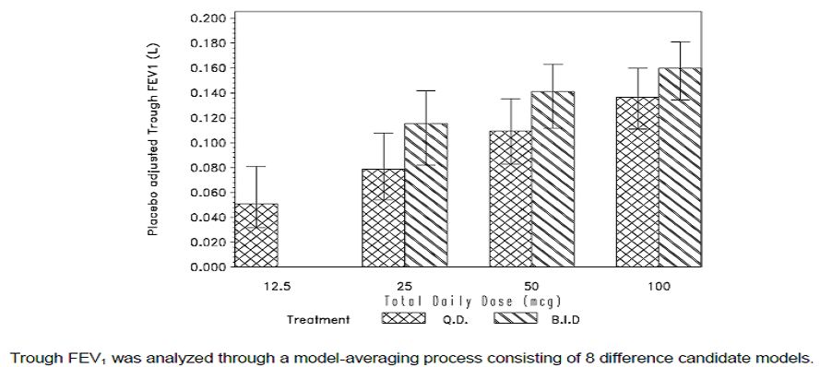

A key secondary modelling outcome derived from the primary analysis was an overall comparison of b.i.d. and q.d. regimens for NVA237, based on the trough FEV1 responses as predicted after 28 days treatment. The primary comparison was the maximum difference in mean response between b.i.d. and q.d. regimens over the range of 20 to 55 μg daily dose (this dose range was selected based on earlier clinical data and modelling and was intended to reflect the region of the dose response curve which was predicted *a priori* to show the maximum difference between once and twice daily therapy for the efficacy evaluations made in the study). Analysis evaluating the maximum difference in mean response of trough FEV1 between dosing regimens over the total daily dose range of 20 μg to 55 μg[7] indicates that the differences between the two regimens were small and not clinically meaningful (greatest difference between the two regimens was 0.037 L; 90% CI = 0.013, 0.052). This occurred at the total daily dose of 25 μg, with the b.i.d. regimen providing a larger treatment difference compared to placebo than that observed for the q.d. regimen (Table 9).

Table 9: Difference in mean response of trough FEV1 (L) between dosing regimens over the range 20 mcg to 55 mcg total daily dose after 28 days of treatment (Full Analysis set).

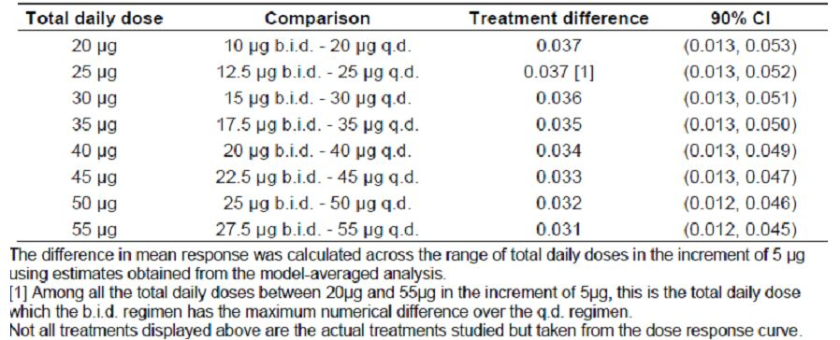

Within each treatment regimen there was a dose related increase in AUC0-24h FEV1. The treatment differences for all NVA237 doses compared to placebo ranged from 0.058L (28.9% Emax) for the 12.5 μg q.d. treatment group, to 0.158 L (79.3% Emax) for the 50 μg b.i.d. treatment group (Table 10). There was little difference between the q.d. and b.i.d. regimens for improvement in AUC0-24h FEV1 compared to placebo for the total daily doses of 25 μg, 50 μg, and 100 μg. For the 50 μg q.d. dose, the treatment difference was 0.123L (61.9% Emax) compared with 0.131 L (65.7% Emax) for 25 μg b.i.d. and 0.098 L (49.0% Emax) for 12.5 μg b.i.d (Figure 4).As with trough FEV1, the 100μg q.d. dose gave only a small incremental benefit over 50μg q.d. (0.024L). For the total daily doses of 25μg, 50μg and 100 μg, the differences between the once and twice daily regimens were neither statistically significant nor clinically meaningful.

Table 10: Dose response results of FEV1 AUC0-24h for model averaged analysis by treatment at Day 28 (Full Analysis set).

Table 10: Dose response results of FEV1 AUC0-24h for model averaged analysis by treatment at Day 28 (Full Analysis set).

Figure 4: FEV1 AUC0-24h for Day 28 for model averaged analysis by treatment regimen (Full Analysis set).

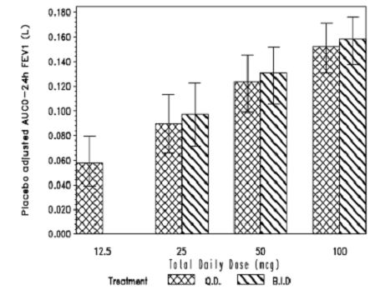

FEV1 AUC0-24h was analysed through a model averaging process consisting of 8 different candidate models.

When comparing regimens, the q.d. regimen provided a greater improvement in AUC0-4h FEV1 than the b.i.d. regimen for the total daily doses of 25 μg, 50 μg and 100 μg. For the 50 μg q.d. dose the treatment difference (NVA237-placebo) was 0.165L (79.7% Emax) compared with 0.153 L (73.7% Emax) for 25 μg b.i.d. Similar results were seen for AUC0-8h FEV1 showing greater improvement with once daily regimen than the b.i.d. regimen for total daily doses of 25 μg, 50 μg and 100 μg. For the 50 μg q.d. dose, the treatment difference (NVA237-placebo) was 0.156 L (77.1% Emax) compared with 0.145 L (71.4% Emax) for 25 μg b.i.d. When comparing the regimens, the q.d. regimen provided a greater improvement in AUC0-12h FEV1 than the b.i.d. regimen for the total daily doses of 25 μg, 50 μg and 100 μg. For the 50 μg q.d. dose the treatment difference (NVA237-placebo) was 0.152L (73.6% Emax) compared with 0.139 L (67.1% Emax) for 25 μg b.i.d., and 0.104 L (50.5% Emax). Within each regimen there was a dose related increase in AUC12-24h FEV1. The treatment differences for all NVA237 doses compared to placebo ranged from 0.051 L (25.6% Emax) for the 12.5 μg q.d. treatment group, to 0.163 L (82.4% Emax) for 50 μg b.i.d. When comparing the regimens, the b.i.d. regimen provided a greater improvement in AUC12-24h FEV1 compared to placebo than the q.d. regimen for the total daily doses of 25 μg, 50 μg and 100 μg. For the 50 μg q.d. dose the treatment difference was 0.111 L (56.4% Emax) compared with 0.141 L (71.4% Emax) for 25μg b.i.d. However, none of the above differences were clinically meaningful.

The q.d. regimen provided a greater improvement in peak FEV1 than the b.i.d. regimen for the total daily doses of 25 μg, 50 μg and 100 μg. For the 50 μg q.d. dose the treatment difference (NVA237-placebo) was 0.168 L (81.5% Emax) compared with 0.156 L (75.6% Emax) for 25 μg b.i.d., and 0.126 L (61.1% Emax) for 12.5 μg b.i.d. For the total daily doses of 25 μg, 50 μg, and 100 μg, the greatest difference was seen between the 25 μg q.d. dose and the 12.5 μg b.i.d. dose, 0.017 L (-0.002, 0.036). However, none of the differences were statistically significant or clinically meaningful.

Within each treatment regimen there was a dose related increase in FVC. The treatment differences for all NVA237 doses compared to placebo ranged from 0.079L (23.3% Emax) for the 12.5 μg q.d. treatment group, to 0.277 L (81.4% Emax) for 50 μg b.i.d. When comparing the regimens, the b.i.d. regimen provided a greater improvement in FVC than the q.d. regimen for the total daily doses of 25 μg, 50 μg and 100 μg. For the 50 μg q.d. dose the treatment difference (NVA237-placebo) was 0.184 L (54.0% Emax) compared with 0.236L (69.3% Emax) for 25μg b.i.d. and 0.182L (53.6% Emax) for 12.5 μg b.i.d. The greatest difference was seen between the 25 μg q.d. dose and the 12.5 μg b.i.d. dose, 0.055 L (0.005, 0.088) and these differences were not clinically meaningful.

The ratio of peak FEV1/FEV1 at 12 h on Day 28 was slightly higher than those on Day 1 for all NVA237 groups (except 25 μg b.i.d. where the ratio remained generally consistent across the treatment period), although these changes were small and not clinically meaningful (Table 11).

Table 11: Summary statistics of ratio peak FEV1 (L)/trough FEV1 (L) at Day 28 by treatment (Full Analysis set).

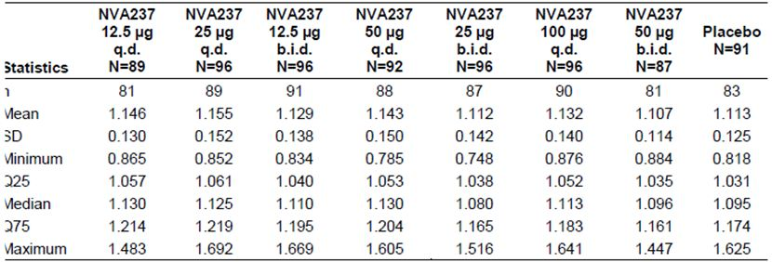

It was planned to analyse rescue medication usage by means of a model applying the assumptions used for trough FEV1, that is, the differences in treatment effect between regimens would decrease to zero as the total daily dose increased. These assumptions did not hold for the rescue medication endpoint. This may have been because the study had too short a treatment period to have an effect upon the use of rescue medication. It was therefore not possible to analyse rescue medication usage via the modelling approach.

*Comments: The efficacy and safety data generated by this study support the 50 μg q.d. dose being effective and safe. Lower once daily doses (12.5 and 25 µg) failed to demonstrate adequate efficacy and the higher once daily dose (100 µg) did not show any additional clinical benefits. The results from Studies NVA237A2205 and 2208 provided sufficient evidence to suggest that the proposed marketing dose of 50 µg was suitable for evaluation in the Phase III studies.*

### Efficacy

The efficacy claim is supported by seven Phase II and Phase III studies in the development program. The two pivotal Studies A2303 and A2304 were adequate and well controlled Phase III studies performed over 6 and 12 months, and which together provide evidence of efficacy in the proposed indication. A smaller Phase III study (A2310) provided evidence of improved exercise endurance in the target population. Four further Phase II Studies A2205, A2206, A2207, and A2208 provided supportive evidence of efficacy and dose response data that supported dose selection. All studies complied with published guidelines.[8]

Trough FEV1 was selected as the primary endpoint for the Phase III clinical program for NVA237 as it is a well accepted means to determine the efficacy of a once daily bronchodilator at the end of the dosing interval, providing an indication of the level of bronchodilation over 24 h. The key secondary symptomatic endpoints and other secondary/exploratory endpoints adequately assessed the efficacy of NVA237 for the proposed indication. Hence, the studies submitted in the dossier were adequate with an acceptable study design and efficacy endpoints.

#### Dose response and proposed dosing regimen

In Study A2205, a clear dose response was shown over the NVA237 dose range 12.5 to 100 μg q.d. with confirmation of study sensitivity from the comparison with open label active comparator (tiotropium 18 µg) versus placebo. There was dose related increase in FEV1 beginning 5 min after the inhalation of study drug which lasted 24 h. This increase was observed both after one inhalation of NVA237, and following 7 days of treatment. The treatment differences (active versus placebo) for trough FEV1 on Day 7 were dose ordered, ranging from 0.075 L for the 12.5 μg dose, to 0.142 L for the 100 μg dose. The effect reached a plateau at the 50 μg daily dose with only very small numerical increments with further dose escalation (from 0.131 L for the 50 μg dose to 0.142 L for the 100 μg daily dose). In Study A2206, there was no incremental therapeutic benefit seen with the 200 μg dose over the 100 μg dose. Although the 50 μg dose was not evaluated in this study, comparison to efficacy results from dose selection Study A2205 suggested that the 100 μg q.d. dose, although safe, did not offer a significant advantage compared to the 50 μg q.d. dose. Based on the data from the Phase II Studies A2205 and A2206, the optimal benefit-risk ratio was observed with the NVA237 50 μg q.d. dose, which in addition demonstrated clinically meaningful bronchodilation comparable to OL (open label) tiotropium. This was therefore the dose used for the two Phase III controlled efficacy Studies A2303 and A2304.

While the Phase III studies were ongoing, a further confirmatory dose ranging study was performed upon US FDA (Food and Drug Administration) request, the purpose being to further investigate dose response in the range 12.5 to 100 μg total daily dose, and also dose interval (q.d. or b.i.d.) (Study A2208). For the total daily doses of 25 μg, 50 μg and 100 μg, the differences between the once and twice daily regimens were not clinically meaningful. Additional endpoints such as FEV1 AUC0- 24h, FEV1 AUC0-12h, FEV1 AUC0-4h, FEV1 AUC0-8h, FEV1 AUC0-12h, FEV1 AUC12-24h, were included in this study to assess an appropriate dosing regimen for NVA237. While the q.d. regimen was numerically superior to the b.i.d. regimen over the first 12 h of dosing, the b.i.d. regimen provided greater improvements from 12-24 h. However, the differences between the two regimens were small and not considered clinically meaningful. For comparison of the two dose regimens, FEV1 AUC 0-24h provides perhaps the most comprehensive assessment of efficacy over the whole dosing interval and for this endpoint there were no clinically meaningful differences between the two dosing regimens. The safety and tolerability profile for all NVA237 doses and regimens was similar to placebo.

The efficacy and safety data generated by this study support the 50 μg q.d. dose being effective and safe. Lower once daily doses (12.5 and 25 µg) failed to demonstrate adequate efficacy and the higher once daily dose (100 µg) did not show any additional clinical benefits. The results from Studies NVA237A2205 and 2208 provided sufficient evidence to suggest that the proposed marketing dose of 50ug was suitable for evaluation in the Phase III studies.

#### Primary endpoint

In both pivotal efficacy studies, NVA237 demonstrated statistically significant improvement in trough FEV1 at Week 12 when compared with placebo (p<0.001 in each study). The treatment difference was 0.108 L in Study A2304 and 0.097 L in Study A2303. In Study 2303, the 0.097 L improvement versus placebo was comparable to that observed for OL tiotropium (0.083 L, p<0.001). In both studies, treatment differences in trough FEV1 at Day 1, Week 26 and Week 52 (A2303 only) were clinically relevant and statistically significant in favour of NVA237 versus Placebo.

#### Secondary spirometric parameters

NVA237 demonstrated a rapid onset of action at the 5 min post dose time point on Day 1 which was sustained throughout treatment duration. The statistically significant treatment difference for NVA237 versus placebo in LSmean FEV1 5 min post dose was 0.093 L in Study A2304, and 0.087 L in Study A2303. In Study A2303, onset of action with NVA237 was considerably more rapid than with tiotropium (0.045 L). Trough FVC was statistically significantly greater in the NVA237 group at Day 1, Week 12 and Week 26 than in the placebo group (p<0.001). Similar results were observed at Week 52 for Study A2303. Inspiratory capacity was statistically significantly greater in the NVA237 group than in the placebo group at all assessed time points on Day 1, Week 12 and Week 26 (in Study A2304 and A2303) and at Week 52 (in Study A2303 only). Peak FEV1 and FEV1 AUC in the first 4 h post dose at Day 1, Weeks 12 and 26 were statistically significantly greater in NVA237 than in placebo in both pivotal Studies A2304 and A2303 (p < 0.05). Similar results were observed at Week 52 in Study A2303.

**Key secondary symptomatic efficacy endpoints**

Key secondary symptomatic efficacy endpoints in both pivotal studies also demonstrated statistically significant improvements compared to placebo. For dyspnea assessed by TDI, NVA237 50 µg q.d. was statistically superior to placebo for TDI focal score in both pivotal studies after 26 weeks of treatment (LSmean difference of 0.81, p=0.002 in Study A2303; 1.04, p=<0.001 in Study A2304;) with a clinically important improvement (>1 point on scale) in a significant proportion of patients, =55.3% in Study A2303 (p=0.010); =61.3% in Study A2304 (p=0.001). For improvement in health status after 26 or 52 weeks, NVA237 50 µg q.d. was superior to placebo as shown by SGRQ (St George Respiratory Questionnaire) total score (in Study A2303, LSmean treatment difference of 3.32, p<0.001; in Study A2304, LSmean treatment difference of 2.81, p=0.004). The proportion of patients achieving a clinically significant improvement in the SGRQ total score (reduction of > 4 points) at Week 26 was statistically significantly greater in the NVA237 treatment group than in the placebo group (56.8% versus 46.3%, p=0.006 in Study A2304 and 58.9% versus 48.8% in Study A2303, (p=0.006). In Study A2303, the proportion of patients with clinical improvement in SGRQ at Week 52 was numerically higher (54.3% versus 50.8%, p = 0.312). Comparable results were observed for OL tiotropium versus placebo at Weeks 12, 26 and 52.

#### Other secondary efficacy endpoints

NVA237 50 µg significantly delayed and reduced the risk for the time to first moderate or severe exacerbation in both pivotal studies. In both pivotal studies, requirements of mean daily number of rescue medication puffs was statistically significantly reduced in the NVA237 group when compared to the placebo group over 26 and 52 weeks of treatment, respectively. In both pivotal studies, NVA237 treated patients were able to have more days to perform usual daily activities. In addition, significant improvements in daily/daytime/night time symptom scores versus placebo over 26 weeks were observed in Study A2304, and over 52 weeks in Study A2303.

#### Rapid onset of action, 24 h effect and long term efficacy

Taking the combined efficacy serial spirometry data, NVA237 demonstrated a 0.090 L treatment difference in FEV1 versus placebo (p < 0.001) at 5 min post dose on Day 1. At 15 min post dose on Day 1 the treatment difference for NVA237 versus placebo was 0.144 L (p < 0.001). Smaller but still statistically significant treatment differences for OL tiotropium versus placebo were observed at 5 min (0.047 L, p < 0.001) and 15 min (0.079 L, p < 0.001) post dose on Day 1. The 24 h response in each controlled efficacy trial showed that at the majority of the measured time point post dose over 24 h, NVA237 50 μg produced statistically significant bronchodilation compared with placebo, confirming the long lasting effect and validity of a once daily dose. The effect was maintained up to and including 52 weeks of treatment with no evidence of tachyphylaxis. As shown in Study A2303, the sustained 24 h NVA237 efficacy was similar in magnitude to that observed with OL tiotropium. In addition, NVA237 significantly improved COPD symptoms including dyspnea (TDI assessments), patients’ health status (SGRQ assessments) as well as time to first COPD exacerbation over the 26 week treatment period when compared to placebo. The effects were maintained up to 1 year of treatment as demonstrated in Study A2303.

#### Combined efficacy analysis

Combined efficacy analysis performed on the two pivotal studies confirmed the efficacy results observed in each individual study. This pooling also allowed several of the efficacy parameters to be evaluated in more detail, enabled a larger subpopulation to more effectively evaluate serial (24 h) spirometry data, and also provided a large pooled population to make extensive analyses exploring the consistency of treatment effect across a range of key population subgroups. Trough FEV1 responder analysis (below) was only reported in the combined analysis. The proportion of patients with at least 10% increase in trough FEV1 from baseline was statistically significantly greater for NVA237 than for placebo at Day 1 (49.4% versus 18.9%), Week 12 (45.1% versus 21.1%), Week 26 (45.3% versus 20.2%), p < 0.001 in each case and Week 52 (A2303 data only, 36.8% versus 21.4%; p = 0.002). Tiotropium was significantly superior to placebo at all assessments. The proportion of patients with at least 100 mL increase in trough FEV1 from baseline was statistically significantly greater for NVA237 than for placebo at Day 1 (56.6% versus 22.1%), Week 12 (52.0% versus 23.0%), Week 26 (49.7% versus 22.5%), p < 0.001 in each case and Week 52 (A2303 only, 42.5% versus 25.5%; p< 0.001). Tiotropium was significantly superior to placebo at all assessments.

Significant reduction in exacerbation rate over the 26 week treatment period was demonstrated in the NVA237 group compared to the placebo group with a rate ratio of 0.66 (95% CI: 0.525, 0.841; p < 0.001). Similarly, the Cox regression analysis showed that the estimated risk ratio for time to first exacerbation leading to hospitalisation was 0.39 (95% CI: 0.205, 0.728; p=0.003), for time to first exacerbation requiring treatment with systemic corticosteroids was 0.68 (95% CI: 0.521, 0.875; p = 0.003) and for time to first exacerbation requiring treatment with antibiotics it was 0.66 (95% CI: 0.521, 0.840; p < 0.001) in favour of NVA237 over placebo after 26 weeks of treatment The number needed to treat to prevent one moderate or severe exacerbation for NVA237 patients was 14. The number needed to treat for OL tiotropium was 37.

Subgroup analyses to assess treatment differences across key patient subgroups including duration of treatment were consistent with the analyses for the total population. Efficacy was shown to persist up to 52 weeks of treatment in Study A2303. No alteration of dose is therefore needed for key patient subgroups. Age, gender, race (Caucasian versus Asians only as there were too few patients belonging to other race groups), region, COPD severity (moderate and severe). Although ICS (inhaled corticosteroid) use did not affect efficacy of NVA237 significantly, numerically lower response was observed for ICS users. Furthermore, NVA237 failed to show significant improvements in symptomatic endpoints of TDI and SGRQ for patients with FEV1 reversibility <5% (improvements in trough FEV1 at Week 12 was not affected by FEV1 reversibility status). Current smokers showed statistically significant improvement in trough FEV1 at Week 12 and TDI focal score at 26 weeks, but the numerical treatment difference compared to placebo was much smaller than that observed in the ex smokers and the overall population. The SGRQ total score failed to show statistically significant improvements over placebo in current smokers.

#### Comment on clinical overview

The evaluators have no major disagreement with the ‘clinical overview’.

### Safety

In total, 14 studies contributed data to the integrated evaluation of safety of Study NVA237. Of these, most data came from 8 Phase II and III studies: 2 large pivotal Phase III studies, 1 smaller phase III study in exercise tolerance, and 5 Phase II studies designed to support dose selection and regimen. The other 6 studies were primarily for PK/PD purposes and they contributed limited short term safety data. The main databases in terms of relevance to the clinical use of NVA237 in the treatment of patients with COPD are the “COPD Major”, and “COPD Core” (6 month and 12 month) populations; the Core 6 month and 12 month Safety databases are nested within the Major Safety database and the Core 6 month Safety database overlaps with the Core 12 month Safety database because they both contain the first 6 months of data from Study A2303. Hence, the number of events displayed in each treatment group was generally similar in each of these 3 databases.

The baseline disease profile, especially among the 2 pivotal studies, was generally consistent and allowed a reliable assessment regarding the safety profile of NVA237 both in short and long term maintenance use in the target patient population; however, there is no data beyond 1 year. The total number of subjects exposed to NVA237 is 2535. Overall, over 2500 patients were exposed to NVA237 at any dose, 1462 at the proposed dose for marketing (50 μg once daily) of which 842 completed 6 months treatment, and 351 completed 12 months, which meets ICH requirements of 1500 patients overall, including 300-600 for 6 months, and at least 100 for 12 months.

The overall incidence of AEs (adverse events) by system organ class (SOC) in the NVA237 treatment group was generally similar to that seen with placebo. The most frequently affected SOCs were respiratory, thoracic and mediastinal disorders, infections and infestations, musculoskeletal and connective tissue disorders, and gastrointestinal disorders. Among imbalances seen, both respiratory, thoracic and mediastinal disorders and infections and infestations were reported noticeably less frequently in the NVA237 treatment group than in the placebo or tiotropium group. The most frequent AE was COPD (that is, exacerbation), reported less frequently in the NVA237 group compared with the placebo group. Other frequent AEs were upper respiratory tract infection (URTI), nasopharyngitis, cough, bacterial URTI and headache. These events were reported at a higher frequency in the placebo group, with the exception of nasopharyngitis, which was most frequent in the tiotropium group. The percentage of patients experiencing ≥ 1 severe AE was higher with placebo (10.7%) and tiotropium (10.5%) than with NVA237 (6.6%). The only severe AE occurring in ≥2.0% of patients in any treatment group was COPD exacerbation (NVA237 1.7%, placebo 4.3%, tiotropium 2.3%). In the Core 12 month dataset, fewer patients reported severe AEs in the NVA237 group (12.6%) compared to the placebo (19.4%) and tiotropium group (16.1%). The most prevalent severe AEs (≥ 2.0%) were COPD and pneumonia. For AEs typically associated with anticholinergic treatment, more patients on NVA237 reported dry mouth (2.23%) compared to placebo (1.12%) or tiotropium (1.50%). Benign prostatic hyperplasia was reported in the NVA237 and tiotropium groups (0.28% and 0.75%, respectively), but not in the placebo group. Glaucoma (non serious) was reported in one patient in the NVA237 group but not in the placebo or tiotropium groups. .

The percentage of patients in the Core 6 month safety population who had one or more treatment related AEs was similar in the NVA237 and placebo groups (7.2% and 7.3%, respectively), and slightly higher in the tiotropium group (7.9%). Suspected AEs ≥1.0% in any treatment group were dry mouth (NVA237 1.6%, placebo 0.9%, tiotropium 1.5%) and COPD exacerbation (NVA237 0.7%, placebo 1.1%, tiotropium 1.1%).

A total of 13 deaths occurred in the Core Safety database, including 2 patients who died during the 30 day follow up. Six (0.56%) of these deaths occurred in the NVA237 group, 5 (0.93%) deaths occurred in the placebo group and 2 (0.75%) deaths occurred in the tiotropium group. None of the deaths was suspected by the investigator to be related to study medication.

In the Major safety population, the number of SAE (serious adverse event) episodes per 100 patient years was higher in the placebo group (40.0) compared with the NVA237 group (27.4). For the preferred term of COPD, the number of SAE episodes per 100 patient years was higher in the placebo group (8.6) compared to the NVA237 group (4.2). The number of SAEs of atrial fibrillation (preferred term) was 1.0 per 100 patient years in the NVA237 group; this SAE was not reported in the tiotropium and placebo groups.

In the Major safety population, discontinuations due to AEs were lower in the NVA237 group (5.9%) compared to the placebo (7.1%) and tiotropium (7.5%) groups, with most frequent event being related to SOCs of respiratory, thoracic and mediastinal disorders, cardiac disorders, and infections and infestations. COPD was the most frequent AE causing discontinuation. Events leading to hospitalisation or requiring dose interruption were lower in the NVA237 group than in the placebo or tiotropium groups. In the NVA237 group, events requiring significant additional therapy were similar to placebo and tiotropium in the COPD Core 12 month population, and similar to placebo in the Major safety population.

In the Major safety population, as might be expected, the incidence of anticholinergic AEs was higher in the NVA237 (5.8%) and tiotropium (6%) groups compared with placebo (4.4%). The frequency of anticholinergic symptoms AEs was 5.8% in the NVA237 group, 4.4% in the placebo group, and 6.0% in the tiotropium group. CCV (cardio and cerebro vascular) SAEs per 100 patient years was 3.4 in the NVA237 group, 4.6 in the placebo group, and 1.3 in the tiotropium group.

Cardiovascular safety of NVA237 was evaluated in great detail in this submission due to recent reports concerning increased overall and CV (cardiovascular) mortality in patients treated with inhaled anticholiergics, especially with tiotropium mist inhaler. Overall, up to 1 year treatment with NVA237 did not show any serious CCV safety concerns and none of the 13 deaths in the core safety database were due to CCV events. Overall, the rate of the CCV SAEs was low. The most frequent SAE (0.3 events per 100 patients years in the NVA237 group) was atrial fibrillation (1.0 events NVA237, 0 events placebo, and 0 events tiotropium); this indicates if 100 patients treated with NVA237 are followed for 1 year, only 1 episode of atrial fibrillation would have been observed. Among patients without a history of atrial fibrillation, new clinically significant atrial fibrillation/flutter events were uncommon and comparable between the NVA237 and placebo groups in the core 6 and 12 month databases. In the smaller group of patients with a history of prior atrial fibrillation/flutter, recurrent atrial fibrillation/flutter events were common and more frequent in the NVA237 treated patients. The patients with recurrent atrial fibrillation also had multiple acute and/or chronic risk factors for atrial fibrillation. Furthermore, the 2 pivotal studies included a high proportion of patients at increased risk for developing atrial fibrillation. About 50% of the combined cohorts were over age 65 with the majority being Caucasian males. In addition, all patients with new onset atrial fibrillation had the additional risk factor of hypertension.

The laboratory analyses did not reveal any trends in the data that indicated a clinically important effect on hematology, chemistry or urinalysis with no meaningful differences between treatment groups. Mean and median values were within normal ranges. There were no clinically relevant differences between treatment groups for shifts from normal at baseline to low (< LLN [lower limit of normal]) or high (> ULN [upper limit of normal]) post baseline in the COPD safety population.

There were no consistent changes in ECG values seen across the treatment groups during the longer term studies. For qualitative ECG assessments such as rhythm disturbance, a slightly higher frequency of newly occurring ECG abnormalities on centralised ECG recordings in the NVA237 group was observed compared to placebo. Increases from baseline of 30-60 ms, and >60 ms in QTcF both occurred with a slightly higher frequency in the NVA237 group. Overall, differences between groups were small, not statistically significant or clinically meaningful. For vital signs, small fluctuations were seen between treatment groups in summary statistics of blood pressure, but overall there were no clinically meaningful findings for blood pressure, pulse rate, or weight.

Overall, NVA237 was well tolerated at the dose recommended and its use in COPD patients in exposure durations up to one year did not give rise to any unexpected safety concerns. The studied population matches the intended marketing population (with a high percentage of co morbidity and disease risk factors in the Phase III population), and included an adequate representation of patients in subgroups likely to be included within that target population.

Numerous subgroup analyses (age, gender, ethnicity) did not reveal a population who were particularly at risk of adverse outcomes. However, there was no subgroup analyses of safety of NVA237 based on COPD severity, drug exposure or concomitant use of ICS. Furthermore, there was no evaluation of NVA237 in patients aged < 40 years or in patients with clinically significant (judgment of the investigator) cardiovascular disease (unstable ischemic heart disease, left ventricular failure, history of myocardial infarction, arrhythmia), and those with significant QTc prolongation.

Overall, no major safety concern for NVA237 was found and long term administration of NVA237 up to 1 year was safe and well tolerated. There was no safety data beyond 1 year of treatment.

### Clinical summary and conclusions

#### First round benefit-risk assessment

##### First round assessment of benefits

The benefits of Seebri Breezhaler 50 µg (NVA237) as once daily, maintenance bronchodilator treatment to relieve symptoms of patients with COPD are:

* Rapid onset of action with a statistically significant treatment difference (in FEV1) compared to placebo being evident as early as 5 min.
* Convenient once daily dosing due to significant bronchodilation (compared with placebo) observed at the majority of the measured time points post dose over 24 h.
* The sustained 24 h bronchodilation observed with NVA237 (NVA237 placebo treatment difference after 12 weeks was -0.097 L) was similar in magnitude to that observed with OL tiotropium 18 µg, which is the recommended and approved dose for tiotropium (-0.083 L).
* There was no clinically significant difference between once daily and twice daily dosing regimens according to a new study (A2208) which was conducted (requested by FDA) while the Phase III trials were ongoing. While the q.d. regimen was numerically superior to the b.i.d. regimen over the first 12 hours of dosing, the b.i.d. regimen provided slightly greater improvements from 12-24 h. For comparison of the two dosing regimens, FEV1 AUC0-24h provided the most comprehensive assessment of efficacy over the whole dosing interval and for this endpoint there were no clinically meaningful differences between the two dosing regimens.
* The improvements in mean trough FEV1 observed at the primary endpoint (12 weeks) were maintained throughout treatment in both the 6 and 12 months studies. Compared to placebo, mean trough FEV1 was increased by 0.113 L at week 26 in the 6 month study and 0.108 L at Week 52 in the 12 month study. These data indicate that the 24 h bronchodilator effect of NVA237 was maintained from the first dose throughout a one year period with no evidence of tachyphylaxis.
* In addition, NVA237 significantly improved COPD symptoms including dyspnea (TDI assessments), patients’ health status (SGRQ assessments) as well as time to first COPD exacerbation over the 26 week treatment period when compared to placebo; the number needed to treat to prevent one moderate or severe exacerbation for NVA237 patients was 14 (the number needed to treat for OL tiotropium was 37).
* Requirements of mean daily number of rescue medication puffs was statistically significantly reduced in the NVA237 group when compared to the placebo group over 26 and 52 weeks of treatment, respectively. Furthermore, NVA237 treated patients were able to have more days to perform usual daily activities and also showed significant improvements in daily/daytime/night time symptom scores versus placebo over 26 and 52 weeks.
* The Phase III, placebo controlled, crossover Study A2310 provided preliminary evidence that NVA237 produced statistically significant 20% (89 seconds) improvement over placebo after 3 weeks of treatment.
* NVA237 was well tolerated at the recommended dose and its use in COPD patients in exposure durations up to one year did not give rise to any unexpected safety concerns. The studied population matched the intended marketing population.

##### First round assessment of risks

The risks of NVA237 in the proposed usage are:

* Tobacco exposure and use of nicotine replacement therapy (as an aid to smoking cessation) was not recorded in the pivotal studies and its potential effect on efficacy outcomes was not evaluated.
* The possibility of kinetic interaction between NVA237 and smoking cessation aids or nicotine replacement therapy was not investigated (which is a requirement as mentioned in the CPMP guidelines).
* The efficacy and safety of NVA237 50 µg once daily maintenance bronchodilator treatment to relieve symptoms of patients with COPD has not been evaluated for treatment periods > 1 year.
* Safety of NVA237 in treatment of COPD did not appear to be affected by age, gender, or race. However, effect of COPD disease severity, concomitant ICS use, drug exposure on safety of NVA237 was not evaluated. Furthermore, there was no evaluation of NVA237 in patients aged <40 years or in patients with clinically significant (judgment of the investigator) cardiovascular disease (unstable ischemic heart disease, left ventricular failure, history of myocardial infarction, arrhythmia), and those with significant QTc prolongation.
* Overall, the incidence of CCV events was higher in patients with > 2 or 3 CCV risk factors but this increase was similar in the NVA237 and placebo groups. The main CCV safety concern identified in the NVA237 program was the increased risk of new or recurrent atrial fibrillation/flutter. The sponsors have attempted to address this by regular monitoring of CCV events as indicated in the RMP (Risk Management Plan).

##### First round assessment of benefit-risk balance

The efficacy of once daily oral inhalation of the anticholinergic drug NVA237 50 µg was established in over 2000 patients with moderate to severe COPD in well conducted clinical studies using well accepted and valid spirometric and symptomatic efficacy endpoints. Patients treated with NVA237 50 μg once daily demonstrated sustained bronchodilatory effect up to 52 weeks, together with significant improvements in dyspnea, health status, and reduction in COPD exacerbation which was similar to that observed with the established standard of care, that is, tiotropium 18 μg once daily. Age, gender, race, baseline disease severity, smoking status (although numerically lower benefits observed in current smokers compared to ex smokers) or use of ICS did not have a significant effect on the bronchodilatory and sympotomatic benefits observed with NVA237. However, tobacco exposure and use of smoking aids such as nicotine replacement was not monitored during pivotal studies and their effect on efficacy was not evaluated. There is no evidence of efficacy/ safety of NVA237 beyond 1 year.

Overall, there were no major safety concerns associated with use of NVA237 up to 1 year other than the ones to be expected with administration of anticholinergic agents. Safety of NVA237 did not appear to be affected by age, gender, or race. However, effect of COPD disease severity, concomitant ICS use, drug exposure on safety of NVA237 was not evaluated. Furthermore, there was no evaluation of NVA237 in patients aged < 40 years or in patients with clinically significant (judgment of the investigator) cardiovascular disease (unstable ischemic heart disease, left ventricular failure, history of myocardial infarction, arrhythmia), and those with significant QTc prolongation.

Recently, results from published studies were conflicting either showing no effect on mortality over 4 years treatment with tiotropium,[9] showing a reduction in all cause mortality, CV mortality and CCV events[10] or showing an increased risk of CV death and overall mortality, especially following use of tiotropium mist inhalers[11].[12] The mist inhaler is available in 55 countries but this formulation has yet to gain regulatory approval in the United States or Australia. The proposed formulation is to be delivered by a device (Concept1) which is similar to the handihaler device (and not the mist inhaler). The sponsors have undertaken an extensive and detailed evaluation of CCV AEs in this submission which failed to show any major CCV safety concerns. None of the deaths were due to CCV events in the Core safety database and the incidence of serious CCV events was also not higher in patients treated with NVA237 compared with placebo. The only significant finding was the higher incidence of new and recurring atrial fibrillation/flutter.

Overall, there is adequate evidence to suggest that NVA237 would offer an important therapeutic option for adult patients with moderate to severe COPD due to its consistent bronchodilatory effects, symptomatic benefits as well as convenient once daily dosing. There are no major safety concerns associated with use of NVA237 up to 1 year and proposed RMP is designed to detect any anticholinergic or CCV safety issues.

Overall, the benefit-risk balance of NVA237 50 µg once daily maintenance bronchodilator treatment to relieve symptoms of patients with COPD is favourable, subject to compliance with recommendations outlined in below.

#### First round recommendation regarding authorisation

It is recommended that Seebri Breezhaler (NVA237) 50 µg once daily maintenance bronchodilator treatment to relieve symptoms of patients with chronic obstructive pulmonary disease (COPD) be approved subject to incorporation of recommended changes and satisfactory response to questions.

#### List of questions

##### Pharmacokinetics

None.

##### Pharmacodynamics

None.

##### Efficacy

According to CPMP guidelines on COPD drugs, tobacco exposure should be monitored carefully throughout the trial in all patients and changes in smoking status documented and reported. The influence of this exposure on the estimates of efficacy should be evaluated by quantifying and illustrating any differences in tobacco exposure between treatment groups and discussing possible quantitative effect of these differences on outcome. It appears that tobacco exposure or the use of nicotine replacement therapy as an aid to smoking cessation was not recorded in the NVA237 pivotal studies and its potential effect on efficacy outcomes could not be evaluated. Could the sponsors clarify this issue and provide results of the analysis, if it was completed.

##### Safety

Safety of NVA237 in subgroups based on COPD disease severity, drug exposure or concomitant ICS use was not provided. It was not recorded if safety was evaluated in the above subgroups. If it was the sponsor should be requested to provide details of the analysis.

#### Second round evaluation of clinical data submitted in response to questions

*(i) According to CPMP guidelines on COPD drugs, tobacco exposure should be monitored carefully throughout the trial in all patients and changes in smoking status documented and reported. The influence of this exposure on the estimates of efficacy should be evaluated by quantifying and illustrating any differences in tobacco exposure between treatment groups and discussing possible quantitative effect of these differences on outcome. It appears that tobacco exposure or the use of nicotine replacement therapy as an aid to smoking cessation was not recorded in the NVA237 pivotal studies and its potential effect on efficacy outcomes could not be evaluated. Could the sponsors clarify this issue and provide results of the analysis if it was done.*

##### Sponsor’s response:

###### Monitoring of tobacco exposure throughout trials:

In both Studies A2303 and A2304 patients’ prior exposure to tobacco products was assessed at the screening visit in terms of their “pack years”, one pack year was defined as 20 cigarettes a day for 1 years, or 10 cigarettes a day for 2 years, etcetera. Smoking status (ex smoker/current smoker) was also collected during the studies at Randomisation, Week 12 and Week 26 in both studies and Week 52 in Study A2303. The potential for changes in smoking status during the study (patients either ceasing smoking or restarting smoking) to impact on the efficacy analyses was evaluated for the Full Analysis Set (FAS). Analysis of change in smoking status at any time during treatment period in Study A2303 and A2304 are summarised in Tables 12-13**.** The percentage of patients changing smoking status at any time after baseline was low in both studies (approximately 6% patients in Study A2304, approximately 12% patients in Study A2303) and similar between treatment groups. In both studies the percentage of patients changing from current smoker to ex smoker was higher than for those changing from ex smoker to current smoker. While the effect of smoking status at baseline on efficacy endpoints was thoroughly characterised, the effect of changing smoking status during the study on efficacy endpoints was not. The reasons for not performing such analyses were:

1. The small number of patients who changed smoking status especially the very small number of patients resumed smoking, and the disparity in size between this subgroup and the larger subgroup who maintained their smoking status would not allow for any statistically meaningful comparison between NVA237 and placebo on efficacy endpoints, particularly symptomatic endpoints which typically require large sample sizes to show differences between treatments,
2. The patient’s experience on treatment, either active or placebo, may have impacted on their decision to change smoking status therefore having a confounding effect of randomisation, so that the observed treatment difference cannot be directly attributed to the randomised group,
3. During the study, the eCRF (electronic Case Report Form) only collected whether the patient was smoking or not smoking at the time of the study visit, not the timeframe over which the patient had changed his/her smoking status, or the actual amount of cigarette consumption; therefore it would be necessary from an analysis perspective to treat patients who had just changed smoking status the same as one who had changed smoking status for several months and their quantities of cigarette consumption could not be factored into the analysis.

Table 12: Percentage of patients changing from baseline smoking status at any time during study (Study A2303).

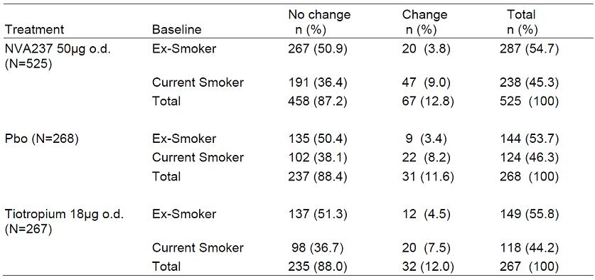

Table 13: Percentage of patients changing from baseline smoking status at any time during study (Study A2304).

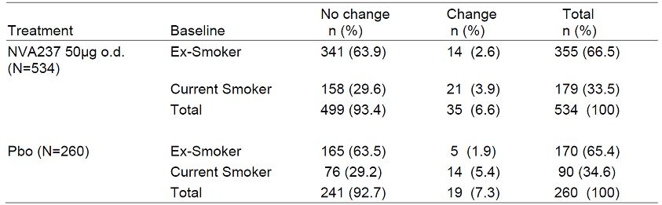

###### Collection of data on the use of nicotine replacement therapy:

Nicotine replacement therapy, if used by a patient during the study was to be recorded in the “non COPD concomitant medications” eCRF. In Study A2303, 1.3% of the total patient population used nicotine replacement therapy: NVA237: 1.5%, Placebo: 1.1%, tiotropium: 1.1%. In Study A2304, 0.6% of the total patient population used nicotine replacement therapy: NVA237: 0.7%, placebo 0.4%**.** Since the number of patients using nicotine replacement therapy was very low no attempt was made to analyses the impact of using nicotine replacement therapy on efficacy endpoints.

##### Evaluator’s comments on sponsor’s response:

The above explanation by the sponsor is adequate and addresses the evaluator’s concerns regarding effects of change in smoking status or use of nicotine replacement therapy on efficacy of Seebri during the pivotal studies.

*(ii) Safety of NVA237 in subgroups based on COPD disease severity, drug exposure or concomitant ICS use was not provided. Please provide information about, and analysis of the safety evaluation in the above subgroups. If it were, please provide details on the analysis.*

##### Sponsor’s response:

###### COPD severity:

The 6 month database included the following numbers of patients per COPD severity group (NVA237/placebo): mild/moderate 663/340 and severe/very severe 412/195. In both severity groups, AEs overall were less frequent on NVA237 than on placebo. The proportion of patients with any type of AEs on NVA237 and placebo were 59.0% and 63.8% in mild/moderate COPD, and 61.2% and 71.8% in severe/very severe COPD, respectively with very similar AE profile across COPD severity groups (Tables 14-15). There was no SOC with a placebo corrected SAE frequency differing by more than 0.5% between the two COPD severity groups.

Table 14: AEs in mild/moderate COPD reported greater than 0.5% more frequently than in severe/very severe COPD (6 month database).

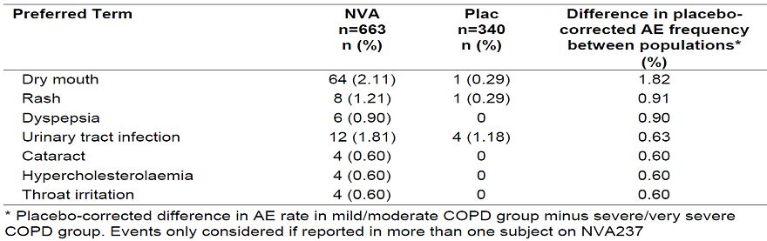

Table 15: AEs in severe/very severe COPD reported greater than 0.5% more frequently than in mild/moderate COPD (6 month database).

###### Table 15: AEs in severe/very severe COPD reported greater than 0.5% more frequently than in mild/moderate COPD (6 month database).

###### ICS use:

The 6 month database included the following numbers of patients by co medication (NVA237/placebo): No ICS group n = 478/262 and ICS group n = 591/272. In both co medication groups AEs overall were less frequent on NVA237 than on placebo. The proportion of patients with any type of AEs on NVA237 and placebo were 55.0% and 66.4% in No ICS group, and 63.8% and 66.9% in the ICS group, respectively with a very similar AE profile across the two co-medication groups (Tables 16-17).

Table 16: AEs in patients without concomitant ICS reported greater than 0.5% more frequently than in those with ICS use (6 month database).

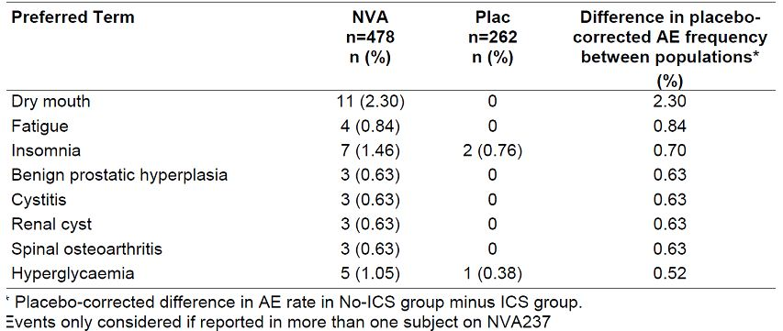

Table 17: AEs in patients on concomitant ICS reported greater than 0.5% more frequently than in those without ICS use (6 month database).

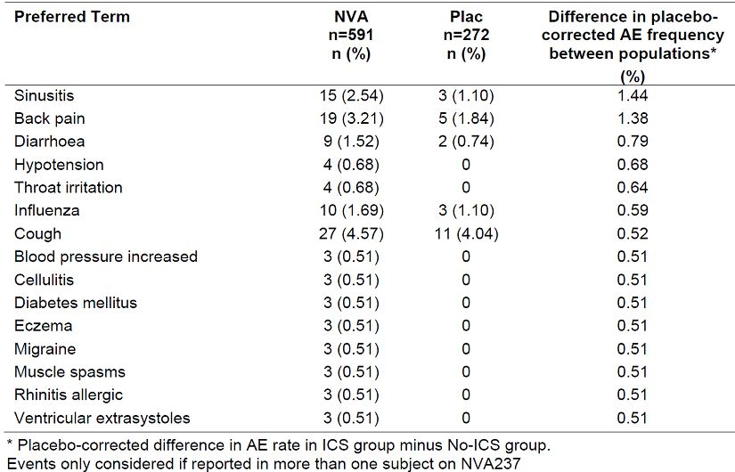

###### Drug exposure:

The frequency and pattern of AEs is similar between the first half than in the second half of the treatment interval both in the 6 month and 12 month databases. Placebo corrected frequencies differ by less than 0.5% between treatment intervals in the vast majority (>96%) of all NVA237 associated AEs. There is no clinically relevant difference between the safety profile of NVA237 over time (Tables 18-21).Since discontinuation rates from trials were generally low and lower on NVA237 than placebo, any bias would be expected to be small and in favour of placebo.

Table 18: AEs in patients during Weeks 1-13 reported greater than 0.5% more frequently than in those in Weeks 14+ (6 month database).

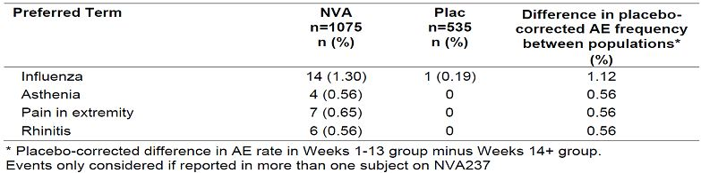

Table 19: AEs in patients during Weeks 14+ reported greater than 0.5% more frequently than in those in Weeks 1-13 (6 month database).

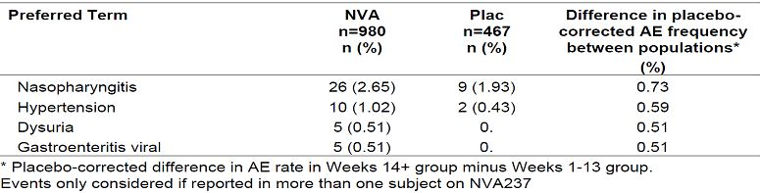

Table 20: AEs in patients during Weeks 1-26 reported greater than 0.5% more frequently than in those in Weeks 27+ (12 month database).

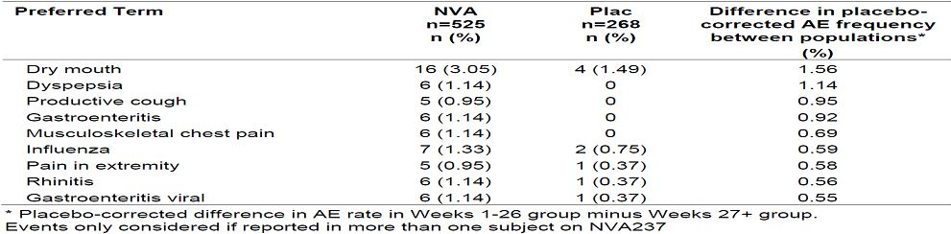

Table 21: AEs in patients during Weeks 27+ reported greater than 0.5% more frequently than in those in Weeks 1-26 (12 month database).

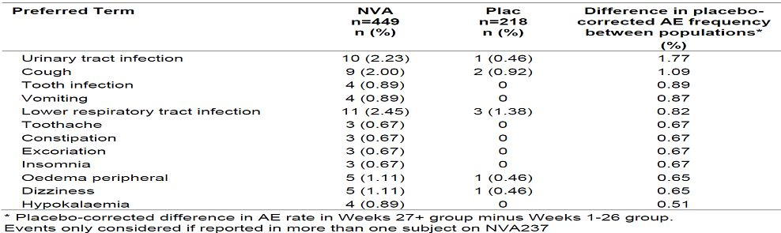

Dry mouth and dyspepsia was reported more frequently in Weeks 1-26, while urinary tract infection and lower respiratory tract infection were more frequent in Weeks 27+ compared to Weeks 1-26. Reports of cough/productive cough were similar across intervals.

There were no SAEs by SOC reported more frequently in Weeks 1-13 than in the Weeks 14+. On the other hand, SAEs related to the SOC Nervous system disorders were more frequent in Weeks 14+ than in Weeks 1-13. These SAEs included a variety of individual PT of which syncope was reported in n=2. There were no SAEs by SOC reported more frequently in Weeks 1-26 than in the Weeks 27+. On the other hand, there were 4 SOC with more SAEs in Weeks 27+ than in the first 26 weeks.

The number of exposure adjusted adverse event episodes in the 6 and 12 month database were similar and did not suggest an increase of events with prolonged treatment. The total number of AE per 100 patient years was 378.9 (NVA237) and 467.7 (placebo) for the 6 months and 364.5 (NVA237) and 427.8 (placebo) for the 12 month database (Table 22).

Table 22: AE episodes adjusted for exposure by SOC (6 and 12 month database).

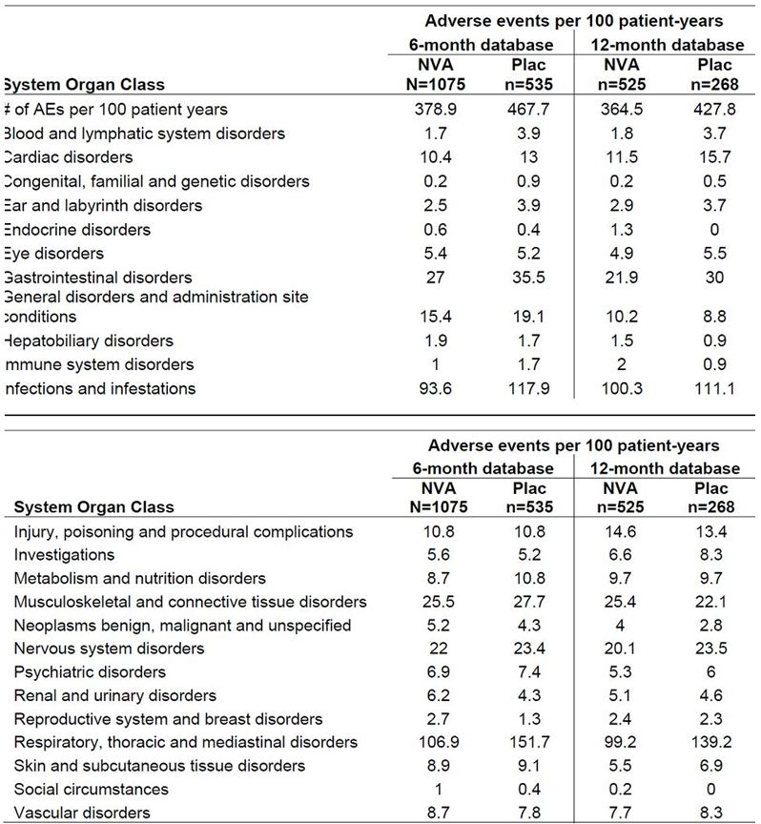

Overall, COPD severity, concomitant ICS use, or drug exposure did not have any meaningful effect on safety profile of NVA237.

##### Evaluator’s comments on sponsor’s response:

The above explanation by the sponsor is adequate and addresses the evaluator’s concerns regarding safety of Seebri in subgroups of COPD patients based on disease severity, drug exposure or concomitant ICS use.

#### Second round benefit-risk assessment

##### Second round assessment of benefits

After consideration of the responses to clinical questions, the benefits of Seebri Breezhaler in the proposed usage are unchanged from those identified above.

##### Second round assessment of risks

After consideration of the responses to clinical questions, the risks of Seebri Breezhaler in the proposed usage are:

* The efficacy and safety of NVA237 50 µg once daily maintenance bronchodilator treatment to relieve symptoms of patients with COPD has not been evaluated for treatment periods > 1 year.
* Overall, the incidence of CCV events was higher in patients with > 2 or 3 CCV risk factors but this increase was similar in the NVA237 and placebo groups. The main CCV safety concern identified in the NVA237 program was the increased risk of new or recurrent atrial fibrillation/flutter. The sponsor has attempted to address this by regular monitoring of CCV events as indicated in the RMP.

##### Second round assessment of benefit-risk balance

The benefit-risk balance of Seebri Breezhaler as once daily maintenance bronchodilator treatment to relieve symptoms of patients with chronic obstructive pulmonary disease (COPD) is favourable.

#### Second round recommendation regarding authorisation

It is recommended that Seebri breezhaler (NVA237) 50 µg once daily maintenance bronchodilator treatment to relieve symptoms of patients with COPD be approved subject to incorporation of recommended changes to the PI.[13]

## V. Pharmacovigilance findings

### Risk management plan

The sponsor submitted a Risk Management Plan that was reviewed by the TGA’s Office of Product Review (OPR).

#### Safety specification

The sponsor provided a summary of Ongoing Safety Concerns which are shown at Table 23.

Table 23: Ongoing Safety Concerns for Seebri Breezhaler.

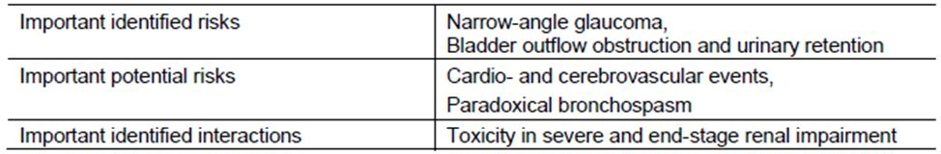

The sponsor’s correspondence dated 29 May 2012 proposes further revision to the RMP.

##### OPR reviewer’s comment:

Pursuant to the evaluation of the nonclinical and clinical aspects of the Safety Specifications, the above summary of the Ongoing Safety Concerns and the proposed revisions are considered acceptable. Nevertheless, it is recommended that the important missing information: ‘Pregnant and lactating women’ be included as a new ongoing safety concern when this RMP document is next updated.

#### Pharmacovigilance plan

##### Proposed pharmacovigilance activities

The sponsor states that routine pharmacovigilance activities, consistent with the activities outlined in published guidelines,[14] are proposed to monitor all the specified ongoing safety concerns.

For the important identified risk: ‘Narrow-angle glaucoma’, the sponsor has proposed targeted follow up of all serious spontaneous reports, serious post marketing surveillance study reports, serious reports from other programs where data is being handled as solicited and all clinical trial SAE reports, using a targeted follow up checklist: *“Glaucoma / Ocular Hypertension Checklist for Compounds containing Glycopyrronium bromide”.* A copy of this targeted Questionnaire/checklist has been provided in the Australian Specific Annex.

For the important identified interaction: ‘Toxicity in severe and end-stage renal impairment’, the sponsor has proposed that in patients with signs of an anticholinergic syndrome /toxicity, and a medical history/symptomatology suggestive of renal failure, targeted follow-up of all serious spontaneous reports, and all clinical trial SAE reports will also be undertaken to gain further information on renal function (creatinine clearance) and their medical history.

##### OPR reviewer’s comments in regard to the pharmacovigilance plan and the appropriateness of milestones:

There is no objection to the sponsor implementing only routine pharmacovigilance activities to monitor all the specified Ongoing Safety Concerns. However, it is also recommended that routine pharmacovigilance be used to monitor the important missing information: ‘Pregnant and lactating women’ & ‘Long term use’, as new Ongoing Safety Concerns.

#### Risk minimisation activities

##### Sponsor’s conclusion in regard to the need for risk minimisation activities

The sponsor has concluded that routine risk minimisation activities for all the specified ongoing safety concerns are sufficient and that none of the identified or potential risks requires an additional risk minimisation activity.

##### OPR reviewer’s comment:

The specified ongoing safety concerns would not appear to warrant additional risk minimisation activities. Nevertheless routine risk minimisation should also be applied to the important missing information: ‘Pregnant and lactating women’ & ‘Long-term use’, as new ongoing safety concerns.

##### Potential for medication errors

The sponsor states that:

*On 29 February 2008, the FDA issued a Public Health Advisory (PHA) to highlight the correct use of Spiriva (tiotropium bromide inhalation powder) and Foradil (formoterol fumarate inhalation powder) capsules. FDA and the American Association of Poison Control Center’s National Poison Data System have received reports of patients swallowing Foradil and Spiriva capsules rather than placing the capsules in the inhalation devices. Reports of ingestions indicate that few patients experienced side effects from the swallowed capsules.*

*NVA237 is provided as 50 μg inhalation powder hard capsules for oral inhalation via the Concept1 device. Absolute bioavailability of orally inhaled NVA237 was estimated to be about 40%, and absolute oral bioavailability of NVA237 to be about 5% [Summary of Biopharmaceutical Studies]. If a patient accidentally or intentionally ingests and swallows an inhalation capsule, the systemic bioavailability is expected to be about 8 fold lower than that after oral inhalation from an inhalation capsule. Therefore, a patient would have to swallow approximately 30 capsules to achieve a systemic exposure similar to that following oral inhalation of a 200 μg dose. Therefore, acute intoxication by inadvertent oral ingestion of NVA237 capsules is highly unlikely.*

*Maximal plasma levels after IV administration of 120 μg glycopyrronium bromide (the active agent in Seebri Breezhaler) in healthy volunteers were about 50 fold the maximal steady state drug levels achieved with the clinical use (50 μg once daily) of Seebri Breezhaler and were well tolerated ([Study A2108], [Study A2103]).*

*Name confusion*

*This item will be provided once the approved trade names are available.*

*Presentation*

*Inhalation powder hard capsules of 50 μg.*

*Instructions for use*

*Patient information / Instructions for patients:*

* *Do not swallow the NVA237 capsules.*
* *The contents of NVA237 capsules are only to be inhaled using their respective inhalation devices provided with the prescription. Remove the capsule from the blister package and place the intact capsule into the inhalation device prior to inhalation.*
* *Follow the instructions contained in the patient information provided with your prescription explaining how to use the NVA237 inhaler. Capsules are to be used immediately after being removed from the blister.*

*Instructions for health care professionals:*

*Doctors, nurses, and pharmacists should discuss with patients how to correctly use the inhaler.*

*Labelling*

*Imprint on packaging states do not swallow. There is no mention of potential medication error in the labelling.*

##### OPR reviewer’s comment:

The sponsor’s handling of this matter using routine pharmacovigilance and risk minimisation activities is considered satisfactory. Nevertheless, the discussion concerning ‘Name confusion’ should be provided when this document is next updated, as the trade names would now appear to be available.

#### Summary of recommendations

The OPR provides these recommendations in the context that the submitted RMP is supportive to the application; the implementation of a RMP satisfactory to the TGA is imposed as a condition of registration; and the submitted EU-RMP is applicable without modification in Australia unless so qualified:

* The nonclinical aspects of the safety specifications in the RMP should be amended according to the recommendations of the nonclinical evaluator when this document is next updated.
* It is recommended that the important missing information: ‘Pregnant and lactating women’ be included as a new Ongoing Safety Concern when this RMP document is next updated.
* There is no objection to the sponsor implementing only routine pharmacovigilance activities to monitor all the specified ongoing safety concerns. Nevertheless, it is also recommended that routine pharmacovigilance be used to monitor the important missing information: ‘Pregnant and lactating women’ and ‘Long term use’, as new Ongoing Safety Concerns.
* The sponsor’s conclusion that routine risk minimisation activities for all the specified Ongoing Safety Concerns are sufficient and that none of the identified or potential risks requires an additional risk minimisation activity is acceptable.
* The discussion concerning ‘Name confusion’ under the ‘Potential for medication errors’ section of the RMP should be provided when this document is next updated, as the trade names would now appear to be available.
* The sponsor’s proposed application of routine risk minimisation activities would appear to be reasonable.
* It is acknowledged that routine risk minimisation has already been proposed for the important missing information: ‘Pregnant and lactating women’, although this is not entirely the case for the new ongoing safety concern: ‘Long term use’.

## VI. Overall conclusion and risk/benefit assessment

The submission was summarised in the following Delegate’s overview and recommendations.

This application comprised pharmaceutical chemistry, some nonclinical data and clinical data. Individual patient data were not supplied and were not requested by the clinical evaluator.

The letter of application includes some notable statements, for example:

*“Glycopyrronium bromide powder for inhalation represents an alternative treatment option for COPD patients. It was shown to have a faster onset of action to the only currently available once daily LAMA on the Australian market, tiotropium...”*

Also:

*“Glycopyrronium bromide is intended for administration to patients once daily by inhalation via a single dose capsule device (“Breezhaler” Concept1). This is a low resistance device, which would be a potential advantage for COPD patients who find breathing difficult.”*

*“Novartis reviewed and commented on the development of the concept paper and the new draft COPD guideline update. The glycopyrronium bromide clinical programme is considered to be in accord with the draft guideline with the exception that the comparison with tiotropium in Study A2303 was not designed to demonstrate non inferiority but was rather included as an exploratory endpoint. Additionally, the draft guideline, like the existing 1999 guideline, asks for a co primary symptoms endpoint. The glycopyrronium bromide studies have symptoms endpoints as 'key secondary endpoints' meaning that an a priori hierarchical testing procedure to control the family wise type I error on the primary lung function endpoint and key secondary symptomatic endpoints was adopted. This approach was endorsed by the five EU HAs listed above. ”*

The draft PI is replete with claims like, *“clinically meaningful improvements in lung function”* but is less clear about the regimens to which glycopyrronium bromide is to be added.

### Quality

The evaluator notes that glycopyrronium has four diastereoisomers of which two (both active) are present. The excipients are magnesium stearate and lactose. (The former is a novel excipient as far as the inhalational route is concerned it is very commonly used in oral formulations.)

Of significance, the evaluator remarks:

*“The dose delivered to the lung as an aerosol powder is estimated in product testing as the ‘fine particle mass (sub 5 μm portion)’ and is controlled to 20-33 μg. The ‘lung dose’ is consistent over the flow rate range expected in patients.”*

Stability data were provided to support a shelf life of 18 months when stored below 30°C in aluminium-aluminium blister packs; this is appropriate for Australian conditions.

With regard to bioavailability, one absolute bioavailability study (Study NVA237A2108) was provided in the dossier but it was not evaluated by the chemistry evaluator.

The evaluator supports registration on chemistry and quality control grounds.

*Comment: A consistent fine particle dose throughout the approved shelf life is essential for consistent dosing. Of note, the lactose monohydrate commonly used in Novartis inhalation products (Onbrez Breezhaler, Foradil Aeroliser) is sourced from healthy animals under the same conditions as milk supplied for human consumption. The magnesium stearate is from vegetable and synthetic origin.*

### Nonclinical

The evaluator notes that the submission was of high quality and that the studies examining repeat dose toxicity, genotoxicity, carcinogenicity and reproductive toxicity were conducted under GLP conditions. Glycopyrronium does not have identical receptor subtype affinities compared to tiotropium. Of note, one of the two diastereoisomers present contributes most of the activity. Enantiomer interconversion was demonstrated in the rat.

Glycopyrronium and its metabolite were not found to possess clinically significant secondary pharmacological activity.

Of note, systemic absorption after inhalational dosing is about 40% of the administered dose; most of this (approximately 90%) is from the lung which is of rapid onset (<5 minutes) and is sustained.

Half life for clearance from the lung was 20-26 h in rats. The volume of distribution was low, most radioactivity was excreted via the urine. Radiolabel data supported limited penetration of the blood:brain barrier. Very limited placental transfer (mice, rabbits and dogs) and substantial excretion in milk (rats) were shown for the drug.

Metabolism was ‘low’ via CYP2D6 and ‘trace’ by six other isoforms. Glycopyrronium is a very weak inhibitor of CYP2D6.

In the toxicology studies, high exposure multiples were obtained relative to the clinical dose. Acute toxicity was reflective of glycopyrronium’s antimuscarinic effects.

Local toxicities in the respiratory tract included eosinophilic globules in the olfactory and respiratory epithelium, hyperplasia/hypertrophy of goblet cells, local inflammatory changes degeneration of the olfactory epithelium and **squamous metaplasia** of the respiratory epithelium. Squamous metaplasia was seen in a rat study that was as short as 7 days. **Squamous metaplasia** of the **larynx** was observed at all doses in the pivotal rat study but exposure did not produce squamous metaplasia in dogs. Reversibility of these effects was seen after a 4 week treatment free period was shown for all respiratory tract findings in the pivotal dog study and for lung (but not nasal cavity and **larynx**) findings in the pivotal rat study. Inflammatory changes were seen in the kidneys and bladders of rats.

Glycopyrronium was not considered to be carcinogenic or mutagenic.

Inhalational administration of magnesium stearate did not produce histopathological lesions in the respiratory tract of rats and dogs, or carcinogenicity in rats.

Registration is not opposed on nonclinical grounds.

*Comment: The applicant should comment on the reversibility of laryngeal and pulmonary squamous metaplasia given the extensive history of smoking in the intended patient population.*

### Clinical

The report is a composite of the initial and second round (that is, reflecting answers to questions) reports. The clinical evaluator noted that all studies were conducted according to GCP and complied with the principles of Declaration of Helsinki.

#### Pharmacodynamics

Dose finding Studies A2205, 2206, 2208 and 2207 (Table 24) also contributed information.

Table 24: Summary of dose finding studies.

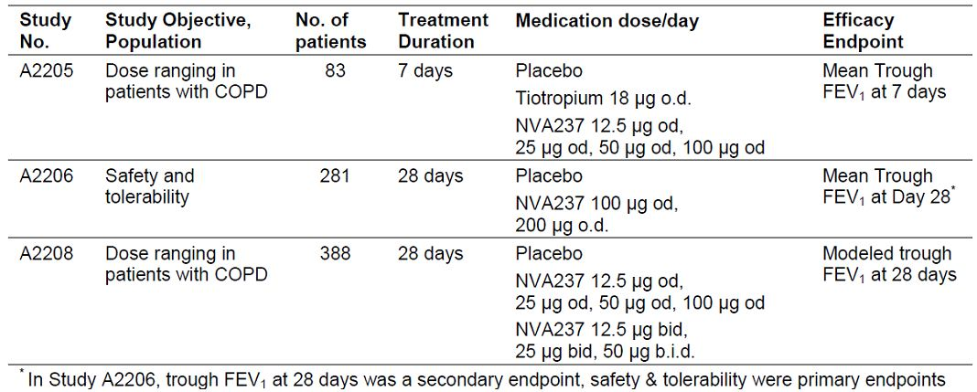

Study A2207 examined only a dose of 50 μg; Study A2208 contributed dose finding (Table 25).

Table 25: Dose response results of trough FEV1 (L) for model averaged analysis by treatment at Day 28 (Full Analysis set).

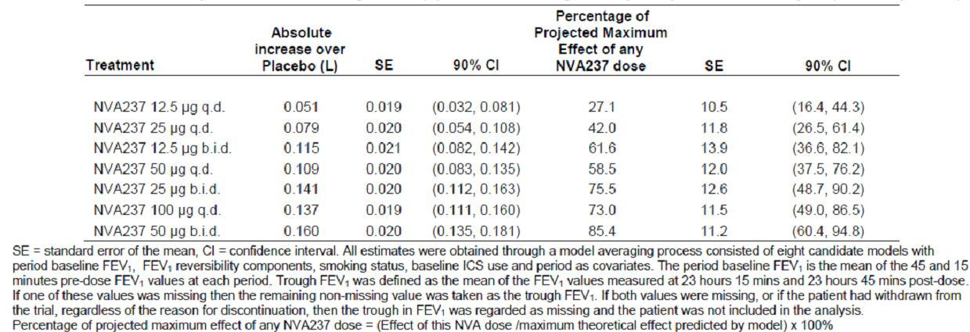

The evaluator concluded that glycopyrronium exerts a bronchodilator effect that starts within 5 min of dosing. Whilst glycopyrronium has a fast onset of action it shows sustained effects due to sustained absorption form the lungs. Clinically meaningful effects on FEV1 were achieved at a daily dose of 50 μg once daily up to 200 μg once daily. Subacute effects were seen on exercise tolerance. Safety data suggested a wide therapeutic index:

*“There was no consistent effect on heart rate or blood pressure values under exercise being reflective of the low systemic effect potential of glycopyrronium under exercise conditions.”*

The evaluator observes that the exposure to glycopyrronium from inhalation is considerably less than from the injection of Robinul.

#### Pharmacokinetics

Glycopyrronium is rapidly but sustainedly absorbed after inhalation, has poor oral bioavailability, is cleared mainly by renal excretion and to a lesser extent by metabolism or biliary excretion and reaches steady state on daily dosing within one week.

Relevant studies are:

* NVA237A2103 (single dose study in healthy volunteers)
* NVA237A2103 (multiple dose study in COPD patients)
* NVA237A2104 (in Japanese and Caucasian)
* NVA237A2105 (in renal impairment).
* NVA237A2109 (drug interaction with cimetidine)
* Studies QVA149A2101/2103 and 2106 provided some supportive pharmacokinetic data following single and multiple inhaled doses of indacaterol (QAB149) and NVA237 (glycopyrronium bromide) when administered alone or in combination
* population pharmacokinetic analyses.

Study NVA237 A2108, a study in healthy volunteers, is of interest because it suggested that oral activated charcoal was effective in blocking the oral absorption of glycopyrronium (content of eight 50 μg inhalation capsules) in ten volunteers. The absolute bioavailability of 200 μg inhaled glycopyrronium without charcoal to IV administration of 120 μg glycopyrronium was, in 20 healthy volunteers, 32.0 % (30.1, 34.1%) based on AUClast and 42.3 % (38.3, 46.6%) based on AUC∞. As concluded by the evaluator:

*“It is concluded that about 90% of systemic exposure following oral inhalation of NVA237 is due to lung absorption while about 10% is due to gastrointestinal absorption. If it is assumed that the absolute bioavailability of orally inhaled NVA237 is 40% of which 90% would be attributed to lung absorption, then about 36% of the nominal dose is expected to be deposited and absorbed in the lungs.”*

Several studies found that absorption was rapid after inhalation, peaking at about 5 min.

Study CNVA237A2104 found dose proportional pharmacokinetics above the proposed dose range in both healthy Caucasians and Japanese (Table 26).

Table 26: Key plasma and urine PK parameters after single inhaled doses of NVA237 in each ethnic group (arithmetic means ± SD).

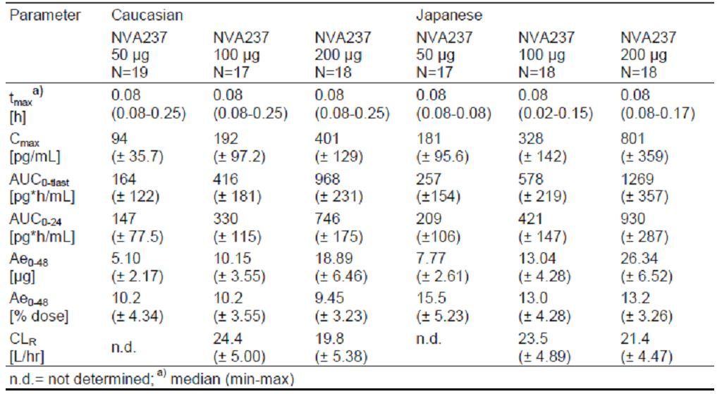

The time to steady state in multiple dosing studies was about 6 days. The enantiomers were cleared similarly.

Renal elimination of parent drug accounts for about 60 to 70% of systemic or total clearance of systemically available glycopyrronium. The rest is cleared by biliary excretion or metabolism. Glycopyrronium is cleared from the systemic circulation in a multi phasic manner. After inhalation, the apparent terminal half life values differed to some extent between studies with means between 13.0 h and 57.2 h. The apparent terminal phase volume of distribution is dependent on the route of administration (Table 27).

Table 27: Summary of key PK parameters of NVA237 after IV infusion and inhalation without and with charcoal (Part 2).

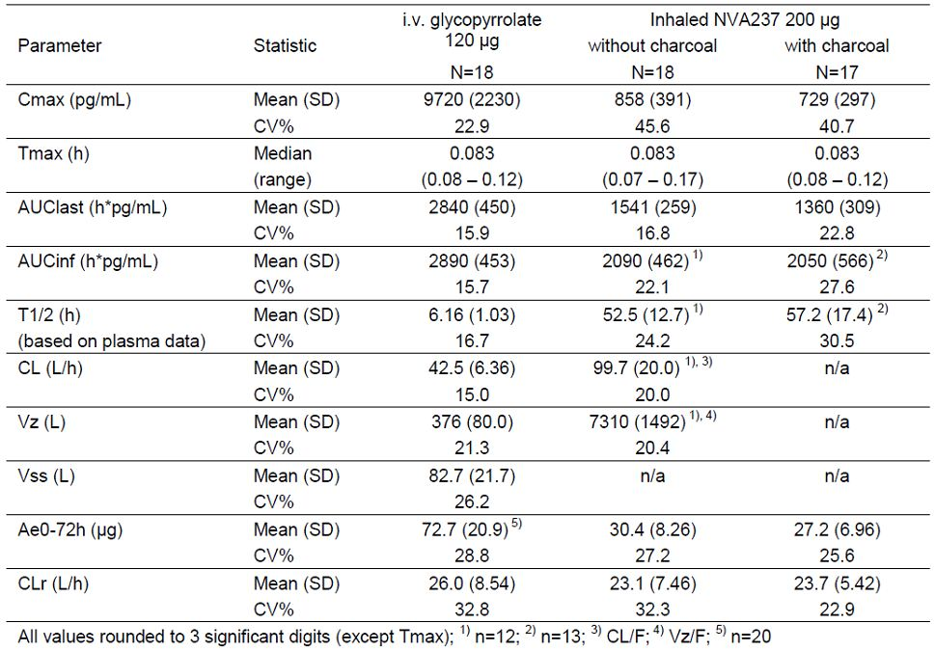

Study NVA237 A2103 is of note because it examined single and repeated once daily inhaled glycopyrronium doses (25-200 μg) in COPD patients, over 14 days. Steady state was reached within one week of treatment. In brief, the pharmacokinetic parameters were similar to healthy volunteers’ results, including at the proposed therapeutic dose, when age and renal function were accounted for.

Specific studies were not done in hepatic impairment.

In renal impairment, the results were as might be expected: the renal clearance of glycopyrronium was correlated with the degree of renal impairment, as assessed by the estimated glomerular filtration rate (eGFR) or the creatinine clearance determined by the Cockcroft-Gault formula or from urinary excretion of creatinine over 24 h. In subjects with severe RI, renal clearance was reduced by about 70% to 80% compared with healthy volunteers.

Study A2109 was of interest: it examined the effect of inhibition of the organic cation transport on glycopyrronium disposition using cimetidine as a probe inhibitor, in 20 healthy non smoking men. Cimetidine increased total exposure (AUClast) to glycopyrronium by 22% and decreased renal clearance by 23%.

In regard the population pharmacokinetic analysis:

*“A population PK analysis including data of three studies in CODP patients identified body weight and age as intrinsic physiological factors contributing to inter patient variability in systemic exposure to glycopyrronium. When taking patients of age 60 to <65 years as reference, median AUCtau was 27% higher in patients of age 75 to 80 years, and 25% lower in patients of age 40 to <45 years.”*

There was no effect of gender. Smoking status also was not associated with differences in exposure in the same analysis.

The evaluator had some reservations:

* No drug interaction studies were conducted between glycopyrronium and other oral/inhaled medications commonly used in COPD; and
* The possibility of kinetic interaction between glycopyrronium and smoking cessation aids or nicotine replacement therapy was not investigated (as mentioned in the CPMP guidelines).

#### Clinical Efficacy and Safety studies

A summary of the clinical efficacy and safety studies are shown in Table 28.

Table 28: Summary of the clinical efficacy and safety studies.

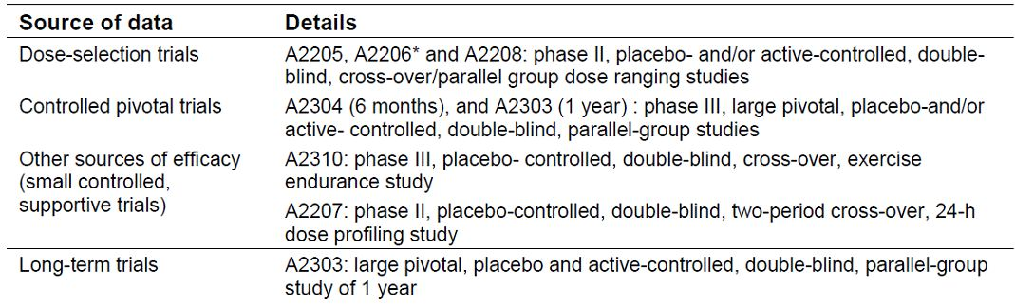

There were several Phase II studies. Studies A2205 and A2208 informed the doses selected for the pivotal clinical trials. The glycopyrronium 50 μg daily dose was selected as close to maximally effective. There was no advantage for b.i.d. dosing. The evaluator supported the section of the proposed dose in the Phase III studies.

The main pivotal Phase III efficacy/safety studies were A2303 and A2304 (Table 29). They were large, multicentre, randomised, parallel group studies that included a blinded comparison of glycopyrronium against placebo but which were of non identical design.

Table 29: Summary of placebo controlled Phase III studies.

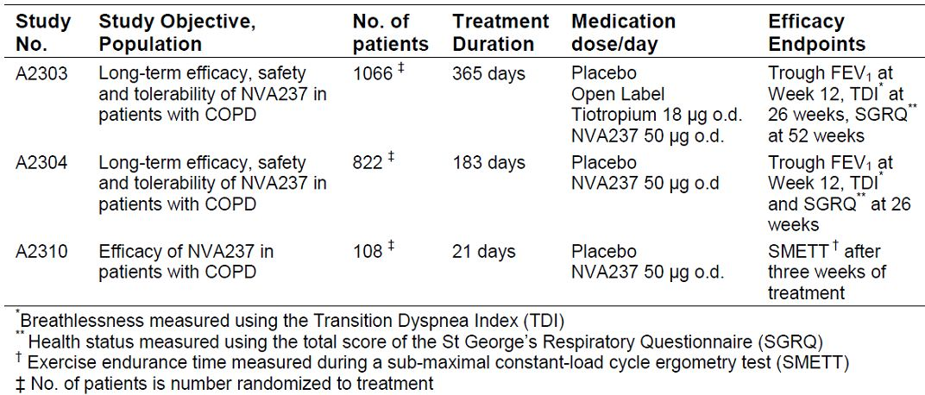

Study A2303 was a 12 month study of 1066 patients with moderate to severe COPD (that is, stable moderate to severe COPD [Stage II or Stage III according to the GOLD Guidelines 2008] and a smoking history of at least 10 pack years post bronchodilator FEV1 ≥ 30% and < 80% of the predicted normal and post bronchodilator FEV1/FVC < 0.7 at Visit 2 [Day −14]). The primary objective was to confirm that glycopyrronium 50 μg q.d. significantly increases trough FEV1 (defined as mean evaluation at 23 h 15 min and 23 h 45 min post dose) compared to placebo following **12 weeks** of treatment. There were numerous secondary endpoints including:

1. breathlessness measured using the TDI after 26 weeks treatment, and
2. the health status by measuring the total score of the SGRQ after 52 weeks treatment.

Other important secondary efficacy variables were:

* time to first moderate or severe COPD exacerbation over 52 weeks of treatment;
* daily rescue medication use over 52 weeks of treatment.

Patients were randomised to glycopyrronium: blinded placebo: open tiotropium at 2:1:1. Open label tiotropium 18 μg q.d. delivered via the Handihaler was used as an active comparator.

A total of 1066 patients were randomised to treatment of which 810 patients (76.0%) completed the study as planned. Study discontinuations occurred more frequently in the placebo group (22.3%, 28.3% and 23.1% in NVA237, placebo and tiotropium groups, respectively).

Pulmonary function assessments were performed using centralised spirometry.

Results were as follows:

*“For the FAS population, the treatment difference for trough FEV1 at 12 weeks compared to placebo was 93 mL in favour of [glycopyrronium], and 83 mL in favour of tiotropium (in both treatment comparisons p<0.001)”.*

Referring to the sample size calculations:

*“The sample size was driven by the joint power of 0.85 for finding the significance of the primary and key secondary hypotheses. Assuming, a difference of 120 mL in trough FEV1 between NVA237 50 μg q.d. and placebo with standard deviation of 270 mL, the study sample size of 455 evaluable patients for NVA237 and 225 for placebo would give a two sided test at the 5% significance level with more than 99% power.”*

*Comment: The result was significant, the sample size was just achieved at randomisation, the quantum of superiority over placebo appears to be significantly less than expected [93 mL not 120mL]. The difference between glycopyrronium and tiotropium is clinically not significant but this was not testable.*

The TDI after 26 weeks treatment, and the health status by measuring the total score of the SGRQ after 52 weeks treatment showed treatment effects for both active treatments versus placebo. Of other secondary endpoints, the 52 week event rates for COPD exacerbation based on Kaplan-Meier estimates were 32.8%, 30.1%, and 40.2% for NVA237, tiotropium, and placebo, respectively.

Study A2304 was a six month study. It was placebo controlled (glycopyrronium:placebo randomisation was 2:1) but there was no active comparator arm. The primary and secondary efficacy endpoints were similar to those described in Study A2303 but for the fact that secondary endpoints were measured at 26 weeks. Of 822 patients randomised to treatment, 662 patients (80.5%) completed the study as planned. The groups were considered to be well matched, most patients were Caucasian (63%; 35% were Asian), male (82%), ex smokers (67% with overall mean smoking history was 45 pack years) with moderate COPD 60.8%, severe 38.7%, or very severe 0.4%. In the year prior to study entry, 78.7% of patients had not experienced a moderate or severe COPD exacerbation, 16.3% of patient had experienced one exacerbation and 5.0% had experienced two or more exacerbations. Prior to start of study drug, approximately 75% of all patients took COPD related medications, and the most frequently taken prior medications were short acting beta agonists (NVA237 versus placebo: 33.1% versus 31.1%), combinations of beta agonist and inhaled steroid (29.6% versus 25.5%), LAMA (28.7% versus 32.2%), combinations of beta agonist and anti cholinergic (12.7% versus 11.2%) and long acting beta agonists (LABA) (7.1% versus 11.2%).

In terms of the primary outcome, glycopyrronium was statistically significantly superior to placebo for trough FEV1 after 12 weeks of treatment. The treatment difference in favour of glycopyrronium was 108 mL (p<0.001). For the “key” secondary efficacy outcomes, statistical significance was declared.

*Comment: the absolute benefit for the SGRQ score at 26 weeks was small -*

Time to first moderate or severe exacerbation during 26 weeks treatment and Daily rescue medication use during 26 weeks treatment both favoured active treatment.

*Evaluator’s efficacy conclusions: “… the studies submitted in the dossier were adequate with an acceptable study design and efficacy endpoints.”*

*“In both pivotal efficacy studies, NVA237 demonstrated statistically significant improvement in trough FEV1 at Week 12 when compared with placebo (p <0.001 in each study). The treatment difference was 0.108 L in Study A2304 and 0.097 L in Study A2303. In Study A2303, the 0.097 L improvement vs. placebo was comparable to that observed for OL tiotropium (0.083 L, p<0.001). In both studies, treatment differences in trough FEV1 at Day 1, Week 26 and Week 52 (Study A2303 only) were clinically relevant and statistically significant in favour of NVA237 versus Placebo.”*

The evaluator concluded that the key efficacy endpoints were favourable and that the claim of rapid onset of action was sustainable; there was no evidence of tachyphylaxis.

##### Safety

Based on six month data from pooling the two pivotal studies, the overall frequency of AEs in the Core 6 month Safety database was lower in the glycopyrronium group (59.8%) compared to the placebo (66.7%) and tiotropium treatment groups (65.2%) (Table 30). This was driven in part by fewer events of COPD: glycopyrronium 22.4%, tiotropium 27.7%, placebo 30.3%. Discontinuations due to adverse events showed the same rend. Other frequent AEs were URTI, nasopharyngitis, cough, bacterial URTI, and headache.

Table 30: AEs by preferred term (at least 1.5% in any group (COPD core 6 month Safety database).

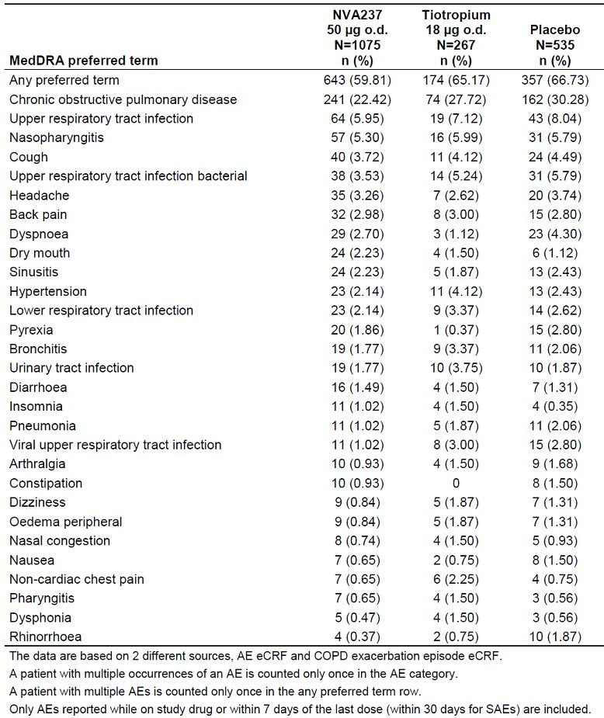

Laboratory test results and special safety monitoring suggested no significant treatment related effects. Of vital signs, weight gain was associated with glycopyrronium:

*“Notably higher body weight was more frequent in the NVA237 group compared to the placebo group only after 6 months (NVA237 4.7%, placebo 3.1%) and after 12 months (NVA237 10.5%, placebo 5.8%); maximum mean change from baseline was greater in the NVA237 group compared to the placebo group up to 3 months (NVA237 versus placebo: 0.16 versus -0.11 kg), after 6 months (0.84 versus 0.36 kg) and after 12 months (1.78 versus 1.02 kg).”*

Most AEs in the Core 6 month Safety database were moderate in severity. The overall frequency of patients with severe AEs was lower in the glycopyrronium group (6.6%) compared to the placebo group (10.7%) and tiotropium group (10.5%).

Fourteen deaths occurred in various studies, including 2 that died within 30 days of the study’s end. Deaths were not more frequent in those receiving glycopyrronium.

The evaluator concluded that, for anticholinergic adverse effects, more patients on glycopyrronium reported dry mouth (2.23%) compared to placebo (1.12%) or tiotropium (1.50%). Benign prostatic hyperplasia was reported in the glycopyrronium and tiotropium groups (0.28% and 0.75%, respectively), but not in the placebo group. Glaucoma (non serious) was reported in one patient in the glycopyrronium group but not in the placebo or tiotropium groups.

The evaluator concluded:

*“Overall, NVA237 was well tolerated at the recommended dose, and its use in COPD patients in exposure durations up to one year did not give rise to any unexpected safety concerns. The studied population matches the intended marketing population (with a high percentage of co morbidity and disease risk factors in the Phase III population), and included an adequate representation of patients in subgroups likely to be included within that target population.”*

*“There was no safety data beyond 1 year of treatment.”*

*Overall Conclusions: “Overall, there is adequate evidence to suggest that NVA237 would offer an important therapeutic option for adult patients with moderate to severe COPD due to its consistent bronchodilatory effects, symptomatic benefits as well as convenient once daily dosing. There are no major safety concerns associated with use of NVA237 up to 1 year and proposed RMP is designed to detect any anticholinergic or CCV safety issues.”*

Various changes to the PI and Consumer Medicines Information (CMI) documents were recommended.

There were two issues that the applicant was asked to address:

1. “According to CPMP guidelines on COPD drugs, tobacco exposure should be monitored carefully throughout the trial in all patients and changes in smoking status documented and reported. The influence of this exposure on the estimates of efficacy should be evaluated by quantifying and illustrating any differences in tobacco exposure between treatment groups and discussing possible quantitative effect of these differences on outcome. It appears that tobacco exposure or the use of nicotine replacement therapy as an aid to smoking cessation was not recorded in the NVA237 pivotal studies and its potential effect on efficacy outcomes could not be evaluated. Could the sponsors clarify this issue and provide results of the analysis if it was done.”
2. “Safety of NVA237 in subgroups based on COPD disease severity, drug exposure or concomitant ICS use was not provided. Was safety evaluated in the above subgroups? If it was, could the sponsors provide details of the analysis.”

The responses were considered in the second round evaluation report.

#### Second round evaluation

##### Answer 1

“The percentage of patients changing smoking status at any time after baseline was low in both studies (approximately 6% patients in 2304, approximately 12% patients in 2303) and similar between treatment groups. In both studies the percentage of patients changing from current smoker to ex smoker was higher than for those changing from ex smoker to current smoker. Whilst the effect of smoking status at baseline on efficacy endpoints was thoroughly characterised, the effect of changing smoking status during the study on efficacy endpoints was not.” The reasons advanced included small numbers, confounding by experience on treatment, incomplete data on actual cigarette consumption. “...[T]he number of patients using nicotine replacement therapy was very low no attempt was made to analyses the impact of using nicotine replacement therapy on efficacy endpoints.”

The evaluator accepted these explanations.

##### Answer 2

“The proportion of patients with any type of AEs on NVA237 and placebo were 55.0% and 66.4% in No ICS group, and 63.8% and 66.9% in the ICS group, respectively, with a very similar AE profile across the two co medication groups.”

“Overall, COPD severity, concomitant ICS use or drug exposure did not have any meaningful effect on safety profile of NVA237.”

The applicant responded that drug exposure (duration of efficacy) showed no significant trends in terms of placebo corrected frequencies for the first months versus the second 6 months, serious adverse events were not more common from weeks 1.13 versus weeks 14+.

The evaluator accepted these explanations.

*Other comments by the evaluator: The overall risk-benefit remains unchanged. There are no efficacy or safety data beyond 12 months. Further changes to the PI were recommended.*

### Risk management plan

This will be included in the agenda papers. Overall, it requires no particular or additional risk management activities.

### Risk-benefit analysis

#### Delegate considerations

In regard to nonclinical data, the Delegate is uncertain as to whether the tumourogenicity and carcinogenicity of glycopyrronium has been fully explored. Perhaps post marketing data will need to be sought.

In regard to efficacy, the benefit was modest but consistent across two studies and durable to 12 months in one of the pivotal studies. For a chronic condition like COPD, longer term extension phases would have been desirable.

The clinical evaluator went to considerable effort to discuss postmarketing reviews of tiotropium in regard to cardiovascular safety. The matter is not resolved in regard to glycopyrronium and one would expect the FDA and the EMA to require longer term data. The applicant was asked to detail any studies that re proposed in regard to this. There is a signal that Spiriva Respimat may be more risky in patients with a background of cardiac dysrhythmia. While this concern related to tiotropium the matter remains unclear in respect of glycopyrronium. Of note, tiotropium Handihaler was used on the 12 month efficacy and safety study.

##### Questions addressed to the Committee

Without wishing to limit or constrain the Committee’s discussion or general discussion or general advice, the following specific questions are asked.

1. Does the data package support the applicant’s claim that glycopyrronium has a faster onset of action than the currently available once daily LAMA on the Australian market, tiotropium?
2. Would the Committee please comment on the PI document, in particular in regard to section 16 of the clinical evaluation report?
3. Is the wording of the indication supported?

##### Proposed actions

The application by Novartis Pharmaceuticals (Australia) Pty Ltd to register Seebri Breezhaler/Tovanor Breezhaler containing glycopyrronium bromide 50 micrograms as a powder for inhalation in hard capsules should be approved. The registered indication should be:

*“as a once-daily maintenance bronchodilator treatment to relieve symptoms of patients with chronic obstructive pulmonary disease (COPD).”*

#### Response from sponsor

Presented here is the sponsor’s pre ACPM response to the TGA Delegate’s Overview (DO) and request for ACPM advice on the application to register glycopyrronium bromide 50 µg as powder for inhalation in hard capsules (Seebri Breezhalder/Tovanor Breezhaler). Where appropriate, the sponsor’s comments have been cross referenced to the DO, the clinical evaluation report (CER), nonclinical evaluation report (NER) and the risk management plan evaluation report (RER), or to the submission for marketing authorisation (MA). The sponsor refers to the product as “Seebri” from this point on.

##### Introduction

The sponsor welcomes the Delegate's proposal to approve Seebri for the proposed indication:

*“Once-daily maintenance bronchodilator treatment to relieve symptoms of patients with chronic obstructive pulmonary disease (COPD)”*

The clinical evaluator also supports the registration of Seebri for the indication proposed by the sponsor [CER]. In addition, there are no nonclinical objections to the registration of Seebri for the proposed indication [NER].

The sponsor notes the specific questions that the Delegate has addressed to the Committee, in relation to: the onset of action; the changes to the PI, and the proposed wording of the indication. To assist the Committee with its deliberations, the sponsor respectfully provides comments in relation to these questions in [this] pre ACPM response. The sponsor also responds to the other comments made by the Delegate, including the comment directed to the sponsor in relation to the clinical relevance of local toxicity seen in animal models.

##### Novartis’ comments on issues raised in Delegate’s questions

###### Onset of action

The claim that glycopyrronium has a faster onset of action than tiotropium is based on the analysis of FEV1 at all time points up to 4 h post dose from the pivotal Phase III Study A2303111. The results were presented in a post text table to the clinical study report. In summary, the results show that the treatment difference with Seebri compared to placebo was more marked than with tiotropium over the first 4 h, and Seebri demonstrated a particularly fast onset of action. At 5 min post dose Seebri versus, placebo showed a statistically significant FEV1 treatment difference of 87 mL, compared to tiotropium versus placebo showing a smaller but still statistically significant treatment difference of 45 mL. At 15 min post dose, Seebri demonstrated a clinical meaningful treatment difference versus placebo of 143 mL compared with a statistically significant treatment difference of 78 mL for tiotropium versus placebo [CER].

###### Wording of the indication

The TGA Delegate and the Clinical Evaluator agree that Seebri should be approved for the proposed indication. The sponsor considers that overall, there are sufficient data presented in the MA to support approval of Seebri for the proposed indication. The main studies that support the therapeutic application of the product in the proposed indication were two Phase III Studies A2303 and A2304 [CER]. The salient results of the studies are discussed here.

The two pivotal efficacy Studies A2303 and A2304 were adequate and well controlled Phase III studies performed over 12 and 6 months respectively, and which together provide substantial evidence of safety and efficacy outcomes in the proposed indication. A smaller Phase III Study A2310, provided evidence of improved exercise endurance in the target patient population. In both pivotal studies, Seebri demonstrated statistically significant improvement in trough FEV1 at Week 12 when compared with placebo (p<0.001 in each study). The treatment difference was 108 mL in Study A2304 and 97 mL in Study A2303. Consistent treatment differences in trough FEV1 at Week 26 and Week 52 (Study A2303 only) across both trials were clinically relevant and statistically significant in favour of Seebri versus placebo [DO].

In one of the pivotal studies, Seebri was compared to the established standard of care, tiotropium 18 µg OD, in COPD patients, and the safety and efficacy outcomes support its use as a safe and effective alternative to tiotropium (Study 2303). In this study, the 97 mL improvement of Seebri versus placebo in FEV1 at Week 12 was comparable to that observed for open label tiotropium (83 mL, p<0.001). Moreover, Seebri was well tolerated at the recommended dose and there were no major safety concerns up to 1 year, other than the ones expected with administration of anticholinergic agents. The Clinical Evaluator notes that *“...patients treated with glycopyrronium 50 µg once daily demonstrated sustained bronchodilatory effects up to 52 weeks, together with significant improvements in dyspnoea, health status (using the total score of the St George’s Respiratory Questionnaire) and reduction in COPD exacerbations which was similar to that observed with the established standard of care tiotropium 18 µg once daily”* [CER].

As a final point, the inclusion and exclusion criteria for these trials were designed for relevance to the wider COPD population. The Clinical Evaluator considered that the *“…studied population matches the intended marketing population (with a high percentage of co-morbidity and disease risk factors in the Phase III population), and included adequate representation on patients in subgroups likely to be included within the target population”* [CER]. The spirometric criteria used in the inclusion criteria for the pivotal studies defined patients with fixed airflow limitation as those with post bronchodilator FEV1 ≥30% and <80% predicted and a FEV1/FVC ratio <0.7, thus covering a broad range of disease severity.

##### Novartis’ response to the Delegate’s comments

The Delegate has raised certain issues under the heading “Comments” [DO] in regard to nonclinical data; efficacy, and post marketing review of cardiovascular safety. The sponsor’s response to these three matters is in this section.

###### Nonclinical data

The nonclinical evaluator concluded that glycopyrrolate was non genotoxic and noncarcinogenic [DO]. In addition, tumourogenicity and carcinogenicity were not identified as ongoing safety concerns by the RMP evaluator. The nonclinical and RMP evaluators’ conclusions are noted in the DO, although the Delegate later expressed uncertainty over whether tumourogenicity and carcinogenicity of glycopyrronium had been fully explored.

The sponsor considers that the tumourogenicity and carcinogenicity potential of glycopyrronium was extensively investigated in the nonclinical programme. Briefly, carcinogenicity studies in transgenic mice (6 months duration; oral administration) and rats (2 year duration; inhalation administration) revealed no tumourogenicity [NER]. For this reason, the sponsor believes that further investigation of the tumourogenicity and carcinogenicity potential is not warranted. The absence of carcinogenic and genotoxic effects seen in nonclinical studies of glycopyrronium does not appear to be dissimilar to the effects reported in the PI documents for the other approved medicines in the class.

The Delegate has also sought specific comment on the reversibility of laryngeal and pulmonary squamous metaplasia seen in the respiratory tract in some rodent studies. Laryngeal squamous metaplasia was only observed in preclinical inhalation studies in the rat. Pulmonary squamous metaplasia, which is considered to be a pre neoplastic lesion in humans, was not observed in any of the rat or dog inhalation toxicity studies conducted with glycopyrronium. Squamous metaplasia of the larynx is considered species specific, resulting from innate sensitivity of rats to inhaled compounds. A first and frequent target site for squamous metaplasia in rats is the base of the epiglottis, which in the rat is covered by a thin layer of transitional to respiratory epithelium. In dogs, monkeys and humans, the base of the epiglottis is covered by a much thicker and more resistant squamous epithelium. Laryngeal squamous metaplasia in rodents showed evidence of reversibility in terms of reduced incidence and severity in the rat glycopyrronium toxicity studies. There is no published evidence that squamous metaplasia in the rat larynx progresses to neoplasia. No evidence of carcinogenicity was seen following inhalation of glycopyrronium in rats. The well differentiated character of the laryngeal alteration, the reversibility and lack of progression over time indicates that this response is adaptive and very unique to the rat without significant human risk.

###### Efficacy

The benefits of Seebri were seen across a number of lung function measures and patient centred outcomes in the clinical trial programme. Seebri showed a sustained bronchodilatory effect that was similar to an established standard of care, tiotropium, over the course of the 12 month trial (Study A2303). The primary efficacy variable for both pivotal Studies A2303 and A2304 was spirometric in order to support a claim of a long term effect on lung function. As noted by the Delegate [DO], results of both pivotal studies show a consistent benefit.

Changes in patient centred outcomes such as symptoms, exacerbations, exercise capacity and health related Quality of Life (QoL) are also important to fully assess therapeutic effectiveness of a pharmacological intervention in COPD. Results on the secondary endpoints show a beneficial effect on symptoms of COPD similar to that of tiotropium. Two pivotal studies demonstrated that Seebri had a statistically significant effect on TDI, a commonly used instrument to assess breathlessness and the impact of intervention. In Study A2304, the treatment effect exceeded the MCID for the instrument.

In Study A2303, the treatment difference was somewhat less than the MCID for the instrument; however, the magnitude was comparable to that seen with tiotropium in the study. The magnitude of these improvements is also similar to those seen in the literature for the comparison of tiotropium (double blind) to placebo.[15] Additionally, a significantly higher percentage of patients treated with Seebri responded with a TDI improvement of 1 point or more in both studies, when compared to placebo. In Study A2303, the percentages in the Seebri and tiotropium arms were similar (55.3% and 53.4%, respectively) [CER]. Finally, an analysis of number needed to treat (NNT) for a ≥ 1 point improvement in TDI for the pooled efficacy populations of Study A2303 and A2304 at Week 26 found the value of NNT for Seebri to be 9, compared with a value of 15 for tiotropium [CER].

Similarly, with regard to the SGRQ, a higher percentage of patients receiving treatment with Seebri were observed to have a 4 point or greater improvement in the instrument than with placebo in Study A2303 at Week 52 [CER] and Study A2304 at Week 26 [CER]. For the pooled efficacy populations of A2303 and A2304 the NNT to achieve a 4 point or greater improvement in SGRQ at Week 26 was 10 for Seebri and 8 for tiotropium [CER], further supporting the conclusion that Seebri has a beneficial effect on the symptoms of COPD similar to that of tiotropium.

Finally, in both pivotal studies Seebri was found to significantly reduce mean daily total COPD scores collected via the patient diary [CER]. Both pivotal trials also provided strong evidence that Seebri decreases COPD exacerbations [CER] which is not unexpected considering the similarity to tiotropium in other efficacy endpoints.

The development programme for Seebri did not include clinical studies with treatment durations greater than 12 months, as was noted by the TGA Delegate. The development programme for Seebri was primarily designed to meet regulatory requirements to support approval of the product. The sponsor has addressed the limitation in the trial duration by adding a statement to the PI to clearly state that safety and efficacy of Seebri has not been investigated beyond one year, as noted previously in this pre ACPM response. It is worth noting at this point that according to published guidelines[16] any indication for the support of symptomatic relief of COPD should be supported by a trial of at least 6 months duration. There was no loss of efficacy observed over the 12 months of treatment in Study A2303, with regard to spirometric measures, QoL related or COPD exacerbations. Moreover, there was no evidence of tachyphylaxis, as was noted by the Clinical Evaluator and Delegate [CER]. These data in conjunction with the finding that tiotropium, also a LAMA, provides benefits in COPD beyond 12 months (UPLIFT [Understanding Potential Long-Term Impacts on Function with Tiotropium][17]), strongly suggest that efficacy with Seebri would be maintained with treatment for greater than 12 months.

###### Post marketing review of cardiovascular safety

The sponsor conducted an extensive and detailed evaluation of cardio and cerebrovascular (CCV) events, which suggest there was no apparent increase in cardiovascular (CV) risk or CCV risk, as noted by the clinical evaluator [CER]. Safety data of patients exposed to Seebri for up to 12 months do not suggest an increased risk for CCV events compared to placebo. Using broad search criteria for cardiac arrhythmias, Seebri did not show a pro arrhythmic effect compared to tiotropium or placebo (Table 31). In a meta analysis comparing Seebri Phase III data with those of tiotropium (4 exposure in UPLIFT), the relative risk for atrial fibrillation/flutter on Seebri was similar to that on tiotropium. Further, a subgroup analysis of CCV events in Phase III trials by number of CV risk factors indicates that in patients with cardiovascular co morbidity, Seebri exposure is not associated with a higher risk for CCV events than the group on placebo [CER].

Table 31: Seebri cardio and cerebrovascular safety in Phase III trials.

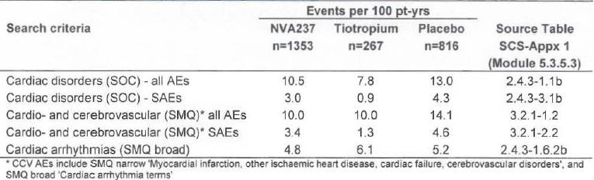

The Delegate requested details of any post marketing studies in regard to cardiovascular safety of Seebri. The request is made in the light of evaluations of other inhaled anticholinergic agents (tiotropium and ipratropium) in the post marketing setting. It is worth noting that the extensive and derailed evaluation of CCV events conducted by Novartis should provide some reassurance on this matter. In response to the Delegate’s comment, in this section the sponsor outlines their plans for a post marketing multinational database cohort study to assess adverse cardiovascular outcomes in association with inhaled Seebri.

The sponsor will conduct a post marketing safety study on CV outcomes in 3000 patients to be completed 5 years after launch in Europe. A protocol outline will be included in the updated RMP. The sponsor will provide the TGA with a complete copy of the updated RMP pending the outcome of the Committee’s deliberations. In addition, the PSUR will include reports on:

1. CCV events and specifically atrial fibrillation/flutter
2. safety experience in patients with arrhythmia, unstable ischemic heart disease and QTc prolongation, and
3. safety experience with long-term use beyond one year.

##### Novartis’ response to other matters raised in the Delegate’s Overview

The sponsor noted the Delegate’s comments in relation to some reservations held by the Clinical Evaluator [DO]. For completeness, a brief response to these matters isincluded in this section.

*“No drug interaction studies were conducted between glycopyrronium and other oraflinhaled medicatioll commonly used ill COPD.” [DO]*

The clinical evaluator raised the concern that no drug interaction studies between Seebri and other oral/inhaled medications commonly used in COPD were conducted [CER]. The Novartis drug-drug interaction strategy for Seebri was designed in accordance with the EMA guideline[18] and therefore considered acceptable by the nonclinical evaluator [NER]. The low likelihood for systemic drug interaction is related to the extremely low plasma concentration observed after inhalation of Seebri. Moreover, available data from studies, whether *in vitro*, drug-drug interaction with indacaterol or Phase III including patients on typical co medication, did not identify any clinically relevant pharmacokinetic interactions. In conclusion, based on the known pharmacokinetic properties of Seebri, no interactions are anticipated.

*“The possibility of kinetic interaction between glycopyrrollium and smoking cessation aids or nicotine replacement therapy was not investigated as mentioned in the CPMP guidelines).” [DO]*

The clinical evaluator also commented on the possibility of interaction between Seebri and smoking cessation aids or nicotine replacement therapy, which had not been investigated [CER]. However, the population PK analysis did not show a difference in PK between smokers and non smokers. Thus, there is no PK interaction between glycopyrronium and nicotine. Consequently, nicotine replacement therapy is not thought to affect the PK of glycopyrronium. There is no rationale to expect that nicotine replacement therapy or smoking cessation should affect inhalation and thus lung deposition and efficacy of Seebri. The general lack of PK interaction potential outlined above would also apply from a clinical pharmacology perspective to treatments for smoking cessation and nicotine replacement.

##### Concluding remarks

Seebri showed consistent and durable efficacy against placebo in two large clinical trials in a clinically relevant patient population. Additional important information about the persistence of the clinical benefits of Seebri can be concluded from the comparison to open label tiotropium in the 12 month pivotal trial. Moreover, the product was well tolerated without any unexpected safety issues in COPD patients exposed up to one year. Overall, there is adequate evidence to support the favourable risk/benefit for the proposed indication; a view supported by the TGA Delegate and Clinical Evaluator. In the management of patients with COPD, the aims of pharmacological therapy are to optimise lung function, decrease exacerbations and reduce the decline in their quality of life. Approval of Seebri would offer physicians and patients an alternative once daily LAMA therapy to treat the symptoms of COPD and help improve quality of life. Its rapid onset of action and the potential to improve exercise tolerance from the first dose onward also represent potential benefits to COPD patients.

#### Advisory Committee Considerations

The Advisory Committee on Prescription Medicines (ACPM), taking into account the submitted evidence of efficacy, safety and quality, agreed with the delegate and considered these products to have an overall positive benefit-risk profile for the following indication;

*For use as a once-daily maintenance bronchodilator treatment to relieve symptoms of patients with chronic obstructive pulmonary disease (COPD).*

In making this recommendation, the ACPM noted that while the studies support a small but significant measure of efficacy and an acceptable safety profile, a safety signal is present for adverse cardiovascular effects. However, this appears to be related to short acting products of this class, further monitoring is warranted.

The ACPM agreed with the Delegate to the proposed amendments to the PI and CMI.

The ACPM advised that the implementation by the sponsor of the recommendations outlined above to the satisfaction of the TGA, in addition to the evidence of efficacy and safety provided would support the safe and effective use of these products.

### Outcome

Based on a review of quality, safety and efficacy, TGA approved the registration of Seebri Breezhaler and Tovanor Breezhaler glycopyrronium (as bromide) 50 µg powder for inhalation, indicated for:

*Seebri Breezhaler and Tovanor Breezhaler glycopyrronium (as bromide) 50 microgram powder for inhalation is indicated as a once-daily maintenance bronchodilator treatment to relieve symptoms of patients with chronic obstructive pulmonary disease (COPD).*

**Specific conditions of registration applying to these therapeutic goods:**

1. The implementation in Australia of the Seebri/Tovanor Breezhaler glycopyrronium bromide 50 µg inhalation powder hard capsule RMP, (Version 1, dated 30 September 2011 and Australian Specific Annex, Version: 1.0, dated 30 September 2011), included with submission PM-2011-020800-3-5, and any subsequent revisions with any accompanying caveats and requests for pharmacovigilance activities as agreed with the TGA and its OPR.

## Attachment 1. Product Information

The Product Information approved at the time this AusPAR was published is at Attachment 1. For the most recent Product Information, please refer to the TGA website at <http://www.tga.gov.au/hp/information-medicines-pi.htm>.

## Attachment 2. Extract from the Clinical Evaluation Report

1. “Grandfathered” refers to products included in the ARTG that were legally supplied in Australia prior to the enactment of *Therapeutic Goods Act 1989* in 1991.
2. Gosens R, et al. (2006) Muscarinic receptor signaling in the pathophysiology of asthma and COPD. *Respir. Res.* 7: 73
3. Barnes PJ. (1993) Muscarinic receptor subtypes in airways. *Life Sci.* 52: 521-527.
4. Wolff RK and Dorato MA. (1993) Toxicologic testing of inhaled pharmaceutical aerosols. *Crit. Rev. Toxicol.* 23: 343-369.
5. Crapo JD, et al. (1983) Morphometric characteristics of cells in the alveolar region of mammalian lungs. *Am. Rev. Respir. Dis.* 128: S42-S46.
6. European Medicines Agency, “Committee for Proprietary Medicinal Products (CPMP): Points to consider on clinical investigation of medicinal products in the chronic treatment of patients with chronic obstructive pulmonary disease (COPD) (CPMP/EWP/562/98)”, 19 May 1999, Web, accessed 26 February 2013 <www.emea.europa.eu/docs/en_GB/document_library/ Scientific_guideline/2009/09/WC500003557.pdf>.
7. A model based approach was used to characterise the NVA237 dose-regimen-response relationship for various spirometry outcomes. This quantitative characterisation of dose response was then used to evaluate the maximum difference in response for the various endpoints between the modelled dosing regimens over the range of doses 20 μg to 55 μg.
8. European Medicines Agency, “Committee for Proprietary Medicinal Products (CPMP): Points to consider on clinical investigation of medicinal products in the chronic treatment of patients with chronic obstructive pulmonary disease (COPD) (CPMP/EWP/562/98)”, 19 May 1999, Web, accessed 26 February 2013 <www.emea.europa.eu/docs/en_GB/document_library/ Scientific_guideline/2009/09/WC500003557.pdf>.
9. Celli B, et al. (2009) Mortality in the 4-year trial of tiotropium (UPLIFT) in patients with chronic obstructive pulmonary disease. *Am J Respir Crit Care Med.* 180: 948-55.
10. Celli B, et al (2010) Cardiovascular safety of tiotropium in patients with COPD. *Chest* 137: 20-30.
11. Inhaled tiotropium is available in two formulations: as a powder (Spiriva; Boehringer Ingelheim, Germany) delivered with a Handihaler device (Boehringer Ingelheim) and in solution as a mist delivered with the Respimat Soft Mist Inhaler (Boehringer Ingelheim). The mist inhaler is a propellant free device, which generates a fine, slow moving cloud for inhalation and the delivered dose is independent of inspiratory effort and relatively unaffected by problems with breathing manoeuvre compared with other devices. It is recommended for use in patients who have poor manual dexterity and therefore have difficulty using the Handihaler. Pharmacokinetic studies have shown that compared with tiotropium 18 μg delivered by the Handihaler, peak plasma concentrations with the mist inhaler at doses of 5 μg and 10 μg were 35% and threefold higher, respectively.
12. Singh S, et al. (2008) Inhaled anticholingergics and risk of major adverse cardiovascular events in patients with chronic obstructive pulmonary disease: A systematic review of meta-analysis. *JAMA* 300: 1439-1450; Singh S, et al. (2011) Mortality associated with tiotropium mist inhaler in patients with chronic obstructive pulmonary disease: systematic review and meta-analysis of randomised controlled trials. *BMJ* 342: d3215.
13. Details of revisions to the PI are beyond the scope of this AusPAR.
14. European Medicines Agency, “ICH Topic E 2 E Pharmacovigilance Planning (Pvp) Step 5: Note for Guidance on Planning Pharmacovigilance Activities (CPMP/ICH/5716/03)”, June 2005, Web, accessed 4 March 2013 <www.ema.europa.eu/docs/en_GB/document_library/Scientific_guideline/ 2009/09/WC500002818.pdf>.
15. Donohue JF, et al. (2002) A 6-month, placebo-controlled study comparing lung function and health status changes in COPD patients treated with tiotropium or salmeterol. *Chest* 122: 47-55; Casaburi R, et al. (2002) A long-term evaluation of once-daily inhaled tiotropium in chronic obstructive pulmonary disease. *Eur Respir J.* 19: 217-224.
16. European Medicines Agency, “Committee for Proprietary Medicinal Products (CPMP): Points to consider on clinical investigation of medicinal products in the chronic treatment of patients with chronic obstructive pulmonary disease (COPD) (CPMP/EWP/562/98)”, 19 May 1999, Web, accessed 26 February 2013 <[http://www.emea.europa.eu/docs/en_GB/document_library/ Scientific_guideline/2009/09/WC500003557.pdf](http://www.emea.europa.eu/docs/en_GB/document_library/%20Scientific_guideline/2009/09/WC500003557.pdf)>.
17. Tashkin DP, *et al*. (2008) A 4-year trial of tiotropium in chronic obstructive pulmonary disease. *N Engl J Med.* 359: 1543-1554.
18. European Medicines Agency, “Committee for Proprietary Medicinal Products (CPMP): Note for guidance on the investigation of drug interactions (CPMP/EWP/560/95)”, 17 December 1997, Web, accessed 26 June 2013 <www.ema.europa.eu/docs/en_GB/document_library/Scientific_guideline/ 2009/09/WC500002966.pdf>.