|  |
| --- |
| **20 September 2014** |

|  |
| --- |
| AusPAR Attachment 2 |
| Extract from the Clinical Evaluation Report for Human Papillomavirus 9 valent Vaccine, Recombinant |
| Proprietary Product Name: Gardasil 9 |
| Sponsor: Merck Sharp and Dohme Australia Pty Ltd |

About the Therapeutic Goods Administration (TGA)

* The Therapeutic Goods Administration (TGA) is part of the Australian Government Department of Health, and is responsible for regulating medicines and medical devices.
* The TGA administers the *Therapeutic Goods Act 1989* (the Act), applying a risk management approach designed to ensure therapeutic goods supplied in Australia meet acceptable standards of quality, safety and efficacy (performance), when necessary.
* The work of the TGA is based on applying scientific and clinical expertise to decision-making, to ensure that the benefits to consumers outweigh any risks associated with the use of medicines and medical devices.
* The TGA relies on the public, healthcare professionals and industry to report problems with medicines or medical devices. TGA investigates reports received by it to determine any necessary regulatory action.
* To report a problem with a medicine or medical device, please see the information on the TGA website < <https://www.tga.gov.au>>.

About the Extract from the Clinical Evaluation Report

* This document provides a more detailed evaluation of the clinical findings, extracted from the Clinical Evaluation Report (CER) prepared by the TGA. This extract does not include sections from the CER regarding product documentation or post market activities.
* The words [Information redacted], where they appear in this document, indicate that confidential information has been deleted.
* For the most recent Product Information (PI), please refer to the TGA website < <https://www.tga.gov.au/product-information-pi>>.

Copyright

© Commonwealth of Australia 2017  
This work is copyright. You may reproduce the whole or part of this work in unaltered form for your own personal use or, if you are part of an organisation, for internal use within your organisation, but only if you or your organisation do not use the reproduction for any commercial purpose and retain this copyright notice and all disclaimer notices as part of that reproduction. Apart from rights to use as permitted by the *Copyright Act 1968* or allowed by this copyright notice, all other rights are reserved and you are not allowed to reproduce the whole or any part of this work in any way (electronic or otherwise) without first being given specific written permission from the Commonwealth to do so. Requests and inquiries concerning reproduction and rights are to be sent to the TGA Copyright Officer, Therapeutic Goods Administration, PO Box 100, Woden ACT 2606 or emailed to < [tga.copyright@tga.gov.au](mailto:tga.copyright@tga.gov.au)> .

Contents

List of abbreviations 4

1. Introduction 10

2. Clinical rationale 11

2.1. Licensed prophylactic HPV vaccines 12

2.2. qHPV vaccine (original strains) 12

2.3. Formulation development 13

3. Contents of the clinical dossier 14

3.1. Scope of the clinical dossier 14

3.2. Other objectives in this submission 19

3.3. Paediatric data 20

3.4. Good clinical practice 20

4. Pharmacokinetics 20

5. Pharmacodynamics 20

6. Dosage selection for the pivotal studies 20

7. Clinical efficacy 21

7.1. Pivotal efficacy studies 22

7.2. Other efficacy studies 51

7.3. Analyses performed across trials (pooled analyses and meta-analyses) 57

7.4. Evaluator’s conclusions on clinical efficacy for 9vHPV 57

8. Clinical safety 58

8.1. Studies providing evaluable safety data 58

8.2. Pivotal studies that assessed safety as a primary outcome 61

8.3. Patient exposure 63

8.4. Adverse events 63

8.5. Laboratory tests 66

8.6. Post-marketing experience 68

8.7. Evaluator’s overall conclusions on clinical safety 68

9. First round benefit-risk assessment 69

9.1. First round assessment of benefits 69

9.2. First round assessment of risks 70

9.3. First round assessment of benefit-risk balance 71

10. First round recommendation regarding authorisation 71

11. References 71

## List of abbreviations

| Abbreviation | Meaning |
| --- | --- |
| 9vHPV | vaccine Nine-valent Human Papillomavirus vaccine |
| AAHS | Amorphous Aluminium Hydroxyphosphate Sulfate |
| Ab | Antibody |
| AEs | Adverse experiences |
| AFT | Accelerated failure-time |
| AHN or All-HN | All-HPV Naive |
| AIN | Anal intraepithelial neoplasia |
| AIS | Adenocarcinoma in situ |
| AN | Allocation number |
| ANCOVA | Analysis of covariance |
| ANOVA | Analysis of variance |
| ANSS | All (HPV Type-specific) Naïve Subjects with Serology |
| ASaT | All-Subjects-as-Treated |
| ASC-H | Atypical squamous cells cannot rule out HSIL |
| ASC-US | Atypical squamous cells of undetermined significance |
| CFR | Code of Federal Regulations |
| CI | Confidence interval |
| CIN | Cervical intraepithelial neoplasia |
| cLIA | Competitive Luminex Immunoassay |
| CRF | Case report form |
| CSS | Clinical study summary |
| CSR | Clinical study report |
| CV | Coefficient of variation |
| DCL | Diagnostic Cytology Laboratories |
| DNA | deoxyribonucleic acid |
| DSMB | Data and Safety Monitoring Board |
| ECC | Endocervical curettage |
| ECI | Event of Clinical Interest |
| eCRF | Electronic case report form |
| EDC | Electronic Data Capture |
| eDMC | External Data Monitoring Committee |
| EEC | Endo/ectocervical |
| EGLs | External genital lesions |
| ELISA | Enzyme-linked immunosorbent assay |
| ERC | Ethical Review Committee |
| FAS | Full Analysis Set |
| FDA | Food and Drug Administration |
| FPE | First patient enrolled |
| GCC | Global Clinical Compliance |
| GCP | Good Clinical Practice |
| GI | Gastrointestinal |
| GMR | Geometric mean ratio |
| GMTs | Geometric Mean Titres |
| GPV | Global Pharmacovigilance |
| GPvP | Good Pharmacovigilance Practice |
| H&E | Haematoxylin and Eosin |
| hCG | Human chorionic gonadotropin |
| HIV | Human immunodeficiency virus |
| HN-TS | HPV-Naïve Type-Specific |
| HPV | Human Papillomavirus |
| HR | High risk |
| HRT | Hormone replacement therapy |
| HSIL | High grade Squamous Intraepithelial Lesion |
| HSV | Herpes simplex virus |
| ICH | International Conference on Harmonization |
| IEC | Independent Ethics Committee |
| IgG | Immunoglobulin G |
| IM | Intramuscular |
| IND | Investigational New Drug |
| IP | Intraperitoneal |
| IRB | Institutional Review Board |
| IUD | Intrauterine device |
| IV | Intravenous |
| IVIG | Intravenous immunoglobulin |
| IVRS | Interactive Voice Response System |
| JRA | Juvenile rheumatoid arthritis |
| LEEP | Loop Electrosurgical Excision Procedure |
| LLOQ | Lower Limit of quantitation |
| LMP | Last menstrual period |
| LOQ | Limit of quantitation |
| LOD | Limit of detection |
| LPLV | Last patient last visit |
| LR | Low risk |
| LS means | Least-squares means |
| LSIL | Low-Grade Squamous Intraepithelial Lesion |
| LVPP | Labial/vulvar/perineal and perianal |
| mAbs | Monoclonal antibodies |
| MARRS | Merck Adverse event Reporting and Review System |
| MED | Minimal effective dose |
| MFI | Mean fluorescent intensity |
| mMU/mL | milli-Merck Units per millilitre |
| MRL | Merck Research Laboratories |
| MSD | Merck Sharp and Dohme Corp |
| MSE | Mean square error |
| MSM | Men-having-sex-with-men |
| NSAEs | Non-serious adverse experiences |
| NSAID | Nonsteroidal anti-inflammatory drug |
| NWAES | New Worldwide Adverse Experience System |
| OTC | Over the counter |
| Pap | Papanicolaou |
| PBNA | Pseudovirion-based neutralization assay |
| PCL | Protocol Clarification Letter |
| PCR | Polymerase Chain Reaction |
| PE | Phycoerythrin |
| PPD | Pharmaceutical Product Development Vaccines & Biologics |
| PPE | Per Protocol Efficacy |
| PPI | Per Protocol Immunogenicity |
| QA | Quality Assurance |
| QC | Quality Control |
| qHPV | vaccine Quadrivalent Human Papillomavirus vaccine |
| RR | Risk reduction |
| RRP | Recurrent Respiratory Papillomatosis |
| RSD | Relative standard deviation |
| S0P0 | Seronegative and PCR Negative |
| S0P1 | Seronegative and PCR Positive |
| S1P0 | Seropositive and PCR Negative |
| S1P1 | Seropositive and PCR Positive |
| SAEs | Serious Adverse Experiences |
| SAP | Statistical analysis plan |
| SC | Subcutaneous |
| SCC | Squamous cell carcinoma |
| SD | Standard deviation |
| SEM | Standard error of the mean |
| siDMC | Standing Internal Data Monitoring Committee |
| SLE | Systemic lupus erythematosus |
| STIs | Sexually transmitted infections |
| SUBJID | Subject identification number (a.k.a., AN) |
| ULN | Upper limit of normal |
| ULOQ | Upper limit of quantification / Upper limit of quantitation |
| VaIN | Vaginal Intraepithelial Neoplasia |
| VE | Vaccine efficacy |
| VIN | Vulvar Intraepithelial Neoplasia |
| VLP | Virus-Like Particle |
| VRC | Vaccination Report Card |
| WBC | White blood (cell) count |

## Introduction

The submission proposes registration of Gardasil 9 a nine valent vaccine for HPV.

Each 0.5 mL dose contains approximately 30 µg of HPV 6 L1 protein, 40 µg of HPV 11 L1 protein, 60 µg of HPV 16 L1 protein, 40 µg of HPV 18 L1 protein, 20 µg of HPV 31 L1 protein, 20 µg of HPV 33L1 protein, 20 µg of HPV 45 L1 protein, 20 µg of HPV 52 L1 protein, and 20 µg of HPV 58 L1 protein.

Each 0.5 mL dose of the vaccine contains approximately 500 µg of aluminium (as amorphous aluminium hydroxyphosphate sulphate adjuvant), 9.56 mg of sodium chloride, 0.78 mg of L‑histidine, 50 µg of polysorbate 80, 35 µg of sodium borate , residual traces (< 7µg/dose) of yeast protein and water for injection. The product does not contain a preservative or antibiotics.

The original studies of the quadrivalent HPV [Types 6, 11, 16, 18] vaccine (qHPV vaccine) showed that the vaccine prevents:

* HPV 16/18 related high grade cervical, vulvar, vaginal and anal dysplasia, the obligate precursors of HPV related cervical, vulvar, vaginal, and anal cancers
* HPV 6/11/16/18 related cervical, vulvar, vaginal, and anal dysplasia (any grade)
* HPV 6/11/16/18 related persistent infection and
* HPV 6/11 related condyloma acuminata (genital warts).

Based on these findings and an acceptable safety profile, qHPV vaccine has been approved and marketed under the name Gardasil/Silgard in over 130 countries. The proposed 9vHPV vaccine targets HPV Types 6, 11, 16, and 18 (called ‘original types’) as well as HPV Types 31, 33, 45, 52, and 58 (‘new types’). The 9vHPV vaccine program was designed so that the 9vHPV vaccine proposed indications would include all the current qHPV vaccine indications plus indications related to the new types. These are summarised below

Approved Gardasil indications:

*Gardasil is indicated in females aged 9 through 45 years* for the prevention of cervical, vulvar, vaginal and anal cancer, precancerous or dysplastic lesions, genital warts, and infection caused by Human Papillomavirus (HPV) Types 6, 11, 16 and 18 (which are included in the vaccine).*

*Gardasil is indicated in males aged 9 through 26 years of age for the prevention of anal cancer, precancerous or dysplastic lesions, external genital lesions and infection caused by HPV Types 6, 11, 16 and 18 (which are included in the vaccine).*

*\*Immunogenicity studies have been conducted to link efficacy in females and male aged 16 to 26 years to the younger populations.*

Proposed Gardasil 9 Indications:

*Gardasil 9 is indicated in females aged 9 through 45 years* for the prevention of cervical, vulvar, vaginal and anal cancer, precancerous or dysplastic lesions, genital warts, and infection caused by Human Papillomavirus (HPV) Types 6, 11, 16, 18, 31, 33, 45, 52 and 58 (which are included in the vaccine).*

*Gardasil 9 is indicated in males aged 9 through 26 years of age for the prevention of anal cancer, precancerous or dysplastic lesions, external genital lesions and infection caused by HPV Types 6, 11, 16, 18, 31, 33, 45, 52 and 58 (which are included in the vaccine).*

*\*Immunogenicity studies have been conducted to link efficacy in females and male aged 16 to 26 years to the younger populations.*

This submission is for the use of the 9vHPV vaccine in girls and women from 9 years of age onward for the prevention of cervical, vulvar, vaginal, and anal cancer; precancerous or dysplastic lesions; genital warts; and persistent infections caused by Human Papillomavirus (HPV).

Specifically, the indication sought is to prevent the following diseases:

* Cervical, vulvar, vaginal, and anal cancer caused by HPV types 16, 18, 31, 33, 45, 52, and 58
* Genital warts (condyloma acuminata) caused by HPV types 6 and 11
* Persistent infections and the following precancerous or dysplastic lesions caused by HPV types 6, 11, 16, 18, 31, 33, 45, 52, and 58:
  + Cervical intraepithelial neoplasia (CIN) Grade 2 and 3 and Cervical adenocarcinoma in situ (AIS)
  + Cervical intraepithelial neoplasia (CIN) Grade 1
  + Vulvar intraepithelial neoplasia (VIN) Grade 2 and 3
  + Vaginal intraepithelial neoplasia (VaIN) Grade 2 and 3
  + VIN Grade 1 and VaIN Grade 1
  + Anal intraepithelial neoplasia (AIN) Grades 1, 2 and 3.

This vaccine will also be indicated for use in boys and men from 9 years of age onward for the prevention of external genital lesions and persistent infections and the following diseases caused by HPV types included in the vaccine:

* Anal cancer caused by HPV types 16, 18, 31, 33, 45, 52, and 58
* Genital warts (condyloma acuminata) caused by HPV types 6 and 11
* Anal intraepithelial neoplasia (AIN) Grades 1, 2 and 3 caused by HPV types 6, 11, 16, 18, 31, 33, 45, 52, and 58.

## Clinical rationale

There is a huge burden of disease, malignant and non-malignant, relating to HPV infection, localised primarily in the anogenital area and aerodigestive tract, in both men and women. HPV types cause a wide range of clinical problems, ranging from being high risk carcinogens to the causative organism for anogenital and aerodigestive warts (Table 1). They are classified into high risk (HR) types, based on their potential to cause cancer, and low risk (LR) types (causing generally benign lesions). The International Agency for Research on Cancer (IARC) has identified 12 HPV types as carcinogens. These include the 7 HR HPV types represented in the 9vHPV vaccine (HPV 16, 18, 31, 33, 45, 52, and 58) and 5 HR HPV types not represented in the 9vHPV vaccine (HPV 35, 39, 51, 56, and 59). LR HPV types 6 and 11, which are responsible for approximately 90% genital warts and RRP cases, are also included in the 9vHPV vaccine.

Table 1: Diseases attributable to HPV by anatomic site

| Diseases attributable to HPV by anatomic site | |
| --- | --- |
| Anogenital manifestations of HPV disease | |
| Cervical Cancer | Nearly 100% of cervical cancers are caused by HPV infection 530,000 new cases diagnosed every year worldwide†; 275,000 annual deaths |
| Other Anogenital Cancers | Approximately 90% of anal cancers, 25% of vulvar cancers, 70% of vaginal cancers, and 30 to 40% of penile cancers are caused by HPV infection  Over 40,000 new cases diagnosed in men and women every year worldwide |
| Anogenital Warts (Condyloma Acuminata) | Benign lesions; treatment often lengthy and painful; high recurrence rates  Incidence rate 0.1 to 0.2% in developed countries, higher in developing countries, representing millions of cases every year |
| Aerodigestive Manifestations of HPV Disease | |
| Oropharyngeal Cancers‡ | Approximately 27% of oropharyngeal cancers are caused by HPV infection  Approximately 22,000 new cases diagnosed every year worldwide (approximately 80% in men); infection is likely sexually acquired |
| Recurrent Respiratory Papillomatosis (RRP) | Rare, generally benign disease; exophytic warts in upper airway can cause severe speech and respiratory impairment, and death by blocking the airway  HPV transmitted from mother to child during passage through the birth canal. In young adults, could be sexually transmitted or a recurrence of childhood infection |

† 80% of the cases in developing countries. In developed countries, cervical cancer screening programs have reduced the incidence of cervical cancer by 75% due to the detection, follow up, and treatment of premalignant lesions (generally involve invasive procedures which represent substantial healthcare utilization). ‡ HPV has also been detected in cancers of the oral cavity and the larynx, although a causal role has not been established.

### Licensed prophylactic HPV vaccines

The 2 currently licensed prophylactic HPV vaccines (bivalent HPV [Types 16, 18] L1 VLP vaccine and quadrivalent HPV (qHPV) vaccine) address high risk types HPV 16 and HPV 18, which are responsible for approximately 70% of cervical cancers yet does not cover genital warts. The qHPV vaccine additionally addresses LR types HPV 6 and HPV 11 (responsible for approximately 90% of genital warts).

### qHPV vaccine (original strains)

In clinical trials, qHPV vaccine was highly efficacious in preventing the development of HPV 16 and 18 related high grade cervical, vulvar, vaginal, and anal dysplasia (the obligate precursors of cervical cancer, and HPV related; vulvar, vaginal, and anal cancers, respectively); HPV 6 and 11 related external genital lesions (including genital warts); HPV 6, 11, 16, and 18 related cervical dysplasia (any grade); and HPV 6, 11, 16 and 18 related persistent infection. Long term effectiveness is being assessed in long term follow up of clinical study cohorts. Interim analyses showed no breakthrough of HPV related disease after up to 6 years of follow up thus far. As of July 2013, the qHPV vaccine has been approved and marketed for use in females over 9 under the name Gardasil/Silgard in over 130 countries. It has also been approved for use in males in 76 countries. Reports from several countries with HPV vaccination programs indicate a rapid, beneficial effect of qHPV vaccination at the population level, including a substantial decrease in the incidence of high grade cervical abnormalities,[1] prevalence of vaccine HPV types,[2] and incidence of genital warts,[3] as early as 3 years following the introduction of the vaccine.

Australia has been the first country to introduce a fully funded national HPV vaccination program. The program, targeted to adolescent females 12 to 13 years of age, was started in April 2007. In addition, up to 31 December 2009, a catch-up vaccination program was offered to girls and women, 14 to 26 years of age.[4] A decrease was noted in incidence of high grade cervical abnormalities in girls less than 18 years of age.1 The prevalence of the vaccine HPV genotypes (6, 11, 16, and 18) also substantially decreased among women following qHPV vaccination.2 Within approximately 3 years following implementation of this qHPV vaccination program, a decline was also observed in the diagnosis of genital warts among young Australian women. A subsequent study reported the near disappearance of genital warts in young women and young heterosexual men within approximately 4 years following implementation of this vaccination program.[5]

Phase III studies have established that the qHPV vaccine is highly efficacious in preventing genital warts and anal cancer and pre cancers in males, and therefore can contribute to reducing the burden of HPV diseases in males.[6] A potential benefit of HPV vaccination in males is contribution to herd protection, which could ultimately lead to a substantial reduction of HPV diseases in both males and females.

The 9vHPV vaccine contains the same HPV types already represented in the qHPV vaccine (HPV 6, 11, 16, and 18), as well as five additional HR HPV types (31, 33, 45, 52, and 58). HPV 16 and 18 are responsible for most (approximately70%) cases of cervical cancer. An additional approximately20% of cases are due to HPV Types 31, 33, 45, 52, and 58.[7] Thus, the 9vHPV vaccine has the potential to prevent approximately90% cervical cancers. The 9vHPV vaccine also has the potential to expand upon the clinical benefit of the qHPV vaccine by preventing more high and low grade cervical dysplasia. The qHPV vaccine prevents approximately 50% cervical intraepithelial neoplasia (CIN) 2/32. The 9vHPV vaccine could prevent approximately 80% CIN 2/3 (a 30% incremental increase over qHPV vaccine), which could match or exceed the efficacy of most cervical cancer screening programs. The vaccine could also prevent approximately 55% CIN 1.

### Formulation development

Prophylactic HPV vaccines have been developed based on virus like particles (VLPs), which are produced by self-assembly of recombinant HPV L1 capsid proteins expressed in a heterologous cell substrate. VLPs mimic the overall structure of HPV virions, thus keeping capsid proteins in their native antigenic conformation. VLPs are non-infectious because they do not contain viral DNA. The qHPV vaccine is adjuvanted with a proprietary aluminium based adjuvant (amorphous aluminium hydroxyphosphate sulphate (AAHS)) which has a good safety record and substantially enhances qHPV vaccine immunogenicity. The 9 valent HPV (Types 6, 11, 16, 18, 31, 33, 45, 52, 58) L1 VLP vaccine (9vHPV vaccine) addresses the HPV types represented in qHPV vaccine and 5 additional HR HPV types. The 9vHPV vaccine is formulated with AAHS as the adjuvant consists of highly purified VLPs of the L1 capsid proteins from HPV 6, 11, 16, 18, 31, 33, 45, 52, and 58. Like for qHPV vaccine, the L1 capsid proteins in the vaccine are individually expressed in Saccharomyces cerevisiae yeast.

A 0.5 mL dose of 9vHPV vaccine contains 30 µg HPV Type 6 L1 VLP, 40 µg HPV Type 11 L1 VLP, 60 µg HPV Type 16 L1 VLP, 40 µg HPV Type 18 L1 VLP, 20 µg HPV Type 31 L1 VLP, 20 µg HPV Type 33 L1 VLP, 20 µg HPV Type 45 L1 VLP, 20 µg HPV Type 52 L1 VLP, 20 µg HPV Type 58 L1 VLP, and 500 µg of the adjuvant AAHS.

The 9vHPV vaccine is not a live virus vaccine. It is not capable of causing viral infection.

## Contents of the clinical dossier

### Scope of the clinical dossier

The submission contained the following clinical information:

* pivotal efficacy/safety studies
* Nonclinical and clinical overview, summary of clinical pharmacology, efficacy and safety, quality summary, summary of clinical safety and literature references.

The submission also included animal studies (in the nonclinical dossier)

There are 6 studies included in this submission that provide data for the efficacy/ immunogenicity of 9vHPV, these are summarised in Tables 2, 3 and 4.

Table 2: Listing of protocols that provided efficacy and immunogenicity data for the 9vHPV vaccine (Protocol 001)

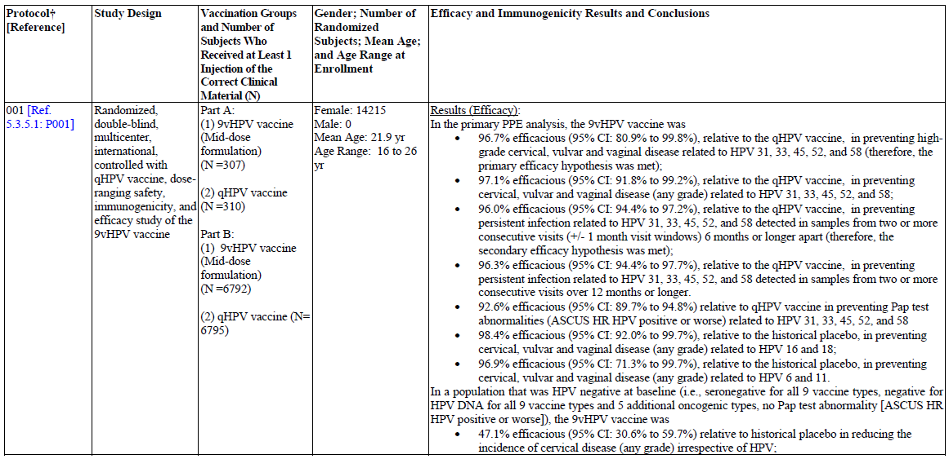

Table 2 (continued): Listing of protocols that provided efficacy and immunogenicity data for the 9vHPV vaccine (Protocol 001)

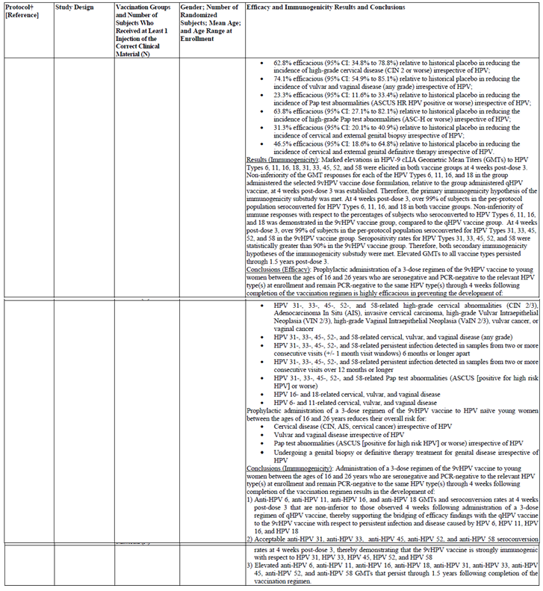

Table 3: Listing of protocols that provided efficacy and immunogenicity data for the 9vHPV vaccine (Protocols, 002)

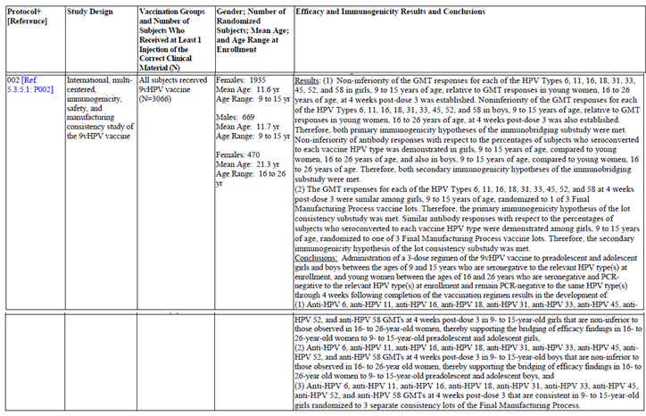

Table 4: Listing of protocols that provided efficacy and immunogenicity data for the 9vHPV vaccine (Protocols 005, 006, 007, and 009)

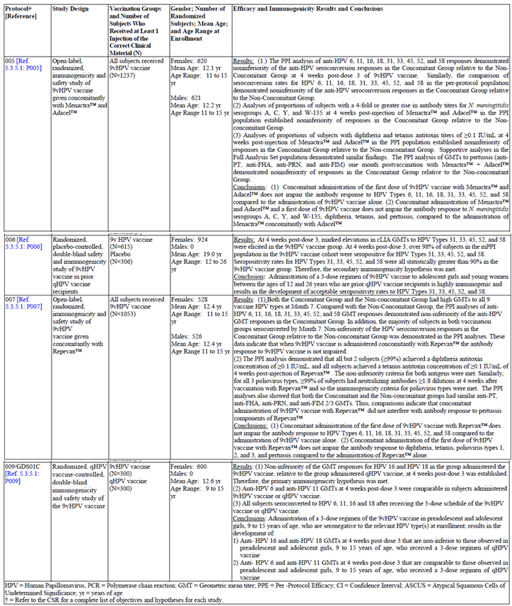

The qHPV vaccine has been marketed since 2006, is available in many countries, and represents the current standard of care for protection against HPV infection and disease. Therefore, using a placebo comparator to assess the clinical efficacy of the 9vHPV vaccine was not acceptable. For this reason, clinical efficacy of the 9vHPV vaccine was assessed using the qHPV vaccine as an active comparator. The clinical development program was designed to establish 9vHPV vaccine efficacy in females, 16 to 26 years of age, based on a large Phase III comparative efficacy study of 9vHPV vaccine versus qHPV vaccine, referred to as Protocol V503-001 (Study 001).

Preadolescents and adolescents could not be included in original Gardasil studies as they involved gynaecological and genital examination and sampling. Therefore, licensure of the qHPV vaccine in preadolescents and adolescents, 9 to 15 years of age, was based on demonstrating that the qHPV vaccine induced non-inferior antibody responses to all 4 vaccine types in this population compared to the responses in a core efficacy population of subjects 16 to 26 years of age (the population used to establish qHPV vaccine efficacy. Using this immunological bridging analysis, the efficacy findings in the core efficacy population were extended to the 9 to 15 year old population.

A similar adult to adolescent immunological bridging strategy was used in the clinical development program of the 9vHPV vaccine to demonstrate that the 9vHPV vaccine immunogenicity for all 9 vaccine types was non-inferior in females and males, 9 to 15 years of age, compared to that in females, 16 to 26 years of age (the population used to establish 9vHPV vaccine efficacy). This is the major objective of Protocol V503-002 (Study 002). This approach has been accepted by the USFDA, the EMA/CHMP, and Health Canada’s BGTD. Additional assessment of immunogenicity was conducted to further strengthen the immunological bridging conclusions from Study 002. Since this assessment was considered supportive, it was conducted only in females, 9 to 15 years of age. This included:

* Protocol V503-009(Study 009) provided immunological bridging from qHPV vaccine to 9vHPV vaccine in preadolescent and adolescent girls, 9 to 15 years of age, by demonstrating that both vaccines have similar immunogenicity with respect to HPV 6, 11, 16, and 18. This study was requested by the EMA/CHMP during Scientific Advice (SA) in 2008 (EMEA/H/SA/1086/1/2008/II), and by EMA Paediatric Committee (PDCO) in 2010 (EMEA-000654-PIP01-09).[8]
* An additional, supportive cross-study analysis to compare the immunogenicity of the 9vHPV vaccine in preadolescent and adolescent girls, 9 to 15 years of age, enrolled in Study 002 with the immunogenicity of the qHPV vaccine in young women, 16 to 26 years of age, enrolled in Protocol V503-001, with respect to HPV 6, 11, 16, and 18.

The immunobridging strategy in the 9vHPV vaccine program was conducted based on a stepwise approach:

*Pivotal analyses:*

1. Demonstrate non-inferior immunogenicity in females, 16 to 26 years of age, administered 9vHPV vaccine versus females, 16 to 26 years of age, administered qHPV vaccine with respect to the 4 original types (Protocol V503- 001)
2. Demonstrate non-inferior immunogenicity in females, 9 to 15 years of age, administered 9vHPV vaccine versus females, 16 to 26 years of age, administered 9vHPV vaccine with respect to the 9 vaccine types (Protocol V503-002)
3. Demonstrate non-inferior immunogenicity in males, 9 to 15 years of age, administered 9vHPV vaccine versus females, 16 to 26 years of age, administered 9vHPV vaccine with respect to the 9 vaccine types (Protocol V503-002)

*Supportive analyses:*

1. Demonstrate non-inferior immunogenicity in females, 9 to 15 years of age, administered 9vHPV vaccine versus females, 9 to 15 years of age, administered qHPV vaccine with respect to HPV 16 and 18 (Protocol V503-009)
2. Demonstrate non-inferior immunogenicity in females, 9 to 15 years of age, administered 9vHPV vaccine versus females, 16 to 26 years of age, administered qHPV vaccine with respect to the 4 original types (cross-study comparison: Protocol V503-002 versus Protocol V503-001)

All of these key aspects of the immunological bridging strategy involving the qHPV vaccine and 9vHPV vaccine clinical development programs are represented in Figure 1.

Figure 1: Immunological bridging strategy in the 9vHPV vaccine program

Figure 1 Immunological bridging strategy in the 9vHPV vaccine program
16 to 26 year old females  with 9vHPV vaccine
step 1 non inferiority  (anti HPV 6,11,16, 18) versus 16 to 26 year old females with qHPV vaccine

9 to 15 year old females with qHPV vaccine non iferiority (anti HPV 6,11,16, 18) versus 16 to 26 year old females with qHPV vaccine
9 to 15 year old females with 9vHPV vaccine non iferiority (anti HPV (6, 11, 16, 18, 31, 33, 45, 52, 58) to 16 to 26 year old females  with 9vHPV vaccine

Step 3 9 to 15 year old males with 9vHPV vaccine non inferioirity for HPV (6, 11, 16, 18, 31, 33, 45, 52, 58) to 16 to 26 year old females  with 9vHPV vaccine

Step 4: 9 to 15 year old females with 9vHPV non inferioirity (anti HPV 16, 18) to 9 to 15 year old females with q HPV vaccine

Step 5  9 to 15 year old females with 9vHPV superiorority (anti HPV 6, 11, 16, 18) to 16 to 26 year old females with qHPV vaccine



### Other objectives in this submission

#### Concomitant use of 9vHPV vaccine with other vaccines

Additional studies were conducted to demonstrate that concomitant administration of the 9vHPV vaccine and vaccines routinely administered in adolescents does not affect the antibody responses to any of the other vaccines.

* Concomitant administration of 9vHPV vaccine with Menactra (meningococcal [Groups A, C, Y and W-135] polysaccharide diphtheria toxoid conjugate vaccine, Sanofi Pasteur, Swiftwater, PA) and Adacel (tetanus toxoid, reduced diphtheria toxoid and acellular pertussis vaccine adsorbed, Sanofi Pasteur, Toronto, Ontario, Canada) was assessed in females and males, 11 to 15 years of age, in Protocol V503-005 (Study 005).
* Concomitant administration of 9vHPV vaccine with Repevax (diphtheria, tetanus, pertussis [acellular, component] and poliomyelitis [inactivated] vaccine [adsorbed, reduced antigen(s) content], Sanofi Pasteur MSD, Ltd., Lyon, France) was assessed in females and males, 11 to 15 years of age, in Protocol V503-007 (Study 007).

#### Use of 9vHPV vaccine in prior qHPV vaccine recipients

The qHPV vaccine has been licensed in 2006. Since then, millions of girls and women have been administered the vaccine. The 9vHPV vaccine was assessed for safety and immunogenicity in prior qHPV vaccine recipients in Protocol V503-006 (Study 006). This study was conducted in females, 12 to 26 years of age. This age range was selected as the most likely age range to receive follow up vaccination with the 9vHPV vaccine, should the vaccine be licensed.

#### Manufacturing lot consistency

A study was conducted to demonstrate clinical consistency of manufactured material through immunogenicity assessment of three different final manufacturing process lots of the 9vHPV vaccine. This assessment was conducted in females, 9 to 15 years of age, as part of Protocol V503-002 (Study 002).

The listing of protocols/results for all these studies that provided efficacy and immunogenicity data is summarised in Tables 2 to 4.

### Paediatric data

The submission includes paediatric efficacy / safety data.

### Good clinical practice

There are statements of compliance with good clinical practice for all studies.

## Pharmacokinetics

There is no pharmacokinetic data supplied in this submission.

## Pharmacodynamics

There is no pharmacodynamic data included in this submission.

## Dosage selection for the pivotal studies

The 3 dose formulations of 9vHPV vaccine tested in Protocol V503-001 are shown in Table 5. The low dose formulation contains the same amounts of HPV 6, 11, 16, and 18 VLPs as the qHPV vaccine and has a higher adjuvant to antigen ratio than the qHPV vaccine. The mid dose formulation contains increased amounts of HPV 6, 16, and 18 VLPs than the qHPV vaccine and has an adjuvant to antigen ratio that is similar to that of the qHPV vaccine. The high dose formulation contains increased antigen amounts for the 7 oncogenic types compared with the mid dose formulation. The adjuvant amount used for all 3 dose formulations was 500 µg of AAHS adjuvant. This amount of AAHS is the same as that used in Recombivax HB3 (hepatitis B vaccine [recombinant]), a recombinant protein based vaccine licensed in many countries to prevent infection with hepatitis B virus, another oncogenic DNA virus. Recombivax HB has been administered to millions of infants, adolescents, and adults, and was found to be effective and have an acceptable safety profile. The dose selected for the second part of Study 001 was the mid dose, taken forward, as shown in Figure 2. This dose was then used in all subsequent studies.

Table 5: Study 001, 9vHPV vaccine dose formulations used for dose selection

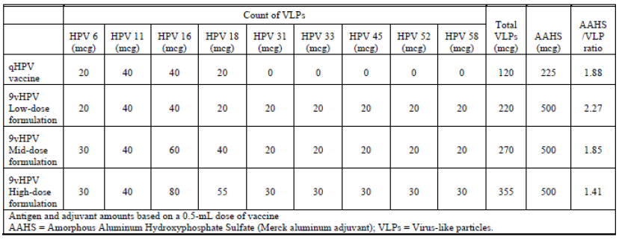

Figure 2: Study 001 objectives of study

Figure 2: Study 001 Objectives of Study
for the 9v HPV vaccine demonstrate non- inferior immunogenicity for (30 µg HPV  6, 40 µg HPV 11, 60 µg HPV 16, 40 µg HPV  18 ) compared with the qHPV vaccine( 20 µg HPV  6, 40 µg HPV 11, 40 µg HPV 16, 20 µg HPV 18) and demonstrate superior efficacy for HPV 31, 33, 45, 52 and 58

## Clinical efficacy

Rather than direct comparison of the clinical efficacy of the 9vHPV vaccine versus qHPV vaccine with respect to HPV 6 , 11, 16 , and 18 related infection (not practical), the immunogenicity of the two vaccines with respect to HPV 6, 11, 16, and 18 was compared. Neutralizing antibodies are recognised as the vaccine induced immune mechanism of protection against HPV infection and disease. Therefore, immunogenicity is an appropriate surrogate for HPV vaccine efficacy. However, since no immune threshold of protection has been identified for HPV vaccines, immunogenicity of the 9vHPV vaccine was compared to that of the qHPV vaccine (known to be highly efficacious in preventing HPV infection and disease related to HPV 6, 11, 16, and 18). Specifically, the qHPV vaccine efficacy findings were bridged to 9vHPV vaccine based on the demonstration of non-inferior immunogenicity in Protocol V503-001 (as described above). This approach has been accepted by the U.S. Food and Drug Administration (USFDA), the European Medicines Agency (EMA) Committee of Medicinal Products for Human Use (CHMP), and Health Canada’s Biologics and Genetic Therapies Directorate (BGTD).

Persistent infection and disease endpoints related to HPV 6, 11, 16, and 18 were also extensively collected in Protocol V503-001 and used to conduct supportive, confirmatory analyses to demonstrate no negative trend on clinical efficacy endpoints with 9vHPV vaccine compared with qHPV vaccine. In these analyses, the respective efficacies of 9vHPV vaccine and qHPV vaccine were determined relative to endpoints in historical placebo recipients from clinical studies of the qHPV vaccine. This approach has been accepted by the USFDA and EMA in 2008.

*Assessment of 9vHPV Vaccine Efficacy against Persistent Infection and Disease Related to HPV Types 31, 33, 45, 52, and 58*

The qHPV vaccine has limited efficacy against infection and disease caused by non-vaccine HPV types. Therefore, the qHPV vaccine represents a suitable control to assess clinical efficacy of the 9vHPV vaccine with respect to persistent infection and disease caused by HPV 31, 33, 45, 52, and 58 (essentially placebo). The qHPV vaccine clinical development program previously established disease, infection and cytology endpoints to demonstrate efficacy of the qHPV vaccine compared to placebo. Similar disease, persistent infection, and cytology endpoints were used in the 9vHPV vaccine program to assess the efficacy of 9vHPV vaccine compared to qHPV vaccine with respect to HPV 31, 33, 45, 52, and 58.

### Pivotal efficacy studies

#### Study V503-001 (Study 001)

Study V503-001 a Phase IIb/III randomised international, double blinded controlled with Gardasil, dose ranging, tolerability, immunogenicity and efficacy study of the 9vHPV vaccine in women 16 to 26

##### Study design, objectives, locations and dates

Study 001 study was designed as a combination of 3 sub-studies:

* A Phase IIb dose ranging sub-study including all subjects enrolled under Part A, to select a vaccine dose formulation for the 9vHPV vaccine program based on immunogenicity and safety assessment through Month 7.
* A Phase III efficacy sub-study including those subjects enrolled under Part A who received the selected dose formulation of 9vHPV vaccine (mid dose 9vHPV vaccine) or the qHPV vaccine control, and subjects enrolled under Part B, to assess the efficacy and safety objectives of the study.
* A Phase III immunogenicity sub-study, that included subjects enrolled under Part B, to assess the immunogenicity objectives of the study.

The 2 primary objectives of V503-001 (Study 001) were immunological bridging with respect to HPV 6, 11, 16, and 18 and demonstration of efficacy with respect to HPV 31, 33, 45, 52, 58, are illustrated in Figure 2. The study was double blinded, controlled, with qHPV vaccine, dose ranging, efficacy, immunogenicity, and safety study of the 9vHPV vaccine. Study 001 is the pivotal efficacy study for the 9vHPV vaccine clinical program. The study used a Phase II/III adaptive design, which allowed progression from Phase II dose selection to Phase III efficacy evaluation. To this end, subjects were enrolled in 2 parts (Part A and Part B) as shown in Figure 2. In Part A, approximately 1,200 subjects were randomised in equal numbers to receive one of 3 dose formulations of 9vHPV vaccine (termed low, mid, and high dose 9vHPV vaccine) or the comparator qHPV vaccine.

Vaccinations were administered as a 3 dose regimen on Day 1, Month 2, and Month 6. One dose formulation of 9vHPV vaccine (mid dose 9vHPV vaccine) was selected based on interim immunogenicity and safety analyses, for use in all subsequent studies of the 9vHPV vaccine. The safety and immunogenicity data available to support for the dose selection was shared with the USFDA on 19 August 2008. The USFDA agreed with the selection of the mid dose formulation of the 9vHPV vaccine for Phase III evaluation.

In Part B, approximately 13,380 subjects were randomised in equal numbers to receive either the selected dose formulation of 9vHPV vaccine or the comparator qHPV vaccine. Vaccinations were administered as a 3 dose regimen on Day 1, Month 2, and Month 6. All of the subjects enrolled in Part A who received the selected 9vHPV vaccine or qHPV vaccine, and all the subjects enrolled in Part B were eligible to participate in the follow up for efficacy and immunogenicity for up to 54 months, representing a 4 year follow up post Vaccination 3.

Subjects in Part A who received one of two 9vHPV vaccine formulations not selected for study in Part B completed the study at Month 7. The enrolment strategy is shown in Figure 3. The study sites were located in 6 countries in the Asia-Pacific region (Hong Kong, Japan, New Zealand, Republic of Korea, Taiwan, and Thailand), 5 countries in Europe (Austria, Denmark, Germany, Norway, and Sweden), 5 countries in Latin America (Brazil, Chile, Colombia, Mexico, and Peru) and 2 countries in North America (Canada and the United States, including US Territory Puerto Rico). Study dates were September 2007to April 2013.

Figure 3: Study 001 study enrolment

Figure 3: Study 001. study enrolment
PART A
Low dose 9vHPV vaccine (n = 310)
Mid dose 9vHPV vaccine (n = 310)
High dose 9vHPV vaccine (n = 310)
qHPV vaccine (active control) (n=310)
Interim immunogenicity analysis and dose selection
Low dose cohort not selected. cohort closeout
mid dose selected continue study with this cohort.
high dose not selected cohort closeout
active control continue study with this cohort

PART B
enroll more subjects in mid dose cohort (n = 6,690)
enroll more subjects in active control study cohort (n = 6,690)

fina efficacy and immunogenicity analyses.

 

##### Inclusion and exclusion criteria

The inclusion and exclusion criteria are summarised in Table 6 and Table 7. The inclusion criteria include healthy females 16 to 26 years of age, not pregnant at enrolment, who agreed to use effective contraception through Month 7 of the study, with no known history of any disease or condition that may have confounded the study or prior HPV infection or vaccination.

Table 6: Summary of inclusion criteria

| Summary of inclusion criteria |
| --- |
| Subject is female, between the ages of 16 years and 0 days and 26 years and 364 days on the day of randomisation.  Subject has never had Pap testing or has only had normal Pap test results.  Subject (or, for minor subjects, parent/legal guardian and subject) fully understands study procedures, alternative treatments available, the risks involved with the study, and voluntarily agree to participate by giving written informed consent.  Subject is able to read, understand, and complete the vaccination report card.  Subject is judged to be in good physical health on the basis of medical history, physical examination, and laboratory results.  The subject has the following lifetime sexual history at the time of enrolment:  Subject has had 1 to 4 male and/or female sexual partners; or  Subject has had 0 male and/or female sexual partners, is 18 years of age or older, and plans to become sexually active within the first 3-6 months of the study.  Subject has refrained from douching/vaginal cleansing and using vaginal medications or preparations for 2 calendar days prior to the Day 1 visit. Subject agrees to refrain from these activities for 2 calendar days prior to any future visit that includes collection of study specimens (cervical/genital swabs, Pap test, or biopsy/definitive therapy tissue).  Subject has refrained from sexual activity (including anal, vaginal, or genital/genital contact whether same sex or opposite sex) for 2 calendar days prior to the Day 1 visit. Subject agrees to refrain from these sexual activities for 2 calendar days prior to any future visit that includes collection of study specimens (cervical/genital swabs, Pap test, or biopsy/definitive therapy tissue).  Since the first day of the subject’s last menstrual period through Day 1, the subject has not had sex with males or has had sex with males and used effective contraception with no failures (an example of a failure is a male condom that ruptures during sexual intercourse). The subject understands and agrees that during the Day 1 through Month 7 period, she should not have sexual intercourse with males without effective contraception, and the uses of the rhythm method alone, withdrawal alone, and emergency contraception, are not acceptable methods per the protocol. |

Table 7: Summary of exclusion criteria

| Summary of exclusion criteria |
| --- |
| Subject has a history of an abnormal cervical biopsy result (showing cervical intraepithelial neoplasia [CIN] or worse).  Subject has a history of a positive test for HPV.  Subject is, at the time of signing informed consent, a user of recreational or illicit drugs or has had a recent history (within the last year) of drug or alcohol abuse or dependence. Alcohol abusers are defined as those who drink despite recurrent social, interpersonal, and/or legal problems as a result of alcohol use.  Subject has a history of severe allergic reaction (for example, swelling of the mouth and throat, difficulty breathing, hypotension or shock) that required medical intervention.  Subject has known allergy to any vaccine component, including aluminium, yeast, or Benzonase (nuclease, Nycomed).  Subject is currently immunocompromised or has been diagnosed as having a congenital or acquired immunodeficiency, HIV infection, lymphoma, leukaemia, systemic lupus erythematosus (SLE), rheumatoid arthritis, juvenile rheumatoid arthritis (JRA), inflammatory bowel disease, or other autoimmune condition.  Subject has had a splenectomy.  Subject is receiving or has received in the year prior to enrolment the following immunosuppressive therapies: radiation therapy, cyclophosphamide, azathioprine, methotrexate, any chemotherapy, cyclosporin, leflunomide (Arana), TNF-α antagonists, monocolonal antibody therapies (including rituximab [Rituxan]), intravenous gamma globulin (IVIG), antilymphocyte sera, or other therapy known to interfere with the immune response. With regard to systemic corticosteroids, a subject will be excluded if she is currently receiving steroid therapy, has recently (defined as within 2 weeks of enrolment) received such therapy, or has received 2 or more courses of high dose corticosteroids (orally or parenterally) lasting at least 1 week in duration in the year prior to enrolment. Subjects using inhaled, nasal, or topical corticosteroids are considered eligible for the study.  Subject has received any immune globulin product or blood-derived product within the 3 months prior to the day 1 vaccination, or plans to receive any such product during Day 1 through Month 7 of the study.  Subject has received non-replicating (inactivated) vaccines within 14 days prior to the Day 1 vaccination or has received replicating (live) vaccines within 21 days prior to the Day 1 vaccination.  Subject has thrombocytopenia or other coagulation disorder that would contraindicate intramuscular injections.  Subject has donated blood within 1 week prior to the Day 1 vaccination, or intends to donate during Day 1 through Month 7 of the study.  Subject is expecting to donate eggs during Day 1 through Month 7 of the study.  Subject is concurrently enrolled in clinical studies of investigational agents or studies involving collection of cervical specimens.  Subject has received a marketed HPV vaccine, or has participated in an HPV vaccine clinical trial and has received either active agent or placebo.  Subject has a history or current evidence of any condition, therapy, lab abnormality or other circumstance that might confound the results of the study, or interfere with the subject’s participation for the full duration of the study, such that it is not in the best interest of the subject to participate.  Subject is unlikely to adhere to the study procedures, keep appointments, or is planning to relocate during the study.  Subject has had a fever (defined as an oral temperature of ≥ 100°F or ≥ 37.8°C) within the 24-hour period prior to the Day 1 vaccination.  Subject is pregnant (as determined by a serum pregnancy test or urine pregnancy test that is sensitive to 25 mIU/mL β-hCG).  Subject has clinical evidence of gross purulent cervicitis.  Subject is having menses.  Subject has a history of or clinical evidence at the Day 1 pelvic examination of HPV-related external genital lesions (for example, condyloma acuminata or vulvar intraepithelial neoplasia [VIN]) or external genital cancer, HPV-related vaginal lesions (for example, condyloma acuminata or vaginal intraepithelial neoplasia [VaIN]) or vaginal cancer.  Subject does not have an intact cervix uteri or has more than one cervix uteri. |

##### Study treatments

These are illustrated in Figure 3. Subjects were randomised 1:1:1:1to receive qHPV vaccine or one of 3 dose formulations of 9vHPV vaccine at Day 1, Month 2, and Month 6, that are shown in Table 5. The mid dose formulation of 9vHPV vaccine was selected for Phase III evaluation based on an interim immunogenicity and safety analysis. Subjects enrolled in part A received either low, mid or high dose 9vHPV vaccine) or qHPV vaccine (control). Subjects enrolled in Part B received either mid dose 9vHPV vaccine or qHPV vaccine (control).

##### Efficacy variables and outcomes

###### Part A analysis

Primary Objectives

* To evaluate the tolerability of the 9 valent HPV L1 VLP vaccine when administered to 16 to 26 year old women.
* To evaluate a formulation of 9 valent HPV L1 VLP vaccine for use in the efficacy evaluation in Part B.

###### Part B analysis

Tolerability and Efficacy Analyses Include Part A Subjects Who Received the Selected 9 valent HPV L1 VLP Vaccine Dose or the Comparator Gardasil

Primary Objectives

* To evaluate the tolerability of the 9 valent HPV L1 VLP vaccine when administered to 16 to 26 year old women.
* To demonstrate that administration of 9 valent HPV L1 VLP vaccine will reduce the combined incidence of HPV 31, 33, 45, 52, and 58 related high grade cervical abnormalities (CIN 2/3), Adenocarcinoma In Situ (AIS), invasive cervical carcinoma, high grade Vulvar Intraepithelial Neoplasia (VIN 2/3), high grade Vaginal Intraepithelial Neoplasia (VaIN 2/3), vulvar cancer, or vaginal cancer, compared with Gardasil in 16 to 26 year old adolescent and young adult women who are seronegative at Day 1 and PCR negative Day 1 through Month 7 to the relevant HPV type.
* To demonstrate that the 9 valent HPV L1 VLP vaccine induces non-inferior GMTs for anti-HPV 6, 11, 16, and 18 compared to Gardasil.

Secondary objectives

* To demonstrate that administration of 9 valent HPV L1 VLP vaccine will reduce the combined incidence of HPV 31, 31, 45, 52, and 58 related persistent infection detected in samples from two or more consecutive visits (± 1 month visit windows) 6 months or longer apart compared with Gardasil in 16 to 26 year old adolescent and young adult women who are seronegative at Day 1 and PCR negative Day 1 through Month 7 to the relevant HPV type.
* To demonstrate that 9 valent HPV L1 VLP vaccine is immunogenic with respect to HPV types 31, 33, 45, 52, and 58.
* To demonstrate that the 9 valent HPV L1 VLP vaccine induces non-inferior immune responses with respect to seroconversion percentages for HPV 6, 11, 16, and 18 compared to Gardasil.
* To quantify the amount by which the administration of 9 valent HPV L1 VLP vaccine reduces combined incidence of HPV 31, 31, 45, 52, and 58 related cervical, vulvar and vaginal disease compared with Gardasil in 16 to 26 year old adolescent and young adult women who are seronegative at Day 1 and PCR negative Day 1 through Month 7 to the relevant HPV type(s).
* To evaluate the persistence of anti-HPV 6, 11, 16, 18, 31, 33, 45, 52, and 58 immune responses generated by 9 valent HPV L1 VLP vaccine.
* To evaluate the impact of administration of 9 valent HPV L1 VLP vaccine on the incidence of Pap test abnormalities (ASC-US [Positive for High Risk HPV] or worse).

All genital swabs and tissue specimens obtained at scheduled visits were tested by PPD using PCR tests for HPV 6, 11, 16, 18, 31, 33, 35, 39, 45, 51, 52, 56, 58, and 59. Pap test diagnoses were provided at a central laboratory. External genital examinations were conducted at Day 1, Month 7 and each subsequent study visit. If a lesion suspected to be HPV related was observed, it was biopsied. In addition, subjects with histologically confirmed HPV related external genital lesion (for example, condyloma acuminata, VIN, cancer) or vaginal lesion (for example, condyloma acuminata, VaIN, cancer) were referred to colposcopy if the external genital or vaginal biopsies were not obtained during colposcopy. A panel consisting of 4 pathologists then reviewed all cervical, vaginal, and external genital biopsy slides and adjudicated all pathology specimens for the purpose of providing the official pathologic diagnosis for the analysis of vaccine efficacy. The consensus diagnosis of this panel represented the final diagnosis for study purposes.

##### Randomisation and blinding methods

There was a central randomisation and blinding procedure. Subjects were randomised and blinded, as shown in Table 8. These were balanced within sites.

Table 8: Study 001, summary of subject allocation and blinding procedures

Table 8: Study 001, summary of subject allocation and blinding procedures

subject population 
PART A 16 to 26 years the target enrollment number is 1,240 which were randomised 1 : 1 : 1 : 1 to one of the three 9vHPV vaccine dose formulations of qHPV vaccine this underwent double blinding
Part B 16 to 26 years the target enrollment number is 13,380  which were randomised 1 : 1 : 1 : 1 to one of the three 9vHPV vaccine dose formulations of qHPV vaccine this underwent double blinding



##### Analysis populations

Figure 4 illustrates the planned analyses in this study. These are delineated in Table 9. All subjects that were part of the defined PPI population were included in the immunogenicity summary.

Figure 4: Study 001: overview of planned analyses

Figure 4: Study 001: overview of planned analyses

Dose ranging study (Phase IIb) for safety and immunogenicity Day 1 to Month 7
low dose 9vHPV vaccine Part A (310 subjects).
High dose 9vHPV vaccine Part A (310 subjects).
mid dose 9vHPV vaccine Part A (310 subjects).
qvHPV vaccine (control) Part A  (310 subjects)

Effiiccay substudy and immunogenicity substudy (Phase III) Day 1 to end of study
mid dose 9vHPV vaccine Part A (310 subjects).Part B (6,690 subjects)
qvHPV vaccine (control) Part A  (310 subjects) Part B (6,690 subjects)
 



Table 9: Study 001, analysis populations

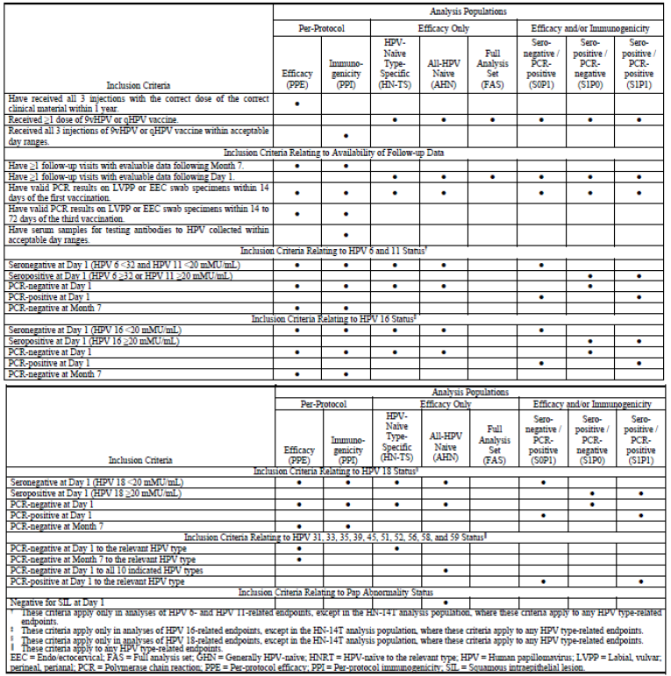

##### Sample size

A total of 15,334 subjects were screened to participate in Study 001. Of these, approximately 97% (n = 14,840) were randomised and 3% (n = 494) were not randomised. The most common reasons that prevented subjects from being randomised were: having too many lifetime sexual partners; having a history of or evidence at Day 1 of HPV related external genital or vaginal lesions/cancer; and subject was likely to be noncompliant. Dose ranging sub-study; a total of 1,242 subjects were enrolled in the dose ranging sub-study under Part A. Among the 1,239 subjects who received at least 1 vaccination, a total of 4.1% discontinued study vaccinations during the vaccination period (Day 1 through Month 7) in the dose ranging sub-study.

As noted previously, the subjects who received either the mid dose 9vHPV vaccine or qHPV vaccine in the dose ranging sub-study were also enrolled in the efficacy sub-study. Of the 617 subjects meeting these criteria, 584 elected to continue in the study in the follow up period after Month 7. Efficacy sub-study cohorts; a total of 14,215 subjects were enrolled in the efficacy sub-study.

##### Statistical methods

###### Efficacy

To address the primary and secondary efficacy hypotheses, one sided tests of the null hypothesis that the vaccine efficacy is ≤ 25% were conducted. The alternative hypothesis states that the vaccine efficacy is > 25%. Each hypothesis was tested at the α = 0.025 (1 sided) level. Vaccine efficacy is defined as VE = 100%*{1–(rN/rG)} where rN, the incidence rate in the 9vHPV group, is defined as rN = CN/ƮN. CN = number of primary efficacy cases in the 9vHPV group and ƮN = total person-years of follow-up in the 9vHPV group. Similarly, rG == CG/ƮG is the incidence rate in the qHPV group, where CG is the number of primary efficacy cases in the qHPV group and ƮG is the total person-years of follow-up in the qHPV group. The null hypothesis that vaccine is not efficacious (that is, VE ≤ 25%) was tested by constructing a two-sided exact confidence interval for VE. The statistical criterion for success with respect to the primary and secondary efficacy hypotheses required that the lower bound of the confidence interval for vaccine efficacy excludes 25%.

###### Immunogenicity

Four ANOVA models (1 per HPV type) were used to test the first primary hypothesis of non-inferiority of anti-HPV 6, 11, 16 and 18 GMTs in subjects receiving the 9vHPV vaccine compared to subjects receiving qHPV vaccine. The response variable was natural log individual titter values and a fixed effect for treatment was used. The differences in log titres between each 9vHPV vaccine groups and the qHPV vaccine group were estimated from the ANOVA model, and a 95% CI constructed, using the mean square error from the model as the estimate of variance. The point estimate and interval limits were exponentiated to express the interval on the GMT ratio scale. The statistical criterion for non-inferiority required that the lower bound of two sided 95% confidence interval of GMT ratio (9vHPV vaccine group vs. qHPV vaccine group) being greater than 0.5 (Part A: dose ranging sub-study) or 0.67 (Part B: immunogenicity sub-study). The secondary hypothesis of non-inferiority of seroconversion percentages for each of the HPV types 6, 11, 16, and 18 was addressed by 4 one sided tests of non-inferiority (one corresponding to each HPV type) conducted at the α = 0.025 level (1 sided). Testing was conducted using the method of Miettinen and Nurminen. The statistical criterion for non-inferiority required that the lower bound of two-sided 95% confidence interval for the difference (9vHPV vaccine group vs. qHPV vaccine group) in seroconversion percentages being greater than ‑5 percentage points for each HPV type.)

For the second primary hypothesis of acceptability of anti-HPV 31, 45, 52, and 58 seroconversion rates, exact 95% CIs for a binomial proportion was calculated. For each HPV type, the lower limit of the 95% confidence interval was required to be above 90% to meet the acceptable criteria. All lower limits of these confidence intervals would need to be above 90% in order to meet the secondary hypothesis.

###### Safety

All subjects who received at least 1 study vaccination and had follow up data were included in the safety summaries. Adverse experiences were summarised descriptively as frequencies and percentages by vaccination group and type of adverse experience, by vaccination visit and across all vaccination visits. Elevated temperatures (≥ 100.0°F, ≥ 37.8°C, oral or oral equivalent) within 5 days following each vaccination were summarised in a similar manner, as in all the other studies. In addition, risk differences and associated 95% CIs were computed comparing the groups across all vaccination visits with respect to injection site adverse experiences on the VRC, specific systemic adverse events, severe injection site adverse event, SAEs and elevated temperatures. P values were computed only for those adverse experiences that were prompted for on the VRC (pain/tenderness/soreness, swelling, and redness) and elevated temperatures. The probability of observing at least 1 SAE in this study depends on the number of subjects enrolled and the incidence rate of SAEs in the general population. If no SAEs were observed among 7,000 subjects in mid dose 9vHPV vaccine group, this study was to provide 95% confidence that the true incidence rate for SAEs is < 0.05% in that vaccine group.

##### Participant flow

The dispositional of subjects in both the dose ranging and efficacy parts of the study out to 54 months post vaccination are shown in Tables 10 to 13. A total of 0.2% (n = 3) of subjects randomised in the dose ranging sub-study were discontinued prior to receiving their first vaccination. All 3 subjects were randomised to the low dose 9vHPV vaccine group. Two subjects withdrew consent prior to receiving the first dose of study vaccine. One subject was not vaccinated on Day 1 and was subsequently classified as lost to follow up. Most subjects who discontinued study vaccinations prior to Month 7 were either lost to follow up or withdrew consent. A total of 0.2% (n = 3) discontinued study vaccinations due to a clinical adverse experience; 1 subject discontinued study vaccinations due to a protocol violation.

Table 10: Study 001; patient disposition in 001, (Day 1 to Month 7) (all randomised subjects, dose-ranging sub-study)

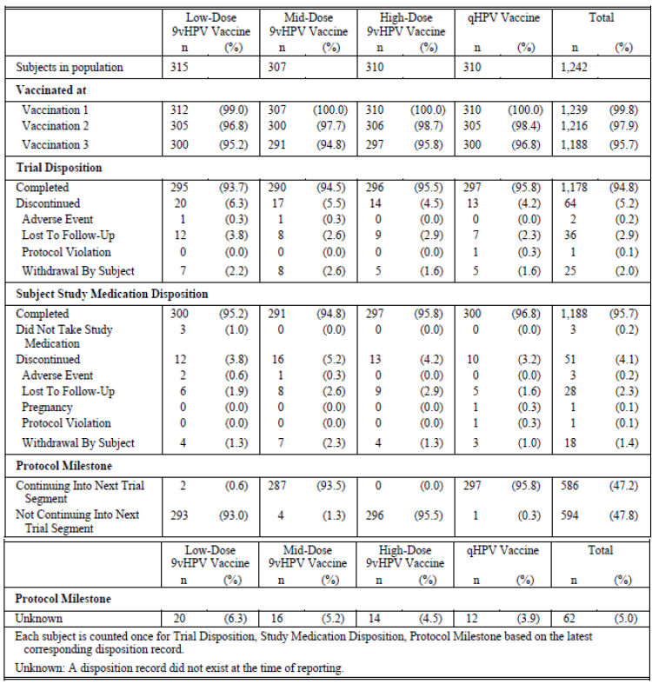

Table 11: Study 001, disposition of subjects (Day 1 to Month 7) (all randomised subjects, efficacy sub-study)

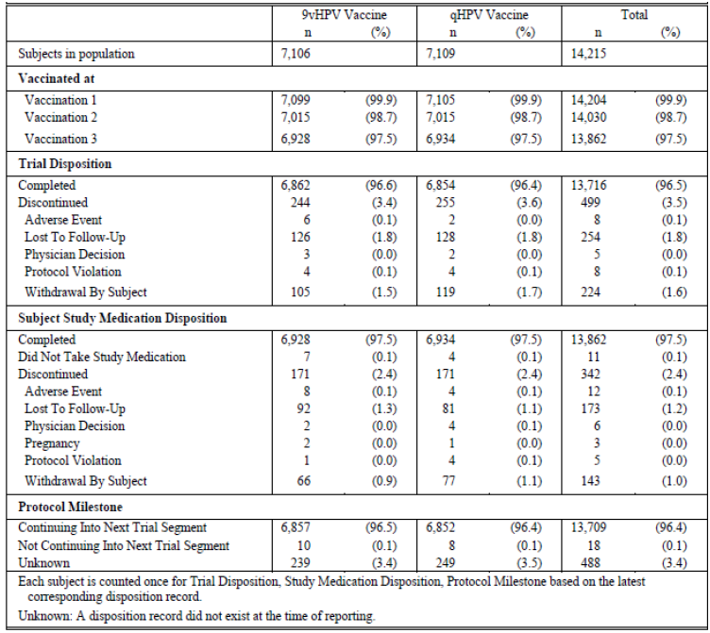

Table 12: Study 001, disposition of subjects (> Month 7 to Month 42) (all randomised subjects, efficacy sub-study)

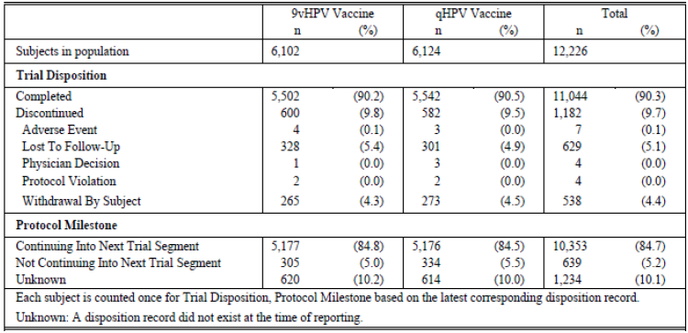

Table 13: Study 001, disposition of subjects (> Month 48 to Month 54) (all randomised subjects, efficacy sub-study)

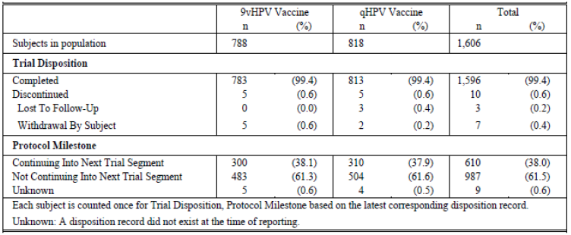

Among the 14,204 subjects who received at least 1 vaccination, 2.4% discontinued study vaccinations during the vaccination period. A total of 0.1% (n = 11) subjects randomised were discontinued prior to receiving their first vaccination. Of these subjects, 7 were in the 9vHPV vaccine group and 4 were in the qHPV vaccine group. The most common reason for randomised subjects discontinuing prior to receiving a dose of study vaccine was withdrawal of consent. Most subjects who discontinued prior to Month 7 were either lost to follow up or withdrew consent. A total of 0.1% discontinued study vaccinations due to a clinical adverse experience and < 0.01% discontinued study vaccinations due to a protocol violation. A total of 0.1% of subjects randomised was discontinued prior to receiving their first vaccination. The reasons for discontinuation included: protocol violation, withdrawal of consent by the subjects, and physician decision. A total of 96% (n = 13,709) subjects randomised in the efficacy sub-study population continued in the follow up period after Month 7. The total number of subjects continuing in the follow up period includes subjects enrolled in Part A who received the mid dose 9vHPV vaccine or qHPV vaccine. A total of n = 13,709 subjects were randomised in the efficacy sub-study population who continued in the follow up period after Month 7. A total of n = 12,226 subjects in the population had follow up post Month 7 through to Month 42. The discrepancy of 1,483 (13,709 minus 12, 226) represents subjects who did not yet have a disposition report at Month 42 (mostly had not yet reached their Month 42 visit).

##### Major protocol violations/deviations

Summaries of the numbers and reasons for major protocol violation and exclusion from efficacy analyses were provided. None of these were due to adverse events. The most common reasons subjects were excluded from the PPE population were:

* Being positive to a vaccine HPV type at or prior to Month 7
  + Subjects positive for HPV Type 6 were also excluded from the analysis for HPV Type 11; subjects positive for HPV Type 11 were excluded from the analysis for HPV Type 6.
* Missing Day 1 or Month 7 swab samples/results
* General protocol violations
* Incomplete vaccinations.

##### Baseline data

###### Dose ranging sub-study

The 4 vaccination groups were well balanced with respect to demographic characteristics. The mean age of randomised subjects was 21.9 years. All subjects were between 16 and 26 years of age as specified in the protocol. Approximately 10.9%, 18.5%, 36.6%, and 34.1% of the subjects were from the Asia-Pacific region, Europe, Latin America, and North America, respectively. The largest race category was White (51.2%) followed by Multi-racial (31.4%), Asian (12.3%), and Black or African American (4.5%). The remaining subjects were American Indian or Alaska Native, Native Hawaiian or Other Pacific Islander, or did not report their race.

###### Efficacy sub-study

The 2 vaccination groups were well balanced with respect to these demographic characteristics. The mean age of randomised subjects was 21.9 years. All subjects were between 16 and 26 years of age as specified in the protocol. The distribution of age at enrolment into the study was generally comparable between the vaccination groups. Approximately 12.8%, 33.9%, 33.4%, and 20.0% of the subjects were from the Asia-Pacific region, Europe, Latin America, and North America, respectively. The largest race category was White (55.2%) followed by Multi-racial (26.8%), Asian (14.3%), and Black or African American (3.3%). The remaining subjects were American Indian or Alaska Native, Native Hawaiian or Other Pacific Islander, or did not report their race.

##### Results for the primary efficacy outcome

###### Clinical protection

The results of evaluation of efficacy against the primary efficacy endpoint of high grade cervical, vulvar, and vaginal disease related to HPV types 31, 33, 45, 52, and 58 in the PPE population are shown in Table 14. The 9vHPV vaccine was highly efficacious in preventing clinical lesions (the primary efficacy endpoint) in subjects who were naïve to the relevant HPV type during the vaccination period. The point estimate of vaccine efficacy is highly statistically significant. The success criterion of the study protocol, that is, that lower bound of the 95% confidence interval (CI) of vaccine efficacy (VE) be greater than 25%, has been met. The cumulative incidence distribution of the primary efficacy endpoint in the PPE population is shown in Figure 5.

Table 14: Study 001, analysis of efficacy against HPV 31/33/45/52/58-Related CIN 2/3, AIS, cervical cancer, VIN 2/3, VaIN 2/3, vulvar cancer, and vaginal cancer (per-protocol efficacy analysis population)

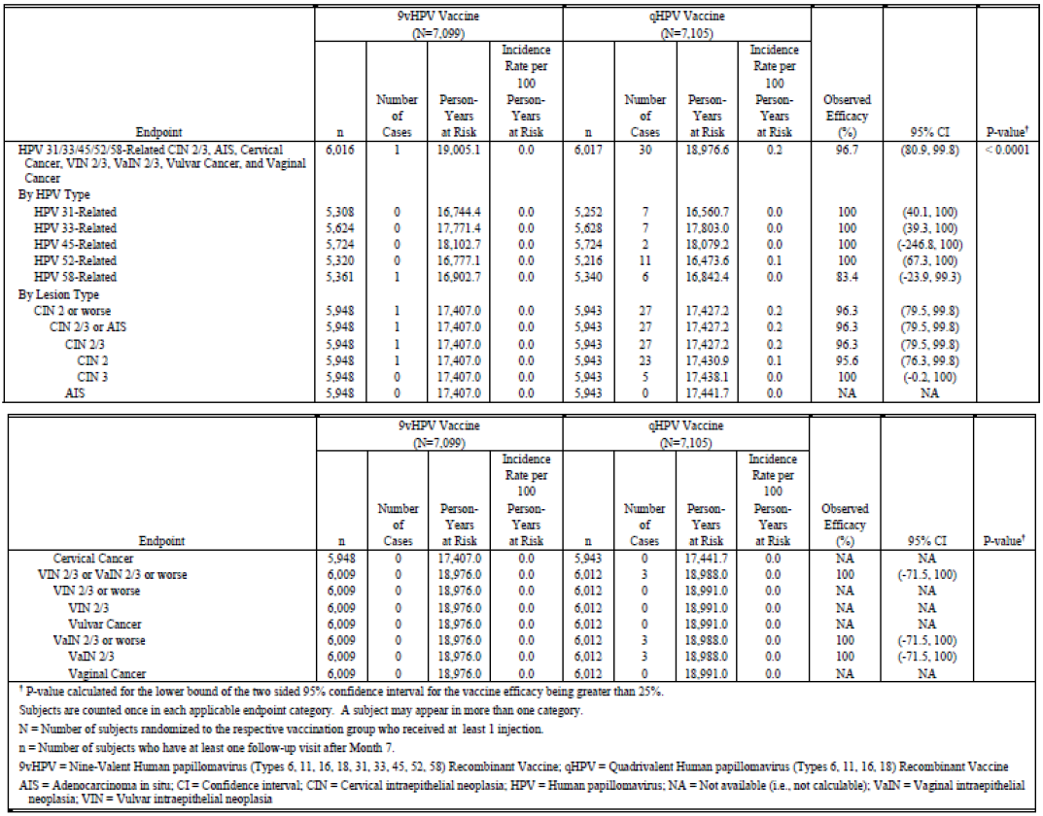

Figure 5: Study 001, Time to HPV 31/33/45/52/58-Related CIN 2/3, AIS, cervical cancer, VIN 2/3, VaIN 2/3, vulvar cancer, and vaginal cancer (per-protocol efficacy analysis population)

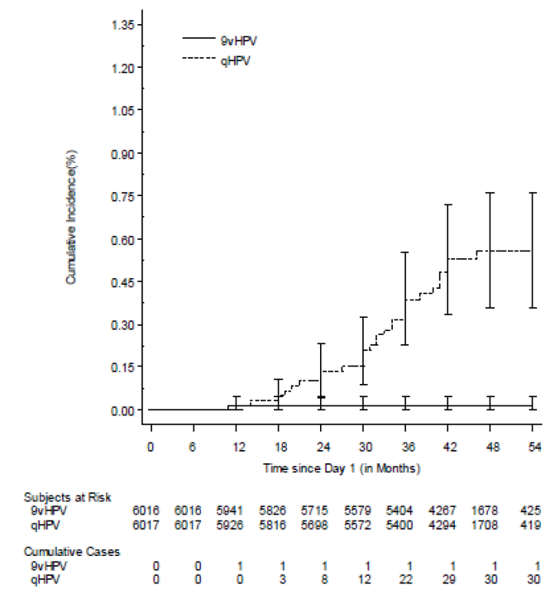

The endpoint of high grade cervical, vulvar, and vaginal disease related to HPV types 31, 33, 45, 52, and 58 in the HNTS population. Consistent with the results in the PPE population, the 9vHPV vaccine is highly efficacious in preventing the incidence of the primary efficacy endpoint among subjects who were naïve to the relevant HPV type at the time of administration of dose 1 of the vaccine. The cumulative incidence distribution of the primary efficacy endpoint in the HNTS population is shown in Figure 6.

Figure 6: Study 001, time to HPV 31/33/45/52/58-related CIN 2/3, AIS, cervical cancer, VIN 2/3, VaIN 2/3, vulvar cancer, and vaginal cancer (HPV-naive type-specific analysis population)

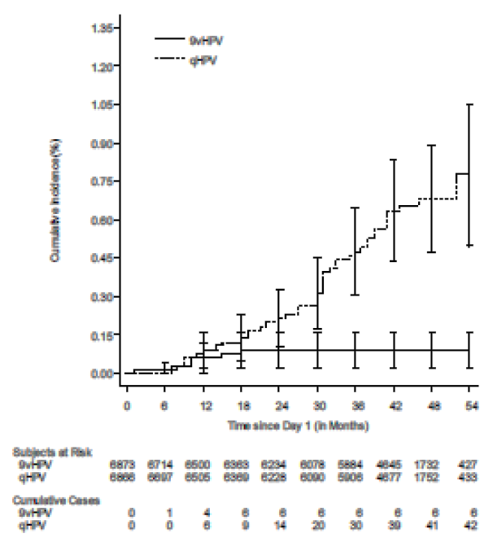

###### *HPV 31/33/45/52/58 related cervical, vulvar, or vaginal lesions results in the PPE population*

This endpoint includes the primary efficacy endpoint, and in addition, it also includes low-grade cervical, vulvar, and vaginal diseases related to HPV types 31, 33, 45, 52, and 58 (a secondary efficacy objective). The 9vHPV vaccine is highly efficacious (lower limit of 95% CI of VE > 90%) in preventing the incidence of the low and high grade cervical, vulvar, and vaginal disease related to HPV types 31, 33, 45, 52, and 58 in the PPE population.

###### Results in the HNTS population

Table 15: Study 001, analysis of efficacy against HPV 31/33/45/52/58-related cervical, vulvar, and vaginal disease (HPV-naive type-specific analysis population)

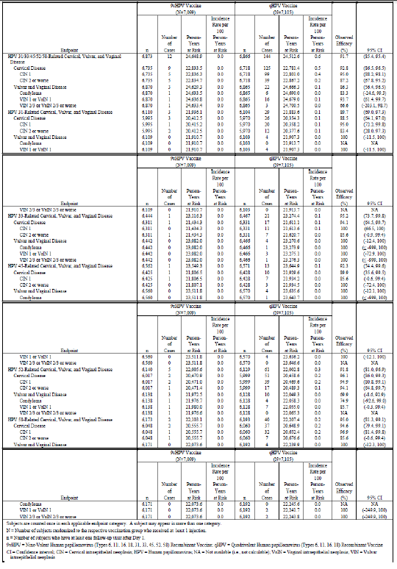

Consistent with the results in the PPE population, the 9vHPV vaccine is highly efficacious (lower limit of 95% CI of VE > 85%) in preventing the incidence of this endpoint in the HNTS population.

###### Immunogenicity

Marked elevations in cLIA Geometric Mean Titres (GMT) to HPV Types 6, 11, 16, 18, 31, 45, 52, and 58 were elicited in all vaccine groups at 4 weeks post Dose 3. Non-inferiority of the GMT responses for each of the HPV Types 6, 11, 16, and 18 in the 9vHPV vaccine group relative to GMT responses in the qHPV vaccine group at 4 weeks post vaccination was established with the mid, dose formulation of the 9vHPV vaccine. Therefore the first primary immunogenicity hypothesis was verified.

At 4 weeks post Dose 3, over 99% of subjects in the per-protocol population seroconverted for HPV Types 6, 11, 16 and 18 in both the qHPV vaccine and 9vHPV vaccine groups, and over 99% of subjects seroconverted for HPV Types 31, 45, 52, and 58 in the 9vHPV vaccine groups. Non-inferiority of immune responses with respect to the percentages of subjects who seroconverted to HPV Types 6, 11, 16 and 18 was demonstrated in the 9vHPV vaccine group, compared to the qHPV vaccine group.

Seroconversion rates for HPV Types 31, 33, 45, 52, and 58 were statistically greater than 90% in the three 9vHPV vaccine groups. Therefore, both secondary immunogenicity hypotheses were verified.

##### Results for other efficacy outcomes

Efficacy against persistent infection related to HPV types 31, 33, 45, 52, and 58 in the PPE and HNTS population was a secondary efficacy outcome. The persistent infection of ≥ 6 months (± 1 month) duration endpoint was a secondary efficacy objective. The persistent infection of ≥ 12 months (± 1 month) duration endpoint corresponds to an exploratory efficacy objective. The success criterion relating to persistent infection of ≥ 6 months duration, that is, that lower bound of the 95% CI of VE be greater than 25%, has been met; The success criterion relating to persistent infection of ≥ 12 months duration, that is, that lower bound of the 95% CI of VE be greater than 0%, has been met; For each of HPV types 31, 33, 45, 52, and 58, the lower limit of 95% CI of VE against persistent infection (of ≥ 6 months and ≥ 12 months duration) is ≥ 90% in the PPE population. It is ≥ 80% in the HNTS population except for HPV 45 related persistent infection of ≥ 12 months duration where the lower limit of 95% CI of VE is 73.4%, but nevertheless still has a high point estimate of VE. The plots of the cumulative incidence of persistent infection of ≥ 6 months and ≥ 12 months duration in the PPE and HNTS populations consistently indicate the increasing efficacy over time of the 9vHPV vaccine in preventing persistent infection related to HPV types 31, 33, 45, 52 and 58.

###### HPV 31/33/45/52/58 related pap test abnormalities

For each of HPV types 31, 33, 45, 52, and 58, the 9vHPV vaccine is highly efficacious in preventing Pap abnormalities of ASCUS positive for high risk HPV, or worse potentially related to these HPV types. For each of these five HPV types, the point estimate of VE is ≥ 90% and ≥ 80% in the PPE and HNTS population respectively.

###### HPV 6/11/16/18 related cervical, vulvar, or vaginal lesions

Both the 9vHPV and qHPV vaccines were similarly highly efficacious in preventing cervical, vulvar, and vaginal disease related to HPV types 6, 11, 16, and 18.All the cases of HPV 6/11/16/18 related cervical, vulvar, and vaginal disease observed in the PPE and HNTS population were likely consequences of co-infections of oncogenic HPV types other than the HPV type 6/11/16/18 for which the subjects were endpoint cases of; and were likely not a failure of either the 9vHPV or qHPV vaccine to confer prophylactic protection against HPV 6/11/16/18 related disease. The combined incidence of HPV 6 and HPV 11 related cervical, vulvar, and vaginal disease was similar (that is, not statistically significantly different) in each of the 9vHPV and qHPV vaccine groups. Consistent with the results in the PPE population, the incidence of HPV 6/11/16/18 related cervical, vulvar, and vaginal disease was similar (that is, not statistically significantly different) in each of the two vaccine groups; thus indicative of similar efficacy of the two vaccines in preventing cervical, vulvar, and vaginal disease related to HPV types 6, 11, 16, and 18.

In relation to HPV 6/11/16/18 related persistent infection, it was found that the 9v HPV vaccine confers prophylactic protection against HPV 6, 11, 16, and 18 related persistent infection that is at least comparable to the prophylactic protection conferred by the qHPV vaccine.

It was also found that the 9v HPV vaccine confers prophylactic protection against Pap abnormalities potentially related to HPV types 6, 11, 16, and 18 that is at least comparable to the prophylactic protection conferred by the qHPV vaccine.

In summary, in Study 001, the key efficacy findings with respect to the new types were summarised as follows. The 9vHPV vaccine is highly efficacious compared to qHPV vaccine in

* Preventing HPV 31, 33, 45, 52, and 58 related high grade cervical, vulvar, and vaginal disease
* Preventing HPV 31, 33, 45, 52, and 58 related cervical, vulvar, and vaginal disease of any grade, persistent infection related to these types and related Pap test abnormalities.
* There was also reduced risk of undergoing HPV 31, 33, 45, 52, and 58 related invasive cervical and external genital procedures.

In qHPV vaccine clinical studies, qHPV vaccine efficacy to prevent overall cervical disease (any grade), high grade cervical disease (CIN 2 or worse), high grade vulvar and vaginal disease (VIN 2/3 or VaIN 2/3 or worse), and condyloma was 29.7%, 42.7%, 77.1%, and 82.8%, respectively. In Study 001, 9vHPV vaccine efficacy (compared with historic placebo) to prevent overall cervical disease (any grade), high grade cervical disease (CIN 2 or worse), high grade vulvar and vaginal disease (VIN 2/3 or VaIN 2/3 or worse), and condyloma was 47.1%, 62.8%, 94.6%, and 86.1%, respectively. This indicates that 9vHPV vaccine could provide added coverage for overall cervical, vulvar, and vaginal disease compared with qHPV vaccine.

#### Study V503-002 (Study 002)

##### Study design, objectives, locations and dates

Study 002 is a Phase III open-label study to study the immunogenicity, tolerability, and manufacturing consistency of V503 (A Multivalent Human Papillomavirus [HPV] L1 Virus-Like Particle [VLP] Vaccine) in preadolescents and adolescents (9 to 15 year olds) with a comparison to young women (16 to 26 year olds). The study was designed to enrol 1,800 females, 9 to 15 years of age, 600 males, 9 to 15 years of age, and 400 females, 16 to 26 years of age. Female and male subjects, 9 to 15 years of age, were enrolled in 2 age strata (9 to 12 years of age, and 13 to 15 years of age at enrolment) in approximately a 2:1 ratio to allow the immunogenicity and safety profile of the vaccine in younger subjects to be more clearly defined. All subjects were administered a 3 dose regimen of 9vHPV vaccine (at Day 1, Month 2, and Month 6). Blood samples were collected at Day 1 and Month 7.

The primary time point for evaluation of immunogenicity was at Month 7. The study was comprised of 2 immunogenicity sub-studies:

* An adult-adolescent immunobridging sub-study to compare 9vHPV vaccine immunogenicity in females, 9 to 15 years of age, versus females, 16 to 26 years of age, and males, 9 to 15 years of age, versus females, 16 to 26 years of age.
* A lot consistency sub-study to demonstrate consistent immunogenicity in subjects randomised to 3 different lots of the final manufacturing process. The lot consistency sub-study was conducted in females, 9 to 15 years of age. Females, 9 to 15 years of age, were equally randomised to 3 vaccine lots (Lots 1, 2, and 3). Males, 9 to 15 years of age, and females, 16 to 26 years of age, were all assigned to Lot 1.

This was a Multicentre study at 72 sites: 21 centres in the United States (US) and 51 centres outside the US. The study sites were located in 1 country in Africa (South Africa), 4 countries in the Asia- Pacific region (India, Korea, Taiwan, and Thailand), 6 countries in Europe (Austria, Belgium, Finland, Poland, Spain and Sweden), 5 countries in Latin America (Brazil, Chile, Colombia, Costa Rica, and Peru), and 1 country in North America (the United States). The study was conducted between 27 August 2009 to 30 March 2011.

##### Inclusion and exclusion criteria

In general, were similar to 001 (apart from the age and gender differences) and a summary was provided.

##### Study treatments

Subjects received one 0.5 mL intramuscular dose of 9vHPV vaccine at Day 1, Month 2, and Month 6.

##### Efficacy variables and outcomes

###### The primary safety objective

To evaluate the tolerability of the 9 valent HPV L1 VLP vaccine in preadolescent and adolescent boys and girls 9 to 15 years of age and young women 16 to 26 years of age.

###### *Primary immunogenicity objectives*

Adolescent-adult immunobridging sub-study

* To demonstrate that administration of the 9 valent HPV L1 VLP vaccine induces non-inferior Geometric Mean Titres (GMTs) for serum anti-HPV 6, anti-HPV 11, anti-HPV 16, anti-HPV 18, anti-HPV 31, anti-HPV 33, anti-HPV 45, anti-HPV 52, and anti-HPV 58 in preadolescent and adolescent girls 9 to 15 years of age compared to young women 16 to 26 years of age.
* To demonstrate that administration of the 9 valent HPV L1 VLP vaccine induces non-inferior GMTs for serum anti-HPV 6, anti-HPV 11, anti-HPV 16, anti-HPV 18, anti-HPV 31, anti-HPV 33, anti-HPV 45, anti-HPV 52, and anti-HPV 58 in preadolescent and adolescent boys 9 to 15 years of age compared to young women 16 to 26 years of age.

Manufacturing lot consistency sub-study

* To demonstrate that the Final Manufacturing Process (FMP) results in 9 valent HPV L1 VLP vaccine that induces consistent serum anti-HPV 6, anti-HPV 11, anti-HPV 16, anti-HPV 18, anti- HPV 31, anti-HPV 33, anti-HPV 45, anti-HPV 52, and anti-HPV 58 responses.

###### Secondary objectives

Adolescent-adult immunobridging sub-study

* To demonstrate that the 9 valent HPV L1 VLP vaccine induces non-inferior immune responses with respect to seroconversion percentages to HPV types 6, 11, 16, 18, 31, 33, 45, 52, and 58 in preadolescent and adolescent girls 9 to 15 years of age compared to young women 16 to 26 years of age.
* To demonstrate that the 9 valent HPV L1 VLP vaccine induces non-inferior immune responses with respect to seroconversion percentages to HPV types 6, 11, 16, 18, 31, 33, 45, 52, and 58 in preadolescent and adolescent boys 9 to 15 years of age compared to young women 16 to 26 years of age.

Manufacturing lot consistency sub-study

* To demonstrate that the FMP results in 9 valent HPV L1 VLP vaccine that induces consistent seroconversion percentages to HPV types 6, 11, 16, 18, 31, 33, 45, 52, and 58.

##### Randomisation and blinding methods

Enrolment was stratified by age and gender. Among the 9 to 15 year old subjects, enrolment was stratified approximately 2:1 for 9 to 12 year olds and 13 to 15 year olds. This was to ensure that the tolerability profile of the vaccine among the younger subjects is clearly defined. Specifically, 3 allocation schedules were generated by the sponsor; one for each of the following cohorts:

* 9 to 15 year old females (approximately1,800 subjects): the allocation schedule was stratified 2:1 for 9 to 12 year olds and 13 to 15 year olds; these subjects were randomised within each age stratum in a 1:1:1 ratio to receive 1 of 3 FMP vaccine lots (Lot 1, Lot 2, or Lot 3) using centralised randomisation; subjects, site personnel and sponsor were blinded to vaccine lot allocation
* 9 to 15 year old males (approximately600 subjects): the allocation schedule was stratified 2:1 for 9 to 12 year olds and 13 to 15 year olds; these subjects all received vaccine Lot 1
* 16 to 26 year old females (approximately400 subjects): no age strata were included in the allocation schedule; these subjects all received vaccine Lot 1.

As in all the studies included in this submission, Interactive Voice Response System (IVRS) was used to allocate study. At the first visit, study personnel accessed the IVRS after the subject had signed informed consent (or for minors after a subject’s parent/legal guardian had signed informed consent and the subject has signed assent), and after the subject had met all inclusion and none of the exclusion criteria. The IVRS assigned the subject an ‘AN’ and a unique vial identification number for the vial of clinical material that the subject was to receive at that visit. The IVRS assigned the appropriate clinical material based on the subject’s vaccination group.

##### Analysis populations

Per Protocol Immunogenicity (PPI) Population

The Per Protocol Immunogenicity (PPI) population will serve as the primary population for the analysis of immune response to each of the 9 HPV types (6, 11, 16, 18, 31, 33, 45, 52, and 58). To be included in this population, subjects must:

* Have received all 3 vaccinations with the correct dose of the correct clinical material, and each vaccination visit must occur within acceptable day ranges (See Table 3-4 for acceptable day ranges for vaccination visits).
* Have provided Month 7 serology result within 21 to 49 days post Dose 3.
* Be seronegative to the appropriate HPV type at Day 1 and (for the young women group only) PCR negative to the appropriate HPV type on all swabs and biopsies from Day 1 through Month 7 (See Table 3-5 for acceptable day ranges for serum and swab samples at Day 1 and Month 7).
* Have no other protocol violations that could interfere with the evaluation of subject’s immune response to the study vaccine.

To be included in the PPI population for HPV 6 and 11, subjects must be seronegative to both HPV 6 and 11 at Day 1 and (for the young women group only) PCR negative to both HPV 6 and 11 from Day 1 through Month 7. To be included in the PPI population for any other vaccine HPV type, subjects need to be seronegative at Day 1 and (for the young women group only) PCR negative from Day 1 through Month 7 only for the HPV type being analysed.

##### Sample size

The numbers planned are listed in the study design section above. A sample size of 400 young women and 600 preadolescent and adolescent girls has 91% power to show non-inferior Month 7 GMTs for preadolescent and adolescent girls versus 16 to 26 year old young women if the underlying GMT ratio is 1.0 for the 4 original types (HPV 6, 11, 16, and 18) and also 1.0 for the 5 new types (HPV 31, 33, 42, 52, and 58). Since higher anti-HPV 6, 11, 16 and 18 GMTs have been observed with qHPV vaccine in preadolescent and adolescent girls and boys than in 16 to 26 year old young women (GMT ratios ranged from 1.7 to 2.7 across the 4 HPV types it was possible that in this study, the GMT ratios for these 4 original types and also the 5 new types (by the same mechanism) would be higher than 1.0.

##### Statistical methods

###### Immunogenicity

The PPI population was the population from which inferences about the immune responses were made. The primary hypotheses of non-inferiority of GMTs for each of HPV types 6, 11, 16, 18, 31, 33, 45, 52, and 58 were addressed by 9 one sided tests of non-inferiority (one corresponding to each HPV type) conducted at the, α = 0.025 level (1-sided). Testing was conducted using an analysis of variance (ANOVA) model with a response of log individual titres and a fixed effect for comparison group. The statistical criterion for non-inferiority required that the lower bound of two-sided 95% CI of GMT ratio (9 to 15 year old boys versus 16 to 26 year old young women or 9 to 15 year old girls versus 16 to 26 year old young women) be greater than 0.67.

The secondary hypothesis of non-inferiority of seroconversion percentages for each of the vaccine HPV types (6, 11, 16, 18, 31, 33, 45, 52, and 58) was addressed by 9 one-sided tests of non- inferiority (one corresponding to each HPV type) conducted at the α = 0.025 level (1‑sided). Testing was conducted using the method of Miettinen and Nurminen. The statistical criterion for non- inferiority required that the lower bound of two-sided 95% CI for the difference (9 to 15 year old boys minus 16 to 26 year old young women or 9 to 15 year old girls minus 16 to 26 year old young women) in seroconversion percentages be greater than ‑5 percentage points for each HPV type.).

The primary hypothesis regarding consistency of the 3 lots of 9vHPV vaccine with respect to the GMTs to HPV 6, 11, 16, 18, 31, 33, 45, 52, and 58 at 4 weeks post Dose 3, was addressed by 3 pair wise (Lot 1 versus Lot 2, Lot 1 versus Lot 3, and Lot 2 versus Lot 3) comparisons for each HPV type (27 comparisons total). Each pair wise comparison tested the equivalence of the 2 lots (within 2-fold) using 2 one-sided tests at the 0.025 level. Testing was conducted using an analysis of covariance (ANCOVA) model with a response of the natural log of individual titres and fixed effects for vaccine lot and age strata. Statistical significance for the 2 one-sided equivalence tests for each pair of lots was established if the p-values for the hypothesis tests are each < 0.025. This corresponds to the 95% CI for the fold difference in the 2 lots being contained entirely within (0.5, 2.0).

The secondary hypothesis regarding consistency of the 3 lots of 9vHPV vaccine with respect to the percentage of subjects who seroconvert for each of HPV types 6, 11, 16, 18, 31, 33, 45, 52, and 58 by 4 weeks post Dose 3 was addressed by 3 pair wise comparisons (Lot 1 versus Lot 2, Lot 1 versus Lot 3, and Lot 2 versus Lot 3) for each vaccine HPV type (27 comparisons total). Each pair wise comparison tested the equivalence of the 2 lots (within an equivalence margin of 5 percentage points) using 2 one sided tests at the 0.025 level.

###### Safety

Analysis was similar to Study 001. The probability of observing at least 1 SAE in this study depended on the number of subjects enrolled and the incidence rate of SAEs in the general population. If no SAEs are observed among all 2800 study subjects, this study will provide 97.5% probability that the true incidence rate for SAEs is < 0.14%.

##### Participant flow

A summary of the number of subjects who were randomised, vaccinated, who completed or discontinued during the study, by vaccination group, is provided in Table 16.

Table 16: Study 002, disposition of subjects

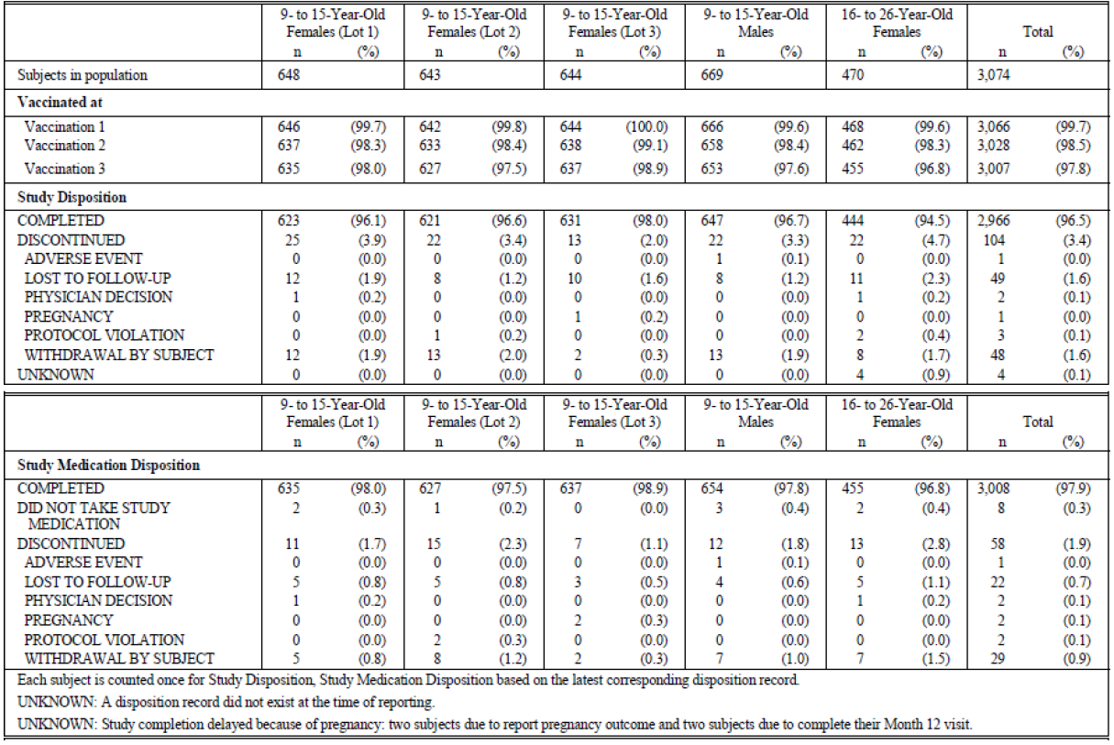

A total of 3,111 subjects were screened for inclusion in this study, 3,074 were randomised, and 3,066 received at least 1 vaccination. Most subjects who discontinued prior to Month 12 were either lost to follow up or the subject withdrew. Only 1 subject discontinued due to a clinical adverse experience. Eight randomised subjects were discontinued prior to their first vaccination. A total of 37 subjects who were screened for the study were never randomised. The most common inclusion criterion not met (5 of the 32 [15.6%]) was that the subject was judged to be in good physical health on the basis of medical history, physical examination, and laboratory results. The most common exclusion criterion met (4 of 32 [12.5%]) was that the subject was unlikely to adhere to the study procedures, keep appointments, or planned to relocate during the study.

##### Major protocol violations/deviations

Among the 3,074 randomised subjects, a total of 104 subjects (3.4 %) discontinued during the entire study period (Day 1 through Month 12) as noted in Table 16. Most subjects who discontinued prior to Month 12 were either lost to follow up or the subject withdrew. Only 1 subject discontinued due to a clinical adverse experience. A total of 37 subjects who were screened for the study were never randomised. The most common inclusion criterion not met (5 of the 32 [15.6%]) was that the subject was judged to be in good physical health on the basis of medical history, physical examination, and laboratory results. The most common exclusion criterion met (4 of 32 [12.5%]) was that the subject was unlikely to adhere to the study procedures, keep appointments, or planned to relocate during the study.

##### Baseline data

These were provided and summarised.

##### Results for the primary efficacy outcome

###### Immunogenicity

Marked elevations in cLIA GMTs to HPV Types 6, 11, 16, 18, 31, 33, 45, 52, and 58 were elicited in all vaccine groups at 4 weeks post Dose 3. At 4 weeks post Dose 3, over 99% of girls, boys, and young women in the PPI population seroconverted for HPV Types 6, 11, 16, 18, 31, 33, 45, 52, and 58.

###### Adult-adolescent immunobridging sub-study

Non-inferiority of the GMT responses for each of the HPV Types 6, 11, 16, 18, 31, 33, 45, 52, and 58 in girls, 9 to 15 years of age, relative to GMT responses in young women, 16 to 26 years of age, at 4 weeks post Dose 3 was established. Non-inferiority of the GMT responses for each of the HPV Types 6, 11, 16, 18, 31, 33, 45, 52, and 58 in boys, 9 to 15 years of age, relative to GMT responses in young women, 16 to 26 years of age, at 4 weeks post Dose 3 was also established. Therefore, both primary immunogenicity hypotheses of the immunobridging sub-study were met (Table 17, Table 18 and Table 19). Non-inferiority of immune responses with respect to the percentages of subjects who seroconverted to each vaccine HPV type was demonstrated in girls, 9 to 15 years of age, compared to young women, 16 to 26 years of age, and also in boys, 9 to 15 years of age, compared to young women, 16 to 26 years of age. Therefore, both secondary immunogenicity hypotheses of the immunobridging sub-study were met.

Table 17: Study 002, statistical analysis of non-inferiority of Month 7 HPV cLIA geometric mean titres comparing 9 to 15 year old females (Lot 1) and 16 to 26 year old females (Lot 1) (per-protocol immunogenicity)

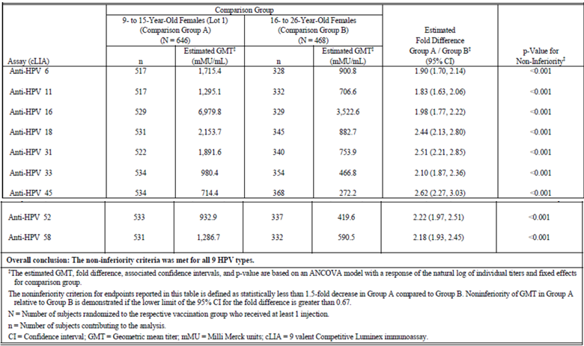

Table 18: Statistical analysis of non-inferiority of Month 7 HPV cLIA geometric mean titres comparing 9 to 15 year old males (Lot 1) and 16 to 26 year old females (Lot 1) (per-protocol immunogenicity population)

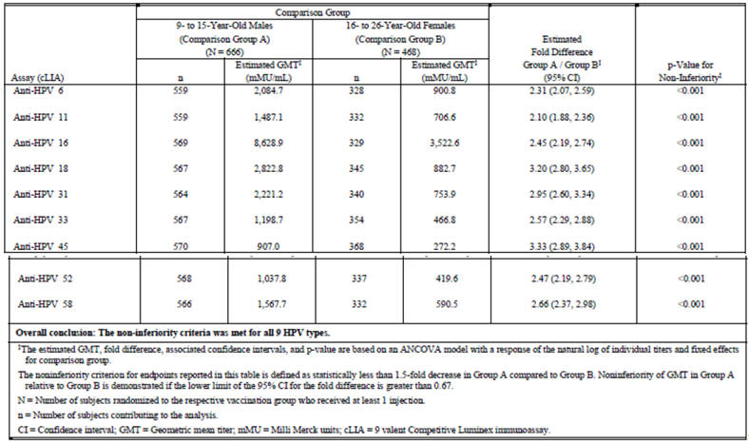

Table 19: Study 002, statistical analysis of equivalence of geometric mean titres at Month 7 comparing 9-Valent HPV vaccine consistency Lots 1, 2, and 3 (per protocol immunogenicity population)

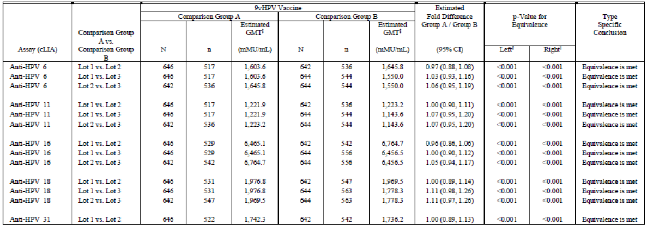

##### Results for other efficacy outcomes

###### Manufacturing lot consistency sub-study

The GMT responses for each of the HPV Types 6, 11, 16, 18, 31, 33, 45, 52, and 58 at 4 weeks post- Dose 3 were similar among girls, 9 to 15 years of age, randomised to 1 of 3 FMP vaccine lots. Therefore, the primary immunogenicity hypothesis of the lot consistency sub-study was met. These results are shown in Table 17. Similar immune responses with respect to the percentages of subjects who seroconverted to each vaccine HPV type were demonstrated among girls, 9 to 15 years of age, randomised to one of 3 FMP vaccine lots (Table 19 above). Therefore, the secondary immunogenicity hypothesis of the lot consistency sub-study was met.

#### Study V503-009/GDS01C (Study 009)

##### Study design, objectives, locations and dates

Study 009 was a double blinded study to assess 9vHPV vaccine safety and immunogenicity in females, 9 to 15 years of age, with a comparison to qHPV vaccine. The study was requested by the EMA CHMP at Scientific Advice in 2008 EMEA/H/SA/1086/1/2008/II), and EMA PDCO in 2010 (EMEA- 000654-PIP01-09). The study was conducted solely in European countries. The study was designed to enrol 600 females, 9 to 15 years of age. Subjects were enrolled in 2 age strata (9 to 12 years of age, and 13 to 15 years of age at enrolment) in approximately a 1:1 ratio and equally randomised to 9vHPV vaccine or qHPV vaccine. All subjects were administered a 3 dose regimen of 9vHPV vaccine or qHPV vaccine (at Day 1, Month 2, and Month 6). Blood samples were collected at Day 1 and Month 7. The primary time point for evaluation of immunogenicity was at Month 7.

Serum samples were collected from all subjects at Day 1 (prior to vaccine administration) and Month 7 to assess anti-HPV levels. The primary time point for immunogenicity evaluation was at Month 7 (1 month following the completion of the 3 dose regimen). 24 centres participated to the study: 3 in Belgium, 4 in Denmark, 4 in Finland, 3 in Italy, 5 in Spain and 5 in Sweden. This study was conducted between 23 February 2011 and 20 December 2011.

##### Inclusion and exclusion criteria

Inclusion criteria were 9 to 15 year old healthy girls, who had not yet coitarche and did not plan on becoming sexually active during the study period. Other inclusions and exclusions were similar to the other studies.

##### Study treatments

Subjects received either 9vHPV vaccine or qHPV vaccine as a series of 0.5 mL intramuscular injections administered in the deltoid region (upper arm) at Day 1, Month 2, and Month 6.

##### Efficacy variables and outcomes

###### Primary objective

To demonstrate that administration of the 9vHPV vaccine induces non-inferior Geometric Mean Titres (GMTs) for serum anti-HPV 16 and anti-HPV 18 compared to qHPV vaccine in preadolescent and adolescent girls 9 to 15 years of age.

###### Secondary objectives

* To evaluate the tolerability of the 9vHPV vaccine in preadolescent and adolescent girls 9 to 15 years of age.
* To summarise humoral immune responses (including anti-HPV 6, 11, 16, 18, GMTs and seroconversion rates at 4 weeks post Dose 3) in preadolescent and adolescent girls 9 to 15 years of age who received 9vHPV vaccine or qHPV vaccine.

###### Exploratory objective

The exploratory immunogenicity endpoints are the cLIA geometric mean titres (GMTs) and the cLIA seroconversion percentages to each of HPV 31, 33, 45, 52 and 58 by 4 weeks post Dose 3 in the 9vHPV vaccine group.

##### Randomisation and blinding methods

A central randomization system (implemented through an Interactive Web Response System [IWRS]) assigned the subject a vaccine group (blinded) and an allocation number according to the randomised allocation schedules and then subsequently assigned a unique vaccine kit number corresponding to the vaccine group. The randomised allocation schedule was stratified in 2 age strata (9 to 12 years of age, and 13 to 15 years of age, at the time of enrolment) with a capping at 300 subjects per stratum and was based on balanced randomization blocks. Subjects were randomised in a 1:1 ratio within each age stratum to 9vHPV vaccine or qHPV vaccine.

##### Analysis populations

###### Randomised set

The Randomised Set consisted of all randomised subjects. A subject was considered as randomised if a group has been assigned to the subject by the IWRS. Subjects were analysed according to the group allocated by randomization.

###### Immunogenicity analysis sets

Per protocol sets

The Per Protocol Sets (PPS) served as the primary sets of subjects for the analysis of immune responses to each of the 9 HPV types (6, 11, 16, 18, 31, 33, 45, 52, and 58). To be included in these sets of subjects, subjects had to:

1. Have received all 3 vaccinations with the correct dose of the correct clinical material, and each vaccination visit must occur within acceptable day ranges.
2. Have provided Month 7 serology result within acceptable days ranges post Dose 3.
3. Be seronegative to the appropriate HPV type at Day 1.
4. Have no other protocol violations that could interfere with the evaluation of subject's immune response to the study vaccine.

All Type-Specific Naïve Subjects with Serology (ANSS) Sets

A supportive immunogenicity analysis was carried out on the all type-specific naïve subjects with serology set. To be included in this set of subjects, subjects had to:

1. Have received all 3 vaccinations
2. Have provided post Dose 3 serology data
3. Be seronegative to the appropriate HPV type at Day 1

The Safety Analysis Set was defined as all subjects who received at least one dose of study vaccine(s) and who had safety follow up data. Subjects were analysed according to the vaccine(s) they actually received. Analyses following any doses were based on the vaccines corresponding to the highest number of doses received by the subject.

##### Sample size

This study was to randomise equally 600 girls (9 to 15 years of age) into each of the 2 groups (9vHPV vaccine versus qHPV vaccine). The primary set of subjects for the analysis of the immune responses was the Per Protocol Set. It was expected that there would be an approximately 20% exclusion rate from the PPS. Thus, the primary analysis would include 480 girls (240 in each group). The non-inferiority margin is 0.67, the true GMT ratio was assumed to be 1 and the standard deviation was estimated at 1.2 for both the HPV 16 and 18 post vaccination titres (natural log scale). Based on 240 evaluable subjects per group and the above elements, the study has over 90% power to demonstrate the non-inferiority of the 9vHPV vaccine compared to qHPV vaccine for HPV 16 and 18.

##### Statistical methods

###### Immunogenicity

9vHPV vaccine induces anti-HPV 16 and anti-HPV 18 GMTs at 4 weeks post Dose 3 that are non-inferior to those induced by qHPV vaccine in preadolescent and adolescent girls 9 to 15 years of age who are seronegative at Day 1 to the relevant HPV types. Each vaccine component was analysed separately in an ANOVA model on log-transformed data. The statistical criterion for non-inferiority requires that the lower bound of two sided 95% confidence interval of the GMT ratio (9vHPV vaccine versus qHPV vaccine) be greater than 0.67 for each of the HPV 16 and 18 types.

###### Safety

Safety and tolerability were assessed by statistical and clinical review of all safety data collected throughout the study. Summaries were provided for each group. Comparisons were made between subjects receiving the 9vHPV vaccine and qHPV vaccine.

##### Participant flow

Additional details are shown in Table 20 and below.

Table 20: Study 009, disposition of subjects

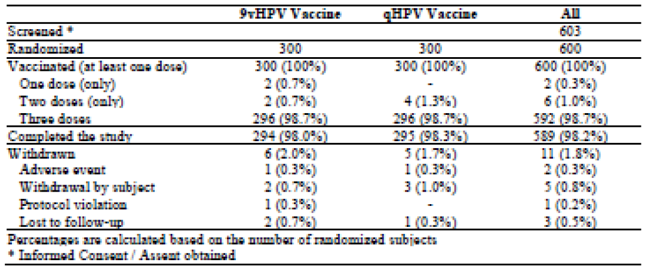

##### Major protocol violations/deviations

The main reason for excluding subjects from the Per Protocol Sets was pre-vaccination seropositivity, reported for 32 subjects (10.7%) receiving qHPV vaccine and 17 subjects (5.7%) receiving 9vHPV vaccine. Seropositivity was mainly reported for HPV types 6 and 58. Non‑compliance with blood sample requirements was reported for 17 subjects in each vaccination group. In particular, the interval between Dose 3 and serum sample was over 49 days for 16 subjects, and post Dose 3 immunogenicity evaluation was not available for 14 subjects. Regarding compliance with vaccination schedule, protocol deviations were reported for 4 subjects receiving 9vHPV vaccine and 5 subjects receiving qHPV vaccine. Eight subjects, 4 in each group, had incomplete vaccination schedule and 1 subject received Dose 3 of qHPV vaccine out of the acceptable day ranges. General protocol deviations were identified for 20 subjects: 9 subjects from 9vHPV vaccine group and 11 subjects from the qHPV vaccine group. Administrations of incorrect clinical material (kit number administered different from number allocated) were observed for 4 subjects; 6 subjects received vaccine that had been frozen; 1 subject received qHPV vaccine in two times (that is unreliable administration of a study vaccine dose).

##### Baseline data

Demographic data and other baseline characteristics were similar for subjects receiving 9vHPV vaccine and subjects receiving qHPV vaccine. Mean (SD) age at first dose was 12.6 (1.9) years for all randomised subjects, 11.0 (1.0) years for the 300 subjects in the stratum 9 to 12 years old and 14.3 (0.8) years for the 300 subjects in the stratum 13 to 15 years old.

##### Results for the primary efficacy outcome

The primary objective of the study was met: the non-inferiority of the 9vHPV vaccine compared to qHPV vaccine was demonstrated for HPV16 and HPV18 since the lower bound of the two sided 95% CI around the post Dose 3 GMT ratio (9vHPV vaccine/qHPV vaccine) is greater than 0.67 for both HPV types (Table 21). Anti-HPV 6 and anti-HPV 11 GMTs were comparable in subjects administered a 3 dose regimen of 9vHPV vaccine or a 3 dose regimen of qHPV vaccine. All subjects seroconverted to the HPV types 6, 11, 16 and 18 after receiving the 3 dose schedule of the qHPV vaccine.

Table 21: Study 009, non-inferiority comparison of post-Dose 3 Anti-HPV Types 16 and 18 GMTs -9vHPV vaccine versus qHPV vaccine - HPV specific per protocol set

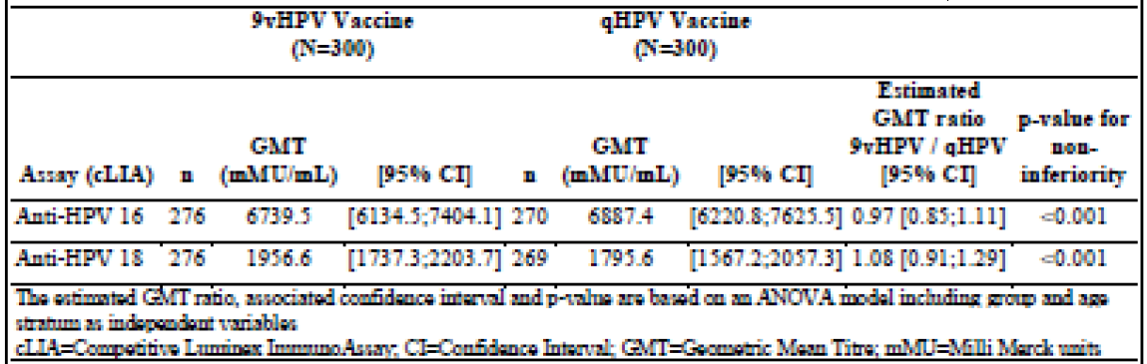

##### Results for other efficacy outcomes

Table 22 presents the post Dose 3 GMTs of the HPV types included in the 9vHPV vaccine, for both groups (except for HPV types 16 and 18 which are presented in Table 21). All subjects seroconverted to the 9 HPV types after receiving the 3 dose schedule of the 9vHPV vaccine, except one subject who did not seroconvert to HPV45. Although the GMTs are low, qHPV vaccine induced some post Dose 3 immune responses to the HPV types not included in the vaccine, including a seroconversion rate of 73.5% for HPV31, 54.8% for HPV58, 21.0% for HPV45, 20.4% for HPV33, and 3.3% for HPV52.

Table 22: Study 009, summary of post Dose 3 anti-HPV types 6, 11, 16, 18, 31, 33, 45, 52 and 58 GMTs by vaccination group - HPV specific per protocol set

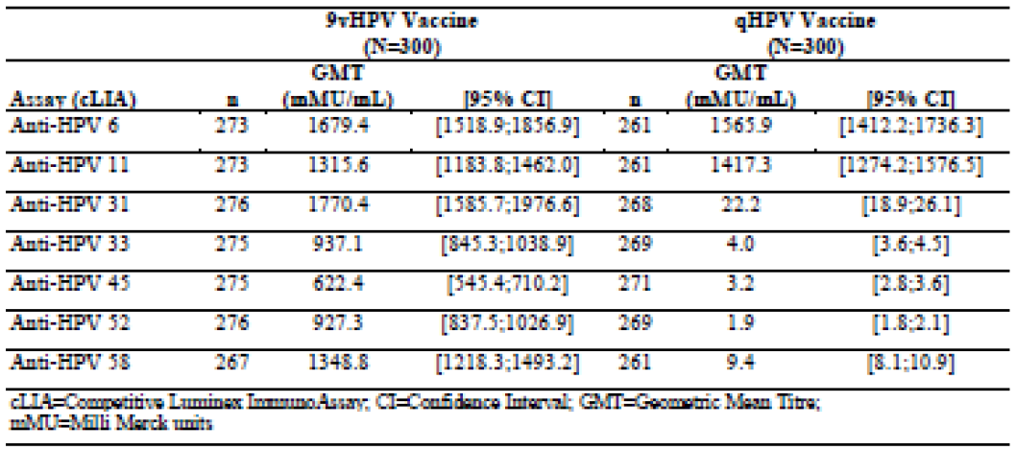

### Other efficacy studies

#### Study V503-005 (Study 005)

Study 005 addressed concomitant administration of 9vHPV vaccine with Menactra, Adacel. It was an open label study to assess 9vHPV vaccine safety and immunogenicity in females and males, 11 to 15 years of age, administered concomitantly with Menactra and Adacel. The study was designed to enrol 620 females, 11 to 15 years of age, and 620 males, 11 to 15 years of age. Subjects were equally randomised to a concomitant cohort or a non-concomitant cohort. Subjects enrolled in the concomitant cohort were administered 9vHPV vaccine, Menactra, and Adacel at Day 1.

Subjects in the non-concomitant cohort were administered 9vHPV vaccine at Day 1, and Menactra and Adacel at Month 1. All subjects were administered a second and third dose of 9vHPV vaccine at Month 2 and Month 6. Blood samples were collected at Day 1, Month 1, Month 2, and Month 7.

The primary time point for evaluation of 9vHPV vaccine immunogenicity was 1 month following administration of the third dose of 9vHPV vaccine. The primary time point for evaluation of Menactra and Adacel immunogenicity was 1 month following administration of Menactra and Adacel. Baseline bloods were collected for comparison.

##### Primary immunogenicity objectives

1. To demonstrate that a first dose of the 9 valent HPV L1 VLP vaccine administered concomitantly with Menactra and Adacel induces non-inferior anti-HPV 6, 11, 16, 18, 31, 33, 45, 52, and 58 Geometric Mean Titres (GMTs) in preadolescent and adolescent boys and girls 11 to 15 years of age compared with the administration of the 9 valent HPV L1 VLP vaccine alone.
2. To demonstrate that Menactra administered concomitantly with Adacel and a first dose of the 9 valent HPV L1 VLP vaccine induces non-inferior immune responses with respect to seroconversion percentages to Neisseria meningitidis serogroups A, C, Y, and W-135 in preadolescent and adolescent boys and girls 11 to 15 years of age compared with the administration of Menactra concomitantly with Adacel.
3. To demonstrate that Adacel administered concomitantly with Menactra and a first dose of the 9 valent HPV L1 VLP vaccine induces non-inferior immune responses to diphtheria, tetanus, and pertussis in preadolescent and adolescent boys and girls 11 to 15 years of age compared with the administration of Menactra concomitantly with Adacel.

##### Secondary objectives:

1. To demonstrate that a first dose of the 9 valent HPV L1 VLP vaccine administered concomitantly with Menactra and Adacel induces non-inferior immune responses with respect to seroconversion percentages to HPV Types 6, 11, 16, 18, 31, 33, 45, 52, and 58 in preadolescent and adolescent boys and girls 11 to 15 years of age compared with the administration of the 9 valent HPV L1 VLP vaccine alone.
2. To demonstrate that Menactra administered concomitantly with Adacel and a first dose of the 9 valent HPV L1 VLP vaccine induces non-inferior GMTs for Neisseria meningitidis serogroups A, C, Y, and W-135 in preadolescent and adolescent boys and girls 11 to 15 years of age compared with the administration of Menactra.

Subjects were stratified by gender (1:1 ratio) and randomly assigned to 1 of 2 vaccination groups in a 1:1 ratio. Subjects in Vaccination Group 1 (referred to as the Concomitant Group) received the first dose of 9vHPV vaccine in the deltoid muscle of the non-dominant arm and Menactra and Adacel were administered concomitantly at separate injection sites at least 2 inches apart in the deltoid muscle of the dominant arm on Day 1. Subjects in Vaccination Group 2 (also referred to as Non-concomitant Group) received the first dose of the 9vHPV vaccine on Day 1 and Menactra and Adacel at Month 1. Subjects in both vaccination groups received the second dose of the 9vHPV vaccine at Month 2 and the third dose at Month 6. The disposition of subjects was provided.

##### Inclusion criteria

Healthy, preadolescent and adolescent boys and girls, 11 to 15 years of age whose parent/legal guardian and the subjects themselves fully understood study procedures, alternative treatments available, the risks involved with the study, and voluntarily agreed to participate by giving written informed consent/assent. They were able to read, understand, and complete the vaccination report card (VRC) and must have agreed to provide study personnel with primary telephone number as well as an alternate telephone number for follow up purposes. Subjects must not yet have had coitarche and must have agreed to refrain from sexual activity throughout the course of the study and must have previously received a documented, full primary vaccination series against diphtheria, tetanus, and pertussis (not in the last 5 years). Also must not be immunosuppressed or enrolled in more than one clinical study (as in the other studies).

##### ***Immunogenicity measurements***

Serum collected from subjects at Day 1 and Month 7 underwent analysis of anti-HPV 6, 11, 16, 18, 31, 33, 45, 52, and 58 responses by 9vHPV vaccine competitive Luminex Immunoassay (HPV-9 cLIA). Serum was analysed to support the primary study objectives and a secondary objective. Serum collected at Day 1 and Month 1 for Group 1 (Concomitant Group), and at Month 1 and Month 2 for Group 2 (Non-concomitant Group), underwent antibody testing for N. meningitidis serogroups A, C, Y, and W-135, diphtheria, tetanus, and pertussis (PT, FHA, FIM, PRN). Meningococcal antibodies were measured by Serum Bactericidal Assay. Diphtheria antibodies were measured by diphtheria antitoxin cell culture assay. Tetanus antibodies were measured by tetanus antitoxin enzyme immunoassay (EIA). Pertussis antibodies were measured by anti-PT enzyme-linked immunosorbent assay (ELISA), anti-FHA ELISA, anti-PRN ELISA, and anti-FIM ELISA. The descriptions of all serologic assays used in this study are provided under immunogenicity measurements in the protocol.

##### Statistical planning and analysis:

###### Immunogenicity

The primary and secondary endpoints for evaluating antibody responses to 9vHPV vaccine were GMTs to HPV 6, 11, 16, 18, 31, 33, 45, 52, and 58 at Week 4 post Dose 3 and the percentages of subjects who seroconverted for each HPV Type (6, 11, 16, 18, 31, 33, 45, 52, 58) by Week 4 post Dose 3. Anti-HPV cut-offs for determining serostatus were 30, 16, 20, 24, 10, 8, 8, 8, and 8 mMU/mL for HPV Types 6, 11, 16, 18, 31, 33, 45, 52, and 58, respectively. The primary endpoints for evaluating antibody response to Menactra were the proportions of subjects with a 4- fold or greater rise in titres for N. meningitidis serogroup A, C, Y, and W-135 one month post- vaccination of Menactra. The primary endpoints for evaluating antibody response to the diphtheria and tetanus components of Adacel were the proportions of subjects who achieve titres of at least 0.1 IU/mL one month post vaccination of Adacel.

The primary immunogenicity endpoints for pertussis were the GMTs to anti-PT, anti-FHA, anti-PRN, and anti-FIM one month post vaccination of Adacel. The primary immunogenicity analysis was done per protocol. For 9vHPV vaccine, subjects were seronegative to the specific HPV type at baseline. Non-inferiority of anti-HPV GMTs 4 weeks post Dose 3 and pertussis GMTs 1 month post- vaccination with Adacel was based on one-sided tests of non-inferiority comparing GMTs for each component. An analysis of variance (ANOVA) model (1 for each component) was used with a response of loge individual titres and fixed effects for vaccination group and gender. Non-inferiority of anti-HPV seroconversion rates, of serologic responses to diphtheria and tetanus was tested by one-sided tests of non-inferiority comparing proportions for each component. These tests were conducted based on methods developed by Miettinen and Nurminen.

###### Statistical analysis

Anti-HPV 6, anti-HPV 11, anti-HPV 16, anti-HPV 18, Anti-HPV 31, anti-HPV 33, anti-HPV 45, anti-HPV 52, and anti-HPV 58 cLIA GMT’s at 4 weeks post Dose 3 and the percentage of subjects who seroconverted by 4 weeks post Dose 3 were compared between the group receiving 9vHPV vaccine + Menactra and Adacel concomitantly and the group receiving the vaccines non- concomitantly. The statistical criterion for non-inferiority with respect to GMTs required that the lower bound of the 95% confidence interval (CI) for the fold difference in GMTs (concomitant vaccination over non-concomitant vaccination) exclude a 2 fold decrease or more for all 9 vaccine HPV types.

##### Results

This non-inferiority criterion was met for all HPV types. This is summarised in Table 23. With respect to seroconversion rates, the statistical criterion for non-inferiority required that the lower bound of the 95% CI for the differences in proportions between the Concomitant Group and the Non-concomitant Group exclude a decrease of 5 percentage points or more. This non-inferiority criterion was met for all HPV types. The non-inferiority criterion for acceptable levels of titres to N. meningitidis serogroups A, C, Y, and W-135 at 4 weeks post vaccination with Menactra and Adacel required that lower bound of the 97.5% CI for the differences in proportions between the Concomitant Group and Non-concomitant Group exclude a decrease of 10 percentage points or more. This non-inferiority criterion was met for the four N. meningitidis serogroups. The non-inferiority criterion for acceptable levels of titres to diphtheria and tetanus at 4 weeks post vaccination with Menactra and Adacel were also met. The non-inferiority criterion for GMTs for pertussis antigens at 4 weeks post vaccination were met for all 4 pertussis antigens.

Table 23: Immunogenicity results for Study 005 statistical analysis of non-inferiority comparing Month 7 HPV cLIA geometric mean titres (HPV types 6, 11, 16, 18, 31, 33, 45, 52 and 58) between concomitant versus non-concomitant vaccination group (per-protocol immunogenicity population HPV)

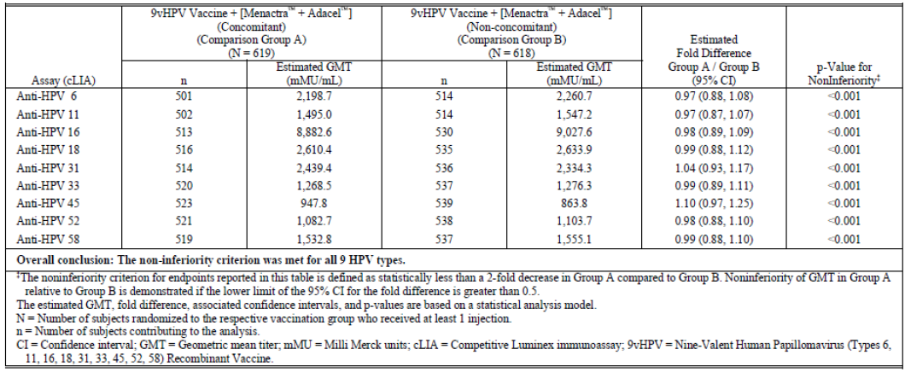

#### Protocol V503-006 (Study 006)

This was a Phase III randomised, international, placebo controlled, double blind clinical trial to study the tolerability and immunogenicity of 9vHPV, given to females 12 to 26 years of age who have previously received Gardasil. This was a multicentre study conducted at 10 US and 22 non‑US sites. Study 006 was a double blinded, placebo-controlled study to assess 9vHPV vaccine safety and immunogenicity in prior qHPV vaccine recipients. The study was designed to enrol 900 females, 12 to 26 years of age. The 12 to 26 year old age range was selected as the most likely age range to receive a follow up vaccination with 9vHPV vaccine, should the vaccine be licensed. Approximately 180 healthy females 12 to 15 years of age and 720 healthy females 16 to 26 years of age were to be enrolled in the study. Subjects were randomised in a 2:1 ratio to 9vHPV vaccine or placebo. All subjects were administered a 3 dose regimen of vaccine or placebo (at Day 1, Month 2, and Month 6). Blood samples were collected at Day 1 and Month 7. All subjects enrolled in the study were to have received the qHPV vaccine as a 3 dose regimen administered within a period of 1 year. The last dose of qHPV vaccine had to have been administered at least 1 year prior to enrolment. This ensured that anti-HPV 6, anti-HPV 11, anti-HPV 16, and anti-HPV 18 levels had decreased from post vaccination peak levels and were generally in the same range at enrolment in all study participants.

##### Objectives

The primary objective was to evaluate the tolerability of the 9 valent HPV L1 VLP vaccine in adolescent girls and young women 12 to 26 years of age who have previously received a 3 dose regimen of Gardasil. The secondary objective was to demonstrate that the 9 valent HPV L1 VLP vaccine is immunogenic with respect to HPV Types 31, 33, 45, 52, and 58 in adolescent girls and young women 12 to 26 years of age who have previously received a 3 dose regimen of Gardasil . Serum samples were collected from all subjects at Day 1 (prior to vaccine administration), Month 2, and Month 7 to assess anti-HPV levels. The primary time point for immunogenicity evaluation was at Month 7 (1 month following the completion of the 3 dose regimen). The disposition of subjects and inclusion criteria were provided.

##### Statistical planning and analysis:

###### Immunogenicity

The modified per-protocol immunogenicity (mPPI) population was the population from which inferences about the immune responses were made. To address the immunogenicity hypotheses that the 9vHPV vaccine induced acceptable immune responses to HPV 31, 33, 45, 52, and 58 in prior Gardasil recipients, the null hypothesis was that the percentage of subjects who were seropositive for a given HPV type at 4 weeks post Dose 3 is 90% and it was tested against the alternative hypothesis that the percentage of seropositivity was > 90% at a 1 sided 0.025 alpha level. The statistical analysis used the confidence interval approach. The percentage of seropositivity to a given HPV type at 4 weeks post Dose 3 in the 9vHPV group was calculated. The associated 95% confidence interval was constructed based on the exact binomial method for a single proportion proposed by Clopper-Pearson. Acceptability was defined as the lower bound of the 95% confidence interval for the seropositivity percentage being greater than 90%. In addition, immunogenicity summaries of Geometric Mean Titres (GMTs) and seropositivity for all nine HPV types at Day 1, Month 2, and Month 7 were provided by vaccination group and age stratum.

###### Results

At 4 weeks post Dose 3, marked elevations in cLIA Geometric Mean Titres (GMTs) to HPV Types 31, 33, 45, 52, and 58 were elicited in the 9vHPV vaccine group. At 4 weeks post Dose 3, over 98% of subjects in the mPPI population in the 9vHPV vaccine cohort were seropositive for HPV Types 31, 33, 45, 52, and 58. Seropositivity rates for HPV Types 31, 33, 45, 52, and 58 were all statistically greater than 90% in the 9vHPV vaccine group. Therefore, the secondary immunogenicity hypothesis was met.

#### Protocol V503-007 (Study 007)

Study 007 was a Phase III open label clinical trial to study the immunogenicity and safety of V503, a multivalent human papillomavirus (HPV) L1 Virus-Like Particle (VLP) vaccine, given concomitantly with Repevax in preadolescents and adolescents (11 to 15 Year Olds). There were 20 sites/investigators in 5 countries in Europe (Austria, Belgium, Denmark, Finland, and Germany) and 2 sites/investigators in 1 country in Southeast Asia (Thailand) received study vaccine. The study was conducted between 26 April 2010 to 16 June 2011. The study was designed to enrol 520 females, 11 to 15 years of age, and 520 males, 11 to 15 years of age. Subjects were equally randomised to a concomitant cohort or a non-concomitant cohort. Subjects enrolled in the concomitant cohort were administered 9vHPV vaccine and Repevax at Day 1. Subjects in the non- concomitant cohort were administered 9vHPV vaccine at Day 1 and Repevax at Month 1. All subjects were administered a second and third dose of 9vHPV vaccine at Month 2 and Month 6.

Blood samples were collected at Day 1, Month 1, Month 2, and Month 7. The primary time point for evaluation of 9vHPV vaccine immunogenicity was 1 month following administration of the third dose of 9vHPV vaccine. The primary time point for evaluation of Repevax immunogenicity was 1 month following administration of Repevax. The study design is summarised in Table 24.

Table 24: Study 007, design and schedule of blood draws

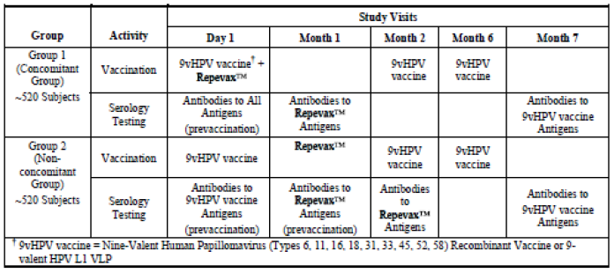

##### Primary immunogenicity objectives

1. To demonstrate that a first dose of the 9 valent HPV L1 VLP vaccine administered concomitantly with Repevax induces non-inferior anti-HPV 6, 11, 16, 18, 31, 33, 45, 52, and 58 Geometric Mean Titres (GMTs) in preadolescent and adolescent boys and girls 11 to 15 years of age compared with the administration of the 9 valent HPV L1 VLP vaccine separately.
2. To demonstrate that Repevax administered concomitantly with a first dose of the 9 valent HPV L1 VLP vaccine induces non-inferior immune responses to diphtheria, tetanus, poliovirus types 1, 2, and 3, and pertussis in preadolescent and adolescent boys and girls 11 to 15 years of age compared with the administration of Repevax.

##### Primary safety objective

To evaluate the tolerability of the concomitant administration of a first dose of the 9 valent HPV L1 VLP vaccine with Repevax in preadolescent and adolescent boys and girls 11 to 15 years of age. Subject disposition is show in Table 25. Subjects received a 0.5 mL intramuscular dose of 9vHPV vaccine at Day 1, Month 2, and Month 6. Subjects also received a 0.5 mL intramuscular dose of Repevax (Group 1 Concomitant Group) on day 1 or at Month 1 (non-concomitant group).

Table 25: Study 007, subject disposition

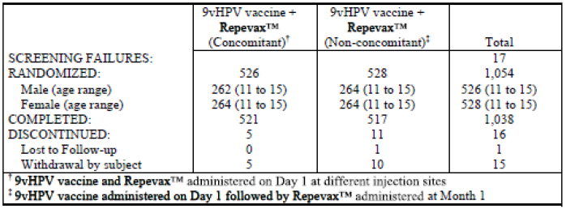

##### Inclusion criteria

Healthy, preadolescent and adolescent boys and girls 11 to 15 years of age whose parent/legal guardian and the subjects themselves fully understood study procedures, alternative treatments available, the risks involved with the study, and voluntarily agreed to participate by giving written informed consent/assent. Subjects must not yet have had coitarche and must have agreed to refrain from sexual activity throughout the course of the study and must have previously received a documented, full primary vaccination series against diphtheria, tetanus, pertussis, and poliovirus (inactivated and/or oral poliovirus) but not in the last 5 years.

##### Immunogenicity measurements

Serum collected from all subjects at Day 1 and Month 7 underwent analysis of anti-HPV 6, 11, 16, 18, 31, 33, 45, 52, and 58 responses by 9vHPV vaccine competitive Luminex Immunoassay (HPV-9 cLIA). Serum was analysed to support the primary study objectives and to support assay development work. Serum collected at Day 1 and Month 1 for Group 1 (Concomitant Group) and Month 1 and Month 2 for Group 2 (Non-concomitant Group) underwent antibody testing for diphtheria, tetanus, pertussis (PT, FHA, FIM, PRN), and poliovirus types 1, 2, and 3. Diphtheria antibodies were measured by diphtheria antitoxin cell culture assay. Tetanus antibodies were measured by tetanus antitoxin enzyme immunoassay (EIA). Pertussis antibodies were measured by anti-PT enzyme-linked immunosorbent assay (ELISA), anti-FHA ELISA, anti-PRN ELISA, and anti-FIM ELISA. Poliovirus antibodies were measured by poliovirus antibody microneutralization assay (MNA) to detect serum neutralizing antibodies to poliovirus before and after vaccination with poliovirus containing vaccine.

##### Safety measurements

All subjects received a VRC which was to be completed by the parent or guardian at the Day 1, Month 1, Month 2, and Month 6 study vaccination visits, and Month 7 study visit.

##### Statistical planning and analysis

###### Immunogenicity

The primary and secondary endpoints for evaluating antibody responses to 9vHPV vaccine were GMTs to HPV 6, 11, 16, 18, 31, 33, 45, 52, and 58 by 4 weeks post Dose 3 and the percentages of subjects who seroconverted for each HPV Type (6, 11, 16, 18, 31, 33, 45, 52, and 58) by 4 weeks post Dose 3. Anti-HPV cut-offs for determining sero status were 30, 16, 20, 24, 10, 8, 8, 8, and 8 mMU/mL for HPV Types 6, 11, 16, 18, 31, 33, 45, 52, and 58, respectively. The primary endpoints for evaluating antibody response to Repevax were the proportions of subjects who achieved acceptable levels of titres to diphtheria, tetanus, and polio, and GMTs for pertussis (anti- PT, anti-FHA, anti-PRN, and anti-FIM) 4 weeks post vaccination with Repevax. The targeted titter levels were ≥ 0.1 IU/mL for diphtheria and tetanus, and neutralizing antibodies at ≥ 1:8 dilution for all poliovirus types.

##### Statistical analysis

The primary immunogenicity analysis was done per protocol. For responses to 9vHPV vaccine, subjects were required to be seronegative to the specific HPV type at baseline. Non-inferiority of anti-HPV GMTs 4 weeks post Dose 3 and pertussis GMTs 1 month post vaccination with Repevax was based on one-sided tests of non-inferiority (conducted at the 0.025 significance level) comparing GMTs between the Concomitant Group and the Non-concomitant Group for each component. An analysis of variance (ANOVA) model (1 for each component) was used with a response of loge individual titres and fixed effects for vaccination group and gender. Non-inferiority of anti-HPV seroconversion rates and of serologic responses to diphtheria, tetanus, and polio was tested by one-sided tests of non-inferiority comparing proportions between the Concomitant Group and the Non-concomitant Group for each component. These tests were conducted based on methods developed by Miettinen and Nurminen. All tests were conducted at the 0.025 significance level. Success in this study was declared if the primary hypotheses of non-inferiority were demonstrated for all components of both 9vHPV vaccine and Repevax.

##### Results

Immunogenicity: Anti-HPV 6, anti-HPV 11, anti-HPV 16, anti-HPV 18, anti-HPV 31, anti-HPV 33, anti-HPV 45, anti-HPV 52, and anti-HPV 58 cLIA GMTs at 4 weeks post Dose 3 and the percentage of subjects who seroconverted by 4 weeks post Dose 3 were compared between the Concomitant group and the Non-concomitant Group. The statistical criterion for non-inferiority with respect to GMTs required that the lower bound of the 95% confidence interval (CI) for the fold difference in GMTs (concomitant vaccination over non-concomitant vaccination) exclude a 2 fold decrease or more for all 9 vaccine HPV types. This non-inferiority criterion was met for all HPV types. With respect to seroconversion rates, the statistical criterion for non-inferiority required that the lower bound of the 95% CI for the differences in proportions between the Concomitant Group and the Non-concomitant Group exclude a decrease of 5 percentage points or more. This non-inferiority criterion was met for all HPV types.

For Repevax seroconversion rates, the statistical criterion for non-inferiority required that the lower bound of the 95% CI for the differences in proportions between the Concomitant Group and Non-concomitant Group exclude a decrease of 10 percentage points or more for the comparison of subjects who achieved acceptable levels of titres to diphtheria, tetanus, and poliovirus types 1, 2, and 3 at 4 weeks post vaccination with Repevax This non-inferiority criterion for seroconversion rates for Repevax as met for all antigens. The non-inferiority criterion for GMTs for pertussis (anti- PT, anti-FHA, anti-PRN, and anti-FIM) at 4 weeks post vaccination in the Concomitant Group versus the Non-concomitant Group required that the lower bound of the 95% CI for the fold difference in GMTs (concomitant vaccination over non-concomitant vaccination) exclude a 1.5 fold decrease or more for all 4 pertussis antigens. This non-inferiority criterion was met for all 4 pertussis antigens.

### Analyses performed across trials (pooled analyses and meta-analyses)

N/A

### Evaluator’s conclusions on clinical efficacy for 9vHPV

* In study participants, administration of a 3 dose regimen of 9vHPV vaccine to females, 16 to 26 years of age, was shown to reduce the overall risk for development of cervical (CIN), vulvar (VIN) and vaginal (VaIN) disease; the risk of having an abnormal Pap test, particularly a Pap test that is predictive for CIN 2/3 and, therefore, requires colposcopic follow up; and their risk of undergoing cervical and external genital diagnostic and therapeutic procedures, especially definitive therapy procedures.
* The protective efficacy induced by the 9vHPV vaccine is durable through at least 4 years post vaccination with respect to infection and disease related to the HPV vaccine types.
* The 9vHPV vaccine induces robust anti-HPV 6, anti-HPV 11, anti-HPV 16, anti-HPV 18, anti-HPV 31, anti-HPV 33, anti-HPV 45, anti-HPV 52, and anti-HPV 58 responses through at least 1.5 years post vaccination.
* Administration of a 3 dose regimen of 9vHPV vaccine to females, 9 to 15 years of age, should have protective efficacy against cervical, vulvar, and vaginal infection and disease caused by HPV types 31, 33, 45, 52, and 58. This conclusion is based on numerically superior and statistically non-inferior anti-HPV 31, anti-HPV 33, anti-HPV 45, anti-HPV 52, and anti-HPV 58 responses induced by 9vHPV vaccine in females, 9 to 15 years of age, compared with anti-HPV responses induced in females, 16 to 26 years of age (the population used to establish 9vHPV vaccine efficacy). (immunobridging evidence, as shown for qHPV).
* Administration of a 3 dose regimen of 9vHPV vaccine to males, 9 to 15 years of age, should have protective efficacy against external genital infection and disease caused by HPV types 31, 33, 45, 52, and 58. This conclusion is based on numerically superior and statistically non-inferior anti- HPV 31, anti-HPV 33, anti-HPV 45, anti-HPV 52, and anti-HPV 58 responses induced by 9vHPV vaccine in males, 9 to 15 years of age, compared with anti-HPV responses induced in females, 16 to 26 years of age (the population used to establish 9vHPV vaccine efficacy). (Immunobridging evidence, as shown for qHPV).
* The final manufacturing process of 9vHPV vaccine produces materials that generate consistent Month 7 anti-HPV cLIA responses.
* Concomitant administration of a 3 dose regimen of 9vHPV vaccine with Menactra and Adacel results in antibody responses to 9vHPV vaccine, Menactra and Adacel components that are comparable to those observed when 9vHPV vaccine is not administered concomitantly with Menactra and Adacel.
* Concomitant administration of a 3 dose regimen of 9vHPV vaccine with Repevax results in antibody responses to 9vHPV vaccine and Repevax components that are comparable to those observed when 9vHPV vaccine is not administered concomitantly with Repevax.
* Administration of a 3 dose regimen of 9vHPV vaccine in females, 12 to 26 years of age, who were previously administered a 3 dose regimen of qHPV vaccine, results in the following: (1) high seroconversion rates with respect to HPV 31, 33, 45, 52, and 58; (2) anti-HPV 6, anti-HPV 11, anti-HPV 16, and anti-HPV-18 responses that are higher than anti-HPV 6, anti-HPV 11, anti-HPV 16, and anti-HPV-18 responses following administration of a 3 dose regimen of 9vHPV vaccine in females, 12 to 26 years of age, naïve to prior HPV vaccination.

## Clinical safety

### Studies providing evaluable safety data

All the studies submitted in this dossier provided evaluable safety data:

The 6 Phase III 9vHPV clinical studies described in Section 7 were conducted in female subjects 9 to 26 years of age and male subjects 9 to 15 years of age. The population considered for evaluation of safety (‘Safety Population’) was defined as all subjects who:

* + Received at least one injection and had follow up data, and
  + were enrolled in Protocols V503-001, V503-002, V503-005, V503-006, V503-007, or V503- 009/GDS01C, and received the mid dose formulation of the 9vHPV vaccine or qHPV vaccine. This is summarised in Table 26. Thus, the safety population excludes subjects enrolled in Part A of Study 001 who received the low dose formulation or the high dose formulation of 9vHPV vaccine, and subjects enrolled in Study 006 who received placebo.

Table 26: Listing of protocols that provided safety data (Protocols 001, 002, 005, 006, 007 and 009/GDS01C)

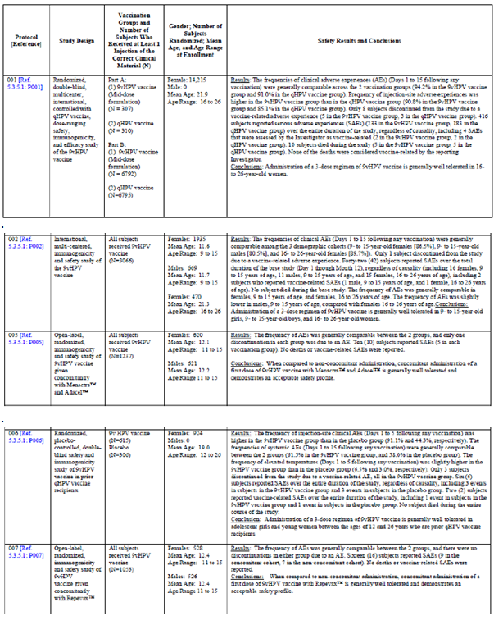

Table 26 (continued): Listing of protocols that provided safety data (Protocols 001, 002, 005, 006, 007 and 009/GDS01C)

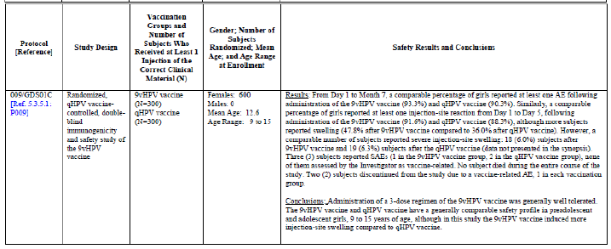

#### Pivotal efficacy studies

In the pivotal efficacy studies, the safety data was collected as detailed in Table 26 and Table 27. General adverse events (AEs) were assessed by subjects or guardians on recording cards (VRC) and by investigators, as were AEs of particular interest, including local and generalised reactions post- vaccination and any new diseases present at final assessment.

Table 27: Number of subjects enrolled by protocol and age who received 9vHPV vaccine (Protocols 001, 002, 005, 006, 007, and 009) for safety analysis

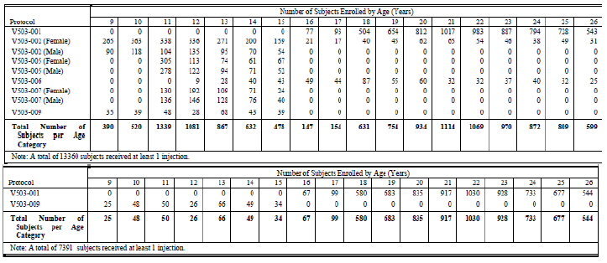

#### Pivotal studies that assessed safety as a primary outcome

All the efficacy studies also assessed safety as a primary outcome. The studies are described in Section 7 above.

#### Dose-response and non-pivotal efficacy studies

N/A

#### Other studies evaluable for safety only

N/A

### Pivotal studies that assessed safety as a primary outcome

The design of all these studies is described above in Section 7

#### Safety variables and outcomes

An important goal of the study was to evaluate the safety and tolerability of the 9vHPV vaccine in the study population. All subjects were to be monitored for safety for the duration of the study as outlined below:

* All subjects received a VRC at the Day 1, Month 2, and Month 6 study vaccination visits. On the VRC, the subject or the parent/guardian of the subject was asked to record the subject’s oral temperature in the evening after each study vaccination and daily for 4 days after each study vaccination for the purpose of identifying febrile events. Also, beginning after each study vaccination and for a total of 15 days including the day of vaccination, the subject was to be asked to record injection site and systemic adverse experiences, concomitant medications, and concomitant vaccinations on the VRC.
* SAEs were to be collected regardless of causality from Day 1 through 6 months following the last vaccination (or Day 1 through end of study for studies of 7 month duration). Event of fetal loss were reported as serious adverse experiences if the last menstrual period (LMP) was between Day 1 and 6 months following the last vaccination (or Day 1 through end of study for studies of 7 month duration).
* Deaths, vaccine related SAEs, and study procedure related SAEs were to be collected throughout the study.
* New medical conditions not present at baseline and not reported as an adverse experience were to be collected throughout the study.
* Any overdose of test vaccine (9vHPV vaccine or qHPV vaccine) defined as a subject receiving more than 3 doses of vaccine (0.5 mL each dose) or receiving ≥ 0.75 mL of vaccine in any one dose, was to be reported.
* Pregnancy and lactation information was also to be collected. A pregnancy test was performed at Day 1, Month 2, and Month 6 visits on all female subjects. Any female subject with a positive pregnancy test at Day 1 was not vaccinated and was not allowed to participate in the study. Female subjects with a positive pregnancy test after Day 1 were not vaccinated until after pregnancy outcome. Pregnant subjects who received less than 3 vaccinations during the study were offered the possibility to complete the vaccination course. Pregnancy and associated AEs, lactation (if a subject received study vaccine while breastfeeding during the Day 1 through Month 7 period) and SAEs in study subjects and infants were to be followed to outcome.

#### Analysis populations

All safety analyses were performed on the All Subjects as Treated (ASaT) population. The ASaT population includes all randomised subjects who receive at least 1 injection of the 9vHPV or qHPV vaccine and have follow up data, and assigns subjects to the vaccination group corresponding to the actual clinical material received. For subjects who received injections of study vaccines corresponding to a sequence that does not correspond to any of the protocol defined vaccination groups (that is, cross treated subjects), a safety profile listing was created separate from the safety reports that were provided for the protocol defined vaccination groups.

#### Sample size

Overall, 13,360 subjects from these 6 studies received 9vHPV vaccine (including 8,053 females 16 to 26 years of age, 3,498 females 9 to 15 years of age, and 1,809 males 9 to 15 years of age), and 7,391 subjects from Protocols V503-001 and V503-009/GDS01C received qHPV vaccine (including 7,093 females 16 to 26 years of age, and 298 females 9 to 15 years of age). The numbers of subjects who received 9vHPV vaccine or qHPV vaccine by age and gender grouping and by vaccination group are presented in (Table 28).

Table 28: Subjects by age category and gender who received 9vHPV Vaccine or qHPV vaccine (Protocols 001, 002, 005, 006, 007, and 009)

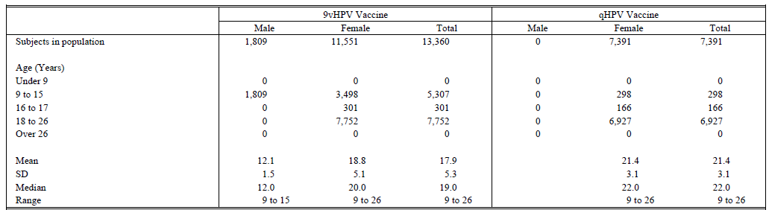

#### Statistical methods

Risk difference and CIs between vaccination and control groups.

#### Participant flow

Described for each study in Section 7.

#### Major protocol violations/deviations

Described for each study in Section 7.

#### Results for the primary safety outcome

Safety analyses were conducted in each of the individual studies and the data was also pooled In Study 001, 7,099 subjects were administered 9vHPV vaccine and 7,105 subjects were administered qHPV vaccine. Safety findings from the study supported the conclusion that the safety profile of the 9vHPV vaccine is generally comparable to that of qHPV vaccine. A higher frequency of injection site adverse experiences was noted in the 9vHPV vaccine group (90.8%) compared with the qHPV vaccine group (85.1%). Moreover, injection site adverse experiences of severe intensity were more frequent in the 9vHPV vaccine group compared with the qHPV vaccine group. Most (over 90%) injection site adverse experiences were of mild or moderate intensity, (or for the adverse experiences of injection site erythema and injection site swelling, with a maximum size of less than 2 inches [5 cm]). The rates of discontinuations due to an adverse experience were low (≤ 0.1%) and comparable between the 2 vaccination groups. Therefore, this difference in frequency of injection site adverse experiences between the 2 vaccination groups did not appear to be of clinical significance. The safety analysis in subjects who received higher dose formulations or partial dose formulations of 9vHPV in 001 did not find a significant difference between the groups in relation to adverse events when compared to the mid dose group.

In Study 002, administration of the 9vHPV vaccine was generally well tolerated. The frequencies of clinical adverse experiences were generally comparable among the 3 demographic cohorts. Only 1 subject discontinued from the study due to a vaccine related adverse experience. Forty-two (42) SAEs were reported over the entire duration of the study, regardless of causality, including 2 vaccine related SAEs.

In Study 009, 300 subjects were administered 9vHPV vaccine and 300 subjects were administered qHPV vaccine. Safety findings from the study supported the conclusion that the safety profile of the 9vHPV vaccine is generally comparable to that of qHPV vaccine. A higher frequency of injection site swelling was noted in the 9vHPV vaccine group (47.8%) compared with the qHPV vaccine group (36.0%). In most cases, these events were of mild or moderate intensity (that is, with a maximum size of less than 2 inches [5 cm]). The frequencies of injection site swelling of severe intensity (defined as a maximum size of more than 2 inches [5 cm]) were comparable between the 2 vaccine groups (6.0% in the 9vHPV vaccine group, 6.3% in the qHPV vaccine group).

In Study006, the 9vHPV vaccine was generally well tolerated in prior qHPV vaccine recipients. A higher frequency of injection site erythema, injection site pain, and injection site swelling was noted in the 9vHPV vaccine group compared with the saline placebo group (95.6 versus 73.8%). The proportion of subjects who reported at least one injection site adverse experience within 15 days of any vaccination was higher among subjects who received 9vHPV vaccine (554/608 [91.1%]) compared to those who received placebo (134 out of 305 [43.9%]).

In Study 005, when compared to non-concomitant administration, concomitant administration of a first dose of 9vHPV vaccine with Menactra and Adacel was generally well tolerated. There were no deaths, few SAEs (< 1% in either vaccination group), and no vaccine related SAEs. The frequency of AEs was generally comparable between the 2 groups, and only one discontinuation in each group due to an AE.

In Study 007, when compared to non-concomitant administration, concomitant administration of a first dose of 9vHPV vaccine with Repevax was generally well tolerated. There were no deaths, few SAEs, and no vaccine related SAEs. The frequency of AEs was generally comparable between the 2 groups, and there were no discontinuations in either group due to an AE.

Overall (in the pooled data), it was noted that from Day 1 to Day 15 following any vaccination, 95.6% of prior qHPV vaccine recipients who received 9vHPV vaccine reported 1 or more adverse experiences, 0.3% of subjects reported a serious adverse experience, and 0.5% of subjects were discontinued due to an adverse experience. In subjects naïve to HPV vaccination who received 9vHPV vaccine, 93.1% of subjects reported 1 or more adverse experiences, 0.3% of subjects reported a serious adverse experience, and 0.1% of subjects were discontinued due to an adverse experience. The frequency of injection site adverse experiences occurring Days 1 to 5 following any vaccination was higher in prior qHPV vaccine recipients (91.1%) than in subjects naïve to HPV vaccination (89.8%). The frequencies of adverse experiences of injection site pain, injection site swelling, and injection site erythema were higher in prior qHPV vaccine recipients compared with subjects naïve to HPV vaccination (90.3% versus 88.1%, 49.0% versus 38.4%, and 42.3% versus 32.3%, respectively). Most injection site adverse experiences were mild or moderate in intensity, and the frequencies of severe injection site adverse experiences were low in both groups. Overall, no specific safety signal of clinical concern was identified among prior qHPV vaccine recipients who received 9vHPV vaccine compared with subjects naïve to HPV vaccination who received 9vHPV vaccine.

### Patient exposure

This is summarised in Table 26. Overall, 13,360 subjects from these 6 studies received 9vHPV vaccine. The number of subjects enrolled by protocol and age is summarised in Table 27.

### Adverse events

#### All adverse events (irrespective of relationship to study treatment)

Table 29 presents a summary of clinical adverse experiences reported Day 1 to Day 15 following any study vaccination by all subjects administered 9vHPV vaccine. Table 30 presents a summary of clinical adverse experiences reported for the entire study period by all subjects administered 9vHPV vaccine. Overall, 92.2% of subjects who received 9vHPV vaccine reported an adverse experience. Most adverse experiences were injection site adverse experiences. Few subjects reported a SAE. Overall 5 SAEs were determined to be related to 9vHPV vaccine. Few subjects (0.1%) discontinued due to an adverse experience. The most common systemic adverse experiences were headache, pyrexia, nasopharyngitis, oropharyngeal pain and dizziness.

Table 29: Adverse event summary subjects who received 9vHPV vaccine (Protocols 001, 002, 005, 006, 007, and 009) (Days 1 to 15 following any vaccination visit)

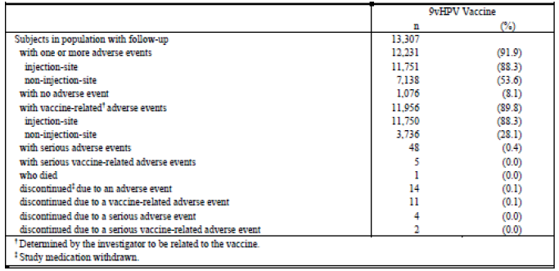

**Table 30: Adverse event summary, subjects who received 9vHPV vaccine (Protocols 001, 002, 005, 006, 007, and 009) (entire study period)**

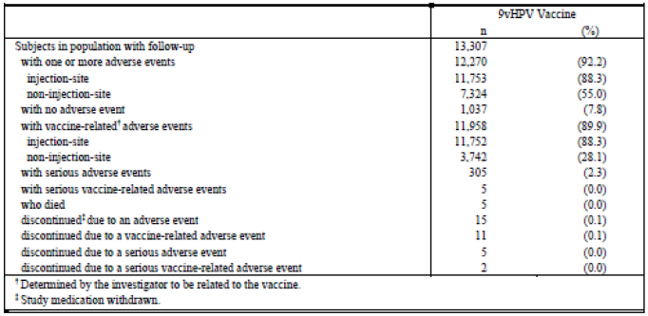

#### Treatment related adverse events (adverse drug reactions)

##### Injection site adverse experiences

The most common injection site adverse experiences occurring in subjects who received 9vHPV vaccine were erythema, pain, and swelling. Most adverse experiences of injection site pain were mild or moderate in intensity. Most adverse experiences of injection site erythema or injection site swelling were mild or moderate in intensity (that is, less than 2 inches [5 cm] in maximum size).

Subjects who received 9vHPV vaccine were more likely to report injection site adverse experiences compared with subjects who received qHPV vaccine (especially with respect to the injection site adverse experiences of erythema, pain and swelling). The frequencies of injection site adverse experiences of severe intensity were generally low in both vaccination groups. In females 16 to 26 years of age (Study 001), the frequencies of injection site pain of severe intensity were 4.3% and 2.6% in the 9vHPVvaccine group and qHPV vaccine group, respectively. Frequencies of injection site erythema greater than 2 inches [5 cm] in maximum size were 1.6% and 0.8% in the 9vHPV vaccine group and qHPV vaccine group, respectively; and frequencies of injection site swelling greater than 2 inches [5 cm] in maximum size were 3.8% and 1.5% in the 9vHPV vaccine group and qHPV vaccine group, respectively. In females 9 to 15 years of age (Protocol V503-009/GDS01C), frequencies of injection site adverse experiences of severe intensity (including injection site erythema or injection site swelling greater than 2 inches [5 cm] in maximum size) were generally low in the 9vHPV vaccine and qHPV vaccine groups.

##### Systemic adverse experiences

The most common vaccine related systemic adverse experiences were headache, pyrexia, nausea, dizziness, and fatigue. Most of these adverse experiences were judged to be mild or moderate in intensity. The proportions of subjects who reported such adverse experiences were generally comparable between the two vaccination groups.

###### Fever

Overall, 6.6% of subjects who received 9vHPV vaccine reported a temperature ≥ 100°F (≥ 37.8°C) and < 102°F (< 38.9°C), and 1.4% of subjects reported a temperature of ≥ 102°F (≥ 38.9°C), oral equivalent. The number and percentage of subjects in Study 001 who experienced fever was generally comparable between 9vHPV vaccine and qHPV vaccine recipients.

###### New medical history

This is the number and percentage of subjects who received 9vHPV vaccine and reported new medical conditions following Day 1 and during the entire study period. The most commonly reported new medical conditions were vaginal infections, nasopharyngitis and influenza. The percentages of subjects who developed new medical conditions were generally comparable between the 9vHPV vaccine and qHPV vaccine groups.

#### Deaths and other serious adverse events

A total of five subjects who received 9vHPV vaccine died during the entire study period. All deaths reported were from subjects in Protocol V503-001. None of the deaths were considered to be vaccine related. The causes of death for the subjects who received 9vHPV vaccine are as follows: One death each due to trauma (road traffic accident); intentional overdose (non-study medications) or suicide; cancer (acute lymphocytic leukaemia); hypovolemic and septic shock; and sudden death (occurring 678 days post Dose 3). A total of five subjects who received 9vHPV vaccine had at least one serious adverse experience that was determined to be related to the vaccine (one event each of pyrexia, allergy to vaccine, asthmatic crisis, headache, and tonsillitis). The most common serious adverse experiences reported in 9vHPV vaccine recipients were infections and pregnancy related events. The proportions of subjects reporting a serious adverse experience in Study 001 were comparable between 9vHPV vaccine and qHPV vaccine recipients. The vaccination groups were also comparable with respect to the types of serious adverse experiences reported. During the extension phase of Study 001 (that is, after visit cut-off date of 10 April 2013) and of Study 002 (that is, after Month 12), serious AEs resulting in death were reported in two subjects, including one death due to cancer (Study 001) and one death due to sepsis (Study 002). Neither of these serious adverse experiences was considered to be vaccine related.

#### Discontinuation due to adverse events

A total of 15 subjects (0.1%) who received 9vHPV vaccine discontinued from further study vaccination due to an adverse experience, including 11 subjects who discontinued study vaccination due to a vaccine related adverse experience. In Study 001, a total of 12 subjects (8 and 4 subjects who received 9vHPV vaccine or qHPV vaccine, respectively) discontinued study vaccination due to an adverse experience. Of these 12 subjects, 8 (5 and 3 in subjects who received 9vHPV vaccine or qHPV vaccine, respectively) discontinued due to a vaccine related AE.

### Laboratory tests

#### Liver function

##### Pivotal studies

N/A

##### Other studies

N/A

#### Kidney function

##### Pivotal studies

N/A

##### Other studies

N/A

#### Other clinical chemistry

##### Pivotal studies

N/A

##### Other studies

N/A

#### Haematology

##### Pivotal studies

N/A

##### Other studies

N/A

#### Use in pregnancy

In the Phase III studies [001, 002, 005, 006, 007, 009], a serum or urine pregnancy test (sensitive to 25 IU hCG) was performed prior to each injection at Day 1, Month 2, and Month 6. Testing was performed by the investigative site on the day of vaccination. Subjects with a positive pregnancy test were not vaccinated. Any subject with a positive pregnancy test at Day 1 was not randomised, vaccinated, or eligible to continue participation in the study. Subjects who became pregnant after the Day 1 visit (after receiving Dose 1 or Dose 2) were not to return for subsequent visits until after resolution of the pregnancy (term, miscarriage, etc.). These subjects were eligible to resume study visits and complete the vaccination series starting at least 4 weeks after resolution of pregnancy and normalization of beta-hCG levels, starting with the visit that was pending prior to pregnancy.

Subjects who became pregnant after completion of the vaccination series completed the study visits and procedures as per the protocol, at the discretion of the investigator. All pregnancies were followed for outcome. Pregnancies were reported in subjects enrolled in Study001, 002, and 006. The adverse experience profile following administration of 9vHPV vaccine to subjects who became pregnant during the vaccination period was generally comparable to that seen in the overall safety population. Overall, 94 subjects who were administered the 9vHPV vaccine and were pregnant during the vaccination period reported at least one SAE. Most of these SAEs were reported in Study 001. The most common events reported were SAEs of fetal loss (79 reports) including elective abortion (53 reports), spontaneous abortion (25 reports), and fetal death (1 report). All events of fetal loss from pregnancies occurring 6 months post vaccination 3 were reported as SAEs. The most common non-fetal loss SAEs were conditions related to pregnancy (15 reports) such as conditions that resulted in caesarean section (for example, failure of labour, malpresentation, cephalopelvic disproportion) and premature onset of labour (for example, threatened abortions, premature rupture of membranes). Overall, 1,213 subjects experienced 1,373 pregnancies. The vast majority of these pregnancies (approximately98%) occurred in subjects enrolled in Study 001. Among pregnancies with known outcomes, the proportions of pregnancies that resulted in a live birth were comparable between the 9vHPV vaccine cohort and the qHPV vaccine cohort.

The proportions of deliveries that were vaginal or by Caesarean section were comparable between the 9vHPV vaccine cohort and the qHPV vaccine cohort. In both vaccination groups, the great majority of live-born infants were categorised as normal. All reported congenital anomalies in pregnancies that resulted in a live birth occurred in subjects enrolled in Study 001. The number of pregnancies that resulted in a congenital anomaly was small, and within the 3% incidence rate reported by the World Health Organization (WHO) as normal. When pregnancies resulting in fetal loss due to a congenital anomaly, and pregnancies with live birth in whom congenital anomaly was detected after the immediate neonatal period are included, a total of 20 pregnancies (1.7%) among subjects who received the 9vHPV vaccine resulted in a congenital anomaly, including 14 pregnancies with live birth and 6 pregnancies with fetal loss (elective abortion). By comparison, a total of 21 pregnancies (1.9%) among subjects who received the qHPV vaccine resulted in a congenital anomaly, including 18 pregnancies with live birth and 3 pregnancies with fetal loss (elective abortion).

Among pregnancies with known outcomes, the proportions of pregnancies that resulted in a fetal loss were comparable between the 9vHPV vaccine group and the qHPV vaccine group. Among clinically recognised pregnancies, 12 to 15% generally result in spontaneous abortions. In the integrated Phase III database, a total of 10.4% of all pregnancies with known outcomes among subjects who were administered the 9vHPV vaccine ended in a spontaneous abortion. By comparison, a total of 12.9% of all pregnancies with known outcomes among subjects who were administered the qHPV vaccine in Protocol 001 ended in a spontaneous abortion. The proportions of pregnancies with known outcomes that resulted in spontaneous abortion in the 2 vaccination groups within the integrated Phase III database are consistent with the rates of spontaneous abortions reported in the published literature. Thus, it can be concluded that administration of the 9vHPV vaccine does not impact spontaneous abortion rates in older adolescent and young adult women. There were 3 late fetal death outcomes among subjects who were administered the 9vHPV vaccine. By comparison, there were 4 late fetal death outcomes among subjects who were administered the qHPV vaccine in Study 001. Thus, the proportions of late fetal deaths among pregnancy outcomes were comparable between subjects who received 9vHPV vaccine or qHPV vaccine. These data suggest that administration of the 9vHPV vaccine does not have an impact on the rates of late fetal death among adolescent and young adult women.

Spontaneous abortions and late fetal deaths represent overall spontaneous fetal losses. Among pregnancy outcomes of live births, spontaneous abortions, and late fetal deaths combined, the proportions of spontaneous fetal losses were 12.2% among subjects who were administered the 9vHPV vaccine, and 14.9% among subjects who were administered the qHPV vaccine in protocol Study 001. Thus, the rate of spontaneous fetal losses among subjects who were administered the 9vHPV vaccine was comparable to that observed among subjects who were administered qHPV vaccine in Study 001, and does not appear to be higher than that expected in the general population. A total of 143 elective abortions were reported, among subjects who were administered the 9vHPV vaccine. Of these, 137 were due to a personal decision, and 6 were due to a fetal abnormality. By comparison, a total of 113 elective abortions were reported, among subjects who were administered the qHPV vaccine in Study 001. Of these, 110 were due to a personal decision, and 3 were due to a fetal abnormality. No elective abortions were due to maternal conditions or perceived risk caused by the vaccine that could have prompted the pregnancy termination. All reported fetal abnormalities occurred in subjects enrolled in Study 001. No spontaneous fetal losses in the 9vHPV vaccine group and no spontaneous fetal losses in the qHPV vaccine group were due to a congenital anomaly. Six (6) subjects in the 9vHPV vaccine group and 3 subjects in the qHPV vaccine group underwent an elective abortion because of a fetal abnormality (based on intra-uterine diagnosis). The anomalies were varied in type, aetiology, and gestational age at exposure and overall appeared consistent with background incidence. There was also no increased incidence in fetal abnormalities in either group amongst breast-fed infants.

### Post-marketing experience

No post-marketing data is available for the 9vHPV vaccine.

### Evaluator’s overall conclusions on clinical safety

* The administration of 9vHPV vaccine is generally well tolerated in female subjects, 16 to 26 years of age and in female and male subjects, 9 to 15 years of age.
* The safety profile of the 9vHPV vaccine is generally comparable to that of the qHPV vaccine among subjects 9 to 26 years of age.
* Use of 9vHPV vaccine among subjects 9 to 26 years of age is associated with an increase in injection site adverse experiences compared with qHPV vaccine (probably around 88%subjects who received 9vHPV vaccine had at least one injection-site adverse experience). However, most of the injection site adverse experiences in subjects administered 9vHPV vaccine are mild or moderate in intensity.
* In general, across the 3 dose series of vaccine administration, injection site adverse experiences are reported in comparable frequencies following administration of a first, second, and third dose of 9vHPV vaccine; however, the frequencies of the adverse experiences of injection site erythema and injection site swelling were increased at each consecutive vaccine administration (similar to qHPV).
* Females, 16 to 26 years of age, and female and male subjects, 9 to 15 years of age, who begin a 3 dose regimen of 9vHPV vaccine rarely, discontinued vaccination due to an adverse experience.
* The adverse experience profile of 9vHPV vaccine is not impacted by racial background, ethnicity, or continent of origin, nor was it different in the different age groups analysed.
* Administration of 9vHPV vaccine is generally well tolerated in subjects, 9 to 26 years of age, who are seropositive or at HPV PCR-positive to at least one vaccine HPV type at the start of vaccination.
* Administration of 9vHPV vaccine is generally well tolerated among subjects who take immunosuppressive or anti-inflammatory or antipyretic medications within 15 days after any vaccination or subjects who use hormonal contraceptives at any time during the vaccination period.
* Administration of 9vHPV vaccine is generally well-tolerated in females, 12 to 26 years of age, who previously received a 3 dose regimen of qHPV vaccine but is associated with more injection site adverse experiences than in subjects’ naïve to HPV vaccination. Most of these injection site adverse experiences are mild in intensity.
* Administration of 9vHPV vaccine concomitantly with Menactra, Adacel and Repevax is generally well tolerated.
* Administration of 9vHPV vaccine does not adversely affect fertility or pregnancy outcomes in older adolescents and young women.

## First round benefit-risk assessment

### First round assessment of benefits

The benefits of 9vHPV in the proposed usage are:

* The 9vHPV vaccine is the prophylactic HPV vaccine that provides the broadest cancer coverage, with a potential to prevent approximately90% of all cervical cancers and the potential to prevent most (approximately80%) high grade cervical dysplasia, which could match or exceed the efficacy of most cervical cancer screening programs.
* The qHPV vaccine is known to be highly effective in preventing the development of HPV 6 , HPV 11, HPV 16 and HPV 18 related persistent infection, cervical, vulvar, vaginal, and anal disease, and genital warts. The data provided demonstrates that 9vHPV vaccine and qHPV vaccine perform similarly with respect to prevention of HPV 6, HPV 11, HPV 16 and HPV 18 related persistent infection and disease.
* Prophylactic administration of 9vHPV vaccine was highly effective compared with qHPV vaccine in preventing the development of HPV 31, HPV 31, HPV 45, HPV 52, and HPV 58 related persistent infection and cervical, vulvar, and vaginal disease. Thus, the 9vHPV vaccine can remove the risk of development of HPV 16, HPV 18, HPV 31, HPV 31, HPV 45, HPV 52, and HPV 58 related cervical, vulvar and vaginal cancers.
* Substantial reductions in the burden of HPV related vulvar, vaginal, and anal cancers are possible.
* Prophylactic administration of 9vHPV vaccine reduced the incidence of HPV 6 and HPV 11 related CIN (any grade) by 99.7%, HPV 16 and HPV 18 related CIN (any grade) by 96.9%, and HPV 31, HPV 31, HPV 45, HPV 52 and HPV 58 related CIN (any grade) by 97.7% (in the PPE population).
* As > 90% of genital warts (and RRP) are caused by HPV 6 and HPV 11, universal vaccination with 9vHPV vaccine may nearly eradicate these lesions.
* HPV infection is common in males, causing genital warts, anal cancer, penile cancer, and oropharyngeal cancer. Men also transmit HPV to women or to other men. Gender-neutral vaccination can contribute to maximise effectiveness of HPV mass vaccination programs. The qHPV vaccine is known to be highly effective in preventing the development of HPV 6 , HPV 11, HPV 16 and HPV 18 related persistent infection, anal disease, and genital warts in males. The high prophylactic efficacy of 9vHPV vaccine with respect to types 6, 11, 16, 18, 31, 33, 45, 52, and 58 in females 16 to 26 years of age, and the high immunogenicity of 9vHPV vaccine in males 9 to 15 years of age strongly suggest that administration of 9vHPV vaccine to males will reduce the incidence of persistent infection, anal disease, and genital warts caused by vaccine HPV types.
* The qHPV vaccine provides continued protection against high grade cervical disease (CIN 2 or worse) caused by HPV 16 and 18 through at least 6 years following vaccination. There is a trend of continued protection up to 8 years following vaccination; however, at this time there are insufficient data in the latter 2 years of observation (Years 6 to 8). The 9vHPV vaccine induces protective efficacy through at least 4 years post Dose 3. It is anticipated that the 9vHPV vaccine will induce similar long term protection to that of the qHPV vaccine.
* The clinical efficacy of 9vHPV vaccine in males older than 15 years of age has not yet been shown, but can be reasonably assumed based on the totality of the data from the 9vHPV vaccine and qHPV vaccine clinical programs. A Phase III immunogenicity and safety study in males 16 to 26 years of age (Protocol V503-003) is ongoing.
* Use of 9vHPV vaccine did not impact overall pregnancy outcomes. Administration of 9vHPV vaccine to nursing mothers did not affect the health of the mother or the nursing child.

### First round assessment of risks

The risks of 9vHPV in the proposed usage are:

* The removal of common HPV types from their ecological niche after 9vHPV vaccination might result in an increase in disease caused by non-vaccine HPV types. Although, in long term follow up studies of the qHPV vaccine, despite 100% prophylactic efficacy against disease related to vaccine types, administration of qHPV vaccine this has not been seen, up to at least 6 years post Dose 3.
* Administration of 9vHPV vaccine may uncover foci of undetected disease caused by less aggressive HPV types that would have otherwise been removed during therapy for the most aggressive and/or common HPV types (that is, the vaccine types) prior to implementation of vaccination. Administration of 9vHPV vaccine did not impact the incidence of cervical and genital disease caused by non-vaccine HPV types
* The efficacy of 9vHPV vaccine in females older than 26 years of age has not been assessed, but can be reasonably extrapolated based on the totality of the data from the 9vHPV vaccine and qHPV vaccine clinical programs.
* The duration of efficacy beyond 4 years post Dose 3 remains to be evaluated. Study 001 will continue to accrue follow up until 2014. Scandinavian subjects in Study 001 (N = 4,400) will then be followed for 10 years through the Nordic Cancer Registry Programs (Protocol V503-021). In addition, subjects in Study 002 will be followed for ten years post Dose 3 to evaluate long-term effectiveness of the 9vHPV vaccine (Protocol V503-002-20).
* The 9vHPV vaccine had an acceptable safety profile in all groups tested. Injection site reactions are common, but usually mild. Vaccine related serious adverse experiences occurred in < 0.1% of subjects. Few subjects discontinued vaccination due to an adverse experience. There was no safety signal with respect to allergic reactions or other immune mediated diseases. The safety profiles of 9vHPV vaccine and qHPV vaccine were generally comparable.
* The frequency of injection site erythema, pain, and swelling was higher in subjects who received 9vHPV vaccine than in subjects who received qHPV vaccine. Most injection site adverse experiences were still mild or moderate in intensity, and the number of subjects reporting severe injection site adverse experiences was low in both vaccination groups. The dose of AAHS in 9vHPV vaccine is the same as that used in other licensed vaccines.
* The long-term safety of 9vHPV vaccine (> 4.5 years from first vaccination) has not been evaluated. This evaluation will be conducted in the Nordic Registry Cancer Program (Protocol V503-021).

### First round assessment of benefit-risk balance

The benefit-risk balance of 9vHPV, given the proposed usage, is favourable

## First round recommendation regarding authorisation

The clinical development program for 9vHPV vaccine supports licensure of 9vHPV vaccine. There was strong evidence of efficacy in a population that was representative of the population for which 9vHPV vaccine is intended, with little observed increase in safety risk when compared with qHPV vaccine. The 9vHPV vaccine has demonstrated a favourable benefit/risk ratio for both female and male populations.

## References

Brotherton JML, Fridman M, May CL, Chappell G, Saville AM, Gertig DM. Early effect of the HPV vaccination programme on cervical abnormalities in Victoria, Australia: an ecological study. *Lancet* 2011;377:2085-2092.

Tabrizi SN, Brotherton JML, Kaldor JM, Skinner.S.R., Cummins E, Liu B, et al. Fall in human papillomavirus prevalence following a national vaccination program. *JID* 2012;206:164551.

Bauer HM, Wright G, Chow J. Evidence of human papillomavirus vaccine-effectiveness in reducing genital warts: an analysis of California public family planning administrative claims data, 2007-2010. *Am J Public Health* 2012:e1-e3.

Garland SM, Skinner SR, Brotherton JML. Adolescent and young adult HPV vaccination in Australia: achievements and challenges. *Prev Med* 2011;53:S29-S35.

Read TRH, Hocking JS, Chen MY, Donovan B, Bradshaw CS, Fairley CK. The near disappearance of genital warts in young women 4 years after commencing a national human papillomavirus (HPV) vaccination programme. *Sex Transm Infect* 2011;87:544-547.

Giuliano AR, Palefsky JM, Goldstone S, Moreira ED, Penny ME, Aranda C, et al. Efficacy of quadrivalent HPV vaccine against HPV infection and disease in males. *N Engl J Med* 2011;364(5):401-411.

De Sanjose S, Quint WGV, Alemany L, Geraets DT, Klaustermeier JE, Lloveras B, et al. Human papillomavirus genotype attribution in invasive cervical cancer: a retrospective cross-sectional worldwide study. *Lancet Oncol* 2010;11:1048-1056.

http://www.ema.europa.eu/ema/index.jsp?curl=pages/medicines/pips/EMEA-000654-PIP01- 09-M02/pip_000432.jsp&mid=WC0b01ac058001d129, accessed 12/09/2014

|  |
| --- |
| Therapeutic Goods Administration |
| PO Box 100 Woden ACT 2606 Australia  Email: [info@tga.gov.au](mailto:info@tga.gov.au) Phone: 1800 020 653 Fax: 02 6232 8605  [**https://www.tga.gov.au**](https://www.tga.gov.au) |

1. Brotherton JML, et al. Early effect of the HPV vaccination programme on cervical abnormalities in Victoria, Australia: an ecological study. *Lancet* 2011;377:2085-2092.
2. Tabrizi SN, et al. Fall in human papillomavirus prevalence following a national vaccination program. *JID* 2012;206:1645-1651.
3. Bauer HM, et al. Evidence of human papillomavirus vaccine-effectiveness in reducing genital warts: an analysis of California public family planning administrative claims data, 2007-2010. *Am J Public Health* 2012:e1-e3.
4. Garland SM, et al. Adolescent and young adult HPV vaccination in Australia: achievements and challenges. *Prev Med* 2011;53:S29-S35
5. Read TRH, et al The near disappearance of genital warts in young women 4 years after commencing a national human papillomavirus (HPV) vaccination programme. *Sex Transm Infect* 2011;87:544-547
6. Giuliano AR, et al. Efficacy of quadrivalent HPV vaccine against HPV infection and disease in males. *N Engl J Med* 2011;364(5):401-411
7. De Sanjose S, et al. Human papillomavirus genotype attribution in invasive cervical cancer: a retrospective cross-sectional worldwide study. *Lancet Oncol* 2010;11:1048-1056
8. http://www.ema.europa.eu/ema/index.jsp?curl=pages/medicines/pips/EMEA-000654-PIP01-09-M02/pip_000432.jsp&mid=WC0b01ac058001d129, accessed 12/09/2014.