|  |
| --- |
| **First round CER report: 22 December 2014** |

|  |
| --- |
| AusPAR Attachment 2 |
| Extract from the Clinical Evaluation Report for human papillomavirus vaccine types 16 and 18 (recombinant, AS04 adjuvanted) |
| Proprietary Product Name: Cervarix |
| Sponsor: GlaxoSmithKline Australia Pty Ltd |

About the Therapeutic Goods Administration (TGA)

* The Therapeutic Goods Administration (TGA) is part of the Australian Government Department of Health, and is responsible for regulating medicines and medical devices.
* The TGA administers the *Therapeutic Goods Act 1989* (the Act), applying a risk management approach designed to ensure therapeutic goods supplied in Australia meet acceptable standards of quality, safety and efficacy (performance), when necessary.
* The work of the TGA is based on applying scientific and clinical expertise to decision-making, to ensure that the benefits to consumers outweigh any risks associated with the use of medicines and medical devices.
* The TGA relies on the public, healthcare professionals and industry to report problems with medicines or medical devices. TGA investigates reports received by it to determine any necessary regulatory action.
* To report a problem with a medicine or medical device, please see the information on the TGA website <<https://www.tga.gov.au>>.

About the Extract from the Clinical Evaluation Report

* This document provides a more detailed evaluation of the clinical findings, extracted from the Clinical Evaluation Report (CER) prepared by the TGA. This extract does not include sections from the CER regarding product documentation or post market activities.
* The words [Information redacted], where they appear in this document, indicate that confidential information has been deleted.
* For the most recent Product Information (PI), please refer to the TGA website <<https://www.tga.gov.au/product-information-pi>>.

Copyright

© Commonwealth of Australia 2015  
This work is copyright. You may reproduce the whole or part of this work in unaltered form for your own personal use or, if you are part of an organisation, for internal use within your organisation, but only if you or your organisation do not use the reproduction for any commercial purpose and retain this copyright notice and all disclaimer notices as part of that reproduction. Apart from rights to use as permitted by the *Copyright Act 1968* or allowed by this copyright notice, all other rights are reserved and you are not allowed to reproduce the whole or any part of this work in any way (electronic or otherwise) without first being given specific written permission from the Commonwealth to do so. Requests and inquiries concerning reproduction and rights are to be sent to the TGA Copyright Officer, Therapeutic Goods Administration, PO Box 100, Woden ACT 2606 or emailed to <[tga.copyright@tga.gov.au](mailto:tga.copyright@tga.gov.au)>.

Contents

List of abbreviations 5

1. Background 9

1.1. Submission type 9

1.2. Drug class and therapeutic indication 9

1.3. Dosage forms and strengths 9

1.4. Dosage and administration 9

2. Clinical rationale 10

3. Contents of the clinical dossier 10

3.1. Scope of the clinical dossier 10

3.2. Paediatric data 11

3.3. Good clinical practice 11

4. Pharmacokinetics 11

5. Pharmacodynamics 11

6. Dosage selection for the pivotal studies 11

7. Clinical efficacy 11

7.1. Proposed two-dose schedule at Month 0 and Month 6 11

7.2. Evaluator’s conclusions on clinical efficacy for proposed two-dose schedule at Month 0 and Month 6 22

7.3. Proposed two-dose schedule at Month 0 and Month 12 23

7.4. Evaluator’s conclusions on clinical efficacy for proposed two-dose schedule at Month 0 and Month 12 25

8. Clinical safety 25

8.1. Studies providing evaluable safety data 25

8.2. Pivotal studies that assessed safety as a primary outcome 26

8.3. Patient exposure 26

8.4. Adverse events 26

8.5. Laboratory tests 30

8.6. Post-marketing experience 33

8.7. Safety issues with the potential for major regulatory impact 33

8.8. Evaluator’s overall conclusions on clinical safety 33

9. First round benefit-risk assessment 34

9.1. First round assessment of benefits 34

9.2. First round assessment of risks 34

9.3. First round assessment of benefit-risk balance 34

10. First round recommendation regarding authorisation 34

11. Clinical questions 35

11.1. Pharmacokinetics 35

11.2. Pharmacodynamics 35

11.3. Efficacy 35

11.4. Safety 35

## List of abbreviations

| Abbreviation | Meaning |
| --- | --- |
| Ab | Antibody |
| AE | Adverse Event |
| Al(OH)3 | aluminium hydroxide |
| ANOVA | Analysis of Variance |
| AS04 | GSK Biologicals’ Adjuvant system, containing aluminium salts (Al[OH]3) and 3-O-desacyl-4’ monophosphoryl lipid A (MPL) |
| ATP | According-To-Protocol |
| CD4/CD8 | Cluster of differentiation (4/8) |
| CD40L | CD 40 Ligand |
| CEVAC | Centre for Vaccinology |
| CFC | Cytokine Flow Cytometry |
| CI | Confidence Interval |
| CPRD GOLD | Clinical Practice Research Datalink General Practice OnLine Database |
| CIN2+ | Cervical Intraepithelial Neoplasia 2+ |
| CMI | Cellular-Mediated Immunity |
| DAE | Discontinuation due to adverse event |
| DEIA | DNA Enzyme-linked Immunoassay |
| DNA | Deoxyribonucleic Acid |
| eCRF | electronic Case Report Form |
| EDD | Expected Date of Delivery |
| ED50 | Estimated Dose 50% (the estimated serum dilution reducing the signal generated by viral infection by 50%) |
| ELISA | Enzyme-Linked ImmunoSorbent Assay |
| EL.U/mL | ELISA units per millilitre |
| GCP | Good Clinical Practice |
| GMT | Geometric Mean Titres |
| GP | General Practitioner |
| GPP | Good Pharmacoepidemiology Practice |
| Group (0, 6; 20 μg) | Group of subjects who received 2 doses of the HPV-16/18 L1 VLP AS04 vaccine with 20 μg of each antigen administered at Day 0 and at Month 6 in Study HPV-048. |
| Group (0, 2; 40 μg) | Group of subjects who received 2 doses of the HPV-16/18 L1 VLP AS04 vaccine with 40 μg of each antigen administered at Day 0 and at Month 2 in Study HPV-048. |
| Group (0, 6; 40 μg) | Group of subjects who received 2 doses of the HPV-16/18 L1 VLP AS04 vaccine with 40 μg of each antigen administered at Day 0 and at Month 6 in Study HPV-048. |
| Group (0,1, 6; 20 μg) | Group of subjects who received 3 doses of the HPV-16/18 L1 VLP AS04 vaccine with 20 μg of each antigen administered at Day 0, Month 1 and at Month 6 in Study HPV-048. |
| Group (0,1,6) | Group of subjects aged 15-25 years who received 3 doses of the HPV-16/18 L1 VLP AS04 vaccine administered at Day 0, at Month 1 and at Month 6 in Study HPV-070. |
| Group (0,6) | Group of subjects aged 9-14 years who received 2 doses of the HPV-16/18 L1 VLP AS04 vaccine administered at Day 0 and at Month 6 in Study HPV-070. |
| Group (0,12) | Group of subjects aged 9-14 years who received 2 doses of the HPV-16/18 L1 VLP AS04 vaccine administered at Day 0 and at Month 12 in Study HPV-070. |
| GSK | GlaxoSmithKline |
| HAV | Hepatitis A virus/vaccine |
| HPV | Human PapillomaVirus |
| HR | Hazard Ratio |
| ICS | Intracellular Cytokine Staining |
| IEC | Independent Ethics Committee |
| IFN-δ | Interferon-gamma |
| IL-2 | Interleukin 2 |
| IRB | Institutional Review Board |
| LAR | Legally Acceptable Representative |
| LBC | Liquid-based Cytology |
| LiPA | Reverse Hybridization Line Probe Assay |
| LL | Lower Limit |
| LMP | Last Menstrual Period |
| MPL | 3-O-desacyl-4’ monophosphoryl lipid A |
| MSC | Medically Significant Condition |
| NCI | National Cancer Institute, USA |
| NOAD | New Onset of Autoimmune Diseases |
| NOCD | New Onset of Chronic Disease |
| OR | Odds Ratio |
| PASS | Post Authorisation Safety Study |
| PBMC | Peripheral Blood Mononuclear Cells |
| PBNA | Pseudovirion-Based Neutralization Assay |
| PCR | Polymerase Chain Reaction |
| pIMD | Potential Immune-Mediated Disease |
| PSV | Pseudovirion |
| RAP | Report Analysis Plan |
| RCC | Reverse Cumulative Curve |
| RDE | Remote Data Entry |
| RR | Relative Risk |
| SAE | Serious Adverse Event |
| SBIR | Randomisation System on Internet |
| SeAP | Secreted Alkaline Phosphatase |
| SD | Standard Deviation |
| SDD | SAS Drug Development |
| SERM | Safety Evaluation & Risk Management |
| SPF10 | Short PCR Fragment 10 |
| TNF-α | Tumour Necrosis Factor alpha |
| TVC | Total Vaccinated Cohort |
| TVC-1 | TVC for Efficacy 1 |
| UL | Upper Limit |
| UK | United Kingdom |
| US | United States |
| VAMPSS | Vaccines and Medications in Pregnancy Surveillance System |
| VCSP | Vaccines Clinical Safety and Pharmacovigilance |
| VE | Vaccine Efficacy |
| VLP | Virus-Like Particle(s) |
| WHO | World Health Organization |

## Background

### Submission type

This is a Category 1, Type F application for Cervarix to vary the dosage to allow for the administration of the vaccine according to an alternative 2-dose schedule (0, 5 - 13 months) in females aged 10 - 14 years old. The currently approved vaccination schedule is 3-doses (0, 1, 6 months) in females aged 10 - 45 years old. In addition, this is also a Category 1, Type J application to change the product information by updating the pregnancy section of the Product Information (PI).

### Drug class and therapeutic indication

Cervarix is a vaccine against human papillomavirus types (HPV) 16 and 18. These two strains of HPV are estimated to be responsible for approximately 70% of all cervical cancers across all regions worldwide. Cervarix contains recombinant C-terminally truncated L1 proteins from human HPV types 16 and 18 each assembled as virus-like particles (VLPs). The HPV-16 and HPV-18 L1 antigens are prepared by recombinant DNA technology using a Baculovirus expression system in Trichoplusia ni cells. Hence, Cervarix is not a live virus vaccine and does not cause infection. Cervarix is thought to exert its action through the development of a humoral immune response and cell mediated immunity to HPV-16 and HPV-18.

The approved indication is:

*Cervarix is indicated in females from 10 to 45 years of age for the prevention of persistent infection, premalignant cervical lesions and cervical cancer caused by human papillomavirus types 16 and 18. Immunogenicity studies have been conducted in females aged 10 to 14 years and 26 to 45 years to link efficacy in females aged 15 to 25 years to other populations.*

No changes to the approved indication are proposed.

### Dosage forms and strengths

The following dosage forms and strengths are currently registered:

* Cervarix human papillomavirus vaccine types 16 and 18 (recombinant, AS04 adjuvanted) suspension for injection pre-filled syringe (AUST R 126114)
* Cervarix human papillomavirus vaccine types 16 and 18 (recombinant, AS04 adjuvanted) suspension for injection vial (AUST R 126115)
* Each 0.5ml dose of Cervarix contains 20 μg each of HPV-16 L1 and HPV-18 L1 proteins, 0.5 milligrams of Al(OH)3 and 50 μg of MPL.

### Dosage and administration

The currently approved dosing schedule is:

* The primary vaccination course consists of three doses.
* The recommended vaccination schedule is 0, 1, 6 months.

If flexibility in the vaccination schedule is necessary, the second dose can be administered between 1 month and 2.5 months after the first dose and the third dose between 5 and 12 months after the first dose.

The proposed new dosing schedule is as shown in Table 1.

Table 1: Proposed new dosing schedule.

|  |  |
| --- | --- |
| **Age at the time of the first injection** | **Immunisation and schedule** |
| 10 - 14 years | The vaccination schedule consists of a total of two doses each of 0.5 ml. The second dose given between 5 and 13 months after the first dose*  **OR**  The vaccination schedule consists of a total of three doses each of 0.5 ml given at 0, 1, 6 months** |
| 15 - 45 years | The vaccination schedule consists of a total of three doses each of 0.5 ml given at 0, 1, 6 months** |

* If the second vaccine dose is administered before the 5th month after the first dose, a third dose should always be administered.

** If flexibility in the vaccination schedule is necessary, the second dose can be administered between 1 month and 2.5 months after the first dose and the third dose between 5 and 12 months after the first dose.

The vaccination schedule depends on the age of the subject.

The necessity for a booster dose has yet to be established.

## Clinical rationale

The primary justification for the proposed new, alternative dosing regimen is summed up in the following paragraph from the Clinical Overview:

*Public health stakeholders from various regions of the world have expressed an interest in a 2-dose HPV vaccination schedule as one of the solutions to address poor coverage due to the lack of vaccination program infrastructure to simplify implementation and to reduce the high cost of the 3-dose HPV vaccination course. A 2-dose schedule could lead to a substantial increase in the number of girls completing the vaccination course for the same cost, ensuring that greater numbers are protected. Ethical concerns of administering 3 doses in girls if 2 doses are sufficient have also been expressed. Some countries (e.g. Canada [British Colombia and Quebec only], Mexico and Switzerland) have already implemented a 2-dose schedule for HPV vaccination in young girls, with the initial recommendation of a booster dose 5 years after first vaccination in Canada and Mexico.*

The Sponsor also proposes to update the Use in Pregnancy section of the PI with information derived from all the pregnancy exposure data available to the Sponsor since first authorisation.

## Contents of the clinical dossier

### Scope of the clinical dossier

The submission contained the following clinical information:

* One efficacy studies that evaluated the proposed alternative dosing regimen: Study HPV-070
* One efficacy study that supports a two dose regimen at Month 0 and Month 6: Study HPV-048
* Two supportive efficacy studies that provide data in support of a two-dose regimen: Study HPV-008 and Study HPV-009.
* One post-marketing study in support of safety in pregnancy: Study EPI-HPV-018 VS UK DB

### Paediatric data

The submission included paediatric efficacy and safety data for females aged 9 years and over.

### Good clinical practice

GCP appears to have been adhered to in the clinical studies.

## Pharmacokinetics

No new pharmacokinetic data were included in the submission.

## Pharmacodynamics

No new pharmacodynamic data were included in the submission.

## Dosage selection for the pivotal studies

Study HPV-048 contained some dose selection data that is discussed in Section 7.1.1.2.

## Clinical efficacy

### Proposed two-dose schedule at Month 0 and Month 6

#### Pivotal efficacy studies

##### Study HPV-070

###### Study design, objectives, locations and dates

Study HPV-070 (Module 5, Section 5.3.5.1) was an open label, randomised, immunogenicity and safety study of two alternative two dose regimens (primary immunisation against HPV-16 and HPV-18) in females aged 9 to 14 years, compared with the standard three dose regimen in females aged 15 to 25 years. The study was conducted by 33 investigators in five countries (Canada, Germany, Italy, Taiwan and Thailand) from June 2011 to January 2014. The submitted data were from two study reports: Study HPV-070 Month 7 and Study HPV-070 Month 12/13.

###### Inclusion and exclusion criteria

The inclusion criteria included:

* Females ≥ 9 and ≤ 25 years of age at the time of the first vaccination.
* Healthy subjects as established by medical history and clinical examination before entering into the study.
* Female subjects of non-childbearing potential could have been enrolled in the study. Non-childbearing potential was defined as pre-menarche, current tubal ligation, hysterectomy, ovariectomy or post-menopause.
* Female subjects of childbearing potential could have been enrolled in the study, if the subject had practiced adequate contraception for 30 days prior to vaccination; had a negative pregnancy test on the day of vaccination; and had agreed to continue adequate contraception during the entire vaccination period and up to two months after the last study vaccine dose.

The exclusion criteria included:

* Pregnant or breastfeeding.
* Planning to become pregnant, likely to become pregnant; or planning to discontinue contraceptive precautions during the entire vaccination period and up to two months after the last study vaccine dose.
* Previous vaccination against HPV or planned administration of another HPV vaccine during the study other than that foreseen in the protocol.
* Child in care.
* Chronic administration (defined as more than 14 consecutive days in total) of immunosuppressants or other immune-modifying drugs within six months prior to the first vaccine/product dose. For corticosteroids, this meant prednisone ≥ 20 mg/day (for adult subjects) or ≥ 0.5 mg/kg/day (for paediatric subjects), or equivalent. Inhaled and topical steroids were allowed.
* History of allergic disease, suspected allergy or reactions likely to be exacerbated by any component of the study vaccines.
* Cancer or autoimmune disease under treatment.
* Planned administration/administration of a vaccine/product not foreseen by the study protocol within 30 days before each dose of vaccine. Administration of routine meningococcal, hepatitis B, hepatitis A, inactivated influenza, diphtheria/tetanus and/or diphtheria/tetanus-containing vaccine up to 8 days before each dose of study vaccine was allowed. Enrolment was to be deferred until the subject was outside of specified window.
* Previous administration of MPL or AS04 adjuvant.
* Administration of immunoglobulins and/or any blood products within the 3 months preceding the first dose of study vaccine or planned administration during the study period.
* Any confirmed or suspected immunosuppressive or immunodeficient condition, based on medical history and physical examination (no laboratory testing required).
* Family history of congenital or hereditary immunodeficiency.
* Major congenital defects or serious chronic illness.
* Acute or chronic, clinically significant pulmonary, cardiovascular, hepatic or renal functional abnormality, as determined by physical examination or laboratory screening tests, which in the opinion of the investigator precluded administration of the study vaccine.
* Acute disease and/or fever at the time of enrolment. Fever was defined as temperature ≥ 37.5°C on oral, axillary or tympanic setting, or ≥ 38.0°C on rectal setting.

###### Study treatments

The study treatment was HPV-16/18 L1 VLP AS04 (Cervarix). There were three dosing schedules:

1. Two dose schedule: Month 0 and Month 6: Group (0,6)
2. Two dose schedule: Month 0 and Month 12: Group (0,12)
3. Three dose schedule: Month 0, Month 1 and Month 6: Group (0, 6, 12)

The vaccine was administered intramuscularly into the non-dominant deltoid.

###### Efficacy variables and outcomes

The main efficacy variables were: Anti-HPV-16/18 seroconversion rates and antibody titers (by ELISA) 1 month after the last dose of study vaccine.

The secondary efficacy outcome measures were:

* Anti-HPV-16/18 seroconversion rates and antibody titres (by ELISA) at Day 0 and Months 7, 12, 18, 24 and 36 (for subjects having received their last vaccine dose at Month 6) or at Day 0 and Months 13, 18, 24 and 36 (for subjects having received their last vaccine dose at Month 12) in all subjects.
* Anti-HPV-16/18 antibody titres (by PBNA) at Day 0 and Months 7, 12, 18, 24 and 36 (for subjects having received their last vaccine dose at Month 6) or at Day 0 and Months 13, 18, 24 and 36 (for subjects having received their last vaccine dose at Month 12) in a subset of subjects.
* Anti HPV-16/18 specific T and B cell-mediated immune responses (frequency of cytokine-positive CD4 or CD8 T-lymphocytes and frequency of memory B-cells measured by flow cytometry) at Day 0, Months 7, 12, 24 and 36 (for subjects having received their last vaccine dose at Month 6) or at Day 0, Months 13, 18 and 36 (for subjects having received their last vaccine dose at Month 12) in a sub-cohort of subjects.

The exploratory outcome measures were:

* Anti-HPV-31/45 antibody titers by ELISA at Day 0 and Months 7, 12, 18, 24 and 36 in a subset of subjects in Group (0,6) and Group (0,1,6).
* Anti-HPV-31/45 specific T and B cell response (frequency of cytokine-positive CD 4 or CD8 T-lymphocytes and frequency of memory B cells) at Day 0 and Months 7, 12, 24 and 36 (for subjects who received their last vaccine dose at Month 6) or at Day 0 and Months 13, 18 and 36 (for subjects who will receive their last vaccine dose at Month 12), in a sub-cohort of subjects.

The ELISA assays used from Month 18 had greater sensitivity for HPV-16 and HPV-18 virus like particle (VLP) antibodies.

The safety outcome measures were: AEs, solicited AEs (local and general, up to 7 days post-immunisation) and pregnancies. AEs were recorded up to 30 days after immunisation.

###### Randomisation and blinding methods

The clinical trial was open label. Subjects aged 9 to 14 years were randomised to one of the two dose schedules (stratified by age subgroup: 9 to 11 years and 12 to 14 years). Subjects aged 15 to 25 years were allocated to the three dose schedule (stratified by age subgroup: 15 to 19 years and 20 to 25 years). Treatment allocation was performed using Randomization System on Internet (SBIR).

###### Analysis populations

The Total Vaccinated Cohort will include all subjects who received at least one dose of vaccine for whom data were available. The According to Protocol (ATP) cohort for analysis of safety included all subjects who received their planned doses of study vaccine according to their random assignment, with sufficient data to perform an analysis of safety and who had not received a vaccine not specified or forbidden in the protocol.

###### Sample size

The sample size calculation was based on a test of non-inferiority using 95% CIs. The calculation determined that 380 evaluable subjects per group would allow:

* The detection of a 5% difference between either two-dose regimen and the three-dose regimen in terms of seroconversion rate for both anti-HPV-16 and anti-HPV-18, 1 month after last dose with 98% power.
* The detection of a 2-fold difference between either two-dose regimen and the three-dose regimen in terms of GMTs for both anti-HPV-16 and anti-HPV-18, 1 month after last dose with 100% power.

Assuming a drop-out rate of 20% (both withdrawal and elimination criteria) at Month 7, approximately 476 subjects were enrolled in each study group, resulting in a total sample size of 1428 subjects enrolled. Power at Month 36 was estimated to be 90% for the primary outcome measure.

###### Statistical methods

Rates of seroconversion (difference) and geometric mean titres (GMT) (ratio) were compared using exact 95% CIs.

###### Participant flow

There were a total of 1447 subjects enrolled in the study: 550 subjects in Group (0,6), 415 in Group (0,12) and 482 in Group (0,1,6). A total of 25 subjects withdrew: 3 in Group (0,6), 7 in Group (0, 12) and 15 in Group (0, 1, 6). The most common reasons for withdrawal were: consent withdrawal (10 subjects) and migrated/moved from study area (6 subjects).

###### Major protocol violations/deviations

Protocol deviations were uncommon. There were 24 subjects that did not have the vaccine administered according to protocol and 29 with missing essential serological data.

###### Baseline data

All subjects were female and within the age ranges specified for their respective groups. There were 774 (53.5%) White – Caucasian/European subjects, 320 (22.1%) East Asian and 318 (22.0%) South East Asian. The Group (0, 1, 6) subjects were taller, heavier and had a greater BMI than the two-dose groups. At baseline, there were more seronegative subjects in the two-dose groups compared with the three-dose group: 441 (83.8%) in Group (0, 6), 335 (85.9%) in Group (0, 12) and 319 (75.4%) in Group (0, 1, 6).

###### Results for the primary efficacy outcome:

At one month after the second vaccination (Month 7), for the Group (0, 6), Group (0, 1, 6) comparison: all subjects in the ATP cohort for immunogenicity seroconverted. The difference between groups (95% CI) was 0.00 (-1.08 to 0.78) % for HPV-16 antibody and 0.00 (- 1.00 to 0.77) % for HPV-18 antibody (Table 2).

Table 2: Non-inferiority assessment of anti HPV-16 and HPV-18 seroconversion rates (HPV [0, 1, 6] schedule vs HPV [0, 6] schedule) one month after the last dose on seronegative subjects (ATP cohort for immunogenicity).

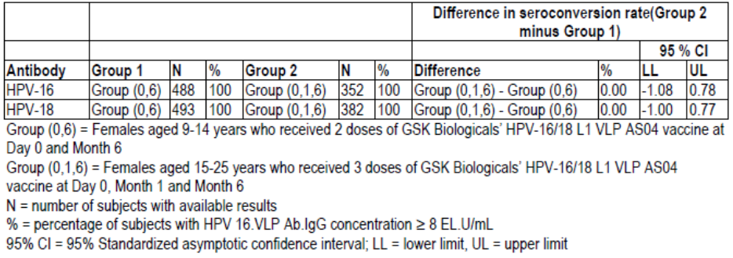

At one month after the second vaccination (Month 7), there was similar immune response for HPV-16 in Group (0, 1, 6) and in Group (0, 6) and the upper 95% CI was < 2, and therefore within the predefined bounds for non-inferiority: GMT ratio (95% CI) 1.09 (0.97 to 1.22) (Table 3). There was a greater immune response to HPV-18 in Group (0, 6) than Group (0, 1, 6): GMT ratio (95% CI) 0.85 (0.76 to 0.95) (Table 3).

Table 3: Non-inferiority assessment of HPV-16 and HPV-18 immune response for (HPV [0, 1, 6] schedule vs HPV [0, 6] schedule) one month after the last dose on initially seronegative subjects (ATP cohort for immunogenicity).

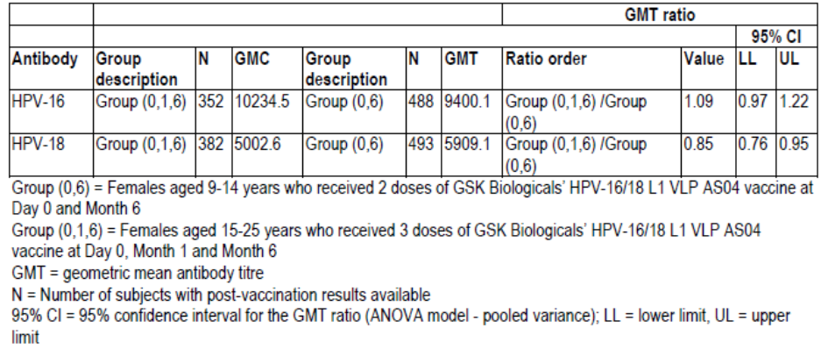

###### Results for other efficacy outcomes

* At six months after the second vaccination (Month 12), for the Group (0, 6), Group (0, 1, 6) comparison: all subjects in the ATP cohort for immunogenicity seroconverted. The difference between groups (95% CI) was 0.00 (- 1.10 to 0.79) % for HPV-16 antibody and 0.00 (- 1.01 to 0.79) % for HPV-18 antibody.
* At six months after the second vaccination (Month 12), there was greater immune response for HPV-16 in Group (0, 1, 6) than in Group (0, 6) but the upper 95% CI was < 2, and therefore within the predefined bounds for non-inferiority: GMT ratio (95% CI) 1.25 (1.10 to 1.40). There was a similar immune response for the two groups to HPV-18: GMT ratio (95% CI) 0.99 (0.87 to 1.12).
* The distribution of anti-HPV-16 antibody titres was similar for Group (0, 6) and Group (0, 1, 6)
* The distribution of anti-HPV-18 antibody titres was similar for Group (0, 6) and Group (0, 1, 6)
* All subjects in Group (0, 6) and Group (0, 1, 6) developed neutralising antibodies to HPV-16 PsV
* All subjects in Group (0, 6) and Group (0, 1, 6) developed neutralising antibodies to HPV-18 PsV
* CD4+ response to HPV-16 was similar for Group (0, 6) and Group (0, 1, 6)
* CD4+ response to HPV-18 was similar for Group (0, 6) and Group (0, 1, 6)
* B cell response to HPV-16 was similar for Group (0, 6) and Group (0, 1, 6)
* B cell response to HPV-18 was similar for Group (0, 6) and Group (0, 1, 6)

For the exploratory outcome variables (sub-population):

* All subjects in Group (0, 6) and all but one in Group (0, 1, 6) developed antibodies to HPV-31
* All subjects in both groups developed antibodies to HPV-45
* CD4+ response to HPV-31 was similar for Group (0, 6) and Group (0, 1, 6)
* CD4+ response to HPV-45 was similar for Group (0, 6) and Group (0, 1, 6)
* B cell response to HPV-31 was similar for Group (0, 6) and Group (0, 1, 6)
* B cell response to HPV-45 was similar for Group (0, 6) and Group (0, 1, 6)

##### Study HPV-048

###### Study design, objectives, locations and dates

Study HPV-048 was a partially blind, randomised, age stratified dose ranging study in healthy females aged 9 to 25 years comparing 2 dose schedules of HPV-16/18 vaccine with a 3 dose schedule. The study was stratified by age group: 9 to 14 years, 15 to 19 years and 20 to 25 years. There were two dose levels of HPV-16/18 vaccine studied. The study was conducted at 21 centres in two countries (Canada and Germany) from October 2007 to October 2008.

###### Inclusion and exclusion criteria

The inclusion criteria included:

* Females between, and including, 9 and 25 years of age at the time of the first vaccination.
* Healthy, as established by medical history and history-oriented clinical examination before entering into the study.
* Non-childbearing potential, i.e. have a current tubal ligation, hysterectomy, ovariectomy or be pre-menarcheal; or if they were of childbearing potential, they were to practice adequate contraception for 30 days prior to vaccination, have a negative pregnancy test and had to agree to continue such precautions for two months after completion of the vaccination series.

The exclusion criteria included:

* Chronic administration (defined as more than 14 days) of immunosuppressants or other immune-modifying drugs within six months prior to the first vaccine dose. For corticosteroids, this meant prednisone, or equivalent, ≥ 0.5 mg/kg/day. Inhaled and topical steroids were allowed.
* Planned administration/administration of a vaccine not foreseen by the study protocol within 30 days before and 30 days after (i.e. Days 0 - 29) the first dose of vaccine. Planned administration/administration of routine meningococcal, hepatitis A or B, inactivated influenza, diphtheria/tetanus and/or diphtheria/tetanus-containing vaccines, up to 8 days before the first dose of study vaccine was allowed. Enrolment was to be deferred until the subject was outside of specified window.
* Pregnant or breastfeeding female.
* A woman planning to become pregnant or planning to discontinue contraceptive precautions during the study period, up to two months after the last vaccine dose.
* Previous vaccination against HPV or planned administration of any HPV vaccine other than that foreseen by the study protocol during the study period (up to Month 24).
* Previous administration of MPL or AS04 adjuvant.
* Cancer or autoimmune disease under treatment.
* Any medically diagnosed or suspected immunosuppressive or immunodeficient condition, based on medical history and physical examination (no laboratory testing required).
* History of allergic disease or reactions likely to be exacerbated by any component of the vaccine, e.g. MPL, AS04.
* Hypersensitivity to latex (found in syringe-tip cap and plunger).
* Acute disease at the time of enrolment. Acute disease was defined as the presence of a moderate or severe illness with or without fever. All vaccines could have been administered to persons with a minor illness such as diarrhoea, mild upper respiratory infection with or without low-grade febrile illness, i.e. oral temperature < 37.5°C / axillary temperature < 37.5°C.
* Acute or chronic, clinically significant pulmonary, cardiovascular, hepatic or renal functional abnormality, as determined by physical examination or laboratory tests.
* Administration of immunoglobulins and/or any blood products within the three months preceding the first dose of study vaccine or planned administration during the study period (up to Month 24).

###### Study treatments

The study treatments were:

* HPV-16/18 VLP AS04 vaccine, 40 μg, two doses administered at Month 0 and Month 2; Group (0, 2; 40 μg)
* HPV-16/18 VLP AS04 vaccine, 40 μg, two doses administered at Month 0 and Month 6; Group (0, 6; 40 μg)
* HPV-16/18 VLP AS04 vaccine, 20 μg, two doses administered at Month 0 and Month 6; Group (0, 6; 20 μg)
* HPV-16/18 VLP AS04 vaccine, 20 μg, three doses administered at Month 0, Month 1 and Month 6; Group (0, 1, 6; 20 μg)

There was a follow-up period of 48 months.

###### Efficacy variables and outcomes

The primary efficacy outcome measures were immunogenicity (antibody titres for HPV-16 and HPV-18) one month after the last dose of study vaccine. Anti-HPV-16 and anti-HPV-18 antibodies were measured using ELISA assays. Secondary efficacy outcome measures were HPV-16 and HPV-18 antibody titers (by ELISA) and seroconversion status assessed during the extended follow-up period (Month 12, Month 18 and Month 24).

The safety outcome measures were solicited local and general symptoms, unsolicited symptoms, AEs and laboratory tests (haematology and biochemistry at Month 0 and Month 7).

###### Randomisation and blinding methods

Randomisation was in a 1:1:1:1 ratio, stratified by age group (9 to 14 years, 15 to 19 years, and 20 to 25 years) and performed by SBIR.

###### Analysis populations

The Total Vaccinated cohort included all vaccinated subjects. The ATP cohort included all subjects who had received all doses of study vaccine/placebo according to their random assignment; with sufficient data to perform an analysis of safety; who had not received a vaccine not specified or forbidden in the protocol; and for whom the randomization code had not been broken.

###### Sample size

The sample size calculation was based on detecting a two-fold difference between groups in GMT one month after the last dose of vaccine, with a power of 90%, using the ANOVA F-test, and an α of 0.025 for both HPV-16 and HPV-18. This resulted in 768 evaluable subjects, and accounting for predicted dropouts a final sample size of 960 subjects.

###### Statistical methods

Between group analyses were performed using the ANOVA F-test. If a statistically significant difference was found then pair-wise comparisons were performed using Tukey’s multiple comparison adjustment.

###### Participant flow

There were 961 subjects enrolled in the study, and 960 were randomised: 240 to Group (0, 2; 40 μg); 241 to Group (0, 6; 40 μg), 240 to Group (0, 6; 20 μg) and 239 to Group (0, 1, 6; 20 μg). There were 928 (96.7%) subjects included in the ATP. There were 922 subjects who completed the study: 231 (96.3%) in Group (0, 2; 40 μg); 228 (94.6%) in Group (0, 6; 40 μg), 229 (95.4%) in Group (0, 6; 20 μg) and 233 (97.9%) in Group (0, 1, 6; 20 μg). There were 843 subjects in the ATP immunogenicity cohort.

###### Major protocol violations/deviations

There were 118 subjects excluded from the ATP immunogenicity cohort: 34 for missing serological data, 30 for non-compliance with blood sampling and 22 for administration of a vaccine forbidden in the protocol.

###### Baseline data

All the subjects were female and the age range was 9 to 25 years. The subjects were predominantly White – Caucasian: 96.7%. The treatment groups were similar in demographic characteristics. There were 45 (5.4%) subjects who were seropositive at baseline: 11 (4.9%) in Group (0, 2; 40 μg); 13 (6.4%) in Group (0, 6; 40 μg), 11 (5.4%) in Group (0, 6; 20 μg) and 10 (4.8%) in Group (0, 1, 6; 20 μg).

###### Results for the primary efficacy outcome

In the ATP immunogenicity cohort all the subjects seroconverted. For each treatment group, the GMT responses were similar by age strata.

For HPV-16 the immune response one month after last vaccination was decreased in Group (0, 6; 20 μg) compared with standard dosing regimen: the GMR (95% CI) for GMT was 0.61 (0.51 to 0.74) (Table 4).

Table 4: Pair-wise comparisons between each 2-dose schedule group and the 3-dose standard schedule group for anti-HPV-16 antibody titers (ATP cohort for immunogenicity).

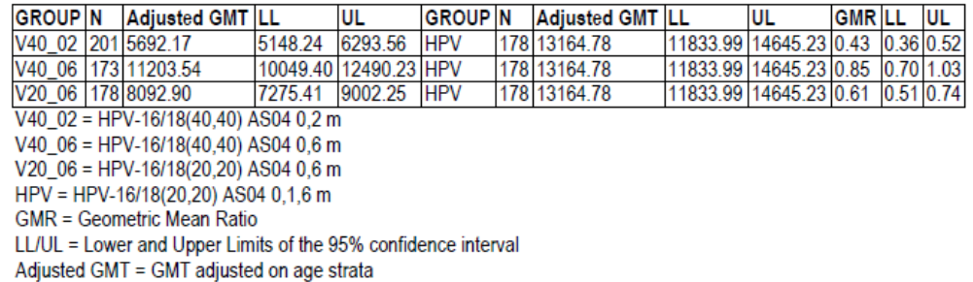

For HPV-18 the immune response one month after last vaccination was similar in Group (0, 6; 20 μg) compared with standard dosing regimen: the GMR (95% CI) for GMT was 0.91 (0.75 to 1.11) (Table 5).

Table 5: Pair-wise comparisons between each 2-dose schedule group and the 3-dose standard schedule group for anti-HPV-16 antibody titers (ATP cohort for immunogenicity).

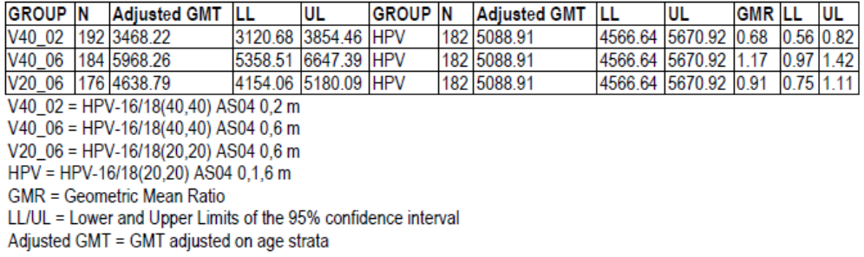

###### Results for other efficacy outcomes

* For the 9 to 15 year age group there was similar response to HPV-16 for Group (0, 6; 20 μg) compared to the 15 to 25 year group for Group (0, 1, 6): GMT 11066.9 and 10322.0 respectively, GMT ratio (95% C) 0.93 (0.68 to 1.28).
* For the 9 to 15 year age group there was similar response to HPV-18 for Group (0, 6; 20 μg) compared to the 15 to 25 year group for Group (0, 1, 6): GMT 4261.5 and 5509.8 respectively, GMT ratio (95% C) 0.77 (0.59 to 1.01).
* For HPV-16 there was similar immune response compared with the standard regimen for up to 48 months.
* For HPV-18 there was similar immune response compared with the standard regimen for up to 48 months.

#### Other efficacy studies

##### Study HPV-008

Study HPV-008 Report (M48) Amendment 1 was a Phase III, randomised, double-blind, randomised, controlled study to evaluate the efficacy of HPV-16/18 VLP/AS04 vaccine in healthy females aged 15 to 25 months. The study was conducted by 131 investigators in 14 countries from May 2004 to November 2009. The study was not designed to assess the efficacy or safety of a two dose regimen, but because some subjects only received two doses a post-hoc analysis of this subgroup was performed.

The original study included healthy women, aged 15 to 25 years, with a negative urine pregnancy test, being of non-childbearing potential or, if of childbearing potential, abstinent or using adequate contraceptive precautions; and with no previous vaccination against HPV or hepatitis A. The study treatments were:

1. HPV-16/18 at Month 0, Month 1 and Month 6
2. Hepatitis A vaccine at Month 0, Month 1 and Month 6

The treatments were administered as three doses over 6 months, with 48 months follow up.

The efficacy measures tested in the cohort that received only two doses were:

* Vaccine efficacy against HPV-16/18 incident infection
* Vaccine efficacy against 6-month persistent infection

The efficacy outcomes for the subgroup that received 2 doses only were:

* Vaccine efficacy against HPV-16/18 incident infection: 5 (2.4%) subjects in the HPV group and 24 (11.3%) in the HAV developed incident infection, vaccine efficacy was 79.4 (44.8 to 93.9) %, p = 0.0004 9 (Table 6).

Table 6: Incidence rates and vaccine efficacy against incident infection with HPV-16 and/or HPV-18 (by PCR) in HPV DNA negative and seronegative subjects at baseline, who received only two doses of study vaccine, using conditional exact method (TVC-1).

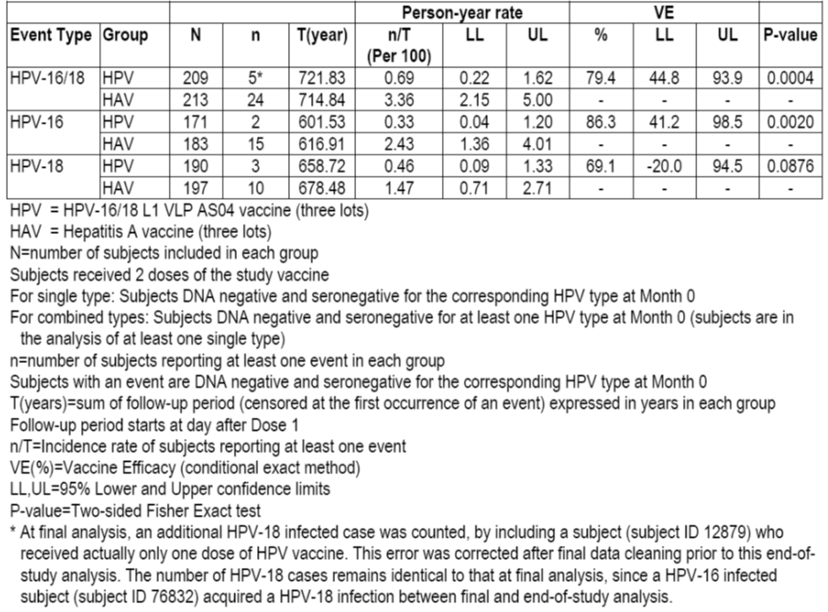

* Vaccine efficacy against 6-month persistent infection: no subject in the HPV group and 11 (5.8%) in the HAV had persistent infection over 6 months, vaccine efficacy against 6-month persistent infection was 100 (60.9 to 100) %, p = 0.0008 (Table 7).

Table 7: Incidence rates and vaccine efficacy against persistent infection (6-month definition) with HPV-16 and/or HPV-18 (by PCR) in HPV DNA negative and seronegative subjects at baseline who received only two doses of study vaccine using conditional exact method (TVC-1) (copied from Table 109, Study HPV-008 Report (M48).

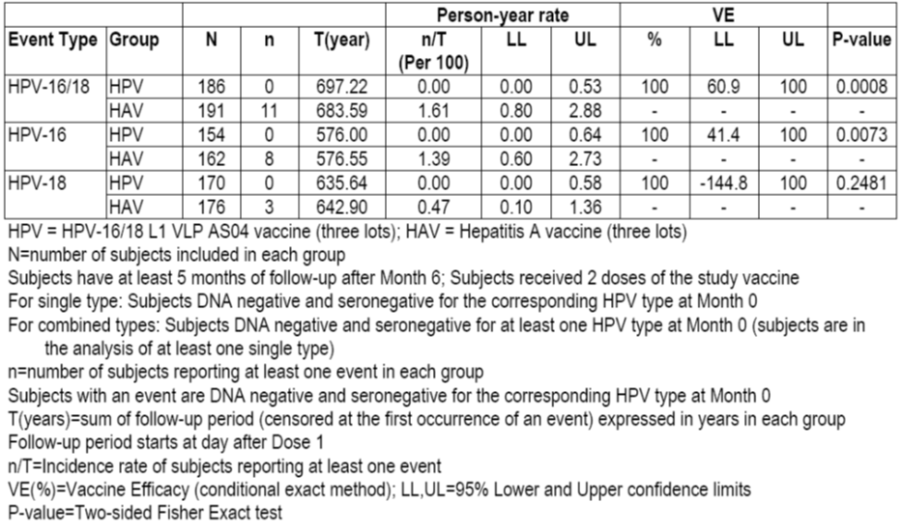

##### Study HPV-009

Kreimer et. al. 2011 (Study HPV-009) was a post-hoc analysis of data from Study HPV-009 which was a double blind, randomised, Phase III study of a HPV-16/18 VLP vaccine in the prevention of advanced cervical intra-epithelial neoplasia. The study was conducted from a single centre with seven satellite centres in Costa Rica from June 2004 to December 2010. The study included healthy young adult women, aged 18 to 25 years at time of first vaccination, with an intact uterus, with a negative urine pregnancy test, and willing to use effective method of birth control for 30 days before vaccination until 60 days after the last vaccination; and with no previous use of any HPV vaccine and monophosphoryl lipid A or AS04 adjuvant. The study treatments were:

* HPV-16/18 VLP AS04 vaccine at Month 0, 1 and 6
* HAV vaccine at Month 0, 1 and 6

The treatments were administered as three separate doses over 6 months. The primary efficacy outcome measure for Study HPV-009 was histopathologically confirmed CIN2+ associated with HPV-16 or HPV-18 cervical infection. However, for the post-hoc analysis the outcome measure was incident 12-month persistent HPV-16 or HPV-18 infections. The analysis excluded women who had no follow-up or who were HPV16 and HPV18 DNA positive at enrolment.

There were 7466 women included in the trial and 7153 in the analysis. There were 5967 subjects who received three vaccine doses (2957 HPV vaccine vs 3010 HVA), 802 received two doses (422 HPV vs 380 HVA), and 384 received one dose (196 HPV vs 188 HVA). The subjects were followed up for a median duration of 4.2 years. For those subjects who received two doses only, there were 3 (0.71%) subjects in the HPV group who had incident 12-month persistent HPV-16 or HPV-18 infections, compared with 17 (4.5%) in the HAV. For those subjects who received three doses, there were 25 (0.85%) subjects in the HPV group who had incident 12-month persistent HPV-16 or HPV-18 infections, compared with 133 (4.4%) in the HAV. The efficacy (95% CI) of two doses compared with three doses was 104 (69.3 to 129.0) %. Vaccine efficacy (95% CI) for three doses against newly detected HPV16 or HPV18 that persisted at least 1 year was 80.9 (71.1 to 87.7) %; for two doses was 84.1 (50.2 to 96.3) %; and for one dose was 100 (66.5 to 100) %.

#### Analyses performed across trials (pooled analyses and meta-analyses)

No meta-analyses of pooled analyses were performed.

### Evaluator’s conclusions on clinical efficacy for proposed two-dose schedule at Month 0 and Month 6

Study HPV-070 demonstrated equivalent immunogenicity for the two dose regimen (Month 0 and Month 6) and the currently approved dosing regimen. In Study HPV-070 at one month and at 6 months after the last dose of vaccine all subjects in the ATP cohort for immunogenicity seroconverted. At one month after the second vaccination (Month 7), there was similar immune response for HPV-16 in Group (0, 1, 6) and in Group (0, 6) and the upper 95% CI was < 2, and therefore within the predefined bounds for non-inferiority: GMT ratio (95% CI) 1.09 (0.97 to 1.22). There was a greater immune response to HPV-18 in Group (0, 6) than Group (0, 1, 6): GMT ratio (95% CI) 0.85 (0.76 to 0.95). At six months after the second vaccination (Month 12), there was greater immune response for HPV-16 in Group (0, 1, 6) than in Group (0, 6) but the upper 95% CI was < 2, and therefore within the predefined bounds for non-inferiority: GMT ratio (95% CI) 1.25 (1.10 to 1.40). There was a similar immune response for the two groups to HPV-18: GMT ratio (95% CI) 0.99 (0.87 to 1.12). All subjects developed neutralising antibodies to HPV-16 PsV and to HPV-18 PsV. There were similar CD4+ and B cell responses to HPV-16, HPV-18, HPV-31 and HPV-45.

In Study HPV-048 all the subjects seroconverted. Within each treatment group, the GMT responses were similar by age strata. For HPV-16 the immune response one month after last vaccination was decreased in Group (0, 6; 20 μg) compared with standard dosing regimen: the GMR (95% CI) for GMT was 0.61 (0.51 to 0.74). For HPV-18 the immune response one month after last vaccination was similar in Group (0, 6; 20 μg) compared with standard dosing regimen: the GMR (95% CI) for GMT was 0.91 (0.75 to 1.11). In comparison with the results from Study HPV-070, for the 9 to 15 year age group there was similar response to HPV-16 for Group (0, 6; 20 μg) compared to the 15 to 25 year group for Group (0, 1, 6): GMT 11066.9 and 10322.0 respectively, GMT ratio (95% C) 0.93 (0.68 to 1.28); and for the 9 to 15 year age group there was similar response to HPV-18 for Group (0, 6; 20 μg) compared to the 15 to 25 year group for Group (0, 1, 6): GMT 4261.5 and 5509.8 respectively, GMT ratio (95% C) 0.77 (0.59 to 1.01). For both HPV-16 and HPV-18 there was similar immune response compared with the standard regimen for up to 48 months.

In Study HPV-008, in a population of women aged 15 to 25 years, for those subjects who received only two of three vaccine doses, with regard vaccine efficacy against HPV-16/18 incident infection: 5 (2.4%) subjects in the HPV group and 24 (11.3%) in the HAV developed incident infection, vaccine efficacy was 79.4 (44.8 to 93.9) %, p = 0.0004. With regard vaccine efficacy against 6-month persistent infection: no subject in the HPV group and 11 (5.8%) in the HAV had persistent infection over 6 months, vaccine efficacy against 6-month persistent infection was 100 (60.9 to 100) %, p = 0.0008.

Study HPV-009 found no increase in HPV-16 or HPV-18 infection in subjects who had received two instead of three doses, but the study did not have sufficient subjects to be able to demonstrate equivalence. In Study HPV-009, for those subjects who received two doses only, there were 3 (0.71%) subjects in the HPV group who had incident 12-month persistent HPV-16 or HPV-18 infections, compared with 17 (4.5%) in the HAV. For those subjects who received three doses, there were 25 (0.85%) subjects in the HPV group who had incident 12-month persistent HPV-16 or HPV-18 infections, compared with 133 (4.4%) in the HAV. The efficacy (95% CI) of two doses compared with three doses was 104 (69.3 to 129.0) %. Vaccine efficacy (95% CI) for three doses against newly detected HPV16 or HPV18 that persisted at least 1 year was 80.9 (71.1 to 87.7) %; for two doses was 84.1 (50.2 to 96.3) %; and for one dose was 100 (66.5 to 100) %.

The development program for the proposed new two dose regimens was appropriately designed and conformed with EMA guidance. The non-inferiority criteria for Study HPV-070 were appropriate, as were the statistical techniques used by the Sponsor. In the opinion of the Evaluator, it is appropriate to use immunogenicity as a surrogate measure of efficacy in the 9 to 15 year old population because HPV-16 and HPV-18 infection are uncommon in this age group and cannot be used as an efficacy outcome measure.

### Proposed two-dose schedule at Month 0 and Month 12

#### Study HPV-070

##### Study design, objectives, locations and dates

The data relating to the two dose schedule at Month 0 and Month 12 were contained in the Study HPV-070 Month 12/13/ report.

##### Inclusion and exclusion criteria

As per Section 7.1.1.1.2.

##### Study treatments

As per Section 7.1.1.1.3.

##### Efficacy variables and outcomes

As per Section 7.1.1.1.4.

##### Randomisation and blinding methods

As per Section 7.1.1.1.5.

##### Analysis populations

As per Section 7.1.1.1.6.

##### Sample size

As per Section 7.1.1.1.7.

##### Statistical methods

As per Section 7.1.1.1.8.

##### Participant flow

As per Section 7.1.1.1.9.

##### Major protocol violations/deviations

As per Section 7.1.1.1.10.

##### Baseline data

As per Section 7.1.1.1.11.

##### Results for the primary efficacy outcome

One month after the last dose of study vaccine, for the Group (0, 12), Group (0, 1, 6) comparison: all subjects in the ATP cohort for immunogenicity seroconverted. The difference between groups (95% CI) was 0.00 (- 1.10 to 1.07) % for HPV-16 antibody and 0.00 (- 1.01 to 1.03) % for HPV-18 antibody (Table 8).

Table 8: Non-Inferiority assessment of anti HPV-16 and HPV-18 seroconversion rates (HPV [0, 1, 6] schedule vs HPV [0, 12] schedule) one month after the last dose in initially seronegative subjects (ATP cohort for immunogenicity).

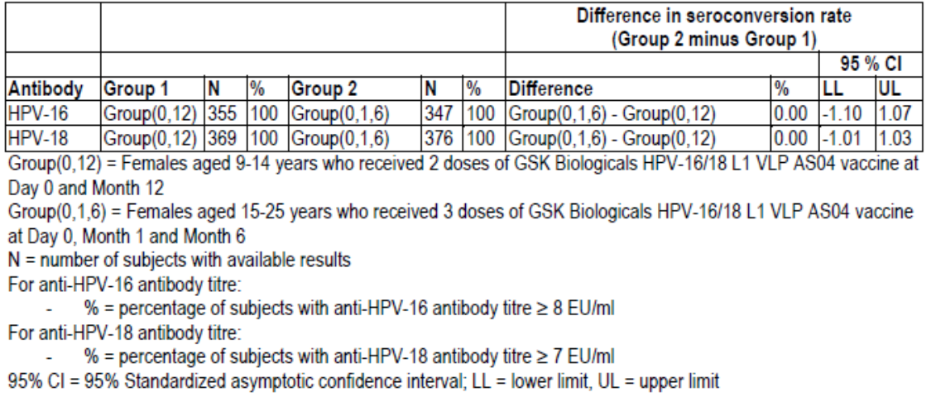

There was similar immune response for HPV-16 in Group (0, 1, 6) and Group (0, 12): GMT ratio (95% CI) 0.89 (0.79 to 1.01) (Table 9). There was a greater immune response to HPV-18 in Group (0, 12) than Group (0, 1, 6): GMT ratio (95% CI) 0.75 (0.67 to 0.85).

Table 9: Non-inferiority assessment HPV-16 and HPV-18 immune response for (HPV [0, 1, 6] schedule vs HPV [0, 12] schedule) one month after the last dose in initially seronegative subjects (ATP cohort for immunogenicity).

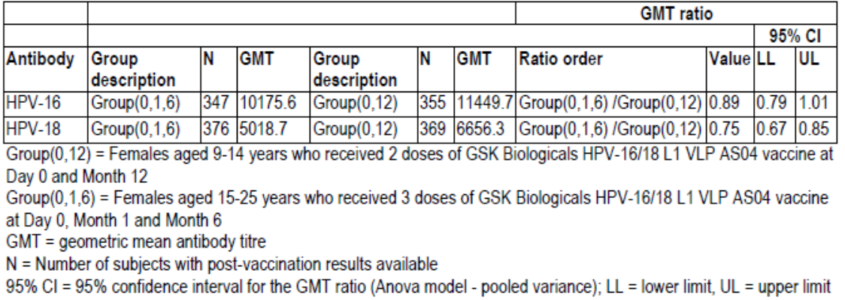

##### Results for other efficacy outcomes

* For the Group (0, 12), Group (0, 6) comparison: all subjects in the ATP cohort for immunogenicity seroconverted. The difference between groups (95% CI) was 0.00 (-0.79 to 1.07) % for HPV-16 antibody and 0.00 (-0.79 to 1.03) % for HPV-18 antibody.
* There was greater immune response for HPV-16 in Group (0, 12) than Group (0, 6): GMT ratio (95% CI) 0.82 (0.74 to 0.91). There was a greater immune response to HPV-18 in Group (0, 12) than Group (0, 6): GMT ratio (95% CI) 0.89 (0.80 to 0.99).
* All subjects developed an anti-HPV-16 pseudovirion Ab titre equal to or above 40 ED50.
* All subjects developed an anti-HPV-18 pseudovirion Ab titre equal to or above 40 ED50.
* CD4+ response to HPV-16 was similar for all three regimens.
* CD4+ response to HPV-18 was similar for all three regimens.
* B cell responses were similar for the three dosing schedules for HPV-16, HPV-18, HPV-31 and HPV-45.

### Evaluator’s conclusions on clinical efficacy for proposed two-dose schedule at Month 0 and Month 12

Study HPV-070 demonstrated equivalent responses for the two dose schedule (Month 0 and Month 12) with the currently approved dosing regimen and with the Month 0 and Month 6 regimen. One month after the last dose of study vaccine, for the Group (0, 12), Group (0, 1, 6) comparison: all subjects in the ATP cohort for immunogenicity seroconverted. There was similar immune response for HPV-16 in Group (0, 1, 6) and Group (0, 12): GMT ratio (95% CI) 0.89 (0.79 to 1.01). There was a greater immune response to HPV-18 in Group (0, 12) than Group (0, 1, 6): GMT ratio (95% CI) 0.75 (0.67 to 0.85). For the Group (0, 12), Group (0, 6) comparison: all subjects in the ATP cohort for immunogenicity seroconverted. There was greater immune response for HPV-16 in Group (0, 12) than Group (0, 6): GMT ratio (95% CI) 0.82 (0.74 to 0.91). There was a greater immune response to HPV-18 in Group (0, 12) than Group (0, 6): GMT ratio (95% CI) 0.89 (0.80 to 0.99). All subjects developed an anti-HPV-16 and an antiHPV-18 pseudovirion Ab titre equal to or above 40 ED50. CD4+ responses to HPV-16 and HPV-18 were similar for all three regimens. B cell responses were similar for the three dosing schedules for HPV-16, HPV-18, HPV-31 and HPV-45.

## Clinical safety

### Studies providing evaluable safety data

The following studies provided evaluable safety data:

#### Pivotal efficacy studies

In the pivotal efficacy studies (Study HPV-070 and Study HPV-048), the following safety data were collected:

* Solicited local symptoms
* Solicited general symptoms
* Unsolicited symptoms
* Adverse events
* Laboratory safety variables

#### Pivotal studies that assessed safety as a primary outcome

Study EPI-HPV-018 VS UK DB (Module 5, Section 5.3.6) is a post-marketing study of safety in pregnancy that is discussed in Section 8.5.6.1.1.

#### Dose-response and non-pivotal efficacy studies

The dose-response and non-pivotal efficacy studies provided safety data, as follows:

* Study HPV-008 Report (M48) Amendment 1, did not present safety data for the subjects that received only two doses
* Kreimer et. al. 2011 (Study HPV-009) did not present safety data for the subjects that received only two doses

### Pivotal studies that assessed safety as a primary outcome

Study EPI-HPV-018 VS UK DB is a post-marketing study of safety in pregnancy that is discussed in Section 8.5.6.1.1.

### Patient exposure

In Study HPV-070:

* 550 subjects in Group (0, 6) were vaccinated: 4 (0.7%) received one dose, 546 (99.3%) received two doses
* 415 subjects in Group (0, 12) were vaccinated: 9 (2.2%) received one dose, 406 (97.8%) received two doses
* 482 subjects in Group (0, 12) were vaccinated: 6 (1.2%) received one dose, 5 (1.0%) received two doses and 471 (97.7%) received three doses

In Study HPV-048:

* 240 subjects were vaccinated in the two dose, 40 μg, Month 0 and Month 2 regimen
* 241 subjects were vaccinated in the two dose, 40 μg, Month 0 and Month 6 regimen
* 240 subjects were vaccinated in the two dose, 20 μg, Month 0 and Month 6 regimen
* 239 subjects were vaccinated in the three dose, 20 μg, Month 0, Month 1 and Month 6 regimen

Safety data were not presented for Study HPV-008 and Study HPV-009.

### Adverse events

#### All adverse events (irrespective of relationship to study treatment)

##### Pivotal studies

In Study HPV-070 there were more adverse events reported in Group (0, 1, 6) primarily because of the additional dose given compared to the other two regimens. Symptoms were reported in 516 (93.8%) subjects in Group (0, 6), 387 (93.7%) in Group (0, 12) and 471 (98.1%) in Group (0, 1, 6) (Tables 10 and 11). General symptoms were reported in 417 (75.8%) subjects in Group (0, 6), 323 (78.2%) in Group (0, 12) and 424 (88.3%) in Group (0, 1, 6). Local symptoms were reported in 505 (91.8%) subjects in Group (0, 6), 385 (93.0%) in Group (0, 12) and 461 (96.0%) in Group (0, 1, 6).

Table 10: Incidence and nature of symptoms (solicited and unsolicited) reported during the 30-day (Days 0-29) post-vaccination period following each dose and overall (Total Vaccinated cohort).

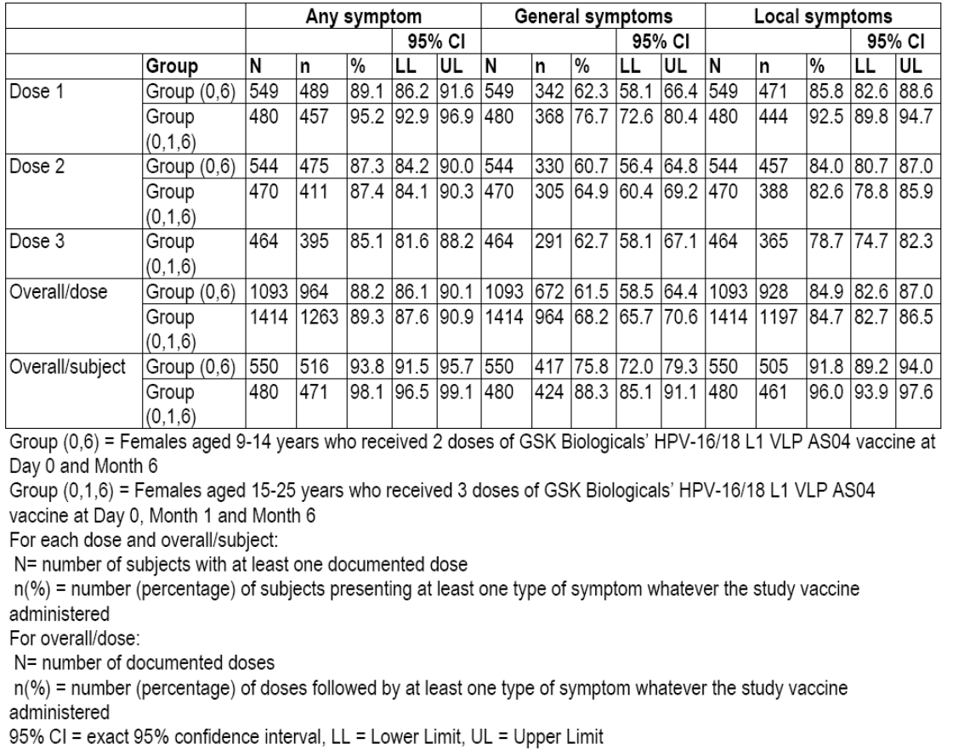

Table 11: Incidence and nature of symptoms (solicited and unsolicited) reported during the 30-day (Days 0-29) post-vaccination period following each dose and overall (Total vaccinated cohort).

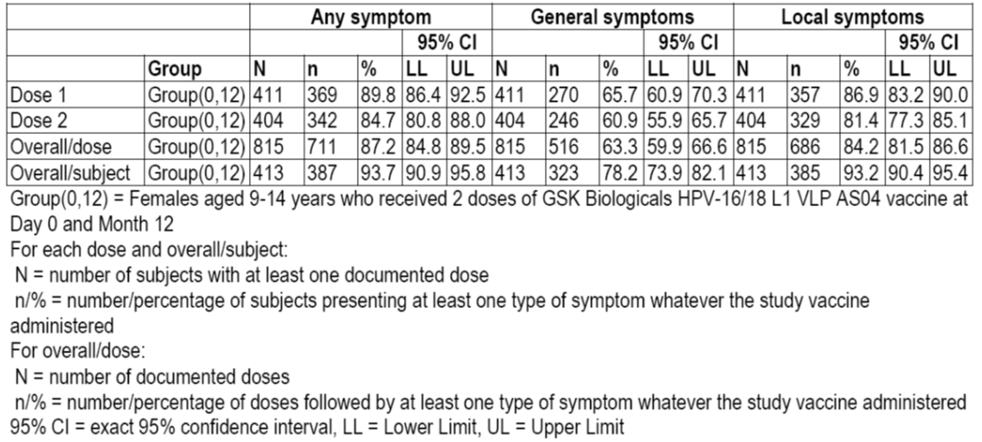

The rate of AEs per dose was similar for the three regimens. Symptoms were reported in 964 (88.2%) doses in Group (0, 6), 711 (87.2%) in Group (0, 12) and 1263 (89.3%) in Group (0, 1, 6). General symptoms were reported in 672 (61.5%) doses in Group (0, 6), 516 (63.3%) in Group (0, 12) and 964 (68.2%) in Group (0, 1, 6). Local symptoms were reported in 928 (84.9%) doses in Group (0, 6), 686 (84.2%) in Group (0, 12) and 1197 (84.7%) in Group (0, 1, 6).

The incidence of pain, redness and swelling was similar for the three dosing regimens.

With regard solicited general symptoms, myalgia, fatigue and headache were reported more frequently in Group (0, 1, 6) (Tables 12 and 13). Myalgia was reported in 50.5% subjects in Group (0, 6), 53.5% in Group (0, 12) and 61.5% in Group (0, 1, 6). Fatigue was reported in 44.9% subjects in Group (0, 6), 52.1% in Group (0, 12) and 64.6% in Group (0, 1, 6). Headache was reported in 37.1% subjects in Group (0, 6), 44.8% in Group (0, 12) and 51.3% in Group (0, 1, 6).

Table 12: Incidence of solicited general symptoms reported during the 7-day (Days 0-6) post-vaccination period following each dose and overall (Study HPV-070 Month 7 report).

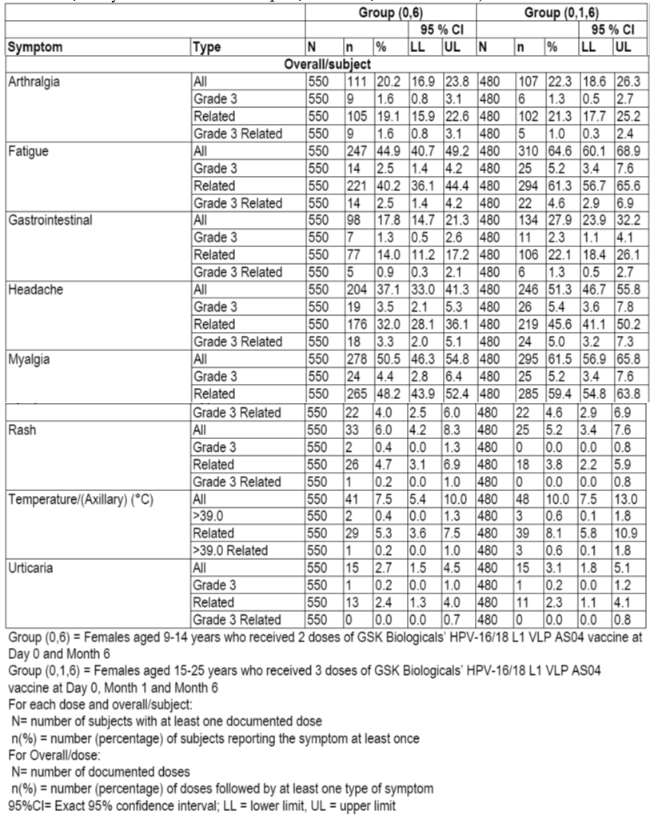

Table 13: Incidence of solicited general symptoms reported during the 7-day (Days 0-6) post-vaccination period following each dose and overall (Study HPV-070 Month 12/13 report).

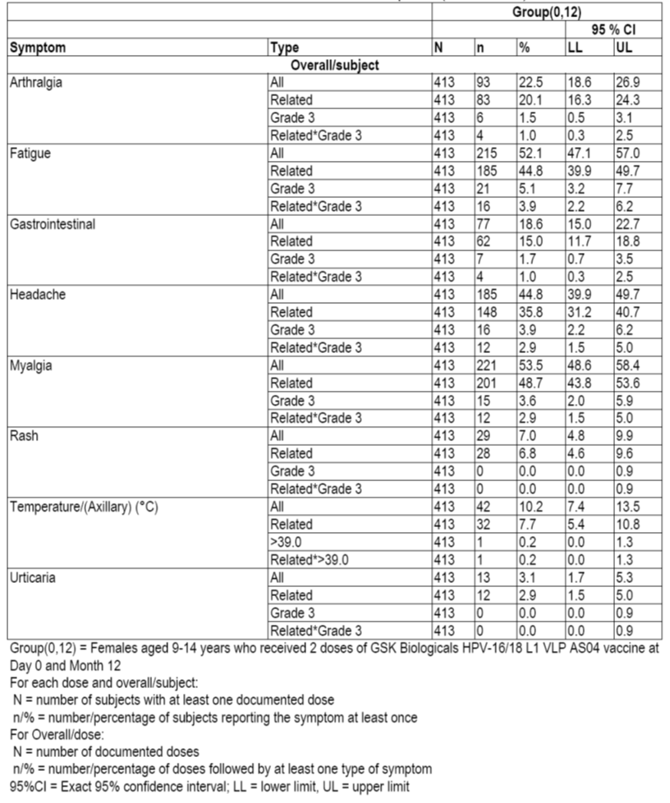

There were 131 unsolicited symptoms reported by 99 subjects in Group (0, 6), 101 by 74 in Group (0, 12) and 273 by 165 in Group (0, 1, 6).

In Study HPV-048, any symptoms within 7 days of vaccination were reported by 226 (95.0%) in Group (0, 2; 40 μg); 232 (97.1%) in Group (0, 6; 40 μg), 227 (95.4%) in Group (0, 6; 20 μg) and 233 (97.9%) in Group (0, 1, 6; 20 μg). General symptoms within 7 days of vaccination were reported by 170 (71.4%) subjects in Group (0, 2; 40 μg); 188 (78.7%) in Group (0, 6; 40 μg), 178 (74.8%) in Group (0, 6; 20 μg) and 182 (76.5%) in Group (0, 1, 6; 20 μg). Local symptoms within 7 days of vaccination were reported by 222 (93.3%) subjects in Group (0, 2; 40 μg); 225 (94.1%) in Group (0, 6; 40 μg), 223 (93.7%) in Group (0, 6; 20 μg) and 229 (96.2%) in Group (0, 1, 6; 20 μg).

The incidence of pain, redness and swelling was similar for the four treatment groups. The incidence of solicited general symptoms was similar for the four treatment groups. Headache was reported in 42.4% to 52.5% of subjects; fatigue in 42.0% to 45.6%; and myalgia in 33.2% to 45.6%.

Unsolicited symptoms were reported by 83 (34.6%) in Group (0, 2; 40 μg); 85 (35.3%) in Group (0, 6; 40 μg), 76 (31.7%) in Group (0, 6; 20 μg) and 107 (44.8%) in Group (0, 1, 6; 20 μg). Overall, new onset of chronic disease was reported in 15 subjects and new onset of autoimmune disease was reported in five subjects.

##### Other studies

Safety data were not presented for Study HPV-008 and Study HPV-009.

#### Treatment-related adverse events (adverse drug reactions)

##### Pivotal studies

In Study HPV-070 there 14 unsolicited symptoms with a causal relationship to the vaccination reported by 11 subjects in Group (0, 6), 17 by 13 in Group (0, 12) and 28 by 24 in Group (0, 1, 6).

##### Other studies

Safety data were not presented for Study HPV-008 and Study HPV-009.

#### Deaths and other serious adverse events

##### Pivotal studies

In Study HPV-070 there were no deaths. There were 18 SAEs reported by 12 subjects in Group (0, 6), 11 by 11 in Group (0, 12) and 18 by 15 in Group (0, 1, 6). There was no apparent pattern to the SAEs.

In Study HPV-048 there were no deaths up to Month 48. Up to 30 days post vaccination, SAEs were reported in 14 subjects: bulimia nervosa, Basedow’s disease (attributed to treatment), coccydynia, abdominal pain, urinary tract infection, appendicitis (n = 2), depression, psychotic disorder, circulatory collapse, concussion, hepatomegaly, tibia fracture, bulimia nervosa, road traffic accident, vestibular neuronitis (n = 2) and fibroma. In total, up to Month 48, there were 74 non-fatal SAEs reported in 54 subjects; none of which were attributed to study treatment.

##### Other studies

Safety data were not presented for Study HPV-008 and Study HPV-009.

#### Discontinuation due to adverse events

##### Pivotal studies

In Study HPV-070 there were no DAEs.

In Study HPV-048 there were no DAEs.

##### Other studies

Safety data were not presented for Study HPV-008 and Study HPV-009.

### Laboratory tests

#### Liver function

##### Pivotal studies

In Study HPV-048 there were no clinically relevant abnormalities in serum biochemistry.

##### Other studies

Safety data were not presented for Study HPV-008 and Study HPV-009.

#### Kidney function

##### Pivotal studies

In Study HPV-048 there were no clinically relevant abnormalities in serum biochemistry.

##### Other studies

Safety data were not presented for Study HPV-008 and Study HPV-009.

#### Other clinical chemistry

##### Pivotal studies

In Study HPV-048 there were no clinically relevant abnormalities in serum biochemistry.

##### Other studies

Safety data were not presented for Study HPV-008 and Study HPV-009.

#### Haematology

##### Pivotal studies

In Study HPV-048 there were no clinically relevant abnormalities in haematology.

##### Other studies

Safety data were not presented for Study HPV-008 and Study HPV-009.

#### Potentially immune-mediated diseases

##### Pivotal studies

In Study HPV-070 there were three potentially immune-mediated diseases reported in two subjects in Group (0, 6) (autoimmune thyroiditis, type 1 diabetes mellitus, Raynaud’s phenomenon), two in two subjects in Group (0, 12) (autoimmune thyroiditis, coeliac disease) and three in two subjects in Group (0, 1, 6) (psoriatic arthropathy, VIIth nerve paralysis, psoriasis).

In Study HPV-048, up to Month 48, there were 17 new onset autoimmune diseases reported in 16 subjects. Hypothyroidism was reported in 5 subjects.

##### Other studies

Safety data were not presented for Study HPV-008 and Study HPV-009.

#### Pregnancies

##### Pivotal studies

In Study HPV-070 there were no pregnancies in Group (0, 6), one pregnancy in Group (0, 12) (resulting in a live infant with no apparent congenital anomaly) and 24 pregnancies in Group (0, 1, 6).

In Study HPV-048 to Month 48, there were 83 pregnancies; 54 (65.1%) of which resulted in a live-born infant with no congenital abnormality (Table 14).

Table 14: Number of subjects with pregnancies (Study HPV-048).

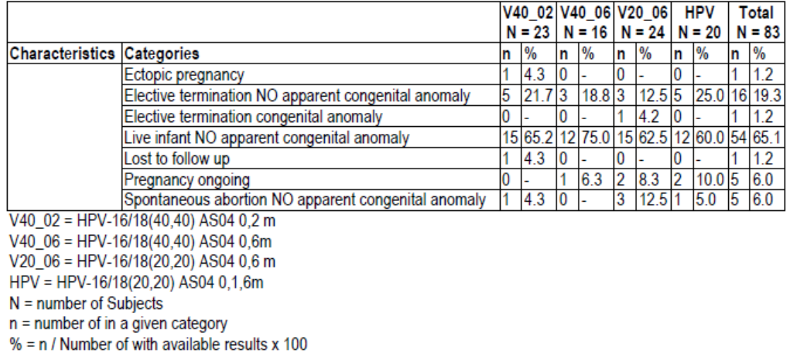

Study EPI-HPV-018 VS UK DB was a retrospective, observational cohort study using the CPRD GOLD data source in the UK to assess the risk of spontaneous abortion during weeks 1 to 23 of gestation (UK definition) in women aged 15 to 25 years with the first day of last menstrual period between 30 days before and 45 days after any dose of Cervarix. The study was conducted by GSK Biologicals using data extracted from the CPRD GOLD. The study included women aged 15 to 25 years, vaccinated with Cervarix, with the first day of LMP between 1st September 2008 and 30th June 2011.

The primary safety outcome measure was the occurrence of spontaneous abortion during weeks 1-23 of gestation. Secondary safety outcome measures were:

* Occurrence of spontaneous abortion during weeks 1 - 19 of gestation.
* Occurrence of other pregnancy outcomes:*
* Induced/therapeutic and other abortions.
* Stillbirth.
* Birth defects identified among all pregnancies with known outcome classified as live births, stillbirths and abortions. For live births, birth defects identified within the first 12 weeks of life were included.
* Small/large for gestational age at birth.
* Pre-term and post-term delivery.
* Baby’s death in the first 12 weeks of life.

There were 78,111 women 15-25 years of age and exposed to Cervarix, 2440 women (3.1%) had both a Cervarix vaccination and a LMP date between 1st September 2008 and 30th June 2011. Of these subjects 1046 were classified as being either exposed or non-exposed to Cervarix: 243 (first day of LMP between 30 days before and 45 days after any dose) and 379 (first day of LMP between 30 days before and 90 days after any dose) were identified as being exposed to Cervarix vaccine, and 667 as non-exposed (first day of LMP between 120 days and 18 months after the last dose of Cervarix vaccine).

There were 84 exclusions from the primary analysis: 48 subjects were not pregnant, for 11 the LMP was not confirmed, for 6 the LMP was out of the study period and for 19 the exposure was not confirmed. There were a further 191 subjects excluded from the secondary analysis: 54 because the LMP was not compatible with the pregnancy outcome; and for 137 the pregnancy outcome was unknown.

The exposed group were younger than the control group, but otherwise the demographic characteristics of the study groups were similar. There were 10 (4.8%) subjects in the exposed group and 10 (1.6%) in the control group exposed to other vaccines within 3 months before first day of gestation (p = 0.0149).

The results of the primary analysis were:

* Spontaneous abortion was reported for 24 (11.6%) pregnancies in the exposed group and 57 (9.0%) in the control: age adjusted HR (95% CI) 1.166 (0.755 to 1.802) p = 0.489.
* Stillbirth was reported for three (1.4%) subjects in the exposed group and four (0.6%) in the control. Adjusted OR (95% CI) for live birth, with control being the exposure variable, secondary analysis: 1.021 (0.699 to 1.555) p = 0.8392.
* Small for gestational age was reported for 8 (6.0%) pregnancies in the exposed group and 27 (6.5%) in the control. Adjusted OR (95% CI), with control being the exposure variable, secondary analysis: 0.903 (0.391 to 2.085) p = 0.8103.
* Large for gestational age was reported for one (0.7%) pregnancy in the exposed group and 14 (3.3%) in the control. Adjusted OR (95% CI), with control being the exposure variable, secondary analysis: 0.263 (0.033 to 2.062) p = 0.2036.
* The neonates had similar characteristics at birth for the two groups.
* At least one major birth defect was reported in four (2.9%) subjects in the exposed group and 11 (2.6%) in the control. Adjusted OR (95% CI), with control being the exposure variable, secondary analysis: 0.999 (0.296 to 3.368) p = 0.9987.
* At least one minor birth defect was reported in three (2.2%) subjects in the exposed group and 10 (2.4%) in the control. Adjusted OR (95% CI), with control being the exposure variable, secondary analysis: 0.721 (0.188 to 2.762) p = 0.8392.
* There was one death in the first 12 weeks in the exposed group and two in the control.

##### Other studies

Pregnancy data were not presented for Study HPV-008 and Study HPV-009.

### Post-marketing experience

See Study EPI-HPV-018 VS UK DB.

### Safety issues with the potential for major regulatory impact

There were no safety issues with the potential for major regulatory impact identified in the data.

### Evaluator’s overall conclusions on clinical safety

The profile of local and general symptoms following Cervarix is similar for the proposed two dose schedule and the currently approved three dose schedule. There were no new safety concerns identified in the data.

Study EPI-HPV-018 VS UK DB did not identify any new safety concerns with regard the administration of Cervarix in pregnancy. There was no significant increase in spontaneous abortion, stillbirth, small for gestational age, large for gestational age, major birth defects, minor birth defects or one death in the first 12 weeks of life. However, there are insufficient data to demonstrate that it is completely safe to administer Cervarix in pregnancy.

## First round benefit-risk assessment

### First round assessment of benefits

#### Benefits of proposed two-dose schedule at Month 0 and Month 6

The benefits of Cervarix in the proposed usage are:

* Cervarix has equivalent immunogenicity for the two dose regimen (Month 0 and Month 6) and the currently approved dosing regimen.
* In the population of females aged 9 to 15 years, a two dose regimen is likely to result in greater adherence, and overall a higher immunisation rate.
* A two dose regimen offers advantages to immunisation programs in terms of cost and ease of delivery

#### Benefits of proposed two-dose schedule at Month 0 and Month 12

The benefits of Cervarix in the proposed usage are:

* Cervarix has equivalent immunogenicity for the two dose regimen (Month 0 and Month 12) and the both the currently approved dosing regimen, and the proposed two dose Month 0 and Month 6 regimen.
* In the population of females aged 9 to 15 years, a two dose regimen with a wider time window for the second dose (6 to 12 months after the first) is likely to result in even greater adherence, and overall a higher immunisation rate.
* A two dose regimen with a wider time window for the second dose (6 to 12 months after the first) offers further advantages to immunisation programs in terms of cost and ease of delivery.

### First round assessment of risks

The profile of local and general symptoms following Cervarix is similar for the proposed two dose schedule and the currently approved three dose schedule. There were no new safety concerns identified in the data.

Study EPI-HPV-018 VS UK DB did not identify any new safety concerns with regard the administration of Cervarix in pregnancy. There was no significant increase in spontaneous abortion, stillbirth, small for gestational age, large for gestational age, major birth defects, minor birth defects or death in the first 12 weeks of life. However, there are insufficient data to demonstrate that it is completely safe to administer Cervarix in pregnancy.

### First round assessment of benefit-risk balance

The benefit-risk balance of Cervarix, given the proposed usage, is favourable.

## First round recommendation regarding authorisation

The evaluator has no objection to the approval of the proposed alternative two dose regimen.

## Clinical questions

### Pharmacokinetics

The Evaluator does not have any questions with regard pharmacokinetics.

### Pharmacodynamics

The Evaluator does not have any questions with regard pharmacodynamics.

### Efficacy

The Evaluator does not have any questions with regard efficacy.

### Safety

The Evaluator does not have any questions with regard safety.

|  |
| --- |
| Therapeutic Goods Administration |
| PO Box 100 Woden ACT 2606 Australia  Email: [info@tga.gov.au](mailto:info@tga.gov.au) Phone: 1800 020 653 Fax: 02 6232 8605  [**https://www.tga.gov.au**](https://www.tga.gov.au) |