|  |
| --- |
| **First Round CER report: 18 November 2014**  **Second Round CER report: 20 January 2015** |

|  |
| --- |
| AusPAR Attachment 2 |
| Extract from the Clinical Evaluation Report for Ibrutinib |
| Proprietary Product Name: Imbruvica |
| Sponsor: Janssen-Cilag Pty Ltd |

About the Therapeutic Goods Administration (TGA)

* The Therapeutic Goods Administration (TGA) is part of the Australian Government Department of Health, and is responsible for regulating medicines and medical devices.
* The TGA administers the *Therapeutic Goods Act 1989* (the Act), applying a risk management approach designed to ensure therapeutic goods supplied in Australia meet acceptable standards of quality, safety and efficacy (performance), when necessary.
* The work of the TGA is based on applying scientific and clinical expertise to decision-making, to ensure that the benefits to consumers outweigh any risks associated with the use of medicines and medical devices.
* The TGA relies on the public, healthcare professionals and industry to report problems with medicines or medical devices. TGA investigates reports received by it to determine any necessary regulatory action.
* To report a problem with a medicine or medical device, please see the information on the TGA website <<https://www.tga.gov.au>>.

About the Extract from the Clinical Evaluation Report

* This document provides a more detailed evaluation of the clinical findings, extracted from the Clinical Evaluation Report (CER) prepared by the TGA. This extract does not include sections from the CER regarding product documentation or post market activities.
* The words [Information redacted], where they appear in this document, indicate that confidential information has been deleted.
* For the most recent Product Information (PI), please refer to the TGA website <<https://www.tga.gov.au/product-information-pi>>.

Copyright

© Commonwealth of Australia 2016  
This work is copyright. You may reproduce the whole or part of this work in unaltered form for your own personal use or, if you are part of an organisation, for internal use within your organisation, but only if you or your organisation do not use the reproduction for any commercial purpose and retain this copyright notice and all disclaimer notices as part of that reproduction. Apart from rights to use as permitted by the *Copyright Act 1968* or allowed by this copyright notice, all other rights are reserved and you are not allowed to reproduce the whole or any part of this work in any way (electronic or otherwise) without first being given specific written permission from the Commonwealth to do so. Requests and inquiries concerning reproduction and rights are to be sent to the TGA Copyright Officer, Therapeutic Goods Administration, PO Box 100, Woden ACT 2606 or emailed to <[tga.copyright@tga.gov.au](mailto:tga.copyright@tga.gov.au)>.

Contents

List of abbreviations 5

1. Introduction 8

1.1. Submission type 8

1.2. Drug class and therapeutic indication 8

1.3. Dosage forms and strengths 8

1.4. Dosage and administration 8

2. Clinical rationale 8

3. Contents of the clinical dossier 9

3.1. Scope of the clinical dossier 9

3.2. Paediatric data 9

3.3. Good clinical practice 9

4. Pharmacokinetics 9

4.1. Studies providing pharmacokinetic data 9

4.2. Summary of pharmacokinetics 10

4.3. Evaluator’s overall conclusions on pharmacokinetics 19

5. Pharmacodynamics 20

5.1. Studies providing pharmacodynamic data 20

5.2. Summary of pharmacodynamics 20

5.3. Evaluator’s overall conclusions on pharmacodynamics 21

6. Dosage selection for the pivotal studies 21

7. Clinical efficacy 22

7.1. Chronic lymphocytic leukaemia/small lymphocytic leukaemia 22

8. Clinical safety 48

8.1. Studies providing evaluable safety data 48

8.2. Patient exposure 50

8.3. Laboratory tests 58

8.4. Clinical pharmacology studies in healthy volunteers 62

8.5. Post-marketing experience 62

8.6. Safety issues with the potential for major regulatory impact 62

8.7. Other safety issues 66

8.8. Evaluator’s overall conclusions on clinical safety 67

9. First round benefit-risk assessment 68

9.1. First round assessment of benefit-risk balance 68

10. First round recommendation regarding authorisation 68

11. Clinical questions 69

11.1. Additional expert input 69

11.2. Clinical questions 69

12. Second round evaluation of clinical data submitted in response to questions 69

13. Second round benefit-risk assessment 70

13.1. Second round assessment of benefits 70

13.2. Second round assessment of risks 70

13.3. Second round assessment of benefit-risk balance 70

14. Second round recommendation regarding authorisation 71

## List of abbreviations

| Abbreviation | Meaning |
| --- | --- |
| AE | adverse event |
| ALC | absolute lymphocyte count |
| ALT | alanine aminotransferase |
| ANC | absolute neutrophil count |
| ASCO | American Society of Clinical Oncology |
| AST | aspartate aminotransferase |
| AUC | area under the time-concentration curve |
| BCR | B-cell receptor |
| BTK | Bruton’s Tyrosine Kinase |
| CIT | chemoimmunotherapy |
| CLL | chronic lymphocytic leukaemia |
| Cmax | maximal concentration |
| CR | complete response |
| CT | computed tomography |
| del17p | deletion in the short arm of chromosome 17p13.1 |
| DDI | drug-drug interaction |
| ECG | electrocardiogram |
| ECOG | Eastern Cooperative Oncology Group |
| EORTC QLQ-C30 | European Organisation for Research and Treatment of Cancer Quality of Life Questionnaires Core 30 |
| EMA | European Medicines Agency |
| EQ-5D-5L | EuroQoL Five-Dimension |
| ESMO | European Society for Medical Oncology |
| FACIT-Fatigue | Functional Assessment of Chronic Illness Therapy Fatigue |
| FDA | Food and Drug Administration |
| Hb | Haemoglobin |
| HR | hazard ratio |
| IRC | Independent Review Committee |
| ITT | intent to treat |
| IV | intravenous |
| IWCLL | International Workshop on Chronic Lymphocytic Leukemia |
| IWRS | Interactive Web Response System |
| MCL | Mantle cell lymphoma |
| MedDRA | Medical Dictionary for Regulatory Activities |
| MMRM | mixed model for repeated measures |
| NCCN | National Comprehensive Cancer Network |
| NE | not estimable |
| ORR | overall response rate |
| OS | overall survival |
| PD | Pharmacodynamics |
| PFS | progression-free survival |
| P-gp | permeability-glycoprotein |
| PK | Pharmacokinetic |
| PR | partial response |
| PRL | partial response with lymphocytosis |
| SAE | serious adverse event |
| SD | Stable disease/standard deviation |
| SLL | small lymphocytic lymphoma |
| SMQ | Standardised MedDRA query |
| SOC | system organ class |
| TEAE | treatment-emergent adverse event |
| Tmax | Time to achieve maximal concentration |
| USA | United States of America |
| WM | Waldenström’s macroglobulinaemia |

## Introduction

### Submission type

This is a category 1 submission to register a new chemical entity.

### Drug class and therapeutic indication

Ibrutinib is a potent, covalently-binding inhibitor of Bruton’s tyrosine kinase (BTK)

The proposed indications are:

Chronic Lymphocytic Leukaemia/Small Lymphocytic Lymphoma (CLL/SLL)

IMBRUVICA is indicated for the treatment of patients with CLL/SLL who have received at least one prior therapy.

Mantle Cell Lymphoma

IMBRUVICA is indicated for the treatment of adult patients with MCL who have received at least one prior therapy.

### Dosage forms and strengths

The submission proposes registration of the dosage form and strength: Ibrutinib capsule 140 mg

### Dosage and administration

For mantle cell lymphoma

The recommended dose of IMBRUVICA is 560 mg (four 140 mg capsules) once daily

For CLL/SLL

The recommended dose of IMBRUVICA is 420 mg (three 140 mg capsules) once daily

## Clinical rationale

Ibrutinib belongs to the pharmacotherapeutic group: antineoplastic agents, protein kinase inhibitors, ATC code: L01XE27.

“Ibrutinib inhibits B-cell antigen receptor and chemokine-receptor signalling pathways in malignant B-cells, disrupts integrin-dependent B-cell migration and adhesion in vitro and promotes egress of malignant B cells from tissues and prevents homing of these cells to tissues in patients without clinically adverse effects on levels of normal B-cells.”

Ibrutinib forms a covalent bond with the cysteine residue (Cys-481) in the BTK active site, causing functional inactivation.

## Contents of the clinical dossier

### Scope of the clinical dossier

The submission contained the following clinical information:

* Module 5
  + 10 clinical pharmacology studies
  + two population pharmacokinetic (PopPK) analyses.
  + one pivotal efficacy/safety study in CLL/SLL (Study 1112)
  + one dose-finding study (Study 04753)
  + three supportive efficacy/safety studies.
  + Integrated Summary of Efficacy, Integrated Summary of Safety
* Module 2
  + Clinical Overview, Summary of Clinical Efficacy, Summary of Clinical Safety, synopses of individual studies and literature references.

### Paediatric data

The submission did not include paediatric data.

### Good clinical practice

The clinical study reports contained in the submission included assurances that the studies had been conducted in accordance with ICH GCP guidelines, applicable country-specific requirements and the ethical principles outlined in the Declaration of Helsinki.

## Pharmacokinetics

### Studies providing pharmacokinetic data

Table 1 shows the studies relating to each pharmacokinetic (PK) topic and the location of each study summary.

Table1: Submitted pharmacokinetic studies

| PK topic | Subtopic | Study ID | Number of subjects enrolled | Summary page |
| --- | --- | --- | --- | --- |
| PK in healthy adults | Single dose  Food-effect (healthy adults) | PCI-32765CLL1004  PCI-32765CLL1001 | 6  52 |  |
| PK in patients | Food effect (CLL/SLL patients) sub-study | PCYC-1102-CA | 16 |  |
| Bioavailability | single oral/IV dose in healthy adults | PCI-32765CLL1011 | 8 |  |
| PK interactions | DDI with CYP3A4 inhibitor (ketoconazole) on PK of ibrutinib  DDI of CYP3A4 inducer (Rifampicin) on Ibrutinib  PK Effect of grapefruit on ibrutinib bioavailability (single oral/IV dose) in healthy adults | PCI-32765CLL1002  PCI-32765CLL1010  PCI-32765CLL1011 | 21  18  8 |  |
| Plasma protein binding studies |  | PCI-32765CLL1002  PCI-32765CLL1004 | 21  6 |  |
| PK in special populations | Hepatic impairment | PCI-32765CLL1006 | Ongoing enrolment |  |
| Population PK analyses | Target populations - MCL/CLL/SLL  Model confirmation in CLL/SLL | Parent studies: 04753, 1102-CA, 1104-CA  PCYC-1112-CA |  |  |

The sponsor developed the population PK model using data from subjects with three target conditions (MCL/CLL/SLL). This model was then used to confirm the summary data from Study 1112 in patients with CLL/SLL.

None of the PK studies had deficiencies that excluded their results from consideration.

### Summary of pharmacokinetics

The information in the following summary is derived from conventional PK studies unless otherwise stated.

#### Pharmacokinetics in healthy subjects

##### Absorption

###### Sites and mechanisms of absorption

Ibrutinib is rapidly absorbed after oral administration, but has extensive first-pass metabolism. The mass balance study indicates that ibrutinib is almost completely absorbed from the GI tract (approximately 99%).

In the population PK analysis, the PK of ibrutinib was described using a standard 2-compartment linear model. The absorption of ibrutinib was described with a lag-time and a subsequent sequential zero-order model.

##### Bioavailability

###### Absolute bioavailability

In healthy adults, the absolute bioavailability (Fabs) of a single ibrutinib dose of 560 mg under fasting conditions was 2.9% (90% CI 2.12, 3.94). This measurement was reported based on AUClast rather than AUC∞ since not all subjects had data evaluable for the latter time-point due to “high variability in the terminal elimination phase”.

When the same subjects were dosed 30 minutes before a standard meal, bioavailability increased to 7.6%, representing an increase of 2.6-fold.

###### Relative bioavailability

No formal relative bioavailability study was performed. The population PK parameter model demonstrated that relative bioavailability was approximately 67% when ibrutinib was administered after an overnight fast as compared to modified fasting or fed conditions.

###### Bioequivalence of clinical trial and market formulations

No formal bioequivalence study was performed between the Catalent and Pharmatek formulations used in Studies 1102 and 1104. The mean values, and percentage coefficient of variation, of maximal concentration (Cmax) and AUC0-24 for the two formulations were reported for each study – Tables 2 & 3.

Table 2: Mean (%CV) Ibrutinib and PCI-45227 pharmacokinetic parameters dose-normalised to 420mg following ibrutinib administration with Pharmatek or Catalent formulations in Study1102

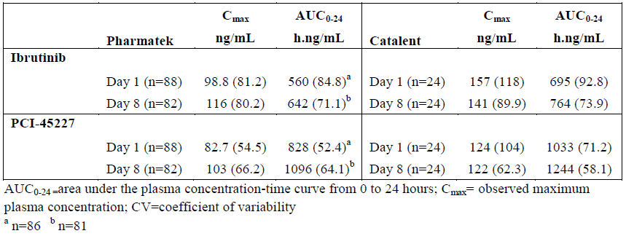

Table 3: Mean (%CV) Ibrutinib and PCI-45227 pharmacokinetic parameters following ibrutinib administration with Pharmatek of Catalent formulations in Study 1104

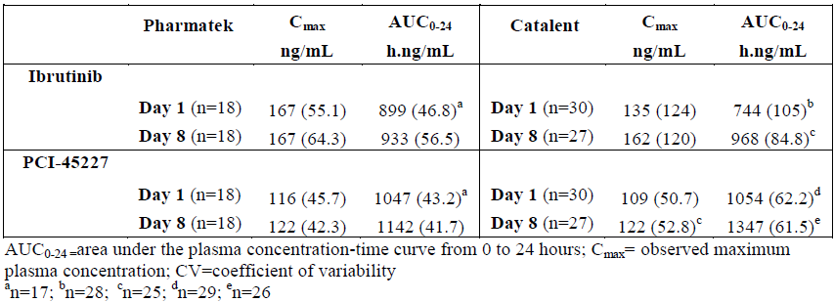

There was no consistent difference in Cmax or AUC0-24 of the parent drug or primary metabolite across the two studies, with a high coefficient of variation for both parameters. With the exception of the Cmax values on Day 1 in Study 1102, the mean Cmax the parameters are considered bioequivalent. However, given the large %CV reported, the differences in Cmax from Study 1102 are unlikely to be clinically relevant.

###### Influence of food

A consistent effect of increased exposure following administration in the fed state, as compared to fasting, was observed.

Study 1001, in healthy adults, demonstrated that Cmax increased 2.6-, 3.2- and 3.9- fold higher when dosing occurred 30 minutes before, 30 minutes after, or two hours after a high fat breakfast. Furthermore, AUClast was 1.6-, 1.9 and 1.8-fold higher at each time-point respectively. An increase in absolute and relative bioavailability was also observed.

Study 1011, in healthy adults, demonstrated that following a standard meal, Fabs increased from 2.3% in the fasting state to 7.6% (90% CI 6.41, 9.03) and following a standard meal plus grapefruit juice Fabs was increased to 15.8% (90%CI 11.93, 20.79).

A sub-study of 1102, in 16 relapsed/refractory CLL/SLL patients treated with 420 mg ibrutinib daily, demonstrated the GMR for Cmax was 2.24 and AUClast was 1.65 higher following a high-fat breakfast as compared to fasting.

The effect of food on the duration of the zero-order absorption process was demonstrated in the population PK model. Relative bioavailability was approximately 67% when administered after an overnight fast as compared to both the modified-fasted, and fed, conditions.

###### Dose proportionality

A formal dose-proportionality study was not performed. However, under fed conditions, single doses of 420 mg and 840 mg resulted in Cmax values of 109 and 190 ng/mL and AUClast values of 514 and 905 ng/mL respectively. Plasma terminal half-life was 4.79 and 4.98 hours for the 420 mg and 840 mg doses respectively; i.e. accumulation was less than two-fold after once daily dosing.

The population PK model describes no deviation from dose-proportionality.

###### Effect of administration timing

As demonstrated in Study 1001, a single 420 mg dose of ibrutinib administered at two hours following a high-fat breakfast resulted in the highest Cmax (147 ng/mL), as compared to the fasting state (62.9 ng/mL) or 30-minutes following food (52 ng/mL).

##### Distribution

###### Volume of distribution

The apparent steady-state volume of distribution (sum of volumes in the central and peripheral compartments) was approximately 10000 L.

###### Plasma protein binding

Ibrutinib reversibly binds to human albumin. The estimate of mean (standard deviation) unbound ibrutinib was 2.3(0.3) % i.e. 97.7% protein-bound. The primary metabolite is 91.0% protein bound.

###### Blood to plasma ratio

The mean blood to plasma concentration ratio was 0.7 (Study 1004 – administration of a single dose 140 mg 14C-ibrutinib).

###### Tissue distribution

There is no human data on the distribution of ibrutinib to tissues. In rat studies, distribution of radiolabelled ibrutinib was observed predominately in the organs of excretion, with concentrations below the limit of quantification by 168 hours post-dose except in the kidney, liver, adrenal glands, pancreas spleen and pigmented skin.

##### Metabolism

###### Interconversion between enantiomers

An S-enantiomer of ibrutinib is present in the manufactured product. The S-enantiomer of ibrutinib, PCI-32769, was evaluated biochemically for inhibitory activity against BTK in three independent assays in which ibrutinib was included as a comparator, showing that PCI-32769 is 3.6 times less potent than ibrutinib.

Exposure to the S-enantiomer of ibrutinib was determined in patient samples after single and repeated ibrutinib dosing. The S to R enantiomer ratios of mean Cmax and AUC were very low; expressed as (S/R)*100%, the values ranged from 0.80% to 1.5%. Taking into account the 0.2% S-enantiomer amount present in the R-enantiomer drug substance dosed, the Cmax and AUC S/R ratios are only slightly higher than the amount of S-enantiomer in the drug substance. Because the S/R ratios for the Cmax and AUC observed after both single and repeated dosing were relatively low and consistent with the percentage S-enantiomer contained in the drug substance, in vivo chiral conversion from R- to S-enantiomers does not occur to an appreciable extent.

###### Sites of metabolism and mechanisms / enzyme systems involved

Three principle CYP3A-mediated pathways have been identified for ibrutinib – hydroxylation, oxidation and epoxidation of separate sites of the parent molecule.

The proposed metabolic scheme of ibrutinib is shown in Figure 1.

Figure 1: Proposed metabolic fate of ibrutinib (labelled JNJ-54179060 in the figure)

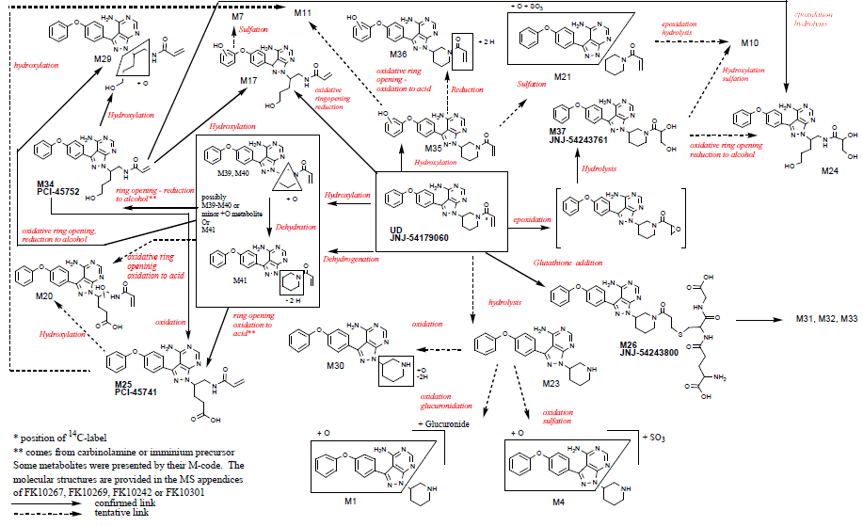

###### Metabolites identified in humans

Active metabolites

Ibrutinib is extensively metabolised by cytochrome P450 (CYP) 3A4-catalysed epoxidation of the acryloyl moiety, followed by hydrolysis to the dihydrodiol metabolite PCI-45227. The pharmacological activity of this metabolite has been studied and described below.

###### Pharmacokinetics of metabolites

PCI-45227 was quantified in the pre-clinical program as a prominent primary metabolite, with levels generally exceeding the parent. This metabolite reversibly inhibits BTK, with a potency of approximately 15-fold less than the parent compound.

The pattern of metabolites found in blood was similar to those detected in faeces.

###### Consequences of genetic polymorphism

Two subjects in Study 1004 were identified as being CYP2D6 poor metabolisers. In one of these subjects Cmax and AUC were 40% higher than the median values.

##### Excretion

###### Routes and mechanisms of excretion

Elimination of the parent drug by the faecal route is minor, on average 0.77% of the administered dose was detected. However, biliary excretion of total 14C-ibrutinib radioactivity is the route of elimination.

Urinary excretion accounted for 3.84% of the administered dose, with the majority of urinary metabolites being of the piperidine opening pathway.

###### Mass balance studies

A mass balance study of a single dose of 14C-ibrutinib demonstrated that PCI-45227 constituted < 10% of total drug-related material in the systemic circulation. Exposure to PCI-45227 was routinely assessed in all subsequent clinical studies and metabolite to parent drug ratios were calculated for Cmax and AUC.

A wide range of mean ratios for AUC was observed, ranging from 0.7 to 4.5, apparently independent of dose and population. Based on these initial data, PCI-45227 was tentatively identified as a major metabolite.

Data from the mass balance study indicated that additional metabolites (that is, M21, M25, and M34) might possibly qualify as major metabolites, when comparing the individual metabolite exposures to that of total compound-related material in the circulation which is not covalently bound. In this latter study, PCI-45227 showed a more prolonged exposure than the other main metabolites

###### Renal clearance

Following an oral dose, only 8% of ibrutinib is recovered in the urine as metabolites, and no unchanged drug is excreted.

The ibrutinib clinical studies recruited patients with varying degrees of renal impairment, with 40.8% of subjects qualifying as mildly impaired (creatinine clearance ≥ 60 and < 90 mL/min) and 21.2% as moderately impaired (creatinine clearance ≥ 30 and < 60 mL/min). In the population PK model, baseline creatinine clearance did not influence the PK of ibrutinib.

The effect of severe renal impairment, or dialysis, has not been studied.

##### Intra- and inter-individual variability of pharmacokinetics

The initial population PK model in MCL/CLL/SLL patients was characterised by large inter-individual variability of all PK parameters, with a CV of the dose-normalised AUC of 62%. Residual unexplained variability (CV) was 72.7%.

The population PK model from Study PCYC-1112-CA did not specifically report the inter-individual variability, but the overall conclusion was that the model was sufficient.

#### Pharmacokinetics in the target population

In the population PK analysis, B-cell histology was not a significant covariate, with no difference in clearance determined between patients with MCL and CLL/SLL.

#### Pharmacokinetics in other special populations

##### Pharmacokinetics in subjects with impaired hepatic function

The clinical studies of ibrutinib excluded patients with hepatic impairment and only limited information is available from non-cancer subjects in clinical pharmacology Study 1006 (ongoing) with mild (n=6), moderate (n=10), and severe (n=8) hepatic impairment but who were otherwise healthy. It was demonstrated that there was a significant increase in exposure, and unbound fraction of ibrutinib, with increasing hepatic impairment. Plasma AUClast was 4.0-, 8.2- and 9.1-fold higher for subjects with mild, moderate and severe hepatic impairment respectively. The fraction of unbound ibrutinib increased by mean (SD) 3.0% (0.52), 3.8% (0.64), 4.8% (0.88) in the mild, moderate, and severe impairment cohorts, respectively, compared to 3.3% in the matched controls

Compared to six healthy matched-controls, mean unbound exposure (AUClast, unbound) in the mild, moderate, and severe cohort is 4.0, 9.5, and 13-fold higher.

The sponsor states that “Terminal half-life trended slightly higher in moderately and severely impaired subjects, but the risk for accumulation on repeated dosing appears negligible.”

##### Pharmacokinetics in subjects with impaired renal function

From studies in healthy adults, there is negligible renal excretion of ibrutinib, and its primary metabolite, in those with normal renal function. Subjects with mild and moderate degrees of renal impairment represented 40.8% and 21.2% of the subjects included in the population PK analysis respectively. Creatinine clearance was found not to have a significant effect on ibrutinib PK.

##### Pharmacokinetics according to weight

In the population PK model, body weight was identified as a significant covariate on the peripheral volumes V2/F and V3/F. However, body weight did not have a significant effect on apparent clearance. Ibrutinib dosing does not therefore require adjustment according to weight.

##### Pharmacokinetics according to age

Age was not considered to be a significant covariate in the population PK model.

##### Pharmacokinetics related to genetic factors

Limited information is available on the effect of CYP2D6 metaboliser genotype. Two subjects in Study 1004 with poor-metaboliser genotype were observed to have similar exposure and metabolic pattern compared to four subjects with extensive-metaboliser status.

##### Pharmacokinetics according to other population characteristics

In the population PK model, gender, patient pre-treatment, clinical chemistry data and method of ibrutinib manufacture were determined to have minimal effects. The model included approximately 90% Caucasian subjects and no inference can be made on the effect of race on ibrutinib PK parameters.

#### Pharmacokinetic interactions

##### Pharmacokinetic interactions demonstrated in human studies

Neither ibrutinib nor PCI-45227 has a significant effect on CYP enzyme inhibition or induction.

In vitro, ibrutinib is not a substrate for permeability-glycoprotein (P-gp), but is a P-gp inhibitor. Ibrutinib was not shown to be a substrate of OATP in vitro.

###### Effect of CYP3A4 induction

In the drug-drug interaction (DDI) Study 1010 examining the effect of the CYP3A4 inducer rifampicin on a single-dose of 560mg ibrutinib PK in 18 healthy adults, there was a significant reduction in Cmax, AUC0-24h and AUClast when co-administered with ibrutinib as compared to ibrutinib alone. Primary metabolite concentrations were also reduced two-fold with co-administration with rifampicin.

The summary of the trial outcomes are shown in Table 4.

Table 4: Summary of PK parameter results – Study PCI-32765CLL1010

| PK parameter | Ibrutinib (N= 18) | Ibrutinib + rifampicin (N=17) | Ratio (90% CI) | Intra-subject CV (%) | Fold reduction in exposure |
| --- | --- | --- | --- | --- | --- |
| Tmax, h  median (range) | 1.76 (1.00, 8.00) | 3.00 (1.50, 23.92) | - |  | 12.59 |
| Cmax, ng/mL  mean (SD) | 42.1 (30.4) | 3.38 (2.62) | 7.94 (5.46 - 11.55) | 69.1 | 9.17 |
| AUC0-24, ng.h/mL  mean (SD) | 259 (176) | 28.8 (23.0) | 10.91 (7.81 - 15.25) | 60.6 | 9.58 |
| AUClast, ng.h/mL  mean (SD) | 335 (229) | 38.0 (36.5) | 10.44 (7.44 - 14.65) | 61.5 | 6.57 |
| AUCinf, ng.h/mL  mean (SD) | 397 (252) | 59.4 (63.5) | 15.23 (5.07 - 45.77) | 74.1 |  |
| t1/2, h  mean (SD) | 9.95 (2.54) | 8.42 (3.61) | - |  |  |

BTK occupancy was greater than 80% in 17 subjects and >90% in 13 subjects following ibrutinib monotherapy, as compared to 15 subjects and 13 subjects, respectively, following co-administration. The population PK model showed that the co-administration of antacids and ibrutinib led to an increase in the duration of zero-order absorption, but this was considered clinically irrelevant.

###### Effect of CYP3A4 inhibition

In the DDI Study 1002, examining the effect of the CYP3A4 inhibitor ketoconazole on the PK of a single dose of ibrutinib in 21 healthy subjects, there was a significant increase in Cmax, AUC0-24 and AUClast when co-administered with ibrutinib as compared to ibrutinib alone.

The summary of the trial outcomes are shown in Table 5.

Table 5: Summary of PK parameter results – Study PCI-32765CLL1002

|  |  |  |  |  |
| --- | --- | --- | --- | --- |
| PK parameter | Ibrutinib (120 mg dose) | Ibrutinib (40 mg dose) + ketoconazole | Dose-normalised ratio (90% CI) | Intra-subject CV (%) |
| Cmax (ng/mL) | 11.8 (6.67) | 108 (44.3) | 2855 (2396 - 3399) | 30.8 |
| Tmax (h) | 1.75 (1.00 – 3.03) | 2.00 (1.50 – 3.03) | - |  |
| AUC0-24 (ng.h/mL) | 63.8 (37.3) | 510 (194) | 2480(2001 - 3072) | 38.3 |
| AUClast (ng.h/mL) | 71.4 (45.1) | 533 (199) | 2393(1900 - 3012) | 41.3 |
| AUC∞ (ng.h/mL) | 84.4 (52.6) | 536 (199) | 2620 (1995 - 3440) | 38.5 |
| CL/F (L/h) | 2014 (1300) | 92.0 (55.8) | - | - |

###### Effect of antacids

The physicochemical characteristics of ibrutinib demonstrate that its’ solubility is pH dependent. The population PK modelling revealed an increase in duration of the zero-order absorption by 61%.In their conclusion, the sponsor has stated that this increase in absorption duration “has to be considered minor and of no clinical relevance”.

Evaluator’s comment: In the absence of a formal DDI study examining the effect of concomitant administration of ibrutinib and antacids on AUC and Cmax, the sponsors’ assertion that the increase in absorption duration is of no clinical relevance cannot be categorically confirmed.

##### Summary & clinical implications of in vitro findings

The non-clinical development program for ibrutinib included the assessment of: inhibition of BTK and other kinases, growth inhibition in human-derived DCBCL cell lines, primary CLL cells and MCL cells.

The median inhibitory concentration against BTK was 0.39 nM. Ibrutinib was shown to have varied reversibility against a “small number of non-BTK protein kinases”, as shown in Table 6.

Table 6: Inhibition for reversibly and irreversibly inhibited kinases vs. maximum plasma concentrations in human subjects

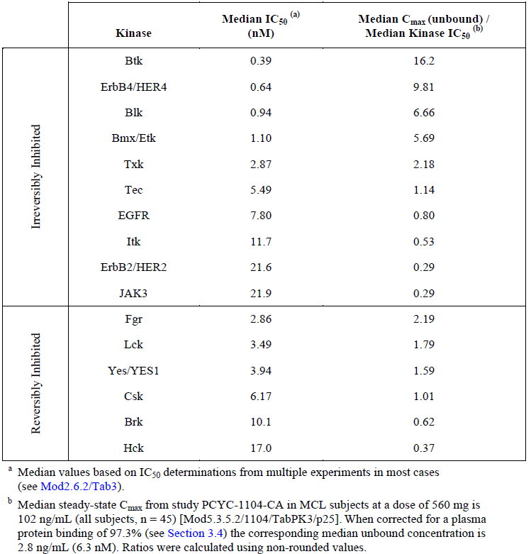

The clinical correlates of ErbB4/HER4 inhibition include nausea, diarrhoea, vomiting, rash and generalised/peripheral oedema. The clinical correlate of Blk inhibition is not sufficiently characterised. Bmx has a role in cell migration and angiogenesis, but the clinical effects are not characterised, and Tec inhibition may result in depletion of peripheral B-cells.

In vitro hERG channel current testing of ibrutinib and PCI-45227was performed according to the appropriate guidance. The IC50 for the inhibitory effect if ibrutinib on hERG channel was 427 mg/mL, which is 96 times the average maximum steady-state plasma concentration observed in humans dosed with 560 mg/day. The IC50 of the inhibitory effect of PCI-45227 was 4555 ng/mL, which is 415 times the average steady-state plasma concentration observed in humans dosed with 560 mg/day. No effect on QTc was observed in dogs receiving ibrutinib, however at doses of 24 mg/kg and 150 mg/kg, prolongation of RR interval and reduction in heart rate and blood pressure were observed.

The maximum dose levels evaluated in rats & dogs were human equivalent doses of 24 mg/kg and 81 mg/kg respectively. BTK occupancy was observed to be >90% following a single dose of 6 mg/kg ibrutinib in mice.

In vitro studies confirmed the extensive metabolism of ibrutinib by CYP3A4/5 enzymes by human liver microsomes. The primary pathways of ibrutinib metabolism, and subsequent excretion, were common in humans and animals.

Toxicology studies in dogs receiving 150 mg/kg/day demonstrated varying degrees of corneal opacification or dystrophy, consistent with alteration in corneal lipid metabolism. In addition, alterations in bowel habit were observed in dogs, with reversible histological changes of acute intestinal inflammation, lymphoid depletion of Peyer’s patches and stomach smooth muscle degeneration. In rats, in addition to the expected effects on lymphoid tissues, squamous cell atrophy of the stomach, skin and vagina were observed, pancreatic acinar atrophy, as well as skeletal effects of cortical bone thinning & reduction in primary trabeculae were seen.

Genotoxicity studies demonstrated no adverse effects of ibrutinib.

The reproductive toxicity effects of ibrutinib in rats included post-implantation loss and foetal visceral and skeletal malformations.

Dose-dependent reductions in B-cell count and immunoglobulin levels were observed in rats dosed with up to 100 mg/kg ibrutinib for approximately one month.

### Evaluator’s overall conclusions on pharmacokinetics

The absolute bioavailability of ibrutinib is low at 2.9% with high inter-subject variability. Orally administered ibrutinib is rapidly and almost completely absorbed, with a median time of maximal absorption of two hours.

The apparent volume of distribution of ibrutinib is 10000 L and apparent clearance is 1000 L/h. Ibrutinib is highly protein-bound at 97.3%. The blood to plasma ratio is approximately 0.7. There is extensive first-pass metabolism by CYP3A4. Ibrutinib exposure is substantially affected by inducers (28-fold) and inhibitors (10-fold) of CYP3A4. However, CYP2D4 metaboliser status does not appear to affect the exposure or metabolism of ibrutinib.

The primary metabolite of ibrutinib, PCI-45227 is a weak irreversible inhibitor of BTK and is not considered to exhibit a clinical effect, thereby in itself should not pose a safety concern. There is rapid, and extensive, hepatobiliary excretion of ibrutinib within two days, and negligible urinary excretion - <10%. The mean terminal half-life is four - 10 hours as assessed by non-compartmental analysis.

The accumulation of ibrutinib is less than two-fold with repeated dosing. The effect of ibrutinib on concomitant medication has not been studied. Age and gender did not have any significant effect on the PK parameters of ibrutinib. In subjects with mild or moderate categories of renal impairment, there was no significant effect on ibrutinib PK.

## Pharmacodynamics

### Studies providing pharmacodynamic data

No specific pharmacodynamic (PD) studies were performed.

BTK receptor binding results were obtained from studies in B-cell malignancies and healthy subjects.

### Summary of pharmacodynamics

The information in the following summary is derived from conventional PD studies in humans unless otherwise stated.

#### Mechanism of action

The target of ibrutinib is BTK which is critical for integrin-mediated adhesion and migration of B-cells. Ibrutinib covalently binds to the cysteine residue (Cys-481) in the BTK active site, with an IC50 of 0.39 nM.

#### Pharmacodynamic effects

##### Primary pharmacodynamic effects

No formal studies of PD were performed; however, BTK occupancy was assessed in two studies uncontrolled studies in healthy adults.

In Study 1002, BTK occupancy was not affected by the co-administration of ketoconazole and ibrutinib as compared to ibrutinib alone - occupancy was reported as >90% within two hours of dosing.

In Study 1010, BTK occupancy was greater than 80% in 17 of the 18 subjects following ibrutinib administration alone, and > 90% in 13 of the 18 subjects. These occupancy levels were achieved within 2 hours of dosing and were maintained for most subjects through 48 hours. In combination with rifampicin, occupancy greater than 80% and 90% was achieved in 15/18, and 13/18, subjects, respectively. Maximal occupancy for five of the 18 subjects was delayed from two to four hours. Mean occupancy at four hours following ibrutinib alone or in combination with rifampicin was 91.2% and 80.8%, respectively.

The PD effect of BTK occupancy was assessed in the Phase 1b/2 Study PCYC-1102-CA, in 81/116 patients enrolled with CLL. This study had five cohorts of patients, with varied regimens – Table 7.

Table7: Composition of Study PCYC-1102-CA cohorts

| Cohort | Population | Dose of ibrutinib |
| --- | --- | --- |
| 1 | Relapsed/refractory | 420 mg/day |
| 2 | Treatment-naïve | 420 mg/day |
| 3 | Relapsed/refractory | 840 mg/day |
| 4 | Relapsed/refractory, high risk | 420 mg/day |
| 5 | Treatment naïve | 840 mg/day |

The median BTK occupancy in cycle 1 of treatment was > 90% for all cohorts, with 88 - 100% BTK occupancy seen on Day 8 of treatment post-dose.

The median and inter-quartile range of BTK occupancy is shown in Figure 2.

Figure 2: Box-plot of BT occupancy in peripheral blood mononuclear cells.

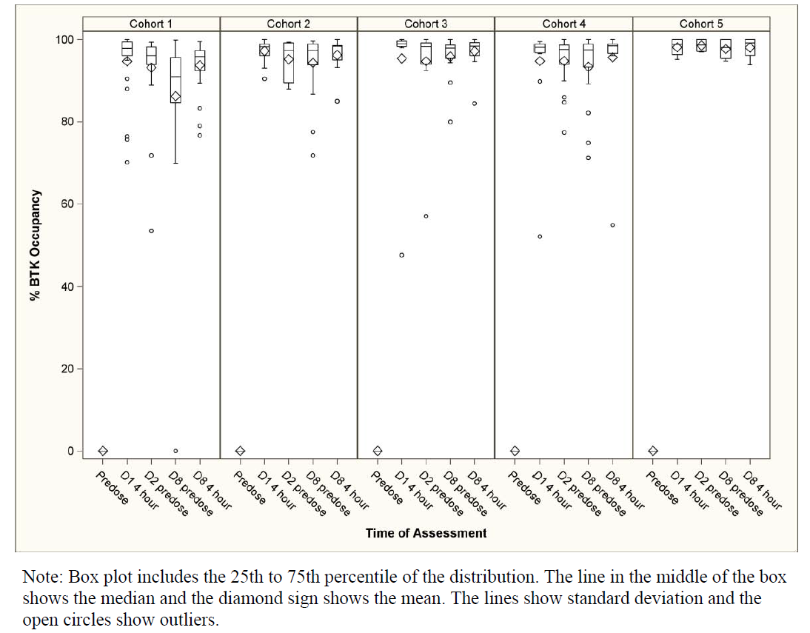

### Evaluator’s overall conclusions on pharmacodynamics

A clinically relevant degree of BTK occupancy of > 90% was observed following ibrutinib treatment at doses of either 420 mg/day or 840 mg/day within one week of commencement.

## Dosage selection for the pivotal studies

No maximum tolerated dose was reached (based on BTK occupancy) in the Phase I clinical Study 04753 in which subjects received up to 12.5 mg/kg/day (1400 mg). There were no dose-limiting toxicities reported for the highest dose cohort in Study 04753, however, two DLTs were reported at lower doses (2.5 mg/kg/day and 8.3 mg/kg/day). These events were an interruption of treatment > seven days for Grade 2 neutropenia and a Grade 3 treatment-related serious adverse event (SAE) of hypersensitivity.

The dose for the pivotal study in CLL/SLL patients was derived from the Phase 1 and 2 studies PK and PD sampling in Studies 04753 and 1102.

## Clinical efficacy

### Chronic lymphocytic leukaemia/small lymphocytic leukaemia

#### Pivotal efficacy study

##### PCYC-1112-CA

###### Study design, objectives, locations and dates

This was a Phase III randomised, multicentre, open-label study of ibrutinib versus ofatumumab in patients with relapsed or refractory CLL/SLL who had failed at least one prior systemic therapy and not considered appropriate candidates for treatment or retreatment with purine analogue-based therapy.

The study was performed in the US, Europe and Australia.

Patient enrolment commenced on 22 June 2012 and the study was completed on 6 November 2013.

###### Inclusion and exclusion criteria

Eligible subjects had been diagnosed with CLL/SLL who had relapsed or refractory disease following at least one line of prior systemic therapy for CLL/SLL, Eastern Cooperative Oncology Group (ECOG) performance status of 0 or 1, active disease meeting at least one of the International Workshop on Chronic Lymphocytic Leukemia (IWCLL) 2008 criteria for treatment initiation, and were not considered appropriate candidates for treatment or retreatment with purine analogue based therapy. Subjects also had measurable lymph node disease by computed tomography (CT), and acceptable laboratory parameters as defined in the protocol.

###### Study treatments

Ibrutinib was administered as 420 mg orally daily, with 240 mL water, taken at least 30 minutes before food or at least two hours after a meal at approximately the same time each day. Subjects were instructed to avoid consuming Seville oranges or grapefruit juice for the duration of the study.

Ofatumumab was administered by intravenous injection according to the regimen approved for CLL patients which is common to the jurisdictions in which the study was performed:

Week 1 – 300 mg dose

Weeks 2-8 – 2000 mg weekly

Weeks 12, 16, 20 & 24 – 2000 mg every four weeks

Pre-specified discontinuation and withdrawal criteria are shown in Table 8.

Table 8: Discontinuation & withdrawal criteria for Study PCYC-1112-CA

| Mandatory discontinuation criteria | Withdrawal criteria |
| --- | --- |
| * Progressive disease as determined by protocol defined criteria * Toxicity - as defined in dose discontinuation portions of the protocol * Death * Withdrawal from treatment by subject including withdrawal of informed consent * Investigator decision * Completion of treatment regimen (applied to ofatumumab arm only) * Patient requires a prohibited treatment * Lost to follow-up * Study terminated by sponsor | * Death * Loss to follow-up * Study termination by sponsor * Withdrawal of consent |

###### Efficacy variables and outcomes

The primary efficacy outcome was:

* Progression-free survival (PFS), IRC-assessed according to the IWCLL 2008 criteria was defined as the time from the date of randomisation to the date of first documentation of disease progression or date of death due to any cause, whichever occurred first.

Secondary efficacy outcomes were:

* Overall survival (OS). Time from the date of randomisation to the date of death from any cause
* Overall response rate (ORR), IRC- assessed according to the IWCLL 2008 criteria. Defined as the proportion of subjects achieving a best overall response of either complete response (CR), complete remission with incomplete blood count recovery (Cri), nodular partial response (nPR), or partial response (PR) per the IRC assessment
* Functional Assessment of Chronic Illness Therapy Fatigue (FACIT-fatigue) score
* Sustained haematological improvement. Defined as ≥ 56 days without blood transfusion or growth factors which included: platelet counts > 100 x 109/L if baseline ≤ 100 x 109/L or increase ≥ 50% over baseline; haemoglobin (Hb) > 11 g/d if baseline ≤ 11 g/dL or increase ≥50% over baseline; absolute neutrophil count (ANC) > 1.5 x 109/L if baseline ≤ 1.5 x 109/L or increase ≥ 50% over baseline
* The main safety end-point was the safety and tolerability of ibrutinib as compared to ofatumumab

Exploratory end-points included:

* Investigator-assessed PFS and ORR per IWCLL 2008 criteria
* Improvement and/or resolution of disease related symptoms
* European Organisation for Research and Treatment of Cancer Quality of Life Questionnaires Core 30 (EORTC QLQ-C30) and EuroQol Five Dimension (EQ-5D-5L)
* Medical resource utilisation
* PK characteristics of subjects with CLL/SLL and to determine, if any, covariates (e.g. age, gender, body size, race) influencing exposure to ibrutinib
* Potential predictive biomarkers and mechanisms of resistance for disease
* Serum immunoglobulin (IgA, IgG, and IgM)

###### Randomisation and blinding methods

Two randomisation schemes were generated for US and non-US based recruits. Under each scheme, randomisation was stratified according to: presence or absence of refractory disease to purine analogue and anti-CD20 containing chemo-immunotherapy (CIT) regimen and presence/absence of deletion in the short arm of chromosome 17p13.1 (del17p).

###### Analysis populations

The intention-to-treat population comprised all randomised subjects. Subjects in this population were analysed according to randomised treatment. This population was used to analyse all efficacy and PRO end-points and baseline characteristics.

Safety population comprised all patients who received at least one dose of study drug. Subjects in this population were analysed according to the actual treatment received. This population was used to analyse all safety end-points and dosing data.

The analysis of PFS included the following potential prognostic variables at screening or baseline:

* Age (<65 versus ≥65)
* Gender (Male, Female)
* Race (White, Non-White)
* Geographic region (US, Other)
* Rai Stage at screening (Stage 0-II, III-IV)
* ECOG at randomisation (0, 1)
* Bulky disease (<5 cm, ≥5 cm)
* Number of prior treatment lines (<3, ≥3)
* Refractory disease to purine analogues as recorded in Interactive Web Response System (IWRS) (Yes, No)
* del17p as recorded in IWRS (Yes, No)
* del11q (Yes, No)
* β2-microglobulin at baseline (≤3.5 mg/L, >3.5 mg/L)

Subgroups analysis for OS and ORR included the following potential prognostic variable: age, gender, race, region, del17p, and refractory disease to purine analogues.

###### Sample size

A minimum of 350 subjects were to be randomised 1:1 to receive either ibrutinib of ofatumumab.

The sample size calculation required a minimum of 176 PFS events to provide 90% power to detect the target hazard ratio (HR) of 0.6, based on a log-rank test and a two-sided overall significance level of 0.05 adjusting for one interim analysis. The interim analysis was planned at 117 IRC-assessed PFS events.

###### Statistical methods

Study treatments were not blinded to investigators or subjects. Assessment of the primary end-point (PFS) and other responses was performed by IRC members who were blinded to both study treatment and absolute lymphocyte count (ALC).

Four protocol amendments were made in the course of the study –Table 9.

Table9: Protocol amendments for Study PCYC-1112-CA

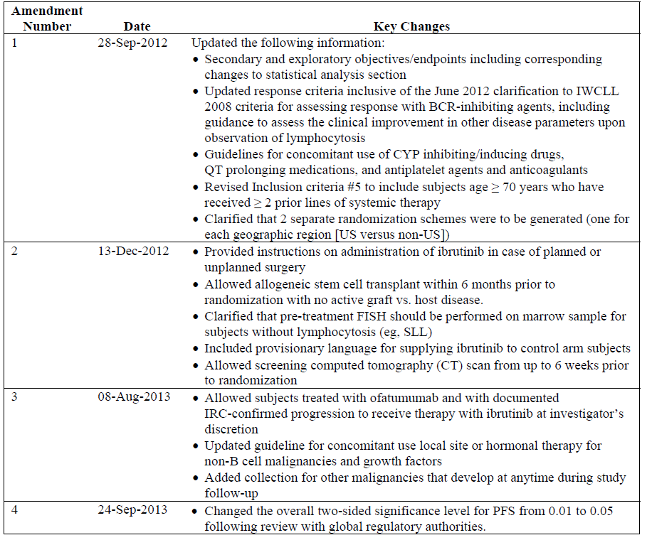

###### Participant flow

A total of 391 subjects were enrolled, distributed across the US (49.1%), Europe (43.5%) and Australia (7.4%). A total of 195 subjects were randomised to ibrutinib and 196 to ofatumumab.

A summary of the participant flow is shown in Table 10.

Table 10: Summary of participant flow, Study PCYC-1112-CA

|  | Ibrutinib arm | Ofatumumab arm |
| --- | --- | --- |
| Number of patients randomised | 195 | 196 |
| Proportion of patients receiving study drug | 195 | 191 |
| Proportion of subjects completed/discontinued treatment as of cut-off | 27/195 (13.8%) | 190/196 (96.9%) |
| Proportion of subjects that discontinued study treatment | 18/195 (9.2%) | 46/196 (23.5%) |
| Death | 8.2% | 19.4% |
| Continuing treatment as of cut-off | 168 (86.2%) | 1 (0.5) |

As of the data cut-off, 57 subjects randomised to ofatumumab subsequently received ibrutinib therapy.

###### Major protocol violations/deviations

Of the five randomised subjects that did not receive ofatumumab, four withdrew consent and one died prior to receipt of study treatment.

The proportion of subjects with important protocol deviations in each arm of the intent to treat (ITT) population was comparable – 17/195 (8.7%) of the ibrutinib arm and 14/196 (7.1%). Given that the study recruited more 41 subjects more than required, and the similar proportion in each arm, the important protocol deviations are unlikely to have a material effect on the primary outcome assessment.

###### Baseline data

The randomisation strategy yielded similar populations in each treatment arm, consistent with the general population with CLL. Most subjects were male, Caucasian, with median age 67 years – Table 11.

Table 11: Demographic characteristics of subjects in Study PCYC-1112-CA

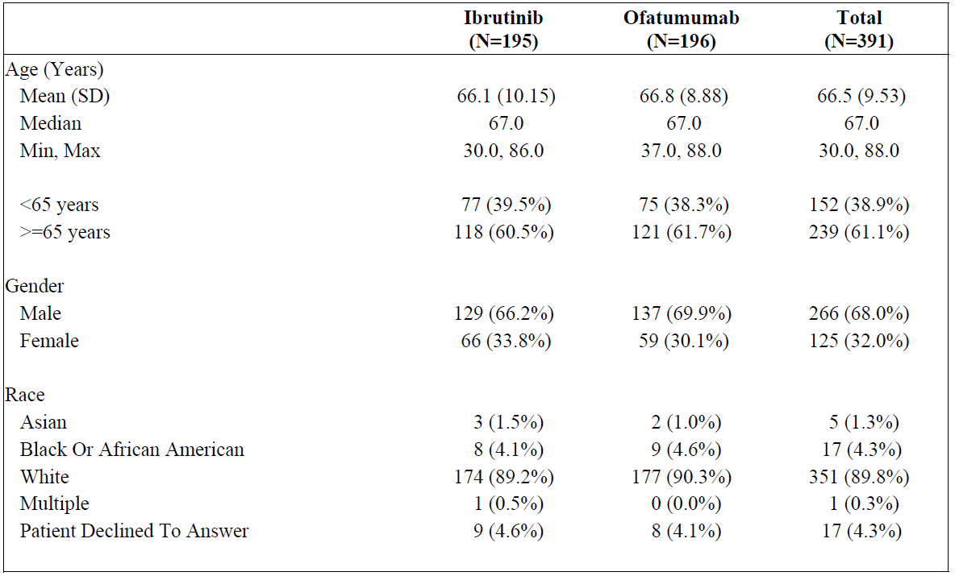

Similarly, baseline disease characteristics were similar between treatment arms – Table 11.

Table 12: Baseline disease characteristics in Study PCYC-1112-CA

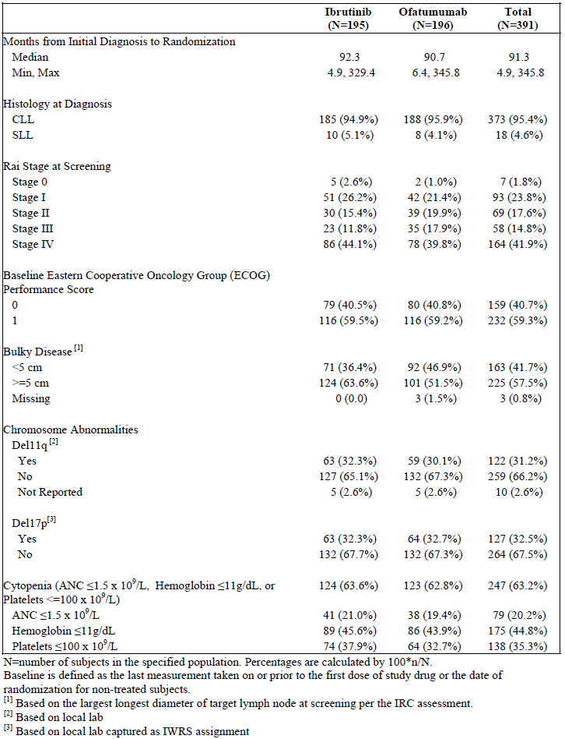

The sponsor has reported that central re-testing for del17p is occurring as of this report. All subjects were locally assessed for del17p - the results presented in Table 10. Re-testing of 274 subjects is complete, with 90 positive results. The concordance of test/retest is 86.2%.

The number and types of prior therapies were similar between the study arms, Table 12.

Table 13: Summary of prior therapies in the PCYC-1112-CA ITT population

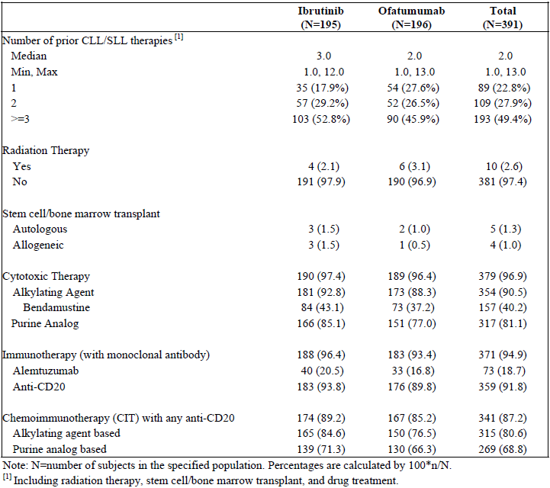

###### Results for the primary efficacy outcome

The primary outcome of the study was met. After 146 PFS events, there was a statistically significant advantage for ibrutinib over ofatumumab (HR 0.215, 95% CI 0.146, 0.317), p<0.0001. The median PFS was not met for ibrutinib whereas the median PFS in the ofatumumab arm was 8.1 months. The 6-month PFS estimates were 87.8% of subjects in the ibrutinib and 64.6% in the ofatumumab arm remained progression free - Table 14 and Figure 3.

As of the data cut-off, in those patients that had experienced disease progression, two in each arm had undergone Richter transformation to large cell lymphoma. An additional subject in the ibrutinib arm was reported to have undergone transformation to prolymphocytic leukaemia.

From the data provided from the pivotal trial, ibrutinib does not appear to be an additional risk factor for Richter transformation.

Table 14: Progression-free survival PCYC-1112-CA ITT population

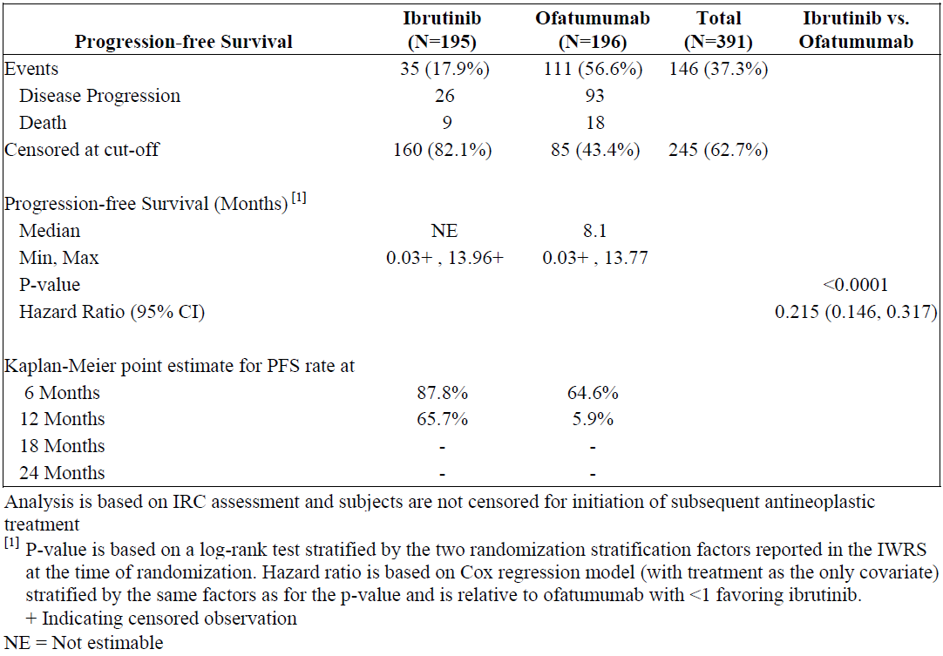

Figure 3: Kaplan-Meier curve of progression-free survival – PCYC-1112-CA ITT population

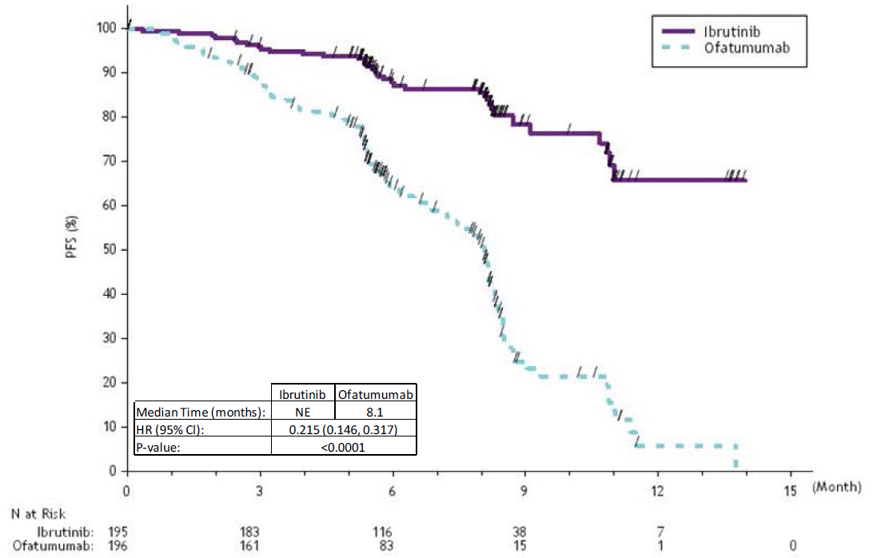

PFS assessment in the sub-groups with potential prognostic variables at screening or baseline demonstrated a consistent benefit of ibrutinib over ofatumumab - Figure 4. In particular, del17p status did not reduce the treatment response to ibrutinib, whereas a difference was observed in the ofatumumab arm – Figure 5. This finding is consistent with the data contained in the current ofatumumab product information.

Figure 4: Forest plot of hazard ratios for PFS PCYC-1112-CA ITT population

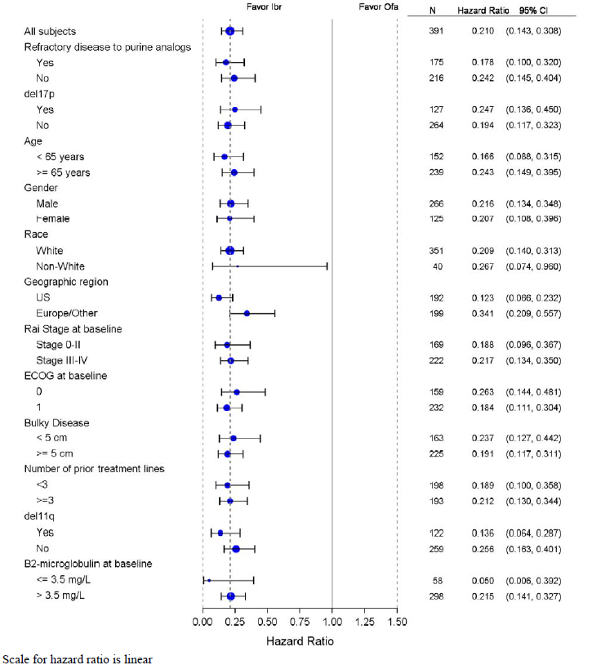

Figure 5: Kaplan-Meier curve for PFS stratified according to 17p deletion status PCYC-1112-CA ITT population

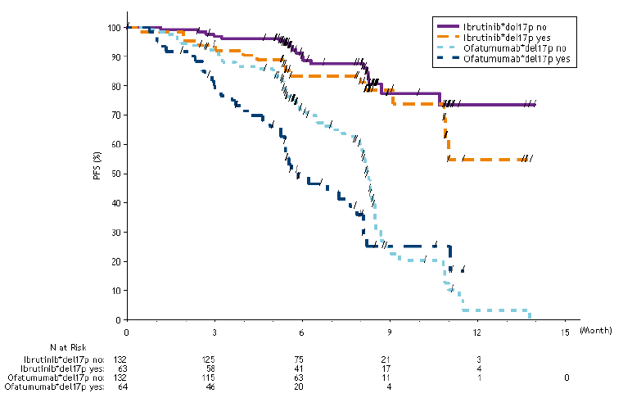

##### Results for other efficacy outcomes

**Overall survival**

The primary analysis of OS demonstrated a statistically significant advantage in OS in the ibrutinib arm – HR 0.434 (95% CI 0.238, 0.789), however median survival had not been reached in either treatment arm.

At data cut-off, 8.2% randomised to the ibrutinib arm and 16.8% randomised to the ofatumumab arm had died. In addition, five of fifty seven subjects who crossed over from ofatumumab to ibrutinib died.

The analysis of OS according to the subgroups specified for the PFS analysis demonstrated a similar treatment benefit of ibrutinib over ofatumumab –Figure 6.

Figure 6: Forest plot of hazard ratios for overall survival, PCYC-1112-CA ITT population

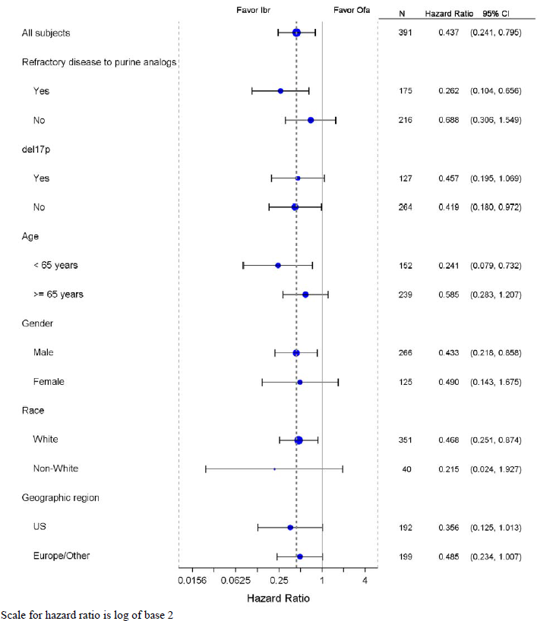

**Overall response rate**

Independently assessed ORR, according to the IWCLL 2008 guideline was higher in the ibrutinib arm 42.6% as compared the ofatumumab arm 4.1%.

ORR was also reported for those with, and without a lymphocytosis, as per the IWCLL guideline modification in 2012, which permitted PR in the presence of an isolated lymphocytosis. Under these criteria, 122/195 (62.6% of the ibrutinib arm achieved an overall response, as compared to 8/196 (4.1%) of the ofatumumab arm.

The analysis of ORR according to the pre-specified sub-groups of interest demonstrated a benefit from ibrutinib for all sub-populations – Figure 7.

Figure 7: Forest plot of overall response rate, PCYC-1112-CA ITT population

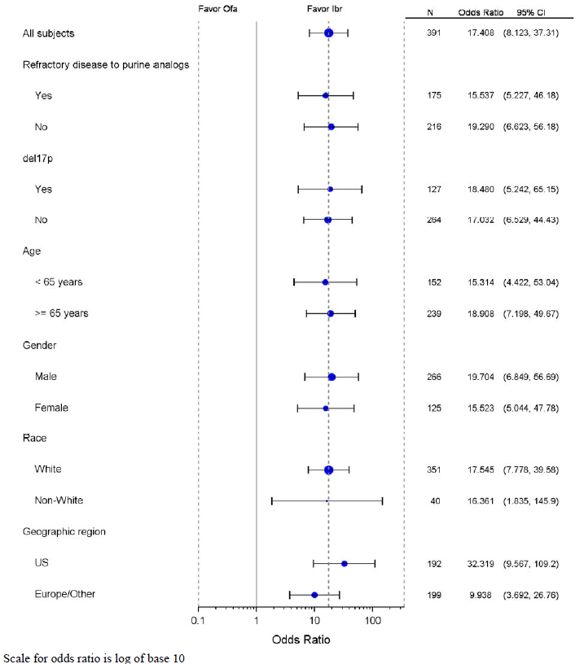

**FACIT-fatigue**

No significant difference was observed in change in FACIT score from baseline between the two treatment arms (p-value for the difference in treatment-effect = 0.84).

**Haematological improvement**

According to the criteria specified in the secondary outcomes above, the proportion of subjects achieving a sustained haematological response was greater in the ibrutinib arm –Table 15.

Table 15: Proportion achieving a sustained haematological response by treatment arm, PCYC-1112-CA

|  |  |  |  |
| --- | --- | --- | --- |
|  | Ibrutinib (N=195) n (%) | Ofatumumab (N=196) n (%) | |
| ANC  Haemoglobin  Platelets  Any of the above | 52 (26.7)  42 (21.5)  60 (30.8)  101 (51.8) | | 19 (9.7)  32 (16.3)  19 (9.7)  58 (29.6) |

|  |  |  |  |  |  |  |  |  |  |  |  |  |  |  |  |  |
| --- | --- | --- | --- | --- | --- | --- | --- | --- | --- | --- | --- | --- | --- | --- | --- | --- |
| Supportive efficacy studies Supportive efficacy data was supplied from three additional studies – Table 16.  Table 16: Supportive efficacy studies   |  |  |  |  | | --- | --- | --- | --- | | Study ID | Phase, type | Study population | Aims | | PCYC-04753 | 1, Open label, dose escalation | Recurrent B-cell lymphoma, CLL, Waldenström’s macroglobulinaemia (WM) | Safety and the maximum tolerated dose (MTD) of orally administered ibrutinib in patients with recurrent B-cell lymphoma  PK of orally administered ibrutinib  PD parameters, including drug occupancy of BTK, the target enzyme, and the effect on biological markers of B-cell function.  Secondary objective of evaluation of tumour responses. | | PCYC-1102-CA | 1b/2, Open label | treatment-naïve or relapsed/refractory CLL/SLL | The safety of a fixed-dose daily regimen of ibrutinib at two dose levels (420 mg and 840 mg)  Preliminary efficacy, PK (including the effects of the fed-versus-fasted state), PD, and long-term safety of ibrutinib | | PCYC-1104-CA | 2, open label | Relapsed/refractory mantle cell lymphoma (MCL) | Primary objective - efficacy of ibrutinib in subjects with relapsed/refractory MCL, based on prior bortezomib exposure.  Secondary objective - safety of a fixed daily dosing regimen (560 mg daily) of ibrutinib |  Study PCYC-04753 **Study design, objectives, locations and dates**  This was a Phase 1 dose-escalation study of ibrutinib in recurrent B-cell lymphoma. It was conducted in nine centres in the US between 25 February 2012 and 30 July 2012; database lock was 21 September 2012.  The objectives were to establish: the safety of the maximum tolerated dose of ibrutinib, PK, PD parameters and biological markers of B-cell function in patients with recurrent B-cell lymphoma. |

**Inclusion and exclusion criteria**

The inclusion criteria for each type of B-cell disease were:

NHL - bi-dimensional disease with ≥2 cm diameter in at least one dimension

CLL - ≥5000 leukaemia cells/mm3

WM - presence of immunoglobulin M (IgM) paraprotein with a minimum IgM level ≥1000 mg/dL and infiltration of bone marrow by lymphoplasmacytic cells; failed ≥1 previous treatment for lymphoma and no standard therapy was available (patients with DLBCL must have failed, refused, or have been ineligible for autologous stem cell transplant); and ECOG performance status of ≤1.

For Cohort D only, DLBCL activated B-cell-like (ABC) sub-type pre-identified by immunocytochemistry (IHC) was required.

According to the study summary, the exclusion criteria were:

“*Exclusion criteria* included more than four prior systemic therapies (not counting maintenance rituximab), except for CLL patients; prior allogeneic bone marrow transplant; immunotherapy, chemotherapy, radiotherapy, or experimental therapy within four weeks before first day of study drug dosing; elevated creatinine, bilirubin, aspartate aminotransferase (AST), or alanine aminotransferase (ALT); decreased values for platelet count, ANC, or Hb; risk factors for, or use of, medications known to prolong QTc interval or that may be associated with Torsades de Pointes within seven days of treatment start; QTc prolongation or other significant electrocardiogram (ECG) abnormalities; history of myocardial infarction, acute coronary syndromes (including unstable angina), coronary angioplasty, and/or stenting within the past six months; known human immunodeficiency virus (HIV) infection, or hepatitis B surface antigen (sAg) or hepatitis C positive; or history of prior cancer less than two years previously, except for basal cell or squamous cell carcinoma of the skin, cervical cancer in situ, or other in situ carcinomas”

**Study treatments**

Ibrutinib was to be administered in six dose escalation cohorts orally once per day, and three continuous dosing cohorts – Table 17. Treatment continued until progressive disease or intolerance.

Subjects were sequentially enrolled into each cohort, with the exception of Cohorts F and D, which were enrolled in parallel. At the cessation of the study, participants could continue into Study PCYC-1103-CA.

Table 17: Study PCYC-04753 dosing cohorts

Table 17: Study PCYC-04753 dosing cohorts 

**Efficacy variables and outcomes**

The primary safety outcomes were adverse event (AE) profile, dose-limiting toxicity, maximum tolerated dose, PK of ibrutinib (Cmax, T1/2, AUC and major metabolite identification) and PD of ibrutinib (drug occupancy of BTK and markers of B-cell function).

The secondary end-point was tumour response.

**Randomisation and blinding methods**

The study was neither randomised nor blinded.

**Analysis populations**

Four analysis populations were described:

Enrolled population – all subjects assigned to a cohort

Safety population – all subjects who received at least one dose of study drug

Per protocol population – subjects who received at least on dose of study drug and underwent at least one tumour assessment thereafter.

Efficacy evaluable population – subjects who received at least one dose of 2.5 mg/kg/day or higher and underwent at least one tumour assessment after treatment initiation.

The per-protocol population and efficacy evaluable population were used to describe efficacy outcomes of ORR and PFS.

The safety analysis population was used to describe the safety outcomes.

**Sample size & Statistical methods**

The anticipated sample size of 75 patients was not based on statistical differences between the cohorts. Descriptive statistics were used to report the results. The final analysis was performed when all subjects had completed the study.

**Participant flow**

Sixty six patients were enrolled across eight cohorts; no subjects were enrolled into the 17.5 mg/kg/day cohort. All enrolled subjects received at least one dose of ibrutinib.

Sixty six patients were enrolled across eight cohorts; no subjects were enrolled into the 17.5 mg/kg/dau cohort. All enrolled subjects received at least one dose of ibrutinib.  

**Protocol deviations**

Overall, nine subjects had eligibility violations. Four had >4 prior therapies, three had screening QTc values outside the protocol-specified entry criteria, one had a screening value of ANC less than that specified and one subject commenced a disallowed concomitant therapy.

**Baseline data**

Enrolled subjects were aged 40 – 82 years with median 65 years. The composition of the histological variants was: DLBCL (25.8%), FL (24.2%), CLL/SLL (24.2%), and MCL (13.6%).

The baseline characteristics according to histology are shown in Table 18.

Table 18: Demographics and baseline characteristics, Study PCYC-04753

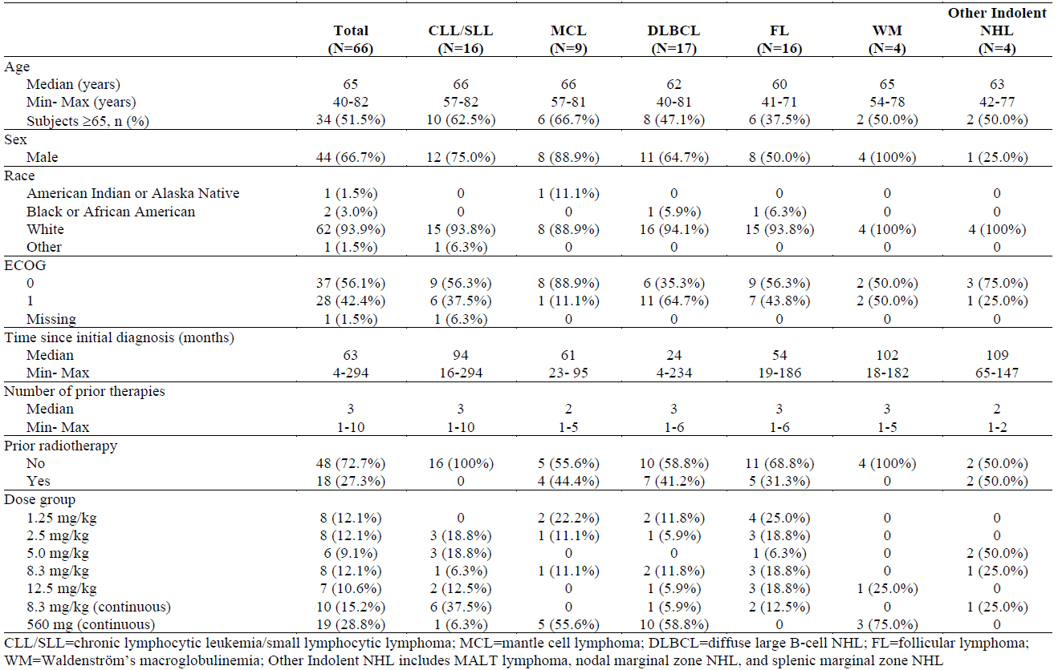

**Results for the primary efficacy outcome**

The ORR and best overall response, by histology is shown in Table 19. CRs were observed for some CLL/SLL, MCL, DLBCL and FL subjects, with the majority of CRs in subjects receiving 8.3 mg/kg/day ibrutinib or less - Table 20.

Table 19: Responses according to histological group, Study PCYC-04753

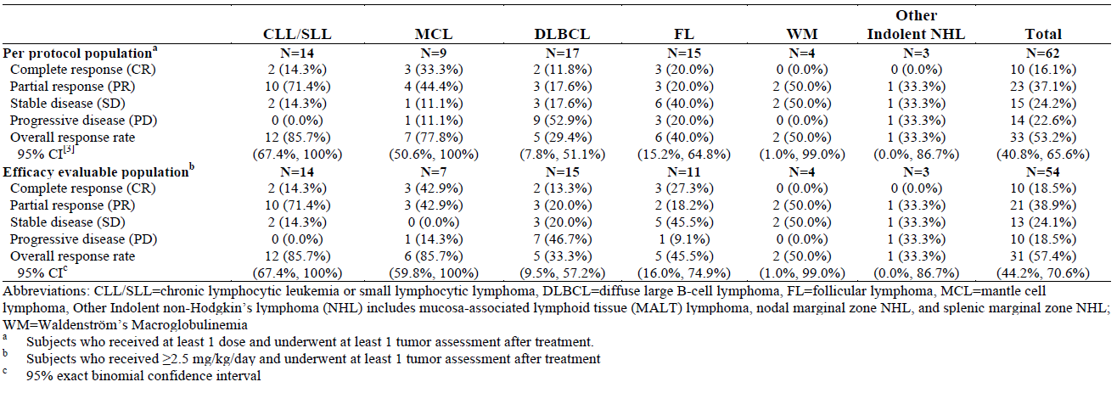

Table 20: Responses according to treatment cohort, Study PCYC-04753

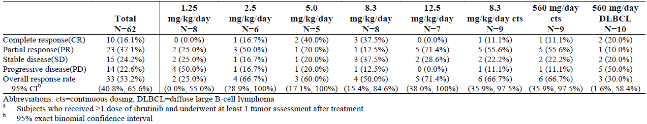

**Results for other efficacy outcomes**

Subjects were recruited having had a median of 63 months (rage four-294 months) from diagnosis to study entry.

The Kaplan-Meier estimate of PFS for the efficacy evaluable population was 10 months (95% CI 6.9, not estimable (NE)) after median follow-up of 8 months (range 0.8, 22.5). The duration of median PFS was 2.5 months DLCBL, 11.3 months or MCL, 13.4 months for FL and NE for CLL/CLL and WM.

#### Other efficacy studies

##### Study PCYC-1102-CA

**Study design, objectives, locations and dates**

This was an open-label, non-randomised, multicentre study in patients with relapsed/refractory CLL, conducted in the US between 20 May 2010 through 18 December 2012.

**Inclusion & exclusion criteria**

Patients had to have confirmed CLL/SLL, treatment-naïve subjects had to be ≥65 years of age and be in need of treatment. Relapsed/refractory subjects (adults) had to have failed two or more prior treatments, including at least one with a purine analogue. Subjects were ECOG status 0 to 2, with ‘adequate hematologic, renal and hepatic function’. For subjects receiving 840 mg ibrutinib/day, their body weight had to be >60 kg.

Study treatments

Six cohorts were to be studied:

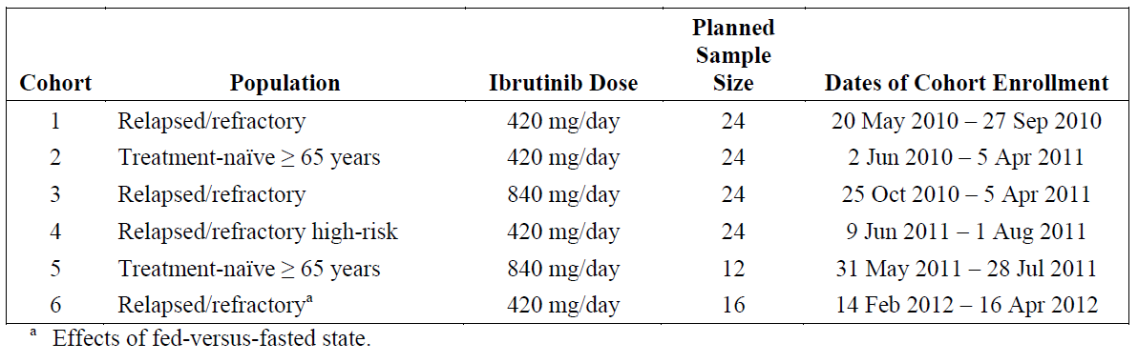

Cohorts 1 and 2 enrolled in parallel; Cohort 3 initiated after Cohort 1 enrolment had completed. Cohorts 4 and 5 enrolled in parallel after Cohorts 1through 3 had enrolled. Cohort 6 was added after Cohorts 1 through 5 were fully enrolled in order to study the effects of the fed-versus-fasted state on dosing.

Ibrutinib was self-administered orally with approximately 240 mL of water (avoiding grapefruit juice). Each dose of ibrutinib was to be taken at least two hours after the previous meal and at least 30 minutes before the next meal at approximately the same time each day.

Treatment with ibrutinib continued until confirmed disease progression or unacceptable toxicity, or any other reason for treatment discontinuation. Following cessation of the study, subjects who had completed 12 cycles of treatment without progression could continue in Study 1103.

**Primary end-point**

Safety was the primary end-point.

**Secondary efficacy end-points were:**

Overall response rate

Progression-free survival

Tolerability of treatment, as assessed by dose modifications due to treatment-related AEs.

**Exploratory efficacy end-points were:**

Time to response

Duration of response

Overall survival

Pre-treatment tumour assessment was by CT scan of the chest, abdomen and pelvis for subjects with CLL; those with SLL required PET/CT scanning.

On-treatment scanning was performed at the end of Cycles 2, 5, 8, 12, 15, 18, and 24, within three months prior to enrolment into Study 1103 or to confirm progression at any time. Response was assessed according to IWCLL 2008 guideline/2012 amendment for lymphocytosis. Progression in subjects with SLL was pre the International Working Group for non-Hodgkin’s Lymphoma, 2007.

**Randomisation and blinding methods**

This study was open-label. Subjects were assigned to Cohorts 1 through 5 in a nonrandomised sequential fashion on the basis of disease and treatment history (relapsed/refractory versus treatment-naïve), age group, and high-risk status.

**Analysis populations**

The following data sets were used:

* Enrolled Population: All subjects who signed informed consent and were enrolled into Cohorts 1 through 5 of this study. This analysis set was used to summarise enrolment and disposition.
* All Treated Population: All enrolled subjects in Cohorts 1 through 5 who received at least one dose of study medication. Subjects in this population were analysed according to the starting dose received. This analysis set was used for all efficacy and safety analyses.
* Response-evaluable Population: All enrolled subjects who received at least one dose of study medication and underwent at least one post-baseline tumour assessment. Subjects in this population were analysed according to the starting dose received. This analysis set was used for a sensitivity analysis of tumour response rate.
* Food Effect Analysis Set: All subjects enrolled into Cohort 6 who received at least one dose of study medication. These subjects were analysed and reported separately from Cohorts 1 through 5.
* Del 17p Analysis Set: A subset of subjects from Cohorts 1 through 6 who received at least one dose of study medication and were positive for the del17p by interphase cytogenetics. Safety and efficacy analyses on this subset of subjects are reported separately.

**Participant flow**

In total 117 subjects were enrolled into Cohorts 1 through 5, of whom 116 were treated (78 subjects received 420 mg/day ibrutinib and 38 received 840 mg/day) – Table 21. One subject in Cohort 5 was treated with 420 mg/day at the investigator’s discretion due to potential safety concerns, and was therefore analysed in Cohort 2.

Table 21: Participants by cohort, Study 1102

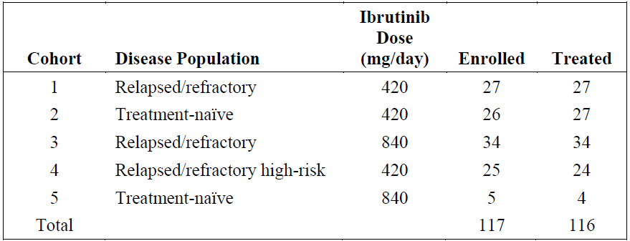

**Baseline data**

Subjects were generally representative of the general population with CLL, with median age 68 years, the majority being male (84/116, 72.4%). Most subjects 98.3% had baseline ECOG score of 0 or 1; the remainder had a score of 2. Baseline disease characteristics are shown in Table 22.

Table 22: Baseline disease characteristics (treated population), Study 1102

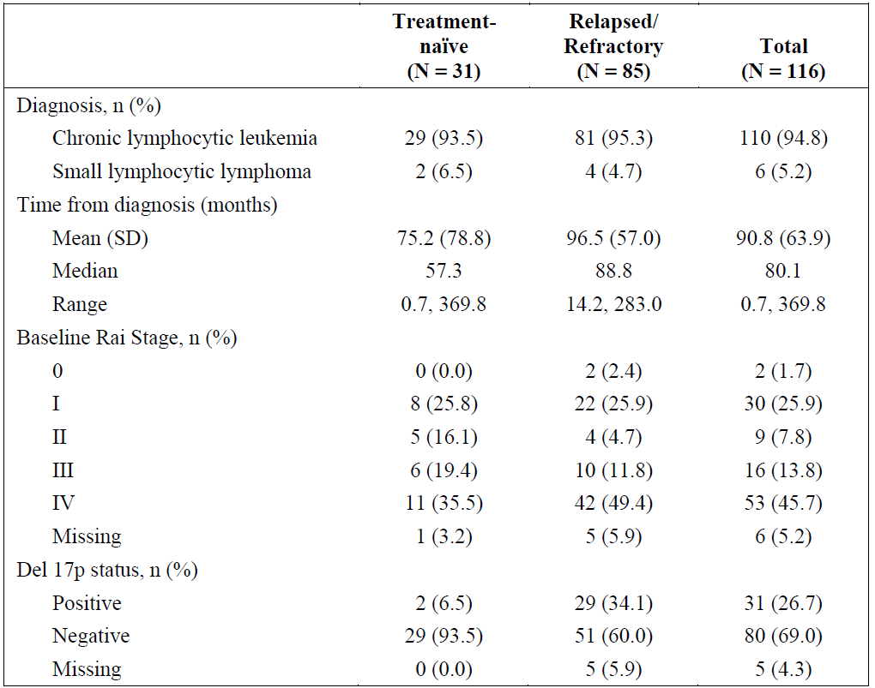

**Results for secondary efficacy outcomes**

These were reported separately for treatment-naïve and relapsed/refractory subjects –Table 23.

Table 23: Summary of responses, and time to initial response, Study 1102

|  | Treatment-naïve (n=31 ) | Relapsed/refractory (n=85) |
| --- | --- | --- |
| Overall best response, n (%)  CR  Nodular PR  PR  PR + lymphocytosis  SD  PD  Missing | 4 (12.9)  1 (3.2)  17 (54.8)  4 (12.9)  3 (9.7)  0 (0.0)  2 (6.5) | 2 (2.4)  -  62 (72.9)  11 (12.9)  4 (4.7)  2 (2.4)  4 (4.7) |
| ORR, n (%) [95% CI] | 22 (71.0) [52.0, 85.8] | 64 (75.3%) [64.7, 84.0] |
| Time to initial response in those with ORR. Median (range), months | 1.9 (1.5, 7.4) | 1.8 (1.4, 12.2) |

An exploratory end-point of this study was the assessment of ORR by del17p status. In the relapsed/refractory population, 29 subjects were del17p positive, with ORR (95%CI) 58.6% (38.9, 76.5) and 51 were del17p negative with an ORR (95%CI) 84.3% (71.4, 93.0).

In the treatment-naïve population, two were del17p-positive, with an ORR (95% CI) of 100% (66.4, 100) and 29 were del17p-negative, with an ORR (95% CI) of 69% (49.2, 84.7).

**Progression-free and overall survival**

For treatment-naïve subjects with a median follow-up time of 22.1 months, the median duration of PFS was not met. At 24 months, the estimated proportion of subjects progression-free was 96.3%.

Among the relapsed/refractory subjects, at an estimated 22.1 months of follow-up, 18/85 (21.2%) had died and 67 (78.8%) were censored. The median PFS duration could not be estimated for this group. The median survival time could not be estimated in the relapsed/refractory population.

The Kaplan-Meier estimate of PFS, by treatment group is shown in Figure 8.

Figure 8: Kaplan-Meier estimates of PFS for relapsed/refractory subjects, Study 1102

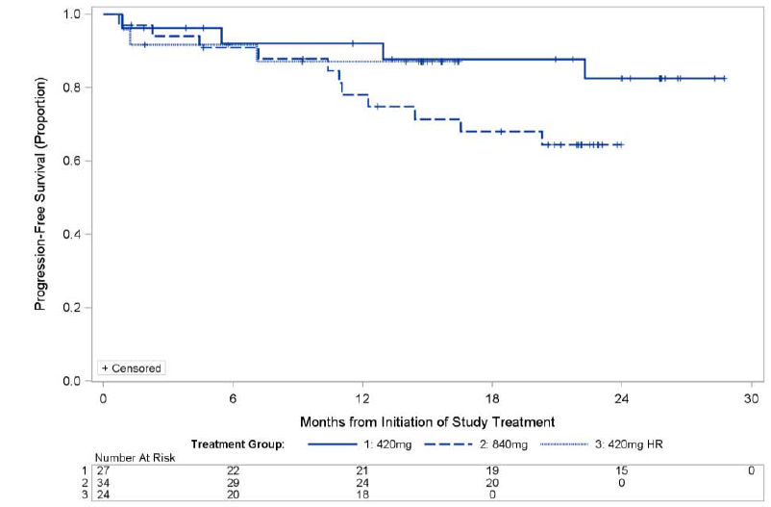

**Duration of response**

At the time of submission of the dossier, the median duration of response has not been met.

##### Study PCYC-1104-CA – Pivotal efficacy study for MCL indication

**Study design, objectives, locations and dates**

Open-label, multicentre, Phase 2 study of ibrutinib in relapsed or refractory MCL performed in the following sites: United States (n=9), Germany (n=2), Poland (n=3) and United Kingdom (n=4). The first patient was recruited on 8 February 2011 and the clinical cut-off for this primary analysis is 26 December 2012.

**Inclusion & exclusion criteria**

Eligible patients required pathologically-confirmed diagnosis of MCL, with documentation of either overexpression of cyclin D1 or chromosomal translocation t(11;14), and measurable disease per CT. Additionally, subjects were to have documented failure to achieve at least PR with, or documented disease progression after one to five prior treatment regimens for MCL.

**Study treatments**

Ibrutinib was administered at 560 mg daily, continuing until the earlier of disease progression or unacceptable toxicity.

**Efficacy variables and outcomes**

The primary efficacy endpoint was investigator-assessed ORR as per the IWG criteria for NHL.

The secondary end-points were DOR, PFS, OR and time to response. Independent review of ORR was an exploratory endpoint.

**Randomisation and blinding methods**

Subjects were enrolled in parallel (nonrandomised) into one of two cohorts based on prior bortezomib exposure. Subjects having received ≥two cycles of prior treatment with bortezomib, either as a single agent or as part of a combination therapy regimen, were considered to be bortezomib exposed. Subjects with <two cycles of prior treatment with bortezomib were considered to be bortezomib-naïve.

**Analysis populations**

The primary analysis was based on the all treated population –those enrolled that received at least one dose of ibrutinib.

**Statistical methods**

The study aimed to enrol approximately 115 subjects: 65 bortezomib naïve subjects would provide 91% power to detect a 20% difference in ORR using a one-sided 0.01 significance level and 50 bortezomib-exposed subjects would provide at least 80% power to test an ORR difference of 15% versus 35% using a one-sided 0.01 significance level.

**Participant flow**

The study enrolled 115 subjects, among whom 63/65 bortezomib naïve subjects and 48/50 bortezomib-exposed subjects received ibrutinib. At the analysis point, 24 bortezomib naïve and 22 bortezomib-exposed subjects are continuing treatment, the remainder having discontinued.

Of those discontinuations, nine were due to an AE; four of these were possibly related to ibrutinib. The majority of discontinuations were due to death (41 subjects), withdrawal of consent eight subjects). Two subjects were lost to follow-up.

**Major protocol violations**

Of the 111 treated patients, 12 had a major protocol violation. Most (nine subjects) had violations of inclusion/exclusion criteria –four deviated from criteria regarding prior therapy, three did not complete all screening laboratory tests, one had previous bowel surgery and one had an abnormal screening ECG.

**Baseline data**

One hundred and eleven subjects were recruited into the study. The median age was 68 years, with the majority being male (76.6%). There were no substantial differences in the baseline characteristics of the bortezomib-naïve and –exposed subjects, excepting the time from diagnosis to first ibrutinib dose was longer in the bortezomib–exposed patients who had received a median of 3.25 prior regimens compared to a median of 2.6 for the bortezomib-naïve group.

The extent of baseline disease is shown in Table 24.

Table 24: Extent of baseline disease, all treated population, Study 1104

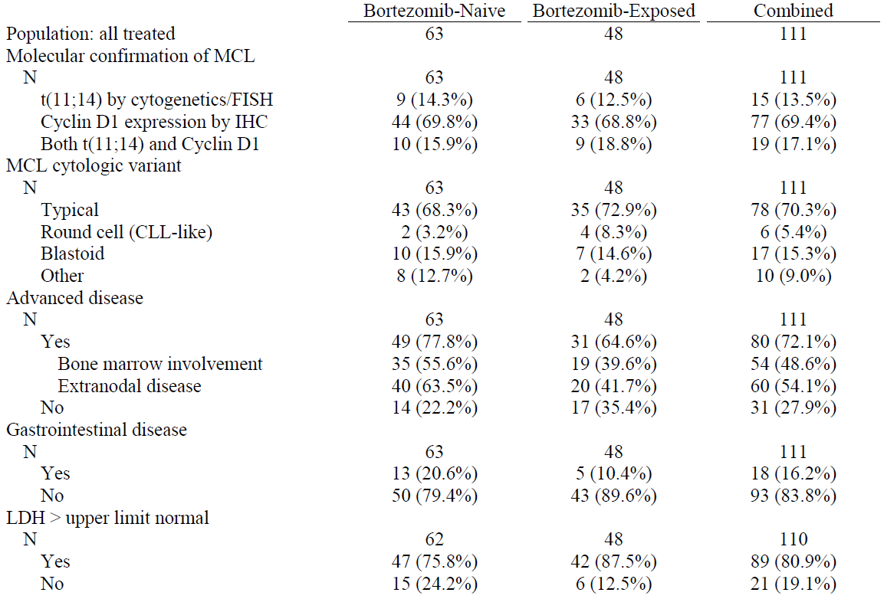

**Results for primary outcome**

Overall, the median number of ibrutinib treatment cycles was nine over a median duration of 8.3 months. The median dose density was 550 mg per day.

One-off dose reductions were required in 11 subjects (9.9%) and on two occasions in five subjects (4.5%). Dose withholding was required for 44 subjects (39.6%).

Investigator-assessed ORR, according to prior bortezomib treatment is shown in Table 25.

Table 25: ORR by investigator assessment, all treated population, Study 1104

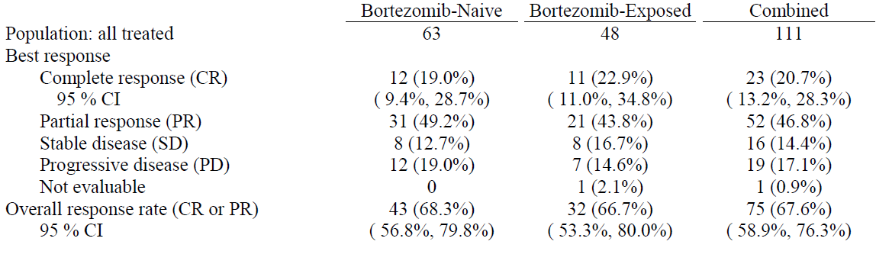

The evaluation of ORR according to baseline characteristics shows a similar magnitude of response across all sub-populations as compared to the overall population.

An exploratory analysis of ORR assessed by an independent review committee (IRC) was consistent with the investigator assessment; Independently-assessed ORR was 68.5%, comprising 20.7% CR and 47.7% PR.

**Results for secondary outcomes**

After a median duration of follow-up of 15.3 months, investigator-assessed median DOR was 17.5 months and independently-assessed median DOR was 19.6 months. Investigator-assessed median DOR in subjects with CR was not met, and was 15.8 months in those with PR.

Overall, 75/111 subjects had a response as assessed by the investigators, with a median time to response of 1.9 months (range 1.4, 13.7). Investigator–assessed median PFS for the 111 subjects was 13.9 months (95% CI 7.0, NE). For the subjects that achieved a best response of CR, the median time to CR was 5.5 months (range 1.7 – 11.5 months).

Among all treated subjects, 41 (36.9%) had died at the analysis point. Median OS was not met after 15.3 months of time on study.

Among the subjects with CLL, there was a discrepancy between the time to achieve improvement in lymph node assessment (SPD) and reduction in ALC. The latter was characterised by an increase from baseline within the first two cycles of treatment –Figure 9.

Figure 9: Absolute Lymphocyte Count Versus Lymph Node Sum of Perpendicular Diameters Median Percent Change From Baseline, Safety Population Histology CLL/SLL (N=16)

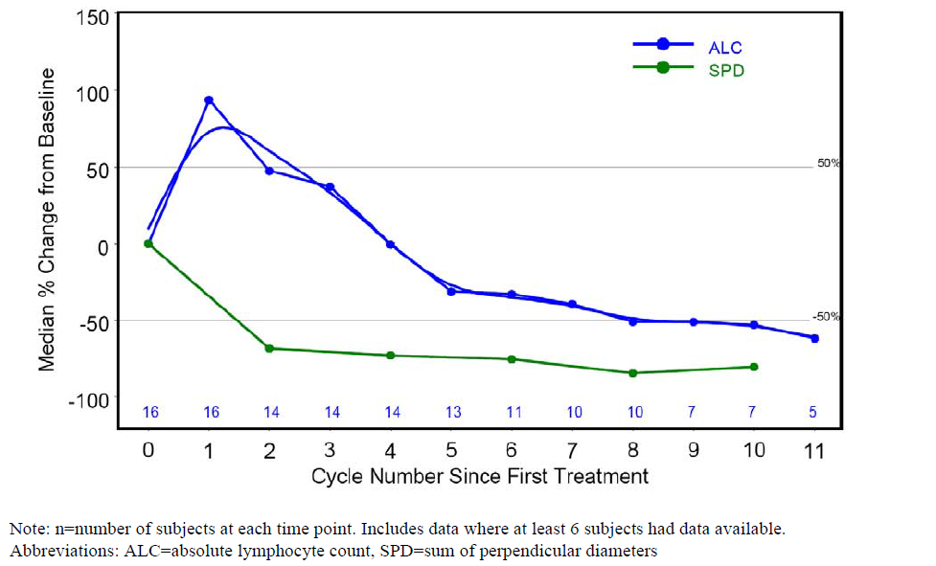

In subjects with CLL/SLL, the development of lymphocytosis during the study was associated with poorer efficacy outcomes. The baseline characteristics of the subjects that developed lymphocytosis were not directly comparable with those that did not: tumour bulk ≥five cm (64.9% versus 37.0%), greater median tumour burden (59.87 cm2 versus 20.43 cm2), B-symptoms (43.2% versus 17.8%), and high-risk mantle cell lymphoma international prognostic index (MIPI) score (64.9% versus 39.7%). A higher proportion of the subjects with lymphocytosis had advanced disease (86.5% versus 64.4%), specifically bone marrow involvement (78.4% versus 32.9%).

CR was observed less frequently in subjects with lymphocytosis 5.4% versus 28.8% in those without. In subjects that developed lymphocytosis (37/110, 33.6%) the observed PFS was shorter than in those without lymphocytosis - 7.39 months (95% CI: 5.26, 17.54) compared with 19.15 months (95% CI: 7.52, NE). Furthermore, disease progression or death occurred in 62.2% of those with lymphocytosis versus 45.2% of those without, resulting in a shorter duration of response of 15.8 months (95% CI: 5.16, NE) compared with subjects without lymphocytosis whose duration of response was NE (95%CI: 17.51, NE).

Median OS was 10.9 months (95% CI: 6.01, NE) for subjects with lymphocytosis and NE for subjects without lymphocytosis; and 19/37 (51.4%) subjects and 22/73 (30.1%) subjects, respectively, died by the clinical cut-off date.

#### Analyses performed across trials (pooled analyses and meta-analyses)

Not applicable

#### Evaluator’s conclusions on clinical efficacy for ibrutinib for the treatment of CLL/SLL

The wording of the proposed indication is:

“IMBRUVICA is indicated for the treatment of patients with CLL/SLL who have received at least one prior therapy.”

The proposed dose of ibrutinib for the treatment of CLL is 420mg once daily.

Ibrutinib is a first-in-class agent acting against BTK offering a novel treatment option for patients with CLL. The pivotal Phase 3 study comparing the efficacy of ibrutinib versus ofatumumab met its primary outcome of demonstrating a statistically significant improvement in PFS with ibrutinib for the whole study population. In sub-groups previously identified as having a poorer treatment response, such as del17p, the magnitude of PFS improvement was similar to the overall population studies. Indeed, given the known inferior response in patients with del17p to currently available therapies, consideration can be given to approve ibrutinib as first-line therapy in this population. The secondary outcome of OS also demonstrated a statistically significant improvement with ibrutinib treatment over ofatumumab.

Whilst the efficacy response comparison of ibrutinib and ofatumumab is sufficiently robust in the randomised Trial 1112, it should be noted that the ORR for the population of patients treated with ofatumumab with previously-treated CLL was substantially lower (at 4.1%, as assessed by Cheson criteria) than the ORR reported for less heavily pre-treated relapsed subjects in the pivotal study seen in the currently approved ofatumumab Australian product information (at 49%, 95%CI 36, 60) – as assessed by IWCLL criteria. However, these differences in assessment methodologies preclude between-study comparisons for the two ofatumumab-exposed populations.

The durability of response, as assessed by the proportion of subjects achieving a sustained haematological response was greater in the ibrutinib arm, for each of the parameters ANC, Hb and platelet count.

Evidence of efficacy from the three early-phase studies is supportive of the findings from the pivotal study and for the dose regimen proposed in CLL patients.

Ibrutinib dose interruption of up to seven days is supported by the dosing regimen in Study 04753 of 28 days on-treatment and seven days off-treatment demonstrates that the PD effect of ibrutinib is maintained in the off-treatment period. This finding supports dose interruptions for up to seven days, where required.

#### Evaluator’s conclusions on clinical efficacy for ibrutinib for the treatment of MCL

The wording of the proposed indication is:

“IMBRUVICA is indicated for the treatment of adult patients with MCL who have received at least one prior therapy.”

The proposed dose of ibrutinib for the treatment of MCL is 560 mg once daily.

Efficacy data from the Phase 2 open-label study of efficacy in MCL patients demonstrated a similar proportion of subjects achieving an ORR as assessed by the investigators (primary outcome) as compared to independent review (secondary outcome). The ORR of 67.6% reported for previously-treated MCL subjects was comparable with the ORR seen in the CLL population. Prior bortezomib exposure did not have a demonstrable impact on the proportion of subjects achieving an ORR.

Given the un-randomised nature of the study, additional efficacy end-points in the sub-groups analysed, though consistent with the overall response can only be considered exploratory.

The PFS data for this indication is currently immature, but demonstrated a median of 13.9 months; the sponsor should commit to providing an update to the PFS data for this study.

The selection of the dose for the MCL subjects is supported by the evidence from the clinical studies in this rarer population.

Development of lymphocytosis was shown to be associated with worse efficacy outcomes, however the baseline characteristics of patients were less favourable in those that developed lymphocytosis and may sufficiently explain these findings. In the absence of a study which stratifies by these baseline factors, this finding remains observational and cannot absolutely predict the response to ibrutinib in individual patients treated with ibrutinib.

## Clinical safety

### Studies providing evaluable safety data

Subjects that received at least one dose of ibrutinib were included in the safety analysis. The following studies provided evaluable safety data:

Table 26: Safety data in pivotal & supportive efficacy studies relating to proposed indications and dosage

|  |  |  |  |  |  |
| --- | --- | --- | --- | --- | --- |
| Study population | Study | Study phase | Study type | Monotherapy | Ibrutinib dose |
| Previously-treated MCL | 1104 | 2 | non-randomised | 111 subjects | 560mg/day |
| Previously-treated MCL | 04753 | 1 | dose-escalation | 9 subjects | 560mg/day |
| Previously-treated CLL/SLL | 1112 | 3 | RCT ibrutinib vs. ofatumumab | 195 subjects | 420mg/day |
| Previously-treated CLL/SLL | 1102 | 1b/2 | non-randomised, open label | 51 subjects | 420mg/day |

Table 27: Studies providing supplementary safety data

| Study population | Study | Study phase | Study type | Monotherapy | Ibrutinib dose |
| --- | --- | --- | --- | --- | --- |
| Previously-treated CLL/SLL | 04753 | 1 | Dose-escalation | 66 (16 CLL/SLL) | Variable |
| Previously-treated CLL/SLL | 1102 | 2 | Non-randomised, open label | 34 subjects | 840mg/day |
| B-Cell malignancies & CLL | 1103 |  | Extension | 197 (119 CLL) | Variable |
| CLL/SLL with del17p | 1117 | 2 | Open label single arm | 145 | 420mg/day |
| MCL | 2001 | 2 | Single arm, progression post-bortezomib | 120 | 560mg/day |
| Relapsed/refractory de novo DLBCL | 1106 | 2 | Safety & efficacy | 78 | 560mg/day |
| Refractory follicular lymphoma | 2002 | 2 | Open label single arm | 70 | 560mg/day |

**Pivotal efficacy studies**

For the MCL and CLL/SLL indications, treatment-emergent adverse events (TEAEs) were reported for four subgroups according to: age (<65 and ≥65, <75 and ≥75 years), gender (male/female), baseline creatinine clearance (≥60, 30 to <60, <30 mL/min) and baseline liver abnormality (yes/no).

In the pivotal efficacy studies:

* The severity of AEs was assessed by CTCAE version 3.0 to 4.03 depending on study number. Maximum severity was recorded in subjects with more than one occurrence of the event per Medical Dictionary for Regulatory Activities (MedDRA) system organ class (SOC). Grade 5 events have been reported separately from Grade 3 and 4 events.
* AEs of particular interest – CNS haemorrhagic events.
* Laboratory data were based on haematology and serum chemistry test results obtained up to 30 days after last dose or the safety follow-up visit, whichever was later. Laboratory parameters were graded using the NCI CTCAE except that CLL/SLL IWCLL 2008 guidelines (Hallek 2008) were used to grade Hb, platelet, and ANC for CLL/SLL subjects.
* Treatment-emergent events were defined as those that met the criteria of: occurring after the first dose of study drug, throughout the treatment phase and for 30 days following last dose; any event with missing onset date and a resolution date during treatment; any event that was considered study-drug-related regardless of the start date of the event; any event that was present at baseline but worsened in severity or was subsequently considered drug-related by the investigator. These events were classified according to MedDRA version 15 to 16.1 depending on study number.

**Pivotal studies that assessed safety as a primary outcome**

There were no pivotal studies of safety.

**Clinical pharmacology studies**

Four studies provided safety data.

Table 28: Populations of healthy volunteers with safety data

| Study | Study phase | Study type | Number of subjects |
| --- | --- | --- | --- |
| 1001 | 2 | non-randomised | 52 |
| 1002 | 1 | dose-escalation | 21 |
| 1004 | 3 | RCT ibrutinib vs. ofatumumab | 6 |
| 1010 | 2 | non-randomised, open label | 18 |

### Patient exposure

Exposure has been reported separately for the population of each of the proposed indications.

**CLL/SLL**

In subjects with CLL/SLL enrolled in Studies 1112 and 1102, the median duration of ibrutinib treatment was 9.0 months (range 0.2 to 28.7 months). Overall, the median total cumulative dose was 110 grams, with a median daily dose of 416 mg (range 140 mg to 430 mg), with a median pooled ibrutinib dose intensity of 99.2%. Dose reductions were required for 16 subjects (6.5%) of the pooled ibrutinib-exposure group, 14 (5.7%) requiring one dose reduction and two (0.8%) requiring two.

**MCL**

In the 120 subjects with MCL enrolled in Studies 1104 and 04753, the median duration of treatment was 8.3 months (range 0.7 to 24.8 months), at data cut off 15 May 2013. Overall, the median total cumulative dose was 125 grams, with a median daily dose of 550 mg (range 80 mg to 708 mg), with a median dose intensity of 98.2%. Dose reductions were only permitted in Study 1104, with 11 subjects (10%) having one and seven subjects (6%) having two events.

#### Treatment-related adverse events (adverse drug reactions)

###### MCL and CLL/SLL subjects

Categorised treatment-emergent adverse drug reactions in 357 MCL and CLL/SLL patients are shown below in Table 29, as presented in the SmPC for ibrutinib.

Table 29: Treatment-emergent adverse events in MCL, CLL and SLL patients

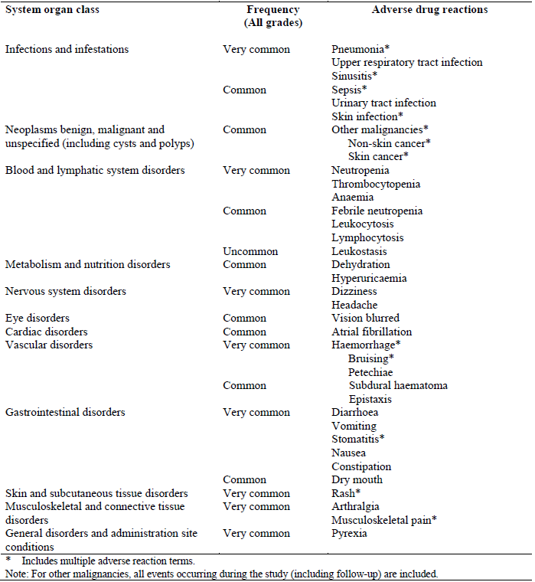

###### CLL/SLL studies

Of the 246 subjects in the integrated CLL/SLL safety population receiving 420 mg per day ibrutinib, 99.6% experienced at least one TEAE of any grade, with 59.8% experiencing at least one event of Grade ≥3.

The listing of AEs in the CLL/SLL population is shown in Table 30.

The most common Grade 3 or 4 events were: neutropenia (15.9%), pneumonia (6.9%), and thrombocytopenia (6.5%)

Table 30: Treatment-emergent adverse events occurring in ≥10% of CLL/SLL safety population

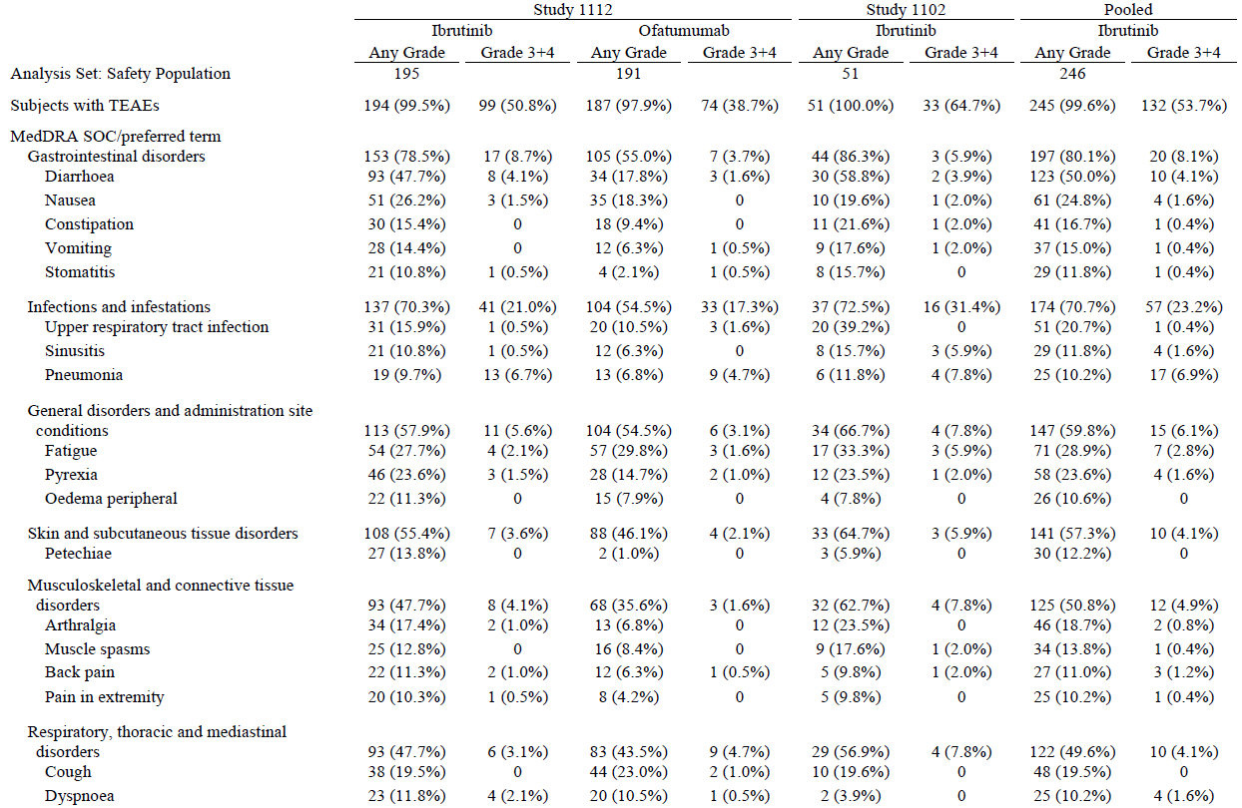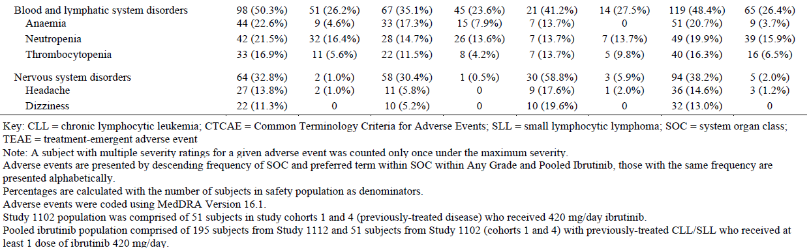

Adverse drug reactions were only reported for the following criteria:

* AEs which occurred in ≥10% of subjects treated with ibrutinib and 5% greater in the ibrutinib group compared with the ofatumumab arm of Study 1112: diarrhoea, musculoskeletal pain, nausea, rash, pyrexia, anaemia, neutropenia, bruising, arthralgia, thrombocytopenia, stomatitis, upper respiratory tract infection, constipation, vomiting, headache, petechiae, dizziness, sinusitis, and vision blurred.
* Frequency of SAEs in ≥2% of subjects treated with ibrutinib and 2% greater in the ibrutinib group compared with ofatumumab in Study 1112: atrial fibrillation, pneumonia, and urinary tract infection.
* Biological plausibility: skin infections, sepsis, epistaxis, subdural haematoma, lymphocytosis, leucocytosis, and febrile neutropenia.

###### MCL studies

Of the 120 subjects in the integrated safety population, 99.2% experienced at least one TEAE of any grade, with 76.7% experiencing TEAE of Grade ≥3.

The listing of AEs in the MCL population is shown in Table 31.

The most common Grade 3 or 4 AEs were: neutropenia (16.7%), thrombocytopenia (11.7%), anaemia (9.2%), diarrhoea (5.0%), abdominal pain (5.0%), and pneumonia (5.0%).

Table 31: Treatment-emergent adverse events in >10% of MCL monotherapy population

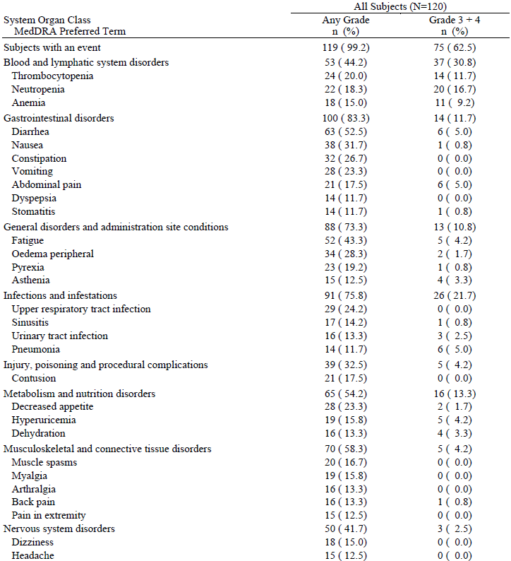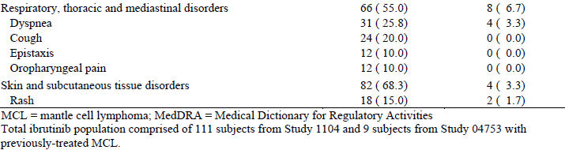

In the absence of comparative safety data, for the MCL safety population, adverse drug reactions were reported for all TEAEs with an incidence of 10% or higher – Table 32.

Table 32: Treatment-emergent adverse reactions reported in >10% of the MCL safety population treated with 560 mg ibrutinib

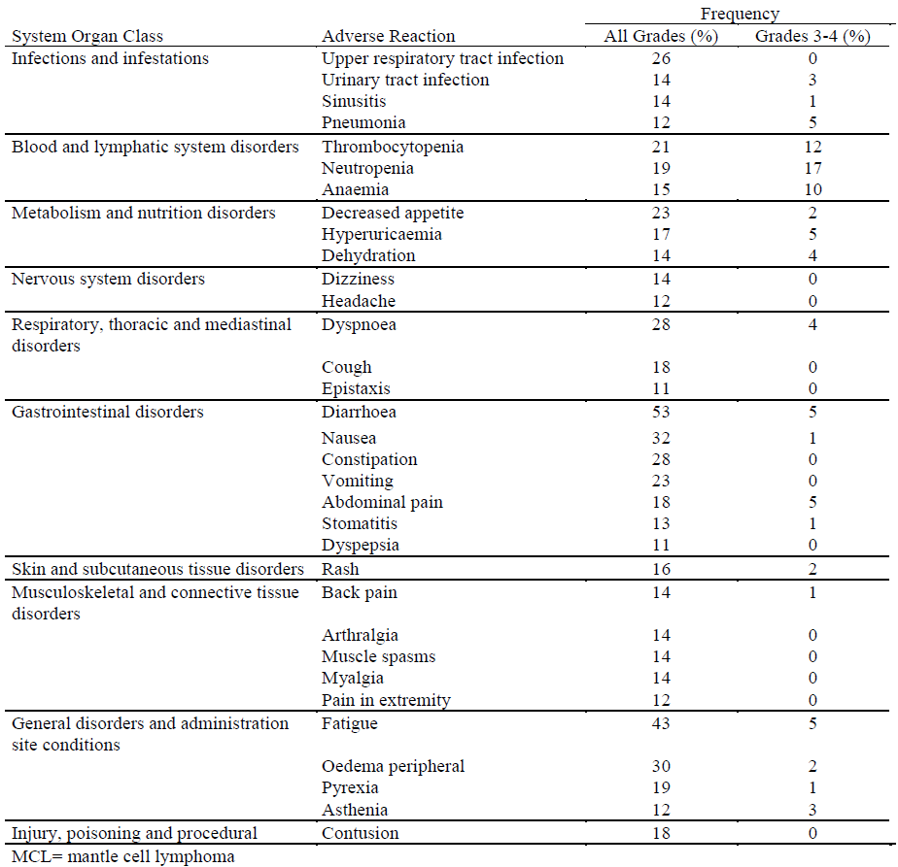

#### Deaths and other serious adverse events

###### CLL/SLL

In the pooled ibrutinib safety population of 246 previously treated CLL/SLL subjects from Studies 1112 and 1102, 15 (6.1%) had TEAEs that led to death. This compares to 16/191 (8.4%) of the ofatumumab arm of Study 1112. The listed causes of death are shown in Table 33. The causes of death in the ibrutinib safety population were generally consistent with known complications of the disease or concomitant conditions in an elderly population.

Table 33: Treatment-emergent adverse events leading to death in CLL/SLL monotherapy safety population

|  | Study 1112 | | Study 1102 | Pooled |
| --- | --- | --- | --- | --- |
| Ibrutinib | Ofatumumab | Ibrutinib | Ibrutinib |
| Analysis Set: Safety Population | 195 | 191 | 51 | 246 |
| Subjects with TEAEs | 12 (6.2%) | 16 (8.4%) | 3 (5.9%) | 15 (6.1%) |
| MedDRA Preferred Term |  |  |  |  |
| Pneumonia | 3 (1.5%) | 2 (1.0%) | 0 | 3 (1.2%) |
| Chronic lymphocytic leukaemia | 2 (1.0%) | 2 (1.0%) | 0 | 2 (0.8%) |
| Sepsis | 2 (1.0%) | 0 | 0 | 2 (0.8%) |
| Cardiac arrest | 1 (0.5%) | 0 | 0 | 1 (0.4%) |
| Gastrointestinal carcinoma | 1 (0.5%) | 0 | 0 | 1 (0.4%) |
| Leukaemia | 1 (0.5%) | 0 | 0 | 1 (0.4%) |
| Malignant histiocytosis | 0 | 0 | 1 (2.0%) | 1 (0.4%) |
| Neutropenic sepsis | 1 (0.5%) | 1 (0.5%) | 0 | 1 (0.4%) |
| Peripheral T-cell lymphoma unspecified | 0 | 0 | 1 (2.0%) | 1 (0.4%) |
| Richter's syndrome | 1 (0.5%) | 0 | 0 | 1 (0.4%) |
| Systemic inflammatory response syndrome | 0 | 0 | 1 (2.0%) | 1 (0.4%) |
| Bacteraemia | 0 | 1 (0.5%) | 0 | 0 |
| Bronchopneumonia | 0 | 1 (0.5%) | 0 | 0 |
| Cardiac failure | 0 | 1 (0.5%) | 0 | 0 |
| Influenza | 0 | 1 (0.5%) | 0 | 0 |
| Metastatic squamous cell carcinoma | 0 | 1 (0.5%) | 0 | 0 |
| Nocardiosis | 0 | 1 (0.5%) | 0 | 0 |
| Pyrexia | 0 | 1 (0.5%) | 0 | 0 |
| Renal failure acute | 0 | 1 (0.5%) | 0 | 0 |
| Sepsis syndrome | 0 | 1 (0.5%) | 0 | 0 |
| Squamous cell carcinoma | 0 | 1 (0.5%) | 0 | 0 |
| Upper respiratory tract infection | 0 | 1 (0.5%) | 0 | 0 |

Of the 15 subjects that died within 30 days of their last ibrutinib dose, only two had events that were possibly related to ibrutinib – one event of systemic inflammatory response syndrome and one event of pneumonia. The remainder were considered not related or unlikely.

Serious AEs were more common in the ibrutinib arm (41.5%) compared to ofatumumab arm (30.4%). In particular the events of atrial fibrillation and pneumonia and lung infection (combined) occurred more commonly with ibrutinib – Table 34

Table 34: Serious adverse events with incidence ≥2% in Study 1112 safety population

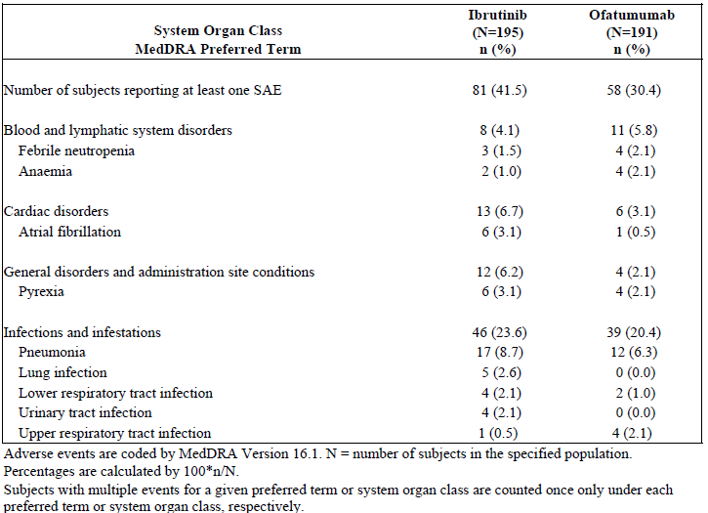

###### MCL

Of the 120 MCL subjects in the safety population, 17 (14.2%) died during treatment or within 30 days of discontinuation. The most common cause of death was disease progression in eight subjects (seven with MCL and one malignant pleural effusion), with a further four having AEs directly related to disease progression. All subjects who died were from Study 1104 and had received the proposed ibrutinib dose for MCL of 560 mg daily. Three subjects died due to treatment-emergent infections; two of these had pneumonia as a cause of death that was possibly related to ibrutinib, the remainder of all deaths were considered not related – Table 35.

Table 35: Causes of death in MCL safety population

| Sex,  Age (y) | Duration of Treatment (Days) | Days from Last Dose | Cause of Death by Preferred Term | Relationship to Ibrutinib |
| --- | --- | --- | --- | --- |
| Male, 76 | 74 | 5 | Pneumonia | Possible |
| Female, 78 | 27 | 30 | Dyspnoea | Not Related |
| Female, 56 | 672 | 21 | Hypovolaemic shock | Not Related |
| Male, 79 | 78 | 13 | Renal failure acute | Not Related |
| Male, 70 | 58 | 15 | MCL | Not Related |
| Male, 60 | 56 | 26 | Malignant pleural effusion | Not Related |
| Male, 67 | 103 | 5 | Ileus paralytic | Not Related |
| Male, 75 | 168 | 15 | *Pneumocystis jiroveci* | Possible |
| Female, 62 | 84 | 18 | MCL | Not Related |
| Male, 76 | 123 | 1 | MCL | Not Related |
| Female, 65 | 250 | 3 | Respiratory failure | Not Related |
| Male, 70 | 167 | 13 | MCL | Not Related |
| Male, 62 | 169 | 23 | MCL | Not Related |
| Male, 68 | 224 | 9 | Sepsis | Not Related |
| Male, 70 | 340 | 1 | Cardiac arrest | Not Related |
| Male, 66 | 119 | 11 | MCL | Not Related |
| Male, 74 | 49 | 12 | MCL | Not Related |

Overall, any SAE was reported for 59.2%, with 51.7% experiencing any Grade ≥3 event. For SAEs that were related, 24.2% had any grade, and 21.7% had Grade ≥3 events.

SAEs in Study 1104 were reported for 60.4% of subjects, the most commonly occurring events were: atrial fibrillation (6.3%), pneumonia (5.4%), urinary tract infection (3.6%), abdominal pain (2.7%), subdural haematoma (2.7%), febrile neutropenia (2.7%), acute renal failure (2.7%), peripheral oedema (2.7%) and pyrexia (2.7%).

#### Discontinuation due to adverse events

###### CLL/SLL

In the integrated safety population from Studies 1112 and 1102, 21/246 (8.5%) had discontinued ibrutinib treatment due to a TEAE, of which 10 events (4.1%) were of Grade 3 or 4 severity.

Overall, the commonest reasons for discontinuation were disease progression (5.3%) and death (5.3%).

###### MCL

In the MCL safety population from Studies 1104 and 04753, 14/120 subjects (11.4%) discontinued treatment due to an AE, of which eight (6.7%) were Grades 3 or 4, and four were Grade 5 Among the 14 subjects, six discontinued due to an AE related to disease progression. There were three events related to haemorrhage – two subjects with subdural haemorrhage and one with splenic haematoma, none of which were fatal.

### Laboratory tests

#### Liver function

###### CLL/SLL

In the ibrutinib arm of Study 1112, two subjects (1.0%) had a post-baseline increase in total bilirubin of Grade 3 or 4, one of whom had an autoimmune haemolytic anaemia with elevated baseline bilirubin.

In the pooled CLL/SLL data, no Grades 3 or 4 toxicities related to AST or ALT were reported.

###### MCL

None of the 120 subjects had a worst post-baseline toxicity of Grade 3 or 4 in ALT, AST or total bilirubin.

#### Kidney function

##### CLL/SLL studies

In the pooled ibrutinib population, there were: 25/244 (10.2%) subjects that experienced any grade increase in creatinine, none of which were Grades 3 or 4, and 44/244 (17.9%) events of decreased creatinine clearance, two of which were Grade 3 or 4.

Among the 244 subjects in the integrated ibrutinib CLL/SLL population with available data, 209 (85.7%) maintained their baseline grade, 18 (7.4%) changed from ≥60 mL/min to <60 mL/min, and two (0.8%) changed from 30 to <60 to <30 mL/min during treatment.

###### MCL studies

TEAEs of elevation of serum creatinine were reported for 40/120 (33.3%) of subjects, two of whom had Grade 3 or 4 decrease in creatinine clearance. Overall, 77.5% of subjects remained in the same category of creatinine clearance, 18.3% changed from ≥60 mL/min to between >60 and 30 mL/min, and 1.7% changed to <30 mL/min at some time during treatment.

#### Serum electrolytes

###### CLL/SLL

For subjects in the pivotal CLL/SLL study whose grade changed from baseline (prior to crossover for ofatumumab subjects), the worst toxicity grade in clinical chemistry parameters are shown in Table 36.

Table 36: Worst toxicity grade in clinical chemistry parameter during treatment (safety population)

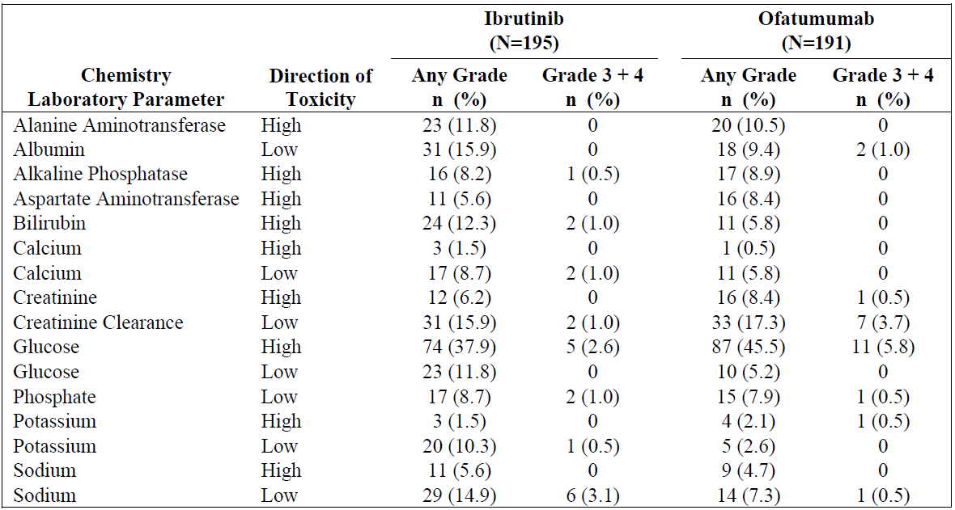

In Study 1102, hypernatraemia of any Grade 1 and 2 was observed in 23.6% of all 116 subjects; no Grade 3 or 4 events were reported. Hyponatraemia was reported in 27 subjects (23.3%) with eight of these events being of Grade 3 severity.

Hyperkalaemia was reported in 31 subjects (26.7%) with four and one events being of Grade 3 and 4 respectively. Hyponatraemia was reported in 15 subjects (12.9%), of which two events were of Grade 3 severity.

Hypocalcaemia was reported in 84 subjects (72.4%), of which three events were of Grade 3 severity. Six events (5.2%) of hypercalcaemia were reported, one of which was Grade 4 severity.

Hyperkalaemia of Grades 3 and 4 were reported in four (3.4%) and one (0.9%) subjects respectively. Two events (1.7%) of Grade 3 hypokalaemia were reported.

###### MCL

In the integrated ibrutinib MCL population, Grade 3 or 4 decreases in calcium, magnesium, potassium, and sodium levels were observed for 0.8%, 0%, 0.8%, and 5.8%, respectively. No ibrutinib treated MCL subject had a treatment-emergent Grade 3 or 4 increase in these serum electrolytes.

#### Haematology

###### CLL/SLL

AEs of neutropenia, febrile neutropenia, anaemia and thrombocytopenia are detailed in Table 37.

Table 37: Summary of selected cytopenias in the CLL/SLL safety population

|  | Any AE | | Grade 3 or 4 AE | | SAE | |
| --- | --- | --- | --- | --- | --- | --- |
|  | Ibrutinib | Ofatumumab | Ibrutinib | Ofatumumab | Ibrutinib | Ofatumumab |
| Neutropenia | 21.5% | 14.7% | 16.4% | 13.6% | 1.0% | 1.6% |
| Febrile neutropenia | 2.1% | 2.6% |  |  | 1.5% | 2.1% |
| Anaemia | 22.6% | 17.3% | 4.6% | 7.9% | 1.0% | 2.1% |
| Thrombocytopenia | 16.9% | 11.5% | 5.6% | 4.2% | 0 | 0 |

Among the subjects with febrile neutropenia, in one patient in the ofatumumab arm this led to treatment discontinuation and no discontinuations occurred in the ibrutinib arm. One subject in the ibrutinib arm died had a fatal AE of neutropenic sepsis which was classified as unlikely related to study treatment, whereas one patient in the ofatumumab arm had a fatal AE of neutropenic sepsis which was possibly related to study treatment.

###### MCL

AEs of neutropenia, febrile neutropenia, anaemia and thrombocytopenia in the 120 subjects in the MCL monotherapy safety population are shown in Table 38 below.

Table 38: Summary of selected cytopenias in the MCL safety population

|  |  |  |  |
| --- | --- | --- | --- |
|  | Any AE | Grade 3 or 4 AE | SAE |
| Neutropenia | 18.3% | 16.7% | 0.8% |
| Febrile neutropenia | 4.2% | 3.3% | 3.3% |
| Anaemia | 15.0% | 9.2% | 1.7% |
| Thrombocytopenia | 20.0% | 11.7% | 0.8% |

Febrile neutropenia of Grade 3 or 4 severity, occurred in 3.3% if the integrated safety population.

#### Electrocardiograph

###### Studies 04753 & 1102

No formal QT/QTc study has yet been performed. However, the sponsor has agreed to a Phase 1 thorough QT study (PCI-32765CLL1007) as a post-approval commitment, with a report anticipated to be submitted by the 4th quarter of 2016. The report of this study should also be submitted to the TGA in the event that ibrutinib is registered in Australia.

In two clinical studies (04753 and 1102) ECG monitoring was performed, but did not include a time-matched control for comparison.

In Study 1102 QTcF intervals were reportedly not prolonged as compared to baseline screening, in either of the two ibrutinib dose groups (420 mg and 840 mg). However, ibrutinib was associated with: a mean numerical QTcF duration shortening of up to 8.9 ms compared to baseline, a reduction in mean HR of up to 6.8 bpm compared to baseline and a mild increase in PR interval. The shortening of QTcF and increase in PR interval was without evidence of dose-dependency.

With the exception of a single observation of 242 ms, there was no evidence of PR interval prolongation (>240 ms). The QRS duration was not affected by ibrutinib, regardless of dose or treatment group.

Exposure-response analysis using ibrutinib and PCI-45227 plasma concentrations did show significant correlations for both QTcF and PR, which translated in a slightly negative and positive concentration-effect relationship for QTcF and PR, respectively, for both ibrutinib and the dihydrodiol metabolite PCI-45227. With slopes of maximally 2 ms for both QTc and PR per 100 ng/mL concentration increase over the extensive concentration ranges observed for both compounds. The sponsor makes the statement that “this is not considered clinically relevant”.

#### Vital signs

###### Studies 1112, 1102, 1104 and 04753

The sponsor states that “Review of vital signs (including weight) did not identify any safety signals in Studies 1112 and 1102. Given both the long duration of treatment in these studies and the complicated medical histories of these older subjects, transient and isolated abnormal vital signs readings over such long spans of time are not unexpected.”

In regard to Studies 1104 and 04752 (MCL indication) the sponsor states “Overall, no clinically meaningful safety signals were seen.”

#### Renal adverse events

###### CLL/SLL studies

In Study 1112, there were two Grade 3 or 4 renal events, one of nephrolithiasis and one of renal failure. There was one fatal event of acute renal failure in this study.

Among the 246 subjects in the integrated CLL/SLL population, TEAEs in the SOC of renal and urinary disorders were reported for 13.0% of subjects. No events led to ibrutinib discontinuation.

###### MCL studies

TEAEs of the SOC of renal and urinary disorders were reported for 22/120 (18.3%) subjects. Of these, six events were classified as serious, including four events of renal failure or renal failure acute; none of the four events were considered related to ibrutinib due to concurrent confounding medical conditions.

#### Infections

###### CLL/SLL

In the CLL/SLL pivotal study, AEs of infections and infestations occurred more commonly in the ibrutinib arm (70.3%) as compared the ofatumumab arm (54.5%). However the proportion of subjects with Grades 3 or 4 infections was similar, with 21.0% and 17.3% occurring in the ibrutinib and ofatumumab arms respectively. Fatal infections occurred in 3.1% and 4.7% of the ibrutinib and ofatumumab arms respectively. None of the fatal infections were considered to be related to study treatment in either treatment arm.

Serious atypical infections occurred in nine subjects overall, five in the ibrutinib arm and four in the ofatumumab arm. Among the ibrutinib patients, there were three events of aspergillosis infection, one of *Pneumocystis jiroveci* pneumonia and one of fungal tonsillitis.

In Study 1102, the overall incidence of infections/infestations was 82.8%, with infection being a reason for treatment discontinuation in 6.9%. The sub-groups of infections included: 31.9% with upper respiratory tract infection, sinusitis in 18.1%, pneumonia in 17.2% and urinary tract infection in 12.1%. Grade 3 or 4 pneumonia-related events occurred in 11.2% and three events (2.6%) were fatal. One event of pneumonia was due to an atypical organism.

###### MCL

Overall, 94/120 (75.8%) of all subjects experienced at least one treatment-emergent infection while on treatment. Grade 3 or 4 treatment-emergent infection were reported in 21.7% of subjects, of which, pneumonia, cellulitis and urinary tract infection were the only infections reported for more than two subjects in 5%, 3.3% and 2.5% respectively.

Two subjects (1.7%) had serious atypical infections reported, one fatal event *of Pneumocystis jiroveci* pneumonia and one non-fatal event of ophthalmic herpes zoster.

### Clinical pharmacology studies in healthy volunteers

Among the 97 subjects enrolled in the clinical pharmacology studies, one subject discontinued study treatment (ibrutinib plus rifampicin) due to a Grade 2 morbiliform rash. No other AEs or SAEs were considered clinically significant and no deaths occurred in this population.

### Post-marketing experience

Ibrutinib was received marketing authorisation by the Food and Drug Administration (FDA) on 12 February 2014. In their summary of clinical safety, the sponsor states that “Safety information obtained from post-marketing sources for the period from 13 November 2013 through 12 February 2014 was reviewed. No new safety signals were observed based upon these post-marketing reports, and there have been no regulatory actions taken for safety reasons.”

### Safety issues with the potential for major regulatory impact

#### Liver toxicity

No subjects in the MCL safety population developed hepatic toxicities that met the criteria for Hy’s law. The MCL studies excluded patients with pre-existing hepatic impairment and no subjects experienced Grades 3 or 4 increases in AST, ALT or total bilirubin. Nine subjects (7.5%) experienced Grade 1 elevation of AST, ALT and/or bilirubin.

No subjects in the CLL/SLL safety population developed hepatic toxicities that met the criteria for Hy’s law. Among the CLL/SLL subjects, there was one subject who experienced a Grade 3 elevation of bilirubin and there were no Grades 3 or 4 elevations of hepatic enzyme elevation. The event of increased bilirubin did not result in ibrutinib dose modification/interruption.

#### CNS haemorrhagic events

This was categorised as an AE of “clinical interest” due to events occurring early in the ibrutinib clinical development program. In total, there have been 9/636 (1.4%) episodes of CNS haemorrhage up to 6 April 2013. The cumulative incidence has fallen over time, as new patients have been accrued into studies: at November 2011, 6/173 (3.5%) events were reported, whereas up to the end of 2012 9/527 (1.7%) events were reported.

In Study 1112, one subdural haematoma and one post-procedural haemorrhage were reported in the ibrutinib arm, of which only the subdural haemorrhage event was considered possibly related to ibrutinib – leading to drug withdrawal.

Six events occurred in Study 1102, three of which were in subjects taking concomitant anticoagulant or anti-platelet medication. One subject was taking concomitant ibuprofen and had a normal platelet count at the time of haemorrhage and a further subject had a history of von Willebrand disease.

#### Haematological toxicity

In the CLL/SLL safety population, one subject in Study 1102 experienced Grade 4 leukostasis. This event was considered related to disease progression and was serious but did not result in ibrutinib discontinuation. However, no subjects in the pivotal Study 1112 experienced leukostasis.

Over time, the median lymphocyte count in CLL/SLL subjects in Study 1102 showed an initial rapid increase in the first two cycles of treatment, followed by a progressive decline - Figure 10.

Figure 10: Median lymphocyte counts over time, in CLL/SLL subjects. Study 1102

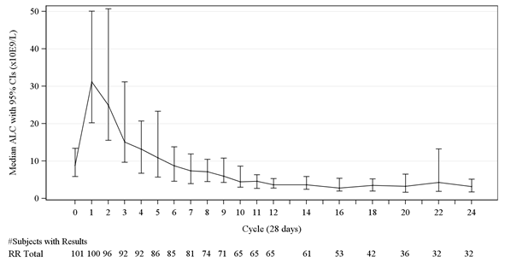

In the MCL studies, one subject in Study 1104 had an event of leukostasis.

A further three cases of leukostasis have been reported in additional ibrutinib studies up to 3 January 2014.

#### Serious skin reactions

In the integrated CLL/SLL population 48 subjects (19.5%) experienced either: “rash”, “rash erythematous” or “rash maculopapular”. No serious rash-related TEAEs were reported, and none led to ibrutinib discontinuation.

In Study 1117, a 71 year-old man experienced Grade 4 Stevens-Johnson syndrome which was histologically confirmed and was considered related to ibrutinib. This subject experienced oral ulceration and a maculopapular rash on first exposure and one re-challenge.

#### Cardiovascular safety

The SOC of cardiac disorders in Study 1112 are summarised in Table 39.

Of the 11 subjects that were reported to have atrial fibrillation or flutter, five had previously received doxorubicin and five had concomitant infection at the time of diagnosis. Only two events were described as possibly-related to ibrutinib.

Two subjects in the ibrutinib arm experienced events of AV block – one subject had pre-existing right bundle branch block at baseline, the second had a normal ECG at baseline.

The only event of right bundle branch block was observed at baseline in the ibrutinib arm.

Table 39: Subjects with SOC of cardiac disorders, Study 1112

|  |  |  |  |  |
| --- | --- | --- | --- | --- |
|  | Ibrutinib (n=195) | | Ofatumumab (n=191) | |
| Any grade (%) | Grade 3 & 4 (%) | Any grade (%) | Grade 3 & 4 (%) |
| Cardiac disorder | 11.8 | 7.9 | 5.6 | 1.6 |
| Atrial fibrillation | 5.1 | 3.1 | 0.5 | 0 |
| Atrial flutter | 1 | 0 | 0 | 0 |
| AV block | 1 | 0 | 0 | 0 |
| RBBB | 0.5 | 0 | 0 | 0 |

In the 120 MCL subjects 11 (9.2%) events of atrial fibrillation occurred and 5.8% had treatment-emergent serious adverse events (TESAEs) of atrial fibrillation.

In Study 1112, there were five subjects in the ibrutinib arm who had atrial fibrillation (all grades); three of these were Grade 3 or 4 events. In comparison in the ofatumumab arm one subject had atrial fibrillation which was neither Grade 3 nor 4.

In the pooled ibrutinib safety population of 246 CLL/SLL subjects, 15 (6%) of subjects had atrial fibrillation of all grades and 10 (4%) had Grade 3 or 4 events.

In the CLL/SLL safety population, events of “sinus bradycardia”, “bradycardia” and “heart rate decreased” were reported collectively in 4/246 (1.6%) of subjects. Events of “sinus tachycardia”, atrial tachycardia”, “heart rate increased” and “tachycardia” were reported collectively in 5/246 (2.0%) of subjects.

In their response to questions from the EMA, the sponsor confirms that all ibrutinib-exposed patients should be periodically monitored for atrial fibrillation.

#### Second malignancies

A description of the malignancies occurring in addition to the primary CLL/SLL in Study 1112 is shown in Table 40. Only data for ofatumumab patients before cross-over is included. The majority of second malignancies were of skin origin.

Table 40: Summary of second malignancies occurring in Study 1112 participants

|  | Ibrutinib (n=195) | | | Ofatumumab (n=191) | |
| --- | --- | --- | --- | --- | --- |
|  | | Any grade | Grade 3&4 | Any grade | Grade 3&4 |
| Subjects with other malignancies | | 14 (7.2%) | 3 (1.5%) | 6 (3.1%) | 1 (0.5)% |
| Skin cancers*  BCC  SCC  SCC of skin  Bowen’s disease  Skin cancer  Metastatic SCC | | 10 (5.1%)  4 (2.1%)  3 (1.5%)  2 (1.0%)  1 (0.5%)  1 (0.5%)  0 (0%) | 1 (0.5%)  0 (0%)  0 (0%)  0 (0%)  0 (0%)  1 (0.5%)  0 (0%) | 4 (2.1%)  1 (0.5%)  2 (1.0%)  0 (0%)  0 (0%)  0 (0%)  1 (0.5%) | 0 (0%)  0 (0%)  0 (0%)  0 (0%)  0 (0%)  0 (0%)  0 (0%) |
| Gastrointestinal carcinoma  Lung adenoma metastatic  Sarcoma  Soft tissue neoplasm  Squamous cell carcinoma of lung  Myelodysplastic syndrome  Tongue neoplasm | | 1 (0.5%)  1 (0.5%)  1 (0.5%)  1 (0.5%)  1 (0.5%)  0 (0%)  0 (0%) | 0 (0%)  1 (0.5%)  0 (0%)  0 (0%)  1 (0.5)  0 (0%)  0 (0%) | 0 (0%)  0 (0%)  0 (0%)  0 (0%)  0 (0%)  1 (0.5%)  1 (0.5%) | 1 (0.5%)  0 (0%)  0 (0%)  0 (0%)  0 (0%)  1 (0.5%)  0 (0%) |

*Events coded by MedDRA term.

#### Progressive multifocal leukoencephalopathy

Two cases of PML have been reported. A 57 year-old woman with CLL, who had received five prior rituximab-containing regimens, developed neurological symptoms on Day 323 of ibrutinib warranting lumbar puncture, which confirmed presence of JC virus. This subject had received her last dose of rituximab 367 days prior to diagnosis.

A 73 year-old woman with relapsed CLL, having not previously received rituximab, developed neurological symptoms following administration of rituximab, bendamustine and ibrutinib. Confirmation of the diagnosis of PML was made between Day 57 & 64 on study. The subject had received 15 doses of ibrutinib, two doses of rituximab and two doses of bendamustine and the investigator assessed the event as possibly related to ibrutinib. This PML event was fatal.

#### Eye disorders

In the MCL safety population, 37 subjects (30.8%) reported an event in the SOC of eye disorders.

In the CLL/SLL safety population from Study 1112, 36.4% in the ibrutinib arm and 18.8% of subjects in the ofatumumab arm developed an eye disorder; none of these events were Grade 3 or 4 severity. Blurred vision was reported by 10/195 subjects in the ibrutinib arm and 3/191 in the ofatumumab arm. The treatment-emergent adverse reaction of blurred vision in the pooled CLL/SLL safety population was reported in nine subjects, with none of the events being Grade 3 or 4 severity. Five out of six subjects in the ibrutinib arm with cataracts observed during the course of the study did not have a prior history of the condition. The disorders of dry eye, increased lacrimation, reduced visual acuity, vitreous floaters, photophobia, eye irritation, eye pruritis, conjunctivitis and ocular hyperaemia were all more commonly reported in the ibrutinib treatment arm.

In the integrated CLL/SLL safety population, eye disorders were reported for 88/246 subjects (35.8%), all of which were Grade 1 or 2 severity. The incidence of blurred vision was 8.9% and dry eye 7.3%.

#### Unwanted immunological events

No events of anaphylaxis have been reported in the CLL/SLL or MCL safety populations.

One subject with a prior history of food- and drug-related allergy/anaphylaxis had four episodes of worsening of angioedema in Study 1112. None of these events were considered related to ibrutinib and did not result in dose modification/interruption.

### Other safety issues

#### Safety in special populations

There have been no studies of ibrutinib use in human pregnancy or breast-feeding. Pre-clinical studies in rats have demonstrated increased post-implantation loss and malformations of the heart and major vessels with doses of between >40 to 80 mg/kg/day.

The sponsor has proposed ibrutinib to be Pregnancy Category B3.

#### Safety related to drug-drug interactions and other interactions

In vitro, ibrutinib is a weak inhibitor of CYP2B6, CYP2C8, CYP2C9, CYP2C19, CYP2D6, and CYP3A4.

The sponsor proposes to advise patients that a seven day off-treatment period is required when ibrutinib needs to be dosed with a strong CYP3A4 inhibitor.

In vitro studies demonstrated that ibrutinib is not a substrate for P-gp but is an inhibitor. No clinical studies have been performed regarding the potential for DDI with P-gp inhibition.

#### Overdose

There is no safety data pertaining to ibrutinib overdose. The maximum tolerated dose was not reached in the clinical development program. The highest daily dose administered was 1400 mg (12.5 mg/kg).

#### Drug abuse

The sponsor states there are no reports of abuse of, or dependence upon, ibrutinib. Given the pharmacological action of ibrutinib, it is not expected to have abuse potential.

#### Withdrawal & rebound

No studies of withdrawal or rebound have been conducted

#### Effect on immunisations

No studies of immunisation efficacy have been conducted.

#### Effects on ability to drive or operate machinery

The sponsor reports that “fatigue, dizziness and asthenia have been reported in some patients taking ibrutinib”. Such events may impair an individuals’ capacity to safely operate machinery or drive.

#### Adverse drug reaction reports submitted to the TGA

As of the 11 November 2014, a total of six ADR reports were received by the TGA for Australian patients up to the date of this evaluation report.

One report was received for a 57 year old female with CLL in Trial PCY-1112-CA. She was reported to have non-cardiac chest pain and recurrent urinary tract infections. The cause of the symptoms was recurrent pyelonephritis, and the dose of ibrutinib was not changed.

The investigator considered the causality between the non-cardiac chest pain and ibrutinib as possible. No assessment of causality between the recurrent UTI and ibrutinib was provided.

One report was received for a 72 year old male with MCL in Trial PCI-32765MCL3002. He was reported to have lower abdominal pain. The cause of the symptoms was diverticulitis. The investigator considered the causality between ibrutinib and diverticulitis as “not related”.

One report was received for a 54 year old female with CLL in Trial PCYC-1112-CA. She was reported to have a febrile illness (Grade 1), oral mucositis (Grade 3) and bacteroides bacteraemia (Grade 3).

The investigator considered the causality between oral mucositis, bacteroides bacteraemia and ibrutinib as “possible”.

One report was received for an 80 year old female with CLL in Study PCYC-1112-CA. She was reported to have had a Grade 2 post-operative haemorrhage following removal of a non-malignant skin lesion. No relevant laboratory data was provided.

The investigator considered the causality between the haemorrhage and ibrutinib as “possible”.

One report was received for a 67 year old male with refractory follicular lymphoma in Study PCI-32765FLR2002, being treated with ibrutinib. He was reported to have developed a malignant melanoma which was considered “possibly related” to ibrutinib exposure.

One report was received for a 75 year old male with MCL in Trial PCI-32765MCL3002. He developed axillary cellulitis and gout which was assessed as having “doubtful” causal association with the blinded study treatment.

### Evaluator’s overall conclusions on clinical safety

Overall, cumulative exposure to ibrutinib was similar between the CLL/SLL and MCL populations, the former having a longer duration of exposure at the proposed lower dose.

Discontinuations due to reasons other than disease progression or death were comparable across the two indications.

The SOC of TEAEs was similar between the two indication populations, with events of infection occurring in subjects already at-risk from their underlying disease states, in a typically elderly population. Atypical infections occurred during the ibrutinib studies but are not unusual in either disease state.

Cytopaenias occurring in multiple cell lines were observed across the CLL/SLL and MCL patient populations.

In addition to observed cytopenias, serious CNS haemorrhagic events were specifically identified at being of clinical interest. The aetiology of the events is multifactorial, some occurring in patients not on anticoagulant or anti-platelet therapies.

The effect of ibrutinib on heart rhythm does not appear readily predictable, nor does it have a typical direction of response on heart rate. Atrial fibrillation was observed across both indication populations, in particular occurring more commonly than with ofatumumab in the CLL/SLL population. In patients who develop atrial fibrillation while on ibrutinib, concomitant administration of anticoagulation should be carefully assessed on an individual basis given the observed risk of serious haemorrhage.

There is a potential for ibrutinib to be associated with a decrease in heart rate, which may have a disproportionate clinical effect in patients with increasing age, poor exercise tolerance or reduced cardiac reserve.

Progressive multifocal leukoencephalopathy was observed in two subjects with CLL, and is contained in the risk management plan under ongoing monitoring with routine pharmacovigilance activities and a targeted follow-up of AEs through a guided questionnaire.

The effect of ibrutinib on concomitant administration of immunisations has not been assessed. It should be recommended that patients receive immunisations prior to commencing ibrutinib or at least one month after ceasing therapy.

Second malignancies are a known risk for patients with haematological malignancies and in response to treatment modalities. In the randomised CLL/SLL subjects, the risk of second malignancies was higher with ibrutinib than with ofatumumab.

The sponsor has proposed ibrutinib to be Category B3. The evaluator considers this incorrect since there have been no studies in pregnant women and their offspring, which is a prerequisite for this categorisation. Given the pre-clinical evidence of foetal major heart and great vessel malformation Category D is the more appropriate pregnancy classification.

Among the CLL subjects, the pattern of causes of death was dissimilar for ibrutinib and ofatumumab; however, most of these events were typical of the underlying disease state or characteristics of the population. The incidence of Grade 3 or 4 cytopenias was similar among the ibrutinib and ofatumumab subjects.

Among the 120 MCL subjects studied, the causes of death were predominately due to disease progression, and only one atypical infection being possibly attributable to ibrutinib.

The incidence of Grades 3 or 4 cytopenias in the MCL subjects was similar to that seen in the CLL/SLL subjects.

## First round benefit-risk assessment

### First round assessment of benefit-risk balance

The benefit-risk balance of ibrutinib, given the proposed usage in both CLL/SLL and MCL populations is favourable.

## First round recommendation regarding authorisation

The evaluator considers that given the efficacy and safety data presented, ibrutinib (Imbruvica) can be considered for approval for the sponsor-proposed indications of:

IMBRUVICA is indicated for the treatment of patients with CLL/SLL who have received at least one prior therapy.

IMBRUVICA is indicated for the treatment of adult patients with MCL who have received at least one prior therapy.

The following should be considered for conditions of registration by the Delegate:

Presentation of the results of the formal QTc study (CLL1007).

Presentation of the results of Study CLL1006 in subjects with varying degrees of hepatic impairment.

Completion of a pH study to establish the effects on ibrutinib absorption

Commitment by the sponsor to provide an update to the efficacy data from Study 1104

## Clinical questions

### Additional expert input

Not requested.

### Clinical questions

#### Safety

1. The sponsor is kindly requested to provide any data it holds on the efficacy and safety of immunisations concurrently administered with ibrutinib.
2. The sponsor should present any new safety signals arising from post-marketing reports obtained outside Australia.

## Second round evaluation of clinical data submitted in response to questions

**Safety questions**

1. The sponsor is kindly requested to provide any data it holds on the efficacy and safety of Immunisations concurrently administered with ibrutinib.

Company response

Currently, the Company does not have any clinical data regarding the safety and efficacy of immunisations concomitantly administered with ibrutinib. Preclinical study in rats showed no adverse reactions from immunisations during concomitant ibrutinib administration at 100 mg/kg (human equivalent doses (HEDs) 16 mg/kg/day, AUC 13.8 μg∙hr/mL); however, there was a dose-dependent inhibition of IgM and IgG responses to immunisations of KLH at ≥ 10 mg/kg/day (HED ≥ 1.6 mg/kg/day, AUC ≥ 1 μg∙hr/mL). This was considered non-adverse as this was anticipated pharmacologic effect. Also, the genetic BTK deficiency in mice is associated with reduced response to immunisation (please see details in Module 2.4). In summary, while there is no data regarding immunisation responses in people, preclinical data suggests immunoglobulin production in response to immunisation may be decreased in patients taking ibrutinib. This is consistent with the mechanism of action of ibrutinib. The Company proposes to add the following statements in the “Special populations” section of the PI:

*Immunisations*

*There is no clinical data on the safety and efficacy of immunisations concomitantly administered with ibrutinib. Immunisations may be less effective in patients on ibrutinib therapy.*

Evaluator response: This response and PI statement satisfactorily documents the current level of evidence and risk.

1. The sponsor should present any new safety signals arising from post-marketing reports obtained outside Australia.

Company response

Cases of tumour lysis syndrome have been observed infrequently in clinical trials and postmarketing settings (four from monotherapy clinical trials out of 1730 subjects treated and seven from post-marketing out of 11,218 treated on commercial drug); none of the cases were fatal and all reported cases were confounded by underlying risk factors for tumour lysis syndrome. A definitive causal relationship between ibrutinib and tumour lysis syndrome cannot be established with the current data. However, since TLS is considered an important potential risk, the Company has added precautionary language in the Warning and Precautions section of the prescribing information as described below.

“Tumour lysis syndrome

Tumour lysis syndrome has been reported with IMBRUVICA therapy. Patients at risk of tumour lysis syndrome are those with high tumour burden prior to treatment. Monitor patients closely and take appropriate precautions.”

Tumour lysis syndrome is an important potential risk described in the EU Risk Management Plan and was also included in the Australian Specific Annex (ASA). The Company will continue to routinely monitor reports of tumour lysis syndrome in association with the use of ibrutinib.

A full review of all reports of tumour

lysis cases from worldwide clinical trials and post marketing sources is provided.

To date, there are no other new safety signals that have been identified from post-marketing surveillance.

Evaluator comment: This PI entry is satisfactory

**Other matters**

The sponsor has amended the indication of Ibrutinib in their Section 31 response, as proposed by the clinical evaluator in the Round 1 Evaluation, to:

**Chronic Lymphocytic Leukaemia/Small Lymphocytic Leukaemia (CLL/SLL)**

IMBRUVICA is indicated for the treatment of patients with CLL/SLL:

* Who have received at least one prior therapy
* Or for the frontline treatment of patients with CLL with 17p deletion

The amended indication is in line with that approved in the USA, EU and Canada. The proposed amended indication is still supported by the clinical evaluator.

## Second round benefit-risk assessment

### Second round assessment of benefits

The benefits from ibrutinib remain the same as at the first round evaluation.

### Second round assessment of risks

The risks of ibrutinib therapy now include an observed risk of tumour lysis syndrome. This AE is expected in the clinical context, and is appropriately warned for. The clinical management of patients anticipated to experience tumour lysis is a standard of care in oncology patients.

This additional risk does not outweigh the benefits of ibrutinib.

### Second round assessment of benefit-risk balance

The benefit-risk balance of ibrutinib, given the proposed usage in both CLL/SLL and MCL populations is favourable.

## Second round recommendation regarding authorisation

The evaluator considers Ibrutinib as registrable in Australia. The proposed conditions of registration seen at round one remain the same.

|  |
| --- |
| Therapeutic Goods Administration |
| PO Box 100 Woden ACT 2606 Australia  Email: [info@tga.gov.au](mailto:info@tga.gov.au) Phone: 1800 020 653 Fax: 02 6232 8605  [**https://www.tga.gov.au**](https://www.tga.gov.au) |