PRAXBIND®

idarucizumab, rch

NAME OF THE medicine

*Active Ingredient:* idarucizumab, rch

*Molecular formula:* C2131H3299N555O671S11

*CAS number:* 1362509-93-0

*Molecular mass:* 47,766 Da

*Structural formula:* Light chain (amino acids 1-219) and heavy chain fragments (amino acids 1-225), covalently linked together by one disulfide bond between cysteine 225 of the heavy chain fragment and cysteine 219 of the light chain.



DESCRIPTION

Idarucizumab is a humanised monoclonal antibody fragment (Fab) molecule derived from murine IgG1 isotype antibody molecule. Idarucizumab drug substance is a colourless to slightly yellow, clear to slightly opalescent solution. The final formulated idarucizumab drug substance has a pH of 5.5 and an osmolality of 270 – 330 mOsmol/kg. The melting point of the idarucizumab molecule is 84.4°C.

Each 50 mL vial of PRAXBIND solution for injection/infusion contains 2.5 g of idarucizumab (50 mg/mL).

Excipients: PRAXBIND also contains acetic acid – glacial, polysorbate 20, sodium acetate trihydrate, sorbitol and water for injection.

PHARMACOLOGY

Mode of Action

Idarucizumab is a specific reversal agent for dabigatran. It is a humanised monoclonal antibody fragment (Fab) that binds to dabigatran with very high affinity, approximately 300- fold higher than the binding affinity of dabigatran for thrombin at physiological pH (pH 7.4). The idarucizumab-dabigatran complex is characterised by a rapid on-rate and extremely slow off-rate resulting in a very stable complex. Idarucizumab specifically binds to dabigatran and its acyl glucuronide metabolites and potently neutralises their anticoagulant effect.

Pharmacodynamics

The pharmacodynamics of idarucizumab after administration of dabigatran etexilate were investigated in 141 subjects in Phase I studies, of which data for a representative subgroup of 6 healthy subjects aged 45 to 64 years receiving a dose of 5 g via intravenous infusion are presented. The median peak dabigatran exposure in the investigated healthy subjects was in the range of a twice daily administration of 150 mg dabigatran etexilate in patients.

Effect of idarucizumab on the exposure and anticoagulant activity of dabigatran

Immediately after the administration of idarucizumab, the plasma concentrations of unbound dabigatran were reduced by more than 99%, resulting in levels with no anticoagulant activity.

The majority of the patients showed sustained reversal of dabigatran plasma concentrations up to 12 hours (>90%). In a subset of patients, recurrence of plasma levels of unbound dabigatran and concomitant elevation of clotting tests was observed, possibly due to redistribution of dabigatran from the periphery. This occurred 2-24 hours after administration of idarucizumab mainly at timepoints ≥ 12 hours.

Figure 1: Plasma-levels of unbound dabigatran in the representative group of healthy subjects (administration of idarucizumab or placebo at 0 hours)

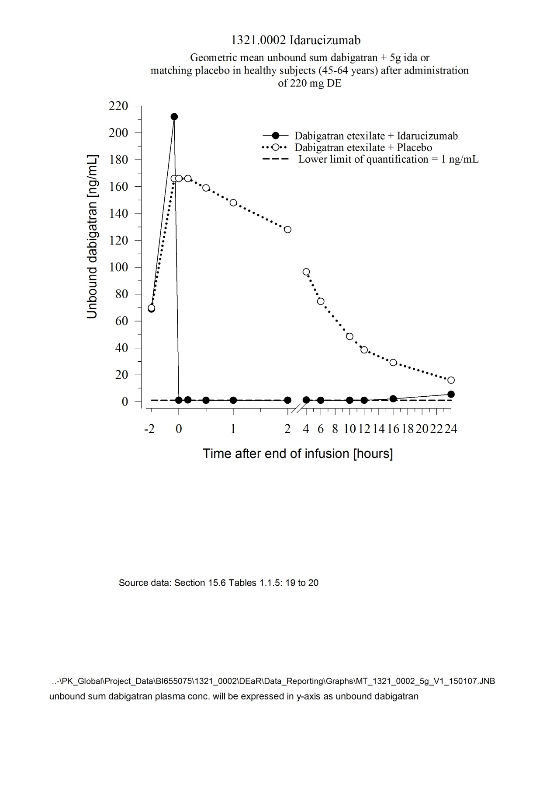

Dabigatran prolongs the clotting time of coagulation markers such as diluted Thrombin Time (dTT), Thrombin Time (TT), activated Partial Thromboplastin Time (aPTT) and Ecarin Clotting Time (ECT), which provide an approximate indication of the anticoagulation intensity. A value in the normal range after administration of idarucizumab indicates that a patient is no longer anticoagulated. A value above the normal range may reflect residual active dabigatran or other clinical conditions e.g., presence of other drugs or transfusion coagulopathy. These tests were used to assess the anticoagulant effect of dabigatran. A complete and sustained reversal of dabigatran-induced clotting time prolongation was observed immediately after the idarucizumab infusion, lasting over the entire observation period of at least 24 hours.

**Figure 2: Reversal of dabigatran-induced clotting time prolongation determined by dTT in the representative group of healthy subjects (administration of idarucizumab or placebo at 0 hours)**

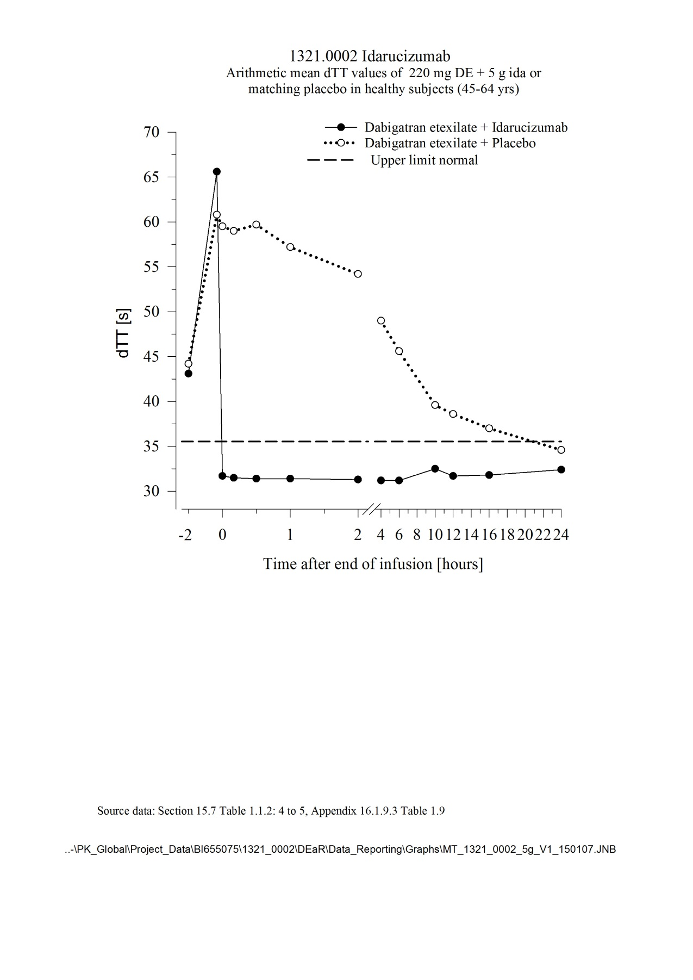

The tables below summarise the idarucizumab effect on coagulation parameters dTT, aPTT, ECT, TT, and ACT over time for 14 healthy subjects aged 45 to 80 years receiving a dose of 5 g via intravenous infusion. The median peak dabigatran exposure in the investigated healthy subjects was in the range of a twice daily administration of 150 mg dabigatran etexilate in patients. Table 1 shows the results of the idarucizumab treatment group and Table 2 shows the results of the placebo treatment group.

**Table 1: Change in coagulation parameters in 14 dabigatran-exposed subjects treated with 5 g idarucizumab**

|  |  |  |  |
| --- | --- | --- | --- |
| Clotting assay  (mean and standard deviation) | Pre-idarucizumab  (N=14) | End of infusion of idarucizumab  (N=14) | 24 hours after  idarucizumab  (N=14) |
| dTT [s] | 66.6 (12.0) | 32.1 (1.38) | 33.0 (1.69) |
| aPTT [s] | 67.8 (14.5) | 29.2 (4.74) | 31.9 (5.71) |
| ECT [s] | 122 (42.2) | 34.7 (1.92) | 38.8 (2.86) |
| TT [s] | 127 (62.6) | 12.5 (0.786) | 19.3 (5.14) |
| ACT [s] | 236 (47.6) | 116 (7.71) | 140 (10.0) |

**Table 2: Change in coagulation parameters in 14 dabigatran-exposed subjects treated with placebo**

|  |  |  |  |
| --- | --- | --- | --- |
| Clotting assay  (mean and standard deviation) | Pre-placebo  (N=14) | End of infusion of placebo  (N=14) | 24 hours after  placebo  (N=14) |
| dTT [s] | 64.7 (9.82) | 65.3 (12.1) | 36.1 (2.48) |
| aPTT [s] | 65.2 (14.0) | 66.5 (13.2) | 37.0 (7.10) |
| ECT [s] | 117 (29.8) | 122 (32.9) | 44.7 (5.39) |
| TT [s] | 132 (35.4) | 147 (46.7) | 39.5 (11.8) |
| ACT [s] | 219 (44.7) | 216 (50.5) | 148 (15.1) |

Thrombin generation parameters

Dabigatran exerts pronounced effects on parameters of the endogenous thrombin potential (ETP). Idarucizumab treatment normalised both thrombin lag time ratio and time to peak ratio to baseline levels as determined 0.5 to 12 hours after the end of the idarucizumab infusion. Idarucizumab alone has shown no procoagulant effect measured as ETP. This suggests that idarucizumab has no prothrombotic effect.

Re-administration of dabigatran etexilate

24 hours after the idarucizumab infusion, re-administration of dabigatran etexilate resulted in expected anticoagulant activity.

Immunogenicity

Serum samples from 283 subjects (224 treated with idarucizumab) were tested for antibodies to idarucizumab before and after treatment.

Pre-existing antibodies with cross-reactivity to idarucizumab were detected in approximately 12 % (33/283) of the subjects. No impact on the pharmacokinetics or the reversal effect of idarucizumab or hypersensitivity reactions were observed in these subjects.

Treatment-emergent possibly persistent anti-idarucizumab antibodies with low titres were observed in 4 % (10/224) of the subjects suggesting a low immunogenic potential of idarucizumab. In a subgroup of 6 subjects, idarucizumab was administered a second time, two months after the first administration. No anti-idarucizumab antibodies were detected in these subjects prior to the second administration. In one subject, treatment-emergent anti-idarucizumab antibodies were detected after the second administration.

Preclinical pharmacodynamics

A trauma model in pigs was performed using a blunt liver injury after dosing with dabigatran to achieve supratherapeutic concentrations of about 10-fold of human plasma levels. Idarucizumab effectively and rapidly reversed the life-threatening bleeding within 15 minutes after the injection. All pigs survived at idarucizumab doses of approximately 2.5 and 5 g. Without idarucizumab, the mortality in the anticoagulated group was 100%. When idarucizumab is present in less than equimolar concentrations, some residual dabigatran activity can reappear if haemostasis has not been achieved.

Preclinical investigations with idarucizumab have shown no interactions with:

* colloid and crystalloid volume expanders (e.g. gelatin or hydroxyethyl starch)
* coagulation factor concentrates, such as prothrombin complex concentrates (PCCs, e.g. 3 factor and 4 factor), activated PCCs (aPCCs) and recombinant factor VIIa
* other anticoagulants (e.g. thrombin inhibitors other than dabigatran, Factor Xa inhibitors including low-molecular weight heparin, vitamin K-antagonists, heparin).

Thus idarucizumab will not reverse the effects of other anticoagulants.

Pharmacokinetics

The pharmacokinetics of idarucizumab were investigated in 224 subjects in Phase I studies, of which data for a representative subgroup of 6 healthy subjects aged 45 to 64 years receiving a dose of 5 g via intravenous infusion are presented.

Distribution

Idarucizumab exhibited multiphasic disposition kinetics and limited extravascular distribution. Following the intravenous infusion of a 5 g dose, the geometric mean volume of distribution at steady state (Vss) was 8.9 L (geometric coefficient of variation (gCV) 24.8%).

Metabolism

Several pathways have been described that may contribute to the metabolism of antibodies. All of these pathways involve biodegradation of the antibody to smaller molecules, i.e. small peptides or amino acids which are then reabsorbed and incorporated in the general protein synthesis.

Excretion

Idarucizumab was rapidly eliminated with a total clearance of 47.0 mL/min (gCV 18.4%), an initial half-life of 47 minutes (gCV 11.4%) and a terminal half-life of 10.3 hours (gCV 18.9%). After intravenous administration of 5 g idarucizumab, 32.1% (gCV 60.0%) of the dose was recovered in urine within a collection period of 6 hours and less than 1% in the following 18 hours. The remaining part of the dose is assumed to be eliminated via protein catabolism, mainly in the kidney.

After treatment with idarucizumab proteinuria has been observed. The transient proteinuria is a physiologic reaction to renal protein overflow after bolus/short term application of 5 g idarucizumab intravenously. The transient proteinuria usually peaked about 4 hours after idarucizumab administration and normalised within 12-24 hours. In single cases the transient proteinuria persisted for more than 24 hours.

Renal impairment

Total idarucizumab clearance was reduced in subjects with renal impairment compared to healthy subjects, leading to an increased exposure of idarucizumab. These findings were consistent with the available data from 68 patients in the RE-VERSE AD trial (see PRECAUTIONS, Use in Specific Populations, Renal impairment).

Elderly patients/sex/race/body weight

Based on population pharmacokinetic analyses in healthy volunteers, sex, age, race and body weight do not have a clinically meaningful effect on the pharmacokinetics of idarucizumab.

clinical trials

Three randomised, double-blind, placebo-controlled Phase I studies in 283 subjects (224 treated with idarucizumab) were conducted to assess the safety, efficacy, tolerability, pharmacokinetics and pharmacodynamics of idarucizumab, given alone or after administration of dabigatran etexilate. The investigated population consisted of healthy subjects and subjects exhibiting specific population characteristics covering age, body weight, race, sex and renal impairment. In these studies the doses of idarucizumab ranged from 20 mg to 8 g and the infusion times ranged from 5 minutes to 1 hour.

Representative values for pharmacokinetic and pharmacodynamics parameters were established on the basis of healthy subjects aged 45-64 years receiving 5 g idarucizumab (see PHARMACOLOGY, Pharmacokinetics and Pharmacodynamics).

A prospective, open-label, non-randomised, uncontrolled study (RE-VERSE AD) is currently ongoing to investigate the treatment of adult patients who presented with dabigatran-related life-threatening or uncontrolled bleeding (Group A) or who required emergency surgery or urgent procedures (Group B). The primary endpoint was the maximum percentage reversal of the anticoagulant effect of dabigatran within 4 hours after the administration of idarucizumab, based on central laboratory determination of diluted Thrombin Time (dTT) or Ecarin Clotting Time (ECT). A key secondary endpoint is the restoration of haemostasis.

An interim analysis of RE-VERSE AD included data for 123 patients: 66 patients with serious bleeding (Group A) and 57 requiring an urgent procedure (Group B). Approximately half of the patients in each group were male. The median age was 77 years and the median creatinine clearance was 61 mL/min. Approximately 68% of patients in Group A and 63% of patients in Group B had been treated with dabigatran 110 mg twice daily. Results of central laboratory evaluations were available for a subset of 90 patients (51 in Group A, 39 in Group B).

Most patients (>89%), in both Groups A and B, achieved complete reversal of the anticoagulant effect of dabigatran as measured by dTT or ECT in the first 4 hours after administration of 5 g idarucizumab. Reversal effects were evident immediately after administration.

Figures 3 and 4 show the reversal of dabigatran-induced clotting time prolongation determined by dTT or aPTT in 90 patients with available data from the RE-VERSE AD study.

**Figure 3: Reversal of dabigatran-induced clotting time prolongation determined by dTT in 90 patients from the RE-VERSE AD study**

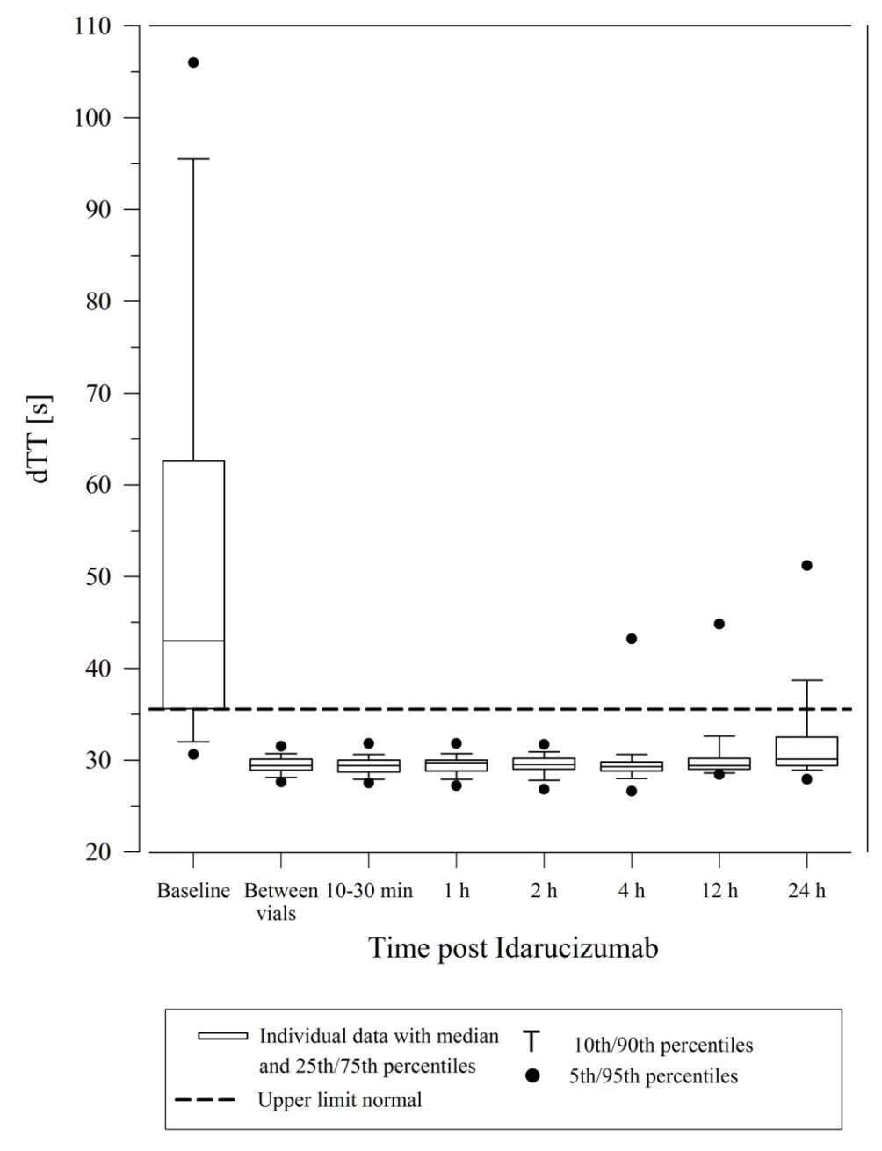

**Figure 4: Reversal of dabigatran-induced clotting time prolongation determined by aPTT in 90 patients from the RE-VERSE AD study**

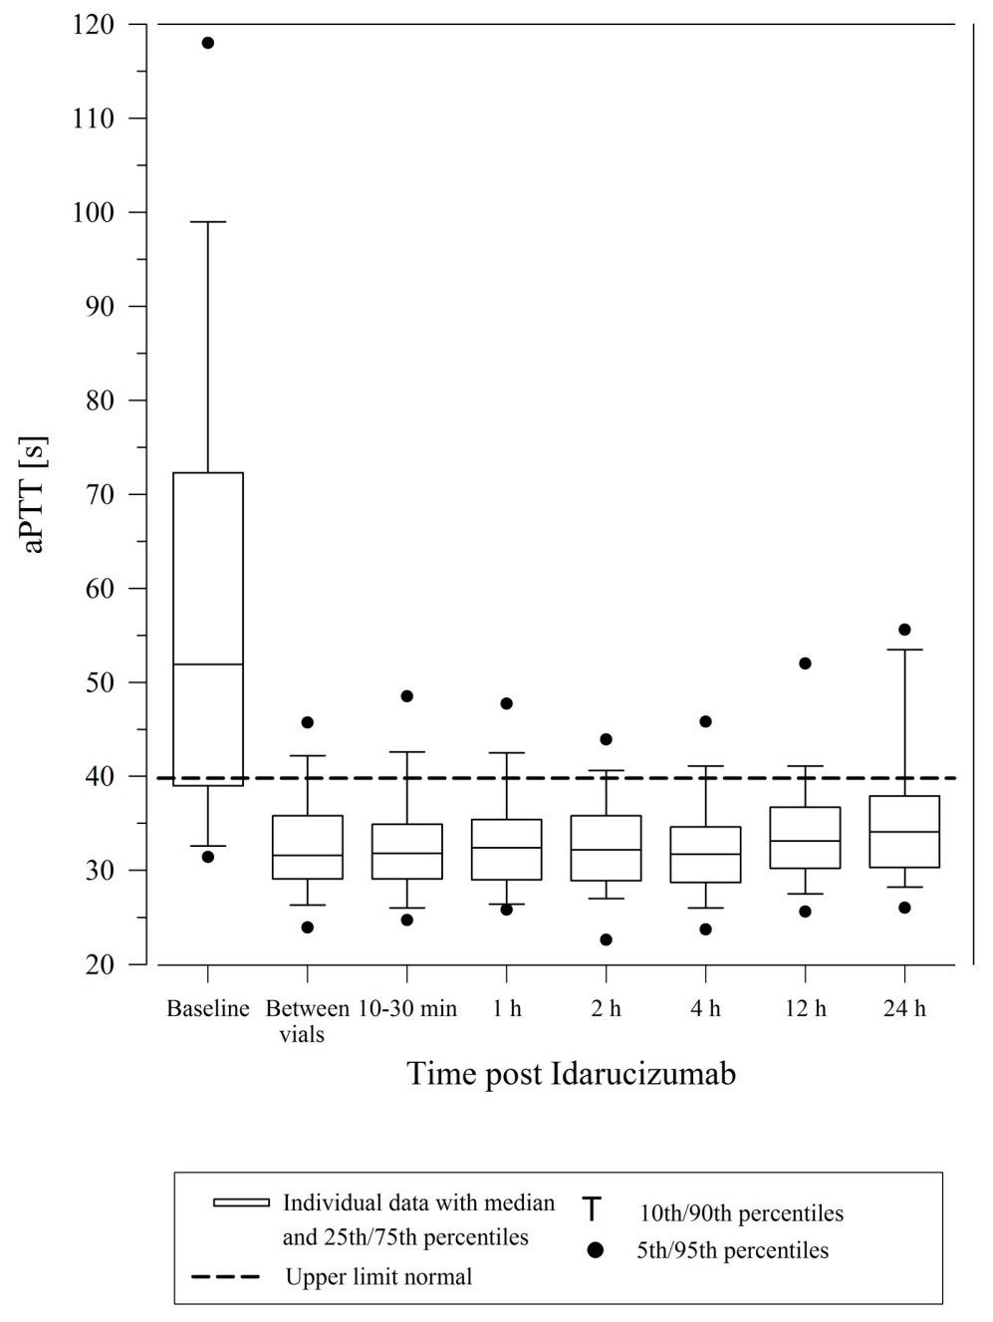

Restoration of haemostasis was achieved in 91% of evaluable patients who had serious bleeding and normal haemostasis was observed in 92% of patients who required an urgent procedure.

Of the total 123 patients, 26 patients died; each of these deaths could be attributed either as a complication of the index event or associated with co-morbidities. Thrombotic events were reported in 5 patients, none of which were on antithrombotic therapy at the time of the event, and in each of these cases, the thrombotic event could be attributed to the underlying medical condition of the patient. Mild symptoms of potential hypersensitivity (pyrexia, bronchospasm, hyperventilation, rash or pruritus) were reported. A causal relationship to idarucizumab could not be established. Further adverse events, reported in greater than or equal to 5% of patients, were hypokalemia (9/123; 7%), delirium (9/123; 7%), constipation (8/123; 7%), pyrexia (7/123; 6%), pneumonia (7/123; 6%).

INDICATIONS

PRAXBIND is a specific reversal agent for dabigatran and is indicated in patients treated with dabigatran etexilate (PRADAXA) when rapid reversal of the anticoagulant effects of dabigatran is required:

* for emergency surgery/urgent procedures
* in life-threatening or uncontrolled bleeding.

CONTRAINDICATIONS

None.

PRECAUTIONS

Safety and efficacy in patients has been evaluated in an interim analysis of 123 patients in a prospective, open-label, non-randomised, uncontrolled study (RE-VERSE AD), which is planned for up to 500 patients (see CLINICAL TRIALS).

Idarucizumab binds specifically to dabigatran and reverses its anticoagulant effect. It will not reverse the effects of other anticoagulants (see PHARMACOLOGY, Pharmacodynamics).

PRAXBIND treatment can be used in conjunction with standard supportive measures, which should be considered as medically appropriate.

Thromboembolic events

Patients being treated with dabigatran have underlying disease states that predispose them to thromboembolic events. Reversal of dabigatran therapy exposes patients to the thrombotic risk of their underlying disease. To reduce this risk, resumption of anticoagulant therapy should be considered as soon as medically appropriate (see DOSAGE AND ADMINISTRATION).

Hypersensitivity

The risk of using PRAXBIND in patients with known hypersensitivity (e.g. anaphylactoid reaction) to idarucizumab or to any of the excipients needs to be weighed cautiously against the potential benefit of such an emergency treatment. If an anaphylactic reaction or other serious allergic reaction occurs, administration of PRAXBIND should be discontinued immediately and appropriate therapy initiated.

Hereditary fructose intolerance

The recommended dose of PRAXBIND contains 4 g sorbitol as an excipient.  In patients with hereditary fructose intolerance, parenteral administration of sorbitol has been associated with reports of hypoglycaemia, hypophosphatemia, metabolic acidosis, increase in uric acid, acute liver failure with breakdown of excretory and synthetic function, and death. Therefore, in patients with hereditary fructose intolerance the risk of treatment with PRAXBIND must be weighed against the potential benefit of such an emergency treatment.

Urinary protein testing

PRAXBIND causes transient proteinuria as a physiologic reaction to renal protein overflow after bolus/short term application of 5g idarucizumab intravenously (see PHARMACOLOGY, Pharmacokinetics). The transient proteinuria is not indicative of renal damage, which should be taken into account for urine testing.

Re-elevation of Coagulation Parameters

In a limited number of patients, recurrence of plasma concentrations of unbound dabigatran and concomitant elevated coagulation parameters have occurred up to 24 hours after administration of idarucizumab (see PHARMACOLOGY, Pharmacodynamics).

If reappearance of clinically relevant bleeding together with elevated coagulation parameters is observed after administration of 5 g PRAXBIND, administration of an additional 5 g dose of PRAXBIND may be considered. Similarly, patients who require a second emergency surgery/urgent procedure and have elevated coagulation parameters may receive an additional 5 g dose of PRAXBIND (see DOSAGE AND ADMINISTRATION).

Sodium

This medicinal product contains 2.2 mmol (or 50 mg) sodium per dose. This should be taken into consideration by patients on a controlled sodium diet.

Use in Specific Populations

Effects on fertility

Studies to assess the potential effects of idarucizumab on fertility have not been performed. Treatment-related changes to reproductive tissues of either sex were not seen during repeat dose intravenous toxicity studies of up to four weeks in the rat and two weeks in monkeys. Additionally, no idarucizumab binding to human reproductive tissues was observed in a tissue cross-reactivity study. Therefore, preclinical results do not suggest a risk to fertility or embryo-fetal development.

Use in pregnancy (Category B2)

There are no data for the use of idarucizumab in pregnant women. Reproductive and developmental toxicity studies have not been performed, given the nature and the intended clinical use of the medicinal product. Idarucizumab may be used during pregnancy, if the expected clinical benefit outweighs the potential risks.

Use in lactation

It is unknown whether idarucizumab is excreted in human milk.

Paediatric use

The safety and efficacy of PRAXBIND in the paediatric population has not been established.

Elderly patients/sex/race/body weight

Based on population pharmacokinetic analyses in healthy volunteers, sex, age, race and body weight do not have a clinically meaningful effect on the pharmacokinetics of idarucizumab.

Genotoxicity

Studies to evaluate the genotoxic potential of idarucizumab have not been performed. Based on its mechanism of action and the characteristics of proteins no genotoxic effects are anticipated.

Carcinogenicity

The carcinogenic potential of idarucizumab has not been investigated in animal studies. Based on its mechanism of action and the characteristics of proteins no carcinogenic effects are anticipated.

Effects on Laboratory Tests

Idarucizumab showed no non-specific binding to blood cells or to other thrombin substrates and did not exhibit thrombin-like, prothombotic effects in several in vitro assays. Coagulation test results (dTT, aPTT, ECT, thrombin time (TT), activated clotting time (ACT)) were comparable in the presence and absence of idarucizumab.

Renal impairment

No dose adjustment is required in renally impaired patients. Renal impairment did not impact the reversal effect of idarucizumab.

In Phase I studies PRAXBIND has been investigated in subjects with a creatinine clearance ranging from 44 to 213 mL/min. Subjects with a creatinine clearance below 44 mL/min have not been studied in Phase I.

Depending on the degree of renal impairment the total clearance was reduced compared to healthy subjects, leading to an increased exposure of idarucizumab.

The method used to estimate renal function (CrCL in mL/min) during the clinical development of PRAXBIND was the Cockcroft-Gault method.

**Table 3: Classification of renal function based on estimated GFR (eGFR) or estimated creatinine clearance (CrCL)**

|  |  |  |  |  |
| --- | --- | --- | --- | --- |
| **Stage** | **Descriptiona** | **eGFRb** | **CrCLc (mL/min)** | **Praxbind development program description** |
| 1 | Control (normal) GFR | ≥ 90 | ≥ 90 | Normal renal function |
| 2 | Mild decrease in GFR | 60-89 | 60-89 | Mild renal impairment |
| 3 | Moderate decrease in GFR | 30-59 | 30-59 | Moderate renal impairment |
| 4 | Severe decrease in GFR | 15-29 | 15-29 | Severe renal impairment |
| 5 | End Stage Renal Disease (ESRD) | < 15 not on dialysis/ requiring dialysis | < 15 not on dialysis/ requiring dialysis | Severe renal impairment/  End Stage Renal Disease (ESRD) |

a Stages of renal impairment are based on K/DOQI Clinical Practice Guidelines for Chronic Kidney Disease (CKD) from the National Kidney Foundation in 2002

GFR: glomerular filtration rate

b eGFR: estimate of GFR based on an MDRD equation

c CrCL: estimated creatinine clearance based on the C-G equation

Based on pharmacokinetic data from 68 patients with different degrees of renal function (median creatinine clearance 19.2-126 mL/min) it is estimated that mean idarucizumab exposure (AUC0–24h) increases by 26% in patients with mild (CrCl 60-90 mL/min), by 78% in moderate (30-60 mL/min) and by 199% in severe (0-30 mL/min) renal impairment. Since dabigatran is also excreted primarily via the kidneys, increases in the exposure to dabigatran are also seen with worsening renal function.

Based on these data and the extent of reversal of the anticoagulant effect of dabigatran in patients, renal impairment does not appear to impact the reversal effect of idarucizumab.

Hepatic impairment

An impact of hepatic impairment on the pharmacokinetics of idarucizumab is not expected.

PRAXBIND has not been studied in patients with hepatic impairment. Antibody fragments are known to be eliminated mainly by proteolytic catabolism in the kidney.

Interactions with other medicines

No formal interaction studies with PRAXBIND and other medicinal products have been performed. Based on the pharmacokinetic properties and the high specificity in binding to dabigatran, clinically relevant interactions with other medicinal products are considered unlikely.

Preclinical investigations have shown no interactions with volume expanders, coagulation factor concentrates and anticoagulants other than dabigatran (see PHARMACOLOGY, Pharmacodynamics).

ADVERSE EFFECTS

The safety of PRAXBIND has been evaluated in 224 healthy subjects as well as in 123 patients in an ongoing phase III trial (RE-VERSE AD), who had uncontrolled or life-threatening bleeding or required emergency surgery or procedures and were under treatment with dabigatran etexilate.

No adverse reactions have been identified.

Clinical trial experience

Three clinical trials in healthy volunteers have been completed, in which 224 subjects were treated with idarucizumab. In these trials during the treatment period the overall frequency of adverse events was similar between idarucizumab-treated subjects (55/224, 25%) and placebo-treated subjects (26/105, 25%).

Table 4 informs about adverse events reported in healthy volunteers treated with placebo alone, PRAXBIND alone and those treated either PRAXBIND alone or treated with PRAXBIND after pre-treatment with dabigatran etexilate.

**Table 4 Adverse events (N/%) reported in healthy volunteers treated with placebo alone, PRAXBIND alone and those treated either PRAXBIND alone or treated with PRAXBIND after pre-treatment with dabigatran etexilate in Phase I trials (data cut-off 1%)**

|  |  |  |  |  |
| --- | --- | --- | --- | --- |
| **MedDRA SOC** | **Adverse event MedDRA PT** | **Placebo alone N (%)** | **IDA alone N (%)** | **IDA or IDA + DE N (%)** |
| **Number of patients** |  | 35 (100.0) | 107 (100.0) | 224 (100.0) |
| **Infections and infestations** | Nasopharyngitis | 1 (2.9) | 2 (1.9) | 3 (1.3) |
| **Nervous system disorders** | Headache Dizziness | 2 (5.7) 1 (2.9) | 9 (8.4) 1 (0.9) | 12 (5.4) 5 (2.2) |
| **Gastrointestinal disorders** | Diarrhoea Constipation | 0 (0.0) 0 (0.0) | 2 (1.9) 1 (0.9) | 3 (1.3) 3 (1.3) |
| **General disorders and administration site condition** | Catheter site pain | 1 (2.9) | 2 (1.9) | 3 (1.3) |
| **Musculoskeletal and connective tissue disorders** | Back pain Musculoskeletal stiffness | 1 (2.9) 0 (0.0) | 4 (3.7) 2 (1.9) | 4 (1.8) 2 (0.9) |
| **Skin and subcutaneous tissue disorders** | Skin irritation | 2 (5.7) | 3 (2.8) | 6 (2.7) |

IDA – idarucizumab (PRAXBIND), DE – dabigatran etexilate (PRADAXA)

In the interim analysis of the RE-VERSE AD (RE-VERSal Effects of idarucizumab on Active Dabigatran) trial, a total of 123 dabigatran-treated patients were administered idarucizumab either because they required an emergency surgery or urgent procedure, or because they presented with life-threatening or uncontrolled bleeding. Of the total, 26 patients died, 11 within the first day after idarucizumab dosing; each of these deaths could be attributed either as a complication of the index event or associated with co-morbidities.

Thrombotic events

Thrombotic events were reported in 5 patients, none of which were on antithrombotic therapy at the time of the event, and in each of these cases, the thrombotic event could be attributed to the underlying medical condition of the patient.

Mild symptoms of potential hypersensitivity

Mild symptoms of potential hypersensitivity (pyrexia 5.7%, bronchospasm 0.8%, hyperventilation 2.4%, rash 0.8% or pruritus 0.8%) were reported. A causal relationship to idarucizumab could not be established.

Table 5 informs about adverse events in patients treated with dabigatran etexilate and experiencing uncontrolled bleeding (group A) or required emergency surgery or procedures (group B).

**Table 5 Adverse events (N/%) in patients with uncontrolled bleeding or required emergency surgery or procedures (data cut-off ≥ 1.5% Total)**

|  | **Adverse event MedDRA PT** | **Group\* A Bleeding N (%)** | **Group\* B Surgery N (%)** | **Total N (%)** |
| --- | --- | --- | --- | --- |
| **Number of patients Patients with adverse events** |  | 66 (100.0) 53 (80.3) | 57 (100.0) 38 (66.7) | 123 (100.0) 91 (74.4) |
| **Infections and infestations** | Urinary tract infection Pneumonia | 5 (7.6) 3 (4.5) | 0 (0.0) 4 (7.0) | 5 (4.1) 7 (5.7) |
| **Blood and lymphatic system disorders** | Thrombocytopenia Anaemia | 4 (6.1) 3 (4.5) | 0 (0.0) 3 (5.3) | 4 (3.3) 6 (4.9) |
| **Metabolism and nutrition** | Hypokalaemia  Hypoalbuminaemia | 6 (9.1)  1 (1.5) | 3 (5.3)  1 (1.8) | 9 (7.3)  2 (1.6) |
| **Psychiatric disorders** | Delirium Anxiety Confusional state Disorientation  Agitation | 7 (10.6) 3 (4.5) 2 (3.0) 2 (3.0)  1 (1.5) | 2 (3.5) 0 (0.0) 1 (1.8) 1 (1.8)  1 (1.8) | 9 (7.3) 3 (2.4) 3 (2.4) 3 (2.4)  2 (1.6) |
| **Nervous System Disorders** | Headache | 5 (7.6) | 1 (1.8) | 6 (4.9) |
| **Cardiac disorders** | Bradycardia Atrial fibrillation  Tachycardia | 3 (4.5) 1 (1.5)  1 (1.5) | 1 (1.8) 2 (3.5)  1 (1.8) | 4 (3.3) 3 (2.4)  2 (1.6) |
| **Vascular disorders** | Hypotension Haematoma Hypertension Deep vein thrombosis | 3 (4.5) 0 (0.0) 2 (3.0) 2 (3.0) | 1 (1.8) 2 (3.5) 2 (3.5) 1 (1.8) | 4 (3.3) 2 (1.6) 4 (3.3) 3 (2.4) |
| **Respiratory, thoracic and mediastinal disorders** | Pneumonia aspiration Hyperventilation Dyspnoea Pulmonary embolism Pulmonary oedema  Pleural effusion  Respiratory distress | 3 (4.5) 1 (1.5) 2 (3.0) 2 (3.0) 2 (3.0)  1 (1.5)  1 (1.5) | 0 (0.0) 2 (3.5) 1 (1.8) 0 (0.0) 0 (0.0)  1 (1.8)  1 (1.8) | 3 (2.4) 3 (2.4) 3 (2.4) 2 (1.6) 2 (1.6)  2 (1.6)  2 (1.6) |
| **Gastrointestinal disorders** | Constipation Diarrhoea Dysphagia Nausea | 6 (9.1) 2 (3.0) 3 (4.5) 3 (4.5) | 2 (3.5) 4 (7.0) 0 (0.0) 1 (1.8) | 8 (6.5) 6 (4.9) 3 (2.4) 4 (3.3) |
| **Skin and subcutaneous tissue disorders** | Hyperhidrosis | 0 (0.0) | 2 (3.5) | 2 (1.6) |
| **Musculoskeletal and connective tissue disorders** | Arthralgia Neck pain Pain in extremity | 4 (6.1) 3 (4.5) 3 (4.5) | 0 (0.0)  0 (0.0) 1 (1.8) | 4 (3.3) 3 (2.4) 4 (3.3) |
| **Renal and urinary disorders** | Renal failure acute | 0 (0.0) | 2 (3.5) | 2 (1.6) |
| **General disorders and administration site conditions** | Pyrexia Chest pain Oedema peripheral Peripheral swelling  Chest discomfort  Fatigue | 6 (9.1) 3 (4.5) 2 (3.0) 2 (3.0)  1 (1.5)  1 (1.5) | 1 (1.8) 0 (0.0) 1 (1.8) 1 (1.8)  1 (1.8)  1 (1.8) | 7 (5.7) 3 (2.4) 3 (2.4) 3 (2.4)  2 (1.6)  2 (1.6) |
| **Investigations** | Haemoglobin decreased Weight decreased | 3 (4.5) 2 (3.0) | 1 (1.8) 0 (0.0) | 4 (3.3) 2 (1.6) |
| **Injury, poisoning and procedural complications** | Laceration  Wound | 1 (1.5)  1 (1.5) | 1 (1.8)  1 (1.8) | 2 (1.6)  2 (1.6) |

\* Group A and B not randomised

DOSAGE AND ADMINISTRATION

The recommended dose of PRAXBIND is 5 g (2x2.5 g/50 mL) (see Figure 5).

PRAXBIND (2x2.5 g/50 mL) is administered intravenously, as two consecutive infusions over 5 to 10 minutes each (see Figure 6) or as a bolus injection (see Figure 7).

|  |  |  |  |  |  |
| --- | --- | --- | --- | --- | --- |
| recommended_dose | | hanging_infusions | | bolus_injection | |
| **Figure 5** | **Recommended dose of PRAXBIND provided as two vials.** | **Figure 6** | **Two consecutive infusions by hanging vials.** | **Figure 7** | **Inject both vials consecutively via syringe.** |

In a limited number of patients, recurrence of plasma concentrations of unbound dabigatran and concomitant prolongation of clotting tests has occurred up to 24 hours after administration of idarucizumab (see PHARMACOLOGY, Pharmacodynamics).

Administration of a second 5g dose of PRAXBIND may be considered in the following situations:

* recurrence of clinically relevant bleeding together with prolonged clotting times, or
* patients require a second emergency surgery/urgent procedure and have prolonged clotting times.

Relevant coagulation parameters are activated Partial Thromboplastin Time (aPTT), diluted Thrombin Time (dTT) or Ecarin Clotting Time (ECT).

The safety and efficacy of repeat treatment with PRAXBIND have not been established.

Restarting Antithrombotic Therapy

Patients being treated with PRADAXA have underlying disease states that predispose them to thromboembolic events. Reversing PRADAXA exposes patients to the thrombotic risk of their underlying disease. To reduce this risk, resumption of anticoagulant therapy should be considered as soon as medically appropriate. Idarucizumab is a specific reversal agent for dabigatran, with no impact on the effect of other anticoagulant or antithrombotic therapies. PRADAXA treatment can be initiated 24 hours after administration of PRAXBIND (refer to dosing in PRECAUTIONS, Use in Specific Populations, Renal impairment).

Instructions for Use / Handling

Parenteral drug products should be inspected visually for particulate matter and discolouration prior to administration.

PRAXBIND must not be mixed with other medicinal products. A pre-existing intravenous line may be used for administration of PRAXBIND. The line must be flushed with sterile sodium chloride 9 mg/mL (0.9 %) solution prior to and at the end of infusion. No other infusion should be administered in parallel via the same intravenous access.

Prior to use, the unopened vial may be kept at room temperature (25°C) for up to 48 hours, if stored in the original package in order to protect from light, or up to 6 hours when exposed to light. Once solution has been removed from the vial, chemical and physical in-use stability of idarucizumab has been demonstrated for 1 hour at room temperature.

PRAXBIND does not contain preservatives. PRAXBIND is for single use in one patient only. Discard any residue.

No incompatibilities between PRAXBIND and polyvinyl chloride, polyethylene or polyurethane infusion sets or polypropylene syringes have been observed.

OVERDOSAGE

For information on the management of overdose contact the Poisons Information Centre on 13 11 26 (Australia).

There is no clinical experience with overdoses of PRAXBIND.

The highest dose of PRAXBIND studied in healthy subjects was 8 g. No safety signals have been identified in this group.

PRESENTATION and storage conditions

PRAXBIND 50 mg/mL solution for injection/infusion is a clear to slightly opalescent, colourless to slightly yellow solution presented as a nominal 50.0 mL fill volume in a 50 mL glass vial, closed with a coated rubber stopper and secured with an aluminium flip-off cap.

PRAXBIND is supplied in packs of 2 vials.

Store in a refrigerator at 2°C to 8°C. Do not freeze.

Store in the original package in order to protect from light.

NAME AND ADDRESS OF THE SPONSOR

Boehringer Ingelheim Pty Limited

ABN 52 000 452 308

78 Waterloo Road

North Ryde NSW 2113

POISON SCHEDULE OF THE MEDICINE

S4 – Prescription Only Medicine

Date of first inclusion in the Australian Register of Therapeutic Goods (the ARTG):

11 May 2016