|  |
| --- |
| **First Round CER: August 2014**  **Second Round CER: September 2014** |

|  |
| --- |
| AusPAR Attachment 2 |
| Extract from the Clinical Evaluation Report for idelalisib |
| Proprietary Product Name: Zydelig |
| Sponsor: Gilead Sciences Pty Ltd |

About the Therapeutic Goods Administration (TGA)

* The Therapeutic Goods Administration (TGA) is part of the Australian Government Department of Health, and is responsible for regulating medicines and medical devices.
* The TGA administers the *Therapeutic Goods Act 1989* (the Act), applying a risk management approach designed to ensure therapeutic goods supplied in Australia meet acceptable standards of quality, safety and efficacy (performance), when necessary.
* The work of the TGA is based on applying scientific and clinical expertise to decision-making, to ensure that the benefits to consumers outweigh any risks associated with the use of medicines and medical devices.
* The TGA relies on the public, healthcare professionals and industry to report problems with medicines or medical devices. TGA investigates reports received by it to determine any necessary regulatory action.
* To report a problem with a medicine or medical device, please see the information on the TGA website <<https://www.tga.gov.au/>>.

About the Extract from the Clinical Evaluation Report

* This document provides a more detailed evaluation of the clinical findings, extracted from the Clinical Evaluation Report (CER) prepared by the TGA. This extract does not include sections from the CER regarding product documentation or post market activities.
* The words [Information redacted], where they appear in this document, indicate that confidential information has been deleted.
* For the most recent Product Information (PI), please refer to the TGA website <[www.tga.gov.au/product-information-pi](https://www.tga.gov.au/product-information-pi)>.

Copyright

© Commonwealth of Australia 2014  
This work is copyright. You may reproduce the whole or part of this work in unaltered form for your own personal use or, if you are part of an organisation, for internal use within your organisation, but only if you or your organisation do not use the reproduction for any commercial purpose and retain this copyright notice and all disclaimer notices as part of that reproduction. Apart from rights to use as permitted by the *Copyright Act 1968* or allowed by this copyright notice, all other rights are reserved and you are not allowed to reproduce the whole or any part of this work in any way (electronic or otherwise) without first being given specific written permission from the Commonwealth to do so. Requests and inquiries concerning reproduction and rights are to be sent to the TGA Copyright Officer, Therapeutic Goods Administration, PO Box 100, Woden ACT 2606 or emailed to <[tga.copyright@tga.gov.au](mailto:tga.copyright@tga.gov.au)>.

Contents

List of abbreviations 5

1. Background 10

1.1. Submission type 10

1.2. Drug class and therapeutic indication 10

1.3. Dosage forms and strengths 10

1.4. Dosage and administration 10

2. Clinical rationale 10

3. Contents of the clinical dossier 12

3.1. Scope of the clinical dossier 12

3.2. Paediatric data 13

3.3. Good clinical practice 13

4. Pharmacokinetics 13

4.1. Studies providing pharmacokinetic data 13

4.2. Summary of pharmacokinetics 14

4.3. Pharmacokinetics in healthy subjects 14

4.4. Evaluator’s overall conclusions on pharmacokinetics 21

5. Pharmacodynamics 23

5.1. Studies providing pharmacodynamic data 23

5.2. Summary of pharmacodynamics 24

5.3. Evaluator’s overall conclusions on pharmacodynamics 26

6. Dosage selection for the pivotal studies 27

7. Clinical efficacy 29

7.1. Indication 1: Treatment of patients with relapsed chronic lymphocytic leukaemia (CLL). 29

7.2. Indication 2: Treatment of patients with refractory indolent non-Hodgkin lymphoma (iNHL) 49

8. Clinical safety 65

8.1. Studies providing evaluable safety data 65

8.2. Pivotal studies that assessed safety as a primary outcome 66

8.3. Patient exposure 66

8.4. Adverse events 68

9. First round benefit-risk assessment 71

9.1. First round assessment of benefits 71

9.2. First round assessment of risks 72

10. First round recommendation regarding authorisation 72

11. Clinical questions 73

11.1. Pharmacokinetics 73

11.2. Pharmacodynamics 73

11.3. Efficacy 74

11.4. Safety 74

12. Second round evaluation of clinical data submitted in response to questions 75

12.1. Pharmacokinetics 75

12.2. Pharmacodynamics 79

12.3. Efficacy 80

12.4. Safety 89

13. Second round benefit-risk assessment 104

13.1. Second round assessment of benefits 104

13.2. Second round assessment of risks 105

14. Second round recommendation regarding authorisation 105

15. References 105

## List of abbreviations

| Abbreviation | Meaning |
| --- | --- |
| ADME | absorption, distribution, metabolism, and excretion |
| AE | adverse event |
| Akt | serine/threonine protein kinase |
| ALC | absolute lymphocyte count |
| ALT | alanine aminotransferase |
| AML | acute myeloid leukaemia |
| ANC | absolute neutrophil count |
| AST | aspartate aminotransferase |
| BCR | B-cell receptor |
| BCRP | breast cancer resistance protein |
| BCS | Biopharmaceutics Classification System |
| BD | twice a day |
| BMI | body mass index |
| BOR | best overall response |
| BR | bendamustine and rituximab |
| CAL-101 | idelalisib |
| CHOP | cyclophosphamide, doxorubicin, vincristine, and prednisone |
| ChR | rituximab and chlorambucil |
| CI | confidence interval |
| CIRS | cumulative illness rating scale |
| CrCl | creatinine clearance |
| CLL | chronic lymphocytic leukaemia |
| CPT | Child-Pugh-Turcotte |
| CR | complete response |
| CT | computed tomography |
| CVP | cyclophosphamide, vincristine, and prednisone |
| CYP | cytochrome P450 enzyme |
| DLBCL | diffuse large B-cell lymphoma |
| DOR | duration of response |
| EC50 | half-maximal effective concentration |
| EC90 | 90% effective concentration |
| ECG | electrocardiogram |
| ECOG | Eastern Cooperative Oncology Group |
| EMA | European Medicines Agency |
| EOP1 | End-of-Phase 1 (meeting) |
| ESMO | European Society for Medical Oncology |
| EU | European Union |
| EWB | emotional well-being (FACT-Lym questionnaire component) |
| F | fludarabine |
| FACT-Lym | Functional Assessment of Cancer Therapy - Lymphoma |
| FC | fludarabine and cyclophosphamide |
| FCR | fludarabine, cyclophosphamide, and rituximab |
| FDA | (US) Food and Drug Administration |
| FL | follicular lymphoma |
| fMLP | formyl-methionine-leucine-phenylalanine |
| FWB | functional well-being (FACT-Lym questionnaire component) |
| Gilead | Gilead Sciences |
| GS-1101 | idelalisib |
| HL | Hodgkin lymphoma |
| HRQL | health-related quality of life |
| IC50 | half-maximal inhibitory concentration |
| ICH | International Conference on Harmonization (of Technical Requirements for Registration of Pharmaceuticals for Human Use) |
| idelalisib | idelalisib (GS-1101; formerly CAL-101) |
| Ig | immunoglobulin (A, E, G, and M) |
| IND | Investigational New Drug (Application) |
| iNHL | indolent non-Hodgkin lymphoma |
| IRC | independent review committee |
| ITT | intent-to-treat |
| KM | Kaplan-Meier |
| LDH | lactate dehydrogenase |
| LPL | lymphoplasmacytic lymphoma |
| m | module |
| mAb | monoclonal antibody |
| MALT | mucosa-associated lymphoid tissue |
| MCL | mantle cell lymphoma |
| MedDRA | Medical Dictionary for Regulatory Activities |
| MID | minimally important difference |
| MM | multiple myeloma |
| MR | minor response |
| MRI | magnetic resonance imaging |
| MST | medical search term |
| MZL | marginal zone lymphoma |
| N or n | number of subjects in a population (N) or subset (n) |
| NA | not applicable |
| NCCN | National Comprehensive Cancer Network |
| NCI | National Cancer Institute (US) |
| NE | not evaluable |
| NHL | non-Hodgkin lymphoma |
| NR | not reached; not reported |
| OAT | organic anion transporter |
| OATP | organic anion transporting polypeptide |
| OCT | organic cation transporter |
| ORR | overall response rate |
| OS | overall survival |
| PD | progressive disease |
| PFS | progression-free survival |
| P-gp | P-glycoprotein |
| PI3K | phosphatidylinositol 3-kinase |
| PI3Kδ | phosphatidylinositol 3-kinaseδ p110 isoform |
| PK | pharmacokinetic(s) |
| PK/PD | pharmacokinetic(s)/pharmacodynamic(s) |
| PPF | Pre-submission Planning Form |
| PR | partial response |
| PT | preferred term |
| PWB | physical well-being (FACT-Lym questionnaire component) |
| Q1, Q2, Q3, Q4 | first quartile, second quartile, third quartile, fourth quartile |
| QT | electrocardiographic interval between the beginning of the Q wave and termination of the T wave, representing the time for both ventricular depolarization and repolarization to occur |
| QTc | QT interval corrected for heart rate |
| QTcF | QT interval corrected for heart rate using the Fridericia formula |
| R | rituximab (tradename Rituxan® (US) or Mabthera® (Australia)) |
| R-CHOP | rituximab, cyclophosphamide, doxorubicin, vincristine, and prednisone |
| R-CVP | rituximab, cyclophosphamide, vincristine, and prednisone |
| R-ICE | rituximab, ifosfamide, carboplatin, and etoposide |
| SAE | serious adverse event |
| SEM | standard error of the mean |
| SD | stable disease |
| SLL | small lymphocytic lymphoma |
| SOC | system organ class |
| SPD | sum of the products of the greatest perpendicular diameters |
| SD | standard deviation |
| SWB | social/family well-being (FACT-Lym questionnaire component) |
| TTR | time to response |
| UGT | uridine glucuronosyltransferase |
| ULN | upper limit of normal range |
| US | United States |
| UV | ultraviolet |
| vs | versus |
| WHO | World Health Organisation |
| WM | Waldenstrom macroglobulinemia |

## Background

### Submission type

This is a Category 1 application to register Zydelig tablets, a new chemical entity comprising of idelalisib (idelalisib; GS-1101; formerly CAL-101) in a 150 mg and 100 mg tablet as an oral therapy for treatment of indolent B-cell non-Hodgkin lymphoma (iNHL) and chronic lymphocytic leukaemia (CLL).

### Drug class and therapeutic indication

Zydelig is a novel, highly selective competitive inhibitor of adenosine-5'-triphosphate binding to the catalytic subunit of phosphatidylinositol 3-kinase (PI3K) p110δ (PI3Kδ), which has been shown to be prominently expressed in cells of hematopoietic origin. PI3Kδ is critical for multiple signalling pathways that are hyperactive in B-cell malignancies.

The proposed indications for Zydelig tablets are as follows:

*Zydelig is indicated, alone or in combination, for the treatment of patients with relapsed chronic lymphocytic leukaemia (CLL).*

*Zydelig is indicated for the treatment of patients with refractory indolent non-Hodgkin lymphoma (iNHL).*

### Dosage forms and strengths

The submission proposes registration of the following dosage forms and strengths: 150mg and 100mg tablets for oral administration.

### Dosage and administration

The recommended dose for adults is 150 mg twice daily, taken orally. Treatment should be continued until disease progression or unacceptable toxicity. Zydelig can be taken with or without food.

## Clinical rationale

Indolent NHL is comprised of 4 indolent lymphomas (follicular lymphoma [FL], small lymphocytic lymphoma [SLL], lymphoplasmacytic lymphoma with or without Waldenstrom macroglobulinemia [LPL/WM], and marginal zone lymphoma [MZL]). Idelalisib clinical studies included subjects with all 4 indolent lymphomas (FL, SLL, LPL/WM, and MZL). Indolent NHL is an incurable chronic life-threatening disease in which the primary treatment goal is disease control for as long as possible. The cornerstones of initial and subsequent therapy are anti-CD20 antibodies and chemotherapy. In this chronically relapsing disease, there are a handful of agents that are approved for use in the refractory setting, in particular, 2 anti-CD20 radioimmunotherapies (131I-tositumomab [approved in the United States [US]] and 90Y-ibritumomab tiuxetan), rituximab, pixantrone (approved in the European Union [EU]) and bendamustine. However, eligibility for the radioimmunotherapies is extremely limited as these agents cause severe, persistent hematologic toxicities (Grade 3 and 4 cytopenias) in > 70% of patients who receive them, and GlaxoSmithKline has announced it will discontinue the manufacture and sale of 131I-tositumomab in 2014 due to minimal use. Indolent NHL refractory to both rituximab and alkylating agents is a serious life-threatening condition for which there is no meaningful effective therapy available. Once patients have been treated with the 2 cornerstones of therapy, an anti-CD20 antibody and an alkylating agent, and progress during their therapy or relapse shortly thereafter (within 6 months), standard treatment options become exhausted. In an attempt to exert some measure of disease control in this highly refractory population, current therapies for frontline treatment are frequently repeated despite lack of meaningful responses in many instances.

CLL is a serious, incurable hematologic malignancy that accounts for approximately one-third of all leukaemias. CLL is almost entirely a disease of the elderly; at diagnosis the median age is 72 years and 70% of patients are ≥ 65 years of age Treatment guidelines for CLL provided the by ESMO in Europe and by the National Comprehensive Cancer Network (NCCN) in the US recommend first-line and relapse treatment options for several categories of patients. The guidelines consider stage of disease, age, comorbidities, and the presence or absence of adverse genetic markers, most importantly 17p deletion. Most indicated frontline regimens, depending on the level of fitness of the patient and age, include the anti-CD20 antibody rituximab (R) in combination with fludarabine, cyclophosphamide, and rituximab (FCR); fludarabine and rituximab (FR); pentostatin, cyclophosphamide, and rituximab (PCR); bendamustine and rituximab (BR); and chlorambucil and rituximab (ChR). These combination chemoimmunotherapies are effective in providing durable remissions in those with treatment-naive CLL without the 17p deletion. For patients with 17p deletion, standard therapy is not considered effective. Initial therapy for CLL is not curative; the disease eventually relapses and further intervention is required to regain disease control. The first-line treatment may be repeated if the patient had a sufficient progression-free interval to demonstrate likely continued responsiveness to the regimen (12 to 24 months for monotherapy or 24 to 36 months for combination therapy). ESMO guidelines recommend alemtuzumab ± rituximab as a suitable regimen in subjects with early relapse (or 17p deletion); other recommendations include FCR for those refractory to alkylators, BR, or ofatumumab in those without bulky disease. In subjects with multiple relapses, treatment options become restricted by significant cumulative toxicity or lack of efficacy as the disease becomes resistant to previously used agents. Thus, a high unmet medical need remains for all CLL patients, and particularly for elderly patients or patients with comorbidities, as they reach the practical limits of available therapy.

Idelalisib is a novel, highly selective competitive inhibitor of adenosine-5'-triphosphate binding to the catalytic subunit of phosphatidylinositol 3-kinase (PI3K) p110δ (PI3Kδ), which has been shown to be prominently expressed in cells of hematopoietic origin. PI3Kδ is critical for multiple signalling pathways that are hyperactive in B-cell malignancies. Inhibition of PI3Kδ modulates B-cell receptor (BCR) signalling as well as signalling through cytokine, chemokine and integrin receptors. These signalling pathways act via downstream enzymes (most importantly the serine/threonine protein kinase [Akt]) to regulate proliferation, apoptosis motility, homing, and retention of malignant B-cells in lymphoid tissues and bone marrow compartments. By inhibiting PI3Kδ-dependent signalling, idelalisib inhibits proliferation, survival, homing, motility, and retention in the tumour microenvironment in many B-cell malignancies.

**Evaluator’s comments:** The two radioimmumotherapies and pixantrone described above are not currently licensed for use in Australia. Indeed, manufacture of tositumomab was discontinued in February 2014.

Rituximab (Mabthera) is licensed in two dose forms in Australia – intravenous and subcutaneous. Only the intravenous formulation of rituximab is licensed for use in CLL. As per the Australian product information rituximab, it is not approved as monotherapy for the treatment of CLL in Australia:

*“Chronic Lymphocytic Leukaemia*

*MABTHERA is indicated for the treatment of patients with CD20 positive chronic lymphocytic leukaemia (CLL) in combination with chemotherapy.”*

*The recommendations for treatment of relapsed/refractory CLL are not uniform across regulatory jurisdictions, owing to the availability of therapies registered. The ESMO guideline referenced by the sponsor does not contain a recommendation to use the combination of Alemtuzumab ± Rituximab. The recommended treatment regimen of early relapse is determined by general physical fitness, co-morbidity burden and 17p deletion status. In patients relapsed patients with impaired physical fitness and co-morbidities the recommended regimens are:*

|  |  |
| --- | --- |
| No 17p deletion | Combination Fludarabine, Cyclophosphamide & Rituximab (only in patients not refractory to fludarabine)  Or  Bendamustine or Alemtuzumab or Ofatumumab or Rituximab + High dose steroids |
| 17p deletion | Alemtuzumab |

*Recommended treatment of late relapse is to repeat first line therapy – which does not include the combination of Alemtuzumab ± Rituximab.*

*In patients with bulky disease, the guideline states: “alemtuzumab may be combined with fludarabine or steroids”.*

Many patients with recurrent CLL are treated with single agents due to age and other health conditions, the most current National Comprehensive Cancer Network guideline recommends monotherapy rituximab in patients with CLL if aged over 70 years, or in younger patients with co-morbidities.1

The dosage recommended in the treatment of CLL in the FDA approved label for rituximab states:

“The recommended dose is: 375 mg/m2 on the day prior to the initiation of FC chemotherapy, then 500 mg/m2 on Day 1 of cycles 2−6 (every 28 days).” I.e. there is also no recommendation for the use of monotherapy rituximab in CLL patients.

Hence, the use of rituximab monotherapy as the control arm in the pivotal CLL study (312-0116) is not universally accepted as a potential regimen for relapsed CLL patients and does not seem justified, especially from the Australian perspective, and questions regarding this have been asked to the sponsors.

## Contents of the clinical dossier

### Scope of the clinical dossier

The submission contained the following clinical information:

* 25 clinical pharmacology studies, including 16 that provided pharmacokinetic data and 12 that provided pharmacodynamics data
* 2 population pharmacokinetic analyses
* The clinical efficacy and safety of idelalisib as monotherapy and in combination regimens were evaluated in 6 Phase I and Phase II clinical studies in B cell malignancies: Studies 101-02, 101-07, 101-08, 101-09, 101-10, and 101-11, and 1 extension study (101-99) of Studies 01-02, 101-07, 101-08, and 101-10, and in 1 Phase III Study (312-0116).

In addition to the studies described above, the sponsor is currently conducting 5 Phase III studies: 2 in relapsed/refractory iNHL, and 3 in relapsed/refractory CLL in relapsed/refractory iNHL.

### Paediatric data

The submission did not include paediatric data.

### Good clinical practice

All clinical studies submitted with this application were conducted under local regulatory requirements and in accordance with recognized international scientific and ethical standards, including but not limited to the International Conference on Harmonisation (ICH) guideline for Good Clinical Practice (GCP) and the original principles embodied in the Declaration of Helsinki.

## Pharmacokinetics

### Studies providing pharmacokinetic data

Table 1 shows the studies relating to each pharmacokinetic topic and the location of each study summary.

Table 1: Submitted pharmacokinetic studies.

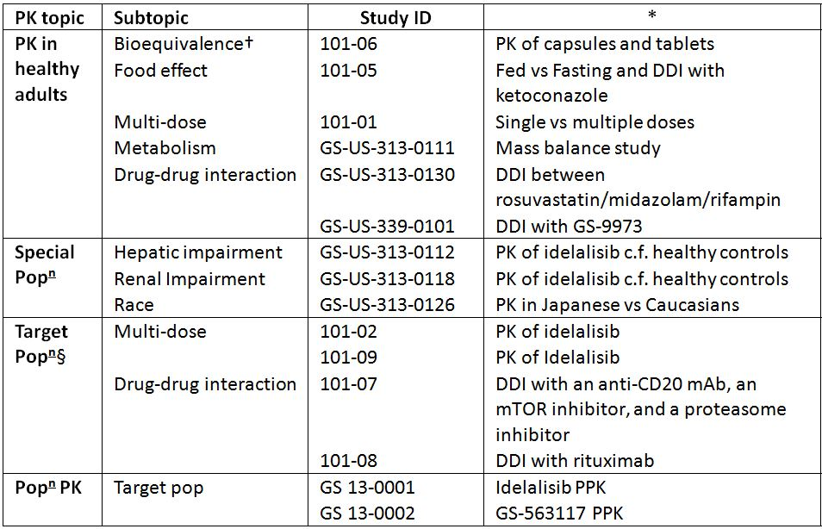

* Indicates the primary aim of the study.  
† Bioequivalence of different formulations.  
§ Subjects who would be eligible to receive the drug if approved for the proposed indication.

Table 2 lists pharmacokinetic results that were excluded from consideration due to study deficiencies.

Table 2: Pharmacokinetic results excluded from consideration.

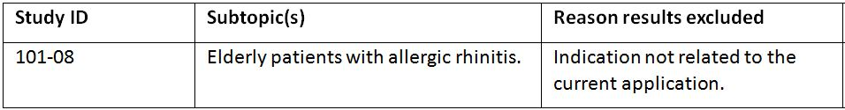

### Summary of pharmacokinetics

The information in the following summary is derived from conventional pharmacokinetic studies unless otherwise stated.

#### Analytical methods

A number of different analytical methods were used to determine the levels of idelalisib and GS - 563117 in plasma and urine in the various trials.

### Pharmacokinetics in healthy subjects

#### Sites and mechanisms of absorption

Following the administration of a 100 mg oral tablet dose of the to-be-marketed (TBM) formulation of idelalisib in healthy males, the median Tmax (range) of idelalisib was 1 h (0.5 – 4.0) and the mean Cmax, AUCinf and t1/2 of idelalisib were 1230 ng/mL, 6340 ng.h/mL and 7.76 h, respectively.

##### Bioavailability

###### Absolute bioavailability

No formal studies have examined the absolute bioavailability of idelalisib and the Sponsor has provided a “Justification for not providing Biopharmaceutic Studies”. In this section, the sponsor states that: “the results of a human mass balance study (GS-US – 313 - 0111) indicate that the bioavailability of Zydelig 150 mg is considered to be moderate to high, based on the fraction of dose recovered in the urine and faeces as intact drug and/or metabolites and that the clinical studies supporting these assessments have been submitted as part of this Category 1 Application.

Therefore based on Gilead’s thorough understanding of the clinical development programme, the bioavailability of Zydelig is considered to be moderate-to-high; an absolute bioavailability study for Zydelig was not deemed necessary and therefore not performed.”

In addition, in the Declaration of compliance with pre-submission planning form and planning letter, the sponsor states: “This justification has previously been accepted by the TGA for NCE’s in Gilead’s HIV and Hepatitis franchise.”

**Evaluator’s comment:** However, Appendix 15: Biopharmaceutic studies of the ‘Australian regulatory guidelines for prescription medicines’ states, that in preparing a justification, the sponsor should address at least the following issues, as applicable: the nature of the dosage form; the solubility of the active ingredient(s);the comparative dissolution profiles across the physiological pH range (1 - 7.5) of the products being considered; the pharmacokinetic characteristics of the active ingredient(s), such as permeability (or absolute bioavailability), linearity or otherwise, first pass effect (if any) and its significance; the clinical consequences of any potential differences in bioavailabilities of the products under consideration (for example, increased dose leading to toxicity or decreased dose leading to lack of efficacy; the width of the margin between the minimum effective and minimum toxic plasma concentration; the similarities of, or differences between, the formulations being considered. The evaluator believes that the current “Justification” as provided by the sponsor falls short of these requirements on a number of grounds and therefore believes the current “Justification” is not satisfactory.

###### Bioavailability relative to an oral solution or micronised suspension

Not applicable.

###### Bioequivalence of clinical trial and market formulations

As previously stated, three oral dosage forms were developed and used during the clinical evaluation of idelalisib: neat drug in capsule (CM), granulated powder in capsule (CG), and tablet. The bioequivalence of these three formulations was examined in Study 101 – 06 following a single 100 mg dose of each in 15 healthy males. For all three formulations, idelalisib median Tmax in plasma was 1 hour post-dose and the geometric mean t1/2 ranged between 7.67 and 8.20 hours. The geometric mean values for Cmax, AUC0-last and AUC0-inf for idelalisib plasma concentrations were higher following administration of 100 mg idelalisib administered as a CM compared to administration of the same dose of idelalisib administered as a tablet or CG. By contrast, the tablet and CG formulations were bioequivalent in regards to their AUC0-last  and AUCinf  for idelalisib and almost bioequivalent in regards to their Cmax with a geometric LS ratio (90% CI) of 0.91 (0.76 – 1.09).

###### Bioequivalence of different dosage forms and strengths

Not applicable.

###### Bioequivalence to relevant registered products

Not applicable

###### Influence of food

Study 101-05 examined the effect of food on idelalisib PK following a 400 mg capsule dose in healthy males under feed and fasted conditions. The geometric mean for Cmax was not different for idelalisib fasted and idelalisib fed; however, the geometric means for AUC0-last and AUC0-inf for idelalisib were approximately 40% higher after administration of 400 mg idelalisib under fed conditions compared to administration of the same dose of idelalisib under fasting conditions.

###### Dose proportionality

Study 101 - 01 examined the dose-proportionality of idelalisib following single doses of either: 17, 50, 125, 250 or 400 mg in healthy males. Following a single dose, the geometric mean values for idelalisib for Cmax, AUC0-inf and AUC0-t increased with dose across the dose range studied. Increases in idelalisib AUCinf were dose-proportional and the slope estimate (95% CI) was 0.91 (0.80 – 1.02), whereas, increases in Cmax were less than dose-proportional with a slope of 0.72 (0.60 – 0.84). The geometric mean t1/2 for plasma idelalisib ranged from 6.3 h to 9.5 h and the plasma concentrations of idelalisib were almost at baseline levels by 64 hours post-dose.

###### Bioavailability during multiple-dosing

Study 101 - 01 also examined dose –proportionality following 50, 100 and 200 mg idelalisib BD for 7 days. Following BD dosing on day 1 both the Cmax and AUC0-12 increased with dose, but the increases were less than dose proportional with slope estimate (95% CI) of 0.78 (0.47 – 1.1) and 0.87 (0.6 – 1.14), respectively. The geometric mean t1/2 for plasma idelalisib ranged from 5.5 h to 10.7 h. Accumulation after multiple doses of idelalisib (AUC0-12 on Day 7 over AUC0-12 on Day 1) ranged between 20 and 80 percent. The linearity over time as indicated by the ratio of AUC0-12 on Day 7 over AUC0-inf on Day 1 ranged between 1.07 and 1.70.

###### Effect of administration timing

Not examined.

##### Distribution

###### Volume of distribution

PPK analysis of idelalisib PKs (Study GS 13-0001) using data collected from 10 clinical studies (101 - 01, 101 - 02, 101 - 04, 101 - 05, 101 - 06, 101 - 07, 101 - 08, 101 - 09, 101 - 11, and 339 - 0101) identified that the plasma PK of idelalisib in the clinical dose range could be described by a two-compartment model. Therefore, for a typical patient, with a body weight of 75 kg, the estimated volumes of distribution for the central (Vc) and the peripheral compartments (Vp) were 22.7 L and 73.0 L, respectively. Idelalisib was absorbed at a typical rate of 0.48/h with a lag time of 0.25 hour.

###### Plasma protein binding

The mass balance study, Study GS-US – 313 – 0111, examined the blood-to-plasma ratio of radioactivity following a single oral dose of idelalisib 150 mg (containing tracer amounts of [14C]idelalisib) in eight healthy males. The mean whole blood-to-plasma concentration ratio of [14C]-radioactivity ranged from 0.4 to 0.6 throughout the 48 hours post-dose and was time-independent. Consistently, the mean whole blood-to-plasma AUCinf ratio was approximately 0.52.

In healthy subjects (Studies GS-US – 313 - 0112 and GS-US – 313 - 0118), idelalisib protein binding was approximately 93% to 94% and GS-563117 protein binding was approximately 99% at 3 hours post-dose following single oral administration of IDELA at 150 mg.

###### Erythrocyte distribution

See above.

###### Tissue distribution

The sponsor states that the distribution of idelalisib into compartments other than plasma (e.g., cerebrospinal fluid, genital tract secretions, and breast milk) has not been clinically evaluated.

##### Metabolism

###### Interconversion between enantiomers

Not applicable.

###### Sites of metabolism and mechanisms / enzyme systems involved

*In vitro* and *in vivo* studies in rats, dogs and humans (Studies AD – 312 - 2002, AD- 312 - 2004, and XT070008; m5.3.2.2, AD- 312 - 2015, AD- 312 - 2023, CAS- 2010 - 001 and XT070003) have identified that idelalisib is primarily metabolised via oxidation in the liver where aldehyde oxidase converts idelalisib to its major circulating plasma metabolite, GS- 563117. To a lesser extent, idelalisib is also metabolised through oxidation by CYP3A and glucuronidation by UGT1A4.

###### Non-renal clearance

The mass balance study GS-US- 313 - 0111 examined the metabolite profile of idelalisib following administration of a single oral dose of 150 mg [14C]idelalisib in serial blood (whole blood and plasma), urine, and faecal samples from 8 healthy males; in this study, 78% of the radioactive dose was recovered in faecal samples over a 240 h period following dosing.

##### Metabolites identified in humans

###### Active metabolites

There are no circulating metabolites of idelalisib that have activity at PI3Kδ; however, GS- 563117, the primary and only circulating metabolite of idelalisib has been shown to be a weak inhibitor of UGT1A1 (at concentrations above systemic exposures observed clinically)and moderate time-dependent inhibitor of CYP3A (see the section on PK interactions of this report for further details).

###### Other metabolites

In plasma, the only 2 circulating species identified were idelalisib (32%) and GS- 563117 (62%). In urine, total radioactivity consisted primarily of idelalisib (23%) and GS- 563117 (49%) and several trace metabolites were also observed (allantoin: 9.9% and M44: 4.8%). In faeces, radioactivity was accounted for mainly by idelalisib (11.5%), GS- 563117 (43.9%), and other oxidation products (M52: 5.8%; M66A/M66B: 4.4%; M36A/M36B: 5.3%).

**Evalutator’s comments:** Based on the plasma AUC0-24 data presented, as stated above, the total plasma radioactivity that can be attributed to idelalisib and GS-563117 is 94%; however, the sponsor states that the total radioactivity of these 2 components adds to 100%. The sponsor has been requested to justify this discrepancy.

###### Pharmacokinetics of metabolites

Following a single dose of 150 mg idelalisib in the mass balance study (Study GS-US- 313 - 0111), the plasma Cmax, AUCinf, Tmax and t1/2 of GS- 563117 were 2267.5 ng/mL, 25836.6 ng.h/mL, 2.77 h and 8.77 h, respectively.

###### Consequences of genetic polymorphism

Studies have identified the presence of functionally inactive hAOX1 allelic variants (the single gene that encodes aldehyde oxidase in humans) as well as variants encoding enzymes with different catalytic activities.2 In addition, polymorphisms in the CYP3A4 and UGT1A4 genes have also been identified that affect the activity of both enzymes.3,4 Therefore, genetic polymorphisms that occur in any of these genes may significantly affect the metabolism of idelalisib in humans.

#### Excretion

Following a single 150 mg dose of idelalisib the t1/2 values for idelalisib and GS- 563117 were 5.74 h and 8.77 h, respectively.

##### Routes and mechanisms of excretion

Quantifiable levels of [14C]-radioactivity were observed for up to 48 hours following administration of [14C]-idelalisib 150 mg. Following single oral dose of 150 mg, predominant routes of excretion were in faeces (75%) and urine (14%).

##### Mass balance studies

See above.

##### Renal clearance

The mean cumulative urinary recovery over 240 h following a 150 mg dose of radioactive idelalisib was 14.4%.

#### Intra- and inter-individual variability of pharmacokinetics

The inter-subject variability in idelalisib Cmax, AUCinf and t1/2 following a 100 mg oral tablet dose was 37%, 33% and 17%, respectively.

The estimated intra- and inter-individual variabilities in idelalisib clearance (CL) for a typical individual were 53.5% and 38.2%, respectively. The PPK study, GS13 – 0002, which represented a meta-analysis of data collected from six clinical trials, predicted that for GS- 563117 these values were 34.8% and 49.5%, respectively.

#### Pharmacokinetics in the target population

The PK of idelalisib in the target population was primarily investigated in Study 101 - 02, which was a Phase I study that examined the PK after a range of idelalisib doses given either once daily (150 mg or 300 mg) or BD (50 mg, 100 mg, 150 mg, 200 mg or 350 mg) in 21 day cycles in patients with confirmed relapsed or refractory CLL, NHL, AML, or MM. Of the 191 patients enrolled, only 50 subjects completed the study (12 cycles of 28 days each for a total of 48 weeks) with disease progression being the predominant reason for withdrawal from the study (n = 88). Cmax and AUC0-6 were assessed following the first day (i.e. a single dose) and following 28 days (multiple-doses) and indicated that there was comparable exposure, which was consistent with minimal/modest idelalisib accumulation. The geometric mean Cmax and AUC0-6 values for Day 1 and Day 28 increased in a less than dose-proportional manner.

A number of other studies also examined idelalisib PK in the target population, providing support to the findings of Study 101 - 02. The first of these, Study 101 - 07 examined the Cmax, Tmax and AUC0-6 following a single dose of either 100 or 150 mg idelalisib. The Cmax and AUC values following the 100 mg dose were 1423 ng/mL and 4983 ng.h/mL, respectively, and for the 150 mg dose were 2376 ng/mL and 6437 ng.h/mL, respectively. Study 101 - 09 examined the PK parameters of idelalisib and GS-563117 following a single dose and multiple doses of 150 mg idelalisib BD in subjects with refractory iNHL. Idelalisib Cmax and AUC following a single dose were 2648 ng/mL and 10639 ng.h/mL respectively, whereas, following multiple doses were 2259 ng/mL and 9586 ng.h/mL respectively. For GS-563117 the Cmax and AUC were 2301 ng/mL and 19004 ng.h/mL, respectively, following a single dose and were 3963 ng/mL and 38866 ng.h/mL, respectively, following multiple dosing.

Using PPK modelling and plasma exposure data from Study 101 - 02, which examined the PKs of idelalisib following multiple-dose administration of idelalisib (BD or once daily) over a dose range of 50 to 350 mg in patients with relapsed or refractory haematological malignancies, steady-state idelalisib exposures were investigated. The multiple-dose Cmax, Ctau, and AUCtau of idelalisib increased in a less than dose-proportional manner over the dose range, with only modest increases in exposure observed above the dose level of 150 mg BD. Compared with idelalisib 150 mg BD, dosing at 350 mg BD provided approximately 54%, 48%, and 54% higher values for idelalisib Cmax, Ctau and AUCtau, respectively.

#### Pharmacokinetics in other special populations

##### Pharmacokinetics in subjects with impaired hepatic function

As idelalisib is primarily metabolised by aldehyde oxidase in the liver, Study GS-US- 313 - 0112 evaluated the PK of idelalisib and its metabolite GS- 563117 in subjects with impaired hepatic function relative to matched, healthy controls following a single oral dose of 150 mg administered with food. Idelalisib Cmax was slightly lower in the subjects with moderate (CPT Score B) or severe (CPT Score C) hepatic impairment relative to normal matched control subjects, whereas, AUC was higher (by 58% to 60%). Tmax occurred later in the subjects with hepatic impairment (at 2 vs 4 h) and surprisingly, given that increased exposure is often accompanied by an increase in t1/2, it was shorter (e.g. 7.73 h in healthy subjects and 6.21 h in subjects with severe hepatic impairment); however, there was considerable overlap in the interquartile range. GS- 563117 exposures (AUC and Cmax) were significantly lower in subjects with moderate and severe hepatic impairment relative to matched healthy control subjects and Tmax was increased, yet the t1/2 was not affected.

##### Pharmacokinetics in subjects with impaired renal function

**Study GS-US- 313 - 0118** evaluated the PK of idelalisib and its metabolite GS-563117 in subjects with severe renal impairment relative to matched, healthy controls following a single oral dose of 150 mg administered with food. Following a single oral dose of 150 mg idelalisib, idelalisib AUClast, AUCinf and Cmax geometric least-squares mean ratios were 127%, 127%, and 105%, respectively in subjects with severe renal impairment relative to matched, healthy control subjects. For GS- 563117 AUClast, AUCinf, and Cmax geometric least-squares mean ratios were 124%, 124%, and 96%, respectively in subjects with severe renal impairment relative to matched, healthy control subjects.

##### Pharmacokinetics according to age

Of the 736 subjects included in the PPK analysis, 406 subjects (55%) were <65 years, 239 subjects (33%) were 65 to 75 years, and 91 subjects (12%) were >75 years. The analyses indicated that idelalisib and GS- 563117 exposure was not influenced by the age of the subject.

##### Pharmacokinetics related to genetic factors

Not examined.

##### Pharmacokinetics in other special populations

###### Effect of gender

Approximately 30% of subjects in the study populations used for PPK analyses were female. The results indicated that gender did not affect the subject’s exposure to either idelalisib or GS-563117 in male versus female subjects and nor was it a clinically relevant covariate.

###### Race

**Study GS-US- 313 - 0126** investigated the PK of idelalisib and GS- 563117 following a single 150 mg dose of idelalisib in healthy Japanese and Caucasian subjects. Idelalisib Tmax occurred later in Caucasian than in Japanese subjects (2.75 h vs 1.25 h), whereas, the AUC0-last, AUCinf, and Cmax values of idelalisib were higher (22%, 23%, and 28%, respectively) in Japanese compared to Caucasian subjects. Similarly, GS- 563117 Tmax occurred later in Caucasians than in Japanese subjects (3.5 vs 2.0 h) and exposure was also higher in Japanese than in Caucasian subjects.

###### Effect of body weight

The effect of body weight, BMI, and body surface area were considered during the covariate assessment in the population PK analyses. Although body weight was identified as a covariate in the final idelalisib PPK model, it did not influence the PK of GS- 563117.

#### Pharmacokinetic interactions

##### Pharmacokinetic interactions demonstrated in human studies

Study GS-US- 313 - 0130 evaluated the effect of 150 mg idelalisib on cytochrome P450 (CYP)3A using midazolam and rifampicin, the drug transporters P-glycoprotein (P-gp) using digoxin and organic anion transporting polypeptides (OATP1B1 and OATP1B3) using rosuvastatin. Although the Cmax of digoxin (a substrate for P-gp that is not metabolised by CYP3A4) was 24% higher when given in combination with idelalisib 150 mg BD compared to when it was given alone, there was little difference in digoxin AUClast or AUCinf when given in combination with idelalisib; this suggests that idelalisib does not have a clinically significant effect on inhibition of P-gp or impact on digoxin PK. Co-administration of rosuvastatin (an OATP1B1 and OATP1B3 substrate) with idelalisib had no effect on rosuvastatin AUC or Cmax indicating that idelalisib did not inhibit BCRP or OATP1B1/1B3 or impact on rosuvastatin PK. By contrast, co-administration of midazolam (a CYP3A4substrate) with idelalisib resulted in significant increases in midazolam Cmax, AUClast, and AUCinf (by 138%, 355%, and 437%, respectively) compared to when it was given alone. Correspondingly, co-administration of midazolam with idelalisib resulted in decreased exposures of 1´-OH-midazolam, overall indicating significant inhibition of CYP3A activity by idelalisib and/or its metabolite. When idelalisib was co-administered with the CYP3A inducer rifampicin the Cmax and AUCinf values for both idelalisib and GS- 563117 were significantly reduced suggesting that CYP3A is an important mediator of the metabolism of both the parent molecule and its metabolite.

A second objective of Study 101 - 05 was to determine the PKs of idelalisib when administered concomitantly with ketoconazole (a CYP3A4 inhibitor) in healthy males. The geometric mean for Cmax was approximately 26% higher and the geometric means for AUCs were approximately 80% higher, after administration of 400 mg idelalisib following 4 days of ketoconazole treatment, compared to administration of 400 mg idelalisib alone. This was confirmed by ANOVA results: treatment ratios for Cmax, AUC0-last and AUC0-inf for idelalisib were 1.26 (90% CI: 1.04-1.51), 1.83 (90% CI: 160-2.09), and 1.79 (90% CI: 1.57-2.04), respectively. Inhibition of CYP3A4 by ketoconazole resulted in higher exposure of idelalisib, indicating that idelalisib is a CYP3A4 substrate *in vivo*.

Study GS-US- 339 - 0101 examined the PKs of idelalisib and GS-9973, a selective inhibitor of spleen tyrosine kinase (Syk), which is an essential mediator of B-cell receptor signalling in normal and transformed B-cells, following administration of each drug alone and in combination in healthy subjects. Compared to GS- 9973 administered alone at 200 or 600 mg BD under fed condition, the primary exposure parameters of GS-9973 (AUCtau, Cmax, and Ctau) were increased when idelalisib was co-administered at 100 or 150 mg BD. The increase of AUCtau, Cmax, and Ctau were 51 - 64%, 38 - 50%, and 74 - 96%, respectively. By contrast, compared to idelalisib administered alone at 100 or 150 mg BD under fed condition, idelalisib AUCtau and Cmax were similar to when GS- 9973 was co-administered at 200 or 600 mg BD, whereas, there was a modest change of Ctau (23 - 33%). Consistent with the lack of change in the PK of the parent compound, GS- 563117 AUCtau, Cmax, and Ctau following idelalisib administration alone were similar to those when GS- 9973 was co-administered at 200 or 600 mg BD.

The Phase II study, Study 101 - 08 examined plasma exposures of idelalisib in elderly subjects with previously untreated CLL or SLL when combined with rituximab, a monoclonal antibody for the CD20 protein, which is primarily found on the surface of immune system B-cells and is used in the treatment of NHL and CLL. However, as idelalisib was not given alone in this study the interaction with rituximab could not be determined.

##### Clinical implications of in vitro findings

*In vitro* studies (AD- 312 - 2017, 13558, 13567, AD- 312 - 2016, AD- 312 - 2018, AD- 312 - 2019 and AD- 312 - 2024) using pooled human hepatic microsomal fractions or recombinant human enzymes demonstrated that idelalisib did not inhibit CYP1A, CYP2B6, CYP2C9, and CYP2D6 (IC50s > 25 - 100 µM) and weakly inhibited CYP2C8 (IC50 = 13 µM), CYP2C19 (76 µM), CYP3A (44 µM), and UGT1A1 (42 µM). GS-563117 did not inhibit CYP1A2, CYP2B6, CYP2C9, and CYP2D6 (IC50s > 90 µM) and weakly inhibited CYP2C8 (40 µM), CYP2C19 (60 µM) and CYP3A (5 – 17 µM).

Further *in vitro* studies (400571, AD- 312 - 2005, AD- 312 - 2011, AD- 312 - 2012 and OPT- 2010 - 087), investigated the potential for idelalisib and GS - 563117 to inhibit transporters in Caco-2 monolayers or cell lines recombinantly expressing individual transporter proteins in the presence of transporter-specific substrates. GS - 563117 did not significantly affect the intestinal transporters P-gp and BCRP, hepatic uptake transporters OATP1B1 and OATP1B3 and renal uptake transporters organic anion transporter (OAT) 1, OAT3, and organic cation transporter (OCT) 2. Similarly, idelalisib did not affect the transporters BCRP, OCT2, OAT1, and OAT3; however, idelalisib did inhibit P-gp (IC50 = 7 µM), OATP1B1 (10 µM) and OATP1B3 (7 µM).

The potential for idelalisib and GS - 563117 to induce drug metabolising enzymes and transporters was evaluated using primary human hepatocytes in Study AD – 312 - 2008. Idelalisib was a weak inducer of CYP2B6, CYP3A4, CYP2C8, CYP2C9, P-gp, UGT1A1, and UGT1A4, whereas, it showed no potential to induce CYP1A2, CYP2C19, or aldehyde oxidase. By contrast, GS-563117 did not induce CYP1A2, CYP2B6, CYP3A, CYP2C8, CYP2C9, CYP2C19, P-gp, UGT1A1, UGT1A4, or aldehyde oxidase.

The potential for idelalisib and GS - 563117 to be substrates for efflux- or uptake-transporters was determined by measuring efflux in cell lines recombinantly expressing individual transporters (Studies 400571, AD – 312 - 2006 and OPT- 2010 - 124) or by comparing rates of uptake in cell lines recombinantly expressing individual transporters and in untransfected controls in the presence or absence of transporter-specific inhibitors (Studies AD- 312 - 2010 and OPT- 2010 - 124). These studies demonstrated that idelalisib was a substrate for the efflux transporters P-gp and BCRP, but not the renal transporters OCT2, OAT1, and OAT3 or the hepatic uptake transporters OATP1B1 and OATP1B3. GS-563117 was a substrate for P-gp and BCRP, but not OATP1B1 and OATP1B3.

### Evaluator’s overall conclusions on pharmacokinetics

#### Absorption

* Following the administration of a 100 mg oral tablet dose of the to-be-marketed formulation of idelalisib in healthy males, the Tmax of idelalisib was 1 h and the Cmax, AUCinf and t1/2 of idelalisib were 1230 ng/mL, 6340 ng.h/mL and 7.76 h, respectively.
* No formal studies have examined the absolute bioavailability of idelalisib and the sponsor has provided a “Justification for not providing Biopharmaceutic Studies”. However, the evaluator believes this justification is not sufficient under the Australian regulatory guidelines for prescription medicines**.**

#### Bioequivalence

* The to-be-marketed tablet formulation and the capsule formulation used in the Phase II and III studies were bioequivalent in regards to their AUC0-last and AUCinf for idelalisib and almost bioequivalent in regards to their Cmax with a geometric LS ratio (90% Confidence Interval [CI]) of 0.91 (0.76-1.09).

#### Food

* Following a 400 mg dose the Cmax of idelalisib was similar under fasted and fed conditions, whereas the AUC0-last and AUC0-inf for idelalisib were approximately 40% higher under fed conditions. Idelalisib can be administered without regard to food.

#### Dose proportionality and accumulation

* Following a single dose, idelalisib Cmax, AUCinf and AUC0-t increased with dose and increases in idelalisib AUCinf were dose proportional, while increases in Cmax were less than dose proportional. Following bis in die (BD, twice daily) dosing, the Cmax and AUC0-12 increased with dose, but the increases were less than dose proportional. Accumulation after multiple doses of idelalisib (AUC0-12 on Day 7 over AUC0-12 on Day 1) ranged between 20 and 80 percent.

#### Distribution

* Population pharmacokinetic analysis identified that the plasma pharmacokinetics of idelalisib in the clinical dose range could be described by a two compartment model and predicted, for a typical healthy subject or patient, that the volumes of distribution for the central and the peripheral compartments were 22.65 L and 72.97 L, respectively. Mean whole blood-to-plasma concentration ratio of [14C]-radioactivity ranged from 0.4 to 0.6 throughout the 48 h post dose and was time independent. The sponsor states that the distribution of idelalisib into compartments other than plasma has not been examined. Idelalisib protein binding was 93-94%.

#### Metabolism and excretion

* *In vitro* and *in vivo* studies in rats, dogs and humans have identified that idelalisib is primarily metabolised via oxidation in the liver where aldehyde oxidase converts idelalisib to its major circulating plasma metabolite, GS-563117. To a lesser extent, idelalisib is also metabolised through oxidation by CYP3A and glucuronidation by UGT1A4. In plasma, the only two circulating species identified were idelalisib (32%) and its primary inactive metabolite GS-563117 (62%).
* The mass balance study identified that 78% of the radioactive dose was recovered in faecal samples and 14.4% in urine samples over a 240 h period following dosing. In urine, total radioactivity consisted primarily of idelalisib (23%) and GS-563117 (49%) and several trace metabolites. In faeces, radioactivity was accounted for mainly by idelalisib (11.5%), GS-563117 (43.9%), and other oxidation products.
* Following a single 150 mg dose of idelalisib, the t1/2 values for idelalisib and GS-563117 were 5.74 h and 8.77 h, respectively.

#### Variability

* The inter subject variability in idelalisib Cmax, AUCinf and t1/2 following a 100 mg oral tablet dose was 37%, 33% and 17%, respectively.
* The estimated intra and inter individual variabilities in idelalisib clearance for a typical individual were 53.5% and 38.2%, respectively. For GS-563117, these values were 34.8% and 49.5%, respectively.

#### PKs in target population

* In the target population the Cmax and AUC0-6 values following a single dose and following 28 days of multiple dosing indicated that there was comparable exposure, which was consistent with minimal/modest idelalisib accumulation. The geometric mean Cmax and AUC0-6 values for Day 1 and Day 28 increased in a less than dose-proportional manner.

#### PKs in hepatic and renal impairment

* Idelalisib Cmax was slightly lower in subjects with moderate or severe hepatic impairment relative to normal matched control subjects, while AUC was higher (by 58% to 60%). Tmax occurred later in the subjects with hepatic impairment; however, there was little to no change in t1/2. By contrast, GS-563117 exposures (AUC and Cmax) were significantly lower in subjects with moderate and severe hepatic impairment relative to matched healthy control subjects. Severe renal impairment had little effect on the pharmacokinetics of idelalisib or GS-563117 (for example, approximately 25% increase in AUCinf).

#### Effect of age, gender, race, body weight on idelalisib PKs

* Population pharmacokinetic analyses indicated that age and gender did not affect the pharmacokinetics of idelalisib or GS-563117, while idelalisib Tmax occurred later in healthy Caucasian than in Japanese subjects (2.75 h versus 1.25 h). The AUC0-last, AUCinf, and Cmax values of idelalisib were higher (22%, 23%, and 28%, respectively) in Japanese subjects. Similarly, GS-563117 Tmax occurred later in Caucasians than in Japanese subjects (3.5 versus 2.0 h), while exposure was higher in Japanese subjects. Body weight was identified as a covariate in the final idelalisib population pharmacokinetic model; however, it did not influence the pharmacokinetics of GS-563117.

#### Drug interactions

* Co-administration of 150 mg idelalisib did not affect the pharmacokinetics of drugs that were substrates of P-gp (digoxin) or OATP1B1/ OATP1B3 (rosuvastatin).
* By contrast, co-administration of midazolam (a CYP3A4 substrate) with idelalisib resulted in significant increases in midazolam Cmax, AUClast, and AUCinf (by 138%, 355%, and 437%, respectively) and decreased exposure to 1’-OH-midazolam compared to when it was given alone, indicating significant inhibition of CYP3A activity by idelalisib and/or its metabolite.
* When idelalisib was co-administered with the CYP3A inducer rifampicin, the Cmax and AUCinf values for both idelalisib and GS-563117 were significantly reduced, suggesting that CYP3A is an important mediator of the metabolism of both the parent molecule and its metabolite.
* Co-administration of idelalisib with ketoconazole (a CYP3A4 inhibitor) resulted in an increase in idelalisib Cmax and AUC by 26% and 80%, respectively, indicating that idelalisib is a CYP3A4 substrate *in vivo*.
* The AUCtau, Cmax, and Ctau of GS-9973 were increased 51-64%, 38-50%, and 74-96% when it was co-administered with idelalisib at 100 or 150 mg BD compared to when it was administered alone. By contrast, co-administration of GS-9973 did not significantly affect the PKs of idelalisib.

#### Limitations of the PK data

* The justification for not submitting biopharmaceutical studies did not address all of the requirements as per TGA guidelines.
* Based on the plasma AUC0-24 data presented, the total plasma radioactivity that can be attributed to idelalisib and GS-563117 is 94%; however, the sponsor states in the Summary of Clinical Pharmacology Studies that the total radioactivity of these two components adds to 100%. Can the sponsor please justify this discrepancy? If not, what does the 6% difference in total radioactivity represent?
* The oral clearance (CL/F) of idelalisib was not reported for patients with either hepatic or renal impairment as required per the TGA adopted EMA guidelines.
* One of the secondary objectives of the Phase III Study GS-US-312-0116 was to characterise the effect of rituximab on idelalisib exposure through evaluations of idelalisib plasma concentrations over time. Information relating to this objective was not available at the time of submission.
* Similarly, the drug-drug interaction data from Study 101-07, which examines the interaction of idelalisib with an anti CD20 monoclonal antibody, a chemotherapeutic agent, a mammalian target of rapamycin (mTOR) inhibitor, and/or a proteasome inhibitor, has not been provided for evaluation.

## Pharmacodynamics

### Studies providing pharmacodynamic data

Table 3 shows the studies relating to each pharmacodynamic topic and the location of each study summary.

Table 3: Submitted pharmacodynamic studies.

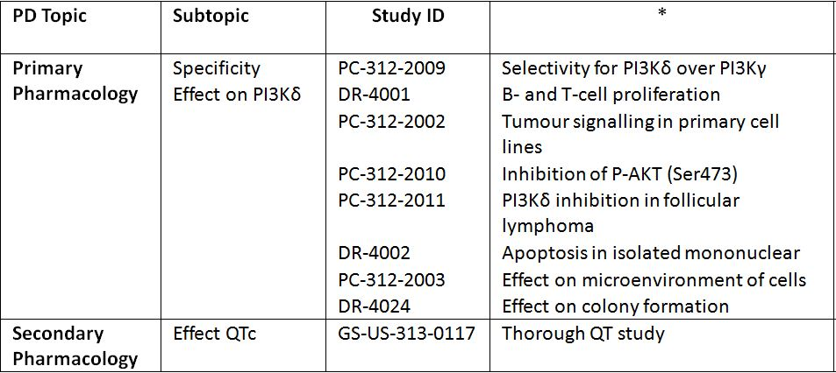

* Indicates the primary aim of the study.  
§ Subjects who would be eligible to receive the drug if approved for the proposed indication.  
‡ And adolescents if applicable.

None of the pharmacodynamic studies had deficiencies that excluded their results from consideration.

### Summary of pharmacodynamics

The information in the following summary is derived from conventional pharmacodynamic studies in humans unless otherwise stated.

#### Mechanism of action

Idelalisib inhibits PI3Kδ kinase, which is hyperactive in B-cell malignancies and is central to multiple signalling pathways that drive proliferation, survival, homing, and retention of malignant cells in lymphoid tissues and bone marrow. Idelalisib is a selective inhibitor of adenosine-5’-triphosphate (ATP) binding to the catalytic domain of PI3Kδ, resulting in inhibition of the phosphorylation of the key lipid second messenger phosphatidylinositol (PIP) and prevention of Akt phosphorylation.

Idelalisib induces apoptosis and inhibits proliferation in cell lines derived from malignant B-cells and in primary tumour cells**.** Idelalisib inhibits homing and retention of malignant B-cells in the tumour microenvironment including lymphoid tissues and the bone marrow.

#### Pharmacodynamic effects

##### Primary pharmacodynamic effects

###### In vitro

Selectivity of idelalisib for PI3Kδ over PI3Kγ

Study PC- 312 - 2009 investigated the potency of idelalisib to inhibit PI3Kδ and PI3Kγ in basophils isolated from the blood of 54 human adult blood donors. In this study, idelalisib blocked PI3Kδ-dependent, anti-FcεRI-induced activation of human basophils in a dose dependent manner with an EC50 value of 39 nM. By contrast, the EC50 of idelalisib for fMLP–stimulated, PI3Kγ-dependent basophil activation was 2833 nM.

Ability to block PI3Kδ kinase-dependent pathways

A number of *in vivo* studies (Studies DR - 4001, PC – 312 - 2002, PC – 312 - 2010, C- 312 - 2011, DR- 4002, PC- 312 - 2003 and DR- 4024) examined the ability of idelalisib to inhibit PI3Kδ kinase-dependent pathways such as the proliferation in human B- and T-cells, which had been isolated from human peripheral blood mononuclear cells and the growth and survival of tumour cell lines derived from B-cell malignancies and of primary tumour and isolated mononuclear cells attained from patients with chronic lymphocytic leukaemia (CLL) and mantle cell lymphoma (MCL).

These studies demonstrated that:

* Idelalisib blocked both B-cell receptor (BCR) induced B-cell proliferation and T-cell receptor (TCR) induced T-cell proliferation in a dose-dependent manner with EC50 values of 6 nM and 973 nM, respectively. In addition, fMLP-mediated elastase exocytosis was inhibited by idelalisib in a dose-dependent manner with an EC50 of 119 nM.
* In patient-derived CLL and MCL malignant B-cells, constitutive levels of pAktT308 were significantly reduced (by 60%) following 100 nM idelalisib. It was further demonstrated that p110δ-dependent PI3K pathway activation occurred via S473 phosphorylation and that idelalisib completely inhibited pAktS473 induction.
* Idelalisib-mediated inhibition of PI3Kδ induced apoptosis in a range of human cells lines, including B-cells and bone marrow mononuclear cells.
* B-cell viability as measured by alamarBlue assay, an assessment of metabolic activity, was strongly and significantly reduced in presence of idelalisib.
* Idelalisib interrupted B-cell cycle as treatment with 0.5 and 5 µM idelalisib resulted in an increased proportion of B-cells in the G1 phase of the cell cycle and a corresponding decrease in cells in S and G2/M.
* Idelalisib inhibits B-cell mediated secretion of chemokines CCL3, CCL4 and CXCL13.
* Idelalisib inhibited colony formation in megakaryocytic as well as myeloid progenitors in semisolid methylcellulose colony formation assays.

###### Ex vivo

Study 101 - 01 examined the ability of idelalisib to inhibit basophil activation, as measured by the CD63 marker, following stimulation of whole blood *ex vivo* with antibodies for FCeR1 and fMLP. The results indicated that idelalisib inhibited basophil activation induced by anti-FCeR1 on Days 1, 3 and 7 following dosing with the extent of inhibition ranging from 55% to 80% of pre-dose. By contrast, in the placebo subjects over the same time period, basophil activation was either similar to or higher than pre-dose levels. There was no apparent inhibitory effect of idelalisib on basophil activation following stimulation with fMLP. Therefore, a clear correlation between the extent of exposure to idelalisib and inhibition of basophil stimulation could not be established.

Study 101 - 02 examined the effect of idelalisib on constitutive PI3K pathway activation in peripheral blood mononuclear cells obtained from subjects with CLL. Following 8 and 28 days of dosing with either 100 mg or 150 mg idelalisib BD, the constitutive phosphorylation of Akt in cells from subjects with CLL was reduced to the background level of healthy volunteers.

##### Secondary pharmacodynamic effects

Study GS-US – 313 - 0117 was a thorough QT study, which examined the effects of idelalisib (at therapeutic and supratherapeutic doses) and metabolite GS - 563117 on time-matched, baseline-adjusted, placebo-corrected QT interval corrected for heart rate calculated using Fridericia correction (QTcF) in 48 healthy subjects. In contrast to moxifloxacin, idelalisib did not prolong QTcF as the upper bounds of the 2-sided 90% CIs for the mean baseline-adjusted difference between therapeutic or supratherapeutic doses of idelalisib versus placebo were below 10 msec at all-time points after dosing. In addition, results from the analyses of secondary endpoints QTcB, QTcN, and QTcI were consistent with those from the primary analysis.

##### Time course of pharmacodynamic effects

Maximal inhibition of basophil activation occurred 1.5 h following idelalisib administration and this effect continued for at least 4 hours post-dose.

Following doses of 100 mg or 150 mg idelalisib BD in healthy women (Study GS-US-339-0101), CD63 expression was decreased following both 1 and 4 days of dosing with greater inhibition observed following 4 days of dosing. Maximal mean inhibition of CD63+/CD123+HLA- cells peaked at 2 hours post-dose.

#### Relationship between drug concentration and pharmacodynamic effects

Following dosing with either 100 mg or 200 mg idelalisib the inhibition of CD63 was concentration-dependent (Study GS-US- 339 - 0101). By contrast, a clear correlation between the extent of exposure to idelalisib and inhibition of basophil stimulation could not be established based on the available data (Study 101 - 01) and there were no clinically relevant relationships between time-matched, baseline-adjusted, placebo-corrected QTcF and idelalisib or GS - 563117 plasma concentrations (Study GS-US- 313 - 0117).

#### Genetic-, gender- and age-related differences in pharmacodynamic response

Not examined.

#### Pharmacodynamic interactions

Study GS-US – 339 - 0101 evaluated the ability of GS - 9973 and idelalisib, each administered alone and in combination following multiple-dose administration in healthy female subjects. Co-administration of GS 9973 and idelalisib led to a greater inhibition of CD63 than either drug was able to achieve when given alone. Under the same conditions, phospho-SYK (Y525) was inhibited by treatment with GS 9973, but not idelalisib, whereas, there was a moderate increase in inhibition of phosphor SYK (Y525) when GS 9973 was co-administered with idelalisib.

### Evaluator’s overall conclusions on pharmacodynamics

* Idelalisib is a selective inhibitor of adenosine-5’-triphosphate (ATP) binding to the catalytic domain of PI3Kδ, resulting in inhibition of the phosphorylation of the key lipid second messenger phosphatidylinositol (PIP) and prevention of Akt phosphorylation, in particular pAktS473 induction.

#### Primary PD effects

* Idelalisib induces apoptosis and inhibits cell viability, basophil activation and proliferation in cell lines derived from malignant B-cells and in primary tumour cells.In addition, idelalisib inhibits homing and retention of malignant B-cells in the tumour microenvironment including lymphoid tissues and the bone marrow. Idelalisib has also been shown to interrupt B-cell cycle and inhibit the secretion of chemokines.
* Idelalisib inhibits the constitutive phosphorylation of Akt in cells from subjects with CLL to the levels seen in healthy volunteers.
* CD63 expression was decreased following both 1 and 4 days of dosing with idelalisib with greater inhibition observed following 4 days of dosing. Maximal mean inhibition of CD63+/CD123+HLA- cells peaked at 2 hours post-dose.

#### Secondary PD effects

* In contrast to moxifloxacin, therapeutic or supratherapeutic doses of idelalisib did not prolong QTcF, QTcB, QTcN or QTcI.
* Following dosing with either 100 mg or 200 mg idelalisib, the inhibition of CD63 was a concentration-dependent. By contrast, there was no correlation between the extent of exposure to idelalisib and inhibition of basophil stimulation or change in QTc.
* PD drug interactions: Co-administration of GS 9973 and idelalisib led to a greater inhibition of CD63 than either drug was able to achieve when given alone. When given alone idelalisib had no effect on phospho-SYK (Y525) but it moderately potentiated the effects of GS 9973 on this pathway.

#### Limitations of PD data

* If it is now available, could the sponsor please provide the PD data relating to Studies 101 - 07, 101 - 08, 101 - 09, 101 - 10 and 101 - 11.
* Genetic-, gender- and age-related differences in PDs were not examined.

## Dosage selection for the pivotal studies

The clinical dosage of 150 mg idelalisib was initially determined based on the results of a Phase 1 study (101 - 02), which examined the PK following idelalisib doses of 50, 100, 150, 200, or 350 mg BD. or 150 or 300 mg once daily administered as monotherapy to subjects with relapsed or refractory hematologic malignancies.

In this study, idelalisib exposure increased in a less than dose-proportional manner; and the different dosing frequencies (i.e. once daily vs BD) varied the shape of the concentration-time curves and the associated PK parameters used in exposure-response analyses. Tumour response was also assessed based upon the change in tumour size (SPD). In addition, in a subgroup of subjects with iNHL, predicted idelalisib exposures based on PPK modelling were evaluated against SPD to assess the exposure-efficacy relationship.

In the iNHL subgroup, over a wide dose/exposure range, median SPD response increased over the quartiles of idelalisib Ctau and reached a plateau at/above the second quartile (Q2) (Figure 1). Idelalisib 150 mg BD. provided exposures (Ctau: 349 ng/mL) encompassed by the third exposure quartile (Ctau range in Q3: 280-405 ng/mL), corresponding to this plateau of high exposure-response and well above the EC90 for PI3Kδ inhibition (~125 ng/mL or 301 nM). At the same total daily dose, idelalisib BD. treatment delivered higher Ctau than once-daily dosing, whereas, the AUC0-24 values following idelalisib 150 mg BD. and 300 mg once daily were comparable (median Ctau of 349 and 167 ng/mL and AUC0-24 of 19,600 and 16,300 ng.h/mL, respectively)

Figure 1: Study 101-02 exposure-efficacy relationship: box plot of the sum of products of the greatest perpendicular diameters of index lesions stratified by quartile of idelalisib Ctau in subjects with iNHL.

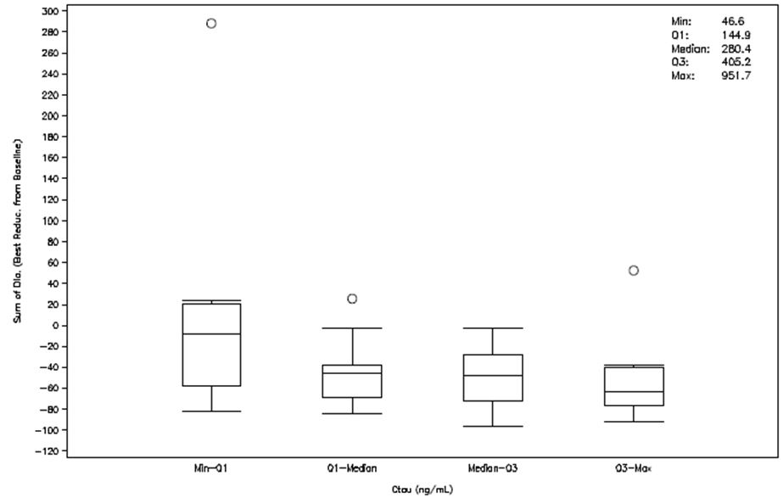

Comparison of SPD response in the BD. versus once-daily regimens indicated that efficacy was best associated with idelalisib trough concentrations. Therefore, 150 mg BD was chosen for further evaluation in clinical studies (including Study 101 - 09) as it would provide a mean Ctau above the EC90 for PI3Kδ inhibition and should demonstrate robust efficacy.

In CLL subjects the exposure-response relationship was similar to that observed in iNHL subjects (Figure 2). Across all quartiles of idelalisib exposure SPD reductions of >50% were identified and SPD response plateaued over the third quartile of idelalisib Ctau. Idelalisib 150 mg BD. provided exposures (Ctau: 349 ng/mL) in CLL subjects encompassed by the third exposure quartile (Ctau range in Q3: 295 - 437 ng/mL) and corresponded to the plateau phase of exposure-response that was observed in subjects with iNHL.

Figure 2: Study 101-02 exposure-efficacy relationship: box plot of the sum of products of the greatest perpendicular diameters of index lesions stratified by quartile of idelalisib Ctau in subjects with CLL.

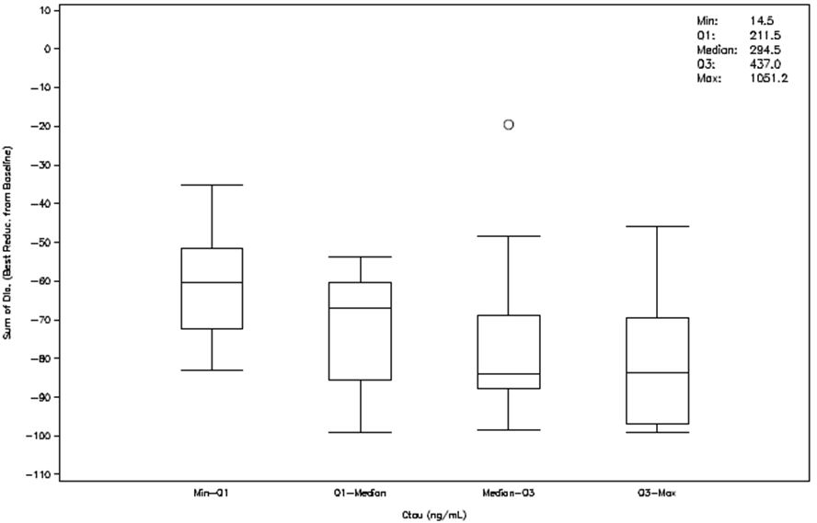

The exposure-response of idelalisib 150 mg BD. was further investigated in the Phase II study, 101 - 09, which examined a population with iNHL that were refractory to rituximab and alkylating agents. The primary objective of this study was to evaluate tumour regression, as assessed by an independent review committee (IRC) based on ORR. Additional efficacy endpoints based on IRC assessments such as BOR, PFS, LNR, and SPD were also evaluated. This study demonstrated that there was no relationship between idelalisib exposure, based on Ctau, and any of the efficacy endpoints measured indicating that the 150 mg BD. regimen produced robust and consistent therapeutic effects across the exposure range observed.

## Clinical efficacy

### Indication 1: Treatment of patients with relapsed chronic lymphocytic leukaemia (CLL).

#### Pivotal efficacy studies

##### Study GS-US - 312 - 0116

###### Study design, objectives, locations and dates

This was a Phase III, randomized, double-blind, two-treatment arm, placebo-controlled study evaluating the efficacy and safety of Idelalisib (GS - 1101) in combination with Rituximab or placebo for previously treated Chronic Lymphocytic Leukaemia.

**Primary objective** was to evaluate the effect of the addition of idelalisib to rituximab on progression-free survival (PFS) in subjects with previously treated CLL.

**Secondary objectives**

To evaluate the effect of the addition of idelalisib to rituximab on: the onset, magnitude and duration of tumour control; measures of subject well-being, including overall survival (OS), health-related quality of life (HRQL), and performance status; on disease-associated biomarkers and potential mechanisms of resistance to idelalisib.

Other endpoints were to characterize the effect of rituximab on idelalisib exposure (through evaluations of idelalisib plasma concentrations over time), to describe the safety profile and to estimate health resource utilization associated with the addition of idelalisib to rituximab.

It was a multicentre study conducted at 58 sites in US, France, Germany, UK, Italy and Germany. The study was conducted from 1 May 2012 (first subject randomised) to 30 August 2013 (last subject observation for the interim report).

The study included 2 pre-specified formal interim efficacy analyses by an independent Data Monitoring Committee (DMC). The report in the submitted dossier presents results from the interim efficacy analysis on data up to 30 August 2013. Based on these results, the DMC recommended stopping the trial on efficacy grounds; the sponsor concurred with this approach. A second analysis will be performed, which will include data up to the end of the blinded treatment phase, which occurred on 09 October 2013. Another report will be generated including these additional data.

**Evaluator’s comments**: The sponsor should indicate when the final study report will be available. In Australia rituximab is only indicated as combination therapy in the treatment of CLL, including in previously untreated and relapsed/refractory patients.

###### Inclusion and exclusion criteria

Inclusion criteria:

* Diagnosis of B-cell CLL, with diagnosis established according to International Workshop on Chronic Lymphocytic Leukaemia (IWCLL) criteria and documented within medical records
* CLL that warrants treatment (consistent with accepted IWCLL criteria for initiation of therapy)
* Presence of measurable lymphadenopathy (defined as the presence of > 1 nodal lesion that measures > 2 cm in the longest diameter [LD] and > 1cm in the longest perpendicular diameter [LPD] as assessed by CT or MRI)
* Prior treatment for CLL comprising either of the following: Prior treatment with > 1 regimen containing a therapeutic anti-CD20 antibody administered for > 2 doses of antibody treatment or prior treatment with > 2 regimens containing > 1 cytotoxic agent administered for > 2 cycles of cytotoxic treatment
* In a subject whose last prior therapy contained an anti-CD20 antibody (e.g. rituximab, ofatumumab and obinutuzumab), evidence of disease improvement during that therapy or documentation of CLL progression > 6 months after completion of that therapy.
* Documentation of CLL progression < 24 months since the completion of the last prior therapy for CLL
* Discontinuation of all therapy (including radiotherapy, chemotherapy, immunotherapy, or investigational therapy) for the treatment of CLL > 3 weeks before randomization
* All acute toxic effects of any prior anti-tumour therapy resolved to Grade < 1 before randomization (with the exception of alopecia [Grade 1 or 2 permitted], neurotoxicity [Grade 1 or 2 permitted], or bone marrow parameters [Grades 1, 2, 3, or 4 permitted])
* Karnofsky performance score of > 40.

The main exclusion criteria were:

* Known histological transformation from CLL to an aggressive lymphoma (i.e. Richter transformation).
* Presence of intermediate- or high-grade myelodysplastic syndrome (i.e. subjects who had > 5% bone marrow blasts; karyotype abnormalities other than normal, Y deletion, 5q deletion, or 20q deletion; or > 2 lineages of cytopaenias due to myelodysplasia)
* History of a non-CLL malignancy except for the following: adequately treated local basal cell or squamous cell carcinoma of the skin, cervical carcinoma in situ, superficial bladder cancer, asymptomatic prostate cancer without known metastatic disease and with no requirement for therapy or requiring only hormonal therapy and with normal prostate-specific antigen for > 1 year prior to randomization, other adequately treated Stage 1 or 2 cancer currently in complete remission, or any other cancer that has been in complete remission for > 5 years
* Evidence of ongoing systemic bacterial, fungal, or viral infection at the time of initiation of randomization (Visit 2)
* Ongoing drug-induced liver injury, chronic active hepatitis C (HCV), chronic active hepatitis B (HBV), alcoholic liver disease, non-alcoholic steatohepatitis, primary biliary cirrhosis, extrahepatic obstruction caused by cholelithiasis, cirrhosis of the liver, or portal hypertension
* Ongoing drug-induced pneumonitis
* Ongoing inflammatory bowel disease
* Ongoing alcohol or drug addiction
* Pregnancy or breastfeeding
* History of prior allogeneic bone marrow progenitor cell or solid organ transplantation
* Ongoing immunosuppressive therapy other than corticosteroids
* Prior therapy with any inhibitor of AKT, Bruton tyrosine kinase (BTK), Janus kinase (JAK), mammalian target of rapamycin (mTOR), phosphatidylinositol 3 kinase (PI3K) (including idelalisib), or spleen tyrosine kinase (SYK)
* History of anaphylaxis in association with previous administration of monoclonal antibodies
* Concurrent participation in another therapeutic clinical trial
* Prior or ongoing clinically significant illness, medical condition, surgical history, physical finding, electrocardiogram (ECG) finding, or laboratory abnormality that, in the investigator’s opinion could adversely affect the safety of subject or impair the assessment of study results.

###### Study treatments

Subjects in Arm A received Idelalisib + rituximab (idelalisib + R), and subjects in Arm B received placebo + rituximab (placebo + R). Idelalisib 150 mg/dose, or placebo, taken orally BD starting on Day 1 was administered continuously thereafter.

Rituximab was administered intravenously at the currently recommended dose of 375 mg/m2 on Day 1 (Week 0); thereafter at 500 mg/m2 intravenously on Day 15 (Week 2), Day 29 (Week 4), Day 43 (Week 6), Day 57 (Week 8), Day 85 (Week 12), Day 113 (Week 16) and Day 141 (Week 20) for a total of 8 infusions.

Study drug (Idelalisib/placebo) was taken continuously until subject withdrawal from study drug, definitive progression of CLL, study drug-related toxicity, pregnancy, noncompliance with study procedures, or study discontinuation. Rituximab was administered until the earliest of a maximum of 8 infusions, subject withdrawal from study, definitive progression of CLL, rituximab-related toxicity, pregnancy, noncompliance with study procedures, or study discontinuation. In the event the study was stopped and unblinded, subjects could continue receiving Idelalisib and rituximab until transition onto the extension study was possible.

**Evaluator’s comments**: The regimen of Rituximab therapy in this trial differs from that approved in both the FDA and Australian product information. FDA approved dosage: “The dose for CLL is 375 mg/m2 in the first cycle and 500 mg/m2 in cycles 2 − 6, in combination with FC, administered every 28 days.” Australian approved dosage: “MABTHERA in combination with chemotherapy is 375 mg/m2 administered on day 1 of the first treatment cycle followed by 500 mg/m² administered on day 1 of each subsequent cycle, for a total of 6 cycles”. The sponsor has not justified why the monotherapy rituximab regimen in the pivotal trial included additional doses, separated by 2 weeks, on efficacy or safety grounds – see clinical questions.

###### Efficacy variables and outcomes

The findings of the IRC were considered primary for analyses of PFS and other disease control endpoints.

Primary endpoint:

PFS was defined as the interval from randomization to the first documentation of definitive disease progression or death from any cause. Definitive disease progression is CLL progression based on standard criteria and occurring for any reason (increasing lymphadenopathy, organomegaly or bone marrow involvement; decreasing platelet count, haemoglobin, or neutrophil count; or worsening of disease-related symptoms) other than lymphocytosis.

Secondary endpoints:

* Overall response rate (ORR) –the proportion of subjects who achieved complete response (CR) or partial response (PR)
* Time to response (TTR) – defined as the interval from randomization to the first documentation of CR or PR
* Duration of response (DOR) – the interval from the first documentation of CR or PR to the earlier of the first documentation of definitive disease progression or death from any cause
* Time to treatment failure (TTF) –interval from randomization to the first documentation of definitive disease progression, the permanent cessation of study drug (GS - 1101/placebo) due to an adverse event, or death from any cause Percent change in lymph node area – defined as the percent change from baseline in the sum of the products of the greatest perpendicular diameters (SPD) of target lymph nodes
* Lymph node response rate –proportion of subjects who achieved a ≥ 50% decrease in the SPD of target lymph nodes
* Splenomegaly response rate –proportion of subjects with baseline splenomegaly who achieved an on-study CR (normalization) or a PR (≥ 50% decrease from baseline) in splenic size
* Platelet response rate –proportion of subjects with baseline thrombocytopenia (platelet count < 100 x 109/L) who achieved an on-study platelet count ≥100 x 109/L or demonstrated a ≥ 50% increase in platelet count from baseline
* Hemoglobin response rate – proportion of subjects with baseline anaemia (haemoglobin < 110 g/L [11.0 g/dL]) who achieved an on-study haemoglobin ≥ 110 g/L (11.0 g/dL) or demonstrate a ≥ 50% increase in haemoglobin from baseline
* Neutrophil response rate –proportion of subjects with baseline neutropenia (absolute neutrophil count [ANC] < 1 x 109/L) who achieved an ANC ≥ 1 x 109/L or demonstrated a ≥ 50% increase in ANC from baseline

Patient well-being end-points:

* Overall survival
* Change from baseline in HRQL domain and symptom scores based on the Functional Assessment of Cancer Therapy: Leukaemia (FACT-Leu); Changes from baseline in Karnofsky performance status
* Changes from baseline in PI3K/AKT/mTOR pathway activation as a measure of PI3K pathway activity
* Changes from baseline in the plasma concentrations of disease-associated chemokines and cytokines.
* Change from baseline in overall health and single-item dimension scores as assessed using the EuroQoL Five-Dimension (EQ-5D) utility measure
* Health resource measures, including resource utilization, total costs, and measures of cost per unit of benefit (e.g. cost per additional progression-free month, cost per quality-adjusted life-year). Exposure to drug was also assessed by Study drug administration as assessed by prescribing records and compliance as assessed by quantification of used and unused drug.

###### Randomisation and blinding methods

After a subject completed screening and was confirmed eligible for the study, the subject was randomized into the study using IWRS. Subjects were randomized 1:1 to either Arm A (idelalisib + R) or Arm B (placebo + R). In order to balance treatment allocation by potentially important predictive factors, a fixed-block centralized randomization allocated subjects within the 8 strata as defined by the intersection of the following 3 stratification factors:

* 17p deletion and/or p TP53 mutation in CLL cells: either versus neither (or indeterminate)
* Immunoglobulin heavy chain variable region (IGHV) mutation: unmutated (or IGHV3 - 21) versus mutated (or indeterminate)
* Any prior therapy with an anti-CD20 therapeutic antibody: yes versus no.

The identity of the treatments was satisfactorily concealed by central blinding of study drug assignments.

**Evaluator’s comments**: While the study randomization was stratified by three factors, the factor “any prior therapy with anti-CD20 therapeutic antibody” was skewed with approximately 96% of subjects having received prior anti-CD20 therapy. In the opinion of the sponsor, this stratification factor did not provide meaningful information and the decision to exclude prior anti-CD20 therapy as a stratification factor was made prior to unblinding for this interim analysis. In all stratified analyses, only 17p deletion and/or TP53 mutation status and IGHV mutation status were considered, as specified in the SAP. However, the sponsor should still report the primary outcome, stratified for prior rituximab therapy, given that it is not clear that the proportion of prior rituximab treatment, and potentially the incidence of pre-study rituximab resistance, is the same in the idelalisib + R and Placebo + R exposure groups.

###### Analysis populations

The ITT analysis set was used in the analyses of subject characteristics, PFS, ORR, OS, and CR rate. The analysis of PFS based on the ITT analysis set was considered primary. Subjects in the ITT analysis set who did not have sufficient baseline or on-study tumour status information to be adequately assessed for response status were included in the denominators in the calculation of ORR and CR rate.

The Per Protocol (PP) analysis set was used in sensitivity analyses of the primary and secondary efficacy endpoints: PFS, ORR, and lymph node response rate.

The safety analysis set was used in the analyses of safety variables as well as study treatment administration, post-study therapy, and health economic variables.

###### Sample size

The target was to enrol ~200 subjects for an accrual of 119 PFS events to achieve a power of > 85%. Two formal interim efficacy analyses were pre-specified after ~ 50% and ~ 75% of PFS events had occurred.

Early stoppage of the study was considered if the PFS was significantly better in Arm A (idelalisib + rituximab) as compared to Arm B (placebo + rituximab) using a 2-sided significance level of 0.001 as pre-specified in the protocol and SAP, and providing all available PFS data was evaluated.

###### Statistical methods

**Primary endpoint**: PFS between the treatment arms was based on the ITT analysis set, comparing time from randomisation to the first documented definitive disease progression or death from any cause using a stratified log-rank test, adjusted for 17p deletion and/or TP53 mutation status and IGHV mutation status. Hazard ratios and corresponding 95% CIs were obtained using a Cox proportional hazard regression model.

Sensitivity analyses of PFS in support of the primary analysis were also performed, including: 1) analysis of PFS in the ITT analysis set using the un-stratified log-rank test, 2) analysis of PFS in the PP analysis set using the stratified log-rank test, and 3) analysis of PFS in the ITT analysis set using the un-stratified log-rank test by censoring data from surviving, non-progressing subjects only at the last time that lack of definitive CLL progression was objectively documented. In addition, subgroups analyses of PFS by 17p deletion and/or TP53 mutation status, IGHV mutation status, 17p deletion status, gender, age and race were also performed.

**Secondary endpoints**: Secondary efficacy endpoints included ORR, LNR, and OS. The 3 secondary endpoints were to be tested sequentially at a 2-sided significance level of 0.05, if the primary efficacy hypothesis was rejected at the appropriate significance level. If a null hypothesis for a secondary endpoint was not rejected, formal sequential testing would be stopped and only nominal significance level would be cited for the remaining secondary endpoints. Differences in number and percentage of subjects between the treatment arms in ORR were compared using CMH Chi-square tests after adjusting for stratification factors (17p deletion and/or TP53 mutation status and IGHV mutation status). Odds ratios and the corresponding 95% CIs were presented as well. Differences in LNR between the 2 treatment arms were compared using CMH Chi-square tests after adjusting for stratification factors (17p deletion and/or TP53 mutation status and IGHV mutation status). Only subjects that had both baseline and >1 evaluable post-baseline SPD were included in this analysis. Data from surviving subjects were censored at the last time that the subject was known to be alive on study. Differences between the treatment arms in OS were assessed in the ITT.

Analysis set using Kaplan-Meier methods and stratified log-rank tests, adjusted for stratification factors (17p deletion and/or TP53 mutation status and IGHV mutation status). Subgroup analyses of ORR and LNR by 17p deletion and/or TP53 mutation status, IGHV mutation status, 17p deletion status, gender, age and race were also performed. In addition, analysis of ORR in the PP analysis set was performed. No subjects had achieved CR at the time of the interim analysis.

TTR and DOR were assessed based on ITT subjects who achieved a CR or PR. Descriptive statistics were provided for TTR. DOR was summarized using Kaplan-Meier methods. The best percent change from baseline in SPD, splenomegaly response rate, hepatomegaly response rate, ALC response rate, platelet response rate, haemoglobin response rate and neutrophil response rate were also summarized. For the summaries of response rates, only subjects who had relevant abnormality at baseline and at least 1 valid post-baseline value were included.

**Exposure and Pharmacodynamics**: Analyses were not presented for any PK-PD parameters in the interim report.

###### Participant flow

Of the 220 randomized subjects, 3 (1.4%) subjects in the placebo group did not receive study drug (Table 4). Thus, 220 subjects were included in the ITT Analysis Set and 217 subjects were included in the Safety Analysis Set. At the time of this interim analysis, 147 subjects (66.8%) were ongoing in the study (idelalisib + R 80.9%, 89 subjects; placebo + R: 51.8%, 57 subjects). Two subjects were excluded from the ITT set in each arm to comprise the per-protocol set (Table 5).

Twenty-three subjects (10.5%) discontinued the study prior to disease progression confirmation per the IRC (idelalisib+R vs. placebo+R 11.8% vs 9.1%) - the main reasons for discontinuation were AEs (4.5% vs 5.5%) and subject withdrawal (5.5% vs 2.7%).

Table 4: Analysis Sets (GS-US-312-0116).

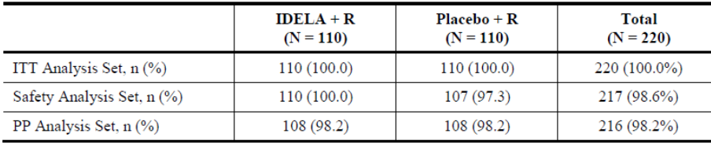

Table 5: Disposition of subjects (ITT Analysis Set).

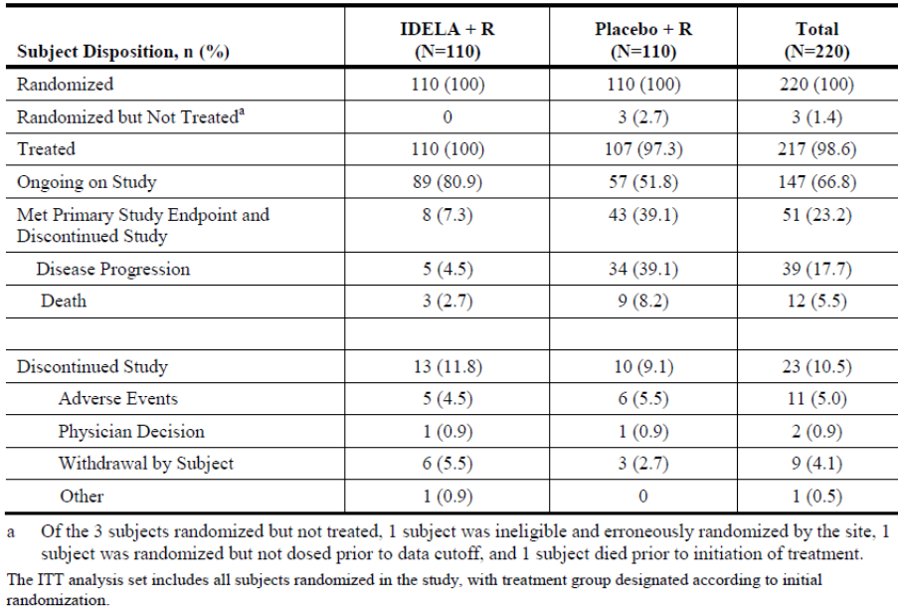

###### Major protocol violations/deviations

Two subjects in the idelalisib + R group were excluded from the PP analysis (1 due to history of Richter’s transformation and 1 who had progressed longer than 24 months from the date of last therapy). Two subjects in the placebo + R group were also excluded from the PP analysis (1 due to history of Richter’s transformation and 1 had not received prior CD20 therapy).

###### Baseline data

Overall, demographics and baseline characteristics were generally comparable between the 2 treatment groups (Table 6).

Table 6: GS-US-312-0116: key demographics and baseline characteristics (ITT Analysis Set).

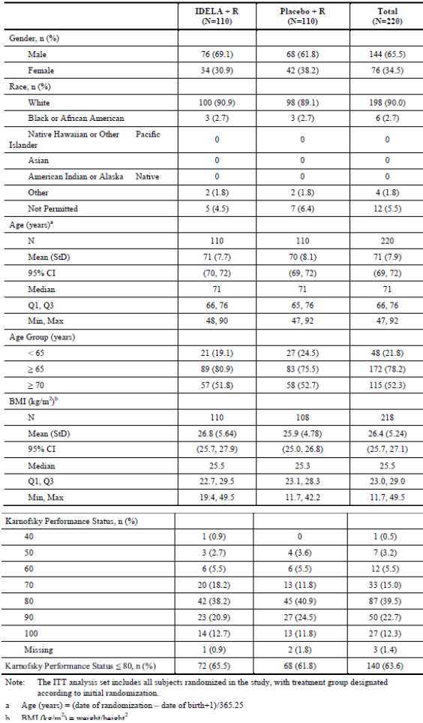

The enrolled patients had characteristics of the intended population with relapsed CLL. Most subjects (78.2%) were > 65 years of age, with a median (Q1, Q3) age of 71 (66, 76). Majority of the subjects were male (65.5%) and White (90.0%); Black/African American and Hispanic/Latino subjects comprised 2.7% and 2.3% of subjects, respectively and 7.3% of subjects were not permitted to report their race. The median (Q1, Q3) baseline BMI was 25.5 (23.0, 29.0) kg/m². The majority of subjects had a reduced Karnofsky Performance Status (KPS) at study entry: 62.3% had modest reduction (KPS score 80 to 90), 20.5% had significant reduction (KPS score 60 to 70).

The median (Q1, Q3) time since diagnosis was 8.5 (5.5, 12.0) years (101.7 [65.8, 143.9] months), with a range of 1.4 to 318.7 months. At study screening, most subjects had advanced disease with 64.6% Rai Stage III or IV and 56.4% Binet Stage C (Table 7). Disease characteristics were balanced between treatment groups.

Table 7: GS-US-312-0116: CLL disease history (ITT Analysis Set).

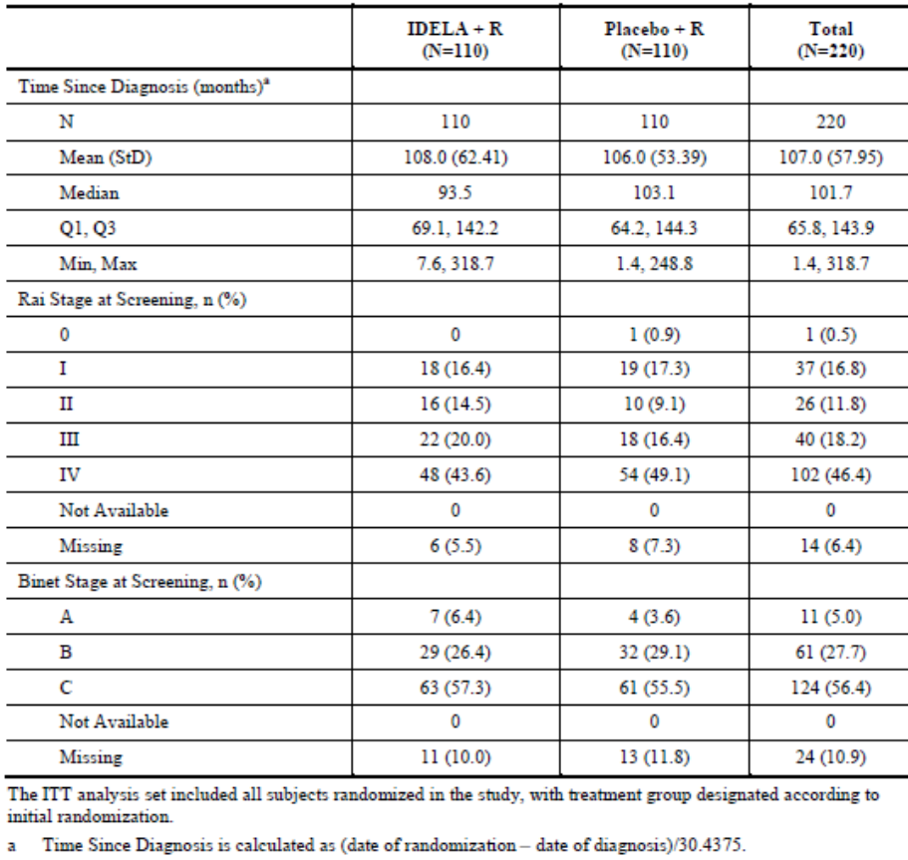

Overall 96 subjects (43.6%) had had presence of 17p deletion and/or TP53 mutation, 184 subjects (83.6%) had unmutated IGHV status and the majority of subjects had received prior anti-CD20 therapy (overall 211 subjects, 95.9%) (Table 8). These stratification factors were balanced between the two treatment arms.

Table 8: GS-US-312-0116: subject distribution by key stratification factors (ITT Analysis Set).

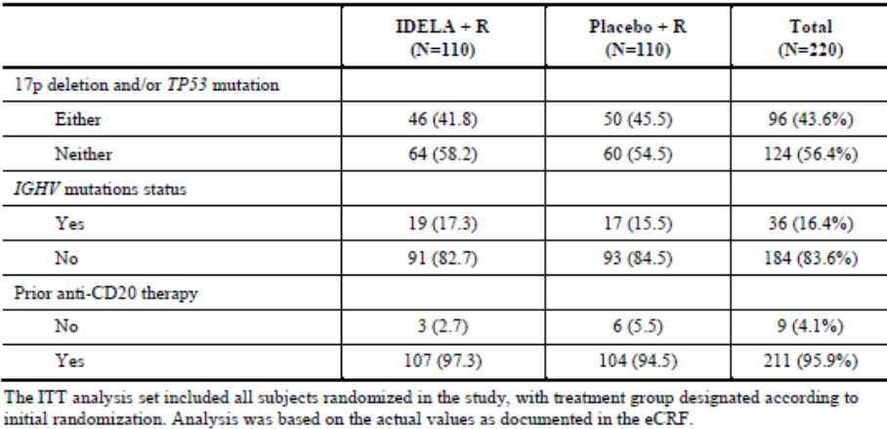

**Evaluator’s comment**: As per the comment, from this description of “prior anti-CD20 therapy”, the proportion of subjects that had received rituximab cannot be determined.

The median (Q1, Q3) cumulative illness rating scale (CIRS) score was 8.0 (7.0, 10.0; range 1.0 to 18.0), with most subjects (187 subjects, 85.0%) had CIRS scores of > 6. Overall, 205 subjects (93.2%) had 3 or more organs with comorbidities and 81 (36.8%) had severe comorbidities (score of 3 or higher in any system) and CIRS scores were comparable between treatment groups.

Baseline abnormal haematology results were also balanced between the two treatment arms (Table 9).

Table 9: GS-US-312-0116: summary of comorbidities (ITT Analysis Set).

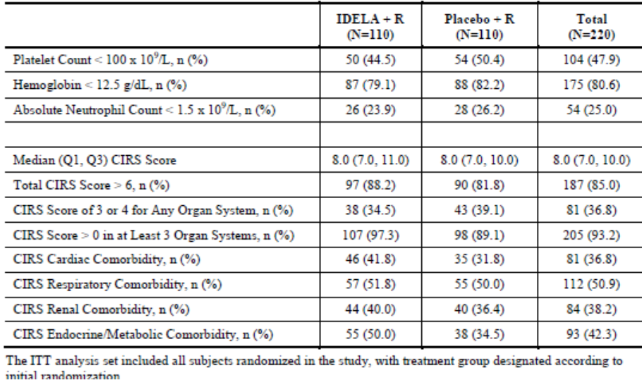

Subjects categorised by degree of renal impairment was imbalanced between the treatment arms with 20% vs. 11% with CrCl > 90mL/min, 36% vs. 52% with CrCl ≥60 to < 90 mL/min and 44% vs 36% having CrCl 60 mL/min in the idelalisib and placebo arms respectively.

The median (Q1, Q3) number of prior CLL regimens was 3.0 (2.0, 5.0), with a range of 1 to 12 prior regimens received. The most common prior regimens were bendamustine + R (44.5%), fludarabine + cyclophosphamide + R (34.1%), single-agent rituximab (31.4%), fludarabine + R (17.3%), and chlorambucil (15.9%). Rituximab was a component of the 3 most prevalent recently administered treatment regimens (BR 21.8%; rituximab alone 11.4%; FCR 8.2%). Treatment groups also were balanced with respect to the incidence and type of prior CLL regimens.

###### Results for the primary efficacy outcome

The primary outcome of the study was met – PFS was increased and deaths were reduced in the idelalisib arm, compared to placebo. The proportion with disease progression was 8.2% vs 40.9% in the idelalisib and placebo arms respectively. Deaths occurred in 2.7% vs 7.3% in the idelalisib and placebo arms respectively. The study met the pre-specified criteria for stopping the trial early.

The PFS hazard ratio, adjusted for 17p deletion/TP53 and IGHV mutation status, was 0.15 (95% CI 0.08, 0.28), P = 3.0 × 10 - 11, in favour of idelalisib.

The median PFS for subjects in the Idelalisib + R group was not reached and the median (95% CI) PFS for subjects in the placebo + R group was 5.5 (3.7, 6.9) months. Analysis of PFS based on the PP Analysis Set was consistent with that observed for the ITT Analysis Set.

PFS results favoured idelalisib + R across all predefined subgroups, including subjects with or without either 17p deletion and/or TP53 mutation and subjects with or without IGHV mutation (Figure 3).

Figure 3: GS-US-312-0116: forest plot of PFS per IRC comparison assessment by subgroup (ITT Analysis Set).

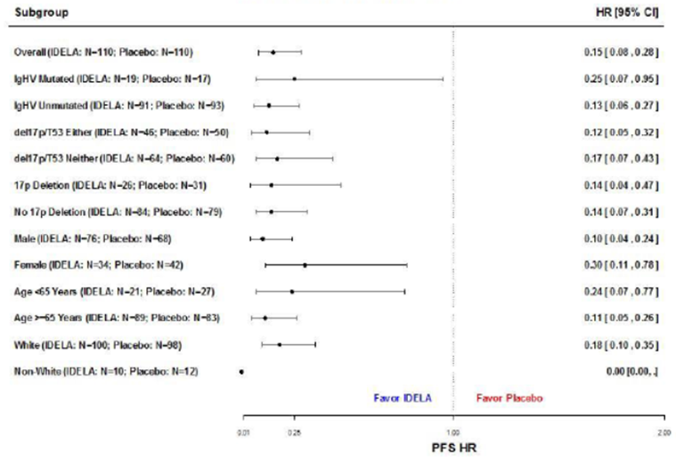

###### Results for other efficacy outcomes

Secondary endpoints

**Overall response rate:** This was classified as CR or PR and could include subjects with no post-baseline assessment. The ORR in the ITT population was 16.81 (7.89, 35.81), p = 1.0 x 10 - 16, favouring the idelalisib arm.

The ORR odds ratio for subjects in the ITT Analysis Set who had at least 1 post-baseline assessment was 29.92 (95% CI 12.76, 70.11), p = 3.0 × 10 - 19.

**Lymph node response rate:** The LNRR odds ratio = 265 (95% CI: 53, 1313), p = 1.3 x 10 - 30 in favour of idelalisib, with a similar finding in each pre-specified subgroup.

Overall survival: At the interim analysis point, 16 subjects had died while participating in the study (idelalisib + R: 3.6%, 4 subjects; placebo + R: 10.9%, 12 subjects). The adjusted OS hazard ratio (95% CI) = 0.28 (0.09, 0.86), p = 0.018, favouring idelalisib.

Other efficacy endpoints

**Time to Response (TTR):** Analyses of TTR included only subjects in the ITT Analysis Set who achieved CR or PR. The median (Q1, Q3) TTR was 2.0 (1.8, 3.7) months for subjects treated with Idelalisib+ R (N = 71), with a range of 1.3 to 5.5 months. The median (Q1, Q3) TTR was 2.1 (1.9, 3.7) months for subjects treated with placebo + R (N = 11), with a range of 1.9 to 8.5 months.

**Duration of response:** Analyses of DOR included only subjects in the ITT Analysis Set who achieved CR or PR. The KM estimate of median (Q1, Q3) DOR was 10.4 (7.1, NR) months for subjects treated with Idelalisib+ R (N = 71) and was 6.4 (4.5, 7.4) months for subjects treated with placebo + R (N = 11).

**Best percent change in SPD:** Analysis included only subjects in the ITT analysis set who had baseline measurements and at least 1 evaluable postbaseline measurement. Among the 90 subjects in each treatment group with measurable index lesions at both baseline and postbaseline, 85 subjects (94.4%) treated with Idelalisib + R and 55 subjects (61.1%) treated with placebo + R had improvement in lymphadenopathy. The median (Q1, Q3) best percent change in SPD was -72.2 (-79.5, -65.4) for subjects treated with Idelalisib+ R and was -7.5 (-24.2, 7.8) for subjects treated with placebo + R. Consistent with the overall analysis, best percent change in SPD favoured idelalisib + R over placebo + R across all subgroups.

**Splenomegaly and hepatomegaly response rates:** Analysis included only subjects in the ITT analysis set who had splenomegaly/hepatomegaly at baseline and at least 1 evaluable post-baseline spleen/liver measurement. The splenomegaly response rate (95% CI) was higher for subjects treated with Idelalisib+ R, 79.4% (67.9%, 88.3%), compared with placebo + R, 25.0% (14.0%, 38.9%). The hepatomegaly response rate (95% CI) was higher for subjects treated with idelalisib + R, 69.6% (54.2%, 82.3%), compared with placebo + R, 52.0% (37.4%, 66.3%).

Haematology parameters

In patients with baseline platelet count < 100 x 109, there was no difference in the proportion that achieved an on-study platelet count ≥ 100 x 109, or increase > 50 x 109 from baseline, following idelalisib exposure was 77% (95%CI: 62, 88) versus 59% (95%CI: 44, 73) in the placebo arm.

In patients with baseline haemoglobin < 110 g/dL, there was a significant difference in the proportion that achieved an on-study haemoglobin ≥ 100g/dL, or an increase > 50% from baseline, following idelalisib exposure was 77% (95%CI 60, 84) versus 37% (95%CI 24, 51) in the placebo arm.

In patients with baseline neutropaenia, ANC < 1.5 x 109, there was no difference in the proportion that achieved an on-study increase in ANC of ≥ 1.5 x 109 or increase > 50% from baseline – 84% (95% CI 64-95) versus 65 (95% CI 43, 82).

The proportion of subjects achieving an ALC response was not different between treatment groups (idelalisib + R 71.8% vs. placebo + R 79.8%).

Health-related quality of life

The sponsor states that the analyses of health-related quality of life and healthcare utility assessments will be reported in the CSR that covers the entire blinded phase of the study.

#### Other efficacy studies

##### Study 101 - 08 (plus its extension study 101 - 99)

###### Study design, objectives, methodology

Phase II, single-arm study of idelalisib plus rituximab in elderly subjects with previously untreated CLL or SLL.

Primary objective:

Overall response rate (ORR) of idelalisib with rituximab in elderly subjects with previously untreated CLL or SLL.

Secondary objectives:

Duration of response (DOR) and progression-free survival (PFS), safety, plasma exposure and pharmacodynamics effects of the combination of idelalisib and rituximab in elderly subjects with previously untreated CLL or SLL.

Subjects were evaluated for response after Study Weeks 8, 16, 24, 36, and 48 according to modified standard criteria.

Treatment:

All subjects received idelalisib 150 mg BD orally (tablet or capsule formulation) on Days 1 through 28 of each 28-day cycle for 48 weeks and rituximab 375 mg/m² intravenously weekly for 8 doses (Cycles 1 and 2) on Days 1 through 28 through the end of Cycle 2 and continuously thereafter and rituximab 375 mg/m² intravenously weekly for 8 doses (Cycles 1 and 2).

Idelalisib and rituximab continued until disease progression or unacceptable toxicity, up to a maximum of 48 weeks of idelalisib. Dose reduction was considered if toxicities occurred that were considered possibly related to study drug. If a Grade 4 haematological toxicity or Grade 3 non-haematological toxicity did not resolve to Grade 1 or Grade 2 toxicity within 2 weeks, subjects underwent dose reduction. Dose reductions were primarily made from 150 mg BD to 100 mg BD, but also could be further reduced to 75 mg BD. Safety parameters were evaluated throughout the study and relevant safety data were reviewed by the sponsor and all investigators up to a minimum of 8 weeks after the last subject entered the study. An interim analysis was performed after 18 subjects had completed 8 weeks of treatment (Cycles 1 and 2) and had been evaluated to determine if the treatment should be stopped for excessive toxicity or lack of efficacy. Subjects completing 48 weeks were eligible to continue idelalisib treatment under a long-term extension protocol (101-99). The study was conducted at 5 sites in USA from 28 September 2010 to 22 March 2013.

**Comments**: The justification for a regimen of weekly rituximab at 375mg/m² in CLL patients requires explanation from the sponsor. This regimen of weekly rituximab for eight doses substantially differs from that recommended in the product information for the initial treatment of CLL patients of: 375mg/m² as a single dose followed by 500mg/m² monthly for six cycles in total. The approved product information indicates that dose reductions are not required, and specifically not for elderly patients. It is therefore uncertain if any treatment benefit is solely due to idelalisib or due to the unapproved dose-dense regimen of rituximab administered. Similarly, it is uncertain how the investigators determined that adverse events were due to the study drug during the concomitant administration phase, rather than the non-standard dosing of rituximab in these patients. The non-standard regimen of rituximab precludes generalising the efficacy (and safety) results from this study to the wider population in whom the recommended rituximab regimen will be used. The two dose forms of idelalisib administered are considered bioequivalent.

Inclusion/exclusion criteria

Inclusion criteria:

* Adults ≥ 65 years of age, with histologically or cytologically confirmed CLL or SLL who had received no prior therapy for CLL or SLL, with the exception of corticosteroids for symptom relief
* World Health Organization (WHO) performance status ≤ 2 (i.e. Fully active, able to carry on all pre-disease performance without restriction, Restricted in physically strenuous activity but ambulatory and able to carry out work of a light or sedentary nature, e.g., light house work, office work, Ambulatory and capable of all self-care but unable to carry out any work activities. Up and about more than 50% of waking hours)
* Subjects with CLL had Binet Stage C or Rai Stage III or IV or active disease
* Evidence of progressive marrow failure as manifested by the development of, or worsening of, anaemia and/or thrombocytopenia
* Massive (i.e. > 6 cm below the left costal margin), progressive, or symptomatic splenomegaly
* Massive (i.e. > 10 cm in longest diameter), progressive, or symptomatic lymphadenopathy; Progressive lymphocytosis with an increase of more than 50% over a 2-month period or lymphocyte doubling time of < 6 months
* Autoimmune anaemia and/or thrombocytopenia poorly responsive to corticosteroids or other standard therapy
* At least 1 of the following disease-related symptoms: Unintentional weight loss ≥ 10% within the previous 6 months ; significant fatigue; fevers > 38.0°C for ≥ 2 weeks without other evidence of infection; night sweats for ≥ 1 month without evidence of infection
* Subjects with SLL had active disease as defined above for CLL, excluding the diagnosis of lymphocytosis.

Exclusion criteria:

* Prior therapy for CLL or SLL, except corticosteroids for symptom relief
* Treatment with systemic corticosteroids within 1 week prior to Visit 1
* Known active central nervous system involvement with malignancy
* Ongoing active, serious infection requiring systemic therapy at Visit 2 (Subjects were allowed prophylactic antibiotics and antiviral therapy at the discretion of the treating physician)
* Serum creatinine ≥ 2.0 mg/dL
* Serum bilirubin ≥ 2.0 mg/dL (unless due to Gilbert’s syndrome) or serum transaminases (i.e. AST, ALT ≥ 2 × upper limit of normal
* Positive test for human immunodeficiency virus (HIV) antibodies
* Active hepatitis B or C (confirmed by RNA test).
* Subjects with serologic evidence of prior exposure were eligible.

Efficacy endpoints:

ORR (proportion who achieved CR or PR) was investigator-assessed according to modified International Workshop on Chronic Lymphocytic Leukaemia Working Group criteria.

Lymph node response rate was assessed and defined as the proportion of subjects with a ≥ 50% decrease in the sum of the products of the greatest perpendicular diameters (SPD) of index lesions. DOR from the month/year of initial diagnosis of CLL and SLL until the date of the first dose of study treatment and PFS from the date of the first dose of study treatment in Cycle 1 to the date of death or classification of progressive disease (whichever came first) were evaluated.

The change from baseline in the SPD of index lesions and response rates for splenomegaly, hepatomegaly, absolute lymphocyte count (ALC), platelet, haemoglobin, and absolute neutrophil count (ANC) were also summarized.

Pharmacokinetics/Pharmacodynamics (PK/PD):

The pharmacodynamic analyses were not reported but the sponsor states they will be included in the final CSR.

Patient disposition, protocol violations, baseline patient characteristics:

All 64 enrolled subjects received the study drug, of which 62 subjects (96.9%) completed Cycle 2 (8 weeks) of the study and completed rituximab dosing. Overall, 43 subjects (67.2%) completed the study, with adverse events being the commonest reason for withdrawal, reported for 17 subjects (26.6%) (Table 10).

Table 10: Study 101-08: subject disposition (ITT Analysis Set).

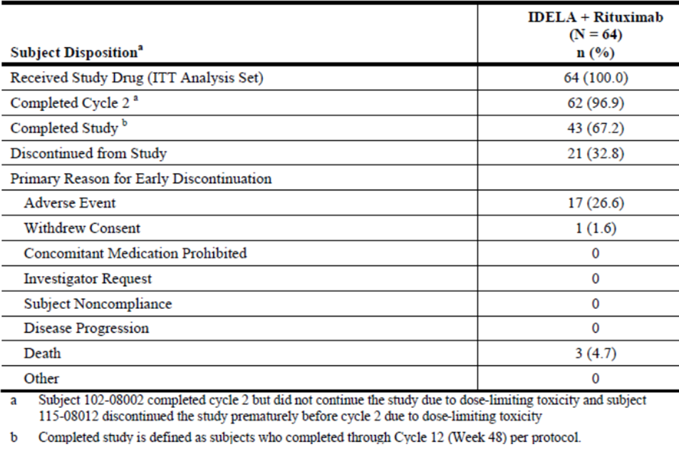

Seven important protocol deviations occurred in 7 subjects. The majority (n = 6) of the important deviations were due to treatment and dosing compliance violations resulting from subjects continuing study drug (idelalisib or rituximab) after experiencing Grade ≥ 3 laboratory abnormalities. The other important deviation was a study procedure violation in which a subject enrolled in Study 101 - 99 before completing Study 101 - 08. The sponsor considered that these important deviations did not substantially affect the interpretation of the data.

The median subject age was 71 years (range 65 - 90), of whom 63% were male. CLL was diagnosed in 92% of enrolled subjects and the remainder had a diagnosis of SLL. The median time since diagnosis was 3.3 years (range 0.1 to 11.3 years).

36 subjects (56.3%) had a WHO performance status score of 1 and 27 subjects (42.2%) had a score of 0.

Symptoms at baseline were seen in 26 subjects (40.6%), the most common being unexplained night sweats (26.6%) and extreme fatigue (21.9%). In total, 28 (43.8%) subjects had splenomegaly and 7 (10.9%) had hepatomegaly.

Efficacy results:

Subjects were treated for a maximum of 48 weeks with the option of entering a continuation study 101 - 99. Of the 43 subjects who completed 101 - 08, 41 entered the continuation study.

The ORR, according to cytogenetic mutation status is shown in Table 11 (three subjects declined consent for tumour DNA analysis). The ORR was independent of 17p-/TP53 and IGHV mutation status.

Table 11: Study 101-08: overall response rate (ITT Analysis Set).

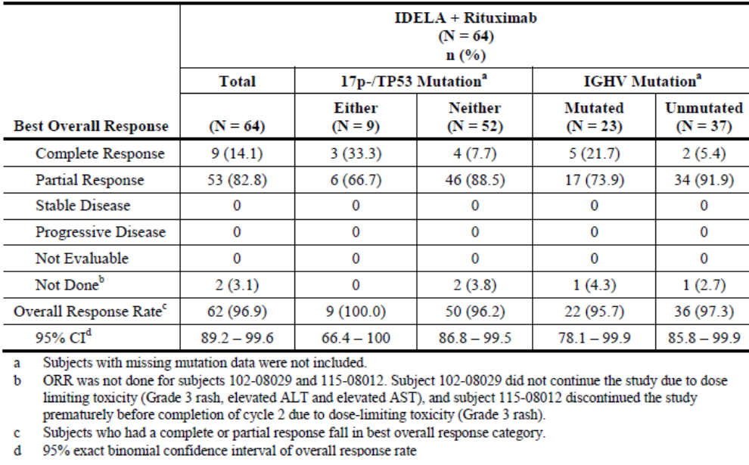

Complete responses and PRs were achieved for up to 28.6 months in subjects who continued in the 101 - 99 extension study. In addition, 53 subjects (82.8%) had a PR in Study 101 – 08 (Table 12).

Table 12: Study 101-08: duration of response in months by Kaplan-Meier analysis (ITT Analysis Set).

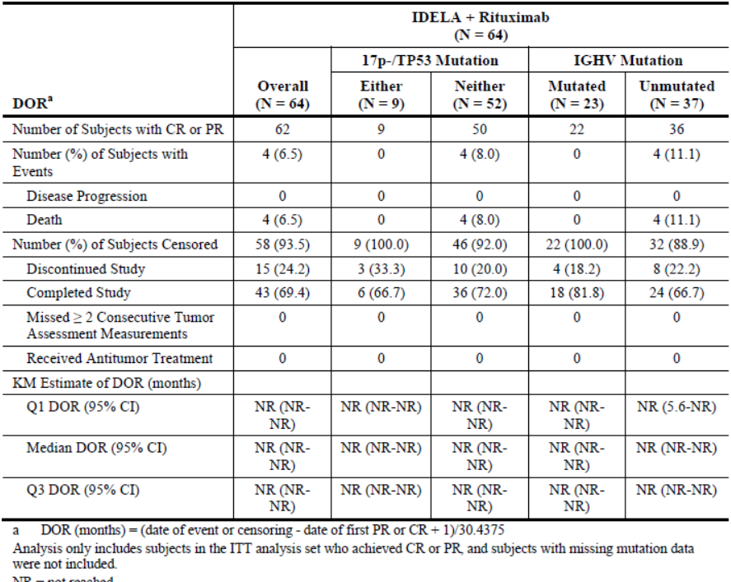

An improvement in clinical status was reported for the following disease features:

* 49 of 50 subjects (98.0%) for lymph node response
* 27 of 28 subjects (96.4%) for splenomegaly
* 7 of 7 subjects (100.0%) for hepatomegaly
* 53 of 53 subjects (100.0%) for ALC
* 16 of 17 subjects (94.1%) for platelets
* 17 of 17 subjects (100.0%) for haemoglobin
* 5 of 5 subjects (100.0%) for ANC
* 24 of the 26 subjects (92.3%) who had B symptoms responded by Week 16.

The KM estimate of median DOR in subjects achieving CR or PR was not reached for study 101 - 08 or the extension study 101 - 99. Similarly, the KM estimate of median PFS was not reached in study 101 - 08. No subjects experienced disease relapse while on the study, or in the extension study.

Of the 62/64 subjects who had a BOR of CR or PR, the median (range) TTR was 1.9 (1.6 – 5.7) months. Median TTR was 1.9 months the same for those subjects with del(17p)/TP53 mutation or IGHV mutation status.

All 50 subjects with lymph node enlargement at baseline and who had at least 1 post-baseline efficacy assessment had a reduction in tumour size.

##### Study 101-07

This is a Phase 1, open-label study of idelalisib in subjects with relapsed or refractory CLL (n = 114) or iNHL (n = 80) which is ongoing.

###### Primary objective

To investigate the safety of idelalisib in combination with an anti-CD20 monoclonal antibody (mAb), a chemotherapeutic agent, a mammalian target of rapamycin (mTOR) inhibitor, and/or a proteasome inhibitor.

###### Secondary efficacy objectives

To evaluate the clinical activity of IDELA combined with an anti-CD20 mAb, a chemotherapeutic agent, an mTOR inhibitor, and/or a proteasome inhibitor in subjects with relapsed or refractory CLL, iNHL, or MCL.

CLL patients were administered idelalisib 150mg BD in conjunction with all other medicines, except for one group which received 100mg idelalisib in conjunction with rituximab monotherapy.

**Evaluator’s comment**: Rituximab was administered in one of two regimens, neither of which was identical to the currently approved regimen for treatment of CLL. One rituximab regimen was the same as that in study 101 - 08 – 375mg/m² weekly for 8 weeks; the other was 375mg/m² on day 1 of cycles 1 - 6.

Of the 114 subjects with CLL, majority were male (67.5%), White (92.1%) with WHO performance status of 0 or 1 (55.3% and 41.2%, respectively) and 59.6% had bulky adenopathy; the mean (SD) age was 65 (9.4) years, with a range of 41 to 87 years and 51.8% were > 65 years of age.

For subjects with CLL (N = 114), the most frequently reported prior therapies were as shown in Table 13.

Table 13: Most frequently reported prior therapies for subjects with CLL.

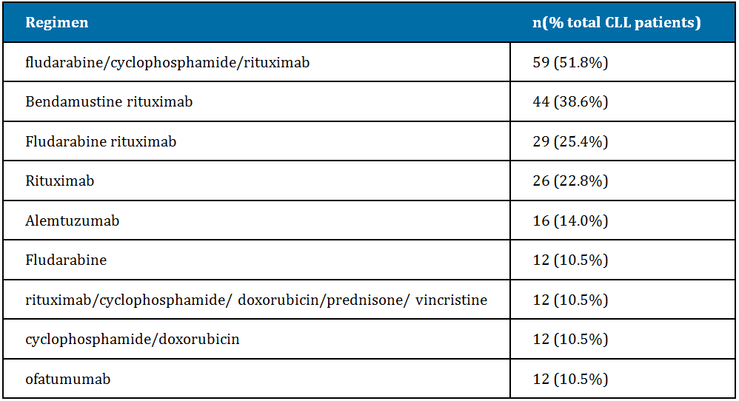

The remaining therapies were each reported for less than 10% of subjects with CLL.

61 subjects (53.5%) were relapsed and 53 subjects (46.5%) were refractory to their last prior treatment; 64 subjects (56.1%) were refractory to any prior rituximab treatment.

The most frequently reported B symptoms were extreme fatigue (30 subjects [26.3%]) and unexplained night sweats (22 subjects [19.3%]). The mean (SD) time since diagnosis was 7.9 years (4.81), and the mean (SD) time since most recent relapse/refractory diagnosis was 3.6 months (4.57). Over half of subjects with CLL (66 subjects [57.9%]) had an enlarged spleen, and 15 subjects (13.2%) had an enlarged liver. Either TP53 mutation or 17p deletion was present in 33 subjects (28.9%). Most subjects had Rai Stage I disease (46 subjects [40.4%]) and Binet A (41 subjects [36.0%]) or B (25 subjects [21.9%]) at diagnosis. Fifty-four subjects (47.4%) had current Rai Stage IV disease, and 52 subjects (45.6%) had Binet C. Cytogenetic lesions 17p-, 11q-, and trisomy 12q were present in similar numbers of subjects with CLL (21.9%, 24.6%, and 21.1%, respectively). Approximately one-third (34.2%) had 13q- as a sole abnormality, 14.9% had normal karyotype, and 32.5% had other cytogenetic lesions.

###### Efficacy results for CLL patients

The ORR was 82.4% (95%CI 72.6%, 89.8%); four subjects (4.7%) achieved CR, and 66 subjects (77.6%) achieved PR and 8 subjects (9.4%) had SD. In subjects who achieved a CR or PR, the median TTR was 1.9 months (range 1.4 months to 8.3 months).

The ORR for subjects with either TP53 mutation or 17p deletion was 70.8% (95% CI 48.9%, 87.4%) and 86.2% (95% CI 74.6%, 93.9%) for subjects with neither abnormality.

The median KM estimates of OR, DOR and PFS were not reached, with a median follow-up time of 11.0 months.

The majority of subjects (74 [87.1%]) were censored because they discontinued the study (27 subjects [31.8%]) or completed the study (47 subjects [55.3%]). The overall lymph node response rate (95% CI) was 72 of 85 subjects (84.7% [75.3%, 91.6%]), and the overall lymph node response rate (95% CI) for subjects with at least 1 post-baseline assessment was 72 of 80 subjects (90.0% [81.2%, 95.6%]); the majority of subjects had improvement in lymph node area and in lymphadenopathy: 77 of 80 subjects (96.3%) with CLL.

For subjects with CLL (N = 85), the overall splenomegaly response rate (95% CI) was 29 of 49 subjects (59.2% [44.2%, 73.0%]), and the overall hepatomegaly response rate (95% CI) was 8 of 13 subjects (61.5% [31.6%, 86.1%]). For subjects with CLL across all treatment regimens, the ALC response rate (95% CI) was 88.6% (78.7%, 94.9%), the platelet response rate (95% CI) was 91.9% (78.1%, 98.3%), the haemoglobin response rate (95% CI) was 70.5% (54.8%, 83.2%), and the ANC response rate (95% CI) was 80.0% (51.9%, 95.7%). At baseline, 30 subjects (35.3%) with CLL had at least 1 B symptom. B symptoms resolved with idelalisib treatment; no subjects reported any continuing B symptoms by Week 48.

##### Study 101-02

This Phase 1, dose-ranging, open-label study 101 - 02 of safety, pharmacokinetics, pharmacodynamics, and clinical activity of idelalisib in patients with relapsed, refractory CLL, NHL, AML or multiple myeloma.

The study enrolled 54 patients with CLL; 13 (24.1%) had 17p deletion and/or TP53 mutation, and 49 (90.7%) patients had unmutated IGHV. Patients had been pre-treated with a median of 5 regimens, and all had previously received anti-CD20 monoclonal antibodies. Idelalisib was administered at doses ranging from 50 mg to 350 mg, once or twice daily, with 11 patients having received the recommended dosage of 150 mg twice daily.

The investigator-assessed ORR was 72.2% (95% CI 58.4, 83.5) with a median DOR of 16.2 months (95% CI 4.6, 40.9). In the 13 patients who received 150 mg twice daily, the ORR was 81.8% (95% CI 48.2, 97.7) and the median DOR was 8.1 months (95% CI 2.6, 39.8). Fifteen patients did not respond; of these, 12 (22.2%) had stable disease and 3 (5.6%) were not evaluable. For the 13 patients with a 17p deletion and/or TP53 mutation, the ORR was 38.5% (95% CI 13.9, 68.4) and the DOR was 9.2 months.

**Evaluator’s comment**: This study was the only one to provide any efficacy evidence for the use of monotherapy idelalisib in CLL patients. As such, this evidence is considered insufficient to approve an indication for this use.

#### Analyses performed across trials (pooled analyses and meta-analyses)

None.

#### Evaluator’s conclusions on clinical efficacy in patients with relapsed CLL

The proposed indication in CLL is:

*Zydelig is indicated, alone or in combination, for the treatment of patients with relapsed chronic lymphocytic leukaemia (CLL).*

Table 14 shows a summary of the studies presented for the evaluation in CLL/SLL patients:

Table 14: Studies presented for the evaluation in CLL/SLL patients.

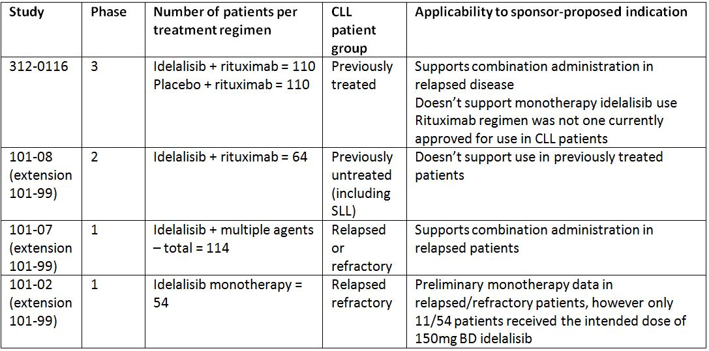

The pivotal trial of idelalisib use in CLL patients 312 - 0116 met its primary objective of demonstrating PFS improvement in in previously treated patients who would otherwise be eligible for monotherapy rituximab. Multiple secondary end-points were also met, demonstrating a benefit from idelalisib + rituximab vs. rituximab alone, in: overall survival, overall response rate, lymph node response rate and duration of response. Furthermore, the efficacy demonstrated was independent of adverse tumour genetic factors which are known to be associated with poor outcome, namely 17p/TP53 and IGHV status.

In patients with baseline anaemia, there was a significant difference in the proportion that achieved an on-study improvement in haemoglobin in the idelalisib + rituximab arm. There was no difference in the proportion that achieved an improvement in platelet count, neutrophil count or lymphocyte count in subjects with baseline thrombocytopaenia, neutropaenia lymphopaenia.

However, this evidence does not support the wording of the initially proposed CLL indication, where “combination” is not further specified, since combination rituximab/idelalisib was the only regimen studied. This pivotal trial does not support the use of monotherapy idelalisib.

Rituximab is neither approved as monotherapy for the treatment of CLL in Australia, nor approved for the regimen administered, thus limiting the extrapolation of the efficacy results. Additionally, the effect of idelalisib/rituximab in patients who had prior treatment with rituximab has not been described separate to those who had never previously received rituximab which may have implications in deciding whether rituximab resistance has an adverse effect on the demonstrated efficacy of the idelalisib/rituximab combination.

The phase II study 101 - 08 does not support the proposed indication for treatment of relapsed CLL as it only enrolled previously untreated patients. Indeed, the results in these treatment-naïve CLL patients should be interpreted cautiously due to the small number of patients studied in a non-randomised setting. Furthermore, the dose regimen of rituximab was not that approved in the current product information, which confounds the ability to generalise the results outside of the clinical trial.

The phase 1 study 101 - 07 provides some supportive efficacy evidence for a combination regimen in previously treated patients, showing an ORR of 82.4%, with median OR, DOR and PFS not reached after a median of 11 months of treatment.

The phase 1 study 101 - 02 provides only preliminary non-randomised data in previously treated patients, but is insufficient, alone, to approve the monotherapy part of the proposed indication.

There are five other phase three trials in progress currently (2 in iNHL patients and 3 in CLL patients), which may provide supportive evidence for monotherapy idelalisib use – see questions to sponsor.

The proposed PI will require modification in order to reflect these conclusions and this has been discussed in detail in section 11.1 of this report.

### Indication 2: Treatment of patients with refractory indolent non-Hodgkin lymphoma (iNHL)

There were no Phase 3 studies for this indication.

#### Pivotal efficacy studies

##### Study 101 - 09

###### Study design, objectives, locations and dates

This is a Phase 2, open-label, single-group, 2-stage, efficacy, safety, and pharmacodynamic study of idelalisib in subjects with previously treated iNHL that was refractory both to rituximab and to alkylating-agent-containing chemotherapy. The pre-specified study analysis was performed when all enrolled subjects completed efficacy, safety, and other assessments through at least 24 weeks of evaluation.

The study was conducted at 54 sites in North America and Europe from 4 March 2011 (first subject screened) until 25 June 2013 (last subject observation for the interim report presented in the dossier).

Primary objective:

“Evaluation the effect of idelalisib on tumour regression as determined by overall response rate (proportion achieving a complete response or partial response; a minor response was permitted for subjects with Waldenstroms macroglobulinaemia) in subjects with indolent non-Hodgkin lymphoma (iNHL) refractory to rituximab and alkylating agents.”

Secondary objectives:

* Duration of response (DOR) – defined as the interval from the first documentation of CR or PR (or MR for subjects with WM) to the earlier of the first documentation of disease progression or death from any cause
* Lymph node response rate – defined as the proportion of subjects who achieve a ≥ 50% decrease from baseline in the sum of the products of the greatest perpendicular diameters (SPD) of index lesions
* Time to response (TTR) – defined as the interval from the start of IDELA treatment to the first documentation of CR or PR (or MR for subjects with WM)
* Progression-free survival (PFS) – defined as the interval from the start of IDELA treatment to the earlier of the first documentation of disease progression or death from any cause
* Overall Survival (OS) – defined as the interval from the start of IDELA treatment to death from any cause
* Changes in HRQL as reported by subjects using the Functional Assessment of Cancer Therapy: Lymphoma (FACT-Lym)
* Changes in performance status as documented using the Karnofsky performance status criteria
* Study drug administration as assessed by prescribing records and compliance as assessed by quantification of used and unused drug

Another objective was to generate pharmacokinetic (PK) data with the final tablet formulation of Idelalisib in subjects with iNHL (through conduct of a PK sub-study).

###### Inclusion and exclusion criteria

Inclusion criteria:

* Age > 18 years
* Karnofsky score > 60 (Eastern Cooperative Oncology Group, ECOG performance score of 0, 1 or 2)
* Histologically confirmed diagnosis of B-cell iNHL, with histological subtype limited to the criteria established by the World Health Organization (WHO) 2008 classification of tumours of haematopoietic and lymphoid tissues
* Radiographically measurable lymphadenopathy or extranodal lymphoid malignancy
* Prior treatment with ≥ 2 prior chemotherapy- or immunotherapy-based regimens for iNH
* Prior treatment with rituximab and with an alkylating agent (eg, bendamustine, cyclophosphamide, ifosfamide, chlorambucil, melphalan, busulfan, nitrosoureas) for iNH
* Lymphoma that is refractory to rituximab and to an alkylating agent
* Refractory status defined as lack of response to, or progression within 6 months of completion of therapy
* Refractoriness to rituximab and to an alkylating agent (e.g. bendamustine, cyclophosphamide, ifosfamide, chlorambucil, melphalan, busulfan, nitrosoureas) was defined as:

For subjects exposed to Rituximab without chemotherapy:

* Lack of a complete response (CR) or partial response (PR) during rituximab therapy comprising ≥ 4 doses of ≥ 375 mg/m² given weekly, or
* Occurrence of progressive disease (PD) within 6 months of the completion of a regimen of rituximab therapy comprising ≥ 4 doses of ≥ 375 mg/m² given weekly, or
* Occurrence of PD during rituximab maintenance therapy or within 6 months of completion of rituximab maintenance therapy

For subjects exposed to Rituximab with chemotherapy:

* Lack of a CR or PR during rituximab-containing therapy comprising ≥ 2 doses of ≥ 375 mg/m², or
* Occurrence of PD within 6 months of the completion of a regimen of rituximab-containing therapy comprising ≥ 2 doses of ≥ 375 mg/m², or
* Occurrence of PD during rituximab maintenance therapy or within 6 months of completion of rituximab maintenance therapy

For subjects exposed to Alkylating agent, administered with or without rituximab:

* Lack of a CR or PR during alkylating-agent-containing therapy comprising ≥ 2 cycles of treatment, or
* Occurrence of PD within 6 months of the completion of a regimen of alkylating-agent-containing chemotherapy comprising ≥ 2 cycles of treatment.

Discontinuation of all other therapies (including radiotherapy or chemotherapy) for the treatment of iNHL >3 weeks before initiation of study treatment (Visit 2)

All acute toxic effects of any prior anti-tumour therapy resolved to Grade < 1 before initiation of study treatment (Visit 2) (with the exception of alopecia [Grade < 2 permitted], neurotoxicity [Grade < 2 permitted], or bone marrow parameters [Grade < 2 permitted].

Exclusion criteria:

* Central nervous system or leptomeningeal lymphoma
* Known histological transformation from iNHL to diffuse large B-cell lymphoma (DLBCL)
* History of a non-lymphoma malignancy except for the following: adequately treated local basal cell or squamous cell carcinoma of the skin, cervical carcinoma in situ, superficial bladder cancer, localized prostate cancer, other adequately treated Stage 1 or 2 cancer currently in complete remission, or any other cancer that had been in complete remission for ≥ 5 years
* Evidence of ongoing systemic bacterial, fungal, or viral infection (excluding viral upper respiratory tract infections) at the time of initiation of study treatment (Visit 2)
* Pregnancy or breastfeeding; Ongoing alcohol or drug addiction
* Known history of drug-induced liver injury, chronic active HCV, chronic active HBV, alcoholic liver disease, non-alcoholic steatohepatitis, primary biliary cirrhosis, ongoing extrahepatic obstruction caused by stones, cirrhosis of the liver or portal hypertension
* History of prior allogeneic bone marrow progenitor cell or solid organ transplantation
* Ongoing immunosuppressive therapy, including systemic corticosteroids
* Prior therapy with Idelalisib
* Exposure to another investigational drug within 3 weeks prior to start of study treatment; Concurrent participation in another therapeutic treatment trial
* Prior or ongoing clinically significant illness, medical condition, surgical history, physical finding, electrocardiogram (ECG) finding, or laboratory abnormality that, in the investigator’s opinion, could affect the safety of the subject; alter the absorption, distribution, metabolism or excretion of the study drug; or impair the assessment of study results.

###### Study treatments

Eligible subjects were treated with Idelalisib 150 mg BD orally.

Possible dose reductions if required by idelalisib-related adverse events (AEs) were either: Reduced Dose-1: idelalisib 100 mg BD, 1 × 100 mg oral tablet and Reduced Dose-2: idelalisib 75 mg BD, 1 × 75 mg oral tablet.

Treatment with Idelalisib continued until tumour progression or unacceptable toxicity. Subjects were followed in the clinic at 2-week intervals during the first 12 weeks of treatment, then at 4-week intervals from 12 to 24 weeks of treatment, then at 6-week intervals from 24 to 48 weeks of treatment, and then at 12-week intervals thereafter.

Tumour responses were evaluated at baseline; at 8, 16, and 24 weeks of therapy; and every 12 weeks thereafter according to standard criteria. Responses were assessed by both the investigator and an IRC. Subject compliance with idelalisib was assessed.

###### Efficacy variables and outcomes

Efficacy:

* ORR - defined as the proportion of subjects who achieve a confirmed complete response (CR) or partial response (PR or minor response [MR] for subjects with WM) during idelalisib treatment
* Duration of response (DOR) – defined as the interval from the first documentation of CR or PR (or MR for subjects with WM) to the earlier of the first documentation of disease progression or death from any cause.
* Lymph node response rate – defined as the proportion of subjects who achieve a ≥ 50% decrease from baseline in the sum of the products of the greatest perpendicular diameters (SPD) of index lesions.
* Time to response (TTR) – defined as the interval from the start of idelalisib treatment to the first documentation of CR or PR (or MR for subjects with WM).
* Progression-free survival (PFS) – defined as the interval from the start of idelalisib treatment to the earlier of the first documentation of disease progression or death from any cause.
* Overall Survival (OS) – defined as the interval from the start of IDELA treatment to death from any cause.
* Changes in HRQL as reported by subjects using the Functional Assessment of Cancer Therapy: Lymphoma (FACT-Lym).
* Changes in performance status as documented using the Karnofsky performance status criteria.
* Study drug administration as assessed by prescribing records and compliance as assessed by quantification of used and unused drug.

Pharmacokinetics and Pharmacodynamics

Idelalisib trough and peak plasma concentrations assessed pre-dose and 1.5 hours post-dose on Days 1, 29, 57, and 113

Pharmacokinetic parameters (AUClast, AUCinf, %AUCexp, Cmax, Clast, Tmax, Tlast, t1/2, λz, CL/F, Vz/F, Ctau [multiple-dose)] and AUCtau [multiple-dose]) on Days 1 and 29 (for subjects in the PK sub-study)

Changes in the plasma concentrations of disease-associated chemokines and cytokines

Safety

Scope covers type, frequency, severity, timing, and relationship to study therapy of any AEs or abnormalities of physical findings, laboratory tests, or electrocardiograms; drug discontinuations due to AE; or serious adverse events (SAEs).

###### Randomisation and blinding methods

This was an open-label, Phase II study. No randomization or blinding was performed.

###### Analysis populations

The intent-to-treat (ITT) analysis set consisted of all subjects who received > 1 dose of idelalisib. The ITT analysis set was used in the analyses of ORR, PFS, OS, safety, and study drug administration and compliance. The ITT analysis set was the primary analysis set for all the efficacy variables.

Duration of response (DOR) and time-to-response (TTR) were analysed based on all ITT subjects who achieved a CR or PR (or MR for subjects with WM). Lymph node response rate (LNR) was analysed based on all ITT subjects who had both baseline and ≥ 1 evaluable post-baseline tumour assessment.

The per-protocol (PP) analysis was composed of all subjects in the ITT analysis set who had a diagnosis of lymphoma or documented refractory disease (refractory to both rituximab and an alkylating agent), had measurable nodal disease as determined by the IRC and had a PFS event and could be evaluated for tumour response with both baseline and an on study tumour evaluations. The PP analysis set was used to assess ORR, DOR, TTR, LNR, and PFS.

The pharmacodynamic and PK analysis sets included data from subjects in the ITT analysis set who had the necessary baseline and on-study measurements to provide interpretable results for the specific parameters of interest.

###### Sample size

Up to 125 subjects were enrolled in order to ensure enrolment of ≥ 100 subjects (31 in Stage 1 and 69 in Stage 2) who had a documented diagnosis of lymphoma, who had confirmed refractory disease, and who could be evaluated for tumour response with baseline and on-study scans (through ≥ 24-week, follow-up tumour assessment). This study tested the null hypothesis that the IRC-reviewed ORR was ≤ 20% against the alternative hypothesis that it was ≥ 39%. Using Simon’s optimal 2-stage design, a sample size of 100 subjects had > 90% power to achieve a 1-sided significance level of < 0.005 and provided an adequate safety database.

###### Statistical methods

Data were presented for both the investigator assessments and the Independent Review Committee (IRC) assessments, with the latter considered primary for analyses of ORR and other tumour control endpoints.

The primary endpoint, ORR, was defined as the proportion of subjects who achieved a CR or PR (or MR for subjects with WM) during the idelalisib treatment, using the hypothesis that ORR is ≥ 39% against the null hypothesis that it was ≤ 20%.

Secondary endpoints of DOR and PFS were summarized using the Kaplan-Meier (KM) method. The date of definitive progression was the time-point at which progression was first identified by relevant radiographic or pathology data. Death occurring within 30 days following the discontinuation of study drug was considered as an event for the DOR and PFS calculation. Data were censored on the date of the last tumour assessment (including assessments with a not evaluable outcome) for subjects (1) who did not have progressive disease (PD) or die within 30 days of permanent study drug discontinuation, (2) who started new anti-tumour therapy prior to PD, or (3) had ≥ 2 consecutive missing tumour assessments before PD or death. Subjects without adequate baseline tumour response evaluation were censored on Study Day 1.

Lymph node response rate was summarized with 95% CI based on the binomial distribution in the ITT analysis set. The SPD and percent change in SPD from baseline to each subsequent assessment were summarized, in addition to the best percent change from baseline during the study. Time to response was summarized based on responding subjects using descriptive statistics. OS was analysed using the KM method based on the ITT analysis set. The FACT-Lym questionnaire was scored as recommended in the user manual for the instrument. The mean subscale scores, the sum of the scores from physical well-being, social/family well-being, emotional well-being, functional well-being, and additional concerns, were summarized in addition to change from baseline and best change from baseline. The following composite scores were derived from the data above: FACT_Lym Trial Outcome Index, Functional Assessment of Cancer Therapy-General (FACT_G) Total Score, and FACT_Lym Total Score. The Karnofsky performance status scores and change from baseline scores to each subsequent assessment were summarized, in addition to the best and worst changes from baseline during the study.

###### Participant flow

As of 25 June 2013, 40/125 (32.0%) subjects enrolled in the study were ongoing; 49 subjects (39.2%) had completed treatment (41 subjects [32.8%] due to PD and 8 subjects [6.4%] due to death), and 36 subjects (28.8%) discontinued treatment.

The most common reasons for discontinuation were AEs (20.0%), withdrew consent (3.2%) and discontinued at the request of the investigator (7 subjects, 5.6%); 3 of the 7 subjects who discontinued at the request of the investigator were referred to undergo stem cell transplantations.

Of the 125 subjects enrolled in the study, 59 subjects (47.2%) entered long-term follow-up, and 42 subjects are currently ongoing in long-term follow-up. Among the 17 subjects (13.6%) who discontinued long-term follow-up, 16 (12.8%) discontinued due to death. A total of 38 subjects (30.4%) of the originally enrolled 125 subjects completed 6 months of long-term follow-up.

###### Major protocol violations/deviations

At the time of data cut-off of 25 June 2012, 6 important protocol deviations had occurred for 5 subjects.

For 3 subjects, SAEs were not reported to Gilead within 24 hours of the site’s knowledge of the event (febrile neutropaenia, diarrhoea and malignant neoplasm). Two subjects had screening laboratory samples taken prior to the subject signing the consent form. One subject did not receive 2 cycles of bendamustine as required by the protocol to meet the alkylating agent refractory criteria; the subject had received only 1 cycle.

The sponsor states “these important deviations did not substantially affect the interpretation of the data.”

###### Baseline data

The median subject age was 64 years (range 33 - 87 years), with the majority of subjects being male (64.0%) and Caucasian (88.7%).

At baseline, 38 subjects (30.4%) had > Grade 1 elevated LDH levels (>234 U/L), 64 subjects (51.2%) had > Grade 1 decreased haemoglobin level (<125 g/L), 43 subjects (34.4%) had >Grade 1 decreased platelet counts ( <130 × 10^9/L), and 30 subjects (24.0%) had >Grade 1 decreased neutrophil counts (<1.96 × 10^9/L).

Ninety subjects (72%) had Karnofsky performance scores of ≥ 90. Overall, radiomimmunotherapy was not indicated for 54 subjects (43.2%) due to their baseline haematological status.

Overall, 72 subjects (57.6%) had FL, 28 subjects (22.4%) had SLL, 10 subjects (8.0%) had LPL/WM, and 15 subjects (12.0%) had MZL.

Median (range) time since diagnosis was 5.3 (0.4, 18.4) years.

Most subjects (87 subjects [69.6%]) were Ann Arbor Stage IV at diagnosis. Most subjects (73.6%) had lesions ≥ 2 cm to < 7 cm in the longest diameter at baseline. The median (range) longest diameter of the largest lesion at baseline was 5.9 (2.0 - 25.0) cm.

Baseline hepatomegaly was seen in 11 subjects (8.8%) and 9 subjects (7.2%) had liver tumour nodules present; 35 subjects (28.0%) splenomegaly at baseline and 9 subjects (7.2%) had spleen tumour nodules present.

The median (range) number of prior regimens received was 4 (2 - 12), with 73 subjects (58.4%) treated with 4 or more prior regimens. All subjects had previously received an alkylating agent, of whom99% were considered refractory to this therapy and all subjects received rituximab previously, all of who were considered refractory to this therapy. Among subjects receiving prior regimens of BR, R-CHOP, rituximab, and R-CVP, 78.3%, 71.4%, 72.0%, and 80.6% were refectory to the therapy. A total of 99 subjects (79.2%) were refractory to 2 or more prior regimens.

Of those subjects that had received an alkylating agent, 111 (88.8%) had received cyclophosphamide and 81 (64.8%) had received bendamustine.

The most common prior regimens received included BR (60 subjects, 48.0%), R-CHOP (56 subjects, 44.8%), single-agent rituximab (50 subjects, 40.0%), and R-CVP (36 subjects, 28.8%). A total of 36 subjects (28.8%) had been treated with radiation at some point prior to the study and 14 subjects (11.2%) had received a prior autologous stem cell transplant. Of the 47 separate therapies received by the 125 subjects just prior to the study, 112 subjects (89.6%) were refractory to the therapy they received.

The median time since completion of the last regimen prior to the study was 3.9 months; this included 13 subjects who responded initially to their last regimen, but relapsed within 6 months. A total of 112 subjects (89.6%) were refractory to their last therapy; 13 subjects (10.4%) had a CR and 16 subjects (12.8%) had a PR to their last regimen prior to the study. The median DOR for those who responded to their last regimen was 5.9 months.

Of the 26 subjects who received BR as their last prior therapy, 22 subjects (84.6%) were refractory to it and of the 17 subjects who received rituximab, 16 subjects (94.1%) were refractory to it. A total of 47 unique therapies were received by the study population of 125 subjects just prior to starting the study and 112 subjects (89.6%) were refractory to the regimen they received.

###### Results for the primary efficacy outcome

The ORR, based on IRC assessment, was achieved in 71/125 subjects (56.8%): 7 subjects (5.6%) had a best response of CR, 63 subjects (50.4%) had a best response of PR, and 1 subject (0.8%) with WM had a best response of MR. The IRC and the investigators agreed in their assessment of overall response for 84.8% of subjects (Table 15).

Table 15: Study 101-09: ORR, n (%) (ITT Analysis Set).

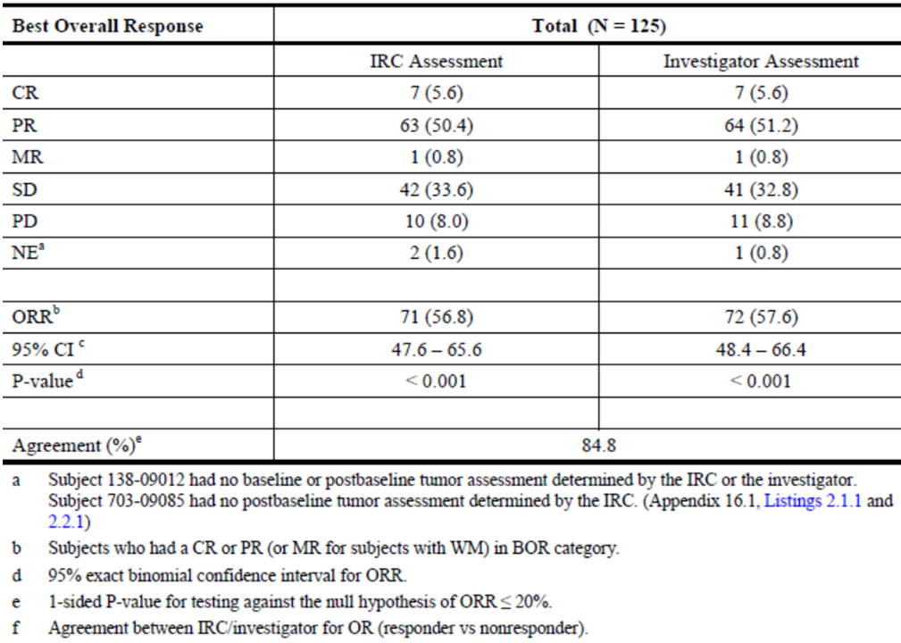

Overall response rates were consistent across subgroups. There was no relationship between response and the degree of prior therapy or the frequency of refractoriness.

###### Results for other efficacy outcomes

Duration of response

In the 71 subjects who achieved a CR or PR (or MR for subjects with WM) the KM estimate of median DOR based on the IRC assessments was 12.5 months.

Change in SPD from baseline

Among subjects with measurable index lesions at both baseline and post-baseline (N = 122), 110 subjects (90.2%) had decreases from baseline in SPD, as assessed by the IRC, and 67 subjects (54.9%) achieved a > 50% decrease from baseline in the SPD of index lesions. The median best percent change in SPD was a decrease of 53.5%.

Time to response

Analysis of TTR includes only subjects who achieved a CR, PR, or MR on study (N = 71). Responses were rapid with a median (range) TTR of 1.9 (1.6 – 8.3) months, corresponding to the first time response was evaluated (Week 8).

Progression-free survival

The KM estimate of median PFS for all 125 subjects was 11.0 months and 10.8 months based on the IRC and the investigator assessments, respectively; the proportion of subjects remaining progression-free at 48 weeks was estimated to be 46.7% and 47.3%, respectively.

Overall survival

The KM estimate of median OS including long-term follow-up for all 125 subjects was 20.3 months and the proportion of subjects surviving at 48 weeks was estimated to be 81.8%. Out of a total of 28 deaths, 19 occurred prior to Week 48 and 9 occurred after Week 48. The KM estimate of median OS on-study (from the date of first dose through 30 days post-dose) for all subjects (N = 125) was not reached, and the proportion of subjects surviving at 48 weeks was estimated to be 87.7%.

Health-Related Quality of Life: Median subscale scores of the FACT-Lymphoma questionnaire remained stable over time with the exception of the lymphoma-specific Additional Concerns subscale (LymS) which increased, representing an improvement. The cumulative distribution for this subscale indicated that > 90% of subjects reported an improvement in their assessment of lymphoma-related symptoms at some point in the study.

#### Other studies

##### Study 101 - 07

###### Study design, objectives, methodology:

This was a Phase I, open-label study of idelalisib in subjects with relapsed or refractory CLL, iNHL, or MCL. The study was conducted at 11 sites in USA from 25 March 2011 (first subject screened) and is ongoing (last subject observation for this report was on 15 Feb 2013).

Primary objective

Investigation of the safety of idelalisib in combination with an anti-CD20 monoclonal antibody (mAb), a chemotherapeutic agent, a mammalian target of rapamycin (mTOR) inhibitor, and/or a proteasome inhibitor.

Secondary objectives

Evaluation of the clinical activity, PKs and PDs of idelalisib combined with an anti-CD20 mAb, a chemotherapeutic agent, an mTOR inhibitor, and/or a proteasome inhibitor in subjects with relapsed or refractory CLL, iNHL, or MCL; to determine the plasma concentrations of the mTOR inhibitor, everolimus, when combined with idelalisib.

Subjects were enrolled into 6 cohorts (and multiple subcohorts) grouped by disease (CLL, iNHL, or MCL) and by treatment regimen.

Study treatment consisted of continuous administration of idelalisib at either 100 mg BD or 150 mg BD, combined with 1 or more of the following drugs administered in 28 -day cycles: rituximab (R), bendamustine (B), everolimus (E), bortezomib (Bo), ofatumumab (O), fludarabine (F), or chlorambucil (Ch).

The chlorambucil-, ofatumumab-, and fludarabine-containing regimens were restricted to CLL subjects because that is the labelled indication for those drugs. Similarly, the everolimus- and bortezomib-containing regimens were restricted to MCL subjects. Subjects were evaluated for response after Cycles 2 (Week 8), 4 (Week 16), 6 (Week 24), 9 (Week 36), and 12 (Week 48) according to standard criteria.

Treatment continued until disease progression or unacceptable toxicity, up to a maximum of 12 cycles.

Subjects completing Cycle 12 (Week 48) were eligible to continue idelalisib treatment in Study 101 - 99.

###### Inclusion/exclusion criteria:

Inclusion criteria:

Subjects aged > 18 years of age with a documented diagnosis of histologically or cytologically confirmed select types of B-cell CLL, iNHL, or MCL

WHO performance status of < 2 who were previously treated with relapsed or refractory disease (refractory defined as not responding to a standard regimen or progressing within 6 months of the last course of a standard regimen).

Exclusion criteria:

Subjects who were considered not good candidates to receive any of the drugs administered in the study for a given disease, according to the clinical judgment of the investigator; subjects with atypical immunophenotype with t(11:14) translocation or cyclin D1 overexpression (CLL subjects only), those who had radiotherapy, radioimmunotherapy, biological therapy, chemotherapy or treatment with study drug within 4 weeks prior to baseline disease status tests, treatment with a short course of corticosteroids within 1 week prior to baseline disease status tests, an allogenic hematopoietic stem cell transplant, known active nervous system involvement, or active, serious infection requiring treatment.

Efficacy endpoints:

An interim safety analysis was performed at the same time for all subjects each of the six cohorts.

Clinical activity assessed was evaluated by investigator assessment, as defined according to standard criteria for each indication.

The clinical response was assessed by: complete response (CR), partial response (PR), stable disease (SD), and progressive disease (PD), best overall response (BOR)

The following clinical responses were assessed for subjects in Cohorts 1 to 4: overall response rate (ORR), duration of response (DOR), progression-free survival (PFS), time to response (TTR), percent change in lymph node area, lymph node response rate, splenomegaly response rate, hepatomegaly response rate, B symptoms, and overall survival (OS).

Only patients with CLL were assessed for Absolute lymphocyte count (ALC) response rate, platelet response rate, haemoglobin response rate, and absolute neutrophil count (ANC) response rate. A formal interim efficacy analysis was performed for all subjects in Cohorts 1 to 4 who completed Cycle 12 (Week 48) or end-of-study evaluations by 15 February 2013.

Patient disposition, protocol violations:

80 subjects with iNHL were included in the ITT analysis set Cohorts 1 to 6 (safety), 75 subjects (93.8%) completed Cycle 2, 37 subjects (46.3%) completed the study, 42 subjects (52.5%) discontinued the study, and 1 subject (1.3%) was ongoing at the time of data cut-off.

The most common reasons for discontinuation were AE (16 subjects [20.0%]) and disease progression (9 subjects [11.3%]). Of the 37 subjects who completed study, 35 subjects enrolled in Study 101-99.

Of the 32 subjects with MCL in the ITT analysis set Cohorts 1 to 6 (safety), 11 subjects (34.4%) completed Cycle 2, no subject completed the study, 21 subjects (65.6%) discontinued the study, and 11 subjects (34.4%) were ongoing at the time of data cut-off. The reasons for discontinuation were AE (9 subjects [28.1%]), disease progression (6 subjects [18.8%]), death (5 subjects [15.6%]), and investigator request (1 subject [3.1%]).

A total of 10 important protocol deviations occurred in 9 subjects. The majority (n = 6) of the important deviations were due to informed consent form (ICF) violations, including 4 subjects who were not re-consented with an updated ICF. Two deviations were due to treatment and dosing compliance. The bilirubin level of one subject did not meet the eligibility criteria. The sponsor considered “these important deviations did not substantially affect the interpretation of the data”.

###### Baseline patient characteristics:

Subjects with iNHL:

The majority were male (66.3%), Caucasian (80.0%), had a WHO performance status of 0 or 1 (58.8% and 40.0%, respectively) and 50.0% had bulky adenopathy; the mean (SD) age was 61 (10.6) years, with a range of 37 to 84 years and 41.3% were > 65 years of age.

Subjects with MCL:

The majority were male (78.1%), Caucasian (90.6%), had a WHO performance status of 0 or 1 (43.8% and 40.6%, respectively) and 62.5% had bulky adenopathy; the mean (SD) age was 68 (7.7) years, with a range of 47 to 80 years and 71.9% were > 65 years of age. Six subjects (5.3%) with CLL, 24 subjects (30.0%) with iNHL, and 7 subjects (21.9%) with MCL received prior radiation therapy.

###### Prior treatments & disease state

Subjects with iNHL (N = 80):

The most frequently reported prior therapies included R (45 subjects [56.3%]), BR (23 subjects [28.8%]), R-CHOP (23 subjects [28.8%]), rituximab/ cyclophosphamide/vincristine/prednisone (R-CVP) (22 subjects [27.5%]), investigational (15 subjects [18.8%]), and Z (8 subjects [10%]). The remaining therapies were each reported for less than 10% of subjects with iNHL.

For subjects with iNHL (N = 80), 44 subjects (55.0%) were relapsed and 36 subjects (45.0%) were refractory to their last prior treatment; 47 subjects (58.8%) were refractory to any prior rituximab treatment. The most frequently reported B symptoms were extreme fatigue (12 subjects [15.0%]) and unexplained night sweats (9 subjects [11.3%]). The mean (SD) time since diagnosis was 7.3 years (6.57), and the mean (SD) time since most recent relapse/refractory diagnosis was 2.6 months (3.35). Eleven subjects (13.8%) with iNHL had an enlarged spleen, and 1 subject (1.3%) had an enlarged liver. The majority of subjects with iNHL had FL (59 subjects [73.8%]), followed by SLL (16 subjects [20.0%]). Most subjects with FL had an FL international prognostic index (FLIPI) score of 2 or 3 (23 subjects [39.0%] and 12 subjects [20.3%], respectively) with a range from 0 to 5. Most subjects had Stage IV disease at diagnosis (47 subjects [58.8%]) and a current disease stage of IV (46 subjects [57.5%]). There was variation between treatment regimens.

###### Subjects with MCL (N = 32)

The most frequently reported prior therapy included BR (16 subjects [50.0%], R-CHOP (15 subjects [46.9%]), R (11 subjects [34.4%]), and investigational (4 subjects [12.5%]). The remaining therapies were each reported for less than 10% of subjects with MCL.

For the subjects with MCL (N = 32), 16 subjects (50.0%) each were relapsed and refractory to their last prior treatment; 15 subjects (46.9%) were refractory to any prior rituximab treatment. The most frequently reported B symptoms were extreme fatigue (6 subjects [18.8%]) and unexplained night sweats (4 subjects [12.5%]). The mean (SD) time since diagnosis was 5.2 years (3.82), and the mean (SD) time since most recent relapse/refractory diagnosis was 1.8 months (2.15). Four subjects (12.5%) with MCL had an enlarged spleen, and none had an enlarged liver. The majority of subjects with MCL had Stage III or IV disease (11 subjects [34.4%] and 13 subjects [40.6], respectively) at diagnosis. One half of subjects had a current disease stage of IV (16 subjects [50.0%]), and one half of subjects had a current disease stage of II or III (6 subjects [18.8%] and 10 subjects [31.3%], respectively). There was variation between treatment regimens.

The median number of prior therapies was 3-4 across the CLL, iNHL and MCL patients.

All subjects in the ITT analysis set Cohorts 1 to 6 (safety) with data available as of the data cut-off date (15 February 2013) were analysed for safety. As of the data cut-off date, the data for Cohorts 5 and 6 were not sufficiently mature to allow analysis of efficacy; therefore, only Cohorts 1 to 4 were analysed for efficacy. One subject with iNHL was mistakenly enrolled in Cohort 6 (CLL, Id+RCh) - this subject was included with iNHL subjects for safety analyses but was excluded from efficacy analyses.

###### Efficacy results

Overall Response Rate:

For the 79 subjects with iNHL, the ORR (95% CI) was 78.5% (67.8%, 86.9%). Twenty-one subjects (26.6%) with iNHL achieved a CR, and 41 subjects (51.9%) achieved a PR; 9 subjects (11.4%) had SD.

Duration of Response:

For subjects with iNHL across all treatment regimens, the median KM estimate of DOR was not reached, with a median follow-up time 10.5 months.

Time to Response:

For subjects with iNHL who achieved CR or PR, the median TTR was 1.9 months, with a minimum of 1.0 month and a maximum of 8.3 months.

Progression-Free Survival:

For all subjects with iNHL across all treatment regimens, the median KM estimate of PFS was not reached, with a median follow-up time of 10.5 months.

Overall Survival: For subjects with iNHL, the majority of subjects were censored because they discontinued the study (39 subjects [49.4%]) or completed the study (37 subjects [46.8%]). The median KM estimate of OS was not reached, with a median follow-up time of 10.5 months.

Lymph node response:

For subjects with iNHL (N = 79), the overall lymph node response rate (95% CI) was 61 of 79 subjects (77.2% [66.4%, 85.9%]), and the overall lymph node response rate (95% CI) for subjects with at least 1 post-baseline assessment was 61 of 75 subjects (81.3% [70.7%, 89.4%]).

The lymph node response rate was similar across treatment groups. The majority of subjects had improvement in lymph node area and in lymphadenopathy: 77 of 80 subjects (96.3%) with CLL and 73 of 75 subjects (97.3%) with iNHL.

Splenomegaly response:

In subjects with iNHL a splenomegaly response was seen in 10 of 11 subjects (90.9% [95% CCI 58.7%, 99.8%]). For subjects with iNHL, the hepatomegaly response analysis included only 1 subject in the Id+B treatment group, and this subject had a response.

B Symptoms: At baseline, 18 subjects (22.8%) with iNHL had at least 1 B symptom. B symptoms resolved with idelalisib treatment; no subjects reported any continuing B symptoms by Week 36.

##### Study 101 - 10

###### Study design, methodology, objectives:

A Phase 1/2 uncontrolled study to evaluate the safety and activity of idelalisib in previously untreated iNHL. The study was conducted at 1 US centre from 18 Feb 2011 and is still ongoing (data cut-off for interim report was 25 Mar 2013).

Due to Grade 3/4 transaminase elevations seen in the first 2 subjects enrolled, the protocol was amended to enrol only subjects with previously treated iNHL (Protocol Amendment 1). As a result of the protocol amendment and the change in patient population, the focus of the study shifted to exploratory pharmacodynamics.

Subjects were treated with 150mg BD idelalisib, with the option of increasing the dose up to a maximum of 300 mg BD continuously per 28-day cycle, for a maximum of 12 cycles.

Subjects could be withdrawn from the study prematurely if they developed PD while receiving idelalisib at the maximal escalated dose of 300 mg BD, if they experienced unacceptable toxicity, or if they were no longer deriving clinical benefit in the opinion of the investigator. As of the data cut-off of this interim report, no subject had received the 300 mg BD dose.

Primary objectives:

of this study were to investigate the safety and efficacy of idelalisib in subjects with previously treated iNHL and to evaluate efficacy of idelalisib 300 mg twice daily (BD) in subjects with previously treated iNHL who were tolerating therapy but experienced disease progression while receiving ≤ 150 mg BD idelalisib.

Secondary objectives:

To determine whether differential phosphatidylinositol 3-kinase p110δ isoform (P13Kδ) inhibition could be observed among B-cell receptor (BCR)-sensitive and BCR-insensitive cells within primary lymphoma samples or among subjects with different proportions of these cell subsets; to determine whether the proportion of tumoural BCR-insensitive cells predicted clinical efficacy of idelalisib monotherapy; to determine whether the degree of ‘upstream’ P13Kδ inhibition (based on phosphorylated serine/threonine protein kinase [pAkt]/Akt ratio) or ‘downstream’ P13Kδ inhibition (per pS6/S6 ratio) in tumour B cells (BCR-stimulated or unstimulated cells) predicted the clinical efficacy of idelalisib monotherapy.

To assess the effects of P13Kδ inhibition on the signalling and in vitro functionality of intratumoural and peripheral T cells and natural killer (NK) cells (intratumoural and peripheral) given the lack of cytotoxicity of P13Kδ inhibition on these additional cell subsets; to assess the pharmacodynamic effects of idelalisib treatment on peripheral blood chemokines and cytokines and to evaluate the effects of idelalisib on gadolinium ethoxybenzyl diethylenetriamine pentaacetic acid (GD-EOB-DTPA) uptake in liver as assessed by magnetic resonance imaging (MRI).

###### Patient characteristics and disposition

Inclusion criteria:

Previously treated relapsed or refractory B-cell iNHL (refractory defined as not responding to the previous therapy or progressing within 6 months of the last dose of the previous therapy) with measurable disease by CT scan defined as at least 2 lesions that measured ≥ 1.5 cm in a single dimension (1 of which was superficial and easily accessible for biopsy) and WHO performance status of ≤ 2.

Eleven subjects were enrolled and received study drug treatment: 1 subject completed the study and enrolled in an extension study, 5 subjects remain on study, and 5 subjects discontinued study treatment (1 AE and 4 PD). The median age of subjects was 58 years (range 31 to 84 years); 6 subjects were female, and 9 subjects were white. Median weight, height, and body mass index were 76.4 kg (range 50.8 to 126.5), 172.7 cm (range 159.0 to 189.0), and 26.3 kg/m² (range 18.1 to 41.3), respectively. Nine subjects had follicular lymphoma (FL), 1 subject had marginal zone lymphoma (MZL), and 1 subject had small lymphocytic lymphoma (SLL). Of the subjects with FL at screening, 3 subjects had lymphomas assessed as Grade 1; 4 subjects were Grade 2, and 2 subjects were Grade 3a. At baseline, disease related symptoms were present for 6 subjects. The diameter of the largest tumour lesion at baseline was ≤ 5 cm for 7 subjects and > 5 cm for 4 subjects.

Efficacy Results:

Of the 6 subjects with both baseline and post-baseline lymph node measurements, 4 subjects achieved a SPD reduction from baseline of ≥ 50%. Of the 4 subjects with a decrease in the SPD, 1 subject had a BOR reported as SD by the investigator; however, the subject had B-symptoms and was taken off study drug due to PD.

Outcomes from three subjects were not reported due to a lack of post-baseline investigator response assessment (2 of the subjects had not yet reached the Visit 6 response assessment time-point and 1 subject prematurely discontinued due to an SAE of increased ALT/AST). No subject had a CR, 3 subjects had a PR, 2 subjects had SD, and 3 subjects had PD.

**Evaluator’s comments**: These preliminary data in non-randomised subjects support further evaluation of idelalisib in relapsed/refractory iNHL. As of the data cut-off date (25 March 2013), the study is still open to enrolment and 5 subjects remain on idelalisib treatment. The pharmacodynamic data have not yet been analysed, and the sponsor states this will be available for the final clinical study report.

##### Study 101 - 99 - extension study of parent studies 101 - 02, 101 - 07, and 101 - 08

###### Primary objective

Primary objective was the assessment of the long-term safety and duration of clinical benefit of idelalisib in subjects with haematological malignancies.

The study was conducted in 18 centres in USA from 22 march 2010 (first subject enrolled) to 01 May 2013 (last subject observation for this interim report).

Overall 481 subjects were enrolled in the parent studies, 177 of whom completed the study. Of those that completed the parent study, 171 subsequently enrolled in Study 101 - 99 as of the data cut-off date (01 May 2013) for this interim report.

Efficacy data from all subjects in the parent studies (regardless of subsequent participation in Study 101 - 99) are aggregated with data from Study 101 - 99, and are presented in this report by parent study.

Response was assessed using standard response criteria for each disease – as per the parent studies. The proportion of subjects with a complete response (CR), partial response (PR), minor response (MR; for subjects with lymphoplasmacytic lymphoma/Waldenstrom macroglobulinemia [LPL/WM]), stable disease (SD), progressive disease (PD), and not evaluable (NE) is summarized. The overall response rate (ORR), duration of response (DOR), progression-free survival (PFS), time to response (TTR), and overall survival (OS) were also summarized.

The baseline characteristics of subjects who enrolled into Study 101 - 99 were similar to the baseline characteristics of all subjects enrolled into the corresponding parent studies.

Overall, 111 subjects with CLL, 54 subjects with iNHL, and 6 subjects with MCL were enrolled in 101 - 99.

All subjects in Study 101 - 99 received at least 1 dose of idelalisib. A total of 97 subjects remain on study and 74 subjects have discontinued; the most common reason for study discontinuation is PD (34 of 74 subjects, 45.9%).

As of this interim analysis, important protocol deviations were reported for 21 subjects. The most common types of important deviations were within the informed consent category (9 subjects) and the treatment and compliance category (7 subjects). Important protocol deviations were reviewed by the medical monitor and did not substantially affect the interpretation of study data.

###### Efficacy results

Overall response - CLL subjects

ORR in subjects with CLL from parent study 101 – 102:

The ORR (95% CI) for subjects with CLL (N = 54) based on applying the 2013 NCCN response criteria was 72.2% (58.4, 83.5); 39 subjects (72.2%) had PR, 12 subjects (22.2%) had SD, and 3 subjects (5.6%) were not evaluable (NE). The ORR (95% CI) based on investigator assessment using the original response criteria was 57.4% (43.2, 70.8); 31 subjects (57.4%) had a PR, 20 subjects (37.0%) had SD, and 3 subjects (5.6%) were NE. Two subjects had an improved response during Study 101-99 compared with the best response observed during Study 101-02, both subjects with SD in the parent study achieved a PR during Study 101-99.

ORR in subjects with CLL from Parent Study 101 – 07:

The ORR (95% CI) for subjects with CLL (N = 85) was 83.5% (73.9, 90.7). Four subjects (4.7%) had a CR, 67 subjects (78.8%) had PR, 7 subjects (8.2%) had SD, 3 subjects (3.5%) had PD, and 4 subjects (4.7%) were NE. One subject had an improved response (SD to PR) during Study 101 – 99.

ORR in subjects with CLL from Parent Study 101 – 08:

The ORR (95% CI) for all subjects (N = 64) was 96.9% (89.2, 99.6); 12 subjects (18.8%) had a CR, 50 subjects (78.1%) had a PR, and 2 subjects (3.1%) were NE; no subjects had SD or PD. Three subjects had an improved response during Study 101 - 99: all 3 subjects improved from PR to CR.

Overall response - iNHL subjects

ORR in subjects with iNHL from parent study 101 – 102:

The ORR (95% CI) for all subjects with iNHL (N = 64) was 46.9% (34.3, 59.8). One subject (1.6%) had a CR, 25 subjects (39.1%) had PR, 4 subjects (6.3%) had an MR, 25 subjects (39.1%) had SD, 4 subjects (6.3%) had PD, and 5 subjects (7.8%) were NE.

ORR in subjects with iNHL from Parent Study 101 – 07:

The ORR (95% CI) for subjects with iNHL (N = 79) was 81.0% (70.6, 89.0); 24 subjects (30.4%) had a CR, 40 subjects (50.6%) had a PR, 7 subjects (8.9%) had SD, 4 subjects (5.1%) had PD, and 4 subjects (5.1%) were NE. Five subjects had an improved response during Study 101-99: 3 subjects improved from PR to CR and 2 subjects improved from SD to PR.

Overall response - MCL subjects

ORR in Subjects with MCL from Parent Study 101 – 02:

Subjects with MCL were treated with one of eight idelalisib regimens. The number of subjects per regimen was very small and so definitive conclusions of efficacy cannot be established. However, the ORR (95% CI) for the forty subjects with MCL was 40.0% (24.9, 56.7). Two subjects (5%) had a CR, 14 subjects (35.0%) had PR, 19 subjects (47.5%) had SD, 4 subjects (10.0%) had PD.

###### Duration of response

Subjects with CLL

Parent Study 101 – 02:

The median (95% CI) KM estimate of DOR for subjects with CLL who achieved a CR or PR using the 2013 NCCN response criteria was 16.2 (4.6, 40.9) months. In a sensitivity analysis using the 2013 NCCN criteria that did not censor DOR by the subject’s use of anti-cancer therapy other than idelalisib, the median (95% CI) KM estimate of DOR was 16.2 (4.6, 39.8) months. The median (95% CI) KM estimate of DOR using the investigator assessed response was 21.2 (8.1, 39.8) months. For subjects with iNHL from Parent Study 101-02, the median (95% CI) KM estimate was 18.4 (10.9, 32.4) months. For subjects with MCL from Parent Study 101 - 02, the median (95% CI) KM estimate of DOR was 2.7 (1.0, 8.1) months.

Parent Study 101 – 07:

The median (95% CI) KM estimate of DOR was 23.9 (17.2, NR) months (Table 7.6.11, p319). For subjects with iNHL from Parent Study 101 - 07, the median (95% CI) KM estimate of DOR was not reached.

Parent Study 101 – 08:

The median DOR (95% CI) was not reached. To date, 5 of the 62 subjects with CR or PR (8.1%) contributed events to the analysis: no PD events and 5 deaths. Of the 57 censored subjects, 15 (24.2%) withdrew early from the parent study, 2 (3.2%) completed the parent study but did not enter Study 101 - 99, 6 (9.7%) withdrew early from Study 101 - 99, and 34 (54.8%) remain on study.

PFS

Parent Study 101 – 02:

The median (95% CI) KM estimate of PFS was 15.8 (5.6, 40.7) months. For subjects with iNHL from Parent Study 101 - 02, the median (95% CI) KM estimate of PFS was 7.6 (3.7, 17.7) months. For subjects with MCL from Parent Study 101 - 02, the median (95% CI) KM estimate of PFS was 3.7 (2.7, 8.2) months.

Parent Study 101 – 07:

The median (95% CI) KM estimate of PFS for subjects with CLL was 23.0 (17.8, NR) months (Table 7.6.17, p323). For subjects with iNHL from Parent Study 101 - 07, the median KM estimate of PFS for subjects with iNHL was not reached.

Parent Study 101 – 08:

The median (95% CI) KM estimate of PFS was not reached. Five of 64 subjects (7.8%) contributed events to the analysis: 5 deaths and no PD events. %). Of the 59 censored subjects, 17 (26.6%) withdrew early from the parent study, 2 (3.1%) completed the parent study but did not enter Study 101 - 99, 6 (9.4%) withdrew early from Study 101 - 99, and 34 subjects (53.1%) are ongoing.

Time to response

TTR in Subjects from Parent Study 101 – 02:

Among subjects with CLL who achieved a CR or PR the median TTR was 1.9 months; among subjects with iNHL and MCL, the TTR was 1.3 and 1.1 months, respectively.

TTR in Subjects from Parent Study 101-07:

The median TTR was 1.9 months both for subjects with CLL and iNHL.

The median TTR for subjects from parent Study 101 - 08 was 1.9 months.

Overall survival

Parent Study 101 – 02:

The median KM estimate of OS for subjects with CLL (N = 54) was not reached. The proportion of subjects surviving at 36 months was estimated to be 74.6%.

The median KM estimate of OS for subjects with iNHL (N = 64) was not reached. The proportion of subjects surviving at 36 months was estimated to be 82.7%.

The median KM estimate of OS for subjects with MCL (N = 40) was not reached. The proportion of subjects surviving at 36 months was estimated to be 83.3%.

Parent Study 101 – 07:

The median (95% CI) KM estimate of OS (from the date of first dose through date of death from any cause or the last date known to be alive) for subjects with CLL (N = 85) was28.5 (25.6, NR) months. The proportion of subjects surviving at 36 months was estimated to be 46.4%.

The median KM estimate of OS (from the date of first dose through date of death from any cause or the last date known to be alive) for subjects with iNHL (N = 79) was not reached. The proportion of subjects surviving at 36 months was estimated to be 91.4%.

Parent Study 101 – 08:

The median KM estimate of OS for subjects from parent Study 101-08 (N = 64) was not reached. The proportion of subjects surviving at 36 months was estimated to be 62.0%.

Study 101 – 11:

This is a Phase II, open-label, single-arm, 2-stage study of, efficacy, safety, and PD study in subjects with relapsed or refractory Hodgkin’s Lymphoma.

**Comment**: An indication in Hodgkin’s lymphoma is not being sought in the current submission and therefore data from this study will not be evaluated for efficacy, but will be included in the safety analysis.

#### Analyses performed across trials (pooled analyses and meta-analyses)

Not applicable.

#### Evaluator’s conclusions on clinical efficacy for indication 2 (refractory indolent NHL)

The pivotal efficacy study supporting the use of Idelalisib as treatment for refractory iNHL is Phase II study 101 - 09 with supplementary evidence of efficacy from dose-ranging, monotherapy, Phase 1 Study 101 - 02 (with extension Study 101 - 99, i.e. Study 101 - 02/99) and dose-ranging, combination therapy, Phase 1 Study 101 - 07 (with extension Study 101 - 99, i.e. Study 101 - 07/99).

In the pivotal study, in which 125 subjects with iNHL refractory to rituximab and an alkylating agent were treated with monotherapy Idelalisib 150 mg BD, the ORR was 46.9% (34.3, 59.8). In study 101 - 0, idelalisib was administered in combination with other agents, the ORR (95% CI) for subjects treated with combination therapy (N = 79) was 81.0% (70.6, 89.0).

The median KM estimate of DOR for subjects treated with idelalisib monotherapy was 18.4 months. Of the 4 categories of disease histology, subjects with LPL/WM had the longest DOR (32.8 months) and subjects with SLL had the shortest DOR (2.3 months).

The median KM estimate of PFS for subjects treated with idelalisib monotherapy was 7.6 months. Of the 4 categories of disease histology, subjects with LPL/WM had the longest PFS (33.3 months) and subjects with SLL had the shortest PFS (3.7 months).

The median KM estimate of OS was only reached for relapsed/refractory CLL subjects treated with combination therapy (N = 85) was 28.5 (25.6, NR) months. The median KM estimate of OS was not reached for any other disease or treatment category (monotherapy or combination therapy).The largest estimated proportion of subjects surviving at 36 months was 91.4% for relapsed/refractory subjects with iNHL treated with combination therapy.

## Clinical safety

### Studies providing evaluable safety data

Table 16 shows studies providing evaluable safety data.

Table 16: Studies providing evaluable safety data.

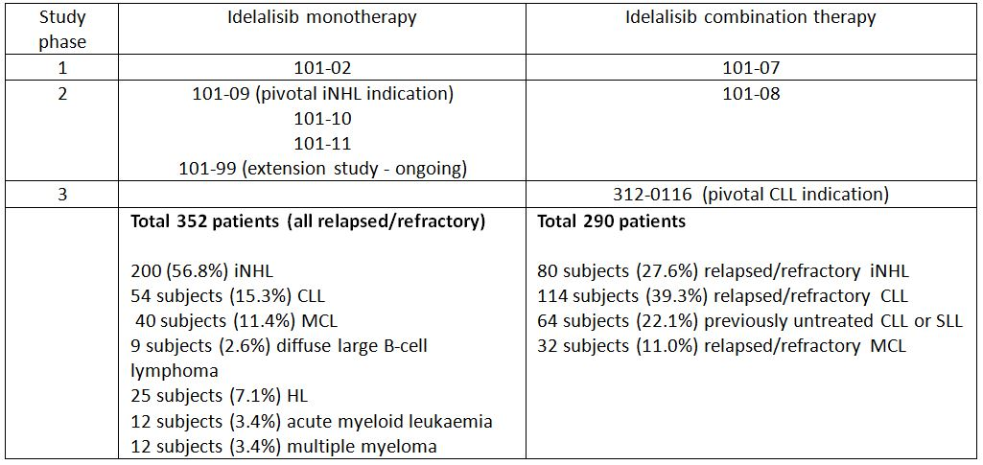

The safety analysis set (subjects who received at least 1 dose of idelalisib) for subjects treated with idelalisib monotherapy was summarized separately from subjects treated with idelalisib combination therapy. The analyses are further organized within each of these two groups into subjects with iNHL, subjects with CLL, and all subjects combined.

The safety data for idelalisib monotherapy was organized by dose category (< 150 mg BD or any once-daily regimen, 150 mg BD, and > 150 mg BD), and aggregated total for all idelalisib monotherapy.

The safety data for idelalisib combination therapy was reported according to treatment regimen: idelalisib plus rituximab [Id+R], idelalisib plus bendamustine [Id+B], idelalisib plus bendamustine and rituximab [Id+BR], idelalisib plus bortezomib [Id+Bo], idelalisib plus ofatumumab [Id+O], idelalisib plus everolimus [Id+E], idelalisib plus fludarabine [Id+F], idelalisib plus chlorambucil [Id+Ch], idelalsib plus rituximab and chlorambucil [Id+RCh], and aggregated total for all idelalisib combination therapy.

The sponsor states:

“Adverse events (AEs) were coded or up-versioned using the Medical Dictionary for Regulatory Activities (MedDRA) Version 15.1. Laboratory toxicities were graded using the National Cancer Institutes’ Common Terminology Criteria for Adverse Events (NCI CTCAE) Version 4.03. For certain laboratory parameters (albumin, cholesterol [high], lymphocytes [decreased], lymphocytes [increased], phosphate, and triglycerides), the central laboratory normal ranges fell within the CTCAE v. 4.03 definitions for Grade 1 and/or Grade 2 laboratory abnormalities. In these instances, the CTCAE definitions have been given precedence, resulting in some reports of treatment-emergent laboratory abnormalities that were in fact within the laboratory normal ranges.”

**Evaluator’s comment**: Why the “normal range” of the numerous test parameters described above fell within the range of grade 1 and 2 CTCAE categories according to the central laboratory “normal range” is uncertain. For example, the most recent Scientific Statement from the American Heart Association, 2011, regarding triglyceride states the normal range to be <150mg/dL, whereas the central laboratory “normal range” was up to 260mg/dL.5 The evaluators have only considered the CTCAE categorisation as the meaningfully reported outcomes.

### Pivotal studies that assessed safety as a primary outcome

No studies assessed safety as a primary outcome.

### Patient exposure

#### Idelalisib monotherapy

Overall, 352 subjects were treated with idelalisib monotherapy. All subjects received at least 1 dose of idelalisib. Studies 101 - 09, 101 - 10, 101 - 11, and extension Study 101 - 99 are ongoing (Table 17).

Table 17: Subjects treated with idelalisib monotherapy.

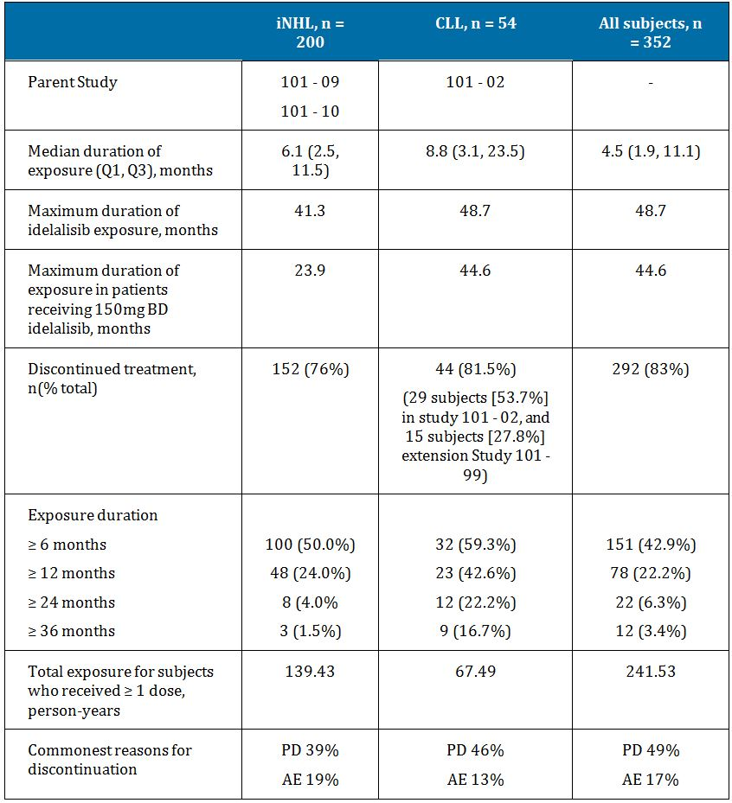

#### Idelalisib combination therapy

Overall, 290 subjects were treated with idelalisib in combination with other therapies (Table 18).

Table 18: Subjects treated with idelalisib in combination with other therapies.

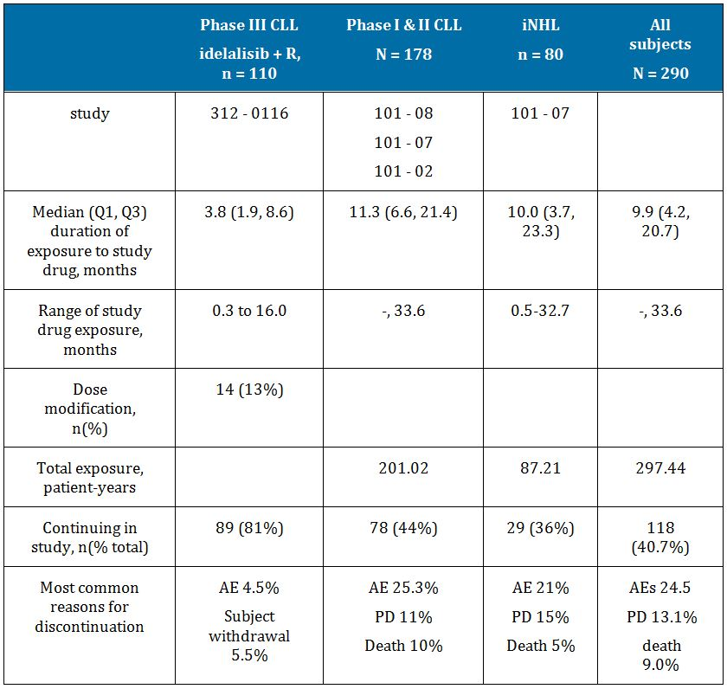

### Adverse events

#### All adverse events (irrespective of relationship to study treatment)

##### Idelalisib monotherapy

###### iNHL subjects

The most frequent AEs of any grade for subjects with iNHL treated with idelalisib monotherapy (reported for ≥ 10% of subjects) were: diarrhoea (40.5%), fatigue (31.5%), nausea (28.0%), cough (24.5%), pyrexia (24.5) and neutropenia (24.0%).

The distribution of patients exposed to <150mg BD, 150mg BD and >150mg BD was not equal (20%, 73% & 7% respectively) and so the incidence of adverse events related to dose level cannot be made with absolute certainty from the data. The AEs which were seen to increase in frequency with increasing dose were: nausea, peripheral oedema, cough, ALT & AST increase, thrombocytopaenia, neutropaenia, night sweats and headache. Other AEs did not demonstrate a dose-dependent relationship of idelalisib exposure.

The majority of subjects with iNHL treated with idelalisib monotherapy (145 of 200, 72.5%) reported at least 1 AE ≥ Grade 3 and the most frequently reported events (reported for ≥ 10% of subjects) were neutropenia (17.0%), ALT increased (13.0%), diarrhoea (11.0%), and pneumonia (10.0%).

###### CLL subjects

The AE profile observed for subjects with CLL treated with idelalisib monotherapy was similar to the profile observed for subjects with iNHL treated with idelalisib monotherapy. The most frequent AEs of any grade (reported for ≥ 10% of subjects) were fatigue (31.5%), diarrhoea (29.6%), pyrexia (27.8%), cough and thrombocytopenia (24.1% each), and anaemia, back pain, neutropenia, pneumonia, rash, and upper respiratory tract infection (22.2% each).

The incidence of pneumonia was highest among subjects treated with > 150 mg idelalisib BD. The majority of subjects with CLL treated with idelalisib monotherapy (42 of 54, 77.8%) reported at least 1 AE ≥ Grade 3 and the most frequently reported events (reported for ≥ 10% of subjects) were neutropenia and pneumonia (20.4% each), thrombocytopenia (13.0%), anaemia and febrile neutropenia (11.1% each).

###### All subjects

The AE profile observed for all subjects treated with idelalisib monotherapy was similar to the profiles observed for subjects with iNHL and CLL treated with idelalisib monotherapy.

The most frequent AEs for all subjects treated with idelalisib monotherapy were diarrhoea (34.9%), fatigue (31.3%), pyrexia (26.4%), nausea (25.3%), cough (22.2%), and neutropenia (20.5%). The majority of subjects treated with idelalisib monotherapy (249 of 352, 70.7%) reported at least 1 AE ≥ Grade 3 and the most frequently reported events (reported for ≥ 10% of subjects) were neutropenia (14.8%), ALT increased (11.4%), and pneumonia (11.1%).

##### Idelalisib combination therapy

###### Pivotal Phase III study 312-0116

Of the 220 subjects randomized in the study, 217 received at least 1 dose of study drug (idelalisib or placebo) as of the data cut-off for the interim analysis (30 August 2013) and were evaluable for safety.

Of the 14 subjects in the idelalisib arm that had dose reductions to 100mg BD, none were subsequently treated at 150mg BD.

Adherence to treatment was similar in both arms – 109 (99.1%) in the idelalisib arm had ≥75% adherence as opposed to 107 (100%) of the placebo arm.

Exposure to rituximab was similar between treatment arms:

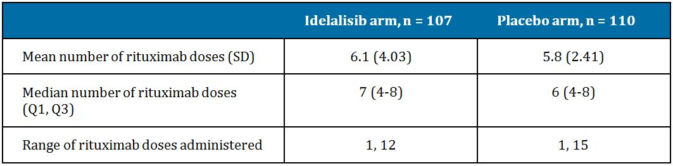

**Evaluator’s comment**: As discussed in the efficacy section, the dosing of rituximab was not according to the currently approved regimen. This exposure data also demonstrates the number of doses of rituximab exceeded the total of 6 doses recommended per the product information. In routine use outside of this clinical trial, it would be anticipated that the recommended rituximab regimen would be used. It is therefore uncertain how to directly translate the safety findings of the idelalisib+rituximab combination to the wider CLL population, given the atypical rituximab dosing regimen used.

Very common AEs, occurring in >10% of subjects, reported in the idelalisib + R group (n=110) were: pyrexia (29.1%) diarrhoea (19.1%), neutropaenia (21.8%), fatigue (23.6%), infusion-related reactions (15.5%) and nausea (23.6%).

Very common AEs reported in the placebo + R group were: pyrexia (15.9%), diarrhoea (14.0%), neutropaenia (13.1%), infusion-related reaction (28.0%), fatigue (27.1%), and cough (25.2%).

Grade ≥ 3 pyrexia was reported for 3 subjects (2.7%) in the idelalisib + R group and 1 subject (0.9%) in the placebo + R group.

Grade 3 or higher fatigue occurred in 3 subjects (2.7%) in the idelalisib + R group and 2 subjects (1.9%) in the placebo + R group.

Four subjects (3.6%) in the idelalisib + R group were reported to have an AE of transaminase increased of any grade, and 3 subjects (2.7%) had AEs of transaminase elevations of ≥ Grade 3 in severity. In the placebo + R group, 1 subject (0.9%) had an AE of transaminase elevations of any grade, and the event was ≥ Grade 3 in severity.

In the twenty-one subjects (19.1%) in the idelalisib + R group had an AE of diarrhoea (any grade), and 4 subjects (3.6%) had events that were ≥ Grade 3 in severity. In the placebo + R group, 15 subjects (14.0%) had diarrhoea of any grade, and 0 subjects had events that were ≥ Grade 3 in severity.

Adverse events of colitis were reported for 5 subjects (4.5%) in the idelalisib + R group and 1 subject (0.9%) in the placebo + R group. Three of the 6 subjects with AEs of colitis also were reported to have AEs of diarrhoea (one of which was concurrent), and the 2 AE terms may have been used interchangeably for these subjects. Colitis AEs of ≥ Grade 3 in severity were reported for 3 subjects (2.7%) in the idelalisib + R group and 0 subjects in the placebo + R group.

Eleven subjects (10.0%) in the idelalisib + R group had rash of any grade, and 2 subjects (1.8%) had rash of ≥ Grade 3 in severity. In the placebo + R group, 6 subjects (5.6%) had rash, and the event was of ≥ Grade 3 severity in 0 subjects. Maculo-papular rash was reported for 3 subjects (2.7%) in the idelalisib + R group (1 event [0.9%] of Grade 3) and for 0 subjects in the placebo + R group.

Five subjects (4.5%) in the idelalisib + R group had pneumonitis of any grade, and 3 subjects (2.7%) had pneumonitis of ≥ Grade 3 in severity. In the placebo + R group, 1 subject (0.9%) had pneumonitis, and the event was of ≥ Grade 3 severity. Subjects who were reported to have pneumonitis also had underlying diseases such as COPD and chronic renal failure and concomitant medical events such as renal failure and deep vein thrombosis/pulmonary embolism.

**Evaluator’s comment**: The currently approved product information for rituximab states that events of pneumonitis and fatal bronchiolitis obliterans have been observed with its use, some of which were fatal.

The pattern of AE profile, when analysed by time-period shows most AEs occurred within the first 12 weeks of treatment. Given that rituximab was only administered during the first 12 weeks of combination, it is uncertain what the cause(s) of the AEs occurring placebo+rituximab arm were –see safety questions.

##### Phase 1 and 2 studies of combination therapy

###### iNHL subjects

The most frequent AEs of any grade (reported for ≥ 20% of subjects) in subjects with iNHL were pyrexia (53.8%), nausea (45.0%), fatigue (42.5%), neutropenia (37.5%), rash (37.5%), diarrhoea (36.3%), cough (35.0%), ALT increased (28.8%), AST increased (27.5%), insomnia (22.5%), and upper respiratory tract infection (20.0%). The majority of subjects with iNHL treated with idelalisib combination therapy (70 of 80, 87.5%) reported at least 1 AE ≥ Grade 3 and the most frequently reported events were neutropenia (27.5%), ALT increased (18.8%), pneumonia (16.3%), and AST increased (12.5%).

###### CLL subjects

The most frequent AEs of any grade (reported for ≥ 20% of subjects) in subjects with CLL were diarrhoea (50.6%), pyrexia (42.7%), cough (35.4%), neutropenia (33.7%), fatigue (30.9%), nausea (30.9%), rash (27.0%), chills (23.0%), dyspnoea (23.0%), ALT increased (20.8%), and pneumonia (20.8%). The majority of subjects with CLL treated with idelalisib combination therapy (153 of 178, 86.0%) reported at least 1 AE ≥ Grade 3 and the most frequently reported events (reported for ≥ 10% of subjects) were neutropenia (29.2%), ALT increased (15.7%), diarrhoea (15.7%), pneumonia (14.0%), AST increased (11.2%), colitis (11.2%), febrile neutropenia (10.7%), and anaemia (10.1%).

###### All subjects

The AE profile observed for all subjects treated with idelalisib combination therapy was similar to the profiles observed for subjects with iNHL and CLL treated with idelalisib combination therapy. The most frequent AEs of any grade (reported for ≥ 20% of subjects) were diarrhoea (46.2%), pyrexia (43.4%), cough (34.5%), neutropenia (34.5%), fatigue (34.1%), nausea (32.4%), rash (29.7%), ALT increased (21.7%), and chills (21.0%). The majority of subjects treated with idelalisib combination therapy (249 of 290, 85.9%) reported at least 1 AE ≥ Grade 3. The most frequently reported events (reported for ≥ 10% of subjects) were neutropenia (27.9%), ALT increased (15.5%), pneumonia (14.1%), diarrhoea (13.4%), thrombocytopenia (11.4%), and AST increased (10.3%).

The incidence of AEs was generally notably higher among all subjects in the combination therapy group compared with all subjects in the monotherapy group.

The incidence of subjects who had neutropenia, any infection, and pneumonia was higher among all subjects treated with combination therapy compared with all subjects treated with idelalisib monotherapy (34.5% vs 20.5%, 65.2% vs 55.1%, and 19.3% v 13.1%, respectively). The incidence for upper respiratory tract infection was similar for subjects treated with combination therapy or idelalisib monotherapy (14.8% vs 14.5%, respectively).

The incidence of ≥ Grade 3 neutropenia, thrombocytopenia, and anaemia was higher among all subjects treated with combination therapy compared with subjects treated with idelalisib monotherapy (27.9% vs 14.8%, 11.4% vs 6.3%, and 9.3% vs 7.1%, respectively. The incidence of ≥ Grade 3 any infection, pneumonia, febrile neutropenia, sepsis, or rash was higher among all subjects treated with combination therapy compared with subjects treated with idelalisib monotherapy (32.4% vs 26.7%, 14.1% vs 11.1%, 9.3% vs 5.1%, 4.5% vs 1.4%, and 6.6% vs 2.0%, respectively.

## First round benefit-risk assessment

### First round assessment of benefits

Treatment of patients with relapsed CLL:

* Zydelig is an oral medication taken twice daily, without evidence of a food-effect
* Pharmacokinetics are not affected by gender, body weight, age or renal failure
* The novel mechanism of action permits use in patients who have relapsed or become refractory to existing therapies
* In patients with relapsed/refractory CLL that are considered eligible for monotherapy rituximab, the addition of idelalisib demonstrated a durable improvement in PFS and OS. The improvement in PFS was also demonstrated in subgroups with a known adverse tumour genetic profile
* Median haematological parameters of absolute neutrophil counts, platelets and haemoglobin did not worsen following idelalisib exposure in CLL patients
* Infusion related reactions were less common with idelalisib + rituximab as opposed to monotherapy rituximab
* The AE profile of idelalisib is generally manageable by dose modification and or supportive therapies.

Treatment of patients with refractory iNHL:

* Zydelig is an oral medication taken twice daily, without evidence of a food effect
* The novel mechanism of action permits use in patients who have relapsed or become refractory to existing therapies
* In patients with refractory iNHL, idelalisib treatment (monotherapy, or in combination) demonstrated a durable improvement in overall response rate
* The AE profile of idelalisib is generally manageable by dose modification and or supportive therapies.

### First round assessment of risks

* Interactions with CYP3A4 inhibitors and inducers affect Cmax and AUC of idelalisib;
* Evidence to support of use of idelalisib as monotherapy in relapsed CLL is currently inadequate
* The method of reporting TEAEs yields uncertainty as to the relative safety profile in patients exposed to idelalisib + rituximab as opposed to rituximab alone
* The incidence of diarrhoea is very common (the commonest reported AE in iNHL subjects), irrespective of monotherapy use or combination therapy
* Very common incidence of severe colitis, requiring treatment with steroids and mesalazine;
* Intestinal perforation was reported in one individual
* Intestinal obstruction was reported in two individuals, one of whom died
* There is a risk of pneumonitis additional to the known risk from other agents, necessitating idelalisib cessation. Fatal pneumonitis events were reported
* Risk of hepatotoxic events, including AST, ALT, and bilirubin elevation
* There is no experience of idelalisib use in patients with severe hepatic impairment
* Very common events of neutropaenia, thrombocytopaenia and anaemia were seen in CLL patients exposed to monotherapy idelalisib, each with an incidence of >20%
* Increased risk of infections (including atypical and opportunistic)
* Increased risk of: dermatitis, exfoliation and bullous skin disorders associated with idelalisib treatment
* There is a risk of acute renal failure, which was fatal in one case.

## First round recommendation regarding authorisation

The proposed use of idelalisib, alone or in combination for the treatment of patients with relapsed chronic lymphocytic leukaemia (CLL) is unfavourable given the proposed usage, but would become favourable if the changes recommended below are adopted:

The authorisation of the use of idelalisib in the treatment of relapsed/refractory CLL cannot yet be approved as:

* Evidence to support of use idelalisib as monotherapy in relapsed CLL is not yet adequate as only one Phase I dose ranging study (101-102) provided preliminary evidence
* Although there was evidence to support use of idelalisib in combination with rituximab in elderly patients with relapsed, recurrent CLL with poor prognosis and limited treatment options, interpretation was limited by use of rituximab.monotherapy, using an unapproved regimen, as the control treatment in the pivotal CLL study (312-016).

The proposed use of Idelalisib for treatment of patients with refractory iNHL is favourable.

It is recommended that the application for marketing approval for idelalisib 150mg BD be approved for the proposed indication of “treatment of patients with refractory indolent non-Hodgkin lymphoma (iNHL).”

## Clinical questions

### Pharmacokinetics

1. The justification for not submitting biopharmaceutical studies did not address all of the requirements as per TGA guidelines. The sponsor is kindly requested to address these deficiencies.
2. Based on the plasma AUC0-24 data presented, the total plasma radioactivity that can be attributed to idelalisib and GS-563117 is 94%; however, the sponsor states in the Summary of Clinical Pharmacology Studies that the total radioactivity of these 2 components adds to 100%. The sponsor is kindly requested to explain this discrepancy.
3. The sponsor is kindly requested to report the CL/F of idelalisib for patients with either hepatic or renal impairment as per the TGA guidelines.
4. One of the secondary objectives of the Phase III Study GS-US-312-0116 was to characterise the effect of rituximab on idelalisib exposure through evaluations of idelalisib plasma concentrations over time. Information relating to this objective was not available at the time of submission. If this data is available, can it be presented?
5. The sponsor is kindly requested to indicate whether the drug-drug interaction data from Study 101-07, which examines the interaction of idelalisib with an anti CD20 mAb, a chemotherapeutic agent, an mTOR inhibitor, and/or a proteasome inhibitor is now available.
6. The sponsor is kindly requested to explain the difference between the protein binding value of idelalisib of 93-94% in the proposed Australian PI and the value of 84% contained in the FDA approved PI.

### Pharmacodynamics

1. The sponsor is kindly requested to indicate when the PD data relating to Studies 101-07, 101-08, 101-09, 101-10 and 101-11 will be available.
2. Is there an analysis available for genetic, gender and age related differences in pharmacodynamics?

### Efficacy

1. What are the five additional phase three trials (2 in iNHL and 3 in CLL patients) in regard to the population being studied and the treatment regimen(s) being administered?
2. The pivotal Study 312-0116 included 2 pre-specified formal interim efficacy analyses by an independent Data Monitoring Committee. Can the sponsor indicate when the second analysis for this study will be available?
3. In Study 312-0116, what was the justification for using monotherapy rituximab, with additional 500 mg/m2 doses separated fortnightly, as opposed to the currently approved regimen in the Australian PI?
4. Why was chlorambucil not considered the appropriate standard treatment comparator in the pivotal CLL study, given the age and co-morbidities of the patients?
5. Can the sponsor please report the proportion of patients that had ever received rituximab prior to enrolment in each arm of the pivotal study 312-0116?
6. Molecular mechanisms of rituximab resistance have been characterised. In those patients in the pivotal study that had received prior rituximab, what proportions had documented rituximab resistance prior to enrolment in the study, and by what method(s) was rituximab resistance confirmed?
7. In Study 312-0116, what was the sponsors’ justification for re-administering rituximab to patients that relapsed or become refractory following its use?
8. The sponsor is kindly requested to compare the PFS outcome of the pivotal CLL trial according to prior rituximab exposure status, for each treatment arm.
9. The sponsors have stated that analyses of health related quality of life (HRQL) and healthcare utility assessments will only be reported in the clinical safety report that covers entire blinded phase in Study 312-0116 involving patients with refractory, relapsed CLL. Can the sponsor please indicate when this data will be available?

### Safety

1. The sponsor is kindly requested provide any information it holds on the duration of B cell depletion following idelalisib treatment in CLL patients and iNHL patients separately.
2. In Study 312-0116, the incidence of TEAEs was reported as 22/107 (20.6%) due to *placebo* exposure. Assuming the placebo was inactive; can the sponsor please explain why these were not categorised as rituximab related?
3. In Study 312-0116, the total incidence of TEAEs does not equal the incidence of TEAEs ascribed to each of the two treatments:

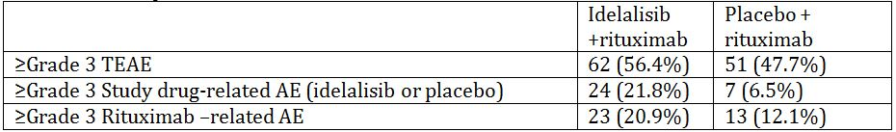

The sponsor is requested to provide a summary of the reasons why the overall incidence of ≥ grade 3 TEAEs is higher (in both study arms) as compared to the ≥ grade 3 events related to both study drug and rituximab arms combined.

1. What was the incidence of histological transformation (Richter transformation) for any of the CLL patients exposed to idelalisib?
2. For the subjects who experienced pneumonitis in association with idelalisib exposure, the sponsor is kindly requested to give a considered summary of these patients, specifically indicating (i) the duration (ii) the reversibility of symptoms and (iii) whether recurrence on re-challenge occurred.
3. In the global development program, in patients exposed to idelalisib and rituximab, what was the incidence of (i) hepatitis B reactivation and (ii) fulminant hepatic failure (iii) progressive multifocal leucoencephalopathy?
4. The exposure ratios of AUC0-last, AUCinf and Cmax were outside the accepted bioequivalence range of 80-125% in patients with severe renal impairment as compared healthy controls. What is the sponsors’ justification for not recommending dose adjustment or contraindication in patients with renal impairment?
5. Among the patients who died, one subject had an “acute abdomen” ascribed as the cause of death. What was the actual cause of death in this patient?
6. Among the patients who died, one subject had “intestinal obstruction” ascribed as the cause of death. What was the actual cause of death in this patient?
7. The FDA approved product information describes a risk of toxic epidermal necrolysis (TEN). The evaluator could not identify this term in the integrated safety summary. The sponsor is kindly requested to provide a summary of the case(s) with TEN AEs.
8. The sponsor is kindly requested to provide a considered summary of the risk of second malignancy in idelalisib exposed subjects.
9. The sponsor is kindly requested to provide a considered statement suitable for inclusion in the PI pertaining to the risks associated with immunisation before, during, and after idelalisib exposure.

## Second round evaluation of clinical data submitted in response to questions

### Pharmacokinetics

#### (Q1) The justification for not submitting biopharmaceutical studies did not address all of the requirements as per TGA guidelines. The sponsor is kindly requested to address these deficiencies.

**Sponsor response**:The biopharmaceutics of IDELA, including bioavailability and food effect, have been extensively evaluated and provided.

The proposed commercial IDELA tablets (150 and 100 mg) are an immediate-release, solid oral dosage form. The description and composition of the IDELA tablets have been provided.

IDELA displays low water solubility and moderate to high permeability, and is therefore considered to be a Class 2 (low solubility - high permeability) compound in accordance with the BCS classification system. Details of solubility assessment of IDELA (module 3.2.P.2.1, Sections 1.1.2.5 and 1.1.2.6) and in-vitro evaluation of IDELA permeability (module 3.2.P.2.1, Section 1.1.2.7) were provided with the original Category 1 Application.

The plasma exposures (Cmax and AUC) of IDELA are approximately dose proportional between 50 mg and 100 mg and less than dose proportional above 100 mg, likely due to solubility limited absorption (Studies 101-01 and 101-02).

The absolute bioavailability of IDELA was estimated based on Study 101-05 and Study 313-0111. In Study 101-05, microdoses of [14C]IDELA were administered by the oral and IV route. The total 14C radioactivity in plasma following IV and oral administration of [14C]IDELA was assessed, and the ratio of the area under the curve (AUC) for total 14C following oral versus IV administration was determined to be 91%. A direct estimation of IDELA absolute bioavailability from this study is not feasible as plasma IDELA concentrations following oral microdose administration of [14C]IDELA could not be measured.

In the follow-up human mass balance Study (313-0111), the radioactivity in plasma was identified as either IDELA (38%) or GS-563117 (62%), and no other circulating radioactive species were identified. Therefore, it can be assumed that the total circulating radioactivity recovered in Study 101-05 represented the combination of both IDELA and GS-563117 and that following oral dosing, the average percent of 14C radioactivity AUC contributed by IDELA relative to total 14C radioactivity AUC was approximately 38%.

Additionally, following IV microdose administration in Study 101-05, the plasma IDELA AUC can be estimated using noncompartmental analysis (NCA), assuming that concentration at time = 0 was contributed by IDELA (ie, no metabolism at Time 0) and the half-life of plasma IDELA was approximately 8.2 hours (based on population PK modeling). Following IV microdosing, IDELA represented approximately 47% of the total 14C radioactivity. Based on the total 14C AUC following IV and oral administration as well as the prevalence of IDELA in the total 14C AUC, the absolute bioavailability can be estimated to be approximately 74% (91% × 38%/47%) using the following formula:

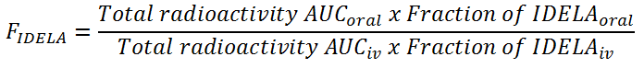

Therefore, given the low solubility and high permeability, low apparent clearance (~15% of hepatic blood flow) and moderate to high bioavailability, the first pass effect is expected to be low. Overall, based on the well characterized pharmacokinetic and ADME properties and moderate-to-high bioavailability, an absolute bioavailability study for IDELA was not deemed necessary and therefore not performed.

The proposed commercial IDELA tablet, administered in pivotal dose defining and efficacy studies, is the only formulation under consideration; therefore, the following issues are not considered relevant for the justification:

* the similarities of, or differences between, the formulations being considered
* the comparative dissolution profiles across the physiological pH range (1-7.5) of the products being considered
* the clinical consequences of any potential differences in bioavailabilities of the products under consideration (e.g. increased dose leading to toxicity or decreased dose leading to lack of efficacy).

**Evaluator response:**

This explanation is satisfactory.

#### (Q2) Based on the plasma AUC0-24 data presented, the total plasma radioactivity that can be attributed to idelalisib and GS-563117 is 94%; however, the sponsor states in the Summary of Clinical Pharmacology Studies that the total radioactivity of these 2 components adds to 100%. The sponsor is kindly requested to explain this discrepancy.

**Sponsor response:**

Based on the results of Study 313-0111, the circulating radioactivity in plasma consisted entirely of IDELA (38%) and its oxidized metabolite, GS-563117 (62%). Therefore, the total plasma radioactivity that can be attributed to IDELA and GS-563117 is 100%. The plasma AUC0-24 data presented in Table 4.5.8 (page 129), showing the contribution of IDELA to the total plasma radioactivity at 32% (ie, total radioactivity of 94%) instead of 38%, is a transcribing error.

**Evaluator response:**

This explanation is satisfactory.

#### (Q3) The sponsor is kindly requested to report the CL/F of idelalisib for patients with either hepatic or renal impairment as per the TGA guidelines.

**Sponsor response:**

The apparent clearance (CL/F) of IDELA following a single oral dose of IDELA 150 mg under fed conditions in subjects with moderate or severe hepatic impairment, or matched healthy control subjects, is summarized in Table 19 and Table 20.

Table 19: IDELA CL/F in Subjects with Moderate Hepatic Impairment and Matched Healthy Controls.

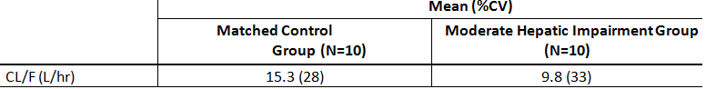

Table 20: IDELA CL/F in Subjects with Severe Hepatic Impairment and Matched Healthy Controls.

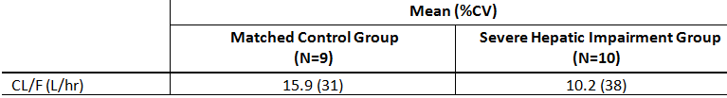

The apparent clearance (CL/F) of IDELA following a single oral dose of IDELA 150 mg under fed conditions in subjects with severe renal impairment, or matched healthy control subjects, is summarized in Table 21.

Table 21: IDELA CL/F in Subjects with Severe Renal Impairment and Matched Healthy Controls.

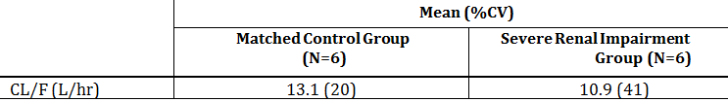

**Evaluator response:**

The reduced magnitude of apparent clearance is similar for subjects with moderate or severe hepatic impairment, and those with severe renal impairment as compared to matched controls.

#### (Q4) One of the secondary objectives of the Phase III Study GS-US-312-0116 was to characterise the effect of rituximab on idelalisib exposure through evaluations of idelalisib plasma concentrations over time. Information relating to this objective was not available at the time of submission. If this data is available, can it be presented?

**Sponsor response:**

In Study 312-0116, the mean trough concentrations of IDELA (~338 ng/mL) in combination with rituximab were comparable to those observed in other studies with IDELA monotherapy (eg, Study 101-02) indicating a lack of effect of rituximab coadministration on IDELA PK (m5.3.5.1 Second Interim Clinical Study Report).

Extensive population PK analyses were performed to analyze IDELA and GS-563117 PK in subjects with hematologic malignancies following IDELA treatment as monotherapy (Studies 101-02, 101-09, 101-11) or in combination with background therapies such as rituximab (studies 101-07, 101-08) (Report # 13-0001). The results showed that rituximab usage was not a statistically significant covariate on IDELA PK parameters (ie, apparent clearance and apparent volume of distribution). In addition, simulated IDELA exposures were similar with (AUCtau: 10220 ng•h/mL, Cmax: 1764 ng/ml and Ctrough: 355 ng/mL) and without rituximab (AUCtau: 10683 ng•h/mL, Cmax: 1947 ng/ml and Ctrough: 365 ng/mL) coadministration. Similarly, a lack of clinically meaningful effect of rituximab on GS-563117 exposure (AUCtau, Cmax, and Ctrough) was shown (Report # 13-0002).

**Evaluator response:**

From the data presented, there appears to be no effect of rituximab on idelalisib exposure.

#### (Q5) The sponsor is kindly requested to indicate whether the drug-drug interaction data from Study 101-07, which examines the interaction of idelalisib with an anti CD20 mAb, a chemotherapeutic agent, an mTOR inhibitor, and/or a proteasome inhibitor is now available.

**Sponsor response:**

Study 101-07 is ongoing. Data available from 197 subjects in Study 101-07 were included in population PK analyses to evaluate the effect of background treatment (rituximab, ofatumumab, bendamustine, chlorambucil, fludarabine, everolimus or bortezomib) on IDELA PK (Report # 13-0001).

The results showed that background treatment was not a statistically significant covariate on IDELA PK. In addition, IDELA PK parameters (individual estimates based on final model) were comparable regardless of the specific background treatment administered as shown in Figure 4.

Figure 4: The relationship between IDELA PK parameters and background treatment.

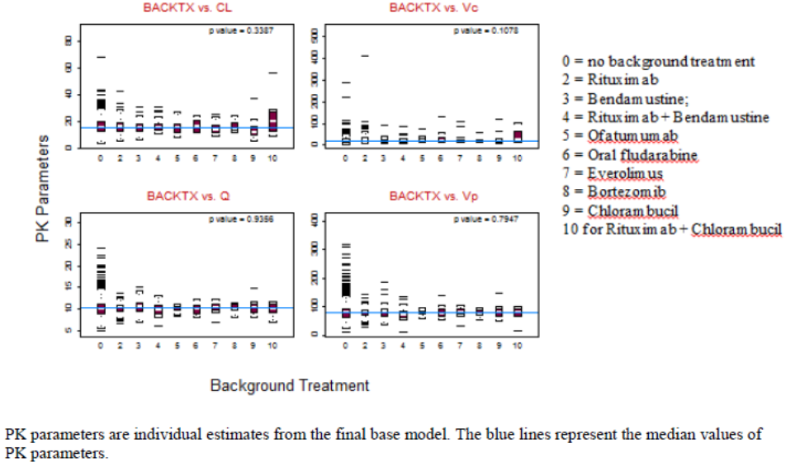

**Evaluator response**

From the interim data presented, there appears to be no effect of background treatment on idelalisib PK parameters.

#### (Q6) The sponsor is kindly requested to explain the difference between the protein binding value of idelalisib of 93-94% in the proposed Australian PI and the value of 84% contained in the FDA approved PI.

**Sponsor response:**

During the evaluation of Zydelig in the US, the US FDA requested this change in percentage to the US Prescribing Information to 84%. The protein binding value of 84% is based on the in vitro study AD-312-2009, while the 93-94% value in the proposed Australian PI is based on assessment in healthy subjects in Studies 313-0112 (hepatic impairment) and 313-0118 (renal impairment). The 93-94% value reported in the proposed Australian PI is consistent with the current EU SmPC which received positive opinion by the CHMP on 25 July 2014. A copy of the SmPC is included within Section 1.10.2 of this response.

**Evaluator response:**

The use of the protein binding value in healthy subjects, as compared the value obtained from an *in vitro* study, is considered appropriate.

### Pharmacodynamics

#### (Q7) The sponsor is kindly requested to indicate when the PD data relating to Studies 101-07, 101-08, 101-09, 101-10 and 101-11 will be available.

**Sponsor response:**

The planned dates for the final study reports for the requested studies are provided in Table 22.

Table 22: Planned dates for final study reports.

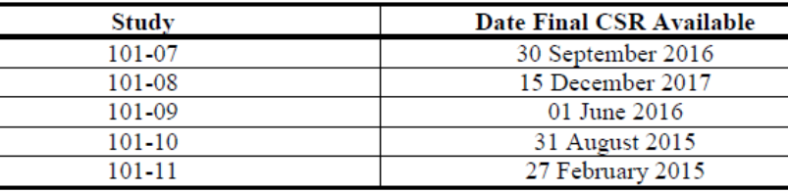

Any pharmacodynamic data collected during the studies will be summarized as part of the final reports.

**Evaluator response:**

These dates are noted.

#### (Q8) Is there an analysis available for genetic, gender and age related differences in pharmacodynamics?

**Sponsor response:**

No analyses of genetic, gender- and age-related differences in pharmacodynamics have been conducted to date.

**Evaluator response:**

The absence of these PD analyses is noted.

### Efficacy

#### (Q9) What are the five additional phase three trials (2 in iNHL and 3 in CLL patients) in regard to the population being studied and the treatment regimen(s) being administered?

**Sponsor response:**

A tabular summary of the ongoing trials is seen in Table 23.

Table 23: Ongoing phase 3 studies of idelalisib.

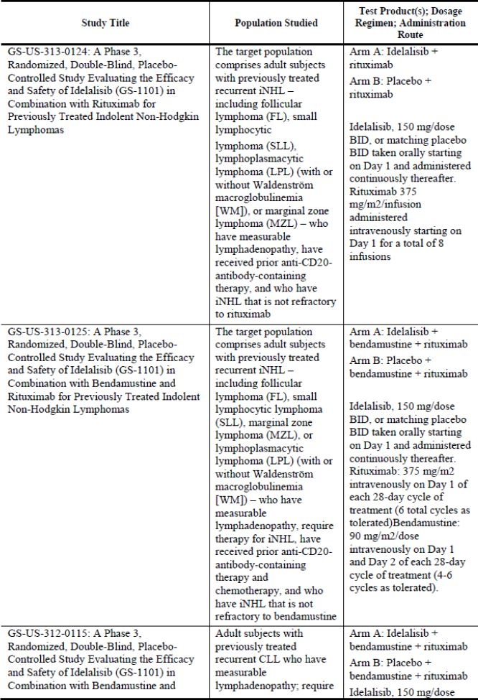

Table 23 (continued): Ongoing phase 3 studies of idelalisib.

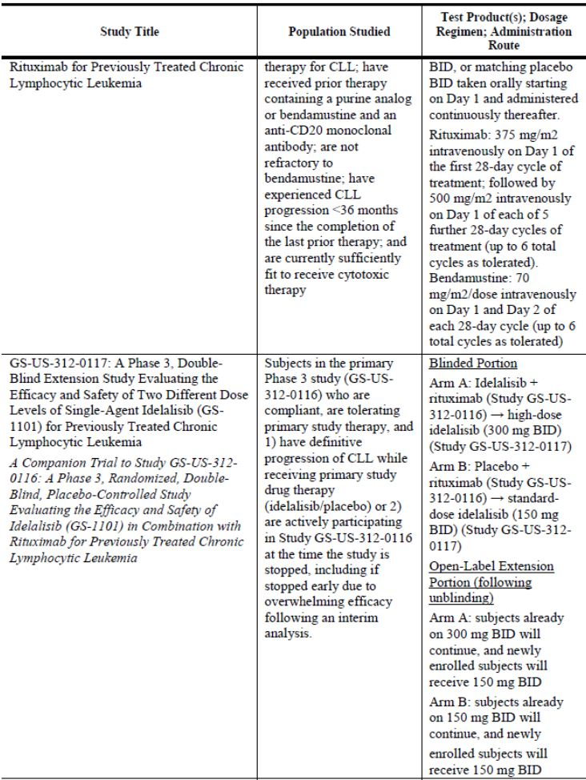

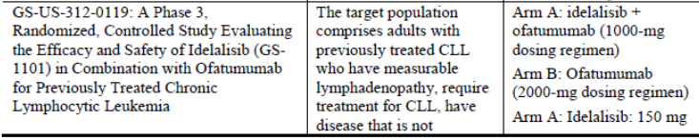

Table 23 (continued): Ongoing phase 3 studies of idelalisib.

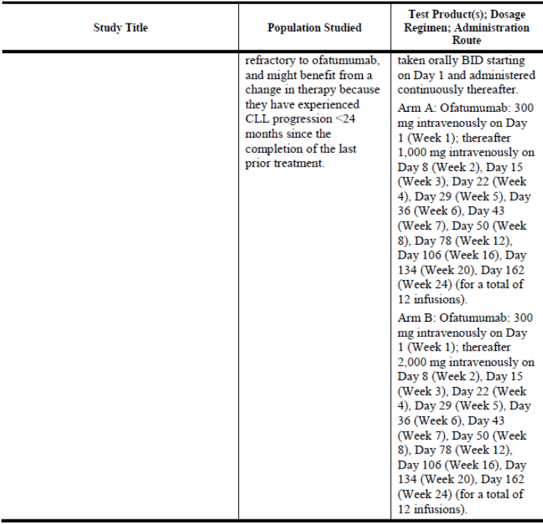

**Evaluator response:**

The trial summaries are noted.

#### (Q10) The pivotal Study 312-0116 included 2 pre-specified formal interim efficacy analyses by an independent Data Monitoring Committee. Can the sponsor indicate when the second analysis for this study will be available?

**Sponsor response:**

Based on results from the first pre-specified interim efficacy analysis, the DMC recommended stopping the trial for overwhelming efficacy, and Gilead agreed. The decision to stop the study early was made in consultation with the FDA on 7 October 2013. On this date a decision was made in conjunction with the FDA to perform a second analysis on blinded data up to 9 October 2013.

The second interim CSR on data up to 9 October 2013 for Study 312-0116 is now available and is provided. The proposed PI has also been updated accordingly.

**Evaluator response:**

The second interim analysis of study 312-0116 is generally consistent with the first interim analysis, demonstrating a similar magnitude of efficacy outcome measures between the two reports. No complete responses were observed in either treatment arm.

The efficacy outcomes reported in the second analysis are summarised in Table 24, in the format presented in the PI.

Table 24: Efficacy outcomes reported in the second analysis.

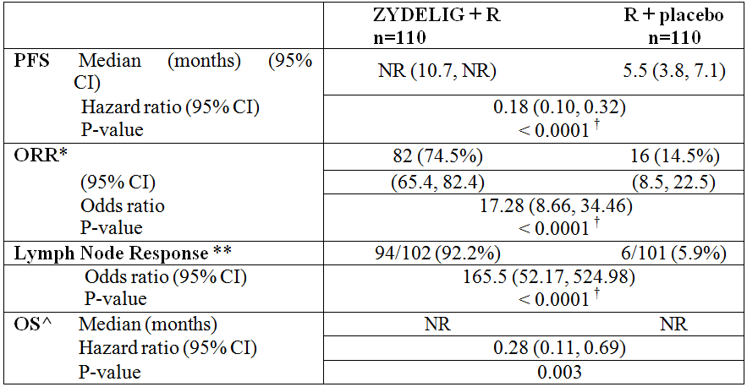

R: rituximab; PFS: progression-free survival; NR: not reached  
* ORR defined as the proportion of patients who achieved a CR or PR based on the 2013 NCCN response criteria and Cheson (2012). Only patients that had both baseline and ≥1 evaluable post-baseline SPD were included in this analysis  
** Lymph node response defined as the proportion of patients who achieve a ≥50% decrease in the sum of products of the greatest perpendicular diameter (SPD) of index lesions. Only patients that had both baseline and ≥1 evaluable post-baseline SPD were included in this analysis  
^ Overall survival (OS) analysis includes data from subjects who received placebo + R on study 312-0116 and subsequently received idelalisib in an extension study, based on intent-to-treat analysis  
† Actual p-values: for PFS, p= 6 x 10-11; for ORR, p=6.3 x 10-19; for LNR, p=4.1 x 10-34  
The PI amendments relating to this information contain a number of errors.

The second interim analysis by sub-groups demonstrates similar efficacy findings to the first analysis. The important difference is the demonstration of an overall survival benefit (although this is a secondary outcome) at the second interim assessment point, in favour of idelalisib.

The data for quality of life in the S31 response are unclear. Figures 5, 6, 7, 8 & 9 are presented using the mean change from baseline ± standard error of the mean. By presenting the error bars as the standard error, rather than the 95% confidence interval, the statistical differences between the two groups appear maximised, where none may actually be present.

The sponsor is requested to re-present the five figures, using the 95% confidence interval of the mean change in baseline.

Crude quality of life data for each arm have not been presented. The data presented in the Section 31 response is derived from a mixed-effects model which included treatment arm, interaction of treatment by study weeks and stratification factors as covariates. This analysis method was not specified in the statistical analysis plan (version 5) submitted in the dossier and thus appears to have been a post-hoc analysis. The sponsor is kindly requested to confirm the timing of the decision to use a mixed-effects model in the presentation of the quality of life data.

Furthermore the statistical analysis plan states that for the EQ-5D questionnaire, “data will be analysed using appropriate methods specified in the user manual to account for incomplete completion of questionnaires”. The proportion of data that was imputed has not been reported for this measure. Furthermore, the use of imputed data to assess quality of life cannot be justified from a regulatory perspective, given that the sponsor cannot provide an assurance that the missing data is true representation of that which would have been obtained if the subject had completed the questionnaire item.

Presented in its current form, due to the uncertainties discussed above, the evaluator is unable to make a considered evaluation of the material provided, from what has been presented, there appears to be no consistent effect from idelalisib exposure. The interim quality of life data with a p-value of less than 0.05 are exploratory only. The sponsor is not proposing to document any exploratory quality of life data in the product information.

#### (Q11) In Study 312-0116, what was the justification for using monotherapy rituximab, with additional 500 mg/m2 doses separated fortnightly, as opposed to the currently approved regimen in the Australian PI?

**Sponsor response:**

Rituximab is approved in combination with FC for the treatment of relapsed CLL. The pivotal trial was designed to establish a non-cytotoxic treatment in a frail patient population not-suitable for further chemotherapy and with high unmet medical need. In this specific patient group, rituximab was considered a feasible comparator (as monotherapy) and combination partner (treatment arm).

Single-agent rituximab has documented activity in subjects with previously treated CLL. In a prospective multicenter study in heavily pretreated subjects with CLL, in which 24 subjects received a standard dose of 375 mg/m2 of rituximab given once weekly for 4 weeks, the ORR was 35% with a PFS of 3.1 months. In a similar study in 28 evaluable subjects with previously treated, relapsed CLL, the same standard dose of rituximab induced an ORR of 25%, with a median PFS of 16 weeks. Additional studies have shown that dose escalation and intensification of rituximab can increase the ORR to 75% and the median PFS to 10 months {22413}, {25412}. The safety of single agent rituximab is long standing and is generally well tolerated in patients with previously treated CLL.

In Study 312-0116, Gilead used the current regimen of rituximab approved in the US for use in combination therapy (6 months, monthly). Dose intensification was added in the form of 2 additional doses every 2 weeks at Weeks 2 and 6 to maximize the efficacy of rituximab monotherapy for the control arm of Study 312-116. The 2013 NCCN guidelines recommend dose-dense rituximab monotherapy in frail patients {23536}. The trial was specifically designed for patients with recurrent, previously treated CLL who had comorbidities or chronic myelotoxicity and were poor candidates for further chemotherapy, ie, frail subjects {20558}. Given their advanced disease, such subjects are expected to have a median survival that is < 15 months. Rituximab monotherapy is an option for these frail subjects given its modest but demonstrated activity in relapsed disease and good tolerability {26378, 26379}. Such therapy is typically employed by practitioners with the hopes of safely regaining or maintaining some level of disease control; for example, among subjects with CLL participating in Phase 1b/2 studies of IDELA, 35% had previously received single-agent rituximab for relapsed disease.

The observation that rituximab monotherapy is in fact prescribed for patients with advanced, relapsed CLL is also supported by treatment practice data from both Europe and the US. In a recent (2010-2013) evaluation of a monthly average of 7736 subjects with CLL undergoing any line of treatment in the US (Gilead, data on file), BR was the most common regimen (14-32% of monthly use) followed by rituximab monotherapy as the second most common regimen (18-25% of monthly use). Of the 4356 subjects with relapsed CLL undergoing treatment, BR was the most common regimen (18-33% of monthly use) followed by rituximab monotherapy (7-16% of monthly use). In an evaluation (2010-2013) of subjects with CLL in EU5 countries {26721}, annually projected data estimated 37,119 subjects were treated, the majority with fludarabine-cyclophosphamide-rituximab (23.1%) followed by BR (17.4%). Rituximab monotherapy was only rarely used as first line therapy (0.3%), it is used increasingly in later lines of therapy for CLL (second line, 8.2%, third line or more, 22.1%) irrespective of age. Thus, despite differences in the treatment practice guidelines, in the clinical practice setting, rituximab monotherapy is used in both the EU and the US in advanced disease.

The reasons that clinicians might choose single agent rituximab for frail patients with comorbidities and advanced disease are well illustrated by the data collected in the control arm of Study 312-0116. The data demonstrate that rituximab monotherapy is active in improving lymphadenopathy in advanced CLL (Figure 5) and undoubtedly provides a measure of disease control in these frail patients unsuited for cytotoxic agents.

Figure 5: Study GS-US-312-0116 first interim analysis: waterfall plot of best percent change from baseline in SPD for each subject.

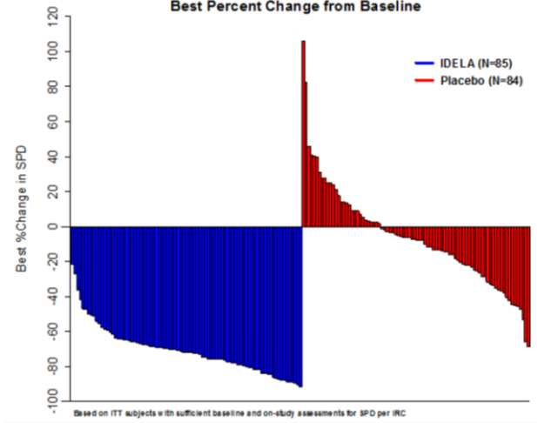

The efficacy and safety findings in Study 312-0116 strongly support a positive benefit risk evaluation for the use of IDELA, in combination with rituximab, in this population of elderly subjects with poor prognosis and extremely limited treatment options. Additionally, benefit in terms of quality of life must be considered in such a patient population. Remarkably, these frail subjects reported a sustained higher quality of life on IDELA + rituximab compared to placebo + rituximab.

**Evaluator response:**

The use of monotherapy rituximab remains unapproved in Australia; therefore, despite the limited evidence for its use in other countries, the sponsor has not provided a robust justification for use in Australian patients. Furthermore, the sponsor has not sufficiently justified the use of additional doses of rituximab in “poor candidates for further chemotherapy, ie, frail subjects”. There appears to be insufficient justification for using an unproved dose-dense regimen, with concomitant risks of increased adverse events in such a population of patients.

#### (Q12) Why was chlorambucil not considered the appropriate standard treatment comparator in the pivotal CLL study, given the age and co-morbidities of the patients?

**Sponsor response:**

The intention of the pivotal trial in relapsed CLL was to establish a non-cytotoxic treatment for patients that are not suitable for chemotherapy. That was the population in which the highest unmet medical need was identified at the time point of study design. Although chlorambucil may be considered as first-line treatment for patients with relevant co-morbidities, ESMO (2008) as well as NCCN (2011) guidelines list chlorambucil as an option for treatment of relapsed CLL only if it was used as a first-line treatment (and then only if the relapse of the disease occurred “late”, which by ESMO and NCCN guidelines means that relapse had to occur after >12-24 and >36 months, respectively). In addition, the NCCN guidelines do not list chlorambucil as an option for relapsed CLL with del(17p) at all, and for patients with del(11q) chlorambucil is only listed as an option if the first-line treatment was chlorambucil as well. Of note, 44% and 32% of subjects enrolled in the pivotal study had relapsed CLL with del(17)/TP53 mutation and del(11p), respectively.

Even though chlorambucil may be considered as a somewhat less toxic form of chemotherapy, chlorambucil still carries a relevant burden of toxicities like all other chemotherapeutics, although possibly to a lesser extent, including laboratory abnormalities of ≥ Grade 3 neutropenia and ≥ Grade 3 infections in 26% and 15% of treated subjects, respectively, with 2% deaths in the frontline CLL treatment setting. There is much less evidence for chlorambucil use in more advanced lines of therapy, but considering that the toxicity burden will likely increase in later lines of therapy, chlorambucil represents a less feasible choice in unfit comorbid subjects. In line with this, in a prospective, randomized study of initially previously un-treated CLL subjects, 28 subjects whose disease had relapsed after treatment with cladribine plus prednisone were then treated with chlorambucil plus prednisone for 7 days every 28 days for a time period of 12 months. The ORR in this study population was 21% and the PFS was 8 months. As expected, the Grade 3/4 toxicities among subjects included 47% infections, 26% neutropenia, 26% thrombocytopenia, and 16% anemia.

In summary, chlorambucil was not used as a comparator in this pivotal study since guidelines did not sufficiently support its use in the defined patient population, the toxicities associated with chlorambucil appeared inadequate for the defined patient population, and the overall goal of this specific pivotal study was to establish a non-cytotoxic treatment for relapsed CLL.

**Evaluator response:**

Further to the response to question 12, the evaluator remains unsure that the justification sufficiently describes the risks posed. The sponsor has stated that the “toxicity burden will likely increase” with chlorambucil as a reason for not using this treatment, yet used an unapproved dose-dense regimen of rituximab with an unknown adverse event profile.

#### (Q13) Can the sponsor please report the proportion of patients that had ever received rituximab prior to enrolment in each arm of the pivotal study 312-0116?

**Sponsor response:**

A total of 90.9% (100/110) of subjects in the IDELA + R arm and 88.2% (97/110) of subjects in the placebo + R arm received rituximab either as a single agent or as part of a combination regimen prior to enrolment in Study 312-0116.

**Evaluator response:**

The proportion of subjects previously exposed to rituximab is similar in each study arm.

#### (Q14) Molecular mechanisms of rituximab resistance have been characterised. In those patients in the pivotal study that had received prior rituximab, what proportions had documented rituximab resistance prior to enrolment in the study, and by what method(s) was rituximab resistance confirmed?

**Sponsor response:**

Almost all subjects enrolled in the pivotal study were previously exposed to rituximab (90%), and studies to confirm or exclude the presence of exact molecular mechanisms of rituximab resistance were not performed. Although molecular mechanisms were not used to document resistance, a clinical definition of refractory, (as defined as relapse occurring within 6 months or not experiencing benefit) was applied and patients who were refractory to their last therapy containing an anti-CD20 antibody were excluded from the study.

**Evaluator response:**

The proportion of subjects with molecular resistance to rituximab in each arm of the CLL pivotal study has not been identified and thus remains a source of potential bias, the magnitude of which cannot be elucidated.

#### (Q15) In Study 312-0116, what was the sponsors’ justification for re-administering rituximab to patients that relapsed or become refractory following its use?

**Sponsor response:**

As outlined in the response to Question 14, patients who were refractory (as defined by relapse occurring within 6 months or not experiencing benefit) to their last therapy containing an anti-CD20 antibody were excluded from Study 312-0116. In 63% of patients enrolled the last therapy included rituximab and an additional 10% had ofatumumab. As such, 73% of patients received an anti-CD20 as a component of the last therapy.

Inclusion Criterion #15 states that in order to be eligible for the study, “in the judgment of the investigator, participation in the protocol offers an acceptable benefit-to-risk ratio when considering current CLL disease status, medical condition, and the potential benefits and risks of alternative treatments for CLL.”

Finally, as shown in the response to Question 16, prior rituximab exposure did not have a negative impact on PFS in either arm of the study, demonstrating that the inclusion and exclusion criteria appropriately defined a patient population that was not refractory to rituximab therapy.

**Evaluator response:**

In the subjects that met the pre-specified exclusions of CLL relapse either occurring within 6 months of rituximab use, or not experiencing benefit from rituximab there was demonstrated continued benefit from its use in the trial population.

#### (Q16) The sponsor is kindly requested to compare the PFS outcome of the pivotal CLL trial according to prior rituximab exposure status, for each treatment arm.

**Sponsor response:**

Of the 220 subjects enrolled in Study 312-0116, 138 (63%) had received rituximab during the last therapy. As shown in Figure 6-7 comparing the KM curves of PFS for subjects with or without prior exposure to rituximab during the last therapy, prior rituximab exposure did not have a negative impact on PFS on either treatment arm. In the IDELA + R treatment arm, the median PFS for subjects with exposure to rituximab during the last therapy is not reached, and the median PFS for subjects without exposure to rituximab during the last therapy is 12.1 months. In the Placebo + R treated arm, the median PFS for subjects with exposure to rituximab during the last therapy is 6.9 months, and the PFS for subjects without exposure to rituximab during the last therapy is 3.7 months.

Figure 6: PFS assessment: by prior rituximab exposure status for the placebo + R arm.

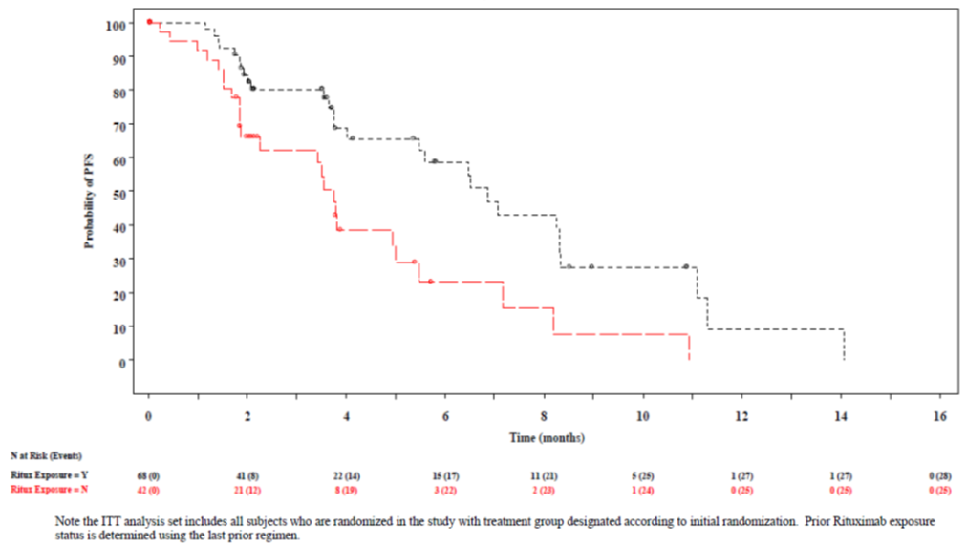

Figure 7: PFS assessment: by prior rituximab exposure status for the IDELA + R arm.

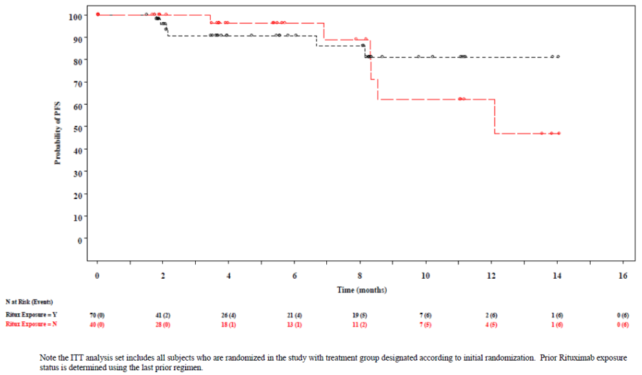

**Evaluator response:**

The PFS outcome for the placebo group shows that the subjects with rituximab exposure in the last regimen may be better than for those with no prior rituximab exposure - showing that there was a maintained benefit from rituximab exposure in the selected population. In the idelalisib treatment arm, median PFS was not reached in those subjects with prior rituximab exposure, whereas in those with prior exposure in the last regimen, the median PFS estimate is 12.1 months. The interpretation of this analysis is complicated by the small numbers of subjects remaining at risk, and the lack of confidence intervals for the PFS estimates, but there may be a PFS advantage in those exposed to rituximab in their previous regimen, including in conjunction with idelalisib.

#### (Q17) The sponsors have stated that analyses of health related quality of life (HRQL) and healthcare utility assessments will only be reported in the clinical safety report that covers entire blinded phase in Study 312-0116 involving patients with refractory, relapsed CLL. Can the sponsor please indicate when this data will be available?

**Evaluator response:**

See response to question 10 above

### Safety

#### (Q18) The sponsor is kindly requested provide any information it holds on the duration of B cell depletion following idelalisib treatment in CLL patients and iNHL patients separately.

**Sponsor response:**

CD19+ lymphocyte subsets in subjects while on treatment with IDELA were assessed by flow cytometry in Studies 101-02, 101-07, 101-09, and 101-11 (Table 25). Note that these analyses do not distinguish between normal B-cells and circulating malignant B-cells that express CD19. Although this is more apparent in CLL and SLL, circulating malignant cells can also occur in other types of lymphoma. As expected based on the pharmacologic activity of IDELA, initial mobilization of CD19+ lymphocytes was observed in subjects with CLL receiving IDELA (Figure 8), but was minimal in subjects with iNHL (mostly observed in the SLL subtype) (Figure 9-11). The number of CD19+ cells was generally stable over time on IDELA in subjects with iNHL. Although no data are available regarding the duration of the effect of IDELA on B-cells following treatment, these data suggest that a persistent depletion of normal B-cells would not be expected as a result of IDELA therapy.

Furthermore, any clinically significant deletion of normal B-cells would be expected to result in an increase in infections and the number or severity of infections do not increase over time on IDELA.

Table 25: CD19+ lymphocyte subset data collected in the IDELA program.

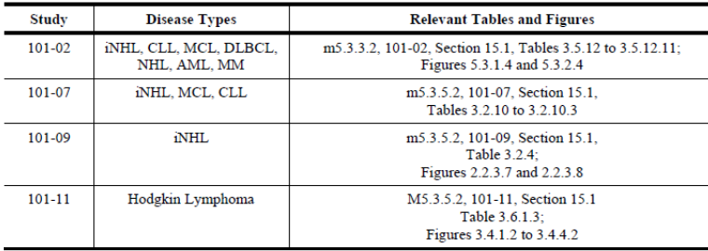

Figure 8: Study 101-02, mean change from baseline for CD19+/CD3- (cells/ul), subjects with CLL (Safety Analysis Set).

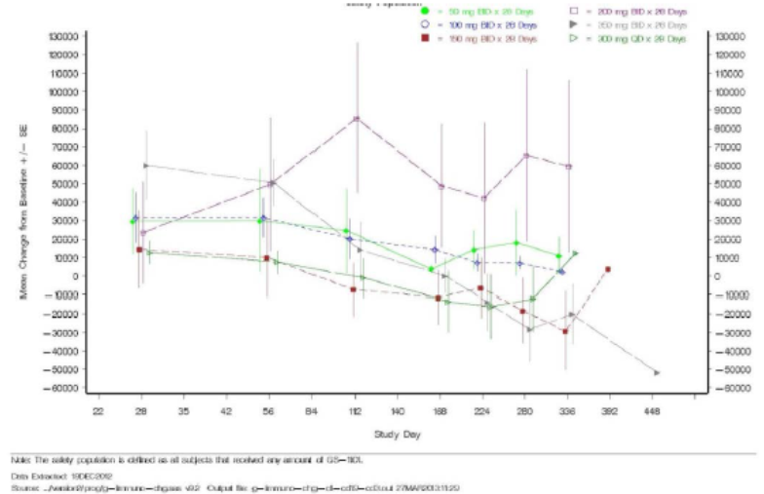

Figure 9: Study 101-02, mean change from baseline for CD19+/CD3- (cells/ul), subjects with iNHL (Safety Analysis Set).

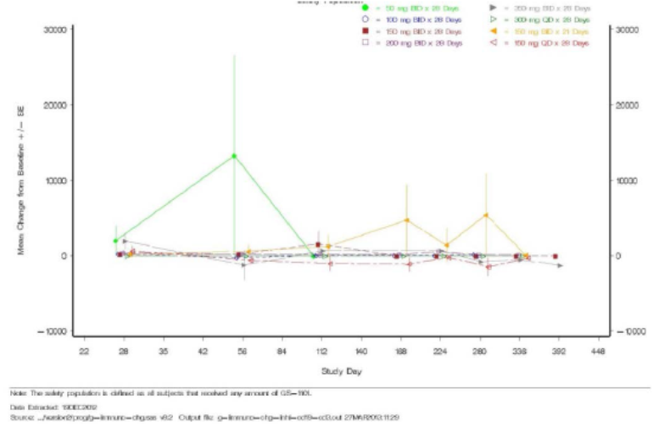

Figure 10: Study 101-09, median and Q1/Q3 over time for CD19 (/uL), subjects with iNHL (ITT Analysis Set).

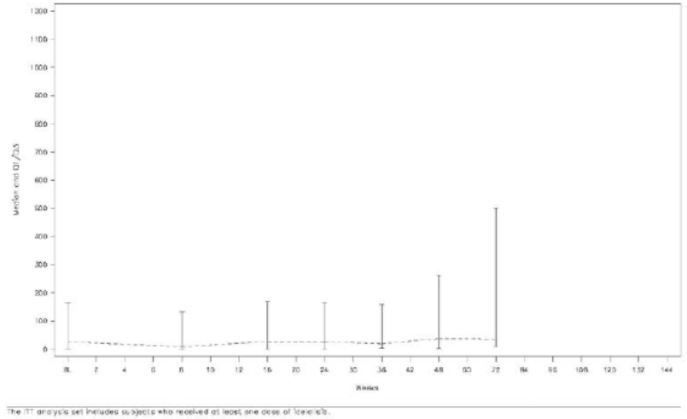

Figure 11: Study 101-09, median and Q1/Q3 over time for CD19/lymphocytes (%), subjects with iNHL (ITT Analysis Set).

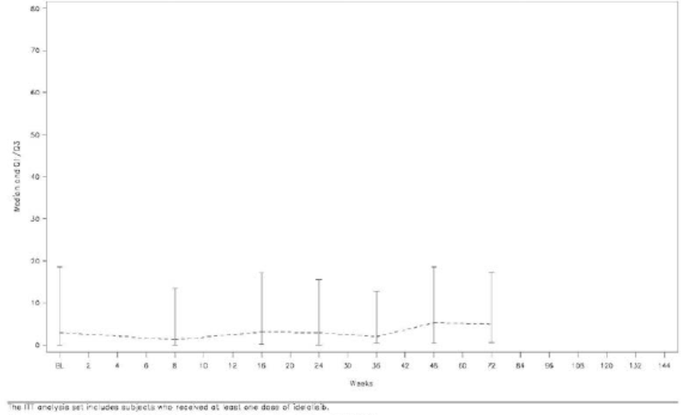

**Evaluator response:**

On-treatment and persistent B-cell depletion has been reported following anti-CD20 antibody immunotherapies. In patients receiving concomitant administration of anti-CD20 antibodies and idelalisib, this risk of B-cell depletion remains.

The sponsor has not presented any data regarding the duration of B-cell depletion in CLL subjects, rather, the change from baseline which does not answer the question posed. The duration of B-cell depletion in such patients remains unknown.

The data presented in figures 10 and 11 above are not sufficiently clear to evaluate the risk of depletion of CD19+ lymphocytes in iNHL subjects, given the y-axis scaling, and presentation of only the interquartile range.

The sponsor is requested to i) re-present figures 10 and 11 using a more appropriate Y-axis scale to enable the evaluator make a considered comment on the data, and ii) report the proportion of subjects who had CD19+ depletion, at each assessment time-point.

#### (Q19) In Study 312-0116, the incidence of TEAEs was reported as 22/107 (20.6%) due to placebo exposure. Assuming the placebo was inactive; can the sponsor please explain why these were not categorised as rituximab related?

**Sponsor response:**

Study 312-0116 was a double blind study and investigators were unaware of whether their subjects were receiving IDELA or placebo. Thus the attribution of AEs to placebo reflects the investigator’s attribution to oral study drug subsequently determined to be placebo after unblinding. Attribution of AEs is difficult to determine and attribution to placebo is common in oncology trials where nonspecific, disease related AEs are relatively common (19042).

**Evaluator response:**

The evaluator acknowledges that the investigators could not have known whether placebo was being administered or not. The adverse events ascribed to placebo are, however, likely to represent the background incidence of AE rather than the effect of the placebo itself though.

#### (Q20) In Study 312-0116, the total incidence of TEAEs does not equal the incidence of TEAEs ascribed to each of the two treatments:



The sponsor is requested to provide a summary of the reasons why the overall incidence of ≥ grade 3 TEAEs is higher (in both study arms) as compared to the ≥ grade 3 events related to both study drug and rituximab arms combined.

**Sponsor response:**

As shown in Table 26, total incidence of ≥Grade 3 TEAEs consists of incidence of (1) ≥Grade 3 TEAEs only related to study drug, (2) ≥Grade 3 TEAEs only related to rituximab, (3) ≥Grade 3 TEAEs related to both study drug and rituximab, and (4) ≥Grade 3 TEAE not related to any drug.

Table 26: Total incidence of TEAEs.

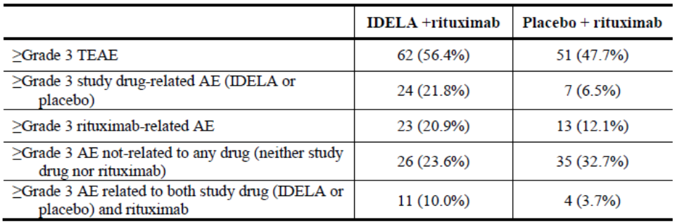

Taking all the cases into account, the total incidence of ≥Grade 3 TEAEs for each treatment arm (62 for IDELA and 51 for placebo) is obtained by adding the incidences of ≥Grade 3 study drug-related AEs (24 for IDELA and 7 for placebo), ≥Grade 3 rituximab-related AEs (23 for IDELA and 13 for placebo), and ≥Grade 3 AEs not related to any drug (26 for IDELA and 35 for placebo), followed by the subtraction of overlapping incidence of ≥Grade 3 TEAEs related to both study drug and rituximab (11 for IDELA and 4 for placebo).

**Evaluator response:**

From Table 26 above, the incidence of all study drug-related TEAEs is doubled with the combination of idelalisib and rituximab (36 subjects, 32.7%) as compared to that with rituximab alone (16 subjects, 15%).

#### (Q21) What was the incidence of histological transformation (Richter transformation) for any of the CLL patients exposed to idelalisib?

**Sponsor response:**

Across the IDELA clinical programme there have been 602 subjects with CLL (including 5 with SLL in Study 101-08) exposed to IDELA, with a total follow-up of 523 subject-years. Of these, there were 13 cases of Richter’s transformation, yielding a 2.5% rate of transformation per year. Excluding 64 treatment-naive subjects in Study 101-08 (59 CLL, 5 SLL), in whom there was no case of transformation, the rate is 2.9% per year in the 538 remaining previously treated CLL patients. By comparison, there were 4 instances of transformation among 197 previously treated placebo subjects in Studies 312-0116 and 312-0117, with a follow-up of 51.7 subject-years, yielding a yearly transformation rate of 4.6%.

**Evaluator response:**

The reported incidence rate of Richter transformation is in keeping with the known reported incidence rate of less than 10% of subjects with CLL.6 Therefore, idelalisib does not appear to be an additional risk factor for this adverse disease outcome.

#### (Q22) For the subjects who experienced pneumonitis in association with idelalisib exposure, the sponsor is kindly requested to give a considered summary of these patients, specifically indicating (i) the duration (ii) the reversibility of symptoms and (iii) whether recurrence on re-challenge occurred.

**Sponsor response:**

Across the clinical development program, inclusive of Studies 101-02, 101-07, 101-08, 101-09, 101-10, 101-11, and 101-99, the incidence of all grades pneumonitis in IDELA-exposed subjects was 2.6% (17 of 642 subjects). The incidence of pneumonitis observed in subjects receiving IDELA monotherapy (2.0%, 7 of 352 subjects) was lower than the incidence observed in subjects receiving IDELA combination therapy (3.4%, 10 of 290 subjects) (Table 27).

Table 27: Subjects with pneumonitis, Studies 101-02, -07, -08, -09, -10, -11, -99 (Safety Analysis Set).

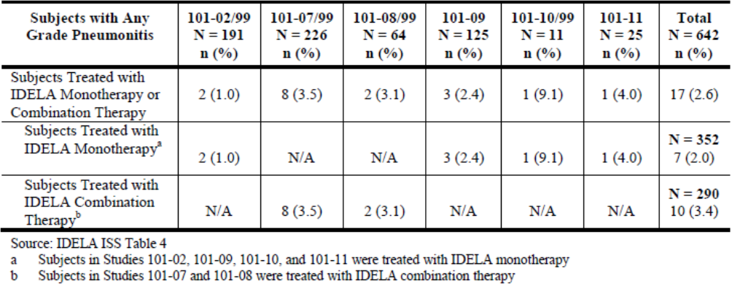

Among subjects in Studies 101-02, 101-07, 101-08, 101-09, and 101-99, fifteen of 606 subjects (2.5%) developed pneumonitis. The median time to onset was 3.7 months (Q1, Q3: 2.2, 5.0 months). The pneumonitis event for 11 of 15 subjects (73.3%) resolved, with a median duration of 0.5 months (Q1, Q3: 0.2, 1.2 months). Results were similar for subjects treated with monotherapy (4 of 5 events resolved [80.0%], median time to onset 0.7 months [Q1, Q3: 0.2, 2.9 months]) or combination therapy (7 of 10 events were reported as resolved [70.0%], median time to onset 0.5 months [Q1, Q3: 0.3, 1.0 months]) (Table 28).

Table 28: Time to onset and resolution of first pneumonitis event, Studies 101-02, 101-07, 101-08, 101-09, 101-99 (Safety Analysis Set).

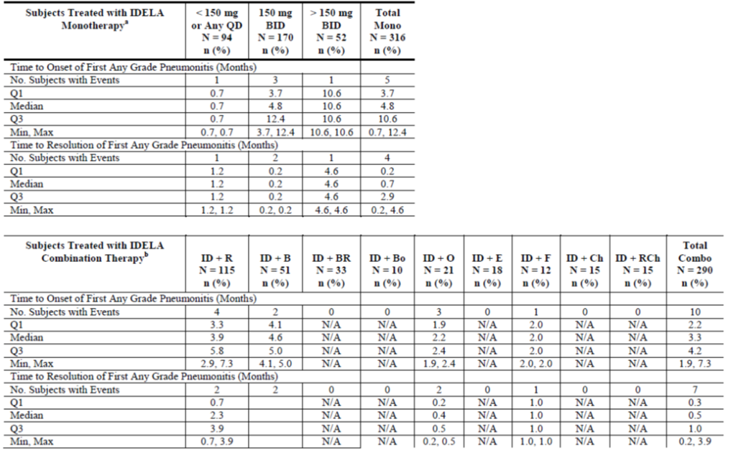

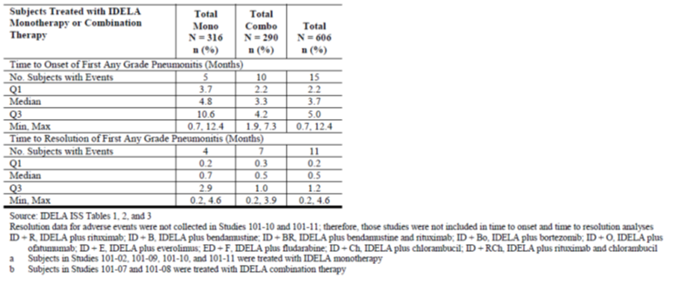

Overall, 8 of 17 subjects (47.1%) from Studies 101-02, 101-07,101-08, 101-09, 101-10, 101-11 and 101-99 were rechallenged with IDELA following a pneumonitis event. Seven of 8 rechallenges (87.5%) were successful. The percentage of subjects who were rechallenged was similar for subjects treated with IDELA monotherapy or combination therapy, as was the percentage of subjects in either group who were successfully rechallenged (Table 29).

Table 29: Subjects with pneumonitis who were rechallenged, Studies 101-02, 101-07, 101-08, 101-09, 101-10, 101-11, and 101-99 (Safety Analysis Set).

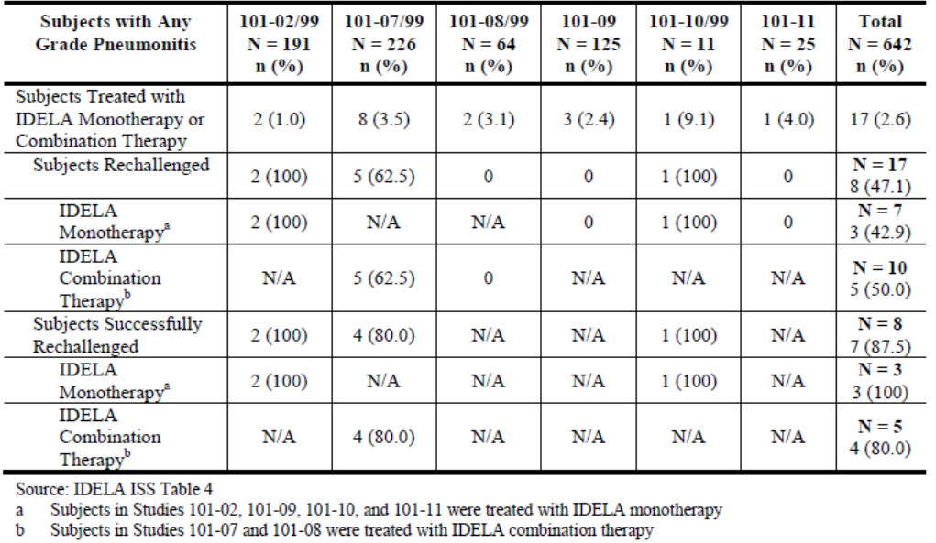

In study 312-0116, five of 110 subjects (4.5%) exposed to IDELA experienced pneumonitis of any grade. The time to onset of pneumonitis ranged from 2.0 to 16 months, with a mean duration similar to that seen across the clinical development program. Among the 5 subjects, the median time to onset was 4.3 months (Q1, Q3:2.8, 10.9 months). The pneumonitis event for 4 of 5 subjects (80%) resolved, with a median duration of 0.5 months (Q1, Q3: 0.4, 1.7 months). One subject was re-challenged, and re-challenged successfully.

**Evaluator response:**

The incidence of idelalisib-associated pneumonitis is not statistically significantly higher with combination therapy as opposed to monotherapy (OR 1.76, 95% CI 0.66, 4.68). However, from the data presented, subjects receiving monotherapy may take longer to recover than those receiving combination therapies.

The proposed wording of the ‘Precaution’ for pneumonitis is not satisfactory:

*Cases of pneumonitis, some with a fatal outcome have occurred with ZYDELIG. Patients presenting with serious lung events should be assessed for drug-induced pneumonitis. If pneumonitis is suspected, idelalisib should be interrupted and the patient treated accordingly.*

The implication from the current statement is that all cases resolved. That there was irreversibility of pneumonitis symptoms in 4/15 (26.6%) of cases should be specifically documented in the product information, rather than the current wording of “Cases of pneumonitis, some with a fatal outcome have occurred with Zydelig” in order to accurately explain the risk.

Proposed wording is:

*Pneumonitis*

*Fatal and serious cases of pneumonitis, 4/15 (26.6%) of which were irreversible, have occurred with ZYDELIG exposure. In patients presenting with pulmonary symptoms or radiographic appearances consistent with pneumonitis, idelalisib should be interrupted and appropriate treatment of pneumonitis commenced.*

#### (Q23) In the global development program, in patients exposed to idelalisib and rituximab, what was the incidence of (i) hepatitis B reactivation and (ii) fulminant hepatic failure (iii) progressive multifocal leucoencephalopathy?

**Sponsor response:**

**i. Hepatitis B reactivation**

Across the IDELA program to date, including ongoing Phase 3 studies, one event of treatment-emergent hepatitis B reactivation has been reported. Subject [information redacted] in ongoing, blinded Phase 3 Study 313-0125, who was receiving bendamustine + rituximab + oral study drug PATEITN(IDELA or placebo), experienced Grade 1 hepatitis B reactivation approximately 2 months after beginning combination therapy. No other events of hepatitis B reactivation have been reported.

**ii. Fulminant hepatic failure**

There are no reports of fulminant hepatic failure in subjects receiving IDELA plus rituximab. To date in the IDELA program, one subject receiving IDELA plus ofatumamab was initially reported to have died from acute liver failure. This case was recently revised by the investigator, replacing the reported SAE of acute liver failure with sepsis, and providing the cause of death as sepsis. According to the investigator, the acute liver failure, along with other conditions (including acute renal failure and acute respiratory insufficiency) were manifestations of sepsis.

This event occurred in a [information redacted] Causasian female subject with CLL ([information redacted] in Study 312-0119) whose concomitant medications included metoprolol, amlodipine, self-prescribed "phospholipids" for "prophylaxis against liver insufficiency during chemotherapy and after" (started 2011), allopurinol, acyclovir sodium, ciprofloxacin, and paracetamol (according to the investigator, the subject "liked the drug paracetamol" however history around self-dosing was not reliable). There was no known history of significant alcohol consumption. Screening laboratory test results were negative for hepatitis B, hepatitis C, and HIV. Cytomegalovirus IgG was positive and IgM was negative. Baseline transaminases and bilirubin were within the normal range. Approximately 1 month after initiating study drug (IDELA + ofatumumab) the subject experienced fever and diarrhea along with mild ALT (2XULN) and AST (2XULN) elevations. Over the course of the next 1-2 weeks, treatment consisted of outpatient antispasmodic, anti-diarrheal, and antibiotic therapy, but additional moderate increases in ALT (3XULN), AST (4XULN) and bilirubin (3XULN) were found at the end of this period. The subject was admitted within 2-3 days of these last laboratory findings with symptoms of cardiorespiratory failure, serious metabolic disorders and septic shock. Abnormal laboratory results at admission included a high C-reactive protein (CRP) value, a high white blood cell count, anemia, and thrombocytopenia accompanying increasing transaminases and bilirubin. The subject’s clinical status further deteriorated, and she was transferred to the ICU with symptoms of acute liver failure, lactic acidosis and "sepsis syndrome". She received ventilatory and renal support. The investigator reported that the subject’s high level of CRP and high serum procalcitonin suggested primary sepsis despite negative cultures. Six days after admission, the subject’s circulatory function ceased and she died. The investigator commented that the subject’s “pain of abdomen," acute renal failure, and acute respiratory insufficiency were all due to sepsis. The investigator confirmed that the subject died of sepsis, and that the acute liver failure was one of many sequelae of sepsis. An autopsy was not performed due to family request.

**iii. Progressive mulifocal leucoencephalopathy (PML)**

To date, 3 cases of PML have been reported in the IDELA studies. Of these, 2 cases occurred in Study 312-0119 in subjects who were receiving ofatumumab only. Ofatumumab has been associated with PML (28711). The third case was reported in a subject who received IDELA + rituximab in Study 312-0116 and had continued to receive IDELA in Study 312-0117; the subject’s last dose of rituximab was administered approximately 14 months prior to onset of neurologic symptoms. Prior therapy in this treatment-refractory subject included rituximab and fludarabine, which are both associated with PML, providing a possible etiology for the event other than a causal role for IDELA. Brief summaries of all 3 events are provided herein.

*Subject [information redacted] in Study 312-0119 [information redacted]*

This case occurred in a [information redacted] Caucasian female subject with CLL assigned to the ofatumumab-only arm of the study. The subject’s prior CLL treatment included fludarabine/cyclophosphamide/rituximab (FCR) in 2013 (disease became refractory and pancytopenia developed). Approximately 2 months after starting ofatumumab, a brain MRI revealed findings consistent with PML; PML was confirmed with a subsequent cerebrospinal fluid (CSF) evaluation that was positive for JC virus. During the following 3 months, the subject underwent rapid neurologic degeneration and died due to complications of multifocal leukoencephalopathy.

*Subject [information redacted] in Study 312-0119 [information redacted]*

This case occurred in a [information redacted] Caucasian female subject with CLL assigned to the ofatumumab-only arm of the study. The subject’s prior CLL treatment included chlorambucil and then fludarabine, cyclophosphamide, and rituximab (FCR), rituximab, bendamustine, and alemtuzumab. Approximately 5 months after starting ofatumumab, a head CT scan conducted to evaluate neurologic impairment revealed findings consistent with possible PML. The subject was hospitalized and died on [information redacted]. The cause of death was reported as PML.

*Subject [information redacted] in Study 312-0116/117 [information redacted]*

This case occurred in a [information redacted] Caucasian male subject with CLL on IDELA whose prior CLL treatment included rituximab and fludarabine, completed in January 2007; rituximab and bendamustine completed on 30 June 2010; and rituximab, cyclophosphamide, vincristine, and prednisone (R-CVP) initiated on 08 March 2012. The subject began receiving IDELA 150 mg BID + rituximab on 28 August 2012 in Study 312-0116 and continued to receive IDELA 150 mg BID in Study 312-0117 beginning 15 January2014. Approximately 2 months after starting Study 312-0117 (and 14 months following the last rituximab dose) the subject began experiencing neurologic symptoms and over the ensuing 4 months underwent multiple evaluations. He was eventually diagnosed with PML based on characteristic brain MRI findings and positive JC virus in the CSF. CLL treatment was deferred in favor of managing the newly diagnosed PML and palliative care was recommended. The subject died on [information redacted]. The cause of death was reported as PML.

**Evaluator response:**

In regard to the hepatitis B reactivation in one subject, given that the treatment received has not been unblinded, no association with idelalisib can be made. However, the FDA approved label contains a boxed warning for hepatitis B reactivation “in some cases resulting in fulminant hepatitis, hepatic failure and death.” The evaluator notes that this boxed warning describes “cases”, plural, and therefore is not consistent with the sponsor only having identified one case only to the TGA. This discrepancy in case numbers requires explanation by the sponsor. In the event that there are more identified subjects with either hepatic failure or death in association with idelalisib, the event of hepatitis B reactivation warrants a boxed warning, and advice regarding hepatitis B testing prior to idelalisib treatment should be included in the Australian PI.

The narrative for the patient who died from culture-negative sepsis, with possible features of hepatorenal syndrome sufficiently excludes a formal, and isolated, diagnosis of fulminant hepatic failure due to idelalisib alone.

Of the three cases of progressive multifocal leukoencephalopathy identified by the sponsor, two definitely have no causal link to idelalisib since they only had exposure to ofatumumab, which has a known association with PML. The third subject developed PML 14 months after ceasing rituximab, but had received idelalisib throughout the intervening period. Given the long duration between last rituximab administration and PML development, the idelalisib PI should include a boxed warning for the risk of PML, with appropriate management advice. Suggested wording is:

*WARNING*

*Use of Arzerra may be associated with an increased risk of progressive multifocal leukoencephalopathy (PML), an opportunistic viral infection of the brain that usually leads to death or severe disability. Patients must be monitored for any new or worsening neurological symptoms or signs suggestive of PML. If such symptoms occur, further administration of Arzerra should be immediately suspended until a diagnosis of PML has been excluded. To establish or exclude a diagnosis of PML evaluation including MRI scan, CSF testing for JC viral DNA and repeat neurological assessments, should be considered. If a diagnosis of PML is confirmed Arzerra must be permanently discontinued (see PRECAUTIONS).*

#### (Q24) The exposure ratios of AUC0-last, AUCinf and Cmax were outside the accepted bioequivalence range of 80-125% in patients with severe renal impairment as compared healthy controls. What is the sponsors’ justification for not recommending dose adjustment or contraindication in patients with renal impairment?

**Sponsor response:**

Gilead does not believe a recommendation for dose adjustment or contraindication in patients with renal impairment is considered warranted. The observed increase in IDELA exposure between subjects with severe renal impairment and healthy matched subjects (~1.3-fold higher in subjects with severe renal impairment) was well within the range of exposures observed in patients with hematologic malignancies (for example, in Studies 101-09 and 312-0116; compared to median, IDELA exposures at the highest quartile were up to ~2.9 fold higher for AUCtau and up to ~2.4-fold for Cmax). There was no relationship between IDELA exposures and safety parameters in cancer patients (Studies 101-02, 101-09) at IDELA 150 mg twice-a-day.

Additionally, an analysis of dose reductions, discontinuations, AEs (including ≥Grade 3), and laboratory abnormalities indicated no unexpected relationship (Table 30).

Table 30: Selected AEs, discontinuations, and dose reductions associated with renal impairment, subjects treated with IDELA monotherapy (Safety Analysis Set).

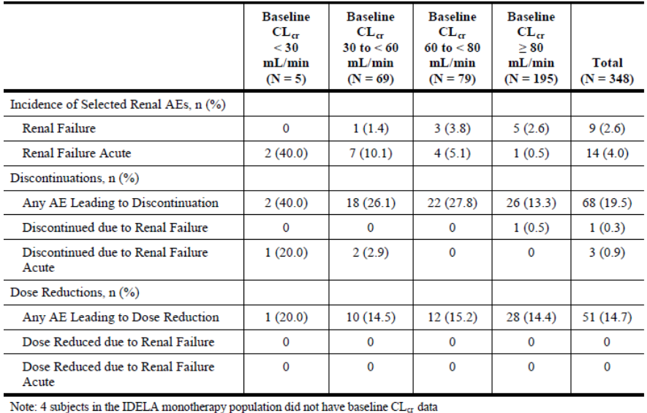

Based on the information presented above, no change to the PI or CMI is proposed.

**Evaluator response:**

A total of 4/23 (17%) of subjects with any form of renal failure discontinued treatment, a similar proportion to all subjects (19.5%). Among the remaining 19 subjects, none had their dose of idelalisib reduced. This information sufficiently excludes the need for change to the PI or CMI.

#### (Q25) Among the patients who died, one subject had an “acute abdomen” ascribed as the cause of death. What was the actual cause of death in this patient?

**Sponsor response:**

According to the investigator, the subject died of a splenic infarct and possibly an ischemic bowel event. This subject was receiving IDELA monotherapy. An autopsy was not reported. The subject had recently been hospitalized with a ‘massive’ stroke with little remaining cortical function. Management was complicated by continuing fluid losses associated with profuse diarrhea (starting prior to the hospitalization), pyrexia, hypoxia, and hypotension, and subsequent occurrence of feculent vomiting and acute exacerbation of abdominal pain. A CT scan revealed an acute splenic infarct but no colonic bowel thickening. The subject’s abdomen was distended with no bowel sounds, suggesting an obstructed bowel, and an ischemic bowel event was also suspected. Given the poor prognosis, the subject’s status was made Do Not Resuscitate (DNR). The outcomes of the events in this case “cerebrovascular accident” and “diarrhea” were reported as continuing, the events “splenic infarct” and “acute abdomen” as fatal.

**Evaluator response:**

The clinical information as to the nature of the bowel pathology in the narrative for this subject is unclear as they are reported as having diagnoses of ongoing (pre-existing) diarrhoea and an obstructed bowel with faeculent vomiting. This notwithstanding, the actual cause of death is different to that reported in the dossier, with evidence of cerebrovascular accident and splenic infarction preceding death reported.

#### (Q26) Among the patients who died, one subject had “intestinal obstruction” ascribed as the cause of death. What was the actual cause of death in this patient?

**Sponsor response:**

According to the subject’s local oncologist, the cause of death was renal failure. This subject was participating in Study 101-09 and was receiving IDELA reduced dose. An autopsy was not reported. After 2 years on study drug, the subject experienced a fall with facial laceration, followed over the next few days by inability to ambulate, constipation and abdominal pain. The subject was hospitalized one week later with a partial bowel obstruction and acute renal failure, and his condition rapidly deteriorated with increasing creatinine and elevated lactic acid levels, becoming unresponsive with significant encephalopathy. It was thought that the subject had suffered a severe abdominal catastrophe, possibly a bowel rupture causing sepsis, acute renal failure and multiorgan system failure; an acute rhythm disturbance occurred, followed by the subject’s death. The outcomes of the events in this case “intestinal obstruction”, “sepsis syndrome” and “acute renal failure” were reported as fatal.

**Evaluator response:**

The expanded narrative for this subject does not provide sufficient information to determine a causal link between idelalisib exposure and intestinal obstruction. The actual causes of death are different to the single cause reported in the dossier.

#### (Q27) The FDA approved product information describes a risk of toxic epidermal necrolysis (TEN). The evaluator could not identify this term in the integrated safety summary. The sponsor is kindly requested to provide a summary of the case(s) with TEN AEs.

**Sponsor response:**

The TEN serious adverse event occurred after database cutoff for integrated safety summary data cut, and was provided separately to all participating sites and in an Investigational New Drug safety report to the FDA.

The case of toxic epidermal necrolysis (TEN) appeared to have started 11 days after initiation of study drugs, and an assessment for a causal role of blinded study drug is confounded by coadministered rituximab and bendamustine which have been associated with TEN. In addition, although the time to onset was suggestive for TEN, the clinical course and pathologic features were also consistent with paraneoplastic pemphigus (PNP), with some of the skin biopsy features actually more suggestive of PNP than TEN, providing the subject’s underlying iNHL as an additional possible causative factor.

The case occurred in a [information redacted] Asian female subject with recurrent iNHL (subject [information redacted] in Study 313-0125). Eleven days after commencing the blinded study drug plus bendamustine and rituximab, the subject presented with neutropenic fever, severe mucositis, a maculopapular rash involving torso, neck, and face, and corneal involvement bilaterally, all thought to be most likely due to a viral syndrome or drug eruption. Blinded study drug was interrupted, and the subject was started on vancomycin, cefepime, fluconazole, and Neupogen (filgrastim). Fever resolved the following day, and over the next week, the rash was reported to be slightly improving and neutropenia had resolved. An esophagogastroduodenoscopy (EGD) for oral pain and significant odynophagia showed diffuse esophagitis with exudates and desquamation and no discrete ulcers, sloughing of oropharyngeal mucositis consistent with mucositis, nodular inflamed tongue, and unremarkable stomach and duodenum; biopsies were taken from the mid-esophagus with results pending. Eleven days into the hospitalization, foci of blistering were noted, and areas of skin sloughing began. A diagnosis of TEN was considered; skin biopsy was performed. The subject was transferred to the burn unit. Over the next few days, fever recurred along with ocular discharge, cheilosis, red tongue, and generalized erythroderma with relative sparing of the cranial area and certain areas of the lower extremities that were starting to blister, but with no full thickness tissue loss. Treatment included cyclosporine (CsA), IVIG and systemic steroids, along with surgical debridement and grafts on leg lesions.

On hospital day 18, skin biopsy results returned with findings of spongiotic interface dermatitis with maturational disturbance, scattered dyskeratotic/necrotic cells, questionable suprabasal acantholysis, and relatively sparse superficial perivascular lymphoid infiltrate. According to the pathologist's comment: “the constellation of findings raised the differential diagnosis of an erythema multiforme (EM) reaction, as seen in erythema multiform/Stevens-Johnson syndrome(SJS)/toxic epidermal necrolysis (TEN) and paraneoplastic pemphigus. By clinical history, the subject had features probably compatible with both clinical entities. Thus, this SJS/TEN-like reaction might be secondary to a recent chemotherapeutic agent or other causative factor, versus paraneoplastic pemphigus. In particular, paraneoplastic pemphigus was suggested by the subject’s clinical characteristics: non-Hodgkin's lymphoma and extensive mucosal involvement; some histologic alterations suggesting possible minimal suprabasal acantholysis, and finally, some immunofluorescence findings: linear granular C3, which was compatible but nonspecific. Thus, both clinical entities must be considered, and paraneoplastic pemphigus needs to be confirmed or ruled out by additional evaluation of the patient.” The case was sent for consultation, and the consultant also recommended consideration of additional biopsy sampling for routine histology and also direct and indirect immunofluorescence studies as well as possible serological investigations specifically directed as confirming or excluding paraneoplastic pemphigus. An expanded differential diagnosis, although less likely, potentially included viral infection, a graft-versus-host-like reaction, connective tissue disease, and other types of drug reaction. A test for indirect cutaneous immunofluorescence antibodies was sent (result not available).

Over the next 2 weeks, significant improvement of the central skin lesions was noted on CyA (off steroids) while slower improvement on the lower extremities and abdomen was seen with full thickness desquamation over shins. Significant ocular inflammation persisted, but mucositis was improving slowly. The subject’s pulmonary system became involved requiring BiPAP therapy and right thoracentesis with lung findings thought to be inflammatory, but no involvement of liver, kidney, or heart was found.

On an unspecified date in hospital, the subject was changed to a do not resuscitate (DNR) code status and comfort measures, and died. Per the death certificate, the immediate cause of death was reported as bronchiolitis, preceded by SJS and non-Hodgkin lymphoma, respectively. It was reported that no autopsy was performed.

**Evaluator response:**

The first histology specimen from this patient is consistent with a diagnosis of SJS/TEN. The second histology report is unavailable and thus cannot provide additional information.

The evaluator is unclear as to the veracity of the cause of death being “bronchiolitis”, which is a disease of infancy. The sponsor is requested to confirm the actual cause of death in this patient.

Given the evidence in the narrative above, there is sufficient information to warrant a precaution in the PI for the adverse event of Stevens-Johnson syndrome/toxic epidermal necrolysis in association with idelalisib.

#### (Q28) The sponsor is kindly requested to provide a considered summary of the risk of second malignancy in idelalisib exposed subjects.

**Sponsor response**

The incidence of second malignancies in the IDELA program was in accordance with the expected incidence for the patient populations. Gilead considers that the IDELA clinical database has captured the occurrence of second malignancies through close medical follow-up which is ongoing in active studies to detect any future second malignancies. Gilead finds no specific scientific observation to explain an underlying mechanism for the low incidence of second malignancies.

As of 9 September 2013, among subjects with CLL, small lymphocytic lymphoma (SLL), or iNHL, 8 of 256 subjects (3.1%) experienced a second malignancy during treatment with IDELA monotherapy (Table 31). Of these 8 subjects, the diagnoses included 2 squamous cell carcinoma of skin, 2 basal cell carcinoma, 2 myelodysplastic syndrome,1 lung neoplasm, and 1 gastric carcinoma.

During treatment with IDELA combination therapy, 23 of 258 subjects (8.9%) with CLL, SLL, or iNHL experienced a second malignancy, including 1 recurrence of colon cancer (IDELA+R combination arm in Study 101-07), and 1 additional subject (IDELA monotherapy in Study 101-09) was diagnosed with basal cell carcinoma.

Table 31: Summary of second malignancies, subjects with CLL, SLL or iNHL treated with IDEAL monotherapy or combination therapy.

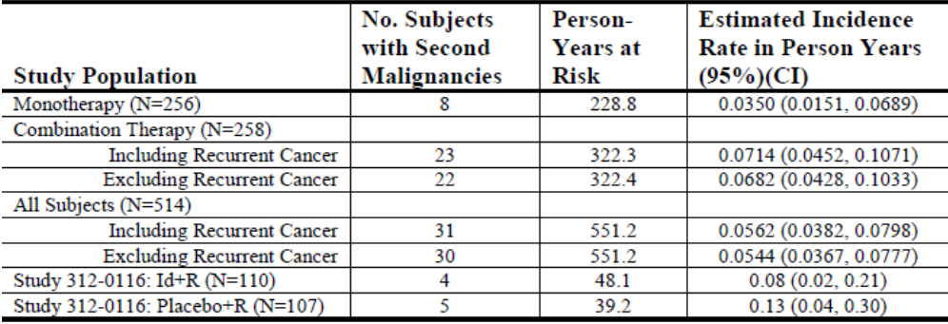

A tabular summary of all treatment-emergent second malignancies is provided in Table 32.

Table 32: Second malignancies listed in tabular form per individual study.

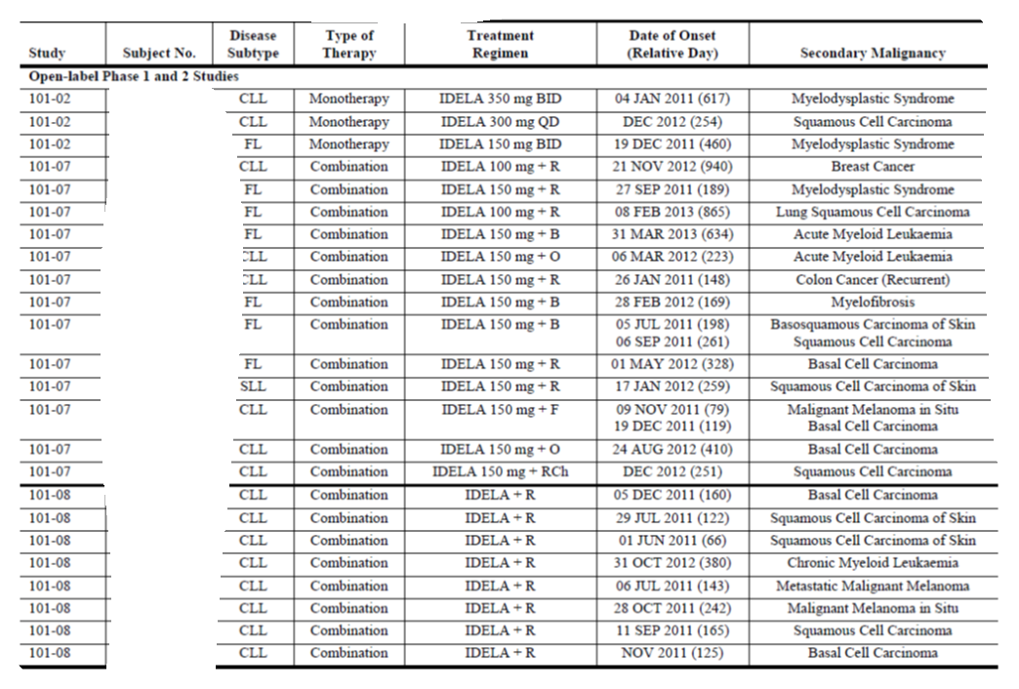

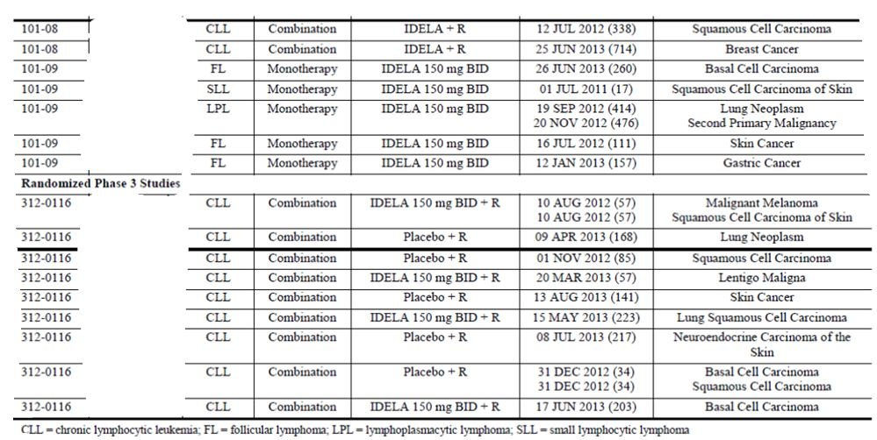

**

**Evaluator response:**

The incidence of second malignancies was similar in the placebo-controlled CLL pivotal study arms, this is important negative safety information to inform the prescriber/recipient. The sponsor should include a statement in the PI to this effect – suggested wording is:

*Malignancies*

*There is an increased incidence of second malignancies in patients with CLL. Data from the pivotal study in patients with CLL does not demonstrate an increased risk of second malignancies following ZYDELIG therapy.*

#### (Q29) The sponsor is kindly requested to provide a considered statement suitable for inclusion in the PI pertaining to the risks associated with immunisation before, during, and after idelalisib exposure.

**Sponsor response:**

No clinical data are available regarding the effects of IDELA on immunisation. However, due to the potential concern that IDELA could reduce the effectiveness of immunization, Gilead proposes to include the following statement in the PRECAUTIONS section of the PI.

*For patients who are at substantial risk of an infection (eg, influenza) that may be prevented by immunization, consideration should be given to providing the vaccine prior to treatment.*

**Evaluator response:**

The proposed wording is not entirely satisfactory and should be amended to:

*The safety of immunisation with live, or inactivated live vaccines in association with idelalisib therapy has not been studied and vaccination with live vaccines is not recommended. For patients who are at substantial risk of an infection that may be prevented by immunizsation (e.g. influenza or pneumococcal sepsis), consideration should be given to providing the vaccine prior to treatment.*

Second round assessment of study 312-0116 safety – second interim clinical study report.

The updated safety assessment of this trial is up until the cut-off of 9 October 2013. The safety analysis set remains on the 218 subjects previously reported. Median (interquartile range) of the duration of study drug exposure has increased to 5.0 (3.0, 9.4) months and 3.7 (2.4, 6.5) months for the idelalisib and placebo arms respectively.

All subjects that required study-drug dose reduction (to 100mg BD) were in the idelalisib arm (16/110, 14.5%) fifteen of whom were unable to be re-escalated to 150mg BD.

In general, the incidence of adverse events was comparable with the initial study report.

Pyrexia, neutropaenia, fatigue and nausea were the most commonly reported adverse events for the idelalisib-exposed subjects. The proposed PI only reports the occurrence of pyrexia. The three other common adverse events should be included in the PI.

Grade ≥3 events related to rituximab were more common in the idelalisib arm (22.7%) as compared to placebo (13.0%).

Infections & infestations occurred more commonly in the idelalisib arm (60.9% versus 47.2% in the placebo arm), which may be associated with the increased incidence of neutropaenia - 27.3% in the idelalisib arm versus 16.7% in the placebo arm.

Among the events of grade 3 or higher, neutropaenia (21.8%, 24 subjects), pneumonia (8.2%, 9 subjects), febrile neutropaenia, anaemia and fatigue (each in 4 subjects – 3.7%) occurred in the idelalisib arm. In comparison, the incidence of events in the placebo arm were neutropaenia (12.0%, 13 subjects), pneumonia (9.3%, 10 subjects), anaemia (6.5%, 7 subjects), thrombocytopaenia (4.6%, 5 subjects) and febrile neutropaenia, asthenia and infusion-related reactions each in 4 subjects (3.7%).

Causes of death were predominately associated with disease progression, with no preponderance of any other cause. No new adverse events leading to death were reported in this study update.

The sponsor has stated that the most common treatment-emergent serum chemistry abnormality was elevated glucose. As evaluated previously, these results are meaningless given that patients did not have to be fasted at the time the sample was taken.

Consistent with the previous findings, transaminase elevations occurred more commonly in the idelalisib arm.

Triglyceride elevation was reported in 56.4% of the idelalisib arm and 34.5% of the placebo arm. As for the glucose measurements, these are not necessarily fasting measurements and no inference can be made.

Events of diarrhoea and colitis (separately), of any grade, and grades 3 or higher, occurred more commonly in the idelalisib arm, as was previously observed.

## Second round benefit-risk assessment

### Second round assessment of benefits

The benefits of idelalisib in relapsed CLL remain as per the first round evaluation.

Given the additional information presented in the responses, the evaluator considers that there is sufficient evidence of efficacy in patients with refractory FL only. The size of the population studied with other subtypes of lymphoma is currently insufficient to support inclusion in the indication.

### Second round assessment of risks

In addition to the risks identified at round one, there is a risk of anaphylactic reaction in association with idelalisib use which should be included in the PI.

The duration of B cell depletion and potential risk of sepsis has not been satisfactorily established by the sponsor.

## Second round recommendation regarding authorisation

Providing the numerous amendments to the product information identified are implemented, then indication for idelalisib use in relapsed CLL could be considered appropriate for registration.

The proposed indication for refractory indolent iNHL is not supported, given only small numbers of patients in non randomised trials, with only ORR as the outcome. However, the evaluator proposes that the following indication may be appropriate for registration:

*Zydelig is indicated as monotherapy for the treatment of patients with refractory follicular lymphoma, who have received at least two prior therapies.*

## References

1. http://www.nccn.org/professionals/physician_gls/pdf/nhl.pdf
2. Hartmann T, Terao M, Garattini E, Teutloff C, Alfaro JF, Jones JP, Leimkühler S. (2012) The impact of single nucleotide polymorphisms on human aldehyde oxidase. Drug Metab Dispos. 40(5): 856-64.
3. Lee SJ, Goldstein JA (2005) Functionally defective or altered CYP3A4 and CYP3A5 single nucleotide polymorphisms and their detection with genotyping tests. Pharmacogenomics. 6(4): 357-71
4. Gulcebi MI, Ozkaynakcı A, Goren MZ, Aker RG, Ozkara C, Onat FY (2011) The relationship between UGT1A4 polymorphism and serum concentration of lamotrigine in patients with epilepsy. Epilepsy Res. 95(1-2): 1-8.
5. Miller, M. et al. Triglycerides and cardiovascular disease: a scientific statement from the American Heart Association. Circulation. 2011;123: 1-42. DOI: 10.1161/CIR.0b013e3182160726
6. Cwynarski et al. Autologous and Allogeneic Stem-Cell Transplantation for Transformed Chronic Lymphocytic Leukemia (Richter’s Syndrome): A Retrospective Analysis From the Chronic Lymphocytic Leukemia Subcommittee of the Chronic Leukemia Working Party and Lymphoma Working Party of the European Group for Blood and Marrow Transplantation. Journal of Clinical Oncology 2012; 30(18):2211-2217.

|  |
| --- |
| Therapeutic Goods Administration |
| PO Box 100 Woden ACT 2606 Australia  Email: [info@tga.gov.au](mailto:info@tga.gov.au) Phone: 1800 020 653 Fax: 02 6232 8605  [**https://www.tga.gov.au**](https://www.tga.gov.au) |