|  |
| --- |
| **October 2017** |

|  |
| --- |
| Australian Public Assessment Report for Idelalisib |
| Proprietary Product Name: Zydelig |
| Sponsor: Gilead Sciences Pty Ltd |

About the Therapeutic Goods Administration (TGA)

* The Therapeutic Goods Administration (TGA) is part of the Australian Government Department of Health and is responsible for regulating medicines and medical devices.
* The TGA administers the *Therapeutic Goods Act 1989* (the Act), applying a risk management approach designed to ensure therapeutic goods supplied in Australia meet acceptable standards of quality, safety and efficacy (performance) when necessary.
* The work of the TGA is based on applying scientific and clinical expertise to decision-making, to ensure that the benefits to consumers outweigh any risks associated with the use of medicines and medical devices.
* The TGA relies on the public, healthcare professionals and industry to report problems with medicines or medical devices. TGA investigates reports received by it to determine any necessary regulatory action.
* To report a problem with a medicine or medical device, please see the information on the TGA website <<https://www.tga.gov.au>>.

## About AusPARs

* An Australian Public Assessment Report (AusPAR) provides information about the evaluation of a prescription medicine and the considerations that led the TGA to approve or not approve a prescription medicine submission.
* AusPARs are prepared and published by the TGA.
* An AusPAR is prepared for submissions that relate to new chemical entities, generic medicines, major variations and extensions of indications.
* An AusPAR is a static document; it provides information that relates to a submission at a particular point in time.
* A new AusPAR will be developed to reflect changes to indications and/or major variations to a prescription medicine subject to evaluation by the TGA.

Copyright

© Commonwealth of Australia 2017  
This work is copyright. You may reproduce the whole or part of this work in unaltered form for your own personal use or, if you are part of an organisation, for internal use within your organisation, but only if you or your organisation do not use the reproduction for any commercial purpose and retain this copyright notice and all disclaimer notices as part of that reproduction. Apart from rights to use as permitted by the *Copyright Act 1968* or allowed by this copyright notice, all other rights are reserved and you are not allowed to reproduce the whole or any part of this work in any way (electronic or otherwise) without first being given specific written permission from the Commonwealth to do so. Requests and inquiries concerning reproduction and rights are to be sent to the TGA Copyright Officer, Therapeutic Goods Administration, PO Box 100, Woden ACT 2606 or emailed to <[tga.copyright@tga.gov.au](mailto:tga.copyright@tga.gov.au)>.

Contents

About AusPARs ii

Common abbreviations 5

I. Introduction to product submission 8

Submission details 8

Product background 8

Regulatory status 10

Product Information 10

II. Quality findings 10

III. Nonclinical findings 11

IV. Clinical findings 11

Introduction 11

Pharmacokinetics 13

Pharmacodynamics 16

Dosage selection for the pivotal studies 16

Efficacy 16

Safety 18

First round benefit-risk assessment 23

First round recommendation regarding authorisation 23

Clinical questions 23

Second round evaluation 23

Second round benefit-risk assessment 24

Second round recommendation regarding authorisation 24

V. Pharmacovigilance findings 24

Risk management plan 24

VI. Overall conclusion and risk/benefit assessment 39

Background 39

Quality 43

Nonclinical 43

Clinical 43

Risk management plan 52

Summary 53

Outcome 61

Attachment 1. Product Information 62

Attachment 2. Extract from the Clinical Evaluation Report 62

## Common abbreviations

|  |  |
| --- | --- |
| Abbreviation | Meaning |
| ACPM | Advisory Committee on Prescription Medicines |
| ACSOM | Advisory Committee on the Safety of Medicines |
| AE | Adverse Event |
| ALC | Absolute Lymphocyte Count |
| ALP | Alkaline Phosphatase |
| ALT | Alanine Transaminase |
| ANC | Absolute Neutrophil Count |
| AST | Aspartate Transaminase |
| ARTG | Australian Register of Therapeutic Goods |
| AUC | Area under the curve |
| BCR | B cell receptor |
| BD | Twice daily |
| CLL | Chronic Lymphocytic Leukaemia |
| Cmax | Maximum concentration |
| CMI | Consumer Medicines Information |
| CR | Complete Response |
| CT | X-Ray Computed Tomography |
| CTCAE | Common Toxicity Criteria for Adverse Events |
| DOR | Duration of Response |
| EMA | European Medicines Agency |
| EOS | End of Study |
| FACT | Functional Assessment of Cancer Therapy |
| FDA | Food and Drug Administration (US) |
| GCP | Good Clinical Practice |
| HCP | Health care professional |
| HRQL | Health Related Quality of Life |
| ICH | International Conference on Harmonisation |
| IRC | Independent Review Committee |
| ITT | Intention to Treat |
| IV | Intravenous |
| IWCLL | International Workshop on CLL |
| LDH | Lactate Dehydrogenase |
| LNR | Lymph Node Response |
| LVD | Longest Vertical Dimension |
| MedDRA | Medical Dictionary for Regulatory Activities |
| NCI | National Cancer Institute |
| NHL | Non-Hodgkins Lymphoma |
| OD | Once daily |
| ORR | Overall Response Rate |
| OS | Overall Survival |
| PD | Pharmacodynamics or Progressive Disease |
| PFS | Progression free survival |
| PI | Product Information |
| PI3δ | Phosphoinositide 3-kinase δ isoform |
| PK | Pharmacokinetics |
| PML | Progressive Multifocal Leukoencephalopathy |
| PP | Per protocol |
| PR | Partial Response |
| QoL | Quality of Life |
| RMP | Risk Management Plan |
| SAE | Serious Adverse Event |
| SD | Stable Disease |
| SLL | Small Lymphocytic Lymphoma |
| SPD | Sum of the Products of Perpendicular Diameters |
| Tmax | Time of maximum concentration |
| TTR | Time to Response |
| ULN | Upper Limit of Normal |
| Vss | Volume of distribution at steady state |

## I. Introduction to product submission

### Submission details

|  |  |
| --- | --- |
| *Type of submission:* | Extension of indications |
| *Decision*: | Approved |
| *Date of decision:* | 1 February 2017 |
| *Date of entry onto ARTG* | 10 February 2017 |
| *Active ingredient:* | Idelalisib |
| *Product name:* | Zydelig |
| *Sponsor’s name and address:* | Gilead Sciences Pty Ltd  417 St Kilda Road  Melbourne VIC 3004 |
| *Dose form:* | Tablet |
| *Strengths:* | 100 and 150 mg |
| *Container:* | Bottle |
| *Approved therapeutic use:* | Zydelig in combination with ofatumumab is indicated for the treatment of adult patients with CLL/SLL upon relapse in patients for whom chemo-immunotherapy is not considered suitable. |
| *Route of administration:* | Oral |
| *ARTG numbers:* | 218837, 218839 |

### Product background

This AusPAR describes the application by the sponsor Gilead Sciences Pty Ltd to extend the indications of idelalisib (tradename, Zydelig). Idelalisib is an inhibitor of phosphoinositide 3-kinase δ isoform (PI3δ kinase). PI3δ kinase is part of the B cell receptor (BCR) signalling pathway, which is crucial for B cell proliferation and survival. PI3 kinase signalling is constitutively activated in CLL.[1]

#### Indications

##### Chronic lymphocytic leukaemia

The change to the CLL indication proposed by the sponsor is taken to be:

*Zydelig is indicated in combination with an anti-CD20 monoclonal antibody (rituximab or ofatumumab) for the treatment of adult patients with chronic lymphocytic leukaemia (CLL) / small lymphocytic lymphoma (SLL):*

* + - *Upon relapse after at least one prior therapy in patients for whom chemoimmunotherapy is not considered suitable, or*
    - *As first line treatment in the presence of 17p deletion or TP53 mutation in patients who are not eligible for other therapies.*

The change to the CLL indication proposed within the dossier for this application is as follows:

*Zydelig in combination with an anti-CD20 monoclonal antibody (rituximab or ofatumumab) is indicated for the treatment of patients with chronic lymphocytic leukaemia (CLL)/small lymphocytic lymphoma (SLL) for whom chemo immunotherapy is not considered suitable, either:*

* + - *Upon relapse after at least one prior therapy, or*
    - *As first line treatment in the presence of 17p deletion or TP53 mutation.*

Separately to this application to allow use in combination with ofatumumab, but during the evaluation of the application, idelalisib’s indication for CLL was changed via a safety related request, relating to the TGA’s ‘efficacy and safety review’ after data from three studies (123, 124 and 125) suggested an imbalance in early mortality and serious AEs mainly related to an increased risk of infection. These studies were evaluating Zydelig in first line treatment of CLL or in early line indolent non-Hodgkin lymphoma (iNHL), indications that are not approved in Australia. The currently approved CLL indication is:

*Zydelig is indicated in combination with rituximab for the treatment of patients with chronic lymphocytic leukaemia (CLL)/small lymphocytic lymphoma (SLL), including patients with 17p deletion or TP53 mutation, upon relapse after at least one prior therapy in patients for whom chemoimmunotherapy is not considered suitable.*

*Zydelig is not recommended for first line treatment of CLL/SLL.*

The sponsor has subsequently requested (also outside this submission) that the CLL indication be further changed to:

*Zydelig is indicated in combination with rituximab for the treatment of patients with chronic lymphocytic leukaemia (CLL)/small lymphocytic lymphoma (SLL):*

* + - *Upon relapse after at least one prior therapy in patients for whom chemoimmunotherapy is not considered suitable, or*
    - *As first line treatment in the presence of 17p deletion or TP53 mutation in patients who are not eligible for any other therapies*

The sponsor has stated they believe that the use of idelalisib in combination with ofatumumab is warranted as first line treatment in patients with 17p deletion or TP53 mutation who are not eligible for any other therapies.

##### Follicular lymphoma

There are no proposed changes to the follicular lymphoma indication. The currently approved wording is:

*Zydelig is indicated as monotherapy for the treatment of patients with follicular lymphoma which is refractory to at least two prior systemic therapies.*

#### Dosage

The following dosage forms and strengths are currently registered: 100 and 150 mg tablets. No new dosage forms or strengths are proposed.

The idelalisib dose proposed for use in combination with ofatumumab is 150 mg BD, which is the same dose approved for the existing indications. For all indications the dose may be reduced to 100 mg BD in the event of toxicity.

### Regulatory status

The international regulatory status at the time of this submission to TGA is listed in Table 1.

Table 1: International regulatory status at the time of this submission to TGA.

|  |  |  |  |
| --- | --- | --- | --- |
| Country | Submission date | Approved | Indications (approved or requested) |
| US | 22 May 2015 | Pending | 1.1 Relapsed Chronic Lymphocytic Leukemia: Zydelig is indicated, in combination with rituximab or ofatumumab, for the treatment of patients with relapsed chronic lymphocytic leukemia (CLL).  1.2 Chronic Lymphocytic: Leukemia with 17p deletion  Zydelig is indicated, in combination with rituximab or ofatumumab, for the treatment of patients with chronic lymphocytic leukemia (CLL) with 17p deletion. |
| EU | 30 Jun 2015 | Pending | Zydelig is indicated in combination with an anti- CD20 monoclonal antibody (rituximab or ofatumumab) for the treatment of adult patients with chronic lymphocytic leukaemia (CLL):  • who have received at least one prior therapy (see section 4.4), or  • as first line treatment in the presence of 17p deletion or TP53 mutation in patients who are not eligible for any other therapies (see section 4.4). |

### Product Information

The approved Product Information (PI) current at the time this AusPAR was prepared can be found as Attachment 1. For the most recent PI, please refer to the TGA website at <<https://www.tga.gov.au/product-information-pi>>.

## II. Quality findings

There was no requirement for a quality evaluation in a submission of this type.

## III. Nonclinical findings

There was no requirement for a nonclinical evaluation in a submission of this type.

## IV. Clinical findings

A summary of the clinical findings is presented in this section. Further details of these clinical findings can be found in Attachment 2.

### Introduction

#### Clinical rationale

CLL/SLL is a haematological malignancy that results from a clonal proliferation and accumulation of mature B lymphocytes. It is typically a disease of the elderly with median age at diagnosis between 67 and 72 years, and is more common in males than females at a ratio of 1.7 to 1.[2] According to Cancer Australia,[3] there were 1,174 new cases of CLL in Australia in 2011, and in 2012 it caused 342 deaths. CLL and SLL are considered to be different presentations of the same disease. In CLL significant numbers of abnormal lymphocytes are found in blood and bone marrow, whereas in SLL they are predominantly found in lymph nodes and bone marrow.[4]

Clinical symptoms and signs of CLL/SLL include weakness, fatigue, night sweats, fever, weight loss, frequent infections, lymphadenopathy, splenomegaly and hepatomegaly. Abnormal laboratory tests in CLL include a lymphocytosis in blood (≥ 5.0 x 109 cells/L) and bone marrow (>30%).[5] Cytopaenias (mainly anaemia and thrombocytopaenia) may occur, especially in advanced disease. Autoimmune phenomena such as haemolytic anaemia and immune thrombocytopaenia may also occur. Hypogammaglobulinaemia occurs in a proportion of patients.

There are currently two systems used for staging CLL – the Rai (Table 2) and Binet (Table 3) systems. Both these systems are based on physical examination and haematology parameters. Higher stages are associated with worse prognosis. Other factors associated with poor prognosis include elevated serum beta-2 microglobulin, elevated serum thymidine kinase, absence of mutations in immunoglobulin heavy chain variable (IGHV) region genes and cellular expression of CD38, CD49d and ZAP-70. Various cytogenetic abnormalities are also associated with poor clinical outcomes, particularly deletion of the long arm of chromosome 11 [del (11q)], deletion of the short arm of chromosome 17 [del (17p)] or mutations in the TP53 gene.[6]

Table 2: Rai staging system for CLL.

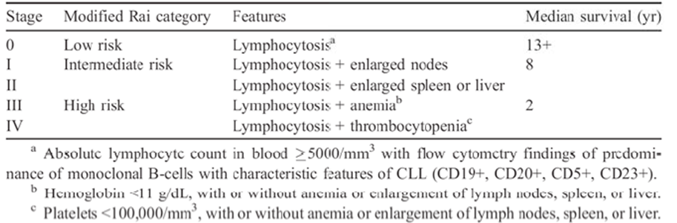

Table 3: Binet staging system for CLL.

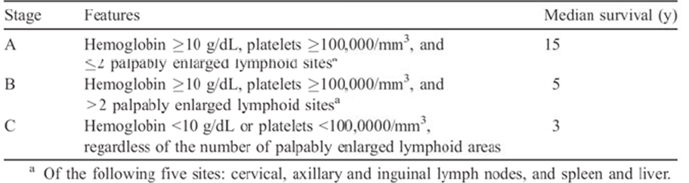

Agents that are currently registered in Australia for the treatment of CLL include alkylating agents (chlorambucil, bendamustine, cyclophosphamide), purine analogues (fludarabine, cladribine), monoclonal antibodies directed against CD20 (rituximab, ofatumumab, obinutuzumab), a monoclonal antibody directed against CD52 (alemtuzumab) and an inhibitor of Bruton’s tyrosine kinase (ibrutinib).

Recommended treatment of CLL/SLL depends on a number of factors including patient functional status, age, the presence or absence of certain cytogenetic abnormalities [del (11q), del (17p) or TP53 mutation] and the presence or absence of significant comorbidities. For previously untreated patients, aged < 70 years and in good physical condition and without adverse cytogenetic abnormalities, combination therapy with a chemotherapy agent and a monoclonal antibody (“chemoimmunotherapy”) is usually recommended, for example, fludaribine + cyclophosphamide + rituximab (FCR).

Previously submitted data had demonstrated that idelalisib in combination with rituximab was effective as a second line regimen in CLL/SLL, and as a first line regimen in subjects with del (17p) or TP53 mutation, who have poor outcomes with standard chemoimmunotherapy regimens. Ofatumumab is another anti CD20 monoclonal antibody registered for the treatment of CLL/SLL. The efficacy and safety of the combination of idelalisib and ofatumumab would therefore be of clinical interest.

#### Guidance

The following EMA guidelines, which have been adopted by the TGA, are considered relevant to the current application:

* Guideline on the evaluation of anticancer medicinal products in man;[7]
* Appendix 1 to the guideline on the evaluation of anticancer medicinal products in man. (Methodological consideration for using progression-free survival or disease-free survival in confirmatory trials);[8]
* Points to consider on application with: 1. Meta-analyses; 2. One pivotal study.[9]

Compliance with these guidelines is considered in the relevant sections of this report.

#### Contents of the clinical dossier

The submission contained the following clinical information:

* 1 pivotal efficacy/safety study (GS-US-312-0119) of idelalisib in combination with ofatumumab.
* An updated study report of one previously evaluated Phase I/II study (Study 101-07) that included some data on the use of idelalisib in combination with ofatumumab.
* Study reports of various other studies not directly relevant to the new indication. Some of these studies had previously been evaluated by TGA. The safety data from these studies have been reviewed in this evaluation.
* A validation study (Report 15-001) of a previously developed population pharmacokinetic model using PK data from the pivotal study.
* Tables of safety data from four ongoing, blinded, placebo controlled Phase III studies of idelalisib (GS-US-312-0115, GS-US-312-0123, GS-US-313-0124, and GS-US-313-0125) in CLL and indolent NHL. These data were all blinded (that is, it was not possible to determine whether a reported AE occurred in a placebo treated or idelalisib treated patient). These data were therefore could not be evaluated. According to the sponsor no new safety concerns have been identified to date from the blinded data.
* Literature references.

#### Paediatric data

The submission did not contain any paediatric data.As CLL/SLL is a disease of adults the absence of paediatric data is acceptable.

#### Good clinical practice

The study reports included in this submission all contained assurances that the studies were conducted in accordance with the International Conference on Harmonisation (ICH) guideline for Good Clinical Practice (GCP) and the original principles embodied in the Declaration of Helsinki.

### Pharmacokinetics

Limited PK sampling was performed in the pivotal study included in this submission (GS-US-312-0119). Results are summarised in Table 4.

Table 4: Idelalisib plasma PK concentration (ng/Ml) PK analysis set.

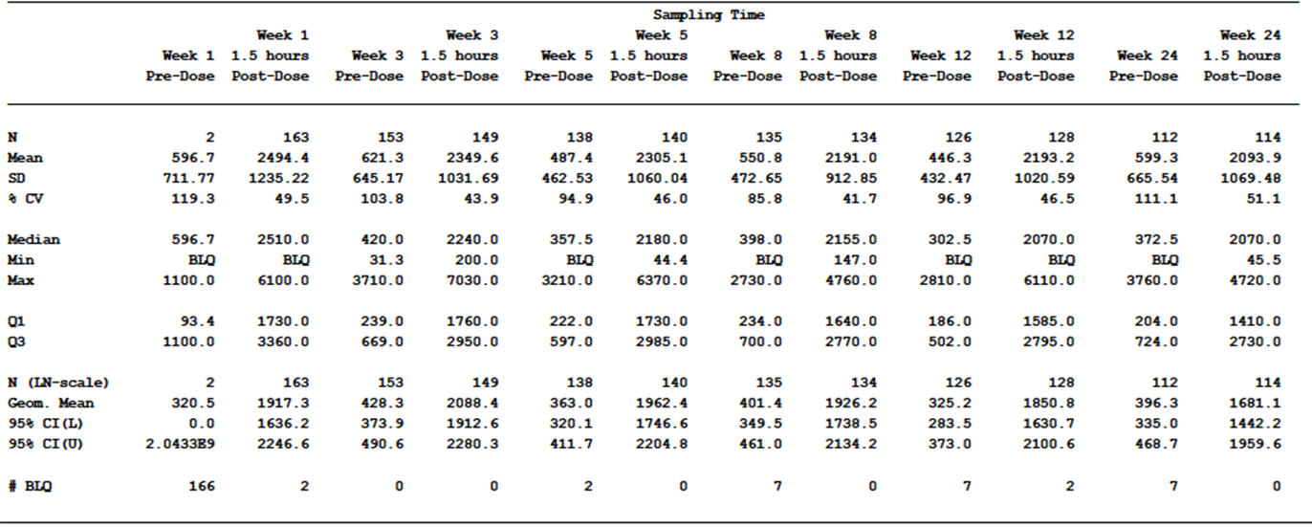

Note: the PK analysis set includes subjects in the safety analysis set who have baseline and on-study measurements to provide interpretable results, with treatment group designated according to the actual treatment received.

In addition, the sponsor conducted various population PK and population PK/PD analyses of subjects enrolled in the pivotal study using previously developed population PK models. Results for these analyses are summarised below.

Table 5: Effect of ofatumumab on idelalisib PK.

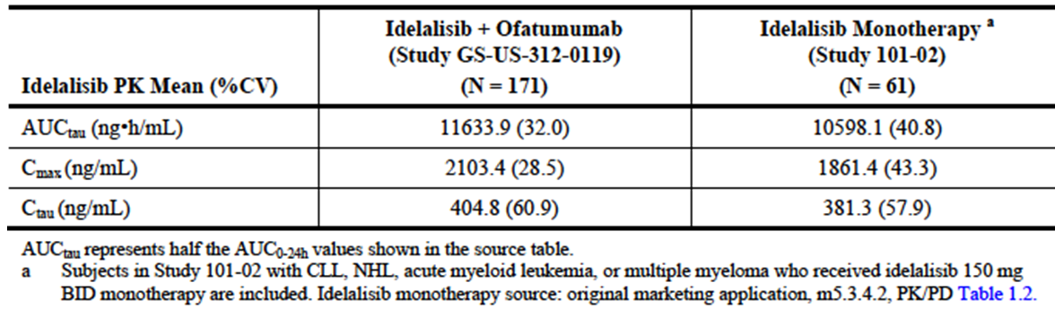

Table 6: Effect of intrinsic factors on idelalisib PK.

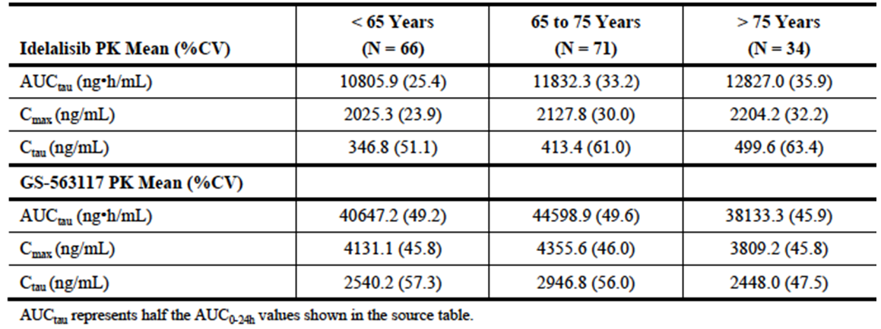

Figure 1: Study GS-US-312-0119: exposure-efficacy relationship, box plot of idelalisib Ctau stratified by BOR.

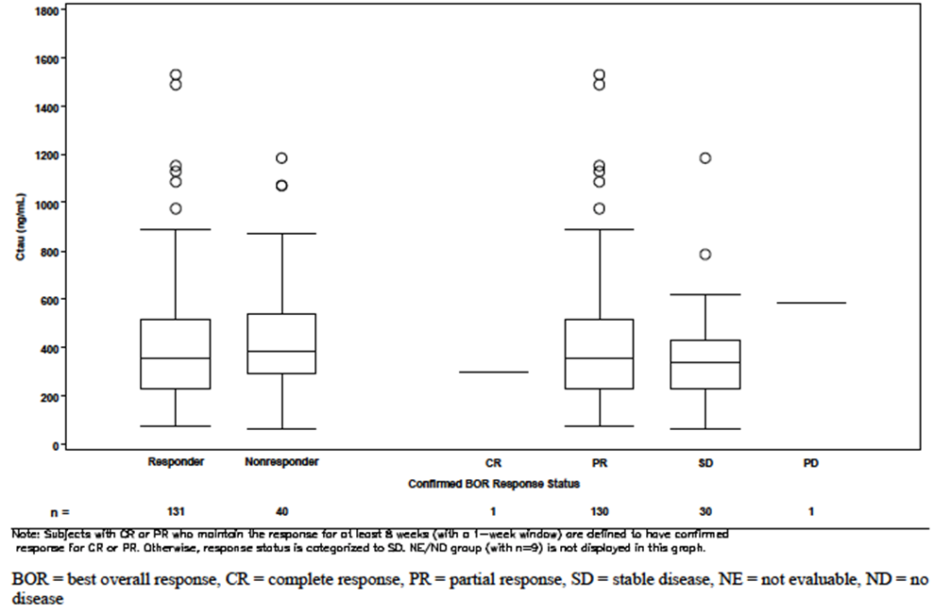

Figure 2: Study GS-US-312-0119: exposure-safety relationship, box plot of idelalisib Cmax for subjects with ≥ Grade 3 AEs of interest.

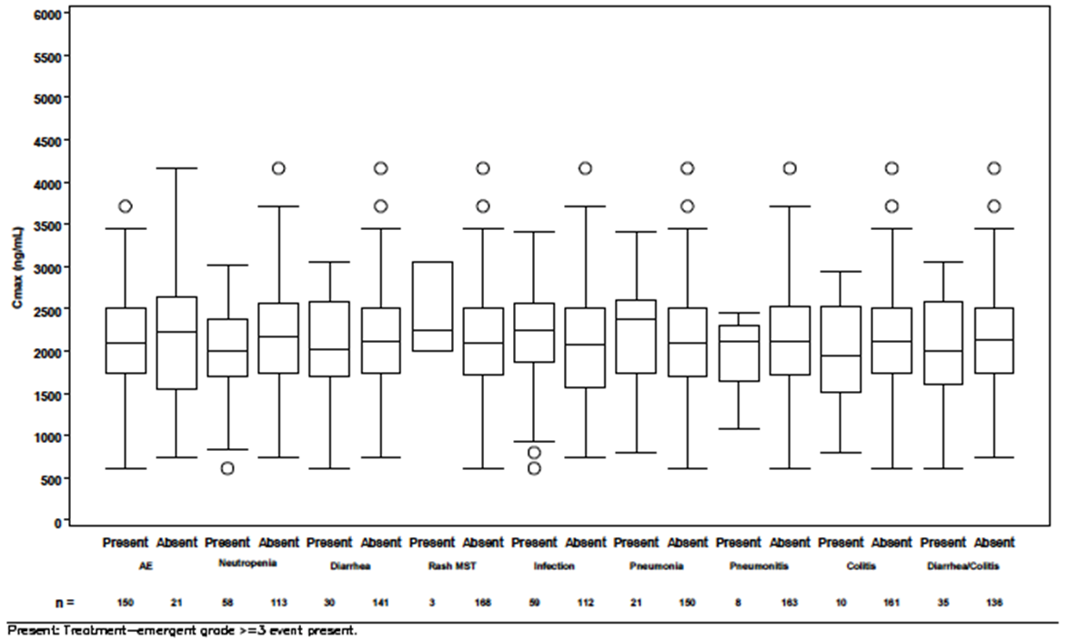

Conclusions drawn from these PK data were:

* Idelalisib trough and peak plasma concentrations remain reasonably stable over 24 weeks when the drug is administered in combination with ofatumumab;
* Co-administration of ofatumumab with idelalisib does not appear to significantly affect the PK of idelalisib;
* No relationships could be established between systemic exposure to idelalisib and efficacy outcomes;
* No relationships could be established between systemic exposure to idelalisib and the occurrence of common AEs.

### Pharmacodynamics

No new pharmacodynamic data were included in the submission. In the pivotal study blood samples were collected for the measurement of plasma cytokines and chemokines, serum markers of iron metabolism and CLL cell DNA, RNA and protein. The study report did not contain analyses of these parameters, but indicated that a separate biomarker analysis report would be submitted.

### Dosage selection for the pivotal studies

The dose of idelalisib used in the pivotal study was 150 mg BD. This is the same regimen used for the currently approved indications and was based on previously evaluated Phase I studies.

The choice of ofatumumab dose (1000 mg) was not discussed in the study report for the pivotal study. However, this dose was used in an earlier phase 1/2 study (101-07) where the stated justification was that the 1000 mg dose is common when ofatumumab is used in combination regimens.

### Efficacy

#### Studies providing efficacy data

##### Pivotal efficacy study: GS-US-312-0119

Study GS-US-312-0119 was a Phase III, randomised, open label controlled trial with two parallel groups. Subjects were randomised (2:1) to receive either the combination of ofatumumab with idelalisib (Group A) or ofatumumab monotherapy (Group B). A study schema is shown in Figure 3.

Figure 3: Study GS-US-312-0119 – Study schema.

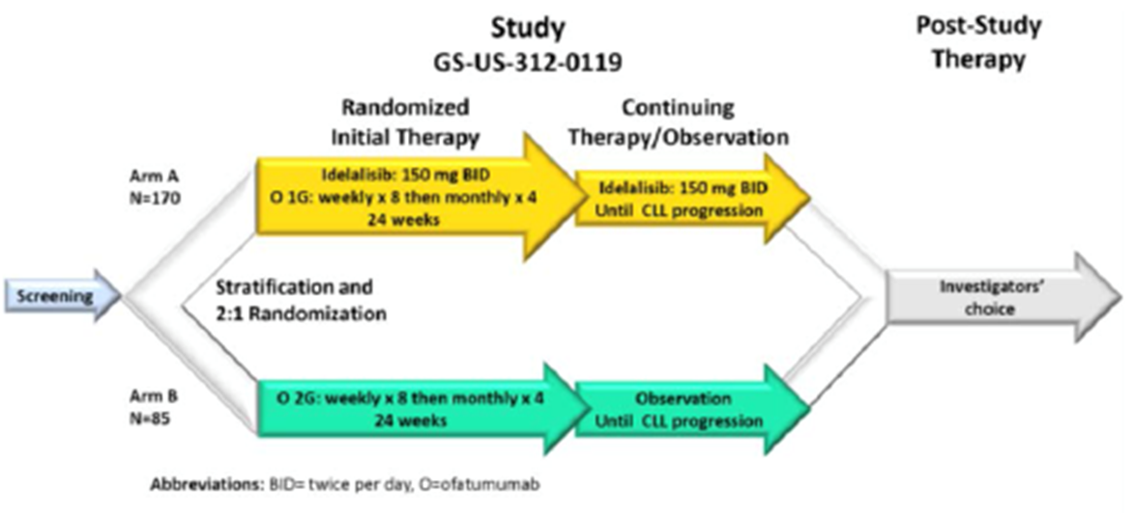

The primary objective of the study was to evaluate the effect of the addition of idelalisib to ofatumumab on progression free survival (PFS) in subjects with previously treated CLL.

The secondary objectives were to:

* Evaluate the effect of the addition of idelalisib to ofatumumab on the onset, magnitude, and duration of tumour control;
* Evaluate the effect of the addition of idelalisib to ofatumumab on the onset, magnitude, and duration of tumour control for subjects with 17p deletion and/or TP53 mutation;
* Assess the effect of the addition of idelalisib to ofatumumab on measures of subject wellbeing, including overall survival (OS), health related quality of life (HRQL), and performance status;
* Assess the effects of the addition of idelalisib to ofatumumab on disease-associated biomarkers and to evaluate potential mechanisms of resistance to idelalisib;
* Characterize the effect of ofatumumab on idelalisib exposure through the evaluation of idelalisib plasma concentrations over time;
* Describe the safety profile observed with the addition of idelalisib to ofatumumab;
* Estimate health resource utilisation associated with the addition of idelalisib to ofatumumab.

##### Other efficacy studies: Study 101-07

This study is an ongoing Phase I, open label trial. It included subjects with CLL, indolent non-Hodgkin’s lymphoma (iNHL) or mantle cell lymphoma (MCL). Subjects were required to have relapsed or refractory disease. This study was reviewed in the clinical evaluation of the original submission for the registration of idelalisib. In the current submission the sponsor provided an updated study report.

The study enrolled multiple separate cohorts of patients to explore the efficacy and safety of idelalisib when used in combination with a variety of other agents (rituximab, ofatumumab, bendamustine, fludarabine, everolimus, bortezomib, chlorambucil and lenalidomide) in the treatment of the three diseases. Overall, 241 subjects were enrolled. In one of the cohorts, subjects with relapsed or refractory CLL were treated with a combination of idelalisib and ofatumumab. Only the results for this cohort are reviewed in this report.

##### Other efficacy data included in the submission

The submission included a number of other studies that were not directly relevant to the proposed new indication. The safety data from these studies have been reviewed. One of these studies (Study 101-09) included efficacy data that was relevant to one of the currently approved indications (follicular lymphoma).

Study 101-09 was a Phase II single arm trial in 125 subjects with treatment refractory indolent NHL. Subjects were treated with idelalisib monotherapy (150 mg BD). The primary efficacy variable was response rate. A full study report for this trial was reviewed in the clinical evaluation of the original submission to register idelalisib. In the current submission the sponsor provided a brief update of efficacy data from the study prepared in response to a request from EMA as a ‘post-authorisation measure (PAM)’.

#### Evaluator’s conclusions on efficacy

The pivotal efficacy study was well designed and executed. The study design was consistent with the recommendations of the relevant EMA guidelines adopted by TGA. The study demonstrated a statistically significant improvement in efficacy when idelalisib was combined with ofatumumab, compared to ofatumumab monotherapy. The magnitude of the efficacy benefit was clinically significant with a doubling of median PFS (16.3 versus 8.0 months) and a 3.7 fold increase in the proportion of subjects alive and free of progressive disease at 12 months (63.7% versus 17.0%). A PFS benefit was observed consistently across the various subgroups examined including those subjects with an adverse prognosis due to the presence of a 17p deletion or TP53 mutation.

The sponsor is proposing that the combination of idelalisib with ofatumumab should be approved for use as first line therapy in subjects with 17p deletion or TP53 mutation. The submitted efficacy studies did not examine the efficacy of the combination in the first line setting. However, efficacy was demonstrated in this subgroup in the setting of relapsed/refractory disease. It is possible that efficacy may be superior in the first line setting where the disease would be expected to be less treatment resistant. Given that disease with 17p deletion or TP53 mutation responds poorly to conventional first line chemoimmunotherapy, it is considered reasonable to extrapolate the efficacy data into the first line setting for this subgroup. It is noted that idelalisib is already approved for use in combination with rituximab in the first line setting for these patients.

Table 7 shows a comparison of the PFS results obtained in Study GS-US-312-0119 with those obtained in Study GS-US-312-0116, the pivotal study that led to the approval of idelalisib in combination with rituximab in CLL. Although both studies were conducted in subjects with relapsed CLL, the inclusion criteria and baseline characteristics of subjects were different and as a result any conclusions regarding comparative efficacy based on cross trial comparison are likely to be unreliable.

Table 7: Comparison of PFS results in Studies GS-US-312-0119 and GS-US-312-0116.

|  | GS-US-312-0119 | | GS-US-312-0116 | |
| --- | --- | --- | --- | --- |
|  | Idelalisib + Ofatumumab | Ofatumumab | Idelalisib + Rituximab | Rituximab |
| % of subjects with PFS event | 43.7% | 62.1% | 22.7% | 63.6% |
| Median PFS – months (95% CI) | 16.3  (13.6, 17.8) | 8.0  (5.7, 8.2) | 19.4  (12.3 – NR) | 6.5  (4.0, 7.3) |
| Adjusted HR (95% CI) | 0.27 (0.19 – 0.39) | | 0.15 (0.09 – 0.24) | |
| p-value | < 0.0001 | | = 1.6 x 10-16 | |

Study 101-07 provided some supportive evidence of efficacy with an overall response rate comparable to that seen in the pivotal study.

Updated efficacy data from Study 101-09 in subjects with indolent NHL were consistent with the original data.

### Safety

Idelalisib is known to be associated with the following toxicities, as described in the current PI:

* Hepatotoxicity;
* Gastrointestinal toxicity (diarrhoea, colitis, intestinal perforation);
* Pneumonitis;
* Cutaneous reactions;
* Cytopaenias;
* Infections (possibly including reactivation of hepatitis infection and progressive multifocal leukoencephalopathy).

#### Studies providing safety data

The following studies provided evaluable safety data relevant to the proposed new indication (treatment of relapsed CLL with idelalisib in combination ofatumumab):

##### Pivotal efficacy study

In the pivotal efficacy study, the following safety data were collected:

* Data on general AEs were collected at each study visit, including the EOS visit and the 30 day follow-up visit. Subjects were asked an open ended question regarding new health problems. An AE was defined as any untoward medical occurrence in a subject. AEs were assessed as either related or not related to study drug and were graded using the Common Toxicity Criteria for Adverse Events (CTCAE) version 4.03. AEs were coded using Medical Dictionary for Regulatory Activities (MedDRA) terminology.
* The following were considered AEs of particular interest: diarrhoea and/or colitis, rash, pneumonitis, pneumonia, bowel perforation, anaphylaxis, PML, Richter’s transformation and second malignancies.
* Laboratory tests, including haematology and biochemistry, were performed at each study visit. Urinalysis and ECGs were not routinely monitored during the study.
* Oxygen saturation by pulse oximetry was measured at each study visit. Other vital signs such as temperature, pulse and blood pressure were not systematically monitored during the study.

##### Study 101-07

Safety monitoring similar to that in the pivotal study was undertaken in this trial.

#### Patient exposure

##### Pivotal efficacy study

Exposure to idelalisib in Study GS-US-312-0119 is summarised in Table 8. Median duration of exposure to idelalisib was 12.3 months. A total of 134 subjects were exposed for at least 6 months and 90 subjects for at least 12 months.

Table 8: Study GS-US-312-0119 – Exposure to idelalisib.

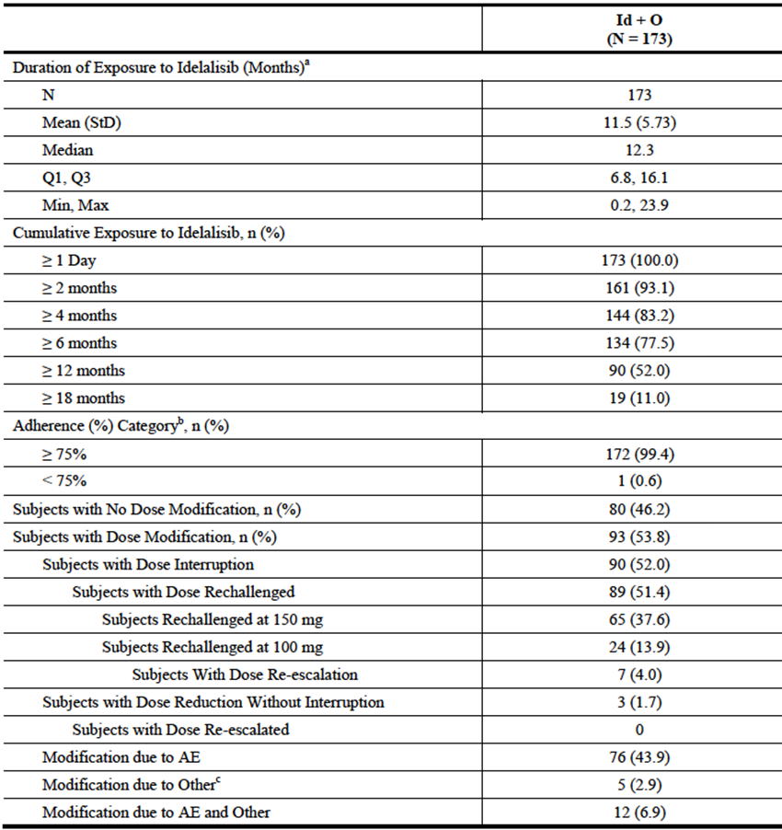

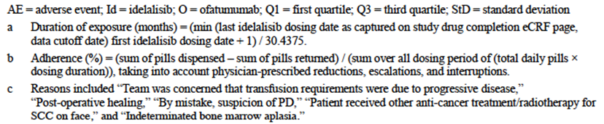

Exposure to ofatumumab is summarised in Table 9. The planned dosing regimen for both arms involved a total of 12 doses with the final dose being given at week 24 (that is, a planned duration of exposure of approximately 6 months). Median duration of exposure was 5.3 months in the combination arm and 4.2 months in the ofatumumab monotherapy arm.

*Comment: Duration of exposure to treatment was considerably longer for subjects in the combination arm, and reporting of AEs would therefore have continued for a longer period. Crude incidence figures for AEs would therefore be expected to be higher in the combination arm.*

Table 9: Study GS-US-312-0119 – Exposure to ofatumumab.

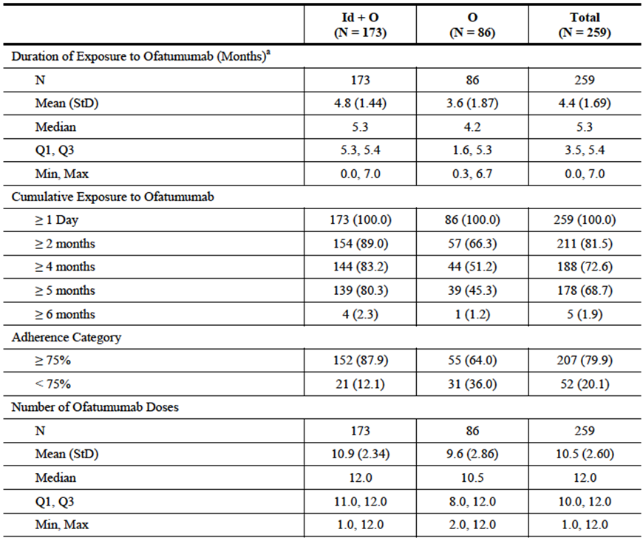

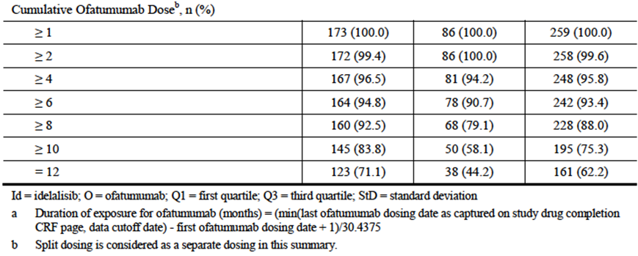

##### Study 101-07

A total of 21 subjects were treated with the combination of idelalisib with ofatumumab. Median duration of exposure to idelalisib was 10.6 months. 15 subjects were exposed for at least 6 months and 1 subject for at least 12 months.

#### Safety issues with the potential for major regulatory impact

##### Liver toxicity

Idelalisib is known to be associated with hepatotoxicity and this was confirmed in the pivotal study where subjects randomised to combination treatment had an increased incidence of transaminase elevation. There were no cases of severe drug induced liver injury (DILI) in any of the submitted studies. In addition there were no cases that clearly met ‘Hy’s law’ criteria (predictive of DILI).

##### Haematological toxicity

Cytopaenias are a known complication of CLL, especially in advanced disease and are a known adverse effect of idelalisib. They are also a complication of many agents used in the initial treatment of CLL. Cytopaenias occurred frequently in the submitted studies. However in the pivotal study in this submission, the incidence of cytopaenias was not increased in the combination arm after incidence was adjusted for duration of exposure (Table 10).

Table 10: Study GS-US-312-0119 – abnormalities in haematology: exposure-adjusted incidence rate.

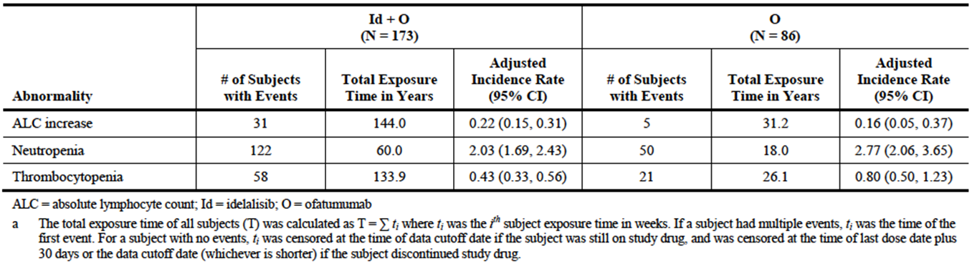

##### Serious skin reactions

Idelalisib is known to be associated with dermatological toxicity. In the pivotal study, the incidence dermatological SAEs was 1.2% in the combination arm and 0% in the ofatumumab arm.

##### Cardiovascular safety

The submitted studies did not produce evidence to suggest that idelalisib is associated with significant cardiovascular toxicity.

##### Unwanted immunological events

Idelalisib was not associated with serious immunological reactions (for example, anaphylaxis) in the submitted studies.

#### Post marketing data

No post-marketing data were included in the submission.

#### Evaluator’s conclusions on safety

The safety profile of idelalisib in the submitted studies was consistent with that previously observed. No new safety issues were identified.

The addition of idelalisib to ofatumumab in the treatment of CLL results in some increase in the incidence of AEs. Combination treatment was associated with an increase in the incidence of grade ≥ 3 AEs (87.9% versus 55.8%) and serious AEs (69.9% versus 41.9%). This increased toxicity may be due in part to the longer observation period for subjects in the combination arm. 30% of subjects in the combination arm had an AE that led to discontinuation of idelalisib. Combination treatment was not associated with any increase in overall mortality.

### First round benefit-risk assessment

#### First round assessment of benefits

The benefits of the combination of idelalisib and ofatumumab in the proposed usage are:

* A significant reduction in the risk of experiencing a PFS event (mainly events of disease progression) in patients with relapsed/refractory CLL.

#### First round assessment of risks

The risks of idelalisib in the proposed usage are:

* An increase in the incidence of a number of adverse events such as diarrhoea, colitis, LFT abnormalities, pneumonitis and skin toxicity.

No new safety issues have been identified with the proposed new indication.

The efficacy and safety of the idelalisib-ofatumumab combination has not been presented for patients with 17p deletion who are treatment naïve. Use in this group is consequently considered unfavourable.

#### First round assessment of benefit-risk balance

The benefit-risk balance of idelalisib used in combination with ofatumumab is considered favourable in patients with relapsed/refractory CLL without 17p deletion. Other studies included in the submission do not alter the benefit-risk balance for the currently approved indications.

### First round recommendation regarding authorisation

Satisfactory responses to the clinical questions are required before authorisation and approval of the proposed indication can be recommended.

### Clinical questions

(Q1) Please provide an assurance that the tablet formulations used in the pivotal study (GS-US-312-0119) were identical to those registered in Australia.

(Q2) The sponsor is requested to provide a justification for the use of a non-registered regimen of ofatumumab for use in combination with idelalisib in the studies presented for evaluation.

(Q3) Given that the studies presented in this submission only recruited patients with CLL that were relapsed or refractory, the sponsor is requested to provide a justification for the extrapolation of use of the idelalisib-ofatumumab combination as first line in patients with 17p deletion – as per the proposed indication.

### Second round evaluation

Not applicable

### Second round benefit-risk assessment

#### Second round assessment of benefits

Not applicable

#### Second round assessment of risks

Not applicable

#### Second round assessment of benefit-risk balance

Not applicable

### Second round recommendation regarding authorisation

Not applicable

## V. Pharmacovigilance findings

### Risk management plan

The sponsor submitted a Risk Management Plan (RMP) EU-RMP Version 2.1 (8 November 2016, DLP: 4 March 2016) and Australian Specific Annex (ASA) Version 1.3 (dated November 2016), which was reviewed by the RMP evaluator.

#### Safety specification

Subject to the evaluation of the clinical aspects, the summary of the safety concerns and missing information as specified in the Summary Table of Safety Concerns (differences between EU and Australia) of the ASA is as shown in Table 11.

Table 11: Summary table of Safety Concerns (differences between EU and Australia).

|  |  |  |
| --- | --- | --- |
|  | EU-RMP v 1.1, dated June 2015 | ASA v 1.1, dated August 2015 |
| Important identified risks | Transaminase elevation  Severe diarrhoea/colitis  Pneumonitis  Neutropenia  Rash | Transaminase elevation  Severe diarrhoea/colitis  Pneumonitis  Neutropenia  Rash |
| Important potential risks | Drug-drug interaction with CYP3A inducers  Reproductive toxicity including teratogenicity  -  Drug-drug interaction with CYP3A substrates  Photosensitivity  Skin cancer | Drug-drug interaction with CYP3A inducers  Reproductive toxicity including teratogenicity  Progressive multifocal leukoencephalopathy (PML)  Intestinal perforation  Drug-drug interaction with CYP3A substrates |
| Missing information | Safety in children  Safety of breastfeeding  Safety in patients with severe hepatic impairment  Development of drug resistance  Carcinogenicity  Long-term safety  Drug-drug interaction with oral contraceptive  Safety in patients with severe renal impairment  Safety in patients with chronic active hepatitis  Safety of patients with concomitant immunisation  Immunological effects and auto-immunity | Safety in children  Safety of breastfeeding  Safety in patients with severe hepatic impairment  Carcinogenicity  Drug-drug interaction with oral contraceptive  Safety in patients with severe renal impairment  Safety in patients with chronic active hepatitis  Safety of patients with concomitant immunisation |

For the important potential risks: ‘Photosensitivity’ & ‘Skin cancer’; and the missing information: ‘Development of drug resistance’, ‘Long-term safety’ & ‘Immunological effects and auto-immunity’, the ASA states: “Not proposed for inclusion into ASA. Please refer to Table 7”. Table 7: ‘Summary Table of Risk Minimization Measures’ of the ASA provides the following justification for such omission, respectively, although it would appear no further links to the specified data or relevant correspondence between the sponsor and TGA have been provided to substantiate such justification:

* Information concerning photosensitivity was provided to TGA in the pre ACPM Response, and subsequently approved by TGA.
* Information concerning the risk of secondary malignancy was provided to TGA in the Response to the Section 31 Request (Clinical Evaluation), and subsequently approved by TGA. Clinical studies to date have not shown any increase in incidence of skin cancers.
* Not included in EU labelling, but provided as Missing Information in EU RMP following EMA evaluation. PAM to provide data on resistance mechanisms is planned for submission in EU in December 2015. Therefore, not included in ASA.
* Longer term safety data is being submitted to TGA as part of this application, which is a specific TGA condition of registration.
* Study TX-312-2018: 4 week oral dose ranging toxicology and toxicokinetic study in RasH2 mice (GS-563117 safety) and final reports of the in vitro and in vivo studies performed to characterise the immune consequences of idelalisib treatment was provided in a separate application. No changes were proposed in this application as a result of the data provided.

##### RMP reviewer comment

At this time there are no objections to the following observed differences to the summary of safety concerns, as specified in the ASA, in comparison to those previously accepted for Zydelig:

* The important potential risk: ‘Pneumonitis’ has now been designated as an important identified risk.
* The important identified risks: ‘Neutropenia’ & ‘Rash’ have been added as new safety concerns.
* The important potential risks: ‘Drug-drug interaction with CYP3A inducers’ & ‘Drug-drug interaction with CYP3A substrates’ have been added as new safety concerns.
* The important potential risk: ‘Reproductive toxicity including teratogenicity’ has now replaced the important potential risk: ‘Teratogenicity’ and the missing information: ‘Safety in pregnant women’.
* The missing information: ‘Long-term safety in patients with severe hepatic impairment’ has now been designated as ‘Safety in patients with severe hepatic impairment’.
* The missing information: ‘Drug-drug interaction with oral contraceptive’, ‘Carcinogenicity’, ‘Safety in patients with severe renal impairment’, ‘Safety in patients with chronic active hepatitis’ & ‘Safety of patients with concomitant immunization’ have now been added.

Notwithstanding the evaluation of the clinical aspects of the Safety Specification, it is recommended that the above summary of safety concerns and missing information be amended as follows:

* Given the sponsor’s justification is considered to be inadequate, the important potential risks: ‘Photosensitivity’ & ‘Skin cancer’; and the missing information: ‘Development of drug resistance’, ‘Long-term safety’ & ‘Immunological effects and auto-immunity’ specified in the EU-RMP should also be included in the summary of safety concerns for Australia. Consideration must be given as to what pharmacovigilance and risk minimisation activities will be proposed for these new safety concerns and the ASA should be revised accordingly. Alternatively, compelling justification for their omission should be provided to the TGA for review.

#### Pharmacovigilance plan

##### Proposed pharmacovigilance activities

Section 2.2.2: ‘Pharmacovigilance Activities’ of the ASA states:

*The pharmacovigilance activities implemented in the EU are also applicable to Australia. Tables 4.1-4.3 highlights the routine and additional pharmacovigilance activities being conducted in Australia.*

However, the ASA also states that some important potential risks and missing information specified in the EU-RMP are not proposed for inclusion in the ASA. Consequently, at this time information in Tables 4.2 & 4.3 referring to routine and/or additional pharmacovigilance activities for these specific safety concerns have not been considered.

In this context and in comparison to the pharmacovigilance plan previously accepted for Zydelig, the following changes have been observed:

* The use of targeted follow-up questionnaires to monitor and further characterise the important identified risk: ‘Pneumonitis’; the important potential risk: ‘Reproductive toxicity including teratogenicity’; and the missing information: ‘Safety in patients with severe hepatic impairment’ has been included as routine pharmacovigilance.[10] Copies of the targeted follow-up questionnaires for these safety concerns have been attached to the ASA. It is noted that a copy of the targeted follow-up questionnaire for the missing information: ‘Immunological effects and auto-immunity’ has been attached to the ASA, despite the ASA stating that this missing information is not proposed for inclusion into ASA.
* Routine pharmacovigilance activities are proposed to monitor the new important identified risks: ‘Neutropenia’ & ‘Rash’.
* Routine pharmacovigilance activities are proposed to monitor the new important potential risks: ‘Drug-drug interaction with CYP3A inducers’ & ‘Drug-drug interaction with CYP3A substrates’.
* For the missing information: ‘Safety in patients with severe hepatic impairment’ & ‘Safety in patients with severe renal impairment’, the ASA states that analysis of safety data from any ongoing or future studies including such patients will be conducted.
* The missing information: ‘Carcinogenicity’ will be further characterised by the ongoing nonclinical Study TX-312-2017: ‘A 2-Year Oral (Gavage) Carcinogenicity Study of Idelalisib in Sprague Dawley Rats’ and the planned nonclinical Study TX-312-2019: ‘26-Week Oral Gavage Carcinogenicity and Toxicokinetic Study with Idelalisib in RasH2 [001178-T (hemizygous), CByB6F1-Tg(HRAS)2Jic] Mice’. The planned date for submission of final reports for both studies is Q2 2017.
* The missing information: ‘Drug-drug interaction with oral contraceptive’ will be further characterised by the initiated in vivo Study BP-US-312-1616: ‘An in vivo interaction (induction) study with oral contraceptive’. No planned date for submission of a final report was provided.

##### RMP reviewer’s comments

At this time there are no objections to the specified changes to the pharmacovigilance plan previously accepted for Zydelig. Nevertheless, the entry for the important potential risk: ‘Reproductive toxicity including teratogenicity’ in Table 4.3 of the ASA should be corrected to include the use of a targeted follow-up questionnaire.

As previously stated, the ASA should be revised as required to achieve internal consistency.

#### Risk minimisation activities

##### Sponsor’s conclusion in regard to the need for risk minimisation activities

The sponsor has concluded that routine risk minimisation activities[11] for all the specified safety concerns and missing information are sufficient.

##### RMP reviewer comment

The sponsor’s conclusion is identical to what was previously accepted for Zydelig and at this time continues to be acceptable.

#### Reconciliation of issues outlined in the RMP report

The following section summarises the first round evaluation of the RMP, the sponsor’s responses to issues raised by the TGA RMP reviewer, and the RMP reviewer’s evaluation of the sponsor’s responses.

##### Recommendation #1 in RMP evaluation report

The updated ASA is considered to be internally inconsistent. For example, the ASA states that some important potential risks and missing information specified in the EU-RMP are not proposed for inclusion in the ASA. However, Section 2.2.2: ‘Pharmacovigilance Activities’ of the ASA states:

*The pharmacovigilance activities implemented in the EU are also applicable to Australia. Tables 4.1-4.3 highlights the routine and additional pharmacovigilance activities being conducted in Australia*

with Tables 4.2 & 4.3 referring to routine and/or additional pharmacovigilance activities for these specific safety concerns. The ASA should be revised as required to achieve internal consistency.

##### Sponsor response

Gilead has revised ASA v1.2 in its entirety to both align with the latest EU-RMP v2.0 (18 August 2016) and to achieve internal consistency.

##### Evaluator’s comment

The ASA has been revised satisfactorily.

##### Recommendation #2 in RMP evaluation report

Safety considerations may be raised by the clinical evaluator through the consolidated Section 31 request and/or the Clinical Evaluation Report. It is important to ensure that the information provided in response to these includes a consideration of the relevance for the RMP, and any specific information needed to address this issue in the RMP. For any safety considerations so raised, the sponsor should provide information that is relevant and necessary to address the issue in the RMP.

##### Sponsor response

Gilead acknowledges the TGA’s request, and commits to considering the need to update the RMP in response to relevant safety considerations that may be raised by the clinical evaluator. Gilead has revised the RMP and ASA following the recent clinical safety signal to reflect the current risk minimisation measures.

##### Evaluator’s comment

The sponsor has added the following three safety concerns following the Safety Review: Stevens-Johnson syndrome (SJS) – Toxic epidermal necrolysis (TEN), serious infections including opportunistic infections such as PJP and CMV and off-label use (first line CLL therapy in patients without 17p deletion/TP53 mutation, early line iNHL therapy). The sponsor has not addressed the recommendation from the Safety Review to add “Immunosuppression” as an Important Identified Risk, in addition to neutropenia. The sponsor should add this to the Summary of Safety Concerns.

##### Recommendation #3 in RMP evaluation report

Given the sponsor’s justification is considered to be inadequate, the important potential risks: ‘Photosensitivity’ & ‘Skin cancer’; and the missing information: ‘Development of drug resistance’, ‘Long-term safety’ & ‘Immunological effects and auto-immunity’ specified in the EU-RMP should also be included in the summary of safety concerns for Australia. Consideration must be given as to what pharmacovigilance and risk minimisation activities will be proposed for these new safety concerns and the ASA should be revised accordingly. Alternatively, compelling justification for their omission should be provided to TGA for review.

##### Sponsor response

Summary Table 7 Pharmacovigilance and Risk Minimisation Activities Proposed in Australia, along with other applicable sections in ASA, have been updated accordingly to address the concerns raised above by TGA. For the risks ‘Development of drug resistance’, ‘Long term safety’ and ‘Immunological effects and autoimmunity’, additional PV studies are proposed together with routine pharmacovigilance. For the risks ‘Photosensitivity’ and ‘Skin cancer’, routine pharmacovigilance alone is proposed. Routine risk minimisation activities are proposed for each safety concern in alignment with the EU-RMP.

##### Evaluator’s comment

The sponsor has updated the ASA satisfactorily.

##### Recommendation #4 in RMP evaluation report

The entry for the important potential risk: ‘Reproductive toxicity including teratogenicity’ in Table 4.3 of the ASA should be corrected to include the use of a targeted follow-up questionnaire.

##### Sponsor response

As the ASA has been revised in its entirety, the information in Table 4.2. Important Potential Risks is now provided within Table 6. Summary Table of Risk Minimization Measures and within Table 4.1. Routine & Additional Pharmacovigilance Activities to include the use of the targeted follow-up questionnaire - Pregnancy Report Form and Pregnancy Outcome Form.

##### Evaluator’s comment

The sponsor has updated Table 4.2 of the ASA satisfactorily. The follow-up questionnaires should be submitted to TGA and appended to the ASA.

##### Recommendation #5 in RMP evaluation report

The entries for the missing information: ‘Drug-drug interaction with oral contraceptive’, ‘Safety in patients with severe renal impairment’ & ‘Safety in children’ in Table 7: ‘Summary Table of Risk Minimization Measures’ of the ASA should be amended to indicate that no additional risk minimisation activities are proposed for these items.

##### Sponsor response

Gilead has amended Table 7: Summary Table of Risk Minimisation Measures of the ASA as requested.

##### Evaluator’s comment

The sponsor should update Table 7 to indicate the additional pharmacovigilance and risk minimisation activities that have been agreed (for example, the Dear HCP [DHCP] letters, and patient safety card).

#### Summary of recommendations

It is considered that the sponsor’s response to the TGA Section 31 Request has adequately addressed all of the issues identified in the RMP evaluation report. There are additional recommendations.

##### Outstanding issues

###### Issues in relation to the RMP

* The sponsor should add “Immunosuppression” to the Summary of Safety Concerns as an Important Identified Risk, and assign appropriate pharmacovigilance and risk minimisation activities.
* The sponsor should provide an annotation under Table 4-2 stating that it is no longer the case that there is no clinical evidence of increased risk of infection as highlighted by Phase III clinical studies in the Safety Review which showed an increase of death due to infection, that is, Studies GS-US-312-0123, GS-US-313-0124, and GS-US-313-0125.
* The sponsor should extend the DHCP letter to address the important identified risks of ‘Serious infections including opportunistic infections such as PJP and CMV’ and ‘off-label use (first line CLL therapy in patients without 17p deletion/TP53 mutation, early line iNHL)’ as is the case for the EU RMP. This should also be recorded as an additional risk minimisation activity against these safety concerns in the ASA.
* The sponsor should provide the wallet-sized patient safety card to TGA when available, and append it to the ASA.
* The targeted follow-up questionnaires for serious infection and PJP should be submitted to the TGA when available, and appended to the ASA.
* The sponsor should commit to updating Table 6 Summary table of Risk Minimisation Activities when the PI is finalised.
* Table 7 of the ASA should also be updated to indicate the additional pharmacovigilance and risk minimisation activities that have been agreed (for example, the DHCP letters, and patient safety card).

##### Comments on the safety specification of the RMP

###### Clinical evaluation report

The clinical evaluator considered that the Safety Specification in the submitted RMP was satisfactory.

###### Nonclinical evaluation report

No nonclinical data were submitted and therefore no nonclinical evaluation report will be issued.

##### Key changes to the updated RMP

EU-RMP Version 1.1, dated 19 June 2015 DLP 30 April 2015 and ASA Version 1.1, dated 31 August 2015 has been superseded by EU-RMP Version 2.0 (20 July 2016, DLP 4 March 2016) and ASA Version 1.2 (August 2016).

Table 12: Key changes from the version evaluated at Round 1.

| Summary of key changes between version 1.1 June 2015 and version 2.0 July 2016 | |
| --- | --- |
| Safety specification | Addition of the following safety concerns to Important identified Risks:  Stevens-Johnson syndrome (SJS) – Toxic epidermal necrolysis (TEN)  Serious infections including opportunistic infections such as PJP and CMV  Off-label use (first line CLL therapy in patients without 17p deletion/TP53 mutation, early line iNHL therapy) |
| Pharmacovigilance activities | Routine pharmacovigilance proposed for the three additional Important Identified Risks including the use of a targeted follow-up PJP questionnaire and a serious infectious event questionnaire, close monitoring of all infection events, including opportunistic infections, with idelalisib in PSURs.  Section 3.1 Newly completed Studies or Activities has results for Study: 101-07 (Phase 1 study – to provide long term safety and efficacy data to further support efficacy in patients with 17p deletion/ TP53 mutation)  Section 3.2 Additional studies with interim data available since last version of RMP include Study 101-09, TX-312-2017, TX-312-2019  Table 4.3 Additional required Pharmacovigilance Activities “*European HCP Survey to measure the effectiveness of the Direct Healthcare Professional Communication that notified prescribers of the risk of serious and/or fatal infections including opportunistic infections such as PJP and CMV in first line treatment of CLL and early line iNHL”* Final report Q4 2017: *“Post-Authorisation Safety Study (PASS)/registry to further characterise the toxicity and safety profile of idelalisib in real life use in refractory FL patients”* TBD. (Study 101-08 terminated)  Updated stated additional Pharmacovigilance Activities Table 4.4 |
| Risk minimisation activities | EU RMP: Additional Risk Minimisation Activities (Direct Healthcare Professional Communication) proposed for the two additional Important Identified Risks, Serious Infections and Off-label use, as well as Neutropenia (Previously no additional risk minimisation) |
| ASA | Approved indication amended – removal of first line treatment of CLL/SLL as a consequence of an identified safety signal (increased risk of death-mainly due to infection)  Proposed indication amended to align with the changes above.  Additional target questionnaires proposed for serious infection and PJP (not yet provided)  Table 3 “The Summary of Safety Concerns” aligns with the EU RMP including the addition of the three safety concerns outlined above. (There are two additional Important Potential Risks in the safety concerns of the ASA which are not included in the EU RMP: Progressive multifocal leukoencephalopathy (PML) and Intestinal Perforation).  Table 4.1 “Comparison of pharmacovigilance activities and risk minimisation activities between the EU and Australia” has been updated.  An additional risk minimisation proposed: Patient Safety Card outlining the key safety risks for idelalisib.  DHCP letter proposed as an additional risk minimisation activity for neutropenia only (DHCP letter is also proposed for the EU for serious infections and Off-label use) |

Table 13: Revised summary of Safety Concerns.

|  |  |
| --- | --- |
| Summary of safety concerns | |
| Important identified risks | Transaminase elevation |
| Severe diarrhoea/colitis |
| Pneumonitis |
| Neutropenia |
| Rash |
| Stevens-Johnson syndrome (SJS) – Toxic epidermal necrolysis (TEN) |
| Serious infections including opportunistic infections such as PJP and CMV |
| Off-label use (first line CLL therapy in patients without 17p deletion/*TP53* mutation, early line iNHL therapy) |
| Important potential risks | Reproductive toxicity including teratogenicity |
| Drug-drug interaction with CYP3A inducers |
| Drug-drug interaction with CYP3A substrates |
| Photosensitivity |
| Skin cancer |
| Missing information | Development of drug resistance |
| Carcinogenicity |
| Long-term safety |
| Safety in patients with severe hepatic impairment |
| Safety in patients with severe renal impairment |
| Safety in patients with chronic active hepatitis |
| Safety of patients with concomitant immunization |
| Immunological effects and auto-immunity |
| Safety in children |
| Safety of breastfeeding |
| Drug-drug interaction with oral contraceptive |

###### RMP evaluator’s comments

**Summary of safety concerns**

The Summary of Safety Concerns in the ASA (and the EU RMP) has been updated to reflect the changes recommended in the Safety Review, including the addition of Stevens-Johnson syndrome (SJS) – Toxic epidermal necrolysis (TEN), serious infections including opportunistic infections such as PJP and CMV and off-label use (first line CLL therapy in patients without 17p deletion/TP53 mutation, early line iNHL therapy) under Important Identified Risks.

However, the Safety Review recommended that immunosuppression (reflecting that risk of infection is not conferred only by neutropenia) be included under Important Identified Risks. Neither the EU RMP (version 2.0) nor the ASA (version 1.2) reflect this recommendation. The sponsor should add “Immunosuppression” to the Summary of Safety Concerns as an Important Identified Risk as recommended in the safety review. Pharmacovigilance and risk minimisation activities should be assigned to the additional safety concern.

Table 4.2 “Exclusion Criteria which are Not Proposed to Remain as Contraindications” of the EU RMP has not been updated and still states that “there is no evidence from the clinical development program to suggest that idelalisib increases the risk of infection”. The sponsor should provide an annotation under Table 4-2 stating that this is no longer the case as highlighted by Phase III clinical studies in the Safety Review which showed an increase of death due to infection, that is, Studies GS-US-312-0123, GS-US-313-0124, and GS-US-313-0125.

In its Section 31 response, the sponsor has committed to considering the need to update the RMP in response to relevant safety considerations that may be raised by the clinical evaluator. This satisfies the request from the Safety Review that the RMP be updated and provided to TGA whenever there is a significant (material) change to the RMP, including when changes to the summary of safety concerns are made.

**Risk minimisation and pharmacovigilance activities**

The sponsor has committed to implementing:

* A wallet-sized patient safety card that outlines key safety risks with the use of idelalisib.
* Targeted Follow-up Questionnaires for serious infection and PJP (in addition to the previously agreed use of follow-up questionnaires for other safety concerns).

The above materials should be submitted to TGA when available, and appended to the ASA.

A DHCP letter has already been sent advising clinicians about the identified safety signal regarding increased deaths due to infections. The sponsor has listed DHCP letter as an additional risk minimisation activity for neutropenia only. The sponsor should explain why it does not propose to include a DHCP letter as an additional risk minimisation activity for the Important Identified Risks of Serious infections including opportunistic infections such as PJP and CMV and off-label use (first line CLL therapy in patients without 17pdeletion/TP53 mutation, early line iNHL) as is the case in the EU RMP.

##### Suggested wording for conditions of registration

###### RMP

Any changes to which the sponsor agreed become part of the risk management system, whether they are included in the currently available version of the RMP document, or not included, inadvertently or otherwise.

The suggested wording is:

* The EU RMP (version 2.0, 20 July 2016, data lock point 4 March 2016), with ASA (version 1.2, August 2016), to be revised to the satisfaction of TGA, must be implemented (see outstanding issues above).

#### Reconciliation of issues outlined in the RMP report: post second round

##### Outstanding issues

* In the ASA, the following Safety Concerns are listed as Important Potential Risks in Table 3 “Summary Table of Safety Concerns instead of as Missing Information”: safety in children, safety of breastfeeding, safety in patients with severe hepatic impairment, development of drug resistance, carcinogenicity, and long term safety. This does not align with the EU RMP and should be amended in the next version of the ASA.
* Table 7 lists “Stevens-Johnson syndrome (SJS) – Toxic epidermal necrolysis (TEN)” as having additional risk minimisation activities (a DHCP letter and Patient Alert Card) but none for Off-label use. However, Table 6 lists Off-label use as having only a DHCP communication and SJS as having no additional risk minimisation activities. The sponsor should address these discrepancies in the next ASA update. Table 6 and 7 should also be updated to include all important identified risks addressed in the patient safety card.
* The sponsor should submit the updated DHCP letter once it has been finalised for consideration by TGA.

##### Suggested wording for conditions of registration

Any changes to which the sponsor agreed become part of the risk management system, whether they are included in the currently available version of the RMP document, or not included, inadvertently or otherwise.

The suggested wording is:

* Implement EU RMP (version 2.1, 8 November 2016, data lock point 4 March 2016), with ASA (version 1.3, November 2016) and any future updates as a condition of registration.

##### Reconciliation of the additional recommendations from Round 2 RMP evaluation

###### Recommendation #1 in RMP evaluation report

The sponsor should add “Immunosuppression” to the Summary of Safety Concerns as an Important Identified Risk, and assign appropriate pharmacovigilance and risk minimisation activities.

###### Sponsor response

Gilead does not propose to revise the ASA to add “Immunosuppression” as an Important Identified Risk, and respectfully notes that Immunosuppression is not listed as an Important Identified Risk in the EU-RMP, v2.1. In the ASA, immunosuppression is suitably covered within the Important Identified Risks of Neutropenia and Serious infections including opportunistic infections such as Pneumocystis jirovecii (PJP) and cytomegalo virus (CMV). Text in the PI provides appropriate risk minimization measures.

###### Evaluator’s comment

The TGA Safety Review recommended that immunosuppression (reflecting that risk of infection is not conferred only by neutropenia) be included under Important Identified Risks. However, patients who are at risk of opportunistic infections such as PJP and CMV are those who are immunosuppressed. The RMP Evaluator is satisfied that the current Summary of Safety Concerns is adequate and is identical to that proposed in the EU RMP version 2.1.

###### Recommendation #2 in RMP evaluation report

The sponsor should provide an annotation under Table 4-2 stating that it is no longer the case that there is no clinical evidence of increased risk of infection as highlighted by Phase III clinical studies in the Safety Review which showed an increase of death due to infection, that is, Studies GS-US-312-0123, GS-US-313-0124, and GS-US-313-0125.

###### Sponsor response

Gilead has updated the ASA as requested by the evaluator to include the following statement under Table 5:

*In a pooled analysis of 3 ongoing Phase III studies evaluating idelalisib in combination with standard therapies in the treatment of first line CLL and early-line iNHL, there was an increased incidence of SAEs, (mostly due to infectious events) and deaths. GS-US-312-0123, GS-US-313-0124, and GS-US-313-0125 as well as all studies in front-line populations have been terminated.*

###### Evaluator’s comment

The sponsor has updated the ASA accordingly under Table 5. “Table of Ongoing and Planned Additional Pharmacovigilance Activities Referenced in the RMP PhV Plan”.

###### Recommendation #3 in RMP evaluation report

The sponsor should extend the DHCP letter to address the important identified risks of ‘Serious infections including opportunistic infections such as PJP and CMV’ and ‘off-label use (first line CLL therapy in patients without 17p deletion/TP53 mutation, early line iNHL)’ as is the case for the EU RMP. This should also be recorded as an additional risk minimisation activity against these safety concerns in the ASA.

###### Sponsor response

Gilead agrees to provide an updated DHCP letter to inform health care providers who participated in the EAP Program of these important identified risks. Gilead has also updated the ASA as requested by the evaluator.

###### Evaluator’s comment

The sponsor has updated the ASA accordingly with additional risk minimisation activity (that is, DHCP communication) for the risks identified above. Once finalised, the sponsor should submit the letter for consideration by TGA.

###### Recommendation #4 in RMP evaluation report

The sponsor should provide the wallet-sized patient safety card to TGA when available, and append it to the ASA.

###### Sponsor response

*Gilead has appended the draft wallet-sized patient safety reminder card to the ASA as an attachment. Any necessary changes to the card following conclusion of this review will be implemented and provided to the TGA.*

###### Evaluator’s comment

The sponsor has attached the patient reminder card to the ASA.

###### Recommendation #5 in RMP evaluation report

The targeted follow-up questionnaires for serious infection and PJP should be submitted to the TGA when available, and appended to the ASA.

###### Sponsor response

The targeted follow-up questionnaires for serious infection and PJP are now available, and are provided as attachments to the ASA.

###### Evaluator’s comment

The questionnaires for serious infection and PJP have been attached to the ASA.

###### Recommendation #6 in RMP evaluation report

The sponsor should commit to updating Table 6 Summary table of Risk minimisation Activities when the PI is finalised.

###### Recommendation #7 in RMP evaluation report

Table 7 of the ASA should also be updated to indicate the additional pharmacovigilance and risk minimisation activities that have been agreed (for example, the DHCP letters, and patient safety card).

###### Sponsor response

The sponsor has committed to updating Table 6 when the PI is finalised and has updated Table 7 of the ASA with the agreed pharmacovigilance and risk minimisation activities.

###### Evaluator’s comment

The tables have been updated but there are still some outstanding issues regarding consistency.

##### Key changes to the updated RMP

EU RMP Version 2.0 (20 July 2016, DLP 4 March 2016) and ASA Version 1.2 (August 2016) has been superseded by EU RMP Version 2.1 (8 November 2016, DLP 4 March 2016) and ASA Version 1.3 (November 2016).

Table 14: Key changes from the version evaluated at Round 2 are summarised below:

| Summary of key changes between ASA version 1.2 July 2016 and version 1.3 November 2016 | |
| --- | --- |
| ASA | Approved and proposed indications updated.  A statement that the sponsor has proposed to withdraw the first line indication for patients with CLL and 17p deletion or TP53 mutation and modification of FL indication for clarification of the term refractory.  Provision of the Patient Reminder Card and the Questionnaires for serious infections and PJP in the Appendix to the ASA.  Updates to the risk minimisation activities table to include the DHCP Letter (for neutropenia, serious infections including opportunistic infections such as PJP and CMV and off-label use) and the Patient Alert card (for neutropenia) to align with the EU RMP. |

Table 15: The Summary of Safety Concerns is shown below (EU RMP version 2.1, 8 November 2016, DLP. 4 March 2016 TRIM Ref: R16/911491):

|  |  |  |  |  |  |
| --- | --- | --- | --- | --- | --- |
| Summary of safety concerns | | Pharmacovigilance | | Risk Minimisation | |
| R | A | R | A |
| Important identified risks | Transaminase elevation | ✓ | – | ✓ | ✓# |
| Severe diarrhoea/colitis | ✓ | – | ✓ | ✓# |
| Pneumonitis | ✓ | – | ✓ | ✓# |
| Neutropenia | ✓ | – | ✓ | ✓** |
| Rash | ✓ | – | ✓ | ✓# |
| Stevens-Johnson syndrome (SJS) – Toxic epidermal necrolysis (TEN) | ✓ | – | ✓ | ✓# |
| Serious infections including opportunistic infections such as PJP and CMV | ✓ | – | ✓ | ✓**, # |
| Off-label use (first line CLL therapy in patients without 17p deletion/*TP53* mutation, early line iNHL therapy) | ✓ | – | ✓ | ✓** |
| Important potential risks | Reproductive toxicity including teratogenicity | ✓ | ✓ | ✓ | – |
| Drug-drug interaction with CYP3A inducers | ✓ | – | ✓ | – |
| Drug-drug interaction with CYP3A substrates | ✓ | – | ✓ | – |
| Photosensitivity | ✓ | – | ✓ | – |
| Progressive multifocal leukoencephalopathy (PML)* | ✓ | – | ✓ | – |
| Intestinal Perforation* | ✓ | – | ✓ | – |
| Skin cancer | ✓ | – | ✓ | – |
| Missing information | Development of drug resistance^ | ✓ | ✓ | ✓ | – |
| Carcinogenicity^ | ✓ | ✓ | ✓ | – |
| Long-term safety^ | ✓ | ✓ | ✓ | – |
| Safety in patients with severe hepatic impairment^ | ✓ | – | ✓ | – |
| Safety in patients with severe renal impairment | ✓ | ✓ | ✓ | – |
| Safety in patients with chronic active hepatitis | ✓ | – | ✓ | – |
| Safety of patients with concomitant immunization | ✓ | – | ✓ | – |
| Immunological effects and auto-immunity | ✓ | ✓ | ✓ | – |
| Safety in children^ | ✓ | ✓ | ✓ | – |
| Safety of breastfeeding^ | ✓ | – | ✓ | – |
| Drug-drug interaction with oral contraceptive | ✓ | ✓ | ✓ | – |

*These Safety Concerns highlighted and underlined are not included in the EU RMP, but are only included in the ASA.

Additional risk minimisation activities are as follows per Table 6 (ASA):

# = Patient safety card: ‘Transaminase elevation’, ‘Severe diarrhoea/colitis’, ‘Pneumonitis’, ‘Rash’ ‘Neutropenia’, ‘Serious infections including opportunistic infections such as PJP and CMV’ and ‘Stevens-Johnson syndrome (SJS) – Toxic epidermal necrolysis (TEN)’

** = DHCP communication – Off label use, ‘Neutropenia’, ‘Serious infections including opportunistic infections such as PJP and CMV’

^ In the ASA, these Safety Concerns are listed as Important Potential Risks instead of Missing Information in Table 3 Summary Table of Safety Concerns. This does not align with the EU RMP and should be amended in the next version of the ASA. Table 6 and Table 7 are correct and align with the Summary of safety Concerns in the EU RMP.

R = routine; A = additional

## VI. Overall conclusion and risk/benefit assessment

The submission was summarised in the following Delegate’s overview and recommendations:

### Background

#### Zydelig in chronic lymphocytic leukaemia (CLL)

The evaluator provides a succinct description of CLL/SLL. Of note, “various cytogenetic abnormalities are also associated with poor clinical outcomes, particularly deletion of the long arm of chromosome 11 [del (11q)], deletion of the short arm of chromosome 17 [del (17p)] or mutations in the TP53 gene”.

Study 116 was a randomised, double-blind study in n=220 patients with relapsed CLL who needed treatment but were not suitable for cytotoxic chemotherapy based on one of the following: Cumulative Illness Rating Score >6; estimated CrCl <60 mL/min; Grade ≥3 neutropenia or Grade ≥3 thrombocytopenia resulting from myelotoxic effects of prior therapy with cytotoxic agents.

Figure 4: Study 116 schema.

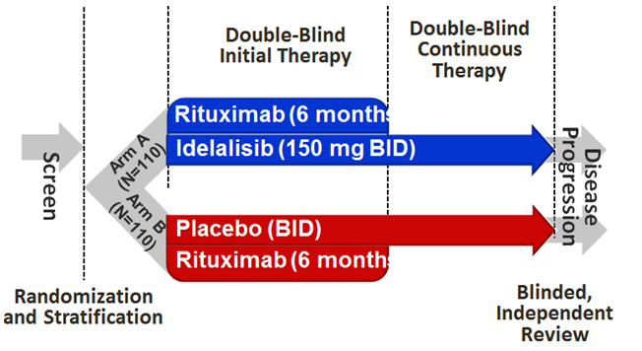

Patients had a median 3 prior therapies; median time since the last regimen was 8 months.

As initially reported, median OS was not reached in either arm, but the hazard ratio (HR) for OS was 0.28 (95% CI 0.11-0.69) favouring Id+R. As reported in a separate submission, median PFS was 19.4 months (Id+R) versus 6.5 months (R), HR 0.15 (95% CI 0.09-0.24), and the HR for OS was 0.34 (95% CI 0.19-0.60). The comparator was monotherapy rituximab (with unconventional dosing), as reflected in the wording of the indication (that is, “for whom chemo-immunotherapy is not considered suitable…”)

Initial approval for first line use in patients with 17p deletion and/or TP53 mutation was via extrapolation from Study 116 in relapsed patients (44% had adverse cytogenetics; but PFS outcomes remained good) supported by Study 101-08 (in previously untreated patients; n = 9 had 17p deletion/TP53 mutation).

#### Recent safety concern (mortality imbalance in Studies 123/124/125)

##### Safety signal

Idelalisib’s sponsor, Gilead Sciences Pty Ltd, notified the TGA of a major safety issue in March 2016. An increased risk of death – mainly due to infection – and an increase in the frequency of SAEs were seen in idelalisib containing arms of three randomised studies in CLL and iNHL patients (Studies 123, 124 and 125):

* GS-US-312-0123: A Phase III, Randomised, Double‑Blind, Placebo-Controlled Study Evaluating the Efficacy and Safety of Idelalisib (GS-1101) in Combination with Bendamustine and Rituximab for Previously Untreated CLL
* GS-US-313-0124 : A Phase III, Randomised, Double-Blind, Placebo-Controlled Study Evaluating the Efficacy and Safety of Idelalisib (GS-1101) in Combination with Rituximab for Previously Treated iNHL
* GS-US-313-0125: A Phase III, Randomised, Double-Blind, Placebo-Controlled Study Evaluating the Efficacy and Safety of Idelalisib (GS-1101) in Combination with Bendamustine and Rituximab for Previously Treated iNHL

Studies 123, 124 and 125 examined off-label use of idelalisib (as an earlier line and/or in combination with therapies other than those within current indications).

##### Interim response to safety signal

The sponsor submitted a safety related request (SRR) on 29 March 2016 to modify the PI in response to the safety concern.

It proposed: changes to the indication; replacement of the Precaution concerning infection with a new Precaution called ‘Serious Infections’ (recommending concurrent PJP prophylaxis and monitoring for CMV infection); a new Precaution about cytopenias (with monitoring for neutropenia); and addition of information about risk of infection in the Adverse Effects section.

The SRR was approved after negotiation on 1 April 2016, resulting in current Zydelig indications (shown in the Summary Information above).

##### ACSOM advice

Details of the increased risk of death/serious AEs were considered by ACSOM and are provided in ACPM papers about the TGA efficacy and safety review of Zydelig.

ACSOM in September 2016 provided advice about whether the proposal to re-allow use in first line CLL patients with 17p deletion or TP53 mutation was acceptable. Advice was also given about use in FL. In summary, as far as idelalisib indications are concerned:

* ACSOM advised that use should not be extended (re-introduced) to first line CLL patients with 17p del and/or TP53 mutation
* ACSOM advised that the FL indication should be clarified to state:

*Zydelig is indicated as monotherapy for the treatment of patients with follicular lymphoma which is refractory to at least two prior lines of systemic treatment. The disease must have been refractory to both rituximab and an alkylating agent.*

##### Post ACSOM position about efficacy and safety of Zydelig

An integrated view of the benefit-risk balance for Zydelig in various indications, taking into account the review of the safety signal as well as data in applications, is presented under ‘Issues – overall risk-benefit, and indications’.

The agreed approach to implement further PI changes arising out of the TGA’s efficacy and safety review is to effect such changes within the current submission. Requested changes to the PI are set out. Other steps include:

* A request for the sponsor to write an updated DHCP letter that communicates key changes arising from recent regulatory activity for idelalisib
* Updating of the relevant area on the TGA website

##### Implications for current submission

In CLL Study 123, idelalisib was given with bendamustine and rituximab. The proposed use of idelalisib + ofatumumab does not involve use of bendamustine. However:

* Idelalisib + anti CD20 is sufficient to confer serious risk of infection. In iNHL Study 124, there was an imbalance in deaths (5% versus 1%) and serious AEs (48% versus 10%) in the Id + R arm versus the R arm. In absolute terms, deaths were more common in idelalisib-BR arms of Studies 123/125 (8%) than the idelalisib-R arm of Study 124 (5%), but not by a wide margin.
* Preliminary information from Study 115 in CLL (Id + BR vs BR) does not suggest increased mortality in the Id-containing arm. The patient population under study may be influential.

Study 123 examined previously untreated CLL patients:

* In the current application, the sponsor proposes use of idelalisib + ofatumumab in two settings, one being previously untreated patients with 17p deletion and/or TP53 mutation who are ineligible for other therapies.
* In Studies 116 (Id + R versus R), 119 (Id + O versus O) and 115 (Id + BR versus BR), patients had received a median of 2-3 prior therapies.
* Median time since diagnosis was 28.5 months in Study 123 versus 75-102 months in the other studies. In Study 123, there was a smaller fraction of patients with 17p del and/or TP53 mutation (12% versus 33-43%).

One view is that in previously untreated subjects, scope for idelalisib to prevent death due to CLL is limited (that is, progression in previously untreated patients is not often manifest as death), so an increased risk of fatal infection cannot be offset; or as the sponsor wrote early regarding the safety signal:

*…In these ongoing studies [123 / 124 / 125], the increased risk of early death may not be outweighed by a reduced hazard of death from disease progression.*

There are data supporting this argument. In Study 123 (CLL), although at the data cut-off deaths were imbalanced (7% Id + BR, 1.3% BR), progressive disease was imbalanced in the opposite direction (0% versus 6.5%, respectively).

If this argument is accepted, it would be important to indicate use in a population where scope to prevent fatal progression is greater than in a first line setting – though the impact of 17p deletion and/or TP53 mutation in upfront CLL patients’ hazard of death must be factored in.

When considering benefit-risk balance within this submission, newly recommended risk mitigation strategies (PJP prophylaxis, CMV monitoring, neutropenia monitoring etc) might influence the likelihood of infection (although the effectiveness of such risk mitigation steps is untested for idelalisib patients).

PJP and CMV events made up only a minority of fatal and serious infectious AEs across Studies 123/124/125, and infections were not restricted to neutropenic patients (for example, lymphocyte dysfunction may also contribute substantially to the degree of immune suppression). Therefore, it cannot be assumed that introduction of new risk mitigation steps will have a major impact on risk of serious infection – only well-designed trials can confirm this objective.

One observation arising from the TGA review was that in the investigator initiated study RIALTO, in less fit CLL patients receiving an ofatumumab + chlorambucil backbone, top-line data for the randomised comparison of idelalisib versus placebo indicated 14% grade 5 SAEs in the Id + Ofa + C arm (5/35), v versus 3% in the Ofa + C arm (1/33), and in patients receiving an ofatumumab + bendamustine backbone, the imbalance was 6% versus 3% (again with very few patients involved per arm).

Table 16: Summary of Grade 5 SAEs by treatment group.

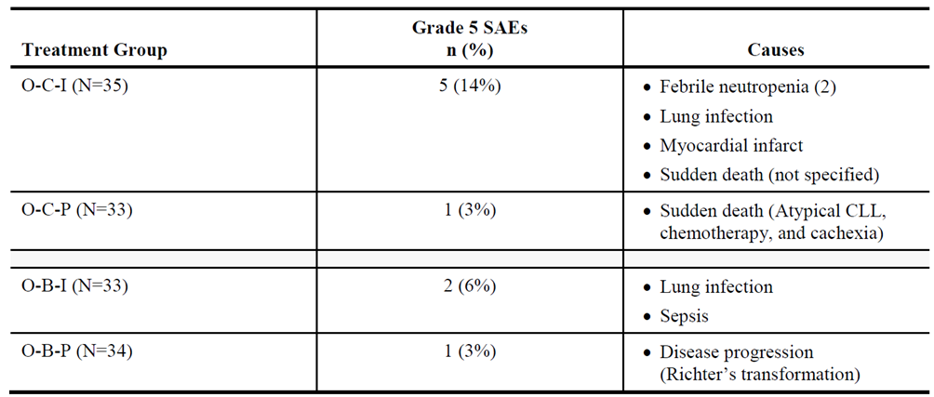

### Quality

There were no data. There were no manufacturing/quality issues.

### Nonclinical

There were no data. There were no nonclinical toxicology issues.

### Clinical

There was a Round 1 but not a Round 2 report. This Delegate’s Overview considers the sponsor’s response to clinical questions in the Round 1 report.

#### Overview of data

The submission included:

* pivotal Study 119
* an updated report of Study 101-07 (an earlier report for this study was evaluated in the initial application to register idelalisib)
* some studies not related to the new indication (safety data were reviewed)
* a population PK report 15-001 (in Study 119, there was sparse PK sampling)

#### Pharmacology

The clinical evaluator concluded that co-administration of ofatumumab with idelalisib does not affect the PK of idelalisib. The study design (Id+O versus O) requires cross-study comparison with established idelalisib PK to draw this conclusion (clinical evaluation report: ‘1. Effect of ofatumumab on idelalisib PK’). Only some subjects in Study 101-02 had CLL. No idelalisib exposure-response relationships were established.

#### Efficacy

##### Study 119

The study was a 2:1 randomised, open-label comparison of ofatumumab with idelalisib versus ofatumumab (different doses of ofatumumab were given).

Although idelalisib was taken until disease progression or unacceptable toxicity, in the control arm there was no treatment after 24 weeks, until progression.

The data cut-off date for results in the Clinical Study Report was 15 January 2015.

Subjects had previously received a purine analogue (for example, fludarabine) or bendamustine. 174 patients were randomised to receive Id + Ofa, and 87 to Ofa monotherapy. Patients were predominantly white (84%), male (71%) and older (median age 68 years). Median time since diagnosis was 92 months; 40% had 17p deletion and/or TP53 mutation. Median number of prior regimens was 3.

The primary objective was to assess PFS. Median PFS was 16.3 months (Id+O) versus 8.0 months (O), HR 0.27 (95% CI 0.19-0.39). The contribution to PFS events was as follows.

Table 17: Contribution to PFS events.

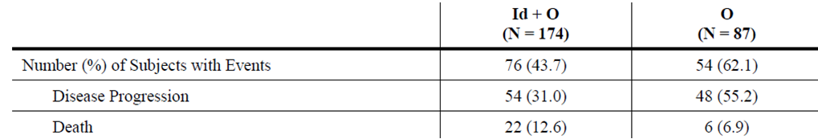

The HR for PFS in sub-groups including those with 17p deletion and/or TP53 mutation is indicated; outcomes were similar across subgroups.

A large proportion of patients in the Ofa arm left the study prior to PFS events, mainly due to patient/investigator wish.

Figure 5: percentage of subjects who discontinued the study without PFS events (death / progression) by treatment group (ITT analysis set).

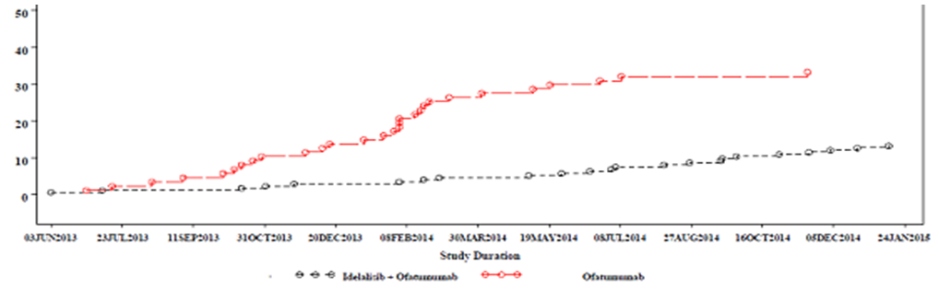

There was a similar disparity in the percentage of patients who discontinued from long-term follow-up.

OS data were immature; 24-25% of subjects per arm had died; median OS was 20.9 months (Id+O) vs 19.4 months (O), HR 0.74 (95% CI 0.44-1.25). The OS curve did not indicate any period (for example, early) where there was a mortality imbalance disadvantaging Id+O patients. Equally, there was no strong signal that PFS benefit translated into any OS benefit.

* *Question for sponsor: Please provide any updated OS data from Study 119. Based on Table 5, ASA to RMP in this submission, an estimated date for the final CSR is Q4 2016 – please provide OS data from this final CSR.*

The evaluator considered differences across arms in quality of life outcomes to be insignificant. It is noted that many Id+O patients reported severe diarrhoea, which presumably has a large impact on quality of life if it is persistent.

##### Study 101-07

This study was previously submitted to the TGA. An updated study report was provided (dates, 17th February 2015 versus 24th July 2013). The relevant cohort was reviewed in the clinical evaluation report; n = 21 were studied. Outcomes were consistent with those in Study 119.

##### Study 101-09 (follicular lymphoma)

This study of iNHL patients is relevant for the follicular lymphoma indication. It was submitted to support initial approval in FL. An update was provided in this submission but although CR rates improved (8% > 14%), ORR was basically unchanged (54% > 56%) as was duration of response. Median OS was not reached in FL subjects; 88% were alive at 48 weeks.

* *Question for sponsor: When is the next update of outcomes from Study 101-09 available?*

#### Safety

##### Exposure

Exposure to idelalisib and ofatumumab is described. Although duration of exposure was longer in the Id+O arm, it is equally true that the sponsor proposes that idelalisib be continued until disease progression or unacceptable toxicity – that is, the crude comparison of AE frequencies between Id+O and O arms needs interpretation, but Id+O AE frequencies are still relevant in themselves.

##### Study 119

Common AEs are reported. Infections were more common in the Id+O arm (76% versus 59%); pneumonia, for example, was seen in 17.3% versus 12.8%. Other large imbalances were seen for diarrhoea (48% versus 23%), neutropenia (35% versus 16%), febrile neutropenia (12.7% versus 3.5%), rash (20% versus 8%) and hypokalaemia (14.5% versus 4.7%). In the case of infusion-related reactions, incidence was lower for Id+O (17% versus 27%), but ofatumumab dose was lower than normal.

SAEs are reported. Severe sepsis was reported in 6.9% versus 1.2%, although overall grade 3+ infection was not markedly imbalanced (35% versus 28%). A large component of this appears to be pneumonia or related processes – but some patients must have had multiple preferred terms (for example, perhaps pneumonia + sepsis).

* *Question for sponsor: What proportion of subjects per arm of Study 119 had severe, life-threatening or fatal ‘pneumonia or pneumonia-like preferred term’ AEs? (for example, counting pneumonia, PJP pneumonia, LRTI, bronchitis, lung infection, RTI and also any relevant terms where incidence was not >2%)?*

PJP was reported in 4.6% versus 0%. The Study 119 protocol states that:

Subjects may be receiving prophylactic antiviral or antibacterial therapies at the discretion of the investigator; anti-pneumocystis prophylaxis is encouraged.

The CSR’s table of concomitant medicines shows that 66.5% (Id+O) vs 54.7% (O) took concomitant Bactrim.

* *Question for sponsor: What proportion of PJP was in patients not on prophylaxis? Were any PJP cases in those on prophylaxis?*

There was an imbalance in severe/life-threatening diarrhoea (17.3% for Id+O versus 1.2% for O) and colitis (5.8% versus 0%). Electrolyte imbalances and dehydration were seen more frequently in the Id+O arm. There was also a major imbalance in grade 3+ respiratory AEs (for example, pneumonitis, 4.6% versus 0%). AEs leading to death are tabulated; sepsis and pneumonia were prominent in the Id+O arm. There was a case of fatal CMV in the Id+O arm, and there were two cases of PML in the O arm. Overall, 9/173 Id+O patients (5.2%) versus 2/86 O patients (2.3%) died of AEs considered related to study drug.

The profile of serious AEs and discontinuation due to AEs was similar to the profile of severe AEs described above. Of laboratory abnormalities, deranged LFTs were seen more often in the Id+O arm than in the O arm. No severe drug induced liver injury was reported.

Safety outcomes in the Study 101-07 update provided no additional information.

##### Update to Study 116

The clinical evaluation report for that submission noted that for Study 116 (Id + R versus R), following the first, planned interim analysis dated 30th August 2013, the independent data monitoring committee recommended the study be stopped due to overwhelming efficacy. Gilead conducted a second interim analysis of blinded-phase data using a data cut-off of 9 October 2013. Results included in the Dossier reflected the final analysis (both blinded and unblinded phases) of Study 116 through to 20 April 2014, or 1 July 2014 for OS.

In the final analysis:

* median PFS was 19.4 months (Id + R) versus 6.5 months (R); the HR was 0.15 (95% CI 0.09-0.24)
* in the 17p deleted/TP53 mutated subgroup, median PFS was not reached versus 4.0 months; the HR was 0.13
* 15.5% of the Id + R arm died, whereas 36.4% of the R arm died; median OS was NR versus 20.8 months; HR was 0.34 (0.19-0.60)
* in the 17p deleted / TP53 mutated subgroup, the HR for OS was 0.31

In summary, the updated results confirmed the favourable outcomes in the Id+R arm seen in the initial CSR for Study 116.

#### Clinical evaluator’s recommendation

##### Efficacy – comparator

In Study 119, subjects had previously received a purine analogue or bendamustine. The comparator, ofatumumab monotherapy, was acceptable in the study setting. The proposed target group is broader than patients who have relapsed after ≥1 prior therapy and in whom chemoimmunotherapy is not suitable. Also targeted are first line patients with 17p deletion or TP53 mutation who are not eligible for any other therapy. Ofatumumab monotherapy may not be standard of care for first line patients with 17p deletion or TP53 mutation:

* ofatumumab is approved for upfront CLL in combination with chlorambucil or bendamustine; ofatumumab monotherapy is only approved in refractory CLL;
* NCCN guidelines (v3.2016) endorse ofatumumab monotherapy in del(17p)/TP53 mutation only for relapsed / refractory patients (with a note that it is not effective in patients with lymph nodes >5 cm)
* EviQ endorses ofatumumab in combination with chlorambucil in B-CLL patients who have not received prior therapy and who are inappropriate for fludarabine-based therapy, but does not endorse ofatumumab monotherapy. There is a statement that for upfront CLL, single agent ofatumumab should be discontinued due to availability of newer, more efficacious agents.

Magnitude of benefit of Id+O over O in Study 119 might exaggerate the value of Id+O over regimens used for first line patients with 17p deletion/TP53 mutation.

On the other hand, the sponsor is requesting a first line indication in patients with 17p deletion / TP53 mutation “who are not eligible for any other therapy”.

##### Efficacy – in previously treated patients

The sponsor proposes use “upon relapse after at least one prior therapy in patients for whom chemoimmunotherapy is not considered suitable” based on Study 119. The evaluator writes: “benefit-risk balance of idelalisib used in combination with ofatumumab is considered favourable in patients with relapsed/refractory CLL without 17p deletion”. In the context of the rest of the CER, it is considered that this is an editorial mistake and that the clinical evaluator supports use in relapsed/refractory CLL regardless of 17p/TP53 status.

Although there is a clear PFS advantage for the idelalisib-containing arm of Study 119, there is no clear OS advantage. This contrasts with Study 116, supporting the existing use of idelalisib + rituximab. In the context of the recent safety concern for idelalisib, it is important to show that a PFS benefit translates into clinical benefit. Given that PFS events include disease progression and death from any cause, it is possible that PFS outcomes obscure a significant risk of death due to drug toxicity. In which case, improvement in PFS would be a much less convincing surrogate for clinical benefit.

If the sponsor can supply updated OS outcomes from Study 119 that provide assurance that there is a real clinical benefit in relapsed/refractory CLL, it may be reasonable to approve the proposed use in previously treated patients. In the absence of any updated OS data, it would be difficult to support approval even in previously treated patients.

##### Safety – hepatotoxicity

The evaluator requested a statement in the PI, that “fatal or serious hepatotoxicity occurred in 14% of Zydelig-treated patients”. The sponsor declined to implement this change, finding insufficient evidence of a causal association between hepatocellular injury and treatment with idelalisib.

In pivotal study 116 (Id+R versus R) there was an effect of idelalisib on transaminases. Grade 3+ ALT occurred in 9.1% (Id + R) vs 0.9%; grade 3+ changes in AST occurred in 5.5% versus 0%. The one grade 3 change in BR was in the Id+R arm. One episode of elevated transaminases – in the Id + R arm – was reported as a serious AE.

In pivotal study 119 (Id+O vs O), there was a similar effect. For example, grade 3+ ALT elevations occurred in 11.6% (Id + O) vs 1.2%, and grade 3+ changes in AST occurred in 8.1% versus 1.2%, respectively. Overall, 12.7% vs 1.2% reported grade 3+ transaminitis. The case each of grade 3 and grade 4 BR elevation was in the Id + O arm. Two patients reported serious AEs of transaminitis.

In Study 101-09 (FL), the CSR indicates that 12.8% of patients had a grade 3-4 transaminitis.

In these pivotal studies, there is a deleterious effect of idelalisib on liver function.

The sponsor is requested to include additional text in the Precaution, after the first sentence:

*Grade 3-4 transaminitis was reported in 9-11% of patients in idelalisib-containing arms of pivotal studies in CLL (versus 0-1% of control arm patients), and in 13% of patients in the pivotal iNHL study 101-09. A higher rate has been reported in some other studies. Transaminitis was sometimes accompanied by elevated bilirubin.*

Lampson et al.[12] report on use of an atypical idelalisib + ofatumumab regimen in upfront CLL. In that study:

* LFTs were monitored twice weekly from weeks 3 to 16 [the current Zydelig PI recommends monitoring every 2 weeks for the first 3 months, then as clinically indicated]
* Grade 1 transaminitis (>ULN to 3xULN) was treated with prednisolone 40 mg daily
* idelalisib was held for Grade 2 (3-5xULN) changes or worsening of grade 1 changes on steroids [the current PI recommends holding treatment only for grade 3+ changes]
* Grade 3 changes (5-20xULN) were treated with prednisone 1 mg/kg and discontinuation, and consideration of mycophenolate mofetil in patients with no initial response to steroids [the current PI recommends discontinuation in patients with grade 4 changes]

In that study, there were two phases of transaminitis (early then around day 130). The authors suggested the extent of transaminitis might be related to the patient population (for example, upfront CLL patients). Also, the study was quite small.

* *Questions for sponsor: Do the outcomes in the study by Lampson et al. suggest a need to adjust the precaution regarding hepatotoxicity, and / or the dose modification scheme?*

*The PI’s dose modification scheme treats ALT and AST elevations separately from bilirubin elevations, whereas concomitant transaminitis and BR elevation may be seen as requiring more aggressive dose modification. Does the sponsor propose to adjust the dose modification table to reflect this?*

##### Safety – CMV monitoring and management

* *Question for ACPM: ACSOM suggested that the TGA obtain expert advice about recommendations for CMV monitoring and management. The ACPM is requested to review the proposed advice about CMV monitoring and management and suggest any changes.*

As a reference for this issue, the PI version 3.1 dated 17 August 2016 is more up-to-date (pre-ACSOM PI). ACSOM Minutes are relevant.

##### Safety – hepatic impairment

The PI notes that after a single 150 mg dose, idelalisib AUC was ~60% higher in patients with moderate and severe hepatic impairment than in matched controls. The PI recommends use with caution in patients with severe hepatic impairment. It recommends patients with baseline hepatic impairment should be monitored for Zydelig toxicity. In the initial registration dossier, the Summary of Clinical Pharmacology suggested no strong relationship between exposure and AST/ALT derangement. This was re-iterated in the exposure-response analysis reviewed by the clinical evaluator.

* *Question to sponsor: Are there new data about the extent of increased exposure to idelalisib in patients with hepatic impairment?*

##### Risk-benefit in upfront CLL with 17p deletion / TP53 mutation – extrapolation

Idelalisib in first line CLL with 17p deletion and/or TP53 mutation in combination with rituximab is broadly justified by extrapolation from a second or later line setting, that is, Study 116. The sponsor continues this approach in this extension of indication proposal by basing evidence supporting use of idelalisib + ofatumumab in first line patients with 17p deletion and/or TP53 mutation on extrapolation from a second or later line setting, in this case Study 119.

The clinical evaluator’s view about extrapolation of efficacy is copied from the clinical evaluation report:

*The submitted efficacy studies did not examine the efficacy of the combination in the first line setting. However, efficacy was demonstrated in this subgroup in the setting of relapsed/refractory disease. It is possible that efficacy may be superior in the first line setting where the disease would be expected to be less treatment-resistant. Given that disease with 17p deletion or TP53 mutation responds poorly to conventional first line chemoimmunotherapy, it is considered reasonable to extrapolate the efficacy data into the first line setting for this subgroup.*

However, in weighing benefit-risk, the clinical evaluator did not accept extrapolation as an overall approach:

*The efficacy and safety of the idelalisib-ofatumumab combination has not been presented for patients with 17p deletion who are treatment-naïve. Use in this group is consequently considered unfavourable.*

The sponsor was asked to justify extrapolation. In its response, the sponsor notes the limited treatment options in this setting. Also, the sponsor tabulated studies with data for subjects with 17p deletion and/or TP53 mutation. Of these studies, only Study 101-08 was in upfront CLL, but few in 101-08 had adverse cytogenetics (n = 9 with ID+R; n = 6 with Id alone). Cohort 2 employed monotherapy.

Table 18: Subject numbers in studies.

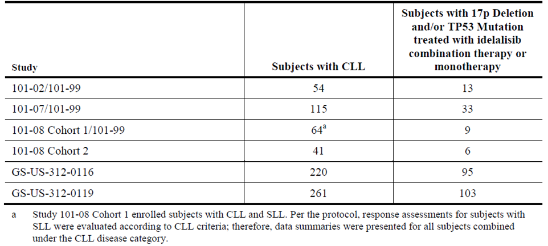

The key point about extrapolation that was not considered in the Section 31 response was the experience from Studies 123/124/125 – where, it appears, risk of fatal AEs (typically infections) was not compensated for by prevention of fatal progression. In first line patients with 17p deletion and/or TP53 mutation, there is a strong concern that a similar effect may be seen. With additional risk mitigation in place (for example, PJP prophylaxis) and perhaps heightened awareness of risk, it could be argued that risk of infection will be lower than in Study 123. Furthermore, Study 123 was in combination with BR (as was Study 125 in previously treated iNHL, though Study 124 in previously treated iNHL was with rituximab and showed a mortality imbalance).

There is no randomised study in a first line setting in CLL where Id + anti CD20 is compared with anti CD20 alone. Studies 118 and 133 (Figure 6) have been terminated.

Figure 6: Key Zydelig studies.

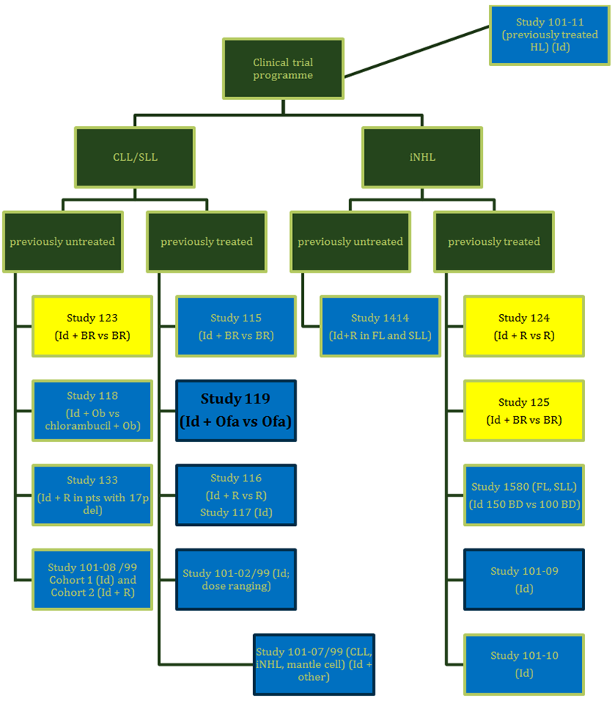

Yellow indicates studies that form the source of the recent safety signal. Black outline indicates studies that have been evaluated by TGA.

With regard to safety, there are limited directly relevant data, but in Study 101-08, there was an indication of increased toxicity. For example, grade 3+ transaminitis was more common; and grade 3+ colitis/diarrhoea was reported in 42%.

The Delegate notes advice of ACSOM regarding use of idelalisib + rituximab in CLL, for example, that use in first line CLL in patients with 17p deletion and/or TP53 mutation is not supported. Given the ongoing absence of direct evidence of a positive benefit-risk balance in this group in studies of idelalisib + ofatumumab, the Delegate’s pre ACPM view is that approval for idelalisib + ofatumumab should not be extended to use in this group. No specific question is being asked about first line use.

##### Overall risk-benefit, and indication

The benefit-risk balance is not sufficiently well characterised to allow approval of the idelalisib + ofatumumab combination in any CLL setting.

* If updated OS data from Study 119 are included in the pre ACPM response, approval for use in CLL/SLL upon relapse after at least one prior therapy in patients for whom chemoimmunotherapy is not considered suitable can be considered.
* Extrapolation to use in upfront CLL in patients with 17p deletion/TP53 mutation is not considered acceptable. There are strong grounds to suspect that benefit-risk balance may be negative in upfront CLL. The absence of many good current options for first line patients with 17p deletion/TP53 mutation is not a strong argument to approve what may not be a good option for such patients.

In regard to first line use in 17p deletion/TP53 mutation with rituximab, similar arguments apply. Since initial TGA approval of that indication, there has been an increased focus on idelalisib’s safety profile, and on whether idelalisib’s toxicity can be offset by its efficacy in stopping disease progression in a first line setting. The advice of ACSOM was to not support first line use in 17p deletion/TP53 mutation. This is consistent with concerns raised above about inability to offset dangerous toxicity in a first line setting and the absence of direct evidence in this setting. This indication is not supported.

In regard to FL, ACSOM advised that the wording of the indication be adjusted to reflect the population profile in pivotal Study 101-09. The Delegate supports modification of the FL indication to state:

*Zydelig is indicated as monotherapy for the treatment of patients with follicular lymphoma which is refractory to at least two prior lines of systemic treatment. The disease must have been refractory to both rituximab and an alkylating agent.*

This is consistent with the population studied in 101-09.

A summary of issues surrounding the Zydelig indication is below.

Table 19: Summary of issues surrounding the Zydelig indication.

| Components of indication | | | Pivotal study | Comment | Pre ACPM view |
| --- | --- | --- | --- | --- | --- |
| CLL | First line in 17p del / TP53mut; not eligible for other therapies | With rituximab | Extrapolation | Advice of ACSOM accepted.  Toxicity may also be higher (O’Brien et al.)[13] | Not acceptable after consideration of safety signal and ACSOM advice |
| With ofatumumab | Extrapolation | Toxicity may also be higher (extrapolation from 101-08 / O’Brien et al.)[14] | Not acceptable after consideration of separate submission and safety signal |
| Upon relapse; chemo-immunotherapy not suitable | With rituximab | Study 116 | Separate submission (final CSR for 116) confirmed positive benefit / risk in this setting | Acceptable |
| With ofatumumab | Study 119 | Update on OS outcomes requested | Only acceptable if positive benefit-risk balance is clarified by updated OS outcomes |
| FL | Refractory to at least 2 prior therapies | Monotherapy | Study 101-09 | Advice of ACSOM accepted. | Wording to be modified as per ACSOM advice |

### Risk management plan

The sponsor has provided an updated EU-RMP (version 2.0, DLP 4 March 2016) and ASA (version 1.2, dated August 2016). These were broadly acceptable to the RMP evaluator with some details subject to negotiation.

Risk minimisation activities (beyond recommendations within the PI) included a dear healthcare professional letter and a patient safety card. These materials must acknowledge the risk of serious/fatal infections, and emphasise the importance of measures such as regular monitoring, use of PJP prophylaxis, etc.

In its consideration of the Zydelig safety signal, ACSOM noted:

*The committee was supportive of having structured mechanisms to gather observational data on patients with FL, including patients who have received idelalisib. Information on PJP prophylaxis, CMV monitoring, dates of and lines of previous treatment, any SAEs, and any grade 2 infectious complications should be included in the dataset. The committee encouraged the use of an established lymphoma registry and for the sponsor to work cooperatively with the data custodians of extant registries.*

* *Question to sponsor: Please explain whether there is any opportunity or intent to co-operate with the data custodians of any established lymphoma registry in Australia, to gather observational data on patients with FL treated with idelalisib.*

### Summary

#### Delegate’s considerations

Idelalisib is a PI3Kδ inhibitor. It was registered in 2015 by TGA for use in certain subsets of patients with CLL or FL. It has not been widely marketed in Australia.

#### Recent safety concern (mortality imbalance in Studies 123/124/125)

The sponsor notified TGA of a major safety issue. An increased risk of death – mainly due to infection – and an increase in the frequency of SAEs were seen in idelalisib containing arms of three randomised studies in CLL and iNHL patients (Studies 123, 124 and 125):

* GS-US-312-0123: A Phase III, Randomised, Double Blind, Placebo Controlled Study Evaluating the Efficacy and Safety of Idelalisib (GS-1101) in Combination with Bendamustine and Rituximab for Previously Untreated CLL
* GS-US-313-0124 : A Phase III, Randomised, Double Blind, Placebo Controlled Study Evaluating the Efficacy and Safety of Idelalisib (GS-1101) in Combination with Rituximab for Previously Treated iNHL
* GS-US-313-0125: A Phase III, Randomised, Double Blind, Placebo Controlled Study Evaluating the Efficacy and Safety of Idelalisib (GS-1101) in Combination with Bendamustine and Rituximab for Previously Treated iNHL

Studies 123, 124 and 125 examined off-label use of idelalisib (as an earlier line and/or in combination with therapies other than those within approved indications).

Changes to the PI that arise from the TGA’s evaluation of the safety signal are being implemented within this submission.

The safety signal has been subject to the advice of ACSOM, so questions addressed by ACSOM are not being re-asked here.

* One example is that ACSOM considered the sponsor’s proposal to allow use in first line CLL/SLL patients with 17p deletion/TP53 mutation, in combination with rituximab. The proposed change to the CLL indication encompasses this. ACSOM has provided advice about this first line use of Id +R.
* However if, in the sponsor’s pre ACPM response, the sponsor disagrees with ACSOM advice and proposes a different approach (for example, to important aspects of the PI), ACPM advice is requested to help decide the best approach to the PI.

#### Manufacturing and quality

There were no data. There were no manufacturing/quality issues.

#### Nonclinical

There were no data. There were no nonclinical toxicology issues.

#### Clinical

Study 119 was pivotal: “A Phase III, Randomised, Controlled Study Evaluating the Efficacy and Safety of Idelalisib (GS-1101) in Combination with Ofatumumab for Previously Treated Chronic Lymphocytic Leukemia”.

In this study of heavily pre-treated CLL patients, a PFS benefit of adding idelalisib to ofatumumab was clear (although 29% of PFS events in the Id + O arm were deaths, versus 11% in the O arm). No survival benefit was evident based on ‘immature’ OS data.

Study 119 was in previously treated CLL. Many subjects had 17p deletion and/or TP53 mutation; outcomes in such patients were consistent with overall outcomes. There were no pivotal data in the dossier to support use in first line CLL patients with adverse cytogenetics. Support for the second component of the proposed CLL indication (first line treatment in the presence of 17p deletion or TP53 mutation in patients who are not eligible for other therapies) is via extrapolation from second line Study 119.

The TGA review of the recent safety concern suggests that in first line use, potential for idelalisib to prevent disease related mortality may not offset a substantial risk of early death due to infection. New risk mitigation steps are proposed (for example, better monitoring; PJP prophylaxis) but the effectiveness of these steps is as yet unclear.

Another clinical concern relating to the first line setting is whether, in Study 119, choice of comparator is sufficiently relevant to allow extrapolation. Ofatumumab monotherapy may not be standard of care for first line patients with 17p deletion or TP53 mutation – though the target population is those patients ‘not eligible’ for other therapies.

Overall, the benefit-risk balance in those first line CLL patients with 17p deletion and/or TP53 mutation is not sufficiently well understood to support approval.

The sponsor is also proposing use in CLL/SLL patients “upon relapse after at least one prior therapy in patients for whom chemoimmunotherapy is not considered suitable”. Study 119 is pivotal. There was a large PFS benefit but whether this translates into clinical benefit requires clarification. Whereas in Study 116 (Id + R versus R) there was a benefit for PFS and OS, in Study 119 (Id + O versus O) there was only a clear PFS benefit. Immature OS outcomes suggested no difference in survival. An updated OS analysis might resolve whether the PFS benefit in Study 119 translates into clinical benefit.

#### RMP

The RMP evaluator considered an EU-RMP and ASA that took into account the signal from Studies 123/124/125. These RMP documents were generally acceptable.

#### Proposed action

Insufficient evidence of efficacy and safety has been provided to support the proposed extensions of indication.

#### Request for ACPM advice

The committee is requested to provide advice on the following specific issues:

* Does the PFS benefit in Study 119 provide sufficient evidence of efficacy in the proposed use in combination with ofatumumab? Or, given new knowledge about the risk of serious/fatal infection with this agent, is it necessary to demonstrate no deleterious impact on OS before approval? In which case, are OS outcomes in Study 119 sufficient to show this? (Note: the sponsor has been asked whether there are any OS updates from Study 119.)
* Overall, is there sufficient evidence to approve use of idelalisib in combination with ofatumumab in the proposed target population, or in some other group?
* Is advice in the Dosage and Administration section about ofatumumab dose sufficiently clear?
* ACSOM suggested that the TGA obtain expert advice about recommendations for CMV monitoring and management. The ACPM is requested to review the proposed PI advice about CMV monitoring and management and suggest any changes.

The committee is also requested to provide advice on any other issues that it thinks may be relevant to a decision on whether or not to approve this application.

The Delegate notes the advice of ACSOM regarding use of idelalisib + rituximab in CLL, for example, advice that use in first line CLL in patients with 17p deletion and/or TP53 mutation should not be endorsed. Given the continuing absence of direct evidence of a positive benefit-risk balance in this group for idelalisib + ofatumumab, the Delegate’s pre ACPM view is that approval for idelalisib + ofatumumab should not be extended to this group. No specific question is being asked about first line use.

A consolidated list of questions to the sponsor is attached.

#### Response from sponsor

##### Background

In the time since this application was made to extend the indications for Zydelig, a signal of increased incidence of SAEs and death (mostly due to infections) was identified in ongoing Phase III studies evaluating Zydelig in unapproved combination agents and/or patient populations. Gilead communicated these findings to TGA and sought to restrict the indications to populations where the benefit-risk remained favourable and to include appropriate guidance in the PI on this risk associated with Zydelig. TGA approved the revised indications, and a DHCP letter regarding these safety findings in first line CLL and early-line iNHL was sent to all physicians who had accessed Zydelig through the Early Access Program (EAP). Zydelig is not currently PBS listed.

Gilead considers that the proposed extension to the indications to include combination use with ofatumumab should be approved, given that:

* the efficacy demonstrated was superior compared to ofatumumab alone (Study GS-US-312-0119) using established clinical endpoints;
* the safety profile was similar to that observed in the currently approved indications; and
* no increased incidence of deaths due to infection was evident in the Zydelig + ofatumumab arm compared to the ofatumumab alone control arm.

Gilead agrees to withdraw the indication for first line use in CLL patients with 17p deletion/TP53 mutation. Upon approval of the revised PI, Gilead will send a DHCP letter to all physicians previously provided Zydelig to advise them of the revisions.

##### ACPM advice being sought by the TGA delegate

* *1. Does the PFS benefit in Study 119 provide sufficient evidence of efficacy in the proposed use in combination with ofatumumab? Or, given new knowledge about the risk of serious / fatal infection with this agent, is it necessary to demonstrate no deleterious impact on OS before approval? In which case, are OS outcomes in Study 119 sufficient to show this? (NB: the sponsor has been asked whether there are any OS updates from Study 119.)*

The recent safety findings of an increased incidence of SAEs and death (mostly due to infections) in the Zydelig versus control arms was observed in a pooled analysis of 3 ongoing Phase III trials in first line CLL and early line iNHL. The majority of these events occurred in the first 6 months of treatment during the time when Zydelig was co-administered with standard chemotherapies (including bendamustine). Following these findings, multiple analyses were conducted to evaluate whether a potential signal or similar trend was evident in prior studies (supporting the current indications for use in relapsed patient populations). These analyses, summarised in Table 20, revealed that across the development program, there was an increased incidence of neutropenia and an increased infection rate in the Zydelig-containing arms which was not evident when incidence rates were adjusted for exposure. A higher incidence of deaths in the Zydelig versus control arms, including those due to infections, also was not evident. Both PJP and CMV were reported at a higher rate in the Zydelig-containing study arms as shown in Table 21.

Table 20: Incidence of Neutropenia and, Infection in Combination with Rituximab, Ofatumumab, or Bendamustine + Rituximab.

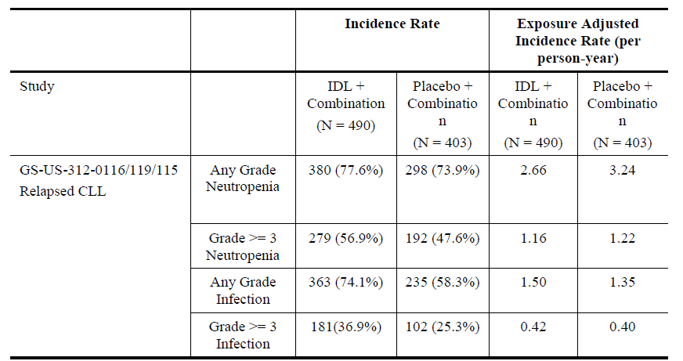

Table 21: Incidence of PJP and CMV in Combination with Rituximab, Ofatumumab, or Bendamustine + Rituximab.

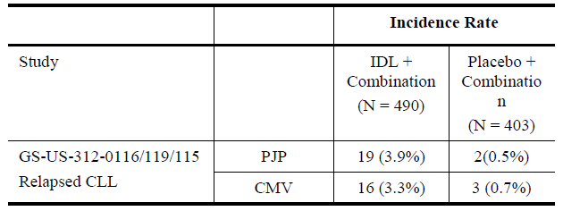

The outcome of these analyses supported the actions taken to terminate all front and early line Zydelig studies and institute the risk minimization measures of ANC and CMV monitoring as well as PJP prophylaxis in patients receiving Zydelig.

In Study GS-US-312-0119, the primary endpoint of PFS was superior in the Zydelig + ofatumumab group compared to the ofatumumab alone group, with an adjusted HR (95% CI) of 0.27 (0.19, 0.39) and 2-sided p-value of < 0.0001 based on a stratified log-rank test (Primary Analysis CSR). The median (95% CI) PFS was 16.3 (13.6, 17.8) months for subjects in the Zydelig + ofatumumab group compared to 8.0 (5.7, 8.2) months for subjects in the ofatumumab alone group. Additionally, PFS following treatment with Zydelig + ofatumumab was improved compared with treatment with ofatumumab alone in all predefined subgroups, including subjects with or without 17p deletion and/or TP53 mutation, subjects with mutated or unmutated IGHV, relapsed and refractory subjects, males and females, subjects < 65 years and ≥ 65 years of age, and whites and non-whites. In Study GS-US-312-0119, Zydelig 150 mg twice daily had a manageable safety profile when administered in combination with ofatumumab in subjects with previously treated CLL.

In Study GS-US-312-0119, OS was not significantly different between treatment groups (adjusted HR [95% CI] of 0.74 [0.44, 1.24]; p = 0.27; Primary Analysis CSR). An analysis of deaths by treatment duration in Study GS-US-312-0119 did not show an increased risk of death over any treatment interval for subjects in the Zydelig + ofatumumab group versus subjects in the ofatumumab alone group. Further, it is important to note that total deaths in the ofatumumab alone group may be underestimated as a disproportionate number of these subjects were lost to long term survival follow-up. In addition, AEs should be viewed in exposure-adjusted incidence rates since collection of AEs occurred during receipt of study drug for both arms, and Zydelig exposure (and therefore collection) was substantially longer than ofatumumab alone. There were no deaths due to CMV or PJP reported in Study GS-US-312-0119 (Primary Analysis CSR).

Updated OS data (1 September 2015 data cut-off date) showed that the median OS (95% CI) was not reached (25.8 months, not reached [NR]) in the Zydelig + ofatumumab group, and was not significantly different from the median OS in the ofatumumab alone group (NR [21.7 months, NR]) with adjusted HR (95% CI) of 0.75 (0.48, 1.18), p = 0.271. A clinically meaningful improvement in OS was observed in patients with 17p deletion and/or TP53 mutation who received Zydelig + ofatumumab. Median (95% CI) OS was 25.8 months (22.7, NR) in the Zydelig + ofatumumab group and 19.3 months (10.7 months, NR) in the ofatumumab alone group, (HR [95% CI] of 0.52, [0.28, 0.96], nominal p-value = 0.0337).[15]

* *2. Overall, is there sufficient evidence to approve use of idelalisib in combination with ofatumumab in the proposed target population, or in some other group?*

Gilead believes that an indication for the use of Zydelig + ofatumumab in adult patients with relapsed CLL is supported given the totality of the efficacy data, including statistically significant improvements in the Zydelig + ofatumumab group for PFS, overall response rate (ORR) and lymph node response (LNR) rate. Although OS did not meet statistical significance, there was no evidence of a deleterious impact on OS. Zydelig 150 mg twice daily had a manageable safety profile when administered in combination with ofatumumab in subjects with previously treated CLL.

Longer term data from Study GS-US-312-0119 are currently being analysed based on a data cut-off date of 2 May 2016; the Interim 2 CSR is in preparation, with estimated availability in early 2017. Preliminary conclusions from this updated data cut indicate that the safety and efficacy results are similar to those presented in the primary analysis CSR, and no new safety signals have been identified. This updated CSR will be provided to TGA upon availability.

* *3. Is advice in the Dosage and Administration section about ofatumumab dose sufficiently clear? If prescribers default by mistake to a ‘normal’ ofatumumab dose, previously treated patients will received twice the dose of ofatumumab that was used in Study 119?*

Gilead has amended the statement in Dosage and Administration as follows to refer to Study GS-US- 312-0119 in the Clinical Trials section to ensure prescribers administer the correct dose of ofatumumab in combination with Zydelig (as used in the Clinical Trials).

*Refer to the CLINICAL TRIALS section, Zydelig in combination with chemotherapy and immunotherapy, Study 312-0119, for details of the recommended ofatumumab dosing regimen used in combination with Zydelig in the clinical study. The first dose of ofatumumab was administered at 300 mg, followed by 1000 mg weekly for 7 doses for patients in the Zydelig + ofatumumab group.*

* *4. ACSOM suggested that the TGA obtain expert advice about recommendations for CMV monitoring and management. The ACPM is requested to review the proposed PI advice about CMV monitoring and management and suggest any changes.*

The CMV text that is currently provided in the proposed PI is consistent with the text in the current approved Zydelig EU SmPC and Gilead considers that no further updates to the PI are warranted.

##### Product information

Gilead has noted the Review of the PI within the Delegate’s Overview and has amended the PI accordingly, or a justification has been provided in the response below. An annotated copy of the current proposed PI is provided.

###### Black box warning

Gilead considers safety a high priority and supports the ongoing awareness and education of HCPs regarding the safety profile of Zydelig; however, Gilead does not consider the inclusion of a black-box warning for serious infections and pneumonitis warranted. As previously noted, the imbalance in infectious deaths and SAEs was identified during 3 Phase III clinical trials (GS-US-312- 0123, GS-US-313-0124 and GS-US-313-0125) assessing the use of Zydelig in first line treatment of CLL and in early-line iNHL, indications which are not approved in Australia. These clinical studies have been terminated. Increased rates of deaths and SAEs due to infections have not been identified during post-marketing surveillance or within the approved indications of relapsed CLL and refractory FL.

The risk of infections and deaths is common to many therapeutic agents in the haematology/oncology field which are approved for use in Australia. It is our understanding that a boxed warning is appropriate for unusual, unexpected or unavoidable serious and/or fatal events; the recent safety findings for Zydelig do not to meet these criteria, and the demonstrated clinical benefit of treatment outweighs the risk when used according to the approved indications and with the specified risk minimization measures and appropriate management of adverse reactions.

Risk mitigation strategies of ANC and CMV monitoring as well as PJP prophylaxis in patients receiving Zydelig have been applied to the registered indications and reflected in the approved Australian PI. These strategies are clearly outlined in the ‘Precautions’ section of the PI, together with other monitoring requirements in the ‘Dosage and Administration’ section of the PI for the safe and effective use of Zydelig. The safety information regarding pneumonitis, which has been reported at 4.5% (any grade) across 2 Phase III studies (GS-US-312-0116 and GS-US-312-0119) and 6 Phase 1 and 2 studies (including in off-label indications) is clearly documented in the PI, both in the ‘Precautions’ and ‘Adverse Events’ sections.

Communication of product risks to HCPs and patients is important. Gilead believes the communication strategy and risk minimization measures in place are appropriate to educate HCPs and patients of the safety issues. Part of this education plan includes the development of a comprehensive Clinical Resource Pack (CRP) for prescribers, as well as a Patient Resource Pack (PRP) that provides a clear overview of the issues for which HCPs and patients must be aware while utilising Zydelig. The PRP includes amongst other items a wallet-sized Safety Reminder Card and a full Zydelig PI which is marked to the attention of their doctor as required or other HCPs who may be less familiar with Zydelig (for example, GPs and emergency physicians). The CRP for HCPs is designed to be used in conjunction with the Zydelig PI and has been provided to all HCPs who enrolled a patient on the Zydelig EAP. Both the CRP and the PRP will continue to be maintained, updated, and provided to HCPs (CRP) and patients (PRP). Draft copies of the educational program, which includes the CRP and PRP, are provided. These materials will be revised accordingly in line with the final approved Zydelig PI.

###### Adverse effects

Gilead proposes to maintain the current format of the Adverse Effects section in the PI, which was previously updated to present the AE data in percentages as requested by the TGA in response to the Delegate’s Overview during the initial registration application. The AE data as proposed in other applications and the TGA safety and efficacy review presents HCPs with sufficient information regarding the frequency and severity of events of clinical importance. The AE section in the Australian PI is consistent with the data presented in the current approved EU SmPC (19 September 2016), and with other similar oncology products approved in Australia.

##### ACSOM advice

Details of the increased risk of death/serious AEs were considered by ACSOM and are provided in ACPM papers about the TGA efficacy and safety review of Zydelig. ACSOM provided advice about whether the proposal to re-allow use in first line CLL patients with 17p deletion or TP53 mutation was acceptable. Advice was also given about use in FL. Meeting minutes are provided as ACPM papers. In summary, as far as Zydelig indications are concerned:

* ACSOM advised that use should not be extended (re-introduced) to first line CLL patients with 17p del and/or TP53 mutation

As per ACSOM advice, Gilead proposes to withdraw the first line indication for CLL patients with 17p deletion or TP53 mutation. The PI has been revised accordingly.

* ACSOM advised that the FL indication should be clarified to state:

*Zydelig is indicated as monotherapy for the treatment of patients with follicular lymphoma which is refractory to at least two prior lines of systemic treatment. The disease must have been refractory to both rituximab and an alkylating agent.*

Gilead has revised the FL indication as suggested by ACSOM as follows in the PI:

*Zydelig is indicated as monotherapy for the treatment of patients with follicular lymphoma which is refractory to at least two prior lines of systemic treatment. The disease must be refractory to both rituximab and an alkylating agent.*

##### Post ACSOM position about efficacy and safety of Zydelig

An integrated view of the benefit-risk balance for Zydelig in various indications, taking into account the review of the safety signal as well as data in applications, is presented under ‘Issues – overall risk-benefit, and indications’. The agreed approach to implement further PI changes arising out of the TGA’s efficacy and safety review is to effect such changes within the current submission. Requested changes to the PI are set out. Other steps include:

* A request for the sponsor to write an updated DHCP letter that communicates key changes arising from recent regulatory activity for idelalisib

Gilead agrees to provide an updated DHCP letter to those health care providers who participated in the Zydelig EAP.

* Updating of the relevant area on the TGA website

Gilead will work with the TGA to update the relevant area on the TGA website.

#### Advisory Committee considerations

The ACPM, taking into account the submitted evidence of pharmaceutical quality, safety and efficacy agreed with the Delegate that Zydelig tablet containing 100 and 150 mg of idelalisibhas an overall uncertain benefit-risk profile for the proposed indication.

In providing this advice, the ACPM:

* Expressed concern over the recent notification of a safety signal with an apparent excess of deaths due mainly to infection
* Agreed with ACSOM that the use of idelalisib + rituximab in CLL, that is, use in first line CLL in patients with 17p deletion and/or TP53 mutation, should not be endorsed
* Agreed with the Delegate that, given the continuing absence of direct evidence of a positive benefit-risk balance in this group (first line CLL in patients with 17p deletion and/or TP53 mutation) for idelalisib + ofatumumab, approval for idelalisib + ofatumumab should not be extended to this group
* Noted that efficacy of the combination treatment of Zydelig with rituximab was clearly demonstrated only for the indication:

*Zydelig is indicated in combination with rituximab for the treatment of adult patients with chronic lymphocytic leukaemia (CLL)/small lymphocytic lymphoma (SLL) upon relapse in patients for whom chemoimmunotherapy is not considered suitable.*

* Agreed that registration of the newly proposed indication (Zydelig in combination with ofatumumab upon relapse in patients for whom chemoimmunotherapy is not considered suitable) would only be acceptable if positive benefit-risk balance is clarified by updated OS outcomes.

##### Proposed conditions of registration

The ACPM proposed the following conditions of registration:

* Subject to satisfactory implementation of the RMP most recently negotiated by the TGA,
* Negotiation of PI and CMI to the satisfaction of the TGA.

##### Proposed PI/CMI amendments

The ACPM specifically advised on the inclusion of the following amendments to the PI and CMI:

* The CMV section requires more specific recommendations. In addition, the possibility of CMV should be noted in other relevant sections, for example, ‘Precautions’ concerning colitis, pneumonitis, pancytopenia, prolonged fever and hepatotoxicity.

##### Specific advice

The ACPM advised the following in response to the Delegate’s specific questions on this submission:

* *1. Does the PFS benefit in Study 119 provide sufficient evidence of efficacy in the proposed use in combination with ofatumumab? Or, given new knowledge about the risk of serious / fatal infection with this agent, is it necessary to demonstrate no deleterious impact on OS before approval? In which case, are OS outcomes in Study 119 sufficient to show this? (NB: the sponsor has been asked whether there are any OS updates from Study 119.)*

ACPM agreed there is clear PFS benefit demonstrated with the combination of ofatumumab + idelalisib compared to ofatumumab therapy alone. However, given the recent concerns regarding severe and fatal infection it would be prudent to await the OS benefit as this is should reflect any excess/unusual mortality resulting from treatment. The current OS benefit shown is not clinically relevant, but those data are not mature. It appears more mature data will be released in early 2017. The committee was of the view that any useful assessment should include that data.

* *2. Overall, is there sufficient evidence to approve use of idelalisib in combination with ofatumumab in the proposed target population, or in some other group?*

ACPM advised there is insufficient evidence for use first line.

For therapeutic use in second line or more the PFS benefit alone would usually be enough evidence to recommend approval, especially given CLL is an incurable malignancy. However, given recent reports of increased mortality from infections (albeit with different combinations), the ACPM advised that it would be in the patients’ best interest to wait until OS available. At the very most approval could only be recommended with prophylaxis and strict monitoring in place.

The committee noted there is another, similar, option already available, with good efficacy and safety evidence (rituximab + idelalisib), so there is no unmet medical need.

* *3. Is advice in the ‘Dosage and Administration’ section about ofatumumab dose sufficiently clear?*

ACPM considered the advice in this section on ofatumumab was reasonable; however it would be clearer if a statement that the dose of ofatumumab is lower when used in combination with idelalisib came first, along with a stated recommendation for ofatumumab dosing.

It would not be suitable anywhere in the documentation to state “rituximab or ofatumumab” as that wording suggests that the two treatments are interchangeable, which on currently available evidence, they are not.

* *4. ACSOM suggested that the TGA obtain expert advice about recommendations for CMV monitoring and management. The ACPM is requested to review the proposed PI advice about CMV monitoring and management and suggest any changes.*

The CMV section requires more specific recommendations. In addition, the possibility of CMV should be noted in other relevant sections such as ‘Precautions’ concerning colitis, pneumonitis, pancytopenia, prolonged fever and hepatotoxicity where the possibility of CMV end organ disease should be actively sought. The ACPM recommended pre-emptive CMV monitoring (that is, routine CMV viral load) which would also mitigate the risk of severe CMV disease.

The section on infections requires more specific recommendations; “infections have been described”. The section needs a list of specific microbiological diagnoses so clinicians know what to look for.

ACPM advised that implementation by the sponsor of the recommendations outlined above to the satisfaction of TGA, in addition to the evidence of efficacy and safety provided would support the safe and effective use of these products.

### Outcome

Based on a review of quality, safety and efficacy, TGA approved the registration of Zydelig (idelalisib) 100 mg and 150 mg tablets, indicated for the **new indication**:

*Zydelig in combination with ofatumumab is indicated for the treatment of adult patients with CLL/SLL upon relapse in patients for whom chemo-immunotherapy is not considered suitable.*

The **full indications** are now:

* + - *Zydelig in combination with rituximab is indicated for the treatment of adult patients with chronic lymphocytic leukaemia (CLL)/small lymphocytic lymphoma (SLL) upon relapse in patients for whom chemo-immunotherapy is not considered suitable.*
    - *Zydelig in combination with ofatumumab is indicated for the treatment of adult patients with CLL/SLL upon relapse in patients for whom chemo-immunotherapy is not considered suitable.*
    - *Zydelig is indicated as monotherapy for the treatment of patients with follicular lymphoma which is refractory to at least two prior systemic therapies. The disease must be refractory to both rituximab and an alkylating agent.*

#### Specific conditions of registration applying to these goods

* The Zydelig EU-RMP version 2.1 (8 November 2016, data lock point 4 March 2016) with ASA (version 1.3, November 2016), and any subsequent revisions, as agreed with TGA will be implemented in Australia.

## Attachment 1. Product Information

The PI approved for Zydelig at the time this AusPAR was published is at Attachment 1. For the most recent PI, please refer to the TGA website at <<https://www.tga.gov.au/product-information-pi>>.

## Attachment 2. Extract from the Clinical Evaluation Report

|  |
| --- |
| Therapeutic Goods Administration |
| PO Box 100 Woden ACT 2606 Australia  Email: [info@tga.gov.au](mailto:info@tga.gov.au) Phone: 1800 020 653 Fax: 02 6232 8605  [**https://www.tga.gov.au**](https://www.tga.gov.au) |

1. Blunt MD and Steele AJ. Pharmacological targeting of PI3K isoforms as a therapeutic strategy in chronic lymphocytic leukaemia. *Leuk Res Rep.* 4: 60-3 (2015).
2. Hallek M. Chronic lymphocytic leukemia: 2013 update on diagnosis, risk stratification and treatment. *Am J Hematol.* 88: 804-816 (2013).
3. Cancer Australia, Chronic lymphocytic leukaemia statistics.
4. National Comprehensive Cancer Network (NCCN). NCCN Clinical Practice Guidelines in Oncology – Non-Hodgkin’s Lymphomas – Version 1.2016.
5. Rai KR and and Patel DV. Chronic lymphocytic leukemia. In: Hoffman R, Benz EJ, Shattil SJ et al (eds). Hematology - Basic Principles and Practice. 3rd ed. Philadelphia: Churchill Livingstone, 2000, pp 1350-1363.
6. National Comprehensive Cancer Network (NCCN). NCCN Clinical Practice Guidelines in Oncology – Non-Hodgkin’s Lymphomas – Version 1.2016.
7. European Medicines Agency. Guideline on the evaluation of anticancer medicinal products in man. EMA/CHMP/205/95/Rev.4; (2012).
8. European Medicines Agency. Appendix 1 to the guideline on the evaluation of anticancer medicinal products in man. Methodological consideration for using progression-free survival (PFS) or disease-free survival (DFS) in confirmatory trials. EMA/CHMP/27994/2008/Rev.1; (2012).
9. European Medicines Agency. Points to consider on application with 1. Meta-analyses; 2. One pivotal study; CPMP/EWP/2330/99 (2001).
10. Routine pharmacovigilance practices involve the following: (a) All suspected adverse reactions that are reported to the personnel of the company are collected and collated in an accessible manner; (b) Reporting to regulatory authorities; (c) Continuous monitoring of the safety profiles of approved products including signal detection and updating of labelling; (d) Submission of Periodic Safety Update Reports (PSURs); and (e) Meeting other local regulatory agency requirements.
11. Routine risk minimisation activities may be limited to ensuring that suitable warnings are included in the PI or by careful use of labelling and packaging.
12. Lampson BL, et al. Idelalisib given front-line for treatment of chronic lymphocytic leukemia causes frequent immune-mediated hepatotoxicity. *Blood* 128: 195-203 (2016).
13. O’Brien SM, et al. A phase 2 study of idelalisib plus rituximab in treatment-naïve older patients with chronic lymphocytic leukemia. *Blood* 126: 2686-94 (2015).
14. O’Brien SM, et al. A phase 2 study of idelalisib plus rituximab in treatment-naïve older patients with chronic lymphocytic leukemia. *Blood* 126: 2686-94 (2015).
15. Jones et al, Updated results of a Phase 3 randomized, controlled study of idelalisib in combination with ofatumumab for previously treated chronic lymphocytic leukemia; (ASCO Abstract #16377), Journal of Clinical Oncology 34, 2016 supplement.