|  |
| --- |
| **June 2013** |

|  |
| --- |
| Australian Public Assessment Report for imatinib (as mesylate) |
| Proprietary Product Name: Glivec |
| Sponsor: Novartis Pharmaceuticals Australia Pty Ltd |

About the Therapeutic Goods Administration (TGA)

* The Therapeutic Goods Administration (TGA) is part of the Australian Government Department of Health and Ageing, and is responsible for regulating medicines and medical devices.
* The TGA administers the *Therapeutic Goods Act 1989* (the Act), applying a risk management approach designed to ensure therapeutic goods supplied in Australia meet acceptable standards of quality, safety and efficacy (performance), when necessary.
* The work of the TGA is based on applying scientific and clinical expertise to decision-making, to ensure that the benefits to consumers outweigh any risks associated with the use of medicines and medical devices.
* The TGA relies on the public, healthcare professionals and industry to report problems with medicines or medical devices. TGA investigates reports received by it to determine any necessary regulatory action.
* To report a problem with a medicine or medical device, please see the information on the TGA website <<http://www.tga.gov.au>>.

About AusPARs

* An Australian Public Assessment Record (AusPAR) provides information about the evaluation of a prescription medicine and the considerations that led the TGA to approve or not approve a prescription medicine submission.
* AusPARs are prepared and published by the TGA.
* An AusPAR is prepared for submissions that relate to new chemical entities, generic medicines, major variations, and extensions of indications.
* An AusPAR is a static document, in that it will provide information that relates to a submission at a particular point in time.
* A new AusPAR will be developed to reflect changes to indications and/or major variations to a prescription medicine subject to evaluation by the TGA.

Copyright

© Commonwealth of Australia 2013  
This work is copyright. You may reproduce the whole or part of this work in unaltered form for your own personal use or, if you are part of an organisation, for internal use within your organisation, but only if you or your organisation do not use the reproduction for any commercial purpose and retain this copyright notice and all disclaimer notices as part of that reproduction. Apart from rights to use as permitted by the *Copyright Act 1968* or allowed by this copyright notice, all other rights are reserved and you are not allowed to reproduce the whole or any part of this work in any way (electronic or otherwise) without first being given specific written permission from the Commonwealth to do so. Requests and inquiries concerning reproduction and rights are to be sent to the TGA Copyright Officer, Therapeutic Goods Administration, PO Box 100, Woden ACT 2606 or emailed to <[tga.copyright@tga.gov.au](mailto:tga.copyright@tga.gov.au)>.

Contents

I. Introduction to product submission 4

Submission details 4

Product background 5

Regulatory status 6

Product Information 7

II. Quality findings 7

III. Nonclinical findings 7

Introduction 7

IV. Clinical findings 7

Introduction 8

Pharmacokinetics 8

Pharmacodynamics 10

Dosage selection for the pivotal studies 10

Efficacy 10

Safety 11

Clinical summary and conclusions 13

List of questions 14

V. Pharmacovigilance findings 15

Risk management plan 15

VI. Overall conclusion and risk/benefit assessment 22

Quality 22

Nonclinical 22

Clinical 22

Risk management plan 23

Risk-benefit analysis 24

Outcome 30

Attachment 1. Product Information 31

Attachment 2. Extract from the Clinical Evaluation Report 31

## I. Introduction to product submission

### Submission details

|  |  |  |
| --- | --- | --- |
| *Type of Submission:* | Major Variation (Extension of duration of treatment) | |
| *Decision*: | Approved | |
| *Date of Decision:* | 30 October 2012 | |
| *Active ingredient:* | Imatinib (as mesylate) |
| *Product Name:* | Glivec |
| *Sponsor’s Name and Address:* | Novartis Pharmaceuticals Australia Pty Ltd 54 Waterloo Road North Ryde NSW 2113 |
| *Dose forms:* | hard capsules and film coated tablets |
| *Strengths:* | hard capsules: 50 mg and 100 mg film coated tablets: 100 mg and 400 mg |
| *Approved Therapeutic use:* | Glivec is indicated for the treatment of:   * patients with chronic myeloid leukaemia (CML); * patients with KIT (CD117) positive unresectable and/or metastatic malignant gastrointestinal stromal tumours (GIST); * adjuvant treatment of adult patients at high risk of recurrence following complete gross resection of KIT (CD117) positive primary GIST; * adult patients with newly diagnosed Philadelphia chromosome positive acute lymphoblastic leukaemia (Ph+ ALL) integrated with chemotherapy; * adult patients with relapsed or refractory Ph+ ALL as monotherapy; * adult patients with myelodysplastic/ myeloproliferative diseases (MDS/MPD) associated with platelet derived growth factor receptor (PDGFR) gene rearrangements, where conventional therapies have failed; * adult patients with aggressive systemic mastocytosis (ASM) where conventional therapies have failed; * adult patients with hypereosinophilic syndrome (HES) and/or chronic eosinophilic leukaemia (CEL); * adult patients with unresectable, recurrent and/or metastatic dermatofibrosarcoma protuberans (DFSP). |
| *Route of administration:* | Oral |
| *Dosage:* | The recommended dose of Glivec is 400 mg/day for a period of 12 months for the adjuvant treatment of GIST. In the present application, the indication and daily dose of Glivec remained the same but the period of administration was proposed to be 36 months instead of 12 months. |
| *ARTG Numbers:* | 78441 (50 mg caps)  78442 (100 mg caps)  94216 (100 mg tabs)  94217 (400 mg tabs) |

### Product background

This AusPAR describes an application by the sponsor, Novartis Pharmaceuticals Australia Pty Ltd, to extend the approved duration of adjuvant treatment with Glivec (imatinib mesylate) of adult patients following complete gross resection of KIT (CD117) positive primary gastrointestinal stromal tumours (GIST) from 12 months to a minimum of 36 months, and to add efficacy and safety data to the clinical section of the Product Information (PI).

Imatinib mesylate (imatinib) is an inhibitor of several protein tyrosine kinases involved in cellular proliferation. One of these is KIT, the receptor for stem cell factor (SCF) produced by the *KIT* oncogene. Imatinib inhibits proliferation and induces apoptosis in GIST cells expressing an activating KIT mutation. Most GISTs (75-80%) have activating KIT mutations.[1] Besides GIST, imatinib is registered for several other indications. The drug is well absorbed after oral administration, cleared mainly by CYP3A4 metabolism and eliminated with plasma elimination half life of 18 h for the drug and 40 h for the main active metabolite which accounts for 16% of exposure. Very common adverse reactions are haematological, gastrointestinal, musculoskeletal and dermatological effects as well as fluid retention and headache.

Glivec is approved in Australia for the treatment of:

* patients with chronic myeloid leukaemia (CML);
* adjuvant treatment of adult patients at high risk of recurrence following complete gross resection of KIT (CD117) positive primary GIST;
* adult patients with newly diagnosed Philadelphia chromosome positive acute lymphoblastic leukaemia (Ph+ ALL) integrated with chemotherapy;
* adult patients with relapsed or refractory Ph+ ALL as monotherapy;
* adult patients with myelodysplastic/ myeloproliferative diseases (MDS/MPD) associated with platelet derived growth factor receptor (*PDGFR*) gene rearrangements, where conventional therapies have failed;
* adult patients with aggressive systemic mastocytosis (ASM) where conventional therapies have failed;
* adult patients with hypereosinophilic syndrome (HES) and/or chronic eosinophilic leukaemia (CEL);
* adult patients with unresectable, recurrent and/or metastatic dermatofibrosarcoma protuberans (DFSP);
* patients with KIT (CD117) positive unresectable and/or metastatic malignant gastrointestinal stromal tumours (GIST).

The last indication above is relevant to the present application.

Similar registered drugs are nilotinib (Tasigna) from Novartis and dasatinib (Sprycel) from Bristol-Myers Squibb. Neither is registered for the treatment of GIST.

The relevant European Medicines Agency (EMA) guideline[2] adopted by TGA is relevant to this application.

The current indication for unresectable/metastatic GIST was registered in 2002. The TGA approval was based on a Food and Drug Administration (FDA) orphan drug evaluation and the application was not referred to ADEC (Australian Drug Evaluation Committee). The currently approved dosage regimen for this indication is 400 or 600 mg/day.

The current indication for the adjuvant treatment of adult patients following resection of GISTs was registered in 2009, at a dose of Glivec of 400 mg/day for 12 months. An accompanying request to amend the approved dosage regimen for the treatment of unresectable and or metastatic GIST to allow an increase in dose to 800 mg a day in patients who had an insufficient response to therapy was approved when the patients had initially been treated with 400 mg/day of Glivec, but not with 600 mg because of insufficient data at the 600 mg/day dose.

### Regulatory status

Table 1 shows the international regulatory history of Glivec. There have been no referrals, withdrawals or rejections of similar applications in other countries.

The countries in which a similar application has been made are the USA and the EU (submitted in each on 22 August 2011) and New Zealand (submitted November 2011). The data package provided to the TGA is identical to that submitted in the US, Europe and New Zealand, except for the Australian specific annex to the RMP (Risk Management Plan) included. In Europe, Studies CST571K2301 and CSTI571A2107 and the various changes to the PI were not included in the same application as the extension of treatment duration. The US application also included safety information that Australia has already included as part of a safety related notification.

The FDA announced the approval of this application on 31 January 2012.

Table 1: Summary of international regulatory status of Glivec approvals.

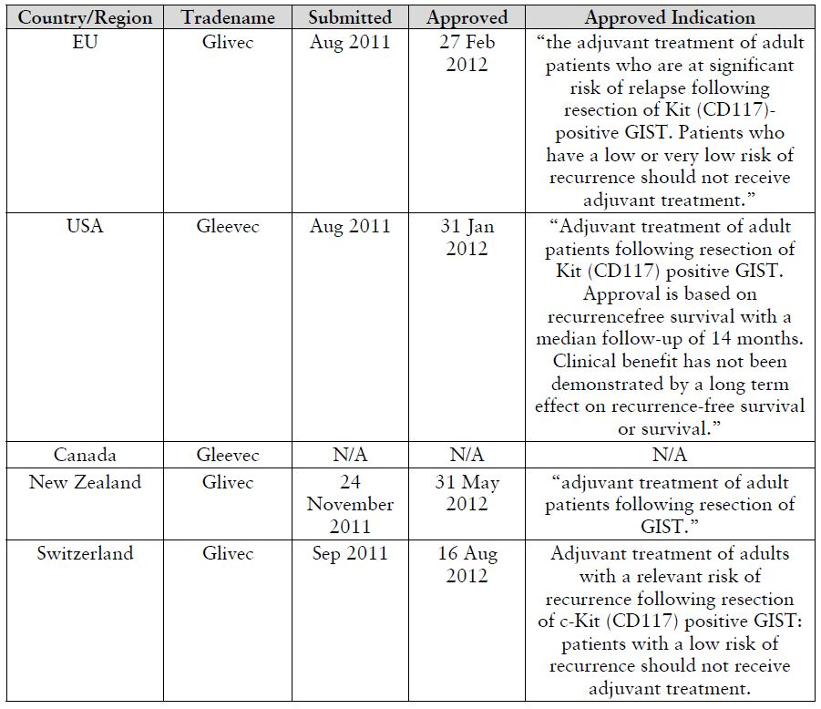

### Product Information

The approved PI current at the time this AusPAR was prepared can be found as Attachment 1.

## II. Quality findings

There was no requirement for a quality evaluation in a submission of this type.

## III. Nonclinical findings

### Introduction

There was no requirement for a nonclinical evaluation in a submission of this type.

## IV. Clinical findings

*A summary of the clinical findings is presented in this section. Further details of these clinical findings can be found in Attachment 2.*

### Introduction

The clinical dossier was confined to a pharmacological study of imatinib and paracetamol (Study CST1571-A2107), a comparative Phase III trial of two different durations of treatment (12 months compared with 36 months) of adjuvant treatment of GIST with Glivec (CST1571-BFI03), and various data supporting changes to the PI, many of which are safety related.

The submission contained the following clinical information:

* A clinical pharmacology study (CST1571-A2107) provided pharmacokinetic data on the effects of Glivec on the pharmacokinetics of paracetamol in patients with newly diagnosed, previously untreated chronic myeloid leukemia in chronic phase (CML-CP);
* Population pharmacokinetic analyses were not part of the submission;
* The pivotal efficacy/safety study (CST1571-BFI03) primarily compared recurrence free survival (RFS) in GIST patients who were assessed as being at a high (> 50%) risk of disease recurrence within the first 5 years following surgery, treated with adjuvant imatinib mesylate for either 12 or 36 months;
* No dose finding studies were included in the submission;
* The previous study CST1571-BUS89 of the adjuvant treatment of GIST with Glivec for 12 months was supplied for reference only as it had been evaluated previously;
* A Phase III study, CST1571-K2301, was submitted to support the inclusion of information on hypophosphatemia in the PI. The randomised open label study of 400 mg versus 800 mg of Glivec (imatinib mesylate) was conducted in patients with newly diagnosed, previously untreated chronic myeloid leukemia in chronic phase (CML-CP); and
* An epidemiology report evaluating the frequency of second primary malignancies in Glivec treated patients in Novartis sponsored clinical trials.
* The submission included proposed changes to parts of the paediatric information in the PI with supporting arguments. No new studies in children were presented.

All studies and any amendments were reviewed by the Independent Ethics Committee or Institutional Review Board for each center. The studies were conducted according to the ethical principles of the Declaration of Helsinki. Informed consent was obtained from each patient in writing during the screening visit and prior to his or her enrollment in the studies. The studies were described to the patients by the investigator, who answered any questions; patients were also provided with written information. Samples of the written information and the consent form were provided in the application.

### Pharmacokinetics

One pharmacokinetic study was submitted (Study CST1571-A2107) investigating the possible acetaminophen/paracetamol and imatinib interaction.

From the PK study of a single dose of acetaminophen/paracetamol co administered with multiple doses of imatinib at steady state, a similar ratio of plasma and urinary acetaminophen glucuronide to acetaminophen was observed in the absence and presence of imatinib, and a similar ratio of plasma urinary acetaminophen sulfate to acetaminophen was also observed in the absence and presence of imatinib. The evaluator concludes that imatinib (400 mg qd [once daily]) did not significantly affect the pathways of metabolism of acetaminophen to its sulfate and glucuronide in the Korean patients studied. The method used was an acceptable surrogate for measuring the hepatotoxic metabolite NAPQ1 itself, which cannot be measured *in vivo* in humans. From these data, we can conclude that imatinib did not cause significant inhibition of glucuronidation and diversion of acetaminophen towards the toxic metabolite in the population studied.

However, a number of problems with the study are of concern as follows.

#### 1. Ethnicity of the subjects

In the Evaluator’s Comments, the point is made that significant differences have been reported in the pharmacokinetics of acetaminophen in some Asians population compared to some Caucasians populations. These clear differences show that acetaminophen is metabolised at different rates in different ethnic groups. Although a difference has not been shown between Korean subjects and Australian Caucasians, the values for the pharmacokinetic parameters in this application for Koreans differ significantly from those of Australian Caucasians, as shown in the Comments referred to. Therefore, the results in the present study cannot be extrapolated to an Australian Caucasian population. This was the main factor for the recommendation to reject the request to change the reference in the PI about this matter.

#### 2. Plasma concentration (Cmax) of acetaminophen

The Cmax value for the plasma concentrations of acetaminophen with and without imatinib did not show equivalence. The ratio of results for the Cmax of acetaminophen in the presence of imatinib to the Cmax in its absence had a 95% CI (confidence interval) of 0.69-1.04. This was outside the required equivalence range of 0.8 to 1.25. Measurements showed a high between patient variability, with CVs ranging from 34.4% to 43.4% for Cmax acetaminophen, and similar CV (coefficient of variation) values for AUC parameters. This variability may account for the lack of equivalence. From a safety perspective, a lower value of Cmax of acetaminophen with co administration of imatinib is not a safety concern, unless the plasma level was low because of accelerated metabolism of acetaminophen in the presence of imatinib. However other results excluded this possibility. Although none of the 12 patients showed evidence of abnormal hepatic function or renal function during the co administration of the two drugs, the numbers in the study (n = 12) were too low to detect relatively rare events such as acute renal failure and hepatic necrosis, even if the co administration increased their frequency significantly.

#### 3. Co medications in real life

Cytochromes metabolise acetaminophen and are inhibited by imatinib. They also have a role in producing the hepatotoxic metabolite of acetaminophen, NAPQ1. The study correctly prohibited those drugs that inhibited, were substrates for, or were inducers of cytochromes (except for allopurinol). While this was possible in a supervised study of this type, in medical practice, this would be unlikely, especially in diseases for which imatinib is used, often with acetaminophen. When other drugs that affect cytochromes are introduced, the effect on the metabolism of acetamophen would be unpredictable, and possibly result in the production of greater amounts of NAPQ1.

#### Conclusion

From a consideration of the above three problems, the evaluator finds the request to delete the statement

*“Glivec inhibits paracetamol O-glucuronidation in vitro (Ki value of 58.5 micromol/L) and may inhibit paracetamol metabolism at therapeutic levels (see ‘Precautions’)”*

from the PI cannot be supported. Reference to ethnic differences in the metabolism of acetaminophen could be considered as an addition.

### Pharmacodynamics

No new pharmacodynamic data were presented in this application.

### Dosage selection for the pivotal studies

As imatinib at a dose of 400 mg/day is already approved for the adjuvant treatment of adult patients following resection of GIST, this dose was chosen for the present study. Study treatment was to be stopped after 12 or 36 months. However, the patients who were rendered free from overt metastases by surgery were an exception and were allowed to continue adjuvant imatinib treatment beyond 12/36 months. The proportion of patients continuing imatinib treatment beyond 12/36 months was tabulated. The median duration and range (Min, Max) of the use of out of study adjuvant imatinib was recorded. Out of study adjuvant imatinib use was not included in duration of exposure of study drug.

Treatment of patients with recurrence of GIST during the study period was not specified, but in most cases was with further imatinib therapy, as this has been shown in other studies to be effective in a percentage of patients. Other treatments included other systemic therapy as first or second or third line treatment, imatinib as second or third line treatment, surgery for GIST recurrence, and radiotherapy for GIST recurrence.

### Efficacy

#### Evaluator’s conclusions on clinical efficacy from the results of pivotal study STI571BFI03 of an increase in the duration of adjuvant treatment of resected GIST from 400 mg/day for 12 months to 400 mg/day for 36 months

##### Adequacy of study design

The final study design resulted from five revised protocols (original [2003], 2004, 2006, 2007, 2008) and three major amendments (2006, 2007, 2008), the changed protocol in 2004 being referred to as an “update”. The objectives of the first Phase II Scandinavian protocol were not stated and the protocol not provided. The Study Report states

*“This study was originally designed to assess RFS in a total of 80 GIST patients treated for either 12 months or 36 months with a follow up of at least 5 years. The study was hypothesis generating and designed to compare each treatment arm with an historical control.”*

Subsequent changes, including that from a Phase II to a Phase III study, are described in more detail under Protocol Amendments. The numerous changes produced a heterogeneous patient population. The intent of the study seems to have been to select only patients at high risk of recurrence after resection, defined as a 50% risk over 5 years. However, because of the changing definitions of “high risk”, the actual ITT (Intent to Treat) population in the completed study was composed of 82% patients at high risk and 18% not at high risk (Fletcher classification, used in the study). In the more recent classification of Miettinen, the high risk population in the study was 71%. As well, in the initial protocol, patients with resected metastatic disease were eligible for inclusion. They were later excluded by the October 2006 amendment. At this time, a total of 83 and 95 patients had been enrolled in the 12 month and 36 month arms, respectively. Of these, only 5 had metastases at initial surgery. This small number would not therefore affect the final data analysis.

A further problem in studying GISTs is its relative rarity (7 to 19 cases per million[3]) and the long clinical course for the overall patient population. One year after resection of tumours 3 cm diameter or greater with no macroscopic residual disease, 82% of patients had no disease recurrence (Australian PI).

In spite of these problems, the final study design was acceptable, the study itself was well conducted, and the data analysed appropriately.

##### Results

RFS was significantly improved in the 36 month arm compared to the 12-month arm:

* For the treated population, with 66% (Miettenen classification) to 82% (Fletcher classification) of patients at high risk of recurrence, those treated for 36 months were at significantly reduced risk of recurrence in the time period studied, compared to those treated for 12 months. The HR (hazard ratio) was 0.46 (95% CI: 0.32-0.65), and the p value <0.0001.
* For the high risk population, classified by either scheme, the HR was similar to that of the overall population in favour of 36 months treatment, with similar values for the HR ratios: 0.46 (95% CI 0.32-0.66, Fletcher classification), and 0.43 (95% CI 0.30-0.62, Miettinen classification).
* The non high risk groups also showed an increased benefit from 36 months treatment, but the low number of recurrences in this smaller group did not give reliable estimates of the benefit.
* Estimates of OS (overall survival) demonstrated the lower risk of death from all causes in the 36 month arm compared to the 12 month arm with a HR of 0.45 (95% CI 0.22-0.89), p = 0.0187. However the difference in the deaths from GIST was not statistically significant between the two arms. In this case, although the HR was 0.46 in favour of the 36 month arm, the 95% CI was very wide (0.19-1.14), and the p value 0.0872. There is no reason to expect an increase in non GIST deaths in the 12 month arm, so the lack of a demonstrated statistical difference in the number of GIST deaths may be due to insufficient number of events (deaths) in this subgroup.
* Sensitivity and subgroup analyses were consistent with the above results for RFS.

### Safety

The recording and reporting of some important safety data was not of an acceptable standard. The pivotal study was designed and carried out by the Swedish Sarcoma Group. Although the sponsor of the present application, Novartis, reworked the safety data, it was unable to correct the deficiencies. This is especially unfortunate since the study is the only monitored study of long term usage (36 or more months) of Glivec. Long term safety is therefore of concern.

##### Deficiencies in reporting safety data

The two main deficiencies dealt with in detail in earlier sections of this evaluation were:

1. failure to record the relationship of AEs (adverse events) to treatment (the relationship of SAEs [serious AEs] to treatment was listed)
2. failure to record laboratory values during the trial unless associated with an related AE.

This resulted among other things in an inability to assess hepatotoxicity by Hy’s law.

##### Safety data presented

The safety data presented showed that 36 months or more of treatment with Glivec was associated with one new adverse outcome, a 5 fold increase in the frequency of cancer of the prostate. Other AEs were similar to those seen in other studies with Glivec, but were approximately twice as frequent.

The AEs (by System Organ Class [SOC]), metabolic and nutritional disorders, infections/infestations, and disorders of the musculoskeletal systems were more frequent in the 12 to 36 month period compared to the 0 to 12 month period of the 36 month treatment arm, as were the SAEs (by preferred terms), GI (gastrointestinal) disorders and infections/infestations.

Approximately twice as many patients discontinued treatment in the 36 month arm as in the 12 month arm with 83.4% completing their 12 month treatment and 58.1% their 36 month treatment.

The assessment of long term hepatotoxicity in the trial was not possible and is unknown. The frequency of Grade 1 and 2 laboratory abnormalities of liver function were high but not those of Grade 3 and 4.

Unexpected and unexplained safety results included:

* The higher frequency of SAEs in the 12 months of the 12 month arm (13 patients) compared to the first 12 months of the 36 month arm (6 patients)
* The number of deaths due to GIST was similar (3 and 4) in the two arms, while the deaths from other causes were significantly higher in the 12 month treatment arm (22 compared with 8). Patients’ narratives suggest that more GIST deaths may have occurred in the 12 month arm.

The pharmacokinetic study (CST157A2107) on the interaction of imatinib and acetaminophen did not provide justification to remove the cautionary sentence about the inhibition of paracetamol metabolism. In addition, the sponsor did not include in the proposed PI any table of the frequency of AEs in the pivotal trial.

##### Overall

In the pivotal study, there was no evidence that the safety of patients was compromised, but rather that the recording and reporting of certain safety data was deficient.

Except for cancer of the prostate, the AEs reported were those previously seen with treatment with Glivec in patients with GIST, but were about twice as frequent with 36 or more months of treatment. Most AEs were low grade and manageable but the deficiencies cited prevent the long term safety of the treatment being fully assessed. Some reassurance is provided by the low incidence of serious and severe AEs, the absence of serious outcomes in patients treated for longer periods in other studies and from post marketing data, and appropriate surveillance in the RMP.

### Clinical summary and conclusions

#### First round assessment of benefits

The survival of GIST patients after surgery alone is favourable compared to other intra abdominal sarcomas,[4] and those patients at high risk of recurrence (>50% at 5 years) can be identified and treated to delay or prevent recurrence. The present pivotal study convincingly showed the benefit of 36 month’s treatment with Glivec compared to 12 month’s treatment in delaying or preventing recurrence (RFS), the risk ratio being 0.46 (95% CI 0.32-0.66) in favour of the longer treatment.

The original study intended to treat only patients at high risk. However, in the treated patient population, only 66% of patients by the Miettenen classification and 82% by the Fletcher classification were at high risk. If these classifications applied to the patients in this study, the rate of recurrence would be expected to be high in the high risk groups in each arm. However the rates of recurrence were very different (10 fold greater in the high risk group compared to the non high risk group in the 36 month group, but only 2 fold different in the 12 month group). This indicates uncertainty about the applicability of this risk classification when used for treated patients.

The 36 month period of treatment also conferred an OS benefit, although not for GIST related deaths. The latter may be explained by several doubtful assignments of the cause of death in the 12 month treatment arm, but such an assumption is made with reservations.

Overall, the benefit to both high risk patients and non high risk patients is robust in the prevention of recurrence but less so in the increase in OS with respect to tumour associated death. The question then arises whether both high risk and non high risk populations should be treated in the same way. Since there is some doubt about risk classification in treated patients as shown by the differences in rates of recurrence, both groups should be included in the indication.

#### First round assessment of risks

One risk of the proposed usage arises from the deficiencies in reporting AEs in the pivotal trial mainly that of possible drug related hepatotoxicity from the long term (36 months or more) treatment with Glivec. To balance this lack of information, the following points are noted, provided by the sponsor on 1 February 2012:

* ~15% of the patients enrolled in the original GIST study for metastatic disease, Study B2222, have been treated for over 5 years with GIST with good tolerability and remain on treatment today. Presumably no significant long term toxicity has been reported in this group
* the Safety RMP (released 7 July2011) gives details of Important Identified Risk, including Hepatotoxicity. The sponsor's comments on hepatotoxicity provide the conclusion of this assessment which indicates that serious and severe hepatotoxicity was uncommon.

The second risk to be considered is that the proposed treatment results in twice the frequency of AEs but not of SAEs. The percentage of patients completing 36 months of treatment was only 58% compared to 83% for 12 month’s treatment because of AEs. Given the serious nature of the condition from the risk of recurrent disease with a fatal outcome and the clear benefit for patients at high risk of recurrence (50% risk in 5 years), the high frequency of AEs is acceptable. A theoretical issue in an adjuvant study is whether patients at lower risk should be treated if the associated safety risks are high. However from the data above, as the risk categories in the present study appear uncertain in treated patients, both high risk and non high risk populations should be combined in the indication for treatment.

The third risk of long term treatment is that the patients have 5 times the risk of developing cancer of the prostate. The OS of treated patients with recurrent GIST is comparatively long, as it is for prostate cancer. Given the current trend to more conservative management of prostate cancer this risk is acceptable.

#### First round assessment of benefit-risk assessment

Based on the definite benefit as described above, and after consideration of the risks as stated, the benefit-risk balance is in favour of the proposed usage of Glivec to treat operable GIST for 36 months.

#### First round recommendation regarding authorisation

The increase in the duration of treatment of adult patients following complete gross resection of KIT (CD117) positive primary GIST with Glivec, 400 mg daily, from 12 months to 36 months is acceptable, subject to the TGA’s approval of related changes to the PI.

#### First round comments on clinical aspects of the Safety Specification in the draft RMP

The Safety Specification in the draft RMP is satisfactory. An important potential risk is the occurrence of a second malignancy in survivors. This is appropriate for the future assessment of the risk of prostatic cancer, referred to above.

### List of questions

#### Question 1

Comparing treatment related SAEs, the Summary of Clinical Safety claimed that

*“No relevant differences were observed between the treatment groups”.*

This was not correct as 14 patients (7.2%) in the 12 month group and 7 in the 36 month group reported treatment related SAEs. As well, in the first 12 months of treatment in each of the two arms, patient numbers, their disease states, and treatments were similar, yet the incidence of SAEs in the 12 month treatment period of the 12 month group was twice that for the first 12 month period for the 36 month group (13 patients compared to 6). The difference is unexplained and raises a concern that there was under reporting of AEs in the 36 month group. The sponsor should comment on this difference and suggest a possible reason.

##### Sponsor’s response:

No significant difference between treatment groups according to Fisher’s Exact Test. This was a chance finding.

##### Evaluator’s comment:

Sponsor response acceptable.

#### Question 2

Comments to subheading “Other Serious Adverse Events Irrespective of Relationship to Treatment: Preferred Terms” reference is made to the apparent 5 fold increase in the incidence of prostate cancer with long term treatment with imatinib noting the neoplastic changes reported in the urogenital system in rats after 2 years treatment. The sponsor should comment on this result. Such comments will also relate to the PI.

##### Sponsor’s response:

Six of the eight cases of prostate cancer occurred in the 60-69 age group and one each in the 70-79 and 80+ age groups. The study was relatively small and the absolute number of cases of prostate cancer was low. Multiple different types of events were examined. Therefore, the finding is likely to be due to chance. An epidemiology report examining data from several trials will be available at the end of this year.

##### Evaluator’s comment:

Sponsor response acceptable.

#### Second round assessment of benefit-risk assessment

After consideration of the responses to the clinical questions the benefits and risks of imatinib in the proposed usage are unchanged from those identified in the clinical evaluation report. The benefit-risk balance is favourable.

#### Second round recommendation regarding authorisation

The evaluator recommends approval of the increased duration of Glivec treatment from one to three years in adults following gross resection of KIT (CD117) positive primary GIST, subject to the PI changes.

#### Second round comments on clinical aspects of the Safety Specification in the draft RMP

There are no changes to the comments on the Safety Specification made in the clinical evaluation report.

## V. Pharmacovigilance findings

### Risk management plan

The sponsor submitted a Risk Management Plan that was reviewed by the TGA’s Office of Product Review (OPR).

#### Safety specification

The sponsor provided a summary of Ongoing Safety Concerns which are shown at Table 2.

Table 2: Ongoing Safety Concerns for Glivec.

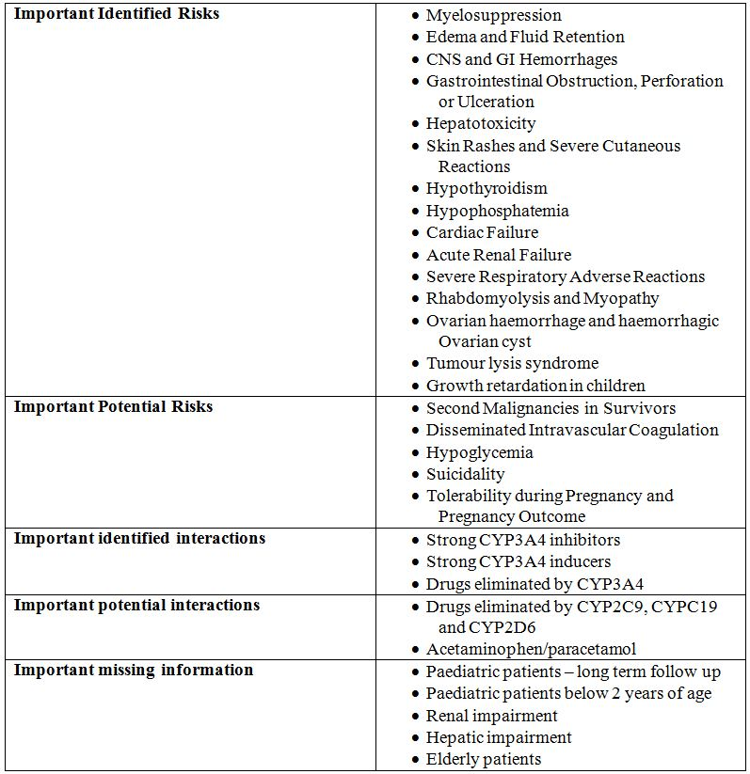

##### OPR reviewer comment:

The above summary of the Ongoing Safety Concerns is considered acceptable.

#### Pharmacovigilance plan

##### Proposed pharmacovigilance activities

Pharmacovigilance activities are proposed by the sponsor and are summarised in Table 3.

Table 3: Pharmacovigilance activities for Glivec.

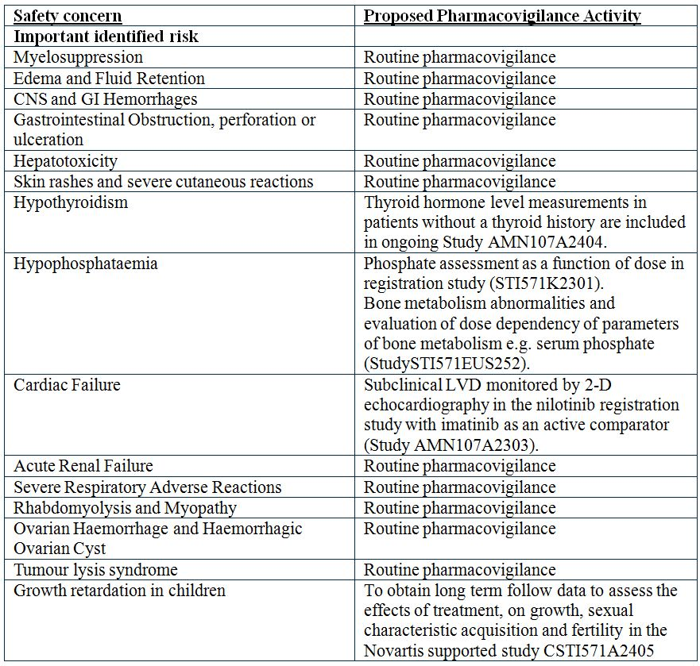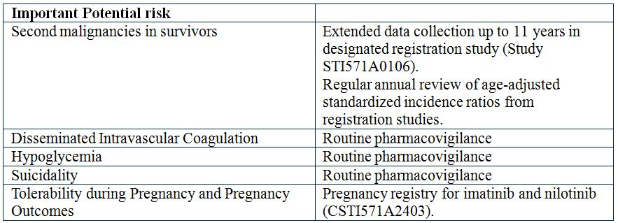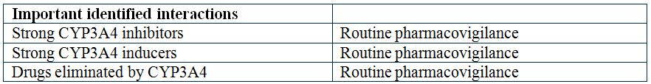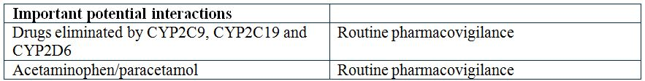

Table 3 (continued): Pharmacovigilance activities for Glivec.

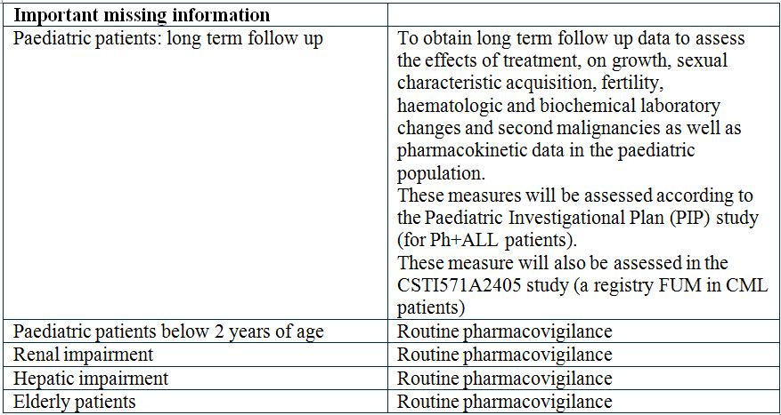

According to the Australian specific annex, there are no additional pharmacovigilance activities proposed specifically for Australia.

##### OPR reviewer’s comments in regard to the pharmacovigilance plan and the appropriateness of milestones:

The planned PIP (Paediatric Investigational Plan) study for ALL (acute lymphoblastic leukaemia) patients is not considered in this report as it does not relate to the current application. All other studies outlined in the pharmacovigilance plan are ongoing and therefore the associated protocols have not been evaluated in detail for the purposes of this report.

A pregnancy registry is also ongoing to assess tolerability during pregnancy and pregnancy outcomes related to imatinib and a companion drug, nilotinib. It is noted that imatinib is currently listed as Category D for use in pregnancy which appropriately reflects the lack of safety data in pregnancy and no changes to this are proposed.

It is recommended that all reports from the ongoing pharmacovigilance studies should be submitted to the TGA when available. It is also expected that any safety issues arising from the studies are cumulatively detailed in the PSUR (Public Safety Update Report).

The clinical evaluator felt that the important potential risk ‘second malignancies in survivors’ is sufficient for the risk of prostate cancer observed in the GIST extended treatment study. Routine pharmacovigilance is currently proposed for this safety concern. Depending on the interpretation of the prostate cancer risk, the Delegate may wish to consider including additional pharmacovigilance for this safety concern as a condition of registration.

Otherwise, the pharmacovigilance plan is considered to be acceptable.

#### Risk minimisation activities

##### Sponsor’s conclusion in regard to the need for risk minimisation activities

No articulated conclusion is provided by the sponsor as such however the RMP details each safety concern and whether or not routine risk minimisation activities are sufficient. In summary, the sponsor proposes that routine risk minimisation activities are sufficient for all safety concerns except ‘Rhabdomyolysis and Myopathy’, ‘Disseminated Intravascular Coagulation’, ‘Hypoglycemia’ and ‘Suicidality’. For these the sponsor states:

*“There is a lack of conclusive data indicating causal relationship at this time. Should the PV activities uncover additional data, the risk will be communicated through the labelling and additional risk minimisation activities may be proposed if necessary.”*

##### OPR reviewer comment:

The rationale for routine risk minimisation is acceptable. The rationale for no risk minimisation activities for ‘Disseminated Intravascular Coagulation’ and ‘Suicidality’ is also acceptable.

The evaluator’s concerns regarding ‘Rhabdomyolysis and myopathy’ and ‘hypoglycaemia’ are discussed in the RMP.

##### Potential for medication errors

The RMP states:

*The potential for medication errors was considered, taking into account the following common sources of medication errors.*

***Name confusion***

*Novartis selected the invented name or trademark “Glivec” as the trademark for imatinib in 2000 as it was determined to be a safe name not likely to cause confusion with other marketed product names. Before submitting the trademark Glivec to FDA or EMA, a robust trademark safety evaluation was conducted by Medical Error Recognition and Revision Strategies, Inc. (Med-E.R.R.S.) and Brand Institute. These assessments included a survey of US and EU healthcare practitioners to assess the potential for look alike and sound alike confusion between Glivec and other marketed products. Additionally, panels of pharmacists and drug safety experts assessed the trademark Glivec and concluded it had an overall low vulnerability for look alike and sound alike confusion and was therefore a suitable trademark for the product.*

*In 2000-2001, as part of the authorisation procedure, Glivec was submitted for review to both the FDA and the EMA. Both health agencies are obligated to consider whether the proposed invented name of a medicinal product could create public health concerns and potential safety risks. The invented name should not convey misleading or pharmaceutical connotations, and should not be liable to cause confusion in print, handwriting or speech with the invented name of an existing medicinal product.*

*The EMA confirmed Glivec was a suitable trademark by first granting ‘pre clearance’ status and then final approval of the Glivec trademark in November 2001. The FDA raised a concern regarding the correct pronunciation of the trademark Glivec and rejected the trademark. In order to overcome the FDA concern, an alternate spelling of Glivec was proposed, and the derivation “Gleevec” was agreed between Novartis and the FDA in April 2001 and the trademark was subsequently approved by the FDA.*

*The trademark Glivec has since been approved by health agencies all over the world.*

##### Presentation

*Imatinib is currently available as two different dosage forms: hard gelatin capsules and filmcoated tablets. The following dosage strengths are applied: 50 mg and 100 mg imatinib mesylate in the hard gelatin capsule formulation; 100 mg and 400 mg imatinib mesylate in the film coated tablets formulation. Both dosage forms are registered worldwide under the trade name of Glivec/Gleevec. A 400 mg divisible film coated tablet was approved in the US in December 2004.*

*The appearance of the different dosage forms are as follows:*

* *a 50 mg light yellow to orange-yellow capsule, hard gelatin capsule, marked “NVR SH”*
* *a 100 mg orange to grayish orange, hard gelatin capsule, marked “NVR ST”*
* *a 100 mg very dark yellow to brownish orange, round, divisible, biconvex film coated tablet with beveled edges, with imprint “NVR” on one side and “SA” and a score on the other*
* *a 400 mg very dark yellow to brownish orange, ovaloid, non divisible biconvex filmcoated tablet with beveled edges, debossed with “NVR” on one side and “SL” on the other*
* *a 400 mg very dark yellow to brownish orange, ovaloid, divisible, biconvex film coated tablet with beveled edges, debossed with “400” on one side and a score on the other side with “SL” on each side of the score*

*The colour and imprinting of the capsules and tablets minimise the potential for any medication errors.*

##### Differentiation from other products taken/administered concomitantly

*Imatinib is not intended to be administered in combination with other products for this indication. However, it is likely that other products are administered concomitantly in this patient population. The unique colour and imprinting of the capsules along with the packaging/labelling minimises the potential for any medication errors.*

##### Accidental ingestion or other unintended use

*The potential for accidental ingestion or other unintended use by children is minimised by the use of child resistant high density polyethylene bottles.*

##### Instructions for use

*Imatinib is an oral tablet or capsule taken at the prescribed dose with a meal and a large glass of water. Doses of 400 mg or 600 mg should be administered once daily, whereas a daily dose of 800 mg should be administered as 400 mg twice a day, in the morning and in the evening. These instructions for use minimise the potential for any medication errors.*

##### OPR reviewer comment:

This is acceptable.

##### Toxicity in overdose

In the PI it is stated:

*Experience with higher than therapeutic doses is limited. Isolated cases of Glivec overdosage have been reported spontaneously and in the literature. Generally the reported outcome in these cases was improvement or recovery. In the event of overdosage the patient should be observed and appropriate symptomatic treatment should be given.*

*Events that have been reported at different dose ranges are as follows:*

***Adult overdose:*** *1,200 to 1,600 mg (duration varying between 1 to 10 days): Nausea, vomiting, diarrhoea, rash, erythema, oedema, swelling, fatigue, muscle spasms, thrombocytopenia, pancytopenia, abdominal pain, headache, decreased appetite. 1,800 to 3,200 mg (as high as 3,200 mg daily for 6 days): Weakness, myalgia, increased CPK, increased bilirubin, gastrointestinal pain. 6,400 mg (single dose): One case in the literature reported one patient who experienced nausea, vomiting, abdominal pain, pyrexia, facial swelling, neutrophil count decreased, increased transaminases.*

*8 to 10 g (single dose): Vomiting and gastrointestinal pain have been reported.*

***Paediatric overdose:*** *One 3 year old male exposed to a single dose of 400 mg experienced vomiting, diarrhoea and anorexia and another 3 year old male exposed to a single dose of 980 mg dose experienced decreased white blood cell count and diarrhoea.*

*Contact the Poisons Information Centre on 13 11 26 for advice on management.*

##### OPR reviewer comment:

This is acceptable.

#### Summary of recommendations

The OPR provides these recommendations in the context that the submitted RMP is supportive to the application; the implementation of a RMP satisfactory to the TGA is imposed as a condition of registration; and the submitted EU-RMP and Australian specific annex is applicable without modification in Australia unless so qualified:

##### Section 8.2

* Reports from the ongoing studies as part of the pharmacovigilance plan should be submitted to the TGA when available. It is also expected that any safety issues arising from the studies are cumulatively detailed in the PSUR.
* Routine pharmacovigilance is currently proposed for the important potential risk ‘second malignancies in survivors’. Depending on the interpretation of the risk of prostate cancer seen in the supporting study, the Delegate may wish to consider including additional pharmacovigilance for this safety concern as a condition of registration.

##### Section 10.1

* No risk minimisation activities are proposed for the important identified risk ‘rhabdomyolysis and myopathy’ however “rhabdomyolysis/myopathy” is listed in the proposed PI (Adverse reactions from post marketing reports). This is considered to be part of routine risk minimisation and should be represented as such in the RMP.
* The clinical evaluator does not support the proposed removal of the paracetamol statement from the PI. Given paracetamol is a commonly used drug and the clinical evaluator’s objection, retention of this statement is considered an important part of routine risk minimisation for this important potential interaction.
* The clinical evaluator noticed that in the study supporting this application a 5 fold increase in the incidence of prostate cancer was observed in patients treated with imatinib for 3 years or more. Depending on the interpretation of this risk, the Delegate may wish to consider including specific risk minimisation for this safety concern as a condition of registration. This could be addressed in the form of routine risk minimisation as a statement in the PI to the satisfaction of OMA.

In regard to the proposed routine risk minimisation activities, it is recommended to the Delegate that the draft product information document be revised as follows:

* Implementation of the PI changes recommended by the clinical evaluator as appropriate
* The RMP states that across the clinical safety database for imatinib, hypoglycaemia was observed in 44 out of 3246 patients. A total of 4 of these were considered to be related to imatinib. Even though the absolute number is small, and causality cannot be absolutely established, hypoglycaemia is considered a clinically important AE. It is therefore recommended that hypoglycaemia is addressed in the PI. This would be considered a routine risk minimisation activity.

## VI. Overall conclusion and risk/benefit assessment

The submission was summarised in the following Delegate’s overview and recommendations:

### Quality

There was no requirement for a quality evaluation in a submission of this type.

### Nonclinical

There was no requirement for a nonclinical evaluation in a submission of this type.

### Clinical

#### Efficacy

A randomised, open label trial in Europe (CST1571-K2301, identified as SSG XVIII/AIO[5] in the PI) was presented to support extension of the adjuvant treatment duration from one to three years in KIT positive GIST. The trial report has been published.[6] Patients with a high risk of recurrence after surgical resection received either imatinib 400 mg/day orally for 1 year or 3 years. High risk was defined as one of:

* Tumour diameter > 10 cm
* Mitotic count > 10/50 high power fields (HPF)
* Tumour diameter > 5 cm and mitotic count > 5/50 HPF
* Tumour rupture into the peritoneal cavity.

The proportion of male and female patients was similar and the median age was 61 years (range 22-84).

The primary endpoint was RFS defined from date of randomisation to date of recurrence or death from any cause. Recurrence was confirmed histologically or radiologically. The longer duration of treatment significantly increased RFS and also OS (Table 4.

Table 4: SSG XVIII/AIO Trial – Efficacy Results – Modified Intent-to-Treat.

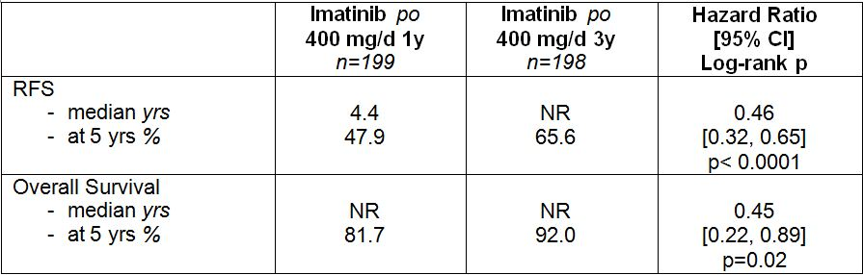

Three randomised patients (one from the 1 year group and two from the 3 year group) did not give informed consent and were excluded. Medians and percentages are Kaplan-Meier estimates and Hazard Ratios are Cox regression estimates (3 year/1 year). NR: Not Reached.

A total of 21% of patients in the 1 year arm and 16% in the 3-year arm were not “high risk” according to the modified Fletcher classification used in the trial. Sensitivity analyses were done in patients classified as “high risk” according to central review using the modified Fletcher risk classification and the more recent Miettinen classification. Both showed a similar effect on RFS to the primary analysis: HR 0.46, 95% CI [0.32, 0.66] with the modified Fletcher classification and 0.43, 95% CI [0.30, 0.62] with the Miettinen classification. The HRs for low to intermediate risk patients were unreliable due to small numbers and few recurrences. The benefit of imatinib in low to intermediate risk patients is lower than that in high risk patients because of the lower incidence of recurrence in low to intermediate risk patients.

#### Safety

The major safety data was from the pivotal trial (SSG XVIII/AIO). The safety population consisted of patients who received at least one dose of study treatment: 194 for the 1 year imatinib group and 198 for the 3 year imatinib group. There was a higher incidence of severe (Grade 3-4) and SAEs in the 3 year group than the 1 year group but this was expected because of the longer duration of treatment. Discontinuations due to AEs were also greater in the 3 year group (13.6%) than the 1 year group (7.7%).

AEs were generally consistent with the known safety profile of imatinib except for the incidences of haematological, liver and renal abnormalities in the 1 year group of the pivotal trial being about twice those seen in the previous 1 year adjuvant trial Z9001 (cited in the PI). The incidences of these AEs were even higher in the 3 year group. There was insufficient data to assess long term safety.

There appeared to be an increased risk of prostate cancer with long term use of imatinib. The sponsor responded that the analysis had several limitations including that the study was relatively small and there were few cases of prostate cancer. An updated epidemiology report with data from several studies will be available in December 2012.

The evaluator recommended approval of the new indication.

### Risk management plan

The RMP proposed is the EU RMP version 5, data lock point 10 May 2011, and an Australian Specific Annex version 5, dated 4 November 2011. This was acceptable to the TGA OPR.

### Risk-benefit analysis

#### Delegate considerations

An increase in the duration of adjuvant imatinib treatment from one to three years in patients with KIT positive GIST significantly increased RFS and OS in a randomised, open label trial (SSG XVIII/AIO). The median RFS and OS in the 3 year group had not been reached after a median follow up of 4.5 years. The majority of patients in the trial were assessed as having a high risk of disease recurrence according to the modified Fletcher criteria.

There was an increased incidence of SAEs with the longer duration of treatment and increased discontinuations from treatment. Deficiencies in the data precluded proper assessment of long term safety.

The benefit-risk balance is in favour of approval of three years adjuvant treatment in high risk GIST patients. There were few low to intermediate risk patients in the trial. The benefit in these patients was less certain and likely to be lower because of fewer recurrences. The toxicity of the drug is likely to outweigh the benefit in this group. The optimal duration of treatment remains to be determined.

#### Draft decision

The Delegate recommends approval of the extension of imatinib (Glivec) treatment to 3 years but with the indication restricted as follows:

* Adjuvant treatment of adult patients at high risk of recurrence following complete gross resection of KIT (CD117) positive primary GIST (see Clinical Trials).

Approval should be subject to finalisation of the product information.

Proposed conditions of registration:

* Implementation of the EU RMP version 5, data lock point 10 May 2011, and an Australian Specific Annex version 5, dated 4 November 2011, and subsequent revisions as agreed with the OPR.
* Submission of the epidemiology report on the association between imatinib and prostate cancer when available (due December 2012).

that were submitted to the ACPM for advice.

#### Response from sponsor

Presented here is the Novartis pre ACPM response to the TGA Delegate’s overview and Request for ACPM Advice in relation to our Category 1 Application to vary the conditions of Registration for the extension to the duration of treatment of Glivec imatinib (as mesylate) capsules and tablets in adult patients with adjuvant gastrointestinal stromal tumours (GIST). Where appropriate, our comments have been cross referenced to the Delegate’s overview (DO), the clinical evaluation report (CER), nonclinical evaluation report (NER) and the risk management plan evaluation report (RER), or to our submission for marketing authorisation (MA).

##### Introduction

Novartis welcomes the TGA Delegate’s recommendation to approve the extension of treatment to 3 years with Glivec in adult patients with GIST. However, the Delegate recommends restricting this indication to patients with high risk of recurrence.

Novartis maintain that the data from Study CSTI571BFI03 (SSG XVIII/AIO) supports the treatment of patients who are also non high risk. The clinical evaluator has not recommended a restriction to high risk patients in his evaluation report:

*“The increase in the duration of treatment of adult patients following complete gross resection of* KIT *(CD117) positive primary GIST with Glivec, 400 mg daily, from 12 months to 36 months is acceptable.”*

This is discussed further in the section below. We request that the committee and the Delegate not restrict the patient population via the change to the wording in the indication recommended in the DO.

Other issues raised by the Delegate in the DO are also addressed below. For ease of reference, the Delegate’s comments are transcribed in italics.

#### Response to issues raised in the Delegate’s overview

##### Indication

*The Delegate recommends approval of the extension of imatinib (Glivec) treatment to 3 years but with the following indication restricted as follows: Adjuvant treatment of adult patients at high risk of recurrence following complete gross resection of* KIT *(CD117) positive primary GIST (see Clinical Trials).*

##### Efficacy

*The benefit of imatinib in low to intermediate risk patients is lower than that in high risk patients because of the lower incidence of recurrence in low to intermediate risk patients.*

###### Sponsor’s comment:

Novartis concur with the Delegate regarding the lower incidence of recurrence in low to intermediate risk patients. However, this does not preclude these patients from recurrence or benefit from imatinib. This risk should be based on physician’s assessment. The indication should therefore not be restricted to high risk patients only. The current approval in this disease is based on Study Z9001, a multicentre, double blind, placebo controlled Phase III study in adjuvant GIST patients. This approval allows all risk categories of patients to be treated for a period of one year. The Delegate has recommended a restriction of indication based on Study CSTI571BFI03, an open label Phase III study.

As identified by the clinical evaluator, the risk classification utilised in study CSTI571BFI03 changed, so depending on which classification was used, the number of high risk patients also changed. In this trial, using a modified Fletcher classification, 82% were high risk compared to the 66% identified under the modified Miettenen classification.

Furthermore, there is a lack of consensus regarding risk classification globally. The use of the term “high risk” to describe the patient population can have multiple interpretations, ultimately leading to confusion in terms of treatment selection. There are currently at least five classification systems used in clinical and research practice in Australia. These include the original NIH (National Institute of Health) criteria; AFIP (Armed Forces Institute of Pathology), modified NIH criteria, Joensuu classification, and the Gold nomogram. Each system has its own interpretation of prognostic factors including tumour size, mitotic rate, tumour location, or presence of tumour rupture. The protocol for Study CSTI571BFI03 implemented the modified NIH consensus criteria in assessing patient eligibility for trial enrolment. Additionally, patients with tumour rupture either at or prior to surgery were deemed to be at high risk of disease recurrence, regardless of their tumour size and mitotic index. Until the protocol amendment, version 2006, patients who underwent resection of metastatic sites of disease were also allowed to enter the study. These patients were regarded to be at high risk of tumour recurrence irrespective of their risk category according to the classification system.

The risk classification in GIST patients has evolved since the initial approval in June 2009. Review and refinement of GIST risk classification has been the subject of a number of publications since the NIH classification was developed. It is likely that these classifications will be further refined over time for this rare disease as new prognostic factors are discovered and integrated (for example, mutational analysis or tumour rupture at surgery). Since one universally accepted standard and risk assessment tool is lacking, defining a set population as “high risk” consistently will be a challenge for physicians.

Furthermore, due to the variable nature of classification of a patient’s risk of recurrence in the NIH classification system, risk estimation can be arbitrary. For example a 1 mm change in tumour size can shift a patient from a 20% risk to 80% risk of recurrence. Recurrence following even complete gross resection with negative surgical margins of primary GIST is common. Tumour rupture or intra abdominal haemorrhage during surgery, incomplete resection or resection with macroscopically positive margins (R1), symptomatic disease presentation, male gender, older age, and mixed cell pathological subtype can negatively affect the disease free survival.[7] Novartis therefore believe that patients with a significant risk of recurrence should be treated, especially those patients that could be classified as having an intermediate risk. As these patients are currently treated based on the current approval, they should not be precluded from continued therapy but should be treated in-line with the physician’s assessment.

The clinical evaluator stated:

*“Overall the benefit to both high risk and non high risk patients is robust in the prevention of recurrence but less so in the increase in OS with respect to tumour associated death. The question then arises, should both high risk and non high risk populations be treated in the same way. Since there is some doubt about risk classification in treated patients as shown by the differences in rates of recurrence, both treatment groups should be included in the indication.”*

We note that the current European approved indication is for

*“the adjuvant treatment of adult patients who are at significant risk of relapse following resection of* KIT *(CD117) positive GIST. Patients who have a low or very low risk of recurrence should not receive adjuvant treatment.”*

This indication is consistent with the view of the Delegate to limit the use of Glivec to patients where a benefit-risk balance is more favourable. This would also closely aligned with the current treatment practice in Australia and remain clinically relevant amid the likely changes to risk classification.

#### Safety

*There was a higher incidence of severe (Grade 3-4) and SAEs in the 3 year group than the 1 year group... Discontinuations due to AEs were also greater in the 3 year group (13.6%) than the 1-year group (7.7%).*

##### Sponsor’s comment:

The clinical evaluator noted that the frequency of SAEs in the 12 month arm was 13 patients and 6 patients in the first 12 months of treatment in the 36 month arm. If SAEs are examined on the basis of their relation to treatment causality, the overall number of events is relatively low and there is no significant difference between the groups (p = 0.1036 by two sided Fisher’s Exact test). This suggests the difference of 13 versus 6 SAEs could have occurred by chance in the absence of any systematic differences between the treatment arms. Further to this, Novartis have agreed to include the text the Delegate has recommended the under the Adverse Effects section of the PI:

*“There was a higher incidence of severe (Grade 3-4) and SAEs in the 3 year group than the 1 year group but this was expected because of the longer duration of treatment. Discontinuations due to adverse effects were also greater in the 3 year group (13.6%) than the 1 year group (7.7%).”*

The rate of AEs in the 3 year arm of Study CSTI571BFI03 was higher than in the 1 year arm; however, the majority of these were mild in severity and easily managed. The cumulative rate of discontinuation due to AEs at 12 months was lower in the 3 year arm, suggesting that any increase in AEs was associated with the longer duration of treatment. It is also important to note that the overall rate of AEs was similar between the two treatment groups. Although more patients in the 3 year group reported AEs, most of these events were mild to moderate in severity and it is reasonable to expect a higher rate of AEs with a longer duration of treatment. The higher risk of AEs associated with 3 years of treatment is expected to be outweighed by the additional benefits associated with a longer duration of treatment.

Considering the majority of AEs were not severe in nature and the longer duration of treatment resulted in significantly improved RFS and OS, it can be concluded that the incremental benefits outweigh the incremental risks associated with 3 years of adjuvant imatinib treatment.

*AEs were generally consistent with the known safety profile of imatinib except for the incidences of haematological, liver and renal abnormalities in the 1 year group of the pivotal trial being about twice those seen in the previous 1 year adjuvant trial Z9001...The incidences of these AEs were even higher in the 3 year group. There was insufficient data to assess long term safety.*

##### Sponsor’s comment:

No new safety signals were identified as a result of the longer duration of treatment and no changes to the RMP were identified, as a result of Study CSTI571BFI03. Overall, 390 patients (99.5%) experienced AEs, 192 patients (99.0%) in the 12 month group and all 198 patients in the 36 month group. A higher frequency of AEs was reported in the 36 month group due to the longer duration of treatment. However; frequencies of AEs were generally similar between the 0 to 12 months period and the >12 to 36 months period for patients treated in the 36 month arm.

During the period of 11 May 2009 to 10 May 2012, approximately 37,878 patients received imatinib treatment in Novartis sponsored global and local investigational clinical trials. Patient exposure has been calculated as approximately 402,000 patient years for this period, based on an average daily dose of 400 mg.[8] No new safety signals were detected during the period identified.

In regards to the long term safety of Glivec, follow up data of two large scale Phase III cooperative groups (EORTC and SWOG) in advanced/metastatic GIST have been previously reported.[9] These longer term studies consisted of larger cohorts of patients with doses from 400 mg/day to 800 mg/day. The safety profile of imatinib in these studies supported the established safety profile of Glivec and confirmed that chronic dosing in patients with GIST is well tolerated.[10]

Furthermore, the long term efficacy of continuous imatinib treatment is well established in patients with chronic myeloid leukemia (CML) or advanced GIST treated for up to 10 years.[11] Nine years of imatinib treatment resulted in estimated progression free rates of 16% (complete and partial responses) and 17% (stable disease), and an estimated OS rate of 35%.[12] Data from the prospective multi-centre phase III study of continuous versus interrupted imatinib treatment for patients with metastatic/unresectable GIST, confirmed that treatment with imatinib should not be discontinued for patients with metastatic and/or inoperable GIST, irrespective of the level of response.[13] A subsequent analysis of the same study demonstrated similar results for patients treated for 3 and 5 years with imatinib which reinforced the above recommendations.

In general, imatinib is well tolerated and many patients with CML or advanced GIST have been taking the medicine for up to 10 years, demonstrating that prolonged chronic therapy is feasible and acceptable for patients with life threatening diseases.[14]

It is also worthwhile noting that the clinical evaluator concluded that

*“Based on the definite benefit as described above, and after consideration of the risks as stated, the risk-benefit balance is in favour of the proposed usage of Glivec to treat operable GIST for 36 months’.”*

*There appeared to be an increased risk of prostate cancer with long term use of imatinib. The sponsor responded that the analysis had several limitations including that the study was relatively small and there were few cases of prostate cancer.*

##### Sponsor’s comment:

As identified in our Section 31 response, the incidence of prostate cancer is known to increase in those over 60 years, according to SEER (Surveillance Epidemiology and End Results) data from the US National Cancer Institute (Table 5). In Australia, incidence increases over the age of 50 years and a marked increase is observed in men over 60 years of age (Australian Institute of Health and Welfare, AIHW). Prostate cancer incidence increased sharply in patients over 60 years in the safety population in Study CSTI571BFI03, in accordance with the SEER incidence data. There is no prostate cancer reporting in younger age groups that might suggest that exposure to imatinib increases the risk of prostate cancer.

Table 5: Descriptive analysis of incidence of prostate cancer by age decile in STI571BI03 in context of corresponding SEER data by age decile.

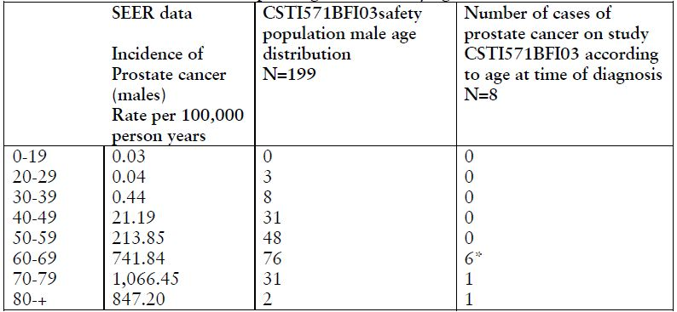

*One case is excluded as pre existing prostate cancer: this patient had a PSA of 15.7ng/ml prior to onset of imatinib. This is consistent with pre existing prostate cancer; however the patient was reported to be diagnosed with prostate cancer after start of imatinib therapy.

This descriptive analysis has several limitations. First, it does not take into account the exposure period to imatinib or the duration of time since imatinib was initiated compared to the diagnosis of prostate cancer. Second, there is a bias in that patients in clinical trials are more likely to be diagnosed with concurrent medical conditions than the general population due to ongoing thorough medical evaluation. Third, when examining multiple different types of events, it is likely that some apparent associations might occur “by chance” due to natural variability. Finally, an interpretation of the observed prostate cancer incidence should also be viewed in the context of low absolute numbers of patients with the disease in a single, relatively small study. Novartis commits to providing an epidemiology report on the association between imatinib and prostate cancer when this becomes available. Please note that this report is not specific to prostate cancer. It will contain additional data on the frequency of second primary malignancies including prostate cancer.

##### Concluding remarks

Novartis welcomes the Delegate’s recommendation to approve the extension of treatment to 3 years of Glivec for the adjuvant treatment of adult patients following complete gross restriction of KIT (CD117) positive primary GIST. Novartis do not believe that the indication should be restricted to high risk patients as a benefit is also observed in patients that have a lower risk categorisation. Furthermore, we have presented a viable alternative that aligns with the treatment practice and the risk/benefit observed in the pivotal trial.

#### Advisory committee considerations

The ACPM (which has succeeded ADEC), taking into account the submitted evidence of efficacy, safety and quality, agreed with the delegate and considered these products to have an overall positive benefit-risk profile for the approved indications to include duration of treatment of up to 3 years for the restricted indications of:

*Adjuvant treatment of adult patients at high risk of recurrence following complete gross resection of* KIT *(CD 117) – positive primary GIST (See Clinical Trials)*

The ACPM agreed with the Delegate to the proposed amendments to the PI and Consumer Medicine Information (CMI) and specifically advised on the inclusion of the following:

* a statement in the Drug Interactions section of the PI and relevant section of the CMI to reflect the potential concerns with paracetamol.

The ACPM agreed with the Delegate on the proposed conditions of registration. The ACPM advised that the implementation by the sponsor of the recommendations outlined above to the satisfaction of the TGA, in addition to the evidence of efficacy and safety provided would support the safe and effective use of these products.

### Outcome

Based on a review of quality, safety and efficacy, TGA approved the registration of Glivec containing imatinib (as mesylate) for the new duration of adjuvant treatment in gastrointestinal stromal tumours (GIST) to 3 years.

The full indications are:

Glivec is indicated for the treatment of:

* patients with chronic myeloid leukaemia (CML).
* patients with KIT (CD117) positive unresectable and/or metastatic malignant gastrointestinal stromal tumours (GIST).
* adjuvant treatment of adult patients at high risk of recurrence following complete gross resection of KIT (CD117) positive primary GIST (see Dosage and Administration and Clinical Trials).
* adult patients with newly diagnosed Philadelphia chromosome positive acute lymphoblastic leukaemia (Ph+ ALL) integrated with chemotherapy.
* adult patients with relapsed or refractory Ph+ ALL as monotherapy.
* adult patients with myelodysplastic/myeloproliferative diseases (MDS/MPD) associated with platelet derived growth factor receptor (PDGFR) gene rearrangements, where conventional therapies have failed.
* adult patients with aggressive systemic mastocytosis (ASM) where conventional therapies have failed.
* adult patients with hypereosinophilic syndrome (HES) and/or chronic eosinophilic leukaemia (CEL).
* adult patients with unresectable, recurrent and/or metastatic dermatofibrosarcoma protuberans (DFSP).

#### Specific conditions of registration applying to these therapeutic goods:

1. The implementation in Australia of the imatinib (as mesylate) RMP, version 5, data lock point 10 May 2011, and an Australian Specific Annex version 5, dated 4 November 2011, and any subsequent revisions, as agreed with the TGA and its OPR.
2. The epidemiology report on the association between imatinib and secondary cancers including prostate cancer is to be submitted when available (due December 2012).

## Attachment 1. Product Information

The following Product Information was approved at the time this AusPAR was published. For the current Product Information please refer to the TGA website at <http://www.tga.gov.au/hp/information-medicines-pi.htm>.

## Attachment 2. Extract from the Clinical Evaluation Report

1. Joensuu H, *et al.* (2012) One vs three years of adjuvant imatinib for operable gastrointestinal stromal tumor: a randomized trial. *JAMA* 307: 1265-1272.
2. European Medicines Agency, “Guideline on the evaluation of anticancer medicinal products in man (EMA/CHMP/205/95/rev.4)”, 15 December 2011, Web, accessed 19 February 2013 <www.ema.europa.eu/docs/en_GB/document_library/Scientific_guideline/2011/12/WC500119966.pdf>.
3. Joensuu H. (2008) Risk stratification of patients diagnosed with gastrointestinal stromal tumor. *Hum Pathol.* 39: 1411-1419.
4. Demetri GD, *et al*. (2007) NCCN Task Force report: management of patients with gastrointestinal stromal tumor (GIST)--update of the NCCN clinical practice guidelines. *J Natl Compr Canc Netw.* 5 Suppl 2:S1-29; quiz S30; DeMatteo RP, *et al*. (2000) Two hundred gastrointestinal stromal tumors: recurrence patterns and prognostic factors for survival. *Ann Surg.* 231: 51-58.
5. SSG: Swedish Sarcoma Group. AIO: Sarcoma Group of the Arbeitsgemeinschaft Internistische Onkologie (German Association of Oncology Physicians).
6. Joensuu H, *et al*. (2012) One vs three years of adjuvant imatinib for operable gastrointestinal stromal tumor: a randomized trial. *JAMA* 307: 1265-1272.
7. Hassan I, *et al*. (2008) Surgically managed gastrointestinal stromal tumors: a comparative and prognostic analysis. *Ann Surg Oncol.* 15: 52-59.
8. Glivec PSUR, 2 July 2012.
9. van Glabbeke MM, *et al*. (2007) Comparison of two doses of imatinib for the treatment of unresectable or metastatic gastrointestinal stromal tumors (GIST): A meta-analysis based on 1,640 patients (pts) [abstract]. *J Clin Oncol.* 25 (18S June 20 Suppl): 10004; Blanke CD, *et al*. (2008) Phase III randomized, intergroup trial assessing imatinib mesylate at two dose levels in patients with unresectable or metastatic gastrointestinal stromal tumors expressing the kit receptor tyrosine kinase: S0033. *J Clin Oncol.* 26: 626-632.
10. van Glabbeke MM, *et al.* (2007) Comparison of two doses of imatinib for the treatment of unresectable or metastatic gastrointestinal stromal tumors (GIST): A meta-analysis based on 1,640 patients (pts) [abstract]. *J Clin Oncol.* 25 (18S June 20 Suppl): 10004; Blanke CD, *et al.* (2008 )Phase III randomized, intergroup trial assessing imatinib mesylate at two dose levels in patients with unresectable or metastatic gastrointestinal stromal tumors expressing the kit receptor tyrosine kinase: S0033. *J Clin Oncol.* 26: 626-632.
11. Blanke CD, *et al.* (2008) Long-term results from a randomized phase II trial of standard- versus higher-dose imatinib mesylate for patients with unresectable or metastatic gastrointestinal stromal tumors expressing KIT. *J Clin Oncol.* 26: 620-625; Deininger M, *et al.* (2009) International randomized study of interferons vs STI571 (IRIS) 8-year follow up: Sustained survival and low risk for progression or events in patients with newly diagnosed chronic myeloid leukemia in chronic phase (CML-CP) treated with imatinib. *Blood* (ASH Annual Meeting Abstracts) 114: Abstract 1126; van Mehren M, *et al.* (2011) Follow-up results after 9 years of the ongoing phase II B2222 trial of imatinib mesylate in patients with metastatic or unresectable KIT+ gastrointestinal stromal tumors (GIST) [poster], 47th Annual Meeting of the American Society of Clinical Oncology, 3-7 June, Chicago (IL) USA.
12. van Mehren M, *et al.* (2011) Follow-up results after 9 years of the ongoing phase II B2222 trial of imatinib mesylate in patients with metastatic or unresectable KIT+ gastrointestinal stromal tumors (GIST) [poster], 47th Annual Meeting of the American Society of Clinical Oncology, 3-7 June, Chicago (IL) USA.
13. Blay JY, *et al*. (2007) Prospective multicentric randomized phase III study of imatinib in patients with advanced gastrointestinal stromal tumors comparing interruption versus continuation of treatment beyond 1 year: the French Sarcoma Group. *J Clin Oncol.* 25: 1107-1113.
14. Blanke CD, *et al.* (2008) Long-term results from a randomized phase II trial of standard- versus higher-dose imatinib mesylate for patients with unresectable or metastatic gastrointestinal stromal tumors expressing KIT. *J Clin Oncol.* 26: 620-625; Deininger M, *et al.* (2009) International randomized study of interferons vs STI571 (IRIS) 8-year follow up: Sustained survival and low risk for progression or events in patients with newly diagnosed chronic myeloid leukemia in chronic phase (CML-CP) treated with imatinib. *Blood* (ASH Annual Meeting Abstracts) 114: Abstract 1126.