|  |
| --- |
| **January 2014** |

|  |
| --- |
| Australian Public Assessment Report for Imatinib |
| Proprietary Product Name: Glivec |
| Sponsor: Novartis Pharmaceuticals Australia Pty Ltd |

About the Therapeutic Goods Administration (TGA)

* The Therapeutic Goods Administration (TGA) is part of the Australian Government Department of Health, and is responsible for regulating medicines and medical devices.
* The TGA administers the *Therapeutic Goods Act 1989* (the Act), applying a risk management approach designed to ensure therapeutic goods supplied in Australia meet acceptable standards of quality, safety and efficacy (performance), when necessary.
* The work of the TGA is based on applying scientific and clinical expertise to decision-making, to ensure that the benefits to consumers outweigh any risks associated with the use of medicines and medical devices.
* The TGA relies on the public, healthcare professionals and industry to report problems with medicines or medical devices. TGA investigates reports received by it to determine any necessary regulatory action.
* To report a problem with a medicine or medical device, please see the information on the TGA website <<http://www.tga.gov.au>>.

About AusPARs

* An Australian Public Assessment Record (AusPAR) provides information about the evaluation of a prescription medicine and the considerations that led the TGA to approve or not approve a prescription medicine submission.
* AusPARs are prepared and published by the TGA.
* An AusPAR is prepared for submissions that relate to new chemical entities, generic medicines, major variations, and extensions of indications.
* An AusPAR is a static document, in that it will provide information that relates to a submission at a particular point in time.
* A new AusPAR will be developed to reflect changes to indications and/or major variations to a prescription medicine subject to evaluation by the TGA.

Copyright

© Commonwealth of Australia 2014  
This work is copyright. You may reproduce the whole or part of this work in unaltered form for your own personal use or, if you are part of an organisation, for internal use within your organisation, but only if you or your organisation do not use the reproduction for any commercial purpose and retain this copyright notice and all disclaimer notices as part of that reproduction. Apart from rights to use as permitted by the *Copyright Act 1968* or allowed by this copyright notice, all other rights are reserved and you are not allowed to reproduce the whole or any part of this work in any way (electronic or otherwise) without first being given specific written permission from the Commonwealth to do so. Requests and inquiries concerning reproduction and rights are to be sent to the TGA Copyright Officer, Therapeutic Goods Administration, PO Box 100, Woden ACT 2606 or emailed to <[tga.copyright@tga.gov.au](mailto:tga.copyright@tga.gov.au)>.

Contents

I. Introduction to product submission 4

Submission details 4

Product background 4

Regulatory status 5

Product Information 6

II. Quality findings 6

III. Nonclinical findings 6

IV. Clinical findings 6

Introduction 6

Scope of the clinical dossier 6

Pharmacokinetics 7

Pharmacodynamics 9

Dosage selection for the pivotal studies 9

Efficacy 9

Safety 15

First round benefit-risk assessment 22

First round recommendation regarding authorisation 23

Clinical questions 23

Second round evaluation of clinical data submitted in response to questions 24

V. Pharmacovigilance findings 26

Risk management plan 26

VI. Overall conclusion and risk/benefit assessment 29

Quality 30

Nonclinical 30

Clinical 30

Risk management plan 37

Risk-benefit analysis 37

Outcome 40

Attachment 1: Product Information 41

Attachment 2: Extract from the Clinical Evaluation Report 41

## I. Introduction to product submission

### Submission details

|  |  |  |
| --- | --- | --- |
| *Type of submission:* | Extension of Indications | |
| *Decision*: | Approved | |
| *Date of decision:* | 21 August 2013 | |
| *Active ingredient:* | Imatinib |
| *Product name:* | Glivec |
| *Sponsor’s name and address:* | Novartis Pharmaceuticals Australia Pty Ltd 54 Waterloo Road NORTH RYDE NSW 2113 |
| *Dose forms:* | Hard gelatine capsules, film-coated tablets |
| *Strengths:* | 50 mg and 100 mg capsules; 100 mg and 400 mg tablets |
| *Container:* | Blister pack |
| *Pack sizes:* | 78441: 24, 48, 96, 120 and 180 capsules; 78442: 30 capsules; 94216: 60 and 180 tablets; 94217: 30 tablets. |
| *New approved therapeutic use:* | Treatment of paediatric patients with newly diagnosed Philadelphia chromosome positive acute lymphoblastic leukaemia (Ph+ ALL) integrated with chemotherapy. |
| *Route of administration:* | Oral |
| *Dosage (abbreviated):* | A dose of 340mg/m2 daily is recommended for children with Ph+ ALL not to exceed a total dose of 600mg/day. Treatment can be given as a once daily dose. |
| *ARTG numbers:* | 78441, 78442, 94216 and 94217 |

### Product background

Imatinib is a small molecule protein tyrosine kinase inhibitor. It inhibits the activity of several tyrosine kinases: c-Kit, the receptor for stem cell factor coded by the c-Kit proto-oncogene; the platelet derived growth factor receptors alpha and beta (PDGFR alpha and PDGFR beta); the Abelson Murine Leukemia viral oncogene homolog (ABL) family of non-receptor tyrosine kinases consisting of ABL1 and ABL2; the discoidin domain receptors DDR1 and DDR2 which are receptors for collagen; and c-Fms the receptor for macrophage stimulating factor.

Imatinib was first registered on 13 August 2001 and has been approved in Australia for the treatment of a number of solid tumour and haematological conditions where tyrosine kinases play a role in the disease. The indications approved currently are:

Glivec is indicated for the:

* treatment of patients with chronic myeloid leukaemia (CML)
* treatment of adult patients with newly diagnosed Philadelphia chromosome positive acute lymphoblastic leukaemia (Ph+ ALL) integrated with chemotherapy
* treatment of adult patients with relapsed or refractory Ph+ ALL as monotherapy
* treatment of adult patients with myelodysplastic/myeloproliferative diseases (MDS/MPD) associated with platelet-derived growth factor receptor (PDGFR) gene re-arrangements, where conventional therapies have failed
* treatment of adult patients with aggressive systemic mastocytosis (ASM), where conventional therapies have failed
* treatment of adult patients with hypereosinophilic syndrome (HES) and/or chronic eosinophilic leukaemia (CEL)
* treatment of patients with Kit (CD117) positive unresectable and/or metastatic malignant gastrointestinal stromal tumours (GIST)
* adjuvant treatment of adult patients at high risk of recurrence following complete gross resection of KIT (CD117)-positive primary GIST (see *Dosage and Administration* and *Clinical Trials*)
* adult patients with unresectable, recurrent and/or metastatic dermatofibrosarcoma protuberans (DFSP).

Use of Glivec for the treatment of patients with newly diagnosed PH+ ALL is already approved in adult patients (see above). This AusPAR describes the application by Novartis Pharmaceuticals Australia Pty Ltd (the sponsor) to extend the use of Glivec in the treatment of Ph+ ALL to paediatric patients. The proposed additional indication is as follows:

*treatment of paediatric patients with newly diagnosed Philadelphia chromosome positive acute lymphoblastic leukaemia (Ph+ ALL) integrated with chemotherapy*

ALL is the most common malignancy in children, accounting for 25% of paediatric cancers. Ph+ ALL is characterised by presence of the Philadelphia chromosome, that is, reciprocal translocation t(9;22)(q34;q11), resulting in the BCR-ABL fusion gene and expression of the BCR-ABL protein. Ph+ ALL accounts for up to 5% of paediatric ALL.

Imatinib (Glivec) for the *treatment of Philadelphia-positive acute lymphoblastic leukaemia (Ph+ ALL)* was designated an Orphan Drug by the TGA in May 2006.

### Regulatory status

The product received initial registration on the Australian Register of Therapeutic Goods (ARTG) on 13 August 2001.

The overseas status for similar applications at the time the TGA considered this application is shown in Table 1.

Table 1: International regulatory status

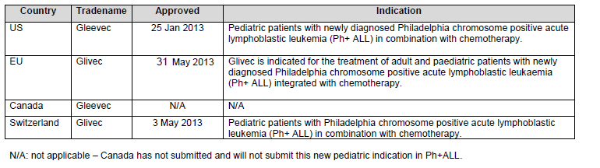

### Product Information

The approved Product Information (PI) current at the time this AusPAR was prepared can be found as Attachment 1.

## II. Quality findings

There was no requirement for a quality evaluation in a submission of this type.

## III. Nonclinical findings

There was no requirement for a nonclinical evaluation in a submission of this type.

## IV. Clinical findings

A summary of the clinical findings is presented in this section. Further details of these clinical findings can be found in Attachment 2.

### Introduction

Imatinib is currently approved in over 110 countries for the treatment of both haematological or malignancies in solid tumours. Imatinib is already approved in a paediatric indication namely Philadelphia chromosome positive chronic myelogenous leukaemia (Ph+ CML) in blast crisis, accelerated phase or chronic phase after failure of Interferon/alpha therapy. The recommended dose is 340 mg/m2 daily. Imatinib is also currently approved in the European Union (EU) for the treatment of adult patients with newly diagnosed Ph+ ALL integrated with chemotherapy at a recommend dose of 600 mg/day. Imatinib is also approved in the EU and the US for the treatment of adult patients with relapsed or refractory Ph+ ALL.

The pivotal Study ST1571I2301 (Study 2301) is presented as a pivotal study supporting efficacy and safety in the treatment of newly diagnosed ALL in very high risk (VHR) paediatric patients. Also presented as a supportive study, Study A1T07 was undertaken with newly diagnosed Ph+ ALL patients who were both good and poor risk. However because of problems with randomisation and patient accrual the study has been determined as appropriate for assessment for safety only in the present submission.

### Scope of the clinical dossier

The submission contained the following clinical information:

A pooled population pharmacokinetic (PopPK) analysis from four studies involving patients with Ph+ CML, Ph+ ALL and other haematological disorders as indicated in Table 2. Also provided is a physiologically based PK (PBPK) model involving paediatric patients from the ages of 1 to 18 years.

Table 2: Summary of clinical and PK studies and PBPK analyses included in the submission

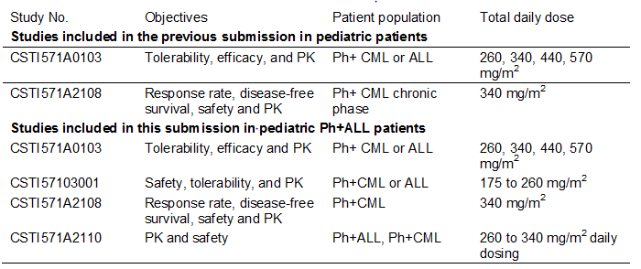

The pivotal study for evaluation of efficacy and safety was Study 2301 in newly diagnosed ALL, VHR patients.

Also provided is a supportive Study A1T07 which was in newly diagnosed Ph+ ALL patients of both good and poor risk. The data provided in relation to efficacy for the supportive study is extremely limited and was therefore not considered to be satisfactory for evaluation. The safety data is considered pertinent.

#### Paediatric data

All the data presented in this submission is in relation to paediatric patients. This includes all pharmacological analyses together with the data from the pivotal Study 2301 and various supportive studies.

#### Good clinical practice

All aspects of good clinical practice have been observed in the pivotal study and supportive studies.

### Pharmacokinetics

#### Studies providing pharmacokinetic data

The clinical pharmacology of imatinib has previously been extensively described in previous applications for imatinib in newly diagnosed CML in adult and paediatric patients and patients with gastrointestinal stromal tumours (GIST). An overview of the studies which support the clinical pharmacology of imatinib in the paediatric Ph+ ALL indication is shown in Table 3.

Table 3: Summary of clinical studies included in the previous submission and this submission



The PopPK analysis was conducted in paediatric patients aged 2 to 18 years with haematological disorders including CML, Ph+ ALL, or other imatinib-indicated haematological disorders in four clinical studies: CSTI571A0103, CSTI57103001, CSTI571A2108, and CSTI571A2110. Since the 100 mg and 400 mg tablet formulations were bioequivalent with the 100 mg hard gelatine capsule, it is appropriate to pool PK data from the above four studies into a single PopPK analysis.

The PBPK modelling report did not use any clinical data and was based on physiological simulation. The PBPK model quantitatively assessed the effect of developmental pharmacology on systemic exposure of imatinib in paediatric patients. The objectives of the PBPK modelling report were:

* to predict paediatric PK using the PBPK approach based on the imatinib clearance in adult population, then compare the results with the experimentally observed values;
* to predict imatinib plasma concentration-time profiles in plasma and tissue in paediatric subjects, and to assess the effect of paediatric growth processes using the PBPK model developed;
* to evaluate factors influencing imatinib exposure in paediatric patients, with particular attention to children in the age range of 1-2 years.

##### Pooled population pharmacokinetic modelling report:

Clearance of imatinib was found to increase with increasing body surface area (BSA) supporting a BSA based dosing scheme for imatinib in paediatric patients. The various cohorts analysed did not have clinically significant effects after correcting for BSA effects. This model corresponds well with the observed data when compared to an adult model and shows that the final model is able to successfully extrapolate to younger children between the ages of 2 and 4 years as well as adults. It is therefore reasonable to conclude that the current dosing schemes of 260 mg/m2 or 340 mg/m2, not to exceed 400 mg or 600 mg, respectively, are applicable for patients aged 1 year or older.

##### Physiologically based PK modelling report

The projection of paediatric exposure to imatinib using a PBPK model was generally in good agreement with the actual measured PK exposure values in a limited number of paediatric patients ranging from age 2 to 18 years. Incorporation of the PK parameters and maturation processes within the model gave reasonable description of imatinib PK in paediatrics from 2 to 18 years. The exposure for a 1 year subject is likely to be over predicted using the PBPK model based on some bias seen in predictions for ages 2 and 3 years. No major exposure–related safety concerns would be expected in dosing if dosed according to BSA.

##### Study A2110

The minimum concentration (Cmin) values from this study in the three paediatric patients were consistent with simulated values from the PopPK model.

### Pharmacodynamics

#### Studies providing pharmacodynamic data

No new pharmacodynamic data in relation to paediatric patients was undertaken or determined in this evaluation.

### Dosage selection for the pivotal studies

No specific dose finding data was performed in the Ph+ ALL setting. The choice of once daily dosing with imatinib 340 mg/m2 for the pivotal study was based on the results of a Central Oncology Group (COG) paediatric Phase I study in Ph+ leukaemia which included 14 chronic phase CML patients, seven acute myeloid leukaemia (AML) patients and 10 ALL patients. Among the 10 ALL patients seven achieved an M1[1] marrow response and one achieved an M2 marrow response with the recommended dose. PK analyses showed that the doses of 260 mg and 340 mg/m2 had exposures similar to those observed in adults treated daily at 400 mg and 600 mg. The study also showed that daily oral imatinib was well tolerated in children at doses ranging from 260 to 570 mg/m2. An intermediate dose of 340 mg/m2 was therefore adopted for the pivotal Study 2301.

It was also noted that from the PopPK modelling, the model based simulation of various dosing schemes confirmed that the exposure of imatinib in paediatric patients receiving 260 mg/m2 not exceeding 400 mg once daily or 340mg/m2 once daily not exceeding 600 mg once daily is comparable to those in adult patients receiving 400 mg or 600 mg once daily, respectively.

### Efficacy

#### Studies providing efficacy data

The submission was based on efficacy and safety data from the pivotal Phase III Study 2301.

A further Study AIT07 (a Phase II/Phase III trial) was a multi-centre study initially designed as an open label randomised study to determine whether the addition of imatinib to standard chemotherapy extended disease free survival (DFS) in paediatric patients with Ph+ ALL. However after the publication of the results from Study 2301 demonstrating a significant benefit of adding imatinib to chemotherapy for paediatric patients of all risk for Ph+ ALL, the participating groups considered it unacceptable to randomise patients into chemotherapy only arms. The protocol was therefore amended so that patients received imatinib regardless of risk category. This meant the sample size is inadequate to properly test for the primary efficacy analysis. The sponsor has not included this study in the efficacy evaluation. The clinical evaluator included the efficacy data available but accepted the fact that it represents very limited value in terms of determining the role of imatinib in the treatment of paediatric patients with Ph+ ALL.

##### Pivotal efficacy Study 2301

The pivotal Study 2301 was sponsored, designed and conducted by the cooperative group COG. The primary objective of this study was to determine the feasibility of patient equivalent toxicity of an intensified chemotherapy regimen and incorporating novel agents for the treatment of children and young adults with VHR ALL including Ph+ ALL. The study consisted of five cohorts each receiving the same intensive chemotherapy regimen back bone post-induction therapy that varied in the integration of imatinib treatment by increasing exposure in five sequential cohorts and is indicated in Table 4.

Table 4: Integration of imatinib into successive blocks of therapy (STI571I2301)

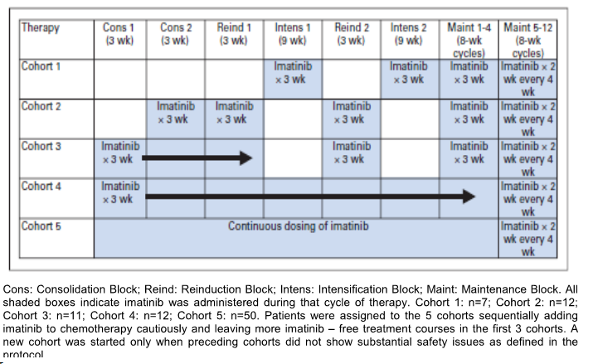

Positive interim results showed acceptable tolerability and superior efficacy for patients in Cohort 5 which led to an amendment that increased the sample size in the group of Ph+ ALL patients receiving continuous imatinib treatment. A subsequent interim analysis demonstrated that earlier administration and higher cumulative doses of imatinib were associated with improved one year event free survival (EFS; defined as relapse at any site, secondary malignancy, and death from any cause after study entry) in all cohorts with the best results being observed in patients treated with continuous dosing in Cohort 5 (95.3%, n = 50) which was higher than that in the historical controls (65.7%, n = 56). At a later date COG performed another analysis at the cut off date of 31 October 2008 with a primary end point of three years EFS in Ph+ ALL patients. This demonstrated three year EFS results for Cohort 5 at 80% with observed EFS rate more than twice that of historical controls at 35% (n = 120).

Accordingly a statistical analysis plan in December 2009 performed additional analyses in Cohort 5 with a cut off date of 5 September 2009 with a primary end point of EFS and this was assessed in the context of data from historical controls.

The pivotal Study 2301 was a multi-centre Phase III open label sequential cohort non-randomised study which involved paediatric and young adult patients of less than 22 years with VHR ALL defined as five year EFS of less than 45% the large majority of whom had the Ph+ subtypes. A summary of study end points is indicated in Table 5.

Table 5: Summary of endpoints for Study STI571I2301

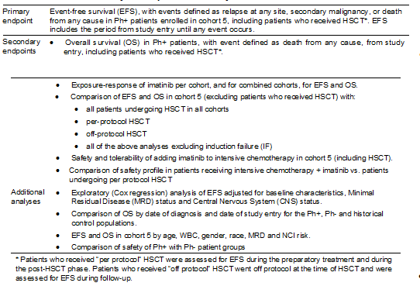

The study design is indicated in Figure 1:

Figure 1: Study design STI571I2301

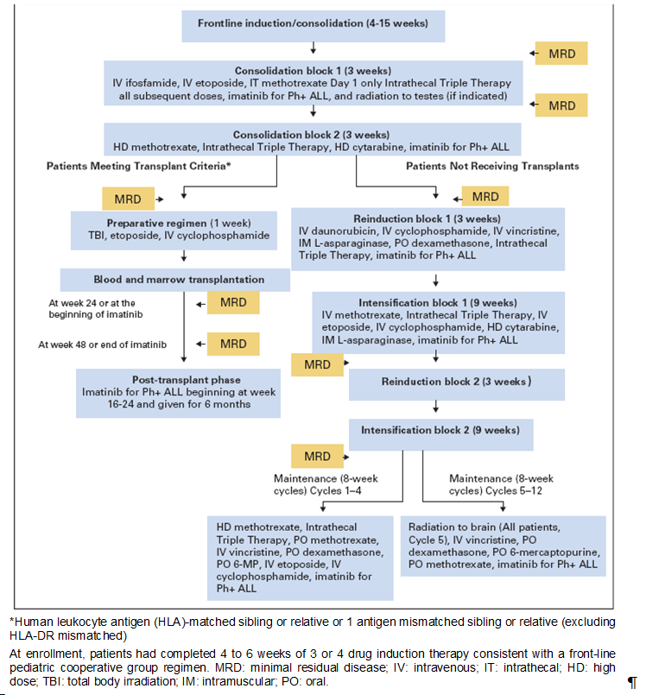

Breakdown of the population analysis for the 160 patients initially entered on to trial is indicated in Figure 2:

Figure 2: Patient Population in Study 2301

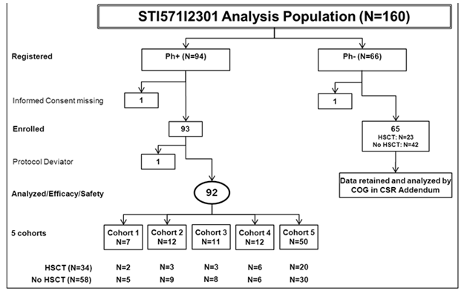

All patients in this study received an initial intensive chemotherapy regimen. The Ph+ patients received imatinib integrated with intensive chemotherapy in successive blocks of increasing imatinib exposure depending on the cohort as indicated in Table 4. In Cohorts 1 to 4 imatinib was given at 340 mg/m2 in three week blocks while in Cohort 5 imatinib was given at 340mg/m2 per day continuously except during Maintenance Blocks 5 through 12 which consisted of two week imatinib blocks every four weeks.

The historical control data set for the analyses presented in this submission included 120 Ph+ ALL patients previously enrolled in five clinical trials performed by the COG.

Imatinib had its highest impact on EFS in patients with Ph+ ALL when administered early on in the course of treatment and for a longer duration, with the best results noted in Cohort 5 (n=50): the 48 month EFS rate for Cohort 5 was 69.6% which was more than twice that of the historical controls with 31.6% and a hazard ratio (HR) 0.28% log rank P < 0.0001 as indicated in Table 6.

Table 6: Event-free survival in Cohort 5 (Efficacy set – STI571I2301) and in historical control

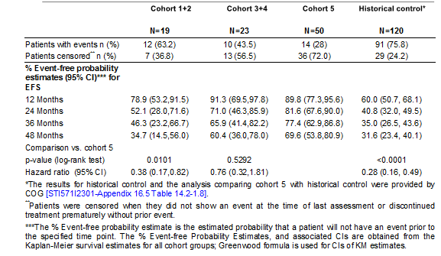

Comparison of overall survival (OS) for the various cohorts compared to the historical controls is summarised in Table 7. The estimated overall 48 month survival rate in Cohort 5 was 83.6% compared to a rate of 44.8% for the historical controls. This compared to an OS at 48 months of 49.2% for Cohorts 1 and 2 and 74.7% for Cohorts 3 and 4.

Table 7: Overall survival in Ph+ cohorts (Efficacy set – STI571I2301) and historical control

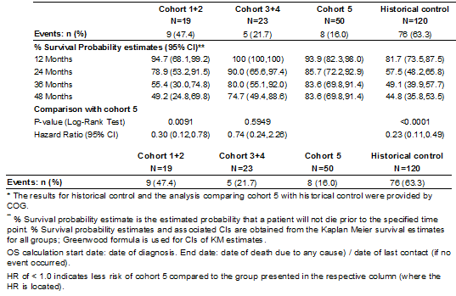

##### Evaluator’s conclusions on pivotal efficacy study STI571I2301

These data have clearly shown that for patients in Cohort 5 of the pivotal study there was a highly significant benefit for the use of imatinib plus chemotherapy compared to the historical controls in relation to both EFS and OS. Sub-group analyses confirmed this data. There was also a lesser but again significant benefit between Cohort 5 and Cohorts 1 + 2 who only had limited exposure to imatinib. The evaluator recognised the fact that this is a relatively uncommon disease and that an appropriately randomised study would have been very difficult to conduct. The choice of historical controls however does raise some concerns particularly in the context that these came from various COG studies involving earlier chemotherapy protocols. The chemotherapy involved in induction for patients on Study 2301 was extremely intensive involving quite a large number of agents which raises the question whether the intensity of induction therapy may not have been a significant factor in determining EFS and OS irrespective of the role of imatinib. This would benefit from further evaluation.

#### Supportive study AIT07

Study AIT07 was an open labelled randomised Phase II/III Study assessing safety and efficacy of imatinib with chemotherapy in paediatric patients with Ph+ ALL and was performed between January 2004 and November 2010 involving 10 paediatric leukaemia study groups. The primary objective of this study was to evaluate the DFS in the good risk group of patients treated either with or without imatinib in correlation with intensive chemotherapy including the option of hematopoietic stem cell transplant (HSCT). The randomisation component involved chemotherapy plus imatinib or chemotherapy alone for the good risk patients. A total of 229 patients who were randomised were registered for the study and among the 213 eligible patients 35 were not entered onto the study. Of the 178 eligible patients 108 were good risk patients. Of these 108 patients 18 were not randomised due to clinical decision and patient refusal and only 90 patients were randomised to imatinib plus chemotherapy or chemotherapy alone.

The study was terminated early because of recognition of the results from the pivotal Study 2301 and a decision that no further randomisation was appropriate. This resulted in an insufficient sample size to properly test for the primary efficacy analysis. Nevertheless in relation to the primary end point of DFS, six out of 44 or 14% of chemotherapy alone patients and four out of 46 or 9% of chemotherapy plus imatinib patients had a DFS event. This was not statistically significantly different. The estimated DFS rates at 24 months were comparable in the good-risk/no imatinib arm (65%) and good-risk/imatinib arm (81%), with very similar and wide confidence intervals of the estimated rates in both groups.

It is noted that over 80% of patients had undergone HSCT significantly influencing the results, but when DFS was assessed not censoring for HSCT, 16 of 44 or 36% of the good risk patients receiving chemotherapy alone and 12 of 46 or 26% receiving chemotherapy plus imatinib had a DFS event. At the end of 24 months the estimated DFS rate was 68% in non-imatinib arm and 79% in the Imatinib arm.

In relation to OS at 48 months, in the good risk imatinib patients it was 85% which was slightly higher than the non-imatinib patients at 73%.

##### Evaluator’s conclusions on supportive study AIT07

These data did not provide any further evidence supporting the role of imatinib in the maintenance phase of patients having undergone intensive chemotherapy induction for Ph+ ALL. Nevertheless, as determined by the sponsor and investigators, the data are difficult to interpret and thereby provides little to the significance of the results from the pivotal Study 2301.

### Safety

#### Studies providing safety data

The submission presented safety data from 220 Ph+ ALL paediatric patients treated with imatinib from two studies, that is, the pivotal Study 2301 involving 92 imatinib treated patients and a supportive Study AIT07 involving 128 imatinib treated patients. As there was substantial differences in design for the two studies, data regarding safety are presented separately. The safety population was defined as patients who received at least one dose of study drug. The safety population was 92 patients for Study 2301 and 128 for Study AIT07. The study design and population for the pivotal study have been presented (Figure 1 and Figure 2) and for the supportive Study AI07 these are indicated in Table 8.

Table 8: Summary of study STI571AI07

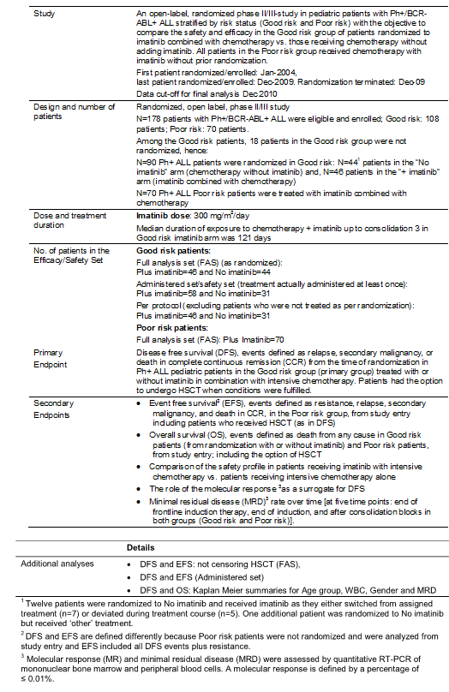

#### Summary of patient/drug exposure

In relation to exposure in the pivotal study, median exposure to imatinib for Cohorts 1 to Cohort 5 among patients who did not undergo HSCT, range from 176 days for Cohort 1 to 708 days for Cohort 5. In the non HSCT Ph negative (Ph-) patients the median exposure to chemotherapy was 783 days and this is illustrated in Table 9.

Table 9: Overall exposure to imatinib/chemotherapy (Safety set excluding HSCT patients – STI571I2301)

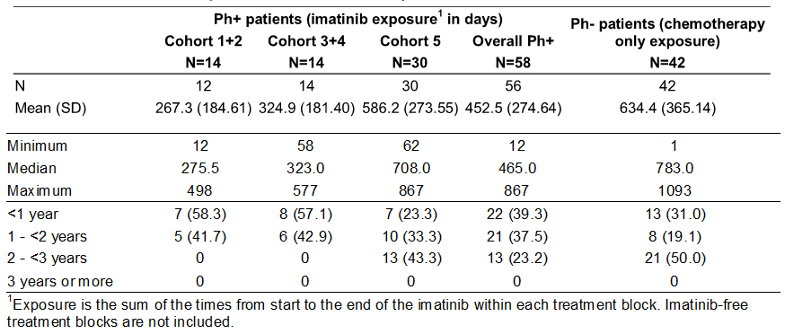

Among the PH+ ALL patients receiving per protocol HSCT the overall median intermittent exposure prior to HSCT was 42 days and with a range of 21 to 77 days and median exposure to imatinib following HSCT was 169 days with a range of 14 to 192 days. Among the Ph+ patients the overall median imatinib exposure prior to patients receiving off protocol HSCT was 53 days with a range of 28 to 165 days.

In relation to Study AIT07 overall treatment exposure for imatinib plus chemotherapy or chemotherapy alone is summarised in Table 10. Median duration of treatment was similar for all patient groups.

Table 10: Overall treatment exposure* (Safety set STI571AIT07)

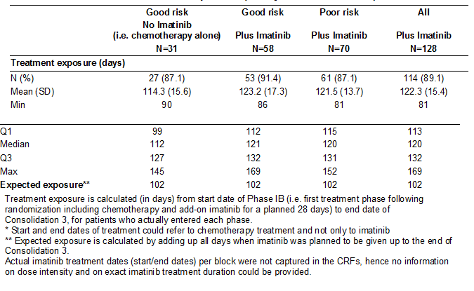

Overall 24 or 77.4% of the good risk patients who received chemotherapy alone, 48 or 82.8% of the good risk patients who received imatinib plus chemotherapy and 61 or 87.1% of the poor risk patients who received imatinib plus chemotherapy underwent HSCT. In total, 109 or 85.2% of patients who received imatinib plus chemotherapy in both good and poor risk patients underwent HSCT in this study. Patients undergoing HSCT did not receive imatinib post HSCT.

The median duration of follow up was similar for good risk patients receiving chemotherapy alone at 38 months with a range two to 72 and patients receiving imatinib plus chemotherapy at 35 months with a range of 2 to 79. As expected, follow time was poor for the poor risk patients at 23 months with a range of four to 79 months. Patients who received imatinib from start of study treatment were followed up to a maximum of 79 months with a median of 30 months.

#### Deaths and serious adverse events

##### Deaths

In relation to deaths, in Study 2301 the deaths and reasons for these are indicated in Tables 11 and 12.

Table 11: Deaths (Safety set – STI571I2301)

Table 11: Deaths (Safety set – STI571I2301)

Table 12: Primary cause of death (Safety set - STI571I2301)

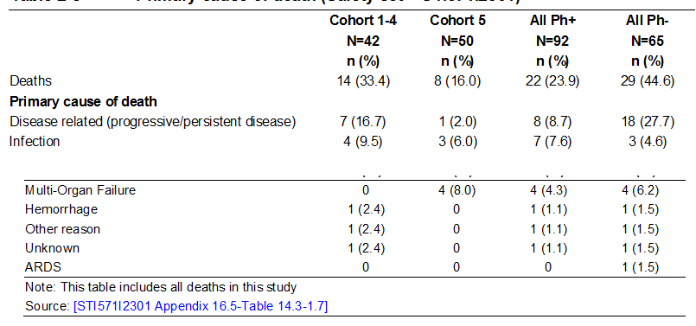

Four deaths occurred on therapy or within 30 days of the last treatment. Of these, two were in patients who were receiving chemotherapy and imatinib and both were related to infection. A further death was related to infection together with respiratory haemorrhage and failure. The final death was also associated with neutropenic infection.

The most common cause of death was progression of malignancy and in particular this was three times more common in the Ph- patients. It is also noted that patients in Cohort 5 with the longest duration of imatinib exposure experienced a lower incidence of deaths than patients in the other four cohorts including those deaths related to progressive disease, infection, haemorrhage and unknown.

In relation to Study AIT07 as indicated in Table 13 a total of 41 deaths occurred during the study with a higher frequency in the poor risk patients (34.3%) compared to the good risk with no imatinib (25.8%) or in good risk with imatinib (15.5%). The reasons for the deaths were generally similar across treatment groups. Again the most common was progressive malignant disease.

Table 13: Deaths and cause of death by Risk and treatment group (Safety Set – STI571AIT07)

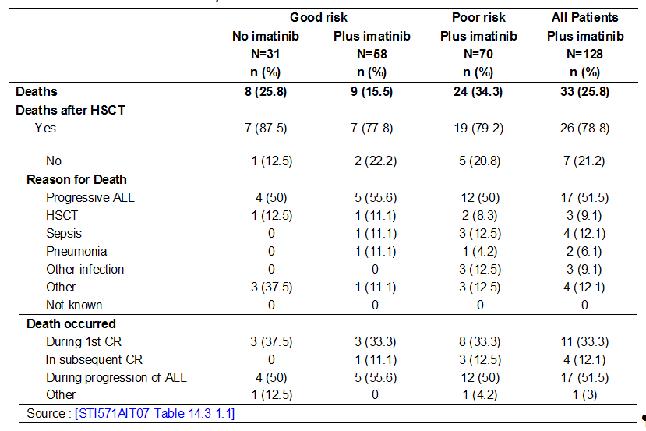

##### Serious adverse events

In relation to serious adverse events (SAEs) the frequency of these by system organ class (SOC) for the pivotal Study 2301 was higher for Cohort 5 patients excluding HSCT at 50% and for all cohort patients who received per protocol HSCT at 33.3% and indicated in Table 14: Adverse Event Expedited Reporting System (AdEERS).

Table 14: AdEERS by system organ class in Cohort 5 excluding HSCT versus all cohorts per protocol HSCT (Safety Set – STI571I2301)

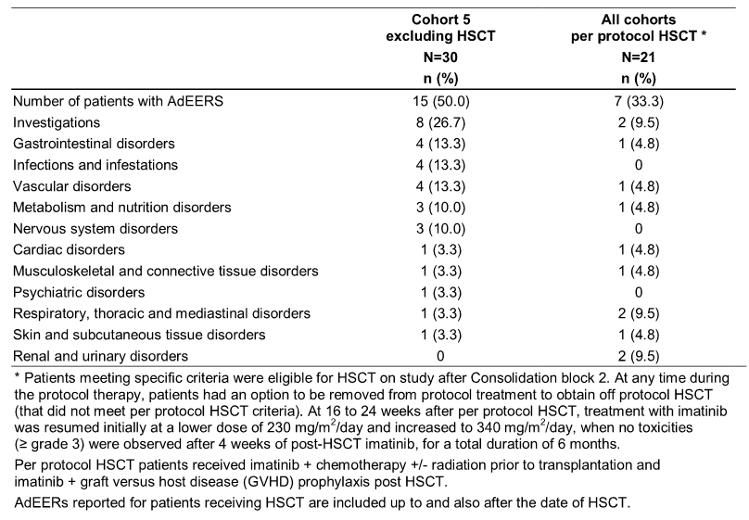

In relation to SAEs for Study AIT07 the proportion of patients who experienced SAEs was similar for patients who received imatinib at 31.3% versus 32.3% for patients not treated with imatinib. The proportion of patients experiencing SAEs was lower in the good risk imatinib group at 27.6% than in the good risk no imatinib group at 32.3%. This latter figure was similar to that for the poor risk group at 34.3% all who had received imatinib. This is illustrated in Table 15. Infections were the most commonly reported SAEs in both risk groups.

Table 15: Serious adverse events regardless of study drug relationship by system organ class and preferred term (Safety set –STI571AIT07)

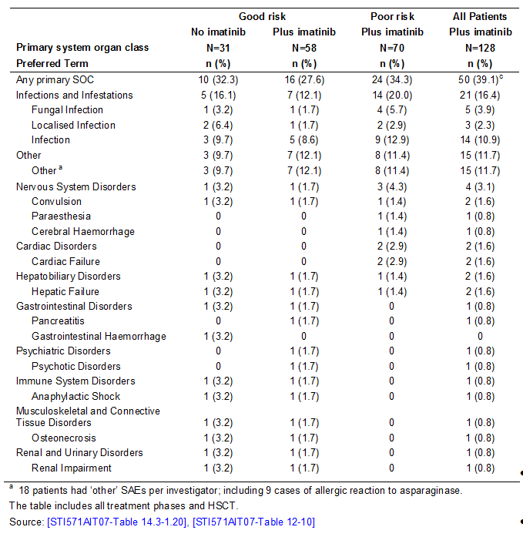

#### Post-marketing data

In relation to post-marketing data a worldwide literature search was performed to capture any investigator reports on safety aspects which were not included in study reports. This did not provide any evidence of unexpected or unknown events that would be attributable to treatment with imatinib, confirming its established safety and tolerability profile.

#### Evaluator’s conclusions on safety

These two studies have essentially shown that the principal impact of AEs relates to the intensive chemotherapy received by the patient. The addition of imatinib resulted in a small increase in potential for selected toxicities in the pivotal Study 2301 but not noted in Study AIT07. Overall the safety profile of imatinib when used in combination with chemotherapy appears to be consistent with the known safety profile of imatinib and consistent with that previously determined for those adult patients with Ph+ ALL receiving imatinib in conjunction with chemotherapy. There was no evidence that younger patients less than 4 years experienced a greater potential for AEs in relation to the use of imatinib.

### First round benefit-risk assessment

#### First round assessment of benefits

The pivotal Study 2301 demonstrated evidence that the addition of imatinib to chemotherapy following initial induction was associated with a prolongation in EFS as the primary end point of this trial. Greater efficacy was apparent for the longer duration of administration of imatinib as determined within Cohort 5 and the estimated 48 month EFS for this Cohort, 69.6%, was more than twice that of historical controls which were 31.6% with an HR of 0.28 and log rank P < 0.0001. There was also evidence of prolongation of OS at 48 months in relation to Cohort 5 compared to historical controls; 83.6% versus 44.8% with an HR of 0.23 and log rank P < 0.0001. There also appears to be significant benefit for patients receiving the longest duration of imatinib as in Cohort 5 when compared with shorter durations in Cohorts 1 and 2, with values being 0.0101 and also similarly for OS with a P value at 0.0091. It is of interest that there was a difference in OS in favour of Cohort 5 excluding HSCT versus HSCT overall at the cohorts both off protocol HSCT and all HSCT showing that the therapeutic benefits in Cohort 5 did not result from a therapeutic effect of HSCT and patients undergoing HSCT did not have better outcomes than patients receiving imatinib in addition to chemotherapy alone.

The data for patients with Ph+ ALL following on from earlier studies demonstrated benefit for the addition of imatinib in Ph+ CML in the paediatric population. Nevertheless the evaluator still had concerns regarding the evidence of benefit for imatinib in the pivotal study as the comparison is with historical controls which were conducted by the COG various years earlier and information regarding the nature and intensity of induction therapies for these studies is not provided. This raises the question as to whether the historical controls represent a comparable group to the study population.

#### First round assessment of risk

The safety profile of imatinib observed in Studies 2301 and AIT07 was consistent with the known safety profile for this agent. The AEs observed also confirmed that the imatinib dosing regimen was therapeutically appropriate for the paediatric patient population and did not adversely impact known drug AE characteristics.

In Study 2301 the overall incidence of preselected targeted toxicities and non-targeted AEs were higher in the Ph+ ALL patients receiving chemotherapy plus imatinib compared with Ph- patients receiving chemotherapy alone. There was however an overall lower frequency of death, that is, 23.9% for patients who received imatinib in contrast with the control group that did not receive imatinib at 44.6%. There were no clinically relevant differences in the development of targeted toxicities and non-targeted AEs between Ph+ and Ph-ALL patients.

In Study AIT07 the overall frequency of AEs including those serious and non-serious was similar between those patients receiving chemotherapy alone versus those who received chemotherapy plus imatinib. There were no clinically relevant differences observed in the nature of AEs across patient groups. There was a small increase in the frequency of AEs between 5 to 10% when comparing the patients treated with imatinib plus chemotherapy to those patients who received chemotherapy alone however the proportion of good risk patients experiencing SAEs was 27.6% and deaths 15.5% which was lower (in the population with imatinib) then the population with chemotherapy alone at 32% and 25% respectively.

It is worth commenting that the four year evaluation data from the pivotal study has not shown any evidence of development of longer term AEs for this paediatric population. Nevertheless, ongoing review of these patients remains appropriate.

It is also noted that the optimum long term duration of administration of imatinib still remains somewhat uncertain both in terms of its potential use in induction as well as longer maintenance therapies for patients with Ph+ ALL.

#### First round assessment of benefit/risk balance

The efficacy results from the pivotal Study 2301 have shown benefit for the addition of imatinib in improving both EFS and OS when compared to historical control. This was most apparent in those who received imatinib for the longest duration of time. These favourable data are in line with that previously observed for paediatric patients with Ph+ CML and adult patients with Ph+ ALL. Nevertheless, the evaluator had some reservation in relation to Study 2301 in regards to the precise comparability of the historical control group to the study group.

Evaluation of AEs from both the pivotal Study 2301 and the supportive Study AIT07 have shown no evidence of an increased potential for AEs in the paediatric population receiving imatinib compared to the known toxicity profile for imatinib in other paediatric populations and adult populations receiving this agent. There is, if anything, some evidence that SAEs and deaths are perhaps reduced by the influence of imatinib in combination with chemotherapy for this paediatric patient population.

### First round recommendation regarding authorisation

On balance the evaluator considered it appropriate to approve imatinib for the proposed new indication for the treatment of adult and paediatric patients with newly diagnosed Ph+ ALL integrated with chemotherapy. This recommendation is made on the basis of the efficacy results and their comparability with adult patients with Ph+ ALL with the addition of imatinib and the paediatric population with Ph+ CML with the addition of imatinib. Nevertheless, the reservations as stated above in relation to the historical control group remain. There is no evidence from evaluation of AEs from the two studies assessed to raise extra concerns regarding the role of imatinib for the Ph+ ALL paediatric population.

### Clinical questions

1. The evaluator sought additional information regarding the nature of induction chemotherapy for the various COG studies utilised as historical controls for the pivotal Study 2301.
2. Further information on the longer term influence of imatinib administration both as part of induction therapy and maintenance therapy for Ph+ ALL would be of interest.

### Second round evaluation of clinical data submitted in response to questions

#### Clinical Question 1: The evaluator seeks additional information regarding the nature of induction chemotherapy for the various COG studies utilised as historical controls for the pivotal trial 2301.

The historical control data used in Study 2301 included 120 newly diagnosed ALL patients previously enrolled in five clinical studies performed by COG and its precursor organisation, the Paediatric Oncology Group (POG), POG 8602 (34 patients), POG 9005 (13 patients), POG 9006 (23 patients), POG 9405 (1 patient), and POG 9406 (49 patients), conducted between 1988 and 1995 (Land *et al* 1994[2], Mahoney *et al* 1998[3], Lauer *et al* 2001[4]).

In all POG/COG protocols (including the pivotal Study 2301), patients received chemotherapy treatment blocks consisting of induction, intensive continuation/consolidation, and maintenance. These chemotherapy regimens were not identical; however induction chemotherapy regimens were very similar across the studies used as historical controls and the pivotal study. As shown in Table 16 below, three chemotherapy drugs (prednisone, vincristine and L-asparaginase), which are widely considered to be the crucial basis of ALL chemotherapy, were consistently used in all studies, with the addition of a fourth drug (daunomycin) in some patients.

Table 16: Chemotherapy drugs used in studies

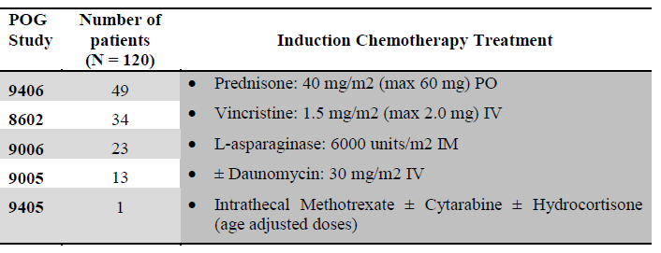

This three-drug induction regimen has historically resulted in high rates of ALL remission and was subsequently used in Study 2301.

#### Clinical Question 2: Further information on the longer term influence of imatinib administration both as part of induction therapy and maintenance therapy for Ph positive ALL would be of interest.

##### Study 2301

The following information is an update on efficacy. Novartis does not have any data and did not conduct any additional analyses beyond the four year cut-off presented in the submission. COG conducted analyses with five year follow-up and a manuscript with these data is being prepared. COG confirmed their five year analyses contain only efficacy data and there is no update on safety. Upon request, COG provided the five year Kaplan-Meier estimates comparing EFS in patients receiving imatinib and chemotherapy with patients receiving related or unrelated bone marrow transplant. Figure 3 compares patients in cohort 5 without HSCT with patients in all cohorts with related or unrelated HSCT. Figure 4 compares patients exclusively within Cohort 5—those without HSCT and those with related or unrelated HSCT. Please note the terms related and unrelated bone marrow transplant (BMT) used by COG in the figures below correspond to the definition of per protocol and off-protocol definitions in Study 2301, respectively. Per protocol HSCT are HSCT with a HLA-matched or one antigen mismatched related donor and off-protocol HSCT are the remainder.

Figure 3: Five year estimated EFS for patients in Cohort 5 without HSCT, patients in all cohorts with related HSCT and patients in all cohorts with unrelated HSCT.

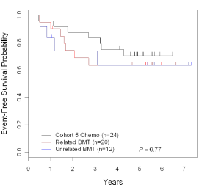

Figure 4: Five year estimated EFS for patients in Cohort 5 without HSCT, patients in Cohort 5 with related HSCT and patients in Cohort 5 with unrelated HSCT

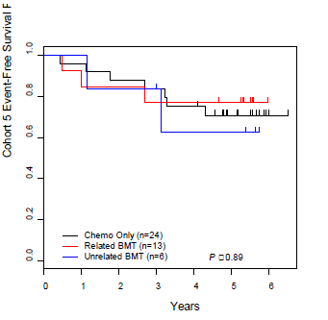

The five year update on efficacy shows that the probability of EFS is comparable between patients receiving only imatinib plus chemotherapy versus patients receiving related HSCT versus patients receiving unrelated HSCT. With one additional year of follow-up it is confirmed that the addition of imatinib to chemotherapy results in comparable long term outcomes to those with HSCT.

No other efficacy updates were provided. No safety updates are available.

##### Study AIT07

The European Intergroup Study on post induction treatment of Ph+ ALL with imatinib (EsPhALL) confirmed that currently there are no plans to analyse efficacy or safety data with longer follow-up.

The sponsor’s response to the clinical questions was evaluated by the Delegate in the Overview for this application (see section on Risk-Benefit Analysis in the AusPAR).

## V. Pharmacovigilance findings

### Risk management plan

The sponsor submitted a Risk Management Plan (RMP; Imatinib Safety Risk Management Plan (Version 5, release date 16 March 2012) and Australian Specific Annex (ASA) Version 2, release date 26 September 2012) which was reviewed by the TGA’s Office of Product Review (OPR).

#### Safety specification

Subject to the evaluation of the clinical aspects of the Safety Specification (SS) by the TGA’s Office of Medicines Authorisation (OMA), the summary of the Ongoing Safety Concerns as specified by the sponsor is as follows:

Table 17: Summary of ongoing safety concerns

|  |  |
| --- | --- |
| Summary of ongoing safety concerns |  |
| **Important identified risks** | Hepatotoxicity  Cardiac Failure  Severe Respiratory Adverse Reactions  Tumour Lysis Syndrome  Growth Retardation in Children |
| **Important potential risks** | Second Malignancies in Survivors  Hypoglycaemia  Tolerability during Pregnancy and Pregnancy Outcomes |
| **Important identified interactions** | Strong CYP3A4 inhibitors  Strong CYP3A4 inducers  Drugs eliminated by CYP3A4 |
| **Important potential interactions** | Drugs eliminated by CYP2C9, CYP2C19 and CYP2D6  Acetaminophen/paracetamol |
| **Important missing information** | Paediatric Patients: long term follow up  Paediatric patients below 2 years of age  Renal Impairment  Hepatic Impairment  Elderly Patients |

It is noted that the summary of ongoing safety concerns has significantly changed compared to the previous version of the RMP (as recently evaluated for a separate application). The current RMP states:

As agreed by European Medicines Agency (EMA), the following important identified and potential risks have been demoted and therefore deleted from all the sections in this RMP: Myelosuppression, Oedema and Fluid retention, central nervous system (CNS) and GI haemorrhage, GI obstruction, perforation or ulceration, Skin Rashes and Severe Cutaneous reaction, Hypothyroidism, Hypophosphatemia, Acute renal failure, Rhabdomyolysis and myopathy, Ovarian haemorrhage and hemorrhagic ovarian cyst, Disseminated intravascular coagulation, and Suicidality.

In their response to TGA’s request for further information, the sponsor should provide more information as to why these previous safety concerns have been deleted from the RMP.

The sponsor should also confirm that the RMP provided with this submission is the current RMP approved by the EMA.

#### Pharmacovigilance plan

Routine pharmacovigilance is proposed to monitor all safety concerns.

Additional pharmacovigilance activities include the following studies:

* For the important identified risk ‘*cardiac failure’* subclinical left ventricular dysfunction will be monitored by echocardiography in the nilotinib registration Study CAMN107A2303 with imatinib as an active comparator.
* For the important identified risk ‘*growth retardation in children’* and important missing information ‘*paediatric patients: long-term follow up’* data will be obtained in the CML registry Study CSTI571A2405 regarding the long-term effects of imatinib treatment on growth, sexual characteristic acquisition and fertility for paediatric patients.
* For the important potential risk ‘*second malignancies in survivors’* there will be extended data collection up to 11 years in a designated registration Study CSTI571A0106.
* For the important potential risk *‘tolerability during pregnancy and pregnancy outcomes’* there is an ongoing pregnancy registry CSTI571A2403.

Australian patients are included in the above protocols. As these studies are ongoing they have not been reviewed in detail for the purposes of this report. However it is expected that results will be forwarded to the TGA when available and included in Periodic Safety Update Reports (PSURs) accordingly.

#### Risk minimisation activities

Routine risk minimisation, that is, product labelling, is proposed to mitigate the risks associated with imatinib. This is consistent with the RMP previously evaluated and accepted by OPR and the evaluator has no objection to this approach.

#### Summary of recommendations

The OPR provides these recommendations in the context that the submitted RMP is supportive to the application; the implementation of the Imatinib Safety Risk Management Plan (Version 5, release date 16 March 2012) and any future updates is imposed as a condition of registration; and the submitted EU-RMP is applicable without modification in Australia unless so qualified:

1. Safety considerations may be raised by the clinical evaluator through the consolidated TGA request for further information and/or the clinical evaluation report respectively. It is important to ensure that the information provided in response to these includes consideration of the relevance for the RMP, and any specific information needed to address this issue in the RMP. For any safety considerations so raised, please provide information that is relevant and necessary to address the issue in the RMP.
2. In their response to the TGA’s request for further information, the sponsor should provide the TGA with more information as to why the previous safety concerns have been deleted from this version of the RMP.
3. The sponsor should also confirm that the RMP provided in this submission (Version 5) is the current RMP approved by the EMA.

The OPR reviewer also recommended revisions of the PI and CMI; details of these are beyond the scope of this AusPAR.

#### Sponsor’s response to the summary of recommendations

##### Recommendation 1:

Any safety issues raised by TGA will be addressed accordingly and in consideration of the RMP. There are no plans to analyse new efficacy or new safety data with longer follow-up considerations raised in the RMP.

##### Recommendation 2:

The previous safety concerns have been deleted in the RMP Version 5 due to a misunderstanding of the risk demotions. The RMP Version 6 has therefore been updated with reinstating risks in the previous RMP submission. Glivec RMP Version 6 has reinstated the following demoted risks:

Myelosuppresion, Oedema and Fluid retention, CNS and GI haemorrhage, GI obstruction, perforation or ulceration, Skin Rashes and Severe Cutaneous reaction, Hypothyroidism, Hypophosphatemia, Acute renal failure, Rhabdomyolysis and myopathy, Ovarian haemorrhage and hemorrhagic ovarian cyst, Disseminated intravascular coagulation, and Suicidality.

As agreed by European Medicines Agency (EMA), the important identified and potential risks which were demoted previously (RMP sent in July 2012) were re-instated in the updated RMP (Version 6 updated with reinstated risks dated 27-Aug 2012).

##### Recommendation 3:

The current RMP approved by the EMA is the RMP Version 6 updated. However another updated RMP (Version 7) is planned to be dispatched this year to include the new RMP template.

#### Reconciliation of issues outlined in OPR Recommendations

The sponsor’s responses to the issues outlined in the OPR recommendations was reviewed by the OPR and found to be acceptable.

#### Final recommendation

Implement RMP (Version 6, dated 27 August 2012) with Australian Specific Annex (Version 2, release date 26 September 2012) and any future updates as a condition of registration.

## VI. Overall conclusion and risk/benefit assessment

The submission was summarised in the following Delegate’s overview and recommendations:

#### Background

This application seeks an extension of the ‘newly diagnosed Ph+ ALL’ indication for imatinib to include children. The amendment (in bold text) to the indication proposed by the sponsor is:

*Treatment of adult* ***and paediatric*** *patients with newly diagnosed Philadelphia chromosome positive acute lymphoblastic leukaemia (Ph+ ALL) integrated with chemotherapy*

The proposed paediatric dose is 340 mg/m2/day, not to exceed 600 mg/day (which is the adult dose), and given as a once daily dose.

Imatinib has been registered in Australia since 2001. The Ph+ ALL indication for adults was approved in 2007. Paediatric use for CML was approved in 2003 and a new paediatric dosage regimen – 340 mg/m2/day, up from 260 mg/m2/day in chronic phase – was approved in 2010.

Highly relevant EU guidelines include:

* Guideline on the evaluation of anticancer medicinal products in man; CPMP/EWP/205/95/Rev.3/Corr., and appendices, including:
* Appendix 2 to the Guideline on the evaluation of Anticancer Medicinal Products in Man (CPMP/EWP/205/95 Rev. 3) on Confirmatory studies in Haematological Malignancies
* Reflection paper: formulations of choice for the paediatric population; EMEA/CHMP/PEG/194810/2005

### Quality

There was no requirement for a quality evaluation in a submission of this type.

### Nonclinical

There was no requirement for a nonclinical evaluation in a submission of this type.

### Clinical

#### Overview of data

* PopPK analysis from four studies involving 67 patients with Ph+ CML (n=46), Ph+ ALL (n=12) and other haematological disorders (n=9).
* PK modelling for patients 1-18 years of age.
* STI571A2110: uncontrolled, open label, paediatric PK study
* STI571I2301: non-randomised, open label, sequential cohort study of newly diagnosed VHR patients 1-22 years of age with ALL; considered pivotal by the sponsor. 92 subjects had Ph+ ALL (65 had Ph- ALL).
* STI571AIT07: ‘initially randomised’, open label study of imatinib versus chemotherapy in newly diagnosed Ph+ ALL (n=90 good risk and n=70 poor risk; 128/160 received imatinib); considered by the sponsor to contribute safety data only.

#### Pharmacokinetics

The PopPK analysis pooled data from Studies A2110, A2108, 03001 and A0103, all of imatinib in children 2-22 years with haematological disorders. The pool consisted of 67 children; nine were <4 years of age; 46 had Ph+ CML; 12 had Ph+ ALL and nine had other conditions. Imatinib and its active metabolite CGP74588 were modelled.

BSA was a covariate on apparent clearance and apparent volume of distribution. Clearance increased with increasing BSA.

Based on this PopPK modelling, the area under the curve (AUC) is predicted to be slightly lower at younger ages, as shown below in Table 18 for 340 mg/m2 dosing not exceeding 600 mg. This suggests lower exposure in young children, relative to older children and adults.

Table 18: Imatinib AUC for children 1-18 years

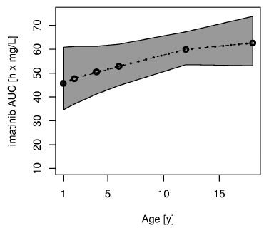

The model was built based on subjects ≥4 years of age, and used to predict AUC in children <4 years of age (‘*external validation’*). Observed concentrations were often within the model-predicted range of inter-individual variability but of the nine subjects <4 years, five had some observed values clearly lower than predicted and none clearly higher than predicted. Dosing was not uniformly at the recommended dose level.

**PBPK modelling** (assessing effects of paediatric growth on imatinib PK; without input of clinical data) resulted in findings consistent with the PopPK modelling.

**Study A2110** studied three children aged 2-3 years with Ph+ ALL (n=2) or chronic eosinophilic leukaemia (n=1). One patient was dosed at 91 mg/m2. It is difficult to extract helpful information from the study, minimum concentration ( Cmin) values achieved were in keeping with simulated values from the PopPK model.

No PK data exist for 12 to <24 month olds. Of note:

* Extent of absorption from the GI tract is uncertain in the very young.
* Imatinib is mainly metabolised by CYP3A4/5; expression of CYP3A reaches near adult levels 1-2 years after birth.
* α-glycoprotein is the major binding protein for imatinib and this reaches 87-91% of adult levels by 1-2 years. This may also vary with disease state.

This suggests uncertainty in imatinib exposure for some younger children (especially near 1 year of age) if dosed based on what is appropriate for older children. Nevertheless, the PopPK model was used to extrapolate AUC for imatinib to this age group.

#### Efficacy

Sources of efficacy evidence were Study I2301 (pivotal) and Study AIT07 (supportive).

##### Study 2301

This was an open label, sequential cohort study of 160 VHR paediatric/young adult (1 to < 22 years of age) patients with ALL. There were 5 cohorts, distinguished by increasing imatinib exposure. The study period was 2002 to 2006. The study was run by the COG.

Paediatric Ph+ ALL is a subtype of VHR ALL. 92/160 enrolled patients had Ph+ ALL; for this subset, the study assessed safety and efficacy of adding imatinib to other treatments. 65/160 other subjects were evaluable for safety comparison purposes, having Ph- ALL. These subjects had other characteristics conferring a broadly similar, poor, prognosis. Expected five year EFS for enrolled patients was <45%.

Patients had already received four to six weeks of an initial three to four drug induction regimen (plus intrathecal therapy) as outlined in Figure 1, above. Patients who failed induction (“IF”) (or who failed extended induction) could be included in the study; there were 10 such patients out of 92 (including six in Cohort 5).

The same post-induction intensive chemotherapy regimen was given to patients in all cohorts. Ph+ ALL patients could also receive imatinib, from as early as Consolidation Block 1. The dose was 340 mg/m2/day, reduced to 230 mg/m2/day if dose-limiting toxicity was observed.

Number of days of exposure to imatinib was increased in 5 sequential cohorts of increasing treatment blocks, as outlined in Table 4, above, so that patients in Cohort 5 underwent continuous dosing with imatinib (except in Maintenance Blocks 5-12).

Patients with human leukocyte antigen (HLA)-matched related donors or one antigen-mismatched (excluding HLA-DR mismatched) related donors could receive HSCT after Consolidation Block 2. A total of 34 patients received HSCT: 21 received this per protocol and 13 received HSCT off-protocol. (Information about off-protocol HSCT and imatinib treatment given after off-protocol HSCT was not provided as patients ‘discontinued’ the study.) Patients with per-protocol HSCT received imatinib for 24 weeks after a 16-24 week interval from time of HSCT (230 mg/m2/day, to 340 mg/m2/day if there were no severe toxicities after four weeks).

Patient status in this study is described in the following flow-chart:

Figure 5: Patient status in Study 2301

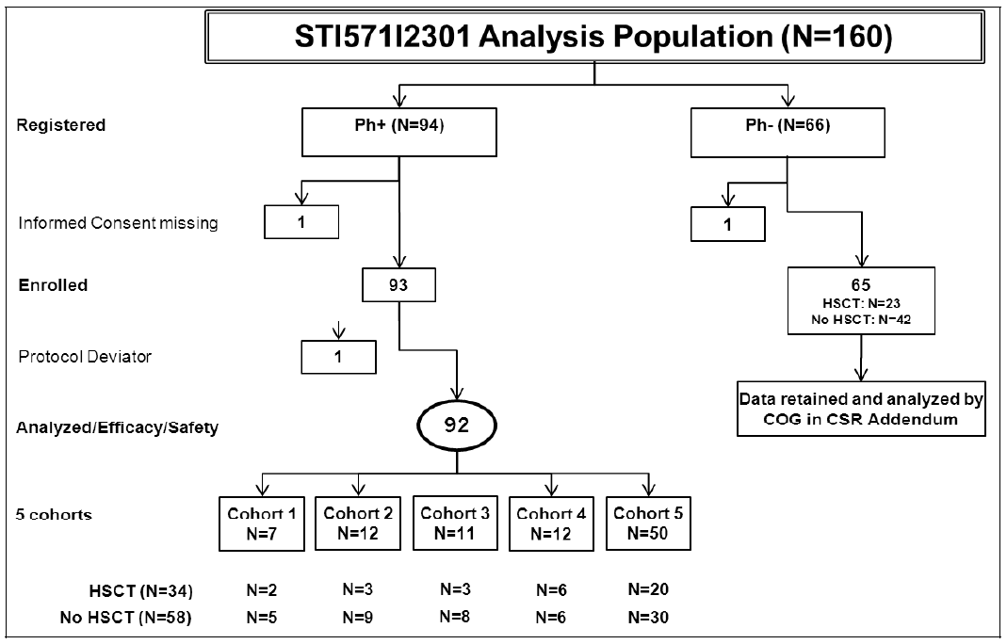

There were some differences in patient/treatment characteristics across cohorts.

Patients in different cohorts differed with regard to initial induction; in Cohorts 1, 2, 3, 4 and 5, induction was in ‘frontline studies’ in 14.3%, 16.7%, 45.5%, 91.7% and 76.0% respectively (otherwise, induction was with ‘similar therapies’). Also, HSCT was used in 25-29% for Cohorts 1-3, but 40-50% for Cohorts 4-5.

There were more patients with minimal residual disease ≤0.01% in higher cohorts: for Cohorts 1, 2, 3, 4 and 5, the proportion of these patients was 0%, 0%, 18.2%, 25% and 36% respectively.

Demographics were broadly similar (see Table 19). Two patients were <2 years of age; both were in Cohort 5.

Table 19: Patient Demographics in Study 2301

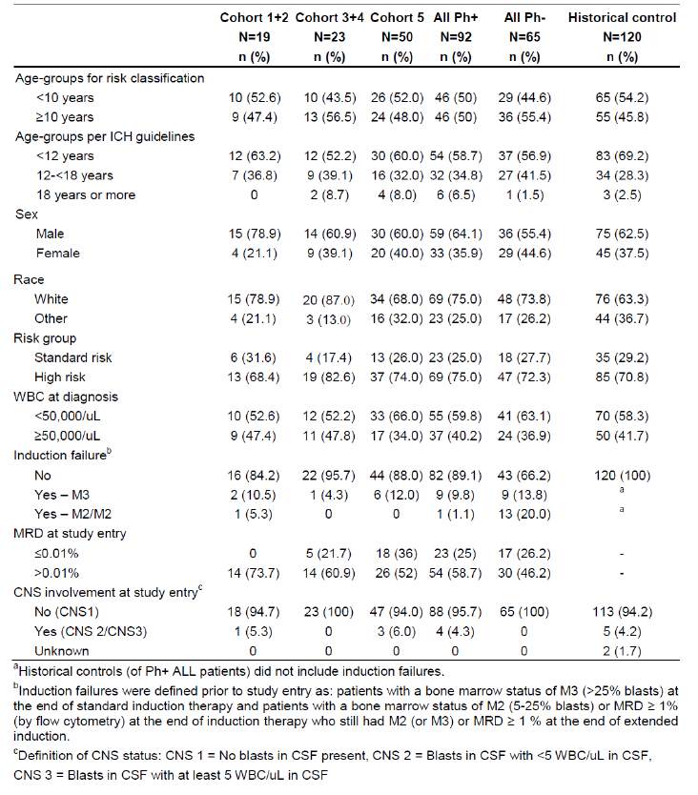

#### Results

The primary patient cohort for efficacy analysis was Cohort 5 (initially daily imatinib therapy).

The primary efficacy endpoint was EFS; an event could be relapse, secondary malignancy or death. 48 month EFS rate per cohort is shown in Table 20 – EFS results; the rate in Cohort 5 was 69.6% which was higher than rates in other cohorts (the trend across cohorts was maintained when cohorts were analysed individually; but that analysis revealed a much lower EFS rate in Cohort 1).

Table 20: EFS results (Ph+ ALL efficacy set in 2301 and in historical controls)

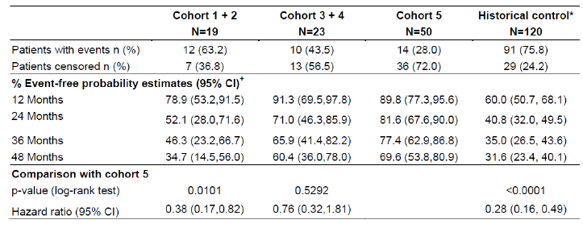

Analysis of EFS by HSCT status suggested HSCT status was not the explanation for high EFS in Cohort 5. 30 patients in Cohort 5 did not receive HSCT; 48 month EFS in that sub-group was 73.7%. This compares with a rate of 65.3% in 21 subjects who received per-protocol HSCT. Confounding may be at play here.

Results were compared with those from a historical control dataset (n=120), from five studies conducted by COG or its precursor POG between 1988 and 1995. Patients had newly diagnosed Ph+ ALL treated with chemotherapy ± HSCT (an unknown number received HSCT). The control group did not include patients with induction failure (a marker for worse prognosis). Only estimated EFS rates were available, so no formal comparisons were made. Multivariate Cox proportional regression analysis for EFS (Cohort 5 versus historical control group) was performed using age, gender and white blood cell (WBC) as covariates (but not status of minimal residual disease, CNS involvement or induction failure, despite these being important risks). The adjusted HR remained in favour of Cohort 5 (HR 0.28, log-rank p<0.0001).

Five year EFS was calculated by COG and reported to Novartis. Within Cohort 5, EFS to five years was similar in patients receiving chemotherapy (including imatinib) only, patients receiving related HSCT and patients receiving unrelated HSCT.

A secondary endpoint was OS - results, Table 21. Results clearly favoured Cohort 5 over historical controls, to 48 months. Results for Cohorts 3 and 4 versus Cohort 5 were closely comparable given the sample sizes involved (HR not statistically significantly different from 1, at 0.74 [95% CI 0.24, 2.26]).

Table 21: OS results (Ph+ and PH- ALL efficacy sets in 2301 and in historical controls

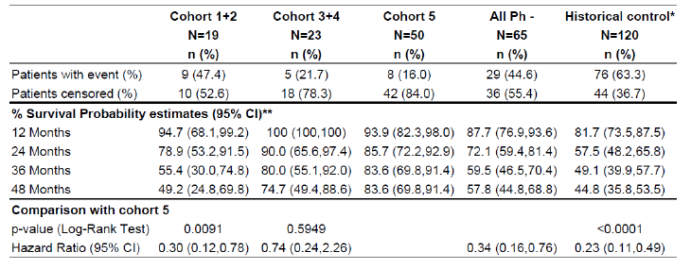

##### Study AIT07

This was run by 10 national paediatric leukaemia study groups in Europe (EsPhALL), with financial support from Novartis.

Subjects had Ph+ ALL and were further classified as good versus poor risk (Table 22).

Table 22: Study AIT07 – study design and patient disposition

Table 22: Study AIT07 – study design and patient disposition

Patients who achieved complete remission following frontline induction therapy were ‘*good risk’* (and were randomised to chemotherapy or chemotherapy plus imatinib). Patients who did not achieve complete remission following frontline induction therapy were ‘*poor risk’*; all these patients received chemotherapy plus imatinib.

The sponsor considered that this study provided safety data only, for the following reasons:

* After publication of results from Study 2301, all patients were given imatinib.
* Additionally, 12/44 subjects randomised to receive chemotherapy only, were switched to receive imatinib prior to the amendment.
* A high percentage (82.5%) of subjects received HSCT during the study (efficacy of HSCT would confound assessment of add-on imatinib’s efficacy).

This position appears reasonable. There was no overtly negative efficacy outcome in the imatinib, good risk arm.

#### Safety

##### Exposure

Study 2301 contributed 93 Ph+ patients to safety analysis (exposure varied from a median of 176 days in Cohort 1 to a median of 708 days in Cohort 5), and Study AIT07 contributed 159 Ph+ patients. In AIT07, 58 good risk patients received 300 mg/m2/day plus chemotherapy, 31 good risk patients received chemotherapy alone, and 70 poor risk patients received imatinib plus chemotherapy. Imatinib was given for about120 days.

Median follow-up time in Study 2301 was 40.5 months for Cohort 5, and in Study AIT07 was 30.3 months.

#### Results

##### Study 2301

Patients were not randomised to the different cohorts and as per efficacy results there are confounding factors in existence (see above). Also, sample size in most cohorts is limited.

Increasing exposure did not result in a major increase in ‘targeted’ AEs:

Table 23: ‘Targeted’ AEs versus patient group

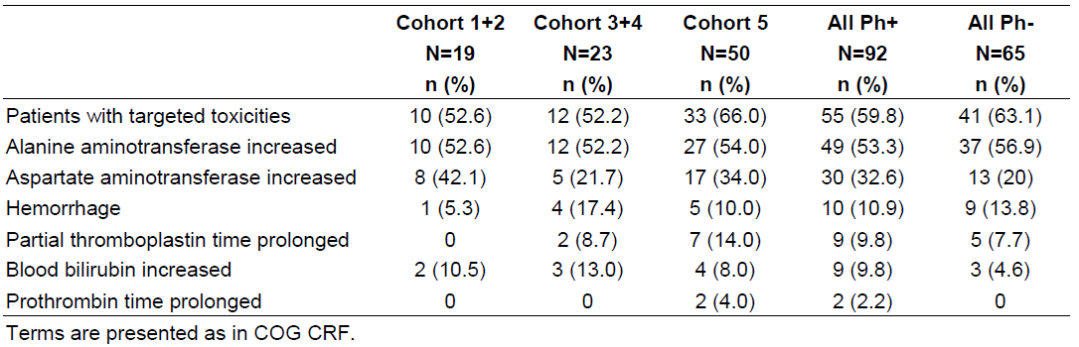

Grade 3+[5] alanine aminotransferase (ALT) elevations occurred in 7/12 patients enrolled early. A protocol change lowered imatinib exposure in the Maintenance Cycles 5-12 from *‘three weeks on one week off’* to *‘two weeks on two weeks off’*. This change was associated with lower hepatotoxicity (for severe ALT elevations, from 58.3% [7/12] to 33.3% [9/27]).

Non-targeted *‘severe’* (Grade 3) AEs with incidence increasing across cohorts are: haemoglobin (in Cohort 5, 64%); nausea (14%); decreased appetite (14%); dehydration (10%); hypertension (10%); hypoxia (14%).

Non-targeted *‘severe’* (Grade 3) AEs with incidence clearly higher in Cohort 5 than in the Ph- ALL group (no imatinib) are: white blood cell investigations (68% versus 50.8%; similar for neutrophil count); platelet count (72% versus 55.4%); haemoglobin (64% versus 47.7%); neutropenic infections (52% versus 36.9%); vomiting (18% versus 3.1%); hypokalaemia (42% versus 24.6%); hypertension (10% versus 3.1%); hypoxia (14% versus 3.1%); pneumonitis (8% versus 1.5%).

Reasons for discontinuation of imatinib included: pancreatitis; hepatotoxicity; palmar-plantar erythrodysaesthesia; and CNS ventriculomegaly/transependymal oedema.

#### Study AIT07

In Study AIT07, randomisation allowed comparison of a group that received add-on imatinib with a group that received only chemotherapy. Bias was re-introduced by cross-over of 12 patients to the imatinib arm (Table 22, above). Setting this aside, there were no major disparities in AE frequency; larger differences were for granulocytes decreased (83.9% no imatinib; 93.1% imatinib), infection (83.9% versus 93.1%), hepatic enzyme increased (71% versus 81%), abdominal pain (61.3% versus 70.7%), antithrombin III decreased (16.1% versus 29.3%), proteinuria (3.2% versus 12.1%) and euphoric mood (3.2% versus 13.8%). Many AEs were more commonly reported in the ‘no imatinib’ group, such as, blood bilirubin increased (58.1% versus 41.4%), probably reflecting the influence of disease processes on AEs (and by extension the influence of imatinib). In the good risk imatinib arm, several patients died of infection (2/58), and this rose to 4/70 in the poor risk (with imatinib) arm.

#### Other comments

Basic subgroup analyses in both studies according to age <4 years or otherwise revealed no major disparities. However, in Study 2301 there were only 15 subjects <4 years of age, and three subjects aged 1-2 years (11 subjects <4 years of age in Cohort 5). In Study AIT07, seven patients (five who received imatinib) were <2 years of age. Differences in frequencies of outcomes such as left ventricular dysfunction and cardiac failure across age groups are difficult to interpret given the small sample sizes and the existence of confounding factors, but 3/24 subjects <4 years of age reported these events (12.5%), versus 8/104 older subjects (7.6%).

There have been case reports of growth retardation occurring in children and pre-adolescents receiving Glivec. Novartis is currently assessing the effect of imatinib on growth in Ph+ CML patients via a third party registry as part of an EMA follow-up measure. No AE of growth retardation was reported in Studies 2301 or AIT07.

The incidence of pneumonitis appears high in Study 2301, and reports of hypoxia were also common. This information should be reflected in the PI.

#### Clinical evaluator’s recommendation

The clinical evaluator has recommended approval of the application.

### Risk management plan

The RMP proposed by the sponsor was considered generally acceptable by the TGA’s OPR.

### Risk-benefit analysis

#### Delegate considerations

##### Efficacy

The main efficacy issue is the reliance placed on a non-randomised study and historical comparisons. These historical comparisons are problematic because from 1988-1995 (accrual of historical data) through to 2002 (start of Study 2301) there may have been significant changes in patient management, impacting on EFS/OS. The sponsor argued that induction agents prednisone, vincristine and L-asparaginase were consistently used across POG and COG studies (including Study 2301), with the addition of daunomycin in some patients.

Reliance was not entirely on historical comparison; it was possible to compare cohorts within I2301, which varied by extent of exposure to imatinib. Allocation to cohorts was not random, so cohorts varied by other factors. The evaluator notes that chemotherapy used for induction was *“extremely intensive involving quite a large number of agents which raises the question whether the intensity of induction therapy may not have been a significant factor in determining EFS and OS irrespective of the role of imatinib”*. Induction regimens differed across cohorts (that is, earlier cohorts were less likely to have induction therapy as part of a frontline study).

##### Formulation

Film-coated tablet (100 mg, 400 mg) and hard gelatine capsule (50 mg, 100 mg) imatinib formulations are registered, but no liquid formulations. The latest proposed PI suggests that the capsule formulations are not available in Australia.

There are existing recommendations about dispersal of imatinib tablets in water or apple juice:

For patients unable to swallow the film-coated tablets, the tablets may be dispersed in a glass of water or apple juice. The required number of tablets should be placed in the appropriate volume of beverage (approximately 50 ml for a 100 mg tablet, and 200 ml for a 400 mg tablet) and stirred with a spoon. The suspension should be administered immediately after complete disintegration of the tablet(s).

The sponsor states that “*in vitro* data demonstrated that dispersed imatinib remained stable in water or apple juice”.

Similar recommendations are proposed (without supportive argument) to encompass capsule formulations:

For patients (for example, children) unable to swallow the capsules, their content may be diluted in a glass of still water or apple juice.

A 3 year old, for example, may have a BSA of, say, 0.6-0.7 m2, so will need ‘204’-‘238’ mg per dose. It will be difficult to provide accurate dosing in some settings. In at least one study (A2108), imatinib dose was rounded to the nearest 100 mg increment.

##### Dosing in the very young

Dosing in paediatric CML is 340 mg/m2/day (said to equate with 600 mg daily in adults, which is the recommended adult dose for Ph+ ALL). Thus the proposed paediatric dose in Ph+ ALL is no departure from the paediatric CML dose, and (assuming comparability of 340 mg/m2/day and 600 mg as per above) no departure from the adult Ph+ ALL dose. No differences in imatinib clearance across paediatric Ph+ CML and paediatric Ph+ ALL were found in the PopPK study.

The assumption about comparability of exposure after 340 mg/m2 and 600 mg dosing is not well-founded in very young children, particularly those 1 to <2 years of age. In pivotal Study 2301, analysis of efficacy by age did not separate the very young (for example, 1 to <4 years) from those <10 years, so it is difficult to look for a possible influence of exposure on efficacy outcomes. There were no additional major safety concerns in 1 to <4 year olds in Study AIT07, but sample size in the very young age group was small.

In the absence of good data on which to base dosing recommendations in very young patients with Ph+ ALL, the Delegate thinks the sponsor’s dosing proposal is acceptable only because these patients will be intensively monitored for treatment response, adverse events, et cetera. The Delegate suggested text in the PI noting the lack of directly observed PK data.

##### Other dosing issues

The sponsor notes:

“Imatinib therapy in the treatment of paediatric Ph+ ALL patients was incorporated in the standard chemotherapeutic regimen beginning with Consolidation 1, rather than beginning with induction therapy. It is unknown whether or not imatinib incorporated with induction therapy in paediatric Ph+ ALL is feasible and whether or not it adds or subtracts from efficacy and toxicity.

Furthermore, the duration of imatinib therapy after the completion of Maintenance Cycle 12 and/or HSCT is also unknown.”

In Study 2301, there was some evidence that ‘two week on two week off’ maintenance dosing was safer than ‘three week on one week off dosing’, with regard to hepatotoxicity.

##### Benefit-risk

The sponsor makes the following pertinent observations:

“The posology in the treatment of paediatric Ph+ ALL patients is similar to the Ph+ CML clinical setting and the exposure duration is shorter, suggesting that the emergence of long-term toxicities is even less likely. It is doubtful that long-term benefits on efficacy could diminish since leukemic relapse in ALL typically occurs quickly after the conclusion of standard therapy. Four-year estimated EFS and OS is likely to be inclusive of the large majority of patients who are destined to relapse with leukaemia.”

The Delegate agreed with the clinical evaluator that benefit-risk in this extension of indication is positive. However, optimal treatment remains to be established, for example, should the imatinib-free induction be adhered to? Should intermittent imatinib in maintenance be adhered to? How does imatinib change the place/timing of HSCT, if at all?

#### Proposed action

The Delegate proposed to approve the application.

The Delegate also proposed revisions to the product literature including the PI. Details of these revisions are beyond the scope of the AusPAR.

#### Request for ACPM advice

The Delegate proposed to seek general advice on this application from the Advisory Committee on Prescription Medicines (ACPM) and to additionally request ACPM address the following in particular:

1. Does the committee consider that the benefit-risk profile of imatinib in newly diagnosed paediatric Ph+ ALL is positive, taking into account the limitations of the supportive evidence provided.
2. Does the committee have any advice about the appropriateness of the proposed indication, and the appropriateness of proposed PI changes?

#### Response from sponsor

The sponsor’s responses to matters raised in the Delegate’s overview, above, have not been included in this AusPAR.

#### Advisory committee considerations

The ACPM considered the evaluations and the Delegate’s overview, as well as the sponsor’s response to these documents, advised the following:

The ACPM, taking into account the submitted evidence of efficacy, safety and quality, agreed with the Delegate and considered Glivec hard capsules containing 50 mg and 100 mg of imatinib (as mesylate), and Glivec film-coated tablets containing 100 mg and 400 mg of imatinib (as mesylate) to have an overall positive benefit–risk profile for the indication as proposed;

*Treatment of adult and paediatric patients with newly diagnosed Philadelphia chromosome positive acute lymphoblastic leukaemia (Ph+ ALL) integrated with chemotherapy*

The ACPM advised that clarification of dosing in paediatric patients should be sought. The ACPM was particularly concerned about the impact on opening the capsule or crushing the tablets would have on pharmacokinetics of imatinib in this patient group.

##### Proposed conditions of registration:

The ACPM agreed with the Delegate on the proposed conditions of registration.

##### Proposed Product Information (PI)/Consumer Medicine Information (CMI) amendments:

The ACPM agreed with the Delegate to the proposed amendments to the PI and CMI and specifically advised on the inclusion of the following:

* A statement in the *Pharmacokinetics* (PK) section of the PI and relevant sections of the CMI to reference that no PK data have been obtained in children < 2 years of age.
* A statement in the *Clinical Trials* section similar to;
  + In maintenance cycles 1-4 imatinib was administered continuously. In maintenance cycles 5-12 imatinib was administered in a 2-week on 2-week off schedule
  + For haematopoietic stem cell transplantation patients imatinib was commenced between week 16 and 24 post HSCT when ANC >750 and platelets > 75,000 and given for a total of 24 weeks
* A statement in the *Precautions* section of the PI that Glivec efficiency and safety has been demonstrated in children with Ph+ ALL leukaemias
* The addition of hypoxia and pneumonitis in the *Adverse Events* section of the PI and relevant sections of the CMI
* A statement in the *Dosage and Administration* section of the PI similar to the following;
  + The safety and efficacy of imatinib in conjunction with the post induction intensive phases of chemotherapy are supported by current evidence. However, use during induction, subsequent optimal scheduling during maintenance and duration of imatinib therapy following completion of chemotherapy/HSCT remains to be established.
* The CMI requires updating to include suitable paediatric statements, especially in the *Indications and Dosage* sections.

The ACPM advised that the implementation by the sponsor of the recommendations outlined above to the satisfaction of the TGA, in addition to the evidence of efficacy and safety provided would support the safe and effective use of these products.

### Outcome

Based on a review of quality, safety and efficacy, TGA approved the registration of Glivec containing imatinib as mesylate for the new indication:

*Treatment of paediatric patients with newly diagnosed Philadelphia chromosome positive acute lymphoblastic leukaemia (Ph+ ALL) integrated with chemotherapy.*

The full indications are now:

Glivec is indicated for the

* treatment of patients with chronic myeloid leukaemia (CML)
* treatment of adult and paediatric patients with newly diagnosed Philadelphia chromosome positive acute lymphoblastic leukaemia (Ph+ ALL) integrated with chemotherapy
* treatment of adult patients with relapsed or refractory Ph+ ALL as monotherapy
* treatment of adult patients with myelodysplastic/myeloproliferative diseases (MDS/MPD) associated with platelet-derived growth factor receptor (PDGFR) gene rearrangements, where conventional therapies have failed
* treatment of adult patients with aggressive systemic mastocytosis (ASM), where conventional therapies have failed
* treatment of adult patients with hypereosinophilic syndrome (HES) and/or chronic eosinophilic leukaemia (CEL)
* treatment of patients with Kit (CD117) positive unresectable and/or metastatic malignant gastrointestinal stromal tumours (GIST)
* adjuvant treatment of adult patients at high risk of recurrence following complete gross resection of KIT (CD117)-positive primary GIST (see Dosage and Administration and Clinical Trials)
* adult patients with unresectable, recurrent and/or metastatic dermatofibrosarcoma protuberans (DFSP).

#### Specific conditions applying to these therapeutic goods

* The Glivec Risk Management Plan (RMP), Version 6, dated 27 August 2012 with Australian Specific Annex Version 2, release date 26 September 2012 and any future updates as agreed with the TGA will be implemented in Australia.

## Attachment 1: Product Information

The Product Information approved at the time this AusPAR was published is at Attachment 1. For the most recent Product Information please refer to the TGA website at <<http://www.tga.gov.au/hp/information-medicines-pi.htm>>.

## Attachment 2: Extract from the Clinical Evaluation Report

1. M1, M2, M3 are defined as follows:

   * M1: <5% blasts, counting all nucleated cells, including erythropoiesis. In case of regenerating marrow with a high erythropoietic predominance, at least a total count of 100 non-erythropoietic cells should be counted.
   * M2: 5-25% blasts, counting all nucleated cells, including erythropoiesis. In case of regenerating marrow with a high erythropoietic predominance, at least a total count of 100 non-erythropoietic cells should be counted.
   * M3: >25% blasts in a BM aspirate. All Poor risk patients received imatinib.

  
2. Land VJ, Shuster JJ, Crist WM*, et al* (1994)] Comparison of Two Schedules of Intermediate-Dose Methotrexate and Cytarabine Consolidation Therapy for Childhood B-Precursor Cell Acute Lymphoblastic Leukemia: A Pediatric Oncology Group Study. *J Clin Oncol*; 12:1939-1945.
3. [Mahoney DH, Shuster JJ, Nitschke R, *et al* (1998)] Intermediate-Dose Intravenous Methotrexate Is Superior to Repetitive Low-Dose Oral Methotrexate With Intravenous Mercaptopurine for Children With Lower-Risk- B-Lineage Acute Lymphoblastic Leukemia: *A Pediatric J Clin Oncol*; 16:246-254.
4. [Lauer SJ, Shuster JJ, Mahoney DH, *et al* (2001)] A comparison of early intensive Methotrexate/Mercaptopurine with early intensive alternating combination chemotherapy for high-risk B-precursor acute lymphoblastic leukemia: a Pediatric Oncology Group phase III randomized trial. *Leukemia*; 15:1038-1045.
5. Common Terminology Criteria for Adverse Events v4.0 (CTCAE); Publish Date: May 28, 2009: Grade refers to the severity of the AE. The CTCAE displays Grades 1 through 5 with unique clinical descriptions of severity for each AE based on this general guideline: Grade 1 Mild; asymptomatic or mild symptoms; clinical or diagnostic observations only; intervention not indicated. Grade 2 Moderate; minimal, local or non-invasive intervention indicated; limiting age-appropriate instrumental activities of daily life (ADL). Grade 3 Severe or medically significant but not immediately life-threatening; hospitalisation or prolongation of hospitalisation indicated; disabling; limiting self care ADL. Grade 4 Life-threatening consequences; urgent intervention indicated. Grade 5 Death related to AE.