First round evaluation: 27 December 2015
Second round evaluation: 17 April 2016

AusPAR Attachment 2

Extract from the Clinical Evaluation Report for Inactivated quadrivalent influenza vaccine (split virion)
  - Proprietary Product Name: Afluria Quad
  - Sponsor: Seqirus Pty Ltd

About the Therapeutic Goods Administration (TGA)
- The Therapeutic Goods Administration (TGA) is part of the Australian Government Department of Health, and is responsible for regulating medicines and medical devices.
- The TGA administers the Therapeutic Goods Act 1989 (the Act), applying a risk management approach designed to ensure therapeutic goods supplied in Australia meet acceptable standards of quality, safety and efficacy (performance), when necessary.
- The work of the TGA is based on applying scientific and clinical expertise to decision-making, to ensure that the benefits to consumers outweigh any risks associated with the use of medicines and medical devices.
- The TGA relies on the public, healthcare professionals and industry to report problems with medicines or medical devices. TGA investigates reports received by it to determine any necessary regulatory action.
- To report a problem with a medicine or medical device, please see the information on the TGA website <https://www.tga.gov.au>.
About the Extract from the Clinical Evaluation Report
- This document provides a more detailed evaluation of the clinical findings, extracted from the Clinical Evaluation Report (CER) prepared by the TGA. This extract does not include sections from the CER regarding product documentation or post market activities.
- The words [Information redacted], where they appear in this document, indicate that confidential information has been deleted.
- For the most recent Product Information (PI), please refer to the TGA website <https://www.tga.gov.au/product-information-pi>.
Copyright
© Commonwealth of Australia 2017
This work is copyright. You may reproduce the whole or part of this work in unaltered form for your own personal use or, if you are part of an organisation, for internal use within your organisation, but only if you or your organisation do not use the reproduction for any commercial purpose and retain this copyright notice and all disclaimer notices as part of that reproduction. Apart from rights to use as permitted by the Copyright Act 1968 or allowed by this copyright notice, all other rights are reserved and you are not allowed to reproduce the whole or any part of this work in any way (electronic or otherwise) without first being given specific written permission from the Commonwealth to do so. Requests and inquiries concerning reproduction and rights are to be sent to the TGA Copyright Officer, Therapeutic Goods Administration, PO Box 100, Woden ACT 2606 or emailed to <tga.copyright@tga.gov.au>.

Contents
List of abbreviations 5
1. Introduction 7
1.1. Drug class and therapeutic indication 7
1.2. Dosage, administration and proposed indications 7
2. Clinical rationale 7
2.1. Formulation development 9
2.2. Guidance 10
3. Contents of the clinical dossier 10
3.1. Scope of the clinical dossier 10
3.2. Paediatric data 10
3.3. Good clinical practice 11
4. Pharmacokinetics 11
5. Immunogenicity 12
5.1. Studies providing immunogenicity data 12
6. Dosage selection for the pivotal studies 12
7. Clinical efficacy 12
7.1. Pivotal efficacy study 12
7.2. Other studies 22
7.3. Analyses performed across trials (pooled analyses and meta-analyses) 29
7.4. Evaluator’s conclusions on the clinical efficacy of the vaccine 29
8. Clinical safety 30
8.1. Studies providing evaluable safety data 30
8.2. Pivotal studies that assessed safety as a primary outcome 32
8.3. Patient exposure 32
8.4. Adverse events 32
8.5. Laboratory tests 35
8.6. Post-marketing experience 36
8.7. Safety issues with the potential for major regulatory impact 36
8.8. Other safety issues 36
8.9. Evaluator’s overall conclusions on clinical safety 36
9. First round benefit-risk assessment 37
9.1. First round assessment of benefits 37
9.2. First round assessment of risks 37
9.3. First round assessment of benefit-risk balance 37
10. First round recommendation regarding authorisation 37
11. Clinical questions 38
11.1. Additional expert input 38
11.2. Clinical questions 38
12. Second round evaluation of clinical data submitted in response to questions 38
12.1. Efficacy 38
13. Second round benefit-risk assessment 40
13.1. Second round assessment of benefits 40
13.2. Second round assessment of risks 40
13.3. Second round assessment of benefit-risk balance 40
14. Second round recommendation regarding authorisation 40
15. References 40

List of abbreviations
Abbreviation | Meaning
AE | Adverse event
AESI | Adverse event of special interest
CDC | Centers of Disease Control and Prevention
CHMP (CPMP) | Committee for Medicinal Products for Human Use
CI | Confidence Interval
eCRF | electronic Case Report Form
EU | European Union
FDA | Food and Drug Administration
GBS | Guillain Barré syndrome
GCP | Good Clinical Practice
GMT | Geometric Mean Titre
HA | Haemagglutinin
HAI | Haemagglutination Inhibition
ICH | International Conference on Harmonization
ILI | Influenza like Infection
IM | Intramuscular
IVV | Influenza virus vaccine
MAA | Marketing Authorization Application
MEDRA | Medical Dictionary for Regulatory Activities
mL | Millilitres
NA | Neuraminidase
NH | Northern Hemisphere
NOCI | New onset of chronic illness
PI | Prescribing Information
QIV | Quadrivalent Influenza Vaccine
RMP | Risk Management Plan
SAE | Serious Adverse Event
SCR | Seroconversion Rate
SCF | Seroconversion Factor
SH | Southern Hemisphere
SOC | System Organ Class
SPR | Seroprotection Rate
TGA | Therapeutic Goods Administration
TIV | Trivalent Influenza Vaccine
US | United States
VE | Vaccine Efficacy
WHO | World Health Organization

Introduction
The original proposed tradename for this vaccine was Fluvax Quad, submitted by the sponsor bioCSL Pty Ltd. During this submission, after undergoing clinical evaluation but before subsequent approval by the TGA, the tradename changed to Afluria Quad and the sponsor name changed to Seqirus Pty Ltd., however both the product evaluated and being described here and the sponsor remain the same despite the name changes. For further details of name changes, please refer to the AusPAR that accompanies this document.
This is a clinical evaluation of an application by the sponsor to register the Quadrivalent Influenza Vaccine (QIV; trade name: Afluria Quad) belonging to the pharmacotherapeutic group of viral vaccines (influenza vaccines). The Anatomical Therapeutic Chemical (ATC) code is J07BB02. QIV is an inactivated vaccine for prophylaxis against influenza. It is supplied as a single dose, 0.5 mL pre-filled syringe containing a sterile, aqueous suspension for injection. Haemagglutinin (HA) and neuraminidase antigens present in the vaccine induce a protective antibody response in vaccinated individuals within 2 to 3 weeks after immunisation. The suspension includes four inactivated, split influenza virus strains; two type A strain subtypes and two type B strains from separate lineages as recommended by the Australian Influenza Vaccine Committee for that season.

Drug class and therapeutic indication
This is an inactivated quadrivalent influenza vaccine containing influenza haemagglutinin antigens: A/California/7/2009 (H1N1) pdm09-like virus; A/Texas/50/2012 (H3N2)-like virus; B/Massachusetts/2/2012-like virus (B/Yamagata lineage); and B/Brisbane/60/2008-like virus (B/Victoria lineage). Seqirus QIV is an inactivated, split-virion influenza virus vaccine formulated to contain 60 µg HA per 0.5 mL dose in the recommended ratio of 15 µg HA for each influenza virus strain: Type A (H1N1)-like virus; Type A (H3N2)-like virus; Type B (Victoria lineage) and Type B (Yamagata lineage). The sponsor’s QIV formulation is consistent with the currently licensed Afluria trivalent influenza virus vaccine (Seqirus TIV), with the exception of the alternate lineage influenza B strain which increases the total HA content from 45 to 60 µg per 0.5 mL dose.

Dosage, administration and proposed indications
This application seeks to gain approval for this quadrivalent inactivated influenza vaccine administered as a single 0.5mL dose annually intramuscularly (IM), Afluria Quad, for the prevention of influenza caused by Influenza Virus, Types A and B in persons aged ≥ 18 years.

Clinical rationale
Influenza, a respiratory orthomyxovirus, is a seasonal infectious disease that occurs in epidemics throughout the northern and southern hemisphere winter months, and leads to considerable morbidity and mortality globally in all age groups. In general, influenza is resolved within two to seven days, although symptoms of cough and malaise may be prolonged. However, for some population groups, notably the elderly and those with chronic diseases (for example pulmonary or circulatory disorders, metabolic disorders such as diabetes mellitus, renal dysfunction, or immunosuppression), influenza can exacerbate underlying medical conditions and/or lead to secondary viral or bacterial pneumonia., During influenza epidemics, there is an increased mortality risk among older adults (age > 65 years), people with chronic diseases, and very young children (age 0 to 12 months), as well as an increase in morbidity and hospitalization because of influenza-associated complications.^{1,}
Influenza A and B cause most human disease. Influenza A viruses are divided into subtypes based on two viral external proteins, the HA and the neuraminidase (NA).
Of the influenza type A virus subtypes, the A/H3N2 and A/H1N1 subtypes are clinically the most important. Influenza type B viruses show extensive variation in antigenicity. Influenza B viruses are separated into two distinct genetic lineages, Yamagata and Victoria. In terms of infection, influenza type A viruses have been isolated from several non-human species, including birds, horses, and swine, whereas influenza type B viruses almost exclusively affect humans.
The influenza A or B surface glycoprotein HA is the key antigen involved in attachment of the virus to receptors on respiratory epithelial cells, whereas the NA glycoprotein is involved in release of the virus from the cell surface. During infection, the virus stimulates production of antibodies in the serum (immunoglobulin G) and nasal secretions (immunoglobulin A) to these surface glycoproteins. High levels of virus type-specific antibodies are associated with protection from disease due to infections with homologous and closely related influenza virus strains.^{1,} Novel influenza strains arise from antigenic drift due to point mutation and recombination events that occur during viral replication. These events result in the emergence of new strains of the influenza virus capable of causing epidemics, as pre-existing antibodies resulting from previous virus exposure or vaccination are generally not cross-protective.⁴ Influenza type A is capable of major antigenic shifts when a novel HA emerges from re-assortment with an animal influenza virus. Influenza B undergoes less rapid antigenic drift that is, is generally more stable, than influenza A. When a new subtype of influenza virus emerges, all individuals are susceptible to infection except those who have lived through earlier epidemics with a related virus subtype. Infection produces immunity to the specific virus; however, the length and extent of immunity is dependent on the degree of antigenic shift, the number of previous infections, and the immune status of the individual.
Influenza epidemics have been associated with the circulation of type A/H3N2, type A/H1N1, and type B viruses, either individually or together. Two genetically distinct lineages of influenza B viruses have co-circulated since 1985. The burden of infection is largely on school age children, young adults, and the elderly. In the US, B viruses account for 24% of positive specimens and 34% of reported paediatric influenza deaths.
Prevention: Prevention of influenza illness is achieved by annual prophylactic immunisation. The US Centers for Disease Control and Prevention (CDC), in response to the A/H1N1 pandemic in 2009 that disproportionately affected healthy young people, revised their recommendations in 2010, calling for annual immunisation of the entire US population. Previously, only those at increased risk for influenza, including the very young, elderly, chronically ill, and health care workers were advised to be vaccinated annually. In Australia, annual influenza vaccination is currently recommended for any person ≥ 6 months of age who wishes to reduce the likelihood of becoming ill with influenza. Annual influenza vaccination is strongly recommended for individuals at increased risk of influenza complications including those with co-morbidities including being immunocompromised for whatever reason.
Rationale for quadrivalent versus trivalent vaccines: Influenza vaccines have historically been trivalent, including variants of A/H3N2, A/H1N1, and one B-strain lineage. HA and, to some extent, NA antigens present in influenza vaccines induce a protective antibody response in vaccinated individuals. Mismatches between the B strain in the vaccine and the circulating strain occur in approximately 5 out of every 10 influenza seasons.⁷ The CDC has estimated that in a season where there is a B strain mismatch, availability of QIV could have reduced annual influenza cases (range: 2200 to 970,000), hospitalisations (range: 14 to 8200), and deaths (range: 1 to 485) in the US. Quadrivalent influenza virus vaccines, inclusive of representative strains from both type B lineages, are being developed to reduce the potential public health burden of type B influenza morbidity and mortality in years where significant B strain mismatch may occur with TIVs.

Formulation development
The chemistry, manufacture, and control of QIV is the same as that described for Seqirus’ TIV (Fluvax AUST ARTG: 91583, 117397, and 145707), with the exception that the vaccine contains a fourth influenza strain in the formulation, which will increase the HA content from 45 to 60 µg HA per 0.5 mL. QIV is a sterile, aqueous suspension of inactivated and split influenza virus types A and B. The virus is purified, inactivated and disrupted to ensure the HA and NA remain immunogenic. It is prepared from the allantoic fluid of influenza virus-infected embryonated chicken eggs. The vaccine is supplied as a thiomersal-free 0.5 mL single-dose pre-filled syringe. The vaccine is indicated for the prevention of influenza caused by influenza virus, types A and B contained in the vaccine. The vaccine is indicated for use in persons aged ≥ 18 years. The vaccine supplied will be formulated from the four strains recommended by the Australian Influenza Vaccine Committee for that season.
The vaccine meets the requirements for the harmonised British Pharmacopoeia Volume IV Immunological Products – Vaccines Inactivated Influenza Vaccine (Split Virion) and European Pharmacopoeia Monograph 0158 Influenza Vaccine (Split Virion, Inactivated). The Seqirus QIV formulation is based on Seqirus TIV, with the exception of the additional B strain, and expected to have a similar safety profile to that established for Seqirus TIV.

Pre-clinical development
Seqirus conducted one formal nonclinical toxicology study for the TIV; an embryofetal developmental toxicity study in rats with post-natal evaluation. This was an extensive pivotal GLP-compliant study covering the ICH Harmonised Tripartate Guideline (November 2000) stages A to E of the reproductive process. The reproductive Toxicity Study of Afluria TIV (Seqirus TIV) in female rats did not demonstrate any adverse effects on mating, fertility, embryo-foetal development and vaccine-related teratogenic effects. Each dose of Seqirus TIV contained 45 µg of HA, resulting in each dose being approximately 265 times the human dose on an mg/kg of bodyweight basis; equating to a dose approximately 200 times the human mg/kg dose for QIV, taking into consideration the additional HA content from the fourth influenza strain. As Seqirus QIV formulation is based on Seqirus TIV, with the exception of the additional B strain, it is expected to have a similar safety profile to that established for Seqirus TIV.
Development of a QIV, including B strains of both lineages, is expected to improve vaccine protection in target populations. Vaccine strain composition is based on the seasonal recommendations of the World Health Organization (WHO). TIVs contain antigens from the B-strain lineage predicted to be most prevalent. Such vaccines provide limited immunity against B strains of the lineage not included in the vaccine. A further problem with TIVs is that the predominant circulating B-strain lineage has been unpredictable; between 2001 and 2011, B-strain lineage predictions for inclusion in vaccines were no better than chance alone (Ambrose). There is a long history of clinical and post-marketing use of Seqirus TIV. The safety of Seqirus TIV is supported by post-marketing surveillance data from more than 168 million doses and from clinical study data. The efficacy of Seqirus TIV is supported by data from a large clinical study examining the efficacy of Seqirus TIV against laboratory-confirmed influenza in adults, and from studies examining immunogenicity after vaccination in children, adults and older adults.

Guidance
The QIV clinical development plan was discussed at two meetings with TGA held on 9 May 2013 and 27 May 2015. The plan was developed to be generally consistent with the TGA adopted European guidelines: CPMP/BWP/214/96 Harmonisation of Requirements for Influenza Vaccines and the EMEA/CHMP/VWP/164653/2005 Guideline on Clinical Evaluation of New Vaccines. In addition, the clinical development plan has been informed by the draft guidance of the European Medicine’s Agency: EMA/CHMP/VWP/457259/2014 Committee for Medicinal Products for Human Use Guideline on influenza vaccines: Non-clinical and clinical module (25 July 2014), although not yet effective in Europe, nor adopted by the TGA.

Contents of the clinical dossier

Scope of the clinical dossier
The submission contained the following clinical information:
- A pivotal Phase III randomised, multicentre, double blinded study (Study CSLCT-QIV-13-01) to evaluate the immunogenicity and safety of Seqirus QIV in comparison with 2014 to 2015 Northern Hemisphere Seqirus TIV (TIV-1) formulation and a TIV containing the alternate B-strain (TIV-2) in adults ≥ 18 years of age;
- Supportive studies of the trivalent influenza vaccine demonstrating clinical lot-to-lot consistency (Study CSLCT-FLU-05-09) and efficacy (Study CSLCT-USF-06-28). Literature references. Supporting data for the Validation of the HAI Test for Titrating Influenza A and B Specific Antibodies for the two A influenza strains and 2 B strains included in this QIV.
- A Clinical Overview, Summary of Clinical Efficacy, Summary of Clinical Safety.

Paediatric data
The submission does not include paediatric efficacy/safety data, although paediatric studies are ongoing and/or planned, for instance: Study CSLCT-QIV-13-02. This is a Phase III, randomised, multicentre, observer-blinded study to evaluate the immunogenicity and safety of Seqirus QIV versus a US licensed Northern Hemisphere 2015 to 2016 QIV comparator in male and female children 5 to < 18 years of age. Subjects were randomised to either treatment group in a 3:1 ratio (Seqirus QIV: comparator QIV). The randomisation was stratified by age into two study cohorts (cohort A: 5 to < 9 yrs of age, and cohort B: 9 to <18 yrs of age) with a sample size of approximately n = 2222. The study does not go below 5 years of age to align with the currently registered paediatric age indication for TIV. The TIV age indication from 6 months to <5 years was rescinded in Australia in the Southern Hemisphere 2010 influenza season following spontaneous post-marketing reports of febrile reactions, including febrile seizures in Australia and New Zealand in 2010. Study CSLCT-QIV-15-03 is a Phase III, randomised, multicentre, observer blinded study to evaluate the immunogenicity and safety of Seqirus QIV versus a US licensed Northern Hemisphere 2016 to 2017 QIV comparator in children 6 months to < 5 years of age. This was to be conducted in the Northern Hemisphere in influenza season 2016/2017 if data from Study CSLCT-QIV-13-02 are supportive of proceeding to this younger age group. If Study CSLCT-QIV-15-03 is conducted, results from this study will potentially support a paediatric indication ≥ 6 months to < 5 years of age. The study design was to be finalised subsequent to review of study conduct and results from Study CSLCT-QIV-13-02.

Good clinical practice
The clinical studies in this application complied with CPMP/ICH/135/95 an internationally accepted standard for the design, conduct, recording and reporting of clinical trials. Ethical and scientific standards of the clinical studies complied with guidance documents of the International Conference on Harmonisation (ICH), the US FDA, and the Therapeutic Goods Administration (TGA) of Australia. The designs of the studies in this submission are consistent with recommendations from the US FDA Guidance for Industry: Clinical Data Needed to Support the Licensure of Seasonal Inactivated Influenza Vaccines, May 2007 (CBER 2007). Furthermore, the designs of the adult QIV study and/or the presentation of results in this submission are also generally consistent with the EU ‘Guideline on Clinical Evaluation of New Vaccines’ (EMEA/CHMP/VWP/164653/2005; CHMP, 2006), and ‘Note for Guidance on Harmonisation of Requirements for Influenza Vaccines’ (CPMP/BWP/214/96; CPMP, 1997). Additionally, the adult QIV study and plans for future paediatric QIV studies are informed by the CHMP/VWP/457259/2014 Guideline on influenza vaccines Non-clinical and clinical module (Draft), which accepts demonstration of non-inferior immunogenicity as a basis for marketing authorisation applications (MAA) in adults including the elderly.
Approvals to undertake the clinical studies were obtained from appropriately constituted institutional ethics committees/independent research boards, in accordance with the relevant national guidelines and regulations applicable.

Pharmacokinetics
This is not applicable to this application, no pharmacokinetic (PK) data is provided. The rationale is that PK studies are usually not required for vaccines.

Immunogenicity

Studies providing immunogenicity data
Efficacy and safety data arising from these three studies is summarised in Section 7 and Section 8 respectively of this document. Only one study provides immunogenicity data for the QIV.

Dosage selection for the pivotal studies
The dosage selection for the additional B strain immunogen in the QIV was based upon the standard used in the TIV; that is 15 µg of HA per strain.

Clinical efficacy
The pivotal study, Study CSLCT-QIV-13-01 is not a ‘clinical efficacy’ study but instead the immunogenicity data derived is used as a surrogate for clinical efficacy. This is a standard approach in influenza vaccine studies. In addition, the studies described in Section 7.2 are prior studies already reviewed by the TGA which demonstrate clinical lot-to-lot consistency and efficacy of Seqirus TIV and the immunogenicity study comparing QIV to two TIV comparators. An abridged review of both is provided below as relevant only to this application.
Standard definitions of ‘immunogenicity’ of the vaccine in influenza vaccine studies were used and anti-HA antibody titres were measured against the 4 vaccine strains:
- Subjects with titres below the detection limit (1:10) are considered seronegative;
- Subjects with a demonstrable titre (≥ 1:10) after vaccination are considered seropositive;
- Titre ≥ 1:40 considered a titre correlating with protection against influenza disease (‘seroprotection level’);
- Seroprotection rate (SPR) = proportion of subjects with HAI titre ≥ 1:40;
- Seroconversion rate (SCR) = proportion of subjects with either a pre vaccination HI titre < 1:10 and a post vaccination titre ≥ 1:40 or a pre vaccination HI titre ≥ 1:10 and a ≥ 4-fold increase in post vaccination HI titre.
- Geometric mean fold increase = the fold increase in serum HAI GMTs post-vaccination versus pre-vaccination.

Pivotal efficacy study

Validation of HAI assays used in the pivotal efficacy study for QIV
- The evaluation of the quantitative assay of neutralising antibody to influenza virus A and B, based upon the WHO protocol (WHO/CDS/CSR/NCS/2002.5), using the HAI test was performed successfully for the A/California/7/2009 X-179A (H1N1) influenza antigen provided by Seqirus. Analysis of the validation data indicate that the HAI assay is accurate, specific, sensitive, precise and linear throughout the range of the HAI assay. This HAI assay for A/California/7/2009 (H1N1) influenza antigen was found to meet the necessary requirements for use and is capable of producing reliable results with acceptable precision.
- The evaluation of the quantitative assay of neutralising antibody to influenza virus A and B using the HAI test was performed successfully for the egg derived A/Texas/50/2012 (H3N2) NYMC X-223 influenza antigen, an A/Victoria/361/2011 (H3N2)-like strain, provided by Seqirus. Analysis of the validation data indicate that the HAI assay is accurate, specific, sensitive, precise and linear throughout the range of the HAI assay The negative reference antiserum must be negative (GMT < 10). This assay for A/Texas/50/2012 (H3N2) influenza antigen has been found to meet the acceptance criteria and is capable of producing reliable results with acceptable precision.
- The evaluation of, the quantitative assay of neutralising antibody to influenza virus A and B using the HAI test based upon the WHO protocol (WHO/CDS/SCR/NCS/2002.5) was performed successfully for the B/Brisbane/60/2008 influenza antigen provided by Seqirus. Analysis of the validation data indicates that the assay is accurate, specific, sensitive, precise and linear throughout the range of the HAI assay for B/Brisbane/60/2008 influenza antigen. This assay for B/Brisbane/60/2008 influenza antigen has been found to meet the necessary requirements for and is capable of producing reliable results with acceptable precision.
- The evaluation of the quantitative assay of neutralising antibody to influenza virus A and B using the HAI test was performed successfully for the egg derived B/Massachusetts/2/2012 NYMC BX-51B influenza antigen provided by Seqirus. Analysis of the validation data indicate that the HAI assay is accurate, specific, sensitive, precise and linear throughout the range of the HAI assay. The negative reference antiserum must be negative (GMT <10). This assay for B/Massachusetts/2/2012 influenza antigen has been found to meet the acceptance criteria and is capable of producing reliable results with acceptable precision.

Study CSLCT-QIV-13-01
‘A Phase 3, randomised, multicentre, double-blinded study to evaluate the immunogenicity and safety of quadrivalent influenza vaccine (CSL QIV) in comparison with a US licensed 2014-15 trivalent influenza vaccine (CSL TIV-1), and a trivalent influenza vaccine containing the alternate B strain (CSL TIV-2), in adults aged 18 years and above.’

Study design, objectives, locations and dates

Design
This was a multicentre, randomised, double-blinded study to evaluate the non-inferior immune response of Seqirus QIV to that of Seqirus TIV-1 and Seqirus TIV-2 along with safety in adults aged ≥ 18 years. The study was conducted during the 2014 to 2015 Northern Hemisphere influenza immunisation season in healthy male and female adults aged 18 years and above. Subjects were randomised to one of the three treatment groups in a 2:1:1 ratio. The randomisation was stratified by age stratum (≥ 18 to 64 years and ≥ 65 years). The stratification by age employed a quota to ensure an equal number of subjects in each age stratum.

Sampling
Bloods for immunogenicity assessments were collected from all subjects immediately before and at Visit 2 (Day 21 + 4 post vaccination) as shown in Figure 1 below.
Figure 1. Study CSLCT-QIV-13-01 overview
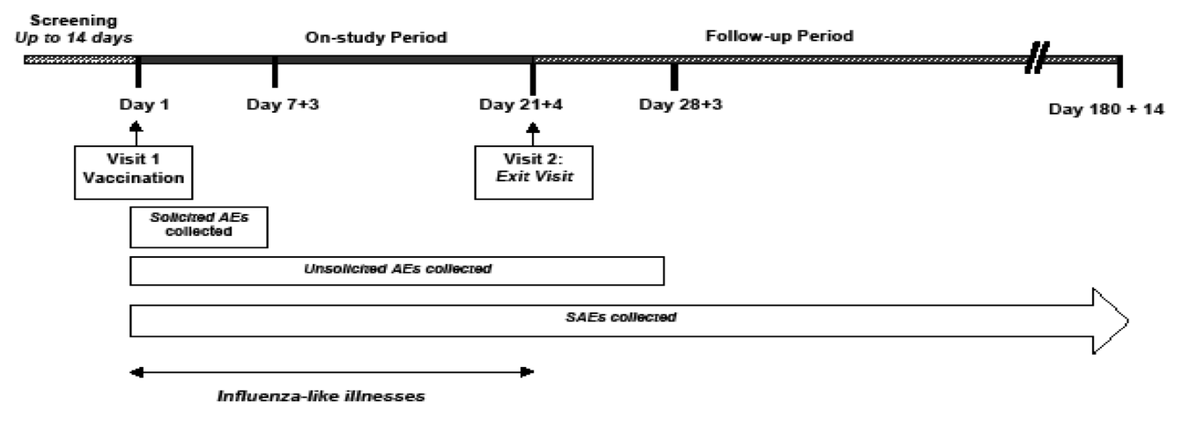

Analytical methods
As described above in Section 7.1.1. Validation of HAI assays used in pivotal immunogenicity study in QIV.

Safety evaluations
See Section 8 below.

Primary objectives
To demonstrate that vaccination with Seqirus QIV elicits an immune response that is not inferior to that of Seqirus TIV containing the same virus strains as the US licensed 2014 to 2015 CSL influenza vaccine (Seqirus TIV-1), and the TIV containing the alternate B strain (Seqirus TIV-2) in adults aged ≥ 18 years.

Secondary objectives
To assess the following, among adults aged ≥ 18 years in two age strata 18 to < 65 years and ≥ 65 years, as well as overall:
- To demonstrate that vaccination with QIV elicits an immune response that is not inferior to that of TIV containing the same virus strains as the US licensed 2014-2015 Seqirus influenza vaccine (TIV-1), and the TIV containing the alternate B strain (TIV-2);
- To demonstrate the immunological superiority of QIV compared to TIV-1 and TIV-2 for the B strain that is not included in each TIV vaccine separately;
- To characterise the immunogenicity of QIV, TIV-1 and TIV-2.

Primary safety objective
To assess safety and tolerability of QIV by the frequency and severity of: solicited local and systemic adverse events (AEs) for 7 days following vaccination (Day 1 to Day 7); cellulitis-like reaction, cellulitis and Grade 3 injection site induration/swelling for 28 days following vaccination; Unsolicited AEs for 28 days following vaccination; serious adverse events (SAEs) for 6 months following vaccination.

Locations
31 US sites.

Dates
First subject, First Visit: 15 Aug 2014; Last subject, Last Visit: 20 Apr 2015.

Inclusion and exclusion criteria

Inclusion criteria
Inclusion criteria included: Healthy male or non-pregnant female aged ≥ 18 years at the time of vaccination; in good health, or in stable health status with no exclusionary medical or neuropsychiatric conditions, as determined by screening evaluation and a physical examination conducted no greater than 14 days prior to vaccination; Able to understand and comply with study requirements; if applicable, females of child-bearing potential must be abstinent or be willing to use a medically accepted contraceptive regimen for the duration of the On-study Period.

Exclusion criteria
Exclusion criteria included: Known hypersensitivity to a previous dose of influenza vaccine or allergy to eggs, chicken protein, neomycin, polymyxin, or any components of Seqirus influenza vaccines; vaccination against influenza in the previous 6 months; known history of GBS or other demyelinating disease; clinical signs of active infection and/or oral temperature of ≥ 100.4°F (38.0°C); active or recent (within the previous month) and clinically significant gastrointestinal/hepatic, renal, neurological, cardiovascular, respiratory, endocrine disorders, or other medical conditions, if: for acute conditions (active or recent), the acute condition required hospitalisation within the previous month; or for chronic conditions, the investigator considers that the chronic condition is unstable, such as illness exacerbations within the previous month: a) requiring hospitalisation; b) with significant organ function deterioration; c) with major changes to treatment dosages; or d) requiring major new treatments; or the investigator considers the subject with an acute (active or recent) or chronic condition may be adversely affected through study participation; history of neurological disorders or seizures, with the exception of a past history of a single seizure event at any age, > two years previously; confirmed or suspected congenital or acquired immunosuppressive condition; clinically significant history of malignancy; current treatment or treatment with radiotherapy or cytotoxic drugs at any time during the six months prior to administration of the Study Vaccine. On-going adjuvant antineoplastic therapy with non-cytotoxic agents commenced ≥ 3 months prior to study vaccine are permitted; current (or within the 90 days prior to study vaccine immunosuppressive or immunomodulative therapy, including systemic corticosteroids; administration of immunoglobulins and/or any blood products within the 3 months prior to administration of the study vaccine or planned administration during the study; participation in a clinical study or use of an investigational compound (that is a new chemical or biological entity not licensed for clinical use, including investigational influenza vaccines) within 30 days prior to or 30 days after receiving the study vaccine, or plans to enter a study during this On-study Period; vaccination with a licensed vaccine within 14 days (inactivated vaccines) or 28 days (live vaccines) prior to administration of the study vaccine, or plans to receive a vaccine during the On-study Period; current treatment with warfarin or other anticoagulants; major congenital defects; evidence, or history (within the previous 12 months) of drug or alcohol abuse; unwillingness or inability to comply with the study protocol including completion of AE diaries; history of psychiatric disorders, which, in the opinion of the Investigator, would prevent subjects from giving proper informed consent; pregnant or lactating females.

Study treatments
QIV inactivated, split-virion, thiomersal-free, administered as one 0.5 mL IM dose into the deltoid muscle. The vaccine is presented in a pre-filled needle-less syringe. Each 0.5 mL dose contains 15 µg HA from each of the following 4 influenza strains (recommended by the FDA Vaccines and Related Biological Products Advisory Committee for the 2014 to 2015 influenza season in the US):
- 15 µg A/California/7/2009 (H1N1) pdm09-like virus;
- 15 µg A/Texas/50/2012 (H3N2)-like virus;
- 15 µg B/Massachusetts/2/2012-like virus (B/Yamagata lineage);
- 15 µg B/Brisbane/60/2008-like virus (B/Victoria lineage).

Comparator products
Seqirus TIV-1 (Afluria): inactivated, split-virion, thiomersal-free, TIV, administered as one 0.5 mL IM dose into the deltoid muscle. The vaccine is presented in a pre-filled needle-less syringe. Each 0.5 mL dose contains 15 µg HA from each of the following 3 influenza strains (recommended for a trivalent influenza vaccine by the FDA VRBPAC for the 2014 to 2015 influenza season in the US):
- 15 µg A/California/7/2009 (H1N1) pdm09-like virus;
- 15 µg A/Texas/50/2012 (H3N2)-like virus;
- 15 µg B/Massachusetts/2/2012-like virus (B/Yamagata lineage - B strain recommended for TIV).
Seqirus TIV-2: inactivated, split virion, thiomersal-free, TIV, administered as one 0.5 mL IM dose into the deltoid muscle. The vaccine is presented in a pre-filled needle-less syringe. Each 0.5 mL dose contains 15 µg HA from each of the following 3 influenza strains (two influenza A strains recommended for a trivalent influenza vaccine by the FDA VRBPAC for the 2014 to 2015 influenza season in the US and the alternate B strain to that recommended for TIV):
- 15 µg A/California/7/2009 (H1N1) pdm09-like virus;
- 15 µg A/Texas/50/2012 (H3N2)-like virus;
- 15 µg B/Brisbane/60/2008-like virus (B/Victoria lineage - alternate B strain).

Efficacy variables and outcomes
The main efficacy variables were:
- Immunogenicity evaluations at approximately 21 days (+ 4 days) after the vaccine;
- Safety evaluations: solicited local and systemic AEs for 7 days following vaccination (Day 1 to Day 7); cellulitis-like reaction, cellulitis and Grade 3 injection site induration/swelling for 28 days post vaccination; Unsolicited AEs for 28 days following vaccination; SAEs for 6 months following vaccination.
The primary efficacy outcomes were to evaluate the following:
- Immunogenicity assessed 21 days after vaccine administration by measuring HAI titres to the 4 virus strains included in the vaccines. The non-inferiority of QIV compared to TIV-1, and to TIV-2 assessed for the co-primary endpoints of HI geometric mean titre (GMT) and seroconversion rate (SCR) for each virus strain included in the vaccines as follows:
  - The GMT ratio for the A/H1N1 strain;
  - The GMT ratio for the A/H3N2 strain;
  - The GMT ratio for the B strain (Yamagata lineage);
  - The GMT ratio for the B strain (Victoria lineage);
  - The difference between the SCR for the A/H1N1 strain;
  - The difference between the SCR for the A/H3N2 strain;
  - The difference between the SCR for the B strain (Yamagata lineage);
  - The difference between the SCR for the B strain (Victoria lineage).
Other efficacy outcomes included:
- Non-inferiority of QIV versus TIV-1, and TIV-2 will be assessed separately within each age group (18 to < 65 years and ≥ 65 years of age), by the co-primary endpoints of HAI GMT and SCR for each virus strain included in the vaccines as described for the primary endpoint.
- Immunologic superiority of the alternate B strain (for example the influenza B strain included in the QIV but not in the TIV formulation) in QIV will be assessed separately within each age group (18 to < 65 years and ≥ 65 years of age), and overall, by the co-primary endpoints of HAI GMT and SCR for each B virus strain.
- The immunogenicity of QIV, TIV-1 and TIV-2 will be assessed in terms of HAI antibodies. Serum HAI antibody titres against the 4 influenza vaccine strains used to calculate:
  - GMT: Geometric mean of HAI titres pre-vaccination (Day 1) and post-vaccination (Day 21);
  - Geometric Mean Fold Increase (GMFI): Geometric mean fold titre rise from Day 1 to Day 21;
  - The percentage of subjects with a titre ≥ 40 (seroprotection rates) at Day 1 and Day 21;
  - SCR as a percentage of subjects with either pre-vaccination HAI titre < 1:10 and a post-vaccination HAI titre ≥ 1:40 or a pre-vaccination titre ≥ 1:10 and a ≥ 4-fold increase in post-vaccination titre.

Randomisation and blinding methods
The randomisation scheme used ensured the balance between the treatment groups was maintained. To ensure the study blind was maintained delegates from the Interactive Response Technology company in association with Seqirus statistician/delegates not directly involved in the analysis of study results prepared the study randomisation code. Investigational site staff including the investigator, were blinded to treatment allocation. Subjects, Seqirus personnel and Contract Research Organisation personnel were also blinded to treatment allocation.

Analysis populations
The full analysis set (FAS) included all subjects who provide informed consent and who were randomised to treatment. The FAS was used to produce summaries and listings of subject characteristics.
The evaluable population for immunogenicity analysis included all subjects in the FAS who: were vaccinated with the study vaccine at Visit 1; provided both pre- and post-vaccination blood samples at Visit 1 and On-Study Period Exit Visit (Visit 2); did not experience a laboratory-confirmed influenza illness (ILI) between Visit 1 and On-Study Period Exit Visit (Visit 2); did not receive a contraindicated medication during study that is medically assessed as potentially impacting on the immunogenicity results. The Evaluable Population was used to produce summaries, analyses and listings for all immunogenicity data.
The per-protocol (PP) population included subjects in the Evaluable Population minus any subjects with deviations thought to potentially affect the immunogenicity results. The PP Population was used to provide confirmatory analysis for the primary immunogenicity endpoints. The PP Population was determined prior to unblinding.
The safety population included all subjects in the FAS who receive at least 1 dose of investigational product and have provided follow-up safety data. Analysis will be according to vaccination(s) received.

Sample size
QIV will be tested against TIV comparators in each age stratum. The treatment randomisation ratio is 2:1:1 (QIV: TIV-1: TIV-2). This study is powered to achieve 80% power to demonstrate non-inferiority in each age stratum (and consequently will be powered overall) over 8 co-primary endpoints, SCR for 4 strains, GMT for 4 strains using a one-sided alpha of 0.025 for each comparison. No adjustment for multiple endpoints was made. For comparisons of SCR a non-inferiority margin of 10% (TIV – QIV) will be employed. It is assumed that the SCR for all strains for TIV is 50% and that there is no difference between QIV and TIV. For comparison of GMT ratio a non-inferiority margin of 1.5 (TIV/QIV) will be employed. It is assumed that there is no difference between QIV and TIV (that is, a ratio of 1) and that the standard deviation of log (titre) is 1.4.
Under these assumptions numbers evaluable = 826 per age stratum in QIV group and 413 per age stratum in each Seqirus TIV group providing 826 and 826 subjects receiving QIV and TIV respectively for comparisons of A strains and 826 and 413 subjects receiving QIV and TIV respectively for comparisons of B strains. This provides a total evaluable = 1652 per age stratum.
Overall 3304 evaluable subjects are required. Allowing for a 5% drop-out n = 3480 subjects will be recruited (1740 per age stratum).

Statistical methods
Analysis populations are described above.

Primary endpoint – non-inferiority
- The difference in SCR (TIV – QIV) for each strain will be determined and presented with 95% confidence limits. Non-inferiority concluded for each strain if upper 95% confidence limit is < 10%.
- HAI titres will be log transformed and a General Linear Model (GLM) will be fitted with Day 21 log (titre) as the outcome variable and vaccine (TIV or QIV), site, age stratum and pre-vaccination titre as covariates. The least squares mean for TIV – QIV will be obtained from the model with 95% confidence limits. The point estimate and confidence limits will be exponentiated to obtain GMT ratio with 95% confidence limits. Non-inferiority concluded if upper 95% confidence limit is < 1.5.
- If all 8 co-primary endpoints result in a conclusion of non-inferiority then overall non-inferiority of QIV to TIV-1 and TIV-2 will be concluded.
- This assessment conducted overall (the primary endpoint) and by age stratum (a 2º endpoint).
In addition, to address secondary objectives, the superiority of QIV over TIV-1 and TIV-2 for the alternate B strain will be assessed using the GMT ratio (QIV/TIV) and difference in SCR (QIV – TIV). Point estimates and 95% confidence limits will be obtained as described for the primary endpoint. Superiority will be declared if the lower 95% confidence limit for the difference in SCR (QIV – TIV) is 0 and the lower 95% confidence limit for the GMT ratio (QIV/TIV) is > 1 for both B strains. GMT will be summarised at Day 1 and Day 21 by treatment group overall and by age stratum. GMFI will be determined for each strain for each treatment group as the GMT ratio of Day 21/Day 1. The percentage of subjects who are seroprotected (HAI titre ≥ 40 at Day 1 and Day 21 will be summarised by treatment group overall and by age stratum.

Safety outcomes
Tabular summaries of local reactions and systemic events. AEs and SAEs summarised by age group and overall population separately for each dose (Dose 1, 2, and 3).

Participant flow
A total of 3484 subjects were enrolled with 1741 in the younger age stratum and 1743 the older (as shown in Figure 2 below).
Figure 2: Study CSLCT-QIV-13-01 - Subject stratification and treatment allocation schema (Actual study numbers – Full analysis set)
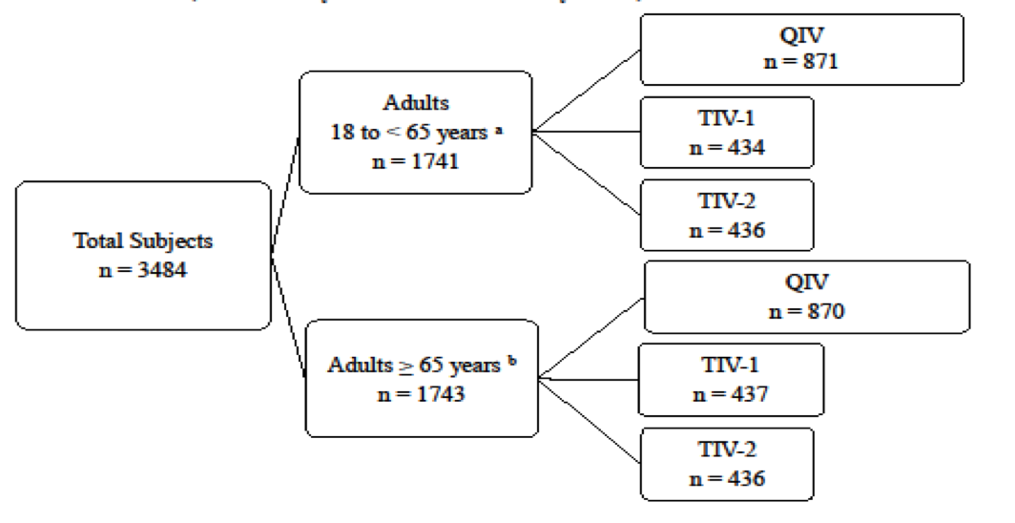
a) adults < 65 age, a maximum of 60% in one subgroup (18 to < 50 years or 50 to <65 years). b) Adults ≥ 65 years of age, a minimum of 30% in the > 75 years of age subgroup.

Major protocol violations/deviations

Table 1. Study CSLCT-QIV-13-01 - Subject disposition
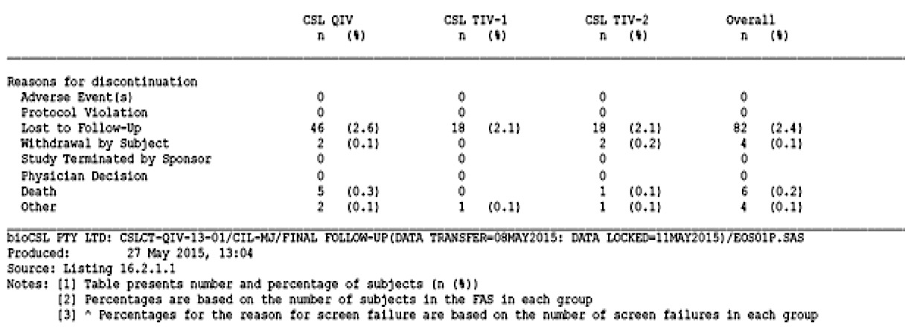

Baseline data

Table 2. Study CSLCT-QIV-13-01 Analysis populations
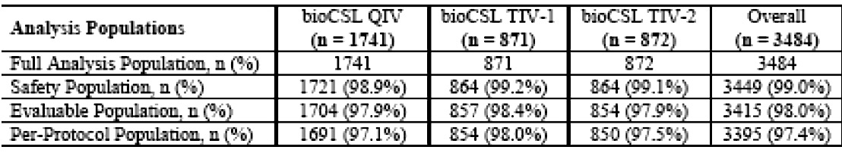

Table 3. Study CSLCT-QIV-13-01 Baseline characteristics
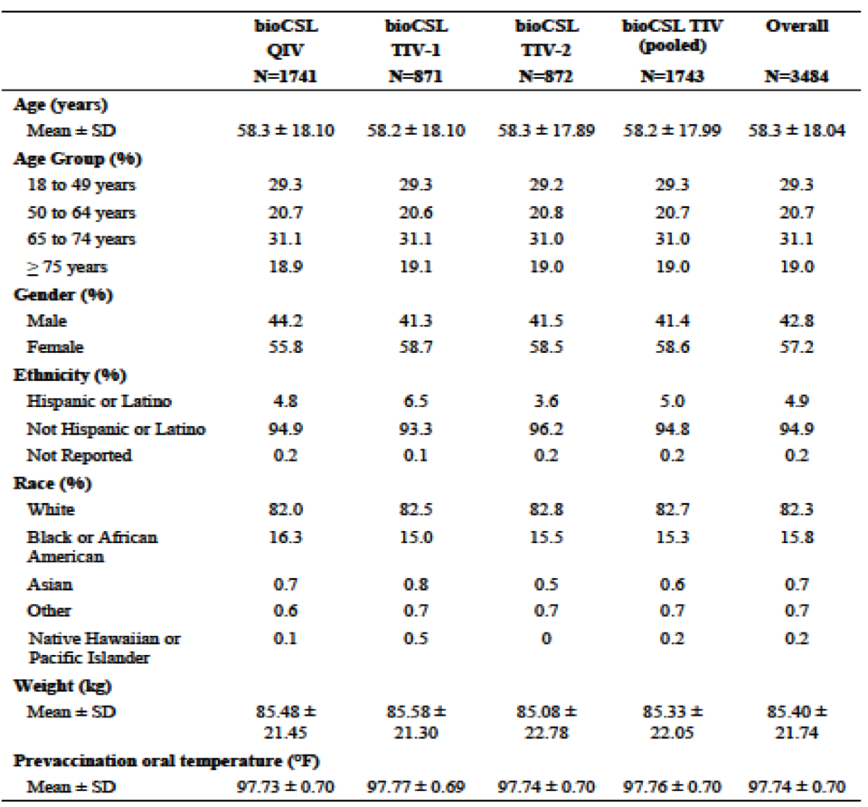

Results for the primary efficacy outcome

Immunogenicity results
Immunogenicity analyses were conducted based on the PP Population, which minimally varied from the Evaluable Population, with less than 1% variation in the number of subjects in the two populations in either age cohort (adults of 18 through 64 years and ≥ 65 years of age).
The HAI antibody responses for QIV were shown to be non-inferior for shared influenza A and B vaccine strains compared with TIV comparators in adults ≥ 18 years of age, for the co-primary endpoints of HI GMT and SCRs.
For the secondary immunogenicity endpoints, the HAI responses were shown in the overall study population to be superior for QIV to the results for the alternate (non-included) influenza B strains for the TIV comparators for the same endpoints. Non-inferiority and/or superiority (according to the study defined criteria for different strains and study vaccines) were also met for each of the serological endpoints of HI GMT and SCR separately in the two age cohorts (adults aged 18 to 64 years and ≥ 65 years of age). Additional descriptive secondary immunogenicity endpoints including the percentage of subjects with a HAI titre ≥ 40 (seroprotection rates), SCRs and GMFIs by study vaccine and age cohort were analysed. In general for these endpoints, results were similar between different study vaccines within each age cohort for A strain results, and when the vaccine included B strains were matched.
There were high rates of vaccination with influenza vaccine in the previous 12 months in the overall study population (FAS: 63.3%) and in both age cohorts, but this was especially high in the older age cohort ≥ 65 years (81.6% versus 45.0% (18 to 64 years)). The post-vaccination seroprotection rates for the A strains were very high (≥ 95%) and generally similar in both age cohorts. However, the post-vaccination seroprotection rates for subjects in the older age cohort ≥ 65 years were lower than the 18 to 64 years age cohort for the B strains, even when the B strains were matched. For example, for the B/Yamagata strain, the post-vaccination seroprotection rates for QIV in adults aged ≥ 65 years was 57.5%, and 84.3% in adults aged 18 to 64 years. For the B/Victoria lineage, the seroprotection rates in adults aged ≥ 65 years was 68.3% and 86.7% in adults aged 18 to 64 years.
Seroconversion rates in the overall study population (adults ≥ 18 years) were generally in the range of 30 to 40% for both A strains and vaccine matched B strains. However, SCRs for subjects in the older age cohort ≥ 65 years of age were lower than the 18 to 64 years of age cohort for all strains, even when the B strains were matched. For example, for the B/Yamagata strain, the SCR for QIV in older adults (≥ 65 years) was 16.6% and 45.7% in adults aged 18 through 64 years.
For the B/Victoria lineage, the SCR in adults aged ≥ 65 years was 23.5%, and 57.6% in adults aged 18 through to 64 years. A similar pattern to the B strain results were also seen for the two A strains for SCRs. Differences in age cohorts were also observed for GMFI.
In general, relatively high seroprotection rates and lower seroconversion rates are a pattern that may be expected in study populations with high rates of influenza vaccination in the previous 12 months, as is the case in the US where the study was conducted.
The immunogenicity primary and secondary endpoints were met regardless of a subject’s gender. Female subjects had slightly higher HAI GMTs (both pre- and post-vaccination) for each strain versus males. Most subjects enrolled in the study were white and Not-Hispanic/Latino. For these groups, the non-inferiority criterion for GMT and SCR and superiority of the alternate B strains for GMT and SCR were met for each strain and results were similar to the overall population. Post-vaccination (Day 21) HAI GMTs and SCRs were generally higher for the black or African American race subgroup versus the white subgroup, and for the Hispanic or Latino ethnicity subgroup compared to Not-Hispanic or Latino subgroup.
In summary, HAI antibody responses for this QIV were shown to be non-inferior for matched influenza A and B vaccine strains versus TIV comparators in adults ≥ 18 years, for the co primary endpoints of HI GMT and SCRs. Additionally, superiority for this QIV was shown for the same serological endpoints for the alternate (non-included) influenza B strains for the TIV comparators. These endpoints were also met for each of the two age cohorts separately.
Figure 3. Study CSLCT-QIV-13-01- Non-inferiority of Seqirus QIV versus Seqirus TIV in terms of geometric mean titre (adjusted GMT ratios) for each Strain (PP population)
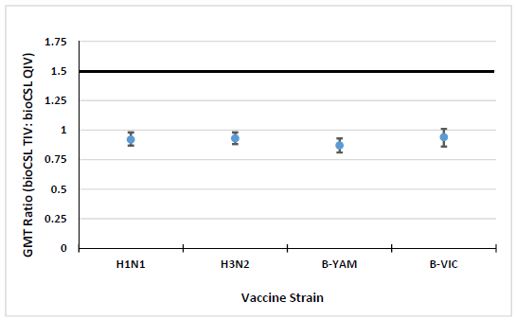
The bold line represents the margin of non-inferiority. Non-inferiority is shown if the upper error bar for estimates lies below the line.
Figure 4. Study CSLCT-QIV-13-01- Non-inferiority of Seqirus QIV versus Seqirus TIV in terms of seroconversion Rates (%) (PP population)
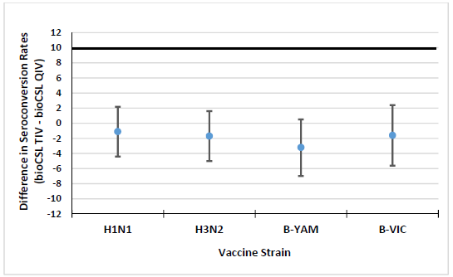
The bold line represents the margin of non-inferiority. Non-inferiority is shown if the upper error bar for estimates lies below the line.

Results for other efficacy outcomes
Safety results are described in Section 8 (below) but there were no safety concerns for the QIV versus the TIVs revealed in this study.

Other studies

Study CSLCT-FLU-05-09
‘A Phase III, randomised, double-blinded, placebo-controlled, multicentre study to evaluate the immunogenicity, safety, and tolerability of Seqirus inactivated influenza vaccine in adults 18 to < 65 years of age’

Study design, objectives, locations and dates

Design
A Phase III, randomised, double-blinded, placebo controlled, multicentre clinical trial with approximately 1250 (up to 1350) healthy adults, between 18 to < 65 years old enrolled randomised in a 1:1:1:1:1 ratio to receive 1 of 3 lots of vaccine in multiple-dose vials, a single lot of vaccine in prefilled syringes, or placebo in multiple dose vials (250 subjects per group). Randomisation was stratified according to age, that is 18 to 49 years and 50 to 64 years of age with a minimum of 63 subjects in the age range 50 to 64 required in each group. Vaccine was prepared and administered by an unblinded vaccine administrator not involved in subsequent assessments.

HAI Antibody response
Standard measurements used.

Objectives
Primary and secondary: immunogenicity, safety and tolerability.

Locations
Multicentre, USA.

Dates
2006 to 2007, Northern Hemisphere influenza season.

Inclusion and exclusion criteria

Key inclusion criteria
Healthy adults aged 18 to < 65 years.

Study treatments
- Seqirus influenza vaccine for the 2006 Southern Hemisphere influenza season with thiomersal; or thiomersal-free; or placebo via IM injection.
- Influenza Virus Vaccine: 30 µg HA/strain/mL, thiomersal containing.
- Influenza Virus Vaccine: 30 µg HA/strain/mL, thiomersal-free.
- Placebo: sterile phosphate buffered saline, thiomersal containing 0.5 mL dose, intramuscular injection.
The 4 formulations of the Seqirus Influenza Vaccine contain 45 µg of influenza haemagglutinin antigens. Both forms of vaccine contain the following Southern Hemisphere 2006 recommended strains of Influenza virus per 0.5-mL dose: 15 µg of A/New Caledonia/20/99 (IVR-116) (H1N1)-like strain; 15 µg of A/New York/55/2004 (NYMC X-157) (H3N2)-like strain; 15 µg of B/Malaysia/2506/2004-like strain.

Efficacy variables and outcomes

Primary objective
To demonstrate that vaccination with Seqirus IVV produces an immune response sufficient to meet the Committee for Medicinal Products for Human Use criteria for young adults of 40% seroconversion and 70% seroprotection.

Secondary objectives
- To demonstrate clinical consistency between three lots of Seqirus IVV multiple-dose vial presentation (thiomersal-containing).
- To demonstrate clinical consistency between Seqirus IVV multiple-dose vial presentation (thiomersal-containing) and CSL IVV pre-filled syringe presentation (thiomersal-free).
- To demonstrate acceptable safety and tolerability of Seqirus IVV multiple-dose vial presentation (thiomersal-containing) and Seqirus IVV pre-filled syringe presentation (thiomersal-free).

Randomisation and blinding methods
Standard blinding techniques.

Analysis populations
As described above.

Sample size
Approximately 1250 healthy adults, between 18 to < 65 years old.

Statistical methods
Immunogenicity analyses carried out on the evaluable population. The safety analysis was carried out on the safety population. Baseline demographic analyses carried out using the Evaluable population and the Safety population. Descriptive statistics used to present all safety and immunogenicity results: participant number, mean, SD, median, maximum, and minimum for continuous data and frequency and percentage for categorical data. Ninety-five percent CI were presented for some immunogenicity criteria. Geometric means and 95% confidence levels presented for the log-transformed immunogenicity parameters. Exact confidence intervals based upon the binomial distribution were calculated for percentages (for example, Clopper-Pearson as implemented in SAS proc Freq). All analyses were performed with a significance level of 5% for two–sided tests and 2.5% for one-sided tests.

Baseline data
1359 randomised of whom 823 received the IVV thiomersal-containing; 266 received the IVV thiomersal-free; and 270 the Placebo. Population analysed = 1359 subjects; safety population, n = 1357, evaluable population, n = 1341, PP population, n = 1241.

Results for the primary and other efficacy outcomes

Immunogenicity
With respect to the co-primary endpoints, overall (Seqirus IVV groups combined), a total of 48.7% (95% CI 0.456, 0.517) of subjects showed seroconversion for the A/New Caledonia strain; 71.5% (95% CI 0.687, 0.742) for the A/New York strain and 69.7% (95% CI 0.669, 0.725) for the B/Malaysia strain. Overall, 97.8% (95% CI 0.967, 0.986) of subjects who received Seqirus IVV met the post-vaccination criteria of seroprotection (titre ≥ 1:40) for the A/New Caledonia strain; 99.9% (95% CI 0.995, 1.000) of subjects for the A/New York strain and 94.2% (95% CI 0.927, 0.956) of subjects for the B/Malaysia strain.
Following the logistic regression analysis of the co-primary endpoints, clinical consistency seen between Lots 1, 2 and 3 of the Seqirus IVV multiple dose vial (thiomersal-containing) presentation with respect to post-vaccination HAI titres. Consistency was also shown between the Seqirus IVV multiple-dose vial (thiomersal-containing) presentation and the Seqirus IVV pre-filled syringe (thiomersal-free) presentation.

Safety
With regard to safety, the majority of subjects did not experience a systemic reaction or local reaction following vaccination on Day 0 and Day 4. Of those subjects who did, the reactions were mostly mild to moderate intensity.

Study CSLCT-USF-06-28
‘A Phase IV, randomised, observer-blind, placebo-controlled, multi-centre study to evaluate the efficacy, safety and tolerability of Seqirus influenza virus vaccine in adults aged ≥ 18 to < 65 years’

Study design, objectives, locations and dates

Design
A Phase IV, randomised, observer-blind, multi-centre, placebo-controlled trial with randomisation in a 2:1 ratio. Study vaccine was administered at Visit 1 (Day 0) and participants returned to the study site 21 days afterwards for an Exit Visit (Visit 2). Blood samples were collected at Visits 1 and 2 for immunogenicity assessments. During the 2008 season, blood samples were collected from all participants at Visit 1 and Visit 2 and immunogenicity analysis was conducted on a randomly selected subset of participants (n = 450). In 2009, blood samples were collected from only 450 participants at Visit 1 and Visit 2.

HAI antibody response
Standard measurements used.

Primary and secondary objectives
These were: efficacy, immunogenicity, safety and tolerability.

Locations
Multicentre, Australia and New Zealand.

Dates
25 February 2008 to 29 January 2010.

Inclusion and exclusion criteria

Key Inclusion criteria
Healthy adults 18 to < 65 years of age.

Study treatments
Single vaccine with either 0.5 mL IM of Seqirus IVV: 30 µg HA/strain/mL, thiomersal-free or Placebo: sterile phosphate buffered saline, thiomersal-free.
Influenza haemagglutinin antigens: 2008 Season A/Solomon Islands/3/2006 (H1N1)-like virus; A/Brisbane/10/2007 (H3N2)-like virus; B/Florida/4/2006-like virus.
2009 Season: A/Brisbane/59/2007 (H1N1)-like virus; A/Brisbane/10/2007 (H3N2)-like virus; B/Florida/4/2006-like virus.

Efficacy variables and outcomes

Primary objective
To demonstrate that the efficacy of Seqirus IVV versus placebo in the prevention of laboratory-confirmed influenza A/B was significantly ≥ 40% in healthy adults, through the assessment of: Incidence of lab-confirmed influenza A/B infection with illness onset on or after Day 14.

Secondary objectives
- To demonstrate the efficacy of this IVV in prevention of lab-confirmed influenza A/B (due to strains matched to vaccine strains) was significantly greater than that of placebo in healthy adults through the assessment of:
  - Incidence of laboratory-confirmed influenza A/B infection, by strains matched to vaccine strains, with illness on or after Day 14.
  - To assess the incidence of ILI, culture-confirmed ILI and laboratory-confirmed CDC ILI, in recipients of IVV or placebo.
  - To assess the immunogenicity of IVV in a subset of study participants, to facilitate extrapolation of vaccine efficacy to other populations through the assessment of: Proportion of participants with a minimum post-vaccination HAI titre of 1:40; seroconversion rate: defined as the percentage of participants with either a pre-vaccination HAI titre < 1:10 and a post-vaccination HAI titre ≥ 1:40 or a pre-vaccination titre ≥ 1:10 and a minimum four-fold rise in post-vaccination HAI antibody titre; Geometric mean fold-increase in HAI titre.
  - To assess the safety and tolerability of IVV through the assessment of the frequency and severity of: Solicited local and general solicited symptoms for 4 days after vaccination (5 days in total); Unsolicited AEs for 20 days after vaccination (21 days in total); SAEs for 180 days after vaccination; and NOCIs for 180 days after vaccination.

Randomisation and blinding methods
A statistician not directly involved in the analysis of study results will prepare the study randomisation code in a SAS database. A randomisation scheme (2 active vaccine: 1 placebo) used to ensure the balance between treatments maintained. Randomisation was stratified according to age at the time of enrolment; at least 25% in the ≥ 50 to < 65 year age group and the remainder in the ≥ 18 to < 50 year age group. Because of the visual difference between the active study vaccine and the placebo, the study will involve personnel who are blinded to the treatment allocation (that is, site staff performing study assessment including the investigator (‘observer-blind’) and participants) and different personnel who are unblinded (that is investigational site staff involved in preparation and administration of the study vaccine); to treatment allocation.

Analysis populations
As per the definitions used above.

Sample size
15,000 randomised participants (7500 for each of the 2 years the study was conducted).

Statistical methods

Primary endpoint
Incidence of laboratory-confirmed (culture/real-time RT-PCR) influenza A/B infection with illness onset on or after Day 14.

Secondary efficacy endpoints
- Incidence of laboratory-confirmed influenza A/B infection, by strains matched to vaccine strains, with illness onset on or after Day 14. This efficacy endpoint was included to control for any unanticipated mismatch between the virus strains circulating during the study period and those included in the study vaccine
- Incidence of ILI;
- Incidence of culture-confirmed ILI;
- Incidence of laboratory-confirmed ILI meeting the CDC ILI definition;
- Seroconversion, geometric mean fold increase in HAI titre and the proportion of participants with an HI antibody titre of 1:40 or greater after vaccination were assessed in a subset of study participants.

Safety endpoints
Frequency and severity of solicited local and general AEs for 5 days, unsolicited AEs for 21 days, SAEs and NOCIs for 6 months after vaccination.

Baseline data
Total randomised was 15,044 of whom 10,033 received IVV thiomersal-free and 5,011 received placebo.

Table 4. Study CSLCT-USF-06-28 - Analysis populations
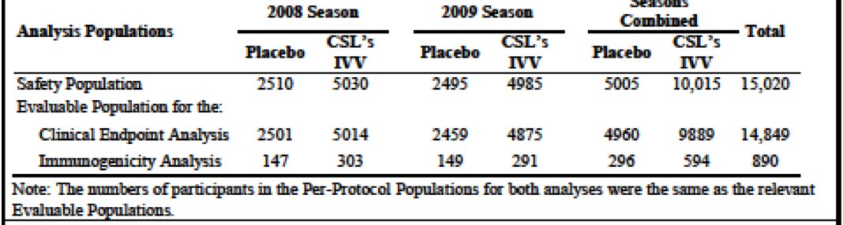

Results for the primary and secondary efficacy outcomes

Primary analysis: overall vaccine efficacy
During both the 2008 and 2009 influenza seasons, overall incidence of laboratory-confirmed influenza infection (due to any influenza A or B virus isolate) was lower in participants who had received Seqirus IVV (2.24%) than in those receiving placebo (3.87%). Overall efficacy of IVV for the prevention of laboratory-confirmed infection due to any influenza A or B virus during the 2008 and 2009 seasons was 42%, with a lower bound of the CI of 28%. The IVV was efficacious versus placebo (the lower bound of the CI exceeded zero), but the results did not satisfy the pre-defined criterion for success (that is lower bound of CI being at least 40%). Thus the primary objective was not met.

Analysis of immunogenicity: Baseline antibody titres
During the 2008 season, over one-third of the participants had HAI antibody titres of ≥ 1:40 to each of the influenza A vaccine strains (H1N1, H3N2) and approximately 13% of participants had HAI antibody titres of 1:40 or more to the influenza B vaccine strain as shown below in Figure 5.
During the 2009 season, approximately one-third of participants had HAI antibody titres of ≥ 1:40 to the H1N1 and B vaccine strains; slightly more participants (up to 40%) had titres of ≥ 1:40 to the H3N2 vaccine strain.

Analysis of immunogenicity: antibody titres after vaccination
After vaccination, the IVV produced robust immune responses to the influenza strains included in the vaccine. In contrast, placebo did not elicit an immune response. IVV was efficacious against influenza infection caused by strains contained in the vaccine, with an efficacy of 60% versus placebo. The IVV was also associated with significantly greater vaccine efficacy than placebo against influenza infection caused by any virus strain; however, the results did not demonstrate that this vaccine efficacy significantly exceeded the pre-specified criterion of 40%.
The assessment of vaccine efficacy in this study was complicated by the circulation of mismatched influenza virus strains in both the 2008 and 2009 SH influenza seasons. In the current study, > 60% of laboratory-confirmed influenza infections were caused by virus strains that were not included in the seasonal vaccines. In 2008, A/H1N1 and B strains that were not matched to vaccine strains accounted for 37% of WHO Collaborating Centre isolates; in 2009, the pandemic A/H1N1 strain accounted for approximately 73% of WHO Collaborating Centre isolates. Despite the unanticipated mismatch between circulating influenza strains and vaccine strains in 2008 and 2009, this study confirmed that this IVV had significant clinical efficacy against infection caused by the vaccine influenza strains in both seasons. This result is further supported by the robust antibody responses elicited against all the vaccine strains, which would fulfil international regulatory criteria for demonstrating immunogenicity.

Secondary analysis of vaccine efficacy: matched strains
When laboratory-confirmed influenza infection caused by strains matched to those included in the vaccine was assessed, IVV was efficacious. During both the 2008 and 2009 influenza seasons, the overall incidence of laboratory-confirmed influenza infection due to vaccine-matched strains was lower in participants who had received IVV (0.59%) than in participants who had received placebo (1.47%). The efficacy of IVV for the prevention of laboratory-confirmed infection due to vaccine-matched strains during both seasons was 60%, with a lower bound of the CI of 41%. As the lower bound of the CI for vaccine matched efficacy exceeded 40%, the secondary vaccine efficacy objective was achieved.
No safety concerns identified in the study.
Figure 5. Study CSLCT-USF-06-28 - Proportion of participants achieving a HAI antibody titre of ≥ 1:40 after vaccination, evaluable population for the immunogenicity analysis
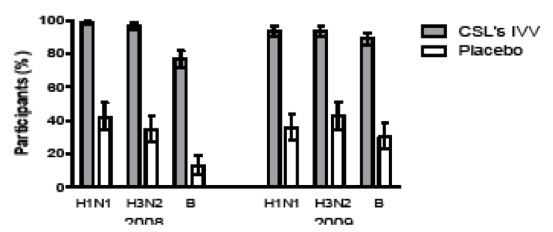
Figure 6. Study CSLCT-USF-06-28 - Proportion of participants achieving seroconversion, evaluable population for the immunogenicity analysis
Figure 7. Study CSLCT-USF-06-28 - Geometric mean fold increase in HAI antibody titre, evaluable population for the immunogenicity analysis
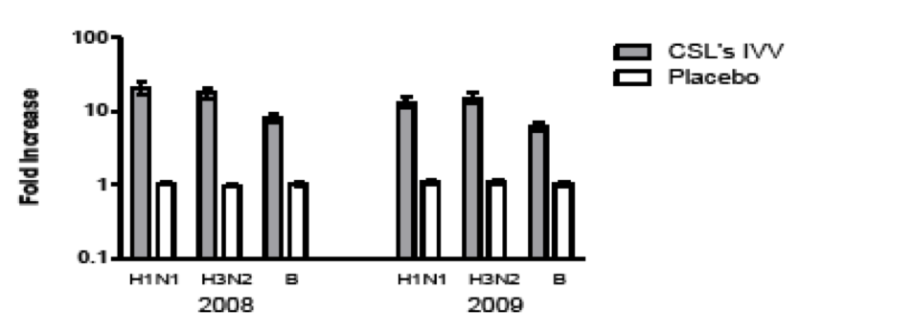

Safety results
These are discussed briefly. No vaccine-related deaths or SAEs. Of the 134 NOCIs reported, 3 considered possibly related to study vaccine (nasal congestion, ulcerative colitis and proctitis) by the investigator. There were 8 withdrawals from the study due to safety-related events: 7 withdrawn because of unrelated SAEs and one withdrawn because of an unrelated NOCI. Halting rules were triggered seven times during the 2008 season because of seven single cases of allergic events. After review of these cases, the DMC considered the events to be expected and of a nature that did not warrant enrolment halt. Three deaths, assessed as unrelated to study vaccine. Significant AEs included 160 unrelated SAEs (including the three that led to death) that were reported by 144 participants (IVV group: 1.0%; placebo group: 0.9%) and 134 NOCIs reported for 126 participants (IVV group: 0.8%; placebo group: 0.9%).

Solicited local adverse events
Both IVV and placebo generally well tolerated. More participants in the IVV group than placebo group reported solicited local AEs (IVV group: 74.6% of subjects; placebo: 20.4% of subjects). The majority of local AEs were mild in intensity. Most frequently reported solicited local AEs in both vaccine groups were injection-site tenderness and pain.

Solicited systemic adverse events
More participants in the IVV group than placebo reported solicited systemic AEs (IVV group: 46.6% of participants; placebo group: 39.1% of participants). Most frequently reported solicited systemic AEs in both vaccine groups were malaise, headache and myalgia. Majority of solicited AEs were graded mild in intensity and short-lived.

Unsolicited adverse events
Frequency of unsolicited AEs similar between vaccine groups. Unsolicited AEs were reported by 34.7% participants and of these, 4.5% participants had unsolicited AEs considered related to study vaccine. The most frequently reported unsolicited AE reported in both vaccine groups was headache.

Analyses performed across trials (pooled analyses and meta-analyses)
There was no pooled analysis or meta-analysis provided.

Evaluator’s conclusions on the clinical efficacy of the vaccine
QIV has demonstrable immunogenicity in a US population of adults aged ≥ 18 years, based on the non-inferiority (for the 8 co-primary endpoints of HAI GMT and SCRs) of the four strains included in QIV, compared to two TIV formulations, and superiority for the QIV B strains not included in each of the two TIV comparator formulations. Non-inferiority and superiority (according to the study defined criteria for different strains and study vaccines) were also met for both the serological endpoints of HI GMT and SCR in the two age cohorts (adults aged 18 to 64 years and ≥ 65 years). Additional descriptive secondary immunogenicity endpoints including percentage with an HAI titre ≥ 40 (seroprotection rates), SCRs and GMFIs by study vaccine and age cohort were analysed. In general, results were similar between different study vaccines within each age cohort for A strain results, and when the vaccine-included B strains were matched. Post-vaccination seroprotection rates for the A strains were very high (≥ 95%) and similar in both age cohorts. For the B strains post-vaccination seroprotection rates for subjects in the older age cohort (≥ 65 years of age) were lower than those in the 18 to 64 years of age cohort, even when the B strains were matched. Seroconversion rates in the overall study population of adults ≥ 18 years were generally in the range of 30 to 40% for both A strains and vaccine matched B strains. However, SCRs for subjects in the older age cohort ≥ 65 years were lower than the younger age cohort for all strains, even when the B strains were matched. One of the explanations for this is this is a study population that have had high rates of influenza vaccination in the previous 12 months. This pivotal study for QIV was not powered for clinical efficacy and at best, it is anticipated that clinical efficacy of QIV will be similar to that demonstrated for TIV for vaccine included and matched strains (around 60%).

Clinical safety

Studies providing evaluable safety data
There is one key study, Study CSLCT-QIV-13-01, described in Section 7 above, that provided evaluable safety data for the QIV. The other two supporting studies described in Section 7 do not utilise the QIV and as such the clinical evaluator has opted to describe the safety data for these briefly in Section 7.

Safety reporting
Adverse event (AE): an AE is any untoward medical occurrence in a patient or clinical investigation subject administered a pharmaceutical product and which does not necessarily have a causal relationship with this treatment. An AE can, therefore, be any unfavourable and unintended sign (including an abnormal, clinically significant laboratory finding), symptom, or disease temporally associated with the use of an investigational product, whether or not considered related to the product. The period of observation for AEs was from informed consent until end of study.
Solicited AEs: Solicited AEs are events specifically sought for (that is, local: pain, induration or swelling and erythema or redness; systemic: headache, malaise, myalgia, fever, chills, nausea and vomiting; and cellulitis-like reaction) and recorded by the subjects in the 7-Day Solicited AE Diary, issued on the day of vaccination. Solicited local and systemic AEs defined and graded (see Tables 5 and 6 below).

Table 5. Intensity grading of solicited local AEs
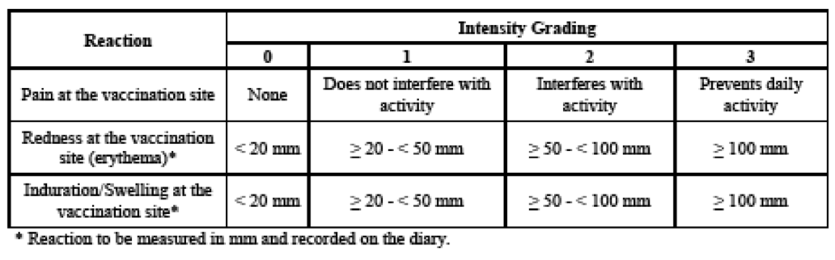

Table 6. Intensity grading of Solicited Systemic AEs
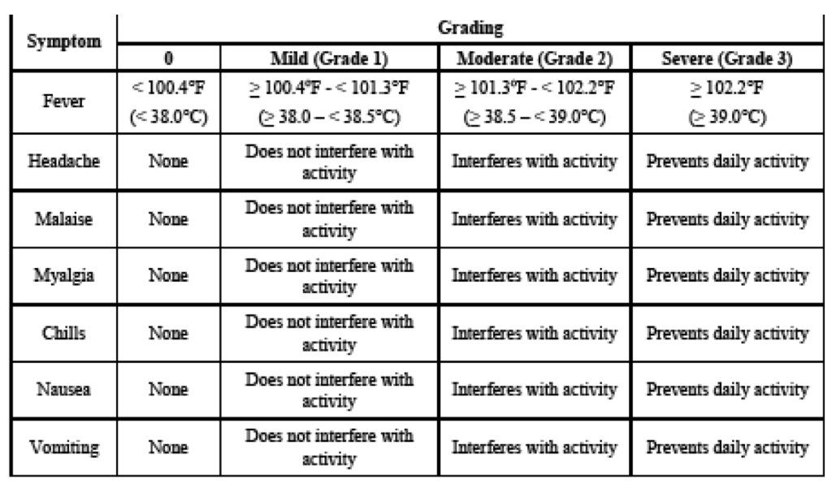
Unsolicited AEs: all other AEs and will be recorded on a separate 21-day diary card issued on the day of vaccination and Day 22 to 28 diary card issued at Visit 2. The intensity/severity of unsolicited AEs will be determined by the subject and graded as follows:
- Mild: Symptoms are easily tolerated and do not interfere with normal, everyday activities.
- Moderate: Discomfort enough to cause some interference with normal, everyday activities.
- Severe: Symptoms that prevent normal, everyday activities.
Adverse Event of Special Interest (AESIs): An AESI (serious or nonserious) is one of scientific and medical concern specific to the sponsor’s product or program, for which ongoing monitoring and rapid communication by the investigator to the sponsor is appropriate. AESI listing for Seqirus QIV is based on AEs assessed to meet the above definition for Seqirus TIV based on the prior safety history, or have been identified as potential class AEs for inactivated influenza vaccines. The list includes: optic neuritis; encephalitis; thrombocytopaenia; vasculitis; GBS; Bell’s palsy; transverse myelitis; demyelinating disorders.
SAE: An untoward medical occurrence that at any dose that results in death; is life-threatening; requires in-patient hospitalisation or prolongation of existing hospitalisation; results in persistent or significant disability or incapacity; is a congenital anomaly or birth defect; is medically significant; or is the suspected transmission of an infectious agent via a medicinal product.
Severity of adverse events: Severity of each unsolicited AE (that is non-serious and SAEs) assessed by the investigator as follows:
- Mild: usually transient and may require only minimal treatment or therapeutic intervention. Event does not generally interfere with usual activities of daily living.
- Moderate: usually alleviated with additional specific therapeutic intervention. Event interferes with usual activities of daily living, causes discomfort but poses no significant/permanent risk of harm to the subject.
- Severe: interrupts usual activities of daily living, or significantly affects clinical status, or may require intensive therapeutic intervention.
Causality of adverse events: Assessed by investigator. All solicited local AEs are assessed as related to the study vaccine. All other AEs classified as related/not related. The degree of certainty with which an AE is attributed to study vaccine or alternative cause determined by how well the event can be understood in terms of: known pharmacology of study vaccine; clinically and/or pathophysiologically plausible context; reaction of a similar nature previously observed with similar products; plausibility supported by the temporal relationship.
Observation period for adverse events: AE reporting from written informed consent until Day 28. For SAEs, from written informed consent until Day 180.

Pivotal studies that assessed safety as a primary outcome
Not applicable. The studies described in Section 7 collected safety data as a secondary outcome.

Patient exposure
1721 of 1741 QIV recipients were included in the safety analysis. See also Table 2 above.

Adverse events

All adverse events (irrespective of relationship to study treatment) in Study CSLCT-QIV-13-01
No AESIs, cellulitis or cellulitis-like reactions at the injection site or AEs leading to withdrawal were reported. Overall, 52.9% reported an AE (solicited local adverse reactions (36.5%), solicited systemic AEs (28.4%) and unsolicited AEs (20.8%)). These AEs were experienced in similar proportions of subjects across all the three vaccine groups.

Table 7. AEs in Study CSLCT-QIV-13-01
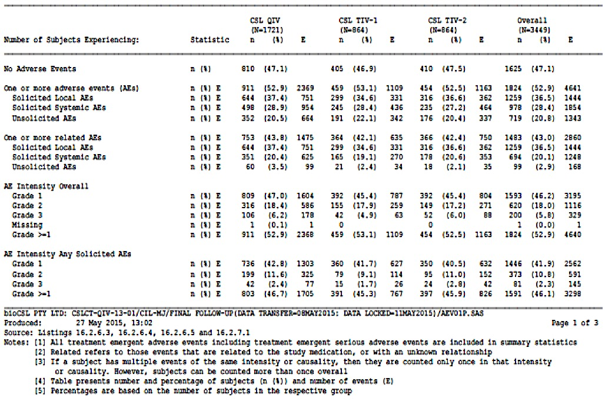

Treatment-related adverse events (adverse drug reactions) in Study CSLCT QIV-13-01
Most common (≥ 10% of subjects) solicited local adverse reaction was injection site pain in all three vaccine groups. Proportion in the QIV group experiencing injection site pain was higher in the 18-64 years age cohort (47.9%) versus the older age cohort (≥ 65 years: 24.6%). Additionally, the proportion of 18 to 64 year olds experiencing moderate redness and swelling/lump at the injection site was slightly higher in the QIV group (0.8% and 1.2%, respectively) versus TIV-1 (0.2% and 0.5% reported redness or swelling/lump, respectively) and TIV-2 groups (0.5% of subjects reporting redness or swelling/lump each). Subjects aged ≥ 65 years also experienced redness and swelling/lump events of greater intensity (moderate (Grade 2) and severe (Grade 3)) in the QIV group versus comparator TIV vaccines. Female subjects in the QIV group were more likely to report any local adverse reaction (1.16 (95% CI: 1.01, 1.32)) and pain (at the injection site) (1.17 (95% CI: 1.02, 1.34)) than females in the TIV-1 group. Most of the solicited local adverse reactions (pain, redness and swelling/lump), experienced in any vaccine group, started on Day 1 and had a mean duration of 1.8 to 3.1 days.

Table 8. Study CSLCT-QIV-13-01 Solicited local symptoms overall and by maximum intensity (safety population)
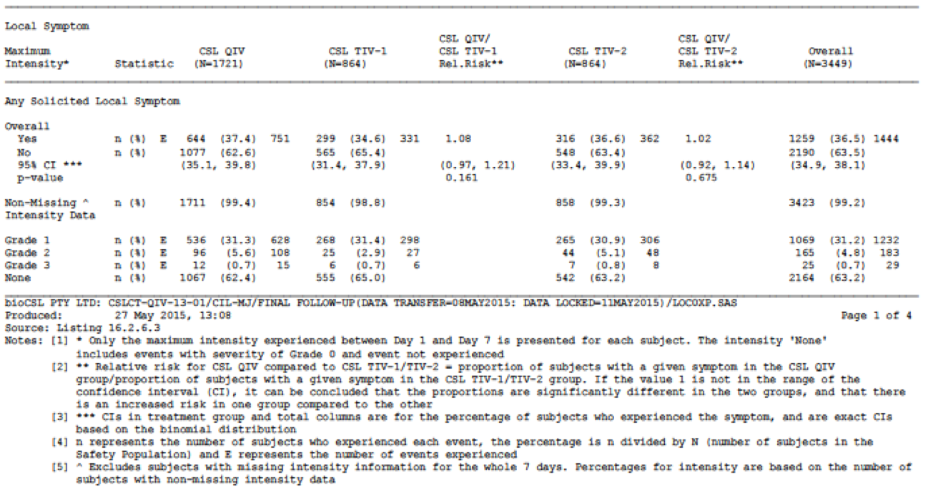
The two most common (≥ 10% of subjects) solicited systemic AEs were myalgia and headache (in all three vaccine groups), in the adult cohort (18 to 64 years) and myalgia (followed by headache, but < 10% of subjects) in the older adult cohort (≥ 65 years). The proportion of subjects reporting any solicited systemic AE tended to be higher in the adult cohort (37.2% subjects overall) compared with the older adult cohort (19.6% subjects overall) regardless of the vaccine administered. Subjects were more likely to experience headache events after vaccination with QIV compared with TIV-1 for all subjects (1.35 (95% CI: 1.08, 1.68)), for subjects in the 18 to 64 years of age cohort (1.43 (95% CI: 1.10, 1.85)), for subjects in the 18 to 49 years of age group (1.40 (95%CI: 1.02, 1.92)) and in females (1.42 (95%CI: 1.10, 1.83)). There were no statistically significant relative risks for any other systemic AEs after vaccination with QIV compared to TIV-1 and TIV-2. The average onset of solicited systemic AEs was on Day 2, with the exception of myalgia in all vaccine groups (average onset was Day 1), fever in the comparator TIV groups (average onset was Day 3) and vomiting in all vaccine groups (average onset was Day 3), and had a mean of 1.1 to 2.2 days.
Generally, the solicited local adverse reactions and systemic AEs were graded as mild in intensity. No individual unsolicited AE was reported in > 10% subjects in any vaccine group or age cohort.
The most common unsolicited AE was headache in 3.5% subjects overall followed by oropharyngeal pain (1.8%), back pain (1.7%), diarrhoea (1.2%), rhinorrhoea (1.2%), cough (1.0%) and nasal congestion (1.0%). The proportion of subjects experiencing any unsolicited AE was similar in the 18 to 64 years age cohort (20.5% subjects overall) compared with ≥ 65 years age cohort (21.2% subjects overall), with slightly higher proportion of subjects experiencing related unsolicited AEs in the 18 through 64 years age cohort (3.7% subjects overall) compared with ≥ 65 years age cohort (2.1% of subjects overall).
A higher proportion of female subjects reported events (solicited local or systemic and unsolicited AEs) versus male subjects in all vaccine groups. No clinically significant differences were noted in the proportion of subjects who reported events (solicited local or systemic or unsolicited AEs) based on race or ethnicity in any vaccine group. Grade 3 injection site swelling/induration was reported in more subjects in the QIV and in the ≥ 65 years age cohort (4 QIV subjects) compared with 18-64 years age cohort (one subject each in QIV and TIV-2 groups).

Table 9. Study CSLCT-QIV-13-01 Summary of all solicited and unsolicited AEs in Females
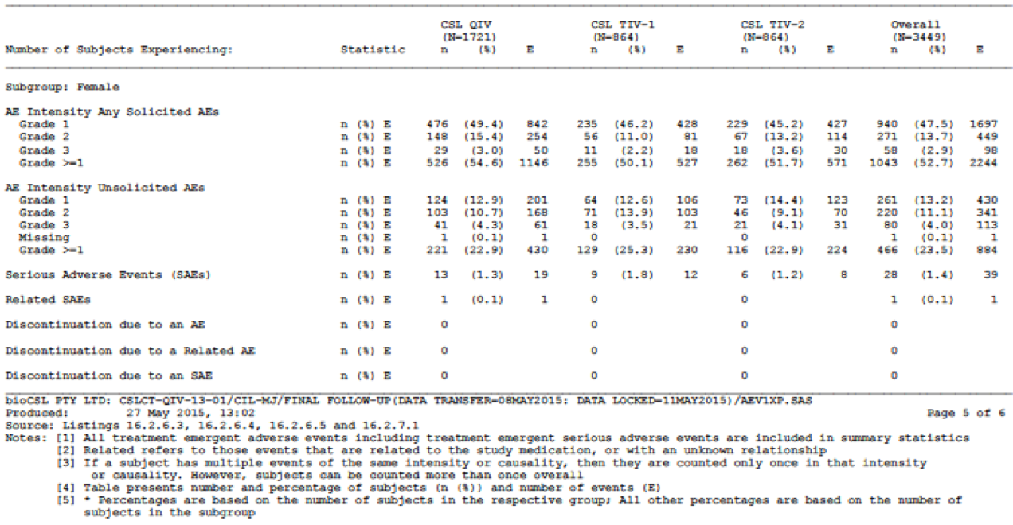

Table 10. Study CSLCT-QIV-13-01 Summary of all solicited and unsolicited AE in Males
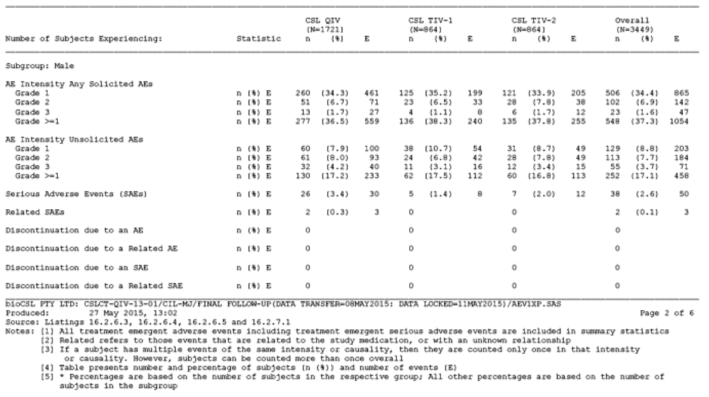

Deaths and other serious adverse events
89 SAEs were experienced in 66 subjects (1.9%) during the study, with 4 SAEs (asthma, pancreatitis acute, hypoxia and pneumonia experienced in 3 subjects in QIV group) assessed as related to study vaccine. A total of 2.3% subjects in the QIV group experienced one or more SAE versus 1.6% and 1.5% in the comparator TIV-1 and TIV-2 groups, respectively. During the active study period (Day 1 to Day 28), a total of 15 SAEs were experienced in 12 subjects.
There were 6 deaths reported during the study, one of which was assessed as related (pneumonia in the ≥ 65 years age cohort) to study vaccine. The SAEs with an outcome of death were: road traffic accident, cardiac failure, acute myocardial infarction, pneumonia and ventricular arrhythmia (QIV group) and sepsis (TIV-2 group). Of these 6 subjects, 2 subjects died (road traffic accident and pneumonia) during the active study period (Day 1 to Day 28). The study was temporarily halted on two occasions (after serious, unexpected and related events of severe acute pancreatitis (occurred on Day 5) and severe asthma (occurred on Day 17; outside the 7 day halting rule period)). The DSMB Chair was consulted and upon review of each event, recruitment was allowed to continue within 24 hours. A formal DSMB meeting was not required for either event.

Discontinuation due to adverse events
None.

Laboratory tests
Laboratory evaluations (aside from immunogenicity) were not performed in these studies.

Electrocardiograph
Not assessed in these vaccine studies.

Vital signs
Not applicable.

Post-marketing experience
Not applicable.

Safety issues with the potential for major regulatory impact
None revealed.

Liver toxicity
None revealed.

Haematological toxicity
None revealed.

Serious skin reactions
None revealed.

Cardiovascular safety
None revealed.

Unwanted immunological events
None revealed.

Other safety issues

Safety in special populations
No other studies of safety in other special populations such as pregnant and breast feeding women, immunocompromised persons is available. As QIV is similar in composition to TIV, the safety profile is expected to be similar to TIV. There was one occurrence of pregnancy during Study CSLCT QIV 13-01. The subject had a positive urine pregnancy test at the Day 21 visit and had an elective termination of pregnancy 12 days later.

Safety related to drug-drug interactions and other interactions
None revealed.

Other safety issues
None revealed.

Evaluator’s overall conclusions on clinical safety
In Study CSLCT-QIV-13-01, the safety profile of QIV in adults and older adults is generally similar to that observed for TIV-1 and TIV-2 vaccines. Solicited local and systemic reactogenicity was more frequent in adults 18 to 64 years of age compared to adults aged ≥ 65 years. Overall, the clinical evaluator thinks that QIV has a clinically acceptable safety and tolerability profile in adults ≥ 18 years at least in the relatively small number of patients enrolled in this study exposed to single dose QIV.

First round benefit-risk assessment

First round assessment of benefits
The benefits of Afluria Quad in the proposed usages are favourable as the QIV provides better coverage of the influenza B strains than the TIV. QIV was immunogenic with a safety profile similar to trivalent inactivated influenza vaccines in general, and to the specific TIV comparators used in the pivotal efficacy study. Moreover, the inclusion of both B strains will overcome the problem of poor predictions of which B strain is likely to circulate, this has been problematic over the last few years and has led to misalignment of the B strain in the recommended TIV with what was the circulating strain.

First round assessment of risks
The risks of Afluria Quad in the proposed usage are:
- there is a paucity of data in subjects of Asian ethnicity – this is relevant to the Australian population;
- there is a paucity of data in subjects of Australian indigenous ethnicity – this is relevant to the Australian population;
- the average age of the subjects enrolled was 58.3 (± 18) years, and although 29% of the cohort in total were aged 18 to 49 years, this suggests a relative paucity of patients in the much younger age group, specifically 18 to 30 years. As the reactogenicity profile appears slightly worse in the younger age group overall, it will be important to gather further specific information on local and solicited vaccine-related AEs in the much younger age group once QIV receives authorisation. The RMP should specifically gather information in both the younger age group receiving the QIV as well as in those of ethnicity not represented in the pivotal study;
- there is no data on the immunogenicity and safety profile in immunocompromised patients as such patients were specifically excluded from participation;
- no clinical efficacy data provided, immunogenicity data is used as a surrogate for clinical efficacy.

First round assessment of benefit-risk balance
The benefit-risk balance of Afluria Quad, given the proposed usages, is favourable.

First round recommendation regarding authorisation
The clinical evaluator recommends authorisation of Afluria Quad.

Clinical questions

Additional expert input
None sought.

Clinical questions

Pharmacokinetics
Not applicable.

Pharmacodynamics
Not applicable, see under ‘efficacy’.

Efficacy
Q1) What are the post-vaccination seroprotection rates for subjects over the age of 75 years for the B strains?
Q2) Do you have any explanation for why the seroprotection rates for B/Yamagata strain, in adults aged ≥ 65 years was lower than for the B/Victoria lineage?

Safety
None.

Second round evaluation of clinical data submitted in response to questions

Efficacy

Question 1
What are the post-vaccination seroprotection rates for subjects over the age of 75 years for the B strains?

Sponsor’s response
Post-hoc analyses demonstrate that the post-vaccination seroprotection rate for subjects ≥ 75 years (n = 325) to QIV in Study CSLCT-QIV-13-01 was 62.8% for the B/Yamagata (B/Massachusetts/2/2012) strain, and 78.5% for the B/Victoria (B/Brisbane/60/2008) strain (see Table 11 below, post-hoc analysis). These QIV B strain post-vaccination seroprotection rates are actually numerically slightly higher in the ≥ 75 years population than in the overall ≥ 60 years population, showing maintenance of the seroprotection rate in this older age group. GMTs, seroconversion rates and Geometric Fold Increases (GMFI) are also shown in to more broadly characterise the HI immune responses for these post-hoc analyses.
The humoral immune response to influenza vaccination in the elderly is known to be reduced compared to adults, especially for influenza A/H1N1 strains prior to the 2009 pandemic and influenza B strains. A quantitative review of 31 influenza vaccine antibody response studies conducted from 1986 to 2002 in the elderly (including studies with subjects with a mean age of 65 years or higher), identified through multiple regression modelling that age, previous vaccination, high pre-vaccination titres and living situation (institutional residence) significantly influenced the antibody response to vaccination. It was also reported that after adjusting for vaccine and host factors, vaccine responses in the elderly (against seroprotection and seroconversion) were approximately three to four fold less for the H1N1 and B strains, and about half that observed for H3N2 strains in younger adults.

Table 11. Summary of HI immunogenicity data for QIV Vaccine (PP Population) by age cohorts defined in the CHMP Criteria (≥ 18 to 60 years and ≥ 60 years) and by age cohort ≥ 75 years, in Study CSLCT-QIV-13-01
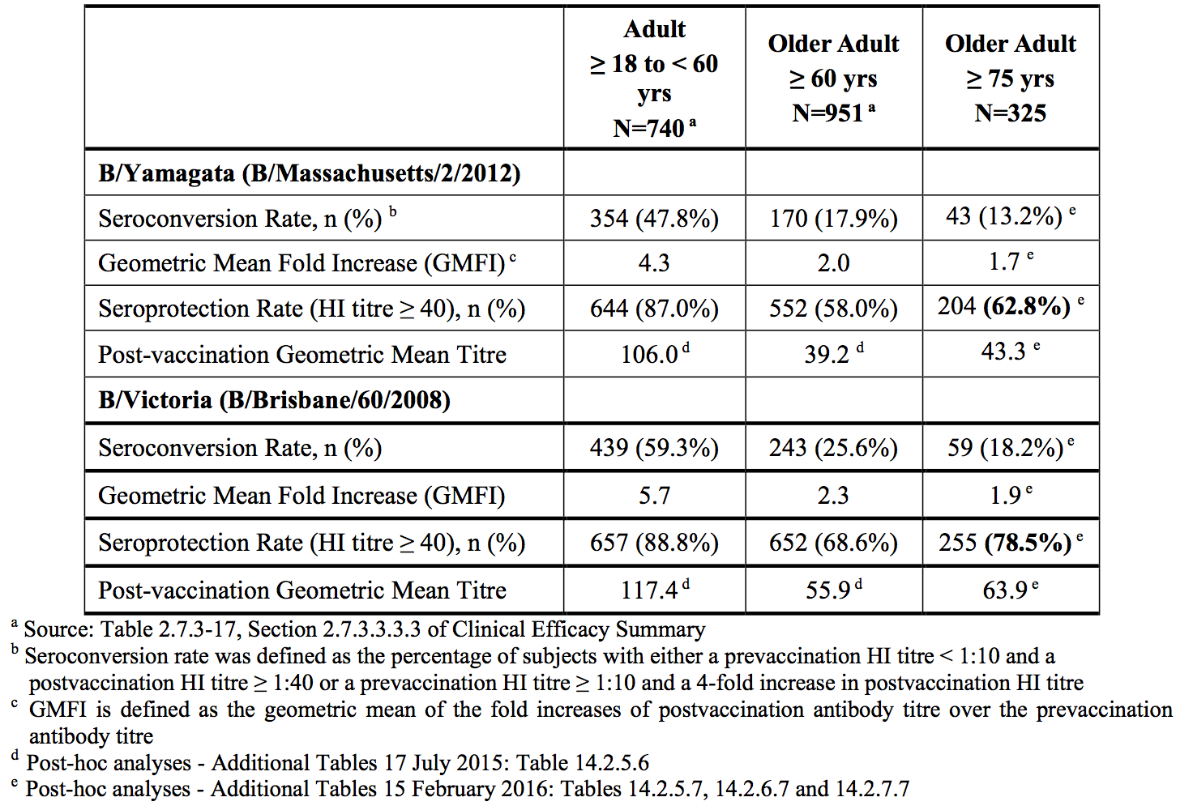

Question 2
Do you have any explanation for why the seroprotection rates for B/Yamagata strain, in adults aged ≥ 65 years was lower than for the B/Victoria lineage?

Sponsor’s response
This observation is likely to be explained predominantly by vaccine B strain characteristics, that is, the B/Yamagata strain (B/Massachusetts/2/2012) appears to be less immunogenic relative to the B/Victoria strain (B/Brisbane/60/2008), when measured by HI assays.
The observation that seroprotection rates for the B/Yamagata strain in adults aged ≥ 65 years was lower than for the B/Victoria lineage in Study CSLCT-QIV-13-01 is consistent with the patterns of HI assay immune responses that have been previously observed to these specific influenza B vaccine strains from two Fluvax TIV clinical studies conducted in support of Annual Strain Updates in Europe (CSLCT-ASU-12-84 (NCT01857297) and CSLCT-ASU-10-66 (NCT01113580)).
GMT by HI assay for the B/Yamagata strain were also numerically lower than results for the B/Victoria strain in subjects ≥ 65 years in the FluQuadri Study QIV-03 (NCT01218646) as evident in the Australian PI for this product. The B/Victoria post-vaccination GMT (B/Brisbane/60/2008) was 73.8 compared with 61.1 for the B/Yamagata post-vaccination GMT (B/Florida/04/2006). Note however that the B/Yamagata strain used in the study was the strain that preceded the B/Massachusetts/2/2012 strain in northern hemisphere vaccines that was included in Study CSLCT-QIV-13-01.

Second round benefit-risk assessment

Second round assessment of benefits
After consideration of the responses to clinical questions, the benefits of Afluria Quad in the proposed usage are unchanged from those identified in the First round assessment of benefits (see Section 9.1 above).

Second round assessment of risks
After consideration of the responses to clinical questions, the risks of Afluria Quad in the proposed usage are unchanged from those identified in the First round assessment on risks (see Section 9.2 above).

Second round assessment of benefit-risk balance
The benefit-risk balance of Afluria Quad, given the proposed usage, remains favourable.

Second round recommendation regarding authorisation
The clinical advisor recommends authorisation of Afluria Quad.

References
Ambrose C, et al., The rationale for quadrivalent influenza vaccines. Hum Vaccin Immunother 2012 Jan; 8(1):81-8.
Belshe, R. The need for quadrivalent vaccine against seasonal influenza. Vaccine 2010 Sep 7; 28 Suppl 4: D45-53.
Beyer W, et al., Protection against influenza after annually repeated vaccination: a meta-analysis of serologic and field studies. Arch Intern Med. 1999;159(2):182-8.
Fiore A, et al. Prevention and control of seasonal influenza with vaccines: recommendations of the Advisory Committee on Immunization Practices (ACIP), 2009. MMWR Recomm Rep 2009 Jul 31;58(RR-8):1-52.
Hay A, et al., Influenza viruses. In: Belshe RB, ed. Textbook of Human Virology. St. Louis, Missouri: Mosby Year Book, Inc, 1991;307−341.
Monto A, Epidemiology of influenza. Vaccine. 2008 Sep 12; 26 Suppl 4:D45-8.
Rota A, et al., Cocirculation of two distinct evolutionary lineages of influenza type B virus since 1983. Virology 1990 Mar; 175(1):59-68.
Rothberg M, et al., Complications of viral influenza. Am J Med 2008 Apr;121(4):258-64
Reed C, et al., Public health impact of including two lineages of influenza B in a quadrivalent seasonal influenza vaccine. Vaccine 2012 Mar 2; 30(11): 1993 8.

Therapeutic Goods Administration
PO Box 100 Woden ACT 2606 Australia
Email: info@tga.gov.au Phone: 1800 020 653 Fax: 02 6232 8605
https://www.tga.gov.au

Fiore A, et al. Prevention and control of seasonal influenza with vaccines: recommendations of the Advisory Committee on Immunization Practices (ACIP), 2009. MMWR Recomm Rep 2009 Jul 31;58(RR-8):1-52.
Rothberg M, et al., Complications of viral influenza. Am J Med 2008 Apr;121(4):258-64
Monto A, Epidemiology of influenza. Vaccine. 2008 Sep 12; 26 Suppl 4:D45-8.
Hay A, et al., Influenza viruses. In: Belshe RB, ed. Textbook of Human Virology. St. Louis, Missouri: Mosby Year Book, Inc, 1991;307−341.
Beyer W, et al., Protection against influenza after annually repeated vaccination: a meta-analysis of serologic and field studies. Arch Intern Med. 1999;159(2):182-8.
Rota A, et al., Cocirculation of two distinct evolutionary lineages of influenza type B virus since 1983. Virology 1990 Mar; 175(1):59-68.
Belshe, R. The need for quadrivalent vaccine against seasonal influenza. Vaccine 2010 Sep 7; 28 Suppl 4: D45-53.
Ambrose C, et al., The rationale for quadrivalent influenza vaccines. Hum Vaccin Immunother 2012 Jan; 8(1):81-8.
Reed C, et al., Public health impact of including two lineages of influenza B in a quadrivalent seasonal influenza vaccine. Vaccine 2012 Mar 2; 30(11): 1993 8.
Date for coming into effect: 1 February 2017.
CPMP/ICH/135/95: Guideline for good clinical practice E6(R2).
The GMT ratio = the geometric mean of post-vaccination (Day 21) HI titre for TIV over the geometric mean of post-vaccination (Day 21) HI titre for QIV.
The SCR is defined as the % of subjects with either a pre -vaccination HAI titre < 1:10 and a post-vaccination HAI titre ≥ 1: 40 or a pre-vaccination HI titre ≥ 1:10 and a ≥ 4-fold increase in post-vaccination HAI titre.
GMFI is defined as the geometric mean of the fold increases of post-vaccination antibody titre over the pre-vaccination antibody titre.
These issues were included in the Clinical and RMP questions and the sponsor has provided a response to these. Please refer to the AusPAR sections ‘Second round evaluation of clinical data submitted in response to questions’ and ‘Reconciliation of issues outlined in the RMP report’.
Goodwin K, et al., Antibody response to influenza vaccination in the elderly: a quantitative review. Vaccine. 2006 Feb 20;24(8):1159-69.

