|  |
| --- |
| **November 2018** |

|  |
| --- |
| Australian Public Assessment Report for Inactivated split influenza vaccine |
| Proprietary Product Name: Fluarix Tetra |
| Sponsor: GlaxoSmithKline Australia Pty Ltd |

About the Therapeutic Goods Administration (TGA)

* The Therapeutic Goods Administration (TGA) is part of the Australian Government Department of Health and is responsible for regulating medicines and medical devices.
* The TGA administers the *Therapeutic Goods Act 1989* (the Act), applying a risk management approach designed to ensure therapeutic goods supplied in Australia meet acceptable standards of quality, safety and efficacy (performance) when necessary.
* The work of the TGA is based on applying scientific and clinical expertise to decision-making, to ensure that the benefits to consumers outweigh any risks associated with the use of medicines and medical devices.
* The TGA relies on the public, healthcare professionals and industry to report problems with medicines or medical devices. TGA investigates reports received by it to determine any necessary regulatory action.
* To report a problem with a medicine or medical device, please see the information on the TGA website <<https://www.tga.gov.au>>.

About AusPARs

* An Australian Public Assessment Report (AusPAR) provides information about the evaluation of a prescription medicine and the considerations that led the TGA to approve or not approve a prescription medicine submission.
* AusPARs are prepared and published by the TGA.
* An AusPAR is prepared for submissions that relate to new chemical entities, generic medicines, major variations and extensions of indications.
* An AusPAR is a static document; it provides information that relates to a submission at a particular point in time.
* A new AusPAR will be developed to reflect changes to indications and/or major variations to a prescription medicine subject to evaluation by the TGA.

Copyright

© Commonwealth of Australia 2018  
This work is copyright. You may reproduce the whole or part of this work in unaltered form for your own personal use or, if you are part of an organisation, for internal use within your organisation, but only if you or your organisation do not use the reproduction for any commercial purpose and retain this copyright notice and all disclaimer notices as part of that reproduction. Apart from rights to use as permitted by the *Copyright Act 1968* or allowed by this copyright notice, all other rights are reserved and you are not allowed to reproduce the whole or any part of this work in any way (electronic or otherwise) without first being given specific written permission from the Commonwealth to do so. Requests and inquiries concerning reproduction and rights are to be sent to the TGA Copyright Officer, Therapeutic Goods Administration, PO Box 100, Woden ACT 2606 or emailed to <[tga.copyright@tga.gov.au](mailto:tga.copyright@tga.gov.au)>.

Contents

Common abbreviations 4

I. Introduction to product submission 7

Submission details 7

Product background 7

Regulatory status 8

Product Information 9

II. Registration time line 9

III. Quality findings 9

IV. Nonclinical findings 10

V. Clinical findings 10

Introduction 10

Pharmacokinetics 13

Pharmacodynamics 13

Dosage selection for the pivotal studies 13

Efficacy 13

Safety 14

First Round Benefit-Risk Assessment 15

Second round clinical evaluation 17

VI. Pharmacovigilance findings 17

Risk management plan (RMP) 17

VII. Overall conclusion and risk/benefit assessment 19

Quality 19

Nonclinical 19

Clinical 20

Risk management plan 28

Risk-benefit analysis 28

Outcome 37

Attachment 1. Product Information 38

Attachment 2. Extract from the Clinical Evaluation Report 38

## Common abbreviations

|  |  |
| --- | --- |
| Abbreviation | Meaning |
| AE | Adverse event |
| AESIs | Adverse events of special interest |
| AIVC | Australian Influenza Vaccine Committee |
| AOM | Acute otitis media |
| ASA | Australian-specific annex |
| ATP-E | According-to-protocol efficacy |
| CBER | Center for Biologics Evaluation and Research |
| CDC | Centers of Disease Control and Prevention |
| CHMP | Committee for Medicinal Products for Human Use |
| CI | Confidence Interval |
| D-QIV | Fluarix Tetra |
| ELISA | Enzyme linked immunosorbent assay |
| ESS | Enhanced safety surveillance |
| EU | European Union |
| FDA | Food and Drug Administration |
| Fluarix Tetra IP | Fluarix Tetra from investigational process (IP) |
| Fluarix Tetra LP | Fluarix Tetra from licensed process (LP) |
| GBS | Guillain Barré syndrome |
| GCP | Good Clinical Practice |
| GMTs | Geometric mean titres |
| Gp | Group |
| HA | Haemagglutinin |
| HI | Haemagglutination inhibition |
| ICH | International Conference on Harmonisation |
| ILI | Influenza like infection |
| IM | Intramuscular |
| ITT | Intention to treat |
| LAR | Legally authorised representative. |
| LRI | Low respiratory infection |
| MEDRA | Medical Dictionary for Regulatory Activities |
| MAVs | Medically attended visits |
| MGI | Mean geometric increase |
| PBRER | Period Benefit Risk Evaluation Report |
| PI | Prescribing Information |
| pIMDs | potential Immune-Mediated-Diseases |
| PP | Per protocol |
| PT | Preferred Term |
| QIV | Quadrivalent inactivated Influenza Vaccine |
| RMP | Risk Management Plan |
| RRA | Recruitment/Randomisation agreement |
| RT-PCR | Reverse Transcription Polymerase Chain Reaction |
| SAE | Serious adverse event |
| SCR | Seroconversion Rate |
| SD | Standard deviation |
| SH | Southern Hemisphere |
| SOC | System Organ Class |
| SPR | Seroprotection rate |
| TGA | Therapeutic Goods Administration |
| TRAE | Treatment-related adverse event |
| TVC | Total vaccinated cohort |
| URTI | Upper respiratory tract infection |
| US | United States |
| VE | Vaccine efficacy |
| VRBPAC | Vaccines and Related Biological Products Advisory Committee |
| WHO | World Health Organization |

## I. Introduction to product submission

### Submission details

|  |  |
| --- | --- |
| *Type of submission:* | Extension of indications |
| *Decision*: | Approved |
| *Date of decision:* | 23 May 2018 |
| *Date of entry onto ARTG:* | 29 May 2018 |
| *ARTG numbers:* | 200674, 210806 and 242512 |
| *Active ingredient:* | Inactivated split influenza vaccine |
| *Product name:* | Fluarix Tetra |
| *Sponsor’s name and address:* | GlaxoSmithKline Australia Pty Ltd  PO Box 18095 Melbourne VIC 8003 Australia |
| *Dose form:* | Suspension for injection |
| *Strength:* | 0.5 mL |
| *Containers:* | Pre-filled syringes with or without syringes |
| *Pack sizes:* | 1 or 10s |
| *Approved therapeutic use:* | Fluarix Tetra is a quadrivalent vaccine indicated for active immunisation of adults and children from 6 months of age for the prevention of influenza disease caused by the influenza virus types A and B contained in the vaccine (see section 5.1 Pharmacodynamic Properties, Clinical trials).  The use of Fluarix Tetra should be based on official recommendations. |
| *Route of administration:* | Intramuscular (IM) preferably into the deltoid muscle or anterolateral thigh (depending on the muscle mass). |
| *Dosage:* | Fluarix Tetra should be administered as a single 0.5 mL injection.  Children 6 months to less than 9 years of age who have not previously been vaccinated against influenza should receive a second dose of 0.5 mL after an interval of at least 4 weeks. |

### Product background

This AusPAR describes the application by the sponsor to extend the indications of inactivated split influenza vaccine (Fluarix Tetra) which is currently approved for the prevention of influenza in adults and children from 3 years of age. The submission seeks to extend the indication to include children from 6 months of age.

The current indications registered in Australia are as follows:

*Fluarix Tetra is a quadrivalent vaccine indicated for active immunisation of adults and children from 3 years of age for the prevention of influenza disease caused by the influenza virus types A and B contained in the vaccine (see Clinical Trials).*

*The use of Fluarix Tetra should be based on official recommendations.*

The sponsor has proposed the following wording for the indications:

*Fluarix Tetra is a quadrivalent vaccine indicated for active immunisation of adults and children from 6 months of age for the prevention of influenza disease caused by the influenza virus types A and B contained in the vaccine (see, Clinical Trials).*

*The use of Fluarix Tetra should be based on official recommendations.*

Fluarix Tetra should be administered as a single 0.5 mL injection. Children 6 months-3 years to less than 9 years of age who have not previously been vaccinated against influenza should receive a second dose of 0.5 mL after an interval of at least 4 weeks.

Fluarix Tetra is an inactivated and purified split influenza vaccine. The antigen composition and strains for the 2018 influenza season corresponds to the following types:

* A/Michigan/45/2015 (H1N1)pdm09-like strain (A/Singapore/GP1908/2015, IVR‑180)
* A/Singapore/INFIMH-16-0019/2016 (H3N2)-like strain (A/Singapore/INFIMH‑16‑0019/2016, NIB-104)
* B/Phuket/3073/2013-like strain (B/Phuket/3073/2013, wild type)
* B/Brisbane/60/2008-like strain (B/Brisbane/60/2008, wild type)

Each 0.5 mL vaccine dose contains 15 mcg haemagglutinin of each of four influenza strains in phosphate buffered saline.

Fluarix Tetra meets the World Health Organization (WHO) requirements for biological substances and influenza vaccines and the European Pharmacopoeia requirements for influenza vaccines. The type and amount of viral antigens in Fluarix Tetra conform to the annual requirements of the Australian Influenza Vaccine Committee (AIVC) and the New Zealand Ministry of Health.

According to the WHO, annual influenza vaccination is currently the most effective means of controlling influenza and preventing its complications, including mortality. Extending the age indication of Fluarix Tetra to ≥ 6 months will contribute to meet the medical need for influenza prevention through vaccination in the 6 to 35 months age group. Children also play an important role in the spread of influenza and vaccination of young children against influenza contributes to protection of the overall community.

### Regulatory status

Fluarix Tetra was first registered in Australia in 2013 and is currently indicated for active immunisation of adults and children from 3 years of age for the prevention of influenza disease caused by the influenza virus types A and B contained in the vaccine.

The proposed update to the Fluarix Tetra indication to include children 6 to 35 months of age was approved by the European Medicines Agency (EMA) on 12 January 2018, US FDA on 11 January 2018 and New Zealand Medsafe on 21 December 2017.

### Product Information

The Product Information (PI) approved with the submission which is described in this AusPAR can be found as Attachment 1. For the most recent PI, please refer to the TGA website at <<https://www.tga.gov.au/product-information-pi>>.

## II. Registration time line

The following table captures the key steps and dates for this application and which are detailed and discussed in this AusPAR and Attachment 2.

|  |  |
| --- | --- |
| Description | Date |
| Submission dossier accepted and first round evaluation commenced | 28 April 2017 |
| First round evaluation completed | 29 September 2017 |
| Sponsor provides responses on questions raised in first round evaluation | 29 November 2017 |
| Second round evaluation completed | 12 January 2018 |
| Delegate’s Overall benefit-risk assessment and request for Advisory Committee advice | 26 February 2018 |
| Sponsor’s pre-Advisory Committee response | 13 March 2018 |
| Advisory Committee meeting | 28 March 2018 |
| Registration decision (Outcome) | 23 May 2018 |
| Completion of administrative activities and registration on ARTG | 29 May 2018 |
| Number of working days from submission dossier acceptance to registration decision* | 225 days |

*Statutory timeframe is 255 working days

## III. Quality findings

There was no requirement for a full quality evaluation in a submission of this type.

Fluarix Tetra is a colourless to slightly opalescent suspension for injection.

Fluarix Tetra is prepared using whole virus cultivated in embryonated hens' eggs. The virus is concentrated and purified by clarification and centrifugation. The purified whole virus is then treated with the detergent sodium deoxycholate and again centrifuged, and the resulting antigen suspension is inactivated with formaldehyde.

Each 0.5 mL vaccine dose contains 15 µg haemagglutinin of each of four influenza strains in phosphate buffered saline.

The manufacture of this product includes exposure to bovine derived materials. No evidence exists that any case of vCJD (considered to be the human form of bovine spongiform encephalopathy) has resulted from the administration of any vaccine product.

Fluarix Tetra meets the WHO requirements for biological substances and influenza vaccines and the European Pharmacopoeia requirements for influenza vaccines.

For the full list of excipients see Section 6.1 list of excipients in PI, available as Attachment 1.

The shelf life of Fluarix Tetra is a maximum of 15 months from the date of manufacture if stored between temperatures of +2°C and +8°C.

The expiry date of the vaccine is indicated on the label and packaging.

Fluarix Tetra must be stored between +2°C and +8°C and be protected from light.

Do not freeze. Discard if vaccine has been frozen.

The pre-filled syringes are made of neutral glass type I, which conforms to European Pharmacopoeia requirements.

Not all pack sizes (1 syringe and 10 syringes) may be distributed in Australia.

## IV. Nonclinical findings

There was no requirement for a nonclinical evaluation in a submission of this type.

## V. Clinical findings

A summary of the clinical findings is presented in this section. Further details of these clinical findings can be found in Attachment 2.

### Introduction

Study D-QIV-015 was included in this submission to support extrapolation of Study D‑QIV-004 and Study D-QIV-009 study data generated with Fluarix Tetra manufactured according to the previous process (licensed process (LP) at the time Studies -004 and -009 were conducted), to Fluarix Tetra manufactured according to the new harmonised process (investigational process (IP) at the time of the studies, but is now the licensed process having replaced the previous process) in children 6 to 35 months of age.

#### Clinical rationale

Influenza, a respiratory orthomyxovirus, is a seasonal infectious disease that occurs in epidemics throughout the northern and southern hemisphere winter months, and leads to considerable morbidity and mortality globally in all age groups. Young children, particularly those younger than 2 years of age, are among the groups with the highest risk of influenza complications.[1] A meta-analysis study of 63 datasets from 42 countries showed that among children hospitalised with respiratory illness, the percentage of children with influenza varied from 5% in those <6 months, to 16% among children 5 to 17 years of age.[2] The pooled estimate of influenza associated hospitalisation among children < 5 year was 7.4% of all respiratory hospitalisations, ranging from 4.6% (95% confidence interval (CI): 2.8 to 7.4%) in the Americas to 8.5% (95% CI: 6.2 to 8.8%) in Southeast Asia.

Influenza A and B cause most of human disease. Influenza A viruses are divided into subtypes based on two viral external proteins, haemagglutinin (HA) and neuraminidase (NA). Of the influenza A virus subtypes, A/H3N2 and A/H1N1 subtypes are clinically the most important. Influenza type B viruses show extensive variation in antigenicity. Influenza B viruses are separated into two distinct genetic lineages, Yamagata and Victoria. In terms of infection, influenza type A viruses have been isolated from several non-human species, including birds, horses and swine whereas influenza type B viruses almost exclusively affect humans. High levels of virus type-specific antibodies are associated with protection from disease due to infections with homologous and closely related influenza virus strains.[3],[4] Novel influenza strains arise from antigenic drift due to point mutation and recombination events that occur during viral replication. These events result in the emergence of new strains of the influenza virus capable of causing epidemics, as pre-existing antibodies resulting from previous virus exposure or vaccination are generally not cross-protective.3 While influenza type A is capable of major antigenic shifts when a novel HA emerges from re-assortment with an animal influenza virus, influenza B is generally more stable. When a new subtype of influenza virus emerges, all individuals are susceptible to infection except those who have lived through earlier epidemics with a related virus subtype. Infection produces immunity to the specific virus; however, the length and extent of immunity is dependent on the degree of antigenic shift, the number of previous infections and the immune status of the individual.[5]

Influenza epidemics have been associated with the circulation of type A/H3N2, type A/H1N1 and type B viruses, either individually or together. Two genetically distinct lineages of influenza B viruses have co-circulated since 1985.[6] The burden of infection is largely on school age children, young adults, and the elderly.[7] In the US, B viruses account for 24% of positive specimens and 34% of reported paediatric influenza deaths[8], however the incidence can vary dramatically between influenza seasons (range 1% to 60%).[9] The burden of influenza B appears to be the highest for children and young adults with a relative high incidence as compared to the type A strains.[10],[11] Influenza B causes morbidity and mortality in all age groups, however in children it appears to be a disproportionate cause of influenza related hospitalisations and deaths compared to the type A strains.[12]

#### Current treatment options

According to the WHO, annual influenza vaccination is currently the most effective means of controlling influenza and preventing its complications, including mortality.[13] Children also play an important role in the spread of the disease;[14] and immunising young children against influenza contributes to the protection of the overall community as a result of ‘herd immunity’.[15]

In summary, the WHO considers children 6 to 59 months of age as a risk group for seasonal influenza.[16] Hence, routine annual influenza vaccination for all persons ≥ 6 months of age who do not have contraindications is recommended in the US and Canada in the universal mass vaccination programme.[17],[18] In the UK, seasonal influenza vaccination is recommended for all children aged 2 to 17 years.[19] Extending the age indication of Fluarix Tetra to ≥ 6 months will, therefore, contribute to meet the medical need for influenza prevention through vaccination in the 6 to 35 months age group.

#### Contents of the clinical dossier

##### Scope of the clinical dossier

###### Pivotal

* Study D-QIV-004 (115345): A Phase III, observer-blind, randomised, multi-country, non-influenza vaccine comparator-controlled study to demonstrate the efficacy of GlaxoSmithKline Vaccines’ quadrivalent seasonal influenza candidate vaccine Fluarix Tetra, administered intramuscularly in children 6 to 35 months of age.

###### Supporting

* Study D-QIV-009 EXT 004 (116023) A Phase III, open-label, multicentre study to evaluate the immunogenicity, safety and reactogenicity of a revaccination dose of GlaxoSmithKline Vaccines’ quadrivalent seasonal influenza candidate vaccine Fluarix Tetra administered to children who previously participated in study D-QIV-004 (115345).
* Study D-QIV-015 (201251) (6 to 35 months cohort). A Phase III, double-blind, randomised, multicenter study to assess safety and immunogenicity of the sponsor’s Quadrivalent Split Virion Influenza Vaccine, Fluarix Tetra, manufactured with a new process, in adults aged 18 to 49 years and in children aged 6 months to 17 years.

#### Paediatric data

This application seeks to extend the indication for use of Fluarix Tetra to children aged 6 months of age or older.

#### Good clinical practice

Approvals to undertake the clinical studies were obtained from appropriately constituted institutional ethics committees/independent research boards, in accordance with the relevant national guidelines and regulations applicable. The studies presented in this application were conducted in accordance with Good Clinical Practice (GCP).

### Pharmacokinetics

With respect to the nature of the product, clinical pharmacology data have not been assessed. The constituents of the vaccine itself are phagocytosed at the site of injection. Therefore, specific interaction or PK studies have not been carried out in man.

### Pharmacodynamics

#### Immunogenicity

Clinical efficacy/immunogenicity and safety data arising from the pivotal Study D-QIV-004 is summarised in the Clinical efficacy and Clinical safety sections in Attachment 2.

### Dosage selection for the pivotal studies

The dose of Fluarix Tetra used in the pivotal paediatric Study D-QIV-004 was the same as that approved for use in the current indication of children from 3 years of age and adults, that is, a single dose of 0.5 mL IM.

### Efficacy

#### Studies providing efficacy data

The pivotal Study D-QIV-004 (115345) provided efficacy data. Supporting efficacy data was provided by Studies D-QIV-009 EXT 004 (116023) and D-QIV-015 (201251) (6 to 35 months cohort).

#### Evaluator’s conclusions on efficacy

*Clinical vaccine efficacy* was shown in each age stratum. Inthe 6 to 17 months and 18 to 35 months age strata, with VE of 48.8% (95% CI: 21.2 to 67.4) and 68.5% (95% CI: 58.2 to 76.5), respectively for the prevention of RT-PCRconfirmed moderate-to-severe influenza and 43.3% (95% CI: 27.8-55.8) and 51.6%(95% CI: 43.7-58.4), respectively for the prevention of reverse transcription polymerase chain reaction (RT-PCR) confirmed influenza ofany severity. Although the 95% CI of vaccine efficacy (VE) by age group overlapped for the primary objectives and forthe majority of the secondary objectives, the VE of Fluarix Tetra tended to be higher in theolder age stratum (18 to 35 months of age) compared to the 6 to 17 months and the 6 to 11months of age stratum.

*Waning of vaccine efficacy over time*VE over the season was evaluated using a piecewise Cox model. There was no notable decrease in VE over time.

*Immunogenicity:* The haemagglutination inhibition (HI) immune response induced with Fluarix Tetra was evaluated in the three studies (in a sub-cohort in Study D-QIV-004).

*HI immune response 28 days after vaccination (Studies D-QIV-004/-015)* The immune response (HI antibody titre) 28 days after vaccination (seropositivityrates, seroprotection rate (SPR), geometric mean titres (GMT), seroconversion rate (SCR), mean geometric increase (MGI)) show that Fluarix Tetra was immunogenic against the four vaccine strains in both studies when given as one dose or two doses depending on the influenza vaccine priming status. For Study D-QIV-004, overall, there was a higher immune response in the 18 to 35 month age stratum (SPR from 79.8% to 92.5%, the total vaccinated cohort (TVC)) compared to the 6 to 17 month age stratum (SPR from 54.9% to 72.5%, TVC). Children in the 6 to 11 month age sub-stratum had lower immune responses (SPR from 38.2% to 55.3%, TVC) compared to the older children. Study D-QIV-015 demonstrated that immune responses were comparable in children with/without risks of influenza complications.

*Persistence (at one year) and immunogenicity of a revaccination dose:* For the two strains similar for priming and revaccination (A/H1N1 and B/Victoria), the Day 0 HI titres in Study D-QIV-009 were higher in subjects primed with Fluarix Tetra compared to un-primed subjects showing that the immune response persists one year after priming. The anamnestic (recall) response was observed against the four vaccine strains despite the fact that Fluarix Tetra composition was updated by strain changes from the priming to the revaccination year for H3N2 and B/Yamagata vaccine components, suggesting cross-priming between unmatched strains.The immunogenic non-inferiority of Fluarix Tetra from investigational process (IP) to Fluarix Tetra licensed process (LP) in Study DQIV-015, 28 days after last vaccination support the efficacy of Fluarix Tetra manufactured with the new harmonised process. Importantly, in Study D-QIV-004, vaccination with Fluarix Tetra led to a reduction in healthcare utilisation (for example, visits to General Practitioner (GP) or paediatrician and emergency room visits), reduced time of nursery/school and lost workdays for parents/ legally authorised representatives (LARs). In addition, although antibiotic use was low, this was nearly halved in those receiving Fluarix Tetra.

### Safety

#### Studies providing safety data

There were no studies in this application that assessed safety as the sole primary outcome. Safety data were collected in pivotal efficacy Study D-QIV-004 and supportive Studies D‑QIV-009 and D-QIV-015.

#### Patient exposure

In Studies D-QIV-004 and D-QIV-015 (6 to 35 months cohort) 6,006 and 474 subjects respectively, aged 6 to 35 months received at least one dose of Fluarix Tetra (Fluarix Tetra or Fluarix Tetra LP, manufacture according to the process licensed at time of study conduct). In Study D-QIV-009, 470 subjects aged 17 to 48 months received ≥1 dose of Fluarix Tetra of whom 241 subjects were previously primed in Study DQIV-004 and received a third dose. In Study D-QIV-015, 466 subjects received ≥ 1 dose of Fluarix Tetra manufactured according to the new harmonised process (Fluarix Tetra IP). A control vaccine (Havrix, Varivax/Varilrix or Prevnar) was administered to 6012 subjects in Study D-QIV-004. Overall, 12,714 doses of Fluarix Tetra (manufacturing process licensed at time of study conduct) and 887 doses of Fluarix Tetra IP were administered to subjects 6 to 35 months of age in Studies D-QIV-004 and D-QIV-015. In Study D-QIV-009, 699 doses of Fluarix Tetra were administered to subjects 17 to 48 months of age.

#### Safety issues with the potential for major regulatory impact

No immunogenicity or immunological events or serious skin reactions were revealed. Liver function, liver toxicity, renal function, renal toxicity, other clinical chemistry, haematology and haematological toxicity, electrocardiograms, vital signs and clinical examinations (except for body temperature) were not conducted or assessed.

#### Postmarketing data

Fluarix Tetra has not been marketed for use in children below 3 years of age. The latest Periodic Risk Benefit Evaluation Report documents safety information of Fluarix Tetra collected through postmarketing surveillance in subjects as of 3 years of age from 16 March 2015 to15 March 2016. Subject exposure to Fluarix Tetra from marketing experience is estimated to be 39,433,132 in the reporting period and 53,585,113 since launch, assuming that vaccination with Fluarix Tetra follows a 1 dose schedule. Since first approval on 14 December 2012, no actions were taken for safety reasons regarding withdrawal, rejection, suspension or failure to obtain a renewal of a Marketing Authorization.

#### Evaluator’s conclusions on safety

The safety and reactogenicity profile of Fluarix Tetra was similar to well characterised licensed vaccines (including a live-attenuated varicella vaccine) used in the same age group in Study D-QIV-004. The rates of reported solicited and unsolicited symptoms were comparable between Fluarix Tetra recipients and non-influenza vaccine control recipient. No increase in reactogenicity was observed after the second dose. Safety data for Fluarix Tetra from the supporting Studies D-QIV-009 and D-QIV-015 was fairly comparable. However, when a re-vaccination dose was given to primed subjects in Study D-QIV-009, a slight increase in reactogenicity in terms of reported solicited local symptoms was observed. As confirmed in Study D-QIV-015 the reactogenicity and safety between the two processes for vaccine manufacture, was similar confirming that the manufacturing change does not impact the safety in this age group. The occurrence of serious adverse events (SAEs) and unsolicited adverse events (AEs) was balanced between the Fluarix Tetra group and the control group in Study D-QIV-004. No safety concerns were identified in terms of unsolicited AEs and SAEs across the 3 studies included in this application. In summary, and overall, the safety profile of Fluarix Tetra was comparable to other widely accepted licensed vaccines and the data showed that Fluarix Tetra is well tolerated in children 6 to 35 months of age.

### First Round Benefit-Risk Assessment

#### First round assessment of benefits

The benefits of Fluarix Tetra in the proposed usage are as shown in Table 1, below.

Table 1: First round assessment of benefits of Fluarix Tetra

|  |  |
| --- | --- |
| Indication | |
| Benefits | Strengths and Uncertainties |
| 1. The pivotal study is a very large clinical efficacy study in influenza RT-PCR positive subjects; conducted over multiple influenza seasons, in high and LMIC setting. The findings, confirm clinical benefit, immunogenicity (in a subset), implied economic and social benefit of Fluarix Tetra, in children aged 6 to 35 months of age. 2. Revaccination in primed children (D-QIV-009) seemed safe and immunogenic. | 1. It is uncertain how these clinical endpoints were validated, was there a 100% monitoring? Did the sponsor review supporting clinical documentation? All investigators were trained in the protocol, but there might still have been significant differences in clinical diagnosis. 2. Strengths: very large pivotal study, conducting over multiple influenza seasons in high and low and middle-income countries (LMIC) countries, good gender and ethnicity mix, findings are representative for a vaccine that can be used globally in this age group. 3. Provided additional safety data for other vaccines approved for use in this age group. The study design of Study D-QIV-004 is not a traditional one, in that most influenza vaccine licensing studies would compare one type of influenza vaccine (usually a trivalent influenza vaccine (TIV)) against the QIV, with immunogenicity endpoints. However, the design is sound, and the study was properly powered as a clinical endpoint study. |

#### First round assessment of risks

The risks of Fluarix Tetra in the proposed usage are discussed in Table 2 below.

Table 2: First round assessment of benefits of Fluarix Tetra

|  |  |
| --- | --- |
| Risks | Strengths and Uncertainties |
| 1. Potential for administration in those under the age of 6 months, for example premature infants. 2. Possible underreporting of some side-effects in some countries in which the study was conducted (such as Bangladesh), notable in Study D-QIV-015 | 1. Some uncertainty that all the solicited local and systemic events were captured completely for example where documentation was obtained by field workers. |

#### First round assessment of benefit-risk balance

Favourable, the clinical efficacy, immunogenicity and favourable safety profile are supportive of the benefit of vaccination with Fluarix Tetra in children 6 to 35 months of age.

### Second round clinical evaluation

For details of the second round evaluation including the issues raised by the evaluator (Clinical questions), the sponsor’s responses and the evaluation of these responses please see Attachment 2.

#### Second round benefit-risk assessment

Favourable, the clinical efficacy, immunogenicity and favourable safety profile are supportive of the benefit of vaccination with Fluarix Tetra in children 6 to 35 months of age.

#### Second round recommendation regarding authorisation

The evaluator recommends the authorisation for Fluarix Tetra vaccination use to be extended to include children 6 to 35 months of age.

## VI. Pharmacovigilance findings

### Risk management plan (RMP)

* The sponsor has submitted EU-RMP version 10.0 dated 14 February 2017 (Data lock point (DLP) 13 July 2016), and Australian Specific Annex (ASA) version 4.0 dated 3 March 2017 in support of this application.
* Along with their response to TGA’s request for further information the sponsor submitted an updated ASA version 5.0 dated 2 November 2017.
* The proposed Summary of Safety Concerns and their associated risk monitoring and mitigation strategies relevant to Australia are summarised in Table 3 below.

Table 3: Summary of ongoing safety concerns

|  |  |  |  |  |  |
| --- | --- | --- | --- | --- | --- |
| Summary of safety concerns | | Pharmacovigilance | | Risk Minimisation | |
| Routine  (R) | Additional  (A) | R | A |
| Important identified risks | None | – | – | – | – |
| Important potential risks | Anaphylaxis | ✓ | – | ✓ | – |
| Febrile seizure | ✓1 | – | ✓ | – |
| Bell’s Palsy | ✓1 | – | ✓ | – |
| Guillain-Barre Syndrome | ✓1 | – | ✓ | – |
| Injection site haemorrhage in individuals with thrombocytopenia or any other coagulation disorder | ✓ | – | ✓ | – |
| Administration error due to mix-up of vaccine brands | ✓ | – | ✓ | – |
| Narcolepsy | ✓1 | – | ✓ | – |
| Missing information | Use during pregnancy and lactation | ✓ | ✓2 | ✓ | – |
| Immunocompromised patients* | ✓ | – | ✓ | – |

1 Specific adverse event follow-up forms; 2 Pregnancy registry; * This missing information was added to the ASA as recommended by the RMP evaluator

* Routine pharmacovigilance has been proposed to monitor all the safety concerns. Additional pharmacovigilance activities include an overseas pregnancy registry. The sponsor is recommended to conduct an enhanced safety surveillance program for reactogenicity in Australia.
* Routine risk minimisation has been proposed to mitigate all the safety concerns. No additional risk minimisation has been proposed by the sponsor. This is considered acceptable.

#### Outstanding recommendations after the second round evaluation

The sponsor has committed to revise the ASA as follows during its next update:

* Include an explanation as to why the outcomes of Study EPI-FLU-050 are not applicable to Australia; and
* remove the details of the Study EPI-FLU-019.

The sponsor states that this vaccine will be included in the AusVaxSafety program. The sponsor should note that if the vaccines included in AusVaxSafety change in future years so that Fluarix Tetra is excluded, then the sponsor may be required to conduct its own enhanced safety surveillance program to assess reactogenicity.

Before each Southern Hemisphere influenza immunisation season, the sponsor should ensure that the pharmacovigilance plan for Fluarix Tetra remains adequate to rapidly detect any increase in the frequency and/or severity of expected reactogenicity, including whether there has been a strain change or other change to the vaccine that could result in a change in reactogenicity and if the vaccine will be included in national safety surveillance programs in Australia. If a change to the pharmacovigilance plan is required, the sponsor should submit an updated risk management plan to the TGA either before or at the time of applying for a seasonal strain variation. The TGA will evaluate the updated RMP independently of the evaluation of the seasonal strain variation.

#### Wording for conditions of registration

Any changes to which the sponsor has agreed should be included in a revised RMP and ASA. However, irrespective of whether or not they are included in the currently available version of the RMP document, the agreed changes become part of the risk management system.

The suggested wording is:

The Fluarix Tetra EU-Risk Management Plan (RMP) (version 10.0, dated 14 February 2017; data lock point 13 July 2016), with Australian Specific Annex (*version 5.0, dated 2 November 2017*), included with submission PM-2017-01036-1-2 and any subsequent revisions, as agreed with the TGA will be implemented in Australia.

An obligatory component of risk management plans is routine pharmacovigilance. Routine pharmacovigilance includes the submission of Periodic Safety Update Reports (PSURs). Unless agreed separately between the supplier who is the recipient of the approval and the TGA, the first report must be submitted to TGA no later than 15 calendar months after the date of this approval letter. The subsequent reports must be submitted no less frequently than annually from the date of the first submitted report until the period covered by such reports is not less than three years from the date of this approval letter. The annual submission may be made up of two PSURs each covering six months. If the sponsor wishes, the six monthly reports may be submitted separately as they become available.

The reports are to at least meet the requirements for PSURs as described in the European Medicines Agency’s Guideline on good pharmacovigilance practices (GVP) Module VII-Periodic Safety Update Report (Rev 1), Part VII.B Structures and processes. Note that submission of a PSUR does not constitute an application to vary the registration. Each report must have been prepared within ninety calendar days of the data lock point for that report.

## VII. Overall conclusion and risk/benefit assessment

The submission was summarised in the following Delegate’s overview and recommendations:

### Quality

There was no requirement for a quality evaluation in a submission of this type.

The evaluation of a harmonised manufacturing process has recently been approved by TGA in another submission. The current submission includes a clinical immunogenicity and safety Study D-QIV-015 in three age cohorts: 18 to 49 years, children 3 to 17 years and children 6 to 35 months.

Study D-QIV-015 was included in this submission to support extrapolation of Study D‑QIV-004 and Study D-QIV-009 study data generated with Fluarix Tetra manufactured according to the previous process, to Fluarix Tetra manufactured according to the new harmonised process in children 6 to 35 months of age.

### Nonclinical

There was no requirement for a nonclinical evaluation in a submission of this type.

### Clinical

The sponsor has submitted the data from the pivotal clinical Study D-QIV-004 to support this application, a Phase III, observer blind, randomised efficacy study with non-influenza vaccine controls that enrolled a total of 12,046 subjects (6 to 35 months of age).

Two supportive clinical studies were submitted:

* Study D-QIV-009, is an extension to Study D‑QIV‑004 designed to evaluate the adequacy of the immunological priming of children 6 to 35 months of age.
* Study D-QIV-015 assessed the safety and immunogenicity of Fluarix Tetra manufactured with a new process. The new process has been approved for older age cohorts. Results for the 6 to 35 month cohort are described in the clinical evaluation (Attachment 2) for this submission.

#### Efficacy

##### Study D-QIV-004

This was a Phase III, observer-blind, randomised, multi-country, non‑influenza vaccine comparator-controlled study to demonstrate the efficacy of the sponsor’s quadrivalent seasonal influenza candidate vaccine administered IM in children 6 to 35 months of age. The study was undertaken at 106 locations in 13 countries. First enrollment was October 2011, the last study visit was December 2014 and an amended report was provided February 2017.

The objectives of this Phase III efficacy study was to demonstrate the efficacy of the Fluarix Tetra vaccine versus non-influenza vaccine controls in the prevention of RT-PCR confirmed moderate-to-severe influenza A and/or B disease and any RT-PCR confirmed influenza A and/or B disease of any severity in children aged 6 to 35 months of age. Participants were randomised 1:1 between Fluarix Tetra and the control group (receiving a licensed pneumococcal polysaccharide conjugated vaccine in children aged <12 months or a licensed inactivated hepatitis A vaccine /a licensed varicella virus vaccine in children ≥12 months).

The design allows observer-blind efficacy evaluation of Fluarix Tetra versus Havrix/a varicella vaccine in subjects aged ≥ 12 months and Fluarix Tetra versus Prevenar 13 in subjects aged < 12 months. Prevenar 13 might interfere in the evaluation of VE of Fluarix Tetra in the prevention of any cause acute otitis media (AOM) and lower respiratory illness (LRI), so the analysis of these parameters will be limited to children aged from 12 to 35 months.

The co-primary objective(s) were:

1. To evaluate the efficacy of Fluarix Tetra in the prevention of RT-PCR confirmed moderate-to-severe influenza A and/or B disease due to any seasonal influenza strain, when compared to non-influenza vaccine controls in children aged 6 to 35 months. The definition of ‘moderate to severe’ and ‘severe’ influenza is shown in Table 4.

Table 4: Definition of ‘moderate to severe’ and ‘severe’ influenza in Study D-QIV-004

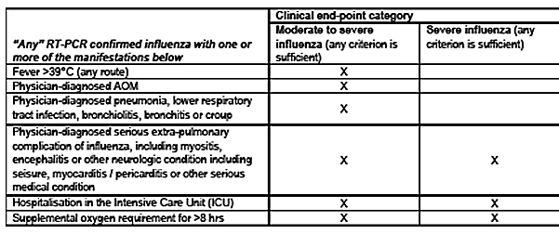

The criterion to be used for efficacy of the Fluarix Tetra vaccine will be if the lower limit (LL) of the two-sided 97.5% CI for VE is > 25%.

1. To evaluate the efficacy of Fluarix Tetra in the prevention of RT-PCR confirmed influenza A and/or B disease of any severity due to any seasonal influenza strain when compared to non-influenza vaccine controls in children aged 6 to 35 months. The criterion to be used for efficacy will be if the LL of the two-sided 97.5% CI for VE is > 15%.

Secondary efficacy objectives and exploratory efficacy endpoints are described in Attachment 2.

The influenza vaccine strains included in Fluarix Tetra during the different seasons followed WHO recommendations and are shown in Table 5. In Study D-QIV-004, subjects aged 6 to 35 months were enrolled in 5 independent cohorts over 5 influenza seasons to ensure the required number of cases of RT-PCR confirmed influenza disease due to seasonal strains.

Table 5: Overview of strains included in the influenza vaccines pivotal Study D‑QIV‑004

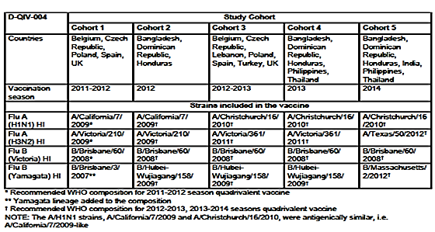

The analysis of efficacy was to be event-driven, with at least 255 cases of moderate-to-severe disease and at least 744 cases of any intensity disease, confirmed by RT-PCR due to any seasonal strain, to ensure achieving at least 240 cases of moderate-to-severe RT-PCR confirmed influenza disease and at least 702 cases of RT-PCR confirmed influenza disease (any) in the according-to-protocol cohort.

Cohort 1: In the Northern Hemisphere (NH), recruitment started October 2011 and 1777 subjects were to be recruited;

Cohort 2: In subtropical countries, recruitment started April 2012 and 2539 subjects were to be recruited;

Cohort 3: In the NH, recruitment started in October 2012 and 1564 subjects were to be recruited;

Cohort 4 and additional independent cohorts: Additional subjects (up to 12,000) will be recruited to reach the required number of cases of RT-PCR confirmed influenza disease.

The study population included 12,018 subjects (6,006 in the Fluarix Tetra group and 6,012 in the control group). 11,612 subjects (96.6%) (5,808 in the Fluarix Tetra group and 5,804 in the control group) completed the study. From the 1578 subjects (933 Fluarix Tetra and 645 Control) enrolled in the immunogenicity sub-cohort, 1332 subjects (753 Fluarix Tetra and 579 controls) were included in the according-to-protocol (ATP) cohort for immunogenicity.

Baseline demographic data are summarised in Attachment 2. Mean age of the TVC at Dose 1 was 21.9 months with approximately equal distribution of males and females. Most subjects were of South East Asian (27.7%) or White Caucasian (24.5%) heritage. Of the 12,108 subjects only 97 subjects were primed (had received at least 2 previous doses of seasonal influenza vaccine separated by 28 days or more) at enrollment.

Results for the primary efficacy outcome are summarised in Tables 6 and 7. Fluarix Tetra was efficacious in preventing RT-PCR confirmed moderate-to-severe influenza A and/or B disease due to any seasonal strain; VE 63.2% (LL of 97.5% CI: 51.8%, that is, LL > 25% pre‑specified success criterion).

Table 6: Vaccine efficacy for RT-PCR confirmed moderate-to-severe influenza confirmatory primary objective (ATP cohort for efficacy Time to event) in Study D‑QIV-004

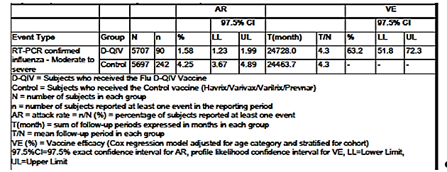

Table 7: Vaccine efficacy for RT-PCR confirmed influenza of any severity - confirmatory primary objective (ATP cohort for efficacy Time to event) in Study D‑QIV-004

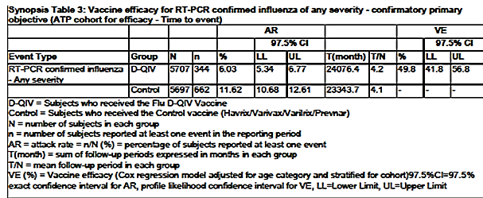

Fluarix Tetra was efficacious in preventing RT-PCR confirmed influenza A and/or B disease of any severity due to any seasonal strain; VE 49.8% (LL of 97.5% CI: 41.8%, that is, LL > 15% prespecified success criterion).

Results for the primary efficacy outcome in the 6 to 17 months and 18 to 35 months age strata, were VE of 48.8% (95% CI: 21.2 to 67.4) and 68.5% (95% CI: 58.2 to 76.5), respectively for the prevention of RT-PCR confirmed moderate-to-severe influenza and 43.3% (95% CI: 27.8 to 55.8) and 51.6% (95% CI: 43.7 to 58.4), respectively for the prevention of RT-PCR confirmed influenza of any severity.

Results for secondary efficacy outcomes are summarised in Table 8. All secondary confirmatory efficacy objectives (evaluated sequentially) were met, except for the last objective related to prevention of RT-PCR confirmed severe influenza disease because there were too few cases.

Table 8: Vaccine efficacy for the seven secondary objectives confirmatory secondary objectives (ATP cohort for efficacy Time to event) in Study D-QIV-004

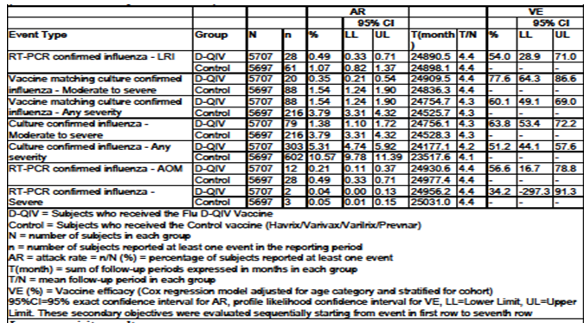

In Study D-QIV-004, vaccination with Fluarix Tetra led to a reduction in healthcare utilisation (for example visits to GP or paediatrician and emergency room visits), reduced time of nursery/school and lost workdays for parents/LAR(s). In addition, antipyretic and antibiotic use was lower in those who received Fluarix Tetra.

Immunogenicity was evaluated in sub-groups for each of Cohorts 1 to 5. HI antibody responses at Days 0 and 28/56 were reported as GMTs, SPR, SCR and Mean Geometrical Increase (MGI). Immunogenicity results are summarised in Tables 9 and 10.

Table 9: Summary of HI antibody parameters (Seropositivity rates, SPR) at pre and post vaccination (ATP cohort for immunogenicity) in Study D-QIV-004

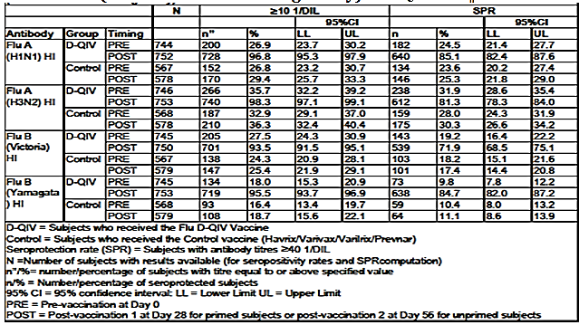

Table 10: Summary of HI antibody parameters (GMT, SCR and MGI) at pre and post vaccination (ATP cohort for immunogenicity) in Study D-QIV-004

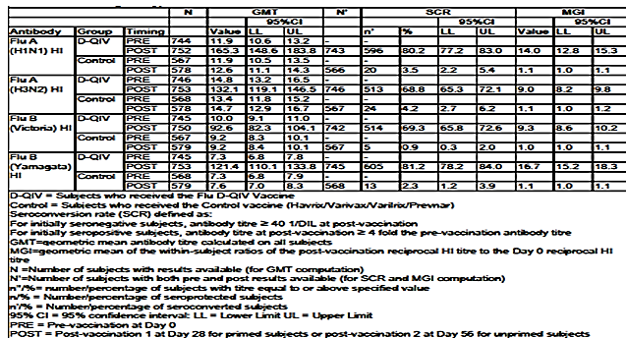

Fluarix Tetra was immunogenic against all four vaccine strains, overall (pooled results of 5 cohorts) and in each cohort as assessed by HI antibody titres.

##### Study D-QIV-009 Ext 004

This was an immunogenicity, safety and reactogenicity study of the sponsor’s quadrivalent seasonal influenza candidate vaccine, administered to children who previously participated in Study D-QIV-004. Study D-QIV-009 Ext 004 was initiated in October 2012 and completed in June 2013.

The primary objective was to assess HI antibody titre at Day 7 after one dose of Fluarix Tetra in vaccine-primed and vaccine-un-primed subjects.

Table 11 summaries immunogenicity results at Day 0 and Day 7 Post-dose 1.

Table 11: Summary of immunogenicity results at Day 0 (Pre) and Day 7 post-Dose 1: seropositivity rates (HI antibody titres ≥ 1:10), GMTs and seroprotection rates (SPRs) (ATP-I) in Study D-QIV-009

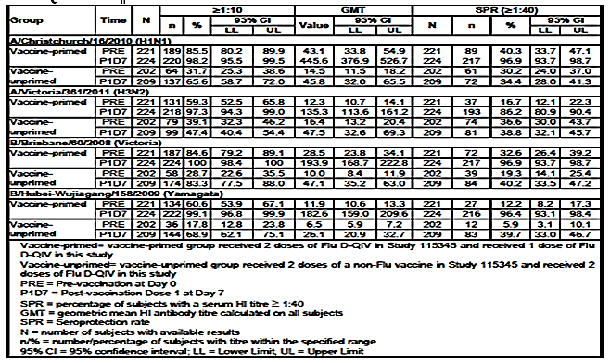

In the ATP immunogenicity (ATP-I), the vaccine primed group, SCRs ranged between 76.5% - 94.1% across the 4 vaccine strains and the highest SPR observed was 96.9% (for A/Christchurch/16/2010 (H1N1) and B/Brisbane/60/2008 (Victoria)), 7 days after the revaccination dose. In the vaccine un-primed group, SCRs ranged between 32.2% and 38.6% across the 4 vaccine strains and the highest SPR observed was 40.2% for B/Brisbane/60/2008 (Victoria) 7 days after the first dose of Fluarix Tetra. For the ATP-I, the GMT for HI antibodies titres at Day 0 ranged between 11.9 and 43.1 in the vaccine primed group, in contrast to between 6.5 and 16.4 in the vaccine un-primed group, while the GMTs at Day 7 ranged between 135.3 and 445.6 in the vaccine-primed group, and between 26.1 and 47.5 in the vaccine un-primed group. The HI adjusted GMT ratios of vaccine-primed/vaccine un-primed subjects 7 days after the first dose of D-QIV, ranged from 2.70 to 8.97 across the 4 vaccine strains.

The amnestic response was observed for the A/H1N1 and B/Victoria strains that were present in both the primary and subsequent year vaccines, as well as for the A/H3N2 and B/Yamagata strains that changed in the subsequent year vaccine.

##### Study D-QIV-015

This was an immunogenicity, safety and reactogenicity study of the sponsor’ quadrivalent seasonal influenza candidate vaccine manufactured with a new process. The new process product has recently been approved by TGA in October of 2017. The study was initiated in August 2014 and completed in April 2015.

This is a Phase III, randomised, double-blind controlled, multi-country study with staggered enrolment of adult and paediatric treatment groups. For children aged 6 to 35 months, the subject numbers and baseline demographics data are summarised in Attachment 2. Immunogenicity results for the 6 to 35 months cohorts overall are summarised in Table 12. For each strain the Day 28/56 GMT ratio 95% CI UL was ≤ 1.5 and non-inferior immunogenicity of Fluarix Tetra IP to Fluarix Tetra LP was concluded. A post hoc analysis of immunogenicity results in children 6 to 35 months of age from Bangladesh which concluded immunogenicity was comparable among children with risk factors for influenza complications and children without risk factors for influenza complications.

Table 12: Adjusted GMT ratios of Flu A/H1N1, Flu A/H3N2, Flu B/Yamagata, Flu B/Victoria HI antibodies between groups (Fluarix Tetra LP/Fluarix Tetra IP) 28 days post last vaccination in subjects aged 6 to 35 months (Paediatric ATP cohort for immunogenicity) in Study D-QIV-015

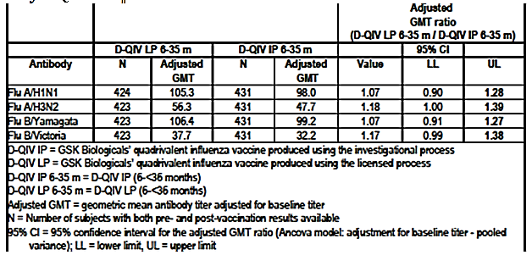

##### Clinical efficacy conclusions

Fluarix Tetra was efficacious in preventing RT-PCR confirmed moderate-to-severe influenza A and/or B disease due to any seasonal strain in the 6 to 35 months population; VE 63.2% (LL of 97.5% CI: 51.8%, that is, LL > 25% pre-specified success criterion).

Fluarix Tetra was efficacious in preventing RT-PCR confirmed influenza A and/or B disease of any severity due to any seasonal strain in the 6 to 35 month population; VE 49.8% (LL of 97.5% CI: 41.8%, that is, LL > 15% prespecified success criterion).

In the 6 to 17 months and 18 to 35 months age strata, VE was 48.8% (95% CI: 21.2-to 67.4) and 68.5% (95% CI: 58.2 to 76.5), respectively for the prevention of RT-PCR confirmed moderate-to-severe influenza and was 43.3% (95% CI: 27.8 to 55.8) and 51.6% (95% CI: 43.7 to 58.4), respectively for the prevention of RT-PCR confirmed influenza of any severity.

For the primary objectives and forthe majority of the secondary objectives, the VE of Fluarix Tetra tended to be higher in theolder age stratum (18 to 35 months of age) compared to the 6 to 17 months and the 6 to 11months of age stratum.

Vaccination with Fluarix Tetra led to a reduction in healthcare utilisation (such as visits to GP or paediatrician and emergency room visits), reduced time of nursery/school and lost workdays for parents/LAR(s). In addition, antibiotic use and antipyretic use were lower in those receiving D-QIV.

The HI antibody response 28 days after vaccine in Studies D-QIV-004/-015 show Fluarix Tetra was immunogenic against the four vaccine strains. There was a higher immune response in the 18 to 35 month age stratum (SPR from 79.8% to 92.5%, TVC) compared to the 6 to 17 month age stratum (SPR from 54.9% to 72.5%, TVC). Children in the 6 to 11 month age sub-stratum had lower immune responses (SPR from 38.2% to 55.3%, TVC) compared to the older children.

In Study D-QIV-009, HI titres were higher in primed subjects compared to un-primed subjects. An anamnestic (recall) response was observed against the four vaccine strains despite the fact that Fluarix Tetra composition was updated by strain changes for H3N2 and B/Yamagata vaccine components from the priming to the revaccination year.

#### Safety

Methodology for safety assessment is described at Attachment 2.

In Studies D-QIV-004 and D-QIV-015 (6 to 35 months cohort) 6,006 and 474 subjects respectively, aged 6 to 35 months received at least one dose of Fluarix Tetra (Fluarix Tetra or Fluarix Tetra LP, manufactured according to the process licensed at time of study conduct. In Study D-QIV-009, 470 subjects aged 17 to 48 months received ≥1 dose of Fluarix Tetra of whom 241 subjects were previously primed in D-QIV-004 and received a 3rd dose. In Study D-QIV-015, 466 subjects received ≥1 dose of Fluarix Tetra manufactured according to the new harmonised process.

At least one AE (any solicited or unsolicited, local or general) was reported for 51.8% (38.4% overall/dose) in the Fluarix Tetra group and 53.8% (39.7% overall/dose) in the control group. At least one Grade 3 AE was reported for 6.0% (3.2 overall/dose) of subjects in the Fluarix Tetra vaccinated group and for 6.2% (3.4% overall/dose) of subjects in the control group. At least one possibly related AE was reported for 41.7% (30.5% overall/dose) in the Fluarix Tetra group and 43.9% 31.7% overall/dose) in the control group. At least one Grade 3 AE with causal relationship was reported for 3.8% (2.0% overall/dose) in the Fluarix Tetra group and for 3.9% (2.1% overall/dose) in the control group.

Injection site pain was the most commonly reported solicited local AE during the 7 day post-vaccination period and was reported for 22.9% (15.6% overall/dose) in the Fluarix Tetra group and 23.3% (16.0% overall/dose) in the control group. There was no increase in the incidences of solicited local AEs from Dose 1 to Dose 2 of the Fluarix Tetra vaccine group.

The most commonly reported solicited general AE during the 7 day post-vaccination period was irritability/fussiness, reported for 23.4% (14.9% overall/dose) in the Fluarix Tetra group and 24.2% (15.5% overall/dose) in the control group. The most commonly reported solicited Grade 3 general AE during the 7 day post-vaccination period was fever (> 39.0°C), reported for 2.3% of subjects (1.2% overall/dose) in the Fluarix Tetra group and 2.4% of subjects (1.3% overall/dose) in the control group.

Unsolicited AEs (during the 28 day post-vaccination follow-up period were reported in 44.0% for the Fluarix Tetra and 44.6% in the control group.

At least one SAE was reported for 3.6% of subjects in the Fluarix Tetra group and for 3.3% of subjects in the control group. There were 7 SAEs with causal relationship to vaccination reported for 6 subjects (0.1%) in the Fluarix Tetra group and 2 SAEs with causal relationship reported for 2 subjects (<0.1%) in the Control group. Four subjects experienced SAEs associated with a fatal outcome (1 subject in Fluarix Tetra group and 3 subjects in control group). None of the SAEs associated with fatal outcome were attributed to the study vaccine.

For 2 SAEs of febrile convulsion (2 days and 10 days post-vaccination) and 1 non serious AE (1 day post-vaccination), a causal relationship to vaccination was not concluded by the sponsor due to confounding factors or incomplete information, but causality associated with vaccination could not be entirely ruled out.

There were 3 subjects in the Fluarix Tetra group and 10 subjects in the control group who discontinued prematurely due to a non-serious AE; 1 subject in the Fluarix Tetra group and 6 subjects in the control group prematurely discontinued due to an SAE. One non-serious AE (upper respiratory tract infection (URTI)) in the Fluarix Tetra group) had a possible causal relationship to vaccination according to the investigator.

In Study D-QIV-009, when a re-vaccination dose was given in primed subjects a slight increase in reactogenicity in terms of reported solicited local symptoms was observed. Unsolicited AE were reported in similar % in vaccine primed and vaccine un-primed groups. Unsolicited AE with a causal relationship to vaccination were reported for 2.1% and 1.3% of the subjects in the vaccine-primed and vaccine un-primed groups, respectively.Solicited general AEs included fever, irritability/ fuzziness, drowsiness and loss of appetite in children 6 to 35 months of age. A total of 15 subjects (7 [2.9%] in the vaccine primed group and 8 [3.5%] in the vaccine un-primed group reported 19 SAEs during the entire study period. No vaccine related SAEs were reported during the study.

In Study D-QIV-015 in children 6 to 35 months of age, solicited local AEs of Grade 3 were infrequent and rates were similar between Fluarix Tetra IP and Fluarix Tetra LP in the per country analysis. The incidence of solicited general AEs was similar between both groups (Fluarix Tetra IP and Fluarix Tetra LP). Solicited general AEs of Grade 3 were infrequent and rates were similar between Fluarix Tetra IP and Fluarix Tetra LP in the per country analysis. The % of subjects reporting at ≥1 unsolicited symptom was similar between the Fluarix Tetra IP and the Fluarix Tetra LP groups during the 28 day follow-up period after each dose. One SAE of febrile convulsion was reported in a subject from 6 to 35 months Cohort in the Fluarix Tetra LP group.

The clinical evaluator concluded the safety profile of Fluarix Tetra was comparable to other widely accepted licensed vaccines and the data showed that Fluarix Tetra is well tolerated in children 6 to 35 months of age.

#### Clinical evaluation benefit risk balance

The pivotal study is a very large clinical efficacy study with a RT-PCR positive influenza disease endpoints conducted over multiple influenza seasons, in high and LMIC setting. Safety data compared Fluarix Tetra with comparator vaccines licensed for use in the 6 to 35 months age group.

The clinical evaluator expressed some concern over potential variation in clinical endpoint validation. The clinical evaluator also commented that there was possible underreporting of adverse events in some countries where documentation was obtained by field workers.

The clinical evaluator considered the clinical efficacy, immunogenicity and favourable safety profile were supportive of the benefit of vaccination with Fluarix Tetra in children 6 to 35 months of age. The clinical evaluator recommends authorisation of the extension of indications in children 6 to 35 months of age.

### Risk management plan

RMP evaluation issues have been resolved. In 2018 this vaccine will be included in the AusVaxSafety program[20]. The RMP evaluation has not recommended inclusion in the Black Triangle Scheme.

### Risk-benefit analysis

#### Delegate’s considerations

This extension of indications was supported by one pivotal efficacy and safety study, Study D-QIV-004. The study design of Study D-QIV-004 is consistent with the relevant EU guideline;[21] which in Section 5.1.1 Requirements for authorisation seasonal inactivated non-adjuvanted vaccines * Paediatric population states

* 1. For an indication that includes use in children aged from 6 months to 36 months, a demonstration of vaccine efficacy, that is prevention of influenza in a randomised clinical trial, is required (see also section 6.2 for study design, and section 6.1.3 Essential Immunogenicity studies)’.

This EU guideline21 had just been adopted by the TGA with some annotations (not related to section 5.1.1).

Study D-QIV-004 was a very large, multi-country, multiple season study. Overall Fluarix Tetra was efficacious in preventing RT-PCR confirmed moderate-to-severe influenza A and/or B disease due to any seasonal strain; VE 63.2% (LL of 97.5% CI: 51.8% that is, LL > 25% prespecified success criterion) and Fluarix Tetra was efficacious in preventing RT-PCR confirmed influenza A and/or B disease of any severity due to any seasonal strain; VE 49.8% (LL of 97.5% CI: 41.8%, that is, LL > 15% prespecified success criterion).

For the primary efficacy outcome, VE was reported for each age stratum, 18 to 35 months, 6 to 17 months and 6 to 11 months. Efficacy was also reported for all secondary efficacy objectives except prevention of RT-PCR confirmed severe disease (because of too few cases). VE was reported for each of the strains included in the vaccine as well as any seasonal strain.

Overall, the clinical evaluator concluded the safety profile of Fluarix Tetra was comparable to other widely accepted licensed vaccines and the data showed that Fluarix Tetra is well tolerated in children 6 to 35 months of age. The clinical evaluator was some possible underreporting of side effects in some countries, most notable in StudyD-QIV-015 where some documentation was obtained by field workers.

#### Summary of issues

This extension of indications was supported by one pivotal efficacy and safety Study D-QIV-004. The design of Study D-QIV-004 is consistent with relevant TGA adopted EU guideline.21

Study D-QIV-004 is a very large, multi-country study in children 6 to 35 months of age undertaken over 5 influenza seasons. The clinical evaluator considered the clinical efficacy, immunogenicity and favourable safety profile were supportive of the benefit of vaccination with Fluarix Tetra in children 6 to 35 months of age. The Delegate concurred with this conclusion.

#### Proposed action

The Delegate had no reason to say, at this time, that the application for Tetra Fluarix should not be approved for registration.

#### Request for advisory committee advice

The committee is requested to provide advice on the following specific issues:

1. Do the clinical efficacy, immunogenicity and safety profile of Fluarix Tetra support the extension of indications in children 6 to 35 months of age?

The committee is (also) requested to provide advice on any other issues that it thinks may be relevant to a decision on whether or not to approve this application.

#### Response from sponsor

##### Executive summary

The extension of indication is supported by one pivotal Phase III, observer blind, randomised efficacy study (Study D-QIV-004) with non-influenza vaccine controls that enrolled a total of 12,046 subjects and two supportive Studies D-QIV-009 and D-QIV-015.

Fluarix Tetra was shown to be efficacious in preventing RT-PCR confirmed moderate-to-severe influenza A and/or B disease due to any seasonal strain in the 6 to 35 months population (vaccine efficacy (VE) 63.2% (lower limit (LL) of 97.5% confidence interval (CI): 51.8%, that is, LL > 25% pre-specified success criterion)). Fluarix Tetra was also shown to be efficacious in preventing RT-PCR confirmed influenza A and/or B disease of any severity due to any seasonal strain in the 6 to 35 months population (VE 49.8% (LL of 97.5% CI: 41.8%, that is, LL > 15% prespecified success criterion)).

The immunogenicity data also showed that Fluarix Tetra induces a high immune response against the four vaccine strains and efficiently cross-primes for revaccination on the next influenza season.

Fluarix Tetra administered for priming vaccination in children aged 6 to 35 months or for revaccination on the next season was well tolerated and no safety concerns were identified. The reactogenicity and safety profile of Fluarix Tetra was similar to the control group and to other childhood vaccines used in the same age group.

This extension of indication for Fluarix Tetra will ensure that the medical need for influenza prevention through vaccination in the 6 to 35 months age group in Australia is met, whilst eliminating the risk of unlicensed administration, and the incorrect influenza vaccine or dose being administered to young children.

##### Specific questions raised by the TGA Delegate for the committee’s advice

1. Do the clinical efficacy, immunogenicity and safety profile of Fluarix Tetra support the extension of indications in children 6 to 35 months of age?

###### Efficacy pivotal Study D-QIV-004

The pivotal efficacy and safety study D-QIV-004 was a Phase III, observer blind, randomised efficacy study with non-influenza vaccine controls that enrolled a total of 12,046 subjects (6 to 35 months of age) in five independent cohorts. Subjects were randomised 1:1 to receive either inactivated quadrivalent influenza vaccine or a non‑influenza control vaccine depending on the subject's age and priming status. Study Fluarix Tetra 004 was conducted over 5 influenza seasons in 13 countries, where seasonal influenza vaccination was not recommended as part of the universal mass vaccination to allow the assessment of an absolute efficacy.

Fluarix Tetra was shown to be efficacious for the prevention of influenza disease when compared to a non-influenza vaccine control, with a VE of 63.2% (97.5% CI: 51.8 to 72.3) against RT-PCR confirmed moderate to severe influenza disease and 49.8% (97.5% CI: 41.8 to 56.8) against RT-PCR confirmed influenza disease of any severity. The VE was similar for culture confirmed influenza disease (63.8%, 95% CI: 53.4 to 72.2 and 51.2%, 95% CI: 44.1 to 57.6), respectively) and increased to 77.6% (95% CI: 64.3 to 86.6) and 60.1% (95% CI: 49.1 to 69.0), respectively when considering VE against antigenically matching strains. The risks were reduced by 2.67% and 5.59%, respectively which represent 1 case of moderate to severe influenza prevented for every 37 children vaccinated and 1 case of any influenza for every 18 children vaccinated.

The evaluation of VE against moderate to severe influenza disease is considered important since the moderate to severe influenza case definition captures medically important manifestations of influenza, such as high fever and otitis media, which prompt medical consultation and symptoms of lower respiratory illness (LRI) which is associated with higher rates of hospitalisations and potential mortality in the vulnerable population studied.

In Study D-QIV-004, vaccination with Fluarix Tetra led to a reduction in healthcare utilisation (such as visits to GP or paediatrician and emergency room visits) and in the use of antibiotics associated with RT-PCR confirmed influenza. The robustness of these observations is supported by the consistency of the results across cohorts. Notably, reduction of emergency room visits was specifically demonstrated in countries with well-developed healthcare systems and where emergency room care is easily accessible and more likely to be utilised. The reduced healthcare utilisation is a direct reflection of health benefits to children of Fluarix Tetra vaccination, since vaccinated children who were protected from influenza infection or who experienced attenuated disease symptoms required fewer or no visits to physicians or the emergency department.

The incidence of influenza illness was reduced in vaccinated children compared to non-vaccinated children. Medical benefit to vaccinated children was additionally shown by a meaningful reduction in the likelihood of hospitalisations and use of antibiotics associated with influenza illness.

###### Safety pivotal Study D-QIV-004

The most frequently reported AEs in Study D-QIV-004 were nasopharyngitis (14.5% and 15.7%) and upper respiratory tract infection (8.7% and 8.6%) in subjects in the Fluarix Tetra and control groups, respectively. The safety and reactogenicity profile of Fluarix Tetra was similar to well characterised approved vaccines used in the same age group and the rates of reported solicited and unsolicited symptoms were comparable between subjects receiving Fluarix Tetra and subjects receiving non-influenza vaccine control. There was no increase in reactogenicity observed after the second dose of Fluarix Tetra.

###### Efficacy supportive Studies D-QIV-009 and D-QIV-015

The Phase III Study D-QIV-009 is an extension to Study D-QIV-004 designed to evaluate the adequacy of the immunological priming of children 6 to 35 months of age. The study assessed the immunogenicity, safety, and reactogenicity of a revaccination dose of Fluarix Tetra in subjects primed by vaccination one year before in Study D-QIV-004 compared to vaccine un-primed subjects from the same study cohort in order to provide data supporting annual revaccination. 470 subjects from the first cohort of Study D-QIV-004, who were administered either 2 doses of Fluarix Tetra (241 subjects in the vaccine primed group) or a non-influenza control vaccine (229 subjects in the vaccine un-primed group) were enrolled in Study D-QIV-009 to receive either one dose or two doses of Fluarix Tetra, respectively.

Vaccination with Fluarix Tetra induced a high immune response in terms of haemagglutination inhibition (HI) antibodies in 6 to 35 month old children when given as a 2 dose schedule. The HI antibody response elicited by this 2 dose priming schedule in the parent study (Study D-QIV-004, Cohort 1) persisted up to a year as evidenced by higher Day 0 (pre-revaccination) geometric mean titres (GMT) in Study D-QIV-009 for the two priming strains common with the revaccination strains (A/H1N1 and B/Victoria) in the vaccine-primed group compared to the vaccine un-primed group.

The Phase III, double-blind, randomised, multicenter Study D-QIV-015 assessed the safety and immunogenicity of Fluarix Tetra manufactured with a new process, in which the downstream processes were harmonised for all monovalent bulks. The immunogenicity bridging between Fluarix Tetra manufactured with the process approved at the time of study conduct (used in Studies D-QIV-004 and D-QIV-009) and Fluarix Tetra manufactured with the new harmonised process was demonstrated in Study D-QIV-015 for the 6 to 35 months cohort through the evaluation of the HI immune response.

Immunogenic non-inferiority was demonstrated in terms of GMT ratios since the upper limit of the 95% CI of the GMT ratio ranged from 1.27 to 1.39 for the four vaccine strains and therefore met the pre-specified criteria of ≤ 1.5. The results of the study support the change in the manufacturing process and the efficacy of Fluarix Tetra manufactured with the new harmonised process in the 6 to 35 month age group. This new process will be implemented for the 2017 to 2018 influenza season.

###### Safety supportive Studies D-QIV-009 and D-QIV-015

When a revaccination dose was given to primed subjects in Study D-QIV-009, a slight increase in reactogenicity in terms of reported solicited local symptoms was observed but not in terms of reported solicited general symptoms and Grade 3 local reactions.

The primary safety objective of Study D-QIV-015 for children 6 to 35 months was met and demonstrated that there is no significant increase of fever ≥ 38ºC (overall per subject) with the new harmonised manufacturing process when compared to the manufacturing process used for the other two studies. The reactogenicity and safety between the two processes were similar confirming that the manufacturing change does not impact the safety in this age group.

##### Overall safety conclusions

Safety data for Fluarix Tetra from Studies D-QIV-004, D-QIV-009 and D-QIV-015 were not pooled since the studies enrolled different populations (health status and age), various comparator vaccines (Study D-QIV-004 used non-influenza comparator vaccines; Study D‑QIV-015 compared Fluarix Tetra manufactured according to different processes; Study D-QIV-009 had no control vaccine) and study duration differed.

No safety concerns were identified in terms of unsolicited AEs and serious AEs across the three studies included in this submission. The safety profile of Fluarix Tetra was comparable to other widely-accepted licensed vaccines and the data showed that Fluarix Tetra is well tolerated in children 6 to 35 months of age. Fluarix Tetra administered for priming vaccination in children aged 6 to 35 months or for revaccination on the next season was well tolerated and no safety concerns were identified. The reactogenicity and safety profile of Fluarix Tetra was similar to the control group and to other childhood vaccines used in the same age group.

Overall, the clinical data available to date supports a favourable benefit-risk assessment for the use of Fluarix Tetra in children 6 to 35 months of age and addresses the need for influenza prevention through vaccination in this vulnerable patient population.

##### Medical need in Australia

Influenza is an acute, highly contagious, respiratory disease caused by influenza viruses, mainly spread through respiratory droplets. Young children, particularly younger than 2 years of age, are among the groups with the highest risk of influenza complications. Infants and children aged < 5 years are at increased risk of hospitalisation and increased morbidity and mortality following influenza. This includes young children without pre-existing medical conditions that are at increased risk of hospitalisation compared with older children and adults. Young children, especially those aged 12 to 23 months of age are also prone to febrile convulsions resulting from fever of any cause. Fever is a prominent sign of influenza infection and peaks at the height of the systemic illness and temperatures may be higher in children.

Fluarix Tetra is currently indicated in adults and children from 3 years of age and listed as a designated QIV for use in all relevant National Immunisation Program (NIP) cohorts from 3 years of age. Extending the age indication of Fluarix Tetra to 6 months of age is proposed to meet the medical need for influenza prevention through vaccination in the 6 to 35 months age group. Of note, the same presentation and dose of Fluarix Tetra can be used from 6 months of age, eliminating the risk of unlicensed administration and the incorrect influenza vaccine or dose being administered to young children.

Currently, there is one influenza vaccine only registered in Australia that is capable of immunising children between the ages of 3 months and 3 years. If there was a supply issue with this vaccine in the future, there would be no vaccine available for the vaccination of Australian children younger than 3 years of age. The Australian Federal Department of Health has expressed the need to have more than one supplier for each of its cohorts as part of the NIP and this is becoming increasingly important with a number of state and territory governments implementing vaccination programs for children aged 6 months to 5 years of age.

##### Other issues raised by the TGA delegate

*There was some possible underreporting of side effects in some countries, notable in Study D‑QIV-015 where some documentation was obtained by field workers.*

The sponsor reviewed the reported rates of AEs by country as part of post hoc analyses for Studies D-QIV-004 and D-QIV-015. There was a certain degree of variability in the reported rates of AEs by country (23.0% to 89.3% for any solicited or unsolicited AE in the first 7 days post vaccination; see Table 13 below). The incidence was observed to be the lowest of this range in Bangladesh (17.9% for local symptoms, 12.2% for general symptoms and 23.0% for any symptom). However, the incidence of reported AEs was similar amongst study groups (Fluarix Tetra versus control) among all countries included in the studies (see Table 13 below). In addition, the incidences of reported serious SAEs and Grade 3 medically attended events (MAEs) were similar across countries (see Table 14).

Table 13: Incidence and nature of symptoms (solicited and unsolicited) reported during the 7 day (Days 0 to 6) post-vaccination period following each dose and overall by country (Total vaccinated Cohort) overall/subject

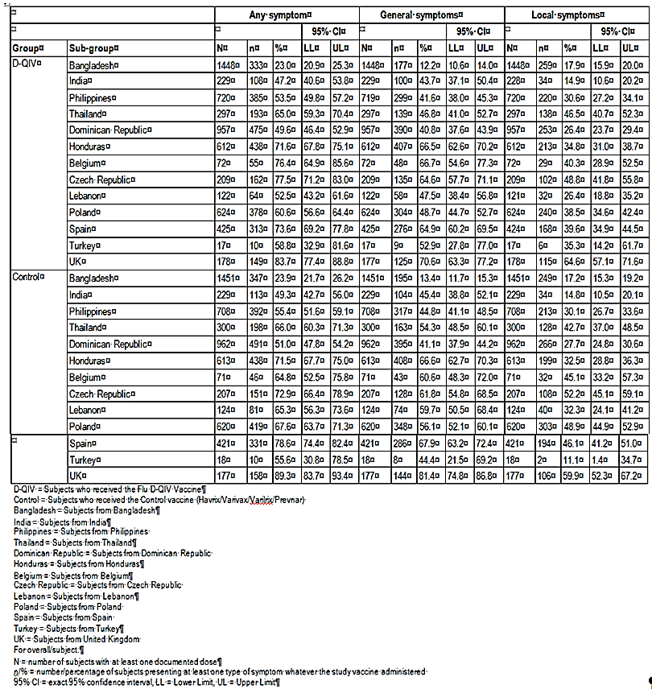

Table 14: Summary of medically attended events (MAEs) and serious adverse events (SAEs) based on Study D‑QIV‑0041

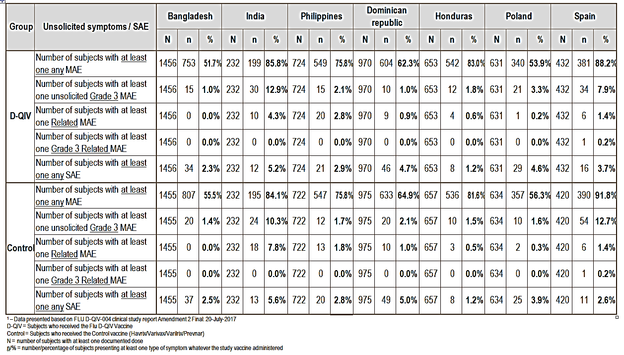

The study protocol permitted two methods for completion of diary cards, either by parents/ legally acceptable representative or with the assistance of field workers in settings with limited literacy. In Bangladesh, all diary cards were completed with the help of field workers and in India approximately 50% of the diary cards were completed with the help of field workers. All other countries had diary cards completed by the subjects’ parents or legally acceptable representative.

A root cause for the lower AE reporting rates in Bangladesh could not be identified. The sponsor acknowledges that differences in data collection methodology (parents versus field workers) or cultural differences in reporting behaviour may have contributed to differences in reported AE rates. However, AE rates were comparable between treatment groups in countries with lower AE reporting rates and the rates for SAEs and Grade 3 MAEs in these countries were comparable to those in other countries.

The same clinical site in Bangladesh was used in Studies D-QIV-004 and D-QIV-015 and reported AEs rates were similar in both studies. The site is well-known in the medical/scientific community with staff properly trained and experienced in many clinical trials. Monitoring did not detect site-specific quality issues that would affect AE reporting.

##### Risk management plan

The sponsor will implement the Fluarix Tetra EU RMP (version 10.0, dated 14 February 2017) with an ASA (version 5.0, dated November 2017) both of which were submitted to the TGA on 28 March 2017 and 29 November 2017 respectively. All RMP evaluation issues have been resolved, and the sponsor has committed to update the ASA in accordance with the TGA clinical and RMP evaluator’s comments during the next revision of the ASA as per the TGA’s request.

The most recent Periodic Benefit Risk Evaluation Report (PBRER) is provided. The safety profile of Fluarix Tetra is continuously monitored through the sponsor’s pharmacovigilance systems and any safety concerns are monitored and reported in the PBRERs and are added to the Global Data Sheet and Australian PI when appropriate.

##### PI and Consumer Medicine Information (CMI)

The sponsor has considered the PI recommendations from the TGA Delegate and commits to updating the PI to align with the new TGA form of the PI dated 8 November 2017. Additionally, the sponsor notes that no further changes have been proposed to the CMI. The sponsor commits to liaising with the TGA Delegate to finalise the PI and CMI to the satisfaction of the TGA.

##### Conclusion

The data provided in this application supports a favourable benefit/risk assessment for the use of Fluarix Tetra in children 6 to 35 months of age. This extension of indication for Fluarix Tetra will ensure that the medical need for influenza prevention through vaccination in the 6 to 35 months age group is met, whilst eliminating the risk of unlicensed administration, and the incorrect influenza vaccine or dose being administered to young children.

#### Advisory Committee Considerations[22]

The Advisory Committee on Vaccines (ACV), taking into account the submitted evidence of efficacy, safety and quality, considered Fluarix Tetra quadrivalent influenza vaccine (split virion, inactivated), containing 15 µg of influenza virus haemagglutinin from each of four strains [in the 2018 season, A/Michigan/45/2015 (H1N1)pdm09 - like strain, A/Singapore/INFIMH-16-0019/2016 (H3N2) - like strain, B/Phuket/3073/2013 - like strain and B/Brisbane/60/2008 - like strain] to have an overall positive benefit-risk profile for the indication:

*Fluarix Tetra is a quadrivalent vaccine indicated for active immunisation of adults and children from 6 months of age for the prevention of influenza disease caused by the influenza virus types A and B contained in the vaccine. (see Clinical Trials).*

*The use of Fluarix Tetra should be based on official recommendations.*

In making this recommendation the ACV:

* Advised that the efficacy data were extensive (the pivotal study had a total vaccination cohort of 12,018 children across five influenza seasons) and supported the use of Fluarix Tetra in infants aged 6 to 35 months.
* Noted that the types and rates of adverse events were similar between administration of Fluarix Tetra and the comparator vaccines in infants in the 6 to 35 month age group.
* Noted that the statistics on efficacy could be represented as:
  + 1 case of moderate to severe influenza prevented for every 37 children vaccinated
  + 1 case of any influenza prevented for every 18 children vaccinated
* Noted that appropriate arrangements will be in place for post-market surveillance.

##### Proposed Product Information (PI) / Consumer Medicine Information (CMI) amendments

The ACV advised that the section on adverse effects in children 6 months and over in clinical trials should be revised to provide quantitative information on the frequency of adverse events, and to also include information on the frequency of adverse effects in the control group.

It was suggested that it could be useful to vaccine administrators if the PI mentioned when an antipyretic should be given to the infant.

##### Specific advice

The ACV advised the following in response to the Delegate’s specific question on the submission:

1. *Do the clinical efficacy, immunogenicity and safety profile of Fluarix Tetra support the extension of indications in children 6 to 35 months of age?*

The ACV advised that the clinical efficacy, immunogenicity and safety data were sufficient to support extension of the indication to include children 6 to 35 months of age.

1. *Any other issues that the ACV thinks may be relevant to a decision on whether or not to approve this application.*

The committee noted that the use of the dose currently used in adults (60 µg in 0.5 mL injection volume) in infants of 6 to 35 months of age represents a shift from current norms. Suitable educational materials comparing vaccines will need to be available to healthcare practitioners.

### Outcome

Based on a review of quality, safety and efficacy, TGA approve the registration of Fluarix Tetra containing inactivated split influenza vaccine for the new indication:

*Fluarix Tetra is a quadrivalent vaccine indicated for active immunisation of adults and children from 6 months of age for the prevention of influenza disease caused by the influenza virus types A and B contained in the vaccine (see section 5.1 Pharmacodynamic Properties, Clinical trials).*

*The use of Fluarix Tetra should be based on official recommendations.*

#### Specific conditions of registration applying to these goods

1. The Fluarix Tetra EU-Risk Management Plan (RMP) (version 10.0, dated 14 February 2017; data lock point 13 July 2016), with Australian Specific Annex (version 5.0, dated 2 November 2017), included with submission PM-2017-01036-1-2 and any subsequent revisions, as agreed with the TGA will be implemented in Australia.

An obligatory component of risk management plans is routine pharmacovigilance. Routine pharmacovigilance includes the submission of Periodic Safety Update Reports (PSURs). Unless agreed separately between the supplier who is the recipient of the approval and the TGA, the first report must be submitted to TGA no later than 15 calendar months after the date of this approval letter. The subsequent reports must be submitted no less frequently than annually from the date of the first submitted report until the period covered by such reports is not less than three years from the date of this approval letter. The annual submission may be made up of two PSURs each covering six months. If the sponsor wishes, the six monthly reports may be submitted separately as they become available.

The reports are to at least meet the requirements for PSURs as described in the European Medicines Agency’s Guideline on good pharmacovigilance practices (GVP) Module VII-Periodic Safety Update Report (Rev 1), Part VII.B Structures and processes. Note that submission of a PSUR does not constitute an application to vary the registration. Each report must have been prepared within ninety calendar days of the data lock point for that report.

## Attachment 1. Product Information

The PI for Fluarix Tetra approved with the submission which is described in this AusPAR is at Attachment 1. For the most recent PI, please refer to the TGA website at <<https://www.tga.gov.au/product-information-pi>>.

## Attachment 2. Extract from the Clinical Evaluation Report

|  |
| --- |
| Therapeutic Goods Administration |
| PO Box 100 Woden ACT 2606 Australia  Email: [info@tga.gov.au](mailto:info@tga.gov.au) Phone: 1800 020 653 Fax: 02 6232 8605  [**https://www.tga.gov.au**](https://www.tga.gov.au) |

1. WHO Fact sheet N°211 March 2014
2. Lafond KE, Nair H, Rasooly MH, et al. Global Role and Burden of Influenza in Pediatric Respiratory Hospitalizations, 1982-2012: A Systematic Analysis. PLoS Med 2016;13(6):e1002060.
3. HayAJ, Belshe RB, Anderson EL, et al. Influenza viruses. In: Belshe RB, ed. Textbook of Human Virology. St. Louis, Missouri: Mosby Year Book, Inc, 1991;307−341.
4. Fiore AE, Shay DK, Broder K, et al. Prevention and control of seasonal influenza with vaccines: recommendations of the Advisory Committee on Immunization Practices (ACIP), 2009. MMWR Recomm Rep 2009 Jul 31;58(RR-8):1-52.
5. Beyer WE1, McElhaney J, Smith DJ, Monto AS, Nguyen-Van-Tam JS, Osterhaus AD. Cochrane re-arranged: support for policies to vaccinate elderly people against influenza. Vaccine. 2013 Dec 5;31(50):6030-3. Epub 2013 Oct 3.
6. Rota PA, Wallis TR, Harmon MW, Rota JS et al. Cocirculation of two distinct evolutionary lineages of influenza type B virus since 1983. Virology 1990 Mar; 175(1):59-68.
7. Belshe, RB. The need for quadrivalent vaccine against seasonal influenza. Vaccine 2010 Sep 7; 28 Suppl 4: D45-53.
8. Ambrose CS, Levin MJ. The rationale for quadrivalent influenza vaccines. Hum Vaccin Immunother 2012; 8(1):81-8.
9. www.euroflu.org
10. Grant KA, et al. High proportion of influenza B characterises the 2008 influenza season in Victoria. Commun Dis Intell Q Rep 2009;33(3):328-36.
11. Olson DR, et al. Monitoring the impact of influenza by age: emergency department fever and respiratory complaint surveillance in New York City. PLoS Med 2007;4(8):e247.
12. Thompson WW, et al. Mortality associated with influenza and respiratory syncytial virus in the United States. JAMA 2003;8;289(2):179-86.
13. Barr IG,McCauley J, Cox N et al. 2010 Epidemiological, antigenic and genetic characteristics of seasonal influenza A(H1N1), A(H3N2) and B influenza viruses: Basis for the WHO recommendation on the composition of influenza vaccines for use in the 2009–2010 Northern Hemisphere season. Vaccine 28 (2010); 1156-1167.
14. Brownstein JS, Mandl KD. Pediatric population size is associated with local timing and rate of influenza and other acute respiratory infections among adults. Ann Emerg Med. 2008; 52: 63-8
15. Loeb, M, Russell, ML, Moss L et al. Effect of Influenza Vaccination of Children on Infection Rates in Hutterite Communities. JAMA, 2010; 303(10): 943-950
16. WHO. Wkly Epidemiol Rec 2012; 47: 461–76.
17. ACIP. Morb Mortal Wkly Rep 2013; 62: 1–43.
18. Canada NACI 2014. PHAC NACI Advisory Committee Statement on Seasonal Influenza Vaccine 2014-2015.
19. JCVI 2013. Draft Minutes of June 2013 Meeting. Available at: https://www.gov.uk/government/policy-advisory-groups/joint-committee-on-vaccinationand- immunisation [accessed August 2016]
20. AusVaxSafety is a national, collaborative active vaccine safety surveillance initiative led by National Centre for Immunisation Research & Surveillance (NCIRS) and funded by the Australian Government Department of Health.
21. EMA/CHMP/VWP/457259/2014 Guideline on Influenza Vaccines Non-clinical and Clinical Module
22. The ACV provides independent medical and scientific advice to the Minister for Health and the Therapeutic Goods Administration (TGA). Members are appointed by the Minister. The ACV was established in January 2017. Membership comprises of professionals with specific scientific, medical or clinical expertise, as well as appropriate consumer health issues relating to medicines.