|  |
| --- |
| **First round CER: July 2013**  **Second round CER: November 2013** |

|  |
| --- |
| AusPAR Attachment 2 |
| Extract from the Clinical Evaluation Report for indacaterol maleate / glycopyrronium bromide |
| Proprietary Product Name: Ultibro Breezhaler 110/50 |
| Sponsor: Novartis Pharmaceuticals Australia Pty Ltd |

About the Therapeutic Goods Administration (TGA)

* The Therapeutic Goods Administration (TGA) is part of the Australian Government Department of Health, and is responsible for regulating medicines and medical devices.
* The TGA administers the *Therapeutic Goods Act 1989* (the Act), applying a risk management approach designed to ensure therapeutic goods supplied in Australia meet acceptable standards of quality, safety and efficacy (performance), when necessary.
* The work of the TGA is based on applying scientific and clinical expertise to decision-making, to ensure that the benefits to consumers outweigh any risks associated with the use of medicines and medical devices.
* The TGA relies on the public, healthcare professionals and industry to report problems with medicines or medical devices. TGA investigates reports received by it to determine any necessary regulatory action.
* To report a problem with a medicine or medical device, please see the information on the TGA website <<http://www.tga.gov.au>>.

About the Extract from the Clinical Evaluation Report

* This document provides a more detailed evaluation of the clinical findings, extracted from the Clinical Evaluation Report (CER) prepared by the TGA. This extract does not include sections from the CER regarding product documentation or post market activities.
* The words [Information redacted], where they appear in this document, indicate that confidential information has been deleted.
* For the most recent Product Information (PI), please refer to the TGA website <<http://www.tga.gov.au/hp/information-medicines-pi.htm>>.

Copyright

© Commonwealth of Australia 2014  
This work is copyright. You may reproduce the whole or part of this work in unaltered form for your own personal use or, if you are part of an organisation, for internal use within your organisation, but only if you or your organisation do not use the reproduction for any commercial purpose and retain this copyright notice and all disclaimer notices as part of that reproduction. Apart from rights to use as permitted by the *Copyright Act 1968* or allowed by this copyright notice, all other rights are reserved and you are not allowed to reproduce the whole or any part of this work in any way (electronic or otherwise) without first being given specific written permission from the Commonwealth to do so. Requests and inquiries concerning reproduction and rights are to be sent to the TGA Copyright Officer, Therapeutic Goods Administration, PO Box 100, Woden ACT 2606 or emailed to <[tga.copyright@tga.gov.au](mailto:tga.copyright@tga.gov.au)>.

Contents

List of abbreviations 5

1. Clinical rationale 8

2. Contents of the clinical dossier 9

2.1. Scope of the clinical dossier 9

2.2. Paediatric data 9

2.3. Good clinical practice 9

3. Pharmacokinetics 9

3.1. Studies providing pharmacokinetic data 9

3.2. Summary of pharmacokinetics 10

3.3. Evaluator’s conclusions on pharmacokinetics 19

4. Pharmacodynamics 21

4.1. Studies providing pharmacodynamic data 21

4.2. Summary of pharmacodynamics 21

4.3. Evaluator’s conclusions on pharmacodynamics 23

5. Dosage selection for the pivotal studies 23

6. Clinical efficacy 24

6.1. Pivotal efficacy studies 24

6.2. Other efficacy studies 36

6.3. Analyses performed across trials (pooled & meta analyses) 37

6.4. Evaluator’s conclusions on efficacy 37

7. Clinical safety 38

7.1. Studies providing safety data 38

7.2. Pivotal studies that assessed safety as a primary outcome 40

7.3. Patient exposure 45

7.4. Adverse events 45

7.5. Post-marketing experience 49

7.6. Safety issues with the potential for major regulatory impact 49

7.7. Evaluator’s conclusions on safety 49

8. First round benefit-risk assessment 50

8.1. First round assessment of benefits 50

8.2. First round assessment of risks 50

8.3. First round assessment of benefit-risk balance 50

9. First round recommendation regarding authorisation 50

10. Clinical questions 51

10.1. Pharmacokinetics 51

10.2. Pharmacodynamics 51

10.3. Efficacy 51

10.4. Safety 51

11. Second round evaluation 52

11.1. Question 1: Pharmacokinetics 52

11.2. Question 2: Pharmacodynamics 56

11.3. Question 3: Efficacy 57

11.4. Question 4: Efficacy 60

11.5. Question 5: Safety 62

12. Second round benefit-risk assessment 65

12.1. Second round assessment of benefits 65

12.2. Second round assessment of risks 65

12.3. Second round assessment of benefit-risk balance 65

13. Second round recommendation regarding authorisation 65

## List of abbreviations

| Abbreviation | Meaning |
| --- | --- |
| AE | adverse event |
| AE0-24h | amount of unchanged drug excreted into the urine from time zero to 24 hours |
| ATS | American Thoracic Society |
| BDI/TDI | dyspnoea index |
| BID | twice daily |
| BMI | body mass index |
| BOV | between occasion variability |
| bpm | beats per minute |
| BSV | between subject variability |
| CCV | cardio- and cerebrovascular |
| CL | systemic clearance |
| CLr | renal clearance |
| COPD | chronic obstructive pulmonary disease |
| CV% | percentage coefficient of variation |
| DPI | dry powder inhaler |
| DPIF | dry powder inhaler formulation |
| ECG | electrocardiogram |
| ERV | expiratory reserve volume |
| F | bioavailability |
| Fabs | Absolute bioavailability |
| FDC | fixed dose combination |
| FEV1 | forced expiratory volume in one second |
| FEV1/FVC | ratio of forced expiratory volume in one second to forced vital capacity |
| FEV25-75 | forced expiratory flow 25% to 75% |
| Flung | Fraction of systemic exposure which is due to lung absorption |
| Flut/Salm | fluticasone/salmeterol |
| FPD | fine particle dose |
| FPM | fine particle mass |
| FRC | functional residual capacity |
| Frel | Relative bioavailability |
| FVC | forced vital capacity |
| GI | gastrointestinal |
| GOLD | Global Initiative for Chronic Obstructive Lung Disease |
| HV | healthy volunteer |
| IC | inspiratory capacity |
| ICS | inhaled corticosteroid |
| IRT | Interactive Response Technology |
| IV / i.v. | intravenous(ly) |
| IVRS/IWRS | Interactive Voice Response System/Web System |
| LABA | long acting beta agonist |
| LAMA | long-acting muscarinic receptor antagonist |
| LC-MS/MS | liquid chromatography-tandem mass spectrometry |
| LLOQ | lower limit of quantification |
| LS | least squares |
| MDI | metered dose inhaler |
| NVA237 | glycopyrronium bromide |
| OD | once daily |
| PD | pharmacodynamic(s) |
| PEF | peak expiratory flow |
| PFT | pulmonary function test |
| PK | pharmacokinetic |
| PO | oral(ly) |
| q.d. | every day |
| Q/F | inter-compartmental clearance |
| QAB149 | indacaterol |
| QID | four times daily |
| QoL | quality of life |
| QTc | corrected QT interval |
| QTcF | corrected QT interval by Fridericia’s method |
| QVA149 | fixed dose combination of NVA237 and QAB149 |
| RAN | randomised population |
| RR | rate ratio |
| RV | residual volume |
| SABA | short acting beta agonist |
| SAE | serious adverse event |
| SD | standard deviation |
| SDDPI | single-dose dry powder inhaler |
| SGRQ | St. George Respiratory Questionnaire |
| SVC | slow vital capacity |
| TDI | transitional dyspnoea index |
| TGV | thoracic gas volume |
| TLC | total lung capacity |
| URTI | upper respiratory tract infection |
| Vc/F | apparent central volume |
| Vp/F | apparent peripheral volume |
| VS | vital signs |
| Wmax | maximum work-rate at the peak of incremental exercise (watt) |

## Clinical rationale

COPD affects over 200 million people worldwide and the numbers are projected to rise, particularly in the third world. The leading cause of COPD is smoking which results in progressive and usually irreversible small airways obstruction and emphysema. COPD is associated with dyspnoea, reduced physical activity, chronic cough and sputum production, and recurrent infective exacerbations leading eventually to respiratory failure and death. There are four severity grades of COPD based on FEV1/FVC ratios (Grades I-IV, ranging from mild to very severe). Bronchial hyper reactivity may exist without a clinical diagnosis of asthma and is an independent predictor for increased deterioration of lung function. Chronic asthma may also co-exist in patients with COPD. Spirometry showing the presence of FEV1/FVC <0.70 is required to confirm the diagnosis of COPD in patients with dyspnoea, chronic cough or sputum production, and chronic exposure to risk factors including smoking, and wood and fossil fuel emissions. Acute exacerbations lead to further irreversible changes in the lung parenchyma and accelerate disease progression with faster loss of FEV1 over time. Prevention of exacerbations improves quality of life, reduces hospital admissions and may lead to improved survival rates. It is doubtful if existing pharmacologic therapy can modify the long term deterioration in lung function. However, medications can reduce the symptoms of COPD, reduce the frequency and severity of exacerbations, and improve quality of life and exercise tolerance. Bronchodilator medications include SABAs and LABAs, short and long acting anticholinergics, combination products containing short acting beta agonists and anticholinergics, methylxanthines, inhaled corticosteroids, combined inhaled steroids and LABA formulations, systemic steroids and PD-4 inhibitors. Medications are preferentially given by metered dose inhaler (MDI) or DPI to maximise drug delivery to the lungs and to minimise systemic adverse effects. Combination bronchodilator therapy combining complementary mechanisms and durations of action may increase bronchodilation and minimise drug side effects. For example, SABA and anticholinergic combinations have been shown to produce greater and more sustained improvements in FEV1 than either drug alone without producing tachyphylaxis. Based on Global Initiative for Chronic Obstructive Lung Disease (GOLD) 2011 recommendations,[1] LABAs and LAMAs are preferred over short acting formulations and oral bronchodilators and QVA149 (Ultibro Breezhaler) is the first such combination product.

## Contents of the clinical dossier

### Scope of the clinical dossier

The submission contained the following clinical information:

* Nine clinical pharmacology studies, including 9 that provided PK data and 2 that provided PD data.
* One population PK analyses.
* Three pivotal efficacy/safety studies (A2303, A2313 and A2304).
* No dose finding studies were submitted.
* Three other efficacy/safety studies (A2305, A2307 and A1301).

### Paediatric data

The submission did not include paediatric data relating to either the PK or PD of the FDC.

### Good clinical practice

All studies were conducted in full compliance with Good Clinical Practice (GCP). The studies were appropriately monitored by Novartis clinical trial personnel or by contract research organisations (CROs). All spirometry machines and use complied with American Thoracic Society (ATS) standards.

## Pharmacokinetics

### Studies providing pharmacokinetic data

Table 1: Submitted PK studies.

| PK topic | Subtopic | Study ID | * |
| --- | --- | --- | --- |
| PK in healthy adults | General PK | CQAB149B2106 | BA of a single 300 μg dose of inhaled indacaterol |
| CNVA237A2108 | BA of a single 200 µg dose of inhaled glycopyrronium bromide |
| CQVA149A2101 | BA of indacaterol and glycopyrronium bromide after administration in a FDC |
| CQVA149A2105 | PKs of indacaterol and glycopyrronium bromide in QVA149 and monotherapies |
| CQVA149A2106 | Steady-state PKs of indacaterol in a FDC relative to the administration of indacaterol 150 μg and glycopyrronium bromide 50 μg alone |
| CQVA149A2103 | Steady-state PKs of indacaterol in a FDC (1 x 110 μg indacaterol and 1 x 50 μg glycopyrronium bromide) relative to the administration of indacaterol (150 μg) alone. |
| PK in special populations | §Target population | CQVA149A2204 | PKs of indacaterol and glycopyrronium bromide after QVA149 300/50 μg in subjects with COPD |
| Japanese & Caucasian Subjects | CQVA149A1101 | PK of inhaled QVA149 in healthy Japanese and Caucasian subjects |
| Population PK analyses | Target population | CQVA149A2303 | Examine covariates responsible for the variability in the dose-exposure relationship of FDC in subjects with COPD. |

* Indicates the primary aim of the study.

† Bioequivalence of different formulations.

§ Subjects who would be eligible to receive the drug if approved for the proposed indication.

BA bioavailability

None of the PK studies had deficiencies that excluded their results from consideration.

### Summary of pharmacokinetics

The information in the following summary is derived from conventional pharmacokinetic studies unless otherwise stated.

Indacaterol was analysed in serum and in plasma using validated LC-MS/MS methods with a lower limit of quantification (LLOQ) of 10 pg/mL. At ≤18°C, stabilities of indacaterol in spiked plasma, in plasma incurred samples, in spiked serum, and in serum incurred samples were demonstrated for up to 13 months, 8 months, 13 months and 13 months, respectively.

Quantitative determinations of glycopyrronium in plasma samples were performed using validated LC-MS/MS methods. The lower limit of quantification (LLOQ) was 4 or 3 pg/mL. At ≤18°C, stability of glycopyrronium in spiked plasma was demonstrated for up to 13 months.

Bioanalytical methods used throughout the clinical development of QVA149 are summarised in Table 2.

Table 2: Summary of analytical methods used in clinical studies.

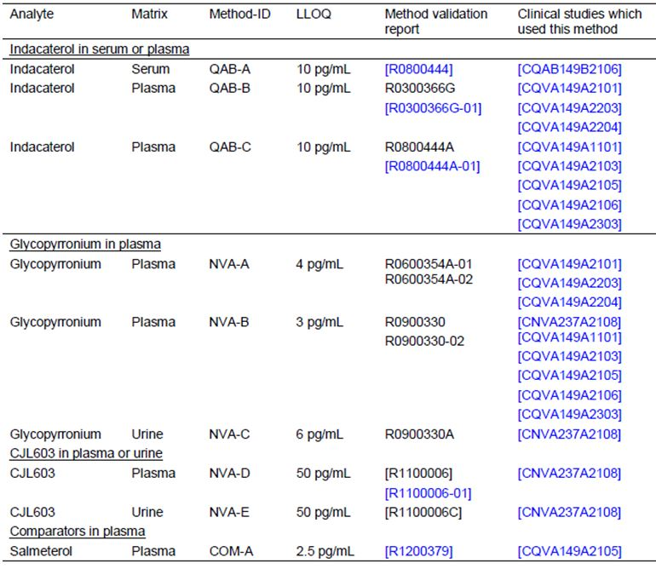

#### Physicochemical characteristics of the active substance

Indacaterol maleate is shown in Figure 1.

Figure 1: Structure of indacaterol maleate.

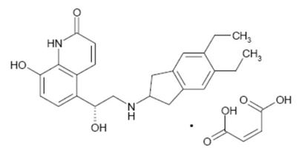

Chemical Name: (R)-5-[2-(5,6-Diethylindan-2-ylamino)-1-hydroxyethyl]-8-hydroxy-1H quinolin-2-one maleate.

Molecular formula: Free base anhydrous: C24H28N2O3; Maleate salt: C24H28N2O3 C4H4O4

Molecular weight: Free base: 392.49; Maleate salt: 508.56

Stereochemistry: (R) enantiomer

Solubility: At 25°C mostly insoluble or very slightly soluble in aqueous media across the pH range from 1 to 10 (water solubility <0.11 mg/mL).

Glycopyrronium bromide is shown in Figure 2.

Figure 2: Structure of glycopyrronium bromide.

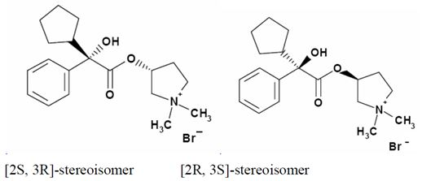

Chemical name: 3-(2-Cyclopentyl-2-hydroxy-2-phenylacetoxy)-1,1-dimethylpyrrolidinium bromide Pyrrolidinium, 3-[(cyclopentylhydroxyphenylacetyl)oxy]-1,1-dimethyl-,bromide-3-Hydroxy-1,1-dimethylpyrrolidinium bromide α-cyclopentylmandelate

Molecular formula: C19H28NO3.Br

Molecular Weight: Salt form: 398.33

Stereochemistry: 2 asymmetric carbon atoms and is an optically inactive racemic mixture of 2 stereoisomers (S,R) and (R,S).

Solubility: At 25°C freely soluble in aqueous media across the pH range from 1 to 10 (water solubility >100 mg/mL).

#### Pharmacokinetics in healthy subjects

##### Absorption

###### Sites and mechanisms of absorption

Indacaterol maleate

A randomised, open-label, single-dose, three-period crossover study in 12 healthy male subjects, CQAB149B2106 identified that following a 300 µg inhaled dose of indacaterol the indacaterol Tmax was 15 minutes (0.25 hours) and the estimated systemic exposure due to lung absorption was approximately 75%, with the remaining 25% resulting from gastrointestinal (GI) absorption.

Glycopyrronium bromide

A randomised, partly double-blind, two-part, study in 10 healthy subjects, CNVA237A2108, identified that following a 200 µg dose of inhaled glycopyrronium bromide Tmax was achieved 5 minutes (0.083 hours) following inhalation. In addition, the fraction of systemic exposure following inhalation of glycopyrronium bromide which resulted from lung absorption based on AUClast and non-compartmental AUCinf data was 86.4% and 97.1%, respectively. Therefore, approximately 90% of systemic exposure following oral inhalation of glycopyrronium bromide is due to lung absorption while approximately 10% is due to GI absorption.

##### Bioavailability

###### Absolute bioavailability

Indacaterol maleate

Study CQAB149B2106 also examined the relative and absolute bioavailability of orally inhaled indacaterol maleate (300 µg - delivered by inhalation via Concept1) compared with a controlled infusion of indacaterol solution (200 μg i.v.). Based on dose normalised AUClast parameters, the point estimate for the absolute bioavailability of inhaled indacaterol (compared to the intravenous dose) was 0.45 with a 90% confidence interval of (0.37, 0.55).

Glycopyrronium bromide

Study CNVA237A2108 also examined the absolute bioavailability of inhaled glycopyrronium bromide (200 µg) relative to an i.v. infusion of 120 μg glycopyrrolate. The point estimate (90% CI) of the absolute bioavailability (Fabs) of inhaled glycopyrronium bromide to i.v. administration was 32.0 % (30.1, 34.1%) based on AUClast and 42.3 % (38.3, 46.6%) based on AUCinf.

###### Bioavailability relative to an oral solution or micronised suspension

Not examined.

###### Bioequivalence of clinical trial and market formulations

Not examined.

###### Bioequivalence of different dosage forms and strengths

Not examined.

###### Bioequivalence to relevant registered products

An open label, single-centre, randomised, single-dose, four-way crossover study (CQVA149A2101) evaluated the bioequivalence of indacaterol and glycopyrronium bromide after administration in a fixed dose combination as QVA149 (1 x 300 μg indacaterol and 1 x 100 μg glycopyrronium bromide DPIF) relative to the administration of indacaterol 300 μg DPIF and glycopyrronium bromide 100 μg DPIF alone in 28 healthy subjects.

The AUC0-tlast and Cmax of indacaterol were 25% and 49%, respectively, higher for QVA149 compared to indacaterol alone, whereas, the AUC0-tlast and Cmax of indacaterol were 9% and 26%, respectively, higher for QVA149 compared to the free combination of glycopyrronium bromide and indacaterol and the free combination and QVA149 were not bioequivalent in regards to indacaterol.

The AUC0-tlast of glycopyrronium bromide was similar after administration of QVA149, the free combination of glycopyrronium bromide and indacaterol, and glycopyrronium bromide alone; although the Cmax of glycopyrronium bromide was similar after administration of QVA149 and glycopyrronium bromide alone, it was 19% lower for QVA149 compared to the free combination of the two drugs and QVA149 and the free combination were not bioequivalent in regards to glycopyrronium bromide.

The increased exposure to indacaterol following the administration of QVA149 compared to both indacaterol alone and the free combination of glycopyrronium bromide and indacaterol was thought to be a consequence of an increased fine particle dose (FPD) of indacaterol in the QVA149 formulation.

A second study, CQVA149A2105, examined the PKs of indacaterol and glycopyrronium bromide following single doses of QVA149 (440/200 μg) and the monotherapies (600 μg indacaterol and 200 μg glycopyrronium bromide) using a double-blind, randomised, placebo and active drug controlled incomplete 3-period cross-over methodology in 50 healthy subjects. Systemic exposure (AUClast, AUC0-24h and Cmax) to glycopyrronium bromide given in FDC was 7 to 11 % greater than for glycopyrronium bromide administered alone. For indacaterol given in the FDC, the systemic exposure was 11 to 14 % less than for indacaterol given alone.

###### Influence of food

As the primary route of delivery of the FDC combination is via the lungs,food is not expectedto have an impact on lung deposition. Therefore, food effect was not studied in either of the monotherapy programs.

###### Dose proportionality

The dose proportionality of the component analytes of QAV149 110/50 μg was not formally assessed in a single study. However, Study CQVA149A1101, which examined the PKs of QVA149 (110/50 μg) and QVA149 (220/100 μg) in 48 healthy Japanese and Caucasian males indicated that the mean Cmax of indacaterol and glycopyrronium appeared to increase dose proportionally in both ethnic groups (2-fold), whereas, the increase in mean AUC0-24 and AUClast with dose, ranged from 2.1-fold to 2.4-fold and 2.14-fold and 3.34-fold, respectively across ethnic groups.

###### Bioavailability during multiple-dosing

As a result of the difference in indacaterol PKs following administration of QVA149 and the free combination, two further studies, which examined PKs following multiple doses of QVA149, used a FDC that contained a lower concentration of indacaterol (110 μg) in an attempt to match the FPD of the indacaterol monotherapy (150 μg).

The first of these, Study CQVA149A2106, used an open-label, randomised, four-period, cross-over methodology to compare the steady-state systemic exposure of indacaterol and glycopyrronium bromide after administration in a fixed-dose combination as QVA149 (110 μg indacaterol and 50 μg glycopyrronium bromide dry powder inhaler formulation [DPIF]) relative to the administration of indacaterol 150 μg and glycopyrronium bromide 50 μg DPIF alone and as a free combination in 24 healthy subjects. The dose chosen for the combination (QVA149 110/50 μg) in this study corresponded to the final dose of the combination product to be tested in the Phase III program.

Following 14 days of treatment with QVA149 (110 /50 μg), the AUC0-24, Cmaxss and Cminss for indacaterol was 2024 pg.h/mL, 371 pg/mL and 54.7 pg/mL, respectively, and for glycopyrronium bromide were 566.8 pg.h/mL, 212.3 pg/mL and 14.2 pg/mL, respectively.

The indacaterol AUC0-24 and Cmaxss were similar for indacaterol given alone and the free combination of indacaterol and glycopyrronium bromide, whereas, the indacaterol AUC0-24 and Cmax were on average approximately 20% lower for QVA149 compared with indacaterol and the free combination and could not be considered bioequivalent.

The glycopyrronium bromide AUC0-24 and Cmaxss were similar across all three treatments, i.e. glycopyrronium bromide given alone, the free combination of indacaterol and glycopyrronium bromide, and QVA149; however, glycopyrronium Cmax was just outside the level of bioequivalence when QVA149 and the free combination were compared with the 90% CI for Cmax ranging from 0.78 to 1.07.

Trough plasma concentrations of indacaterol and glycopyrronium bromide were stable from Day 12 to Day 15 in all treatments indicating that PK steady-state was reached on Day 14.

The second of these studies, CQVA149A2103, was an open-label, randomised, three-way crossover study, which compared the steady-state systemic exposure of indacaterol after administration in a fixed-dose combination as QVA149 (1 x 110 μg indacaterol and 1 x 50 μg glycopyrronium bromide DPIF) relative to the administration of indacaterol (150 μg DPIF) alone in 43 healthy subjects.

Following 14 days of treatment, the indacaterol AUC0-24 was similar for the fixed-dose combination QVA149 110/50 μg compared to indacaterol 150 μg alone, whereas, indacaterol Cmax,ss was, on average, 24% higher for QVA149 than for indacaterol and the two formulations could not be considered bioequivalent in regards to indacaterol Cmax.

Steady-state systemic exposure (AUC0-24 and Cmax,ss) of glycopyrronium bromide was higher (by 34% and 42%, respectively) after administration of the FDC QVA149 110/50 μg compared to glycopyrronium bromide 50 μg given alone and the two formulations were not bioequivalent with respect to glycopyrronium bromide.

###### Effect of administration timing

Not examined.

##### Distribution

###### Volume of distribution

Indacaterol

The volume of distribution at steady state (Vss, mean [CV%]) following a single i.v. infusion of 200 µg indacaterol in Study CQAB149B2106 was 1362 L (28.9) and the volume of distribution in the terminal elimination phase (Vz, mean [CV%] = 2361 L [18.0]) indicated an extensive distribution of indacaterol throughout the body. By comparison, following oral inhalation of 300 µg indacaterol the Vz [CV%] was 5242 L (36.9).

Glycopyrronium bromide

In Study CNVA237A2108 the Vss (CV%) of glycopyrronium bromide following a single i.v. 120 µg infusion of glycopyrronium was 82.7 L (21.7) and the Vz was 376 L (80.0). By contrast, following inhalation of 200 µg glycopyrronium bromide Vz was 7310 L (1492).

###### Plasma protein binding

No *in vitro* studies examining plasma protein binding have been performed with the fixed dose combination QVA149.

###### Erythrocyte distribution

No distribution studies have been performed with QVA149.

###### Tissue distribution

No distribution studies have been performed with QVA149.

##### Metabolism

###### Interconversion between enantiomers

Not applicable.

###### Sites of metabolism and mechanisms / enzyme systems involved

Indacaterol

*In vitro* investigations show that the predominant enzymes responsible for the metabolism of indacaterol are UGT1A1 and CYP3A4. Indacaterol is a low affinity substrate for the efflux pump P-gp and is unlikely to significantly inhibit transporter proteins such as P-gp, MRP2, BCRP, the cationic substrate transporters hOCT1 and hOCT2, and the human multidrug and toxin extrusion transporters hMATE1 and hMATE2K. In a human ADME (absorption, distribution, metabolism, excretion) study, unchanged indacaterol was the main component in serum, accounting for about one third of total drug-related AUC over 24 h. Systemic exposure to indacaterol is not significantly affected by the low activity UGT1A1 genotypic variation (Gilbert’s syndrome genotype).

Glycopyrronium

*In vitro* metabolism studies showed consistent metabolic pathways between animals and humans. Hydroxylation resulting in a variety of mono-and bis-hydroxylated metabolites and direct hydrolysis resulting in the formation of a carboxylic acid derivative (M9) were seen. *In vitro* investigations showed that multiple CYP isoenzymes contribute to the oxidative biotransformation of glycopyrronium.

###### Non-renal clearance

Indacaterol

The faecal route of excretion is dominant over the urinary route. Indacaterol was excreted into human faeces primarily as unchanged parent drug (54% of the dose) and, to a lesser extent, as hydroxylated indacaterol metabolites (23% of the dose).

Glycopyrronium bromide

Following inhalation of 200 µg glycopyrronium bromide in Study CNVA237A2108, 76.8% of systemic clearance is estimated to be due to non-renal mechanisms.

###### Metabolites identified in humans

Active metabolites

No new studies have been conducted.

Other metabolites

No new studies have been conducted.

###### Pharmacokinetics of metabolites

No new studies have been conducted.

###### Consequences of genetic polymorphism

No new studies have been conducted.

##### Excretion

###### Routes and mechanisms of excretion

Indacaterol

Following inhalation of 300 µg indacaterol in Study CQAB149B2106, the plasma CL was 39.4 L/h and the t1/2 was 91.8 hours.

Glycopyrronium bromide

Following inhalation of 200 µg glycopyrronium bromide in Study CNVA237A2108 the systemic plasma clearance (CL) ofglycopyrronium bromide was 99.7 L/h and the t1/2 was 52.5 hours.

###### Mass balance studies

No mass balance studies examined the FDC.

###### Renal clearance

###### Indacaterol

The amount of indacaterol excreted unchanged in urine is generally less than 2% of the dose. Renal clearance of indacaterol was, on average, between 0.46 and 1.20 L/h (about 2% to 6% of systemic clearance).

Glycopyrronium bromide

Following inhalation of 200 µg glycopyrronium bromide in Study CNVA237A2108 the mean renal clearance (CLr [CV%]) of glycopyrronium bromide was 23.1 L/h (32.3).

##### Intra- and inter-individual variability of pharmacokinetics

The population PK study 2303 estimated the between-subject variability (BSV) for indacterol; apparent central volume (Vc/F) had a variance of 0.559, BSV on apparent inter-compartmental flow (Q/F) had a variance of 0.167 and BSV on bioavailability (F) had a variance of 0.0554, whereas, between occasion variability (BOV) on F was estimated to have a variance of 0.0359.

For glycopyrronium bromide, BSV on CL/F had a variance of 0.0306, BSV on Vc/F had a variance of 1.67, BSV on ka had a variance of 0.274, and BSV on F had a variance of 0.137, whereas, BOV on F was estimated to have a variance of 0.119.

#### Pharmacokinetics in the target population

A randomised, double-blind, 4-period cross-over, multi-centre study, CQVA149A2204examined the PKs of glycopyrronium bromide and indacaterol after oral inhalation of QVA149 300/50 μg and compared the systemic exposure to indacaterol when delivered alone and in the fixed combination QVA149 in 153 patients with COPD.

Indacaterol AUC0-24 and Cmax following the administration of the FDC (QVA149 300/50 μg) was 3861.7 pg.h/mL and 452.9 pg/mL, respectively, and was similar to AUC0-24 and Cmax following administration of indacaterol 300 μg alone, 3624.6 pg.h/mL and 405.1 pg/mL, respectively, and was about 60% of the exposure observed after administration of indacaterol 600 μg. A dose-associated increase in exposure to indacaterol was observed with indacaterol 600 μg versus indacaterol 300 μg. Glycopyrronium bromide systemic exposure following inhalation of QVA 300/50 μg corresponded to the expected level for this dose.

The population PK study, CQVA149A2303 also examined the PKs of glycopyrronium bromide and indacaterol given as a fixed-dose combination (QVA149) using the Concept1 SDDPI device in patients with COPD. Based on the combined data (from both the 29 day and 85 day time points) the steady-state Cminss (95% CI), Cmaxss and AUC0-4 for indacaterol, following 150 µg indacaterol daily was 96.8 pg/mL (87.8-105.7), 250.9 pg/mL (232.5 – 269.3) and 778.1 pg.h/mL (722.6-833.7), respectively, and following QVA149A (110/50 µg) daily was 76.7 pg/mL (71.8-81.6), 226.8 (209.8 – 243.8) and 642.6 pg.h/mL (603-682.1), respectively.

For glycopyrronium bromide, the steady-state Cminss (95% CI), Cmaxss and AUC0-4, following 50 µg glycopyrronium bromide daily was 12.0 pg/mL (10.2 – 13.7), 130.1 pg/mL (112.7-147.6) and 247.9 pg.h/mL (227.2 – 268.7), respectively, and following QVA149A (110/50 µg) daily was similar with Cminss, Cmaxss and AUC0-4 of 10.7 pg/mL (9.3 – 12.0), 131.3 pg/mL and 233.8 pg.h/mL (213.1 – 254.4), respectively.

#### Pharmacokinetics in other special populations

##### Pharmacokinetics in subjects with impaired hepatic function

Not examined for the FDC.

##### Pharmacokinetics in subjects with impaired renal function

Not examined for the FDC.

##### Pharmacokinetics according to age

The population PK study identified no significant effect of age on exposure to either indacaterol or glycopyrronium bromide following administration of QVA149 to patients with COPD.

##### Pharmacokinetics related to genetic factors

Not applicable.

##### Pharmacokinetics {in other special population / according to other population characteristic}

Study CQVA149A1101 evaluated the PK of single inhaled doses of QVA149 (110/50 μg and 220/10 μg) delivered by SDDPI in 24 healthy Japanese and 24 Caucasian subjects using a single centre, randomised, double-blind, placebo-controlled, single ascending-dose methodology. Both indacaterol and glycopyrronium bromide were systemically available shortly after inhalation with median Tmax values of 0.25 hours (indacaterol) and 0.083 hours (glycopyrronium bromide) in both Japanese and Caucasians for all treatments. Based on Cmax, peak exposure to indacaterol was on average 22% to 26% higher in Japanese than in Caucasians. Peak exposure to glycopyrronium bromide was 78% to 92% higher in Japanese than in Caucasians. Based on AUC0-24 and AUClast, total systemic exposure to indacaterol was on average 11% to 34% higher in Japanese than in Caucasians. Total systemic exposure to glycopyrronium bromide was 19% to 39% higher in Japanese than in Caucasians.

In addition, the population PK study identified no significant effect of sex, FEV1, disease severity, smoking history, or GFR was detected on exposure for both compounds.

#### Pharmacokinetic interactions

##### Pharmacokinetic interactions demonstrated in human studies

Two studies, CQVA149A2101 and CQVA149A2106, compared the PKs following inhalation of the free combination of indacaterol and glycopyrronium bromide with inhalation of each drug alone.

Study CQVA149A2101 examined the PKs following single doses of 100 μg glycopyrronium bromide and 300 μg indacaterol alone and in combination. In this study the AUC0-tlast and Cmax of indacaterol was 14% and 18%, respectively, higher for the free combination compared to indacaterol alone and both PK parameters were outside the levels of bioequivalence. By contrast, the AUC0-tlast of glycopyrronium bromide was similar when the drug was given as part of the free combination and when it was given alone; however, glycopyrronium bromide Cmax was 15% higher when given as the free combination and the two formulations could not be considered bioequivalent in regard to Cmax.

Study CQVA149A2106 was a 14-day repeated dose study comparing glycopyrronium bromide doses of 50 μg o.d. and indacaterol doses of 150 μg o.d. on Day 14 under steady state conditions of both drugs. In the free combination treatments glycopyrronium bromide was inhaled first, followed by indacaterol. In this study, the indacaterol AUC0-24 and Cmax,ss were similar when the drug was given alone and when it was given as part of the free combination and at steady state the two formulations could be considered bioequivalent in regards to indacaterol exposure. For glycopyrronium bromide, although the AUC0-24 was similar when the drug was given alone and in the free combination, the glycopyrronium bromide Cmax,ss was 10% higher when administered as part of the free combination and the two formulations could not be considered bioequivalent in regard to glycopyrronium bromide Cmax,ss.

No studies examined the PK interaction between the FDC and other drugs.

##### Clinical implications of in vitro findings

No *in vitro* studies examined the interaction of the PK interaction between the FDC and other drugs.

#### Population PK

A population PK study CQVA149A2303 examined PKs of glycopyrronium bromide and indacaterol given as a fixed-dose combination (QVA149) using the Concept1 SDDPI device in 190 patients with COPD and identified covariates that accounted for some of the variability in the dose-exposure relationship of both compounds given in combination.

The final PK model for both analytes was a two-compartment disposition model with first-order absorption and first-order elimination. The disposition kinetics were parameterised using apparent systemic clearance (CL/F), apparent central volume (Vc/F), apparent inter-compartmental clearance (Q/F), and apparent peripheral volume (Vp/F) (NONMEM subroutine TRANS4).

For indacaterol in the FDC (QVA149), mean CL/F was estimated to be 46 L·h-1, Vc/F to be 90.8 L, apparent peripheral volume (Vp/F) to be 1580 L, inter-compartmental clearance (Q/F) to be 686 L·h-1, absorption rate constant to be 1.16 h-1.

F was estimated to decrease linearly with increasing lean body weight; AUCtau,ss therefore decreases with increasing lean body weight (according to the relationship AUCtau,ss = F*Dose/CL) and indacaterol AUCtau,ss decreased linearly by 22% between 1st and 3rd quartile of lean body weight (48- 62 kg) in COPD patients.

For glycopyrronium bromide in fixed-dose combination (QVA149), mean CL/F was estimated to be 106 L·h-1, Vc/F to be 5 L, apparent peripheral volume (Vp/F) to be 1520 L, inter-compartmental clearance (Q/F) to be 431 L·h-1, absorption rate constant ka to be 1.03 h-1.

F was estimated to decrease linearly with increasing lean body weight; AUCtau,ss therefore decreases with increasing lean body weight (according to the relationship AUCtau,ss = F*Dose / CL) and glycopyrronium bromide AUCtau,ss decreased linearly by 38% between 1st and 3rd quartile of lean body weight (48-62 kg) in COPD patients.

When corrected by lean body weight, no statistically significant direct effect of ethnicity (Japanese versus non-Japanese) on exposure for both compounds was found in COPD patients.

No significant effect of age, sex, FEV1, disease severity, smoking history, or GFR was detected on exposure for both compounds.

### Evaluator’s conclusions on pharmacokinetics

* Indacaterol and glycopyrronium were rapidly absorbed following oral inhalation, with Tmax values of 15 minutes and 5 minutes, respectively and the estimated systemic exposure due to lung absorption was approximately 75% and 90%, respectively.
* The absolute bioavailability of inhaled indacaterol (compared to the IV dose) was 0.45 with a 90% confidence interval (CI) of (0.37, 0.55) and for glycopyrronium bromide was 32.0 % (30.1, 34.1%) based on AUC0-last and 42.3 % (38.3, 46.6%) based on AUC0-∞.
* Following a **single dose** inhalation of QVA149 (300 /100 μg) compared to the free combination:
  + the AUC0-last and Cmax of indacaterol were 9% and 26%, respectively, higher for QVA149 and the free combination and QVA149 were not bioequivalent in regards to indacaterol; and
  + for glycopyrronium bromide, although AUC0-last was similar the Cmax of glycopyrronium bromide was 19% lower for QVA149 compared to the free combination and QVA149 and the free combination were not bioequivalent in regards to glycopyrronium bromide.
* The increased exposure to indacaterol following the administration of QVA149 compared to the free combination of glycopyrronium bromide and indacaterol was thought to be a consequence of an increased fine particle dose (FPD) of indacaterol in the QVA149 formulation.
* As the primary route of delivery of the FDC combination is via the lungs, food is not expected to have a clinical impact on lung deposition.
* Although the dose proportionality of the component analytes of QAV149 110/50 μg was not formally assessed, one study indicated that the mean Cmax of indacaterol and glycopyrronium appeared to increase dose proportionally in both healthy Japanese and Caucasian subjects, whereas, the increase in mean AUC0-24h and AUC0-last with dose, ranged from 2.1 fold to 2.4 fold and 2.14 fold and 3.34 fold, respectively, across ethnic groups.
* At **steady state** in healthy subjects:
  + indacaterol exposure was approximately 20% lower following QVA149 (110 /50 μg) compared with the free combination (150/50 μg) and therefore, the two preparations could not be considered bioequivalent with regards to indacterol;
  + glycopyrronium bromide AUC0-24h was similar between QVA149 (110 /50 μg) and the free combination (150/50 μg), whereas, glycopyrronium Cmax was just outside the level of bioequivalence with 90% CIs ranging from 0.78 to 1.07; and
  + PK steady state for indacaterol and glycopyrronium bromide was achieved by Day 14.
* Following indacaterol (300 µg) inhalation the plasma clearance (CL) was 39.4 L/h and the t1/2 was 91.8 h and
* Following glycopyrronium bromide (200 µg) inhalation plasma CL was 99.7 L/h and the t1/2 was 52.5 h.
* In subjects with COPD, the indacaterol AUC0-24h and Cmax following the administration of the QVA149 300/50 μg was 3861.7 pg.h/mL and 452.9 pg/mL.
* No studies examined the metabolism of the FDC.
* No studies examined the PK of the FDC in children or adolescents or in patients with hepatic or renal impairment.
* The population PK study identified no significant effect of age, sex, FEV1, disease severity, smoking history, or glomerular filtration rate (GFR) was detected on exposure for both compounds.
* Following a single inhaled dose of QVA149 (110/50 μg):
  + the Cmax of indacaterol and glycopyrronium bromide was 26% higher and 92% higher, respectively, in healthy Japanese than in Caucasians; and
  + the AUC0-24h of indacaterol and glycopyrronium bromide was 22% and 33% higher, respectively, in Japanese than in Caucasians.
* Two studies examined the drug-drug interaction between indacaterol and glycopyrronium bromide when given alone and when given as a free combination:
  + following a **single dose** of 300 μg indacaterol and 100 μg glycopyrronium bromide, indacaterol AUC0-last and Cmax was 14% and 18%, respectively, higher following inhalation of the free combination compared to indacaterol alone. For glycopyrronium bromide AUC0-last was similar between treatments; however, Cmax was 15% higher; and
  + under **steady state** conditions, following dosing with indacaterol (150 μg) and glycopyrronium bromide (50 μg), indacaterol AUC0-24h and Cmax,ss and glycopyrronium bromide AUC0-24h were similar when the drugs were given alone and when given in the free combination, whereas glycopyrronium bromide Cmax,ss was 10% higher when administered as part of the free combination.
  + These studies indicate that there is a small but significant drug-drug interaction between the two compounds following single doses and at steady state.
* Under steady state conditions, following 14 days dosing with glycopyrronium bromide (50 μg) and indacaterol (150 μg):
  + indacaterol AUC0-24h and Cmax,ss were similar when the drug was given alone and when given in the free combination and at steady state the two formulations could be considered bioequivalent in regards to indacaterol exposure; and
  + glycopyrronium bromide AUC0-24h was similar between treatments; however, Cmax,ss was 10% higher when administered as part of the free combination and the two formulations could not be considered bioequivalent in regard to glycopyrronium bromide Cmax,ss.
* No studies examined the PK interaction between FDC and other drugs.
* A population PK study identified:
  + that two compartment disposition models with first order absorption and first order elimination adequately described the PKs of both analytes;
  + for indacaterol in the FDC, mean CL/F was estimated to be 46 L·h-1, Vc/F to be 90.8 L, apparent peripheral volume (Vp/F) to be 1580 L, inter-compartmental clearance (Q/F) to be 686 L·h-1, absorption rate constant to be 1.16 h-1;
  + for glycopyrronium bromide in the FDC, mean CL/F was estimated to be 106 L·h-1, Vc/F to be 5 L, apparent peripheral volume (Vp/F) to be 1520 L, inter compartmental clearance (Q/F) to be 431 L·h-1, absorption rate constant ka to be 1.03 h-1;
  + for both drugs, bioavailability (F) was estimated to decrease linearly with increasing lean body weight and AUCtau,sstherefore decreased with increasing lean body weight; and when corrected by lean body weight, no statistically significant direct effect of ethnicity (Japanese versus non Japanese) on exposure for both compounds was found in COPD patients.

## Pharmacodynamics

### Studies providing pharmacodynamic data

Table 3 shows the studies relating to each PD topic and the location of each study summary.

Table 3: Submitted PD studies.

| PD Topic | Subtopic | Study ID | * |
| --- | --- | --- | --- |
| Secondary Pharmacology | Effect on heart rate | CQVA149A2105 | Effect of QVA149 on time-matched peak heart rate. |
| CNVA237A2108 | Effect of i.v. glycopyrrolate on heart rate |

* Indicates the primary aim of the study.

§ Subjects who would be eligible to receive the drug if approved for the proposed indication.

‡ And adolescents if applicable.

None of the PD studies had deficiencies that excluded their results from consideration.

### Summary of pharmacodynamics

The information in the following summary is derived from conventional pharmacodynamic studies in humans unless otherwise stated.

#### Mechanism of action

##### Indacaterol

Indacaterol is an ultra-long-acting β2-adrenergic agonist, which when inhaled acts locally in the lung as a bronchodilator.

##### Glycopyrronium bromide

Glycopyrronium bromide is a high affinity muscarinic receptor antagonist, which binds to the muscarinic receptor subtypes M1-3. It works by blocking the bronchoconstrictor action of acetylcholine on airway smooth muscle cells thereby dilating the airways.

#### Pharmacodynamic effects

##### Primary pharmacodynamic effects

No studies examined the primary PD effects of the FDC.

##### Secondary pharmacodynamic effects

Two studies examined the cardiac effects of the FDC.

Study CQVA149A2105 examined the effect of cumulative doses of QVA149 in terms of time-matched largest (peak) heart rate change from baseline and average heart rate change from baseline over 24h as compared to placebo using a double-blind, randomised, placebo and active drug controlled incomplete 3-period cross-over methodology in fifty healthy subjects.

Subjects were randomised to one of 10 treatment sequences in which they received 3 of the 5 possible treatments (QVA149 [440/200 μg indacaterol/glycopyrronium bromide], 600 μg indacaterol, 200 μg glycopyrronium bromide, 200 μg salmeterol and placebo) in random order.

There were no consistent heart rate effects observed. The largest mean increase of 5.69 bpm (90% CI: 2.71, 8.66 bpm) was observed at 1h 10m post dose with the upper 90% CI being below 10 bpm. The largest mean decrease was -2.51 bpm (90%CI: -5.48, 0.47).

There was no tachycardic potential of QVA149 when compared to indacaterol alone and no relevant tachycardic effect when QVA149 was compared with glycopyrronium bromide alone. When QVA149 was compared to salmeterol the heart rate change from baseline was lower (max time-matched difference -11.34 bpm).

QVA149 had no relevant effect on QTcF when compared to placebo. There were no consistent QTcF differences when QVA149 was compared to indacaterol, glycopyrronium bromide and a slight trend towards lower QTcF values when compared to salmeterol.

QVA149 did not show a relevant effect on serum potassium. A small effect of QVA149 was observed on blood glucose when compared to placebo, the maximum difference being 0.67 mmol/L. There were no differences between QVA149 and indacaterol. The largest difference to glycopyrronium bromide was 1.13 mmol/L.

Study CNVA237A2108 investigated the effect of i.v. glycopyrrolate (120 μg) on heart rate as compared to placebo using a randomised, partly double-blind, two-part design in 20 healthy subjects. There were no tachycardic effects on heart rate as would be expected for an antimuscarinic compound. There were no apparent relationships between systemic drug concentrations of glycopyrronium bromide and the effects on heart rate. A consistent trend towards mild bradycardia was observed after intravenous administration of glycopyrronium bromide. Overall in the investigated exposure range there seems to be no apparent relationship between glycopyrronium bromide drug exposure and heart rate. There were no relevant effects of inhaled glycopyrronium bromide and i.v. glycopyrrolate treatments on QT-interval.

#### Time course of pharmacodynamic effects

Not examined

#### Relationship between drug concentration and pharmacodynamic effects

Not examined.

#### Genetic-, gender- and age-related differences in pharmacodynamic response

Not examined.

#### Pharmacodynamic interactions

Not examined.

Importantly, no studies examined the PD interaction between QVA149 and salbutamol, a beta2-agonist, or ipratropium bromide, an anticholinergic drug, which are commonly used in the treatment for COPD.

In addition, no studies have examined the PD-interaction between QVA149 and beta-blockers, which have been shown to improve survival rates in patients with chronic systolic heart failure and after myocardial infarction, including in those patients with coexisting COPD and reactive airway disease.

### Evaluator’s conclusions on pharmacodynamics

Indacaterol is an ultra LABA agonist, which when inhaled acts locally in the lung as a bronchodilator.

Glycopyrronium bromide is a high affinity muscarinic receptor antagonist, which works by blocking the bronchoconstrictor action of acetylcholine on airway smooth muscle cells thereby dilating the airways.

No studies examined the cardiac effects of the proposed dose of the FDC nor were dosing ranging studies conducted; however, supra therapeutic doses of QVA149 (440/200 μg) had no consistent effect on heart rate.

There was no tachycardic potential of QVA149 (440/200 μg) when compared to indacaterol alone and no relevant tachycardic effect when QVA149 was compared with glycopyrronium bromide alone.

QVA149 had no relevant effect on QTcF when compared to placebo. In addition, there were no consistent QTcF differences when QVA149 was compared to indacaterol, glycopyrronium bromide and a slight trend towards lower QTcF values when compared to salmeterol.

QVA149 did not show a relevant effect on serum potassium; however, a small effect of QVA149 was observed on blood glucose when compared to placebo.

No studies examined the PD interaction between QVA149 and salbutamol, a β2-agonist, or ipratropium bromide, an anticholinergic drug, which are commonly used in the treatment for COPD.

## Dosage selection for the pivotal studies

The approved monotherapy 50 µg dose of glycopyrronium bromide (NVA237) was selected for use in the combination product. Two approved doses of indacaterol maleate (QAB149), 150 µg and 300 µg, were available as monotherapy products but the 300 µg dose was considered unlikely to confer additional benefit compared with the 150 µg dose in the combination product (QVA149). A dose of 110 µg for QAB149 was selected for combination product after adjustment of the Fine Particle Mass (FPM). This was determined on physicochemical characteristics and several biopharmaceutic and bioavailability studies which examined the effect of FPM on systemic exposure. Based on these calculations, the 110 µg dose was estimated to deliver an FPM of 48 µg compared with 47.7 µg for the 150 µg dose.

*Comment: A bioequivalence clinical study in COPD patients would be preferred but dose selection based on the in vitro criteria noted above can be considered acceptable in this instance.*

## Clinical efficacy

### Pivotal efficacy studies

#### Study A2303

##### Study design, objectives, locations and dates

This was a multinational study with 299 sites in N. America (49), UK and Europe (109), India (14), China (15), Japan (54), Australia (5), S. America (35), rest of Asia (15) and S. Africa (3). The first patient was enrolled in September 2010 and the last patient completed in February 2012. It was a 26 week, multi-centre, randomised, double-blind, parallel group, placebo and active controlled (open label) study to assess the efficacy and safety of QVA149 OD in patients with moderate to severe COPD. The objective of the study was to demonstrate the superiority of QVA149 110/50 µg compared with both QAB149 150 µg and NVA237 50 µg alone, based on trough FEV1 and symptom control.

At a pre-screening visit, current COPD medications were adjusted to a regimen permitted in the protocol. Patients taking combined ICS + LABA products were switched to ICS monotherapy at an equivalent stable dose with a SABA as required as rescue therapy. At the screening Visit 2, eligibility spirometry was performed which included reversibility following both salbutamol and ipratropium. At Visit 3, eligible patients were randomised 2:2:2:2:1 to receive either, double-blind QVA149, QAB149, NVA237, placebo or open label tiotropium as shown below in Figure 3. There were a further 10 visits up to Day 184.

Figure 3: Design of Study A2303.

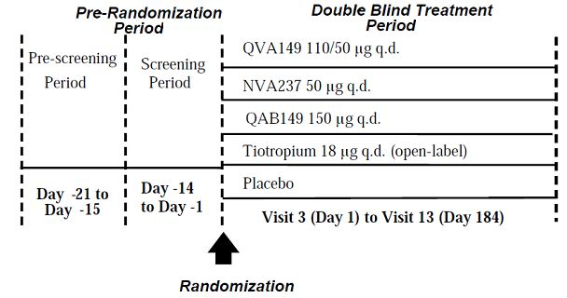

##### Inclusion and exclusion criteria

Key inclusion criteria were male or female patients aged ≥40 years with moderate to severe COPD (based on the GOLD guidelines, 2008); current or ex-smokers of at least 10 pack years; post-bronchodilator FEV1 ≥30% and <80% of predicted normal; and post-bronchodilator FEV1/FVC <0.70 at screening. Key exclusion criteria were significant concomitant illnesses including Type 1 or Type 2 diabetes, a significantly abnormal ECG (including QTc prolongation), narrow angle glaucoma, urinary retention or severe renal failure; patients requiring long-term oxygen therapy; patients with recent acute exacerbations or URTI; patients with other significant pulmonary disease including asthma; atopy or intermittent allergic rhinitis; patients unable to use DPI or MDI; patients unable to perform spirometry.

##### Study treatments

* QVA149 110/50 µg capsules for inhalation delivered OD via Novartis SDDPI
* QAB149 150 µg capsules for inhalation delivered OD via Novartis SDDPI
* NVA237 50 µg capsules for inhalation delivered OD via Novartis SDDPI
* matching placebo inhalation capsules delivered OD via Novartis SDDPI
* open label tiotropium 18 µg capsules delivered OD via the HandiHaler®

*Comment: In this and other studies, open-label tiotropium was used as a comparator because it was impossible to blind the commercially available product.*

##### Efficacy variables and outcomes

The main efficacy variables were:

* Spirometry measurements of FEV1, FVC conducted at each study visit to Week 26
* Serial 12 hour and 24 hour spirometry conducted on Day 1 and Week 26
* Rescue medication use (SABA)
* Patient reported symptoms recorded by eDiary
* Baseline and Transitional Dyspnoea Index (BDI/TDI), recorded by an independent assessor on Day 1, Week 12 and Week 26
* SGRQ conducted on Day 1, Week 12 and Week 26
* COPD exacerbations (based on protocol defined criteria)

The primary efficacy outcome was to demonstrate the superiority of QVA149 110/50 µg compared to both QAB149 150 µg and NVA237 50 µg based on trough FEV1 measured immediately pre-dose following treatment for 26 weeks.

Other efficacy outcomes were:

* To demonstrate the superiority of QVA149 compared with placebo assessed by level of breathlessness (measured by TDI), QoL measured by the SGRQ, and the use of rescue medication (number of puffs)
* To compare the superiority of QVA149, QAB149 and NVA237 compared to placebo measured by trough FEV1 following 26 weeks of treatment
* To demonstrate at least equal effectiveness of QVA149 and open label tiotropium measured by trough FEV1 following 26 weeks treatment.

##### Randomisation and blinding methods

Eligible patients were randomised and assigned a treatment number at Visit 3 using interactive response technology (IRT). Patients randomised to open-label tiotropium were not assigned a treatment number as this medication was supplied locally. Patients, investigator site staff and data analysts remained blind to the treatment identity from randomization to data base lock. However, emergency un-blinding was permitted.

##### Analysis populations

The randomised set (RAN) included all randomised patients whether they received trial medication or not. The full analysis set (FAS) and safety analysis set (SAF) included all randomised patients who received at least one dose of study medication. The per protocol set (PPS) included FAS patients who did not have significant protocol deviations or meet withdrawal criteria. Nearly all patients (99.6%) were included in the FAS and SAF and most patients (85.8%) were included in the PPS.

##### Sample size

It was estimated that 2743 patients were required to be screened to achieve 2,138 patients randomised into five treatment arms in a ratio of 2:2:2:2:1 (n=238 in the placebo arm and n=475 in each of the other treatment arms). It was planned that at least 1,710 patients would complete the study. A drop-out rate of 20% at 26 weeks was assumed and drop-outs were not replaced. The randomization plan was based on a previous 26 week study of QAB149. The plan assumed a QVA149-Placebo delta FEV1 = 120 mL and QVA149-Mono-component delta FEV1 = 60 mL with SD = 245 mL for both comparisons. With alpha = 0.05, the study had >99% power to detect the superiority of delta FEV1for QVA149 versus placebo and 87% power for QVA149 versus its mono-components. The power to detect superiority of QVA149 versus placebo for TDI, SGRQ and rescue medications was 92%, 81% and 99% respectively.

##### Statistical methods

The study was designed to test multiple statistical hypotheses to evaluate the efficacy of QVA149 compared with QAB149, NVA237, placebo and the positive control (tiotropium). SAS version 9.2 was used for all analyses. The primary efficacy variable was trough FEV1 response following treatment for 26 weeks using a mixed model for the FAS. The model included baseline smoking status, baseline ICS use and geographical region. All comparisons were conducted at a two-sided significance level of 5% and procedures were applied to control for multiplicity. Comparisons were presented for both raw and adjusted one-sided p-values. Superiority of QVA149 was to be demonstrated if the p-value was less than the multiplicity adjusted significance level and the multiplicity adjusted confidence interval was higher than 0 mL. Exploratory analyses were performed on sub-groups defined by age, gender, race, smoking history, disease severity, BMI, and reversibility levels following SABA at screening. Key secondary variables for the FAS were analysed using the same mixed model specified for the primary analysis. Other secondary efficacy variables were analysed for the FAS only without adjustment for multiplicity. Estimated adjusted treatment effects and treatment differences are presented with associated confidence intervals and p-values.

##### Participant flow

A total of 3,625 patients were screened and 2,144 patients were randomised. Study discontinuations were lowest in the QVA149 arm (8%) and highest in the placebo arm (19.2%).

##### Major protocol violations/deviations

Major protocol deviations occurred in 280 patients (13.1%). The most frequent deviation (5.4%) was non-compliance with dose timing in relation to spirometry at clinic visits. A total of 40 patients (1.9%) were excluded from the PPS because of over or under-compliance with their randomised medication.

##### Baseline data

Baseline demographics were well balanced. The overall mean age was 63.9 years and 12.8% of patients were aged ≥75 years. Most patients were male (75.8%) and most were Caucasian (67.7%) or Asian (28.8%). Overall, most patients had moderate (63.6%) or severe disease (36.3%) with two patients excluded from the PPS because they had mild disease. At baseline, 57.5% of patients used ICS, 60.3% were ex-smokers and 39.7% were current smokers and the mean number of pack years was 44.9. A total of 74.6% of patients had no history of COPD exacerbations in the year before enrolment. Screening spirometry and reversibility were similar in the treatment groups. Mean post-bronchodilator FEV1 was 55.2% of predicted normal, mean reversibility was 20.3% and mean FEV1/FVC ratio was 48.7%. COPD medications and non-drug therapies were discontinued before randomization by 76.5% of patients. The drugs most frequently discontinued were beta-agonist plus steroid (38.8%), SABA (36.5%) and long-acting anti-cholinergics (31.4%).

##### Results for the primary efficacy outcome

The primary objective was to show the superiority of QVA 110/50 µg over both QAB149 and NVA237 assessed by trough FEV1. There were significant improvements in mean trough FEV 1 in the QVA149 arm compared with NVA237 (70 mL) and QAB149 (90 mL) (p<0.001). There was a significant improvement in trough FEV1 in the QVA149 arm with a mean treatment difference of 200 mL at 26 weeks compared with placebo (p<0.001). There were also significant improvements in the QAB149, NVA237 and tiotropium arms compared with placebo (130 mL, 120 mL, and 130 mL, respectively). These differences were all statistically significant (p<0.001) and clinically meaningful. Results in the PPS analysis were similar to those in the FAS. At 26 weeks, there was a mean increase in trough FEV1 from baseline in all treatment groups, QVA149 160 mL (15.3%), QAB149 80 mL (7.7%), NVA237 70 mL (7.1%) and tiotropium 90 mL (9.3%). Similar results were demonstrated in sub-group analyses defined by age, gender, race, COPD disease severity, ICS use and smoking status. The proportion of patients with an increase of >200 mL was greater in the QVA149 arm (39.8%) than in the QAB149 (26.2%), NVA237 (23.8%), tiotropium (25.1%) and placebo (8.4%) arms (p<0.001 for all treatment comparisons in this *post hoc* analysis).

*Comment: An increase in trough FEV1 of >120 mL may be considered to have significant clinical value. Meaningful increases in FEV1 were achieved by QVA149 and its mono-components compared with placebo and the superiority of QVA149 versus its mono-components was also confirmed statistically.*

Trough FEV1 after 26 weeks was analysed in sub-groups defined by reversibility at baseline.In patients with baseline FEV1 reversibility ≤5%, QVA149 was numerically superior to QAB149, NVA237, placebo and tiotropium with mean differences of 40 mL, 50 mL, 70 mL and 20 mL respectively. In patients with FEV1 reversibility >5% to 12%, QVA149 was statistically superior to QAB149 (90 mL, p=0.004), NVA237 (60 mL, p=0.05), placebo (290 mL, p<0.001) and tiotropium (p=0.001). In patients with FEV1 reversibility >12%, QVA149 was statistically superior (p<0.001 for all comparisons) to QAB149 (80 mL), NVA237 (100 mL), placebo (210 mL) and tiotropium (80 mL).

##### Results for other efficacy outcomes

The profile of FEV1 measurements at each time point for 24 hours post-dose at Week 26 is shown below in Figure 4. There was a clear separation between the QVA149 group, placebo and the active comparators. The differences in favour of QVA149 were all statistically significant (p<0.001).

Figure 4: Profile of FEV1 measurements at each time point for 24 hours post-dose at Week 26.

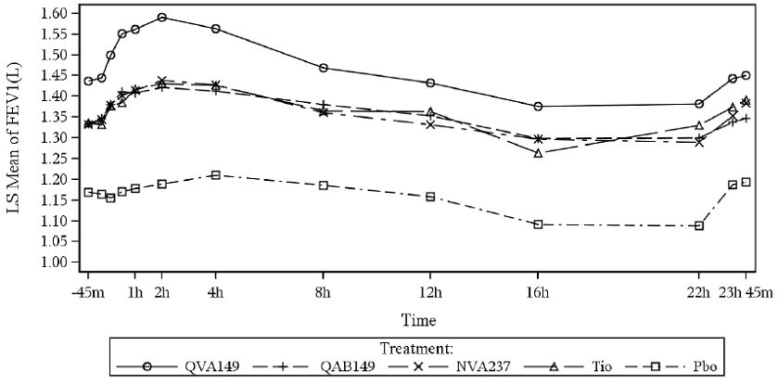

In the QVA149 group there was a statistically significant improvement in TDI score compared with placebo at 26 weeks (1.09, p<0.001). There were also improvements compared with QAB149 (0.84), NVA237 (0.89) and tiotropium (0.58). Changes in TDI score of ≥1.0 may be considered clinically important. Patients in the QVA149 group required less SABA rescue medication than patients in the placebo group (-0.96 puffs/day, p<0.001), QAB149 (-0.30 puffs/day, p<0.03), NVA237 (0.66 puffs/day, p<0.001) and tiotropium (0.54 puffs/day, p<0.001). Quality of life measured by SGRQ was higher at Week 26 compared with baseline in the QVA149 group. The proportion of patients with a clinically relevant increase of ≥4 points was 63.7% in the QVA group, compared with 63.0%, 60.5%, 56.4% and 56.6% in the QAB149, NVA237, tiotropium and placebo groups respectively. None of the treatment differences between QVA149 and comparator groups were statistically significant. In the year prior to study entry, 35.4% of patients experienced a moderate or severe COPD exacerbation. After treatment for 26 weeks, moderate or severe COPD exacerbations had occurred in 17.9%, 21.6%, 18.8%, 25.9% and 17.7% in the QVA149, QAB149, NVA237, placebo and tiotropium groups, respectively. The number of moderate or severe exacerbations per treatment year was 0.46 in the QVA149 group and ranged from 0.45 to 0.75 in the other groups (the study was not powered for this end-point). QVA149 patients had statistically significant benefits compared with other groups for some e-diary symptom scores but these were not clinically meaningful. Overall, similar changes in the secondary efficacy end-points were observed in all demographic sub-groups and no differences were clinically meaningful.

*Comment: The study was well designed and conducted and the choice of comparators was appropriate. QVA149 was statistically superior to its mono-components, to tiotropium and to placebo, and the differences were clinically meaningful. The benefit in lung function was supported by improved symptomatic control in the QVA149 group.*

*Not surprisingly, FEV1 reversibility at baseline predicted response to the randomised treatments. A total of 1,342/2,144 (63%) randomised patients had a clinical diagnosis of COPD with mean FEV1 reversibility >12% (mean increase 220 mL). The EU guideline recognizes that up to 50% of COPD patients have some degree of reversibility (the magnitude not defined). However, it is not clear what attempts were made to exclude the diagnosis of adult onset asthma or mixed asthma/COPD in these study patients. Patients with atopy or a history of asthma before age 40 were excluded. However, adult onset asthma is common in all age groups, it tends to be underdiagnosed and often there is no history of atopy. Other than medical history as stated in the protocol, the sponsors should be asked what if any other efforts were made to exclude this specific asthmatic or mixed asthmatic patient population at screening, especially when overall mean FEV1 reversibility at baseline was 20%.*

#### Study A2313

##### Study design, objectives, locations and dates

This was a multi-national study conducted at sites in Belgium (6), Czech Republic (7), Estonia (2), Germany (38), Hungary (9), Korea (7), Lithuania (6), Norway (5), Luxemburg (1) and Spain(5). The first patient was enrolled in March 2011 and the last patient completed in March 2012. It was a 26 week, multi-centre, randomised, double-blind, double-dummy, parallel group study to compare the efficacy and safety of QVA149 with fluticasone/salmeterol 500 µg/50 µg BID (Seretide) in patients with moderate to severe COPD. The main objective was to demonstrate the superiority of QVA149 OD compared with Seretide measured by FEV1 AUC0-12h after treatment for 26 weeks.

The study schema is shown in Figure 5 below.

Figure 5: Study schema for Study A2313.

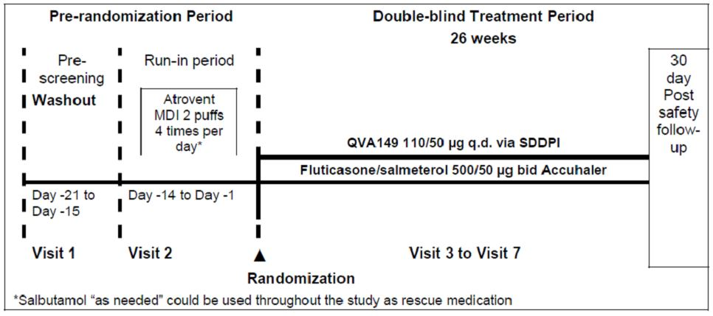

At the pre-screening Visit 1, patients were asked to stop taking ICS plus LABA combinations at least 48 hours before Visit 2. At Visit 2, patients started a 14 day run-in period during which they were treated with ipratropium (Atrovent MDI) two puffs QID and with salbutamol rescue via inhaler. Spirometry with reversibility was performed at this visit. At the baseline Visit 3, eligible patients were randomised to receive either double-blind QVA149 or double-blind Flut/Salm in a 1:1 ratio for a 26 week treatment period. Treatment randomization was stratified by smoking status (current or ex-smoker).

##### Inclusion and exclusion criteria

Key inclusion criteria were males or females aged ≥40 years; moderate or severe COPD according to GOLD guidelines; current or ex-smokers with a smoking history of at least 10 pack years; post-bronchodilator FEV1 ≥40% and <80% of predicted normal. Key exclusion criteria were significant concomitant illnesses including Type 1 or Type 2 diabetes, a significantly abnormal ECG (including QTc prolongation), narrow angle glaucoma, urinary retention or severe renal failure; patients requiring long-term oxygen therapy; patients with recent acute exacerbations or URTI; patients with other significant pulmonary disease including asthma; atopy or intermittent allergic rhinitis; patients unable to use DPI or MDI; patients unable to perform spirometry.

##### Study treatments

* QVA149 (QAB 110 µg, NVA237 50 µg) capsules given once daily via an SDDPI
* Fluticasone/salmeterol 500/50 µg dry inhalation powder (Seretide) delivered via Accuhaler.
* matching placebo inhalers

##### Efficacy variables and outcomes

The main efficacy variables were:

* Spirometry conducted at Weeks 1, 6, 12, 18 and 26
* 12 hour serial spirometry conducted at Weeks 1, 12 and 26

The primary efficacy outcome was FEV1 AUC0-12h after treatment for 26 weeks

Other efficacy outcomes included:

* BDI/TDI conducted at Weeks 1, 12 and 26
* SGRQ conducted at Weeks 1, 12 and 26

##### Randomisation and blinding methods

Randomization was conducted by IRT at Visit 3 and this was stratified by smoking status. Patients, investigator staff, those performing the assessments and data analysts remained blind until database lock. A double-dummy design was used to conceal the study drug identity. Emergency un-blinding was permitted.

##### Analysis populations

A total of 523 patients were randomised of whom 522 (99.8%) were included in the FAS and SAF. One patient was excluded from the FAS and SAF because he was randomised in error. Overall, 92.7% of patients were included in the PPS. The PPS includes all patients in the FAS population without any significant protocol deviations or other criteria for exclusion. The SAF includes all patients who received at least one dose of study drug.

##### Sample size

Previous studies with QVA, QBA and NVA were associated with standard deviations of FEV1 AUC0-12h of approximately 200 mL. An estimated sample size of 522 randomised patients was planned to provide 444 completed patients assuming a 15% drop-out rate. This provided 80% power at alpha = 0.05 to detect a treatment arm differential of 60 mL in FEV1 AUC0-12h at Week 26.

##### Statistical methods

Standardized AUC0-12h for FEV1 were calculated on Day 1, and Weeks 12 and 26 using the trapezoidal rule. The primary analysis was performed on the FAS using a mixed model using baseline FEV1, smoking status at baseline, history of ICS use and geographical region as covariates.

The adjusted treatment difference for QVA149 compared with Flut/Sam was estimated with the 95% CI and two sided p-value. The superiority of QVA149 compared with Flut/Salm was assumed if the p-value was less than 5% and the 95% CI was completely to the right of 0 litres.

##### Participant flow

A total of 832 patients were screened, 523 patients were randomised (259 QVA149 and 264 Flut/Salm) as shown below. The most common cause of screening failure was failure to meet the spirometry entry criteria. Overall, discontinuations were 17.4%, the most common reasons being AEs, withdrawal of consent and protocol deviations.

##### Major protocol violations/deviations

Overall, 6.9% of randomised patients had at least one major protocol deviation which required exclusion from the FAS. The proportion of patients with major deviations was higher in the QVA149 group (8.5%) compared with the Flut/Salm group (5.3%). This difference was due mainly to a minor imbalance in the pre-baseline medical history criterion.

##### Baseline data

Baseline demographics were well balanced. Most patients were male (71%) and Caucasian (89.3%) with a mean age of 63.3 years (range 44 to 87 years). The overall BMI was 27.1 kg/m2. The baseline disease characteristics were similar in both treatment groups. The median duration of COPD was 5.8 years (range 0-38 years) with a mean number of 40.2 pack years and the proportion of patients with moderate and severe COPD was similar in both groups. Pre-baseline ICS use was 37.1% in the Flut/Salm group compared with 32.9% in the QVA149 group. Spirometry in both treatment groups was similar at screening. Overall, mean post-bronchodilator FEV1 was 60.2% of predicted normal and FEV1 reversibility was 20.4%. COPD medications were discontinued before the start of study medication by 90.4% of patients, most commonly tiotropium (39.5%), salbutamol (29.5%) and Flut/Salm.

##### Results for the primary efficacy outcome

There was an increase in mean FEV1 AUC0-12h in both treatment groups at Day 1, Week 12 and Week 26 but the improvement in the QVA149 group was statistically significant compared to the Flut/Salm group at each visit. At Week 26 the difference in favour of QVA149 was 140 mL (95% CI: 100, 170 mL, p<0.001). A sensitivity analysis of the PPS confirmed the results of the FAS with a treatment benefit of 140 mL in favour of QVA149 at Week 26 (p<0.001). The results of the primary analysis were consistently similar in sub-groups defined by age, gender, smoking status, COPD severity and FEV1 reversibilty at baseline. Treatment differences in favour of QVA149 ranged from 120 -150 mL in all sub-groups and they were all statistically significant at Week 26.

##### Results for other efficacy outcomes

The profile of FEV1 measurements at each time point from 5 minutes to 12 hours post-dose at Week 26 is shown below in Figure 6. There was a clear separation between the two groups at all the time points and the differences were all statistically significant (p<0.001).

Figure 6: FEV1 measurements to 12 hours post-dose at Week 26.

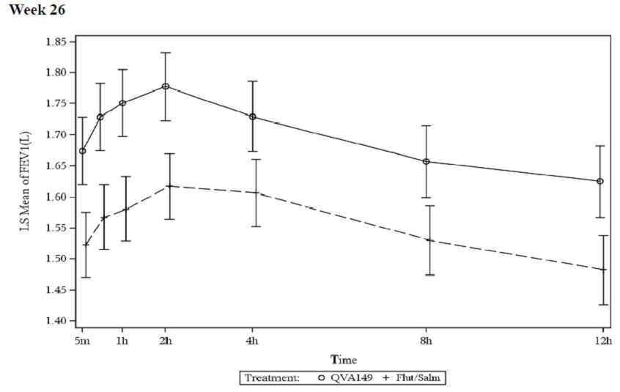

There were improvements in dyspnoea symptom scores in both treatment groups. The changes in both groups were clinically meaningful but the improvement was more marked in the QVA149 group (LS mean 1.75 to 2.16) compared with the Flut/Salm group (LS mean 1.16 to 1.41). Symptom scores recorded by eDiary improved in both groups from baseline but there were no meaningful differences between groups. There were clinically meaningful increases in QoL measured by the SGRQ in both groups with a small benefit in favour of QVA149. Rescue medication measured by puffs of salbutamol was used less frequently in the QVA149 group compared with the Flut/Salm group over the 26 week treatment period. The percentage of days with no rescue medication use was numerically in favour of QVA149 (51.25%) compared with Flut/Salm (46.53) but the difference was not statistically significant.

*Comment: The study design and conduct were appropriate. Flut/Salm is an appropriate comparator as it is a widely used gold standard treatment for COPD. There was an immediate and sustained statistically significant benefit in favour of QVA149. The difference between treatments after 26 weeks ranged from 120-150 mL in the main group and all sub-groups. The lung function benefit is clinically meaningful although the symptomatic benefit was borderline.*

#### Study A2304

##### Study design, objectives, locations and dates

This study was conducted at 362 sites including the US (58), Canada (9), Germany (50), S. America (49) S. America (56), India (15), the UK (18), S. Africa (5), the Philippines (6) and the remainder in other European countries. The first patient was recruited in April 2010 and the last patient completed in July 2012. It was a multi-centre, randomised, double-blind, parallel-group, active controlled study to compare the effects of QVA149 versus NVA237 and open-label tiotropium on COPD exacerbations in patients with severe to very severe COPD. The primary objective was to demonstrate superiority of QVA149 (110/50 µg OD) to NVA237 (50 µg OD) measured by the rate of moderate to severe COPD exacerbations over a 64 week treatment period. The main secondary objective was to demonstrate superiority of QVA149 (110/50 µg OD) to open-label tiotropium (18 µg OD) for the same endpoint.

The study schema is shown in Figure 7.

**Figure 7: Study design for A2304.**

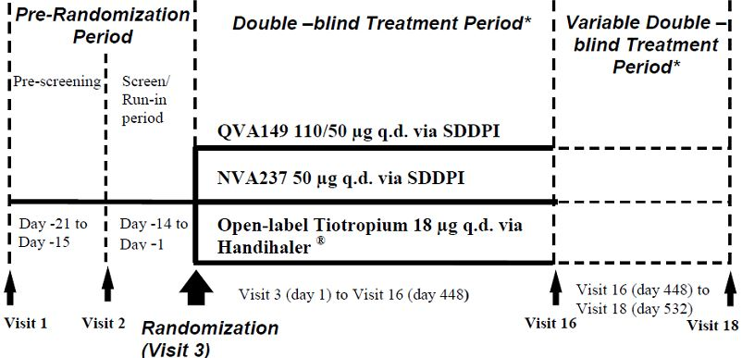

Patients were randomised to receive double-blind QVA149 or NVA237, or open-label tiotropium. The study consisted of a pre-randomization period, the double-blind treatment period (64 weeks) and the optional, variable, double-blind treatment period (an additional 12 weeks for a total of 76 weeks). All study treatments were given in addition to other COPD background therapy. At Visit 1, COPD therapy was adjusted to allowable therapy. Patients taking fixed-dose ICS plus LABA discontinued treatment and were switched to an equivalent ICS monotherapy plus SABA rescue at least 48 hours before Visit 2. The ICS dose then remained stable for the rest of the study. At Visit 2, patients commenced a 2 week run-in and baseline measurements including spirometry, FEV1 reversibility and eDiary measurements were recorded. At Visit 3, eligible patients were randomised in a 1:1:1 ratio to receive either double-blind QVA149 or NVA237 or open-label tiotropium for a minimum of 64 weeks. The randomization was stratified by smoking status and ICS use. Patients who completed 64 weeks of treatment were given the option of continuing in the study for a further 12 weeks, depending on their time of enrollment.

Patients who experienced a COPD exacerbation during the treatment period were treated at the discretion of the investigator. A standardized treatment plan for an oral course of prednisolone (or equivalent) and/or an antibiotic was provided. Following treatment of the exacerbation and if considered safe by the investigator, patients continued in the study and were returned to their randomised medication. Three independent adjudication committees were established for the study to oversee COPD exacerbations, mortality and CCV events. All were external to the sponsor and study personnel at the investigator site.

A COPD exacerbation was defined as:

* a worsening of two or more of the major symptoms (dyspnoea, sputum volume or sputum purulence) for at least two consecutive days, or
* a worsening of one major symptom with an increase in severity of sore throat, cold symptoms, fever without other cause, cough or wheeze

##### Inclusion and exclusion criteria

Key inclusion criteria were male or females aged ≥40 years; severe or very severe COPD according to GOLD guidelines; current or ex-smokers with a smoking history of at least 10 pack years; post-bronchodilator FEV1 <50% and FEV1/FVC 0.70 of predicted normal; and a documented history of at least one COPD exacerbation in the preceding year. Key exclusion criteria were significant concomitant illnesses including Type 1 or Type 2 diabetes, a significantly abnormal ECG (including QTc prolongation), narrow angle glaucoma, urinary retention or severe renal failure; patients requiring long-term oxygen therapy; patients with recent acute exacerbations or URTI; patients with other significant pulmonary disease including asthma; atopy or intermittent allergic rhinitis; patients unable to use DPI or MDI; and patients unable to perform spirometry.

##### Study treatments

* QVA149 (QAB 110 µg/NVA237 50 µg) capsules given once daily via Novartis SDDPI
* NVA237 50 µg capsules given once daily via Novartis SDDPI
* Open-label tiotropium bromide 18 µg capsules given once daily via HandiHaler
* Matching QVA149 and NVA237 placebo capsules

##### Efficacy variables and outcomes

The main efficacy variables were:

* Adjudicated COPD exacerbations
* Pre- and post-dose spirometry conducted at Visits 3, 5, 7, 10, 12, 14 and 16 (Week 64)

The primary efficacy outcome was the rate of adjudicated COPD exacerbations in each treatment group.

Other efficacy outcomes included:

* Rescue medication usage
* SGRQ and patient eDiary recordings

##### Randomisation and blinding methods

Randomization was conducted by IVRS/IWRS at Visit 3 and this was stratified by smoking status and ICS use. A treatment randomization of 1:1:1 was maintained at the regional and/or country level but not site level. Patients, investigator staff, those performing the assessments and data analysts remained blind until database lock. A double-dummy design was used to conceal the study drug identity. Emergency un-blinding was permitted.

##### Analysis populations

A total of 2,224 patients were randomised of whom 2,214 (99.6%) were included in the FAS. A total of 2,215 patients were included in the SAF. One patient was excluded from the FAS and SAF because he was randomised in error. A total of 7 patients were excluded from the FAS and SAF because of unacceptable GCP compliance at one centre (site 820 which was terminated). Overall, 99.1% of patients were included in the modified FAS (mFAS) and 99.2% were included in the modified SAF (mSAF). Overall, 91.6% of patients were included in the PPS as shown below. The PPS includes all patients in the FAS population without any significant0 protocol deviations or other criteria for exclusion. The SAF includes all patients who received at least one dose of study drug, whether or not they were randomised.

##### Sample size

Assuming a constant rate during the treatment period, the sample size was calculated as the number of patient years required to detect a clinically meaningful 20% reduction in the rate of COPD exacerbations in the QVA149 arm compared with NVA237. Based on previous COPD studies which had drop-out rates of over 13%, an estimated sample of 3,500 patients were to be recruited to randomize approximately 2,198 patients into three treatment arms in a ratio of 1:1:1. It was assumed that 1,540 patients would complete the study allowing for a conservative 30% drop-out rate. Assuming an average patient exposure of 17 months, a total of 2,198 randomised patients would have 84% power at a 5% two-sided significance level to confirm the primary endpoint.

##### Statistical methods

All efficacy endpoints were conducted on the mFAS which excluded nine patients because of poor GCP compliance. The primary analysis variable was the number of adjudicated moderate or severe COPD exacerbations during the treatment period. The number of COPD exacerbations recorded before adjudication was used in a sensitivity analysis. Patients who died of a COPD exacerbation were recorded as a single exacerbation event. A negative binomial model, Kaplan-Meier curves and Cox regression analyses were used as appropriate. The model included terms for treatment, smoking status, ICS use and country as fixed effects. Daily symptom score, baseline COPD exacerbation history and FEV1 were used as covariates. A two-sided superiority test of QVA149 versus NVA237 was conducted at the type 1 error rate of 5%. If the primary efficacy analysis was found to be significant, then a two-sided superiority test of QVA149 versus tiotropium on the rate of COPD exacerbations was performed at α=0.05. No other secondary variables were adjusted for multiplicity.

##### Participant flow

A total of 3,865 patients were screened, 2,224 patients were randomised. The most common cause of screening failure was failure to meet the diagnostic or severity criteria. Overall, there were 557 (25%) discontinuations, the most common reasons being AEs, withdrawal of consent, death and unsatisfactory efficacy. Study discontinuations were more common in the NVA237 group. Discontinuations due to AEs were more common in the QVA149 and NVA237 groups, but more patients in the tiotropium group discontinued because of unsatisfactory efficacy.

##### Major protocol violations/deviations

Overall, 176 (7.9%) of randomised patients had at least one major protocol deviation which required exclusion from the mFAS. The proportion of patients with major deviations was higher in the QVA149 group (9.4%) compared with the NVA237 (6.7%) and tiotropium (7.5%) groups. The most common deviations were eosinophils >600/mm3 and severe COPD exacerbations in the immediate pre-screening period.

##### Baseline data

Baseline demographics in the mSAF were well balanced. Most patients were male (74.8%) and Caucasian (82.1%) with a mean age of 63.3 years (range 40 to 90 years). The overall BMI was 25.3 kg/m2. The baseline disease characteristics were similar in both treatment groups. Two patients (0.1%) had moderate COPD, 79.0% were severe and 20.9% were very severe and the proportions of patients with moderate and severe COPD were similar in both groups. The median duration of COPD was 7.2 years (range 0-40 years) with a mean number of 45.1 pack years. Overall, pre-baseline ICS use was 75.3%. In the year before the study, 76.2% of patients had experienced one moderate or severe COPD exacerbation and 22.3% had experienced two or more exacerbations. Spirometry in both treatment groups was similar at screening. Overall, mean post-bronchodilator FEV1 was 37.2% of predicted normal and FEV1 reversibility was 18.3%. All patients had post-bronchodilator FEV1/FVC ratio <0.70. COPD medications were discontinued before the start of study medication by 87.4% of patients. Overall, the most commonly discontinued therapies were LABA plus steroid (50.6%), LAMA (43.5%) and SABA 36.6%).

##### Results for the primary efficacy outcome

The primary objective was met. In the mFAS, there were 812 exacerbations in the QVA149 group compared with 900 in the NVA237 group with a comparative rate reduction of 12% (RR 0.88, 95% CI: 0.77, 0.99, p=0.038). In the PPS, there were 760 exacerbations in the QVA149 group compared with 838 in the NVA237 group with a comparative rate reduction of 10% (RR 0.89, 95% CI: 0.79, 1.01, p=0.08). The rate of exacerbations per year was 0.94 in the QVA149 group compared with 1.07 in the NVA237 group. In sub-group analyses defined by age, gender, race, smoking status, disease severity and ICS use, the pattern of exacerbations was similar to the overall population. In patients with baseline FEV1 reversibility ≤12%, there was no rate reduction in the QVA149 group compared with the NVA237 group. In patients with baseline FEV1 reversibility >12%, the rate reduction in the QVA149 group (n=399) compared with the NVA237 group (n=438) was statistically significant (RR 0.80, 95% CI: 0.68, 0.93, p<0.05). Seasonal effects were noted in the RR comparisons and the superiority of QVA149 compared with NVA237 was statistically significant in autumn/ winter with only a small difference recorded in spring/summer.

##### Results for other efficacy outcomes

The main secondary objective was to demonstrate superiority of QVA149 over open-label tiotropium measured by the rate of moderate to severe COPD exacerbations. There was a non-significant rate reduction of 10% in the QVA149 group (RR 0.90, 95% CI: 0.79, 1.02, p=0.096), but there was no meaningful difference in the NVA237 group compared with the tiotropium group. Similar results were obtained in the PPS. Sub-group analyses were similar to the overall results. There was a 7% risk reduction in the QVA149 group compared with the NVA237 group but this was not statistically significant. The annualized rate of all COPD exacerbations (including non-adjudicated mild exacerbations) was 15% lower in the QVA149 group (3.44) compared the NVA237 group (4.04) (RR 0.85, 95% CI: 0.77, 0.94, p=0.001).

There were increases in mean pre-dose FEV1 in all treatment groups at all time points over the 64 week period. QVA149 was superior to NVA237 and tiotropium with treatment differences ranging from 0.06 to 0.08 L (p<0.001). The differences were of borderline clinical significance. Decreased SGRQ scores were observed in all groups but QVA149 was significantly superior to both NVA237 and tiotropium (p<0.01). Use of rescue medication decreased in all groups. There was a statistically significant and clinically meaningful decrease in rescue medication use in the QVA149 group compared with NVA237 and tiotropium (0.81 and 0.76 inhalations/day respectively, p<0.001 for both comparisons). There were significant and clinically meaningful improvements in daily, morning and evening symptom scores in the QVA149 group compared with NVA237 and tiotropium (p<0.001 for both comparisons).

*Comment: The study was well designed and conducted. The lack of placebo control is regrettable although it might have been considered inappropriate in a study population with severe COPD. Lung function following QVA149 treatment was statistically superior to NVA237 and tiotropium (p<0.001) although the differences were modest (0.06 – 0.08 L) throughout the 64 week treatment period. QVA149 also offered improved symptom control compared with the other groups.*

*COPD exacerbation rates were the primary study objective. In the FAS, QVA149 reduced the rate of moderate or severe exacerbations by 12% compared to NVA237 (RR 0.88, 95% CI: 0.77, 0.99, p=0.038). In the PPS, there was a similar benefit in favour of QVA149 with a comparative rate reduction of 10% which was not statistically significant (RR 0.89, 95% CI: 0.79, 1.01, p=0.08). In the FAS, there was a 10% reduction in exacerbation rates in the QVA149 group compared to tiotropium. However, the benefit was not statistically significant so the study did not meet its main secondary endpoint. The benefit in favour of QV149 compared with its mono-component NVA237 is of borderline statistical and clinical significance. There is no evidence from this study that either treatment is superior to placebo for the reduction of COPD exacerbations.*

### Other efficacy studies

#### Study A2305

This was a randomised, double-blind, double-dummy, placebo controlled, 3 period, cross-over study to assess the effect of QVA149 on exercise endurance in patients with moderate to severe COPD using tiotropium as an active control. It was conducted in 2011 at 14 centres in Spain and Germany. Patients of either gender aged ≥40 years had post-bronchodilator FEV1 ≥40% and <70% of predicted normal and FEV1/FVC <0.70 at baseline. Patients with recent COPD exacerbations, history of asthma or significant other pulmonary disease were excluded. The study treatments were QVA149 110/50 µg capsules for inhalation or matching placebo, and tiotropium 18 µg capsules for inhalation or matching placebo capsules, all delivered via SDDPI. The study schema is shown below in Figure 8. Patients randomly received QVA149, tiotropium or placebo, each for three weeks with a three week wash-out between periods.

Figure 8: Study design for A2305.

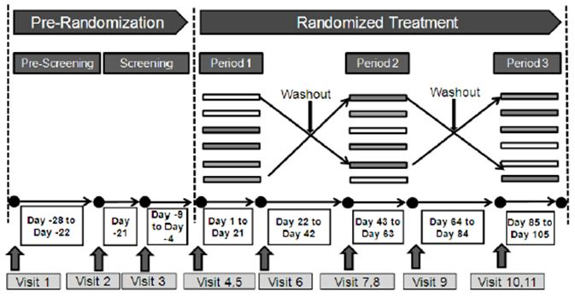

Baseline spirometry, including reversibility and body plethysmography were performed before and after a standardized, incrementally loaded bicycle exercise test. Efficacy variables included exercise duration time, spirometry, leg discomfort, dyspnoea, symptom score and use of rescue medication after three weeks of investigational product. A total of 85 patients were randomised and 73 patients completed the study. The mean age was 62.1 years, 63.1% were male, and most were Caucasian (96.4%). Most patients had moderate COPD (72.6%) and the mean disease duration was 8.9 years. Most were not using ICS at baseline (69.0%), most were current smokers (53.6%) and the mean number of pack years was 50.0. Mean baseline post-bronchodilator FEV1 was 55.9% of predicted normal and mean reversibility was 22.6%. Mean exercise duration at screening was 572.9 seconds.

The primary efficacy endpoint was exercise endurance time during a sub-maximal constant load cycle ergometry test at Day 1 and after three weeks of treatment. QVA149 treatment was superior to placebo for endurance time after three weeks. The improvement was 13% with a mean treatment difference of 59.5 sec (p=0.006). The exercise tolerance time was slightly higher in the tiotropium group and significantly different from placebo (66.3 sec, 15%, p=0.002). QVA149 significantly improved the main secondary endpoint of trough FEV1 at Day 21 compared with tiotropium (0.10 L, p<0.001,). QVA149 was numerically superior to placebo for dyspnoea and symptom scores but similar to tiotropium.

*Comment: QVA149 increased exercise endurance by 13% compared with placebo but there was no benefit compared with tiotropium even though FEV1 was higher by 0.10 L in the QVA149 group. There were no meaningful differences in symptom scores although the study was not powered to show them.*

### Analyses performed across trials (pooled & meta analyses)

None presented.

### Evaluator’s conclusions on efficacy

The studies complied with the Committee for Medicinal Products for Human Use (CHMP) guideline for COPD drugs. The study designs and choice of comparators in the pivotal efficacy studies was appropriate although it was impossible to blind the proprietary tiotropium inhaler. The inclusion/exclusion criteria ensured a representative population of moderate to severe COPD patients although they excluded patients with potentially confounding illnesses prevalent in the elderly COPD population, for example, asthma, uncontrolled Type 2 diabetes, and heart disease.

The studies complied with the CHMP guideline for FDC.[2] Dose ranging was not performed because the approved doses of the mono components are fixed and both are given once daily. The indacaterol/glycopyrronium FDC was tested against its single components and against placebo. It was also tested against tiotropium and fluticasone/salmeterol (Flut/Salm), both widely used standard therapies for COPD. QVA149 has been shown to be an effective bronchodilator in these studies of patients with COPD, although the absolute effects were modest due to the largely irreversible nature of the disease. In the 26 week Study A2303, benefits in mean trough FEV1 were observed for QVA149 compared with placebo (0.20 L), QAB149 (0.07 L), NVA237 (0.09 L) and open label (OL) tiotropium (0.08 L). In the 26 week Study A2313, there was a 0.14 L benefit for mean FEV1 AUC0-12h in the QVA149 group compared with Flut/Salm. The primary endpoint was achieved in both studies, the comparisons were all statistically significant (p<0.001) and increases of 0.12 L FEV1 can be considered clinically useful. Improved lung function was immediate, sustained throughout the 24 h dosing interval and sustained with long term treatment. In the 64 week Study A2304, there were smaller but still significant benefits in favour of QVA149 compared with NVA237 (0.07 L) and OL tiotropium (0.06 L) (p<0.001 for both comparisons). The results of the pivotal efficacy studies are supported by efficacy data in the pivotal safety Study A2307. In patients treated for 52 weeks, pre-dose FEV1 was significantly greater in the QVA149 group compared with placebo with a treatment difference of 0.189 L (p<0.001). Long term bronchodilator response was predicted by pre-treatment FEV1 reversibility so arguably treatment should be reserved for patients with a demonstrated response capability. Symptomatic benefits in favour of QVA149 were also demonstrated in the pivotal studies as measured by transitional dyspnoea index (TDI), St. George’s Respiratory Questionnaire (SGRQ), rescue medication use, and diary daytime and night time symptom scores. In Study A2305, there was also a modest but statistically significant increase in exercise endurance over 3 weeks during QVA149 treatment compared to placebo. After 3 weeks treatment, pre-dose FEV1 was 0.20 L higher during QVA149 treatment than during placebo. The primary endpoint in Study A2304 was an exacerbation rate reduction in favour of QVA149 compared with NVA237. The 12% benefit in favour of QVA149 in the Full Analysis Set was confirmed statistically but not in the PPS sensitivity analysis. Moreover, the clinical value of the treatment difference was borderline with absolute mean annual exacerbation rates of 0.94, 1.07 and 1.06 in the QVA149, NVA237 and tiotropium groups, respectively. There were trends in favour of QVA149 in the other controlled efficacy studies but they were not powered to detect statistically significant exacerbation rate reductions. This trend was not observed in the 52 week pivotal safety study A2307 although this study was not powered to show a treatment difference and was conducted in patients with moderate to severe COPD rather than severe to very severe patients in A2304. Moderate or severe exacerbations occurred in 25.3% of the QVA149 group and 22.1% of the placebo group with annual rates of 0.4 and 0.38 respectively.

No placebo comparator group was included in study A2304, presumably because of the COPD severity in this study population. NVA237 has been shown to reduce exacerbation rates compared with placebo in pooled analyses. However, the sponsor states that no long-term controlled trials with COPD exacerbations as a primary endpoint have yet been published. Overall, there is good evidence that QVA149 improves lung function and symptoms compared to placebo and current ‘gold standard’ therapies. There is borderline evidence that QVA149 reduces exacerbation rates compared with NVA149 but not tiotropium. However, the sponsor has not provided evidence that exacerbation rates for QVA149 (or NVA237) are lower than in patients given placebo. Overall, the data are insufficient to support the proposed indication claim that QVA149 reduces exacerbations in patients with COPD.

## Clinical safety

### Studies providing safety data

Four large double blind, controlled, pivotal Phase III studies contributed to the safety data as shown in Table 4.

Table 4: Phase III safety studies.

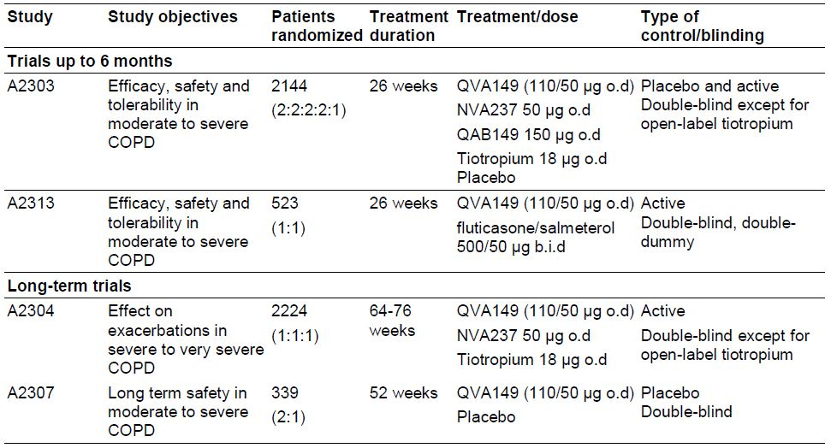

Other controlled Phase III studies are shown in Table 5. In addition, there were five clinical pharmacology trials in healthy volunteers and two Phase II, exploratory trials (A2203, a short term cardiovascular safety study; and A2204, a short term crossover efficacy study).

Table 5: Phase III safety studies.

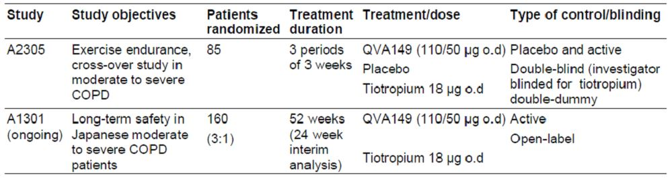

* + 1. **Pivotal efficacy studies**

In the pivotal efficacy studies, the following safety data were collected:

* General adverse events (AEs) were assessed by non directive questioning at each study visit, or through physical examination, laboratory test or other assessments. Patients also reported daily clinical symptoms in an eDiary.
* AEs of particular interest, including serious AEs (SAEs), death, COPD exacerbations, pneumonia, cardio and cerebrovascular (CCV) events, atrial fibrillation/flutter, were assessed and adjudicated by an independent Data safety Monitoring Committee. CCV events included events related to QTc prolongation, non fatal myocardial infarction, hospitalisation for unstable angina, non fatal stroke, heart failure requiring hospitalisation and coronary revascularisation.
* Laboratory tests, including haematology, biochemistry and urinalysis were performed at a central laboratory.

#### Pivotal studies that assessed safety as a primary outcome

StudyA2307 was a pivotal study that assessed safety as a primary outcome.

#### Dose response and non pivotal efficacy studies

The dose response and non pivotal efficacy studies provided safety data, as follows:

* Study A2305 provided data on exercise endurance following QVA149 for 3 weeks.
* Study A1301 provided 26 week safety data in Japanese patients.

### Pivotal studies that assessed safety as a primary outcome

#### Study A2307

##### Study design, objectives, locations and dates

This study was conducted at 48 sites in Canada (4), France (5), India (7), Korea (4), Lithuania (6), Latvia (4), Romania (5), South Africa (1) and the UK (8). The first patient enrolled in April 2010 and the last patient completed in December 2011. It was a multi-centre, randomised, double-blind, placebo-controlled assessment of the long-term safety of 52 weeks treatment with QVA149 (110/50) in patients with moderate to severe COPD. The main objective was to assess the safety and tolerability of QVA149 OD on the AE reporting rate.

The study schema is shown in Figure 9.

Figure 9: Study design for A2307.

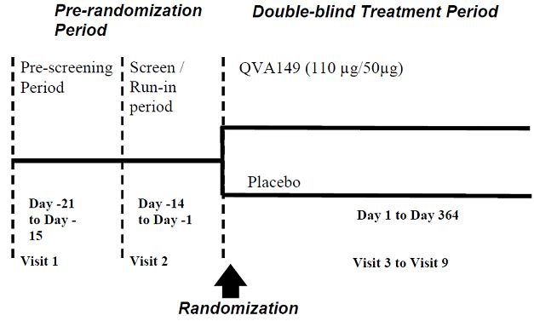

At Visit 1, COPD treatment was adjusted to allowable COPD medications consisting of ICS and SABA before entering a wash-out phase. At Visit 2, screening spirometry and reversibility was performed. Patients were then randomised in a 2:1 ratio to receive either QVA149 or placebo with stratification according to smoking status. Patients were instructed to take their medication between 0800 and 1100 hours daily. Patients returned for 6 further visits at Weeks 3, 6, 12, 26, 39 and 52. At the end of the treatment period, they were followed for an additional 30 days for survival information. During the study, inhaled salbutamol was permitted as rescue medication. COPD exacerbations were treated at the discretion of the investigator with the guidance of a standardised plan. When safe to do so, these patients then continued in the study and resumed their randomised medications. Compliance was assessed by capsule counts at each study visit.

##### Inclusion and exclusion criteria

Key inclusion criteria were male or female adults aged ≥40 years with moderate or severe stable COPD according to GOLD guidelines; smoking history of at least 10 pack years; post-bronchodilator FEV1 ≥30% and <80%; or post-bronchodilator FEV1/FVC <0.70. Key exclusion criteria were patients requiring long-term oxygen therapy; a recent COPD exacerbation; recent respiratory tract infections; other significant pulmonary diseases; significant ECG abnormalities (including QTc prolongation); atopy or history of asthma; Type 1 or Type 2 diabetes; or significant cardiovascular disease.

##### Study treatments

QVA149 (110 µg/50 µg) capsules for oral inhalation, delivered OD by an SDDPI, or matching placebo capsules delivered by SDDPI.

##### Safety variables and outcomes

The main safety variables were all AEs, SAEs, causality, pregnancies, ECGs, central laboratory haematology and blood chemistry, urinalysis, vital signs and physical examination findings. The main efficacy variables were spirometry (FEV1 and FVC), reversibility, symptom scores and the number of COPD exacerbations.

The primary safety outcome was to assess the safety and tolerability of QVA149 compared with placebo measured by the rate of AEs during treatment for 52 weeks. Events of special interest included adjudicated deaths and CCV events, and events expected in the QVA149 group including increased heart rate, cardio- and cerebrovascular events, hypokalaemia, diabetes and hyperglycaemia, QTc prolongation, paradoxical bronchospasm, narrow angle glaucoma and urinary retention.

The main efficacy outcome was to compare the bronchodilator effect of QVA149 versus placebo on pre-dose FEV1 after treatment for 52 weeks. Other efficacy outcomes included:

* Comparison of the effect of QVA149 versus placebo on the time to first COPD exacerbation
* Comparison of the bronchodilator effect of QVA149 versus placebo on FEV1 and FVC during at all time points during the study

##### Randomisation and blinding methods

Randomization was conducted at Visit 3 by automated IRT. Patients were randomised to QVA149 or placebo in a 2:1 ratio with stratification by smoking status. Patients, investigator staff, persons performing the assessments and data analysts remained blind until database lock. The identity of the medications was concealed by the use of identical packaging, labelling, appearance and schedule of administration.

##### Analysis populations

The RAN comprised all randomised patients regardless of whether or they received study medication. The FAS includes all randomised patients who received at least one dose of study drug. The PPS includes all patients in the FAS without major protocol deviations. The Safety set includes all patients who received at least one dose of study drug whether or not they were randomised. The analysis populations are shown below. A total of 339 patients were randomised of whom 338 were included in the FAS and Safety set. One patient was excluded from the FAS and safety set because he withdrew consent before receiving a dose of study medication. There were 263 (77.6%) patients in the PPS.

##### Sample size

The sample size was selected based on ICH E1 to ensure there were sufficient patients exposed to QVA149 for 52 weeks for assessment of safety. Approximately 339 patients were to be randomised to receive QVA149 or placebo in a 2:1 ratio to have at least 237 patients completing the study. Events with an underlying incidence rate of 1% could be observed in the QVA149 group with 80%, chance. There was a 96% chance of observing AEs with a 2% incidence.

##### Statistical methods

A mixed model was used to analyse the post-baseline visit measurements. The model contained treatment as a fixed effect with the baseline measurements as covariates. The model also included smoking status, history of ICS use and country as fixed effects. Treatment comparisons with placebo were provided with 95% CI and p-values without adjustment for multiplicity. All available data were used in the safety evaluation with no imputation for missing data.

##### Participant flow

Patient disposition is shown below. A total of 498 patients were screened and 339 were randomised (QVA149, n = 226; placebo, n = 113). The most common reason for screening failure was failure to meet diagnostic and severity protocol criteria. The proportion of patients who completed the study was higher in the QVA149 group (85.8%) than in the placebo group (78.8%). The most common reasons for discontinuation were withdrawal of consent and AEs.

##### Major protocol violations/deviations

The rate of protocol deviations was balanced in each treatment group. A total of 75 patients in the FAS had at least one major protocol deviation resulting in exclusion from the PPS, the most frequent reason being banned concomitant medication. The most commonly used banned medications were QTc prolonging drugs and H1 antagonists. Minor protocol deviations occurred in 13.7% of the QVA149 group and 17.7% of the placebo group.

##### Baseline data

The majority of patients were Caucasian (80.5%) and the remainder were Indian (19.5%). Most patients were male (76.9%) with a mean age of 62.6 years (range 40 to 88 years) and mean BMI 26.5 kg/m2. Mean duration of COPD was 5.7 years, more patients were ex-smokers (54.7%) with a mean number of 36.9 pack years. A higher proportion of patients in the QVA149 group had severe COPD (31.1%) than in the placebo group (18.6%) and the imbalance was statistically significant (p=0.027). ICS use at baseline was higher in the QVA149 group (45.8%) than the placebo group (38.9%), but the difference was not statistically significant. There were no meaningful differences between groups. Overall, post-bronchodilator FEV1 was 57.4% of predicted normal and FEV1 reversibility was 15.7%. One patient with very severe COPD was randomised inadvertently with post-bronchodilator FEV1 26.2% and was listed as a major deviation. Overall, post-bronchodilator FEV1/FVC was 53.9%. COPD medications were discontinued before the start of the study by 76.9% of patients. Overall, the most commonly discontinued medications were inhaled formulations of salbutamol (41.1% of patients) and tiotropium (28.7% of patients).

##### Results for the primary safety outcome

The primary outcome was the adverse event profile of QVA149 compared with placebo. The results are detailed below and not repeated in Section 8.4.

###### Adverse events, SAEs and deaths

The incidence of AEs in the QVA149 group (57.8%) was similar to placebo (56.6%). The most common AEs were related to COPD (28.0% QVA149, 25.7% placebo) and infections of the upper and lower respiratory tracts. The proportion of patients with AEs suspected to be drug-related was 5.3% in the QVA149 group and 7.1% in the placebo group. Cough was the most common event in the QVA149 group (3.1%) with no reports in the placebo group. There were 5 deaths (4 QVA149, 1 placebo). None of the deaths were suspected to be study drug related. The proportion of patients with SAEs was 16.4% in the QVA149 group and 10.6% in the placebo group. Most SAEs were related to COPD (5.8% QVA149, 3.5% placebo). Pneumonia was more common in the QVA149 group (3.6%) compared with no patients in the placebo group. Cardiac disorders were experienced by more patients in the QVA149 group (2.2%) compared with none in the placebo group. Discontinuation rates due to AEs were similar in the QVA149 group (5.8%) and placebo group (6.2%).

###### Laboratory abnormalities

There were few significant liver function abnormalities: AST >3xULN was experienced in 0.9% of QVA149 patients and 1.0% of placebo patients; ALT >3xULN was experienced by 0.5% of QVA149 patients and 2.0% of placebo patients. One patient experienced a deterioration in renal function in each of the QVA149 and placebo groups. There were no notable changes in clinical chemistry with the exception of plasma glucose. Significant hyperglycaemia was noted in 7.5% of the QVA149 group compared with 3.0% in the placebo group. There were no cases of clinically significant hypokalaemia in any of the pivotal studies and no clinically meaningful shifts from baseline or differences in any haematological parameter across treatment groups.

###### ECG and vital sign abnormalities

Increased QTc intervals with QTcF > 450 ms were experienced by 4.9% of the QVA149 group compared with 8.8% in the placebo group. Two patients in the QVA149 group experienced QTcF >480 ms. Clinically significant ECG changes were reported at Week 26 in one patient in each treatment group. The incidence of newly occurring or worsening clinically significant vital signs at any time point during the treatment period was low with no meaningful differences between treatment groups.

###### Adverse events of special interest

In the QVA149 group, 2.2% of patients had tachyarrhythmias and 1.3% had urinary retention/bladder obstruction. There were five adjudicated CCV SAEs in the QVA149 group (4 cardiac, I nervous system) compared with none in the placebo group (OR 3.43, p=0.258). None of the CCV events was suspected to be drug related.

##### Results for other outcomes

The main secondary study objective was the effect of QVA149 on pulmonary function tests. In the FAS, LS mean pre-dose FEV1 was significantly greater in the QVA149 group compared with placebo, with a treatment difference of 0.189L (p<0.001) after 52 weeks. In addition, FEV1 was consistently greater in the QVA149 group throughout the 52 week study period. The study was not powered for COPD exacerbations and most patients did not have severe exacerbations (QVA149 94.7%, placebo 97.3%). Moderate or severe exacerbations occurred in 25.3% of the QVA149 group and 22.1% of the placebo group with annual rates of 0.4 and 0.38, respectively. There were statistically significant benefits in favour of QVA149 for most of the daily, morning and evening symptom scores. Rescue use was also significantly lower in the QVA149 group with a treatment difference of -0.726 (95% CI: -1.18, -0.27, p=0.002).

#### Other studies

##### Study A1301

This is an 52 week treatment, multi-centre, open-label, parallel group study to assess the long-term safety and tolerability of QVA149 using tiotropium as an active control in Japanese patients with moderate to severe COPD. The study is being conducted in 35 centres in Japan and the first patient was entered in January 2011. The results presented are those of an interim analysis with the cut-off point in February 2012 when all patients had reached 24 weeks of treatment. The study schema is shown below in Figure 10.

Figure 10: Study design for A1301.

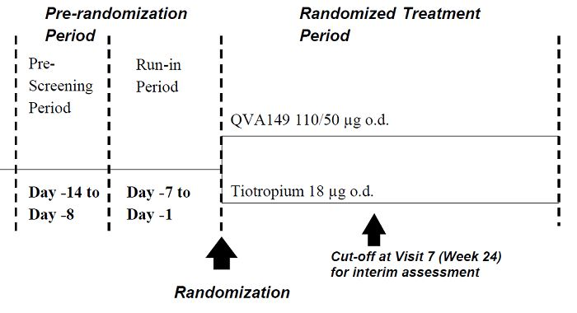

COPD medications were adjusted before a run-in period. Eligible patients were then randomised in a 3:1 ratio to receive either QVA149 110/50 µg OD or tiotropium 18 µg OD for 52 weeks. Patient numbers were based on the Japanese authority’s requirement for at least 100 patients to complete treatment for 52 weeks. A total of 160 patients were randomised (121 QVA149 and 39 tiotropium), and 152 patients (95.0%) completed 24 weeks of the study. The study population consisted of male and female patients aged ≥40 years with moderate to severe COPD. Post-bronchodilator FEV1 was ≥30% and <80% of predicted normal with FEV1/FVC <0.7 at Visit 2. The primary endpoint was the overall assessment of the safety and tolerability of QVA149 in Japanese patients. Secondary outcomes included lung function, symptom scores and COPD exacerbation rates. No power calculations were made and the statistical analysis is descriptive.

The majority of patients were male and all were Japanese with a mean age of 69.3 years. Overall, 62.7% had moderate COPD and the remainder were severe. Most patients were ex-smokers (72.8%) and approximately 27% used ICS. The mean baseline pre-bronchodilator and post-bronchodilator FEV1 was 47.2% and 53.8% in the QVA149 group and 51.4% and 58.3% in the tiotropium group. Overall, mean FEV1 reversibility was 15.9%.

Mean exposure to study treatments was approximately 164 in both groups. The overall incidence of AEs was 67.2% in the QVA149 group compared with 51.3% in the tiotropium group as shown in Table 6. Events related to COPD were more common in the QVA149 group and URTIs were more common in tiotropium group.

Table 6: Phase III safety studies.

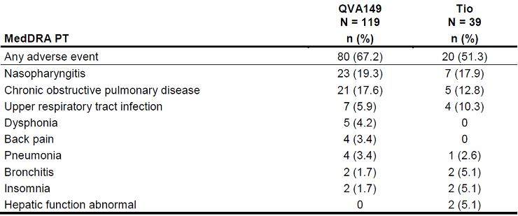

AEs which were suspected of being related to the study drug were 13.4% in the QVA149 group and 10.3% in the tiotropium group. Dry mouth (2.5%) and dysphonia (2.5%) were reported in the QVA149 group but in none of the tiotropium group. There were no deaths at the 24 week cut-off date. There were four (3.4%) SAEs in the QVA149 group compared with one (2.6%) in the tiotropium group but none were considered related to study treatment. There were four discontinuations due to AEs, all in the QVA149 group. There was one CCV SAE, thrombotic cerebral infarction in a QVA149 patient who had a prior history of stroke. There were no safety signals related to laboratory assessments, vital signs or ECGs in either treatment group. At Week 24, the mean change from baseline in FEV1 was 0.195 L in the QVA149 group compared with 0.115 L in the tiotropium group. Rescue medication use was low and similar in both groups. The proportion of patients with at least one COPD exacerbation was 13.4% in the QVA149 group and 12.8% in the tiotropium group.

*Comment: The study was designed to meet the requirements of the Japanese authority. The open-label design, small patient numbers and lack of placebo control mean the results should be interpreted with caution. However, QVA149 was generally safe and well tolerated with no significant differences compared with the Caucasian population data.*

### Patient exposure

The All treated safety database consisted of all studies, including pharmacology and Phase II studies, with a total of 6921 patients and healthy volunteers. A total of 2321 patients received QVA149 for a mean duration of 234.4 days (range 1.0 to 558.0) and 663 patients received placebo for a mean duration of 114.6 days (range 1.0 to 373.0 days).

### Adverse events

#### All adverse events (irrespective of relationship to study treatment)

##### Pivotal studies

In study A2303, the overall incidence of AEs was lowest in the QVA149 group (55.1%) compared with 57.8% placebo, 61.1% QAB149, 61.3% NVA237 and 57.3% tiotropium. The most common AEs were respiratory (related to COPD) and nasopharyngitis. COPD exacerbations occurred most commonly in the placebo group (39.2%) compared with 28.9% in the QVA149 group. In study A2313, the overall incidence of AEs was higher in the Flut/Salm group (60.2%) than in the QVA149 group (55.4%). The most common AEs were respiratory (related to COPD) and nasopharyngitis. The difference between the two groups was related to a higher incidence of events related to COPD in the Flut/Salm group (23.5%) compared with the QVA149 group (17.1%). In study A2304, the overall incidence of AEs was similar across the treatment groups. AEs related to COPD occurred in ~90% of patients in each treatment group. The most common other AEs were upper and lower respiratory tract infections and nasopharyngitis.

##### Other studies

In study A2305, the overall incidence of AEs was lower in the tiotropium arm (27.7%) than in the QVA149 arm (37.7%) and the placebo arm (36.4%). The most common AEs were related to COPD, cough and nasopharyngitis.

#### Treatment-related adverse events (adverse drug reactions)

##### Pivotal studies

In study A2303, the incidence of AEs suspected to be study drug-related was low in the QVA149 (5.7%), QAB149 (9.0%), NVA237 (5.9%) and tiotropium (5.0%) groups, and lowest in the placebo group (3.4%). Cough was the most common AE, reported in 2.5%, 5.5%, 0.8% and 1.0% in the QVA149, QAB149, NVA237 and tiotropium groups respectively. Cough was not reported in the placebo group. In study A2313, drug-related AEs were suspected in 2.7% of the QVA149 group and 6.8% of the Flut/Salm group. In the QVA149 group, the most common event was oropharyngeal pain (1.2%) while in the Flut/Salm group, the most common events were dysphonia (1.5%), COPD (1.1%), drug-related muscle spasms (1.1%) and dyspnoea (1.1%). In study A2304, drug-related AEs were suspected in 7.8% of the QVA149 group, 7.6% of the NVA237 group and 5.4% of the tiotropium group. The most common events were related to the known side effect profiles of the study drugs. Dry mouth was reported in 1.9% of the tiotropium group, 1.2% in the NVA237 group and 0.4% in the QVA149 group. Cough was reported in 1.9% of the QVA149 group, 0.7% in the NVA237 group and 0.1% in the tiotropium group.

##### Other studies

In study A2305, the proportion of patients with AEs suspected to be drug-related was 7.8% in the QVA149 arm, 2.4% in the tiotropium arm and 3.9% in the placebo arm. The most common event was cough, reported in 6.5% of the QVA149 arm, no patients in the tiotropium arm and 1.3% in the placebo arm.

#### Deaths and other serious adverse events

##### Pivotal studies

In study A2303, there were 7 deaths during the treatment period. No death was considered related to study treatment and the single death in the QVA149 group was due to colon cancer.

The proportion of SAEs in the QVA149 group was 4.6% compared with 5.6% in the placebo group, 5.5% in the QBA149 group, 6.1% in the NVA237 group and 4.0% in the tiotropium group. The most common SAE was COPD which occurred in 2.1% of QVA149 patients and 3.0% of placebo patients. The second most common SAE was pneumonia which occurred in 0.4% of QVA149 patients and 1.3% of placebo patients. In study A2313, there was a single death in the Flut/Salm group. SAEs occurred in 5.0% of QVA149 patients and 5.3% of Flut/Salm patients. The pattern of SAEs was similar in both groups with respiratory causes reported most commonly (1.2% QVA149, 1.5% Flut/Salm). In study A2304, a total of 70 patients died during treatment and another 17 patients died within 30 days of receiving their last dose of study medication. The proportion of deaths was approximately 3% in each treatment group. The most common cause of death in the QVA149 group was COPD. The proportion of SAEs was also similar in each group (22.9% QVA149, 24.2% NVA237, 22.4% tiotropium). Overall, the most frequently reported SAE was COPD in all treatment groups. In the QVA149 group, 1% of patients experienced SAEs thought to be study drug related.

##### Other studies

In study A2305, there were no deaths and one SAE reported in each treatment group (one case of colitis while taking QVA149).

#### Discontinuation due to adverse events

##### Pivotal studies

In study A2303, there were few AEs leading to study drug discontinuation, 1.3% of QVA149 patients, 4.3% of placebo patients, 5.0% of QAB149 patients, 3.0% of NVA237 patients and 4.3% of tiotropium patients. In study A2313, the number of AEs and SAEs leading to study discontinuation were similar in both groups (8.5% QVA149, 10.2% Flut/Salm). In study A2304, AEs leading to discontinuation of study drug were experienced in 10.8%, 11.6% and 9.1% of the QVA149, NVA237 and tiotropium groups, respectively.

##### Other studies

In study A2305, study drug was discontinued in 6% of the QVA149 arm and 1.3% during the placebo arm.

#### Laboratory tests

##### Liver function

###### Pivotal studies

Treatment emergent liver function abnormalities were uncommon in all pivotal studies in all treatment groups. In study A2303, no patients in the QVA149 group had treatment emergent AST/ALT elevations >3xULN. In study A2313, one patient in the QVA149 group experienced a significant AST rise without a corresponding ALT rise. In study A2304, AST/ALT elevations >3xULN occurred in <1% of patients in each treatment group.

###### Other studies

No significant liver function abnormalities were experienced in study A2305.

##### Kidney function

###### Pivotal studies

Treatment emergent deterioration in renal function was uncommon in all pivotal studies in all treatment groups. In study A2303, clinically significant elevations in serum creatinine (>176.8 µmol/L) was experienced in <1% of all treatment groups. In study A2313, one QVA149 experienced a rise in serum creatinine compared with none in the Flut/Salm group. In study A2304, serum creatine abnormalities were experienced by <1% of patients in each group.

###### Other studies

In study A2305, one patient experienced renal impairment without an apparent relationship to any of the study medications.

#### Other clinical chemistry

##### Pivotal studies

In study A2303, there were no clinically meaningful treatment emergent abnormalities of clinical chemistry with the exception of plasma glucose. Significant hyperglycaemia (>9.99 mmol/L) was recorded in 3.7% of QVA149 patients, a similar proportion to placebo (2.9%) and the other treatment groups. A similar profile was observed in study A2313; hyperglycaemia was observed in 4.1% of QVA149 patients and 4.2% of the Flut/Salm patients. A similar profile was observed in study A2304; hyperglycaemia was observed in 5.6%, 4.4% and 4.1% of the QVA149, NVA237 and tiotropium groups, respectively.

##### Other studies

In study A2305, treatment emergent hyperglycaemia was observed in 4.8% of the patients but no direct relationship with the study medications was observed.

*Comment: Hyperglycaemia is a known adverse event observed in a small proportion of patients treated with beta-agonists.*

#### Haematology

##### Pivotal studies

In the pivotal studies (A2303, A2313 and A2304) there were no clinically meaningful shifts from baseline or differences in any haematological parameter across treatment groups.

##### Other studies

In study A2305, there were no meaningful changes in any haematological parameter.

#### Electrocardiograph

##### Pivotal studies

In study A2303, there were no significant treatment emergent differences in QTcF between groups. QTcF >450 ms was experienced by 4.8% of the QVA149 group compared with 5.8% in the placebo group. Clinically significant ECG changes occurred in one QVA149 patient and two in placebo patients. In study A2313, QTcF > 450 ms was experienced by 4.5% of QVA149 patients and 1.6% of Flut/Salm patients. However, there were no cases of QTcF > 480 ms in either group. Two QVA149 patients and one Flut/Salm patient developed significant ECG changes during the study. In study A2304, QTcF prolongation > 450 ms occurred in 8.2% of the QVA149 group, 8.4% of the NVA237 group and 6.0% of the tiotropium group. The LS mean difference in QTcF was 2.45 ms higher in the QV149 group compared with the tiotropium group (95% CI: 1.13, 3.77, p<0.001). Clinically significant ECG changes developed in 1% of the QVA149 group, 1.5% of the NVA237 group and 0.7% of the tiotropium group.

*Comment: QBA149 and NVA237 as mono-therapies had no effects on QTc interval in previously conducted TQT studies. There was no evidence of a QTc effect for QVA149 or tachycardia in the present FDC studies.*

##### Other studies

Only one patient experienced QTcF > 450 ms and a clinically significant ECG change during study A2305.

#### Vital signs

##### Pivotal studies

In study A2303, the incidence of newly occurring or worsening clinically significant vital signs at any time point during the treatment period was low with no meaningful differences between treatment groups. Similar patterns of clinically insignificant change were observed in studies A2313 and A2304.

##### Other studies

The incidence of newly occurring or worsening clinically significant vital signs at any time point during the study was low.

#### Adverse events of special interest

##### Pivotal studies

In study A2303, few patients had AEs of special interest. The proportion of patients with any AEs of special interest was 3.8% in the QVA149 group compared with 4.3% to 5.5% in the other groups. AEs such as constipation, dry mouth, urinary retention/bladder obstruction and hyperglycaemia were more frequent in the QVA149 group compared with the placebo group. There were no adjudicated CCV SAEs in QVA149 patients compared with 0.4% to 1.5% in the other treatment groups. Three cases of tachyarrhythmia were observed in each group but overall the incidence of events was low. There were three patients in each treatment group with CCV SAEs but none was suspected to be study drug related. In study A2304, AEs of special interest were reported by fewer than 3% of patients in any treatment group. A similar proportion of patients experienced a CCV SAE in each treatment group (3.2% QVA149, 3.2% NVA237 and 3.4% tiotropium). The majority of events were cardiac disorders.

##### Other studies

In study A2305, AEs of special interest were not reported separately.

### Post-marketing experience

Not applicable.

### Safety issues with the potential for major regulatory impact

#### Liver toxicity

There was no evidence of significant liver toxicity related to QVA149.

#### Haematological toxicity

There was no evidence of haematological toxicity related to QVA149.

#### Serious skin reactions

No serious skin reactions were recorded in any study.

#### Cardiovascular safety

There were no cardiovascular safety signals in the QVA149 group.

#### Unwanted immunological events

Not applicable.

#### Post marketing data

Not applicable.

### Evaluator’s conclusions on safety

The safety population was based on the four pivotal studies (A2303, A2313, A2304 and A2307) and data from the 24 week interim analysis of Study A1301 in Japanese patients. Overall, the frequency of AEs and other safety assessments was similar in patients who received QVA149 or placebo. It was also similar in patients who received the monotherapy components (QAB149 and NVA237) and the widely used therapies Flut/Salm and tiotropium. The most common adverse events were related to COPD and associated respiratory conditions including cough, nasopharyngitis, upper respiratory tract infection (URTI) and oropharyngeal pain. AEs associated with LABA and anticholinergics were also similar or lower in the QVA149 group compared with placebo and the active comparators although hyperglycaemia was noted more frequently in QVA149 patients. Death rates were low and balanced across all treatment groups (1.95 deaths per 100 patient years in the QVA149 group). CCV events were less frequent in the QVA149 group (1.7%) than in the placebo group (2.6%) with a very low incidence of tachyarrhythmias. SAEs were similar in the QV149 group (6.0%) compared with placebo (5.5%), and in the QVA149 group compared with the monotherapy components (QVA149 5.5%, QAB149 5.5% and NVA237 6.1%). SAEs defined as COPD exacerbations were 2.1% in the QVA149 group and 2.6% in the placebo group. SAE exacerbations in the QVA149 group (1.6%) were also less frequent than in the QAB149 and NVA237 monotherapy groups (3.2% and 1.9%, respectively). There were few changes with time in liver function, renal function, clinical chemistries, haematology or urinalysis and there no meaningful treatment differences. Overall, there were no significant electrocardiogram (ECG) changes and no QTc signals associated with any treatment. Safety in subgroups was analysed in detail and no differences related to age, gender, race, COPD severity, smoking history, or inhaled corticosteroid (ICS) use were identified.

The overall conclusion is that QVA149 is safe and well tolerated with an AE profile similar to placebo and other standard treatments in patients with moderate to severe COPD.

## First round benefit-risk assessment

### First round assessment of benefits

The benefits of the Ultibro Breezhaler in the proposed usage are:

* Improved lung function with an average FEV1 increase of 200 mL compared with placebo;
* Rapid onset bronchodilation, sustained throughout the 24 hour dosing interval;
* Sustained effect for at least 64 weeks with no evidence of tachyphylaxis;
* Improved dyspnoea and symptomatic scores (TDI);
* Improved health status (SGRQ);
* Reduced rescue medication use;
* Improved exercise endurance;
* Modest reduction in COPD exacerbations compared with NVA237 monotherapy;
* Once daily dosing with an assumed compliance benefit;
* Well understood adverse event profile of the individual components;
* Well tolerated with AE profile similar to placebo.

### First round assessment of risks

The risks of Ultibro Breezhaler in the proposed usage are:

* Evidence for reduction of COPD exacerbation with QVA149 was not concluded;
* No significant risks have been demonstrated other than those associated with the individual components, mainly AEs associated with well understood β-2 agonist and anticholinergic effects. There is no evidence of an additive effect in the rate of AEs;
* There is a potential risk of sudden death due to the LABA component in patients with COPD and undiagnosed asthma and who are not receiving concomitant inhaled corticosteroids (ICS).

### First round assessment of benefit-risk balance

The benefit-risk balance of Ultibro Breezhaler, given the proposed usage, is unfavourable, but would become favourable if the changes recommended in the next section are adopted.

## First round recommendation regarding authorisation

It is recommended that authorisation should not be approved for Ultibro Breezhaler for the proposed indication of:

*Once daily maintenance bronchodilator treatment to relieve symptoms and reduce exacerbations in patients with chronic obstructive pulmonary disease (COPD).*

However, it can be approved for the revised indication:

*Once daily maintenance bronchodilator treatment to relieve symptoms in patients with COPD.*

This is subject to incorporation of changes to the PI and adequate response to questions raised.

## Clinical questions

### Pharmacokinetics

Q1. The data regarding the bioequivalence between QVA149 and the free combination of the mono therapies is at best equivocal. How can the sponsor therefore justify the use of the proposed FDC in the absence of a robust demonstration of bioequivalence?

### Pharmacodynamics

Q2. Can the sponsor justify why no studies examined the PD interaction between QVA149 and salbutamol, a β2-agonist, or ipratropium bromide, an anticholinergic drug, which are commonly used in the treatment of COPD?

### Efficacy

Q3. In A2304 conducted in patients with severe or very severe COPD, COPD exacerbations were less frequent in the QVA149 group compared with one of its component mono therapies (annual exacerbation rate 0.94 in the QVA149 group compared with 1.07 in the NVA237 group). This marginal difference was statistically significant in the FAS but not in the PPS. In the A2307 study (non powered) in patients with less severe COPD, the reverse trend was observed (annual exacerbation rate 0.4 in the QVA149 group compared with 0.38 in the placebo group). QVA149 may be marginally superior to NVA237 but overall the evidence is tenuous and the sponsor must demonstrate that either treatment is superior to placebo. To justify the proposed COPD exacerbation claim, please provide controlled clinical trial evidence that glycopyrronium (or QVA149) is any more effective than placebo in reducing exacerbation rates.

Q4. According to EU guidelines on COPD drugs,[3] tobacco exposure should be monitored carefully throughout the trial in all patients and changes in smoking status documented and reported. The influence of this exposure on the estimates of efficacy should be evaluated by quantifying and illustrating any differences in tobacco exposure between treatment groups and discussing possible quantitative effect of these differences on outcome. Smoking status was recorded at baseline in all studies and at intervals thereafter in some of them. Please state what analyses were performed on these data and if the results biased any efficacy and safety outcomes.

### Safety

Q5. The EMA guideline on COPD drugs[4] recognises that: *up to 50% of patients with COPD have some degree of reversibility of airflow obstruction* but requires that patients with predominantly asthma be excluded from clinical trials in COPD. Baseline mean FEV1 reversibility of ~20% was observed in the overall randomised population and 63% had reversibility >12%. Adult onset asthma is not uncommon in patients over 40 years of age and it is often not IgE mediated. There are no data for QVA149 in asthmatic or mixed asthmatic patients and the Onbrez PI cautions against the use of LABA (without concomitant ICS use) in such patients. Please state if any specific efforts were made to identify and exclude mixed asthmatic patients other than ‘medical history’ as mandated in the study protocols.

## Second round evaluation

### Question 1: Pharmacokinetics

*The data regarding the bioequivalence between QVA149 and the free combination of the mono therapies is at best equivocal. How can the sponsor therefore justify the use of the proposed FDC in the absence of a robust demonstration of bioequivalence?*

#### Sponsor’s response

The sponsor believes that the PK studies conducted fully support the use and registration of Ultibro Breezhaler 110/50 (QVA149) and that a formal bioequivalence should not be required between the FDC and the single agent DPI products. Ultibro Breezhaler 110/50 is as a new FDC DPI product as noted by the clinical evaluator the Clinical Evaluation Report. It is important to note that QVA149 is formulated as a dry powder for inhalation and its efficacy is primarily dependent upon local action in the lungs.

The relative bioavailabilities of indacaterol and glycopyrronium inhaled via Concept1 (Breezhaler) as the FDC (QVA149) and/or as the free combination of the monotherapies versus the monotherapy products were characterised in the three biopharmaceutical studies in healthy volunteers (Study A2101, Study A2103, and Study A2106). The three studies compared the systemic total exposure (the amount of drug absorbed through the gastrointestinal [GI] tract plus that absorbed into the systemic system via the lungs) to indacaterol and glycopyrronium after administration as QVA149 relative to the administration of QAB149 and NVA237 alone. In addition the pivotal Study A2303 in COPD patients also provided data (population PK analysis) for the comparison of QVA149 to the monotherapy products. The PK data of those studies do not provide information on the efficacy of the products, or on the therapeutic equivalence of the products.

##### Clinical PK data and formulation development

We present a summary of the results from the three PK studies which supported the development of QVA149 in Tables 7-9. To provide some further background on this discussion, the key steps of the development history are summarised below:

1. Study A2101 (implemented between January and April 2008) used an initial formulation of QVA149 (QVA149 300/100 μg); the indacaterol dose had not been adjusted to match the FPM of the indacaterol monotherapy product (QAB149 300 μg). Also, this study used a dose strength of glycopyrronium (NVA237 100 μg) that was different from the later approved 50 μg strength.

2. For subsequent studies, including the pivotal efficacy studies, the indacaterol dose in QVA149 was adjusted with the aim to match the FPM of the indacaterol monotherapy. This resulted in the QVA149 110/50 μg formulation. This QVA149 formulation was used in Studies A2103 and A2106 and was compared with the later approved monotherapy, that is, Onbrez Breezhaler 150 μg (QAB149) and Seebri Breezhaler 50 μg (NVA237).

3. Study A2103 (implemented between January and March 2009) showed unexpected results for glycopyrronium: AUCtau and Cmax,ss of glycopyrronium were 34% and 42% higher, respectively, after administration of QVA149 110/50 μg in comparison with 50 μg NVA237 (Table 7). Investigations of the *in vitro* performance characteristics showed that there had been an unanticipated drop of the glycopyrronium FPM of about 25% in the NVA237 monotherapy batch used in this study. This observation led to the optimization of the manufacturing process, and to implementation of further manufacturing controls (optimization of blistering process and aerodynamic particle size distribution [APSD] testing after blistering) to ensure a constant aerodynamic performance for glycopyrronium in the monotherapy product and the FDC QVA149.

4. Following these improvements, Study A2106 was performed (implemented between November 2009 and March 2010). In this study, total steady state systemic exposure (AUCtau) and peak exposure (Cmax,ss) to indacaterol were 23% and 19% lower, respectively, for QVA149 110/50 μg than for QAB149 150 μg (Table 7). However, total steady state systemic exposure (AUCtau) and peak exposure (Cmax,ss) to glycopyrronium were similar between the FDC QVA149 110/50 μg compared to NVA237 50 μg alone (Table 7). Repeated QVA149 110/50 μg daily administration yielded consistent steady state systemic exposure to indacaterol and glycopyrronium (Studies A2103 and A2106; Table 8 and Table 9).

Table 7: Summary of statistical analysis of PK parameters of indacaterol and glycopyrronium following inhaled administration of QVA149 and QAB149 or NVA237, respectively, to healthy volunteers.

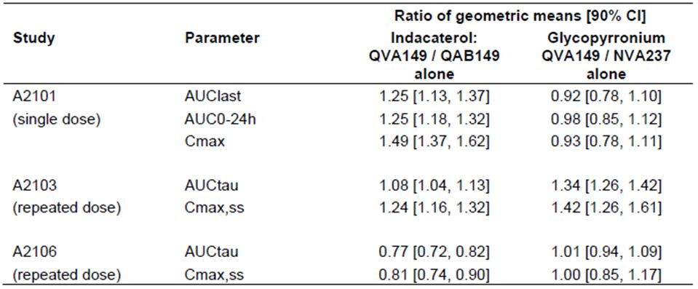

Table 8: PK parameters of indacaterol when administered in FDC (QVA149) on Day 14 in healthy volunteers.

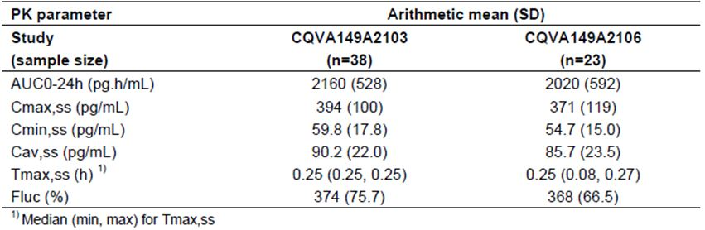

Table 9: PK parameters of glycopyrronium when administered in FDC (QVA149) on Day 14 in healthy volunteers.

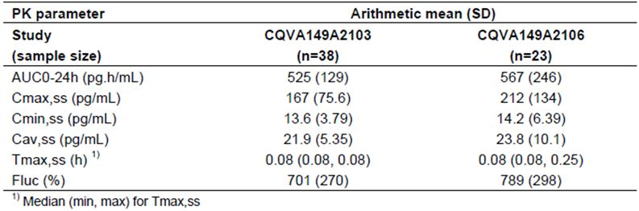

The sponsor included treatments with the free combination of the two drugs in two of the three component interaction studies, Study A2101 and Study A2106. The comparison of the free combination with each drug alone is the relevant comparison to assess the potential PK interaction. The sponsor based the conclusion on the absence of PK drug-drug interaction between indacaterol and glycopyrronium on the results of the comparison of the free combination versus each drug alone.

##### In vitro performance characteristics and systemic exposure to indacaterol and glycopyrronium

The *in vitro* performance characteristics and systemic exposure of QVA149 to indacaterol and glycopyrronium after oral inhalation are explained in further detail below.

Systemic exposure following oral inhalation results from a composite of pulmonary and gastrointestinal absorption. Delivered dose and FPM for the QVA149, QAB149 (indacaterol) and NVA237 (glycopyrronium) batches used in Studies A2101, A2103, A2106 and A2303 were obtained and were used to estimate the lung and GI contributions, the total exposure (that is, the total amount predicted to reach the systemic circulation) and the predicted treatment ratios for lung and systemic exposure. The *in vitro* predicted systemic exposure ratios of indacaterol and glycopyrronium were compared with the *in vivo* observed ratios. For indacaterol, the predicted and observed exposure ratios were consistent. The predicted ratio as a percentage of the observed ratio ranged from 90.7% to 109.1%, with a mean of 101.3%. For glycopyrronium, the predicted and observed glycopyrronium exposure ratios were in agreement, except in Study A2101. The predicted ratio as a percentage of the observed ratio ranged from 93.3% to 113.5% in Studies A2103, A2106 and A2303, with a mean of 103.5%. In Study A2101 the predicted ratio was ~30% higher than the observed ratio. This may be a result of the limited manufacturing controls in place during the primary packaging (blistering) giving rise to differences in FPM between bulk and blistered material of the particular NVA237 batch used in this study.

Taken together, the *in vitro* performance characteristics of the formulations and batches together with the PK properties of each drug explain the trends seen for systemic exposure: A lower exposure to indacaterol for QVA149 110/50 μg versus QAB149 150 μg in Studies A2106 and A2303, and a higher exposure to glycopyrronium for QVA149 110/50 μg versus NVA237 50 μg in Study A2103.

Thus, the sponsor believes the *in vitro* performance characteristics, that is, the delivered dose and the FPM, of the QVA149 and monotherapy product batches used in Studies A2101, A2103 and A2106 together with the PK characteristics of the two drugs explain the apparently inconsistent *in vivo* results for the treatment ratios. The exception is glycopyrronium in Study A2101, probably due to differences in FPM between bulk and blistered material of the particular NVA237 batch.

##### Summary and discussion

Findings from PK studies discussed (A2101, A2103, A2106 and PK analysis A2303) can be summarised as follows:

* Total steady state systemic exposure (AUC) to indacaterol achieved with the QVA149 110/50 μg formulation ranged from 23% lower than, to 8% higher than, the exposure achieved with QAB149 150 μg.
* The fact that indacaterol exposure is similar or slightly lower after QVA149 inhalation supports the selected approach to adjust the indacaterol dose in QVA149 to 110 μg.
* Total steady-state systemic exposure (AUC) to glycopyrronium achieved with the QVA149 110/50 μg formulation was similar to that achieved with NVA237 50 μg.
* Repeated QVA149 110/50 μg daily administration yielded consistent steady state systemic exposure to indacaterol and glycopyrronium (based on the healthy volunteer Studies A2103 and A2106).
* Based on the *in vitro/in vivo* correlation, the delivered dose and the FPM of the QVA149 and monotherapy product batches used in Studies A2101, A2103, A2106 and A2303 and together with the PK characteristics of the two drugs explain the *in vivo* results for the treatment ratios.

It should be noted that systemic drug levels, as determined in these studies, are not a surrogate of the efficacy of inhaled QVA149 as the mode of action of both monotherapy components in the lung is topical. No exposure-response relationship was seen between PK parameters and bronchodilator effects nor was it expected to be seen, for the monotherapy products or the FDC formulation in the PK studies. Therefore, the small differences in total and peak systemic exposures to indacaterol as seen in our PK studies are not believed to have an impact on the efficacy assessment of QVA149 in the Phase III trials. For the interpretation of the PK and statistical analyses references to the standard bioequivalence criterion (90% CI or the treatment ratio within 0.80 and 1.25) were made to put the exposure ratios of geometric means (and 90% CI) into perspective, but not with the aim to conclude or reject bioequivalence.

To the best of our knowledge, there are no TGA, EU or FDA Clinical or Quality Guidelines for inhalation products that require bioequivalence to be demonstrated for a new FDC product (such as QVA149) versus the corresponding individual products given concomitantly (as the free combination) or separately. According to the Australian Regulatory Guidelines for Prescription Medicines (ARGPM), Biopharmaceutic Data (bioequivalence studies) are not normally required for preparations for inhalation, except where the active ingredient is to be delivered to the systemic circulation via inhalation, which is not the case for these bronchodilators.

##### Conclusion

The PK studies (A2101, A2103 and A2106) were not intended to be bioequivalence studies; they were designed as relative bioavailability studies. The PK results of the relevant studies (including A2303) are consistent and show that the systemic exposure of both indacaterol and glycopyrronium when delivered as a fixed dose combination via the Ultibro Breezhaler 110/50 DPI is similar to that obtained when the drugs are delivered concomitantly or separately via the corresponding single agent DPI products.

The TGA Guidelines do not require formal bioequivalence to be shown between FDC and single agent DPI products. Both drugs are approved as DPI in COPD patients and their respective safety profiles have been established as part of previous applications. Numerous clinical studies conducted by the sponsor have shown that safety profiles associated with the use of the FDC or the single agent DPI products are comparable. Novartis therefore considers that the existing studies fully support the use and registration of the new product, Ultibro Breezhaler 110/50 μg FDC DPI in Australia.

#### Evaluator’s response

The sponsor’s statement regarding ARGPM Biopharmaceutic Data that biopharmaceutic studies are not normally required for preparations for inhalation is true; however, the TGA guidelines for FDC products state the following:

*The combination contains known active substances and it is a substitution indication (i.e. use in patients adequately controlled with the individual products given concurrently, at the same dose level as in the combination, but as separate tablets****) or the new fixed combination contains known active ingredients that have not been used in combination before. In these cases bioequivalence should be demonstrated between the free combination of the recognised reference formulations of the individual monocomponents and the marketing formulation (fixed combination).***

Therefore, the evaluator believes that as Ultibro Breezhaler 110/50 is a new FDC DPI product it could be argued that in this case a dedicated bioequivalence study is required and that the studies provided by the sponsor indicate that exact bioequivalence does not exist between the FDC and the free combination.

However, given the facts that: the PK differences between the fixed and free combinations appear to be minimal (in the order of ~20% for some parameters) and that the clinical evaluator has established that QVA149 is safe and well tolerated with an adverse event profile similar to placebo and other standard treatments in patients with moderate to severe COPD, the evaluator agrees with the sponsor that strict bioequivalence between the fixed and free combinations is not required for Ultibro Breezhaler 110/50 nor is a dedicated bioequivalence study required.

### Question 2: Pharmacodynamics

*Can the sponsor justify why no studies examined the PD interaction between QVA149 and salbutamol, a β2-agonist, or ipratropium bromide, an anticholinergic drug, which are commonly used in the treatment of COPD?*

#### Sponsor’s response

The bronchodilatory modes of action of β2-agonists as well as antimuscarinic compounds in COPD are well established. As shown for other β2-agonists including salbutamol, indacaterol exerts its bronchodilatory effect by acting as an agonist at the human β2-receptor which causes bronchial smooth muscle relaxation resulting in a dilation of the bronchial airways. This pharmacological concept is shared by the class of β2-receptor selective agonists. In analogy, anti muscarinic agents used in the treatment of COPD including glycopyrronium and ipratropium bromide lead to bronchodilation by acting as competitive antagonists at the muscarinic acetylcholine receptors.

An increase in concentration of compounds that stimulate the β2 receptor (for example, indacaterol or salbutamol) at the receptor is expected to lead to an increased activation of adenylyl cyclase, which in turn catalyses the production of cAMP. Increased intracellular cAMP causes a decrease in intracellular calcium concentration leading to smooth muscle relaxation and bronchodilation. This bronchodilatory effect of Ultibro Breezhaler 110/50 can be expected to be increased by addition of a SABA or a SAMA. For the combination of LABAs plus salbutamol this was shown in a study in COPD patients with moderate to severe airway obstruction. Increasing doses of salbutamol after pre treatment with eformoterol or salmeterol lead to incremental increases in FEV1 that levelled off at very high doses of salbutamol (800 µg).[5] Since indacaterol, eformoterol, and salmeterol act via the same receptor it is likely that a similar additive effect would be observed.

In the Phase III clinical studies with Ultibro Breezhaler, QVA149 was effective in reducing the “as needed” use of rescue salbutamol when compared to indacaterol, glycopyrronium, tiotropium, or placebo comparator arms respectively. In these clinical trials no safety concerns arose from the use of salbutamol as rescue medication on top of Ultibro Breezhaler 110/50. However, a potential residual risk for adverse drug reactions remains with uncontrolled or regular use of salbutamol as rescue medication. This basic pharmacological principle (that is, increasing bronchodilatory effects in the lung but also increasing the potential for systemic side effects of the corresponding drug class in particular in case of overdosing) also holds true for the addition of a SAMA to LAMA containing therapies. Hence the combination of two β2-agonists or two anti muscarinic agents is not recommended by current guidelines (GOLD 2013; COPDX) or the PI for Onbrez and Seebri Breezhaler, as well as the proposed PI for Ultibro Breezhaler 110/50. An additional paragraph to be included in the Ultibro Breezhaler 110/50 PI was requested by the clinical evaluator. The sponsor accepts the evaluator’s recommendation with a proposal for one change as given below. The rationale for this proposal is provided. The following statement was included in the proposed Ultibro Breezhaler 110/50 PI:

*No studies have examined the PD interaction between Ultibro Breezhaler 110/50 and drugs commonly used in the treatment of COPD or frequently observed co-morbidities such as cardiovascular disease, these include salbutamol, ipratropium bromide and beta blockers; therefore, caution should be taken when co-administering Ultibro Breezhaler 110/50 with drugs used for the treatment of COPD, asthma, hypertension or cardiac disease.*

The decision to not perform interaction studies between indacaterol or glycopyrronium and other LABA or SABA or anti muscarinic agents, respectively, was not of concern during the registration processes for either Onbrez Breezhaler or Seebri Breezhaler, not in Australia and not with other health authorities worldwide.

The European guidance document[6] (adopted in Australia) states that:

*The need for PD interactions studies should be determined on a case by case basis.*

Thus, in light of the knowledge on the widespread use of SABAs and LABAs as well as anti muscarinic agents the sponsor is of the opinion that no specific PD interaction studies needed to be conducted for Ultibro Breezhaler 110/50. No concerns emerged requiring doing such interaction studies for the registration of Ultibro Breezhaler 110/50 since registration of the two mono components.

#### Evaluator’s response

The evaluator is satisfied with the sponsor’s response and the proposed changes to the PI as indicated by the sponsor.

### Question 3: Efficacy

*In A2304 conducted in patients with severe or very severe COPD, COPD exacerbations were less frequent in the QVA149 group compared with one of its component mono-therapies (annual exacerbation rate 0.94 in the QVA149 group compared with 1.07 in the NVA237 group). This marginal difference was statistically significant in the FAS but not in the PPS. In the A2307 study (non-powered) in patients with less severe COPD, the reverse trend was observed (annual exacerbation rate 0.4 in the QVA149 group compared with 0.38 in the placebo group). QVA149 may be marginally superior to NVA237 but overall the evidence is tenuous and the sponsor must demonstrate that either treatment is superior to placebo. To justify the proposed COPD exacerbation claim, please provide controlled clinical trial evidence that glycopyrronium (or QVA149) is any more effective than placebo in reducing exacerbation rates.*

#### Sponsor’s response

The sponsor accepts the clinical evaluator’s recommendation to remove the exacerbation claim from the proposed indication. Nonetheless, prevention of exacerbations is an important COPD disease management strategy and a key objective for new drug treatments for COPD (GOLD 2013; COPDX 2012). Therefore, the results of Studies 2304 and 2313, explained in detail below, should be described in the Clinical Trial section of the Ultibro Breezhaler 110/50 PI to adequately inform the prescribers.

The reduction in rate of COPD exacerbations was investigated in a rigorous, well conducted and dedicated study (A2304) of 2224 severe to very severe COPD patients. All patients had a documented history of at least 1 exacerbation in the past 12 months. The primary objective was in the rate of exacerbation for QVA149 versus NVA237 (glycopyrronium).

In this study, all patients received a LAMA, either as monotherapy (NVA237 or OL tiotropium), or as combination (NVA237 in QVA149). Thus the effect of QVA149 compared to NVA237 or OL tiotropium represents the additional contribution of the second component of the combination, that is, the LABA QAB149, over the effect of the LAMA (NVA237 or OL tiotropium). In the NVA237 monotherapy registration program, NVA237 reduced exacerbations by 24% versus placebo and the difference was statistically significant (Seebri Breezhaler PI). Tiotropium showed a 14% reduction in the rate of exacerbations compared to placebo in the 4 year UPLIFT study in moderate to very severe COPD patients and the difference was statistically significant.[7] In the QAB149 (indacaterol) registration program, QAB149 150 μg once daily reduced exacerbations by 26% compared to placebo and the difference was statistically significant (Onbrez Breezhaler PI).

In Study A2304, QVA149 reduced the rate of moderate or severe COPD exacerbations by 12% (statistically significant) compared to NVA237 (primary endpoint) and 10% compared to OL tiotropium (secondary endpoint).

The best measure of an exacerbation effect would have been a comparison with placebo, as the evaluator suggests, but this was not possible for ethical reasons in this severe to very severe COPD population.

However, in another study in moderate to severe COPD patients (Study A2303), a direct comparison of QVA149 with placebo showed a reduction in time to first exacerbation of 44%, which was statistically significant.

The true patient benefit of QVA149 treatment in severe to very severe COPD patients can also be demonstrated by the greater effects of QVA149 compared to NVA237 and OL tiotropium for lung function, SGRQ (including individual domains), total daily symptom scores, and rescue medication use. Thus, the effect size on exacerbation should be evaluated in the context of the totality of the data on the spirometric and symptomatic benefits of QVA149.

For all exacerbations (a secondary endpoint), QVA149 demonstrated statistically significant differences versus NVA237 and OL tiotropium (rate ratio [RR] 0.85, p = 0.001 and RR 0.86, p = 0.002, respectively). A reduction in frequency of 20% has been suggested as a reasonable MCID for exacerbations, calculated by anchoring exacerbation rates to the SGRQ.[8] Even with this 20% value, there appears to be a large range in what is considered an important change. Exacerbation rates between 4.4% and 42.0%, for example, have been associated with meaningful changes in questionnaire based instruments,[9] and if the studies that have influenced the 2011 GOLD guidelines are considered, then statistically significant differences in exacerbation rates of between 9% and 53.5% indicate meaningful clinical benefit.[10]

It is clear that a significant number of COPD exacerbations are not reported to healthcare professionals and are thus not treated with standard therapy with oral corticosteroids and/or antibiotics. Thus, not unexpectedly, in Study A2304, there were a large number of mild exacerbations reported, which met the standardised protocol definition of an exacerbation. Although mild exacerbations are classically defined as those requiring no extra therapy or those treated with an increase in inhaled rescue medication only, observational studies have shown that these mild exacerbations may have similar recovery periods compared with those exacerbations treated and grouped as moderate or severe exacerbations.[11] Studies have also shown that exacerbations that are not treated by antibiotics and/or systemic steroids may have a negative impact on the patients’ quality of life,[12] underlining the importance of early detection and therapy of all these events.

In Study A2313, an analysis of mild, moderate, and severe exacerbations (Table 10) also demonstrated that QVA149 lowered rates of mild, moderate, severe, moderate to severe and all types of COPD exacerbations compared to the active comparator, Flut/Salm, although the difference was not statistically significant reflecting sample size and length of the study.

Table 10: Rate of COPD exacerbations: Study A2313.

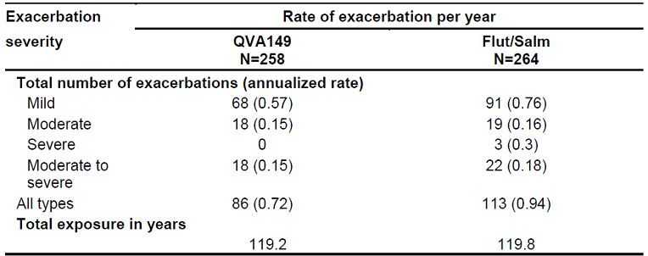

Notwithstanding the robustness demonstrated in Study A2304, with SGRQ, lung function and rescue medication, the sponsor acknowledges the clinical evaluator’s comments regarding the effect size of QVA149 versus NVA237 in the primary endpoint of moderate or severe exacerbation (RR 0.88) in patients who have severe to very severe COPD. However, it should be noted that prevention of even one exacerbation of any severity has a significant impact on patient outcomes and is critical to avoid disease worsening.[13]

As noted earlier, the sponsor agrees with the clinical evaluator’s recommendation to withdraw the claim for an exacerbation from the indication. Nevertheless, given the importance of prevention of exacerbations in the management of COPD, the sponsor believes that the description of efficacy of QVA149 on the prevention of exacerbation in the ‘Clinical Trials’ section of the PI should be expanded.

The sponsor proposes to expand the ‘Clinical Trials’ section of the Australian PI to reflect the results of Study A2313 in reduction of exacerbations in COPD patients. To provide clarity and readability, the number of patients per arm is included in the added text as well as annualised rates of exacerbations. For consistency, the sponsor proposes to re-word the existing paragraph on the results of Study A2304, so that results of both studies are presented in a similar way. The text in the Australian PI has been revised as follows and is now in line with the recently approved EU Summary of Product Characteristics (SmPC).

In a 64 week study comparing Ultibro Breezhaler 110/50 (n = 729), glycopyrronium (n = 739) and tiotropium (n = 737), Ultibro Breezhaler 110/50 reduced the annualised rate of moderate or severe COPD exacerbations by 12% compared to glycopyrronium (p = 0.038) and by 10% compared to tiotropium (p = 0.096). The number of moderate or severe COPD exacerbations/patient years was 0.94 for Ultibro Breezhaler 110/50 (812 events), 1.07 for glycopyrronium (900 events), and 1.06 for tiotropium (898 events). Ultibro Breezhaler 110/50 also statistically significantly reduced the annualised rate of all COPD exacerbations (mild, moderate or severe) by 15% as compared to glycopyrronium (p = 0.001) and 14% as compared to tiotropium (p = 0.002). The number of all COPD exacerbations/patient years was 3.34 for Ultibro Breezhaler 110/50 (2,893 events), 3.92 for glycopyrronium (3,294 events) and 3.89 for tiotropium (3,301 events).

In a 26 week study comparing Ultibro Breezhaler 110/50 (n = 258) and Flut/Salm (n = 264), the number of moderate or severe COPD exacerbations/patient years was 0.15 versus 0.18 (18 events versus 22 events), respectively (p = 0.512), and the number of all COPD exacerbations/patients years (mild, moderate or severe) was 0.72 versus 0.94 (86 events versus 113 events), respectively (p = 0.098).

#### Evaluator’s comments

The sponsor’s responses to the questions relating to the clinical efficacy data are satisfactory.

### Question 4: Efficacy

*According to CPMP guidelines on COPD drugs, tobacco exposure should be monitored carefully throughout the trial in all patients and changes in smoking status documented and reported. The influence of this exposure on the estimates of efficacy should be evaluated by quantifying and illustrating any differences in tobacco exposure between treatment groups and discussing possible quantitative effect of these differences on outcome. Smoking status was recorded at baseline in all studies and at intervals thereafter in some of them. Please state what analyses were performed on these data and if the results biased any efficacy and safety outcomes.*

#### Sponsor’s response

##### Summary

In the QVA149 Phase III program, prior exposure to tobacco was recorded at baseline, and the impact of smoking status at baseline on various efficacy endpoints was analysed and presented, and the impact of smoking status at baseline on various efficacy endpoints was presented in the Summary of Clinical Efficacy. Smoking status was also recorded at a number of timepoints throughout the studies, and an analysis has been performed of the number of patients. The number of patients changing smoking status during the studies was very low and similar between treatment groups.

The QVA149 Phase III development program was designed to take into consideration the EMA guidance document on developing medicinal products for the treatment of COPD.[14] The guidance on collecting and recording tobacco exposure and the means by which the QVA149 development program satisfies the EMA guidelines is summarised below.

##### Stratification according to smoking status

The guidelines recommend formal stratification by smoking status prior to randomisation in efficacy studies. All QVA149 Phase III studies were stratified by smoking status (current smoker/ex-smoker at baseline) to ensure balance in treatment arms.

##### Monitoring of tobacco exposure throughout trials

Patients’ prior exposure to tobacco products was assessed at the screening visit in terms of their “pack years”, 1 pack year was defined as 20 cigarettes a day for 1 year, or 10 cigarettes a day for 2 years, etc. Smoking status (ex-smoker/current smoker) was also collected during the studies at randomisation, Week 12 and Week 26 in Studies A2303, A2307 and A2304 and Week 52 in Studies A2307 and A2304. If a patient changed smoking status (a current smoker giving up smoking or an ex-smoker re-starting) it did not affect the patient’s participation in the study.

##### Tobacco use

The majority of patients in Studies A2303, A2304, and A2307 were non-smokers at baseline and the percentages of patients changing smoking status at any time after baseline (from ex-smoker to smoker or current smoker to ex-smoker) was very low (QVA149: about 6.5% in A2303, 5.8% in A2307, 15.5% in A2304) in all studies and similar between treatment groups (Tables 11-13).

Table 11: Percentage of patients changing from screen smoking status at any time during the study (Study 2303).

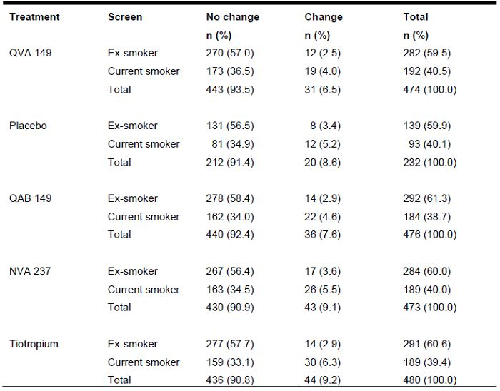

Table 12: Percentage of patients changing from screen smoking status at any time during the study (Study 2304).

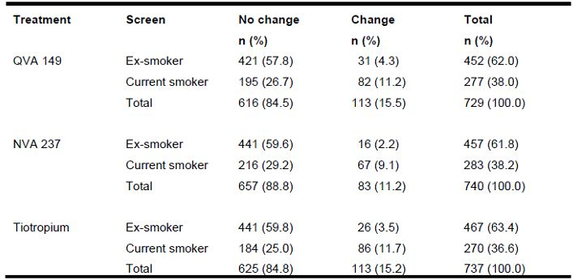

Table 13: Percentage of patients changing from screen smoking status at any time during the study (Study 2307).

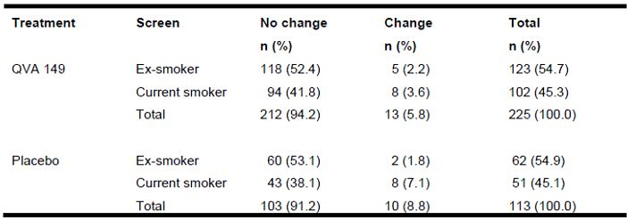

The effect of smoking status at baseline on efficacy endpoints was thoroughly characterised in each study and reported in the Summary of Clinical Efficacy. Note that the effect of changing smoking status during the study on efficacy endpoints was not analysed. The reasons for not performing such analyses were:

* the small number of patients who changed smoking status, and the disparity in size between this subgroup and the larger subgroup who maintained their smoking status (no change) would not allow for any meaningful comparison between QVA149 and placebo on efficacy endpoints, particularly symptomatic endpoints which typically require large sample sizes to show differences between treatments;
* the patient’s experience on treatment, either active or placebo, may have impacted their decision to change smoking status therefore having a confounding effect of randomisation, so that the observed treatment difference cannot be directly attributed to the randomised group;
* during the study, the electronic case report form (eCRF) only collected whether the patient was smoking or not smoking at the time of the study visit, not the timeframe over which the patient had changed his/her smoking status, or the actual amount of cigarette consumption; therefore it would be necessary from an analysis perspective to treat patients who had just changed smoking status, the same as one who had changed smoking status for several months and their quantities of cigarette consumption could not be factored into the analysis.

The sponsor also acknowledges that smoking status was not collected in Study A2313. However, as seen in most of our studies, the change in smoking status during a 6 month study is anticipated to be minimal and unlikely to have any impact on the study outcome.

#### Evaluator’s comments

The sponsor’s responses to the questions relating to the clinical efficacy data are satisfactory.

### Question 5: Safety

*The EMA guideline on COPD drugs[15] recognises that:’ up to 50% of patients with COPD have some degree of reversibility of airflow obstruction’ but requires that patients with predominantly asthma be excluded from clinical trials in COPD. Baseline mean FEV1 reversibility of ~20% was observed in the overall randomised population and 63% had reversibility >12%. Adult onset asthma is not uncommon in patients over 40 years of age and it is often not IgE mediated. There are no data for QVA149 in asthmatic or mixed asthmatic patients and the Onbrez PI cautions against the use of LABA (without concomitant ICS use) in such patients. Please state if any specific efforts were made to identify and exclude mixed asthmatic patients other than ‘medical history’ as mandated in the study protocols.*

#### Sponsor’s response

The QVA149 pivotal study protocols stipulated several criteria to ensure that asthmatic patients were not included and only a representative population of COPD patients was recruited. While we acknowledge the clinical heterogeneity of COPD, and increased awareness in the literature of common phenotypes in asthma and COPD it is important to note that the inclusion and exclusion criteria with respect to asthma were consistent across all studies. Patients with any history of asthma, a blood eosinophil count >600/mm3 at screening, patients with less fixed airflow limitation as evidenced by a FEV1/FVC ratio >70%, an onset of symptoms prior to 40 years, as well as atopic patients (patients with eczema, known high IgE levels, or known positive skin prick test in the last 5 years) were excluded from the studies at screening. Furthermore, investigators were provided with guidance as described in Table 14 to screen and exclude patients with asthma or mixed asthma. If there was any uncertainty with the diagnosis, investigators would call the country medical advisor or call the global medical monitor to assess the eligibility of the patient.

Table 14: Investigator guidance for screening patients with asthma.

| Asthma | COPD |
| --- | --- |
| Medical history | |
| Asthma is often diagnosed in childhood (onset early in life) | COPD is diagnosed later in life (>40 years of age) |
| Past history of allergy, sinusitis, eczema, frequent respiratory infections and nasal polyps IgE levels/eosinophil counts could be high because of atopy | Allergies and sinusitis are rare in COPD |
| Many asthmatics are non-smokers or if smokers pack-years likely to be lower  Family history of asthma usually present | COPD is frequently associated with significant and long tobacco exposure |
| Symptoms | |
| Characterized by episodic wheeze with chest tightness and dry cough  Symptoms vary from day to day  Symptoms at night/early morning | Persistent or worsening dyspnea, often productive chronic cough  Dyspnea during exercise  Symptoms are slowly progressive  Symptoms are more in the morning and during day |
| Pulmonary Function Tests | |
| Asthmatic patients commonly have normal or slightly reduced FEV1/FVC ratio | FEV1/FVC ratio <70% predicted is required for the diagnosis of COPD |
| Asthma usually fully reversible after bronchodilator challenge | COPD not fully reversible or irreversible airflow obstruction |

To ensure the exclusion of patients with asthma or mixed asthma, investigators were required to check the patients’ medical records for any documented history of asthma. This was further validated by the sponsor’s clinical monitor by verifying source documents for patients. Investigators were also expected to discuss patients’ medical history with them to identify any undocumented diagnoses of asthma. Patients with asthma or a suspicion of mixed asthma were therefore excluded on clinical grounds as determined by the investigator. These included onset of symptoms, smoking history, increased IgE levels, increased eosinophils, and history of allergic rhinitis.

Furthermore, in Studies A2303 and A2313, >60% of all patients had FEV1 reversibility >12% at baseline (62.9% [1342/2135] in Study A2303 and 65.6% [343/523] in Study A2313). These values are not substantially different from those that have been published for COPD patients.

In the Understanding Potential Long-Term Impacts of Function with Tiotropium (UPLIFT) trial (REF), patients with moderate to very severe COPD (n = 5756) were treated with 80 μg of ipratropium followed 60 min later by 400 μg of salbutamol.[16]

Evaluation of bronchodilator responsiveness, performed 30 min after the 400 μg salbutamol dose, showed that >50% of patients achieved reversibility based on the criteria from the American College of Chest Physicians of ≥15% FEV1 increase over baseline (Figure 11) (American College of Chest Physicians Report of the Committee on Emphysema 1974)[17] and the American Thoracic Society (≥12% and ≥200 mL FEV1 increase over baseline) (American Thoracic Society 1991).[18]

Figure 11: Percentage of COPD patients showing FEV1 responsiveness (UPLIFT trial, American College of Chest Physicians Criterion ≥15% increase in FEV1 over baseline).

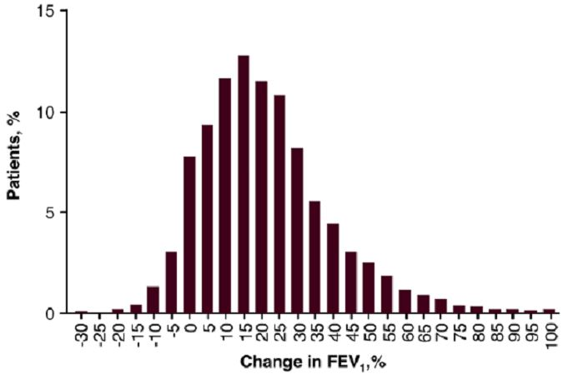

Similarly, reversibility was assessed in the QVA149 registration program, where the degree of reversibility was very similar to that observed in the UPLIFT trial (tiotropium versus placebo).

In conclusion, the sponsor provided clear and consistent exclusion criteria to exclude the asthmatic and mixed asthmatic patients across study protocols, and in addition provided clear guidance to investigators how to enrol or screen COPD patients into studies.

Therefore, the sponsor believes that the efficacy and safety of QVA149 reflects its effects on COPD patients. Given the concern on the safety of LABAs in asthma and mixed asthma patients and the current precaution statement in the Onbrez PI, the sponsor is proposing to amend the precaution section and include a similar statement in the Ultibro Breezhaler 110/50 PI. This is described in detail in response above.

#### Evaluator’s comments

The sponsor’s responses to the questions relating to the clinical safety data are satisfactory.

## Second round benefit-risk assessment

### Second round assessment of benefits

After consideration of the response to clinical questions, the benefits of Ultibro Breezhaler in the proposed usage are unchanged from those identified in the first round.

### Second round assessment of risks

After consideration of the response to clinical questions, the risks of Ultibro Breezhaler in the proposed usage are unchanged from those identified in the first round.

### Second round assessment of benefit-risk balance

After consideration of the response to clinical questions, the benefit-risk balance of Ultibro Breezhaler in the proposed usage is unchanged from that identified in the first round.

## Second round recommendation regarding authorisation

It is recommended that authorisation should be approved for the indication:

*Ultibro Breezhaler 110/50 is indicated as a once-daily maintenance bronchodilator treatment to relieve symptoms in patients with chronic obstructive pulmonary disease (COPD).*

However, the approval is subject to incorporation of suggested changes to the proposed PI.

|  |
| --- |
| Therapeutic Goods Administration |
| PO Box 100 Woden ACT 2606 Australia  Email: [info@tga.gov.au](mailto:info@tga.gov.au) Phone: 1800 020 653 Fax: 02 6232 8605  [**http://www.tga.gov.au**](http://www.tga.gov.au) |

1. Global Initiative for Chronic Obstructive Lung Disease (GOLD, 2011) Global Strategy for the Diagnosis, Management and prevention of Chronic Obstructive Pulmonary Disease (COPD). National Heart, Lung, and Blood Institute (NHLBI)/World Health Organization (WHO) workshop report.
2. European Medicines Agency, “Committee for Medicinal Products for Human Use (CHMP): Guidance on the Non-clinical Development of Fixed Combinations of Medicinal Products (EMEA/CHMP/SWP/258498/2005)”, 24 January 2008.
3. European Medicines Agency, “Guideline on clinical investigation of medicinal products in the treatment of chronic obstructive pulmonary disease (COPD) (EMA/CHMP/483572/2012)”, 21 June 2012.
4. European Medicines Agency, “Guideline on clinical investigation of medicinal products in the treatment of chronic obstructive pulmonary disease (COPD) (EMA/CHMP/483572/2012)”, 21 June 2012.
5. Cazzola M, et al. (1998) Effects of formoterol, salmeterol or oxitropium bromide on airway responses to salbutamolin COPD. *Eur Respir J.* 11: 1337-1141.
6. European Medicines Agency, “Guideline on the Investigation of Drug Interactions (CPMP/EWP/560/95/Rev. 1)”, 21 June 2012.
7. Tashkin DP, et al. (2008) A 4-year trial of tiotropium in chronic obstructive pulmonary disease. *N Engl J Med.* 359: 1543-1554.
8. Calverley PM. (2005) Minimal clinically important difference--exacerbations of COPD. *COPD* 2: 143-148.
9. Anzueto A, et al. (2009) Impact of frequency of COPD exacerbations on pulmonary function, health status and clinical outcomes. *Int J Chron Obstruct Pulmon Dis.* 4: 245-251.
10. Chapman KR, et al. (2013) Do we know the minimal clinically important difference (MCID) for COPD exacerbations? *COPD* 10: 243-249.
11. Seemungal TA, et al. (1998) Effect of exacerbation on quality of life in patients with chronic obstructive pulmonary disease. *Am J Respir Crit Care Med.* 157: 1418-1422.
12. Langsetmo L, et al. (2008) Underreporting exacerbation of chronic obstructive pulmonary disease in a longitudinal cohort. *J. Am J Respir Crit Care Med.* 177: 396-401.
13. Seemungal TA, et al. (1998) Effect of exacerbation on quality of life in patients with chronic obstructive pulmonary disease. *Am J Respir Crit Care Med.* 157: 1418-1422; Seemungal TA, et al. (2000) Time course and recovery of exacerbations in patients with chronic obstructive pulmonary disease. *Am J Respir Crit Care Med.* 161: 1608-1613; Donaldson GC, et al. (2002) Relationship between exacerbation frequency and lung function decline in chronic obstructive pulmonary disease. *Thorax* 57: 847-852; Spencer S, Jones PW. (2003) Time course of recovery of health status following an infective exacerbation of chronic bronchitis. *Thorax* 58: 589-593; Donaldson GC, et al. (2005) Exacerbations and time spent outdoors in chronic obstructive pulmonary disease. *Am J Respir Crit Care Med.* 171: 446-452.
14. European Medicines Agency, “Guideline on clinical investigation of medicinal products in the treatment of chronic obstructive pulmonary disease (COPD) (EMA/CHMP/483572/2012)”, 21 June 2012.
15. European Medicines Agency, “Guideline on clinical investigation of medicinal products in the treatment of chronic obstructive pulmonary disease (COPD) (EMA/CHMP/483572/2012)”, 21 June 2012.
16. Tashkin DP, et al. (2008) A 4-year trial of tiotropium in chronic obstructive pulmonary disease. *N Engl J Med.* 359: 1543-1554.
17. American Thoracic Society (1974) Criteria for the assessment of reversibility in airways obstruction. Report of the Committee on Emphysema American College of Chest Physicians. *Chest* 65: 552-553.
18. American Thoracic Society (1991) Lung function testing: selection of reference values and interpretative strategies. *Am Rev Respir Dis.* 144: 1202-1218.