|  |
| --- |
| **First round report January 2017**  **Second round report May 2017** |

|  |
| --- |
| AusPAR Attachment 2 |
| Extract from the Clinical Evaluation Report for Indacaterol maleate/ Glycopyrronium bromide |
| Proprietary Product Name: Ultibro Breezhaler |
| Sponsor: Novartis Pharmaceuticals Australia Pty Ltd |

About the Therapeutic Goods Administration (TGA)

* The Therapeutic Goods Administration (TGA) is part of the Australian Government Department of Health, and is responsible for regulating medicines and medical devices.
* The TGA administers the *Therapeutic Goods Act 1989* (the Act), applying a risk management approach designed to ensure therapeutic goods supplied in Australia meet acceptable standards of quality, safety and efficacy (performance), when necessary.
* The work of the TGA is based on applying scientific and clinical expertise to decision-making, to ensure that the benefits to consumers outweigh any risks associated with the use of medicines and medical devices.
* The TGA relies on the public, healthcare professionals and industry to report problems with medicines or medical devices. TGA investigates reports received by it to determine any necessary regulatory action.
* To report a problem with a medicine or medical device, please see the information on the TGA website <<https://www.tga.gov.au>>.

About the Extract from the Clinical Evaluation Report

* This document provides a more detailed evaluation of the clinical findings, extracted from the Clinical Evaluation Report (CER) prepared by the TGA. This extract does not include sections from the CER regarding product documentation or post market activities.
* The words [Information redacted], where they appear in this document, indicate that confidential information has been deleted.
* For the most recent Product Information (PI), please refer to the TGA website <<https://www.tga.gov.au/product-information-pi>>.

Copyright

© Commonwealth of Australia 2018  
This work is copyright. You may reproduce the whole or part of this work in unaltered form for your own personal use or, if you are part of an organisation, for internal use within your organisation, but only if you or your organisation do not use the reproduction for any commercial purpose and retain this copyright notice and all disclaimer notices as part of that reproduction. Apart from rights to use as permitted by the *Copyright Act 1968* or allowed by this copyright notice, all other rights are reserved and you are not allowed to reproduce the whole or any part of this work in any way (electronic or otherwise) without first being given specific written permission from the Commonwealth to do so. Requests and inquiries concerning reproduction and rights are to be sent to the TGA Copyright Officer, Therapeutic Goods Administration, PO Box 100, Woden ACT 2606 or emailed to <[tga.copyright@tga.gov.au](mailto:tga.copyright@tga.gov.au)>.

Contents

List of abbreviations 5

1. Introduction 6

1.1. Submission type 6

1.2. Drug class and therapeutic indication 6

2. Clinical rationale 6

3. Contents of the clinical dossier 6

3.1. Scope of the clinical dossier 6

3.2. Paediatric data 6

3.3. Good clinical practice 6

4. Pharmacokinetics 6

4.1. Studies providing pharmacokinetic information 6

5. Pharmacodynamics 7

5.1. Studies providing pharmacodynamic information 7

6. Dosage selection for the pivotal studies 7

7. Clinical efficacy 7

7.1. Studies providing evaluable efficacy data 7

7.2. Pivotal or main efficacy studies 7

7.3. Analyses performed across trials: pooled and meta analyses 23

7.4. Evaluator’s conclusions on clinical efficacy 24

8. Clinical safety 25

8.1. Studies providing evaluable safety data 25

8.2. Patient exposure 25

8.1. Adverse events 25

8.2. Evaluator’s overall conclusions on clinical safety 30

9. First round benefit-risk assessment 30

9.1. First round assessment of benefits 30

9.2. First round assessment of risks 31

9.1. First round assessment of benefit-risk balance 31

10. First round recommendation regarding authorisation 31

11. Clinical questions 31

11.1. Efficacy 31

12. Second round evaluation of clinical data submitted in response to questions 31

12.1. Sponsor response to the clinical evaluation report 33

13. Second round benefit-risk assessment 35

13.1. Second round assessment of benefits 35

13.2. Second round assessment of risks 35

13.3. Second round assessment of benefit-risk balance 35

14. Second round recommendation regarding authorisation 36

## List of abbreviations

| Abbreviation | Meaning |
| --- | --- |
| AEs | Adverse events |
| AUC | Area under the curve |
| CER | Clinical evaluation report |
| CI | Confidence Interval |
| CCV | Cerebro cardiovascular |
| EU | European Union |
| FEV1 | Forced expiratory volume in 1 second |
| FDC | Fixed dose combination |
| FVC | Forced vital capacity |
| GOLD | Global Initiative for Chronic Obstructive Lung Disease |
| MACE | Major adverse cardiovascular event |
| SAEs | Serious adverse event |
| SGRG-C | St George’s respiratory questionnaire |

## Introduction

### Submission type

This is an application for extension of indications for Ultibro/Xoterna Breezhaler 110/50 µg (indacaterol maleate/glycopyrronium bromide) powder for inhalation in hard capsule

*The indication is: Ultibro Breezhaler 110/50 is indicated as a once-daily maintenance bronchodilator treatment to relieve symptoms and* ***prevent exacerbations*** *in patients with chronic obstructive pulmonary disease (COPD).*

The bold phrase is the proposed new indication.

### Drug class and therapeutic indication

Ultibro Breezhaler is a fixed dose combination of indacaterol maleate and glycopyrronium bromide for inhaled use. Indacaterol is a long acting beta agonist (LABA) and glycopyrronium is an anti-cholinergic, long acting M1-5 muscarinic receptor antagonist (LAMA). Both act in a complementary manner to reverse airway obstruction in COPD. Both compounds are approved for symptomatic relief in patients with COPD but not in patients with asthma or mixed airways disease.

## Clinical rationale

Reference is made to the clinical evaluation report for Submission PM-2012-4395-1-5.

## Contents of the clinical dossier

### Scope of the clinical dossier

One study (FLAME) has been submitted to support this application.

### Paediatric data

Not applicable.

### Good clinical practice

The study has been conducted in full compliance with GCP.

## Pharmacokinetics

### Studies providing pharmacokinetic information

Not submitted.

## Pharmacodynamics

### Studies providing pharmacodynamic information

Not submitted.

## Dosage selection for the pivotal studies

Not submitted.

## Clinical efficacy

### Studies providing evaluable efficacy data

One study has been submitted to support the extension of indication and the inclusion of the trial in the clinical trials section of the PI.

### Pivotal or main efficacy studies

#### Study QVA149A2318

##### Study design, objectives, locations and dates

Study QVA149A2318: A 52 week treatment, multi-centre, randomised, double blind, double dummy, parallel-group, active controlled study to compare the effect of QVA149 (indacaterol maleate /glycopyrronium bromide) with salmeterol/fluticasone on the rate of exacerbations in subjects with moderate to very severe COPD. See flow chart below in Figure 1.

Figure 1: Study QVA149A2318; study design

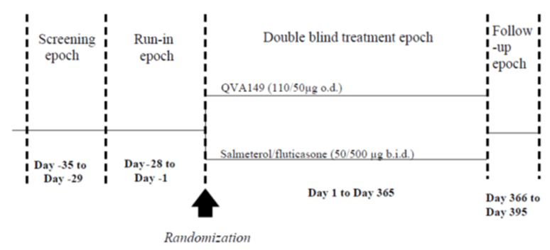

##### Inclusion and exclusion criteria

The study population consisted of male and female adults age 40 years and older, with a clinical diagnosis of COPD according to Global Initiative for Chronic Lung Disease (GOLD 2011), a smoking history of at least 10 pack years and a documented history of at least 1 COPD exacerbation requiring systemic glucocorticosteroid and/or antibiotics in the previous 12 months. Patients were also required to have post-bronchodilator FEV1 ≥ 25% and < 60% of the predicted normal value, and post-bronchodilator FEV1/FVC < 0.70 and a Modified Medical Research Council (mMRC) grade of at least 2 at the visit at the start of the run-in period.

###### Exclusion criteria:

1. Pregnant or nursing (lactating) women
2. Women of child bearing potential.
3. Patients with Type I or uncontrolled Type II diabetes.
4. Patients with a history of long QT syndrome or whose QTc measured at start of the run-in epoch was prolonged (> 450 ms for males and females) and confirmed by a central assessor. These patients were not re-screened.
5. Patients who had a clinically significant ECG abnormality at the start of the run-in period or double blind treatment.
6. Patients who had a clinically significant laboratory abnormality at the start of the run-in period.
7. Patients who had a clinically significant renal, cardiovascular (such as but not limited to unstable ischemic heart disease, NYHA Class III/IV left ventricular failure, myocardial infarction), arrhythmia, neurological, endocrine, immunological, psychiatric, gastrointestinal, hepatic, or haematological abnormalities which could interfere with the assessment of the efficacy and safety of the study treatment.
8. Patients with paroxysmal (for example intermittent) atrial fibrillation were excluded.
9. Patients contraindicated for treatment with, or having a history of reactions/ hypersensitivity to any of the following inhaled drugs, drugs of a similar class or any component thereof: anticholinergic agents; LABA and SABA; sympathomimetic amines; lactose or any of the other excipients of trial medication.
10. Patients with a history of malignancy of any organ system, treated or untreated, within the past 5 years whether or not there was evidence of local recurrence or metastases, with the exception of localized basal cell carcinoma of the skin.
11. Patients with narrow angle glaucoma, symptomatic benign prostatic hyperplasia or bladder neck obstruction or moderate to severe renal impairment or urinary retention.
12. 12. Patients who had not achieved an acceptable spirometry results at the start of the run-in period in accordance with American Thoracic Society (ATS)/European Respiratory Society (ERS) criteria for acceptability (one retest could be performed for patients that did not meet the acceptability criteria).
13. Patients who had a COPD exacerbation that required treatment with antibiotics and/or systemic corticosteroids and/or hospitalization in the 6 weeks prior to Visit 1.
14. Patients who developed a COPD exacerbation of any severity (mild/moderate/severe) between screening (Visit 1) and treatment epoch (Visit 201) were not eligible but were permitted to be re-screened after a minimum of 6 weeks after the resolution of the COPD exacerbation.
15. Patients who had a respiratory tract infection within 4 weeks prior to screening (Visit 1).
16. Patients who developed a respiratory tract infection between screening and prior to treatment were not eligible, but were permitted to be re-screened 4 weeks after the resolution of the respiratory tract infection.
17. Patients requiring long term oxygen therapy prescribed for > 12 hours per day.
18. Patients with any history of asthma.
19. Patients with an onset of respiratory symptoms, including a COPD diagnosis prior to age 40 years.
20. Patients with a blood eosinophil count > 600/mm3 at the start of the run-in period.
21. Patients with allergic rhinitis who used a H1 antagonist or intra-nasal corticosteroids intermittently (treatment with a stable dose or regimen was permitted).
22. Patients with concomitant pulmonary disease (for example lung fibrosis, sarcoidosis, interstitial lung disease, pulmonary hypertension).
23. Patients with clinically significant bronchiectasis.
24. Patients with a diagnosis of α-1 anti-trypsin deficiency.
25. Patients with active pulmonary tuberculosis, unless confirmed by imaging to be no longer active.
26. Patients with pulmonary lobectomy or lung volume reduction surgery or lung transplantation.
27. Patients participating in or planning to participate in the active phase of a supervised pulmonary rehabilitation program during the study. (Maintenance program was permitted.)
28. Use of other investigational drugs/devices (approved or unapproved) at the time of enrolment, or within 30 days or 5 half-lives of the screening visit (Visit 1), whichever was longer.
29. Patients unable to use an electronic patient diary and EXACT-PRO diary.
30. Patients unable to use a dry powder inhaler device, Metered Dose Inhaler (MDI) or a pressurized MDI (rescue medication) or comply with the study regimen.

##### Study treatments

QVA149 110/50 μg capsules for inhalation were supplied in blisters delivered via Novartis single dose dry powder inhaler (SDDPI) and salmeterol/fluticasone dry inhalation powder was delivered via Accuhaler device.

The formulation and batch details are given below in Table 1.

Table 1: Study QVA149A2318 study medication formulation and batch numbers

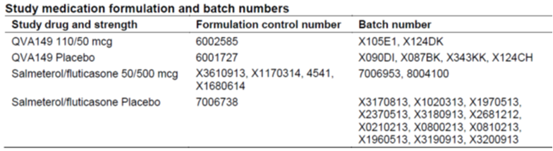

Additional study treatments:

* SABA (salbutamol or albuterol) inhaler could be used as rescue medication on an ‘as needed’ basis throughout the study.
* Tiotropium was also to be used in the run-in period. Patients received ipratropium bromide 20 μg for use instead of tiotropium during the 3 days prior to the start of the run-in period (if required) and in the 24 hours prior to randomization (if required) to allow washout of tiotropium. Patients discontinued both tiotropium (at least 24 hours) and ipratropium (at least 8 hours) prior to randomisation.

##### Efficacy variables and outcomes

The primary analysis variable was the rate of all COPD exacerbations during the treatment period, (the period between the first day of the study drug administration to one day after the last day of the study drug administration).

Other (secondary) efficacy endpoints were:

* time to first COPD exacerbation (mild/moderate/severe)
* rate and time of moderate/severe exacerbation
* change from baseline in pre-dose FEV1 and FVC after 4, 12, 26, 38, and 52 weeks of treatment
* FEV1 AUC0-12h after 4, 12, 26, 38, 52 weeks of treatment in a subset of approximately 600 patients (the serial spirometry set)
* Symptoms and rescue medication used (number of puffs) as reported by the patients using the patient e-Diary
* SGRQ-C after 4, 12, 26, 38, and 52 weeks of treatment and percentage of patients with a clinically important improvement of at least 4 or 8 in the total SGRQ-C score after 52 weeks of treatment.

COPD exacerbation is defined as: a worsening of the following two or more major symptoms for at least 2 consecutive days:

* dyspnoea
* sputum volume
* sputum purulence

or;

a worsening of any 1 major symptom together with an increase in any one of the following minor symptoms for at least 2 consecutive days:

* sore throat
* colds (nasal discharge and/or nasal congestion)
* fever without other cause
* cough
* wheeze

It is stated in the CSR that, ‘for the purposes of this study, the type of treatment provided for a COPD exacerbation determined the severity of the exacerbation. A worsening of symptoms that met the above symptom definition that was not treated with systemic corticosteroids and/or antibiotics was considered a mild COPD exacerbation. A COPD exacerbation was considered of moderate severity if treatment with systemic corticosteroids or antibiotics or both was required and severe, if hospitalisation was required (in addition to treatment with systemic corticosteroids and/or antibiotics). An emergency room visit of longer than 24 hours was considered a hospitalisation. A COPD exacerbation that required an emergency room visit for less than 24 hours was of moderate severity, providing the exacerbation was treated with systemic corticosteroids or antibiotics or both’.

##### Randomisation and blinding methods

All eligible patients were randomised via Interactive Response Technology (IRT) to one of the treatment arms. Randomisation was stratified by smoking status, severity of airflow limitation and ICS use. Patients, investigator staff, persons performing the assessments, and data analysts remained blind to the identity of the treatment from the time of randomisation until database lock. A double-dummy design was used because the identity of the study drugs could not be disguised due to their different forms. Unblinding only occurred in the case of patient emergencies (and at the conclusion of the study).

##### Analysis populations

The randomised set (RAN) comprised all randomised patients. Patients in RAN were analysed according to the treatment to which they were randomised.

The full analysis set (FAS) included all randomised patients who received at least one dose of study drug. Following the intent-to-treat principle, patients were analysed according to the treatment they were assigned to at randomisation.

The per-protocol set (PPS) included all patients in the FAS without any major protocol deviations.

Major protocol deviations were defined prior to database lock and the unblinding of the study. Patients were analysed according to the treatment they were randomised to.

The safety set included all patients who received at least one dose of study drug. Patients were analysed according to the treatment they received.

##### Statistical methods

The comparison of QVA149 (110/50 μg QD) to salmeterol/fluticasone (500/50 μg BD) was evaluated by testing the following null hypothesis (Ho) versus the alternative hypothesis (Ha) at one-sided significance level of 0.025:

* Ho: There was at least 15% increase in rate of mild/moderate/severe COPD exacerbations for COPD patients at risk of exacerbating treated with QVA149 (110/50 μg QD) compared to salmeterol/fluticasone (50/500 μg BD).
* Ha: Rate ratio of mild/moderate/severe COPD exacerbations for COPD patients at risk of exacerbating treated with QVA149 (110/50 μg QD) compared to salmeterol/fluticasone (50/500 μg BD) was less than 1.15.

The number of exacerbations during the 52 week treatment period was analysed using a generalised linear model assuming a negative binomial distribution. The model included terms for treatment, smoking status at baseline, inhaled corticosteroid (ICS) use at screening, baseline severity of airflow limitation, and region as fixed effects.

An estimate of the ratio of exacerbation rates in the treatment groups (QVA149 versus salmeterol/fluticasone) was presented together with a two-sided 95% confidence interval (CI). If the upper limit of the CI was less than 1.15, non-inferiority of QVA149 compared to salmeterol/fluticasone could be claimed, and the following hypothesis was tested at one-sided significance level of 0.025 using the same CI computed from above:

* Ho2: There was no difference in the rate of mild/moderate/severe COPD exacerbations for COPD patients at risk of exacerbating treated with QVA149 (110/50 μg QD) compared to salmeterol/fluticasone (50/500 μg BD).
* Ha2: For COPD patients at risk of exacerbating, the rate of mild /moderate /severe COPD exacerbations treated with QVA149 (110/50 μg QD) was lower than that of patients treated with salmeterol/fluticasone (50/500 μg BD).

If the upper limit was less than 1, then Ho2 was rejected and superiority QVA149 versus SFC in reducing the rate of COPD exacerbation could be claimed. The overall type I error from the two hypothesis tests described above (that is, the non-inferiority test and the following superiority test) was kept at significance level 0.05 (two-sided).

In relation to the secondary endpoints, it appears that no multiplicity adjustments were performed.

##### Participant flow

The following table is extracted from the dossier (Table 2).

Table 2: Participant flow

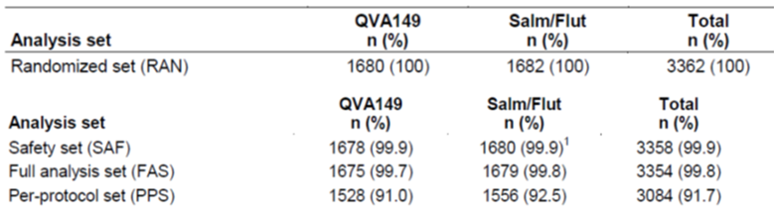

##### Major protocol violations/deviations

Overall, 8.3% of patients were excluded from the per-protocol analysis, mainly due to protocol deviations (7.7%).

##### Baseline data

COPD history and baseline disease characteristics were well-balanced between the treatment arms, see Table 3. The majority of patients had moderate or severe COPD by airflow limitation at baseline (91.5%), see Tables 3 and 4.

Disease severity was similar between the treatment arms in terms of the GOLD combined assessment and mMRC Dyspnoea Scale. Almost all (99.9%) patients had baseline mMRC ≥ 2 (72% had a score of 2). In the year prior to study entry, 80.6% of patients had experienced one COPD exacerbation, and 19.3% of patients had experienced 2 or more exacerbations.

Table 3: Severity of COPD at baseline

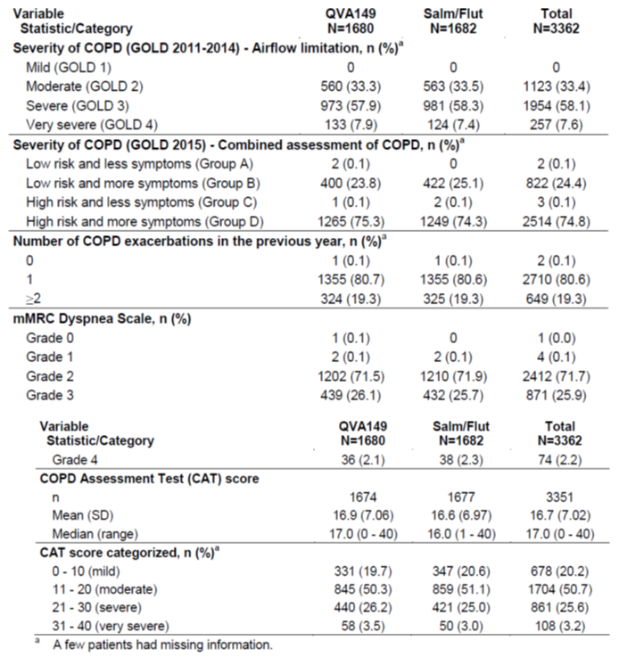

Table 4: Duration of COPD

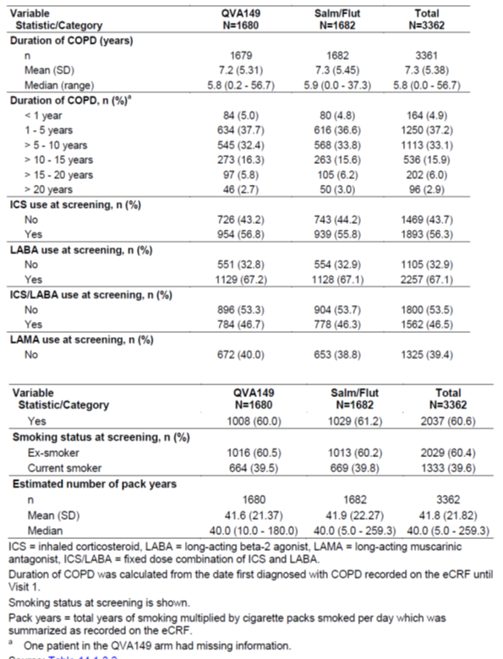

##### Results for the primary efficacy outcome

The annualised rate of all COPD exacerbations was statistically significantly lower with QVA149, 3.59 (3.28, 3.94) compared to salmeterol/fluticasone 4.03 (3.68, 4.41). The rate ratio is 0.89 (0.83, 0.96), p = 0.003, see Figure 2 and Table 5.

The estimated rate ratio for all COPD exacerbations (mild, moderate or severe) and associated 95% CI during double blind treatment (PPS and FAS) is shown in the figure below. Details of the model are described in Figure 2.

The study report states that this study, ‘met its primary and secondary objectives for this endpoint. The upper bound of the 2-sided 95% CI of the rate ratio was less than 1.15 demonstrating that QVA149 was non-inferior to salmeterol/fluticasone. … the upper bound of 2-sided 95% CI for rate ratio was less than 1, demonstrating the superiority of QVA149 to salmeterol/fluticasone’. See Figure 2 below for further details.

Figure 2: Estimated COPD exacerbation (mild, moderate or severe) rate ratio and associated 95% confidence intervals during double-blind treatment (Per protocol set and Full analysis set) Study QVA149A2318

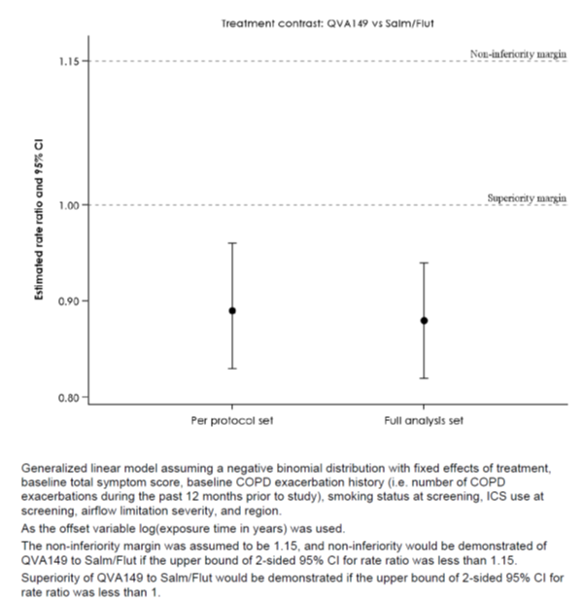

Table 5: Summary and generalised linear model for the rate of COPD exacerbations (mild, moderate or severe) during double blind treatment (per protocol set)

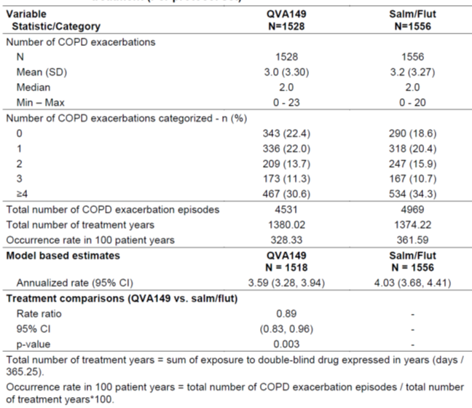

##### Results for other efficacy outcomes

Only the secondary efficacy variables stipulated in the protocol are considered here.

###### Time to first COPD exacerbation

The median time to event in the QVA149 arm was 71.0 days, compared to 51.0 days in the salmeterol/fluticasone arm. The hazard ratio of risk reduction in QVA149 versus salmeterol/fluticasone was 0.84, (95% CI: 0.78, 0.91); p < 0.001, see Table 6.

Table 6: Time to first COPD exacerbation

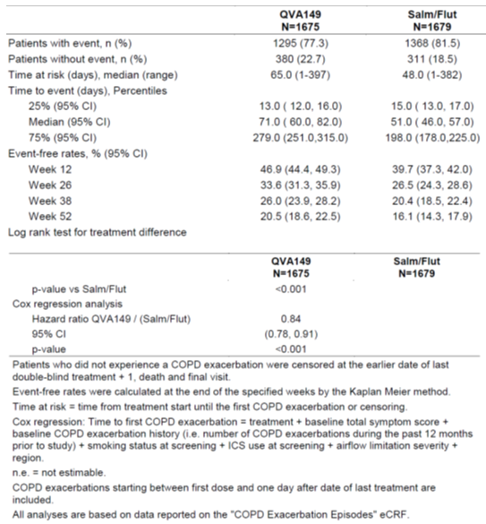

###### Rate and time to first moderate or severe COPD exacerbation

The annualised rate of moderate or severe COPD exacerbations was 0.98 with QVA149 compared to 1.19 with salmeterol/fluticasone. The rate ratio of exacerbation rate of moderate or severe exacerbations of QVA 149 versus salmeterol/fluticasone (rate ratio: 0.83, 95% CI 0.75, 0.91, p < 0.001, see Table 7.

Table 7: Summary and generalised linear model for the rate of moderate or severe COPD exacerbation

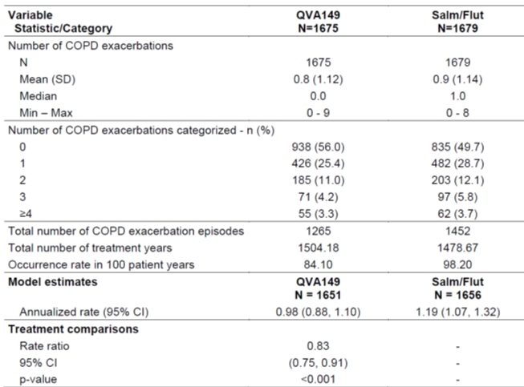

###### Change from baseline in pre-dose FEV1 and FVC after 4, 12, 26, 38, and 52 weeks of treatment

See Table 8 for details. Improvements over 52 weeks in pre-dose trough FEV1 for QVA149 versus salmeterol/fluticasone ranged from 0.062 on Day 365 to 0.086 L on Day 183. Improvements in QVA149 treated group over the comparator was seen at different time points. FVC changes showed similar trends: Over 52 weeks, improvements in pre-dose trough FVC for QVA149 versus salmeterol/fluticasone ranged from 0.160 L on Day 365 to 0.209 L on Day 183, see Table 9.

Table 8: FEV1 changes; mixed model for repeated measures (MMRM) of change from baseline in pre-dose trough FEV1 (L) by visit (full analysis set)

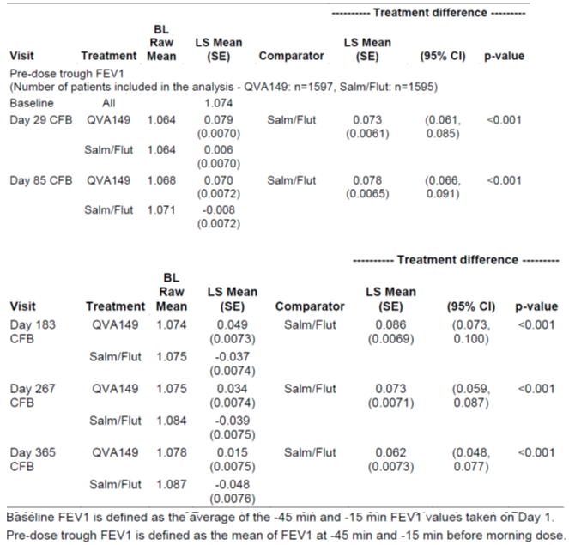

Table 9: FVC changes

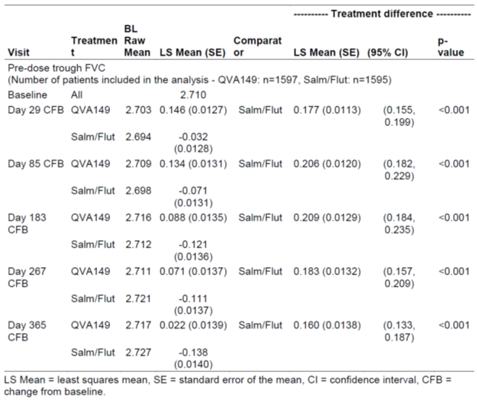

###### FEV1 AUC0-12h after 4, 12, 26, 38, 52 weeks of treatment in a subset of approximately 600 patients (the serial spirometry set)

QVA149 group was statistically superior to salmeterol/fluticasone group from Day 1 onwards (p = 0.022). The LS mean improvement for QVA149 was 0.027 L greater than for salmeterol/fluticasone at Day 1 and 0.117 L greater at Day 85, see Table 10 for details.

Table 10: MMRM of change from baseline in FEV1 (L) AUC 0-12h, by visit (Serial spirometry set)

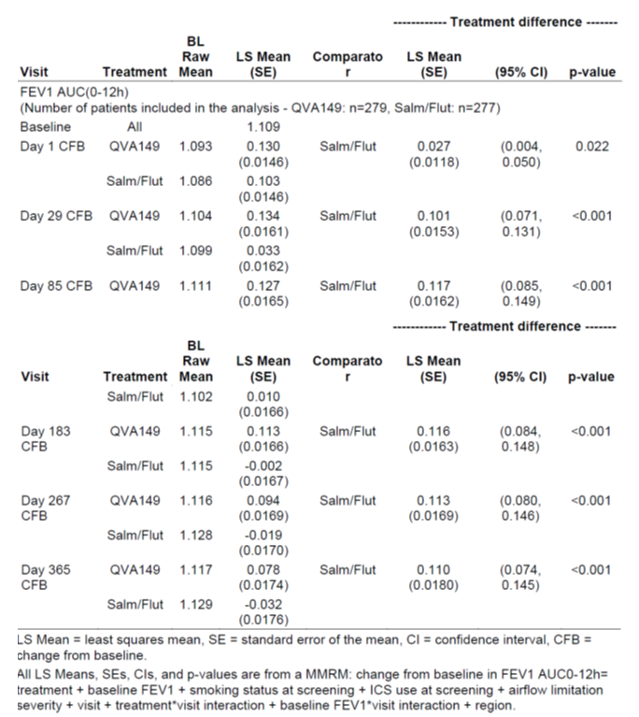

###### SGRQ-C after 4, 12, 26, 38, and 52 weeks of treatment

SGRQ-C after 4, 12, 26, 38, and 52 weeks of treatment and percentage of patients with a clinically important improvement of at least 4 or 8 in the total SGRQ-C score after 52 weeks of treatment. Estimated treatment differences and associated 95% confidence intervals of the SGRQ total score starting from Day 85 onwards show results favouring QVA149 over salmeterol/fluticasone, see Table 11. The proportion of patients with a clinically meaningful improvement in the SGRQ total score (≥ 4 point reduction) was higher in the QVA149 arm compared to the salmeterol/fluticasone arm from Day 85 onwards (49.2% versus 43.7%, odds ratio 1.30 (CI: 1.11, 1.51), p< 0.001 on Day 365), respectively.

###### Symptoms and rescue medication used (number of puffs) as reported by the patients using the patient e-Diary

The reduction in daily rescue medication usage was approximately 0.25 inhalations per day compared to salmeterol/fluticasone, see Table 11.

There was no significant reduction in the daily symptom score with QVA149 compared to salmeterol/fluticasone (LS mean -0.03, p = 0.619), and there was a significant increase in the night time score with QVA149 compared to salmeterol/fluticasone, (LS mean 0.14, p = 0.011).

Table 11: Change in St Georges score

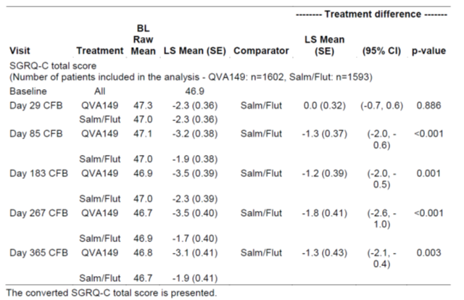

Subgroup analyses are listed in Figure 3.

Figure 3: Forest plot of estimated COPD exacerbation (mild, moderate or severe) rate ratio and associated 95% confidence intervals during double blind treatment by demographics (full analysis set)

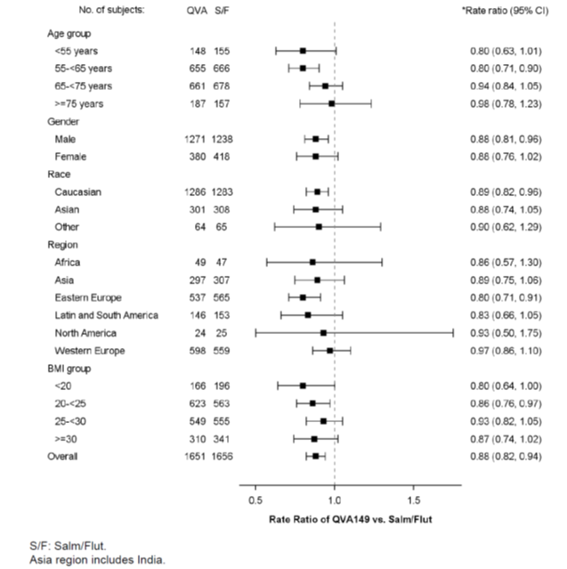

##### Evaluator commentary

This study is a well design study (double blind comparator controlled) that has used the commonly accepted definition for evaluating and recording COPD exacerbations with the use of a patient’s electronic diary; it also complies with the definitions for exacerbation, severity scores recommended in the EU Guideline on Clinical investigation of medicinal products in the treatment of COPD.

The primary efficacy endpoint revealed non-inferiority and then statistical superiority to the comparator treatment.

Some secondary endpoints, showed statistically significant difference favouring the study medication.

### Analyses performed across trials: pooled and meta analyses

Not applicable.

### Evaluator’s conclusions on clinical efficacy

The sponsor’s clinical summary states that, in relation to COPD, ‘approximately 50% of patients, including those with only moderate airflow obstruction, have at least one exacerbation per year. Furthermore, 22% of COPD patients with moderate airflow obstruction and 33% of patients with severe obstruction have at least 2 exacerbations per year (Hurst et al 2010)[1]. Exacerbations impact patients of varying COPD severities. The prevention of only one COPD exacerbation of any severity may have a significant effect on patient outcomes (Wedzicha and Wilkinson 2006)[2]. There is also evidence that exacerbations, particularly more frequent exacerbations, are responsible for accelerating the progression of the disease, leading to earlier development of disability, respiratory failure, and death. Thus, an important goal of COPD management is to prevent exacerbations (GOLD 2016)’.

This study showed that QVA149 was statistically superior to salmeterol/fluticasone in relation to the primary efficacy endpoint that is rate of all COPD exacerbations. This is the basis for the proposed extension of indications, ‘prevention of exacerbations’. This is based on the mean (SD) exacerbations of 3.0 (3.30) in the QVA149 group versus 3.2 (3.27) in the salmeterol/fluticasone group. This finding relates to all severities of exacerbations (mild, moderate and severe). Thus, the evaluator questions the clinical relevance of this margin of difference to support the indication of ‘prevention of exacerbation’. It is noted that moderate to severe categories of exacerbation were 0.8 (1.12) and 0.9 (1.14) respectively, see Table 7. It would seem that a significant proportion was mild exacerbation. The sponsor should provide, in the Section 31 response, the number of mild exacerbations: mean (SD), number of COPD exacerbations categorised, annualised rate and rate ratio as expressed in Table 7 for moderate to severe exacerbations. If this analysis is already included in the dossier, the sponsor should provide its location.

The secondary efficacy endpoints are presented in Section 7.2.1.4. Some endpoints showed statistical superiority favouring QVA149 over the comparator. However, the evaluator questions the clinical relevance of the magnitude of these findings: for example, time to first COPD exacerbation is expressed in median time and is a crude index. The rate ratio of exacerbation rate of moderate or severe exacerbation of 0.83, 95% CI 0.75, 0.91, p < 0.001 is of limited clinical relevance. Similarly, pre dose FEV1 over time (62 to 86 mL) is also of limited clinical relevance indicating that the rate of progression of disease was not significantly different between groups.

In addition, there are multiple secondary endpoints; the study report states that no multiplicity adjustments were performed on any secondary endpoints giving rise to concerns about the statistical validity of these results.

Whilst this study provides some evidence of efficacy, the magnitude of efficacy is inadequate to support the extension of indications to include ‘prevention of exacerbation’. In addition, prevention also correlates to reduced progression of disease. This would mean that prevention of exacerbation would indirectly alter the course of COPD. Altering the course needs to be confirmed with studies earlier in the course of the illness, see EU Guideline EMA/CHMP/483572/2012- corr 1 Guidelines on clinical investigation of medical products for the treatment of COPD.

The original report (PM-2012-4395-5) discussed a study where the primary efficacy endpoint was the exacerbation rate (moderate to severe as per the GOLD definition). This study was Study A2304 where the inclusion criterion was severe and very severe COPD, see that report where one of the treatment arms was QVA149. The study duration was 64 weeks where it is reported that the mean (SD) number of moderate to severe exacerbations in the QVA149 group was 1.11 (1.3). Whilst cross study comparison has its limitations, especially as the inclusion criterion was a more severe COPD, the results are in line with that reported in the current study. That study was considered (by the evaluator of the original submission), insufficient to support the proposed indication that QVA149 reduces exacerbations.

## Clinical safety

### Studies providing evaluable safety data

#### Pivotal and/or main efficacy studies

The pivotal study provided safety data on QVA149. The details of safety monitoring are similar to those of previously submitted data, (see PM-2012-4395-1-5).

### Patient exposure

Table 12: Patient exposure

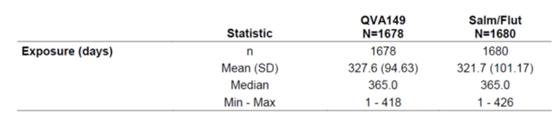

Compliance was high in both treatment arms, with a mean of approximately 99% of days where drug was taken as per protocol over the treatment period.

### Adverse events

#### All adverse events (irrespective of relationship to study treatment)

##### Integrated safety analyses

The overall incidence of AEs was similar across the treatment arms. The most commonly (approximately 80%) affected primary SOC was respiratory, thoracic and mediastinal disorders, followed by infections and infestations. The incidence of infection and infestation AEs was 42.3% in the QVA149 arm versus 48% in the salmeterol/fluticasone arm, see Table 13.

Table 13: Incidence of AEs

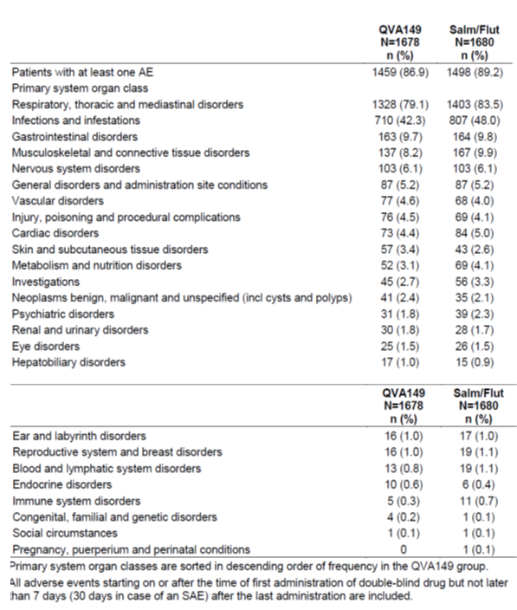

A summary of the most frequently reported AEs (≥ 1% in any treatment arm) by preferred term is presented in Table14. Overall the most frequently reported AE was COPD, which was reported with a similar frequency across both treatment arms (77.4% and 81.8%, in QVA149 and salmeterol/fluticasone, respectively). Other frequently reported AEs (> 5% in both treatment arms) were nasopharyngitis (11.7% versus 11.6%), viral upper respiratory tract infection (7.9% versus 8.2%) and upper respiratory tract infection bacterial (7.4% versus 10.0%), respectively. Overall, there were no meaningful differences in AE frequencies between treatment arms.

Table 14: Most frequent > 1% Adverse events

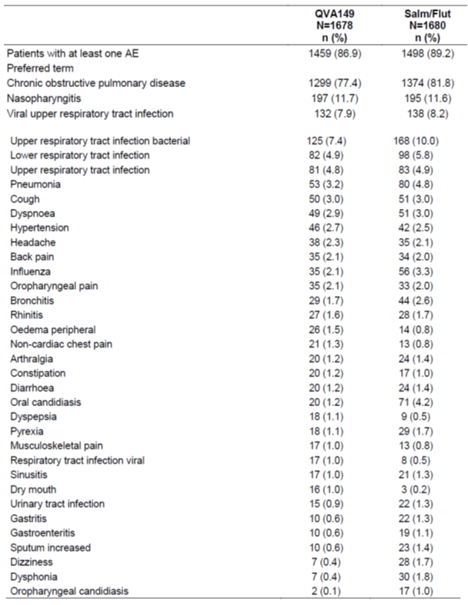

###### Severity

Mild AEs occurred in 30.3% of patients in the QVA149 arm compared to 27.7% in the salmeterol/fluticasone arm; moderate AEs occurred in 39.9% of patients in the QVA149 arm compared to 43.1% of patients in the salmeterol/fluticasone arm. Severe AEs were reported in 16.7% of patients in the QVA149 compared to 18.4% in the salmeterol/fluticasone arm.

###### Deaths

All deaths (including those reported after 30 days after last treatment, but before end of study period) were adjudicated in a blinded fashion by an external independent panel, see Table 15. Overall, the causes of death by major category were similar between treatment arms. In the QVA149 treatment arm, respiratory cause was the most frequent cause of death (11 patients, 0.7%), while cardiovascular cause was most frequent cause of death in the salmeterol/fluticasone arm (11 patients, 0.7%). The incidence of overall adjudicated MACE and/or CV deaths was similar and balanced between the treatment arms (1.9% versus 1.8%).

Table 15: Number of deaths by adjudicated primary cause

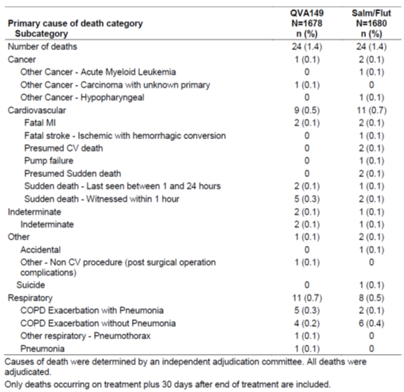

###### SAEs

The proportion of patients experiencing an SAE was similar across the treatment arms (18.4% and 19.9% in QVA149 and salmeterol/fluticasone arms, respectively). SAEs were most frequently reported within the respiratory, thoracic and mediastinal SOC, followed by infections and infestations SOC.

###### Adjudicated CCV SAEs

A similar percentage of patients experienced at least one adjudicated CCV SAE in both treatment arms (2.4% and 2.7% in QVA149 and salmeterol/fluticasone arms, respectively).

Adverse events of special interest were 31.7% (QV149) and 35.6% (salmeterol/fluticasone). These were events compatible with beta adrenergic or anticholinergic mechanism of action.

#### Laboratory investigations:

##### Haematology

No clinically significant difference between the two treatment groups was seen in relation to worsening haematology values, see Table 16.

Table 16: Number of patients with newly occurring or worsening clinically notable haematology values at any time post baseline

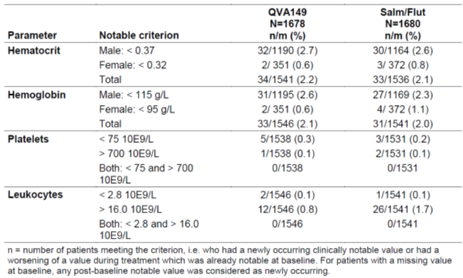

##### Blood chemistry

No significant difference was seen between groups except for a higher percentage of patients in the QVA149 arm (4.3%) reported newly occurring notable blood urea nitrogen levels (> 9.99 mmol/L) compared to the salmeterol/fluticasone arm (2.6%), see Table 17. There were no significant changes in LFTs, urinalysis.

Changes in Vital Signs were not clinically significant and were low.

QTc changes were clinically not significant.

Table 17: Number of patients with newly occurring or worsening clinically notable chemistry values at any time post baseline

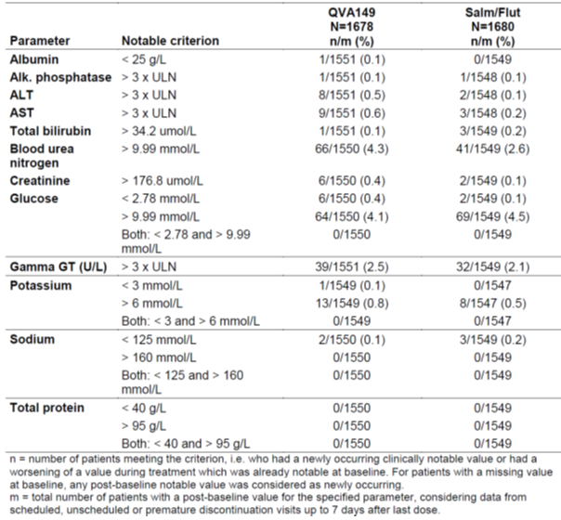

### Evaluator’s overall conclusions on clinical safety

This 52 week study provides adequate evidence of safety and supports the safety findings obtained in the original submission. No undue safety concerns were identified.

## First round benefit-risk assessment

### First round assessment of benefits

* This study was designed as a non-inferiority study and then if non-inferiority was shown, as a superiority study in relation to the primary efficacy endpoint which was the rate of exacerbation. This study met these expectations.
* Exacerbations were well defined; the COPD inclusion was moderate to severe.
* The study was well designed and the duration was adequate.
* Safety results were in line with those described in the original submission.
* The Clinical study has adequate efficacy and safety data to include in the Clinical trials section.

### First round assessment of risks

* Though statistical superiority has been shown in this study, the clinical significance of this margin is considered inadequate (and of small magnitude) to support the extension of indication.
* The margin of difference also includes mild exacerbations, the rate of which could not be verified by the evaluator.
* There are multiple secondary endpoints and issues of multiplicity have not been factored into the statistical considerations.
* The incidence of pneumonia (as confirmed by radiographic imaging that is chest x-ray or CT scan) was numerically higher in the salmeterol/fluticasone arm (4.8%) compared to QVA149 arm (3.2%). This also suggests that the difference in exacerbations may be due to increased infections that are biologically plausible in the comparator group.

### First round assessment of benefit-risk balance

The first round assessment is unfavourable to include the extension of indication, prevention of exacerbation. However the inclusion of FLAME study is acceptable in the Clinical Trials section, provided the amendments recommended by the evaluator are made.

## First round recommendation regarding authorisation

The first round assessment is unfavourable to include the extension of indication, prevention of exacerbation. However the inclusion of FLAME study is acceptable in the Clinical Trials section provided the amendments recommended by the evaluator are made.

## Clinical questions

### Efficacy

It is noted in the pivotal study, the moderate to severe categories of exacerbation were 0.8 (1.12) and 0.9 (1.14) respectively, see Table 7. It would seem that a significant proportion was mild exacerbation. The sponsor should provide, in the post-first round response, the number of mild exacerbations: mean (SD), number of COPD exacerbations categorised, annualised rate and rate ratio as expressed in Table 7 for moderate to severe exacerbations. If this analysis is already included in the dossier, the sponsor should provide its location.

## Second round evaluation of clinical data submitted in response to questions

*It is noted in the pivotal study, the moderate to severe categories of exacerbation were 0.8 (1.12) and 0.9 (1.14) respectively, see Table 7. It would seem that a significant proportion was mild exacerbation. The sponsor should provide, in the Section 31 response, the number of mild exacerbations: mean (SD), number of COPD exacerbations categorised, annualised rate and rate ratio as expressed in Table 7 for moderate to severe exacerbations. If this analysis is already included in the dossier, the sponsor should provide its location.*

***Sponsors response:***

The sponsor’s response is provided in Table 18 below.

Table 18: Summary and generalised linear model for the rate of mild COPD exacerbations during double blind treatment (Full analysis set)

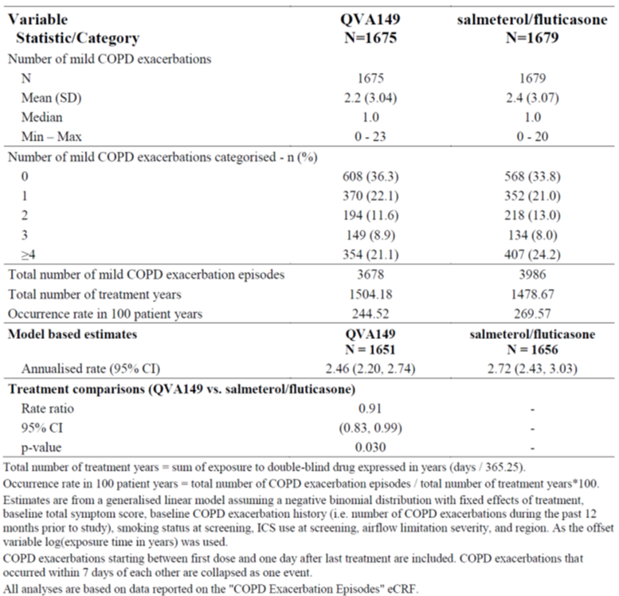

The sponsor states that mild exacerbations also have a negative impact on patient’s health status; FLAME demonstrated a significant reduction in all exacerbations as well as in the category of moderate to severe exacerbations.

***Evaluation of response:***

Table 19 below reveals the mean (SD) and the annualised rate of exacerbations in each treatment group.

Table 19: The mean (SD) and the annualised rate of exacerbations in each treatment group

| Severity | Source, CER | Mean (SD) | | Annualised rate (95% CI) | |
| --- | --- | --- | --- | --- | --- |
|  |  | QVA 149 | Salm/Flut | QVA 149 | Salm/Flut |
| Mild, moderate, severe | Table 9 | 3.0 (3.30) | 3.2 (3.27) | 3.59 (3.28, 3.94) | 4.03 (3.68,4.41) |
| Moderate, severe | Table 12 | 0.8 (1.12) | 0.9 (1.14) | 0.98 (0.88. 1.10) | 1.19 (1.07, 1.32) |
| Mild | Table on page 23 | 2.2 (3.04) | 2.4 (3.07) | 2.46 (2.20,2.74) | 2.72 (2.43,3.03) |

It is evident from the above findings that a significant proportion of the rates of exacerbation have been of mild severity. Mild severity is defined in the study protocol as, ‘a worsening of symptoms that either did not meet the above symptom definition but was treated by the investigator with systemic corticosteroids or antibiotics, or that met the symptom definition but did not receive antibiotics and/or systemic corticosteroids, was not considered a moderate or severe COPD exacerbation for the study. However, these events were captured on the COPD exacerbation CRF as mild exacerbations’.

Whilst the evaluator does not dispute the fact that mild exacerbations impact the patient’s health, it is the opinion of the evaluator that the clinical significance of these findings are inadequate to support the extension of indication. The inclusion of FLAME in Clinical Trials section of the PI ensures that the findings will assist the prescriber to be informed regarding appropriate treatment.

### Sponsor response to the clinical evaluation report

*Comment 1*

*Though statistical superiority has been shown in this study, the clinical significance of this margin is considered inadequate (and of small magnitude) to support the extension of indication.*

***Sponsor’s response:***

The sponsor disagrees with the evaluator’s comment pointing to the annualised rate of exacerbations where it states that the differences point to clinically meaningful results. Several relative benefits from large studies relating to other monotherapies are discussed; also relative risk reduction in the current FLAME study are also discussed to support that the magnitude of effect is sufficient to support the indication of ‘prevention of exacerbation’.

It also maintains that the ‘results of Study A2318 showed a consistent clinically relevant benefit of QVA149 on all exacerbation outcomes compared with salmeterol/fluticasone’.

To support the magnitude of efficacy observed in the FLAME study as clinically significant the sponsor states that, ‘it is important to note that the comparator in this trial, salmeterol/fluticasone, demonstrated a 25% annualised rate of exacerbation reduction versus placebo in TORCH (Calverley et al 2007[3]), and is one of the most commonly prescribed drugs in COPD patients who are at risk of repeated exacerbations. There is no minimal clinically important difference (MCID) in terms of reduction of COPD exacerbations as defined in regulatory Guidelines to support an indication claim for ‘prevention of exacerbations.’

***Evaluator’s comment:***

The sponsor’s response is noted.

In relation to the magnitude of efficacy noted in the TORCH study, the evaluator observes that the approved indication for Seretide does not include prevention of exacerbation, rather it is approved for, ‘the symptomatic treatment of patients with severe COPD (FEV1 < 50% predicted normal) and a history of repeated exacerbations who have significant symptoms despite regular beta-2 agonist bronchodilator therapy. Seretide is not indicated for the initiation of bronchodilator therapy in COPD’.

The sponsor states, that ‘the absolute difference in the rate of all COPD exacerbations per year was 0.44’. The evaluator maintains that the clinical significance is considered inadequate to extend indications. However, is acceptable for inclusion of FLAME study in Clinical Trials section.

*Comment 2:*

*The margin of difference also includes mild exacerbations, the rate of which could not be verified by the evaluator.*

See above.

*Comment 3:*

*There are multiple secondary endpoints and issues of multiplicity have not been factored into the statistical considerations.*

***Sponsor’s response:***

Sponsor has stated that whilst this is the case, ‘the consistency of the results across key secondary outcomes demonstrates the robustness of the findings’.

***Evaluator’s comment:***

The sponsor’s response is noted. There still remains a statistical deficiency in that the findings did not factor in the issues of multiplicity.

*Comment 4:*

*The incidence of pneumonia (as confirmed by radiographic imaging that is chest x-ray or CT scan) was numerically higher in the salmeterol/fluticasone arm (4.8%) compared to QVA149 arm (3.2%). This also suggests that the difference in exacerbations may be due to increased infections that are biologically plausible in the comparator group.*

***Sponsor’s response:***

The sponsor maintains that, ‘given the consistency of the data of study A2318 favouring QVA149, it is unlikely that higher risk of infection due to the ICS component may have driven the overall exacerbation differences between the two groups’. Several subgroup analyses are provided to support this.

***Evaluator’s comment:***

The sponsor’s response is noted.

*Comments 5-11*

*These relate to amendments recommended to the proposed PI.*

The sponsor’s responses are acceptable except for the following:

The inclusion of ‘clinical significant’ results in relation to some endpoints. The evaluator maintains that this should be removed as the PI document expresses factual findings; the term ‘clinically significant’ for results, without confirmation from accepted relevant EU Guidelines, is inappropriate, in the opinion of the evaluator.

Reference to secondary endpoints in the PI should be removed.

Relating to the extension of indication: the evaluator maintains that the data are inadequate to approve ‘prevention of exacerbations’.

## Second round benefit-risk assessment

### Second round assessment of benefits

The benefits remain the same as the first round benefits, see Section 9.1.

### Second round assessment of risks

The sponsor’s response to the Round 1 clinical evaluation report attempts to address the concerns of the evaluator identified in Section 9.2.

The response discusses the concern that the margin of difference in relation to the primary efficacy endpoint (that is rate of all COPD exacerbations observed between the two groups) lacks clinical significance to approve the indication of ‘prevention of exacerbations.’

The evaluator maintains that the difference of the rate of exacerbations, especially in relation to moderate and severe exacerbations is not of significant magnitude to warrant the extension. The sponsor cites several management guidelines to support the extension. However, the evaluator’s conclusion is that the PI document reflects the evaluated data; the prescriber has adequate information in the clinical trials section to inform regarding treatment options.

The risks identified in section 9.2 are still the same.

### Second round assessment of benefit-risk balance

The second round assessment is unfavourable to include the extension of indication, prevention of exacerbation. However the inclusion of FLAME study is acceptable in the clinical trials section.

It is noted in the EU where the FLAME study is included in the clinical trials section, the registered indication is, ‘*Ultibro Breezhaler is indicated as a maintenance bronchodilator treatment to relieve symptoms in adult patients with chronic obstructive pulmonary disease (COPD)’*.

## Second round recommendation regarding authorisation

The second round assessment is unfavourable to include the extension of indication, prevention of exacerbation. However the inclusion of FLAME study is acceptable in the Clinical Trials section.

|  |
| --- |
| Therapeutic Goods Administration |
| PO Box 100 Woden ACT 2606 Australia  Email: [info@tga.gov.au](mailto:info@tga.gov.au) Phone: 1800 020 653 Fax: 02 6232 8605  [**https://www.tga.gov.au**](https://www.tga.gov.au) |

1. Hurst JR, et al Susceptibility to exacerbation in chronic obstructive pulmonary disease. *N Engl J Med*; 2010; 63: 1128-1138.
2. Wedzicha JA, Wilkinson T (2006) Impact of chronic obstructive pulmonary disease exacerbations on patients and payers. *Proc Thorac Soc* 2006; 3: 218-221.
3. Calverley PM, Anderson JA, Celli B (2007)] Salmeterol and fluticasone propionate and survival in chronic obstructive pulmonary disease*. N Engl J Med*; 356: 775-89.