|  |
| --- |
| **September 2018** |

|  |
| --- |
| Australian Public Assessment Report for Indacaterol maleate/ Glycopyrronium bromide |
| Proprietary Product Name: Ultibro Breezhaler |
| Sponsor: Novartis Pharmaceuticals Australia Pty Ltd |

About the Therapeutic Goods Administration (TGA)

* The Therapeutic Goods Administration (TGA) is part of the Australian Government Department of Health and is responsible for regulating medicines and medical devices.
* The TGA administers the *Therapeutic Goods Act 1989* (the Act), applying a risk management approach designed to ensure therapeutic goods supplied in Australia meet acceptable standards of quality, safety and efficacy (performance) when necessary.
* The work of the TGA is based on applying scientific and clinical expertise to decision-making, to ensure that the benefits to consumers outweigh any risks associated with the use of medicines and medical devices.
* The TGA relies on the public, healthcare professionals and industry to report problems with medicines or medical devices. TGA investigates reports received by it to determine any necessary regulatory action.
* To report a problem with a medicine or medical device, please see the information on the TGA website <<https://www.tga.gov.au>>.

About AusPARs

* An Australian Public Assessment Report (AusPAR) provides information about the evaluation of a prescription medicine and the considerations that led the TGA to approve or not approve a prescription medicine submission.
* AusPARs are prepared and published by the TGA.
* An AusPAR is prepared for submissions that relate to new chemical entities, generic medicines, major variations and extensions of indications.
* An AusPAR is a static document; it provides information that relates to a submission at a particular point in time.
* A new AusPAR will be developed to reflect changes to indications and/or major variations to a prescription medicine subject to evaluation by the TGA.

Copyright

© Commonwealth of Australia 2018  
This work is copyright. You may reproduce the whole or part of this work in unaltered form for your own personal use or, if you are part of an organisation, for internal use within your organisation, but only if you or your organisation do not use the reproduction for any commercial purpose and retain this copyright notice and all disclaimer notices as part of that reproduction. Apart from rights to use as permitted by the *Copyright Act 1968* or allowed by this copyright notice, all other rights are reserved and you are not allowed to reproduce the whole or any part of this work in any way (electronic or otherwise) without first being given specific written permission from the Commonwealth to do so. Requests and inquiries concerning reproduction and rights are to be sent to the TGA Copyright Officer, Therapeutic Goods Administration, PO Box 100, Woden ACT 2606 or emailed to <[tga.copyright@tga.gov.au](mailto:tga.copyright@tga.gov.au)>.

Contents

Common abbreviations 4

I. Introduction to product submission 6

Submission details 6

Product background 6

Regulatory status 8

Product Information 9

II. Registration time line 9

III. Quality findings 9

IV. Nonclinical findings 10

V. Clinical findings 10

Introduction 10

Pharmacokinetics 10

Pharmacodynamics 10

Dosage selection for the pivotal studies 10

Efficacy 10

Safety 13

First Round Benefit-Risk Assessment 13

First round recommendation regarding authorisation 14

Second round evaluation 14

Second round benefit-risk assessment 14

VI. Pharmacovigilance findings 15

VII. Overall conclusion and risk/benefit assessment 15

Introduction 15

Quality 18

Nonclinical 18

Clinical 18

Previous clinical data 21

Risk management plan 24

Risk-benefit analysis 25

Outcome 35

Attachment 1. Product Information 35

Attachment 2. Extract from the Clinical Evaluation Report 35

## Common abbreviations

|  |  |
| --- | --- |
| Abbreviation | Meaning |
| AEs | Adverse events |
| ARTG | Australian Register of Therapeutic Goods |
| BD | Twice daily |
| CER | Clinical evaluation report |
| CI | Confidence Interval |
| COPD | Chronic Obstructive Pulmonary Disease |
| DPI | Dry powder inhaler |
| EU | European Union |
| FEV1 | Forced expiratory volume in 1 second |
| FDC | Fixed dose combination |
| FVC | Forced vital capacity |
| GPs | General practitioners |
| GOLD | Global Initiative for Chronic Obstructive Lung Disease |
| HR | Hazard ratio |
| ICS | Inhaled corticosteroids |
| LABA | Long acting β2 adrenoceptor agonist |
| LAMA | long acting muscarinic antagonist |
| MAA | Marketing Authorisation Application |
| MD | Mean difference in FEV1 |
| mMRC | Modified Medical Research Council Dyspnoea Scale |
| NNT | Number needed to treat |
| OD | Once daily |
| OR | Odds ratio |
| PBAC | Pharmaceutical Benefits Advisory Committee |
| QUM | Quality use of medicines |
| QVA149 | Indacaterol maleate /glycopyrronium bromide |
| RACGP | Royal Australian College of General Practitioners |
| RR | Relative risk |
| SAEs | Serious adverse event |
| SABA | Short acting β2 adrenergic agonist |
| SAMA | Short acting muscarinic antagonist |
| SGRG-C | St George’s respiratory questionnaire |
| TDI | Transitional Dyspnoea Index |

## I. Introduction to product submission

### Submission details

|  |  |
| --- | --- |
| *Type of submission:* | Major variation extension of indications |
| *Decision*: | Approved |
| *Date of decision:* | 4 September 2017 |
| *Date of entry onto ARTG:* | Date of entry onto ARTG |
| *ARTG number:* | 206449 |
| *Active ingredients:* | Indacaterol maleate/ glycopyrronium bromide |
| *Product name:* | Ultibro Breezhaler[1] |
| *Sponsor’s name and address:* | Novartis Pharmaceuticals Australia Pty Ltd  PO Box 101  North Ryde NSW 1670 |
| *Dose form:* | Powder for inhalation |
| *Strength:* | 110 μg indacaterol (equivalent) /50 μg glycopyrronium (equivalent) |
| *Container:* | Capsule blister pack |
| *Pack sizes:* | 6 capsules + 1 device (sample pack), 10 capsules + 1 device; 30 capsules + 1 device |
| *Approved therapeutic use:* | *Ultibro Breezhaler 110/50 is indicated as a once-daily maintenance bronchodilator treatment to relieve symptoms in patients with chronic obstructive pulmonary disease (COPD), and for the reduction of exacerbations of COPD in patients with a history of exacerbations.* |
| *Route of administration:* | Inhalation |
| *Dosage:* | 110/50 µg is taken as an inhalation once daily |

### Product background

This AusPAR describes the application by Novartis Pharmaceuticals Australia Pty Ltd (the sponsor) to register Ultibro Breezhaler for the following indication (change is indicated in bold):

*Ultibro Breezhaler110/50 is indicated as a once-daily maintenance bronchodilator treatment to relieve symptoms* ***and prevent exacerbations*** *in patients with chronic obstructive pulmonary disease (COPD).*

Chronic obstructive pulmonary disease (COPD) is the second leading cause of preventable hospital admissions in Australia with significant healthcare resource burden and costs. The prevention of exacerbations is therefore one of the primary goals in COPD management. A Long acting β2 adrenoceptor agonist/inhaled corticosteroids (LABA/ICS) fixed dose combination is current standard of care to reduce the frequency of COPD exacerbation.

Other long acting β2 adrenoceptor agonist (LABA) and long acting muscarinic antagonists (LAMAs) available on the Australian Register of Therapeutic Goods (ARTG) and their indications are described in Table 1 below. The only other agent with an indication for exacerbations is tiotropium. Interesting, prevention of exacerbation is not statement as an indication for fluticasone/salmeterol despite the clinical trial data and place in clinical practice guidelines.

Table 1: LABA and LAMA products on the ARTG

|  |  |
| --- | --- |
| Product | Indication |
| **SAMA (Short acting muscarinic antagonist)** | |
| Atrovent ipratropium bromide | Atrovent metered aerosol is indicated as a bronchodilator for maintenance treatment of bronchospasm associated with asthma and chronic obstructive pulmonary disease (COPD). |
| **LABA (Long acting β2 adrenoceptor agonist)** | |
| Serevent salmeterol xinafoate | Salmeterol also provides long-lasting (12 hour) bronchodilation for the reversible component of airways obstruction due to chronic obstructive pulmonary disease (COPD). |
| Onbrez Breezhaler indacaterol | Onbrez Breezhaler is a long-acting β2-agonist indicated for long-term, once-daily, maintenance bronchodilator treatment of airflow limitation in patients with chronic obstructive pulmonary disease. (See "Clinical Trials") |
| **LAMA (long acting muscarinic antagonist)** | |
| Bretaris Genuair aclidinium bromide | Bretaris Genuair is indicated as a long-term maintenance bronchodilator treatment to relieve symptoms in adult patients with chronic obstructive pulmonary disease (COPD). |
| Spiriva tiotropium | Spiriva is indicated for the long term maintenance treatment of bronchospasm and dyspnoea associated with chronic obstructive pulmonary disease (COPD). SPIRIVA is indicated for the prevention of COPD exacerbations |
| Seebri Breezhaler glycopyrronium bromide | Seebri Breezhaler is indicated as a once-daily maintenance bronchodilator treatment to relieve symptoms of patients with chronic obstructive pulmonary disease (COPD). |
| Incruse Ellipta umeclidinium bromide | Incruse Ellipta is indicated as a long-term once daily maintenance bronchodilator treatment to relieve symptoms in adult patients with chronic obstructive pulmonary disease (COPD). |
| **LAMA/LABA** | |
| Brimica Genuair eformoterol fumarate dehydrate/aclidinium bromide | Brimica Genuair 340/12 is indicated as a long-term twice daily maintenance bronchodilator treatment to relieve symptoms in adult patients with chronic obstructive pulmonary disease (COPD). |
| Ultibro Breezhaler 110/50 indacaterol maleate/glycopyrronium bromide | Ultibro Breezhaler 110/50 is indicated as a once-daily maintenance bronchodilator treatment to relieve symptoms in patients with chronic obstructive pulmonary disease (COPD). |
| Spiolto Respimat olodaterol hydrochloride/tiotropium bromide monohydrate | Spiolto Respimat is indicated as a once-daily maintenance bronchodilator treatment to relieve symptoms in adult patients with chronic obstructive pulmonary disease (COPD). |
| Anoro Ellipta vilanterol trifenatate/umeclidinium bromide: | Anoro Ellipta is indicated as a long-term once daily maintenance bronchodilator treatment to relieve symptoms in adult patients with chronic obstructive pulmonary disease (COPD). |
| **ICS/LABA** | |
| Seretide fluticasone propionate/salmeterol xinafoate | For the symptomatic treatment of patients with severe COPD (FEV1 < 50% predicted normal) and a history of repeated exacerbations who have significant symptoms despite regular beta-2 agonist bronchodilator therapy. Seretide is not indicated for the initiation of bronchodilator therapy in COPD. |
| Breo Ellipta fluticasone furoate/vilanterol trifenatate | Breo Ellipta is indicated for symptomatic treatment of patients with COPD with a FEV1 < 70% predicted normal (post-bronchodilator) in patients with an exacerbation history despite regular bronchodilator therapy. |
| Symbicort eformoterol/budesonide | Symbicort 200/6 is indicated for the symptomatic treatment of moderate to severe COPD (FEV1 ≤ 50% predicted normal) in adults with frequent symptoms despite long-acting bronchodilator use, and/or a history of recurrent exacerbations. Symbicort is not indicated for the initiation of bronchodilator therapy in COPD. |

### Regulatory status

The product received initial registration on the Australian Register of Therapeutic Goods (ARTG) (Submission PM-2012-04395-1-5) on 21 March 2014 for the indication:

*Ultibro Breezhaler 110/50 is indicated as a once daily maintenance bronchodilator treatment to relieve symptoms in patients with chronic obstructive pulmonary disease (COPD).*

At the time the TGA considered this application, a similar application was under consideration in Canada (submitted September 2016).

No submissions for of change of indication were under consideration in any other country at the time this application was reviewed. However an application was made to the European Medicines Agency (EMA) to include information about the FLAME study in the clinical trials section of the Summary of Product Characteristics (SmPC).

### Product Information

The Product Information (PI) approved with the submission which is described in this AusPAR can be found as Attachment 1. For the most recent PI, please refer to the TGA website at <<https://www.tga.gov.au/product-information-pi>>.

## II. Registration time line

The following table captures the key steps and dates for this application and which are detailed and discussed in this AusPAR and Attachment 2.

Table 2: Registration timeline for Submission PM-2016-02734-1-5

|  |  |
| --- | --- |
| Description | Date |
| Submission dossier accepted and first round evaluation commenced | 31 October 2016 |
| First round evaluation completed | 9 March 2017 |
| Sponsor provides responses on questions raised in first round evaluation | 5 April 2017 |
| Second round evaluation completed | 25 May 2017 |
| Delegate’s Overall benefit-risk assessment and request for Advisory Committee advice | 25 May 2017 |
| Sponsor’s pre-Advisory Committee response | 17 July 2017 |
| Advisory Committee meeting | August 2017 |
| Registration decision (Outcome) | 4 September 2017 |
| Completion of administrative activities and registration on ARTG | 6 September 2017 |
| Number of working days from submission dossier acceptance to registration decision* | 193 |

*Statutory timeframe 255 working days.

## III. Quality findings

There was no requirement for a quality evaluation in a submission of this type.

## IV. Nonclinical findings

There was no requirement for a nonclinical evaluation in a submission of this type.

## V. Clinical findings

A summary of the clinical findings is presented in this section. Further details of these clinical findings can be found in Attachment 2.

### Introduction

#### Clinical rationale

Reference is made to the clinical evaluation report for Submission PM-2012-4395-1-5[2].

#### Paediatric data

Not applicable.

#### Good clinical practice

The study has been conducted in full compliance with Good Clinical Practice (GCP).

### Pharmacokinetics

Not submitted.

### Pharmacodynamics

Not submitted.

### Dosage selection for the pivotal studies

Not submitted.

### Efficacy

#### Studies providing efficacy data

One study, Study QVA149A2318, has been submitted to support the extension of indication and the inclusion of the trial in the clinical trials section of the PI.

Study QVA149A2318 was a 52 week treatment, multi-centre, randomised, double blind, double dummy, parallel-group, active controlled study to compare the effect of QVA149 (indacaterol maleate /glycopyrronium bromide) with salmeterol/fluticasone on the rate of exacerbations in subjects with moderate to very severe COPD.

#### Evaluator’s conclusions on efficacy

The sponsor’s clinical summary states that, in relation to COPD, ‘approximately 50% of patients, including those with only moderate airflow obstruction, have at least one exacerbation per year. Furthermore, 22% of COPD patients with moderate airflow obstruction and 33% of patients with severe obstruction have at least 2 exacerbations per year (Hurst et al 2010)[3]. Exacerbations impact patients of varying COPD severities. The prevention of only one COPD exacerbation of any severity may have a significant effect on patient outcomes (Wedzicha and Wilkinson 2006)[4]. There is also evidence that exacerbations, particularly more frequent exacerbations, are responsible for accelerating the progression of the disease, leading to earlier development of disability, respiratory failure, and death. Thus, an important goal of COPD management is to prevent exacerbations (Global Initiative for Chronic Obstructive Lung Disease (GOLD) 2016)’.

This study showed that QVA149 was statistically superior to salmeterol/fluticasone in relation to the primary efficacy endpoint that is rate of all COPD exacerbations. This is the basis for the proposed extension of indications, ‘prevention of exacerbations’. This is based on the mean (SD) exacerbations of 3.0 (3.30) in QVA149 group versus 3.2 (3.27) in the salmeterol/fluticasone group. This finding relates to all severities of exacerbations (mild, moderate and severe). Thus, the evaluator questions the clinical relevance of this margin of difference to support the indication of ‘prevention of exacerbation’. It is noted that moderate to severe categories of exacerbation were 0.8 (1.12) and 0.9 (1.14) respectively, see Table 3. It would seem that a significant proportion was mild exacerbation. The sponsor should provide, in the post-first round response, the number of mild exacerbations: mean (SD), number of COPD exacerbations categorised, annualised rate and rate ratio as expressed in Table 3 for moderate to severe exacerbations. If this analysis is already included in the dossier, the sponsor should provide its location.

Table 3: Summary and generalised linear model for the rate of moderate or severe COPD exacerbation

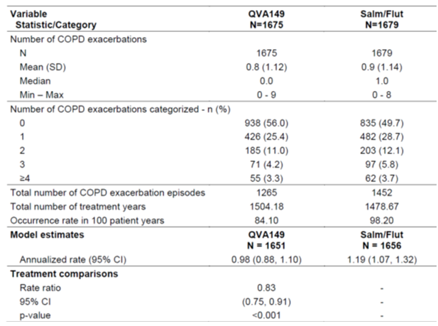

The secondary efficacy endpoints are presented in Attachment 2, Section 7.2.11. Some endpoints showed statistical superiority favouring QVA149 over the comparator. However, the evaluator questions the clinical relevance of the magnitude of these findings: for example, time to first COPD exacerbation is expressed in median time and is a crude index. The rate ratio of exacerbation rate of moderate or severe exacerbation of 0.83, 95% confidence interval (CI) 0.75, 0.91, p < 0.001 is of limited clinical relevance. Similarly, pre‑dose forced expiratory volume in 1 second (FEV1) over time (62 to 86 mL) is also of limited clinical relevance indicating that the rate of progression of disease was not significantly different between groups.

In addition, there are multiple secondary endpoints; the study report states that no multiplicity adjustments were performed on any secondary endpoints giving rise to concerns about the statistical validity of these results.

Whilst this study provides some evidence of efficacy, the magnitude of efficacy is inadequate to support the extension of indications to include ‘prevention of exacerbation’. In addition, prevention also correlates to reduced progression of disease. This would mean that prevention of exacerbation would indirectly alter the course of COPD. Altering the course needs to be confirmed with studies earlier in the course of the illness, see the European Union (EU) Guideline.[5]

The original report (PM-2012-4395-5)2 discussed a study where the primary efficacy endpoint was the exacerbation rate (moderate to severe as per the GOLD definition). This study was Study A2304 where the inclusion criterion was severe and very severe COPD; see that report where one of the treatment arms was QVA149. The study duration was 64 weeks where it is reported that the mean (SD) number of moderate to severe exacerbations in the QVA149 group was 1.11 (1.3). Whilst cross study comparison has its limitations, especially as the inclusion criterion was a more severe COPD, the results are in line with that reported in the current study. That study was considered (by the evaluator of the original submission), insufficient to support the proposed indication that QVA149 reduces exacerbations.

### Safety

#### Studies providing safety data

The pivotal study provided safety data on QVA149. The details of safety monitoring are similar to those of previously submitted data, (see PM-2012-4395-1-5).2

#### Patient exposure

Table, shown below, gives data related to patient exposure.

Table 4: Patient exposure

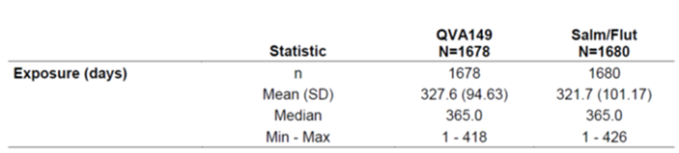

Compliance was high in both treatment arms, with a mean of approximately 99% of days where drug was taken as per protocol over the treatment period.

#### Adverse events

##### All adverse events (irrespective of relationship to study treatment)

The overall incidence of adverse events (AE) was similar across the treatment arms. The most commonly (approximately 80%) affected primary System Organ Class (SOC) was respiratory, thoracic and mediastinal disorders, followed by infections and infestations. The incidence of infection and infestation AEs was 42.3% in the QVA149 arm versus 48% in the salmeterol/fluticasone arm.

For the full evaluation of safety please see Attachment 2.

#### Evaluator’s conclusions on safety

This 52 week study provides adequate evidence of safety and supports the safety findings obtained in the original submission. No undue safety concerns were identified.

### First Round Benefit-Risk Assessment

#### First round assessment of benefits

* This study was designed as a non-inferiority study and then if non-inferiority was shown, as a superiority study in relation to the primary efficacy endpoint which was the rate of exacerbation. This study met these expectations.
* Exacerbations were well defined; the COPD inclusion was moderate to severe.
* The study was well designed and the duration was adequate.
* Safety results were in line with those described in the original submission.
* The clinical study has adequate efficacy and safety data to include in the Clinical Trials section (of the PI).

#### First round assessment of risks

* Though statistical superiority has been shown in this study, the clinical significance of this margin is considered inadequate (and of small magnitude) to support the extension of indication.
* The margin of difference also includes mild exacerbations, the rate of which could not be verified by the evaluator.
* There are multiple secondary endpoints and issues of multiplicity have not been factored into the statistical considerations.
* The incidence of pneumonia (as confirmed by radiographic imaging that is chest x-ray or CT scan) was numerically higher in the salmeterol/fluticasone arm (4.8%) compared to QVA149 arm (3.2%). This also suggests that the difference in exacerbations may be due to increased infections that are biologically plausible in the comparator group.

#### First round assessment of benefit-risk balance

The first round assessment is unfavourable to include the extension of indication, prevention of exacerbation. However the inclusion of FLAME study is acceptable in the PI Clinical Trials section, provided the amendments recommended by the evaluator are made.

### First round recommendation regarding authorisation

The first round assessment is unfavourable to include the extension of indication, prevention of exacerbation. However the inclusion of FLAME study is acceptable in the PI Clinical Trials section provided the amendments recommended by the evaluator are made.

### Second round evaluation

For details of the second round evaluation including the issues raised by the evaluator (clinical questions), the sponsor’s responses and the evaluation of these responses please see Attachment 2.

### Second round benefit-risk assessment

#### Second round assessment of benefits

The benefits remain the same as the first round benefits, see above.

#### Second round assessment of risks

The sponsor’s response to the first round clinical evaluation report attempts to address the concerns of the evaluator identified in the first round assessment of risks.

The response discusses the concern that the margin of difference in relation to the primary efficacy endpoint (that is rate of all COPD exacerbations observed between the two groups) lacks clinical significance to approve the indication of ‘prevention of exacerbations.’

The evaluator maintains that the difference of the rate of exacerbations, especially in relation to moderate and severe exacerbations is not of significant magnitude to warrant the extension. The sponsor cites several management guidelines to support the extension. However, the evaluator’s conclusion is that the PI document reflects the evaluated data; the prescriber has adequate information in the clinical trials section to inform regarding treatment options.

The risks identified in the first round assessment of risks are still the same.

#### Second round assessment of benefit-risk balance

The second round assessment is unfavourable to include the extension of indication, prevention of exacerbation. However the inclusion of FLAME study is acceptable in the PI clinical trials section.

It is noted in the EU where FLAME is included in the clinical trials section, the registered indication is, ‘*Ultibro Breezhaler is indicated as a maintenance bronchodilator treatment to relieve symptoms in adult patients with chronic obstructive pulmonary disease (COPD)’*.

## VI. Pharmacovigilance findings

The TGA granted a waiver from the requirement for a Risk Management Plan for this application.

## VII. Overall conclusion and risk/benefit assessment

The submission was summarised in the following Delegate’s overview and recommendations:

### Introduction

Indacaterol is a long acting β agonist. Glycopyrronium is an anticholinergic, long acting M1-5 muscarinic receptor antagonist. Both agents are used for symptomatic treatment of COPD by opening up the airways. It is important to note that the benefits observed in symptom control and improvements in FEV1 are only observed while patients are taking these medications.

The classification of COPD has changed over time; now based on symptoms score and risk of exacerbations.

COPD is a chronic and progressive disorder. In clinical practice, main challenges are diagnosis (differentiating COPD from asthma and encouraging general practitioners (GPs) to perform spirometry), optimising therapy. Most patients with COPD are managed by GPs. The aim of management of COPD is to prevent disease progression, relieve symptoms, improve exercise tolerance, improve health status, prevent and treat complications, prevent and treat exacerbations, reduce mortality. A LABA or LAMA is indicated as first line therapy for COPD. Combination therapy is now increasingly being used for patients with symptoms despite use of either LAMA or LABA. The Lung foundation of Australia/Thoracic Society of Australia and New Zealand / and RACGP[6] have developed COPD-X guidelines to assist practitioners diagnosing and managing COPD.[7] Figure 1 illustrates the current treatment algorithm.

Figure 1: Current Algorithm for COPD treatment

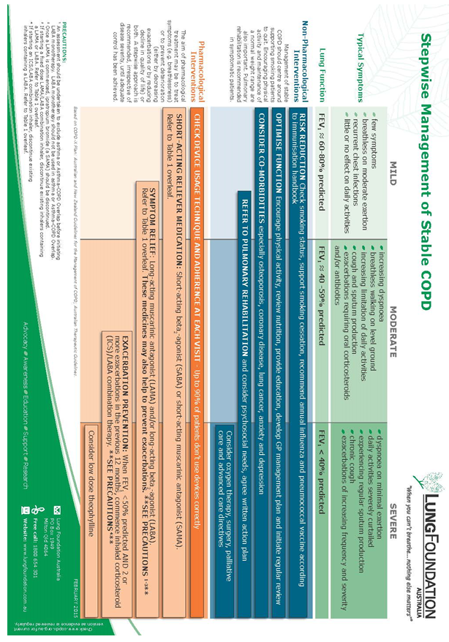

The ‘Form for providing PI for a restricted medicine or other medicine in relation to which the secretary requires PI to be provided’ states for Indications ‘the therapeutic applications should be stated clearly and concisely, and should define the target disease or condition, distinguishing between treatment (symptomatic, curative, or modifying the evolution or progressions of the disease), prevention and diagnostic indications.’

### Quality

There was no requirement for a quality evaluation in a submission of this type.

### Nonclinical

There was no requirement for a nonclinical evaluation in a submission of this type.

### Clinical

#### Clinical trials

##### FLAME; Study QVA 149A2318

A single clinical trial was submitted, the FLAME study (Study QVA 149A2318). This study has also been published.[8]

###### Design

A 52 week, multicentre, randomised, double blind, double dummy, parallel group, active controlled study to compare the effect of indacaterol/glycopyrronium with salmeterol/fluticasone on the rate of severe exacerbations in COPD.

###### Inclusion criteria

* age > 40 years
* COPD diagnosis according to GOLD criteria 2011[9]
* smoking history of 10 pack years
* at least one exacerbation requiring systemic corticosteroids and/or antibiotics in the previous 12 months
* post bronchodilator FEV1 25 to 60% predicted
* post bronchodilator FEV1/ forced vital capacity (FVC) < 0.7
* Modified Medical Research Council Dyspnoea Scale (mMRC) Grade of at least 2.

###### Treatments

Indacaterol/glycopyrronium 110/50µg DPI daily or placebo versus salmeterol/fluticasone 50/500µg twice daily (BD) or placebo

###### Efficacy endpoints

Primary

* rate of COPD exacerbations (see explanation below)

Secondary

* time to first COPD exacerbation
* rate and time of moderate/severe exacerbation
* change from baseline in pre-dose FEV1 and FVC
* FEV1 AUC
* symptoms and rescue medication use
* SGRQ-C

###### Statistics

The study was designed as a non-inferiority study with a limit of rate ratio of 1.15. If non inferiority was confirmed, superiority was tested.

###### Baseline data

Most patients had moderate or severe COPD (see Tables 3 and 4 in Attachment 2). A total of 3,362 patients were randomised.

56.3% were using inhaled corticosteroids (ICS) at Screening, 67.1% were using LABA, 46.5% ICS/LABA, 60.6% were using LAMA.

Table 5: Severity of COPD at Baseline

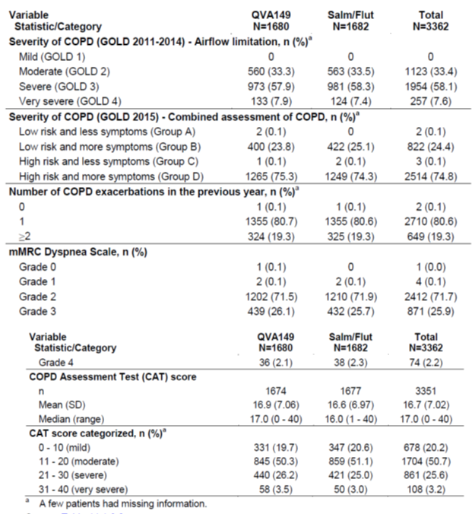

###### Primary efficacy

Annualised rate of all COPD exacerbations were; indacaterol/glycopyrronium 3.59 (3.28 to 3.94) versus salmeterol/fluticasone 4.03 (3.68-4.41). Rate ratio 0.89 (0.83-0.96). Absolute risk reduction 0.44 exacerbations per year. Most exacerbations were mild

Table 6: Summary and generalized linear model for the rate of COPD exacerbations (mild, moderate or severe) during double blind treatment (per protocol set)

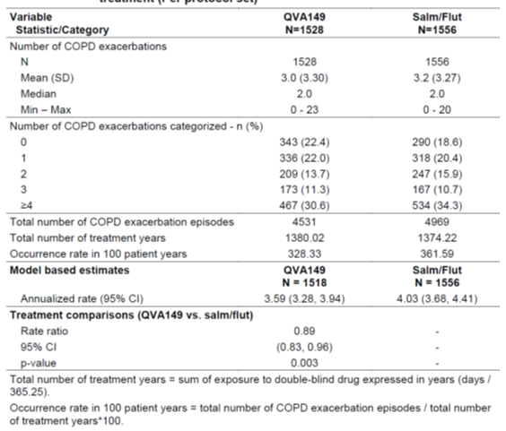

###### Secondary efficacy endpoints

(Please see Attachment 2 Section 7.2.1.1)

* prolonged time to first exacerbation
* reduced rate of moderate to severe exacerbations
* greater improvement in SGRQ with indacaterol/glycopyrronium
* less use of rescue medication

###### Safety

AE were similar in the two groups. The incidence of infection and infestation was 42.3% in indacaterol/glycopyrronium and 48% in salmeterol/fluticasone. Moderate and severe AE were slightly more common with salmeterol/fluticasone than indacaterol/glycopyrronium.

More pneumonia with salmeterol/fluticasone than indacaterol/glycopyrronium.

SAE and deaths were similar between treatment groups.

###### COPD exacerbation

COPD exacerbation is defined as: a worsening of the following two or more major symptoms for at least 2 consecutive days:

* dyspnoea
* sputum volume
* sputum purulence

or; a worsening of any 1 major symptom together with an increase in any one of the following minor symptoms for at least 2 consecutive days:

* sore throat
* colds (nasal discharge and/or nasal congestion)
* fever without other cause
* cough
* wheeze.

‘For the purposes of this study, the type of treatment provided for a COPD exacerbation determined the severity of the exacerbation. A worsening of symptoms that met the above symptom definition that was not treated with systemic corticosteroids and/or antibiotics was considered a mild COPD exacerbation. A COPD exacerbation was considered of moderate severity if treatment with systemic corticosteroids or antibiotics or both was required and severe, if hospitalisation was required (in addition to treatment with systemic corticosteroids and/or antibiotics). An emergency room visit of longer than 24 hours was considered a hospitalisation. A COPD exacerbation that required an emergency room visit for less than 24 hours was of moderate severity, providing the exacerbation was treated with systemic corticosteroids or antibiotics or both’.

#### Clinical evaluator’s recommendation

The second round assessment is unfavourable to include the extension of indication, prevention of exacerbation. However the inclusion of FLAME study is acceptable in the clinical trials section (of the PI).

### Previous clinical data

#### Submission PM-2012-04395-1-05 initial application for the fixed dose combination (FDC) indacaterol/glycopyrronium

The sponsor proposed reductions in exacerbations in the indication for this submission, however this was rejected by the Delegate and ACPM as they considered that the efficacy was not adequately demonstrated.

##### Study A2303

This was 26 week, multinational, randomised, double blind, parallel group, placebo and active controlled study to assess the efficacy and safety of indacaterol/glycopyrronium in moderate to severe COPD. The primary efficacy outcomes were trough FEV1 and symptom control. A total of 2,144 patients were randomised. There were significant improvements in mean trough FEV 1 in the indacaterol / glycopyrronium arm compared with glycopyrronium (70 mL) and indacaterol (90 mL) (p < 0.001).In the indacaterol/glycopyrronium group there was a statistically significant improvement in symptom score compared with placebo at 26 weeks. There were less moderate or exacerbations in the indacaterol/glycopyrronium treatment arm compared to placebo, but similar rates to that observed with tiotropium and monotherapy with indacaterol or glycopyrronium.

Table 7: Summary statistics of the number of moderate or severe COPD exacerbations over 26 weeks of treatment Full Analysis Set

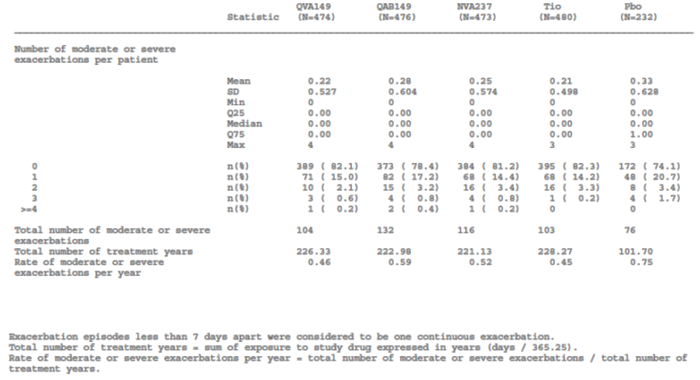

QAB; 150μg indacaterol NVA; 50 μg glycopyrronium Tio18 μg tiotropium

##### Study A2304

This was a multi-centre, randomised, double blind, parallel group, active controlled study to compare the effects of indacaterol/glycopyrronium to glycopyrronium and open label tiotropium on COPD exacerbations in patients with severe to very severe COPD. The primary objective was to demonstrate superiority of indacaterol/glycopyrronium (110/50 μg once daily (OD)) to glycopyrronium (50 μg OD) measured by the rate of moderate to severe COPD exacerbations over a 64 week treatment period. The main secondary objective was to demonstrate superiority of indacaterol/glycopyrronium (110/50 μg OD) to open label tiotropium (18 μg OD) for the same endpoint.

In the modified full analysis data set, there were 812 exacerbations in the indacaterol/glycopyrronium group compared with 900 in the glycopyrronium group , comparative rate reduction of 12% (relative risk (RR) 0.88, 95% CI: 0.77, 0.99, p = 0.038). In the per protocol set there were 760 exacerbations in the indacaterol/glycopyrronium group compared with 838 in the glycopyrronium group with a comparative rate reduction of 10% (RR 0.89, 95% CI: 0.79, 1.01, p = 0.08). The rate of exacerbations per year was 0.94 in the indacaterol/glycopyrronium group compared with 1.07 in the glycopyrronium group. In patients with baseline FEV1 reversibility ≤ 12%, there was no rate reduction in the indacaterol/glycopyrronium group compared with the glycopyrronium group. In patients with baseline FEV1 reversibility > 12%, the rate reduction in the indacaterol/glycopyrronium group (n = 399) compared with the glycopyrronium group (n = 438) was statistically significant (RR 0.80, 95% CI: 0.68, 0.93, p < 0.05).

##### Study 2307

It was a multi-centre, randomised, double blind, placebo controlled assessment of the long term safety of 52 weeks treatment with indacaterol/glycopyrronium (110/50) in patients with moderate to severe COPD. The main objective was to assess the safety and tolerability of indacaterol/glycopyrronium OD on the AE reporting rate. There was no reduction in exacerbation rate in this study.

Table 8: Most frequent AEs (including COPD exacerbations) (at least 1.0% in the QVA149 treatment group) by Preferred Term; n(%) of patients (safety set)

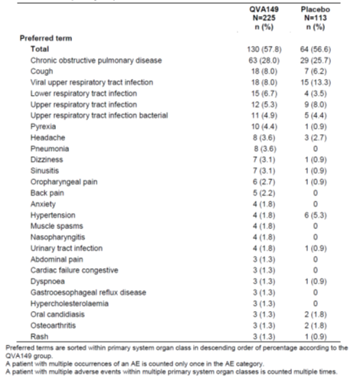

Table 9: Adjudicated cause of deaths adjusted for exposure by category (safety set)

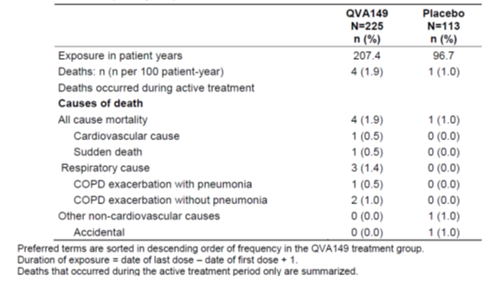

### Risk management plan

There was no risk management plan (RMP) as part of this submission; however the sponsor submitted an updated RMP and Australian-Specific Annex (ASA) (version 4 to EU RMP version 2.1). This is acceptable.

Table 10: Summary of safety concerns

|  |  |
| --- | --- |
| Summary of Safety Concerns: | |
| Important identified risks | QTc prolongation  Ischemic heart disease  Myocardial infarction  Cardiac Arrhythmias  Cardiac failure  Cerebrovascular Events  Hyperglycaemia  Hypokalaemia  Narrow angle glaucoma  Bladder obstruction/urinary retention  Use in patients with severe renal impairment and ESRD  Paradoxical bronchospasm  Atrial fibrillation |
| Important potential risks | Intubation, hospitalization and death due to asthma related events in asthma  Medication errors  Interactions with- drugs known to prolong the PI interval, sympathomimetic agents, beta adrenergic blockers |
| Missing Information | Use in unstable, clinically significant cardiovascular conditions  Use in patients with prolonged QTc at baseline or long QTc syndrome  Use in patients with T1DM or T2DM  Use in patients with severe liver impairment  Use in patients with moderate-severe renal impairment  Long term exposure to medication beyond 18 months  Use in COPD not related to smoking or smoking exposure less than 10 pack years  Use in pregnancy and lactation  Use in patients with ethnic origin other than Caucasian or Asian |

### Risk-benefit analysis

#### Delegate’s considerations

The evaluator’s main concern was in relation to the suboptimal efficacy that this medicine had on treatment efficacy.

##### Evidence of efficacy

Although the Delegate agreed the treatment effect was small, it is similar to what has been observed in other studies to prevent exacerbation in this patient subgroup. For example, tiotropium was given this indication with a hazard ratio (HR) of 0.86 95% CI 0.91 to 0.91 for exacerbations, even though this was not a primary endpoint for the study.[10]

Fluticasone/salmeterol combinations are used by clinicians in patients at risk of exacerbations based on the reduced risk of exacerbations in the TORCH study (rate ratio 0.75 (95%CI 0.69 to 0.81) compared to placebo, or 0.88 (95% CI 0.81 to 0.95) compared to salmeterol), however this was also a secondary endpoint.[11] In the FLAME study fluticasone/salmeterol was used as the comparator, so the risk reduction relative to placebo may be even greater.

There are a number of limitations with the clinical trial. The use of ICS/LABA comparator could be questioned as these are not equally placed in the treatment algorithm. The definition of exacerbations, particularly mild exacerbations, is somewhat subjective and may be prone to error. An exacerbation of COPD may be confused with asthma, infection, heart failure or a viral illness. There were large patient numbers but a low event rate. The low rate of events has been a problem with other studies that have used risk of exacerbations as an endpoint as any small change in exacerbations or patient population can lead to significant changes in the results. The subjective nature of mild exacerbations is also problematic.

When a single pivotal trial is used to support a new indication, the evidence needs to be robust. Although this may not be the case with this study, there are a number of other meta-analysis that support the use of LABA/LAMA combinations to prevent exacerbations. In a Cochrane review;[12] compared to the LABA + ICS arm, LAMA + LABA arm reduced exacerbations (odds ratio (OR) 0.82 (95% CI 0.70 to 0.96); serious adverse events (SAE), OR 0.91 (95% CI 0.79 to 1.05); and trough FEV1 change from the baseline, mean difference in FEV1 (MD) 0.08 L (95% CI 0.06 to 0.09) pneumonia, OR 0.57 (95% CI 0.42 to 0.79); all-cause death, OR 1.01 (95% CI 0.61 to 1.67); and SGRQ total score change from the baseline of 4 points or greater OR 1.25 (95% CI 1.09 to 1.44). A pooled analysis in patients with GOLD B and D also demonstrated benefits in lung function, symptoms, and exacerbations.[13] A network meta-analysis showed LABA/LAMA combinations were associated with a significantly greater proportion of St George’s respiratory questionnaire (SGRQ) and Transitional Dyspnoea Index (TDI) responders than monotherapies and fewer moderate-to-severe exacerbations compared with LABAs but not when compared with LAMAs. However, there were no statistically significant differences associated with LABA/LAMA combinations compared with monotherapies in safety outcomes as well as in severe exacerbations.[14]

Treatment with indacaterol/glycopyrronium is associated with less side effects than fluticasone/salmeterol. The TGA has been involved with a COPD working group with the PBS and other stakeholders. There is concern about the overuse of ICS/LABA in the community.

##### Is a new indication warranted?

The current indication defines the treatment population: COPD. It also describes the treatment as for symptomatic relief. The new indication of prevent exacerbation is a different treatment paradigm in that it proposes an alteration in the evolution or progression of disease.

To approve this new indication would place this medicine above others in this class for its range of therapeutic effect.

However not to approve this indication would not restrict the use of this medicine as patients at risk of exacerbations are generally symptomatic of COPD.

In the response to questions, the sponsor gave a number of reasons for including this indication:

* the CHMP guidelines (as well as the GOLD guidelines;[15] COPD-X guidelines;[16] and WHO[17]) all consider prevention of exacerbations as an important outcome
* the reduction in exacerbations was supported by the FLAME study, and the reduction in this study was superior to that seen in the studies submitted with the original submission
* the results of the FLAME study show indacaterol/glycopyrronium was at least non inferior to salmeterol/fluticasone which is already used to prevent exacerbations with efficacy demonstrated in the TORCH study
* current prescribing patterns in Australia suggest over prescribing of ICS/LABA and under prescribing of LAMA/LABA which is not consistent with guidelines. The sponsor has proposed that by adding the prevention of exacerbations to the indacaterol/glycopyrronium indications this may reverse this trend
* use of ICS to prevent exacerbations increases the risk of pneumonia
* There are limitations in the data; however the available evidence does suggest a small reduction in exacerbations. The Delegate accepted there are problems in conducting clinical trials looking at exacerbations due to the infrequency of such events and the difficulties in clearly defining these.

###### Conclusion

Most of the clinical trials have been in moderate/severe COPD whereas the current indication does not specify this. Long term studies have indicated that the use of LAMA/LABA increases FEV1 over placebo, but subsequent rate of subsequent decline is parallel to placebo. Thus, there is no evidence that early therapy in mild would be of benefit over moderate/severe disease.

The Delegate recommended some changes to the PI to avoid over reporting of outcomes however presentation of this is beyond the scope of the AusPAR.

##### Questions for sponsor

1. Please calculate the number needed to treat (NNT) to prevent 1 exacerbation per year; taking into account duration of therapy, and compare this to tiotropium and salmeterol/fluticasone.
2. What was the reason for not suggesting the additional indication for prevention of exacerbation in Europe and the USA?

##### Summary of Issues

* there was one single clinical study to support this indication.
* the evaluator did not believe the magnitude of the increase in exacerbations was significant enough to warrant a new indication
* the new wording of the indications would not change the patient population in which the medicine is indicated for
* however early use of LAMA/LABA is proposed in the COPD guidelines and has advantages over current ICS/LABA in terms of safety
* the evidence presented is mainly for moderate/severe COPD however the current indications do not specify severity.

#### Proposed action

The Delegate recommendation would be to approve the indication:

*Ultibro Breezhaler110/50 is indicated as a once-daily maintenance bronchodilator treatment to relieve symptoms and prevent exacerbations in patients with chronic obstructive pulmonary disease (COPD).*

And that the application for the extension of indication (to include prevention of exacerbations) for indacaterol maleate/glycopyrronium bromide should be approved for registration.

#### Request for ACPM advice

1. Is the reduction in exacerbations seen in the FLAME study clinically meaningful?
2. Is a new indication to prevent exacerbations acceptable
3. Is there a need to specify severity in the indications?

The committee is (also) requested to provide advice on any other issues that it thinks may be relevant to a decision on whether or not to approve this application.

#### Response from sponsor

Presented here is the sponsor’s pre-ACM response to the Delegate’s overview (DO) pertaining to our application to vary the indication of Ultibro Breezhaler (indacaterol/glycopyrronium) to include a statement referring to the reduction of exacerbations in patients with a history of exacerbations. Ultibro contains indacaterol, a long acting β agonist (LABA), and glycopyrronium, an anticholinergic long acting M1-5 muscarinic receptor antagonist (LAMA).

The sponsor welcomes the Delegate’s preliminary assessment to approve our application to include prevention of exacerbations in the Ultibro indication as well as to include the exacerbation data in the ‘clinical trials’ section of the PI. The sponsor respectfully took the opportunity to comment on the specific advice sought by the Delegate from the ACM, to address the central question raised by the Delegate as to why we believe a change to the indication is warranted. The sponsor also responded to the Delegate’s ‘Questions for the sponsor’. Where appropriate, our comments have been cross referenced to the original marketing authorisation application (MAA), the clinical evaluation report (CER), the sponsor’s response to the CER dated 7 April 2017, or the Delegate’s overview. Please note that in our response below, the Delegate’s comments have been italicised for ease of reference.

The sponsor brings to the attention of the Committee that an alternative wording of the indication was proposed with our response to the CER on 26 June 2017. The amended proposed indication is as shown below (additions in bold, deletions struck though):

*Ultibro Breezhaler110/50 is indicated as a once-daily maintenance bronchodilator treatment to relieve symptoms ~~and prevent exacerbations~~ in patients with chronic obstructive pulmonary disease (COPD),* ***and for the reduction of exacerbations of COPD in patients with a history of exacerbations****.*

Novartis believes this change is warranted and will help address key concerns raised by the Delegate:

* that current prescribing patterns in Australia suggest over prescribing of ICS/LABA and under prescribing of LAMA/LABA which is not consistent with guidelines;
* concerns over the overuse of ICS/LABA in the community, while treatment with LAMA/LABA is associated with less side effects than ICS/LABA, and
* the use of ICS to prevent exacerbations increases the risk of pneumonia.

In addition, the proposed indication aligns with the revised wording suggested by Health Canada as part of the ongoing regulatory review, and is consistent with the study population enrolled in the pivotal clinical trial which included patients with a documented history of at least one COPD exacerbation requiring systemic glucocorticosteroids and/or antibiotics in the previous 12 months.

***A change to the indication is warranted***

LABA/LAMA combinations in Australia are currently registered for the symptomatic treatment of COPD. Novartis maintains the firm view that a change to the indication to include reduction of COPD exacerbations in patients with a history of exacerbations is warranted. Even though the current indication does not prevent patients from accessing LABA/LAMA combinations, Australian respiratory physicians highlighted that risk of exacerbations is a legitimate and important target for therapy, and this should therefore be reflected in the indication where data are available. Ultibro is the only registered LABA/LAMA product with proven efficacy in reducing exacerbation rates in randomised controlled clinical trial. The proposed changes to the PI will better define the optimal therapeutic application on the medicine and reinforce current treatment guidelines.

Exacerbations are important events in the disease cycle and their effect should not be underestimated. It often leads to a poor quality of life and more rapid decline in lung function compared to those who do not have exacerbations. Our application is supported by the evidence accumulated to date. The proposal for an amended indication is primarily based on the totality and consistency of the results of the FLAME study, a large multinational, 52 week, controlled, randomised, dedicated exacerbation study, enrolling 3,362 patients, which demonstrated statistically significant superiority versus a relevant active comparator commonly used in Australian clinical practice (salmeterol/fluticasone) to reduce COPD exacerbations of all severity (mild, moderate and severe) by 11% in patients with moderate to very severe COPD (primary endpoint). In current local clinical practice, it is well established that exacerbation reduction is the most important effect of inhaled corticosteroids (ICS) combinations. A feature of this randomised, double blind study was that COPD exacerbations were carefully monitored with daily symptom recordings and captured by an electronic diary using the commonly accepted and standardised Anthonisen definition;[18],[19] making it possible to document all exacerbations (mild, moderate and severe) including of note, moderate and severe exacerbations requiring healthcare utilisation (defined as those requiring oral steroids, antibiotics or hospital admission);[20] therefore allowing for robust data generated in support of the current indication change application.

In addition to the FLAME study, the results of a previous exacerbation study conducted with Ultibro, the SPARK study (Study A2304; n = 2,224), shows that Ultibro has an effect on reducing COPD exacerbations in patients with moderate to severe COPD. In this 64 week study the overall rate of moderate to severe COPD exacerbations per year was 0.94 for the LABA/LAMA combination and 1.07 for the LAMA monotherapy component. The 12% reduction in the rate was statistically significant and clinically meaningful. The absolute difference in the rate of exacerbations per year between the LABA/LAMA and LAMA monotherapy was 0.13. These data were presented in our original MAA, however alone, were not deemed sufficient to support an exacerbation claim in the indication.

Importantly, the reduction rates for moderate or severe COPD exacerbations (regardless of disease severity) observed in FLAME were similar to that observed and reported in the literature.

Table 11: Comparison of moderate to severe COPD exacerbation rate reductions amongst products registered in Australia for the treatment of exacerbation

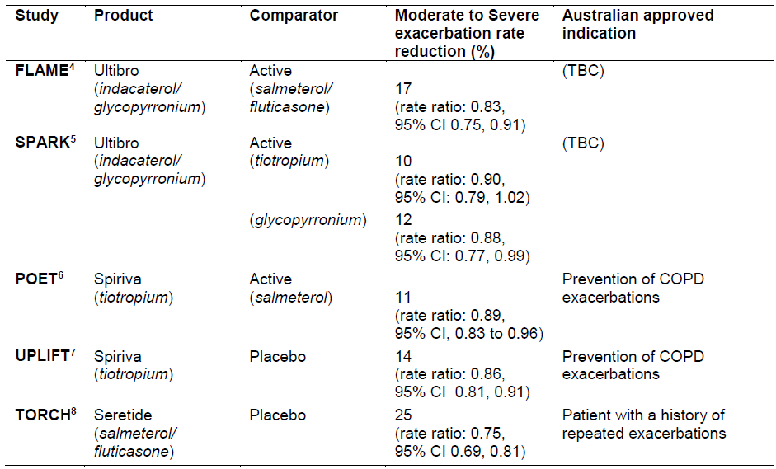

For the following studies, see the relevant footnotes: FLAME4 see[21]; SPARK5 see[22]; POET6 see[23]; UPLIFT7 see[24]; TORCH8 see[25]

On the basis of the FLAME and SPARK studies, the Canada label was approved with the following (additions in bold):

*Ultibro Breezhaler(indacaterol maleate and glycopyrronium bromide) is a combination of a long-acting beta2-agonist (LABA) and a long-acting muscarinic antagonist (LAMA), indicated for the long-term once-daily maintenance bronchodilator treatment of airflow obstruction in patients with chronic obstructive pulmonary disease (COPD), including chronic bronchitis and emphysema****, and for the reduction of exacerbations of COPD in patients with a history of exacerbations.***

The clinical evaluator acknowledged that FLAME is a well-designed study which showed consistent superiority on all exacerbation outcomes, thereby validating the robustness of the findings to support the indication change. Even though the evaluator did not consider the magnitude of exacerbation reduction was significant enough to warrant a new indication, they felt it could be included in the clinical trial section of the PI. Novartis disagrees with the clinical evaluator’s assessment which is at odds with the Delegate’s recommendation to approve an amended indication that better defines the target population that benefits in the clinical trials. Including ‘reduction of exacerbations’ to the indication is consistent with the approved indication salmeterol/fluticasone, a widely recognised standard of care for the reduction of exacerbations, which is indicated in patients with a history of repeated exacerbations who have significant symptoms despite regular β2 agonist bronchodilator therapy. The demonstrated superiority of Ultibro over salmeterol/fluticasone is further justification that the therapeutic effect is clinically significant. An amendment to the indication would reinforce prescribing of LAMA/LABA over ICS/LABA to prevent exacerbations in accord with current treatment guidelines.

In FLAME, Ultibro reduced the rate of all exacerbations by 11% against the active comparator, salmeterol/fluticasone, one of the most commonly prescribed drugs in Australia for COPD patients who are at risk of repeated exacerbations. It is important to note that in the TORCH study (considered a landmark trial), efficacy for salmeterol/fluticasone was compared against placebo. When compared to FLAME, Ultibro clearly sets a new clinical benchmark as it demonstrated what would be a 25% annualised rate of exacerbation reduction if compared to placebo. Symptoms and exacerbations are major factors that drive treatment decisions and current guidelines recognise the step by step pharmacotherapy approach. It should be noted that there is no minimal clinically important difference in terms of reduction of COPD exacerbations defined in regulatory guidelines to support an indication of ‘reduction of exacerbations’. However, a 17% incremental benefit with Ultibro on top of salmeterol/fluticasone and 12% improvement with Ultibro compared to glycopyrronium (the SPARK study) in the rate of moderate or severe COPD exacerbations is remarkable and clinically meaningful.

Moreover, the 22% risk reduction of a moderate or severe COPD exacerbation with Ultibro on top of salmeterol/fluticasone (FLAME) is clinically significant. This risk reduction is larger than that observed in the POET and UPLIFT studies, which only compared a monotherapy to another monotherapy or to placebo. None of these studies compared a dual bronchodilator combination therapy to an ICS/LABA combination therapy, as in the FLAME study. Thus in context of the relevance of the effect size, the results from FLAME, a study designed to challenge the current COPD treatment algorithm, have wider implications to the treatment of COPD exacerbations.

Table 12: Comparison of exacerbation risk reduction for products approved in Australia for the prevention of COPD exacerbations

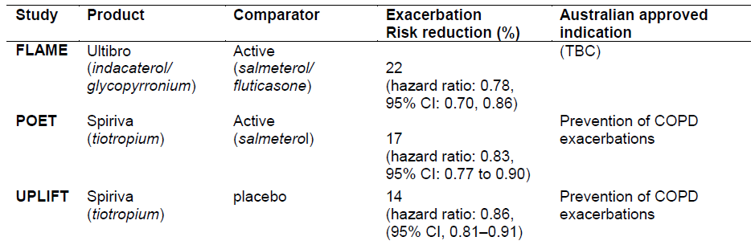

In addition and importantly, the number needed to treat (NNT) in the FLAME study was in favour of Ultibro. It is quite common for clinicians to examine the NNT as an expression of what effect a drug may have. NNT is a direct measure of effectiveness of an intervention which is treatment specific and describes the differences between a treatment and a control group in achieving a particular outcome. It can be used to describe any outcome where event rates are available for both treatment and control. For Ultibro versus salmeterol/fluticasone, the NNT was 22.7 for all exacerbations and 14.9 for moderate or severe exacerbations, calculated from the Week 52 Kaplan-Meier event rates. This means that 15 patients would require treatment with Ultibro for 52 weeks, versus salmeterol/fluticasone, to prevent 1 patient from having any moderate or severe exacerbation. Thus, Ultibro can provide additional clinically meaningful benefits to exacerbating COPD patients over standard of care.

These remarkable findings support the revised COPD guidelines (that is COPD-X and GOLD) which now advocate for the early use of LABA/LAMA in clinical practice. In Australia, it is strongly believed that a specific indication statement highlighting the reduction of COPD exacerbations with Ultibro is warranted to help shift the treatment paradigm in Australia towards current evidence based COPD guidelines. The latest GOLD strategy recognises clinical events, such as exacerbations, when making decisions on initial therapy and recommends LABA/LAMA as the preferred treatment option for patients with persistent exacerbations. It also recognises that ICS containing therapies increase the risk of developing pneumonia and adrenal insufficiency in some patients, as well as other systemic side effects.[26] In patients with COPD and comorbid type 2 diabetes, ICS therapy has a negative impact on diabetes control.[27] Furthermore, patients prescribed higher cumulative doses of ICS are at greater risks of diabetes progression. Another important increased systemic risk includes osteoporosis fracture. Among patients with COPD, long-term exposure to fluticasone and budesonide is consistently associated with a statistically significant increased likelihood of fractures.[28] It has been shown that many patients with COPD are taking ICS unnecessarily and risking adverse effects. A concerning 60% of newly diagnosed COPD patients are being initiated on ICS/LABA combination in Australia (extracted from 2017 Pharmaceutical Benefits Advisory Committee (PBAC) data) and some reports suggest and that up to 40% can stop taking them.[29] Ultibro therefore represents an ICS free alternative treatment option for COPD patients who have exacerbations.

There is evidence to suggest that prescribing patterns for COPD are often not in accordance with guidelines and suggest a higher use of ICS combination therapy where not warranted and under-prescription of bronchodilators, [30],[31] therefore denying patients the most suitable therapy. Most COPD care is provided in primary care where awareness to evolving guidelines is less than optimal.[32] In the SAND 179C report,[33] almost half (45.6%) of the COPD only population were taking a LABA/ICS and 27.8% of these patients had not experienced an exacerbation. Thus it is critical that physicians understand and adhere to COPD guidelines. The FLAME study showed that Ultibro was superior to salmeterol/fluticasone, which is registered and commonly used in Australia for treatment of COPD patients with a history of repeated exacerbations. More importantly, in a similar population, the FLAME study revealed that it was superior to the existing standard of care. Thus a change to the indication for Ultibro would be justified and consistent with quality use of medicines (QUM) goals, which encourage an evidence-based approach to the therapeutic application of medicines as well as adherence to the therapeutic guidelines. As noted above, it will positively help general practitioners and non-specialists with their prescribing habits and will help them understand that adherence to COPD guidelines has the potential to improve treatment outcomes for patients by reducing inappropriate exposure to ICS and its associated risks (that is pneumonia etcetera), and reduce the overall burden of the disease on the community.

The Department of Health recently conducted a COPD Post-Market review to assess the utilisation, safety, efficacy and cost-effectiveness of PBS listed COPD medicines, and to address QUM concerns associated with the apparent use of multiple products. The PBAC proposed a range of potential measures including an increased restriction level for ICS/LABA on the PBS to Authority Required.

This highlights the importance of concerted efforts from all stakeholders to implement a multi-faceted solution to improve the COPD treatment paradigm.

Given the arguments presented above, Novartis and the Delegate agree that the change to the indication is warranted based on the evidence presented for moderate to severe COPD. However, Novartis does not believe that it is necessary to specify further the disease severity in the proposed reduction of exacerbation indication. The revised wording (‘patients with a history of exacerbations’) already implicitly specify the severity of the patient population who would benefit the most from treatment. The inclusion of additional COPD severity wording would only be redundant. In clinical practice when assessing COPD severity several factors are taken into account including clinical symptoms and impact on quality of life, lung function, history of exacerbations, and often patients with repeated exacerbations fall within the severe category. In COPD-X guideline, moderate to severe patients are defined by their typical symptoms which includes exacerbations requiring oral corticosteroids or antibiotics (moderate); and exacerbations of increasing severity and frequency (severe). Mild patients do not have a documented history of exacerbations.

##### Response to the Delegate’s question for sponsor

*What was the reason for not suggesting the additional indication for prevention of exacerbation in Europe and the USA?*

The sponsor would like to clarify that no application was submitted in the U.S. given that the FLAME study used a different dose and dosing regimen other than that approved by the FDA. The approved dose in the US is 27.5 μg indacaterol/ 15.6 μg glycopyrrolate BD whereas the FLAME study assessed efficacy, safety and tolerability of indacaterol 110 μg/ glycopyrronium 50 μg once daily (that is which is the product strength and dosage regimen approved in all other countries).

In Europe, as disclosed in our pre-submission meeting and in our dossier, Novartis received positive feedback during a pre-submission meeting with the CHMP Rapporteur and Co-Rapporteur on the FLAME data; both Rapporteurs were supportive of Novartis submitting an application for a potential indication change based on their preliminary pre-submission review of the results. However, Novartis subsequently decided not to apply for an indication change due to non-regulatory business considerations in certain EU markets unrelated to any aspect of safety and efficacy. The FLAME results, however, were submitted in an application to revise Section 5.1 (Clinical efficacy and safety) of the SmPC via the centralised procedure, which was approved by CHMP on 27 October 2016. The approved SmPC was provided in the response.

##### Concluding remarks

Novartis welcomes the Delegate’s recommendation to approve our amended indication based on Ultibro’s clinical impact on the reduction of exacerbations across clinical studies. Novartis believes that the proposed wording is adequate and already further defines the patient population that will benefit from using Ultibro in clinical practice (that is in patients with a history of exacerbations) to help implement the updated evidence-based guidelines and promote quality use of medicine by influencing prescribing habits. The ultimate goal is to lead to improved treatment outcomes for patients by reducing rates of COPD exacerbations and address inappropriate use of ICS given its associated safety risks.

#### Advisory Committee Considerations[34]

The Advisory Committee on Medicines (ACM) taking into account the submitted evidence of efficacy, safety and quality, agreed with the delegate and considered Ultibro Breezhaler dry powder inhaler containing 110/50 µg of indacaterol maleate/ glycopyrronium bromide to have an overall positive benefit-risk profile for the amended indication.

Current indication:

*Ultibro Breezhaler110/50 is indicated as a once-daily maintenance bronchodilator treatment to relieve symptoms in patients with chronic obstructive pulmonary disease (COPD).*

Proposed indication:

*Ultibro Breezhaler110/50 is indicated as a once-daily maintenance bronchodilator treatment to relieve symptoms and in patients with chronic obstructive pulmonary disease (COPD), and for the reduction in exacerbations of COPD in patients with a history of exacerbations.*

In making this recommendation the ACM:

* noted there was only one single clinical study in the submission
* noted new advised wording of indication would not change the patient population for that indication
* noted the data presented is mainly for moderate to severe COPD
* noted that the magnitude of effect was small but consistent with the magnitude of effect of other goods registered for this indication.

##### Proposed conditions of registration

The ACM agreed with the delegate on the proposed conditions of registration and advised on the inclusion of the following:

* Subject to satisfactory implementation of the RMP most recently negotiated by the TGA
* Negotiation of the PI and Consumer Medicine Information to the satisfaction of the TGA.

##### Proposed Product Information (PI)/ Consumer Medicine Information (CMI) amendments

The ACM agreed with the delegate to the proposed amendments to the Product Information (PI) and Consumer Medicine information (CMI) and specifically advised on the inclusion of the following:

Amendment of the PI/CMI to reflect the wording advised by ACM:

*‘Ultibro Breezhaler110/50 is indicated as a once-daily maintenance bronchodilator treatment to relieve symptoms in patients with chronic obstructive pulmonary disease (COPD), and for the reduction of exacerbations in patients with moderate or severe disease with a history of exacerbations’.*

##### Specific Advice

The ACM advised the following in response to the Delegate’s specific questions on the submission:

1. ***Is the reduction in exacerbations seen in the FLAME study clinically meaningful?***

The ACM agreed that the reduction in exacerbations in the FLAME study is clinically acceptable.

The ACM noted that the demonstrated efficacy, the aims of treatment, comparative effect size to tiotropium (only other product with an exacerbations indication), known issue of achieving sufficient power in such trials and other supportive literature are all relevant.

The ACM also notes the sponsor’s comments including supporting an evolving paradigm of treatment, the number needed to treat of 15 and lack of regulatory guideline on minimal important effect size are also relevant.

1. ***Is a new indication to prevent exacerbations acceptable?***

The ACM agreed that it was appropriate to address exacerbations in the indication wording.

The ACM agreed with the following:

* that the reduction in exacerbations is better terminology than prevention of exacerbations
* that the reduction of exacerbations is an important outcome in COPD and different to a reduction in symptoms
* the use of LAMA/LABA combination to reduce exacerbations has advantages over an ICS/LABA in that it associated with a reduced rate of pneumonia.

1. ***Is there a need to specify severity in the indications?***

ACM agreed that there was a need to specify status of the disease (moderate to severe) in the indications. ACM noted that this would reflect the pivotal study population (inclusion criteria moderate or worse disease).

***The committee was (also) requested to provide advice on any other issues that it thinks may be relevant to a decision on whether or not to approve this application.***

The ACM noted that the data was consistent with and supportive of current clinical guidance on COPD management. The ACM advised that implementation by the sponsor of the recommendations outlined above to the satisfaction of the TGA, in addition to the evidence of efficacy and safety provided would support the safe and effective use of this product.

### Outcome

Based on a review of quality, safety and efficacy, TGA approved the registration of Ultibro Breezhaler 110/50 indacaterol (as maleate)/ glycopyrronium (as bromide) 110 μg /50 μg powder for inhalation in hard capsule indicated for:

*Ultibro Breezhaler 110/50 is indicated as a once-daily maintenance bronchodilator treatment to relieve symptoms in patients with chronic obstructive pulmonary disease (COPD), and for the reduction of exacerbations of COPD in patients with a history of exacerbations.*

## Attachment 1. Product Information

The PI for Ultibro Breezhaler 110/50 approved with the submission which is described in this AusPAR is at Attachment 1. For the most recent PI, please refer to the TGA website at <<https://www.tga.gov.au/product-information-pi>>.

## Attachment 2. Extract from the Clinical Evaluation Report

|  |
| --- |
| Therapeutic Goods Administration |
| PO Box 100 Woden ACT 2606 Australia  Email: [info@tga.gov.au](mailto:info@tga.gov.au) Phone: 1800 020 653 Fax: 02 6232 8605  [**https://www.tga.gov.au**](https://www.tga.gov.au) |

1. The submission also included the product Xoterna Breezhaler 110/50 (ARTG 223389) however this was withdrawn during the process of the submission as a result of the cancellation (by the sponsor) of the ARTG entry for this product.
2. <https://www.tga.gov.au/auspar/auspar-indacaterol-maleate-glycopyrronium-bromide>
3. Hurst JR, et al Susceptibility to exacerbation in chronic obstructive pulmonary disease. *N Engl J Med*; 2010; 63: 1128-1138.
4. Wedzicha JA, Wilkinson T (2006) Impact of chronic obstructive pulmonary disease exacerbations on patients and payers. *Proc Thorac Soc* 2006; 3: 218-221.
5. EMA/CHMP/483572/2012 corr 1 Guidelines on clinical investigation of medical products for the treatment of COPD.
6. RACGP; Royal Australian College of General Practitioners
7. See information at www.copdx.org.au
8. Wedzicha, JA et al 2016 Indacaterol–Glycopyrronium versus Salmeterol–Fluticasone for COPD *NEJM* 2016; 374, 2222-2234
9. Global Strategy for the Diagnosis, Management and Prevention of Chronic Obstructive Pulmonary Disease (COPD). Updated 2011.
10. Tashkin DP et al (2008) A 4-year trial of tiotropium in chronic obstructive pulmonary disease. *N Engl J Med*; 2008; 359: 1543-1554.
11. Calverley PM, et al (2007)] Salmeterol and fluticasone propionate and survival in chronic obstructive pulmonary disease. *N Engl J Med* 2007; 356: 775-789.
12. Horita in 2017 Horita N; Goto A; Shibata Y; Ota E; Nakashima K; Nagai K; Kaneko T. LAMA plus LABA versus LABA plus ICS for stable COPD*. Cochrane Database of Systematic Reviews*. 2017 Feb 10(2)
13. Vogelmeier C et al 2016. Indacterol/glycopyrronium in symtpomatic patients with COPD (GOLD B and GOLD D) versus salmeterol/fluticasone: pooled analysis. *Int J Chron Obstruct Pulmon Dis* 2016; 11: 3189-3197
14. Oba Y, Sarva ST, Dias S. 2016Efficacy and safety of LABA/LAMA in COPD: a network meta-analysis. *Thorax* 2016; 71: 15-25
15. GOLD guidelines available at https://goldcopd.org/
16. COPD-X guidelines The Australian and New Zealand Guidelines for the management of chronic obstructive pulmonary disease
17. WHO COPD Management http://www.who.int/respiratory/copd/management/en/ (downloaded 2017)
18. Anthonisen NR, Manfreda J, Warren CPW, et al (1987). Antibiotic therapy in exacerbations of chronic obstructive pulmonary disease. Ann Intern Med; 106:196-204.
19. Seemungal TAR, Donaldson GC, Paul EA, et al (1998). Effect of exacerbation on quality of life in patients with chronic obstructive pulmonary disease. Am J Respir Crit Care Med; 157:1418-22.
20. Wedzicha JA, Decramer M, Ficker JH (2013). Analysis of chronic obstructive pulmonary disease exacerbations with the dual bronchodilator QVA149 compared with glycopyrronium and tiotropium (SPARK): a randomised, double-blind, parallel-group study. Lancet Respir Med; 1: 199-209
21. Wedzicha JA, et al (2016). Indacaterol–glycopyrronium versus salmeterol–fluticasone for COPD. *N Engl J Med;* DOI: 10.1056/NEJMoa1516385.
22. Wedzicha JA, et al (2013)] Analysis of chronic obstructive pulmonary disease exacerbations with the dual bronchodilator QVA149 compared with glycopyrronium and tiotropium (SPARK): a randomized, double-blind, parallel-group study. *Lancet Respir Med*; 1:199-209.
23. Vogelmeier C, et al (2011). POET-COPD Investigators. Tiotropium versus salmeterol for the prevention of exacerbations of COPD. *N Engl J Med*; 364: 1093-103.
24. Tashkin DP, et al (2008). A 4-year trial of tiotropium in chronic obstructive pulmonary disease. *N Engl J Med*; 359: 1543- 54.
25. Calverley PM, Anderson JA, Celli B (2007). Salmeterol and fluticasone propionate and survival in chronic obstructive pulmonary disease. *N Engl J Med*; 356: 775-89.
26. Global Initiative for Chronic Obstructive Lung Disease (GOLD) (2017). Global Strategy for the Diagnosis, Management and Prevention of Chronic Obstructive Pulmonary Disease (COPD). Update 2017.
27. Price DB, et al (2016). Metabolic Effects Associated with ICS in Patients with COPD and Comorbid Type 2 Diabetes: A Historical Matched Cohort Study. PLOS ONE September 22, 2016
28. Loke YK, Cavallazzi R, Singh S (2011). Risk of fractures with inhaled corticosteroids in COPD: systematic review and meta-analysis of randomised controlled trials and observational studies. *Thorax* 2011; 66: 699-708.
29. Woodhead M (2017). Australian Doctor: Consider taking COPD patients off inhaled steroids: experts. Available from: <http://www.australiandoctor.com.au/news/latestnews/consider-taking-copd-patients-off-inhaled-steroids >
30. Gruffydd-Jones K, et al (2016). Changes in initial COPD treatment choice over time and factors influencing prescribing decisions in UK primary care: in UK primary care: a real-world, retrospective, observational. *NPJ Prim Care Respir Med* 2016; 26:16002.
31. AIHW: Correll PK, et al (2015). Respiratory medication use in Australia 2003–2013: treatment of asthma and COPD. Cat. no. ACM 31. Canberra: AIHW
32. Overington JD, et al (2014). Implementing clinical guidelines for chronic obstructive pulmonary disease: barriers and solutions. *J Thorac Dis* 2014; 6: 1586-1596.
33. Bettering the Evaluation and Care of Health (2016). SAND report: Block 179C. COPD management among Australian general practice patients. Family Medicine Research Centre, Sydney School of Public Health
34. The ACM provides independent medical and scientific advice to the Minister for Health and the Therapeutic Goods Administration (TGA) on issues relating to the safety, quality and efficacy of medicines supplied in Australia including issues relating to pre-market and post-market functions for medicines.

    The Committee is established under Regulation 35 of the Therapeutic Goods Regulations 1990. Members are appointed by the Minister. The ACM was established in January 2017 replacing Advisory Committee on Prescription Medicines (ACPM) which was formed in January 2010. ACM encompass pre and post-market advice for medicines, following the consolidation of the previous functions of the Advisory Committee on Prescription Medicines (ACPM), the Advisory Committee on the Safety of Medicines (ACSOM) and the Advisory Committee on Non-Prescription Medicines (ACNM). Membership comprises of professionals with specific scientific, medical or clinical expertise, as well as appropriate consumer health issues relating to medicines.