|  |
| --- |
| **December 2012** |

|  |
| --- |
| Australian Public Assessment Report for Infliximab |
| Proprietary Product Name: Remicade |
| Sponsor: Janssen-Cilag Pty Ltd |

About the Therapeutic Goods Administration (TGA)

* The Therapeutic Goods Administration (TGA) is part of the Australian Government Department of Health and Ageing, and is responsible for regulating medicines and medical devices.
* TGA administers the *Therapeutic Goods Act 1989* (the Act), applying a risk management approach designed to ensure therapeutic goods supplied in Australia meet acceptable standards of quality, safety and efficacy (performance), when necessary.
* The work of the TGA is based on applying scientific and clinical expertise to decision-making, to ensure that the benefits to consumers outweigh any risks associated with the use of medicines and medical devices.
* The TGA relies on the public, healthcare professionals and industry to report problems with medicines or medical devices. TGA investigates reports received by it to determine any necessary regulatory action.
* To report a problem with a medicine or medical device, please see the information on the TGA website <[www.tga.gov.au](http://www.tga.gov.au)>.

About AusPARs

* An Australian Public Assessment Record (AusPAR) provides information about the evaluation of a prescription medicine and the considerations that led the TGA to approve or not approve a prescription medicine submission.
* AusPARs are prepared and published by the TGA.
* An AusPAR is prepared for submissions that relate to new chemical entities, generic medicines, major variations, and extensions of indications.
* An AusPAR is a static document, in that it will provide information that relates to a submission at a particular point in time.
* A new AusPAR will be developed to reflect changes to indications and/or major variations to a prescription medicine subject to evaluation by the TGA.

Copyright

© Commonwealth of Australia 2012  
This work is copyright. You may reproduce the whole or part of this work in unaltered form for your own personal use or, if you are part of an organisation, for internal use within your organisation, but only if you or your organisation do not use the reproduction for any commercial purpose and retain this copyright notice and all disclaimer notices as part of that reproduction. Apart from rights to use as permitted by the *Copyright Act 1968* or allowed by this copyright notice, all other rights are reserved and you are not allowed to reproduce the whole or any part of this work in any way (electronic or otherwise) without first being given specific written permission from the Commonwealth to do so. Requests and inquiries concerning reproduction and rights are to be sent to the TGA Copyright Officer, Therapeutic Goods Administration, PO Box 100, Woden ACT 2606 or emailed to <[tga.copyright@tga.gov.au](mailto:tga.copyright@tga.gov.au)>.

Contents

I. Introduction to product submission 3

Submission details 3

Product background 4

Regulatory status 4

Product Information 5

List of abbreviations 5

II. Quality findings 6

III. Nonclinical findings 7

IV. Clinical findings 7

Introduction 7

Pharmacokinetics 7

Pharmacodynamics 9

Dosage selection for the pivotal studies 9

Efficacy 9

Safety 15

Clinical summary and conclusions 26

List of questions 27

V. Pharmacovigilance findings 27

Risk management plan 27

VI. Overall conclusion and risk/benefit assessment 31

Quality 31

Nonclinical 31

Clinical 31

Risk management plan 33

Risk-benefit analysis 34

Outcome 39

Attachment 1. Product Information 40

## I. Introduction to product submission

### Submission details

|  |  |  |
| --- | --- | --- |
| *Type of Submission* | Extension of indications | |
| *Decision*: | Approved | |
| *Date of Decision:* | 7 May 2012 | |
| *Active ingredient(s):* | Infliximab |
| *Product Name(s):* | Remicade |
| *Sponsor’s Name and Address:* | Janssen-Cilag Pty Ltd  1-5 Khartoum Road  Macquarie Park NSW 2113 |
| *Dose form(s):* | Powder for injection vial |
| *Strength(s):* | 100 mg |
| *Approved Therapeutic use:* | Remicade is indicated for the treatment of moderately severe to severe active ulcerative colitis in adults or in children and adolescents (6 to 17 years) patients who have had an inadequate response to conventional therapy. |
| *Dosage and administration:* | 5 mg/kg given as an intravenous (IV) infusion over a 2 h period followed by additional 5 mg/kg infusion dose at 2 and 6 weeks after the first infusion, then every 8 weeks thereafter. |
| *ARTG Number (s)* | AUST R 73827 |

### Product background

This AusPAR describes an application by the sponsor, Janssen-Cilag Pty Ltd, to extend the indications of Remicade (infliximab) 100 mg powder for injection vial to include use in the treatment of paediatric patients with ulcerative colitis (UC).

The current approved indication for infliximab is:

* **Ulcerative colitis**
* Remicade is indicated for the treatment of moderately severe to severe active UC in patients who have an inadequate response to conventional therapy.

The proposed replacement indication is:

* **Ulcerative colitis in Adults and in children and adolescents (6-17 years)**
* Remicade is indicated for the treatment of moderately severe to severe active UC in patients who have an inadequate response to conventional therapy.

Infliximab is a chimeric human murine monoclonal antibody that binds to human tumour necrosis factor alpha (TNF). The sponsor does not propose any new formulations or any changes to the currently approved formulation of infliximab.

### Regulatory status

Table 1 shows the registration status globally. The paediatric extension to the indication for UC was not approved in any country at the time of submission but was subsequently approved in the US and Canada, and was recommended for approval in the EU by the Committee for Medicinal Products for Human Use (CHMP). The Australian dossier is stated to be based on the same data set as the US, Canadian and EU dossiers.

Table 1: Summary of international regulatory status of Remicade (infliximab).

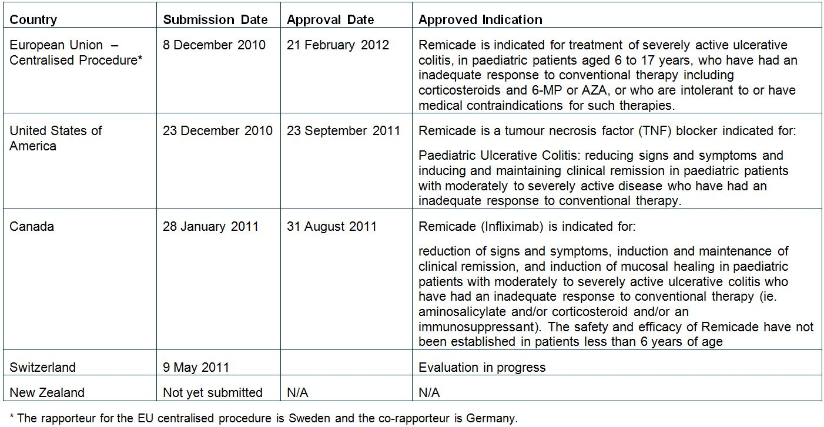

The sponsor states: “There have been no deferrals, withdrawals or rejections for the application to extend the indication for UC to include children and adolescents (6 to 17 years).”

### Product Information

The approved Product Information (PI) current at the time this AusPAR was prepared can be found as Attachment 1.

### List of abbreviations

AE adverse event

AIDS acquired immunodeficiency syndrome

ALT alanine transaminase

ALP alkaline phosphatase

ANOVA analysis of variance

AST aspartate transaminase

AUC area under the plasma concentration time curve

AZA azathioprine

BSA body surface area

BSV between subject variability

CD Crohn’s disease

CHF congestive heart failure

CHMP Committee for Medicinal Products for Human Use

CI confidence interval

CL clearance

CMI Consumer Medicine Information

CRP C reactive protein

CTX-1 C telopeptide cross linking of type I collagen

CV coefficient of variability

DAE adverse event leading to discontinuation

DPD total deoxypyridinoline

ELISA enzyme linked immunosorbent assay

EMEA European Medicines Agency

FDA Food and Drug Administration

FOCE first order conditional estimation

GCP Good Clinical Practice

HIV human immunodeficiency virus

HSTCL hepatosplenic T cell lymphoma

IBD inflammatory bowel disease

IV intravenous

LLQ lower limit of quantification

MTX methotrexate

OI opportunistic infection

PI Product Information

PIP paediatric investigation plan

PK pharmacokinetic

PUCAI Paediatric Ulcerative Colitis Activity Index

PYD pyridinium

RMP risk management plan

RSE root squared error

SAE serious adverse event

SmPC Summary of Product Characteristics

TB tuberculosis

TEAE treatment emergent adverse event

TNF tumour necrosis factor

UC ulcerative colitis

ULN upper limit of normal

V volume of distribution

6-MP 6-mercaptopurine

## II. Quality findings

There was no requirement for a quality evaluation in a submission of this type.

## III. Nonclinical findings

There was no requirement for a nonclinical evaluation in a submission of this type.

## IV. Clinical findings

### Introduction

The dossier represents a partial paediatric development program.

The clinical submission contained the following information:

* The submission contained data from one population PK study, Study Report CP 2010T-045.
* There was a single pivotal efficacy and safety study conducted in paediatric subjects with UC, Study C0168T72
* There were three studies evaluable for safety only, one of which was conducted in paediatric subjects: Study C0168T37, Study C0168T32 and Study C0168T46.

The studies presented in the submission appear to have been conducted according to GCP.

### Pharmacokinetics

#### Studies providing PK data

The submission contained data from one population PK study, Study Report CP 2010T-045.

#### Summary of PK

##### PK in the target population

Study Report CP 2010T-045 described a population PK study of Infliximab in paediatric subjects using data from Study C0168T72 (Table 2). The doses of infliximab used in the study were: 5 mg/kg infusion at Weeks 0, 2, and 6; followed by at Week 8, either 5 mg/kg infliximab q8w or q12w through for up to 46 weeks.

Table 2: PK of Remicade (infliximab).

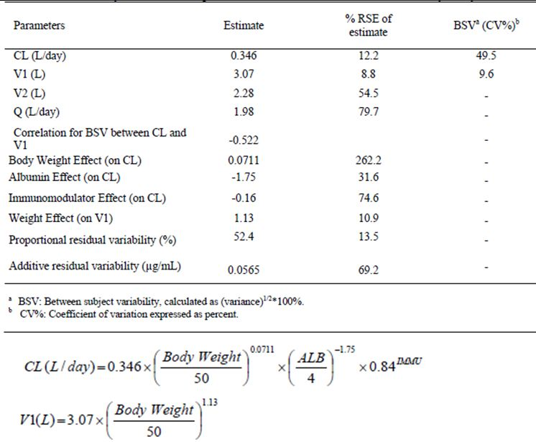

The study used a confirmatory approach as opposed to an exploratory approach because of the limited number of subjects. Hence, the structural PK model was based on a prior analysis of data from adults. The structural PK model was a two compartment model parameterised by central volume of distribution (V1), clearance (CL), peripheral volume of distribution (V2) and distributional clearance (Q). The model had between subject variability on V1 and CL with correlation between V1 and CL, and an additive plus proportional residual error model. The primary model also included the covariate effects of body weight on V1 and albumin on CL. Body weight appears to have been centered on the median. Half life was estimated using post hoc estimates. The FOCE method with interaction was used. Standard errors for the final models were calculated using 2000 bootstrap runs.

Serum samples were collected at the following times: prior to every infusion; 60 minutes after infusion at Weeks 0, 2, and 6; and 60 minutes after the final infusion. Additional samples were also collected at non infusion study Weeks 8, 54, and 62. For those subjects who discontinued study infusions early, samples were collected 16 weeks after the last study infusion. Serum infliximab concentrations were determined using an ELISA with a LLQ of 0.1 μg/mL.

All 60 subjects included in the study received infliximab and had at least one measurable serum concentration of infliximab. Thirty two (53.3%) subjects were female, 28 (46.7%) were male, 49 (81.7%) were Caucasian, the weight range was 22.7 to 91.6 kg, the height range was 108 to 193 cm, the BSA range was 0.9 to 2.1 m2, and the age range was 6 to 17 years. Concomitant treatment with AZA or 6-MP was received by 29 (48.3%) subjects and with MTX by three (5.0%). There were a total of 562 observations (serum infliximab concentrations) included in the analysis.

Overall results of this population PK analysis indicated that, for a typical subject weighing 50 kg, infliximab CL was 0.346 L/day (%RSE 12.2%), and V1 was 3.07 L (8.8%). In addition, V2 was estimated to be 2.28 L (54.5%) and Q was 1.98 L/day (79.7%). The parameter estimates are summarised in Table 2. BSV (CV%) on CL and V1 was 49.5% and 9.6%, respectively. Proportional error (CV%) was estimated as 52.4% with an additive error of 0.0565 μg/mL. Half life was estimated as median (interquartile range) 10.8 (9.6 to 15.4) days. After accounting for weight, age did not have a significant influence on the PK parameters. Concomitant treatment with immunomodulators did not have any significant effect on the PK parameters. The 5 mg/kg dose resulted in a median AUCτ in pediatric subjects that was approximately 20% lower than that in adult subjects

#### Evaluator’s overall conclusions on PK

The population PK study was well conducted and in accordance with FDA and EMEA guidance for conduct of population PK studies. The PK parameters were determined for the 6 to 17 year age group and are supportive of the proposed dosing regimen.

### Pharmacodynamics

#### Studies providing pharmacodynamic data

There were no new pharmacodynamic data included in the dossier.

### Dosage selection for the pivotal studies

The dose selection for the pivotal studies was based on that used in the studies conducted in adults with UC.

### Efficacy

#### Ulcerative Colitis in the Paediatric Population

##### Efficacy study, Study C0168T72

###### Study design, objectives, locations and dates

Study C0168T72 was a multicentre, Phase 3, randomised, multicentre, open label, parallel group study of the efficacy of a three dose induction regimen of infliximab in inducing a clinical response. The study was also aimed at evaluating the safety profile of infliximab during induction and maintenance treatment in paediatric patients aged 6 to <18 years with moderate to severely active UC. The study was conducted at 23 centres in the US, Canada, Netherlands and Belgium from August 2006 to June 2010.

###### Inclusion and exclusion criteria

The inclusion criteria included:

* Age 6 to 17 years old, inclusive;
* With moderately to severely active UC, defined as a baseline Mayo score[1] of 6 to 12, inclusive;
* UC diagnosed or referral to the investigator to establish UC diagnosis initiated at least two weeks prior to screening;
* Diagnosis of UC confirmed by biopsy;
* Must have moderately to severely active UC confirmed by a Mayo endoscopy subscore ≥ 2 at screening sigmoidoscopy;
* Either receiving adequate treatment, or failed to respond to an adequate dose, or had medical complications and/or AEs from either 5-ASA, immunomodulators (6-MP or AZA) or systemic (oral or IV) corticosteroids;
* Doses of 5-ASA, corticosteroids (systemic or rectal), bulking or stool softening agents, and enteral nutrition must be stable;
* Must have discontinued the use of antibiotics for the treatment of UC;
* Must have immunity to varicella;
* If at increased risk for colon cancer must have had a colonoscopy to assess the presence of dysplasia within one year;
* Screening laboratory tests that meet the following criteria: haemoglobin ≥ 7.5 g/dL; white blood cell count ≥ 2.5x 109/L, neutrophils ≥ 1.5 x 109/L, platelets ≥ 100 x 109/L and AST, ALT, and ALP within 3x ULN;
* Willing to use adequate birth control measures; and
* Negative for TB screening and no history, signs or symptoms of latent or active TB.

The exclusion criteria included:

* Severe extensive colitis;
* UC limited to the rectum only or to <20 cm of the colon;
* History of latent or active granulomatous infection, including TB, histoplasmosis, or coccidioidomycosis;
* Nontuberculous mycobacterial infection or opportunistic infection (for example, cytomegalovirus, *Pneumocystis carinii*, aspergillosis) within 6 months;
* Live viral or bacterial vaccination within 3 months;
* Stool culture or other examination positive for an enteric pathogen including *Clostridium difficile* toxin;
* Serious infection (for example, hepatitis, pneumonia or pyelonephritis) within 3 months;
* Immune deficiency syndrome (for example, severe combined immunodeficiency syndrome, T cell deficiency syndromes, B cell deficiency syndromes, and chronic granulomatous disease);
* Documented HIV, AIDS related complex, or AIDS and/or hepatitis B or hepatitis C;
* Require chronic and frequent use of antimotility agents for control of diarrhea;
* Laxatives, except for preparation for endoscopy or other procedures, within 1 week;
* Treated with cyclosporine, tacrolimus, sirolimus, or mycophenolate mofetil within 8 weeks;
* Have received prior treatment with infliximab or any other TNF antagonist (for example, pentoxifylline, thalidomide, etanercept, CDP 571, or D2E7); natalizumab or other agents that target alpha 4 integrin; or agents that deplete B cells (for example, rituximab) or T cells (for example, alemtuzamab);
* Presence of a stoma;
* Presence or history of a fistula;
* Within the two months, surgery for active gastrointestinal bleeding, peritonitis, intestinal obstruction, or intra abdominal or pancreatic abscess requiring surgical drainage;
* Severe, fixed symptomatic stenosis of the large or small intestine;
* Presence or history of colonic obstruction within 6 months;
* History of extensive colonic resection;
* History of colonic mucosal dysplasia;
* Presence on screening endoscopy of adenomatous colonic polyps;
* Presence or history of any malignancy within 5 years;
* History of, or current, lymphoproliferative disease including lymphoma, or signs and symptoms suggestive of possible lymphoproliferative disease;
* Diagnosis or history of CHF, including medically controlled asymptomatic CHF;
* Have signs or symptoms of severe, progressive, or uncontrolled renal, hepatic, hematologic, endocrine, pulmonary, cardiac, neurologic, psychiatric, or cerebral diseases;
* History of systemic lupus erythematosus;
* Received an organ transplant (with the exception of a corneal transplant >3 months prior to screening);
* History of demyelinating disease, such as multiple sclerosis or optic neuritis;
* Family history of lymphoproliferative disease or leukemia; and
* Receiving corticosteroids at a dose equivalent to **>**50 mg prednisone per day.

###### Study treatments

All subjects received infliximab 5 mg/kg by IV infusion at Weeks 0, 2, and 6. At Week 8 responders were randomly assigned 1:1 to maintenance treatment with either:

1. 5 mg/kg infliximab q8w through Week 46
2. 5 mg/kg infliximab administered q12w through Week 42

Clinical response was defined as a decrease from baseline in the Mayo score by ≥30% and ≥3 points, with a decrease in the rectal bleeding subscore of ≥1 or a rectal bleeding subscore of 0 or 1. Subjects who increased their dose of, or initiated treatment with, corticosteroids, 6-MP, AZA, MTX, or 5-ASA prior to Week 8 were treated as non responders. Loss of clinical response was defined as either an increase in the partial Mayo score of ≥2 points from the reference partial Mayo score at two consecutive visits at least 7 days apart, or an increase in the partial Mayo score of ≥3 points from the reference partial Mayo score at any scheduled or unscheduled visit. Clinical remission was defined as a Mayo score ≤2 points (with no individual subscore >1) and including a rectal bleeding subscore of either 0 or 1. The study design is summarised in Figure 1. The Mayo Scoring System was used for the assessment of UC Activity.

Figure 1: Study C0168T72 schema.

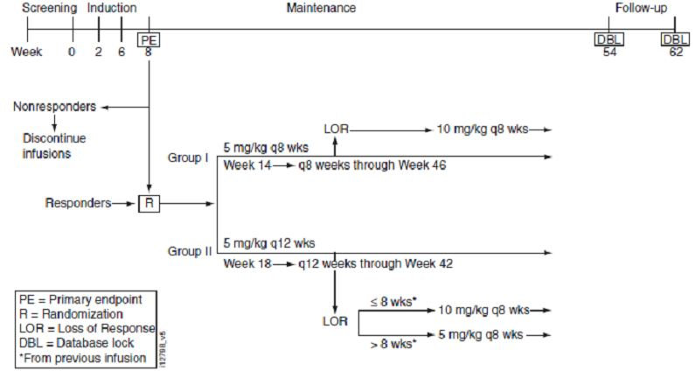

###### Efficacy variables and outcomes

The primary efficacy outcome measure was the proportion of paediatric subjects in clinical response at Week 8. The secondary efficacy outcome measures were:

* PUCAI score[2]: the proportion of pediatric subjects in remission at Week 54;
* Clinical remission at Week 8, as measured by the Mayo score;
* Remission at Week 8, as measured by the PUCAI score; and
* Mucosal healing at Week 8.

Other efficacy analyses were:

* Clinical Response at Week 8 in subgroups based on baseline clinical characteristics (including duration of disease and extent of disease), baseline medications, and concomitant medication history;
* Corticosteroid Use: change from baseline in average daily corticosteroid use at Weeks 30 and 54;
* The proportion of subjects receiving any concomitant corticosteroids at baseline who at Week 54 are in remission and not receiving concomitant corticosteroids;
* Immunomodulator use: change from baseline in average daily immunomodulator use at Weeks 30 and 54;
* Development: changes from baseline at Weeks 30 and 54 in linear growth;
* Changes from baseline at Weeks 2, 8, 30, and 54 in serum and urine bone metabolites;
* Quality of Life: change from baseline in the IMPACT III score at Weeks 8, 30, and 54;
* Global assessments of change at Week 8 (subject, parent/guardian, and physician);
* Global assessment scores (subject, parent/guardian, and physician);
* Partial Mayo Score over time;
* PUCAI over time;
* Change from baseline in the PUCAI;
* Change from Week 8 in the PUCAI;
* Change from baseline in CRP; and
* Histological scores from biopsy samples.

###### Randomisation and blinding methods

Randomisation was performed centrally in blocks of four, in a ratio of 1:1. Subjects and investigators were not blinded to treatment allocation.

###### Sample size

The sample size calculation was based on achieving <12% precision in estimating the true proportion of pediatric subjects in clinical response at Week 8 using a 95% CI. If the lower 95% CI did not contain 40%, then the sponsor concluded efficacy. The clinical response rate of 67% at Week 8 was assumed to be 67% based on the clinical response rate of all randomized adult subjects receiving 5 mg/kg infliximab in the ACT 1 and ACT 2 trials.

###### Statistical methods

Hypothesis tests were performed using the Cochran-Mantel-Haenszel test for stratified categorical data, the Chi squared test for data without stratification, and ANOVA for continuous variables.

###### Participant flow

A total of 60 subjects were included in the study, and 45 were randomised at Week 8: 22 subjects to q8w and 23 to q12w (Figure 7.1.4). There were 32 (53.3%) females, 28 (46.7%) males, 49 (81.7%) subjects were Caucasian, the weight range was 22.7 to 91.6 kg, height range was 108 to 193 cm, BSA range was 0.9 to 2.1 m2, and the age range was 6 to 17 years.

###### Major protocol violations/deviations

There were no significant protocol deviations.

###### Baseline data

In the non responder group there was a higher proportion of Black subjects, but the randomised groups were similar in demographic characteristics. The treatment groups were similar in baseline disease characteristics. Fewer subjects were on high dose corticosteroids in the non responder group.

###### Results for the primary efficacy outcome

Clinical response occurred for 44 (73.3%) subjects and the 95% CI for response rate was 62.1% to 84.5%, which was within the sponsor’s predefined bound for concluding efficacy. The response rate was similar for all subgroups.

###### Results for other efficacy outcomes

Clinical remission at Week 8 by the Mayo score occurred for 24 (40.0%) subjects and by the PUCAI score for 17 (33.3%) subjects. Mucosal healing at Week 8 occurred in 41 (86.3%) subjects. An endoscopy score of 0 at Week 8 occurred in 20 (33.3%) subjects. The median change from baseline to Week 8 in the Mayo score was -5.0. The median change from baseline to Week 8 in the partial Mayo score (without endoscopy) was -4.0. Physician and subject global assessments were better at Week 8 for 39 (70.9%) subjects and 34 (63.0%), respectively. Histological assessment of inflammation of Grade 0 was reported in 3/27 (11.1%) subjects that underwent evaluation at baseline and 12/27 (44.4%) subjects at Week 8. There was no significant difference between the groups in:

* Improved PUCAI score at Week 30: eight (40.0%) subjects with q8w and four (19%) with q12w p=0.141
* Improved PUCAI score at Week 54: eight (38.1%) subjects with q8w and four (18.2%) with q12w p=0.146

In the q8w group there was a median reduction in PUCAI score from baseline to Week 54 of 30.0 points, but no change from baseline in the q12w group. The median change from baseline to Week 54 in the Mayo score was -6.0 in the q8w group and 0.0 in the q12w group. The median change from baseline to Week 54 in the partial Mayo score (without endoscopy) was -3.0 for the q8w group and 0.0 for the q12w. Fourteen subjects in each group were on corticosteroids at baseline, and five (38.5%) of 13 in the q8w group evaluable at Week 54 were in remission without corticosteroids, compared with none of 13 in the q12w group. The median dose of immunomodulator decreased by Week 54 in the q8w group by 0.92 mg compared with no change in the q12w group. There was no change in CRP to Week 54 in either group. A total of 54 subjects completed the IMPACT questionnaire and the median baseline score was 108, the median change (improvement) to Week 8 was 15 but there was no change to Week 54. Three subjects were positive to antibodies to infliximab and there did not appear to be an effect on efficacy. IL-8 was quantifiable at baseline for 10 (20%) subjects and the median decrease in concentration at Week 8 was 34.2%. IL-12 was quantifiable at baseline for 35 (70%) subjects and the median increase in concentration to Week 8 was 5.8%.

Median serum osteocalcin concentration increased by ~240% from baseline to Week 54, median bone specific alkaline phosphatase increased by 50%, and median N terminal propeptide of type I collagen by 80%. Median urine CTX-1 increased from baseline to Week 8 by 42.7%, DPD by 19.2% and PYD by 24.9%.

###### Analyses performed across trials (pooled analyses and meta analyses)

No pooled analyses or meta analyses were included in the dossier.

#### Evaluator’s conclusions on clinical efficacy

Efficacy was demonstrated for Remicade (infliximab) for the treatment of UC in paediatric subjects aged 6 to 17 years. Treatment benefit was maintained for one year. The maintenance treatment regimen at 8 week intervals appeared to offer greater efficacy than the 12 week intervals. Although this was not statistically significant, it does support the q8w regimen over the q12w regimen.

The design of the pivotal clinical trial was in accordance with the PIP submitted to the EU. The design also was in accordance with published guidelines[3] with respect to study population (inclusion/exclusion criteria) and outcome measures. The outcome measures specific to the paediatric population (growth and bone turnover) were also adhered to. Although the study was neither placebo nor comparator controlled, it appears that the study design had been discussed with the EU and approved.

### Safety

#### Studies providing evaluable safety data

##### Pivotal efficacy studies

There was one pivotal efficacy study: Study C0168T72.

##### Other studies evaluable for safety only

There were three studies evaluable for safety only: Study C0168T37, Study C0168T32 and Study C0168T46.

Study C0168T37 was an Extension of Study ACT 1 in subjects who responded: double blind placebo controlled until sites were unblinded, then the study was continued open label. The study included adults with moderately to severely active UC who had participated in Study ACT 1. The study treatments were either infliximab 5 mg/kg or 10 mg/kg every 8 weeks, or placebo that was discontinued after unblinding. A total of 364 subjects were enrolled in the main study and 149 participated in the extension: 31 (20.8%) continued to receive placebo, 118 (79.2%) received infliximab 5 mg/kg or 10 mg/kg. Thirty one (26.3%) subjects in the infliximab group discontinued, 16 (10.1%) because of AE. Of the 118 subjects in the infliximab group, there were 70 (59.3%) males, 48 (40.7%) females, and the age range was 18 to 77 years. Sixty one (51.7%) subjects were receiving immunomodulatory drugs and 64 (54.2%) received corticosteroids.

Study C0168T32 was an addendum report for an open label, three year extension of Study C0168T32. The study included subjects with polyarticular juvenile rheumatoid arthritis who had completed treatment in Study C0168T32 through to Week 44. A total of 78 subjects entered the open label phase, 36 received infusions through to Week 196, and 42 (53.8%) discontinued. There were 67 (85.9%) females, 11 (14.1%) males, 70 (92.1%) subjects were Caucasian, and the age range was from 4 to 17 years. The study treatment was infliximab 3 mg/kg to 6 mg/kg every 8 weeks in combination with MTX for up to 196 weeks.

Study C0168T46 was an open label extension of ACT 2, a randomised placebo controlled trial of infliximab in adults with UC. The study included subjects who had completed Study ACT 2; with UC, a Mayo score between 6 and 12 points and an endoscopy subscore of ≥2; concurrent treatment with at least one of: corticosteroids, AZA, 6-MP or 5-ASA; and either failed to successfully taper, tolerate or respond to corticosteroids, AZA, 6-MP or 5-ASA. A total of 364 subjects were enrolled in ACT 2, 142 were included in the study extension, 111 subjects were treated with infiximab, and 68 completed treatment. One subject in the placebo group received an infliximab infusion by mistake. There were 64 (57.7%) male subjects, 47 (42.3%) female, 105 (94.6%) subjects were Caucasian, and the age range was 20 to 73 years. The study treatments were infliximab 5 mg/kg or 10 mg/kg every 8 weeks, or placebo. After unblinding, subjects in the placebo arm were discontinued. Treatment duration was for up to 3 years.

#### Patient exposure

In Study C0168T72, 60 paediatric subjects were exposed to infliximab with a mean duration of follow up of 38 weeks and mean exposure of 29.4 weeks.

In Study C0168T37, 118 adult subjects were treated with infliximab 5 mg/kg or 10 mg/kg for an average of 105.9 weeks of treatment.

In Study C0168T32 open label extension, 78 paediatric subjects received at least one dose of infliximab, 53 subjects were treated for 124 weeks and, of these, 36 subjects were treated for 196 weeks

In Study C0168T46, 112 adult subjects were treated with infliximab 5 mg/kg or 10 mg/kg for a mean duration of 104 weeks.

#### Adverse events

##### All adverse events (irrespective of relationship to study treatment)

###### Pivotal studies

In Study C0168T72, treatment emergent adverse events (TEAEs) were reported in 57 (95%) subjects. The most frequently reported TEAEs were: UC, 27 (45.0%) subjects; upper respiratory tract infection, 14 (23.3%); pharyngitis, 11 (18.3%); abdominal pain, 8 (13.3%); fever, 8 (13.3%); headache, 8 (13.3%); anaemia, 6 (10.0%) and coughing, 6 (10.0%).

###### Other studies

In Study C0168T37, AEs were reported by 104 (88.1%) subjects in the infliximab group and 29 (93.5%) in the placebo. Infections were more common in the infliximab group. Malignancies were reported in 3 subjects. PGA score 0 or 1 (normal or near normal) ranged from 88% to 98.0% through to Week 144. No subjects had colectomies or ostomies in the infliximab treatment group during the study extension. The proportion of subjects who did not use corticosteroids ranged from 81.7% to 93.3%. The mean number of UC related hospitalisations per 100 subject years of follow up was 19.4 in the placebo group and 4.2 in the infliximab. The mean number of UC related surgeries and procedures per 100 subject years was 3.2 in the placebo group and 0 in the infliximab.

In Study C0168T32 open label extension, 71 (91.0%) subjects reported at least one TEAE from Week 52 to Week 204. The most commonly reported AEs were: upper respiratory tract infection, 31 (39.7%); pharyngitis, 30 (38.5%); headache, 19 (24.4%); fever, 18 (23.1%); and rhinitis, 118 (23.1%).

In Study C0168T46, TEAEs were reported in 97 (86.6%) subjects in the infliximab group and 23 (76.7%) in the placebo. Abdominal symptoms and respiratory infections were the most commonly reported AEs.

##### Treatment related adverse events (adverse drug reactions)

###### Pivotal studies

In Study C0168T72, TEAEs were reported in 20 (33.3%) subjects. The most frequently reported treatment related TEAEs were UC, 4 (6.7%) subjects; and dyspnoea, 3 (5.0%).

##### Deaths and other serious adverse events

###### Pivotal studies

In Study C0168T72, there were no deaths reported. Overall, 14 (23%) subjects reported SAEs (Table 3). Of the subjects randomised to maintenance treatment, SAEs were reported in 4 (18.2%) of the q8w group and 5 (21.7%) of the q12w. The most commonly reported SAE was UC, 9 (15.0%) subjects.

Table 3: Number of subjects with one or more serious TEAEs through Week 54 by WHOART system organ class and preferred term (Study C0168T72).

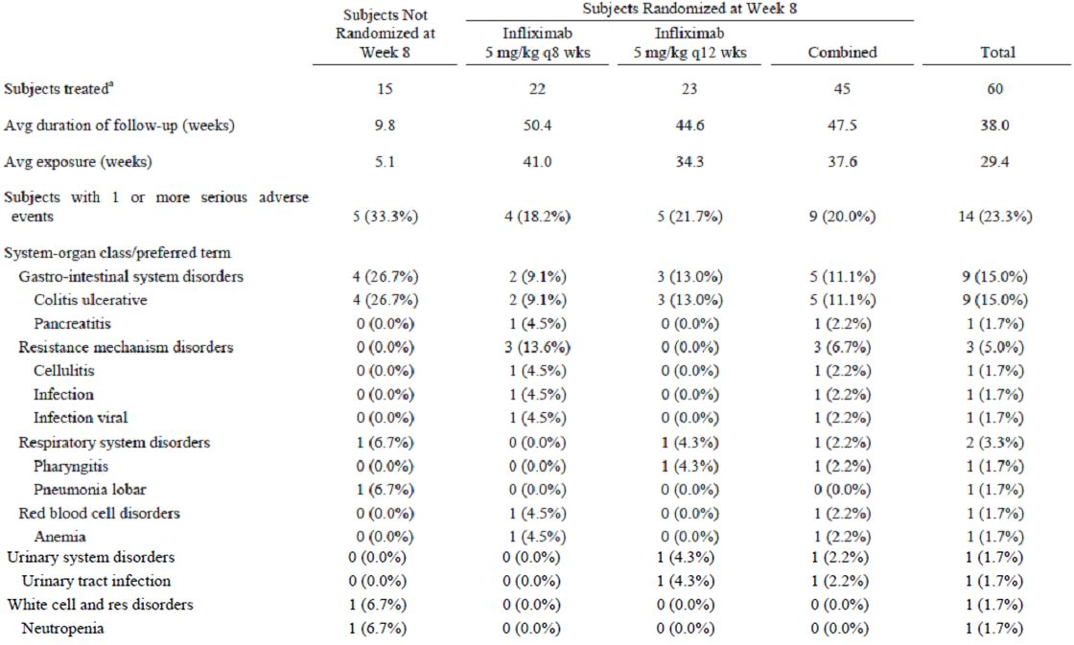

###### Other studies

In Study C0168T37 there were no deaths during the study but one subject in the infliximab group died of lung adenocarcinoma after completion of the study. SAEs were reported in 29 (24.6%) subjects in the infliximab group and nine (29.0%) in the placebo. The pattern of SAEs in this adult population is quite different to that which would be expected in a paediatric population (Table 4).

Table 4: Number of subjects with one or more SAEs during the study extension by WHOART system organ class and preferred term in the study extension (Study C0168T37).

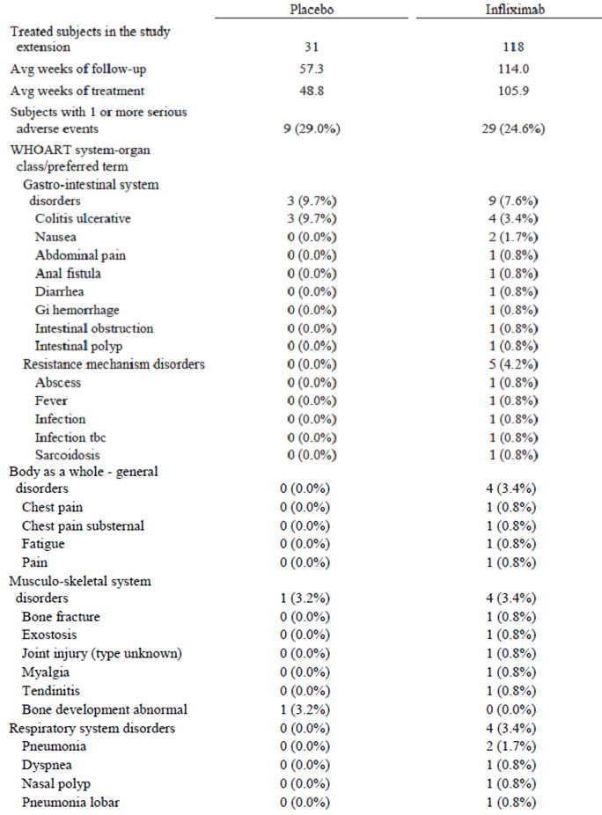

Table 4 (continued): Number of subjects with one or more SAEs during the study extension by WHOART system organ class and preferred term in the study extension (Study C0168T37).

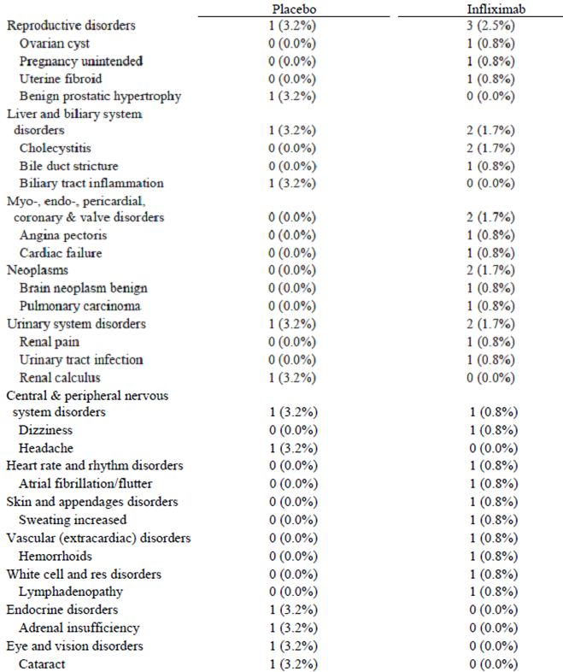

In Study C0168T32 open label extension, there were no deaths reported. A total of 17 (21.8%) subjects were reported with SAEs. SAEs reported in more than one subject were: rheumatoid arthritis (4), arthritis (2), pneumonia (2), and infusion reaction (2).

In Study C0168T46, one subject in the infliximab 5 mg/kg group died from respiratory failure due to histoplasmosis at Day 463 of treatment. SAEs were reported in two (6.7%) subjects in the placebo group and 20 (17.9%) in the infliximab. Two subjects in the 5 mg/kg group and one in the 10 mg/kg group were reported with serious infections: pneumonia (2) and serious fever (1).

##### Discontinuation due to adverse events

###### Pivotal studies

In Study C0168T72, thirteen (21.7%) subjects discontinued because of AEs: 4 (26.7%) of the subjects not randomised at Week 8, 3 (13.6%) in the q8w group and 6 (26.1%) in the q12w (Table 5). The most common AE leading to discontinuation was UC, 10 (16.7%) subjects.

Table 5: Number of subjects who discontinued study agent because of one or more TEAEs through Week 54 by WHOART system organ class and preferred term (Study C0168T72).

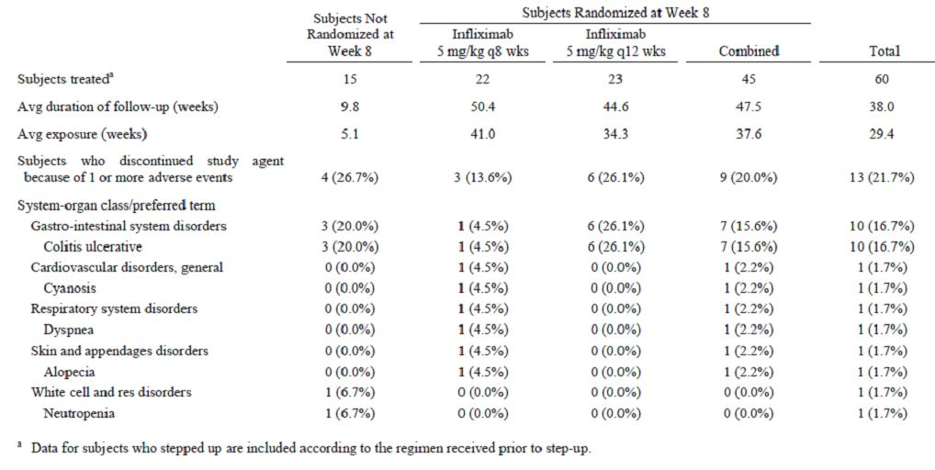

###### Other studies

In Study C0168T37, discontinuation because of an AE occurred in 9 (7.6%) subjects in the infliximab group and 6 (19.4%) subjects in the placebo. The pattern of these AEs in the adult population is different to that which would be expected in a paediatric population (Table 6).

Table 6: Number of subjects who permanently discontinued study infusions because of one or more AEs during the study extension by WHOART preferred term (Study C0168T37).

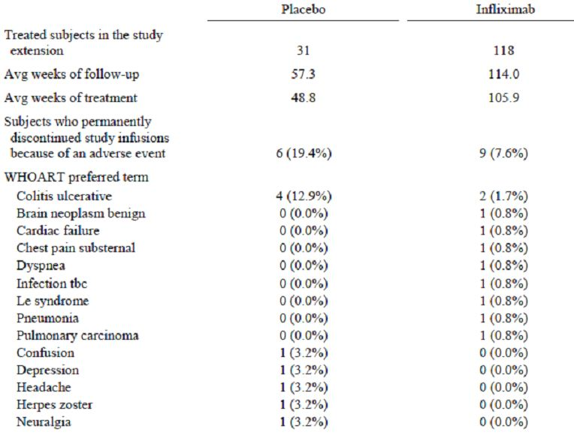

In Study C0168T32 open label extension, 11 (14.1%) subjects discontinued because of AEs. The commonest AEs were infusion syndrome (5) and pneumonia (2) (Table 7).

Table 7: Number of subjects who permanently discontinued study infusions because of one or more TEAEs from Week 52 to Week 204 by WHOART system organ class and preferred term (Study C0168T32).

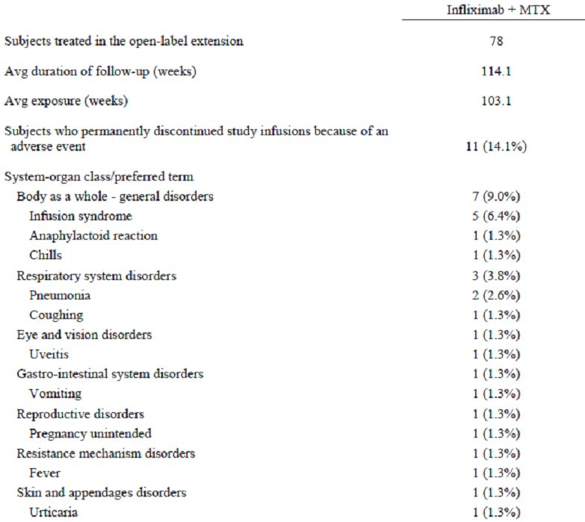

In Study C0168T46, 14 (12.5%) subjects in the infliximab group and none in the placebo discontinued because of AEs (Table 8).

Table 8: Number of subjects who permanently discontinued study infusions because of one or more AEs during the study extension by WHOART preferred term (Study C0168T46).

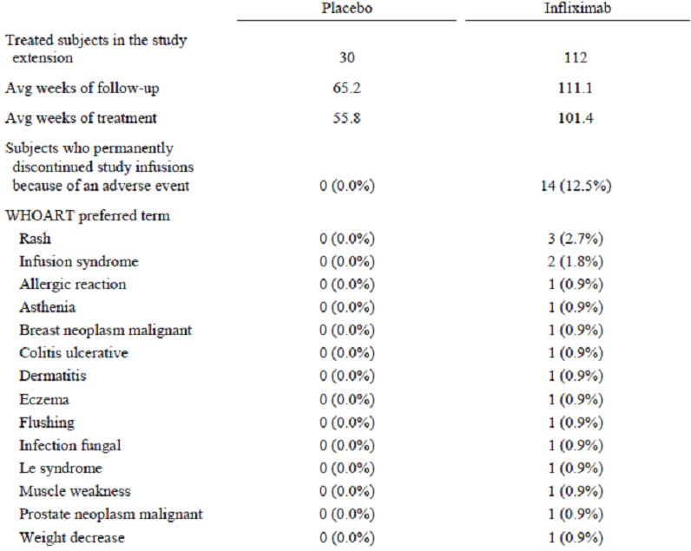

#### Laboratory tests

##### Liver function

###### Pivotal studies

In Study C0168T72, 3 (5%) subjects were reported with an elevation in ALT.

###### Other studies

In Study C0168T37, 3 subjects had markedly elevated ALT or AST values, all of which returned to normal.

In Study C0168T32 open label extension, 9 (11.5%) subjects had elevated ALT.

In Study C0168T46, 3 (2.7%) subjects in the infliximab group were reported with elevated ALT, and 3 (2.7%) with elevated AST.

##### Kidney function

###### Pivotal studies

There were no reports of disordered renal function.

###### Other studies

There were no reports of disordered renal function.

##### Other clinical chemistry

###### Pivotal studies

Other than the subjects with elevations in ALT, there were no clinically significant changes in clinical chemistry parameters.

###### Other studies

There were no clinically significant abnormalities in other clinical chemistry parameters.

##### Haematology

###### Pivotal studies

There were 2 serious haematological events: anaemia (1) and neutropenia (1). A total of 7 (11.7%) subjects were reported with a decreased neutrophil count and 15 (25.0%) with a decreased lymphocyte count. A total of 10 subjects with decreased lymphocyte count were receiving immunomodulators.

###### Other studies

In Study C0168T32 open label extension, 9 (11.5%) subjects were reported with high white blood cell counts.

In Study C0168T46, 20 (18.0%) subjects in the infliximab group and 7 (23.3%) in the placebo were reported with a decreased lymphocyte count

##### AEs of Interest

###### Pivotal studies

A total of 5 (8.3%) subjects underwent colectomy during the study. A total of 31 (51.7%) subjects reported infections, most commonly respiratory system disorders, 14 (23.3%) subjects, and 22 (36.7%) subjects required oral or parenteral antibiotics. A total of 7 AEs were classified as serious infections. There were no reports of malignancy, central nervous system or peripheral demyelinating disorders, optic neuritis or seizures. No subjects with opportunistic infections or TB were reported. No subjects with CHF were reported.

###### Other studies

In Study C0168T32 open label extension, serious infections were reported in 7 (9.0%) subjects (Table 9). There were no reports of malignancy.

Table 9: Number of subjects with one or more treatment emergent serious infections from Week 52 through Week 204 by WHOART system organ class and preferred term (Study C0168T32).

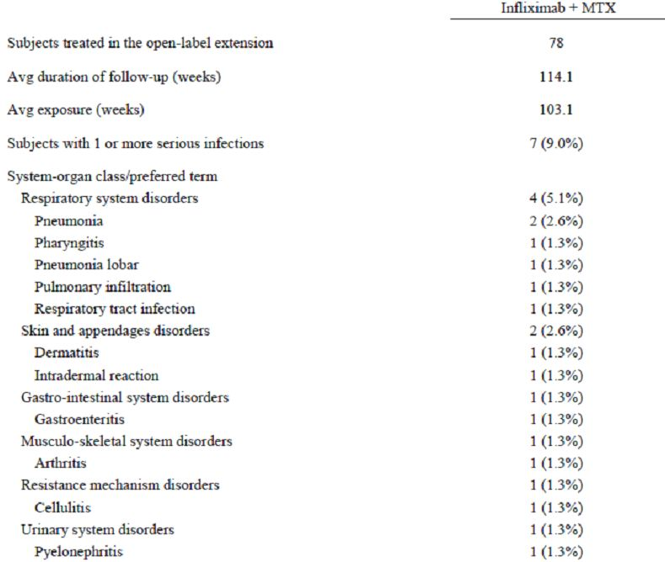

In Study C0168T46, 2 malignancies were reported in the 5 mg/kg group: prostate cancer (1) and breast cancer (1).

##### Immunologically mediated AEs

###### Pivotal studies

In Study C0168T72, 8 (13.3%) subjects reported infusion reactions: urticaria in one. There were no reports of anaphylaxis or shock. One subject discontinued because of an infusion reaction of cyanosis and dyspnoea. A total of 4 (7.7%) of 52 subjects tested for anti infliximab antibodies were positive. Nine (22.0%) of 41 subjects that were ANA negative at baseline were positive for ANA during the study. Two subjects became positive for anti dsDNA.

###### Other studies

In Study C0168T37, 11 (9.3%) subjects in the infliximab group reported infusion reactions compared with none in the placebo. None of the infusion reactions were typical of immunologically mediated reactions. No anaphylactic or delayed hypersensitivity reactions were reported. Of the subjects ANA negative at baseline, 24 (28.9%) subjects in the infliximab group and 1 (3.8%) in the placebo were positive at any time during the study. Of the subjects negative for anti dsDNA antibodies at baseline, 11 (11.2%) subjects in the infliximab group and none in the placebo were positive at any time during the study. A total of 11 (9.5%) subjects were positive for infliximab antibodies at any time.

In Study C0168T32 open label extension, 20 (47.6%) of 42 subjects that were negative for ANA at Week 52 were positive through to Week 204. A total of 4 (6.6%) of 61 subjects that were negative for anti dsDNA at Week 52 were positive through to Week 204. A total of 30 (39.5%) of 76 subjects with appropriate samples were positive for antibodies to infliximab at any time. In Study C0168T32 open label extension, infusion reactions occurred in 25 (32.1%) subjects, and serious infusion reactions occurred in 2 (2.6%) subjects. One subject (1.3%) was reported with a possible anaphylactic reaction.

In Study C0168T46, infusion reactions were reported in 25 (22.3%) subjects in the infliximab group. Two (1.8%) subjects reported urticaria (Table 10). There were no anaphylactic or delayed hypersensitivity reactions. A total of 29 (30.5%) of 95 subjects negative for ANA at baseline became positive at any time during the study. Twelve (12.1%) of 99 subjects negative for dsDNA at baseline became positive at any time during the study. Twenty one (18.9%) of subjects were positive for anti infliximab antibodies.

Table 10: Number of subjects with one or more infusion reactions during the study extension by WHOART preferred term (Study C0168T46).

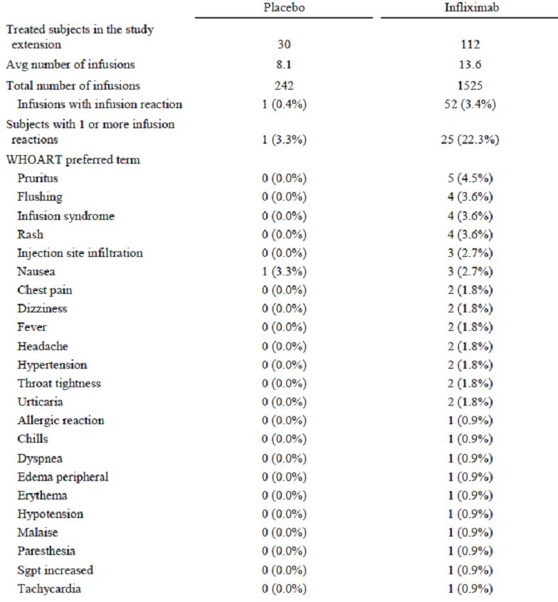

#### Post marketing experience

##### Post marketing data

A report was provided from a registry of children with IBD. A total of 1615 patients were entered into the registry and data were available for 1490. There were 929 (57.5%) males and 686 (42.5%) females. There were 67 (4.1%) patients aged <5 years, 325 (20.1%) aged 5 to 9 years, 998 (61.8%) aged 10 to 14 years, and 225 (13.9%) aged 15 to 16 years. A total of 469 children had been treated with infliximab, with 101 having received >20 doses. A total of 64 (14.7%) patients had at least one acute infusion reaction, none requiring hospitalisation (Table 11). One patient was reported with malignancy: Stage II Hodgkin’s disease in resected ileocaecal bowel. There was one death: cardiac arrhythmia associated with long QT syndrome.

Table 11: Infusion reactions (IBD Registry Interim Report, June 2010).

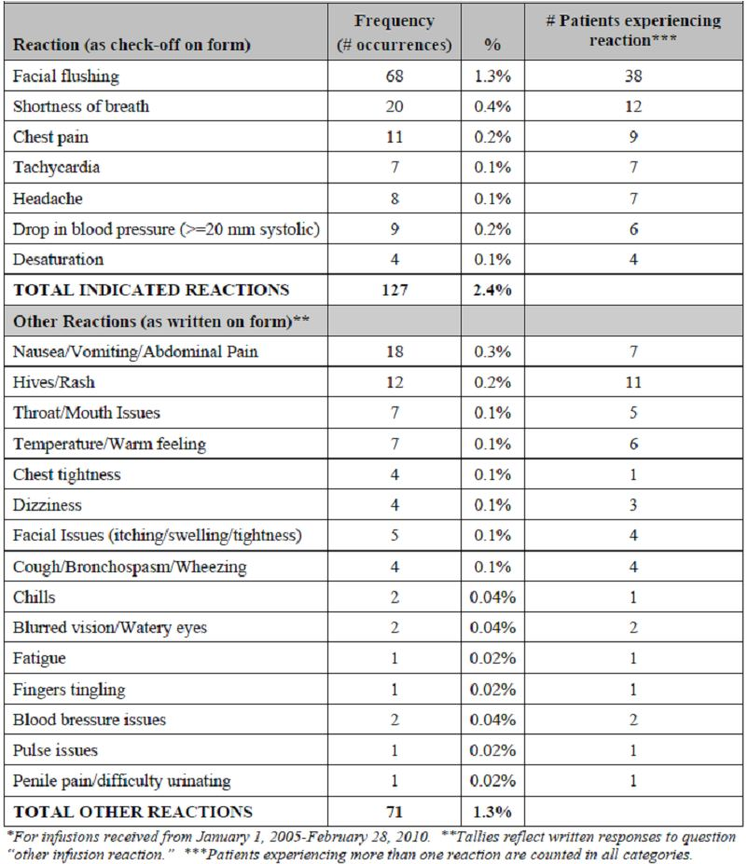

##### Risk management plan

Infection and malignancy are the major concerns in the paediatric population. The sponsor proposes routine pharmacovigilance and additional surveillance through registries and long term safety follow up studies to address these risks in the paediatric population.

#### Safety issues with the potential for major regulatory impact

##### Liver toxicity

There was a higher than expected rate of elevations in ALT. These elevations were transient and self resolved. However, elevations in ALT may indicate direct toxicity or alternatively reduced immunity to infections involving the liver.

##### Malignancy

The follow up time in the paediatric population is insufficient to determine the risk of developing HSTCL or other malignancies.

##### Seroconversion for ANA and anti dsDNA

The follow up time in the paediatric population is insufficient to determine the consequences of seroconversion for ANA and anti dsDNA.

##### Serious infections

Serious infections appear to be the most common SAE, other than UC itself.

#### Evaluator’s overall conclusions on clinical safety

The predominant TEAEs and SAEs, unrelated to UC, were respiratory tract infections. In the clinical trials in the paediatric population there were no reports of opportunistic infections or malignancies. There was one malignancy (Hodgkin’s lymphoma) in the post marketing data and, considering this and the adult data, opportunistic infection and malignancy are clearly risks. There was a high rate of infusion reactions, ANA conversion and anti dsDNA conversion. There was a higher than expected rate of elevations in ALT but it is not clear whether this was related to concurrent immunomodulators and/or infections. There was a high rate of development of anti infliximab antibodies but little indication that these antibodies decreased efficacy or increased AE rates.

The duration of follow up (up to 46 weeks) for paediatric subjects with UC was adequate given the other paediatric indications and the other safety data that are available.

#### First round risk-benefit assessment

##### First round assessment of benefits

The benefits of Remicade (infliximab) in the proposed usage are:

* Efficacy was demonstrated for Remicade (infliximab) for the treatment of UC in paediatric subjects aged 6 to 17 years.
* Treatment benefit was maintained for one year.
* The maintenance treatment regimen at 8 week intervals appeared to offer greater efficacy than 12 week intervals.

##### First round assessment of risks

The risks of Remicade (infliximab) in the proposed usage are:

* Increased risk of infections, particularly respiratory tract infections;
* Increased risk of ANA conversion and anti dsDNA conversion;
* A higher than expected rate of elevations in ALT;
* A high rate of development of anti infliximab antibodies; and
* An as yet undetermined rate of malignancy in the long term.

##### First round assessment of risk-benefit balance

The risk-benefit balance of Remicade (infliximab), given the proposed usage, is favourable.

### Clinical summary and conclusions

Remicade (infliximab) should be approved for:

* **Ulcerative colitis in Adults and in children and adolescents (6-17 years)**
* Remicade is indicated for the treatment of moderately severe to severe active UC in patients who have an inadequate response to conventional therapy.

### List of questions

#### Pharmacokinetics

1. The PIP submitted to the EMA included a simulation of PK in the paediatric population aged 2 to 6 years. Given that age was not a significant covariate in the population PK study included in the present submission, does the sponsor still intend to conduct this study? If so, then how will the simulation extrapolate to the younger age group?

#### Efficacy

1. The pivotal study was neither placebo nor comparator controlled. Had this study design been discussed with, and approved by, the EMA as part of the PIP?
2. Off label use in the 2 to 6 year population is a possibility given the extension of indications to the 6 to 17 year age group. How does the sponsor intend establishing efficacy in the 2 to 6 year age group, or alternatively, how does the sponsor intend managing off label use in this population?

#### Safety

1. Off label use in the 2 to 6 year population is a possibility given the extension of indications to the 6 to 17 year age group. How does the sponsor intend establishing safety and tolerability in the 2 to 6 year age group, or alternatively, how does the sponsor intend managing off label use in this population?

## V. Pharmacovigilance findings

### Risk management plan

The sponsor submitted a Risk Management Plan that was reviewed by the TGA’s Office of Product Review (OPR).

#### Safety specification

The sponsor provided a summary of Ongoing Safety Concerns, which are shown at Table 12.

Table 12: Ongoing Safety Concerns for Remicade.

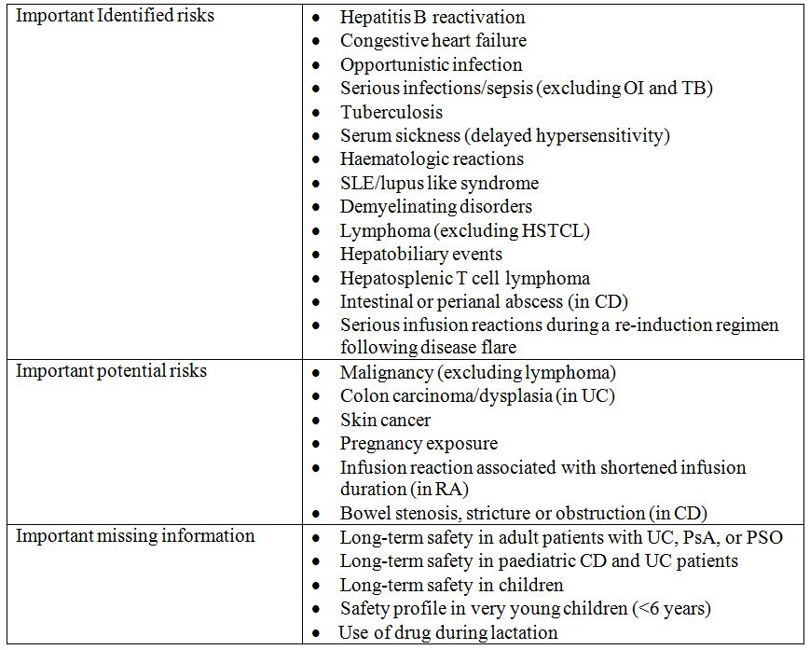

##### OPR reviewer comment:

The above summary of the Ongoing Safety Concerns is considered acceptable.

#### Pharmacovigilance plan

##### Proposed pharmacovigilance activities:

The sponsor has provided details of the routine pharmacovigilance activities that will be undertaken for all of the Ongoing Safety Concerns. The sponsor’s routine pharmacovigilance practices include AE collection and single case processing, preparation of aggregate reports and conducting periodic medical review of aggregate post marketing data through intra and inter product signalling. Components of the sponsor’s routine surveillance program include making use of their worldwide safety database (SCEPTRE), the FDA AERS/SRS database and the World Health Organisation Vigibase database. The sponsor proposes to also undertake signal detection related to product quality and manufacturing.

The sponsor has proposed to undertake additional pharmacovigilance activities for all of the important identified and potential risks and for all of the missing information except for: ‘safety profile in very young children’ and’ use during lactation’, for which only routine pharmacovigilance is proposed.

The sponsor’s proposed additional pharmacovigilance activities include a combination of additional surveillance through studies, including long term safety follow up studies, registries and an epidemiological study (KAISER) and enhanced follow up of routine pharmacovigilance activities through the use of questionnaires.

The sponsor has stated that the objective of their additional surveillance is to obtain additional safety data including long term safety data on infliximab use and the relevant safety concerns, to compare the incidence/reporting rate for these events over time and to assess the effectiveness of risk minimisation activities such as product labelling updates and educational activities. The sponsor further states that registries complement passive surveillance by providing more comprehensive and robust data on specific population(s).

##### OPR reviewer comment in regard to the pharmacovigilance plan and the appropriateness of milestones:

It is noted that each of the proposed studies/registries are ongoing. The sponsor was requested to provide information on whether there are any plans to implement any Australian studies in the Section 31 request. In response, the sponsor states that currently there are no registries planned to include Australian patients. Nevertheless, the sponsor states that the RESULTS UC (C0168T62) program collects long term safety data in adult subjects with UC who participated in the ACT 1 and ACT 2 studies, and in paediatric subjects with UC who participated in Study C0168T72. The C0168T37 ACT 1 study of infliximab in adult UC included 7 investigational sites in Australia and 2 investigational sites in New Zealand. All of these 9 sites participated in the RESULTS UC (C0168T62) program and included 34 subjects from Australia and 11 subjects from New Zealand.

On 23 September 2011, an extension into paediatric patients (6 years and older UC) for Remicade was approved by the FDA. The FDA determined that three post marketing studies were required (1-3 below), in addition to those proposed by the sponsor (4-7 below). These studies were required as the FDA determined that routine pharmacovigilance would not be sufficient to assess the known risk of HSTCL and the increased risk of SAEs in patients receiving higher doses of infliximab, such as opportunistic infections and congestive heart failure. Furthermore, the FDA also determined that only a clinical trial (rather than a nonclinical or observational study) will be sufficient to assess a known risk of SAEs in patients receiving higher doses of infliximab (see FDA required studies).

If this submission is approved, it is recommended that the sponsor provide to the TGA’s OPR, the protocols for the FDA required studies and sponsor proposed studies (Table 13). In addition, the sponsor should also provide a summary for each of these studies on how they are appropriately designed to further inform their assigned Ongoing Safety Concerns. Please consider factors such as study design, follow up duration and outcome measurements.

Table 13: FDA required and sponsor proposed post marketing studies.

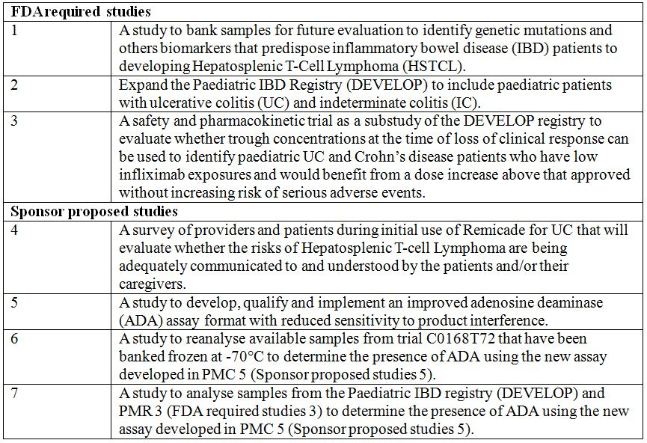

#### Risk minimisation activities

##### Sponsor’s conclusion in regard to the need for risk minimisation activities

The sponsor has provided the following evaluation of the need for risk minimisation activities:

‘The infliximab SmPC provides up to date relevant safety and efficacy information to guide the physicians and patients in the appropriate use of the drug and, as such, is updated whenever necessary. TNFα antagonists are an extensively used class of drugs under close scrutiny by health authorities, health care professionals and consumers within the EU and around the world. Therefore, the relevant safety information provided in the infliximab SmPC is considered the routine and sufficient means for risk minimisation, with the exception of TB, infusion reactions associated with shortened infusion duration (in rheumatoid arthritis) and the long term safety in paediatric CD and UC patients.’

##### OPR reviewer comment:

The sponsor’s conclusions regarding the need for risk minimisation activities are acceptable.

The sponsor has proposed to undertake additional risk minimisation activities for the following Ongoing Safety Concerns:

* Important identified risks: Opportunistic infection;
* Serious infection/sepsis (excluding OI and TB) and Tuberculosis;
* Important potential risks: Infusion reaction associated with shortened infusion duration (in RA); and
* Important missing information: Long term safety in paediatric CD and UC patients.

##### Potential for medication errors

The sponsor has provided the following discussion on the potential for medication errors:

‘Infliximab treatment is to be initiated and supervised by qualified physicians experienced in the diagnosis and treatment of RA, IBDs, AS, PSA or PSO. Infliximab infusions should be administered by qualified healthcare professionals trained to detect any infusion related issues. Detailed instructions for use and handling of the product are provided in the SmPC. Therefore, the potential for drug administration errors is considered minimal. In addition, single doses of infliximab up to 20 mg/kg have been administered without toxic effect. To date, documented medication errors such as incorrect dosage, rate of administration, or technique in drug usage (that is, reconstituted incorrectly or administered without a filter) have not resulted in clinically serious sequelae.

The only available presentation for infliximab is single use vials containing 100 mg infliximab, thus no potential for medication errors due to different presentations exists. No know potential for name confusion with existing drugs is known for either the generic name or the trade name.’

##### OPR reviewer comment:

The sponsor discussion on the potential for medication errors is acceptable. Furthermore, the SmPC and PI contain a similar level of detail in the instructions for use of and handling/preparation and administration sections of the relevant documents.

## VI. Overall conclusion and risk/benefit assessment

The submission was summarised in the following Delegate’s overview and recommendations:

### Quality

There was no requirement for a quality evaluation in a submission of this type.

### Nonclinical

There was no requirement for a nonclinical evaluation in a submission of this type.

### Clinical

#### Pharmacology

Population PK data were obtained from Study C0168T72, the pivotal efficacy study, and used in PK modelling and simulation analysis. That study included patients with moderate to severe UC and in one of the two study arms, patients received the proposed dose regimen of infliximab. A total of 562 observations were collected from 60 subjects. Samples were taken prior to each infusion at Weeks 0, 2 and 6 and 60 minutes after the final infusion. Additional samples were also collected at non infusion study Weeks 8, 54 and 62.

Data obtained from Study C0168T72 were compared with PK data from previously submitted studies in adults with UC and a study in children with CD. Comparisons of median peak and trough serum concentrations were discussed in the sponsor’s clinical overview and are reproduced in Table 14.

Table 14: Summary of infliximab 5 mg/kg PK in the C0168T72, REACH, and ACT studies.

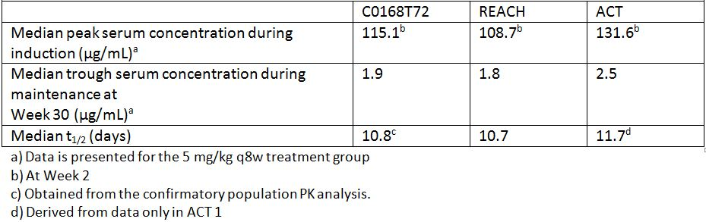

#### Efficacy

Study C0168T72 was an open, randomised, parallel group study in which children and adolescents aged from 6 to 17 years with UC received an initial induction regimen of 5 mg/ kg infusion at Weeks 0, 2 and 6. Responding subjects were then randomly assigned 1:1 to maintenance treatment with either 5 mg/kg infliximab q8w through to Week 46 or 5 mg/kg infliximab q12w through to Week 42.

For enrolment, patients required a baseline Mayo score of 6 to 12, which equates to moderately to severely active UC. The Mayo score is a disease activity tool and was used in previously evaluated studies of infliximab in UC. Concomitant therapy with 5-ASA, 6-MP, AZA, or systemic corticosteroids was permitted and doses had to be stable prior to commencement of study.

The primary outcome measure was the proportion of subjects in clinical response at Week 8. Secondary efficacy measures included: remission rate at Week 54, measured using the PUCAI score; clinical remission at Week 8 (by Mayo and PUCI scores); and mucosal healing at Week 8. Clinical response was defined as a decrease from baseline in the Mayo score by at least 30% and at least three points, with a decrease in the rectal bleeding subscore of at least 1 or a rectal bleeding subscore of 0 or 1.

Subjects who increased their dose of, or initiated treatment with corticosteroids, 6-MP, AZA, MTX or 5-ASA prior to Week 8 were treated as non responders. Loss of clinical response was defined as either an increase in the partial Mayo score of at least 2 points from the reference partial Mayo score at two consecutive visits at least 7 days apart, or an increase in the partial Mayo score of at least 3 points from the reference partial Mayo score at any scheduled or unscheduled visit. Clinical remission was defined as a Mayo score of ≤2 points, with no individual subscore more than 1; and including a rectal bleeding subscore of either 0 or 1. A target of >40% of patients to achieve a clinical response at Week 8 was set based on pooled data from the placebo groups in the ACT 1and ACT 2 studies which were conducted in adults. These studies were used as an “historical control”.

A total of 60 subjects were included in the study. The age range was from 6 to 17 years (median 14.5 years), weight range was from 22.7 to 91.6 kg (median 50.8 kg) and 46 (76.7%) patients had extensive disease. Median UC disease duration was 1.35 years (range 0-8.2 years). All subjects were receiving at least one concomitant therapy for UC and 32 (53.3%) were receiving immunomodulatory agents (mostly azathioprine or 6-MP).

At Week 8, a clinical response had occurred for 44 (73.3%) patients (95% CI 62.1 to 84.5%). This was within the pre specified range for clinical response. Clinical remission at Week 8 by the Mayo score occurred for 24 (40.0%) subjects and by the PUCAI score for 17 (33.3%). Mucosal healing at Week 8 occurred in 41 (86.3%) subjects. Subgroup analyses for the primary efficacy criterion included: sex; race; age; severity, extent and duration of disease; weight and baseline concomitant medications. While the 95% CI for each of these subgroup analyses was not >40%, results were supportive of similar efficacy across subgroups.

A total of 45 of the subjects who had responded at Week 8 were randomised to maintenance either every 8 or 12 weeks. In the q8w group, there was a median reduction in PUCAI score from baseline to Week 54 of 30.0 points but no change from baseline in the q12w group. The median change from baseline to Week 54 in the partial Mayo score (without endoscopy) was -3.0 for the q8w group and 0.0 for the q12 w group. Overall, measures of clinical response were better for the q8w maintenance group than for the q12w group.

#### Safety

Data in children and adolescents were available from an addendum to a three year extension of a study in children and adolescents with polyarticular juvenile rheumatoid arthritis as well as from the pivotal study for this submission. A total of 36 children and adolescents received infliximab in clinical trial conditions for up to 196 weeks. In the pivotal study for this indication, the mean exposure for the 60 patients enrolled was 29.4 weeks.

The major risks associated with infliximab, and other TNF-α inhibitors are: increased risk of infection, including TB and invasive fungal infections; autoimmune processes including demyelination and hepatitis; leukopaenia; neutropaenia; thrombocytopaenia and pancytopaenia; and an increased propensity to lymphoma and other malignancies.

Of particular concern, there have been post market cases of HSTCL, a rare type of T cell lymphoma, in patients treated with TNF blockers including infliximab. All cases were reported in patients with CD or UC, the majority of who were adolescent or young adult males. This rare, aggressive T cell lymphoma is fatal. All of these patients had received treatment with azathioprine or 6-MP concomitantly with infliximab at or prior to diagnosis.

In the pivotal study, 31 (51.7%) of patients reported infections, most commonly respiratory system disorders. A total of 7 serious infections were reported. There were no reports of malignancy, demyelinating disorders, seizures, TB or opportunistic infections.

The concern regarding malignancy is a major safety issue for infliximab, particularly as it is not clear if the probability of developing malignancy increases with duration of exposure, and if so, what is the relative and absolute increase in risk of development of malignancy. There are some post market data regarding malignancy risk and that is considered in the RMP evaluation.

It is noted that the PI for Remicade in the US was updated in August 2011 and includes substantially more information regarding risk of malignancy than was proposed in the draft PI for this submission.

### Risk management plan

The RMP evaluator has noted that the sponsor has proposed to undertake additional risk minimisation activities for the following ongoing safety concerns: important identified risks: OI; serious infection/sepsis (excluding OI and TB) and tuberculosis; important potential risks: infusion reaction associated with shortened infusion duration (in RA); and important missing information: long term safety in paediatric CD and UC patients.

There was some concern about the possibility of off label use in children aged <6 years but, given the incidence of UC in this group is extremely low it was not considered necessary to conduct trials in that population.

The proposed indication was approved in the US in September 2011. Additional cases of HSTCL and literature reports of an increased risk of SAEs, such as opportunistic infections and congestive heart failure, in patients receiving higher doses of infliximab led to the FDA requiring the sponsor to conduct three post marketing studies in addition to four other studies that the sponsor was also required to conduct. These studies are tabulated in the RMP evaluation and include a study to bank samples for future evaluation to identify genetic mutations and others biomarkers that predispose IBD patients to developing HSTCL.

The RMP evaluator recommended that the sponsor submit protocols for the post market studies to the OPR within TGA. The evaluator also recommended that:

* RMP Version 4.1, dated 30 November 2010, including the sponsor’s response to the Section 31 request for information/documents and any future updates, be imposed as a condition of registration; and
* The sponsor provide timelines for the submission of documents, where required, to the TGA’s OPR for the pharmacovigilance activities and risk minimisation activities (education program) listed in the RMP evaluation.

### Risk-benefit analysis

#### Delegate considerations

The dose regimen proposed for children and adolescents with UC is the same as the regimen currently approved for adults with UC and is also the same as the regimen for adults, adolescents and children and adolescents with CD.

The PK of infliximab in a paediatric population was assessed in the evaluation of the submission for treatment of Crohn’s disease in children and adolescents. This submission compared results from that study with a smaller population of children and adolescents with UC and also with adults with UC. As would be expected, children and adolescents with UC and CD had similar PK for infliximab. Compared to adults with UC, children and adolescents with UC had slightly higher serum concentrations after the initial infusion and slightly lower serum concentrations at later time periods (4 to 12 weeks). No notable differences in single dose PK parameters and terminal half life were observed between paediatric and adult patients with UC.

The ACT 1 and ACT 2 studies were studies of infliximab in adults with moderately to severely active UC and are described in the current PI for Remicade. In these studies clinical response at Week 8 was the primary efficacy endpoint. The pooled clinical response rate in those studies was 66.9% for the 5 mg/kg infliximab dose regimen. In children and adolescents with moderately to severely active UC, the clinical response rate at Week 8 was 73.3% using the same dose regimen. Similar results were seen for assessment of maintenance over up to 54 weeks. The q8w regimen gave better results than the alternative q12w regimen of infliximab.

Malignancy is major concern with infliximab, particularly it is not clear if the probability of developing a malignancy increases with duration of exposure, and if so, what is the relative and absolute increase in risk of development of malignancy. The extent of increased risk associated with concomitant use of immunomodulatory agents with infliximab is also unclear. Children and adolescents, particularly males are at increased risk of HSTCL. Modifications to the RMP for Australia will assist with further identification of the risks from use of infliximab in children and adolescents which may be of value in the future in identifying individuals at increased relative risks of these adverse events. The proposed educational material requires review and acceptance by the OPR.

I propose to approve the extension of indications for Remicade to include:

* **Ulcerative colitis in Adults and in Children and Adolescents (6 to 17 years)**
* Remicade is indicated for the treatment of moderately severe to severe active UC in patients who have had an inadequate response to conventional therapy.
* Adherence to the current RMP should be a condition of registration.
* The advice of the ACPM is requested.

#### Response from sponsor

##### 1. Introduction

This document has been prepared in response to the Delegate’s request for ACPM advice received from the TGA on 13 February 2012 for the above mentioned Category 1 application.

The sponsor agrees with the Delegate's recommendation to approve the extension of indications for Remicade to include:

* “**Ulcerative colitis in Adults and in Children and Adolescents (6 to 17 years)**
* Remicade is indicated for the treatment of moderately severe to severe active UC in patients who have had an inadequate response to conventional therapy.”

##### 2. Recommendation by Delegate – Changes to Draft PI

1. Clinical Trials - Define clinical response and clinical remission before results presented.
2. Precautions - Replace last part of paragraph on HSTCL.
3. Precautions - Identify REACH study as being conducted in children and adolescents with Crohn’s disease.

###### Applicant Response

The sponsor agrees to incorporate each of these three above mentioned changes and the draft PI has been updated.

##### 3. Recommendations by RMP evaluator

To provide timelines for the submission of documents, where required, to the OPR for the below pharmacovigilance activities and risk minimisation activities (education program).

###### Request 1

Protocols for the FDA required studies and sponsor proposed studies, summary for each of these studies, study milestone and reporting timelines.

###### Applicant Response

The sponsor proposes the following timelines for submission of the documents detailed in the FDA approval letter for the paediatric UC supplement.[4]

1. **PMR#1**: A study to bank samples for future evaluation to identify genetic mutations and other biomarkers that predispose IBD patients to developing HSTCL. Final Protocol Submission to TGA by December 2012 or when protocol design approved by FDA.
2. **PMR#2**: Expand the Paediatric IBD Registry (DEVELOP) to include paediatric patients with UC and indeterminate colitis. Protocol is currently available, as UC/IC patients were added to the registry with the last amendment. The number of these patients will double with the next registry amendment scheduled for later this year.
3. **PMR#3**: A safety and PK study as a substudy of the DEVELOP registry to evaluate whether trough concentrations at the time of loss of clinical response can be used to identify paediatric UC and CD patients who have low infliximab exposures and would benefit from a dose increase above that approved without increasing risk of SAEs. Final protocol submission of Substudy Protocol will be submitted to TGA by December 2012 or when FDA has approved protocol substudy design. With this next amendment, paediatric UC/IC patient number targets will be doubled to 2000 pts/1000 on Remicade (see PMR#2 above).
4. **PMC#4**: A survey of providers and patients during initial use of Remicade for UC that will evaluate whether the risks of HSTCL are being adequately communicated to and understood by the patients and/or their caregivers. Final Protocol Submission to TGA by September 2012 or when approved by FDA.
5. **PMC#5**: A study to develop, qualify and implement an improved anti drug antibody assay format with reduced sensitivity to product interference. Final Report Submission to TGA by December 2013 or when results acceptable to FDA. Note that no protocol will be created, but rather a report of the new assay along with its validation.
6. **PMC#6**: A study to reanalyse available samples from Study C0168T72 that have been banked frozen at -70°C to determine the presence of anti drug antibody using the new assay developed in PMC#5. Final Report Submission June 2013, final report will be provided to TGA by December 2013 or when results acceptable to FDA.
7. **PMC#7**: A study to analyse samples from the Paediatric IBD registry (DEVELOP) and PMR#3 (FDA required study 3) to determine the presence of anti drug antibody using the new assay developed in PMC#5. Final report will be provided to TGA by December 2015.

###### Request 2

Provide educational material for UC, such as presentation slide kits and/or printed materials, and patient’s materials to OPR for review.

###### Applicant Response

The sponsor proposes to provide these materials to the OPR within two months following approval of this application.

###### Request 3

Update paediatric educational program to include information on the risk of lymphoma and other malignancies, including HSTCL and also the increased risk of developing infections in children and need for immunisations to be up to date.

###### Applicant Response

The sponsor agrees to include this information in the paediatric educational program. The Australian addendum to the EU RMP has been updated to include this information.

###### Request 4

Implement the use of a patient alert card in Australia and provide it to the OPR for review.

###### Applicant Response

The sponsor considers that the use of a patient alert card in Australia is not required. The patient alert card is used in the EU to meet a specific EMA requirement. In Australia, the processes for preparing and administering Remicade to patients would make it unlikely that the patient would receive any alert card provided in packs. Remicade is typically reconstituted and diluted to form the solution for infusion by a hospital pharmacist or nurse, in a dedicated preparation area. This area is usually separate from the site of administration. The solution for infusion is then provided to the health care professional for administration to the patient. It is considered unlikely that a card would be retained from the pack during the preparation process and then passed on to the health care professional to be then subsequently provided to the patient.

The sponsor considers that other mechanisms in place provide a more effective communication of safety information to patients and parents of paediatric patients, including the CMI. In addition, patient material (in the form of a booklet), prepared by the sponsor, outlines the profile of the product and key safety information and is given to patients at the time of prescription by the physician. A copy of this booklet will be submitted to the OPR for review. Patients are also provided an opportunity to enrol in a patient support program. Upon enrolment they are also provided with this booklet in addition to other educational materials. Since it is unlikely that the patient will be handling the Remicade packaging, the sponsor considers that this is a more effective way of communicating key information to patients.

###### Request 5

Give consideration to requiring the sponsor conduct a study to evaluate the effectiveness of the Australian education program, specifically in relation to the risk of HSTCL. The sponsor should submit to the OPR a study protocol and information on how this study is appropriately designed to evaluate whether the risks of HSTCL are being adequately communicated by prescribers of Remicade. Study milestone and reporting timelines should also be submitted.

###### Applicant Response

The sponsor proposes to provide a study protocol, information on study design, study milestone and reporting timelines to the OPR within two months following approval of this application. The commitment to undertake this study has been incorporated into the Australian addendum to the EU RMP.

###### Request 6

Amend discrepancy in proposed Australian PI regarding observation time post infusion.

###### Applicant Response

The Sponsor agrees to amend this discrepancy. The Dosage and Administration section of the draft PI has been updated to:

*“All patients administered Remicade are to be observed for at least one to two hours post infusion for side effects.”*

This text is consistent with the Precautions section of the Australian PI and also with the EU SmPC.

The discrepancy originated from the way infusion reactions were defined in early and later clinical studies in the various indications for Remicade. For studies included in the original dossiers for CD and for early rheumatoid arthritis trials and many Phase 2 trials, an infusion reaction was defined as any AE occurring during or within 2 h of infusion. For all maintenance Phase 3 trials (that is, more than three doses of Remicade), due to increased experience with infliximab at this point, the definition was further refined to any AE occurring during or within 1 h of infusion. Hence, labels based on earlier studies typically defined infusion reactions – and thus the time a patient should be observed for these effects – as occurring up to 2 h post infusion, while later, larger Phase 3 trials defined infusion reactions as occurring up to 1 h post infusion. Given the latter, larger body of data now available, and to keep consistency with other major market Remicade labels and to maintain consistency within the Australian PI, the sponsor has updated this section to the statement above.

###### Request 7

Align the Australian PI with the SmPC and include information on colon carcinoma/dysplasia (in UC) in the Precautions, Malignancies and lymphoproliferative disorders section.

###### Applicant Response

The sponsor has updated the PI to include this SmPC text as recommended.

##### 4. Delegate’s comment on PK

Page 4 of Request for ACPM Advice:

“Compared to adults with UC, children and adolescents with UC had slightly higher serum concentrations after the initial infusion and slightly lower serum concentrations at later time periods (4 to 12 weeks).”

###### Applicant Response

The sponsor proposes that this should be amended to the following:

“Compared to adults with UC, children and adolescents with UC had slightly lower serum concentrations following IV infusions of 5 mg/kg infliximab at Week 0, 2, 6 and every 8 weeks thereafter.”

Serum infliximab concentrations in paediatric UC patients (children and adolescents, Study C0168T72) were consistently lower compared to adult UC patients (studies ACT 1 and ACT 2) regardless of the periods of time.

##### 5. Conclusion

In summary, Remicade is considered an effective treatment option in paediatric patients with UC and the sponsor agrees with the Delegate’s recommendation to approve the proposed indication.

#### Advisory committee considerations

The Advisory Committee on Prescription Medicines (ACPM), taking into account the submitted evidence of efficacy, safety and quality, agreed with the Delegate and considered this product to have an overall positive benefit-risk profile for the following indication:

*For the treatment of moderately severe to severe active UC in adults or in children and adolescent (6 to 17 years) patients who have had an inadequate response to conventional therapy.*

In making this recommendation the ACPM noted the absence of long term safety data in adults, children and adolescents aged 6 to 17 years and in children aged less than six years. This lack of evidence leads to a requirement for strict implementation of the post market monitoring to be set out in the RMP.

The ACPM agreed with the Delegate on the proposed amendments to the PI and CMI.

The ACPM agreed with the Delegate on the proposed conditions of registration and specifically advised on the inclusion of the following:

* Strengthening of the RMP to manage the safe use of this product.
* Consideration of inclusion of Australian patients in the register that is in place in USA and Europe (C0168Z02).
* Investigation into the safety signals of greater proportionate risk of malignancy in young males.

The ACPM emphasised ongoing concerns that the low numbers of HSTCL and high dropout rates for paediatric patients involved in clinical studies continues to impact on the generation of clear efficacy and safety evidence and encouraged the sponsor to work to address this issue.

The ACPM advised that the implementation by the sponsor of the recommendations outlined above to the satisfaction of the TGA, in addition to the evidence of efficacy and safety provided would support the safe and effective use of these products.

### Outcome

Based on a review of quality, safety and efficacy, TGA approved the registration of Remicade containing infliximab for the new indication:

*Remicade is indicated for the treatment of moderately severe to severe active UC in adults or in children and adolescents (6 to 17 years) patients who have had an inadequate response to conventional therapy.*

The approved full indications now read as follows:

* **Rheumatoid Arthritis in adults**
* Remicade, in combination with methotrexate, is indicated for the reduction of signs and symptoms and prevention of structural joint damage (erosions and joint space narrowing) in:
  + patients with active disease despite treatment with methotrexate
  + patients with active disease who have not previously received methotrexate.
* Remicade should be given in combination with methotrexate. Efficacy and safety in Rheumatoid Arthritis have been demonstrated only in combination with methotrexate.
* **Ankylosing Spondylitis**
* Remicade is indicated for the reduction of signs and symptoms and improvement in physical function in patients with active disease.
* **Psoriatic arthritis**
* Remicade is indicated for the treatment of the signs and symptoms, as well as for the improvement in physical function in adult patients with active and progressive psoriatic arthritis who have responded inadequately to disease modifying anti rheumatic drug (DMARD) therapy. Remicade may be administered in combination with methotrexate.
* **Psoriasis**
* Remicade is indicated for the treatment of adult patients with moderate to severe plaque psoriasis for whom phototherapy or conventional systemic treatments have been inadequate or are inappropriate. Safety and efficacy beyond 12 months have not been established.
* **Crohn’s Disease in Adults and in Children and adolescents (6 to 17 years)**
* Remicade is indicated for the treatment of moderate to severe Crohn’s disease, to reduce the signs and symptoms and to induce and maintain clinical remission in patients who have an inadequate response to conventional therapies.
* **Refractory Fistulising Crohn’s Disease**
* Remicade is indicated for reducing the number of draining enterocutaneous and rectovaginal fistulas and maintaining fistula closure in adult patients.
* **Ulcerative colitis in Adults and in Children and adolescents (6 to 17 years)**
* Remicade is indicated for the treatment of moderately severe to severe active ulcerative colitis in patients who have had an inadequate response to conventional therapy.

#### Specific conditions of registration applying to these therapeutic goods:

1. Details of the distribution of the drug including quantities and forms of products distributed and related batch numbers should be supplied on request while the drug remains on the Australian Register of Therapeutic Goods.
2. The implementation in Australia of the infliximab RMP version 4.1, dated 30 November 2011, included with the submission, and any subsequent revisions, as agreed with the TGA and its OPR.

## Attachment 1. Product Information

The following Product Information was approved at the time this AusPAR was published. For the current Product Information please refer to the TGA website at <http://www.tga.gov.au/hp/information-medicines-pi.htm>.

1. Mayo Scoring System for Assessment of Ulcerative Colitis Activity [from Rutgeerts P, et al. (2005) Infliximab for induction and maintenance therapy for ulcerative colitis. *New England Journal of Medicine* 353: 2462-2476]:

   Stool Frequency: 0 = Normal number of stools for patient; 1 = 1 to 2 stools per day more than normal ; 2 = 3 to 4 stools more than normal; 3 = 5 or more stools more than normal

   Rectal Bleeding: 0 = No blood seen; 1 = Streaks of blood with stool less than half the time; 2= Obvious blood with stool most of the time; 3 = Blood alone passed

   Endoscopic findings: 0 = Normal or inactive disease; 1 = Mild Disease; 2 = Moderate Disease; 3 = Severe Disease

   Physician's Global Assessment: 0 = Normal; 1 = Mild disease; 2 = Moderate disease; 3 = Severe disease.
2. Item Points: Sum of PUCAI (0-85) [from Turner D, et al. (2005) Consensus for managing acute severe ulcerative colitis in children: a systematic review and joint statement from ECCO, ESPGHAN, and the Porto IBD Working Group of ESPGHAN. *American Journal of Gastroenterology* 106: 574-588]:

   (1) Abdominal pain: 0 = No pain; 5 = Pain can be ignored; 10 = Pain cannot be ignored

   (2) Rectal bleeding: 0 = None; 10 = Small amount only, in <50% of stools; 20 = Small amount with most stools; 30 = Large amount (>50% of the stool content)

   (3) Stool consistency of most stools: 0 = Formed; 5 = Partially formed; 10 = Completely unformed

   (4) Number of stools per 24 h: 0 = 0-2; 5 = 3-5; 10 = 6-8; 15 = 9 or more

   (5) Nocturnal stools (any episode causing wakening): 0 = No; 10 = Yes

   (6) Activity level: 0 = No limitation of activity; 5 = Occasional limitation of activity; 10 = Severe restricted activity.
3. European Medicines Agency, “Committee for Medicinal Products for Human Use (CHMP): Guideline on the Development of New Medicinal Products for the Treatment of Ulcerative Colitis (CHMP/EWP/18463/2006)”, 24 January 2008, Web, accessed 12 November 2012 <www.ema.europa.eu/docs/en_GB/document_library/Scientific_guideline/2009/09/ WC500003266.pdf>.
4. Note that the sponsor proposes to distribute the final versions of these protocols or reports once agreement has been reached with the FDA on their contents. Additional time has been added to allow for this negotiation, however, we cannot guarantee that the FDA will provide agreement within the prescribed timelines, especially given past experience.